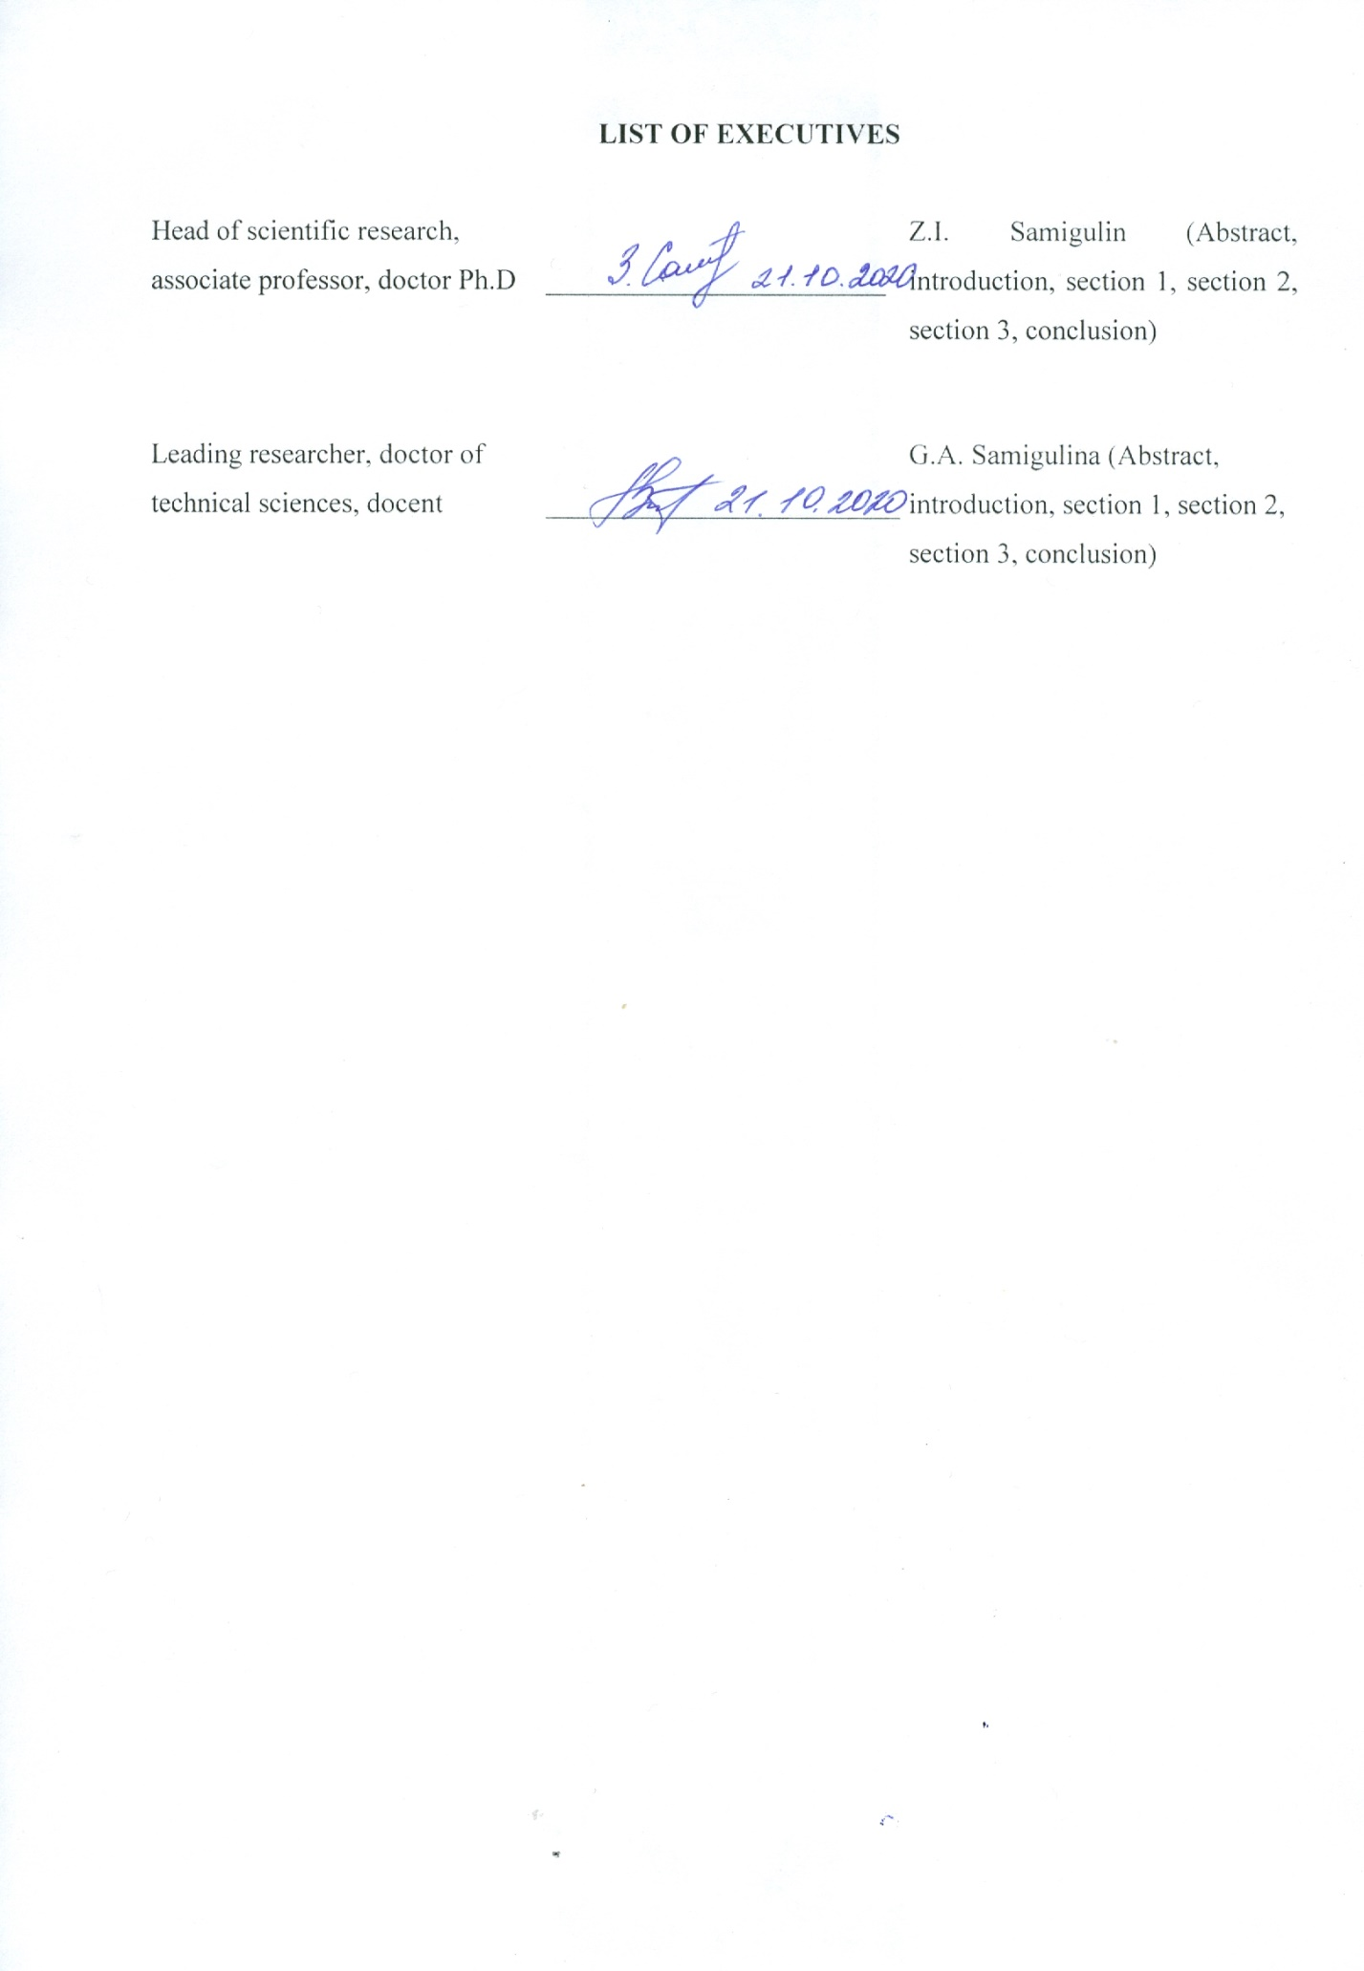

ABSTRACT

Report 173 p., 30 fig., 7 tabl., 39 resources., 20 appen.
DATABASE ANALYSIS, DRUG COMPOUNDS, ARTIFICIAL INTELLIGENCE, ARTIFICIAL IMMUNE SYSTEMS, FMEA

The object of the research is: the development of a highly effective intelligent technology for predicting the «structure-property» dependence of drug compounds based on modified algorithms of artificial immune systems (AIS).

The purpose of the work: creation of theoretical foundations, modified algorithms and software based on a promising AIS approach for obtaining drug compounds with desired properties.

Methods or methodology of work: artificial immune systems, ontological approach, object-oriented programming.

The results of the work and their novelty: there was developed software for the implementation of an intelligent technology for predicting the «structure-property» dependence of drug compounds and for analyzing databases based on AIS and the JADE multi-agent platform; there was created a methodology for analyzing databases using information processing by various approaches of artificial intelligence based on the FMEA risk assessment model; there was developed IES-analytics software for the implementation of an automated technology for modeling the processes of medicine using a medical expert system database that takes into account the «structure-property» dependence of drug compounds.

The field of application of the results: domestic pharmaceutical companies, healthcare, research laboratories and universities.

Recommendations for the implementation or the results of the implementation of research results: the results can be implemented in research laboratories and healthcare.

Economic efficiency or significance of work: research results contribute to the development of the domestic pharmacological industry of the Republic of Kazakhstan.

Predictive assumptions about the development of the object of research: it is proposed to develop an adaptive technology for creating new drug compounds based on metaheuristic algorithms of swarm intelligence and an approach of artificial immune systems with an assessment of the toxicity of the compounds obtained.

РЕФЕРАТ

Есеп 173 б., 30 сурет., 7 кесте., 39 дереккөз, 20 қосымша.
ДЕРЕКТЕР ҚОРЫН ТАЛДАУ, ДӘРІЛІК ҚОСЫЛЫСТАР, ЖАСАНДЫ ИНТЕЛЛЕКТ, ЖАСАНДЫ ИММУНДЫ ЖҮЙЕЛЕР, FMEA
Зерттеу объектісі: жасанды иммундық жүйенің (ЖИЖ) модификацияланған алгоритмдері негізінде дәрілік қосылыстардың «құрылым-қасиет» қатынасын болжаудың жоғары тиімді интеллектуалды технологиясын жасау болып табылады.
Жұмыстың мақсаты: қажетті қасиеттері бар дәрілік қосылыстар алу үшін ЖИЖ-нің перспективалық тәсіліне негізделген теориялық негіздерді, модификацияланған алгоритмдер мен бағдарламалық жасақтама құру
Жұмыстың әдісі немесе әдістемесі: жасанды иммунды жүйелер, онтологиялық тәсіл, объектіге бағытталған бағдарламалау.
Жұмыстың нәтижелері және олардың жаңашылдығы: ЖИЖ және JADE мультиагентті платформасы негізінде дәрілік қосылыстардың «құрылымдық-қасиеттік» байланысын болжаудың интеллектуалды технологиясын жүзеге асыруға және деректер қорын талдауға арналған бағдарламалық жасақтама құрылды; FMEA тәуекелді бағалау моделі негізінде жасанды интеллекттің әр түрлі тәсілдерінің көмегімен ақпаратты өңдеудің мәліметтер базасын талдау әдісі құрылды; дәрілік қосылыстардың құрылымдық-қасиеттік қатынастарын ескеретін медициналық сараптамалық жүйенің мәліметтер базасын қолдана отырып, медицина процестерін модельдеудің автоматтандырылған технологиясын жүзеге асыру үшін IES-analytics бағдарламалық жасақтамасы құрастырылды.
Нәтижелерді қолдану саласы: отандық фармакологиялық компаниялар, денсаулық сақтау, ғылыми-зерттеу зертханалары және жоғарғы оқу орындары.
ҒЗЖ-ның нәтижелерін енгізу немесе енгізу нәтижелері бойынша ұсыныстар: нәтижелер ғылыми зертханаларда және денсаулық сақтау саласында енгізілуі мүмкін.
Жұмыстың экономикалық тиімділігі немесе маңыздылығы: зерттеу нәтижелері Қазақстан Республикасының отандық фармокологиялық саласының дамуына ықпалын тигізеді.
Зерттеу объектісінің дамуы туралы болжамды пайымдаулар: алынған қосылыстардың уыттылығын бағалайтын жасанды иммунды жүйелердің тәсілі мен үйірлі интеллектің метаэврестикалық алгоритмдерінің негізінде дәрілік қосылыстарды құрудың адаптивті технологиясын жасау ұсынылады

TABLE OF CONTENTS

DEFINITIONS, SYMBOLS AND ABBREVIATIONS……………………………………….. | 7
INTRODUCTION …………………………………………………………………………..…. | 8
1 Development of software for the implementation of intelligent technology for predicting the «structure-property» dependence of drug compounds and for database analysis …………... | 11
- Software development using the JADE multi-agent platform for a Smart-system for prediction based on artificial immune systems……………………………………... | 11
1.2 Development of a knowledge base for software on the basis of JADE multi-agent platform…………………………………………………………………………………. | 14
- Conclusion……………………………………………………………………………… | 16
2 Analysis of databases, obtained as a result of processing by various methods and using modern software means………………………………………………………………………. | 17
2.1 Development of a methodology for assessing the effectiveness of a Smart-technology for predicting the properties of drug compounds and analyzing databases using modern software means………………………………………………………………....  2.2 FMEA methodology………………………………………………………………..…… | 18  19
2.3 Methodology for risk assessment of stages of a Smart-technology for predicting the «structure-property» dependence of drug compounds based on FMEA……………… | 21
2.4 Example of FMEA based risk assessment………………………………………………. | 23
2.5 Conclusion …………………………………………………………………………..….. | 27
3 Development of an automated technology for modeling the processes of medicine using the DB of an intelligent medical expert system that takes into account the «structure-property» dependence of drug compounds …………………………....................................................... | 29
3.1 Development of IES-analytics software ………………………………………………... | 29
3.2 IES-analytics program interface………………………………………………..……….. | 30
3.3 Conclusion …………………………………………………………………………….... | 41
CONCLUSION........................................................................................................................... | 42
REFERENCES…………………………………………………………………………………. | 47
APPENDIX A Calendar plan…………………………………………………………………... | 52
APPENDIX B List of publications............................................................................................. | 67
APPENDIX C Reprints of articles …………………………………………………………..… | 72
APPENDIX D Certificates…………………………………………………………………….. | 106
APPENDIX E Act of implementation…………………………………………………………. | 109
APPENDIX F Copyright certificates ………………………………………………................ | 110
APPENDIX G Risk priority matrix …………………………………………………………..... | 112
APPENDIX K Ontological model of IES-analytics software …............................................... | 113
APPENDIX L Instructions for installing the IES-analytics program …………………….…… | 114
APPENDIX M IES-analytics program variable specification. Module 1……………………… | 117
APPENDIX N IES-analytics program variable specification. Module 2………………………. | 118
APPENDIX P Ranking of test results for selection of target group of patients ….................... | 119
APPENDIX R MainWindow.xaml.cs code listing …………………………………………….. | 121
APPENDIX S Drugs.xaml.cs code listing ……………………………………………………... | 136
APPENDIX T AnalysisWindow.xaml.cs code listing …………………………………………. | 150
APPENDIX U MainWindow.xaml code listing ……………………………………………….. | 156
APPENDIX V Drugs.xaml code listing …………………………………………………….….. | 165
APPENDIX X Analysis.xaml code listing ……………………………………………….……. | 175
APPENDIX Y App.config code listing …………………………………………………….….. | 177
APPENDIX Z List of used foreign information resources …………………………………….. | 178

DEFINITIONS, SYMBOLS AND ABBREVIATIONS

In this research report, the following terms are used with their respective definitions, abbreviations and symbols:
DB | – database
AI | – artificial intelligence
AIS | – artificial immune systems
GA | – genetic algorithm
SI | – swarm intelligence
NN | – neural networks
SW | – software
AIS (Artificial Immune System) | – artificial immune systems
AIRS (Artificial Immune Recognition Systems) | – artificial immune recognition systems
Detection | – failure detection
СLONALG | – clonal selection algorithm
CSA (Clonal selection algorithm) | – clonal selection algorithm
JADE (Java Agent Development Framework) | – multi-agent platform
OWL (Web Ontology Language) | – language for describing ontologies
Occurrence | – failure occurrence
QSAR (Quantitative Structure – Activity Relationship) | – quantitative «structure-activity» ratio
SMILES (Simplified Molecular Input Line  Entry Specification) | – simplified molecular specification
Severity | – the significance of the failure
Protégé | – ontology editor
RPI (Risk Priority Index) | – risk priority index
RI (Risk Matrix) | – risk matrix
MAС (Multi-Agent System) | – multi-agent systems
FMEA (Failure Mode and Effects Analysis) | – analysis of types and consequences of failures
FPA (Flower Pollination Algorithm) | – flower pollination algorithm

INTRODUCTION

Assessment of the current state of the problem and its relevance. Modern research in the field of medicine and pharmacology is aimed at studying new diseases, that threaten humanity and finding DRUG compounds for their treatment. A strategically important step is the development of innovative techniques for computer molecular design of drugs based on the latest achievements in artificial intelligence (AI). The search for new drugs is complicated by the need to analyze a large amount of chemical information and increased requirements for computing resources. In this regard a promising direction of research is the approach of artificial immune systems (AIS) and the development of modified algorithms based on it, which makes it possible to process large databases of drug compound descriptors.
Foundations and initial data for the development of the topic. The research is based on the grant of MES RK № AR05130019. The initial data for the development of the topic were obtained on the basis of information in the publications of rating journals, as well as world databases of chemical information.
Justification of the need for research. The development of the domestic pharmacological industry and the production of original drugs in a short time contributes to the growth of the economy and an increase in the level of healthcare in the Republic of Kazakhstan
Information about the planned scientific and technical level of development. Domestic developments of new innovative intelligent technologies for predicting the «structure-property» dependence of deug compounds based on modified AI algorithms and the approach of immune network modeling are a promising and original direction of international research.
Information about the metrological support of research work. Intelligent predictive models are implemented using modern Big Data machine learning platforms that provide the creation and maintenance of science-intensive data.
The relevance of the research. The creation of new drugs is a difficult task, since developments are carried out at the intersection of disciplines: pharmacology, bioinformatics, chemometrics, IT-technologies and etc. The solution of many time-consuming tasks of computer molecular design of drugs, that require large computing power has become possible due to significant progress in the development of artificial intelligence and due to the occurrence of predictive bioinspired models. The exponential growth of chemical data, as well as their heterogeneity present significant difficulties in the rapid screening of descriptors, describing the structure of drug compounds. In this connection, the development of new modified algorithms for immune network modeling, assessment of their effectiveness and the creation of software for predicting the «structure-property» dependence of drug compounds is an urgent task.
The relationship of this work with other research projects. These studies are a continuation of the SF MES RK on the topic: «Computer molecular design of drugs based on immune network modeling» (2015-2017), as well as the project «Intelligent technology of immune network modeling of drugs» (2012-2014), which were carried out on the basis of the Institute of Information and Computing Technologies, lab. «Intelligent control and prediction systems”, scientific supervisor Doctor of Technical Sciences Samigulina G.A.
Research goals and objectives. The goal of the project is the development and analysis of descriptors databases of drug compounds based on world databases of chemical information for the computer molecular design of new drugs with desired properties, the creation of an effective intelligent technology and information system for conducting scientific research to predict the «structure-property» dependence of drug compounds based on modified AI algorithms.
Research objectives:
- Creation of theoretical foundations for the creation and analysis of databases based on the use of various AI approaches (artificial immune systems, algorithms of swarm intelligence, neural networks, genetic algorithms and etc.) in order to solve the problem of predicting the «structure-activity» dependence of drug compounds.
- Development of intelligent technology and information system for conducting scientific research to predict the «structure-activity» dependence of drug compounds based on modified artificial intelligence algorithms.
- Creation of modified AI algorithms for processing structural chemical information and forming databases of drug compounds with desired properties based on an optimal set of descriptors.
- Comparative analysis of databases of drug compounds, obtained as a result of processing by various AI methods.
- Development of an intelligent medical expert system, that takes into account the «structure-activity» dependence of drug compounds using the approaches of medical neuroinformatics.
Scientific novelty of the results obtained. Scientific novelty lies in the creation of new modified algorithms based on AIS and other AI approaches for the creation and analysis of databases of drug compounds and the selection of the optimal set of descriptors. There are no analogs of developments for this type of problems, implemented on the basis of immune network modeling. The research uses domestic developments on immune network modeling based on the assessment of prediction by homologous proteins.
The first section is devoted to software development, as well as to the creation of a knowledge base for the implementation of an intelligent technology for predicting the «structure-activity» dependence of drug compounds and analyzing databases using a multi-agent approach based on the JADE platform. In the second section there is developed a methodology for analyzing databases, obtained as a result of the implementation of an intelligent technology for predicting the «structure-activity» dependence of drug compounds using data processing by various approaches of artificial intelligence based on the FMEA risk analysis model and stages of intelligent technology functioning in order to eliminate potential risks of errors. The third section is devoted to the development of an automated technology for modeling the processes of medicine using a database of an intelligent medical expert system, that takes into account the «structure-activity» dependence of drug compounds. There is presented the IES-analytics software, which is an intelligent expert system for solving various problems of medicine, the structure of the program is described, the interface is shown with examples of data storage and processing, the functionality and requirements for operation are described. In the conclusion the main results obtained are presented.
These studies are the final ones for the development and analysis of databases for an information system for predicting the «structure-activity» dependence of drug compounds based on artificial intelligence algorithms. The following intermediate reports have been prepared for the project:
- for 2019 year inventory number 0219RK00710;
- for 2018 year inventory number 0218RK00435.

1 Development of software for the implementation of intelligent technology for predicting the «structure-property» dependence of drug compounds and for database analysis

Nowadays the urgent problem of modern society is the development of highly effective and safe drugs with desired pharmacological properties. The latest trends and progress in the field of artificial intelligence, computing, innovative information technologies, on the one hand, and huge accumulated arrays of raw structural chemical information, on the other hand, contribute to the creation of fundamentally new approaches to the development of drug compounds. A specific feature of the process of creating drugs based on computer molecular design is the need to process huge amounts of data. Another problem - attracting various experts from many fields of science and technology: chemists, microbiologists, biologists, modeling specialists, programmers, IT-professionals and etc. Promising bioinspired artificial intelligence approaches and new modified algorithms are of great interest to developers of these systems.

Therefore, today the development of an effective innovative technology for the creation of new drug compounds with desired properties based on modified algorithms of artificial immune systems is relevant.

1.1 Software development using the JADE multi-agent platform for a Smart-system for prediction based on artificial immune systems

Recently there has been an increase in publications on the use of innovative artificial intelligence algorithms for QSAR (Quantitative Structure - Activity Relationship) modeling and other applications in bioinformatics and medicine [1]. The article [2] is devoted to modern trends in QSAR modeling. Studies [3] propose the use of neural networks for QSAR prediction based on deep learning. The artificial immune system (AIS) approach is also actively used in solving these problems. For example, in [4] there is considered the use of an algorithm of artificial immune systems with clonal selection for predicting the structure of a protein. The article [5] solves an optimization problem based on artificial immune systems for the selection of informative descriptors. Development of a Smart-technology for predicting QSAR is relevant. A Smart-technology - a technology that is an interactive, collective, coordinated highly efficient activity, consisting of a large number of independent elements, capable of communicating with each other and with the environment [6]. Software implementation of a Smart-technology is convenient using a multi-agent approach. In article [7] there is carried out the diagnosis of personal data on the basis of a multi-agent-oriented approach. In studies [8] there is considered a multi-agent artificial immune system for solving the classification problem.

The statement of the research problem is formulated as follows: it is necessary to develop software for an innovative Smart-system for predicting the «structure-property» dependence of new drug compounds based on artificial immune systems and the JADE multi-agent platform.

The implementation of a Smart-system for QSAR prediction is carried out in the class of multi-agent systems (MAS). Today a large number of MAS software has been developed: JACK Intelligent Agents, MadKIT, AgentBuilder, MASON and etc. The main advantages of MAS include: reliability; flexibility, since the system can be supplemented with new agents and modified; performance; scalability; self-recovering and fault resistance. The most widely used is an open multi-agent platform JADE (Java Agent Development Framework) [9]. The JADE multi-agent platform complies with the international FIRA (The Foundation for Intelligent agent) standard, has a dynamic environment, in which agents operate, has a class library and a convenient set of graphical tools. JADE creates containers: main and standard. In the main container there are special agents of AMS (agent management system) and DF (directory coordinator), which is always active. Standard containers with agents are connected at starting. Agents communicate with each other using ACL messages. A special agent ACC (Agent Communication Channel) manages communication between agents.

Intelligent agents can work with the semantic knowledge base [10] in the OWL (Web Ontology Language) format. Representation of agents' knowledge in the form of ontologies facilitates communication between agents [11]. There are three types of MAS for ontology application:

- distributed MAS, when each agent contains its own ontology;

- centralized MAS, when there is created a standard ontology for all agents;

- hybrid MAS, when the ontology is partially distributed, partially centralized.

The Smart-system functioning algorithm consists of several stages: connecting the knowledge base and the descriptor database; structural chemical information; choosing a data optimization method and the creation of an optimal model based on a selected set of descriptors; selection of a pattern recognition algorithm and prediction based on the AIS approach; training the system according to standards compiled by experts from descriptors of drug compounds with precisely known properties; pattern recognition based on the selected AIS algorithm; QSAR prediction of chemical compounds; comparison of the efficiency of the algorithms used; selection of the best algorithms and selection of candidates for new chemical compounds with desired properties for further research [12,13].

The key component of the proposed Smart-system is the use of modified AIS algorithms for solving the QSAR prediction problem. There was developed a knowledge base for a multi-agent Smart-system based on ontological models of algorithms used in the Protégé ontology editor and in a unified ontological model of the system. Figure 1 shows a block diagram of the Smart-system for QSAR prediction based on the JADE multi-agent platform.

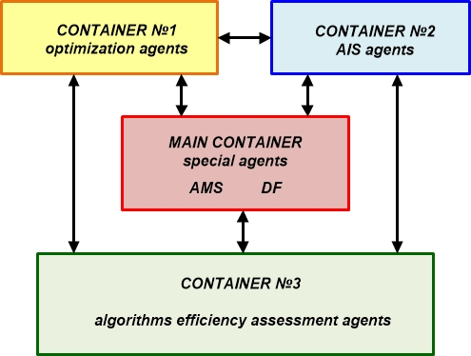

Figure 1.1 – Block diagram of the multi-agent Smart-system for QSAR prediction based on the JADE platform

Special agents are created in the main container:

- AMS (Agent Management System) to manage agents and to provide information about currently existing agents;

- DF (Director Facilitor) provides information about the services of agents registered with AMS.

Container № 1 contains agents that implement optimization algorithms (flower pollination methods, ant colony algorithm, bee colony algorithm, grey wolf algorithm, particle swarm algorithm, principal component method and random forest algorithm and etc.); container № 2 contains agents, executing algorithms for artificial immune systems (AIRS algorithm, CLONALG clonal selection algorithm, immune network algorithm and etc.); container № 3 contains agents for the assessment of the effectiveness of algorithms (Precision agent, Recall agent and etc.).

Effective communication between agents is carried out using messages in the ACL (Agent Communication Language), which consist of such fields as: sender, receiver, communication and content.

Therefore, the use of the JADE multi-agent platform in the development of software for the Smart-system for QSAR prediction is determined by a number of advantages: flexibility of operation, high self-organization, optimal distribution of computing resources, the possibility of autonomous operation of agents and operational interaction between agents, reliability and scalability, the ability to expand new algorithms and other modules [14].

1.2 Development of a knowledge base for software on the basis of JADE multi-agent platform

Let us consider an example of developing a knowledge base [15] for software implementation of a Smart-technology using an ontological approach based on a modified FPA-AIS algorithm, consisting of a method for extracting informative descriptors of the Flower Pollination Algorithm (FPA) and an algorithm for recognizing patterns of Artificial Immune Systems (AIS).

The formulation of the research problem is formulated as follows: it is necessary to develop a knowledge base for software based on the JADE multi-agent platform to implement an intelligent technology for predicting the «structure-property» dependence of drug compounds based on a modified FPA-AIS algorithm of artificial immune systems, agent-oriented and ontological approaches.

The general architecture of software, implementing intelligent technology based on the JADE platform is shown on figure 1.2.

Figure 1.2 – Software architecture for predicting the «structure-property» dependence of drug compounds based on agent-oriented and ontological approaches

The software environment consists of interacting agents, that implement the set goals, are able to make decisions and to communicate with other agents. The system is connected to the knowledge base and to the ontological model, containing the information of experts and of the ontological model of the system, as well as of the descriptors database of the chemical compound under consideration. The descriptor database is formed on the basis of the world databases of chemical information such as Mol-Instincts, PubChem, Drug bank and etc. The developed predictive model based on the modified FPA-AIS algorithm is described using an ontological model, implemented in the Protégé ontology editor (Figure 1.3) [16,17].

Figure 1.4 shows a block diagram of the ontological model of the modified FPA-AIS algorithm in the Protégé ontology editor.

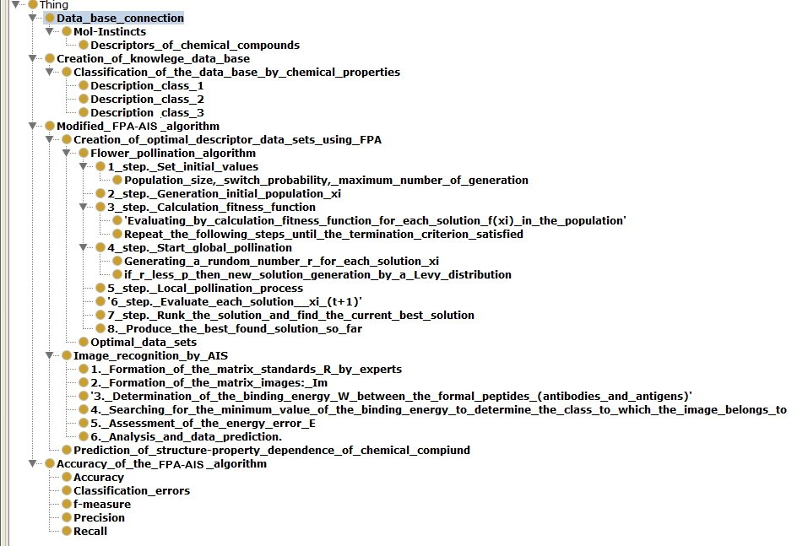

Figure 1.3 – Class taxonomy of the ontological model of the modified FPA-AIS algorithm

The agent-oriented and ontological approaches are convenient modern tools for the implementation of the developed intelligent technology for predicting the «structure-property» dependence of drug compounds based on modified artificial intelligence algorithms. This approach makes it possible to process large arrays of chemical information, to form optimal sets of descriptors, to improve the quality of predictive models and to reduce time resources when creating candidates for drug compounds.

The developed ontologies of modified algorithms of artificial immune systems constitute an expandable library, the algorithms of which are used to obtain new drug compounds with desired properties.

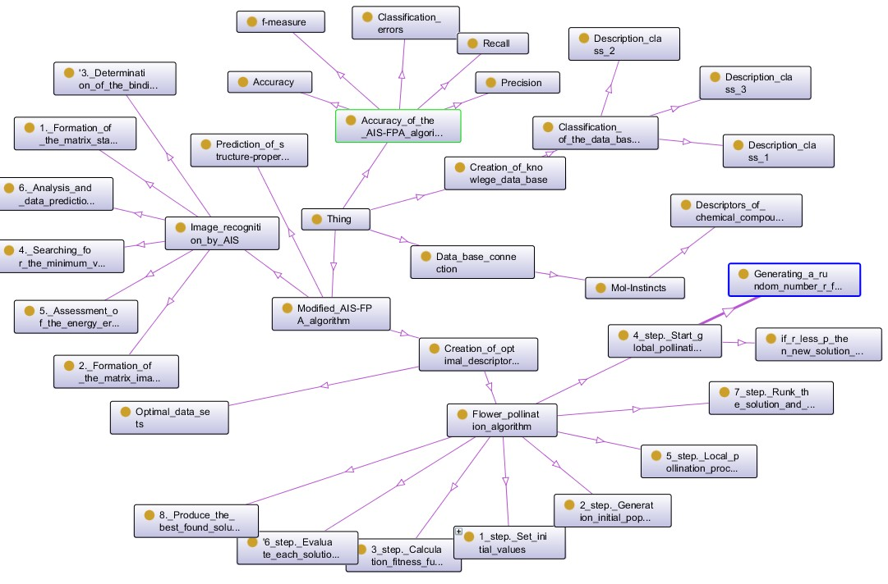

Figure 1.4 - Block diagram of the ontological model of the modified FPA-AIS algorithm

Representation of knowledge in the form of ontologies has the following advantages: it allows to clearly structure and share knowledge, has the ability to reuse model components and the ability to formally represent knowledge.

1.3 Conclusion

The following main results were obtained:

- There was developed software for the implementation of intelligent technology for predicting the «structure-property» dependence of drug compounds and database analysis.

- There was developed a knowledge base (using a unified ontological model of the system using the example of the modified FPA-AIS algorithm) and software for the implementation of the technology for creating a multi-agent Smart-system for predicting the QSAR dependence of drug compounds based on artificial immune systems (AIS) and the multi-agent platform JADE

2 Analysis of databases, obtained as a result of processing by various methods and using modern software means

Modern research in the field of medicine and pharmacology is aimed at studying new diseases, that threaten humanity and the search for drug compounds for their treatment. A strategically important step is the development of innovative techniques for the computer-aided molecular design of drugs based on the latest achievements in artificial intelligence. The search for new drugs is complicated by the need to analyze a large amount of chemical information and by increased requirements for computing resources.
Artificial intelligence methods are widely used to solve problems of selection of informative descriptors, describing the structure of a chemical compound, pattern recognition and predicting the «structure-property» dependence of drug compounds (Quantitative Structure Activity Relationship, QSAR). Promising algorithms are swarm intelligence (SI) [18], grey wolf optimization (GWO) [19], flower pollination algorithm (FPA) [20], genetic algorithms (GA) [21] and etc.
Of particular interest is the approach of artificial immune systems (AIS) and modified algorithms based on it. The AIS algorithms imitate the mechanisms of the immune system of a living organism and have the properties of self-organization, memory, and the ability to recognize patterns at the class boundary. Currently there are many varieties of AIS and modified algorithms based on them. For example, in [22] there is presented an improved algorithm for pattern recognition by an artificial immune system (Artificial Immune Recognition Systems, AIRS). The modification is named AIRS3. The article [23] considers an artificial immune system for associative classification in the diagnosis of breast cancer. The work [24] is devoted to the development of a hybrid clonal selection algorithm with modified combinatorial recombination and adaptive mutation for solving problems of numerical optimization.
With the occurrence of modified artificial intelligence algorithms and new technologies for data analysis based on them it is relevant to use modern methods of risk assessment to ensure the accuracy of prediction. Currently there are many effective risk assessment methodologies, such as: FMEA (Failure Mode and Effects Analysis), PFMEA (Process Failure Mode and Effects Analysis), FTA (Fault Tree Analysis) and etc. These methodologies are widely used not only in the assessment of production risks, but also in the field of health care.
The FMEA approach is actively used in the field of pharmacology, medicine and pharmaceutical production. For example, work [25] considers the FMEA methodology for assessing the risks of software for medical devices. The paper proposes a modification of the classical FMEA approach based on the fuzzy logic approach and a comparative analysis of the results obtained. Studies [26] are devoted to the use of the FMEA model to reduce medical risks. In [27] there is presented an application of the FMEA methodology in the development of new drugs. This approach allows visualizing complex processes in pharmaceutical research, identifying technological defects and quantifying undesirable effects, that directly affect quality and efficiency.
In this regard the development of an innovative methodology for the analysis of descriptor databases, obtained after processing by artificial intelligence algorithms based on a risk analysis model (Failure Mode and Effects Analysis, FMEA) is relevant.

2.1 Development of a methodology for assessing the effectiveness of a Smart-technology for predicting the properties of drug compounds and analyzing databases using modern software means

Currently the development of effective technologies for the creation of new drug compounds with desired properties is a complex task, at the junction of several disciplines: pharmacology, bioinformatics, chemometrics, and IT-technologies. When developing such systems the following requirements should be taken into account: the ability to process descriptors databases of high-dimensional drug compounds; combining the latest achievements in pharmacology and artificial intelligence; availability of modular structure and the possibility of expanding the system; integration with modern software products for data mining; ease of implementation; risks assessment of defects in the functioning of the developed technology for the search for new drug compounds.
The statement of the research problem is formulated as follows: it is necessary to develop a methodology for assessing the effectiveness of a Smart-technology for predicting the «structure-property» dependence of drug compounds based on modified AIS algorithms for analyzing descriptors databases of drug using the FMEA approach using modern software means.
2.2 FMEA methodology

Let us consider the FMEA approach for analyzing the types and consequences of defects. This methodology was firstly developed in the USA (NASA) and was applied in the following areas: aerospace, automotive industry, standards development (Germany), medicine and pharmaceutical industry [28-29]. Figure 2.1 presents a risk assessment table using FMEA (Failure Mode and Effects Analysis).

Figure 2.1 – FMEA methodology

The table describes potential failures (Figure 2.1, columns 1-3) or system defects and the reasons for their occurrence to prevent errors (for example, an assessment of the operation of an information system, an assessment of the stages of a technological process or laboratory tests and etc.). The following definitions are introduced (Figure 2.1, columns 4-6) for risk assessment [30]:
Definition 1. The significance of the «Severity» defect is the degree of failure consequences (the degree of significance is ranked in the range: the number of ranking categories);
Definition 2. Occurrence of a defect «Occurrence» - an assessment, representing the probability of a defect cause occurrence (the criterion is set in the range: the number of ranking categories).
Definition 3. Detection of a defect «Detection» - the probability of detecting defects, their causes and their consequences for the entire system (the criterion is ranked in the range: the number of ranking categories).
Definition 4. «Risk priority index» is a quantitative assessment of the complex risk. If the risk value for several failures has the same value, the risk, for which the «Severity» criterion has the greatest value is considered the most serious. This coefficient is calculated by the formula:

(2.1)

Definition 5. «Risk Matrix» - a mechanism for assessing the severity of a failure. This assessment is effective in case of incorrect assignment of risk priority classes by experts (Figure 2.1, columns 4-6) and allows assessing the criticality of defects from different points of view.
Figure 2.2 shows an example of visualization of the risk matrix taking into account the ranking of criteria in the range from 1 to 10.
The matrix is divided into three zones: «ZONE A» - low degree of risk; «ZONE B» - medium degree of risk; «ZONE С» - high degree of risk.

Figure 2.2 – FMEA methodology risk matrix

The FMEA methodology can be successfully applied to assess the developed Smart-technology for predicting the «structure-property» dependence of drug compounds based on the approach of artificial immune systems.

2.3 Methodology for risk assessment of stages of a Smart-technology for predicting the «structure-property» dependence of drug compounds based on FMEA

Let us consider the methodology for assessing the risks of stages of a Smart-technology for predicting the «structure-property» dependence of drug compounds based on FMEA.
The creation of new drugs includes various stages. Figure 2.3 shows a block diagram of the developed Smart-technology for predicting the «structure-property» dependence of drug compounds [31]. The goal of a Smart-technology is to analyze the descriptor database to obtain compounds of drug candidates with desired properties. The DB of sulfonamides descriptors is considered as an example. Sulfonamides are divided into several classes according to the duration of action:
1 class – short duration of action;
- class – medium duration of action;
- class – long duration of action.
The prognosis and selection of drug candidates is realized on the basis of modified algorithms of artificial immune systems [31-32].
Assessment of the effectiveness of the developed Smart-technology using the FMEA approach is carried out in several stages. Each stage of data analysis based on a Smart-technology is considered. The table is filled in (Figure 2.3) where: 1 column - the current operation; 2- a problem, that may arise during the execution of the stage; 3- the effect of the defect on the efficiency of the Smart-technology «Severity»; 4- a possible reason for detecting the defect «Occurrence»; 5- the probability of detecting a defect «Detection»; 6- calculation of the risk ratio. The risk coefficient is determined by the formula:.
The FMEA model contains recommendations for eliminating errors at each stage, that makes it possible to obtain a high accuracy in predicting the «structure-property» dependence of sulfonamides drug compounds based on the developed Smart-technology [33].

Figure 2.3 – Smart-technology block diagram

Figure 2.4 shows an ontological model of risk assessment of the Smart-technology stages based on FMEA in the Protégé software environment.

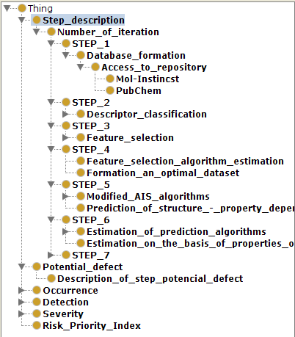

Figure 2.4 - Taxonomy of classes of the ontological model for risk assessment of the Smart-technology stages based on the FMEA approach

The ontological model includes an FMEA-based assessment of each stage of the developed Smart-technology for predicting the «structure-property» dependence of drug compounds and can be used as a knowledge base for software implementation of a Smart-technology based on a multi-agent approach.

2.4 Example of FMEA based risk assessment

Let us consider the risk assessment of the Smart-technology stages using the FMEA model using the example of analyzing the descriptors database of sulfonamides for drug compounds [34]. Figure 2.5 shows the FMEA risk assessment model of the Smart-technology stages.

Figure 2.5 - FMEA model for risk assessment

Table 2.1 – Model of FMEA indicators
«Severity» |  |  | «Occurrence» |  | «Detection»
Ranking indicators
S | defect impact | O |  | defect probability |  | D | defect detection
1 | min | 1 |  | very low |  | 1 | very efficient
2 | significant | 2 |  | low |  | 2 | efficient
3 | critical | 3 |  | medium |  | 3 | not reliable
4 | catastrophic | 4 |  | strong |  | 4 | not possible

The enlarged Smart-technology algorithm is presented below:
1 STAGE. Formation of a database of drug compound descriptors.
2 STAGE. Classification of drug compounds (by duration of action, degree of toxicity and etc.).
3 STAGE. Selection of informative descriptors based on metaheuristic AI algorithms (genetic algorithm, grey wolf optimization method, flower pollination method and etc.).
4 STAGE. Assessment of the efficiency of algorithms for the selection of informative descriptors. Formation of the optimal data set, based on the modeling results.
5 STAGE. Prediction of the properties of sulfonamide drug compounds based on modified AIS algorithms [35-36].
6 STAGE. Assessment of the prediction efficiency based on assessments: accuracy, classification error, precision, recall, sensitivity, specifity, f-measure, AUC, ROC-area. Assessment of the modified AIS algorithm based on the properties of homologous proteins.
7 STAGE. Selection of drug candidates for drugs with desired properties.
Table 2.2 shows a fragment of the sulfonamides descriptor database. The database contains 2005 descriptors of various levels (molecular descriptors, topological indices, quantum-chemical descriptors and etc.) and consists of 30 075 data copies. The fragment of the database under consideration contains the following descriptors: nAT - number of atoms; MW - Molecular weight; AMW - average molecular weight; Sv - sum of atomic van der Waals volumes (scaled on Carbon atom) and etc.

Table 2.2 - Fragment of Sulfonamide database
Drug number | nAT | MW | AMW | Sv | … | Class
Drug 1 | 27.00 | 250.275 | 9.270 | 17.880 | … | short_acting
Drug 2 | 33.00 | 278.328 | 8.440 | 21.080 | … | short_acting
Drug 3 | 31.00 | 267.301 | 8.620 | 19.590 | … | short_acting
Drug 4 | 27.00 | 270.324 | 10.010 | 17.970 | … | short_acting
Drug 5 | 46.00 | 311.441 | 6.770 | 26.670 | … | short_acting
Drug 6 | 33.00 | 278.328 | 8.440 | 21.080 | … | short_acting
… | … | … | … | … | … | …
Drug 2005 | 24.00 | 214.238 | 8.930 | 15.000 | … | medium_acting

Prediction of the «structure-property» dependence of drug compounds was carried out after preliminary data processing based on the flower pollination method (FPA) [36] using the immune network simulation algorithm (AIS). The AIS-based pattern recognition mechanism is implemented as follows [37, 38].
Let the «pattern» be presented as an dimensional column vector, , where - real numbers [39]. We represent the number of classes as . Pattern recognition is defined as . «Standards» are presented in the form . The «standards» class is described as . The solution to the pattern recognition problem is reduced to finding a class of an arbitrary dimensional vector , . The AIS-based pattern recognition algorithm is presented below.
Algorithm 1.
1 step. Formation of a matrix of «standards» .
2 step. Formation of a matrix of «patterns» , where number of patterns.
3 step. Definition of left and right singular vectors .
4 step. Calculation of the minimum binding energy between formal peptides (antibody and antigen) [37-38] according to the formula: , where transpose symbol.
5 step. Search for the minimum of binding energy, which determines the class, to which the «image» belongs .
The result of the analysis of the sulfonamide descriptors database based on a Smart-technology in terms of AUC is shown on figure 2.6. The AIS-based prognosis was compared with clonal selection algorithms (CLONALG and CSA) and artificial immune system recognition (AIRS). The modeling results show that the most efficient algorithm is the one, that tends to the upper left corner, that is the value of the AUC characteristic is close to 1.
A modified algorithm based on immune network modeling [36] showed the best prognostic result. An example of risk assessment based on the developed ontological model and FMEA approach is shown on figure 2.7. The risk priority matrix is calculated, presented in Appendix G.
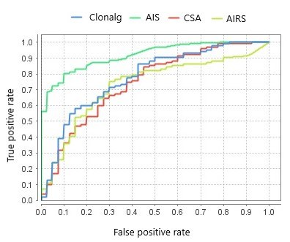
Figure 2.6 - Prediction of the «structure-property» dependence of drug compounds based on modified AIS algorithms

The table contains information about the stage of a Smart-technology functioning and potential defect.
Figure 2.7 - FMEA risk assessment example for a Smart-technology for predicting the «structure-property» dependence of sulfonamides

Further there is described the name of the error and the possible cause of the error. According to the assessment criteria, considered in section 2.1, experts assess the degree of criticality of the defect. The values of the columns «Severity», «Occurrence» and «Detection» are filled in. The value of the risk priority index RPI is calculated. Maximum value of the coefficient:. The lower the value of the coefficient , the less significant the risk for the functioning of a Smart-technology.
The practical value of the work lies in the fact that the proposed Smart-technology allows to quickly select the desired modified AIS algorithm, which is most suitable for a specific set of data and for an effective solution to the problem. Assessment of the effectiveness of the developed Smart-technology based on the FMEA methodology allows eliminating potential risks of errors and improving the prediction quality.

2.5 Conclusion

The following main results were obtained:
- There was carried out the analysis of the DB, obtained as a result of processing by various AI methods using modern software.
- There was developed a method for analyzing databases, obtained as a result of the implementation of an intelligent technology for predicting the «structure-property» dependence of drug compounds using data processing by various approaches of artificial intelligence based on the Failure Mode and Effects Analysis (FMEA) risk analysis model.
- There was developed a FMEA model in order to assess the risks of the functioning of the stages of the proposed intellectual technology, to eliminate the potential risks of errors and to improve the prediction quality.
- There was carried out an analysis of sulfonamides databases, obtained as a result of processing by various artificial intelligence methods (FPA, AIS, CLONALG, CSA and AIRS) based on the Failure Mode and Effects Analysis (FMEA) approach.
- There was created a risk matrix and the Risk priority index (RPI) was calculated, which is a quantitative assessment of the complex risk for assessing the stages of a Smart-technology.

- Development of an automated technology for modeling the processes of medicine using the DB of an intelligent medical expert system that takes into account the «structure-property» dependence of drug compounds

Nowadays in the pharmaceutical industry there is an acute issue of patient resistance to drugs. According to statistics the prescribed drug treatment does not help from 35 to 75% of patients. Since the creation of new drug compounds is a complex, multistage process it is relevant to develop an automated technology for modeling the processes of medicine, capable of selecting a target group of patients upon request in order to create new drugs with desired properties based on an intelligent medical expert system, that takes into account the «structure-property» dependence of drug compounds in Microsoft Visual Studio environment.

3.1 Development of IES-analytics software

In the process of developing new drug compounds an important stage is the creation of high-quality databases of chemical compounds and clinical data of patients, necessary to assess the effect of the obtained compounds on the human body, which has a certain set of features (gender, age, blood group, allergic reactions, ECG results and etc.). In this connection it is important to develop modern software for the development of new drug compounds with desired properties.
The statement of the research problem is formulated as follows: it is necessary to develop software for automated modeling of medicine processes using a database of a medical expert system, that takes into account the «structure-property» dependence of drug compounds.
The developed software ontological model is presented in Appendix K. The software consists of two modules. The first module allows to collect information about patients, analyze and determine the state of health. Based on these data there is selected a target group in order to create new drug compounds. The second module contains information about the compounds under study (identifiers in repositories, data on the chemical structure, descriptors, describing the properties of compounds). The obtained databases of patients (different in age, sex and state of health), as well as databases of chemical compounds allow theoretical studies during the development of new drug compounds based on modified algorithms of artificial intelligence [36].
The software is developed in the C# and XAML programming language using Microsoft Visual Studio. In order to run the program the following requirements to a personal computer are presented: Windows 10 operating system, display with a screen resolution of 1920x1080 (recommended), 1024x768 (minimum), keyboard, mouse. Required programs for installing «IES-analytics»: Microsoft Net Framework 4.6.1, Microsoft Server 2017 LocalDB. Instructions for launching the program are presented in Appendix L.
The software consists of interconnected databases for various purposes, the information of which is stored in tables.

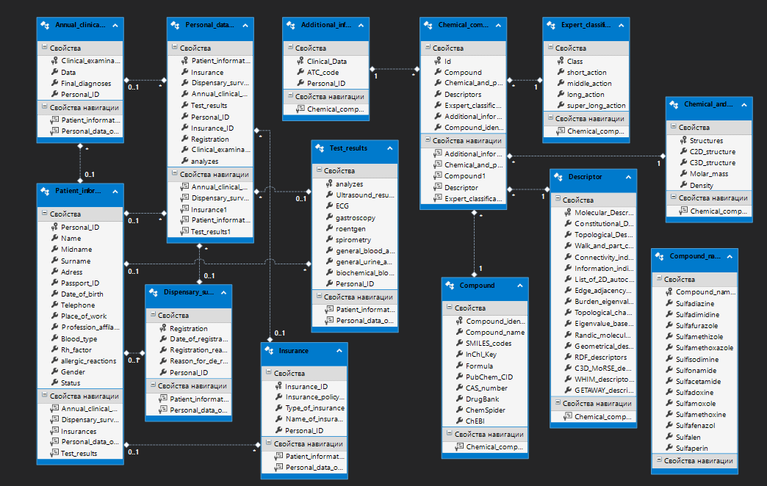

Figure 3.1 - MedicalDB database model

The IES-analytics software variables specification is presented in Appendix M and N, in accordance with each module. Figure 3.2 below shows the project structure in Microsoft Visual Studio.

3.2 IES-analytics program interface

Let us consider the interface of the developed software IES-analytics. Figure 3.2 shows the main dialog window of the program. The toolbar contains the File, Patient DataBase, Chemical Compound DataBase, View tabs. In the dialog window you can search for patients by first name, last name, passport number, telephone number or residential address.

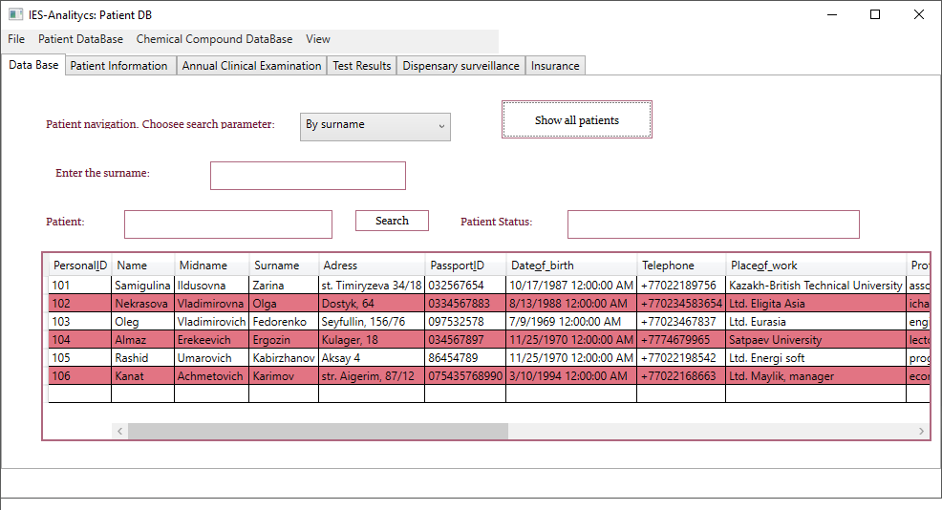
Figure 3.2 – IES-analytics interface

Switching between modules 1 and 2 allows to select the patient information of the desired category and enter data for the drug under consideration. Patient data are entered sequentially in the tabs of the Patient DataBase module and can subsequently be configured on request on the main page of the module. The Patient Information section displays the patient's contact details, blood type, and possible allergic reactions (Figure 3.3).

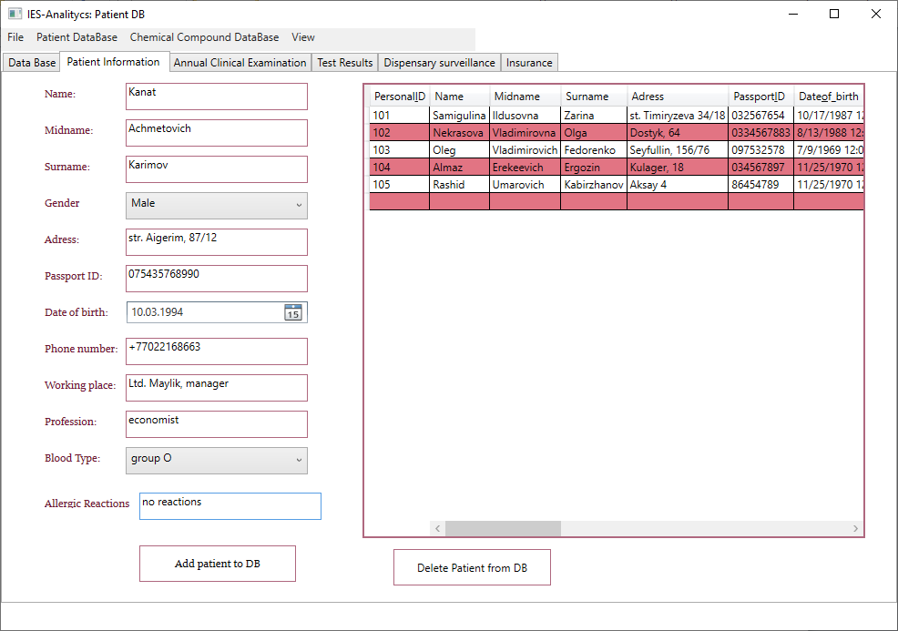
Figure 3.3 – Patient Information dialog window
Then the information about the annual dispensary examination is entered (Figure 3.4) in the Annual Clinical Examination tab.

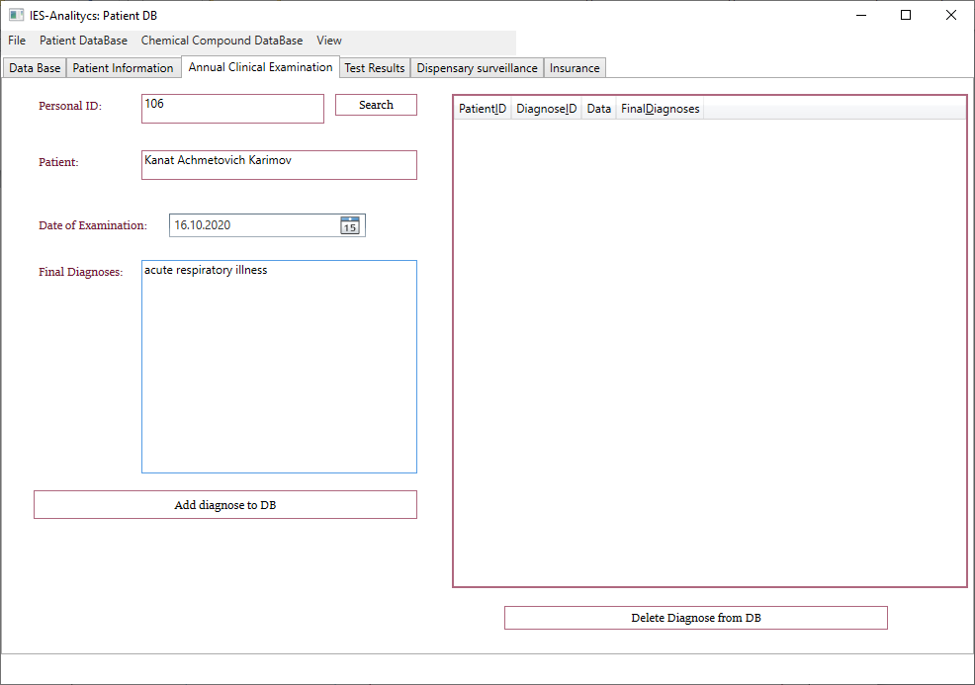
Figure 3.4 –Annual Clinical Examination dialog window

The results of the current analyzes are entered into the Test Results table (Figure 3.5).
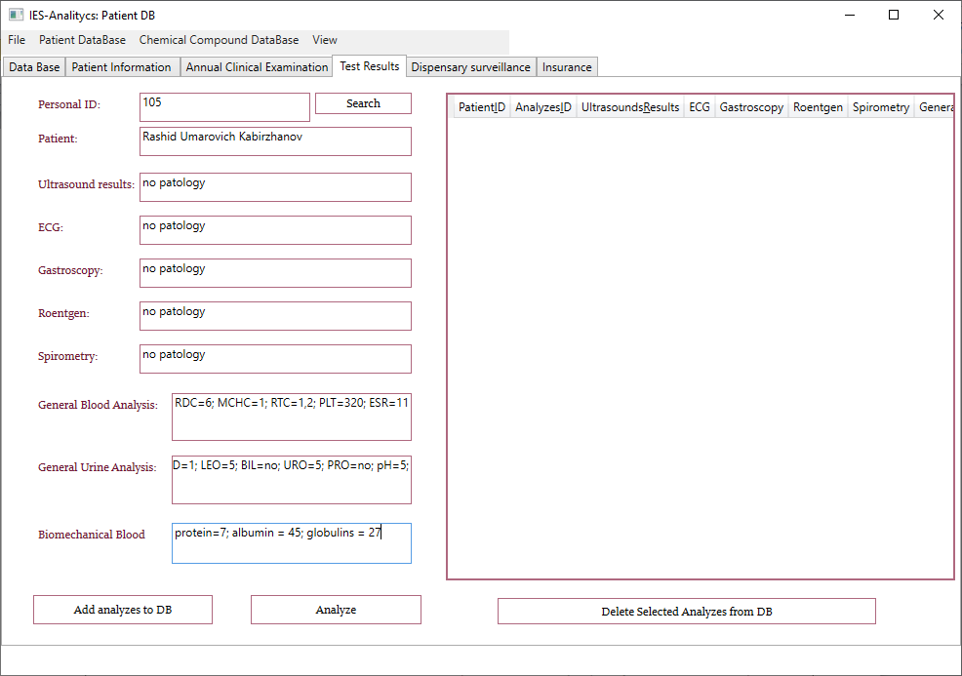
Figure 3.5 –Test Results dialog window
The Test Results tab data is analyzed by an expert and ranked in accordance with the following tables P.1, P.2, Appendix P for assessing the patient's state of health. The expert fills in the dialog window in order to assess the patient's state of health (Figure 3.6).

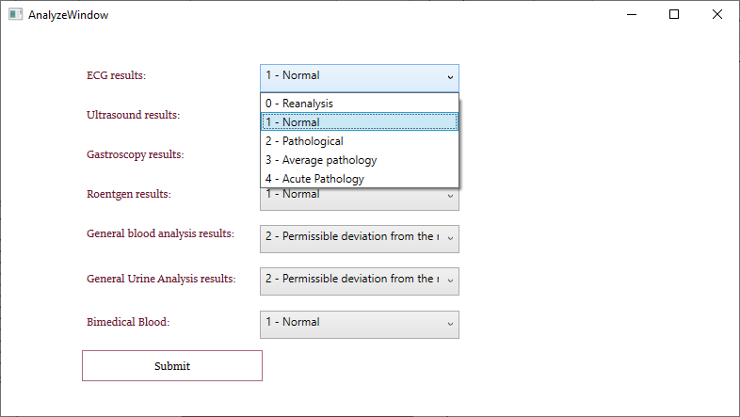
Figure 3.6 – Dialog window for expert assessment of the patient's state of health

The ranking of patients by health state for the selection of control groups in predicting the «structure-property» dependence of drug compounds is carried out as follows. The set of patient analyzes is described by the expression:

(3.1)

where «А..G» - results of patient analyzes (Appendix P, Table P.1 and Table P.2); «N» - total number of analyzes.
IES-analytics automatically calculates a coefficient , showing the degree of deviation in the patient's health using the following formula:

(3.2)

Depending on the indicator and the presence of pathologies in the analyzes patients are divided into classes, presented in Table 3.1.

Table 3.1 – Classification of patients according to the degree of health
Class | coefficient range | Notes
1 class |  | small degree of deviation of the patient's health
2 class |  | medium degree of deviation of the patient's health;
3 class |  | strong degree of deviation of the patient's health;
4 class |  | critical degree of deviation of the patient's health.

The percentage of the degree of deviation of the patient's of health is calculated by the formula:

(3.3)

where - the maximum value of the coefficient (3.2).

If, the deviation in health is more than 50% then the patient data can be used to compose control groups when predicting the «structure-property» dependence of new drug compounds with desired properties according to the following expression:

(3.4)

Let us consider an example, a patient with an ID number has the following results of the analysis:
(3.5)

where - electrocardiogram (ECG) results;
- ultrasound examination (ultrasound);
- gastroscopy;
- x-ray examination;
- general blood analysis,
- general urine analysis,
- biochemical blood analysis.

The example , accordingly the degree of deviation of the patient's health is 22.5% and belongs to the first class. The analysis results, as well as the status of the patients are displayed on the main dialog window, figure 3.7.

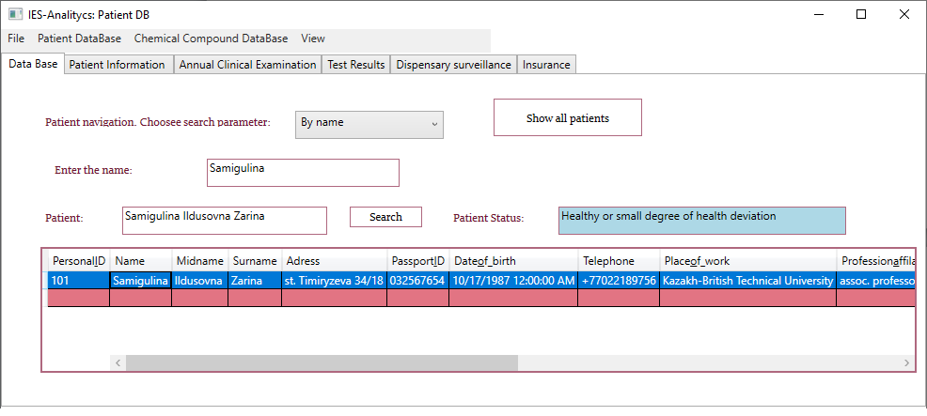
Figure 3.7 – Ranking patients according to the degree of health state

Tables, containing patient information are linked and in the main dialog window you can search by keywords: first name, last name, phone number, passport number or residential address (Figure 3.8).

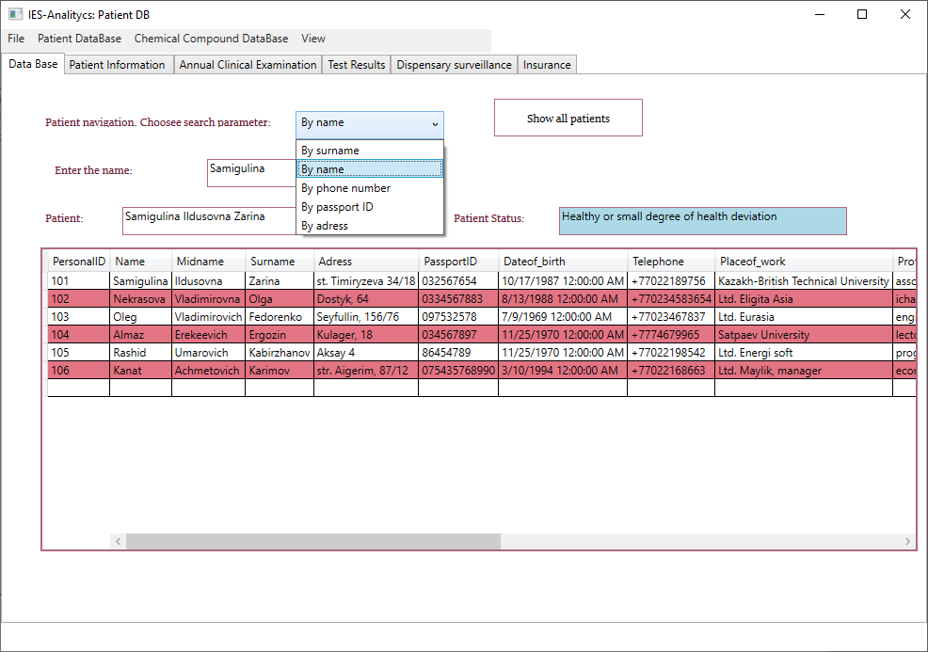
Figure 3.8 – Patient search parameters

Next the dialog window (Figure 3.9) is filled in, containing information about the dispensarization (date of appeal, reason, complaint).

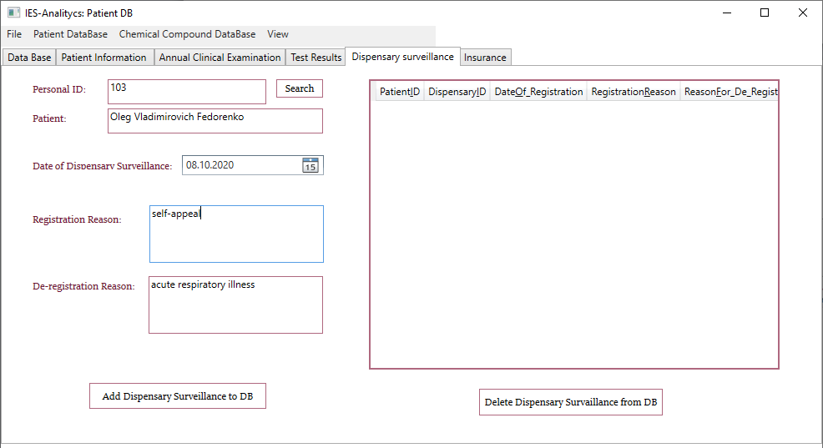
Figure 3.9 –Dispensary surveillance dialog window

The database also contains information about the availability of health insurance, its number, type and name of the health insurance organization (Figure 3.10).

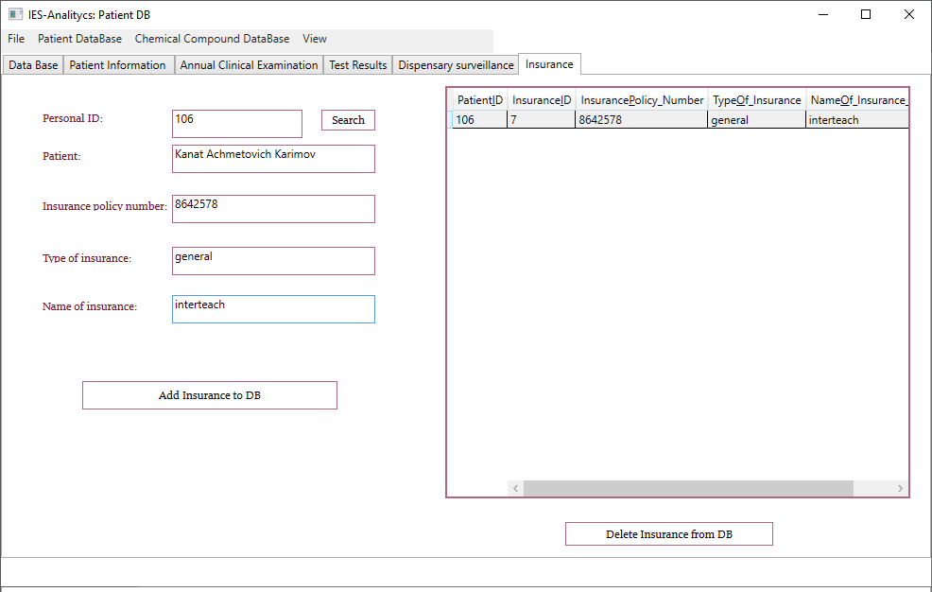

Figure 3.10 – Insurance dialog window

Next let us consider Module 2, the Chemical Compound DataBase tab. Figure 3.11 shows the Compound dialog window, which displays information about a chemical compound. The advantage is the ability to enter ID numbers of compounds from various international data banks, since the domestic and European names of the compounds do not always coincide. Identification of substances by databases is provided: Mol-Instincts, PubChem, Drug Bank, Chem Sprider, CheBl. The structure of a chemical compound is entered in the form of a simplified representation of molecules in the SMILES (Simplified Molecular Input Line Entry System) input line. The InChl code (International Chemical Identifier), the international chemical identifier of the substance, is indicated. A unique numerical identifier of chemical compounds is introduced, the CAS number parameter (Chemical Abstracts Service).

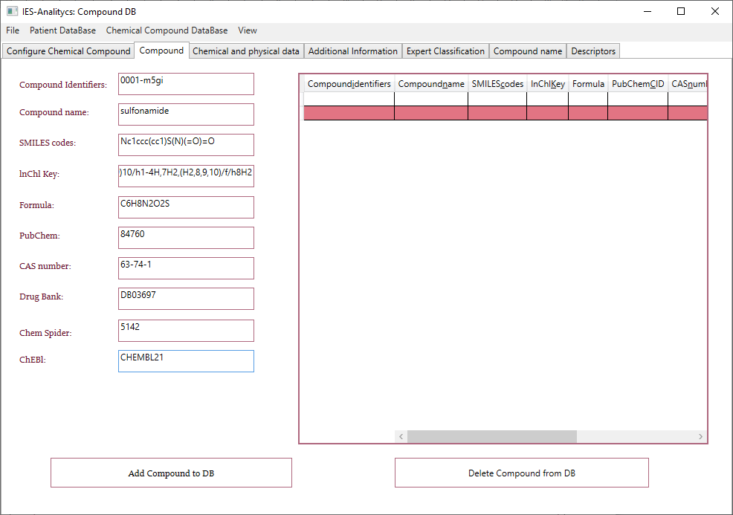
Figure 3.11 – Chemical compound information

The next dialog window allows to include information about the 2D and 3D structure of the compound (Figure 3.12). The program supports the ability to download an image file.

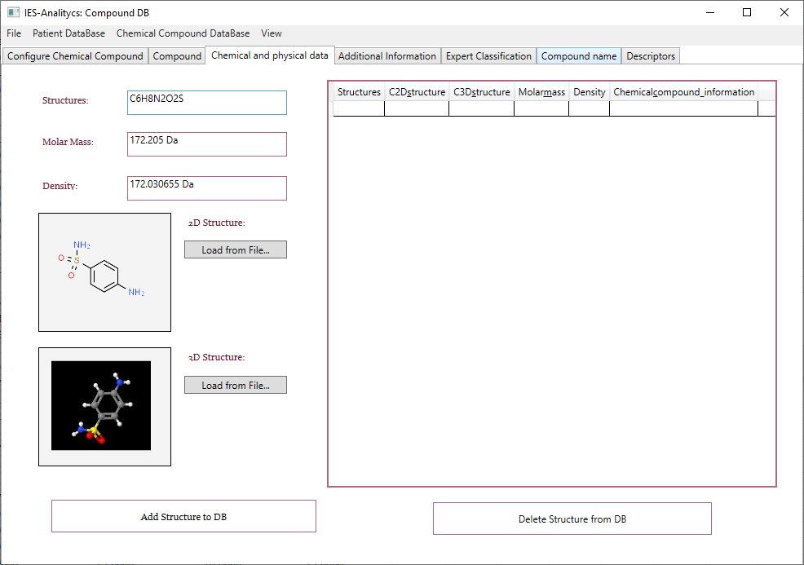
Figure 3.12 – Chemical and physical data dialog window
Additional information in the form of clinical data or ATC code (Anatomical Therapeutic Classification) is entered on the Additional Information tab (Figure 3.13).

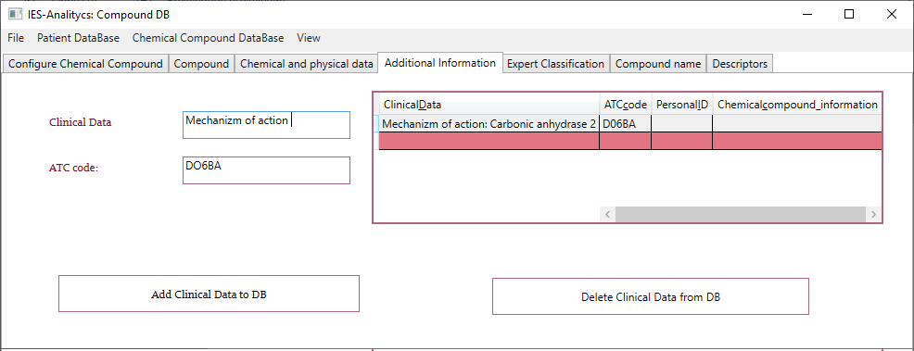
Figure 3.13 – Entering additional information about a chemical compound.

In the program you can enter the classification of substances according to various characteristics, for example according to the duration of action of a drug compound in the Expert Classification section (Figure 3.14).
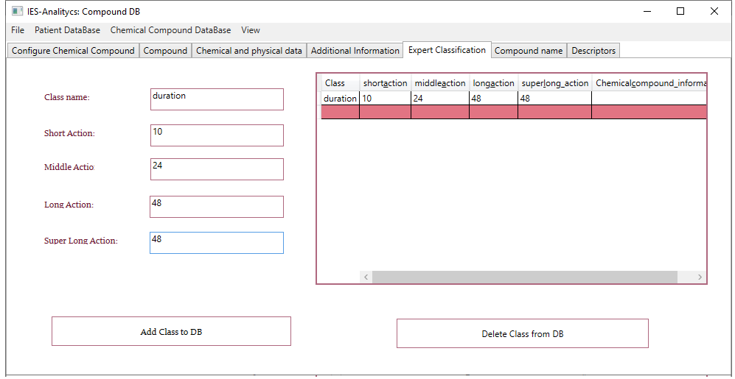
Figure 3.14 – Expert Classification dialog window

Information about chemical compounds, including descriptors can be entered in the Compound name section (Figure 3.15).

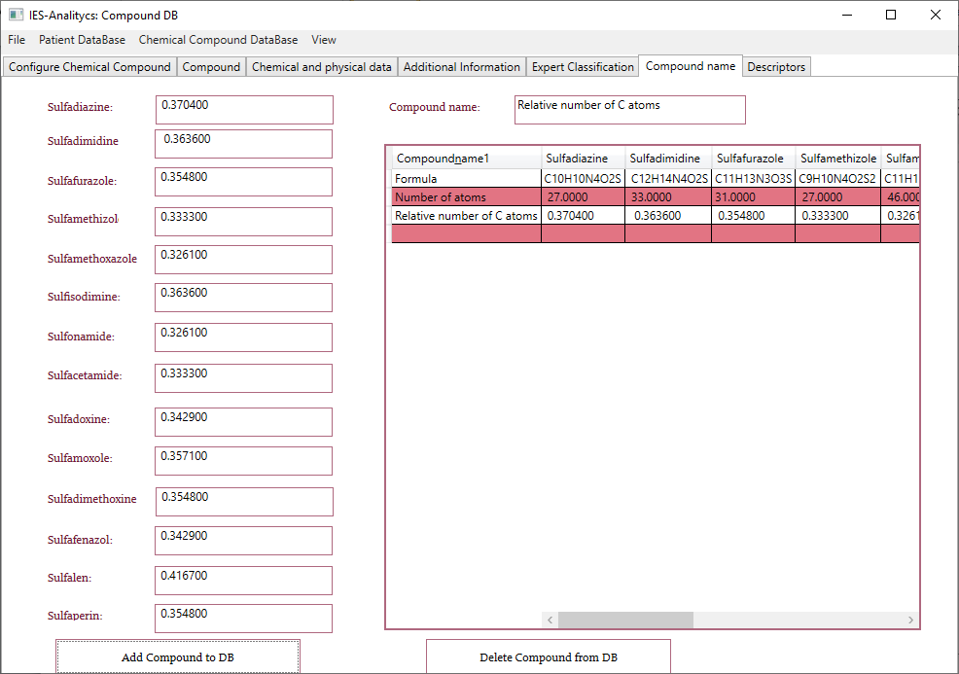
Figure 3.15 – Compound name dialog window

The Descriptors tab allows to enter descriptors of the investigated chemical compounds of various levels (Figure 3.16). For example, the Molecular descriptor contains data on molecular descriptors, describing a chemical compound (number of atoms, molecular weight, gravity index and etc.). The Geometrical Descriptors class contains geometric descriptors, such as Moment inertia A.

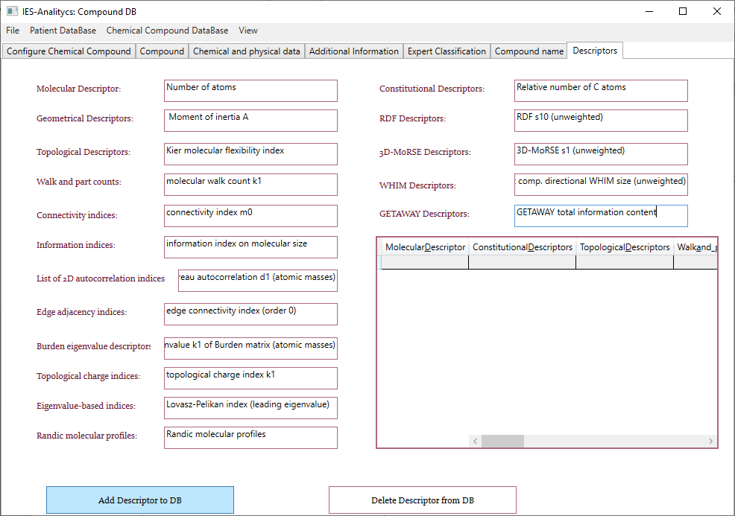
Figure 3.16 – Descriptors dialog window
On the main Configure Chemical Compound dialog window (Figure 3.17) you can request the necessary information about the chemical compound with a full description of its properties.
The obtained databases can be used for computer molecular design of new drugs. The developed software is a promising platform for research in the field of predicting the «structure-property» dependence of drug compounds. A feature of IES-analytics is the ability to select target groups of patients with a set of specific features for analysis: diagnoses, blood types, gender, age and etc. The use of the developed intelligent expert system allows taking into account many factors and creating highly effective drug compounds.

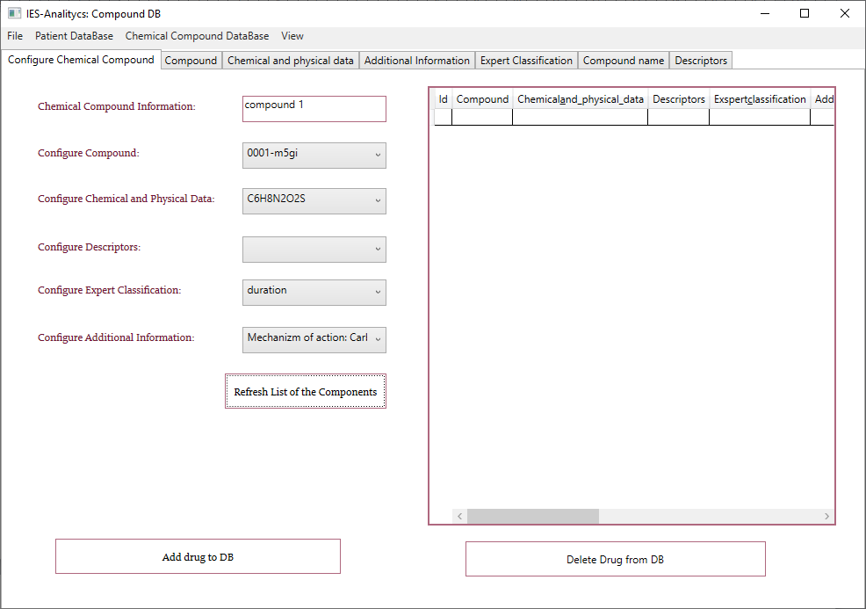
Figure 3.17 – Configure Chemical Compound dialog window

  - Conclusion

The following main results were obtained:
- There was developed an automated technology for modeling the processes of medicine using a database of an intelligent medical expert system, that takes into account the «structure-property» dependence of drug compounds;
- There was created an ontological model of an automated technology for modeling the processes of medicine using a database of a medical expert system, that takes into account the «structure-property» dependence of drug compounds.
- There was developed IES-analytics software for the implementation of an automated technology for modeling medical processes using a database of an intelligent medical expert system in C #;
- There was created a user interface of an intelligent medical expert system, that takes into account the «structure-property» dependence of drug compounds in the Microsoft Visual Studio application package;
- There was developed an automated system for monitoring a target group of patients in order to create new drugs with desired properties based on an intelligent medical expert system, that takes into account the «structure-property» dependence of drug compounds in the Microsoft Visual Studio environment

CONCLUSION

During the project, the following main results were obtained for 2020 year:
- There was developed software for the implementation of intelligent technology for predicting the «structure-property» dependence of drug compounds and database analysis
- There was developed a knowledge base (using a unified ontological model of the system on the example of the modified FPA-AIS algorithm) and software for the implementation of the technology for creating a multi-agent Smart-system for predicting the dependence of QSAR for drug compounds based on artificial immune systems (AIS) and the JADE multi-agent platform.
- There was carried out the analysis of the databases, obtained as a result of processing by various AI methods using modern software.
- There was developed a method for analyzing databases, obtained as a result of the implementation of an intelligent technology for predicting the «structure-property» dependence of drug compounds using data processing by various approaches of artificial intelligence based on the Failure Mode and Effects Analysis (FMEA) risk analysis model.
- There was developed a FMEA model in order to assess the risks of the functioning of the stages of the proposed intellectual technology, to eliminate the potential risks of errors and to improve the prediction quality.
- There was carried out the analysis of sulfonamides databases, obtained as a result of processing by various artificial intelligence methods (FPA, AIS, CLONALG, CSA and AIRS) based on the Failure Mode and Effects Analysis (FMEA) approach.
- There was created the risk matrix and the Risk priority index (RPI) was calculated, which is a quantitative assessment of the complex risk for assessing the stages of a Smart-technology.
- There was developed an automated technology for modeling the processes of medicine using a database of an intelligent medical expert system, that takes into account the «structure-property» dependence of drug compounds;
- There was created an ontological model of an automated technology for modeling the processes of medicine using a database of a medical expert system, that takes into account the «structure-property» dependence of drug compounds.
- There was developed IES-analytics software for the implementation of an automated technology for modeling medical processes using a database of an intelligent medical expert system in C #;
- There was created a user interface of an intelligent medical expert system, that takes into account the «structure-property» dependence of drug compounds in the Microsoft Visual Studio application package;
- There was developed an automated system for monitoring a target group of patients in order to create new drugs with desired properties based on an intelligent medical expert system, that takes into account the «structure-property» dependence of drug compounds in the Microsoft Visual Studio environment.
- In 2020 year, based on the research results, 11 scientific articles were published in journals and materials of prestigious international conferences, including 3 articles with an impact factor (Q2, Q3), included in the Scopus and Thompson Reuters databases and 1 copyright certificate for computer program.
During the implementation of the project for 2019 year, according to the calendar plan (Appendix A) the following results were obtained:
- There was developed an information system for conducting scientific research in order to predict the «structure-property» dependence of drug compounds based on modified AI algorithms.
- There was created the architecture of an information system for conducting scientific research based on a model-oriented approach, Model Driven Architecture for computer molecular design of new drugs.
- There was developed the necessary requirements for the creation of software for a multi-agent Smart-system for conducting scientific research on predicting the dependence of QSAR on new drug compounds, which should be taken into account when processing multidimensional chemical information by modified AIS algorithms.
- There was presented the structure of a multi-agent system for conducting scientific research for predicting the «structure-property» dependence of drug compounds based on modified artificial intelligence algorithms.
- There were developed agents for the information multi-agent Smart-system for conducting scientific research based on AIS.
- Within the framework of the MDA (Model Driven Architecture) concept there was developed a multi-agent ontological Smart-system model for predicting QSAR drugs and a library of ontologies based on modified AIS algorithms for processing structural chemical information.
- There were created modified AI algorithms for processing structural chemical information and DB of drug compounds with desired properties based on an optimal set of descriptors.
- There was developed a modified AIS algorithm based on the Flower Pollination Algorithm (FPA) for an information system for conducting scientific research in predicting the «structure-property» dependence of drug compounds.
- There was developed a modified algorithm for artificial immune systems based on the Grey Wolf Optimization (GWO) method and the Artificial Immune Recognition Systems algorithm within the framework of the Model Driven Architecture concept for an information system for conducting scientific research.
- There was carried out a comparative analysis of the results of QSAR modeling of sulfonamides by various algorithms of artificial immune systems and modified AIS algorithms using the grey wolf optimization method.
- There was developed an effective method for analyzing the database of an intelligent medical expert system, taking into account the «structure-property» dependence of drug compounds, when solving various problems of medicine on the basis of the proposed Smart- system for QSAR prediction for a medical expert system.
- There was developed a module for assessing the quality of predictive models based on modified AIS algorithms.
- There was carried out an analysis of the effectiveness of the application of modified artificial intelligence algorithms for processing the database of an intelligent medical expert system based on the ROC (Receiver Operating Characteristic), AUC (Area Under ROC Curve) error curves and characteristics: precision, recall and f-measure.
- In 2019 year, based on the research results 11 scientific articles were published in journals and materials of prestigious international conferences (Appendix B), an act of implementation of the project research results into the educational process at the Kazakh-British Technical University at the Faculty of Information Technologies was received.
During the implementation of the project for 2018 year, according to the calendar plan (Appendix A) the following results were obtained:
- There was presented an overview of the application of modern AI approaches in pharmacology.
- There were created the theoretical foundations for the creation and analysis of databases based on the application of various approaches of artificial intelligence (AIS, algorithms of swarm intelligence, NN, GA) for solving the problem of predicting the «structure-property» dependence of drug compounds.
- There was presented an analysis of descriptors databases of chemical compounds for predicting the «structure-property» dependence of drug compounds based on a genetic algorithm in the RStudio programming environment using the function of parallel data processing.
- There was carried out prediction of the «structure-property» dependence of sulfonamides medicinal compounds based on the algorithm of artificial immune systems (AIRS, Artificial Immune Recognition System) using the Python language.
- There was developed an intelligent technology for predicting the «structure-property» dependence of drug compounds based on modified algorithms of swarm intelligence (particle swarm optimization algorithm with the weight of inertia and a cooperative swarm optimization algorithm) and immune network modeling.
- There was carried out simulation of swarm intelligence algorithms on the basis of modern software products WEKA and Yarpiz.
- There was performed a comparative analysis of the classical PSO particle swarm optimization algorithm and the modified inertia weight particle swarm (IWPSO) algorithm for the selection of informative descriptors.
- There was carried out an analysis of the current state of expert systems for medical purposes.
- There were formed attributes of entities and selected a set of attributes of the database of the intelligent medical expert system. An entity/relationship diagram (E/RD).
- There was developed a structure of a database of an intelligent medical expert system, taking into account the «structure-property» dependence of drug compounds for personalized medical diagnostics based on expert assessments and the approach of 46 artificial immune systems, as well as an ontological model of a general-purpose intelligent medical expert system.
- There was presented a module of the medical expert system, which takes into account the «structure-property» dependence of drugs based on modified algorithms of swarm intelligence. The ontological models IWPSO and СPSO were developed in the Protégé editor.
- There was obtained an OWL model for a general-purpose intelligent medical expert system in the Protégé ontology editor.
- In 2018 year, 11 articles were published and 1 certificate of state registration of rights to an object of copyright (for a computer program) was received.
For three years, based on the results of the research, there were published:
- A monograph in a foreign publishing house (Appendix B);
- There are 33 articles in journals and materials of prestigious international conferences, 4 articles of which are included in the Scopus and Thompson Reuters database, quartile Q2 and Q3 (1 article in print for 2020 year);
- There was received 2 copyright certificates for the computer program in the Committee on Intellectual Property Rights (Appendix F);
- There was received 1 act of implementation of research results at the Kazakh-British Technical University, Faculty of Information Technology (Appendix E).
The scientific novelty of the project lies in the development of new modified algorithms based on the approach of artificial immune systems and other artificial intelligence algorithms for the creation and analysis of drug compound descriptors databases. The development of medicinal compounds databases, consists of optimal sets of descriptors based on new modified algorithms for immune network technology is a fundamental difference from other approaches. The technology based on the developed domestic algorithms for immune network modeling has a number of advantages over others. This is first of all the ability of the system to solve the problem of pattern recognition of chemical compounds, that are on the border of nonlinearly separated classes and have similar structures. Numerous International conferences on this topic confirm the relevance and importance of this area of artificial intelligence.
The development of databases based on the proposed intellectual technology will allow moving to a qualitatively new level of research in biomedicine and pharmacology, to open great opportunities for the production of domestic drugs with a wide spectrum of action.

REFERENCES

- Hessier G., Baringhaus K. Artificial Intelligence in Drug Design // Molecules. – 2018. – № 23. – P. 25-20.
- Roy K. Advances in QSAR Modeling // Application in Pharmaceutical, Chemical, Food, Agricultural and Environmental Sciences. – 2017. – P. 3-55.
- Ghasemi F., Mehridehnavi A., Pérez-Garrido A., Pérez-Sánchez H. Neural network and deep-learning algorithms used in QSAR studies: metrics and drowbacks // Drug discovery today. – 2018. – № 23(10). – P. 1-12.
- Zhu H., Wu J., Gu J. Studies on Immune Clonal Selection Algorithm and Application of Bioinformatics // International Journal of Intelligent Engineering and Systems. – 2015. –№ 8. – P. 10-16.
- Kihel B.K., Chouraqui S. Firefly Optimization Using Artificial Immune System for Feature Subset Selection // International Journal of Intelligent Engineering and Systems. – 2019. – Vol. 12, № 4. – P. 337-347.
- Krishnamurthy E.V., Murthy V.K. On engineering Smart systems // Proceeding KES of the 9th international conference on Knowledge-Based Intelligent Information and Engineering Systems. – Australia, 2005. – Vol. 3. – P. 505-512.
- Ramirez M.R., Moreno H.B., Rojas E.M., Hurtado C., Núñez S.O. Multi-Agent System Model for Diagnosis of Personality Types // Proceedings of the 12th International Conference Agents and Multi-agent Systems: Technologies and Applications. Smart Innovation, Systems and Technologies book series. - Springer, 2018. – № 96. – P. 209-214.
- Asa A., Hanafi S.O., Hassanien A.E. Multi-agent Artificial Immune System for Network Intrusion Detection and Classification. // International Joint Conference. Advances in Intelligent Systems and Computing. – Springer, 2014. – Vol. 299. –P. 145-154.

9 JADE Architecture Overview. – 2019 // http://www.jade.tilab.com/: 05.10.2020.

10 Freitas A., Bordini R.H., Vieira R. Designing Multi-Agent Systems from Ontology Models // Lecture Notes in Computer Science. – Springer, 2019. – Vol. 11375.– P. 76-95.

11 Naidanov D.G., Shein P.E. Ontologies in multi-agent systems // Proceedings of the XII All-Russian meeting on control problems. –M., 2014. - P. 9044-9050.

12 Samigulina G.A., Samigulina Z.I. Information system for molecular design of drug compounds based on a model-oriented approach // Bulletin of NTU «KhPI». - 2019. - № 13 (1339). - P. 176-187. (in Russian)

13 Samigulina G.A., Samigulina Z.I. A multi-agent system for conducting scientific research for predicting the «structure-property» dependence of drug compounds based on modified algorithms of artificial immune systems // Problems of Informatics. - 2019. - № 3. - P. 34-45. (in Russian)
14 Samigulina G.A., Samigulina Z.I. Development of software using the multi-agent platform JADE for a Smart-system for prediction based on artificial immune systems // Bulletin of NTU «KhPI». - Kharkov, 2019. - №28(1353). - P. 84-92. (in Russian)
15 Samigulina G.A., Samigulina Z.I. Development of a knowledge base and software for a multi-agent Smart-system for prediction based on artificial immune systems // Materials of the XI All-Russian Scientific and Technical Conference with International Participation «Robotics and Artificial Intelligence». –Zheleznogorsk, 2019. - P. 133-137. (in Russian)
16 Samigulina G.A., Samigulina Z.I. Development of software for the implementation of intelligent technology for predicting the «structure-property» dependence of drug compounds based on a modified algorithm of artificial immune systems // Problems of the evolution of open systems. - Almaty, 2020. - Vol. 1. - P. 1-9. (in Russian)
17 Samigulina G.A., Samigulina Z.I. Development of a knowledge base for the implementation of intelligent technology for predicting the «structure-property» dependence of drugs // Proceedings of the international scientific and practical conference «Satpayev readings-2020». - Almaty, 2020. - Vol. 2. - P. 409-413. (in Russian)
18 Chenye Qiu. A novel multi-swarm particle swarm optimization for feature selection // Genetic programming and evolvable machines. – Springer, 2019. - №20. – P. 503-529.
19 Gao Zh., Zhao J. An Improved Grey Wolf Optimization Algorithm with Variable Weights // Computational Intelligence and Neuroscience. – 2019. – Vol.1, №3. – P.1-13.
20 Abdel-Basset M., Laila A. Shawky. Flower pollination algorithm: a comprehensive review // Artificial Intelligence Review. – 2019. – Vol. 52. – P. 2533-2557.
21 Xi Wang. The Application of Genetic Algorithms in the Biological Medical Diagnostic Research // International journal of BIO automation. – 2016. – Vol.20, №4. – P. 493 – 504.
22 Jenhani I., Elouedi Z. Re-visiting the artificial immune recognition system: a survey and an improved version // Artificial Intelligence Review. – 2014. – Vol. 42. – P. 821–833.
23González-Patiño D., Villuendas-Rey Y., Argüelles-Cruz A., Camacho-Nieto O., Yáñez-Márquez C. AISAC: An Artificial Immune System for Associative Classification Applied to Breast Cancer Detection // Applied science. – 2020. – Vol.10, №2. – Р. 515.
24 Zhang W., Gao K., Zhang W., Wang X., Zhang Q, Wang H. A hybrid clonal selection algorithm with modified combinatorial recombination and success-history based adaptive mutation for numerical optimization // Applied Intelligence. - 2018. – Vol.49. – P.819-836.
25 Chang T.W., Lo H.-W., Chen K.-Y. and Liou J.J. A Novel FMEA Model Based on Rough BWM and Rough TOPSIS-AL for Risk Assessment // Mathematics. – 2019. – Vol.7., №874. – Р. 1-21.
26 Chiozza M.L., Ponzetti C. FMEA: a model for reducing medical errors // Clinica Chimica Acta; International Journal of Clinical Chemistry. – 2009. – Vol. 404(1). – P. 75-78.
27 Hirotaka I., Shu Y. Failure mode and effects analysis in pharmaceutical research // International Journal of Quality and Service Sciences. – 2010. - Vol.2(3). – P. 369-382.
28 Batbayar K., Takács M., Kozlovszky M. Medical device software risk assessment using FMEA and fuzzy linguistic approach: case study // Proceeding of 11th IEEE International Symposium on Applied Computational Intelligence and Informatics. – 2016. – P. 197-202.
29 Inoue H., Yamada S. Failure mode and effects analysis in pharmaceutical research // International Journal of Quality and Service Sciences. – 2010. - №2(3). – Р.369-382.
30 Sharma K., Srivastava S. Failure mode and effect analysis (FMEA) implementation: a literature review // Journal of Advance research in aeronautics and space science. – 2018. - №1(17). – Р.1-18.
31 Samigulina G.A., Samigulina Z.I. Ontological model of multi-agent Smart-system for predicting drug properties based on modified algorithms of artificial immune systems // Theoretical Biology and Medical Modelling. – BMC, 2020. -17(12). – P.1-22.
32 Samigulina G.A., Samigulina Z.I. Machine learning for big data analysis in drug design // Sixth International Conference on Machine Learning, Optimization, and Data Science – July 19-23, 2020, Certosa di Pontignano, Siena – Tuscany, Italy. Lecture notes in computer science. –2020. - Vol. 12514. – P. 1162-1174.
33 Samigulina G.A., Samigulina Z.I. Development of a methodology for analyzing drug descriptors databases based on the FMEA risk assessment model // Materials of the XVI International Scientific and Practical Conference «Advanced Science-2020». - UK, Sheffield: Science and Education Ltd, 2020. - Issue 8. - P. 3-6. (in Russian)
34 Samigulina G.A., Samigulina Z.I. Assessment of the risks of predicting the «structure-property» dependence of drug compounds of a sulfonamide group based on the FMEA methodology // Materials of the XVI International Scientific and Practical Conference «European Science of the XXI Century». - Poland, Przemysl: Nauka i studia, 2020. - Issue 3. - P. 50-53. (in Russian)
35 Samigulina G.A., Samigulina Z.I. Development of a methodology for assessing the effectiveness of a Smart-technology for predicting the properties of drug compounds and analyzing databases using modern software // Bulletin of KBTU. - Almaty, 2020. –№3(54). - P. 173-179. (in Russian)
36 Samigulina G.A., Samigulina Z.I. Development and analysis of databases for the intellectual system for predicting the structure-property dependence of drag compounds on the basis of artificial immune systems: Monograph. – Yelm, WA, USA: Science Book Publishing Ноuse, 2020. – 220 p. ISBN 978-1-62174-135-0. (in Russian)
37 Tarakanov A.O., Borisova A.V. Formal Immune Networks: Self-Organization and Real-World Applications // Advances in Applied Self-organizing Systems. – 2013. – P. 321-341.
38 Tarakanov A., Nicosia G. Foundations of immunocomputing // Proceedings of the 1-st IEEE Symposium on Foundations of Computational Intelligence. – 2007. – P. 503-508.
39 Blum V.S., Zabolotsky V.P. The immune system and immunocomputing. - 2007 // http://sgma.alpha-design.ru/MMORPH/N-16-html/blum/blum.pdf: 20.10.2020. (in Russian)

APPENDIX A

Calendar plan

TECHNICAL SPECIFICATIONS AND
CALENDAR WORK PLAN

under the Agreement № 229 from 20.03.2018 year

1. «KAZAKH-BRITISH TECHNICAL UNIVERSITY» JSC

1.1 By priority: №4. Life sciences and health.
1.2 By sub-priority: 4.1 Fundamental and applied research in the field of biology. Search for new medicinal substances, pharmacological research and technologies for the production of original drug.
1.3 On the topic of the project: № AR05130019 «Development and analysis of databases for an information system for predicting the «structure-property» dependence of drug compounds based on artificial intelligence algorithms».
1.4 The total amount of the project is 24 000 000 (twenty four million) tenge, including by years, for the performance of work in accordance with paragraph 3:
- for 2018 year - in the amount of 8 000 000 (eight million) tenge;
- for 2019 year - in the amount of 8 000 000 (eight million) tenge;
- for 2020 year - in the amount of 8 000 000 (eight million) tenge.

2. Characteristics of scientific and technical products by qualification characteristics and economic indicators

2.1 Direction of work: Bioinformatics.
2.2 Field of application: Pharmacology.
2.3 Final result:
- for 2018 year: Theoretical foundations for creating and analyzing databases based on the use of various approaches of artificial intelligence (AI) (artificial immune systems (AIS), algorithms of swarm intelligence, neural networks (NN), genetic algorithm (GA) and etc.) for solving the problem of predicting the «structure-activity» dependence of drug compounds. An article will be published in a peer-reviewed Russian journal with a non-zero impact factor.
- for 2019 year: Information system for conducting scientific research for predicting the «structure-activity» dependence of drug compounds based on modified AI algorithms. An article will be published in a peer-reviewed foreign journal with a non-zero impact factor.
- for 2020: Software (SW) for the implementation of intelligent technology for predicting the «structure-activity» dependence of drug compounds and analysis of databases (DB). Articles will be published in foreign peer-reviewed journals included in the Web of Science or Scopus databases: Theoretical Biology and Medical Modeling by Springer (IF=1,746) and J. Artificial Intelligence Review (Thompson Reuter, IF=2,627).
2.4 Patentability: It is possible to obtain a copyright certificate.
2.5 Scientific and technical level (novelty): Scientific novelty lies in the creation of new modified algorithms based on AIS and other AI approaches for the creation and analysis of databases of medicinal compounds and for the selection of the optimal set of descriptors.
2.6 The use of scientific and technical products is carried out: by the Executor.
2.7 Type of use of the result of scientific and (or) scientific and technical activities: The developed technologies and databases of drug compounds can be in demand in the pharmaceutical industry at developing new drugs with desired properties.

3. Name of work, terms of their implementation and results
Work, stage code | Name of work under the Agreement and the main stages of its implementation |  | Terms of execution |  | Expected results
Work, stage code |  |  | beginning | ending
2018 year
1. | Creation of theoretical bases for the creation and analysis of databases based on the application of various AI approaches (AIS, swarm intelligence algorithms, NN, GA and etc.) to solve the problem of predicting the «structure-property» dependence of drug compounds. |  | January 2018 year | until November 1, 2018 year | Theoretical foundations will be created for the creation and analysis of databases based on the use of various AI approaches (AIS, algorithms of swarm intelligence, NS, GA and etc.) to solve the problem of predicting the «structure-property» dependence of drug compounds.  An article will be published in a peer-reviewed Russian journal with a non-zero impact factor.
1.1 | Review of the application of modern AI approaches in pharmacology. Development of intellectual technology for predicting the «structure-property» dependence of drug compounds on the basis of modified AI algorithms. |  | January 2018 year | June 2018 year | A review of the application of modern AI approaches in pharmacology will be carried out and an intelligent technology for predicting the «structure-property» dependence of drug compounds based on modified AI algorithms will be developed.
1.2 | Development of the DB structure of the intellectual medical expert system which takes into account the «structure-property» dependence of drug compounds at solving various problems of medicine. |  | July 2018 year | until November 1, 2018 year | The structure of the database of an intelligent medical expert system will be developed, taking into account the «structure-property» dependence of drug compounds, at solving various problems of medicine.
2019 year
2. |  | Development of an information system for conducting scientific researches for predicting the «structure-property» dependence of drug compounds on the basis of modified AI algorithms. | January 2019 year | until November 1, 2019 year | An information system for conducting scientific research will be developed to predict the «structure-property» dependence of drug compounds based on modified AI algorithms.  An article will be published in a peer-reviewed foreign journal with a non-zero impact factor.
2.1 |  | Creation of modified AI algorithms for processing of structural chemical information and formation of DB of drug compounds with desired properties on the basis of an optimal set of descriptors. | January 2019 year | June 2019 year | Modified AI algorithms will be created for processing structural chemical information and databases of medicinal compounds with desired properties based on an optimal set of descriptors.
2.2 |  | Creation effective methods of DB analysis of an intellectual medical expert system which takes into account the «structure-property» dependence of drug compounds at solving various problems of medicine. | July 2019 year | until November 1, 2019 year | Effective methods for analyzing the database of an intelligent medical expert system, taking into account the «structure-property» dependence of drug compounds, will be created at solving various problems of medicine.
2020 year
3 |  | Development of software for the implementation of intelligent technology for predicting the «structure-property» dependence of drug compounds and DB analysis. | January 2020 year | until November 1, 2020 year | Software will be developed for the implementation of intelligent technology for predicting the «structure-property» dependence of drug compounds and database analysis.  Articles will be published in foreign peer-reviewed journals included in the Web of Science or Scopus database: Theoretical Biology and Medical Modeling by Springer (IF=1,746) and J. Artificial Intelligence Review (Thompson Reuter, IF=2,627).
3.1 |  | Analysis of DB obtained as a result of processing by various methods of AI using modern software means | January 2020 year | June 2020 year | The analysis of the databases obtained as a result of processing by various AI methods using modern software means will be carried out.
3.2 |  | Development of an automated technology for modeling processes of medicine using a DB of an intellectual medical expert system, that takes into account the «structure-property» dependence of drug compounds | July 2020 year | until November 1, 2020 year . | An automated technology for modeling the processes of medicine will be developed using the database of an intelligent medical expert system, that that takes into account the «structure-property» dependence of drug compounds.

Calendar plan

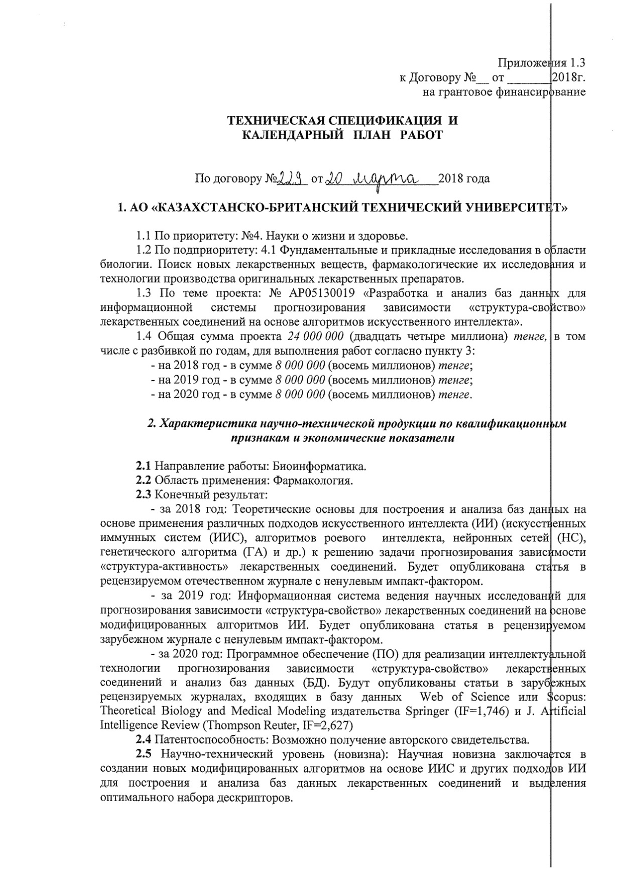

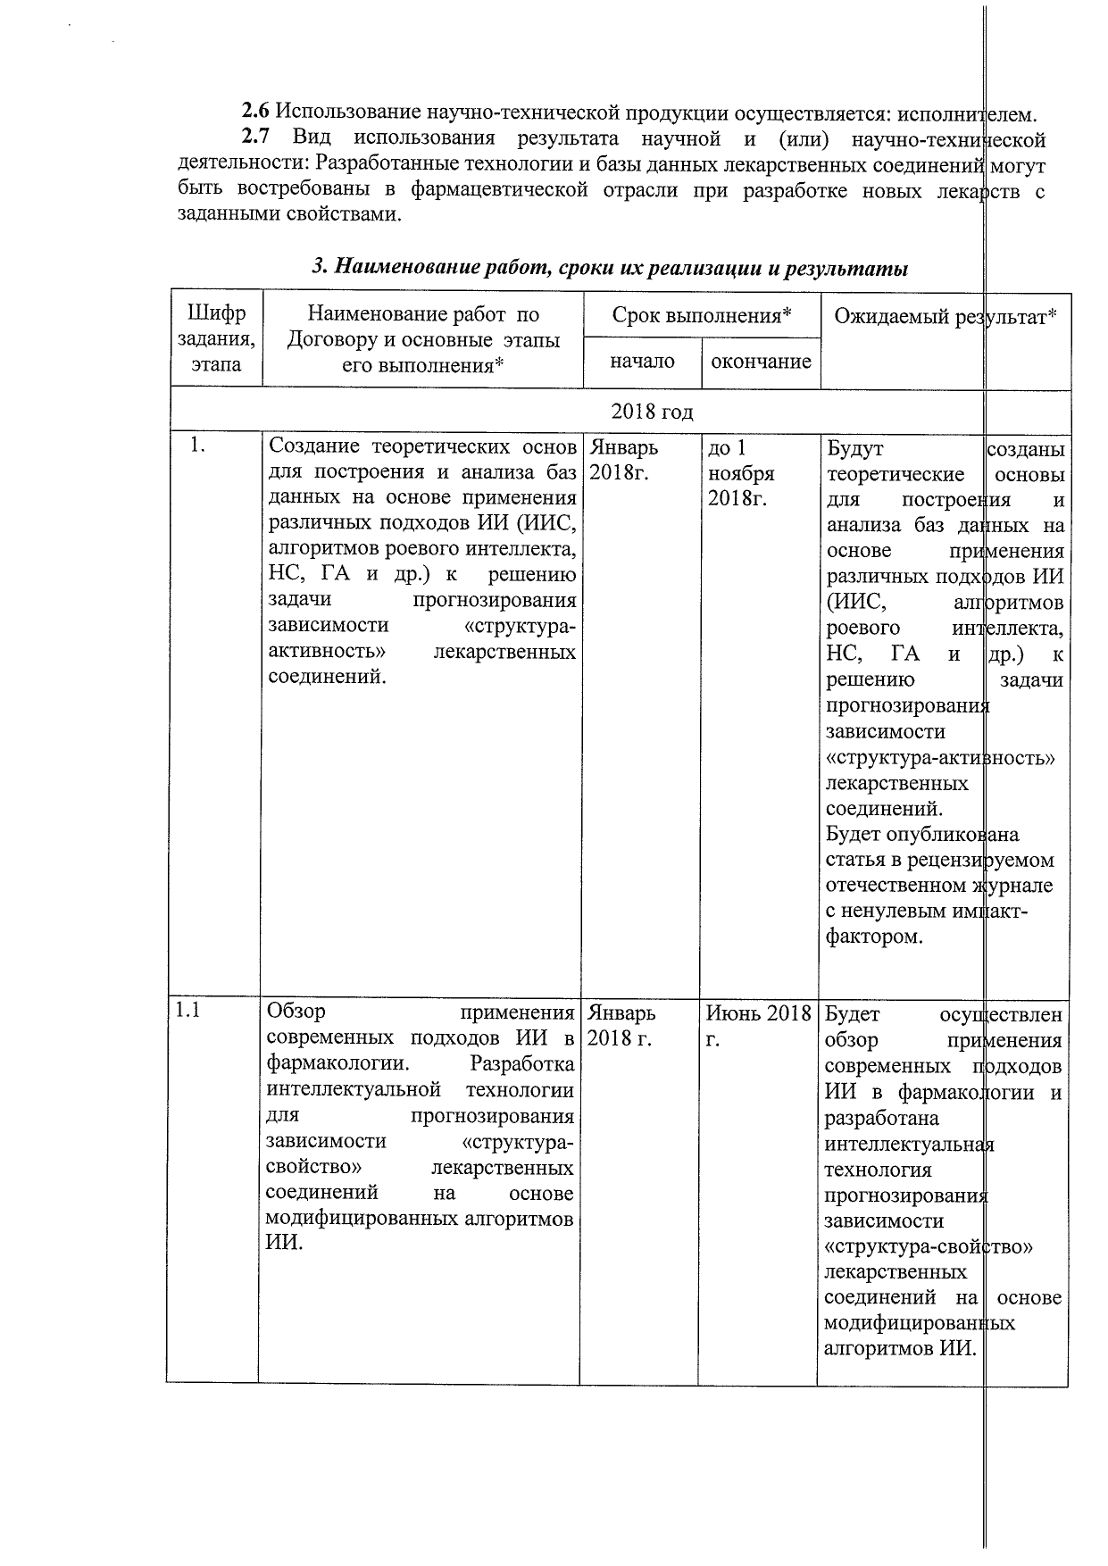

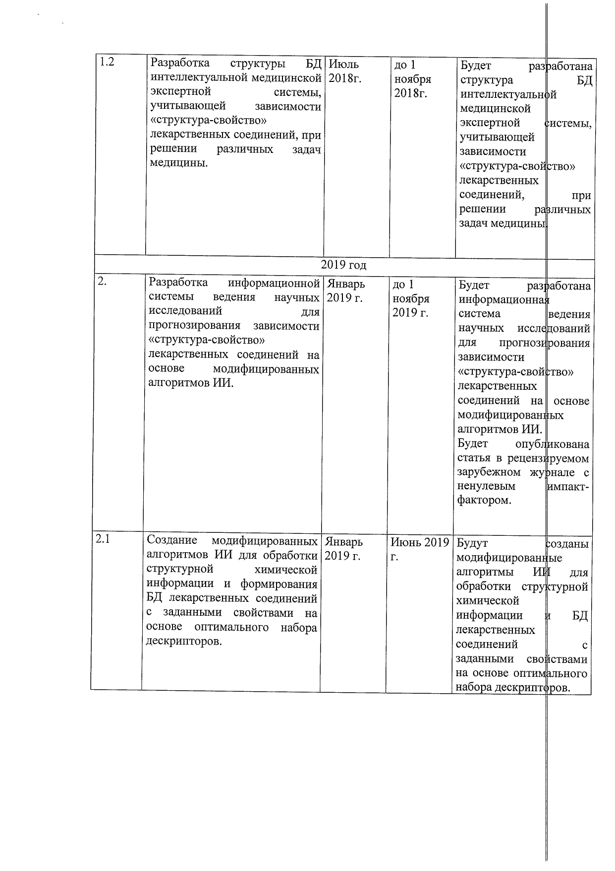

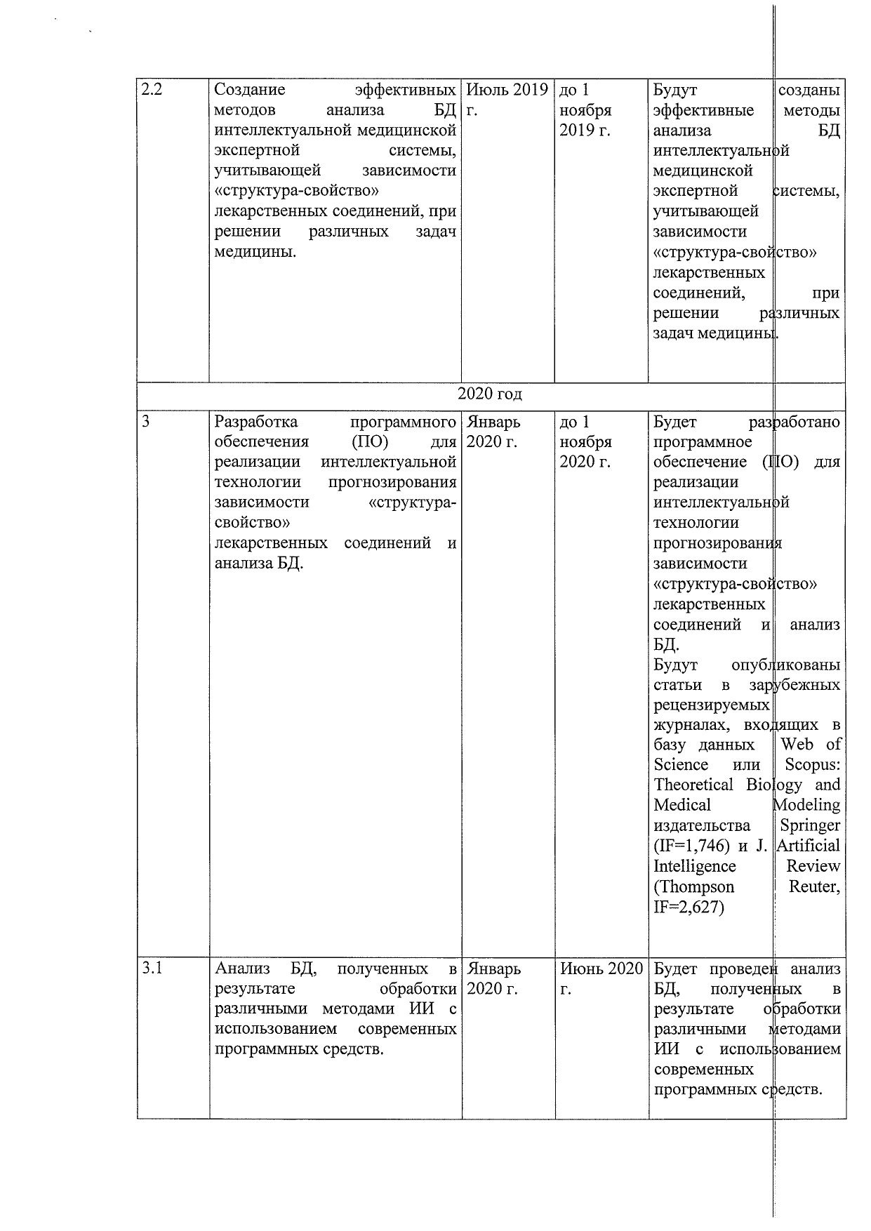
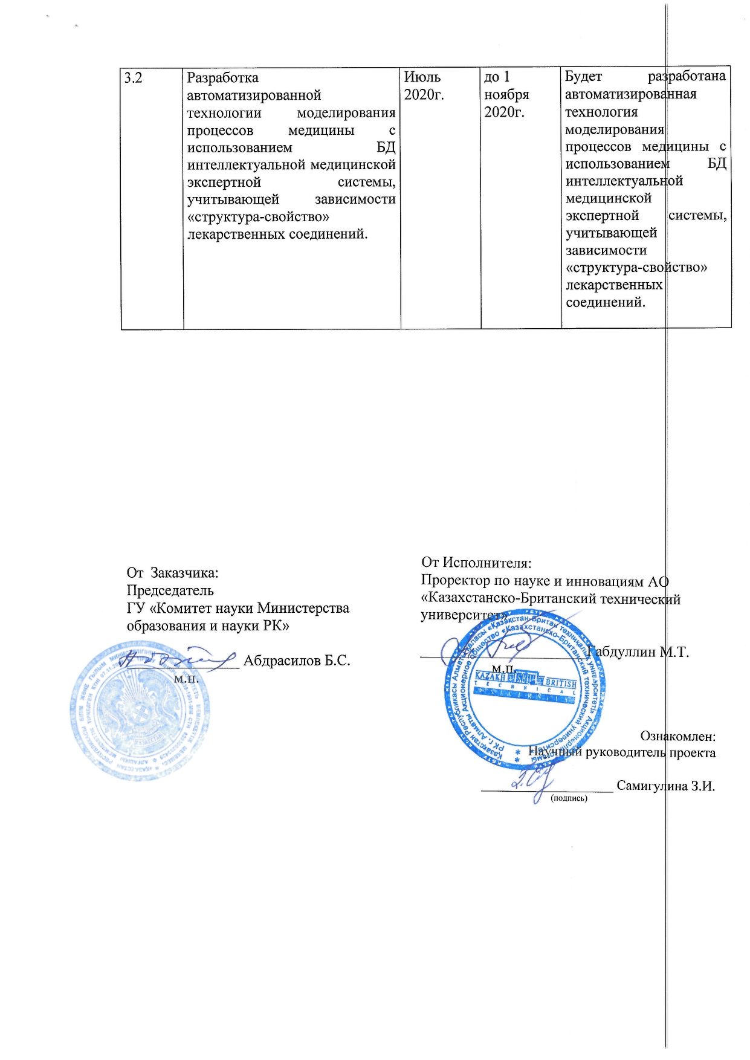

Information about changes to the calendar plan

Sending a letter to the Science Committee of MES RK with a request to remove from paragraph 3 the name of specific journals dated May 25, 2020. The request was approved.

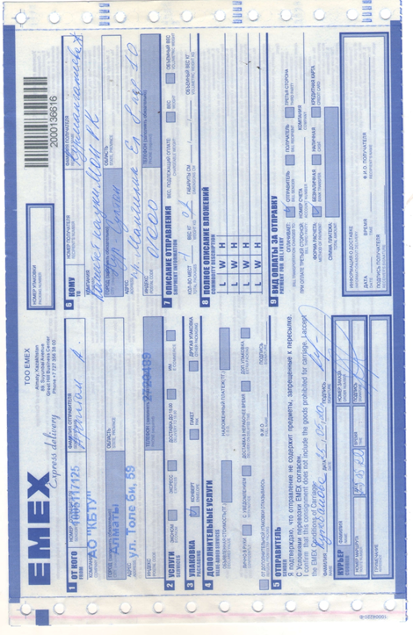



Amendments to the calendar plan

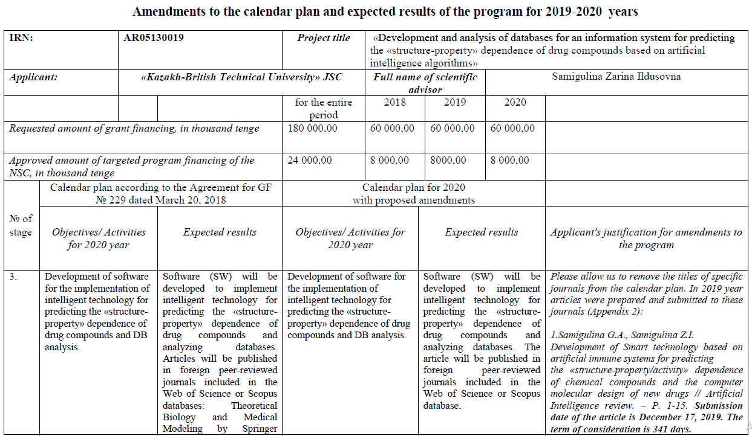
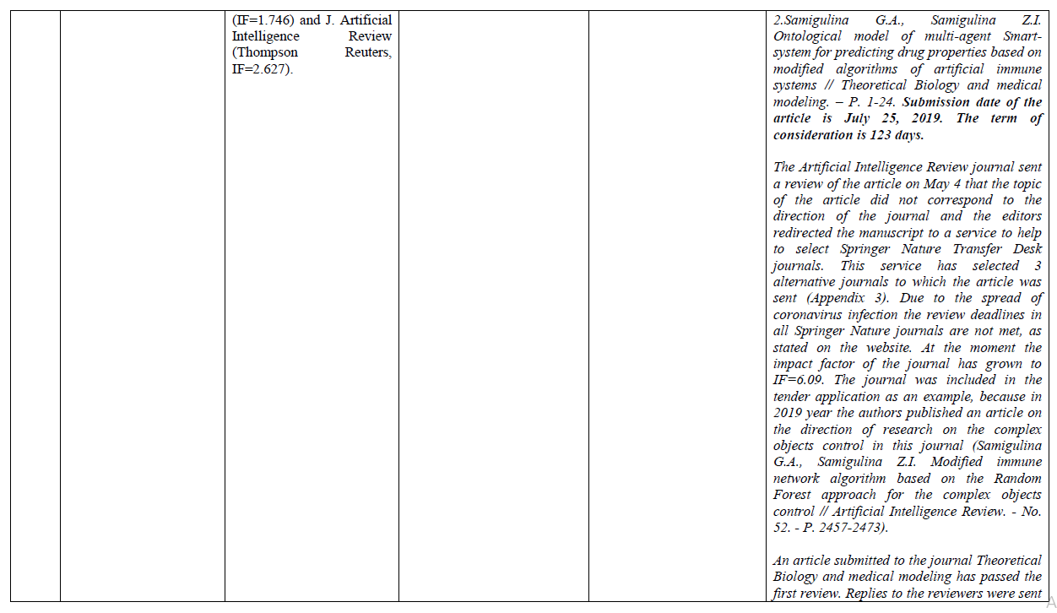
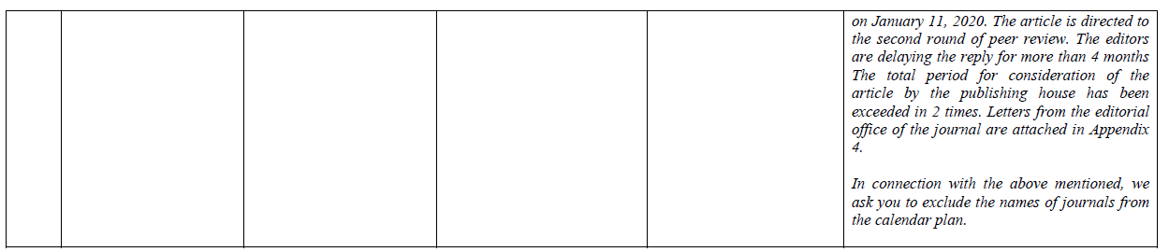

Extract №1 from the protocol of the meeting №7
of the National Scientific Council for the priority area
"Science of life and health" dated 23.09.2020 year

Positive decision on the project by Z.I. Samigulina on amendments to the calendar plan (remove the names of specific journals) is presented under №24.
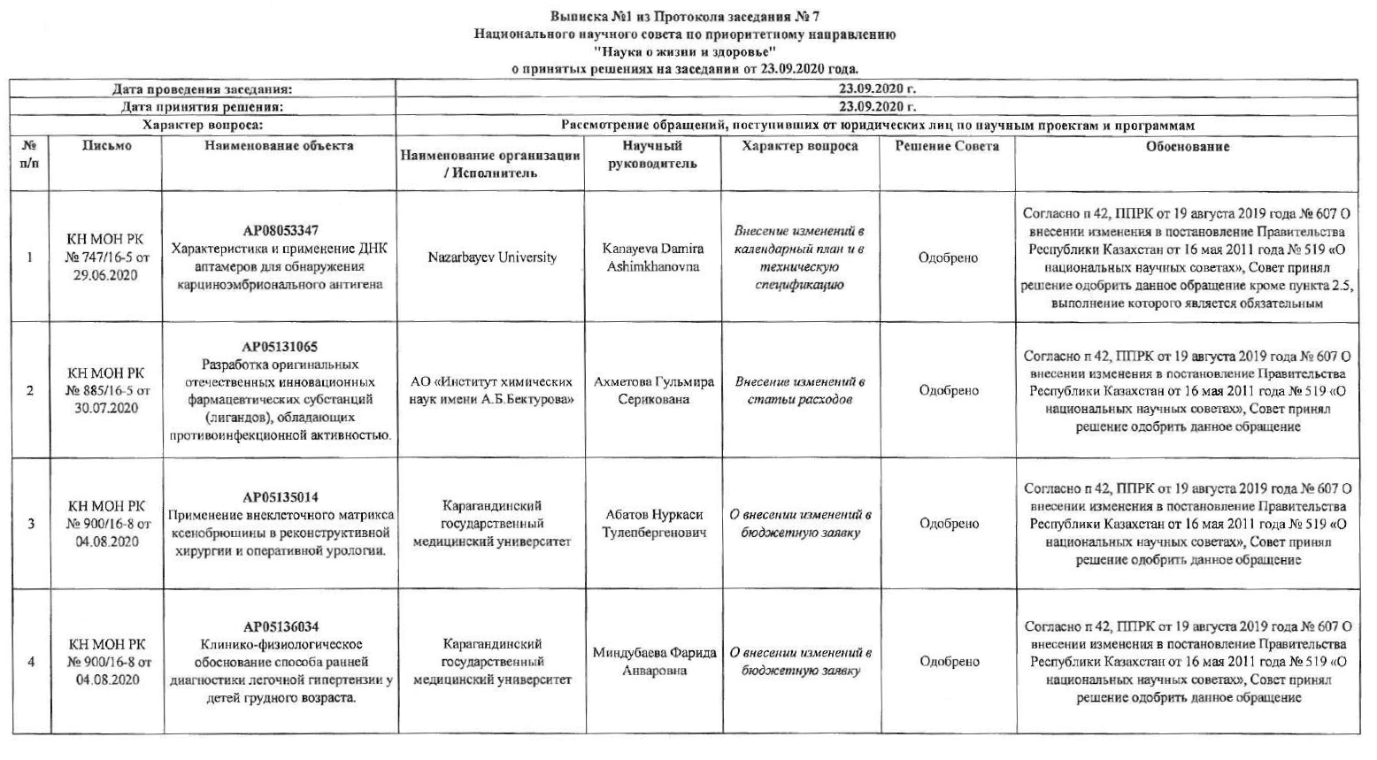
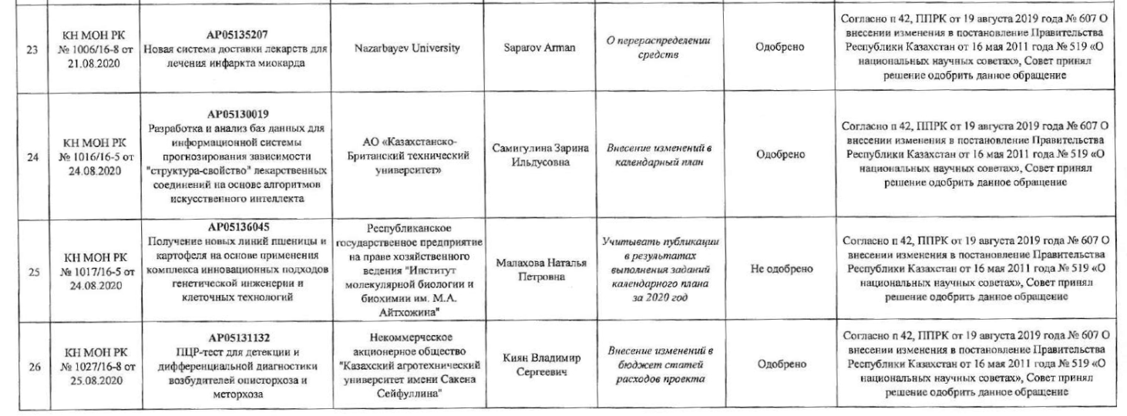

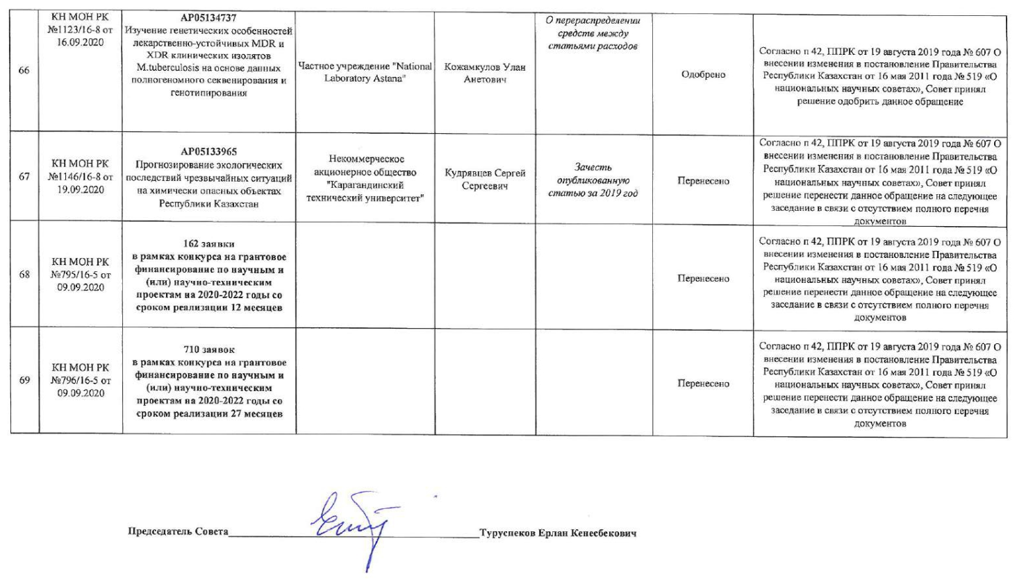

APPENDIX B

List of publications for 2020 year

Foreign:

1 Samigulina G.A., Samigulina Z.I. Ontological model of multi-agent Smart-system for predicting drug properties based on modified algorithms of artificial immune systems // Theoretical Biology and Medical Modelling. – BMC, 2020. - №17(12). – P.1-22. (IF WoS - 1.68; Cite Score Scopus – 3,1; SJR Scopus – 0,580; Q2; 64%).
2 Samigulina G.A., Samigulina Z.I. Machine learning for big data analysis in drug design // Proceeding of the Sixth International Conference on Machine Learning, Optimization and Data Science; J. Lecture notes in computer science. – Certosa di Pontignano, Siena – Tuscany, Italy, 2020. - Vol. 12514. – P. 1162-1174. (IF WoS – 1,17; Cite Score Scopus – 1,9; SJR Scopus – 0.427; Q2; 57%).
3 Samigulina G.A., Samigulina Z.I. Ontological model for risks assessment of the stages of a Smart-technology for predicting the «structure-property» dependence of drug compounds // 4th Computational Methods in Systems and Software. Advances in Intelligent Systems and Computing. – 2020. – P.1-12. (WoS ; Cite Score Scopus –0,9; SJR Scopus –0,18; Q3; 27%, accepted for publication).
4 Samigulina G.A., Samigulina Z.I. Development of a methodology for analyzing databases of drug descriptors based on the FMEA risk assessment model // Materials of the XVI International scientific and practical conference «Advanced Science-2020». - UK, Sheffield: Science and Education Ltd, 2020. - Issue 8. - P. 3-6. (In Russian).
5 Samigulina G.A., Samigulina Z.I. Assessment of the risks of predicting the «structure-property» dependence of sulfonamide group medicinal compounds based on the FMEA methodology // Materials of the XVI International scientific and practical conference «European science of the XXI century» - Poland, Przemysl: Nauka i studia, 2020. - Issue 3. - P. 50-53. (In Russian).
6 Samigulina G.A., Samigulina Z.I. Development of software using the multi-agent platform JADE for a Smart-system for prediction based on artificial immune systems // Bulletin of NTU «KhPI». - Kharkov, 2019. - №28(1353). - P. 84-92. DOI: 10.20998 / 2411-0558.2019.28.08. (IF RSCI - 0.129, not included in the report for 2019 year). (In Russian).
7 Samigulina G.A., Samigulina Z.I. Development of a knowledge base and software for a multi-agent Smart-system for prediction based on artificial immune systems // Materials of the XI All-Russian scientific and technical conference with international participation «Robotics and artificial intelligence». – Zheleznogorsk, 2019. - P. 133-137. (not included in the report for 2019 year). (In Russian).
8 Samigulina G.A., Samigulina Z.I. Development and analysis of databases for the intellectual system for predicting the structure-property dependence of drag compounds on the basis of artificial immune systems: Monograph. – Yelm, WA, USA: Science Book Publishing Ноuse, 2020. – 220 p. ISBN 978-1-62174-135-0. (In Russian).

Domestic:

9 Samigulina G.A., Samigulina Z.I. Development of software for the implementation of intelligent technology for predicting the «structure-property» dependence of drug compounds based on a modified algorithm of artificial immune systems // Problems of the evolution of open systems. - Almaty, 2020. - Vol. 1. - № 22 - P. 67-74. (IF KZ - 0.079). (In Russian).
10 Samigulina G.A., Samigulina Z.I. Development of a methodology for assessing the effectiveness of a Smart-technology for predicting the properties of drug compounds and analyzing databases using modern software // Bulletin of KBTU. - Almaty, 2020. –№3(54). - P. 173-179. (IF KZ - 0.047). (In Russian).
11 Samigulina G.A., Samigulina Z.I. Development of a knowledge base for the implementation of intelligent technology for predicting the «structure-property» dependence of drugs // Proceedings of the international scientific and practical conference "Satpayev readings-2020". - Almaty, 2020. - Vol. 2. - P. 409-413. (In Russian).
12 C.C. № 1280 «IES-analytics» (Intelligent Expert Systems - analytics) software - Intelligent expert system - analytics / Samigulina G.A., Samigulina Z.I., Samigulin T.I.; publ. 10/25/2020. (In Russian).

List of publications for 2019 year

- Samigulina G.A., Samigulina Z.I., Samigulina T.I. Development of smart-technology for prediction drug properties based on modified algorithms of artificial immune systems and ontological models // Proceeding of the 7th International Work-Conference on Bioinformatics and Biomedical Engineering. – Granada, 2019. – P. 1-2.
- Samigulina G.A., Samigulina Z.I. Information system for molecular design of drug compounds based on a model-based approach // Bulletin of KhPI. - Kharkov, 2019. - №13 (1338). - P. 176-187. (IF RSCI - 0.129). (In Russian).
- Samigulina G.A., Samigulina Z.I. Information system for conducting scientific research on the basis of a model-oriented approach and a modified algorithm of artificial immune systems for computer molecular design of new drugs // Bulletin of KazNRTU. - Almaty, 2019. - № 3(133). - P. 130-135. (IF KZ - 0.045). (In Russian).
- Samigulina Z.I., Rakhmetzhanov M., Samigulina G.A. Prediction of the «structure-property» dependence of sulfonamide drug compounds based on the recognition algorithm by the artificial immune system. Bulletin of the NRA RK. - 2019. - № 2. - P. 48-53. (IF KZ-0.142). (In Russian).
- Samigulina G.A., Masimkanova Zh. Development of a modified algorithm based on the cooperative algorithm of a particle swarm, artificial immune systems and an ontological approach // Problems of the evolution of open systems. - Almaty, 2019. - Vol. 1. - № 21. - P. 85-89. (IF KZ - 0.079). (In Russian).
- Samigulina G.A., Samigulina Z.I. Ontological models for a multi-agent Smart-system for predicting the properties of drugs based on modified algorithms of artificial immune systems. Proceedings of Satpayev readings «Innovative technologies - the key to successfully solution of fundamental and applied problems in the ore and oil and gas sectors of the economy of the RK.» - Almaty, 2019. - V. II. - P. 343-345. (In Russian).
- Samigulina G.A., Samigulina Z.I. Development of an ontological multi-agent model for an information medical expert system that takes into account the «structure-property» dependence of drug compounds // International scientific readings (in memory of V.V. Petrov): collection of articles of an international scientific and practical conference. - Moscow: EFIR, 2019 .-- P. 17-19. (In Russian).
- Samigulina G.A., Samigulina Z.I. Information system for conducting scientific research for predicting the «structure-property» dependence of drug compounds based on modified algorithms of artificial immune systems // Problems of informatics. - 2019. - №3(44). - P. 31-46. (IF RSCI - 0.182). (In Russian).
- Samigulina G.A., Samigulina Z.I. Multi-agent Smart-system for predicting the properties of drugs based on a model-oriented approach and modified algorithms for artificial immune systems // Abstracts of the XXVII International scientific and practical conference «Information technologies: science, engineering, technology, education, health» (MicroCAD-2019). - Kharkiv, May 15-17, 2019 .-- P.190. (In Russian).
- Samigulina G.A., Masimkanova Zh.A. Modified cooperative particle swarm algorithm for molecular drug design // Collection of articles on the results of the International scientific - practical conference «Science intensive technologies and intelligent systems». - Samara, November 23, 2018 .-- P. 64-68. (In Russian).
- Samigulina G.A., Samigulina Z.I. Development of modified artificial intelligence algorithms for processing structural chemical information // Proceedings of the IX All-Russian scientific and technical conference with international participation in «Robotics and artificial intelligence». - Zheleznogorsk, 2018 .-- P. 124-128. (In Russian).

List of publications for 2018 year

- Samigulina G.A., Samigulina Z.I. Development of multi-agent technology for prediction of the «structure-property» dependence of drugs on the basis of modified algorithms of artificial immune systems // Proceeding of the International Work Conference on Bioinformatics and Biomedical Engineering. – Spain, Granada, 2018. – P. 1-2.
- Samigulina G.А., Massimkanova Zh.A. Construction of optimal immune network model based on swarm intelligence algorithms for computer design of new drugs // Proceeding of the VII International Conference «Optimization problems and their applications. – Omsk, 2018. – P. 349-358. (Scopus).
- Samigulina G.A., Samigulina Z.I. Development of a database structure for an intelligent medical expert system, that takes into account the «structure-property» dependence of drug compounds // Materials of the twentieth all-russian seminar «Modeling of unequal systems – 2018». - Krasnoyarsk, 2018 .-- P.74-79. (In Russian).
- Samigulina G.A., Masimkanova Zh.A. Creation of an optimal immune network model based on a modified particle swarm algorithm. Bulletin of KazNU named after Al-Farabi. - Almaty, 2018. - №2 (98). - P. 20-28. (In Russian).
- Samigulina G.A., Samigulina Z.I. Development and analysis of descriptors databases for computer molecular design of drug compounds based on the use of various approaches of artificial intelligence // Proceedings of the XIV International scientific and practical conference «Days of Science». - Czech Republic: Prague, 2018. - Issue 6. - P. 62-64. (In Russian).
- Samigulina G.A., Samigulina Z.I. Development of a modified algorithm for immune network modeling for computer molecular design of new drug compounds based on the grey wolves optimization algorithm // Materials of the XIII International science and Practical conference «Science without borders». - UK, England: Sheffield science and education LTD, 2018. - Vol.10. - P. 63-65. (In Russian).
- Samigulina Z.I., Konovalov S., Samigulina G.A. Analysis of descriptors databases of chemical compounds for predicting the «structure-property» dependence of drug compounds based on the genetic algorithm in the RSTUDIO programming environment. Bulletin of KBTU. - Almaty, 2018. - V.15. - №4. - P. 35-42. (In Russian).
- Samigulina G.A., Samigulina Z.I. Modified artificial intelligence algorithms for the creation of drugs // Information technologies in science, education and management. - Krasnoyarsk, 2018. - №5(9). - P.52-56. (IF RSCI - 0.966). (In Russian).
- Samigulina G.A., Masimkanova Zh.A. Information system for conducting scientific research based on the particle swarm method and the approach of artificial immune systems // Proceedings of the XVIII International conference «Informatics: problems, methodology, technologies». - Voronezh, 2018. http: //ipmt-conf.ru/open/program: 10.08.2018. (In Russian).
- Samigulina G.А., Massimkanova Zh.A. Computer modeling of new drugs based on the methods of swarm intelligence and immune network modeling // Bulletin of NTU «KhPI». Series «Informatics and modeling». - Kharkiv, 2017. - № 50 (1271). - P. 88-94. (IF RSCI - 0.129, not included in the report for 2017 year). (In Russian).
- Samigulina G.A., Samigulina Z.I. Application of modern Datamining methods for predicting the «structure/property» dependence of sulfonamide chemical compounds // Problems of the evolution of open systems. - Almaty-Krasnoyarsk, 2017. - Issue 19, Vol. 2. - P. 99-107. (IF KZ - 0.079, not included in the report for 2017 year). (In Russian).
- C.c. №3191 "SIIM" (Swarm Intelligence for Immune network Modeling) software - Swarm Intelligence for Immune Network Modeling / Samigulina G.A., Masimkanova Zh.A.; publ. 25.12.2017

APPENDIX C

Reprints of publications for 2020 year

1 Samigulina G.A., Samigulina Z.I. Ontological model of multi-agent Smart-system for predicting drug properties based on modified algorithms of artificial immune systems // Theoretical Biology and Medical Modelling. – BMC, 2020. -17(12). – P.1-22. (IF WoS - 1.68; Cite Score Scopus – 3,1; SJR Scopus – 0,580; Q2; 64%).

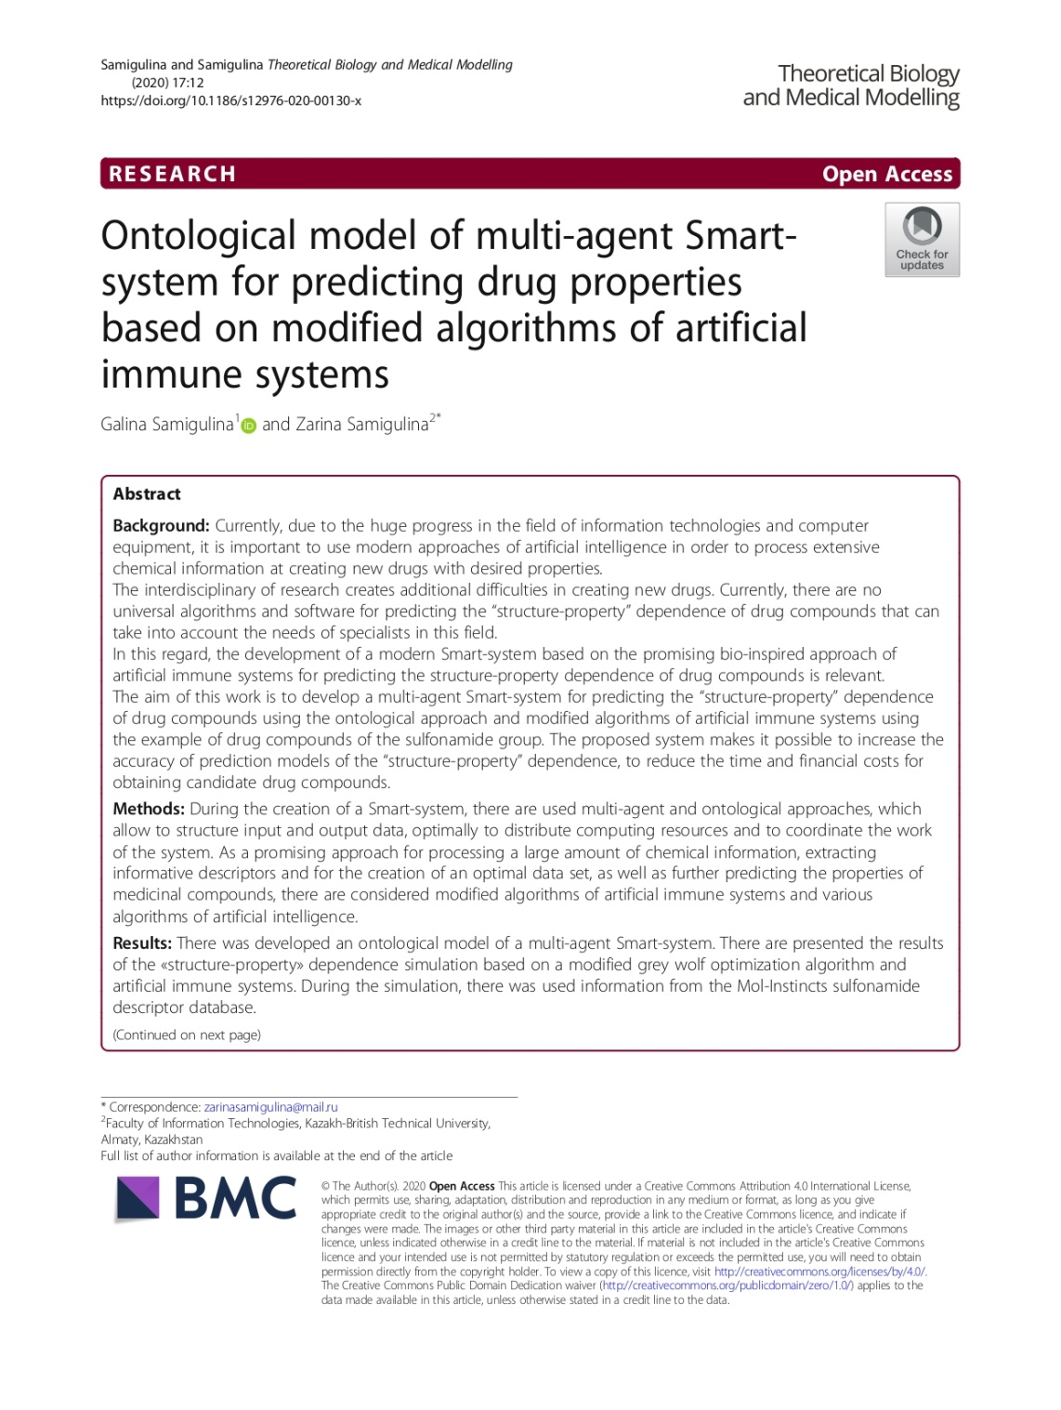

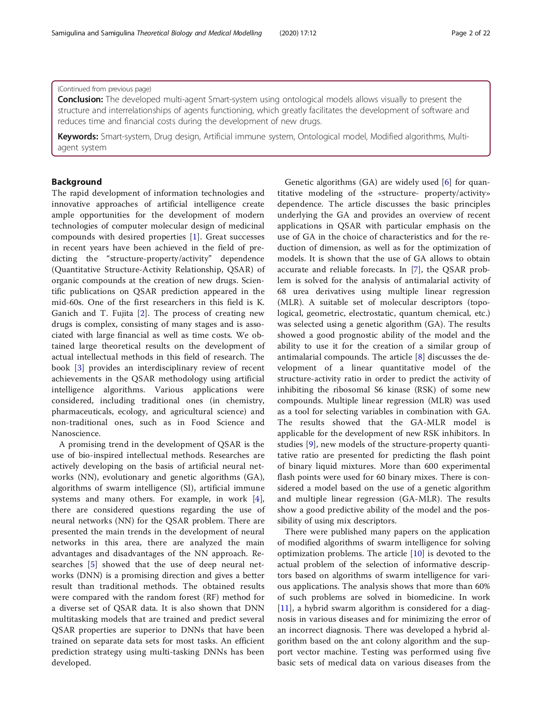

2 Samigulina G.A., Samigulina Z.I. Machine learning for big data analysis in drug design // Proceeding of the Sixth International Conference on Machine Learning, Optimization and Data Science; J. Lecture notes in computer science. – Certosa di Pontignano, Siena – Tuscany, Italy, 2020. - Vol. 12514. – P. 1162-1174. (IF WoS – 1,17; Cite Score Scopus – 1,9; SJR Scopus – 0.427; Q2; 57%).
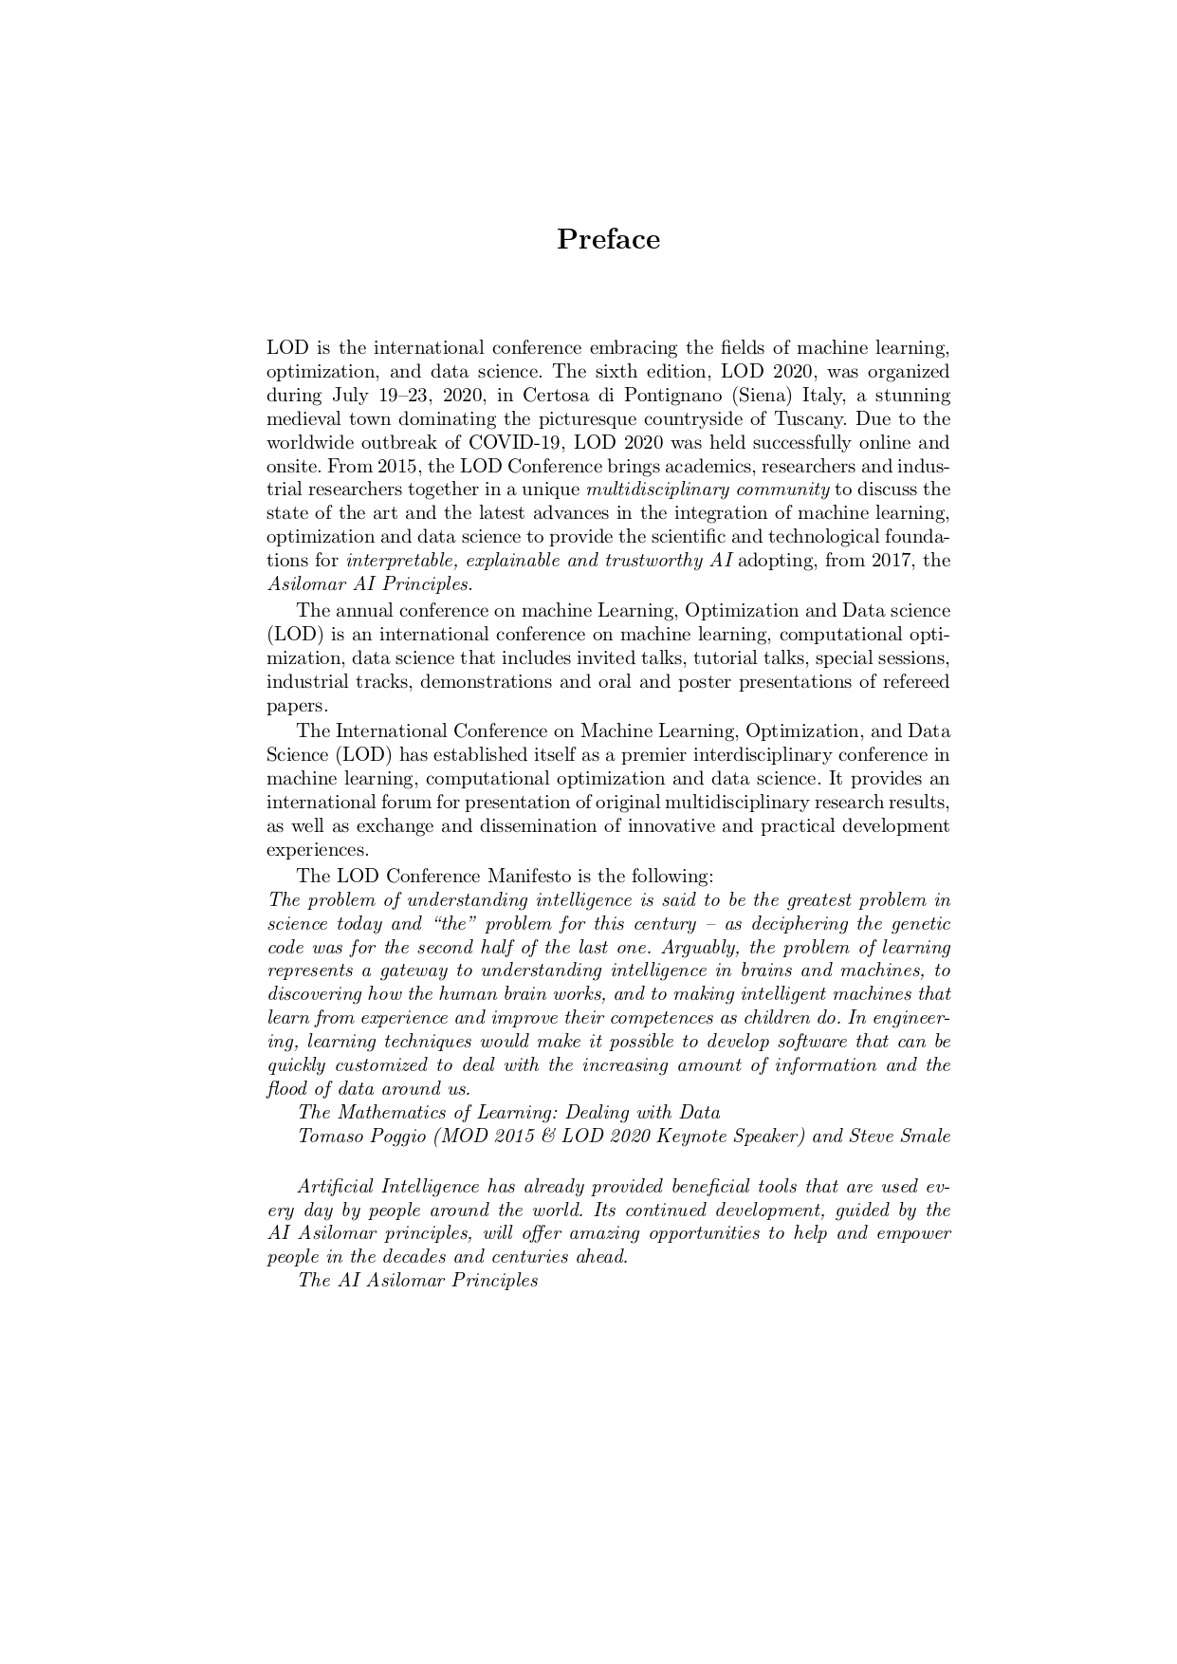



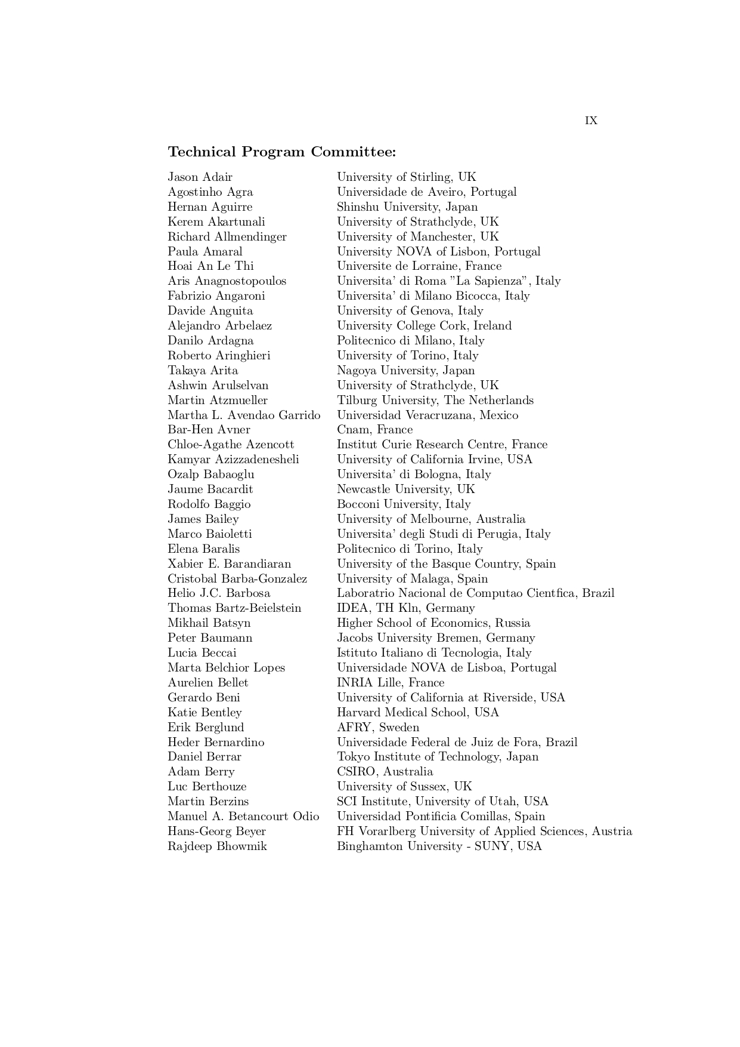
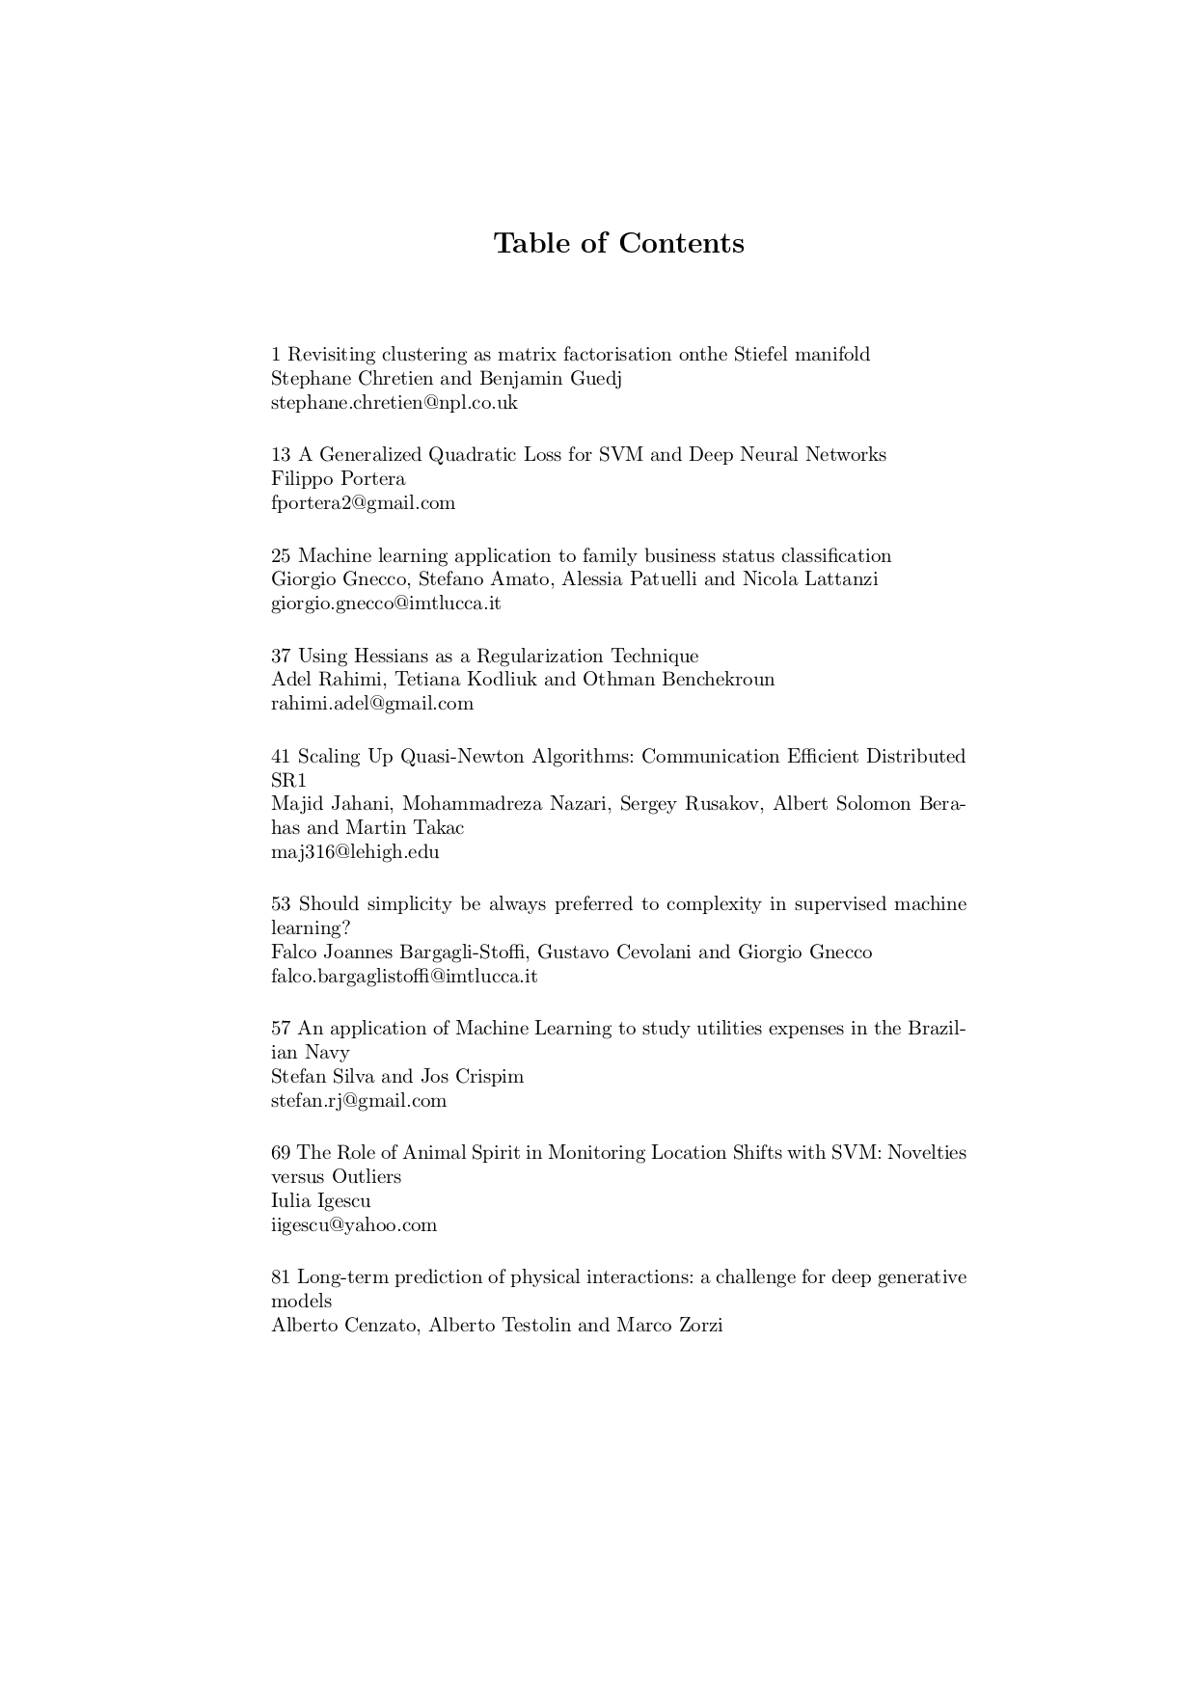

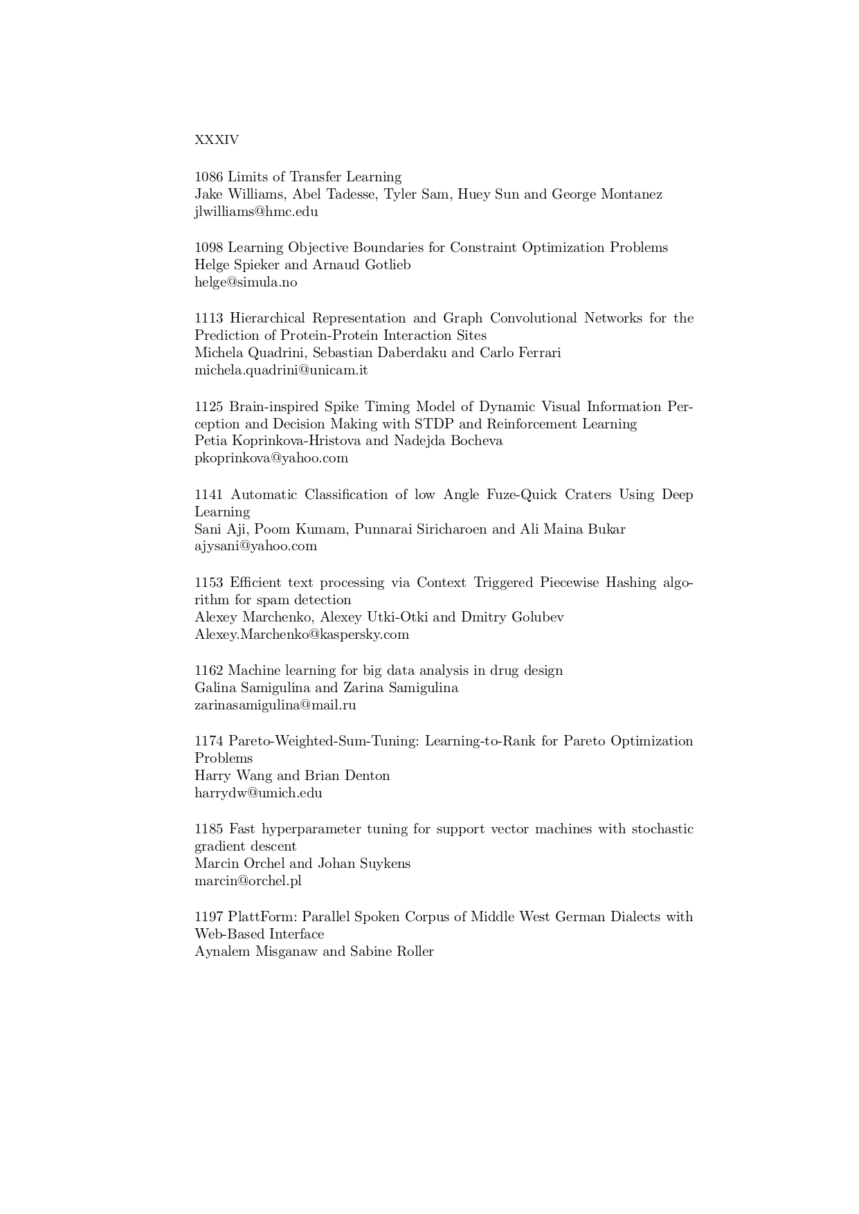

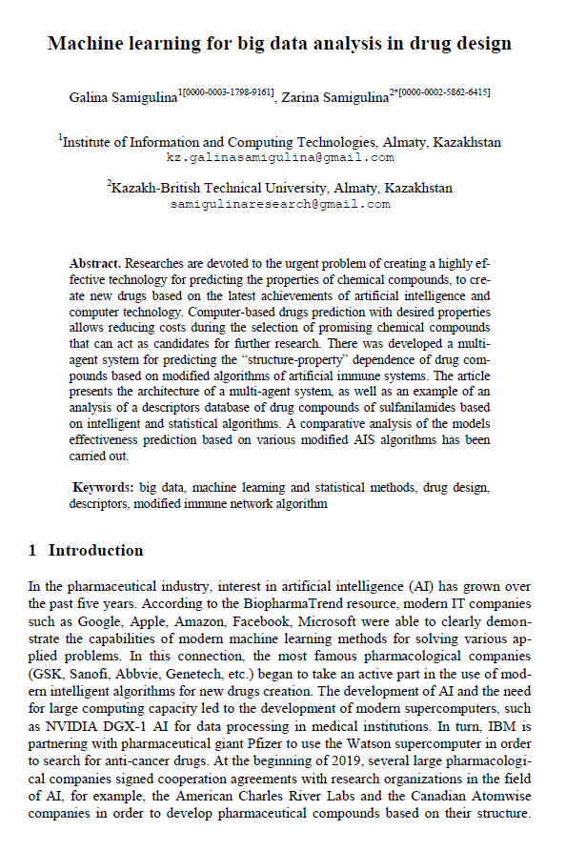

3 Samigulina G.A., Samigulina Z.I. Ontological model for risks assessment of the stages of a Smart-technology for predicting the «structure-property» dependence of drug compounds // 4th Computational Methods in Systems and Software. Advances in Intelligent Systems and Computing. – 2020. – P.1-12. (IF WoS – 0,57; Cite Score Scopus –0,9; SJR Scopus –0,18; Q3; 27%, accepted for publication).
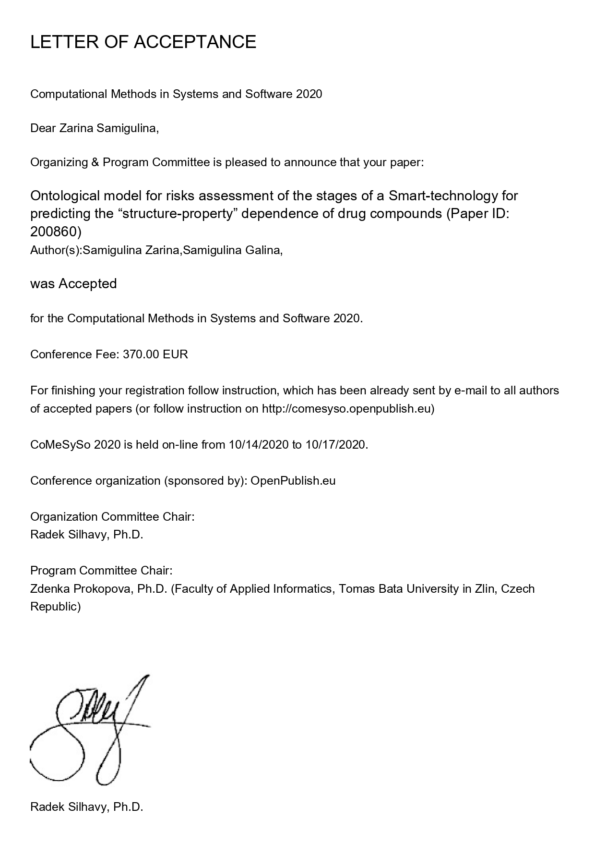

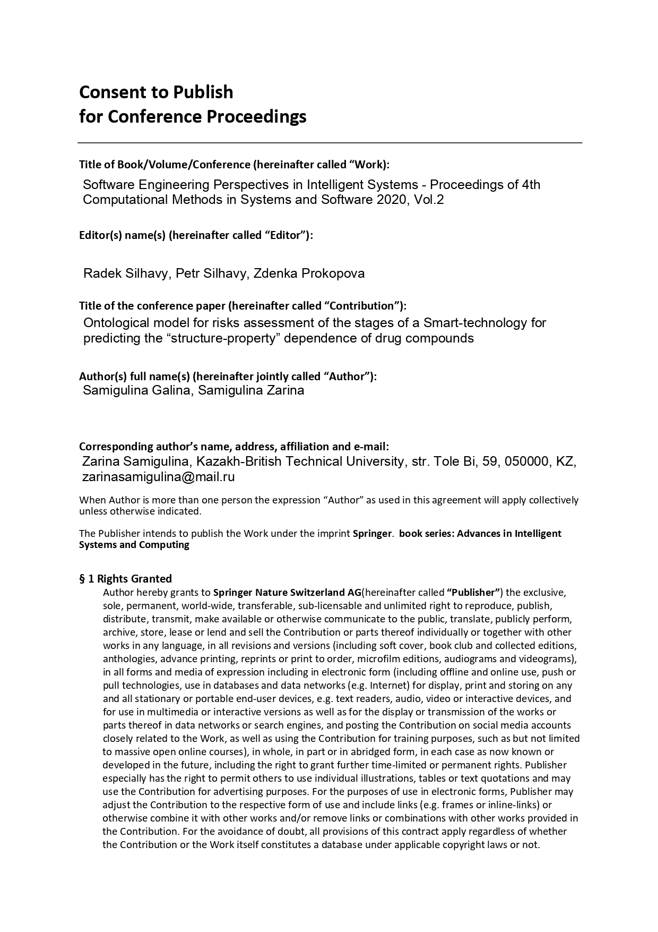

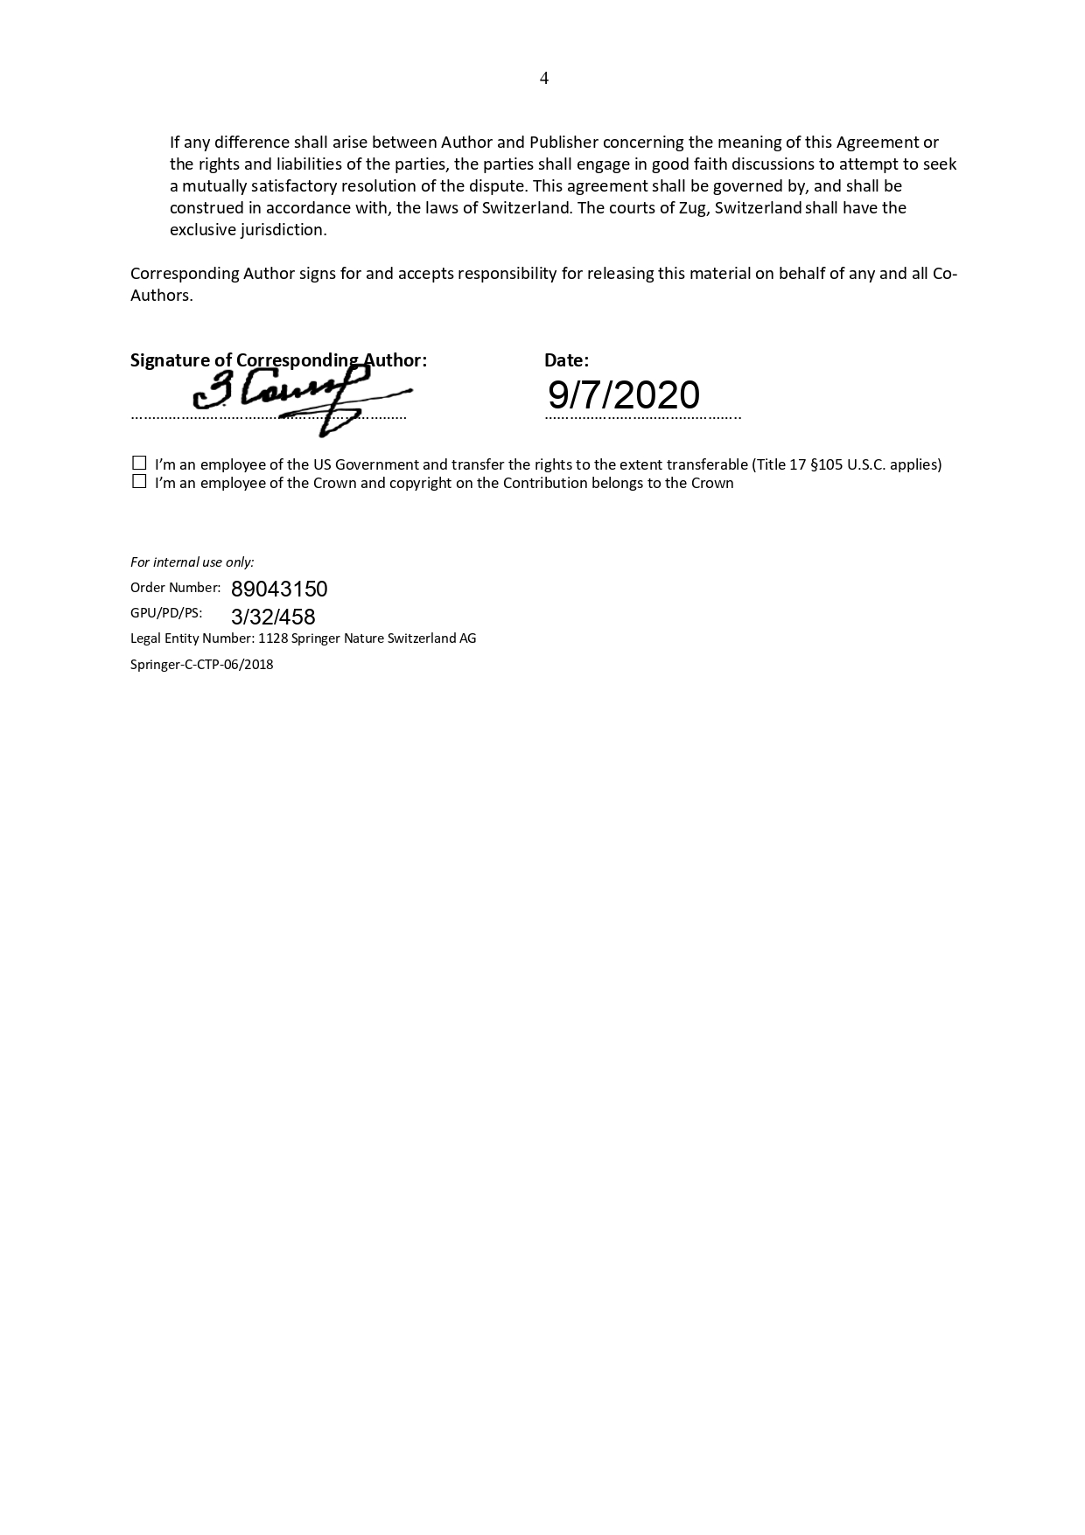

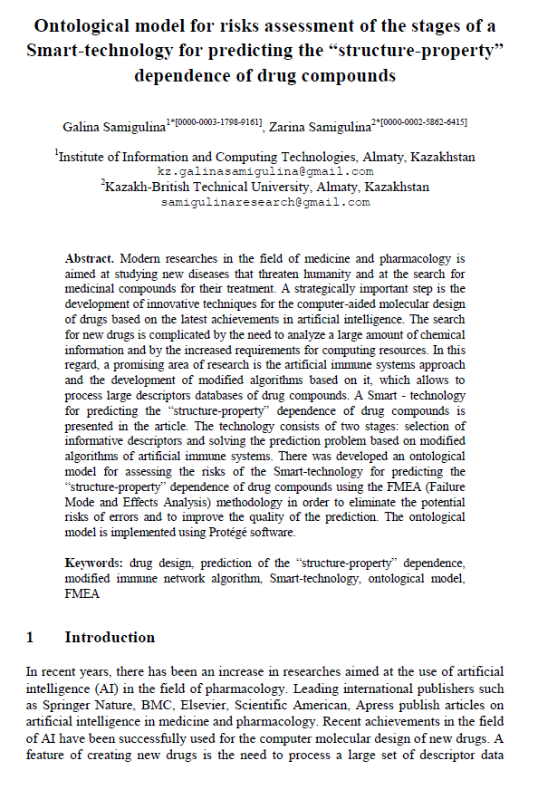

- Samigulina G.A., Samigulina Z.I. Development of a methodology for analyzing drug descriptors databases based on the FMEA risk assessment model // Materials of the XVI International scientific and practical conference «Advanced Science-2020». - UK, Sheffield: Science and Education Ltd, 2020. - Issue 8. - P. 3-6.





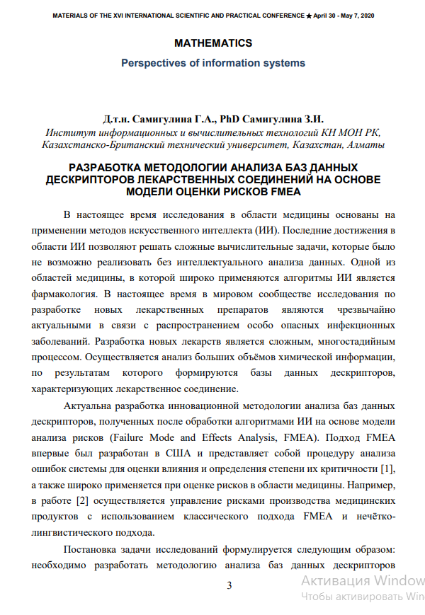

5 Samigulina G.A., Samigulina Z.I. Risks assessment for predicting the «structure-property» dependence of sulfonamide group drug compounds based on the FMEA methodology // Materials of the XVI International scientific and practical conference «European science of the XXI Ccentury» - Poland, Przemysl: Nauka i studia, 2020. - Issue 3. - P. 50-53.


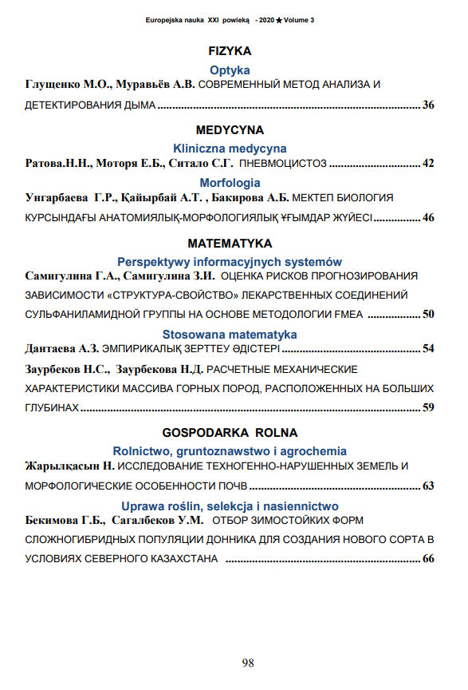
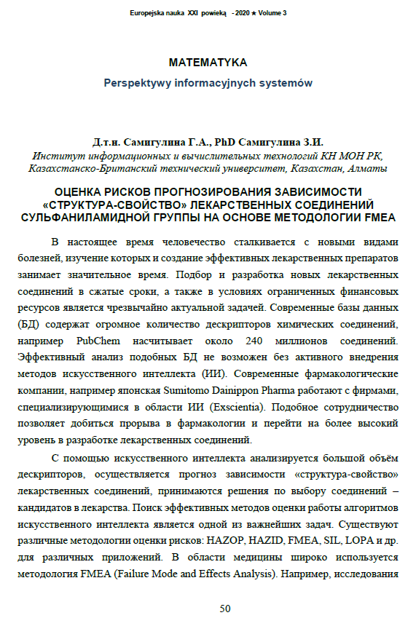

6 Samigulina G.A., Samigulina Z.I. Development of software using the multi-agent platform JADE for a Smart-system for prediction based on artificial immune systems // Bulletin of NTU «KhPI». - Kharkov, 2019. - №28(1353). - P. 84-92. DOI: 10.20998 / 2411-0558.2019.28.08. (not included in the report for 2019 year)
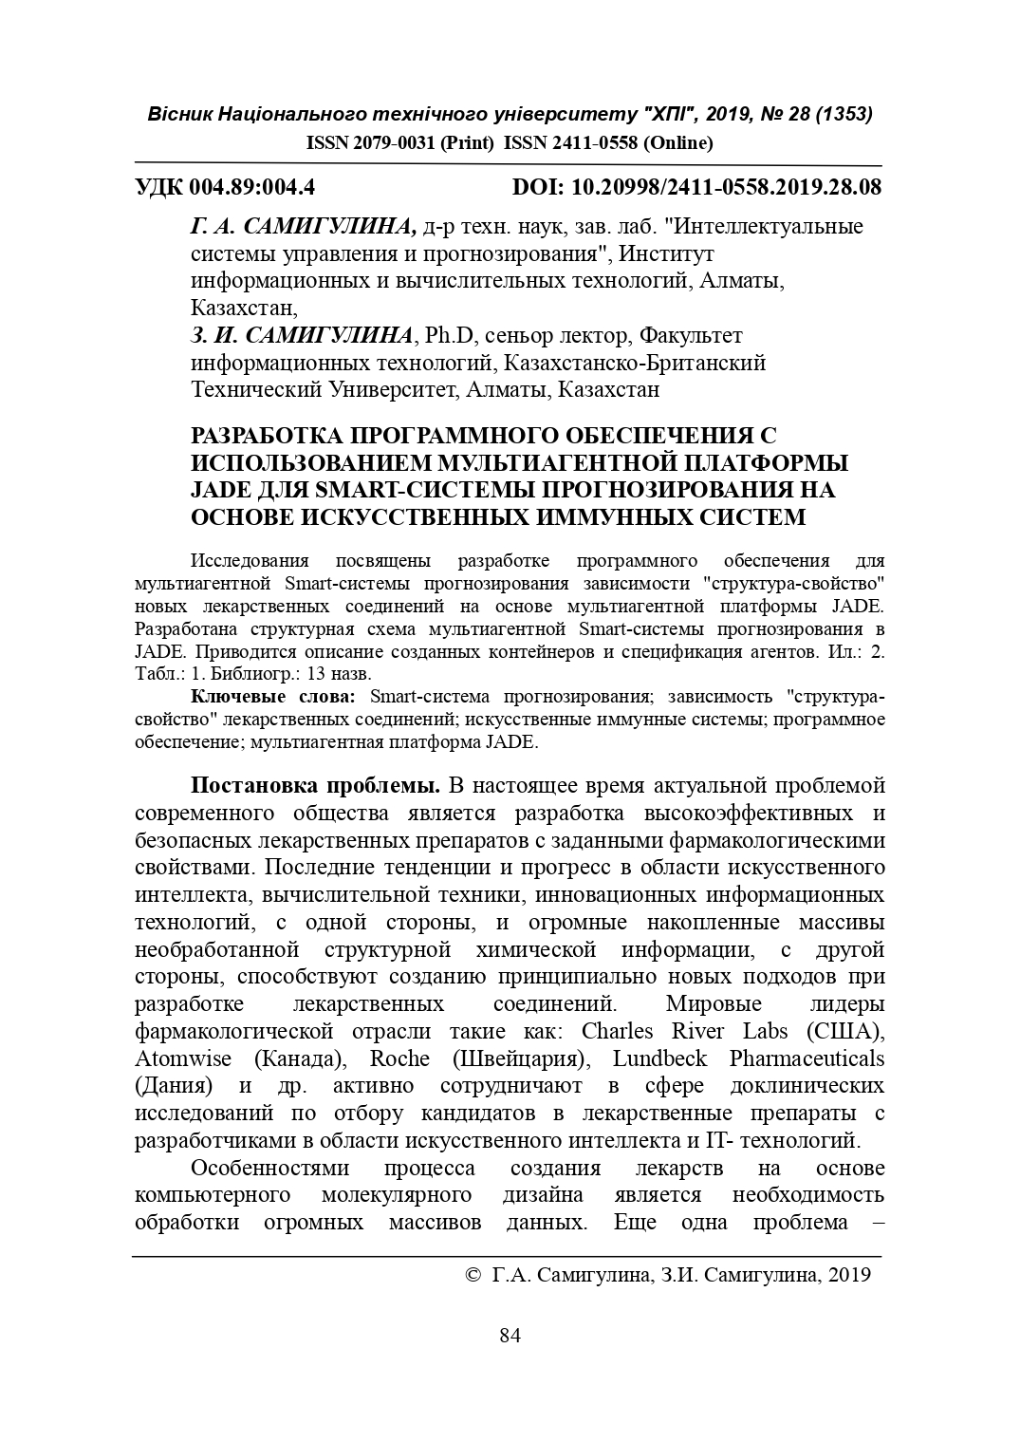

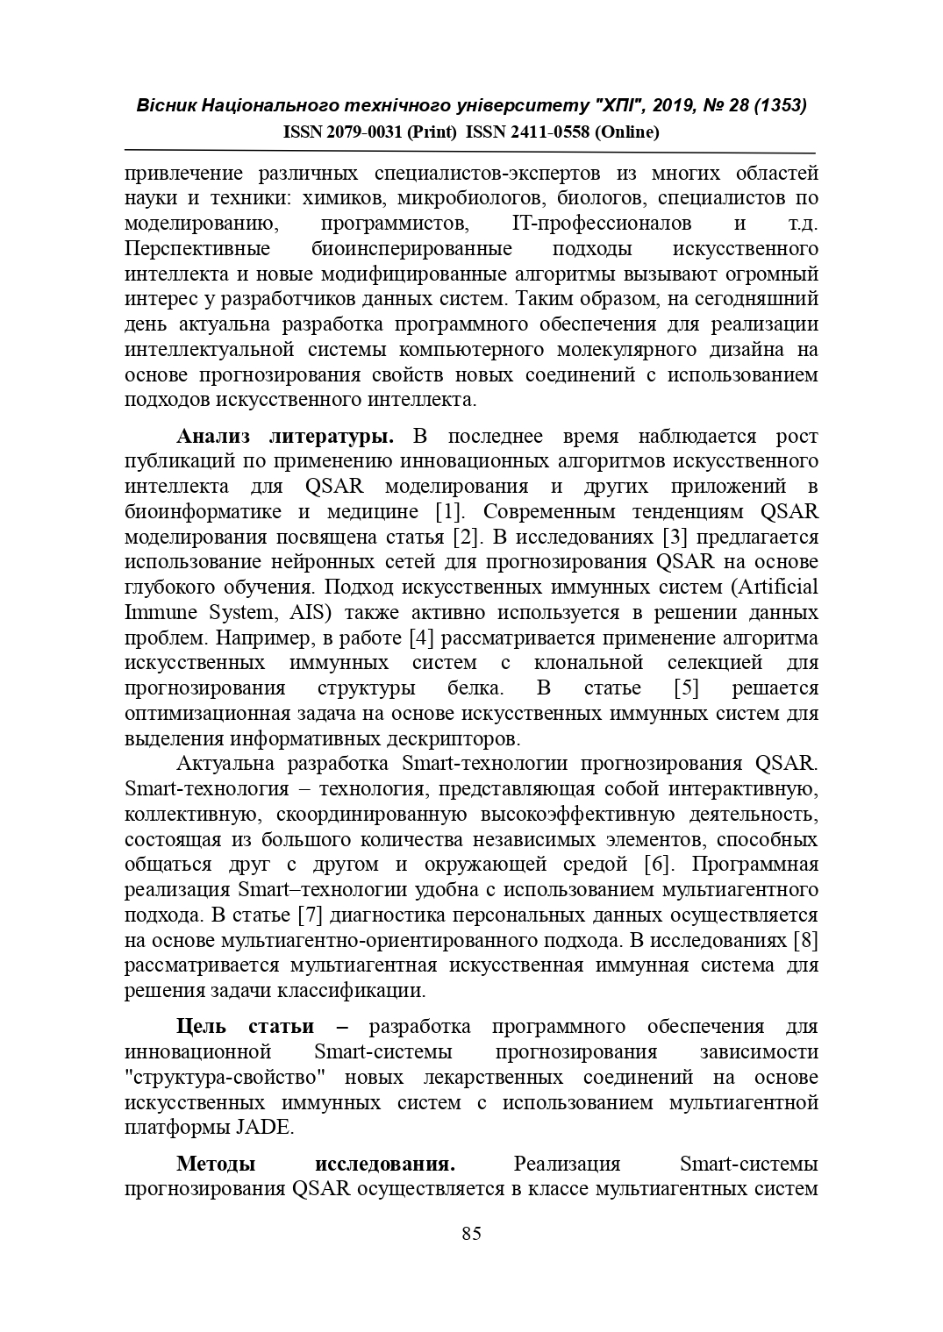

7 Samigulina G.A., Samigulina Z.I. Development of a knowledge base and software for a multi-agent Smart-system for prediction based on artificial immune systems // Materials of the XI All-russian scientific and technical conference with international participation «Robotics and artificial intelligence». –Zheleznogorsk, December 14, 2019. - P. 133-137. (not included in the report for 2019 year)


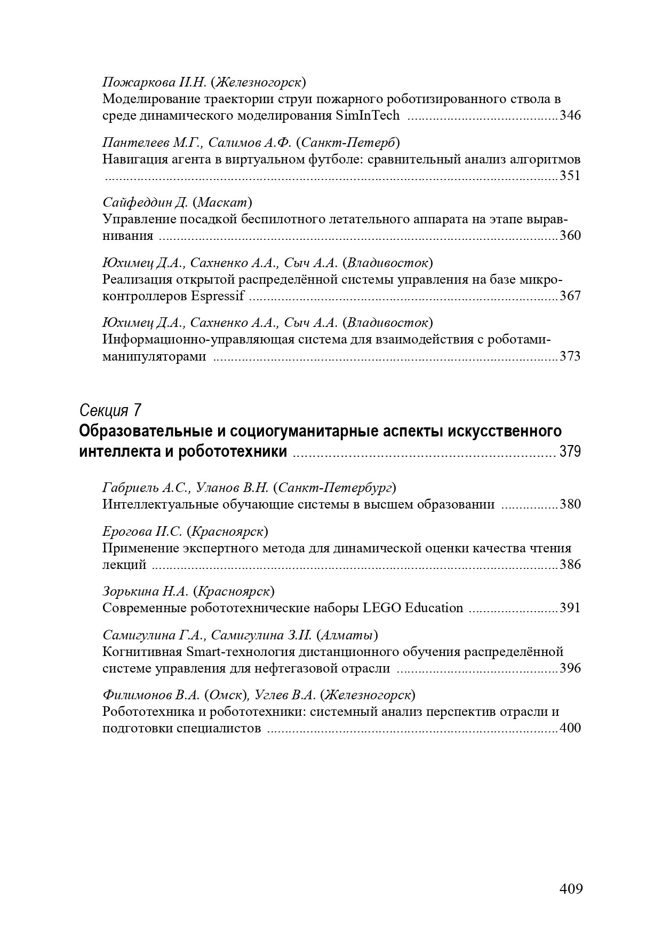



- Samigulina G.A., Samigulina Z.I. Development and analysis of databases for the intellectual system for predicting the structure-property dependence of drag compounds on the basis of artificial immune systems: Monograph. – Yelm, WA, USA: Science Book Publishing Ноuse, 2020. – 254 p. ISBN 978-1-62174-135-0.


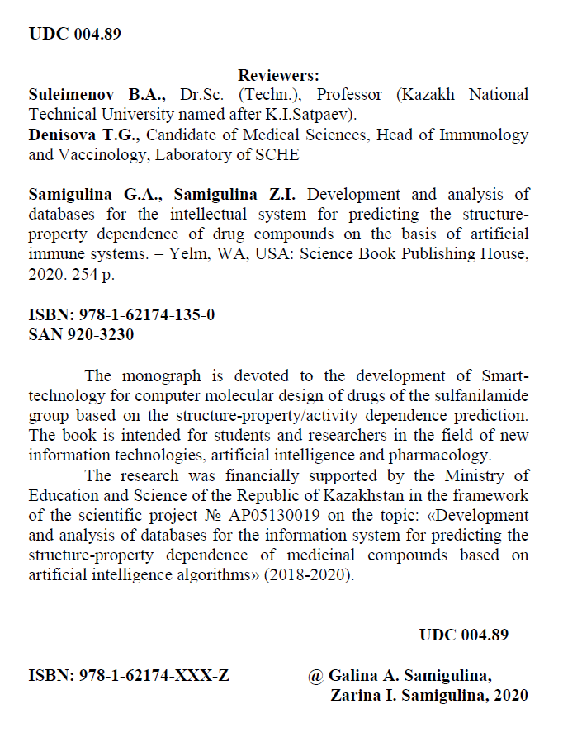

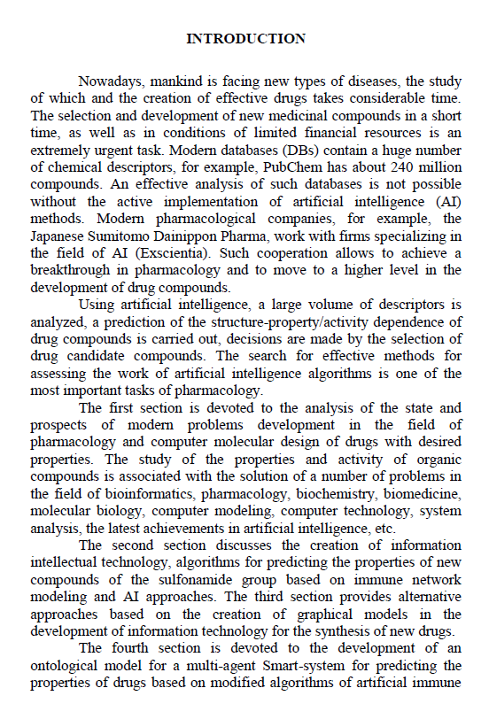

9 Samigulina G.A., Samigulina Z.I. Development of software for the implementation of an intelligent technology for predicting the «structure-property» dependence of drug compounds based on a modified algorithm of artificial immune systems // Problems of the evolution of open systems. - Almaty, 2020. - Vol. 1. –№22. - P. 67-74. (IF KZ - 0.079).
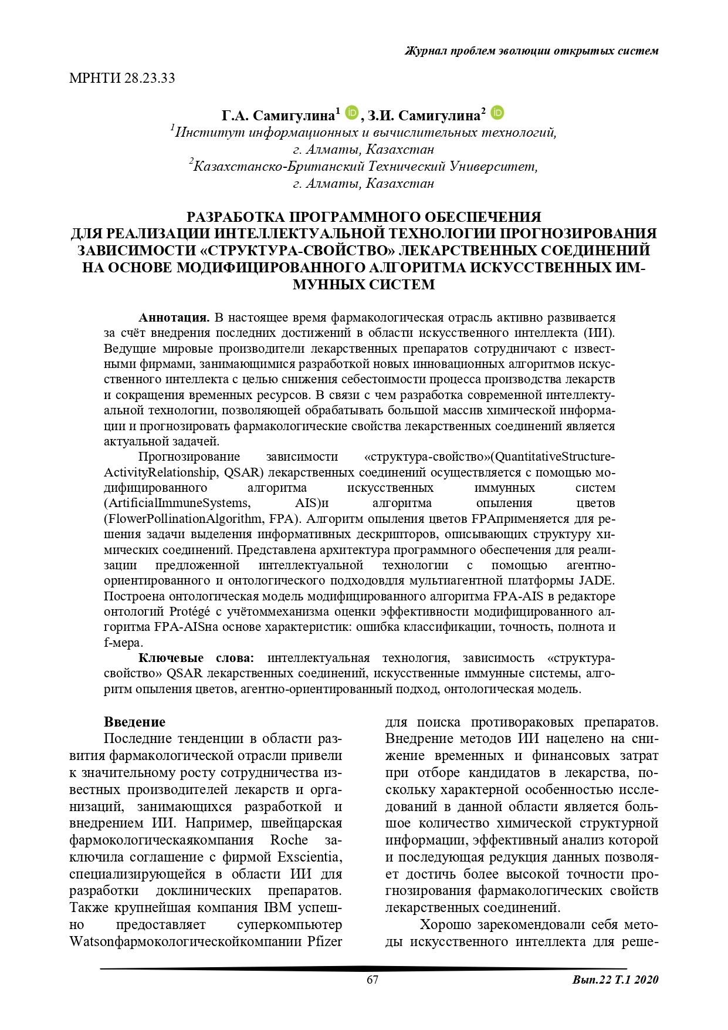

10 Samigulina G.A., Samigulina Z.I. Development of a methodology for assessing the effectiveness of a Smart-technology for predicting the properties of drug compounds and analyzing databases using modern software // Bulletin of KBTU. - Almaty, 2020. - №3. - P. 173-180. (IF KZ - 0.047).


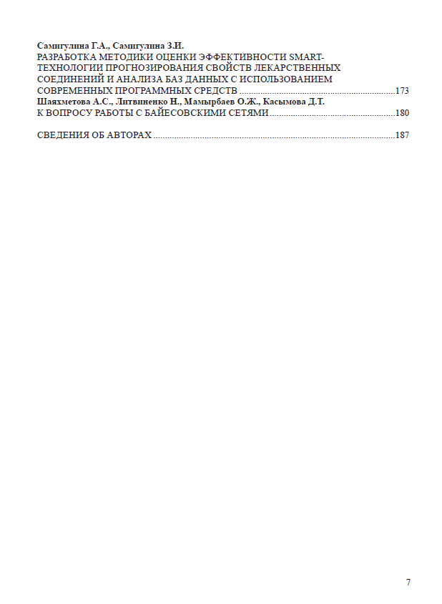

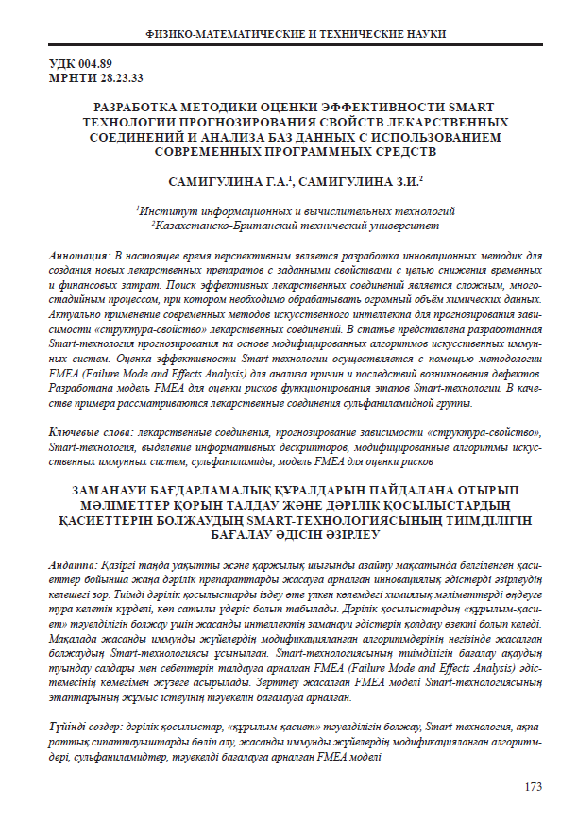

11 Samigulina G.A., Samigulina Z.I. Development of a knowledge base for the implementation of intelligent technology for predicting the «structure – property» dependence of drugs // Proceedings of the international scientific and practical conference «Satpayev readings-2020». - Almaty, April 10, 2020. - V.2. - P. 409-413.

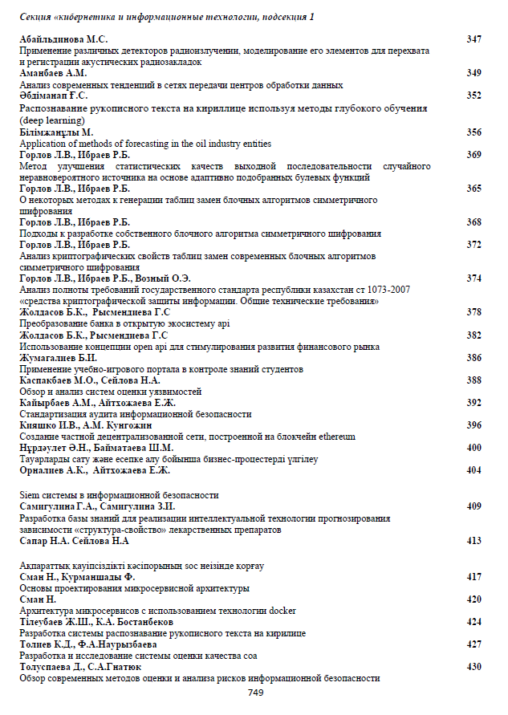
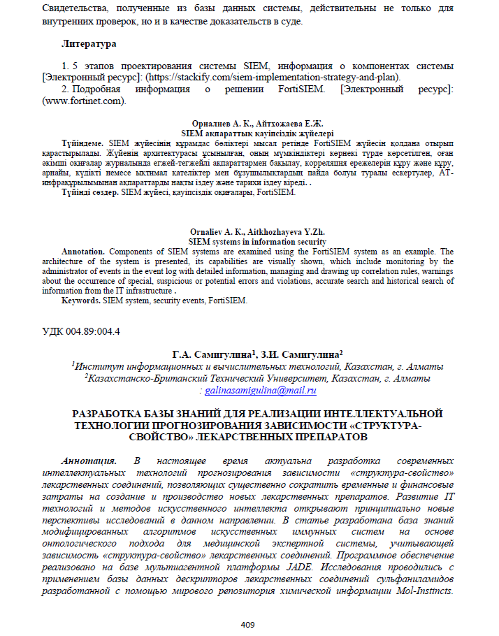

APPENDIX D

Certificates







APPENDIX E

Act of implementation


APPENDIX F

Copyright certificates



APPENDIX G

Risk priority matrix

Table G.1 – An example of calculation of the risk priority matrix
1 STAGE |  | «Occurrence»  Defect occurrence
«Severity»  Defect significance | x | 1 | 2 | 3 | 4
«Severity»  Defect significance | 1
«Severity»  Defect significance | 2 |  |  |  | Х
«Severity»  Defect significance | 3 |  |  | Х
«Severity»  Defect significance | 4 |  |  | Х | Х

APPENDIX K

Ontological model of IES-analytics software

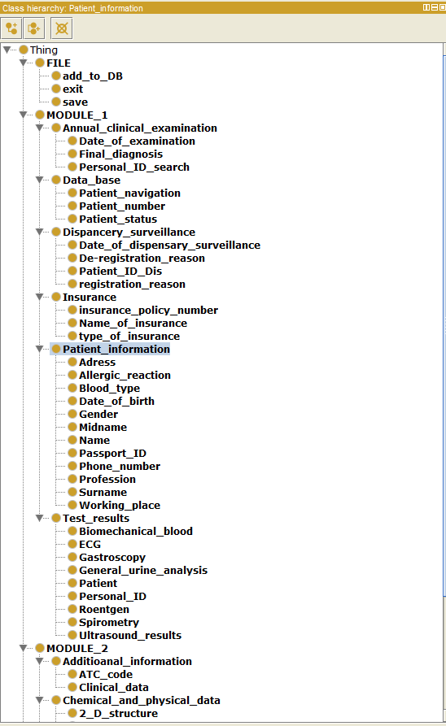
APPENDIX L

Instructions for installing the IES-analytics program

The procedure for installing the IES-analytics program:
Step 1. Install the NetFramework4.6.1.exe components located in the Required Programs folder.
Step 2. Install the local database server SqlLocalDB.msi located in the Required Programs folder.
Step 3. Launch the LocalDB_launch.exe application located at Required Programs/ LocalDB_launch / bin / Debug / LocalDB_launch.exe.
Step 4. Install the IES_analytics_setup.msi installer

Instructions for starting the program:
- After opening the launcher, press the <Next> button.

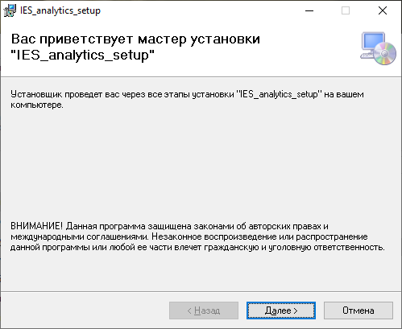

- Next, select the path to install the program by clicking the <Browse> button.

ATTENTION: It is not advisable to install the program on the Disk on which Windows is installed. Otherwise the database will be read-only. After selecting the folder for installation, click on the <Next> button.

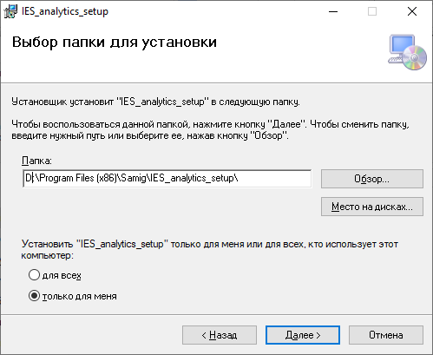

- Confirm installation by <Next> button.

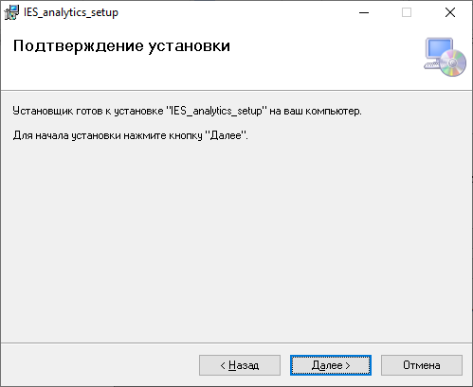

- After successful installation of the program a dialog window should appear, that can be closed.

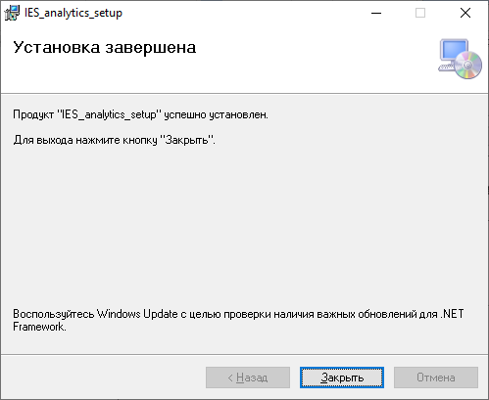

- Open the IES_analytics.exe application in the folder specified during installation.

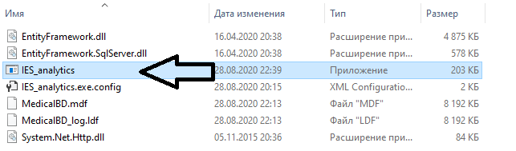

APPENDIX M

IES-analytics program variable specification. Module 1

Table 1 – Parameter specification of the module 1
Table name  Compound | Data type
DIALOG WINDOW №1 EXPERT SYSTEN DATABASE
COMPOUND IDENTIFIERS
Compound name | Char (text)
SMILES_codes | Char (text)
In_Chi_key | Char (text)
Formula | Char (text)
PubChem CID | Char (text)
CAS number | Char (text)
DrugBank | Char (text)
ChemSpider | Char (text)
ChEBI | Char (text)
STRUCTURE
2D structure | image
3D structure | image
Molar mass | Real
Density | Real
CLASS
Class 1 | Char (text)
Class 2 | Char (text)
Class 3 | Char (text)
Class N | Char (text) (you can add a class more than three)
CLINICAL DATA
ATC code | Char (text)
MOLECULAR DESCRIPTOR
Constitutional descriptors | Real
Topological descriptors | Real
Walk and part counts | Real
Connectivity indices | Real
Information indices | Real
List of 2D autocorrelation indices | Real
Edge adjacency indices | Real
Burden eigenvalue descriptors | Real
Topological charge indices | Real
Eigenvalue-based indices | Real
Randic molecular profiles | Real
Geometrical descriptors | Real
RDF descriptors | Real
3D-MoRSE descriptors | Real
WHIM descriptors | Real
GETAWAY descriptors | Real

APPENDIX N

IES-analytics program variable specification. Module 2

Table 2 – Parameter specification of the module 2

Table name  Compound | Data type
DIALOG WINDOW №2 PERSONAL DATA OF PATIENT
PATIENT INFORMATION
Name | Char (text)
Midname | Char (text)
Surname | Char (text)
Address | Char (text)
Passport ID | integer
Date of birth | date
Telephone | integer
Place of work | Char (text)
Profession | Char (text)
Affiliation | Char (text)
Blood type | integer
Rh factor | Char (text)
Allergic reactions | Char (text)
INSURRANCE
Type of Insurance | Char (text)
Name of Insurance company | Char (text)
DISPENSARY SURVEILLANCE
Date of registration | Date
Registration reason | Char (text)
ANNUAL CLINICAL EXAMINATION
Data of examination | Date
Final diagnosis | Char (text)
ANALYSIS
Ultrasound results | Char (text)
ECG | Char (text)
Gastroscopy | Char (text)
Roentgen | Char (text)
Spirometry | Char (text)
General blood analysis | Char (text)
General urine analysis | Char (text)
Biochemical blood test | Char (text)
…………………………………………………. | …………………………….

APPENDIX P

Ranking of test results for selection of target group of patients

Table P.1 – Ranking of analysis results to identify pathologies. Part 1
ECG – «A» |  | Ultrasound - «B» |  | Gastroscopy – «C» |  | Roentgen – «D»
score | state | score | state | score | state | score | state
0 | reanalysis | 0 | reanalysis | 0 | reanalysis | 0 | reanalysis
1 | normal | 1 | normal | 1 | normal | 1 | normal
2 | Pathological | 2 | pathological | 2 | pathological | 2 | pathological
3 | average pathology | 3 | average pathology | 3 | average pathology | 3 | average pathology
4 | acute pathology | 4 | acute pathology | 4 | acute pathology | 4 | acute pathology

Table P.2 – Ranking of analysis results to identify pathologies. Part 2
General blood analysis – «E» |  | General Urine Analysis – «F» |  | Biomedical blood - «G»
score | state | score | state | score | state
0 | reanalysis | 0 | reanalysis | 0 | reanalysis
1 | normal | 1 | normal | 1 | normal
2 | рermissible deviation from the norm | 2 | рermissible deviation from the norm | 2 | рermissible deviation from the norm
3 | deviation from the norm | 3 | deviation from the norm | 3 | deviation from the norm
4 | pathological | 4 | pathological | 4 | pathological
5 | average pathology | 5 | average pathology | 5 | average pathology
6 | acute pathology | 6 | acute pathology | 6 | acute pathology

APPENDIX R

MainWindow.xaml.cs code listing

using System;
using System.Collections.Generic;
using System.Data;
using System.Data.SqlClient;
using System.Linq;
using System.Text;
using System.Text.RegularExpressions;
using System.Threading.Tasks;
using System.Windows;
using System.Windows.Controls;
using System.Windows.Data;
using System.Windows.Documents;
using System.Windows.Input;
using System.Windows.Media;
using System.Windows.Media.Imaging;
using System.Windows.Navigation;
using System.Windows.Shapes;
using System.IO;
using Path = System.IO.Path;
using System.Configuration;
using Microsoft.Win32;

namespace Ambulance
{
/// <summary>
/// Логика взаимодействия для MainWindow.xaml
/// </summary>
public partial class MainWindow : Window
{static string connectionString = @"Data Source=(localdb)\MSSQLLocalDB;Initial Catalog=userstore;Trusted_Connection=True";
SqlConnection connection = new SqlConnection(connectionString);
public MainWindow()
{
string dbPathMyDocs = Environment.GetFolderPath(Environment.SpecialFolder.MyDocuments);

string dbPathAppData = Environment.GetFolderPath(Environment.SpecialFolder.ApplicationData);String dbPath = Path.Combine(dbPathMyDocs, "LocalAppData");

AppDomain.CurrentDomain.SetData("DataDirectory", dbPath);

MedicalBDEntities db = new MedicalBDEntities();
InitializeComponent();
show_table();
show_all_table();
}
public void show_all_table()
{
using (MedicalBDEntities db = new MedicalBDEntities())
{
var users = db.Patient_information;
dataGrid6.ItemsSource = users.ToList();
}
}
public void show_table()
{
using (MedicalBDEntities db = new MedicalBDEntities())
{
var users = db.Patient_information;
dataGrid1.ItemsSource = users.ToList();
}
}
public void show_table_diagnoses()
{
try
{
using (MedicalBDEntities db = new MedicalBDEntities())
{
int selected_patient_id = Convert.ToInt32(Personal_ID_examination.Text);

var diagnoses = from order in db.Annual_clinical_examination.AsEnumerable()
where order.Personal_ID == selected_patient_id
select new
{
Patient_ID = order.Personal_ID,
Diagnose_ID = order.Clinical_examination,
Data = order.Data,
Final_Diagnoses = order.Final_diagnoses,
};

dataGrid2.ItemsSource = diagnoses.ToList();
}
}
catch (Exception ex)
{
MessageBox.Show(ex.Message);
}
}
private void Button_Click(object sender, RoutedEventArgs e)
{
if (!Regex.IsMatch(Name.Text, @"^[a-zA-Z]+$") || !Regex.IsMatch(Midname.Text, @"^[a-zA-Z]+$") || !Regex.IsMatch(Surname.Text, @"^[a-zA-Z]+$"))
{
MessageBox.Show("Введите корректно ваши данные!");
}
else
{
try
{
using (MedicalBDEntities db = new MedicalBDEntities())
{
Patient_information new_patient = new Patient_information();
new_patient.Name = Name.Text;
new_patient.Midname = Midname.Text;
new_patient.Surname = Surname.Text;
new_patient.Gender = Gender.Text;
new_patient.Adress = Adress.Text;
if (Positive.IsChecked == true) { new_patient.Rh_factor = "Positive"; }
else
{ new_patient.Rh_factor = "Negative"; };
new_patient.Passport_ID = Passport_ID.Text;
new_patient.Telephone = Telephone.Text;
new_patient.Date_of_birth = Date_of_birth.SelectedDate;
new_patient.Place_of_work = Place_of_work.Text;
new_patient.Profession_affilation = Proffecion_affilation.Text;
new_patient.Blood_type = Blood_Type.Text;
new_patient.allergic_reactions = Allergic_reactions.Text;

db.Patient_information.Add(new_patient);
db.SaveChanges();
show_table();
MessageBox.Show("Данные успешно загружены в базу данных!");
Name.Text = "";
Midname.Text = "";
Surname.Text = "";
Adress.Text = "";
Gender.Text = "";
Passport_ID.Text = "";
Telephone.Text = "";
Place_of_work.Text = "";
Proffecion_affilation.Text = "";
Blood_Type.Text = "";
Allergic_reactions.Text = "";
}
}
catch (Exception ex)
{
MessageBox.Show(ex.ToString());
}
}
}
private void delete_button_clicked(object sender, RoutedEventArgs e)
{
using (MedicalBDEntities db = new MedicalBDEntities())
{
try
{
Patient_information selected_patient = (Patient_information)dataGrid1.SelectedItem;
int selected_patient_id = selected_patient.Personal_ID;
Patient_information removing_patient = (from u in db.Patient_information where u.Personal_ID == selected_patient_id select u).First();
db.Patient_information.Remove(removing_patient);

db.SaveChanges();
show_table();
MessageBox.Show($"Patient {selected_patient.Name} was deleted");
}
catch (Exception ex)
{
MessageBox.Show("Before delete the patient - make sure that all analyzes, insurances, etc. of this person has been deleted");
}
}
}
private void Add_diagnose_Click_1(object sender, RoutedEventArgs e)
{
try
{
using (MedicalBDEntities db = new MedicalBDEntities())
{
int selected_patient_id = Convert.ToInt32(Personal_ID_examination.Text);

Annual_clinical_examination new_diagnose = new Annual_clinical_examination();
new_diagnose.Final_diagnoses = Final_diagnoses.Text;
new_diagnose.Data = Date.SelectedDate;
new_diagnose.Personal_ID = selected_patient_id;
db.Annual_clinical_examination.Add(new_diagnose);
db.SaveChanges();
show_table_diagnoses();
MessageBox.Show("Данные успешно загружены в базу данных!");
Final_diagnoses.Text = "";
}
}
catch (Exception ex)
{
MessageBox.Show(ex.ToString());
}
}
private void Delete_diagnose_Click(object sender, RoutedEventArgs e)
{
using (MedicalBDEntities db = new MedicalBDEntities())
{
try
{
var cellInfo = dataGrid2.SelectedCells[1];
var content = (cellInfo.Column.GetCellContent(cellInfo.Item) as TextBlock).Text;
int diagnose = Convert.ToInt32(content);
Annual_clinical_examination removing_diagnose = (from u in db.Annual_clinical_examination where u.Clinical_examination == diagnose select u).First();
MessageBox.Show($"Diagnose {diagnose} was deleted");
db.Annual_clinical_examination.Remove(removing_diagnose);
db.SaveChanges();
show_table_diagnoses();
}
catch (Exception ex)
{
MessageBox.Show(ex.ToString());
}
}
}
public void show_table_analyzes()
{
try
{
using (MedicalBDEntities db = new MedicalBDEntities())
{
int selected_patient_id = Convert.ToInt32(Personal_ID_analyzes.Text);

var analyzes = from order in db.Test_results.AsEnumerable()
where order.Personal_ID == selected_patient_id
select new
{
Patient_ID = order.Personal_ID,
Analyzes_ID = order.analyzes,
Ultrasounds_Results = order.Ultrasound_results,
ECG = order.ECG,
Gastroscopy = order.gastroscopy,
Roentgen = order.roentgen,
Spirometry = order.spirometry,
General_Blood_Analysis = order.general_blood_analysis,
General_Urine_Analysis = order.general_urine_analysis,
Biomechanical_Blood_Test = order.biochemical_blood_test,
};
dataGrid3.ItemsSource = analyzes.ToList();
}
}
catch (Exception ex)
{
MessageBox.Show(ex.Message);
}
}
private void Final_diagnoses_TextChanged(object sender, TextChangedEventArgs e)
{
}
private void Add_analyzes_Click_1(object sender, RoutedEventArgs e)
{
try
{
using (MedicalBDEntities db = new MedicalBDEntities())
{
int selected_analyzes_id = Convert.ToInt32(Personal_ID_analyzes.Text);

Test_results new_analyzes = new Test_results();
new_analyzes.Ultrasound_results = Ultrasounds_results.Text;
new_analyzes.ECG = ECG.Text;
new_analyzes.gastroscopy = Gastroscopy.Text;
new_analyzes.roentgen = Roentgen.Text;
new_analyzes.spirometry = Spirometry.Text;
new_analyzes.general_blood_analysis = General_Blood_Analysis.Text;
new_analyzes.general_urine_analysis = General_Urine_Analysis.Text;
new_analyzes.biochemical_blood_test = Biomechanical_Blood_Analysis.Text;
new_analyzes.Personal_ID = selected_analyzes_id;
db.Test_results.Add(new_analyzes);
db.SaveChanges();
show_table_analyzes();
MessageBox.Show("Данные успешно загружены в базу данных!");
Ultrasounds_results.Text = "";
ECG.Text = "";
Gastroscopy.Text = "";
Roentgen.Text = "";
Spirometry.Text = "";
General_Blood_Analysis.Text = "";
General_Urine_Analysis.Text = "";
Biomechanical_Blood_Analysis.Text = "";
}
}
catch (Exception ex)
{
MessageBox.Show(ex.ToString());
}
}
private void Delete_analyzes_Click(object sender, RoutedEventArgs e)
{
using (MedicalBDEntities db = new MedicalBDEntities())
{
try
{
var cellInfo = dataGrid3.SelectedCells[1];
var content = (cellInfo.Column.GetCellContent(cellInfo.Item) as TextBlock).Text;
int analyze = Convert.ToInt32(content);
Test_results removing_analyzes = (from u in db.Test_results where u.analyzes == analyze select u).First();
MessageBox.Show($"Diagnose {analyze} was deleted");
db.Test_results.Remove(removing_analyzes);
db.SaveChanges();
show_table_analyzes();
}
catch (Exception ex)
{
MessageBox.Show(ex.ToString());
}
}
}
public void show_table_dispensary()
{
try
{
using (MedicalBDEntities db = new MedicalBDEntities())
{
int selected_patient_id = Convert.ToInt32(Personal_ID_Dispensary.Text);

var dispensary = from order in db.Dispensary_survellance.AsEnumerable()
where order.Personal_ID == selected_patient_id
select new
{
Patient_ID = order.Personal_ID,
Dispensary_ID = order.Registration,
Date_Of_Registration = order.Date_of_registration,
Registration_Reason = order.Registration_reason,
Reason_For_De_Registration = order.Reason_for_de_registration,
};
dataGrid4.ItemsSource = dispensary.ToList();
}
}
catch (Exception ex)
{
MessageBox.Show(ex.Message);
}
}
private void Add_dispensary_Click_1(object sender, RoutedEventArgs e)
{
try
{
using (MedicalBDEntities db = new MedicalBDEntities())
{
int selected_patient_id = Convert.ToInt32(Personal_ID_Dispensary.Text);

Dispensary_survellance new_dispensary = new Dispensary_survellance();
new_dispensary.Date_of_registration = Date_Dispensary.SelectedDate;
new_dispensary.Personal_ID = Convert.ToInt32(Personal_ID_Dispensary.Text);
new_dispensary.Registration_reason = Regisration_reason.Text;
new_dispensary.Reason_for_de_registration = De_regisration_reason.Text;

db.Dispensary_survellance.Add(new_dispensary);
db.SaveChanges();
show_table_dispensary();
MessageBox.Show("Данные успешно загружены в базу данных!");
Regisration_reason.Text = "";
De_regisration_reason.Text = "";
}
}
catch (Exception ex)
{
MessageBox.Show(ex.ToString());
}
}
private void Delete_dispensary_Click(object sender, RoutedEventArgs e)
{
using (MedicalBDEntities db = new MedicalBDEntities())
{
try
{
var cellInfo = dataGrid4.SelectedCells[1];
var content = (cellInfo.Column.GetCellContent(cellInfo.Item) as TextBlock).Text;
int dispensary = Convert.ToInt32(content);

Dispensary_survellance removing_dispensary = (from u in db.Dispensary_survellance where u.Registration == dispensary select u).First();
MessageBox.Show($"Dispensary surveillance {dispensary} was deleted");
db.Dispensary_survellance.Remove(removing_dispensary);
db.SaveChanges();
show_table_dispensary();
}
catch (Exception ex)
{
MessageBox.Show(ex.ToString());
}
}
}
public void show_table_insurance()
{
try
{
using (MedicalBDEntities db = new MedicalBDEntities())
{
int selected_patient_id = Convert.ToInt32(Personal_ID_Insurance.Text);
var insurance = from order in db.Insurances.AsEnumerable()
where order.Personal_ID == selected_patient_id
select new
{
Patient_ID = order.Personal_ID,
Insurance_ID = order.Insurance_ID,
Insurance_Policy_Number = order.Insurance_policy_number,
Type_Of_Insurance = order.Type_of_insurance,
Name_Of_Insurance_Company = order.Name_of_insurance_company,
};

dataGrid5.ItemsSource = insurance.ToList();
}
}
catch (Exception ex)
{
MessageBox.Show(ex.Message);
}
}
private void Add_insurance_Click_1(object sender, RoutedEventArgs e)
{
try
{
using (MedicalBDEntities db = new MedicalBDEntities())
{
int selected_patient_id = Convert.ToInt32(Personal_ID_Insurance.Text);
Insurance new_insurance = new Insurance();
new_insurance.Personal_ID = Convert.ToInt32(Personal_ID_Insurance.Text);
new_insurance.Insurance_policy_number = Insurance_policy_number.Text;
new_insurance.Type_of_insurance = Type_of_insurance.Text;
new_insurance.Name_of_insurance_company = Name_of_insurance.Text;

db.Insurances.Add(new_insurance);
db.SaveChanges();
show_table_insurance();
MessageBox.Show("Данные успешно загружены в базу данных!");
Insurance_policy_number.Text = "";
Type_of_insurance.Text = "";
Name_of_insurance.Text = "";
}
}
catch (Exception ex)
{
MessageBox.Show(ex.ToString());
}
}
private void Delete_insurance_Click(object sender, RoutedEventArgs e)
{
using (MedicalBDEntities db = new MedicalBDEntities())
{
try
{
var cellInfo = dataGrid5.SelectedCells[1];
var content = (cellInfo.Column.GetCellContent(cellInfo.Item) as TextBlock).Text;
int insurance = Convert.ToInt32(content);

Insurance removing_insurance = (from u in db.Insurances where u.Insurance_ID == insurance select u).First();
MessageBox.Show($"Insurance number {insurance} was deleted");
db.Insurances.Remove(removing_insurance);
db.SaveChanges();
show_table_insurance();
}
catch (Exception ex)
{
MessageBox.Show(ex.ToString());
}
}
}
private void MenuItem_Click_Exit(object sender, RoutedEventArgs e)
{
this.Close();
}
private void MenuItem_Click_Drugs(object sender, RoutedEventArgs e)
{
Window1 drugs = new Window1();
drugs.Show();
this.Close();
}
private void Search_SelectionChanged(object sender, SelectionChangedEventArgs e)
{
ComboBox comboBox = (ComboBox)sender;
ComboBoxItem selectedItem = (ComboBoxItem)comboBox.SelectedItem;
if (selectedItem.Content.ToString() == "By name")
{
ByName.Visibility = Visibility.Visible;
BySurname.Visibility = Visibility.Hidden;
ByPhone.Visibility = Visibility.Hidden;
ByAdress.Visibility = Visibility.Hidden;
ByPassport.Visibility = Visibility.Hidden;
Button_search_byname.Visibility = Visibility.Visible;
Button_search_bysurname.Visibility = Visibility.Hidden;
Button_search_byphone.Visibility = Visibility.Hidden;
Button_search_byadress.Visibility = Visibility.Hidden;
Button_search_bypassport.Visibility = Visibility.Hidden;
EnterName.Visibility = Visibility.Visible;
EnterSurname.Visibility = Visibility.Hidden;
EnterPhone.Visibility = Visibility.Hidden;
EnterAdress.Visibility = Visibility.Hidden;
EnterPassport.Visibility = Visibility.Hidden;
}
else if (selectedItem.Content.ToString() == "By surname")
{
ByName.Visibility = Visibility.Hidden;
BySurname.Visibility = Visibility.Visible;
ByPhone.Visibility = Visibility.Hidden;
ByAdress.Visibility = Visibility.Hidden;
ByPassport.Visibility = Visibility.Hidden;
Button_search_byname.Visibility = Visibility.Hidden;
Button_search_bysurname.Visibility = Visibility.Visible;
Button_search_byphone.Visibility = Visibility.Hidden;
Button_search_byadress.Visibility = Visibility.Hidden;
Button_search_bypassport.Visibility = Visibility.Hidden;
EnterName.Visibility = Visibility.Hidden;
EnterSurname.Visibility = Visibility.Visible;
EnterPhone.Visibility = Visibility.Hidden;
EnterAdress.Visibility = Visibility.Hidden;
EnterPassport.Visibility = Visibility.Hidden;
}
else if (selectedItem.Content.ToString() == "By phone number")
{
ByName.Visibility = Visibility.Hidden;
BySurname.Visibility = Visibility.Hidden;
ByPhone.Visibility = Visibility.Visible;
ByAdress.Visibility = Visibility.Hidden;
ByPassport.Visibility = Visibility.Hidden;

Button_search_byname.Visibility = Visibility.Hidden;
Button_search_bysurname.Visibility = Visibility.Hidden;
Button_search_byphone.Visibility = Visibility.Visible;
Button_search_byadress.Visibility = Visibility.Hidden;
Button_search_bypassport.Visibility = Visibility.Hidden;
EnterName.Visibility = Visibility.Hidden;
EnterSurname.Visibility = Visibility.Hidden;
EnterPhone.Visibility = Visibility.Visible;
EnterAdress.Visibility = Visibility.Hidden;
EnterPassport.Visibility = Visibility.Hidden;
}
else if (selectedItem.Content.ToString() == "By adress")
{
ByName.Visibility = Visibility.Hidden;
BySurname.Visibility = Visibility.Hidden;
ByPhone.Visibility = Visibility.Hidden;
ByAdress.Visibility = Visibility.Visible;
ByPassport.Visibility = Visibility.Hidden;
Button_search_byname.Visibility = Visibility.Hidden;
Button_search_bysurname.Visibility = Visibility.Hidden;
Button_search_byphone.Visibility = Visibility.Hidden;
Button_search_byadress.Visibility = Visibility.Visible;
Button_search_bypassport.Visibility = Visibility.Hidden;
EnterName.Visibility = Visibility.Hidden;
EnterSurname.Visibility = Visibility.Hidden;
EnterPhone.Visibility = Visibility.Hidden;
EnterAdress.Visibility = Visibility.Visible;
EnterPassport.Visibility = Visibility.Hidden;
}
else if (selectedItem.Content.ToString() == "By passport ID")
{
ByName.Visibility = Visibility.Hidden;
BySurname.Visibility = Visibility.Hidden;
ByPhone.Visibility = Visibility.Hidden;
ByAdress.Visibility = Visibility.Hidden;
ByPassport.Visibility = Visibility.Visible;

Button_search_byname.Visibility = Visibility.Hidden;
Button_search_bysurname.Visibility = Visibility.Hidden;
Button_search_byphone.Visibility = Visibility.Hidden;
Button_search_byadress.Visibility = Visibility.Hidden;
Button_search_bypassport.Visibility = Visibility.Visible;

EnterName.Visibility = Visibility.Hidden;
EnterSurname.Visibility = Visibility.Hidden;
EnterPhone.Visibility = Visibility.Hidden;
EnterAdress.Visibility = Visibility.Hidden;
EnterPassport.Visibility = Visibility.Visible;
}
}
private void Add_analyze_Click(object sender, RoutedEventArgs e)
{
AnalyzeWindow aw = new AnalyzeWindow();
aw.Show();
}
private void DataGrid6_SelectionChanged(object sender, SelectionChangedEventArgs e)
{
using (MedicalBDEntities db = new MedicalBDEntities())
try
{
Patient_Name_Status_Label.Visibility = Visibility.Visible;
Patient_Name_Status.Visibility = Visibility.Visible;
var cellInfo = dataGrid6.SelectedCells[0];
var content = (cellInfo.Column.GetCellContent(cellInfo.Item) as TextBlock).Text;
int selected_patient_id_status = Convert.ToInt32(content);

Patient_information searching_patient = (from u in db.Patient_information where u.Personal_ID == selected_patient_id_status select u).First();
Patient_Name_Status.Text = searching_patient.Name + " " + searching_patient.Midname + " " + searching_patient.Surname;
int? StatusCount = searching_patient.Status;
if (StatusCount < 10) { Status.Text = "Healthy or small degree of health deviation"; Status.Background = Brushes.LightBlue; }
else if ((StatusCount >= 10) && (StatusCount < 20)) { Status.Text = "Medium degree of health deviation"; Status.Background = Brushes.Yellow; }
else if ((StatusCount >= 20) && (StatusCount < 30)) { Status.Text = "Severe degree of health deviation"; Status.Background = Brushes.Orange; }
else if ((StatusCount >= 30) && (StatusCount < 40)) { Status.Text = "Critical degree of health deviation"; Status.Background = Brushes.Red; }
}
catch (Exception ex)
{
MessageBox.Show("Patient is not found");
}
}
private void MenuItem_Click(object sender, RoutedEventArgs e)
{
MessageBox.Show("The program created by: Samigulina Galina Ahmetovna, Samigulina Zarina Ildusovna, Samigulin Timur Ildusovich, 2020 year");
}
private void Button_Click_Show_All(object sender, RoutedEventArgs e)
{
show_all_table();
}
private void PID_click_annual(object sender, RoutedEventArgs e)
{
using (MedicalBDEntities db = new MedicalBDEntities())
try
{
int selected_patient_id = Convert.ToInt32(Personal_ID_examination.Text);
Patient_information searching_patient = (from u in db.Patient_information where u.Personal_ID == selected_patient_id select u).First();

Patient_Name.Text = searching_patient.Name + " " + searching_patient.Midname + " " + searching_patient.Surname;
dataGrid2.ItemsSource = "";
show_table_diagnoses();
}
catch (Exception ex)
{
MessageBox.Show("Patient is not found");
}
}
private void PID_click_test(object sender, RoutedEventArgs e)
{
using (MedicalBDEntities db = new MedicalBDEntities())
try
{
int selected_patient_id = Convert.ToInt32(Personal_ID_analyzes.Text);
Patient_information searching_patient = (from u in db.Patient_information where u.Personal_ID == selected_patient_id select u).First();
Patient_Name_Test.Text = searching_patient.Name + " " + searching_patient.Midname + " " + searching_patient.Surname;
dataGrid2.ItemsSource = "";
show_table_analyzes();
}
catch (Exception ex)
{
MessageBox.Show("Patient is not found");
}
}
private void PID_click_dispensary(object sender, RoutedEventArgs e)
{
using (MedicalBDEntities db = new MedicalBDEntities())
try
{
int selected_patient_id = Convert.ToInt32(Personal_ID_Dispensary.Text);
Patient_information searching_patient = (from u in db.Patient_information where u.Personal_ID == selected_patient_id select u).First();
Patient_Name_Dispensary.Text = searching_patient.Name + " " + searching_patient.Midname + " " + searching_patient.Surname;
dataGrid4.ItemsSource = "";
show_table_dispensary();
}
catch (Exception ex)
{
MessageBox.Show("Patient is not found");
}
}
private void PID_click_insurance(object sender, RoutedEventArgs e)
{
using (MedicalBDEntities db = new MedicalBDEntities())
try
{
int selected_patient_id = Convert.ToInt32(Personal_ID_Insurance.Text);
Patient_information searching_patient = (from u in db.Patient_information where u.Personal_ID == selected_patient_id select u).First();
Patient_Name_Insurance.Text = searching_patient.Name + " " + searching_patient.Midname + " " + searching_patient.Surname;
dataGrid5.ItemsSource = "";
show_table_insurance();
}
catch (Exception ex)
{
MessageBox.Show("Patient is not found");
}
}
private void PID_click_bypassport(object sender, RoutedEventArgs e)
{
using (MedicalBDEntities db = new MedicalBDEntities())
{
try
{
var query = from u in db.Patient_information
where u.Passport_ID == ByPassport.Text
orderby u.Passport_ID
select u;
dataGrid6.ItemsSource = query.ToList();
}
catch (Exception ex)
{
MessageBox.Show(ex.Message.ToString());
}
}
}
private void PID_click_byphone(object sender, RoutedEventArgs e)
{
using (MedicalBDEntities db = new MedicalBDEntities())
{
try
{
var query = from u in db.Patient_information
where u.Telephone == ByPhone.Text
orderby u.Telephone
select u;
dataGrid6.ItemsSource = query.ToList();
}
catch (Exception ex)
{
MessageBox.Show(ex.Message.ToString());
}
}
}
private void PID_click_byadress(object sender, RoutedEventArgs e)
{
using (MedicalBDEntities db = new MedicalBDEntities())
{
try
{
var query = from u in db.Patient_information
where u.Adress == ByAdress.Text
orderby u.Surname
select u;

dataGrid6.ItemsSource = query.ToList();
}
catch (Exception ex)
{
MessageBox.Show(ex.Message.ToString());
}
}
}
private void PID_click_bysurname(object sender, RoutedEventArgs e)
{
using (MedicalBDEntities db = new MedicalBDEntities())
{
try
{
var query = from u in db.Patient_information
where u.Surname == BySurname.Text
orderby u.Surname
select u;

dataGrid6.ItemsSource = query.ToList();
}
catch (Exception ex)
{
MessageBox.Show(ex.Message.ToString());
}
}
}
private void PID_click_byname(object sender, RoutedEventArgs e)
{
using (MedicalBDEntities db = new MedicalBDEntities())
{
try
{
var query = from u in db.Patient_information
where u.Name == ByName.Text
orderby u.Name
select u;
dataGrid6.ItemsSource = query.ToList();
}
catch (Exception ex)
{
MessageBox.Show(ex.Message.ToString());
}
}

APPENDIX S

Drugs.xaml.cs code listing

using Microsoft.Win32;
using System;
using System.Collections.Generic;
using System.IO;
using System.Linq;
using System.Text;
using System.Threading.Tasks;
using System.Windows;
using System.Windows.Controls;
using System.Windows.Data;
using System.Windows.Documents;
using System.Windows.Input;
using System.Windows.Media;
using System.Windows.Media.Imaging;
using System.Windows.Shapes;
using System.Drawing;
using System.Data;
using System.Data.SqlClient;
using System.Windows.Interop;
namespace Ambulance
{
/// <summary>
/// Логика взаимодействия для Window1.xaml
/// </summary>
public partial class Window1 : Window
{
public byte[] img1 = { 0 };
public byte[] img2 = { 0 };
public Window1()
{
InitializeComponent();
show_table_compound();
show_table_compound_name();
show_table_descriptors();
show_table_structures();
show_table_classes();
show_table_clinical_data();
show_table_drugs();
MedicalBDEntities db_1 = new MedicalBDEntities();
var query = from u in db_1.Compounds select u.Compound_identifiers;
foreach (string item in query) { Configure_Compound.Items.Add(item); }
var query2 = from u in db_1.Chemical_and_physical_data select u.Structures;
foreach (string item in query2) { Configure_Chemical_and_physical_data.Items.Add(item); }
var query3 = from u in db_1.Descriptors select u.Molecular_Descriptor;
foreach (string item in query3) { Configure_Descriptors.Items.Add(item); }
var query4 = from u in db_1.Expert_classification select u.Class;
foreach (string item in query4) { Configure_Expert_Classification.Items.Add(item); }

var query5 = from u in db_1.Additional_information select u.Clinical_Data;
foreach (string item in query5) { Configure_Additional_Information.Items.Add(item); }
}
private void MenuItem_Click(object sender, RoutedEventArgs e)
{
this.Close();
}
private void MenuItem_Click_1(object sender, RoutedEventArgs e)
{
MainWindow patients = new MainWindow();
patients.Show();
this.Close();
}
private void Button_Click_Delete_Compound(object sender, RoutedEventArgs e)
{
using (MedicalBDEntities db = new MedicalBDEntities())
{
try
{
var cellInfo = dataGrid_Compound.SelectedCells[0];
var content = (cellInfo.Column.GetCellContent(cellInfo.Item) as TextBlock).Text;
string compound = content.ToString();
Compound removing_compound = (from u in db.Compounds where u.Compound_identifiers == compound select u).First();
db.Compounds.Remove(removing_compound);
db.SaveChanges();
MessageBox.Show($"Compound {compound} was deleted");
show_table_compound();
}
catch (Exception ex)
{
MessageBox.Show("Before delete the compoumd - make sure that all depended data (chemical compounds) are deleted");
}
}
}
public void show_table_compound()
{
try
{
using (MedicalBDEntities db = new MedicalBDEntities())
{
var users = db.Compounds;
dataGrid_Compound.ItemsSource = users.ToList();
}
}
catch (Exception ex)
{
MessageBox.Show(ex.Message);
}
}
public void show_table_compound_name()
{
try
{
using (MedicalBDEntities db = new MedicalBDEntities())
{
var users = db.Compound_name;

dataGrid_Compound_name.ItemsSource = users.ToList();
}
}
catch (Exception ex)
{
MessageBox.Show(ex.Message);
}
}
private void Button_Click_Add_Compound(object sender, RoutedEventArgs e)
{
try
{
using (MedicalBDEntities db = new MedicalBDEntities())
{
Compound new_compound = new Compound();
new_compound.Compound_identifiers = Compound_Identifiers.Text;
new_compound.Compound_name = Compound_name_1.Text;
new_compound.SMILES_codes = SMILES_codes.Text;
new_compound.lnChl_Key = lnChl_Key.Text;
new_compound.Formula = Formula.Text;
new_compound.PubChem_CID = PubChem.Text;
new_compound.CAS_number = CAS_number.Text;
new_compound.DrugBank = DrugBank.Text;
new_compound.ChemSpider = ChemSpider.Text;
new_compound.ChEBl = ChEBl.Text;
db.Compounds.Add(new_compound);
db.SaveChanges();
show_table_compound();
MessageBox.Show("Данные успешно загружены в базу данных!");
Compound_Identifiers.Text = "";
Compound_name_1.Text = "";
SMILES_codes.Text = "";
lnChl_Key.Text = "";
Formula.Text = "";
PubChem.Text = "";
CAS_number.Text = "";
DrugBank.Text = "";
ChemSpider.Text = "";
ChEBl.Text = "";
}
}
catch (Exception ex)
{
MessageBox.Show(ex.ToString());
}
}
private void Button_Click_Add_Compound_Name(object sender, RoutedEventArgs e)
{
try
{
using (MedicalBDEntities db = new MedicalBDEntities())
{
Compound_name new_compound_name = new Compound_name();
new_compound_name.Compound_name1 = Compound_names.Text;
new_compound_name.Sulfadiazine = Sulfadiazine.Text;
new_compound_name.Sulfadimidine = Sulfadimidine.Text;
new_compound_name.Sulfafurazole = Sulfafurazole.Text;
new_compound_name.Sulfamethizole = Sulfamethizole.Text;
new_compound_name.Sulfisodimine = Sulfisodimine.Text;
new_compound_name.Sulfonamide = Sulfonamide.Text;
new_compound_name.Sulfadoxine = Sulfadoxine.Text;
new_compound_name.Sulfamethoxazole = Sulfamethoxazole.Text;
new_compound_name.Sulfamoxole = Sulfamoxole.Text;
new_compound_name.Sulfamethoxine = Sulfadimethoxine.Text;
new_compound_name.Sulfafenazol = Sulfafenazol.Text;
new_compound_name.Sulfalen = Sulfalen.Text;
new_compound_name.Sulfaperin = Sulfaperin.Text;
db.Compound_name.Add(new_compound_name);
db.SaveChanges();
show_table_compound_name();
MessageBox.Show("Данные успешно загружены в базу данных!");
}
}
catch (Exception ex)
{
MessageBox.Show(ex.ToString());
}
}
private void Button_Click_Delete_Compound_Name(object sender, RoutedEventArgs e)
{
using (MedicalBDEntities db = new MedicalBDEntities())
{
try
{
var cellInfo = dataGrid_Compound_name.SelectedCells[0];
var content = (cellInfo.Column.GetCellContent(cellInfo.Item) as TextBlock).Text;
string compound_name = content.ToString();
Compound_name removing_compound_name = (from u in db.Compound_name where u.Compound_name1 == compound_name select u).First();

db.Compound_name.Remove(removing_compound_name);
db.SaveChanges();
show_table_compound_name();
MessageBox.Show($"Compound name {compound_name} was deleted");

}
catch (Exception ex)
{
MessageBox.Show("Before detele compound name - make sure that all related data are deleted (Chemical compound, compound information");
}
}
}
public void show_table_descriptors()
{
try
{
using (MedicalBDEntities db = new MedicalBDEntities())
{
var users = db.Descriptors;
dataGrid_Descriptors.ItemsSource = users.ToList();
}
}
catch (Exception ex)
{
MessageBox.Show(ex.Message);
}
}
private void Button_Click_Add_Descriptor(object sender, RoutedEventArgs e)
{
try
{
using (MedicalBDEntities db = new MedicalBDEntities())
{
Descriptor new_descriptor = new Descriptor();
new_descriptor.Molecular_Descriptor = Molecular_Descriptor.Text;
new_descriptor.Constitutional_Descriptors = Convert.ToDouble(Constitutional_Descriptors.Text);
new_descriptor.Topological_Descriptors = Convert.ToDouble(Topological_Descriptors.Text);
new_descriptor.Walk_and_part_counts = Convert.ToDouble(Walk_and_part_counts.Text);
new_descriptor.Connectivity_indices = Convert.ToDouble(Connectivity_indices.Text);
new_descriptor.Information_indices = Convert.ToDouble(Information_indices.Text);
new_descriptor.List_of_2D_autocorrelation_indices = Convert.ToDouble(List_of_2D_autocorrelation_indices.Text);
new_descriptor.Edge_adjacency_indices = Convert.ToDouble(Edge_adjacency_indices.Text);
new_descriptor.Burden_eigenvalue_descriptors = Convert.ToDouble(Burden_eigenvalue_descriptors.Text);
new_descriptor.Topological_charge_indices = Convert.ToDouble(Topological_charge_indices.Text);
new_descriptor.Eigenvalue_based_indices = Convert.ToDouble(Eigenvalue_based_indices.Text);
new_descriptor.Randic_molecular_profiles = Convert.ToDouble(Randic_molecular_profiles.Text);
new_descriptor.Geometrical_descriptors = Convert.ToDouble(Geometrical_Descriptors.Text);
new_descriptor.RDF_descriptors = Convert.ToDouble(RDF_Descriptors.Text);
new_descriptor.C3D_MoRSE_descriptors = Convert.ToDouble(ThreeD_MoRSE_Descriptors.Text);
new_descriptor.WHIM_descriptors = Convert.ToDouble(WHIM_Descriptors.Text);
new_descriptor.GETAWAY_descriptors = Convert.ToDouble(GETAWAY_Descriptors.Text);
db.Descriptors.Add(new_descriptor);
db.SaveChanges();
show_table_descriptors();
MessageBox.Show("Данные успешно загружены в базу данных!");
Molecular_Descriptor.Text = "";
Constitutional_Descriptors.Text = "";
Topological_Descriptors.Text = "";
Walk_and_part_counts.Text = "";
Connectivity_indices.Text = "";
Information_indices.Text = "";
List_of_2D_autocorrelation_indices.Text = "";
Edge_adjacency_indices.Text = "";
Burden_eigenvalue_descriptors.Text = "";
Topological_charge_indices.Text = "";
Eigenvalue_based_indices.Text = "";
Randic_molecular_profiles.Text = "";
Geometrical_Descriptors.Text = "";
RDF_Descriptors.Text = "";
ThreeD_MoRSE_Descriptors.Text = "";
WHIM_Descriptors.Text = "";
GETAWAY_Descriptors.Text = "";
}
}
catch (Exception ex)
{
MessageBox.Show("Molecular Descriptor has string type of variable. Descriptors type - double. Use ',', for example 12,654");
}
}
private void Button_Click_Delete_Descriptor(object sender, RoutedEventArgs e)
{
using (MedicalBDEntities db = new MedicalBDEntities())
{
try
{
var cellInfo = dataGrid_Descriptors.SelectedCells[0];
var content = (cellInfo.Column.GetCellContent(cellInfo.Item) as TextBlock).Text;
string descriptor = content.ToString();
Descriptor removing_descriptor = (from u in db.Descriptors where u.Molecular_Descriptor == descriptor select u).First();

db.Descriptors.Remove(removing_descriptor);
db.SaveChanges();
show_table_descriptors();
MessageBox.Show($"Descriptor {descriptor} was deleted");
}
catch (Exception ex)
{
MessageBox.Show("Before delete the descriptor - make sure that all related data is deleted (Chemical compound)");
}
}
}
public void BtnLoadFromFile_Click(object sender, RoutedEventArgs e)
{
try
{
OpenFileDialog openFileDialog = new OpenFileDialog();
if (openFileDialog.ShowDialog() == true)
{
Uri fileUri = new Uri(openFileDialog.FileName);
TwoD_image.Source = new BitmapImage(fileUri);
byte[] img1 = File.ReadAllBytes(openFileDialog.FileName);
}
}
catch (Exception ex)
{
MessageBox.Show(ex.Message.ToString());
}
}
public void Button_Click_Add_Structure(object sender, RoutedEventArgs e)
{
try
{
using (MedicalBDEntities db = new MedicalBDEntities())
{
Chemical_and_physical_data new_structure = new Chemical_and_physical_data();
new_structure.Structures = Structures.Text;
new_structure.C2D_structure = img1;
new_structure.C3D_structure = img2;
new_structure.Density = Density.Text;
new_structure.Molar_mass = Molar_Mass.Text;
db.Chemical_and_physical_data.Add(new_structure);
db.SaveChanges();
show_table_structures();
MessageBox.Show("Данные успешно загружены в базу данных!");
TwoD_image.Source = null;
ThreeD_image.Source = null;
Structures.Text = "";
Density.Text = "";
Molar_Mass.Text = "";
}
}
catch (Exception ex)
{
MessageBox.Show(ex.Message.ToString());
}
}
private void Button_Click_Delete_Structure(object sender, RoutedEventArgs e)
{
using (MedicalBDEntities db = new MedicalBDEntities())
{
try
{
var cellInfo = dataGrid_Structure.SelectedCells[0];
var content = (cellInfo.Column.GetCellContent(cellInfo.Item) as TextBlock).Text;
string structure = content.ToString();
Chemical_and_physical_data removing_structure = (from u in db.Chemical_and_physical_data where u.Structures == structure select u).First();
db.Chemical_and_physical_data.Remove(removing_structure);
db.SaveChanges();
MessageBox.Show($"Structure {structure} was deleted");
show_table_structures();
}
catch (Exception ex)
{
MessageBox.Show("Before delete the chemical and physical data - make sure that all depended data (chemical compounds) are deleted");
}
}
}
public static byte[] GetPhoto(string filePath)
{
FileStream stream = new FileStream(
filePath, FileMode.Open, FileAccess.Read);
BinaryReader reader = new BinaryReader(stream);
byte[] photo = reader.ReadBytes((int)stream.Length);
reader.Close();
stream.Close();
return photo;
}
public void show_table_structures()
{
try
{
using (MedicalBDEntities db = new MedicalBDEntities())
{
var users = db.Chemical_and_physical_data;
dataGrid_Structure.ItemsSource = users.ToList();
}
}
catch (Exception ex)
{
MessageBox.Show(ex.Message);
}
}

public void BtnLoadFromFile_Click2(object sender, RoutedEventArgs e)
{
try
{
OpenFileDialog openFileDialog = new OpenFileDialog();
if (openFileDialog.ShowDialog() == true)
{
Uri fileUri = new Uri(openFileDialog.FileName);
ThreeD_image.Source = new BitmapImage(fileUri);
byte[] img2 = File.ReadAllBytes(openFileDialog.FileName);
}
}
catch (Exception ex)
{
MessageBox.Show(ex.Message.ToString());
}
}
private void DataGrid_Structure_SelectionChanged(object sender, SelectionChangedEventArgs e)
{
}
public void show_table_classes()
{
try
{
using (MedicalBDEntities db = new MedicalBDEntities())
{
var users = db.Expert_classification;
dataGrid_Classes.ItemsSource = users.ToList();
}
}
catch (Exception ex)
{
MessageBox.Show(ex.Message);
}
}
public void show_table_clinical_data()
{
try
{
using (MedicalBDEntities db = new MedicalBDEntities())
{
var users = db.Additional_information;
dataGrid_ATC.ItemsSource = users.ToList();
}
}
catch (Exception ex)
{
MessageBox.Show(ex.Message);
}
}
private void Button_Click_Add_Class(object sender, RoutedEventArgs e)
{
try
{
using (MedicalBDEntities db = new MedicalBDEntities())
{
Expert_classification new_class = new Expert_classification();
new_class.Class = Classes.Text;
new_class.short_action = Convert.ToDouble(Short_Action.Text);
new_class.middle_action = Convert.ToDouble(Middle_Action.Text);
new_class.long_action = Convert.ToDouble(Long_Action.Text);
new_class.super_long_action = Convert.ToDouble(Super_Long_Action.Text);
db.Expert_classification.Add(new_class);
db.SaveChanges();
show_table_classes();
MessageBox.Show("Данные успешно загружены в базу данных!");
Classes.Text = "";
Short_Action.Text = "";
Middle_Action.Text = "";
Long_Action.Text = "";
Super_Long_Action.Text = "";
}
}
catch (Exception ex)
{
MessageBox.Show("Class must be string, actions must be double, use ','");
}
}
private void Button_Click_Delete_Class(object sender, RoutedEventArgs e)
{
using (MedicalBDEntities db = new MedicalBDEntities())
{
try
{
var cellInfo = dataGrid_Classes.SelectedCells[0];
var content = (cellInfo.Column.GetCellContent(cellInfo.Item) as TextBlock).Text;
string classes = content.ToString();
Expert_classification removing_class = (from u in db.Expert_classification where u.Class == classes select u).First();
db.Expert_classification.Remove(removing_class);
db.SaveChanges();
show_table_classes();
MessageBox.Show($"Class {classes} was deleted");
}
catch (Exception ex)
{
MessageBox.Show("Before delete the class - make sure that all depended data (chemical compounds) are deleted");
}
}
}

private void Button_Click_Add_ATC(object sender, RoutedEventArgs e)
{
try
{
using (MedicalBDEntities db = new MedicalBDEntities())
{
Additional_information new_ATC = new Additional_information();
new_ATC.Clinical_Data = Clinical_Data.Text;
new_ATC.ATC_code = ATC_code.Text;
db.Additional_information.Add(new_ATC);
db.SaveChanges();
show_table_clinical_data();
MessageBox.Show("Данные успешно загружены в базу данных!");
Clinical_Data.Text = "";
ATC_code.Text = "";
}
}
catch (Exception ex)
{
MessageBox.Show(ex.Message.ToString());
}
}
private void Button_Click_Delete_ATC(object sender, RoutedEventArgs e)
{
using (MedicalBDEntities db = new MedicalBDEntities())
{
try
{
var cellInfo = dataGrid_ATC.SelectedCells[0];
var content = (cellInfo.Column.GetCellContent(cellInfo.Item) as TextBlock).Text;
string ATC = content.ToString();
Additional_information removing_ATC = (from u in db.Additional_information where u.Clinical_Data == ATC select u).First();
db.Additional_information.Remove(removing_ATC);
db.SaveChanges();
show_table_clinical_data();
MessageBox.Show($"Clinical Data {ATC} was deleted");
}
catch (Exception ex)
{
MessageBox.Show("Before delete the additional information - make sure that all depended data (chemical compounds) are deleted");
}
}
}
private void Search_SelectionChanged(object sender, SelectionChangedEventArgs e)
{
}
private void DataGrid_Descriptors_SelectionChanged(object sender, SelectionChangedEventArgs e)
{

}
private void DataGrid_Expert_Classification_SelectionChanged(object sender, SelectionChangedEventArgs e)
{
}
private void DataGrid_Chemical_and_Physical_Data_SelectionChanged(object sender, SelectionChangedEventArgs e)
{
}
private void DataGrid_Additional_Information_SelectionChanged(object sender, SelectionChangedEventArgs e)
{
}
private void Chemical_Compound_Information_TextChanged(object sender, TextChangedEventArgs e)
{
}
private void Button_Click_Drug(object sender, RoutedEventArgs e)
{
MedicalBDEntities db = new MedicalBDEntities();
try
{
string Selected_Info = Chemical_Compound_Information.Text;
string Selected_Compound = Configure_Compound.SelectedItem.ToString();
string Selected_Chemical_and_Physical_Data = Configure_Chemical_and_physical_data.SelectedItem.ToString();
string Selected_Descriptors = Configure_Descriptors.SelectedItem.ToString();
string Selected_Additional_Information = Configure_Additional_Information.SelectedItem.ToString();
string Selected_Expert_Classification = Configure_Expert_Classification.SelectedItem.ToString();
Chemical_compound_information new_drug = new Chemical_compound_information();
new_drug.Compound = Selected_Info;
new_drug.Chemical_and_physical_data = Selected_Chemical_and_Physical_Data;
new_drug.Compound_identifiers = Selected_Compound;
new_drug.Descriptors = Selected_Descriptors;
new_drug.Exspert_classification = Selected_Expert_Classification;
new_drug.Additional_information = Selected_Additional_Information;
db.Chemical_compound_information.Add(new_drug);
db.SaveChanges();
show_table_drugs();
MessageBox.Show("Данные успешно загружены в базу данных!");
}
catch (Exception ex)
{
MessageBox.Show(ex.InnerException.Message.ToString());
MessageBox.Show("Выберите все компоненты");
}

}
public void show_table_drugs()
{
using (MedicalBDEntities db = new MedicalBDEntities())
try
{
dataGrid_Drugs.ItemsSource = db.Chemical_compound_information.ToList();
}
catch (Exception ex)
{
MessageBox.Show(ex.Message);
}
}
private void Button_Click_Delete_Drug(object sender, RoutedEventArgs e)
{
using (MedicalBDEntities db = new MedicalBDEntities())
{
try
{
Chemical_compound_information selected_drug = (Chemical_compound_information)dataGrid_Drugs.SelectedItem;
int selected_drug_id = selected_drug.Id;
Chemical_compound_information removing_drug = (from u in db.Chemical_compound_information where u.Id == selected_drug_id select u).First();

db.Chemical_compound_information.Remove(removing_drug);
db.SaveChanges();
MessageBox.Show($"Drug {selected_drug_id} was deleted");
show_table_drugs();
}
catch (Exception ex)
{
MessageBox.Show(ex.ToString());
}
}
}
private void MenuItem_Click_2(object sender, RoutedEventArgs e)
{
MessageBox.Show("The program created by: Samigulina Galina Ahmetovna, Samigulina Zarina Ildusovna, Samigulin Timur Ildusovich, 2020 year");
}

private void Button_Click_Refresh(object sender, RoutedEventArgs e)
{
MedicalBDEntities db_1 = new MedicalBDEntities();
Configure_Compound.Items.Clear();
Configure_Chemical_and_physical_data.Items.Clear();
Configure_Descriptors.Items.Clear();
Configure_Expert_Classification.Items.Clear();
Configure_Additional_Information.Items.Clear();
var query = from u in db_1.Compounds select u.Compound_identifiers;
foreach (string item in query) { Configure_Compound.Items.Add(item); }

var query2 = from u in db_1.Chemical_and_physical_data select u.Structures;
foreach (string item in query2) { Configure_Chemical_and_physical_data.Items.Add(item); }
var query3 = from u in db_1.Descriptors select u.Molecular_Descriptor;
foreach (string item in query3) { Configure_Descriptors.Items.Add(item); }
var query4 = from u in db_1.Expert_classification select u.Class;
foreach (string item in query4) { Configure_Expert_Classification.Items.Add(item); }
var query5 = from u in db_1.Additional_information select u.Clinical_Data;
foreach (string item in query5) { Configure_Additional_Information.Items.Add(item); }
}
}
}

APPENDIX T

AnalyzeWindow.xaml.cs code listing

using System;
using System.Collections.Generic;
using System.Linq;
using System.Text;
using System.Threading.Tasks;
using System.Windows;
using System.Windows.Controls;
using System.Windows.Data;
using System.Windows.Documents;
using System.Windows.Input;
using System.Windows.Media;
using System.Windows.Media.Imaging;
using System.Windows.Shapes;
namespace Ambulance
{
/// <summary>
/// Логика взаимодействия для AnalyzeWindow.xaml
/// </summary>
public partial class AnalyzeWindow : Window
{
public int DegreeA = 0;
public int DegreeB = 0;
public int DegreeC = 0;
public int DegreeD = 0;
public int DegreeE = 0;
public int DegreeF = 0;
public int DegreeG = 0;
public int Total = 0;
public AnalyzeWindow()
{
InitializeComponent();
}
private void Button_Click_Verdict(object sender, RoutedEventArgs e)
{
using (MedicalBDEntities db = new MedicalBDEntities())
try {
string idnomer = ((MainWindow)Application.Current.MainWindow).Personal_ID_analyzes.Text.ToString();
int selected_patient_id = Convert.ToInt32(idnomer);
Patient_information searching_patient = (from u in db.Patient_information where u.Personal_ID == selected_patient_id select u).First();
Total = DegreeA + DegreeB + DegreeC + DegreeD + DegreeE + DegreeF + DegreeG;
if (Total < 10) { MessageBox.Show("Малая степень отклонения здоровья пациента"); }
else if ((Total >=10) && (Total <20)) { MessageBox.Show("Средняя степень отклонения здоровья пациента"); }
else if ((Total >= 20) && (Total < 30)) { MessageBox.Show("Сильная степень отклонения здоровья пациента"); }
else if ((Total >= 30) && (Total < 40)) { MessageBox.Show("Критическая степень отклонения здоровья пациента"); }
Patient_information changing_patient_data = (from u in db.Patient_information where u.Personal_ID == selected_patient_id select u).First();
MessageBox.Show($"Patient {changing_patient_data.Surname}`s status was updated");
changing_patient_data.Status = Total;
db.SaveChanges();
}
catch (Exception ex)
{
MessageBox.Show(ex.Message.ToString());
MessageBox.Show("Patient not found! Enter the Patient ID to the Test Results tab");
}
}
private void ECG_SelectionChanged(object sender, SelectionChangedEventArgs e)
{
ComboBox comboBox = (ComboBox)sender;
ComboBoxItem selectedItem = (ComboBoxItem)comboBox.SelectedItem;
if (selectedItem.Content.ToString() == "0 - Reanalysis")
{
DegreeA = 0;
}
else if (selectedItem.Content.ToString() == "1 - Normal")
{
DegreeA = 1;
}
else if (selectedItem.Content.ToString() == "2 - Pathological")
{
DegreeA = 2;
}
else if (selectedItem.Content.ToString() == "3 - Average pathology")
{
DegreeA = 3;
}
else if (selectedItem.Content.ToString() == "4 - Acute Pathology")
{
DegreeA = 4;
}
}
private void Ultrasound_SelectionChanged(object sender, SelectionChangedEventArgs e)
{
ComboBox comboBox = (ComboBox)sender;
ComboBoxItem selectedItem = (ComboBoxItem)comboBox.SelectedItem;
if (selectedItem.Content.ToString() == "0 - Reanalysis")
{
DegreeB = 0;
}
else if (selectedItem.Content.ToString() == "1 - Normal")
{
DegreeB = 1;
}
else if (selectedItem.Content.ToString() == "2 - Pathological")
{
DegreeB = 2;
}

else if (selectedItem.Content.ToString() == "3 - Average pathology")
{
DegreeB = 3;
}

else if (selectedItem.Content.ToString() == "4 - Acute Pathology")
{
DegreeB = 4;
}
}
private void Gastroscopy_SelectionChanged(object sender, SelectionChangedEventArgs e)
{
ComboBox comboBox = (ComboBox)sender;
ComboBoxItem selectedItem = (ComboBoxItem)comboBox.SelectedItem;
if (selectedItem.Content.ToString() == "0 - Reanalysis")
{
DegreeC = 0;
}
else if (selectedItem.Content.ToString() == "1 - Normal")
{
DegreeC = 1;
}
else if (selectedItem.Content.ToString() == "2 - Pathological")
{
DegreeC = 2;
}

else if (selectedItem.Content.ToString() == "3 - Average pathology")
{
DegreeC = 3;
}

else if (selectedItem.Content.ToString() == "4 - Acute Pathology")
{
DegreeC = 4;
}
}
private void Roetgen_SelectionChanged(object sender, SelectionChangedEventArgs e)
{
ComboBox comboBox = (ComboBox)sender;
ComboBoxItem selectedItem = (ComboBoxItem)comboBox.SelectedItem;
if (selectedItem.Content.ToString() == "0 - Reanalysis")
{
DegreeD = 0;
}
else if (selectedItem.Content.ToString() == "1 - Normal")
{
DegreeD = 1;
}
else if (selectedItem.Content.ToString() == "2 - Pathological")
{
DegreeD = 2;
}

else if (selectedItem.Content.ToString() == "3 - Average pathology")
{
DegreeD = 3;
}

else if (selectedItem.Content.ToString() == "4 - Acute Pathology")
{
DegreeD = 4;
}
}
private void General_Blood_SelectionChanged(object sender, SelectionChangedEventArgs e)
{
ComboBox comboBox = (ComboBox)sender;
ComboBoxItem selectedItem = (ComboBoxItem)comboBox.SelectedItem;
if (selectedItem.Content.ToString() == "0 - Reanalysis")
{
DegreeE = 0;
}
else if (selectedItem.Content.ToString() == "1 - Normal")
{
DegreeE = 1;
}
else if (selectedItem.Content.ToString() == "2 - Permissible deviation from the normal")
{
DegreeE = 2;
}
else if (selectedItem.Content.ToString() == "3 - Deviation from the normal")
{
DegreeE = 3;
}
else if (selectedItem.Content.ToString() == "4 - Pathological")
{
DegreeE = 4;
}
else if (selectedItem.Content.ToString() == "5 - Average pathology")
{
DegreeE = 5;
}
else if (selectedItem.Content.ToString() == "6 - Acute Pathology")
{
DegreeE = 6;
}
}
private void General_Urine_SelectionChanged(object sender, SelectionChangedEventArgs e)
{
ComboBox comboBox = (ComboBox)sender;
ComboBoxItem selectedItem = (ComboBoxItem)comboBox.SelectedItem;
if (selectedItem.Content.ToString() == "0 - Reanalysis")
{
DegreeF = 0;
}
else if (selectedItem.Content.ToString() == "1 - Normal")
{
DegreeF = 1;
}
else if (selectedItem.Content.ToString() == "2 - Permissible deviation from the normal")
{
DegreeF = 2;
}

else if (selectedItem.Content.ToString() == "3 - Deviation from the normal")
{
DegreeF = 3;
}
else if (selectedItem.Content.ToString() == "4 - Pathological")
{
DegreeF = 4;
}

else if (selectedItem.Content.ToString() == "5 - Average pathology")
{
DegreeF = 5;
}

else if (selectedItem.Content.ToString() == "6 - Acute Pathology")
{
DegreeF = 6;
}
}
private void Biomedical_SelectionChanged(object sender, SelectionChangedEventArgs e)
{
ComboBox comboBox = (ComboBox)sender;
ComboBoxItem selectedItem = (ComboBoxItem)comboBox.SelectedItem;
if (selectedItem.Content.ToString() == "0 - Reanalysis")
{
DegreeG = 0;
}
else if (selectedItem.Content.ToString() == "1 - Normal")
{
DegreeG = 1;
}
else if (selectedItem.Content.ToString() == "2 - Permissible deviation from the normal")
{
DegreeG = 2;
}
else if (selectedItem.Content.ToString() == "3 - Deviation from the normal")
{
DegreeG = 3;
}
else if (selectedItem.Content.ToString() == "4 - Pathological")
{
DegreeG = 4;
}
else if (selectedItem.Content.ToString() == "5 - Average pathology")
{
DegreeG = 5;
}
else if (selectedItem.Content.ToString() == "6 - Acute Pathology")
{
DegreeG = 6;
}
}
}
}

APPENDIX U

MainWindow.xaml code listing

<Window x:Class="Ambulance.MainWindow"
xmlns="http://schemas.microsoft.com/winfx/2006/xaml/presentation"
xmlns:x="http://schemas.microsoft.com/winfx/2006/xaml"
xmlns:d="http://schemas.microsoft.com/expression/blend/2008"
xmlns:mc="http://schemas.openxmlformats.org/markup-compatibility/2006"
xmlns:local="clr-namespace:Ambulance"
mc:Ignorable="d"
Title="IES-Analitycs: Patient DB" Height="700" Width="1000" MaxHeight="700" MaxWidth="1000" MinHeight="700" MinWidth="1000" >
<Grid>
<Grid.ColumnDefinitions>
<ColumnDefinition Width="525*"/>
<ColumnDefinition Width="304*"/>
<ColumnDefinition Width="163*"/>
</Grid.ColumnDefinitions>
<Grid.RowDefinitions>
<RowDefinition ></RowDefinition>
<RowDefinition Height="30"></RowDefinition>
</Grid.RowDefinitions>
<Grid Grid.Row="0" Grid.ColumnSpan="3">
</Grid>
<Menu Height="25" VerticalAlignment="Top">
<MenuItem Header="File">
<MenuItem Header="Exit" Click="MenuItem_Click_Exit" ></MenuItem>
</MenuItem>
<MenuItem Header="Patient DataBase" ></MenuItem>
<MenuItem Header="Chemical Compound DataBase" Click="MenuItem_Click_Drugs" ></MenuItem>
<MenuItem Header="View" >
<MenuItem Header="About the program" Click="MenuItem_Click" ></MenuItem>
</MenuItem>
</Menu>
<TabControl Grid.Row="0" Grid.ColumnSpan="3" RenderTransformOrigin="0.546,0.503" Margin="0,25,0,0">
<TabItem Header="Data Base">
<Grid Width="900">
<Grid.ColumnDefinitions>
<ColumnDefinition Width="35*"/>
<ColumnDefinition Width="201*"/>
<ColumnDefinition Width="214*"/>
</Grid.ColumnDefinitions>
<Label Margin="0,37,201,519" Foreground="#FF701432" FontFamily="Constantia" Grid.ColumnSpan="2">Patient navigation. Choosee search parameter:
</Label>
<Button MinHeight="30" MaxHeight="40" Background="White" Foreground="Black" Margin="10,0,260,489" FontFamily="Constantia" BorderBrush="#FFAF687F" Content="Show all patients" Click="Button_Click_Show_All" Grid.Column="2"/>
<ComboBox x:Name="Search" Height="30" VerticalAlignment="Top" Margin="201,37,43,0" BorderBrush="#FFAF687F" SelectionChanged="Search_SelectionChanged" Grid.Column="1">

<ComboBoxItem >By surname</ComboBoxItem>
<ComboBoxItem >By name</ComboBoxItem>
<ComboBoxItem >By phone number</ComboBoxItem>
<ComboBoxItem >By passport ID</ComboBoxItem>
<ComboBoxItem >By adress</ComboBoxItem>
</ComboBox>
<Label x:Name="EnterName" Margin="10,88,338,468" Foreground="#FF701432" Visibility="Hidden" FontFamily="Constantia" Grid.ColumnSpan="2">Enter the name:</Label>
<Label x:Name="EnterSurname" Margin="10,88,338,468" Foreground="#FF701432" Visibility="Hidden" FontFamily="Constantia" Grid.ColumnSpan="2">Enter the surname:</Label>
<Label x:Name="EnterPhone" Margin="10,88,295,468" Foreground="#FF701432" Visibility="Hidden" FontFamily="Constantia" Grid.ColumnSpan="2">Enter the phone number:</Label>
<Label x:Name="EnterAdress" Margin="10,88,295,468" Foreground="#FF701432" Visibility="Hidden" FontFamily="Constantia" Grid.ColumnSpan="2">Enter the adress:</Label>
<Label x:Name="EnterPassport" Margin="10,88,264,452" Foreground="#FF701432" Visibility="Hidden" FontFamily="Constantia" Grid.ColumnSpan="2">Enter the passport:</Label>
<Label x:Name="Patient_Name_Status_Label" Margin="0,139,371,409" Foreground="#FF701432" FontFamily="Constantia" Visibility="Visible" Grid.ColumnSpan="2" >Patient:</Label>
<TextBox x:Name="Patient_Name_Status" Height="30" VerticalAlignment="Top" Margin="17,139,167,0" BorderBrush="#FFAF687F" IsReadOnly="True" Visibility="Visible" Grid.Column="1" />
<Button x:Name="Button_search_byname" Background="White" Foreground="Black" Margin="259,139,66,417" FontFamily="Constantia" BorderBrush="#FFAF687F" Visibility="Visible" Content="Search" Click="PID_click_byname" Grid.Column="1" />
<Button x:Name="Button_search_bysurname" Background="White" Foreground="Black" Margin="259,139,66,417" FontFamily="Constantia" BorderBrush="#FFAF687F" Visibility="Visible" Content="Search" Click="PID_click_bysurname" Grid.Column="1" />
<Button x:Name="Button_search_byadress" Background="White" Foreground="Black" Margin="259,139,66,417" FontFamily="Constantia" BorderBrush="#FFAF687F" Visibility="Visible" Content="Search" Click="PID_click_byadress" Grid.Column="1" />
<Button x:Name="Button_search_byphone" Background="White" Foreground="Black" Margin="259,139,66,417" FontFamily="Constantia" BorderBrush="#FFAF687F" Visibility="Visible" Content="Search" Click="PID_click_byphone" Grid.Column="1" />
<Button x:Name="Button_search_bypassport" Background="White" Foreground="Black" Margin="259,139,66,417" FontFamily="Constantia" BorderBrush="#FFAF687F" Visibility="Visible" Content="Search" Click="PID_click_bypassport" Grid.Column="1" />
<Label x:Name="Status_Label" Margin="364,139,365,409" Foreground="#FF701432" FontFamily="Constantia" Visibility="Visible" Grid.ColumnSpan="2" Grid.Column="1" >Patient Status:</Label>
<TextBox x:Name="Status" Height="30" VerticalAlignment="Top" Margin="79,139,43,0" BorderBrush="#FFAF687F" IsReadOnly="True" Visibility="Visible" Grid.Column="2" />
<TextBox x:Name="ByName" Height="30" VerticalAlignment="Top" Margin="107,88,90,0" BorderBrush="#FFAF687F" Visibility="Hidden" Grid.Column="1" />
<TextBox x:Name="BySurname" Height="30" VerticalAlignment="Top" Margin="107,88,90,0" BorderBrush="#FFAF687F" Visibility="Hidden" Grid.Column="1" />
<TextBox x:Name="ByPhone" Height="30" VerticalAlignment="Top" Margin="107,88,90,0" BorderBrush="#FFAF687F" Visibility="Hidden" Grid.Column="1" />
<TextBox x:Name="ByPassport" Height="30" VerticalAlignment="Top" Margin="107,88,90,0" BorderBrush="#FFAF687F" Visibility="Hidden" Grid.Column="1" />
<TextBox x:Name="ByAdress" Height="30" VerticalAlignment="Top" Margin="107,88,90,0" BorderBrush="#FFAF687F" Visibility="Hidden" Grid.Column="1" />
<DataGrid x:Name="dataGrid6" HorizontalAlignment="Left" Height="323" VerticalAlignment="Top" Width="932" AutoGenerateColumns="True" Margin="0,182,-32,0" FrozenColumnCount="1" CanUserResizeColumns="False" HorizontalScrollBarVisibility="Disabled" VerticalScrollBarVisibility="Disabled" Background="White" BorderThickness="2" ScrollViewer.CanContentScroll="True" ScrollViewer.VerticalScrollBarVisibility="Auto" ScrollViewer.HorizontalScrollBarVisibility="Auto" BorderBrush="#FFAF687F" AlternatingRowBackground="#FFE27483" ItemsSource="{Binding}" Grid.ColumnSpan="3" SelectionChanged="DataGrid6_SelectionChanged" />
</Grid>
</TabItem>
<TabItem Header="Patient Information ">
<Grid Width="428" HorizontalAlignment="Left">
<Grid.ColumnDefinitions>
<ColumnDefinition Width="96*"/>
<ColumnDefinition Width="11*"/>
</Grid.ColumnDefinitions>
<Label Margin="40,10,0,0" Foreground="#FF701432" FontFamily="Constantia" Grid.ColumnSpan="2">Name:</Label>
<TextBox x:Name="Name" Width="200" Height="30" VerticalAlignment="Top" Margin="134,10,50,0" TextAlignment="Justify" BorderThickness="1" BorderBrush="#FFAF687F">
</TextBox>
<Label Margin="40,50,0,0" Foreground="#FF701432" FontFamily="Constantia" Grid.ColumnSpan="2" >Midname:</Label>
<TextBox x:Name="Midname" Width="200" Height="30" VerticalAlignment="Top" Margin="134,50,50,0" BorderBrush="#FFAF687F">
</TextBox>
<Label Margin="40,90,0,0" Foreground="#FF701432" FontFamily="Constantia" Grid.ColumnSpan="2" >Surname:</Label>
<TextBox x:Name="Surname" Width="200" Height="30" VerticalAlignment="Top" Margin="134,90,50,0" BorderBrush="#FFAF687F" >
</TextBox>
<Label Margin="40,130,0,0" Foreground="#FF701432" FontFamily="Constantia" Grid.ColumnSpan="2">Gender
</Label>
<ComboBox x:Name="Gender" Width="200" Height="30" VerticalAlignment="Top" Margin="134,130,50,0" BorderBrush="#FFAF687F">
<ComboBoxItem IsSelected="True">Female</ComboBoxItem>
<ComboBoxItem >Male</ComboBoxItem>
</ComboBox>
<Label Margin="40,170,0,0" Foreground="#FF701432" FontFamily="Constantia" Grid.ColumnSpan="2" >Adress:</Label>
<TextBox x:Name="Adress" Width="200" Height="30" VerticalAlignment="Top" Margin="134,170,50,0" BorderBrush="#FFAF687F" >
</TextBox>
<Label Margin="40,210,0,0" Foreground="#FF701432" FontFamily="Constantia" Grid.ColumnSpan="2" >Passport ID:</Label>
<TextBox x:Name="Passport_ID" Width="200" Height="30" VerticalAlignment="Top" Margin="134,210,50,0" BorderBrush="#FFAF687F" >
</TextBox>
<Label Margin="40,250 ,0,0" Foreground="#FF701432" FontFamily="Constantia" Grid.ColumnSpan="2" >Date of birth:</Label>
<DatePicker x:Name="Date_of_birth" HorizontalAlignment="Left" Margin="135,250,0,0" VerticalAlignment="Top" Width="199"/>
<Label Margin="40,290,0,0" Foreground="#FF701432" FontFamily="Constantia" Grid.ColumnSpan="2" >Phone number:</Label>
<TextBox x:Name="Telephone" Width="200" Height="30" VerticalAlignment="Top" Margin="134,290,50,0" BorderBrush="#FFAF687F" >
</TextBox>
<Label Margin="40,330,0,221" Foreground="#FF701432" FontFamily="Constantia" Grid.ColumnSpan="2" >Working place:</Label>
<TextBox x:Name="Place_of_work" Width="200" Height="30" VerticalAlignment="Top" Margin="134,330,50,0" BorderBrush="#FFAF687F" >
</TextBox>
<Label Margin="40,370,0,131" Foreground="#FF701432" FontFamily="Constantia" Grid.ColumnSpan="2" >Profession:</Label>
<TextBox x:Name="Proffecion_affilation" Width="200" Height="30" VerticalAlignment="Top" Margin="134,370,50,0" BorderBrush="#FFAF687F" >
</TextBox>
<Label Margin="40,410,0,136" Foreground="#FF701432" FontFamily="Constantia" Grid.ColumnSpan="2" >Blood Type:</Label>
<ComboBox x:Name="Blood_Type" Width="200" Height="30" VerticalAlignment="Top" Margin="134,410,50,0" BorderBrush="#FFAF687F">
<ComboBoxItem IsSelected="True">group A</ComboBoxItem>
<ComboBoxItem >group B</ComboBoxItem>
<ComboBoxItem >group O</ComboBoxItem>
<ComboBoxItem >group AB</ComboBoxItem>
</ComboBox>
<Label Margin="40,450,263,131" Foreground="#FF701432" FontFamily="Constantia" >Rh factor:</Label>
<RadioButton Margin="135,455,88,136" x:Name="Positive" Background="#FFE27483" Foreground="#FF701432">Positive</RadioButton>
<RadioButton Margin="200,455,0,136" x:Name="Negative" IsChecked="True" Background="#FFE27483" Foreground="#FF701432" Grid.ColumnSpan="2">Negative</RadioButton>

<Label Margin="40,460,240,96" Foreground="#FF701432" FontFamily="Constantia" RenderTransformOrigin="0.5,-0.3" >Allergic Reactions:</Label>
<TextBox x:Name="Allergic_reactions" Width="200" Height="30" VerticalAlignment="Top" Margin="149,460,35,0" BorderBrush="#FFAF687F" >
</TextBox>
<Button MinHeight="30" MaxHeight="40" Background="White" Foreground="Black" Margin="149,510,63,12" FontFamily="Constantia" BorderBrush="#FFAF687F" Content="Add patient to DB" Click="Button_Click"/>
<DataGrid x:Name="dataGrid1" HorizontalAlignment="Left" Height="500" VerticalAlignment="Top" Width="552" AutoGenerateColumns="True" Margin="10,10,-518,0" FrozenColumnCount="1" CanUserResizeColumns="False" HorizontalScrollBarVisibility="Disabled" VerticalScrollBarVisibility="Disabled" Background="White" BorderThickness="2" ScrollViewer.CanContentScroll="True"
ScrollViewer.VerticalScrollBarVisibility="Auto"
ScrollViewer.HorizontalScrollBarVisibility="Auto" BorderBrush="#FFAF687F" AlternatingRowBackground="#FFE27483" ItemsSource="{Binding}" Grid.Column="1" />
<Button MaxHeight="40" x:Name="delete_button" Content="Delete Patient from DB" HorizontalAlignment="Left" VerticalAlignment="Top" Width="173" Margin="44,522,-173,0" Background="White" RenderTransformOrigin="-0.107,0.4" Height="64" BorderBrush="#FFAF687F" Click="delete_button_clicked" Grid.Column="1"/>
</Grid>
</TabItem>
<TabItem Header="Annual Clinical Examination">
<Grid Width="428" HorizontalAlignment="Left">
<Label Margin="30,14,10,10" Foreground="#FF701432" FontFamily="Constantia" >Personal ID:</Label>
<TextBox x:Name="Personal_ID_examination" Height="30" VerticalAlignment="Top" Margin="139,14,104,0" BorderBrush="#FFAF687F" />
<Button Background="White" Foreground="Black" Margin="335,14,10,542" FontFamily="Constantia" BorderBrush="#FFAF687F" Content="Search" Click="PID_click_annual" />
<Label Margin="30,71,10,-47" Foreground="#FF701432" FontFamily="Constantia" >Patient:</Label>
<TextBox x:Name="Patient_Name" Height="30" VerticalAlignment="Top" Margin="139,71,10,0" BorderBrush="#FFAF687F" IsReadOnly="True" />
<Label Margin="30,135,10,-111" Foreground="#FF701432" FontFamily="Constantia" >Date of Examination:</Label>
<DatePicker x:Name="Date" HorizontalAlignment="Left" Margin="167,135,0,0" VerticalAlignment="Top" Width="199"/>
<Label Margin="30,182,10,-158" Foreground="#FF701432" FontFamily="Constantia" RenderTransformOrigin="0.508,0.583" >Final Diagnoses:</Label>
<TextBox x:Name="Final_diagnoses" TextWrapping="Wrap" Height="216" VerticalAlignment="Top" Margin="139,182,10,0" BorderBrush="#FFAF687F" TextChanged="Final_diagnoses_TextChanged" />
<Button x:Name="Add_diagnose" Background="White" Foreground="Black" Margin="30,415,10,134" FontFamily="Constantia" BorderBrush="#FFAF687F" Content="Add diagnose to DB" Click="Add_diagnose_Click_1" />
<DataGrid x:Name="dataGrid2" HorizontalAlignment="Left" Height="500" VerticalAlignment="Top" Width="522" AutoGenerateColumns="True" Margin="453,14,-547,0" FrozenColumnCount="1" CanUserResizeColumns="False" HorizontalScrollBarVisibility="Disabled" VerticalScrollBarVisibility="Disabled" Background="White" BorderThickness="2" ScrollViewer.CanContentScroll="True" ScrollViewer.VerticalScrollBarVisibility="Auto" ScrollViewer.HorizontalScrollBarVisibility="Auto" BorderBrush="#FFAF687F" AlternatingRowBackground="#FFE27483" ItemsSource="{Binding}" />
<Button x:Name="Delete_diagnose" Background="White" Foreground="Black" Margin="506,532,-466,22" FontFamily="Constantia" BorderBrush="#FFAF687F" Content="Delete Diagnose from DB" Click="Delete_diagnose_Click" />
</Grid>
</TabItem>
<TabItem Header="Test Results">
<Grid Width="428" HorizontalAlignment="Left">
<Grid.ColumnDefinitions>
<ColumnDefinition Width="69*"/>
<ColumnDefinition Width="145*"/>
</Grid.ColumnDefinitions>
<Label Margin="30,14,10,10" Foreground="#FF701432" FontFamily="Constantia" Grid.ColumnSpan="2" >Personal ID:</Label>
<TextBox x:Name="Personal_ID_analyzes" Height="30" VerticalAlignment="Top" Margin="1,14,114,0" BorderBrush="#FFAF687F" Grid.Column="1" />
<Button Background="White" Foreground="Black" Margin="181,14,10,542" FontFamily="Constantia" BorderBrush="#FFAF687F" Content="Search" Click="PID_click_test" Grid.Column="1" />
<Label Margin="30,49,10,-25" Foreground="#FF701432" FontFamily="Constantia" Grid.ColumnSpan="2" >Patient:</Label>
<TextBox x:Name="Patient_Name_Test" Height="30" VerticalAlignment="Top" Margin="1,49,10,0" BorderBrush="#FFAF687F" IsReadOnly="True" Grid.Column="1" />
<Label Margin="30,96,10,-72" Foreground="#FF701432" FontFamily="Constantia" Grid.ColumnSpan="2" >Ultrasound results:</Label>
<TextBox x:Name="Ultrasounds_results" Height="30" VerticalAlignment="Top" Margin="0,96,10,0" BorderBrush="#FFAF687F" HorizontalAlignment="Right" Width="279" RenderTransformOrigin="0.487,-3.033" Grid.Column="1" />
<Label Margin="30,140,10,-116" Foreground="#FF701432" FontFamily="Constantia" Grid.ColumnSpan="2" >ECG:</Label>
<TextBox x:Name="ECG" Height="30" VerticalAlignment="Top" Margin="1,140,10,0" BorderBrush="#FFAF687F" Grid.Column="1" />
<Label Margin="30,184,10,-160" Foreground="#FF701432" FontFamily="Constantia" Grid.ColumnSpan="2" >Gastroscopy:</Label>
<TextBox x:Name="Gastroscopy" Height="30" VerticalAlignment="Top" Margin="1,184,10,0" BorderBrush="#FFAF687F" Grid.Column="1" />
<Label Margin="30,228,10,-204" Foreground="#FF701432" FontFamily="Constantia" Grid.ColumnSpan="2" >Roentgen:</Label>
<TextBox x:Name="Roentgen" Height="30" VerticalAlignment="Top" Margin="1,228,10,0" BorderBrush="#FFAF687F" Grid.Column="1" />
<Label Margin="30,272,10,-248" Foreground="#FF701432" FontFamily="Constantia" Grid.ColumnSpan="2" >Spirometry:</Label>
<TextBox x:Name="Spirometry" Height="30" VerticalAlignment="Top" Margin="1,272,10,0" BorderBrush="#FFAF687F" Grid.Column="1" />
<Label Margin="30,322,10,-298" Foreground="#FF701432" FontFamily="Constantia" Grid.ColumnSpan="2" >General Blood Analysis:</Label>
<TextBox x:Name="General_Blood_Analysis" Height="49" VerticalAlignment="Top" Margin="34,322,10,0" BorderBrush="#FFAF687F" Grid.Column="1" />
<Label Margin="30,386,10,150" Foreground="#FF701432" FontFamily="Constantia" Grid.ColumnSpan="2" >General Urine Analysis:</Label>
<TextBox x:Name="General_Urine_Analysis" Height="50" VerticalAlignment="Top" Margin="34,386,10,0" BorderBrush="#FFAF687F" Grid.Column="1" />
<Label Margin="30,455,278,87" Foreground="#FF701432" FontFamily="Constantia" Grid.ColumnSpan="2" >Biomechanical Blood</Label>
<Label Margin="30,470,300,110" Foreground="#FF701432" FontFamily="Constantia" Grid.ColumnSpan="2" >Analysis:</Label>
<TextBox x:Name="Biomechanical_Blood_Analysis" Height="42" VerticalAlignment="Top" Margin="34,455,10,0" BorderBrush="#FFAF687F" Grid.Column="1" />
<Button x:Name="Add_analyzes" Background="White" Foreground="Black" Margin="30,529,214,19" FontFamily="Constantia" BorderBrush="#FFAF687F" Content="Add analyzes to DB" Click="Add_analyzes_Click_1" Grid.ColumnSpan="2" />
<Button x:Name="Analyze" Background="White" Foreground="Black" Margin="115,529,0,19" FontFamily="Constantia" BorderBrush="#FFAF687F" Content="Analyze" Click="Add_analyze_Click" Grid.ColumnSpan="1" Grid.Column="1" />
<DataGrid x:Name="dataGrid3" HorizontalAlignment="Left" Height="500" VerticalAlignment="Top" Width="522" AutoGenerateColumns="True" Margin="315,14,-547,0" FrozenColumnCount="1" CanUserResizeColumns="False" HorizontalScrollBarVisibility="Disabled" VerticalScrollBarVisibility="Disabled" Background="White" BorderThickness="2" ScrollViewer.CanContentScroll="True" ScrollViewer.VerticalScrollBarVisibility="Auto" ScrollViewer.HorizontalScrollBarVisibility="Auto" BorderBrush="#FFAF687F" AlternatingRowBackground="#FFE27483" ItemsSource="{Binding}" Grid.Column="1" />
<Button x:Name="Delete_analyzes" Background="White" Foreground="Black" Margin="368,532,-466,19" FontFamily="Constantia" BorderBrush="#FFAF687F" Content="Delete Selected Analyzes from DB" Click="Delete_analyzes_Click" Grid.Column="1" />
</Grid>
</TabItem>
<TabItem Header="Dispensary surveillance">
<Grid Width="428" HorizontalAlignment="Left">
<Grid.ColumnDefinitions>
<ColumnDefinition Width="137*"/>
<ColumnDefinition Width="247*"/>
<ColumnDefinition Width="44*"/>
</Grid.ColumnDefinitions>
<Grid.RowDefinitions>
<RowDefinition Height="200*"></RowDefinition>
</Grid.RowDefinitions>
<Label Margin="30,14,23,542" Foreground="#FF701432" FontFamily="Constantia" >Personal ID:</Label>
<TextBox x:Name="Personal_ID_Dispensary" Height="30" VerticalAlignment="Top" Margin="125,14,69,0" BorderBrush="#FFAF687F" Grid.ColumnSpan="2" />
<Button Background="White" Foreground="Black" Margin="190,14,1,542" FontFamily="Constantia" BorderBrush="#FFAF687F" Content="Search" Click="PID_click_dispensary" Grid.Column="1" />
<Label Margin="30,49,27,507" Foreground="#FF701432" FontFamily="Constantia" >Patient:</Label>
<TextBox x:Name="Patient_Name_Dispensary" Height="30" VerticalAlignment="Top" Margin="125,49,1,0" BorderBrush="#FFAF687F" IsReadOnly="True" Grid.ColumnSpan="2" />
<Label Margin="30,106,175,451" Foreground="#FF701432" FontFamily="Constantia" Grid.ColumnSpan="2" >Date of Dispensary Surveillance:</Label>
<DatePicker x:Name="Date_Dispensary" HorizontalAlignment="Left" Margin="77,105,0,0" VerticalAlignment="Top" Width="170" Grid.Column="1"/>
<Label Margin="30,170,229,376" Foreground="#FF701432" FontFamily="Constantia" Grid.ColumnSpan="2" >Registration Reason:</Label>
<TextBox x:Name="Regisration_reason" Height="69" VerticalAlignment="Top" Margin="38,165,0,0" BorderBrush="#FFAF687F" Grid.Column="1" />
<Label Margin="30,250,222,304" Foreground="#FF701432" FontFamily="Constantia" Grid.ColumnSpan="2" >De-registration Reason:</Label>
<TextBox x:Name="De_regisration_reason" Height="69" VerticalAlignment="Top" Margin="37,250,1,0" BorderBrush="#FFAF687F" Grid.Column="1" />
<Button x:Name="Add_dispensary" Background="White" Foreground="Black" FontFamily="Constantia" BorderBrush="#FFAF687F" Content="Add Dispensary Surveillance to DB" Click="Add_dispensary_Click_1" Margin="103,360,69,187" Grid.ColumnSpan="2" />
<DataGrid x:Name="dataGrid4" HorizontalAlignment="Left" Width="492" AutoGenerateColumns="True" Margin="54,14,-502,0" FrozenColumnCount="1" CanUserResizeColumns="False" HorizontalScrollBarVisibility="Disabled" VerticalScrollBarVisibility="Disabled" Background="White" BorderThickness="2" ScrollViewer.CanContentScroll="True" ScrollViewer.VerticalScrollBarVisibility="Auto" ScrollViewer.HorizontalScrollBarVisibility="Auto" BorderBrush="#FFAF687F" AlternatingRowBackground="#FFE27483" ItemsSource="{Binding}" Height="436" VerticalAlignment="Top" Grid.Column="2" />
<Button x:Name="Delete_dispensary" Width="220" Background="White" Foreground="Black" Margin="186,477,-362,69" FontFamily="Constantia" BorderBrush="#FFAF687F" Content="Delete Dispensary Survaillance from DB" Click="Delete_dispensary_Click" Grid.Column="2" />
</Grid>
</TabItem>
<TabItem Header="Insurance">
<Grid>
<Label Foreground="#FF701432" FontFamily="Constantia" Margin="36,32,837,521" >Personal ID:</Label>
<TextBox x:Name="Personal_ID_Insurance" Height="30" VerticalAlignment="Top" Margin="178,35,662,0" BorderBrush="#FFAF687F" />
<Button Background="White" Foreground="Black" Margin="336,35,585,521" FontFamily="Constantia" BorderBrush="#FFAF687F" Content="Search" Click="PID_click_insurance" />
<Label Margin="36,72,868,484" Foreground="#FF701432" FontFamily="Constantia" >Patient:</Label>
<TextBox x:Name="Patient_Name_Insurance" Height="30" VerticalAlignment="Top" Margin="178,72,585,0" BorderBrush="#FFAF687F" IsReadOnly="True" />
<Label Margin="36,125,796,431" Foreground="#FF701432" FontFamily="Constantia" >Insurance policy number:</Label>
<TextBox x:Name="Insurance_policy_number" Height="30" VerticalAlignment="Top" Margin="178,125,585,0" BorderBrush="#FFAF687F" />
<Label Margin="36,180,796,376" Foreground="#FF701432" FontFamily="Constantia" >Type of insurance:</Label>
<TextBox x:Name="Type_of_insurance" Height="30" VerticalAlignment="Top" Margin="178,180,585,0" BorderBrush="#FFAF687F" />
<Label Margin="36,231,796,325" Foreground="#FF701432" FontFamily="Constantia" >Name of insurance:</Label>
<TextBox x:Name="Name_of_insurance" Height="30" VerticalAlignment="Top" Margin="178,231,585,0" BorderBrush="#FFAF687F" />
<Button x:Name="Add_insurance" Background="White" Foreground="Black" FontFamily="Constantia" BorderBrush="#FFAF687F" Content="Add Insurance to DB" Click="Add_insurance_Click_1" Margin="83,322,625,226" />
<DataGrid x:Name="dataGrid5" HorizontalAlignment="Left" Width="492" AutoGenerateColumns="True" Margin="467,10,0,0" FrozenColumnCount="1" CanUserResizeColumns="False" HorizontalScrollBarVisibility="Disabled" VerticalScrollBarVisibility="Disabled" Background="White" BorderThickness="2" ScrollViewer.CanContentScroll="True" ScrollViewer.VerticalScrollBarVisibility="Auto" ScrollViewer.HorizontalScrollBarVisibility="Auto" BorderBrush="#FFAF687F" AlternatingRowBackground="#FFE27483" ItemsSource="{Binding}" Height="436" VerticalAlignment="Top" />
<Button x:Name="Delete_insurance" Background="White" Foreground="Black" Margin="594,471,164,82" FontFamily="Constantia" BorderBrush="#FFAF687F" Content="Delete Insurance from DB" Click="Delete_insurance_Click" />
</Grid>
</TabItem>
</TabControl>
</Grid>
</Window>

APPENDIX V

Drugs.xaml code listing

<Window x:Class="Ambulance.Window1"
xmlns="http://schemas.microsoft.com/winfx/2006/xaml/presentation"
xmlns:x="http://schemas.microsoft.com/winfx/2006/xaml"
xmlns:d="http://schemas.microsoft.com/expression/blend/2008"
xmlns:mc="http://schemas.openxmlformats.org/markup-compatibility/2006"
xmlns:local="clr-namespace:Ambulance"
mc:Ignorable="d"
Title="IES-Analitycs: Compound DB" Height="700" Width="1000" MaxHeight="700" MaxWidth="1000" MinHeight="700" MinWidth="1000" >
<Grid>
<Menu Height="25" VerticalAlignment="Top">
<MenuItem Header="File">
<MenuItem Header="Exit" Click="MenuItem_Click" ></MenuItem>
</MenuItem>
<MenuItem Header="Patient DataBase" Click="MenuItem_Click_1" ></MenuItem>
<MenuItem Header="Chemical Compound DataBase" ></MenuItem>
<MenuItem Header="View" >
<MenuItem Header="About the program" Click="MenuItem_Click_2"></MenuItem>
</MenuItem>
</Menu>
<TabControl Grid.Row="0" RenderTransformOrigin="0.546,0.503" Margin="0,25,0,-25">
<TabItem Header="Configure Chemical Compound">
<Grid>
<Grid.ColumnDefinitions>
<ColumnDefinition Width="31*"/>
<ColumnDefinition Width="110*"/>
</Grid.ColumnDefinitions>
<Button MinHeight="30" MaxHeight="40" Background="White" Foreground="Black" Margin="36.5,321,542,225" FontFamily="Constantia" BorderBrush="#FFAF687F" Content="Refresh List of the Components" Click="Button_Click_Refresh" Grid.Column="1"/>
<Button x:Name="add_Drug" MinHeight="30" MaxHeight="40" Background="White" Foreground="Black" Margin="59,509,594,37" FontFamily="Constantia" BorderBrush="#FFAF687F" Content="Add drug to DB" Click="Button_Click_Drug" Grid.ColumnSpan="2"/>
<DataGrid x:Name="dataGrid_Drugs" HorizontalAlignment="Left" Height="500" VerticalAlignment="Top" Width="465" AutoGenerateColumns="True" Margin="267.5,17,0,0" FrozenColumnCount="1" CanUserResizeColumns="False" HorizontalScrollBarVisibility="Disabled" VerticalScrollBarVisibility="Disabled" Background="White" BorderThickness="2" ScrollViewer.CanContentScroll="True" ScrollViewer.VerticalScrollBarVisibility="Auto" ScrollViewer.HorizontalScrollBarVisibility="Auto" BorderBrush="#FFAF687F" AlternatingRowBackground="#FFE27483" ItemsSource="{Binding}" Grid.Column="1" />
<Button MaxHeight="40" x:Name="delete_Drug" Content="Delete Drug from DB" HorizontalAlignment="Left" VerticalAlignment="Top" Width="342" Margin="310.5,535,0,0" Background="White" RenderTransformOrigin="-0.107,0.4" Height="45" BorderBrush="#FFAF687F" Click="Button_Click_Delete_Drug" Grid.Column="1"/>

<Label Margin="34,28,718,576" Foreground="#FF701432" FontFamily="Constantia" Grid.ColumnSpan="2">Chemical Compound Information:</Label>
<TextBox x:Name="Chemical_Compound_Information" Height="30" VerticalAlignment="Top" Margin="56.5,28,542,0" TextAlignment="Justify" BorderThickness="1" BorderBrush="#FFAF687F" TextChanged="Chemical_Compound_Information_TextChanged" Grid.Column="1"/>
<Label Margin="34,81,51.5,521" Foreground="#FF701432" FontFamily="Constantia" Content="Configure Compound:"/>
<ComboBox x:Name="Configure_Compound" Height="30" VerticalAlignment="Top" Margin="56.5,81,542,0" BorderBrush="#FFAF687F" SelectionChanged="DataGrid_Structure_SelectionChanged" Grid.Column="1"></ComboBox>
<Label Margin="34,133,704,469" Foreground="#FF701432" FontFamily="Constantia" Content="Configure Chemical and Physical Data:" Grid.ColumnSpan="2"/>
<ComboBox x:Name="Configure_Chemical_and_physical_data" Height="30" VerticalAlignment="Top" Margin="56.5,133,542,0" BorderBrush="#FFAF687F" SelectionChanged="DataGrid_Chemical_and_Physical_Data_SelectionChanged" Grid.Column="1"></ComboBox>
<Label Margin="34,188,704,414" Foreground="#FF701432" FontFamily="Constantia" Content="Configure Descriptors:" Grid.ColumnSpan="2"/>
<ComboBox x:Name="Configure_Descriptors" Height="30" VerticalAlignment="Top" Margin="56.5,188,542,0" BorderBrush="#FFAF687F" SelectionChanged="DataGrid_Descriptors_SelectionChanged" Grid.Column="1"></ComboBox>
<Label Margin="34,237,704,365" Foreground="#FF701432" FontFamily="Constantia" Content="Configure Expert Classification:" Grid.ColumnSpan="2"/>
<ComboBox x:Name="Configure_Expert_Classification" Height="30" VerticalAlignment="Top" Margin="56.5,237,542,0" BorderBrush="#FFAF687F" SelectionChanged="DataGrid_Expert_Classification_SelectionChanged" Grid.Column="1"></ComboBox>
<Label Margin="34,291,704,311" Foreground="#FF701432" FontFamily="Constantia" Content="Configure Additional Information:" Grid.ColumnSpan="2"/>
<ComboBox x:Name="Configure_Additional_Information" Height="30" VerticalAlignment="Top" Margin="56.5,291,542,0" BorderBrush="#FFAF687F" SelectionChanged="DataGrid_Additional_Information_SelectionChanged" Grid.Column="1"></ComboBox>
</Grid>
</TabItem>
<TabItem Header="Compound">
<Grid>
<Label Margin="17,21,814,583" Foreground="#FF701432" FontFamily="Constantia">Compound Identifiers:</Label>
<TextBox x:Name="Compound_Identifiers" Height="30" VerticalAlignment="Top" Margin="155,17,640,0" TextAlignment="Justify" BorderThickness="1" BorderBrush="#FFAF687F"/>
<Label Margin="17,58,843,547" Foreground="#FF701432" FontFamily="Constantia">Compound name:</Label>
<TextBox x:Name="Compound_name_1" Height="30" VerticalAlignment="Top" Margin="155,58,640,0" TextAlignment="Justify" BorderThickness="1" BorderBrush="#FFAF687F"/>

<Label Margin="17,99,843,506" Foreground="#FF701432" FontFamily="Constantia">SMILES codes:</Label>
<TextBox x:Name="SMILES_codes" Height="30" VerticalAlignment="Top" Margin="155,99,640,0" TextAlignment="Justify" BorderThickness="1" BorderBrush="#FFAF687F"/>
<Label Margin="17,141,843,464" Foreground="#FF701432" FontFamily="Constantia">lnChl Key:</Label>
<TextBox x:Name="lnChl_Key" Height="30" VerticalAlignment="Top" Margin="155,141,640,0" TextAlignment="Justify" BorderThickness="1" BorderBrush="#FFAF687F"/>
<Label Margin="17,183,843,422" Foreground="#FF701432" FontFamily="Constantia">Formula:</Label>
<TextBox x:Name="Formula" Height="30" VerticalAlignment="Top" Margin="155,183,640,0" TextAlignment="Justify" BorderThickness="1" BorderBrush="#FFAF687F"/>
<Label Margin="17,224,843,381" Foreground="#FF701432" FontFamily="Constantia">PubChem:</Label>
<TextBox x:Name="PubChem" Height="30" VerticalAlignment="Top" Margin="155,224,640,0" TextAlignment="Justify" BorderThickness="1" BorderBrush="#FFAF687F"/>
<Label Margin="17,265,843,340" Foreground="#FF701432" FontFamily="Constantia">CAS number:</Label>
<TextBox x:Name="CAS_number" Height="30" VerticalAlignment="Top" Margin="155,265,640,0" TextAlignment="Justify" BorderThickness="1" BorderBrush="#FFAF687F"/>
<Label Margin="17,306,843,299" Foreground="#FF701432" FontFamily="Constantia">Drug Bank:</Label>
<TextBox x:Name="DrugBank" Height="30" VerticalAlignment="Top" Margin="155,306,640,0" TextAlignment="Justify" BorderThickness="1" BorderBrush="#FFAF687F"/>
<Label Margin="17,355,843,250" Foreground="#FF701432" FontFamily="Constantia">Chem Spider:</Label>
<TextBox x:Name="ChemSpider" Height="30" VerticalAlignment="Top" Margin="155,349,640,0" TextAlignment="Justify" BorderThickness="1" BorderBrush="#FFAF687F"/>
<Label Margin="17,391,843,214" Foreground="#FF701432" FontFamily="Constantia">ChEBl:</Label>
<TextBox x:Name="ChEBl" Height="30" VerticalAlignment="Top" Margin="155,390,640,0" TextAlignment="Justify" BorderThickness="1" BorderBrush="#FFAF687F"/>
<Button MinHeight="30" MaxHeight="40" Background="White" Foreground="Black" Margin="64,512,589,34" FontFamily="Constantia" BorderBrush="#FFAF687F" Content="Add Compound to DB" Click="Button_Click_Add_Compound"/>
<DataGrid x:Name="dataGrid_Compound" HorizontalAlignment="Left" Height="500" VerticalAlignment="Top" Width="552" AutoGenerateColumns="True" Margin="397,17,0,0" FrozenColumnCount="1" CanUserResizeColumns="False" HorizontalScrollBarVisibility="Disabled" VerticalScrollBarVisibility="Disabled" Background="White" BorderThickness="2" ScrollViewer.CanContentScroll="True" ScrollViewer.VerticalScrollBarVisibility="Auto" ScrollViewer.HorizontalScrollBarVisibility="Auto" BorderBrush="#FFAF687F" AlternatingRowBackground="#FFE27483" ItemsSource="{Binding}" />
<Button MaxHeight="40" x:Name="delete_button" Content="Delete Compound from DB" HorizontalAlignment="Left" VerticalAlignment="Top" Width="342" Margin="527,535,0,0" Background="White" RenderTransformOrigin="-0.107,0.4" Height="45" BorderBrush="#FFAF687F" Click="Button_Click_Delete_Compound"/>
</Grid>
</TabItem>
<TabItem Header="Chemical and physical data">
<Grid>
<Rectangle Fill="#FFF4F4F5" HorizontalAlignment="Left" Height="146" Margin="43,180,0,0" Stroke="Black" VerticalAlignment="Top" Width="163"/>
<Rectangle Fill="#FFF4F4F5" HorizontalAlignment="Left" Height="146" Margin="43,345,0,0" Stroke="Black" VerticalAlignment="Top" Width="163"/>
<Label Margin="43,30,815,581" Foreground="#FF701432" FontFamily="Constantia" Content="Structures:"/>
<TextBox x:Name="Structures" Height="30" VerticalAlignment="Top" Margin="152,30,630,0" TextAlignment="Justify" BorderThickness="1" BorderBrush="#FFAF687F"/>
<Label Margin="43,81,815,530" Foreground="#FF701432" FontFamily="Constantia" Content="Molar Mass:"/>
<TextBox x:Name="Molar_Mass" Height="30" VerticalAlignment="Top" Margin="152,81,630,0" TextAlignment="Justify" BorderThickness="1" BorderBrush="#FFAF687F"/>
<Label Margin="43,135,815,476" Foreground="#FF701432" FontFamily="Constantia" Content="Density:"/>
<TextBox x:Name="Density" Height="30" VerticalAlignment="Top" Margin="152,135,630,0" TextAlignment="Justify" BorderThickness="1" BorderBrush="#FFAF687F"/>
<Button MinHeight="30" MaxHeight="40" Background="White" Foreground="Black" Margin="59,509,594,37" FontFamily="Constantia" BorderBrush="#FFAF687F" Content="Add Structure to DB" Click="Button_Click_Add_Structure"/>
<DataGrid x:Name="dataGrid_Structure" HorizontalAlignment="Left" Height="500" VerticalAlignment="Top" Width="552" AutoGenerateColumns="True" Margin="397,17,0,0" FrozenColumnCount="1" CanUserResizeColumns="False" HorizontalScrollBarVisibility="Disabled" VerticalScrollBarVisibility="Disabled" Background="White" BorderThickness="2" ScrollViewer.CanContentScroll="True" ScrollViewer.VerticalScrollBarVisibility="Auto" ScrollViewer.HorizontalScrollBarVisibility="Auto" BorderBrush="#FFAF687F" AlternatingRowBackground="#FFE27483" ItemsSource="{Binding}" SelectionChanged="DataGrid_Structure_SelectionChanged" />
<Button MaxHeight="40" x:Name="delete_button_structure" Content="Delete Structure from DB" HorizontalAlignment="Left" VerticalAlignment="Top" Width="342" Margin="527,535,0,0" Background="White" RenderTransformOrigin="-0.107,0.4" Height="45" BorderBrush="#FFAF687F" Click="Button_Click_Delete_Structure"/>
<Label Margin="222,180,630,431" Foreground="#FF701432" FontFamily="Constantia" Content="2D Structure:"/>
<Image x:Name="TwoD_image" Margin="59,191,797,327" />
<Button Name="btnLoadFromFile" Margin="222,214,630,397" Click="BtnLoadFromFile_Click">Load from File...</Button>
<Label Margin="222,345,630,266" Foreground="#FF701432" FontFamily="Constantia" Content="3D Structure:"/>
<Image x:Name="ThreeD_image" Margin="59,359,797,159" />
<Button Name="btnLoadFromFile2" Margin="222,380,630,231" Click="BtnLoadFromFile_Click2">Load from File...</Button>
</Grid>
</TabItem>
<TabItem Header="Additional Information">
<Grid>
<Label Margin="44,39,856,572" Foreground="#FF701432" FontFamily="Constantia" Content="Clinical Data:"/>
<TextBox x:Name="Clinical_Data" Height="30" VerticalAlignment="Top" Margin="193,39,604,0" TextAlignment="Justify" BorderThickness="1" BorderBrush="#FFAF687F"/>
<Label Margin="44,88,856,523" Foreground="#FF701432" FontFamily="Constantia" Content="ATC code:"/>
<TextBox x:Name="ATC_code" Height="30" VerticalAlignment="Top" Margin="193,88,604,0" TextAlignment="Justify" BorderThickness="1" BorderBrush="#FFAF687F"/>
<Button MinHeight="30" MaxHeight="40" Background="White" Foreground="Black" Margin="59,509,594,37" FontFamily="Constantia" BorderBrush="#FFAF687F" Content="Add Clinical Data to DB" Click="Button_Click_Add_ATC"/>
<DataGrid x:Name="dataGrid_ATC" HorizontalAlignment="Left" Height="460" VerticalAlignment="Top" Width="552" AutoGenerateColumns="True" Margin="397,17,0,0" FrozenColumnCount="1" CanUserResizeColumns="False" HorizontalScrollBarVisibility="Disabled" VerticalScrollBarVisibility="Disabled" Background="White" BorderThickness="2" ScrollViewer.CanContentScroll="True" ScrollViewer.VerticalScrollBarVisibility="Auto" ScrollViewer.HorizontalScrollBarVisibility="Auto" BorderBrush="#FFAF687F" AlternatingRowBackground="#FFE27483" ItemsSource="{Binding}" />
<Button MaxHeight="40" x:Name="delete_button_ATC" Content="Delete Clinical Data from DB" HorizontalAlignment="Left" VerticalAlignment="Top" Width="342" Margin="527,535,0,0" Background="White" RenderTransformOrigin="-0.107,0.4" Height="45" BorderBrush="#FFAF687F" Click="Button_Click_Delete_ATC"/>
</Grid>
</TabItem>
<TabItem Header="Expert Classification">
<Grid>
<Label Margin="44,39,856,572" Foreground="#FF701432" FontFamily="Constantia" Content="Class name:"/>
<TextBox x:Name="Classes" Height="30" VerticalAlignment="Top" Margin="193,39,604,0" TextAlignment="Justify" BorderThickness="1" BorderBrush="#FFAF687F"/>
<Label Margin="44,88,856,523" Foreground="#FF701432" FontFamily="Constantia" Content="Short Action:"/>
<TextBox x:Name="Short_Action" Height="30" VerticalAlignment="Top" Margin="193,88,604,0" TextAlignment="Justify" BorderThickness="1" BorderBrush="#FFAF687F"/>
<Label Margin="44,134,856,477" Foreground="#FF701432" FontFamily="Constantia" Content="Middle Action:"/>
<TextBox x:Name="Middle_Action" Height="30" VerticalAlignment="Top" Margin="193,134,604,0" TextAlignment="Justify" BorderThickness="1" BorderBrush="#FFAF687F"/>
<Label Margin="44,185,856,426" Foreground="#FF701432" FontFamily="Constantia" Content="Long Action:"/>
<TextBox x:Name="Long_Action" Height="30" VerticalAlignment="Top" Margin="192,185,604,0" TextAlignment="Justify" BorderThickness="1" BorderBrush="#FFAF687F"/>
<Label Margin="44,234,809,377" Foreground="#FF701432" FontFamily="Constantia" Content="Super Long Action:"/>
<TextBox x:Name="Super_Long_Action" Height="30" VerticalAlignment="Top" Margin="192,234,604,0" TextAlignment="Justify" BorderThickness="1" BorderBrush="#FFAF687F"/>
<Button MinHeight="30" MaxHeight="40" Background="White" Foreground="Black" Margin="59,509,594,37" FontFamily="Constantia" BorderBrush="#FFAF687F" Content="Add Class to DB" Click="Button_Click_Add_Class"/>
<DataGrid x:Name="dataGrid_Classes" HorizontalAlignment="Left" Height="472" VerticalAlignment="Top" Width="532" AutoGenerateColumns="True" Margin="417,17,0,0" FrozenColumnCount="1" CanUserResizeColumns="False" HorizontalScrollBarVisibility="Disabled" VerticalScrollBarVisibility="Disabled" Background="White" BorderThickness="2" ScrollViewer.CanContentScroll="True" ScrollViewer.VerticalScrollBarVisibility="Auto" ScrollViewer.HorizontalScrollBarVisibility="Auto" BorderBrush="#FFAF687F" AlternatingRowBackground="#FFE27483" ItemsSource="{Binding}" />
<Button MaxHeight="40" x:Name="delete_button_class" Content="Delete Class from DB" HorizontalAlignment="Left" VerticalAlignment="Top" Width="342" Margin="527,535,0,0" Background="White" RenderTransformOrigin="-0.107,0.4" Height="45" BorderBrush="#FFAF687F" Click="Button_Click_Delete_Class"/>
</Grid>
</TabItem>
<TabItem Header="Compound name">
<Grid>
<Label Margin="40,17,847,587" Foreground="#FF701432" FontFamily="Constantia">Sulfadiazine:</Label>
<TextBox x:Name="Sulfadiazine" Height="30" VerticalAlignment="Top" Margin="156,17,639,0" TextAlignment="Justify" BorderThickness="1" BorderBrush="#FFAF687F"/>
<Label Margin="391,17,466,587" Foreground="#FF701432" FontFamily="Constantia">Compound name:</Label>
<TextBox x:Name="Compound_names" Height="30" VerticalAlignment="Top" Margin="525,17,215,0" TextAlignment="Justify" BorderThickness="1" BorderBrush="#FFAF687F"/>
<Label Margin="40,52,855,553" Foreground="#FF701432" FontFamily="Constantia">Sulfadimidine:</Label>
<TextBox x:Name="Sulfadimidine" Height="30" VerticalAlignment="Top" Margin="155,52,640,0" TextAlignment="Justify" BorderThickness="1" BorderBrush="#FFAF687F"/>
<Label Margin="40,93,855,514" Foreground="#FF701432" FontFamily="Constantia">Sulfafurazole:</Label>
<TextBox x:Name="Sulfafurazole" Height="30" VerticalAlignment="Top" Margin="155,91,640,0" TextAlignment="Justify" BorderThickness="1" BorderBrush="#FFAF687F"/>
<Label Margin="40,132,855,473" Foreground="#FF701432" FontFamily="Constantia">Sulfamethizole:</Label>
<TextBox x:Name="Sulfamethizole" Height="30" VerticalAlignment="Top" Margin="155,132,640,0" TextAlignment="Justify" BorderThickness="1" BorderBrush="#FFAF687F"/>
<Label Margin="40,173,836,434" Foreground="#FF701432" FontFamily="Constantia">Sulfamethoxazole:</Label>
<TextBox x:Name="Sulfamethoxazole" Height="30" VerticalAlignment="Top" Margin="155,171,640,0" TextAlignment="Justify" BorderThickness="1" BorderBrush="#FFAF687F"/>
<Label Margin="40,212,836,393" Foreground="#FF701432" FontFamily="Constantia">Sulfisodimine:</Label>
<TextBox x:Name="Sulfisodimine" Height="30" VerticalAlignment="Top" Margin="155,210,640,0" TextAlignment="Justify" BorderThickness="1" BorderBrush="#FFAF687F"/>
<Label Margin="40,253,836,353" Foreground="#FF701432" FontFamily="Constantia">Sulfonamide:</Label>
<TextBox x:Name="Sulfonamide" Height="30" VerticalAlignment="Top" Margin="155,251,640,0" TextAlignment="Justify" BorderThickness="1" BorderBrush="#FFAF687F"/>
<Label Margin="40,293,836,308" Foreground="#FF701432" FontFamily="Constantia">Sulfacetamide:</Label>
<TextBox x:Name="Sulfacetamide" Height="30" VerticalAlignment="Top" Margin="155,293,640,0" TextAlignment="Justify" BorderThickness="1" BorderBrush="#FFAF687F"/>
<Label Margin="40,338,836,268" Foreground="#FF701432" FontFamily="Constantia">Sulfadoxine:</Label>
<TextBox x:Name="Sulfadoxine" Height="30" VerticalAlignment="Top" Margin="155,338,640,0" TextAlignment="Justify" BorderThickness="1" BorderBrush="#FFAF687F"/>
<Label Margin="40,378,836,226" Foreground="#FF701432" FontFamily="Constantia">Sulfamoxole:</Label>
<TextBox x:Name="Sulfamoxole" Height="30" VerticalAlignment="Top" Margin="155,378,640,0" TextAlignment="Justify" BorderThickness="1" BorderBrush="#FFAF687F"/>
<Label Margin="40,420,836,184" Foreground="#FF701432" FontFamily="Constantia">Sulfadimethoxine:</Label>
<TextBox x:Name="Sulfadimethoxine" Height="30" VerticalAlignment="Top" Margin="156,420,639,0" TextAlignment="Justify" BorderThickness="1" BorderBrush="#FFAF687F"/>
<Label Margin="40,462,836,145" Foreground="#FF701432" FontFamily="Constantia">Sulfafenazol:</Label>
<TextBox x:Name="Sulfafenazol" Height="30" VerticalAlignment="Top" Margin="155,460,640,0" TextAlignment="Justify" BorderThickness="1" BorderBrush="#FFAF687F"/>
<Label Margin="40,501,836,106" Foreground="#FF701432" FontFamily="Constantia">Sulfalen:</Label>
<TextBox x:Name="Sulfalen" Height="30" VerticalAlignment="Top" Margin="155,501,640,0" TextAlignment="Justify" BorderThickness="1" BorderBrush="#FFAF687F"/>
<Label Margin="40,540,836,71" Foreground="#FF701432" FontFamily="Constantia">Sulfaperin:</Label>
<TextBox x:Name="Sulfaperin" Height="30" VerticalAlignment="Top" Margin="155,540,640,0" TextAlignment="Justify" BorderThickness="1" BorderBrush="#FFAF687F"/>
<Button MinHeight="30" MaxHeight="40" Background="White" Foreground="Black" Margin="53,576,673,20" FontFamily="Constantia" BorderBrush="#FFAF687F" Content="Add Compound to DB" Click="Button_Click_Add_Compound_Name" RenderTransformOrigin="0.5,0.5">
</Button>
<Button MinHeight="30" MaxHeight="40" Background="White" Foreground="Black" Margin="434,576,292,20" FontFamily="Constantia" BorderBrush="#FFAF687F" Content="Delete Compound from DB" Click="Button_Click_Delete_Compound_Name" RenderTransformOrigin="0.5,0.5"></Button>
<DataGrid x:Name="dataGrid_Compound_name" HorizontalAlignment="Left" Height="500" VerticalAlignment="Top" Width="552" AutoGenerateColumns="True" Margin="391,67,0,0" FrozenColumnCount="1" CanUserResizeColumns="False" HorizontalScrollBarVisibility="Disabled" VerticalScrollBarVisibility="Disabled" Background="White" BorderThickness="2" ScrollViewer.CanContentScroll="True"
ScrollViewer.VerticalScrollBarVisibility="Auto"
ScrollViewer.HorizontalScrollBarVisibility="Auto" BorderBrush="#FFAF687F" AlternatingRowBackground="#FFE27483" ItemsSource="{Binding}" />
</Grid>
</TabItem>
<TabItem Header="Descriptors">
<Grid>
<Label Margin="40,66,775,535" Foreground="#FF701432" FontFamily="Constantia">Geometrical Descriptors:</Label>
<TextBox x:Name="Geometrical_Descriptors" Height="30" VerticalAlignment="Top" Margin="216,66,529,0" TextAlignment="Justify" BorderThickness="1" BorderBrush="#FFAF687F"/>
<Label Margin="500,26,315,575" Foreground="#FF701432" FontFamily="Constantia">Constitutional Descriptors:</Label>
<TextBox x:Name="Constitutional_Descriptors" Height="30" VerticalAlignment="Top" Margin="686,26,59,0" TextAlignment="Justify" BorderThickness="1" BorderBrush="#FFAF687F"/>
<Label Margin="500,66,315,535" Foreground="#FF701432" FontFamily="Constantia">RDF Descriptors:</Label>
<TextBox x:Name="RDF_Descriptors" Height="30" VerticalAlignment="Top" Margin="686,66,59,0" TextAlignment="Justify" BorderThickness="1" BorderBrush="#FFAF687F"/>
<Label Margin="500,111,315,490" Foreground="#FF701432" FontFamily="Constantia">3D-MoRSE Descriptors:</Label>
<TextBox x:Name="ThreeD_MoRSE_Descriptors" Height="30" VerticalAlignment="Top" Margin="686,111,59,0" TextAlignment="Justify" BorderThickness="1" BorderBrush="#FFAF687F"/>
<Label Margin="500,156,315,445" Foreground="#FF701432" FontFamily="Constantia">WHIM Descriptors:</Label>
<TextBox x:Name="WHIM_Descriptors" Height="30" VerticalAlignment="Top" Margin="686,152,59,0" TextAlignment="Justify" BorderThickness="1" BorderBrush="#FFAF687F"/>
<Label Margin="500,194,315,407" Foreground="#FF701432" FontFamily="Constantia">GETAWAY Descriptors:</Label>
<TextBox x:Name="GETAWAY_Descriptors" Height="30" VerticalAlignment="Top" Margin="686,194,59,0" TextAlignment="Justify" BorderThickness="1" BorderBrush="#FFAF687F"/>
<Label Margin="40,26,775,575" Foreground="#FF701432" FontFamily="Constantia">Molecular Descriptor:</Label>
<TextBox x:Name="Molecular_Descriptor" Height="30" VerticalAlignment="Top" Margin="216,26,529,0" TextAlignment="Justify" BorderThickness="1" BorderBrush="#FFAF687F"/>
<Label Margin="40,111,775,490" Foreground="#FF701432" FontFamily="Constantia">Topological Descriptors:</Label>
<TextBox x:Name="Topological_Descriptors" Height="30" VerticalAlignment="Top" Margin="216,111,529,0" TextAlignment="Justify" BorderThickness="1" BorderBrush="#FFAF687F"/>
<Label Margin="40,151,775,450" Foreground="#FF701432" FontFamily="Constantia">Walk and part counts:</Label>
<TextBox x:Name="Walk_and_part_counts" Height="30" VerticalAlignment="Top" Margin="216,152,529,0" TextAlignment="Justify" BorderThickness="1" BorderBrush="#FFAF687F"/>
<Label Margin="40,196,775,405" Foreground="#FF701432" FontFamily="Constantia">Connectivity indices:</Label>
<TextBox x:Name="Connectivity_indices" Height="30" VerticalAlignment="Top" Margin="216,194,529,0" TextAlignment="Justify" BorderThickness="1" BorderBrush="#FFAF687F"/>
<Label Margin="40,236,775,365" Foreground="#FF701432" FontFamily="Constantia">Information indices:</Label>
<TextBox x:Name="Information_indices" Height="30" VerticalAlignment="Top" Margin="216,236,529,0" TextAlignment="Justify" BorderThickness="1" BorderBrush="#FFAF687F"/>
<Label Margin="40,281,756,320" Foreground="#FF701432" FontFamily="Constantia">List of 2D autocorrelation indices:</Label>
<TextBox x:Name="List_of_2D_autocorrelation_indices" Height="30" VerticalAlignment="Top" Margin="235,281,529,0" TextAlignment="Justify" BorderThickness="1" BorderBrush="#FFAF687F"/>
<Label Margin="40,326,775,275" Foreground="#FF701432" FontFamily="Constantia">Edge adjacency indices:</Label>
<TextBox x:Name="Edge_adjacency_indices" Height="30" VerticalAlignment="Top" Margin="216,326,529,0" TextAlignment="Justify" BorderThickness="1" BorderBrush="#FFAF687F"/>
<Label Margin="40,372,775,229" Foreground="#FF701432" FontFamily="Constantia">Burden eigenvalue descriptors:</Label>
<TextBox x:Name="Burden_eigenvalue_descriptors" Height="30" VerticalAlignment="Top" Margin="216,372,529,0" TextAlignment="Justify" BorderThickness="1" BorderBrush="#FFAF687F"/>
<Label Margin="40,412,775,189" Foreground="#FF701432" FontFamily="Constantia">Topological charge indices:</Label>
<TextBox x:Name="Topological_charge_indices" Height="30" VerticalAlignment="Top" Margin="216,412,529,0" TextAlignment="Justify" BorderThickness="1" BorderBrush="#FFAF687F"/>
<Label Margin="40,452,775,149" Foreground="#FF701432" FontFamily="Constantia">Eigenvalue-based indices:</Label>
<TextBox x:Name="Eigenvalue_based_indices" Height="30" VerticalAlignment="Top" Margin="216,452,529,0" TextAlignment="Justify" BorderThickness="1" BorderBrush="#FFAF687F"/>
<Label Margin="40,492,775,109" Foreground="#FF701432" FontFamily="Constantia">Randic molecular profiles:</Label>
<TextBox x:Name="Randic_molecular_profiles" Height="30" VerticalAlignment="Top" Margin="216,492,529,0" TextAlignment="Justify" BorderThickness="1" BorderBrush="#FFAF687F"/>
<Button MinHeight="30" MaxHeight="40" Background="White" Foreground="Black" Margin="58,572,668,24" FontFamily="Constantia" BorderBrush="#FFAF687F" Content="Add Descriptor to DB" Click="Button_Click_Add_Descriptor" RenderTransformOrigin="0.5,0.5">
</Button>
<Button MinHeight="30" MaxHeight="40" Background="White" Foreground="Black" Margin="437,572,289,24" FontFamily="Constantia" BorderBrush="#FFAF687F" Content="Delete Descriptor from DB" Click="Button_Click_Delete_Descriptor" RenderTransformOrigin="0.5,0.5"></Button>
<DataGrid x:Name="dataGrid_Descriptors" HorizontalAlignment="Left" Height="286" VerticalAlignment="Top" Width="460" AutoGenerateColumns="True" Margin="500,236,0,0" FrozenColumnCount="1" CanUserResizeColumns="False" HorizontalScrollBarVisibility="Disabled" VerticalScrollBarVisibility="Disabled" Background="White" BorderThickness="2" ScrollViewer.CanContentScroll="True"
ScrollViewer.VerticalScrollBarVisibility="Auto"
ScrollViewer.HorizontalScrollBarVisibility="Auto" BorderBrush="#FFAF687F" AlternatingRowBackground="#FFE27483" ItemsSource="{Binding}" />
</Grid>
</TabItem>
</TabControl>
</Grid>
</Window>

APPENDIX X

Analyze.xaml code listing

<Window x:Class="Ambulance.AnalyzeWindow"
xmlns="http://schemas.microsoft.com/winfx/2006/xaml/presentation"
xmlns:x="http://schemas.microsoft.com/winfx/2006/xaml"
xmlns:d="http://schemas.microsoft.com/expression/blend/2008"
xmlns:mc="http://schemas.openxmlformats.org/markup-compatibility/2006"
xmlns:local="clr-namespace:Ambulance"
mc:Ignorable="d"
Title="AnalyzeWindow" Height="450" Width="800">
<Grid>
<Label Margin="86,37,584,345" Foreground="#FF701432" FontFamily="Constantia"> ECG results: </Label>
<ComboBox x:Name="ECG_degree" Height="30" VerticalAlignment="Top" Margin="275,37,297,0" BorderBrush="#FFAF687F" SelectionChanged="ECG_SelectionChanged">
<ComboBoxItem >0 - Reanalysis</ComboBoxItem>
<ComboBoxItem >1 - Normal</ComboBoxItem>
<ComboBoxItem >2 - Pathological</ComboBoxItem>
<ComboBoxItem >3 - Average pathology</ComboBoxItem>
<ComboBoxItem >4 - Acute Pathology</ComboBoxItem>
</ComboBox>
<Label Margin="86,79,584,303" Foreground="#FF701432" FontFamily="Constantia">Ultrasound results:</Label>
<ComboBox x:Name="Ultrasound_degree" Height="30" VerticalAlignment="Top" Margin="275,79,297,0" BorderBrush="#FFAF687F" SelectionChanged="Ultrasound_SelectionChanged">
<ComboBoxItem >0 - Reanalysis</ComboBoxItem>
<ComboBoxItem >1 - Normal</ComboBoxItem>
<ComboBoxItem >2 - Pathological</ComboBoxItem>
<ComboBoxItem >3 - Average pathology</ComboBoxItem>
<ComboBoxItem >4 - Acute Pathology</ComboBoxItem>
</ComboBox>
<Label Margin="86,121,584,261" Foreground="#FF701432" FontFamily="Constantia">Gastroscopy results:</Label>
<ComboBox x:Name="Gastroscopy_degree" Height="30" VerticalAlignment="Top" Margin="275,121,297,0" BorderBrush="#FFAF687F" SelectionChanged="Gastroscopy_SelectionChanged">
<ComboBoxItem >0 - Reanalysis</ComboBoxItem>
<ComboBoxItem >1 - Normal</ComboBoxItem>
<ComboBoxItem >2 - Pathological</ComboBoxItem>
<ComboBoxItem >3 - Average pathology</Co

mboBoxItem>
<ComboBoxItem >4 - Acute Pathology</ComboBoxItem>
</ComboBox>
<Label Margin="86,163,584,219" Foreground="#FF701432" FontFamily="Constantia">Roentgen results:</Label>
<ComboBox x:Name="Roentgen_degree" Height="30" VerticalAlignment="Top" Margin="275,163,297,0" BorderBrush="#FFAF687F" SelectionChanged="Roetgen_SelectionChanged">
<ComboBoxItem >0 - Reanalysis</ComboBoxItem>
<ComboBoxItem >1 - Normal</ComboBoxItem>
<ComboBoxItem >2 - Pathological</ComboBoxItem>
<ComboBoxItem >3 - Average pathology</ComboBoxItem>
<ComboBoxItem >4 - Acute Pathology</ComboBoxItem>
</ComboBox>
<Label Margin="86,205,530,177" Foreground="#FF701432" FontFamily="Constantia">General blood analysis results:</Label>
<ComboBox x:Name="General_blood_analysis_degree" Height="30" VerticalAlignment="Top" Margin="275,208,297,0" BorderBrush="#FFAF687F" SelectionChanged="General_Blood_SelectionChanged">
<ComboBoxItem >0 - Reanalysis</ComboBoxItem>
<ComboBoxItem >1 - Normal</ComboBoxItem>
<ComboBoxItem >2 - Permissible deviation from the normal</ComboBoxItem>
<ComboBoxItem >3 - Deviation from the normal</ComboBoxItem>
<ComboBoxItem >4 - Pathological</ComboBoxItem>
<ComboBoxItem >5 - Average pathology</ComboBoxItem>
<ComboBoxItem >6 - Acute Pathology</ComboBoxItem>
</ComboBox>
<Label Margin="86,253,530,129" Foreground="#FF701432" FontFamily="Constantia">General Urine Analysis results:</Label>
<ComboBox x:Name="General_Urine_Analysis_degree" Height="30" VerticalAlignment="Top" Margin="275,253,297,0" BorderBrush="#FFAF687F" SelectionChanged="General_Urine_SelectionChanged">
<ComboBoxItem >0 - Reanalysis</ComboBoxItem>
<ComboBoxItem >1 - Normal</ComboBoxItem>
<ComboBoxItem >2 - Permissible deviation from the normal</ComboBoxItem>
<ComboBoxItem >3 - Deviation from the normal</ComboBoxItem>
<ComboBoxItem >4 - Pathological</ComboBoxItem>
<ComboBoxItem >5 - Average pathology</ComboBoxItem>
<ComboBoxItem >6 - Acute Pathology</ComboBoxItem>
</ComboBox>
<Label Margin="86,299,530,83" Foreground="#FF701432" FontFamily="Constantia">Bimedical Blood:</Label>
<ComboBox x:Name="Biomedical_Blood_G" Height="30" VerticalAlignment="Top" Margin="275,299,297,0" BorderBrush="#FFAF687F" SelectionChanged="Biomedical_SelectionChanged">
<ComboBoxItem >0 - Reanalysis</ComboBoxItem>
<ComboBoxItem >1 - Normal</ComboBoxItem>
<ComboBoxItem >2 - Permissible deviation from the normal</ComboBoxItem>
<ComboBoxItem >3 - Deviation from the normal</ComboBoxItem>
<ComboBoxItem >4 - Pathological</ComboBoxItem>
<ComboBoxItem >5 - Average pathology</ComboBoxItem>
<ComboBoxItem >6 - Acute Pathology</ComboBoxItem>
</ComboBox>

APPENDIX Y

App.config code listing

<?xml version="1.0" encoding="utf-8"?>
<configuration>
<configSections>
<!-- For more information on Entity Framework configuration, visit http://go.microsoft.com/fwlink/?LinkID=237468 -->
<section name="entityFramework" type="System.Data.Entity.Internal.ConfigFile.EntityFrameworkSection, EntityFramework, Version=6.0.0.0, Culture=neutral, PublicKeyToken=b77a5c561934e089" requirePermission="false" />
</configSections>
<startup>
<supportedRuntime version="v4.0" sku=".NETFramework,Version=v4.6.1" />
</startup>
<entityFramework>
<providers>
<provider invariantName="System.Data.SqlClient" type="System.Data.Entity.SqlServer.SqlProviderServices, EntityFramework.SqlServer" />
</providers>
</entityFramework>
<connectionStrings>
<add name = "MedicalBDEntities" connectionString = "metadata=res://*/ModelDB.csdl|res://*/ModelDB.ssdl|res://*/ModelDB.msl;provider=System.Data.SqlClient;provider connection string=&quot;data source=(LocalDB)\MSSQLLocalDB;attachdbfilename=|DataDirectory|\MedicalBD.mdf;integrated security=True;connect timeout=30;MultipleActiveResultSets=True;App=EntityFramework&quot;" providerName = "System.Data.EntityClient" />
</connectionStrings>
</configuration>

APPENDIX Z

List of used foreign information resources

The following databases were used during scientific research on this project:
- Springer.com;
- Elsevier.com;
- Webofknowledge.com;
- Scopus.com;
- Wiley.com;
- eLIBRARY.ru;
- ieeexplore.ieee.org
- ChemSpider;
- DrugBank;
- PubChem;
- Chemicalize;
- MOLInstincts;
- ACD/I-Lab;
- Cambridge Structural Database;
- SPRESIweb.

