Ministry of Education and Science of the Republic of Kazakhstan

KAZAKH NATIONAL UNIVERSITY named after AL-FARABI

SCIENTIFIC RESEARCH INSTITUTE OF EXPERIMENTALAND THEORETICAL PHYSICS

(IETP)

UDC 669.268:621.785.53

№ state registration 0118РК00315

|  |  |
| --- | --- |
| Inv. № |  |

REPORT

ON SCIENTIFIC RESEARCH WORK

DEVELOPMENT OF NANOTECHNOLOGY FOR THE SYNTHESIS OF FUNCTIONAL GALVANIC COATINGS FOR ELECTRICAL EQUIPMENT COMPONENTS

(final )

АР05130069

|  |  |  |
| --- | --- | --- |
| Head of the theme, Ch.R.  Doctor of phys.-math. sciences, Professor | C:\Users\Gulmira\Pictures\подпись МОЯ.png | G.Sh.Yar-Mukhamedova |
|  |  |

Almaty 2020

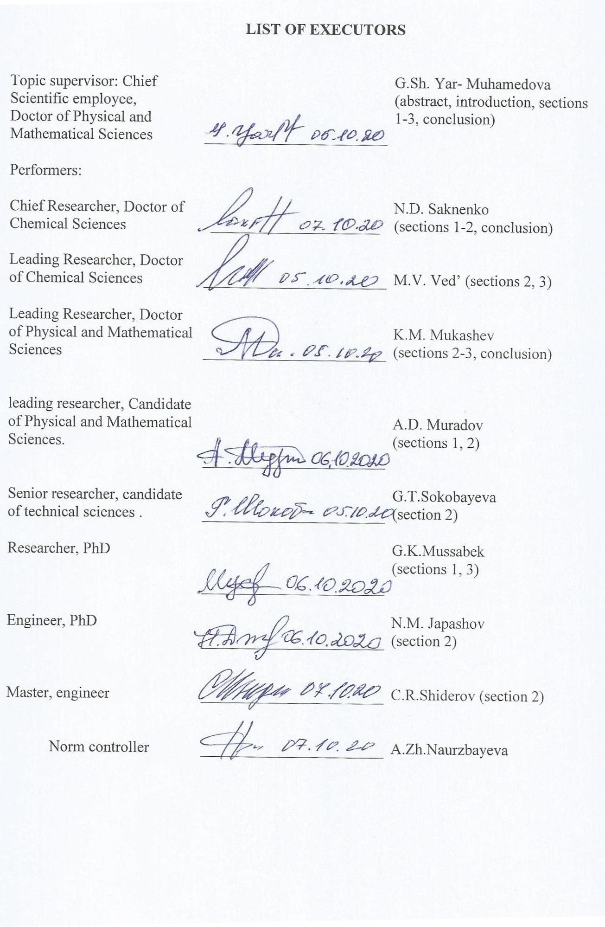

**ESSAY**

Report 43 pages, 13 figures, 11 sources, 6 tables, 4 appendixes.

NANOTECHNOLOGY, FUNCTIONAL GALVANIC COATINGS, CORROSION RESISTANCE, SYNTHESIS, ELECTRICAL EQUIPMENT PARTS

Research object - nanocomposite electrolytic coatings with improved functional properties.

The aim of the research is to develop control methods and technological parameters of physicochemical processes for the synthesis of nanostructured galvanic coatings with alloys, mixed oxides and composites, which increase the service life of electrical equipment by 10.5-15.2 times and to create pilot projects for the production of competitive and export-oriented products: strip conductors and grounding electrodes.

In the course of the work, the following were used: electrochemical research methods, optical, scanning electron and atomic force microscopy, X-ray diffraction, gravimetric method of corrosion research. To analyze the experimental data and determine the kinetic laws and the mechanism of cathodic reactions, kinetic parameters and characteristic criteria were used.

As a result of the study, for the first time, technological parameters of the process of obtaining nanocoatings for components of electrical equipment, launching a galvanic line, making prototypes and conducting life tests were developed.

As a result of the study, for the first time, technological parameters of the process of obtaining nanocoatings for components of electrical equipment, launching a galvanic line, making prototypes and conducting life tests were developed. The main design, technological, technical and operational characteristics: the methods of increasing the efficiency of nanocomposite electrolytic coatings (nano-CEC) developed as part of the research work on this project, made it possible to create optimal electrolyte compositions for the synthesis of coatings with double and ternary Fe (Ni, Co ) –Mo (W), Co-Mo-W.

Scope - chemical, oil and gas and heavy engineering, repair and restoration production.

Efficiency is determined by the fact that the developed electrolyte-suspension increases corrosion resistance and increases the service life of electrical equipment by 10.5 -15.2 times, depending on operating conditions.

|  |  |
| --- | --- |
| **CONTENT** |  |
| introduction………………………………………………………………………..  main part……………………………………………………………………………… | 5  7 |
| 1. Development of a methodology for synthesis of nanostructural electrolytic coatings and scientific basis of selection of coating components for different functional purposes and designing of modernized galvanic lines……………………………….. | 7 |
| 1. Development of a neural network model of connection between functional properties of nanocoatings and their qualitative and quantitative composition, equip a modernized galvaniс line ……………………………………………………………… | 12 |
| 1. Development of technological parameters of the process of obtaining nano coatings for parts of electrical equipment, launching of a galvanic line, production of models and conducting resource tests………………………………………………………… | 18 |
| * 1. Determination of structure-dependent functional properties of multicomponent galvanic nanocoatings and production of a batch of electrodes and strip grounding conductors ………………………..…………………………………………………   2. Conducting enlarged life tests with specification of technological characteristics and development of recommendations for further use of the results………………………………………………………………………………. | 18  24 |
| CONCLUSION…………………………………………………………………………… | 28 |
| REFERENCES……………………………………………………………………………. | 30 |
| APPENDIX A List of published works …………………………………………………. | 31 |
| APPENDIX B Calendar plan……………………………………………………………...  APPENDIX C Testing act………………………………………………………..………. | 35  39 |

APPENDIX D Implementation act ………………………………………………………. 40

**INTRODUCTION**

Electrochemical deposition of nanodispersed alloys is an important and promising area of electroplating for several reasons. First, the list of metals that can be isolated from aqueous solutions is rather limited, so electrolytic alloys are becoming increasingly important. Secondly, due to the combination of valuable qualities of individual metals, coatings with nanodispersed alloys impart various physicochemical and physicomechanical properties to the surface of products [1-3], the level of which can be quite simply varied. Third, at present, in practical electroplating, there is an almost uncontested transition to multicomponent and synergistic alloys, which are characterized by a superadditive enhancement of functional properties in relation to alloy-forming components - catalytic, anti-corrosion, strength and wear resistance, semiconductor and superconductivity, magnetic [4-5] , including giant magnetic resistance, etc.

Among practically important alloys, the main place is occupied by electrolytic nanocompositions formed by metals of the iron triad (iron, cobalt, and nickel) with refractory metals, primarily tungsten, molybdenum, vanadium, and zirconium. One of the reasons for this attention is that, despite the extreme demand for monometallic coatings with refractory metals in various fields, it is well known that individual coatings with tungsten and molybdenum from aqueous solutions cannot be obtained, whereas with metals of the iron triad they can be coprecipitated into alloys [ 6-7].

For the deposition of multicomponent galvanic alloys of iron with refractory metals, ammonia-citrate electrolytes based on Fe (II) are mainly used [8, 9], while, along with metal components, oxygen was found in the composition of coatings, the content of which increases with temperature and working current density, probably due to an increased degree of iron (II) hydrolysis and incomplete reduction of oxometallate. That is why the current trend in electroplating is the use of electrolytes based on iron (III) for the formation of multicomponent coatings with cobalt and tungsten [10-11].

The main task to be solved at this stage consisted in the development of technological parameters of the process of obtaining nanocoatings for components of electrical equipment, the launch of the galvanic line, the manufacture of prototypes and performance tests.

Scientific novelty, validity and compliance of the applied methodology with the specifics of research lies in the fact that the electrochemical method has such undoubted advantages as the possibility of creating a composite coating with a given structure and functional properties, the ease of carrying a uniform layer of adjustable thickness on the surface of the product, the absence of thermal effects, the possibility of excluding subsequent machining, low cost. Implementation of the project objectives was carried out strictly according to the approved research plan without deviations. On the topic of the project "Development of nanostructured coatings for electrical equipment components" (state registration number 0118RK00315), the main goal is to develop control methods and technological parameters of physicochemical processes for the synthesis of nanostructured coatings mixed with electrochemical oxides and composites, an increased service life of device devices in 10, 5-15 , 2 times and the creation of experimental and industrial developments for the production of competitive and export-oriented products. Stage 2018 "Development of a methodology for the synthesis of nanostructured electrolytic coatings and scientific foundations for the selection of coating components for various functional purposes and design of a modernized galvanic line" (Report 2018, inv. No. 0218RK00111). Stage 2019 "Development of a neural network model of the relationship between the functional properties of nanocoatings with their qualitative and quantitative composition, equipment of the modernized galvanic line" (Report 2019, inv. No. 0219RK00162). Stage 2020. "Development of technological parameters for the process of obtaining nanocoatings for electrical components, launching a galvanic line, making prototypes and conducting life tests." The report presents the results of the development and research of nanotechnology for obtaining nanostructured composite electrolytic coatings based on chromium, iron and titanium, the microstructure and properties of coatings, as well as the results of enlarged tests of electrolytes and nano-ECC in industrial conditions.

As a result of the project, 41 works were published, including those with a high impact factor 9, monographs 2, patents 5, textbooks 4, articles of the CCSSE 7. Prepared and defended 2 PhD theses and 3 Master's thesis. The results of scientific research were discussed at foreign conferences in Japan, China, Bulgaria and Ukraine.

The planned scope of work for 2018-2020 was completed in full in accordance with the schedule.

**MAIN PART**

**1 Development of optimal compositions of chrome electrolytes for obtaining nanostructured composite electrolytic coatings**

Solving applied problems of creating new technologies and expanding the spectrum of functional materials determines the interest of researchers and technologists in galvanic multicomponent alloys. Particular attention in the works of leading scientists is paid to the electrochemical synthesis of alloys by metals of the iron triad with d4-elements Fe (Ni, Co) –Mo (W). Such coatings are interesting for the possibility of combining functional properties in them that exceed those for alloy-forming metals. In some cases, researchers note a superadditive increase in performance. Complex implementation in thin layers of increased microhardness, wear and corrosion resistance, catalytic, magnetic properties allows to significantly expand the scope of such coatings. This includes replacing toxic chromium plating, creating efficient catalytic materials that are more affordable compared to traditional platinum.

### Electrochemical synthesis methods make it possible to flexibly control the content of components, the deposition rate, and the state of the surface by varying the composition of electrolytes and polarization modes (static or pulsed, reverse current or potential decrease). It is obvious that the formation of coatings in each individual case depends, first, on the qualitative and quantitative composition of the electrolyte. Secondly, the synthesis conditions have a significant effect on the composition of electroplated deposits, the ratio of components, and the phase composition of coatings. Thus, the structure of the alloy predetermines the properties and applications of the coatings. In this regard, it is relevant to study the effect of electrolysis modes on the composition and morphology of galvanic alloys.

The expediency of using non-stationary electrolysis modes in the creation of triple synergistic Co-Mo-W alloys is confirmed by the research of leading scientists in the field of materials science and nanotechnology. The presented results demonstrate a significant increase in the microhardness and corrosion resistance of the coatings in comparison with the substrate material. The presence in such alloys of metals with different affinities for oxygen and hydrogen opens up prospects for the use of ternary coatings as catalysts and electrode materials for fuel and flow batteries.

Coatings with Fe-Co-Mo alloys were deposited on a copper M1 substrate at a temperature of 20–25 ºC from a complex electrolyte of the composition, mol / dm3: Na3C6H5O7∙2H2O - 0.4; Fe2(SO4)3·9Н2О - 0.075; Na2МоO4∙2H2O - 0.06; CoSO4·7H2O - 0.2; Na2SO4 – 0.15; Н3ВО3 – 0.1. The acidity of the electrolyte was controlled with a pH-meter pH-150M (Republic of Belarus) with a glass electrode EGL-6307 (Republic of Belarus), the pH of the solution was maintained at level 4.7. The surface preparation of the samples was carried out according to the standard technique, including mechanical grinding, degreasing, chemical etching in a mixture of 50% nitric and sulfuric acids, thorough rinsing with distilled water, and drying. Electrolyte solutions were prepared from certified reagent of mark “c. p.” and "p. f. a." (Republic of Belarus, China) on distilled water.

Electrolysis was carried out in a glass cell according to a two-electrode scheme, with unipolar pulse current with an amplitude of 2–5 A / dm2. The duration of the pulse and pause was varied in the range 2⋅10–3–5⋅10–2 s. We used radially located stainless steel anodes of the Kh18N10T brand with a cathode to anode area ratio of 1: 5. The bulk current density was maintained at 2 A / dm3.The chemical composition of the obtained coatings was determined by the X-ray fluorescence method using a portable spectrometer "SPRUT" (Republic of Belarus) with a relative standard deviation of 10–3–10–2. The error in determining the content of the components was ± 1 mass. %. To verify the results, energy dispersive X-ray spectroscopy was also performed using an Oxford INCA Energy 350 electron probe microanalyzer (Great Britain) integrated into a scanning electron microscope (SEM) system.

Surface morphology was studied using a ZEISS EVO 40XVP SEM (Germany). Images were obtained by registering secondary electrons by scanning with an electron beam, which made it possible to make measurements with high resolution and contrast. The current efficiency was determined by the gravimetric method under the assumption that the metals in the deposited coating are in a fully reduced state. The theoretical weight gain as a result of electrodeposition was calculated according to Faraday's law, taking into account the electrochemical equivalent of the alloy.

The composition of the electrolyte was selected based on the results of preliminary studies on the effect of the concentration of the solution components on the composition, surface morphology and current efficiency of Fe-Co-Mo electrolytic alloys. Nevertheless, the control of the quality of coatings and the efficiency of electrolysis, expansion of the range of the content of alloy-forming components lies in the plane of the use of non-stationary current. In this regard, it is necessary to establish the influence of the energy (amplitude of the current density) and temporal (pulse and pause duration) parameters of pulse electrolysis on the composition and surface morphology of ternary alloys.

We have studied the effect of the current density of stationary electrolysis on the composition, morphology and current efficiency of ternary Fe-Co-Mo alloys. It is shown that with an increase in the current density from 2 to 4 A / dm2, the iron content in the alloy decreases from 53 at. % up to 49 at. % by increasing cobalt. The molybdenum content of the coating does not change. An increase in the current density in the studied interval leads to a decrease in the efficiency of the process from 65% to 45%. The decrease in current efficiency is explained by the intensification of the parallel reaction of hydrogen evolution.

These studies show that with a current amplitude of 2–3 A / dm2 and a fixed ratio of impulse / pause duration ti / tp = 2 ms / 20 ms, the alloy composition is practically the same (Figure 1, a, b). An increase in the current density up to 5 A / dm2 contributes to an increase in the content of cobalt and molybdenum in the coating due to a decrease in the iron content (figure 1, c).

|  |  |
| --- | --- |
| FeCoMo 2_2-20 (1) inversion | FeCoMo 3_2-20 (1) inversion |
| a) | b) |

**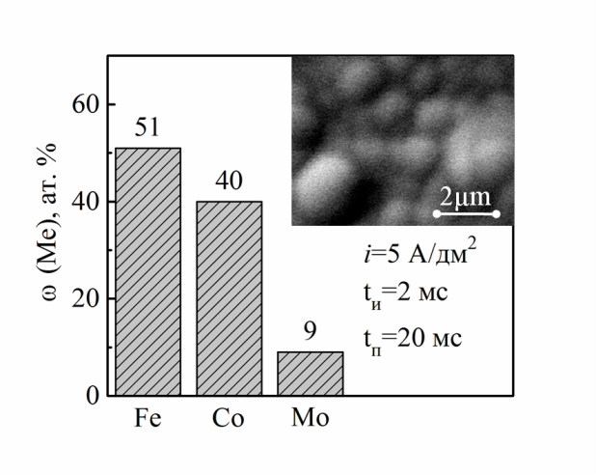**

c )

а) 2; b) 3; c) 5

Figure 1 - Composition and morphology of the Fe-Co-Mo coating at the amplitude of the impulse current, A / dm2

Varying the current amplitude significantly affects the morphology of the deposited coatings. The deposits obtained at a current density of 2 A / dm2 have a fine-grained structure. With an increase in i to 3 A / dm2, separate spheroids are formed on the surface (Figure 1, b), and at 5 A / dm2, a developed globular structure is formed (Figure 1, c). At low current densities (2–3 A / dm2) and a pause tp = 10 ms, an increase in the polarization time has an ambiguous effect on the coating composition. As can be seen from Figure 2, the content of Co and Fe in the alloy varies in the range of 4–10 at. %.

|  |  |
| --- | --- |
| FeCoMo 2A t off 10  рус | FeCoMo 3 A t off 10 рус |
| a) | b) |
|  | |
| с)  current density *і,* А/dm2: а) 2, б) 3, в) 5  Figure 2 - Dependence of the content of components in the Fe-Co-Mo alloy on the pulse duration at tp = 10 ms | |

The maximum amount of molybdenum ω (Mo) is 12–14 at. % corresponds to the interval ton 5–20 ms (Figure 2, a, b). However, at ti / tp = 50 ms / 10 ms, there is a sharp decrease in the concentration of alloying components (cobalt and molybdenum) in the coating. At the same time, an increase in the iron content in the alloy up to 56 at. % (figure 2, a, b).

The dependence of the current efficiency of the Fe-Co-Mo alloy on the parameters of pulse electrolysis is rather complex (table 1). Nevertheless, the analysis of the results of a series of experimental studies allows us to identify some patterns.

Table 1 - Dependence of the process efficiency W,% on the parameters of impulse electrolysis

|  |  |  |  |  |
| --- | --- | --- | --- | --- |
| Impulse / pause ratio | Impulse / pause duration, ms | Current density, A / dm2 | | |
|  |  |  |
| 1:1 | 2/2 | 39 | 27 | 15 |
| 1:2,5 | 2/5 | 38 | 40 | 15 |
| 1:5 | 2/10 | 59 | 40 | 23 |
| 1:1 | 5/5 | 80 | 27 | 35 |
| 1:2 | 5/10 | 39 | 34 | 31 |
| 1:4 | 5/20 | 69 | 51 | 39 |
| 1:1 | 10/10 | 57,3 | 52,8 | 44,3 |
| 1:2 | 10/20 | 81,9 | 65,9 | 54,1 |
| 1:5 | 10/50 | 65,7 | 63,7 | 68,8 |

First, in the entire range of current densities at a fixed ti / tp, the current efficiency increases with increasing impulse duration. Secondly, with an increase in the current density (at ti / tp = const), a decrease in the efficiency of the process is observed. The maximum current efficiency of 80–82% was recorded at a current density of 2 A / dm2 and a ratio ti / tp = (5 ms / 5 ms; 10 ms / 20 ms).

Thus, the analysis of the experimental data reflects the effect of electrolysis parameters on the composition, morphology of coatings, and current efficiency. In addition, the results of the experiment lead to the conclusion about the competitive reduction of molybdenum and iron. All this creates the prerequisites for controlling the composition of the alloy, not only by changing the composition of the electrolyte, but also by varying the parameters of pulse electrolysis.

According to the results of the 2018 year, 16 works were published, including those with an impact factor from 0.8 (Eurasian Chemico-Technological Journal) to 8.7 (Applied Surface Science) 9, monographs 3, patents 5, textbooks, CCSSE articles 7. 1 PhD thesis and 2 master's theses were prepared and defended. The results of scientific research were discussed at foreign conferences in Japan, China, Bulgaria and Ukraine.

The planned scope of work for 2018 was completed in full in accordance with the schedule.

**2 Establishment of the structure formation features, conducting laboratory tests, studying the mechanical properties and morphology of the surface of the nano-CEC**

Coatings with binary and ternary Fe– (Co) –W alloys were deposited onto a steel substrate made of complex citrate electrolytes by constant and pulsed currents with different polarization parameters. The content of alloying elements in the coatings was determined with a SPRUT X-ray spectrometer and an INCA Energy 350 energy-dispersive spectrometer, the phase composition of electrolytic alloys was determined using a DRON-3.0 in monochromatic Co-Kα radiation, the surface morphology was visualized using a ZEISS EVO 40XVP scanning electron microscope, and the roughness was estimated by the contact method. using the probe of the atomic force microscope NT-206. The relationship between the properties of galvanic alloys Co-W, Fe-W and Co-Fe-W of various compositions and the main factors determining the composition and morphology of coatings was revealed using an apparatus of artificial neural networks (ANN). It has been established that the most significant factors influencing the structure-dependent properties of coatings with alloys are the nature, composition and ratio of electrolyte components, as well as the shape, time and amplitude parameters of the polarizing current. It is the multifactorial nature of the system that necessitated the use of ANNs to obtain an adequate description of the array of experimental data.

It is shown that the use of impulse current for the deposition of tungsten-containing coatings makes it possible to create conditions when the rates of nucleation and crystal growth become comparable, which reduces the internal stresses in the coatings. DC deposited Fe-W coatings are porous and their morphology differs from Co-W coatings in the presence of smoother and larger globules that merge with spheroidal structures. With an increase in the current density from 3 to 5 A / dm2, the tungsten content increases and the surface becomes denser. A further increase in the pulsed current density contributes to the enrichment of the coatings with tungsten up to 40 mass%, and the coatings deposited in the pulsed mode have a homogeneous structure without visible defects and pores. The study of the morphology of the coatings using atomic force microscopy made it possible to estimate the size of grains, associates, and the degree of surface development. Thus, the surface relief of Fe-W coatings is more uniform in comparison with Co-W, but it is more developed in comparison with the substrate. Nanosized grains and crystallites merge into cone-shaped agglomerates with a diameter of 0.5–1.0 µm.

The phase composition of tungsten-containing coatings depends on the content of the refractory metal, as well as the nature of the matrix metal. In the general case, the phase composition of electrolytic alloys with the same W content is practically the same and is a solid solution of a refractory component in a cobalt or iron matrix with a small fraction of amorphous structures, but an increase in the content of a refractory component increases the fraction of the amorphous part. It is the difference in surface morphology that explains the experimentally observed fact of an increase in the microhardness of Co – W coatings deposited in a pulsed mode (10–15% higher) compared to Fe – W with the same tungsten content. In this case, the phase composition of electrolytic alloys is almost the same — a solid solution of refractory components in a cobalt or iron matrix.

The general trend in the chemical resistance of coatings with electrolytic alloys Co-W, Fe-W and Co-Fe-W in aggressive media is an increase in corrosion potentials, which is accompanied by a decrease in the corrosion rate. This relationship becomes more pronounced as the content of the refractory metal increases. Tungsten-based alloys are not only resistant to corrosion, but also have high mechanical properties - microhardness increases with increasing W content (Figure 3), but for coatings it is much higher than alloy-forming metals: Co-150, Fe-140, W-400 , which allows us to recommend such materials as an alternative to hard chrome coatings.

|  |
| --- |
| микротвердость |
| 1 – Co–W, 2 – Fe–W  Picture 3- Influence of the tungsten content in the alloy on the microhardness of the coatings |

When substantiating the composition of electrolytes and the ratio of components, the fact was taken into account that ionic equilibria in such solutions significantly depend on pH, and high concentrations of tungstates cause the formation of W2O72- dimer and [FeW2O7HCit]- complexes, which reduce the concentration of electrode-active particles [FeHCitWO4]-, and , therefore, inhibit the cathodic process as a whole. Based on this, the coating with the Fe-W alloy was obtained at the ratio of the components c (Fe3 +): c (Cit3 -): c (WO42-) as 1: 1.5: 0.3 from electrolytes with the composition, mol / dm3: Fe2 (SO4)3 – 0.1-0.15; Na2WO4 – 0.04-0.06; Na3Сit – 0.2-0.3; Na2SO4 – 0.1; H3BO3 – 0.1. The acidity of the electrolyte was controlled by the addition of NaOH or H2SO4 and maintained in the pH range 3.0-4.0. To obtain the Fe-Co-W alloy, cobalt sulfate was additionally introduced into the electrolyte. It was found that the high content of tungsten in the coatings corresponds to the electrolyte with the content, mol / dm3 Fe2 (SO4) 3 – 0.1 и Na2WO4 – 0.06. (Figure 4). An increase in the content of tungstates in the electrolyte over 0.06 mol / dm3 is impractical due to cracking and delamination from the coating substrate due to high internal stresses. An increase in pH to 5.0-6.0, at which mono-oxometalates dominate in the electrolyte and a higher content of alloying components in the alloy should be provided by facilitating their discharge in comparison with condensed forms (W2O72- and others), does not lead to the expected effect. On the contrary, the oxygen content significantly increases, the current efficiency (up to 50.0-60.0%) and the stability of electrolytes are significantly reduced. At the same time, the quality of the resulting coatings deteriorates significantly: cracks appear, the coating peels off from the base metal in places due to low adhesion. This is due to an increase in the rate of hydrolysis and the formation of Fe (III) hydroxoforms in the specified pH range and their inclusion in the composition of coatings.

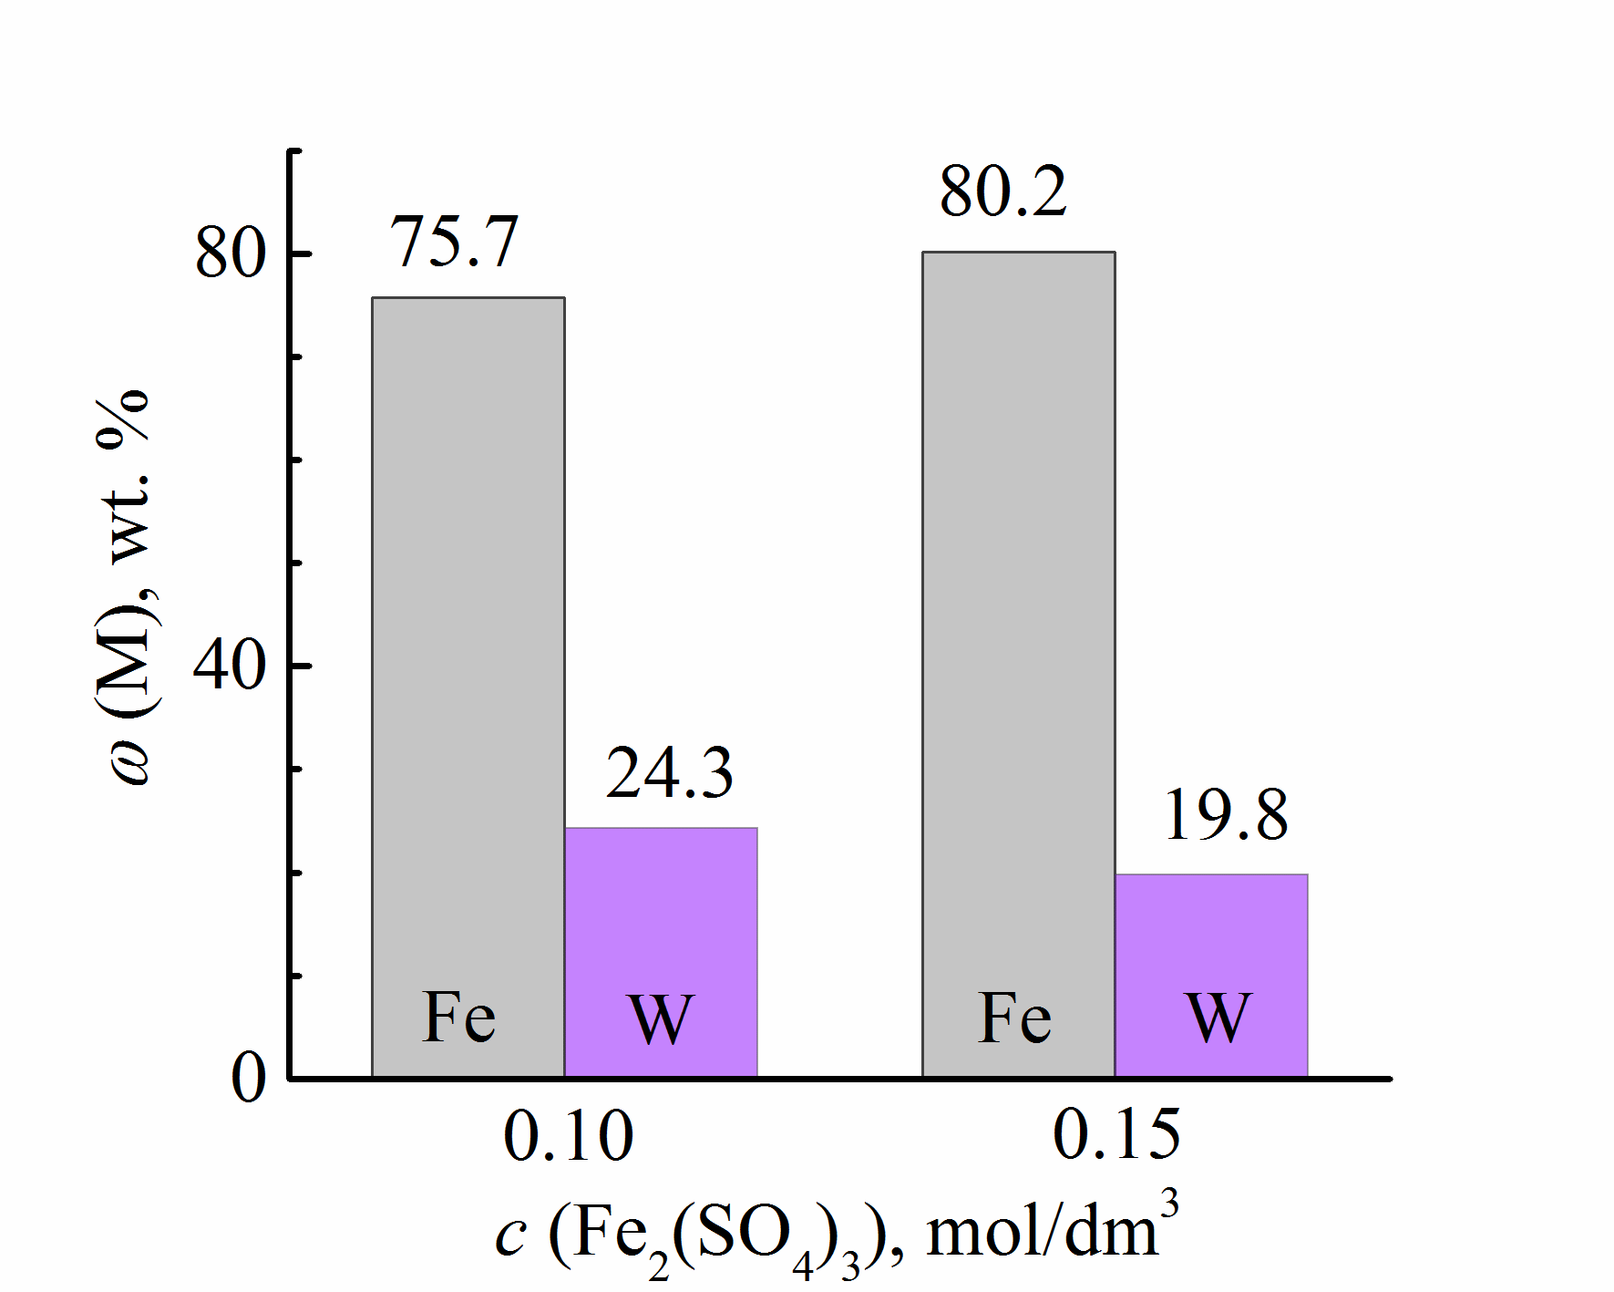 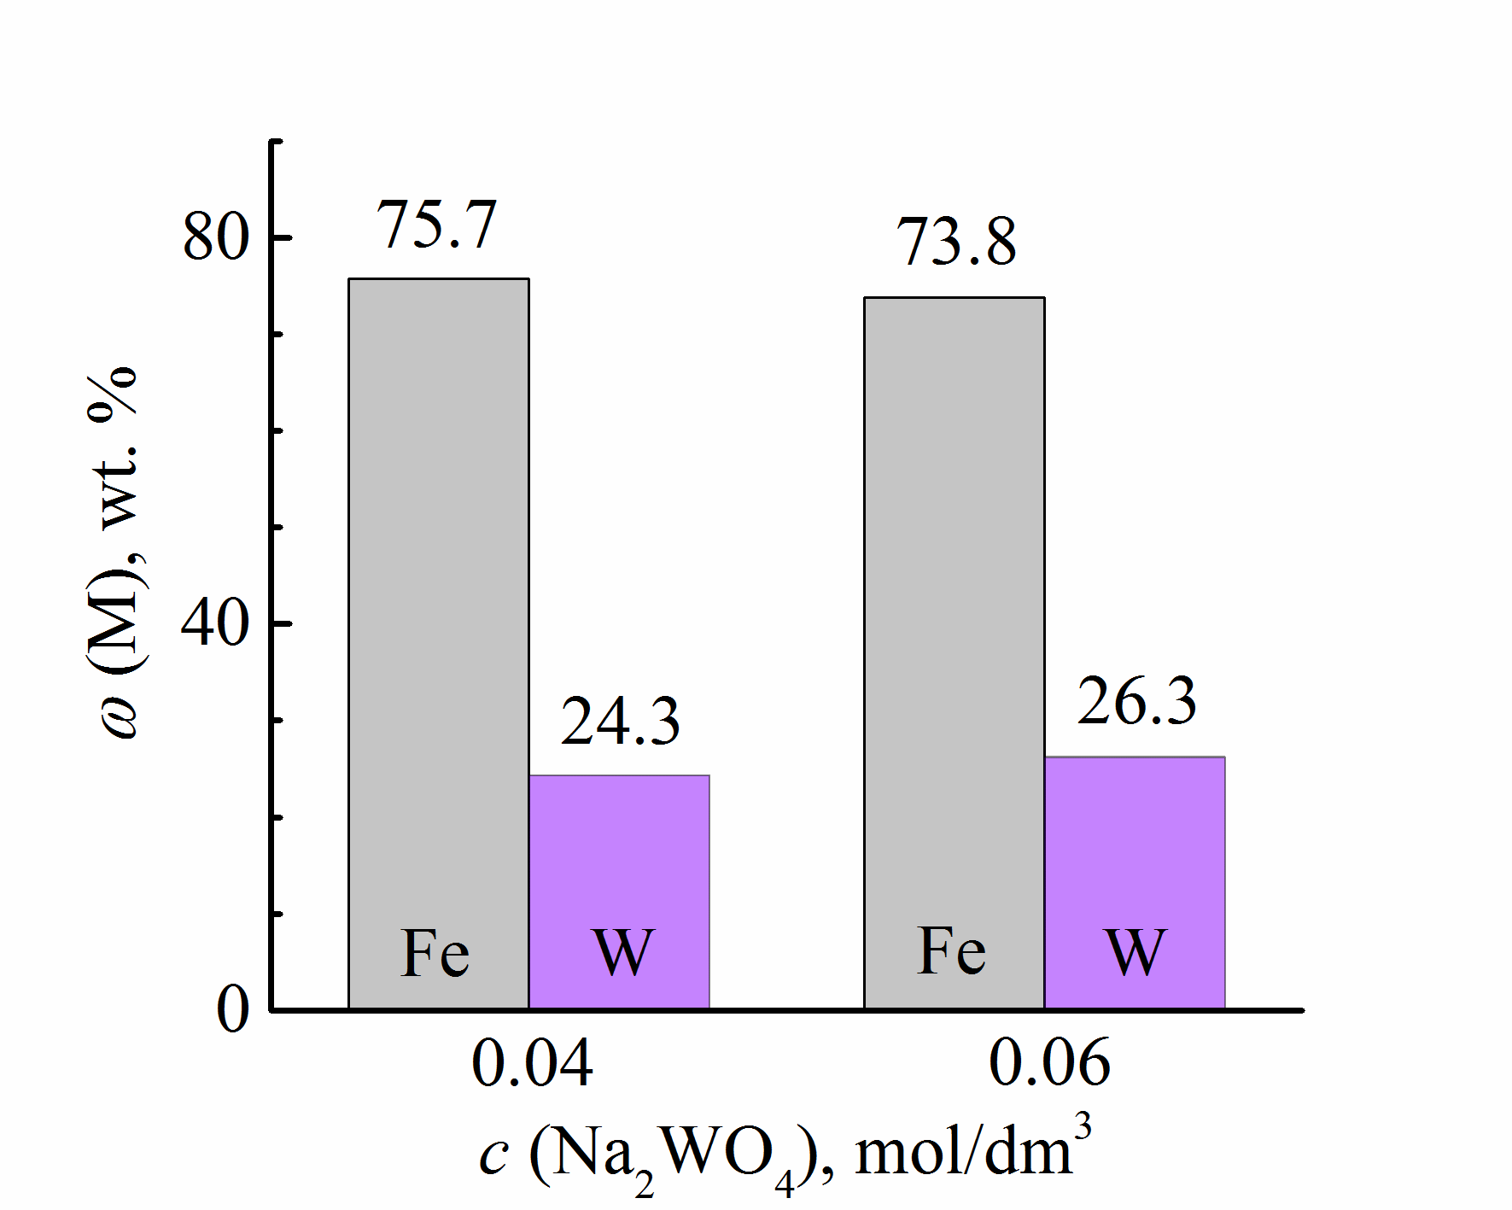

а) б)

a) Fe2(SO4)3, б) Na2WO4; *i*= 4.5 А/dm2

Figure 4 - Influence of the concentration of electrolyte components on the composition of Fe-W coatings

The composition, quality of coatings, as well as the efficiency of the process, depend on the ratio of the salts of alloy-forming components in the electrolyte, pH and temperature, as well as on the electrolysis mode. It should be noted that Fe-W coatings are sufficiently stressed and have defects (cracks, bulges) with a tendency to peel off. This feature is determined by the ratio of the radius of the atoms of alloy-forming metals, which is characteristically for electrolytic tungsten alloys.

The dependences of the tungsten content in the composition of binary coatings, as well as VT on the electrodeposition current density, have an extreme character. Optimal indicators of the electrodeposition process for both galvanostatic and pulse modes (Figure 5) are observed at current densities in the range from 4.5 to 8.5 A / dm2. The coatings deposited on direct current with a density of more than 6.5 A / dm2 crack and peel off from the substrate due to the inclusion of Fe (III) hydroxoforms. The use of unsteady electrolysis makes it possible to expand the operating range of current densities up to 8.0 A / dm2 and to form electrolytic coatings of sufficient quality with a significant current efficiency and content of a refractory component. Analysis of the composition and morphology of the coatings shows that, in addition to the main components (Fe, W) (Figure 5), they contain a certain amount of oxygen.

At the same time, it should be noted the uneven distribution of alloy components over the surface of the coatings deposited with direct current: an increased content of metals is noted on the reliefs, and oxygen in the depressions (Figure 6, a). This concentration profile is due to several reasons: firstly, the increased current density on the protrusions of the coating ensures its enrichment with metals, while in the depressions at low current densities, the complete reduction of oxometallates is difficult, and, consequently, intermediate oxides of refractory elements can be included in the composition of the deposits.

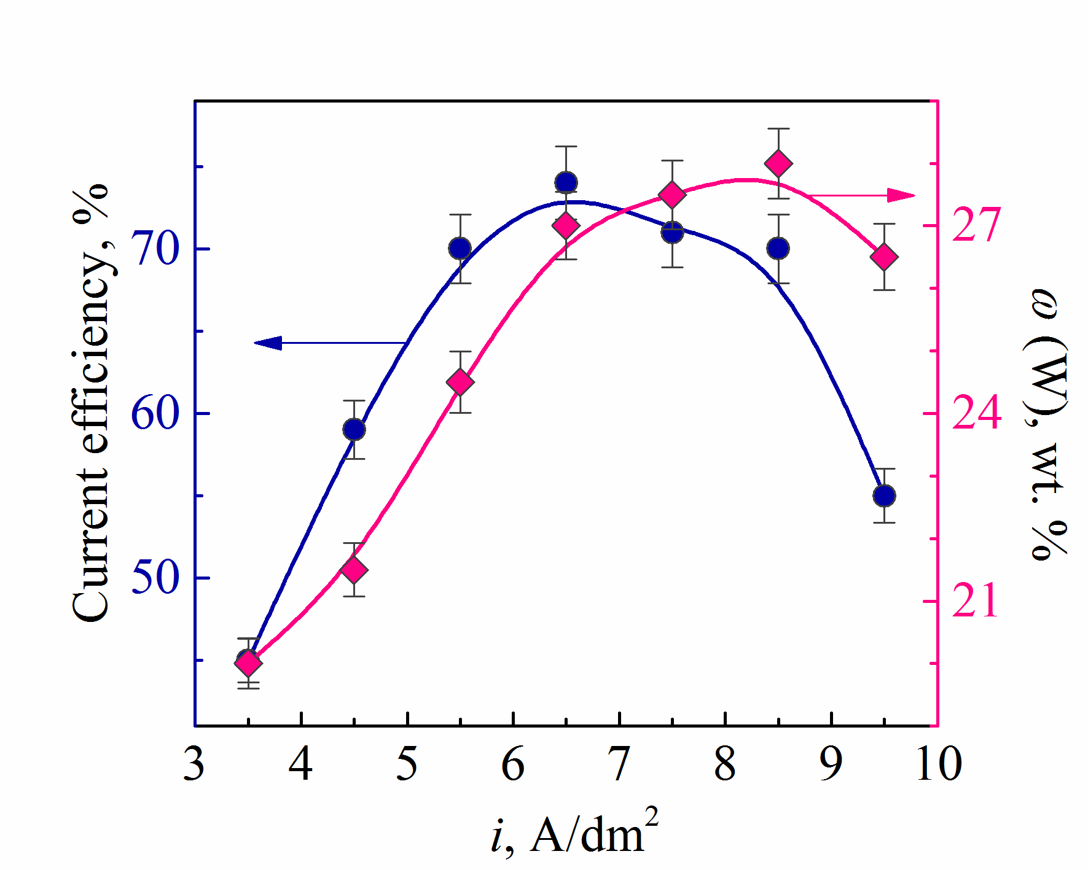 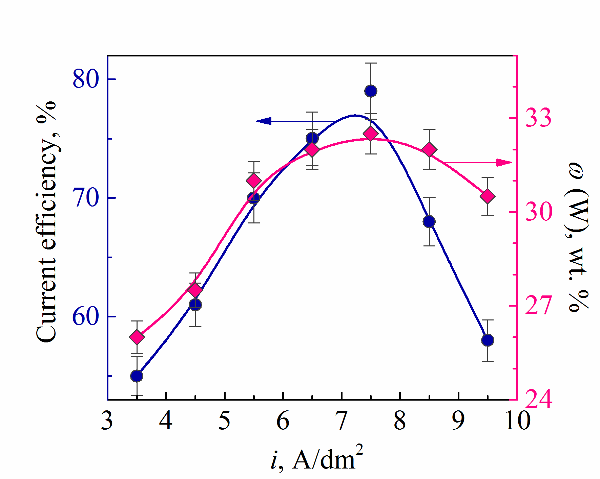

а) б)

a) DC deposition, b) AC deposition, *t*on/*t*off = 10/20 ms

Figure 5 - Influence of current density on the current output of the cathodic reaction and the composition of Fe-W coatings (in terms of metal)

|  |  |
| --- | --- |
| FeW galvanostat | FeW puls |
| FeCoW стац состав с кислородом | FeCoW импульс состав с кислородом |
| a) | б) |
| a) on DC, b)– on AC, ton/toff = 10/20 ms; рН 3.0; t – 25°C  Figure 6 - Morphology and composition of Fe-W coatings (mass%), 1 - on protrusions (1) and cavity (2), deposited | |

Secondly, the processes of adsorption / desorption and diffusion, as well as the chemical stages of dissociation of surface complexes, which limit the overall process of electrochemical alloy formation, proceed with a deliberately higher rate on the relief ridges, and oxoforms of electrolyte components can remain in the depressions. Coatings deposited in a pulse mode from electrolytes of a similar composition are distinguished by a more uniform distribution of components over the surface and a lower oxygen content (Figure 6, b), which is explained by the peculiarities of the electrocrystallization of alloys under conditions of unsteady electrolysis. During the impulse recovery of Iron (III) , oxo-tungstates to oxides in an intermediate oxidation state is carried out. During the pause, the processes of adsorption of reagents, chemical reduction of intermediate tungsten oxides by ad-hydrogen atoms, and a chemical reaction of ligand release are implemented. Thus, the use of the programmed electrolysis mode makes it possible to obtain more uniform coatings due to the acceleration of delayed chemical stages and the discharge of alloy-forming metals. Variations in the pulse duration within 5 - 10 ms and a pause in the interval 10 - 20 ms of the unsteady mode do not significantly affect the content of the refractory component and the current efficiency. Therefore, it is these ranges that are recommended as optimal for electrosurgical coatings with Fe-W alloy.

Fe-Co-W coatings were formed from electrolytes (Table 2), the compositions of which differ in the ratio of the concentrations of alloy-forming components and ligand. The research results indicate the competitive reduction of iron, cobalt and tungsten, the nature of which depends both on the ratio of electrolyte components and on the electrolysis parameters.

Table 2 - Electrolytes for the formation of Fe-Co-W coatings

|  |  |  |  |
| --- | --- | --- | --- |
| Concentration of components, mol/dm3 | ratio  с(Fe3+) : с(Со2+) : с(WO42–) : с(Cit3–) | | |
| W1 | W2 | W3 |
| 1 : 1 : 0,4 : 2 | 1 : 1,3 : 0,6 : 2,7 | 1 : 1,3 : 0,6 : 3,3 |
| Fe2(SO4)3∙9H2O | 0,075 | 0,075 | 0,075 |
| CoSO4∙7H2O | 0,15 | 0,2 | 0,2 |
| Na2WO4∙2H2O | 0,06 | 0,06 | 0,06 |
| Na3Cit∙2H2O | 0,3 | 0,4 | 0,5 |
| Na2SO4 | 0,15 | 0,15 | 0,15 |
| H3BO3 | 0,1 | 0,1 | 0,1 |
| рН | 3,8 | 4,3 | 4,55 |

In coatings deposited from electrolyte W1 (the ratio of the components in solution is c (Fe3+): с (СО2 +): с (WO42-): с (Cit3-) = 1: 1: 0.4: 2 при плотностях тока 2.0 – 4.0 A / dm2, there is a slight variation in the content of iron and cobalt, and the content of tungsten in the coatings increases with an increase in *iк*, but does not exceed 8 at.%. According to the results of the 2019 year, 16 works were published, including those with an impact factor from 0.8 (Eurasian Chemico-Technological Journal) to 8.7 (Applied Surface Science) 3, monographs 1, patents 3, textbooks, articles of CCSSE 3. 2 master's theses were prepared and defended. The results of scientific research were discussed at foreign conferences in Bulgaria and Ukraine.

The planned scope of work for 2019 was completed in full in accordance with the schedule.

**3 Conducting increased tests for clarification technological characteristics and developing a scheme for producing nano-CEC chrome-white soot with specified anti-corrosion properties**

**3.1 Determination of structure-dependent functional properties of multicomponent galvanic nanocoatings and production of a batch of electrodes and strip grounding conductors**

The fields of application of multicomponent galvanic nanocoatings, depending on the ratio of alloy components and the state of the surface, can vary over a wide range, depending on the quality of the coatings and, as a consequence, their functional properties. For example, iron-cobalt alloys alloyed with refractory components (molybdenum, tungsten, etc.) are predicted to be characterized by high chemical stability and corrosion resistance, high physical and mechanical properties, including microhardness, high adhesion to the substrate material. etc. It is these properties that predetermined the choice of the objects of study - galvanic coatings with Fe-Co-Mo alloys. But, at the same time, depending on the electrolysis conditions, the coatings obtained at the same density values of the unipolar pulsed and direct current differ in the content of the oxide phase. We found that the amount of the latter will be higher for those applied in the galvanostatic mode, which gives grounds to assert the presence of MOx oxides in the coating composition, and the coatings themselves should be referred to composites. In turn, in pulsed electrolysis, the reduction of a refractory metal will occur not only during the pulse time and, but also in the chemical stage due to adsorbed hydrogen ad-atoms during the pause. Under these conditions, the amount of oxides will be minimized, as a result of which the coatings can be classified as metallic. A difference is also assumed in the topography of ternary alloys due to the different surface morphology.

The atomic force microscopy (AFM) was used to study the morphology of coatings (Figure 7) obtained at the same current densities in galvanostatic and pulse modes. It was found that the average crystallite size of the amorphous part for the Fe48Сo40Mo12 alloy obtained in a stationary mode at a current density of 3 A / dm2 (Figure 7, a) is 63 Ǻ, and for the Fe43Сo39Mo18 alloy deposited in a pulsed mode at the same current density (Fig. 7, b) is 56 Ǻ.

The study of the topographic map of the alloy surface is a source of information on the structure of composite electrolytic and metal coatings. The results of studies carried out by the AFM method indicate the heterogeneity of the formed coatings - the surface relief in an area with a size of 48 × 48 μm can vary from 0 (dark color) to 2.5 μm (light color).

The results of the analysis of the surface topography of the coating with the composition Fe44Co40Mo16, obtained at i = 2.5 A / dm2 in the galvanostatic mode (Figure 8, c), indicates the development of the surface and the formation of an amorphous-crystalline structure.

|  |  |
| --- | --- |
| імп перед рфа | стац перед рфа |
| a) | b) |
| Figure 7 - Morphology of Fe-Co-Mo alloy coatings obtained in stationary *(a)* and pulsed *(b)* modes at a current density of 3 A / dm2.  Scanning area 20 μm | |

|  |  |  |
| --- | --- | --- |
| *1_hist*  а) | 1_profiles  b) | |
| *1_color* | 1_color_3D |
| c) | |
| Figure 8 - 2D-, 3D-map of the surface, cross-sectional profile between markers 1 and 2 and a heights distribution histogram, tilt angles of elementary surface areas, and orientation angles of the Fe-Co-Mo coating obtained at 2.5 A / dm2. AFM scanning area 48 × 48 μm | | |

The synthesized coatings are characterized by a fine-crystalline surface with separate agglomerate formations.

The evidence of unevenness and roughness is the presence of protrusions and depressions on the surface map, the width and depth of which, recorded on the alloy surface, can reach 0.8 microns (Figure 8, b). The general condition of the surface of the investigated area is characterized by a uniform distribution of protrusions and depressions, and in the investigated area of the surface, associates and clusters of spheroidal shape are fixated (Figure 9, c).

|  |  |  |
| --- | --- | --- |
| *11_hist*  а) | 11_profile  b) | |
| *11_color* | 11_3D_color |
| c) | |
| Figure 9 - 2D-, 3D-map of the surface, cross-sectional profile between markers 1 and 2 and a heights distribution histogram, tilt angles of elementary surface areas, and orientation angles of the Fe-Co-Mo coating obtained at 2.5 A / dm2. AFM scanning area 5 × 5 μm | | |

The value of the surface free energy (SFE) of alloys depends on the characteristics of the material surface, especially the roughness index Ra, with an increase in which the SFE value increases. In addition, the adsorption of oxygen ions on the surface of coatings, which displace an equivalent amount of free surface electrons of metals, leads to the formation of a passivation barrier, which significantly reduces the value of the SFE of the coatings. For all investigated samples, on the surface of which a coating was formed with an alloy, a higher value of the polar component of the SFE is characteristic, which indicates the polarity of the coating surface (Table 3).

Table 3 - The value of SFE and the characteristics of the microrelief of the surface of the Fe-Co-Mo alloy and the substrate

|  |  |  |  |  |
| --- | --- | --- | --- | --- |
| Marking | CEP, mJ/m2 | | | Rа,  μm |
| Dispersion component, mJ/m2 | Polar component, mJ/m2 | Total value,  mJ/m2 |
| Copper М1 | 36,36 | 23,91 | 60,07 | 0,104 |
| Fe–Co–Mo composite | 126,07 | 1,66 | 127,74 | 0,15 |
| Fe–Co–Mo  metal coatings | 115,35 | 2,85 | 118,10 | 0,11 |

When measuring the surface free energy by the sitting drop method, the contact angle of wetting depends on the values of surface tensions at the boundaries of the distribution of three phases. This can explain the difference in the values obtained in the air atmosphere (Table 1), and the known tabular (in vacuum, inert gas and hydrogen atmospheres) data.

The free energy of the surface of ternary alloy coatings is within 118-128 mJ/m2 and is higher than for the substrate. This fact is due to the high values of the SFE of the alloy-forming components. Compared to a metal coating, Fe-Co-MoОх composites are characterized by lower values of the SFE, which is a consequence of the high oxygen content in its structure. The relatively low, in comparison with individual alloy-forming metals, the value of the surface free energy, together with high adhesive strength, are the prerequisites for high corrosion resistance of the developed coatings and composites.

One of the important consumer characteristics of electroplated coatings is their corrosion resistance. The protective ability of the alloys was established from the results of polarization measurements. Compared to the behavior of the base material in acidic (Figure 10, curves 1, 1') and neutral (Figure 10, curves 2, 2') media, the behavior of the Fe-Co-Mo alloy is markedly different.

In an alkaline medium, due to the inhibition of the cathodic reaction caused by the passivation of the alloy surface with iron and cobalt hydroxides, the corrosion potential shifts to the negative side (Figure 11, dependences 3, 3 '). The transition metal hydroxides present cause complications in the delivery of the depolarizer. In the media under study, a shift of the corrosion potential is obserVed’ in the positive direction, the corrosion rate in this case decreases due to the formation of a dense film of acidic molybdenum oxides on the surface of the coatings.

Based on the results of the analysis of corrosion resistance indicators (Table 4), ternary alloy coatings were classified as "resistant" in acidic environments and "highly resistant" in neutral and alkaline environments.

|  |
| --- |
| Мо13 |
| 1, 1 '- 1M Na2SO4 + H2SO4 to рН 3, 2, 2 '- 3% NaCl at рН 5, 3, 3'- 1M Na2SO4 + NaOH to рН 9,5, substrate material - steel Ст 3  Figure 10 - Cathodic (1, 2, 3) and anodic (1 ', 2', 3 ') polarization dependences of Fe51Co36Mo13 coatings in corrosive media of composition |

|  |
| --- |
| Мо38 |
| 1, 1'- 1M Na2SO4 + H2SO4 to рН 3, 2, 2'- 3% NaCl at рН 5,  3, 3'- 1M Na2SO4 + NaOH to рН 9,5, substrate material - steel Ст3  Figure 11 - Cathodic (1, 2, 3) and anodic (1', 2', 3') polarization dependences of Fe31Co31Mo38 coatings in corrosive media of composition |

Table 4 - Corrosion indicators for steel St 3 and Fe-Co-Mo alloy with different content of components

|  |  |  |  |  |  |  |  |  |
| --- | --- | --- | --- | --- | --- | --- | --- | --- |
| Coating composition, *w*, at. % | | | рН 3 | | рН 5 | | рН 9,5 | |
| *Е*кор,  В | lg*i*кор., А/см2 | *Е*кор,  В | lg*i*кор., А/см2 | *Е*кор,  В | lg*i*кор., А/см2 |
| Fe | Co | Mo |
| 51 | 36 | 13 | –0,25 | –3,7 | –0,3 | –4,9 | –0,46 | –5,5 |
| 31 | 31 | 38 | –0,16 | –4,5 | –0,31 | –4,8 | –0,32 | –5,1 |
| Steel St 3 | | | –0,34 | –2,8 | –0,35 | –3,0 | –0,32 | –2,8 |

For verification of the obtained results, the corrosion resistance of the coatings under study was tested using the method of electrode impedance spectroscopy (EIS). The measurements were made according to a two-electrode scheme in a neutral medium of sodium chloride with a mass concentration of 3% at a potential of free corrosion in the frequency range of alternating current 10-2-106 Hz. The results obtained were visualized in the form of Nyquist and Bode diagrams, from the analysis of which the parameters of equivalent schemes were determined. The structure-dependent functional properties of multicomponent galvanic nano-coatings have been determined and pilot batches of electrodes and strip grounding conductors have been manufactured.

**3.2 Conducting enlarged resource tests with specification of technological characteristics and development of recommendations for further use of the results**

The development of technological parameters of the process of obtaining nanocoatings for electrical equipments' components, the launch of a galvanic line, the manufacture of prototypes and performance tests were carried out. The development of the parameters of the process of obtaining nanocomposite coatings was carried out on the basis of experimental data based on the study of the effect of deposition modes of nanocomposite coatings on the corrosion resistance of grounding electrodes. Analysis of the research results shows that at low concentrations of carbon in the electrolyte (2-6 g/l), the graph has maximum values at 2 kA/m2 (2 g/l C + 18 g/l SiO2), 5 kA/m2 (4 g/l C + 16 g/l SiO2) and 6 kA/m2 (6 g/l C + 14 g/l SiO2). For electrolytes with a concentration of 8 g/l C + 12 g/l SiO2 and 14 g/l C + 6 g/l SiO2, the dependence of the current efficiency on the current density exponentially decreases. Figure 12 shows electron microscopy of nano-CEPs obtained from electrolytes with a concentration of 4 g/l C + 16 g/l SiO2 (4 kA/m2) and 16 g/l C + 4 g/l SiO2 (6 kA/m2). The results obtained at the previous stages of the project implementation formed the basis for the development of the scientific foundations of the technology for the formation of multicomponent galvanic alloys.

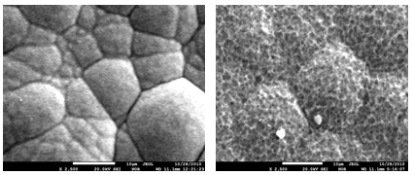

а) b)

а) 4 г/л С + 16 г/л SiO2, b) 16 г/л С + 4 г/л SiO2

Figure 12 – Electron microscope structure of nano-CEC

The testing of technological modes for the deposition of coatings with alloys was carried out in accordance with the developed recommendations and the results of enlarged resource tests. Based on the results of the entire complex of scientific and technological research, a technological instruction was developed for the process of applying a galvanic coating with an alloy of iron - cobalt - molybdenum, given below. The technological process is intended for the application of coatings with alloys and composites in the iron-cobalt-molybdenum system on products from low-carbon steel and cast iron, as well as other metals and their alloys.

The enlarged resource tests (Appendix C) and the subsequent implementation (Appendix D) of the developed nanotechnology were carried out on the basis of Intercom LLP, with which an agreement was signed on the use of the production base for scientific research. To apply nanocrystalline coatings with an iron-cobalt-molybdenum alloy, polypropylene baths were used, which were equipped with on-board suction, brass (copper) tires, heating elements and rectifier units from 12 to 36 V. The accuracy of voltage and current stabilization is ± 5%.

The pendants are designed for rectangular bath and parts of specific sizes, configurations and types. They were necessarily insulated with plastisol. The choice of the type of side slope was determined in accordance with the requirements for sanitary and hygienic working conditions, design and technical and economic calculations of the equipment. The aspirators were made of vinyl plastic. We used insoluble stainless steel anodes of the Х18Н10Т mark. The ratio of the area of the anode to the cathode is (10:1) - (5:1). Electrochemical deposition modes for coatings with an alloy of iron-cobalt-molybdenum and the composition of the electrolyte are shown in table 5 and 6, respectively. To prepare the electrolyte, the propylene bath is filled with distilled or deionized water to one eighth of its volume.

Table 5 - Modes of coatings' electrochemical deposition with an alloy of iron-cobalt-molybdenum

|  |  |  |
| --- | --- | --- |
| Parameter name | Range of values | Optimal value |
| Cathode current density, A/dm2 | 2,0 – 4,0 | 2,0 – 4,0 |
| Voltage, V | 12 -24 | 12 -24 |
| Temperature, оС | 25 - 28 | 25 |
| рН of solutions | 4,5 – 4,9 | 4,8 |
| Processing time, min | 20 – 60 | Processing mode:  - galvanostatic;  - pulse unipolar, 2 ms work, 5 ms pause |

We used aqueous solutions of the components at the rate of one-eighth of the calculated volume for each component. To form complexes, the sodium citrate solution is divided into three parts, which are added at stirring to solutions of iron (iii) sulfate, cobalt sulfate and sodium molybdate. A solution of sodium molybdate with sodium citrate is divided into two parts, each of which is added with stirring to solutions of iron (iii) with sodium sulfate and cobalt sulfate with sodium citrate. The addition of reagents to the bath is carried out in the following sequence:

- A solution of ferrous sulfate (iii) with sodium citrate and sodium molybdate;

- A solution of cobalt sulfate with sodium citrate and sodium molybdate.

Table 6 - Composition, preparation and analysis of electrolyte

|  |  |  |  |
| --- | --- | --- | --- |
| Component name | Standard | Concentration, g/dm3 | Optimal concentration, g/dm3 |
| Ferric (ІІІ)  sulfate 9-water | GOST 9485-74 | 30 – 60 | 45 |
| Cobalt sulfate 7-water | GOST 4462-78 | 30 – 80 | 60 |
| Sodium  molybdate 2-water | GOST 1093-74 | 15 – 30 | 20 |
| Sodium  Citrate 2-water | GOST 22280-76 | 80 – 120 | 120 |
| Sodium sulfate | GOST 4166-76 | 15 – 45 | 30 |
| Boric acid | GOST 9656-45 | 6 | 6 |

Iron-cobalt-molybdenum electrolytes have been tested on the basis of Intercom LLP (Appendix B). Based on the test results, it was decided to introduce the developed nanotechnology and use an electrolyte for applying to steel strips and grounding electrodes (Figures 11 and 12), the service life of which increases from 10.2 to 15.3 times, depending on the composition and moisture of the soil.

|  |  |  |
| --- | --- | --- |
|  |  | |
| а) | b) | |
| а) metal strips for the ground loop; b) grounding electrodes | | |
| Figure 11 - Appearance of finished product | | |
| Enlarged tests of nanotechnology for the synthesis of nano-CEP iron-cobalt-tungsten electrolyte at Intercom LLP (Appendix B) allowed us to establish the optimal temperature of 25–35 °C and the current density of 2–7 kA / m2. The pulsating modes of deposition of nanostructured composite electrolytic coatings have been established and recommended for use.  Verification of the mathematical model developed by us showed that the corrosion characteristics obtained as a result of enlarged tests coincide with the theoretically calculated values ​​with an accuracy of 10-15%. This confirms the adequacy of the scientific statements underlying the mathematical model. | |

According to the results of the 2020 stage, 9 works were published, including those with an impact factor from 2, monographs 1, patents 2, textbooks, articles of CCSSE 2. 2 master's theses were prepared and defended. The results of scientific research were discussed at foreign conferences in Japan and Ukraine.

The planned scope of work for 2020 has been fully completed in accordance with the schedule.

**CONCLUSION**

In order to develop a methodology for the synthesis of nanostructured galvanic coatings and scientific foundations for the selection of coating components for various functional purposes and for the design of a modernized galvanic line, a set of studies was carried out and the following conclusions were made:

- The structure-dependent functional properties of multicomponent galvanic nanocoatings have been determined and batches of electrodes and strip grounding conductors have been manufactured, which have 10.5-15.2 times higher corrosion resistance than those traditionally used in this industry.

- Enlarged resource tests were carried out with the clarification of technological characteristics on the basis of the galvanic line of Intercom LLP and recommendations were developed for further use in order to extend the service life of ground loops and electrodes.

Assessment of the completeness of the tasks' solution. A nanotechnology for the synthesis of multicomponent electroplated nanocoatings has been developed. Large-scale laboratory tests were carried out, prototypes were obtained.

Recommendations and initial data on the specific use of research results. Assessment of the technical and economic efficiency of implementation. Based on the results of this research, nanotechnology for the synthesis of nanocomposite coatings based on chromium and binary and ternary alloys with nano- and amorphous-crystalline structure has been developed.

Assessment of the scientific and technical level of the completed research work in comparison with the best achievements in this area. The scientific and technical level of the performed research and development work is comparable to modern achievements in the production of corrosion and wear-resistant composite electrolytic coatings.

Organizational and material and technical provision for performing research. Research work on the project was carried out in the laboratory of SRI of Experimental and theoretical physics and on the basis of the galvanic shop of Intercom LLP, with which a cooperation agreement was concluded. The team of the main performers, including 4 doctors (2 of which are foreign professors from Ukraine), 2 candidates of sciences, 2 PhDs and 1 master, has experience in the development of technologies for obtaining nanocomposite coatings. As support staff, 2 PhD students of the second and third year were temporarily involVed’ in the work.

For the realization of the project, the necessary research infrastructure was used: production facilities, modern research equipment of SRI of Experimental and theoretical physics, as well as the infrastructure of the Department of Physical Chemistry of the National Technical University "Kharkov Polytechnic Institute" (foreign partners, Ukraine).

Research works were carried out in accordance with the international standard ISO 10006 “Administrative quality management. - Guidelines for Quality Assurance in Project Management”.

SRI of Experimental and theoretical physics has implemented a certified quality management system in relation to research and development activities and personnel training for compliance with the requirements of ST RK ISO 9001-2009 "Quality Management Systems". Analytical work was carried out in a certified laboratory. The devices and equipment were systematically checked, which ensured the reliability of the results and analyzes. Patent and license provision of research is carried out by the relevant department of the organization at all stages of the project. During the implementation of the project, the following modern research and analytical equipment was used: scanning electron microscope with a JEOL JXA-8230 analyzer (JEOL, Japan); microscope OLIMPUS BX-51, thermal analyzer STA 449 F3 Jupiter, sequential atomic emission spectrometer with inductively coupled plasma model 8300 DV (Perkin Elmer Inc., USA); X-ray diffractometer D8 ADVANCE; X-ray fluorescence spectrometer with wave dispersion Venus 200 PANalyical B.V. (PANalytycal B.V., Holland), model AA240 atomic absorption spectrophotometer (Varian Optical Spectroscopy Instruments, Australia).

Economic feasibility of the requested amount of funding for Research Development. Project costs include the following items: salary for personnel, deductions from salary (social tax, social insurance), travel expenses, purchase of materials, others (transfers, registration fees), maintenance of equipment and others, project support.

**REFERENCES**

1. Tsyntsaru N. Modern Trends in Tungsten Alloys Electrodeposition with Iron Group Metals / N. Tsyntsaru, H. Cesiulis, M. Donten, J. Sort, E. Pellicer, E.J. Podlaha-Murphy // Surf. Eng. Appl. Electrochem. – 2012. – Vol. 48, № 6. – P. 491–520.
2. Podlaha, E.J. Induced codeposition: III. Molybdenum alloys with nickel, cobalt and iron / E. J. Podlaha, D. Landolt // J. Electrochem. Soc. –1997. – Vol.144, № 5. – P. 1672–1680.
3. Tsyntsaru, N. Tribological and corrosive characteristics of electrochemical coatings based on cobalt and iron superalloys / N. Tsyntsaru, A. Dikusar et al.// Powder Metallurgy and Metal Ceramics. – 2009. – Vol. 48, №7-8. – P. 419–428.
4. Yar-Mukhamedova, G. Iron binary and ternary coatings with molybdenum and tungsten / G. Yar-Mukhamedova, M. Ved’, N. Sakhnenko et al.// Appl. Surf. Sci. – 2016. – Vol. 383. – P. 346-352.
5. Ramanauskas, R. Effect of pulse plating on the composition and corrosion properties of Zn–Co and Zn–Fe alloy coatings / R. Ramanauskas, L. Gudavičiūtė, R. Juškėnas // Chemija. – 2008. – Vol. 19.– P. 7–13.
6. Ved’, M.V. Electrodeposition of Iron–Molybdenum Coatings from Citrate Electrolyte / M. V. Ved’, N. D. Sakhnenko et al. // Russ.J.of Appl. Chem. – 2014. – Vol. 87. – P. 276-282.
7. [Danilov](https://springerlink3.metapress.com/content/?Author=F.+I.+Danilov), F. I. Electroplating of Ni-Fe Alloys from Methanesulfonate Electrolytes / F. I. Danilov, I. V. [Sknar](https://springerlink3.metapress.com/content/?Author=I.+V.+Sknar), Yu. E. [Sknar](https://springerlink3.metapress.com/content/?Author=Yu.+E.+Sknar) // Russ.J.of Appl. Chem. – 2014. – Vol. 87. – P. 293–296.
8. Weston, D.P. Establishing Relationships between Bath Chemistry, Electrodeposition and Microstructure of Co-W Alloy Coatings Produced from a Gluconate Bath / D. P. Weston, S. J. Harris, P. H. Shipway et al. // Electrochimica Acta. – 2010. – Vol. 55. – P. 5695–5708.
9. Cirovc N. Synthesis, Structure and Properties of Nickel-Iron-Tungsten Alloy Electrodeposits PART I: Effect of Synthesis Parameters on Chemical Composition, Microstructure and Morphology / N. Cirovc, P. Spasojević, L. Ribić-Zelenović, et al. // Science of SinterSintering. – 2015. – Vol. 47. – P. 347–365.
10. Hatchard, T.D. Non–Noble Metal Catalysts Prepared from Fe in Acid Solution / T. D. Hatchard, J. E. Harlow et al. // 2012. – Vol. 159. – P. B121–B125.
11. Silkin, S.A. Effect of bulk current density on tribological properties of Fe-W, Co-W and Ni-W coatings / S. A. Silkin, A. V. Gotelyak,; N. Tsyntsaru, et al.// Surf. Eng. Appl. Electrochem. – 2012. – Vol. 48, № 6. – P. 51–56.

**APPENDIX A**

**List of published works**

2018

1. Yar-Mukhamedova, G. Electrodeposition and properties of binary and ternary cobalt alloys with molybdenum and tungsten/ G.Yar-Mukhamedova, M.Ved’, N.Sakhnenko, T.Nenastina // Applied Surface Science, 445 (2018) 298-307 (Q1, IF TR8.7).
2. Ved’ M. Composition and Corrosion Behavior of Iron-Cobalt-Tungsten // M.Ved’, N. Sakhnenko, I. Yermolenko, G.Yar-Mukhamedova, R. Atchibayev / Eurasian Chemico-Technological Journal. 2018.- V.20 №3.- Pp. 145-152.
3. Muradov A. D. Influence of Γ-Irradiation on The Optical Properties of The Polyimide–Yba2cu3o6.7 System // A. D. Muradov, N. E. Korobova, A. A. Kyrykbaeva, G. Sh. Yar-Mukhamedova, K. M. Mukashev / Journal of Applied Spectroscopy. 2018. V.85, N2.- Pp.260-266. (Q4, IF TR0.6).
4. Sakhnenko N.Galvanic ternary Fe-Co-Mo coatings: structure and magnetic properties/ N. Sakhnenko , I. Yermolenko, M. Ved’ et al// Funсtional materials, 2018, 25 (2).- p.1-8.

5 Yar-Mukhamedova G.Sh., Mukashev K.M., Muradov A.D., Atchibaev R.A. Modified electrolyte for obtaining nanocomposite coatings with improVed’ anti-corrosion properties // G. Sh. Yar-Mukhamedova, K.M. Mukashev, A. D. Muradov, R. A. Atchibaev / Materials of the international conference Advanced technologies in research and education, Severodonetsk, 2018, p. 24-26.

6 Muradov A.D. Modern materials science and methodology of materials' choice / A.D. Muradov, K.M. Mukashev, G.Sh. Yar-Mukhamedova. Handbook. Almaty: Kazakh University, 2018.p-127.

1. Muradov A.D. Influence of $γ$-irradiation on the optical properties of the polyimide-YBa2Cu3O6,7 system / A. D. Muradov, N. E. Korobova, A. A. Kyrykbaeva, G. Sh. Yar-Mukhamedova, K. M. Mukashev // Journal of Applied Spectroscopy, Vol. 85, No. 5, 241-247.
2. Gabdrakhmanova L.A. Metals, alloys, composites / L.A. Gabdrakhmanova, K.M. Mukashev, A.D. Muradov, 2018. Monograph. Almaty: Kazakh University. - 530 p.
3. Mukashev K. Anti-Corrosion Properties of Nanocomposite Coatings In Amine Environments / K.Mukashev, R. Atchibayev, A.Kyzyrova, Zh. Aitbayev et al.// 18-th International Multidisciplinary Scientific Geo-Conference & EXPO – SGEM. - Bulgaria: Albena, 2018. - p. 39-46.
4. Yar-Mukhamedova G. Research on the improvement of mixed titania and Co(Mn) oxide nano-composite coatings // G.Yar-Mukhamedova, N. Sakhnenko, M.Ved’, I. Yermolenko, R.Atchibayev / Global Conf. on Polymer and Composite Materials - Japan: Kitakusu, 2018.-p. 69-74.
5. Yar-Mukhamedova G. Development of Recommendations on The Application of Corrosion-Resistant Nano-CEC for Hec Water Pumps Protection // G.Yar-Mukhamedova, K. Mukashev, A. Muradov, R. Atchibayev, Y. Yar-Mukhamedov / Problems of Corrosion and Corrosion Protection of Materials, Ukrain: Lviv.2018.- p. 249-252.
6. Sakhnenko N.D. Anticorrosive properties of nanocomposite coatings in amine media // N.D. Sakhnenko, M.V. Ved’, A.V. Karakurkchi, G.Sh. Yar-Mukhamedova, R.A.Achibaev / Vestnik KazNRTU, №3 (127), p. 589-593.
7. Musabek G.K. Study of porous titanium films by electrochemical etching // G.K. Musabek, D. Ermukhamed, etc. / Problems of optimization of complex systems, Kyrgyzstan, 2018, -p. 393-397.
8. Sakhnenko M.D. Properties of composite electrochemical coatings modified with zirconium dioxide // M.D. Sakhnenko, M.V. Ved’ et al. / Visnik NTU "KPI", 2018. - №18 (1294). - p.80-84.
9. Sakhnenko M.D. The influence of the content of refractory components on the corrosion resistance of ternary alloys based on iron and cobalt // MD Sakhnenko M.V. Ved’, G.S. Yar-Mukhamedova / Physico-chemical mechanics of materials. - 2018. - № 4.- p. 100-109.
10. Sakhnenko M.D. The structure of nanocomposite electrochemical coatings // M.D. Sakhnenko, M.V. Ved’ et. al / X Ukrainian Conference on Inorganic Chemistry. 2018. Ukraine: Dnipro. - p. 177.

2019

1. Yar-Mukhamedova G. Composition electrolytic coatings with given functional properties / G.Yar-Mukhamedova, M.Ved’, N.Sakhnenko, T.Nenastina // Chapter in the book Applied Surface Science. 2019. Open access DOI: <http://dx.doi.org/10.5772/intechopen.84519>.
2. Yar-Mukhamedova G. Effect of Electrodeposition Parameters on The Composition and Surface Topography of Nanostructured Coatings by Tungsten with Iron and Cobalt / Yar-Mukhamedova G., Ved’ M., Sakhnenko N. et. al.// Eurasian Chemico-Technological Journal. – 2019. – P.24-32.
3. Sachanova Y.I., Influence of the Contents of Refractory Components on the Corrosion Resistance of Ternary Alloys Based on Iron and Cobalt // Y.I., Sachanova, I.,  M.V.Ved’,  G.S.Yar-Mukhamedova, N.D. Sakhnenko et.al. // Materials Science.-2019.- Vol. 54, № 4.- Рp.556-566 (IF TR 0,44).
4. Mukashev, K.M. Investigation of acoustic signals correlated with the flow of muons of cosmic rays, in connection with seismic activity of the north Tien Shan / Mukashev, K.M., Muradov A.D. et.al. // Acta Geophysica. - 2019.- P.1241-1245 (IF Sopus 1.09)
5. Patent RK № 3691. Method of obtaining nanocomposite electrolytic chromium - carbon coatings / G. S.Yar-Mukhamedova, K. M. Mukashev, A. D. Muradov, S. R. Shiderov // Publ. 12.02.2019.
6. Patent RK № 3440. Electrolyte for applying nano-coatings with an iron-cobalt alloy / G.S.Yar-Mukhamedova, N.D. Sakhnenko, M.V. Ved’ // Publ. 10.01.2019.
7. Patent RK № 3441. Electrolyte for applying nano-coatings with an iron-cobalt-tungsten alloy / G.S.Yar-Mukhamedova, N.D. Sakhnenko, M.V. Ved’ // Publ. 10.01.2019.
8. Narivsky A.E. Influence of circulating water parameters, chemical composition and structural heterogeneity of AISI304 steel on its pitting resistance / A.E. Narivsky, G.S. Yar-Mukhamedova, R.A. Atchibaev et al. // Vestnik KazNRTU.- 2019.- № 1.- p. 69-75.
9. Dzhamanbaeva G.T. Prospects for the use of perovskites in photonics / G.T. Dzhamanbayeva, G.S. Yar-Mukhamedova, A.A. Zakhidov // Vestnik KazNRTU.- 2019.- №. 4.- p. 348-354.
10. Sachanova Y.I., Ved’ M.V., Sakhnenko M.D., Yar-Mukhamedova G.S., et. al. Injection of a myst of refractory folds to the corrosion of the triviality of ternary alloys based on gall and cobalt // Physico-chemical mechanics of materials. - 2019. - №4. - p. 100-109. (in Ukraine)
11. Yar-Mukhamedova G.S. // Physico-chemical mechanics of materials. - 2019. - №6. - p. 100-109.
12. Yar-Mukhamedova G. Electrical Machinnary / G.Yar-Mukhamedova, R. Shiderova // Handbook.- Almaty: Qazaq universiteti, 2019. – Pp. 300
13. Yar-Mukhamedova G.S. Effect of AISI304 steel on circulating water, chemical composition and heterogeneity of nanostructure parameters on pitting resistance / G.S. Yar-Mukhamedova, A.E. Narivsky, A.E. Kemelzhanova et. al. // KIMS.- 2019. -№2. - p. 37-45.
14. Yar-Mukhamedova G. ANN simulation of nanocomposites Fe(Co)-W corrosion resistance / G. Yar-Mukhamedova, M.V. Ved’, N.D. Sakhnenko et.al./ 19-th International Multidisciplinary Scientific Geo-Conference & EXPO – SGEM.- Bulgaria: Albena, 2019.- Рp. 267-274.
15. Yar-Mukhamedova G.Sh. Effect of the deposition temperature on the corrosion resistance of nano-CEP / Yar-Mukhamedova G.S., Lunarska E., Atchibaev R.A., Shomanov R.A., Zhumabayeva A.E. // Mater. int. conf. Advanced technologies in research and education. Ukraine: Severodonetsk, 2019 .- p.138-139.
16. Ved’ M. Refractory metals influence on the properties of Fe-Co-Mo(W) electrolytic alloys / M.Ved’, I. Yermolenko, Yu. Sachanova N.Sakhnenko // Materias Today Proceedings.- 2019. - Vol. 6.- p. 120-127.
17. Sakhnenko M.D., Functional galvanic curves: synthesis and modeling / M.D. Sakhnenko, M.V. Ved’, G.S. Yar-Mukhamedova, M.V. Mayba // Proceedings of the XXVII International Conference of Information Technologies: Science, Technology, Education, Health MicroCAD-2019.- Ukraine: Kharkiv, NTU "KPI". - 2019. - p.334.

2020 г.

1. Yar-Mukhamedova G. Nanocomposite electrolytic coatings with defined functional properties / G.Yar-Mukhamedova, M.Ved’, N.Sakhnenko // Monograph. Almaty: Kazakh University, 2020.- 184 p .
2. Yar-Mukhamedova G. Effect of electrodeposition parameters on the composition and surface topography of nanostructured coatings by tungsten with iron and cobalt / G.Yar-Mukhamedova, M.Ved’, N.Sakhnenko // Eurasian Chemico-Technological Journal. 22(1), 2020. - с. 19-25. (26%, IF Scopus 0.8).
3. Gabdrakhmanova L.A. Intensive plastic deformation influence on phase relations of cobalt nanocrystals / L.A. Gabdrakhmanova, , K.M.Mukashev, A.D. Muradov, G.Yar-Mukhamedova et al// Journal of Nano- and Electronic Physics (31% , IF 1.0, SJR 0.213)
4. Kemelzhanova A. Investigation of the anticorrosion properties of nano-СЕС in amine environments/ A. Kemelzhanova, K.Mukasev, G.Yar-Mukhamedova // Complex Use of Mineral Raw Materials. №2 (313), 2020.- р. 52-57. (IF КazBC 0.206).
5. Atchibaev R., Yar-Mukhamedova G.Sh. Investigation of the morphology and microhardness of anticorrosive nanocomposite electrolytic coatings Cr-C-SiO2 // Bulletin of KazNRTU. -2020. №5.-с. 708-714. (in Russian)
6. Sakhnenko M., Vie M., Yar-Mukhamedva G. Physical and mechanical power of nanocomposites based on iron / Problems of Corrosion and Corrosion Protection of Materials. Ukrain: Lviv, 2020.- Pp.23-27. (in Ukraine)
7. Yar-Mukhamedova G. N. Sakhnenko, M.Ved’, I. Yermolenko, R.Atchibayev Research on the improvement of mixed titania and Co(Mn) oxide nano-composite coatings // Global Conf. on Polymer and Composite Materials - Japan: Kitakusu, 2020.-69-74.
8. Patent RK № 4831. Electrolyte for applying nanodispersed coatings with cobalt-tungsten-zirconium alloy / G.Sh.Yar-Mukhamedova, ND Sakhnenko, MV Ved, AD Muradov // Publ. 10.06.2020. (in Russian)
9. Patent RK № 4978. Method for the formation of oxide nanodispersed coatings on aluminum alloys / G.Sh.Yar-Mukhamedova, ND Sakhnenko, MV Ved, Mukashev K. et al. // Publ. 10.01.2020. (in Russian)

**APPENDIX B**

|  |  |  |  |  |  |  |  |  |  |  |  |  |  |  |  |  |  |  |  |  |  |  |  |  |  |  |  |  |  |  |  |  |  |  |  |  |  |  |  |  |  |  |  |  |  |  |  |  |  |  |  |  |  |  |  |  |  |  |  |  |  |  |  |  |  |  |  |  |  |  |  |  |  |
| --- | --- | --- | --- | --- | --- | --- | --- | --- | --- | --- | --- | --- | --- | --- | --- | --- | --- | --- | --- | --- | --- | --- | --- | --- | --- | --- | --- | --- | --- | --- | --- | --- | --- | --- | --- | --- | --- | --- | --- | --- | --- | --- | --- | --- | --- | --- | --- | --- | --- | --- | --- | --- | --- | --- | --- | --- | --- | --- | --- | --- | --- | --- | --- | --- | --- | --- | --- | --- | --- | --- | --- | --- | --- |
| **Calendar plan**   |  |  |  |  |  |  |  | | --- | --- | --- | --- | --- | --- | --- | | № п/п | The name of tasks, activities for the implementation of project objectives | Duration  (in  months) | Beginning and completion of work (dd / mm / yy.) | Years of project implementation, expected results of project implementation(In terms of tasks and activities) | | | | 2018 | 2019 | 2020 | | 1. | Development of a methodology for the synthesis of nanostructured electrolytic coatings and the scientific basis of selection of coating components of various functional purposes and designing the modernization of galvanic line. | 12 | 03/01/18  31/12/18 | A methodology for the synthesis of nanostructured electrolytic coatings and the scientific basis of selecting coating components of various functional purposes and designing of modernization of galvanic line will be developed |  |  | | 1.1 | Analysis and generalization of existing technologies, the effect of the composition of multicomponent nanomaterials on their functional properties and the justification of methods for the synthesis of coatings with double and triple alloys, and pre-project preparation | 6 | 03/01/18  30/06/18 | The analysis and generalization of existing technologies, the effect of the composition of multicomponent nanomaterials on their functional properties and the justification of methods for the synthesis of coatings with double and triple alloys, and pre-project preparation will be conducted |  |  | | 1.2 | Development of a neural network models of communication for the functional properties of nanocoatings with their qualitative and quantitative composition, the rationale of methods of synthesis of coatings with mixed oxides, and the design of a galvanic line | 6 | 01/07/18  31/12/18 | Development of a neural network models of communication for the functional properties of nanocoatings with their qualitative and quantitative composition, the rationale of methods of synthesis of coatings with mixed oxides, and the design of a galvanic line will be developed |  |  | | 2. | Development of a neural network models of communication for the functional properties of nanocoatings with their qualitative and quantitative composition, and the complementation of a galvanic line | 12 | 03/01/19  31/12/19 |  | Development of a neural network models of communication for the functional properties of nanocoatings with their qualitative and quantitative composition, and the complementation of a galvanic line will be carried out |  | | 2.1 | Determination the effect of the composition of electrolytes, parameters of electrochemical and thermochemical synthesis on the composition and morphology of synthesized nanocoatings and complementation of the galvanic line | 6 | 03/01/19  30/06/19 |  | The effect of the composition of electrolytes, parameters of electrochemical and thermochemical synthesis on the composition and morphology of synthesized nanocoatings and complementation of the galvanic line will be determined |  | | 2.2 | Investigation of the influence of technological synthesis modes on the properties of galvanic nanocoatings and the establishment of ways to optimize the structure-dependent qualities for increasing their functional suitability, adjusting the work of the modernized galvanic line | 6 | 01/07/19  31/12/19 |  | The influence of technological synthesis modes on the properties of galvanic nanocoatings and the establishment of ways to optimize the structure-dependent qualities for increasing their functional suitability, adjusting the work of the modernized galvanic line will be investigated |  | | 3. | Development of technological parameters for the process of obtaining nanocoatings for electrical equipment components, starting a galvanic line, making prototypes and conducting resource tests | 12 | 03/01/20  31/12/20 |  |  | Development of technological parameters for the process of obtaining nano coatings for electrical equipment components, starting a galvanic line, making prototypes and conducting resource tests will be conducted | | 3.1 | Determination of the structurally-dependent functional properties of multicomponent galvanic nanocoatings and the production of batch of electrodes and strip ground conductors . | 6 | 03/01/20  30/06/20 |  |  | Determination of the structurally-dependent functional properties of multicomponent galvanic nanocoatings and the production of batch of electrodes and strip ground conductors will be conducted | | 3.2 | Conducting enlarged resource tests with clarification of technological characteristics and development of recommendations for further use of research results | 6 | 01/07/20  31/12/20 |  |  | Enlarged resource tests with clarification of technological characteristics and development of recommendations for further use of research results will be conducted | |
|  |
|  |
|  |
|  |
|  |

**APPENDIX C**

**Testing act**

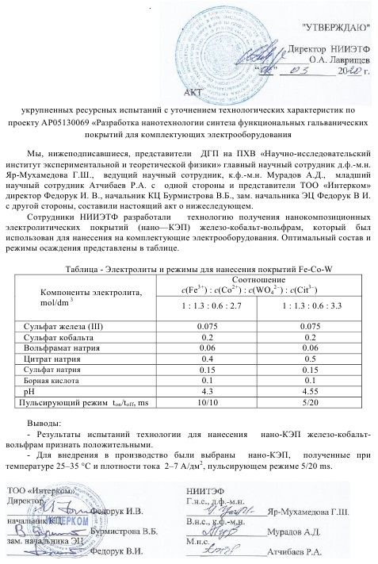

**APPENDIX D**

**Implementation act**

