Ministry of Digital Development, Innovations and Aerospace Industry
of the Republic of Kazakhstan
Aerospace committee

JSC “NATIONAL CENTER OF SPACE RESEARCH AND TECHNOLOGY”

Branch limited liability partnership
“FESENKOV ASTROPHYSICAL INSTITUTE”
(BLLP “FAI”)

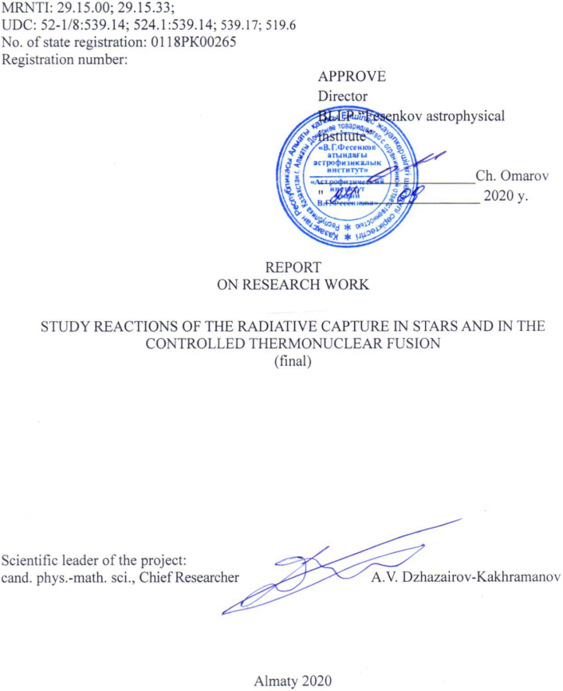
LIST OF EXECUTORS

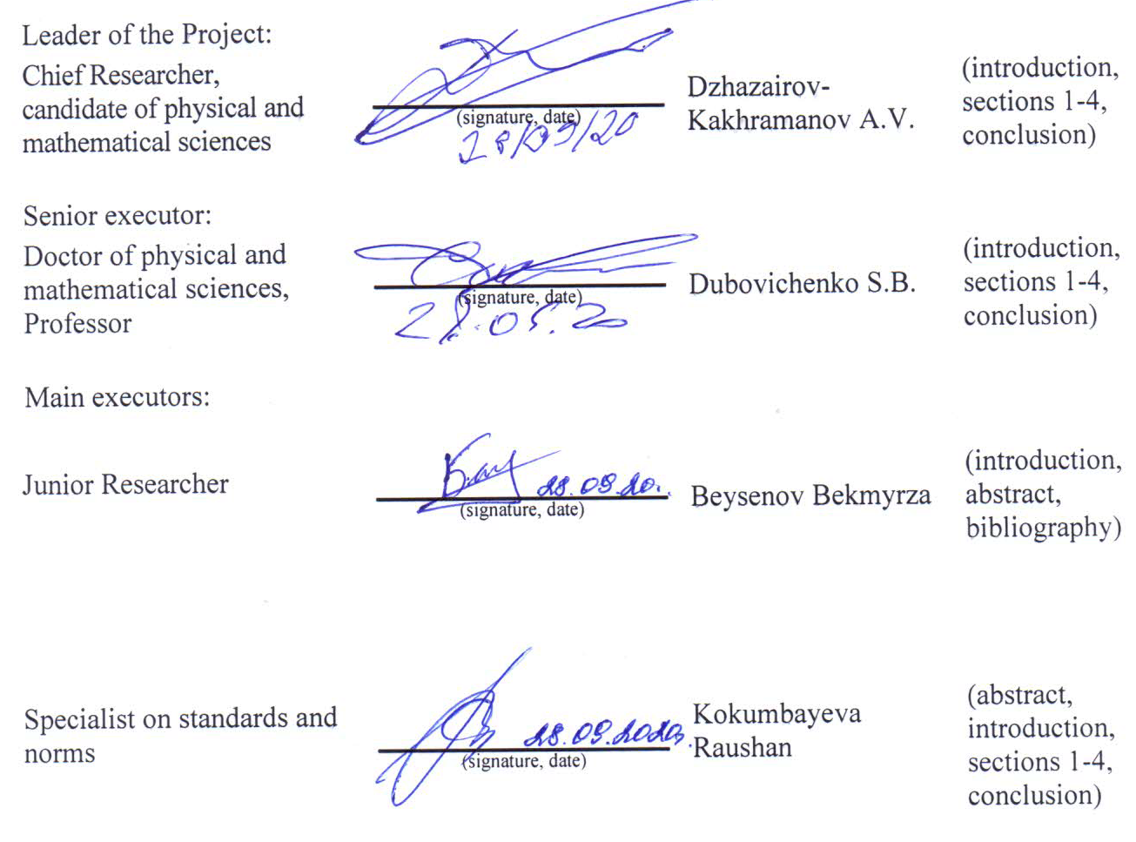

Андатпа
Есеп 44 бет, 1 кітап, 6 сурет., 6 кесте, 75 дерекнама, 2 қосымша.
Әлем, ядролық астрофизика, термоядролық процесстер, радиациялық басып алу, жеңіл атом ядроларының үлгілері
Зерттеу нысандары: Әлемнің термоядролық процесстері.
Жұмыстың мақсаты: Әлемдегі жеңіл атом ядроларының және термоядролық реакциялардың ықтимал кластерлік моделінде қолданылатын аналитикалық және сандық математикалық әдістер, бағдарламалық қамтамасыз ету алгоритмдері және компьютерлік бағдарламалар.
Зерттеу әдістері: Әлемнің жеңіл атом ядроларының потенциялды кластерлік үлгілері мен термоядролық үрдістері аясында пайдаланылатын аналитикалық және сандық математикалық әдістер, бағдарламалық алгоритмдер және компьютерлік бағдарламалар.
Зерттеу нәтижелері мен олардың жаңалығы: ³H + ³He → ⁶Li + γ және p + ⁸Li → ⁹Be + γ процестеріне арналған сандық есептеулерге, компьютерлік бағдарламаларды жазуға немесе жаңартуға арналған астрофизикалық S-факторына және қарастырылатын реакция жылдамдығына өрнектер дайындау.
Іске асыру дәрежесі: Жұмыс теориялық және іске асыруды білдірмейді, бірақ ол жұлдыздардағы термоядролық процестердің механизмдерін, біздің Әлемнің бастапқы нуклеосинтезін және басқарылатын термоядролық синтезді жақсы түсінуге ықпал етеді.
Қолданылу аймағы: Күн мен жұлдыздардағы термоядролық процестер, басқарылатын термоядролық синтез реакциясы және Әлемнің алғашқы нуклеосинтезі.
Зерттеу нысанының дамуы жөніндегі болжам: Жобаның ұлттық және халықаралық ауқымдағы маңызы ядролық астрофизика және ядролық энергетика өзекті мәселелерін шешуде осы зерттеулердің бағытымен анықталады. Бұндай теориялық зерттеулер жұлдыздарда және басқарылатын термоядролық синтездің реакторларында өтетін процесстердің механизмдерін түсіну үшін де маңызды.
Біздің жобаларымыздағыдай жалпы түсініктер, модельдер, әдістер мен тәсілдер негізінде Күнде, жұлдыздарда және бүкіл Әлемде оның қалыптасуы мен дамуының әр түрлі кезеңдерінде болатын 40-қа жуық негізгі термоядролық реакциялардың негізгі сипаттамаларын әлі күнге дейін ешкім түсіндіре алмады. 2009-2020 жж Бұл жоба осындай қарастырудың белгілі кезеңі болып табылады. Қарастырылып отырған термоядролық реакциялардың негізгі сипаттамаларын түсіндіру үшін ³H + ³He → ⁶Li + γ және p + ⁸Li → ⁹Be + γ түсіру үшін бірыңғай тәсіл қолданылады, яғни модификацияланған потенциалды кластерлік модель.
ABSTRACT
Report 44 p., 1 part, 6 figs, 6 tabs, 75 refs, 2 annexes.
UNIVERSE, nUCLEAR ASTROPHYSICS, THERMONUCLEAR PROCESSES, RADIATIVE CAPTURE, LIGHT ATOMIC NUCLEI MODELS
Subject of research: Thermonuclear processes in the Universe.
Project Objective: Development of the unified methods of calculation of rates for thermonuclear reactions passing in stars and in the controlled thermonuclear fusion and comparative analysis of the obtained results with the results of other authors.
Research technique: Analytical and numerical methods, program algorithms and computer programs, used in the framework of the potential cluster model of light atomic nuclei and thermonuclear reactions in the Universe.
Results of research and their novelty: Preparation of expressions for astrophysical S-factor and rate of the considered reaction for the numerical calculations, writing or modernization of the computer programs for processes ³H + ³He → ⁶Li + γ and p + ⁸Li → ⁹Be + γ.
Measure of implementation: The work is theoretical and implementation is not intended, but promote to the best understanding of the flowing mechanisms of thermonuclear processes in stars, primordial nucleosynthesis our Universe and in controlled thermonuclear fusion.
Application field: Thermonuclear processes in the Sun and stars, reactions of the controlled thermonuclear fusion and primordial nucleosynthesis of the Universe.
Forecasting assumption about developing of the subject of research: The significance of the Project in the national and the international scale is defined by the orientation of these researches for solving of the actual problems of nuclear astrophysics and nuclear power engineering. Such theoretical researches are important for the understanding of the thermonuclear fusion mechanism in reactors of controlled thermonuclear fusion.
Nobody cannot explain as yet basic characteristics of almost 40 basic thermonuclear reactions following in the Sun, stars and in all our Universe at different stages of its formation and developing, based on the unified ideas, models, methods and approaches, as it was done by us in our projects from 2009–2020. This project is the certain stage of such consideration. The unified approach, namely, modified potential cluster model is used for studying of the basic characteristics considering thermonuclear capture reactions ³H + ³He → ⁶Li + γ and p + ⁸Li → ⁹Be + γ.
CONTENTS

INTRODUCTION……………………………………………………………………...… |  | 7
MAJOR PART………………………………………………………………………..….. |  | 10
1 | Searching of the elastic scattering ³H + ³He phase shifts in the scientific literature and in the data bases, or the construction of the phase shifts on the basis of the available data on ³H + ³He spectrum levels………………………..….. | 12
2 | Searching of the elastic scattering p + ⁸Li phase shifts in the scientific literature and in the databases, or the construction of the phase shifts on the basis of the available data on p + ⁸Li spectrum levels……………………………………………….……. | 15
3 | The derivation of analytical expressions for the astrophysical S-factor and reaction rate of the considered reaction and preparation the numerical calculation or modernization computer program for the process ³H + ³He → ⁶Li + γ…………..... | 21
4 | The derivation of analytical expressions for the astrophysical S-factor and reaction rate of the considered reaction and preparation the numerical calculation or modernization computer program for the process p + ⁸Li → ⁹Be + γ………..…….. | 24
CONCLUSION………………………………………………………………….………... |  | 28
REFERENCES…………………………………………………………………….……… |  | 32
ANNEX A – List of publications on the Project theme for 2018–2020 years……….…… |  | 38
ANNEX B – Time schedule for 2018–2020 years……………………………………...... |  | 40
LIST OF DESIGNATIONS AND ABBREVIATIONS

In this research report, the following abbreviations and symbols are used:

PCM | – | potential cluster model
MPCM | – | modified potential cluster model
RGM | – | resonating group method
GCM | – | generator-coordinate method
BS | – | bound state
GS | – | ground state
FS | – | forbidden state
ES | – | excited state
AS | – | allowed state
WF | – | wave function
FDM | – | finite-difference method
VM | – | variational method
MeV | – | megaelectronvolt
keV | – | kiloelectronvolt
eV | – | electronvolt
meV | – | milielectronvolt
fm | – | Fermi – 1 fm = 10⁻¹⁵ meters
 | – | mass of the Sun
Т₆ | – | million Kelvin degrees
Т₉ | – | billion Kelvin degrees

INTRODUCTION
Estimation of the modern state of the carrying out scientific and technical problem:
Calculations of the total cross sections of the proton capture reactions at tritium nuclei at astrophysical energies in the modified potential cluster model (MPCM) with forbidden states (FS) of atomic nuclei were not carried out before. In this project and at these energies they are preparing first, all results are new and perspective, and theme of the project exclusively vital.
Substantiation of the necessity of carrying out research study work (RSW):
The Project is the continuation of works carrying out earlier in the Fesenkov Astrophysical Institute from 2009, and with final stage 2018–2020 years.
Information about scientific and technical level of RSW:
The scientific and technical level of the development corresponds to the International scientific level. The description results of the proton radiative capture reactions on tritium nuclei at astrophysical energies in the frame of MPCM was obtained at first in this project. The project was carried out in stages, in accordance with the time schedule (Appendix B) and calculation of the estimated cost. The results are published in world famous journals with a high impact factor (Appendix A).
Project Objective:
Development of the unified methods of calculation of rates for thermonuclear reactions passing in stars and in the controlled thermonuclear fusion and comparative analysis of the obtained results with the results of other authors.
Actuality.
Actuality is caused by the orientation of studies that are important for understanding mechanisms of flowing processes of thermonuclear synthesis in the Sun, stars and in installations of controlled thermonuclear fusion. They promote to knowing of the processes of star evolution, and it means – the evolution of our entire Universe, to development of the model ideas about flowing thermonuclear processes in star and primordial nucleosynthesis of the Universe at different stages of its forming and development.
Novelty.
The novelty of the study of thermonuclear reactions of the radiative capture in stars and controlled thermonuclear fusion consists in the usage one of the most modern approach for research of nuclear and thermonuclear processes. Such approach consists in the usage of the modified potential cluster model of light atomic nuclei with the orbital states classification according to Young tableaux and, in any cases, forbidden states of clusters for calculations of the reaction characteristics. The detailed and systematic calculations of astrophysical characteristics of the thermonuclear reactions in this model are modern and perspective, the work direction is extremely important.
Perspective.
Many nuclear-physical results that have a big practical and applied value in the near future depend on the accurate solve of such theoretical problems. Results of the implemented studies permit to correctly describe of the cross sections of the certain class nuclear reactions at astrophysical energies, which are necessary for thermonuclear and astrophysical supplements. All that allows deeper understand the structure of light atomic nuclei and interaction mechanisms of particles wit nuclei, in this case, thermonuclear reactions in stars and in the controlled thermonuclear fusion. Earlier we have considered basic characteristics more than 40 thermonuclear processes at astrophysical energies in the framework of MPCM.
Basic tasks for studies on stage of 2020 year according to time schedule (Appendix B):
Searching and analysis of the elastic scattering ³H + ³He and p + ⁸Li phase shifts in the scientific literature and in the databases, or the construction of the phase shifts on the basis of the available data on ³H + ³He and p + ⁸Li spectrum levels.
1) Searching and analysis of the elastic scattering ³H + ³He phase shifts in the scientific literature and in the data bases, or the construction of the phase shifts on the basis of the available data on ³H + ³He spectrum levels.
2) Searching and analysis of the elastic scattering p + ⁸Li phase shifts in the scientific literature and in the data bases, or the construction of the phase shifts on the basis of the available data on p + ⁸Li spectrum levels.
3) The derivation of analytical expressions for the astrophysical S-factor and reaction rate of the considered reaction and preparation the numerical calculation or modernization computer program for the process ³H + ³He → ⁶Li + γ.
4) The derivation of analytical expressions for the astrophysical S-factor and reaction rate of the considered reaction and preparation the numerical calculation or modernization computer program for the process p + ⁸Li → ⁹Be + γ.
Reasons for carrying out RSW:
– Decision of the National research council on the priority direction of scientific research “Energetics and machine construction” about grant financing (protocol No. 1 from 19 of January 2018 year)
– Decision of the National research council on the priority direction of scientific research “Energetics and machine construction” about correction of time schedules (protocol No. 3 from 01 of March 2018 year)
– Agreement with the Committee of Science of the Ministry of Education and Science of the Republic of Kazakhstan No. 109 from 05 of March 2018 year
– Decision of the National research council on the priority direction of scientific research “Energetics and machine construction” about future financing for 2019 year (protocol No. 12 from 07 of December 2018 year)
– Decision of the National research council on the priority direction of scientific research “Energetics and machine construction” about future financing for 2020 year (protocol No. 9 from 09 of December 2019 year)
List of the intermediate reports, registered and presented into the joint company “National Center of Science and Technology Evaluation”:
1) Study reactions of the radiative capture in stars and in the controlled thermonuclear fusion: Report about RSW (intermediate) / BLLP “Fesenkov Astrophysical Institute”: Leader of the Project Dzhazairov-Kakhramanov A.V. – Almaty. – 2018. – 33p. – Registration number 0218РК00059.
2) Study reactions of the radiative capture in stars and in the controlled thermonuclear fusion: Report about RSW (intermediate) / BLLP “Fesenkov Astrophysical Institute”: Leader of the Project Dzhazairov-Kakhramanov A.V. – Almaty. – 2019. – 36p. – Registration number 0218РК00046.
Implementation period – 2018-2020 years.
Amount of financing for 2018-2020 years – 14 966,950 ths tenge.
Including: 2018 year – 5 000.00 ths tenge, 2019 year – 5 068.545 ths tenge, 2020 year – 4 898.405 ths tenge.
MAJOR PART
Choosing the research direction:
One of the exclusively successful ways of development of nuclear physics in the last 50 years becomes the microscopic model titled the “Resonating Group Method” (RGM, see, for example, [1,2] and also models connecting with it, for example, Generator-coordinate Method (GCM, see, in particular, [3]) or algebraic version of the RGM [4]. Such evident success leads majority of physicists to the idea that the future obtaining of new results in the field of nuclear physics and nuclear astrophysics is possible only in this direction. However, till now, the possibilities of simple potential two-cluster models (PCM) are not enough examined, especially, if they are used conception forbidden states (FS) [5] and directly take into account resonance behavior of the elastic scattering phase shifts at low energies [6,7] – such model can be titled as modified PCM with FS (MPCM). Not near the whole time, the comparatively difficult RGM calculations are necessary for explanation of the available experimental data. It is sufficient to use comparatively simple MPCM, taken into account classification of the orbital states according to Young diagrams, for consideration of various problems of nuclear astrophysics. Exactly this approach allows, in many cases, to obtain quite adequate results for descriptions of many experimental investigations [6,7].
Substantiation of the research direction:
Particularly, earlier we have shown the possibility of description [6,8,9] for the astrophysical S-factors [10,11] of the radiative capture reactions of charged particles on certain light and lightest atomic nuclei in the framework of MPCM [6,7]. This model takes into account supermultiplet symmetry of the wave function (WF) of the cluster system with the splitting of orbital states by Young diagrams [8,9,12]. The used classification of orbital states allows one to analyze the structure of intercluster interactions, to determine the presence and number of the allowed states (AS) and FS in the intercluster potentials, that means, and it gives an opportunity to find the number of nodes of radial wave function of the relative cluster motion {13–15].
In the using approach, potentials of the intercluster interactions for scattering processes are constructed on the basis of the description elastic scattering phase shifts, which are extracted from the experimental differential cross sections at the implementation of the phase shift analysis [6–9]. Some additional criteria, instead phase shifts, are used for the bound states (BS) of light nuclei in cluster channels for constructing potentials. For example, the requirement of reproduction the binding energy and some other characteristics of the ground state (GS) of nucleus, meanwhile in some cases this requirement is fundamental [6–9]. Herewith, it is assumed that BS is caused by the cluster channel, consisting of initial particles, which take part in this reaction [16–18].
Choice of the modified potential cluster model for consideration similar cluster systems in nuclei, nuclear and thermonuclear processes at astrophysical energies [10,19] is caused by the fact that in many light atomic nuclei the probability of forming nucleon associations, i.e. clusters and degree of their isolation from each other are relatively high. This is prove out by the numerous experimental measurements and different theoretical calculations, obtained by different authors during the last fifty-sixty years [5,20,21]. Of course, such assumption is a certain idealization for real situation in the nucleus, such as supposes that in the BS there is 100% clusterization of nucleus for particles of the initial channel.
At the same time, some nuclear characteristics of separate, even not cluster nuclei, can be predominantly caused by the one certain cluster channel, i.e., have the certain cluster structure at the small contribution of other possible cluster configurations. In this case, the used by us, one-channel cluster model allows one to identify dominant cluster channel and to extract that characteristics of nuclear system, which are caused by it.
Modern status of the problem:
Following consideration of the thermonuclear processes flowing in different objects of the Universe at the different stages of its evolution and development [6,7], in stars and in processes of the controlled thermonuclear fusion. Here the results in the research area of the proton radiative capture reactions on tritium nuclei at the lowest, i.e. astrophysical energies are presented. The MPCM used as a Nuclear model, which allows one to construct intercluster interaction potentials for description thermonuclear processes on the basis of unified ideas, criteria and methods. The distorted wave method [22] is used as a method for the calculation radiative capture total cross sections, and computer programs based on this method are taken from [23]

1 Searching of the elastic scattering ³H + ³He phase shifts in the scientific literature and in the databases, or the construction of the phase shifts on the basis of the available data on ³H + ³He spectrum levels
Searching of the elastic scattering ³H + ³He phase shifts in the literature and in the databases, or the construction of the phase shifts on the basis of the available data on ³H + ³He spectrum levels was done.
The following papers were found as a result of search –
1) Vlastou J. et al. Scattering of polarised and unpolarised ³He by ³H and high excitation in ⁶Li // Nucl. Phys. A 1977. V.292. P.29 и Batten R. et al. Elastic scattering of ³He by tritium // Nucl. Phys. A 1970. V.151. P.56, where the experimental data on the elastic scattering phase shifts in the ³He³H channel were found.
2) Tompson D., Tang Y.C. Study of ³H+³H, ³H+³He, and ³He+³He systems with the resonating-group method // Nucl. Phys. A. 1968. V.106. P.591, where the calculations of the scattering phase shifts by the resonating group method (RGM) is described.
Orbital states in the ³He³Н system for ⁶Li nucleus are pure on Young diagrams that is shown in Figure 1).
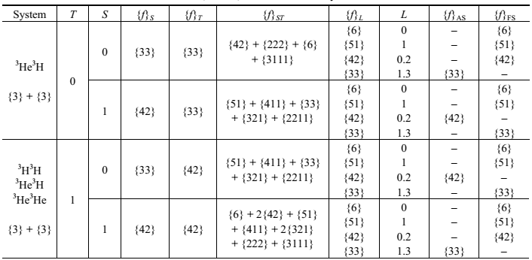

Figure 1 – Classification of states in ³He³Нe, ³H³Нe, and ³H³Н cluster systems
Note – Together with the designation of the system, the orbital Young tableaux of the initial particles are given, and in the {f}_{L} column, possible values of the orbital tableaux for the indicated system are given, which are obtained by way of the Littlewood theorem. The following notation has been adopted: T, S, and L are the isospin, spin, and orbital angular momentum of the system of particles; {f}_{S}, {f}_{T}, and {f}_{ST} are the spin, isospin, and spin-isospin Young tableaux, and {f}_{L} is a possible orbital Young tableau; and {f}_{AS} and {f}_{FS} are the Young tableaux of the allowed and forbidden orbital states (AS and FS).

Therefore, potentials obtained on the basis of the scattering phase shifts are possible to use directly for considering characteristics of bound states of these nuclei. Results will depend on the clusterization degree of nuclei in the considered cluster channels. Because, the probability of clusterization lithium nuclei is relatively high, then the calculation results should generally reproduce experimental data.
The Gaussian form is used for potentials

$V(r)= V_{0} \text{exp}(− α r^{2 })+V_{c}(r)$ (1)

with the point-like Coulomb term. Interaction parameters for pure cluster states in ⁶Li nucleus, obtained in [15,24], are given in Table 1. In the ³He³H system at S = 0 for D and F phase shifts the same potentials are used that for the S and P waves correspondingly.

Table 1 – Potential parameters in the ³He³H system.

 | S = 1 |  | S = 0
L_{J} | V₀, (MeV) | α, (fm⁻²) | V₀, (MeV) | α, (fm⁻²)
S | –90 | 0.18 | –85.0 | 0.18
P₀ | –52.5 | 0.2 | – | –
P₁ | –65.0 | 0.2 | –74.0 | 0.2
P₂ | –80.0 | 0.2 | – | –
D₁ | –72.0 | 0.18 | – | –
D₂ | –85.0 | 0.18 | – | –
D₃ | –90.0 | 0.18 | – | –

Due to the absence of the experimental results, the potentials for the ³He³He system are constructed exclusively on results of the calculation of phase shifts, obtained in the RGM [25,26]. Parameters of such interactions coincide with potentials of the ³He³He system at S = 0. Therefore, ³He³He it is a system of identical particles, here even L correspond to zero spin, and odd to unit spin.
The quality of the phase shift description is shown in Figure 2 with experimental data from woks [27–30] for ⁴He²H, [31–33] for ⁴He³H and [34,35] for ³He³H systems. The calculation results of the ³He³He elastic scattering phase shifts obtained in the RGM [36] are shown by crosses in Figure 2.
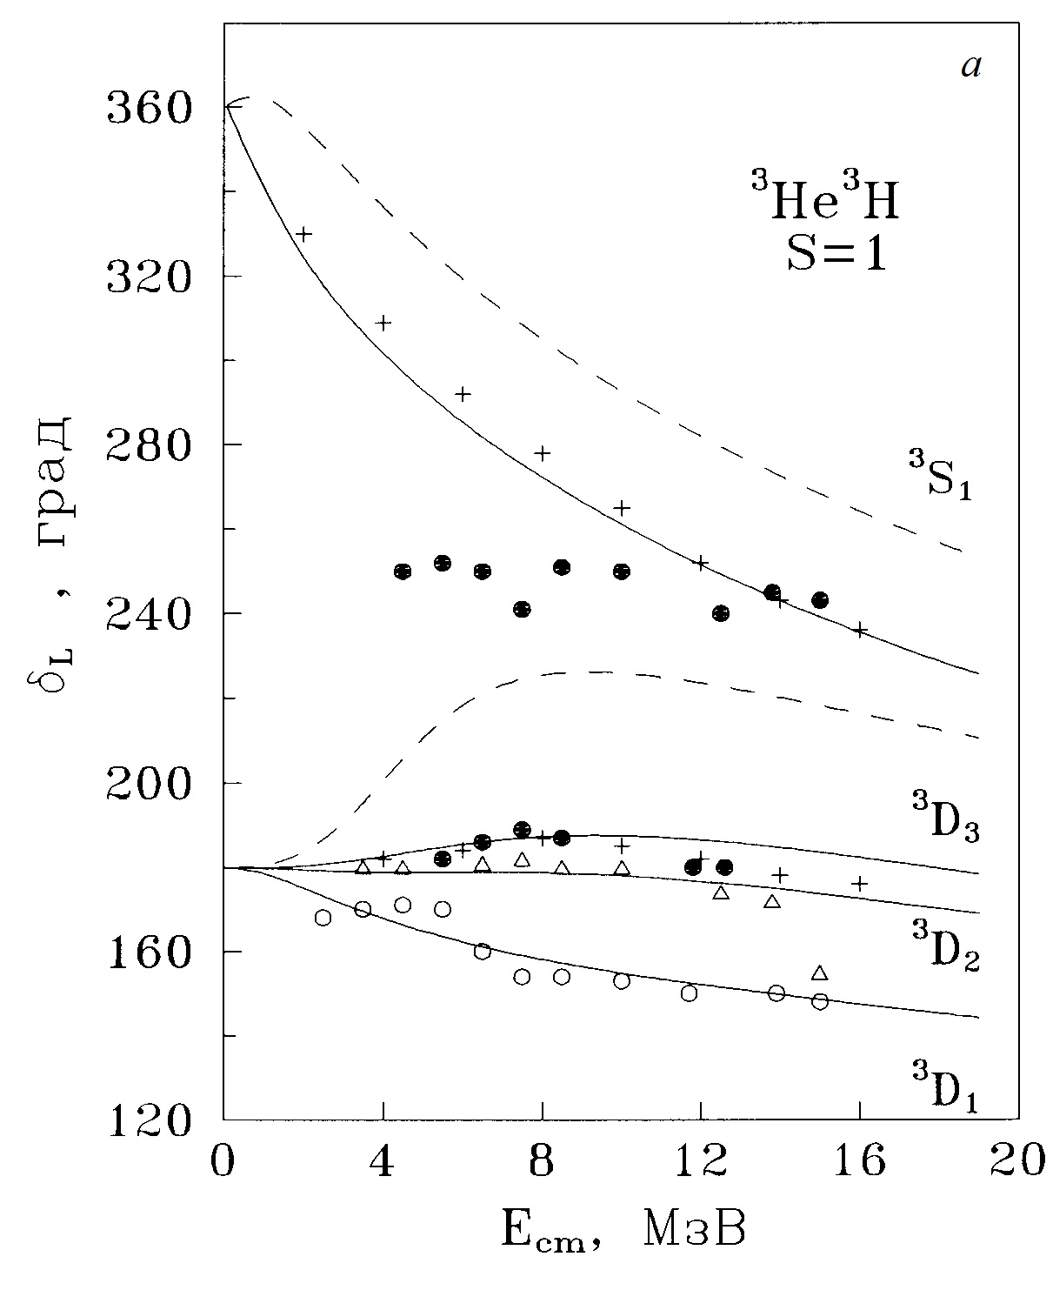  (a) | 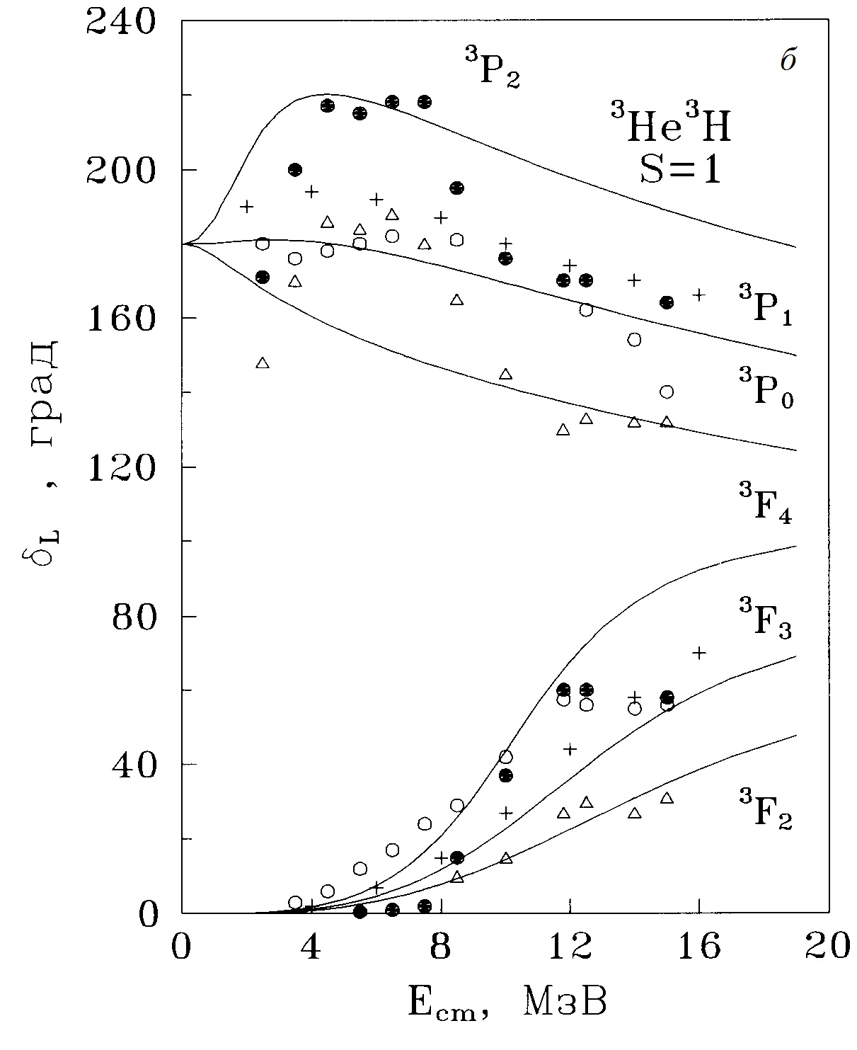  (b)
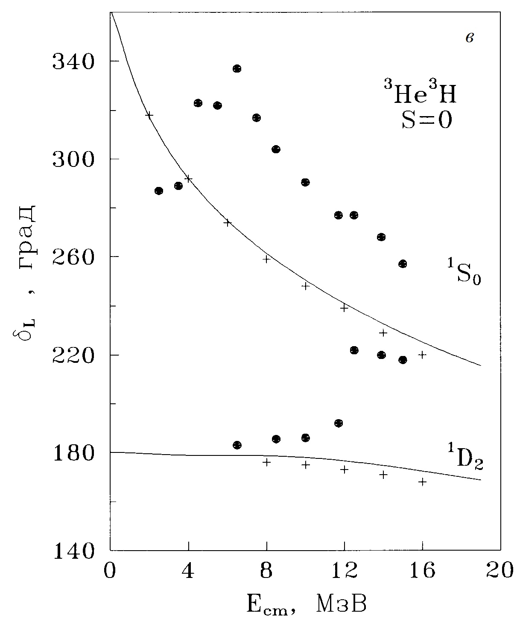  (c) | 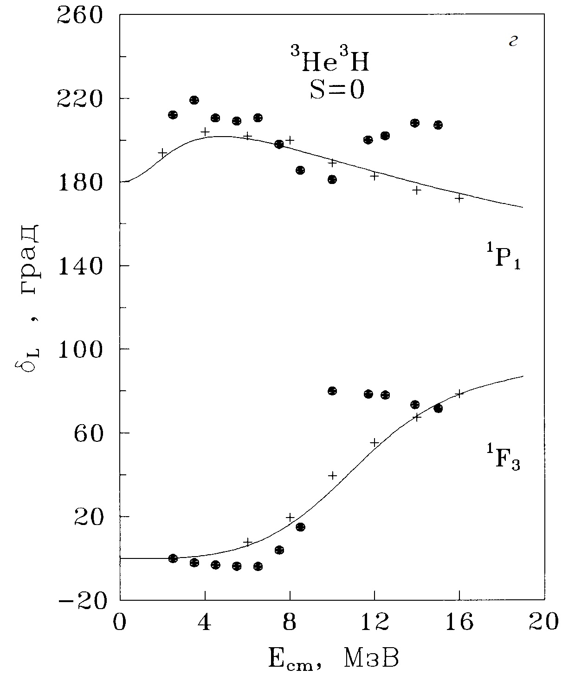  (d)
Figure 2 – Elastic phase shifts of the ³He³H scattering. Curves are calculations for potentials with parameters from Table 1. Points, triangles and circles are experimental data from [34,35]. Crosses are RGM calculations from [36] (a, b, c, d).

2 Searching of the elastic scattering p + ⁸Li phase shifts in the scientific literature and in the databases, or the construction of the phase shifts on the basis of the available data on p + ⁸Li spectrum levels
As far as we did not succeed to find the results of phase shift analysis of the p⁸Li elastic scattering and they unlikely exist, potentials are constructed on the basis of ⁹Be spectra. Thus, S potentials, since in ⁹Be spectra at considering energies there are no ⁴S resonances, should lead to the ⁴S scattering phase shifts on the point of zero or slowly decreasing S phase shifts, and at the absence of the bound FS it can be potential with zero depth or low-repulsive potential. These are relatively weak criteria for the construction of potential, therefore its parameters can be considered as variable in the present model. Potentials of resonance waves are constructed so as to correctly describe the location of resonance E_{r} and its width Γ_{c.m.}, therefore their parameters are obtained quite unambiguously.
GS potentials will be constructed in such a form that allows one to correctly describe channel binding energy, charge radius of ⁹Be and its asymptotic constant in the p⁸Li channel. Since, all known values of asymptotic normalization coefficient (ANC) and spectroscopic factor S_{f}, according to which the asymptotic constant (AC) is obtained, have enough large error. The GS potentials also can have few options with different parameters of width. However, at the given values of AC and binding energy, its parameters are constructed absolutely unambiguously.
Study of formation mechanisms of ⁹Be directly concern to the problem of overlapping of A = 8 mass gap and synthesis of heavier elements in the early Universe, and also the r-process nucleosynthesis in supernovae (see, for example, [37,38]). In the present time, the point of view has appeared that ⁹Be is formed as a result of two-stage process: radiative capture of alpha particles leads to synthesis of short-half-life isotope ⁸Be (), and furthermore radiative neutron capture [38,39]. Also, more difficult process of the direct three-particle capture , (see, for example, [40–44]).
At the same time, in [44] different binary channels of disintegration of ⁹Be: , , , and also were experimentally studied. Evidently, that processes of two-body radiative capture connected with them by the detailed balancing principle lead to the synthesis of ⁹Be and require corresponding estimation contextually the astrophysical supplements. Meanwhile, it should to note that first three reactions have the Coulomb barrier in channels , and lower than in along with channels, namely in a ratio 3/4. Thus, they have the preference in this parameter. Higher factor of the Coulomb suppression takes place in the initial channels of and processes, which role briefly were discussed above.
Here we are considering reaction p⁸Li→⁹Beγ at low astrophysical energies in connection with that is included in the chain of significant processes, which lead to synthesis heavier elements in the fundamentally significant work of Terasawa et al. [37], which almost 20 years plays the role of certain “proposal practical research guide” from the moment of its publishing.
The cross section of ⁸Li(p,γ)⁹Be is hard obtained directly due to low ⁸Li beam intensity and small cross section at astrophysical energies. Besides, the problem of study ⁸Li(p,γ)⁹Be reaction also is in the fact that direct experiment measurement of cross sections is practically impossible due to very small half-life of ⁸Li – 838 ms [45]. However, as in the case of the neutron capture on ⁸Li [46], some indirect methods of extracting direct capture cross sections can be used with the help of radiative capture model and spectroscopic factor [37–45].
Considering reaction p⁸Li→⁹Beγ present significant astrophysical interest, because it is included in the list of processes of primordial nucleosynthesis of the Universe [47]. However, its experimental investigation in the astrophysical range is carried out clearly insufficiently. Intrinsically, there is only one work [48] where the astrophysical range is considered. Work [49] adds it, where measurements were done at higher energies. Meanwhile, these works were published in sixtieth of the previous century and we do not succeed more modern experimental studies of total cross sections of the considering reaction [50]. Even though studying of spectra ⁹Be in the p⁸Li channel continue till now [51]. Besides, the available and considered further theoretical results differ so high that it is difficult to do any certain conclusions about rate of this reaction. Meanwhile, all these calculations do not take into account existence of resonances in the p⁸Li system at low energies [51].
In the present paper we will consider reaction of the proton capture on ⁸Li in the frame of MPCM [52,53] and will define how criteria of this model allow correctly describe total cross sections and astrophysical S-factor at astrophysical energies. The energy range of 10 keV to 7.0 MeV was considered, but taking into account structure of resonances only to 2.0 MeV, which was given in new work [51]. Rate of this reaction was calculated at the temperature range of 0.01 to 10 T₉. The analysis of influence of location and magnitude of resonances to the value and shape of reaction rate was presented.
Potentials of the p⁸Li interaction:
The radius of ⁸Li equals 2.327±0.0298 fm, which is given in data base [54], was used in further calculations. The radius of 2.518±0.0119 fm for ⁹Be also is known from data base [54]. Besides, for example, the value of 2.299(32) fm for ⁸Li radius was found in [55]. In work [56] for these radiuses were obtained values of 2.30(4) fm and 2.519(12) fm, correspondingly. All these data well agree among themselves within limits of errors. The accurate values: m(⁸Li) = 8.022487 amu [57] and m_{p} = 1.0072764669 amu [58] were used for masses of nucleus and proton. The charge and mass radius of proton is equal to 0.8775(51) fm [58].
Spectroscopic factor S_{f} of the GS and A_{NC} ANC are connected by the next formula

$A_{\text{NC}}^{2}=S_{f}×C^{2}$, (2)

where C is dimensioned asymptotic constant in fm^{-1/2}, which connected with dimensionless AC C_{w} [59] by the next way: $C=\sqrt{2k_{0}}C_{w}$, and dimensionless constant C_{w} defined in the relation [59]

, (3)

Here, χ_{L}(r) is the numerical BS radial wave function, obtained as the solution of the Schrödinger equation normalized to unit size; W_{-ηL+1/2}(2k₀r) is the Whittaker function of the bound state, determining the asymptotic behavior of the wave function and obtained as the solution of the same equation without nuclear potential; k₀ is a wave number related to the channel binding energy E where $k_{0}=\sqrt{2{μE}/{ℏ^{2}}}$ in fm⁻¹; η is the Coulomb parameter $η={μZ}_{1}Z_{2}e^{2}/(ℏ^{2}k_{0})$ = $3\text{.}\text{44476}⋅{\text{10}}^{−2}{μZ}_{1}Z_{2}/k_{0}$; Z₁ and Z₂ are the particle charges; L is the orbital momentum of the bound state; μ = m₁m₂/(m₁+m₂) is the reduced mass of two particles and constant ħ²/m₀ is equal to 41.4686 MeV fm², where m₀ – atomic mass unit (amu). Coulomb potential at zero Coulomb radius R_{coul} = 0 is written in the form V_{coul}(MeV) = 1.439975·Z₁Z₂/r, where r is the relative distance between particles of the initial channel in fm; μ_{p} = 2.792847µ₀ [58] and μ(⁸Li) = 1.65356µ₀ [60] are magnetic moments of proton and nucleus, where µ₀ is the nuclear magneton.
As in our previous works [52,53] for other nuclear systems, we will use the potential of Gaussian form (1) with the point-like Coulomb term with the given orbital momentum L in each partial wave as the p⁸Li interaction.
The ⁴P_{3/2} level we consider as the ground state of ⁹Be in the p⁸Li and such potential should correctly describe the AC for this channel. In order to extract this constant C in form (2) or C_{w} (3) from the available experimental data let us consider information about spectroscopic factors S_{f} and asymptotic normalization coefficients A_{NC}. For example, in [62] except owned results, authors add data of previous works. If to separate from these similar results, that is, with closely spaced values of spectroscopic factor that can be presented in the form of Table 2

Table 2 – Data on spectroscopic factors S_{f} for the GS of ⁹Be in the p⁸Li channel from works [61–64]. is the average value on data interval

Reaction from what S_{f}  was determined | S_{f} for the p⁸Li_{GS}  channel | Ref.
⁸Li(d,n)⁹Be | 0.64(21) | [62]
¹²C(⁹Be,⁸Li)¹⁴N | 0.73(15) | [61]
Average value | 0.69, that is, $\sqrt{S_{f}}$= 0.83
Average value on data interval | = 0.66(22), 0.43–0.88  = 0.81(14)
⁹Be(⁸Li,⁹Be)⁸Li | 1.50(28) | [63]
Potential model | 1.50(27) | [64]
Average value on all results | 1.09, = 1.05
Data interval on all results | = 1.11(68), 0.43-1.78  = 1.05(28)

Furthermore, the ANC ⁴P_{3/2} GS in the p⁸Li channel was given in [65], where A_{NC} = 10.75(12) fm^{-1/2} was obtained. Constant for the ⁶P_{3/2} state is much less – 0.25(10) fm^{-1/2} [65]. Therefore, we consider here only one spin channel with S = 3/2. On the basis of expression (2) and average value on interval = 0.66(22) according works [61,62] for AC GS the value С = 13.71(2.52) fm^{-1/2} was obtained, and because $\sqrt{2k_{0}}=$1.307, so dimensionless AC (3) is equal to C_{w} = 10.49(1.93). However, if to use the average value on all works from Table 2, equals 1.05(28), then for constant C we will obtain more wide data interval 11.06(3.06) fm^{-1/2} and С_{w} = 8.46(2.34). Consequently, the possible interval of C_{w} values on two data groups from Table 2 is approximately from 6 (by the latest data) to 12.5 (by the previous results).
Furthermore, two options of the GS potentials with FS, which allow to obtain dimensionless asymptotic constant C_{w} in the given above limits, were obtained. Parameters of these potentials V_{L} and α_{L}, and also main characteristics of the nucleus, obtained with them (binding energy E_{b}, asymptotic constant C_{w}, mass radius <R>_{m} and charge radius <R>_{ch}) are listed in Table 3.

Table 3 – GS potential parameters and main characteristics of ⁹Be

Potential No. | V_{L}, MeV | α_{L}, fm⁻² | E_{b}, MeV | C_{w} | <R>_{m}, fm | <R>_{ch}, fm
1 | 212.151135 | 0.17 | -16.88820 | 10.2(1) | 2.40 | 2.46
2 | 286.178045 | 0.25 | -16.88820 | 6.6(1) | 2.36 | 2.38

For example, potential No. 1 has the FS and leads to the binding energy -16.88820 MeV at accuracy of the used here finite-difference method (FDM) for finding energy of 10⁻⁵ MeV [66]. Definition of calculation expressions for used here radii is given, for example, in [52]. Given above AC errors are defined by their averaging over the distance interval from 6–8 to 10–12 fm, which is the AC stabilization range. The phase shift of the elastic scattering of this potential for the GS ⁴Р_{3/2} smoothly decreases down to zero and at 5.0 MeV has the value about 330°. Here we taking into account that in the presence of two bound FS and AS, the phase shift according to generalized Levinson theorem starting from 360° [67]. Furthermore, another option of the GS potential that leads to smaller AC is given in Table 3.
Parameters of the used by us scattering potentials are listed in Table 4. The experimental data are given in two last columns of Table 4. The potential No. 1 without FS was obtained for the S wave, which at energies up to 5.0 MeV leads to the scattering phase shift about 155° – it is shown by the blue dashed curve in Figure 3. Here and further, it should be kept in view that in accordance with the generalized Levinson theorem [18], the phase shift of the potential without FS starting from 0°, but resonance potentials with one FS – from 180°. Figure 3 shows phase shifts so that they can be seen in a single figure.

Figure 2 – Phase shifts of the elastic p⁸Li scattering at low energies

Table 5 – Options of potential parameters with FS for resonance states of nucleus and some characteristics obtained with them

No. | ^{2s+1}L_{J} | V_{J}, MeV | α_{J}, fm⁻² | E_{r} (c.m.), keV | Γ_{c.m,}, keV | E_{r} (c.m.), keV | Γ_{c.m,}, keV
1 | ⁴S_{3/2} | -5 | 0.1 | – | – | – | –
2 | ⁴D_{3/2} | 269.242 | 0.2 | 1100 | 56 | 1100(30) | 50(22)
3 | ⁴P_{1/2} | 66.69121 | 0.075 | 87 | ∼0.4 | 87(1) | 0.39(1)
4 | ⁴P_{5/2} | 34.0399 | 0.04 | 410 | 203 | 420(7) | 210(20)

Potential No. 3 from Table 5 leads to the ⁴P_{1/2} scattering phase shift, plotted in Figure 2 by the black solid curve, which is shown at energies up to 5.0 MeV and has the resonance at 87 keV. Scattering potential No. 4 has the phase shift ⁴P_{5/2} presented in Figure 2 by the red dashed curve and at the considered energies has the resonance at 410 keV. Potential No. 2 leads to the ⁴D_{3/2} phase shift shown in Figure 2 by the green solid curve. All resonance potentials have the phase shift of 90.0°(1) at the resonance energy and the bound FS.

3 The derivation of analytical expressions for the astrophysical S-factor and reaction rate of the considered reaction and preparation the numerical calculation or modernization computer program for the process ³H + ³He → ⁶Li + γ
The possibility of description of the astrophysical S-factors and total cross sections of the radiative capture for three tenth processes was shown earlier in our works on the basis of two-body potential cluster model (PCM) and the preliminary results [24] for the ³He radiative capture on ³H at astrophysical energies. The calculation of these reactions are carried out on the basis of modified variant of the PCM with FS and classification by Young tableaux.
Quite definite success of the MPCM in description of the total cross sections for the processes of similar type can be explained by the fact that intercluster interaction potentials in continuous spectrum are constructed not only on the basis of the known elastic scattering phase shifts or the structure of the resonance levels for the final nucleus, and for discrete spectrum on the basis of the description of the main characteristics of the bound states (BS) such nuclei – ground and excited states. These intercluster potentials based on the classification of cluster states by Young tableaux according to general Neudatchin potential model, which allows to define the existence and number FS in each partial wave, and consequently, the number of nodes of the wave function (WF) in such cluster systems.
Therefore, continuing studying these thermonuclear reactions on the basis of MPCM with splitting of the orbital states by Young tableaux, we consider description of the astrophysical S-factor of the ³H(³He,γ)⁶Li radiative capture at energies of 10 keV to 10 MeV and for the reaction rate of T₉ = 0.003 to T₉ = 10. Preliminary results on the S-factor of this reaction at astrophysical energies in the framework of the MPCM are given in our work [68]. Basic methods and principles of the used here MPCM were partially given in [69].
Astrophysical S-factors are characterizing behavior of the total cross section of nuclear reaction at the energy tending to zero, and are determined in the following manner [70]

, (4)

where σ – radiative capture total cross section in barn, Е_{cm} – energy of particles, usualy measuring in keV, in center-of-mass system, μ – reduced mass of particles for the initial channel in amu, Z_{1,2} – charges of particles in elementary charge unit and N – these are E and M transitions of J^{th} multiplicity to the final J_{f} nucleus state. The value of the numerical coefficient 31.335 is obtained based on the modern values of fundamental constants.
Reaction rate of the ³H(³He,γ)⁶Li radiative capture is presented as [71]

$N_{A}\left\langle σv\right\rangle =3\text{.}\text{7313}⋅{\text{10}}^{4}μ^{{−1}/2}T_{9}^{{−3}/2}\int_{0}^{∞}{σ(E)E\text{exp}(−\text{11}\text{.}\text{605}E/{T_{9}})\text{dE}}$, (5)

where $N_{A}\left\langle σv\right\rangle$ – reaction rate in cm³mol⁻¹s⁻¹, the energy E is given in MeV, cross section σ(E) is measured in μb, Т₉ – temperature in units 10⁹ K [71], which is given in the energy range of 0.01 to 10 T₉ in our calculations.

The summarized astrophysical S-factor, caused by all E1 processes, is shown in Figure 4 by the solid curve. The re-counted above experimental data from works [72–74] are shown by different points. The value of the obtained here calculated S-factor at energy 10 keV is equal to 0.065 keV·b. Because the S-factor in this energy range tends to the constant value, then this value can be considered as the value at zero energy.

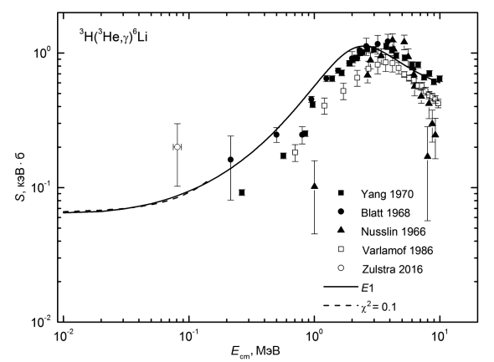
Figure 4 – Astrophysical S-factor of the radiative ³H(³He,γ)⁶Li capture

Conclusions:
The reaction rate value of the ³H(³He,γ)⁶Li radiative capture, calculated in the present work at temperatures of Т₉ to 10 Т₉, allows one to conclude that this reaction quite possible to make a contribution to formation of ⁶Li nuclei in the primordial nucleosynthesis of elements in the Universe, especially at higher temperatures about 3–5 Т₉. The obtained results of the reaction rate, thanks to their simple numerical approximation, can be used in the future for comparative estimation of the ⁶Li output, obtained in this reaction.
Thus, the relatively simple model presentations allow one to obtain theoretical results, which generally coincide with the available experimental data for total cross sections of the radiative capture. Nevertheless, note that the known measurements of the total cross sections of the considered reaction, carried out from 1966 year, have big errors and ambiguities. Particularly, data [72] and [73] very noticeably differ between each other, and new results [74] were obtained only at one energy. Therefore, new and more detailed measurements of total cross sections for the considered capture reaction are necessary for obtaining the final results for reaction rate.

4 The derivation of analytical expressions for the astrophysical S-factor and reaction rate of the considered reaction and preparation the numerical calculation or modernization computer program for the process p + ⁸Li →⁹Be + γ
The above used expressions (4) and (5) are used for calculations of the astrophysical S-factor and the reaction rate of the considered reaction p + ⁸Li →⁹Be + γ. Now we will give calculation results for the radiative capture of the astrophysical S-factor for the scattering potentials from Tables 4 and 5, they are presented in Figure 4. The calculated S-factor at 10 keV for both options of calculation is equal to 4.5(1) keV·b.
The value 0.15 keV·b with a smooth decrease at 2.0 MeV down to 0.1 keV·b was obtained for the astrophysical S-factor in [62]. The interval of possible S-factor values at zero energy is determined approximately of 0.075 to 0.23 keV·b. The value of 0.3 keV·b for the S-factor value at zero energy was obtained in [63], and furthermore up to 1.5 MeV the S-factor smoothly decrease approximately down to 0.25 keV·b. The interval of possible S-factor values at zero energy defined in this work near the range of 0.21 to 0.38 keV·b. In [64] the S-factor value at zero energy of 0.85 keV·b was obtained, and furthermore up to 1.5 MeV the S-factor smoothly decrease approximately down to 0.75 keV·b. The interval of possible S-factor values at zero energy defined near the range of 0.63 to 1.15 keV·b. However, in all of these works not any resonances, including the first, do not take into account and the S-factor has the smooth shape. Besides, the results for comparison with experimental measurements [48,49] are not given in that works.
The general parametrization of the S-factor in the energy range up to 50 keV was done by the expression of the form

S(E_{c.m.}) = S₀ + S₁E + S₂E², (6)

where energy is in keV, and parameters are of values S₀ = 5.082, S₁ = –0.09391, S₂ = 0.005359. For this parameters the χ² value is equal to 0.26 with 5% errors of initial, that is, calculated data. Results of this parametrization are shown in Figure 4 by the red solid curve.
Furthermore, in Figure 6 green and blue solid curves show the reaction rate of the proton capture on ⁸Li, which corresponds to the same curves in Figure 4 and is written in the form (5). Integration of cross section is carried out in the energy range of 10 keV – 7 MeV. Black dashed curve shows the reaction rate that takes into account only E1 transition from the S scattering wave.

Figure 5 – Astrophysical S-factor of the radiative ⁸Li(p,γ)⁹Be capture to the GS of ⁹Be. Black points are experimental data from [48]

Figure 6 – Reaction rate of the proton capture on ⁸Li

Here, the reaction rate for results of work [63] is shown by the blue dashed curve. Besides, the green dashed curve shows in Figure 6 results for the reaction rate from [62]. Both of these results are smaller than the result obtained by us by some orders of magnitude. It is seen from Figure 5 that consideration of the first resonance very essentially changes the reaction rate as against results of works [62,63], where this account was not carried out. Accounting of two next resonances in our calculations leads only to the small increasing of the rate at highest temperatures.
Furthermore, the parametrization of the reaction rate was carried out using the expression of the form [75]

$\begin{aligned}N_{A}\left\langle \text{sv}\right\rangle =\frac{a_{1}}{T^{2/3}}\text{exp}\left(−\frac{a_{2}}{T^{1/3}}\right)\left(1+a_{3}T^{1/3}+a_{4}T^{2/3}+a_{5}T+a_{6}T^{4/3}+a_{7}T^{5/3}+a_{8}T^{7/3}\right)+ \\ +\frac{a_{9}}{T^{1/2}}\text{exp}\left(−\frac{a_{\text{10}}}{T^{1/2}}\right)+\frac{a_{\text{11}}}{T}\text{exp}\left(−\frac{a_{\text{12}}}{T}\right)+\frac{a_{\text{13}}}{T^{3/2}}\text{exp}\left(−\frac{a_{\text{14}}}{T^{3/2}}\right)+\frac{a_{\text{15}}}{T^{2}}\text{exp}\left(−\frac{a_{\text{16}}}{T^{2}}\right)\end{aligned}$ (7)

with parameters listed in Table 5.

Table 5 – Parameters of the analytical parametrization with χ² = 0.06 at 5% errors of the reaction rate calculated curve.
a₁ | a₂ | a₃ | a₄ | a₅ | a₆ | a₇ | a₈
-146.8134 | 7.52023 | -1.57556E6 | 5.38408E6 | -4.16671E6 | 109516 | 564105.0 | -41092.96
a₉ | a₁₀ | a₁₁ | a₁₂ | a₁₃ | a₁₄ | a₁₅ | a₁₆
-417.1643 | 2.34235 | 2.75351E6 | 0.94389 | -2.82805E6 | 1.18361 | 1.26521E6 | 0.99103

Results of these parametrization are shown above in Figure 6 by the red dashed curve. The parametrization of the reaction rate shown in Figure 6 by the black dashed curve for the E1 capture was done additionally. The next form was used for this

$N_{A}\left\langle \text{sv}\right\rangle =\frac{a_{1}}{T^{2/3}}\text{exp}\left(−\frac{a_{2}}{T^{1/3}}\right)\left(1+a_{3}T^{1/3}+a_{4}T^{2/3}+a_{5}T+a_{6}T^{4/3}+a_{7}T^{5/3}+a_{8}T^{7/3}\right)$ (8)

with parameters listed in Table 6.

Table 6 – Parameters of the analytical parametrization with χ² = 0.06 at 5% errors of the reaction rate calculated curve.
a₁ | a₂ | a₃ | a₄ | a₅ | a₆ | a₇ | a₈
-11.52211 | 8.41371 | -5.44959E6 | 7.78529E6 | -3.98974E6 | 201.7225 | 457623.9 | -32323.2

Results of this parametrization were shown in Figure 6 by the light blue dashed curve. It is seen that, like in previous case, the description of the calculated curve by this parametrization can be considered quite reasonable.

Conclusions:
New results for astrophysical S-factor and reaction rate that happen essentially more than similar results of previous works [62,63], where the first resonance 1/2⁻ (0.087) was not take into account, were obtained. The parametrization of the calculated S-factor in the energy range to 50 keV was carried out. Further account of two other resonances 5/2⁻ (0.410) and 3/2⁺ (1.100) leads only to small changes of the rate at highest temperatures. Parametrizations of two options of the reaction rate calculation were carried out. The obtained results for the reaction rate of the proton capture on ⁸Li can do essential influence to calculation results of efficiencies of light nuclei in different thermonuclear processes in the Universe.
We consider the presented results as estimative, so as undoubtedly goal-seeking measurements of the capture cross sections are needed in the range, where our model predicts the resonance behavior of cross sections, founded by the modern data on ⁹Be spectra near the proton threshold. Finally, let us note that further refinement of experimental characteristics of high-lying levels of ⁹Be also extremely desirable.
In a period of carrying out of works on the Project IRN AP05130104 “Study reactions of the radiative capture in stars and in the controlled thermonuclear fusion” the five papers were published. Two of them in the local editions without impact-factors and three in the foreign editions with nonzero impact-factors (see Annex A “List of publications”).
CONCLUSION
Brief conclusions on results of 2020 year:
In conclusion, draw attention that for the ³He³H system the attempt to demonstrate certain methods of nuclear physics of low and ultralow, i.e. astrophysical energies, energies was done. These methods can be used for calculations of some characteristics of thermonuclear reactions in the Sun and stars. It was shown that on the basis of certain calculation methods and chosen ideas of nuclear physics, it is possible to obtain nuclear intercluster interaction potentials, allowing to solve in future some problems in description of thermonuclear reactions, which determine formation, structure and existence of all our Universe, observed in the present time.
It is possible to construct two-body potentials of the p⁸Li interaction, which allow correctly describe available data on characteristics of the bound state of ⁹Be in the p⁸Li channel in the frame of the MPCM. Suggested options of the GS potentials of ⁹Be in the p⁸Li channel allow one to obtain AC within limits of errors available for it and lead to the reasonable description of ⁹Be radii. Such potentials generally allow the available experimental data for total cross sections of the radiative proton capture on ⁸Li at low and ultralow energies. Obtained results for total cross sections and static characteristics of ⁹Be strongly depend of GS potential parameters of this nuclear in the p⁸Li channel.
Brief conclusions on results for all implementation period of this project:
Thermonuclear capture reactions p + ³H → ⁴He + γ, ³H + ³He → ⁶Li + γ and p + ⁸Li → ⁹Be + γ are included in the number of almost 40 processes of the radiative capture type that can be described on the basis of MPCM using the FS conception, which follows from the classification of these states by Young tableaux. Thus, the used here methods of obtaining the shape and depth of the intercluster interactions for scattering and BS allow to escape from the discrete and continuous ambiguity its parameters, appropriate to the known optical model and which are observed in usual approaches of construction intercluster potentials in continuous and discrete spectrum. Later, they can be used in any calculations connected with solving of different nuclear-physical and astrophysical problems of low and ultralow energies.
In conclusion, draw attention that for the ³He³H system the attempt to demonstrate certain methods of nuclear physics of low and ultralow, i.e. astrophysical energies, energies was done. These methods can be used for calculations of some characteristics of thermonuclear reactions in the Sun and stars. It was shown that on the basis of certain calculation methods and chosen ideas of nuclear physics, it is possible to obtain nuclear intercluster interaction potentials, allowing to solve in future some problems in description of thermonuclear reactions, which determine formation, structure and existence of all our Universe, observed in the present time.
Results for 2018 year:
Carried out of studies for the astrophysical S-factor and the reaction rate of thermonuclear reaction p + ³H → ⁴He + γ, and also approximation it by simple functions:
1) Searching of the elastic scattering p + ³H phase shifts in the scientific literature and in the databases, or the construction of the phase shifts on the basis of the available data on p + ³H spectrum levels.
2) The classification of the p³H states by Young tableaux is obtained.
3) The construction of the p³H potentials and scattering phase shifts is obtained.
4) The potentials pure by isospin with T = 0 for р³Н interactions in the singlet channel are obtained.
Results for 2019 year:
Carried out of studies for the astrophysical S-factor and the reaction rate of thermonuclear reaction p + ³H → ⁴He + γ, and also approximation it by simple functions:
1) The astrophysical S-factor of the p + ³H → ⁴He + γ radiative capture is obtained.
2) The approximations of our results on S-factor and comparison with the results of other authors (Hahn et al. и Canon et al.).
3) The derivation of analytical expressions for the astrophysical S-factor and reaction rate of the considered reaction and preparation the numerical calculation or modernization computer program for the process p + ³H →⁴He + γ.
4) The study of the astrophysical S-factor and reaction rate of thermonuclear reaction p + ³H → ⁴He + γ and also approximate them by simple functions. Perform a comparative analysis of the obtained results with the results of other authors.
Results for 2020 year:
The information about elastic scattering ³H + ³He and p + ⁸Li phase shifts in the scientific literature and in the databases, and also the phase shifts on the basis of the available data on ³H + ³He and p + ⁸Li spectrum levels were constructed:
1) The information about the elastic scattering ³H + ³He phase shifts is obtained, or they are constructed by spectra of levels of the ³H + ³He system.
2) The information about the elastic scattering p + ⁸Li phase shifts is obtained, or they are constructed by spectra of levels of the p + ⁸Li system.
3) The derivation of expressions for the astrophysical S-factor and the rate of considered reaction, modernization computer program for the process ³H + ³He → ⁶Li + γ.
4) The derivation of expressions for the astrophysical S-factor and the rate of considered reaction, modernization computer program for the process p + ⁸Li → ⁹Be + γ.
Estimation of the completeness of decisions for the assigned tasks:
The Project is carried out in full, all assigned tasks are solved completely according to the Annex B “Time Schedule”. It is possible correctly to describe total cross sections of the radiative capture process at astrophysical energies for the considered particles in the framework of the used model and calculation methods.
Recommendation on the concrete using of the RSW results:
Usage the results of the Project is possible for solving other problems of nuclear astrophysics, connected with the consideration by us thermonuclear processes in stars. They can be useful for solving some problems of the controlled thermonuclear fusion, searching of the additional sources of energy at thermonuclear fusion and understanding of the mechanism of energy production in stars.
Estimation of the technical-and-economic efficiency of the implementation:
Technical-and-economic implementation is not involved in the frame of the Project.
Estimation of the scientific and technical level of the carried out RSW in comparison with the best achievement in this field:
This work stands on one of the advanced position in the world science in this field. Till now, there are nobody who can explain basic characteristics of almost 40 thermonuclear reactions flowing in the Sun, stars and in our Universe at different stages of its formation and development.
This Project is the definite stage of such consideration, where, taking into account previous results, obtained in our projects 2009–2017 years, the successful analysis of 40 reactions of this type was done. For explanation of the basic characteristics of all considered thermonuclear reactions the unified approach, namely, modified potential cluster model of light atomic nuclei with forbidden states, is used.
High level of the results for previous parts of this project (2009–2017y.) is proved out by their publication in 2012 in New-York publishing NOVA Sci. Publ. (USA) as a monograph – Dubovichenko S.B. «Thermonuclear processes of the Universe». The First English Edition. New-York. NOVA Sci. Publ. 2012. 194р. – which is available in Internet through electronic address http://www.novapublishers.org/catalog/product_info.php?products_id=31125.
In the form of monograph – Dzhazairov-Kakhramanov A.V. Astrophysical S-factors of light atomic nuclei. – Saarbrücken: Lap Lambert Academic Publishing, ISBN: 978-3-659-49854-1, 2013. – 127 p.
Two reviews published in USA:
Dubovichenko S.B., Dzhazairov-Kakhramanov A.V. Astrophysical S-factors of proton radiative capture in thermonuclear reactions in the Stars and the Universe. / The Big Bang: Theory, Assumptions and Problems. – New-York: NOVA Sci. Pub, 2012. – P.1-60.
Dubovichenko S.B., Dzhazairov-Kakhramanov A.V. Neutron radiative capture by ²H, ⁶Li, ⁷Li, ¹²C, ¹³C, ¹⁴C and ¹⁴N at astrophysical energies // The Universe Evolution. Astrophysical and Nuclear Aspects. – New-York: NOVA Sci. Publ. – 2013. – P.49-108.
Working with the tide of these works, Dr. Dzhazairov-Kakhramanov A.V. has published the monograph in Germany, two reviews up to 70 pages in the books published in the USA. He has more than 35 of papers and reviews up to 55 pages in journals with nonzero impact factor. In 2014 year Dr. Dzhazairov-Kakhramanov A.V. was elected as an academician of the European Academy of Natural Sciences, and in summer of 2014 year he was awarded by the European Carl Friedrich Gauss – Medal. In March 13, 2015 he was elected in the Russian Academy of Natural Sciences as a Professor, at the same year he was elected as an academician of the International Academy of Informatization (IAI), in 2020 year he was awarded by the IAI Gold Anniversary Medal. The Leader of the Project has the H-index equals 14 according to Web of Science.
REFERENCES
- Wildermuth K., Tang, Y. C. A Unified Theory of the Nucleus – Moscow: Mir, 1980. –502 p (in Russian).
- Mertelmeir, T., Hofmann, H. M. Consistent cluster model description of the electromagnetic properties of lithium and beryllium nuclei // Nuclear Physics A. – 1986. – Vol. 459. – P. 387-416.
- Descouvemont, P., Dufour, M. Microscopic cluster model // In: Clusters in Nuclei, Vol. 2; Editor C. Beck. – Berlin: Springer-Verlag Heidelberg, 2012. – 353 p.
- Nesterov, A. V. Three-cluster description of light nuclei characteristics // Fiz. Elem. Chast. At. Yad. – 2010. – Vol. 41. – P. 1337-1424 (in Russian).
- Nemets, O. F, Neudatchin, V. G., Rudchik, A. et al. Nucleon associations in atomic nuclei and nuclear reactions of manynucleon transitions. – Kiev: Naukova Dumka, 1988. – 488p (in Russian).
- Dubovichenko, S. B. Thermonuclear processes in stars and in the Universe. – Ed. 3rd, corrected and amended. – Germany, Saarbrucken: Palmarium Academy Publ. GmbH&Co. KG, 2015. – 348p.; https://www.palmarium-publishing.ru/catalog/details/store/it/book/978-3-659-60165-1/Термоядерные-процессы-в-Звездах (in Russian).
- Dubovichenko, S. B. Radiative neutron and primordial nucleosynthesis of the Universe. Fifth edition, corrected and amended. Saarbrucken: Lambert Academy Publ. GmbH&Co. KG, 2016. – 496p.; https://www.ljubljuknigi.ru/store/ru/book/Радиационный захват нейтронов/isbn/978-3-659-82490-6 (in Russian).
- Dubovichenko, S. B., Uzikov, Yu. N. Astrophysical S-factors for reactions with light atomic nuclei // Fiz. Elem. Chast. At. Yad. – 2011. – Vol. 42. – P. 478-577 (in Russian).
- Dubovichenko, S. B., Dzhazairov-Kakhramanov, A. V. Examination of astrophysical S-factors of р²H, p⁶Li, p⁷Li, p¹²C and p¹³C radiative capture reactions // International Journal of Modern Physics E. – 2012. – Vol. 21. – P. 1250039(1-44).
- Barnes, C. A., Clayton, D. D., Schramm, D. N. Essays in Nuclear Astrophysics / Presented to William A. Fowler. – Cambridge, UK: Cambridge University Press, 1982. – 562 p.
- Kapitonov, I. M., Ishkhanov, B. S., Tutyn’, I. A. Nucleosynthesis in the Universe. – Moscow: Librokom, 2009. – 69p (in Russian).
- Dubovichenko, S. B., Dzhazairov-Kakhramanov, A. V. Astrophysical S-factors of proton radiative capture in thermonuclear reactions in the Stars and the Universe // In: The Big Bang: Theory, Assumptions and Problems. – New-York: NOVA Sci. Publ., 2012. – Р. 1-60.
- Neudatchin, V. G., Sakharuk, А. А., Smirnov, Yu. F. Generalized potential description of the interaction of lightest clusters – scattering and photonuclear reactions // Fiz. Elem. Chast. At. Yad. – 1992. – Vol. 23. – P. 480-541 (in Russian).
- Neudatchin, V. G., Struzhko, B. G., Lebedev, V. M. Supermultiplet potential interaction model of lightest clusters and unified description of different nuclear reactions // Fiz. Elem. Chast. At. Yad. – 2005. – Vol. 36. – P. 890-941 (in Russian).
- Neudatchin, V. G. Generalized potential model description of mutual scattering of the lightest p²H, ²H³He nuclei and the corresponding photonuclear reactions // Physical Review C. – 1992. – Vol. 45. – P. 1512-1527.
- Dubovichenko, S. B. Astrophysical S-factors of the ³Не⁴Не, ³Н⁴Не and ²Н⁴Не radiative captures // Yad. Fiz. – 2010. – Vol. 73. – P. 1573-1584 (in Russian).
- Dubovichenko, S. B., Dzhazairov-Kakhramanov, A. V. The ⁷Li(n,γ)⁸Li radiative capture at astrophysical energies // Annalen der Physik. – 2012. – Vol. 524 – P. 850-861.
- Dubovichenko, S. B., Dzhazairov-Kakhramanov, A. V. The radiative ¹⁰Be(n,γ)¹¹Be capture at thermal and astrophysical energies // Journal of Physics G: Nuclear and Particle Physics. – 2016. – Vol. 43. – 095201(14p.).
- Adelberger, E. G. Solar fusion cross sections. II. The pp chain and CNO cycles // Review of Modern Physics. – 2011. – Vol. 83. – P. 195-245.
- Dubovichenko, S. B. Light nuclei and nuclear astrophysics. - Ed. 2nd, corrected and amended. – Saarbrucken, Germany: Lambert Acad. Publ. GmbH&Co. KG, 2013. – 316 p.; https://www.lap-publishing.com/catalog/details/store/fr/book/978-3-659-41308-7/Light nuclei and nuclear astrophysics (in Russian).
- Kukulin, V. I., Neudatchin, V. G., Obukhovsky, I. T., Smirnov, Yu. F. Clusters as subsystems in light nuclei // In: Clustering Phenomena in Nuclei / edited by K. Wildermuth and P. Kramer. – Branschweig: Vieweg, 1983. – Vol. 3. – Р. 1.
- Igаshirа, М., Ohsаki, Т. Nеutron саpturе nuсlеosynthеsis in thе Univеrsе // Science and Technology of Advanced Materials. − 2004. − Vol. 5. − P. 567-573.
- Sasaqui, T., Kajino, T., Mathews, G. J., Otsuki, K. and Nakamura, T. Sensitivity of r-process nucleosynthesis to light-element nuclear reactions // Astrophisical Journal. – 2005. – V.634. – P.1173-1189.
- Dubovichenko, S. B., Dzhazairov-Kakhramanov, A. V. Photoprocesses on ⁶Li in the cluster models for potentials with forbidden states // Yad. Fiz. – 1995. – Vol. 58. – P. 852-859 (in Russian).
- Baye, D., Hanck, M. Generator-coordinate study of ³He+³He elastic scattering with a spin-orbit interaction // Journal of Physics G: Nuclear and Particle Physics. – 1981. – Vol. 7. – P. 1073.
- Tompson, D., Tang, Y. C. Resonating-Group Calculation of He³-He³ Scattering // Physical Review. – 1967. – Vol. 159. – P. 806.
- Bruno, M. et al. Experimental study on low-energy ²H(α, α)²H elastic scattering // Nuovo Cimento A. – 1982. – Vol. 68. – P.35.
- Jenny, B. et al. Phase-shift analysis of d-α elastic scattering between 3 and 43 MeV // Nuclear Physics A. – 1983. – Vol. 397. – P. 61.
- Darriulat, P. et al. Phase shift analysis of deuteron-alpha scattering between 10 and 27 MeV // Nuclear Physics A. – 1967. – Vol. 94. – P. 653.
- Barit, I. Ya. et al. – Preprint of Nuclear Research Institute. – Moscow. – 1987. – No. P-0513.
- Barnard, A. C., Jones, C. M., Phillips, G. C. The scattering of He³ by He⁴ // Nuclear Physics. – 1964. – Vol. 50. – P. 629.
- Spiger, R., Tombrello, T.A. Scattering of He³ by He⁴ and of He⁴ by Tritium // Physical Review. – 1967. – Vol. 163. – P. 964.
- Ivanovich, M., Young, P. G., Ohlsen, G. G. Elastic scattering of several hydrogen and helium isotopes from tritium // Nuclear Physics A. – 1968. – Vol. 110. – P. 441.
- Vlastou, J. et al. Scattering of polarised and unpolarised ³He by ³H and high excitation in ⁶Li // Nuclear Physics A. – 1977. – Vol. 292. – P .29.
- Batten, R. et al. Elastic scattering of ³He by tritium // Nuclear Physics A – 1970. – Vol. 151. – P. 56.
- Tompson, D., Tang, Y. C. Study of ³H+³H, ³H+³He, and ³He+³He systems with the resonating-group method // Nuclear Physics A. – 1968. – Vol. 106. – P. 591.
- Terasawa, M., Sumiyoshi, K., Kajino, T., Mathews, G.J., and Tanihata, I. New nuclear reaction flow during r-process nucleosynthesis in supernovae: critical role of light, neutron-rich nuclei // The Astrophysical Journal. – 2001. – Vol. 1562. – P. 470-479.
- Casal, J., Rodr´ıguez-Gallardo, M., and Arias, J. M. Astrophysical reaction rate for ⁹Be formation within a three-body approach // Physical Review C. – 2014. – Vol. 90. – P. 044304(11).
- Robinson, A. E. Reanalysis of radioisotope measurements of the ⁹Be(γ,n)⁸Be cross section // Physical Review C. – 2016. – Vol. 94. – P. 024613(9).
- Casal, J., Rodr´ıguez-Gallardo, M., Arias, J. M., Gómez-Camacho, J. Three-body radiative capture reactions // EPJ Web of Conferences. – 2017. – Vol. 165. – P. 01010. – DOI: 10.1051/epjconf/201716501010 NPA8 2017 (4p)
- Arnold, C. W., Clegg, T. B., Iliadis, C., Karwowski, H. J., Rich, G. C., Tompkins, J. R., Howell, C. R. Cross-section measurement of ⁹Be(γ,n)⁸Be and implications for α+α+n→⁹Be in the r-process // Physical Review C. – 2012. – Vol. 85. – P. 044605.
- Ishikawa, S., Kajino, T., Shibagaki, S., Balantekin, A. B., Famiano, M. A. Three-Body Model Calculation of ⁹Be Formation Rate and Application to Supernova Nucleosynthesis // Proc. 14th Int. Symp. on Nuclei in the Cosmos (NIC2016) JPS Conf. Proc. – 2017. – P 010406.
- Sasaqui, T., Kajino, T. et al. Sensitivity of r-process nucleosynthesis to light-element nuclear reactions // The Astrophysical Journal. – 2005. – Vol. 634. – P. 1173–1189.
- Shoda, K., Tanaka, T. Clusters in the photodisintegration of ⁹Be // Physical Review C. – 1999. – Vol. 59. – P. 239.
- Guimaraes, V. et al. Investigation of nucleosynthesis neutron capture reactions using transfer reactions induced by ⁸Li beam // International Symposium on Nuclear Astrophysics – Nuclei in the Cosmos. IX. June 25–30. CERN. Geneva. Switzerland. – 2006. – P. 108.
- Dubovichenko, S. B., Dzhazairov-Kakhramanov, A. V. The reaction ⁸Li(n,)⁹Li at astrophysical energies and its role in primordial nucleosynthesis // The Astrophysical Journal. – 2016. – Vol. 819. – P. 78(8).
- Kajino, T., Boyd, R. N. Production of the light elements in primordial nucleosynthesis // The Astrophysical Journal. – 1990. – Vol. 359. – P. 267.
- Clikeman, F. M., Bureau, A. J., Stewart, M. G. Photoproton Reaction in ⁹Be // Physical Review. – 1962. – Vol. 126. – P. 1822.
- Komar, A. P., Makhnovsky, E. D. Photodisintegration of ⁹Be // Nuclear Physics. – 1964. – Vol. 65. – P. 662; http://cdfe.sinp.msu.ru/exfor/index.php.
- Leistenschneider, E. et al. Spectroscopy of high-lying resonances in ⁹Be by the measurement of (p,p), (p,d), and (p,α) reactions with a radioactive ⁸Li beam // Physical Review C. – 2018. – Vol. 98. – P. 064601(13).
- Dubovichenko, S. B. Thermonuclear processes of the Universe. New-York: NOVA Scientific Publishing, 2012. – 194p.; https://www.novapublishers.com/catalog/product_info.php?products_id=31125.
- Dubovichenko, S. B. Thermonuclear processes in Stars and Universe. Germany, Saarbrucken: Scholar’s Press, 2015. – 332p.; https://www.scholars-press.com/catalog/details/store/gb/book/978-3-639-76478-9/Thermonuclear-processes-in-stars.
- Dubovichenko, S. B. Radiative neutron capture. Primordial nucleosynthesis of the Universe. First English edition. – Berlin/Munich/Boston: Walter de Gruyter GmbH, 2019. – 296p. ISBN 978-3-11-061784-9, e-ISBN (E-BOOK) 978-3-11-061960-7, e-ISBN (EPUB) 978-3-11-061790-0, https://doi.org/10.1515/9783110619607-202.
- Chart of nucleus shape and size parameters (0≤Z≤14) http://cdfe.sinp.msu.ru/cgi-bin/muh/radchartnucl.cgi?zmin=0&zmax=14&tdata=123456.
- Sanchez, R. et al. Nuclear charge radius of ¹¹Li // Hyperfine Interaction. – 2006. – Vol. 171. – P. 181.
- Nortershauser, W. et al. Nuclear Charge Radii of ^{7,9,10}Be and the One-Neutron Halo Nucleus ¹¹Be // Physical Review Letters. – 2009. – Vol. 102. – P. 062503(4).
- Nuclear Wallet Cards; http://cdfe.sinp.msu.ru/services/ground/NuclChart_release.html
- Constants in the category "Atomic and nuclear constants"; http://physics.nist.gov/cgi-bin/cuu/Value?mud|search_for=atomnuc!
- Plattner, G. R., Viollier, R. D. Coupling constants of commonly used nuclear probes // Nuclear Physics A. – 1981. – Vol. 365. – P. 8.
- Neugart, R. et al. Precision measurement of ¹¹Li moments // Physical Review Letters. – 2008. – Vol. 101. – P. 132502.
- Li, Z. H. et al. New determination of the proton spectroscopic factor in ⁹Be from the ¹³C(⁹Be, ⁸Li)¹⁴N angular distribution // Physical Review C. – 2013. – Vol. 87. – P. 017601(4).
- Jun, S. et al. Astrophysical reaction rates of the ⁸Li(p,)⁹Be direct capture reaction // Chinese Physics Letters. – 2006. – Vol. 23. – P. 56-57.
- Camargo, O. et al. The ⁹Be(⁸Li,⁹Be)⁸Li elastic-transfer reaction // Physical Review C. – 2008. – Vol. 78. – P. 034605.
- Guimaraes, V. et al. Transfer reactions in the investigation of light-nuclei nucleosynthesis // Revista Mexicana de Física – 2008. – Vol. 54. – P. 63.
- Nollett, K. M., Wiringa, R. B. Asymptotic normalization coefficients from ab initio calculations // Physical Review C. – 2011. – Vol. 83. – P. 041001(R).
- Dubovichenko, S. B. Calculation methods of nuclear characteristics. Sec. Edit., revised and expanded. – Saarbrucken: Lambert Acad. Publ. GmbH&Co. KG, 2012. – 425p.; https://www.lap-publishing.com/catalog/details//store/ru/book/978-3-659-21137-9/metody-rascheta-yadernyh-kharacteristic (in Russian).
- Neudatchin, V. G., Smirnov, Yu. F. Nucleon associations in light nuclei. Moscow: Nauka, 1969. – 414p. (in Russian).
- Dubovichenko, S. B. Reaction rate of radiative ³He³H capture // Russian Physics Journal. – 2020. – Vol. 63. – P. 385.
- Dubovichenko, S. B., Dzhazairov-Kakhramanov, A. V. Thermonuclear processes for three body system in the potential cluster model // Nuclear Physics A. – 2015 – Vol. 941. – P. 335.
- Fowler, W. A. et al. Thermonuclear Reaction Rates, II // Annual Review of Astronomy and Astrophysics. – 1975. – Vol. 13. – P. 69.
- Angulo, C. et al. A compilation of charged-particle induced thermonuclear reaction rates // Nuclear Physics A. – 1999. – Vol. 656. – P. 3.
- Young, A. M. et al., Direct Radiative Capture of ³He by Tritons and t+³He Cluster States in ⁶Li // Physical Review Letters. – 1970. – Vol. 25. – P. 1764.
- Varlamov, V. V. et al. Photonuclear Data. Photodisintegration of Lithium. Evaluated Cross Sections of Channels and Reactions // Preprint CDFE/LI2. – 1986; http://cdfe.sinp.msu.ru.
- Zylstra, A. B. et al. Using Inertial Fusion Implosions to Measure the T+³He Fusion Cross Section at Nucleosynthesis-Relevant Energies // Physical Review Letters. – 2016. – Vol. 117. – P. 035002.
- Caughlan, G. R., Fowler, W. A. Thermonuclear reaction rates V // Atomic Data and Nuclear Data Tables – 1988. – Vol. 40. – P. 283-334.

ANNEX А

List of publications on the theme of Project at 2018 year.
Published papers (far abroad):
- Dubovichenko S.B., Dzhazairov-Kakhramanov A.V. New results for radiative proton capture on ¹⁶O at astrophysical energies // Indian Journal of Physics. – 2018. – V.92(8). – P.947-953. https://doi.org/10.1007/s12648-018-1190-8. IF=1.407, Q3, SJR=0.28 (Web of Science) Switzerland

List of publications on the theme of Project at 2019 year.
Published papers (far abroad):
- Dubovichenko S.B., Burkova N.A., Dzhazairov-Kakhramanov A.V. Potential Cluster Calculations for the Astrophysical S-factor and Reaction Rate of the Radiative ³Не(⁴Не, γ)⁷Bе Capture //Indian Journal of Physics. – 2019. – V.93(3). – P.279; https://doi.org/10.1007/s12648-018-1287-0. IF=1.407, Q3, SJR=0.28 (Web of Science) Switzerland
- Dubovichenko S.B., Dzhazairov-Kakhramanov A.V., Burkova N.A. New Theoretical Results for Radiative ³H(p, γ)⁴He, ³He(²H, γ)⁵Li, ⁴He(²H, γ)⁶Li, ⁴He(³H, γ)⁷Li, and ⁴He(³He, γ)⁷Be Captures at Astrophysical Energies // International Journal of Modern Physics E – V.28. – 2019. – 1930004(49pp). – DOI: 10.1142/S0218301319300042. (IF=1.036, Q2, SJR=0.46, Singapore: World Scientific Publishing Co. Pte Ltd)
Published papers (Kazakhstan):
  - Dzhazairov-Kakhramanov A.V., Karipbaeva L.T. Radiative proton capture on ³H at astrophysical energies and its role in the initial stage on star formation //News of the National Academy of Sciences of the Republic of Kazakhstan, Physico-Mathematical Series. – V.3. – Number 325. – 2019. – P.13-21. DOI: 10.32014/2019.2518-1726.19.
  - Dzhazairov-Kakhramanov A.V., Karipbaeva L.T. Astrophysical S-factor and reaction rate of the radiative ³H(p,γ)⁴He capture //News of the National Academy of Sciences of the Republic of Kazakhstan, Physico-Mathematical Series. – V.3. – Number 325. – 2019. – P.22-31. DOI: 10.32014/2019.2518-1726.20.

List of publications on the theme of Project at 2020 year.
Published papers (far abroad):
- Dubovichenko S.B., Burkova N.A., Dzhazairov-Kakhramanov A.V. The role of resonances in the capture of ⁸Li(p,γ)⁹Be on the reaction rate of the relevant astrophysical synthesis of ⁹Be // Nuclear Physics A. – 2020. – V.1000. – 121842. – https://doi.org/10.1016/j.nuclphysa.2020.121842. IF=1.695, Q2 (Web of Science) Netherland.
- Dubovichenko S.B., Burkova N.A., Dzhazairov-Kakhramanov A.V., Tkachenko A.S. Influence of resonances on the ¹¹B(n,γ) capture reaction rate. Capture at ground state of ¹²B. //Astroparticle Physics – 2020. – V.123. – P.102481. https://doi.org/10.1016/j.astropartphys.2020.102481. IF=2.61, Q2 (Web of Science) Netherland.
- Dubovichenko S.B. Reaction Rate of Radiative ³He³H Capture // Russian Physics Journal. – 2020. – V.63. – №3. – P.385-392; https://doi.org/10.17223/00213411/63/3/37. IF=0.625, Q3 (Web of Science) USA.
Published papers (Kazakhstan):
- Dzhazairov-Kakhramanov A.V., Karipbaeva L.T., Steblyakova A.A. Partial potentials for ⁸Li(p,γ)⁹Be capture at astrophysical energies // News of the National Academy of Sciences of the Republic of Kazakhstan, Physico-Mathematical Series. – V.3. – Number 326. – 2020. – P.34-43. https://doi.org/10.32014/2020.2518-1726.34. (Web of Science)
- Dzhazairov-Kakhramanov A.V., Karipbaeva L.T., Steblyakova A.A. Radiative tritium capture on ³He at low and astrophysical energies // News of the National Academy of Sciences of the Republic of Kazakhstan, Physico-Mathematical Series. – V.3. – Number 326. – 2020. – P.44-51. https://doi.org/10.32014/2020.2518-1726.35. (Web of Science)

ANNEX B

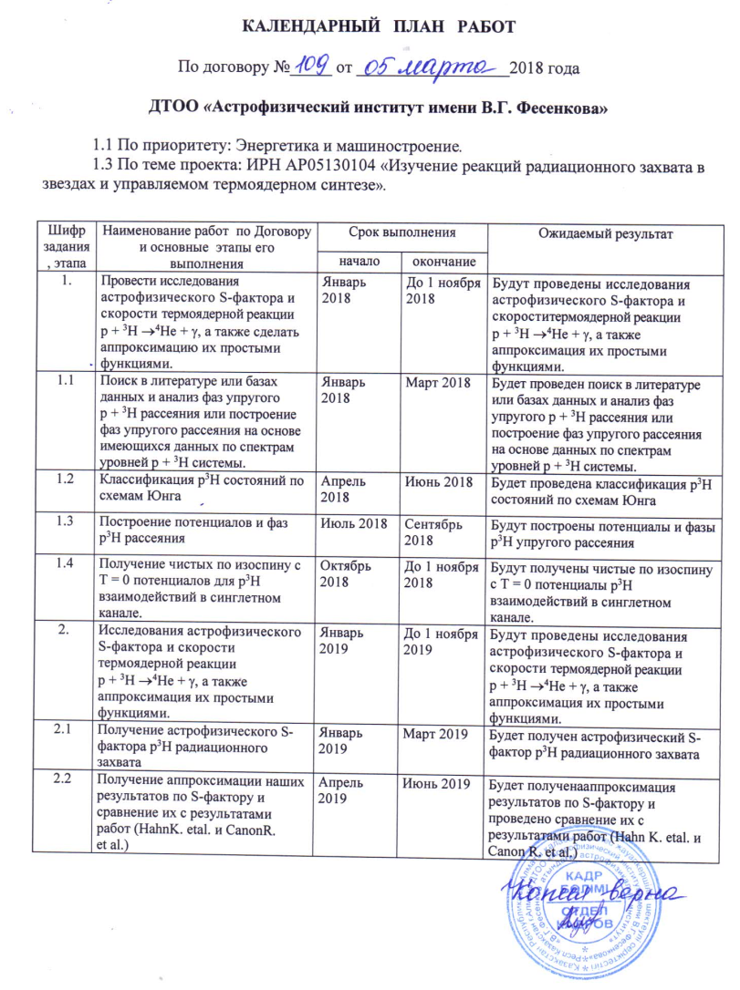
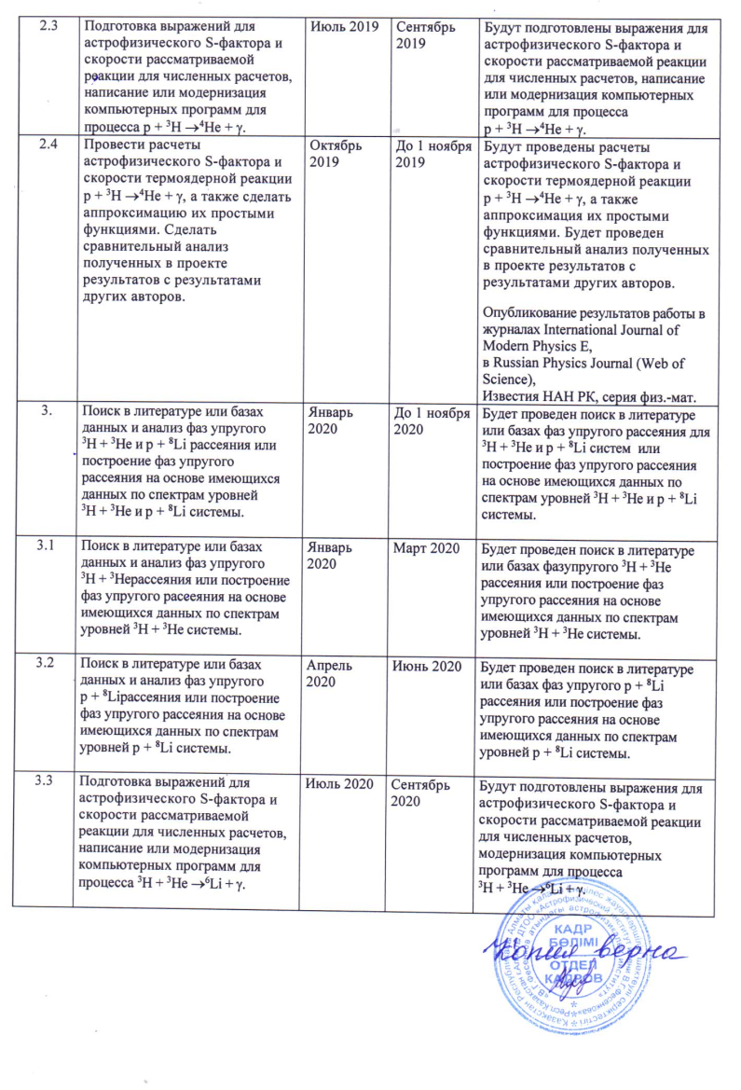
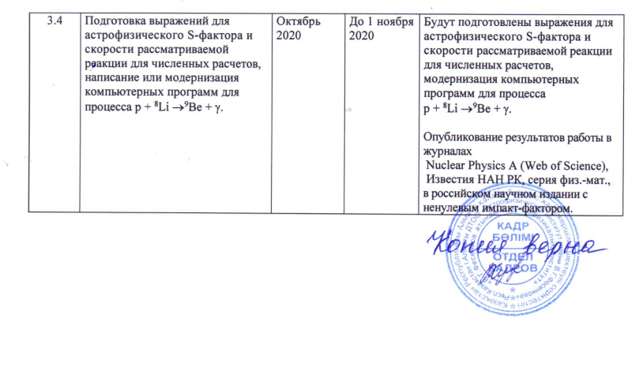

Time Schedule
On the Agreement No. 109 from 05 March 2018.

BLLP “Fesenkov astrophysical institute”
1.1 On priority direction: “Energetics and machine construction”
1.3 On theme of the project: IRN AP05130104 “Study reactions of the radiative capture in stars and in the controlled thermonuclear fusion”.
The code of the task | Name of work under the Contract and the main stages of its implementation | Deadline |  | Expected results
The code of the task |  | beginning | ending | Expected results
1 | Carried out of studies for the astrophysical S-factor and the reaction rate of thermonuclear reaction p + ³H → ⁴He + γ, and also approximate it by simple functions. | January 2018 | Till 1st of November2018 | The studies for the astrophysical S-factor and the reaction rate of thermonuclear reaction p + ³H → ⁴He + γ, and also approximations them by simple functions were carried out.
1.1 | Searching of the elastic scattering p + ³H phase shifts in the scientific literature and in the databases, or the construction of the phase shifts on the basis of the available data on p + ³H spectrum levels. | January 2018 | March 2018 | Searching of the elastic scattering p + ³H phase shifts in the scientific literature and in the databases, or the construction of the phase shifts on the basis of the available data on p + ³H spectrum levels will be done.
1.2 | The classification of the p³H states by Young tableaux. | April 2018 | June  2018 | The classification of the p³H states by Young tableaux is obtained.
1.3 | The construction of the p³H potentials and scattering phase shifts. | July  2018 | September 2018 | The construction of the p³H potentials and scattering phase shifts is obtained.
1.4 | The potentials pure by isospin with T = 0 for р³Н interactions in the singlet channel. | October 2018 | Till 1st of November 2018 | The potentials pure by isospin with T = 0 for р³Н interactions in the singlet channel are obtained.
2 | Carried out of studies for the astrophysical S-factor and the reaction rate of thermonuclear reaction p + ³H → ⁴He + γ, and also approximation it by simple functions. | January 2019 | Till 1st of November 2019 | The studies for the astrophysical S-factor and the reaction rate of thermonuclear reaction p + ³H → ⁴He + γ, and also approximation it by simple functions are carried out.
2.1 | Obtaining of the astrophysical S-factor of the p + ³H → ⁴He + γ radiative capture. | January 2019 | March 2019 | The astrophysical S-factor of the p + ³H → ⁴He + γ radiative capture is obtained.
2.2 | Obtaining of the approximations of our results on S-factor and comparison with the results of other authors (Hahn et al. и Canon et al.). | April 2019 | June  2019 | The approximations of our results on S-factor and comparison with the results of other authors (Hahn et al. и Canon et al.) are obtained.
2.3 | The derivation of analytical expressions for the astrophysical S-factor and reaction rate of the considered reaction and preparation the numerical calculation or modernization computer program for the process p + ³H →⁴He + γ. | July  2019 | September 2019 | The analytical expressions for the astrophysical S-factor and reaction rate of the considered reaction and preparation the numerical calculation or modernization computer program for the process p + ³H →⁴He + γ are prepared.
2.4 | The study of the astrophysical S-factor and reaction rate of thermonuclear reaction p + ³H → ⁴He + γ and also approximate them by simple functions. Perform a comparative analysis of the obtained results with the results of other authors. | October 2019 | Till 1st of November 2019 | The study of the astrophysical S-factor and reaction rate of thermonuclear reaction p + ³H → ⁴He + γ and also approximate them by simple functions will be done. The comparative analysis of the obtained results with the results of other authors will be performed.  Publishing of papers in journals: International Journal of Modern Physics E, Russian Physics Journal (Web. Of Science).  News of the National Academy of Sciences of the Republic of Kazakhstan, Physico-Mathematical Series.
3 | Searching of the elastic scattering ³H + ³He and p + ⁸Li phase shifts in the scientific literature and in the databases, or the construction of the phase shifts on the basis of the available data on ³H + ³He and p + ⁸Li spectrum levels. | January 2020 | Till 1st of November 2020 | Searching of the elastic scattering ³H + ³He and p + ⁸Li phase shifts in the scientific literature and in the databases, or the construction of the phase shifts on the basis of the available data on ³H + ³He and p + ⁸Li spectrum levels will be done.
3.1 | Searching of the elastic scattering ³H + ³He phase shifts in the scientific literature and in the data bases, or the construction of the phase shifts on the basis of the available data on ³H + ³He spectrum levels. | January 2020 | March 2020 | Searching of the elastic scattering ³H + ³He phase shifts in the scientific literature and in the data bases, or the construction of the phase shifts on the basis of the available data on ³H + ³He spectrum levels will be done.
3.2 | Searching of the elastic scattering p + ⁸Li phase shifts in the scientific literature and in the databases, or the construction of the phase shifts on the basis of the available data on p + ⁸Li spectrum levels. | April 2020 | June  2020 | Searching of the elastic scattering p + ⁸Li phase shifts in the scientific literature and in the databases, or the construction of the phase shifts on the basis of the available data on p + ⁸Li spectrum levels will be done.
3.3 | The derivation of analytical expressions for the astrophysical S-factor and reaction rate of the considered reaction and preparation the numerical calculation or modernization computer program for the process ³H + ³He → ⁶Li + γ. | July  2020 | September 2020 | The analytical expressions for the astrophysical S-factor and reaction rate of the considered reaction and preparation the numerical calculation or modernization computer program for the process ³H + ³He → ⁶Li + γ will be obtained.
3.4 | The derivation of analytical expressions for the astrophysical S-factor and reaction rate of the considered reaction and preparation the numerical calculation or modernization computer program for the process p + ⁸Li → ⁹Be + γ. | October 2020 | Till 1st of November 2020 | The analytical expressions for the astrophysical S-factor and reaction rate of the considered reaction and preparation the numerical calculation or modernization computer program for the process p + ⁸Li → ⁹Be + γ will be obtained.  Publishing of papers in journals: Nuclear Physics A, News of the National Academy of Sciences of the Republic of Kazakhstan, Physico-Mathematical Series, Russian scientific journal with nonzero IF.

