Ministry of Education and Science of the Republic of Kazakhstan

AL-FARABY KAZAKH NATIONAL UNIVERSITY

SCIENTIFIC RESEARCH INSTITUTE OF EXPERIMENTAL AND THEORETICAL PHYSICS (IETP)

IRSTI 29.19.22; 29.19.16

UDC 538.97; 539.216.2; 539.23

State registration № 0118РК00400

Inventory №

"APROOVED"

Director of IETP

_____________________O.A. Lavrichshev

“___” ____________ 2020 y.

REPORT

ON THE RESEARCH PROJECT

EXPERIMENTAL STUDIES OF RECONDENSED STATES OF MATTER AT LOW AND ULTRALOW TEMPERATURES WITH THE GOAL OF CREATING A VERIFICATION BASE FOR IR SPECTROMETRIC OBSERVATIONS OF THE UNIVERSE

(final)

Project supervisor,

Doctor of PhD,

Leading Researcher Aldiyarov A.U.

Almaty 2020LIST OF PERFORMERS

|  |  |  |
| --- | --- | --- |
| The head of the topic, Doctor of PhD,  Leading Researcher. | signature, date | A.U. Aldiyarov (Introduction, conclusion, main sections, annexes) |
| Executors of the theme: |  |  |
| Senior Researcher, PhD | signature, date | D.Y. Sokolov (Introduction, conclusion, main sections) |
| Senior Researcher, PhD | signature, date | Y.S. Korshikov (Main sections) |
| Researcher, PhD | signature, date | A.K. Shinbaeva (data processing) |
| Researcher, Master of Technical Physics | signature, date | A.Y. Nurmukan (data processing) |

Реферат

Есеп 56 беттен тұрады. Суреттер саны – 19, қолданылған әдебиеттер тізімі – 46, қосымшалар – 3.

РЕКОНДЕНСАТТАР, ОПТИКАЛЫҚ СПЕКТРЛЕР, СЫНУ КОЭФФИЦИЕНТІ, ТЫҒЫЗДЫҚ, ТЕМПЕРАТУРА, ЭВОЛЮЦИЯ, ҚҰРЫЛЫМ

*Зерттеу нысаны* – Зерттеу нысандары азотпен және аргонмен әр түрлі концентрациялық қатынастағы су, этанол және метанол болып табылады.

*Зерттеулер мақсаты –* Жобаның мақсаты зерттелінетін заттардың төмен және аса төмен температураларда қатты ерітінділеріндегі құрылымды-фазалық айналулардың және релаксациялық процестердің нәтижесінде түзілетін сутекті байланысқан молекула реконденсаттарының жұқа үлдірдерінің қалыптасу процестерін және қасиеттерінің эволюцияларын зерттеу болып табылады.

*Зерттеу жаңалығы –* Жоба реконденсаттардың түзілу процестерін, олардың қасиеттерін және түзілетін ұсақ дисперсті орталардағы құрылымды-фазалық айналуларды кешенді зерттеуге бағытталған.

*Соңғы нәтижелердің қысқаша сипаттамасы* – Азот пен аргон криоматрицасындағы судың, метанолдың және этанолдың полиагрегаттарында термикалық түрде ынталандырылған құрылымдық-фазалық түрленулерді анықтау.

*Қолданылу аймағы* –ИҚ-диапазонда ғарыш кеңістігінің оптикалық бақылаулары үшін верификациялық базаны қалыптастыру сатыларының бірі орындалады.

*Ғылыми зертхана –*Барлық тәжірибелі нәтижелер әл-Фараби атындағы Қазақ Ұлттық университетінің эксперименттік және теориялық физика ғылыми зерттеу институтының Криофизика және криотехнология лабораториясында алынды

Жобаның этаптарын орындауға қолданылатын *ғылыми-зертханалық құрылғылар* – лабораторияның тәжірибелік негізі, температуралық диапазоны Т=12 К және вакуумды камерадағы қысым Р=10-5 Па, әмбебап криогенді вакуумды спектрофотометр болып табылады.

*Зерттеу әдістері* – Криовакуумді конденсаттардың жұқа қабықшасының тербелмелі спектрлерін ИҚ-спектрометрлік талдау әдісі; конденсация жылдамдығын, қабықшаның қалыңдығын, үлгінің тығыздығын және сыну коэффициентін өлшеуге арналған екісәулелік лазерлі интерферометрия әдісі; үлгінің күйін термодесорбционды талдау әдісі.

*Апробация базалары –* зерттеу нәтижелері халықаралық конференцияларда баяндалды (жеке қатысумен баяндама жасалынды)

*Енгізу* – астрофизиика, нанотехнология, материалтану

ABSTRACT

The report consists of 56 pages. Number of pictures - 19, list of used literature - 46, appendices - 3.

RECONDENSATES, OPTICAL SPECTRA, REFRACTIVE INDEX, DENSITY, TEMPERATURE, EVOLUTION, STRUCTURE

*Object of research* - Objects of research are water, ethanol and methanol in different concentrations with nitrogen and argon.

*The purpose of the project* - The purpose of the project is to study the processes of formation and evolution of the properties of thin films of hydrogen-bound molecule condensates formed as a result of structural-phase rotations and relaxation processes in solid solutions of the studied substances at low and very low temperatures.

*Novelty of the research* - The project is aimed at a comprehensive study of the processes of formation of condensates, their properties and structural-phase rotations in the formed finely dispersed media.

*A brief description of the final results* is the identification of thermally stimulated structural-phase changes in the polyaggregates of water, methanol and ethanol in the cryometry of nitrogen and argon.

*Scope* - one of the stages of forming a verification base for optical observations of outer space in the IR range.

*Scientific laboratory* - All experimental results were obtained in the Laboratory of Cryophysics and Cryotechnology of the Research Institute of Experimental and Theoretical Physics of Al-Farabi Kazakh National University

*The scientific and laboratory equipment* used to implement the stages of the project is a practical basis of the laboratory, a universal cryogenic vacuum spectrophotometer with a temperature range T = 12 K and a pressure in the vacuum chamber P = 10-5 Pa.

*Research methods* - IR-spectrometric analysis of oscillating spectra of a thin film of cryovacuum condensates; two-beam laser interferometry method for measuring condensation rate, film thickness, sample density and refractive index; method of thermodesorption analysis of the state of the sample.

*Approbation bases* - the results of the study were presented at international conferences (presented in person)

*Implementation* - astrophysics, nanotechnology, materials science*.*

THERMS AND DEFINITIONS

This report uses terms that have the following definitions:

|  |  |
| --- | --- |
| Cryoprecipitation | phase formation process on a substrate from a gas phase at low temperatures |
| Recondensation | process of recondensation of a substance as a result of evaporation of one of the previously co-condensed components of a mixture |
| Structural transformations | Physical transformations in thin films of cryocondensates |
| Substrate | condensation surface |
| Vacuum | an environ that contains gas at pressures significantly below atmospheric is characterized by the ratio between the mean free path of gas molecules λ and the characteristic size of the medium |

**CONTENT**

THERMS AND DEFINITIONS 5

INTRODUCTION 7

1. EXPERIMENTAL STUDIES OF RECONDENSED STATES OF SUBSTANCE AT LOW AND SUPERLOW TEMPERATURES WITH THE PURPOSE TO CREATE A VERIFICATION BASE OF IR SPECTROMETRIC OBSERVATIONS OF THE UNIVERSE 12

1.1. Measurement of refractive indices and density of two-component films (nitrogen, argon) + (water, ethanol, methanol) depending on the concentration and temperature of cryoprecipitation………………………………………………………………………………..12

1.2. Measurement of IR spectra of films (nitrogen, argon) + (water, ethanol, methanol) depending on the concentration and temperature of cryoprecipitation…………………………18

2. IR spectrometric studies of thermally stimulated transformations in films (nitrogen / argon) + (water, methanol, ethanol) at various concentrations 33

3. INVESTIGATION OF THERMALLY STIMULATED TRANSFORMATIONS IN RECONDENSATES OF WATER, ETHANOL AND METHANOL 35

3.1. Studies of the processes of evaporation and recondensation of water molecules, ethanol and methanol……………………………………………………………………………………..…35

3.2. Creation of a database of properties of recondensates of water, ethanol and methanol for the benefit of astrophysical observations…………………………………………….......................37

CONCLUSION 39

REFERENCES 41

APPLICATION А – DATA SHEET AND WORK SHEDULE 45

APPLICATION B – LIST OF PUBLICATIONS OF THE REPORTS OF THE REPORT 53

APPLICATION C – GRANT FINANCING 56

INTRODUCTION

*Information about the interim report of the previous year on the grant*

Experimental studies of recondensed states of matter at low and ultralow temperatures in order to create a verification base for IR spectrometric observations of the Universe: research report (intermediate) / NTs STI: hands. Drobyshev A. S.; executed.: Sokolov D. Yu. - Almaty, 2018.- 44 p. - GR No. AP05130123-OT-18. - Inv. No. 0218RK00197.

Experimental studies of recondensed states of matter at low and ultra-low temperatures in order to create a verification base for IR spectrometric observations of the Universe: research report (intermediate) / NTs STI: hands. Aldiyarov A. U.; executed.: Sokolov D. Yu. - Almaty, 2019.- 31 p. - GR No. AP05130123-OT-19. - Inv. No. 0219RK00041.

Interest in the study of recondensates is due to both the applied significance of this type of research and fundamental interest. When we talk about the practical application of knowledge related to the formation processes and properties of space ice.

To date, more than 140 different molecules have been identified in the interstellar medium. Dust particles are also found in the interstellar medium, and some of these molecules freeze at low temperatures (10-20 K), forming molecular ices. Understanding the adsorption and desorption of these ices is critical to understanding the processes that lead to the formation of stars and planets, and may even help understand the origin of life itself. Highly sensitive surface exploration techniques, including temperature programmed desorption and infrared absorption and reflection spectroscopy, are increasingly being used to investigate interactions between dust particles and interstellar ice. This perspective provides an overview of the current level of understanding of adsorption and desorption of astrophysically significant molecules from a range of dust analog surfaces. Although the main focus of this review is on interstellar ice, the results discussed are equally applicable to the discussion of cometary and planetary ice [1].

A powerful impetus in a new direction in the development of cryophysics was space technologies, initially having a mainly military accent, but later acquiring more and more civilian features. In both cases, the development of applied research has always been stimulated by new research of a fundamental nature, just as, indeed, and vice versa, the creation of new cryogenic equipment often gave the opportunity to conduct fundamental research at a much higher level. A typical example of this interaction can be the development of space technologies aimed both at solving applied problems and at ensuring the implementation of programs for fundamental research in near and deep space. A number of such programs are based on the idea that a significant part of the matter in the Universe is a state of matter condensed at low and ultra-low temperatures, formed on the surface of natural space objects - cosmic dust, interstellar clouds, asteroids and other space bodies of the cold and ultracold part of space [2 -4]. Studies have shown that ices on the surface of such objects are in the process of constant transformations, participating in chemical processes and structural-phase transformations. Figure 1 shows a small part of such chemical and physical processes occurring on the surface of cryocondensed gas films.



Figure 1 - Processes occurring on the surface of ice formed on natural space objects [2]

The increased interest in the study of a wide range of properties of thin films of cryocondensed gases over the past three decades is largely due to the intensive use of near-Earth space both for pragmatic purposes (remote sensing of the earth, military and civilian reconnaissance technologies, communication systems, etc.), and for the organization of deep space exploration from purely heuristic reasons. In the first case, thin films of cryocondensates of industrial gases were formed on the cooled working surfaces of space-based information-optical systems, significantly reducing their sensitivity. This circumstance stimulated the study of cryocondensation processes and the properties of the formed cryo-precipitates, which led not only to the solution of a number of technological problems, but also to obtaining results of a fundamental nature, which were the basis for the creation of a new scientific direction - physical chemistry of cryovacuum condensates.

Naturally, the emerging possibilities of creating research complexes outside the Earth's atmosphere made it possible to formulate a wide range of new problems in the study of the Universe. One of such tasks is the study of the gas giant planets of the solar system, as well as objects of cold deep space - cosmic dust, asteroids, nebulae. At the same time, an important direction of such research is the acquisition and analysis of the vibrational spectra of solidified gases located on the surface of the objects under study. Comparing the data obtained with the results of model tests carried out on ground-based simulators, one can make quite reasonable assumptions about the conditions in which the observed space objects of deep and near space are located. Thus, it becomes obvious that it is necessary to create such a comparison base, a verification base, for various cryocondensed gases and their mixtures, which are most common in outer space. These include molecules of hydrogen, nitrogen, water, carbon dioxide, carbon monoxide, nitrous oxide, methane, inert gases and a number of light organic molecules, in particular, alcohols.

At the same time, it is necessary to note the following important circumstance, which, in our opinion, remained without due attention of researchers. It is known that the studied space ice in most cases is a mixture of various solidified gases. Moreover, various components of these ices have different sublimation temperatures, which, under certain temperature conditions, can lead to dramatic changes in them. For example, for a two-component sample, upon reaching the temperature of the medium above the value of the sublimation temperature of the low-temperature component, it will evaporate, resulting in the release of the second component and its subsequent recondensation. A schematic diagram of the recondensation process is shown in Figure 2.

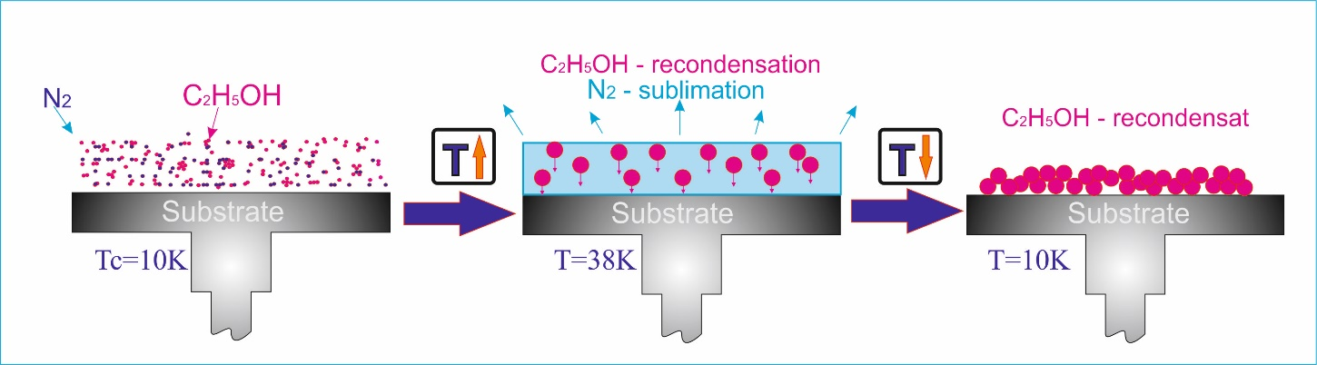

Figure 2 - Diagram of the recondensation process

Previously, we carried out physical modeling of such a process [5, 6], which confirms the above assumption. The processes of formation of a two-component film of cryovacuum condensate nitrogen + ethanol and the cluster composition of the sample were studied (Figure 3). The phase formed as a result of recondensation on the substrate surface was called "recondensate" [7]. Our studies have shown that the properties of recondensates, including optical ones, differ significantly from the properties of homogeneous films. Obviously, the process of recondensation will radically differ from the classical physical vapor deposition (PVD [7]). The main difference will be the fact that not individual gas molecules will take part in it, but its polyaggregates that were previously formed in the film during the condensation of the initial two-component sample [5]. Figure 3 shows the vibrational spectrum of ethanol in a nitrogen cryomatrix, demonstrating the presence in the film of polyaggregates of various scales - dimers, trimers, cyclic tetramers, multimers. It is clear that both the recondensation process and the properties of the resulting recondensate will be determined by the initial concentration ratio between the components, as well as by the nature of intermolecular interactions of the structural elements of the recondensed component. It seems obvious that the verification database used for the interpretation of astrophysical observations should be supplemented with information concerning the properties and behavior of recondensates of various gases obtained from various mixtures.

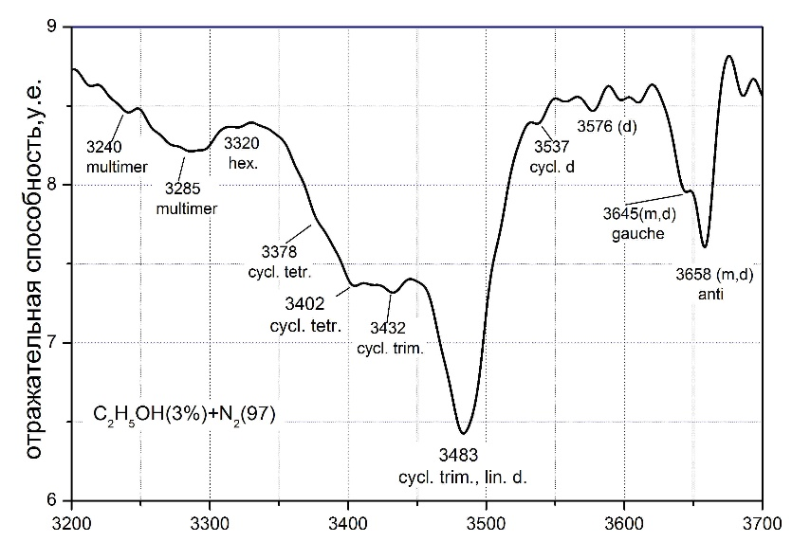

Reflectivity, arb.un.

Frequency, сm-1

Figure 3 - Vibrational spectrum of ethanol in nitrogen cryomatrix in the vicinity of OH-bond frequencies [5]. Frequencies are indicated corresponding to the existence of various structures

The above data are the basis for the implementation of comprehensive studies of the formation processes and properties of the recondensed state of matter. Moreover, such studies are of independent fundamental interest, since we are talking about evolution and structural transformations in nanoscale formations, as well as the interaction of these structural elements with each other. The proposed project provides for comprehensive research in these areas. Water, ethanol and methane in mixtures with nitrogen and argon are proposed as objects of research. The choice is due to the prevalence of these substances in space. In addition, the presence of a hydrogen bond in water, methanol and ethanol molecules, as well as spin-nuclear conversion processes in them and their interaction with the rotational subsystem of lattices, makes the study of these substances under the considered conditions extremely interesting also from a fundamental point of view [7].

Methanol has been extensively studied experimentally and theoretically to test theories of hydrogen bonding and chain formation [8]. On cooling, methanol freezes at 175.37 K, and then undergoes what was originally considered a second-order transition [1] from the high-temperature b-phase to the low-temperature a-phase at 157.4 K [9]. Later measurements with a dilatometer [10] showed that in fact there are two transitions: a first-order transition at 159 K and a second-order transition at 156 K. The amorphous phase is obtained by vapor deposition at low temperatures, and this phase transforms into a -phase when heated to 130 K [11]. Another crystalline phase is obtained when the pressure rises above 3.5 GPa at ambient temperature.

1. EXPERIMENTAL STUDIES OF RECONDENSED STATES OF SUBSTANCE AT LOW AND SUPERLOW TEMPERATURES WITH THE PURPOSE TO CREATE A VERIFICATION BASE OF IR SPECTROMETRIC OBSERVATIONS OF THE UNIVERSE

## 1.1. Measurement of refractive indices and density of two-component films (nitrogen, argon) + (water, ethanol, methanol) depending on the concentration and temperature of cryoprecipitation

In recent years, there has been renewed interest in studies of ethanol [12–15] and methanol [16–18] thin films deposited from the gas phase at low temperatures, especially in the framework of astrophysical studies [19]. The purpose of this work is to study the effect of impurities on the temperature dependence of refractive indices and on their structural-phase transformations upon heating. The effect of a change in the number of translational and rotational degrees of freedom of molecules on the mechanical and optical properties of thin films, such as the refractive index, density, and polarizability, has not yet been fully studied [19–21]. This relationship becomes even more complex due to the role of the deposition temperature in the structural and phase state of these materials.

It is known that the space ice under investigation in most cases is a mixture of various solidified gases. Different components of this ice have different sublimation temperatures, which under certain temperature conditions can lead to their dramatic changes. For example, for a two-component sample, when the ambient temperature reaches above the sublimation temperature of the low-temperature component, it will evaporate, which will lead to the release of the second component and its subsequent re-condensation. A schematic diagram of the recondensation process is shown in Figure 4.

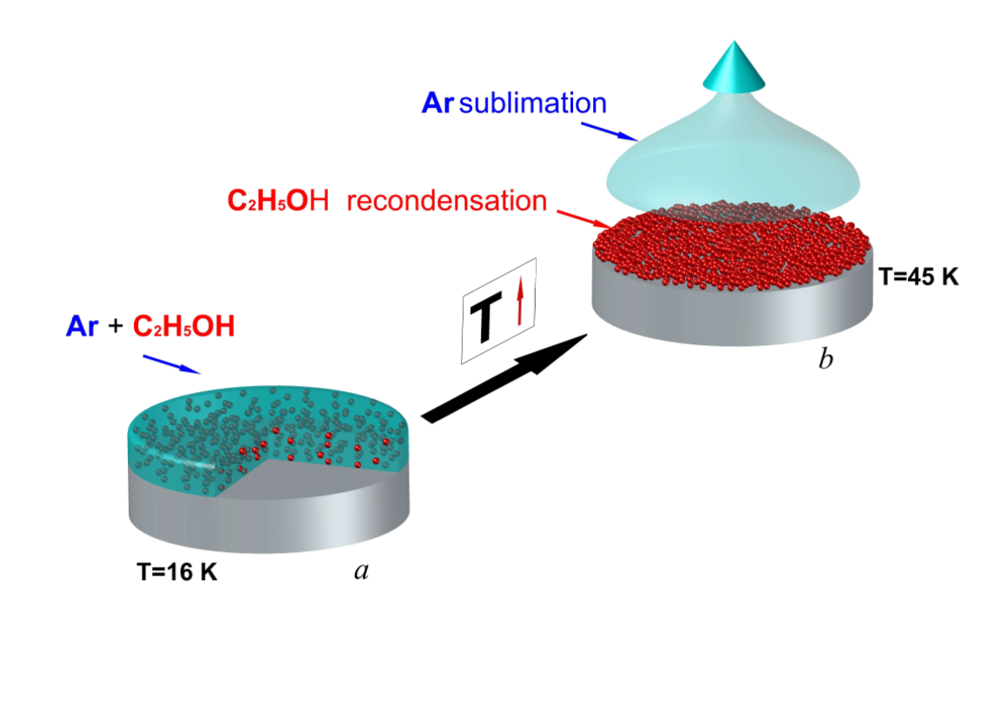

Figure 4 - Diagram of the recondensation process

Previously obtained data on pure films of ethanol and methanol [5, 22–25] by the PVD method and studies of clathrate compounds raised many questions about the structures formed during condensation of mixtures, which cannot be answered by the classical theories of clathrate compounds.

Earlier we carried out physical modeling of such a process [5], which confirms the above assumption. The processes of formation of a two-component film of cryovacuum condensate nitrogen + ethanol and the cluster composition of the sample are investigated. The phase formed as a result of recondensation on the substrate surface is called "recondensate". Our studies have shown that the properties of recondensates, including optical ones, differ significantly from the properties of homogeneous films. Obviously, the process of recondensation will be radically different from the classical physical vapor deposition (PVD [26,27]). The main difference will be that not individual gas molecules will take part in it, but its polyaggregates that were previously formed in the film during the condensation of the initial two-component sample [6]. It is clear that both the recondensation process and the properties of the resulting recondensate will be determined by the initial ratio of the component concentrations, as well as by the nature of intermolecular interactions of the structural element of the recondensed component. It seems obvious that the verification database used to interpret astrophysical observations must be supplemented with information on the properties and behavior of recondensates of various gases obtained from various mixtures. The above data are a sufficiently serious basis for researching the formation processes and properties of the recondensed state of matter.

To determine the dependence of the effect of concentration on the properties of condensates during condensation, methanol and ethanol were chosen as structure-forming agents, and argon and nitrogen were chosen as acceptors. The refractive indices and IR spectrometric characteristics of ethanol and methanol films obtained by the PVD method were measured by us earlier [14,23,24,28,29]. Figure 5 shows the refractive indices of a mixture of ethanol + argon, methanol + argon at different concentrations and different condensation temperatures. Calculation of refractive indices is a fairly relative method for a small number of measurements, but with a large number of experiments, it shows a certain dependence, which gives useful information. With a detailed study of the questions that have arisen, upon obtaining a larger number of reliable points, it will be possible to talk about the publication of all data on the refractive indices of mixtures of ethanol + argon, ethanol + nitrogen, methanol + argon, methanol + nitrogen.

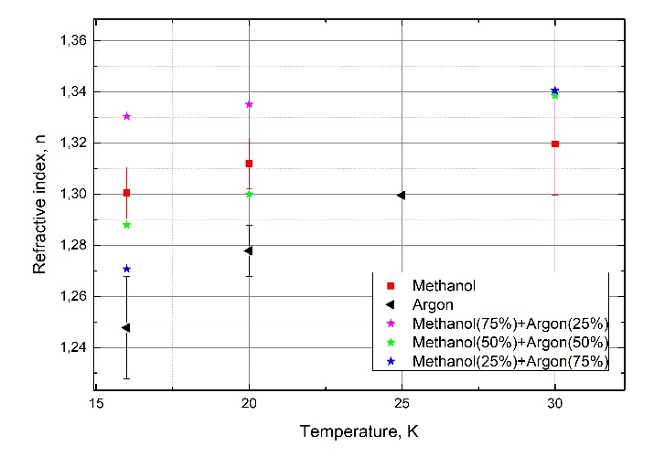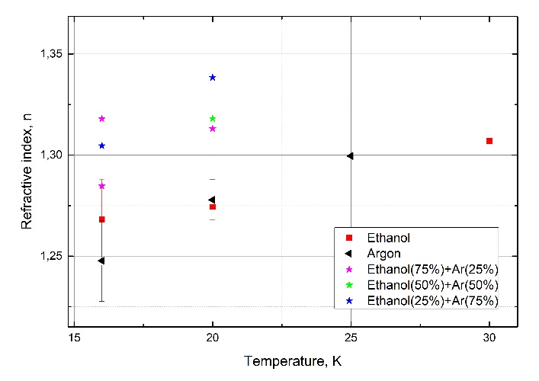

Figure 5 - Refractive indices of mixtures of ethanol with argon / nitrogen and methanol with argon / nitrogen at various concentrations

The question may arise regarding methanol, since it is very problematic to obtain amorphous methanol upon ultrafast cooling [30], especially with an admixture of argon or nitrogen. Compared to ethanol, this is a rather poor glass former. We used two different ideas. For methanol with argon and nitrogen, we used the same film thickness for different concentrations and condensation temperatures. For ethanol with argon and nitrogen, we chose such a thickness that the amount of ethanol on the substrate was the same at different concentrations, which should have helped when comparing IR spectra and determining the effect of concentration on different modes.

The analysis showed a similar effect of argon and nitrogen on vibrational spectra, therefore, in all spectra and discussions below, only argon will be mentioned.

The figure shows that the librational absorption band of methanol undergoes a series of changes in the presence of an impurity (766, 790, 801 cm-1). A significant decrease in the amplitude of the characteristic frequencies of alcohol is observed in the spectrum of an impurity of methanol with nitrogen. The shift by 1119 cm – 1 for pure methanol and its mixture with argon is insignificant, and, on the whole, the amorphous structure of the mixtures is retained. However, the splitting of the libration absorption band in a mixture with argon suggests the formation of a different amorphous structure than pure methanol. We believe that at a given concentration, methanol forms a transitional structural state between amorphous (pure methanol) and plastic crystals with sharp absorption bands [23], the spectrum of which is shown in Figs. 6.

Figure 6 (right) shows the IR spectrometry data of ethanol and its mixture with argon at a condensation temperature of 16 K and the spectrum of pure ethanol at a condensation temperature of 110 K. The spectrum for a mixture with nitrogen is similar to the spectrum with argon.

We see significant changes in the spectra of the mixture. The absorption bands with frequencies of 880 cm-1, 1315 cm-1, 1380 cm-1 differ from the absorption bands of the spectrum of pure alcohol, the nature of which, we believe, is similar to the changes in the structure of methanol mixtures. Consequently, the spectrum of ethanol at a condensation temperature of 110 K has similar absorption frequencies with the spectrum of a mixture of ethanol and argon, with less pronounced absorption peaks (802 cm-1) and a separated peak (879 cm-1, 887 cm-1), which is absent in pure amorphous ethanol. Methanol, unlike ethanol, has not been previously studied by us in matrix isolation, but in extensive studies by other authors, such changes in librational vibrations were not mentioned [31].

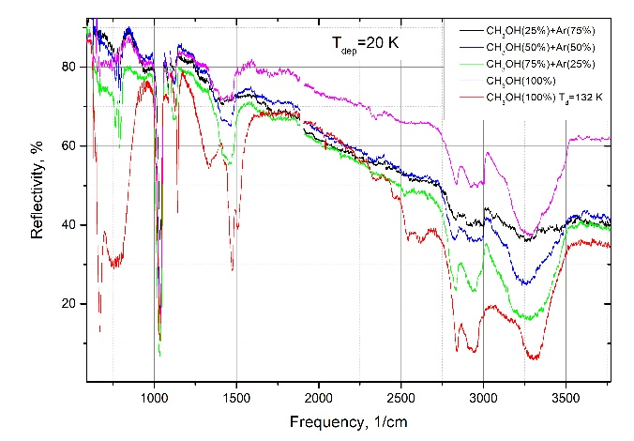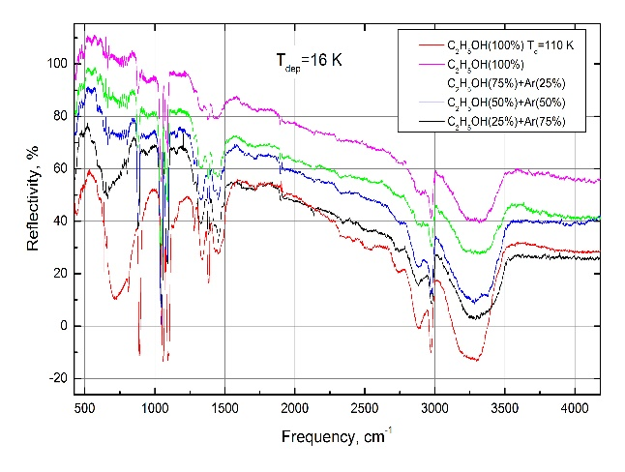

Figure 6 - IR spectra of methanol (left), ethanol (right) and its mixtures of cryocondensates

1. Based on the analysis of the obtained IR spectra, it is concluded that there are monomers and dimers of ethanol in the nitrogen matrix. This is indicated by:

a) Absorption band at a frequency of 3658 cm-1, due to vibrations of the OH bond of monomers and dimers of ethanol. The existence of local minima in this band at frequencies of 3645 and 3658 cm-1 is associated with the presence of two conformational states in the ethanol molecule, anti (3658 cm-1) and gauche (3645 cm-1).

b) Two absorption bands at frequencies of 1259 cm-1 and 1276 cm-1, related to bending vibrations of δ (CОH) anti- and gauch isomers, respectively.

c). Two bands corresponding to a combination of stretching vibrations ν (CCO) with rotational vibrations of the methyl group r (CH3), related to anti-dimers (ν = 1090 cm-1) and anti-monomers (ν = 1095 cm-1).

2. Local minima in the range 3000-3600 cm-1 indicate the presence of the following ethanol aggregates in the matrix: m-monomer, d-dimer, cycl. d- cyclic dimer, cycl. trim.-cyclic trimer, cycl. tetr.- cyclic tetramer, hex-hexomer. A wide band in the range 3250-3330 cm-1 means the presence of large polyaggregates in the matrix, in which ethanol molecules are in a hydrogen-bonded state (multimer).

3. Local minima with frequencies at 1259 and 1276 cm-1 correspond to bending vibrations of δ (CОH) anti- and gauch isomers, respectively. The band corresponding to the vibration of the anti-isomer of ethanol (1259 cm-1) disappears completely as the concentration of ethanol in the matrix increases, while the gauch-isomer fluctuation remains and becomes more pronounced. This is explained by the fact that the intermolecular formation of cyclic ethanol polyaggregates occurs along the δ (CОH) -anti bond, followed by inhibition of this type of vibration. Thus, it can be assumed that the δ (COH) -gauch bond does not participate in the cluster formation of ethanol molecules.

4. The splitting of the band of stretching CCO vibrations with a change in the concentration of ethanol in the nitrogen matrix is associated with the fact that the vibrations of the corresponding frequencies existing for monomers and dimers of ethanol are coupled during the formation of cyclic clusters. For aggregates more than trimers, only stretching vibrations along the CCO bond with three frequency modes (896, 898, and 900 cm-1) remain, which are not separated due to the large absorption band in pure ethanol samples. An increase in the concentration of ethanol in nitrogen up to 5-10% leads to an increase in the number of anti-gauche dimers with frequencies ν = 884 cm-1 and ν = 900 cm-1. The first of them corresponds to the symmetric stretching vibration of the (CCOa) -acceptor, and the second frequency ν = 900 cm-1 corresponds to the donor type of symmetric stretching vibrations νs (CCOd). A further increase in the ethanol concentration leads to a sharp decrease in the number of not only monomers, but also dimers, and the double absorption band degenerates into one.

## 1.2. Measurement of IR spectra of films (nitrogen, argon) + (water, ethanol, methanol) depending on the concentration and temperature of cryoprecipitation

For almost 90 years, the condensed state of ethanol has been the object of diverse and large-scale research. Starting from the work of Gibbs [32] and up to the present, teams of researchers from different countries are studying the unique properties of solid ethanol using acoustic, optical, structural, calorimetric, and other methods. The reason for this close attention is the fact that ethanol has extremely interesting polymorphic and polyamorphic properties. In the temperature range below its melting point (Tm = 159 K), ethanol exists in various states: a glassy state (structural glass SG), which is formed during the rapid cooling of the liquid phase to a temperature below the glass transition temperature Tg = 97 K; plastic crystal PC (bcc), which is formed through an intermediate supercooled liquid phase (SCL) as a result of heating SG above Tg; orientationally disordered crystal (ODC), formed during cooling of a plastic crystal PC to a temperature below T = 97 K; monoclinic crystal MS, which is the main stable state of solid ethanol. The result of consistent targeted research in recent decades was the formation of a phase diagram for solid ethanol [33–36]. In this case, in most of the works, a technique was used to obtain the glassy state of ethanol from the liquid phase by means of its ultrafast quenching and subsequent thermally stimulated transformations. At the same time, there is another obvious way of obtaining an amorphous state, including structural glass — condensation from the gas phase onto a substrate cooled below the glass transition temperature. Moreover, in our opinion, it is this path that is the most controllable experimentally in terms of the speed and degree of hypothermia.

Earlier, we carried out a series of studies devoted to thermally stimulated transformations in cryovacuum condensates of various gases, including water and ethanol vapors [25, 29]. Within the framework of these studies, the question was raised about the role of cluster formation processes in the formation of thin films of cryocondensates on a cooled substrate. It was assumed that these processes have a significant effect on the formation of the short-range order structure of cryocondensates and, as a consequence, on the nature of their subsequent thermally stimulated transformations. For this we used the cryomatrix isolation method with nitrogen as a cryomatrix. The results obtained for the case of cryoprecipitation of water vapor are presented in [29]. The natural next step in this direction is to carry out similar studies in relation to the processes of ethanol cryocondensation. On the whole, these studies were carried out using the setup and the technique used in [29], and the available features will be discussed below.

The task of our research is an attempt to explain the complex and often ambiguous behavior of thin films of ethanol cryocondensates in the process of thermally stimulated transformations from the standpoint of the influence of the cluster composition of the deposited samples on these processes. For this purpose, studies of the cryoprecipitation processes of the ethanol-nitrogen gas mixture in various concentration ratios, as well as the properties of the resulting cryocondensates, have been carried out. The object of research is thin films of nitrogen cryocondensates (matrices) containing ethanol molecules in various cluster states. By changing the concentration of ethanol in nitrogen, one can expect a change in the cluster composition of ethanol molecules immobilized in the nitrogen matrix.

The analysis of the spectra obtained by us for the determination of the cluster composition of ethanol in the nitrogen matrix is based on comparison with the data of other authors. From a large number of studies of this kind, both theoretical and experimental, we have selected works performed using two methods for the formation of ethanol clusters - expansion of He or He / Ne supersonic ethanol-containing jet [15.37, 38], as well as the method cocondensation of ethanol with nitrogen as a matrix [39–41]. Thus, we tried to take into account the fact that the clusters contained in the matrix can be formed both in the gas phase with subsequent capture by the matrix, and in the process of condensation of the mixture itself, most likely in the adsorbed layer. We used the generalized data of these studies below to analyze the obtained spectra. Figure 7 shows the main types of ethanol polyaggregates, the principles of their formation and spectral manifestations in different spectral ranges.

|  |  |  |
| --- | --- | --- |
| Monomers |  | 3685, 3678, 3660 [11]; 3661 [12]; 1446(t), 1094(t), 1275(g), 2988(g), 1261(t), 882(g) [20]; 3645(g),3658(a) [10] |
| Dimers | tt | 3672,3654,3548,3542,3540,2984(tt) [11]; 3547, 3540, 3532 [12]; 1445(tt), 2983(tg), 1489(tg), 1464(tt), 2984(tt), 2983(tg), 1056(tg), 883(tg), 811(tg), 418(tt) [13,20]; 3537(cycl.), 3576(cycl.), 3645(g) [10] |
| Trimers |  | 3447 [12]; 3433 [13]; 2984(ttt), 1464(ttt) [20]; 3432(cycl.), 3487(cycl.) [10]; 3433 [13]; |
| Tetramers |  | 3378(cycl.), 3402(cycl.) [10]; 3378 [13] |

Figure 7 - The main types of ethanol polyaggregates, the principles of their formation and spectral manifestations in different ranges of the spectrum. Accepted designations: g-gauche-conforms; a-anti-conformal; cycl is a cyclic cluster. Dimension of numerical values in cm-1

In comparison with the studies carried out in [29], in this work, some changes were made in the methodology. They mainly touched on the technology for preparing a mixture of nitrogen-ethanol. In [29], the components were injected in parallel into the chamber using two calibrated leakages. On the one hand, this eliminated the need to take into account the separation of the mixture during filling, but on the other hand, it did not allow the concentration of the components to be measured with the required accuracy. Studies have shown that the potential separation of the mixture during the filling will certainly make a smaller contribution to the error in determining the concentration than the error based on the need to measure the pressures of the mixture components during the filling and to calculate the concentrations based on them. In this regard, we used a technique with preliminary preparation of a mixture of a given concentration and its filling into the chamber through one leak. The condensation rate and thickness were monitored with a two-beam laser interferometer. After the planned film thickness was deposited, the gas puffing was stopped and the IR reflection spectra of the film-substrate system were measured. The main parameters of the experiment were maintained as follows: substrate temperature T = 16 K; mixture inlet pressure P = 10-5 Torr; concentration of ethanol in nitrogen from 0.5% to 10%; spectrum frequency range from 4200 to 400 cm-1.

Figure 8 shows the vibrational spectra of thin films of cryocondensates of a nitrogen-ethanol mixture with various ethanol concentrations. The frequency range is 4200-400 cm-1. The condensation temperature of the samples T = 16 K. The thickness of the samples was set in accordance with the concentration of ethanol in the nitrogen matrix: (C = 10% - d = 5 μm); (C = 5% - d = 7.5 μm); (C = 3% - d = 10 μm); (C = 1.5% - d = 10 microns); (C = 0.5% - d = 12.5 μm). Thus, as the ethanol concentration decreased, the film thickness increased so that the number of ethanol molecules interacting with the globar radiation did not change significantly for different concentrations. In addition, for the convenience of analyzing and comparing the spectra obtained at different ethanol concentrations, the corresponding databases were multiplied by a constant. The figure shows the following designations: ν (OH) - stretching vibrations of the OH bond; ν (CH) - stretching vibrations of CH bond; δ (CH3, CH2) - deformation vibrations of the methyl and methylene groups; δ + ν + r (CH) -combinations of deformation, stretching and fan vibrations; ν (CO) - stretching vibrations of the CO bond. In a more detailed discussion of the results obtained, it is advisable to divide the range of frequencies under consideration into intervals corresponding to the characteristic vibrations of the ethanol molecule.

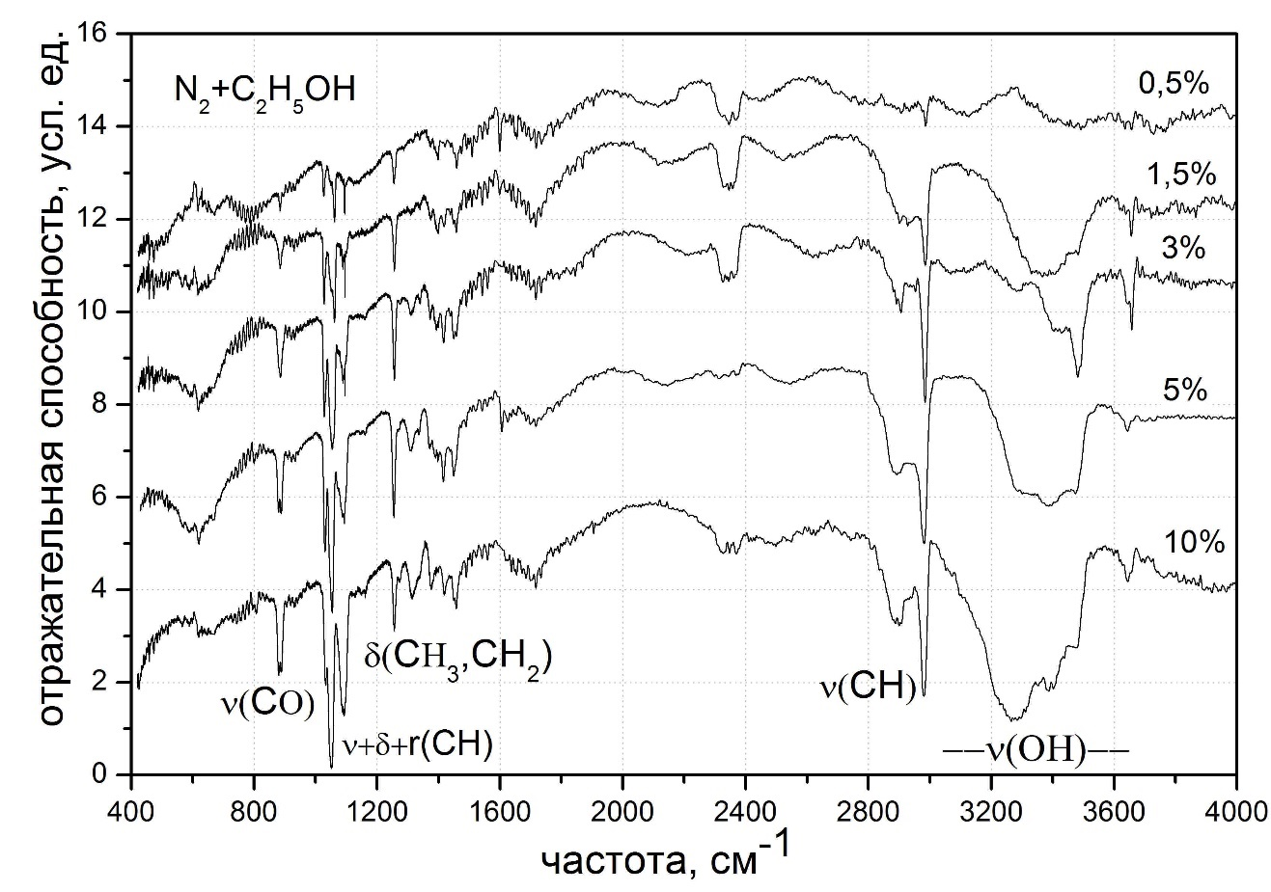

Reflectivity, arb.un.

Frequency, cm-1

Figure 8 - Vibrational spectra of thin films of cryocondensates of a nitrogen-ethanol mixture with various ethanol concentrations. Condensation temperature T = 12 K. Sample thickness in accordance with ethanol concentrations: (C = 10%, d = 5 microns); (C = 5%, d = 7.5 μm); (C = 3%, d = 10 μm); (C = 1.5%, d = 10 μm); (C = 0.5%, d = 12.5 μm)

The interval 3000-3700 cm-1 corresponds to the stretching vibrations of the O-H bond in the free and bound state of molecules. The frequency range from 2800 to 3000 cm-1 corresponds to symmetric and asymmetric stretching vibrations of the CH bond of the methyl CH3 and methylene CH2 groups. The interval 1300-1500 cm-1 contains the frequencies of deformation and fan-shaped vibrations of CH3 and CH2 groups. Combinations of stretching, rotational and vibrational frequencies are located in the range 1200-1000 cm-1. The absorption band in the frequency range 880-900 cm-1 refers to stretching CCO vibrations and their combinations with rotational vibrations of the methyl and methylene groups. The band at 415-420 cm-1 corresponds to the deformation vibration along the CCO bond.

It seems appropriate to compare the obtained data with the IR spectra of pure films of ethanol samples of the corresponding condensation temperature and thickness. Figure 9 shows the comparison spectra of two samples - a film of pure ethanol and a sample consisting of 3% ethanol and 97% nitrogen. The selected ethanol concentration C = 3% contains all the characteristic features of the ethanol spectrum in the nitrogen matrix as compared to the pure sample. The film thickness of pure ethanol is 1 μm, the film thickness of a mixture of nitrogen and ethanol is 10 μm. In accordance with the selected frequency ranges, let us consider in more detail the obtained spectra.

1. The frequency interval is 3000-3700 cm-1, corresponding to the valence O-H bond. The obvious difference is due to a much lower degree of hydrogen bonding in ethanol aggregates in the nitrogen matrix. In accordance with the data shown in Fig. 1, the absorption band at ν = 3658 cm-1 can be interpreted as the vibrations of the OH bond of the monomers and dimers of ethanol. Its shift to longer wavelengths as compared with the characteristic frequencies of monomers and dimers in the gas phase [15.38] is apparently the result of the influence of the nitrogen matrix lattice. A more detailed analysis of the interaction of the nitrogen lattice with ethanol molecules, as well as the position of ethanol in the matrix, although it is of considerable interest, is not included in the task of these studies.

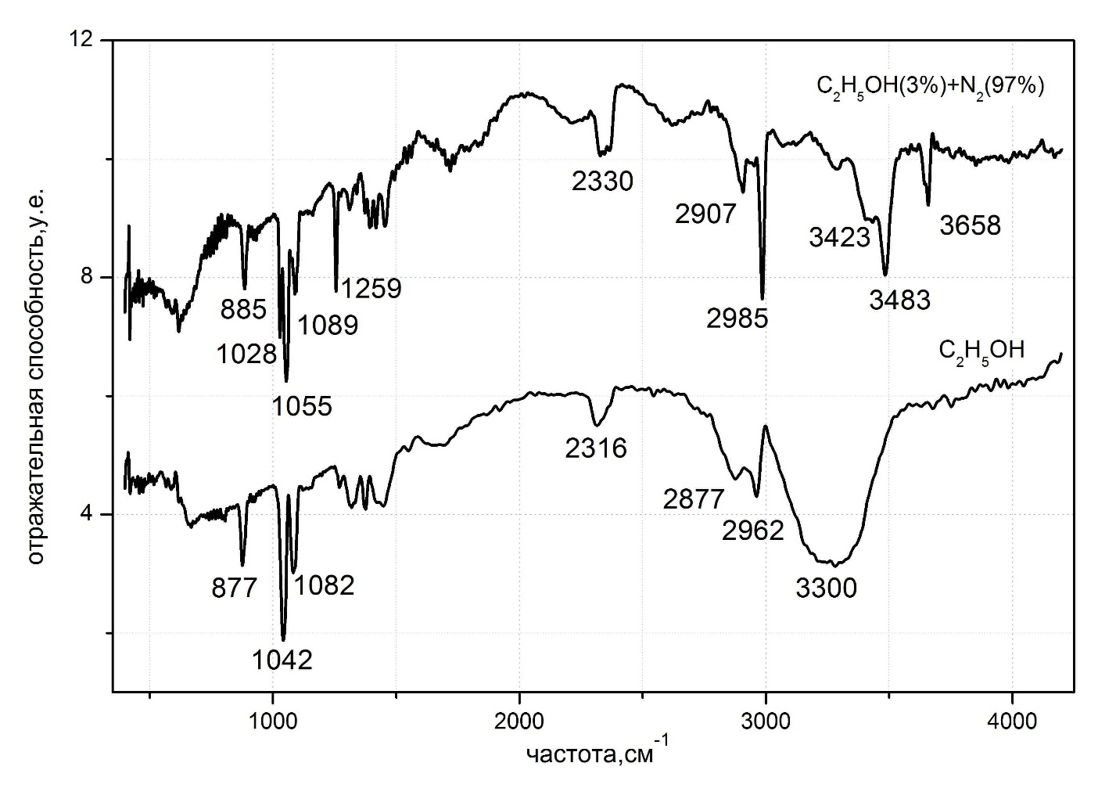

Reflectivity, arb.un.

Frequency, cm-1

Figure 9 - Comparison of vibrational spectra of thin films of cryocondensates of pure ethanol and an ethanol-nitrogen mixture. The upper curve is a mixture of 3% ethanol and 97% nitrogen, condensation temperature T = 12 K, sample thickness d = 10 μm. The lower curve is ethanol, the condensation temperature is T = 12 K, the sample thickness is d = 1 μm. Frequencies corresponding to the absorption maximum of the main characteristic vibrations are indicated.

A more detailed consideration of this band is of interest (Figure 10). As can be seen from the figure, the band has local minima at frequencies ν = 3645 cm-1 and ν = 3658 cm-1. We believe that this is due to the presence of two conformational states in the ethanol molecule, anti (3658 cm – 1) and gauche (3645 cm – 1), due to the difference in the position and, accordingly, the energies of the hydrogen atom in the O – H bond [40, 42 ]. It can be seen from the figure that the difference in the energies of conformers is 13 cm – 1, which is in good agreement with the data of other authors [41]. In addition, the asymmetric shape of the absorption band under consideration coincides with the data of [43] - the results of IR-spectral deconvolution of the asymmetric profile of the absorption band of the O-H bond, shown in the figure on the right. The slight discrepancy in frequencies is a consequence of the heterogeneity of the ethanol cluster composition in the nitrogen matrix, i.e. the considered plane refers to quasi-free monomers or dimers of ethanol.

|  |  |
| --- | --- |
|  |  |

Figure 10 - Left - Spectral manifestation of the conformational features of the structure of the ethanol molecule. Local minima correspond to anti (3658 cm-1) and gauche (3645 cm-1) isomers of ethanol relative to the position of the hydrogen atom in the OH bond. Right- Comparison with the results of IR-spectral deconvolution of the asymmetric profile of the absorption band of the O-H bond [18]

Analysis of the fine structure of the absorption band of the O - H bond in the range of 3000-3600 cm-1 (Figure 11) also indicates the presence of local minima corresponding to different cluster states of ethanol molecules in the nitrogen matrix. Based on the calculations and experimental data of other authors [39, 44], we conclude that there are ethanol clusters of various sizes in the nitrogen matrix. Figure 11 shows the frequencies of local minima and their interpretation in accordance with the data given in [45]. In this case, the following abbreviations are used: m-monomer, d-dimer, cycl. d- cyclic dimer, cycl. trim.-cyclic trimer, cycl. tetr.- cyclic tetramer, hex-hexomer. In addition, the appearance of a wide band in the range of 3250-3330 cm-1 may mean the appearance in the matrix of large polyaggregates in which ethanol molecules are in a hydrogen-bonded state; they are designated as multimer.

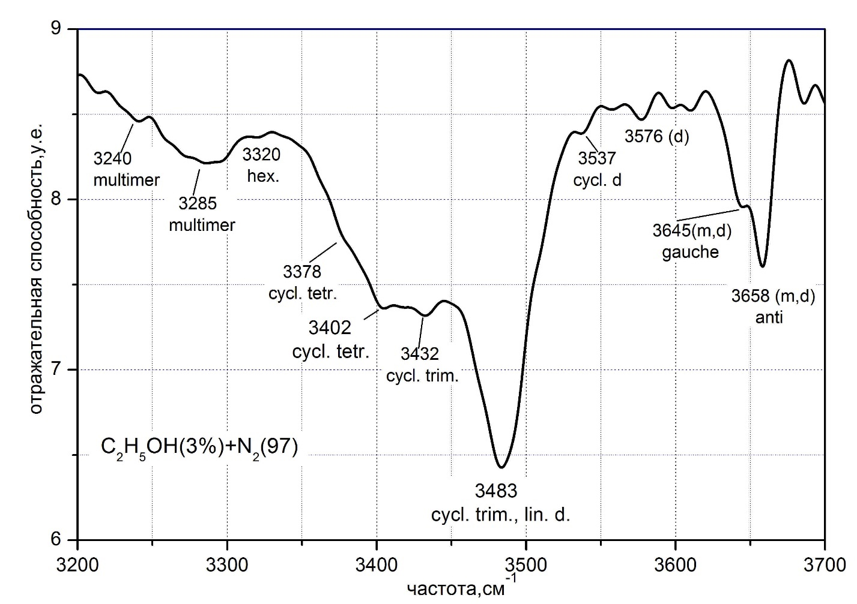

Reflectivity, arb.un.

Frequency, cm-1

Figure 11 - Features of the absorption band of the OH bond of ethanol (3%) in the nitrogen cryomatrix (97%). Abbreviations: m-monomer, d-dimer, cycl. d- cyclic dimer, cycl. trim.-cyclic trimer, cycl. tetr.- cyclic tetramer, hex-hexomer

It is worth noting that in the publications cited by us, aggregates larger than dimers are predominantly cyclic. This property of ethanol molecules to cyclically close hydrogen bonds, forming the most stable cluster formations, may be the fundamental reason for the ability of ethanol to form stable polymorphic and polyamorphic, including glassy, states.

2. The interval 2800-3000 cm-1 includes stretching vibrations of CH-bonds of the methyl and methylene groups of ethanol. Figure 12 shows the vibrational spectra of films of pure ethanol (bottom graph) and a 3% mixture of ethanol and nitrogen (top graph) in this frequency range. An obvious difference is the presence of a finer structure of the spectrum related to the matrix isolated state of ethanol. A pronounced narrow absorption peak at a frequency of ν = 2985 cm – 1 refers to asymmetric stretching vibrations of the СН-bond of the methyl group νа (СН3) of monomers and dimers [45].

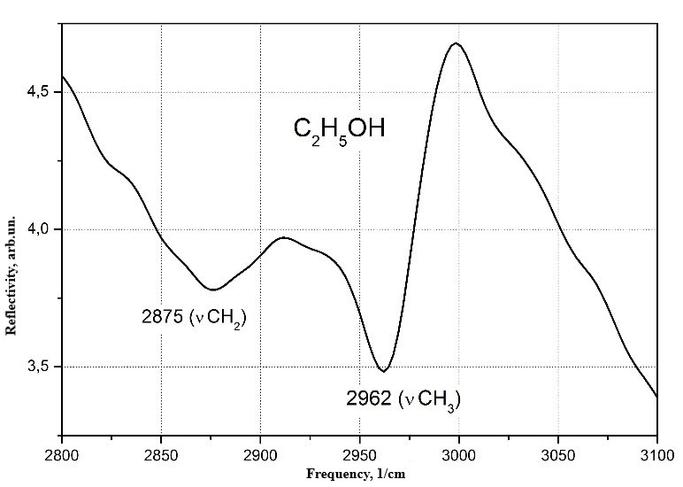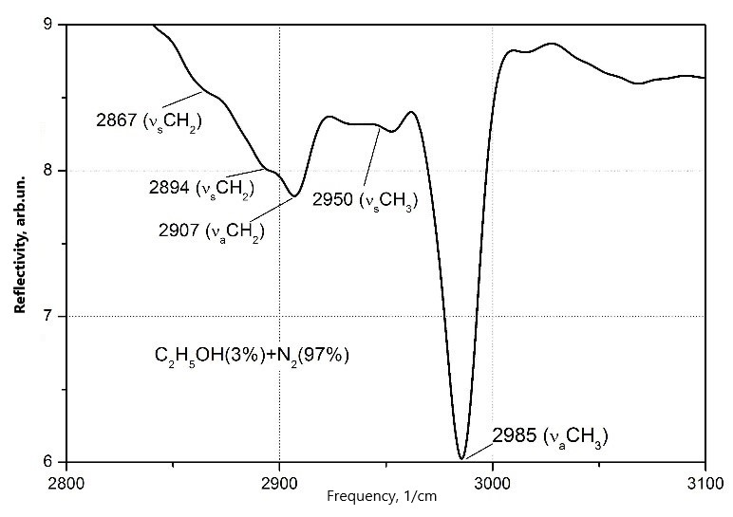

Figure 12 - Vibrational spectra of films of pure ethanol and a 3% mixture of ethanol and nitrogen in the frequency range of stretching vibrations of the CH bond of ethanol

A weak band at a frequency of ν = 2950 cm-1 belongs to the same type of vibration. The absorption band at a frequency of ν = 2907 cm-1 reflects the СН-stretching asymmetric vibrations of the methylene group νа (CH2), and the local extrema at frequencies of 2894 and 2867 cm-1 refer to the symmetric type of these vibrations.

The lower graph shows the absorption spectrum in the range of CH stretching vibrations of pure ethanol cryocondensate. Compared to the upper spectrum, a significant broadening of the absorption bands is observed, which leads to the disappearance of the fine structure reflecting various types of vibration of the ethanol molecule. Two broad bands centered at 2962 and 2875 cm–1 correspond to stretching vibrations of the CH bond of the methyl and methylene groups, respectively.

In addition to broadening of absorption bands, a significant shift of their centers to the low-frequency region is observed as compared to the upper figure. This displacement is Δν = 23 cm-1 for the methyl group and Δν = 32 cm-1 for the methylene group. Both the broadening of the bands of СН-stretching vibrations and their "redshift" are a manifestation of intermolecular interactions of ethanol and the appearance of a medium and long-range order of the structure of cryocondensates.

3. The interval 1200-1500 cm-1 includes the frequencies of various kinds of deformation vibrations. Figure 13 shows in more detail the characteristic vibration spectra of ethanol molecules in a nitrogen matrix (3% + 97%) (upper curve) in comparison with the IR spectrum of a film of cryocondensate of pure ethanol (lower curve) in the frequency range of bending (δ) and fan-like (W ) fluctuations of ethanol, as well as combinations of these fluctuations.

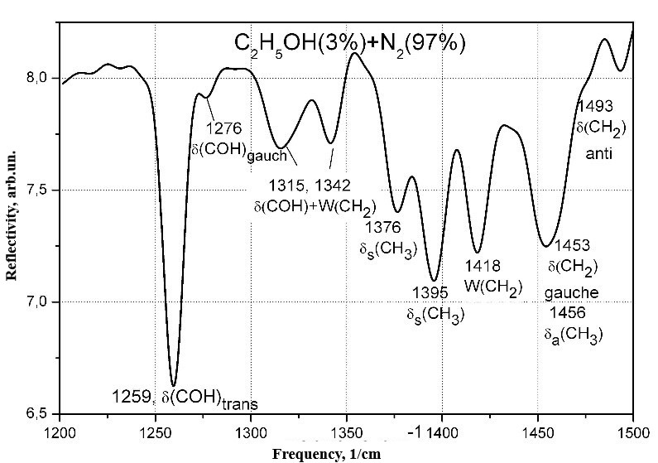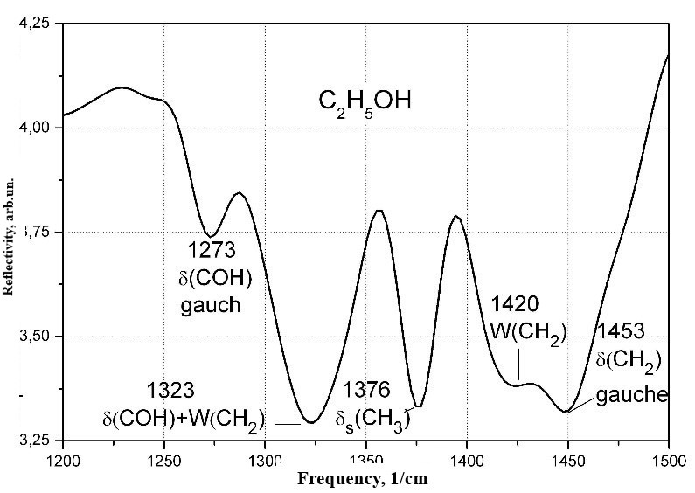

Figure 13 - Typical vibration frequencies of ethanol molecules in a nitrogen matrix (3% + 97%) and in a film of pure ethanol cryocondensate

As can be seen, the structure of the spectrum of a mixture of 3% ethanol with nitrogen is more complex than the spectrum of pure cryocondensate. Of the 9 characteristic peaks of the upper spectrum in the frequency range under consideration, only 5 characteristic absorption bands remain for a clean film. The band with an average frequency ν = 1493 cm-1 disappears, which corresponds to the bending vibration of the methylene group of the δ (CH2) anti-isomers. Two separated bands of seven-dimensional bending vibrations of the methyl group δ (CH) s with frequency centers of 1376 and 1395 cm-1, apparently in the process of broadening, form one band with a frequency of ν = 1376 cm-1. The same happens with two separated frequencies (1315 and 1342 cm-1) of a combination of bending vibrations along the bond (СОН) and fan vibrations of the methylene group W (CH2), as a result of which one broad band is formed with a center at a frequency of ν = 1323 cm-1. Интересным образом ведет себя полоса поглощения, соответствующая деформационным колебаниям δ(CОH) anti- и gauch изомеров с частотами на 1259 и 1276 см-1. The band corresponding to the vibration of the anti-isomer of ethanol (1259 cm-1) completely disappears, while the gauch-isomer fluctuation persists and becomes more pronounced. The nature of this phenomenon is, apparently, in the fact that the intermolecular formation of cyclic ethanol polyaggregates occurs along the δ (CОH) -anti bond with the subsequent inhibition of this type of vibration. Thus, it can be assumed that the δ (COH) -gauch bond does not participate in the clustering of ethanol molecules.

As noted above, one of the most striking differences between the spectra under consideration is the absorption band at a frequency of 1259 cm–1. In accordance with [45], it characterizes the bending vibration δ (COH). As can be seen, this band is completely absent in the spectrum of pure ethanol cryocondensate. Taking into account the tendency of ethanol molecules to cyclic in the formation of aggregates, this band should disappear for aggregates larger than dimers, since during the formation of cyclic aggregates the vibrational degree of freedom of the O - H bond will become impossible due to its inclusion in the process of cyclic cluster formation. This assumption is confirmed by the data presented in [45]. Thus, this band can be attributed to the presence of ethanol monomers and dimers in the nitrogen matrix. In addition, this band also has two components (anti -1259 cm-1 and gauche -1256 cm-1), which are a manifestation of the conformity of the structure of the ethanol molecule.

4. The frequency interval 1000-1120 cm-1 is shown in Fig. 14 by a system of absorption bands related to combinations of stretching ν (ССО) vibrations with rotational vibrations of the methyl r (CH3) and methylene r (CH2) groups and bending vibrations of the δ (OH) bond ... As can be seen, for a mixture of ethanol and nitrogen, the absorption spectrum has a more complex structure than that of pure ethanol cryocondensate. The spectrum of the 3% ethanol-nitrogen mixture has three broad, pronounced absorption peaks in the range under consideration, as well as a sharp and narrow absorption band at a frequency of ν = 1095 cm-1. Based on the analysis presented in [38,41,43,46], it is possible with sufficient confidence to determine the following nature of these fluctuations.

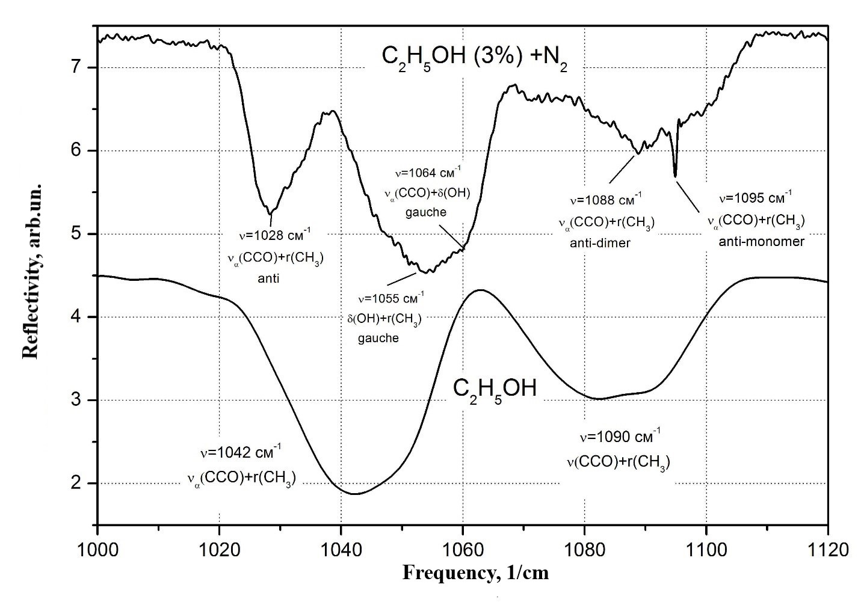

Figure 14 - Absorption spectra of a film of a mixture of 3% ethanol-nitrogen and pure ethanol in the frequency range of combinations of stretching ν (ССО) vibrations with rotational vibrations of the methyl r (CH3) and methylene r (CH2) groups, as well as deformation vibrations of the δ (OH) bond

The band with the absorption maximum at ν = 1028 cm-1 corresponds to a combination of stretching vibrations ν (CCO) with rotational vibrations of the methyl group r (CH3). For the case of a pure ethanol film, this band significantly broadens with a simultaneous center shift to ν = 1028 cm–1. Both are a consequence of the interaction of the ethanol molecule with the internal field of the lattice. A wide and pronounced peak centered at ν = 1055 cm-1 is associated with a combination of stretching ν (CCO) vibrations with bending vibrations of the δ (COH) bond. In this case, these fluctuations refer to the gauche conformals of ethanol. Taking into account the tendency to cyclic clustering of ethanol molecules, it becomes clear that the amplitude of this vibration decreases with an increase in the concentration of ethanol in the nitrogen matrix and that this band disappears completely in pure samples. This refers to the participation of the COH-bond in the formation of cyclic clusters and the "inhibition" of this type of oscillation.

The band centered at ν = 1090 cm-1 refers to the combination of stretching vibrations ν (CCO) with rotational vibrations of the methyl group r (CH3). It has two characteristic peaks related to dimers - anti (ν = 1090 cm-1) and monomers –anti (ν = 1095 cm-1). It can be seen that at a given concentration, the fraction of ethanol monomers in the nitrogen matrix is significant.

|  |  |
| --- | --- |
| Reflectivity, arb.un. | C:\Users\Марина\Desktop\14-ниже\Graph14-1.JPGC:\Users\Марина\Desktop\14-ниже\Graph14-2.JPGC:\Users\Марина\Desktop\14-ниже\Graph14-3.JPGC:\Users\Марина\Desktop\14-ниже\Graph14-4.JPGC:\Users\Марина\Desktop\14-ниже\Graph14-5.JPG  Frequency, cm-1  Figure 15 - Vibrational spectra of ethanol in nitrogen at various concentrations |

Of interest is information on how the cluster composition of ethanol, in particular monomers, in the nitrogen matrix changes with a change in the concentration ratio. These data are presented in Figure 15. It shows the vibrational spectra of ethanol at its various concentration ratios in the nitrogen matrix. As can be seen from the spectra, with an increase in the concentration of ethanol in the nitrogen matrix, a decrease in the absorption amplitude of the band at a frequency of ν = 1095 cm-1 is observed, which corresponds to a combination of stretching vibrations ν (CCO) with rotational vibrations of the methyl group r (CH3) of anti-conformal monomers. That is, the change in the amplitude of this vibration is directly related to the change in the concentration of ethanol monomers in the nitrogen matrix. Below this information will be given in a graphical display (Figure 19).

5. The frequency interval is 800-1000 cm-1. Figure 16 shows the absorption spectra of cryocondensate films of ethanol-nitrogen mixtures in various concentration ratios.

|  |  |
| --- | --- |
| Reflectivity, arb.un. | C:\Users\Марина\Desktop\14-ниже\Graph15-1.JPGC:\Users\Марина\Desktop\14-ниже\Graph15-2.JPGC:\Users\Марина\Desktop\14-ниже\Graph15-3.JPGC:\Users\Марина\Desktop\14-ниже\Graph15-4.JPG  Figure 16 - Absorption spectra of films of cryocondensates of ethanol-nitrogen mixtures in various concentration ratios in the range of stretching vibration frequencies ν (SSO) and their combinations |

The frequency range corresponding to stretching vibrations ν (CCO), as well as modes of combinations of these vibrations with rotational vibrations of the methyl group, is considered. Noteworthy is the transformation of the spectrum with an increase in the concentration of ethanol in the nitrogen matrix. In the measured concentration range of 0.5-3%, the absorption peak is an almost symmetrical monoband centered at a frequency of ν = 885 cm-1. This band is quite reliably identified as stretching vibrations of the CCO bond [41, 43].

For the measured concentrations of ethanol in nitrogen of 5% and 10%, the band splits with the appearance of two pronounced minima with the same center frequencies for both concentrations ν = 879 cm-1 and ν = 888 cm-1. The vibration at a frequency of ν = 879 cm–1 can be interpreted as a combination of the CCO stretching vibration and the rotational vibration of the methyl group for the ethanol monomer Mg gauche – isomorph [41].

The relationship between the ethanol concentrations and the process of splitting of the valence CCO band observed at these concentrations is not quite obvious. An assumption can be made based on the data given in [45]. In accordance with these data, the vibration frequencies existing for monomers and dimers of ethanol are bound during an increase in the concentration of ethanol and the formation of cyclic clusters. For aggregates of more than trimers, only purely stretching vibrations along the CCO bond with three frequency modes (896, 898, and 900 cm-1) remain, which are not separated due to the large The shift of the center of the absorption band to the long-wavelength region of the spectrum is associated with the effect of the internal field in the film of a 100% ethanol sample. Nevertheless, it remains unclear why, at concentrations from 0.5 to 3%, the considered band has one minimum (at a frequency of ν = 884 cm-1) and does not reflect the presence of monomers and dimers in these samples. We can assume the following explanation for this fact. Combinations of stretching and rotational vibrations of the methyl group ν (CCO) + r (CH3) correspond to the frequencies we are considering close to. At this frequency ν = 896 cm–1, vibrations of the anti- monomer (or trans-, according to the designations adopted in [45]) correspond. The frequency ν = 882 cm-1 corresponds to the vibration of the gauche monomer, which is in full agreement with our experimental data (the center of the band is located at the frequency ν = 884 cm-1).

Assuming that mainly anti-conforms are involved in the formation of cyclic polyaggregates, it becomes clear that these vibrations of monomers are linked in a cycle and, thus, the band centered at ν = 884 cm-1 belongs to vibrations of gauche monomers. An increase in the concentration of ethanol in nitrogen up to 5-10% leads to an increase in the amount of anti-gauche dimers Dtg, with frequencies ν = 884 cm-1 and ν = 900 cm-1. The first of them corresponds to the symmetric stretching vibration, when (CCOa) is an acceptor, and the second frequency ν = 900 cm-1 corresponds to the donor type of symmetric stretching vibrations νs (CCOd). A further increase in the ethanol concentration leads to a sharp decrease in the number of not only monomers, but also dimers, and the double absorption band degenerates into one.

As we noted above, some characteristic vibrations of the ethanol molecule can be reliably correlated with the presence of aggregates of various scales in the nitrogen matrix. In particular, the absorption band at a frequency of ν = 3658 cm-1 (Figures 3-4) corresponds to the valence O-H-bond in ethanol monomers and dimers. The peak at a frequency of ν = 1259 cm-1 (Figures 13-14) refers to the bending vibration of the O-H bond and also characterizes the presence of monomers and dimers. And, finally, the band at a frequency ν = 1095 cm-1 corresponds to a combination of stretching vibrations ν (CCO) with rotational vibrations of the methyl group r (CH3), which belongs to the monomers –anti (ν = 1095 cm-1). These three types of vibration can generally characterize the content of monomers and dimers in the matrix. In order to be able to compare different spectra at different concentrations, the amplitudes of the considered vibrations were normalized to the amplitude of the CH bond of the methyl group at a frequency ν = 2985 cm-1, which reacts weakly to changes in the ethanol concentration in the matrix. These data are shown in Figure 17. As can be seen from the figure, for all three dependences, a similar behavior is observed in the process of changing the concentration of ethanol in the nitrogen matrix. This fact can serve as confirmation of the correctness of the conclusions drawn regarding the nature of these oscillations and their behavior.

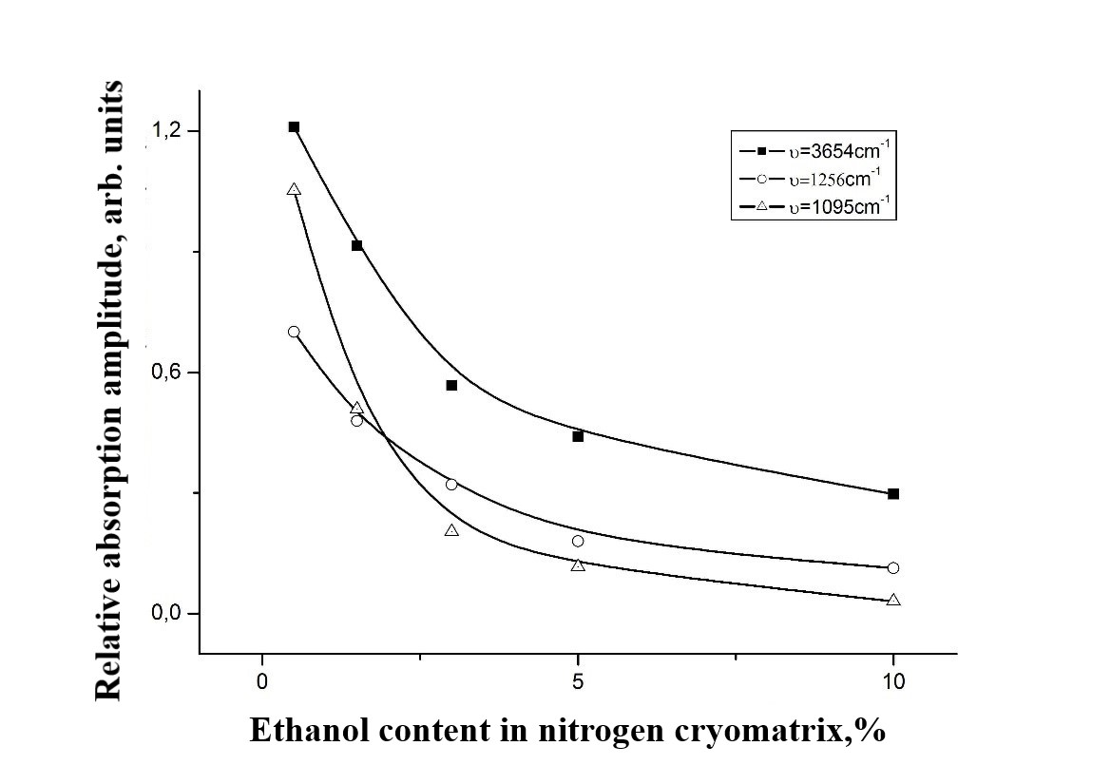

Figure 17 - Dependence of the relative absorption amplitude of the characteristic vibrations of the ethanol molecule on the concentration of ethanol in the nitrogen matrix. The amplitudes of the considered vibrations are normalized to the amplitude of the CH bond of the methyl group at a frequency ν = 2985 cm-1

Low-temperature condensation of ethanol leads to the formation of amorphous layers. In particular, in the temperature range from 16 to 45 K, we assume that the ethanol film is in a high-density amorphous state - HAD ethanol.

Amorphous ethanol at a temperature of T ~ 78 K transforms into a structural glass state. Starting from this temperature and with subsequent heating, our samples behave similarly to samples obtained from the liquid phase by the rapid quenching method..

1. IR spectrometric studies of thermally stimulated transformations in films (nitrogen / argon) + (water, methanol, ethanol) at various concentrations

After condensation and recording of the IR spectrum, the film began to heat up to 45 K. During heating, the signal from the laser interferometer and the signal from the IR spectrometer were recorded at a fixed frequency. This made it possible to control the temperature range of evaporation of argon or nitrogen from the film (Figure 18). Upon further heating, the impurity molecules partially evaporated. The IR spectrum was recorded at a fixed temperature, then the sample was cooled again to 16 K and the spectrum was measured again. The spectra of the heated and cooled films did not differ. After taking the spectrum, the film was warmed up until complete evaporation with measurements of the signals from the laser interferometer, IR spectrometer, and pressure sensor in the chamber. However, during secondary heating, the thermogram showed changes in the shift of the glass transition temperature at which secondary desorption occurred (Figure 19). This is a very interesting fact for further studies of the structural transformations of mixtures of alcohols with nitrogen and argon.

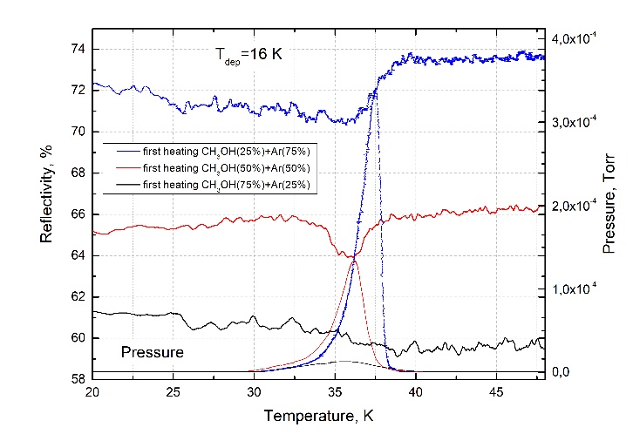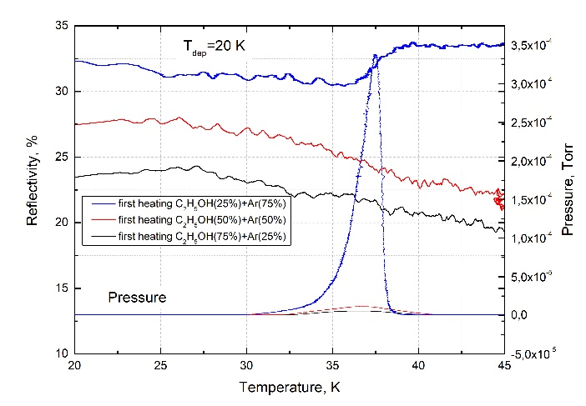

Figure 18 - Change in the signal of the IR spectrometer at the observation frequency (methanol νobs = 1410 cm–1, ethanol νobs = 3195 cm–1) and the peak of the desorption pressure upon heating the cryocondensate from T = 20 K to T = 45 K Heating rate Vheat = 0,05 K/s

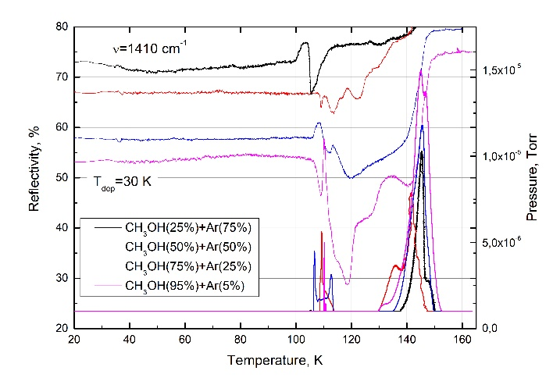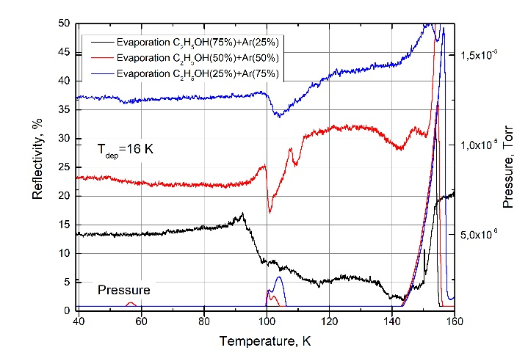

Figure 19 - Change in the signal of the IR spectrometer at the observation frequency (methanol νobs = 1410 cm–1, ethanol νobs = 3195 cm–1) and the peak of the desorption pressure upon heating the recondensate from T = 16 K to T = 170 K

In addition to pure samples, during all other heating of the films with mixtures, gas escaping from the film in the glass transition region of the corresponding alcohol was observed. In Figure 8, for 25% methanol, it is barely noticeable due to the previously small amount of methanol capable of forming the structure. For ethanol, a different picture is observed with an increase in the ethanol concentration by 75%, the desorption peak disappears both at a deposition temperature of 16 K and at 20 K and 30 K. The mass spectrometer purchased for our chamber will help to accurately determine the amount and composition of the gas leaving films. Again, this will indirectly allow us to determine the composition of the clathrate in the recondensate.

Impurities of nitrogen and argon in alcohols form a new amorphous structure containing polycrystals with disordered molecules, which can persist even after the nitrogen/argon molecules are “released” during the first heating. These polycrystals, having a surface binding energy higher than that required for the evaporation of the entire impurity component, "hold" nitrogen/argon molecules, and their desorption is achieved when heated to the temperature of destruction of these polycrystals. The destruction temperature of polycrystals is in the area of the glass junction, in some cases it coincides with the crystallization temperature.

# **3. INVESTIGATION OF THERMALLY STIMULATED TRANSFORMATIONS IN RECONDENSATES OF WATER, ETHANOL AND METHANOL**

## 3.1. **Studies of the processes of evaporation and recondensation of water molecules, ethanol and methanol**

The main conclusion that can be drawn from the analysis of the research results can be formulated as follows: the state of immobilized water and ethanol molecules in weak solutions with nitrogen and argon is not stable. A slight increase in the temperature of the matrix, long before its evaporation, leads to a change in the vibrational spectra of water and ethanol in their two-component solid solutions with nitrogen and argon. This conclusion poses before us at least two questions: 1) if the observed changes in the vibrational spectra of molecules are the result of interactions between various immobilized molecules or clusters, then what is the mechanism of this interaction that takes into account the rigidity of the lattices of solid nitrogen and argon in the temperature ranges under consideration; 2) why different types of vibrations of quasi-free molecules of water and ethanol react differently to a change in the temperature of the samples.

The resolution of these contradictions lies, in our opinion, in the following plane. When analyzing the data of the spectra, it is necessary to take into account the following considerations. The term "matrix isolation", which is sometimes used in this work, serves solely to shorten the presentation. We are talking about the analysis of the state of molecules in weak solid solutions with gases optically transparent in the IR range, such as nitrogen and argon. It is quite obvious that at such high concentrations, the existence of monomers and dimers of both water and ethanol is unlikely. But then what is the origin of the absorption bands, the frequencies of which correspond to the existence of quasi-free states of molecules? And how to interpret the fact that the stretching vibrations of water molecules in an unbound state, which are in weak solid-state solutions with argon and nitrogen, are more resistant to an increase in temperature compared to bending vibrations. In our opinion, an explanation is possible if the assumption is made that the considered absorption bands do not belong to individual monomers or dimers frozen in argon or nitrogen, but are a manifestation of the peculiarities of vibrations of ensembles of water molecules combined into nanoobjects of various sizes. Those. It can be assumed that in the process of co-condensation of water and ethanol with matrix gases, polyargyrites of various scales are formed. In this case, some of the molecules that form these aggregates and are located in the near-surface zone of these clusters are not bound by intermolecular interactions with neighboring molecules, thus being in a quasi-free state. The spectral reflection of this fact is the presence in the vibrational spectra of the samples of absorption bands corresponding to monomers and linear dimers of water and ethanol. An increase in the matrix temperature leads to transformations in the state of polyargyrites, which is reflected in a change in the absorption amplitudes at the frequencies of the characteristic vibrations of quasi-free water and ethanol molecules.

In the same vein, it is also possible to explain the fact that different types of OH vibrations of water and ethanol molecules (stretching and deformation) react differently to an increase in the substrate temperature.

## 3.2. **Creation of a database of properties of recondensates of water, ethanol and methanol for the benefit of astrophysical observations**

The process of co-condensation of water and nitrogen is accompanied by the formation of polyargyrites of water of various sizes. This process begins already in the gas phase and continues, apparently, in the adsorption layer. This is indicated by the fact that the formed film at the initial stage of its existence is essentially nonequilibrium. For at least about 60 minutes. in it, rearrangement processes take place, possibly consisting in orientational ordering of clusters in the nitrogen matrix, as well as in the absorption of smaller neighboring clusters by larger polyargyrites (coalescence process). These processes mainly affect the libration band, which indicates the ordering in polyargyrites at the level of short-range order.

The splitting of absorption bands at the frequency of bending and librational vibrations is a consequence of the difference in the energies of the corresponding vibrations in bulk and surface molecules. This can manifest itself under the condition when the ratio between the number of these molecules is commensurate, i.e., for polyargyrites of water molecules in the matrix.

The process of evaporation of the nitrogen matrix and the subsequent "condensation" of polyargyrites of water to the substrate leads to the formation of a finely dispersed medium on it, consisting of particles of various sizes. An indirect confirmation of this process can be the scattering of light from the frequency of stretching vibrations to a frequency of the order of 2000 cm-1.

The process of co-condensation of water and nitrogen is accompanied by the formation of polyargyrites of various sizes, as well as micro crystallites. It can be assumed that these structural elements are also formed upon condensation of pure water. These elements have a crystalline structure and are the nuclei of cubic and hexagonal phases in amorphous solid water. The nature of thermally stimulated transformations in ASW will largely be determined by the properties of these nuclei and their concentration. The temperature boundaries of the existence of three amorphous states - high-density, low-density, and hindered amorphs, as well as two crystalline forms (cubic and hexagonal ices) will be determined by the cluster composition of water, which forms directly during cryoprecipitation. This process of cluster formation is to a certain extent random, which is reflected in the significant scatter of experimental data available in the literature.

Based on all the experiments carried out, an electronic database of the properties of recondensates of water, ethanol and methanol was created and contains the following parameters: the refractive indices of different concentrations of mixtures of water with nitrogen / argon, the density of various concentrations of mixtures of water with nitrogen / argon, IR spectra of recondensates of water, ethanol, methanol with decoding, thermograms of evaporation of recondensates of water, ethanol and methanol, temperature of glass transition in thin films of recondensates of water, ethanol and methanol, temperature of evaporation of the matrix of future recondensates of water, methanol and ethanol.

CONCLUSION

1. Based on the analysis of the obtained IR spectra, it is concluded that there are monomers and dimers of ethanol in the nitrogen matrix. This is indicated by:

a). The absorption band at a frequency of 3658 cm-1, due to the vibrations of the O-H bond of monomers and dimers of ethanol. The existence of local minima in this band at frequencies of 3645 and 3658 cm-1 is associated with the presence of two conformational states in the ethanol molecule, anti (3658 cm-1) and gauche (3645 cm-1).

b). Two absorption bands at frequencies of 1259 cm-1 and 1276 cm-1 related to bending vibrations of δ (CОH) anti- and gauche isomers, respectively.

с). Two bands corresponding to a combination of stretching vibrations ν (CCO) with rotational vibrations of the methyl group r (CH3), related to anti-dimers (ν = 1090 cm-1) and anti-monomers (ν = 1095 cm-1).

2. Local minima in the range 3000-3600 cm-1 indicate the presence of the following ethanol aggregates in the matrix: m-monomer, d-dimer, cycl. d- cyclic dimer, cycl. trim.-cyclic trimer, cycl. tetr.- cyclic tetramer, hex-hexomer. A wide band in the range of 3250-3330 cm-1 means the presence of large polyargyrites in the matrix, in which ethanol molecules are in a hydrogen-bonded state (multimer).

3. Local minima with frequencies at 1259 and 1276 cm-1 correspond to bending vibrations of δ (CОH) anti- and gauche isomers, respectively. The band corresponding to the vibration of the anti-isomer of ethanol (1259 cm-1) disappears completely as the concentration of ethanol in the matrix increases, while the gauche-isomer fluctuation remains and becomes more pronounced. This is explained by the fact that the intermolecular formation of cyclic ethanol polyargyrites occurs along the δ (CОH) -anti bond, followed by inhibition of this type of vibration. Thus, it can be assumed that the δ (COH) -gauche bond does not participate in the cluster formation of ethanol molecules.

4. The splitting of the band of stretching CCO vibrations with a change in the concentration of ethanol in the nitrogen matrix is associated with the fact that the vibrations of the corresponding frequencies existing for monomers and dimers of ethanol are coupled during the formation of cyclic clusters. For aggregates more than trimers, only stretching vibrations along the CCO bond with three frequency modes (896, 898, and 900 cm-1) remain, which are not separated due to the large absorption band in pure ethanol samples. An increase in the concentration of ethanol in nitrogen up to 5-10% leads to an increase in the number of anti-gauche dimers with frequencies ν = 884 cm-1 and ν = 900 cm-1. The first of them corresponds to the symmetric stretching vibration of the (CCOa) -acceptor, and the second frequency ν = 900 cm-1 corresponds to the donor type of symmetric stretching vibrations νs (CCOd). A further increase in the ethanol concentration leads to a sharp decrease in the number of not only monomers, but also dimers, and the double absorption band degenerates into one.

* Based on the results of the planned work:
* Refractive indices and film density measured (nitrogen, argon) + (water, ethanol, methanol)
* Obtained IR spectra of films (nitrogen, argon) + (water, ethanol, methanol)
* The cluster composition of the samples (nitrogen) + (water, ethanol, methanol) at various temperatures and concentrations was determined
* The cluster composition of two-component samples (argon) + (water, ethanol, methanol) was determined depending on temperature and concentration
* Determined the effect of film concentration on the kinetics of evaporation and recondensation of samples
* The processes of evolution and structural-phase transformations in recondensates of water, ethanol and methanol have been studied
* Based on all the experiments carried out, an electronic database of the properties of recondensates of water, ethanol and methanol was created and contains the following parameters: the refractive indices of different concentrations of mixtures of water with nitrogen/argon, the density of different concentrations of mixtures of water with nitrogen/argon, IR spectra of recondensates of water, ethanol , methanol with decoding, thermograms of evaporation of recondensates of water, ethanol and methanol, temperature of glass transition in thin films of recondensates of water, ethanol and methanol, temperature of evaporation of the matrix of future recondensates of water, methanol and ethanol.

REFERENCES

1. Kelley K.K. CALIFORNIA 298OK . AND THE CORRESPONDING ENTROPY AND FREE ENERGY The measurements of the heat capacities of aliphatic compounds made by Parks and his co-workers2 have brought forth interesting regularities in the entropies and free energies of members o. 1929. Vol. 3, № 1926.

2. Hama T., Watanabe N. Surface processes on interstellar amorphous solid water: Adsorption, diffusion, tunneling reactions, and nuclear-spin conversion // Chem. Rev. 2013. Vol. 113, № 12. P. 8783–8839.

3. Satorre M.Á. et al. Density of CH4, N2 and CO2 ices at different temperatures of deposition // Planet. Space Sci. 2008.

4. Fray N., Schmitt B. Sublimation of ices of astrophysical interest: A bibliographic review // Planet. Space Sci. 2009.

5. Aldiyarov A. et al. IR spectroscopy of ethanol in nitrogen cryomatrices with different concentration ratios // Low Temp. Phys. 2011. Vol. 37, № 6. P. 524–531.

6. Drobyshev A., Aldiyarov A. IR-spectroscopy of ethanol formed by recondensation from a nitrogen cryomatrix // Low Temp. Phys. 2011. Vol. 37, № 8. P. 718–724.

7. Ozier I., Yi P.N. Nuclear spin isomerization in methane // J. Chem. Phys. 1967. Vol. 47, № 12. P. 5458–5459.

8. Torrie B.H. et al. Phase transitions in solid methanol // J. Solid State Chem. 2002. Vol. 166, № 2. P. 415–420.

9. Parks G.S. Thermal data on organic compounds I. The heat capacities and free energies of methyl, ethyl and normal-butyl alcohols // J. Am. Chem. Soc. 1925. Vol. 47, № 2. P. 338–345.

10. Staveley L.A.K., Hogg M.A.P. A dilatometric study of the transition in methyl alcohol // J. Chem. Soc. 1954. Vol. c. P. 1013–1016.

11. Dempster A.B., Zerbi G. Lattice dynamics of methanol: Hydrogen bonding and infrared absorption // J. Chem. Phys. 1971. Vol. 54, № 8. P. 3600–3609.

12. Hudson R.L. An IR investigation of solid amorphous ethanol — Spectra, properties, and phase changes // Spectrochim. Acta - Part A Mol. Biomol. Spectrosc. Elsevier B.V., 2017. Vol. 187. P. 82–86.

13. Sani E., Dell’Oro A. Spectral optical constants of ethanol and isopropanol from ultraviolet to far infrared // Opt. Mater. (Amst). Elsevier Ltd, 2016. Vol. 60. P. 137–141.

14. Drobyshev A. et al. Structure and phase transition peculiarities in solid nitrous oxide and attempts at their explanation // Low Temp. Phys. 2013. Vol. 39, № 5. P. 460–464.

15. Wassermann T.N., Suhm M.A. Ethanol monomers and dimers revisited: A Raman study of conformational preferences and argon nanocoating effects // J. Phys. Chem. A. 2010. Vol. 114, № 32. P. 8223–8233.

16. Gálvez Ó. et al. Spectroscopic effects in CH4/H2O ICES // Astrophys. J. 2009. Vol. 703, № 2. P. 2101–2107.

17. He X., Wu C., Yang D.S. Communication: No guidance needed: Ordered structures and transformations of thin methanol ice on hydrophobic surfaces // J. Chem. Phys. 2016. Vol. 145, № 17.

18. Ayotte P. et al. A Beaker without Walls: Formation of Deeply Supercooled Binary Liquid Solutions of Alcohols from Nanoscale Amorphous Solid Films // Phys. Rev. Lett. 2002. Vol. 88, № 24. P. 4.

19. Wang L., Liu X. Tribological behavior of DLC/IL solid-liquid lubricating coatings in a high-vacuum condition with alternating high and low temperatures // Wear. Elsevier, 2013. Vol. 304, № 1–2. P. 13–19.

20. Hudson R.L., Gerakines P.A., Moore M.H. Infrared spectra and optical constants of astronomical ices: II. Ethane and ethylene // Icarus. Elsevier Inc., 2014. Vol. 243. P. 148–157.

21. Chen L. et al. Effect of coadsorption of water and alcohol vapor on the nanowear of silicon // Wear. 2015. Vol. 332–333. P. 879–884.

22. Drobyshev A. et al. Cryoemission of Nitrous Oxide and Ethanol: Dynamic and Energy Characteristics // J. Low Temp. Phys. Springer US, 2017. Vol. 187, № 1–2. P. 71–79.

23. Drobyshev A. et al. IR Spectrometry studies of methanol cryovacuum condensates // Low Temp. Phys. 2019. Vol. 45, № 4.

24. Drobyshev A. et al. IR studies of thermally stimulated structural phase transformations in cryovacuum condensates of Freon 134a // Fiz. Nizk. Temp. 2018. Vol. 44, № 8.

25. Aldiyarov A. et al. Investigation of dynamic glass transitions and structural transformations in cryovacuum condensates of ethanol // Low Temp. Phys. 2009. Vol. 35, № 4. P. 251–255.

26. Saketi S., Olsson M. Influence of CVD and PVD coating micro topography on the initial material transfer of 316L stainless steel in sliding contacts – A laboratory study // Wear. Elsevier, 2017. Vol. 388–389. P. 29–38.

27. Yang L. et al. Erosion failure mechanism of EB-PVD thermal barrier coatings with real morphology // Wear. 2017. Vol. 392–393, № September. P. 99–108.

28. Sokolov D., Drobyshev A., Ramos M. The phase transition between the orientational glass and plastic crystal in cryovacuum condensate of ethanol // Int. J. Math. Phys. 2014. Vol. 5, № 2. P. 77–80.

29. Drobyshev A. et al. Thermal desorption and IR spectrometric investigation of polyamorphic and polymorphic transformations in cryovacuum condensates of water // Low Temp. Phys. 2007. Vol. 33, № 5. P. 472–480.

30. Ramos M.A. et al. Low-temperature properties of monoalcohol glasses and crystals // Low Temp. Phys. 2013. Vol. 39, № 5. P. 468–472.

31. По С., Nan N., Nan N. Matrix Isolation Spectroscopy / ed. Barnes A.J. et al. Dordrecht: Springer Netherlands, 1981. 78500 p.

32. Lewis, G. N. and Gibson G.E. erican Chemical // J. Am. Chem. Soc. 1920. Vol. 42, № 8. P. 1529–1533.

33. Haida O., Suga H., Seki S. Preparation of glassy carbon tetrachloride // J. Non. Cryst. Solids. 1976. Vol. 22, № 1. P. 219–221.

34. Riobóo R.J.J., Ramos M.A. Brillouin spectroscopy experiments on polymorphic ethanol // Philos. Mag. 2007. Vol. 87, № 3–5. P. 657–663.

35. Talón C., Ramos M.A., Vieira S. Low-temperature specific heat of molecular glasses and crystals // Phys. B Condens. Matter. 2000. Vol. 284–288, № PART II. P. 1155–1156.

36. Talón C. et al. Low-temperature specific heat and glassy dynamics of a polymorphic molecular solid // Phys. Rev. B - Condens. Matter Mater. Phys. 1998. Vol. 58, № 2. P. 745–755.

37. Larsen R.W., Zielke P., Suhm M.A. Hydrogen-bonded OH stretching modes of methanol clusters: A combined IR and Raman isotopomer study // J. Chem. Phys. 2007. Vol. 126, № 19.

38. Zielke P., Suhm M.A. Concerted proton motion in hydrogen-bonded trimers: A spontaneous Raman scattering perspective // Phys. Chem. Chem. Phys. 2006. Vol. 8, № 24. P. 2826–2830.

39. Luck W.A.P., Schrems O. Infrared matrix isolation studies of self-association of methanol and ethanol: proof of cyclic dimers // J. Mol. Struct. 1980. Vol. 60, № C. P. 333–336.

40. Fang H.L., Swofford R.L. tensities of the two conformer bands provides an esti- of hydrogen bonded to atoms The overtone absorption spectrum of ethanol vapor ( North-Holland Physics Publishing Division ) Torr ) was measured with an intracavity cw dye laser photoacoustic ( PA ) sp. 1984. Vol. 105, № 1. P. 5–11.

41. Coussan S. et al. Rotational isomerism of ethanol and matrix isolation infrared spectroscopy // J. Phys. Chem. A. 1998. Vol. 102, № 29. P. 5789–5793.

42. Gardner E.A. et al. Infrared spectra and conformational analysis of anti and gauche deuterated ethanol isotopomers // J. Mol. Struct. 2006. Vol. 784, № 1–3. P. 249–253.

43. Belhekar A.A., Agashe M.S., Jose C.I. Conformational equilibria in n-alkanols. Infrared spectral deconvolution of the unsymmetric hydroxyl band profile // J. Chem. Soc. Faraday Trans. 1990. Vol. 86, № 10. P. 1781–1784.

44. Hu Y.J., Fu H.B., Bernstein E.R. Infrared plus vacuum ultraviolet spectroscopy of neutral and ionic ethanol monomers and clusters // J. Chem. Phys. 2006. Vol. 125, № 15.

45. González L., Mó O., Yáñez M. Density functional theory study on ethanol dimers and cyclic ethanol trimers // J. Chem. Phys. 1999. Vol. 111, № 9. P. 3855–3861.

46. Michinori B. Intramolecular Interaction between Hydroxyl Group II1 ). Limitation of the Interaction by Chain-length in. 1958. Vol. 72, № 1957.

**APPLICATION А – DATA SHEET AND WORK SHEDULE**

**Under the contract № 283 dated 29 march 2018 year**

**Subsidiary state enterprise on the right of economic jurisdiction "Research Institute of Experimental and Theoretical Physics" of the Republican enterprise on the right of economic management " Al-Faraby Kazakh National University » MES RK**

1.1 Priority: Information, telecommunication and space technologies, scientific research in the field of natural sciences

1.2 In the sub-priority: Space technology- Development of the scientific and experimental base for studies of distant and near space.

1.3 On the topic: " Experimental studies of recondensed states of matter at low and ultralow temperatures with the goal of creating a verification base for IR spectrometric observations of the Universe"

1.4 The project amount is 30000000 (thirty million) tenge.

**2. Characteristics of scientific and technical products on qualification characteristics and economic indicators**

**2.1** Direction of work: fundamental scientific research in the field of physics.

**2.2** Field of application: Astrophysical research

**2.3** The final concrete result:

-for 2018: determination of the relationship between condensation conditions (temperature, condensation pressure of the gas phase, concentration) and film properties (refractive index, density, reflectivity in the infrared range). 1 article will be published in a domestic journal and 2 articles in Web of Science or Scopus

-for 2019: determination of the cluster composition of the investigated recondensate samples depending on temperature and concentration. 1 article will be published in a domestic journal and 5 articles in foreign scientific journals

-for 2020: determination of the effect of the concentration of two-component films on the kinetics of evaporation and recondensation of samples; study the processes of evolution and structural-phase transformations in recondensates. 6 articles will be published in foreign scientific journals.

**2.4** Patentability: not patentable

**2.5** Scientific and technical level (novelty): For the first time, the processes of formation and evolution of the properties of recondensates of hydrogen-bonded molecules at low temperatures will be studied

**2.6** The use of scientific and technical products is carried out by the Executor

**2.7** Type of use of the result of scientific and (or) scientific and technical activity: Fundamental-applied research and development

**3. Name of work, terms of their implementation and results**

|  |  |  |  |  |  |  |
| --- | --- | --- | --- | --- | --- | --- |
| **Job number phase** | | **Name of work under the Contract, and the main stages of its implementation** | **Deadline** | | | **Expected Result** |
| **Start** | | **ending** |
| 1.1 | | Measurement of the refractive index and film density of (nitrogen, argon) + (water, ethanol, methanol) as a function of concentration and cryodeposition temperature | January 2018 | | June 2018 | The refractive indices and density of the (nitrogen, argon) + (water, ethanol, methanol) films will be measured |
| 1.2 | | Measurement of the IR spectra of the (nitrogen, argon) + (water, ethanol, methanol) films depending on concentration and cryodeposition temperature | July 2018 | | 1st of November 2018 | The IR spectra of the (nitrogen, argon) + (water, ethanol, methanol) films will be obtained  Articles will be published in foreign peer-reviewed scientific journals, such as Low Temperature Physics - 1 (one) article, Fizika Nizkih Temperatur - 1 (one) article, chapters in books of materials of international conferences "cryocrystals and quantum crystals" will be published, as well as at least 1 (one) publication in peer-reviewed domestic journals with a nonzero impact factor |
| 2.1 | | IR spectrometric studies of thermostimulated transformations in (nitrogen) + (water, ethanol, methanol) films at various concentrations | January 2019 | | June 2019 | The cluster composition of the samples of (nitrogen) + (water, ethanol, methanol) will be determined at various temperatures and concentrations |
| 2.2 | | IR spectrometric studies of thermally stimulated transformations in two-component films (argon) + (water, ethanol, methanol) at various concentrations. | July 2019 | | 1st of November 2019 | IR spectrometric studies of thermally stimulated transformations in two-component films (argon) + (water, ethanol, methanol) at various concentrations will be carried out. The cluster composition of two-component samples (argon) + (water, ethanol, methanol) will be determined depending on temperature and concentration.  Articles will be published in foreign peer-reviewed scientific journals, such as Low Temperature Physics - 2 (two) articles, Low Temperature Physics - 2 (two) articles, Journal of Low Temperature Physics - 1 (one) article, as well as at least 1 (one) publication in peer-reviewed Russian journals with a nonzero impact factor |
| 3.1 | | Studies of the processes of evaporation and recondensation of water, ethanol, methanol molecules | January 2020 | | June 2020 | The influence of the concentration of the films on the kinetics of evaporation and recondensation of the samples will be determined |
| 3.2 | | Investigation of thermally stimulated transformations in recondensates of water, ethanol and methanol. Creation of a database of properties of recondensates of water, ethanol and methanol for the benefit of astrophysical observations | July 2020 | | 1st of November 2020 | IR spectrometric studies of thermally stimulated transformations in two-component films (argon) + (water, ethanol, methanol) at various concentrations will be carried out. The cluster composition of two-component samples (argon) + (water, ethanol, methanol) will be determined depending on temperature and concentration.  Articles will be published in foreign peer-reviewed scientific journals, such as Low Temperature Physics - 2 (two) articles, Low Temperature Physics - 2 (two) articles, Journal of Low Temperature Physics - 1 (one) article, as well as at least 1 (one) publication in peer-reviewed Russian journals with a nonzero impact factor. |
|  | | |  | | | |
| By customer:  Chairman of the State Committee "Science Committee of the Ministry of Education and Science of the Republic of Kazakhstan"  _________________ B.S. Abdrasilov.  l.s. | | | From the Contractor:    Director of Subsidiary state enterprise on the right of economic jurisdiction "Research Institute of Experimental and Theoretical Physics" of the Republican enterprise on the right of economic management "Kazakh National University. al-Farabi » MES RK  ________________O.A.Lavrichshev  l.s.  Familiarized:  Scientific supervisor of the project ___________________Drobyshev A.S.  signature | | | |

|  |  |  |  |  |  |  |
| --- | --- | --- | --- | --- | --- | --- |
|  |  | **Extract from the minutes of the meeting**  **National Scientific Council for the priority area**  **"Information, telecommunication and space technologies, scientific research in the field of natural sciences**  **№27 dated June 25, 2019** | | | | |
|  |  | **Date of the meeting** | | **June 25, 2019** | | |
|  |  | **Decision date** | | **June 25, 2019** | | |
|  |  | **Presided over** | | **Kalimoldaev Maksat Nuradilovich** | | |
|  |  | Nature of the issue s | | Consideration of applications from individuals and legal entities within the framework of a competition for grant funding of scientific, scientific and technical projects | | |
| p / p | letter to SK MOS RK | Object name | Applicant | Nature of the issue | Board decision | Justification |
| 1 | №585 16-5 from  09.04.2019 | АРО51ЗО12З  « Experimental studies of recondensed states of matter at  low and ultra-low temperatures in order to create a verification base for IR spectrometric observations of the Universe » | Scientific Research Institute for Experimental and Theoretical Physics | Making changes to the schedule | Approved | According to Act No. 7 of 06.25, drawn up based on the results of electronic secret ballot, the draft is recommended by a majority of votes for correction. |
| 2 | №966/16-5 from  10.06.2019 | АРО51З1784  « Development of an information system for  modeling economic and technological renewal in various industries and enterprises of Kazakhstan » | Eurasian National University tag named after L.N. Gumilyov | Making changes to the schedule | Approved | According to Act N27 of June 25, 2018, drawn up on the basis of the results of electronic secret ballot, the draft is recommended by a majority of votes for correction. |
| 3 | №968/16-5 from  10.06.2019 | АРО51ЗЗ471  « Use of the DFTB method to simulate the influence of the dipole moment and the shape of nanosized CdS clusters on electronic transitions in them » | Eurasian National University tag named after L.N. Gumilyov | Making changes to the schedule | Approved | According to Act No. 7 of June 25, 2018, drawn up based on the results of electronic secret ballot, the draft is recommended by a majority of votes for correction. |
| 4 | SK MES RK No. 1057 16-5 dated 24.06.2019 | АРОЗ 134651  «Development of an active knowledge management system to automate the design of high-performance parallel programs for processing unstructured data and numerical modeling in filtration problems» | SS-OE Scientific Research Institute of Mathematics and Mechanics | About replacing the supervisor | Approved | According to Act No. 7 of 06/25/18, drawn up on the basis of the results of electronic secret voting, the draft is recommended by a majority of votes for correction. |
| 5 | SK MES RK No. 1051 / 16-5 dated 21.06.2019 | АР05131806  «Building a scientific and educational cluster based on the integrated distributed IS Akademgorodok» | Kazakhstan Engineering Technological University | Making changes to the schedule | Approved | According to Act No. 7 of June 25, 2018, drawn up based on the results of electronic secret ballot, the draft is recommended by a majority of votes for correction. |

Chairman of the Council Kalimoldaev Maksat Nuradilovich

Secretary of the Council Zhanbaev Rinat Abdykadyrovich

*Application to justifying*

**Adjustment of the project schedule AP05130123**

|  |  |  |  |  |  |  |  |  |
| --- | --- | --- | --- | --- | --- | --- | --- | --- |
| **IRN:** | **AP05130123** | ***Name of the project*** | «Experimental studies of recondensed states of matter at low and ultralow temperatures with the goal of creating a verification base for ir spectrometric observations of the universe» | | | | | |
| ***Applicant:*** | DSE on the REM "Research Institute of Experimental and Theoretical Physics" RSE on the REM "Kazakh National University named after al-Farabi "MES RK (NIIETF) | | ***FULL NAME. scientific advisor*** | | | In connection with the death of the project manager Drobyshev A.S. please replace him with A.U. Aldiyarov. | | |
|  |  | **for the whole period** | | **2018** | **2019** | | **2020** |  |
| ***Requested amount to complete the project according to the schedule, in thousand tenge*** | | 90 000 | | 30 000 | 30 000 | | 30 000 |  |
| ***The approved amount of NNS for the implementation of the project, according to the same calendar plan, in thousand tenge*** | | 30 000 | | 10 000 | 10 000 | | 10 000 |

|  |  |  |  |  |  |
| --- | --- | --- | --- | --- | --- |
| **№** | **Schedule according to the Agreement** | | **Adjustments to the schedule** | |  |
| ***Objectives / activities for 2018-2020*** | ***Expected results (taking into account section "7. Expected results)*** | ***Objectives / activities for 2018-2020*** | ***Expected results (taking into account section "7. Expected results)\**** | ***Applicant's justification for project adjustments*** |
| **2.2** | IR spectrometric studies of thermally stimulated transformations in two-component films (argon) + (water, ethanol, methanol) at various concentrations | IR spectrometric studies of thermally stimulated transformations in two-component films (argon) + (water, ethanol, methanol) at various concentrations will be carried out. The cluster composition of two-component samples (argon) + (water, ethanol, methanol) will be determined depending on temperature and concentration.  Articles will be published in foreign peer-reviewed scientific journals, such as Low Temperature Physics - 2 (two) articles, Low Temperature Physics - 2 (two) articles, Journal of Low Temperature Physics - 1 (one) article, as well as at least 1 (one ) publications in peer-reviewed Russian journals with a nonzero impact factor. | IR spectrometric studies of thermally stimulated transformations in two-component films (argon) + (water, ethanol, methanol) at various concentrations | IR spectrometric studies of thermally stimulated transformations in two-component films (argon) + (water, ethanol, methanol) at various concentrations will be carried out. The cluster composition of two-component samples (argon) + (water, ethanol, methanol) will be determined depending on temperature and concentration.  Articles will be published in foreign peer-reviewed scientific journals, such as Low Temperature Physics - 1 (one) article, Low Temperature Physics - 1 (one) article, as well as at least 2 (two) publications in peer-reviewed domestic journals with a non-zero impact factor. | Due to the loss of the main participant (project manager) and the reduction in project funding, please make the following adjustments to the schedule while maintaining the general requirements of the Tender Documentation:  Replace "Low Temperature Physics - 2 (two) articles, Low Temperature Physics - 2 (two) articles, Journal of Low Temperature Physics - 1" with "Low Temperature Physics - 1 (one) article, Low Temperature Physics - 1 (one) article, as well as at least 2 (two) publications in peer-reviewed Russian journals with a non-zero impact factor. "Other types of work and requirements of clause 20 of the Tender Documentation are saved. |
| **3.2** | Investigation of thermally stimulated transformations in recondensates of water, ethanol and methanol. Creation of a database of properties of recondensates of water, ethanol and methanol for the benefit of astrophysical observations | A study of thermally stimulated transformations in recondensates of water, ethanol and methanol will be carried out. The processes of evolution and structural-phase transformations in recondensates of water, ethanol and methanol will be studied.  A database of properties of recondensates of water, ethanol and methanol will be formed for the benefit of astrophysical observations.  Articles will be published in peer-reviewed foreign scientific journals indexed in the Web of Science or Scopus databases with a non-zero impact factor, such as Low Temperature Physics - 2 (two) articles, Low Temperature Physics - 2 (two) articles, Journal of Low Temperature Physics - 2 (two) articles. Chapters in the books of the materials of the international conference "Cryocrystals and quantum crystals" will be published. It is planned to publish the second part of the monograph "Cryovacuum condensates". | Investigation of thermally stimulated transformations in recondensates of water, ethanol and methanol. Creation of a database of properties of recondensates of water, ethanol and methanol for the benefit of astrophysical observations | A study of thermally stimulated transformations in recondensates of water, ethanol and methanol will be carried out. The processes of evolution and structural-phase transformations in recondensates of water, ethanol and methanol will be studied.  A database of properties of recondensates of water, ethanol and methanol will be formed for the benefit of astrophysical observations.  1 (one) article will be published in a peer-reviewed foreign scientific journal, indexed in the Web of Science or Scopus database with a non-zero impact factor, as well as at least 2 (two) publications in a peer-reviewed foreign journal with a non-zero impact factor. | Due to the loss of the main participant (project manager) and the reduction in project funding, please make the following adjustments to the schedule while maintaining the general requirements of the Tender Documentation:  Replace “Articles will be published in peer-reviewed foreign scientific journals indexed in Web of Science or Scopus databases with a non-zero impact factor, such as Low Temperature Physics - 2 (two) articles, Low Temperature Physics - 2 (two) articles, Journal of Low Temperature Physics - 2 (two) articles. Chapters in the books of the materials of the international conference "Cryocrystals and quantum crystals" will be published. It is planned to publish the second part of the monograph "Cryovacuum condensates" on "One (1) article will be published in a peer-reviewed foreign scientific journal, indexed in the Web of Science or Scopus database with a non-zero impact factor, as well as at least 2 (two) publications in the peer-reviewed foreign journal with a non-zero impact factor ”. |
|  |  | ***Addition:*** | Thus, publications of grant AP05130123  3 (three) articles were published:  - 2 (two) articles in peer-reviewed foreign scientific journals indexed in the Web of Science or Scopus databases with a non-zero impact factor;  - 1 (one) article in a peer-reviewed Russian journal with a non-zero impact factor;  planned in 2019-2020 7 (seven) articles:  - 3 (three) articles in peer-reviewed foreign scientific journals, indexed in Web of Science or Scopus databases with a non-zero impact factor;  - 2 (two) articles in a peer-reviewed Russian journal with a nonzero impact factor.  - 2 (two) articles in a peer-reviewed foreign journal with a non-zero impact factor. | | |

* **-** subject to the preservation of requirements for the results of programs in accordance with clause 20 of the tender documentation

APPLICATION B – LIST OF PUBLICATIONS OF THE REPORTS OF THE REPORT

**FOR 2018**

1. Shinbayeva, A., Drobyshev, A.; Aldiyarov, A.; Nurmukan, A. IR spectrometric method for recording structural-phase transformations in thin films of cryovacuum condensates//Recent Contributions to Physics – 2018. – Vol. 64(1). P. 48-53. (IF kz – 0.092)
2. Drobyshev, A., Aldiyarov, A., Sokolov, D., Shinbaeva, A., Nurmukan, A., IR Studies of Thermally Stimulated Structural Phase Transformations in Cryovacuum Condensates of Freon 134a // Low Temperature Physics – 2018. – Vol. 44, No. 8. P. 831-839. (IF WoS – 0.791; Q4; SJR Scopus – 0.394; percentile 34)
3. Drobyshev, A., Aldiyarov, A., Sokolov, D., Shinbaeva, A., Nurmukan, A., IR Studies of Thermally Stimulated Structural Phase Transformations in Cryovacuum Condensates of Freon 134a//Fizika Nizkikh Temperatur – 2018. – Vol. 44, Issue 8. - 1062-1072 p. (SJR Scopus – 0.173; percentile 14), (rus)
4. Drobyshev, A.; Aldiyarov, A.; Nurmukan, A.; Sokolov D.; Shinbaeva A., Structure transformations in thin films of CF3-CFH2 cryodeposites. Is there a glass transition and what is the value of T-g?//Applied surface science – 2018. Vol. 446(SI). P. 196-200. (IF WoS – 6.182; Q1; SJR Scopus – 1.230; percentile 94)
5. A. Drobyshev, A. Aldiyarov, D. Sokolov, A. Shinbaeva, A. Nurmukan, IR-spectrometric investigations of methanol cryovaccum condensates//12th International Conference on Cryocrystals and Quantum Crystals, 26-31 AUGUST 2018 | WROCLAW / WOJANÓW, POLAND
6. A. Drobyshev, A. Aldiyarov, D. Sokolov, A. Shinbaeva, A. Nurmukan, Refractive Indexes of Methanol, Tetrechloromethane and Freon-134a Cryofilms in the Vicinity of Temperature Ranges of Transformation Changes12th International Conference on Cryocrystals and Quantum Crystals, 26-31 AUGUST 2018 | WROCLAW / WOJANÓW, POLAND
7. A. Aldiyarov, A. Drobyshev, A. Nurmukan, A. Shinbayeva, D. Sokolov, Investigation of vapor cryodeposited glasses and glass transition of tetrachloromethane films// 15th International Conference on the Physics of Non-Crystalline Solids & 14th European Society of Glass Conference, Saint-Malo, France, July 9 - 13, 2018.
8. A. Aldiyarov, A. Drobyshev, A. Nurmukan, A. Shinbayeva, D. Sokolov, IR-investigation of Glass Transition in Thin Film of CF3-CFCH2 Cryodeposites// 15th International Conference on the Physics of Non-Crystalline Solids & 14th European Society of Glass Conference, Saint-Malo, France, July 9 - 13, 2018.

**FOR 2019**

1. Aldiyarov A., Nurmukan A., Zheksen U., Oman Z., Torebay A., Ic spectra of ethanol nanoclusters in nitrogen cryomatrix//Recent contributions to physics – 2019. – Vol. 69(2). P.104-113. (IF kz – 0.092), (kaz)
2. Aldiyarov, A.U., Akylbaeva, A.K., Sokolov, D. Yu., Strzhmechny, Yu.M., Methods for improving measurements in the field of IR spectrophotometry // Bulletin to KAZNITU – 2019. – Vol. 2(132). P. 372-377. (IF kz – 0.045), (rus)
3. Aldiyarov, A., Nurmukan, A., Sokolov, D., Ramos, M., Effect of condensation conditions on structural changes in cryovacuum condensates of Freon 134a//Bulletin to KAZNITU – 2019. – Vol.3(133). P. 259-264. (IF kz – 0.045), (rus)
4. Drobyshev, A., Aldiyarov, A., Sokolov D., Shinbaeva A., Nurmukan, A., IR Spectrometry studies of methanol cryovacuum condensates//Low temperature physics – 2019. Vol. 45(441). P.511-522. (IF WoS – 0.791; Q4; SJR Scopus – 0.394; percentile 34)
5. Drobyshev, A., Aldiyarov, A., Sokolov D., Shinbaeva A., Nurmukan, A., IR Spectrometry studies of methanol cryovacuum condensates //Fizika Nizkikh Temperatur – 2019. Vol. 45(40). P. 511-523. (SJR Scopus – 0.173; percentile 14), (rus)
6. A. Nurmukan, A. Aldiyarov, A. Drobyshev, D. Sokolov. [P1.039] Investigation of vapor cryodeposited glasses and glass transition of tetrachloromethane films // ICASS2019 – 3rd International Conference on Applied Surface Science, 17-20 June 2019, Pisa, Italy.
7. A. Nurmukan, A. Aldiyarov, A. Drobyshev, D. Sokolov. [P1.038] Study of polimeric household waste to determine the temperature regimes of cryogenic processing // ICASS2019 – 3rd International Conference on Applied Surface Science, 17-20 June 2019, Pisa, Italy.
8. D. Sokolov, A. Aldiyarov, A. Nurmukan. Influence of deposition temperature and impurities on the refractive indices of thin films of methanol and ethanol // The XV International Workshop on Complex Systems, Andalo, Italy, 17-21. 03 2019.
9. A. Aldiyarov, D. Sokolov, A. Nurmukan, A. Kolomiitseva. Evolution of properties of thin film mixtures of hydrogen-bonded molecules at low temperatures// The XV International Workshop on Complex Systems, Andalo, Italy, 17-21. 03 2019.
10. A.U. Aldiyarov, A.K. Akylbaev. Determination of Accuracy in IR Spectrometric Measurements//V Global Science and innovations 2019: Central Asia. Internatonal scientific practical conference, Astana 2019 ISBN 978-601-341-108-8, (rus)
11. A.U. Aldiyarov, Zhuman Gaukhar. Computer model of water and heavy water in the cryomatrix of different gases//International Scientific Conference of Students and Young Scientists "Farabi Alemi", Almaty, Kazakhstan, April 8-11, 2019: p. 117, (kaz)
12. A.U. Aldiyarov, А.А. Qabdibulaq. The method of measuring low temperatures with a thermoelectric thermometer// International Scientific Conference of Students and Young Scientists "Farabi Alemi", Almaty, Kazakhstan, April 8-11, 2019: p. 122, (kaz)
13. A.U. Aldiyarov, A.N. Torebay. Study of the effect of condensation temperatures on the properties of thin films of cryocondensates of ethyl alcohol // International Scientific Conference of Students and Young Scientists "Farabi Alemi", Almaty, Kazakhstan, April 8-11, 2019: S. 151, (kaz)

**FOR 2020**

1. Aldiyarov, A., Akylbaeva, A., Sokolov, D., Strzhmechny, Yu., Moldybaev. D., Implementation of standards for measuring the accuracy of assessment results for ISO 5725 Laboratories of the Republic of Kazakhstan // Bulletin of KAZNITU – 2020. – Vol. 3(139). P. 471-474. (IF kz – 0.045), (kaz)
2. Aldiyarov, A., Sokolov, D., Nurmukan, A., Korshikov, E. Investigation of vapor cryodeposited glasses and glass transition of tetrachloromethane films//Applied Surface Science – 2020. – Vol. 507. P. 144857. (IF WoS – 6.182; Q1; SJR Scopus – 1.230; percentile 94)
3. Aldiyarov, A., Sokolov, D., Nurmukan, A., Korshikov, E. The study of thermophysical properties of rubber and plastic household waste to determine the temperature conditions of cryoprocessing//Applied Surface Science – 2020. – Vol. 511. P. 145487. (IF WoS – 6.182; Q1; SJR Scopus – 1.230; percentile 94)
4. Aldiyarov, A.U., Sokolov, D.Y., Nurmukan, A.Y., Ramos, M.A. Refractive Index at Low Temperature of Tetrachloromethane and Tetrafluoroethane Cryovacuum Condensates//ACS Omega – 2020. – Vol. 5(20). P. 11671-11676. (IF WoS – 2.87; Q2; SJR Scopus – 0.767; percentile 59)
5. A. Aldiyarov D. Sokolov A. Akylbayeva and А. Nurmukan N. Tokmoldin, On thermal stability of cryovacuum deposited CH4 H2O films//Fizika Nizkikh Temperatur – 2020. – Vol. 46, Issue 11. P. 1318–1322. (SJR Scopus – 0.173; percentile 14)

APPLICATION C – GRANT FINANCING

(results for 2020)

|  |  |  |  |  |  |  |  |  |  |
| --- | --- | --- | --- | --- | --- | --- | --- | --- | --- |
| **Full name of the executing organization** | | **Grant number** | | **Type of research** | **Project name** | | **Project start date** | | **Project completion date** |
| Subsidiary state enterprise on the REM "Research Institute of Experimental and Theoretical Physics" RGP on the REM "Al-Farabi KazNU | | *GF5 2018* | | *fundamental* | Experimental studies of recondensed states of matter at low and ultralow temperatures with the goal of creating a verification base for ir spectrometric observations of the universe. | | 01.01.2018 | | 31.12.2020 |
| Type of the result obtained | | | | | | | | | |
| Method | | | | | | | | | |
|  | | | | | | | | | |
| Patents** | | | | | | | | | |
| Number of innovative patents or copyright certificates | | Number of Kazakhstan patents | | Number of Eurasian patents | Number of OECD international patents | Number of other international patents | | | Patent implementation |
|  | |  | |  |  |  | | |  |
| Implementation of results ** | | | | | | | | | |
| № | Implementation name | | Implementation type (technology, standard, recommendation, technique, other) | | Place of implementation (excluding the executing organization) * | | | | |
| 1 |  | |  | |  | | | | |
| 2 |  | |  | |  | | | | |
| Publications** | | | | | | | | | |
| The number of published reports and articles based on research results at international conferences with an impact factor | | | | | Number of reports and research papers published at regional and local conferences | | | | |
| 4 | | | | | 0 | | | | |
| Personnel training ** | | | | | | | | | |
| Number of performers with a scientific degree | | | | | | | | *4* | |
| The number of foreign scientists involved in research | | | | | | | | *0* | |
| Participation of PhD students, undergraduates in research in the preparation of their dissertations | | | | | | | | *2* | |
| Applications (attach the necessary documents confirming the data provided) | | | | | | | | | |
| _____________________________ / Signature of the project supervisor / | | | | | | | | 8 (727) 293 76 99 | |
|
| Director of IETP O. A. Lavrischev | | | | | | | | E-mail Andrei.Drobyshev@kaznu.kz | |
|
|
|
| Confirmation: I confirm that the information provided in this report is complete and correct  ________________ / Signature of Authorized Verifier /  Note:  * Indicate each value in a separate cell  ** you must attach copies of documents confirming the information | | | | | | | | | |