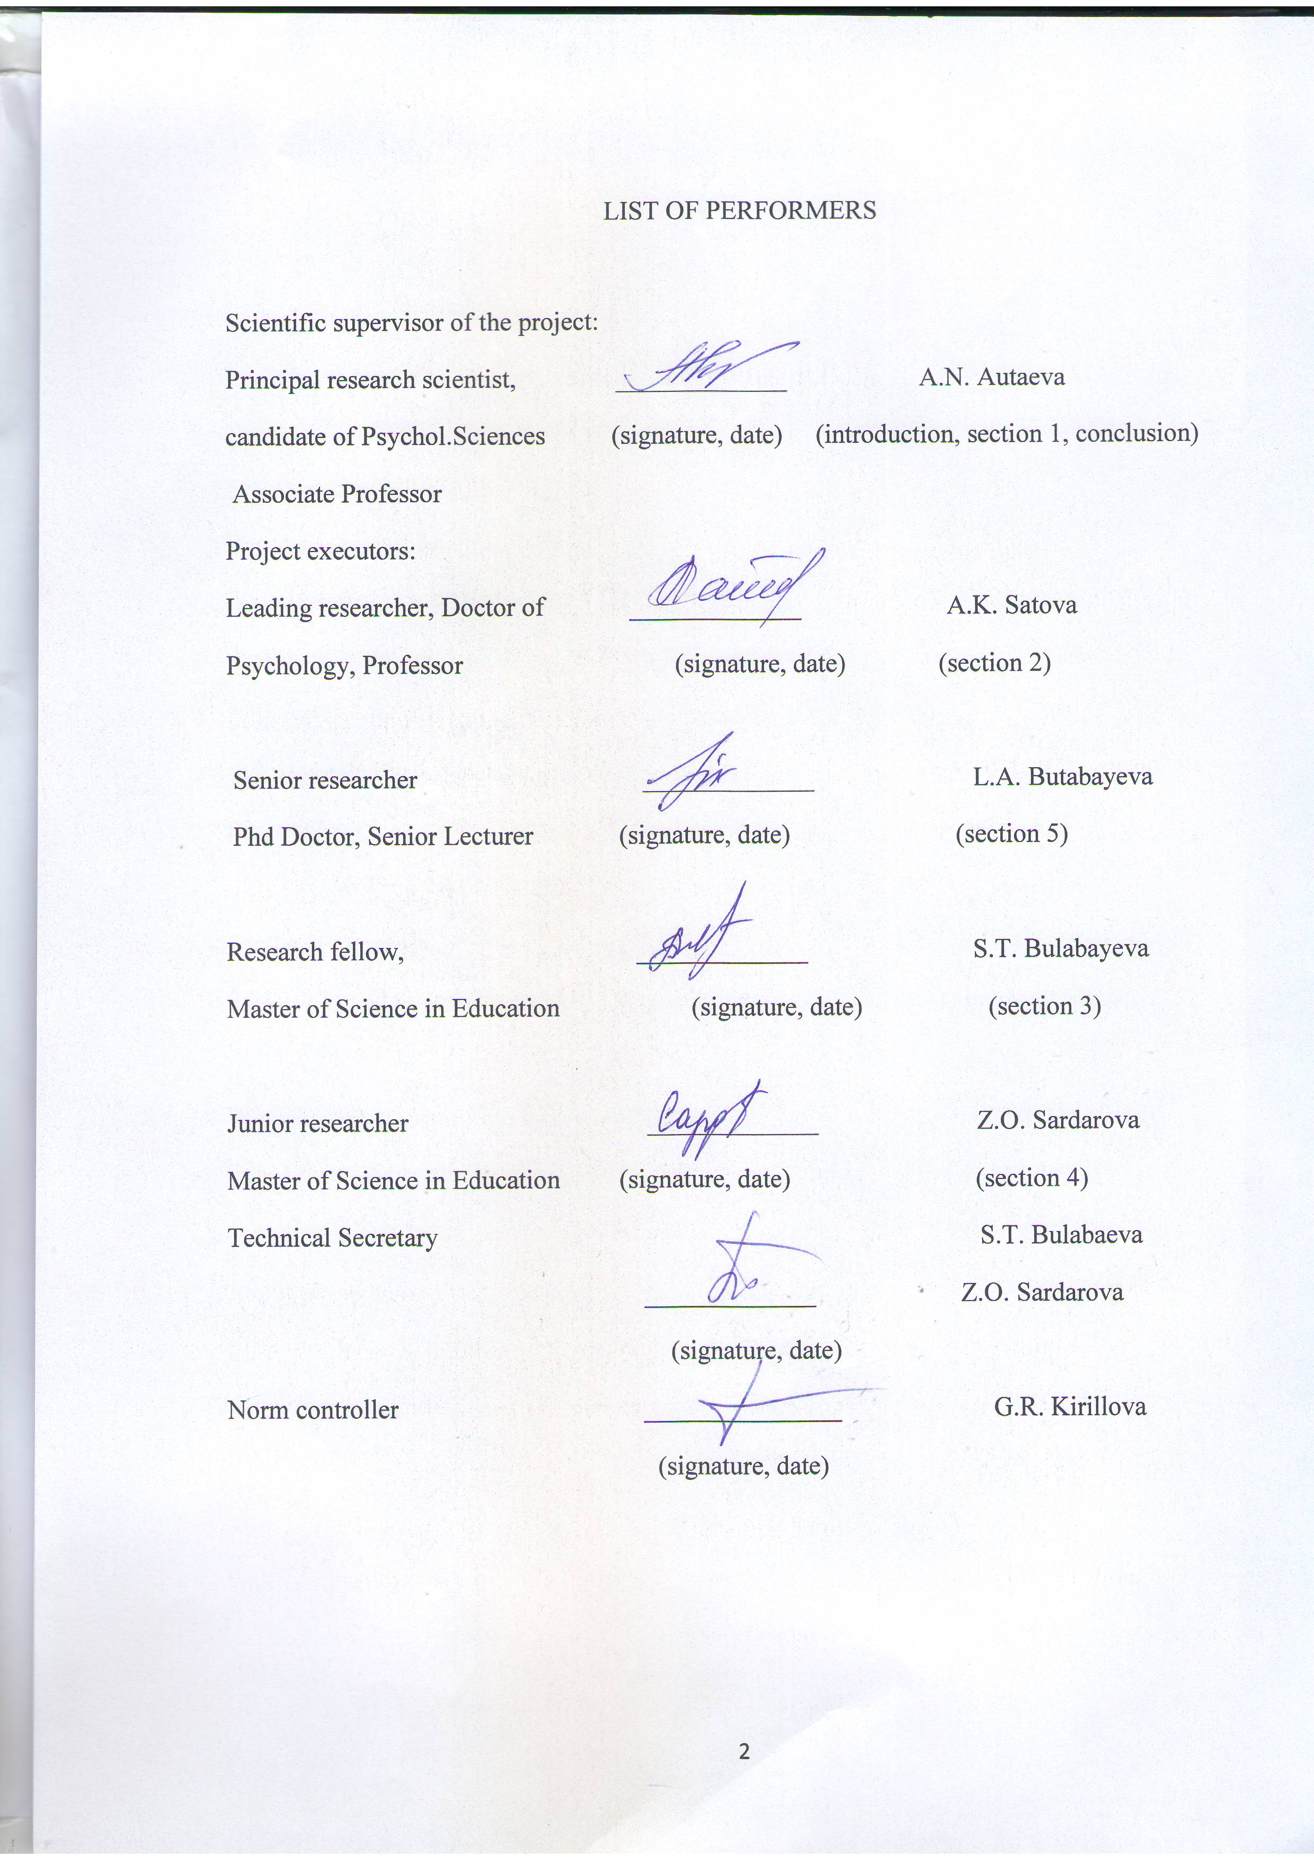

ABSTRACT
Report 56 p., 26 sources, applications 2
MANAGEMENT TECHNOLOGY, EVALUATION OF LEARNING ACHIEVEMENTS, PORTFOLIO, INTRASCHOOL CONTROL, MONITORING THE QUALITY OF EDUCATION
The object of the research is the process of assessing the educational achievements of children with special educational needs.
The purpose of the work is to develop a technology for the process of assessing the educational achievements of children with special educational needs.
The method of the work include the study and analysis of the mechanisms of using the results of monitoring the progress of students to carry out procedures: within school control, the quality of education; licensing; monitoring the quality of education.
Results of the work: The world practice has been studied on the use of special (specific) conditions for examinations with the participation of persons with SEN by category. An analytical note was prepared on the development of an individual children's route in the context of his life needs, interests and inclinations. The mechanisms of using the results of monitoring the progress of children for carrying out procedures have been studied: within school control, public expertise, quality of education; licensing; monitoring the quality of education (section 2 "Guidelines for assessing the educational achievements of students with SEN in the context of the quality of special educational services"). The experience of assessing the quality of special educational services was studied (electronic version of the tutorial "Assessment of educational achievements of students with SEN"; section 3 "Methodological recommendations for assessing the educational achievements of students with SEN in the context of the quality of special educational services"). The technology for managing the process of assessing the educational achievements of students with special educational needs is described ("Methodological recommendations for assessing the educational achievements of children with SEN in the context of the quality of special educational services").)
The scientific novelty of the results at this stage lies in the fact that an electronic version of the textbook "Assessment of educational achievements of students with SEN" and "Methodological recommendations for assessing educational achievements in the context of the quality of special educational services" has been prepared.
Basic design and technical and economical indicators: the main components of technology of estimation of educational achievements of students with SEN; the content and mechanisms of functioning components of the technology of estimation of educational achievements of students with SEN were identified components (conceptual, substantive, procedural, personal) technology management process assessment of academic achievements and a algorithm create a portfolio of educational achievements of students with the SEN.
Degree of implementation: a technology for evaluating educational achievements of students with special educational needs and an algorithm for creating an electronic portfolio for evaluating educational achievements of children SEN on the correctional component of the curriculum of special and correctional schools has been developed.
Efficiency: the algorithm for generating portfolio as an alternative assessment system of children wth SEN allows you to solve a number of problems in building a personality-oriented educational process: commits the changes and growth in overcoming the primary defect, as well as in the development of educational programs for a certain period of time, supports the educational and correctional goals, encourages the students, teachers and parents opens a whole range of works, ensures the continuity of learning from year to year, shows the range of skills and abilities.
Application area: special and inclusive schools.

CONTENT
TERMS AND DEFINITIONS............................................... .............................................6
INTRODUCTION ……………………………………………………………………… .8
1 ANALYSIS OF THE CONCEPT AND STRUCTURE OF LEARNING ACHIEVEMENTS OF STUDENTS IN THE RK ............................................................ 11
2 WORLD PRACTICE OF APPLICATION OF SPECIAL (SPECIFIC) CONDITIONS OF EXAMINATION WITH THE PARTICIPATION OF PERSONS WITH SEN BY CATEGORIES ………………………………………………………………………….. 13
3 THE MECHANISM OF USING THE RESULTS OF CONTROLLING THE PROGRESS OF STUDENTS FOR PERFORMING PROCEDURES INSIDE SCHOOL CONTROL, LICENSING, MONITORING THE QUALITY OF EDUCATION .............................. .................................................. ........................................................... 18
4 EXPERIENCE IN QUALITY ASSESSMENT OF SPECIAL EDUCATIONAL SERVICES. ……………………………………………………………………………… 23
5 TECHNOLOGIES FOR MANAGING THE PROCESS OF ASSESSMENT OF LEARNING ACHIEVEMENTS OF STUDENTS WITH SPECIAL EDUCATIONAL
NEEDS …………………………………………………………………………………… 29

CONCLUSION ………………………………………………………………………….. 32
LIST OF USED SOURCES ……………………. ………………………………………. 34
LIST OF PUBLISHED WORKS ………………………………………………………… 36
APPENDIX A CALENDAR PLAN ……………………………………………………... 38
APPENDIX B SUPPLEMENTARY AGREEMENT ……………………………………. 43

TERMS AND DEFINITIONS
In this RW report, the following terms are used with appropriate definitions:
Descriptor | – a characteristic that describes actions when performing tasks
Individual educational achievements of children | – the result of the development of his personality in the learning process, established at the time of assessment and characterized, formed in students by the planned results of mastering the educational program of the corresponding level of general education: personal, meta-subject and subject, achieved by the student in the educational process in one of the educational organizations or with self-study according to an approved program.
Criteria assessment | – is the process of correlating the learning outcomes actually achieved by students with the expected learning outcomes based on the developed criteria
Assessment criterion | – a feature on the basis of which the assessment of the educational achievements of students is carried out
Persons (children) with special educational needs | – persons who experience permanent or temporary difficulties in obtaining education, due to health, in need of special, general educational programs and educational programs of additional education
Licensing | – is the process of obtaining permission to conduct certain commercial, industrial, educational or other activities. These permits are issued by government agencies. At the moment, several dozen types of work and services in our country are subject to compulsory licensing
Assessment mechanisms | – are the main means and stage for measuring achievements and diagnosing learning problems, which allows you to determine the quality of education
Monitoring the quality of education | – is a form of organizing, collecting, storing, processing and disseminating information about the activities of the pedagogical system, which ensures continuous monitoring of its state and forecasting its development in important educational aspects at the national, regional and local (including schools) levels.
A mark | is a symbol, a conditionally formal, quantitative expression of the assessment of students' educational achievements in numbers, letters or otherwise
Assessment | – is the process of observing the learning and cognitive activities of students, as well as the process of describing, collecting, registering and interpreting information about a student in order to improve the quality of education. The goal, objectives, subject, object, principles, methods, forms and tools of assessment should be clear to all subjects of the educational process - school administration, teachers, parents and students themselves.
Evaluation | – is an outcome of an evaluation process, an evaluation activity or action, qualitative feedback information
A portfolio | – is a way of recording, accumulating and evaluating individual achievements of students with SEN
Special education | - is a system of conditions created by the state for persons with special educational needs in order to ensure equal opportunities for them in obtaining education by eliminating physical, financial or psychological barriers that exclude or restrict the participation of these persons in the life of society. Special (correctional) educational institutions are the institutions intended for children, adolescents and adults with various anomalies of psychophysical development.
Special educational conditions | – - conditions for obtaining special education, including technical and other aids, as well as medical, social and other services, without which it is impossible for children with disabilities to master educational programs
Special conditions for obtaining education | - conditions including special curricula and teaching methods, technical and other means, living environment, as well as medical, social and other services, without which it is impossible to master general educational and educational programs by persons (children) with special educational needs
Assessment technology | – is a technology of action in situations of assessment, described in the form of rules of action for each type of case: "what to evaluate", "who evaluates", "when to evaluate", "where to fix the results", "what criteria to evaluate"
Academic achievement | – is an assessment of the quality of mastering educational programs (student achievement of the planned educational results), an essential element of the educational process

INTRODUCTION
Defining a new political course for the development of the nation, as one of the primary development goals of our state, the First President of the Republic of Kazakhstan N.A. Nazarbayev in the Strategy "Kazakhstan - 2050" put forward "... the creation of modern and effective systems of education and health care" [1]. 2016 was marked by the ratification by Kazakhstan of the Convention against Discrimination in Education and the Convention on the Rights of Persons with Disabilities [2, 3]. All provisions of these Conventions are indicated in the legislation of the country, including in the Law of the Republic of Kazakhstan "On Education" and "State Program for the Development of Education and Science of the Republic of Kazakhstan for 2016-2019" [4, 5]. The availability of quality education for all, on the basis of full equality, depending on the abilities and desires of everyone, is implemented at all levels: the state, the private sector and the civil society of the country. It is known that in the modern civilized world, attitude towards vulnerable groups of the population is a gradient of the cultural development of the country, the spirituality of the nation.
Integration of students with special educational needs into society and parental counseling have been part of the educational policy of the Republic of Kazakhstan over the past 10 years [6]. The significance of the issue remains to this day, due to the unresolved issues noted in the SPDE (hereinafter referred to as the Program), namely:
- only 30.7% of schools have created appropriate conditions for inclusion; only 27% of children with special educational needs received the opportunity to study in a general education school;
- the management and monitoring of the success of training in special and inclusive education is not perfect: an external assessment of educational achievements does not allow timely identification and support of students with low academic performance, which, in most cases, include students with SEN;
- the five-point assessment system does not reflect the real level of knowledge of students with SEN; it does not allow to develop an individual trajectory of learning, taking into account the existing difficulties, to motivate students to eliminate gaps in the assimilation of the curriculum;
- final exams do not measure language competence, do not provide for an assessment of the level of formation of the skills and abilities of a 21st century student, which are necessary in a fickle, uncertain, complex and contradictory world. The educational achievement assessment toolkit requires a meaningful reformatting;
- barrier-free learning environment (including the procedure for passing exams) has not been created in all regions of the country. So, in the universities of Akmola, Almaty, West Kazakhstan, Karaganda, Kostanay and South Kazakhstan regions, the cities of Astana and Almaty, 570 students with special educational needs study, but at the same time, at the legislative level, mechanisms for their employment have not been developed, which would take into account the real level of educational achievements by the time of graduation.
The result of the actualization of this problem was the inclusion of a relevant article in the Law of the Republic of Kazakhstan "On Education", according to which monitoring is an integral component of the education system and is defined as "systematic observation, analysis, assessment and forecast of the state and dynamics of changes in the results and conditions of educational processes ...".

Work in such areas as the creation of a national system for assessing the quality of education; improving the forms and methods of assessing the educational achievements of students.
Thus, today one of the priority areas of modernization of the education system is the development of a system for assessing the quality of education and one of its most important elements - a system for assessing individual educational achievements of students, including students with special educational needs.
The reliability of the assessment of individual educational achievements of students allows:
1) analyze pedagogical actions,
2) develop and make appropriate pedagogical decisions in the general education system.
The development of new educational standards, updating the content of education, which are currently being carried out in the Republic of Kazakhstan, have revealed scientific and methodological problems associated with the system of assessing educational achievements (educational results) of students. One of these problems is the scientific and methodological support of the process of assessing the educational achievements of students with special educational needs.
On a nationwide scale, the development and implementation of technology for assessing the educational achievements of students with special educational needs will serve to create in the Republic of Kazakhstan an "inclusive education system that provides an appropriate level of education and socialization for children and adults with developmental disabilities", scheduled for 2020, which means:
1) increasing the competitiveness of Kazakhstani education and science;
2) improving the quality of human capital;
3) provision of social and legal guarantees of the quality of life of vulnerable groups of citizens;
4) investment support of education and science from international organizations and employers;
5) new effective methods of management in education, including a system of per capita financing of the educational process based on an assessment of the individual educational needs of students with SEN;
6) availability, attractiveness, quality and openness of the education sector.
The methodological basis of this scientific project is the technologies of criterion-oriented teaching (V.P. Bespalko, B. Bloom, J. Keroll) according to which, as a constant, fixed parameter of research, it is necessary to single out precisely the learning outcomes, in combination with the variable conditions of the development process programs and the procedure for assessing the achievements of students (time, way of presenting information, way of demonstrating knowledge, use of additional tools, etc.)
The research method and methodology include the study and analysis of mechanisms for using the results of monitoring students' progress for carrying out procedures: within school control, quality of education; licensing; monitoring the quality of education.

Results of work:
1) The world practice has been studied on the use of special (special) conditions for examinations with the participation of persons with SEN by category. An analytical note was prepared on the development of an individual student's route in the context of his life needs, interests and inclinations.
2) The mechanisms of using the results of monitoring the progress of students for carrying out procedures have been studied: within school control, public examination, the quality of education; licensing; monitoring the quality of education (section 2 "Guidelines for assessing the educational achievements of students with SEN in the context of the quality of special educational services").
3) The experience of assessing the quality of special educational services was studied (electronic version of the textbook "Assessment of educational achievements of students with SEN"; section 3 "Methodological recommendations for assessing the educational achievements of students with SEN in the context of the quality of special educational services").
4) The technology for managing the process of assessing the educational achievements of students with special educational needs is described ("Guidelines for assessing the educational achievements of students with SEN in the context of the quality of special educational services").)
The scientific novelty of the results at this stage lies in the fact that an electronic version of the textbook "Assessment of educational achievements of students with SEN" and "Methodological recommendations for assessing educational achievements in the context of the quality of special educational services" has been prepared.

1 Analysis of the concept and structure of learning achievements of students in the republic of kazakhstan
According to the State Educational Standard of primary general, basic general and secondary general education of the Republic of Kazakhstan, the National Action Plan for the formation of functional literacy of schoolchildren and the State Program for the Development of Education in the Republic of Kazakhstan for 2016-2019, [5] educational achievements include the planned results of the programs of the corresponding level of general education: personal, metasubject and subject. Currently, according to the System of Criteria-Based Assessment, recommended by the Altynsarin NAO for use in the educational process with the participation of students with SEN, seven key competencies should become the results of the educational process, which are of a supra-subject, universal nature and characterize students as holistic individuals with a well-formed worldview. , life position, trajectory of individual development:
1) Social competence is manifested in the ability to social interaction
2) Personal competence is manifested in the ability to self-knowledge, the development of personal qualities necessary for a modern person; in the awareness of their role in society and the comprehension of purpose; in the ability to make the right decisions in the current situation; in striving for self-education, self-realization and self-development.
3) Civic competence is manifested in the formation of an active civic position, high patriotic feelings; in readiness to serve the Motherland and protect its interests; in the ability to assess current social events, to make decisions in various life situations, taking into account the interests of the state, respect for history, culture, traditions and other values ​​of the Kazakh people and other ethnic groups living in Kazakhstan.
4) Managerial competence means the ability to make decisions in various life situations; use of knowledge in practical activities, creative processing of the information received.
5) Information competence is manifested in the ability to independently search, analyze, process, classify, synthesize, transform, use, save and transmit information, use it in educational activities.
6) Technological competence is reflected in the ability to apply modern information and communication technologies in the design of research in the framework of educational and research activities.
7) Communicative competence is manifested in the ability to oral, written productive communication in Kazakh, Russian and English (foreign) languages.
A study of the literature and regulatory documents shows that the level of competence formation should be determined in the course of intra-school control or external diagnostics. The experience of the Nazarbayev Intellectual Schools is indicative in this sense. [7] Diagnostic testing "at the entrance" of grade 1 students allows to determine indicators of the quality of knowledge of each student (individual reports) and serves as a mechanism for more effective impact on the formation of an individual educational trajectory. Based on input "at the entrance" diagnostic testing, teachers should:
1) properly inform students and their parents, thereby instilling a sense of responsibility and developing self-regulation skills;
2) for better preparation of students, the primary school teacher is recommended:
- Arrange targeted support for each student as a result of detailed interpretation of individual reports.
- Teach students self-control techniques, the ability to evaluate the results of actions performed.
- Pay more attention to developing games in the lessons of "Mathematics" and "Literacy training". This will allow you to trace the connection between thinking and language (compose words, select antonyms, synonyms, compare objects and navigate in space).
- Systematically conduct individual work with children who have difficulties during the adaptation process: keep an observation list, enter nominations, symbols "For the best answer", "For the best presentation", etc.
- Explain the teaching material in detail and clearly so that the student does not experience difficulties in mastering the material, successfully solving complicated problems.
- Pay more attention to the formation and development of general educational "over-subject" skills in children. The most important is the ability to read fluently, consciously and expressively, using modern pedagogical technologies and techniques (“buzzing” reading, silent articulation, in a loud whisper, using a rhythmic basis for speed reading, etc.).
- To develop the memory of students, using the technologies of eidotechnics, contributing to a more favorable speech development, revealing the emotional state of the child, developing associative thinking, memory, attention.
- Provide detailed, painstaking work with texts, especially artistic ones. Use the maximum number of channels for obtaining information (auditory, visual, motor). To draw the attention of students to the features of the text, teach them to mark with a pencil as they read, keywords, phrases, significant sections.
- Systematically use propaedeutic creative and informational advancing tasks for couples, teams, individual 24 children. Some assignments can be prepared in conjunction with the parents. At each lesson, pay attention to the development of students' speech, the ability to conduct dialogue, debate, public speaking, speak in a whisper.
- The teacher spends less time at the blackboard. Play the role of an expert, consultant more often. Work in teams with children, providing all possible assistance to those students who need it. In general, the results of diagnostic testing "at the entrance" of grade 1 students in all subjects determine a sufficient level that allows students to continue their education at subsequent stages of education.
Thus, under the individual educational achievements of a student in modern pedagogy is understood the result of the development of his personality in the learning process, established at the time of assessment and characterized by the planned results of mastering the educational program formed in students the corresponding level of general education: personal, metasubject and subject, achieved by the student in the educational process in one of the educational organization or during self-study according to the approved program.

2 World practice of application of special (specific) conditions for conducting examinations with the participation of persons with sen by category
The purpose of this section of the study is to highlight the world practice of using special (specific) conditions for conducting examinations with the participation of persons with sen (by category of violation).
It is important to note that back in 2006, within the framework of the joint project of the Ministry of Education and Science of the Republic of Kazakhstan and the World Bank "Know to manage", an analysis of the situation was carried out and recommendations were developed on two key areas for building a monitoring and evaluation (M&E) system: educational statistics and a system for assessing educational student achievement. Within the framework of the project, a sociological study was also carried out in order to study the public opinion regarding the current system for assessing the educational achievements of students in Kazakhstan.
The concentrated result of this discussion was the inclusion of a relevant article in the Law of the Republic of Kazakhstan "On Education", according to which monitoring is an integral component of the education system and is defined as "systematic observation, analysis, assessment and forecast of the state and dynamics of changes in the results and conditions of educational processes."
Work in such areas as the creation of a national system for assessing the quality of education; improving the forms and methods of assessing the educational achievements of students.
One of the practical mechanisms for the implementation of this task in the education system of the Republic of Kazakhstan was the introduction in 2012 of an external assessment of educational achievements (EAEA) - a selective monitoring survey of 4th and 9th grade students in schools and 2nd year students of higher educational institutions.
Today, EAEA is an important element of the national education quality assessment system that is being formed in Kazakhstan. The experience gained during the period of its implementation (from March 2012 to the present) is actively used to improve this - generally new for the country's education system - type of assessment of students' educational achievements.
It is important to note here that the practice of conducting monitoring surveys of the educational achievements of students in Kazakhstan before the introduction of the EAEA was sporadic and was initiated, as a rule, within the framework of various international projects.
However, even today, EAEA and other forms of assessing educational achievements of the Kazakh sample are organized, mainly, taking into account the "knowledge" approach. For example, when monitoring the educational achievements of students in MRE organizations, where the knowledge-based approach dominates, the assessment is based on normative criteria and generally accepted rules, a high frequency of control, where the final grade is displayed as the arithmetic mean of current grades, and a five-point scale of grades is used. At the same time, colleges have the right to independently establish the criteria for the current assessment, but they are not able to formulate them so that they go beyond the conceptual framework (technical framework) and can be used at the system level. As you can see, the existing forms of assessing the educational achievements of students do not allow creating an effective assessment system at the national level, and the existing electronic accounting system "e-learning" in some educational organizations only complicated their work.
All this testifies to how important it is in the system of monitoring the educational achievements of students to have clear "criteria" that come from clearly formulated "goals" at the national level, where "indicators" are developed and "measures" are improved. This approach would create a “data collection” mechanism where each teacher would have the opportunity to use analytical materials on current assessment, past exam results and instructions to improve student performance.
Thus, the analysis made it possible to speak about the absence at the national level of a clear goal, objectives, results, indicators, means of verification for tracking those activities that are spelled out in the Model Rules for the current monitoring of progress.
In general, the analysis of the existing practice of assessing the educational achievements of students with special educational needs in the Republic of Kazakhstan showed the imperfection of management and monitoring of educational achievements (educational results, learning success) in special and inclusive education:
- for example, an external assessment of educational achievements does not allow timely identification and support of students with low academic performance, which in most cases include students with SEN;
- the five-point assessment system does not reflect the real level of knowledge of students (with SEN); it does not allow to develop an individual trajectory of learning, taking into account the existing difficulties, to motivate students to eliminate gaps in the assimilation of the curriculum;
- final exams do not measure language competence, do not provide for the assessment of the level of formation of the skills and abilities of a 21st century student, which are necessary in a fickle, uncertain, complex and changing world;
- the lack of a clear regulatory and methodological basis for the current assessment is the reason for the unsystematic nature of the procedure and its content;
- the analysis showed that individual educational organizations “initiate” redundant assessment procedures, which are also not systemic and not regulated at the republican level. Accordingly, such assessment (for example, assessment of knowledge at the beginning of training) is not provided with the necessary methodological base;
- the toolkit for assessing educational achievements requires substantial reformatting, etc. [12].
A comparative analysis of foreign systems for assessing educational achievements gives a clear idea of ​​two different approaches to what is taken into account and what is assessed (i.e., what is important) in different education systems: Kazakhstani and foreign.
In the United States, for example, there is no single educational standard, curriculum, unified testing system, and other important attributes of a centralized education system. In the United States, as you know, each state, municipality, as well as various private and public organizations that are the founders of educational institutions are themselves responsible for organizing the educational process, setting standards and funding. The main role of the national department of education is limited to conducting public dialogue on key education issues (equality, access, improving learning outcomes, etc.) and funding through grants to states, schools and colleges for the implementation of some government initiatives. In the field of assessing the quality of student learning outcomes in the country, there are several assessment procedures, some of which are implemented exclusively at the state level, and some at the national level.
It should be said about the mandatory test at the state level. Under the federal “No Child Left Behind Act” of 2001, each state is required to set its own student learning standards and develop and administer an annual test to assess learning outcomes in math and reading for grades 3-8. The tests used track the annual progress of schools and states in meeting established standards by different groups of students (by family income, degree of English proficiency, availability of special educational needs, ethnic group).
Noteworthy is the legal framework for assessing students with SEN in force in Poland. The political transformation in Poland and the influence of Western scientific thought led to significant changes in the approach to people with disabilities and the philosophy of education at the end of the 20th century. Until the early 1990s, the country had two separate education systems, one for students with normal development and the other for students with disabilities (disabled). In 1993, as a result of the efforts of non-profit organizations, associations of parents of children with developmental disabilities, a legal act was adopted, which served as the basis for the creation of integration schools and kindergartens, where students with disabilities could study in the same class with students who are not disabled. Thus, 1993 is a symbolic date, signifying the merger of two separate educational paths.
The specifics of the organization of work in integration institutions is:
a) creating classes of up to 20 students in the ratio: one student with developmental disabilities and four students without developmental problems in the class;
b) adaptation of forms, methods, means and content of programs corresponding to the needs of students with SEN;
c) conducting classes / lessons by two teachers at the same time - leading and supporting (special teacher/defectologist).
At present, the education of students with special educational needs in Poland is regulated by a number of legal acts, the most important of which are as follows:
1) Law of September 7, 1991 on the education system (Journal of Laws 2016, article 1943 as amended);
2) Law of December 14, 2016 on educational law (Journal of Laws 2017, paragraph 59, paragraph 949);
3) Convention on the Rights of the Child, adopted by the General Assembly of the United Nations on November 20, 1989 (Journal of Laws of 1991 No. 120, paragraph 526 as amended);
4) Resolution of the Ministry of Public Education of August 9, 2017 on the conditions for organizing training, upbringing and caring for children and adolescents with disabilities (disabled *), with social maladjustment and under the threat of social maladjustment (Journal of Laws 2017, paragraph 1578);
5) Decree of the Ministry of Public Education of August 9, 2017 on individual compulsory preschool education of children and individual education for children and youth (Journal of Laws 2017, paragraph 1616);
6) Decree of the Minister of Public Education of August 9, 2017 on the principles of organizing and providing psychological and pedagogical assistance in public kindergartens, schools and institutions (Journal of Laws 2017, paragraph 1591);
7) Resolution of the Ministry of Public Education of March 17, 2017 on the detailed organization of public schools and public kindergartens (Journal of Laws 2017, paragraph 649);
8) Ordinance of the Minister of Public Education of 10 June 2015 on (…) the conditions and procedure for the assessment, classification and promotion of pupils and students in public schools (Journal of Laws 2015, paragraph 843).
A student with SEN is provided with free psychological and pedagogical assistance in kindergartens, schools and other institutions, which consists in:
− identifying and meeting the needs of students in development and education;
− determination of the individual psychophysical abilities of the student;
− identification of environmental factors affecting his work at school;
− supporting the development of the student's potential;
− creating conditions for his active and full participation in the life of the school, in the social environment;
− supporting parents and teachers in solving educational and didactic problems and developing their educational skills in order to increase the effectiveness of assistance provided to students [8; nine].
Students with disabilities (disabled) are the first group of children with special educational needs mentioned above. If in the process of teaching and upbringing they need a special organization and special teaching methods, then the psychological and pedagogical counseling center, based on the diagnosis, issues an appropriate decision on the need for special education [10].
Among the students with disabilities who can receive such a document: deaf, hard of hearing; blind, visually impaired; children with musculoskeletal disorders, including aphasia; with mild, moderate and significant intellectual disability; with autism (including Asperger's syndrome); with complex violations.
The decree of the Ministry of Public Education dated August 9, 2017 [11] emphasizes that education, upbringing and care of students with disabilities should be carried out within the framework of integration with students who are not disabled in kindergartens, preschool branches of primary schools, and other forms preschool or school education in a place located in the area of ​​permanent residence of the student's family. The decree does not provide for the organization of special kindergartens and special departments in public kindergartens for students with mild intellectual disabilities: they are covered by general education with peers without violations.
In Poland, students with special educational needs, including students with disabilities (disabled people), were included in the general education system, the so-called mainstream, in the early 1990s. The document that gives these students the right to a special organization and special teaching methods is the decision of the psychological and pedagogical counseling center about the need for special education. Special education can be organized in three types of public institutions: public, integration and special. All students with a decision on the need for special education are engaged in individual therapy and educational programs.
As you can see, the assessment of school achievements of students with SEN in Poland has two forms: qualitative (orally or in writing) and quantitative (on a scale from 1 to 6). Pupils with complex impairments, moderate or significant intellectual disabilities are assessed according to different rules - only qualitatively based on individual progress and work.
In Russia, exams with the participation of persons with SEN are conducted on the basis of the Regulations on the system of assessing the knowledge and achievements of students with SEN, and are aimed at checking the compliance of students' knowledge with SEN, with varying degrees of severity of the defect, the requirements of programs for the depth and strength of the knowledge gained, the ability to apply practical activities necessary for social adaptation and integration into society.
Criteria-based assessment is applied to the procedure for monitoring the achievements of students with SEN, as well as in relation to students in general
According to criteria-based assessment:
- assessment is a process of determining the qualitative and quantitative indicators of theoretical and practical training of students for the existing assessment requirements;
- grade is a quantitative assessment of knowledge, skills and abilities acquired by students, which is the result of the assessment process, expressed in points;
- setting a mark - determining a score according to an officially accepted scale for recording the results of educational activities, the degree of its success.
The grades given to students with SEN cannot be equated with the grades of students in general education schools, due to the significant heterogeneity of the composition of students in terms of the degree of mental defect, even in one class, but are only an indicator of the success of students' promotion in relation to themselves. Grade also plays the role of a stimulating factor, therefore, it is acceptable to evaluate the work of some students with a higher score.
The following groups of students with SEN are distinguished by learning levels:
1st level. Students who are able to fully master the adapted educational program for students with SEN (with intellectual disabilities). They learn quite successfully, understand the frontal explanation of the teacher, are able to independently apply the knowledge gained based on clarity.
2nd level. Students who are able to master the adapted educational program for students with SEN (with intellectual disabilities) in a smaller volume, with dosed, in terms of intensity and complexity of the material, individual educational load.
3rd level. Children with complex developmental disabilities, according to many researchers, are not able to master the program, except for individual sections, selectively, depending on the severity of the defect and potential capabilities, under the control and with the help of an adult in a conjugate mode at the lowest level. The progress of the student is tracked relative to the child himself.
In general, the main principle of the existing systems for assessing the educational achievements of students abroad is the involvement in the assessment activities of both teachers and students, and their parents (legal representatives). In addition, in all European countries and the United States, criteria-based assessment is applied to the procedure for monitoring the achievements of students with SEN, as well as to students in general.
In Kazakhstan, the issues of the procedure for assessing individual achievements, the selection of methods, forms, means and conditions for assessment, as well as taking into account personal indicators, as well as the professional and psychological readiness of a teacher to participate in assessing the achievements of students with psychophysical disabilities, are practically not presented in regulatory documents.
There are only some recommendations on this aspect of educational activities. So, in the "Methodological recommendations for the organization and preparation for the final certification of school graduates" (Astana, 2016), it is noted: "For children with special educational needs (hereinafter: SEN), studying in special classes of secondary schools, special correctional institutions, the question of the need for final certification is decided by the district, city education department or education department in accordance with the medical diagnosis of the students. At the same time, "the examination materials of the final certification in special correctional institutions are developed by education departments." As for special conditions, only one special condition is indicated in the document: "For children with SEN who pass the final certification, additional time is provided when passing the exam in accordance with the decision of the Commission for the final certification of students in accordance with the school's recommendations" [14].
As you can see, the development of a whole set of appropriate conditions for the examinations required for each category of students with SEN remains an unsolved problem.
As the analysis of the practice of conducting exams has shown, over the past 5 years, less than 10% of students with SEN passed the final certification for mastering the course of basic school in special (correctional) schools. The rest of the students, on the basis of health certificates, were exempted from exams. One of the reasons for this situation is the lack of development of mechanisms and tools for conducting assessment procedures for students with SEN.

3 The mechanism of using the results of controlling the progress of students for the procedures: inside school control, licensing; monitoring the quality of education
The purpose of this section is to reveal the mechanism of using the results of monitoring students' progress for carrying out procedures: within school control, licensing; monitoring the quality of education.
Today, the assessment system is considered the main tool for diagnosing learning problems and implementing feedback, which is the basis of the educational process as a whole. The assessment system is used not only for the assignment of marks, but also generally implements the control and diagnostic connection between the subjects of the educational process.
The assessment system, as the main tool for measuring achievements and diagnosing learning problems, allows you to determine the quality of the educational process, make decisions on the strategy and tactics of learning, improve the forms of assessing the expected results and the content of education.
When choosing an assessment system, it is important to take into account the strategic objectives in the field of education, requests for the quality of education when licensing educational activities.
In accordance with the "Standard rules for the activities of types of special educational institutions for children with developmental disabilities" dated July 4, 2013 No. 258, special educational organizations for children with visual impairment, hearing impairment, speech impairment, musculoskeletal system, mental retardation carry out the educational process in accordance with the general educational programs of educational levels: preschool education and training, primary education, basic secondary education, general secondary education.
The Committee for Quality Assurance in the Sphere of Education and Science of the Ministry of Education and Science of the Republic of Kazakhstan (hereinafter referred to as the Committee) is a licensor that licenses activities in the sphere of education.
The state service “Issuance of a license to engage in educational activities is provided by the Committee for Quality Assurance in Education and Science of the Ministry of Education and Science of the Republic of Kazakhstan and territorial departments of the Committee for Quality Assurance in Education of the Ministry of Education and Science of the Republic of Kazakhstan.
Licensing of educational institutions is a procedure that includes an examination, decision-making, registration and issuance of a license to a vocational education institution for the right to conduct educational activities in the areas (specialties), levels of vocational education specified in the license, as well as additional adult education.
The results of mastering the general education program of the category of children with complex impairments of vision, hearing, speech, musculoskeletal system, mental retardation do not correspond to the level of primary general education. Accordingly, such children have the opportunity to continue their education in the senior classes according to the program, the successive program of the initial stage.
For children with severe and multiple developmental disabilities, education provides for training according to individual educational programs, taking into account their individual capabilities. Consequently, psychological and pedagogical examination of students on individual educational programs is the main means of monitoring their educational achievements. According to G.M. Kodzhaspirova's definition, monitoring in education is the constant observation of any process in education in order to identify its compliance with the desired result or initial proposals [15].
All participants in the educational process are the subjects of monitoring. The degree of their participation is different, but all of them (teachers, students, parents and the public) receive information, analyze it.
The objects of monitoring are the educational process and its results, the personal characteristics of all participants in the educational process, their needs and attitude towards the educational institution.
The current control of the development of educational programs by students with SEN and intermediate certification (internal assessment) is carried out in accordance with Article 28 of the Law of the Republic of Kazakhstan "On Education".
In this context, the organization of education in the choice of the forms, order and frequency of current monitoring of the progress of students with SEN and intermediate certification are independent. Their main goal is to establish the correspondence of the real educational achievements of students with SEN to the expected learning outcomes, in accordance with the formulated level goals that correspond to the program content and capabilities of students with SEN.
Internal assessment is carried out by the teacher in the classroom during the educational process and is implemented in the form of current (lesson), periodic (thematic) and final control. Systematic observation of the educational activities of students with SEN in the classroom, as well as the analysis of independent and practical tasks, collective work are referred to as current control. In order to adjust the process of educational and cognitive activities of students with SEN, lesson control is carried out.
After studying the program topic, section, periodic control is carried out, and in order to check and evaluate the mastering of educational material by students with SEN on a particular topic, thematic control is carried out, which is carried out not on individual elements (as in lesson control), but in a logical system corresponding to the structure and the content of the educational topic (s). At the end of the quarter, the final control is carried out, in which the results are not the only indicator of the success of students with SEN.
The choice of the form of control depends not only on the content and specifics of the academic subject, but also on the typological and individual characteristics of students with SEN. The analysis and description of the dynamics of development and success of each student in the class is carried out by the teacher during the academic year. The main types of control are carried out in oral, written, practical forms and in combination. To implement the control of educational achievements of students with SEN, it is important to use various methods and means, such as oral, written, practical forms of control, which help to obtain objective information about the results and quality of the educational process of students with SEN. These include: oral and written assignments, practical activities of students with SEN (portfolio), situational tasks. "Portfolio" - folders of individual educational achievements of students, which reflect the process of individual development of students with SEN during their training. The portfolio includes the results of external and internal assessment of the educational achievements of students with SEN, including the results of control and final work.
The quality of educational results, the quality of the implementation of the educational process, quality control of management are the main objects of internal monitoring of the quality of education.
The quality of education is the level of development of education as a state-social system (including any educational institution) and its place in the international ranking of educational systems.
Assessment of the quality of educational results is aimed at processing information on the level of implementation of requirements for the results of mastering the educational program of the school, including the basic educational programs of basic general education and primary general education.
Assessment of the quality of educational results is carried out in the course of such procedures as: start-up diagnostics, control and methodological cuts of external expertise, non-personalized monitoring studies, intermediate and final certification, the results of which are the basis for making managerial decisions in the implementation of the educational process at all levels of general education.
Monitoring of the quality of education is carried out through: licensing; state accreditation; systems of internal monitoring of the quality of education; state final certification of graduates; external monitoring of the quality of education.
The main sources of data for monitoring the quality of education are: analysis of the results of start-up diagnostics, intermediate and final certification; analysis of the results of internal statistical and sociological research; analysis of students' creative achievements; analysis of the in-school direction of certification of pedagogical and administrative staff of the school; results of methodological cuts; the results of medical and psychological research conducted at the initiative of the medical service and the school administration.
The frequency of monitoring the quality of education, monitoring objects are established in the plan for in-school control.
Intraschool control is one of the general functions of intraschool management systems.
The results of monitoring the quality of education are analyzed by school, by class, by subject, for each student and teacher separately, and are considered in dynamics, both during the academic year and in comparison with the previous academic year. Based on the results of monitoring the quality of education, the school administration is carrying out a lot of methodological work. It includes the work of providing methodological assistance to the teacher.
The main goals of in-school control: organization of management of educational activities; identification and generalization of advanced experience in the formation of new teacher competencies; collection and processing of information on the state of the quality of education, educational achievements of students with SEN, teachers and school activities.
The tasks of in-school control are: correlation of results with the tasks set; identifying ways and conditions for increasing the efficiency and quality of the educational process; correction of management and teaching activities.
Monitoring and evaluation of educational achievements of students with SEN should be aimed at identifying individual dynamics of development from the beginning of the school year to the end, taking into account individual characteristics. This solution helps to identify difficulties in mastering educational material and correcting the knowledge of students with SEN.
Thus, monitoring the quality of education helps not only to track all progress and achievements of students, but also to see their strengths and weaknesses, analyze and evaluate the effectiveness of training, and also assess the effectiveness of the educational process. Continuous monitoring of the quality of learning allows the teacher to exercise self-control over his activities. This learning process (teaching and learning) becomes more meaningful and focused.

4 Experience in quality assessment of special educational services
The analysis of studies has shown that the concept of assessing educational outcomes includes two fundamental parameters: (1) control / audit and (2) assessment of learning outcomes. Control refers to the macro or holistic level of the learning process; the assessment measures the learning outcomes of individual learners, i.e. it belongs to the micro level and is one of the control elements. J. Cowan figuratively defined control as "the power plant of the learning process", and assessment as "the engine of learning." Thus, control is qualitative, and assessment is a quantitative characteristic of the system for assessing educational results. At the same time, the assessment of educational results has its own characteristics, depending on the nature of the academic subject, the characteristics of the contingent of students, the level of their education and training, the specifics of the educational institution, etc.
Cognitive skills, emotional and psychomotor skills of students with SEN are of particular importance when assessing expected learning outcomes.
The classification of educational outcomes is also presented in the works of J. Biggs, in which 4 types of knowledge are distinguished: declarative, procedural, conditional and functional According to J. Biggs, it is these 4 types of knowledge in aggregate that lead to the formation of social skills of students with SEN [16].
The technology SMART (ER), which is quite common in Europe, which is used mainly in management for project management, business management and personal development, is now widely used in special education. Smart goals are essential for setting goals. These goals are often referred to as Key Performance Indicators (KPIs).
Thus, the effectiveness of the educational process in relation to students with SEN, in general, directly depends on 1) the goals and objectives of learning, 2) the achievement of educational results and 3) the compliance of monitoring and evaluation tools with the expected results [17].
When developing a technology for managing the assessment of educational achievements, one should take into account the factor of staging and variability. Distinguish: the initial, intermediate and final stages of pedagogical diagnostics. By types of control: Formative (current), Summative, Alternative. In the scientific literature, when discussing the issue of the choice of methods and types of control and assessment, great importance is attached to the target audience. The factors of influence, in this case, are: the level of development, learning and training of students, their special preferences, motivation, mental makeup and orientation. A direct "exit" to the development of special conditions for passing exams by students with SEN involves the VARK system, based on the type of perception of information by students. The following 4 types are distinguished: Visual, Audial (Aural - people who receive information mainly through the auditory canal (through sounds), Digital (discrete) (Reading and writing - people who comprehend information through logic, numbers, signs, Kinesthetic - people, who care about feelings, sensations and movements.
Thus, the diversity of students with SEN presupposes the use of a variety of methods, types and types of control and assessment of educational results, which will contribute to taking into account individual opportunities in achieving learning goals and motivating students. It is noteworthy that in practice a significant variety of methods for monitoring and evaluating education results are used. A fairly effective technology for monitoring educational results was developed by the American specialist Donald Kirkpatrick in 1959. He refers to assessment methods, in particular, the following: modeling, exercises, laboratory work, problem solving, reflective learning, self-assessment, field research reports, writing essays, article reviews, work in small groups, case analysis, projects, speeches and presentations , portfolio (a collection of students' works, which are carefully and reasonably selected), observations, trust logs, student data, etc. [18].
The most commonly used method of assessing educational outcomes is testing.
A test is a method of measuring an individual's abilities, knowledge or activities in a particular area. The main types of tests (based on the norm and on criteria), their goals, principles of organization and specifications, test formats, as well as approaches to the development of parameters and criteria for assessing the learning outcomes of persons with SEN are considered in detail during the project.
The choice of methods for assessing educational results depends on all of the above factors (what, when, whom and by whom to assess), as well as the relevance and effectiveness of the chosen method for each specific situation and each specific student with SEN.
In the modern world, the capabilities of people with SEN are equated to the capabilities of normo-typical people. This also applies to the educational sphere. In this regard, special attention is paid to the development and improvement of special and inclusive education.
As you know, inclusive education is the process of including children with SEN in all aspects of school life, which requires adaptation of the environment to the needs of the child, and not vice versa. Such education gives a child with SEN the opportunity to study according to an individual program, without any difficulties outside the separation from the classroom. However, the implementation of inclusive education also creates some difficulties for teachers. And here the same question arises about the technology and methods of assessing the learning outcomes of children with SEN in an inclusive environment.
The development of methods and forms for assessing the learning outcomes of a particular student in an inclusive classroom is one of the key issues in the implementation of an adapted curriculum. The most important indicators of the effectiveness of the work of specialists in psychological and pedagogical support of children with SEN are reflected in the positive dynamics of the development of these children. The assessment of the content of a child's “movement” in a certain period of time is very related to the tasks set by the teacher, parents and support specialists in the IEP.
In our proposed technology for managing the process of assessing the educational achievements of students with special educational needs, the following requirements must also be taken into account:
for students with SEN, the ways of presenting information should be changed or curricula modified (adapted) in order to more successfully master the special and general education program;
- it is necessary to provide special conditions: changes in deadlines, the form of the assignment, its organization, ways of presenting the results;
- it is necessary to change (adapt) the individual educational program of a student with SEN;
- these changes should be applied in such a way that they reflect the individual needs of students with special needs, and it is also very important to find out the opinion of the students themselves about what exactly they need.
E.V. Lyogkikh, S.G. Makarova, N.V. Novoselova and other specialists identify several problems in the field of assessing the educational achievements of students with SEN: the lack of uniform approaches and continuity in assessment when students move from one level to another; not developed criteria base for assessment; weak orientation of the educational process to the educational achievements of each student. In this regard, the problem of improving the system of monitoring and assessing the achievements of students is urgent.
As noted above, in foreign countries there are different approaches to assessing the educational achievements of students with SEN.
There is a type of assessment activities in which many states, including the United States, take part - these are international comparative studies of the quality of education - PISA, TIMSS, PIRLS. All data is used to compare the educational achievement of American students with international standard data and is also used to conduct in-depth research to describe the causes of poor performance in specific scientific areas. Here, the National Assessment of Educational Progress (NAEP) deserves special attention; it gives a picture of the state and trends in the learning outcomes of American schoolchildren, serves as the basis for the development of educational policies at the country and state levels. This program is conducted every two years on a representative sample of students in grades 4, 8 and 12.
The main goal of the NAEP is to obtain reliable and accurate information to assess progress in the education of students and to develop measures to improve education in the country. NAEP tests the knowledge and skills of 4th, 8th, and 12th grade students in the following subject areas: English, mathematics, social studies, writing, geography, arts, economics, technology and engineering literacy (tested since 2014), US history.
The NAEP does not provide accurate information about individual student and school performance, making it a low-cost measurement with no negative impact on schools, teachers and students. All learning outcomes are measured on the basis of standardized tests, which include multiple choice and response engineering tasks. Depending on the subject, the student spends on the test from one and a half to two hours.
In addition to the tests, the NAEP monitoring used uses questionnaires to collect contextual information. They provide information on the factors affecting learning outcomes, and also provide an opportunity to present test results for different groups of students, which is a legal requirement.
Four types of questionnaires are used:
- a questionnaire for teachers - to collect information on training and advanced training, teaching methods and practices (to be filled in by teachers of the 4th and 8th grades);
- a questionnaire for schoolchildren - to collect information about demographic characteristics, learning experience at school;
- a questionnaire for schoolchildren with SEN and non-native English (filled out by teachers and school staff who directly work with these students):
- questionnaire for schools - to collect all information about the characteristics of the educational process and the school as a whole (to be completed by the school administration).
An important feature of the NAEP national monitoring is its additional research, designed specifically to track long-term trends in learning since 1971 (Long-term trend assessments). This study involves students aged 9, 13 and 17 years old. The assessment is carried out in two main subjects - mathematics and reading. Its results cannot be directly compared with those of the NAEP National Monitoring, as it uses different types of assignments and the sample of students is organized by age rather than grade. The results of the national assessment of progress in education are presented in two main ways that allow the most accessible communication of the results of the assessment to various groups of users - through the average test score and levels of achievement.
The NAEP defines three levels of achievement:
• Basic - partial possession of the knowledge and skills necessary for successful training;
• Proficient - testifies to solid knowledge and skills, the ability to apply them in real situations;
• Advanced - very high achievement level.
In NAEP, assessments are summarized not only at the country (state, city district) level, but also by student and school group. The results for each of them are published if the number of students participating in the monitoring is not less than the required minimum (at least 62 schoolchildren from at least five local territories).
Thus, let us once again highlight an important specificity of NAEP monitoring - the applied strategy of dissemination of results is based on broad informing of educational workers and the public about the learning outcomes of American students. As a result, a framework is being developed for discussing the existing achievements and problems of education both at the political level (the leadership of the country, states, school districts) and at the level of the professional community [19].
It is important to note that the assessment of educational achievements of students with SEN allows not only tracking the process of achieving educational results by each student, but also analyzing the dynamics of this process. Tracking the development and formation of universal educational actions gives the teacher invaluable assistance in building purposeful and effective work to achieve the quality of education for each child.
It should also be noted that the assessment of the achievement of the planned results of mastering the basic educational program by students with SEN includes initial, current (formative) and intermediate (final) assessment.
The subject of the initial assessment, which is carried out at the beginning of each academic year, is to determine the residual knowledge and skills of students relative to the past academic year, which allows the teacher to organize an effective repetition process and determine the effects of learning over the past academic year.
The subject of current (formative) assessment is the operational composition of subject modes of action and key competencies. Such assessment is carried out both by the student himself and by the teacher and performs two important functions: diagnostic and corrective. The purpose of such an assessment is to see the problems and difficulties in mastering subject methods of action and competencies and outline a plan of work to eliminate the problems and difficulties that have arisen.
The subject of interim (final) assessment at the end of the academic year is the level of mastering by students of cultural subject methods and means of action, as well as key competencies. Such an assessment is carried out by an external, relative to the teacher, school service for assessing the quality of education.
A formative assessment of the educational results of students with SEN is carried out in accordance with an agreed approach to planning and implementing the educational process for all students throughout the entire period of study. The purpose of this assessment: to identify the strengths and weaknesses of each student, to develop and implement strategies aimed at improving the performance of students with SEN. Students should have a clear understanding of where they grow and what exactly they can do to improve their performance.
Tracking life competencies seems to be the most difficult. They are concretized and reflected, like all other results in the "Electronic Achievement Portfolio" of students with SEN.
Let's dwell on the portfolio as an effective tool for monitoring and evaluating the educational achievements of students with SEN.
When talking about the role of the portfolio in the educational process, many proponents of this form of assessment see a portfolio as much more than just a form of assessment or a collection of works. There is a whole educational philosophy behind this idea. The idea of ​​a portfolio is connected with a new understanding of the essence of the educational process, with the goals of education according to a new standard. The main thing is not the portfolio as such, but the portfolio as a set of the process of training and education of the individual, built in connection with the achievements. The portfolio itself is a by-product of this process.
Working on a portfolio allows the student to become a subject of the learning process, which includes, along with the result, the processes of assessing, planning and reflecting on their lifestyle.
In the pedagogical literature, the concept of "portfolio" is considered by various authors both as a form of assessment of students' achievements, and as a pedagogical technology, and as a means of self-organization and self-development of the individual.
Since there are many definitions of a portfolio, it is necessary to introduce a basic distinction between the concept of "portfolio", which will be used further in the developed methodological manual in two positions:
Authentic assessment is a type of assessment that is used primarily in practice-oriented activities and provides for the assessment of the formation of a person's skills and abilities in the conditions of placing it in a situation as close as possible to the requirements of real life.
The portfolio is applicable not only for the authentic assessment of student educational outcomes, but also for assessing the competence of teachers. At the same time, the complexity of the assessment is especially valuable in the authenticity of the assessment of the teaching staff. On the one hand, competence is assessed by professional certification services, on the other hand, forms of introspection, self-assessment and design of the teacher's self-development are used.
The "portfolio" of a student with SEN is a form and process of organizing (collection, selection and analysis) of samples and products: all control and testing and diagnostic works (starting, final, diagnostic, thematic testing, diagnostics of psychomotor and speech development) and their assessment sheets; products of the student's educational and cognitive activities (reports, presentations, etc.); "Knowledge maps", as well as relevant information materials from external sources (classmates, teachers, parents, etc.), intended for their subsequent analysis, a comprehensive quantitative and qualitative assessment of the level of student learning and further correction of the learning process.
The "portfolio" of a student with psychophysical developmental features is a form and process of organizing (collection, selection and analysis) of samples and products: all control and testing and diagnostic work (starting, final, diagnostic, thematic testing, diagnostics of psychomotor and speech development) and their score sheets; products of the student's educational and cognitive activities (reports, presentations, etc.); "Knowledge maps", as well as relevant information materials from external sources (classmates, teachers, parents, etc.), intended for their subsequent analysis, a comprehensive quantitative and qualitative assessment of the level of student learning and further correction of the learning process.
Evaluation of the contents of the "portfolio" is carried out by classmates, parents and a teacher in the form of a meaningful qualitative assessment using the information environment of an educational institution.
Thus, the "Portfolio" allows, on the basis of a systematic recording of the results, to create a complete picture of the student's development and provide effective assistance to the teacher in teaching and educating pupils with general education in the context of special and inclusive education.

5 Technologies for managing the process of assessment of learning achievements of students with special educational needs
The technology of managing the process of assessing educational achievements, according to G.K. Selevko [20], belongs to the category of metatechnologies, representing the educational process at the level of implementation of social policy in the field of education (social - pedagogical level). To put it another way, these are general pedagogical technologies that cover the entire educational process in a country, region, educational institution.
Determining the main components of technology, we considered the existing approaches to the definition of the concept of "pedagogical technology" in the context of pedagogical management. The psychological and pedagogical literature describes three approaches to the definition of teaching technology.
In the first approach, technology is often understood as a private methodology for achieving a separately set goal. Equating technology with a private methodology, the authors of this approach rely on one of the most important characteristics of technology as a way to achieve any specific goal. Proponents of the second approach mean by technology the pedagogical system as a whole. Representatives of the third approach consider technology not just as a methodology or pedagogical system, but as an optimal method or system for achieving a given goal, as a kind of algorithm.
The most appropriate, in the context of updating the content of education in the Republic of Kazakhstan, we believe the third approach, since it is he who is aimed at determining (if we are talking about a new technology) the mechanisms of interaction of various components in their development and the sequence of steps to achieve the goal. Representatives of this approach are Bespalko V.P. and Klarina MV, who define pedagogical technology as an integral part of the educational system associated with the processes of teaching, upbringing and development, as well as means and organizational forms [21].
Before considering the components of the technology for managing the process of assessing the educational achievements of students with SEN, we recommend that you determine the content and value characteristics, the main of which is the position (place) of the child in the process of implementing the named technology, the attitude of adults towards the child. It should be borne in mind that many studies have described 3 main types of technology according to the place and role of the child in the educational process, namely:
- authoritarian technologies, in which the teacher is the sole subject of the educational process, and the student is only an “object”;
- didactic-centric technologies, which are distinguished by a high degree of inattention to the personality of the child, subject-object relations of the teacher and students dominate in them, the priority of teaching over education, didactic means are considered the most important factors in the formation of personality;
- personality-oriented technologies, which put the child's personality at the center of the entire school educational system, ensuring comfortable, conflict-free and safe conditions for its development, the realization of its natural potentials. The child's personality is a priority, it is the goal of the educational system. These technologies are characterized by anthropocentricity, humanistic and psychotherapeutic orientation and are aimed at the versatile, free and creative development of the child.
Considering the fact that the main "actor" of the technology we are developing are students with special educational needs and the process of realizing their right to quality and affordable education, the only choice of the type of technology will be the third type, that is, according to the nature and importance of the child. Therefore, the technology presented by us for managing the process of assessing educational achievements will be personality-oriented.
Further, let us dwell on the views of scientists on the issue of structural content and interaction of components of management technologies and metatechnologies.
O. Episheva, defining the main elements of pedagogical metatechnology, identifies the following criteria for choosing educational technologies, such as the name of the technology, which reflects the main problem it solves, etc. [23].
It is known that the structural elements of the system are the main basic characteristics of the pedagogical system (technology), the totality of which explains the fact of their presence and distinguishes it from all other (non-pedagogical) systems. In the interpretation of N.V. Kuzmina's pedagogical system includes five structural elements: goals, content of education (educational information), means of pedagogical communication, students and teachers. And the functional components of the system determine the stable basic connections of the main structural components that arise in the process of the activities of leaders, teachers, students and thereby determine the movement, development, improvement of the educational process and, as a result, their stability, resilience, survival. N.V. Kuzmina distinguishes five main functional components: gnostic, design, constructive, communicative and organizational [24].
As you can see, the structural components of A.P. Chernyavskaya and B.S. Grechina are grouped into the following basic components:
1. conceptual - reveals the goals of the process, all methodological approaches, the regulatory framework, taking into account the fact that the goal is equal to the result;
2. substantial - reveals the content of the process through educational, managerial and other information;
3. procedural component - includes a description of methods, means, forms;
4. control and evaluation - includes monitoring the efficiency of the process, reflexive and corrective activities of organizers and performers;
5. personal (reveals the subject-object (or the subject-subject nature of the relationship between the participants in the process) [25].
It is important to note that the lack of the structure of this technology is, in our opinion, the absence of a component describing the conditions for the implementation of pedagogical and educational activities, while students with SEN are legally guaranteed special educational conditions "(Law on Education of the Republic of Kazakhstan").
The structure of the technology for managing the process of assessing educational achievements is fully consistent with Western, modern technocratic approaches in education, which were analyzed by N.V. Clarin, noting that “the leading categories of effective management technology in the West are:
- learning efficiency
- specification of educational goals,
- learning criteria (reference results),
- corrective feedback
- formative and cumulative assessment
- training procedures,
- presentation of information and standards of assimilation, testing, criterion control,
- complete assimilation of knowledge and skills ”[26].
Thus, the analysis of the available scientific approaches to the problem of researching the components of the technology for managing the process of assessing the educational achievements of students, including those with special educational needs, allowed us to single out the following main components of the technology:
1. conceptual - includes: a) the goals and principles of the process of assessing the educational achievements of students with SEN, b) the regulatory framework of this process;
2. content - includes: a) criteria for assessing the educational achievements of students with SEN, b) the content of the achievements of students with SEN, formulated in the form of educational and personal competencies;
3. procedural - includes a description of the methods, means, forms and conditions for organizing the assessment of educational achievements of students with SEN;
4. personal - includes: a) the motives, interests and inclinations of the student with SEN, b) the possibilities of the student with SEN, c) the professional competence of teachers.
At the same time, it should be noted that the first and second components are quite fully reflected in the regulatory and legal framework of the education system of the Republic of Kazakhstan, since students with SEN with preserved intellectual capabilities master the state educational standard. At the same time, the issues of the procedure for assessing individual achievements, the selection of methods, forms, means and conditions for assessment, as well as taking into account personal indicators, as well as the professional and psychological readiness of the teacher to participate in assessing the achievements of students with psychophysical characteristics, are practically not presented in the documents.

CONCLUSION
New social requirements for the system of general and special education dictate the need for its modernization. In recent years, approaches to assessing educational achievements have changed significantly, new forms have been improved and introduced into educational practice. The problem of assessing the educational achievements of students is one of the key problems of education. It is necessary to make the assessment system more flexible and diversified, to take into account the individual achievements of students in the course of the innovative activities of teachers, entire creative teams that create optimal forms of assessing the educational achievements of students in the educational process.
An important component of the educational process is the development of universal educational actions of schoolchildren. Along with their influence on the quality of education, the ability to set a goal in teaching academic disciplines plays a significant role. Focusing only on the knowledge factor of the educational process does not correspond to the requirements of society for a modern school.
The change in the theoretical and methodological foundations of the construction of the educational process reflects the change in the goals of education.
In the concept, educational results are understood as the achievement of the general cultural, cognitive and personal development of the student, which is why the key competence should be considered the ability to learn, the ability to self-development and self-improvement through the conscious and active assimilation of new social experience, and not only the development by students of specific subject knowledge and skills within the framework individual disciplines.
"Ability to learn" is a significant factor in increasing the efficiency of students' mastering of subject knowledge, skills and the formation of other competencies, the formation of a holistic picture of the world. Self-education is a very important point in modern society. It is necessary not only to transfer knowledge to a person, but to teach him to obtain it on his own, to master new types of activity. The lessons now need to focus on the development of the child's activities, the implementation of various design, research work.
In the modern system of special and inclusive education, an important place is occupied by the system of monitoring and assessing the quality of educational results of students with SEN. The grading system is the primary means of diagnosing learning problems and implementing feedback.
An important aspect is that when assessing the educational achievements of children with SEN, it is necessary to treat the psyche of students as carefully as possible and avoid traumatic situations.
The experience of studying the assessment of educational achievements of students with SEN showed that the assessment system is based on the criterion-oriented teaching technology of V.P. Bespalko, which is focused on varying the types of tasks, forms of control, various types of assistance to students, allow each student to achieve a given level of mandatory criteria , without mastering which further full-fledged training and personal development is impossible.
New social requirements for the system of general and special education dictate the need for its modernization.

In recent years, approaches to assessing educational achievements have changed significantly, new forms have been improved and introduced into educational practice.
The problem of assessing the educational achievements of students is one of the key problems of education.
It is necessary to make the assessment system more flexible and diversified, to take into account the individual achievements of students in the course of the innovative activities of teachers, entire creative teams that create optimal forms of assessing the educational achievements of students in the educational process.
The analysis of sources shows that the individual educational achievements of a student in modern pedagogy are understood as the result of the development of his personality in the learning process, established at the time of assessment and characterized by the planned outcomes of mastering the educational program of the corresponding level of general education in students: personal, metasubject and subject; achieved by the student in the educational process in one of the educational organization or during self-study according to the approved program.
Life itself requires the use of new information and pedagogical technologies that allow the formation of innovative human behavior, which contributes to his creative activity, allows him to effectively adapt to rapidly changing environmental conditions, economy, etc. A student must see the results of his work, the dynamics of his development, it is this vision that causes even greater motivation to achieve success. Therefore, the introduction into the educational process of such a form as a portfolio, a student's achievement folder, is very relevant and important. All materials of a student with SEN based on the results of education in elementary school are drawn up in the form of a "portfolio" (diary, cumulative folder).
The analysis of the sources shows that the portfolio is an alternative assessment system for students with SEN, which allows you to solve a number of problems in building a personality-oriented educational process: it records changes and growth on the way to overcoming the primary defect, as well as in the development of educational programs for a certain period of time, supports educational and remedial goals, encourages the results of students, teachers and parents, reveals the full range of work performed, ensures the continuity of the learning process from year to year, shows a range of skills and abilities. In general, the portfolio is the most relevant form of assessing the educational achievements of students with SEN.
The implementation of the technology for managing the process of assessing the educational achievements of students with special educational needs, including the following main components: conceptual, substantive, procedural and personal, will serve to create in the Republic of Kazakhstan an “inclusive education system that provides an appropriate level of education and socialization for children and adults with disabilities in development ”scheduled for 2020.
This technology is presented in the "Methodological Recommendations for Evaluating the Academic Achievements of Students with SEN in the Context of the Quality of Special Educational Services" and is based on a system of criteria-based assessment, which, in our opinion, is the most consistent with modern requirements for correctional and developmental education of children with SEN.

LIST OF USED SOURCES

1 Message from the President of the Republic of Kazakhstan - Leader of the Nation N.A. Nazarbayev to the people of Kazakhstan: approved. December 14, 2012.
2 On ratification of the Convention against Discrimination in Education Law of the Republic of Kazakhstan: approved. January 28, 2016, No. 449.
3 Convention on the Rights of Persons with Disabilities: adopted by the UN General Assembly on 13 December 2006
4 About education. Law of the Republic of Kazakhstan: approved dated July 27, 2007, No. 319-III.
5 Strategic directions for the development of the education system in the Republic of Kazakhstan in the light of the State Program for the Development of Education and Science of the Republic of Kazakhstan for 2016-2019. - Access mode: http://adilet.zan.kz/rus/docs/P1800000460
6 Psychological and pedagogical support of children with special educational needs in a general education school: method. recommendations / Eliseeva I.G., Ersarina A.K. - Almaty: NNP Ts KP, 2019.- 96p.
7 Report on the results of diagnostic testing "at the entrance" of grade 1 students within the framework of approbation of updating the content of education // Autonomous Organization of Education "Nazarbayev Intellectual Schools" Center for Pedagogical Measurements http://nis.edu.kz/ru/edurenew/eduinside/edu- programs /
8 Act of 14 December 2016 on Educational Law (Journal of Laws 2017, paragraph 59, paragraph 949).
9 Decree of the Minister of Public Education of August 9, 2017 on the principles of organizing and providing psychological and pedagogical assistance in public kindergartens, schools and institutions (Journal of Laws 2017, paragraph 1591).
10 Resolution of the Minister of Public Education of September 7, 2017 on judgments and conclusions made by collectives working in public psychological and pedagogical counseling centers (Journal of Laws 2017, paragraph 1743).
11 Decree of the Ministry of Public Education of August 9, 2017 on the conditions for organizing training, upbringing and care for children and adolescents with disabilities, with social maladjustment and under the threat of social maladjustment (Journal of Laws 2017, paragraph 1578).
12 Ordinance of the Minister of Public Education of 10 June 2015 on (...) the conditions and procedure for the assessment, classification and promotion of pupils and students in public schools (Journal of Laws 2015, paragraph 843).
13 Statutes of the elementary school No. 51 named after John Paul II in Lublin, chapter IX. Detailed assessment rules within the school. Internal documents. Annex to Resolution No. 8 / XI / 2017 of the Pedagogical Council dated November 16, 2017.
14 "Methodological recommendations for the organization and preparation for the final certification of school graduates" (Astana, 2016)
15 Kodzhaspirova G.M. Pedagogical Dictionary. - M., 2005.S. 86
16 Biggs J. B. Teaching for quality learning at university: What the student does. - McGraw-hill education (UK), 2011 .-- 418 p.
17 Kainova E.B. Criteria for the quality of education: main characteristics and methods of measurement. - M., 2005.-85 s
18 Donald L. Kirkpatrick., James D. Kirkpatrick Four Steps to Successful Training. - M: HR Media, 2008 .-- 218 p.
19 Waldman, IA Features of the organization of monitoring of educational achievements in the countries of the world: national assessment of progress in education in the United States / IA Waldman // Problems of modern education [Electronic resource]: scientific-inform. magazine. - 2014. - No. 5. - P. 13–34.
20 Selevko V.K. "The components of pedagogical technologies", M., "Pedagogy", http://www.alleng.ru/d/ped/ped020.htm https://docviewer.yandex.kz/view/
21 Bespalko V.P. Components of pedagogical technology / V.P. Bespalko. - M.: Pedagogika, 1989 .-- 190 p.
22 Podlasy, I. P. Pedagogy: textbook / I. P. Podlasy. - 2nd ed., Add. - M.: UWrite Publishing House
23 Episheva O.B. Teaching students to learn mathematics: the formation of methods of educational activities: a book for the teacher. - M .: Education, 2006.
24 Kuzmina, N.V. Methods of systemic pedagogical research / N.V. Kuzmina. - M .: Public education, 2002 .-- 208 p.
25 Chernyavskaya, A. P., Grechin, B. S. Modern means of assessing learning outcomes / A. P. Chernyavskaya, B. S. Grechin - Yaroslavl: YAGPU Publishing House, 2008. - 98 p.
26 Klarin M.V. Innovation in Teaching: Metaphors and Models: Analysis of Foreign Experience. - M.: Science, 1997.

List of published works for 2018:

Domestic:

1 Аутаева А.Н., Сатова А.К., Денисова И.А. Научно-теоретические основы оценки учебных достижений обучающихся с ООП // -Вестник «Арнайы педагогика». - 2018. -№1 (52). – С. 118-122.
2 Denisova I. The main components of management technology of assessment educational achievements of students with special educational needs// - Вестник «Арнайы педагогика». - 2018. -№3 (54). – С.13-18
Foreign:
3 Кулеша Е.М., Аутаева А.Н., Сатова А.К. Правовая основа обучения и оценки учащихся с особыми образовательными потребностями в Польше// - "Веснік адукацыі". – 2018. - №10. – С. 18-25

for 2019
Foreign:
1 Satova A., Autayeva A., Kulesza E.M., Butabayeva L. Evaluation of school achievements of students with special educational needs – a preliminary study1 «szko£a specjalna» , «Czasopismo akademii pedagogiki specjalnej im. Marii Grzegorzewskiej»., Warszawa .2019. P: 31-42
2 Satova A., Autayeva A., Kulesza E.M., Butabayeva L., Bulabayeva S. Condition of evaluation system of school achievements in students with special educational needs in Kazakhstan – «11th International Conference on Education and New Learning Technologies». Palma. Spain. 1-3 July, 2019. P: 9324-9325

for 2020
Foreign:
1 Аутаева А.Н., Сатова А.К., Бутабаева Л.А., Булабаева С.Т., Сардарова З.О. Управление процессом оценки учебных достижений обучающихся с особыми образовательными потребностями // Международный журнал экспериментального образования.-2020.-№5.–С.12-16. РИНЦ .
2 Аутаева А.Н., Сатова А.К., Бутабаева Л.А., Булабаева С.Т., Сардарова З.О. Проблемы обучения учащихся с особыми образовательными потребностями // Инновации. Наука. Образование. -2020.- №17.- С. 499-507. РИНЦ
3 Uessenbayeva S., Butabayeva L., Nurzhanova G., Bektemir A., Baiseitova A. Forming of the information culture of the adolescents with visual impairments // Talent development and Excellence.-2020.-V.12.-Iss.1.-P.984-998.
Domestic:
4 Autayeva A.N., Bulabayeva S.T. Psychological-pedagogical aspects of research problems of inclusive education //Вестник КазНПУ имени Абая. Сер.психол. - 2020. -№1. -С. 78-83.
5 Autayeva A.N., Bulabayeva S.T. Psychological and pedagogical significance of the study of inclusive culture of teachers of secondary schools //Вестник КазНПУ имени Абая. Сер.психол. -2020. -№1. -С.83-86.
6 Калыкбаева А., Сатова А.К.. Организация самооценивания обучающихся с ООП в инклюзивном обучении на основе принципа SMART (на примере уроков математики в начальной школе) организация // Вестник КазНПУ имени Абая. Сер.Педагог. -2020.- №1. - С. 410-416.
7 Методические рекомендации по оценке учебных достижений в контексте качества специальных образовательных услуг: метод. рекомендация/ сост. Аутаева А.Н., Сатова А.К., Бутабаева Л.А., Булабаева С.Т., Сардарова З.О. – Алматы: ИП «Балауса», 2020. - 88 с.
8 Оценка учебных достижений обучающихся с особыми образовательными потребностями: электр.уч./ Аутаева А.Н., Сатова А.К., Бутабаева Л.А., Булабаева С.Т., Сардарова З.О. /Алматы: ИП «Балауса», 2020.- 88 с.
9 Аутаева А.Н., Сатова А.К., Бутабаева Л А., Булабаева С.Т., Сардарова З.У. Метод тестирования в оценке учебных достижений обучающихся с ООП в инклюзивном образовании // -Вестник «Психология». - 2020. -№3 (64). – С. 83-96.

APPENDIX A 







Appendix 1.8
to the Agreement №__ from _______2018
on scholarship financing

TECHNICAL SPECIFICATIONS AND
CALENDAR WORK PLAN
On the Agreement №_____ from __________________2018

- REPUBLICAN STATE ENTERPRISE ON THE RIGHT OF ECONOMIC MANAGEMENT “KAZAKH NATIONAL PEDAGOGICAL UNIVERSITY NAMED AFTER ABAY” BY THE MINISTRY OF EDUCATION AND SCIENCE OF THE REPUBLIC OF KAZAKHSTAN

1.1 Priority direction of the development of science: 5. Scientific foundations of "Mengilik El" (EducationXXI century, fundamental and applied research in the humanities
1.2 Based on sub-priority: Fundamental and applied research of the problems of Education in ХХІ century.
1.3 Based on Project Subject: AP05130202 « Managing the process of assessing the learning achievements of students with special educational needs».
1.4 The total amount of the Project is: 15 797 501 (fifteen million seven hundred and ninety-seven thousand five hundred and one ) tenge, considering the breakdown by years, for the execution of work in accordance with paragraph 3:
- for 2018 - the amount of 5 163 456 (five million one hundred sixty-three thousand four hundred and fifty six) tenge;
- for 2019 - the amount of 5 242 025 (five million two hundred forty-two thousand and twenty-five) tenge;
- for 2020 - the amount of 5 392 019 (five million three hundred ninety-two thousand and nineteen) tenge.

2. Characteristics of scientific and technical products by qualification features and economic indicators
2.1 Direction of work: scientific and methodological research on the problem of "Managing the process of evaluating educational achievements of students with special educational needs" with publication in national and international scientific journals.
2.2 Application field: Potential consumers of research results can be educational institutions of different types (schools for children with hearing, vision, intelligence, musculoskeletal disorders, inclusive schools, secondary special educational institutions, etc.), professional development and retraining systems, pedagogical universities.
2.3 Final result:
- for 2018: Theoretical and methodological analysis of the research topic. Identification of the main components of the technology for managing the process of evaluating educational achievements of students with special educational needs. Organizing and conducting a webinar with the participation of practitioners in order to exchange experience on the research problem. Study of available materials on the problem of evaluating educational achievements of students with SEN in the Republic of Kazakhstan and abroad. The rules of organization of control of the correctional and educational process with various forms of assessment of educational achievements of persons with SEN will be studied; A business trip will be organized to study the experience of creating a portfolio of educational achievements of students with SEN and an algorithm will be prepared for creating an electronic portfolio of students based on maps of educational achievements. Based on the results of the analysis of theoretical data and practical experience, two articles will be published: 1) in the journal with impact-factor , "Bulletin Abay KazNPU, a series of "Special pedagogy"; 2) «Веснік Адукацыі» NIE of the Republic of Byelorussia.
- for 2019: We will study the existing systems of assessment of students ' educational achievements in Kazakhstan and abroad, as well as the rules for organizing control of the correctional and educational process with various forms of assessment of educational achievements of persons with SEN; Based on the results of the studied problem, will be prepared section 1 of the"Methodological recommendations for assessing the educational achievements of students with SEN in the context of the quality of special educational services").»; will be studied the world practice of applying special (special) conditions for conducting exams with the participation of persons with SEN – by category. Based on the results of the research, an analytical note will be prepared on the development of an individual educational route for students in the context of their life needs, interests and inclinations, as well as the publication of an article on the research problem:1 ) in the journal of Szkola Specjalna (Poland); 2) in a journal with a non-zero impact factor, "Bulletin Abay KazNPU, a series of "Special pedagogy".
- for 2020: A business trip will be organized to study special (special) conditions for passing exams for students with SEN. Based on the results of the studied problem will be prepared a draft regulatory document "Methodological recommendations for assessing the educational achievements of students with SEN in the context of the quality of special educational services". Will be developed, tested, refined and described the technology for managing the process of evaluating educational achievements of students with special educational needs.
2.4 Patentability: not.
2.5 Scientific and technical level (novelty): will be developed and tested the main difference between the idea of this project and existing analogues is that for the first time in the Republic of Kazakhstan:
1) Technology for managing the process of evaluating educational achievements of students with SEN, which will combine into a single system fragments of control with various forms of evaluating educational achievements of students with SEN, the results of which will be useful for self-development, self-education and self-determination of users with special educational needs at various stages of the educational process;
2) Content and technological bases of internal assessment of the quality of education for use in educational organizations or universities where adapted General education programs are implemented;
3) Special (special) conditions for passing exams, including psychological and material and technical requirements, which will: a) avoid stressful and traumatic situations during the exam, and b) provide students with SEN with the opportunity to demonstrate their achievements in an individual, accessible to everyone, and valid form.
2.6 The use of scientific and technical products is carried out: in educational organizations of various types (schools for children with hearing, vision, intelligence, musculoskeletal system, inclusive schools, secondary special educational institutions, etc.), the system of professional development and retraining of specialists; pedagogical universities.
2.7 Type of use of the result of scientific and (or) scientific and technical activities: Issue of educational and methodological recommendations, publication of scientific articles in national and journals with a high impact factor.
3. Work subjects, implementation terms and results
Task code, stage | The subject of the Tasks based on the Agreement and the main stages of implementation | Implementation period |  | Expected results
 |  | initiation | completion
1. | Identify the main components of the technology for managing the process of evaluating educational achievements of students with special educational needs  Webinar with the participation of other universities of the Republic of Kazakhstan on the topic "Practice of evaluating the achievements of students with SEN". | March,  2018 | June,  2018 | The main components of the technology for managing the process of evaluating educational achievements of students with special educational needs will be identified. Based on the results of the theoretical review of the problem, an article will be published in the "Bulletin" of Abai KazNPU series "Special pedagogy. A webinar will be held with the participation of practitioners in order to exchange experience on the problem of evaluating educational achievements of students with SEN. The program and summary of the webinar will be prepared..
2 | Develop a tool for studying existing methods and techniques for evaluating educational achievements of students with SEN in various educational systems | July,  2018 | 1 ^{st} November, 2018 | Tools will be developed to study existing methods and techniques for evaluating educational achievements of students with SEN in various educational systems.  A scientific article will be published in the journal «Веснік Адукацыі» NIE Republic Of Belarus.
3 | To study the existing systems of assessment of students ' academic achievements in Kazakhstan and abroad | February,  2018 | November, 2018 | The existing systems of assessment of students ' academic achievements in Kazakhstan and abroad will be studied. The rules for organizing the control of the correctional and educational process with various forms of assessment of educational achievements of persons with SEN will be studied.
3.1 | Business trip to Moscow (Bauman Technical University) to study the experience of creating a portfolio of educational achievements of students with SEN | June, 2018 | 1 ^{st} November, 2018 | A business trip to Moscow (Bauman Technical University) will be organized to study the experience of creating a portfolio of educational achievements of students with SEN. An algorithm for creating an electronic student portfolio based on academic achievement maps will be developed .
4 | Business trip to  Finland to study  special (special) conditions for passing exams for students with SEN | April ,2020 | May, 2020 | A business trip to  Finland will be organized in order to study special (special) conditions for passing exams for students with SEN. Based on the results of the studied problem  , section 2 "Methodological recommendations for assessing the educational achievements of students with SEN in the context of the quality of special educational services") will be prepared»
5 | To study the mechanism of using the results of student performance monitoring for conducting procedures: interaschool control, public examination, quality of education; licensing; monitoring the quality of education | January, 2020 | September, 2020 | The mechanism of using the results of student performance monitoring for conducting procedures will be studied: internal school control, public expertise, quality of education; licensing; monitoring the quality of education. Based on the results of the research, a scientific article will be published in the journal "Vestnik" Abai KazNPU series " Special pedagogy
5.1 | Business trip to Saint Petersburg  to study the experience of evaluating the quality of special educational services | Аpril, 2020 | June, 2020 | A business trip to Saint Petersburg will be carried  out to study the experience of evaluating the quality of special educational services. Based on the results of the studied problem  , section 3 "Methodological recommendations for assessing the educational achievements of children with SEN in the context of the quality of special educational services"
6 | Develop a working version of the technology for managing the process of evaluating educational achievements of students with special educational needs | July,  2020 | September,  2020 | A working version of the technology for managing the process of evaluating educational achievements of students with special educational needs will be developed (trial version)
7 | To test, Refine and describe the technology for managing the process of evaluating educational achievements of students with special educational needs in the " Methodological recommendations for evaluating educational achievements in the context of the quality of special educational services "  (draft normative document) | Оctober, 2020- | 1 ^{st} November, 2020 | The technology for managing the process of evaluating educational achievements of students with special educational needs will be tested, refined and described in the " Methodological recommendations for evaluating educational achievements in the context of the quality of special educational services "(a draft regulatory document will be presented). 2 articles will be published in a peer-reviewed foreign scientific publi  cation with a non-zero impact factor

(signature)
___________________ A.N. Autaeva
By the Customer:  Chairman of the PA “Science Committee of the Ministry of Education and Science of the RK"  _______________ B.S. Abdrasilov  s.p. | By the Contractor:  Rector of the RSE on the REM “Kazakh  National Pedagogical University named after Abay”  ________________ Т.О. Balykbayev  s.p.

APPENDIX B
SUPPLEMENTARY AGREEMENT
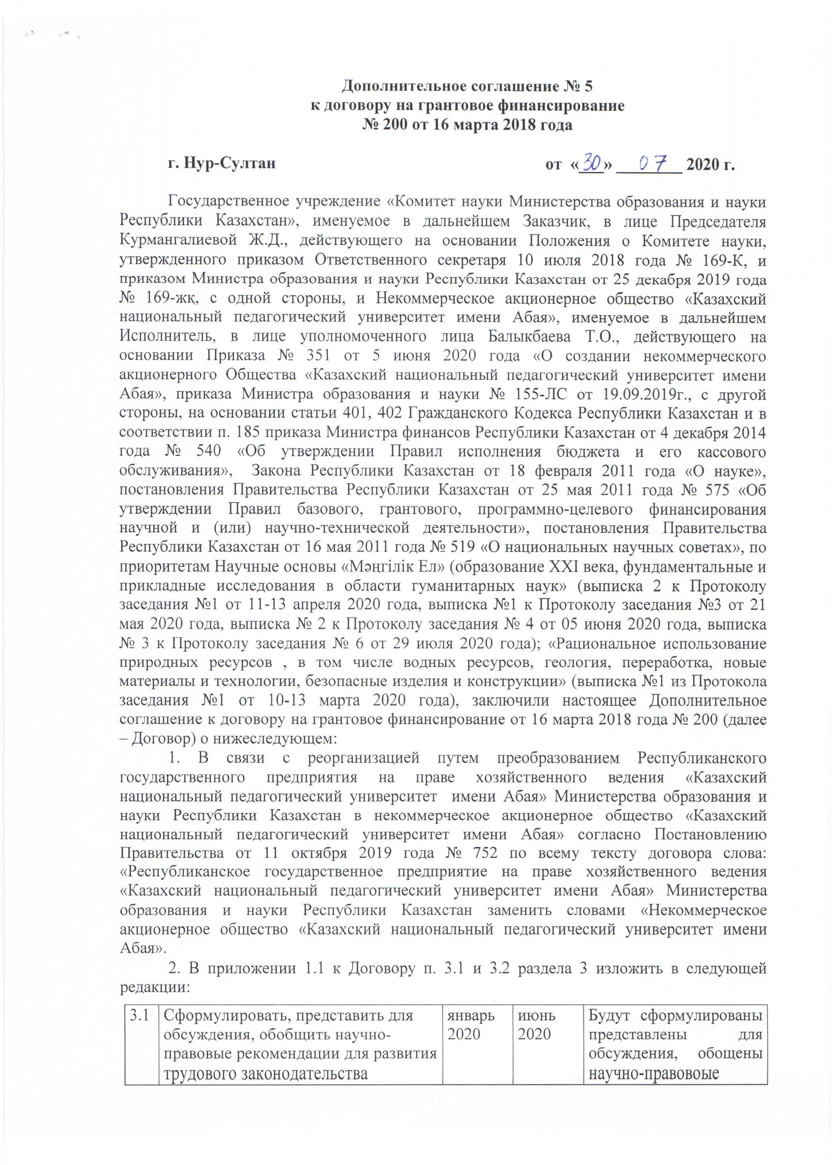
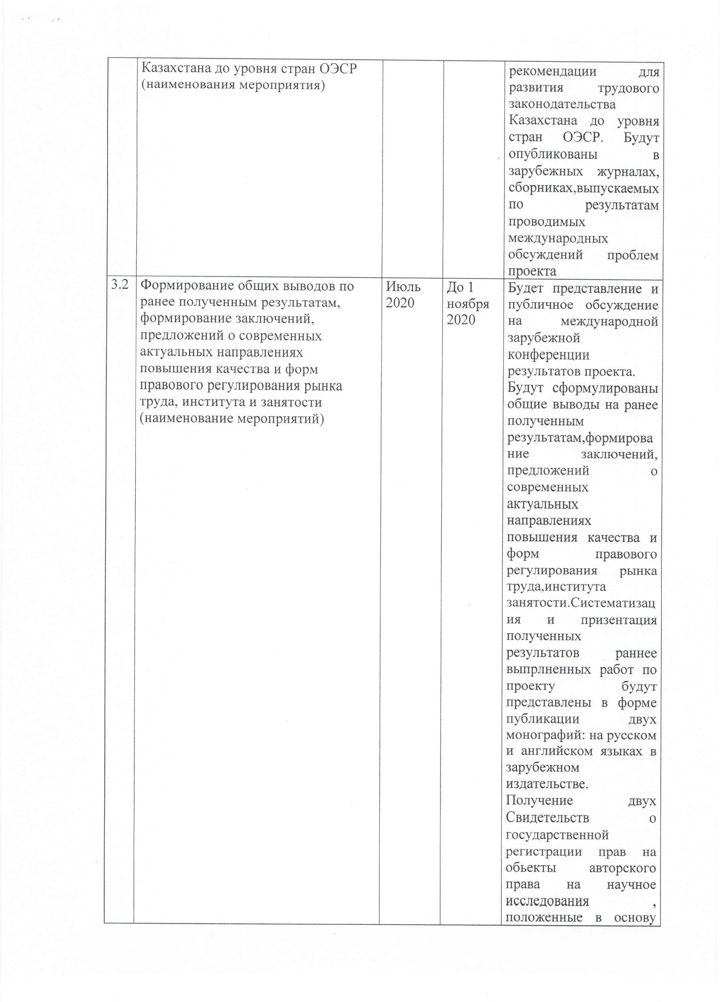
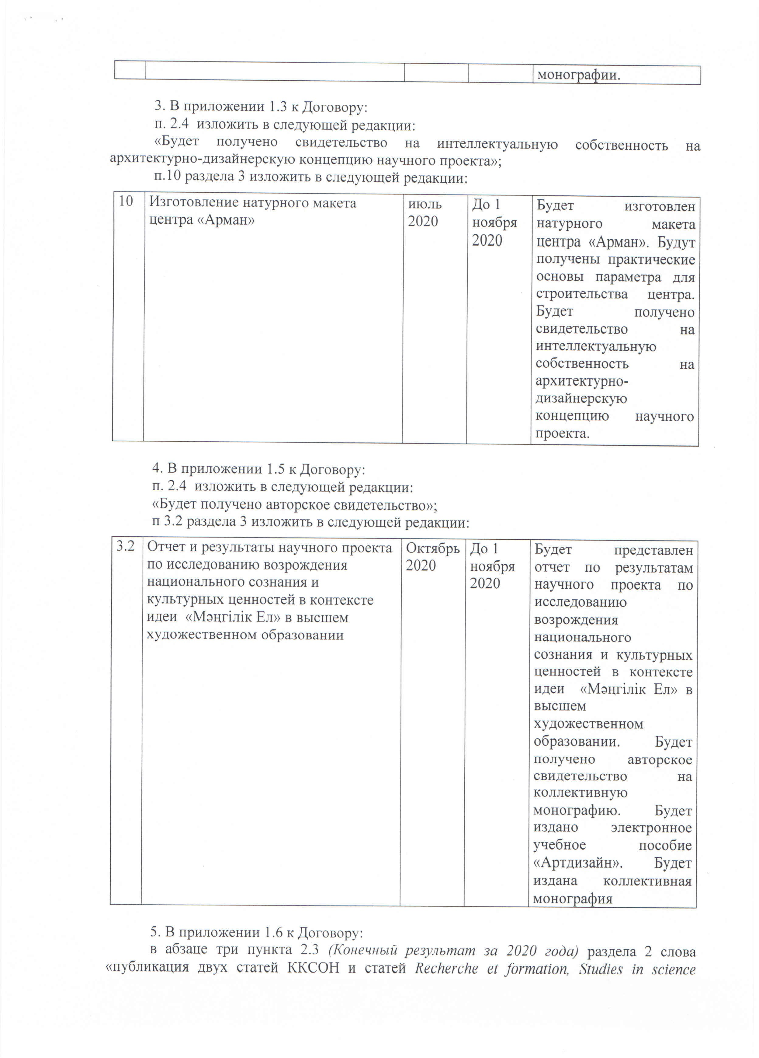
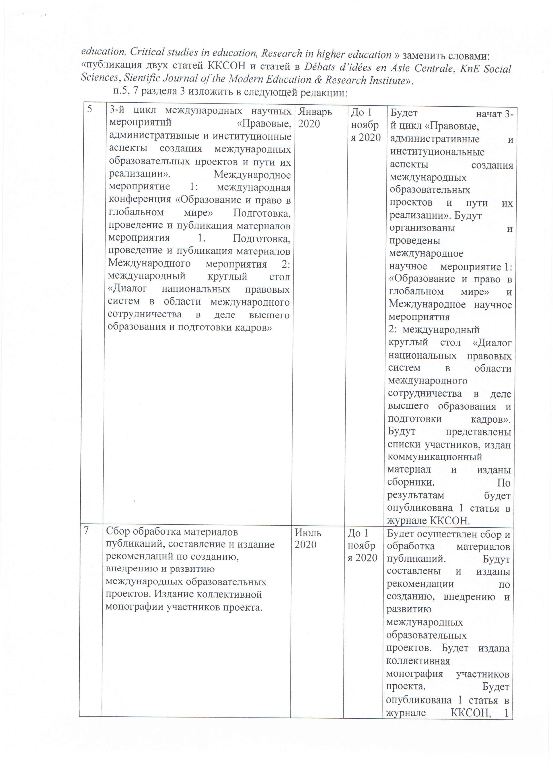
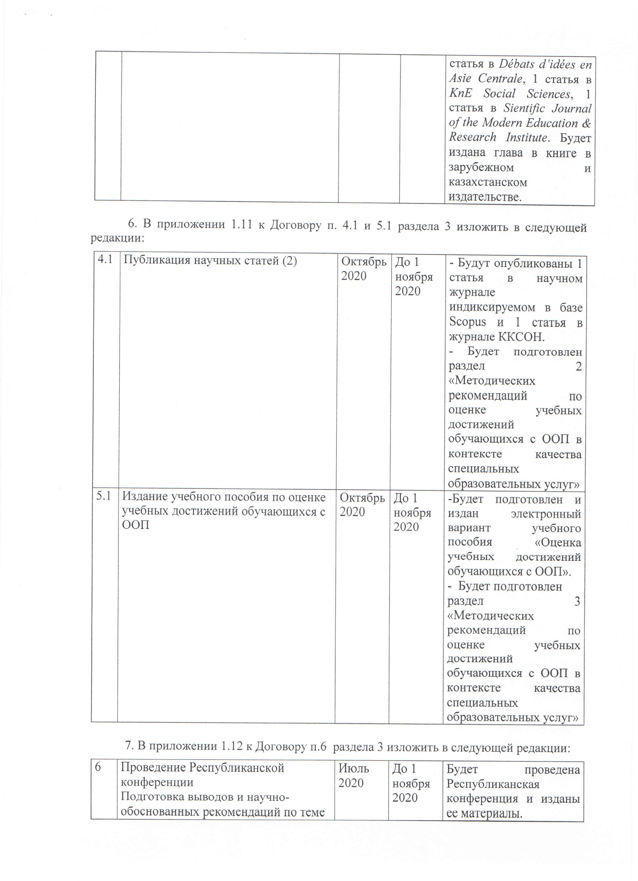
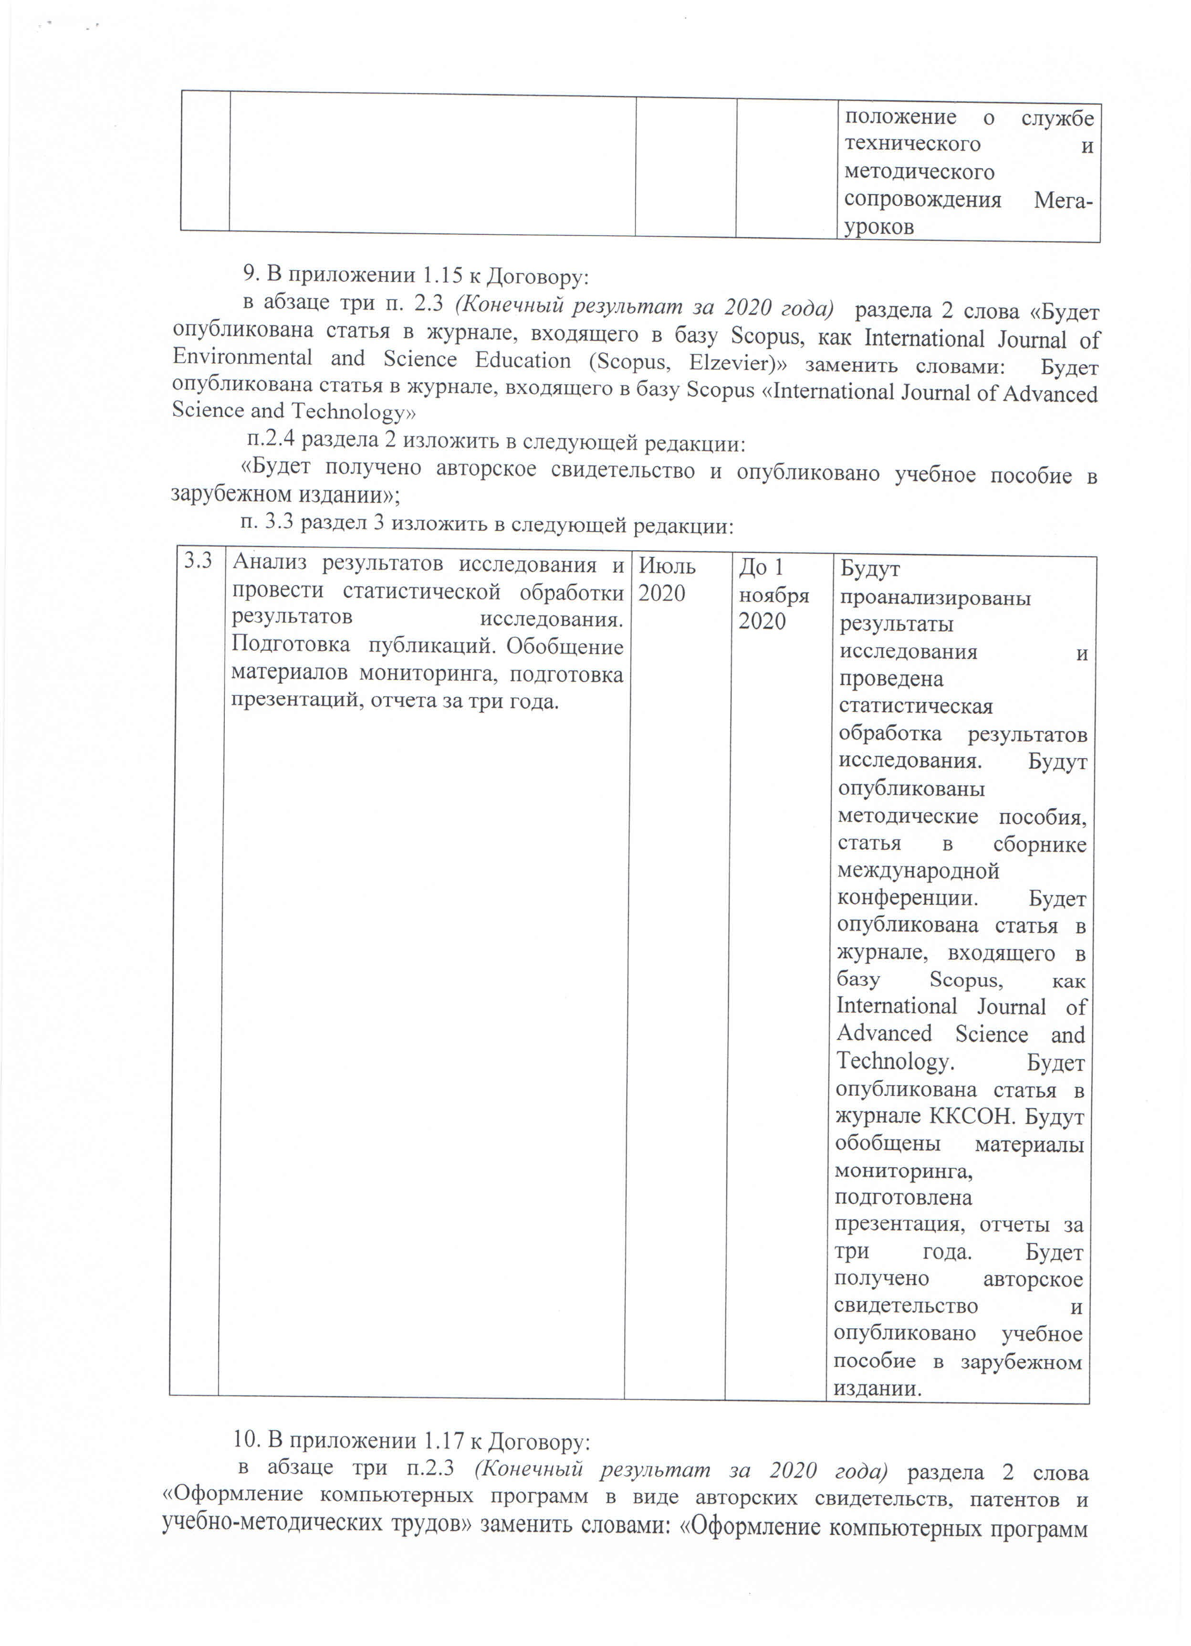
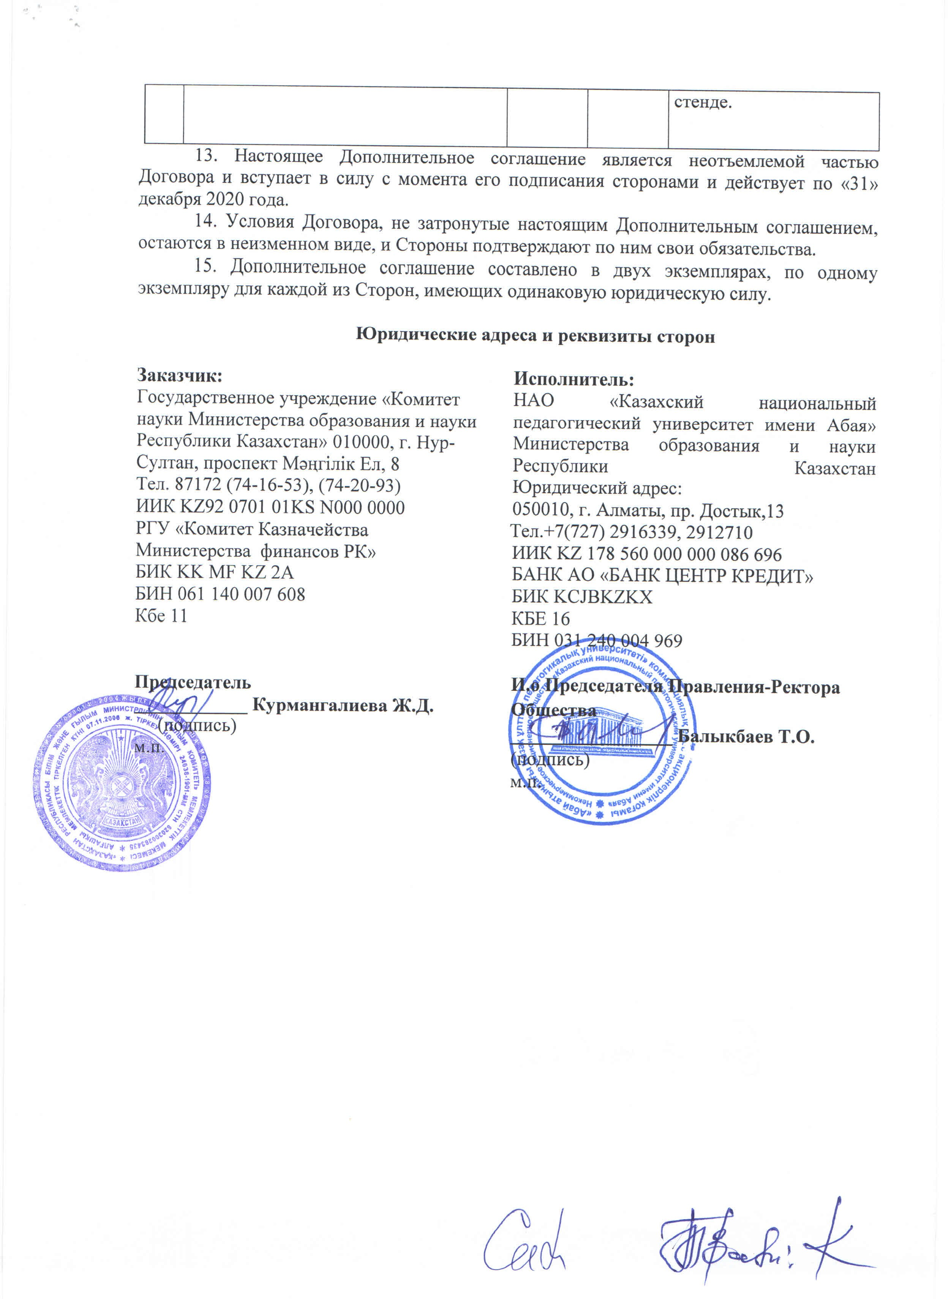

6. in Appendix 1.11 to the Agreement, paragraphs 4.1 and 5.1 of section 3 should be amended as follows:
4.1 | Publication of scientific articles (2) | Оctober,2020 | Until November 1, 2020 | - 1 article will be published in the scientific journal in Titles indexed in Scopus and 1 article in the journal of CCES MES RK (Committee for control in the field of education and science of the Ministry of education and science)  - Section 2 will be prepared "Methodological recommendations for assessing the educational achievements of children with SEN in the context of the quality of special educational services"
5.1 | Publication of a textbook on evaluating academic achievements of students with OOP | Оctober,2020 | Until November 1, 2020 | - An electronic version of the textbook "Assessment of educational achievements of students with OOP"will be prepared and published.  - Will be prepared Section 3 of the Methodological recommendations for assessing educational achievements in the context of the quality of special educational services"

