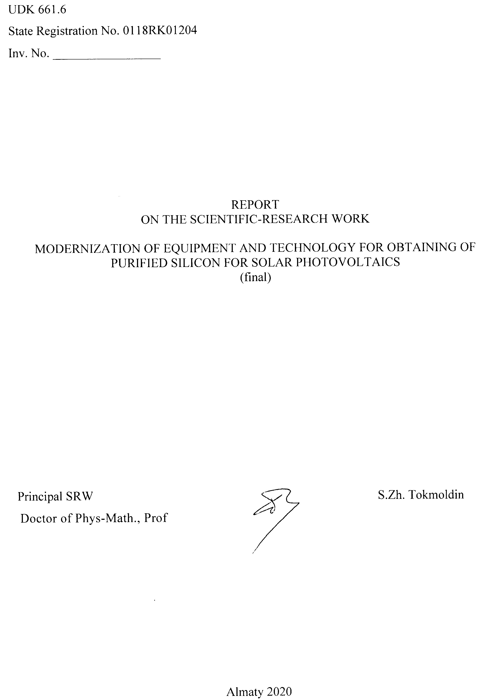
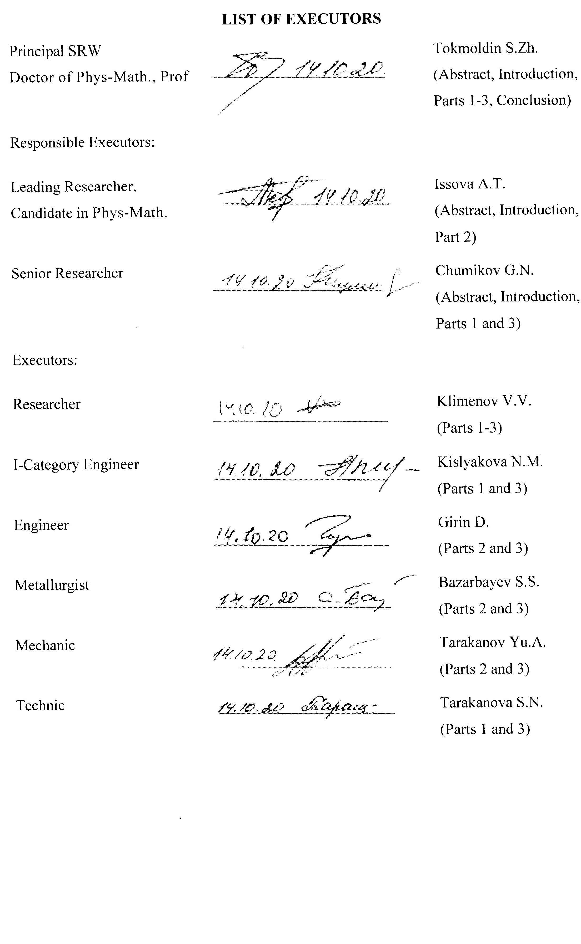
РЕФЕРАТ
Отчет 60 с., 1 кн., 20 рис., 2 табл., 22 источн., 4 прил.
ФОТОЭНЕРГЕТИКА, КРЕМНИЙ, ПРИМЕСИ, ШЛАКОВАЯ ОЧИСТКА, НАПРАВЛЕННАЯ КРИСТАЛЛИЗАЦИЯ, ТРОЙНЫЕ СПЛАВЫ
Объекты исследований: оборудование и методы получения металлургического кремния высокой чистоты и тройного сплава CaAl₂Si₂.
Цель исследований: Целью проекта является модернизация оборудования и технологии получения поликремния и тройного интерметаллического сплава CaAl₂Si₂ для солнечной фотоэнергетики и электронной промышленности.
Методы исследований: Алюмотермическое восстановление и шлаковая очистка кремния в индукционной плавильной печи, кристаллизационная очистка, рентгенофазная дифрактометрия с использованием дифрактометра Дрон-6 для определения фазового состава кремния и оптическая спектроскопия с использованием спектрометра Optima 2000DV с индуктивно-связанной плазмой для определения примесного состава.
Результаты исследований и их новизна: Получены тройные сплавы Al/Ca/Si в модернизированной индукционной печи с графитовым тиглем. На фазовых диаграммах тройной системы СаО-Al₂O₃-SiO₂ установлена область доступных составов исходной шихты и конечных шлаков в алюмотермических процессах восстановления оксида кремния с получением кремния, его очистки синтетическими шлаками, а также получения тройного сплава CaAl₂Si₂. Показана возможность снижения вязкости расплавов без применения разжижающей добавки CaF₂. Показано, что основным компонентом тройного сплава, получаемого в процессе алюмотермического восстановления оксида кальция в среде жидкого кремния, является соединение CaAl₂Si₂, кристаллы которого имеют кубическую структуру. Показано, что в ходе алюмотермического процесса без использования разжижающей добавки CaF₂ необходимо поддерживать бинарную систему CaO-Al₂O₃ в определенном диапазоне долей компонентов, не допуская уменьшения доли CaO ниже критической, при которой температура затвердевания расплава может стать выше 1550℃.
Область применения: производство материалов для солнечной фотоэнергетики и электронной промышленности.
Прогнозные предположения о развитии объекта исследования: Организация и научно-технологическое сопровождение конкурентоспособного, наукоемкого, экологически чистого производства поликремния и новых материалов на его основе. Ожидаемый положительный социально-экономический эффект высок и связан с созданием новых рабочих мест для привлечения высококвалифицированного персонала.

ABSTRACT
The report contains 60 pages, 1 book, 20 figures, 2 tables, 22 references, 4 appendixes.
PHOTOVOLTAICS, SILICON, IMPURITIES, SLAG REFINEMENT, DIRECTIONAL SOLIDIFICATION, TERNARY ALLOYS
Objects of investigations: equipment and methods of obtaining upgraded metallurgical silicon and ternary alloy CaAl₂Si₂.
Aim of the investigations: The aim of the project is modernization of the equipment and technology to obtain polysilicon and a ternary intermetallic alloy CaAl₂Si₂ for the solar photovoltaics and electronic industry.
Investigation methods: Aluminothermic reduction and slag refinement of silicon in an induction melting furnace, directional solidification, X-ray diffraction using a Dron-6 diffractometer to determine the phase composition of silicon and optical emission spectroscopy using an Optima 2000DV spectrometer with an inductively coupled plasma to determine the phase composition.
Investigation results and their novelty: Ternary Al/Ca/Si alloys were obtained in a modernized induction furnace with a graphite crucible. In the phase diagrams of the СаО-Al₂O₃-SiO₂ ternary system, a region of accessible compositions of the original charge and the resulting slags is determined following the aluminothermic processes of the silicon dioxide reduction with production of silicon, its purification using synthetic slags and the production of the ternary CaAl₂Si₂ alloy. The possibility of reducing the viscosity of the melts avoiding the diluent additive CaF₂ is demonstrated. It is demonstrated that the main component of the ternary alloy obtained in the process of aluminothermic reduction of calcium oxide in a liquid silicon environment is the CaAl₂Si₂ compound whose crystals have a cubic structure. A mechanism of formation of the CaAl₂Si₂ ternary alloy, in which the atoms of Al and Si in the presence of oxides form an intermediate compound Al_{3.21}Si_{0.47} which reacts with the reduced Ca atom to form CaAl₂Si₂. It has been shown that during the aluminothermic process, in the absence of the diluent additive CaF₂, a binary system CaO-Al₂O₃ must be sustained in the specific range of the component ratios, avoiding the decrease of the amount of CaO below the critical value for which the melt solidification temperature may exceed 1550℃.
Field of application: production of materials for photovoltaics and electronic industry.
Forecast on the development of the object of investigations: Organization and the scientific and technological support of the competitive, science-intensive, environmentally benign production of polysilicon and new materials based thereupon. The expected positive socio-economic effect is high and related to the creation of new jobs for highly qualified personnel.
CONTENTS

INTRODUCTION………………………………………………………………………… | 7
1. Main results for 2018-2019……………………………………………………………... | 12
1.1 Main results for 2018: Development of a preliminary design for modernization of an induction melting furnace with a graphite crucible……………………………….. | 12
1.1.1 Development of a functional scheme of the process of purification of metallurgical silicon……………………………………………………………….. | 12
1.1.2 Development of a graphite crucible for the combined process of production and purification of silicon…………………………………………………………… | 13
1.1.3 Development of an operational scheme of the combined process of purification of metallurgical silicon in an induction furnace with a graphite crucible.…….…. | 15
1.2 Main results for 2019: Development of a combined process of slag cleaning and directed crystallization of silicon….……………………………………………….…. | 17
1.2.1 Development of single-stage slag treatment of metallurgical silicon……….……. | 17
1.2.2 Investigation of the processes of silicon and slag stratification and extraction of target products from the crucible……………………………………………….….. | 19
1.2.3 Research and development of the combined process of slag cleaning and directed crystallization of silicon…………………………………………….……….…… | 22
2 Preparation of ternary Al/Ca/Si alloys in a modernized induction furnace and study of their parameters…………………………………………………………………….…… | 24
2.1 Production of ternary Al/Ca/Si alloys in a modernized induction furnace with a graphite crucible……………………………………………………………………... | 24
2.2 Analysis of the structure and elemental composition of Al/Ca/Si ternary alloys…… | 31
2.3 Development of a combined process for obtaining ternary Al/Ca/Si alloys with specified properties…………………………………………………………………… | 33
CONCLUSION……………………………………………………………………………. | 39
LIST OF REFERENCES……………...…………………………………………………... | 43
APPENDIX A Work schedule for 2018-2020………………………………………….. | 46
APPENDIX B List of published articles………………………..……………………. | 52
APPENDIX C List of awarded patents…………………………………………………. | 53
APPENDIX D List of submitted patent applications …………………………………... | 58

SYMBOLS AND ABBREVIATIONS

The following designations and abbreviations are used in this research report:
Acidolysis – treatment of a material with an aqueous solution of inorganic acid
Aluminothermy – reduction of an element by aluminum from its oxide
Binary system – a system consisting of two bound oxides
Charge basicity – the ratio of the basic oxide to the acid oxide CaO/SiO₂
Charge – initial mixture of components consisting of CaO, SiO₂, CaF₂
MG-Si – metallurgical grade silicon
Silicide phase – alloys of calcium, aluminum, and silicon
Slag cleaning – removal of impurity elements from the silicon melt by exposure to synthetic slag
Slag – a key component of final products of the aluminothermic process

INTRODUCTION

Currently, the world production of polysilicon for the global terawatt-scale renewable solar energy system amounts to more than 500 thousand tons per year. 95% of this renewable solar energy is produced and will be produced by silicon panels, and in the near future, the growth rate of photovoltaic energy will provoke additional demand in silicon in the amount exceeding further 500 thousand tons per year.
According to the studies of the German company Bernreuter Research, prior to 2005 the world market of polysilicon amounted to slightly above 29 thousand tons per year and was controlled by seven companies, called “Seven Sisters”:
- Hemlock Semiconductor (USA),
- Wacker Chemie (Germany),
- Advanced Silicon Materials (ASiMI, presently REC Silicon/USA),
- Tokuyama Corporation (Japan),
- MEMC Electronic Materials (USA and Italy),
- Mitsubishi Materials (Japan and USA),
- Osaka Titanium Technologies (former Sumitomo Titanium/Japan).
Throughout the decades, these companies have produced exclusively electronic grade polysilicon with the relatively low yearly growth of capacity, with the leader – Hemlock Semiconductor – producing only 7 thousand tons of polysilicon per year.
The abrupt growth in the amount of consumption and production of polysilicon started in 2013, due to the record decrease of the polysilicon spot prices following the rapid development of photovoltaics and China’s ambitions to achieve a global monopoly in photovoltaic energy and leadership in the electronics industry.
Since then, four Chinese manufacturers Xinte Energy, Daqo New Energy, Tongwei and East Hope New Energy have at once become the world leaders, each having the production volumes between 20 and 36 thousand tons of polysilicon in 2017. By 2020, the Big Six was formed with one German (Wacker Chemie AG) and five Chinese giants (Figure 1).
The former leader – Hemlock Semiconductor – with the annual capacity of 36 thousand tons of polysilicon is located in the 8th place. The top ten also includes one South Korean company and two Chinese companies with a production volume of 10 to 36 thousand tons of polysilicon per year.

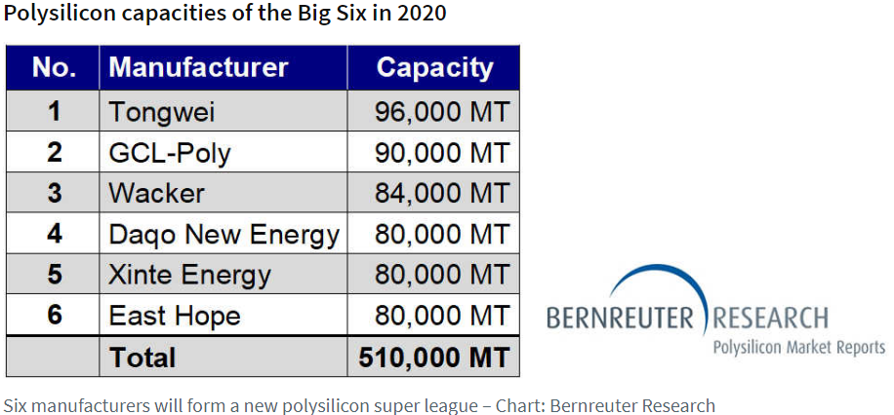
Figure 1 – The Big Six of polysilicon manufacturers
Two Chinese companies Tongwei and Inner Mongolia Dunan PV Technology with a total production of more than 100 thousand tons of polysilicon per year are located in Inner Mongolia. Four Chinese giants GCL-Poly Energy Holdings, Xinte Energy, Daqo New Energy and East Hope New Energy with a total production volume of about 330 thousand tons of polysilicon per year are located in the Xinjiang Uygur Autonomous Region, which has become the world's largest producer of polysilicon and has a great interest in the creation of a large primary metallurgical silicon production with a capacity of about 100 thousand tons a year or more in Pavlodar region of Kazakhstan, which boasts cheap electricity (Kazakhstan additionally interests China due to the presence of high quality quartz raw material deposits). The latter shows that China's domestic resources to meet the growing demand for polysilicon are not very large.
The world production and subsequent use of polysilicon is concentrated mainly in China and Southeast Asia, where production facilities for the growth of crystal ingots and wafers are located, sold in the domestic and world markets to manufacturers of discrete components, integrated circuits, solar cells, etc.
The cost reduction and record growth of production volumes were technologically achieved due the improved know-how of Union Carbide and Siemens processes, on which the technologies for the synthesis and purification of trichlorosilane, monosilane and their pyrolysis to obtain lump high-purity polysilicon are based, including:
- solar grade from 6N (99.9999%) and above used in the growth of multi-crystalline ingots used in photovoltaics;
- solar grade from 9N and above used in the growth of monocrystalline ingots used in photovoltaics;
- electronic grade from 10N and above used in the growth of monocrystalline ingots used in the electronics industry.
At the same time, to ensure the economic efficiency of modern giant chlorosilane and monosilane industries, huge public and private investments are required, the technologies are energy-intensive, require extensive industrial and environmental safety measures and the creation of an expensive logistics network for transportation, storage and distribution of monosilane used by manufacturers in the growth processes of discrete components, integrated circuits, solar cells and other semiconductor structures.
It is undeniable that the irreversible process of abandoning coal, oil and gas with the transition to the rails of a green economy on a global scale, which in the leading economies of the world has been even aggressive towards the producers of hydrocarbon raw materials, will lead to a stable growth of renewable energy capacities and, in particular, solar photovoltaic systems based on silicon. This mainstream trend is supported by the International Renewable Energy Agency's 2050 Global Energy Transformation Roadmap (Figure 2); it will be accompanied by significant and steady growth in demand for the new “oil” – solar-grade polysilicon.

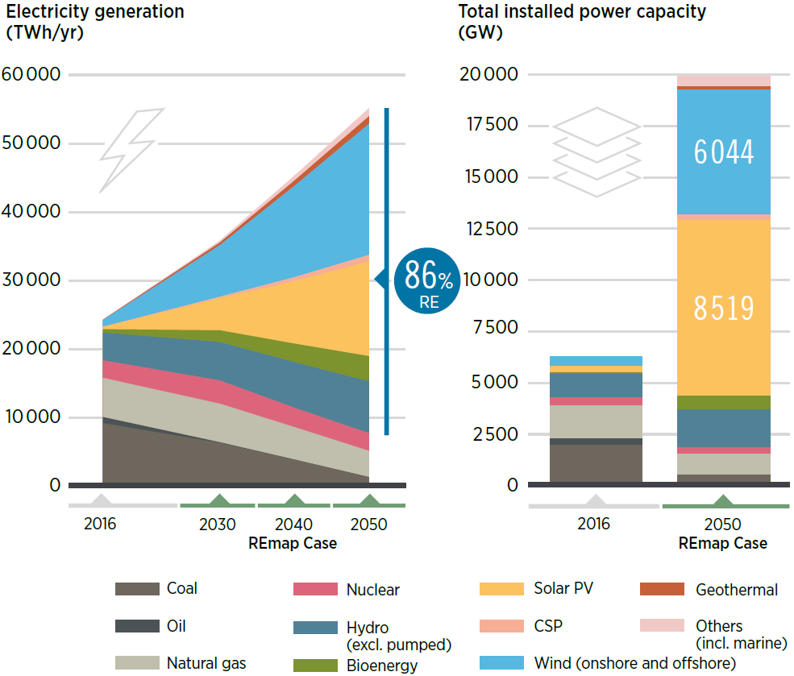

IRENA, Global energy transformation: A roadmap to 2050 (2019 edition)
Figure 2 – Trends in development of global energy up to 2050.

In the September 2020 Address to the Nation “Kazakhstan in a new reality: time for action”, President Tokayev emphasized that “The long oil supercycle seems to have ended” and in these conditions “We should be ready for a completely new conjuncture of the world market. The creation of a truly diversified, technologically advanced economy is not just a necessity for us, this path already does NOT HAVE AN ALTERNATIVE”.
Energy, first of all, electrical energy is the circulatory system of a developed economy. A diversified and technologically advanced economy needs access to energy and operational, reliable information, which can only be provided by accelerated digitalization of all types of economic activity based on the use of modern hardware and computing systems built mainly on the silicon component base. This suggests that the demand will grow not only for solar grade polysilicon, but also for ultra-high purity polysilicon and monosilane for the electronics industry.
Thus, a unique situation is created when Kazakhstan, in response to the vital challenges at a turning, historical moment of transition to a “truly diversified, technologically advanced economy” can create its own niche in the polysilicon market for organizing the domestic electronic industry and its own production of photovoltaic systems.
The problem solved by the project is the modernization of equipment and technology for producing polysilicon with the subsequent commercialization of high-demand new materials and waste-free environmentally friendly technologies for their production:
- Within the framework of the project, the main products proposed for implementation are the intellectual property for environmentally friendly and waste-free processes of aluminothermic reduction of silicon and its purification with synthetic slags in an induction furnace to obtain important materials for the solar photovoltaics and electronics industry, as well as the R&D on the design and creation of relevant industries.
These products are of interest to the Gulf countries, possessing the sources of quartz sand, cheap aluminum and cheap electricity. For example, in 2009-2015 the group of Prof. Tokmoldin completed contracts with the King Abdulaziz City for Science and Technology, Saudi Arabia, for a total of approximately US $3.5 million to obtain primary metallurgical silicon from Saudi sands.
- The market of materials for silicon microelectronics and terawatt solar photovoltaics, where high-purity polysilicon and monosilane are the main raw materials for the production of discrete components, integrated circuits, heterojunction solar cells and other semiconductor structures.
The project intends to conduct pilot tests and start a small-scale production of an innovative ternary alloy CaAl₂Si₂, used for the synthesis of gaseous monosilane, which is one of the main raw materials for the electronics industry and solar photovoltaics, used in the growth processes of epitaxial layers of monocrystalline silicon – the basis for discrete semiconductor devices , such as diodes, transistors, operational amplifiers, solar cells, and very large integrated circuits such as processors, memory elements, etc.
It must be noted that the CaAl₂Si₂ alloy represents a safe, stable upon storage and transportation “accumulator” of silicon for the synthesis of monosilane, whose traditional technologies of production, transportation, storage and distribution require special safety measures. The CaAl₂Si₂ alloy can be stored for years under normal and adjacent to them conditions and used for the synthesis and rectification of monosilane at the time of its use by the end user – manufacturer of discrete components, integrated circuits and other semiconductor structures – which completely eliminates the consequences of emergency situations associated with monosilane.
Inventory number of the interim report for 2018 - 0218RK00873.
Inventory number of the interim report for 2019 - 0219РК00104.

1 Main results for 2018-2019
1.1 Main results for 2018: Development of a preliminary design for modernization of an induction melting furnace with a graphite crucible
1.1.1 Development of a functional scheme of the process of purification of metallurgical silicon

The objective of this research is the modernization and development of the equipment and technological processes that can be used in the production of pure polysilicon without the use of operations in the gas phase.
The choice of the aluminothermic method for the reduction of silicon from quartz raw materials is due to a number of advantages:
- high process speeds and low energy costs per unit of the target product due to the exothermic nature of the reactions;
- the possibility of obtaining cleaner reduction products in comparison with the carbothermic method;
- simplicity and small dimensions of induction melting units, etc.
In this work, aluminothermic reduction of silica slags melted in an induction furnace with separation of metallic silicon and slag was carried out [1] (Figure 3).

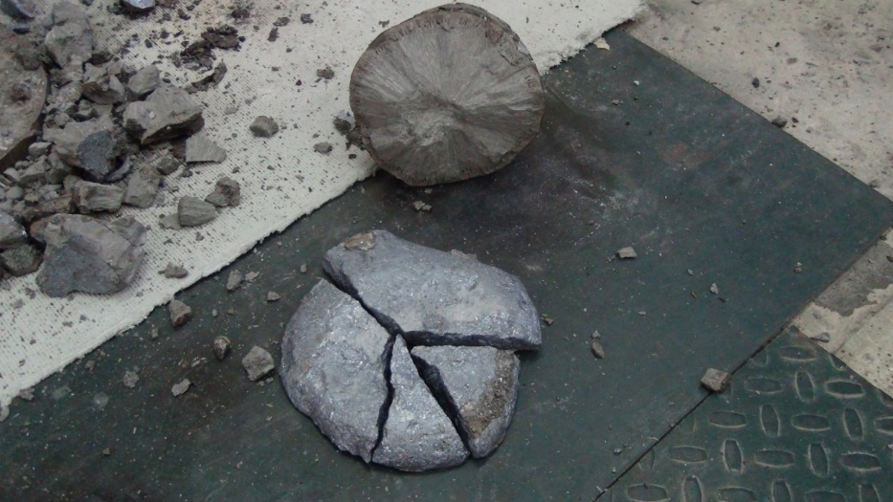

Figure 3 – Homogeneous phase of silicon on the surface of the slag

At a slag / silicon ratio ≥ 4.7, reduced silicon floats to the slag surface and forms a homogeneous metal phase, while at a slag / silicon ratio ≤ 4.7 silicon forms “beads” and is distributed throughout the slag volume. The optimal slag / aluminum ratio was determined, which is in the range of 3.5-3.75. The formation of a homogeneous phase in silicon depends not only on the slag / silicon ratio, but also on the oxidizer / reducing agent ratio. It has been found that the larger the basicity modulus, the larger the losses associated with the silicide phase and the lower silicon yield. The procedure for introducing the charge into the melt has been determined. The ratio of the components of the synthetic slag-charge CaO, SiO₂, CaF₂, which makes it possible to obtain a homogeneous silicon phase, has been selected. The volume (amount) of slag for the absorption of Al₂O₃ and 3CaO∙Al₂O₃ has been determined.
In the course of the studies on the metallurgical processes in an induction melting furnace with a graphite crucible, a functional diagram of the process of silicon refinement using synthetic slags was developed.
In our experiments, the separation of silicon from the slag was carried out during the cooling of the melt in a “cold” mold at an initial temperature not higher than 100 ℃, at which it is difficult to effectively separate silicon from the slag. Therefore, we propose gravitational separation of the melt in an undisturbed liquid state with a flat horizontal boundary due to the difference in the densities of slag and silicon directly in the working crucible of the furnace, which, in contrast to the conventional methods used for separating silicon from slag, avoids the technologically parasitic effects of mixing of the purified silicon with the slag. The next step should not be the discharge of the liquid silicon located at the top, since the densities of silicon 2.3 g/cm³ and slag 2.6 g/cm³ [2] are approximately equal, but the cooling and crystallization of the melt forming the “silicon-on-slag” ingot.
Additional purification of silicon from impurities is possible by creating a vertical temperature gradient with a minimum in the upper part and a maximum in the lower part of the crucible, which makes it possible to realize directional crystallization of silicon, an effective method for purifying silicon from most impurities, including iron, aluminum, calcium, etc. etc. After the completion of the directional crystallization process, it is necessary to heat the crucible, unload the two-layer ingot, and mechanically separate the silicon from the slag.

1.1.2 Development of a graphite crucible for the combined process of production and purification of silicon

A graphite crucible has been developed for the combined process of obtaining and purifying metallurgical silicon.
It is shown that isostatic graphite is the optimum crucible material, since it is the most dense, durable and least susceptible to environmental influences, in particular oxidation.
The dimensions of the crucible were determined, including wall thickness, diameter, height, which ensure controlled separation of the melt into silicon and slag, as well as directional crystallization of silicon.
To implement the above-mentioned main stages of the controlled silicon purification process, it is proposed to change the geometric parameters of the crucible (Figure 4) of the modernized industrial induction melting furnace with a capacity of 250 kW, approximately doubling the ratio of its height to diameter, which would increase the height of the silicon ingot and the efficiency of the slag and crystallization refinement.
To implement the vertical temperature gradient of the working crucible of the induction furnace, we have proposed a sectional inductor with three zones of energy supply along the crucible height, in which the two lower zones combined have approximately the same height as the upper zone. Figure 5 shows that this configuration enables to shift the zone of intense heating to the lower part of the melt and ensure its intense convection mixing.

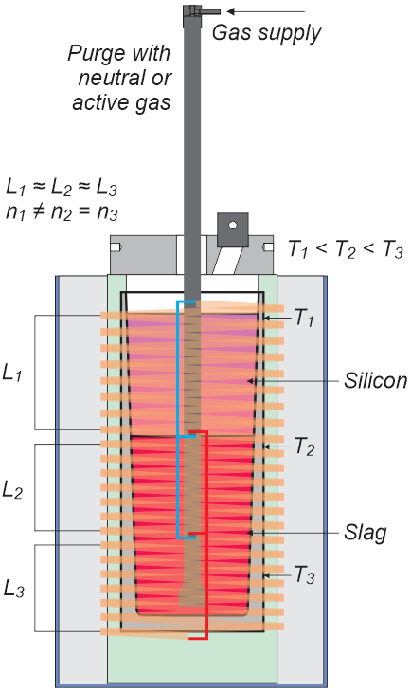
Figure 4 - Sketch of a controlled process for obtaining and purifying metallurgical silicon in an induction melting furnace

The residual content of impurities can be significantly reduced by bubbling the silicon and slag melt with an active gas and converting the impurities into volatile compounds not only in silicon, but also in the slag, which will increase the efficiency of the process of removing volatile compounds several times in accordance with the slag / silicon ratio. For this, we have developed a purge unit that ensures high efficiency of the process of interaction of the working gas with the melt, low gas consumption and limiting the gas pressure in the diffuser, preventing the diffuser from bursting with high pressure.

1.1.3 Development of an operational scheme of the combined process of purification of metallurgical silicon in an induction furnace with a graphite crucible

The optimal conditions for obtaining silicon from quartz raw materials were selected to be used in the study of the combined process of purification from impurities. This process consists of five technological stages, four of which are carried out sequentially after the reduction of silicon dioxide with aluminum in the same crucible of an induction furnace. These four stages are simple in technological execution, take little time, do not require additional equipment and form the basis for the modernization of an induction melting furnace with a graphite crucible (Figure 5).
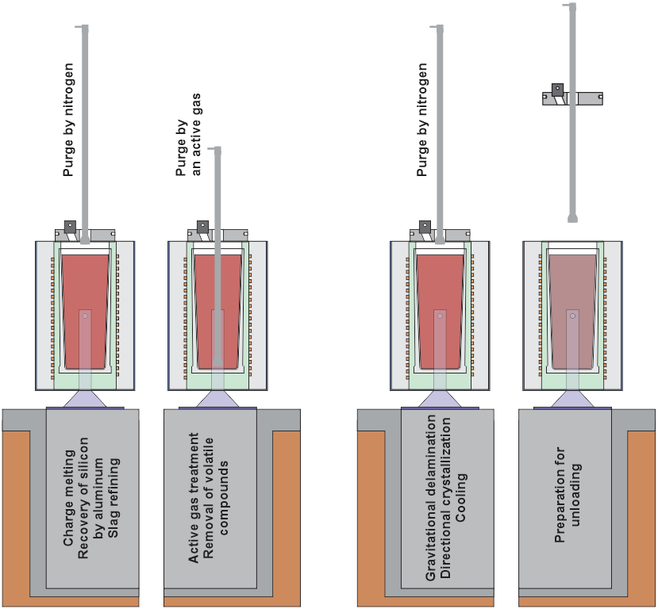

Figure 5 – Operating diagram of the combined process of production
and purification of metallurgical silicon in an induction melting furnace

It has been shown that:
during the 1st stage of the slag refinement boron, dissolved in silicon, is oxidized and extracted by the slag; the efficiency of this stage is determined by the oxidation and distribution of boron in the slag;
during the 2nd stage the metallic aluminium additive stimulates the oxidation reaction of phosphorus and the formation of PO⁻³₄, which is extracted by the slag; the degree of silicon purification from phosphorus is determined by the weight ratios CaO/SiO₂ and Al/Si;
during the 3rd stage bubbling of the melt with an active gas leads to the oxidation of aluminum and calcium with the formation of Al₂O₃ and CaO, which are extracted by the slag;
during the 4th stage control of the processes of cooling and gravitational stratification of the melt components, facilitated by the geometrical parameters of the crucible and the sectional design of the inductor, make it possible to purify silicon during crystallization, resulting in efficient removal of aluminum, calcium, iron and other impurities;
during the 5th stage the degree of silicon purification is significantly improved due to the process of directional crystallization in the Czochralski crystal growth furnace, which provides complete and accurate control of technological parameters.

1.2 Main results for 2019: Development of a combined process of slag cleaning and directed crystallization of silicon
1.2.1 Development of single-stage slag treatment of metallurgical silicon

A one-stage process of slag cleaning of metallurgical grade silicon has been developed. It is shown that the ratio of CaO / SiO₂ < 1 leads to the purification of silicon from boron, whereas the ratio of CaO / SiO₂ > 1 leads to the purification of silicon from phosphorus. In this case, a one-stage slag cleaning of silicon from boron is effective when its content is below 30 ppm due to the small distribution coefficient of boron in the slag.
Thanks to the selected ratio of CaO/SiO₂, phosphorus and boron are effectively removed from silicon and transferred to the slag. The addition of aluminum to silicon promotes dissolved phosphorus to form a compound (AlP) in silicon, which is extracted into the slag. In this case, to retain phosphorus in the slag, it is necessary that the basicity of the slag is equal to 2-2.5.
Table 1 shows the data on the content of aluminum, calcium and the residual concentration of phosphorus in silicon obtained by the aluminothermic method. It can be seen that the main parameter responsible for the purification of silicon from phosphorus is the amount of aluminum in silicon. The maximum degree of purification of silicon from phosphorus is achieved at an aluminum content of 7.3% in silicon. From the data shown in Table 1 it can be seen that the residual boron concentration in silicon depends on the CaO/SiO₂ ratio. The lower the CaO/SiO₂ ratio, the lower the residual boron concentration in silicon.

Table 1 – Elemental composition of metallurgical silicon obtained by aluminothermy with the contents of boron of 15ppmw and phosphorus of 50ppmw
Sample No. | CaO/SiO₂ at start of melting | CaO/SiO₂ at end of melting | Al, % | Ca, % | В, ppm | В_{о}/В | P, ppm | Р_{о}/Р | Fe, ppm
143 | 0.72 | 1.06 | 2.3 | 1.2 | 1.85 | 8.1 | 22.4 | 2.2 | 5556
144 | 0.87 | 1.33 | 4.9 | 2.9 | 2.75 | 5.5 | 7.3 | 6.8 | 5578
145 | 0.88 | 1.44 | 7.3 | 6.4 | 3.19 | 4.7 | < 0.5 | 100 | 3518
141 | 0.96 | 1.54 | 2.4 | 1.7 | 4.0 | 3.8 | 23 | 2.2 | 6817

Experiments were carried out on the treatment of silicon with silicate slags with additions of Al in the charge, leading to the natural saturation of the silicon melt with aluminum and calcium. Due to this, during the crystallization of such silicon, the process of formation of large silicon grains surrounded by silicide layers occurs (Figure 6). The image was obtained on a JEOL JSM-6490 scanning electron microscope.

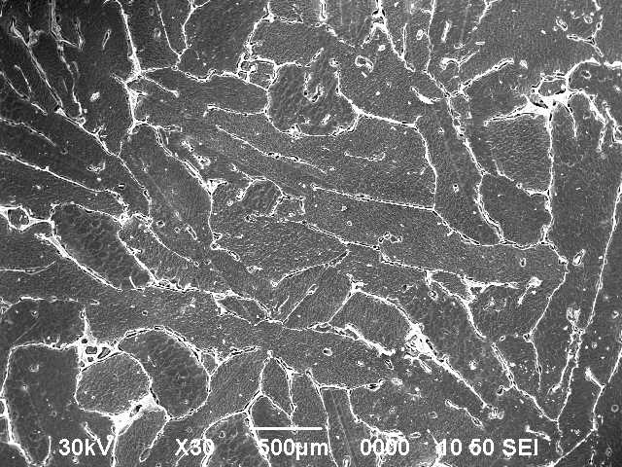 A | B
C
A – Grain structure on a metallographic cross section
B – Distribution of impurities along the data acquisition track
C – The same on a larger scale; blue line - silicon
Figure 6 – Distribution of defects and impurities in silicon,
obtained via aluminothermy

Complex ternary alloy silicides Ca-Al-Si with the primary phase of CaAl₂Si_{1.5-2} are dominant. The silicide layer that holds coarse silicon grains together consists of nanocrystals less than 1 μm in size, with various compositions and a large total surface area. The silicide nanocrystals formed during cooling serve as a getter for a significant proportion of impurities in silicon, which ensures the high efficiency of the slag refinement. Due to the different temperature expansion coefficients of the ternary alloy silicide nanocrystals and silicon, the effect of self-dispersion of large pieces of silicon into a fine powder of silicon crystals with different grain sizes is observed.

1.2.2 Investigation of the processes of silicon and slag stratification and extraction of target products from crucible

In the majority of the known experiments, the separation of silicon from the slag was carried out while cooling the melt in an initially “cold” mold, the temperature of which did not exceed 100°C before pouring the melt. Under these conditions, it is difficult to expect effective separation of silicon from the slag, and we have often observed slag beads in silicon [1]. At the same time, under optimal conditions, effective separation of silicon and slag took place [1], which indicates that even during the cooling of the melt in an initially “cold” mold, lighter silicon has time to “float” in the form of a pancake to the surface of the heavier slag. Therefore, in this study, we have proposed to carry out gravitational separation of the melt in an undisturbed liquid state with a flat horizontal boundary due to the difference in the densities of the slag and silicon directly in the graphite crucible of the induction melting furnace, which, in contrast to the previously used methods of separating silicon and slag, eliminates the parasitic effects of mixing purified silicon with the slag. To solve the problem, modernization of the furnace was proposed with the following requirements for the process and equipment:
- to implement the process of gravitational separation of the melt in an undisturbed liquid state with a flat horizontal boundary, it is necessary to exclude the effect of magnetodynamic mixing of the melt, which requires an increase in the operating frequency of the induction melting furnace to several kHz (we have chosen a value of 8 kHz) so that the magnetic field is completely absorbed in the material of the graphite crucible;
- at the same time, in the processes of silicon reduction by aluminum and slag purification from impurities, convective mixing of already separating heavy lower slag layers with upper silicon layers is necessary, which can be achieved by creating a vertical melt temperature gradient with the maximum in the lower part of the crucible;
- the creation of a vertical gradient of the melt temperature makes it possible to implement the process of directed “top-down” crystallization of silicon;
- increasing the operating frequency of the induction melting furnace and creating a vertical gradient of the temperature of the melt require a transition to a sectional inductor with parallel-connected sections.
Determination and control of the parameters of the sectionalized inductor of the melting furnace and the vertical gradient of the temperature of the melt is non-trivial in real operating conditions, therefore, for the given configurations of the inductor (one section of 22 coils, two parallel sections of 12 and 11 coils, three parallel-connected sections of 8, 7 and 7 coils; the step of the sections in the coils is different) the lumped parameters of the serial equivalent circuit for operation at a frequency of 8 kHz were calculated and the distribution of the specific power on the surface of the graphite crucible shown in Figure 3 was determined in collaboration with Interm LLC, St. Petersburg.
For the calculation, we used a program for the numerical analysis of magnetic fields with sinusoidal currents in conducting media, developed at the St. Petersburg State Electrotechnical University (COILPro 1.0.0.41, included in the IndHeat software package). The geometry of the research object is set graphically, and the results are displayed in the form of magnetic field strength lines, current density, specific power, as well as in the form of integral values calculated using a postprocessor. The calculation of the specific power was carried out for two modes: cold graphite and hot graphite at 1600°C (Figure 7). Local growth at the lower edge of the crucible is due to the concentration of the field at the right angle and indicates the need for chamfering.

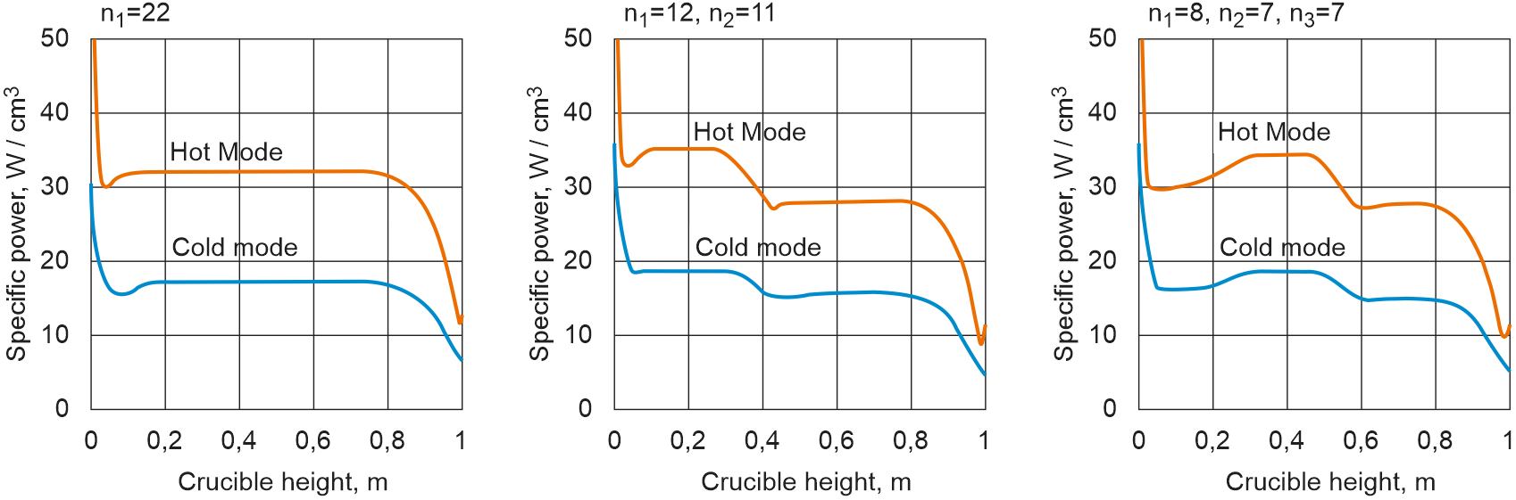

Figure 7 - Comparison of power density distribution across the crucible surface
for different inductor switching schemes

Figure 8 shows the distribution of the magnetic field strength in the hot mode for all three variations of the section connection. It is seen that the magnetic field does not penetrate into the graphite shield, which prevents magnetodynamic mixing of the melt. In addition, the magnetic field is effectively blocked inside the copper shield, which significantly reduces energy losses for absorption on external structural elements and reduces the size of the induction melting furnace.

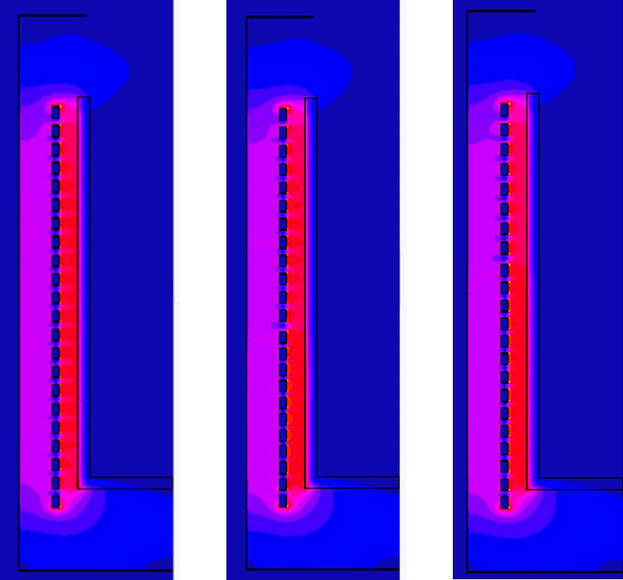
n₁=22 n₁=12, n₂=11 n₁=8, n₂=7, n₃=7

Figure 8 - Magnetic field strength in the hot mode

Thus, by controlling the rate of change in the temperature of the silicon melt mirror and the surface of the graphite crucible, it is possible to optimize the process of gravitational separation of the silicon melt and the slag in a liquid undisturbed state with a flat horizontal boundary, as shown in Figure 4. Important factors in this case are the geometric parameters of the graphite crucible (height, diameter, side wall thickness), which affect the vertical temperature gradient, the rate of cooling of the melt, and the stratification of the melt components. Moreover, the slower the cooling rate, the stronger will be the stratification of the system and the lower the probability of interaction of the melt components with different densities with each other during cooling, and vice versa, the higher the cooling rate, the lower the separation of the system, and, respectively, the higher the probability of interaction of the components with different densities. In addition, the cooling rate and, accordingly, the rate of directional crystallization of the silicon ingot will affect the process of removing calcium, aluminum, iron and other impurities from the volume of the silicon ingot to the interface of the composite ingot “silicon-on-slag”.
The next step is the rapid induction heating of the graphite crucible, during which a thin layer on the lateral surface of the silicon-on-slag composite ingot is melted, which allows the ingot to be unloaded from the graphite crucible. Here we note that it is important to reduce the thickness of the side wall of the graphite crucible as much as possible, which determines the crucible heating rate and also limits the lower boundary of the operating frequency of the induction melting furnace, which in our case is 8 kHz.
Further separation of the composite ingot into silicon and slag can be performed either mechanically or by self-decomposition of the silicate slag into powder upon cooling as a result of the phase transition of the silicate 2CaO∙SiO₂ from the β-phase to the ϒ-phase, which occurs when the CaO/SiO₂ ratio is equal to 2.5-2.6.

1.2.3 Research and development of the combined process of slag cleaning and directed crystallization of silicon

The combined process of the slag refinement and directional crystallization of silicon consists of five technological stages, four of which are performed sequentially in the same crucible of an induction furnace. These four stages are simple in technological execution, take little time, and do not require additional equipment.
At the first stage, the slag of the composition CaO-SiO₂-CaF₂ is melted in a crucible at a temperature in the range of 1460-1600℃, and then crushed metallurgical silicon is added to it. After complete melting of metallurgical silicon, a charge of the composition CaO-SiO₂-CaF₂ is added to the melt twice. When the ratio CaO/SiO₂ <1, boron dissolved in silicon is oxidized and extracted with the slag, resulting in purification of the silicon material from boron. The coefficient of silicon purification from boron is comprised of two values: the distribution coefficient of boron in the slag and the oxidation coefficient of boron during oxidative refining. The residual boron concentration following the slag treatment is found to be 1.2 ppm.
At the second stage, the silicon melt is refined by adding a CaO-CaF₂-Al mixture to it twice. The addition of metallic aluminum stimulates the oxidation reaction of phosphorus and the formation of PO⁻³₄, which is extracted by the slag. According to the results obtained, the degree of phosphorus removal from the silicon increases with an increase in the CaO/SiO₂ ratio, while the maximum value of the phosphorus removal factor reaches 10. It was also found that the phosphorus content in silicon decreases with an increase in the aluminum-to-silicon ratio. The coefficient of purification of silicon from phosphorus reaches 100. The residual concentration of phosphorus after slag purification is 0.5 ppm.
At the third stage, bubbling the melt with an active gas containing oxygen leads to the oxidation of aluminum and calcium with the formation of Al₂O₃ and CaO, which are extracted by the slag. We used both oxygen-added air and a composition-controlled mixture of nitrogen and oxygen.
At the 4th stage, additional purification of silicon from impurities was carried out by creating a vertical temperature gradient with a minimum in the upper part and a maximum in the lower part of the crucible, which makes it possible to implement the process of directional crystallization of silicon, an effective method of purifying silicon from most impurities, including the impurities of iron, aluminum, calcium, etc. The essence of the method of directional crystallization is the slow cooling of a silicon melt in a graphite crucible at a temperature of 1600°C. We slowly reduce the temperature of the silicon melt to a temperature of 1420°C, which corresponds to the formation of a solid silicon phase. Then we maintain the desired crucible temperature until the melt solidifies. In this case, the liquid silicon phase moves from top to bottom of the crucible and is enriched with impurity elements, which are concentrated at the bottom of the silicon ingot.
To unload the two-layer “silicon-on-slag” ingot, we heat the crucible to the melting temperature of the surface layer of the ingot, as a result the ingot is separated from the crucible and falls out. The subsequent separation of silicon from the slag occurs mechanically; alternatively, we make adjustments to the composition of the charge to form bicalcium silicate 2CaO∙SiO₂, which promotes the separation of the slag from silicon and the decomposition of the slag into powder as a result of the transition of bicalcium silicate from the β-phase to the γ-phase, at a ratio of CaO / SiO₂ > 2.5.
In the study and development of the combined process of slag purification, and directional crystallization of multicrystalline silicon, the optimal modes of each process were selected, included in the combined method of purifying silicon from impurities, which ensure the production of the “solar quality” silicon. This made it possible to obtain high-purity silicon, from which monocrystalline silicon was grown, and used in a joint study with Prof. Munir Naife from the University of Illinois, USA [3] to obtain nanostructured silicon. Currently, the work is underway to use this nanocrystalline silicon powder as a phosphor in LED lamps.

2 Preparation of ternary Al/Ca/Si alloys in a modernized induction furnace and study of their parameters
2.1 Production of ternary Al/Ca/Si alloys in a modernized induction furnace with a graphite crucible

The aim of this grant project, dedicated to the modernization of technologies and equipment for obtaining silicon, is the commercialization and achievement of high liquidity for both silicon on its own as well as its derivatives in the domestic and foreign markets, which requires ensuring the high quality of the products, energy efficiency of the technological processes, reliability of industrial equipment, low expenses for components, consumables and raw materials. Work in this direction, along with the results of the studies conducted in 2018 and 2019, required the study of the following issues:
- interaction of the inner surface of the graphite crucible with ambient oxygen, silicon, aluminum, as well as the oxides CaO, Al₂O₃ and SiO₂, which are part of the synthetic slags used;
- thermodynamic properties of the synthetic slag systems based on the oxides CaO, Al₂O₃ and SiO₂.
As shown above, for the implementation of the combined process of obtaining and purifying metallurgical silicon, the best choice is a crucible made of isostatic graphite, which is the most resistant towards oxygen oxidation in comparison with other grades of graphite. The primary method of protection against oxidation is inert gas purging (Figure 5). Additionally, it is possible use protective coatings (quickly “aging” under the influence of molten slags), produced by companies specializing in the fields of refractory materials and coatings.
However, according to the Ellingham diagrams [4], at 1500℃ and above, carbon reduces oxides, in particular, silicon dioxide (Figure 9) with the formation of silicon, silicon carbide and SiO, the partial pressure of which exceeds the partial pressure of CO as temperature is increased, which leads to a significant acceleration of erosion of the inner surface of the graphite crucible (Figure 10). In this case, wear- and corrosion-resistant high-temperature coatings developed by Beijing Zhi Sheng Wei Hua Chemical Co. Ltd and the All-Russian Research Institute of Aviation Materials, specializing in the military and aerospace industries, are promising for protecting graphite.

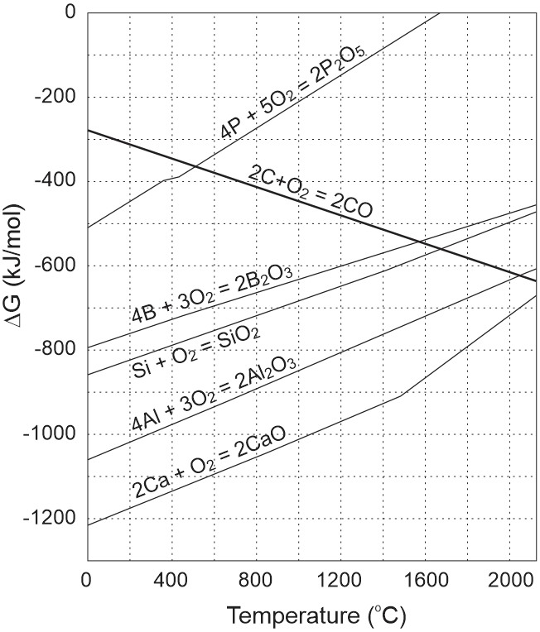

Figure 9 – Ellingham diagrams [4] of carbon, silicon and components, including impurity, slag melts in a graphite crucible

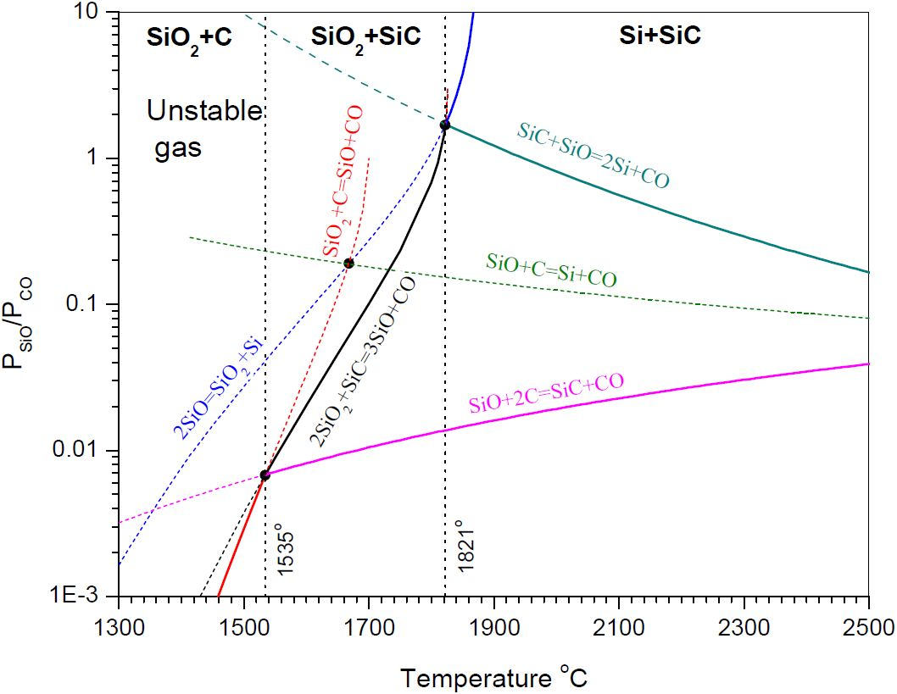

Figure 10 – Equilibrium diagrams for the reactions of interaction of silicon and carbon calculated on the basis of the JANAF database [5]

Technological processes developed in this project are based on the use of binary systems CaO-Al₂O₃, CaO-SiO₂, Al₂O₃-SiO₂ and a ternary system CaO-Al₂O₃-SiO₂, widely used in metallurgy and actively studied both experimentally and theoretically [6-12].
In the process of aluminothermic reduction of silicon dioxide, the CaO-SiO₂ system is transformed into the CaO-Al₂O₃-SiO₂ ternary system, which ultimately transforms into Al₂O₃-SiO₂. The binary systems CaO-SiO₂ and Al₂O3-SiO₂ are connected stoichiometrically, which makes it possible to determine the weight fractions of the components of the initial CaO-SiO₂ system based on the specified weight fractions of the components of the final Al₂O₃-SiO₂ system; at the same time, the ranges of weight fractions of the CaO-SiO₂ and Al₂O₃-SiO₂ systems are limited by the limiting process temperature of 1600℃ (Figure 11), which was selected to reduce the energy consumption and wear of the melting furnace components, primarily the graphite crucible.

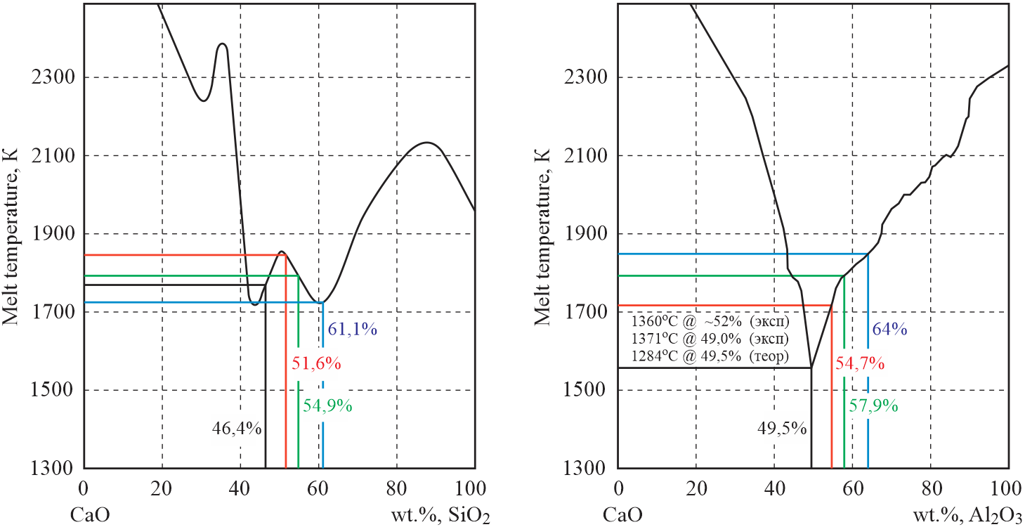

Figure 11 – Liquidus curves of binary systems CaO-SiO₂ and CaO-Al₂O₃ depending on the weight fraction of the components [6-12]

On the phase diagrams of the CaO-Al₂O₃-SiO₂ ternary system (Figure 12) the points highlighted on the CaO-SiO₂ and CaO-Al₂O₃ liquidus curves form the region of available compositions of the initial charge and the final slags in the processes of aluminothermic reduction of silicon oxide to obtain silicon, its purification by synthetic slags, as well as obtaining the ternary alloy CaAl₂Si₂. Figure 12 shows the coordinates of nine points of invariant transformations located in the indicated region [12]; five of them have temperatures close to the minimum temperatures CaO-CaF₂, SiO₂-CaF₂, and Al₂O₃-CaF₂ [8], which indicates the possibility of reducing the viscosity of the melts without the use of CaF₂.

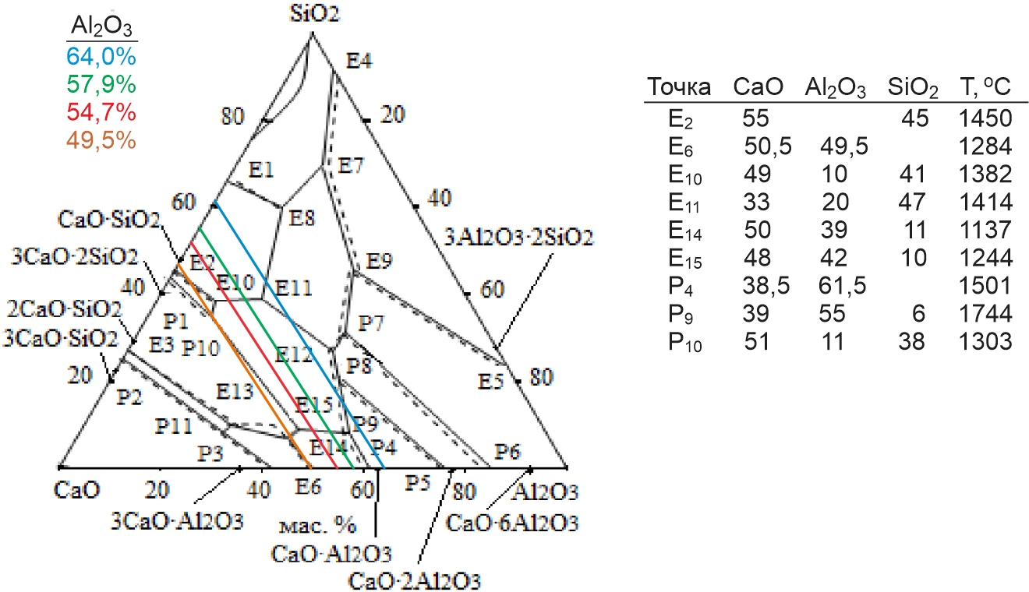

Figure 12 - Experimental (─) and calculated (---) phase diagrams of the CaO-Al₂O₃-SiO₂ ternary system presented in [12]

In Table 2, as well as in Figures 11 and 12 above, the parameters of melts demonstrating the possibility of controlling the process of aluminothermic reduction of SiO₂ to obtain metallurgical silicon with its subsequent slag purification are given.

Table 2 – Parameters of the process of aluminothermic reduction of SiO₂
Parameter Name | Melt 1 | Melt 2 | Melt 3 | Melt 4 | Melt 5
Al₂O₃ fraction in the slag, wt% | 64.0 | 57.9 | 54.7 | 49.5 | 44.0
The share of SiO₂ in the charge, wt% | 61.1 | 54.9 | 51.6 | 46.4 | 41.0
Silicon yield, g | 78.1 | 78.1 | 78.1 | 78.1 | 78.1
Slag / silicon ratio | 3.8 | 4.2 | 4.4 | 4.9 | 5.5
T_{melt} of the initial charge, °C | 1452 | 1520 | 1573 | 1496 | 1595
T_{melt} of the final slag, °C | 1576 | 1520 | 1444 | 1284 | 1528

A more detailed description will be given in international patent applications.
For the method of obtaining metallurgical silicon of high purity from natural quartz sands by the method of aluminothermy, a utility model patent of Kazakhstan No. 5297 was obtained with the priority date of January 30, 2020 [15].
The results were also used to correct the component composition of the slag melt at the final stage of the aluminothermic process for obtaining the ternary alloy CaAl₂Si₂, which is used for acidolysis-based synthesis of monosilane to further obtain high-purity polysilicon and device structures for various functional purposes in the electronic industry and photovoltaics. For this aluminothermic process, a Kazakhstan patent for invention No. KZ 34266р was received with a priority of October 26, 2018 [16] and an application was filed for a Eurasian patent No. KZ2020 / 056 with a priority of September 11, 2020.
A well-known method of obtaining metal alloys is the fusion of the required components in a liquid metal flux, which can be constituted of one of the components of the alloy being created [13]. The method was recently applied to obtain the ternary intermetallic alloy CaAl₂Si₂ in liquid aluminum at a temperature of 1150℃ [14] using high-purity starting components. However, this method is complex and expensive to apply in large-scale industrial production.
The best known alloy used for the synthesis of silane by acidolysis is magnesium silicide Mg₂Si. In the Chinese patent CN1027439 C [17], a method for obtaining magnesium silicide for the synthesis of silane is indicated, based on mixing two powder components, magnesium and silicon, in a stoichiometric ratio, followed by sintering at a temperature of 500-650°C in a vacuum or inert gas atmosphere. Since the reaction is exothermic, problems arise associated with overheating of materials in the reactor, loss of magnesium during sublimation, decomposition of magnesium silicide, change in stoichiometry, etc., which in the PRC patent CN102452653A [18] are solved by improving the design of the reactor.
In addition, there is a known method of using industrial metal silicides with the formula M¹_{x}M²_{y}Si_{z}, where M¹ is aluminum or magnesium, and M² is calcium, to obtain silicon hydrides (silanes), presented in the US patent US4698218A [19]. However, this method showed a very low yield of silanes due to the significant inhomogeneity of the elemental and phase composition of the above industrial metal silicides.
Small amounts of inhomogeneities in the elemental and phase composition were also observed in our experiments, in which the formation of ternary alloys Al/Ca/Si was established in the course of the study of the process of slag purification of silicon obtained by the aluminothermic method with Ca and Al contents ranging from 1 to 7 wt% (Table 1). The effect of the treatment with the synthetic slag СaO-SiO₂ on the impurity composition of silicon differs depending on the ratio of the components СaO/SiO₂ < 1 and СaO/SiO₂ > 1 (Figures 13 and 14). It is seen that the silicide phase is formed only in the case of СaO/SiO₂ > 1.

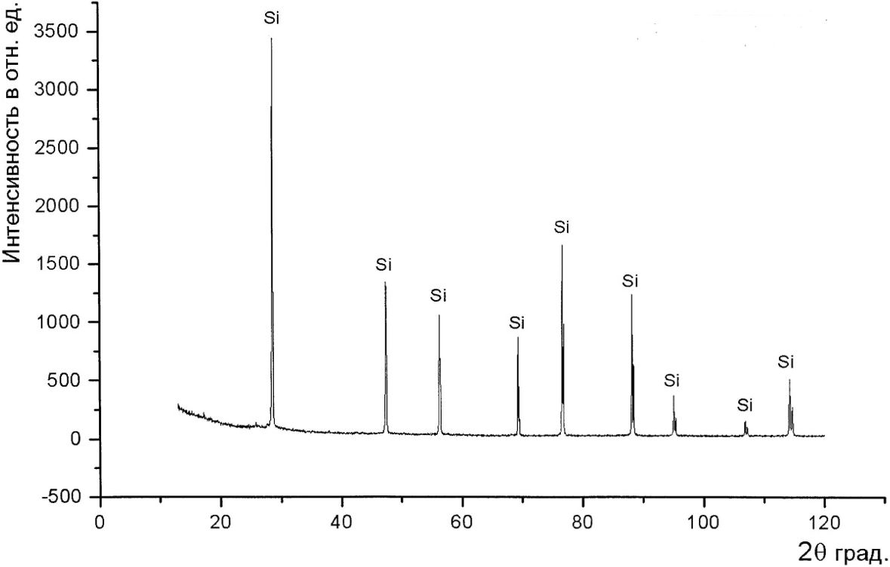
Intensity, arb.un.

Figure 13 – X-ray phase diffraction pattern of a silicon sample treated with an acid slag with the CaO/SiO₂ ratio = 0.56

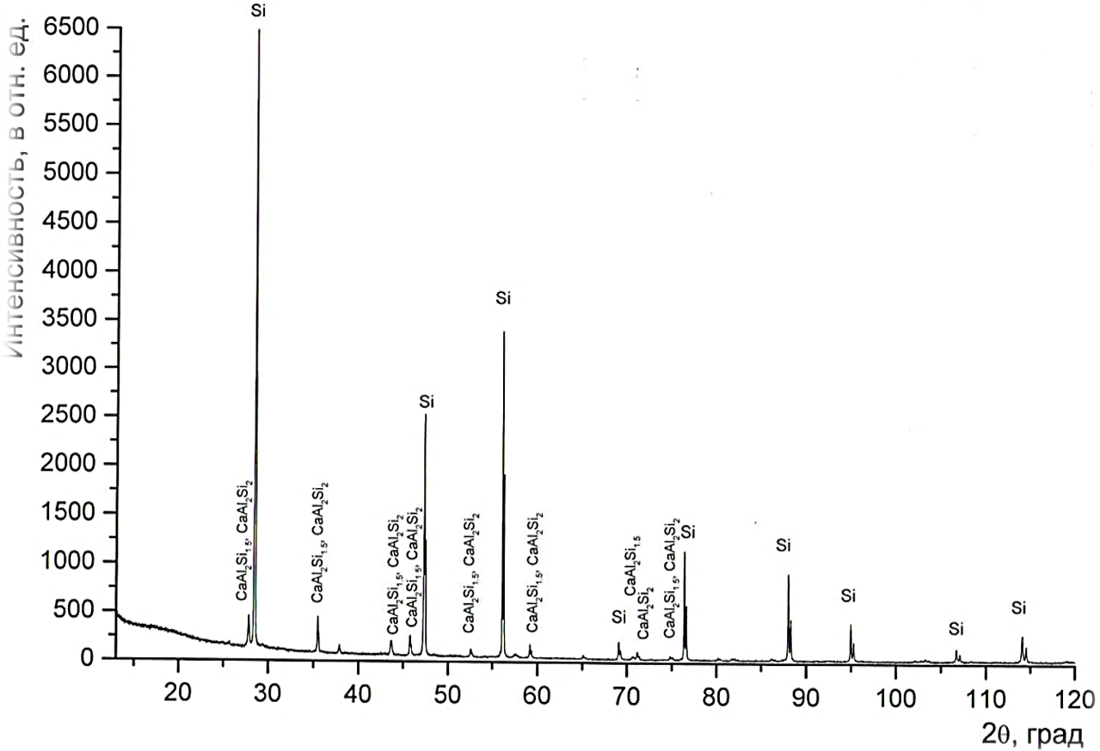
Intensity, arb.un.

Figure 14 – X-ray diffraction pattern of a silicon sample treated with an alkaline slag with the CaO/SiO₂ ratio = 1.94

To study the process of obtaining ternary alloys Al/Ca/Si, an experiment was carried out on the aluminothermic reduction of CaO in a liquid silicon medium. The composition and parameters of the initial charge were as follows:
Si mass: 3 kg;
Al mass: 3 kg;
slag/Si mass ratio: 1.7;
mass of the slag: 5 kg;
basicity modulus: 4;
% slag composition: CaO – 70%, SiO₂ – 17.5%, CaF₂ – 12.5%;
CaO mass: 5×0.7 = 3.5 kg;
SiO₂ mass: 5×0.175 = 0.875 kg;
CaF₂ mass: 5×0.125 = 0.63 kg;
initial loading: 3.5 kg of slag + 3 kg of silicon;
repeated loadings: 3 times 0.5 kg of slag + 1 kg of Al.
The alloy obtained in the experiment was ground in a disk mill to obtain a powder with a fineness of 63-100 μm, then phase analysis of the samples was carried out using a Dron-6 X-ray diffractometer, which showed the presence of the CaAl₂Si₂ and CaAl₂Si_{1.5} phases, silicon, as well as a small amount of an impurity Al_{3.21}Si_{0.47} phase (Figure 15).
Intensity, arb.un.

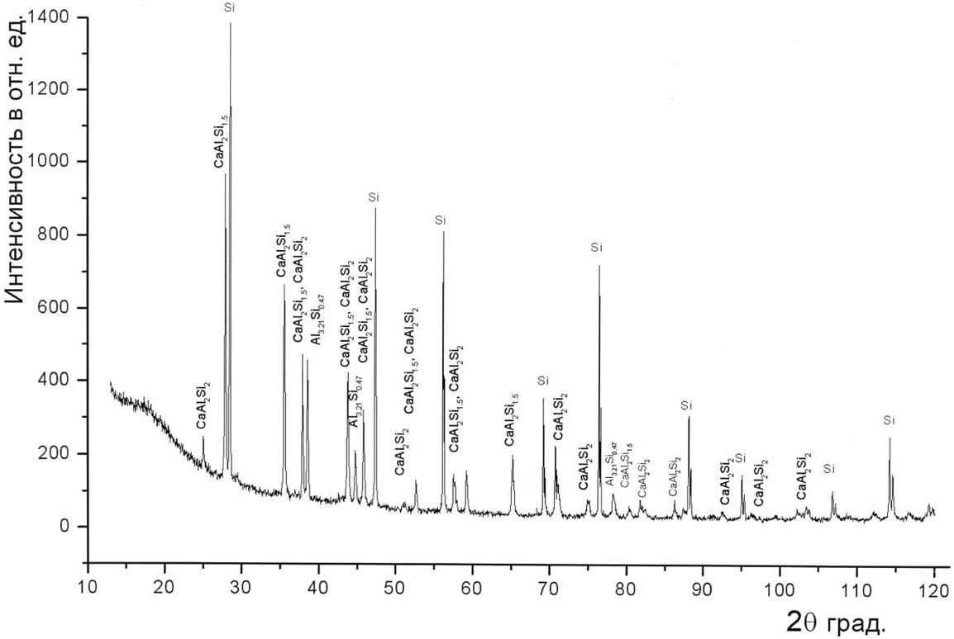

Figure 15 – X-ray phase diffraction pattern of Sample No. 1 of an alloy of complex composition based on silicon and its compounds with calcium and aluminum

2.2 Analysis of the structure and elemental composition of Al/Ca/Si ternary alloys

The acidolysis of the alloy obtained above in 10% solutions of hydrochloric and sulfuric acids demonstrated the violent nature of the reactions of the synthesis of silanes, which spontaneously ignite in air and burn to form SiO₂. Since the non-bound silicon and the impurity compound Al_{3.21}Si_{0.47}, present in an insignificant amount, cannot participate in the active synthesis of silanes, it is the CaAl₂Si₂ and CaAl₂Si_{1.5} phases which are involved in the acidolysis reaction. In order to prove this conclusion, it was necessary to conduct a spectral analysis of the residual products of the acidolysis reactions and, in a series of melting processes with a controlled composition of the initial charge, to determine the optimal composition of the charge components, which would ensure the removal of un-bound silicon and the impurity compounds.
The spectral analysis of the residual products of the alloy acidolysis reactions was conducted using an “OPTIMA 2000DV” optical emission spectrometer with inductively coupled plasma. Quantitative measurements of the contents of silicon, calcium and aluminum in the solution were carried out, and their dependences on the composition of the initial mixture were determined. Based on the difference in the mass of the alloy and the masses of calcium and aluminum, the mass of silicon in the alloy was calculated, which made it possible to calculate the percentage of silicon in the alloy and establish that the ternary alloy has the chemical formula CaAl₂Si₂.
Based on the results of these studies, we have developed a method for the synthesis of silanes in a flow reactor with counterflows of powdered raw materials and an active reagent and, subsequently, filed an application KZ2020 / 055 with a priority of 09/11/2020 to obtain a Eurasian patent. The invention relates to the field of technologies and equipment for the chemical and electronic industries and solar photovoltaics.
In the above method of acidolysis of Mg₂Si, presented in the Chinese patent CN1027439 C [17], the yield of silicon into silanes does not exceed 30%, which is due to the formation of prosiloxane H₂SiO [20] according to the following mechanism.
First, Mg₂Si interacts with water (equation (1)), then with HCl (equation (2)), and then the intermediate product SiH₂ polymerizes and reacts with water to form prosiloxane and silanes (equation (3)):
Mg₂Si + 2H₂O = H₂Si(MgOH)₂, (1)
H₂Si(MgOH)₂ + HCl = 2MgCl₂ + 2H₂O + H₂↑ + [SiH₂], (2)
(SiH₂)₂ + H₂O = H₂SiO + SiH₄↑. (3)
Further, prosiloxane H₂SiO is polymerized into a solid cake H₂Si₂O₃ in an aqueous medium, and the reaction of acidolysis of Mg₂Si proceeds in the following form [21]:
3Mg₂Si + 12HCl + 3H₂O = SiH₄↑ + H₂Si₂O₃ + 6MgCl₂ + 6H₂↑. (4)
It can be seen that only one of the three silicon atoms is involved in the synthesis of silanes. An increase in the silane yield by 8% in this experiment when replacing HCl with H₂SO₄ correlates with replacing the MgCl₂ salt with the MgSO₄ salt. It is known that the MgCl₂ salt is corrosive and acts as an active reagent in an aqueous medium, which indicates its catalytic role in reactions (1) - (3) leading to the formation of prosiloxane H₂SiO.
The closest method to the one developed by us for the synthesis of silanes is the synthesis of silicon hydrides presented in US Patent 4698218A [19], which is carried out via acidolysis of industrial Al_{x}Ca_{y}Si_{z} alloys at temperatures from 50°C to 90°C. The yield in the amount of 1 kg of silane upon acidolysis of 10 kg of the alloy 33%Al / 18%Ca / 40%Si (which corresponds to the yield of silicon in silanes, equal to about 22%) is achieved when adding the alloy powder into the acid solution, while adding the acid solution into the alloy powder requires 18 kg of the alloy to obtain 1 kg of silane (which corresponds to a yield of about 12%). The disadvantage of this method is the low yield of silanes, which must be increased. The percentage composition 33%Al / 18%Ca / 40%Si of the industrial alloy differs markedly from the stoichiometrically correct composition of 27%Ca / 36%Al / 37%Si of the CaAl₂Si₂ alloy, whose preparation method is presented in Patent KZ 34266p [16]. As a result, approximately 13% of Si in the industrial alloy cannot participate in the silane synthesis, which reduces the potential yield by 30% and requires a stoichiometrically correct composition of the CaAl₂Si₂ alloy, for which the acidolysis reaction has the form:
CaAl₂Si₂ + 8HCl = 2SiH₄↑ + CaCl₂ + 2AlCl₃. (5)
In the right-hand side of reaction (5), the target products are silanes, the by-products are the salts of CaCl₂ and AlCl₃, which lead to the aging of the active reagent, an aqueous solution of HCl. Moreover, AlCl₃ is highly corrosive and acts as an effective catalyst in chemical reactions stimulating the formation of prosiloxanes H₂SiO and H₂Si₂O₃ in the reactions similar to reactions (1) – (3). At the same time, CaCl₂ has high hygroscopic potential and can suppress the catalytic activity of AlCl₃. To the support of this argument, it should be noted that in Patent FR 2989076 [22], the simultaneous introduction of an aqueous solution of HCl and CaCl₂ into the powder of a stoichiometrically incorrect alloy 33%Al / 18%Ca / 40%Si leads to an increase in the yield of silanes. Taking the latter into account, it is expected that the maximum yield of silanes in reaction (5) is 50%, and in order to increase the yield of silicon into silanes, it is necessary to continuously remove the aged active reagent from the reaction zone using a flow reactor.
The acidolysis reaction of the CaAl₂Si₂ alloy with an aqueous solution of H₂SO₄ has the form:
CaAl₂Si₂ + 4H₂SO₄ = 2SiH₄↑ + CaSO₄ + Al₂(SO₄)₃. (6)
The by-products of the reaction are calcium sulfate, a base component in gypsum, and aluminum sulfate, which has coagulating and tanning properties. Calcium sulfate CaSO₄ is slightly soluble in water, therefore, with an increase in concentration, it will form cloudy suspensions and gypsum sediment, which do not affect the acidolysis process. Aluminum sulfate Al₂(SO₄)₃ can exhibit catalytic properties as in the case of aluminum chloride AlCl₃.
In the claimed invention, acidolysis of the CaAl₂Si₂ ternary alloy of a stoichiometrically correct composition of 27%Ca / 36%Al / 37%Si is used for the synthesis of silanes. The acidolysis reaction is carried out in a flow-through reactor with the main operating unit – a concave meniscus-shaped bed – which supplies an optimal volume of the active reagent in the reaction zone, which can be determined based on equations (5) and (6), leading to the formation of counter flows of the powdery raw materials and the active reagent, removal of the aged active reagent from the reaction zone, which makes it possible to most effectively reduce its effect on the silane yield, as well as to prevent the washing off of the powdery raw materials.
The method enables to achieve the continuity of the synthesis of silanes, which is important for the organization of an industrial production, significant simplification and reduction in the cost of the technological process due to the use of available, cheap feedstock and simplicity of the technological hardware.
Thus, the presented data confirm that the main component of the ternary alloy obtained in the process of aluminothermic reduction of calcium oxide in liquid silicon is the CaAl₂Si₂ compound, whose crystals [14] have a cubic structure.

2.3 Development of a combined process for obtaining ternary Al/Ca/Si alloys with specified properties

To determine the optimal composition of the charge, which ensures the production of the optimized ternary alloy CaAl₂Si₂ and which does not contain free silicon and impurity compounds of the Al_{3.21}Si_{0.47} type, a series of melting experiments with controlled compositions of the initial charge was carried out. Figures 16-20 show the X-ray diffraction patterns of the obtained CaAl₂Si₂ ternary alloy samples and the corresponding descriptions of the initial charge compositions and the batch loading of the melt components into the graphite crucible.
Analysis of the data presented in Figures 15-20 (samples No. 1-6) shows that in the case of samples 1-4, the amounts of unbound silicon and the impurity compound Al_{3.21}Si_{0.47} stably decreases with an increase in the weight amount of CaO and Al. If the amount of CaO is left unchanged, but the amount of Al is increased, then the amount of unbound silicon decreases, but the Al_{3.21}Si_{0.47} phase unexpectedly increases (Figure 19, sample 5), which may indicate a lack of Ca for the formation of the CaAl₂Si₂ compound. Following an increase in the amount of CaO in sample 6 with a simultaneous slight decrease in the amount of Al and the exclusion of SiO₂ from the charge, both the unbound silicon and the impurity compound Al_{3.21}Si_{0.47} phases are removed completely. However, in this case, a weak peak corresponding to unbound Ca appears in the diffraction pattern, which indicates a slight excess of CaO.
The appearance of the Ca peak following a decrease in the amount of Al and in the absence of unbound silicon suggests a mechanism of formation of CaAl₂Si₂, in which in the presence of the oxides the Al and Si atoms form the intermediate compound Al_{3.21}Si_{0.47}, which reacts with the reduced calcium atoms to form the ternary intermetallic compound CaAl₂Si₂.

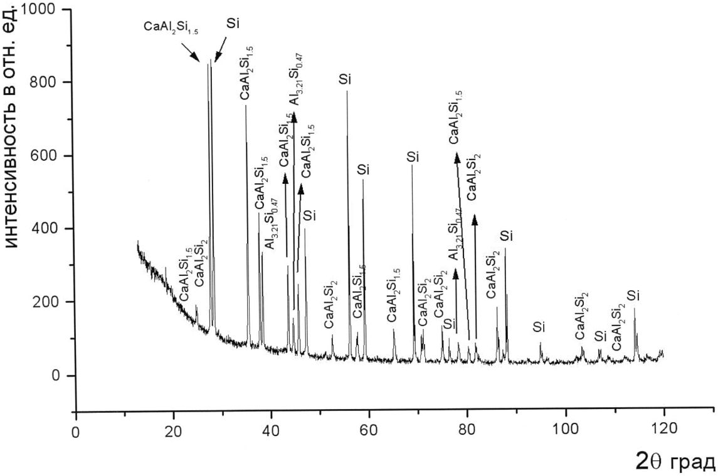

Intensity, arb.un.

Si – 3 kg, Al – 3.75 kg, slag/Si – 2.5, charge – 7.5 kg, basicity – 4,
% composition: CaO – 70, SiO₂ – 17.5, CaF₂ – 12.5,
weight content: CaO – 5.25 kg, SiO₂ – 1.31 kg, CaF₂ – 0.94 kg
initial loading: 4.5 kg charge + 3.0 kg Si;
repeated loadings: 3 times 1.0 kg of the charge + 1.25 kg Al
Figure 16 – X-Ray diffraction pattern of sample No. 2
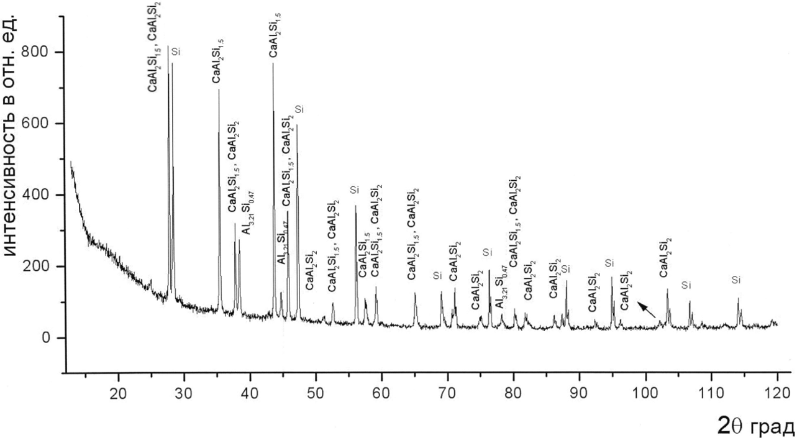

Intensity, arb.un.
Si – 3 kg, Al – 4.5 kg, slag/Si – 2.5, charge – 7.5 kg, basicity – 4,
% composition: CaO – 70, SiO₂ – 17.5, CaF₂ – 12.5,
weight content: CaO – 5.25 kg, SiO₂ – 1.31 kg, CaF₂ – 0.94 kg
initial loading: 4.5 kg charge + 3.0 kg Si;
repeated loadings: 3 times 1.0 kg of the charge + 1.5 kg Al;
additional loading: 1.5 kg SiO₂ + 0.15 kg CaF₂
Figure 17 – X-Ray diffraction pattern of sample No. 3
Intensity, arb.un.

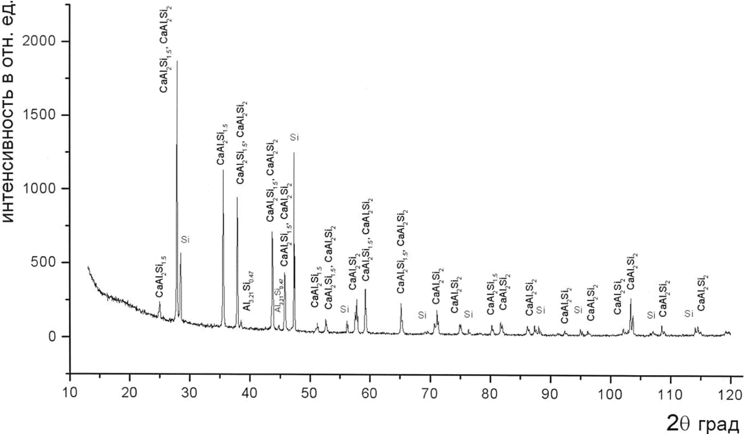

Si – 3 kg, Al – 4.5 kg, slag/Si – 3.0, charge – 9.0 kg, basicity – 4,
% composition: CaO – 70, SiO₂ – 17.5, CaF₂ – 12.5,
weight content: CaO – 6.3 kg, SiO₂ – 1.6 kg, CaF₂ – 1.1 kg
initial loading: 6.0 kg charge + 3.0 kg Si;
repeated loadings: 3 times 1.0 kg of the charge + 1.5 kg Al
Figure 18 – X-Ray diffraction pattern of sample No. 4
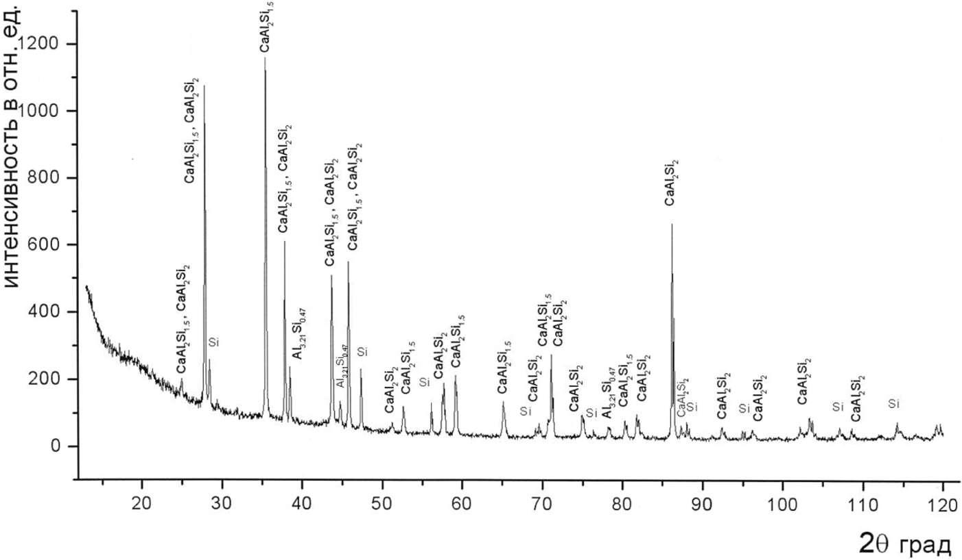

Intensity, arb.un.
Si – 3 kg, Al – 5.1 kg, slag/Si – 3.0, charge – 9.0 kg, basicity – 4,
% composition: CaO – 70, SiO₂ – 17.5, CaF₂ – 12.5,
weight content: CaO – 6.3 kg, SiO₂ – 1.6 kg, CaF₂ – 1.1 kg
initial loading: 6.0 kg charge + 3.0 kg Si;
repeated loadings: 3 times 1.0 kg of the charge + 1.7 kg Al
Figure 19 – X-Ray diffraction pattern of sample No. 5

Depending on the initial composition of the charge, the Ca/Al/Si ternary alloys obtained in the process of aluminothermic reduction of calcium oxide in liquid silicon may consist of several components and include the ternary intermetallic alloy CaAl₂Si₂, silicon, and the intermediate compound Al_{3.21}Si_{0.47}.
However, the end products of the aluminothermic process include not only ternary alloys, but also slag products such as Al₂O₃ and CaF₂, as well as SiO₂ and CaO in case the composition of the initial charge does not match the stoichiometric composition of the components of the aluminothermic process, which is typically due to the lack of aluminum, which reduces both CaO and SiO₂. Therefore, the most probable components of the slags are Al₂O₃ and CaF₂, as well as CaO in the case of its excess.
An examination of the liquidus curves of the binary systems Al₂O₃-CaF₂ and SiO₂-CaF₂ depending on the weight fraction of the components [8] shows that they differ little from the binary systems CaO-SiO₂ and CaO-Al₂O₃ in terms of the shape of the liquidus curve, the minimum temperatures and the range of the component fractions at which the minimum temperatures are realized. Only in the case of the CaO-CaF₂ binary system [8], the range of the component fractions at which the minimum temperatures are realized is twice as wide and extends from 40 wt% to 80 wt%.
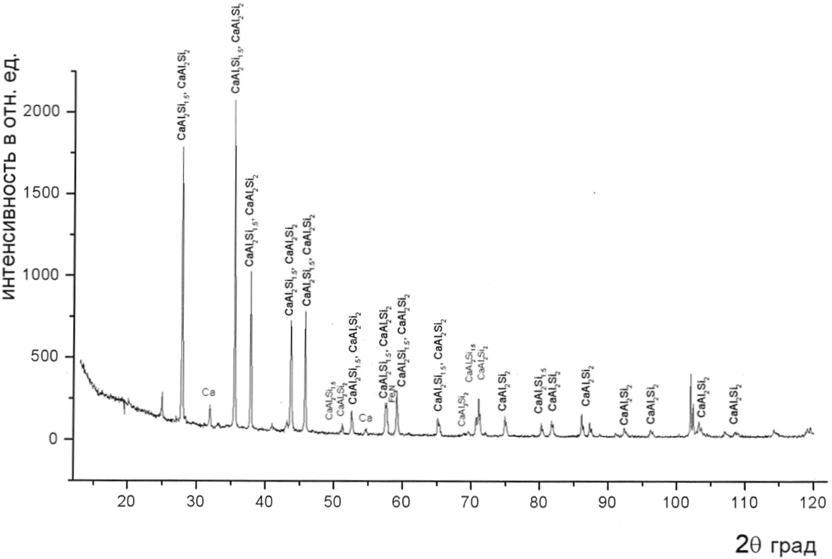
Intensity, arb.un.

Si – 3 kg, Al – 4.5 kg, slag/Si – 2.5, charge – 7.5 kg, basic,
% composition: CaO – 87.5, CaF₂ – 12.5,
weight content: CaO – 6.56 kg, CaF₂ – 0.94 kg
initial loading: 3 kg Si;
repeated loadings: 3 times 2.5 kg of the charge + 1.5 kg Al
Figure 20 – X-Ray diffraction pattern of sample No. 6

Considering the liquidus curves of the binary systems Al₂O₃-CaF₂, SiO₂-CaF₂ and CaO-CaF₂ [8], and also taking into account that the amount of CaF₂ in the initial charge was only 12.5%, it was rather difficult to ensure the minimum possible slag temperatures of about 1360℃. In the performed experiments in order to ensure complete extraction of the melt from the crucible into the mold, the temperature was maintained above 1550℃, since the melting temperature of the slag was about 1500℃. Under these conditions, it is difficult to ensure the ideally flat layering of the ternary alloy, the melting temperature of which does not exceed 1150℃ [8], and the slag, which quickly solidifies from the periphery to the center, creating a meniscus bed for the liquid ternary alloy, which was observed in the experiment.
The problem of the ideally flat layering of the ternary alloy and the molten slag is solved by controlled cooling of the melt in the graphite crucible of the induction melting furnace, as well as by eliminating the use of CaF₂ to ensure the lowest possible temperature of the slag solution. In this case, the aluminothermic process is carried out under the conditions of maintaining the stoichiometric composition of the components up to the final loading, the selection of the composition of which would ensure the minimum melting temperature of approximately 1370℃ for the binary system CaO-Al₂O₃, which is the key slag component of the final products [6-12].
With regards to the aluminothermic process without the use of the CaF₂ diluting additive, starting from the initial charge and throughout the intermediate charges, it is necessary to maintain the binary system CaO-Al₂O₃ in a certain range of component fractions, preventing the CaO fraction from decreasing below the critical value, at which the solidification temperature of the melt can rise above 1550℃.
Detailed descriptions of the results of the experimental studies of the combined aluminothermic processes to obtain 1) the ternary alloy CaAl₂Si₂, 2) silicon followed by its slag purification while avoiding the use of the CaF₂ diluting additive are out of the scope of this project and will be presented in applications for international patents in the EU, the USA, China and South Korea.

CONCLUSION

As a result of the studies, the optimal conditions for the aluminothermic reduction of silicon from quartz raw materials were determined. The obtained MG-Si was further used in the study of the combined process, which consists of four sequential technological stages of purification of MG-Si from impurities. These four stages constitute the main result of the development of a draft design for the modernization of an induction melting furnace with a graphite crucible, in which
a functional diagram of the controlled process of obtaining and purifying metallurgical silicon has been developed,
it is shown that crystallization of silicon in a working crucible avoids the technologically parasitic effects of mixing purified silicon with the slag, in contrast to the previously used methods of silicon separation from the slag,
the design of an induction furnace with three zones of energy supply along the height of the crucible has been developed, which makes it possible to shift the zone of intense heating to the lower part of the melt and to ensure its intensive convection mixing,
a graphite crucible is developed for the controlled separation of the melt into silicon and the slag, as well as directional crystallization of silicon,
the design of a device for bubbling the melt with a neutral or active gas has been developed, which ensures high efficiency of the process of interaction of the working gas with the melt, low gas consumption and limitation of the gas pressure in the diffuser,
an operating diagram of the combined process of purification of metallurgical silicon in a modernized induction melting furnace with a new graphite crucible has been developed.
As a result of the research, the combined process of slag refinement and directional crystallization of silicon was considered with an emphasis on justifying the corresponding modernization of the design of the induction melting furnace.
A one-stage process of slag refinement of metallurgical grade silicon has been developed. It has been found that the CaO/SiO₂ ratio is one of the main parameters affecting the purification of silicon from boron and phosphorus. It is shown that the slag based on CaO and SiO₂ mixes with silicon, binding and transferring impurities from silicon to the slag through the contact phase boundary between the silicon and the slag phases. It is shown that the ratio CaO/SiO₂ <1 leads to the purification of silicon from boron, whereas the ratio CaO/SiO₂ > 1 leads to the purification of silicon from phosphorus. It has been found that one-stage slag cleaning of silicon is effective when the boron content is below 30 ppm due to the small distribution coefficient of boron in the slag. It is shown that for the transfer of phosphorus from silicon to the slag, it is necessary for the basicity of the slag to be equal to 2-2.5, while the addition of aluminum to the melt promotes the formation of the AlP compound, which is extracted by the slag.
The processes of separation of silicon and the slag and extraction of the target products from the crucible have been investigated. It has been established that gravitational separation of the melt in an undisturbed liquid state with a flat boundary in the working crucible of an induction melting furnace avoids the parasitic effects of mixing of the purified silicon with the slag, in contrast to the previously used methods of separating silicon from slag in a cold mold. It is shown that the sectioned inductor allows creating a vertical gradient of the melt temperature due to the vertical gradient of the power of the magnetic field energy released on the side wall of the graphite crucible.
As a result of the conducted research, ternary alloys Al/Ca/Si were obtained in a modernized induction furnace with a graphite crucible. Interactions of the inner surface of a graphite crucible with ambient oxygen, silicon and oxides CaO, Al₂O₃, and SiO₂, which are part of the synthetic slags used, as well as the thermodynamic properties of synthetic slag systems based on CaO, Al₂O₃ and SiO₂ oxides have been studied. It has been shown that the main method of protection against oxidation is purging with inert gas. At the temperature of 1500℃ and above, carbon reduces the oxides, in particular, silicon dioxide with the formation of silicon, silicon carbide and SiO, the partial pressure of which exceeds the partial pressure of CO with increasing temperature, which leads to a significant acceleration of the erosion of the inner surface of the graphite crucible. In this case, high-temperature wear and corrosion resistant coatings of complex composition are required to protect graphite. On the phase diagrams of the CaO-Al₂O₃-SiO₂ ternary system, the range of available compositions of the initial charge and final slags in the aluminothermic processes of the reduction of silicon oxide with the production of silicon, its purification with synthetic slags, as well as the preparation of the ternary alloy CaAl₂Si₂ is established. The possibility of reducing the viscosity of the melts without the use of a CaF₂ diluting additive is shown.
The analysis of the structure and elemental composition of the obtained ternary alloys Al/Ca/Si is carried out. It is shown that the main component of the ternary alloy obtained in the process of aluminothermic reduction of calcium oxide in liquid silicon is the CaAl₂Si₂ compound, the crystals of which have a cubic structure.
A combined process to obtain ternary Al/Ca/Si alloys with desired properties has been developed. In a series of melting experiments with controlled compositions of the initial charge, it was shown that with an increase in the weight amount of CaO and Al, the proportion of the unbound silicon and the Al_{3.21}Si_{0.47} compound phases decreases. If, in this case, the amount of CaO is left unchanged, but the amount of Al is increased, then the amount of unbound silicon decreases, but the amount of Al_{3.21}Si_{0.47} unexpectedly increases. After elimination from the composition of the initial SiO₂ charge, the phases of unbound silicon and the impurity compound Al_{3.21}Si_{0.47} are completely removed. Based on the data obtained, a mechanism for the formation of CaAl₂Si₂ was proposed, in which the Al and Si atoms in the presence of oxides form an intermediate compound Al_{3.21}Si_{0.47}, which reacts with reduced calcium atoms to form the ternary intermetallic compound CaAl₂Si₂. The conditions for ideally flat layering of the ternary alloy and the slag melt by controlled cooling in a graphite crucible of an induction melting furnace have been established. It is shown that in the course of the aluminothermic process without using the CaF₂ diluting additive, it is necessary to maintain the CaO-Al₂O₃ binary system in a certain range of component fractions, preventing the CaO fraction from decreasing below the critical value, at which the solidification temperature of the melt can rise above 1550℃, and to ensure that the melting temperature of the binary CaO-Al₂O₃ system, the key slag component of the final products, is equal to about 1370℃, by selecting the composition of the final charge.
The results obtained will be used for the scientific and technological support of the establishment of the Scientific and Technological Center for Experimental and Industrial Testing and Commercialization of Waste-Free Environmentally Friendly Technologies for the Production of High Purity Polysilicon and Novel Silicon-Containing Materials for Solar Photovoltaics and Electronic Industry, which is currently being established by Silica Metals LLP on the territory of the Special Economic Zone “Park of Innovative Technologies”. To this end, on October 19, 2020, an agreement No. SZ-02/2020 was signed with Technopark Alatau LLP on the allocation of the mentioned scientific and technological center, whose activities will be based on the technological developments presented in this report and obtained as a result of the implementation of this project. The expected positive socio-economic effect is high and is associated with the development of the electronics industry and the creation of new jobs to attract highly qualified personnel.
In a peer-reviewed national scientific journal the following article was published: Chumikov G.N., Klimenov V.V., Tokmoldin N.S., Tokmoldin S.Zh. Obtaining homogeneous silicon in the process of alumothermic reduction of silicon dioxide // Eurasian journal of physics and functional materials. – 2019. – No. 3 (2). – Р. 155-163; http://ephys.kz/files/2019-06-18_07_20190302.pdf. The article was found in the RSCI databases. The two-year impact factor of the RSCI without self-citation is 0.037. Two-year impact factor RSCI, taking into account citation from all sources 0.093 (https://www.elibrary.ru/title_profile.asp? id=67364). Quoted in databases: Index Copernicus International Ltd, Poland; CrossRef (World); Google Scholar; Science Library Index (Meadow Springs, Mandurah State, Australia); Scilit (Basel, Switzerland); ResearchBib (World), DOAJ, KKSON RK.
In a peer-reviewed foreign scientific journal the following article was published: Ersin Bahceci, Brian Enders, Zain Yamani, Serekbol Tokmoldin, Aman Taukenov, Laila Abuhassan, and Munir Nayfeh. Proximal probe-like nano structuring in metal-assisted etching of silicon // AIP Advances. – 2019. – V. 9. – P. 055228-1 – 055228-7; https://doi.org/10.1063/1.5096659. The article was found in the Web of Science Core Collection and Scopus databases. At the time of publication of the article in 2019, AIP Advances magazine had an Impact Factor of 1.579, a CiteScore for 2018 of 2.5, and a percentile in Physics and Astronomy of 56.
For the method of obtaining high-purity metallurgical silicon from natural quartz sands using aluminothermic reduction, a Patent of Kazakhstan for a useful model No. 5297 was obtained with the priority date of January 30, 2020.
For the method of obtaining a ternary CaAl₂Si₂ intermetallic alloy for the synthesis of silane, an Invention Patent of Kazakhstan No. KZ 34266р was obtained with a priority date of October 26, 2018 and an application was filed for a Eurasian Patent for an invention No. KZ2020 / 056 with the priority date of September 11, 2020.
An application was filed for obtaining a Eurasian Invention Patent No. KZ2020 / 055 for the method of synthesizing silanes in a flow reactor with counter flows of powdered raw materials and an active reagent with the priority date of 11.09.2020.
LIST OF REFERENCES

- Chumikov G.N., Klimenov V.V., Tokmoldin N.S., Tokmoldin S.Zh. Obtaining homogeneous silicon in the process of alumothermic reduction of silicon dioxide // Eurasian journal of physics and functional materials. – 2019. –№3(2). -Р.155-163. http://ephys.kz/files/2019-06-18_07_20190302.pdf (date of access 2020-06-08).
- Basov A.V., Magidson I.A., Smirnov N.A. Physical properties of refining slags // Bulletin of SUSU, Series “Metallurgy”, 2015. - Vol. 15, N. 3. P. 43–53. (Басов А.В., Магидсон И.А., Смирнов Н.А. Физические свойства рафинировочных шлаков // Вестник ЮУрГУ, Сер. «Металлургия». - 2015. – Т.15. №3. -С. 43–53)
- Ersin Bahceci, Brian Enders, Zain Yamani, Serekbol Tokmoldin, Aman Taukenov, Laila Abuhassan, and Munir Nayfeh. Proximal probe-like nano structuring in metal-assisted etching of silicon // AIP Advances. – 2019. – Vol.9. – P.055228-1–055228-7 https://doi.org/10.1063/1.5096659 (date of access 2020-08-09).
- Stanley M. Howard. Ellingham Diagrams. // Internet Resource for Metallurgical Thermodynamics. http://showard.sdsmt.edu/MET320/Handouts/EllinghamDiagrams/Ellingham _v22_Macro.pdf (date of access 2020-11-09).
- Sarina Bao, Merete Tangstad, Kai Tang, and Eli Ringdalen. Production of SiO gas in the silicon process. // Proceedings of the Thirteenth International Ferroalloys Congress: Efficient Technologies in Ferroalloy Industry. – Almaty, Kazakhstan, June 9-12, 2013. – P. 273-282.
- Rankin G.A., Wright P.E. The ternary system CaO-Al₂O₃-SiО₂ // Amer. J. Sci. – 1915. – Vol. 39(4). – P.1–79.
- Nurse R.W., Welch J.H., and Majumdar A.J. CaO-Al₂O₃ System in a Moisture-free Atmosphere. // Trans. Brit. Ceram. Soc. – 1965. – Vol. 64, N.9. – P. 409-418.
- Toropov N.A., Barzakovsky V.P., Lapin V.V., Kurtseva N.N. State diagrams of silicate systems/ Handbook: Issue. 1. Binary systems, ed. 2nd. – Leningrad: Science, 1969. – 822 p. (Торопов Н.А., Барзаковский В.П., Лапин В.В., Курцева Н.Н. Диаграммы состояния силикатных систем/ Справочник: Вып. 1. Двойные системы, изд. 2-е. – Ленинград: Наука, 1969. – 822 с.)
- Berezhnoy A.S. Multicomponent oxide systems. – Kiev: Naukova Dumka, 1970. – 544 p. (Бережной А.С. Многокомпонентные системы окислов. – Киев: Наукова думка,1970. – 544 с.)
- Zherebtsov D.A., Archugov S.A., Mikhailov G.G. Investigation of the fusibility of the CaO-Al₂O₃ system // Melts. – 1999. – N 2. – P. 63-65. (Жеребцов Д.А., Арчугов С.А., Михайлов Г.Г. Исследование плавкости системы CaO-Al₂O₃ // Расплавы. – 1999. – N 2. – С.63-65.)
- Jerebtsov D.A., Mikhailov G.G. Phase diagram of CaO-Al₂O₃ system// Ceramics International. – 2001. – V. 27. – P. 25-28.
- Pratskova S.E., Burmistrov V.A., Starikov A.A. Thermodynamic modeling of oxide melts of the CaO-Al₂O₃-SiO₂ system. // Bul. Universities. Chemistry and chem. technology. – 2020. – Vol. 63. – Issue 1. – P. 45-50. (Працкова С.Е., Бурмистров В.А., Старикова А.А. Термодинамическое моделирование оксидных расплавов системы CaO-Al₂O₃-SiO₂// Изв. вузов. Химия и хим. технология. – 2020. – Т. 63. Вып. 1. – С. 45-50.)
- Canfield P. C. and Fisk Z. Growth of single crystals from metallic fluxes// Philosophical Magazine B – 1992 – Vol. 65, Issue 6. – P. 1117-1123.
- Tao Deng, Cheng Chen, Hao Su, Junyi He, Aiji Liang, Shengtao Cui, Haifeng Yang, Chengwei Wang, Kui Huang, Chris Jozwiak, Aaron Bostwick, Eli Rotenberg, Donghui Lu, Makoto Hashimoto, Lexian Yang, Zhi Liu, Yanfeng Guo, Gang Xu, Zhongkai Liu, and Yulin Chen. Electronic structure of the Si-containing topological Dirac semimetal CaAl₂Si₂. // Phys. Rev. B 102, 045106 (2020) DOI: 10.1103/PhysRevB.102.045106.
- Patent № 5297: CO1B33 / 023. Method of obtaining metallurgical silicon of high purity from natural quartz sands by the method of aluminothermy / Tokmoldin N.S., Chumikov G.N., Tokmoldin S.Zh. – Application №. 2020/0088.2. – Priority from 01.30.2020. – Posted on 23.10.2020, bul. № 42 (Патент № 5297: СO1B33/023. Способ получения металлургического кремния повышенной чистоты из природных кварцевых песков методом алюминотермии / Токмолдин Н.С., Чумиков Г.Н., Токмолдин С.Ж. – Заявка №2020/0088.2. – Приоритет от 30.01.2020. – Опубликовано 23.10.2020, бюл. № 42)
- Patent KZ 34266p: C01B 33/04 (2006.01); C01B 33/06 (2006.01). Method of obtaining ternary intermetallic alloy of composition CaAl2Si2 for silane synthesis / Tokmoldin N.S., Tokmoldin S.Zh., Chumikov G.N. – Application No. 2018/0795/1. – Priority from 26.10.2018. – Published on 30.04.2020, 2020, bul. №17. (Патент KZ 34266р: C01B 33/04 (2006.01); C01B 33/06 (2006.01). Способ получения тройного интерметаллического сплава состава CaAl2Si2 для синтеза силана / Токмолдин Н.С., Токмолдин С.Ж., Чумиков Г.Н. – Заявка №2018/0795/1. – Приоритет от 26.10.2018. – Опубликовано 30.04.2020, бюл. №17.)
- China Patent CN1027439C. Making method of magnesium silicide. / Application filed CN 91107558. – Priority 1991-12-14. – Publication 1995-01-18.
- China Patent CN102452653A. Method and device for producing magnesium silicide. / Application filed CN2011101190283A. – Priority 2011-05-10. – Publication 2012-05-16.
- US Patent US 4698218А. Process and the apparatus for the production of silicon hydrides / Dominique Belot, Jean-Yves Rade, Jean-Francois Piffard, Christian Larquet, Philippe Cornut. – Priority 1983-12-19. – Publication 1987-10-06.
- Andrianov K.A. Organosilicon compounds. – M: GNTI Chemical Literature, 1955. – 436 p. (Андрианов К.А. Кремнийорганические соединения. – М.: ГНТИ Химической литературы, 1955. – 436 с.)
- Komelin I.M. About the reaction of magnesium silicide with acids// Questions of chemistry and chemical technology. – 2013. – №4. – P. 106-110. (Комелин И.М. О реакции силицида магния с кислотами// Вопросы химии и химической технологии. – 2013. – №4. – С. 106-110.)
- FR Patent FR2989076A1. Preparing silane compound, by reacting silicide/silicon alloy in form of powder, in presence of calcium chloride, with hydrochloric acid that is pre-dissolved in aqueous solution, where silane is useful in manufacture of e.g. solar cell / Yves Marot, Anthony Correia-Anacleto, Dirach Jocelyn Le. – Priority 2012-04-06. – Publication 2013-10-11.

APPENDIX A
Work schedule for 2018-2020
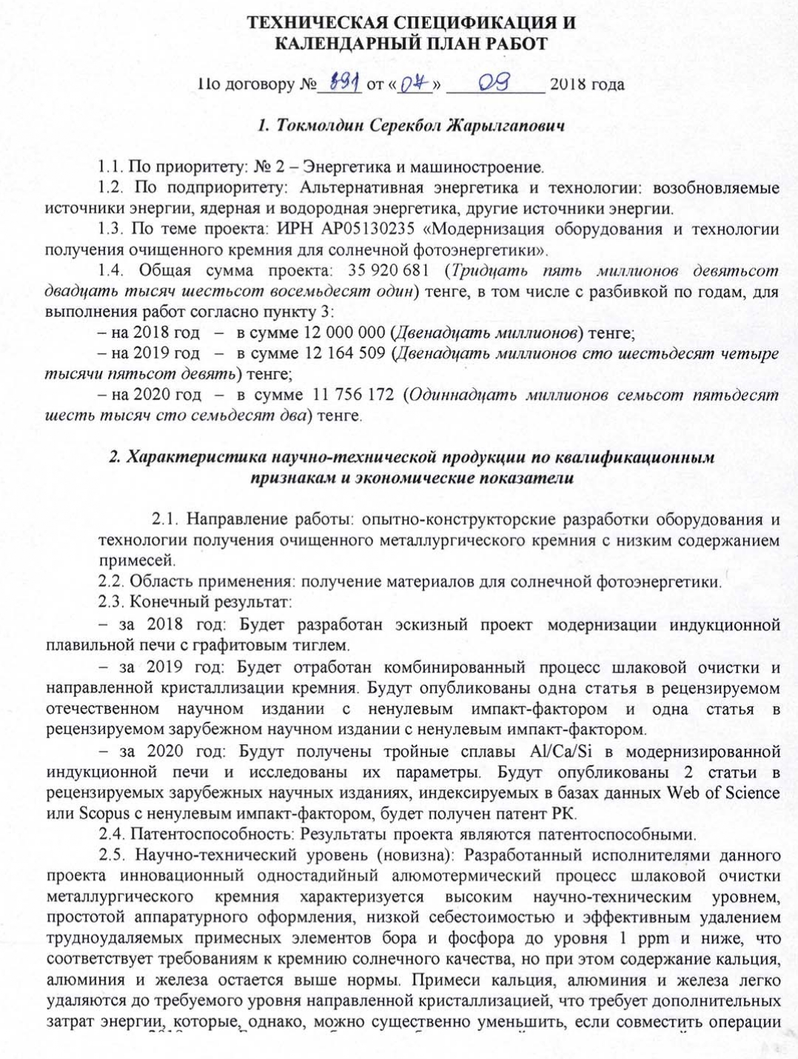
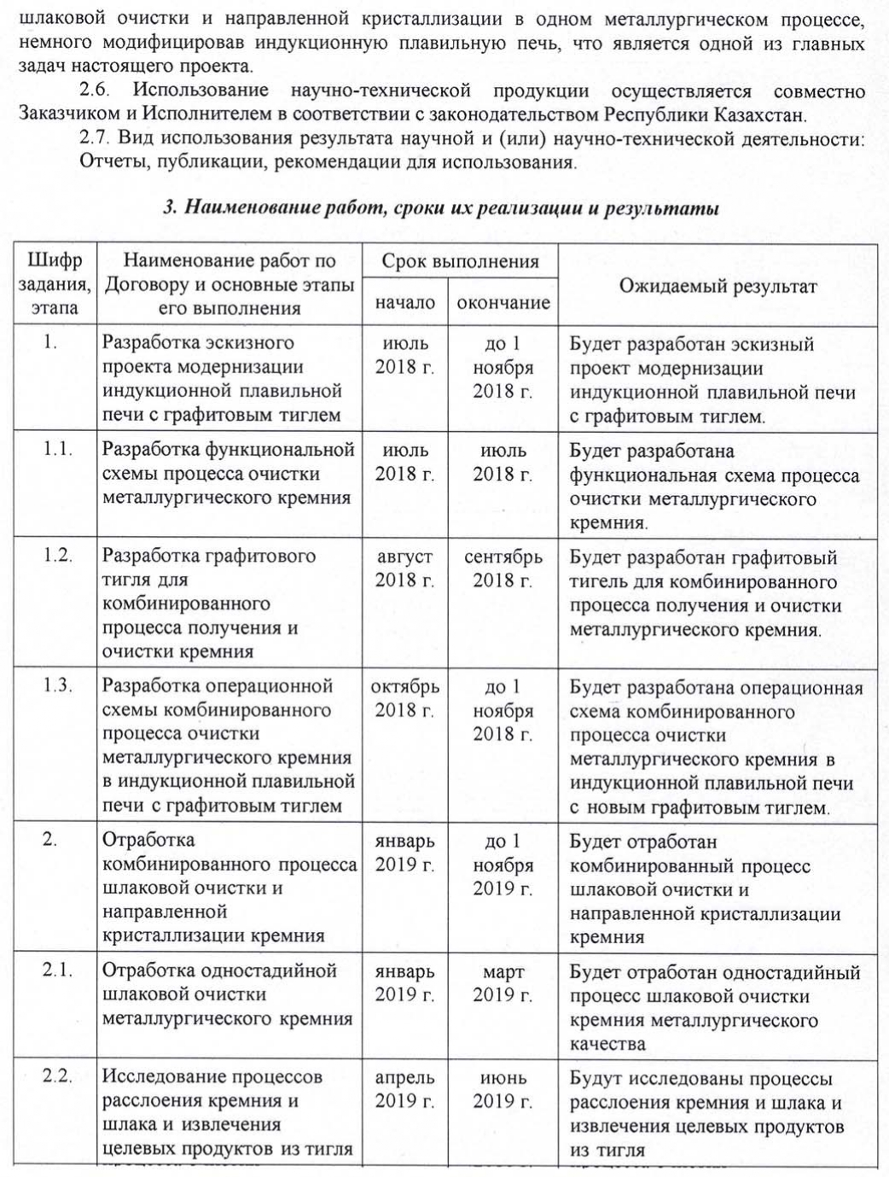
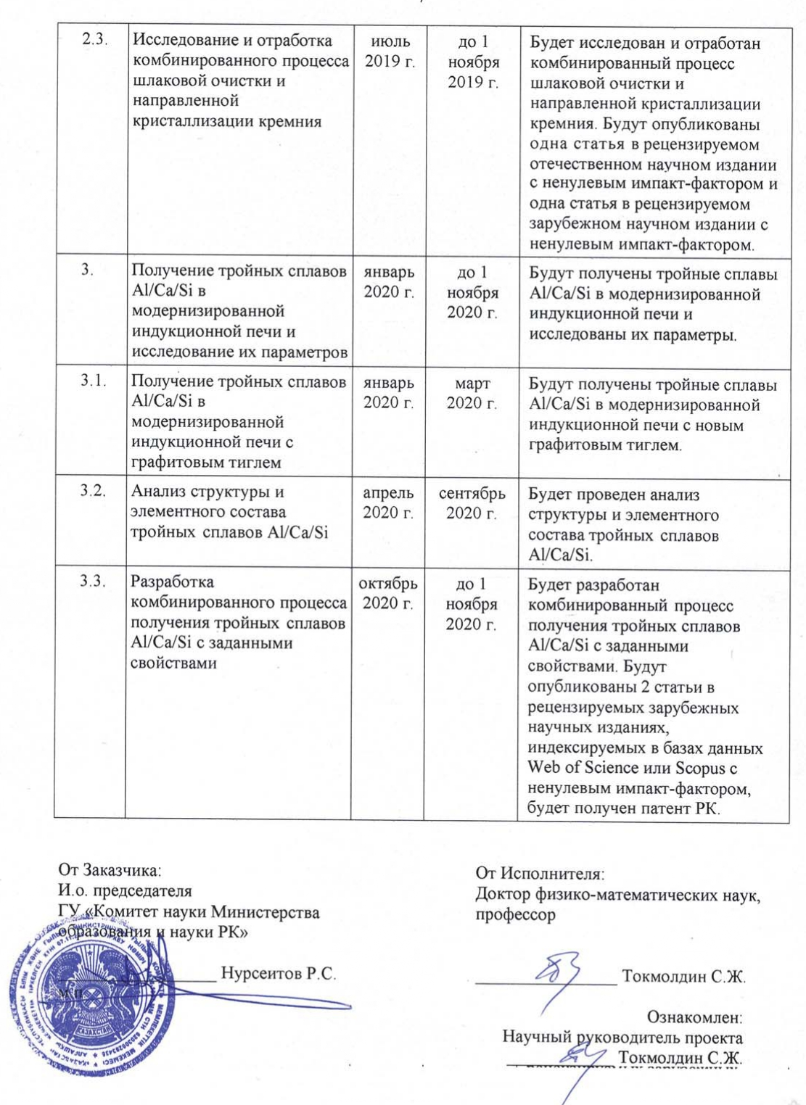

TECHNICAL SPECIFICATIONS AND WORKPLAN
Under contract No. 391 dated "07" 09 2018

1. Tokmoldin Serekbol Zharylgapovich

1.1. By priority: No. 2 - Energy and mechanical engineering.
1.2. By sub-priority: Alternative energy and technologies: renewable energy sources, nuclear and hydrogen energy, other energy sources.
1.3. On the project topic: IRN AR05130235 «Modernization of equipment and technology for obtaining purified silicon for solar photovoltaics».
1.4. Total project amount: 35 920 681 (Thirty five million nine hundred twenty thousand six hundred eighty one) tenge, including with a breakdown by years, for the performance of work in accordance with paragraph 3:
– for 2018 – in total 12 000 000 (Twelve million) tenge;
– for 2019 – in total 12 164 509 (Twelve million one hundred sixty four thousand five hundred nine) tenge;
– for 2020 – in total 11 756 172 (Eleven million seven hundred fifty six thousand one hundred seventy two) tenge.

2. Characteristics of scientific and technical products by qualification characteristics
and economic indicators

2.1. Direction of work: development of equipment and technology for obtaining purified metallurgical silicon with a low content of impurities.
2.2. Application: obtaining materials for solar photovoltaics.
2.3. Final result:
- 2018: A draft design for the modernization of an induction melting furnace with a graphite crucible will be developed.
- 2019: Combined process of slag cleaning and directional crystallization of silicon will be developed. One article will be published in a peer-reviewed domestic scientific journal with a non-zero impact factor and one article in a peer-reviewed foreign scientific journal with a non-zero impact factor.
- 2020: Ternary alloys Al / Ca / Si will be obtained in a modernized induction furnace and their parameters will be investigated. 2 articles will be published in peer-reviewed foreign scientific journals, indexed in the Web of Science or Scopus databases with a non-zero impact factor, a patent of the Republic of Kazakhstan will be obtained.
2.4. Patentability: Project results are patentable.
2.5. Scientific and technical level (novelty): The innovative one-stage aluminothermal process of slag cleaning of metallurgical silicon developed by the executors of this project is characterized by a high scientific and technical level, simplicity of hardware design, low cost and effective removal of stubborn impurity elements of boron and phosphorus to a level of 1 ppm and below, which meets the requirements for solar grade silicon, but the content of calcium, aluminum and iron remains above the norm. Impurities of calcium, aluminum and iron are easily removed to the required level by directional crystallization, which requires additional energy consumption, which, however, can be significantly reduced if the operations of slag cleaning and directional crystallization are combined in one metallurgical process, by slightly modifying the induction melting furnace, which is one of the main tasks of this project.
2.6. The use of scientific and technical products is carried out jointly by the Customer and the Contractor in accordance with the legislation of the Republic of Kazakhstan.
2.7. Type of use of the result of scientific and (or) scientific and technical activities: Reports, publications, recommendations for use.

3. Name of work, terms of their implementation and results

Job code, stage | Name of work under the Agreement and the main stages of its implementation | Period of execution |  | Expected Result
Job code, stage |  | start | ending | Expected Result
1. | Development of a draft design for the modernization of an induction melting furnace with a graphite crucible | July 2018 | until Nov. 1 2018 | A draft design for the modernization of an induction melting furnace with a graphite crucible will be developed
1.1. | Development of a functional scheme of the metallurgical silicon purification process | July 2018 | July 2018 | A functional diagram of the metallurgical silicon purification process will be developed
1.2. | Development of a graphite crucible for a combined process for the production and purification of silicon | August 2018 | September 2018 | A graphite crucible will be developed for a combined process for the production and purification of metallurgical silicon
1.3. | Development of an operating scheme for a combined purification process for metallurgical silicon in an induction melting furnace with a graphite crucible | October 2018 | until Nov. 1 2018 | An operating scheme will be developed for a combined purification process for metallurgical silicon in an induction melting furnace with a new graphite crucible
2. | Development of the combined process of slag cleaning and directional crystallization of silicon | January 2019 | until Nov. 1 2019 | The combined process of slag cleaning and directional crystallization of silicon will be developed
2.1. | Development of one-stage slag cleaning of metallurgical silicon | January 2019 | March 2019 | One-stage process of slag cleaning of metallurgical grade silicon will be developed
2.2. | Study of the processes of separation of silicon and slag and the extraction of target products from the crucible | April 2019 | June 2019 | The processes of separation of silicon and slag and extraction of target products from the crucible will be investigated
2.3. | Research and development of the combined process of slag cleaning and directional crystallization of silicon | July 2019 | until Nov. 1 2019 | The combined process of slag cleaning and directional crystallization of silicon will be studied and tested. One article will be published in a peer-reviewed domestic scientific journal with a non-zero impact factor and one article in a peer-reviewed foreign scientific journal with a non-zero impact factor
3. | Production of ternary alloys Al / Ca / Si in a modernized induction furnace and study of their parameters | January 2020 | until Nov. 1 2020 | Ternary alloys Al / Ca / Si will be obtained in a modernized induction furnace and their parameters will be investigated
3.1. | Obtaining of ternary alloys  Al / Ca / Si in a modernized induction furnace with a graphite crucible | January 2020 | March 2020 | Al / Ca / Si ternary alloys will be obtained in a modernized induction furnace with a new graphite crucible
3.2. | Analysis of the structure and elemental composition of ternary alloys Al / Ca / Si | April 2020 | September 2020 | The analysis of the structure and elemental composition of ternary alloys Al / Ca / Si will be carried out
3.3. | Development of a combined process for obtaining ternary Al / Ca / Si alloys with desired properties | October 2020 | until Nov. 1 2020 | A combined process for producing ternary Al / Ca / Si alloys with desired properties will be developed. 2 articles will be published in peer-reviewed foreign scientific journals, indexed in the Web of Science or Scopus databases with a non-zero impact factor, a patent of the Republic of Kazakhstan will be obtained

From Customer: From the Contractor:
Acting Chairman Doctor of Phys. & Mathem. Sciences,
State Institution «Science Committee Professor
of the Ministry of Education and Science
of the Republic of Kazakhstan»

__________________ Nurseitov R.S. ________________ Tokmoldin S.Zh.
place of stamp
Acquainted:
Scientific supervisor of the project
____________ Tokmoldin S.Zh.
APPENDIX B
LIST OF PUBLISHED ARTICLES
Published work in a domestic scientific journal in 2019

1 Chumikov G.N., Klimenov V.V., Tokmoldin N.S., Tokmoldin S.Zh. Obtaining homogeneous silicon in the process of alumothermic reduction of silicon dioxide // Eurasian journal of physics and functional materials. – 2019. – No. 3 (2). – Р. 155-163; http://ephys.kz/files/2019-06-18_07_20190302.pdf (date of access 2020-06-08).
The article was found in the RSCI databases. The two-year impact f(date of access 2020-06-08)actor of the RSCI without self-citation is 0.037. Two-year impact factor RSCI, taking into account citation from all sources 0.093 (https://www.elibrary.ru/title_profile.asp? id=67364). Quoted in databases: Index Copernicus International Ltd, Poland; CrossRef (World); Google Scholar; Science Library Index (Meadow Springs, Mandurah State, Australia); Scilit (Basel, Switzerland); ResearchBib (World), DOAJ, KKSON RK.

Published work in a foreign scientific journal in 2019
1 Ersin Bahceci, Brian Enders, Zain Yamani, Serekbol Tokmoldin, Aman Taukenov, Laila Abuhassan, and Munir Nayfeh. Proximal probe-like nano structuring in metal-assisted etching of silicon // AIP Advances. – 2019. – Vol. 9. – P. 055228-1 – 055228-7; https://doi.org/10.1063/1.5096659. (date of access 2020-06-10)
The article was found in the Web of Science Core Collection and Scopus databases. At the time of publication of the article in 2019, AIP Advances magazine had an Impact Factor of 1.579, a CiteScore for 2018 of 2.5, and a percentile in Physics and Astronomy of 56.

APPENDIX C
LIST OF AWARDED PATENTS

- Patent No. 5297: CO1B33 / 023. Method of obtaining metallurgical silicon of high purity from natural quartz sands by the method of aluminothermy / Tokmoldin NS, Chumikov GN, Tokmoldin S.Zh. – Application No. 2020/0088.2. – Priority from 01/30/2020. – Published on October 23, 2020, bul. №42. (Патент № 5297: СO1B33/023. Способ получения металлургического кремния повышенной чистоты из природных кварцевых песков методом алюминотермии / Токмолдин Н.С., Чумиков Г.Н., Токмолдин С.Ж. – Заявка №2020/0088.2. – Приоритет от 30.01.2020. Опубликовано 23.10.2020, бюл. №42)
- Patent KZ 34266p: C01B 33/04 (2006.01); C01B 33/06 (2006.01). Method of obtaining ternary intermetallic alloy of composition CaAl2Si2 for silane synthesis / Tokmoldin N.S., Tokmoldin S.Zh., Chumikov G.N. – Application № 2018/0795/1. – Priority from 10/26/2018. – Published on April 30, 2020, bul. № 17. (Патент KZ 34266р: C01B 33/04 (2006.01); C01B 33/06 (2006.01). Способ получения тройного интерметаллического сплава состава CaAl₂Si₂ для синтеза силана / Токмолдин Н.С., Токмолдин С.Ж., Чумиков Г.Н. – Заявка №2018/0795/1. – Приоритет от 26.10.2018. – Опубликовано 30.04.2020, бюл. №17)

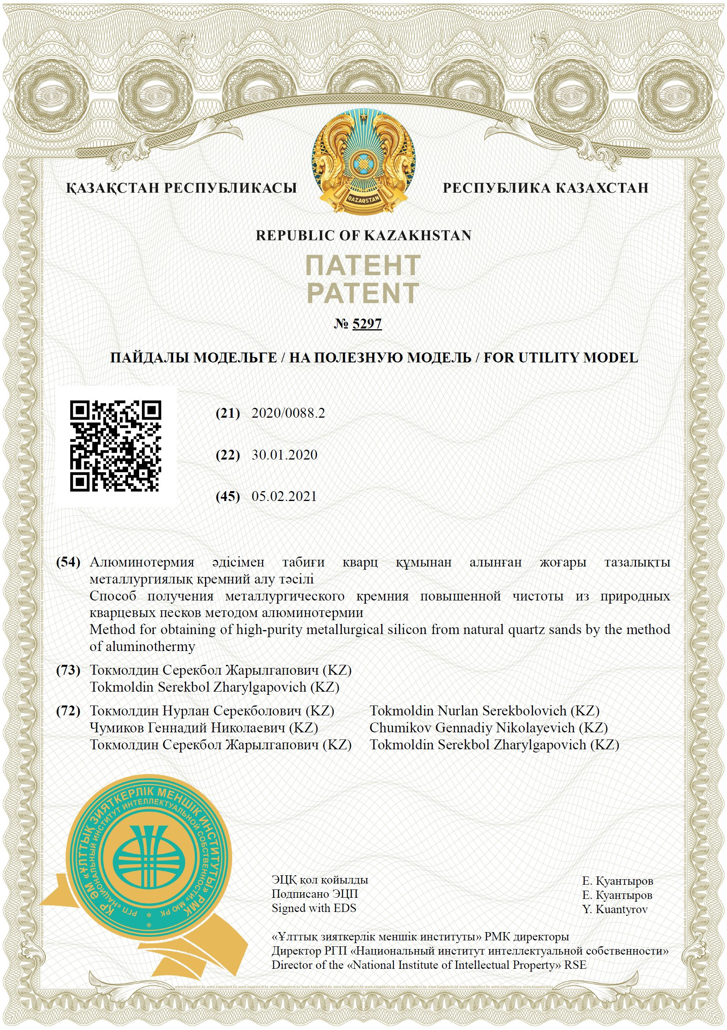
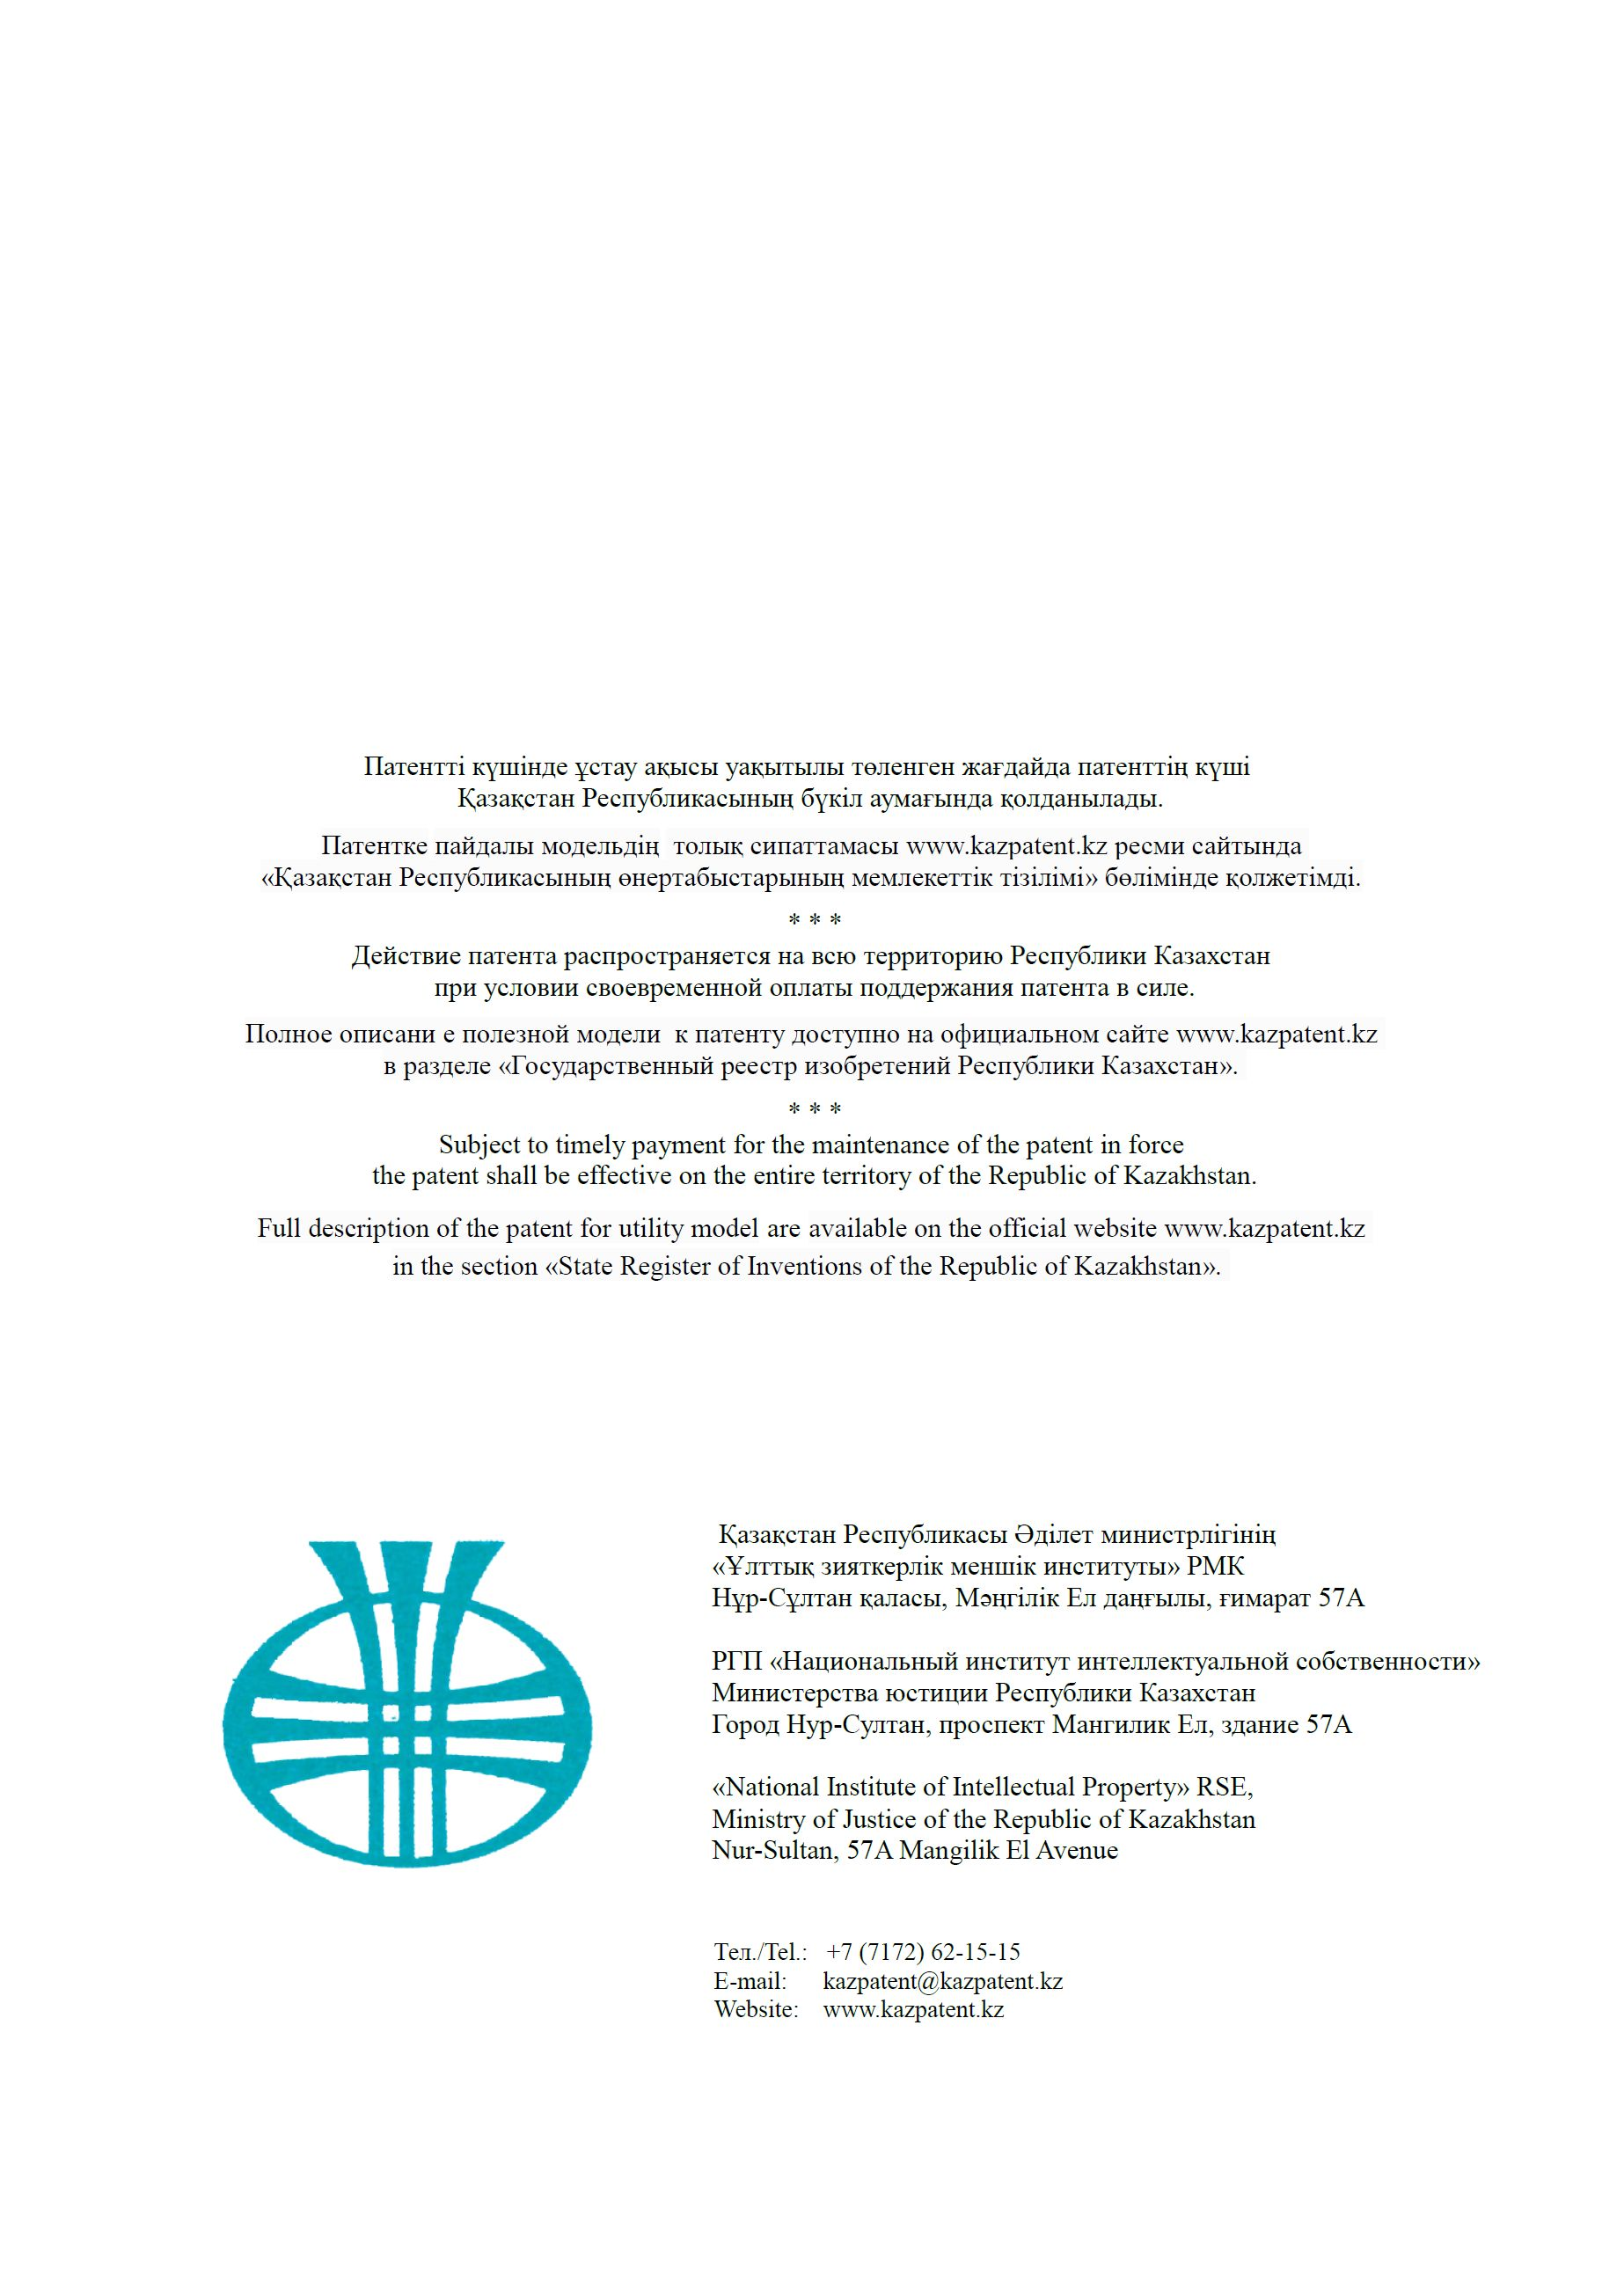
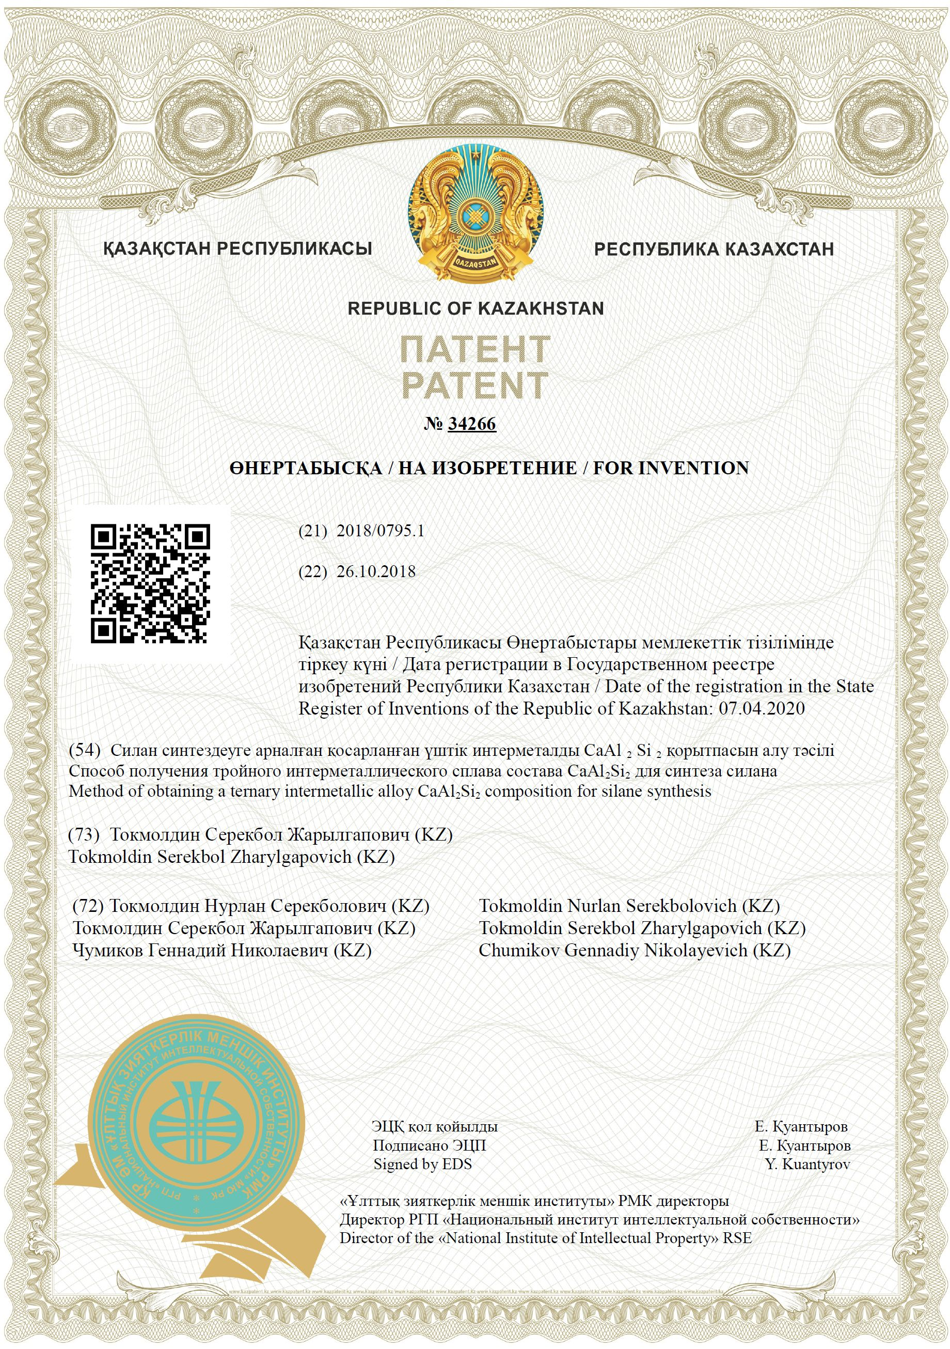
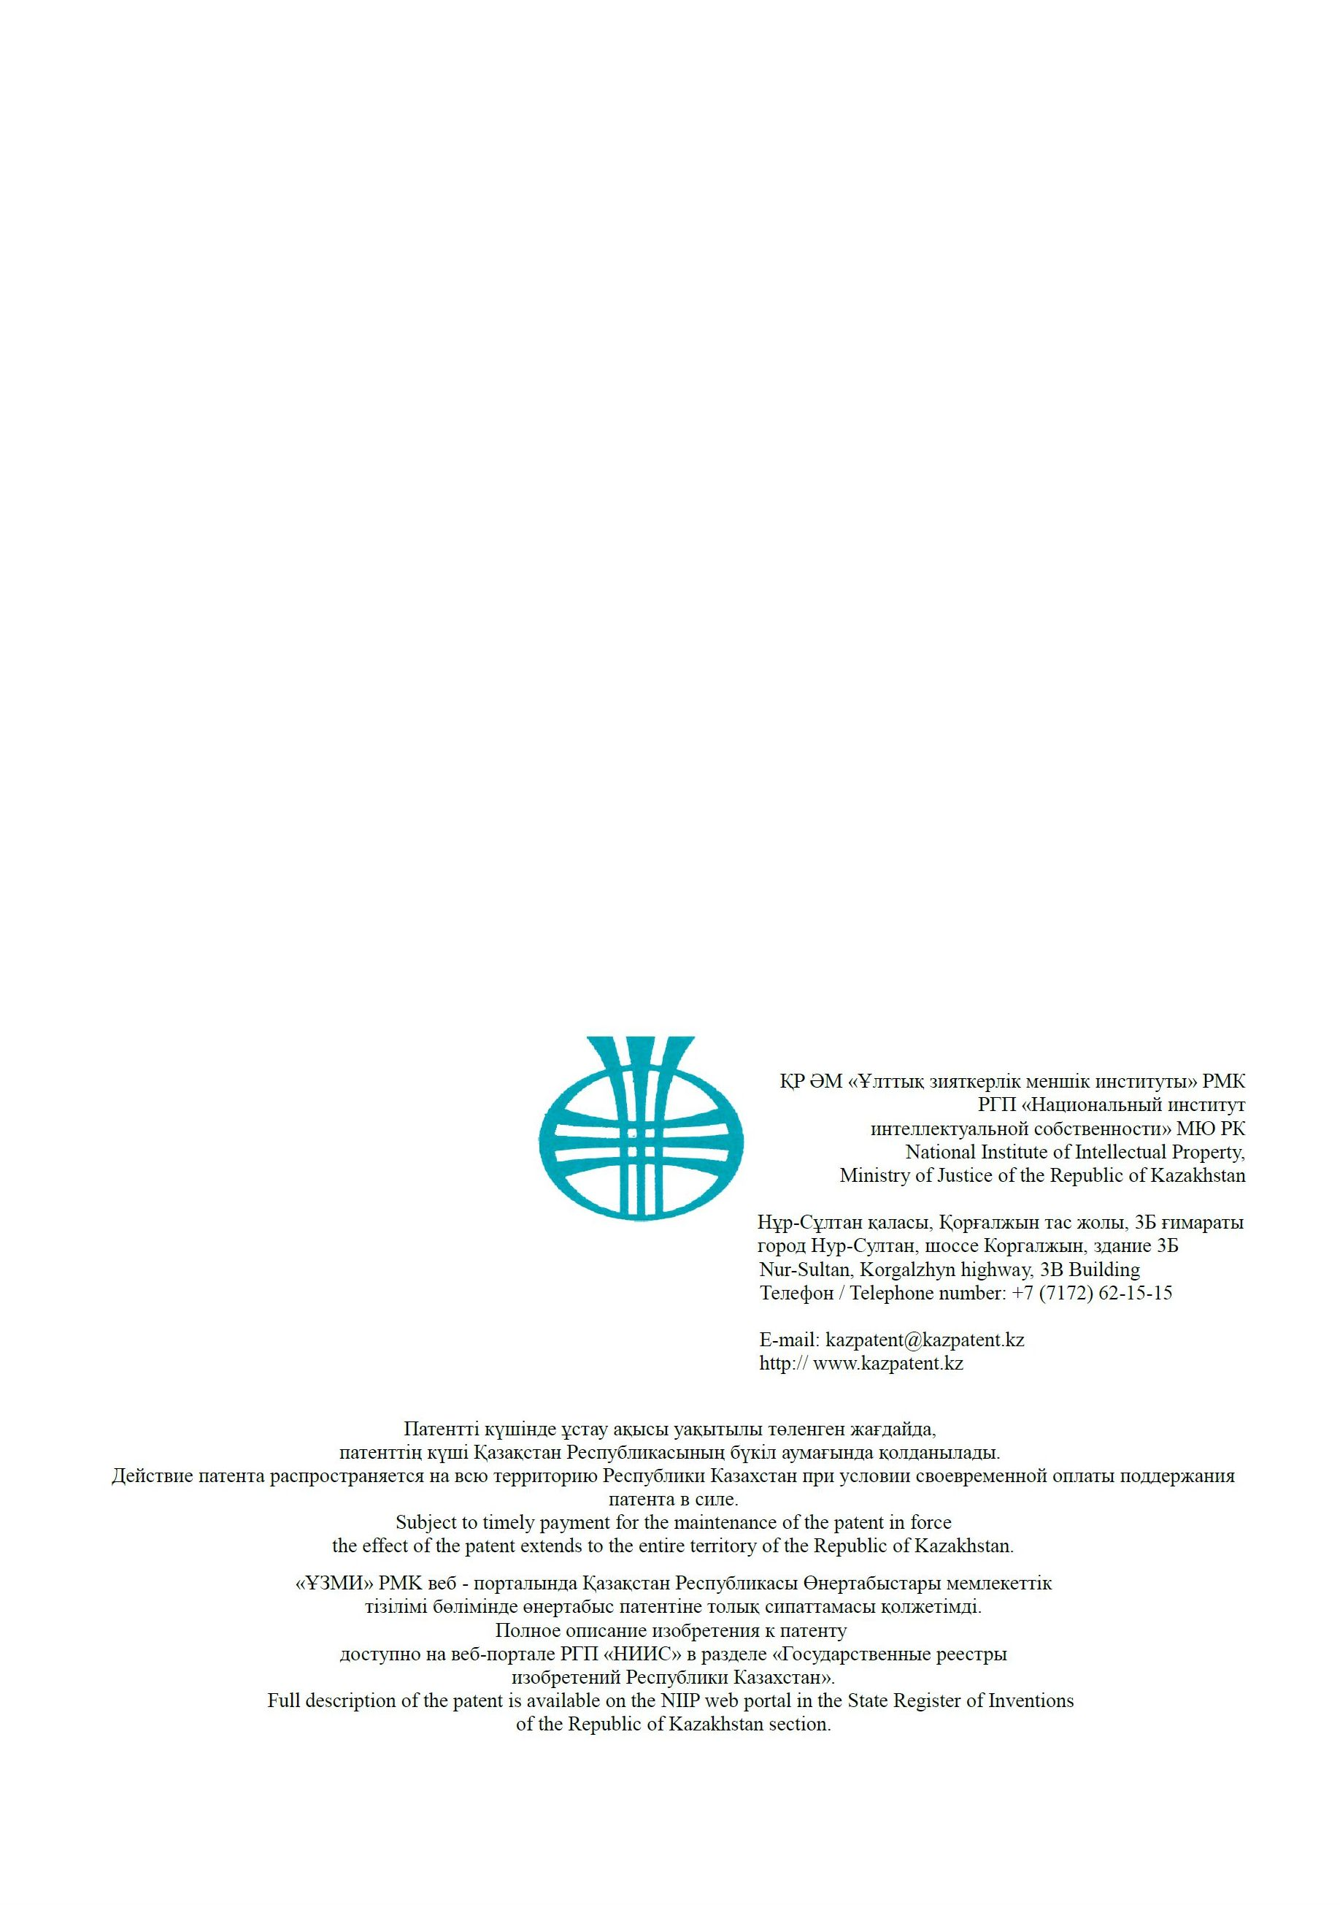

APPENDIX D
List of submitted patent applications

- Application for obtaining a Eurasian patent for invention No. KZ2020 / 056: C01B33 / 06. Method of obtaining ternary intermetallic alloy of composition CaAl2Si2 for silane synthesis / Tokmoldin N.S., Tokmoldin S.Zh., Chumikov G.N. – Priority from 09/11/2020. (Заявка на получение евразийского патента на изобретение № KZ2020/056: C01B33/06. Способ получения тройного интерметаллического сплава состава CaAl₂Si₂ для синтеза силана / Токмолдин Н.С., Токмолдин С.Ж., Чумиков Г.Н. – Приоритет от 11.09.2020)
- Application for obtaining a Eurasian patent for an invention No. KZ2020 / 055: C01B33 / 04, C01B33 / 06. Method for the synthesis of silanes in a flow reactor with counter streams of powdered raw materials and an active reagent / Tokmoldin S.Zh. – Priority from 09/11/2020. (Заявка на получение евразийского патента на изобретение № KZ2020/055: C01B33/04, C01B33/06. Способ синтеза силанов в проточном реакторе со встречными потоками порошкообразного сырья и активного реагента / Токмолдин С.Ж. – Приоритет от 11.09.2020)

