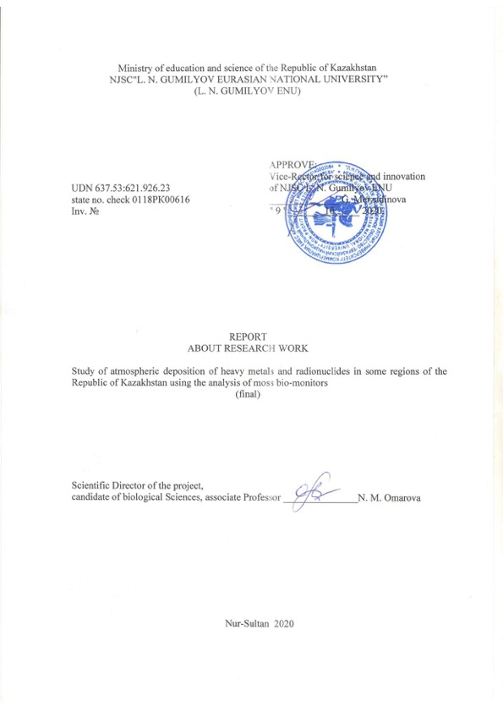

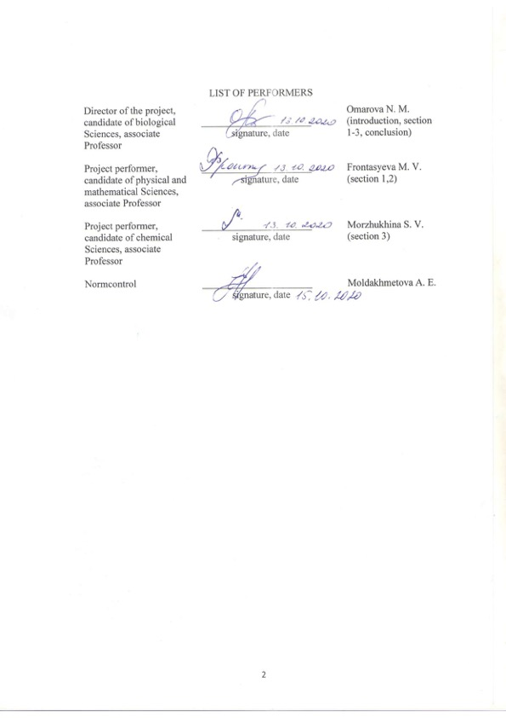

REPORT

Report 38 p., 38 figures, 7 tables, 25 sources, 5 appendixes.
MOSSES-BIOINDICATORS, HEAVY METALS, RADIONUCLIDES, ATMOSPHERIC PRECIPITATION, NEUTRON ACTIVATION ANALYSIS
Object of study: The content of heavy metals and radionuclides in the air in central Kazakhstan.
Purpose: to determine the degree of contamination with toxic elements using bioindicators.
Methods:
- (1) instrumental neutron activation analysis (INAA),
- (2) atomic adsorption spectrometry (AAS).
Research results: The method of moss biomonitors in combination with neutron activation analysis was used to determine the level of heavy metals in the territory of the Karaganda region. All experiments were carried out at the PFR-2 reactor using the REGATA pneumatic transport unit, based on instrumental neutron activation analysis (INAA) at the Neutron Physics laboratory of the joint Institute for Nuclear Research. The final stage of the work is the mapping of the studied territory based on the data obtained using GIS technologies.
Field of application: The results of such research will serve as a good basis for local administrations and environmental services in solving problems of environmental protection, assessing the risk to human health living in polluted regions. Based on the small number of territories studied, we can say that it is necessary to increase the sampling area and continue work throughout the territory of the Republic of Kazakhstan in order to study the state of the atmosphere in detail.

CONTENT

 | INTRODUCTION………………………………………………………………… | 6
 | 1 The choice of research direction…………………………………………………. | 8
 | 2 Research methodology……………………………………………………………. | 10
 | 2.1 Neutron activation analysis…………………………………………………… | 10
 | 2.2 Atomic absorption spectrometry……………………………………………… | 10
 | 2.3 Irradiation process at the PFR-2 reactor and processing  of gamma-spectrometric information………………………………………… | 13
 | 2.4 Sample preparation for atomic absorption analysis…………………………… | 14
 | 3 Results and discussions……………………….………………………………….. | 15
 | 3.1 The results of neutron activation analysis and atomic absorption spectrometry... | 15
 | 3.2 Correlation analysis…………………………………………………………... | 17
 | 3.3 Multivariate statistical analysis (factor analysis)……………………………… | 20
 | 3.4 Comparison of results with other countries…………………………………… | 33
 | 3.5 Building a map using the ArcGIS software…………………………………… | 38
 | CONCLUSION……………………………………………………………………... | 42
 | LIST OF SOURCES USED………………………………………………………… | 43
 | APPENDIX A - Results of neutron activation analysis for short-lived isotopes…… | 45
 | APPENDIX B - Results of neutron activation analysis for long-lived isotopes -1…. | 47
 | APPENDIX C - Results of neutron activation analysis for long-lived isotopes -2…. | 49
 | APPENDIX D - List of publications on research results…………………………… | 51
 | APPENDIX E - Technical specification and work schedule……………………….. | 55

LIST OF ABBREVIATIONS AND SYMBOLS

In this draft, the following terms are used with the appropriate designations:

PFR-2 – pulse fast reactor;
NAA – neutron activation analysis;
AAS – atomic absorption spectrometry;
LNP of JINR – Laboratory of neutron physics of the joint Institute for nuclear research;
HM – heavy metals;
GIS - geographical information technology;
SLI – short-lived isotopes;
LLI – long-lived isotopes

INTRODUCTION

Relevance of the work. Air pollution is one of the main problems facing humanity over the past few decades. Among the numerous substances released into the atmosphere as a result of anthropogenic impacts, special attention is paid to heavy metal. Increasing accumulation of heavy metals (HM) can lead to disruption of the ecological balance, and HM can also cause serious diseases in humans.

Scientific novelty. Currently, the method of mosses-bioindicators is being actively developed for atmospheric air biomonitoring. In the late 1980s, the international cooperative program for studying the effects of air pollution on natural vegetation and crops (ICP Vegetation, formally ICP Crops) was founded. ICP Vegetation is attended by scientists from 40 countries (Harmens et al., 2013b). The program is coordinated by the Centre for Ecology and Hydrology (CEH) in Bangor, UK. Since 2014, the joint Institute for nuclear research (JINR) (Dubna, Russian Federation) has been coordinating European simultaneous moss collections (https://icpvegetation.ceh.ac.uk/) [1-3]. The laboratory of neutron physics of the joint Institute for nuclear research (JINR) has been working for many years to study air pollution with heavy metals using neutron activation analysis [1]. since 2015, Kazakhstan has been participating in this program of the UN Commission on long-range transboundary transport of air pollution in Europe (UNECE LRTAP) using the moss-biomonitor method [2]. This paper presents for the first time the results of studies on heavy metal pollution in Central Kazakhstan.

The purpose of the work is to determine the degree of contamination in the Karaganda region with toxic elements using bioindicators.

​ Tasks:
- collect samples of moss samples in the Karaganda region of the Republic of Kazakhstan;
- analyzing scientific data on the indicator values of mosses; ​
- correlate the results of analyses identified by the NAA and AAS methods;
- correlate points of contamination of the territory from other countries with the results of the work;
- generate maps of the distribution area of heavy metal pollution using GIS technologies;
- summarize the results of the study;
- summarize the level of contamination of the area under development.

Scientific and practical significance. In the field of atmospheric precipitation biomonitoring, project group C of The Gumilyov ENU works with the Joint Institute for nuclear research (JINR) of the Russian Federation (RF). since 2014, the UN air Europe Program has been implemented from the JINR [2,3].

The work was performed in the laboratory of neutron physics, in the sectors of activation analysis and radiation research of the I. M. Frank research and experimental Department of physics of the joint Institute for Nuclear Research, Dubna, Moscow region, Russian Federation. Today's analysis was carried out on the basis of the PFR -2 pulse fast reactor of the LNP of the JINR, including in the laboratory of the Department of chemistry, new technologies and materials of the Dubna State University.

The interim report for 2018 "Study of atmospheric deposition of heavy metals and radionuclides in some regions of the Republic of Kazakhstan using the analysis of moss bio-monitors" was registered with the inventory number 0218PK00354 in the National center of science and technology evaluation.

The interim report for 2019 "Study of atmospheric deposition of heavy metals and radionuclides in some regions of the Republic of Kazakhstan using the analysis of moss bio-monitors" was registered with the inventory number 0219PK00287 in the National center of science and technology evaluation.

- The choice of research direction

In the modern world, the degree of anthropogenic impact increases with the technical equipment of society. At the first stages of anthropogenic development, it was extremely weak. However, with the development of society and labor productivity, the situation began to change dramatically. The last century was called the century of scientific and technological progress. At this time, such spheres of human life as science, technology and technology began to develop progressively, opening up new opportunities for humanity and, at the same time, creating a new global problem for it – the environmental one. What does the term "ecology" mean? This word was first proposed by the German biologist E. Haeckel in 1866, meaning science, the subject of which is the relationship between man and nature.

A comprehensive environmental assessment of the human environment is possible only with well-organized environmental monitoring. In this environmental assessment involves the following steps: identification and comprehensive characterization of sources of environmental pollution, trace pollutants flows through all possible channels of migration, biogeochemical assessment of migration and concentration of pollutants in living organisms directly in the polluted zones, and with regard to their transfer through trophic chains, revealing the dynamics of environmental pollution and materials looking.

The chemical industry makes a special "contribution" to global pollution. Man-made factories pollute the air with substances such as dust, fuel oil ash, sulfur and nitrogen oxides, various toxic compounds, etc. Sampling of atmospheric air revealed its catastrophic condition, which caused many chronic respiratory diseases. Air pollution is an acute problem known in every corner of our planet. Cities where oil refining, chemical, metallurgical, energy, construction, and pulp and paper industries operate have a critically high level of pollution [4]. In addition, boilers and motor vehicles, releasing combustion products into the atmosphere, also poison the air. Together, all of the above factors are anthropogenic causes of atmospheric pollution. Among the numerous substances released into the atmosphere as a result of anthropogenic impacts, special attention is paid to heavy metal. Increasing accumulation of heavy metals (HM) can lead to disruption of the ecological balance, and HM can also cause serious diseases in humans. For these reasons, it is very important to work together across sectors and national borders. In order to improve air quality at various levels, member States of The United Nations economic Commission for Europe are successfully working to gradually reduce and prevent air pollution in the region. One of the means to achieve this goal was the Convention on long-range transboundary air pollution, which was signed in 1979. Over the years, it has been expanded into eight protocols that define specific measures that Parties should take to reduce their air-polluting emissions. The air Convention provides access to emission data, measurements and models. It also contains information on the effects of air pollution on ecosystems, health, crops, and materials [3]. The source of the chemical compounds are at ground level, and they mix with the air of the troposphere. They are called primary pollutants. Some of them may react chemically with other pollutants or with air components and form secondary pollutants. As a result, photochemical smog and acid rain are observed, and ozone is formed in the surface layer of the atmosphere. Photochemical acids contained in the atmosphere are dangerous for human health and environmental changes [4]. Despite the fact that heavy metals are usually called a group of chemical elements with an atomic mass of more than 40, some trace elements that are vital are also part of this group.

Since the industry is rapidly developing, and therefore the environment is polluted, the most attention is paid to anomalies of elements, mainly HM, that have an industrial origin.

2 Research methodology

2.1 Neutron activation analysis

Neutron activation analysis (NAA) is a nuclear process used to determine the concentrations of elements in a sample. The range of elements determined by the rector of the PFR-2 LNP of JINR for vegetation includes Ag, Al, As, Au, B, Br, Ca, Cd, Ce, Cl, Cr, Cs, Cu, Dy, Eu, Fe, Ga, Hf, Hg, I, Ir, K, Li, Mg, Mn, Zn, Mo, Na, Ni, Rb, Sb, Se, Sn, Ta, Te, Th, W, V, U. analysis in most practical cases is from 1 to 10 percent, and the detection limit is from hundreds of nanograms to units of picograms.

Neutron activation analysis is divided into:

1) Radiochemical neutron activation analysis (RNAA), involving the use of chemical procedures to isolate activated elements in their pure form.

2) Instrumental neutron activation analysis (INAA), in which the identification and quantitative determination of elements in an irradiated sample is carried out selectively, using the variation of irradiation conditions – (energy of bombarding particles, the exposure time), and given the nuclear properties of elements and the resulting radionuclides (particularly schema-defined decay of radionuclides, half-life) [5,6].

2.2 Atomic absorption spectrometry

Atomic absorption spectrometry (AAS) is an instrumental method of quantitative elemental analysis that is widespread in analytical chemistry (modern methods of atomic absorption determination allow determining the content of almost 70 elements of the Periodic system) using atomic absorption spectra to determine the content of metals in solutions of their salts. AAS is characterized by high selectivity, sensitivity, and expressiveness. The development of this method of analysis, its improvement and wide acceptance in the entire field of analysis have fundamentally expanded the capabilities of analytical chemistry. For example, in many cases, the use of AAS for determining traces of metals has led to a significant displacement of such a well-known method as spectrophotometry, which is inferior to atomic absorption in selectivity, labor intensity and sensitivity. In terms of performance and speed of analysis of large batches of the same type of samples, flame absorption is superior to such classical chemical methods as gravimetric, titrimetric, spectrophotometric, electrochemical, etc. When determining ultra-low concentrations of individual elements, electrothermal atomic absorption successfully competes with many instrumental methods of analysis. At the moment, the AAS will allow you to identify about 70 elements – metals and non-metals. For most of the detected elements, it is possible to achieve relatively low detection limits: in the flame version – from tenths to tens and hundreds of micrograms/l; in the electrothermal version – from thousandths to tenths of micrograms/l. The absolute detection limits in the flame are-10-1 – 105ng, in the electrothermal version - 10-5 – 10ng. Also, the advantage of AAS is its versatility in relation to a wide variety of objects of analysis, as well as the possibility of using it both to determine traces and to reliably and accurately determine the main components in samples of complex compositions [7].

The method of mosses-biomonitors in combination with neutron activation analysis was used to determine the level of heavy metals in some part of the territory of Kazakhstan. All experiments were performed at the PFR-2 reactor using the REGATA pneumatic transport unit, based on instrumental neutron activation analysis (NAA) in the Neutron Physics laboratory of the joint Institute for Nuclear Research [5,8-11].
38 moss samples were collected on the territory of Central Kazakhstan, which is home to 35 major mining and processing enterprises (Figure 1-2). 6 species of mosses were collected: Hypnum cupressiforme, Brachythecium salebrosum, Abietinella abietina, Homalothecium sericeum, Homalothecium philippeanum, and Homalia trichomanoides (Figure 3) [12-14]. Sampling was carried out in accordance with the UN program [15-17] [https://icpvegetation.ceh.ac.uk/get-involved/manuals/moss-survey].

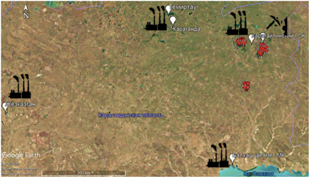

Figure 1 – The main map of sampling points in Karaganda region

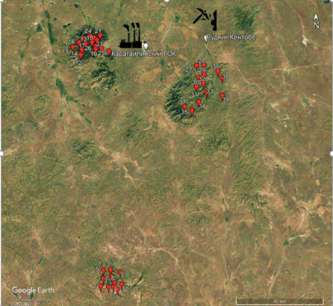

Figure 2 – The map of sampling points in the Karaganda region
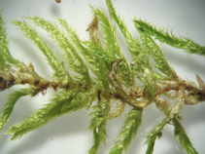  а) Hypnumcupressiforme | 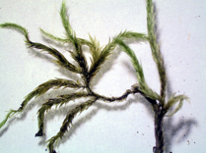  б)Brachythecium salebrosum
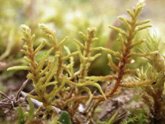  в) Abietinella abietina | 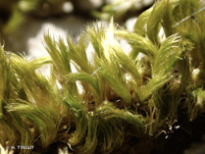  г) Homalothecium sericeum
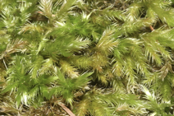  д) Homalothecium philippeanum | 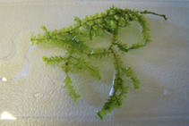  е) Homalia trichomanoides

Figure 3 - Types of mosses used in the study

Samples were prepared for irradiation in the SNAPPY chemical laboratory. Moss samples were not crushed, but dried at room temperature to a constant weight (Steinnes et al, 1994).

To determine the elements by short – lived isotopes, moss samples of about 0.3 g were Packed in plastic bags and in aluminum cups-by long-lived isotopes (Figure 4) [10,11,18].

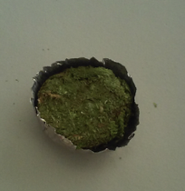 | 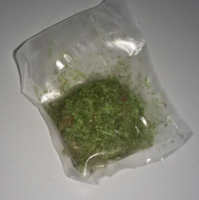

Figure 4 - Packed samples moss samples for NAA

2.3 Irradiation process at the PFR-2 rector and processing of gamma-spectrometric information

Instrumental neutron activation analysis (INAA) was performed at the PFR-2 pulse reactor at the JINR LNF in Dubna, using the REGATA pneumatic transport unit (PTU). Containers with samples for the determination of long-lived radionuclides were irradiated for 4-5 days in a channel with a cadmium screen. After irradiation, the samples were repackaged especially clean in plastic containers for measuring induced gamma activity. The induced gamma activity of the samples was measured twice after 4-5 days ( As, Br, K, La, Na, Mo, Sm, U, and W) and 20 days (Ba, Ce, Co, Cr, Cs, Fe, Hf, Ni, Rb, Sb, Sc, Sr, Ta, Tb, Th, Yb, and Zn). The measurement time was 40-50 minutes and 2.5-3 hours, respectively. To determine short-lived isotopes, moss samples Packed in plastic containers were irradiated for 3-5 minutes. After 5-7 minutes, induced gamma activity was measured twice for 3-5 minutes and 10-15 minutes sequentially. The induced gamma activity was measured using Ge (Li) detectors. The detector resolution is usually characterized by a resolution on the γ-lines of ⁶⁰ Co (1332 Kev) and ⁵⁷ Co (122 Kev). The resolution of the detectors used at the REGATTA is 2.5-3 Kev. The GENIE 2000 program package was used for processing gamma spectra, which includes the procedure for processing the gamma spectrum (automatic search for peaks, identification of radioactive isotopes, and determination of the concentrations of elements contained in the test sample), developed at the JINR LNF [1,5,8].

2.4 Sample preparation for atomic absorption analysis

For AAS, 0.3 g of moss samples were taken and placed in Teflon vessels. Then 5 ml of nitric acid and 2 ml of hydrogen peroxide were added to the sample vessels. For complete decomposition, the vessels were placed in a microwave system (Mars-6 microwave sample decomposition system, CEM(USA)). The samples were decomposed in two stages. At the first stage, at a temperature of 160 ⁰C, a pressure of 20 bar, a power of 400 V, and a time of 15 minutes. At the second stage, the temperature, pressure, and power remained unchanged, with a time of 10 minutes. After cooling to room temperature, the samples were transferred to a 100 ml flask and brought to the label with bi-distilled water [7].

Cd, Cu, and Pb were determined using an ICE 3400 atomic absorption spectrometer with electrothermal (graphite cell) atomization (Thermo Fisher Scientific, USA).

Quality control. Calibration solutions for AAS were prepared from a standard solution of 1 g/l (AAS standard solution; Merck, DE). For quality control, the NAA used the following certified standards of the National Institute of standards and technology (NIST, Gaithersburg, MD, USA): 1632c (NIST), 1633b (NIST), 1547(NIST). 1549 (NIST), 1633c (NIST), 2709 (NIST), as well as the IAEA reference material SL-1(IAEA).

3 Results and discussions
In total, 39 elements (Na, Mg, Al, Cl, K, Ca, Sc, Ti, V, Cr, Mn, Fe, Co, Ni, Cu, Zn, As, Br, Rb, Sr, Zr, Cd, Sb, I, Cs, Ba, La, Ce, Nd, Sm, Tb, Tm, Hf, Ta, W, Au, Pb, Th, and U) were determined using NAA and AAC. The median values and concentration ranges for the studied elements are shown in table 1 (Appendix A, B, and C). When studying the content of heavy metals in the territories near the Karagailinsky mining and processing plant and the Kentobe mine, moss samples were found to contain an excess of copper, zinc, manganese, iron, tungsten and lead. At the Kentobe mine, iron ore is extracted by open-pit mining. The source ore consists of heavy metals, which are released into the atmosphere as inorganic dust during transportation and processing of the ore. Mosses collected at a distance of 100 km from the copper smelter have the highest concentrations of zinc and copper. High lead concentrations are observed at points near the Balkhash mining and metallurgical plant and the Karagailinsky mining and processing plant [15-17]. The results indicate a high level of contamination with copper, zinc, lead and other toxic elements.
3.1 The results of neutron activation analysis and atomic absorption spectrometry
Table 1 - Average, median, minimum, maximum values of 39 elements obtained using NAA and AAS mg/kg
Element | Average | Median | Minimum | Maximum
1 | 2 | 3 | 4 | 5
Na | 605,08 | 441,5 | 187 | 2060
Mg | 2385,8 | 1835 | 1180 | 5850
Al | 3227,8 | 2435 | 967 | 11600
Cl | 412,1 | 124 | 56 | 2290
K | 7003,4 | 5740 | 3330 | 18200
Ca | 8010,5 | 6890 | 3970 | 15700
Sc | 0,7 | 0,49 | 0,103 | 5
Ti | 147,8 | 121,5 | 39 | 525
V | 4,2 | 3,1 | 0,8 | 18
Cr | 6,3 | 5,4 | 3,2 | 15,2
Mn | 187,7 | 154 | 53 | 584
Fe | 1732,1 | 1395 | 501 | 5050

continuation of table 1
1 | 2 | 3 | 4 | 5
Co | 0,7 | 0,615 | 0,326 | 1,47
Ni | 2,9 | 2,45 | 1,1 | 6,2
Zn | 61,1 | 49 | 16,5 | 179
As | 1,2 | 1,1 | 0,21 | 3,16
Br | 9,4 | 5,45 | 1,5 | 48
Rb | 12,8 | 10,05 | 4,95 | 38
Sr | 39,1 | 31,25 | 18 | 93
Zr | 11,8 | 7,95 | 2,3 | 55
Sb | 0,2 | 0,198 | 0,042 | 0,78
I | 2,7 | 1,615 | 0,63 | 30
Cs | 1,1 | 0,313 | 0,083 | 12,2
Ba | 124 | 114 | 10,7 | 305
La | 5,5 | 2,25 | 0,74 | 55
Ce | 5,8 | 3,655 | 0,96 | 27,6
Nd | 6 | 2,5 | 0,15 | 49
Sm | 1,4 | 0,45 | 0,115 | 12
Tb | 0,4 | 0,076 | 0,02 | 3,46
Tm | 0,4 | 0,06 | 0,005 | 4,5
Hf | 0,2 | 0,15 | 0,07 | 0,88
Ta | 0,1 | 0,033 | 0,01 | 0,287
W | 0,5 | 0,315 | 0,083 | 3
Au | 0 | 0,004 | 0,001 | 0,026
Th | 0,9 | 0,4275 | 0,19 | 12
U | 4,5 | 0,14 | 0,063 | 67
Cu | 10,7 | 9,27 | 5,43 | 21,88
Cd | 0,2 | 0,21 | 0,03 | 0,52
Pb | 6,9 | 6,95 | 1,47 | 16,71

3.2 Correlation analysis
Correlation analysis is a category of mathematical statistics that groups methods for studying relationships between random factors. The purpose of this analysis is to extract information about variables. If the goal is achieved, then the variables are interrelated, that is, they are correlated. Correlation means that the values of one variable change when the values of another variable change proportionally. Correlation does not imply a causal relationship between variables. Correlation analysis tools can have different correlation coefficients. The coupling coefficients are chosen depending on the methods of measuring variables, as well as the nature of the relationship between them [19].
High correlation coefficients (R) between some pairs of elements (R>0.80) indicate a strong relationship between these elements and suggest a single source of their entry into the atmosphere (Figures 5-8).
Let's look at the possibilities of using the data Analysis package in Microsoft Excel when performing correlation analysis.
The correlation is interpreted based on:
1) the correlation coefficient (r) and its square – the coefficient of determination (R2), which indicate the strength of the relationship; R2 is the proportion of variation common to two variables (in other words, the "degree" of dependence or connectivity of two variables);
2) the significance level calculated for each correlation coefficient, which allows us to judge the reliability of the correlation;
3) visual communication analysis.
To perform a correlation analysis, select the data Analysis option in the Data menu. In the window that appears, select an option. Correlation.
In the Correlation window, enter the Input interval – the data to be analyzed. In our example, grouping is performed by columns (the columns contain separate indicators by country). The Place mark field in the first row should be marked if the input interval is set together with the column/row headers.
In the output parameters section of the Window, specify where to output the correlation matrix (a square (or rectangular) table where the correlation coefficient between the corresponding parameters is located at the intersection of the corresponding row and column) [19].
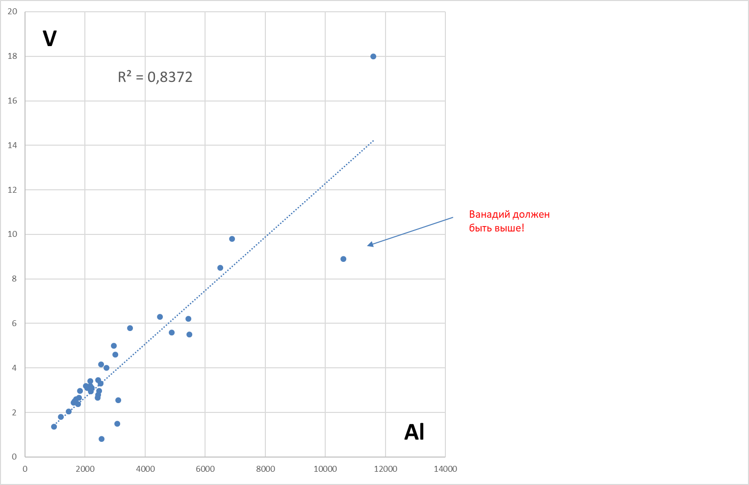

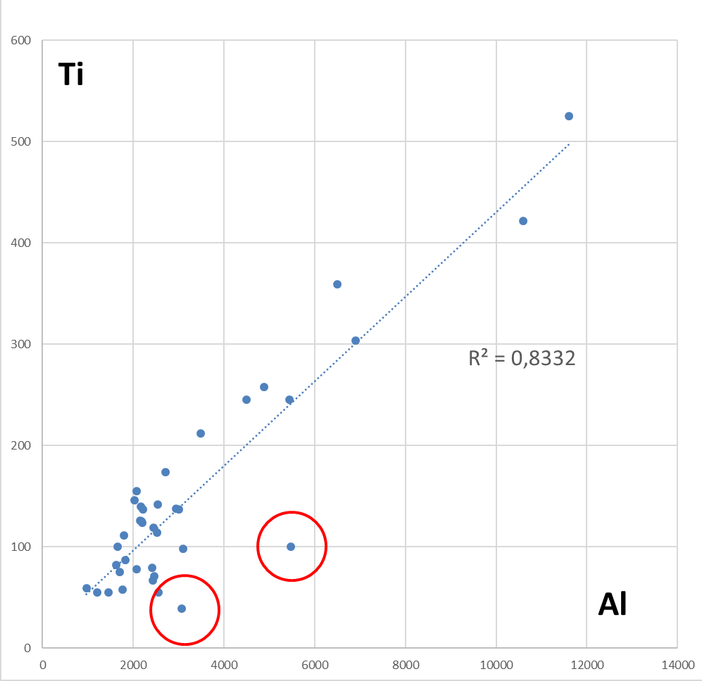
Figure 5 - Correlation between V and Al

Figure 6 - Correlation ratio of Ti and Al
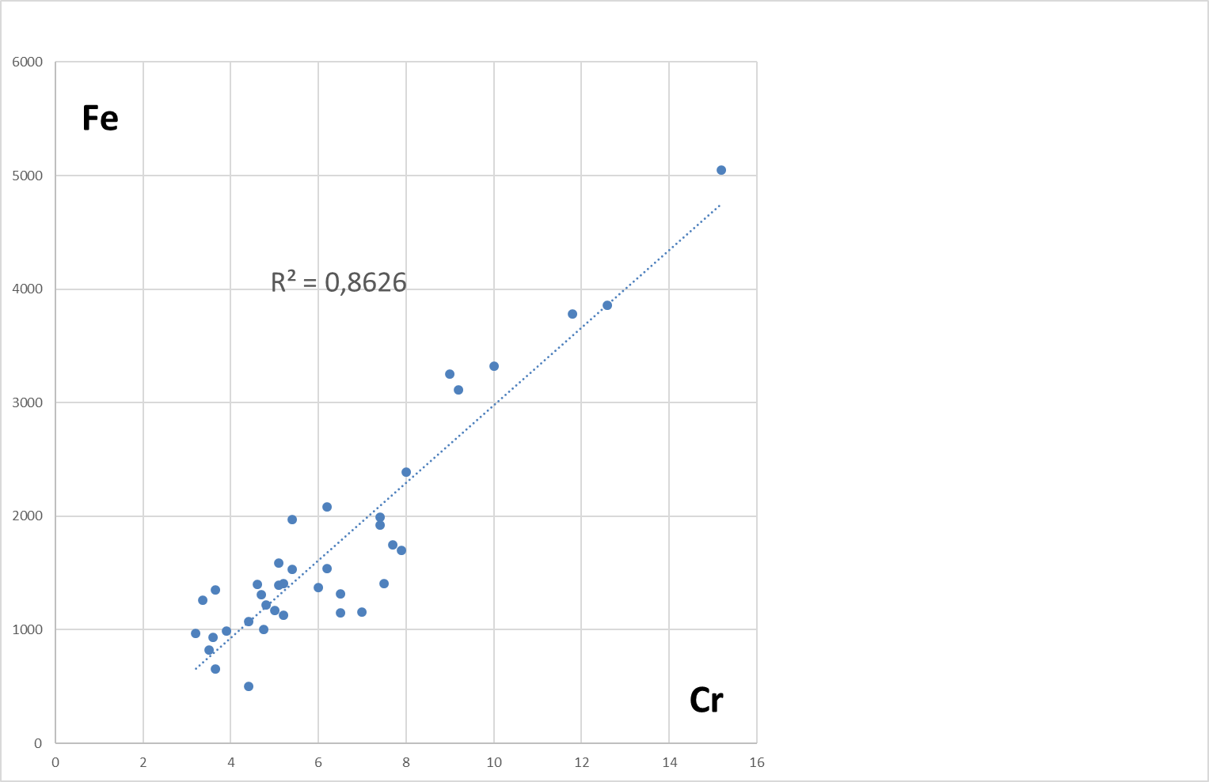

Figure 7 - Correlation ratio of Fe and Cr

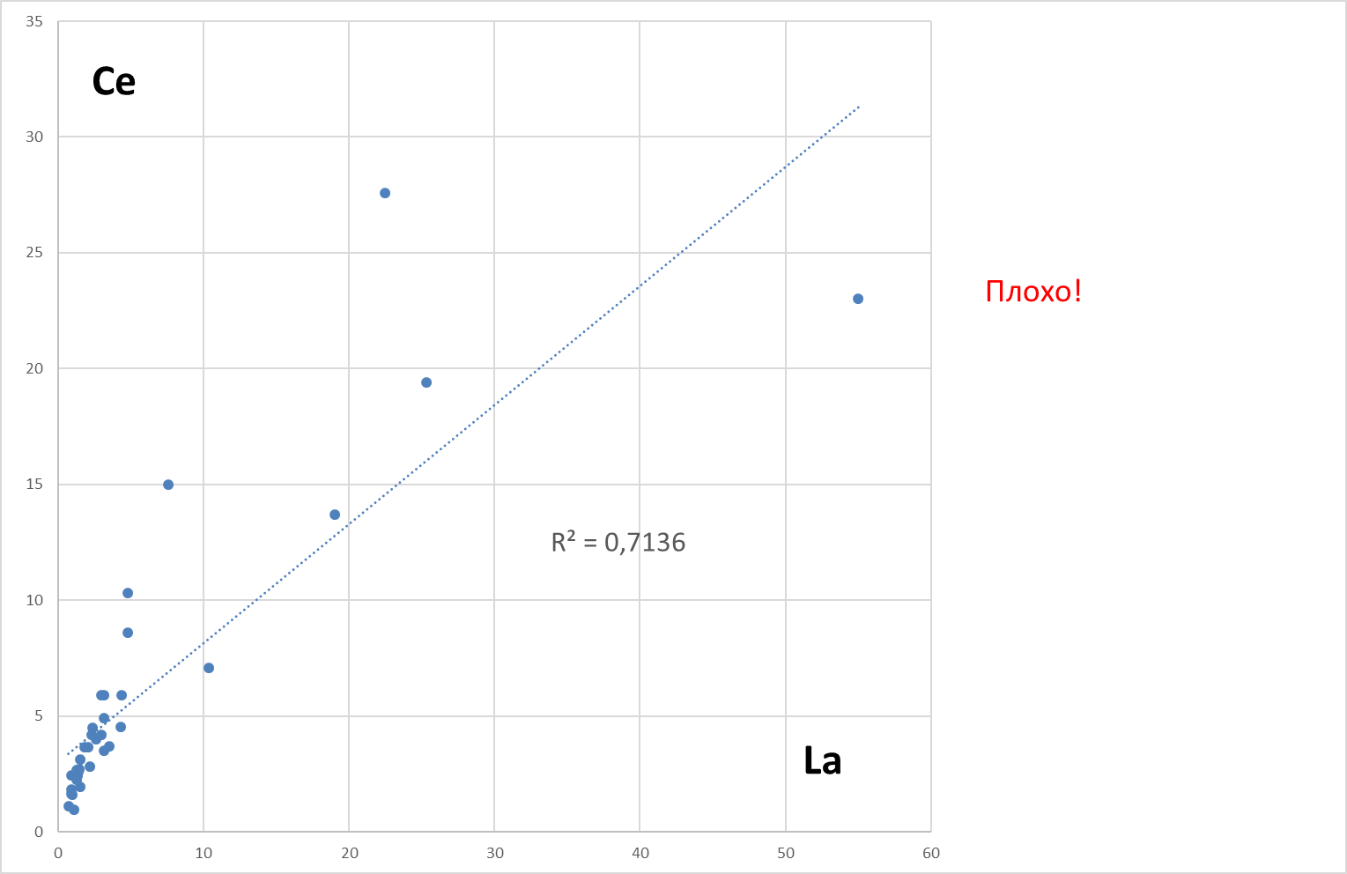

Figure 8 - Correlation between Ce and La

For example, the correlation coefficient R=0.86 between Cr and Fe clearly indicates that the single source of atmospheric precipitation of these elements is metallurgical production in the Karaganda region. The presence of Fe, Zn, Pb, V, Cu, W proves that iron ore is extracted in the region.

3.3 Multivariate statistical analysis (factor analysis)
To identify possible sources of environmental pollution by certain elements, we used the analysis of the main components (Principal Component Analysis) [20]. Factor analysis was used to identify the main components (factors). In contrast to correlation analysis, which establishes paired correlations (dependencies between pairs of elements), factor analysis allows you to identify dependencies between groups of data (in our case, these are elements that characterize a particular source of pollution). This approach is widely used in the analysis of atmospheric precipitation [21].
Table 2 shows data from the analysis of the main components (factor analysis) obtained using the standard program. Taking into account the structure of the region's industry and the location of individual plants and plants, we can offer the following interpretation of the results of factor analysis.
Factor 1: Light (Al, Mg, Ti, Ca, Sr, Cs, Ba) and heavy (Zn, Fe, Cr, Co, Ni, As) components of the earth's crust. In addition, the presence of Fe, Mn, Si confirms that iron ore is mined in this area.
Factor 2: The main components of this factor are La, Ne, Sm, U, Nd, Tb, Mo, Th, Br, Sb. The elemental composition (U, Sb, Mo) is associated with the production of U, Mo concentrate.
Factor 3: Includes I, Mn, and K. The Mn element is most likely associated with the interaction of moss with higher vegetation. This factor corresponds relatively well to the wooded areas of the region.
Factor 4: Consists of Se and Cl - associated with the food industry.

Table 2 - Value of factor loads
Element | Factor
Element | F1 | F2 | F3 | F4
1 | 2 | 3 | 4 | 5
Na | 0,88 | 0,29 | 0,13 | -0,1
Mg | 0,8 | 0,38 | 0,29 | -0,2

continuation of table 2
1 | 2 | 3 | 4 | 5
Al | 0,82 | 0,46 | 0,08 | -0,14
Si | 0,62 | 0,14 | 0,34 | 0,1
Cl | 0,25 | 0,24 | 0,08 | 0,71
K | 0,24 | -0,32 | 0,61 | 0,43
Ca | 0,7 | 0,45 | 0,26 | 0,04
Sc | 0,9 | 0,4 | -0,1 | 0,04
Ti | 0,87 | 0,3 | 0,07 | -0,19
V | 0,84 | 0,37 | 0,1 | -0,11
Cr | 0,88 | 0,41 | 0,04 | 0,08
Mn | 0,16 | -0,02 | 0,73 | 0,39
Fe | 0,85 | 0,49 | 0,16 | 0,02
Co | 0,86 | 0,45 | 0,01 | 0,09
Ni | 0,85 | 0,36 | 0,1 | 0,14
Zn | 0,76 | 0,21 | 0,43 | 0,22
As | 0,6 | 0,58 | 0,22 | 0,22
Se | -0,24 | 0,02 | 0,04 | 0,78
Br | 0,24 | 0,74 | 0,19 | 0,15
Rb | 0,72 | -0,03 | 0,25 | 0,33
Sr | 0,69 | 0,47 | 0,03 | 0,27
Zr | 0,65 | 0,63 | -0,03 | 0,25
Mo | 0,49 | 0,79 | 0,1 | -0,11
In | 0,47 | 0,12 | 0,24 | 0,29
Sb | 0,56 | 0,71 | -0,02 | 0,25
I | 0,2 | 0,19 | 0,83 | 0,02
Cs | 0,81 | 0,23 | -0,22 | 0,11
Ba | 0,85 | 0,35 | -0,11 | 0,17

continuation of table 2
1 | 2 | 3 | 4 | 5
La | 0,23 | 0,95 | 0,07 | 0,05
Ce | 0,27 | 0,92 | 0,02 | 0,14
Nd | 0,38 | 0,89 | 0,14 | -0,03
Sm | 0,39 | 0,9 | -0,01 | -0,01
Eu | 0,61 | 0,62 | -0,22 | -0,14
Tb | 0,5 | 0,84 | -0,08 | 0,1
Yb | 0,59 | 0,66 | 0,15 | 0,21
Hf | 0,67 | 0,58 | 0,02 | 0,2
Ta | 0,8 | 0,48 | 0,15 | -0,02
W | 0,77 | 0,4 | 0,33 | -0,04
Au | 0,13 | -0,21 | -0,74 | 0,22
Th | 0,58 | 0,75 | 0,23 | 0,03
U | 0,19 | 0,9 | 0,12 | -0,12

In order to find out the level of pollution in the region, the limits of permissible concentrations for each element are indicated [22].

Table 3 - Limit of permissible concentration for heavy metals in soils
The name of the elements | Limit of permissible concentration, mg/kg
Pb | 32
Cu | 3
Cr | 6
Mn | 1500
Zn | 23

As can be seen from table 3, the permissible concentration limit is exceeded by elements such as Cr (samples 1, 17, 20), Cu (at all points except 27), and Zn (at all points except 7, 38). This is due to the fact that a large number of industrial enterprises operate in the area under study. Mining and processing enterprises such as Kazakhmys Corporation LLP, Arcelor Mittal Temirtau, Nova-zinc JV LLP, Zhairemsky GOK OA, ABS-Balkhash GRK JSC, Shubarkolsky Section JSC and others operate in the Karaganda region. In total, there are 35 major mining and processing enterprises in Central Kazakhstan. There are also 31 processing plants and 9 processing plants in the region. Table 4 shows the concentration values and corresponding pollution levels [22].

Table 4 - Heavy metal pollution levels
Element | Levels corresponding to the degree of contamination, mg/kg
Element | I level, | ІІ level,  low | ІІІ level,  middle | IV level,  high | V level,  very high
Cd | <PC | PC up to 3 | 3 – 5 | 5 – 20 | >20
Pb | <PC | PC up to 125 | 125 – 250 | 250 – 600 | >600
As | <PC | PC up to 20 | 20 – 30 | 30 – 50 | >50
Zn | <PC | PC up to 500 | 500 – 1500 | 1500 – 3000 | >3000
Cu | <PC | PC up to 200 | 200 – 300 | 300 – 500 | >500
Co | <PC | PC up to 50 | 50 – 150 | 150 -300 | >300
Ni | <PC | PC up to 150 | 150 – 300 | 300 – 500 | >500
Mo | <PC | PC up to 40 | 40 – 100 | 100 – 200 | >200
Ba | <PC | PC up to 200 | 200 – 400 | 400 – 2000 | >2000
Cr | <PC | PC up to 250 | 250 – 500 | 500 – 800 | >800
V | <PC | PC up to 225 | 225 – 300 | 300 – 350 | >350

Where PC - permissible concentration
To determine the accuracy of the measurement of the applied as installation,the multistandard was diluted at concentrations of 0.1, 1, 5 and 10 mg/l.
According to the constructed histograms (Figures 9-12), it can be seen that for small values of Bi concentration exceeds the norm, and for high values, the concentrations of elements correspond to the initial values (table 5).

Table 5 - Dilution of multistandard
Element | Concentration
Element | 0,1 | 1 | 5 | 10
1 | 2 | 3 | 4 | 5
Ag | 0,08 | 0,96 | 4,82 | 9,98
Al | 0,1 | 0,93 | 4,71 | 9,9
B | 0,06 | 0,95 | 4,79 | 10
Ba | 0,1 | 1,02 | 4,95 | 9,99
Bi | 0,43 | 1,3 | 4,98 | 10,2
Ca | 0,11 | 1,02 | 5,06 | 10,2
Cd | 0,09 | 0,97 | 4,85 | 10
Co | 0,1 | 0,99 | 4,89 | 10,1
Cr | 0,1 | 1 | 4,93 | 10,2
Cu | 0,1 | 0,98 | 4,88 | 10,1
Fe | 0,08 | 0,99 | 4,88 | 10,1
Ga | 0,09 | 0,92 | 4,72 | 9,88
In | 0,07 | 0,93 | 4,77 | 9,92
K | 0,1 | 0,92 | 4,79 | 10,3
Li | 0,11 | 0,92 | 4,83 | 10,1
Mg | 0,09 | 1,02 | 4,96 | 10,1
Mn | 0,1 | 1 | 4,9 | 10,1
Na | 0,1 | 0,93 | 4,72 | 9,98
Ni | 0,1 | 1 | 4,89 | 10,1
Pb | 0,1 | 0,98 | 4,87 | 10,1
Sr | 0,1 | 1,01 | 4,98 | 9,98
Tl | 0,05 | 0,92 | 4,84 | 10
Zn | 0,09 | 0,98 | 4,84 | 10

Figure 9 - Element concentration 0.1 mg/l

Figure 10 - Element concentration 1 mg/l

Figure 11 - Element concentration 5 mg/l

Figure 12 - Element concentration 10 mg/l
To determine the frequency of occurrence of samples with a certain content of elements, histograms of the distribution were constructed (Figures 13-16).

Figure 13 – A histogram of the distribution of Ca

Figure 14 – A histogram of the Cr distribution

Figure 15 – A histogram of the Mg distribution

Figure 16 – A histogram of the Sr distribution

In order to make sure that the analyses were performed correctly, we compared the results obtained by neutron activation analysis and atomic adsorption spectrometry (Figures 17-20).
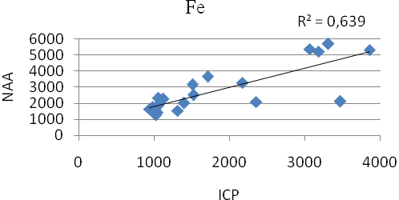

Figure 17 - Comparison of Fe data obtained by neutron activation analysis and atomic adsorption spectrometry
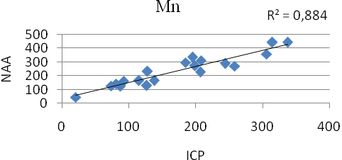

Figure 18 - Comparison of MP data obtained by neutron activation analysis and atomic adsorption spectrometry
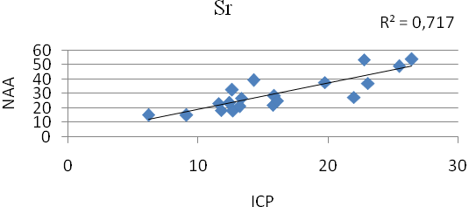
Figure 19 - Comparison of Sr data obtained by neutron activation analysis and atomic adsorption spectrometry
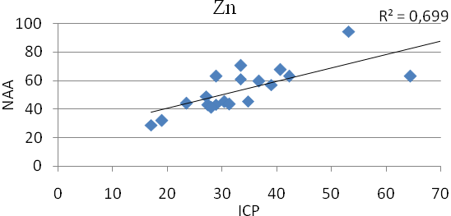
Figure 20 - Comparison of Zn data obtained by neutron activation analysis and atomic adsorption spectrometry

In the table 6 are shown the concentration values from the passport and data obtained by atomic absorption spectrometry.

Table 6 - Concentration values from the passport and obtained by atomic absorption spectrometry
С± Δ (мкг/г) | Al | B | Ba | Ca | Cu | Fe
M2 | 175±23 | 16,7±4 | 18,2±2,4 | 1890±321 | 68±9 | 245±27
AAS | 141±18 | 7±1,5 | 11,2±1,5 | 1383±235 | 51±6,6 | 196±22
С± Δ (мкг/г) | K | Mn | Na | Ni | Pb | Zn
M2 | 6510±846 | 357±46 | 164±21 | 14,8±2 | 5,86±0,7 | 35,2±6
AAS | 5780±752 | 228±30 | 168±22 | 12±1,6 | 5,6±0,7 | 21,3±3,6

For each element, graphs were plotted comparing the values in the passport with the values obtained experimentally (Figures 21-23).
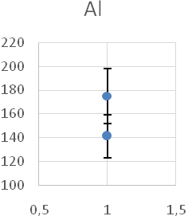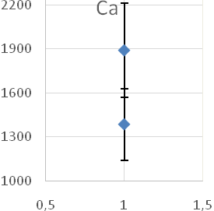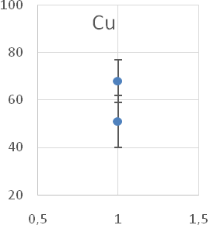

Figure 21 - A Graph comparing the values of Al, Ca and Cu
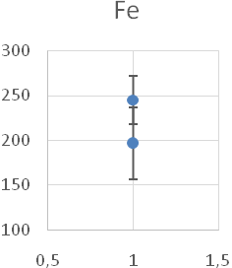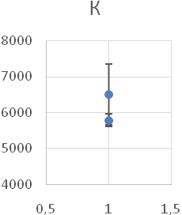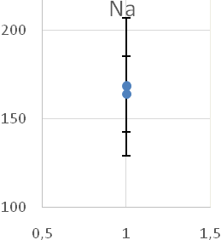

Figure 22 - Comparison Graph for Fe, K and Na values
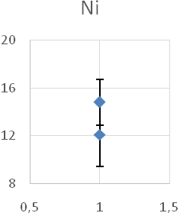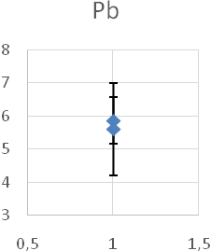

Figure 23 - Graph of comparing the values of Ni and Pb
Method the Q-criterion. There are criteria that determine errors (outliers, misses) when performing measurements. Suspicion occurs when a single measurement differs from the rest [23].
A miss is a part of a data set that is incompatible with other parts of the data set. Detection and elimination of errors is the initial stage of processing experimental data.
In this paper, we used the Q-test method. To begin with, the data obtained experimentally are distributed in a series of ascending values. Then the Q values are calculated for each nearest pair of measurement results.
The Q-criterion is calculated using the formula:
Q = (x? - x_{near})/( x_{min} - x_{max}) (1)
where is x? - probable outlier, x_{near} - nearest to a suspicious value, x_{min} and x_{max} - maximum and minimum values of a series of distributed values.
The calculated value is compared with the table value (Table 7).

Table 7 - Values of Q-criterion
Number of definitions | Confidence probability
Number of definitions | 0,9 | 0,95 | 0,99
3 | 0,94 | 0,98 | 0,99
4 | 0,76 | 0,85 | 0,93
5 | 0,64 | 0,73 | 0,82
6 | 0,56 | 0,64 | 0,74
7 | 0,51 | 0,59 | 0,68
8 | 0,47 | 0,54 | 0,63
9 | 0,44 | 0,51 | 0,6
10 | 0,41 | 0,48 | 0,57

If the calculated value is greater than the table value, then the suspicious result is a miss and it is excluded [23,24].

3.4 Comparison of results with other countries
Comparison of the results with similar data from European countries (Figures 24-32) showed relatively high levels of heavy metal contamination, such as cu, Zn, Pb, Fe, and V.

Figure 24 - comparison of copper concentrations with some European countries

The highest concentration of copper in atmospheric precipitation is observed in Kazakhstan (10.7 mg/kg), but it is lower than in Ukraine (20.7 mg/kg) and significantly higher than in other countries.

Figure 25 - comparison of zinc concentrations with some European countries

The highest concentration of zinc in atmospheric precipitation is observed in Kazakhstan (61.1 mg/kg), but it is slightly higher than in Ukraine (58.7 mg/kg is slightly higher than in other countries.

Figure 26 - comparison of lead concentrations with some European countries

Also, a high concentration of lead in atmospheric precipitation is observed in Kazakhstan (12, mg/kg), but it is slightly lower than in Slovakia (18.7 mg/kg is slightly higher than in other countries.

Figure 27 - comparison of iron concentrations with some European countries
The highest concentration of iron in atmospheric precipitation is observed in Kazakhstan (1732.1 mg/kg), but it is lower than in Ukraine (1797.7 mg/kg) and significantly higher than in other countries.

Figure 28 - comparison of aluminum concentrations with some European countries
The highest concentration of aluminum in atmospheric precipitation is observed in Kazakhstan (3227.8 mg/kg), but it is approximately on the same level as Romania (3229.7 mg/kg) and significantly higher than in other countries.

Figure 29 - comparison of vanadium concentrations with some European countries

The highest concentration of vanadium in atmospheric precipitation is observed in Kazakhstan (4.2 mg/kg), but it is lower than in Romania (4.9 mg/kg) and significantly higher than in other countries.

Figure 30 - comparison of cadmium concentrations with some European countries
The highest concentration of cadmium in atmospheric precipitation is observed in Kazakhstan (0.2 mg/kg), but it is lower than in Slovakia and Poland (0.68 and 0.33 mg/kg, respectively) and significantly higher than in other countries.

Figure 31 - comparison of chromium concentrations with some European countries

The highest concentration of chromium in atmospheric precipitation is observed in Kazakhstan (6.3 mg/kg), but it is lower than in Russia (9.2 mg/kg) and significantly higher than in other countries.

Figure 32 - comparison of Nickel concentration with some European countries
The value of Nickel concentration in atmospheric precipitation in Kazakhstan corresponds to (2.9 mg/kg), but it is much lower than in Ukraine and Macedonia (6.75 and 4.25 mg/kg, respectively) and much higher than in other countries.

3.5 Building a map using the ArcGIS software
Based on the results of the analysis, distribution maps were constructed using the ArcGIS software for some heavy elements, such as cu, Zn, V, Fe, Pb, and W (Figures 33-38).
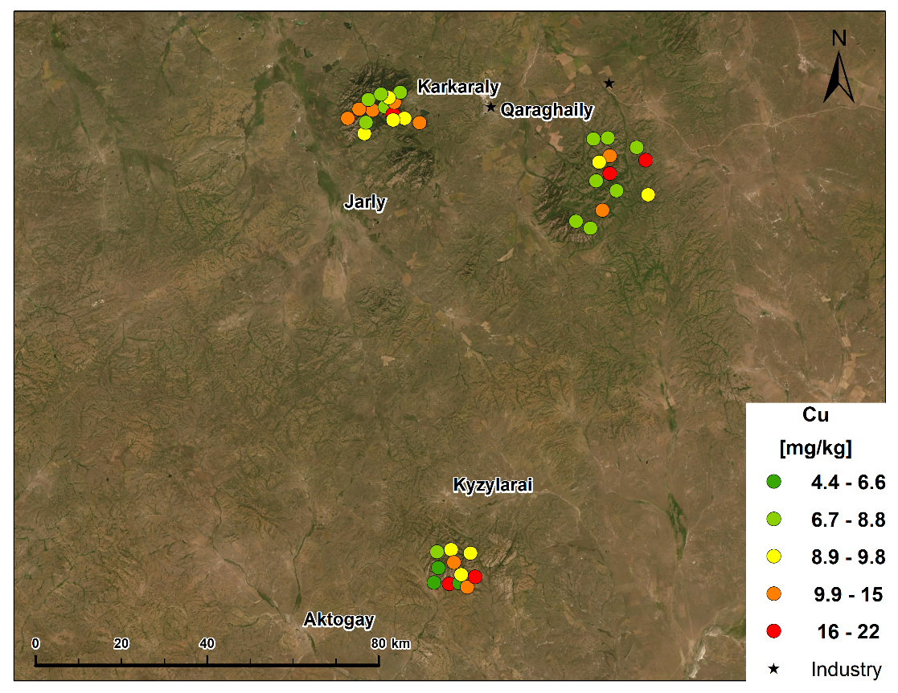

Figure 33 - Map of copper concentration distribution, mg/kg

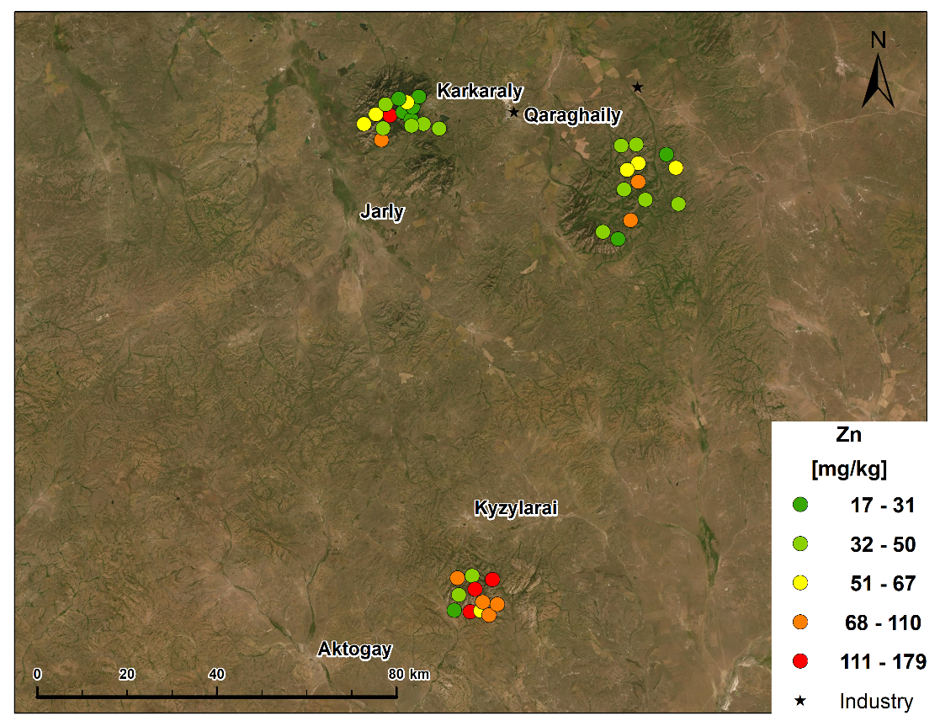

Figure 34 – Map of zinc concentration distribution, mg/kg

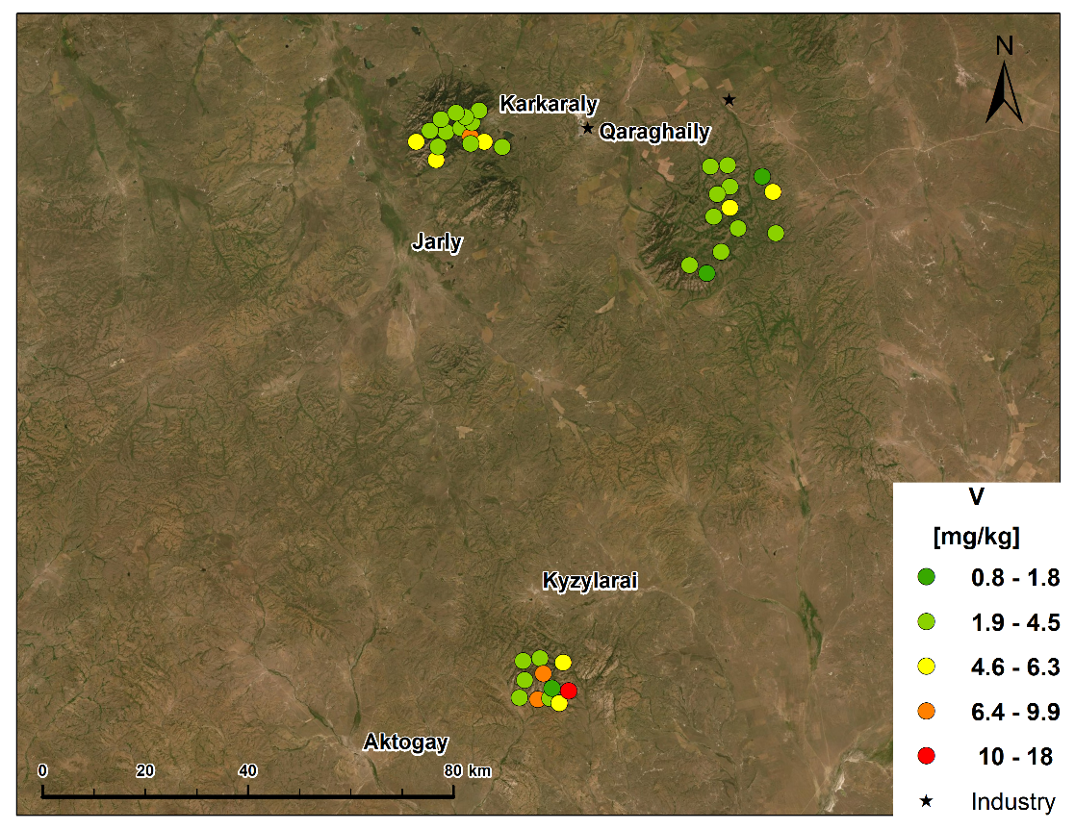

Figure 35 - Map of vanadium concentration distribution, mg/kg

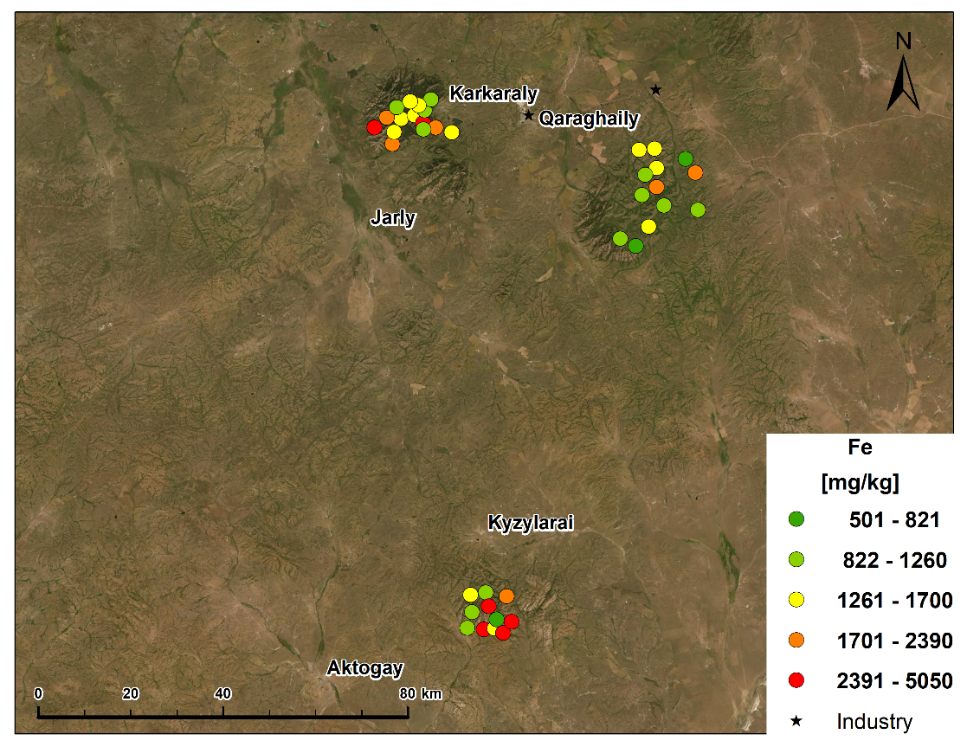

Figure 36 - Map of the distribution of iron concentration, mg/kg

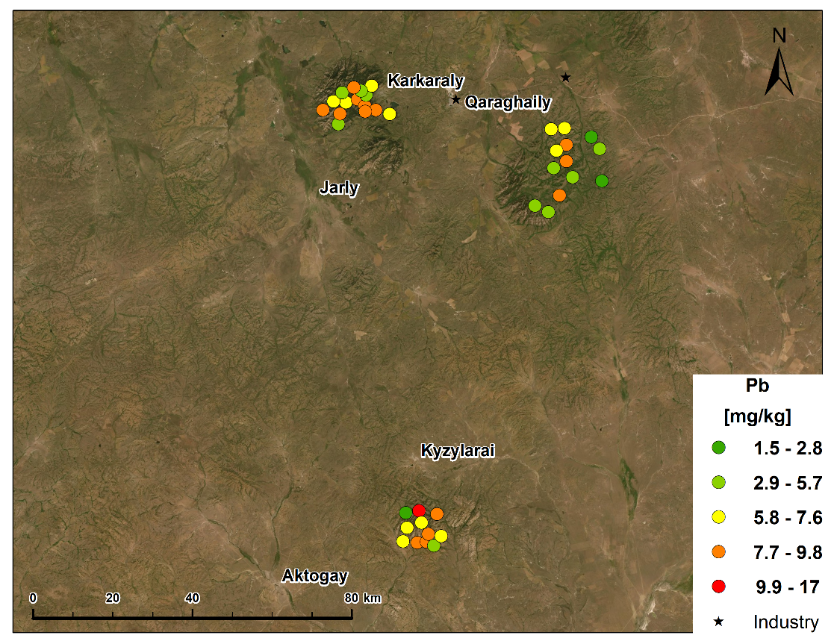

Figure 37 - Map of lead concentration distribution, mg/kg

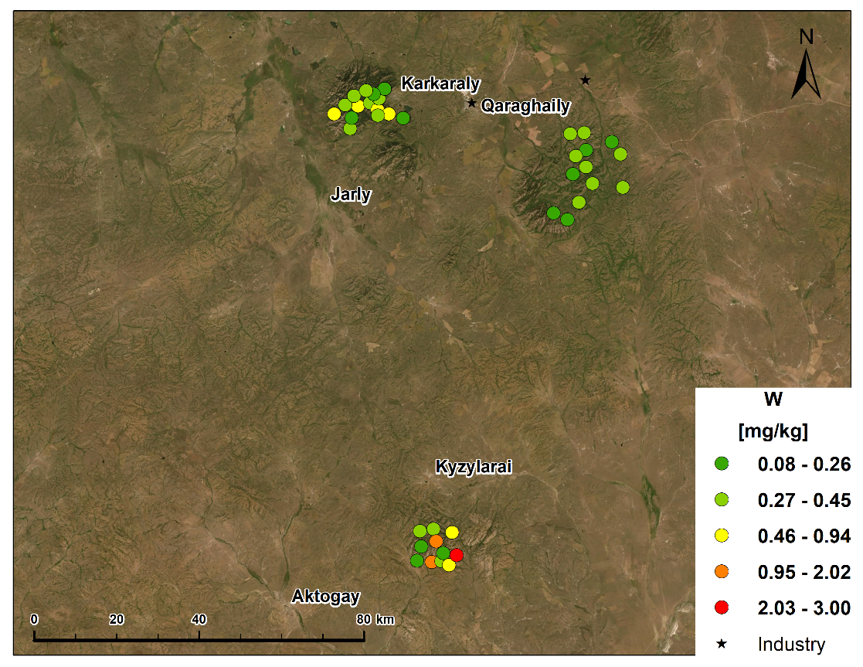

Figure 38 - Map of the distribution of tungsten concentration, mg/kg
According to air pollution, Kazakhstan can be divided into three zones.
- East Kazakhstan, Karaganda and Pavlodar regions, full of heavy industry enterprises.
- Aktobe, Atyrau, West Kazakhstan and Mangistau regions where gas and oil refining complexes are located.
- The southern region where oil refining enterprises are located.
The main air pollutants in Kazakhstan are enterprises of the energy, mining and metallurgical industries. The share of harmful vehicle emissions is 40-60% [25].
Some cities in the country have very high levels of specific compounds in the air. For example, in Shymkent, the concentration of phosphorus (V) oxide, hydrogen fluoride, copper, lead and cadmium is increased. In Ekibastuz and Pavlodar – zinc, chromium, lead, copper, chlorine, mercury and other metals. In Almaty, about 100 harmful substances were detected in the air, including about ten of them belong to the first hazard class [25].
Thus, the problem of air pollution in Kazakhstan is quite acute. Therefore, it is necessary to urgently develop a set of priority measures to improve the country's air basin.

CONCLUSION

- The method of mosses-biomonitors in combination with neutron activation analysis was first used to determine the pollution of pollutants in the studied territory of Kazakhstan.
- Sampling and further training were carried out at the JINR neutron physics laboratory. Work on irradiation of samples in the laboratory of neutron physics was carried out on a high-flow pulsed fast reactor PFR-2 and determined a number of elements of the periodic system of D. I. Mendeleev. Graphical and statistical methods of data processing made it possible to detect the anthropogenic origin of a number of toxic elements present in the atmospheric air. These are Zn, Sb, Pb, As, Cr, Ni, and V.
- The GENIE 2000 program package was used for processing gamma spectra, which includes the procedure for processing the gamma spectrum (automatic search for peaks, identification of radioactive isotopes, and determination of the concentrations of elements contained in the test sample), developed at the JINR LNF.
- Based on the results of the analysis, distribution maps were built using the ArcGIS software for potentially dangerous air pollutants of heavy elements such as cu, Zn, V, Fe, Pb and W.
- The conducted research shows that the environment of industrial regions of the Karaganda region is significantly polluted with TM. The main pollutants are copper, zinc, iron, manganese, and lead. High concentrations of these elements pose the greatest risk to human health. This indicates the need to study the migration of heavy metals and regular biomonitoring of atmospheric air.
- Kazakhstan, transforming the "Strategy 2030", "Concept of transition to sustainable development for 2007-2024", aims at a long - term environmental strategy-the harmonization of interaction between society and the environment, as well as the creation of an environmentally safe, favorable environment. Based on this goal, we can talk about the need to increase the sampling area and further continue work on the entire territory of the Republic of Kazakhstan in order to study in detail the state of the atmosphere and the future development and implementation of more effective work in the field of greening production, the development of nature-saving technologies, especially in leading industries.
- The results of such a study will serve as a good basis for local administrations and environmental services in solving problems of environmental protection and assessing the risk to human health living in polluted regions.

LIST OF SOURCES USED
- Frontasyeva M., Harmens H., Uzhinskiy A., Chaligava O. and participants of the moss survey. Mosses as biomonitors of air pollution: 2015/2016 survey on heavy metals, nitrogen and POPs in Europe and beyond. - Dubna: JINR, 2020. — 136 p.
- Information service of the United Nations economic Commission for Europe [Electronic resource]. - URL: http://www.unece.org/mission.html.
- ICP Vegetation is an international research programme investigating the impacts of air pollutants on crops and (semi-)natural vegetation [Electronic resource]. - URL: https://icpvegetation.ceh.ac.uk/.
- Global environmental problems [Electronic resource]. - 2012. - URL: http://kateloseva.blogspot.com/2010/12/blog-post.html.
- Frontasyeva M. V. Neutron activation analysis in life Sciences (review) // Physics of elementary particles and the atomic nucleus. - 2011, vol. 42, No 2. - P. 636-716. (in Russian).
- Frontasyeva M.V., Yermakova Ye.V., Steinnes E., Rahn K.A. Study of trace elements in annual segments of moss biomonitors using epithermal neutron activation analysis: link with atmostheric aerosol. // Proceedings of NATO ARW Man-Made Radionuclides and Heavy Metals in the Environment. Kluwer Academic Publishers, NATO Science Series. IV. Earth and Environmental Sciences. – 2001. - №5. - P. 165-170.
- Chegrintsev S. N. Atomic absorption analysis: guidelines for performing laboratory work on the course "Physical and chemical methods of analysis" -Tomsk: Publishing house of Tomsk Polytechnic University. 2014. – 44 p. (in Russian).
- Frontasyeva M.V., Pavlov S.S., In «Problems of Modern Physics» / Editors: Sissakian A.N., Trubetskov D.I. Dubna, JINR, 1999. - Р. 152-158.
- Ostrovnaya, T. M., Nefedyeva, L. S., Nazarov, V. M., Borzakov, S. B., Strelkova, L. P., Software for INAA on the Basis of Relative and Absolute Methods Using Nuclear Data Base, Activation Analysis in Environment Protection, Dubna, JINR, 1993. -Р. 319–326.
- Frontasyeva M.V., Steinnes E., Lyapunov S.M., Smirnov I.L. Biomonitoring of heavy metal deposition in South Ural region:Some preliminary obtained by nuclear and related techniques // J. Radioanal. Nucl. Chem., - 2000. - №2. - P. 415-420.
- Frontasyeva M.V., Steinnes E., Harmens H. Monitoring long-term and large-scale deposition of air pollutants based on moss analysis. Chapter in a book “Biomonitoring of Air Pollution Using Mosses and Lichens: Passive and Active Approach ‒ State of the Art and Perspectives”, Nova Science Publishers, New York, - USA. 2016. – 126 р.
- Flora of Kazakhstan. vol. 2. - Alma-Ata: Publishing house of the Kazakh SSR Academy of Sciences, 1958. – 290 p. (in Russian).
- Shcherbakov A.V., Mayorov A.V. Field study of flora and herbarization of plants. – Moscow: MSU publishing house, 2006. – 84 p. (in Russian).
- Karamysheva Z. V., Rachkovskaya E. I. Botanical geography of the steppe part of Central Kazakhstan. – L.: Nauka, 1973. – 279 p. (in Russian).
- Maksutova P. A., Dyusekeeva sh. E., Kulmaganbetova A. O. Physical geography of the Karaganda region. – Karaganda, 2005. – 59 p. (in Russian).
- Janalieva K. M., Budnikova T. I., Veselov E. N. etc. Physical geography of the Republic of Kazakhstan. - Almaty: Kazak University, 1998. – 266 p. (in Russian).
- Konkabayeva A. E., Ishmuratova M. Yu. Assessment of heavy metals accumulation in soil, water and plants of industrial regions of the Karaganda region. -Karaganda, 2016. – P. 31-37. (in Russian).
- Berg, T., Steinnes, E. Use of mosses (Hylocomium splendens and Pleurozium schreberi) as biomonitors of heavy metal deposition: from relative to absolute values // Environmental Pollution. - 1997. - №2. - Р. 61-71.
- Kurzaeva L. V. Correlation analysis in spreadsheets// International journal of applied and fundamental research. – 2016. - No. 12, p. 1230-1233. (in Russian).
- Schaug J, Rambek, J.P., Steinnes E. And Henry R.C. Multivariate Analysis of Trace Element Data from Moss Samples Used to Monitor Atmospheric Deposition // Atmospheric Environment. – 1990. - № 10. – P. 2625-2631.
- Berg Т., Royset О., Steinnes E. And Vadset M. Atmospheric Trace Element Deposition: Principal Component Analysis of ICP-MS Data from Moss Samples // Environ. Pollut. – 1995. - № 88. - P.67-77.
- Maximum permissible concentrations (MPC) of chemicals in soils and acceptable levels of their content in terms of harmfulness. State commission on nature SSSR. – 1990. - No. 2. 90 p. (in Russian).
- Dorogova V. B., Ignatieva L. P. Methods of photometric analysis in sanitary and hygienic research. Electronic libraries: educational and methodological guide. - Ed. Academy of Natural Sciences, 2013. -215 p. (in Russian).
- Tyurin Yu. N., Makarov A. A. data Analysis on a computer. - M.: Infra-M, 2002. – 528 p. (in Russian).
- National report on the state of the environment and the use of natural resources of the Republic of Kazakhstan for 2018. [Electronic resource]. – 2019. - URL: http://ecogosfond.kz/orhusskaja-konvencija/dostup-k-jekologicheskoj-informacii/ jekologijaly -zha-daj/r-orsha-an-ortany-zhaj-k-ji-turaly-ltty-bajandamalar/ (in Russian).
APPENDIX А
Results of neutron activation analysis for short-lived isotopes

 |  |  | Na | Mg | Al | Cl | K | Ca | Ti | V | Mn | I | Cu | Cd | Pb
Sample | Latitude | Longitude | Conc, mg/kg | Conc, mg/kg | Conc, mg/kg | Conc, mg/kg | Conc, mg/kg | Conc, mg/kg | Conc, mg/kg | Conc, mg/kg | Conc, mg/kg | Conc, mg/kg | Conc, mg/kg | Conc, mg/kg | Conc, mg/kg
1 | 48,39319264 | 75,46315098 | 2180 | 4250 | 10600 | 234 | 7490 | 10100 | 422 | 8,9 | 275 | 1,63 | 15,70716 | 0,245083 | 8,364856
2 | 48,46461564 | 75,47783661 | 363 | 1920 | 2220 | 56 | 3980 | 5940 | 137 | 3,1 | 117 | 1,28 | 9,338265 | 0,234419 | 16,71293
3 | 48,43711024 | 75,48290789 | 959 | 4220 | 6900 | 1150 | 10700 | 14900 | 304 | 9,8 | 226 | 6,6 | 14,62709 | 0,520883 | 7,432279
4 | 48,39311677 | 75,49489203 | 355 | 2360 | 2710 | 120 | 4540 | 8950 | 174 | 4 | 137 | 1,4 | 5,43286 | 0,154202 | 9,761236
5 | 48,45336428 | 75,53805307 | 437 | 2330 | 3490 | 143 | 3320 | 9340 | 212 | 5,8 | 110 | 2,02 | 9,697765 | 0,278372 | 9,131957
6 | 48,42848286 | 75,43305027 | 340 | 1850 | 3100 | 108 | 4920 | 5300 | 98 | 2,56 | 103 | 0,77 | 6,415839 | 0,185808 | 7,024277
7 | 48,41016658 | 75,50273082 | 1000 | 4080 | 967 | 1690 | 14400 | 15100 | 59 | 1,37 | 133 | 1,77 | 9,547589 | 0,192009 | 7,862289
8 | 48,462375 | 75,43335833 | 532 | 3500 | 2520 | 2290 | 14000 | 15700 | 114 | 3,3 | 115 | 4,1 | 7,671252 | 0,207309 | 2,762415
9 | 48,38293477 | 75,51877175 | 535 | 3650 | 5480 | 2100 | 12900 | 9860 | 100 | 5,5 | 135 | 5,6 | 11,84662 | 0,148235 | 5,079106
10 | 48,40351534 | 75,54548142 | 2000 | 5850 | 11600 | 1110 | 9540 | 11900 | 525 | 18 | 164 | 30 | 21,87805 | 0,358705 | 7,082459
11 | 49,34891152 | 75,31447544 | 959 | 4250 | 5440 | 2260 | 15200 | 14300 | 245 | 6,2 | 329 | 2,02 | 9,234921 | 0,211257 | 4,9633
12 | 49,39606057 | 75,34734074 | 2100 | 3750 | 2540 | 1400 | 16600 | 12300 | 142 | 4,15 | 150 | 4,6 | 15,17078 | 0,321998 | 6,116474
13 | 49,37154322 | 75,32259151 | 331 | 1510 | 2080 | 115 | 3090 | 5170 | 155 | 3,1 | 106 | 1,8 | 7,711786 | 0,239065 | 9,000315
14 | 49,38332205 | 75,26582874 | 762 | 2460 | 4890 | 132 | 5750 | 6630 | 258 | 5,6 | 222 | 0,63 | 13,2808 | 0,256651 | 9,139393
15 | 49,4007578 | 75,30480668 | 219 | 2000 | 1700 | 137 | 4070 | 9450 | 75 | 2,6 | 190 | 1,82 | 13,07158 | 0,206073 | 7,621907
16 | 49,41898181 | 75,33716884 | 397 | 1620 | 1650 | 97 | 5670 | 6270 | 100 | 2,5 | 79 | 1,08 | 7,491783 | 0,252756 | 5,392063
17 | 49,40066275 | 75,38811311 | 364 | 1440 | 2180 | 77 | 3350 | 6450 | 125 | 3,2 | 125 | 1,25 | 7,969197 | 0,196399 | 9,007347
18 | 49,38449742 | 75,41121506 | 1220 | 3860 | 6500 | 138 | 6740 | 10500 | 359 | 8,5 | 176 | 1,25 | 16,13635 | 0,199225 | 7,86477
19 | 49,40862667 | 75,41927822 | 305 | 1560 | 1200 | 128 | 7380 | 3970 | 55 | 1,8 | 93 | 0,81 | 12,44701 | 0,179774 | 4,810243
20 | 49,42862922 | 75,44080165 | 538 | 1630 | 1760 | 189 | 4620 | 5080 | 58 | 2,37 | 98 | 0,93 | 8,689886 | 0,129496 | 6,67978
21 | 49,41906385 | 75,40284679 | 797 | 1790 | 2410 | 70 | 4620 | 7050 | 79 | 2,66 | 246 | 1,6 | 9,202025 | 0,209743 | 5,737821
22 | 49,37364719 | 75,44762673 | 619 | 1820 | 2950 | 139 | 4350 | 6730 | 138 | 5 | 159 | 1,7 | 9,723721 | 0,280144 | 9,344058
23 | 49,42838001 | 75,37811921 | 368 | 1630 | 2020 | 100 | 5740 | 6060 | 146 | 3,2 | 165 | 2 | 8,607266 | 0,204539 | 8,163992
24 | 49,36170198 | 75,4937424 | 312 | 1500 | 1450 | 95 | 4750 | 5890 | 55 | 2,05 | 96 | 1,46 | 13,46979 | 0,424758 | 6,619927
25 | 49,37187224 | 75,41026307 | 210 | 1640 | 1830 | 57 | 3690 | 4990 | 87 | 2,96 | 134 | 1,44 | 8,890054 | 0,201115 | 8,922688
26 | 49,2948591 | 76,04413092 | 535 | 1780 | 2440 | 195 | 5090 | 4800 | 119 | 3,45 | 172 | 1,8 | 8,714546 | 0,328467 | 6,131622
27 | 49,29437349 | 76,09056593 | 230 | 1540 | 1620 | 69 | 7380 | 4730 | 82 | 2,43 | 230 | 1,4 | 7,632367 | 0,1703 | 6,871481
28 | 49,25650674 | 76,09096516 | 117 | 1830 | 2430 | 113 | 3740 | 8040 | 67 | 2,8 | 333 | 2,6 | 12,53025 | 0,189085 | 8,411802
29 | 49,21975548 | 76,08530871 | 287 | 2440 | 3010 | 79 | 5150 | 9420 | 137 | 4,6 | 437 | 2,74 | 15,59094 | 0,34771 | 8,06678
30 | 49,20697459 | 76,03991224 | 230 | 1600 | 1800 | 81 | 7380 | 4520 | 111 | 2,67 | 203 | 1,4 | 8,227638 | 0,178317 | 4,278231
31 | 49,24538698 | 76,05487827 | 205 | 1690 | 2080 | 77 | 4050 | 8310 | 78 | 3,1 | 479 | 1,9 | 8,999995 | 0,282531 | 6,209331
32 | 49,18282193 | 76,10214643 | 485 | 1670 | 2190 | 118 | 4820 | 5030 | 124 | 2,94 | 158 | 1,2 | 6,889173 | 0,206553 | 5,452061
33 | 49,14471241 | 76,05163652 | 176 | 1730 | 2460 | 104 | 3670 | 10200 | 71 | 2,96 | 303 | 3,3 | 13,00263 | 0,337526 | 8,0333
34 | 49,10955148 | 76,0082593 | 281 | 1180 | 2550 | 168 | 6340 | 4650 | 51 | 0,8 | 53 | 0,81 | 8,190972 | 0,034943 | 3,767053
35 | 49,26902214 | 76,17903205 | 321 | 1630 | 3070 | 169 | 6260 | 4550 | 39 | 1,5 | 94 | 1,44 | 8,017426 | 0,056209 | 1,667895
36 | 49,12652542 | 75,96404431 | 428 | 1840 | 2170 | 77 | 5430 | 5900 | 140 | 3,4 | 85 | 1,4 | 8,579373 | 0,48917 | 4,560075
37 | 49,24053055 | 76,20411416 | 514 | 2930 | 4500 | 112 | 6290 | 8020 | 245 | 6,3 | 584 | 3,2 | 17,20469 | 0,211609 | 5,26943
38 | 49,16777909 | 76,20113306 | 425 | 2330 | 2150 | 162 | 6370 | 8300 | 126 | 3,1 | 119 | 1,47 | 9,300065 | 0,229351 | 1,467429

APPENDIX B
Results of neutron activation analysis for long-lived isotopes -1

 |  |  | As | Sb | La | Sm | W | Au
Sample | Latitude | Longitude | Conc, mg/kg | Conc, mg/kg | Conc, mg/kg | Conc, mg/kg | Conc, mg/kg | Conc, mg/kg
1 | 48,39319264 | 75,46315098 | 2,65 | 0,254 | 22,5 | 5 | 2,02 | 0,00188
2 | 48,46461564 | 75,47783661 | 0,87 | 0,106 | 1,38 | 0,216 | 0,273 | 0,00195
3 | 48,43711024 | 75,48290789 | 3,16 | 0,54 | 55 | 12 | 1,55 | 0,007
4 | 48,39311677 | 75,49489203 | 1,38 | 0,148 | 2,2 | 0,34 | 0,34 | 0,00144
5 | 48,45336428 | 75,53805307 | 2,14 | 0,36 | 2,6 | 0,43 | 0,5 | 0,0019
6 | 48,39854446 | 75,41569597 | 1,08 | 0,11 | 2,4 | 0,57 | 0,22 | 0,00127
7 | 48,42848286 | 75,43305027 | 1,07 | 0,09 | 0,98 | 0,22 | 0,156 | 0,0063
8 | 48,41016658 | 75,50273082 | 1,01 | 0,102 | 4,3 | 1,45 | 0,34 | 0,00314
9 | 48,462375 | 75,43335833 | 1,82 | 0,21 | 25,3 | 8,3 | 0,66 | 0,00314
10 | 48,38293477 | 75,51877175 | 1,42 | 0,158 | 19 | 6,3 | 3 | 0,00665
11 | 48,40351534 | 75,54548142 | 1 | 0,153 | 10,4 | 3,3 | 0,34 | 0,0041
12 | 49,34891152 | 75,31447544 | 1,12 | 0,146 | 3,55 | 0,94 | 0,58 | 0,0172
13 | 49,39606057 | 75,34734074 | 1,4 | 0,247 | 1,36 | 0,24 | 0,255 | 0,00204
14 | 49,37154322 | 75,32259151 | 1,6 | 0,225 | 4,8 | 0,98 | 0,7 | 0,00203
15 | 49,38332205 | 75,26582874 | 1,5 | 0,273 | 3,15 | 0,66 | 0,4 | 0,00247
16 | 49,4007578 | 75,30480668 | 0,83 | 0,14 | 1,54 | 0,32 | 0,284 | 0,00202
17 | 49,40066275 | 75,38811311 | 1,12 | 0,21 | 2,97 | 0,53 | 0,27 | 0,00224
18 | 49,38449742 | 75,41121506 | 1,32 | 0,78 | 3,2 | 0,56 | 0,6 | 0,0068
19 | 49,40862667 | 75,41927822 | 0,61 | 0,123 | 0,74 | 0,115 | 0,27 | 0,00253
20 | 49,42862922 | 75,44080165 | 0,67 | 0,132 | 2,3 | 0,62 | 0,187 | 0,0255
21 | 49,41906385 | 75,40284679 | 1,05 | 0,198 | 1,53 | 0,296 | 0,23 | 0,0028
22 | 49,37364719 | 75,44762673 | 1,54 | 0,395 | 4,4 | 1,08 | 0,94 | 0,0025
23 | 49,42838001 | 75,37811921 | 1,2 | 0,213 | 1,45 | 0,275 | 0,37 | 0,0043
24 | 49,36170198 | 75,4937424 | 0,84 | 0,203 | 1,3 | 0,256 | 0,23 | 0,0197
25 | 49,37187224 | 75,41026307 | 0,84 | 0,22 | 0,91 | 0,167 | 0,274 | 0,0052
26 | 49,2948591 | 76,04413092 | 0,96 | 0,206 | 1,35 | 0,26 | 0,3 | 0,0058
27 | 49,29437349 | 76,09056593 | 0,93 | 0,197 | 1,4 | 0,235 | 0,36 | 0,0235
28 | 49,25650674 | 76,09096516 | 1,12 | 0,186 | 2,1 | 0,47 | 0,178 | 0,01115
29 | 49,21975548 | 76,08530871 | 1,7 | 0,27 | 1,84 | 0,396 | 0,45 | 0,00177
30 | 49,20697459 | 76,03991224 | 0,76 | 0,144 | 0,96 | 0,17 | 0,25 | 0,0052
31 | 49,24538698 | 76,05487827 | 1,28 | 0,145 | 1,28 | 0,32 | 0,33 | 0,00104
32 | 49,18282193 | 76,10214643 | 0,93 | 0,157 | 1,28 | 0,25 | 0,283 | 0,01405
33 | 49,14471241 | 76,05163652 | 1,55 | 0,23 | 3,2 | 0,83 | 0,28 | 0,0084
34 | 49,10955148 | 76,0082593 | 0,21 | 0,042 | 4,8 | 1,55 | 0,083 | 0,0118
35 | 49,26902214 | 76,17903205 | 0,35 | 0,054 | 7,6 | 2,6 | 0,162 | 0,0105
36 | 49,12652542 | 75,96404431 | 0,93 | 0,176 | 0,95 | 0,164 | 0,234 | 0,026
37 | 49,24053055 | 76,20411416 | 2,1 | 0,294 | 3 | 0,71 | 0,44 | 0,0026
38 | 49,16777909 | 76,20113306 | 1,01 | 0,25 | 1,1 | 0,206 | 0,35 | 0,0021

APPENDIX C
Results of neutron activation analysis for long-lived isotopes -2

 |  |  | Sc | Cr | Fe | Co | Ni | Zn | Rb | Sr | Sb | Cs
Sample | Latitude | Longitude | Conc, mg/kg | Conc, mg/kg | Conc, mg/kg | Conc, mg/kg | Conc, mg/kg | Conc, mg/kg | Conc, mg/kg | Conc, mg/kg | Conc, mg/kg | Conc, mg/kg
1 | 48,39319264 | 75,46315098 | 5 | 15,2 | 5050 | 1,47 | 5,2 | 137 | 35 | 53 | 0,254 | 5,8
2 | 48,46461564 | 75,47783661 | 0,43 | 3,36 | 1260 | 0,48 | 2,35 | 36 | 8,6 | 20,4 | 0,106 | 0,28
3 | 48,43711024 | 75,48290789 | 1,48 | 12,6 | 3860 | 1,18 | 5,9 | 150 | 24,5 | 80 | 0,54 | 2,53
4 | 48,39311677 | 75,49489203 | 0,49 | 4,6 | 1400 | 0,485 | 1,43 | 54 | 9,7 | 39 | 0,148 | 0,35
5 | 48,45336428 | 75,53805307 | 0,84 | 8 | 2390 | 0,8 | 3,8 | 136 | 10,3 | 39,6 | 0,36 | 0,37
6 | 48,39854446 | 75,41569597 | 0,35 | 3,2 | 971 | 0,45 | 1,97 | 43,5 | 14 | 29,5 | 0,11 | 0,366
7 | 48,42848286 | 75,43305027 | 0,297 | 3,5 | 821 | 0,55 | 2,3 | 76 | 13,4 | 76 | 0,09 | 0,32
8 | 48,41016658 | 75,50273082 | 0,62 | 6,2 | 1540 | 0,6 | 4,7 | 74 | 15,3 | 74 | 0,102 | 0,61
9 | 48,462375 | 75,43335833 | 1,6 | 10 | 3320 | 0,87 | 6,2 | 82 | 15,8 | 69 | 0,21 | 1,84
10 | 48,38293477 | 75,51877175 | 1,42 | 11,8 | 3780 | 1,18 | 4,8 | 110 | 30,4 | 89 | 0,158 | 12,2
11 | 48,40351534 | 75,54548142 | 0,88 | 7,4 | 1920 | 0,92 | 5,1 | 77 | 15,8 | 71 | 0,153 | 0,92
12 | 49,34891152 | 75,31447544 | 0,6 | 5,1 | 1590 | 1,13 | 2,26 | 179 | 38 | 93 | 0,146 | 8,2
13 | 49,39606057 | 75,34734074 | 0,53 | 6 | 1370 | 0,54 | 1,66 | 37,5 | 7 | 31,5 | 0,247 | 0,254
14 | 49,37154322 | 75,32259151 | 1,18 | 9 | 3250 | 1,26 | 3,95 | 64 | 26,5 | 37 | 0,225 | 0,93
15 | 49,38332205 | 75,26582874 | 0,71 | 6,2 | 2080 | 0,74 | 3,04 | 62 | 16,3 | 31 | 0,273 | 0,43
16 | 49,4007578 | 75,30480668 | 0,34 | 4,4 | 1070 | 0,326 | 1,76 | 46 | 9,2 | 26,5 | 0,14 | 0,23
17 | 49,40066275 | 75,38811311 | 0,49 | 5,4 | 1530 | 0,47 | 2,33 | 28 | 10,3 | 30 | 0,21 | 0,21
18 | 49,38449742 | 75,41121506 | 1,16 | 9,2 | 3110 | 1,05 | 3,95 | 28 | 18 | 49 | 0,78 | 0,6
19 | 49,40862667 | 75,41927822 | 0,31 | 3,6 | 931 | 0,41 | 1,83 | 27 | 8,6 | 18 | 0,123 | 0,195
20 | 49,42862922 | 75,44080165 | 0,42 | 5 | 1170 | 0,57 | 2,4 | 22 | 9,6 | 23 | 0,132 | 0,29
21 | 49,41906385 | 75,40284679 | 0,46 | 6,5 | 1320 | 0,58 | 3,1 | 62 | 8,3 | 31 | 0,198 | 0,225
22 | 49,37364719 | 75,44762673 | 0,74 | 7,4 | 1990 | 0,79 | 3,14 | 48 | 5,6 | 35 | 0,395 | 0,26
23 | 49,42838001 | 75,37811921 | 0,57 | 5,1 | 1390 | 0,76 | 2,33 | 31 | 9 | 20,2 | 0,213 | 0,306
24 | 49,36170198 | 75,4937424 | 0,445 | 4,7 | 1310 | 0,5 | 2,5 | 48 | 12 | 29 | 0,203 | 0,355
25 | 49,37187224 | 75,41026307 | 0,41 | 6,5 | 1150 | 0,52 | 2,26 | 38 | 6,6 | 23 | 0,22 | 0,18
26 | 49,2948591 | 76,04413092 | 0,5 | 7,5 | 1410 | 0,73 | 2,84 | 40 | 10,1 | 21,3 | 0,206 | 0,233
27 | 49,29437349 | 76,09056593 | 0,61 | 7,9 | 1700 | 0,76 | 2,95 | 48 | 9,3 | 23,3 | 0,197 | 0,33
28 | 49,25650674 | 76,09096516 | 0,41 | 3,65 | 1350 | 0,36 | 3,2 | 60 | 5,3 | 32 | 0,186 | 0,135
29 | 49,21975548 | 76,08530871 | 0,7 | 7,7 | 1750 | 1,06 | 3,8 | 75 | 8 | 33 | 0,27 | 0,266
30 | 49,20697459 | 76,03991224 | 0,41 | 7 | 1160 | 0,52 | 1,96 | 35 | 8,6 | 20,5 | 0,144 | 0,255
31 | 49,24538698 | 76,05487827 | 0,32 | 4,75 | 1000 | 0,59 | 2,6 | 60 | 5,9 | 30 | 0,145 | 0,14
32 | 49,18282193 | 76,10214643 | 0,36 | 3,9 | 987 | 0,62 | 1,26 | 36 | 10,5 | 24 | 0,157 | 0,51
33 | 49,14471241 | 76,05163652 | 0,45 | 5,2 | 1410 | 0,61 | 2,17 | 85 | 4,95 | 38 | 0,23 | 0,17
34 | 49,10955148 | 76,0082593 | 0,103 | 4,4 | 501 | 0,69 | 1,1 | 18,5 | 7 | 25 | 0,042 | 0,083
35 | 49,26902214 | 76,17903205 | 0,185 | 3,65 | 657 | 0,8 | 1,58 | 16,5 | 6 | 28,4 | 0,054 | 0,092
36 | 49,12652542 | 75,96404431 | 0,384 | 5,2 | 1130 | 0,385 | 1,28 | 36 | 11,5 | 25 | 0,176 | 0,51
37 | 49,24053055 | 76,20411416 | 0,73 | 5,4 | 1970 | 0,9 | 3,5 | 67 | 10 | 35 | 0,294 | 0,34
38 | 49,16777909 | 76,20113306 | 0,44 | 4,8 | 1220 | 0,54 | 2 | 50 | 10,8 | 34 | 0,25 | 0,265

APPENDIX D
List of publications on research results

For 2018:
Foreign publications:

- Nurgalieva D.Zh., Nurkassimova M.U., Omarova N.M., Dalelova A.M., Frontasyeva M.V., Morzhuhina S.V. “Atmospheric depositions of heavy metals and radionuclides in Irtysh areas of Kazakhstan”, ICP VEGETATION 31st Task Forca Meeting, Dessay-Rosslau, Germany. р.74. 5-8 March. 2018.
- Omarova N. M., Nurgalieva D. Zh., Nurkasimova M. U., frontasieva M. V., Morzhukhina S. V., Kabdulkarimova K. K. "Monitoring of the environment in the Republic of Kazakhstan for the content of heavy metals and radionuclides". ISSN 2076-1163. RSCI online scientific publication. Sustainable development: science and practice. Issue No.1 (20) 2018. p. 20-29. (in Russian).
- Nurgalieva D. Zh., Nurkassimova M. U., Omarova N. M., Dalelova A.M., Frontasyeva M. V., Chepurchenko O. “Atmospheric deposits of heavy metals in Kazakhstan", 8th International workshop on biomonitoring of atmospheric pollution. BIOMAP8. RF. Dubna, July 2-7, 2018, p. 77.
- Nurgalieva D. Zh., Omarova N. M., Frontasyeva M. V., Morzhukhina S. V., "Atmospheric precipitation of heavy metals on the territory of the Republic of Kazakhstan", International scientific and practical conference "Ecological readings-2018", Omsk State agrarian University named after P. A. Stolypin, June 5, 2018, p. 219. (in Russian).
- Kabdulkarimova K, Seilgazina S., Omarova N., Kassymova Z., Ibraeva L., Kaygusuz M. “Chemical analisis of filamentous algae of the Semipalatinsk region by inductivfly coupled plasma mass spectrometry”, Fresenius environmental bulletin – ISSN 1018-4619. Volume 27-No.9/2018 p. 5975-5979. Web of Science Q3. (IF=0.37)

Domestic publications:

- Nurkassimova M.U., Tashenov A.K., Omarova N.M., Frontasyeva M.V., Morzhuhina S.V “Atmospheric depositions of heavy metals and radionuclides in Irtysh areas of Kazakhstan” participation with a report at the XIII International scientific conference of students and young scientists "Science and education – 2018", Astana, L.N.Gumilyov ENU, 2018, p. 1242-1245.
- Nurgalieva D. Zh. "Atmospheric precipitation of heavy metals on the territory of the Republic of Kazakhstan" participation in the report and 1st place classes at the XIII International scientific conference of students and young scientists "Science and education – 2018", head of Omarova N. M. Astana, L. N. Gumilyov ENU, p. 1305-1309. (in Russian).
- Omarova N. M., Tashenov A. K., Nurkassimova M. U., "Biomonitoring of atmospheric deposits of heavy metals and radionuclides in Irtysh areas of Kazakhstan", monograph, recommended for publication by the scientific сouncil of the , L.N.Gumilyov ENU Protocol No. 15 of June 4, 2018, LLP "Master Po", 5.85 p. l., 2018.
- Nurgalieva D. Zh., Omarova N. M., Tashenov A. K., Nurkasimova M. U., Makhambet A., Frontasieva M. V., Chepurchenko O., Glushchenoko V. N., Solodukhin V. P., Morzhukhina S. V., Kabdulkarimova K. "Atmospheric precipitation of heavy metals on the territory of the Republic of Kazakhstan", Bulletin of the L N.Gumilyov ENU. Chemistry, Geography, Ecology series, No. 2 (123)/2018, p. 13-23. (in Russian).

For 2019:
Foreign publications:

      - Omarova N.M., Frontasyeva M.V. Investigation atmospheric depositions of heavy metals in north and west region of the Republic of Kazakhstan using the method of moss-biomonitoring. участие на конференции 18-21 Feb. 2019. ICP VEGETATION 32st Task Forca Meeting, Targoviste, Romania., р.73.
      - Omarova N. M., Tashenov A. K., Nurkasimova M. U., Kokoraeva A. K. Study of the composition of moss - a natural bioindicator for air monitoring in the East Kazakhstan region. Bulletin of the International University of nature, society and man "Dubna". Series "Natural and engineering Sciences" of the Russian Federation. Dubna: No. 1(42) /2019, p. 19-25. (in Russian).
      - Chrysoula Betsou, Evdoxia Tsakiri, Nerantzis Kazakis, Atanas Vasilev, Marina Frontasyeva, Alexandra Ioannidou. Atmospheric deposition of trace elements in Greece using moss Hypnum cupressiforme Hedw as biomonitors. May 2019, Journal of Radioanalytical and Nuclear Chemistry, 320(11) Web of Science Q3. (IF=1.24) DOI: 10.1007/s10967-019-06535-4.
Domestic publications:

            - Participation and presentation of the report by A. Dalelova, head of Omarova N. M. "Study of atmospheric precipitation of heavy metals in the Western regions of the Republic of Kazakhstan" XV international. scientific conference of students and young scientists "GYLYM JANE BILIM – 2019", Astana, L. N. Gumilyov ENU, 2019, p. 962-966. ISBN978-601-337-170-2. (in Russian).
            - Dalelova A.M., Omarova N. M., Frontasyeva M. V., Morzhukhina S. V. Investigation of atmospheric precipitation of heavy metals in the Western regions of the Republic of Kazakhstan using the moss-biomonitor method. Bulletin of the L.N. Gumilyov ENU, Chemistry, Geography, Ecology Series. №1 (126)/2019, p. 21-38. (in Russian).
            - Patent of the Republic of Kazakhstan for utility model No. 3793 dated 18.03.2019. "Methods for assessing the content of heavy metals in atmospheric air using moss-biomonitors", patent holder Omarova N. M. (in Russian).

For 2020:
Foreign publications:

1.Omarova N., Kabylova A., Frontasyeva M., Strekova L., Yushin N. Moses as bioindicators of trace elements in the environment of central Kazakhstan. ICP VEGETATION 33st Task Forca Meeting, Latvia, Riga. p.72. 25-28 January. 2020.
2.Presentation by Kabylova A. "Mosses as bioindicators of air pollution by heavy metals and other toxic elements in Central Kazakhstan" the paper was published on the website of the XII International student scientific conference "Student scientific forum - 2020" at scienceforum.ru/2020/article/2018019807 (Kabylova A. S., Omarova N. M., Frontaseva M. V. awarded the diploma of the winners of the XII International student scientific conference "Student scientific forum - 2020» Moscow, Russia) (in Russian).
3.L. H. Khiem, K. Sera, T. Hosokawa, N. H. Quyet, M. V. Frontasyeva, T. T. M. Trinh, N. T. B. My, N. T. Nghia, T. D. Trung, L. D. Nam, K. T. Hong, N. N. Mai, D. V. Thang, N. A. Son, T. T. Thanh, D. P. T. Tien. Assessment of atmospheric deposition of metals in Ha Noi using the moss bio-monitoring technique and proton induced X-ray emission. Journal of Radioanalytical and Nuclear Chemistry (2020) 324:43–54. Web of Science Q3. (IF=1.24) https://doi.org/ 10.1007/s10967-020-07066-z.
4.Kosior, G., Frontasyeva, M., Ziembik, Z. et al. The Moss Biomonitoring Method and Neutron Activation Analysis in Assessing Pollution by Trace Elements in Selected Polish National Parks. Arch Environ Contam Toxicol (2020). Web of Science Q2. (IF=2.24) https://doi.org/10.1007/s00244-020-00755-6

Domestic publications:

- Tashenov A. K., Kabylova A. S., Frontasyeva M. V., Omarova N. M., Morzhukhina S. V. Assessment of atmospheric precipitation of heavy metals and other toxic elements in the Karaganda region based on the moss-biomonitor method. Bulletin of the L.Gumilyov. ENU. Chemistry, Geography, Ecology series, No1 (130)/2020, p. 54-62. (in Russian).
- Participation in the XV International. Scientific conf. of students and young scientists "GYLYM JANE BILIM – 2020" 2nd year master's student of specialty 6M060600 - Chemistry Kabylova A. S., head of Omarova N. M. "Atmospheric precipitation of heavy metals in Central Kazakhstan using mosses-biomonitors and neutron activation analysis" Nur-Sultan, L. N. Gumilyov ENU, 2020, p. 1029-1033. (in Russian).
- Omarova N.M. Frontasyeva M. V., Kabylova A. S., Dalelova A.M., Nurgalieva D. Zh. Monograph on the project "Еnvironmental Monitoring of Kazakhstan 2018-2020", TechSmith publishing house 2020. 112s.7 p. s. (recommended by the academic Council of the Gumilyov ENU on June 30, 2020 Protocol No. 13). (in Russian).

APPENDIX E
Technical specification and work schedule

Appendix 1.4
to the agreement No. 132 of 12.03.2018
for grant funding

TECHNICAL SPECIFICATION AND CALENDAR PLAN WORK
Under agreement No. 132 of March 12, 2018
1.Republican government enterprise on the right of economic management "L. N. Gumilyov Eurasian national University" of the Ministry of education and science of the Republic of Kazakhstan
1.1 Priority areas: Rational use of natural geology, recycling, new materials and technologies, safe products and constructions, including water resources
1.2 By sub-priority: Monitoring of objects of environment and “green” technology
1.3 Project topic: AP05130496 «Study of atmospheric deposition of heavy metals and radionuclides in some regions of the Republic of Kazakhstan using the analysis of moss bio-monitors»
1.4 total amount of the project: 15,100,000 (fifteen million one hundred thousand) tenge, including by year, for the performance of works in accordance with paragraph 3:
- for 2018 – in the amount of 5,000,000 (five million) tenge,
- for 2019 – in the amount of 5,045,000 (five millionsorok five thousand) tenge,
- for 2018 – in the amount of 5,055,000 (five million fifty-five thousand) tenge.

2. Characteristics of scientific and technical products according to the educational characteristics and economic indicators
2.1. Area of work: Applied research. In Kazakhstan, due to the current socio-economic development, there are disadvantaged regions by state of the environment, which is a unique urbanistic system saturated with varied companies of very different technological orientation. The presence of large number of enterprises and high levels of radiation in some regions of Kazakhstan determine the urgency of these studies.
Theoretical and experimental obtained dates from studying of air deposition of trace elements based on the moss bio-monitors will make a significant contribution to the level of development of ecological safety of Kazakhstan.
2.2 Scope of application: The results can make a huge contribution in the field of protection and control of the environment.
2.3. Final result:
- for 2018: 1 (one) publication will be published in a peer-reviewed foreign or domestic scientific publication with a non-zero impact factor.
- for 2019: 1(one) publication will be published in a peer-reviewed scientific publication with a non-zero impact factor, including the journal рroblems of regional ecology (RF), etc.
- for 2020: The research results will be published in a monograph "Environmental Monitoring of Kazakhstan 2018-2020", articles will be published in peer-reviewed foreign scientific publications indexed in the Web of Science or Scopus databases with a non-zero impact factor.
2.4 Patentability: The research results will be presented in the form of applications for patents in the Kazakh patent office.
2.5. Scientific and technical level (novelty): Innovative advantage of this project is a potentially new approach, i.e. the use of the method of biomonitoring to study air deposition of trace elements at the territory of Kazakhstan. This direction seems to be new and highly topical; being that only some regions of the country were previously studied. Based on the small number of studied territories, we can talk about the need to increase the area of sampling and further work on the entire territory of the Republic of Kazakhstan for studying the state of the atmosphere.
2.6. Тhe use of scientific and technical products is carried out by: Service analytical control of environmental objects. The results can make a huge contribution in the field of protection and control of the environment.
2.7.Тype of use of the result of scientific and (or) scientific and technical activities: Тhe obtained scientific results can be used in the field of environmental ecology, and can be used as a tool for information support of the process of preparation and decision-making in the field of environmental protection and nature management.

3.Name of works, terms of their realization and results

Code of the task, stage | Name of work under the Agreement and the main stages of its implementation | Deadline for implementation |  | Expected result
Code of the task, stage |  | start | end | Expected result
1 | A comprehensive study of mosses (the elemental composition of mosses that reflect the condition of the air) and analysis of distribution of elements in the study areas | January 2018 | to November 1, 2018 | A comprehensive will be studied of mosses(the elemental composition of mosses that reflect the condition of the air) and analysis of distribution of elements in the study areas. Cartography and topography of the study area will be made.  The NAA programs will be filled.
1.1 | Sampling and sample preparation of mosses to the analysis | January 2018 | to 1 July 2018 | Sampling and preparation of moss samples for analysis will be carried out. The study material will be collected, prepared for analysis
1.2 | Determination of the elemental composition of moss samples using instrumental neutron activation analysis (NAA) | June 2018 | to November 1, 2018 | The elemental composition of moss samples will be determined using instrumental NAA. Results of analysis of mosses using NAA will be obtained. 1 (one) publication will be published in a peer-reviewed foreign or domestic scientific publication with a non-zero impact factor.
2 | Experimental dates that characterize the atmospheric deposition of pollutant elements on the territory of Kazakhstan | January 2019 | to November 1, 2019 | Experimental data will be obtained characterizing atmospheric deposition of polluting elements in Kazakhstan. Data processing will be done using statistical and mathematical calculation methods. A report on ICP Vegetation will be prepared.
2.1 | Creation map of the distributions of elements using GIS technology. | February  2019 | to August 1, 2019 | It will be created the map of the distribution of each element in the study area using GIS
2.2 | Sampling and sample preparation of mosses to the analysis | March  2019 | September 2019 | Sampling and preparation of moss samples for analysis will be carried out. The study material will be collected, prepared for analysis. 1 (one) publication will be published in a peer-reviewed foreign or domestic scientific publication with a non-zero impact factor.
3 | Carry out the economic analysis of the effectiveness of the developed technology of biomonitoring | January 2020 | to November 1, 2020 | An economic analysis of the effectiveness of the developed biomonitoring technology will be carried out. It will be created a distribution map of the elements/
3.1 | Calculations on the basis of statistical analysis of the obtained data, using the established maps of elements distribution with GIS technology | January 2020 | October 2020 | Calculations will be made based on the statistical analysis of the data obtained using the established maps of the distribution of elements using GIS technology. It will assessed potential sources of contaminants to the environment. Articles will be published in peer-reviewed foreign scientific journals indexed in the Web of Science or Scopus databases with a non-zero impact factor.
3.2 | A full report about the work done | September 2020 | to November 1, 2020 | The final research report will be issued. A monograph on the research topic will be published.

