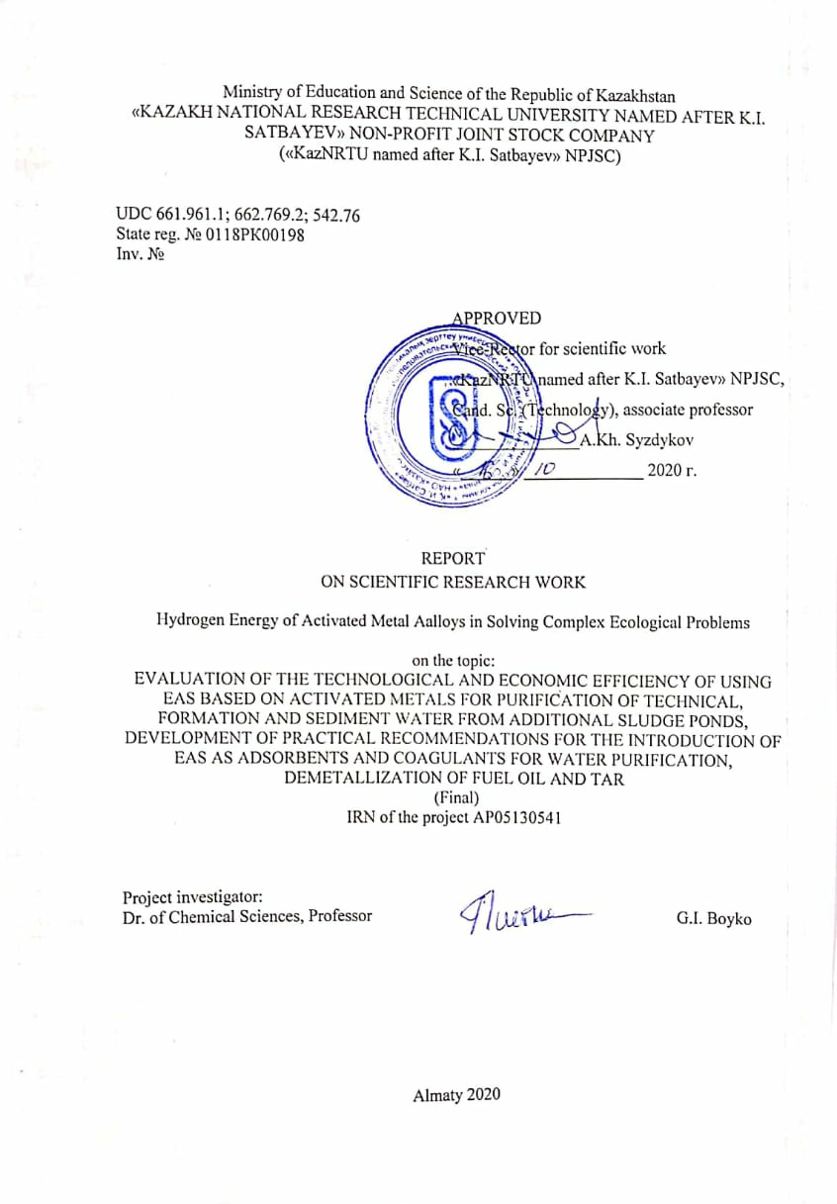
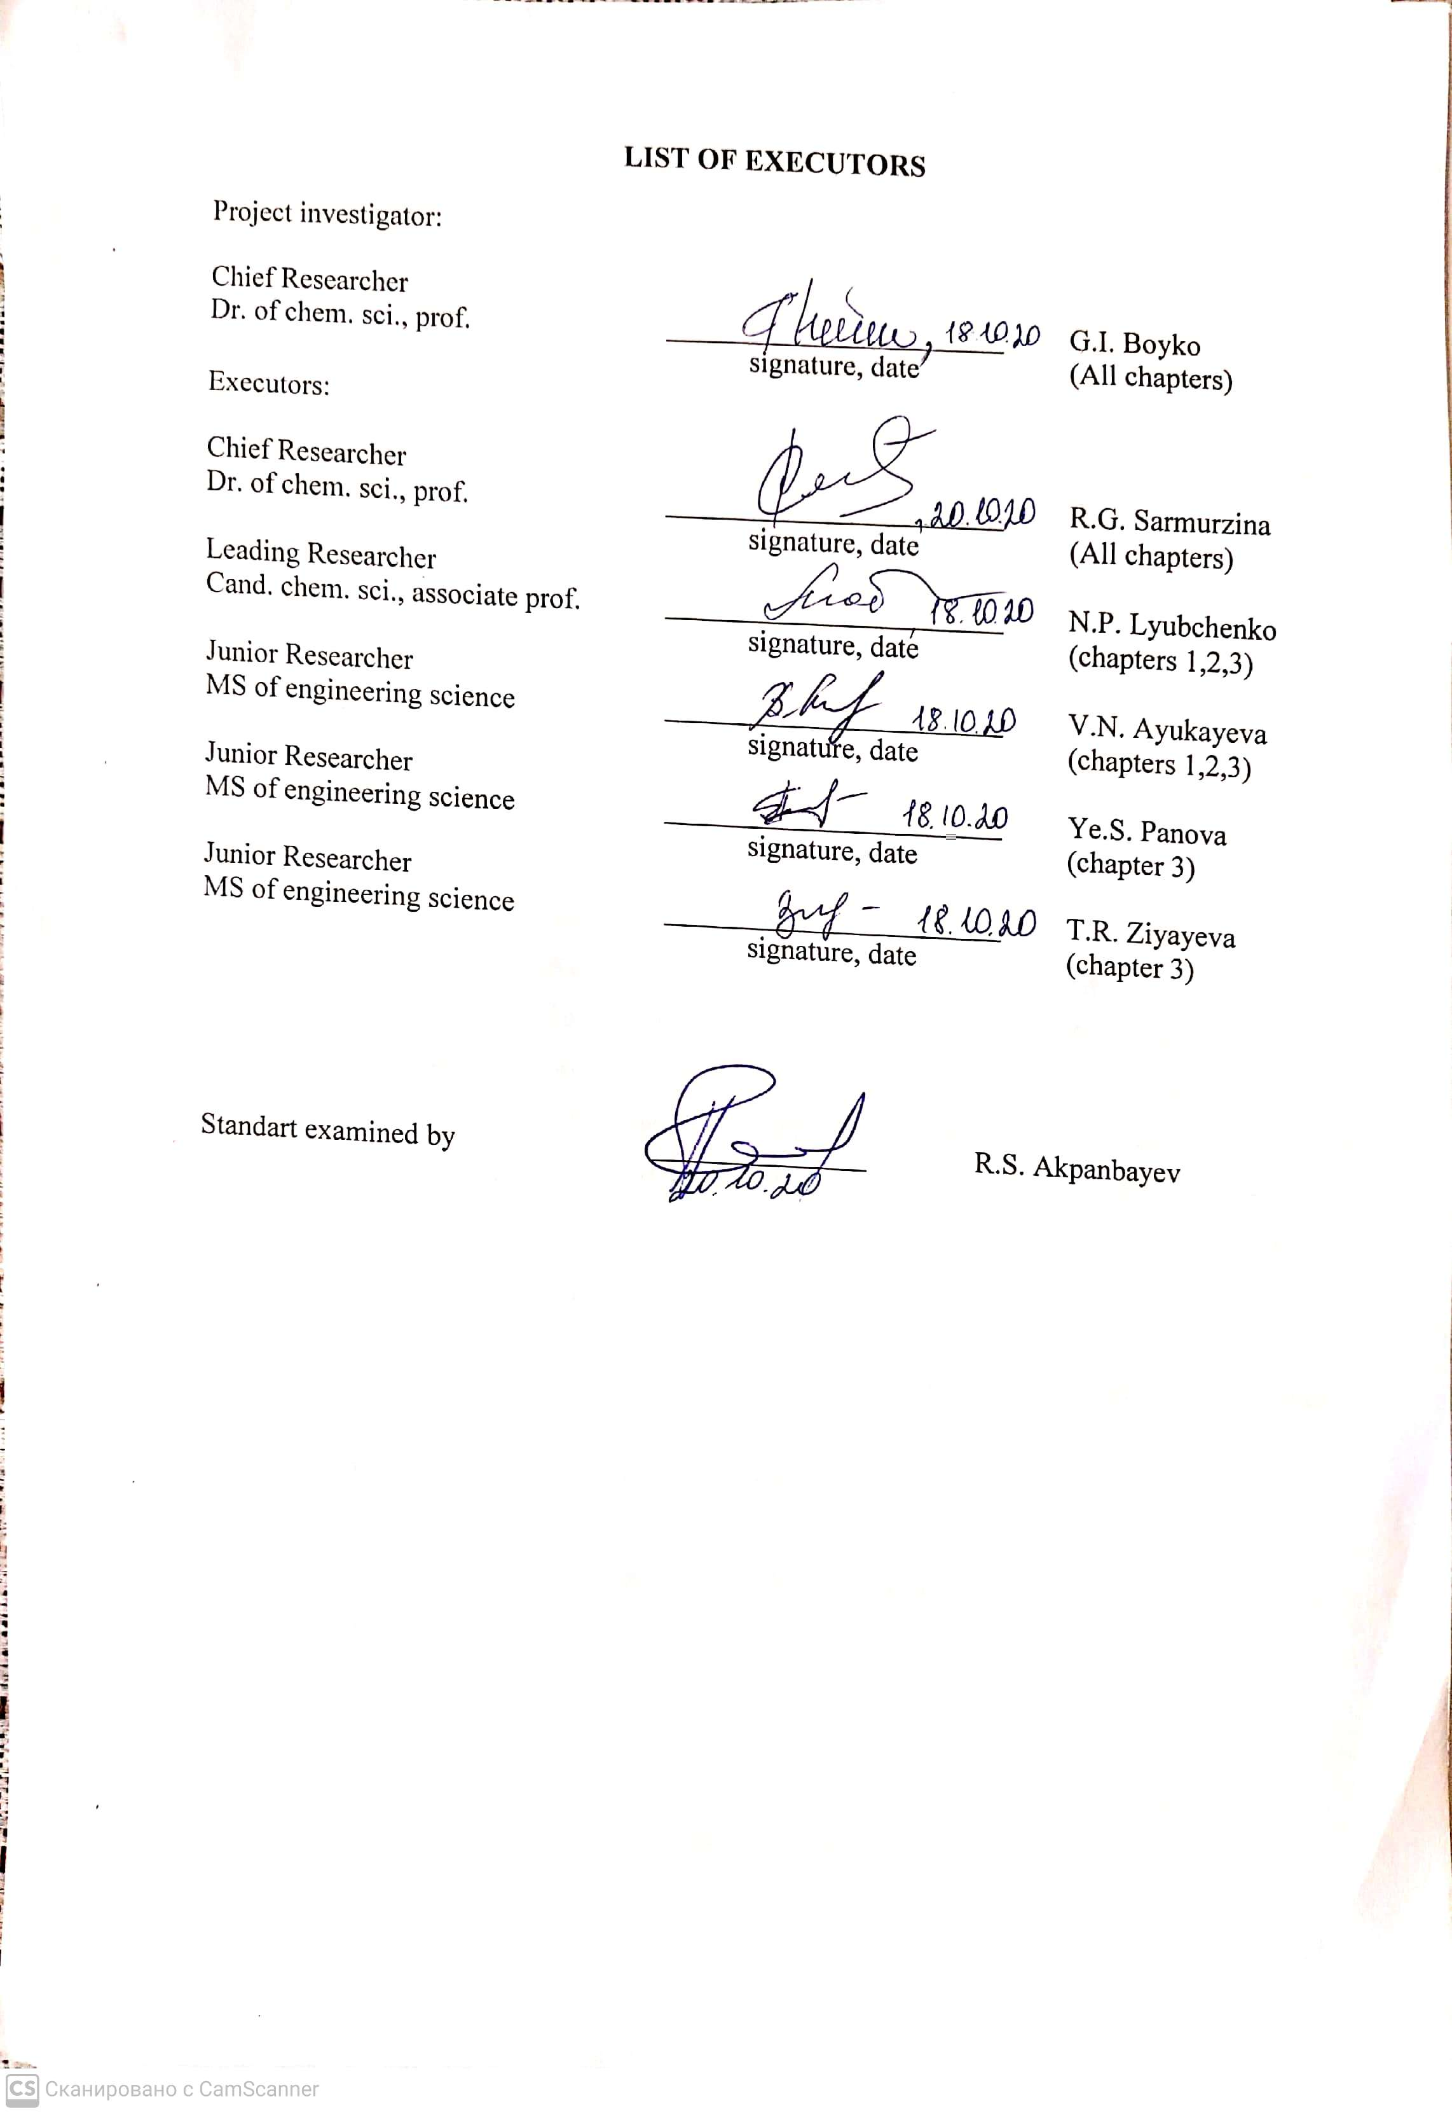 Вспомогательный персонал: А.С. Омаргалиева

ESSAY
The report contains 67 p., 20 fig., 77 ref.
EAS, HYDROGEN, AAA, WATER-OIL EMULSIONS, OIL SLUDGES, FORMATION WATER, TAR, MAZUT, DEMETALLIZATION, DESULFURIZATION
The objects of research are aluminum alloys activated by metal activators (AAA).
The aim of the work is to reveal the role of the nature of activator metals, alloy composition, salinity and pH of formation, sediment and circulating water on the rate of hydrogen evolution, as well as the degree of demetallization and desulfurization of heavy oils and oil products.
Methods or methodology of work. Methods of optical emission spectroscopy with inductively coupled plasma (ICIP), X-ray phase and X-ray fluorescence analysis, TG, DTA, DSC, SEM.
Results of work and their novelty. The high reactivity of aluminum with water was revealed due to mechanical loosening of the surface and heterogeneity of the alloy. The prospects of using Rose, Wood and Darce alloys for the activation of aluminum have been theoretically substantiated and experimentally proved. The rate of hydrogen evolution is regulated by the composition and ratio of the activating additives, as well as by the acidity and mineralization of the water. For the first time, the possibility of cleaning formation, sediment and circulating water from corrosive ions Ca, Mg and Fe has been shown and proven. A new highly efficient method for demetallization and desulphurization of heavy hydrocarbons using the hydrogen energy of AAA, as well as purification of formation and sediment water using coagulants based on the decomposition products of EAS with water has been developed and tested.
Scope of the results. Oil production, oil transportation and oil refining industries, as well as non-traditional energy sources.
Recommendations for the implementation or the results of the implementation of research results. The research results can be used as a basis for work on the creation of a new generation of alloys based on aluminum and solving a number of complex environmental problems.
Cost-effectiveness or value of work.
Determined by the possibility of using AAA as a source for obtaining hydrogen from water, using hydrogen energy in solving environmental problems in the oil industry.
Predictive assumptions about the development of the research object. In the technology of application of hydrogen energy EAV based on ASA to obtain hydrogen from water with a high controlled rate of emission of thermal energy and for purification of industrial and formation water, as well as demetallization of fuel oil and tar.
CONTENT

NORMATIVE REFERENCES……………………………….………………..……...…6
LIST OF ABBREVIATIONS AND SYMBOLS…………………………………..….…7
INTRODUCTION……..………………..…………………………………..…………....8
1 Chapter 1 Creation of new generation of EAS based on activated metal alloys. A comprehensive comparative analysis of the physicochemical properties of samples of technical, formation and sediment water from additional sediment ponds before and after processing with EAS using modern physicochemical methods; development of methods and methods of using EAS for purification of formation water and sediment water from additional sludge ponds from hazardous water-soluble impurities, oil residues. Results of the first year of the study………………………………………………………………………………………...……13
  - Revealing the role of metals-activators, alloy composition, crystallization modes and features of the formation of the structure of an activated metal alloy for obtaining high rates of hydrogen evolution from water and aluminum oxide with predetermined properties….…….13
  - Comprehensive comparative analysis of the physicochemical properties of samples of formation waters of various fields and sediment water of additional sludge ponds from the Atyrau oil refinery and the Pavlodar Petrochemical Plant using physicochemical methods prior to EAS treatment…………………………………………………...………..…...16
2 Chapter 2 Development of methods for demetallization of fuel oil and tar with the use of hydrogen energy EAS based on activated metal alloys. Results of the second year of the study...……….……………………………………………………………………………..……19
2.1 Study of the physicochemical properties and characteristics of fuel oil and tar samples from the Atyrau oil refinery and the Pavlodar Petrochemical Plant before processing with EAS........................................................................................................................................19
2.2 Establishment of optimal parameters for the interaction of aluminum alloys, activated by Darce, Wood, Rose alloys with water, depending on temperature, the amount of an activating additive in the alloy, pH of water according to the rate of hydrogen evolution. Comparative assessment of the efficiency of alloys……..………………………………………20
2.3 Production of the required amount of activated aluminum alloys for the destruction of various types of oil sludge ……..……………………………………..………………….…...23
2.4 Comprehensive analysis of the composition of Karazhanbas oil prior to treatment with EAS based on activated aluminum alloys ……………………………………………....…24
2.5 Development of methods for demetallization of fuel oil and tar (V, Ni) by thermogas-chemical action with activated metal alloys ………………………………………...24
2.6 Evaluation of the effectiveness of demetallization of masut and tar (V, Ni) of thermogasochemical action by activated metal alloys based on the analysis of the physicochemical properties of fuel oil and tar samples from the Atyrau oil refinery and the Pavlodar Petrochemical Plant after treatment with EAS……………………………………..….25
2.7 Development of methods for desulfurization of tar by the action of activated metal alloys …………………………………………………………………………………………….26
3 Chapter 3 Evaluation of the technological and economic efficiency of using EAS based on activated metals for purification of technical, formation and sediment water from additional sludge ponds, development of practical recommendations for the introduction of EAS as adsorbents and coagulants for water purification, demetallization of fuel oil and tar..………………………………………………………………………………………………29
3.1 Comparative evaluation of the efficiency of purification of industrial and formation water using adsorbents and coagulants based on the decomposition products of EAS water …..29
3.2Development of the formation water treatment technology using different doses of activated aluminum………………………………………...…………………………………….32
3.3Development of practical recommendations for the introduction of EAS based on activated metal alloys and hydrolysis products with water as adsorbents and coagulants for water purification, demetallization of mazut and tar………………………………………………..….34
CONCLUSION…...………..………………………………………………..…………...37
REFERENCES ………………………...………...………..……………………….…....44
APPENDIX A The list of published works on the topic for 2018-2020 years……...…..50
APPENDIX B Calendar plan of works…………..…………………………………...…54
APPENDIX C Extract from the minutes of the joint meeting of the Academic and Educational-Methodological Council of institute of chemical and biological technologies….…66
APPENDIX D Extract from the minutes of the NTS KazNITU…………………….….67

NORMATIVE REFERENCES

This report uses references to the following standards:
GOST 7.32-2017 Research report. Structure and design rules.
GOST 7.1-2003. Bibliographic record. Bibliographic description. General requirements and rules for drawing up.
GOST 6370-83. Oil, petroleum products and additives. Method for determination of mechanical impurities.
GOST 11851 – 85. Oil. Paraffin determination method.
GOST 2517-2012 Oil and oil products. Sampling methods.
GOST 2477-65 Oil and oil products. Method for determining water content.
OST 39-133-81 Water for flooding oil reservoirs. Determination of oil content in industrial waste water
OST 39-225-88 Water for flooding oil reservoirs. Quality requirements. M.: Minnefteprom,1990.8p
GOST Р52963-2008 Water. Methods for determination of alkalinity and mass concentration of carbonates and bicarbonates. - Introduced 09/29/2008. - Moscow: Standartinform, 2008 .-28 p.
GOST 4245-72. Drinking water. Methods for determination of chloride content
GOST 26449.1-85 Stationary distillation desalination plants. Methods for chemical analysis of salt waters. - Introduced 01-01-1987. - Moscow: Standartinform, 2003 .-44 p.
Methodology PND F 16.1: 2.3: 3.11-98 for performing measurements of metal content in solid objects (soil, composts, cakes, sewage sludge, samples of plant origin) by inductively coupled plasma spectrometry and fluorescence analysis.

LIST OF ABBREVIATIONS AND SYMBOLS

In this research report, the following abbreviations and symbols are used
AOR | Atyrau Oil Refinery
АAA | Activated aluminum alloy
мV | Miles Volt
ICIP | Inductively coupled plasma-optical emission spectrometry
DTA | Differential thermal analysis
DSC | Differential Scanning Calorimetry
OGPD | Oil and Gas Production Department
BHFZ | Bottom-hole formation zone
PPP | Pavlodar Petrochemical Plant
VST | Vertical steel tank
SEM | Scanning electron microscope
HOR | heavy oil residues
TG | Thermogravimetry
EAS | Energy accumulating substances
ORP | ORP - redox potential
HRM | heavy raw materials
HOR | heavy oil residues
XFA | X-ray fluorescence analysis

INTRODUCTION

Assessment of the current state of the solved scientific and technical problem. Unique physicochemical properties and practically unlimited resources allow the use of hydrogen as an energy carrier in hydrogen energy systems. Environmental protection is an important argument for the introduction of hydrogen into power engineering: when hydrogen is used for energy, only water vapor is discharged into the atmosphere. When using hydrogen as a fuel, the possibility of an increase in the greenhouse effect is excluded, no harmful substances are emitted (a car engine emits 45 toxic substances, including carcinogens), there is no danger of the formation of stagnant zones of hydrogen: it easily volatilizes [1-13].
Long-term exploitation of oil fields leads to high oil water cut (20-97%), as well as the formation of stable oil-water emulsions, scale deposits of various compositions, which complicates the production processes.
In this regard, the task of maintaining the level of oil production in the long term through the creation, development and implementation of effective science-intensive, innovative technologies that ensure the stable development of oil production is urgent [6-7].
The paper proposes new technical solutions for the development of economically feasible activated aluminum alloys with a high, controlled hydrogen evolution rate. For the first time, to solve the environmental problems of the oil industry, innovative technological solutions have been developed for demetallization and desulphurization of heavy oils and petroleum products using hydrogen energy of activated aluminum alloys, as well as purification of formation and sediment water using adsorbents and coagulants based on the decomposition products of EAS with water.
Basis and initial data for the development of the theme. Hydrogen energy of activated metal alloys in solving complex environmental problems "within the framework of the state order for the implementation of scientific and scientific and technical projects under the budget program 217" Development of Science ", subprogram 102" Grant financing of subjects of scientific and / or scientific and technical activities ", specifics 156 "Payment for consulting services and research." By priority "Energy and Mechanical Engineering". The name of the specialized scientific direction for which the application is submitted: Alternative energy and technologies: renewable sources, hydrogen energy, other energy sources".
Justification of the need for research
For the widespread use of hydrogen in power engineering, the problems of its efficient production and highly efficient use must be solved.
Fundamental physicochemical and physicotechnical problems associated with the widespread introduction of hydrogen energy are mainly determined by the need to develop new methods for efficient and environmentally friendly production of hydrogen [8 - 14].
In this regard, it seems promising to develop methods for producing hydrogen directly from water by reacting it with aluminum.
In terms of prevalence in nature, aluminum ranks first among metals. Its content in the earth's crust is 8.8% [6].
At the same time, it is known that a dense oxide film formed upon contact of aluminum with atmospheric oxygen creates diffusion restrictions on the oxidation of aluminum even in boiling water. The development of methods and conditions for the activation of aluminum by metals-activators, which lead to the destruction of the oxide film, and ensure the reactivity of aluminum to water, is urgent. There is also no doubt about the need to identify the role of metals-activators, alloy composition, crystallization modes and features of the formation of the structure of activated aluminum in order to obtain high rates of hydrogen evolution from water and aluminum oxide with predetermined physicochemical properties. Carrying out work to solve this problem made it possible to solve a number of practical problems on the development of methods and conditions for the activation of aluminum by metals-activators, providing aluminum reactivity to water.
The use of AAA and the products of their interaction with water (hydrogen, hydroxides, high-pressure steam, heat of reaction) opens up broad prospects in technologies for the integrated treatment of oil, the destruction of abnormally stable oil-water emulsions and oil sludge, demetallization and desulfurization of HC (mazut and tar), as well as wastewater treatment of oil production and oil refining facilities [14].
Information about the planned scientific and technical level of development, patent research and conclusions from them
An analytical generalization of well-known scientific and technical results on the use of EAS in the field of non-traditional energy sources is carried out. It is proposed to use EAS as AAA [8-13].
In the process of performing the work, the role of the nature of the activator metals, the composition of materials, and modes of creating the necessary type of non-equilibrium in order to obtain high rates of hydrogen evolution from water was revealed. A number of technological methods have been developed to obtain materials with a given concentration. So, for the activation of aluminum, the principle associated with the P.A. Rebinder effect [10-15] and based on the use of activators to change the specific surface energy was used. Liquid metals and low-melting eutectics: gallium, indium, tin, as well as Darce, Rose and Wood alloys were studied as potent activators. For the first time, it was proposed to use AAA as coagulants for the purification of industrial, waste and formation waters with various degrees of mineralization [20-23].
The physicochemical properties and characteristics of samples of fuel oil and tar of Atyrau Oil Refinery LLP and Pavlodar Petrochemical Plant LLP, anomalously stable water-oil emulsion of the Karazhanbas field, oil sludge from ASP Atyrau Refinery were studied.
Structural-group, X-ray phase and X-ray fluorescence analysis of tar and fuel oil was carried out. It is shown that the resource potential of oil and water-oil emulsions Karazhanbas can become a reliable source of valuable metals - vanadium and nickel.
For the first time, a method has been developed for demetallization of heavy oils and oil products using the AAA hydrogen energy. Composite compositions containing EAS based on AAA, organic solvents and distilled water have been developed. It was revealed that the use of composite compositions containing EAS based on an AAA can significantly reduce the content of non-ferrous metals vanadium and nickel in heavy hydrocarbon feedstock (mazut, tar) to 70 - 75%.
A method has been developed for desulphurization of HO and OP (mazut, tar) and oil sludge from PDO LLP "Atyrau Refinery" using hydrogen energy of AAA. Composite compositions containing EAS based on activated aluminum alloys, organic solvents and distilled water have been developed. It was found that the use of compositions containing EAS based on an activated aluminum alloy can significantly reduce the sulfur content in heavy hydrocarbon feedstock. The degree of desulfurization for tar - 51%, fuel oil - 64%, Karazhanbas oil - 82%, oil sludge - 98%.
Information on metrological support of research work
Modern instrumental methods of chemical analysis: optical emission spectrometer with inductively coupled plasma Tim 8000, spectrophotometer Hach Lange 3900, Germany, acid purification system BSB-939-IR, pH-, ORP-meter, IR-spectrometer Agilent Catty 660, X-ray diffractometer X'PERT PRO MPD, SEM Jeol-JSM-6490 LA, 20071, X-ray fluorescence spectrometer X-RAY INNOV SYSTEMS.
To study the kinetic parameters of the reaction of the interaction of AAA with water samples of various degrees of mineralization and acidity, a special installation has been developed and created with the registration of the volume of evolved gases on a drum gas meter. The water heating temperature was measured with a thermometer with an accuracy of 0.1 ° C.

Relevance
The significance of the project is determined by the possibility of using AAA as a source for obtaining hydrogen from water, using hydrogen energy in solving environmental problems in the oil industry.
Carrying out research in the field of non-traditional environmentally friendly energy sources, in particular, hydrogen energy, new ways of storing energy in the form of hydrogen and its compounds, EAS. Finding new ways to use hydrogen and the energy of interaction of AAA with water.
The controllability of the process of generating active hydrogen during the interaction of ASA with water is carried out due to the developed methods of aluminum activation and is regulated by their composition.
Creation of adsorbents-coagulants of different types with controlled physicochemical properties without changing the hardware and technological schemes. The use of EAS as adsorbents-coagulates for physicochemical water purification, in the rejection of foreign products, improvement of the commercial characteristics of oil, destruction of abnormally stable oil-water emulsions, oil sludge, as well as demetallization of HO and OP (mazut and tar) with simultaneous purification from sulfur is relevant.
The implementation of this project will allow solving a number of serious environmental problems in the oil industry through the integrated use of the products of interaction of AAA with water (metal oxides, high pressure steam, hydrogen, heat of reaction) to create resource and energy saving technologies for demetallization, desulfurization of hydrocarbons ( masut and tar), waste and formation water treatment.
The novelty of the topic. For the first time, the use of EAS of new generation obtained on the basis of aluminum activated by Rose, Wood and Darce alloys has been proposed. It was found that the synthesized alloys of activated aluminum exhibit a high coagulating ability and can be used as coagulants for purification of formation and sediment waters from Ca, Mg and Fe, which reduces the corrosiveness of the tested waters.
The high reactivity of aluminum with respect to water was revealed due to mechanical loosening of the surface and heterogeneity of the alloy.
The prospects of using Rose, Wood and Darce alloys for the activation of aluminum have been theoretically substantiated and experimentally proved. The rate of hydrogen evolution is regulated by the composition and ratio of the activating additives, as well as by the acidity and mineralization of the water.
For the first time, the possibility of cleaning formation, sediment and circulating water from corrosive ions Ca, Mg and Fe has been shown and proven.
New technical solutions for the development of economically viable activated aluminum alloys with a high controlled hydrogen evolution rate. Innovative technological solutions for demetallization and desulfurization of heavy oils and petroleum products using hydrogen energy of activated aluminum alloys.
The relationship of this work with other research projects.
This research work is a logical continuation of the work of academicians D.V. Sokolsky, R.G. Sarmurzina to solve the problem of modifying metals in order to directly influence their chemical, physicochemical and physicomechanical properties, including the creation of a new class of EAS, which, when interacting with water, release hydrogen at high rates.
Goals and objectives of the research stage, their place in the implementation of research in general
Revealing the role of the nature of metal-activators, alloy composition, salinity and pH of formation, sediment and circulating water on the rate of hydrogen evolution, as well as the degree of demetallization and desulfurization of heavy oils, analysis of the technologies of decomposition of oil and bottom sediments in ponds of additional sludge existing in the world practice, and sludge collectors, fuel oil tanks. Obtaining the results of the analysis of patent and scientific and technical literature on the topic being developed.
List of names of prepared interim reports by stages and their registration numbers:
REPORT 2018 “Creation of new generation EAS based on activated metal alloys. A comprehensive comparative analysis of the physicochemical properties of samples of technical, reservoir and sediment water from additional sediment ponds before and after treatment with EAS using modern physicochemical methods; development of methods and methods of using EAS for purification of formation and sediment water from additional sediment ponds from hazardous water-soluble impurities, oil residues ”No. state.reg.0118RK001989 (project AR05130541).
REPORT 2019 "Development of methods for demetallization of fuel oil and tar with the use of hydrogen energy eav based on activated metal alloys" No. state reg. 0219RK00933 (project AR05130541).
Chapter 1 Creation of new generation of EAS based on activated metal alloys. A comprehensive comparative analysis of the physicochemical properties of samples of technical, formation and sediment water from additional sediment ponds before and after processing with EAS using modern physicochemical methods; development of methods and methods of using EAS for purification of formation water and sediment water from additional sludge ponds from hazardous water-soluble impurities, oil residues. Results of the first year of the study

1.1 Revealing the role of metals-activators, alloy composition, crystallization modes and features of the formation of the structure of an activated metal alloy for obtaining high rates of hydrogen evolution from water and aluminum oxide with predetermined properties
Aluminum, activated by metal activators, is an alternative source of hydrogen production from water, its storage, emission of thermal energy, as well as solid aluminum hydroxide, the composition of which (boehmite, pseudoboehmite, bayerite) depends on the ratio of reagents and the reaction temperature [1-10]:
$Аl + 3Н20 = Аl(ОН)3 + 1,5Н2 + 16,3 MJ / kg Аl$ (1)
$Аl+ 2Н2O = АlOOН + 1,5Н2 +15,5 MJ / kg Аl$ (2)
$Аl + 1,5Н2O = 0,5АI2О3 + 1,5Н2 +15,1MJ / kg Аl$ (3)

It is noted [14-16] that the thermodynamic instability of activated aluminum with respect to water makes it possible to obtain hydrogen at high rates as a result of the developing reaction, the intensity of which depends on the structure of the alloy, the state of grain boundaries, the distribution of additives between the body and grain boundaries [14-16].
The principle associated with the P.A. effect was used to activate aluminum. Rebinder, based on the use of activators for the embrittlement of materials due to a decrease in their surface energy [10]. Gallium, indium, tin, zinc, bismuth, lead, cadmium, and antimony were used as activator materials. It was found that all aluminum alloys, both binary and complex-component, belong to systems of the eutectic type and correspond to the well-known Rebinder-Shchukin-Gorkatov rule. Alloys were prepared under nonequilibrium conditions in order to obtain a pronounced heterogeneity of the structure. The high crystallization rate ensured the release of the eutectic along the ingot boundaries even at low concentrations of the introduced activator metals. With an increase in the percentage of each of the input components from 1.0 to 5.0 wt. %, the refinement of the aluminum phase is also observed, and is more pronounced than in binary alloys. High cooling rates of the melt to the temperature of liquid nitrogen enhances the overall inhomogeneity of the ingot: the formation of an intercrystalline structure with the release of second phases, both along the boundaries and along the grain body, which are the centers of development of intergranular and focal corrosion.
X-ray phase analysis confirms the eutectic nature of the studied alloys. However, the chemical composition of the surface of the alloys, as a rule, is not identical to the chemical composition of the bulk phase.
Under the influence of the introduced metals - activators, the mechanical properties of aluminum-based alloys change in accordance with Figure 1.

Figure 1 - Dependence of the ultimate strength of alloys on the nature and amount of activator metals

The sharp decrease in the mechanical properties is a consequence of the fact that the activator metals greatly reduce the surface energy and develop the effect of the adsorptive decrease in strength (Rebinder effect). An increase in the percentage of activator metals leads to a refinement of the grain structure of aluminum, to an increase in the number of formed eutectics, their distribution over the volume, to an increase in the heterogeneity of alloys with a simultaneous decrease in strength. The reactivity of the alloy with respect to water is largely determined by the conditions of its manufacture. The most active is the alloy prepared by quenching in liquid nitrogen. Introduction of metals - activators into aluminum and quenching of alloys with high cooling rates promotes the formation of a single-crystal structure of the metal and an increase in the number of microgalvanic elements. Processes leading to grain dispersion (alloy hardening, increasing the amount of additives) contribute to the growth of activity.
A typical form of kinetic curves of topochemical reactions is shown in Figure 2. Introduction of bismuth into the Al:Ga:In:Sn alloy, cadmium, antimony or eutectic alloy ingredients leads to an increase in the rate of its interaction with water. Distilled water, as well as model aqueous solutions of sodium bicarbonate, sodium chloride, calcium and magnesium chloride, and their mixtures, with an additive were studied as an oxidizer of the Al:Ga:In:Sn = 85:5:5:5 alloy (reagent Rau-85). and without added HCl. The total mineralization of electrolyte solutions varied from 2688 mg/l to 77712 mg/l. The ORP of water is -48 mV, which corresponds to the conditions of the reducing environment (from +200 to -300 mV) [17]. It was found that with a decrease in the pH of the simulated formation water by adding hydrochloric acid, the volumetric yield and the rate of hydrogen evolution increase (the hydroxonium ion Н₃О⁺ is an active oxidizing agent).

б
а
4
3
1
2
1
2
3
4111

a) 1 Al -Ga; 2 Al -Ga- In; 3 Al -Ga- In; 4 Al -Ga- In-Sn. (5.0 wt.% Of metals-activators) b) Al-Ga-In-Sn alloy, the content of metals-activators (wt.%): 1-0.5; 2-1.0; 3-3.0; 4-5.0;
Figure 2 - Dependence of the degree of transformation (α) of the interaction of alloys with water on time

1- solution №4 (NaHCO₃- 5376 mg/l ); 2- solution № 3 (NaHCO₃- 5376 mg/l +36168 NaCl) with HCl; 3 – distilled water with HCl;4- solution №1 с HCl;
5- solution №2 (NaHCO₃ - 2688 mg/l) c HCl; 6- distilled water without HCl; 7 solution №1 with HCl; 8- solution №5( NaHCO₃- 5376 mg/l +72336 NaCl) с HCl
(solution №1 - NaHCO₃ -1344;NaCl-18084; CaCl₂ -3046;MgCl₂·6H₂O mg/l)
Figure 3 - Dependence of the amount of evolved gases (a) and the heat of reaction (b) during the oxidation of Rau-85 with electrolyte solutions
It was found that the rate of H2 evolution during Rau-85 oxidation in distilled water is higher than in the simulated formation water (Figure 3). This reaction takes place without an induction period. The volumetric output of H₂ increases and reaches 99% relative to the theoretical, and the heat is 33712 kJ/kg. The oxidation rate of Rau-85 by electrolyte solutions with additions of HCl increases with the transition from the multicomponent composition of the solution to a one-component solution of NaHCO3. The highest gas yield (1.45 l per 1 g of alloy) is observed when using solution No. 4, containing 5376 mg/l NaHCO₃ (curve 1). The volume of evolved gases is much higher than the theoretically calculated volume of H₂ (according to stoichiometry, 1.244 m³ H₂ is released per 1 kg of Al). Apparently, in the course of the exothermic reaction, the aqueous salt solution is heated to 60°C, at this temperature sodium bicarbonate decomposes into sodium carbonate, carbon dioxide and water [19].

1.2 Comprehensive comparative analysis of the physicochemical properties of samples of formation waters of various fields and sediment water of additional sludge ponds from the Atyrau Oil Refinery and the Pavlodar Petrochemical Plant using physicochemical methods prior to eas treatment
The method of optical emission spectroscopy with inductively coupled plasma, spectrophotometric method, ORP-meter, as well as titration and study of pH, carried out a comprehensive analysis of the chemical composition and physicochemical characteristics of the formation waters of the Western Kazakhstan fields. The waters contain Na, K, Ca , Mg , Fe, Ba, Li ions as salt-forming cations. The waters are characterized as brines. The total mineralization ranges from 86.9 g / dm³ (o. Koschagyl № 606) to 215.7 g/dm³ (o. Botakhan). Waters are at greater risk of sodium chloride (halite) deposition. The presence of Mg and Fe cations in formation waters indicates their high corrosive activity, therefore, to prevent the formation of mineral salts on oil-producing equipment and oil-transporting equipment, it is necessary to prevent mixing of waters containing carbonates and sulfates.
Reagent Rau-85 was used to treat formation waters of the Altykul (well No. 102), Botakhan (well No. 121) and Karazhanbas (well No. 897, well No. 1783, well No. 3817) fields, and Karsak. Figures 4-7 show the dependence of the temperature rise of the reaction medium and heat release on the acidity and total salinity of the formation water during the oxidation of activated aluminum Rau-85 with acidified and non-acidified formation water. It was shown that additions of HCI lead to an increase in the heating temperature of the reaction mixture. The amount of released heat is on average 6 times higher than the amount of heat without adding HCl to water.

Figure 4 - Dependence of the temperature increase of acidified and non-acidified formation water when treated with Rau-85 reagent

Figure 5 - Dependence of the heat of reaction of Rau-85 with HCl (5% solution) on time

For the first time, the relationship between the total salinity of formation waters and the rate of interaction with Rau-85 was revealed. When Rau-85 interacts with formation waters, the hydrogen yield relative to the theoretical is 38.9% on average. When adding HCl to formation water from 1% to 5% of the mass. the volumetric yield of hydrogen relative to theoretical reaches 99%.The hydrogen evolution rate reaches 1100 ml / gmin, the process ends at the 6th minute, which is shown in Figure 7.

Figure 6 - Dependence of the released heat of reaction of Rau-85 without HCl on time

Figure 7 - The rate of hydrogen evolution during the reaction of Rau-85 by the formation waters of the fields of Western Kazakhstan with the addition of HCI
Thus, it was shown that the reactivity of the alloy can be controlled. The rate of hydrogen generation from water is controlled by the structure and composition of the alloy, as well as by the conditions of heat treatment of the alloy, by introducing appropriate additives to water.

Chapter 2 Development of methods for demetallization of fuel oil and tar with the use of hydrogen energy EAS based on activated metal alloys. Results of the second year of the study

2.1 Study of the physicochemical properties and characteristics of fuel oil and tar samples from the Atyrau oil refinery and the Pavlodar Petrochemical Plant before processing with EAS
In HOR (mazut, tar, bitumen), metals (vanadium and nickel) are concentrated in the resinous-asphaltene part [24-28]. In heavy oil residues (mazut, tar, bitumen), metals (vanadium and nickel) are concentrated in the resinous-asphaltene part. Their content in comparison with the content in oils increases by at least 3.5 - 4 times and can reach the level of industrial ore concentrations [28].
In this work, the physicochemical properties and characteristics of samples of masut and tar of LLP "Atyrau Refinery", "PPCHP" LLP, water-oil emulsion of the Karazhanbas field were studied. Structural-group, X-ray phase and XFA of tar and fuel oil was carried out.
It was revealed that the tar of LLP "Atyrau Refinery" contains 2.5 times more asphaltenes in comparison with tar of "PPCHP" LLP. Fuel oil and tar are HOR with a high content of silica gel resins from 22.21% in mazut to 27.66% in tar.
XFA of asphalts isolated from Karazhanbas oil showed an increased content of vanadium in them, the concentration of vanadium reaches 0.482% and nickel 0.075% (4.82 kg and 750 g, respectively, per 1 ton of asphaltenes). It is shown that the resource potential of oil and water-oil emulsions Karazhanbas can become a reliable source of valuable metals.
XFA of mechanical impurities showed that the tar contains S, Ca, V, Na, Ni, Zn, Fe, Cr. The amount of sulfur in the tar is 2.624%, vanadium 0.18%, nickel 0.10%. After the tar treatment with Rau-85, the sulfur content in the tar was 1.716%, that is, it decreased by 0.908%, the content of vanadium and nickel decreased to 0.017%, respectively, and nickel to 0.008%.
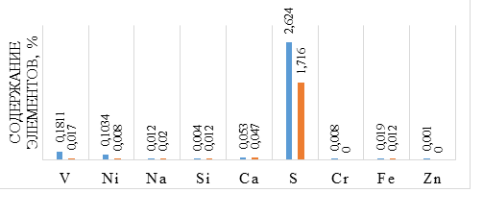
Figure 8 - The content of sulfur and metals in the tar of "PPCHP" LLP before and after treatment with an activated aluminum alloy Rau-85
2.2 Establishment of optimal parameters for the interaction of aluminum alloys, activated by Darce, Wood, Rose alloys with water, depending on temperature, the amount of an activating additive in the alloy, pH of water according to the rate of hydrogen evolution. Comparative assessment of the efficiency of alloys
In order to reduce the cost of an aluminum alloy activated with metal activators indium, gallium and tin, the authors of the report have developed new economically feasible alloys that exclude the use of nonferrous scattered metals and contain Wood, Rose and Darce alloys as activator metals.
The optimal parameters of interaction of aluminum alloys, activated by Darce, Wood, Rose alloys with water, depending on the temperature, the amount of the activating additive in the alloy, and the pH of water, have been established. It was found that the optimal temperature for the interaction of alloys with distilled water is 90 ° C, the content of the activating additive in the alloy is 10%, the conversion of aluminum under these conditions reaches 25 - 28% depending on the composition of the activated alloy.
For aluminum alloys activated by Darce and Wood alloys the optimal ratio is Al: alloy = 85: 15.
The effect of water pH on the rate of hydrogen generation has been studied. It was revealed that a decrease in pH by adding hydrochloric acid to distilled water increases the volumetric yield of hydrogen from 200 ml to 1100 ml and the average rate of hydrogen evolution from 20.5 to 100 ml / g ∙ min. Conversion of aluminum reaches 99 - 100% at a temperature of 90 ° C and the content of an activating additive in the alloy is 10%.
The hydrogen yield increases with increasing acid concentration and corresponds to the theoretically calculated value. The rates of hydrogen evolution for aluminum alloys activated by Wood and Rose alloys are practically equal, the conversion of aluminum reaches 100%, the volume of released H₂ during the reaction of the alloy with acidified water reaches the theoretically calculated value at a lower temperature - 70° C. The rate of H₂ generation under these conditions is for Al alloy : Darce's alloy - 59 ml / g ∙ min, Al: Wood's alloy - 29 ml / g ∙ min and Al: Rose's alloy - 20 ml / g ∙ min. The maximum hydrogen evolution rate at 90 ° C and the ratio of aluminum to alloy 85: 15 is 200 ml / min for Al: Wood's alloy, 100 ml / min for Al: Rose alloy and 140 ml / min for Al: Rose alloy.
Comparative kinetic curves of hydrogen evolution during the interaction of an aluminum alloy activated by Wood's alloy in time depending on temperature and HCl concentration at different ratios are shown in Figure 9, Rose alloy in Figure 10.
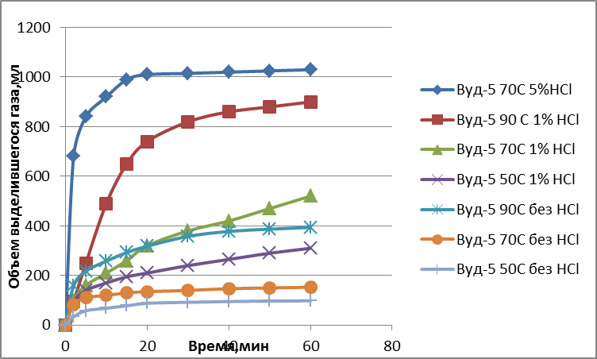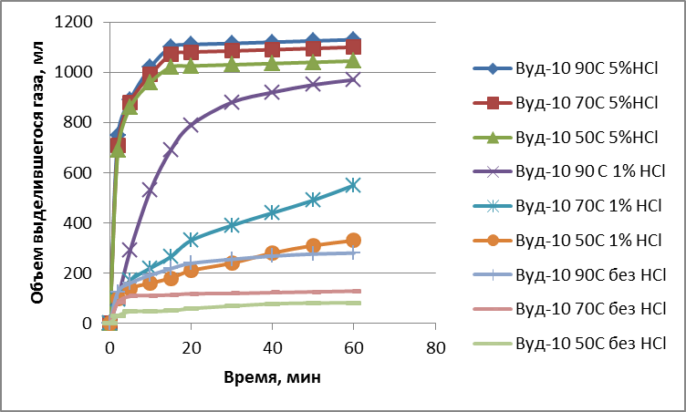
(а)
(а)
(б)

Figure 9-Comparative kinetic curves of H₂ evolution during the interaction of aluminum activated by Wood's alloy in time depending on temperature and HCl concentration at a ratio of 95: 5 (a) and 90: 10 (b)

Figure 10 shows the comparative kinetic curves of hydrogen evolution during the interaction of aluminum activated by Rose's alloy with distilled and acidified water (1% HCl solution) at a temperature of 90 ° C.

Figure 10 - Comparative kinetic curves of hydrogen evolution during the interaction of AAA with distilled and acidified water (1% HCl solution) at a temperature of 90 ° C

Figure 11 shows the average hydrogen evolution rate during the interaction of aluminum activated with Wood's alloy (a) and Rose's alloy (b), depending on the temperature and concentration of HCl for 10 minutes.

Figure 11- Average rate of H₂ evolution, during the interaction of activated Al alloy: Wood's alloy (a) and Al alloy: Rose's alloy (b) depending on temperature and concentration of HCl (10 minutes)

Kinetic curves of hydrogen evolution during the interaction of AAA with stratum sediment water from Karazhanbas (Figure 12) indicate that the volume of released H₂ reaches 1400 ml with acidified (1% HCl solution) water, while without adding HCI to water, the yield is H₂ did not exceed 500 ml. The addition of Н₂О₂ to formation water reduces the rate and amount of released Н₂, the highest rate is observed for water with the addition of sodium hydroxide, the volume of released Н₂ is higher than the theoretically calculated one.

Figure 12 - Comparative kinetic curves of H₂ evolution during the reaction of the activated alloy AI: Wood's alloy = 90:10 (slowly cooled) with the formation water of the Karazhanbas 3/9 field with the addition of chemical reagents under the following conditions: temperature 90 ° C, alloy: formation water ratio 1 :50

Thus, the studies carried out made it possible to reveal the dependence of the rate of interaction of AAA with water on temperature, composition and amount of an activating additive in the alloy, and pH of water.

2.3 Production of the required amount of activated aluminum alloys for the destruction of various types of oil sludge
An experimental batch of the reagent was made in the laboratory of the NJSC "KazNRTU named after K.I.Satbayev". To obtain castings, steel molds were manufactured with an outer diameter of 60 mm, an inner diameter of 40 mm and a height of 40 mm to 80 mm.
An aluminum alloy with an activating additive is prepared in an alundum crucible, on the bottom of which an alloy (Darcé, Rose or Wood) is placed in an amount of 5-15% by weight, and metal aluminum is placed on top in the form of granules or wire. Smelting is carried out at a temperature of 850 ° C in a SNOL 1300 furnace in an inert gas atmosphere with subsequent cooling. The melt is kept at a temperature of 800 - 8500C for 30 minutes. As soon as the aluminum melted (temperature over 660 ° C), the melt was stirred with a quartz rod and placed back in the furnace. After heating, the composition was mixed again and poured into manufactured steel molds with an outer diameter of 60 mm, an inner diameter of 40 mm, and a height of 40 mm to 80 mm. The ingots were placed on a flat steel plate. The cooling rate of the lower casting layer when the liquid metal touches the plate did not allow metal to spill into the gap between the plate and the mold. The absence of a bottom at the mold facilitated the removal of the casting from it after crystallization and cooling of the metal. With a mold wall thickness of 10 mm, the melt rapidly cooled down with the formation of a fine-crystalline structure and high reagent activity. The total duration of metal heating during heat treatment is the sum of the heating time to a given temperature and the holding time at this temperature. The duration of the heating - holding - cooling cycle was 1 hour. It was found that the content of metals in the alloy slightly differs from the initial ratio of metals taken for the preparation of alloys.
Powder with granule sizes up to 0.6 mm was made from the ingot.
1 kg of AAA was smelted. Estimated prices for raw materials for the preparation of alloys indicate that the use of Wood, Rose and Darce alloys as AAA an order of magnitude to reduce the prices for AAA.

2.4 Comprehensive analysis of the composition of Karazhanbas oil prior to treatment with EAS based on activated aluminum alloys
Oil from the Karazhanbas field is characterized by a high content of resinous (26.32%) and a low content of paraffinic components (0.8%). The oil is sulphurous, the sulfur content in crude oil is 2.288% (according to titration data), according to XRD data - 1.883%.
It was revealed that the main component of the structural-group composition of the oil part of the Karazhanbas water-oil emulsion samples are high-molecular-weight asphaltenes localizing in their structure a high content of heteroatoms. According to the data of the structure-group composition, the contribution of oil components to the formation of the dispersed phase in ODS was characterized using the ratio RAC / PH, where RAC are resinous-asphaltene components, PH are paraffinic hydrocarbons [25, 26]. According to this classification, the core of the dispersed particle of the oil part of the Karazhanbas field (ratio RAC / PH> 1) is represented by resinous asphaltene components [25, 26].

2.5 Development of methods for demetallization of fuel oil and tar (V, Ni) by thermogas-chemical action with activated metal alloys
The attention of researchers to vanadium-containing compounds of oil is connected not so much with the problem of extracting vanadium from alternative (petroleum) feedstock, but with the fact that vanadyl porphyrins present in oils, contained in the residue, during catalytic cracking are "poisons" for catalysts, interfere with the cracking of oil, or the use of cracking products [26-28]. The structure of porphyrin complexes of vanadyl in oils was studied in [27,29-32]. It was revealed that the concentration of vanadium in oil is the higher, the higher the sulfur content, and Ni - the higher the nitrogen content, and in general, the higher the ligand atom content.
The purpose of this work is to develop an easy-to-implement with high efficiency method for removing non-ferrous metals from heavy oil feedstock and reducing its energy intensity (Patent RK No. 33863)
According to the patent, HOR is preheated, mixed with an organic solvent and water is added, and the aluminum alloy is introduced into the aqueous layer, then the resulting mixture is stirred and the non-ferrous metal salts are separated by filtration.
The method of demetallization of HOR and OP is carried out by the interaction of the Rau-85 reagent with water in a solvent medium. The reaction is accompanied by a significant TLC effect. The aluminum alloy interacts with the aqueous phase to release hydrogen and heat. As a result of the release of atomic hydrogen in the reaction mixture, a number of chemical interactions occur, and the hydrocracking of HPS proceeds. Aluminum alloy, hydrolyzed by water to form hydroxides, which are adsorbents for non-ferrous metal ions. The resulting solid components are separated by filtration. The aluminum alloy contains components in the following ratio, (wt.%): Indium 0.1-5, gallium 0.1-5, tin from 0.1-5. Heavy oil feedstock is heated to a temperature of 60C. The weight ratio of heavy oil feedstock: solvent is from 1: 1 to 1: 4. The weight ratio of heavy oil feedstock: water is 1: 1. Water is added with a temperature of 70 - 100⁰C. An aluminum alloy is introduced into HOR at a mass ratio of 1: 100, respectively. The mixture is stirred for 0.5 to 3 hours. The novelty of the method for extracting non-ferrous metals from heavy petroleum feedstock is determined by the use of the AAA hydrogen energy.

2.6 Evaluation of the effectiveness of demetallization of fuel oil and tar (V, Ni) by thermogasochemical action of activated metal alloys based on the analysis of the physicochemical properties of fuel oil samples, tar from Atyrau oil refinery and Pavlodar Petrochemical Plant after treatment with EAS
A comparative assessment of the efficiency of demetallization of petroleum products was carried out on the samples of tar from Pavlodar Petrochemical Plant LLP (Figure 13).

Figure 13 - The content of vanadium (blue) and nickel (yellow) on the adsorbent at TGCT with the reagent Rau-85 in various solvents

Figure 14 - The degree of extraction of vanadium (green) and nickel (gray) by the adsorbent at TGCT with the reagent Rau-85 from tar
Composite compositions containing EAS based on AAA, organic solvents and distilled water have been developed. Comparative results of metal extraction from tar are shown in Figure 14. After tar treatment with Rau-85 reagent, vanadium content in tar decreased from 0.1811 to 0.017%, nickel from 0.017 to 0.008%. The best results on the extraction of non-ferrous metals on an adsorbent, which is a product of hydrolysis of an aluminum alloy, were obtained when heptane and benzene were used as solvents at a temperature of 80 ° C. The degree of demetallization reaches 64.61%.
The developed method for extracting non-ferrous metals from HOR using AAA is more economical in comparison with the method according to the prototype, because does not require high temperatures. The adsorbent formed during the hydrolysis of AAA concentrates Ni and V in quantities that allow the adsorbed product to be used as a raw material for vanadium production. The processed HOR contains a low content of Ni and V, which makes it possible to use it for further processing into the target product.

2.7 Development of methods for desulfurization of tar and oil Karazhanbas (northern) by treatment of activated metal alloys
Most of the sulfur in oil is presented in the form of its organosulfur compounds (mercaptans (RSH), sulfides (RSR '), disulfides (RSSR'), cyclic sulfides (C_{n}H_{2n}S) [33–48]. In recent years, strict environmental standards have required a reduction in sulfur content to a level close to zero.
The purification of oil and petroleum products from sulfur is possible with the implementation of various variants of the extraction process, including sulfuric acid, alkaline extraction, with polar solvents, as well as hydrotreating of sulfur-containing compounds by chemical conversion of sulfur to H₂S on catalysts in a hydrogen atmosphere at high pressures and temperatures, adsorption purification on silica gel and AI₂O₃, biodesulfurization and sonocatalytic oxidative desulfurization [36-53].
Despite the variety of proposed technologies for desulphurization of oils and petroleum products, the problem has not been practically resolved to date; an integral universal method, practical for the purification of both sulphide and mercaptan sulfur, has not yet been found [49-51].
The authors of the report have developed an alternative desulfurization method using the ACA hydrogen energy. The technical result is achieved by a method for removing sulfur from petroleum feedstock, including contacting said feedstock with a Rau-85 reagent (RK patent No. 34095).
The raw material is preheated, mixed with an organic solvent and water is added, and the Rau-85 reagent is introduced into the aqueous layer, then the resulting mixture is stirred and the formed sulfur-containing precipitate is separated by filtration. HRM is heated to a temperature of 60 ° C. The mass ratio of HRM: solvent is from 1: 1 to 1: 4. The mass ratio of HRM: water is 1: 1. Water is added at a temperature of 70-100 ° C. AAA, are introduced into petroleum feedstock at a mass ratio of 1: 100, respectively. The mixture is stirred for 0.5 to 3 hours.
Evaluation of the efficiency of desulphurization of HPS with the use of AAA hydrogen power was carried out on samples of tar and fuel oil from PPCHP LLP and AOR LLP, as well as Karazhanbas oil (North). The desulfurization process was controlled in accordance with the methodology GOST 1437-56, as well as described in the source [40].
After the tar treatment with AAA, the content of sulfur and metals decreases (Figure 15), the degree of desulfurization of the tar of Atyrau Refinery LLP reaches values of 21 - 51%, depending on the composition of the original tar and the solvent used (Figures 15, 16).

Figure 15 - Sulfur content in the tar of Atyrau oil refinery LLP after treatment with an activated aluminum alloy. Dependence of the degree of desulfurization of tar of Atyrau Refinery

Figure 16 - Results on desulphurization of fuel oil by Atyrau oil refinery LLP
The degree of desulfurization of fuel oil at 80 ° C is 41–65%. Treatment of HRM with white spirit and AAA according to the proposed method allows to achieve its desulfurization up to 98% (Figure 17). AAA interacts with the aqueous phase with the release of atomic hydrogen and heat. As a result, a number of chemical interactions take place in the reaction mixture, hydrogenolysis of HC sulfur compounds by the mechanism:
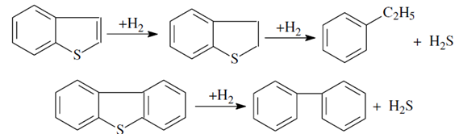

Figure 17 - Results of desulfurization of oil sludge LLP "Atyrau oil refinery"
The desulphurization method using ASA was applied to de-sulfurize the Karazhanbas (Severny) crude oil, Figure 18.
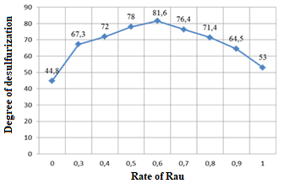
Figure 18 - Dependence of the degree of desulfurization of crude oil Karazhanbas (norhtern) on the consumption of Rau-85 (oil: solvent ratio - 1: 5; solvents - benzene: hexane; temperature - 80 ℃; time - 1 hour)
After TGCT of oil with compositional compositions containing Rau-85, the sulfur content decreases from 2.8% to 0.5%, the degree of desulfurization reaches 81.6% at a reagent consumption of 6 kg per ton of oil, the optimal ratio of oil to solvent is 1: 5 .
Thus, it has been shown that using composite compositions containing AAA can significantly reduce the content of sulfur and non-ferrous metals in heavy oil. The method does not require high temperatures and special equipment. The adsorbent formed during the hydrolysis of AAA concentrates sulfur and effectively purifies HC. The processed HOR contains an insignificant content of sulfur and metals, which makes it possible to use it for further processing into the target product.
Chapter 3 Evaluation of the technological and economic efficiency of using EAS based on activated metals for purification of technical, formation and sediment water from additional sludge ponds, development of practical recommendations for the introduction of EAS as adsorbents and coagulants for water purification, demetallization of fuel oil and tar. Results of the third year of the study

3.1 Comparative evaluation of the efficiency of purification of industrial and formation water using adsorbents and coagulants based on the decomposition products of EAS with water
For the purification of industrial wastewater in world practice[52-63], various methods are used, including sorption methods based on activated carbons, zeolites, aluminum salts and alumina Аl₂O₃, which make it possible to reduce the anthropogenic load on water bodies. Many impurities of coarse, colloidal and part of dissolved impurities are not removed from the water mechanically, are not neutralized during biological treatment, and are not removed by traditional water purification methods such as sedimentation, coagulation and flotation. This leads to the introduction of the stage of sorption additional treatment into the complex technological scheme of water treatment. Additional treatment of effluents using sorption materials is the final stage in technological schemes.
Sorption methods make it possible to remove contaminants of a very wide nature, in fact, to trace concentrations, regardless of their chemical resistance. Sorption methods of purification are a heterogeneous process, they are quite effective, they are used for deep purification of weakly concentrated wastewater, mainly from molecularly dissolved substances. The choice of adsorbent depends on the nature of the extracted substance and the form of its presence in solution.
The mechanism of sorption of contaminants on inorganic sorbents (clay materials, zeolites) is rather complex, and includes van der Waals interactions of hydrocarbon chains with a developed surface of silicate microcrystals and the Coulomb interaction of charged and polarized sorbate molecules with positively charged areas of the sorbent surface containing H ⁺ and Al ³⁺ [63].
According to the author [63], widespread adoption is due to a rather high sorption capacity, selectivity, cation exchange qualities, as well as a relatively low cost and availability. Cheap natural sorbents have a developed structure with micropores having different sizes depending on the type of mineral.
In [62], it is noted that the expansion of their implementation scale for water purification is facilitated by the ability to regulate the porosity and sorption qualities of inorganic compounds, chemical and thermal stability, resistance to fire, readiness of raw materials and the organization of domestic products during synthesis by adding various compounds.

Clay materials are most widely used for water bleaching, removal of inorganic impurities and especially toxic organochlorine compounds and herbicides, various surfactants. Natural sorbents are extracted in the immediate vicinity of the place of consumption.
The most widely used natural sorbents are zeolites - chabazite (Na₂Ca)O(Al₂O₃(4SiO₂(6H₂O) with pore size 0.37-0.50 nm, mordenite (Na₂K₂Ca)O(Al₂O₃(10SiO₂(6.7H₂O) with pore size 0.67-0.70 nm), and also clinopptilomite (Na₂K₂Ca) O (Al₂O₃ (10SiO₂ (8H₂O). For the manufacture of durable and water-resistant filter materials from natural zeolites, they are fired in furnaces with sodium chloride or sodium carbonate at 1000⁰C. Improves the sorption of oil from water by treating the surface of zeolites with organosilicon compounds, which make it hydrophobic.
It should be noted [60, 62] that high-tech development of sorption materials, which allow complex sorption of pollutants of various nature up to their complete absorption, have a very high cost. There are no relatively inexpensive sorbents capable of purifying water from heavy metal ions (HMI) and other pollutants. Therefore, the problem of complex wastewater treatment from HMI and organic compounds is of great scientific and practical importance.
Water purified to the norms necessary for reuse for technological needs can be obtained only by using combined reagent and physicochemical methods of wastewater treatment, modernization of existing enterprises, replacing outdated treatment processes, improving the quality of wastewater treatment, introducing closed production cycles [60, 62]. It is necessary to focus on resource-saving technologies [64, 65].
The choice of optimal technological schemes for water purification is known to be a rather difficult task. This is due to the predominant variety of impurities in the water and high requirements for the quality of water purification. When choosing wastewater treatment schemes, one has to take into account not only their composition, but also the requirements that the treated water must satisfy. When used in the production of re-treated wastewater, the criterion for the degree of purification is those requirements that are necessary for the implementation of specific technological processes [66-69].
The aim of the work is to improve the quality of wastewater treatment of LLP "Atyrau oil refinery" to the standards required for reuse in technological processes.
When choosing a coagulant used for wastewater treatment, the following requirements were taken into account:
-availability;
-low cost;
-good filtration properties;
-high sorption capacity;
-the possibility of further disposal.
It is known from the literature that AI₂O₃ is widely used as a sorbent.
To break the stability of the dispersed system in the process of water treatment, the authors of this report used the products of the reaction of AAA with water as coagulants-sorbents for disinfection and physicochemical purification of sediment formation waters after the destruction of the OS. It was revealed [20] that coagulants-adsorbents based on the reagent Rau-85 not only improves the properties of water by reducing the content of corrosive cations Ca, Mg, Fe, but also have a bactericidal effect.

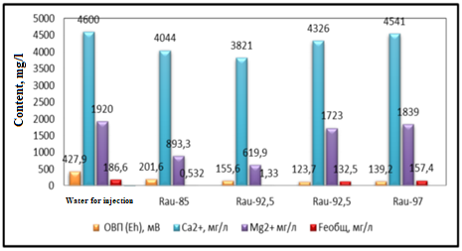
Figure 19 - The content of cations in the formation water of Western Makat field before and after treatment with activated aluminum alloys of different composition

Figure 19 shows that after treatment with the Rau-85 reagent, the total salinity of formation water for injection from the Western Makat field decreases by more than 2 times, the content of Ca cations decreases from 4600 mg / l to 4044 mg / l, Mg from 1920 mg / l up to 893.3 mg / l, Fe from 186.6 to 0.532 mg / l, which is associated with the reactions of ion exchange and adsorption on the surface of aluminum hydroxides. From 66% to 96% of the elements in the formation water are deposited on the surface of aluminum hydroxide. AAA purify water from toxic compounds of natural and technogenic origin, reduce the total mineralization and the content of alkaline earth elements, which helps to protect the environment, as well as improve the state and preserve human health.
AAA is highly active with water. The reaction takes place with the formation of aluminum hydroxide and hydrogen in any aqueous solutions. The reaction is exothermic, from which it follows that the use of AAA will be especially effective in the cold season, when the rate of chemical reaction of wastewater treatment is significantly reduced, as well as during spring and autumn floods [20]. It has been shown that the reaction products of AAA with water are effective adsorbents and coagulants and can be used for water purification for various purposes at oil production facilities, oilfield preparation and oil refining.

3.2 Development of formation water treatment technology using different doses of activated aluminum
At the present stage of development, Atyrau Oil Refinery LLP does not have a fully closed recycling water supply system. In this regard, after purification, excess wastewater treated according to regulations is discharged into a special evaporation pond to the evaporation fields, which are located to the north-east, 3 km from the plant. Evaporation pond of the left-bank part of Atyrau. belongs to the main potential sources of groundwater pollution. The total area of ​​the evaporation pond is 1000 hectares, the capacity is 14.0 million m³. The design volume of wastewater discharged into the evaporator pond of Atyrau Refinery LLP, taking into account the deep oil refining complex (DORC), will amount to 288.82 m³ / h for 2019; 2530096 m³ / year [76.77]. The standard maximum permissible discharge (MPD) for 2019 is 847.28 m³ / hour, 7 422 170.85 m³ / year.
When developing a method for treating formation water separated from oil sludge from ASP AOR LLP using activated aluminum alloys, the effect of the composition of the AAA, the ratio of alloy: water, as well as the mineral composition and pH of water was studied.
In laboratory conditions, a reagent method for purifying contaminated water from petroleum products using AAA on industrial waters of ASP AOR LLP and in comparison with industrially used coagulants with AI₂ (SO₄) ₃ and Fe₂ (SO₄) ₃ has been worked out.
The influence of the composition of AAA, the ratio of alloy: water, as well as the mineral composition of water and its pH on the efficiency of water purification was revealed.
Before carrying out technological research on water purification using AAA and assessing its effectiveness, a complete chemical analysis of the source water was carried out. On the basis of the obtained results and analysis of industrial methods of water purification, variants of the technological scheme of water purification were developed.
Recommended scheme for water purification AAA: a sample of 50-750 ∙ 10⁻⁶ g / dm³ of aluminum alloy was introduced into a water sample with a volume of 1 dm³, and it was altered with electric stirrers for 300 s - 2000 s. Rapid mixing is important at this stage in order to obtain a homogeneous dispersion of the chemical and to maximize the possibility of maximum contact between the particles. After prolonged (several minutes) stirring, coagulation of particles into larger formations is observed. After the particles have increased in size and weight, they begin to settle to the bottom, due to the action of gravity. In the process of interaction of alloys with water, particles of the resulting products can capture various impurities and, precipitating, remove them. When AAA is used as coagulants, coprecipitation and adsorption are likely to occur simultaneously.
After stirring, the stirrers were turned off and the water was allowed to settle for 3600 s. After the stage of coagulation and sedimentation of the precipitate, the water was passed through a filter. The filtration method is the main technological method of fine purification of any type of water from dissolved and dispersed particles [60], then the determination of the physicochemical characteristics of the purified water was carried out according to the methods set forth in the State Standards.
Thanks to the use of a coagulant, the water at the outlet is purified from suspended oil particles and from the mechanical particles of calcium, sodium, magnesium, and iron hydroxide contained in it.
The content of oil in industrial waters ASP in the aqueous phase before alloy treatment is 404 mg / l after AAA purification - 15-17 mg / l (there is no need for preliminary additional treatment). The cleaning efficiency depends on the process conditions (solution temperature, solution pH, alloy composition). Alkalinization of water was used to accelerate flocculation. In order to reduce the consumption of the coagulant, the coagulation process was carried out in the medium pH range from 4.4–8; the highest purification efficiency is achieved in media with high pH, ​​which are achieved by adding sodium hydroxide.
Processing of sediment formation water samples by AAA allows to obtain transparent waters (Figure 20), in which there are no oil impurities, turbidity decreases from 128 to 1-2 NTU, the content of Ca, Mg, Fe cations decreases towards lower values.
The use of Rose, Wood, Darce alloys for the activation of aluminum makes it possible to reduce the cost of activated aluminum alloys by an order of magnitude. Purified formation water using ASA as coagulants-adsorbents, according to hygienic standards, the content of oil, suspended particles, heavy metals, which have a significant effect on the oil recovery factor, meets the requirements for the quality of injected water for waterflooding of oil reservoirs with a porous reservoir medium permeability up to 35 μm2 and more and the coefficient of relative fracturing of the reservoir from 6.5 to 2 inclusive (industry standard OST 39-225-88). The purified water has a pH of 8.22-8.50, the oil content is 15 mg / l, iron ions are trace concentrations.
From the analysis of Figure 20, it follows that the coagulant based on ASA more effectively removes organic substances that impart color to wastewater compared to AI₂ (SO₄) ₃ and Fe₂ (SO₄) ₃.

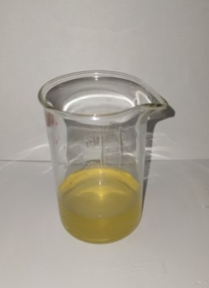(a) 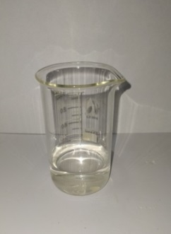 (b) 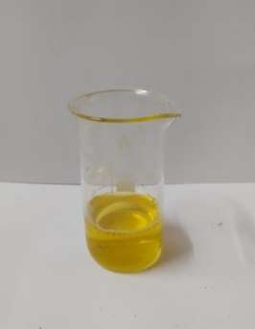 (c) 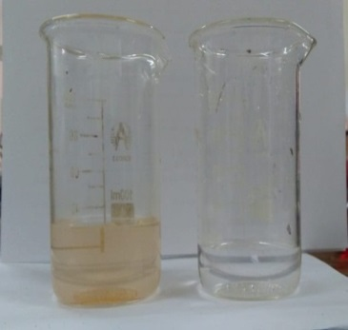 (d)
a - initial formation water, b - sediment water after treatment AI: Wood's alloy = 90: 10 at a temperature of 90 ° C and a ratio of 1:50, c - formation water after treatment with AI₂ (SO₄) ₃ at a temperature of 90 ° C and a ratio of 1:50, d-sediment water of the Karazhanbas field
Figure 20 - Photos of sediment water from oil sludge from ASP AOR LLP and water-oil emulsion from Karazhanbas field.

Thus, the test results of the developed purification technology using AAA as coagulants-sorbents confirmed their effectiveness for wastewater purification up to the norms required for reuse in technological processes.

3.3 Development of practical recommendations for the introduction of EAS based on activated metal alloys and hydrolysis products with water as adsorbents and coagulants for water purification, demetallization of mazut and tar
When developing a reagent method for purifying contaminated water from OP using AAA, it was revealed that in media with a high pH, ​​which is achieved by adding sodium hydroxide, the content of alkaline earth ions is significantly reduced in comparison with media with low pH values ​​(achieved by adding HCI). However, the content of aluminum ions increases in the purified water.
It is known that aluminum oxide in aqueous acidic media has a positive charge, in alkaline media - negative, which allows the oxide surface to selectively sorb anions (in acidic media) and cations (in alkaline media) [62].
The established increase in efficiency in the extraction of cations from the solution with increasing pH indicates the occurrence of chemisorption processes. Due to the increase in the number of OH functional groups in the solution, the surface of the sorbent acquires a negative charge, and the sorption of positively charged metals occurs more efficiently [17, 62].
It is also known that the solubility of Al (OH) ₃ in water is a function of pH [72] at low pH values ​​<4.5, Al³ ⁺ ions prevail in the solution, at pH = 5-6, Al (OH) ²⁺ ions prevail in the solution, at pH > 7 ions Al (OH) ₄ prevail in the solution. Aluminum salts and aluminates in solutions are highly hydrolyzed.
In an environment with a high pH value, when the alloy interacts with water, along with aluminum hydroxide, sodium aluminate NaAI (OH) ₄ is formed, soluble in water, which is a sodium salt of aluminum acid, which is an effective coagulant. In the process of waste water purification, a double coagulation process takes place, while polyvalent aluminum cations compensate for the charge of negatively charged particles, and aluminate ions act on contaminants with a surface positive charge. In an environment with a high pH value, sodium aluminate interacts with water molecules to form sodium tetrahydroxoaluminate, that is, sodium aluminate exhibits anionic properties. Sodium aluminate leads to a decrease in the hardness of waste water, since it effectively precipitates magnesium ions [73–75].
It is noted that many adsorbents on their surface in an aqueous medium carry a charge, the value and sign of which are determined by the pH of the solutions under study.
It was revealed that with a decrease in the concentration of heavy metal ions (HMI) in the solution, the pH value shifts to the alkaline region.
The efficiency of wastewater treatment from HMI is influenced by the nature of the cation. Wastewater treatment from HMI (Cu ² ⁺, Ni ² ⁺, Fe _{to}t., Zn ² +, Cd ² ⁺, Pb ² ⁺) using activated aluminum alloys showed that the purification efficiency increases in the series: Cu ² ⁺ <Ni ² ⁺ <Fe _{tot.} <Cd ² ⁺ <Zn ² ⁺ (89%) <Pb ² ⁺.
AAA, when interacting with alkaline water, form sodium aluminate NaAI (OH) ₄ soluble in water, therefore, after treatment of water with alloys, the aluminum content is higher than in the original water. The content of elements Ba, Ca, Fe, Mg, P, Si is significantly reduced and reaches trace concentrations, which indicates the high efficiency of alloys as coagulants for water purification.
Aluminum ions contained in water do not belong to substances with pronounced toxic effects. Maximum concentration limit of aluminum in drinking water is 0.2 mg / l, in some cases reaching 0.5 mg / l.
When using purified water in a circulating water supply system, the amount of dissolved aluminum salts in order to avoid the formation of a hydroxide precipitate is normalized, since in these systems a reagent containing phosphate ions is used as a corrosion inhibitor, aluminum in the water interacts with them, forming complex insoluble complex compounds that clog the pipes of heat exchangers and impair their operation [75]. Considering the above, it is recommended to purify water using AAA without adding acids or alkalis to the water (pH of the medium from 4.4 to 8) and the dose of the alloy from 70 to 100 ppm, at a temperature of 25 ° C when using the reagent Rau-85 containing indium as activator metals, gallium, tin at a ratio AI: In: Ga: Sn = 85: 5: 5: 5, and a temperature of 90 ° C when using aluminum activated with Rose, Wood, Darcay alloys at a ratio AI: alloy = 90: 10.
In the water purified in this way, the aluminum content is in the range from 0 to 15 mg / l. Shaking and stirring vigorously the coagulated water is not recommended, because this leads to the separation of the floccules.
The desulfurization process is recommended to be carried out using composite compositions containing AAA in a mixture of solvents benzene: hexane = 1: 1, with a ratio of oil: solvent = 1: 5, a ratio of heavy oil feedstock: water from 1: 1 to 1: 4, a temperature of 80 ° C and the duration of the process is 1 hour.
The demetallization process is recommended to be carried out in a solvent environment (benzene, heptane). Heavy petroleum feedstock is heated to 60 ° C.
Water is added at a temperature of 70-100 ° C at a ratio of oil feedstock: water = 1: 1. An aluminum alloy (Rau-85 reagent) is added to the oil feed at a ratio of 1: 100. The duration of the process is from 0.5 to 3 hours.

CONCLUSION

Brief conclusions on the results of the completed research work or its individual stages
The technical solution of the research work carried out is the development of methods and conditions for the activation of aluminum by metals with activators, which lead to the destruction of the oxide film and ensure the reactivity of aluminum to water.
The possibilities of controlling the process of interaction of activated aluminum with water are revealed, which makes it possible to obtain hydrogen at high rates, which is determined by the nature and content of the activator metals, as well as the nature of metals and water salinity, the temperature of the experiment and the conditions of heat treatment of alloys.
It is noted that the introduction of Darce, Rose, Wood activator alloys into the Al alloy leads to an increase in the rate of its interaction with water in comparison with an alloy containing only Al, Ga, In, Sn.
The method of optical emission spectroscopy with inductively coupled plasma, spectrophotometric method, ORP-meter, as well as titration and study of pH, carried out a comprehensive analysis of the chemical composition and physicochemical characteristics of the formation waters of the Western Kazakhstan fields. The formation waters of the Koschagyl, Akkuduk, Kisimbai, Akingen fields differ in the content of Na, K, Mg, Ca, Ba, Si cations. The analyzed formation waters are characterized as brines and are at greater risk for sodium chloride (halite) deposition. Thus, at Koschagyl No. 606, the density value was 1055 kg/m³, and the total mineralization was 86.9 g/dm³, while at Cape Botakhan 150, the density was 1143 kg/m³, and the total mineralization was 215.7 g/dm³.
The presence of Mg and Fe cations in formation waters indicates their high corrosive activity. It was found that during the exploitation of the studied oil and gas fields, it is necessary to prevent the mixing of waters containing carbonates and sulfates in order to prevent the formation of mineral salts on oil production and oil transportation equipment.
A pilot batch of AAA of various compositions and degrees of grinding has been produced for comprehensive research. A pilot batch of AAA was obtained.
It has been shown that the reaction products of activated alloys of Rau with water are excellent adsorbents and coagulants and can be used to purify water for various purposes at oil production enterprises and to reduce its corrosivity.
Based on the analysis of the formation waters of East Makat (EmbaMunayGas JSC) before and after treatment with AAA, it was concluded that after treatment with the Rau reagent, a decrease in the redox potential (Eh) of water and salts towards lower values ​​is associated with ion exchange and adsorption reactions on the surface of aluminum hydroxides. The content of cations of Ca decreases from 4600 mg/l to 4044 mg/l, Mg from 1920 mg/l to 893.3 mg/l, Fe from 186.6 to 0.532 mg/l.
It was found that with an increase in the total mineralization and an increase in the acidity of water, the rate of interaction of AAA with formation water increases and heat release increases. The physicochemical properties and characteristics of fuel oil and tar samples of Atyrau Oil Refinery LLP, Pavlodar Petrochemical Plant LLP, water-oil emulsion of the Karazhanbas (Northern) field before processing with EAS were studied.
Structural-group, X-ray phase and X-ray fluorescence analysis of tar and fuel oil was carried out. It was revealed that the tar of "Atyrau oil refinery" LLP contains 2.5 times more asphaltenes in comparison with the tar of " Pavlodar Petrochemical Plant " LLP. X-ray fluorescence analysis of asphalts isolated from Karazhanbas oil showed an increased content of vanadium in them, the concentration of vanadium reaches 0.482% and nickel 0.075% (4.82 kg and 750 g, respectively, per 1 ton of asphaltenes). It is shown that the resource potential of oil and water-oil emulsions Karazhanbas can become a reliable source of valuable metals - vanadium and nickel.
For the first time, a method has been developed for demetallization of HO and OP (mazut and tar) using hydrogen energy of AAA. Composite compositions containing EAS based on AAA, organic solvents and distilled water have been developed. It was revealed that the use of composite compositions containing EAS based on an activated aluminum alloy can significantly reduce the content of non-ferrous metals vanadium and nickel in heavy hydrocarbon feedstock (fuel oil, tar) to 70 - 75%.
For the first time, a method has been developed for desulfurization of heavy oils and oil products (fuel oil, tar) and oil sludge from LLP "Atyrau oil refinery" using activated aluminum alloys. Composite compositions containing EAS based on activated aluminum alloys, organic solvents and distilled water have been developed. It was found that the use of composite compositions containing EAS based on an activated aluminum alloy can significantly reduce the sulfur content in heavy hydrocarbon feedstock.
The degree of desulfurization for tar - 51%, fuel oil - 64%, Karazhanbas oil - 82%, oil sludge – 98%.
Assessment of the completeness of the solution of the assigned tasks
1) The task of the project No. 1.1 according to the calendar plan was completed in full. A correlation has been established between the composition of the aluminum-based alloy, the temperature and the rate of hydrogen evolution.
To reduce the cost of activating aluminum, it was proposed to replace the metals Ga, In, with Darce, Rose and Wood alloys. It was found that their introduction into the composition of the aluminum alloy leads to an increase in the rate of its interaction with water. It is noted that the rate of hydrogen evolution during the oxidation of activated aluminum with distilled water is higher than in the simulated formation water. The hydrogen evolution reaction proceeds without an induction period. It was also found that with a decrease in the pH of the simulated formation water by adding hydrochloric acid, the volumetric yield of hydrogen increases and reaches the theoretical 99%, and the heat of reaction is 3371 kJ/kg.
2) The task of the project No. 1.2 was completed in full according to the schedule.
Using the method of optical emission spectroscopy with inductively coupled plasma, pH-, ORP - meter, spectrophotometer and titration, a comprehensive analysis of the chemical composition and physicochemical characteristics of formation waters for the content of salt-forming elements Na, K, Ca, Mg, Fe, Ba, Li, Si, Sr, V, anions SO₄²⁻, Cl⁻, CO₃⁻, HCO₃⁻, as well as pH, ORP, electrical conductivity, ρ, total mineralization.
The waters of the Altykul (well No. 102), Botakhan (well No. 121) and Karazhanbas (well No. 897, well No. 1783, well No. 3817), and Karsak deposits were studied. Tengiz: field-2NT, field -11 NT and field -4NT, field of NGDU "Zhylyoimunaigaz": Koschagyl No. 606, Koschagyl Kazan, Akingen, Akkuduk, Botakhan 121, Botakhan 150, Kisimbai No. 34, NGDU “Zhaiykmunaigas” : Saltanat Balgimbaev RVS No. 1,8,9.
Based on the research, it was concluded that during the operation of the fields, it is necessary to prevent the mixing of waters containing carbonates and sulfates in order to prevent the formation of mineral salts on oil-producing equipment and oil-transporting equipment.
3) The task of the project No. 1.3 was completed in full according to the schedule.
With regard to aluminum alloys, a simple and cheap method has been developed for obtaining aluminum alloy powder and storing it without changing its activity. For this, an aluminum alloy with the addition of activator metals was initially obtained by fusion, which was cast into cooled cylindrical molds, and then, in an atmosphere of pure argon, was crushed in a fine crusher DMD 160x100 mm according to a program that allows obtaining the required grain size composition of the alloy.
4) The task of the project No. 1.4 was completed in full according to the schedule.
Produced waters are characterized by different chemical composition and physical and chemical properties. It can be noted that the analyzed formation waters are characterized as brines with a total salinity of 16374, mg / l for wells. No. 3817 m. Karazhanbas up to 215600 mg / l for well. No. 121 m. Botakhan. After the treatment of formation waters by ASA, there is a decrease in the total mineralization, so on the example of Cape East Makat, the content of cations decreases: Ca from 4600 mg / l to 4044 mg / l, Mg from 1920 mg / l to 893.3 mg / l, Fe from 186.6 to 0.532 mg / l.
Research data indicate that the reaction products of activated alloys of Rau with water are excellent adsorbents and can be used for water purification for various purposes at oil production enterprises. It has been proved that during the exploitation of the studied fields it is necessary to prevent mixing of waters containing carbonates and sulfates in order to prevent the formation of mineral salts on oil and gas production and oil transportation equipment.
5) The task of the project No. 2.1 according to the calendar plan was completed in full. The physicochemical properties and characteristics of fuel oil and tar samples from the Atyrau oil refinery and the Pavlodar Petrochemical Plant before processing with EAS have been studied.
6) The task of the project No. 2.2 is completed in full. Based on the rate of hydrogen evolution, the optimal parameters of the interaction of aluminum alloys activated by Darce, Wood, Rose alloys with water, depending on the temperature, the amount of the activating additive in the alloy, and the pH of water, have been established. A comparative assessment of the efficiency of the alloys is carried out. It was revealed that the process proceeds at a significant speed for 20 - 40 minutes and ends after 40 minutes. The hydrogen yield reaches theoretical values ​​when the pH of the water is reduced by adding hydrochloric acid.
7) The task of the project No. 2.3 is completed in full. A comprehensive analysis of the composition of oil and water-oil emulsion Karazhanbas, sediment formation water before the processing of activated aluminum alloys was carried out. The elemental composition of asphaltenes isolated from oil products, mechanical impurities and sediment water of the Karazhanbas creek after the treatment with AAA was studied. It is shown that the resource potential of oil and water-oil emulsions Karazhanbas can become a reliable source of valuable metals - vanadium and nickel. Treatment of sediment formation water samples with an activated aluminum alloy allows obtaining transparent waters in which there are no oil impurities, the turbidity is reduced from 128 to 1 - 2 NTU.
8) The task of the project No. 2.4 was completed in full according to the schedule. A method has been developed for demetallization (V, Ni) of HO and OP (mazut, tar) by thermogasochemical action with AAA. Composite compositions containing EAS based on AAA, organic solvents and distilled water have been developed.
9) The task of the project No. 2.5 was completed in full according to the schedule. An assessment of the efficiency of demetallization (V, Ni) of mazut and tar by thermogasochemical action with AAA was carried out on the basis of an analysis of the physicochemical properties of fuel oil and tar samples from the Atyrau oil refinery and the Pavlodar Petrochemical Plant after treatment with EAS.
10) The task of the project No. 2.6 was completed in full according to the schedule.
A method has been developed for desulphurization of HO and OP (mazut, tar) and oil sludge of LLP "Atyrau Refinery" using AAA. Composite compositions containing EAS based on AAA, organic solvents and distilled water have been developed. It was found that the use of composite compositions containing EAS based on an AAA can significantly reduce the sulfur content in HHF.
11) The task of the project No. 3.1 was completed in full according to the schedule. An assessment of the technological and economic efficiency of the use of EAS based on AAA for the treatment of industrial wastewater from LLP "Atyrau Refinery" has been carried out. The results of testing the reagent method of purification by the decomposition products of EAS with water confirmed the efficiency of using AAA as coagulants-sorbents for wastewater treatment, up to the norms required for reuse in technological processes. AAA purify water from toxic compounds of natural and technogenic origin, reduce the content of alkaline earth elements and general mineralization, improve the properties of water, and exhibit a bactericidal effect. The use of Rose, Wood, Darce alloys for the activation of aluminum makes it possible to reduce the cost of activated aluminum alloys by an order of magnitude.
Purified formation water using AAA as coagulants-adsorbents, according to hygienic standards, content of oil, suspended particles, heavy metals, meets the requirements for water quality (industry standard GOST 39-225-88). Purified water has a pH of 8.22-8.50, oil content 15 mg / l, iron ions - trace concentrations.
12) The task of the project No. 3.2 was completed in full according to the schedule. The technology of purification of formation water separated from oil sludge from LLP "Atyrau Refinery" with the use of various doses of AAA has been developed. The influence of the composition of the activated alloy, the alloy: water ratio, as well as the mineral composition and pH of water has been studied.
To accelerate flocculation, alkalization of water with sodium hydroxide was used. In the water purified in this way, the aluminum content is in the range from 0 to 15 mg / l.
13) The task of the project No. 3.3 was completed in full according to the schedule. Practical recommendations have been developed for the introduction of EAS based on AAA and products of hydrolysis with water as adsorbents and coagulants for water purification, demetallization of fuel oil and tar.
Water purification using AAA must be carried out without adding acids or alkalis to the water (pH of the medium is from 4.4 to 8) and the dose of the alloy is from 70 to 100 ppm at a temperature of 25°C when using the Rau-85 reagent containing indium, gallium as activator metals , tin at the ratio AI: In: Ga: Sn = 85:5:5:5, and 90 ° C when using aluminum activated with alloys Rose, Wood, Darce at the ratio AI: alloy = 90:10.
The desulfurization process is recommended to be carried out using composite compositions containing AAA in a solvent mixture benzene: hexane = 1: 1, with an oil: solvent ratio = 1: 5, a heavy oil: water ratio from 1: 1 to 1: 4, a temperature of 80 ° C and the duration of the process is 1 hour.
The demetallization process is recommended to be carried out in a solvent environment (benzene, heptane). HHF is heated to 60 ° C. Water is added at a temperature of 70-100 ° C at a ratio of HHF: water = 1: 1. Aluminum alloy reagent Rau-85 is introduced into oil feedstock at a ratio of 1: 100. The duration of the process is from 0.5 to 3 hours.
Development of recommendations and initial data on the specific use of research results;
It consists in finding the possibility of using activated metal alloys as a source for obtaining hydrogen from water. Creation of adsorbents-coagulants of various types with controlled physicochemical properties for water purification, improvement of the commercial characteristics of oil, demetallization of fuel oil and tar. Solving environmental problems in the oil production, oil transportation industry, and the petrochemical industry through the integrated use of EAS water decomposition products (metal oxides, high pressure steam, heat of reaction) for resource and energy saving technologies for demetallization, desulfurization of hydrocarbon raw materials (fuel oil and tar), waste and reservoir treatment water.
The results of assessing the technical and economic efficiency of implementation
The results of the research carried out at this stage are not enough to assess the technical and economic efficiency. Research in this direction will be continued
The results of assessing the scientific and technical level of the completed research work in comparison with the best achievements in this area.
The performed research and development work corresponds to the best achievements in this area, which is confirmed by the publication of research results in high-ranking journals (Yerzhan A. Issabayev, Galina I. Boiko, Nina P. Lyubchenko, Yerengaip M. Shaikhutdinov, Hervé Muhr, Ludovic Colombeau, Philippe Arnoux, Céline Frochothesis Synthesis and evaluation of new aminophosphonic acid as scale inhibitor for industrial water applications // Journal of Water Process Engineering 22 (2018) 192 - 202 Impact factor = 4.0, quartile Q1, percentile 91%; Raushan G. Sarmurzina, Galina I. Boyko, Meirzhan T. Baigaziyev, Uzakbai S. Karabalin, Nina P. Lubchenko New generation of energy accumulating substances based on activated aluminum // Journal of chemical technology and metallurgy//Journal of chemical technology and metallurgy, Sofia, V53, issue 1, 2018. - pp. 119 - 124 (with an impact factor of 0.60, quartile Q3, percentile 41%), Valeriya N. Ayukayeva, Galina I. Boiko, Nina P. Lyubchenko, Raushan G. Sarmurzina, Rashida F. Mukhamed ova, Uzakbay S. Karabalin, Sergey A. Dergunov Polyoxyethylene Sorbitan Trioleate Surfactant as an Effective Corrosion Inhibitor for Carbon Steel Protection//Colloids and Surfaces A: Physicochemical and Engineering Aspects А579 (2019). - P. 1 - 9 (impact factor 3.13, quartile Q2, percentile 76%), as well as patents (1. Patent No. 33863 on application reg. No. 2018 / 0265.1 dated 26.04.2018 / date of registration in the State Register inventions of the Republic of Kazakhstan: 08/27/2019 Method of extracting non-ferrous metals from heavy oil raw materials / Sarmurzina R.G., Boyko G.I., Lyubchenko N.P., Nabidollaev S.E., Boyko E.A., Karabalin U.S., Akchulakov B.U., Kozyrev D.V .; 2. Patent of the Republic of Kazakhstan No. 34095 (z. Reg. No. 2018 / 0640.1 dated 16.09.18) publ. 20.03.2020, bulletin No. 11 Method for removing sulfur from crude oil / Boyko G.I., Sarmurzina R.G., Karabalin U.S., Tiesov D.S., Lyubchenko N.P., Nabidollaev S.E., Boyko E.A.), speeches at international conferences and forums .

References

1 Du B.D., Wang W., Chen W., Chen D.M., Yang K. Grain refinement and Al-water reactivity of Al-Ga-In-Sn alloys // International Journal of Hydrogen Energy. – Volume 42. –Issue 34. –24 August 2017. –P. 21586-21596 (eng).
2 Ching-Yuan Ho. Hydrolytic reaction of waste aluminum foils for high efficiency of hydrogen generation // International Journal of Hydrogen Energy. –Volume 42. –Issue 31. –3 August 2017. –P. 19622-19628 (eng).
3 He T.T., Wang W., Chen W., Chen D.M., Yang K. Influence of In and Sn compositions on the reactivity of Al-Ga-In-Sn alloys with water // International Journal of Hydrogen Energy. –Volume 42. –Issue 9. –P. 5627-6434 (eng).
4 Wang W., Zhao X.M., D.M. Chen, K. Yang. Insight into the reactivity of Al-Ga-In-Sn alloy with water // International journal of hydrogen energy. –2012. –Volume 37. –P. 2187-2194 (eng).
5 Yu-Kuang Chen, Hsin-Te Teng, To-Ying Lee, Hong-Wen Wang. Rapid hydrogen generation from aluminum–water system by adjusting water ratio to various aluminum/aluminum hydroxide // Int J Energy Environ Eng. – 2014. –Volume 5. –P. 87 (eng).
6 Gimatudinov Sh.K. Oil Production Reference Book. – М.: Nedra. –1983. – P. 455 (rus).
7 Zorkin L.M. Зорькин Л.М. Geochemistry of gases in formation waters of oil and gas basins. –М.: Nedra, 1973. –P. 224 (rus).
8 Varshavskiy I.L. Energy storage substances and their use. –Kiev: Nauk.dumka, 1980. –P. 240 (rus).
9 Podgornyi A.P., Varshavskiy I.L. Hydrogen is the fuel of the future. –Kiev: Nauk.dumka, 1980. –Р. 240 (rus).
10 Rebinder P.A. Surface phenomena in dispersed systems. –М.: Nauka, 1978. –P.36-73 (rus).
11 A.с. 535364 Aluminum based alloy for hydrogen production / Sokolsky D.V., Sarmurzina R.G.; published. in B.I., 1976, №42 (rus).
12 Sarmurzina R.G., Presniyakov А.А, Моrozova О.I, Mopha N.N, Aubakirova R.К. Relation of the structure of activated aluminum to the skinetics of hydrogen evolution during the interaction of the alloy with water // J. physical chemistry. –1984. –Т.57. –№4. –P. 975-976 (rus).
13 Sarmurzina R.G., Sokolsky D.V., Vozdvizhenskiy V.F. Physicochemical bases of aluminum activation in order to obtain hydrogen fuel. – Collection. Questions of atomic science and technology. –Ser. Atomic-hydrogen energy and technology.– 1985. –№2. –P.29-32 (rus).
14 Sarmurzina R.G., Presniyakov А.А, Morozova О.I., Mopha N.N. Structure and properties of activated aluminum // Physics of metals and metal science. –1988. –Т.66. –№ 3. –P. 504-508 (rus).
15 Bersh А.V., Kleimenov B.V., Mazalov U.А, Nizovcev V.Ye. Prospects for the development of hydrogen energy based on aluminum // Radioelectronics and Telecommunications. –2005. –№2. – P. 62-66 (rus).
16 OPTIMA 8000 User's manual © 2011 Perkin Elmer, Inc.
17 Vdovykin, G.P. Redox potential of formation waters of the northwestern Ciscaucasia and some surface waters / G.P. Vdovykin // Geology of oil and gas. –1963. –№7. –P.43-47 (rus).
18 Sarmurzina R.G., Boyko G.I., Baigaziyev M.T., Karabalin U.S., Lubchenko N.P. New generation of energy accumulating substances on the basis of activated aluminum // Journal of chemical technology and metallurgy // Journal of chemical technology and metallurgy, Sofia. –2018. –V53. –№1. –С.119-124 (eng).
19 Kaschavtsev V.E., Mishchenko I.T., Salt formation during oil production. – М. – 2004. – 432 p (rus).
20 KZ Innovative patent №29254 by application № 2013/1917.1 from 19.12.2013. Innovative patent KZ №29254. Coagulant for drinking water purification / Beisembetov I.K.., Kenzhaliyev B.K., Kurapov G.G., Sarmurzina R.G. Boiko G.I,, Shaikhutdinov Ye.М., Lyubchenko N.P.; application № 2013/1917.1 от 19.12.2013, publ. 15.12.2014, Bull. № 12 (rus).
21 Boiko G.I., Sarmurzina R.G., Shaikhutdinov Ye.M., Lyubchenko N.P., Issabayev Ye.A., Baigaziyev M.T. Analysis of stratal waters of oil fields in Kazakhstan and modern methods of their purification with energy storage substances // Proceedings of the IX International Beremzhanov Congress on Chemistry and Chemical Technology (KazNU). –2016. -FROM. 270-273 (rus).
22 Sarmurzina R.G., Boiko G.I., Lubchenko N.P., Kasymgaliyev K.M., Moldabekov B.S., Issabayev Y.A. Activated aluminum alloys for water purification // 6th International Congress “Biomaterials and Nanobiomaterials: Recent Advances Safety - Toxicology and Ecology Issues. - Crete, Greece. –2015. –Р. 30-35 (eng).
23 Issabaev E.A., Boiko G.I., Lyubchenko N.P., Sarmurzina R.G., Shaikhutdinov Ye.M., Kassymgaliev K.M. Chemical composition and properties of stratal waters of oil and gas fields of western Kazakhstan // Bulletin of the Kazakh-British Technical University. –T.12. -№ 3. –2015. -P. 72-78 (rus).
24 Vaisman Ya.I., Glushankova I.S., Rudakova L.V., Dyakov M.S. Research of physical and chemical properties and thermal destruction of waste from oil refineries // Research and innovation, Scientific journal. - 2010. - T. 4. - № 3. – P. 21-28 (rus).
25 Prozorova I.V., Volkova G.I., Loskutova Yu.V., Yudina N.V., Kirbizhekova Ye.V. Composite additive for paraffinic and highly paraffinic oils // Oil industry. -№2. -2012. –P.86-88 (rus).
26 Galiev R.G., Khavkin V.A., Danilov A.M. The world of oil products. - 2009. -№ 2. - p.3 (rus)
27 Nukenov D.N., Punanova S.N., Agafonova Z.G. Metals in oils, their concentration and extraction methods M: GEOS, 2001. -77 p. (rus)
28 A.F. Akhmetov Demetallization of heavy oil residues is the main problem of deep oil refining // Bashkir Chemical Journal. –Volume 18. –№2. –2011. –P. 93-98 (rus)
29 Abyzgildin Yu.N., Mikhailyuk Yu.N., Yarullin K.S., Rostovskaya A.A. Porphyrins and metal porphyrin complexes of oils.– М.: Nauka, 1977. – 88 p. (rus)
30 M. Ali, H. Pernazowski, A. Haji, Nickel and vanadyl porphyrins in Saudi Arabian crude oils // Energy and Fuels. –Volume 7. –1993. –P. 179. (eng)
31 Simanzhenkov V., Indem R., Crude Oil Chemistry, Marcel Dekker, Inc., New York, USA, –2003. (eng)
32 Nuranbaeva B.M., Akhmedzhanov T.K., Ismagilova L.T. Method and technological schemes for extracting vanadium and other metals from oil and oil products during their preparation // Modern science-intensive technologies. - 2013. - №. 4. - P. 49-52. (rus)

33 Pat. No. 2631702 RF, C10C 3/08, C10G 21/00, C22B. Method for the isolation of valuable metals concentrate from heavy oil raw materials / Magomedov R.N., Visaliev M.Ya., Pripahaylo A.V., Kadiev Kh.M., Maryutina T.A., Khadzhiev S.N .; published 26.09.2017. (rus)
34 Pat. No. 2462501 RF, C10G 32/02. Method for demetallization and desulfurization of crude oil in the stream / Obraztsov S.V., Orlov A.A .; publ. 27.09.2012. (rus)
35 Pat. 9133401 US. Catalyst for the first hydrodemetalization step in a hydroprocessing system with multiple reactors for the improvement of heavy and extra heavy crudes / M.S. Rana, J.A. Juárez, P.R. Mayoral, S.K. Maity. Published 15.09.2015. (eng)
36 Pat. No. 30908 RK. Method for demetallization of metal-containing hydrocarbon raw materials, including heavy oils, oil-bituminous rocks and oil residues / Nurzhanova S.B., Syzdykov T.D., Kalau T.M. Publ. 15.02. 2016. (rus)
37 Pat. No. 2610525 RF. Method of deasphalting and demetallization of heavy oil raw materials / Parunin P.D., Lysikov A.I., Okunev A.G. and others. Publ. 13.02.2017 (rus)
38 Sugiyama I, Williams-Jones AE. An approach to determining nickel, vanadium and other metal concentrations in crude oil // Anal Chim Acta. – Volume 1002. – 2018. –P. 18–25. (eng)
39 Yazu, K,; Yamamoto, Y.; Furuya, T.; MiM, K.; Ukegawa, K. E/zeygy (6 2001, 7J,1535. (eng)
40 Torres-Nieto, J.; Arevalo, A.; Garcia, J.J. Organometallics 2007, 2, 2228–2233 (eng)
41 Chehata, A.; Oviedo, A.; Arevalo, A.; Bernes, S.; Garcia, J.J., Organometallics. –Volume 22. –2003. –P. 1585–1587 (eng)
42 Wang W., Wang S., Wang Y., Liu H., Wang Z. A new approach to deep desulfurization of gasoline by electrochemically catalytic oxidation and extraction // Fuel Processing Technology. –Volume 88. –2007. –p. 1002 (eng)
43 Pat. 0159503 U.S. Electrochemical treatment of heavy oil feedstocks followed by caustic extraction or thermal treatment / M.A. Greaney, K. Wang, F.C. Wang; publ. 2009 (eng)
44 Pat. 0159500 U.S. Electrodesulfurization of heavy oils / M.A. Greaney, C.A. Wright, J.M. McConnachie, H. Freund, K. Wang; publ. 2009 (eng)
45 Pat. 082467 U.S. M.A. Partial electrochemical hydrogenation of sulfurcontaining feedstreams followed by sulfur removal / Greaney, K. Wang, F.C. Wang; publ. 2009.
46 Berhault, G.; Perez De la Rosa, M.; Mehta, A.; Yacaman, M.; Chianelli, R.R. Appl. Catal. A: Gene. – 2008. –Volume 345. –P. 80–88 (eng)
47. Ma, X., and Song, C. Deep Desulfurization of Liquid Hydrocarbons by Selective Adsorption for Fuel Cell Applications // Am. Chem. Soc., Div. Petrol. Chem. Prepr. –Volume 47. –2002. –P.48 (eng)
48 Anisimov A.V., Tarakanova A.V. Oxidative desulfurization of hydrocarbon raw materials. // Ross. Chem. Journal. - 2008. - T. LII. - p. 32-40 (rus)
49 Pat. 2325427 RF. C10G 45/02. Method of cleaning hydrocarbon raw materials from sulfur and / or sulfur compounds / Nekrasov-Zotov S. N., Kozlov P. A. Owners of the patent RU 2325427: Nekrasov-Zotov S. N.; published 27.05.2008 (rus)
50 Pat. № 2462501 RF. , C10G 32/02 Method of demetallization and desulfurization of crude oil in a stream // Obraztsov S. V., Orlov A.A .; publ. 27.09.2012 (rus)
51 Nurzhanova S.B., Matyushenko A.D., Ongarbaev E.K., Ashirbekov A.Zh. Demetallization and desulfurization of tar - a promising technology for producing petcoke // Oil and Gas. - No. 3 (99). –2017. -p. 108-117 (rus)
52 Mironov, K.V. Handbook of a coal geologist. - M: Nedra, 1991 (rus)
53 Arbuzov S.I., Rare elements in the coals of the Kuznetsk basin / S.I. Arbuzov, V.V. Ershov, A.A. Potseluyev, L.P. Rikhvanov // Kemerovo: Publishing House of the KPK. - 2000 .- 226 p. (rus)
54 Tyulenev M.A. On the question of choosing the most effective method for purifying quarry waters in the open-pit mines of Kuzbass // Industrial safety and labor protection at enterprises of the fuel and energy complex: Collection of articles. A separate issue of GIAB. -M.: Publishing house "Gornaya kniga", 2011. - No. ОВ9. - P. 88-93. (rus)
55 Ochilov G.M. Purification of wastewater from non-ferrous metal ions using developed coal adsorbents - Abstract of thesis for the degree of candidate of chemical sciences, Tashkent – 2011 (rus)
56 Rubanov Yu.K., Tokach Yu.Ye., Ognev M.N., Processing of sludge and waste water from galvanic production with the extraction of heavy metal ions // Modern science-intensive technologies. - 2009. -3. - p. 82–83 (rus)
57 Molokanov D.A., Molchan A.V. Wastewater treatment: a comprehensive solution // Ecology of production. - 2005. - 9. - p.38-41 (rus)
58 Zhashuyeva K.A., Sivolobova N.O., Sikarskaya N.V. Water purification from ions of heavy metals of adsorbentamine based on plant waste // Bulletin of the Technological University. –2017. –Т.20, №7. - p. 142-143 (rus)
59 Ulyanova V.V. Wastewater treatment from heavy metal ions with sorbents based on modified waste from ceramic production and agricultural processing. Abstract of the dissertation for the degree of candidate of technical sciences. Saratov 2015 (rus)
60 Kaschavtsev V.E., Mishchenko I.T., Salt formation during oil production. - M. - 2004 .- 432 p. (rus)
61 Issabaev Ye.A., Boiko G.I., Lyubchenko N.P., Sarmurzina R.G., Shaikhutdinov Ye.M., Kassymgaliev K.M., Chemical composition and properties of formation waters of oil and gas fields in Western Kazakhstan // Bulletin of the Kazakh-British Technical University. –2015. - No. 3 (34). - p. 72-78. (rus)
62 Dresvyannikov A.F., Kolpakov M.E. Electrochemical processes in solutions with the participation of aluminum and the formation of micro- and nanoscale precursors of polymetallic systems // Bulletin of the Technological University. -2016. Vol.19, No. 9.-P.36-50 (rus)
63 Apalova A.S., Nazarov Ye.A., Kaldarova T. The use of inorganic sorbents in the treatment of waste water in the oil industry // Young Scientist. - 2014. - No. 4.1. - p. 16-17. (rus)
64 Khlynina Natalya Gennadievna, Using sapronel as a sorbent for wastewater treatment: dissertation. Candidate of Technical Sciences, Blagoveshchensk. - 2008. - p. 180. (rus)
65 Korchik N.M., Belikova S.V. Wastewater treatment for galvanic production with water return to the washing operation // Vodoochistka. - 2010. - No. 9. – p. 21-25 (rus)
66 Design of waste water treatment facilities. Reference manual to SNiP. M .: Stroyizdat, 1990. - p.192 (rus)
67 Trusova V.V. Purification of circulating and waste waters of enterprises from petroleum products with a sorbent based on brown coal / Dis. Cand. tech. sciences. Irkutsk, 2014 .- 110p (rus)
68 RF patent 2096328 C1, 20.11.1997. A method for producing an aluminum-containing coagulant. / Kutsenko S.A., Burtseva N.V., Nezhentsev V.Yu., Pilyuzin V.I., Spiridonov A.A. (rus)
69 Lesin Yu.V., Tyulenev M.A., Lukyanova S. Yu., Comparative assessment of the content of pollutants in pit wastewater using various methods of their purification // Mining information and analytical bulletin (scientific and technical journal) GIAB (rus)
70 Tingaev A. V. Minimization of the concentration of harmful substances in urban wastewater // Problems of land reclamation. - 2002. -№ 3-4. -P.178-189. (rus)
71 Tingaeva Ye.A. Wastewater treatment from arsenic // EKIP, 2007. - N12. - p.8-9. (rus)
72 Mironov, K.V. Handbook of a coal geologist. - M: Nedra, 1991(rus)
73 Yakovlev S.V., Voronov Yu.V. Water disposal and wastewater treatment.- M.: Publishing house ASV, 2002 - 704 p. (rus)
74 RF patent No. 2268860, MPK C02F 1/465, C02F 1/52. Method of purification of natural and waste waters by electroflotation. / Litvanov V.F., Kulakova S.I., Kulakova S.G. (rus)
75 RF patent No. 2257352, IPC C02F 1/40, C02F 103: 34. A device for the treatment of oily wastewater. / Adelshin A.D., Potekhin N.I., Adelshin A.A. (rus)
76 Project Reconstruction of sewage treatment facilities in the city of Atyrau. Volume 4 Environmental protection (III stage of OBOC), “ECOM” LLP. Karaganda, 2018 (rus)
77 Non-technical summary for the ОВОС on the adjustment of the project "Construction of a complex for deep oil refining at the Atyrau oil refinery", LLP "Engineering company Kazgiproneftetrans" LLP "ECOKRONOS", Almaty 2017 – 30p. (rus)

APPENDIX А
The list of published works on the topic for 2018 -2020 years

№ | Output data of works |  | Link
2018 year
1 | Yerzhan A. Issabayev, Galina I. Boiko, Nina P. Lyubchenko, Yerengaip M. Shaikhutdinov, Hervé Muhr, LudovicColombeau, Philippe Arnoux, Céline Frochot Synthesis and evaluation of new aminophosphonic acid as scale inhibitor for industrial water applications // Journal of Water Process Engineering 22 (2018) 192-202 (IF- 4,0 ; Q1; Procentile-91% ) (eng) |  | Scan copy
2 | Assem K.Merekenova, Galina I.Boiko, Sergey A.Dergunov, Raushan G.Sarmurzina, Uzakbay S.Karabalin, Nina P.Lubchenko A new monoalkyl phosphate ester based on а product derived from the recycling of а postconsumer polyethylene terephthalate waste Journal of chemical technology and metallurgy, Sofia,2018.- Volume 53, Issue1,Р.43-49 (IF-0,60, Q3 , Procentile-41% ) (eng) |  | Scan copy
3 | Baigaziyev M.T., Sarsenbekov N, D., Boyko G.I., Sarmurzina R.G., Lyubchenko N.P. Karabalin U.S., Akchulakov B.U. Study of the impact of activated aluminum alloy on cores saturated with oil fields in Kazakhstan // Oil Industry 2018, No. 7.-p.86-89 (IF 0.3; Quartile -3; Percentile-26% (rus) |  | Scan copy
4 | Ye.A. Issabayev, A.K. Merekenova, G.I. Boiko, N.P. Lyubchenko, R.G. Sarmurzina, Ye.M. Shaikhutdinov. Scale inhibitor testing of new organophosphoric compounds. Bulletin of The Karaganda University, №1 (89)//2018 – p. 14-21 (Thomson Reuters). (eng) |  | Scan copy
5 | Ayukayeva V.N., T.R. Ziyayeva, G.I. Boyko, R.G. Sarmurzina, N.P. Lyubchenko Nitrogen-oxygen derivatives of maleic anhydride for corrosion inhibition // Proceedings of the International Satpayev readings "Innovative solutions to traditional problems: engineering and technologies" and is timed to the message of the President of the Republic "Digital Kazakhstan". Almaty KazNRTU 12.04.2018. –p.246-250. (rus) |  | Scan copy
6 | Ye.A. Issabayev, Ayukayeva V.N., T.R. Ziyayeva, G.I. Boyko, R.G. Sarmurzina, N.P. Lyubchenko, Zakariya G.K., Shaikhutdinov Ye.M. Test of aminophosphonic acid based on flexible-chain aromatic diamines as corrosion inhibitor // Herald of KBTU, V15, edition 3, september 2018.-p.19-24 ISSN 1998-6688 (rus) |  | Scan copy
7 | Issabayev E.A., Boyko G.I., Lyubchenko N.P., Sarmurzina R.G., Shaikhutdinov Ye.M. New organophosphorus scale inhibitor //. Materials of the International Scientific and Practical Conference "Modern Trends in Higher Education and Science in the Field of Chemical and Biochemical Engineering", 2018.-p35-38 (rus) |  | Scan copy
8 | Ayukaeva V.N., Ziyaeva T.R., Boyko G.I., Lyubchenko N.P., Shaikhutdinov E.M. The effectiveness of inhibitor protection of oilfield equipment // Materials of the International Scientific and Practical Conference "Modern trends in higher education and science in the field of chemical and biochemical engineering", 2018. -p 42-44 (rus) |  | Scan copy
9 | S.E. Nabidollaev, G.I. Boyko, R.G. Sarmurzina, N.P. Lyubchenko, M.K. Eleubekov, A.E.Bimuratov, D.K. Kenesova, Ye.M. Shaikhutdinov. Demetallization of tar of PNHZ LLP with the use of energy storage substances. Materials of the International Scientific and Practical Conference "Modern trends in higher education and science in the field of chemical and biochemical engineering", 2018. - p55-58. (rus) |  | Scan copy
10 | V.N. Ayukayeva, G.I. Boiko, N.P. Lyubchenko, R.G. Sarmurzina, R.F. Mukhamedova, U.S. Karabalin. Inhibitory activity investigation of a new nitrogen-containing surfactant in an acid medium\\ Bulletin of The Karaganda University, №4 (92) 2018.-С48-54 (Thomson Reuters, Clarivaty analytics) (eng) |  | Scan copy
2019 year
1 |  | Demeubaeva N.S., Nabidollaev S.E., Boyko G.I., Lyubchenko N.P. "Demetallization and desulfurization of heavy residue of hydrocarbon reserves using energy accumulating substances based on activated aluminum" // Proceedings of the International Conference "Innovative technologies - the key to solving fundamental and applied problems in the ore and oil and gas sectors of the economy of the Republic of Kazakhstan" (Satpaevskie readings), 2019, April.-С.570-574. (eng) | Scan copy
2 |  | Boyko G.I., Aitkaliyeva G.S., Lyubchenko N.P., Sarmurzina R.G., Karabalin U.S., Tiesov D.S. Regulation of the structure and properties of industrial waste of polyolefins // Abstracts of the I Korshakov All-Russian conference "Polycondensation processes and polymers" Moscow, 2019, February 18-20. - O-18 (p. 55). (rus) | Scan copy
3 |  | Ziyaeva T.R., Ayukaeva V.N., Isabaev E.A., Sarmurzina R.G., Boyko G.I., Lyubchenko N.P. Study of corrosion inhibitor protection of steel plates with new phosphorus-, oxygen-, nitrogen-containing compounds / Proceedings of the International Conference "Innovative technologies - the key to solving fundamental and applied problems in the ore and oil and gas sectors of the economy of the Republic of Kazakhstan", Satpayevskie readings, 2019, April-P.561 -565 (rus) | Scan copy
4 |  | Boyko G.I., Lyubchenko N.P., Sarmurzina R.G., Karabalin U.S., Tiesov D.S., Mukhamedova R.F., Taukeleva S.A. Modified copolymers of malein anhydride with different functional activity, 2019 Тезисы 10th International Conference "Biomaterials and Nanobiomaterials: Recent Advances Safety-Toxicology and Ecology Issues” Including Workshop and School of Young Scientists 05-12 May,2019, Heraklion, Crete, Greece.-037 (с.39) (eng) | Scan copy
5 |  | T.R. Ziyayeva, G.I. Boyko, N.P. Lyubchenko, R.G. Sarmurzina, V.N. Ayukayeva, U.S. Karabalin, D.S. Tiyessov New corrosion and scale inhibitors based on modified maleic anhydride polymers //Book of Abstracts VIII International symposium on specialty polymers (specialty polymers for environment protection, oil industry, bio-, nanotechnology and medicine) / Buketov Karaganda State University. – Karaganda 2019. -С.- 81 (eng) | Scan copy
6 |  | Valeriya N. Ayukayeva, Galina I. Boiko, Nina P. Lyubchenko, Raushan G. Sarmurzina, Rashida F. Mukhamedova, Uzakbay S. Karabalin, Sergey A. Dergunov Polyoxyethylene Sorbitan Trioleate Surfactant as an Effective Corrosion Inhibitor for Carbon Steel Protection// Colloids and Surfaces A: Physicochemical and Engineering Aspects А579 (2019). - С.1-9.  https://doi.org/10.1016/j.colsurfa.2019.123636 процентиль – 72% (eng) | Scan copy
7 |  | GI Boyko, RG Sarmurzina A new generation of energy storage substances and compositional compositions for a comprehensive solution to the problem of oil production and transportation // Proceedings of the Kazenergy Scientific and Technical Council I volume-Nur-Sultan: 2019. -682s. (P. 105- 124) (rus) | Scan copy
8 |  | GI Boyko, RG Sarmurzina Complex tests of demulsifying activity of new reagents in the destruction of highly stable emulsions and oil sludge from oil production facilities in Kazakhstan // Proceedings of the Kazenergy Scientific Council I volume-Nur-Sultan: 2019. -682s. (S. 189-200) (rus) | Scan copy
9 |  | N.S. Demeubayeva, P.V. Kenyaikin, G.I. Boyko, N.P. Lyubchenko, R.G. Sarmurzina Noval composite formulations based on activated aluminum for the desulfurization of heavy hydrocarbons// Proceedings of the X International Beremzhanov Congress on Chemistry and Chemical Technology October 24-25, 2019 (ISBN 978-601-04-4270-2) KazNU.al-Farabi.- p. 204-205 (eng) | Scan copy
10 |  | Patent RK No. 33863 (z. 2018 / 0265.1 dated April 26, 2018) publ. 08/27/2019 Method of extracting non-ferrous metals from heavy oil feedstock / Sarmurzina R.G., Boyko G.I. Lyubchenko N.P., Nabidollaev S.E., Boyko E.A. (rus) | Scan copy
11 |  | Application for invention reg. 2019 / 0169.1 dated 03/04/2019 Alloy for hydrogen production and method of its preparation / Sarmurzina R.G., Boyko G.I., Karabalin U.S., Tiesov D.S., Lyubchenko N.P., Baygaziev M T., Boyko E.A. (rus) | Scan copy
12 |  | Application for invention reg. number 2019 / 0516.1 from 22.07.2019. Alloy for hydrogen production and method of its preparation / Sarmurzina R.G., Boyko G.I., Karabalin U.S., Tiesov D.S., Lyubchenko N.P., Baigaziev M.T., Boyko E.A., Mamutov M.E. (rus) | Scan copy
13 |  | Application for invention registration number 2019 / 0517.1 dated 07.22.2019 Alloy for hydrogen production and method of its preparation / Sarmurzina R.G., Boyko G.I., Karabalin U.S., Lyubchenko N.P., Tiesov D. S., Baigaziev M.T., Mamutov M.E. (rus) | Scan copy
 |  | 2020 year
1 |  | Patent of the Republic of Kazakhstan No. 34095 (publ. 20.03.2020 (reg. No. 2018 / 0640.1 dated 16.09.18) Method for removing sulfur from crude oil / Boyko G.I., Sarmurzina R.G., Karabalin U.S., Tiesov D.S., Lyubchenko N.P., Nabidollaev S.E., Boyko E.A. (rus) | Scan copy
2 |  | Boyko G.I., N.P. Lyubchenko, G.S. Aitkaliyeva, R.G. Sarmurzina Karabalin, D.S. Tiesov, G.A. Bukaeva Asphalt-resin-paraffin deposits of deposits of Western Kazakhstan and compositions for their removal // Bulletin of the oil and gas industry of Kazakhstan. -2020. - No. 1 (2). –S.60-69. ISSN: 2707-422611 (rus) | Scan copy
3 |  | G.I. Boyko, R.G. Sarmurzina, N.P. Lyubchenko, U.S. Karabalin, D.S. Tiesov, Ye.S. Panova Purification of contaminated with etoxicants wastewater of oil industry enterprises Abstract Book 11th International Conference "Biomaterials and Nanobiomaterials: Recent Advances Safety-Toxicology and Ecology Issues” Including Russian-Hellenic Workshop and School of Young Scientists, 7-8 September 2020, Heraklion, Crete - Greece. - 037(Р17, с.30-31) (eng) | Scan copy

Defenced: 1 PhD thesis on the topic: "New inhibitors and coagulants based on organophosphorus substances and activated aluminum for the prevention of salt deposition and water purification" (Issabaev Ye.A.), 3 master's degree thesis.

APPENDIX B
Calendar plan of works

to Agreement No. 110 dated March 5, 2018
for grant funding

1 Non-profit joint stock company "Kazakh National Research Technical University named after K.I. Satbayev "

1.1 By priority: 2. Energy and mechanical engineering
1.2 For sub-priority: 2.2 Alternative energy and technologies: renewable sources hydrogen energy, other energy sources.
1.3 On the topic of the project: № ИРН АР05130541 «Hydrogen energy of activated metal alloys in solving complex environmental problems».
1.4 Total project amount 26 940 510 (twenty six million nine hundred forty thousand five hundred ten) tenge, including with a breakdown by years, for the performance of work in accordance with paragraph 3:
- 2018 year – in total 9 000 000 (nine millions) tenge;
- 2019 year - in total 9 123 381 (nine million one hundred twenty three thousand three hundred eighty one) tenge;
- 2020 year - in total 8 817 129 (eight million eight hundred seventeen one hundred twenty nine) tenge.
2. Characteristics of scientific and technical products for qualification
featured and economic performance
2.1 Direction of work: Hydrogen energy. Fundamental, applied and experimental research.
2.2 Application: oil and gas industry, oil transportation, oil refining industry.
2.3 End result: Methods of using EAS hydrogen energy based on activated aluminum alloys to obtain hydrogen from water with a high controlled release rate, emission of thermal energy and use of hydrolysis products as coagulants for purification of technical, formation and sediment water from additional sediment ponds from hazardous water-soluble impurities , oil residues contained in small quantities in water, as well as for the technological use of hydrogen energy for demetallization and desulfurization of heavy oil residues
- 2018 year: Development of new generation EAS based on activated metal alloys. Comprehensive comparative analysis of the physicochemical properties of samples of technical, formation and sediment water from additional sludge ponds before and after EAS treatment using modern physicochemical methods. Development of methods and methods for using EAS for purification of formation water and sediment water from ponds of additional sludge from hazardous water-soluble impurities, oil residues, the results of the analysis of patent and scientific and technical literature on the topic being developed;
- 2019 year: Development of a method for demetallization of fuel oil and tar, as well as desulfurization of heavy oil residues using hydrogen energy EAS;
- 2020 year: Assessment of the technological and economic efficiency of the use of EAS based on activated metals for the purification of technical, formation water and sludge water from additional sludge ponds from hazardous water-soluble impurities, oil residues contained in small quantities in water, as well as for the technological use of hydrogen energy for demetallization and desulfurization heavy oil residues. Practical advice. Over the entire period of the project implementation, articles will be published in foreign peer-reviewed scientific journals with a non-zero impact factor: Journal of chemical technology and metallurgy, (Sofia, Bulgaria), Journal of Water Process Engineering (Holland), Oil Industry (Russia) and 1 an article in a peer-reviewed Russian scientific publication with a nonzero impact factor. 2 applications for the RK patent will be filed.
2.4 Patentability: patentable.
2.5 Scientific and technical level (novelty): The use of hydrogen energy of activated aluminum alloys and products of their hydrolysis with water for purification of technical, formation and sediment water from additional sludge ponds, demetallization of fuel oil and tar. Integrated use of water decomposition products by energy-storage substances based on activated aluminum alloys (hydrogen, metal oxides, high-pressure steam and heat of reaction) in solving environmental problems, rational use of modern resource and energy-saving technologies.
2.6 The use of scientific and technical products is carried out by: the Customer and the Contractor together.
2.7 Type of use of the result of scientific and (or) scientific and technical activity: Prototypes, titles of protection, publications.

Cipher tasks, stage | Name of work onThe agreement and main stages of its implementation * | Period of execution * |  | Expected Result *
Cipher tasks, stage |  | Start | Ending | Expected Result *
1 | The task of the project for 2018  Creation of EAS of a new generation based on activated metal alloys. Complex comparative analysis of the physicochemical properties of samples of technical, reservoir and sediment water from additional sediment ponds before and after treatment with EAS using modern physicochemical methods; Development of methods and methods of using EAS for purification of formation water and sediment water from additional sediment ponds from hazardous water-soluble impurities, oil residues, analysis of decomposition technologies existing in world practice oil and bottom sediments in additional sludge ponds, and sludge collectors, fuel oil reservoirs. | January 2018 | November 1st 2018 | A new generation EAS will be created based on activated metal alloys. A comprehensive comparative analysis of the physicochemical properties of samples of technical, reservoir and sediment water from additional sludge ponds before and after processing with EAS using modern physical and physical and chemical methods; Methods and methods of using EAS for purification of formation water and sediment water from ponds of additional sludge from hazardous water-soluble impurities, oil residues will be developed, an analysis will be carried out decomposition technologies existing in the world practice oil and bottom sediments in additional sediment ponds, and sludge collectors, fuel oil tanks. The results of the analysis of patent and scientific and technical literature will be received on the topic being developed.
1.1 | The task of the project 1. Revealing the role of metal activators, alloy composition, crystallization modes and features of the formation of the structure of an activated metal alloy to obtain high speeds evolution of hydrogen from water and aluminum oxide with predetermined physical and chemical properties. | January 2018 | March  2018 | The roles of activator metals, alloy composition, crystallization modes and features of the formation of the structure of an activated metal alloy for obtaining high rates of hydrogen evolution from water and aluminum oxide with predetermined physical and chemical properties. A new generation EAS will be developed based on activated metal alloys with high controlled rates of hydrogen evolution from water and aluminum oxide with predetermined physicochemical properties.
1.2 | The task of the project 2. Comprehensive comparative analysis of physical and chemical properties of reservoir water samples from various fields and sediment water from additional sediment ponds from Atyrau Oil Refinery and Pavlodar PetroChemicl Plant with the use of physicochemical methods prior to EAS treatment. | April  2018 | June 2018 | The results of a comprehensive comparative analysis of physical and chemical properties of samples of formation waters various deposits and sediment water of ponds additional sludge from Atyrau Oil Refinery and Pavlodar PetroChemicl Plant using physical and chemical methods up to EAV processing.
1.3 | The task of the project 3. Production of a pilot batch of activated alloy of metals of various compositions and the degree of grinding for complex research. | July 2018 | September2018 | A pilot batch of activated alloy will be produced metals of various compositions and degrees of grinding for complex research. An experimental batch of activated alloy of metals.
1.4 | The task of the project 4.  Analysis of formation water and sediment water from additional sediment ponds for the content of cations, anions, ORP, pH. electrical conductivity after processing with EAS using physicochemical methods. | October 2018 | November 1st 2018 | The results of analyzes of formation water and sediment water from additional sludge ponds will be obtained for the content of cations, anions, ORP, pH after processing EAS with application of physical chemical methods.
2 | The task of the project for 2019.  Development of methods for demetallization of fuel oil and tar with the use of hydrogen energy EAS based on activated metal alloys | January 2019 | November 1st 2019 | Methods will be developed for demetallization of fuel oil and tar using the hydrogen energy of EAS based on activated metal alloys
2.1 | The task of the project 5.  Study of the physicochemical properties and characteristics of fuel oil and tar samples from the Atyrau Oil Refinery and Pavlodar PetroChemicl Plant before processing with EAS | January 2019 | March 2019 | The physicochemical properties and characteristics of the fuel oil and tar samples from the Atyrau Oil Refinery and the Pavlodar PetroChemicl Plant before processing with EAS will be studied. The results of the analysis of the physicochemical properties of the fuel oil and tar samples from the Atyrau Refinery and the Petrochemical Plant before processing with EAS
2.2 | The task of the project 6.  Development of methods for demetallization of mazut and tar (V, Ni) by thermogasochemical action with activated metal alloys | April 2019 | June 2019 | Methods for demetallization of mazut and tar (V, Ni) by thermogasochemical action with activated metal alloys will be developed
2.3 | The task of the project 7.  Evaluation of the efficiency of demetallization of mazut and tar (V, Ni) of thermogasochemical action by activated metal alloys based on the analysis of the physicochemical properties of mazut and tar samples from the Atyrau Oil Refinery and Pavlodar PetroChemicl Plant after treatment with EAS | July 2019 | September 2019 | The results of evaluating the effectiveness of demetallization of fuel oil and tar (V, Ni) of thermogasochemical action by activated metal alloys will be obtained based on the analysis of the physicochemical properties of fuel oil and tar samples from the Atyrau Oil Refinery and Pavlodar PetroChemicl Plant after treatment with EAS
2.4 | The task of the project 9.  Development of methods for desulfurization of tar by the action of activated metal alloys | October 2019 | November 1st 2019 | Methods for desulfurization of tar by exposure to activated metal alloys will be developed
3 | The task of the project for 2020.  Assessment of the technological and economic efficiency of the use of EAS based on activated metals for the purification of industrial, formation water and sediment water from additional sludge ponds. Development of practical recommendations for the introduction of EAS as adsorbents and coagulants for water purification, demetallization of mazut and tar | January 2020 | November 1st 2020 | The results of evaluating the technological and economic efficiency of the use of EAS based on activated metals for the purification of technical, formation water and sediment water from additional sediment ponds will be obtained. Practical recommendations will be developed for the introduction of EAS as adsorbents and coagulants for water purification, demetallization of mazut and tar.
3.1 | The task of the project 10.  Comparative evaluation of the efficiency of purification of industrial and formation water using adsorbents and coagulants based on the decomposition products of EAS with water | January 2020 | April 2020 | Comparative assessments of the efficiency of purification of industrial and formation water using adsorbents and coagulants based on the decomposition products of EAS with water will be obtained.
3.2 | The task of the project 11.  Development of the formation water treatment technology using different doses of activated aluminum | May 2020 | August 2020 | The technology of formation water purification using various doses of activated aluminum will be developed
3.3 | The task of the project 12.  Development of practical recommendations for the introduction of EAS based on activated metal alloys and hydrolysis products with water as adsorbents and coagulants for water purification, demetallization of fuel oil and tar | September 2020 | November 1st 2020 | Practical recommendations will be developed for the introduction of EAS based on activated aluminum and products of hydrolysis by water as adsorbents and coagulants for water purification, and demetallization of fuel oil and tar will be carried out. Over the entire period of the project, articles will be published in foreign peer-reviewed scientific journals with a non-zero impact factor (Scopus): Journal of chemical technology and metallurgy (Sofia, Bulgary), Journal of water process engineering (Holland), “Oil industry” (Russia) and 1 article in a peer-reviewed Russian scientific publication with a non-zero impact factor. 2 applications for the RK patent will be filed.

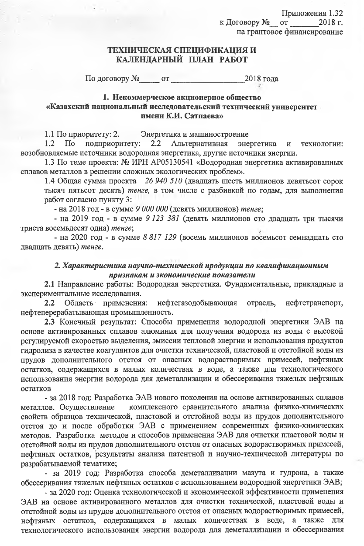
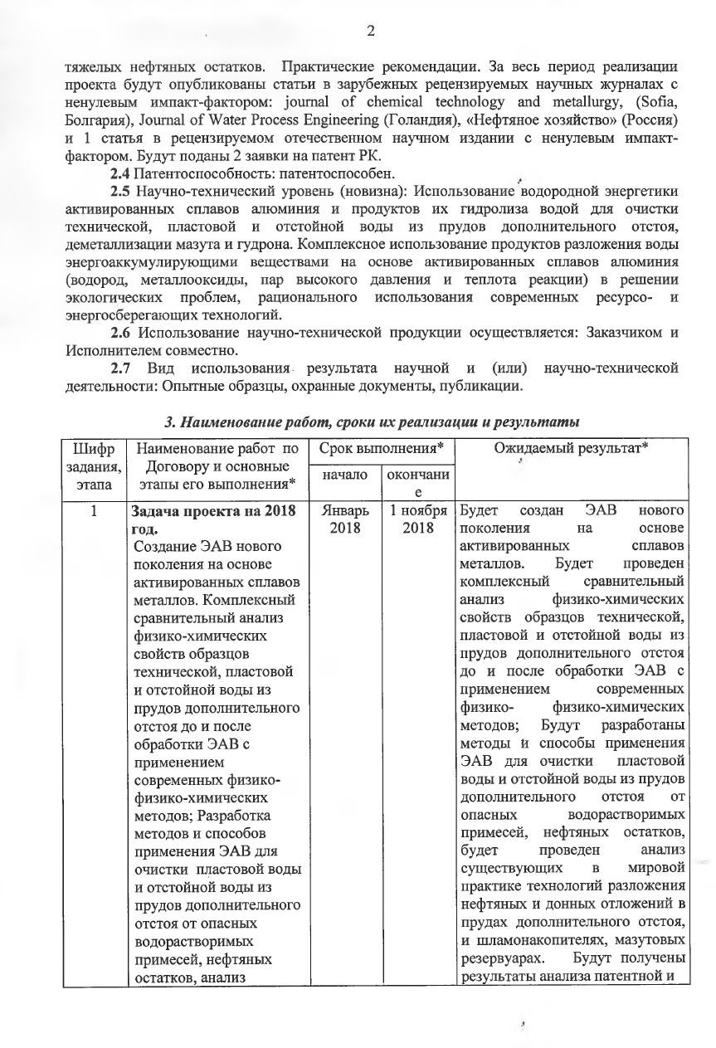

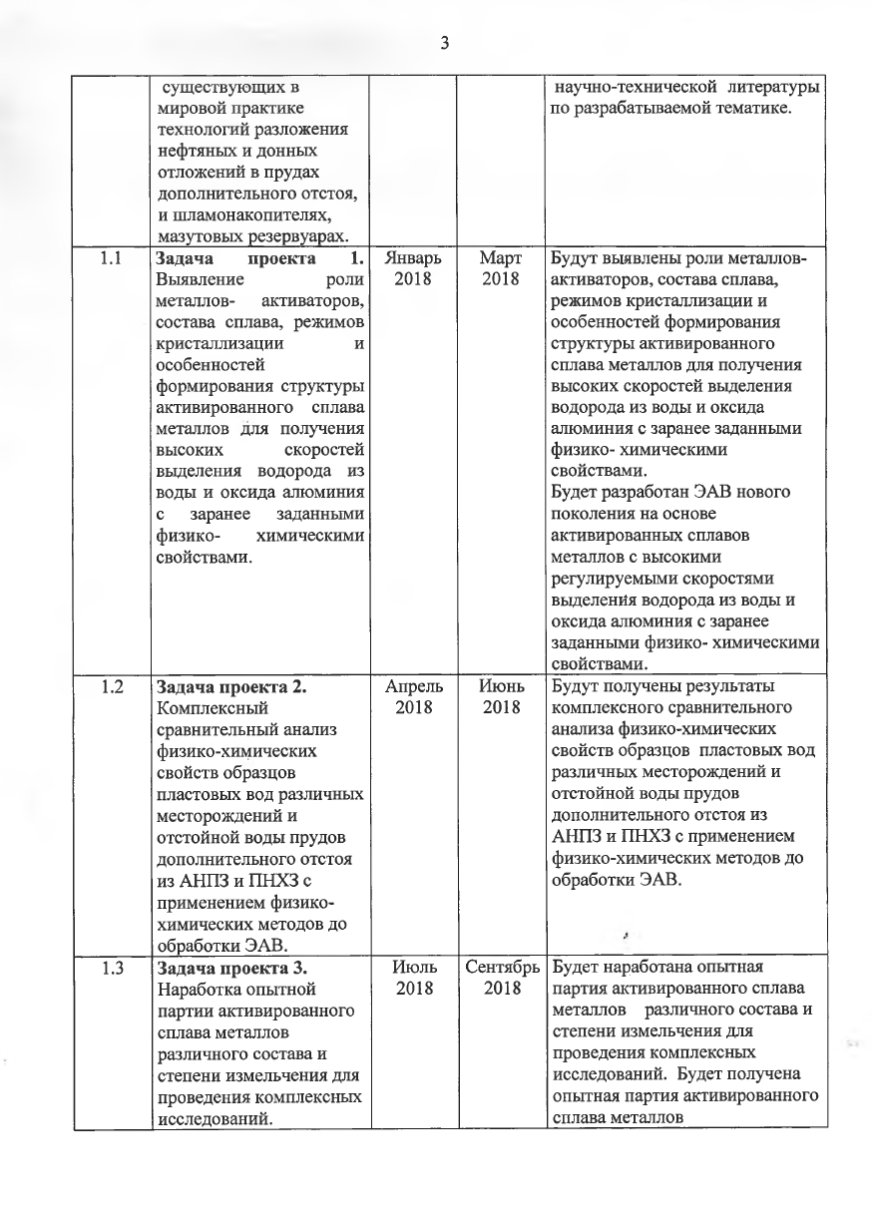
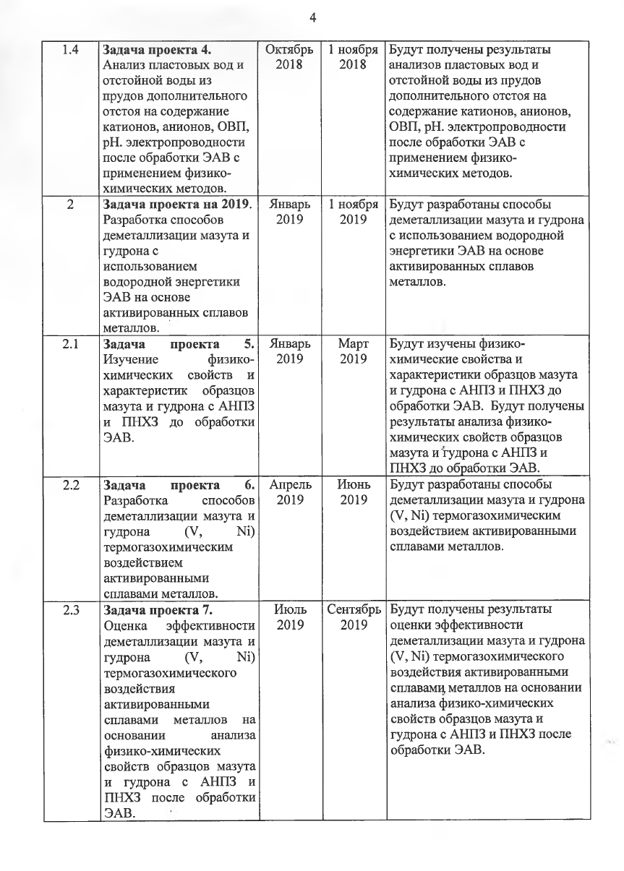

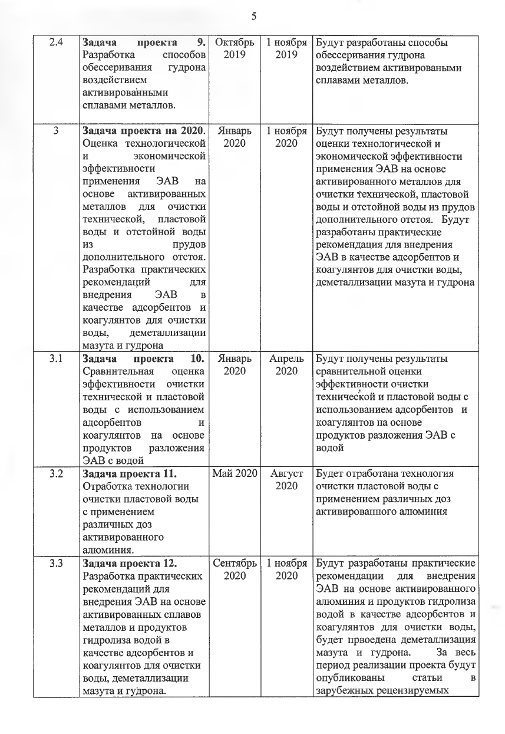
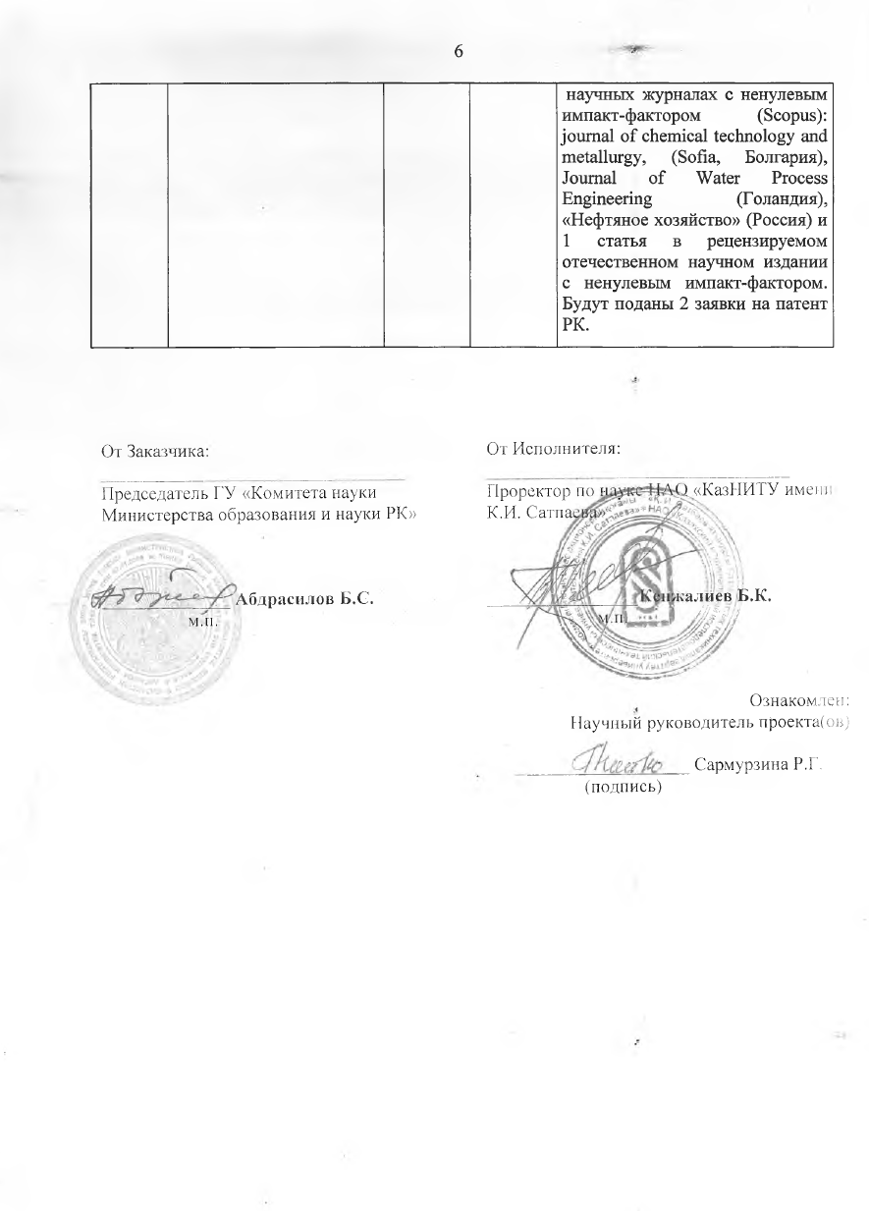

APPENDIX C
Extract from the minutes of the joint meeting of the Academic and Educational-Methodological Council of institute of chemical and biological technologies
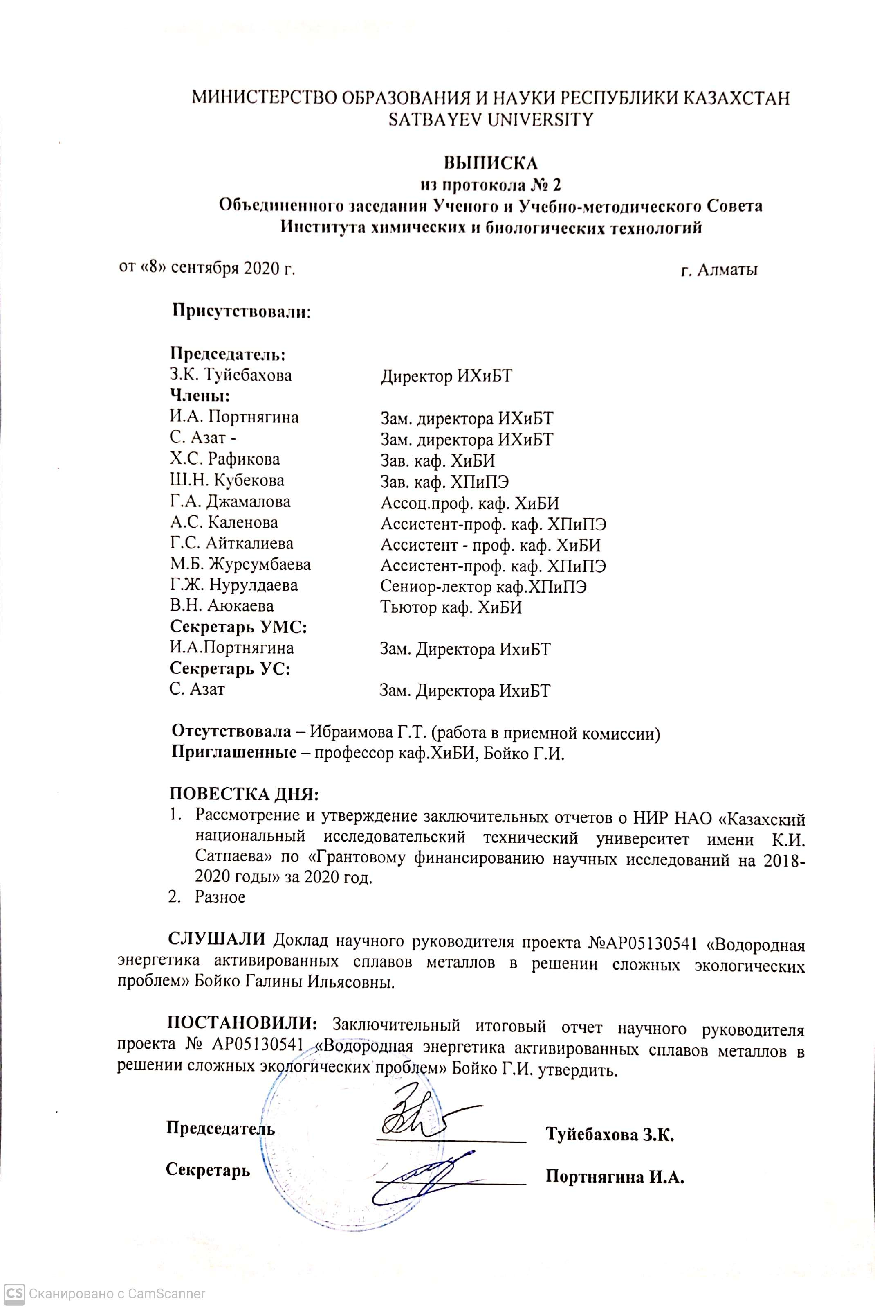
APPENDIX D
Extract from the minutes of the NTS KazNITU
