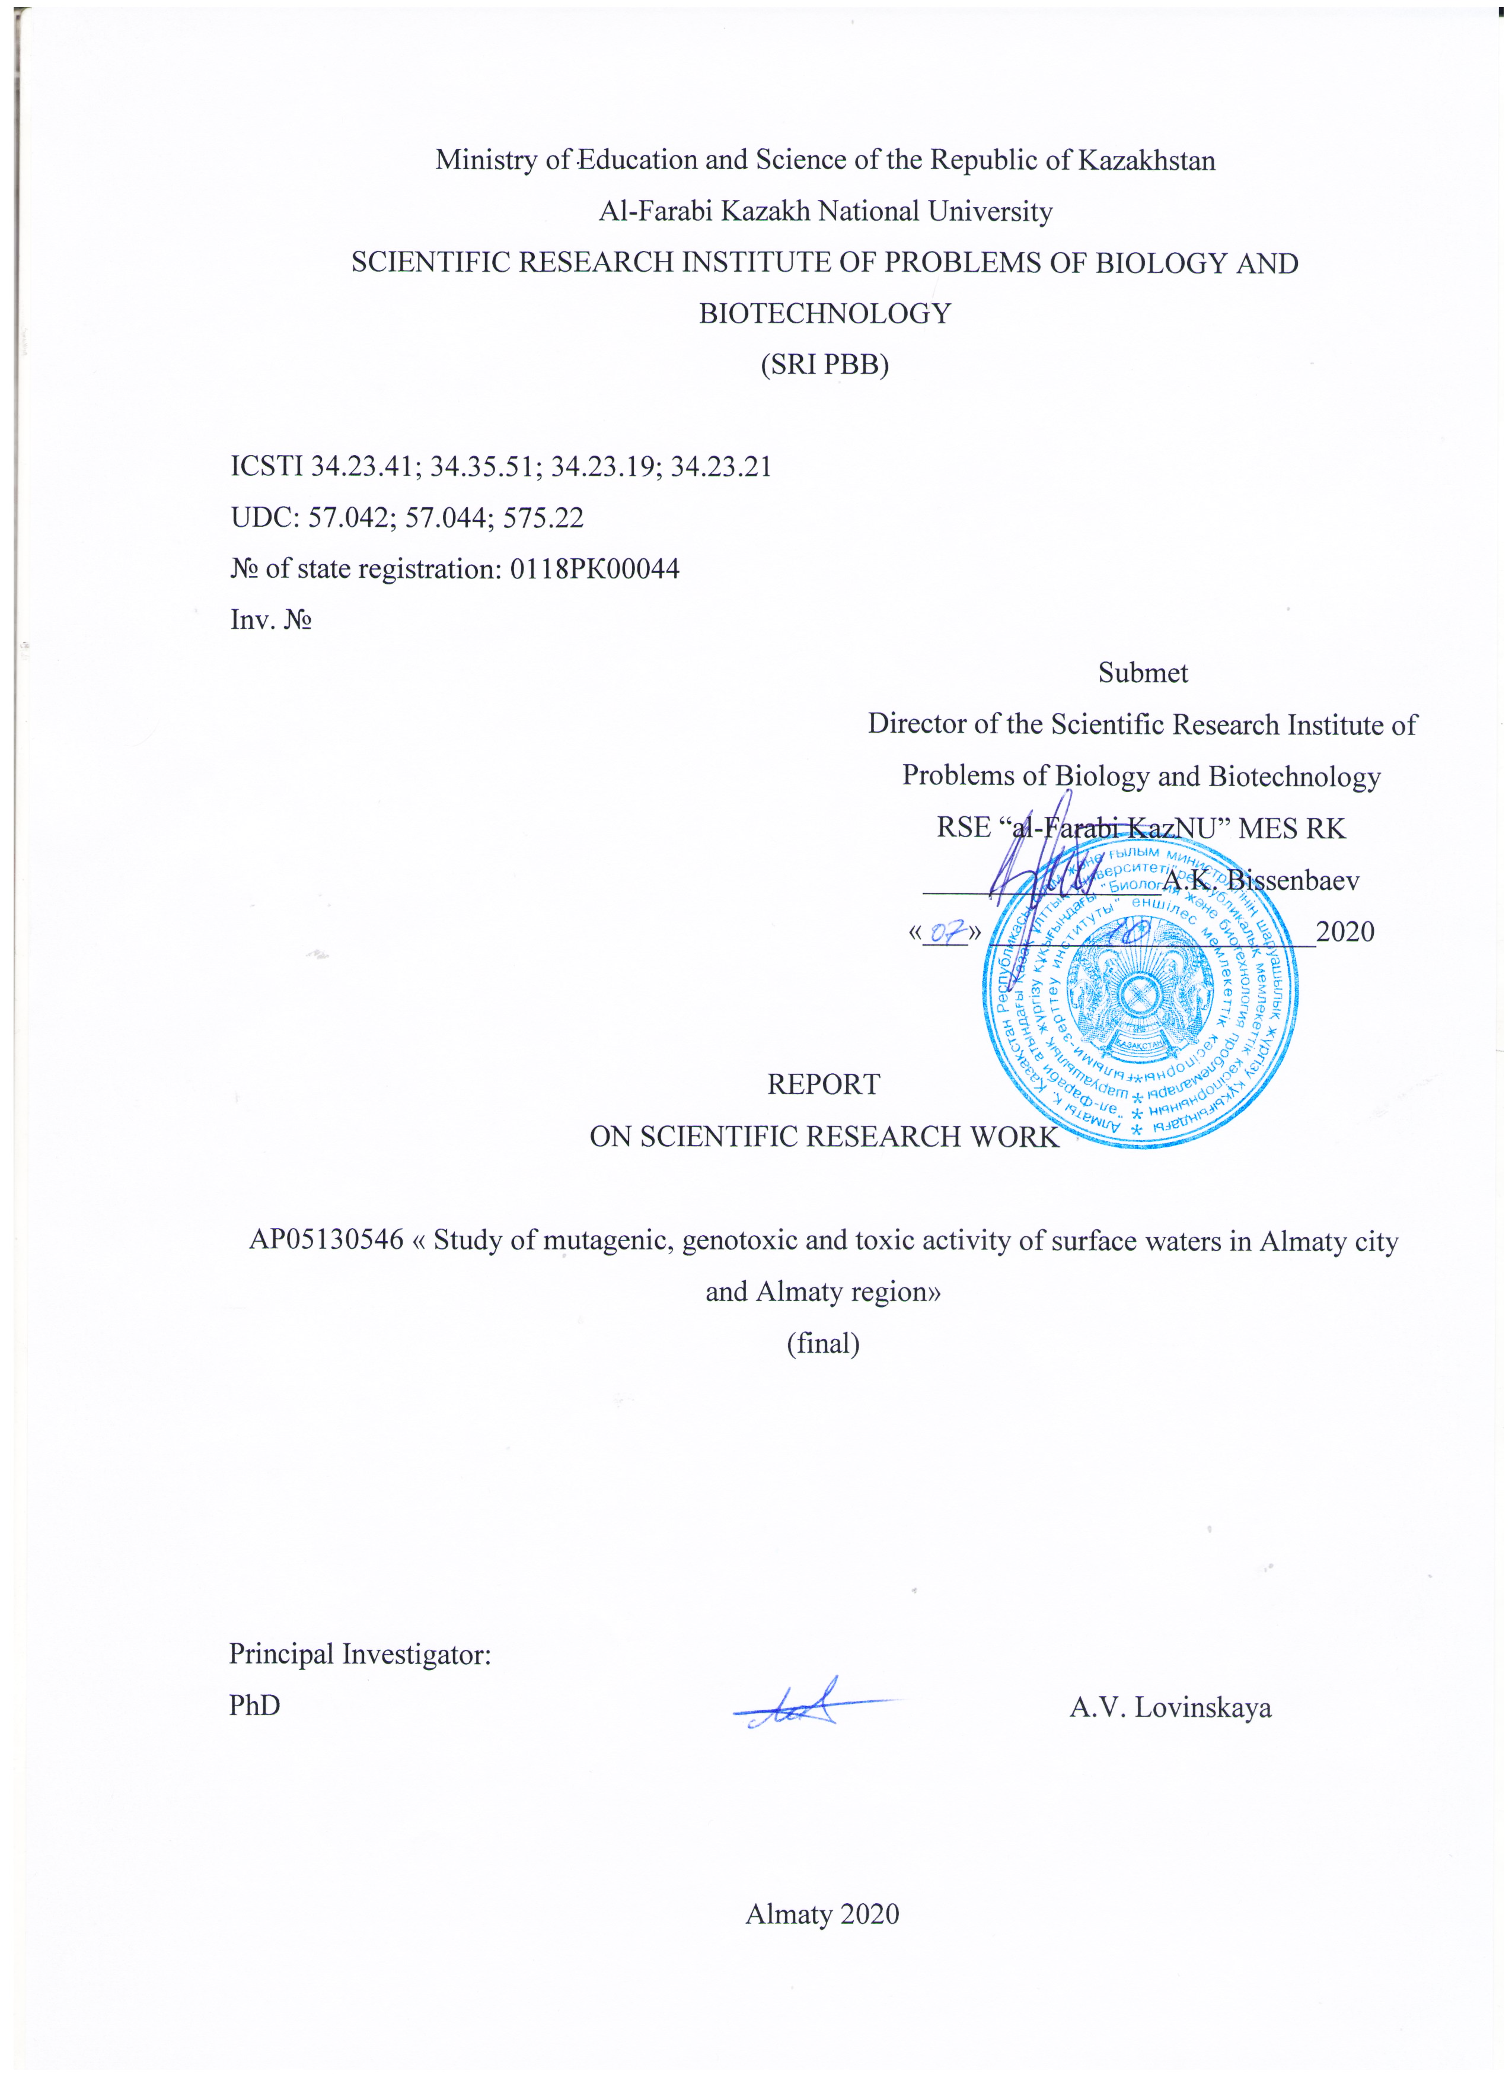
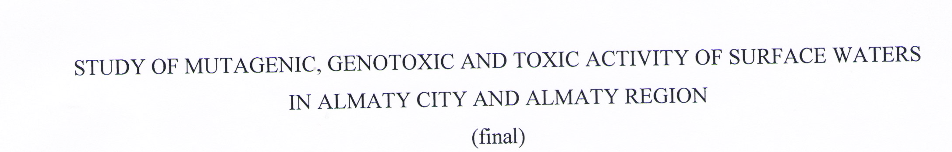
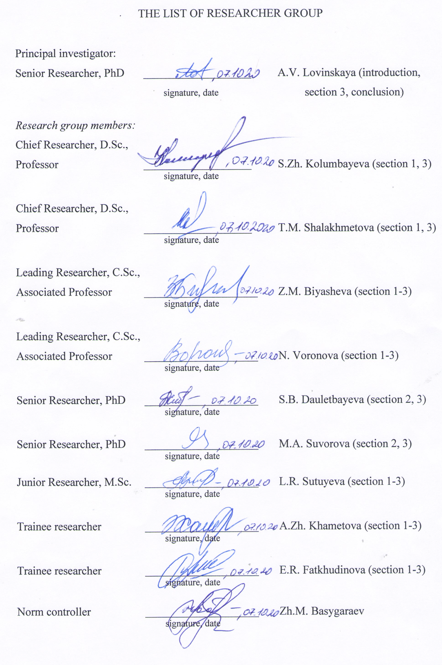

ABSRACT

Report 131 p., 53 resources, 3 app.
SURFACE WATER, MUTAGENICITY, GENOTOXICITY, CYTOTOXICITY, EMBRYOTOXICITY, CHROMOSOMAL ABERRATIONS
The research objects were surface natural waters of Almaty and Almaty region, microbiological, plant and animal test objects.
The research aim is to study mutagenicity, genotoxicity and toxicity of natural surface waters in Almaty and Almaty region.
The following methods were used: determination of the physical parameters of water, atomic absorption spectrometry, bioluminescence bacteria test-system (lux-test), phytotoxicity test (Allium cepa), chromosome aberrations test (Hordeum vulgare, Mus musculus), determination of the mitotic index (Allium cepa, Hordeum vulgare), an embryotoxicity test (Danio rerio, Drosophila melanogaster), sex-linked recessive lethal test (Drosophila melanogaster), DNA comet assay.
Screening of natural surface waters of 53 water bodies was carried out in Ili, Balkash, Talgar, Enbekshikazakh, Zhambyl, Karasay, Koksu, Eskeldinsky, Aksu, Sarkand, Raiymbek, Uygur, Panfilov districts of Almaty region and Almaty city. Physicochemical analysis revealed in the water of all studied sources the excess of MPC for heavy metals. The bioluminescence test has identified water sources with DNA tropic effects or oxidative stress. Most of the studied water samples (80%) were highly toxic, significantly reducing the bioluminescent response of the pRecA, pColD, pKatG, pSoxS, pXen7 biosensors. The toxicity and mutagenicity of water in most water bodies was revealed on plant test objects Allium cepa and Hordeum vulgare. The cytotoxic (decrease in MI) and mutagenic (statistically significant level of structural and genomic mutations) water activity in most of the studied water bodies was established. Biotesting of natural water using Drosophila melanogaster, Danio rerio, and Mus musculus revealed its toxic, embryotoxic, teratogenic, mutagenic and genotoxic activity.

РЕФЕРАТ

Есеп 131 бет, 53 әдибиеттер, 3 қосымша.
ЖЕР ҮСТІ СУЛАРЫ, МУТАГЕНДІК, ГЕНОТОКСИКАЛЫЛЫҚ, ЦИТОТОКСИКАЛЫҚ, ЭМБРИОТОКСИКАЛЫҚ, ХРОМОСОМАЛЫҚ АБЕРРАЦИЯЛАР
Зерттеу нысандары болып Алматы қаласы және Алматы облысының жер бетіндегі табиғи сулары, микробиологиялық, өсімдік және жануар текті тест-объектілері табылды.
Зерттеу мақсаты - Алматы қаласы және Алматы облысының табиғи жер үсті суларының мутагендік, генотоксикалық және токсикалық әсерін зерттеу.
Жұмыс барысында қолданылған әдістер: судың физикалық параметрлерін анықтау, атомды-абсорбциялық спектрометрия, биолюминесцентті тест (lux-тест), фитотоксикалылықты тестілеу (Allium cepa), хромосомалық аберрацияларды есепке алу тесті (Hordeum vulgare, Mus musculus), митоздық индексті анықтау (Allium cepa, Hordeum vulgare), эмбриотоксикалылық тест (Danio rerio, Drosophila melanogaster), рецессивті, жыныспен тіркесетін летальды мутацияларды есепке алу әдістері (Drosophila melanogaster), ДНҚ-кометалар әдісі арқылы биотестілеу.
Алматы қаласы мен Алматы облысының Іле, Балқаш, Талғар, Еңбекшіқазақ, Жамбыл, Қарасай, Көксу, Ескелді, Ақсу, Сарқанд, Райымбек, Ұйғыр, Панфилов аудандарындағы 53 су объектінің табиғи жер үсті суларының скринингі жүргізілді. Физико-химиялық талдау барлық зерттелген көздердің суларынан ауыр металлдардың шеткі рұқсат етілген концентрацияның (ШРК) асуын анықтады. Биолюминисцентті тест ДНҚ-тропты әсер мен тотықтандыру стрессін тудыратын су көздерін анықтады. Зерттелген су үлгілерінің көпшілігі (80%) жоғары уытты болып, pRecA, pColD, pKatG, pSoxS, pXen7 биосенсорларының биолюминесцентті жауабын едәуір төмендетті. Allium cepa және Hordeum vulgare өсімдік текті тест-объектілерінде көптеген су объектілердің суының токсикалығы және мутагендігі анықталды. Көптеген зерттелген су қоймаларында цитотоксикалық (митоздық индекстің төмендеуі) және мутагендік (құрылымдық және геномдық мутациялардыың статистикалық маңызды деңгейі) белсенділігі байқалды. Drosophila melanogaster, Danio rerio және Mus musculus көмегімен табиғи суларды биотестілеу олардың токсикалық, эмбриотоксикалық, тератогенді, мутагенді және генотоксикалық белсенділігін көрсетті.

CONTENT

LIST OF ABBREVIATIONS AND SYMBOLS 6
INTRODUCTION 7
MAIN PART OF REPORT ON SRW 9
1 Literature Review 9
2 Research materials and methods 13
2.1 Research objects 13
2.2 Experimental design and methods for studying toxicity, genotoxicity and mutagenicity
of surface waters 14
3 Research results and discussion 18
3.1 Study of genotoxicity, mutagenicity and toxicity of surface waters in Almaty and
Almaty region 18
3.2 Physicochemical analysis of water samples 19
3.3 Assessment of mutagenicity of water samples using microbiological test systems 23
3.4 Assessment of mutagenicity, genotoxicity and toxicity of water samples using plant
test systems 26
3.5 Assessment of mutagenicity, genotoxicity and toxicity of water samples using animal
test systems (Drosophila melanogaster, Danio rerio) 30
3.6 Assessment of mutagenicity, genotoxicity and toxicity of water samples using animal
test systems (Mus musculus) 33
3.7 Assessment of genetic risk for organisms, including humans 36
CONCLUSION 37
REFERENCES 41
APPENDIX А – Supplementary tables and figures 47
APPENDIX B – Work schedule 111
APPENDIX C – List of published papers 115

LIST OF ABBREVIATIONS AND SYMBOLS

In this research report, the following abbreviations and symbols are used
CA | – chromosomal aberrations
hpf | – hours post fertilization
IIGR | – integral indicator of genetic risk
TI | – toxicity index
LOOH | – lipid hydroperoxides
LPO | – lipid peroxidation
MDA | – malonic dialdehyde
MI | – mitotic index
MMS | – methyl methanesulfonate
MPC | – maximum permissible concentration
MPCdw | – maximum permissible concentration for drinking water
MPCfr | – the maximum permissible concentration of water for fishery reservoirs
MPCdom | – the maximum permissible concentration of water for water bodies of household,  drinking and cultural and household water use
SRW | – scientific research work

INTRODUCTION

The ecological crisis that has developed in many countries of the world has not bypassed the rapidly developing Kazakhstan. This is evidenced by the large-scale pollution of the republic's environment by chemical compounds, the sources of which are various industries and agriculture. The rapid accumulation in the environment and in the biosphere as a whole of such common pollutants as heavy metals, pesticides, oil and oil products, surfactants, rocket fuel and its derivatives, medicines, dyes and other substances leads to an increase in the incidence of the population, a decrease in biological diversity and destabilization of natural ecosystems.
Natural aquatic ecosystems, being a habitat for many organisms, a source of drinking water and a resource for human economic activity, are currently undergoing a powerful anthropogenic pressure. Interest in the study of genotoxicity and mutagenicity of surface waters has increased significantly in many countries of the world [1-8]. Thus, some authors have established the mutagenic potential of both natural and drinking water, in particular chlorinated tap water [6-8].
Kazakhstan belongs to the category of countries with a large deficit of water resources. In terms of water supply, Kazakhstan ranks last among the CIS countries. The specific water supply is 37 thousand m³ per 1 km² and 6.0 thousand m³ per person per year. On the territory of Kazakhstan there are about 39 thousand rivers and temporary streams, more than 48 thousand lakes, about 4 thousand ponds and 204 reservoirs.
According to the RSE "Kazhydromet" of the Ministry of Ecology, Geology and Natural Resources of the Republic of Kazakhstan for the first half of 2020, out of 143 surveyed water bodies (93 rivers, 15 reservoirs, 31 lakes, 3 canals, 1 sea), 12 belong to the 1st class in terms of water quality , 9 - to the 2nd class (normatively clean), and the rest - to the 3-5 classes according to the “Unified system of classification of water quality in water bodies” [9]. However, on the territory of Kazakhstan, genotoxicological studies of water have practically not been carried out and are not being carried out. In the available scientific literature, there is only information about the analysis of genotoxicity of drinking water in regional centers can lead to cytogenetic disorders. They identified correlations between the genotoxic properties of drinking water and the incidence of congenital anomalies in the local population, and the incidence of malignant neoplasms [10].
In the complex of the influence of pollutants, genetic consequences are important. There is no doubt that an increase in mutagenic factors is undesirable for the human population, because creates a real basis for increasing the genetic load and changing the rate of the mutational process. In medico-genetic terms, this can be expressed in increased intrauterine death of individuals, the emergence and spread of congenital malformations, hereditary diseases, a genetically determined predisposition to diseases of various natures [11]. Assessment of the genetic hazard of a particular substance for a person is a complex process: mutagenic activity is a test-specific feature, that is, mutagens in one test system may turn out to be non-mutagens in another.
It should be noted that monitoring of water resources is the most important link in the system of measures for the protection and rational use of the natural environment. In the study of water bodies, the assessment of its genotoxicity and mutagenicity becomes an important component, as noted above. However, at present, the features of the dynamics of the genotoxic situation in rivers and water bodies exposed to the influence of pollutants have not been studied, and the methodology for assessing the genotoxic situation of such water bodies has not been fully developed. Nevertheless, carrying out genotoxicological studies of surface natural waters in the Republic of Kazakhstan is extremely urgent and necessary.
The project aim is to study mutagenicity, genotoxicity and toxicity of natural surface waters in Almaty and Almaty region.
Research objectives:
- study of physical and chemical parameters of surface waters in Almaty and Almaty region;
- study of the toxicity of surface waters using microbiological, plant and animal test objects;
- study of mutagenic and genotoxic effects of surface waters using microbiological, plant and animal test objects and test systems.

MAIN PART OF REPORT ON SRW

1 Literature Review
Large-scale pollution of the environment with various chemical compounds of anthropogenic nature aggravates the crisis ecological situation in the world, including in Kazakhstan. The accumulation in various environments (atmosphere, hydrosphere, pedosphere) of such common pollutants as heavy metals, pesticides, oil and oil products, surfactants, rocket fuel and its derivatives, drugs, dyes and other substances leads to an increase in the incidence of diseases in the population, decrease in biological diversity and destabilization of natural ecosystems [1, 12, 13].
According to the CAS (Chemical Abstracts Service, USA), 10 million chemical compounds were registered in the period from 1957 to 1990, in 2008 the total list was 40 million, and as of September 2018 - 144 million [14]. All of them can end up in the air, water, soil and food. As a result, several dozen compounds can enter the body simultaneously, which can be found in the tissues of humans and other organisms. For example, when examining pregnant women, it was found that the number of pollutants entering their body every day is 515 [15]. An average of 200 anthropogenic chemicals, including pesticides, dioxins, industrial chemicals, perfluorooxyalkylvinyl compounds, and brominated flame retardants, were found when examining the umbilical cord blood of newborns [16]. The data presented indicate an increasing number and expansion of the spectrum of xenobiotics in the biosphere, which undoubtedly leads to an increase in the genetic load and, as a consequence, increases the likelihood of extinction of one or another species.
According to the RSE "Kazhydromet" of the Ministry of Ecology, Geology and Natural Resources of the Republic of Kazakhstan for the first half of 2020, water bodies belonging to class 2-5 according to the "Unified system of classification of water quality in water bodies" include the rivers Esentai, Ulken Almaty, Ile, Korgas, Lepsy, Karatal, Kishi Almaty, Kaskelen, Esik, Shilik, Kurty reservoir [9].
The rivers Aksai, Ulken Almaty, Boraldai, Esentai, Kargalinka, Kishi Almaty, the Ulken Almaty canal, the Sairan reservoir are located on the territory of Almaty. In the valley of the River Ulken Almaty, a 40-meter reinforced concrete mudflow protection dam with a mudflow storage, a cascade of hydroelectric power plants, a water supply system in Almaty, a recreation area and a Sairan reservoir have been built. The water resources of the River Boraldai are used for irrigation of suburban farms. On the territory of Almaty, along the Esentai riverbed, an embankment and recreation areas have been created, including the park of the KazNUgrad University complex, the amusement park and attractions "Fantasy World", the park near the Auezov theater. Water of the River Esentai are used for household needs and irrigation. Water of the River Kargalinka, a right tributary of the River Kaskelen, is used for irrigation and water supply. Today, the sanitary condition of the Kargalinka River is assessed as unsatisfactory. Water of River Kishi Almaty is used for water supply to industrial enterprises and irrigation. The route of the Big Almaty Canal crosses the territories of three districts of the Almaty region: Enbekshikazakhsky, Talgar, Karasay and Almaty itself. The starting point of the channel is the Bartogay reservoir on Shilik river. Within Almaty, on the canal, there are three beach-park zones for the recreation of citizens, and the corresponding infrastructure has been created. The canal waters are used for irrigation, various technical needs, private needs of the population (washing carpets) and recreational needs (rest, bathing). The Kaskelen River is used for water supply and irrigation of the cities of Almaty, Kaskelen, and suburban farms.
The Ile River, which is the main waterway of southeastern Kazakhstan, flows into the western part of Lake Balkash, giving 73-80% of the total inflow of water into Lake Balkhash. On the bank of the river Ile is located the Kapshagay reservoir. The large settlements are the Bakanas village and the Kapshagay town. Near the Bakanas village begins the world's northernmost rice growing massif - Akdalinsky. The Kapshagay reservoir is one of the largest reservoirs in Kazakhstan and is used for the needs of irrigation, fish farming, and recreation. In addition to the rivers Ile, Turgen, Shilik, Esik, Talgar, and Kaskelen also flow into the Kapshagay reservoir. The Shilik River is the largest river in the Trans-Ile Alatau, one of the largest left tributaries of the Ile river. The water of the Shilik River is used for irrigation. The Bartogay reservoir was created on the river, from where the Ulken Almaty canal begins. The waters of the Talgar River are used for irrigation and water supply, and are operated by energy enterprises. The Talgar city and other settlements are located on the river.
The Karatal River is the second tributary of Lake Balkash in terms of water flow and economic importance after the Ile River, providing about 20% of the river flow into the lake and about 10-12% of its annual volume. On the river are Taldy-Kurgan, Tekeli and Ushtobe cities. There is a cascade of small hydroelectric power plants on the river. The river water is actively used for large-scale irrigation and other economic needs. Water of Koksu River, which is a left tributary of the Karatal River, is used for water supply to the population.
The Lepsy River, which belongs to the basin of Lake Balkash, ranks third in terms of water content after the Ile and Karatal rivers. The river's water is used for water supply to the population, irrigation, and molten timber rafting [8].
One of the priority tasks of environmental health is the assessment of mutagenic and carcinogenic properties of environmental factors of anthropogenic nature [1, 17, 18] Pollution of the aquatic environment is a global problem. Water bodies exposed to anthropogenic pressure and containing a wide range of pollutants are capable of moving them long distances from the source of pollution. Many pollutants can cause cytotoxic, genotoxic and mutagenic effects, as well as cause sterility, metabolic disorders and various body functions [1, 2].
Chemicals are the main cause of oncological diseases in 80% of cases [19]. According to a number of authors, genotoxic effects underlie the development of most tumors. The correlation dependence of mutagenic and carcinogenic properties of chemical compounds has been established [17]. It is believed that the onset and development of malignant growth is preceded by the accumulation of mutations in certain genes [20]. However, the role of mutagens is much broader, as mutational damage to germ cells leads to spontaneous abortions and congenital malformations. Mutations in germ cells can lead to hereditary diseases in the population, and in somatic cells - to oncological diseases and premature aging of the body. To find out the reasons for the increase in the number of certain diseases and take measures to eliminate them, it is extremely important to timely conduct toxicological and genotoxicological studies of the state of the environment.
Natural waters exposed to anthropogenic pollution, as a rule, can contain a complex mixture of chemicals, the physicochemical analysis of which cannot always give accurate knowledge of the composition and concentrations of various components. In addition, certain chemicals can be in very low concentrations and not be detected by analytical methods. However, the combined effect of the chemicals present, even at low concentrations, can have a negative effect on the body [3].
Unlike physicochemical analysis of water, studies of biological effects reveal the effects of all harmful agents, including synergistic or antagonistic effects. At the same time, it is necessary to apply chemical and biological control methods, which makes it possible to identify the relationship between the concentrations of pollutants and the biological effects that they cause. In turn, this combination of methods can help in determining the contribution of specific pollutants to the observed overall biological effect [3]. The simultaneous use of conventional physicochemical analysis and analysis for mutagenicity / genotoxicity should be implemented in water quality monitoring programs [2-4].
It is very important to assess the genotoxicity of polluted water as a whole, and not of each component [5], since, as noted above, biological effects may be mainly due to the effect of a mixture of pollutants. It is the simultaneous use of a battery of test objects (microorganisms S. typhimurium, E. coli; plants A. cepa, H. vulgare; animals D. melanogaster, D. rerio, M. musculus) and test systems (Ames test, lux-biosensors, test for embryotoxicity, sex-linked recessive lethal test in D. melanogaster, chromosome aberration test, micronucleus test, single cell gel electrophoresis (Comet assay), methods for determining biochemical indicators, heritable translocations test) can make it possible to assess the potential risk of water pollution for various forms of organisms.
Currently, scientific and regulatory efforts are focused on identifying and quantifying specific chemicals that are considered harmful to humans or the environment. In practice, conventional monitoring programs measure almost exclusively chemical / physical parameters. Measurements of pollutant concentrations can provide detailed descriptions of pollution levels, but only indirectly indicate the potential biological effects of mixed environmental pollution. Biological assays, in turn, provide a mechanism by which the biological effects of mixtures can be quantified. The combination of these two approaches makes it possible to identify the main sources of risk that require constant monitoring. Therefore, an adequate assessment of the risk to the environment caused by any pollution should be based on the simultaneous use of chemical methods for the control of pollutants, followed by biological tests [3, 4].
All of the above indicates the importance and necessity of conducting a comprehensive genotoxicological study of surface and ground waters in the Republic of Kazakhstan, which has a shortage of water resources.

2 Research materials and methods
  - Research objects
The research objects were the surface waters of the Almaty region. The test objects were biosensor strains of Escherichia coli (MG 1655 (pSoxS-lux), MG1655 (pKatG-lux), MG1655 (pColD-lux)), MG1655 (pXen7-lux), barley (Hordeum vulgare L.) grade Baisheshek, onion (Allium cepa), fruit fly (Drosophila melanogaster), zebrafish (Danio rerio) used as a developmental biology model organism. 4-nitroquinoline 1-oxide (4-NQO, C₉H₆N₂O₃), methyl methanesulfonate (MMS, C₂H₆O₃S) were used as mutagens (positive control); paraquat (C₁₂H₁₄Cl₂N₂) and hydrogen peroxide (Н₂О₂) were used as oxidants, zinc sulfate (ZnSO₄) was used as toxicant.
Samples of natural surface waters were taken in Zhambyl, Karasay, Ile, Balkash, Talgar, Enbekshikazakh, Koksu, Eskeldi, Aksu, Sarkand, Raiymbek, Uygur, Panfilov districts of Almaty region, as well as in water bodies of Almaty city. Water samples were taken from 53 water bodies at 72 points. Water samples from the Zhambyl district were taken at 4 points: the rivers Kopa, Targap, Aksengir, Uzyn Kargaly. In the Karasay district, water samples were taken at 2 points: the Kaskelen and Shamalgan rivers. In the Ile district, water samples were taken at 4 points: Kurty river, Kurty reservoir, Pervomayskie ponds (2 points). Water samples from the Talgar district were taken at 7 points: the rivers Talgar (3 points), Tsyganka, Kapshagay reservoir (2 points). In the Enbekshikazakh region, water samples were taken at 13 points: the rivers Esik (3 points), Turgen (2 points), Shilik, Lake Esik (4 points), the Nurly-Arasan hot spring and an unnamed river and an artesian well located nearby.
In the Raiymbek district, water samples were taken at 4 points: the Kaindy river, Kaindy, Kolsay lakes, a spring near the village Saty. Water samples from the Koksu district were taken at 2 points: the Kishi Byzhy and Byzhy rivers. In the Eskeldi district, water samples were taken at 8 points: the rivers Koksu (2 points), Balykty, Karatal (2 points), Kora, Chuzha, the Korinskiye klyuchi spring. In the Aksu district, water samples were collected from 2 points: the Akeshki and Koldenen rivers, in the Sarkand district - at 2 points: the Aksu and Lepsy rivers. In the Uygur district, water samples were taken at 3 points: the Charyn river, hot springs Bakhus, Khoshelik. Water samples from the Panfilov district were taken at 4 points: the Ile, Chizhin, Osek rivers, and a spring. In the Balkhash district, water samples were collected from the Ile River at 3 points. In Almaty, water samples were taken at 15 points: Prokhodnaya, Ulken Almaty (2 points), Kumbel, Kishi Almaty (2 collection points), Esentai, Butak (3 points), Kimasar, springs (4 points). The locations of the sampling points are shown in Figures A.1 – A.16.

  - Experimental design and methods for studying toxicity, genotoxicity and mutagenicity of surface waters
Determination of physicochemical parameters of water samples. The collection, filtration, and conservation of water samples were carried out in accordance with GOST 31861-2012 [21]. At the site of sampling of surface water, measurements of the physical parameters of water were carried out: temperature, hydrogen index (pH), total dissolved solids, oxidation-reduction potential, water-dissolved oxygen, electrical conductivity (Figure A.17). Temperature, total mineralization (total dissolved solids) and electrical conductivity were measured using a portable analyzer TDS & EC-meter (Barry Century, China), pH values were measured using a portable analyzer pH-meter PH-009 (I) (Barry Century, China), oxidation reduction potential were measured using portable analyzer ORP-meter ORP169E (Barry Century, China), the level of dissolved oxygen was measured using portable analyzer DO-meter DO-pen type (Alvin Instrument, China). Determination of heavy metals was carried out by atomic absorption on an MGA-915MD atomic absorption spectrophotometer (Lumex, Russia) according to PND F 14.1:2.214-06 [22].
Determination of toxic, genotoxic and oxidative activity of water using a bioluminescence test. Five genetically modified strains of E. coli were used in this study: MG1655 pColD-lux, MG1655 (pRecA-lux),MG 1655 (pSoxS-lux), MG1655 (pKatG-lux), MG1655 (pXen7-lux) [23-25]. The promoters pCoD and pRecA were used to detect substances that induce DNA damage. 4-nitroquinoline 1-oxide (4-NQO) at a concentration of 75.0 μg/mL was used as a positive control to activate these promoters. Induction of oxidative stress was detected using the PKatG (protein-activator OxyR) and PSoxS (protein-activator SoxR) promoters. PKatG produces a response to hydrogen peroxide and organic peroxides, while PSoxS responds to superoxide ion radicals [25, 26]. Hydrogen peroxide at a concentration of 0.01 μg/mL was used as a positive control to activate KatG and 10.0 μg/mL paraquat was used to activate PSoxS. The E. coli MG1655 biosensor (pXen7-lux) responds by inhibiting the level of bioluminescence for the presence of toxic substances in the medium; ZnSO₄ at a concentration of 50 μg/mL was used as a positive control. Distilled water was used as a negative control. Bacteria were grown in Luria-Bertani broth containing 100 μg/mL of ampicillin. Overnight cultures were diluted to a concentration of 107 cell/mL in fresh broth and grown at 37 °C for 2–3 h. Aliquots of the culture (160 μL) were transferred to sterile wells (in plate strips) and 40 μL of each water sample was added. 40.0 μL of distilled water or control mutagen/oxidant was added to control cells. Incubations were performed for specific durations depending on the promoter: pColD for 90 min, рRecА and pSoxS for 60 min, and pKatG and pXen7 for 45 min. The level of bacterial luminescence was measured with a Lu Mate 4400 microplate luminimeter (Awareness Technology, USA) and expressed as relative light units (RLU). The criterion for the toxic effect is the change in the intensity of the bioluminescence of the test object in the test sample compared to that for the sample with a solution that does not contain toxic substances. The change in the intensity of bioluminescence is proportional to the toxic effect. The quantitative assessment of the parameter of the test reaction is expressed as a dimensionless value of the toxicity index "TI". The method allows three threshold levels of the toxicity index: TI <20% was defined as the permissible degree of toxicity; TI = 15-20% with a statistically significant difference between the experience and control and TI = 20-50% was defined as toxic; TI> 50 was defined as highly toxic. The level of genotoxicity was defined as the induction factor (I), the ratio of luminescence from the lux-biosensor suspension with the tested compound (Lc), to the luminescence of the control suspension (Lk). I < 2 was considered a weak genetoxic effect, while, 2 ≤ I ≤ 10 was defined as moderate and I > 10 was defined as a strong effect. All experiments were carried out in 4 - 5 independent replicates [26].
Determination of phytotoxicity and cytotoxicity of water on onions. Common onion (Allium cepa L.) was used as the test object. Methyl methanesulfonate (MMS, C₂H₆O₃S) was used as the standard mutagen at a concentration of 10.0 mg/L [27, 28], while distilled water containing a residual quantity of nitric acid was used as the negative control. Onions of almost equal size (4 cm in diameter) were placed in the experimental and control water samples (5 replicates) and grown at room temperature. Phytotoxicity was assessed by the growth of the rooting tufts after 7 and 14 days [29]. To determine the cytotoxicity of the studied water samples, the mitotic index was determined in the cells of onion roots, germinated for 96 hours, according to the generally accepted method [30]. Staining was performed with acetocarmine. Cytological preparations were analyzed using an Olympus BX 43F microscope (Olympus, Japan).
Determination of cytotoxicity and mutagenicity of water on barley seeds. Seeds of the spring-crop two-raw barley (Hordeum vulgare L.) of grade Baisheshek were used as the test object for these experiments. MMS was used as the standard mutagen at a concentration of 5.0 mg/L [27], while distilled water containing residual nitric acid was used as the negative control. Treatment was conducted for 4 h before seeds were grown and fixed in an alcohol-vinegar mixture [30]. Metaphase methods were used to determine the mutagenicity of the samples and mitotic index was used to determine cytotoxicity [30, 31]. Staining was done with fuchsin-sulfuric acid. Cytological preparations were analyzed with an Olympus BX 43F microscope (Olympus, Japan).
Determination of toxicity and mutagenicity of water on the fruit fly D. melanogaster. Oregon strain of Drosophila melanogaster females of the same age were used in the experiment and control to determine the toxicity of aquatic samples. On the basis of the water samples under study, a 2% sucrose solution was prepared, in which filter paper was soaked. The walls of a sterilized flask were pasted over with this paper, into which 100 females were placed, and after 72 hours the number of live and dead individuals was counted. Distilled water was used in the control [32].
The Meller-5 (Basc) method was used to determine the mutagenicity of water, which makes it possible to detect lethal and morphological mutations in the X chromosome of the fruit fly D. melanogaster in the second generation. Females of the Möller-5 (M-5) line carry two inversions in both X chromosomes: sc⁸ and δ⁴⁹. The sс⁸ inversion covers almost the entire X chromosome, and within its limits there is another inversion - δ⁴⁹. The order of genes in the sс⁸ δ⁴⁹ chromosome is violated twice, as a result of which the cross in it is completely excluded. As a result, both inversions are not associated with a recessive lethal effect, and females homozygous for the Möller-5 chromosome and the same hemizygous males are viable. Phenotypic markers were the recessive mutation w^{а} - apricot eyes and the dominant mutation Bаr - stripe eyes [33]. To determine the genotoxicity of water samples, we used males and females of the M-5 line at the age of 3-5 days, in young individuals (1-2 days), germ cells are at different stages of development, therefore, they have different sensitivity to xenobiotics. The males of the first generation had the phenotype of the Möller-5 line. Females have red eyes, narrower than those of wild-type flies (the action of an incomplete dominant gene B), each of them had one X-chromosome, which came from the male. In this X chromosome, in some F1 females a newly arisen recessive lethal mutation could be localized; in most females lethality is absent. Crossing was carried out according to the crossing scheme according to the Möller-5 method to detect letals and sterility mutations in the X chromosome of D. melanogaster [34].
Determination of water embryotoxicity on zebrafish. Experiments were started with stage 50%–75% of epiboly. Embryo exposition was conducted in sterile Petri dishes with 25 mL of incubation medium for 72 h at 27 °C in a Binder В28 incubator (Binder, Germany). Embryos that survived after hatching of the chorion were fixed in 10% neutral buffered formalin. Embryos were analyzed at 24, 48, and 72 h post fertilization (hpf) in vitro. Stages of development were determined according to the atlas of D. rerio normal embryonic development [35]. Alive and fixed embryos were analyzed and photographed using a MoticDM 143 digital stereo microscope. Acute embryotoxic effects of the water samples were assessed according to recommendations of OECD [36]. Morphological analyses of embryos were performed at 72 hpf. Damage to more than 50% of embryos in the exposure group was considered typical. Deviation from normal development of D. rerio was assessed by malformation of development of head, tail, tail tip, otic capsules, pericardial oedema, body bending, deformation of yolk, and growth retardation [37].
Determination of mutagenic, genotoxic and toxic activity of water in animal test systems (Mus musculus). Male mice of the BALB/cYwal line aged 2-3 months with a body weight of 25-30 g were used as the test object for these experiments. Intact and experimental animals were kept in a vivarium on a standard diet. Laboratory animals were cared for in accordance with national and international principles [38, 39]. The animals were slaughtered by cervical dislocation. Bone marrow samples were taken for cytogenetic analysis, internal organs (liver, kidneys, spleen, bone marrow) were taken for study DNA breaks using the DNA comet assay, liver was taken for study the content of lipid peroxidation (LPO) products.
Mammalian chromosome aberration test was used to assess the mutagenic properties [31, 40]. Water samples were administered orally for 7 days. Mutagen methyl methanesulfonate (MMS, positive control) at a dose of 40.0 mg / kg was injected intraperitoneally in the form of aqueous solutions. Cytogenetic preparations were prepared 24 hours after the last injection of the preparation. The staining was carried out with Romanovsky-Giemsa stain. For cytogenetic analysis, a resolution of x1000 was used. We took into account cells with chromosomal and chromatid disorders (single and paired chromosome fragments, acentric and centric rings, point fragments), as well as aneuploid and polyploid metaphases. DNA comet assay was used to assess the genotoxic properties of water [41]. The staining was performed with Romanovsky-Giemsa stain [42]. The analysis of the preparations was carried out using an Olympus microscope (Olympus Corporation, Japan) with increasing the resolution 40x. The parameter “Percentage of DNA in tail comet“ (%TDNA) was counted using the Casp 1.2.2 software (CASPlab, Vroclaw, Poland).
To assess the toxic properties of water in the hepatic tissue homogenate of laboratory mice, the content of primary (LOOH - lipid hydroperoxide) and secondary (MDA - malonic dialdehyde) lipid peroxidation products was determined [43].
Statistical analyses of results. Statistical processing was conducted using the “Data analysis” add-in of Microsoft Excel, StatPlus, and WINPIPI. In all cases the average values and the standard errors of means were calculated. Mean statistical significance was assessed using Student’s t-test, χ² test with Yates correction (biotesting for D. melanogaster). Differences were considered significant at the level of confidence 0.95 (p<0.05).
The integral indicator of genetic risk (IIGR) is the arithmetic mean of indicators of genetic, chromosomal and functional disorders of all test objects [44].

3 Research results and discussion
3.1 Study of genotoxicity, mutagenicity and toxicity of surface waters in Almaty and Almaty region
Natural aquatic ecosystems, being a habitat for many organisms, a source of drinking water and a resource for human economic activity, are currently undergoing powerful anthropogenic pressure. Most of the environmentally hazardous factors are not only toxic, but also mutagenic and carcinogenic. Identification of potential mutagens and carcinogens for humans is the main task of testing. In the complex of the influence of pollutants, genetic consequences are important. An increase in the spectrum and amount of environmental pollutants with mutagenic activity creates a real basis for an increase in the genetic load and a change in the rate of the mutation process. In medico-genetic terms, this can be expressed in increased intrauterine fetal death, the emergence and spread of congenital malformations, hereditary diseases, a genetically determined predisposition to diseases of a different nature [11]. Testing for genotoxicity and mutagenicity of various pollutants on model objects under laboratory conditions is aimed at finding ways to prevent adverse genetic consequences if they are introduced into the environment. However, not a single model object and not a single test system separately provide data on the basis of which it would be possible to conclude about the degree of genetic danger of the tested substance for humans. The specificity of the biological object on which the action of the mutagen is studied, as well as the specificity of mutational events, dictate the need to use several biological models and testing methods [44-46].
The toxicological and genotoxicological study of natural waters in the territory of Almaty region and Almaty city were carried out. Samples of natural surface waters were taken in Zhambyl, Karasay, Ile, Balkash, Talgar, Enbekshikazakh, Koksu, Eskeldi, Aksu, Sarkand, Raiymbek, Uygur, Panfilov districts of Almaty region, as well as in water bodies of Almaty city. Water samples were taken from 53 water bodies at 72 points. Water samples from the Zhambyl district were taken at 4 points: the rivers Kopa, Targap, Aksengir, Uzyn Kargaly. In the Karasay district, water samples were taken at 2 points: the Kaskelen and Shamalgan rivers. In the Ile district, water samples were taken at 4 points: Kurty river, Kurty reservoir, Pervomayskie ponds (2 points). Water samples from the Talgar district were taken at 7 points: the rivers Talgar (3 points), Tsyganka, Kapshagay reservoir (2 points). In the Enbekshikazakh region, water samples were taken at 13 points: the rivers Esik (3 points), Turgen (2 points), Shilik, Lake Esik (4 points), the Nurly-Arasan hot spring and an unnamed river and an artesian well located nearby. In the Raiymbek district, water samples were taken at 4 points: the Kaindy river, Kaindy, Kolsay lakes, a spring near the village Saty. Water samples from the Koksu district were taken at 2 points: the Kishi Byzhy and Byzhy rivers. In the Eskeldi district, water samples were taken at 8 points: the rivers Koksu (2 points), Balykty, Karatal (2 points), Kora, Chuzha, the Korinskie klyuchi spring. In the Aksu district, water samples were collected from 2 points: the Akeshki and Koldenen rivers, in the Sarkand district - at 2 points: the Aksu and Lepsy rivers. In the Uygur district, water samples were taken at 3 points: the Charyn river, hot springs Bakhus, Khoshelik. Water samples from the Panfilov district were taken at 4 points: the Ile, Chizhin, Osek rivers, and a spring. In the Balkash district, water samples were collected from the Ile River at 3 points. In Almaty, water samples were taken at 15 points: Prokhodnaya, Ulken Almaty (2 points), Kumbel, Kishi Almaty (2 collection points), Esentai, Butak (3 points), Kimasar, springs (4 points).

3.2 Physicochemical analysis of water samples
At the sampling site, measurements were made of the physical parameters of water: temperature, hydrogen index (pH), total dissolved solids, oxidation-reduction potential, water-dissolved oxygen, electrical conductivity. After the water samples were delivered to the laboratory, they were filtered and preserved by adding a few drops of nitric acid to the water. The samples were placed in a freezer, where they were constantly stored until testing for various types of activity. The results of measurements of the physical parameters of the studied water bodies are shown in Table A.1.
The pH value in most of the studied water sources (64%) was in the range of standard values (pH = 6.0-9.0). pH value of water from the Kurty reservoir, rivers Prohodnaya, Kumbel, Tsyganka, Talgar (p. No. 23-2), Esik (p. No. 24-1, 24-2), Turgen, Shilik, Koksu, Karatal, Chuzha, Koldenen, Ile (p. No. 53-3, 53-4), a river nameless (p. No. 29), hot springs Bakhus and Khoshalik, lake Esik (p. No. 25-1, 25-2, 25-4), spring-1, spring-7, artesian well (p. No. 30) varied from 4.6 to 5.9. Acidic waters (pH 3.0-4.9) include water from the river Tsyganka. The lowered pH value can be associated with the ingress of carbonic acid, fulvic acids and other organic acids into the water as a result of the decomposition of organic substances. Most of the water sources (80.6%) can be attributed to weakly acidic waters (pH 5.0-6.5). Neutral waters (pH 6.6-7.5) include water from the rivers Kurty, Esentai, Kishi Almaty, Kimasar, Butak (p. No. 26-2), Talgar (p. No. 23-3), Esik (p. No. 24-3), Ile (p. No. 53-2), Pervomayskie ponds (p. No. 9-1), Kapshagay reservoir (p. No. 21-2). Water from the Kapshagay reservoir (t. No. 21-1), the Nurly-Arasan hot spring can be classified as weakly alkaline waters.
In terms of oxidation-reduction potential, all waters had values within the normative values, with the exception of the Kaskelen (345.0 mv) and Turgen (p. No. 26-2, 79.0 mv) rivers. The total mineralization (total dissolved solids) of water in the studied waters varied widely from 27 to 2015. At the same time, 62.5% of the studied water samples did not meet the standard indicators: the total mineralization of 35 samples exceeded the standard, and 10 samples - less than the standard. The electrical conductivity of water also varied over a wide range - from 54 to 4030 μS/cm. At the same time, 25% of water samples did not meet the standards, 8 water samples exceeded the standard, and 10 - less than the standard. Increased values of total mineralization and electrical conductivity can be associated with a high concentration of dissolved mineral salts and ions of Na⁺, K⁺, Ca²⁺, Cl⁻, SO₄²⁻, HCO₃⁻.
The level of dissolved oxygen in the water of the studied sources was 0.9-8.9 mg/L. Low levels of dissolved oxygen (<7.0 mg/L) indirectly show that the rivers River Kishi Byzhy, artesian well (p. No. 30) are moderately polluted, rivers Targap, Kishi Almaty (p. No. 18-2), Talgar (p. No. 23-1, 23-2), Esik (p. No. 24-2), Turgen (p. No. 26-2), Akeshki, Koldenen, Charyn, Ile (p. No. 53-1), river nameless (p. No. 29), Pervomayskie ponds (t. No. 9-2), Lake Esik, spring-7 are polluted; the rivers Kopa, Uzyn Kargaly, Shamalgan, Prokhodnaya, Ulken Almaty, Kishi Almaty (p. No. 18-1), Kimasar, Butak, Tsyganka, Esik (p. No. 24-3), Turgen (p. No. 26-1), Shilik, Kaindy, Byzhy, Koksu, Balykty, Kora, Aksu, Lepsy, Osek, Chizhin, springs 1-5, lakes Kolsay, Kaindy, hot springs Bakhus and Khoshalik are dirty; the rivers Kumbel, Esentai, Talgar (p. No. 23-3), Karatal, Chuzha, the Nurly-Arasan hot spring, spring-6 "Korinskiye Kluchi" are very dirty. However, a decrease in thedissolved oxygen level in water can be associated with an increase in ambient temperature, as well as with increased microbial activity [42].
In the samples of the studied waters, the content of the following heavy metals was determined: Ni, Mn, Co, Pb, Cr, Fe, Zn, Cu, Cd. The measurement results are shown in Table A.2. In the river Kurty, the content of Co, Zn and Cu exceeded 1.1, respectively; 1.6 and 2.3-fold the MPC for water in fishery reservoirs (MPCfr). Pb exceeded by 1.6-fold the MPC for water bodies of domestic drinking and cultural and domestic water use (MPCdom) and 2.7-fold - MPCfr. The Cd content was 2.4 times higher than the MPC for drinking water (MPCdw) and MPCdom. In the reservoir Kurty, the content of Ni, Zn, Cu exceeded MPCfr by 1.34, 1.6 and 1.5-folds, respectively. The Mn content was at the MPCfr level, and the Cd content exceeded the MPCdw and MPCdom by 1.2-folds. In river Aksengir only the Mn content exceeded the MPCfr by 1.4-fold; copper was at the MPCfr level, and Cd - at the MPCdw and MPCdom levels. In the Pervomayskie ponds, Mn, Pb, Zn exceeded MPCfr by 5.0; 1.3 and 1.3-folds, respectively, and Cu - at the MPCfr level. In the reservoir Kapshagay, the content of Mn, Zn, and Cu exceeded the MPCfr by 1.1-fold, and Pb - 1.5-fold. In river Tsyganka, the Mn content exceeded the MPCfr of 4.8; Cu 3.2; Zn 1.8; Pb - 1.5-fold. The cadmium content was 3.0-fold higher than the MPCdw and MPCdom. In river Talgar, the content of Mn, Zn, Cu and Pb exceeded the MPCfr by 3.6, respectively; 6.2; 2.8 and 1.7-folds. In river Esik, the content of Mn, Pb and Zn exceeded the MPCfr by 1.5, respectively; 1.4 and 3.7-folds. In the lake Esik, the content of Zn, Pb and Mn exceeded the maximum permissible concentration of 1.1; 1.3 and 2.9-folds respectively. The cadmium content was 1.3-fold higher than the MPCdw and MPCdom.
In river Turgen, the content of Pb was at the level of MPCfr, and the content of Mn and Zn exceeded the MPCfr by 7.0 and 1.5-folds, respectively. In river Shilik, the content of Mn exceeded the MPCfr by 1.4-fold, and Cd - by 4.1-fold the MPCdw and MPCdom. In the water of river nameless (p. No. 29) near the Nurly-Arasan hot spring, the Mn content exceeded the MPCfr by 3.7-fold. The Pb content exceeded the MPCfr by 2.0-fold, and the MPCdw and MPCdom, respectively, by 1.2-folds. Cd exceeded MPCdw and MPCdom by 1.1-fold. In the water of an artesian well, the content of Ni, Co, Cr, Fe, Pb, Cu, Cd was lower than the MPC, and Mn and Zn were 1.2 and 1.4-folds higher than the MPC. In the Nurly Arasan hot spring, Ni exceeded MPCfr and MPCdom by 9.2 and 4.5-folds, respectively. The excess of MPCfr was 8.3; 3.8; 3.4; 5.9-folds for Mn, Co, Zn, Cu, respectively. The Pb content exceeded the MPCdw, MPCfr, MPCdom by 3.6; 5.9 and 3.6-folds respectively. The Cr content exceeded the MPCdw and MPCdom by 1.7-fold, and the MPCfr - by 4.3-fold. The content of Cd exceeded the MPCdw and MPCdom by 9.1-folds, and the MPCfr - 1.8-fold. In river Ile, the content of Mn and Pb exceeded the MPCfr by 1.1 and 1.3-fold, Cr - 1.5-fold; Cu - 3.1-fold.
In the waters of Almaty from the rivers Prokhodnaya, Ulken Almaty, Kumbel, Esentai, Kishi Almaty, Butak, Kimasar, the content of Ni, Co, Pb, Cr, Fe, Cu, Cd did not exceed the MPC. The excess of MPCfr was observed for Mn and Zn in the Prokhodnaya, Ulken Almaty, Kumbel, Esentai, Kishi Almaty, Butak rivers by 1.4 and 1.3, respectively; 2.1 and 8.3; 1.9 and 1.5; 2.1 and 1.1; 3.1 and 1.9; 1.6 and 3.2-fold. The Mn content in the river Kimasar exceeded the MPCfr by 20.5-fold, and the Zn content was at the level of MPCfr. In river Kishi Almaty, the maximum permissible concentration of Pb was also exceeded by 1.5-fold. In the water of spring-1 and spring-3, Pb exceeded MPCfr by 1.6 and 1.3-fold, respectively. In the water of spring-2, no excess of MPC was found for any of the determined heavy metals. In the water of spring-4, an excess of MPCfr for Pb was established by 1.8-fold and MPCdom - by 1.1-fold, and the Zn content exceeded MPCfr by 2.6-fold.
In p. Kopa, the excess of MPCfr for Mn, Co, Zn, Cu was respectively 1.3; 2.7; 2.0 and 4.7-folds, and Ni and Pb, respectively, exceeded 1.3 and 2.9-fold the MPCdom and 2.5 and 4.8-folds the MPCfr. Cr exceeded MPCdw 1.6-fods, MPCfr - 4.0-fold, MPCdom - 1.6-fold. The content of Cd exceeded the MPCdw and MPCdom by 3.6-fold. In river Targap the content of Cr, Zn and Cu exceeded the MPCfr by 1.9; 1.6 and 2.9 -folds, respectively, Pb was at the MPCdom level, but exceeded the MPCfr by 1.7-fold. In river Uzyn Kargaly, the content of Mn, Zn, Cu exceeded the MPCfr by 1.4, 1.2 and 1.8-folds, respectively.
The contents of Ni, Co, Pb, Cr, Fe, and Cd in the water of the studied rivers of the Karasay district of the Almaty region did not exceed the MPC. Also in river Kaskelen did not exceed the MPC for Mn and Zn, but Cu was 1.6-fold the MPCfr. In river Shamalgan Mn, Zn and Cu exceeded the MPCfr by 1.4; 2.1 and 1.3-folds respectively. In river Kishi Byzhy, the content of Ni, Mn, Co, Fe does not exceed the MPC. The content of Pb, Cr, Cu exceeds 1.2; 1.9 and 3.3-folds MPCfr, respectively. Zn content at the MPCfr level. The content of Cd exceeds the MPCdw and MPCdom by 1.3-fold. In river Byzhy, the excess of the MPCfr values was noted for Cr and Cu, amounting to 1.1 and 1.8-folds, respectively. In the rivers Koksu and Balykty, an excess of MPCfr for copper of 1.7 was observed in the river Koksu and 1.1-fold in the river Balykty. In river Karatal content of Cr was at the level of MPCfr, while Zn and Cu were 1.7-fold higher. In river Chucha, the excess of MPCfr was observed for Zn and Cu (1.8 and 1.5-fold, respectively), and in the river Kora - for Cr and Cu. For the rest of the studied heavy metals, the excess of the MPC was not revealed. In the spring-6 "Korinskiye Klyuchi", the excess of MPCfr by 1.2 and 1.3-folds was noted for lead and chromium, respectively.
In river Akeshki from Aksu district, the content of Zn and Cu exceeded the MPCfr by 1.5 and 2.7-fold, respectively, and in river Koldenen, the content of Cr and Cu, respectively, exceeded 1.4 and 3.8-fold, and zinc - at the MPCfr level. In the studied rivers Aksu and Lepsy rivers from the Sarkand district, the Cr content exceeded the MPCfr, respectively, by 1.3 and 1.1-fold, and copper - by 2.8 and 2.2-fold.
In water bodies located on the territory of the State National Natural Park "Kolsay Lakes" of the Raiymbek District of the Almaty Region, an excess of MPC was also observed for a number of heavy metals. In the lake Kolsay, the excess of MPCfr was observed only for copper in 1.1-fold, and in the river Kaindy - 1.7-fold only on chromium. In the lake Kaindy, the Pb content exceeded the MPCfr by 1.1-fold; Cr - 1.2-fold; Cu - 1.3-fold. In the water from spring-5, the Cr content exceeded the MPCfr of 1.1; Zn - 1.2; Cu - 1.3-fold. In river Charyn, the maximum concentration limit for Pb was exceeded by 1.4-fold; Cr - 2.1-fold, Cu - 1.8-fold. The content of Cd was at the level of MPCdw and MPCdom.
In the hot springs of the Uygur region, the content of manganese and iron did not exceed the MPC. In the hot spring Bacchus, the content of Ni, Zn and Cu exceeded the MPCfr of 1.1; 1.8; 2.4-fold, respectively. The Pb content exceeded the MPCfr and MPCdom by 2.0 and 1.2-fold, respectively. The Cr content exceeded the MPCfr and MPCdom by 1.1-fold, and the MPCfr - by 2.7-fold. The content of Cd exceeds the MPCdw and MPCdom by 1.6-fold. In the hot spring Khoshalik, the content of Ni, Zn and Cu exceeded the MPCfr by 1.2; 1.8 and 2.7-fold, respectively. Co content exceeds MPCdw and MPCdom by 1.2-fold, and MPCfr - 12.3-fold. The Pb content exceeded the MPCfr by 2.0-fold, the MPCdom - by 1.2-fold. The Cr content exceeded the MPCfr and MPCdom by 1.2-fold, and the MPCfr - by 3.1-fold. The content of Cd exceeded the MPCdw and MPCdom by 1.8-fold.
In river Osek, Pb, Cr content exceeded the MPCfr by 1.6; Zn - 1.3; Cu - 1.9-fold. In the water from the river Chizhin, the Cr content exceeded the MPCfr by 2.1; Zn - 2.3; Cu - 3.0-fold. The Pb content exceeded the MPCfr by 1.6-fold, and the Cd content exceeded the MPCdw and MPCdom by 1.1-fold. In the water from spring-7, the source of which is located near the river Chizhin, the Cr content exceeded the MPCfr of 1.1; Zn - at 1.1; Cu - 1.4-fold. There was no excess for the rest of the studied heavy metals.
Thus, according to the content of heavy metals, the water from spring-2 is suitable for all types of water use: for drinking water, fishery purposes, drinking water and cultural and domestic water use. Waters from the rivers Kurty, Aksengir, Tsyganka, Shilik, Kopa, Kishi Byzhy, Charyn, Chizhin, river nameless, hot springs Nurly-Arasan, Bakhus, Khoshalik, Kurty reservoir, lake Esik are not suitable for all types of water use. Waters from the rivers Ile, Talgar, Esik, Turgen, Prokhodnaya, Ulken Almaty, Esentai, Kishi Almaty, Kimasar, Butak, Kaskelen, Shamalgan, Uzyn Kargaly, Byzhy, Koksu, Balykty, Karatal, Chuzha, Kora, Akeshki, Koldenen, Aksu, Lepsy, Kaindy, Osek, Pervomaisky ponds, Kapshagay reservoir, artesian well, spring-1, spring-3, lakes Kolsai and Kaindy, as well as all the studied springs are not suitable for fishery water use purposes, but can be used for drinking water, drinking water and cultural and domestic water use. Water from spring-4 and r. Targap is not suitable for fishery water use, domestic drinking and cultural and domestic water use, but it is suitable for drinking.

3.3 Assessment of mutagenicity of water samples using microbiological test systems
Before determining the toxicity and genotoxicity of water samples using microbiological test systems, sterility testing was carried out. All water samples, except for the river Tsyganka, were sterile. The turbidity of the resulting suspension in the nutrient medium with the addition of water from the river Tsyganka was 3.6 units McFarland (10.8x10-8 CFU/mL), which is 4.5 times more than with the addition of sterile water. This may indicate bacteriological contamination of this source.
Using a bioluminescence test (lux-biosensors), 72 water samples were studied for detecting responses to DNA tropic agents and oxidative stress, and 30 water samples for general (integral) toxicity. The genotoxic activity of water samples was studied on E. coli MG1655 (pRecA-lux) and E. coli MG1655 (pColD-lux) strains, and the prooxidant activity - on E. coli MG 1655 (pSoxS-lux) and E. coli MG1655 (pKatG-lux). The pRecA-lux and pColD-lux biosensors respond by increasing the bioluminescence level to DNA-damaging substances, the pKatG-lux biosensor to oxidative stress caused by the appearance of hydrogen peroxide, and the pSoxS-lux biosensor, caused by the superoxide anion. The biosensor E. coli MG1655 (pXen7-lux) responds by inhibiting the level of bioluminescence for the presence of toxic substances.
When using the RecA biosensor, an increase in the bioluminescent response was recorded in 9 water samples: the rivers Aksengir, Ile (p. No. 53-2), Tsyganka, Talgar (p. No. 23-3), Esik (p. No. 24-3), Kopa, Targap, Pervomayskie ponds. However, there was no statistically significant difference in the level of bioluminescence in these samples compared to the control. In all other studied water samples, low values of the induction factor were recorded. At the same time, high values of the toxicity index were recorded in these samples (Tables A.3 and A.4). Perhaps this is due to the high toxicity of the samples, which suppresses the growth of the culture and reduces the bioluminescence level. The highest toxicity was noted in 15 water samples - the Nurly-Arasan hot spring (20.99%), the Prokhodnaya River (21.07%), rivers Ulken Almaty (p. No. 11-1 (22.44%), p. No. 11-2 (17.43%)), Kumbel (22.32%), Esentai (20.49%), Kishi Byzhy (16.45%), Byzhy (18.45%), Koksu (p. No. 37- 1 - 23.05%, p. No. 37-2 - 21.48%), Balykty (20.30%), Kora (18.72%), Akeshki (18.66%), Koldenen (17.86 %), Charyn (17.09%). spring-1 (19.73%), spring-2 (21.03%). The decrease in the level of bioluminescence in all the listed water samples was statistically significant (p <0.05-0.001) compared to the control, with the exception of the Nurly-Arasan hot spring.
When using the ColD biosensor, a similar picture was observed with low induction factor values with simultaneous high toxicity values (Tables A.3, A.4). The most toxic waters were 36 water samples: Kapshagay reservoir, rivers Prokhodnaya, Ulken Almaty, Kumbel, Kishi Almaty, Kimasar, Butak (p. No. 20-3), Turgen (p. No. 26-2), Shamalgan, Kishi Byzhy, Koksu, Karatal (p. No. 38-1 ), Balykty, Chuzha, Kora, Kaindy, Charyn, Ile, Osek (p. No. 53-1, 53-2), hot springs Nurly-Arasan, Bakhus, Khoshalik, artesian well, springs 1-4, 6, 7, lakes Kolsay and Kaindy. The toxicity index in these samples varied from 18.84% (Ulken Almaty river, p. No. 11-2) to 33.31% (Chuzha river). It should be noted that in Almaty, 80% of the studied water samples (12 out of 15) showed toxic activity. An increase in the bioluminescent response was recorded in 5 water samples; however, this excess compared to the control was not statistically significant.
An increase in the bioluminescent response of the KatG biosensor was recorded in 10 water samples: Kurty reservoir, Pervomayskie ponds, rivers Aksengir, Tsyganka, Butak (p. No. 20-1, 20-2), Talgar (p. No. 23-3), Esik (p. No. 24-3), Chizhin (tables A.5, A. 6). However, this increase was at the control level, with the exception of a water sample from the river Esik (p. No. 24-3) (p <0.05). This indicates the presence in the water of the river Esik substances that cause oxidative stress. The highest toxicity of water, in which the growth of the culture was suppressed and the bioluminescence level of the KatG biosensor decreased, was revealed in 22 samples: Kapshagay reservoir, rivers Shamalgan, Kaskelen, Talgar (p. No. 23-1, 23-2), Esik (p. No. 24-2), Turgen (p. No. 26-2), Kishi Byzhy, Byzhy, Koksu, Karatal (p. No. 38-1), Balykty, Chuzha, Kora, Akeshki, Koldenen, Aksu, Lepsy, Kaindy, Ile (p. No. 53-3, No. 53-4), river nameless (p. No. 29) and an artesian well near it, lakes Esik (p. No. 25-1 - No. 25-3), Kolsay and Kaindy, the Nurly-Arasan hot spring, springs 5, 6. The toxicity index in these samples varied from 14.12% (lake Esik, p. No. 10-3) to 30.46% (Nurly-Arasan hot spring).
An increase in the bioluminescence response of the SoxS biosensor was recorded in 26 water samples from 23 water bodies, but this increase did not differ statistically significantly from the control (Tables A.5, A.6). The highest toxicity was observed in 5 water samples: rivers Koksu (p. No. 37-1 - 20.45%, p. No. 37-2 - 18.61%), Akeshki (17.19%), Koldenen (20, 66%), Aksu (15.96%). The toxicity index in all the listed water samples was statistically significant (p<0.05-0.01) compared to the control.
In the study of general (integral) toxicity using the pXen7-lux biosensor, it was found that most of the studied water samples have moderate toxic activity - 22 samples (Table A.7). The toxicity index varied from 16.41% (spring-5) to 33.60% (Koksu river, p. No. 37-2) and was statistically significant (p <0.05-0.01) compared with control. Correlation analysis between the toxicity indices detected on the pRecA-lux, pColD-lux, pSoxS-lux, pKatG-lux, and pXen7-lux biosensors showed that the level of inhibition of bioluminescence level on non-target strains statistically significantly correlates with the data obtained on the pXen7-lux strain. Thus, there is a high correlation between strains pRecA-lux and pSoxS-lux with pXen7-lux, the correlation coefficient was 0.88 (p<0.001) and 0.73 (p<0.001), respectively, and a weak correlation between strains pColD-lux and pKatG-lux with pXen7-lux, the correlation coefficient of which was 0.37 (p<0.05) and 0.49 (p <0.01), respectively.
Thus, using a bioluminescence test, surface waters were identified that have DNA tropic effects or cause oxidative stress. The prooxidant activity, revealed using the KatG biosensor, was exhibited only by water from the river Esik (p. No. 24-3). Most of the studied water samples (84.9%) were highly toxic, significantly reducing the bioluminescent response of biosensors. These include samples from river Esentai for the pRecA-lux strain; rivers Turgen, Kishi Almaty, Kimasar, Butak, Osek, spring-3, spring-4 by pColD-lux strain; rivers Talgar, Esik, Kaskelen, river nameless (p. No.29), lake Esik for the pKatG-lux strain; spring-7, river Chizhin for the pXen7-lux strain; rivers Prokhodnaya, Ulken Almaty, Kumbel, spring-1, spring-2 for strains рRecA-lux, pColD-lux; rivers Shamalgan, Kaindy, Kapshagay reservoir, artesian well, lake Kolsay on biosensors pColD-lux, pKatG-lux; hot springs Bakhus, Khoshalik, river Ile for strains pColD-lux, pXen7-lux; river Lepsy by strains pKatG-lux, pXen7-lux; Nurly-Arasan hot spring for pRecA-lux, pColD-lux, pKatG-lux strains; river Charyn for strains pRecA-lux, pColD-lux, pXen7-lux; river Byzhy for strains pRecA-lux, pKatG-lux, pXen7-lux; rivers Karatal, Chuzha, spring-5, spring-6, lake Kaindy for strains pColD-lux, pKatG-lux, pXen7-lux; river Aksu for strains pKatG-lux, pSoxS-lux, pXen7-lux; rivers Kishi Byzhy, Balykty, Kora for strains pRecA-lux, pColD-lux, pKatG-lux, pXen7-lux; rivers Ak eshki, Koldenen for strains pRecA-lux, pKatG-lux, pSoxS-lux, pXen7-lux; river Koksu for strains pRecA-lux, pColD-lux, pKatG-lux, pSoxS-lux, pXen7-lux.

3.3 Assessment of mutagenicity, genotoxicity and toxicity of water samples using plant test systems
We have studied 53 water bodies (72 sampling points) for mutagenicity, genotoxicity and toxicity on onions (Allium cepa) and barley (Hordeum vulgare L.), meeting the criteria for test objects, and recommended by the World Health Organization for research on genetic and toxic activity of xenobiotics of the environment.
The phytotoxicity of water was assessed by measuring the length of the root system of onion (Allium cepa) when germinated in various water samples. An effect is considered phytotoxic if not only an inhibitory effect, but also a eutrophying (stimulating) effect is detected. The results of measuring the length of the root system are presented in Figures A.18, A.19.
The inhibitory effect of the positive control (MMS; 10.0 mg/L) during onion germination on days 7 and 14 was 83.99 and 60.80%. The minimum average length of onions germinated on water samples for 7 days was 0.31 cm (river Esik, p. No. 24-3), within 14 days - 1.19 cm (Nurly-Arasan hot spring). The maximum average length of onions germinated on water samples for 7 days was 5.67 cm (artesian well), within 14 days - 11.28 cm (Kurty reservoir).
Most of the studied water samples had an inhibitory effect after 7 days of onion germination, however, a statistically significant decrease in the growth of the root system during germination was shown by water samples from the rivers Kopa (57.55%, p<0.05), Shamalgan (54.75%, p<0.01), Karatal (p. No. 38-1, 71.55%, p<0.05), Chuzha (66.29%, p<0.05), Kaindy (57.17%, p<0.05), Charyn (70.95%, p <0.05), Ile (p. No. 53-1, 64.46%, p <0.05), Chizhin (62.70%, p <0, 05), Esik (p. No. 24-3, 88.92%, p <0.05), Nurly-Arasan hot spring (73.42%, p <0.05), spring-5 (66.22% , p <0.01). A stimulating effect after 7 days of onion germination was provided by water samples from the rivers Aksengir (149.80%, p<0.01), Ile (130.22% - 161.29%, p <0.05-0.01), Esentai (140.03%, p <0.05), Butak (p. No. 20-1 and p. No. 20-2, respectively, 173.12% and 157.24%, p <0.05 ), Kapshagay reservoir (p. No. 21-1, 180.25%, p <0.01), artesian well (200.28%, p <0.01), spring-2 (181.99%, p <0.05).
The inhibitory effect after 14 days of onion germination was observed in water samples from Pervomayskie ponds, the rivers Tsyganka, Talgar, Esik (p. No. 24-3), Butak (p. No. 20-3), Turgen, Lake Esik (p. No. 25-2, 25-4), Nurly-Arasan hot spring. The stimulating effect after 14 days of germination was observed on water samples from the reservoirs Kurty, Kapshagay (p. No. 21-2), rivers Aksengir, Prokhodnaya, Ulken Almaty (p. No. 11-2), Kumbel, Esentai, Kishi Almaty, Kimasar, Butak (p. No. 20-1, 20-2), Esik (p. No. 24-1), Ile (p. No. 53-2, 53-3, 53-4), Uzyn-Kargaly, Shamalgan, Byzhy, Balykty, Kora, Ak eshki, Koldenen, Aksu, Lepsy, Osek, springs-1-4, artesian well, hot spring Khoshalik.
On onion roots germinated on water from the rivers Kurty, Aksengir, Ile (p. No. 53-4), Shilik, Prokhodnaya, Ulken Almaty, Kumbel, Kishi Almaty, Kimasar, Butak, Targap, Uzyn Kargaly, Shamalgan, Kaskelen, Kishi Byzhy, Koksu (p. No. 37-2), Karatal (p. No. 38-1), Chuzha, Ak eshki, Koldenen, Charyn, Osek, Chizhin, Kapshagay reservoir, lake Kaindy, springs 1, 3, 5-7 on the 14th day of germination, such a morphological change as branching was observed (Figure A.20). The percentage of branched roots to the total number of all sprouted roots at the end of the experiment is shown in Figure A.21. Some authors have established that increasing doses of mutagenic substances in plants primarily cause morphological changes in roots [29, 50].
Thus, as a result of the studies carried out, a phytotoxic effect was established for 54.7% of all studied sources of natural waters. These include water from the reservoirs Kurty, Kapshagay, Lake Esik, Pervomaisky ponds, rivers Kopa, Aksengir, Shamalgan, Tsyganka, Talgar, Esik, Turgen, Prokhodnaya, Ulken Almaty, Kumbel, Kishi Almaty, Butak, Karatal, Chuzha, Kaindy, Charyn, Chizhin, Ile, hot Nurly-Arasan spring, artesian well, springs 1-5. A possible mutagenic effect was possessed by 56.6% of the studied sources of natural waters. These include waters from the rivers Kurty, Aksengir, Ile, Shilik, Prokhodnaya, Ulken Almaty, Kumbel, Kishi Almaty, Kimasar, Butak, Targap, Uzyn Kargaly, Shamalgan, Kaskelen, Kishi Byzhy, Koksu, Karatal, Chuzha, Ak eshki, Koldenen, Charyn, Osek, Chizhin, reservoir Kapshagay, lake Kaindy, springs 1, 3, 5-7. The conducted research shows that the waters of the Almaty region and Almaty city are subject to toxic and mutagenic pollution.
The results of cytogenetic analysis of barley seeds treated with water from natural sources studied in 2018 are presented in Table A.8. From 26 water sources from 13 water objects showed mutagenic activity, statistically significantly increasing the frequency of chromosomal aberrations in the root meristem of barley as compared with the negative control. The frequency of aberrant cells and the number of structural mutations per 100 metaphases in barley seeds treated with water from natural objects of the Balkhash region were statistically significantly higher compared to the control only in variant p. Ile (p. No. 53-2). At lower sampling points, the mutagenic activity of the water of the river Ile has not been identified. In water samples Kapshagay, rivers Tsyganka and Talgar was not revealed mutagenic activity. On the territory of the Enbekshikazakh region, mutagenic activity was revealed for the water from the lake Esik (p. No. 25-1). In barley seeds treated with water from the river Shilik and the Nurly-Arasan hot spring, the frequency of aberrant cells and the number of chromosomal aberrations per 100 metaphases exceeded those in the negative control. No mutagenic activity of water from rivers Esik, Turgen, lake Esik (p. No. 25-2 - 25-4) and an artesian well. In Almaty, water from 15 sources was studied for mutagenic activity, including rivers and springs. Cytogenetic analysis showed that water from rivers Kumbel, Esentai, Butak (p. No. 20-2, 20-3), as well as spring-3, has mutagenic activity. No mutagenic activity was revealed in natural waters of the rivers Prokhodnaya, Ulken Almaty, Kishi Almaty, Kimasar, Butak (p. No. 20-1), springs 1, 2, 4. In all variants of the experiment, where the mutagenic activity of the studied water samples was detected, the spectrum of structural mutations was represented by violations of both chromosomal (paired terminal and interstitial deletions, centric rings, paired dot fragments) and chromatid (single terminal and interstitial deletions, single acentric rings, dot fragments) types (Figure A.22). The revealed spectrum of chromosomal aberrations indicates the presence of mutagenic factors of a wide range of action in the waters that have shown genotoxic activity.
In almost all variants of the experiment, where germination of barley seeds was carried out on samples of natural waters, anaphases with structural chromosomal abnormalities (bridges, chromosome lagging, single and paired fragments, multipolar anaphases) were observed, which were absent in the negative control. Cells with a polyploidy are also marked (Figure A.23). Polyploid cells were found with a high frequency in variants with water from rivers Kurty, Aksengir, Tsyganka, Talgar, Esik, Shilik, river nameless (p. No. 29), Kishi Almaty, Kimasar, Butak, reservoir Kapshagay, lake Esik, hot spring Nurly-Arasan, springs 1 and 3. The mutagenicity of water in the studied surface waters was at the level of positive control (MMS). The results obtained indicate the presence of mutagenic factors in these waters. Analysis of the mitotic index (MI) revealed a decrease in the proliferative activity of barley treated with the studied waters, compared with the negative control, which indicates the cytotoxic activity of the studied waters.
The results of the cytogenetic analysis of barley seeds treated with water from the natural sources studied in 2019 are presented in Table A.9. Of the 28 studied sources, water from 18 water bodies showed pronounced mutagenic activity, statistically significantly increasing the level of structural mutations in the cells of the barley root meristem as compared to the negative control. Thus, the water of the Kopa, Targap, Uzyn-Kargaly rivers in the Zhambyl district induced chromosome rearrangements, the level of which was statistically significantly higher than the control. Mutagenic activity was also revealed in water samples from the Shamalgan and Kaskelen rivers in the Karasay district. A statistically significant excess of the spontaneous level of mutation was observed in the number of chromosomal aberrations per 100 cells. A similar picture was revealed in the study of the genotoxic activity of water from the Kishi Byzhy and Byzha rivers flowing through the territory of the Koksu district. The water under study statistically significantly increased the total number of chromosomal aberrations and the chromatid-type rearrangements, which may indicate water pollution by chemical factors with mutagenic activity. In water samples taken from 8 points of 6 different water natural sources on the territory of the Eskeldinsky district, no mutagenic activity of water was detected from the spring-6 "Korinskie Kluchi" and river Kora. Water from the rivers Koksu and Karatal, sampled at points No. 1, was genetically inactive, that is, the studied mutagenicity indicators of the studied factors were at the control level. At the same time, water samples from points No. 2, taken on the opposite bank of the river Koksu and in the lower reaches of the river Karatal exhibited mutagenic activity, statistically significantly increasing the natural mutation rate. Water from the Balykty and Chuzha rivers also statistically significantly enhanced the induction of natural mutagenesis. When seeds were germinated in water from the Karatal and Balykty rivers, the level of structural rearrangements of the chromatid type significantly increased. Based on the results obtained, it can be concluded that out of 6 studied water bodies, 4 have genetic activity and induce structural mutations. In the Aksu district, the waters of two rivers – Ak eshki and Koldenen were studied for mutagenicity. Water from the first river did not show mutagenic activity, and when germinating seeds on the water of the river Koldenen revealed a weak mutagenic effect. In the Sarkand district, the water of the Aksu and Lepsy rivers was studied. Water from the river Aksu did not give a mutagenic effect, while the waters of the river Lepsy have a mutagenic effect on barley seeds significantly increased both the frequency of aberrant cells and the number of chromosomal aberrations per 100 cells. In the Raiymbek district, the mutagenic activity of water from 4 natural sources - Lake Kolsay, spring-5, river Kaindy and lake Kaindy. The cytogenetic study did not reveal any mutagenic activity of water in any of the sources. From three water sources in the Uygur region, water from the river Charyn and the hot spring Bachus showed mutagenic properties. In the Panfilov district, 4 natural sources were tested for the genetic activity of water. Mutagenic activity was detected in water from the Ile, Osek, and Chizhin rivers, which statistically significantly increased the spontaneous level of mutation in barley seeds.
The spectrum of structural mutations induced by the studied waters with mutagenic activity contained chromosomal and chromatid type aberrations. Aberrations of the chromosomal type were represented by paired terminal and interstitial deletions, centric rings, paired dot fragments, and the chromatid type - single terminal and interstitial deletions, single acentric rings, and dot fragments. The revealed spectrum of chromosomal aberrations indicates the presence of mutagenic factors of a wide spectrum of action in the waters that have shown genotoxic activity.
Anaphases with chromosomal rearrangements were also identified, including bridges, chromosome lagging, single and paired fragments, and multipolar anaphases. In addition, in many variants, cells with a polyploidy are noted. The mutagenicity of water in most of the studied natural waters was statistically significantly higher than the negative control, but lower than the positive control (MMS). Comparative analysis of cytogenetic parameters in variants with MMS and water from natural sources that showed genotoxic activity did not reveal statistically significant differences. When germinating barley seeds in water, which gave a mutagenic effect, a decrease in the proliferative activity of the root meristem was noted in comparison with the negative control. Apparently, natural water contains pollutants that have not only mutagenic, but cytotoxic effects and are capable of suppressing mitotic activity.
Thus, the carried out cytogenetic studies of surface waters from 53 natural water bodies showed that the water of 36 sources exhibits genetic activity and induces structural and genomic mutations, the level of which is statistically significantly higher than the natural level of mutation. The results obtained indicate the presence of potential mutagens in the water of the studied objects, which can have a negative effect on the genetic material of living organisms.

3.5 Assessment of mutagenicity, genotoxicity and toxicity of water samples using animal test systems (Drosophila melanogaster, Danio rerio)
Drosophila melanogaster test system: Basc (Meller-5) and fused X chromosomes. The advantage of the Drosorhila melanogaster in testing the genetic effects of xenobiotics is well-studied genetics, in contrast to most higher organisms. Tests using Drosorhila melanogaster are recommended by the WHO for studying the mutagenic and toxic activity of anthropogenic xenobiotics and pharmacological agents [40]. Before determining the mutagenicity of water samples using test systems on Drosophila, 29 water samples from sources were tested for toxicity: Kapshagay reservoir (p. No. 21-1); spring-4; the rivers Ulken Almaty, Aksengir, Kishi Almaty (p. No. 18-1), Kimasar, Butak (p. No. 20-3), Esik (p. No. 24-3), Kopa, Targap, Uzyn-Kargaly, Shamalgan, Kaskelen, Kishi Byzhy, Byzhy, Koksu (p. No. 37-2), Karatal (p. No. 38-2), Balykty, Chuzha, Kora, Koldenen, Aksu, Lepsy, Charyn, Osek, Chizhin, Ile (p. No. 53-3); hot spring Bakhus. In the experiment, females Oregon wild-type of Drosophila melanogaster adults were orally injected with the test water, and distilled water was used in the control. Out of 29 water samples, 20 adults were dead (Table A.10). However, there was no statistically significant difference in the level of death of individuals in these samples compared to the control (p <0.05). Only water from the river Osek showed toxicity at a probability level of p<0.05. Consequently, the water from 28 samples taken from various sources of the Almaty region turned out to be non-toxic for the adults of Drosophila.
We studied two water samples for mutagenicity on Drosorhila melanogaster in the Möller-5 test system (Basc). The results of genetic analysis for mutagenic activity of 4 water samples taken from the sources of the rivers Koksu (p. No. 37-2), Osek, Ile (p. No. 53-3) and the Nurly-Arasan hot spring are presented in Table A.11. The excess of the spontaneous level of mutation for the water sample from the river Ile (p. No. 53-3) was not detected (p <0.05). The results of the analysis of the mutation level in the experiment with water from the Nurly-Arasan spring are not unambiguous. Statistically significant differences (p<0.05) were found in the level of induction of sterility mutations in the experiment as compared with the control. The induction of lethal mutations in the experiment did not exceed the spontaneous level (p<0.05). However, genotoxic activity was determined by the total effect or the total number of induced lethal and sterility mutations. In this case, we can state that the water from the Nurly-Arasan hot spring has mutagenic activity (p <0.001). In all other variants of the experiment in the second generation, the frequency of revealed lethal mutations and mutations leading to sterility did not differ statistically significantly from the control.
Danio rerio test system. The study of various types of biological activity of natural waters of the Almaty region and Almaty city from 24 sources (28 sampling points) was carried out using the Danio rerio test object: resrvoirs Kurty, Kapshagay (p. No. 21-1), Aksengir, Tsyganka, Talgar (p. No. 23-1, No. 23-2), Esik (p. No. 24-2, 24-3), Turgen (p. No. 26-2), Shilik, Ulken Almaty (p. No. 11-2), river nameless (p. No. 29), Kopa, Shamalgan, Kaskelen, Byzhy, Koksu (p. No. 37-2), Karatal (p. No. 38- 2), Lepsy, Osek, Ile (p. No. 53-1, 53-2, 53-4), Pervomayskie ponds (p. No. 9-1), Lake Esik (p. No. 25-2, No. 25-3 ), hot spring Nurly-Arasan, artesian well. The FET (Fish Embryo Toxicity) test is now a mandatory component of routine wastewater testing in many countries and is internationally standardized. The results of studies of embryotoxicity of 140 xenobiotics confirm the effectiveness of using fish embryos to assess toxicity and prove the possibility of extrapolating FET data to mammals [51-53].
In our experiments, MMS (positive control) promoted a significant accumulation of dye by the structures of the developing embryo. The accumulation of dye was also observed in zebrafish embryos that developed from eggs cultured in water samples from Pervomayskie ponds, the Tsyganka, Ile rivers, and Kapshagay resrvoir. Violation of the chorionic permeability can facilitate the penetration of other xenobiotics into the perivitelline space and tissues of the embryo, thus increasing their toxic effect. In our experiments, the acute toxicity of water samples for zebrafish eggs was assessed by counting coagulated embryos at 24, 48 and 72 hpf and expressed as a percentage of the sum of dead embryos from the total number of embryos at the beginning of the experiment (Figure A.24). The embryo mortality in the control was slightly more than 2%, which meets the criteria of validity. The highest survival rate of embryos was observed in the water of the reservoir Kurty, rivers Ile, Shamalgan, Karatal. Mortality and toxicity, statistically significantly higher than control, were noted during the cultivation of embryos in the water of Lake Esik, the rivers Esik, Talgar, Shilik, Aksengir, Turgen, Ulken Almaty, Tsyganka, Osek, Byzhy, Koksu, Kopa, the Nurly-Arasan hot spring and an artesian well, Pervomayskie ponds.
The teratogenic effect of water samples from the studied water bodies was assessed as the percentage of all D. rerio embryos with abnormal development from the number of living embryos by 72 hours post fertilization (Figure A.25). MMS at a concentration of 3.4 mg/L caused developmental disorders in 89.3% of embryos (p≤0.01). MMS in the concentration used makes it possible to evaluate the response of the test system with embryos to the introduction of a direct mutagen into the incubation medium. A number of water samples contain biologically hazardous substances or their complex mixtures that have the ability to cause deviations from normal development in fish embryos. Water of the rivers Ile, Esik, Talgar, Aksengir, Ulken Almaty, Tsyganka, Osek, Byzhy, Karatal, Kopa, Shamalgan, Lepsy, reservoirs Kapshagay, Kurty and Pervomaysky ponds, significantly increased the number of embryos with deviations from normal development.
In addition to the total number of embryos with abnormalities, we also took into account various violations of the normal development of zebrafish embryos: scoliosis (curvature of the dorsal cord), curvature of the tail and tip of the tail, oedema of the pericardium and yolk sac, and developmental delay. The results of the study are shown in Figure A.26. In our experiments, MMS caused all types of observable developmental anomalies. A disorder characteristic of substances with a pronounced mutagenic / disruptive effect was noted - underdevelopment of the tip of the tail (Figure A.27) as a result of a violation of normal cell division and differentiation. Such anomalies as oedema of the pericardial sac (Figures A.28, A.29) and the yolk sac were observed in embryos incubated in water from the Talgar (vol. 23-2), Tsyganka, Ulken Almaty, Kopa, Karatal, Shamalgan, Osek rivers, Pervomaisky ponds, reservoirs Kapshagay and Kurty. Tail tip curvatures were found in the following groups: rivers Talgar, Shilik, Esik, Ulken Almaty, Tsyganka, Ile, Kopa, Byzhy, Lepsy, Shamalgan, Karatal, Kaskelen, Pervomayskie ponds, resrvoir Kurty. Anomalies in the development of the tail region may be accompanied by morphological changes in the fin border in the form of proliferation of epithelial tissue, vacuolization of cells, deformation and adhesion of the fin border, its thinning (Figure A.29). The underdevelopment of the tip of the tail section, characteristic of the direct mutagen MMS, was noted in three studied points - the Ulken Almaty, Tsyganka rivers and Pervomayskie ponds. The underdevelopment of the tip of the tail is characteristic of the presence in water of substances that affect the cell cycle and cell differentiation.
During the development of embryos in the water of the Talgar, Shilik, Ile, Aksengir, Shamalgan, Osek, Karatal, Lepsy rivers, the Nurly-Arasan hot spring, Lake Esik, reservoir Kurty scoliosis accounted for from 57.5% to 100% among all studied anomalies. Scoliosis also occurred during incubation of eibryos in water rivers Turgen, Tsyganka, Kopa, Kaskelen, Byzhy, reservoir Kapshagay and Pervomaiskiye ponds. Spinal deformities lead to a decrease in the survival rate of larvae during hatching, impaired motor activity and balance.
Delay in normal development is one of the most serious disorders of normal development, since, unlike other dysmorphologies, it cannot be the result of changes in water-salt, gas or ionic balance, but always indicates a violation of cell division and differentiation. That is, as a rule, it indicates the presence of a toxicant of an alkylating effect in the sample - during incubation with the MMS mutagen, developmental delay is 86.6% of all anomalies. Delays in growth and development were noted in the water of the Talgar, Esik, Shilik, Ulken Almaty, Tsyganka, Ile, Karatal and Kopa rivers, the Nurly-Arasan hot spring and the nearby artesian well, Pervomayskie ponds, Kurty and Kapshagay reservoir, which indicates the presence in these samples of compounds that cause disruption of cell division and arrest of the cell cycle. With some caution, one can declare the presence of direct-acting mutagens in the water of these rivers.
The results of biotesting of the waters of the Almaty region indicate the presence in the aquatic environment (in particular, of the reservoirs located in the territory of Almaty city) of biologically hazardous substances with embryotoxic and mutagenic effects

3.6 Assessment of mutagenicity, genotoxicity and toxicity of water samples using animal test systems (Mus musculus)
Based on the results obtained on the level of pollution, toxicity, genotoxicity and mutagenicity of natural waters using microbiological and plant test systems, the 12 most contaminated sources were selected for laboratory experiments on mice.
The results of cytogenetic testing for mutagenic activity of water in mice are presented in Table A.12. As a result of water due in experimental animals of all experimental groups, the frequency of aberrant cells, as well as the number of aberrations per 100 metaphases and the level of genomic mutations, increased statistically significantly in comparison with intact animals. Thus, in the variant of the experiment, where the mice took water from the Nurly-Arasan hot spring, the frequency of aberrant bone marrow cells and the level of chromosomal aberrations per 100 metaphases were statistically significantly increased by 2.0 and 4.0-fold compared with intact mice. As a result of water due from the rivers Shilik, Tsyganka, Kurty, Esik, Ile, Karatal and Shamalgan, the frequency of aberrant cells in experimental animals increased statistically significantly (p <0.001) compared to the negative control by 3.35; 3.39; 2.97; 3.33; 3.17; 2.58 and 2.52 times, respectively. Water from the lake. Esik, Pervomaisky ponds, Kurty and Kapshagai reservoirs induced structural chromosome abnormalities in bone marrow cells, statistically significantly higher than the frequency of aberrant cells and the number of rearrangements per 100 metaphases, respectively, in 3.33 and 3.88 (p <0.001); 2.65 and 2.98 (p <0.001); 2.60 and 2.89 (p <0.001); 3.27 (p <0.05) and 3.62-fold (p <0.01) compared with negative controls. In almost all variants of the experiment, mutagenesis induced by the natural water of the studied sources was at the level of a positive control, where methyl methanesulfonate (MMS) was injected intraperitoneally into laboratory animals.
Structural aberrations of chromosomes in all variants of the experiment were represented by rearrangements of chromosomal and chromatid types. Among chromosomal disorders, paired terminal deletions, centric rings, paired acentric rings are noted. Aberraions of the chromatid type were represented mainly by single terminal fragments, single acentric rings. There were also dot fragments that statistically significantly exceeded this indicator in the control variant with water. The water of all the studied sources with a high reliability induced chromatid-type disturbances characteristic of chemical mutagens. A statistically significant increase in structural mutations of the chromosomal type was observed in animals that took water from the Nurly-Arasan hot spring, the Tsyganka and Kurty rivers and the Kurty reservoir. A statistically significant increase in dot fragments was observed in animals that consumed water from the Nurly-Arasan spring, rivers Tsyganka, Esik, Ile, lake Esik, and Kapshagaysky reservoir.
Along with an increase in the frequency of chromosomal aberrations, water in most of the studied water bodies also induced genomic mutations in mice. Thus, in animals that took water from the Nurly-Arasan hot spring, the frequency of aneuploid and polyploid cells increased significantly, respectively, by 3.2 (p <0.05) and 4.1-fold (p <0.001); from river Shilik - 2.1 (p<0.001) and 2.5-fold (p <0.05); from river Tsyganka - 3.4 (p <0.001) and 3.9-fold (p <0.001); from river Kurty - 3.2 (p <0.001) and 2.9-fold (p <0.01); from the lake Esik - 2.5 (p <0.05) and 2.4-fold (p <0.05); from Pervomayskie ponds - 2.5 (p <0.05) and 2.8-fold (p <0.01); from the Kurty reservoir - 2.2 (p <0.05) and 2.5-fold (p <0.05). Water from the Esik and Ile rivers, as well as from the Kapshagai reservoir, caused a statistically significant increase in the frequency of polyploid cells, respectively by 2.3 (p <0.05), 3.4 (p <0.01) and 2.6-fold (p <0.01) compared to the negative control. In these variants, the frequency of aneuploid cells was at the control level. Water from the river Karatal significantly increased the frequency of aneuploid cells (p<0.05), while the frequency of polyploid cells was at the control level. Although the water from the Shamalgan river increased the level of genomic mutations, this increase was not statistically significant. It should be noted that the water from the rivers Shilik and Kurty induced aneuploidy in the bone marrow cells of mice with a frequency statistically significantly higher than the level induced by MMS (p<0.05). And in mice that took water from the river Tsyganka, there was an increase in both the frequency of aneuploid (p<0.05) and polyploid bone marrow cells (p<0.05) compared with the positive control.
The genotoxic activity of 12 most contaminated sources was also studied using the DNA comet assay. The cells of the liver, kidneys, spleen and bone marrow were examined. In all the cells of the studied organs of mice, which received water from various natural sources, a statistically significant increase in DNA single-strand breaks was observed compared to intact animals (Table A.13). As a result of daily intake of water for 7 days, a statistically significant increase (p<0.001) in the frequency of DNA breaks in liver cells varied from 4.61 (Pervomayskie ponds) to 5.68-fold (Nurly-Arasan hot spring) compared with intact animals, in kidney cells - from 5.27 (Pervomayskie ponds) to 6.48-fold (Tsyganka river), in spleen cells - from 4.86 (Shamalgan river) to 5.77-fold (Nurly-Arasan hot spring), in bone marrow cells - from 5.89 (Pervomayskie ponds) to 6.98-fold (Tsyganka river). There is a high correlation between the frequency of DNA breaks in bone marrow cells and the number of chromosomal aberrations per 100 metaphases, the correlation coefficient was 0.87 (p<0.001).
In mice that received daily water from different sources for 7 days, the content of lipid peroxidation products was statistically significantly higher than the control values (Table A.14). As a result of the intake of water from various sources in the experimental animals, the LOOH content in the liver increased statistically significantly (p <0.05-0.001) compared to the negative control: from the Nurly-Arasan hot spring - by 5.24-fold (p <0.001), rivers Shilik - 2.10-fold (p<0.05), Tsyganka - 4.40-fold (p<0.05), Kurty - 2.69-fold (p<0.05), Lake Esik - 4.59-fold (p<0.001), Pervomayskie ponds - 5.85-fold (p<0.001), Kurty reservoir - 3.47-fold (p<0.01), rivers Esik - 4.09-fold (p<0.01), Ile - 6.09-fold (p<0.01), Karatal - 3.71-fold (p<0.05), Shamalgan - 2.36-fold (p<0.05), Kapshagay reservoir - 2.51-fold (p<0.05).
The content of the secondary product of malondialdehyde also increased in intoxicated mice: when drinking water from the Nurly-Arasan hot spring - 6.33-fold (p<0.01), rivers Shilik - 4.02-fold (p<0.01), Tsyganka - 4.71-fold (p<0.01), Kurty - 4.17-fold (p<0.01), Esik - 5.27-fold (p<0.01), Ile - 5.36-fold (p<0,01), Karatal - 3.85-fold (p<0.01), Shamalgan - 4.49-fold (p<0.01), lake Esik - by 4.69-fold (p<0.001), Pervomayskie ponds - by 4.37-fold (p <0.01), reservoirs Kurty - 4.12-fold (p<0.001), Kapshagay - 3.86-fold (p<0.01).
Thus, as a result of the carried out cytogenetic and biochemical studies, it was found that water from 12 studied water sources has pronounced toxic, mutagenic and genotoxic activity. In laboratory animals that received oral natural water, there was a statistically significant increase in the frequency of aberrant cells, the number of chromosomal aberrations per 100 metaphases, and the frequency of aneu- and polyploid cells, DNA breaks. There was also a statistically significant increase in lipid peroxidation products. The results obtained indicate the presence in the investigated natural waters of chemical substances with mutagenic, genotoxic and toxic activity.

3.7 Assessment of genetic risk for organisms, including humans
The toxic, teratogenic, genotoxic and mutagenic activity of a number of water bodies of the Almaty region and Almaty city was shown with the help of various biological methods of analysis, test systems and test objects. With the help of the WinPepi program, the possible genetic risk of the manifestation of disorders caused by the influence of contaminated surface water in a number of natural water bodies was calculated in experiments on various test systems and test objects.
When receiving water from the Nurly-Arasan hot spring, the rivers Shilik, Tsyganka, Kurty, lake Esik, Pervomayskie ponds, reservoir Kurty, rivers Esik, Ile, reservoir Kapshagay, the rivers Karatal and Shamalgan, the risk of toxic, mutagenic, genotoxic, teratogenic effects of water in the human population and the percentage of the population exposed to the risk factor were, respectively (in %): 3.91 and 49.13; 3.55 and 46.97; 4.09 and 47.87; 3.37 and 47.10; 3.82 and 48.05; 3.09 and 47.47; 3.10 and 48.66; 3.81 and 48.18; 3.85 and 49.92; 3.60 and 48.83; 3.14 and 49.38; 3.03 and 48.44.
Table A.15 shows the positive and negative responses of the test systems and test objects used in the study for toxicity, genotoxicity and mutagenicity of natural surface waters of the Almaty region and Almaty city. Comparative analysis of the level of toxic, mutagenic and genotoxic activity makes it possible to rank the studied water bodies in the following order: Nurly-Arasan hot spring> Pervomayskie ponds> river Shilik> river Kurty> river Ile> reservoir Kurty, river Tsyganka> river Osek> river Shamalgan> river Byzhy> river Aksengir> lake Esik> resrvoir Kapshagay > river Kumbel> river Karatal, spring-5> rivers Koksu, Kaskelen> river Kopa, spring-3 > river Ulken Almaty> spring-6 "Korinsky Kluchi", river Ak eshki> artesian well> river Chuzha > rivers Koldenen, Talgar> river Prokhodnaya> river Kishi Byzhy> rivers Turgen, Esik> river Balykty > river Chizhin> river Charyn> river Butak, lake Kaindy> hot spring Bakhus> river Kora> spring-1> rivers Lepsy, Kaindy> river Aksu, hot spring Khoshalik> river Targap> spring-2, river Esentai> spring-7> river Uzyn Kargaly> rivers Kishi Almaty, Kimasar> Lake Kolsay> river nameless (No.29)> spring-4.
As noted earlier, genotoxic and mutagenic factors present in the environment can increase the evolutionary level of mutation for each species and increase the genetic load in the population of living organisms, including humans. Therefore, it is very important to carry out genetic monitoring to identify the mutagenic activity of the environment.
CONCLUSION

In relation to the increase in the number and rate of entry into the environment of ecologically hazardous factors, including various chemical substances with mutagenic and genotoxic activity, the conduct of ecological and genetic monitoring of the natural environment is of particular relevance and importance. Identification of potential mutagens and carcinogens for humans is the main task of testing. In the late 60s - early 70s, the methods of studying mutagenic and carcinogenic activities did not overlap and were based on different principles. The tasks of controlling environmental pollution and developing scientific directions that would make it possible to give a comprehensive assessment of the impact of these processes on humans have become priorities.
Natural aquatic ecosystems, being a habitat for many organisms, a source of drinking water and a resource for human economic activity, are currently undergoing a powerful anthropogenic pressure. In this regard, the study of the level of pollution and the effect on genetic material is extremely relevant.
Testing for the mutagenicity of various pollutants on model objects in laboratory conditions is aimed at finding ways to reduce human contact with mutagenic factors, to prevent adverse genetic consequences if they are introduced into the environment. However, none of them separately allows obtaining data on the basis of which it would be possible to conclude about the degree of genetic danger to humans of the tested substance. The specificity of the biological object on which the action of the mutagen is studied, as well as the specificity of mutational events, dictate the need to use several biological models and testing methods [40].
In this regard, conducting toxicological and genotoxicological studies of natural waters exposed to environmental pollutants, especially in areas where humans live, is extremely important.
Samples of natural surface waters from 53 water bodies at 72 points in Ili (rivers Kurty, Aksengir, reservoir Kurty, Pervomayskie ponds), Balkash (Ile river), Talgar (rivers Talgar, Tsyganka, reservoir Kapshagay), Enbekshikazakh (the rivers Esik, Turgen, Shilik, Lake Esik, the Nurly-Arasan hot spring and river nameless and artesian well located nearby), Zhambyl (rivers Uzyn Kargaly, Targap, Kopa), Karasay (rivers Kaskelen, Shamalgan), Koksu (rivers Kishi Byzhy, Byzhy), Yeskeldinsky (the rivers Koksu, Balykty, Karatal, Kora, Chuzha, the spring "Korinsky Klyuchi"), Aksu (rivers Akeshki, Koldenen), Sarkandsky (rivers Aksu, Lepsy), Raiymbeksky (rivers Kaindy, Lake Kaindy, Kolsay, spring), Uygur (Charyn river, hot springs Bakhus and Khoshelik), Panfilovsky (rivers Ile, Osek, Chizhin, spring) districts of Almaty region and Almaty city (Kishi and Ulken rivers Almaty, Butak, Prokhodnaya, Esentai, Kumbel, Kimasar, springs).
The physicochemical parameters of natural waters, their toxic, genotoxic and mutagenic activity were studied using various physicochemical and biological methods of analysis, test systems and test objects,. The results obtained led to the following conclusions:
- the content of heavy metals in the water of the studied water bodies was determined. It is shown that, in accordance with the established MPCs, water from spring-2 is suitable for all types of water use: for drinking water, fishery purposes, household and drinking and cultural and household purposes of water use; water from the rivers Kurty, Aksengir, Tsyganka, Shilik, Kopa, Kishi Byzhy, Charyn, Chizhin, river nameless (p. No. 29), lake Esik, reservoir Kurty and hot springs Nurly-Arasan, Bakhus and Khoshalik are not suitable for all types of water use; water from the Pervomaiskiye ponds, water reservoir Kapshagay, rivers Ile, Talgar, Esik, Turgen, Prokhodnaya, Ulken Almaty, Esentai, Kishi Almaty, Kumbel, Kimasar, Butak, Kaskelen, Shamalgan, Uzyn Kargaly, Byzhy, Koksu, Balykty, Karatal, Chuzha, Kora, Ak eshki, Koldenen, Aksu, Lepsy, Kaindy, Osek, artesian well, spring-1, spring-3, spring 5-7, lakes Kolsay, Kaindy are not suitable for fishery water use, but can be used for drinking water, household and drinking water and cultural and household purposes of water use; water from the river Targap, spring-4 is only suitable for drinking water;
- water from the rivers Ile, Talgar, Esik, Turgen, Prokhodnaya, Ulken Almaty, Kumbel, Esentai, Kishi Almaty, Kimasar, Butak, Shamalgan, Kaskelen, Kishi Byzhy, Byzhy, Koksu, Karatal, Balykty, Chuzha, Kora, Ak eshki, Koldenen, Aksu, Lepsy, Kaindy, Charyn, Osek, Chizhin, river nameless (p. No. 29), lakes Esik, Kaindy, Kolsai, hot springs Nurly-Arasan, Bakhus and Khoshalik, reservoir Kapshagay, artesian well, springs significantly reduced the bioluminescent response of biosensors (pRecA, pColD, pKatG, pSoxS, pXen7), which indicates its toxicity. Shown prooxidant activity of water from the river Esik using bioluminescence test (KatG);
- In A. cepa test, the phytotoxic activity of water from the water bodies was established. Reservoirs Kurty, Kapshagay, Pervomaiskiye ponds, rivers Aksengir, Ile, Tsyganka, Talgar, Esik, Turgen, Prokhodnaya, Ulken Almaty, Kumbel, Kishi Almaty, Butak, Kopa, Shamalgan, Karatal, Chuzha, Kaindy, Charyn, Chizhin, and springs-1-5, lake Esik, hot spring Nurly-Arasan, artesian well. The genotoxic effect of water from rivers Kurty, Aksengir, Ile, Shilik, Prokhodnaya, Ulken Almaty, Kumbel, Kishi Almaty, Kimasar, Butak, Targap, Uzyn Kargaly, Shamalgan, Kaskelen, Kishi Byzhy, Koksu, Karatal, Ak eshki, Koldenen, Charyn, Osek, Chizhin, springs 1, 3, 5-7, lake Kaindy, reservoir Kapshagay;
- water of the rivers Kurty, Aksengir, Ile, Shilik, Kumbel, Esentai, Butak, Kopa, Targap, Uzyn Kargaly, Shamalgan, Kaskelen, Kishi Byzhy, Byzhy, Koksu, Karatal, Balykty, Chuzha, Koldenen, Lepsy, Charyn, Osek, Chizhin, reservoir Kurty, Pervomaiskie ponds, lake Esik, hot springs Nurly-Arasan, Bakhus, as well as spring-3 showed mutagenic activity on barley seeds, statistically significantly increasing the frequency of chromosomal aberrations in the root meristem;
- water from the rivers Kurty, Aksengir, Tsyganka, Talgar, Esik, Shilik, Kishi Almaty, Kimasar, Butak, river nameless, reservoir Kapshagay, lake Esik, Nurly-Arasan hot spring, spring-1, spring-3 induced polyploid cells in barley seeds, the frequency of which was statistically significantly higher than the control level (Н₂О), and reduced mitotic activity in seeds treated with these waters;
- it was found that water from the rivers Shilik, Ile, Kurty, Butak, Kumbel, Tsyganka, Esentai, reservoir Kurty, spring-1, Pervomayskie Ponds decreased the proliferative activity of the cell population of the root meristem of plant test objects as compared to the negative control (water). If in the control variant the MI was 5.3%, then in the variants with the test water it was 2.1-2.4%. Apparently, in the natural water of the above sources there are pollutants that have not only genotoxic, but cytotoxic effects and are capable of suppressing mitotic activity;
- the D. melanogaster test revealed the toxic activity of water from the river Osek, mutagenic activity (Möller-5 (Basc) test system) determined for the water of the Nurly-Arasan hot spring;
- it was found that the survival rate of D. rerio embryos in water from the river Ile, reservoirs Kapshagay and Kurty were at the control level, which can be explained by the high volumes of flowing water. However, the surviving embryos showed a teratogenic effect, manifested in the accumulation of developmental abnormalities (28–36%). A significant embryotoxic effect (death of more 50% of embryos) was established for water from the Kopa, Koksu, Byzhy and Osek rivers, which indicates the presence of substances with an acute lethal effect in the water. Waters from rivers Talgar, Turgen, Shilik, Esik, Ulken Almaty, Tsyganka, Lepsy, Shamalgan, Karatal and Kopa, Nurly-Arasan hot spring, artesian well, lake Esik, Pervomayskie ponds showed high toxicity and teratogenicity for fish embryos at all stages of development. The most common disorder, characteristic of all the studied points, was the curvature of the spinal cord (scoliosis). A developmental anomaly, characteristic of the direct mutagen MMS, was revealed, underdevelopment of the tip of the tail section in embryos grown in the waters of the rivers Ulken Almaty, Tsyganka and Pervomaiskiye ponds;
- it was found that water from the Nurly-Arasan hot spring, the Shilik, Tsyganka, Kurty, Esik, Ile, Karatal and Shamalgan rivers, lake Esik, Pervomaiskiye ponds, Kurty and Kapshagay reservoirs caused a statistically significant increase in the frequency of aberrant cells, the number of chromosomal aberrations per 100 metaphases, and the frequency of aneu- and polyploid cells in the bone marrow of laboratory mice, as well as lipid peroxidation products (LOOH and MDA);
- it is shown that the water from the Nurly-Arasan hot spring, the Shilik, Tsyganka, Kurty, Esik, Ile, Karatal and Shamalgan rivers, Lake Esik, Pervomayskie ponds, Kurty and Kapshagay reservoirs in the cells of the liver, kidneys, spleen and bone marrow of laboratory animals statistically significantly increased single-strand DNA breaks compared to intact animals, which indicates the genotoxic activity of the water from the above water sources;
- the results of physicochemical, microbiological, cytogenetic, molecular genetic, biochemical analysis of water on plant and animal test objects indicate the presence in the investigated natural surface waters of chemicals with mutagenic, genotoxic and toxic activity.
REFERENCES

- Castro e Sousa J.M. de, Peron A.P., Silva e Sousa L. da, Moura Holanda M. de, Macedo Vieira Lima A. de, Oliveira V.A. de, Silva F.C.C. da, Morais Lima L.H.G. de, Matos L.A., Moura Dantas S.M.M. de, Aguiar R.P.S. de, Islam M.T., Carvalho Melo-Cavalcante A.A. de, Bonecker C.C., Junior H.F.J. Cytotoxicity and genotoxicity of Guaribas river water (Piauí, Brazil), influenced by anthropogenic action // Environmental Monitoring and Assessment. – 2017. – Vol. 189, N 6. – Р.301.
- Ohe T., Watanabe T., Wakabayashi K. Mutagens in surface waters: A review // Mutation Research - Reviews in Mutation Research. – 2004. – Vol. 567, N 2. – Р.109–149.
- Geras’kin S., Oudalova A., Michalik B., Dikareva N., Dikarev V. Genotoxicity assay of sediment and water samples from the Upper Silesia post-mining areas, Poland by means of Allium-test // Chemosphere. – 2011. – Vol. 83, N 8. – Р.1133–1146.
- Ye Y., Weiwei J., Na L., Mei M., Donghong W., Zijian W., Kaifeng R. Assessing of genotoxicity of 16 centralized source-waters in China by means of the SOS/umu assay and the micronucleus test: Initial identification of the potential genotoxicants by use of a GC/MS method and the QSAR Toolbox 3.0 // Mutation Research - Genetic Toxicology and Environmental Mutagenesis. – 2014. – Vol. 763. – P.36–43.
- Simonyan A., Gabrielyan B., Minasyan S., Hovhannisyan G., Aroutiounian R. Genotoxicity of Water Contaminants from the Basin of Lake Sevan, Armenia Evaluated by the Comet Assay in Gibel Carp (Carassius auratus gibelio) and Tradescantia Bioassays // Bulletin of Environmental Contamination and Toxicology. – 2016. – Vol. 96, N 3. – P. 309–313.
- Nie X., Liu W., Zhang L., Liu Q. Genotoxicity of drinking water treated with different disinfectants and effects of disinfection conditions detected by umu-test // Journal of Environmental Sciences (China). – 2017. – Vol. 56. – P. 36–44.
- Bolognesi C., Buschini A., Branchi E., Carboni P., Furlini M., Martino A., Monteverde M., Poli P., Rossi C. Comet and micronucleus assays in zebra mussel cells for genotoxicity assessment of surface drinking water treated with three different disinfectants // Science of the Total Environment. – 2004. – Vol. 333, N 1–3. – P.127–136.
- Liviac D., Wagner E.D., Mitch W.A., Altonji M.J., Plewa M.J. Genotoxicity of water concentrates from recreational pools after various disinfection methods // Environmental Science and Technology. – 2010. – Vol. 44, N 9. – P.3527–3532.
- RGP “Kazgidromet” Ministerstva energetiki Respubliki Kazakhstan. Informatsionnyy byulleten' o sostoyanii okruzhayushchey sredf Respubliki Kazakhstan za I polugodie 2020 g. [RSE “Kazhydromet” of the Ministry of Energy of the Republic of Kazakhstan. Information bulletin on the state of the environment of the Republic of Kazakhstan for the first half of 2020] - URL: https://www.kazhydromet.kz/uploads/calendar/5/polugodie_1_file/ 5f11a2a54ae7d16-07-20_byulleten-rk-1-pg-2020-russ-2-1.pdf (date of the application 05.10.2020) (In Russian)
- Larikova N.V., Baboshkina S.V., Likhodumova I.N., Beletskaya N.P., Puzanov A.V., Kirillov V.V., Gorbachev I.V. Genotoksikologicheskaya otsenka pit'evoy vody i nekotorye pokazateli zabolevaemosti naseleniya Severo-Kazakhstanskoy oblasti [Genotoxicological assessment of drinking water and some indicators of morbidity in the population of the North Kazakhstan region] // Ecological genetics. – 2012. – Vol. Х, N 4. – P. 40–49. (In Russian)
- Bochkov N.P. Geneticheskiy monitoring populyatsiy cheloveka v svyazi s zagryazneniem sredy [Genetic monitoring of human populations in connection with environmental pollution] // Tsitologiya i genetika. – 1977. – Vol. 11 – P.195–206. (In Russian)
- Mai H., Cachot J., Brune J., Geffard O., Belles A., Budzinski H., Morin B. Embryotoxic and genotoxic effects of heavy metals and pesticides on early life stages of Pacific oyster (Crassostrea gigas) // Marine Pollution Bulletin. – 2012. – Vol. 64, N 12. – Р. 2663–2670.
- Kolumbayeva S., Begimbetova D., Shalakhmetova T., Saliev T., Lovinskaya A., Zhunusbekova B. Chromosomal instability in rodents caused by pollution from Baikonur cosmodrome // Ecotoxicology. – 2014. – Vol. 23, N 7. – Р. 1283–1291.
- Database Chemical Abstracts Service (CAS). - URL: http://www.cas.org/ (date of the application 05.10.2020)
- Backhaus T., Blanck H., Faust M. Hazard and Risk Assessment of Chemical Mixtures under REACH - State of the Art, Gaps and Options for Improvement // Swedish Chemicals Agency report PM 3/10 – 2010. – Р.1–91.
- Houlihan J., Kropp T., Wiles R., Gray S., Campbell C. Body Burden, the pollution in newborn: Report // The Environmental Working Group. – 2005. – 83 р.
- Sycheva L.P. Nauchnoe obosnovanie i razrabotka sistemy otsenki mutagennogo effekta khimicheskikh zagryazneniy okruzhayushchey sredy u mlekopitayushchikh in vivo s uchetom organnoy spetsifichnosti [Scientific substantiation and development of a system for assessing the mutagenic effect of chemical environmental pollution in mammals in vivo, taking into account organ specificity.]. – Author's abstract. thesis ... doc. biol. sc.: 03.00.15. – М., 2002.- 30 p. (In Russian)
- Kern D.I., Oliveira Schwaickhardt R. De, Lutterbeck C.A., Kist L.T., Alcayaga E.A.L., Machado Ê.L. Ecotoxicological and genotoxic assessment of hospital laundry wastewaters // Archives of environmental contamination and toxicology. – 2015. – Vol. 68, N 1. – Р. 64–73.
- Carpenter D.O., Bushkin-Bedient S. Exposure to chemicals and radiation during childhood and risk for cancer later in life // Journal of Adolescent Health. – 2013. – Vol. 52, N 5. – Р. S21–S29.
- Chen K.H., Wang K.J., Wang K.M., Angelia M.A. Applying particle swarm optimization-based decision tree classifier for cancer classification on gene expression data // Applied Soft Computing Journal. – 2014. – Vol. 24. – Р. 773–780.
- GOST 31861–2012. Mezhdunarodnyy standart. Voda. Obshchie trebovaniya k otboru prob [International standard. Water. General requirements for sampling]. – M.: Standartinform, 2013.– 64 p. (In Russian)
- PND F 14.1:2:4.214-06. Kolichestvennyy khimicheskiy analiz vod. Metodikaizmereniy massovykh kontsentratsiy zheleza, kadmiya, kobal'ta, margantsa, nikelya, medi, tsinka,khroma i svintsa v pit'evykh, poverkhnostnykh i stochnykh vodakh metodom plamennoy atomno-absorbtsionnoy spektrometrii [Quantitative chemical analysis of waters. Methods for measuring mass concentrations of iron, cadmium, cobalt, manganese, nickel, copper, zinc, chromium and lead in drinking, surface and waste waters by the method of flame atomic absorption spectrometry]. – М., 2006. - 22 p. (In Russian)
- Manukhov I.V., Kotova V.Yu., Zavil'gel'skii G.B., Mal'dov D.G., Il'ichev A.V., Bel'kov A.P. Induction of oxidative stress and SOS response in Escherichia coli by vegetable extracts: the role of hydroperoxides and the synergistic effect of simultaneous treatment with cisplatinum // Microbiology (Mikrobiologiya). - 2008. - Vol. 77, N. 5. - P. 523-529.
- Kotova V.Y., Manukhov I.V., Zavilgelskii G.B. Lux-biosensors for detection of SOS-response, heat shock, and oxidative stress // Applied Biochemistry and Microbiology. - 2010. - Vol. 46, N.8. - P. 781-788.
- Zavilgelsky G.B., Kotova V.Y., Manukhov I.V. Action of 1,1-dimethylhydrazine on bacterial cells is determined by hydrogen peroxide // Mutat Res. – 2007. – Vol. 634, N 1–2. – Р. 172–176.
- Kkhatab Z.S. Ekologo-geneticheskaya otsenka kachestva vody rodnikov g. Rostova-na-Donu metodom biotestirovaniya s ispol'zovaniem svetyashchikhsya bakteriy [Ecological and genetic assessment of the water quality of the springs of Rostov-on-Don by the method of biotesting using luminous bacteria]. Thesis... cand.biol.sc: 03.02.08, 03.00.15. – Rostov-na-Donu, 2012. - 184 p. (In Russian)
- Khudoley V.V. Kantserogeny: kharakteristiki, zakonomernosti, mekhanizmy deystviya [Carcinogens: characteristics, patterns, mechanisms of action]. – SPb: NII Khimii SPbGU, 1999.– 375 p. (In Russian)
- Silva R.M.G. da, Amaral E.A. do, Oliveira Moraes V.M. de, Silva L.P. Determination of heavy metals and genotoxicity of water from an artesian well in the city of Vazante-MG, Brazil // African Journal of Biotechnology. – 2013. – Vol. 12, N 50. – Р. 6938–6943.
- Podovalova S.V., Ivanyutin N.M. Otsenka kachestva vod reki Salgir s ispol'zovaniem metoda biotestirovaniya [Evaluation of the water quality of the Salgir River using the biotesting method] // Nauchnyy zhurnal Rossiyskogo NII problem melioratsii. – 2017. – Vol. 27, N 3. – P. 127–143. (In Russian)
- Pausheva Z.P. Praktikum po tsitologii rasteniy [Workshop on plant cytology].– M.: Agropromizdat, 1988.–271 p. (In Russian)
- Nemtseva L.S.Metafaznyy metod ucheta perestroek khromosom [Metaphase method for recording chromosome rearrangements]. – M.: Nauka, 1970. – 126 p. (In Russian)
- Azarov S.V., Yazikov E.G., Il'inskikh N.N. Otsenka ekologicheskoy opasnosti otkhodov gornodobyvayushchikh predpriyatiy respubliki Khakasiya s primeneniem metoda biotestirovaniya [Assessment of the environmental hazard of waste from mining enterprises of the Republic of Khakassia using the biotesting method] // Izvestiya Tomskogo politekhnicheskogo universiteta [Bulletin of the Tomsk Polytechnic University]. – 2004. – N 4. – P. 55–59. (In Russian)
- Medvedev N.N. Prakticheskaya genetika [Practical genetics]. – M.: Nauka, 1968. – 294 p. (In Russian)
- Wurder F.E., Sobel F.H., Vogel E. Drosophila as an Assay System for Detecting Genetic Changes. Handbook of Mutagenicity Test Procedures: 2nd ed., Kibbey, B.J.et al. - Amsterdam: Elsevier, 1984. - P. 551-601.
- Kimmel C.B., Ballard W.W., Kimmel S.R., Ullmann B., Schilling T.F. Stages of Embryonic Development of the Zebrafish // Developmental Dynamics. – 1995. – Vol. 203. – P.253–310.
- OECD Guidelines for the Testing of Chemicals. Test No. 236: Fish Embryo Acute Toxicity (FET) Test. - The OECD observer, 2013. – 22 p.
- Busquet F., Nagel R., Landenberg F. Von, Mueller S.O., Huebler N., Broschard T.H. Development of a new screening assay to identify proteratogenic substances using zebrafish Danio rerio embryo combined with an exogenous mammalian metabolic activation system (mDarT) // Toxicological Sciences. – 2008. – Vol. 104, N 1. – P.177–188.
- Sanitarnye pravila po ustroystvu, oborudovaniyu i soderzhaniyu eksperimental'no-biologicheskikh klinik (vivariev) No. 8.01.004.97, utverzhdennye Glavnym gosudarstvennym sanitarnym vrachom Respubliki Kazakhstan E.E. Durumbetovym ot 19.08.1997 g. [Sanitary rules for the design, equipment and maintenance of experimental biological clinics (vivariums) No. 8.01.004.97, approved by E.E. Durumbetov, the Chief State Sanitary Doctor of the Republic of Kazakhstan dated 19.08.1997.] - URL: https://online.zakon.kz/Document/?doc_id=30032557 (date of the application 05.10.2020) (In Russian)
- Guide for the care and use of laboratory animals: Eight Education. - The National Academies Press, 2011. – 246 p.
- Vsemirnaya organizatsiya Zdravookhraneniya Rukovodstvo po kratkosrochnym testam dlya vyyavleniya mutagennykh i kantserogennykh khimicheskikh veshchestv: Gigienicheskie kriterii sostoyaniya okruzhayushchey sredy 51 [World Health Organization Guidelines for short-term tests for the detection of mutagenic and carcinogenic chemicals: Hygienic criteria for the state of the environment 51]. – M.: Meditsina, 1989.– 212 p. (In Russian)
- Dhawan A., Bajpayee M., Pandey A.K., Parmar D. Protocol for the single cell gel electrophoresis / Comet assay for rapid genotoxicity assessment // ITRC. – 2007. – Р. 1–10.
- Osipov A., Arkhangelskaya E., Vinokurov A., Smetanina N., Zhavoronkov A., Klokov D. DNA comet Giemsa staining for conventional bright-field microscopy // International Journal of Molecular Sciences. – 2014. – Vol. 15, N 4. – P. 6086–6095.
- Chernadchuk S.S., Fedorko N.L., Zakharieva Z.E., Budnyak A.K., Petrov S.A., Zaporozhchenko A.V. Metody otsenki sostoyaniya oksidantnoy i antioksidantnoy sistem biologicheskikh ob'ektov [Methods for assessing the state of the oxidative and antioxidant systems of biological objects]. - Odessa: Odesskiy natsional'nyy universitet im. I.I. Mechnikova, , 2010.– 53 p. (In Russian)
- Biologicheskiy kontrol' okruzhayushchey sredy. Geneticheskiy monitoring [Biological control of the environment. Genetic monitoring] / pod red. S.A.Geras'kina i E.A.Sarapul'tsevoy [ed. S.A. Geraskin and E.A. Sarapultseva]. – M.: «Akademiya», 2010. – 208 p. (In Russian)
- Abilev S.K. Khimicheskie mutageny i geneticheskaya toksikologiya [Chemical Mutagens and Genetic Toxicology] // Priroda. – 2012. – N 10. – P. 39–44. (In Russian)
- Abilev S.K., Glazer V.M. Mutagenez s osnovami genotoksikologii [Mutagenesis with the basics of genotoxicology]. – M.; SPb.: Nestor-Istoriya, 2015.– 304 p. (In Russian)
- Patil P.N, Sawant D.V, Deshmukh R.N. Physico-Chemical Parameters for Testing of Water–a Review // International Journal of Environmental Sciences. – 2012. – Vol. 3, N 3. – P.1194–1207.
- Krivolutskiy A.S., Kulagin V.A. Izmenenie okislitel'no-vosstanovitel'nogo potentsiala vody v rezul'tate kavitatsionnoy obrabotki [Change in the redox potential of water as a result of cavitation treatment] // Vestnik KrasGAU. – 2007. – N 2.– P. 139–146. (In Russian)
- Prozhorina T.I., Kaverina N.V., Nikol'skaya A.N., Ivanova E.Yu., Fedorova V.I., Antsiferova G.A., Mikheeva M.A., Sivachenko V.V., Tregub T.F. Ekologo-analiticheskie metody issledovaniya okruzhayushchey sredy [Ecological and analytical methods of environmental research]. – Voronezh: Istoki, 2010. – 304 p. (In Russian)
- Ilyushchenko V.P., Shchegol'kov V.N. Chuvstvitel'nost' Allium-testa k prisutstviyu tyazhelykh metallov v vodnoy srede [Sensitivity of the Allium test to the presence of heavy metals in the aquatic environment] // Khimiya i tekhnologiya vody. – 1990. – Vol. 12, N 3 – P. 275–278. (In Russian)
- Hill A.J., Teraoka H., Heideman W., Peterson R.E. Zebrafish as a model vertebrate for investigating chemical toxicity // Toxicological Sciences. – 2005. – Vol. 86, N 1. – P. 6–19.
- Souza Anselmo C. de, Sardela V.F., Sousa V.P. de, Pereira H.M.G. Zebrafish (Danio rerio): A valuable tool for predicting the metabolism of xenobiotics in humans? // Comparative Biochemistry and Physiology. Part C: Toxicology and Pharmacology. – 2018. – Vol. 212. - P. 34–46.
- Braunbeck T., Lammer E. Fish embryo toxicity assays. – Heidelberg, 2006.– 298 p.

APPENDIX А
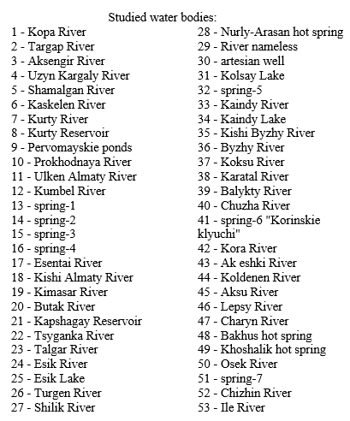
Supplementary tables and figures
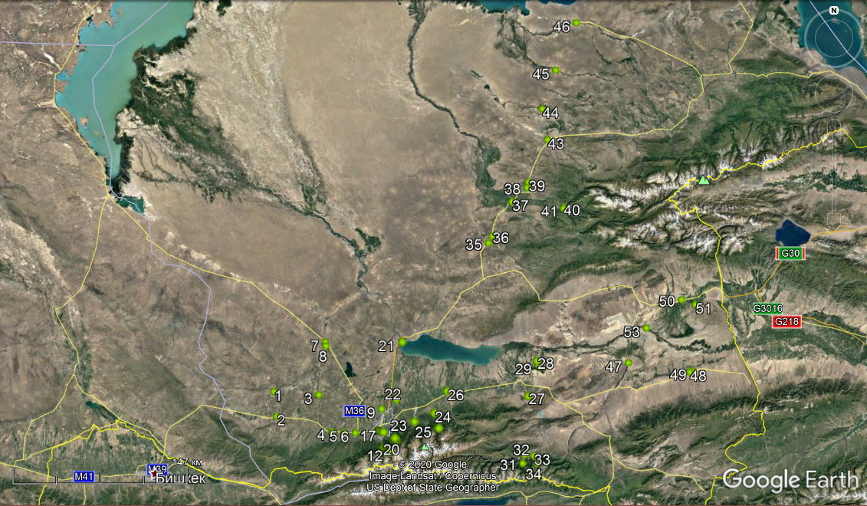

Figure 1 - Studied rivers and reservoirs of Almaty region and Almaty city
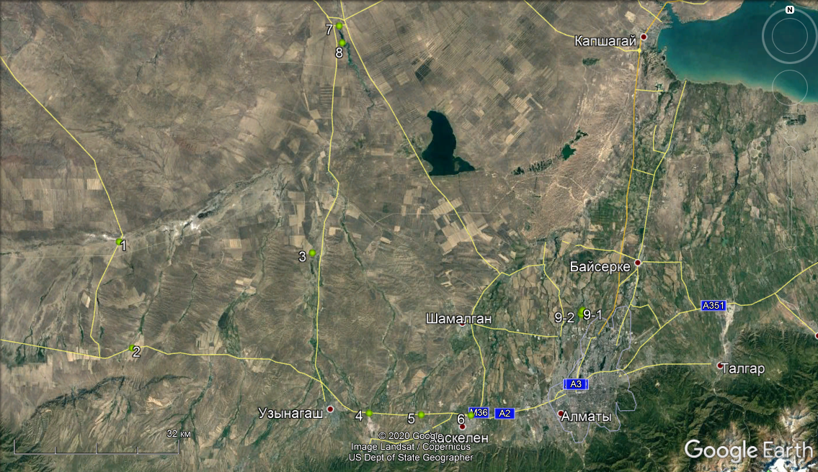

No.1 – Kopa River: coordinates: 43⁰30'51.57'' N, 75⁰48'40.37'' E; No.2 – Targap River: coordinates: 43⁰19'56.91'' N, 75⁰50'38.74'' E;
No.3 - Aksengir River: coordinates: 43⁰29’50.82’’ N, 76⁰16’2.04’’ E; No.4 - Uzyn Kargaly River: coordinates: 43⁰13'24.02'' N, 76⁰24'5.90'' E;
No.5 - Shamalgan River: coordinates: 43⁰13'13.75'' N, 76⁰31'25.69'' E; No.6 - Kaskelen River: coordinates: 43⁰13'10.22'' N, 76⁰38'25.49'' E;
No.7 - Kurty River: coordinates: 43⁰53’11.07’’ N, 76⁰19’44.15’’ E; No.8 - Kurty Reservoir: coordinates: 43⁰51’27.11’’ N, 76⁰20’9.84’’ E;
No. – Pervomayskie ponds: No.9-1, coordinates: 43⁰23’51.86’’ N, 76⁰54’14.92’’ E; No.9-2, coordinates: 43⁰23’34.05’’N, 76⁰54’4.66’’E
Figure 2 – The location of water sampling points in the Zhambyl (No. 1 - 4), Karasay (No. 5, 6), Ile districts (No. 7-9) of Almaty region
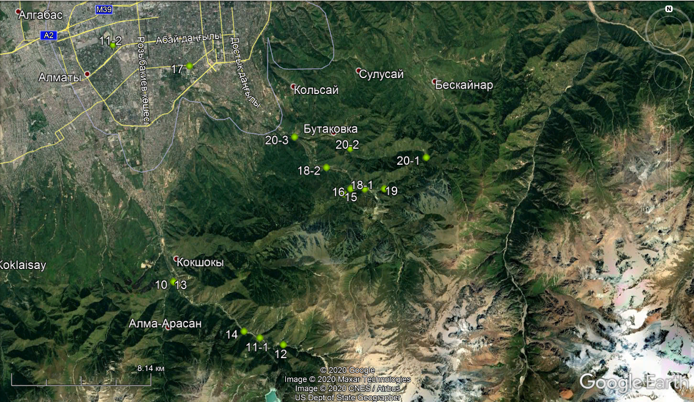

No.10 – Prokhodnaya River: coordinates: 43⁰6’48.48’’ N, 76⁰54’48.76’’E; No.11 – Ulken Almaty River: No.11-1 - coordinates: 43⁰5’2.28’’ N, 76⁰58’32.16’’ E; No.11-2 - coordinates: 43⁰14’14.96’’ N, 76⁰52’11.28’’E, estuary of Sairan Reservoir; No.12 - Kumbel River: coordinates: 43⁰4’49.58’’ N, 76⁰59’33.15’’ E; No. 13 – spring-1: coordinates: 43⁰6’47.79’’ N, 76⁰54’49.70’’ E, near the Prokhodnaya River;
No.14 – spring-2: coordinates: 43⁰5’45.13’’ N, 76⁰57’51.65’’ E; No.15 – spring-3: coordinates: 43⁰9’33.96’’ N, 77⁰2’8.95’’ E, near the Batareika River; No. 16 – spring-4: coordinates: 43⁰9’43.79’’ N, 77⁰2’27.47’’ E, at the bus-stop Prosveschenets on the road to Medeo;
No. 17 – Esentai River: coordinates: 43⁰13’35.66’’ N, 76⁰55’29.47’’ E, No.18 – Kishi Almaty River: No.18-1 - coordinates: 43⁰9’43.22’’ N, 77⁰3’3.02’’ E; No.18-2 - coordinates: 43⁰10’23.91’’ N, 77⁰1’23.98’’ E; No. 19 – Kimasar River: coordinates: 43⁰9’43.43’’ N, 77⁰3’54.25’’ E;
No.20 – Butak River: No.20-1, coordinates: 43⁰10’42.86’’ N, 77⁰5’41.90’’ E, in the Butak Valley; No.20-2 - coordinates: 43⁰10’59.69’’ N, 77⁰2’25.16’’ E; No.20-3 - coordinates: 43⁰11’21.42’’ N, 77⁰0’1.52’’ E
Figure 3 – The location of water sampling points in Almaty city (No.10-20)
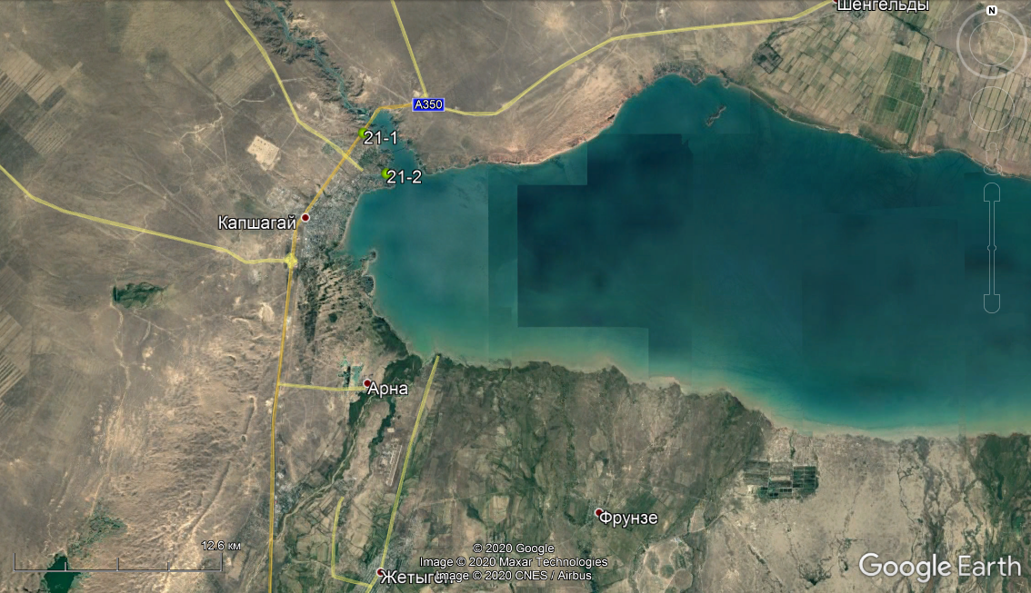

No.21 - Kapshagay Reservoir: No.21-1 - coordinates: 43⁰54’45.90’’ N, 77⁰5’41.79’’ E; No.21-2, coordinates: 43⁰53’26.72’’ N, 77⁰6’44.61’’ E
Figure 4 – The location of water sampling points in the Talgar (No. 21) districts of Almaty region
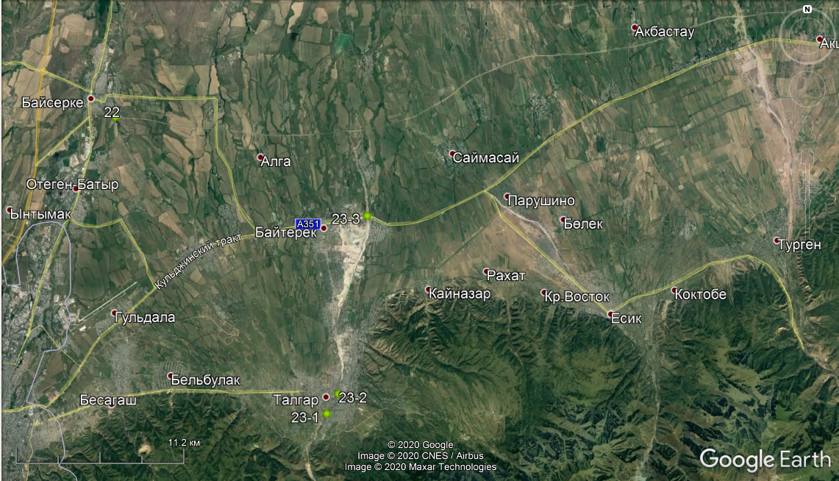

No.22 - Tsyganka River: coordinates: 43⁰28’9.88’’ N, 77⁰3’13.40’’ E; No.23 - Talgar River: No.23-1, coordinates: 43⁰17’32.89’’ N, 77⁰13’39.70’’ E, in Talgar city; No.23-2, coordinates: 43⁰18’15.43’’ N, 77⁰14’13.90’’ E, in Talgar city; No.23-3, coordinates: 43⁰24’37.05’’ N, 77⁰15’38.72’’ E, near the Kulja highway
Figure 5 – The location of water sampling points in the Talgar (No. 22-23) districts of Almaty region

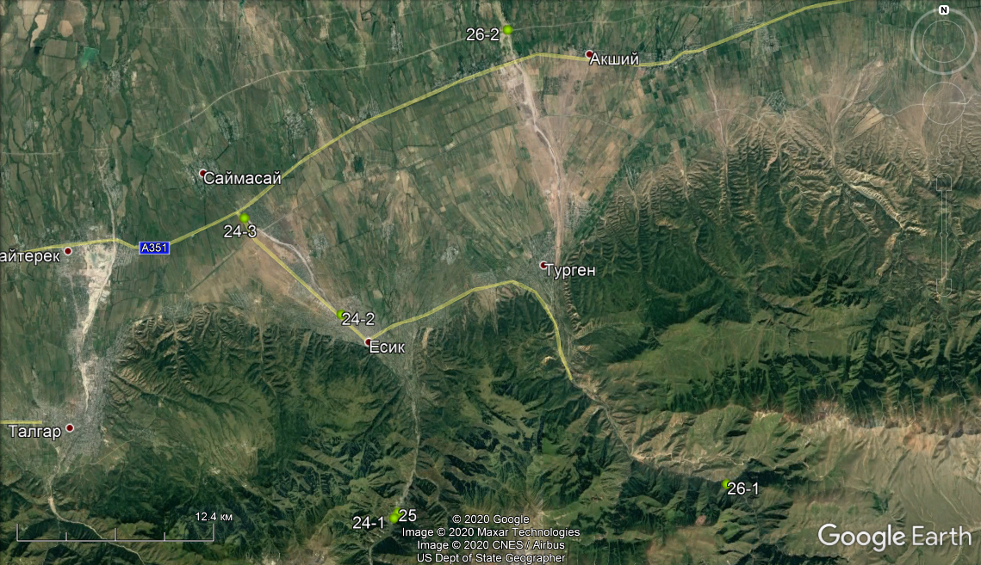

No.24 - Esik River: No.24-1, coordinates: 43⁰15’5.90’’ N, 77⁰28’48.51’’E, near Esik Lake; No.24-2, coordinates: 43⁰22’2.16’’ N, 77⁰26’20.07’’ E, in Esik city; No.24-3, coordinates: 43⁰25’18.87’’ N, 77⁰21’46.70’’ E, near the Kulja highway;
No.25 - Esik Lake: coordinates: 43⁰15’17.74’’ N, 77⁰28’59.19’’ E; No.26 - Turgen River: No.26-1 - coordinates: 43⁰16’14.98’’ N, 77⁰44’21.39’’E; No.26-2 - coordinates: 43⁰31’44.31’’ N, 77⁰34’7.46’’ E, near the Almaty-Khorgos highway
Figure 6 – The location of water sampling points in the Enbekshikazakh districts (No. 24-26) of Almaty region

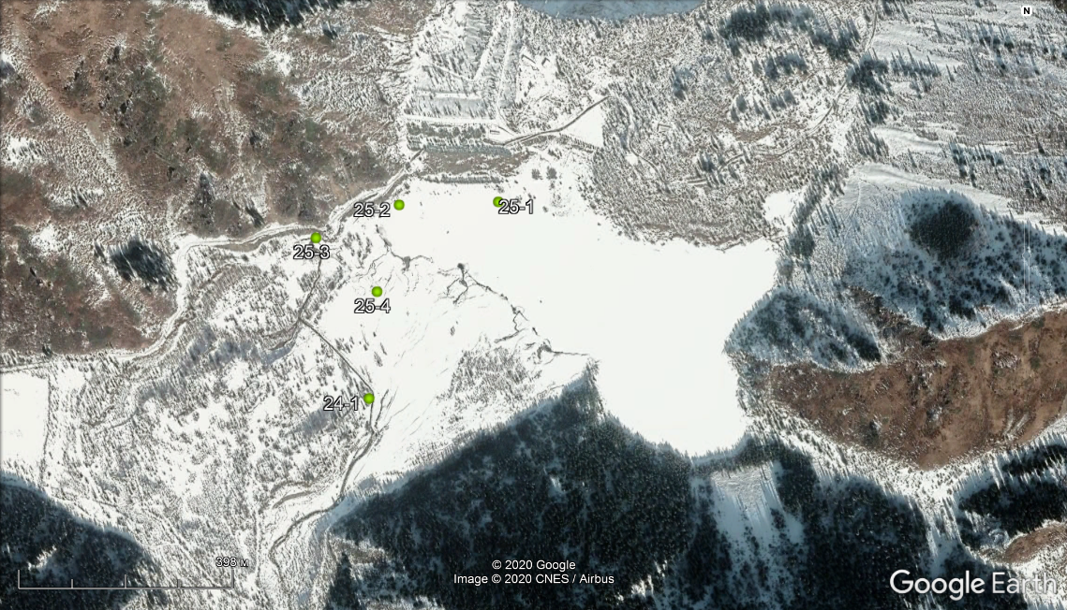

No.24 - Esik River: No.24-1, coordinates: 43⁰15’5.90’’ N, 77⁰28’48.51’’E;
No.25 - Esik Lake: No.25-1 - coordinates: 43⁰15’17.74’’ N, 77⁰28’59.19’’ E; No.25-2 - coordinates: 43⁰15’17.56’’ N, 77⁰28’51.00’’ E;
No.25-3 - coordinates: 43⁰15’15.57’’ N, 77⁰28’44.14’’ E; No.25-4, coordinates: 43⁰15’12.33’’ N, 77⁰28’49.18’’ E
Figure 7 – The location of water sampling points in the Enbekshikazakh districts (No. 24-25) of Almaty region
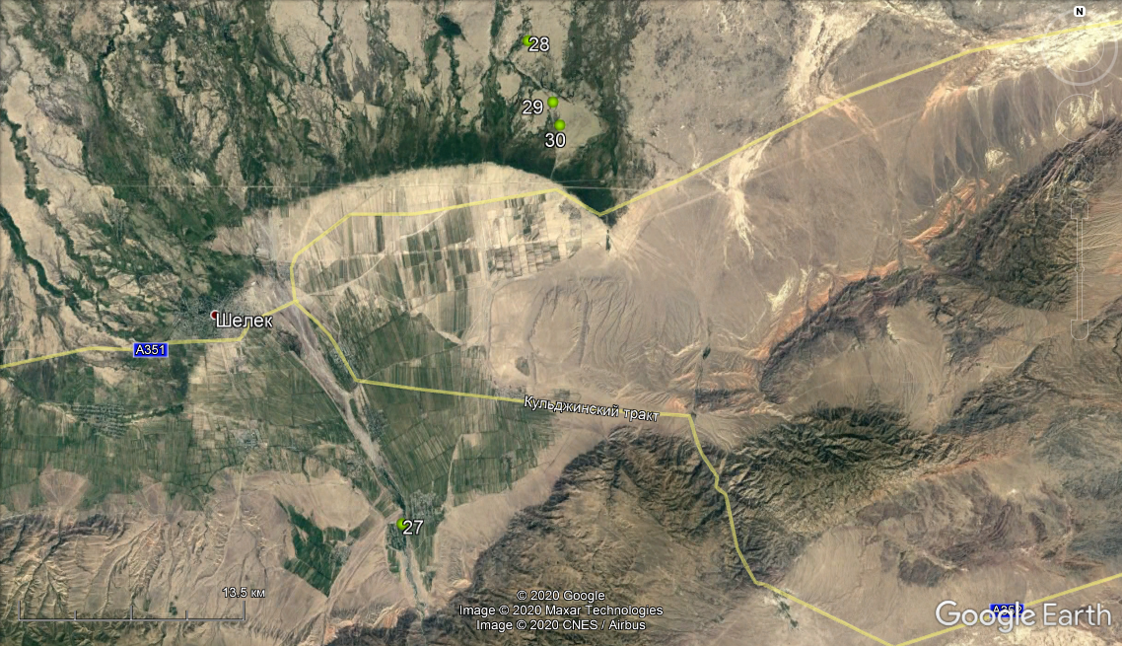

No.27 - Shilik River: coordinates: 43⁰29’7.02’’N, 78⁰23’24.35’’E; No.28 - Nurly-Arasan hot spring: coordinates: 43⁰44’41.51’’ N, 78⁰29’0.43’’E; No.29 – River nameless: coordinates: 43⁰42’43.00’’ N, 78⁰30’6.77’’ E, near Nurly-Arasan hot spring;
No.30 – artesian well: coordinates: 43⁰41’58.40’’ N, 78⁰30’25.31’’E, near Nurly-Arasan hot spring
Figure 8 – The location of water sampling points in the Enbekshikazakh districts (No. 27-30) of Almaty region

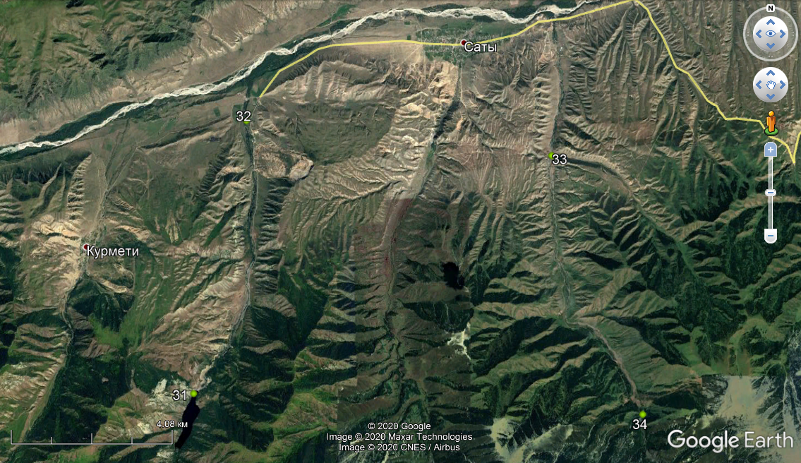

No.31 - Kolsay Lake: coordinates: 42⁰59'23.03'' N, 78⁰19'32.15'' E; No.32 – spring-5: coordinates: 43⁰3'7.31'' N, 78⁰20'29.93'' E, near Saty village; No.33 – Kaindy River: coordinates: 43⁰2'38.43'' N, 78⁰26'14.24'' E; No.34 – Kaindy Lake: coordinates: 42⁰59'5.96'' N, 78⁰27'55.05''E
Figure 9 – The location of water sampling points in the Raiymbek districts (No. 31-34) of Almaty region

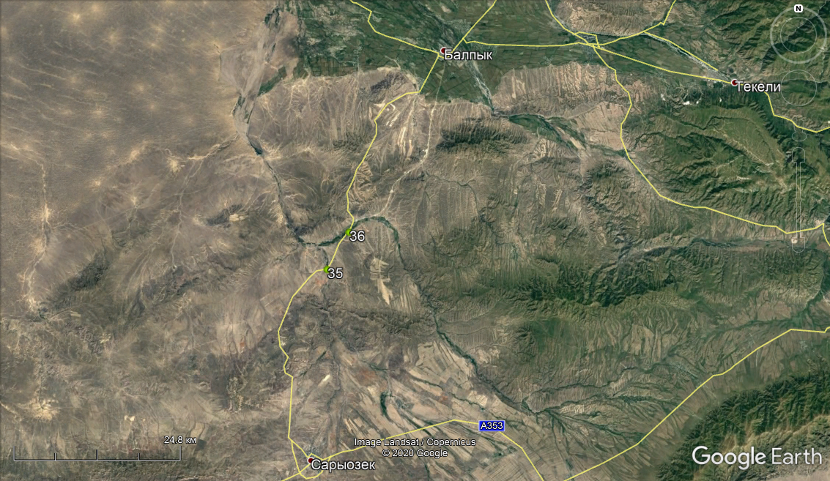

No.35 - Kishi Byzhy River: coordinates: 44⁰36'48.48'' N, 77⁰59'54.21'' E; No.36 - Byzhy River: coordinates: 44⁰39'46.56''N, 78⁰2'21.64'' E
Figure 10 – The location of water sampling points in the Koksu districts (No. 35, 36) of Almaty region
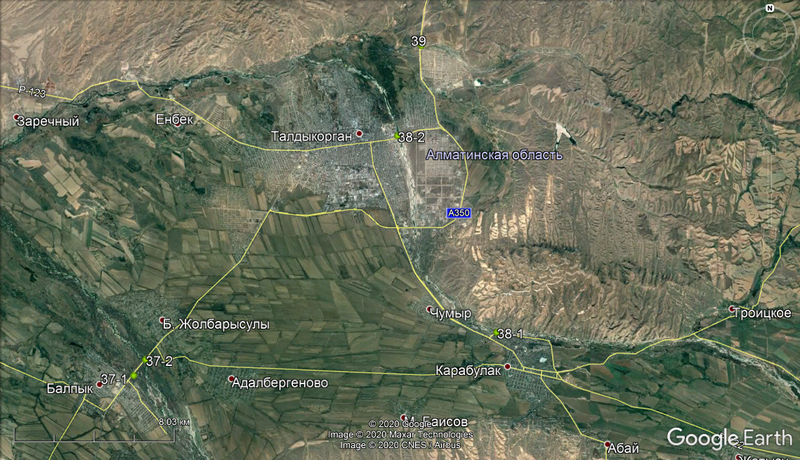

No.37 - Koksu River: No.37-1: coordinates: 44⁰54'30.36'' N, 78⁰14'18.28'' E; No.37-2: coordinates: 44⁰54'56.30'' N, 78⁰14'44.98'' E;
No.38 – Karatal River: No.38-1: coordinates: 44⁰55'43.80'' N, 78⁰28'6.23'' E; No.38-2: coordinates: 45⁰1'0.61'' N, 78⁰24'17.59'' E, in Taldykorgan city; No.39 - Balykty River: coordinates: 45⁰3'26.31'' N, 78◦25'10.78'' E
Figure 11 – The location of water sampling points in the Eskeldi district (No. 37-39) of Almaty region

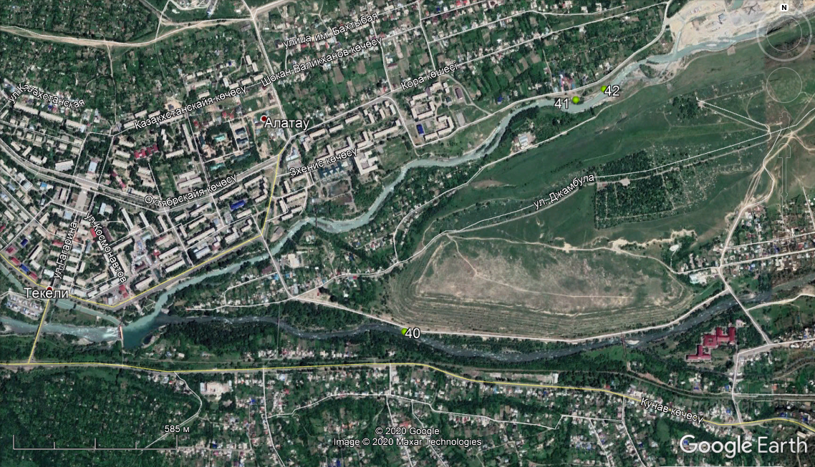

No.40 - Chuzha River: coordinates: 44⁰51'31.52'' N, 78⁰46'44.62'' E; No.41 – spring-6 "Korinsky klyuchi": coordinates: 44⁰51'58.62'' N, 78⁰47'12.87''E; No.42- Kora River: coordinates: 44⁰51'59.87'' N, 78⁰47'17.56'' E
Figure 12 – The location of water sampling points in the Eskeldi district (No. 40-42) of Almaty region
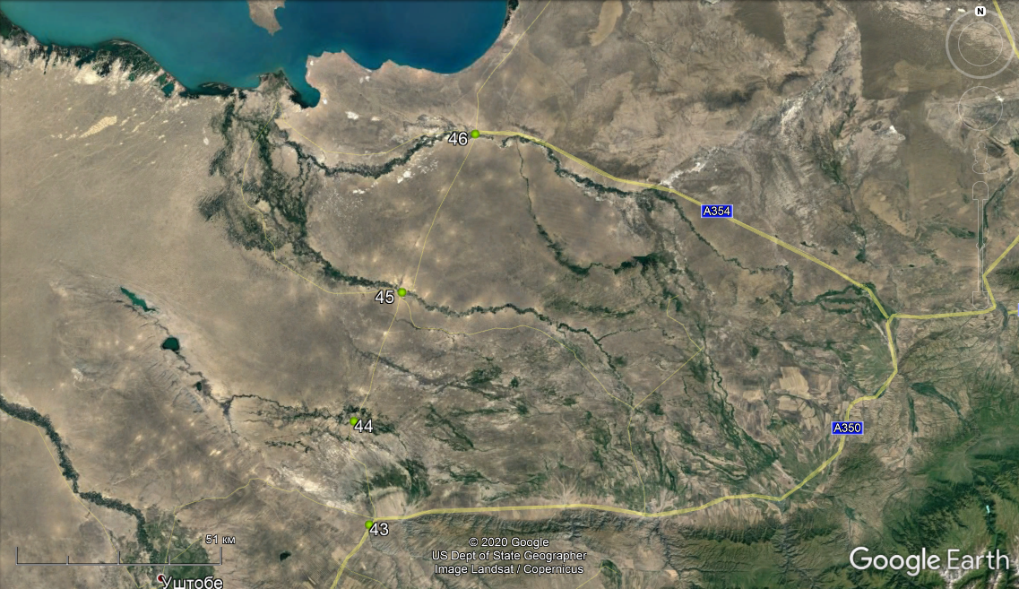

No.43 - Ak eshki River: coordinates: 45⁰21'56.25'' N, 78⁰37'40.51'' E; No.44 – Koldenen River: координаты 45⁰35'37.44''N, 78⁰34'43.91'' E;
No.45 – Aksu River: coordinates: 45⁰52'42.64'' N, 78⁰43'44.06'' E; No.46 – Lepsy River: coordinates: 46⁰13'38.65'' N, 78⁰57'39.33'' E
Figure 13 – The location of water sampling points in the Aksu (No. 43, 44) and Sarkand districts (No. 45, 46) of Almaty region
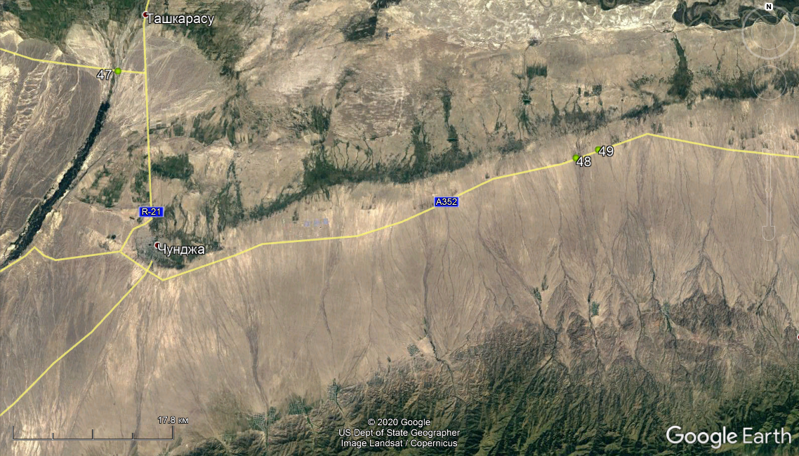

No.47 - Charyn River: coordinates: 43⁰42'52.08'' N, 79⁰24'53.38'' E; No.48 – Bakhus hot spring: coordinates: 43⁰37'45.02'' N, 80⁰2'35.58'' E;
No.49 – Khoshalik hot spring: coordinates: 43⁰38'14.51"N, 80⁰4'25.99"E
Figure 14 – The location of water sampling points in the Uygur district (No. 47, 49) of Almaty region
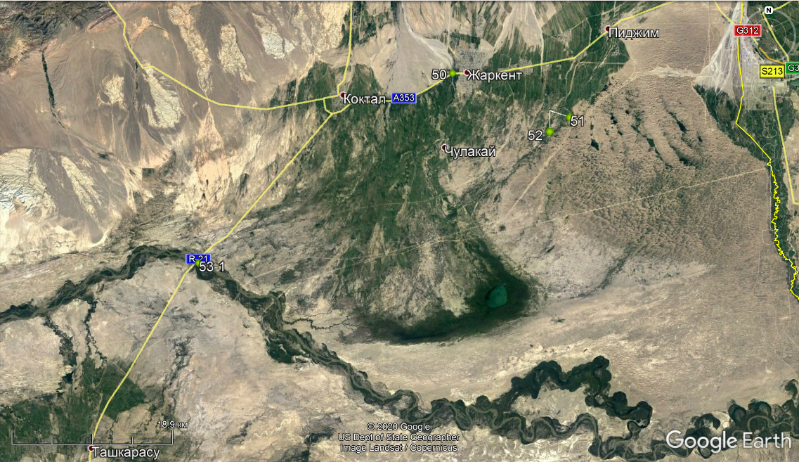

No.50 – Osek River: coordinates: 44⁰9'56.82'' N, 79⁰58'44.31'' E; No.51 – spring-7: coordinates: 44⁰7'34.65"N, 80⁰7'15.16" E;
No.52 – Chizhin River: coordinates: 44⁰7'36.69''N, 80⁰7'16.06'' E; No.53 - Ile River: No.53-1: coordinates: 43⁰57'58.30'' N, 79⁰36'28.11'' E;
Figure 15 – The location of water sampling points in the Panfilov district (No. 50-53) of Almaty region
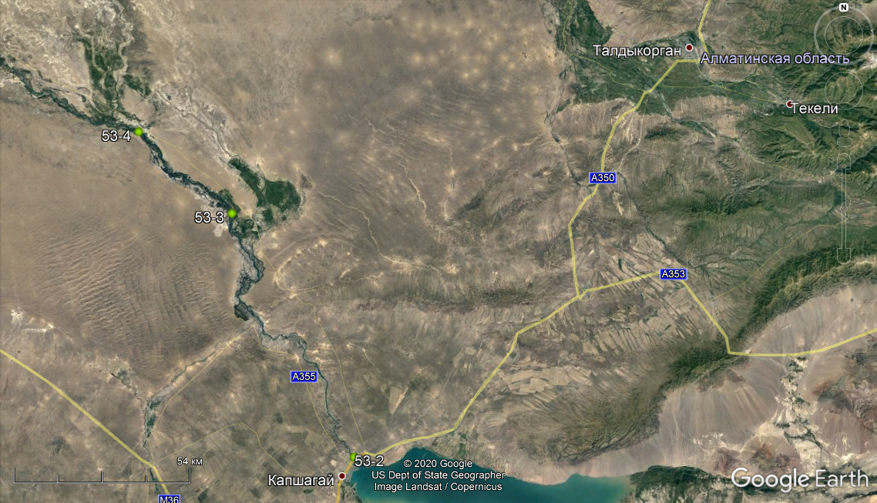

No.53 - Ile River: No.53-2 - coordinates: 43⁰55’7.38’’N, 77⁰5’49.99’’E; No.53-3, coordinates: 44⁰34’34.34’’N, 76⁰38’4.49’’E;
No.53-4, coordinates: 44⁰47’43.95’’N, 76⁰16’34.89’’E, near Bakanas village
Figure 16 – The location of water sampling points in the Balkash district (No. 53) of Almaty region
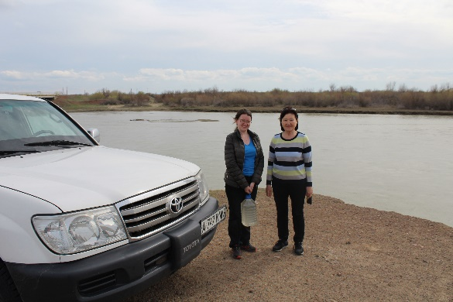 | 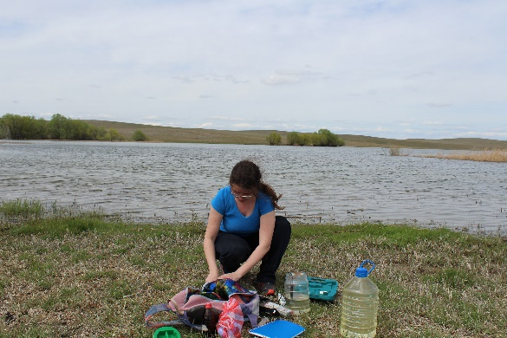 | 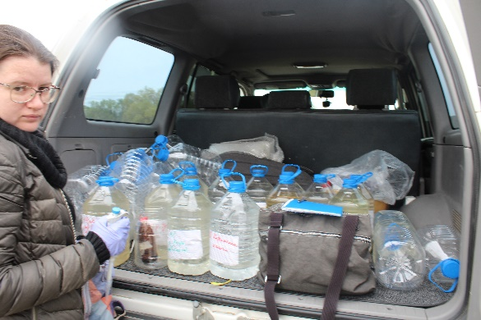
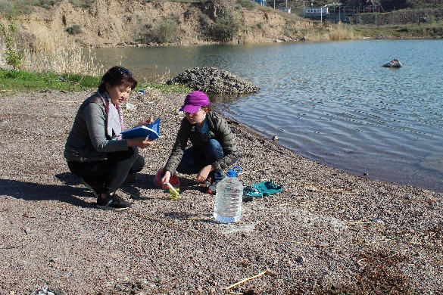 | 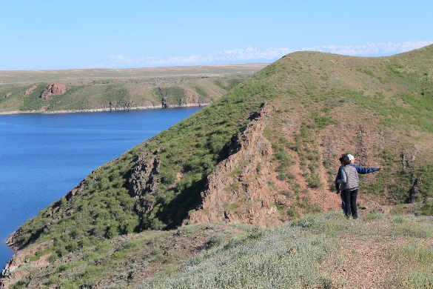 | 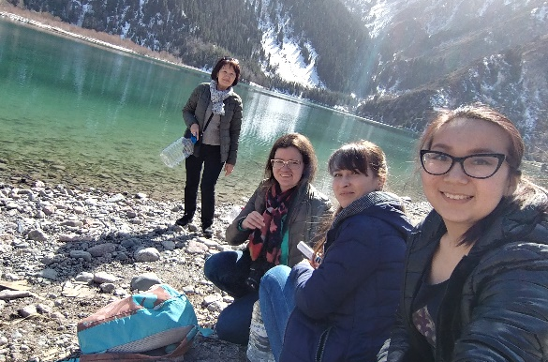
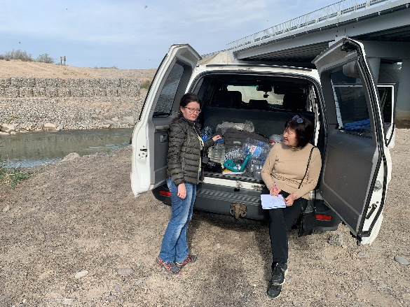 | 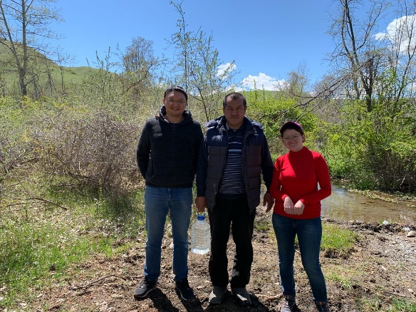 | 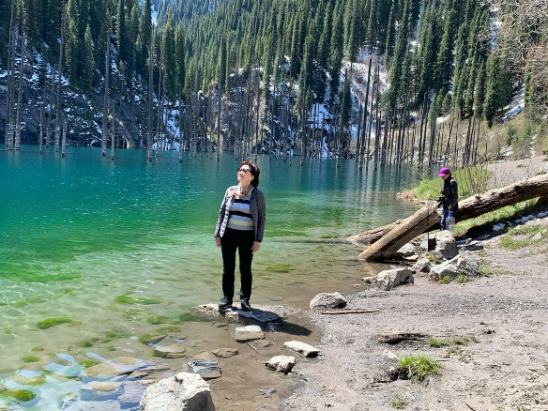

Figure 17 - Sampling and measurement of physical parameters of natural waters of Almaty region and Almaty city

Table 1 - Physical parameters of water samples from water bodies of Almaty region and Almaty city
Water samples | t (⁰С) | рН | ORP (mv) | TDS (ppm) | EC (μSм/sm) | DO (mg/L)
1 | 2 | 3 | 4 | 5 | 6 | 7
Zhambyl district
Kopa River, No.1 | 17.0 | 6.3 | 165 | 2015 | 4030 | 3.5
Targap River, No.2 | 15.0 | 6.4 | 183 | 584 | 1150 | 4.3
Aksengir River, No.3 | 15.0 | 6.5 | 129 | 340 | 680 | 8.9
Uzyn Kargaly River, No.4 | 15.0 | 6.3 | 193 | 117 | 240 | 2.6
Karasay district
Shamalgan River, No.5 | 11.0 | 6.3 | 208 | 101 | 206 | 2.9
Kaskelen River, No.6 | 10.0 | 6.3 | 345 | 142 | 284 | 3.8
Ile district
Kurty River, No.7 | 9.2 | 6.6 | 140 | 910 | 1820 | 8.9
Kurty Reservoir, No.8 | 15.4 | 5.8 | 144 | 675 | 1350 | 8.9
Pervomayskie ponds, No. 9-1 | 17.0 | 6.6 | 234 | 255 | 532 | 8.8
Pervomayskie ponds, No. 9-2 | 17.8 | 6.0 | 193 | 265 | 530 | 4.5
Almaty city
Prokhodnaya River, No.10 | 10.8 | 5.5 | 148 | 45 | 90 | 3.0
Ulken Almaty River, No.11-1 | 8.4 | 6.5 | 142 | 37 | 74 | 2.2
Ulken Almaty River, No.11-2 | 12.8 | 6.4 | 145 | 47 | 94 | 2.2
Kumbel River, No.12 | 3.4 | 5.8 | 148 | 27 | 54 | 1.3
spring-1, No.13 | 9.8 | 5.8 | 155 | 365 | 580 | 2.6
spring-2, No.14 | 4.2 | 6.4 | 153 | 45 | 90 | 2.3
spring-3, No.15 | 4.4 | 6.5 | 158 | 181 | 362 | 2.8
spring-4, No.16 | 2.8 | 6.0 | 167 | 191 | 398 | 2.7
Esentai River, No.17 | 11.0 | 6.6 | 208 | 127 | 246 | 1.8
Kishi Almaty River, No.18-1 | 2.8 | 6.6 | 116 | 38 | 74 | 2.0
Kishi Almaty River, No.18-2 | 5.4 | 6.7 | 149 | 118 | 246 | 4.3
Kimasar River, No.19 | 3.8 | 6.6 | 160 | 36 | 70 | 2.6
Butak River, No.20-1 | 2.4 | 6.5 | 143 | 27 | 54 | 2.8
Butak River, No.20-2 | 5.4 | 7.3 | 136 | 45 | 90 | 2.7
Butak River, No.20-3 | 6.8 | 6.5 | 136 | 120 | 228 | 2.8
Talgar district
Continuation of Table 1
1 | 2 | 3 | 4 | 5 | 6 | 7
Kapshagay Reservoir, No.21-1 | 9.6 | 7.9 | 120 | 290 | 598 | 8.9
Kapshagay Reservoir, No.21-2 | 9.6 | 6.7 | 136 | 280 | 560 | 8.8
Tsyganka River, No.22 | 13.8 | 4.6 | 158 | 416 | 832 | 2.2
Talgar River, No.23-1 | 4.0 | 6.1 | 121 | 94 | 192 | 5.4
Talgar River, No.23-2 | 4.0 | 5.6 | 119 | 90 | 186 | 4.1
Talgar River, No.23-3 | 15.0 | 6.6 | 116 | 85 | 170 | 1.7
Enbekshikazakh district
Esik River, No.24-1 | 6.0 | 5.5 | 93.0 | 91 | 178 | 7.9
Esik River, No.24-2 | 4.0 | 5.0 | 96.0 | 85 | 163 | 5.7
Esik River, No.24-3 | 22.4 | 6.7 | 80.0 | 79 | 158 | 2.7
Esik Lake, No.25-1 | 5.0 | 5.0 | 101.0 | 132 | 278 | 5.8
Esik Lake, No.25-2 | 5.0 | 5.0 | 110.0 | 130 | 268 | 5.5
Esik Lake, No.25-3 | 3.0 | 6.0 | 119.0 | 129 | 375 | 5.7
Esik Lake, No.25-4 | 4.0 | 5.5 | 98.0 | 105 | 295 | 5.7
Turgen River, No.26-1 | 4.0 | 5.6 | 89.0 | 111 | 132 | 3.2
Turgen River, No.26-2 | 7.0 | 5.7 | 79.0 | 87 | 143 | 5.4
Shilik River, No.27 | 16.0 | 5.0 | 90.0 | 81 | 158 | 2.7
Nurly-Arasan hot spring, No.28 | 40.0 | 7.6 | 140 | 680 | 1550 | 1.9
River nameless, No.29 | 6.0 | 5.5 | 90.0 | 81 | 158 | 5.7
artesian well, No.30 | 5.0 | 5.7 | 150 | 161 | 352 | 6.8
Raiymbek district
Kolsay Lake, No.31 | 10.0 | 6.4 | 146 | 98 | 210 | 2.0
spring-5, No.32 | 10.0 | 6.4 | 151 | 139 | 318 | 2.0
Kaindy River, No.33 | 10.0 | 6.4 | 206 | 213 | 426 | 2.5
Kaindy Lake, No.34 | 10.0 | 6.3 | 156 | 196 | 392 | 2.3
Koksu district
Kishi Byzhy River, No.35 | 12.2 | 6.5 | 210 | 1038 | 2170 | 6.0
Byzhy River, No.36 | 11.8 | 6.2 | 144 | 332 | 642 | 3.7
Eskeldi district
Koksu River, No.37-1 | 11.8 | 6.2 | 153 | 95 | 196 | 2.1
Koksu River, No.37-2 | 11.8 | 5.9 | 157 | 98 | 184 | 2.1
Karatal River, No.38-1 | 5.0 | 5.9 | 145 | 76 | 152 | 1.7
Continuation of Table 1
1 | 2 | 3 | 4 | 5 | 6 | 7
Karatal River, No.38-2 | 10.6 | 5.9 | 163 | 92 | 184 | 1.8
Balykty River, No.39 | 5.8 | 6.0 | 158 | 197 | 370 | 2.4
Chuzha River, No.40 | 7.6 | 5.0 | 139 | 48 | 96 | 0.9
spring-6 "Korinskie klyuchi", No.41 | 9.6 | 6.0 | 149 | 84 | 170 | 0.9
Kora River, No.42 | 6.6 | 6.3 | 137 | 71 | 154 | 0.95
Aksu district
Ak eshki River, No.43 | 11.8 | 6.5 | 129 | 260 | 554 | 5.0
Koldenen River, No.44 | 21 | 5.9 | 164 | 475 | 960 | 5.1
Sarkand district
Aksu River, No.45 | 20.8 | 6.0 | 147 | 220 | 440 | 2.8
Lepsy River, No.46 | 20.2 | 6.0 | 160 | 190 | 378 | 3.1
Uygur district
Charyn River, No.47 | 16.7 | 6.4 | 226 | 507 | 1014 | 4.4
Bakhus hot spring, No.48 | 31.7 | 5.8 | 178 | 974 | 2022 | 3.7
Khoshalik hot spring, No.49 | 33.8 | 5.9 | 168 | 711 | 1422 | 3.9
Panfilov district
Osek River, No.50 | 17.7 | 6.3 | 130 | 193 | 388 | 3.1
spring-7, No.51 | 18 | 5.8 | 174 | 215 | 430 | 4.3
Chizhin River, No.52 | 24.7 | 6.0 | 155 | 740 | 1480 | 3.9
Ile River, No. 53-1 | 18.8 | 6.0 | 169 | 261 | 526 | 5.2
Balkash district
Ile River, No.53-2 | 8.0 | 7.0 | 130 | 297 | 560 | 8.8
Ile River, No.53-3 | 8.6 | 5.9 | 143 | 298 | 596 | 8.9
Ile River, No.53-4 | 10.2 | 5.8 | 146 | 281 | 562 | 8.9
Standard | - | 6.0-9.0 | +80.0-300.0 | 50.0-150.0 | 100.0- 1200.0 | 7.0-9.0
Note: t - temperature, ORP – oxidation-redox potential, TDS - total dissolved solids, EC - electrical conductivity, DO - dissolved oxygen in water

Таблица 2 – Content of heavy metals (mg/dm³) in water samples of Almaty region and Almaty city
Water samples | Ni | Mn | Co | Pb | Cr | Fe | Zn | Cu | Cd
1 | 2 | 3 | 4 | 5 | 6 | 7 | 8 | 9 | 10
Zhambyl district
Kopa River, No.1 | 0.0253±  0.0002*◊ | 0.0127± 0.0001* | 0.0273±  0.0004* | 0.0290±  0.0002*◊ | 0.0804±  0.0007•*◊ | 0.0322±  0.0006 | 0.0203±  0.0004* | 0.0047±  0.0001* | 0.0036±  0.0001•◊
Targap River, No.2 | 0.0050±  0.0006 | 0.0091±  0.0004 | 0.0044±  0.0001 | 0.0101±  0.0009*◊ | 0.0381±  0.0007* | 0.0455±  0.0010 | 0.0155±  0.0008* | 0.0029±  0.0009* | 0.0008±  0.0001
Aksengir River, No.3 | 0.0022± 0.0001 | 0.0137± 0.0001* | 0.0071± 0.0002 | 0.0059± 0.0001 | 0.0054± 0.0001 | 0.0193± 0.0002 | 0.0085± 0.0001 | 0.0011± 0.0001* | 0.0010± 0.0001•◊
Uzyn Kargaly River, No.4 | 0.0011±  0.0001 | 0.0136±  0.0008* | 0.0016±  0.0001 | 0.0025±  0.0002 | 0.0172±  0.0007 | 0.0689±  0.0014 | 0.0122±  0.0011* | 0.0018±  0.0005* | 0.0001±  0.0000
Karasay district
Shamalgan River, No.5 | 0.0017±  0.0001 | 0.0136±  0.0005* | 0.0074±  0.0004 | 0.0036±  0.0007 | 0.0114±  0.0012 | 0.0933±  0.0014 | 0.0209±  0.0011* | 0.0013±  0.0001* | 0.0004±  0.0001
Kaskelen River, No.6 | 0.0014±  0.0003 | 0.0004±  0.0001 | 0.0053±  0.0006 | 0.0006±  0.0001 | 0.0127±  0.0011 | 0.0623±  0.0015 | 0.0010±  0.0001 | 0.0016±  0.0003* | 0.0001±  0.0000
Ile district
Kurty River, No.7 | 0.0070± 0.0001 | 0.0091± 0.0001 | 0.0108± 0.0002* | 0.0160± 0.0002*◊ | 0.0168± 0.0002 | 0.0103± 0.0002 | 0.0168± 0.0002* | 0.0023± 0.0001* | 0.0024± 0.0002•◊
Kurty Reservoir, No.8 | 0.0133± 0.0002* | 0.0105± 0.0003* | 0.0043± 0.0001 | 0.0093± 0.0001* | 0.0147± 0.0002 | 0.0133± 0.0001 | 0.0400± 0.0002* | 0.0015± 0.0001* | 0.0012± 0.0001•◊
Continuation of Table 2
1 | 2 | 3 | 4 | 5 | 6 | 7 | 8 | 9 | 10
Pervomayskie ponds, No. 9-1 | 0.0052± 0.0003 | 0.0477± 0.0018* | 0.0035± 0.0003 | 0.0074± 0.0001* | 0.0095± 0.0001 | 0.0362± 0.0001 | 0.0133± 0.0002* | 0.0010± 0.0000* | 0.0007± 0.0000
Pervomayskie ponds, No. 9-2 | 0.0038 ±0.0002 | 0.0537± 0.0017* | 0.0017± 0.0003 | 0.0077± 0.0001* | 0.0073± 0.0002 | 0.0322± 0.0006 | 0.0102± 0.0004* | 0.0011± 0.0001* | 0.0008± 0.0000
Almaty city
Prokhodnaya River, No.10 | 0.0009±  0.0001 | 0.0144± 0.0002* | 0.0016± 0.0003 | 0.0043± 0.0003 | 0.0032± 0.0001 | 0.0097± 0.0001 | 0.0126± 0.0001* | 0.0006± 0.0001 | 0.0004± 0.0000
Ulken Almaty River, No.11-1 | 0.0012±  0.0002 | 0.0214± 0.0002* | 0.0038± 0.0002 | 0.0018± 0.0001 | 0.0035± 0.0002 | 0.0316± 0.0001 | 0.0830± 0.0001* | 0.0009± 0.0000 | 0.0005± 0.0001
Ulken Almaty River, No.11-2 | 0.0019±  0.0003 | 0.0185± 0.0014* | 0.0025± 0.0004 | 0.0040± 0.0001 | 0.0052± 0.0001 | 0.0337± 0.0002 | 0.0767± 0.0001* | 0.0007± 0.0000 | 0.0004± 0.0000
Kumbel River, No.12 | 0.0007±  0.0001 | 0.0186± 0.0014* | 0.0046± 0.0002 | 0.0047± 0.0001 | 0.0038± 0.0001 | 0.0424± 0.0001 | 0.0153± 0.0002* | 0.0004± 0.0001 | 0.0004± 0.0002
Spring-1, No.13 | 0.0026±  0.0002 | 0.0095± 0.0003 | 0.0018± 0.0002 | 0.0096± 0.0002* | 0.0093± 0.0001 | 0.0106± 0.0003 | 0.0083± 0.0003 | 0.0006± 0.0000 | 0.0009± 0.0001
Spring-2, No.14 | 0.0009±  0.0001 | 0.0096± 0.0001 | 0.0014± 0.0001 | 0.0050± 0.0001 | 0.0037± 0.0001 | 0.0040± 0.0001 | 0.0025± 0.0002 | 0.0004± 0.0001 | 0.0004± 0.0001
Spring-3, No.15 | 0.0030±  0.0001 | 0.0094± 0.0001 | 0.0005± 0.0001 | 0.0078± 0.0002* | 0.0104± 0.003 | 0.0034± 0.0001 | 0.0065± 0.0001 | 0.0006± 0.0001 | 0.0006± 0.0001
Continuation of Table 2
1 | 2 | 3 | 4 | 5 | 6 | 7 | 8 | 9 | 10
Spring-4, No.16 | 0.0029±  0.0001 | 0.0067± 0.0001 | 0.0004± 0.0000 | 0.0106± 0.0003*◊ | 0.0077± 0.0002 | 0.0125± 0.0001 | 0.0257± 0.0002* | 0.0007± 0.0001 | 0.0007± 0.0001
Esentai River, No.17 | 0.0013±  0.0002 | 0.0212± 0.0011* | 0.0031± 0.0003 | 0.0045± 0.0002 | 0.0054± 0.0001 | 0.0783± 0.0002 | 0.0106± 0.0003* | 0.0006± 0.0001 | 0.0004± 0.0000
Kishi Almaty River, No.18-1 | 0.0004± 0.0000 | 0.0312± 0.0020* | 0.0006± 0.0001 | 0.0054± 0.0004 | 0.0052± 0.0001 | 0.0754± 0.0003 | 0.0168± 0.0003* | 0.0006± 0.0001 | 0.0004± 0.0000
Kishi Almaty River, No.18-2 | 0.0007± 0.0001 | 0.0111± 0.0002* | 0.0017± 0.0001 | 0.0087± 0.0001* | 0.0012± 0.0001 | 0.0459± 0.0002 | 0.0198± 0.0002* | 0.0007± 0.0000 | 0.0006± 0.0001
Kimasar River, No.19 | 0.0006± 0.0001 | 0.0205± 0.0012* | 0.0044± 0.0003 | 0.0046± 0.0002 | 0.0046± 0.0002 | 0.0765± 0.0002 | 0.0104± 0.0004* | 0.0006± 0.0002 | 0.0003± 0.0001
Butak River, No.20-1 | 0.0016±  0.0002 | 0.0137± 0.0002* | 0.0005± 0.0001 | 0.0044± 0.0001 | 0.0074± 0.0001 | 0.0613± 0.0001 | 0.0317± 0.0001* | 0.0006± 0.0000 | 0.0003± 0.0001
Butak River, No.20-2 | 0.0009± 0.0001 | 0.0157± 0.0001* | 0.0016± 0.0004 | 0.0054± 0.0001 | 0.0077± 0.0001 | 0.0423± 0.0002 | 0.0234± 0.0003* | 0.0006± 0.0001 | 0.0009± 0.0001
Butak River, No.20-3 | 0.0017± 0.0002 | 0.0149± 0.0001* | 0.0072± 0.0001 | 0.0055± 0.0003 | 0.0120± 0.0002 | 0.0391± 0.0002 | 0.0192± 0.0002* | 0.0008± 0.0000 | 0.0002± 0.0001
Talgar district
Kapshagay Reservoir, No.21-1 | 0.0017±  0.0001 | 0.0114± 0.0002* | 0.0031± 0.0001 | 0.0088± 0.0002* | 0.0039± 0.0001 | 0.0027± 0.0001 | 0.0059± 0.0001 | 0.0011± 0.0002* | 0.0006± 0.0001
Continuation of Table 2
1 | 2 | 3 | 4 | 5 | 6 | 7 | 8 | 9
Kapshagay Reservoir, No.21-2 | 0.0022±  0.0002 | 0.0078± 0.0001 | 0.0035± 0.0001 | 0.0087± 0.0001* | 0.0035± 0.0002 | 0.0024± 0.0001 | 0.0107± 0.0002* | 0.0011± 0.0001* | 0.0008± 0.0001
Tsyganka River, No.22 | 0.0033±  0.0002 | 0.0476± 0.0028* | 0.0029± 0.0001 | 0.0089± 0.0002* | 0.0092± 0.0001 | 0.0342± 0.0003 | 0.0178± 0.0003* | 0.0032± 0.0002* | 0.0035± 0.0003•◊
Talgar River, No.23-1 | 0.0007±  0.0001 | 0.0098± 0.0002 | 0.0011± 0.0001 | 0.0103± 0.0004*◊ | 0.0018± 0.0001 | 0.0075± 0.0002 | 0.0028± 0.0001 | 0.0010±  0.0002* | 0.0002± 0.0000
Talgar River, No.23-2 | 0.0010±  0.0002 | 0.0144± 0.0019* | 0.0036± 0.0002 | 0.0080± 0.0004* | 0.0017± 0.0002 | 0.0123± 0.0002 | 0.0019± 0.0001 | 0.0006±  0.0001 | 0.0004± 0.0001
Talgar River, No.23-3 | 0.0030±  0.0004 | 0.0369± 0.0004* | 0.0035± 0.0002 | 0.0096± 0.0001* | 0.0048± 0.0002 | 0.0634± 0.0002 | 0.0623± 0.0003* | 0.0028± 0.0003* | 0.0006± 0.0001
Enbekshikazakh district
Esik River, No.24-1 | 0.0071±  0.0004 | 0.0096± 0.0002 | 0.0017± 0.0002 | 0.0040± 0.0002 | 0.0034± 0.0002 | 0.0046± 0.0001 | 0.0102± 0.0001* | 0.0003±  0.0001 | 0.0002± 0.0000
Esik River, No.24-2 | 0.0024±  0.0002 | 0.0132± 0.0002* | 0.0020± 0.0002 | 0.0059± 0.0002 | 0.0082± 0.0002 | 0.0338± 0.0002 | 0.0350± 0.0001* | 0.0006± 0.0001 | 0.0006± 0.0001
Esik River, No.24-3 | 0.0014±  0.0003 | 0.0152± 0.0003* | 0.0035± 0.0003 | 0.0084± 0.0001* | 0.0034± 0.0002 | 0.0263± 0.0002 | 0.0371± 0.0003* | 0.0006± 0.0001 | 0.0004± 0.0000
Esik Lake, No.25-1 | 0.0003±  0.0001 | 0.0195± 0.0013* | 0.0037± 0.0001 | 0.0025± 0.0002 | 0.0026± 0.0002 | 0.0064± 0.0001 | 0.0058± 0.0001 | 0.0003± 0.0001 | 0.0003± 0.0001
Continuation of Table 2
1 | 2 | 3 | 4 | 5 | 6 | 7 | 8 | 9 | 10
Esik Lake, No.25-2 | 0.0006±  0.0001 | 0.0188± 0.0002* | 0.0015± 0.0002 | 0.0047± 0.0001 | 0.0021± 0.0001 | 0.0056± 0.0001 | 0.0063± 0.0001 | 0.0009± 0.0001 | 0.0003± 0.0001
Esik Lake, No.25-3 | 0.0012±  0.0002 | 0.0296± 0.0003* | 0.0021± 0.0002 | 0.0069± 0.0003* | 0.0020± 0.0001 | 0.0058± 0.0001 | 0.0106± 0.0001* | 0.0008± 0.0001 | 0.0004± 0.0000
Esik Lake, No.25-4 | 0.0020±  0.0004 | 0.0187± 0.0002 | 0.0019± 0.0001 | 0.0055± 0.0001 | 0.0030± 0.0001 | 0.0051± 0.0001 | 0.0070± 0.0001 | 0.0006± 0.0001 | 0.0013± 0.0001•*◊
Turgen River, No.26-1 | 0.0008±  0.0000 | 0.0728±  0.0002* | 0.0030± 0.0002 | 0.0060± 0.0003* | 0.0050± 0.0002 | 0.0134± 0.0001 | 0.0051± 0.0003 | 0.0004± 0.0000 | 0.0004± 0.0001
Turgen River, No.26-2 | 0.0014±  0.0001 | 0.0336± 0.0003* | 0.0022± 0.0001 | 0.0064± 0.0001* | 0.0045± 0.0002 | 0.0176± 0.0001 | 0.0153± 0.0002* | 0.0007± 0.0001 | 0.0004± 0.0001
Shilik River, No.27 | 0.0007±  0.0002 | 0.0141± 0.0003* | 0.0040± 0.0001 | 0.0051± 0.0004 | 0.0118± 0.0001 | 0.0091± 0.0001 | 0.0036± 0.0002 | 0.0004± 0.0001 | 0.0041± 0.0001•*◊
Nurly-Arasan hot spring, No.28 | 0.0918±  0.0025* | 0.0834± 0.0006* | 0.0381± 0.0034* | 0.0355± 0.0002•*◊ | 0.0854± 0.0003•*◊ | 0.0371± 0.0001 | 0.0339± 0.0002* | 0.0059± 0.0002* | 0.0091± 0.0012•*◊
River nameless, No.29 | 0.0073±  0.0004 | 0.0366± 0.0004* | 0.0028± 0.0001 | 0.0121± 0.0002*◊ | 0.0110± 0.0002 | 0.0218± 0.0001 | 0.0093± 0.0001 | 0.0007± 0.0001 | 0.0011± 0.0002•*◊
Artesian well, No.30 | 0.0011±  0.0001 | 0.0120± 0.0004* | 0.0018± 0.0003 | 0.0057± 0.0001 | 0.0082± 0.0001 | 0.0222± 0.0002 | 0.0136± 0.0001* | 0.0007± 0.0001 | 0.0005± 0.0000
Raiymbek district
Continuation of Table 2
1 | 2 | 3 | 4 | 5 | 6 | 7 | 8 | 9 | 10
Kolsay Lake, No.31 | 0.0014±  0.0003 | 0.0065±  0.0008 | 0.0014±  0.0004 | 0.0037±  0.0008 | 0.0146±  0.0005 | 0.0011± 0.0002 | 0.0083±  0.0004 | 0.0011±  0.0004* | 0.0001± 0.0000
spring-5, No.32 | 0.0018±  0.0005 | 0.0064±  0.0004 | 0.0018± 0.0001 | 0.0058±  0.0001 | 0.0215±  0.0003* | 0.0371±  0.0011 | 0.0116±  0.0004* | 0.0013±  0.0003* | 0.0004±  0.0001
Kaindy River, No.33 | 0.0019±  0.0004 | 0.0040±  0.0008 | 0.0041±  0.0005 | 0.0050±  0.0008 | 0.0343±  0.0003* | 0.0042±  0.0004 | 0.0087±  0.0008 | 0.0009±  0.0001 | 0.0000±  0.0000
Kaindy Lake, No.34 | 0.0025±  0.0003 | 0.0050±  0.0009 | 0.0028±  0.0002 | 0.0063±  0.0004* | 0.0249±  0.0011* | 0.0018±  0.0002 | 0.0071±  0.0009 | 0.0013±  0.0002* | 0.0005±  0.0000
Koksu district
Kishi Byzhy River, No.35 | 0.0099±  0.0005 | 0.0048±  0.0004 | 0.0070±  0.0003 | 0.0073±  0.0004* | 0.0371±  0.0009* | 0.0107±  0.0005 | 0.0100±  0.0010* | 0.0033±  0.0005* | 0.0013±  0.0002•◊
Byzhy River, No.36 | 0.0031±  0.0006 | 0.0031±  0.0004 | 0.0025±  0.0002 | 0.0054±  0.0008 | 0.0215±  0.0009* | 0.0148±  0.0007 | 0.0093±  0.0005 | 0.0018±  0.0002* | 0.0005±  0.0001
Eskeldi district
Koksu River, No.37-1 | 0.0018±  0.0005 | 0.0037±  0.0003 | 0.0015±  0.0004 | 0.0019±  0.0005 | 0.0015±  0.0002 | 0.0607±  0.0015 | 0.0037±  0.0005 | 0.0017±  0.0002* | 0.0002±  0.0000
Koksu River, No.37-2 | 0.0026±  0.0001 | 0.0083±  0.0005 | 0.0012±  0.0002 | 0.0048±  0.0005 | 0.0192±  0.0015 | 0.2841±  0.0012 | 0.0093±  0.0011 | 0.0020±  0.0005* | 0.0004±  0.0001
Karatal River, No.38-1 | 0.0017±  0.0005 | 0.0112±  0.0014 | 0.0014±  0.0005 | 0.0028±  0.0002 | 0.0198±  0.0012 | 0.0996±  0.0018 | 0.0170±  0.0002* | 0.0017±  0.0002* | 0.0002±  0.0000
Continuation of Table 2
1 | 2 | 3 | 4 | 5 | 6 | 7 | 8 | 9 | 10
Karatal River, No.38-2 | 0.0007±  0.0001 | 0.0157±  0.0013 | 0.0016±  0.0002 | 0.0058±  0.0005 | 0.0204±  0.0004* | 0.1283±  0.0013 | 0.0124±  0.0005* | 0.0014±  0.0001* | 0.0003±  0.0000
Balykty River, No.39 | 0.0014±  0.0004 | 0.0035±  0.0005 | 0.0014±  0.0005 | 0.0007±  0.0001 | 0.0186±  0.0014 | 0.0297±  0.0018 | 0.0029±  0.0004 | 0.0011±  0.0002* | 0.0002±  0.0001
Chuzha River, No.40 | 0.0014±  0.0005 | 0.0044±  0.0002 | 0.0009±  0.0004 | 0.0025±  0.0003 | 0.0072±  0.0004 | 0.1590±  0.0003 | 0.0180±  0.0009* | 0.0015±  0.0003* | 0.0002±  0.0001
spring-6 "Korinskie klyuchi", No.41 | 0.0018±  0.0005 | 0.0070±  0.0003 | 0.0015±  0.0003 | 0.0069±  0.0004* | 0.0252±  0.0003* | 0.0051±  0.0009 | 0.0046±  0.0004 | 0.0008±  0.0001 | 0.0003±  0.0000
Kora River, No.42 | 0.0020±  0.0003 | 0.0029±  0.0001 | 0.0012±  0.0003 | 0.0022± 0.0009 | 0.0229±  0.0009* | 0.0572± 0.0012 | 0.0058±  0.0009 | 0.0011±  0.0001* | 0.0001±  0.0000
Aksu district
Ak eshki River, No.43 | 0.0018±  0.0004 | 0.0064±  0.0008 | 0.0023±  0.0003 | 0.0043±  0.0001 | 0.0086±  0.0004 | 0.0191±  0.0009 | 0.0151±  0.0003* | 0.0027±  0.0004* | 0.0004±  0.0001
Koldenen River, No.44 | 0.0046±  0.0008 | 0.0030±  0.0003 | 0.0041±  0.0009 | 0.0034±  0.0004 | 0.0272±  0.0003* | 0.0202±  0.0012 | 0.0103±  0.0009* | 0.0038±  0.0008* | 0.0007±  0.0000
Sarkand district
Aksu River, No.45 | 0.0027±  0.0001 | 0.0068±  0.0008 | 0.0028± 0.0003 | 0.0047±  0.0009 | 0.0257±  0.0012* | 0.0170±  0.0009 | 0.0058±  0.0008 | 0.0028±  0.0002* | 0.0004±  0.0001
Lepsy River, No.46 | 0.0022±  0.0004 | 0.0042±  0.0008 | 0.0018± 0.0002 | 0.0058±  0.0004 | 0.0229±  0.0002* | 0.0220±  0.0005 | 0.0065±  0.0005 | 0.0022±  0.0004* | 0.0004±  0.0001
Continuation of Table 2
1 | 2 | 3 | 4 | 5 | 6 | 7 | 8 | 9 | 10
Uygur district
Charyn River, No.47 | 0.0054±  0.0005 | 0.0032±  0.0008 | 0.0048±  0.0009 | 0.0081±  0.0005* | 0.0412±  0.0003* | 0.0136±  0.0005 | 0.0084±  0.0008 | 0.0018±  0.0004* | 0.0010±  0.0002•◊
Bakhus hot spring, No.48 | 0.0112±  0.0011* | 0.0045±  0.0009 | 0.0086±  0.0003 | 0.0121±  0.0009*◊ | 0.0535±  0.0004•*◊ | 0.0144±  0.0008 | 0.0177±  0.0011* | 0.0024±  0.0002* | 0.0016±  0.0002•◊
Khoshalik hot spring, No.49 | 0.0118±  0.0004* | 0.0059±  0.0003 | 0.123± 0.0006•*◊ | 0.0122±  0.0004*◊ | 0.0613±  0.0011•*◊ | 0.0213±  0.0009 | 0.0177±  0.0003* | 0.0027± 0.0009* | 0.0018±  0.0003•◊
Panfilov district
Osek River, No.50 | 0.0024±  0.0006 | 0.0070±  0.0014 | 0.0044±  0.0001 | 0.0094±  0.0005* | 0.0329±  0.0014* | 0.0562±  0.0005 | 0.0133±  0.0014* | 0.0019±  0.0005* | 0.0005±  0.0002
spring-7, No.51 | 0.0021±  0.0006 | 0.0029±  0.0002 | 0.0023±  0.0005 | 0.0054±  0.0006 | 0.0215±  0.0006* | 0.0138±  0.0014 | 0.0110± 0.0006* | 0.0014±  0.0002* | 0.0004±  0.0001
Chizhin River, No.52 | 0.0058±  0.0005 | 0.0044±  0.0004 | 0.0053±  0.0002 | 0.0102± 0.0006*◊ | 0.0427±  0.0007* | 0.0229±  0.0006 | 0.0231±  0.0005* | 0.0030±  0.0002* | 0.0011±  0.0002•◊
Ile River, No. 53-1 | 0.0034±  0.0001 | 0.0029±  0.0006 | 0.0025±  0.0002 | 0.0065± 0.0006* | 0.0300±  0.0007* | 0.0180±  0.0014 | 0.0081±  0.0006 | 0.0031±  0.0002* | 0.0004± 0.0001
Balkash district
Ile River, No.53-2 | 0.0016± 0.0001 | 0.0077± 0.0001 | 0.0025± 0.0002 | 0.0062± 0.0002* | 0.0044± 0.0001 | 0.0036± 0.0001 | 0.0072± 0.0001 | 0.0007± 0.0001 | 0.0005± 0.0000
Continuation of Table 2
1 | 2 | 3 | 4 | 5 | 6 | 7 | 8 | 9 | 10
Ile River, No.53-3 | 0.0016± 0.0001 | 0.0079± 0.0001 | 0.0026± 0.0001 | 0.0063± 0.0001* | 0.0038± 0.0001 | 0.0037± 0.0001 | 0.0060± 0.0002 | 0.0008± 0.0000 | 0.0006± 0.0001
Ile River, No.53-4 | 0.0021± 0.0001 | 0.0105± 0.0003* | 0.0021± 0.0002 | 0.0078± 0.0001* | 0.0049± 0.0001 | 0.0044± 0.0001 | 0.0051± 0.0001 | 0.0006± 0.0001 | 0.0005± 0.0000
MPCdw | 0.1 | 0.1 | 0.1 | 0.03 | 0.05 | 0.3 | 5.0 | 1.0 | 0.001
MPCfr | 0.01 | 0.01 | 0.01 | 0.006 | 0.02 | 0.1 | 0.01 | 0.001 | 0.005
MPCdom | 0.02 | 0.1 | 0.1 | 0.01 | 0.05 | 0.3 | 1.0 | 1.0 | 0.001
Note: MPCdw - maximum permissible concentration for drinking water, MPCfr – MPC of water for fishery reservoirs, MPCdom – MPC of water for water sources, domestic and drinking water supply, places of cultural and domestic water use;
• - exceeds or at the level of MPCdw, * - exceeds or at the level of MPCfr, ◊ - exceeds or at the level of MPCdom

Table 3 - The effect of water samples (2018) on the luminescence of bacteria E. coli MG1655 (pRecA-lux) and E. coli MG1655 (pColD-lux) strain (genotoxic activity)
Water samples | E. coli MG1655 (pRecA-lux) |  |  |  |  | E. coli MG1655 (pColD-lux)
Water samples | Luminescence, RLU | Induction  factor | ТI, % | Activity | Luminescence, RLU |  | Induction  factor | ТI, % | Activity
1 | 2 | 3 | 4 | 5 | 6 |  | 7 | 8 | 9
Distilled water | 19742.37±967.28 |  |  |  | 533.84±38.35
4-NQO | 111819.60±4601.19*** | 5.66 |  | GА | 20151.74±4152.37*** |  | 37.75 |  | GА
Zhambyl district
Aksengir River, No.3 | 23316.75±2156.91 | 1.18 | - | NА | 431.57±55.60 |  | 0.81 | 19.16 | NА
Continuation of Table 3
1 | 2 | 3 | 4 | 5 | 6 |  | 7 | 8 | 9
Ile district
Kurty River, No.7 | 18686.54±3196.75 | 0.95 | 5.35 | NА | 468.67±52.66 |  | 0.88 | 12.21 | NА
Kurty Reservoir, No.8 | 19570.63±1718.50 | 0.99 | 0.87 | NА | 429.46±65.37 |  | 0.80 | 19.55 | NА
Pervomayskie ponds, No. 9-1 | 22406.25±1128.63 | 1.13 | - | NА | 516.33±25.39 |  | 0.97 | 3.28 | NА
Pervomayskie ponds, No. 9-2 | 21515.33±972.66 | 1.09 | - | NА | 518.58±27.31 |  | 0.97 | 2.86 | NА
Almaty city
Prokhodnaya River , No.10 | 15583.13±454.89*** | 0.79 | 21.07 | РТ | 388.29±31.99** |  | 0.73 | 27.26 | PТ
Ulken Almaty River, No.11-1 | 15.312.71±168.18*** | 0.78 | 22.44 | РТ | 410.00±40.25* |  | 0.77 | 23.20 | PТ
Ulken Almaty River, No.11-2 | 16301.63±503.46** | 0.83 | 17.43 | PТ | 433.29±22.29* |  | 0.81 | 18.84 | PТ
Kumbel River, No.12 | 15335.29±510.81*** | 0.78 | 22.32 | PТ | 395.38±36.11* |  | 0.74 | 25.94 | PТ
Spring-1, No.13 | 15847.13±965.23* | 0.80 | 19.73 | PТ | 391.29±40.27* |  | 0.73 | 26.70 | PТ
Spring-2, No.14 | 15591.25±746.46** | 0.79 | 21.03 | PТ | 419.63±36.00* |  | 0.79 | 21.40 | PТ
Spring-3, No.15 | 17695.00±2656.14 | 0.90 | 10.37 | NА | 396.69±42.06* |  | 0.74 | 25.69 | PТ
Spring-4, No.16 | 17887.88±2704.90 | 0.91 | 9.39 | NА | 404.59±57.10 |  | 0.76 | 24.21 | PТ
Esentai River, No.17 | 15696.63±504.93* | 0.80 | 20.49 | PТ | 439.08±59.19 |  | 0.82 | 17.75 | NА
Kishi Almaty River, No.18-1 | 18541.58±2692.46 | 0.94 | 6.08 | NА | 421.25±46.36 |  | 0.79 | 21.09 | PТ
Kishi Almaty River, No.18-2 | 17711.92±2944.52 | 0.90 | 10.28 | NА | 391.16±56.10 |  | 0.73 | 26.73 | PТ
Kimasar River, 195 | 18306.75±2695.82 | 0.93 | 7.27 | NА | 411.88±48.13 |  | 0.77 | 22.85 | PТ
Butak River, No.20-1 | 19469.17±3290.37 | 0.99 | 1.38 | NА | 432.28±55.27 |  | 0.81 | 19.02 | NА
Continuation of Table 3
1 | 2 | 3 | 4 | 5 | 6 |  | 7 | 8 | 9
Butak River, No.20-2 | 19457.71±3150.42 | 0.99 | 1.44 | NА | 468.34±49.51 |  | 0.88 | 12.27 | NА
Butak River, No.20-3 | 17487.00±2519.08 | 0.89 | 11.42 | NА | 413.47±37.73 |  | 0.77 | 22.55 | PТ
Talgar district
Kapshagay Reservoir, No.21-1 | 18657.79±3547.12 | 0.95 | 5.49 | NА | 412.54±56.31* |  | 0.77 | 22.72 | PТ
Kapshagay Reservoir, No.21-2 | 19640.46±3987.44 | 0.99 | 0.52 | NА | 423.38±54.08* |  | 0.79 | 20.69 | PТ
Tsyganka River, No.22 | 20832.58±1211.42 | 1.06 | - | NА | 538.17±21.95 |  | 1.01 | - | NА
Talgar River,No.23-1 | 18832.54±2274.27 | 0.95 | 4.61 | NА | 519.17±119.88 |  | 0.97 | 2.75 | NА
Talgar River,No.23-2 | 18344.04±2223.24 | 0.93 | 7.08 | NА | 508.88±125.73 |  | 0.95 | 4.68 | NА
Talgar River,No.23-3 | 20000.71±1233.46 | 1.01 | - | NА | 518.42±60.33 |  | 0.97 | 2.89 | NА
Enbekshikazakh district
Esik River, No.24-1 | 17066.21±2552.58 | 0.86 | 13.56 | NА | 507.71±144.09 |  | 0.95 | 4.90 | NА
Esik River, No.24-2 | 16519.71±2445.20 | 0.84 | 16.32 | NА | 501.58±143.12 |  | 0.94 | 6.04 | NА
Esik River, No.24-3 | 22120.46±1300.50 | 1.12 | - | NА | 576.88±30.89 |  | 1.08 | - | NА
Esik Lake,No.25-1 | 16893.17±2576.22 | 0.86 | 14.43 | NА | 506.54±153.71 |  | 0.95 | 5.11 | NА
Esik Lake, No.25-2 | 16838.58±1903.63 | 0.85 | 14.71 | NА | 515.58±145.65 |  | 0.97 | 3.42 | NА
Esik Lake, No.25-3 | 17529.54±2500.47 | 0.89 | 11.21 | NА | 513.58±152.26 |  | 0.96 | 3.79 | NА
Esik Lake, No.25-4 | 18830.58±3713.55 | 0.95 | 4.62 | NА | 538.00±165.04 |  | 1.01 | - | NА
Turgen River, No.26-1 | 17612.63±2710.57 | 0.89 | 10.79 | NА | 535.08±175.09 |  | 1.00 | - | NА
Turgen River, No.26-2 | 17429.29±2872.57 | 0.88 | 11.72 | NА | 413.21±55.74 |  | 0.77 | 22.60 | PТ
Continuation of Table 3
1 | 2 | 3 | 4 | 5 | 6 |  | 7 | 8 | 9
Shilik River, No.27 | 17957.17±2238.85 | 0.91 | 9.04 | NА | 564.54±199.91 |  | 1.06 | - | NА
Nurly-Arasan hot spring, No.28 | 15598.79±1736.87 | 0.79 | 20.99 | PТ | 407.33±84.86 |  | 0.76 | 23.70 | PТ
River nameless, No.29 | 16921.42±2740.05 | 0.86 | 14.29 | NА | 460.25±103.34 |  | 0.86 | 13.79 | NА
Artesian well, No.30 | 18509.58±3463.78 | 0.94 | 6.24 | NА | 408.38±66.82 |  | 0.76 | 23.50 | PТ
Balkash district
Ile River, No.53-2 | 20123.50±4739.12 | 1.02 | - | NА | 422.13±44.48* |  | 0.79 | 20.93 | PТ
Ile River, No.53-3 | 18911.21±3447.69 | 0.96 | 4.21 | NА | 428.25±55.84 |  | 0.80 | 19.78 | NА
Ile River, No.53-4 | 18757.42±3466.29 | 0.95 | 4.99 | NА | 445.04±59.23 |  | 0.83 | 16.63 | NА
Note: * - p <0.05, ** - p <0.01, *** - p <0.001 in comparison with distilled water;
RLU - relative light units; TI – toxicity index; 4-NQO - 4-Nitroquinoline 1-oxide; GA - genotoxic activity, NA - no genotoxic / toxic activity detected, PT - possible toxicity

Table 4 - The effect of water samples (2019) on the luminescence of bacteria E. coli MG1655 (pRecA-lux) and E. coli MG1655 (pColD-lux) strain (genotoxic activity)
Water samples | E. coli MG1655 (pRecA-lux) |  |  |  | E. coli MG1655 (pColD-lux)
Water samples | Luminescence, RLU | Induction  factor | ТI, % | Activity | Luminescence, RLU | Induction  factor | ТI, % | Activity
1 | 2 | 3 | 4 | 5 | 6 | 7 | 8 | 9
Distilled water | 25843.68±2143.34 |  |  |  | 434.15±44.73
4-NQO | 122054.51±18462.48*** | 4.82 | - | GА | 30367.46±4490.56*** | 81.24 | - | GА
Zhambyl district
Kopa River, No.1 | 25676.83±751.17 | 1.05 | - | NА | 378.98±56.62 | 0.95 | 5.37 | NА
Targap River, No.2 | 24912.90±162.36 | 1.02 | - | NА | 355.60±58.82 | 0.89 | 11.48 | NА
Uzyn Kargaly River, No.4 | 24222.55±285.92 | 0.99 | 1.29 | NА | 349.25±64.51 | 0.85 | 14.55 | NА
Karasay district
Shamalgan River, No.5 | 22894.45±678.66 | 0.94 | 6.33 | NА | 322.90±64.97* | 0.78 | 22.14 | PТ
Kaskelen River, No.6 | 23588.08±626.18 | 0.96 | 3.86 | NА | 339.48±62.57 | 0.83 | 16.73 | NА
Raiymbek district
Kolsay Lake, No.31 | 22954.73±455.60 | 0.93 | 6.56 | NА | 321.75±58.96* | 0.79 | 21.18 | PТ
spring-5, No.32 | 22077.23±492.34 | 0.90 | 10.12 | NА | 316.70±58.59* | 0.77 | 22.52 | PТ
Kaindy River, No.33 | 22355.13±537.47 | 0.91 | 9.04 | NА | 313.23±60.39* | 0.76 | 23.59 | PТ
Kaindy Lake, No.34 | 22166.65±520.73 | 0.90 | 9.77 | NА | 317.25±59.37* | 0.78 | 22.26 | PТ
Koksu district
Kishi Byzhy River, No.35 | 21409.50±2538.10* | 0.84 | 16.45 | PТ | 343.88±60.75* | 0.77 | 22.70 | PТ
Continuation of Table 4
1 | 2 | 3 | 4 | 5 | 6 | 7 | 8 | 9
Byzhy River, No.36 | 20589.58±2000.33* | 0.82 | 18.45 | PТ | 337.63±58.54* | 0.76 | 23.58 | PТ
Eskeldi district
Koksu River, No.37-1 | 19574.45±2157.44* | 0.77 | 23.05 | PТ | 337.68±62.40* | 0.76 | 24.46 | PТ
Koksu River, No.37-2 | 20037.60±2327.73* | 0.79 | 21.48 | PТ | 337.58±61.02* | 0.77 | 23.28 | PТ
Karatal River, No.38-1 | 20634.47±2244.84 | 0.83 | 17.24 | NА | 307.53±60.36*** | 0.69 | 30.98 | PТ
Karatal River, No.38-2 | 22498.05±2358.30 | 0.89 | 11.09 | NА | 412.18±63.01 | 0.96 | 3.92 | NА
Balykty River, No.39 | 20363.20±2474.70* | 0.80 | 20.30 | PТ | 337.45±60.48* | 0.76 | 23.86 | PТ
Chuzha River, No.40 | 20395.35±2139.74 | 0.82 | 17.92 | NА | 297.65±58.37*** | 0.67 | 33.31 | PТ
spring-6 "Korinskie klyuchi", No.41 | 20402.83±2132.27 | 0.82 | 17.93 | NА | 300.13±54.86*** | 0.68 | 31.60 | PТ
Kora River, No.42 | 20480.03±2541.54* | 0.81 | 18.72 | PТ | 321.83±60.30** | 0.73 | 26.92 | PТ
Aksu district
Ak eshki River, No.43 | 20857.80±2638.46* | 0.81 | 18.66 | PТ | 363.23±65.99 | 0.82 | 17.78 | NА
Koldenen River, No.44 | 20953.28±2591.41* | 0.82 | 17.86 | PТ | 352.80±60.06 | 0.80 | 19.57 | NА
Sarkand district
Aksu River, No.45 | 21950.93±2433.76 | 0.86 | 13.80 | NА | 385.05±66.03 | 0.88 | 11.89 | NА
Lepsy River, No.46 | 21081.60±2322.72 | 0.83 | 16.85 | NА | 390.58±62.60 | 0.91 | 9.49 | NА
Uygur district
Charyn River, No.47 | 20563.26±2199.74 | 0.83 | 17.09 | NА | 307.60±58.31** | 0.70 | 30.17 | PТ
Continuation of Table 4
1 | 2 | 3 | 4 | 5 | 6 | 7 | 8 | 9
Bakhus hot spring, No.48 | 20631.24±1867.19 | 0.84 | 16.19 | NА | 318.55±59.24** | 0.73 | 27.47 | PТ
Khoshalik hot spring, No.49 | 21733.66±2160.71 | 0.88 | 12.23 | NА | 327.40±63.56** | 0.74 | 25.79 | PТ
Panfilov district
Osek River, No.50 | 22199.38±601.02 | 0.90 | 9.78 | NА | 324.73±55.56* | 0.80 | 19.68 | PТ
spring-7, No.51 | 22728.38±2072.02 | 0.92 | 7.68 | NА | 353.28±59.24 | 0.83 | 16.73 | NА
Chizhin River, No.52 | 23486.72±2119.92 | 0.95 | 4.66 | NА | 366.88±47.29 | 0.90 | 10.33 | NА
Ile River, No. 53-1 | 21835.49±1722.53 | 0.89 | 10.81 | NА | 337.40±57.30* | 0.79 | 21.34 | PТ
Note: * - p <0.05, ** - p <0.01, *** - p <0.001 in comparison with distilled water;
RLU - relative light units; TI – toxicity index; 4-NQO - 4-Nitroquinoline 1-oxide; GA - genotoxic activity, NA - no genotoxic / toxic activity detected, PT - possible toxicity

Table 5 – The effect of water samples (2018) on the luminescence of bacteria E. coli MG1655 (pKatG-lux) and E. coli MG1655 (pSoxS-lux) strain (prooxidant activity)
Water samples | E. coli MG1655 (pKatG-lux) |  |  |  | Е. coli MG 1655 (pSoxS-lux)
Water samples | Luminescence, RLU | Induction  factor | ТI, % | Activity | Luminescence, RLU | Induction  factor | ТI, % | Activity
1 | 2 | 3 | 4 | 5 | 6 | 7 | 8 | 9
Distilled water | 1679.23±92.70 |  |  |  | 5316.81±317.61
Positive control | 51858.93±3762.52*** | 30.88 |  | PА | 36830.14±14221.39*** | 6.93 |  | PА
Zhambyl district
Aksengir River, No.3 | 1762.50±321.67 | 1.05 | - | NА | 5351.79±446.59 | 1.01 | - | NА
Ile district
Kurty River, No.7 | 1483.04±365.57 | 0.88 | 11.68 | NА | 5838.41±539.33 | 1.10 | - | NА
Kurty Reservoir, No.8 | 1806.11±284.70 | 1.08 | - | NА | 4769.79±436.41 | 0.90 | 10.29 | NА
Pervomayskie ponds, No. 9-1 | 2022.32±193.66 | 1.20 | - | NА | 5844.58±1593.17 | 1.10 | - | NА
Pervomayskie ponds, No. 9-2 | 2090.34±209.47 | 1.24 | - | NА | 5669.54±1568.72 | 1.07 | - | NА
Almaty city
Prokhodnaya River, No.10 | 1551.31±73.67 | 0.92 | 7.62 | NА | 4655.33±1399.53 | 0.88 | 12.44 | NА
Ulken Almaty River, No.11-1 | 1535.66±118.42 | 0.91 | 8.55 | NА | 4605.83±1435.89 | 0.87 | 13.37 | NА
Ulken Almaty River, No.11-2 | 1636.48±108.16 | 0.97 | 2.55 | NА | 4695.04±1436.87 | 0.88 | 11.69 | NА
Kumbel River, No.11 | 1522.31±69.18 | 0.91 | 9.34 | NА | 4837.02±1364.14 | 0.91 | 9.02 | NА
Spring-1, No.13 | 1644.15±86.59 | 0.98 | 2.09 | NА | 4731.38±1285.16 | 0.89 | 11.01 | NА
Spring-2, No.14 | 1545.95±99.40 | 0.92 | 7.94 | NА | 4623.20±1541.93 | 0.87 | 13.05 | NА
Continuation of Table 5
1 | 2 | 3 | 4 | 5 | 6 | 7 | 8 | 9
Spring-3, No.15 | 1457.82±255.52 | 0.87 | 13.18 | NА | 4742.25±501.50 | 0.89 | 10.81 | NА
Spring-4, No.16 | 1496.64±251.19 | 0.89 | 10.87 | NА | 4730.50±237.50 | 0.89 | 11.03 | NА
Esentai River, No.17 | 1507.96±207.65 | 0.90 | 10.20 | NА | 5686.88±1428.61 | 1.07 | - | NА
Kishi Almaty River, No.18-1 | 1575.63±281.84 | 0.94 | 6.17 | NА | 4898.50±379.92 | 0.92 | 7.87 | NА
Kishi Almaty River, No.18-2 | 1484.80±278.93 | 0.88 | 11.58 | NА | 4644.96±351.66 | 0.87 | 12.64 | NА
Kimasar River, No.19 | 1489.23±267.36 | 0.89 | 11.31 | NА | 4830.38±347.94 | 0.91 | 9.15 | NА
Butak River, No.20-1 | 1779.28±270.44 | 1.06 | - | NА | 4746.25±275.96 | 0.89 | 10.73 | NА
Butak River, No.20-2 | 1788.17±364.51 | 1.06 | - | NА | 4774.63±566.89 | 0.90 | 10.20 | NА
Butak River, No.20-3 | 1502.45±246.57 | 0.89 | 10.53 | NА | 4730.33±337.13 | 0.89 | 11.03 | NА
Talgar district
Kapshagay Reservoir, No.21-1 | 1300.83±252.59 | 0.77 | 22.53 | PТ | 6022.05±409.79 | 1.13 | - | NА
Kapshagay Reservoir, No.21-2 | 1311.54±239.44 | 0.78 | 21.90 | PТ | 5852.78±320.28 | 1.10 | - | NА
Tsyganka River, No.22 | 2204.06±245.29 | 1.31 | - | NА | 5433.00±1359.16 | 1.02 | - | NА
Talgar River, No.23-1 | 1384.13±43.65** | 0.82 | 17.57 | PТ | 5961.33±613.55 | 1.12 | - | NА
Talgar River, No.23-2 | 1340.71±48.30** | 0.80 | 20.16 | PТ | 5960.08±486.43 | 1.12 | - | NА
Talgar River, No.23-3 | 1953.42±180.73 | 1.16 | - | NА | 6887.71±1594.48 | 1.30 | - | NА
Enbekshikazakh district
Esik River, No.24-1 | 1375.04±125.77 | 0.82 | 18.11 | NА | 5917.72±666.97 | 1.11 | - | NА
Esik River, No.24-2 | 1326.25±111.47* | 0.79 | 21.02 | PТ | 5973.96±416.92 | 1.12 | - | NА
Continuation of Table 5
1 | 2 | 3 | 4 | 5 | 6 | 7 | 8 | 9
Esik River, No.24-3 | 2400.74±258.44* | 1.43 | - | PА | 5621.46±1365.51 | 1.06 | - | NА
Esik Lake, No.25-1 | 1362.17±91.67* | 0.81 | 18.88 | PТ | 6037.17±393.31 | 1.14 | - | NА
Esik Lake, No.25-2 | 1344.96±95.84* | 0.80 | 19.91 | PТ | 5986.83±586.98 | 1.13 | - | NА
Esik Lake, No.25-3 | 1442.04±60.65* | 0.86 | 14.12 | PТ | 6125.13±350.72 | 1.15 | - | NА
Esik Lake, No.25-4 | 1526.44±62.04 | 0.91 | 9.10 | NА | 6364.58±414.67 | 1.20 | - | NА
Turgen River, No.26-1 | 1511.00±75.72 | 0.90 | 10.02 | NА | 6131.58±340.92 | 1.15 | - | NА
Turgen River, No.26-2 | 1233.00±197.92* | 0.73 | 26.57 | PТ | 5745.52±205.59 | 1.08 | - | NА
Shilik River, No.27 | 1536.50±83.56 | 0.92 | 8.50 | NА | 5714.54±472.81 | 1.07 | - | NА
Nurly-Arasan hot spring, No.28 | 1167.75±220.15* | 0.70 | 30.46 | PТ | 5095.34±343.95 | 0.96 | 4.17 | NА
River nameless, No.29 | 1377.87±102.40* | 0.82 | 17.95 | PТ | 5619.38±371.68 | 1.06 | - | NА
Artesian well, No.30 | 1317.83±218.06* | 0.78 | 21.52 | PТ | 5965.89±315.45 | 1.12 | - | NА
Балкашский район
Ile River, No.53-2 | 1377.54±268.79 | 0.82 | 17.97 | NА | 6370.21±416.87 | 1.20 | - | NА
Ile River, No.53-3 | 1282.75±267.57* | 0.76 | 23.61 | PТ | 5661.22±433.11 | 1.06 | - | NА
Ile River, No.53-4 | 1288.67±237.62* | 0.77 | 23.26 | PТ | 5711.94±390.09 | 1.07 | - | NА
Note: * - p <0.05, ** - p <0.01, *** - p <0.001 in comparison with distilled water;
Positive control: peroxide (pKatG-lux), paraquat (pSoxS-lux); RLU - relative light units, TI – Toxicity index
PA - prooxidant activity, NA - no prooxidant / toxic activity, PT - possible toxicity
Table 6 – The effect of water samples (2019) on the luminescence of bacteria E. coli MG1655 (pKatG-lux) and E. coli MG1655 (pSoxS-lux) strain (prooxidant activity)
Water samples | E. coli MG1655 (pKatG-lux) |  |  |  | Е. coli MG 1655 (pSoxS-lux)
Water samples | Luminescence, RLU | Induction  factor | ТI, % | Activity | Luminescence, RLU | Induction  factor | ТI, % | Activity
1 | 2 | 3 | 4 | 5 | 6 | 7 | 8 | 9
Distilled water | 2693.86±251.45 |  |  |  | 3052.30±587.99
Positive control | 59804.16±4710.72*** | 25.40 | - | PА | 27763.79±6195.81*** | 7.76 | - | PА
Zhambyl district
Kopa River, No.1 | 2678.18±402.26 | 0.92 | 8.39 | NА | 2785.08±945.00 | 0.93 | 7.27 | NА
Targap River, No.2 | 2455.28±299.05 | 0.86 | 13.96 | NА | 2825.50±958.98 | 0.93 | 7.21 | NА
Uzyn Kargaly River, No.4 | 2327.40±260.06 | 0.82 | 18.35 | NА | 2757.98±945.10 | 0.91 | 8.95 | NА
Karasay district
Shamalgan River, No.5 | 2238.75±334.02* | 0.77 | 23.32 | PТ | 2717.23±918.33 | 0.90 | 9.84 | NА
Kaskelen River, No.6 | 2304.48±316.42* | 0.79 | 20.53 | PТ | 2578.73±803.52 | 0.89 | 10.84 | NА
Raiymbek district
Kolsay Lake, No.31 | 2298.15±311.69* | 0.79 | 20.52 | PТ | 2496.05±806.33 | 0.85 | 14.60 | NА
spring-5, No.32 | 2224.85±297.14* | 0.77 | 23.39 | PТ | 2481.80±805.32 | 0.86 | 14.08 | NА
Kaindy River, No.33 | 2200.58±314.60* | 0.76 | 24.50 | PТ | 2456.88±736.99 | 0.87 | 12.93 | NА
Kaindy Lake, No.34 | 2188.05±290.40* | 0.75 | 24.63 | PТ | 2480.90±790.41 | 0.86 | 14.14 | NА
Koksu district
Kishi Byzhy River, No.35 | 1997.98±256.34*** | 0.76 | 23.54 | PТ | 3204.70±1153.15 | 0.87 | 13.09 | NА
Continuation of Table 6
1 | 2 | 3 | 4 | 5 | 6 | 7 | 8 | 9
Byzhy River, No.36 | 1890.13±232.92*** | 0.72 | 27.57 | PТ | 3141.50±1169.20 | 0.84 | 15.80 | NА
Eskeldi district
Koksu River, No.37-1 | 1848.78±221.80*** | 0.71 | 29.19 | PТ | 2939.93±1091.20** | 0.80 | 20.45 | PТ
Koksu River, No.37-2 | 1831.18±226.94*** | 0.70 | 29.93 | PТ | 2969.05±1069.34** | 0.81 | 18.61 | PТ
Karatal River, No.38-1 | 1777.08±274.67* | 0.76 | 23.52 | PТ | 2368.10±825.29 | 0.87 | 13.37 | PА
Karatal River, No.38-2 | 2291.08±192.69 | 0.89 | 10.65 | NА | 3098.85±1063.24 | 0.87 | 13.41 | NА
Balykty River, No.39 | 1842.88±212.83*** | 0.71 | 29.17 | PТ | 3030.00±1056.84 | 0.83 | 17.07 | NА
Chuzha River, No.40 | 1732.83±265.01* | 0.75 | 25.25 | PТ | 2396.26±869.13 | 0.87 | 13.10 | NА
spring-6 "Korinskie klyuchi", No.41 | 1752.00±258.84* | 0.75 | 24.53 | PТ | 2491.10±878.82 | 0.91 | 9.44 | NА
Kora River, No.42 | 1775.80±282.14* | 0.76 | 24.14 | PТ | 2531.06±888.89 | 0.92 | 7.81 | NА
Aksu district
Ak eshki River, No.43 | 1908.80±235.12*** | 0.73 | 26.99 | PТ | 3032.08±1071.53* | 0.83 | 17.19 | PТ
Koldenen River, No.44 | 1843.25±198.70*** | 0.71 | 28.83 | PТ | 2886.58±1025.85** | 0.79 | 20.66 | PТ
Sarkand district
Aksu River, No.45 | 1970.43±217.97*** | 0.76 | 24.09 | PТ | 3044.58±1063.75* | 0.84 | 15.96 | PТ
Lepsy River, No.46 | 2053.00±222.00*** | 0.79 | 20.81 | PТ | 3124.63±1054.12 | 0.87 | 12.86 | NА
Uygur district
Charyn River, No.47 | 1785.00±247.60 | 0.78 | 21.78 | NА | 2327.44±825.92 | 0.85 | 15.20 | NА
Continuation of Table 6
1 | 2 | 3 | 4 | 5 | 6 | 7 | 8 | 9
Bakhus hot spring, No.48 | 1797.53±243.88 | 0.79 | 20.99 | NА | 2352.69±815.57 | 0.86 | 14.10 | NА
Khoshalik hot spring, No.49 | 1829.00±219.60 | 0.81 | 18.86 | NА | 2404.22±855.18 | 0.87 | 12.52 | NА
Panfilov district
Osek River, No.50 | 2348.90±317.14 | 0.81 | 18.69 | NА | 2594.60±801.31 | 0.91 | 8.59 | NА
spring-7, No.51 | 2120.18±284.88 | 0.94 | 6.14 | NА | 2459.69±864.50 | 0.89 | 10.58 | NА
Chizhin River, No.52 | 2324.03±354.65 | 1.01 | - | NА | 2374.93±806.69* | 0.87 | 12.56 | PТ
Ile River, No. 53-1 | 1987.68±246.23 | 0.88 | 11.61 | NА | 2440.87±867.95 | 0.89 | 11.21 | NА
Note: * - p <0.05, ** - p <0.01, *** - p <0.001 in comparison with distilled water;
Positive control: peroxide (pKatG-lux), paraquat (pSoxS-lux); RLU - relative light units, TI – Toxicity index
PA - prooxidant activity, NA - no prooxidant / toxic activity, PT - possible toxicity

Table 7 –The effect of water samples on the luminescence of bacteria E. coli MG1655 (pXen7-lux) strain (general (integral) toxicity)
Water samples | E. coli MG1655 (pXen7-lux)
Water samples | Luminescence, RLU | ТI, % | Activity
1 | 2 | 3 | 4
Distilled water | 6394.84±586.30
ZnSO₄ | 3138.42±303.82*** | 50.22 | ТА
Zhambyl district
Kopa River, No.1 | 5058.63±523.19 | 12.13 | NА
Targap River, No.2 | 4920.25±478.34* | 14.58 | ТА
Uzyn Kargaly River, No.4 | 5205.56±543.37 | 9.69 | NА
Karasay district
Shamalgan River, No.5 | 5279.19±609.73 | 8.68 | NА
Kaskelen River, No.6 | 5187.38±592.78 | 10.20 | NА
Raiymbek district
Kolsay Lake, No.31 | 4913.19±508.19 | 14.78 | NА
spring-5, No.32 | 4805.81±437.75** | 16.41 | ТА
Kaindy River, No.33 | 4945.34±405.84 | 13.77 | NА
Kaindy Lake, No.34 | 4769.16±366.72* | 16.74 | ТА
Koksu district
Kishi Byzhy River, No.35 | 5352.94±896.66** | 25.37 | ТА
Byzhy River, No.36 | 5126.22±813.67** | 28.07 | ТА
Eskeldi district
Koksu River, No.37-1 | 4734.88±715.63** | 33.17 | ТА
Koksu River, No.37-2 | 4741.31±775.70** | 33.60 | ТА
Karatal River, No.38-1 | 4402.13±465.34** | 26.25 | ТА
Karatal River, No.38-2 | 5594.88±961.22** | 22.36 | ТА
Balykty River, No.39 | 5069.03±891.98** | 29.79 | ТА
Chuzha River, No.40 | 4261.34±456.95** | 28.63 | ТА
spring-6 "Korinskie klyuchi", No.41 | 4485.81±484.71*** | 24.96 | ТА
Kora River, No.42 | 4555.59±496.63*** | 23.80 | ТА
Aksu district
Ak eshki River, No.43 | 5057.19±817.08** | 29.19 | ТА
Koldenen River, No.44 | 5004.47±899.77** | 30.89 | ТА
Sarkand district
Continuation of Table 7
1 | 2 | 3 | 4
Aksu River, No.45 | 5353.44±895.02** | 25.43 | ТА
Lepsy River, No.46 | 5260.97±783.73* | 25.77 | ТА
Uygur district
Charyn River, No.47 | 4394.78±476.34** | 26.43 | ТА
Bakhus hot spring, No.48 | 4467.16±486.13*** | 25.29 | ТА
Khoshalik hot spring, No.49 | 4527.97±481.72** | 24.15 | ТА
Panfilov district
Osek River, No.50 | 5153.38±374.19 | 9.91 | NА
spring-7, No.51 | 4901.97±402.23* | 16.96 | ТА
Chizhin River, No.52 | 4838.13±460.75* | 18.54 | ТА
Ile River, No. 53-1 | 4697.78±477.84** | 21.08 | ТА
Note: * - p <0.05, ** - p <0.01, *** - p <0.001 in comparison with distilled water;
RLU - relative light units, TI – toxicity index, TA - toxic activity, NA - no toxic activity was detected

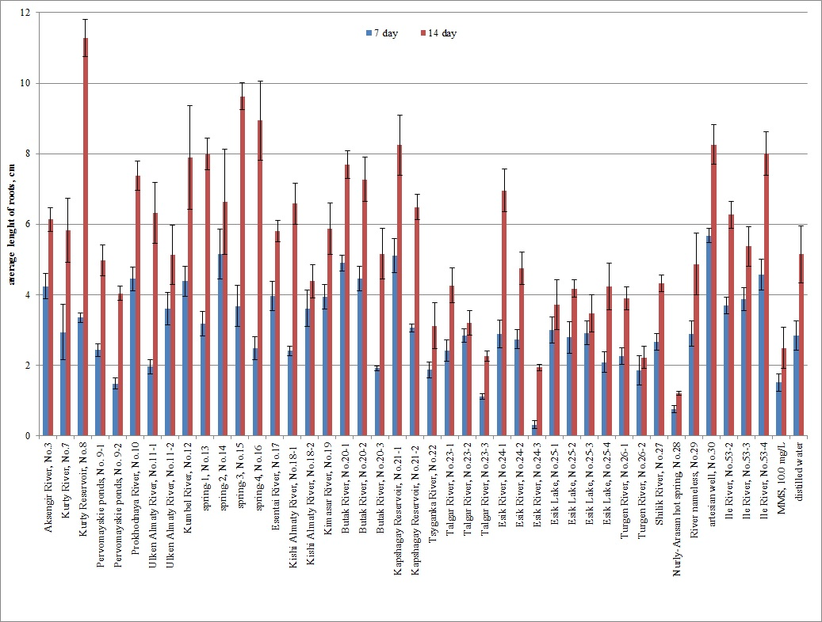

Figure 18 - Average length of roots of Allium cepa exposed to water samples (2018) from water bodies of Almaty region and Almaty for 7 and 14 days
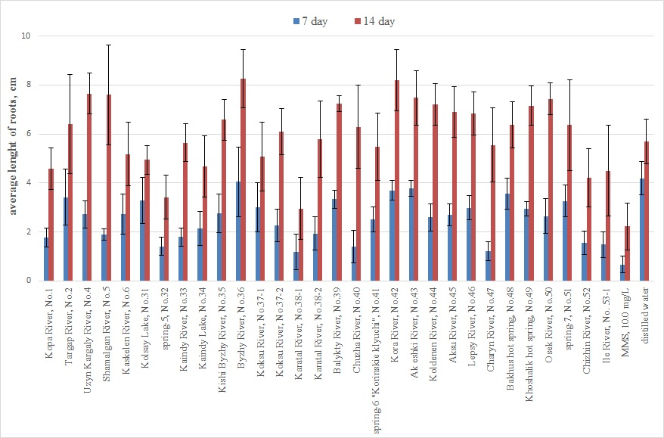

Figure 19 - Average length of roots of Allium cepa exposed to water samples (2019) from water bodies of Almaty region for 7 and 14 days

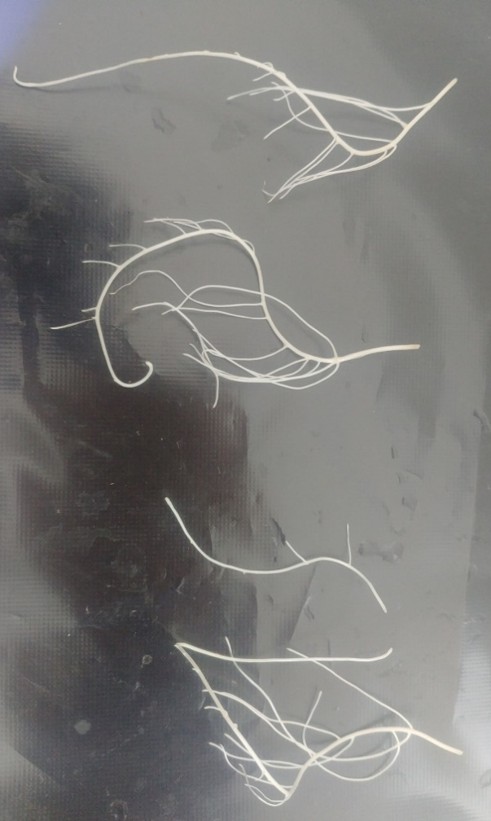

Figure 20 - Branching on the roots of onions germinated in water from the Aksengir River

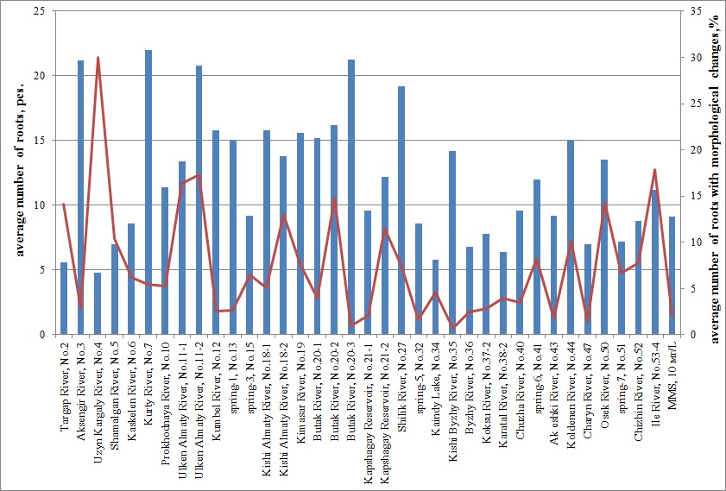

Figure 21 - The percentage of branching roots to the total number of all roots on day 14 of onion germination

Table 8 - Frequency and spectrum of structural chromosome abnormalities induced by natural waters (2018) in barley seeds
Experience variant | Total studied cells | Frequency of aberrant cells  (М ± m%) | The number of chromosomal aberrations per 100 metaphase cells
Experience variant | Total studied cells | Frequency of aberrant cells  (М ± m%) | total aberrations | chromosomal  type | chromatid type
1 | 2 | 3 | 4 | 5 | 6
Distilled water | 490 | 1.63 ± 0.57 | 2.04 ± 0.64 | 0.82 ± 0.41 | 1.22 ± 0.50
ММS, 5.0 mg/L | 530 | 5.66±1.00*** | 6.98±1.11*** | 2.83± 0.72* | 4.15 ± 0.87**
Zhambyl district
Aksengir River, No.3 | 468 | 3.85±0.89* | 6.20±1.11** | 3.21±0.81** | 2.99±0.79
Ile district
Kurty River, No.7 | 485 | 3.92±0.88* | 6.60±1.13*** | 4.54±0.94*** | 2.06±0.65
Kurty Reservoir, No.8 | 512 | 4.49±0.92** | 6.64±1.10*** | 3.52±0.81** | 3.13±0.77
Pervomayskie ponds, No. 9-1 | 567 | 3.88±0.81* | 4.59±0.88** | 3.35±0.76** | 1.23±0.46
Pervomayskie ponds, No. 9-2 | 514 | 3.31±0.79 | 4.47±0.91* | 3.31±0.79** | 1.17±0.47
Almaty city
Prokhodnaya River, No.10 | 475 | 2.53±0.72 | 3.16±0.80 | 1.26±0.51 | 1.68±0.59
Ulken Almaty River, No.11-1 | 485 | 3.09±0.79 | 3.92±0.88 | 2.27±0.68 | 1.65±0.58
Ulken Almaty River, No.11-2 | 495 | 2.42±0.69 | 3.43±0.82 | 1.82±0.60 | 1.62±0.57
Kumbel River, No.12 | 510 | 3.53±0.82 | 5.29±0.99** | 2.16±0.64 | 3.14±0.77
Spring-1, No.13 | 487 | 2.05±0.64 | 2.26±0.67 | 1.44±0.54 | 0.82±0.41
Spring-2, No.14 | 450 | 1.78±0.62 | 2.67±0.76 | 1.56±0.58 | 1.11±0.49
Spring-3, No.15 | 529 | 4.54±0.90** | 7.75±1.16*** | 4.35±0.89*** | 3.40±0.79*
Spring-4, No.16 | 448 | 1.79±0.63 | 2.46±0.73 | 1.34±0.54 | 1.12±0.50
Esentai River, No.17 | 480 | 3.33±0.82 | 4.38±0.93* | 1.67±0.58 | 2.71±0.74
Kishi Almaty River, No.18-1 | 490 | 2.45±0.70 | 3.06±0.78 | 1.63±0.57 | 1.43±0.54
Kishi Almaty River, No.18-2 | 493 | 2.64±0.72 | 3.65±0.84 | 2.23±0.67 | 1.42±0.53
Kimasar River, No.19 | 497 | 2.01±0.63 | 2.62±0.72 | 1.41±0.53 | 1.21±0.49
Butak River, No.20-1 | 508 | 1.97±0.62 | 2.76±0.73 | 1.38±0.52 | 1.38±0.52
Butak River, No.20-2 | 490 | 3.06±0.78 | 4.69±0.96** | 3.67±0.85** | 3.06±0.78
Continuation of Table 8
1 | 2 | 3 | 4 | 5 | 6
Butak River, No.20-3 | 495 | 2.83±0.75 | 4.24±0.91* | 2.63±0.72* | 1.62±0.57
Talgar district
Kapshagay Reservoir, No.21-1 | 510 | 2.16±0.64 | 2.75±0.72 | 1.76±0.58 | 0.98±0.44
Kapshagay Reservoir, No.21-2 | 495 | 1.82±0.60 | 2.42±0.69 | 1.41±0.53 | 1.01±0.45
Tsyganka River, No.22 | 450 | 2.22±0.69 | 2.67±0.76 | 1.78±0.62 | 0.89±0.44
Talgar River, No.23-1 | 529 | 1.70±0.56 | 2.08±0.62 | 1.51±0.53 | 0.57±0.33
Talgar River, No.23-2 | 494 | 2.83±0.75 | 3.44±0.82 | 1.82±0.60 | 1.62±0.57
Talgar River, No.23-3 | 478 | 2.09±0.65 | 2.72±0.74 | 1.88±0.62 | 0.84±0.42
Enbekshikazakh district
Esik River, No.24-1 | 456 | 1.97±0.65 | 2.19±0.69 | 1.32±0.53 | 0.88±0.44
Esik River, No.24-2 | 487 | 2.46±0.70 | 2.87±0.76 | 1.64±0.58 | 1.23±0.50
Esik River, No.24-3 | 490 | 2.04±0.64 | 2.45±0.70 | 1.63±0.57 | 0.82±0.41
Esik Lake, No.25-1 | 484 | 3.31±0.81 | 4.34±0.93* | 2.89±0.76* | 1.45±0.54
Esik Lake, No.25-2 | 485 | 2.47±0.71 | 3.30±0.81 | 1.86±0.61 | 1.44±0.54
Esik Lake, No.25-3 | 510 | 2.55±0.70 | 3.14±0.77 | 1.37±0.52 | 1.76±0.58
Esik Lake, No.25-4 | 510 | 1.57±0.55 | 1.76±0.58 | 0.98±0.44 | 0.78±0.39
Turgen River, No.26-1 | 507 | 1.78±0.59 | 2.37±0.68 | 1.58±0.55 | 0.99±0.44
Turgen River, No.26-2 | 530 | 1.89±0.59 | 2.45±0.67 | 0.94±0.42 | 1.51±0.53
Shilik River, No.27 | 528 | 5.49±0.99*** | 7.01±1.11*** | 3.98±0.85*** | 3.03±0.75*
Nurly-Arasan hot spring, No.28 | 530 | 6.23±1.05*** | 7.36±1.13*** | 2.45±0.67 | 4.91±0.94**
River nameless, No.29 | 519 | 1.73±0.57 | 2.12±0.63 | 1.73±0.57 | 0.39±0.27
Artesian well, No.30 | 490 | 2.04±0.64 | 2.65±0.73 | 1.63±0.57 | 0.82±0.41
Balkash district
Ile River, No.53-2 | 449 | 6.46±1.16*** | 7.57±1.25*** | 4.01±0.93** | 3.56±0.87*
Ile River, No.53-3 | 419 | 2.15±0.71 | 2.63±0.78 | 1.91±0.67 | 0.72±0.41
Ile River, No.53-4 | 511 | 2.54±0.70 | 3.33±0.79 | 2.54±0.70* | 0.78±0.39
Note - * - p <0.05; ** - p <0.01; *** - p <0.001 in comparison with distilled water

Table 9 - Frequency and spectrum of structural chromosome abnormalities induced by natural waters (2019) in barley seeds
Experience variant | Total studied cells | Frequency of aberrant cells  (М ± m%) | The number of chromosomal aberrations per 100 metaphase cells
Experience variant | Total studied cells | Frequency of aberrant cells  (М ± m%) | total aberrations | chromosomal type | chromatid type
1 | 2 | 3 | 4 | 5 | 6
Distilled water | 497 | 1.41±0.53 | 1.41±0.53 | 0.80±0.40 | 0.60±0.35
ММS, 5.0 mg/L | 515 | 4.85±0.95** | 6.80±1.11*** | 2.52± 0.69 | 4.27±0.89
Zhambyl district
Kopa River, No.1 | 557 | 3.05±0.73 | 4.31±0.86** | 1.26±0.47 | 3.05±0.73**
Targap River, No.2 | 526 | 3.04±.75 | 3.99±0.85* | 1.90±0.60 | 2.09±0.62*
Uzyn Kargaly River, No.4 | 498 | 3.01±0.77 | 3.61±0.84* | 2.01±0.63 | 1.61±0.56
Karasay district
Shamalgan River, No.5 | 505 | 2.97±0.76 | 3.76±0.85* | 1.58±0.56 | 2.18±0.65
Kaskelen River, No.6 | 541 | 2.96±0.73 | 4.07±0.85** | 1.48±0.52 | 2.59±0.68**
Raiymbek district
Kolsay Lake, No.31 | 547 | 1.83±0.57 | 2.19±0.63 | 1.28±0.48 | 0.91±0.41
spring No.5, No.32 | 530 | 1.89±0.59 | 2.08±0.62 | 1.32±0.50 | 0.75±0.38
Kaindy River, No.33 | 509 | 1.77±0.58 | 2.16±0.64 | 1.18±0.48 | 0.98±0.44
Kaindy Lake, No.34 | 512 | 2.34±0.67 | 2.93±0.75 | 1.37±0.51 | 1.56±0.55
Коксукский район
Kishi Byzhy River, No.35 | 515 | 2.52±0.69 | 3.50±0.81* | 2.52±0.69* | 0.97±0.43
Byzhy River, No.36 | 494 | 2.83±0.75 | 3.64±0.84* | 2.43±0.69* | 1.21±0.49
Eskeldi district
Koksu River, No.37-1 | 504 | 2.78±0.73 | 3.17±0.78 | 1.98±0.62 | 1.19±0.48
Koksu River, No.37-2 | 538 | 3.35±0.78* | 4.28±0.87** | 2.42±0.66* | 1.86±0.58
Karatal River, No.38-1 | 543 | 2.39±0.66 | 2.95±0.73 | 1.66±0.55 | 1.29±0.48
Karatal River, No.38-2 | 506 | 3.16±0.78 | 3.95±0.87* | 1.78±0.59 | 2.17±0.65*
Balykty River, No.39 | 520 | 2.69±0.71 | 3.46±0.80* | 1.15±0.47 | 2.31±0.66*
Chuzha River, No.40 | 523 | 3.06±0.75 | 3.25±0.78* | 2.10±0.63 | 1.15±0.47
spring-6 "Korinskie klyuchi", No.41 | 506 | 2.57±0.70 | 2.96± 0.75 | 1.78±0.59 | 1.19±0.48
Kora River, No.42 | 514 | 2.72±0.72 | 3.11±0.77 | 2.14±0.64 | 0.97±0.43
Continuation of Table 9
1 | 2 | 3 | 4 | 5 | 6
Aksu district
Ak eshki River, No.43 | 519 | 1.93±0.60 | 2.89±0.74 | 1.35±0.51 | 1.54±0.54
Koldenen River, No.44 | 493 | 2.84±0.75 | 3.65±0.84* | 1.22±0.49 | 2.43±0.69*
Sarkand district
Aksu River, No.45 | 506 | 2.17±0.65 | 3.16±0.78 | 1.58±0.55 | 1.58±0.55
Lepsy River, No.46 | 510 | 3.33±0.79* | 4.51±0.92** | 1.57±0.55 | 2.94±0.75**
Uygur district
Charyn River, No.47 | 543 | 2.70±0.69 | 3.60±0.79* | 1.98±0.59 | 1.62±0.54
Bakhus hot spring, No.48 | 526 | 3.04±0.75 | 3.80±0.83* | 2.09±0.62 | 1.71±0.57
Khoshalik hot spring, No.49 | 500 | 2.00±0.63 | 2.60±0.71 | 1.60±0.56 | 1.00±0.44
Panfilov district
Osek River, No.50 | 529 | 3.59±0.81* | 4.54±0.90** | 1.89±0.59 | 2.65±0.70**
spring-7, No.51 | 495 | 2.63±0.72 | 3.23±0.79 | 1.82±0.60 | 1.41±0.53
Chizhin River, No.52 | 505 | 2.97±0.76 | 3.96±0.87* | 1.58±0.56 | 2.38±0.68*
Ile River, No. 53-1 | 518 | 3.09±0.76 | 3.86±0.85* | 1.54±0.54 | 2.32±0.66*
Note - * - p <0.05; ** - p <0.01; *** - p <0.001 in comparison with distilled water

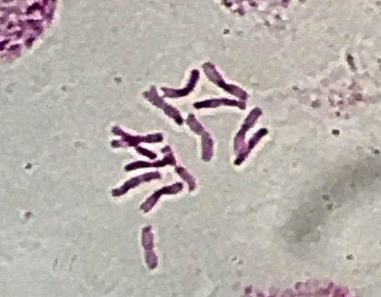 | 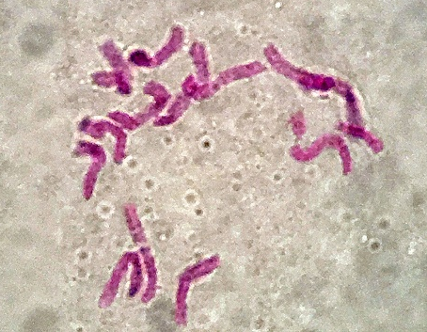 | 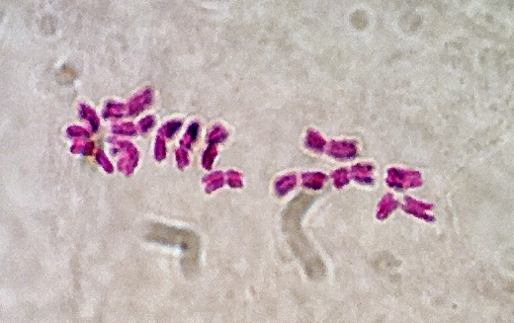
norm in metaphase (2n = 14) | paired terminal deletion | chromatid deletion
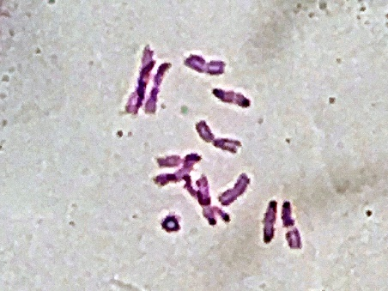 | 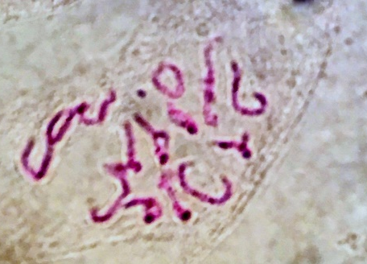 | 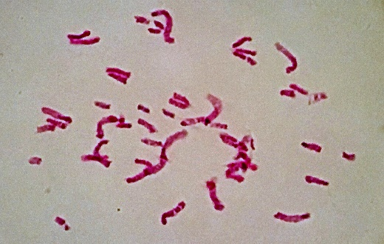
centric rings |  | multiple structural mutations

Figure 13 - Structural chromosome abnormalities induced by the waters of natural sources in barley seeds, х1000

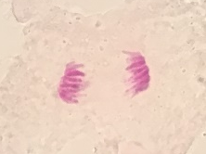 | 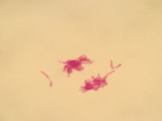 | 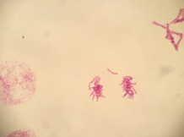
the norm in anaphase | lagging chromosomes
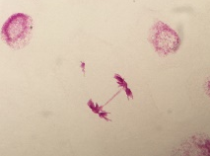 | 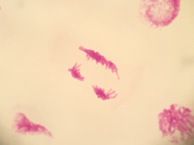 | 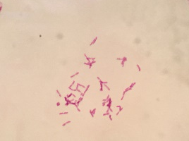
bridge | multipolar mitosis | Polyploid set

Figure 23 - Structural chromosome abnormalities in anaphase of mitosis and polyploid metaphases induced in barley seeds by waters of natural sources, x1000

Table 10 - Toxicity of water samples from the water bodies of the Almaty region and Almaty city
Sample water source | Number of survivors females | Number of dead females | χ²_{emp} value
Control (distilled water) | 100 | 0 | 0
Kopa River, No.1 | 97 | 3 | 1.354
Targap River, No.2 | 98 | 2 | 0.505
Aksengir River, No. 3 | 100 | 0 | 0
Uzyn Kargaly River, No.4 | 97 | 3 | 1.354
Shamalgan River, No.5 | 99 | 1 | 0
Kaskelen River, No.6 | 99 | 1 | 0
Ulken Almaty River, No.11-1 | 100 | 0 | 0
Ulken Almaty River, No.11-2 | 96 | 4 | 2.295
spring-4, No.16 | 100 | 0 | 0
Kishi Almaty River, No.18-1 | 98 | 2 | 0.505
Kimasar River, No.19 | 100 | 0 | 0
Butak River, No.20-3 | 97 | 3 | 1.353
Kapshagay Reservoir, No.21-1 | 100 | 0 | 0
Esik River, No.24-3 | 100 | 0 | 0
Kishi Byzhy River, No.35 | 96 | 4 | 2.296
Byzhy River, No.36 | 97 | 3 | 1.354
Koksu River, No.37-2 | 98 | 2 | 0.505
Karatal River, No.38-2 | 99 | 1 | 0
Balykty River, No.39 | 99 | 1 | 0
Chuzha River, No.40 | 100 | 2 | 0.505
Kora River, No.42 | 100 | 0 | 0
Koldenen River, No.44 | 98 | 2 | 0.505
Aksu River, No.45 | 95 | 5 | 3.282
Lepsy River, No.46 | 100 | 0 | 0
Charyn River, No.47 | 98 | 2 | 0.505
Bakhus hot spring, No.48 | 99 | 1 | 0
Osek River, No.50 | 94 | 6 | 4.269
Chizhin River, No.52 | 100 | 0 | 0
Ile River, No.53-3 | 99 | 1 | 0
Note - χ²_{crit} = 3,84 for df=1, р≤0,05
Table 11 - Mutagenic activity of water samples in the test system Möller-5 (Basc)
Water samples | Number of families per  F₁ | Number of families per F₂ | Analysis F₂
Water samples | Number of families per  F₁ | Number of families per F₂ | Sterility | Mortality | Σ
Control (distilled water) | 40 | 515 | 4 | 1 | 5
Nurly-Arasan hot spring, No. 28 | 40 | 512 | 21 | 6 | 27
Koksu River, No.37-2 | 40 | 510 | 7 | 2 | 9
Osek River, No. 50 | 40 | 512 | 10 | 3 | 13
Ile River, No.53-3 | 40 | 510 | 8 | 2 | 10

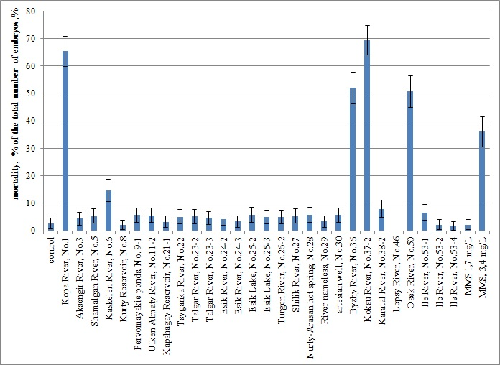
Figure 24 - Acute lethal effect of water samples from various water sources of Almaty region and Almaty city in the FET test

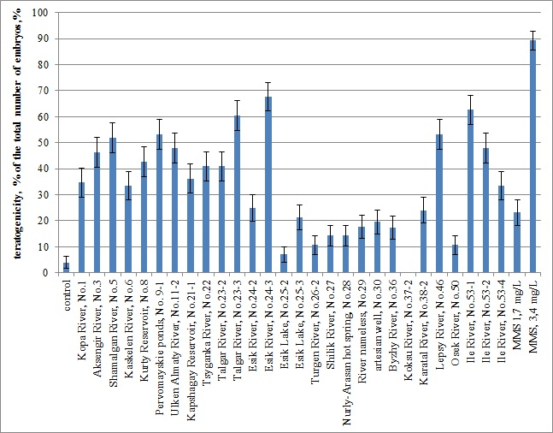

Figure 25 - Teratogenic effect of water samples from various water sources of the Almaty region and Almaty city in FET test

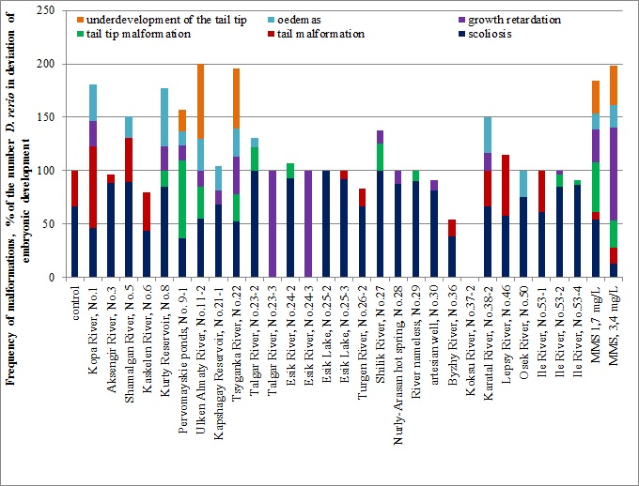

Figure 26 - The spectrum of morphological developmental disorders and their percentage contribution to the total number of D. rerio embryos with disorders during incubation in water of various water sources of the Almaty region

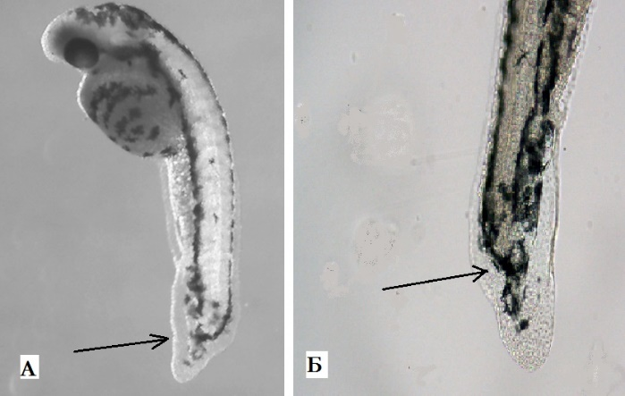

Figure 25 - Underdevelopment of the terminal part of the tail of D. rerio embryos during incubation in MMS at 3.4 mg/L, x.40 (A), x.100(Б)

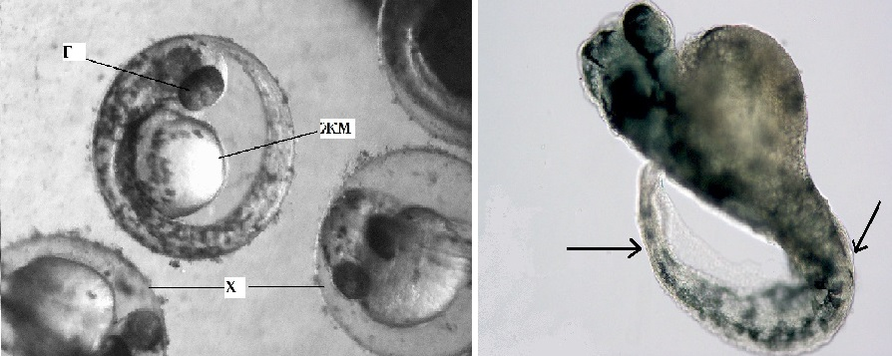
a normal D. rerio embryo in the chorion. x40; designations: Г - eyes. ЖМ - yolk sac. X - chorion | an embryo with abnormal tail development and growth retardation. x 100; arrows indicate the curvature of the axial skeleton

Figure 28 - Development of D. rerio embryo in norm and in pathology

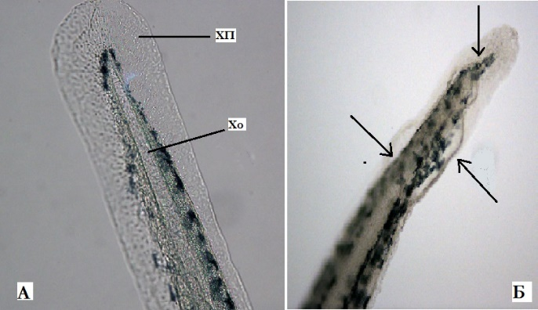
normal development of the caudal region, Designations: ХП - caudal fin, Хo – chord, х.100 |  | Dysmorphology of the fin border and tip of the tail (indicated by arrows), х.100
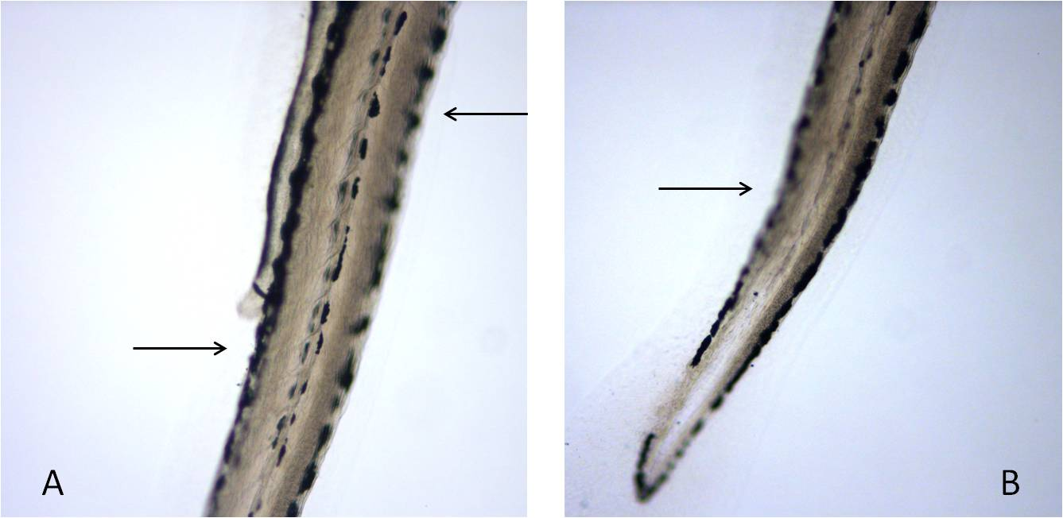
Curvature of the spine, х.100 |  | Curvature of the tail section, х.100
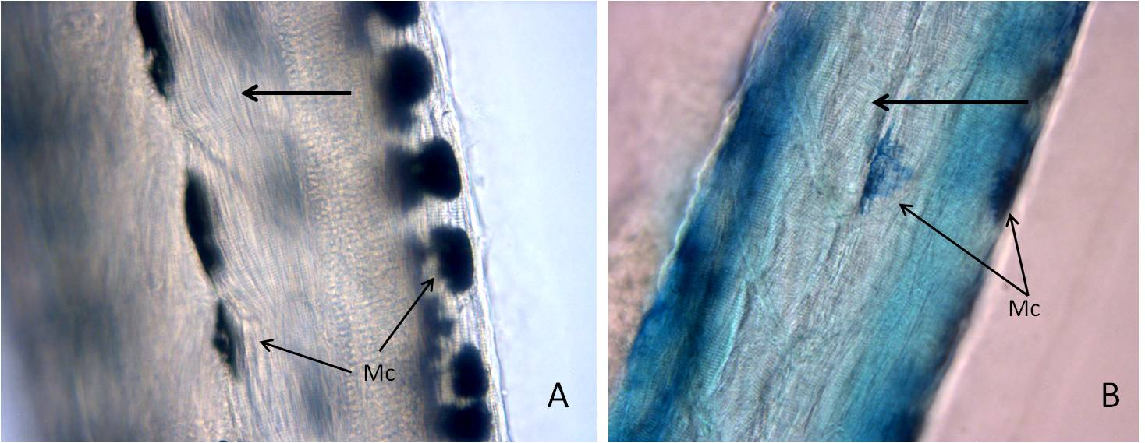
normal formation of somites (arrow), x.200 |  | disorganization of muscle fibers (arrow), x 100; blue color is due to the accumulation of dye in melanocytes (MC) and surrounding tissues
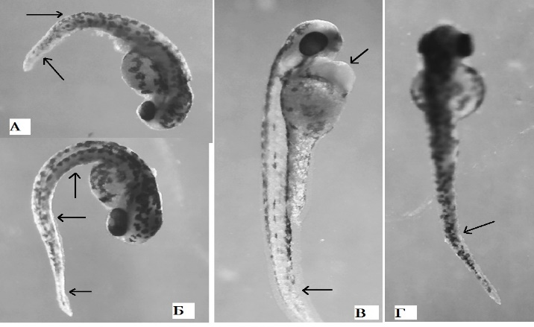
oedema of the pericardial sac, х.40 | the embryo retarged growth, curvature of the spine, underdevelopment of the tip section, х.40 |  | curvature of the spine, underdevelopment of the tip section, х.40

Figure 29 – Malformations of normal development encountered during the incubation of D. rerio embryos in water samples from various water bodies of the Almaty region

Table 12 - Frequency of structural chromosome abnormalities induced by natural waters in the bone marrow cells of mice after oral exposure
Experimental variants | Studied meta-phases | Frequency aberrant cells  (M ± m%) | The number of chromosomal aberrations per 100 metaphases |  |  |  | Aneuploid cells  (М ± m),% | Polyploid cells  (М ± m),%
Experimental variants | Studied meta-phases | Frequency aberrant cells  (M ± m%) | total aberrations | chromosomal type | chromatid type | dot fragments | Aneuploid cells  (М ± m),% | Polyploid cells  (М ± m),%
1 | 2 | 3 | 4 | 5 | 6 | 7 | 8 | 9
Negative control, dН₂О | 612 | 1.44 ± 0.27 | 1.60 ± 0.34 | 0.64 ± 0.18 | 0.66 ± 0.18 | 0.29 ± 0.20 | 0.64 ± 0.18 | 1.03 ± 0.36
Positive control, MMS | 584 | 6.07 ± 1.18 | 7.31 ± 1.14 | 2.08 ± 0.28 | 3.83 ± 0.64 | 1.40 ± 0.27 | 1.03 ± 0.19 | 2.01 ± 0.64
Shamalgan River, No.5 | 575 | 4.03±0.41*** | 4.53±0.34*** | 0.85 ± 0.32 | 2.79±0.17*** | 0.88 ± 0.30 | 1.47 ± 0.50 | 2.09 ± 0.37
Kurty River, No.7 | 545 | 4.27 0.81*** | 5.39±0.85*** | 1.68 ± 0.40* | 2.60±0.28*** | 1.11 ± 0.41 | 2.05±0.40*** | 2.96±0.53**
Kurty Reservoir, No.8 | 580 | 3.75±0.34*** | 4.62±0.44*** | 1.18 ± 0.17* | 2.58±0.26*** | 0.86 ± 0.32 | 1.39 ± 0.25* | 2.61±0.45*
Pervomayskie ponds, No.9-1 | 553 | 3.82±0.38*** | 4.77±0.53*** | 0.93 ± 0.38 | 2.91±0.40*** | 0.92 ± 0.32 | 1.62 ± 0.35* | 2.87 ± 0.29**
Kapshagay Reservoir, No.21-1 | 584 | 4.71 ± 1.06* | 5.79±1.17** | 1.56 ± 0.36 | 3.03 ± 1.17** | 1.20 ± 0.23* | 1.38 ± 0.41 | 2.71±0.27**
Tsyganka River, No.22 | 562 | 4.88±0.67*** | 6.85±0.73*** | 1.81±0.34*** | 3.81±0.63*** | 1.23±0.21*** | 2.17±0.45*** | 3.97±0.62***
Esik River, No.24-3 | 569 | 5.07±0.52*** | 6.10±0.83*** | 1.03 ± 0.35 | 3.62±0.73*** | 1.45±0.30*** | 1.43 ± 0.44 | 2.32 ± 0.45*
Esik Lake, No.25-3 | 566 | 4.80±0.66*** | 6.21±0.63*** | 1.25 ± 0.26 | 3.75±0.43*** | 1.21 ± 0.18** | 1.59 ± 0.36* | 2.50 ± 0.42*
Shilik River, No.27 | 542 | 4.83±0.48*** | 5.80±0.79*** | 1.31 ± 0.28 | 3.57±0.63*** | 0.91 ± 0.32 | 2.18±0.45*** | 2.60 ± 0.61*
Nurly-Arasan hot spring, No.28 | 591 | 4.29 ± 0.63** | 6.35±0.81*** | 1.35 ± 0.23* | 3.61±0.49*** | 1.38±0.27*** | 2.02 ± 0.61* | 4.21±0.41***
Karatal River, No.38-2 | 597 | 3.72±0.28*** | 4.68±0.40*** | 1.02 ± 0.20 | 2.85±0.17*** | 0.81 ± 0.30 | 1.72 ± 0.48* | 2.14 ± 0.60
Ile River, No.53-2 | 610 | 4.56±0.33*** | 6.13±0.77*** | 1.16 ± 0.25 | 3.63±0.70** | 1.34 ± 0.38* | 1.26 ± 0.27 | 3.49±0.58**
Note - * - p <0.05, ** - p <0.01, *** - p <0.001 in comparison with negative control; dН₂О – distilled water
Table 13 - Frequency of DNA breaks in cells of various organs of mice induced by natural waters by oral exposure
Experiental variants | The frequency of DNA breaks in cells of various organs according to the indicator "% DNA in the tail of comet" (% TDNA)
Experiental variants | liver | kidney | spleen | bone marrow
1 | 2 | 3 | 4 | 5
Negative control, dН₂О | 2.83±0.37 | 2.49±0.19 | 2.65±0.37 | 2.20±0.32
Positive control, MMS | 17.08±0.42*** | 18.19±0.51*** | 15.75±0.16*** | 15.98±0.44***
Shamalgan River, No.5 | 13.25±0.31*** | 13.54±0.37*** | 12.89±0.30*** | 13.05±0.16***
Kurty River, No.7 | 15.10±0.22*** | 16.01±0.38*** | 15.06±0.27*** | 15.11±0.21***
Kurty Reservoir, No.8 | 15.97±0.28*** | 15.67±0.48*** | 15.18±0.45*** | 15.14±0.22***
Pervomayskie ponds, No.9-1 | 13.05±0.14*** | 13.12±0.49*** | 12.99±0.11*** | 12.96±0.16***
Kapshagay Reservoir, No.21-1 | 14.06±0.35*** | 14.02±0.39*** | 13.89±0.17*** | 13.96±0.29***
Tsyganka River, No.22 | 15.29±0.47*** | 16.14±0.25*** | 15.18±0.35*** | 15.35±0.26***
Esik River, No.24-3 | 14.80±0.24*** | 14.03±0.55*** | 13.81±0.16*** | 13.97±0.16***
Esik Lake, No.25-3 | 14.97±0.29*** | 14.15±0.61*** | 14.04±0.38*** | 14.10±0.21***
Shilik River, No.27 | 15.05±0.31*** | 16.07±0.41*** | 15.26±0.32*** | 15.21±0.31***
Nurly-Arasan hot spring, No.28 | 16.07±0.18*** | 15.79±0.50*** | 15.28±0.29*** | 15.25±0.20***
Karatal River, No.38-2 | 13.89±0.42*** | 13.91±0.25*** | 13.25±0.26*** | 13.14±0.25***
Ile River, No.53-2 | 14.83±0.22*** | 14.15±0.55*** | 13.91±0.14*** | 14.02±0.13***
Note - *** - p <0.001 in comparison with negative control; dН₂О – distilled water

Table 14 - Content of lipid peroxidation products in the liver of laboratory mice exposed to natural water samples
Experienmantal variantd | LOOH content | MDA content
Negative control, dН₂О | 2.22±1.73 | 4.55±0.52
Positive control, MMS | 9.23±0.54*** | 28.82±0.94***
Shamalgan River, No.5 | 5.23±0.37* | 20.43±3.19**
Kurty River, No.7 | 5.98±0.89* | 18.96±1.56**
Kurty Reservoir, No.8 | 7.71±0.31** | 18.75±0.45***
Pervomayskie ponds, No.9-1 | 11.63±0.66*** | 18.31±2.58**
Kapshagay Reservoir, No.21-1 | 12.98±0.50*** | 19.87±2.58**
Tsyganka River, No.22 | 5.58±0.87* | 17.56±2.40**
Esik River, No.24-3 | 9.76±1.85* | 21.45±3.24**
Esik Lake, No.25-3 | 9.08±1.01** | 24.00±2.62**
Shilik River, No.27 | 10.19±0.45*** | 21.35±0.55***
Nurly-Arasan hot spring, No.28 | 4.66±0.37* | 14.91±1.90**
Karatal River, No.38-2 | 8.23±1.08* | 17.52±1.98**
Ile River, No.53-2 | 13.51±1.58** | 24.38±3.86**
Note – LOOH - lipid hydroperoxide, MDA - malondialdehyde;
* - p <0.05, ** - p <0.01, *** - p <0.001 in comparison with negative control; dН₂О – distilled water

Table 15 - Mutagenic, genotoxic and toxic activity of natural surface waters of Almaty region and Almaty city in various test systems
Water samples | Lux-test | Allium-test |  | CA test (barley) | Dr. Melanogaster tests | FET-test | CA test (mouse) | Comet assay | Biochemical indicators  (LOOH и MDA) | IIGR
Water samples | Lux-test | toxicity | genotoxicity
1 | 2 | 3 | 4 | 5 | 6 | 7 | 8 | 9 | 10 | 11
Zhambyl district
Kopa River, No.1 | – | – | – | + | N/A | + | N/A | N/A | N/A | 0.56
Targap River, No.2 | – | – | + | + | N/A | N/A | N/A | N/A | N/A | 0.20
Aksengir River, No.3 | – | + | + | + | – | – | N/A | N/A | N/A | 0.81
Uzyn Kargaly River, No.4 | – | – | + | + | N/A | N/A | N/A | N/A | N/A | 0.17
Karasay district
Shamalgan River, No.5 | + | + | + | + | – | + | + | + | + | 0.84
Kaskelen River, No.6 | + | – | + | + | – | – | N/A | N/A | N/A | 0.59
Ile district
Kurty River, No.7 | – | – | + | + | N/A | N/A | + | + | + | 1.08
Kurty Reservoir, No.8 | – | + | – | + | N/A | – | N/A | N/A | N/A | 0.94
Pervomayskie ponds, No. 9 | – | + | – | + | N/A | + | + | + | + | 1.28
Almaty city
Prokhodnaya River, No.10 | + | – | + | – | N/A | N/A | N/A | N/A | N/A | 0.44
Ulken Almaty River, No.11 | + | – | + | – | – | + | N/A | N/A | N/A | 0.55
Kumbel River, No.12 | + | – | + | + | N/A | N/A | N/A | N/A | N/A | 0.63
spring-1, No.13 | – | + | + | + | N/A | N/A | N/A | N/A | N/A | 0.25
Continuation of Table 15
1 | 2 | 3 | 4 | 5 | 6 | 7 | 8 | 9 | 10 | 11
spring-2, No.14 | + | + | – | – | N/A | N/A | N/A | N/A | N/A | 0.19
spring-3, No.15 | – | + | + | + | N/A | N/A | N/A | N/A | N/A | 0.56
spring-4, No.16 | – | + | – | – | – | N/A | N/A | N/A | N/A | 0.01
Esentai River, No.17 | + | – | – | + | N/A | N/A | N/A | N/A | N/A | 0.19
Kishi Almaty River, No.18 | + | – | + | + | – | N/A | N/A | N/A | N/A | 0.13
Kimasar River, No.19 | + | – | + | + | – | N/A | N/A | N/A | N/A | 0.13
Butak River, No.20 | + | – | + | + | – | N/A | N/A | N/A | N/A | 0.29
Talgar district
Kapshagay Reservoir, No.21 | + | + | + | - | – | – | + | + | + | 0.75
Tsyganka River, No.22 | – | + | – | + | N/A | + | + | + | + | 0.94
Talgar River, No.23 | + | + | – | + | N/A | + | N/A | N/A | N/A | 0.46
Enbekshikazakh district
Esik River, No.24 | + | + | – | + | – | + | + | + | + | 0.38
Esik Lake, No.25 | + | + | – | + | N/A | + | + | + | + | 0.78
Turgen River, No.26 | + | + | – | – | N/A | + | N/A | N/A | N/A | 0.38
Shilik River, No.27 | – | – | + | + | N/A | + | + | + | + | 1.25
Nurly-Arasan hot spring, No.28 | + | + | – | + | + | + | + | + | + | 1.30
River nameless, No.29 | – | – | – | + | N/A | – | N/A | N/A | N/A | 0.04
Artesian well, No.30 | + | + | – | – | N/A | + | N/A | N/A | N/A | 0.50
Continuation of Table 15
1 | 2 | 3 | 4 | 5 | 6 | 7 | 8 | 9 | 10 | 11
Raiymbek district
Kolsay Lake, No.31 | + | – | – | – | N/A | N/A | N/A | N/A | N/A | 0.11
spring-5, No.32 | + | – | + | – | N/A | N/A | N/A | N/A | N/A | 0.60
Kaindy River, No.33 | + | + | – | – | N/A | N/A | N/A | N/A | N/A | 0.24
Kaindy Lake, No.34 | + | – | + | – | N/A | N/A | N/A | N/A | N/A | 0.29
Koksu district
Kishi Byzhy River, No.35 | + | – | + | + | – | N/A | N/A | N/A | N/A | 0.43
Byzhy River, No.36 | + | – | – | + | – | + | N/A | N/A | N/A | 0.82
Eskeldi district
Koksu River, No.37 | + | – | + | + | – | + | N/A | N/A | N/A | 0.59
Karatal River, No.38 | + | – | + | + | – | + | + | + | + | 0.60
Balykty River, No.39 | + | – | – | + | – | N/A | N/A | N/A | N/A | 0.34
Chuzha River, No.40 | + | – | – | + | – | N/A | N/A | N/A | N/A | 0.47
spring-6 «Korinskie klyuchi», No.41 | – | – | + | – | N/A | N/A | N/A | N/A | N/A | 0.51
Kora River, No.42 | + | – | – | – | – | N/A | N/A | N/A | N/A | 0.26
Aksu district
Ak eshki River, No.43 | + | – | + | – | N/A | N/A | N/A | N/A | N/A | 0.51
Koldenen River, No.44 | + | – | + | + | – | N/A | N/A | N/A | N/A | 0.46
Sarkand district
Continuation of Table 15
1 | 2 | 3 | 4 | 5 | 6 | 7 | 8 | 9 | 10 | 11
Aksu River, No.45 | + | – | – | – | N/A | N/A | N/A | N/A | N/A | 0.22
Lepsy River, No.46 | + | – | – | + | – | + | N/A | N/A | N/A | 0.24
Uygur district
Charyn River, No.47 | + | + | + | + | – | N/A | N/A | N/A | N/A | 0.31
Bakhus hot spring, No.48 | + | – | – | + | – | N/A | N/A | N/A | N/A | 0.27
Khoshalik hot spring, No.49 | + | – | – | – | N/A | N/A | N/A | N/A | N/A | 0.22
Panfilov district
Osek River, No.50 | + | – | + | + | + | + | N/A | N/A | N/A | 0.87
spring-7, No.51 | – | – | + | – | N/A | N/A | N/A | N/A | N/A | 0.18
Chizhin River, No.52 | + | + | + | + | – | N/A | N/A | N/A | N/A | 0.32
Panfilov and Balkash districts
Ile River, No. 53 | + | + | + | + | – | + | + | + | + | 0.97
Note - CA - chromosomal aberrations; IIGR is an integral indicator of genetic risk;
(-) - no activity; + - there is activity; N/A - not determined

APPENDIX B
Work schedule
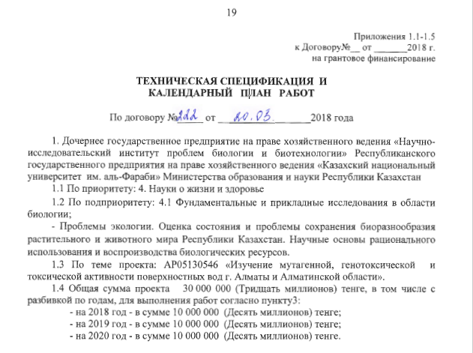
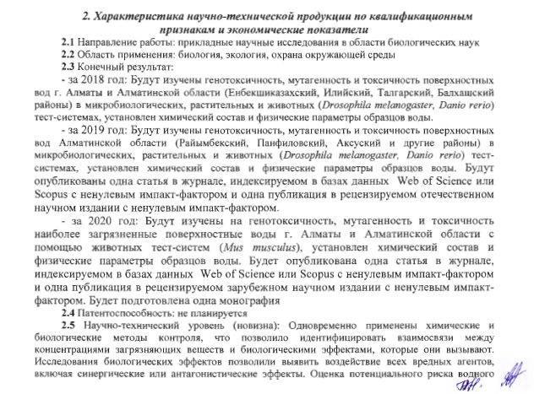
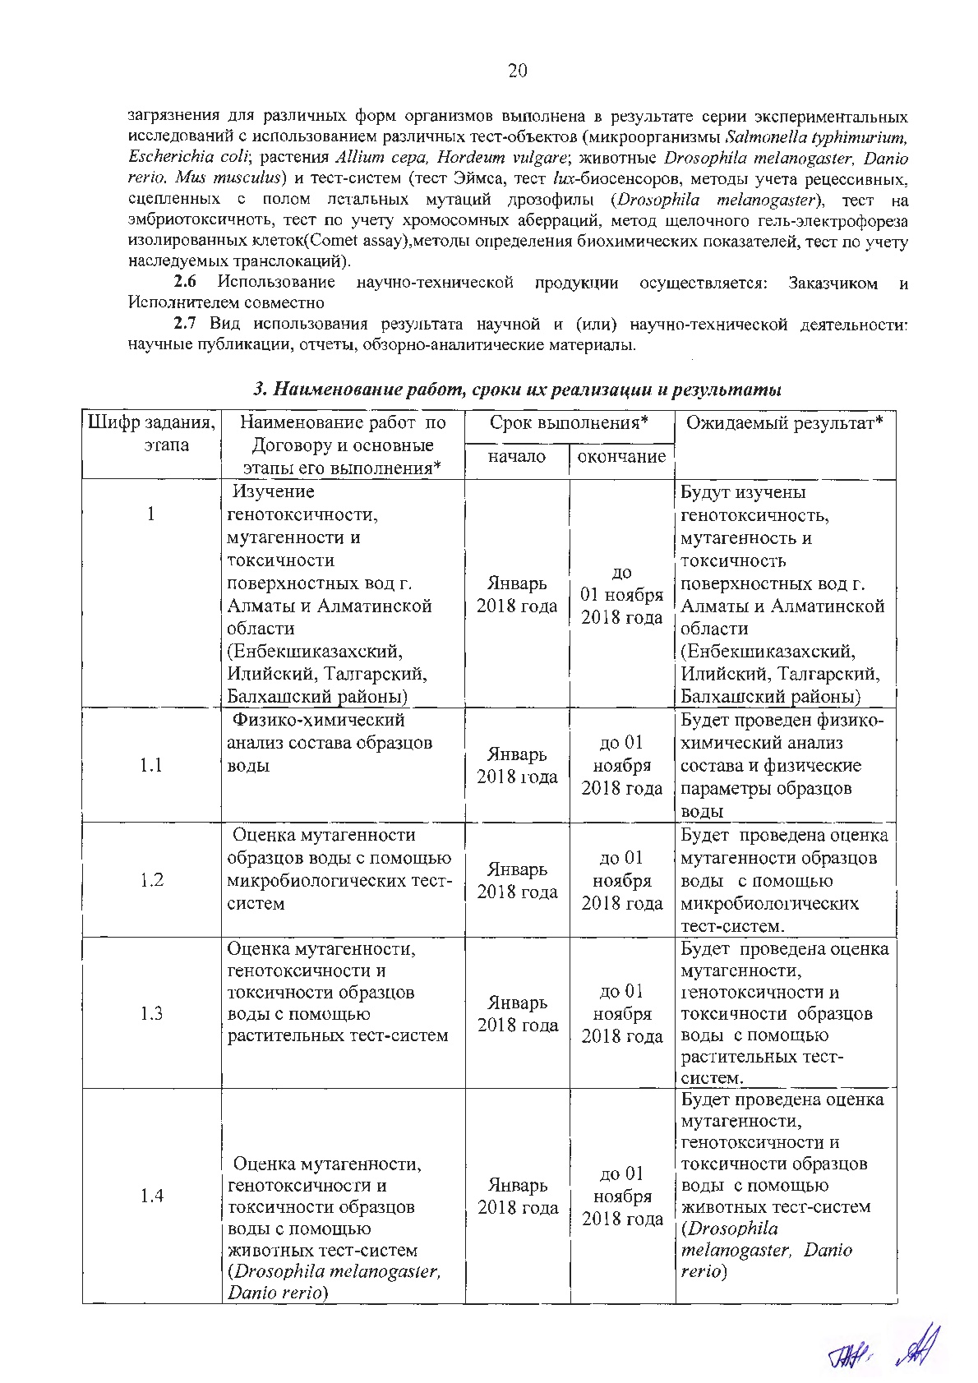
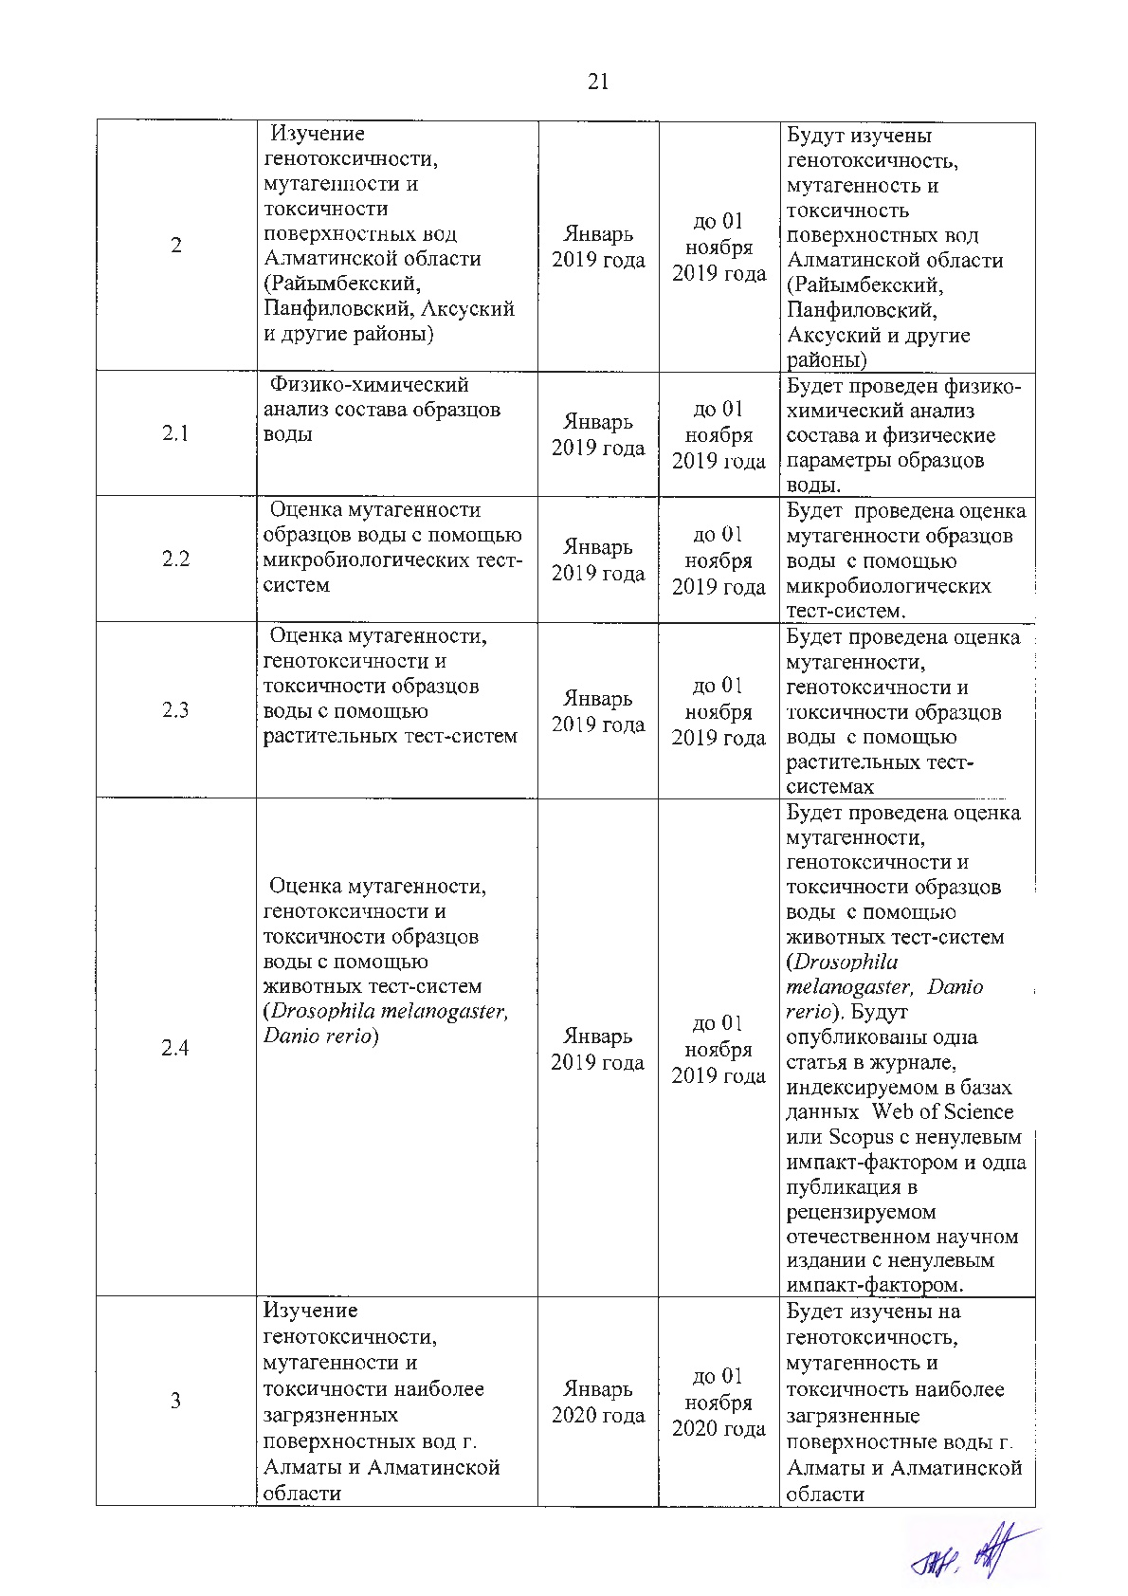
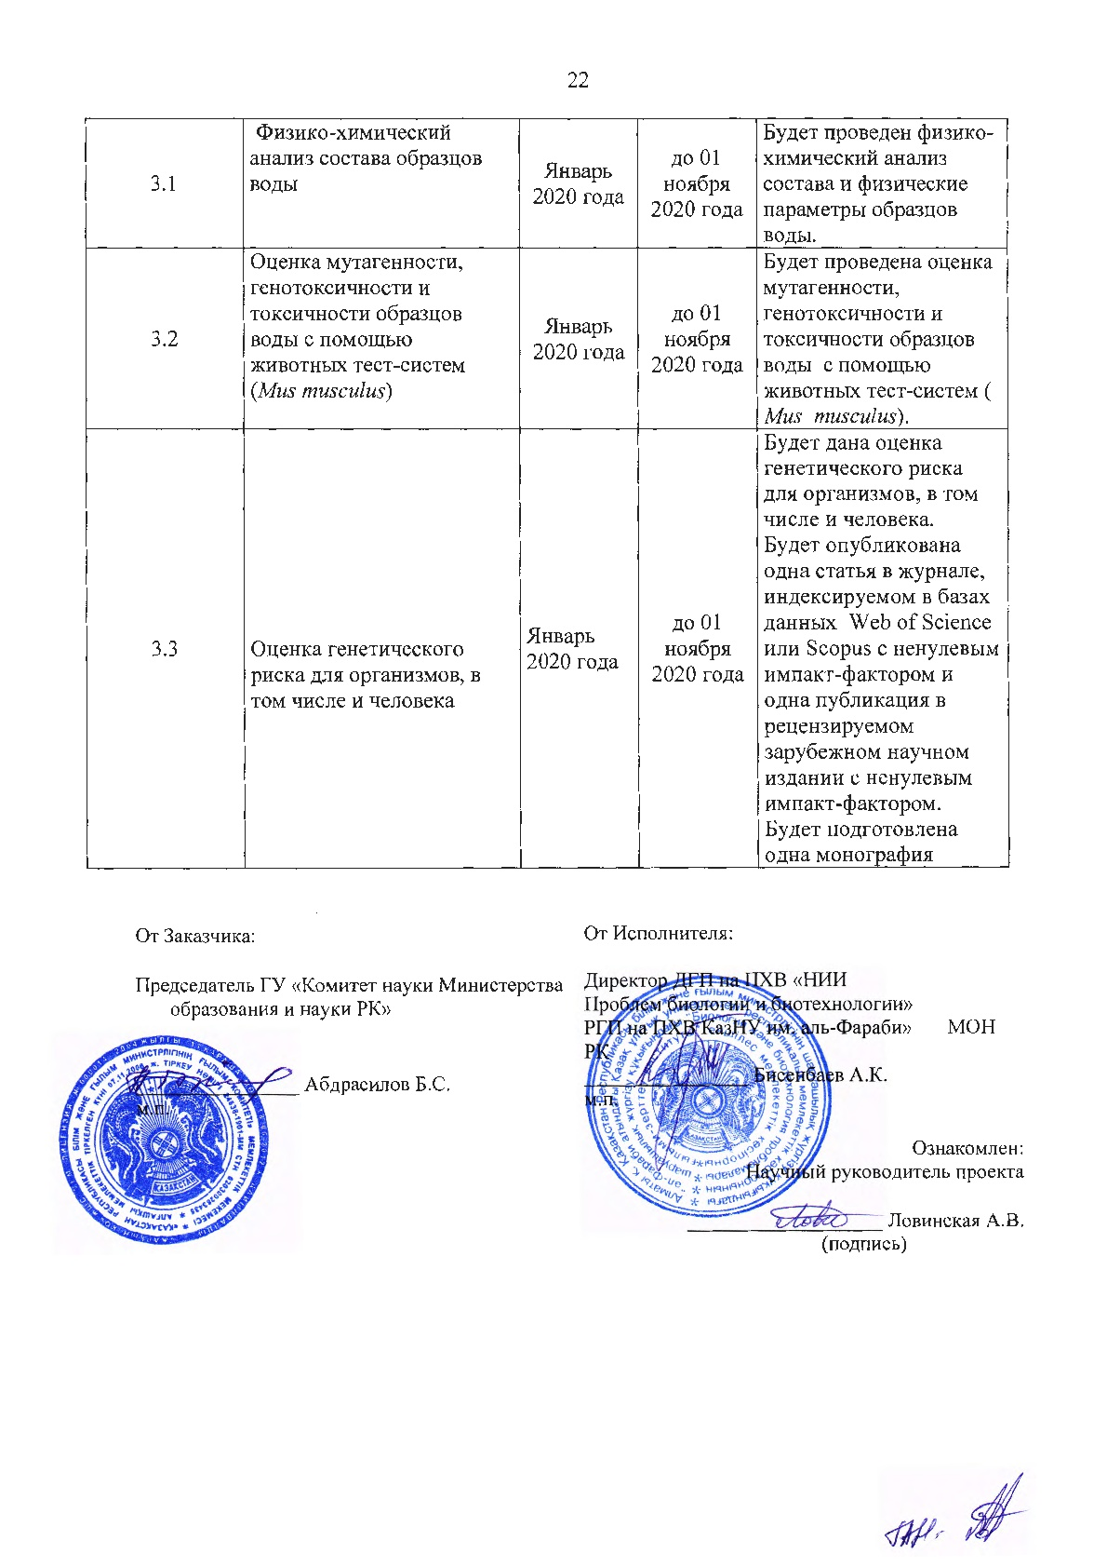

Appendix 1.1-1.5
to Agreement _ dated ___ 2018
for grant funding

TECHNICAL SPECIFICATIONS AND
CALENDAR WORK PLAN
to Agreement No. 222 dated _20.03.__ 2018

1. Subsidiary state enterprise on the right of economic management "Research Institute of Biology and Biotechnology" of the Republican State Enterprise on the right of economic management "al-Farabi Kazakh National University" of the Ministry of Education and Science of the Republic of Kazakhstan
1.1 The priority: 4. Life Sciences and Health
1.2 The specialized scientific direction: 4.1 Fundamental and applied research in biology;
- Ecological problems. Assessment of the state and problems of biodiversity conservation of flora and fauna of the Republic of Kazakhstan. Scientific basis for the rational use and reproduction of biological resources.
1.3 The title of the Project: AP05130546 «Study of mutagenic, genotoxic and toxic activity of surface waters in Almaty city and Almaty region»
1.4 The total requested amount of financing 30,000,000 (Thirty million) tenge, including with a breakdown by years, to perform work in accordance with paragraph 3:
- for 2018 - in the amount of 10,000,000 (Ten million) tenge;
- for 2019 - in the amount of 10,000,000 (Ten million) tenge;
- for 2020 - in the amount of 10,000,000 (Ten million) tenge.

2. Characteristics of scientific and technical products by qualification characteristics and economic indicators
2.1 Field of work: Applied Biological Science Research
2.2 Applications: biology, ecology, environmental protection
2.3 Final result:
- 2018: Genotoxicity, mutagenicity and toxicity of surface waters Almaty and Almaty region (Enbekshikazakhsky, Ili, Talgar, Balkhash districts) will be studied in microbiological, plant and animal (Drosophila melanogaster, Danio rerio) test systems, the chemical composition and physical parameters of water samples have been established.
- 2019: The genotoxicity, mutagenicity and toxicity of surface waters of the Almaty region (Raiymbeksky, Panfilovsky, Aksu and other areas) in microbiological, plant and animal (Drosophila melanogaster, Danio rerio) test systems will be studied, the chemical composition and physical parameters of water samples are established. One article will be published in a journal indexed in the Web of Science or Scopus databases with a non-zero impact factor, and one publication in a peer-reviewed scientific journal with a non-zero impact factor.
2020: The most polluted surface waters of the city will be studied for genotoxicity, mutagenicity and toxicity using animal test systems (Mus musculus), the chemical composition and physical parameters of water samples were established in Almaty and Almaty region. One article will be published in a journal indexed in the Web of Science or Scopus databases with a non-zero impact factor and one publication in a peer-reviewed foreign scientific journal with a non-zero impact factor. One monograph will be prepared
2.4 Patentability: not planned
2.5 Scientific and technical level (novelty): Chemical and biological control methods were applied simultaneously, which made it possible to identify the relationship between the concentrations of pollutants and the biological effects that they cause. Biological effects studies have revealed the effects of all harmful agents, including synergistic or antagonistic effects. The assessment of the potential risk of contamination for various forms of organisms was carried out as a result of a series of experimental studies using various test objects (microorganisms Salmonella typhimurium, Escherichia coli; plants Allium sulfur, Hordeum vulgare; animals Drosophila melanogaster, Danio rerio, Mus musculus) and test systems (test Ames, lux-biosensors test, recessive, sex-linked lethal mutations test (Drosophila melanogaster), test for embryotoxicity, chromosome aberration test, single cell gel electrophoresiss (Comet assay), methods for determining biochemical parameters , inherited translocations test).
2.6 The use of scientific and technical products is carried out: by the Customer and the Contractor together
2.7 The type of use of the result of scientific and (or) scientific and technical activities: scientific publications, reports, review and analytical materials.

3. Name of work, terms of their implementation and results

Work code, stage | Name of work under the Agreement and the main stages of its implementation* | Period of execution* |  | Expected Result*
Work code, stage |  | Start | Ending | Expected Result*
1 | Study of genotoxicity, mutagenicity and toxicity of surface waters in Almaty and Almaty region (Enbekshikazakh, Ili, Talgar, Balkash districts) | January 2018 | Until November 1, 2018 | Genotoxicity, mutagenicity and toxicity of surface waters of Almaty and Almaty region will be studied
1.1 | Physico-chemical analysis of the composition of water samples | January 2018 | Until November 1, 2018 | Chemical com-position and physical parame-ters of water samples will be established
1.2 | Assesment of the mutagenicity of water samples using microbiolo-gical test | January 2018 | Until November 1, 2018 | Mutagenicity of water samples in microbiological test will be established
1.3 | Assesment of the mutagenicity, genotoxicity and toxicity of water samples using plant test | January 2018 | Until November 1, 2018 | Mutagenicity, genotoxicity and toxicity of water samples in plant test will be established
1.4 | Assesment of the mutagenicity, genotoxicity and toxicity of water samples using animal test (D.melanogaster, D.rerio) | January 2018 | Until November 1, 2018 | Mutagenicity, genotoxicity and toxicity of water samples in ani-mal test will be established (D.melanogaster, D.rerio)
2. | Study of genotoxicity, mutagenicity and toxicity of surface waters in the Almaty region (Rayimbek, Panfilov, Aksu and other districts) | January 2019 | Until November 1, 2019 | Genotoxicity, mutagenicity and toxicity of surface waters of Almaty region will be studied
2.1 | Physico-chemical analysis of the composition of water samples | January 2019 | Until November 1, 2019 | Chemical com-position and physical parame-ters of water samples will be established
2.2 | Assesment of the mutagenicity of water samples using microbiological test | January 2019 | Until November 1, 2019 | Mutagenicity, of water samples in microbiological test will be established
2.3 | Assesment of the mutagenicity, genotoxicity and toxicity of water samples using plant test | January 2019 | Until November 1, 2019 | Mutagenicity, genotoxicity and toxicity of water samples in plant test will be established
2.4 | Assesment of the mutagenicity, genotoxicity and toxicity of water samples using animal test (D.melanogaster, D.rerio) | January 2019 | Until November 1, 2019 | Mutagenicity, genotoxicity and toxicity of water samples in ani-mal test (D.me lanogaster, D. rerio) will be established. One article will be published in a journal indexed in the Web of Science or Scopus databases with a non-zero impact factor, and one publication in a scientific journal with a non-zero impact factor.
3. | Study of genotoxicity, mutagenicity and toxicity of the most con-taminated surface waters of Almaty and Almaty region | January 2020 | Until November 1, 2020 | Genotoxicity, mutagenicity and toxicity of the most contaminated surface water in Almaty and Almaty region will be studied
3.1 | Physico-chemical analysis of the composition of water samples | January 2020 | Until November 1, 2020 | Chemical composition and physical parameters of water samples will be established
3.2 | Assesment of the mutagenicity, genotoxicity and toxicity of water samples using animal test (Mus musculus) | January 2020 | Until November 1, 2020 | Mutagenicity, genotoxicity and toxicity of water samples in animal test (M.musculus) will be established
3.3 | Genetic risk assessment for organisms, including humans | January 2020 | Until November 1, 2020 | Genetic assessment risk for organisms exposed to contaminated surface water will be made. One article will be published in a journal indexed in the Web of Science or Scopus databases with a non-zero impact factor and one publication in a peer-reviewed foreign scientific journal with a non-zero impact factor. One monograph will be prepared

From customer | From the Contractor
Chairman of the State Institution "Science Committee of the Ministry of Education and Science of the Republic of Kazakhstan"  ________________ | Director of the SSE on the REM "Research Institute of Problems of Biology and Biotechnology" RSE on the REM " al-Farabi"MES RK
________________ Abdrasilov B.S. | _______________ Bissenbaev A.K.
Familiarized with:
Principal Investigator of the project
_______________ A. V. Lovinskaya

APPENDIX C
List of published papers

List of scientific papers on the topic of the project 2018
Articles published in journals indexed in the Web of Science or Scopus databases:
1. Suvorova M.A., Lovinskaya A.V., Kolumbayeva S.Zh. Application of a Zebrafish Embryo Toxicity Assay for the Study of Surface Water Toxicity in the Lower Ile River // International Journal of Biology and Chemistry. – 2018. – Vol. 11, N.2. – P. 68-74 (Q4)

List of scientific papers on the topic of the project 2019
Articles published in journals indexed in the Web of Science or Scopus databases:
1. Lovinskaya A.V., Kolumbayeva S.Zh., Suvorova M.A., Iliyassova A.I., Biyasheva Z.M., Abilev S.K. Complex study of potential toxicity and genotoxicity of water samples from natural sources of the suburban zone of Almaty // Ecological genetics. - 2019. - Vol. 17, N.2. - P.69-81 (Q4, percentile – 8%)
Articles published in publications recognized by the Committee for Supervision and Attestation in Education and Science of the Ministry of Education and Science of the Republic of Kazakhstan:
- . Lovinskaya A.V., Kolumbayeva S.Zh., Suvorova M.A., Iliyasova A.I., Abilev S.K. Toxic and mutagevic activity of the spring waters of Almaty // Eurasian Journal of Ecology. – 2019. – Vol. 60, No.3. – P. 42-53.
Publications published in peer-reviewed foreign scientific journals:
- Kolumbayeva S.Zh., Lovinskaja A.V., Iliyasova A.I. Izuchenie geneticheskoj aktivnosti prirodnyh poverhnostnyh vod Almaty city [Study of the genetic activity of natural surface waters in Almaty city]// VII Congress of the Vavilov Society of Geneticists and Breeders (VOGiS). - Saint Petersburg, Russia. - 18.06-22.06.2019. - P. 493. (In Russian) (RSCI)
Materials and abstracts of international conferences held in the Republic of Kazakhstan:
- Zueva N.P. Izuchenie genotoksicheskoj i fitotoksicheskoj aktivnosti vody ozera Esik [Study of the genotoxic and phytotoxic activity of the water of the Esik lake] // Materials of the international scientific conference of students and young scientists "Farabi Alemi"– Kazahstan, Almaty. – 09.04.-10.04.2019. – P.194 (In Russian)
- Kerіmbek N.M., Karazhanova A.B. Izuchenie mutagennyh svojstv vody iz rek Ulken Almaty i Esentaj metodom shhelochnogo gel'-jelektroforeza [Study of mutagenic properties of water from the Ulken Almaty and Esentai rivers by single cells alkaline gel electrophoresis] // Materials of the international scientific conference of students and young scientists "Farabi Alemi"– Kazahstan, Almaty. – 09.04.-10.04.2019. – P.197-198. (In Russian)
- Fathudinova E.R. Izuchenie fito- i citotoksicheskoj aktivnosti vodnyh prob reki Turgen [Study of phyto- and cytotoxic activity of water samples from the Turgen river] // Materials of the international scientific conference of students and young scientists "Farabi Alemi"– Kazahstan, Almaty. – 09.04.-10.04.2019. – P.217. (In Russian)
- Khametova A.Zh. Izuchenie fitotoksichnosti i citotoksichnosti vody reki Esik [Study of the phytotoxicity and cytotoxicity of the water of the Esik River] // Materials of the international scientific conference of students and young scientists "Farabi Alemi"– Kazahstan, Almaty. – 09.04.-10.04.2019. – P.217-218. (In Russian)

List of scientific papers on the topic of the project 2020
Articles published in journals indexed in the Web of Science or Scopus databases:
- Lovinskaya A., Kolumbayeva S.Zh., Begimbetova D., Suvorova M., Abilev S.K. Toxic and genotoxic activity of river waters of the Kazakhstan // Acta Ecologica Sinica– filed for printing (percentile – 30%)
- Lovinskaya A., Kolumbayeva S., Begimbetova D., Abilev S. The study of the prooxidant and genetic activity of natural surface waters using lux-biosensors // The FEBS Journal – filed for printing (Q1, percentile – 86%)
- Kolumbayeva S., Lovinskaya A., Kalimagambetov A., Dauletbayeva S., Voronova N. Toxic and genotoxic effects of natural surface water in laboratory mice // The FEBS Journal – filed for printing (Q1, percentile – 86%)
Articles published in publications recognized by the Committee for Supervision and Attestation in Education and Science of the Ministry of Education and Science of the Republic of Kazakhstan:
- Khametova A.Zh., Zueva N.P., Fatkhudinova E.R., Lovinskaya A.V., Kolumbayeva S.Zh., ShalakhmetovaT.M., Abilev S.K. Toxic and mutagenic activity of water samples from natural sources of the Еnbekshikazakh District of the Almaty Region // Вестник КазНУ. Серия экологическая (Eurasian Journal of Ecology). – Т. 64. - No.3. -С. 54-63
Publications published in peer-reviewed foreign scientific journals:
- Khametova A.Zh., Fathudinova E.R., Lovinskaja A.V. Izuchenie toksichnosti i mutagennosti vody rek Esik i Turgen (Respublika Kazahstan) [Study of toxicity and mutagenicity of water in the Esik and Turgen rivers (Republic of Kazakhstan)] // Materials of the XXVII International Scientific Conference of Students, Postgraduates and Young Scientists "Lomonosov", Russia, Moscow, 2020 - P. 1. (In Russian) (RSCI)
Materials and abstracts of international conferences held in the Republic of Kazakhstan:
- Seksenbayeva N.B. Genetic activity of water samples from the Kaskelen and Shamalgan rivers of Almaty region // Materials of the international scientific conference of students and young scientists "Farabi Alemi"Алматы. - Kazahstan, Almaty. – 06.04.-09.04.2020. - P. 262.
Monograph:
- Lovinskaya A.V., Kolumbayeva S.Zh., Suvorova M.A., Abilev S.K. Toksiko-geneticheskoe issledovanie prirodnyh poverhnostnyh vod g. Almaty i Almatinskoy oblasti. [Toxic-genetic study of natural surface waters of Almaty and Almaty region.]: monograph. – Almaty: Qazaq University, 2020 – 183 p. (filed for printing) (In Russian)

