ABSTRACT

Report 59 pages, 28 figures, 5 tables, 16 sources, annex 3
LINING, RELIABILITY, REFRACTORIES, HEAT LOSS, HEATING MODES
Research or development object. The object of the research is high-temperature installations of industrial heat power engineering - metallurgical furnaces, ladles.
Purpose of work. Development of technology for variable operating modes (drying, heating and cooling) of high - temperature units while reducing the time of operations themselves, the consumption of energy and material resources, and increasing the duration of operation of the unit as a whole.
Method or methodology of the work. The current standard methods of performing laboratory research and calculations, as well as modern verified instruments and measuring instruments, were used in the work.
Results and their novelty. Surveys of the thermal operation of a number of high-temperature units, as well as a statistical analysis of their operation, were carried out, which determined the reasons for the withdrawal of equipment for repair, emergencies, etc.
The analysis of non-stationary thermal conditions of a number of high-temperature aggregates was performed on the existing equipment, and their drying and heating schedules were plotted.
In laboratory conditions, studies were conducted on samples of refractory materials and data were obtained on the amount of moisture contained in the refractory materials used in the considered high-temperature aggregates.
A mathematical model of thermal operation of linings of high-temperature units is developed.
Two Russian patents on the subject of this project were received. Two applications for a patent of the Republic of Kazakhstan on the subject of this project were submitted.
Rational modes of drying and heating, as well as stopping (cooling) of high-temperature units have been developed. The calculation of indicators of economic efficiency of the proposed technical solutions was made.
Application area. Industrial heat power facilities - high-temperature metallurgy units; boiler plants of various capacities.

CONTENT

INTRODUCTION………………………………………………………………………………..6
1 Conditions of thermal operation of high-temperature installations’ linings…………………….8
1.1 Characteristics of the high temperature units’ fire protection service……………………….8
1.1.1 Rotary furnaces…………………………………………………………………………...8
1.1.2 Steel-teeming ladles…………………………………………………………………......13
2 Research of thermophysical and strength properties of refractory and heat-insulating
materials………………………………………………………………………………………….16
2.1 Investigation of the influence of temperature and operating conditions on the
thermophysical properties of refractory materials..…………………………………………….16
2.1.1 Fireclay refractories (grade SHCU)………………………………………………….....16
2.1.2 Periclase-carbon refractories……………………………………………………………16
2.1.3 Dependence of the thermal conductivity factor of fireclay bricks on the temperature…17
2.2 Investigation of the compressive strength of refractory materials as a function of
temperatur………………………………………………………………………………………18
2.2.1 The study of the limit of chamotte refractories’ (SHCU) compressive strength………..18
2.2.2 Investigation of the periclase-carbon refractories’ compressive strength………………19
2.2.3 The dependence of the tensile strength of the fireclay refractory temperature………....19
2.3 Determination of the density of the lining materials used………………………………….20
2.4 Study of drying process parameters………………………………………………………...21
3 Modeling of thermal operation of high-temperature installations……………………………..23
3.1 Simulation of lining’s temperature field……………………………………………………23
3.2 Determination of thermal stresses…………………………………………………………..26
3.2.1 Temperature fields in the lining of sintering furnaces…………………………………..26
3.2.2 Calcination furnaces…………………………………………………………………….26
3.2.3 Steel-teeming ladles……………………………………………………………………..27
3.3 The simulation results of the thermal stress state of the lining……………………………..28
4 Improvement of high-temperature installations’ non-stationary thermal modes………………30
4.1 Recommendations to improve temperature regimes of high-temperature installations……30
4.2 Cooling modes and their influence on the thermal stability of the studied units…………..32
5 Economic efficiency of the proposed technical solutions……………………………………..36
CONCLUSION…………………………………………………………………………………39
REFERENCES………………………………………………………………………………….41
APPENDIX A. List of publications….........................................................................................43
APPENDIX В. Recommendations for the implementation of developments…………………..46
APPENDIX С. Work schedule...........…………………………………………………………..50

INTRODUCTION

Currently, industrial furnaces for various purposes (metallurgy, petrochemistry, construction), drying plants, heat-power plants (steam boilers and turbines), and others that have a lining in the structure are widely used in various industries. Thermal operation of various equipment’s linings is carried out according to General principles and laws.
To reduce heat losses, retain molten materials in a given volume, and protect maintenance personnel, parts of the equipment are covered with a protective lining. The minimum thickness of the lining can be several centimeters (for drying plants), while the maximum is up to 1.5 m (for large industrial furnaces). The temperature gradient of some units in the thickness of the lining can be about a thousand degrees Celsius.
During the operation of the equipment, the lining of the considered units is destroyed and should be repaired. For a number of equipment (for example, metallurgical furnaces), wear of the lining is the main reason for their withdrawal for repair.
In modern conditions, the urgency of the main task of production is increasing – to provide consumers with a sufficient amount of high - quality product, using highly efficient technological equipment and new resource-saving and energy-saving technologies in their production.
Relevance of the topic. Taking into account the fact that the cost of refractory and heat-insulating materials significantly affects the cost of the final product, there is a need to use innovative technologies to reduce the specific consumption of refractories per unit of output, as well as to reduce heat losses by developing technological modes for drying, heating and cooling units.
The requirement to reduce the consumption of refractory materials, energy resources, as well as increase the stability and durability of the lining of high-temperature installations leads to the need to develop new technologies and operating methods.
Therefore, increasing the durability of linings is an urgent task that cannot be solved without studying the factors that affect the thermal operation of high – temperature units.
Novelty of the topic: the authors have done the following work on the topic under study:
- developed a method for thermomechanical testing of refractory materials and a method for determining the residual life of thermal barriers of high-temperature units. Patent applications have been filed for these inventions;
- obtained dependences of the ultimate strength of refractory materials on temperature;
- obtained dependences of the thermal conductivity coefficient of refractories on their operating conditions;
- developed rational modes of drying and heating, as well as stopping (cooling) high-temperature units;
- developed and patented method for determining the residual life of high-temperature units’ thermal barriers;
- developed and patented method for determining the reliability of high-temperature units’ linings.
Links to other research papers. The ongoing project is a continuation of research works to improve energy efficiency and reliability of high-temperature units, which were performed in the framework of the competition for the best innovative project of Pavlodar region organized by the Department of industry and entrepreneurship of the Pavlodar region of Kazakhstan on the theme "Improvement of thermal operation of high-temperature plants’ wide class », Research on the program of scientific research grant financing on the topic "Research and development of modes of small and medium capacity boiler’s thermal operation in order to improve energy efficiency" (2013-2015).
Testing of practical results. The results of the work were reported and discussed at the VII-th international all–Russian scientific and practical conference "Heat engineering and Informatics in education (Yekaterinburg city), science and production, international scientific conference "Marine engineering and technologies. Safety of the marine industry" (Kaliningrad city), "Current problems of transport and energy; ways of their innovative solutions" (Astana city); "Satpayev readings" (Pavlodar city); "Current issues of energy" (Omsk city); "Heat engineering and Informatics in education, science and production" (Yekaterinburg city).
List of all prepared interim reports: research reports "Development of a set of measures to increase energy efficiency and reliability of operation of a wide class of high-temperature plants" interim for 2018 and 2019; registration number 0118RK00264; inventory № 0218RK00284 and № 0219RK00641.

1 Сonditions of thermal operation of high-temperature installations’ linings

1.1 Characteristics of the high temperature units’ fire protection service
Analyzing the operating conditions of high-temperature units, we can identify the following reasons for the withdrawal of equipment for repair due to the unsatisfactory condition of the lining:
- corrosion of refractories due to chemical effects of slags;
- chipping and cracking in the lining when thermal stresses exceed the permissible limit;
- local (hole) wear of linings;
- wear of the lining above the purge plugs and in the impact zone of the metal jet (if any);
- the presence of excessive vibration or local elevated temperature fields.
Let's consider the specific service conditions of the refractory protection of the studied installations.
1.1.1 Rotary furnaces
The lining of the rotary furnace is periodically exposed to media with different temperatures, such as the process material and the furnace medium, during each rotation of the housing. In this case, the lining experiences significant temperature fluctuations due to the different temperatures of the above media. During contact with the gas environment, the lining temperature increases with each rotation of the unit, and decreases when it comes into contact with the fired material. The amplitude of fluctuations in the surface temperature of the lining reaches 40-100 °C, and their number is 1400-1700 per day [1].
The durability of rotating furnaces’ lining is usually determined by the number of days of working time (inter-lining campaign) of the most collapsing section. For all rotary furnaces, this section is the sintering zone.
The average durability of the rotary furnace lining is about 250 days. In other less temperature-stressed zones, the lining resistance is on average one to two years [1].
The lining of the sintering and calcination furnaces under consideration is brought out for major repairs on average once a year for a period of 45 days. Current repairs take from 10 to 30 days, and are carried out once or twice a year.
Figure 1 shows statistics for the last four years of the duration of repair work on one of the sintering furnaces.
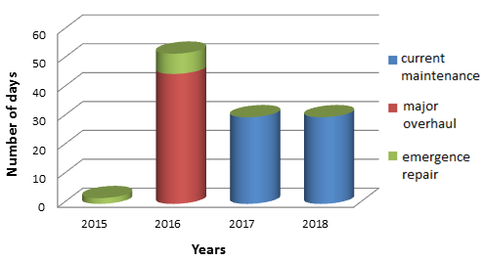
Figure 1 – Duration of repair work on the sintering furnace (№7)

A more General picture of the duration of repair work on eight sintering furnaces in the period from 2015 till 2018 is shown in figure 2.
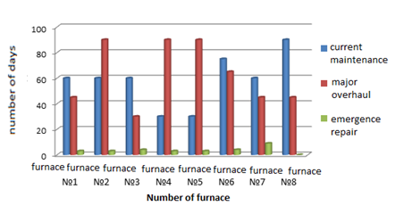

Figure 2 – Duration of repair work on eight sintering furnaces in the period from
2015 till 2018

As follows from the above analysis, a significant proportion of repairs occur on current ones, which are mainly associated with the unsatisfactory condition of the furnace linings.
Inspection of rotary furnaces. Let's consider the thermal operation of the lining of rotating furnaces on the example of sintering and calcination furnaces of alumina production. Along the length of the sintering furnace, there are four zones where the material undergoes physical changes and, accordingly, there are differences in the thermal operation of the lining. The first zone is drying. The peculiarity of this zone is low temperatures, as a result of which the sintering of the masonry seam lags behind in time or does not occur at all. Periodically, as the furnace rotates, cold material is rolled onto the lining from the zone of the pulp torch, which causes cooling of the working surface of the brick, and hence linear shrinkage, which may cause the brick to detach from the seam. Wear of the brick itself is insignificant.
The calcination zone has the best operating conditions – the brick on the working surface is sintered with seams, the compression is moderate, dense. In the calcination zone, there is an objective process that reduces the service life of the lining – the degeneration of bricks in the upper zone due to the impregnation of chamotte with charge substances. Figure 3 shows part of the lining of the sintering furnace’s calcination zone. The surface of refractories is uniform, practically without chips and cracks, and is covered with a layer of charge material.

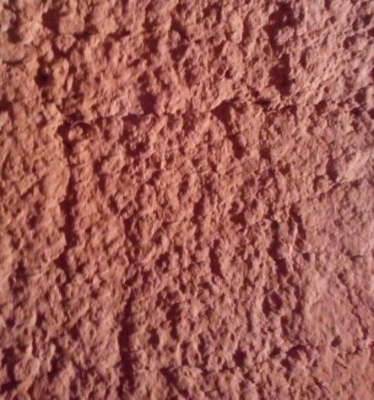

Figure 3 – Lining surface of the sintering furnace’s calcination zone

However, this process does not determine the stability of the lining in the calcification zone. The main wear of the masonry occurs due to chipping of parts of the refractory that occurs due to unsatisfactory management of the heating and cooling processes of the furnace. A typical pattern of damage to the lining is cracks up to 20-30 mm deep and up to 3.5 – 4 meters long (figure 4 a, b, c). Figure 5.3 shows a chipped refractory with a depth of about 15 mm and a length of up to 40 mm. In this area, chips are not common (about 2 chips per 5 m²).

 |  | 
а | b | c

Figure 4 – Cracks in the sintering furnace lining

The lining in the sintering zone should be covered with a skull during operation and the wear of the refractories should be minimal. Surveys have shown that the wear of the lining in the sintering zone is due to the lack of skull, low degree of chamotte’s resistance to the alkaline liquid phase.
The second component of wear is the so-called "burn" of the lining. "Burn" is the result of the thermochemical process of wear of the chamotte by alkaline melts, since the refractoriness of the used chamotte is not lower than 1700 ºC, which means that burnout is impossible only due to the influence of temperature. Figure 5 shows an example of partial "burning" of the lining on the thermogram of the outer surface of the sintering zone’s casing.

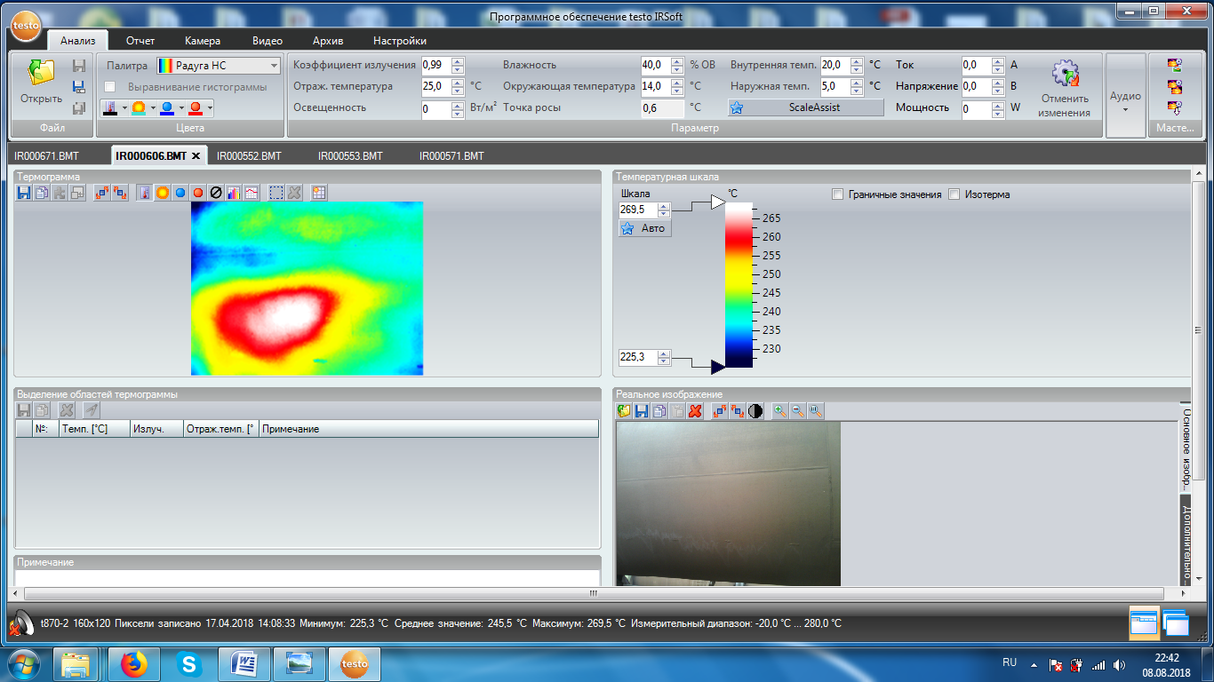

Figure 5 – External surface of the sintering furnace

The calcination furnace is in many ways similar to the sintering furnace in terms of heat. Let's briefly discuss the features of its operation and illustrate the wear of the lining with photos. Inside the oven the entire length is lined with refractory fireclay brick grade SHCU. On the length of 60-65 m (on the loading side), the lining thickness is 200 mm, on the rest of the length – 230 mm.
The first zone of the oven is the drying zone. In this zone, the external (physical) moisture of the hydrate is removed, and the material is heated to a temperature of 200-250 °C. The temperature of gases entering the drying zone is about 600 °C, at the outlet – about
200-250 °C.
Next is the calcination zone, where all the crystallization (chemical) moisture is removed from the process material, the material is heated to a temperature of 900-950 °C and gamma-modified alumina is formed at a flue gas temperature of about 600-700 °C. Figure 6 shows the depth of impregnation of fireclay refractory from the calcination zone, reaching 15 mm.

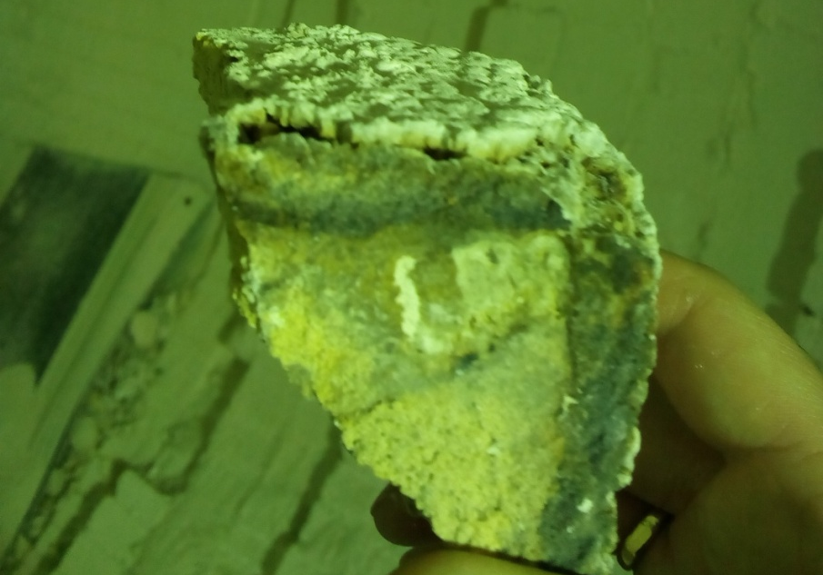

Figure 6 – Depth of impregnation of fireclay refractory from the calcination zone

The third zone is calcination, in which (in the area of torch fuel’s burning) starts the active formation of alumina’s alpha modification. The temperature of alumina at the outlet of the calcination zone is 1200 °C, the temperature of the gas medium is 1300-1400 °C. Typical failures of the lining of this zone are rare chips and cracks (figure 7).

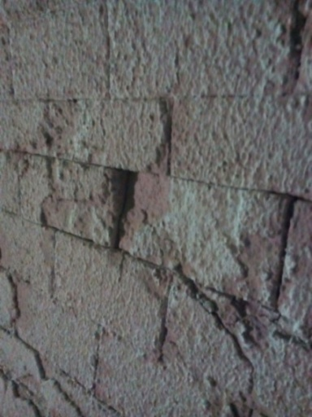 | 

Figure 7 – Condition of the calcination zone’s lining

The fourth is the cooling zone. In the cooling zone, alumina is cooled to a temperature of 600-900 °C, while already behind the fuel torch. In this zone, due to cyclic temperature conditions similar to the sintering furnace, the lining is worn in the form of flake chipping
(figure 8).


Figure 8 – Wear of the lining in the form of scaly chipping

Consequently, the stability of the lining of rotating furnaces depends more on temperature changes than on the chemical effect of the process material.
1.1.2 Steel-teeming ladles
The main amount of refractories is consumed by ferrous metallurgy enterprises, so, as a rule, the consumption of refractories is correlated per ton of steel produced. On average, the global output of refractory materials is 2.5 – 6% of the mass of steel produced, in industrial countries the cost of refractories is about 0.1% of the gross national product [2].
Figure 9 shows data on the durability of ladle’s lining of various capacities. The durability of the lining, regardless of the ladle capacity, is relatively low: 10 ± 5 smelting. In some cases, a resistance of up to 30 smeltings was obtained. Due to the low resistance, the specific consumption of refractories for ladle’s linings reaches 6 – 10 kg/t of steel.

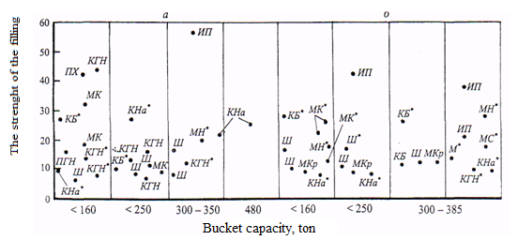

КБ – quartzite chemically bonded, Ш – chamotte, ПХ – magnesia-chrome, МК – mullite-corundum, ИП – lime-periclase, М – mullite, МКр – mullite-siliceous, КГН – quartz-loamy, МН – mullite, МС – magnesia-silicon, КНа – quartzite filling, * – combined lining

Figure 9 – Durability of ladles’ lining of various capacities made of piece refractories

The slag belt has the minimum resistance among steel ladle’s elements, the resistance of slag belt with periclase refractories using is most often from 40 to 50 smelting [3, 4]. It is possible to significantly increase the resistance using other refractories in the slag belt. Thus, the authors [5] talk about achieving the stability of the ladle’s lining for 400 smelting during usage of corundum concrete in the slag belt.
A survey of steel-teeming ladles. The remaining thickness of the slag belt refractories before the ladle is put into intermediate repair is on average 97 mm. The average duration of ladle operation before major overhaul is 40 smelting, with one intermediate repair (replacement of the upper rows of refractories).
The topography of lining wear shows (figure 10) that the greatest masonry wear is observed in the area of the 8th – 9th row.

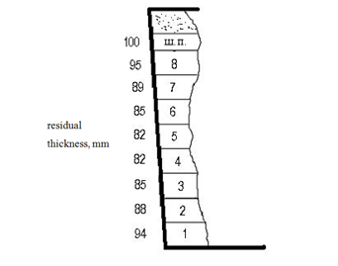

Figure 10 – Topography of wear on the lining of 25-ton steel-teeming ladles in major overhaul time

The lower rows of the lining have a sufficiently large value of the residual thickness. The minimum thickness of the working layer of the lining is 80 mm. From the experience of using ladles, it follows that ladles with ring lining are removed from service for safety reasons when the remaining brick thickness is at least 70 mm [6]. In this regard, the lining of the ladles under consideration does not fully develop its resource.
Thus, the conducted surveys of high – temperature units show that the main reason for the withdrawal of high-temperature units for repair is the unsatisfactory condition of the lining, the main reason for which is the temperature stresses that occur during variable operating modes of the equipment: setups and shutdowns.
2 Research of thermophysical and strength properties of refractory and heat-insulating materials

2.1 Investigation of the influence of temperature and operating conditions on the thermophysical properties of refractory materials
The calculation of the thermal stress state of the lining involves the use of thermophysical parameters of the refractory materials used in the operating temperature range. Thus, the first stage of calculations of the thermally stressed state was the experimental determination of the thermophysical and strength properties of the materials used.
2.1.1 Fireclay refractories (grade SHCU)
To study fireclay refractories (SHCU grade), samples were taken from the working layer of the sintering furnace lining during the current repair (after eight months of operation). The obtained experimental values for the new refractory and after operation are shown in table 1.

Table 1 – Dependence of fireclay refractory’s (SHCU grade) thermal conductivity coefficient on the temperature
Temperature, ° С | 20 | 200 | 300 | 400 | 500 | 600 | 700
Thermal conductivity coefficient of new refractory grade SHCU,  W / (m ∙ K) | 1,22 | 1,26 | 1,29 | 1,32 | 1,35 | 1,38 | 1,40
Thermal conductivity coefficient of refractory grade SHCU after operation (eight months),  W / (m ∙ K) | 1,280 | 1,321 | 1,354 | 1,386 | 1,415 | 1,449 | 1,471

It was found that after using it in the working layer of the sintering furnace for eight months, the thermal conductivity coefficient increases by 4-5 %.
2.1.2 Periclase-carbon refractories
To study periclase-carbon refractories, samples were taken from the working layer of the steel-teeming ladle lining during intermediate repairs (after 22 melts). The obtained experimental values for the new refractory and after operation are shown in table 2.

Table 2 – Temperature dependence of the thermal conductivity coefficient of periclase-carbon refractory
Temperature, ° С | 20 | 200 | 300 | 400 | 500 | 600 | 700
Coefficient of thermal conductivity of a new periclase-carbon refractory, W/(m*K) | 4,52 | 4,4 | 4,23 | 4,05 | 3,92 | 3,73 | 3,6
Coefficient of thermal conductivity of periclase carbon after operation (22 smeltings), W/(m*K) | 4,91 | 4,82 | 4,68 | 4,41 | 4,3 | 4,14 | 4,03

Analysis of the obtained data shows that the value of the thermal conductivity coefficient of periclase-carbon refractories varies significantly. After operation, due to metal impregnation, the thermal conductivity coefficient increases from 8 to 10 %.
2.1.3 Dependence of the thermal conductivity factor of fireclay bricks on the temperature
To study the coefficient of thermal conductivity of heat-insulating materials, samples of fireclay refractories (SHB brand) that were in operation were taken from the heat-insulating layer of a steel-teeming ladle. The obtained experimental values for the new refractory and after operation are shown in table 3.

Table 3 – Dependence of the thermal conductivity coefficient of fireclay refractory (SHB grade) on the temperature
Temperature, ° С | 20 | 200 | 300 | 400 | 500 | 600 | 700
Coefficient of thermal conductivity of a new brick SHB, W/(m*K) | 1,12 | 1,14 | 1,17 | 1,20 | 1,22 | 1,26 | 1,29
Coefficient of thermal conductivity of the SHB brick after 22 smeltings,  W/(m*K) | 1,09 | 1,10 | 1,12 | 1,15 | 1,18 | 1,21 | 1,24

The obtained values show a decrease in the thermal conductivity of chamotte after its operation by an average of up to 4 %. Meanwhile, there is a tendency to increase the coefficient of thermal conductivity with increasing temperature. So, in the temperature range of 20-700 ºC, the increase in the thermal conductivity coefficient is about 13 %.

2.2 Investigation of the compressive strength of refractory materials depending on temperature
In addition to conductivity, the rate of heating up masonry is significantly affected by the tensile strength of the material, as it is a determining factor for the arising thermal stresses [7], and hence for the duration of the working campaign of the unit. In this connection, for further research, it is necessary to obtain the dependences of the strength limit of refractory materials on temperature.
2.2.1 The study of the limit of chamotte refractories’ (SHCU) compressive strength
Fireclay refractories with a content of Al₂O₃ not less than 32 % were used as samples for the study; compressive strength was 25 MPa [8].
The strength limit was determined in the temperature range of 20-700 ºC. The measurement results are shown in figure 11.

Figure 11 – Ultimate strength dependences on the temperature

The curve of the ultimate strength dependence on temperature has the following trends: starting from the temperature of 20 ºC, the ultimate strength of the refractory increases, reaching the value 48 MPa (at a temperature of ~ 400 ºC), then the value of the tensile strength begins to gradually decrease, reaching 42 MPa (at ~ 700 ºC).
Thus, the value of the compressive strength in the temperature range of 300-600 ºC increases by 23-47 %, which gives an additional reserve for increasing the heating speed and reducing the time and energy resources for heating.
2.2.2 Investigation of the periclase-carbon refractories’ compressive strength
Periclase-carbon refractories of the composition MgO ≥ 80 %; C ≥ 8 % were used as test samples. In this case, the claimed compressive strength is 40 MPa (manufacturer's passport data).
The strength limit was determined in the temperature range of 18-500 ºC. The measurement results are shown in figure 12.
The curve of tensile strength on temperature has the following trend: the starting temperature ~ 90 ° tensile strength of the refractory increases, reaching a value of 51.2 MPa (at a temperature of ~ 200 ºC), then the value of the tensile strength begins to gradually decline, reaching 40 MPa (at ~ 400 ºC).

Figure 12 – Periclase carbon strength limit dependence on temperature

Thus, the value of the compressive strength in the temperature range 150-300 ^{о}С increases by 18 – 28 %, which gives an additional reserve for increasing the heating speed and reducing the time and energy resources for heating.
2.2.3 The dependence of the tensile strength of the fireclay refractory temperature
The literature review has shown that for fireclay materials (the brand is not specified), data on the compressive strength at various temperatures can be found. Thus, the literature [9] provides the following data: the compressive strength of fireclay refractory at a temperature of 20 ° C is 20 MPa, and at 600 ° C its value is 40 MPa.
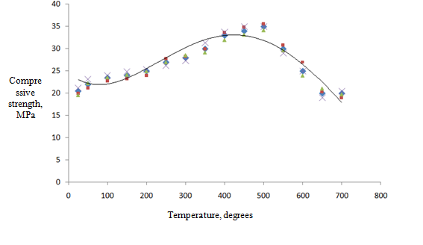
Figure 13 – Dependence of the compressive strength of fireclay refractories
(SHB -5 grade) on temperature

Based on the conducted research on the dependence of the compressive strength of chamotte (SHB -5) on temperature, the following graph was obtained (figure 13). The ultimate strength in the considered temperature range (from 25 to 500 ^{о}С) increases from 20 MPa to 35 MPa. This can be explained by the appearance of plastic deformations when the temperature of the material increases.

2.3 Determination of the density of the lining materials used
During operation, due to the impregnation of refractories with the working medium, not only the thermal conductivity coefficient changes, but also the density of refractories. For the considered periclase-carbon materials, the density varies from 3020 kg/m³ (new material) up to 3,100 kg/m³ (after 22 smeltings).
According to our research, the density of chamotte should decrease, which is confirmed by a decrease in the coefficient of thermal conductivity and visually observed cracks. This is confirmed by measurements: the density of chamotte after operation. It decreases by 2 % (from 2003.2 kg/m³ to 1965.3 kg/m³).
The obtained values for changing the properties of the materials used in the high-temperature units’ lining will allow to adjust the heating schedules of these units, which can increase the reliability and residual life of high-temperature units.

2.4 Study of drying process parameters
Drying the lining during the heating process is an important technological component, and to determine the duration of the drying process, it is necessary to know the humidity of the materials used. To obtain such data, periclase carbon, diatomite, and chamotte were dried under laboratory conditions and used in high-temperature units.
The dynamics of drying materials at a temperature of 110 ° C is shown in figures 14, 15 and 16.

Figure 14 – Dynamics of periclase carbon drying

Figure 15 – Dynamics of diatomite drying

Figure 16 – Dynamics of chamotte drying

The amount of moisture determined experimentally will allow you to take into account its amount when developing drying and heating schedules to avoid rapid vaporization during the drying process and the effect of this process on the strength of the lining.
The assessment of the thermal and strength properties of refractories, taking into account the influence of temperature and operating conditions, will allow to carry out non-stationary processes (primarily drying and heating) with high speeds.

3 Modeling of thermal operation of high-temperature units

3.1 Simulation of lining’s temperature field
The mathematical model is described by the following equations.
Dependences between thermal stresses and deformations, which in our case arise due to uneven temperature distribution [10, 11]

(1)

where σ_{xx}, σ_{yy}, σ_{zz} - stress components;
ε_{xx}, ε_{yy}, ε_{zz} – corresponding deformations;
e = ε_{xx}+ε_{yy}+ε_{zz} – volume deformation;
α – coefficient of linear temperature expansion;
ν - Poisson ratio;
λ and μ are lame constants that are related to the Young's modulus and Poisson ratio

,.

The relationships between stresses and deformations mathematically describe the behavior of the material under consideration. It is also necessary to take into account the requirements of mechanics. The laws of mechanics and geometry are introduced by equilibrium equations and relations between deformations and displacements.
Equilibrium equations, which in general have the form

(2)
Relations between deformations and displacements that are derived based on geometric considerations

(3)

where u, v, w – components of the displacement vector in the directions of the x, y, and z axes, respectively.
This statement of the task is equivalent to the following six equations containing only stress components (the formulation of the task in stresses)

(4)

where Θ = σ_{xx}+ σ_{yy}+ σ_{zz} - the sum of normal stresses.

To determine the stresses in the refractory layer due to the fact that the wall diameter is much larger than its thickness, we will consider the lining in the form of a flat wall. We assume that the lining is free from surface forces and the temperature changes only in thickness T=T(x,τ). Under these conditions, the voltage components will look like

σ_{yy} = σ_{zz}= σ (x), σ_{xx} = σ_{xz} = σ_{yz} = σ_{xy} = 0. (5)

In this case, the stress components (5) satisfy the equilibrium equations (2) (with zero volume forces) and the compatibility equations (4). The last three of the six compatibility equations are satisfied identically, and the first three are satisfied if

. (6)

Integration of the equation gives the form of the stress components [10]

, (7)

where С₁ and С₂ – constant of integration determined from the boundary conditions. In this case, C₁ and C₂ can be chosen based on the fact that for any temperature T (x, τ), the resulting force and the resulting moment caused by the stresses σyy and σzz were equal to zero at the wall boundary , i.e.

. (8)

As a result, the solution found in this way has the form

(9)

Taking into account the fact that the weight of the lining is quite large and there are butt joints, significantly higher stresses occur in the refractory than in the free state [12]. Therefore, the stresses should be determined by the formula
(10)

3.2 Determination of thermal stresses
3.2.1 Temperature fields in the lining of sintering furnaces
The initial information for calculating the thermal stress state of linings is data on the temperature fields in the lining. To obtain these data, the temperature fields in high-temperature units’ linings were measured when they were heated.
Consider the heating schedule of the sintering furnace, in the lining of which the fireclay brick of the SHCU brand is used as a refractory material. Measurements were made for the warm-up period from 0 to 11 hours of the next day. Figure 17 shows a graph of changes in the average thickness of the lining temperature.

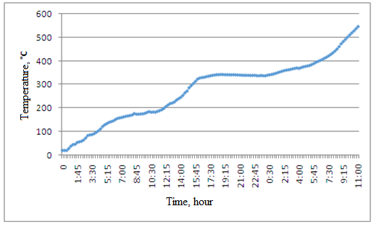

Figure 17 – Average temperature of the sintering furnace lining during heating

3.2.2 Calcination furnaces
Figure 18 shows a graph of changes in the average temperature over the thickness of the lining for the calcination furnace.

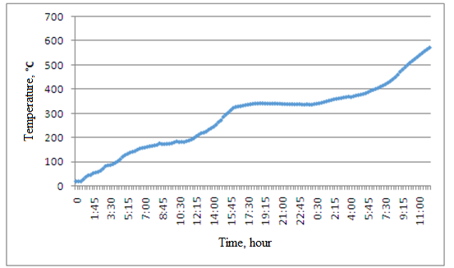

Figure 18 – Average temperature of the calcination furnace lining during heating

3.2.3 Steel-teeming ladles
The average temperature of the steel-teeming lining during heating (the first 17 h 30 min) is shown in figure 19.

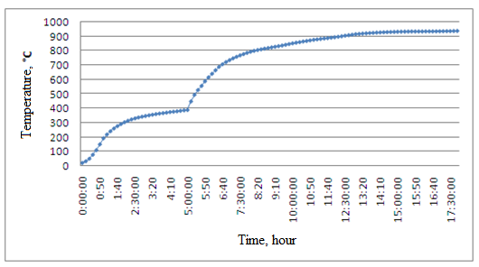

Figure 19 – Average temperature of the steel-teeming lining during heating

3.3 Results of modeling linings’ thermal stress state
Sintering furnaces. Using the heating graph (average lining temperature) as boundary conditions, we calculate the thermal stress state of the sintering furnace lining based on the developed mathematical model. Calculations were made for the warm-up period from 0 to 19 hours. The calculation results are presented as graphs (figure 20).

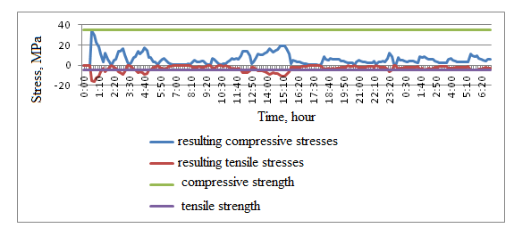

Figure 20 – Emerging temperature stresses

Heating of the sintering furnace is carried out with heating speeds exceeding the permissible ones. When heated, a compression stress (σ_{с}) occurs in the high-temperature section from the average temperature, and a tensile stress (σ_{р}) occurs in the low-temperature section. The maximum value of the compression stress is 1.4 times higher than the permissible value, and there are seven times more than the permissible value for tensile stresses. The maximum value of the tensile stress exceeds – 3.2 times.
Steel-teeming ladles. The calculation results are presented as graphs (figure 21). After analyzing this graph, we can say that when the lining was heated, thermal stresses both compressive and tensile occurred in it, which exceed the compressive and tensile strength of periclase carbon (horizontal lines in figure 21).
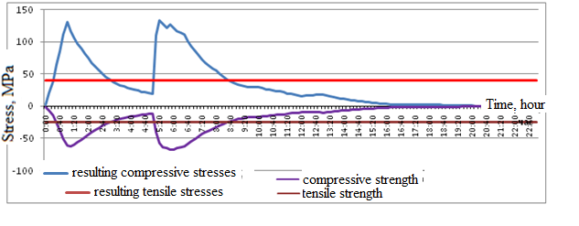
Figure 21 – Emerging temperature stresses in the steel-teeming ladle lining

There is a clear relationship between temperature jumps and emerging stresses jumps.
The existing heating schedule for the steel-teeming ladle lining is critical for the resulting temperature stresses. During the heating process, two time periods are allocated on the graph for compression stresses, the temperature stresses in which exceed the permissible ones (0h 20m – 3h 10m; 5h 10m – 8h 40m); the graph for tensile stresses also has two periods (0h 30m – 3h 00m; 5h 00m – 8h 30m). When heated, a compression stress (σ_{с}) occurs in the high-temperature section from the average temperature, and a tensile stress (σ_{р}) occurs in the low-temperature section. The maximum value of the compression stress is 3.24 times higher than the permissible value, and the tensile stress is 2.7 times higher.
4 Improvement of high-temperature units’ non-stationary thermal modes

4.1 Recommendations to improve temperature regimes of high-temperature units
To streamline the heating schedules, you need to choose the heating speed. As a rule, the increase in the lining temperature of a high-temperature unit is discrete. That is, the warm-up period is replaced by a holding period at the same temperature. So, in the process of heating the unit, there are at least two sections of exposure ("shelves") – for removing external (hydrate) moisture at a temperature of 100-110 ºC and removing internal (chemically bound) moisture at a temperature of 400-550 ºC (depending on the material).
Let's consider different methods of the unit heating intensity.
In the first method the heating speed in the beginning of the first 30 minutes is considered as 1 ^{о}С/min, and then the entire heating process at 0.4–0.5 ^{о}С/min.
In the second method the heating speed is considered evenly by 0.4 ºC/min to the temperature 500 ^{о}С.
In the third method the heating speed at the beginning of 5h 50 minutes is 0.2 ºC/min and in the rest of time is 0.4–0.5 ºC/min.

1 - the maximum possible increase in temperature from the initial stage with a further decrease in the heating rate; 2 - uniform heating to the required temperature at a constant rate throughout the entire time; 3 - initial heating at minimum speeds and further heating at maximum speeds

Figure 22 – Considered heating schedules

Thus, the best option (according to figure 22) is the first: the maximum possible temperature increase from the initial stage with a further decrease in the heating rate.
With the help of developed program, the modes of drying and heating the lining of a 25-ton steel-teeming ladle were rationalized (the factory schedule for drying and heating steel-teeming ladle’s lining is shown in figure 23 – curve 2; the rationalized schedule is curve 1).

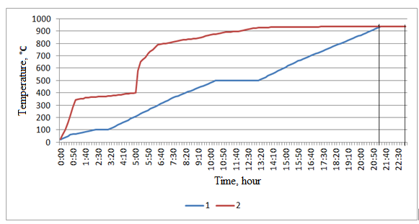

1 – streamlined the schedule of warm-up 2 – factory default chart warm-up

Figure 23 – Heating charts for the lining of a 25-ton steel-teeming ladle

The graph shows that at the initial stage (20-65 ºC), the average heating rate is 0.9 ºC /min. The drying studies of the materials under consideration conducted in the second Chapter showed that moisture begins to exit intensively when the temperature reaches 65 ° C, so the heating rate slows down from this temperature value. The speed in the section 65-100 ºC was chosen from conditions where there is no increase in temperature stresses. At a temperature of 100 ° C, a temperature exposure ("shelf") is made for the release of moisture.
After that, the heating speed increases by 60 ºC/hour (section 100-500 ºC). At this temperature, we make another exposure (shelf) for relaxation of temperature stresses and the release of bound moisture, which, according to our calculations, takes 3 hours. After that, the heating process continues with an average temperature of 60 ° C/h to 938 ° C. With this heating schedule, we reached the operating temperature an hour and a half earlier without exceeding the strength limits of periclase carbon.
Then the modes of drying and heating the sintering furnace lining were rationalized (the factory and rationalized schedules for drying and heating the sintering furnace lining are shown in figure 24).

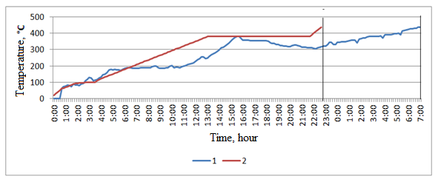

1 – factory warm – up schedule; 2-rationalized warm-up schedule

Figure 24 –Sintering furnace lining’s heating charts

Analyzing the rationalized heating schedule, it can be seen that at the initial stage (20-100 ºC), the average heating rate is 0.5 ºC/min. At a temperature of 100 °C, a temperature exposure ("shelf") is made for the release of moisture. After that, the heating rate is 0.48 ºC/min (section 100-438 ºC). At this temperature, we make another exposure (shelf) to relax the temperature stresses and release the bound moisture, which, according to our calculations, takes 2 hours.
Rationalized heating schedules for the considered high-temperature units (25 – ton steel-teeming ladle and sintering furnace) allow the heating process to be carried out without exceeding the strength limit of the refractory materials used and reduce the heating process by 2 hours for the steel-teeming ladle; by 2 hours 20 minutes for the sintering furnace.

4.2 Cooling modes and their influence on the thermal stability of the studied units
Analysis of the lining service showed that when the lining is rapidly heated, surface layers of masonry, facing the working space, experience compression stresses. During rapid cooling, these layers are exposed to tensile stresses [13].
Knowing the initial temperature distribution in the wall, we can calculate the temperature distribution at any time using the formula [14]

, (11)

where n = 1, 3, 5, ...;
t – surface temperature at time τ, ^{о}С;
t_{i} and t₁ - surface and ambient temperature at the initial time, ^{о}С.

Taking into account the initial temperature on the inner surface of the lining and the rate of its decrease, we calculate the temperatures for the cross-section of the lining in 10-minute increments using the formula (11). Figure 25 shows the dynamics of changes in the temperature of the sintering furnace lining at different points in thickness during cooling.

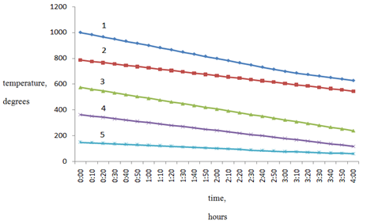

1 – on the inner surface of the lining; 2 – by ¼ of the lining thickness (from the inner surface);
3 – 1/2 of the lining thickness (from the inner surface); 4 – 3/4 of the lining thickness (from the inner surface); 5 – on the outer surface of the lining

Figure 25 – Dynamics of temperature changes in the sintering furnace lining at different points in thickness during cooling

Having data on the temperature distribution in the lining, we calculate the temperature stresses according to the method described in [15].
Figure 26 shows graphs of the resulting temperature stresses values in the sintering furnace lining at different points in thickness during cooling.

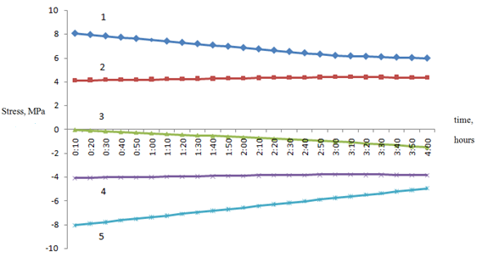

1 – on the inner surface of the lining; 2 – by ¼ of the lining thickness (from the inner surface);
3 – 1/2 of the lining thickness (from the inner surface); 4 – 3/4 of the lining thickness (from the inner surface); 5 – on the outer surface of the lining

Figure 26 – Values of emerging temperature stresses in the sintering furnace lining at different points in thickness during cooling

Analysis of the obtained data shows that the initial stage of the cooling process is accompanied by an excess of tensile stresses. The maximum values of tensile stresses occur on the outer surface of the lining layer.
With an acceptable level (tensile strength) of 5 MPa, the maximum tensile stress is 8.038 MPa at the time of 0 h 10 min, which is 1.6 times higher than the allowed one. As it cools, the stress values drop and when 4 hours of cooling are reached, they take on acceptable values (4.95 MPa). In the future, at the next stage of cooling (at a speed of 73 ºC/h), the stresses do not exceed the strength limit of the material.
Compression stresses, when cooled according to the specified schedule, are within acceptable limits. The maximum compressive stress that occurs at the time 0 h 10 min is 8.063 MPa, which is 32.25 % of the compressive strength of the materials used. This, in particular, can be explained by a significant difference in the ultimate compressive and tensile strength of the SHCU chamotte: 25 MPa and 5 MPa, respectively.
Thus, it can be concluded that the available cooling rate of sintering furnaces during the "subcooling" (100 ºC/h) is not rational from the point of view of the resulting temperature stresses. The tensile stresses exceed the permissible limit during the entire period of " subcooling", while the maximum value of the resulting stresses exceeds 1.6 times the tensile strength.
Further calculations show that to reduce the resulting temperature stresses to the normalized level, it is necessary to reduce the cooling rate to 60 ºC/h during the first 4 hours. Further cooling can be carried out at a speed of 100 ºC/h. Initially, according to the factory schedule, the process of cooling the furnace from a temperature of 1000 ºC to 40 ºC goes: 4 hours at a speed of 100 ºC/h and 9 hours 20 minutes at a speed of 60 ºC/h. If you replace this graph with a new one: 4 hours at a speed of 60 ºC/h and 7 h 17 min at a speed of 100 ºC/h, the result is that the total cooling time is reduced by more than 2 hours (figure 27).

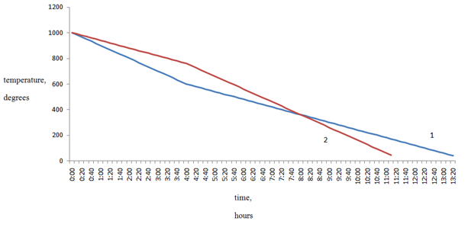

1 – current; 2 – proposed

Figure 27 – Sintering furnace cooling charts

5 Economic efficiency of the proposed technical solutions

The lining of the considered rotary furnaces and calcination furnaces is put into major overhauls on average once a year for a period of 45 days. Current maintenances are taken from 10 to 30 days, and are carried out once or twice a year. During the current maintenance 30 linear meters of lining are replaced; during the major overhaul the masonry is completely changed. One major overhaul or one or two current maintenances are performed annually.
Using the example of sintering furnaces, we will consider the economic efficiency of implementing rational heating modes after a repair company. For these units, there are three main components:
- costs of repairing the furnace lining;
- costs of heating the furnace after taking out of repair;
- loss of manufactured products (sintering) due to downtime of the furnace during repair.
Table 4 provides information on the cost of purchasing fireclay bricks (open access) used for emergency repairs of the lining of eight sintering furnaces for the period from 2016 to 2018.

Table 4 – Total costs for the purchase of fireclay bricks, million tenge
Furnace № | 2016 year | 2017 year | 2018 year
1 | 1,94 | – | –
2 | 1,26 | – | –
3 | – | – | –
4 | – | – | 1,02
5 | – | 1,46 | –
6 | – | 2,04 | –
7 | 0,61 | – | –
8 | – | – | –
Total | 3,81 | 3,50 | 1,02

The total cost of emergency repair of sintering furnace linings for three years is 8.33 million tenge.
When considering the costs of heating the furnace after withdrawal from repair, it is necessary to determine the total cost of M-100 fuel oil used for heating the sintering furnace after current maintenance and major overhaul.
Considering this type of cost, we will proceed from the fact that the rational modes of heating of high-temperature units proposed in [16] allow reducing the heating time of furnaces after withdrawal from current maintenance or major overhauls by 11 hours. This will allow to determine the reduction in the cost of purchasing fuel oil relative to the same costs for the actual heating schedules. Calculated data for furnaces at the cost of M-100 fuel oil is 111 thousand tg/ton are presented in table 5.

Table 5 – Reduction of total costs for M-100 fuel oil, million tenge
Furnace  № | 2016 year | 2017 year | 2018 year
1 | 3,3 | 3,3 | 3,3
2 | 3,3 | 3,3 | 3,3
3 | 3,3 | 3,3 | –
4 | – | 3,3 | 3,3
5 | 3,3 | – | 3,3
6 | – | 3,3 | 3,3
7 | 3,3 | 3,3 | 3,3
8 | 3,3 | 3,3 | 3,3
Total | 19,8 | 23,1 | 23,1

The total profit from reducing fuel oil consumption for heating sintering furnaces for three years amounted to 66 million tenge.
Economic losses with unreleased products due to the withdrawal of high-temperature units for repair with a capacity of each furnace of 65 ton/h for three years approximately amounted to 9 billion tenge. It is obvious that this component occupies a large share in the total losses associated with the repair campaign of sintering furnaces, so we will exclude it from consideration in further analysis.
A comparison of the two components of economic profit for 2016-2018 is shown in figure 28.

Figure 28 – Comparative analysis of economic costs

Thus, the implementation of rational modes of high-temperature units heating will:
1 Reduce the cost of purchasing fireclay bricks of the SHCU brand, associated with the absence of emergency repairs, by an average of 2.77 million tenge per year.
2 Reduce the cost of purchasing fuel oil of the M-100 brand in view of reducing the heating time of furnaces after withdrawal from current maintenance or major overhauls by 11 hours, which in average will amount to 22 million tenge per year.
3 Get an economic profit from the production of final products, which could be realized if: first, the sintering furnaces did not stop for emergency repairs; second, the heating of these furnaces after the repair campaign was reduced by 11 hours.

CONCLUSION

During the reporting period, the following types of work were performed:
- survey and collection of data on the operation of existing high-temperature equipment: sintering and calcination furnaces; steel ladles; boiler units of various capacities. Statistical data on the operation of high-temperature aggregates are obtained;
- analysis of non-stationary operating conditions of the equipment (starts and stops). The main reasons for the withdrawal of equipment for repair, emergencies, etc. were found out: reducing the thickness of the lining layer to a minimum value and violating the integrity of the masonry (at the "hot end" of the furnace) – significant chipping and falling out of bricks;
- studies of the initial stage of the heating – drying process were carried out; the main drying parameters affecting the heating process were determined. Graphs of drying dynamics of samples of a number of refractory materials: chamotte, diatomite, periclase carbon are obtained;
- data on the thermophysical properties of refractory heat-insulating materials were obtained, taking into account the specifics of their operation in high-temperature aggregates;
- a mathematical model of thermal operation of linings of high-temperature units has been developed;
- developed rational modes of drying and heating, as well as stopping (cooling) high-temperature units;
- calculation of indicators of economic efficiency of the proposed technical solutions
- three publications in peer-reviewed foreign scientific publications with a non-zero impact factor indexed by Web of Science databases were published:
1. Nikiforov A. S., Prikhod’ko E. V., Kinzhibekova A. K., Karmanov A. E. Heat-Engineering Characteristics of Diatomaceous-Earth Materials in a Wide Temperature Range. Glass and Ceramics. May 2018, Volume 75, Issue 1-2.Pp 60–62. DOI 10.1007/s10717-018-0029-2. Scopus: Q3. SJR = 0,282.
2. Nikiforov, A. S. Investigation of the Dependence of Refractory Thermal Conductivity on Impregnation with a Corrosive Medium / A. S. Nikiforov, E. V. Prikhod’ko, A. K. Kinzhibekova, A. E. Karmanov // Refractories and Industrial Ceramics. – 2020. – Vol. 60, № 5. – P. 463–467. DOI 10.1007/s11148-020-00386-3. Scopus: Q3. SJR = 0,244.
3. Nikiforov, A.S., Prikhod’ko, E.V., Kinzhibekova, A.K. et al. Refractory Material Moisture Metering When Heating High-Temperature Units. Refract Ind Ceram 61, 224–227 (2020). https://doi.org/10.1007/s11148-020-00461-9. Scopus: Q3. SJR = 0,244.
Five publications in a peer-reviewed domestic publication with a non-zero impact factor (recommended by COXON); two patents of the Russian Federation, as well as 8 articles in the proceedings of international scientific conferences.
Possible ways to apply the results. The results obtained are graphs of drying, heating and cooling of high – temperature units (sintering furnaces and steel-teeming ladles). The developed schedules can be recommended for implementation at the production facilities: JSC "Aluminum of Kazakhstan", LLP "Casting". The introduction of these modes will reduce the time of heating (or cooling), and therefore fuel consumption; reduce emissions of harmful substances, due to lower fuel consumption; increase the duration of the working campaign of units and reduce the consumption of refractory materials; and also increase the reliability of the units as a whole.

REFERENCES

1 Islamov M. Sh. Design and operation of industrial furnace. (Сhemistry, Leningrad, 1986), p. 280 (in Russian)
2 Refractory technology http://огнеупор.москва/articles/1/3/ehnologiya-ogneuporov/ (in Russian)
3 Mozherin A. V. Evolution of the design and resistance of the lining of 150-t steelmaking buckets, New Refractoriesp, Pp. 5-14, 1 (2009) (in Russian)
4 Mozhzherin A. V., Musevich V. A., Duka A. P., Margishvili A. P., Payvin A. A., Kazakov V. V. Ladle maintenance technology for ladle-furnace installation, Ferrous Metallurgy News Abroa, Pp. 79-83, 4 (2004) (in Russian)
5 Gret U. Application of monolithic lining in slag belt of 220 t steelmaking ladle, W. Greete, K. Schlüter, E. Pischke, H. Berg, Ferrous metals, Pp. 34-39, 6 (2003) (in Russian)
6 Khoroshavin L. B., Ovchinnikov I.I., Gimpelman E.Ya. Optimality coefficient of linings of thermal units, Refractory materials, Pp. 26-27, 12 (1994) (in Russian)
7 Mastryukov B. S. Theory, structures and calculations of metallurgical furnaces. Calculations of metallurgical furnaces / Ed. by V. A. Krivandin. (Metallurgy, Moscow, 1986), Vol. 2 p. 376 (in Russian)
8 Karmanov A. E., Isabaeva S. D. Refractory materials of high-temperature aggregates. Materials of the international scientific conference "XIX Satpaev Readings". (Pavlodar, 2019), Vol. 21. Рp. 43-47 (in Russian)
9 Nikiforov A. S., Prikhod/ko E. V., Kinzhibekova A. K., Karmanov A. E. Heat-Engineering Characteristics of Diatomaceous-Earth Materials in a Wide Temperature Range. Glass and Ceramics. – 2018. –Vol. 75, Issue 1-2. – Pp. 60-62 (in English)
10 Boli B., Wainerd. Theory of temperature stresses. (World, Moscow, 1964),
р. 520 (in Russian)
11 Gatewood B. E. Temperature stresses. – М.: Publishing house of foreign literature, 1959. – 332 p (in Russian)
12 Nikiforov A. S. Reliability of lining of metallurgical furnaces. – Pavlodar: Pavlodar University, 2003. – 109 с (in Russian)
13 Slovikovsky V. V., Gulyaeva A. V. Influence of heating unit lining heating regimes and refractory storage duration on refractory lining durability. Novye ogneupory (New refractories). 2015;(6):9-13.– Pp. 9-13 (in Russian)

14 Schneider P. Engineering problems of thermal conductivity. – М. Foreign literature, 1960. – 478 p (in Russian)
15 Nikiforov A. S., Prikhodko E. V., Kinzhibekova A. K., Karmanov A. E. Development of a program for calculating temperature stresses in the lining of high-temperature units. – PSU Bulletin, "Energy" series. – 2018. – № 2. – Pp. 253-260 (in Russian)
16 Nikiforov A. S., Prikhodko E. V., Karmanov A. E. Physical modeling of the process of heating the lining of high-temperature units [Text] / Nikiforov AS, Prikhodko EV,
Karmanov A.E. // Energy and fuel resources of Kazakhstan. – 2012. –
№ 9–10. – Pp. 88-89 (in Russian).

APPENDIX A
List of publications
for 2018
In foreign periodicals:
1 Nikiforov A. S., Prikhodko E. V., Kinzhibekova A. K., Karmanov A. E. Thermal characteristics of diatomite materials in a wide temperature range. Glass and ceramics. – 2018. – No 2. – P. 24-26 (in Russian)
2 Prikhodko E. V., Kinzhibekova A. K., Kazhibaeva A. T., Uvaisova M. G. Forecasting the service life of power equipment based on the results of its inspection. –- Materials of the All-Russian scientific and practical conference with international participation "CURRENT ISSUES OF ENERGY" – Omsk, OMGTU, 2018. – pp. 52-55 (in Russian)
3 A. S. Nikiforov, E. V. Prikhod'ko, A. K. Kinzhibekova, A. E. Karmanov Heat-Engineering Characteristics of Diatomaceous-Earth Materials in a Wide Temperature Range. Glass and Ceramics. May 2018, Volume 75, Issue 1-2, pp 60-62 (in English)
4 Nikiforov A. S., Kinzhibekova A. K., Prikhodko E. V., Karmanov A. E. Energy efficiency of operation of sintering furnaces. – Materials of the VI International Baltic Maritime Forum, Kaliningrad, 2018 . – P. 313-316 (in Russian)
5 Prikhodko E V, Uvaisova M G Determination of the residual resource of thermal enclosures of high-temperature units. - VII All-Russian scientific and practical conference "Heat engineering and informatics in education, science and production." Yekaterinburg, 2018. – Р. 328-333 (in Russian)
In domestic periodicals:
6 Nikiforov A. S., Prikhodko E. V., Kinzhibekova A. K., Karmanov A. E. Investigation of the moisture content of the lining materials. PSU Bulletin, "Energy" series. – 2018. – No. 2. –
Р 246-253 (in Russian)
7 Nikiforov A. S., Prikhodko E. V., Kinzhibekova A. K., Karmanov A. E. Development of a program for calculating temperature stresses in the lining of high-temperature units. PSU Bulletin, "Energy" series. – 2018. – No. 2. – Р. 253-260 (in Russian)
8 Taizhanova K.S., Karmanov A.E., Prikhodko E.V. Analysis of the operating conditions of the lining of high-temperature units. – Materials of the international scientific-practical conference "X Toraigyrov readings", 2018. – P. 330-336 (in Russian)
for 2019
In foreign periodicals:
1 Nikiforov A. S., Prikhodko E. V., Kinzhibekova A. K., Karmanov A.E. Evaluation and calculation of the permissible residual life of the lining depending on the thermophysical and strength characteristics. – Materials of the VII International Baltic Maritime Forum: Kaliningrad, 2019 – P.212-215 (in Russian)
2 Nikiforov A.S., Prikhodko E.V., Kinzhibekova A.K., Karmanov A.E. Study of the dependence of the thermal conductivity of refractories on their impregnation with an aggressive medium. New refractories. – 2019 – No. 9. – P.50-54. https://doi.org/10.17073/1683-4518-2019-9-50-54 (in Russian)
In domestic periodicals:
3 Prikhodko E V, Boyandinova A. B., Kabdynasyrov Sh. A. Relevance of reliability-oriented maintenance and repair according to the RCM methodology. – Materials of the international scientific conference "XIX SATPAEV READINGS". – Pavlodar, 2019 . – T. 21 . – Р. 13-19 (in Russian)
4 Karmanov A.E., Isabaeva S.D. Refractory materials for high-temperature units. - Materials of the international scientific conference "ХIХ Satpayev readings". – Pavlodar, 2019. – T. 21 . – Р. 43-47 (in Russian)
5 Nikiforov A. S., Prikhodko E. V., Kinzhibekova A. K., Karmanov A. E.,
Shupeeva Sh. M. Analysis of working conditions and mechanisms of destruction of lining of high-temperature units. – Bulletin of EKSTU, Ust-Kamenogorsk, 2019. – No. 3. – P.139-146
(in Russian)
for 2020
In foreign periodicals:
1 Nikiforov, E. V. Prikhod’ko, A. K. Kinzhibekova, A. E. Karmanov. Investigation of the Dependence of Refractory Thermal Conductivity on Impregnation with a Corrosive Medium. – Refractories and Industrial Ceramics, Vol. 60, No. 5, January, 2020; doi:10.1007/s11148-020-00386-3. Pp. 463- 467 (in English)
2 Nikiforov A.S., Prikhodko E.V., Kinzhibekova A.K., Karmanov A.E. Accounting for the moisture content of refractory materials during heating of high-temperature aggregates. – New refractories. 2020; (4): https://doi.org/10.17073/1683-4518-2020-4-56-59 Р. 56-59
(in Russian)
3 A. S. Nikiforov, E. V. Prikhod’ko, A. K. Kinzhibekova, A. E. Karmanov. Refractory Material Moisture Metering When Heating High-Temperature Units. - Refract Ind Ceram 61, 224-227 (2020). https://doi.org/10.1007/s11148-020-00461-9 (in English)
In domestic periodicals:
4 Korabaeva S. D., Karmanov A. E. Investigation of changes in the structure of refractory materials of lining of high-temperature aggregates. – Materials of the international scientific and technical conference "I Anniversary Readings of Boyko F. K." – Pavlodar, 2020 . – Р. 269-274 (in Russian)
5 Nikiforov A. S., Prikhodko E. V., Kinzhibekova A. K., Nurkina Sh. M. Investigation of the thermally stressed state of the lining of rotating furnaces. – Bulletin of the Shakarim State University, series "Energy". – 2020. – No. 1. – P. 100-103 (in Russian)
6 Karmanov A. E., Prikhodko E. V., Nurkina Sh. M. Determination of thermomechanical properties of refractory materials. - Materials of the VIII international scientific and practical conference: "Actual problems of transport and energy: ways of their innovative solution." – Nur-Sultan, 2020 – Р. 340-344 (in Russian)
7 Nikiforov A. S., Prikhodko E. V., Kinzhibekova A. K., Nurkina Sh. M. Analysis of the economic efficiency of introducing rational modes of heating high-temperature units. – Bulletin of PSU, series "Energy". – 2020. – No. 2. – P. 351-357 (in Russian)
8 Nikiforov A. S., Prikhodko E. V., Kinzhibekova A. K., Karmanov A. E.,
Nurkina Sh. M. Reliability and energy efficiency of thermal operation of high-temperature units. – Pavlodar: Toraighyrov University, 2020. – 145 р. (in Russian)
Patents
1 Prikhodko E. V., Nikiforov A. S., Nikonov G. N., Kucher E. O., Kinzhibekova A. K., Karmanov A. E., Kazhibaeva A. T., Zykov V. V. residual life of thermal enclosures of high-temperature units – Patent No. 2724135 Russian Federation, SPK G01N 25/72 publ. 06/22/2020, bul. No. 18 (in Russian)
2 Prikhodko E. V., Nikiforov A. S., Nikonov G. N., Kucher E. O., Kinzhibekova A. K., Kazhibaeva A. T., Zykov V. V. Method for determining the reliability of lining of high-temperature units. – Patent No. 2731478 Russian Federation, SPK G01N 3/18, G01N 25/72, G01N 25/58 publ. 03.09.2020, bul. No. 25. – 5 р. (in Russian)

APPENDIX B
(mandatory)
Recommendations for the implementation of developments

25-ton steel-teeming ladles. Figure В.1 shows a schedule for drying and heating the lining of a 25-ton steel-teeming ladle to a temperature of 938 ° C for 23 hours. The temperature was measured on the inner surface of the bucket lining.

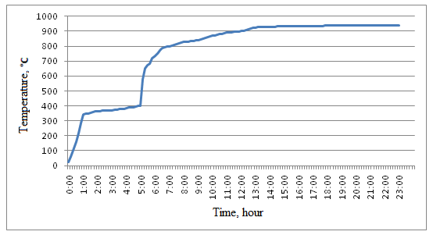

Figure В.1 – Drying and heating of the steel ladle lining

Figure В.2 shows a graph of temperature stresses in the lining of a steel-teeming ladle when it is heated.
The existing heating schedule for the steel ladle lining is critical for the resulting temperature stresses. During the heating process, two time periods are allocated on the graph for compression stresses, the temperature stresses in which exceed the permissible ones (0 h 20 m – 3 h 10 m; 5 h 10 m – 8 h 40 m); the graph for tensile stresses also has two periods (0 h 30 m –
3 h 00 m; 5 h 00 m – 8 h 30 m). When heated, a compression stress (σ_{с}) occurs in the high-temperature section from the average temperature, and a tensile stress (σ_{р}) occurs in the low-temperature section. The maximum value of the compression stress is 3.24 times higher than the permissible value, and the tensile stress is 2.7 times higher.

Figure В.2 – Emerging temperature stresses

Using the developed mathematical model, a rational (recommended) heating schedule for the lining of a 25-ton steel ladle was obtained (figure В.3).

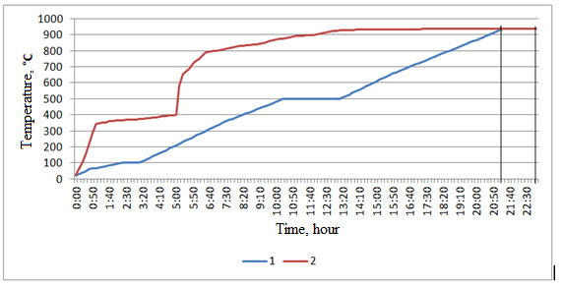

1 – streamlined the schedule of warm-up; 2 – factory default chart warm-up

Figure В.3 – Heating charts for the lining of a 25-ton steel ladle

Sintering furnaces. Figure В.4 shows the schedule for drying and heating the sintering furnace lining.

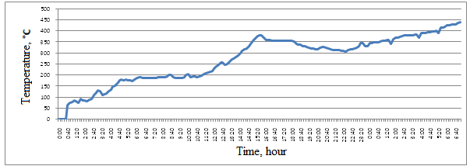

Figure В.4 – Factory schedule for heating the sintering furnace after major overhauls (built graph)

According to these values, the temperature stresses that occur in the furnace lining were calculated (figure В.5).

Figure В.5 – Emerging temperature stresses

Then the drying and heating modes of the sintering furnace lining were rationalized. The recommended schedule for heating sintering furnace lining is shown in figure В.6.

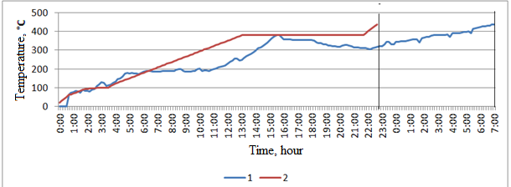

1 – Factory warm – up schedule; 2 – Rationalized warm-up schedule

Figure В.6 – Heating graphs for the sintering furnace lining

Conclusions. Rationalized heating schedules for the considered high-temperature units (25-ton steel-teeming ladle and sintering furnace) allow the heating process to be carried out without exceeding the strength limit of the refractory materials used and reduce the heating process by 2 hours for the steel ladle; by 2 hours 20 minutes for the sintering furnace.

APPENDIX C
Work schedule
Task code, stage | Name of the work under the Agreement and the main periods of its implementation |  |  | Period of implementation |  |  |  |  |  | Expected Result
Task code, stage |  |  |  | Start |  |  | Ending
2018 год
1 | Conduct a research and collect data on the maintenance of operating high-temperature equipment |  |  | January 2018 |  |  | March  2018 |  |  | A survey and a collection of data on the maintenance of the operating high-temperature equipment will be carried out. Statistical data on the maintenance of high-temperature units will be obtained.
2 | Analysis of operating non-stationary conditions of the equipment (the starts and stops) |  |  | April 2018 |  |  | May 2018 |  |  | An analysis of the operating non-stationary conditions of the equipment (the starts and stops) will be carried out. The main reasons for emergency situations and the withdrawal of the equipment for repairs will be determined by the analysis of these data.
3 | Article writing and business trip to Kaliningrad |  |  | May 2018 |  |  | May 2018 |  |  | An article will be written and a business trip will be made to Kaliningrad. A report will be made at an international conference and the article will be published in the conference collection.
4 | Business trip to Novosibirsk for consultations |  |  | June 2018 |  |  | June 2018 |  |  | A business trip to Novosibirsk for consultations will be made. Data on the maintenance of high-temperature units will be obtained.
5 | Conduct a study of the initial stage of the heating process – drying; determine the basic parameters of drying that affect the process of heating |  |  | June 2018 |  |  | October 2018 |  |  | A study of the initial stage of the heating-drying process will be carried out; the main parameters of the drying process that affect the heating process will be determined. Data on the actual heating processes at the initial stage (their duration, the amount of moisture removed, the speed and intensity of drying) will be obtained.
6 | Research article writing |  |  | October 2018 |  |  | November 1, 2018 |  |  | Articles based on the research results will be written. One publication in a peer-reviewed foreign scientific journal with a non-zero impact factor indexed by the Web of Science or Scopus databases (the journal “Glass and Ceramics”), one publication in a peer-reviewed foreign scientific journal with a non-zero impact factor (RCI) and three publications in scientific journals and conference proceedings will be published.
7 | Writing a report for the first year of the research |  |  | October 2018 |  |  | November 1, 2018 |  |  | A report for the first year of the research will be written.
2019 год
8 |  | Conduct a study of thermal and strength properties used in enterprises of refractory and insulating materials. |  |  | January 2019 |  |  | April 2019 |  |  | A study of the thermophysical and strength properties of refractory and heat-insulating materials used in high-temperature units will be carried out. Taking into account the specifics of the work of refractory materials in high-temperature units, data on the thermophysical properties of refractory and insulating materials will be obtained.
9 |  | Scientific internship at the Ural Federal University (Yekaterinburg, Russia) |  |  | April 2019 |  |  | April 2019 |  |  | A scientific internship at the Ural Federal University (Yekaterinburg, Russia) will be carried out. Skills to calculate the reliability of the residual life of the equipment, taking into account the conditions of its maintenance, will be obtained.
10 |  | Article writing and business trip to Kaliningrad |  |  | May 2019 |  |  | May 2019 |  |  | An article will be written and a business trip will be made to Kaliningrad. A report will be made at an international conference and the article will be published in the conference collection.
11 |  | Develop a mathematical model of the thermal performance of the linings in high-temperature units |  |  | May 2019 |  |  | August 2019 |  |  | A mathematical model of the thermal performance of the linings in high-temperature units will be developed.
12 |  | To develop and apply for a patent on the method (device) for the project. |  |  | September 2019 |  |  | November  2019 |  |  | Two patent applications for a new method (device) on the theme of this project will be developed and filed.
13 |  | Business trip to Omsk for consultations |  |  | October 2019 |  |  | October 2019 |  |  | A business trip to Omsk for consultations will be made. An analytical report on the methods for calculating the reliability of operation of high-temperature units will be filed.
14 |  | Research article writing |  |  | October 2019 |  |  | October 2019 |  |  | Articles based on the research results will be written. One publication in a peer-reviewed national scientific journal with a non-zero impact factor and two publications in scientific journals and conference proceedings will be published.
15 |  | Writing a project report for 2019 |  |  | October 2019 |  |  | November 1, 2019 |  |  | A project report for the second year of the research will be written.
2020 год
16 | Develop rational modes of drying, heating and cooling of high-temperature units |  | January 2020 |  |  | April 2020 |  |  | Rational modes of drying, heating and cooling of high-temperature units will be developed.
17 | Develop the economic efficiency |  | January 2020 |  |  | July 2020 |  |  | Cost-effectiveness issues will be developed. The indicators of the economic efficiency of the proposed technical solutions (necessary costs, payback period) will be calculated, which is necessary for introduction of the developments into production.
18 | Article writing and business trip to Kaliningrad |  | May 2020 |  |  | May 2020 |  |  | An article will be written and a business trip will be made to Kaliningrad. A report will be made at an international conference and the article will be published in the conference collection.
19 | Business trip to Almaty for consultations |  | May 2020 |  |  | May 2020 |  |  | A business trip to Almaty for consultations will be made. The applicable methods for calculating the economic efficiency of the introduction of regime cards will be determined.
20 | Research article writing |  | June 2020 |  |  | September 2020 |  |  | Articles based on the research results will be written. One publication in a peer-reviewed foreign scientific journal with a non-zero impact factor indexed by the Web of Science or Scopus databases (the journal “Instruments and Experimental Techniques” or “Refractories and Industrial Ceramics”), and five publications in scientific journals and conference proceedings will be published.
21 | Publication of a monograph on the theme of the research |  | June 2020 |  |  | September 2020 |  |  | A monograph on the research theme will be published.
22 | Development of regime maps of variable operating modes (drying, preheating and cooling processes) for attendants |  | August 2020 |  |  | November 2020 |  |  | Regime cards of variable modes of operation (drying, heating and cooling) for the service staff will be developed. Regime maps of drying, heating and shutdown of high-temperature units will be obtained.
23 | Writing a final project report |  | September 2020 |  |  | November 1, 2020 |  |  | The final project report will be written.

