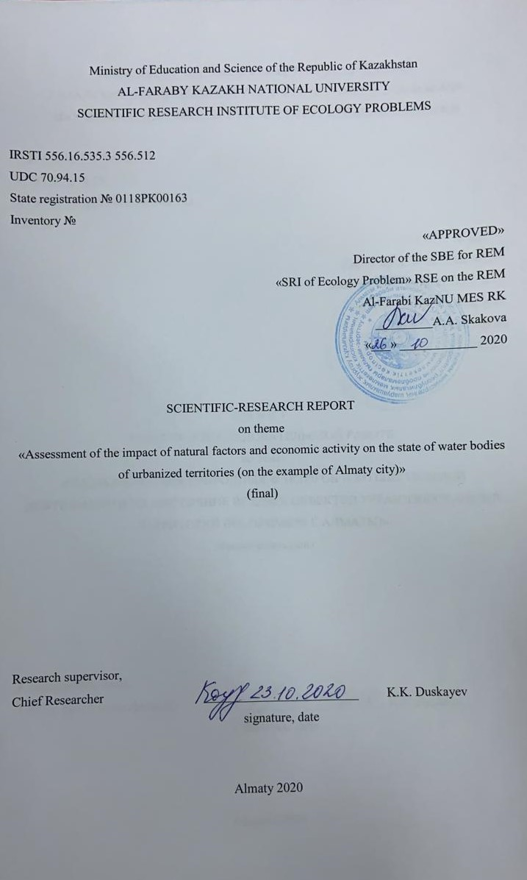
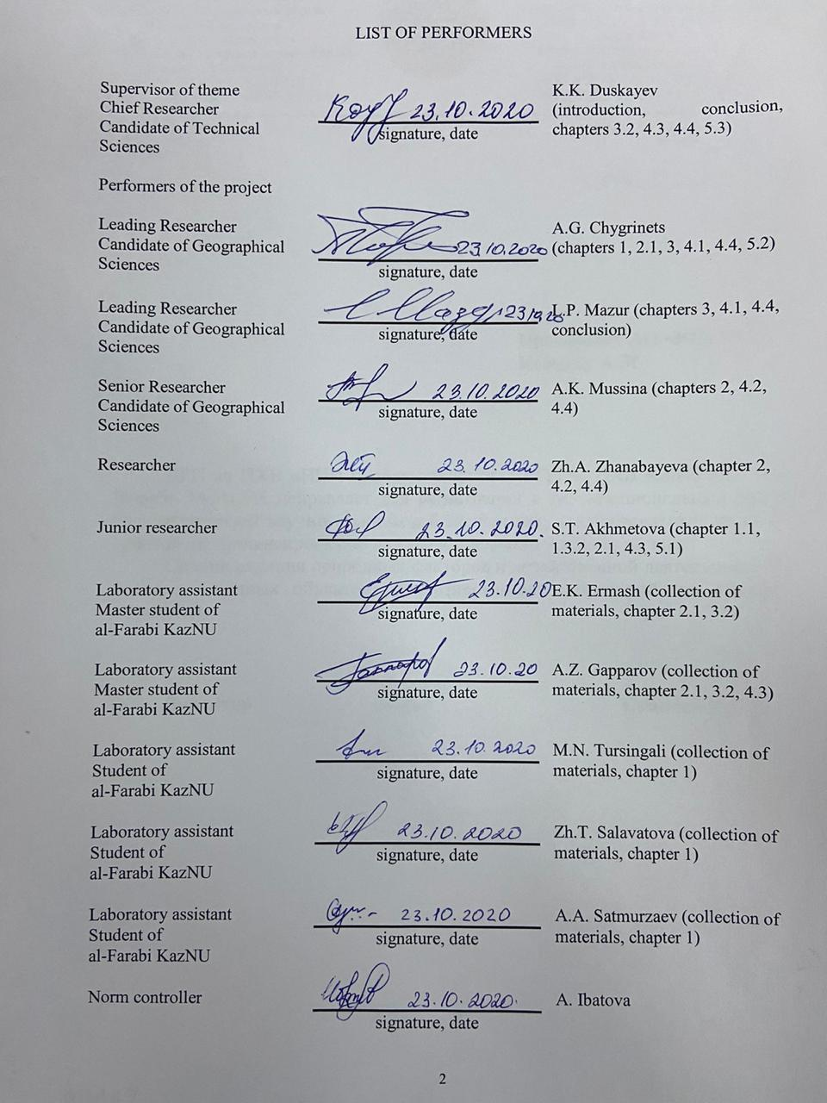

ABSTRACT

The report includes 191 pages, 11 figures, 74 literature sources and 3 annexes.
SMALL RIVERS, URBANIZATION, URBANIZED AREA, HYDROGRAPHY, CALCULATED CHARACTERISTICS OF RUNOFF, WATER DISCHARGE, CHANNEL WATER BALANCE, SCHEMATIC MAPS.
The object of research is the water bodies of urbanized territories (by example, the Almaty city).
Research purpose: identifying patterns and taking into account the impact of urbanized and adjacent territories on the elements of hydrological processes occurring a result of anthropogenic and natural changes in the hydrological cycle, using the example of the largest metropolis of the Republic of Kazakhstan - Almaty.
Research methods: geographic-hydrological method, landscape-differentiated, mathematical statistics, spatial analysis.
The main obtained results: modern hydrography and updated hydrographic characteristics, calculated characteristics of the annual, maximum and minimum runoff, channel water balance of mountain springs and karasu rivers, updated schematic maps of modern hydrography, generalized materials on accounting for the impact of the Almaty megalopolis on the hydrometeorological characteristics and water balance of its territory.
Scientific novelty: for the first time comprehensive studies were carried out to clarify the hydrographic characteristics of water bodies in the Almaty territory; quantitative hydrological characteristics of changes in runoff and water balance elements under the influence of the Almaty megalopolis were obtained; based on the results of field measurements, the main patterns of formation and characteristics of the channel water balance were revealed.
Application area: scientific support for management and planning of measures to reduce the harmful impact of urbanized areas on water bodies by national and municipal authorities of Almaty and other urbanized areas.
Scientific and practical significance is the development of a methodological and information-cartographic base to reduce the negative impact of urbanization on hydrological characteristics by the example of the rivers of Almaty.
During the conducting research are involved three bachelor students, 2 master students and a PhD student of the Meteorology and Hydrology Department of al-Farabi KazNU.

CONTENT

 |  | pages
Introduction |  | 7
1 | Analysis of the studying and conditions of formation of watercourse of Almaty city | 9
1.1 | Meteorological and hydrological studying of the study area | 9
1.2 | Creation of a database of hydrometeorological characteristics | 10
1.2.1 | Structure and content of the bank of hydrological characteristics | 10
1.2.2 | Structure and content of the bank of meteorological characteristics | 11
1.3 | Conditions for the runoff formation of watercourses of Almaty | 11
1.3.1 | Relief and orography, geological conditions | 11
1.3.2 | Climatic factors of river runoff formation | 13
1.3.2.1 | General information | 13
1.3.2.2 | Wind | 13
1.3.2.3 | Radiation balance | 14
1.3.2.4 | Air temperature | 14
1.3.2.5 | Precipitation | 14
1.3.2.6 | Air humidity, evaporation, soil temperature | 15
1.3.2.7 | Snow cover | 15
1.3.2.8 | Depth of soil freezing | 15
1.4 | Soil and vegetation cover | 16
2 | Assessment of the dynamics and the current state of hydrography of the Almaty territory | 18
2.1 | Field researches of city hydrography | 18
2.2 | Transformation of hydrography and water bodies under the influence of the Almaty megalopolis | 18
2.3 | Drafting a schematic map of modern hydrography of Almaty by using GIS technologies | 23
3 | Evaluation of the channel water balance of the main rivers of the Almaty territory | 25
3.1 | Water balance zones of rivers of the Almaty city territory | 25
3.2 | Measurement technique of channel water balance | 26
3.3 | Measurements results of the channel water balance of rivers of the Almaty territory | 27
4 | Calculation of the characteristics of water runoff in the Almaty territory | 30
4.1 | Calculation of the norm and variability of the annual runoff | 30
4.2 | Calculation of the maximum runoff characteristics | 31
4.3. | Calculation of the minimum runoff characteristics | 32
4.4 | Recommendations for the determination of runoff characteristics for unexplored rivers | 33
5 | Estimation of the trends of variability of the water runoff of the rivers of Almaty for a long period depending on natural and anthropogenic factors | 36
5.1 | Modern dynamics of changes in climatic characteristics of Almaty | 36
5.2 | Assessment of trends in water runoff variability in Almaty rivers over a long-term period depending on natural and anthropogenic factors | 40
5.3 | Recommendations for taking into account the influence of natural, anthropogenic factors on the hydrological characteristics of water bodies in urbanized areas and improving the ecological state of small rivers (on example Almaty) | 43
Conclusion |  | 45
List of used sources |  | 47
Appendix |  | 53

INTRODUCTION

Currently, the rapid development and expansion of urbanized areas have a negative impact on the ecology of cities, including water bodies. Urbanization processes strongly negatively affect watercourses and reservoirs within urbanized areas.
The water bodies of Almaty, the largest metropolis of Kazakhstan are of great national economic importance not only for the southern region, but also for the whole republic as a whole. The water resources of these rivers, canals and reservoirs of Almaty are widely used for drinking and industrial water supply, irrigation, electricity generation, recreation and other purposes. The high concentration of the population in Almaty, the development of various forms of management near and directly on water bodies, their great vulnerability have led to significant pollution and degradation of rivers and reservoirs of the city.
The fundamental condition for improving the living comfort and health of Almaty residents is the creation of an ecologically safe water environment, the availability and reliability of the water use services provided, the effective and balanced development of the water sector of the southern capital. The creation of such conditions is possible based on detailed researches of all types of impact on water bodies of the city.
Purpose of the study: identifying patterns and taking into account the impact of urbanized and adjacent territories on the elements of hydrological processes occurring as a result of anthropogenic and natural changes in the hydrological cycle, using the example of the largest metropolis of the Republic of Kazakhstan - Almaty.
Assessment of the impact of natural and anthropogenic factors on water bodies in urbanized areas is a complex and very relevance problem, the solution of which is of great scientific, social and applied importance.
The project has carried out in the period 2018-2020 in three stages.
The main results of the first stage (2018) inventory number: 0218RK00539: modern data on the river exploration, conditions of runoff formation, peculiarities of the water regime, economic use of water bodies in the Almaty territory; modern hydrography and updated hydrographic characteristics of the watercourses of the river Kishi Almaty; data bank of hydrometeorological characteristics.
The results of the second stage (2019) inventory number: 0219RK00650: calculated characteristics of the annual, maximum and minimum water runoff of the main rivers. Channel water balance of mountain springs and river-karasu, schematic maps of modern hydrography, hydrometeorological exploration, and herringbone schemes for economic use and schemes points for measuring the channel water balance of the Almaty territory.
The results of the third stage (2020): recommendations for determining the hydrological characteristics of unexplored rivers, generalized research materials on taking into account the influence of the Almaty megalopolis on the hydrometeorological characteristics and water balance of its territory. Based on the research results, the monograph "Rivers of the Almaty megapolis" was prepared for publication. Works on all three stages has fully completed, in accordance with the work schedule. The main results of the work on the first (2018) and second (2019) stages of the topic are detailed in the interim reports on the topic over the years; the conclusions are given in the conclusion.
As an information basis for research on the project were used the following: cartographic materials of the Republican State Treasury Enterprise "National Cartographic and Geodetic Fund"; observational data of the RSE "Kazhydromet" for 1932-2015 years: Hydrological Yearbooks, Annual data on the regime and resources of surface waters on land, Basic hydrological characteristics, Long-term data on the regime and resources of surface waters on land. Surface water resources of the USSR. The names of the hydrological gauging stations and rivers are given as they are cited in the cadastral materials of the RSE "Kazhydromet".
The methodological basis of the research was the standards of the State Construction Committee (USSR) and the In Russian Federation, as well as Set of rules-33-101-2003 - "Determination of the main design characteristics". All calculations were performed in accordance with the requirements of regulatory documents.
In addition to the main performers are involved three bachelor students, two master students and PhD doctoral student of the Department of Meteorology and Hydrology of the KazNU named after al-Farabi.

1 Analysis of the studying and conditions of formation of watercourse of Almaty city

1.1 Meteorological and hydrological studying of the study area
Basin of the Kishi Almaty River (according to [1-6]). The first hydrological gauging station in the river basin was opened in 1912, 7 km above the Almaty city. Since 1934, a hydrometric network has been developing in the river basin, which consisted of more than 50 gauging stations. Currently in the river basin Kishi Almaty (according to RSE Kazhydromet), there are only 7 hydrological gauging station (1 water gauge point).
Basin of the Ulken Almaty River (based on materials [1-7]). The first hydrological gauging station on the Ulken Almaty River was organized back in 1907. The change in the hydrological characteristics of the river over time has been widely studied since 1928. In total, about 40 gauging station operated in the river basin [8]. Currently, there are only five operating gauging stations.
Kargaly river basin. The hydrological gauging stations on the Kargaly River was opened in 1938. Hydrological gauging stations river Kargaly (Kukuzek, Kargalinka) – Chapaev village functioned with small interruptions in observations until 1983.
Aksai river basin. The first gauging station on the Aksai River was opened in April 1912. Regular observations in cadastral materials have been provided since 1928. The gauging station worked until 1988. In the river basin Aksai observations were carried out on mountain springs: on the Tastybulak stream in the alignment of the Aksai village and on the Oyzhailau stream near the Kamenka village. General information on the hydrological studying of the Almaty territory is given in the research report 2018 by this project.
The beginning of systematic meteorological observations in Kazakhstan dates back to the fifties of the 19th century. Meteorological station Almaty united hydrometeorological station [9] in the period 1859-60 was located on the territory of the fortress Fortification Verny. Since July 1878 the station has been located in the Bolshoi Alma-Ata village. Since October 1908, the meteorological station has been located in the center of the Verny city. In 1915, the meteorological station was moved 2 km to the north-west and set up in a designated area on the southern outskirts of the city.
Weather station Almaty Kamenskoe Plateau [9]. Meteorological observations at Kamenskoe Plateau station were organized in June 1931. Observation period: from June 1931 to 1941 and from 1961 to the present. The name of the station: since 1931 - Kamenskaya Shchel, since 1939 - Kamenskoe Plateau, since 1961 - Alma-Ata-agro.
Meteorological station Almaty BAL [9]. Meteorological observations at the Big Almaty Lake were organized in 1915. Observation period: from 1915 to January 14, 1916, from July 14, 1925 to the present.
Meteorological station Almaty Mynzhilki [9]. Meteorological observations at the high-mountain station Myn-Dzhylki were organized in July 1935. Observation period: from July 1935 to the present.
Snow avalanche station Shymbulak. In 1973, the Shymbulak avalanche station was opened, which has also been conducting meteorological observations since 2000.
General information on the meteorological studying of the Almaty area is given in the research report 2018 by this project.

1.2 Creation of a data bank of hydrometeorological characteristics
1.2.1 Structure and content of the bank of hydrological characteristics
As noted earlier, the studying of water runoff in the area under consideration was begun back in 1907 on the river Ulken Almaty and in 1916 on Kishi Almaty. In total, in the river basins of the study area, there were about 90 gauging stations belonging to various departments. Currently in the river basin Ulken Almaty (according to Kazhydromet) there are only five hydrological gauging station, and in the basin of the river Kishi Almaty 7 hydrological gauging station, of which one water meter [10-15].
The most detailed and high-quality observations of river water runoff began to be carried out from the 30s-40s, and now the archives contain materials of these observations on almost 30 hydrological gauging station, which were under the jurisdiction of Kazhydromet, the Department of Water Resources, the Almaty Hydrogeological Station, etc. Observations of departmental gauging station of low quality, measurements on them are irregular and are carried out mainly during the growing season. In total, the generated databank contains information on river water runoff at 54 observation points at gauging stations of the RSE "Kazhydromet" and departmental organizations. The databank contains information on average monthly, average annual, maximum and minimum water runoff and the dates of their occurrence for all available observation periods. The published cadastral materials were used: "Hydrological Yearbooks", "Basic Hydrological Characteristics", "Annual data on the regime and resources of surface waters of the land", "Long-term data on the regime and resources of surface waters of the land", "Resources of surface waters of the USSR" [10-15], as well as "Observation materials at the Alma-Ata mudflow station" [4]. Due to the requirements for limiting the volume of the report, data on the average monthly and average annual water flow for individual reference gauging stations of the study area are given in the research report 2018 by this project and information on the maximum and dates of their occurrence, and the minimum water discharges are given in the research report 2018 by this project.

1.2.2 Structure and content of the bank of meteorological characteristics
Today in the Almaty city, there are four meteorological stations (Almaty, Kamenskoe Plateau, BAL, and Mynzhilki), one snow avalanche (Shymbulak), where carried out meteorological observations, as well as one aerological station.
Regular meteorological observations in Almaty began to be carried out in 1915, and currently the archives contain materials of these observations at all observation points that were under the jurisdiction of Kazhydromet. In total, the generated data bank contains information on climatic parameters for six observation points. The databank contains information on average monthly, average annual air temperatures and precipitation amounts for all available observation periods. The following published cadastral materials were used: “Handbook on the climate of Kazakhstan. Long-term data”, “Scientific and applied reference book on climate” [1], as well as the website of the weather archive of the RSE “Kazhydromet” rp5.kz. Due to the requirements for limiting the volume of the report, data on average monthly and average annual air temperatures and precipitation amounts for individual stations in the study area are given in the research report 2018 by this project.

1.3 Conditions for the runoff formation of watercourses of Almaty
The main natural factors in the formation of river water runoff can be considered the relief, geological structure of the territory, climate, soils and vegetation, hydrography and water regime of rivers, as well as anthropogenic impact. The drainage basins of the four main rivers flowing through the city of Almaty - Ulken and Kishi Almaty, Kargaly and Aksai, are located in the central part of the northern slope of the Ile Alatau ridge.

1.3.1 Relief and orography, geological conditions
In mountainous regions, the dominant factor determining the altitudinal zonation of hydrological elements and, in particular, the mountain rivers runoff is the relief. The Ile Alatau, being one of the extreme northern arcs of the Tanirtau (Tien Shan) mountain system, extends in a sublatitudinal direction (43 ° N) between 75 ° and 78 ° E. The highest point of the ridge is Talgar peak, reaching 4973 m abs [7, 16-17], which conventionally divides the ridge into two parts - east and west and is the center of modern glaciation. The northern part of the ridge is represented by a strip of foothill plains [18]. The highest absolute heights (4000-4500 m abs and more) are noted in the central part of the ridge - Talgar (Shilik-Kemin) mountain cluster. The most characteristic and clearly manifested regularity of the structure of the surface of the Ile Alatau, and the northern slope in particular, is its tiered structure. In the mountainous part, there are three high-altitude relief belts: high-mountain-glacial, mid-mountain and low-mountain-foothill, smoothly turning into a foothill (foothill) plain, and within the foothill-plain part, two zones are distinguished: a zone of fanning cones and a zone of foothill accumulative plain [7, 16-19].
The alpine-glacial belt (above 2800-3000 m) occupies about 40 % of the area of its mountainous territory, mainly the axial zone of the ridge. The external appearance of the relief of the high-mountain-glacial belt was created by tectonic movements of the greatest amplitude, slope denudation, ancient and modern glaciation.
Mid-mountain zone (from 1400-1500 m to 2800-3000 m). Occupies about 25 % of the mountainous area of the Ile Alatau. Above 2000 m, this belt is characterized by a significant dissection of the relief by a network of gorges and deep V-shaped valleys, the presence of steep slopes from 25-35 ° to 40 °. Below 2000 m, the steepness of the slopes decreases to 20-30 °. The mid-mountain zone influences the formation of water runoff by melted snow, storm and ground waters.
The low-mountain foothill belt (from 800-900 m to 1400-1500 m) occupies about 35 % of the area of the mountainous territory of the Ile Alatau. This belt is characterized by mountain ranges that extend from the ridge massif in a northern direction. The river valleys reach a depth of 300-400 m and look like gorges. The presence of “counters” is typical - flattened massive ridges, which are composed of a stratum of Neogene-Paleogene and boulder-pebble Quaternary deposits. The relief of the low-mountain belt is distinguished by insignificant amplitudes of heights, but significant horizontal dissection.
The sloping foothill plain begins from the foot of the mountains, which turns into the flat lowland of the Ili depression. Geomorphologically within the limits of this foothill-lowland part, two zones are distinguished: the zone of the fan and the zone of the foothill accumulative plain. Fan cones are located at heights from 1000 to 800 m. Their average slope is about 3 °, and their width reaches 10-12 km [7].
Geology. The geological structure of the mountain river basins of the Ile Alatau has a significant impact on the runoff and water balance. The Ile Alatau high mountain range has a complex geological history. One of the first uplifts in its place occurred 300-400 million years ago, in the so-called Caledonian period of mountain building. After that, tens of millions of years have passed, these ancient mountains were destroyed by the processes of physical and chemical weathering, flooded by the waters of the ancient sea. However, 200-250 million years ago, during the period of the Hercynian folding, powerful uplifts occurred again, accompanied by the outpouring of large masses of molten magma. Most of the Ile Alatau granites date from this time. The subsequent destruction of the mountains took place up to the period of the alpine mountain-forming process (tens of millions of years ago), which created the general appearance of the modern relief. The most intensive uplift of the ridge took place in the last 300-400 thousand years. Frequent earthquakes testify to incessant mountain building processes in our time. Throughout its history, the city has experienced two catastrophic earthquakes (1887 and 1911), as well as dozens of medium ones. The territory under consideration belongs to the most active seismic regions in Asia by most of its characteristics. Special studies show that the Ile Alatau “grows” by an average of 3-5 mm annually. This is a very significant value. So, in geological terms, the Ile Alatau are young mountains [9, 18-20].
The removal cones of the main rivers located at the foot of the ridge are formed by Upper Quaternary deposits, which have different thicknesses: from 40 m in the valley of the river Shilik and 70 m in the valley of the river Uzun-Agash, up to 430 m in the valley of the river Kishi Almaty.
The hydrogeological conditions of the Ile Alatau territory were studied by N.G. Kassin (1930), V.F. Shlygin [21], U.M. Akhmedsafin [22-23] and other researchers. According to [17], there are fractured waters prevail here. The depth of their occurrence ranges from zero to 100 m. Due to the large dissection of the relief, fissure waters are intensively drained by river valleys and participate in the formation of deep-water underground runoff [7].

1.3.2 Climatic conditions for river runoff formation
1.3.2.1 General information
The Almaty city is mainly located in the foothills of the northern slope of the Ile Alatau ridge on an alluvial cone that gradually decreases from south to north. The average height of the city is 800 m BS. To the south and southeast of Almaty, a strongly rugged hilly foothill begins, which, as it rises, passes into the Ile Alatau ridge. Newly built areas in the southern part of the city are located in the foothills.
To study the climatic characteristics of the Almaty territory for the following as reference meteorological stations were selected: Airport, Almaty and Kamenskoe plateau.
The choice of meteorological stations characterizing the climate of Almaty is dictated by the zoning distribution of climatic characteristics depending on the altitude of the city district.

1.3.2.2 Wind
Meteorological conditions of Almaty are determined by its location in the foothill zone and the presence of mountain-valley atmospheric circulation here. Due to the fact that the central part of the city is located at the junction of two inclined planes, the territory of the city is not always under the influence of circulation. The mountain airflow is heated due to adiabatic compression, flows over the cold layers adjacent to the earth's surface and cooled by radiation cooling. Thus, a powerful surface temperature inversion is formed, which persists for a long time in winter. Hence, weak winds characteristic of Almaty, the frequency of calm a year on average 28 %.
The average monthly wind speed is 1-2 m/s, the maximum speed is 10-15 m/s. In a clearly pronounced annual course, there is an increase in wind in the summer months and a weakening to calm values in winter. Throughout the year, winds with a speed of up to 2 m/s prevail in Almaty. The share of calm is especially high. The total frequency of calm and very weak winds (up to 1 m/s) is 76 % in the city and 56 % in the foothills.
The mountain-valley circulation in the Almaty area is determines the prevalence of winds from the southern and southeastern directions (45 %). The next direction in terms of frequency is north (16 %).

1.3.2.3 Radiation balance
The annual course of the radiation balance is repeats the basic course of the total radiation. The maximum values of the radiation balance fall on June-July, the minimum is observed in December-January and has a negative value.
In the winter months, the monthly amounts of the radiation balance vary significantly depending on the presence or absence of snow cover.

1.3.2.4 Air temperature
The average annual average annual air temperature in Almaty is 9 °С. Average monthly (29.8 °С) and absolute (43.0 °С) maximums of air temperature are observed in July. In the foothills, these figures are lower. On an annual basis, the minimum air temperature is observed in January (minus 6.5°С), while the absolute minimum (minus 38 °С) falls on February. In the foothills, the minimum temperatures are higher than in the city.
The continental climate of Almaty determines a significant amplitude of air temperature fluctuations. The amplitude of average monthly temperature values in the meteorological station Almaty is 40 °С, absolute values 82 °С. The relief plays an important role in the formation of the thermal regime in Almaty. Taking into account the influence of mountain-valley circulation and the transformation of solar heat, one can note a decrease in the continental climate of the southern (foothill) areas of the city compared to the northern ones. The average annual mean annual air temperature as it rises up the northern slope of the Ile Alatau gradually decreases, turning into negative in the high mountain regions. Therefore, at the Mynzhilki meteorological station, it is equal to minus 2.0 °С.

1.3.2.5 Precipitation
Annual precipitation on the northern slopes of the Ile Alatau increases to a height of 2 thousand meters: in the airport area the average annual amount is 420 mm, at the Almaty meteo-station - 626 mm, Kamenskoye plateau - 871 mm. According to the nature of the intra-annual distribution of precipitation in Almaty, there are two minimums (in January and August) and two maximums (in May and October). One third of the annual precipitation falls in the period April-May.
Annual precipitation in Almaty and the foothills corresponds to the zone of sufficient moisture (Moscow, Riga, etc.), but the peculiarity of their annual distribution and the high temperature background of the warm period create conditions of aridity here.

1.3.2.6 Air humidity, evaporation, soil temperature
From May to October, the evaporation rate in Almaty exceeds the amount of precipitation several times; the annual amount of evaporation is twice the annual amount of precipitation.
This means that only half of the amount of moisture that can evaporate at an average air temperature and average relative humidity, calculated by N.N. Ivanov:

Еm = 0,0018 (25 + t)² (100 – a), (1.1)

where Em - evaporation rate per month, mm; t is the average monthly air temperature, °С; a - average monthly relative humidity,%.
Soil temperature and saturation deficit have an intra-annual variation; a maximum similar to air temperature is observed in July, and a minimum in January.

1.3.2.7 Snow cover
An increase in the altitude of a site above sea level within the city from north to south has an impact on the timing and nature of snow cover in Almaty. The first snowfalls are observed at first in the southern outskirts of the city - in the first ten days of October in the Medeu region. In the second decade of the month, snow cover is observed directly in the city, and in the third decade - in the northern regions, near the airport. In some years, deviations from the average dates of the establishment of snow cover fluctuate within a month both towards earlier and later dates.

1.3.2.8 Depth of soil freezing
The thermal properties of the soil depend on a number of factors: landforms, air temperature, soil texture, etc. The depth of penetration of the temperature 0 °С into the soil is taken as the depth of soil freezing. In Almaty, stable soil freezing is observing from November to March. The maximum penetration depth of 0 °С temperature is observed in February. Its value varies within the city from south to north: at the Kamenskoye plateau meteorological station, the freezing depth is 0.58 m, at Almaty station - 0.91 m, at the airport - 1.26 m.

1.4 Soil and vegetation cover
Land cover is an important factor in runoff formation and water quality. The distribution of the soil and vegetation cover clearly shows vertical zonation, exposure differences due to the influence of the relief, dynamic geological processes, climatic conditions, the composition and properties of parent rocks, anthropogenic activity, etc. The vertical zonation is most fully manifested in the central part of the ridge, within its northern slope.
In the northern part of the city, up to heights of 600-700 m, there is a foothill desert-steppe belt. Light chestnut calcareous soils and gray soils prevail here. The vegetation is represented by the wormwood-fescue association with the participation of poppies, feather grass, bluegrass, etc. The natural appearance of the belt has been greatly altered by economic activity.
Above there is a mountain-steppe belt up to heights of 1300-1400 m. The soils are dark chestnut and mountain black earth. The vegetation is feather-grass-forb with a wide participation of shrubs - dog rose, buckthorn, barberry, etc. This is a zone of cultivated orchards, ornamental plantings and garden plots. This altitudinal belt is most strongly susceptible to anthropogenic impact, since significant areas are occupied by summer cottages.
In the southern part of the city and higher, up to an altitude of 2800-2900 m, there is a forest-meadow belt. In the lower part of the forest belt, there are deciduous forests (aspen, birch, mountain ash, wild apple, apricot, hawthorn), higher are coniferous forests (spruce). One of the main representatives here is the Tien Shan spruce (Shrenka spruce), which usually occupies the northern slopes and partly the bottom of river valleys. In treeless areas, there are tall grass meadows. The soils are mountain-forest dark-colored, podzolized black earth and mountain-meadow black earth. In the upper part of the belt there are subalpine meadows with mountain-meadow and meadow-steppe soils and meadow and meadow-steppe vegetation. Outcrops of bedrocks are widespread in this belt.
The soils of the city, which have been experiencing technogenic loads for a long time, and, in contrast to their natural counterparts, are characterized by greater compaction, the lowest coefficient of porosity and filtration. The soils adjacent to highways are enriched with lead, and in industrial zones the soils accumulate substances contained in the emissions of nearby industries.
Vegetable world. On the city territory there are green spaces of various functional purposes: common use (parks, squares, boulevards, recreation areas, etc.); limited use (green spaces on the territories of industrial enterprises, educational institutions, etc.); special purpose, etc.
The composition of urban plantings includes 550 species of trees, except for fruit trees, 30 species of shrubs, excluding those growing in the Botanical Garden. The main species for Almaty are: pyramidal poplar, feathery elm (elm), birch, acacia, white poplar, oak, maple, ash, linden, willow. Coniferous and fruit trees are widespread.
It should be noted that all groups of green spaces in Almaty are now in critical condition. The majority of deciduous trees are physically obsolete and pose a potential hazard to human health and life in adverse weather conditions.

2 Assessment of the dynamics and the current state of hydrography of the Almaty territory

2.1 Field researches of city hydrography
During the period of field surveys of river basins belonging to the Almaty territory, information was collected on the state of the river network, on anthropogenic load on river systems, on changes that occurred as a result of redevelopment of the urban area, and on changes in the hydrography of the main rivers and their tributaries.
In 2018, the Kishi Almaty River basin and adjacent territories with rivers passing through the city territory were surveyed. Reconnaissance surveys were carried out on the upper reaches of the Kishi Almaty River and its main mountain tributaries - Sarysay with the Shymbulak, Kuigensay, Kimasar tributaries with the Left and Right Ortasay tributaries, the left-bank mountain tributaries of the Kazakhkyzy (Kazashka) and Bedelbay (Batareika), and right-bank tributary Butak with tributary Shybinsay.
In 2019, a survey was carried out of the basins of the Ulken Almaty, Kargaly and Aksai rivers, with mountain tributaries, as well as the Karasu rivers - Boroldai, Zhainak, Terenkara, Ashybulak, Right Esentai, Sasybulak-karasu, "Parkhomenko log", Karasu and Malaya Karasu, Ulken-karasu, Sultan-karasu, Esenbay and a number of small springs.
Water intakes from rivers, sections of a stabilized channel, straightened sections of a channel, hydraulic structures aimed at reducing mudflow hazard, areas equipped for recreational purposes and with increased anthropogenic load were identified.
The data of field surveys of 1995-1996, 1999 and 2005-2007, within the framework of the ongoing project, were summarized with the results of field surveys in 2018 [8-9, 24-25]. As a result, it was revealed that due to the engineering redevelopment of urban areas, backfilling of individual sections of river channels, underground sewerage and inter-basin diversion of river runoff, as well as the improvement of individual sections of channels, significant changes have occurred in the hydrography of the urban area. The result of field surveys is a detailed hydrographic description of rivers illustrated with photographs, intended for writing a monograph on water bodies in the territory of Almaty, given in the research report 2018 by this project..

2.2 Transformation of hydrography and water bodies under the influence of the megalopolis of Almaty
Almaty city is located in the center of the Eurasian continent, in the south-east of the Republic of Kazakhstan. Geographic coordinates: 77˚54 'east longitude and 43˚15' north latitude. Almaty is located in the foothills of the Ile Alatau. Due to the water inflow from the mountains. The hydrographic network is well developed on the Almaty territory - the total length of permanent and temporary watercourses within the city is more than 200 km. The city has four main waterways: Kishi Almaty in the eastern part, Ulken Almaty, Kargaly and Aksai in the western part of the city.
The formation and transformation in time and space of the urban hydrographic network, caused by natural and anthropogenic factors, is one of the urgent problems of the development of urban areas. Man created a city - a human ecosystem, in accordance with their needs. The terrain chosen for the construction of the city changes significantly as it is developed and turned into an urban area. The development of an urban area leads to a change in all components of the natural landscape, including the hydrographic network: its structure, morphometric characteristics of water bodies, their level regime, flow conditions, hydrochemical composition, etc. Changes to the hydrographic network aimed at improving the comfort and safety of living are often accompanied by negative consequences. This is especially evident in ancient cities, including Almaty. The development of the urban area and the high technogenic load have led to a significant transformation of the landforms, and as a result - the conditions for the functioning and development of the hydrographic network.
The primary foundation of modern Almaty was the Zailiyskoe (Vernoe) fortification, built in 1854 on the right bank of the Kishi Almaty (formerly Malaya Almatinka) and the intersection of two caravan roads. One led to Tashkent and eventually became known as the Tashkent Alley (now Raiymbek Avenue), the other went to the Chinese Kuldja, therefore it was called the Kuldzhinsky tract. Not far away was the third road, which led to the Ili River, and after crossing it - to the cities of Kopal and Semipalatinsk. Then it was called the Kopalsky tract, now it is part of Suyunbai Avenue.
In 1856, along the western rampart of the fortress, the first residential area was formed - Bolshaya Almaty stanitsa. It was bounded by the left bank of the river Kishi Almaty (from the Central Park of Culture and Leisure to Bayanaulskaya st.), St. Makataev, the lower part of the Pushkin street and Suyunbai Avenue.
The second district, built after the foundation of the Vernoe fortification is Tatarka. It appeared to the east of the fortress in 1860. It is generally accepted that it begins from the territory below the zoo, from the river. Zharbulak (formerly Kazachka) and st. Dobrolyubov, to Mount Koktobe. Down almost to the Talgar tract.
The Malaya stanitsa district emerged in the late 1870s and was not included in the city limits until 1962. Its borders today can be considered the right bank of the Kishi Almaty to the river. Zharbulak, st. Dobrolyubov, Ryskulov Avenue. [26].
The modern hydrographic network of the city in many respects has developed spontaneously, hence another important problem is the scientific substantiation of projects for organizing the urban area and the rational use of water bodies, which requires knowledge of the peculiarities of the formation and development of the hydrographic network in the city under the influence of a set of factors and at different stages of development.
The conducted ground-based surveys of water bodies within the urban territory of Almaty made it possible to establish their change under the influence of natural and anthropogenic factors, to assess their current state.
The analysis of changes in the hydrographic network of the city was carried out by studying literary sources and cartographic data, starting from 1912. The topographic maps of 1912, 1942, 1989 and 2015 were studied in most detail, according to which maps of the transformation of urban areas were created. Also involved were modern satellite maps and online web mapping resources such as OpenStreetMap. The study of cartographic material was supplemented by a visual inspection of the locations of water bodies.
Within the framework of the grant theme, for the first time, not only published, but also archival and service materials were considered, which made it possible to significantly clarify the history of anthropogenic transformations of water bodies on the Almaty territory. The circumstances of the creation of some water bodies have been clarified, a number of documentary sources have been identified that have not previously been used in studies of the city's hydrographic network.
The influence of the anthropogenic factor led to the transformation of the appearance of the hydrographic network of Almaty. The initial stage was characterized by an indirect impact on water bodies through the plowing of floodplain lands, deforestation in the territory of drainage basins. The next stage was distinguished by a direct impact on water bodies associated with the construction of protective structures from the dangerous effects of hydrological hazards and new water bodies (ditches); backfilling and laying "in the pipe" of "inconvenient" water bodies (wetlands within the city, shallow streams); construction of canals and ditches for irrigation of agricultural land, etc. At the present stage, the anthropogenic impact on water bodies of the urban area is complex. It is associated with water intake; transformation of water bodies due to the improvement of territories; backfilling and sewerage of rivers and streams; runoff regulation; influence on the natural hydrochemical composition of water bodies.
For example, the Sairan reservoir appeared on the maps of Alma-Ata in 1971. On the site of the reservoir in the 60s of the last century, the quarry of the Almaty house-building plant was located. The sand and stone mined here were used for the production of panels, from which new micro-districts of Alma-Ata were built. When the quarry's reserves ran out, it was decided to create a recreation area with a reservoir in its place. To fill the basin with water, a dam was built from the side of Toli Bi Street (then Komsomolsky prospect) on the bed of the Bolshaya Almatinka River. The area around the new lake was reclaimed: paths were laid, the beach was poured and a boat station was organized.
The Esentai River is the left arm of the river Kishi Almaty. Currently, it is separated by a dam at the exit from the Small Almaty Gorge to the fan to the west of Gornaya Street, below the mouth of the river Butak. The Esentai River After leaving the city again merges with the river Kishi Almaty near the Otegen Batyr village. The Esentai River has been used since the second half of the 19th century to drain the melt water of Malaya Almatinka, which, during the melting of glaciers and heavy rains, overflowed the banks, which could lead to floods. This helped to protect the bridges and numerous mills built on the banks of the Malaya Almatinka from destruction.
In 1959, on the site of the dam, new engineering structures were built, thanks to which the employees of the State Institution "Kazselezashchita" still regulate the directions of flows and the water level in the rivers. In Soviet times, the “Vesnovskaya Canal System” functioned - a special network of irrigation engineering structures, which was used to irrigate about 3.5 thousand hectares of apple orchards located in the foothills of the Zailiyskiy Alatau.
The Big Almaty Canal, 168 km long, serves for the gravity feed of regulated drain of the Shilik River to the basins of the Turgen, Esik, Kaskelen and others rivers, to the fields and lands located around them. The channel crosses the main rivers of the Almaty city.
To identify changes in the river network, the outlines of urban areas of different years were superimposed on the modern Almaty map (Figure 1.1). For comparison, the modern river network of the city is given.

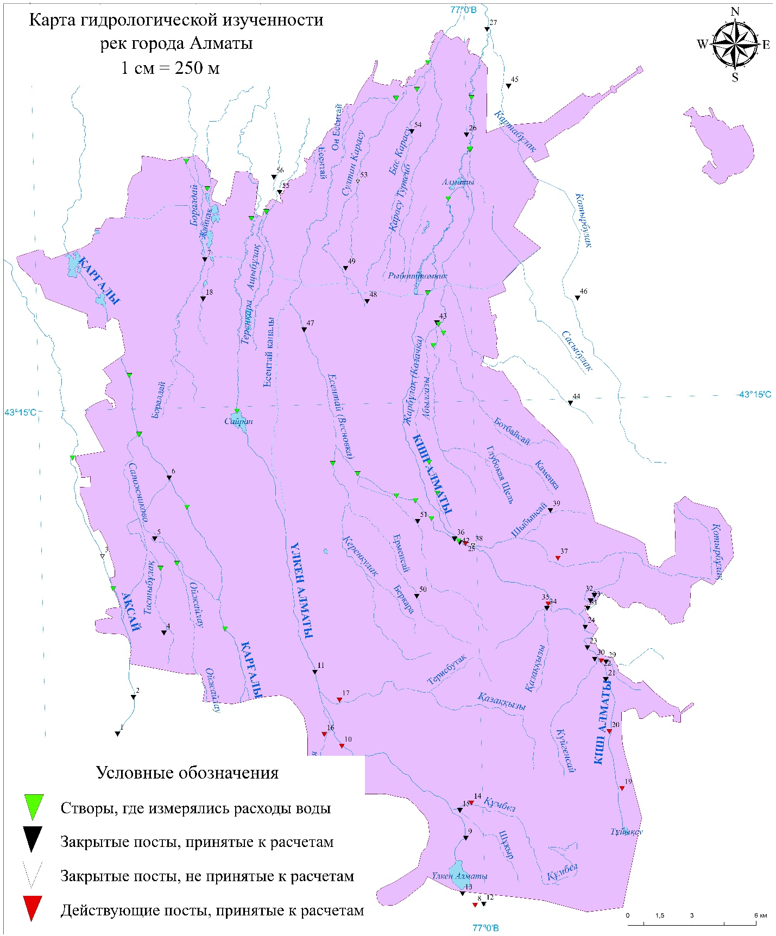

Areal values of the city territory, km²
Years | 1912 |  | 1942 |  | 1989 |  | 2015
Area | GIS | Internet | GIS |  | GIS |  | GIS | Internet
Area | 10,5 | 4,55 | 52,0 |  | 282 |  | 704,5 | 682,0
Length of the main rivers of the city territory, km
River | River length, km
River | 1912 | 1942 | 1989 | 2015
Kishi Almaty | - | 8,01 | 20,70 | 52,5
Ulken Almaty | - | - | 11,88 | 39,10
Kargaly | - | - | - | 21,48
Aksai | - | - | - | 3,46

Figure 1.1 - Hydrographic network of Almaty
2.3 Drafting a schematic map of modern hydrography of Almaty by using GIS technologies
Over time, the surface of river catchments undergoes changes under the influence of natural causes and human economic activity. In this regard, the values of the morphometric characteristics of water bodies and watersheds obtained from topographic and other thematic maps also change [27]. Morphometric characteristics are classified as relatively stable and dynamic. Stable ones include: the catchment area, the average height of the catchment, the average slope of the slopes of the catchment, the area of closed areas. All other morphometric characteristics should be classified as dynamic.
According to the Standard [27], the morphometric characteristics of water bodies and their catchments should be updated when changes have occurred in the water bodies themselves or their catchments and this begins to affect the accuracy of hydrological calculations. All morphometric characteristics of the water body must be checked and updated simultaneously. Morphometric characteristics can be specified not only by maps, but also by aerospace images or by the results of field hydrographic surveys.
To clarify the hydrographic network of Almaty, a map (plan-scheme) of Almaty 1:25 000 with a new city boundary, compiled in 2015 and a base topographic map used as an information background in the GIS, built into the ArcGIS software 10.4.1 were used.
Topographic maps are nationwide maps. They are compiled in strict accordance with the provisions, instructions and symbols developed by the Republican State Treasury Enterprise "National Cartographic and Geodetic Fund". Modern large-scale topographic maps are characterized by the absence of significant distortions due to projection, high image accuracy of all content elements, and continuous coverage of the territory and therefore can be used as a basis for cartometric work for hydrological purposes.
The accuracy of the hydrographic information obtained from the map depends primarily on the scale at which the map is drawn. The larger the scale of the map used, the higher the accuracy of the morphometric characteristics determined from it [27].
The average position errors on the topographic map of objects and terrain contours relative to the nearest points of the planned survey network according to the existing standards do not exceed 0.5 mm, and in mountainous, high-mountainous and desert areas - 0.75 mm on the map scale, which will accordingly amount to: on a scale of 1 : 10,000 - 5 and 7.5 m; on a scale of 1: 25,000 - 12 and 19 m; on a scale of 1: 50,000 - 25 and 38 m; on a scale of 1: 100,000 - 50 and 75 m [26]. The maps used should reflect the current state of all elements of the terrain and, first of all, water bodies and their catchments. Information about the year of the survey of the area is indicated on each sheet of the topographic map.
To ensure the required accuracy of hydrological calculations, it is required that hydrological observations and morphometric characteristics of water bodies correspond to the same period.
When creating a map of Almaty at a scale of 1:25 000 for the convenience of clarifying the morphometric characteristics of water bodies, a unified system of geodetic coordinates Pulkovo-1942 (SK-42) and a transverse-cylindrical Gauss-Kruger projection were used. Cartometric work to determine the morphometric characteristics of water bodies within the city of Almaty was carried out based on a vector digital map.
1) To analyze the change in the hydrographic network of the study area, it is recommended to use modern satellite maps and online web-mapping resources, such as OpenStreetMap, together with the study of literature and cartographic data for different periods, which may reflect the transformation of the study area.
2) To clarify the hydrographic network of the study area, it is recommended to use large-scale maps (plan-schemes) and base topographic maps used as an information background in GIS, built into the ArcGIS 10.5 software.
The maps used should reflect the current state of all elements of the terrain and, first of all, water bodies and their catchments.

3 Evaluation of the channel water balance of the main rivers of the Almaty territory

3.1. Water balance zones of rivers of the Almaty city territory
A number of works [21, 28-38] are devoted to the study of the regularities of the formation of surface and underground runoff and their relationship in this area. As a result of long-term studies of groundwater alluvial fans and regime hydrogeological observations, a close genetic relationship of groundwater with surface waters of rivers has been established in the Ile Alatau and a runoff formation scheme has been developed.
According to this scheme, by the totality of natural conditions (geological, hydrological, hydrogeological), the study region can be divided into four hydrogeological regions (water balance zones) [28-38]:
1) a mountainous area (slope), composed of rocky Paleozoic rocks and being the main area of runoff feeding. This area is characterized by deep and intense dissection of the relief and almost complete (86-92 %) drainage of fissured groundwater in the weathering zone.
2) The foothill area is a tectonically uplifted block, folded at the base of rocky Paleozoic rocks, which are overlain by younger Neogene, Quaternary deposits. The underground runoff is both transit and local, which is formed at the foothill stage from filtration from rivers and precipitation. This area is characterized by the simultaneous transit of surface and underground runoff from the mountains, absorption of part of the surface runoff and feeding of the underground runoff. In addition, it acts as a screen for underground runoff from the mountains.
3) Foothill plume, formed by merged fan cones, which is a zone of intense absorption of surface river runoff, irrigation water and atmospheric precipitation. Geological is a zone in which thick strata of coarse-clastic Cenozoic sediments are widespread, in which through filtration of surface waters to great depths is possible (up to 2013 m in the Ulken Almaty river basin) [31].
4) Foothill plain, which is characterized by the outcropping of low-water-permeable sediments of the lower Quaternary and which is a zone of groundwater discharge of alluvial cones. It is composed of proluvial-alluvial deposits, has a terraced surface, inclined towards the river. Ile.
In a number of cases, for hydrological studies, instead of four regions, three water balance zones are distinguished [34-41]:
1) mountainous zone of formation of surface runoff;
2) zone of runoff losses in loose sediments of fan fans;
3) the secondary zone of formation of surface runoff due to wedging out of groundwater.
The territory of the Almaty city of is located on a foothill plume formed by merged fan outflow cones of small rivers. It is a zone of intense absorption of river surface runoff, irrigation water and atmospheric precipitation. Surface and ground waters in the study area are closely related.
At moving from the mountains to the valley of the Ile River, they can repeatedly move from one position to another [21, 31-33, 37-38]. Under anthropogenic impact on surface or underground runoff, the regime and water balance of both types of runoff are disturbed.
A quantitative assessment of the mutual water exchange of surface and groundwater flows during their movement from the mountains to the Ile river valley can be given by drawing up the water balance of the loss zone and the secondary zone of formation of surface runoff due to the wedging out of groundwater.

3.2 Measurement technique of channel water balance
In addition to assessing the interaction of surface and groundwater, as noted above, the compilation of channel water balances (CWB) is one of the methods for studying and quantifying water resources.
During the research, attention was paid to the channel water balance of both the main rivers of the Almaty city are Kishi Almaty with the Esentai, Ulken Almaty, Kargaly and Aksai channels, and the rivers "karasu": in the Ulken Almaty basin - river Boroldai and river Zhainak; in the Kishi Almaty basin - rivers Ashybulak, Terenkara, Sultan-Karasu, Ulken Karasu (Moika-Karasu), Kishi Karasu, as well as some rivers - "karasu" without names, tributaries of the river Kishi Almaty and mountain springs: Abylgazy, Botbaisay, Tiksay, Terisbulak, Kerenkulak, Oyzhailau and Tastybulak. The Aksayskiy (Sapozhnikovo) runoff channel from the river Aksai to river Kargaly [41-42]. Measurements of the channel water balance were carried out using the methodology outlined below for areas within the city boundaries.
To analyze the results of field studies and calculate the channel water balance (CWB) of small rivers in Almaty, the following equations were adopted:
1) for the zone of losses of surface runoff in loose sediments of fan cones:

Sf = Qu + Qt - Ql - Qwi + Qrsw (3.1)

where Sf - the absolute value of filtration losses, m³/s; Qu and Ql - water discharges rates in the upper and lower sections, m³/s, respectively; Qt - total discharge of side tributaries, m³/s; Qwi - total water intake at the site, m³/s; Qrsw - the total discharge of return surface water discharged into the river from irrigated fields and other discharges into the river at the site, m³/s;
2) for the zone of groundwater discharge into the river beds "karasu":

Sgw = Ql - Qu + Qwi - Qt - Qrsw, (3.2)

where Sgw is the absolute value of groundwater wedging out, m³/s.
On the selected balance sections, the measurements were carried out in dry periods, taking into account the travel time and taking into account the error in measuring the discharges rates with a hydrometric spinner.
To compare the channel water balances of various rivers, not the absolute values of losses and wedging out were used, but the values of specific losses (Slf, m³/s × km) and wedging out (Slgw, m³/s × km) of water discharge per unit length of the river section:

, (3.3)

, (3.4)

where L is the length of the calculated water balance section, km. The rest of the notation is the same [43].

3.3 Measurements results of the channel water balance of rivers of the Almaty territory
Analysis of the results of measurements of the CWB of the main rivers and rivers - "karasu" in Almaty showed that, as in the basin of the river Ulken Almaty and river Kishi Almaty, the zone of river runoff pinching - "karasu" begins below Raiymbek avenue, this below the horizontal 540 m BS.
A herringbone diagram of the hydrographic network of small rivers in Almaty with stations for measuring the channel water balance (CWB) in 2019 is shown in Figure 3.1, and CWB measurements on the Almaty rivers are shown in Figures 3.2-3.5.

Figure 3.1 - Herringbone diagram of the hydrographic network of small rivers of the Almaty city (RWB, 2019)

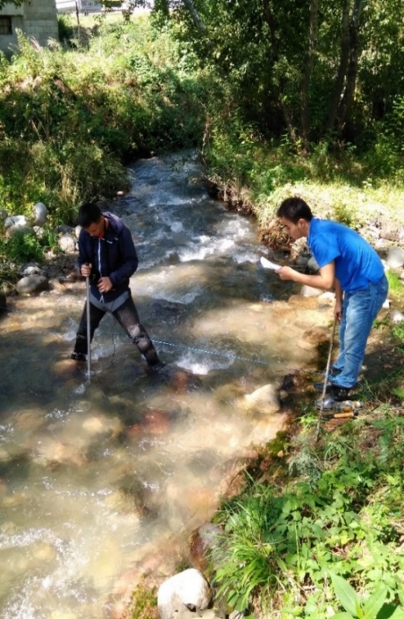  Figure 3.2 - Canal Aksay - Sapozhnikovo, entrance to the city territory, measurement of RWB 2019 | 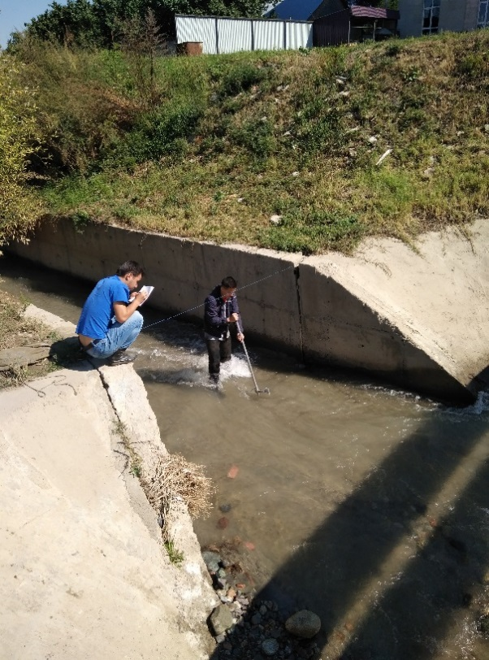  Figure 3.3 - Kargaly River - in the alignment of street Chaliapin, measurement of RWB 2019
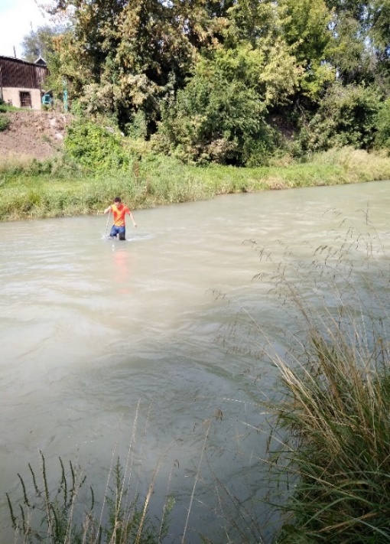  Figure 3.4 - Ulken Almaty River – in Boroldai station, exit from the city territory, measurement of RVB 2019 | 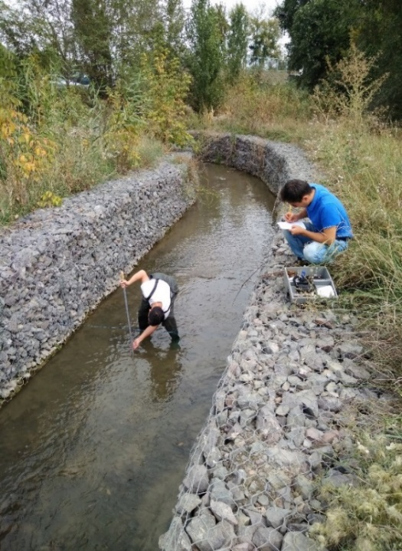  Figure 3.5 - River Zhainak (Dzhigitovka) - below the BeNT ponds, exit from the city territory, measurement of RVB 2019
It should also be noted that as a result of the arrangement of the channels of a number of karasu rivers with gabion structures, cleaning them from debris, the outflow of wedging groundwater was normalized and the general condition of the urban river system and its recreational capacity improved. This favorably affects the ecological state of not only the rivers themselves, but also the adjacent territories.
4 Calculation of the characteristics of water runoff in the Almaty territory

4.1 Calculation of the norm and variability of the annual runoff
At performing these researches, the observations series of the runoff up to 2015 inclusive were used. At different times, about 54 water runoff observation-gauging stations are operated on the under consideration territory. The existing gaps in the annual runoff observation series have been restored. At calculating the runoff rate and assessing the errors in its determination, the generally accepted recommendations set forth in [44-51], as well as the recommendations for the area under consideration [52-53], were taken into account. The construction of the probability curves was carried out using the Easy Line program, developed for the type III Pearson binomial distribution curve in [54].
The analysis of the differential integral curves of the annual runoff plotted for the reference posts indicates that, due to the existing asynchrony of fluctuations in the average annual runoff rates at different posts, the general calculation period can be taken from 1938 to 2015.
Determination of the river runoff rate was carried out in parallel by methods: moments, graphical-analytical, and in some cases, graphical method. To restore gaps in observations and extend the series, the dependences of the water discharge of the studied river and the analogous river, as well as the graphs of the relationship between the average annual water discharge and the average discharge for the vegetation period for the same river, were used. It should be noted that the latter had very high correlation coefficients (0.8-0.99).
The annual runoff rate, expressed by the water discharge, was determined by for 54 gauging stations with observation series. As well as for several unexplored rivers - by calculation.
For the reference hydrological stations, the average error in calculating the runoff rate was ± 2.99 %, the extreme values ± 5.79 % (Left Shybinsay river – in mouth) and ± 0.71 % (Shukur river – in mouth).
The average error of the coefficient of variation was ± 2.29 %, and the extreme values ± 5.03 % (Left Shybinsay river – in mouth) and ± 0.50 % (Shukur river – in mouth).
Thus, the series of river water runoff were obtained for a representative period from 1938 to 2015.
Analysis of long-term observation series of water discharge of the Almaty territory rivers has showed that changes in annual runoff occur as under the climatic changes influence (Kishi Almaty - downstream of the mouth of Sarysai, Ulken Almaty-2 km upstream of Ulken Almaty lake) and in connection with the strengthening of anthropogenic influence (the Kishi Almaty - Almaty city, the Ulken Almaty, 2 km above the mouth of the Prokhodnaya river).
The calculated norms and variability of the annual runoff, as well as the values of the average long-term annual runoff of various availability for the control gauging stations of the study area were given in the research report 2019 by this project.

4.2 Calculation of maximum runoff characteristics
At determining the maximum river runoff in the study area, cadastral data on hydrological stations of the Balkash lake basin were used, which is part of the network of the RSE "Kazhydromet", from the beginning of instrumental observations until 2015 inclusive [10-15]. Currently, there are 11 operating and 20 closed hydrological gauging stations in the city's area (the research report 2018 by this project). The available gaps in the series of observations of the maximum flow were reconstructed according to the graphs, which were determined by the tightness of the connection exceeding 0.70. In the study area, the communication density fluctuated 0.71-0.88. The duration of observation periods for the highest water discharge in the study area is from 5 to 86 years. When calculating the maximum runoff and estimating its errors, the generally accepted recommendations set forth in [55-58] were used.
For the calculation period, the largest number of completed cycles was taken, consisting of groups of low-water and high-water years,
The choice of the calculation period for the maximum water discharges of the study area was carried out by constructing differential integral curves, which is used to determine the representativeness of a number of observations for periods and years. For rivers within the city of Almaty, 1940-2015 was chosen as the calculation period.
The probabilistic values of the maximum runoff of rivers of rare recurrence were produced by the methods: moments, graphical-analytical, and in some cases, also a truncated method proposed by R.I. Galperin.
Analysis of long-term series of observations of the maximum runoff of rivers in Almaty showed that changes in maximum runoff occur under the influence of natural changes (increased temperature background, degradation of glaciers, increased precipitation, and, as a consequence, the manifestation of mudflows and floods), and in connection with intensification of anthropogenic load on river runoff.
As a result of the analysis of the series of observations of the maximum water discharges for a long-term period, the specified characteristics of the maximum runoff of the Almaty rivers were obtained. Comparative analysis of the results of calculations of the maximum runoff with the results of studies in 2012 [59] shows a decrease in the values of the maximum runoff rates of rare recurrence. Thus, along the section Kishi Almaty - Almaty city, the value of the maximum runoff rates of 1 % of probability (rare recurrence) was 54.0 m³/s, which is 7 % lower than the values obtained in [59].
The maximum runoff of the rivers (the Kishi and Ulken Almaty rivers) is influenced by climatic and intense anthropogenic factors. The Almaty city has a complex effect on the maximum runoff of rivers, it is associated with water intakes, the transformation of water bodies, as a result of landscaping; backfilling and sewerage of rivers and streams, regulation of runoff, influence on the natural hydrochemical composition of water bodies [60].
The calculated statistical parameters of the maximum runoff of various availability at the hydrological posts of the study area are given in the research report 2019 by this project.

4.3 Calculation of minimum runoff characteristics
First of all, it should be noted that the minimum river runoff of the study area has been studied much less than the annual and maximum.
To determine and calculate the minimum water discharges of the rivers of the study area, cadastral data on hydrological stations that are part of the network of the RSE "Kazhydromet" were used from the beginning of instrumental observations until 2017.
When determining the calculated values of the minimum runoff of the main rivers of Almaty, an analysis was made of the minimum average monthly water discharge of the summer-autumn dry season at the gauging stations of the river Ulken Almaty - 2 km above the Lake Ulken Almaty and river Kishi Almaty - below the mouth of the river Sarysay, rive Prohodnaya -mouth, as well as the river Aksai – Aksai village.
The minimum monthly runoff on the selected rivers was calculated for the period of the summer-autumn dry season (4 ... 10) of the hydrological year. On Mountain Rivers of the studied region, the minimum water discharge is observed, as a rule, at the end of the winter low-water period, before the beginning of the spring flood: at this time, the greatest depletion of the underground litany of rivers occurs 1952 ... 2017, 1934 ... 2017, 1957 ... 2015 were selected as the calculated observation periods (the research report 2018 by this project).
To calculate the minimum flow rate of water of different availability, the curves of availability were built for the posts of the river. Ulken Almaty - 2 km above Lake Ulken Almaty and on the river. Kishi Almaty - below the mouth of the river. Sarysay, r. Checkpoint - the mouth, as well as the river. Aksai - s. Aksai.
As a result, using new cadastral materials, including 2017, for gauging stations of the r. Ulken Almaty - 2 km above the lake. Ulken Almaty and on the r. Kishi Almaty - below the mouth of the river. Sarysay, the territorial coordination of the long-term course of the minimum average monthly summer-autumn runoff has been established. In addition, new data and refined parameters of the minimum monthly summer-autumn runoff were obtained, including the calculated guaranteed values of these values for the main rivers.
According to the gauging stations of the river Ulken Almaty - 2 km above the Lake Ulken Almaty and river Kishi Almaty - below the mouth of the river Sarysai, similar parameters were determined between the long-term average values of the summer-autumn minimum average monthly water consumption (the research report 2018 by this project).
The obtained basic characteristics of the minimum river runoff (norm, runoff layer, variation coefficients) correspond to the values given in published monographs and scientific articles [61–64] for the study area.
It should be noted that new data have been obtained on the asynchrony of long-term fluctuations in the minimum runoff on the river Kishi Almaty - Almaty city and below the mouth of the river Sarysay.
The revealed pattern for the Kishi-Almaty River refers to significant results of the study, since it is associated with differences in the factors of formation of the minimum flow in the upper and lower regions of the river. For example, the formation of surface and underground runoff is influenced by the difference in relief slopes in the upper and lower zones of the river, different climatic conditions, etc.

4.4 Recommendations for the determination of runoff characteristics for unexplored rivers
To determine the norm of the annual runoff of unexplored rivers in mountainous conditions, a method based on the dependence of the average annual water runoff modulus on the average weighted height of the catchment area is currently widely used [63-69]. The dependences М0 = f (Hav), constructed for the considered area, are shown in Figure 4.1.
Table 4.1 shows the characteristics of the average annual water discharge rate, the coefficients of variation and asymmetry, as well as the water discharge of various supplies of unexplored rivers in the territory of Almaty, obtained by calculation in the absence of observational data.

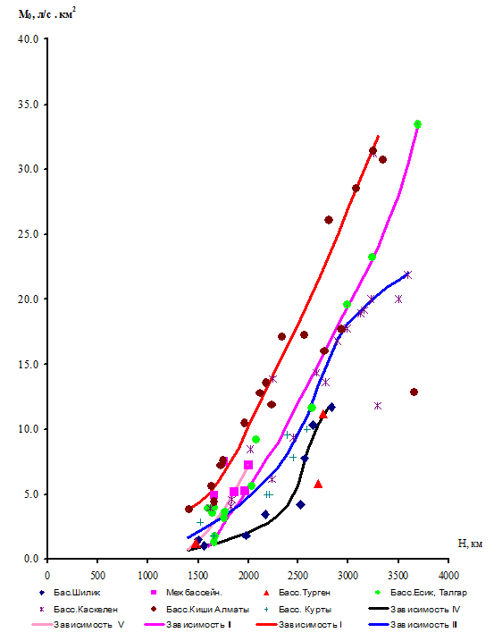

Figure 4.1 - Dependence of the annual runoff rate on the weighted average height of the catchments of the Ile Alatau rivers, [7]

Table 4.1 - Average long-term annual water discharges and discharges of various probability of unexplored rivers in the Almaty territory, obtained by calculation

№ | River - Point | Catchment |  | Average runoff long period, м³/s (1938-2015) | Accepted values |  | Water discarges of different probability, m³/s
№ | River - Point | area, km2 | average height, m | Average runoff long period, м³/s (1938-2015) | Сv | Cs | 10% | 25% | 50% | 75% | 90% | 95% | 97%
1 | Kerenkulak (Poganka) - mouth | 29,9 | 1272 | 0,097 | 0,35 | 1,06 | 0,14 | 0,11 | 0,090 | 0,071 | 0,059 | 0,052 | 0,049
2 | Botbaysay (Shirokaya Shchel) - mouth | 6,4 | 1184 | 0,018 | 0,31 | 0,72 | 0,026 | 0,021 | 0,017 | 0,014 | 0,011 | 0,010 | 0,009
3 | Abylgazy (Solonovka) - mouth | 8,5 | 1273 | 0,029 | 0,31 | 0,73 | 0,041 | 0,034 | 0,028 | 0,023 | 0,019 | 0,016 | 0,015

Hydrological calculations for unexplored rivers within this region are complicated by mountainous relief and a sparse observation network. To increase the reliability of determining especially extreme characteristics of runoff, it is necessary to introduce into practice the dependence "water discharge - catchment area". These links are more reliable than those used in current regulations. Another important advantage is their simplicity in practical application. With the help of these links, it is possible to significantly clarify the limits of the areas in which the maximum runoff is reduced, the critical areas for calculating the annual and minimum runoff of small rivers, and hence the possibility of more reliable mapping of all these runoff characteristics.
It is also possible to improve the methodology for assessing long-term runoff variability based on the use of the “standard deviation - runoff rate” relationship. Analysis of the two types of the above relationships can be used to clarify hydrological zoning.
An increase in water consumption and a reduction in water resources due to unfavorable climatic trends, along with global climate changes, lead to a change in the parameters of the minimum and ecological runoff, which, in turn, requires constant, detailed monitoring and improvement of calculation methods for the characteristics of the minimum runoff for the mountainous and foothill zone of the city Almaty zone.
To determine the characteristics of the minimum runoff for unexplored rivers, reference rivers and their characteristics obtained in Section 4.3, as well as schematic maps of isolines of the minimum runoff modules, and regional calculated dependencies, can be used as analogous rivers [61-65].

.
5 Estimation of the trends of the variability of the water runoff of the Almaty rivers for a long period depending on natural and anthropogenic factors

5.1 Modern dynamics of changes in climatic characteristics of Almaty
To analyze modern changes in climatic parameters, we used long-term data on average monthly air temperatures and precipitation totals for four operating stations in the region under study (Almaty OGMS, Kamenskoe plateau, Mynzhilki, Bolshoye Almaty Lake) for the period from the beginning of observations until 2016.
Figure 5.1 shows the long-term course of sliding five-year periods for the stations of Almaty, BAO, Kamenskoe plateau, Mynzhilki (Appendix A, Figures A.1-A.3). The analysis of these graphs revealed that in general, both at the plain and at the mountain stations, there is an identical pronounced positive trend in the average annual temperature, approximately 1.5-2.5 ° С. The highest values were recorded between 2004 and 2010. The maximum temperature reaches 11.1 ° C at the Almaty meteorological station.

Figure 5.1 - Long-term variation of moving five-year averages of mean annual air temperatures for the period 1916 - 2016 at the Almaty meteorological station

In the long-term course of annual precipitation amounts (Figure 5.2), a tendency to their increase is noted in most of the territory under consideration. Trends in the mean values of the mean annual precipitation amounts for the selected stations are characterized by growth trends. A noticeable increase in the amount of precipitation is observed at the Almaty meteorological station. The maximum is observed in the period from 2001 to 2005 years - 761 mm.

Figure 5.2 - Long-term variation of rolling five-year averages of annual precipitation amounts for Almaty meteorological station in the period from 1916 to 2016

At BAL station, a noticeable decrease in precipitation was observed from the 1960s, from the 1985s, and also from the beginning of the 2000s (about 940 mm) (Appendix A, Figure A.4).
Judging by the figures (Appendix A, Figures A.5-A.6), it can be noted that for the considered observation period at all stations there is a positive trend in the number of average annual precipitation amounts with some decreases (about 20-50 mm). The maximum precipitation amounts have been mainly observed since the beginning of the 21st century, i.e. since the 2000s.
In addition, an analysis of the seasonal values of air temperature for the corresponding stations was carried out, which showed that in all seasons there is a tendency for an increase in temperatures of 1-3 ° C. Temperatures in spring and autumn are almost identical. At Almaty station, the trend of winter temperatures is more pronounced than for other seasons. Also, at the mountain stations BAL and Mynzhilki, there is a more pronounced positive trend in all seasons. At the BAL station, the air temperature in summer and autumn does not have significant growth or fall jumps and fluctuates within about 10.0-11.0 ° С and 0.5-2.5 ° С, respectively. As for the air temperature in winter, it can be noted that in the 30s the lowest temperatures were noted for the entire period under consideration, and amounted to about -9.5 ° C.
At analyzing the distribution of the average values of seasonal precipitation amounts over rolling five-year years, it was revealed that in autumn and summer for the Almaty meteorological station, the amount of precipitation fluctuates in the region of 100-150 mm. At BAL station, in summer and spring, an almost identical course of precipitation amounts is observed, the average amount of precipitation amounts is about 300 mm. At all the studied stations, except for the Kamenskoe plateau station, a positive trend in the increase in the amount of precipitation was revealed. The Kamenskoe Plateau is characterized by a weak tendency to decrease precipitation in spring and autumn. For Mynzhilki station, the distribution of seasonal precipitation amounts is characterized by a uniform course with an insignificant increase throughout the study period.
Linear trends in the moving five-year mean values of seasonal precipitation amounts over the study area for the period from the station opening to 2016 indicate an almost year-round small increase in precipitation amounts.
In the course of the study, for the stations under consideration, the long-term average values of air temperature and precipitation for the studied observation period were also compared with the corresponding climatic norms of 1971-2000. [1]. As a result, it was revealed that at the Kamenskoe Plateau station, the mean long-term temperature value exceeds the climatic norm in almost all months, except for April, September and October. At Mynzhilki station, a significant difference is observed between the mean multiyear value and the climatic norm. At BAO station, mean long-term values are predominantly below the climatic norm. At Mynzhilki and Almaty stations during the cold period, the mean long-term temperature is generally less than or equal to the climatic norm, and the picture changes during the warm period.
Based on a comparison of the mean long-term value of the precipitation totals with the climatic norm for the stations, it was revealed that at the Kamenskoye Plato station and BAL, the long-term average value of the precipitation totals exceeds the climatic norm. At BAL station practically in all months, except for May, July and September, and at Kamenskoe Plateau station in February, July and October, the average long-term precipitation amounts and the climatic norm are equal.
Also, to assess climate dynamics, the main statistical characteristics of temperature and precipitation were calculated: standard deviation, variance, asymmetry coefficients As and kurtosis Ex.
Analysis of As and Ex indicates that the distributions of monthly precipitation amounts differ from normal. The values of the asymmetry coefficient are positive in all cases, which is consistent with the studies of other authors [71-72].
The variation in values is small. In the cold period, large values of the standard deviation are noted, and in the warm period, less. The annual course of the mean square deviations is the opposite of the annual course of the average monthly temperatures. It is almost the same at all the stations considered: it has a minimum in the warm half of the year (August) and a maximum in the cold half of the year (January).
As is known, in the first approximation, with values of the asymmetry coefficient As <0.2, it is considered insignificant, with 0.2 <As <0.5 - moderate, with As> 0.5 - strong. In the distribution of monthly precipitation totals, the asymmetry is strong, less often moderate. There are no perfectly symmetric distributions. Negative kurtosis does not exceed the limiting border, positive kurtosis vary from 0.1 to 14.
Thus, based on the analysis of trends in temperature and the amount of precipitation, a positive growth trend was revealed for the entire period under consideration, especially since the beginning of the 21st century. When comparing the average long-term values of the parameters with climatic norms, one can also conclude that the average long-term values are slightly exceeded over the norm practically throughout the entire territory, which is also consistent with the calculated statistical characteristics.
It is also necessary to note the influence of urban agglomeration and anthropogenic activity, due to which the temperature regime in urbanized areas changes and the urban climate is formed.
One of the important factors in the formation of the urban climate are anthropogenic heat fluxes, which increase the air temperature in the city [73]. The influence of this effect on the urban microclimate is especially significant for millionaire cities, such as the megalopolis of Almaty, in which the specific values of technogenic heat fluxes exceed those of smaller industrial centers.
Another factor that determines the thermal regime of the urban climate system is the nature of the development of the urban area, which affects its ventilation and the absorption of solar energy [74].
In addition, the city of Almaty is distinguished by a polluted atmosphere due to road transport and industrial activities, which increases its turbidity and thereby reduces the influx of solar radiation, which is also enhanced by high buildings in narrow streets. Due to the veil of smoke and dust on the territory of the city, effective radiation is reduced, and hence the night cooling. At the same time, in the city, scattered radiation is joined by radiation reflected by walls and pavements. Roofs and walls of houses, pavements and other elements of the city, absorbing radiation, heat up during the day more than the soil and grass, and give off heat to the air, especially in the evening. Therefore, air temperatures in cities are 70-80 % of cases higher than in rural areas.
The system of city streets and squares leads to changes in the direction of the wind in the city. The wind is mainly directed along the streets. In general, the wind speed in the city weakens, but increases in narrow streets; dusty whirlwinds and drifts easily occur on streets and intersections.
Thus, modern urbanization and the observed warming of the climate have a multifaceted impact on the climate of large cities. Changes in the landscape of urbanized areas and the high density of anthropogenic heat fluxes on the territory of megalopolises contribute significantly more to the formation of an urban heat island than in smaller cities.

5.2 Assessment of trends in water runoff variability in Almaty Rivers over a long-term period depending on natural and anthropogenic factors
As a result of the analysis of the series of observations of the water discharge of the rivers of the territory of Almaty in long-term periods, changes in the annual river runoff were revealed, both under the influence of climatic changes (the Kishi river Almaty - below the mouth of the Sarysai river, the Ulken Almaty river - 2 km above Lake Ulken Almaty), and in connection with the strengthening of anthropogenic influence (the Kishi Almaty - Almaty city, the Ulken Almaty, 2 km above the mouth of the Prokhodnaya river).
Climatic changes are confirmed by positive trends in mean annual air temperature and precipitation.
In this study, using the moving average method, which is widely used in studying the patterns of runoff fluctuations, the analysis of the studied time series was carried out and trends in its change were identified by building trends. As a result, runoff trends were obtained using data for the estimated period 1938-2015, presented for individual rivers in Figures 5.3-5.5.
The analysis of the obtained trends showed that positive trends in runoff change are observed along the main rivers, indicating an increase in the runoff of the rivers of the study area, using which it is possible to give "scenario forecasts" of water discharges for the coming decades based on extrapolation of the identified trends in the long-term runoff of Almaty rivers.
In the course of the study, a joint analysis of the dynamics of atmospheric precipitation, air temperature at meteorological stations and water flow rates at hydrological posts of the study area was carried out. Figures 5.6-5.7 show a combined graph of the long-term variation of five-year sliding sums of precipitation, air temperature and water discharge for the Almaty and BAL weather station, as well as for the gauging stations of Kishi Almaty - Almaty and Ulken Almaty - above 1.1 km of Big Almaty Lake.
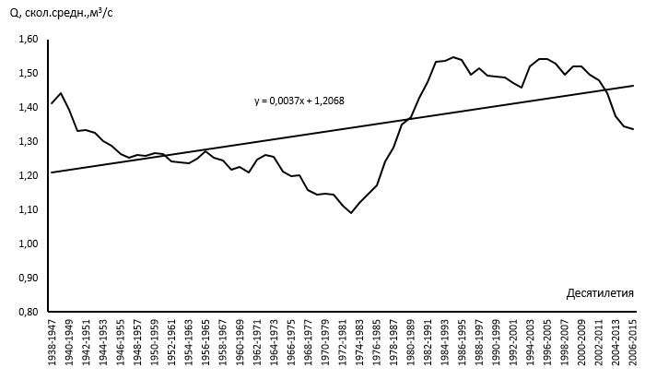
Figure 5.3 - Long-term variation of moving ten-year averages of the mean annual water discharges of the river Kishi Almaty - below the mouth of the river Sarysay for 1938-2015

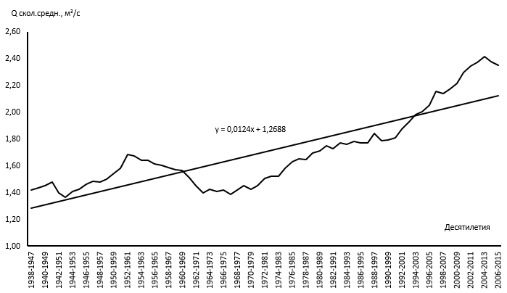

Figure 5.4 - Long-term variation of moving ten-year averages of average annual water discharges of the river Ulken Almaty - 2 km above Lake Ulken Almaty for 1938-2015

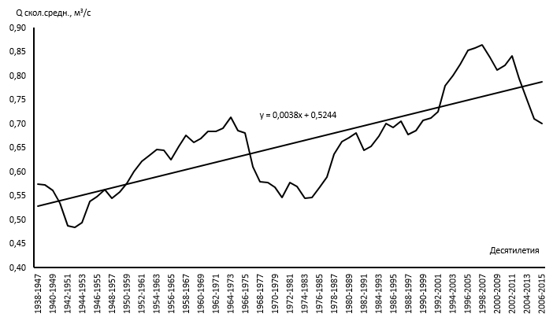

Figure 5.5 Long-term variation of moving ten-year averages of average annual water discharges in the river. Kargaly-s. Chapaevo for the period 1938-2015

Figure 5.6 - Combined graph of the multi-year course of quinquennium sliding sums of atmospheric precipitation, air temperature according to the data of the Almaty meteorological station and water discharge in the gauging stations river Kishi Almaty - Almaty

Figure 5.7 - Combined graph of the multi-year course of quinquennium sliding sums of atmospheric precipitation, air temperature according to the data of the BAL meteorological station and water flow rates at the gauging station of the river Ulken Almaty - above 1.1 km of the BAL
Figure 5.7 shows that with an increase in atmospheric precipitation and air temperature, water consumption increases.
The runoff of the studied rivers within a year is associated not only with changes in precipitation and air temperature, but also with anthropogenic factors. As can be seen from Figure 5.6, on the combined graph for the Almaty meteorological station and the Kishi Almaty-Almaty station, there is a noticeable decrease in water discharge and a negative trend for the household flow of the river, due to the anthropogenic influence of the urbanized area. At the same time, the runoff naturally restored by analogy shows an increase in water consumption due to an increase in precipitation and air temperature.

5.3 Recommendations for taking into account the influence of natural, anthropogenic factors on the hydrological characteristics of water bodies in urbanized areas and improving the ecological state of small rivers (on example Almaty)
The condition of water bodies is the most important indicator of the ecological well-being of Almaty and other urbanized territories, since they are integral elements of the entire landscape-architectural system of the megalopolis, perform sanitary-biological, climate-forming, cultural-historical, recreational functions.
Almost all urban water bodies and watercourses are natural-anthropogenic or completely anthropogenic (technogenic) objects. The intensity and direction of changes in the hydrological characteristics of water bodies in urbanized areas differ significantly from the state and changes in similar characteristics of natural water bodies.
As the results of the studies carried out for the megalopolis of Almaty have shown, taking into account the influence of natural and anthropogenic factors on hydrological characteristics should include a wide range of measures, consisting of the following main stages.
The initial stage consists of the collection and creation of a complete database of observations of hydrometeorological data, including the restoration of passes and data in the absence of observations for all water bodies of the city.
Since the boundaries of urban areas periodically change, and the water bodies of the city themselves are subject to significant changes under the influence of natural and anthropogenic factors, at the next stage it is necessary to conduct research to clarify their hydrography and create a reliable topographic base (map) using modern GIS technologies. Such a map will serve as the basis for modeling and scientifically grounded forecast of the development of urbanized territories, engineering reconstruction of water bodies, and improving the environment.
In the future, based on the results of determining the main hydrological characteristics, trends of variability of these characteristics, supplemented by the results of measurements and calculations of the channel water balance, it is necessary to regionalize and classify the water bodies of the city, primarily according to the ecological state, economic use, target potential and significance. This will make it possible to rank measures for the rational use and protection of water bodies, methods of their engineering and environmental arrangement within the boundaries of the entire city.
For example, for the city of Almaty, the results of the research carried out served as the basis for the development of recommendations on the protection and restoration of small rivers, substantiation of the size of water protection zones (WPZ) and water protection belts (WPB) within the city [24].
Based on the revealed results of the influence of natural and anthropogenic factors on the hydrometeorological characteristics of water bodies, it becomes possible to adjust plans for optimizing urban infrastructure, in terms of the optimal location of industrial and economic enterprises, determining zones, areas of comfortable and safe residence of residents. The latter is very important for the Almaty city, in connection with the unique altitudinal zonality and, associated with this, various climatic, sanitary and ecological conditions from the northern to southern borders of the city.
As the main results of research on this project have shown, there is an urgent need to expand and optimize the network of hydrometeorological and environmental monitoring of the territory of Almaty. The solution to this problem, to create the basis for the sustainable functioning and development of the agglomeration of Almaty and other urbanized territories, is one of the most significant and basic recommendations of the implemented project.

CONCLUSION

All types of work in accordance with the timetable for the topic are completed. Based on this, can be make the following main conclusions:
- the laborious work on creation of the bank of hydrometeorological characteristics was done. The formed hydrological data bank contains information on river water runoff at 54 observation points at gauging stations of the RSE "Kazhydromet" and departmental organizations, and the meteorological data bank on climatic parameters - for 6 meteorological stations for all available observation periods, up to 2015 inclusive;
- analysis of the factors of runoff formation showed that its main natural factors in the study area are: relief, geological structure of the territory, climate, soil and vegetation cover, hydrography. It was revealed that economic activity in the upper part of their basins also has a significant impact on the formation of water runoff in watercourses in Almaty. The drainage basins of the four main rivers flowing through the Almaty city: Ulken and Kishi Almaty, Kargaly and Aksai have a total amplitude of about 4000 m BS;
- an important result of the first stage of the work was the field reconnaissance studies to clarify the hydrographic characteristics of water bodies. As a result, it was revealed that due to the engineering redevelopment of urban areas, backfilling of individual sections of river channels, underground sewerage and inter-basin diversion of river runoff, as well as the improvement of individual sections of channels, significant changes occurred in the hydrography of the urban area of Almaty;
- based on the research results an updated modern hydrographic schematic map of Almaty at a scale of 1: 25,000 was compiled, created using the ArcGIS 10.4 software;
- analysis of the water regime of the rivers in the Almaty territory showed that the main ones cross several high-altitude zones and have mixed feeding. In general, according to the water regime, all rivers in the Almaty territory are divided into four main groups [8]: rivers with spring flooding and floods in the warm season; rivers with spring-summer flooding and floods in the warm season; rivers with summer floods and floods in the warm season; rivers with a leveled runoff due to increased groundwater supply;
- conducted field measurements of the channel water balance on water bodies in Almaty, which showed its rather large changes. The sections of channel losses during concreting became transit, i.e. the planned location of the water balance areas has changed. Specific values of losses and wedging out in river beds have changed;
- it was revealed that as a result of the intensive use of the Almaty groundwater deposit for domestic water supply of the city, the runoff of the “karasu” rivers decreased, and the pinch-out zone (sources) of the “karasu” rivers shifted northward, while the seasonal fluctuations of the runoff characteristics were smoothed out;
- at calculating the characteristics of the annual, maximum and minimum runoff of the main rivers, the series of runoff observations up to 2015 were used;
- the norm of the annual runoff, expressed by the water discharges, was determined by us not only for 54 points with observation series, but also for three rivers with no runoff observation data: river Kerenkulak - mouth, river Botbaysay - mouth and river Abylgazy - mouth;
- analysis of long-term series of observations of water discharges of rivers in the Almaty city territory are showed that changes in annual runoff occur as under the influence of climatic changes (Kishi Almaty river - below the mouth of the Sarysay river, Ulken Almaty river - 2 km above Lake Ulken Almaty ), and in connection with the strengthening of anthropogenic influence (the Kishi Almaty - Almaty, the Ulken Almaty, 2 km above the mouth of the Prokhodnaya river). Climatic changes are confirmed by positive trends in mean annual air temperature and atmospheric precipitation;
- based on the research results, the recommendations were developed for determining the runoff characteristics for unexplored rivers To calculate the rate of annual runoff in mountainous areas, it is recommended to use a method based on the dependence of the average annual module of river runoff on the average weighted height of the catchment area (М₀ = f (H_{ave}));
- using the moving average method, which is widely used in the study of the regularities of runoff fluctuations, the analysis of the time series of the annual runoff was carried out and trends in its change were identified by plotting trends for the estimated period 1938-2015. As a result, it was revealed that positive trends in runoff change were observed in the main rivers during this period;
- in the course of the study, a joint analysis of the dynamics of atmospheric precipitation, air temperature by meteorological stations and water discharges at hydrological gauging station of the study area was carried out, which showed a noticeable decrease in water discharges and a negative trend for the domestic river runoff caused by anthropogenic influence. At the same time, the runoff naturally restored by analogy shows an increase in water consumption due to an increase in precipitation and air temperature.
Inventory number for 2018: 0218RK00539
Inventory number for 2019: 0219RK00650

LIST OF USED SOURCES

1 Handbook on the climate of Kazakhstan. Long-term data. - Section 1, issue 14, - RSE Kazhydromet: Almaty, 2004. - 305 p. (in In Russian)
2 Assessment of the degree of anthropogenic load and development of recommendations for the arrangement of water protection zones of small rivers in the city of Almaty: report on research // KazSU. Almaty, 1995. – 129 p. (in In Russian)
3 Resources of surface waters of the USSR. Hydrological knowledge. Lake Basin Balkhash. L.: Gidrometeoizdat, 1967. - T. 13. - Issue 2. - 304 p. (in In Russian)
4 Observation materials of the Almaty mudflow station. KazNIGMI. 1960-1961 Ed. L.P. Mazur and V.R. Ryndina. Alma-Ata, photo-offset laboratory UGMS, 1966. - Issue 3. - 331 p. (in In Russian)
5 Materials on hydrography of the USSR. The closed basins of Kazakhstan. Lake Balkhash basin. Bolshaya Almatinka River, Alma-Ata, 1944. - 100 p. (in In Russian)
6 State Water Cadastre of the Republic of Kazakhstan. Annual data on the regime and resources of land surface waters. River basins of Lake Balkhash and Lake Alakol (2001-2015). - Almaty (Astana): RSE "Kazhydromet". (in In Russian)
7 Chigrinets A.G. Hydrological and ecological assessment of small rivers of the mountain-foothill zone of the Ileyskiy Alatau and development of recommendations for their protection. Dis. Candidate of geographical sciences. - Almaty, 2007. - 303 p. (in In Russian)
8. Research Report. Inventory № 0297RK00320, No.GR0197RK00122 Assessment of the current ecological state and development of recommendations for the arrangement of water protection zones of the river. Vesnovka // KazSU. - Almaty, 1996. - 114 p. (in In Russian)
9 Water surface resources of the USSR, Central and South Kazakhstan. Lake Basin Balkhash. v. 13, issue 2, - L.: Gidrometeoizdat, 1970. - 645 p. (in In Russian)
10 Basic hydrological characteristics. Central and South Kazakhstan. L.: Gidrometeoizdat, 1967. - T. 13. - Issue 2. - 472 p. (In Russian)
11 Basic hydrological characteristics. Central and South Kazakhstan. L.: Gidrometeoizdat, 1977. - T. 13. - Issue 2. - 316 p. (In Russian)
12 Basic hydrological characteristics. Central and South Kazakhstan. L.: Gidrometeoizdat, 1980. - T.13. - Issue 2. - 288 p. (In Russian)
13 State Water Cadastre of the Republic of Kazakhstan. Long-term data on the regime and resources of land surface waters. Kazakh SSR. River basins of Lake Balkhash and internal drainage regions of Central Kazakhstan. L.: Gidrometeoizdat, 1998. - T.V. - Issue 4. - 576 p. (In Russian)
14 State Water Cadastre of the Republic of Kazakhstan. Long-term data on the regime and resources of land surface waters. River basins of Lake Balkhash and internal drainage regions of Central Kazakhstan. Almaty: "Hydrometeoizdat", 2002. - Book 2. - Issue 4-Ch.1.-P.124-247. (In Russian)
15 State Water Cadastre of the Republic of Kazakhstan. Annual data on the regime and resources of land surface waters. River basins of Lake Balkhash and Lake Alakol (2001-2015). - Almaty (Astana): RSE "Kazhydromet". (In Russian)
16 Dzhanalieva K.M., Budnikova T.I., Vilesov E.N. and others. Physical geography of the Republic of Kazakhstan. - Almaty: Kazakh University, 1998. - 266 p. (In Russian)
17 Vilesov E.N., Uvarov V.E. Evolution of the modern glaciation of the Zailiyskiy Alatau in the XX century. - Almaty: Kazakh University, 2001. - 252 p. (In Russian)
18 Zhandaev M.Zh. Geomorphology of the Zailiyskiy Alatau and problems of the formation of river valleys. - Alma-Ata: Nauka, 1972. - 162 p. (In Russian)
19 Sosedov I.S. Study of the balance of snow moisture on mountain slopes. - Alma-Ata: Nauka, 1967. - 199 p. (In Russian)
20 Palgov N.N. Modern glaciation in the Zailiyskiy Alatau. - Alma-Ata: Ed. AN KazSSR, 1958. - 313 p. (In Russian)
21 Shlygina V.F. Groundwater runoff from the northern slopes of the Zailiyskiy Alatau and its role in the feeding of groundwater from fan lobes // Academy of Sciences of the Kazakh SSR. Geol. Series - 1964. - No. 4. – P. 48-62. (In Russian)
22 Akhmedsafin U.M. Formation of groundwater and artesian waters of Kazakhstan // Formation of groundwater in Kazakhstan. - Alma-Ata, 1955. - P. 3-25. (In Russian)
23 Akhmedsafin U.M. Formation of underground runoff in Kazakhstan. - Alma-Ata: Nauka, 1970. - 147 p. (In Russian)
24 Research Report. No.GR0197RK 00124. - Inventory No. 0197 RK 00124. Assessment of the current ecological state and development of recommendations for the arrangement of water protection zones of the river. Bolshaya Almatinka: report on research // KazSU. - Almaty, 1996. - 165 p. (In Russian)
25 Chigrinets A.G., Chigrinets L.Yu., Mazur L.P. Features of the formation and calculation of the maximum flow of the river. Teresbutak // Bulletin of KazNU, ser.geographer., Almaty, "Kazakh university", 2017.-3 (46) .- 25-38 p. (In Russian)
26 Pavlenko D. Informal districts of Almaty: where the city began // https://krisha.kz/content/articles/2018/neformal-nye-rayony-almaty-s-chego-nachinalsya-gorod. (In Russian)
27 Determination of morphometric characteristics of water bodies of land and their catchments using the technology of geographic information systems on digital maps of the In Russian Federation and satellite images. - Moscow: OOO RPC Etching, 2017. - 148 p. (In Russian)
28 Akhmedsafin U.M. Groundwater resources of South Kazakhstan and the prospects for their economic use // Productive forces of South Kazakhstan. - Alma-Ata: Science of the Kazakh SSR, 1966. - T.4. - 274 p. (In Russian)
29 Ili artesian basin / Ed. MIND. Ahmedsafina. - Alma-Ata: Nauka KazSSR, 1980. - 198 p. (In Russian)
30 Formation, forecast, management of the groundwater regime of fan cones / U.M. Ahmedsafin and others; ed. Zh.S. Sadykov. –Alma-Ata: Nauka KazSSR, 1978. - 155 p. (In Russian)
31 Shlygina V.F. Formation, forecast, management of the groundwater regime of fan cones (on the example of the foothill plume of the Zailiyskiy Alatau). - Alma-Ata: Nauka Publishing House, 1978. - 155 p. (In Russian)
32 Shapiro S.M., Vinnikov T.N. Hydrogeological forecasts in the area of the Kapshagai reservoir. - Alma-Ata: Science of the Kazakh SSR, 1980. - 107 p. (In Russian)
33 Shlygina V.F. Type of water management system with a close relationship of surface and underground runoff and the problem of its management at the present stage // Theory and practice of land water resources management. - M.: Nauka, 1985. - P. 138-145. (In Russian)
34 Emelyanova L.A. On the balance of surface runoff in the fan zone // Biology and Geography. - Alma-Ata: Ed. MV and SSO KazSSR, 1968. - Issue IV. - P. 162-163. (In Russian)
35 Emelyanova L.A. Formation of river runoff "karasu" in the Ili foothill plain // Izvestia VGO. - 1970. - T.102, issue 1. - P. 71-75. (In Russian)
36 Leonov G.M. Zoning of groundwater on the northern slope of the Zailiyskiy Alatau and the foothill plain // Bulletin of the Academy of Sciences of the Kazakh SSR. - 1977. - No. 10 (151). - P.12-15. (In Russian)
37 Dostai Zh.D. Transformation of river runoff on the northern slope of the Zailiyskiy Alatau: Dis. Cand. geogr. sciences. - Alma-Ata, 1990. - 189 p. (In Russian)
38 Dostaev Zh.D. Mathematical model of river flow transformation on the northern slope of the Zailiyskiy Alatau // Natural resources of the Ili-Balkhash region. - Alma-Ata: Science of the Kazakh SSR, 1988. - pp. 56-64. (In Russian)
39 Research Report. No. GR 0181008496 Study and assessment of the channel flow balance of the rivers of the foothill plain in the command zone of the Chilik-Chemolgan canal: Report on research / KazSU. - Alma-Ata, 1982. - 93 p. (In Russian)
40 Technical design of the Chilik-Alma-Ata canal with the Bartogai reservoir on the Chilik river in the Alma-Ata region of the Kazakh SSR. - Alma-Ata: Kazgiprovodkhoz, 1967. - 245 p. (In Russian)
41 Feasibility study on the use of water and land resources in the Chilik-Chemolgan interfluve of the Alma-Ata region of the Kazakh SSR. - Alma-Ata, 1976. - 367 p. (In Russian)
42 State catalog of geographical names of the Republic of Kazakhstan. Alma-Ata's region. Almaty, 2005.-391 p. (In Russian)
43 Chigrinets A.G., Mazur L.P. Channel water balance of the karasu rivers of the river basin. Ulken Almaty within the city territory // Materials of the international scientific-practical conference "Geography: science and education" - Almaty, 2008. - 259-265 p. (In Russian)
44 Research Report. No. GR0100RK00308. - Inv. No. 0203RK00170. Assess the water resources of the transboundary river Ili, taking into account climate change and develop principles for their protection and joint use, Part 1 (final) / IG MES RK. - Almaty, 2002. - 237 p. (In Russian)
45 Guidance on hydrological calculations in the design of reservoirs. - L.: Gidrometeoizdat, 1983. - P.3-82. (In Russian)
46 Determination of calculated hydrological characteristics (building regulations 2.01.14-83) / State Committee for Construction. - M., 1983. - 97 p. (In Russian)
47 Guide to Determination of Design Hydrological Characteristics. - L.: Gidrometeoizdat, 1984 .-- 448 p. (In Russian)
48 Hydrological and water balance calculations / ed. N.G. Galushchenko. - Kiev: Vishcha school, Head publishing house, 1987. - 248 p. (In Russian)
49 Goroshkov I.F. Hydrological calculations. - L.: Gidrometeoizdat, 1979. -P.1-144. (In Russian)
50 Methodological recommendations for determining the calculated hydrological characteristics in the absence of hydrometric observation data. St. Petersburg, State Institution "GGI", 2009. - 193 p. (In Russian)
51 Code of rules SP 33-101-2003. Determination of the main calculated hydrological characteristics. Official edition. - M.: Gosstroy of Russia, 2004. - 73 p. (In Russian)
52 Research Report. GR No. 01860110031, To clarify and assess the surface water resources of the Ili-Balkhash basin in the runoff formation zone with the definition of the main characteristics in the outlet sections: research report (final) / KazSU. - Alma-Ata, 1987. - 145 p. (In Russian)
53 Galperin R.I., Chigrinets L.Yu. Long-term fluctuations of solid runoff as an indicator of the ecological state of the rivers of South-East Kazakhstan // Bulletin of KazGU, Series of ecological - Almaty, 2000. No. 1, 2 (6, 7). - From 10. (In Russian)
54 Chigrinets L.Yu. Determination of the calculated hydrological characteristics using a personal computer. - Almaty: Kazakh University, 2009. - 211 p. (In Russian)
55 Methodical recommendations for determining the calculated hydrological characteristics in the absence of hydrometric observation data. St. Petersburg, State Institution "GGI", 2009. - 193 p. (In Russian)
56 Sikan A.V. Methods for statistical processing of hydrometeorological information. Textbook. Specialty "Hydrology", direction of training "Hydrometeorology". - SPb: publishing house RSGMU. 2007. - 279 p. (In Russian)
57 Code of rules SP 33-101-2003. Determination of the main calculated hydrological characteristics. Official edition. - M.: Gosstroy of Russia, 2004. - 73 p. (In Russian)
58 Building regulations 2.01.14-83. Determination of the calculated hydrological characteristics. M.: Publishing house of standards. 1985. 36 p. (In Russian)
59 Mazur L.P., Chigrinets A.G., Zagidullina A.R. Maximum flow rates of the river. Kishi Almaty and its tributaries in the lower reaches // Hydrometeorology and ecology, - 2012. - №2. - P.66-80. (In Russian)
60 K.K. Duskaev, A.G. Chigrinets, A.K. Musina, J.A. Zhanabayeva, S.T. Akhmetova, E.K. Ermash Estimation of the maximum water discharges of the rivers of the city of Almaty. - Hydrometeorology and ecology, No. 2, 2019, P.7-22. (In Russian)
61 Message from the President of the Republic of Kazakhstan N.A. Nazarbayev to the people of Kazakhstan dated December 14, 2012 "Strategy Kazakhstan - 2050: a new political course of an established state." Astana, 2012. (In Russian)
62 State program of water resources management in Kazakhstan, approved by the Decree of the President of the Republic of Kazakhstan dated April 4, 2014 No. 786. Astana, 2014. (In Russian)
63 Water Code of the Republic of Kazakhstan dated July 9, 2003 (with amendments and additions as of June 15, 2015). Astana, 2003. (In Russian)
64 Medeu A.R., Malkovsky I.M., Toleubaeva L.S. Water resources of Kazakhstan: assessment, forecast, management (concept). –T.1. - Almaty, 2012 - 94p. (In Russian)
65 Surface water resources of the USSR. Lake basin Balkhash. - L.: Gidrometeoizdat, 1970. - Vol. 13, issue 2. - 643 p. (In Russian)
66 Sosedov I.S. The method of territorial water balance generalizations in the mountains. - Alma-Ata: Nauka, 1976. - 150 p. (In Russian)
67 Shultz V.L. Rivers of Central Asia. - L.: Gidrometeoizdat, 1965. - 691 p. (In Russian)
68 Mazur L.P. Methodology for calculating river runoff in the study of the water balance of mountain watersheds (on the example of the northern slope of the Zailiyskiy Alatau) // Problems of the integrated use of water resources in the Ili-Balkhash basin. - Alma-Ata: KazSU, 1985. - pp. 54-64. (In Russian)
69 Boldyrev V.M. Calculation of the minimum monthly water consumption of mountain rivers in the Balkhash-Alakol depression // Problems of the complex use of water resources of the Ili-Balkhash basin. - Alma-Ata: KazGU, 1985. - P. 68-87. (In Russian)
70 Handbook on the climate of Kazakhstan. Long-term data. - Section 1, issue 14, - RSE Kazhydromet: Almaty, 2004. - 305 p. (In Russian)
71 Bogolyubova E.V., Baltabaeva D.B. Analysis of statistical characteristics of climatic parameters in Central Kazakhstan, in the Akmola region // Journal Vestnik KazNU. - Geographical series, 2012. - P. 1-3. (In Russian)
72 Uteshev A.S. Climate of Kazakhstan. - L.: Gidrometizdat, 1959. - P. 189-289. (In Russian)
73 Klimenko V.V., Ginzburg A.S., Demchenko P.F., Tereshin A.G., Belova I.N., Kasilova E.V. Impact of urbanization and climate warming on energy consumption in large cities // Journal of the Academy of Sciences sciences. - 2016. - Issue. 5, T. 470. - P. 519-524. (In Russian)
74 Alvarez J.R. PLEA2013. XXIX Conf. Sustainable Architecture for a Renewable Future. Munich, 10– 12 September 2013. Munich, 2013.

APPENDIX A

Figure А.1 - Long-term variation of sliding quinquennium averages of average annual air temperatures for the period 1932-2016 at the station Big Almaty Lake

Figure А.1 - Long-term variation of sliding quinquennium averages of average annual air temperatures for the period 1932-2016 at the station Big Almaty Lake

Figure A.3 - Long-term variation of sliding quinquennium averages of average annual air temperatures for the period 1937 - 2016 at Mynzhilki station

Figure A.4 - Long-term variation of sliding quinquennium averages of average annual precipitation for the BAL station in the period from 1932 to 2016

Figure A.5 - Long-term variation of sliding quinquennium averages of average annual precipitation for Kamenskoe Plateau station in the period from 1961 to 2016

Figure А.6 - Long-term variation of sliding quinquennium averages annual precipitation amounts for Mynzhilki station in the period from 1937 to 2016

APPENDIX B

Calendar work plan

TECHNICAL SPECIFICATIONS AND CALENDAR WORK PLAN

Under contract No. _____ dated _________________2018

1. The SBE on the REM "Research Institute of Ecology problems" RSE on the REM" al-Farabi Kazakh National University" of the Ministry of Education and Science of the Republic of Kazakhstan

1.1 By priority: Rational use of natural resources, including water resources, geology, processing, new materials and technologies, safe products and structures
1.2 By sub-priority: Management of water, soil and biological resources
1.3 On the topic of the project: No. AP05130805 "Assessment of the impact of natural factors and economic activity on the state of water bodies of urbanized territories (on the example of Almaty city)"
1.4 The total amount of the project is 18,120,000 (eighteen million one hundred twenty thousand) tenge, including with a breakdown by years, for the performance of work in accordance with clause 3:
- for 2018 - in the amount of 6,000,000 (six million) tenge;
- for 2019 - in the amount of 6,054,000 (six million fifty four thousand) tenge;
- for 2020 - in the amount of 6,066,000 (six million sixty-six thousand) tenge;

2. Characteristics of scientific and technical products by qualification characteristics and economic indicators

2.1 Direction of work: geography, hydrology, ecology
2.2 Application: hydrology
2.3 End result:
- for 2018: Databank of hydrometeorological information. Updated hydrographic schemes of the Almaty territory. Publication in a foreign peer-reviewed scientific journal Scopus with a non-zero impact factor.
- for 2019: Channel water balance of mountain springs and karasu rivers. Schematic maps of hydrography of the Almaty territory, hydrometeorological study, economic use and points for measuring channel water balance. Calculated characteristics of the maximum and minimum water runoff of the rivers of the study area.
- for 2020: Recommendations for the determination of hydrological characteristics of unexplored rivers. According to the results of the study, it is planned to publish the monograph "Rivers of the Almaty megapolis" in the publishing house "Kazakh University". Publication in a foreign peer-reviewed scientific journal Scopus with a non-zero impact factor.
2.4 Patentability: are patentable.
2.5 Scientific and technical level (novelty): Based on the assessment of the impact of urbanized areas on hydrological processes for small rivers of Almaty. Taking into account the revealed patterns of influence of urbanized areas on surface waters, a system of effective water protection measures for the Almaty city has been developed and implemented. Taking into account the identified patterns, recommendations were developed and implemented for the design of water protection zones and coastal protection zones for water bodies of urbanized areas, and quantitative hydrological characteristics of changes in runoff and water balance elements under the influence of the Almaty megalopolis, as one of the largest urbanization objects in the Republic of Kazakhstan, were obtained.
2.6 The use of scientific and technical products is carried out: by the Customer and the Contractor
2.7 Type of use of the result of scientific and (or) scientific and technical activities: scientific articles and reports.
3. Name of work, terms of their implementation and results

Cipher of the task stage | Name of works under the Contract and the main stages of its implementation | Deadline |  | Expected Result
Cipher of the task stage |  | start | ending | Expected Result
1 | Analysis of the conditions for the formation of runoff in urbanized territories and existing methods for calculating its main hydrological characteristics, creation of a data bank on hydrometeorological characteristics and knowledge of the study area. | 03.01.2018 | 30.04.2018 | Generalization of existing methods for calculating the main hydrological characteristics of runoff and water balance of urbanized areas and a databank of hydrometeorological information.
2 | Creation of a data bank on hydrometeorological characteristics and knowledge of the study area, on the economic use of waters, field work on hydrographic survey of river systems in the Almaty territory. | 02.05.2018 | 31.08.2018 | Databank of hydrometeorological information, data on water use, updated hydrographic diagram of the Almaty territory.
3 | Creation of a data bank on hydrometeorological characteristics, carrying out field work to assess the channel water balance of the main rivers of the study area. | 03.09.2018 | 01.11.2018 | Databank of hydrometeorological information. Tables for calculating the channel water balance of the main rivers in the territory of Almaty. Publication in a foreign peer-reviewed scientific journal Scopus with a non-zero impact factor
4 | Carrying out field work to assess the channel water balance of mountain sources and river-karas of the study area. Hydrological calculations of the annual runoff - norms and other elements of the water balance. | 03.01.2019 | 30.06.2019 | Channel water balance of mountain springs and karasu rivers, the results of calculating the main characteristics of river water flow and identifying trends in runoff variability over a long-term period depending on changes in natural and anthropogenic factors.
5 | Drafting scheme-maps of hydrography, hydrometeorological studying, scheme herringbone for economic use and schemes of location points for measuring the channel water balance. | 03.01.2019 | 31.10.2019 | Schematic maps of hydrography of the Almaty territory, hydrometeorological studying, economic use and points for measuring the channel water balance.
6 | Hydrological calculations of maximum and minimum runoff | 08.01.2019 | 11.01.2019 | Calculated characteristics of the maximum and minimum water runoff of the rivers of the study area
7 | Development of recommendations for determining the hydrological characteristics of unexplored rivers | 03.01.2020 | 30.06.2020 | Recommendations for determining the hydrological characteristics of unexplored rivers
8 | Generalization of materials on the impact of the megalopolis on hydrometeorological characteristics and on the water balance of the territory. Preparation for publication of a monograph on the Rivers of the Almaty megalopolis | 07.01.2020 | 11.01.2020 | Based on the results of the study, it is planned to publish the monograph "Rivers of the Almaty megapolis" in the publishing house "Kazakh University". Publication in a foreign peer-reviewed scientific journal Scopus with a non-zero impact factor

APPENDIX C

Publication and approbation of research results

As part of the work performed from 2018-2020 project participants published 15 articles:
1) Oleg Halidullin, Nurushev M.Zh. and Duskaev KK. Changing of the Climate. Acta Scientific Agriculture. Volume 2 Issue 1, 2018, p. 20-22.
2) Oleg Halidullin and Duskaev K.K. The Man and the Cycle of Water in Nature. Advance in Environmental Waste Management & Recycling. Volume 1 Issue 1, 2018, p. 1-3.
3) Khalidullin O.Kh., Duskaev K.K. Man and the water cycle in nature. International scientific journal "Science without Borders", No. 3 (20). Moscow, 2018, pp. 96-102. (In Russian)
4) Duskaev K.K., Zhanabayeva Zh.A. Participation of students in research work as the basis for the formation of practice-oriented competencies in innovative education. Materials of the 48th international scientific and methodological conference "The role of higher educational institutions in the modernization of public consciousness: the transition to the" University 4.0 "model. Volume 2. Almaty "Kazakh University", 2018, pp.96-98. (In Russian)
5) Sanya Akhmetova, Kassym Duskaev Dynamics of changing air temperature and precipitation in Almaty city // International Symposium on Water and Land Resources in Central Asia. 9-11 October 2018 Almaty, Kazakhstan. Proceedings Paper, p. 20-21.
6) T.A. Baimoldaev, M.K. Kasenov, A.K. Mussina, Zh.T. Raimbekova Spatial-temporal analysis of the distribution of mudflow phenomena and ways to prevent and reduce their destructive effects in the mountainous and foothill regions of Kazakhstan // Mudflows: disasters, risk, forecast, protection. Proceedings of the 5th International Conference. Tbilisi, Georgia, October 1-5, 2018 - Resp. ed. S.S. Chernomorets, G.V. Gavardashvili.-Tbilisi: Universal, 2018, p. 262-270. (In Russian)
7) Alexander G. Chigrinets, Lidiya P. Mazur, Kassym K. Duskayev, Larissa Y. Chigrinets, Saniya T. Akhmetova Water economy balance of the Almaty city. - Journal of Ecological Engineering, SJR: 0.224, Volume 20, Issue 3, 2019, P.194-203.
8) Akhmetova S.T. Analysis of atmospheric aridity in the territory of Almaty region - Materials of the International Scientific Conference "Farabi Alemi". Almaty, Kazakhstan, April 8-12, 2019, pp. 279-283. (In Russian)
9) Duskaev K.K., Chigrinets A.G., Musina A.K., Zhanabaeva Zh.A., Akhmetova S.T., Ermash E.K. Assessment of the maximum water discharge of the rivers of the city of Almaty - Hydrometeorology and ecology, No. 2, 2019, P.7-22. (In Russian)
10) N.T. Serikbay, K.K. Duskaev, S.T. Akhmetova, M. Ospanova Assessment of changes in the characteristics of the minimum runoff in the Esil river basin, - Hydrometeorology and ecology, No. 1, 2019. pp. 145-153. (In Russian)
11) S.T. Akhmetova, J.R. Ilarri, K.K. Duskayev Analysis of atmospheric aridity in the territory of Almaty region in the conditions of modern climate change. - Bulletin of KazNU, geographic series, No. 3, 2019. P. 49-58.
12) A.K. Mussina, M. Shahgedanova, Zh.T. Raimbekova, Z.S. Marven "Possibilities of application of world models at prediction of rainfall generated mudflows". - Bulletin of KazNU, geographic series. No. 3 (54). 2019. P. 26-37.
13) Duskaev K.K., Chigrinets A.G., Akhmetova S.T. The impact of climate change and economic activity on the state of water bodies in urbanized areas (for example, Almaty). Materials of the international scientific-practical conference "The role of the President of Tajikistan in solving global problems: Water is the source of life." Almaty, 2019.P. 14-18. (In Russian)
14) Duskaev K.K., Chigrinets A.G., Gapparov A.Z., Akhmetova S.T. Alken zhune Kishi Almaty Ozenderi poolderi boyinsha minimaly zhazy-kozgi akyndynyk sipattamalary - Hydrometeorology and ecology, No. 2, 2020, pp. 36-46. (In Kazakh)
15) Alexander G. Chigrinets, Lidiya P. Mazur, Kassym K. Duskayev, Larissa Y. Chigrinets, Saniya T. Akhmetova, Mussina A.K. Evaluation and Dynamics of the Glacial Runoff of the Rivers of the Ile Alatau Northern Slope in the Context of Global Warming. - International Journal of Engineering Research and Technology, Volume 12, Issue 8, 2020, P.1279-1277.

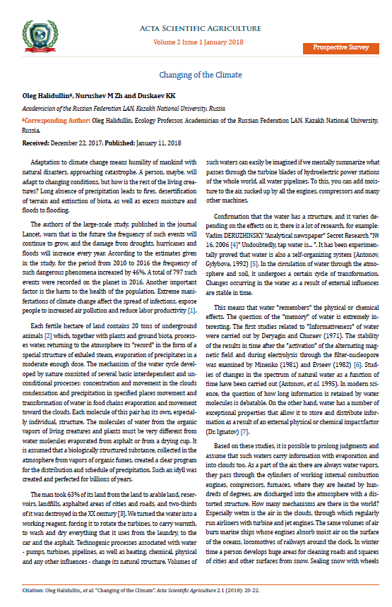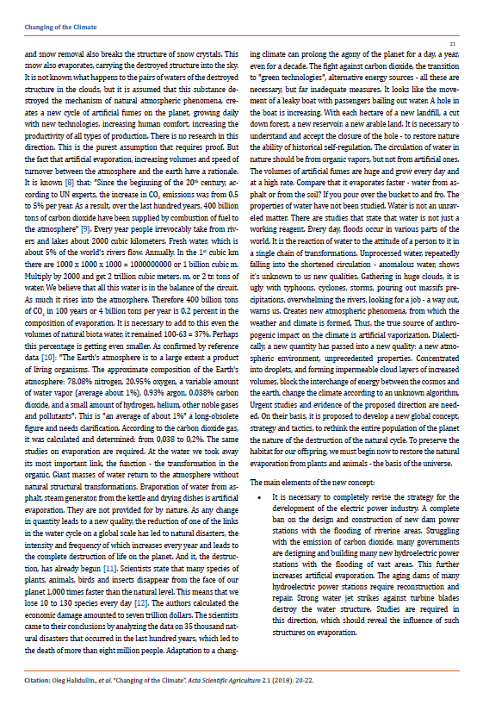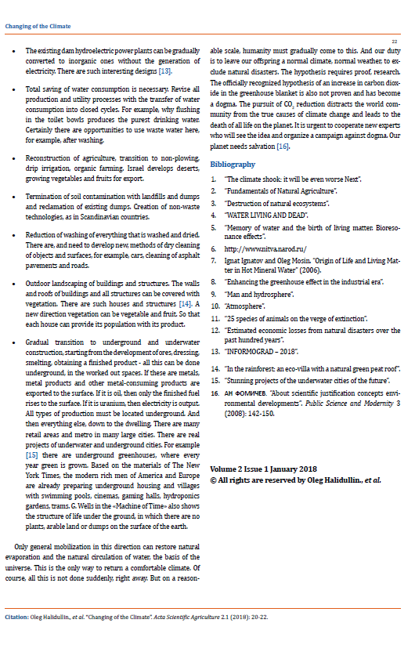
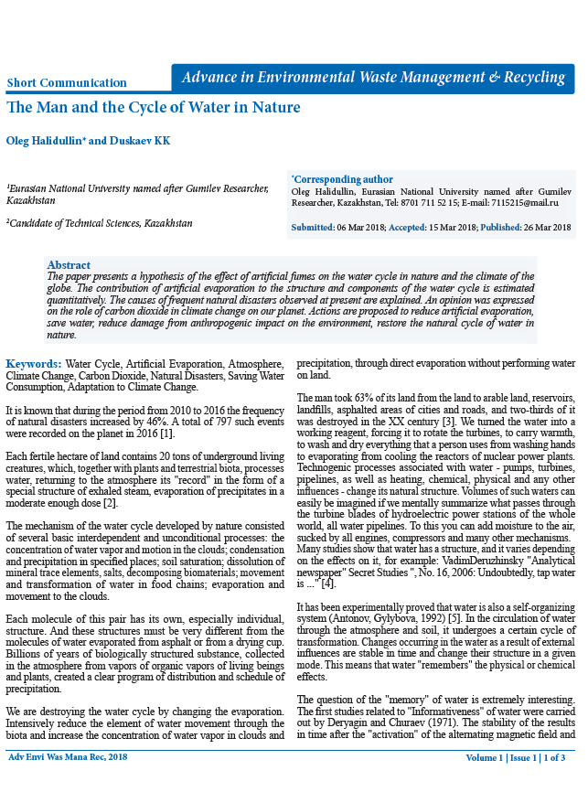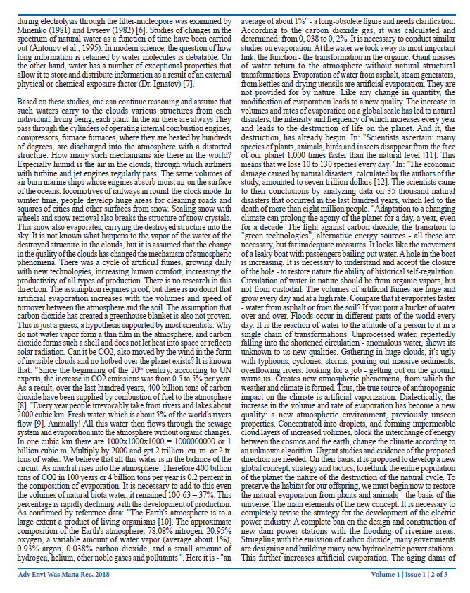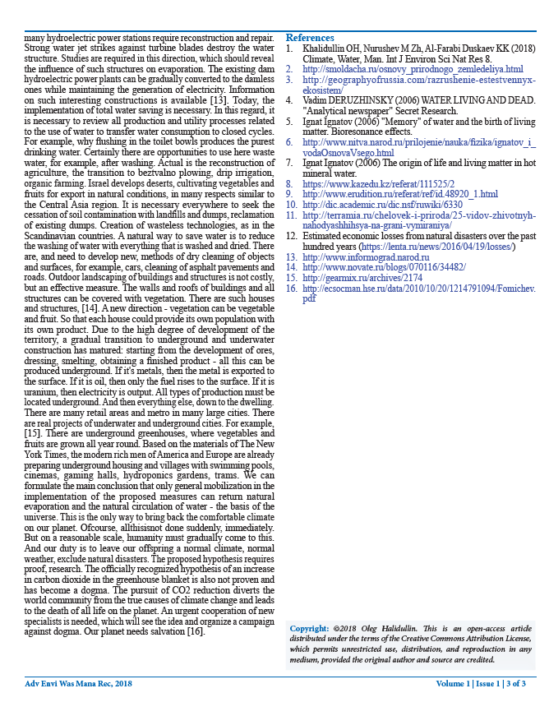
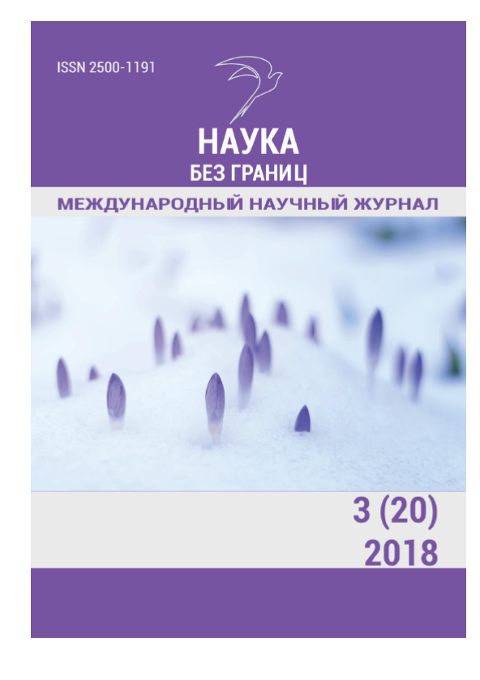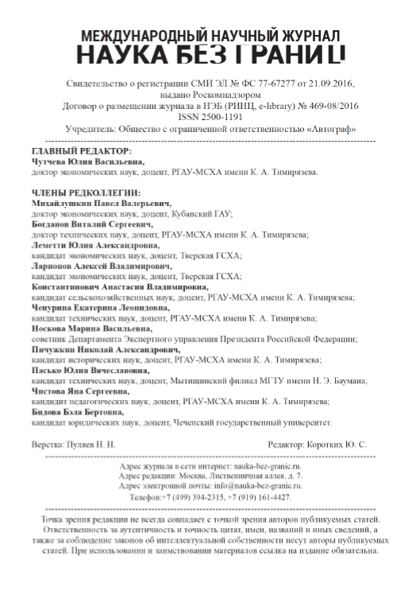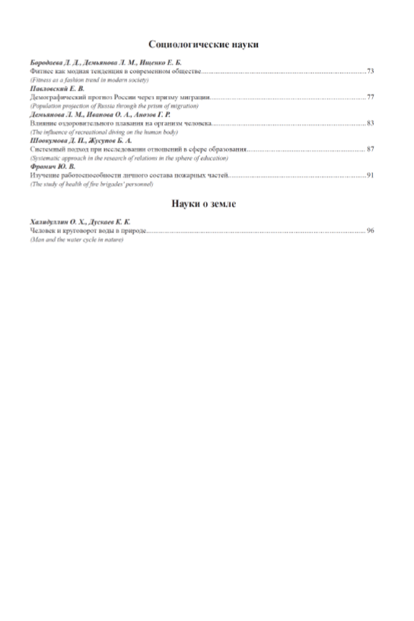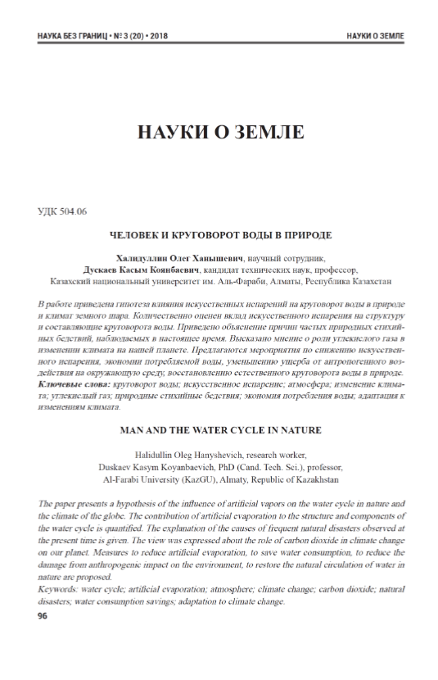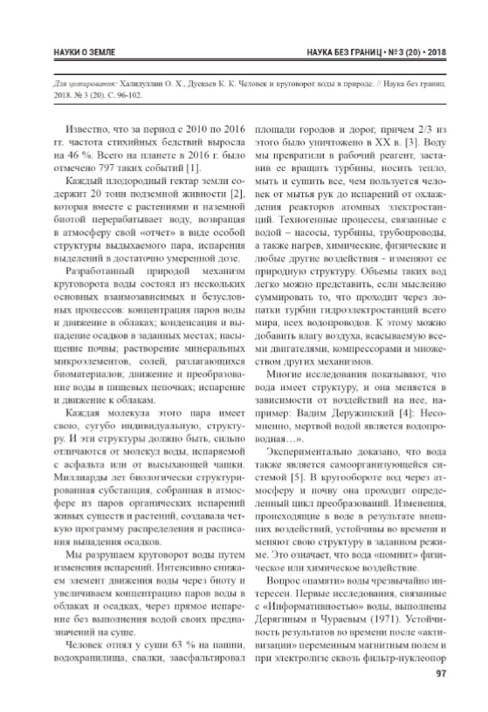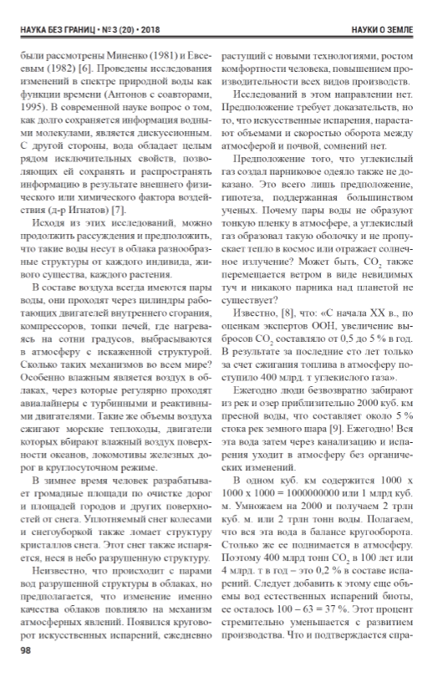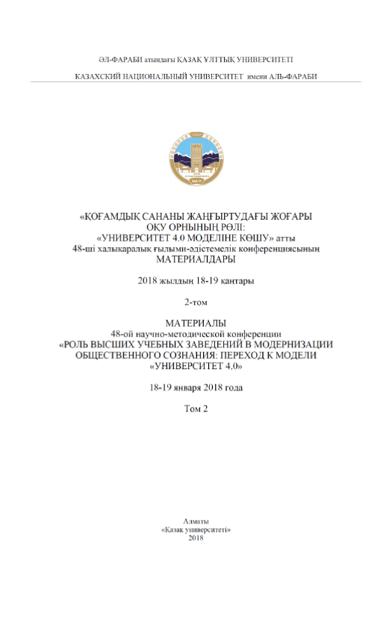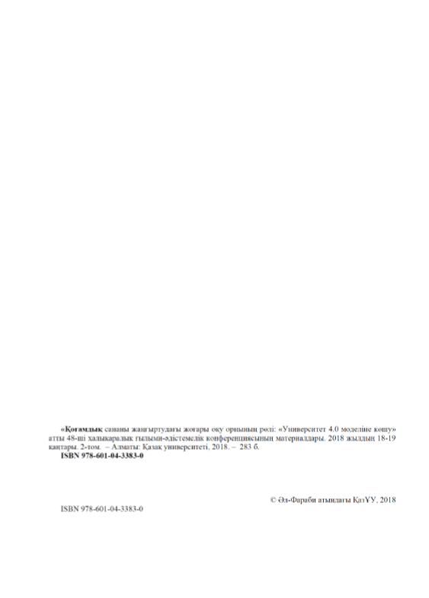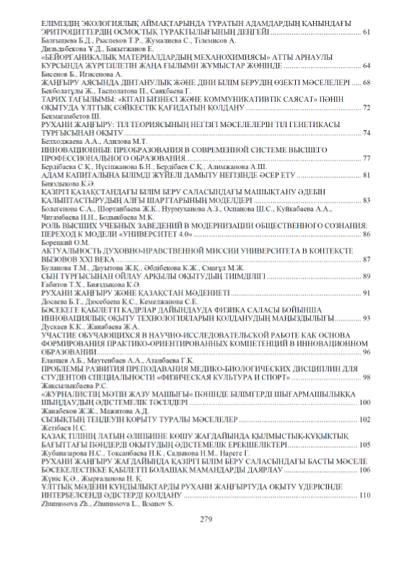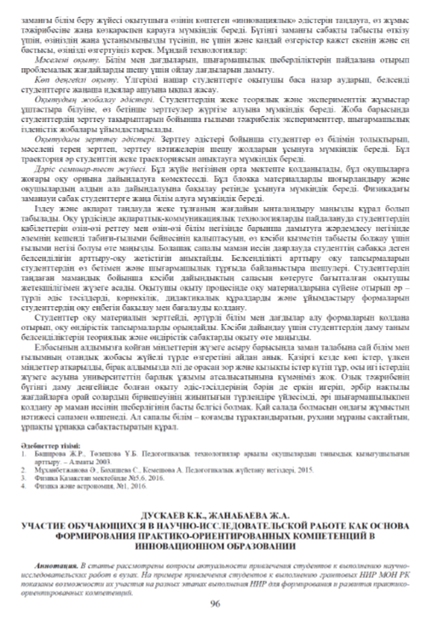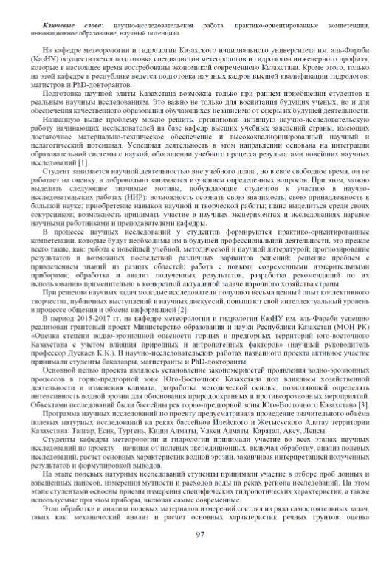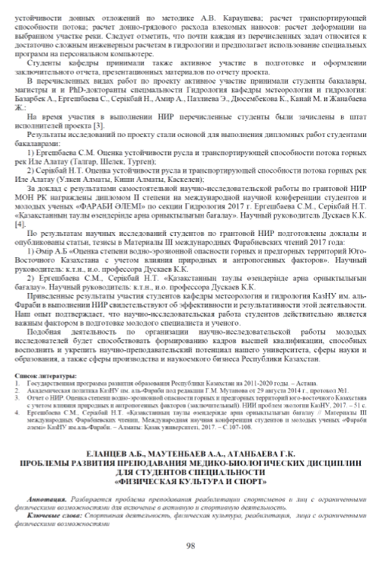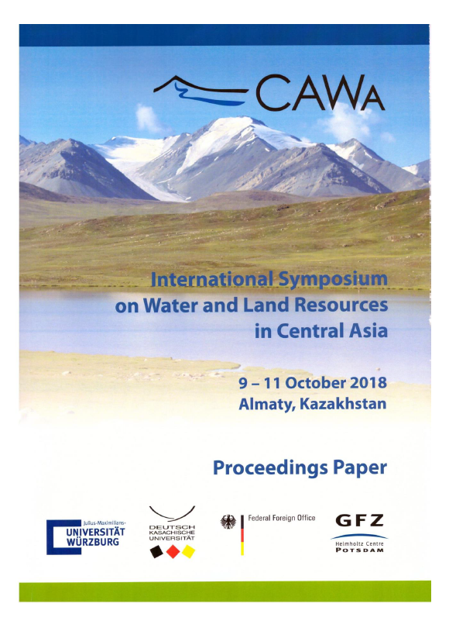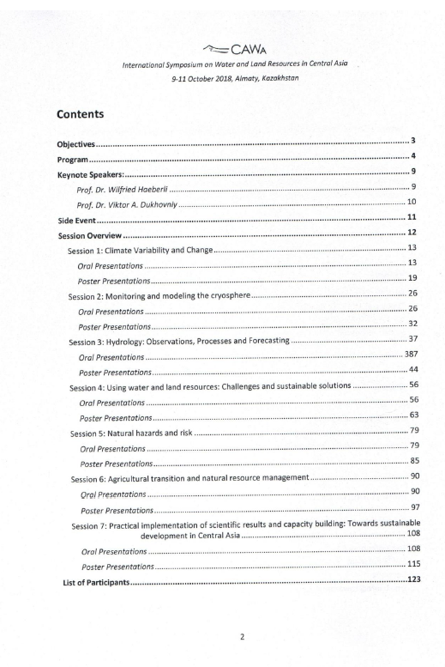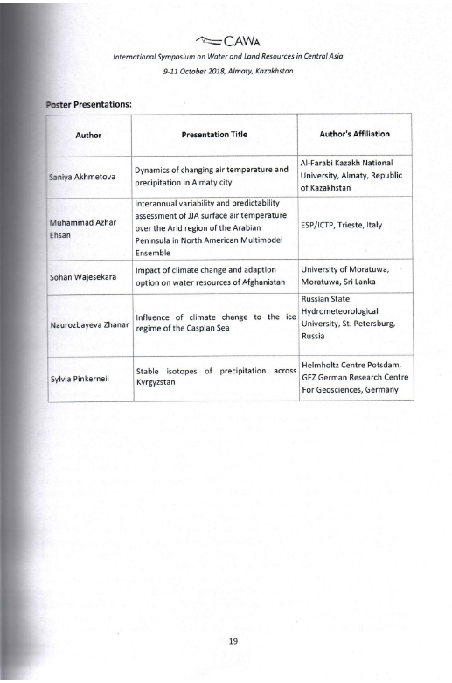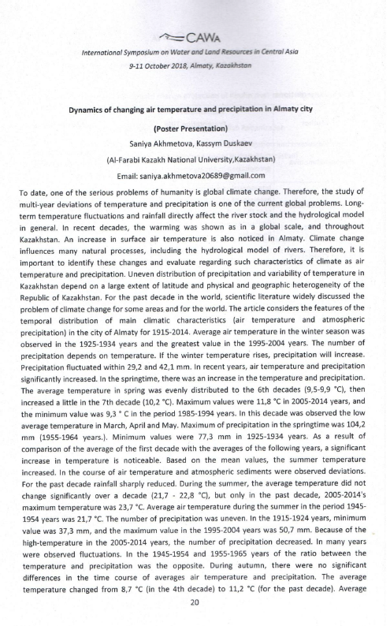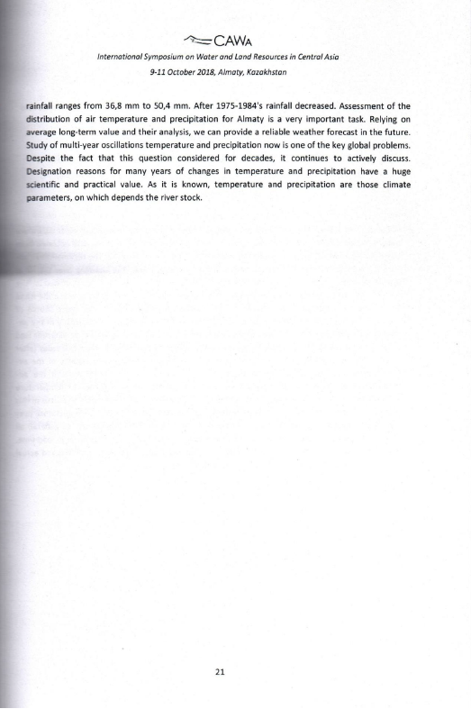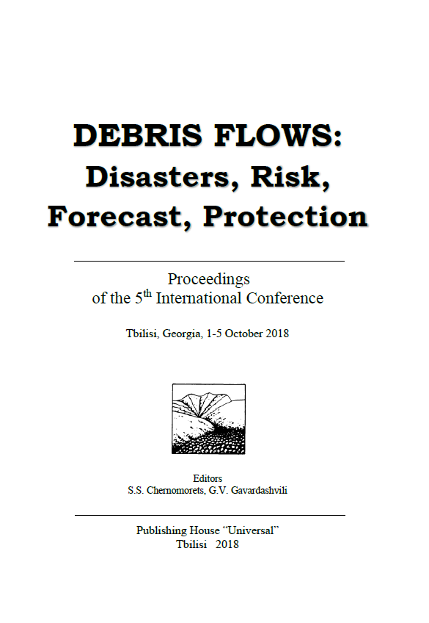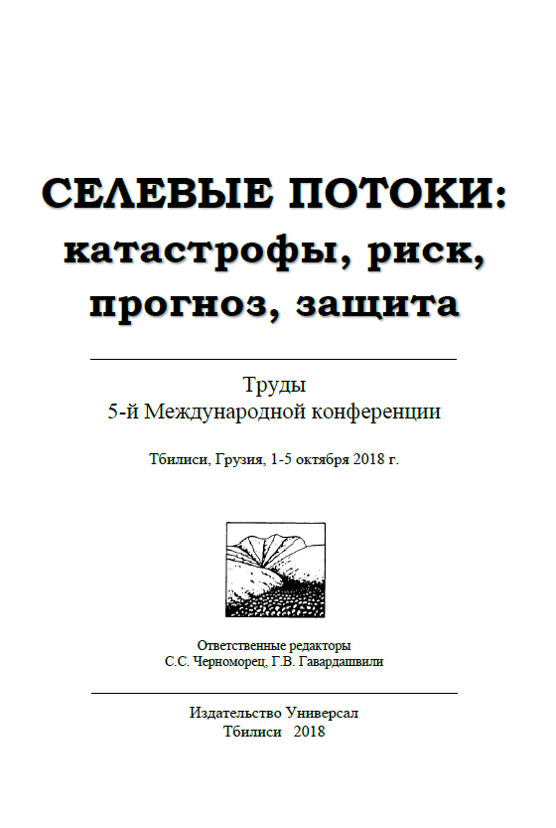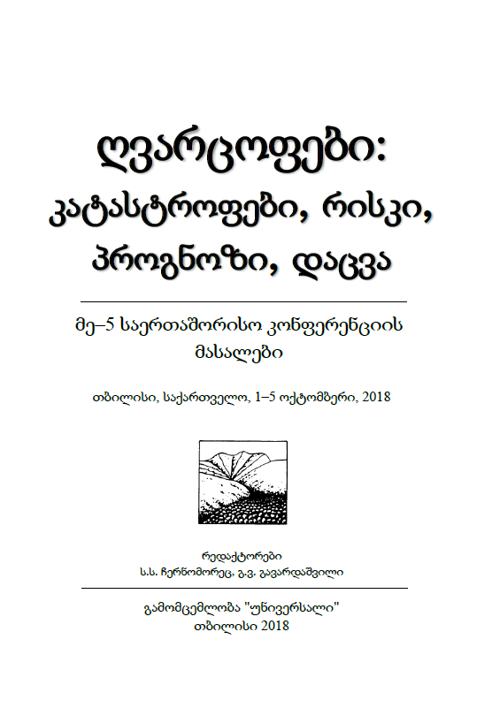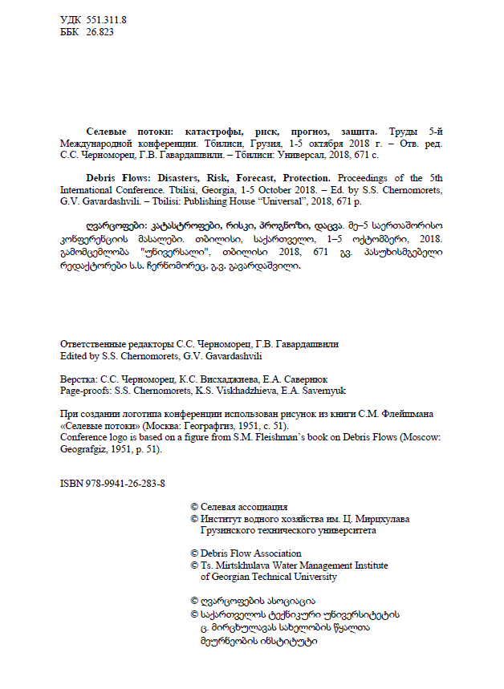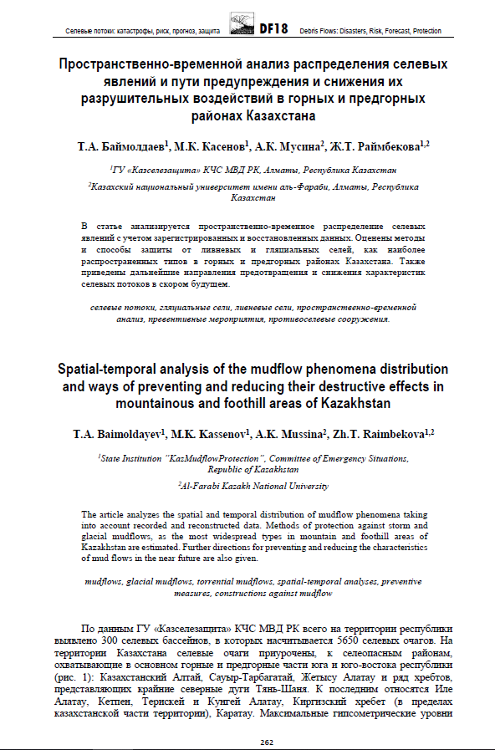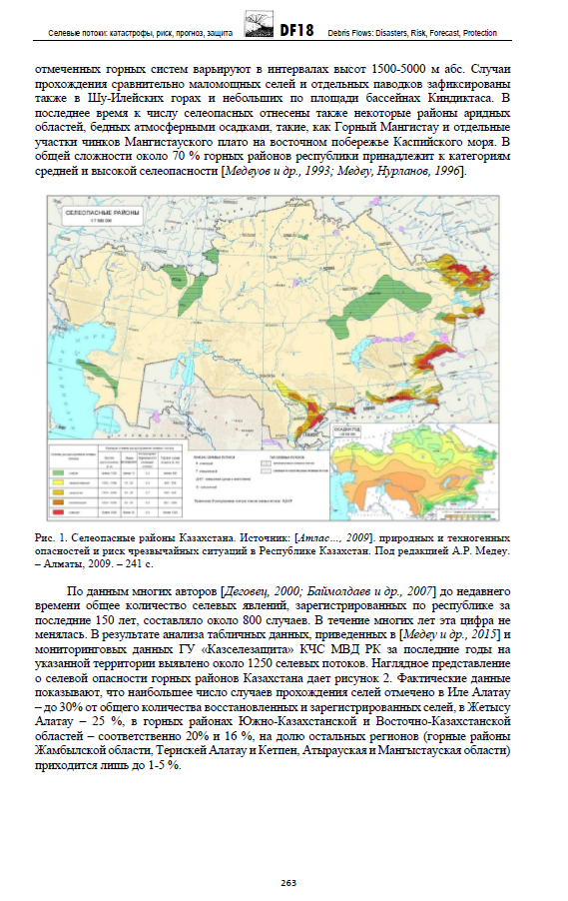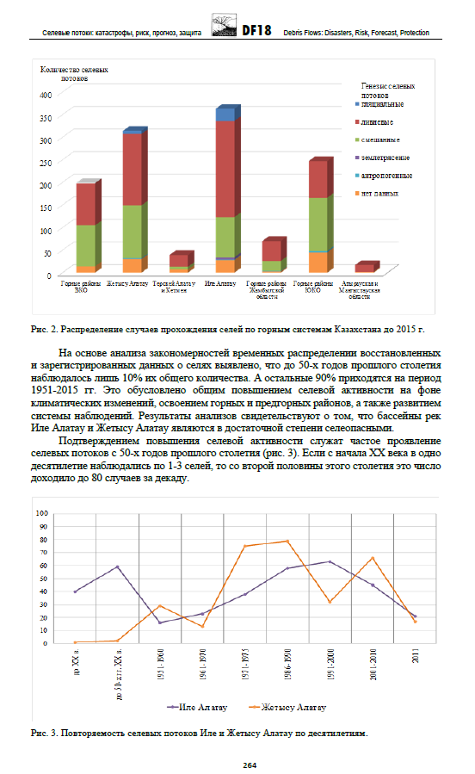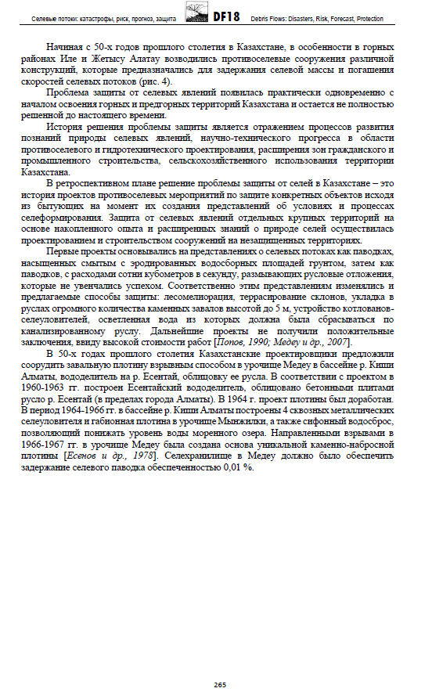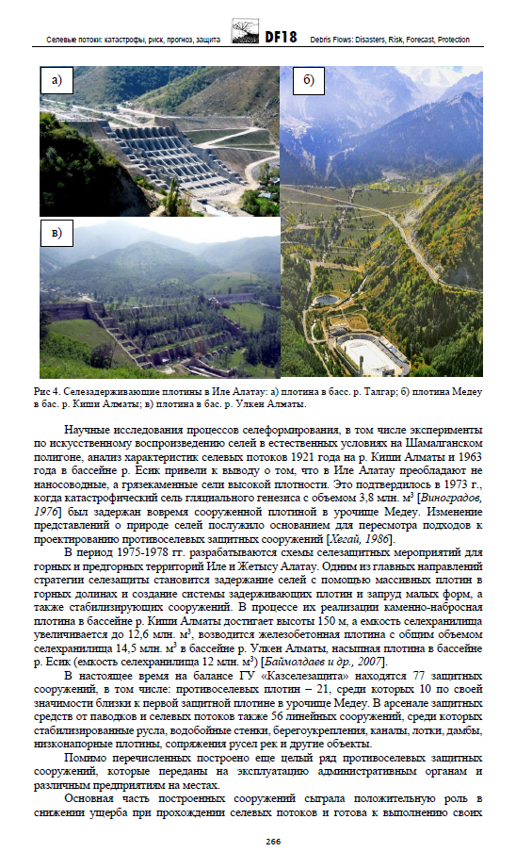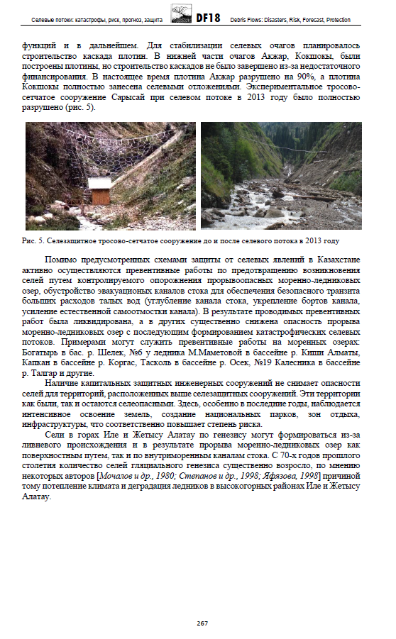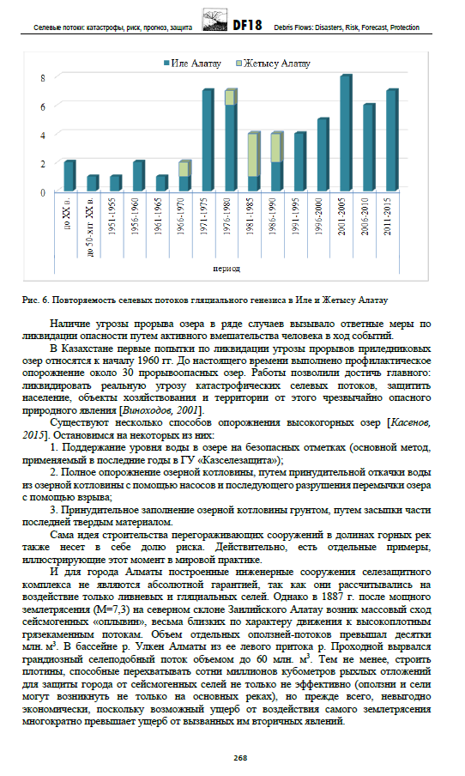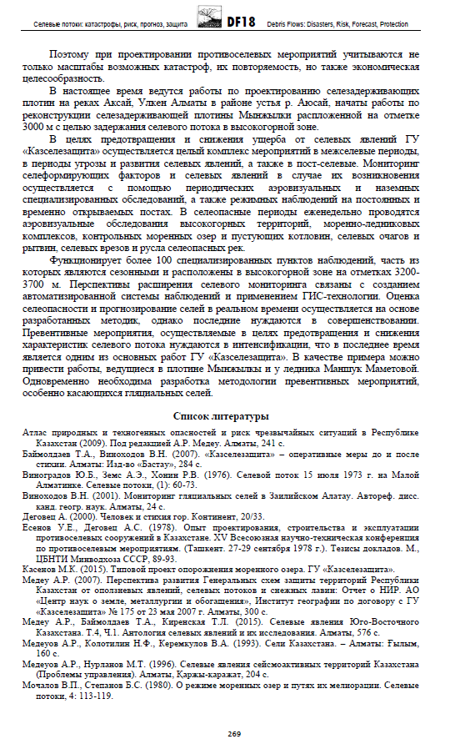

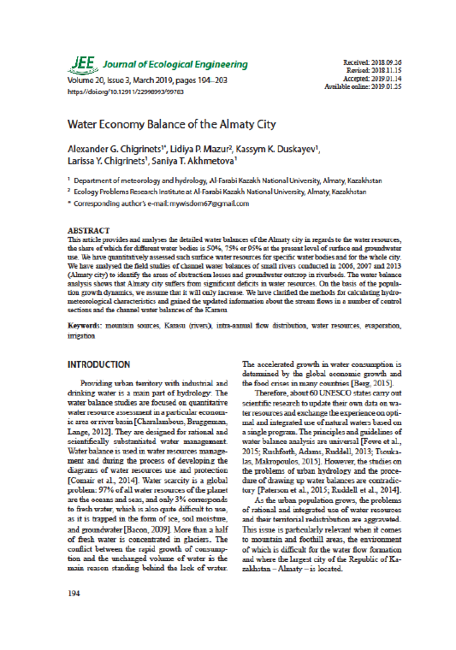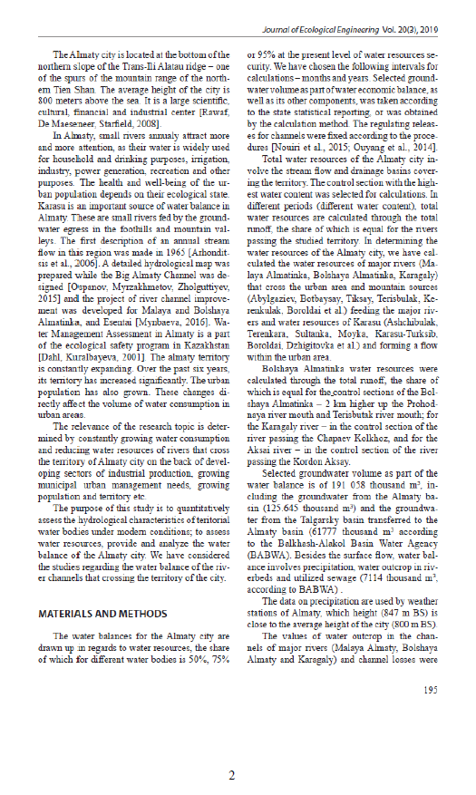
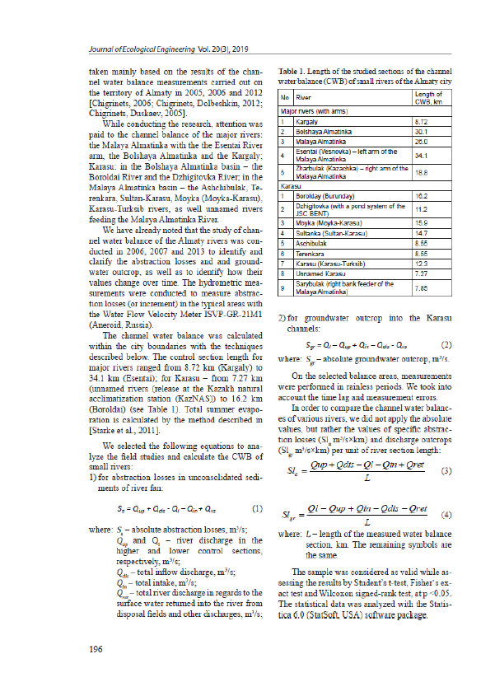
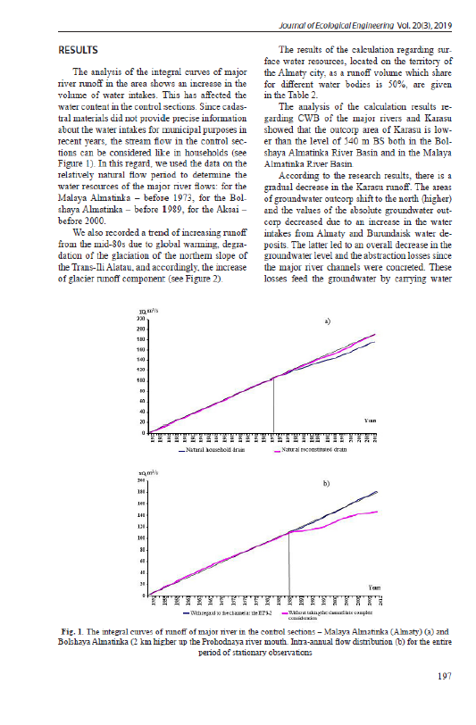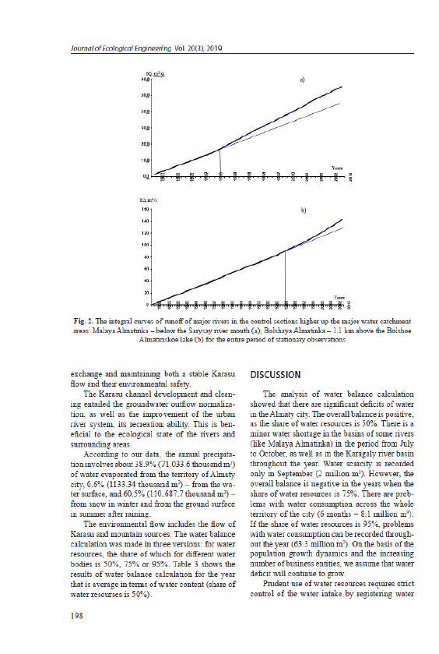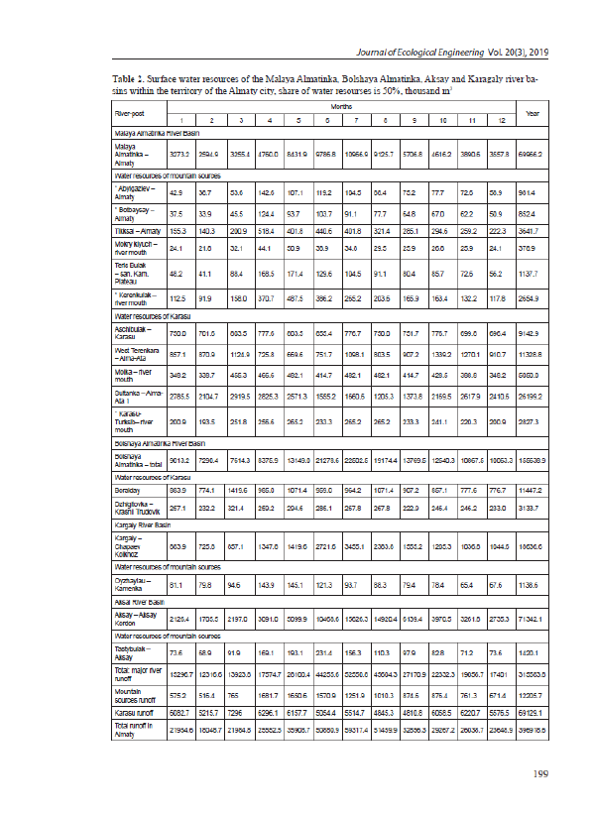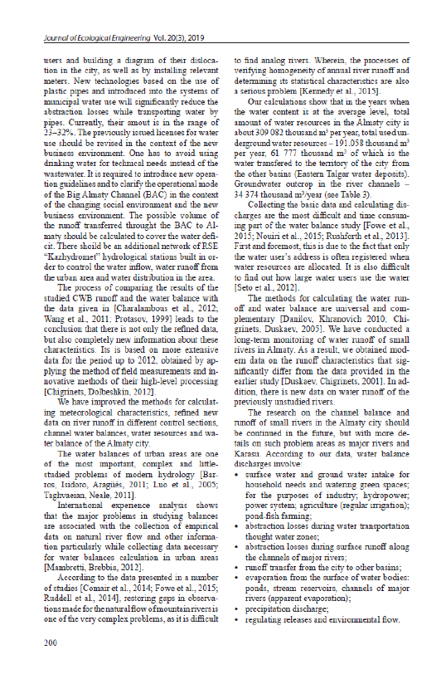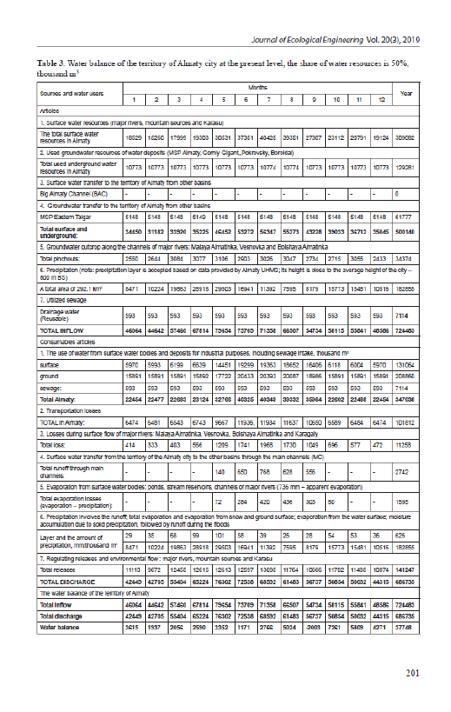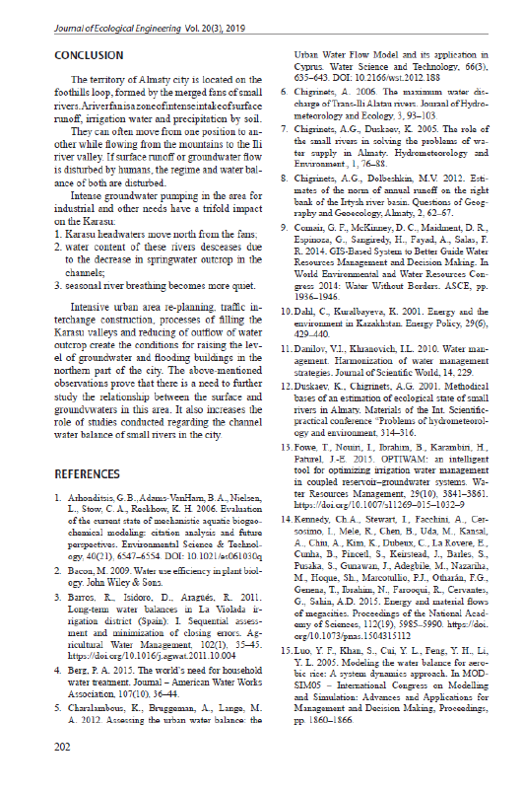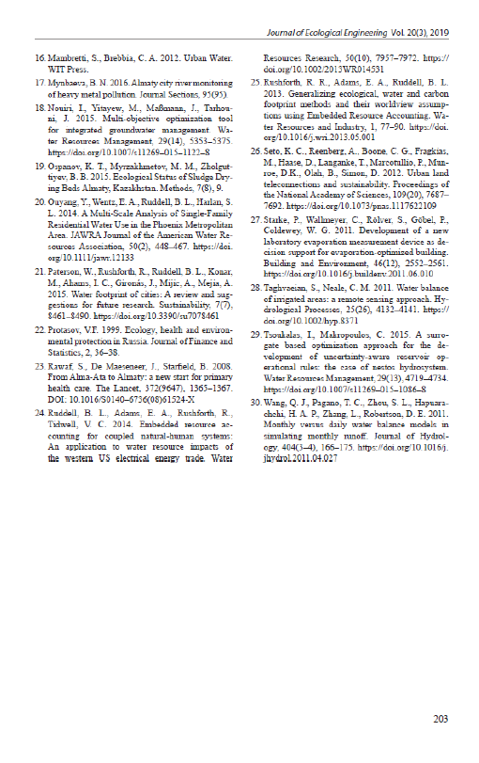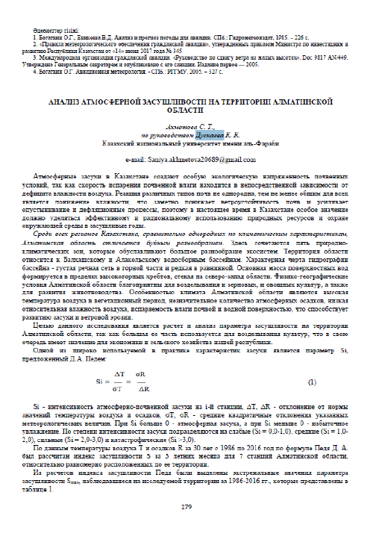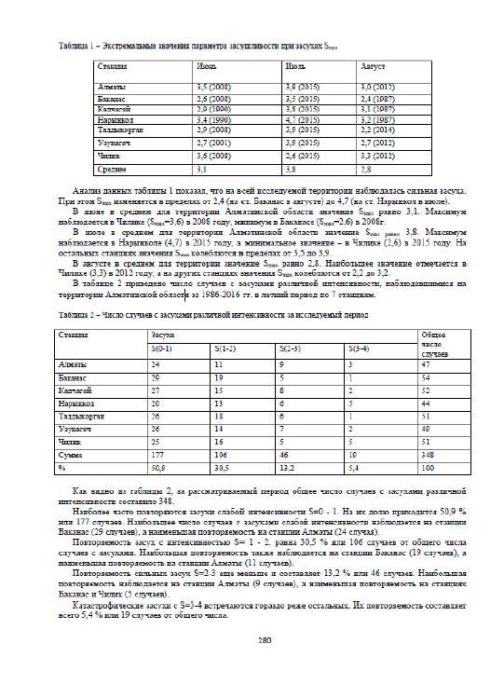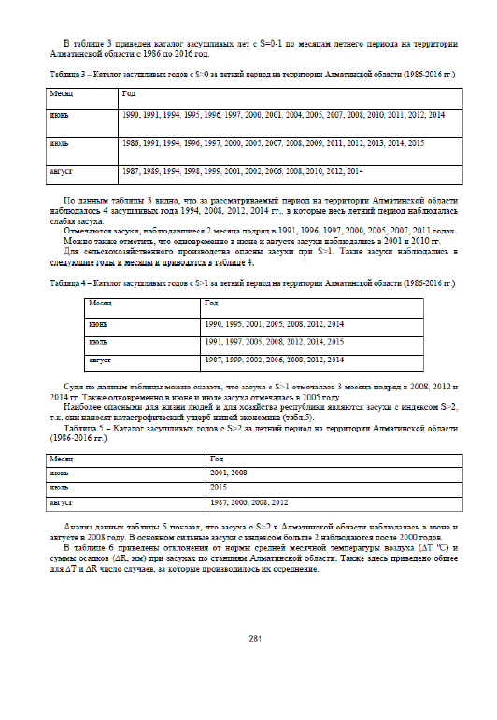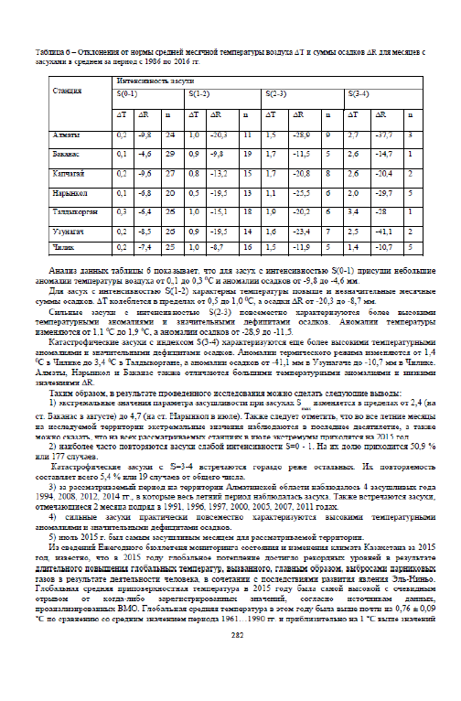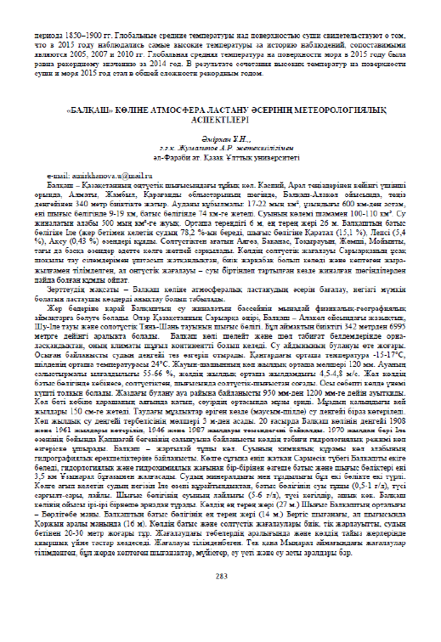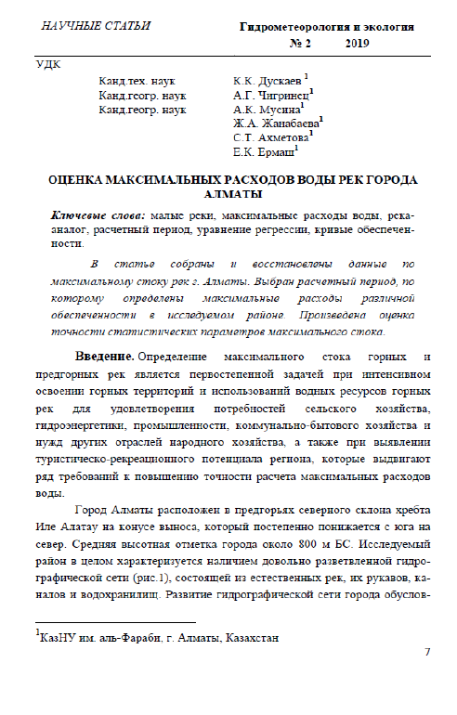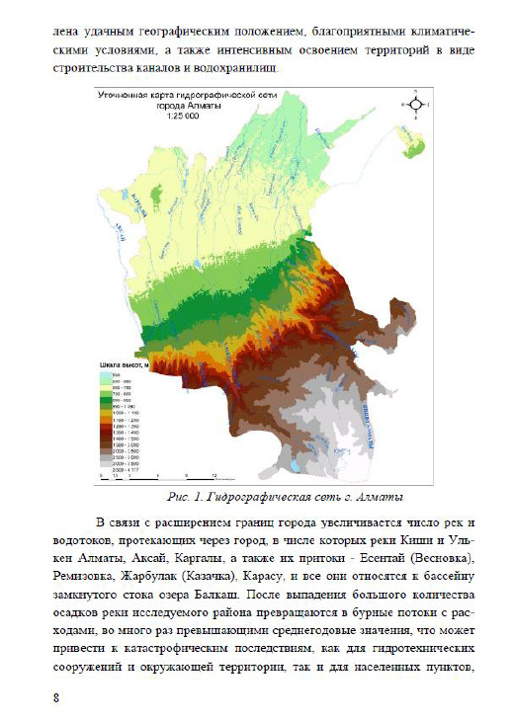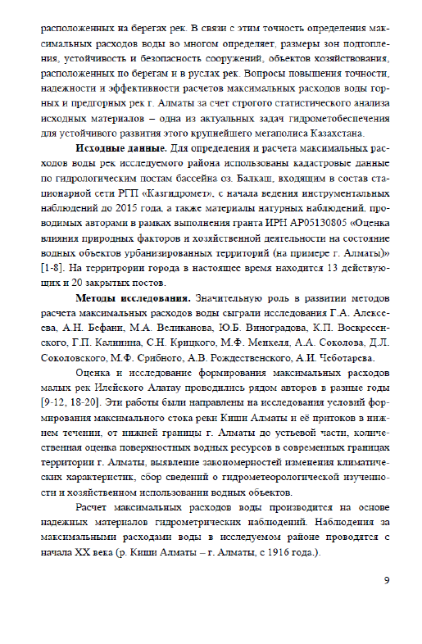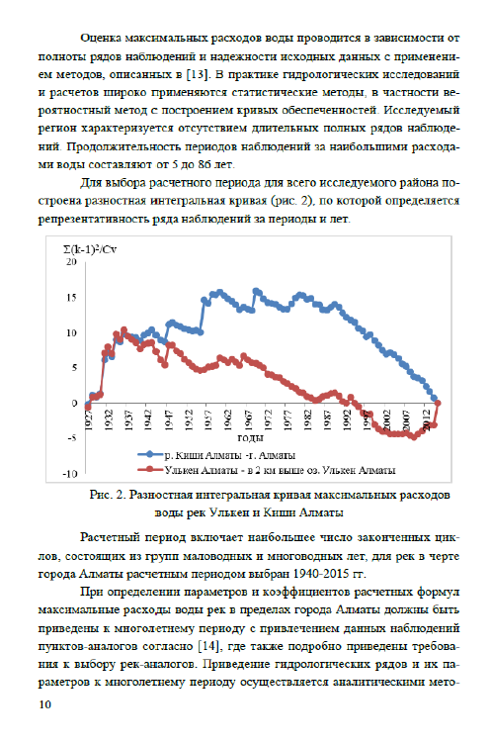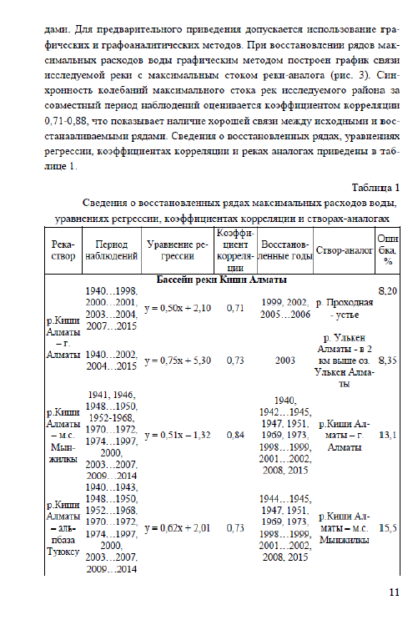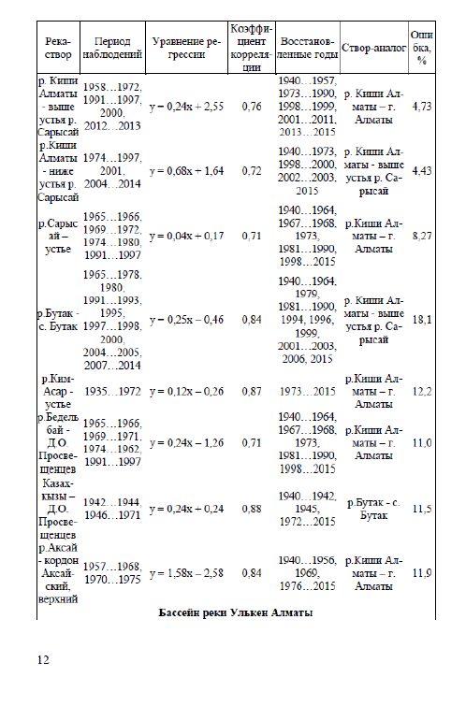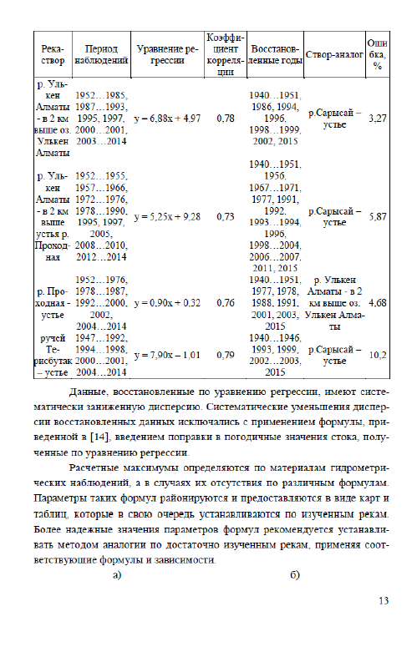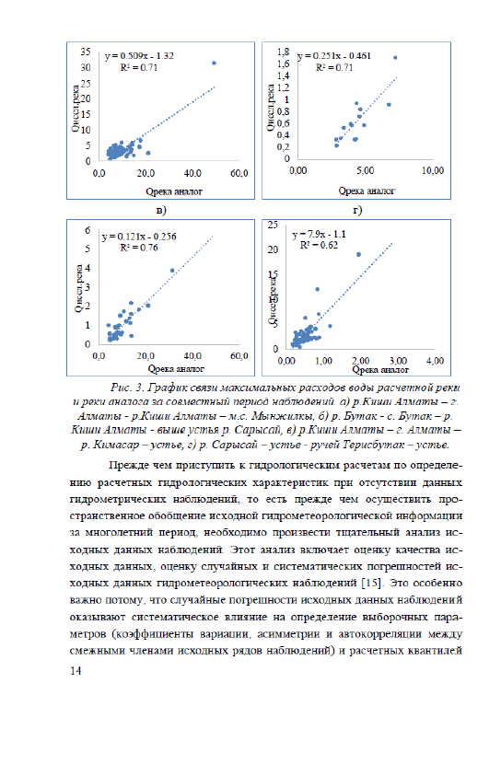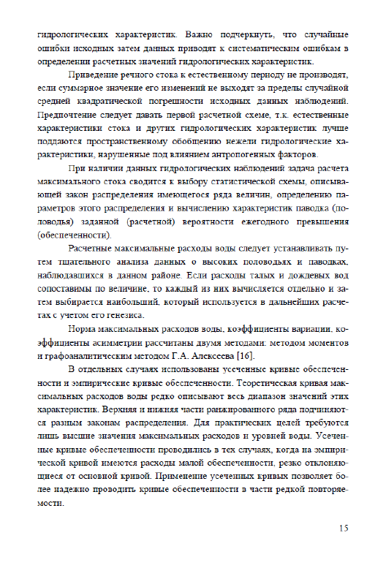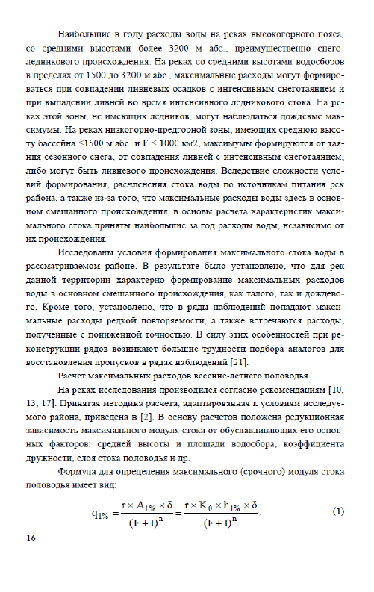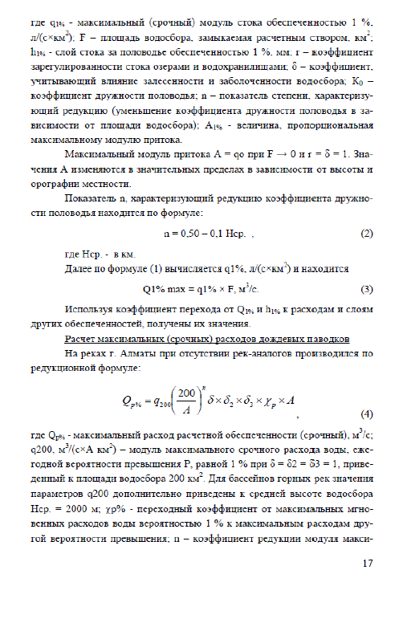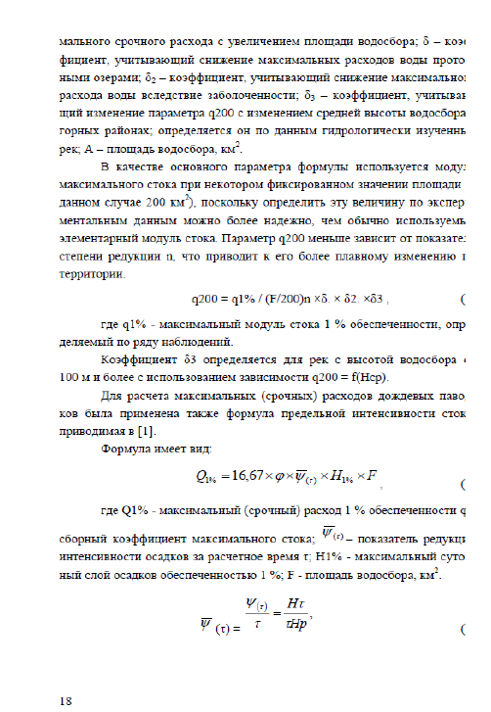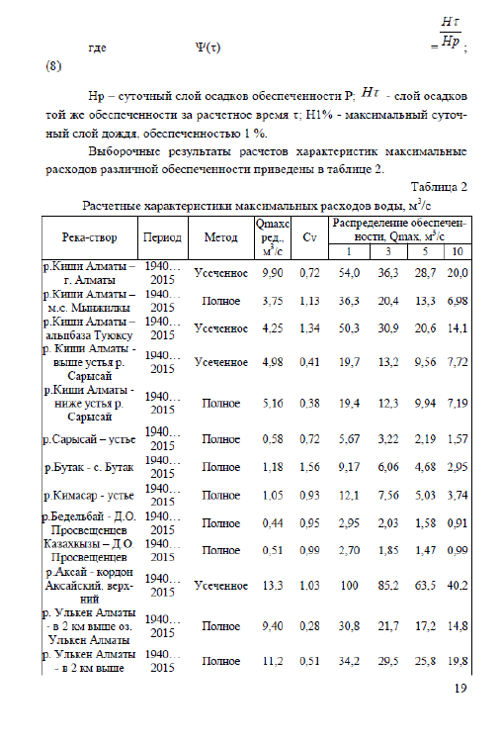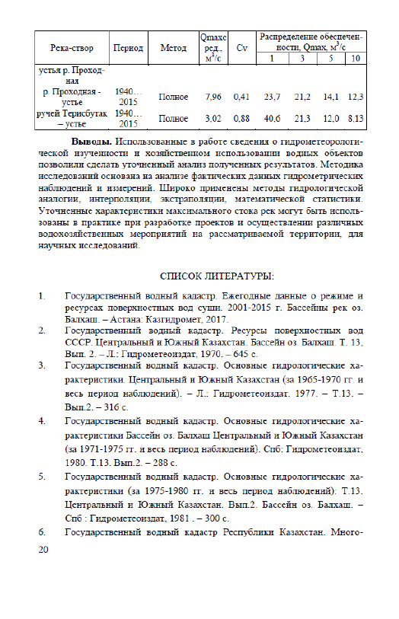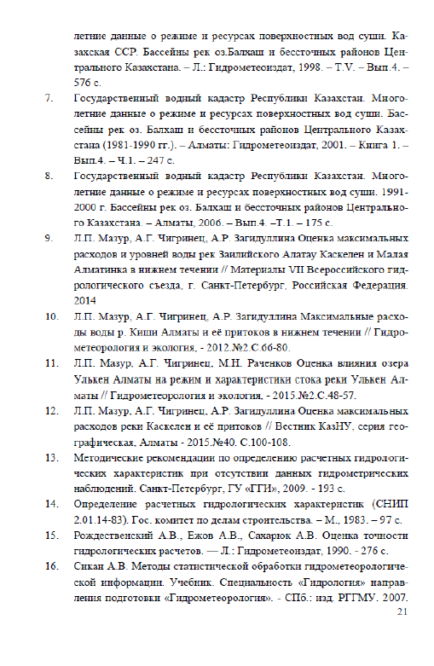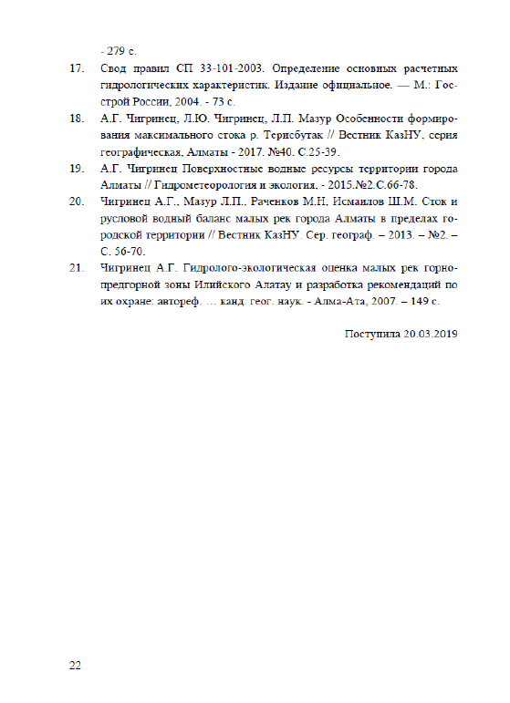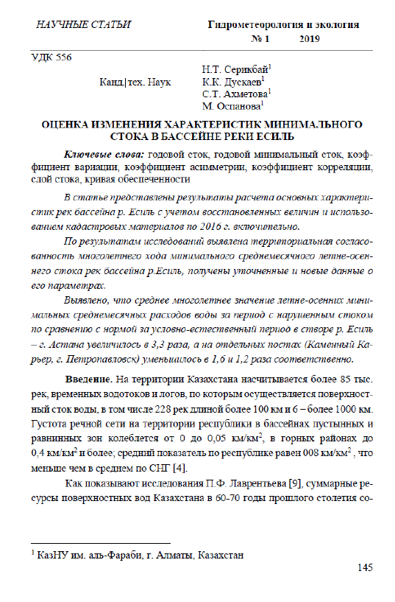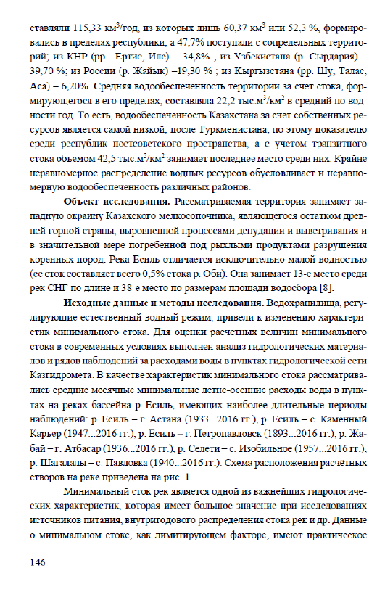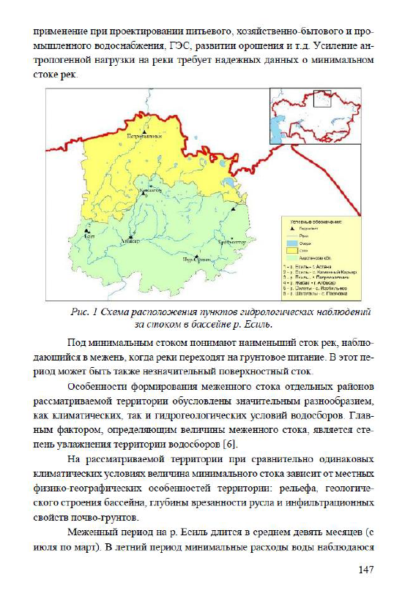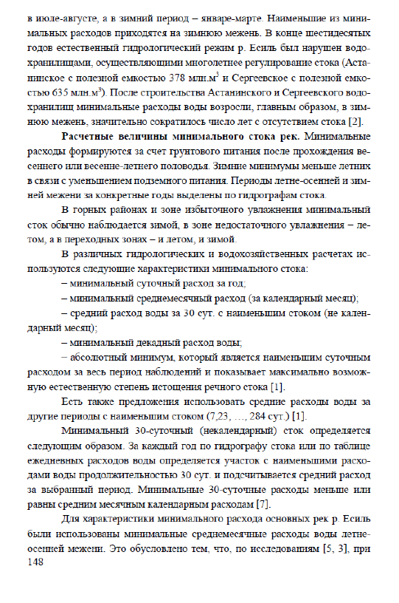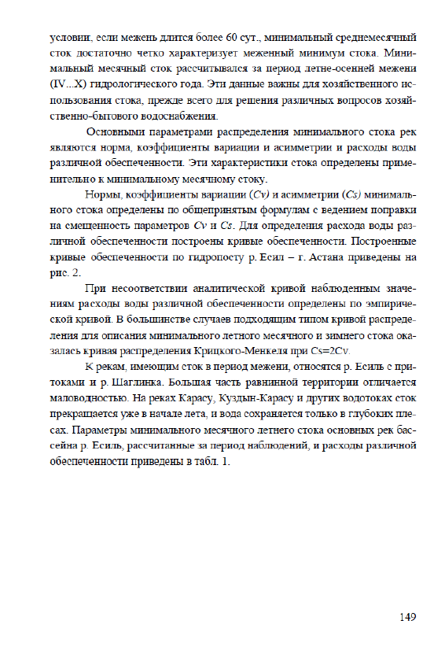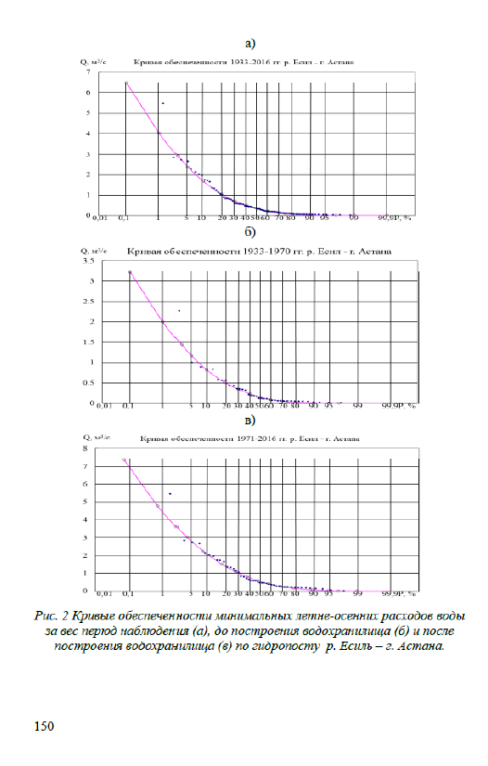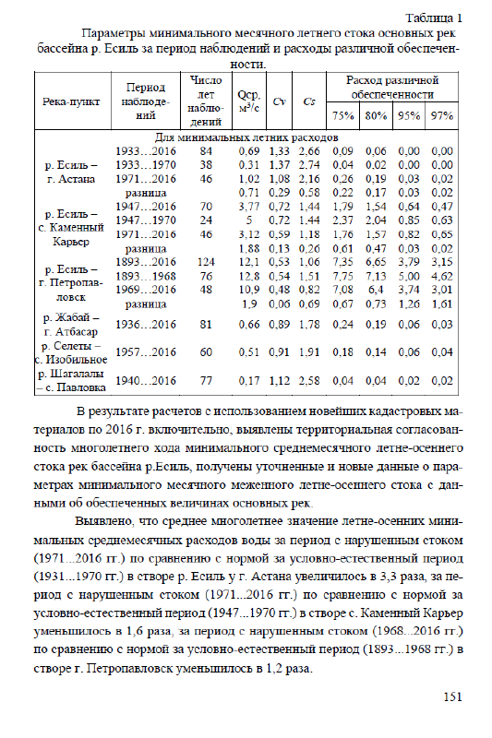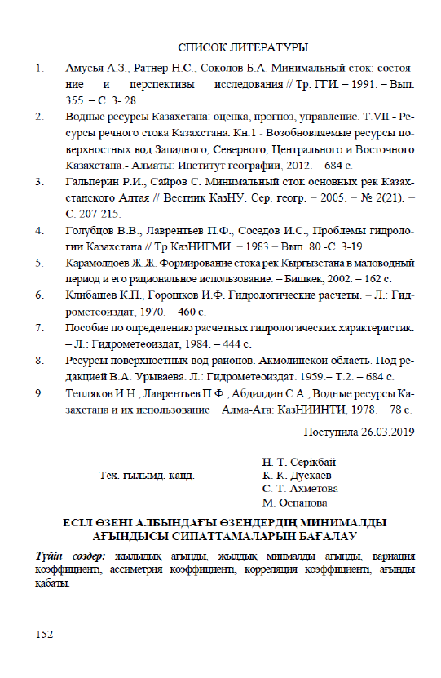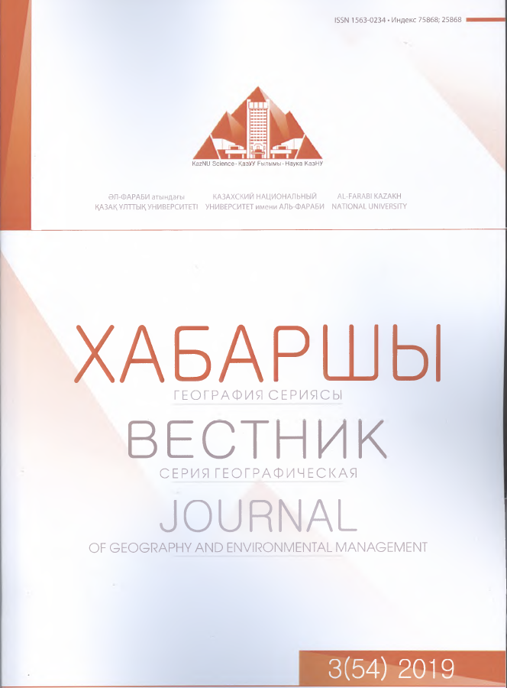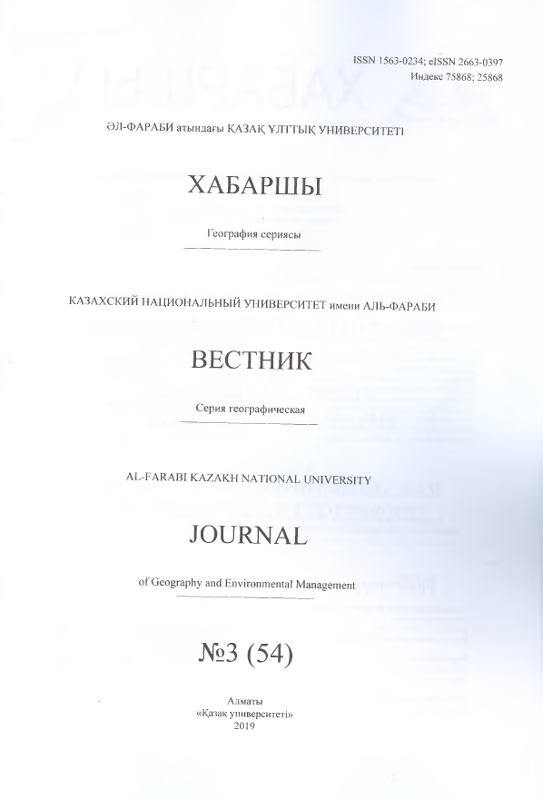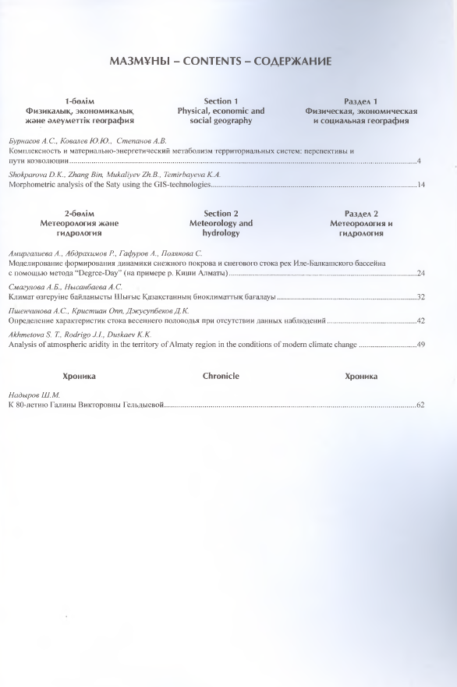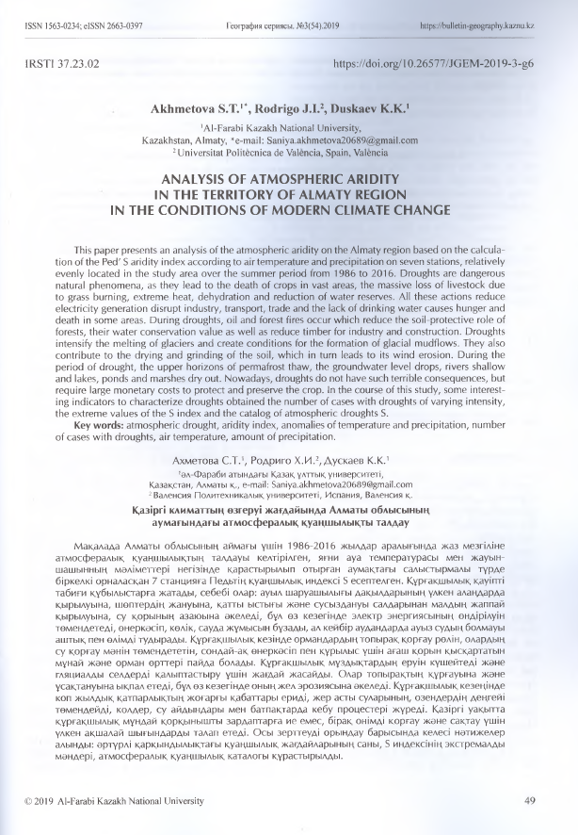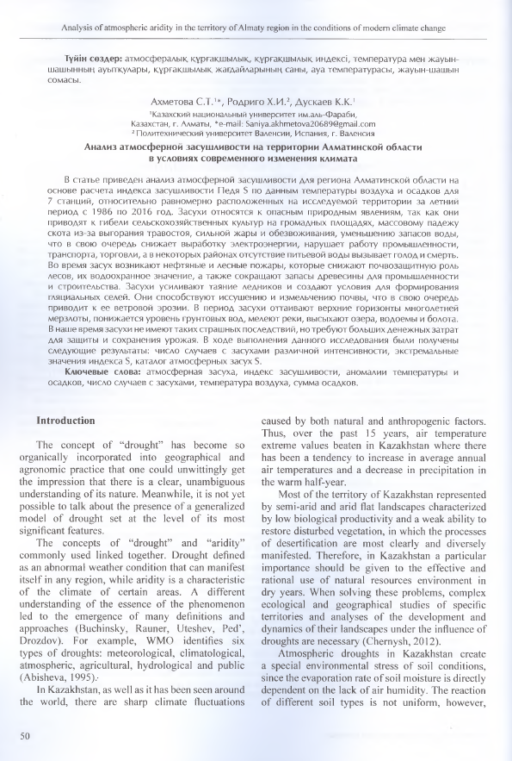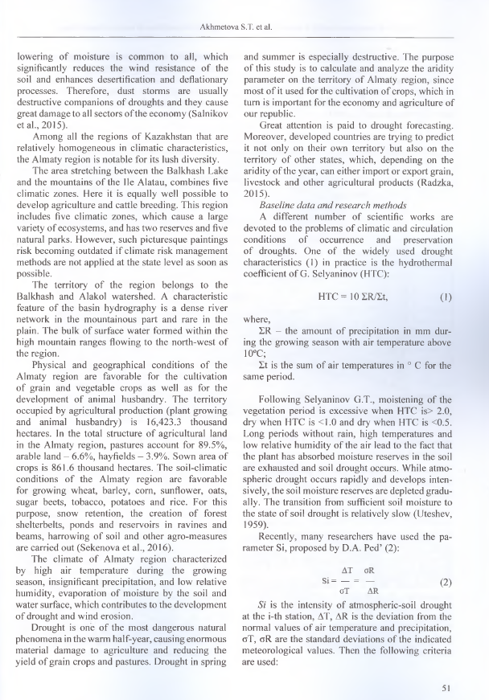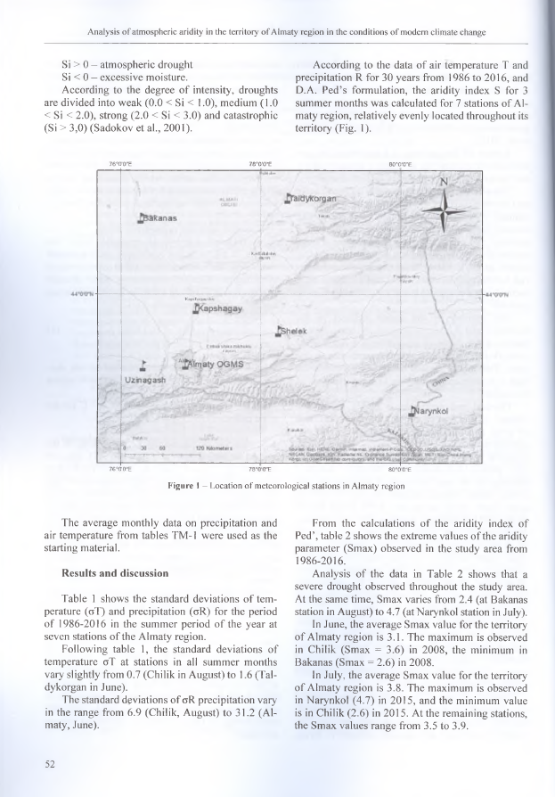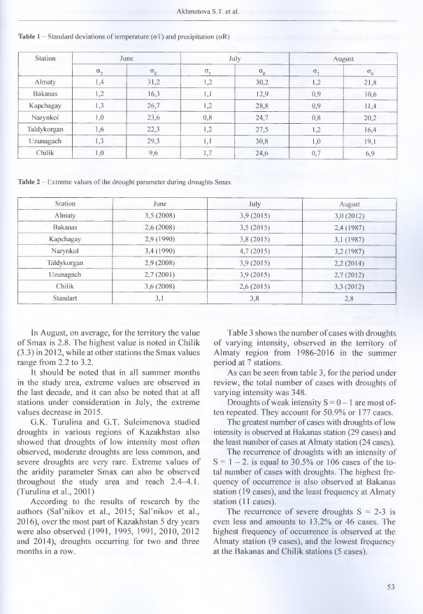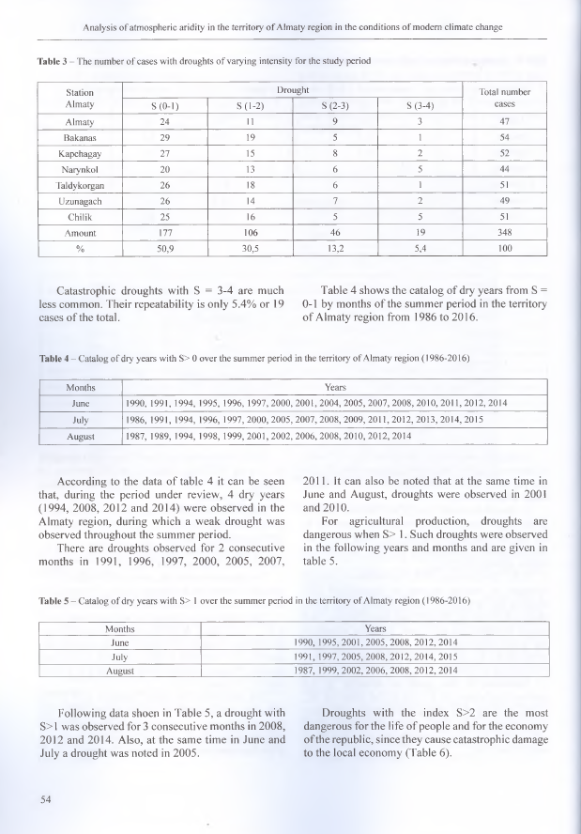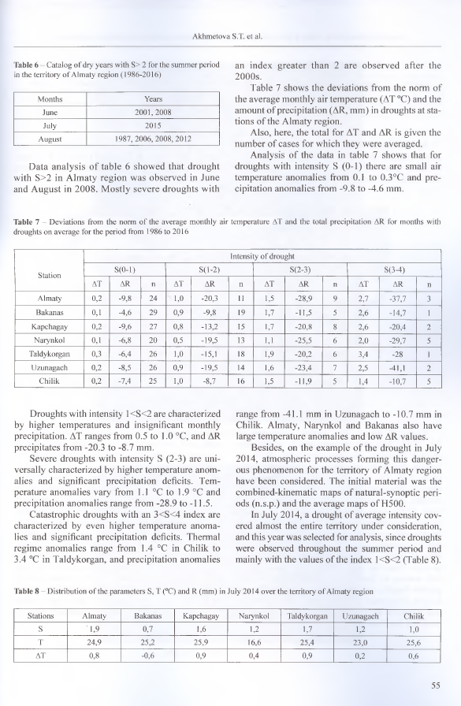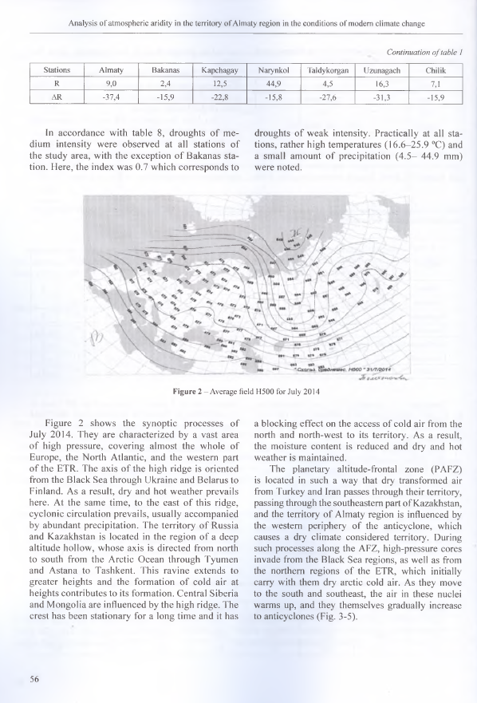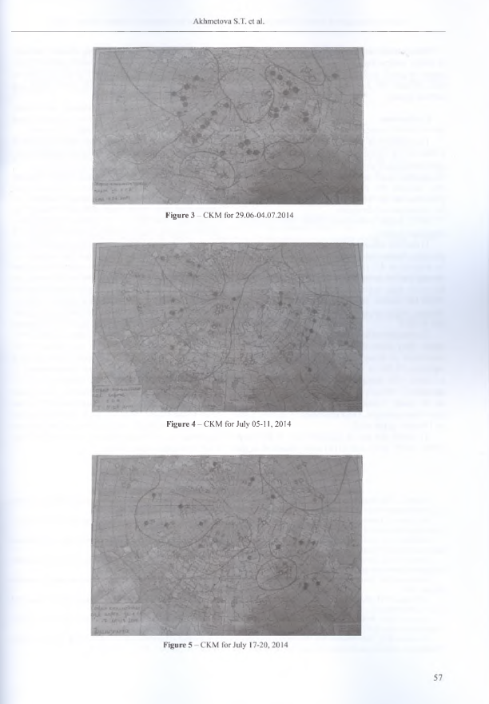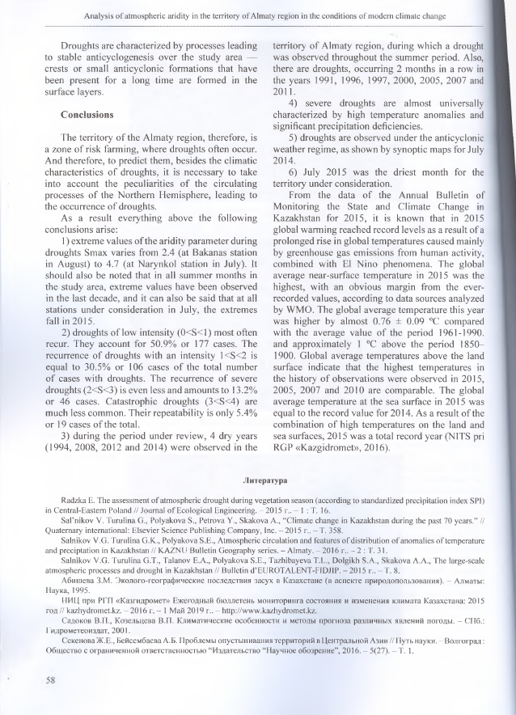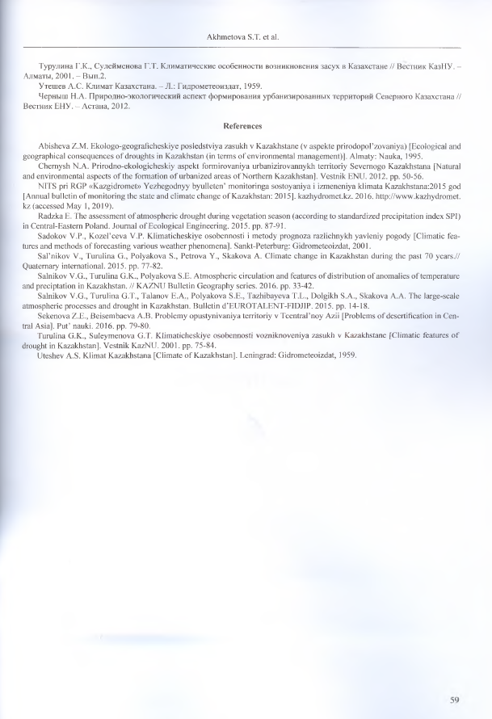

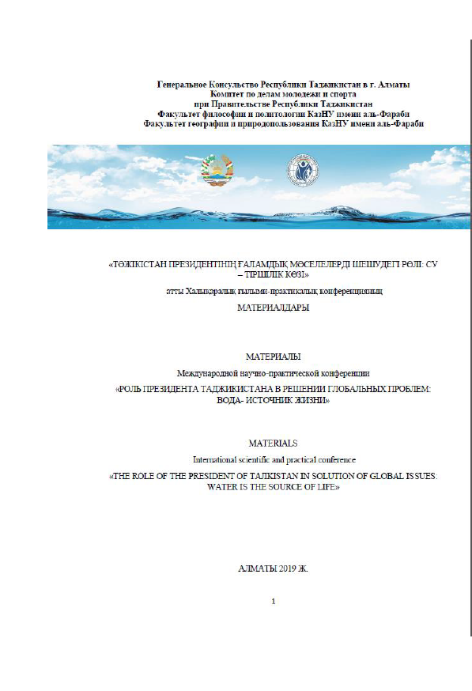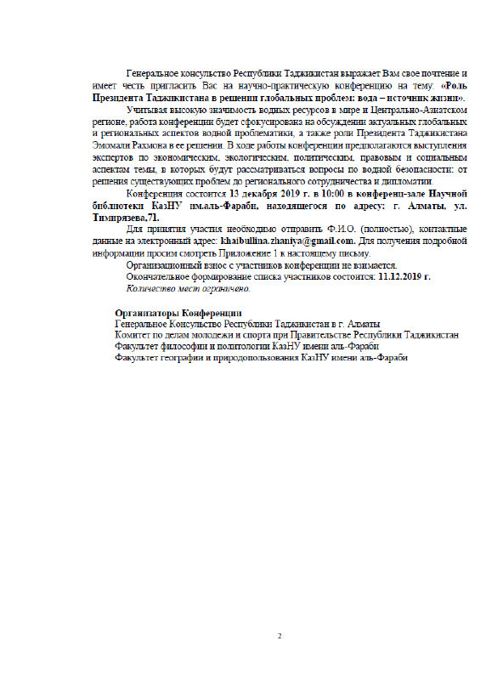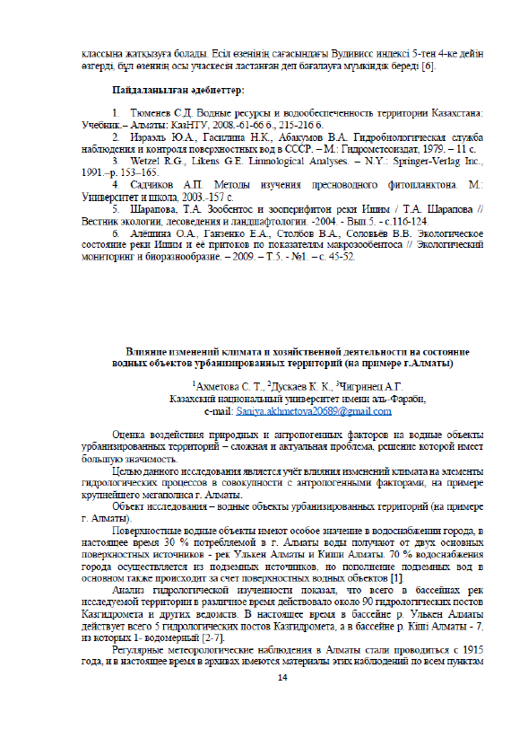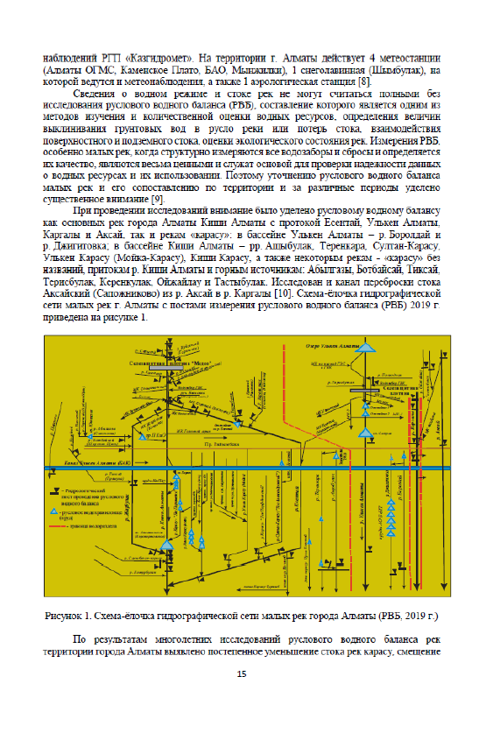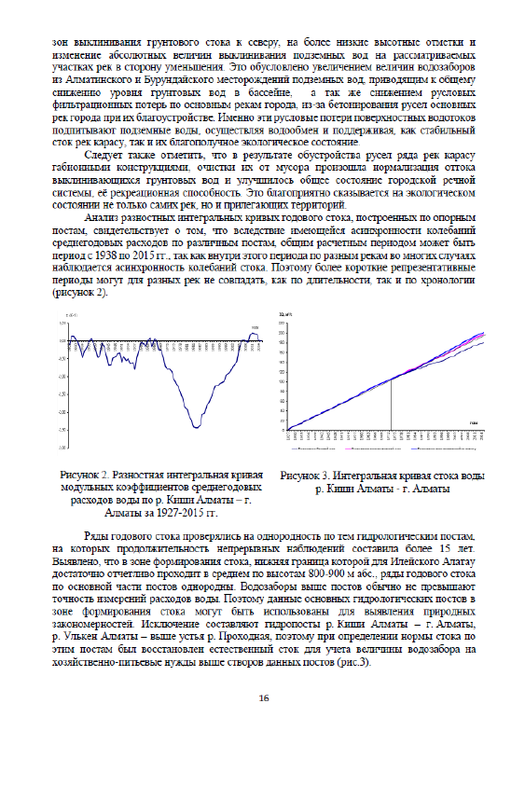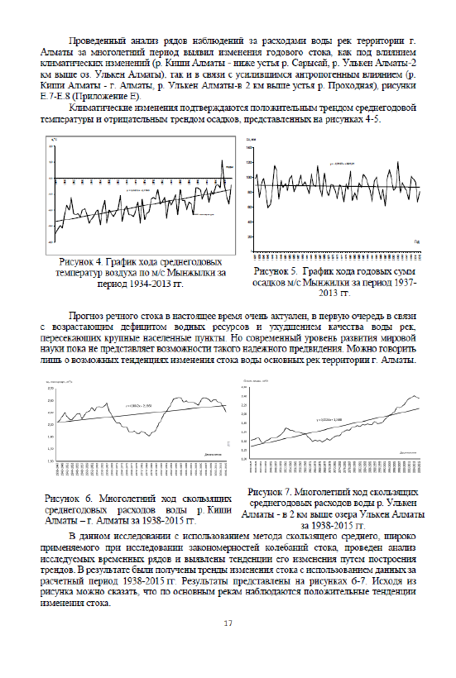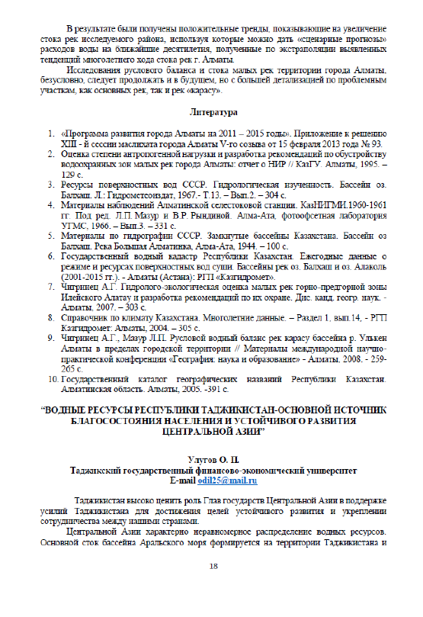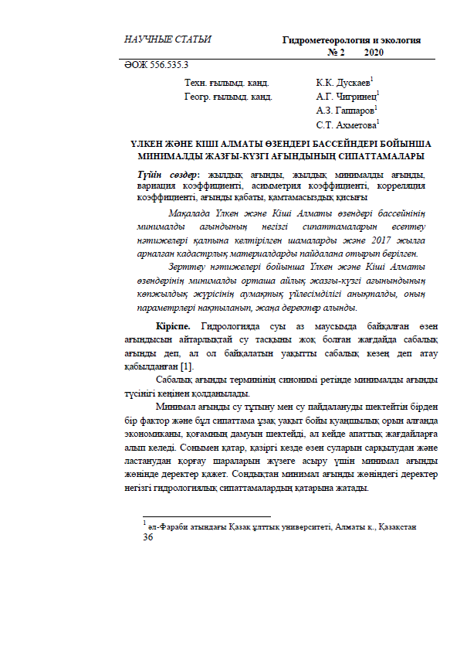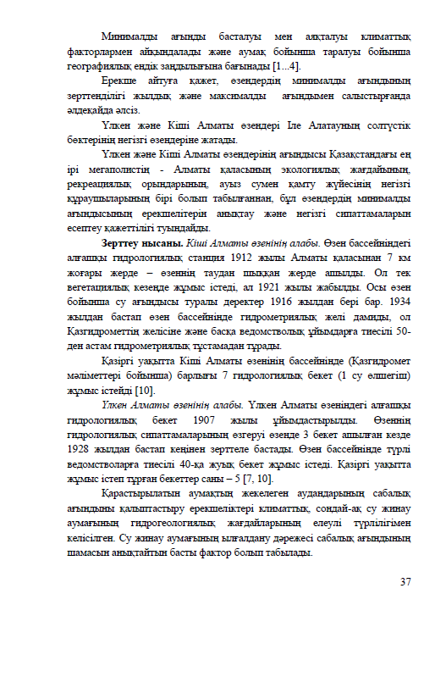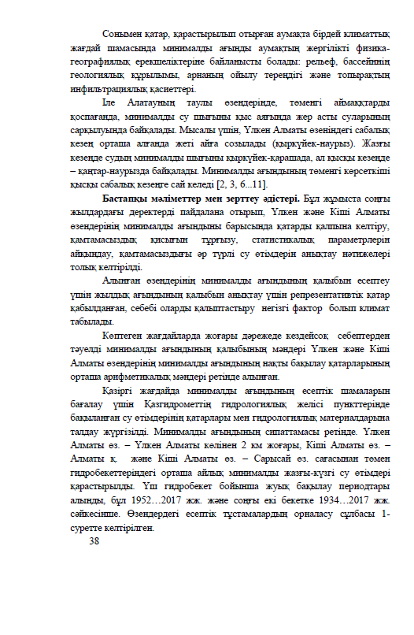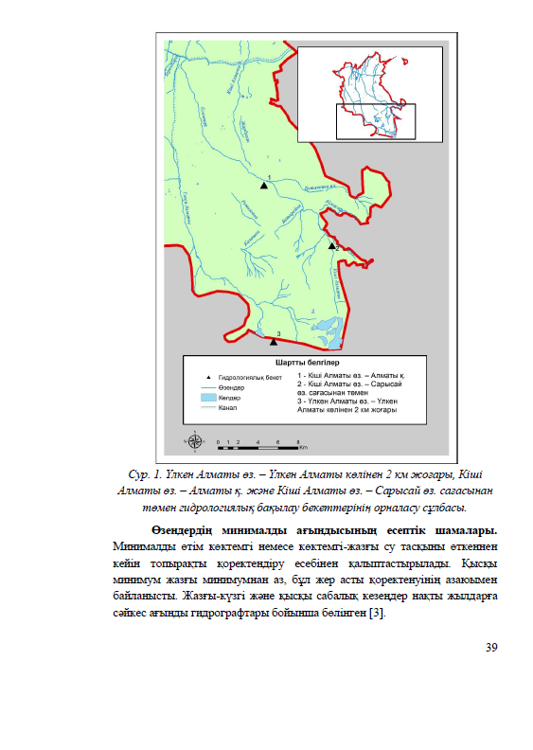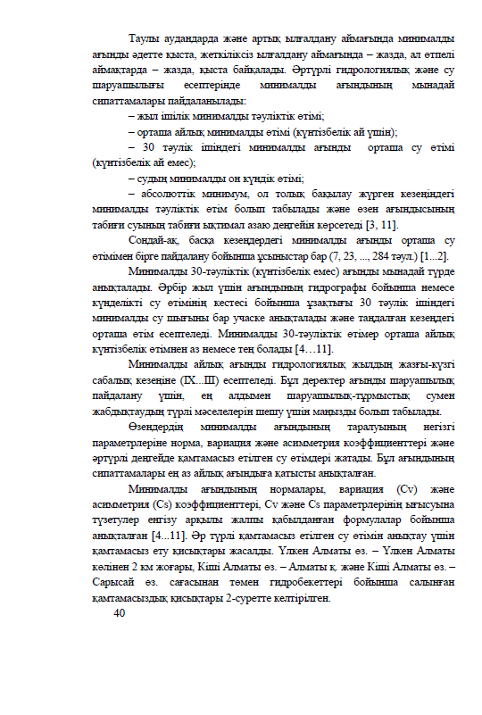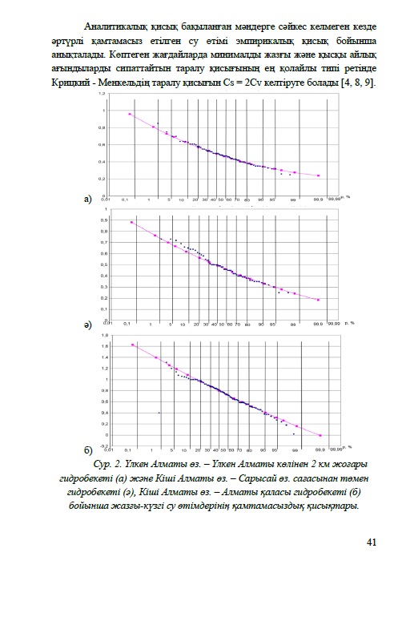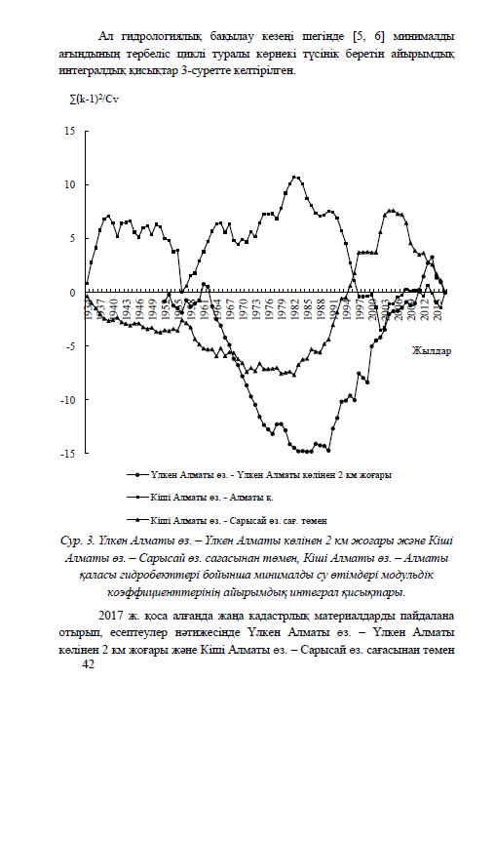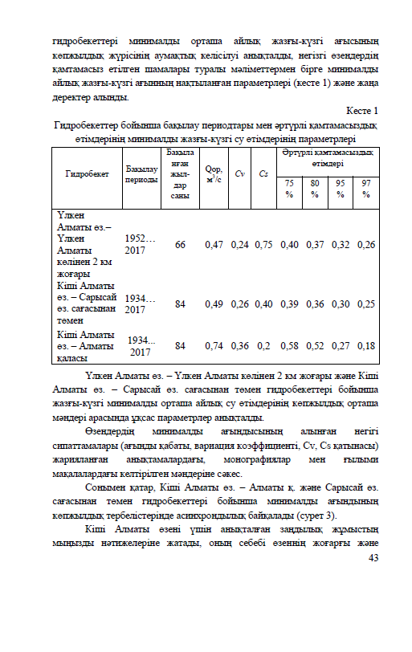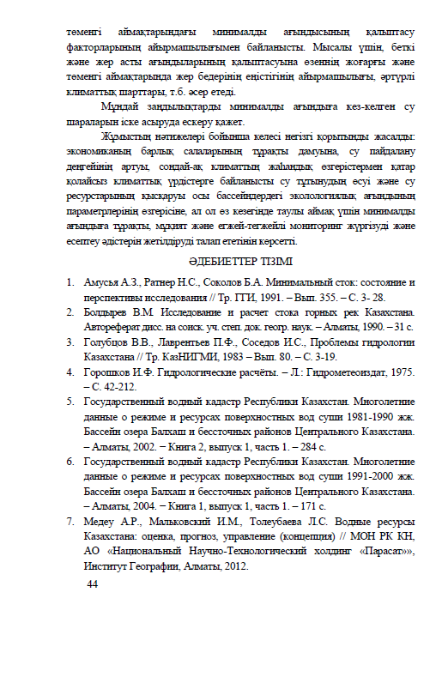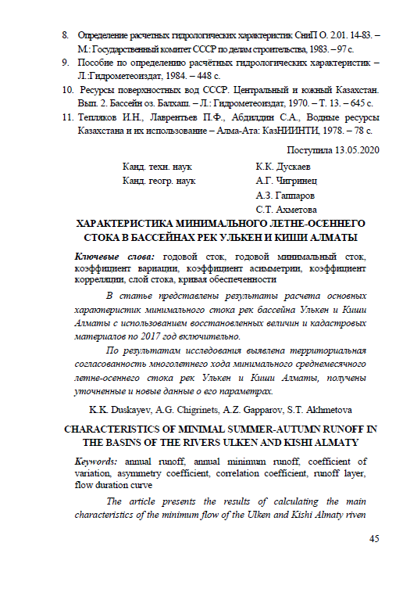

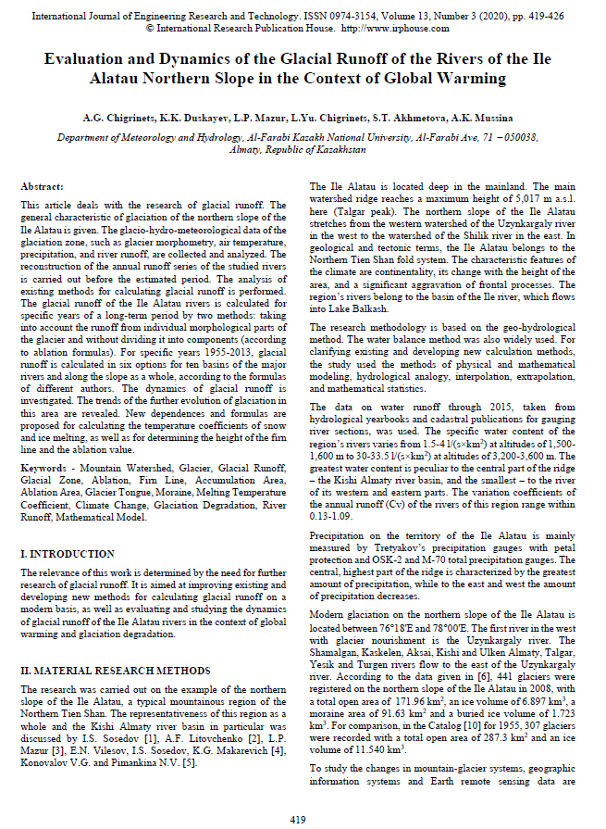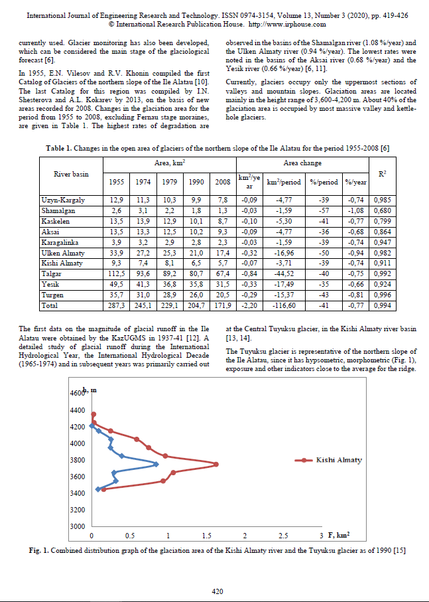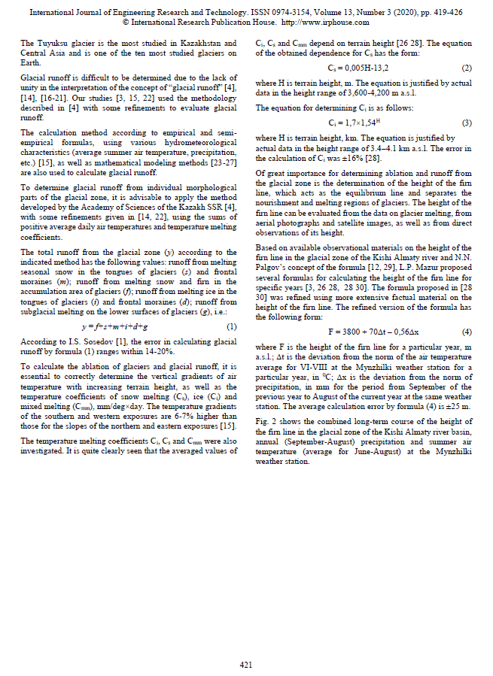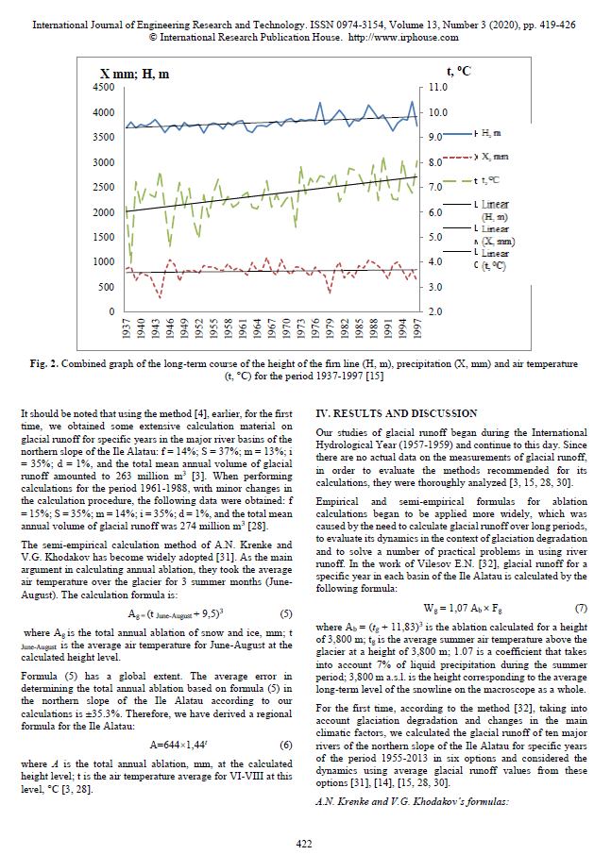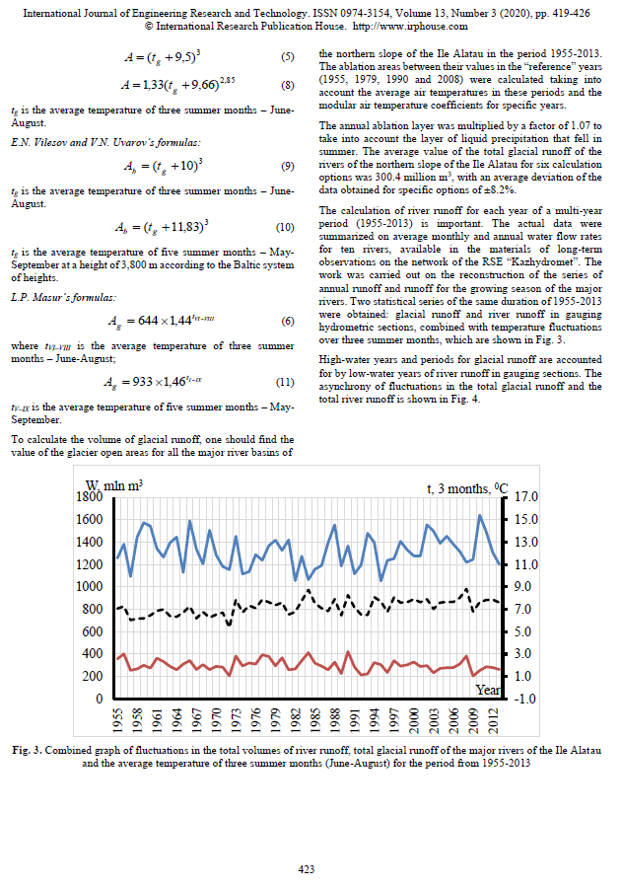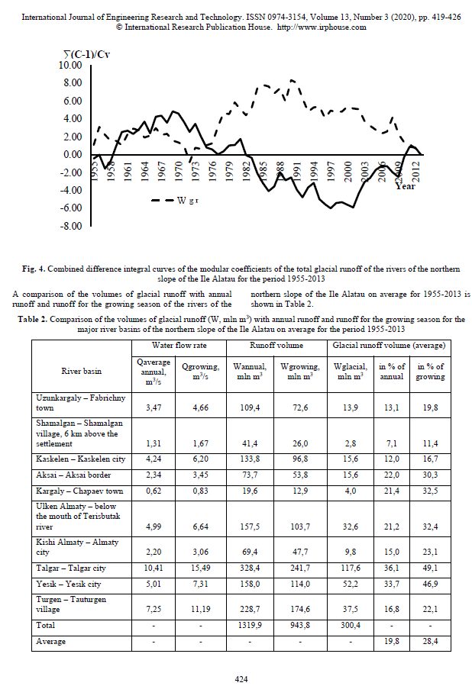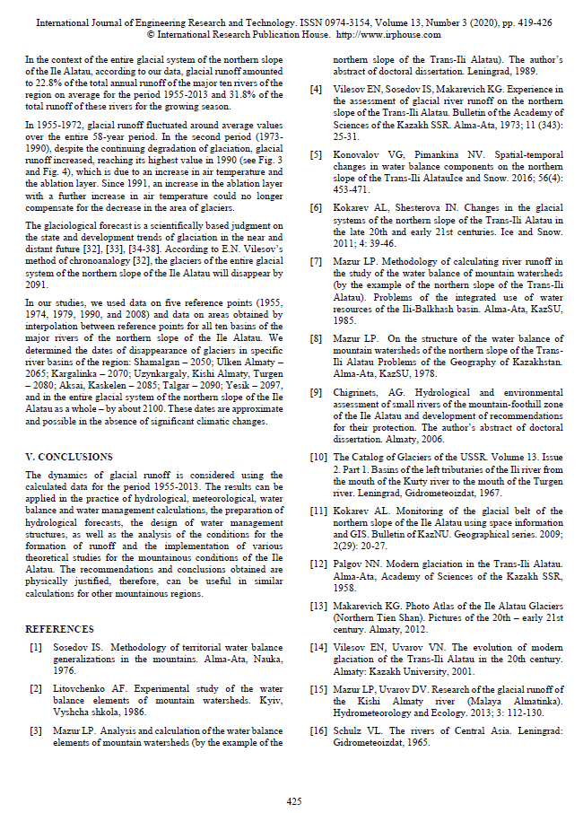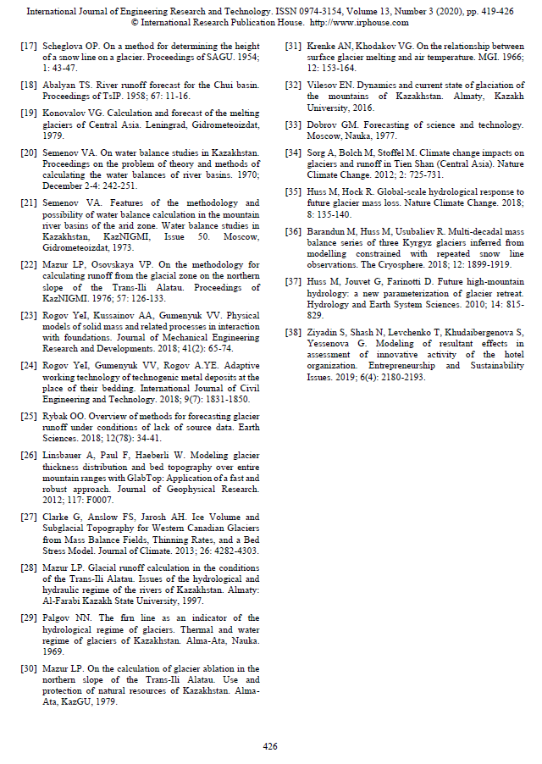

APPENDIX D

Publication and approbation of research results

As part of the work performed from 2018-2020 project participants received 2 patents:

Patents:
1) Khalidullin O.Kh., Salnikov V.G., Duskaev K.K., Khalidullin R.O. Way and deepening of the river bottom. Patent for invention of the Republic of Kazakhstan No. 33643 (date of registration in the State Register of Inventions of the Republic of Kazakhstan: 05/21/2019). Patentee: The SBE on the REM "Research Institute of Ecology problems" RSE on the REM" al-Farabi Kazakh National University" of the Ministry of Education and Science of the Republic of Kazakhstan.
2) Khalidullin O.Kh., Salnikov V.G., Duskaev K.K., Khalidullin R.O. Method and deepening of the river bottom. A method of forming a river bottom by influencing the current and a device for its implementation. Patent for invention of the Republic of Kazakhstan No. 33724 (date of registration in the State Register of Inventions of the Republic of Kazakhstan: 20.06.2019). Patentee: The SBE on the REM "Research Institute of Ecology problems" RSE on the REM" al-Farabi Kazakh National University" of the Ministry of Education and Science of the Republic of Kazakhstan.

