РЕФЕРАТ

Есеп 55 б., 8 сурет, 11 кесте, 21 әдеб., 5 қосымша.
МҰНАЙДЫҢ АУЫР ҚАЛДЫҚТАРЫ, ГУДРОН, МЕТАЛСЫЗДАНДЫРУ, КҮКІРТСІЗДЕНДІРУ, КОКС, АДСОРБЕНТ, ВАНАДИЙ, ЦЕОЛИТ, ТҮРЛЕНДІРУ
Зерттеу нысаны – Павлодар мұнай химия зауытының баяу кокстау қондырғысының гудроны.
Жұмыстың мақсаты – химиялық түрлендірілген наноқұрылымды адсорбенттерді пайдаланып, мұнайдың ауыр қалдықтарын металсыздандыру және күкіртсіздендіру технологиясын әзірлеу және күкірт пен металдардың мөлшері аз кокс алу.

«Павлодар мұнай химия зауыты» ЖШС металсызданған және күкіртсізденген гудронын 490-510 °С температурада 8 сағат бойы кокстау жүргізілді. Кокстау нәтижесінде кокс шығымы 34 %-ға дейін, бензин фракциясының шығымы артады, кокстық дистиллят шығымы азаяды.

Алынған кокс үлгілерінің негізгі физика-химиялық сипаттамалары мен құрамындағы күкірт және металдардың мөлшері анықталды. Алдын ала металсыздандырылған және күкіртсіздендірілген гудроннан алынған кокс ұшқыш заттардың массалық үлесі (6 %), күлділігі (0,25 %), күкірт (1,45 %) пен металдардың мөлшері (0,008% V, 0,0014 % Ni, 0,0011 % Fe) бойынша жақсартылған көрсеткіштерге ие болды. Бұл көрсеткіштер бойынша кокс үлгісі кокстың бірінші сұрыпты КЗА маркасының талаптарына сай келеді.
Өңдеуден кейінгі химиялық адсорбентті кәдеге жарату тәсілі сыналды.
Павлодар мұнай химия зауытының технологиялық сызбасына мұнайдың ауыр қалдықтарын металсыздандыру, күкіртсіздендіру және кокстау процестерін енгізу үшін практикалық ұсынымдар әзірленді. Металдар мен күкірттің мөлшері аз кокс өндіру үшін ванадий оксидінің ксерогелімен өңделген цеолит қатысында гудронды 340-400 °С-та 3 сағат металсыздандыру және күкіртсіздендіру процесінен, 490-510 °С-та 8 сағат кокстау процесінен тұратын технологиялық сызбанұсқа әзірленді.
Жұмыстың практикалық маңыздылығы құрамындағы күкірт пен металдардың мөлшері аз кокс алу үшін гудронның сапасын жоғарылату болып табылады.
Түрлендірілген адсорбенттерде металсыздандыру және күкіртсіздендіру технологиясы гудронның құрамынан металдар мен күкіртті тиімді азайтуға мүмкіндік береді.

ABSTRACT

Report 55 p., 8 fig., 11 tabl., 21 sourc., 5 app.
HEAVY OIL RESIDUES, VACUUM RESIDUE, DEMETALLIZATION, DESULFURIZATION, COKE, ADSORBENT, VANADIUM, ZEOLITE, MODIFICATION
The object of research is vacuum residue of the delayed coking unit of the Pavlodar petrochemical plant.
The purpose of this work is to develop a technology for demetallization and desulfurization of heavy oil residues by using chemically modified nanostructured adsorbents with subsequent production of coke with a low content of sulfur and metals.
Coking of demetallized and desulfurized vacuum residue of Pavlodar petrochemical plant LLP was carried out at a temperature of 490-510 °С, the duration of the process is 8 hours. As a result of coking, the yield of coke and gasoline fractions increases to 34%, the yield of coke distillate decreases.
The main physical and chemical characteristics and the content of sulfur and metals in the composition of the obtained coke samples have been determined. The coke obtained from vacuum residue after preliminary demetallization and desulfurization has better indicators in terms of the mass fraction of volatiles (6 %), ash content (0,25 %), sulfur content (1,45 %) and metals (0,008 % V, 0,0014 % Ni, 0,0011 % Fe). According to the indicated indicators, the coke sample meets the requirements for the KZA coke grade, first grade.
The method of utilization of the spent chemical adsorbent has been tested. A method has been developed for utilization of a spent chemical adsorbent by alkaline treatment with an aqueous solution of ammonia.
Practical recommendations were given for the processes of demetallization, desulfurization and coking of heavy oil residues for introduction into the technological scheme of the Pavlodar petrochemical plant. For the production of coke with a low content of metals and sulfur, a technological scheme has been developed that includes carrying out the demetallization and desulfurization process at 340-400 °C for 3 hours in the presence of zeolite modified with vanadium oxide xerogel, coking process at 500 °C for 8 hours.
The practical significance of the work lies in improving the quality of vacuum residue to obtain the final product with high added value – coke with a low content of sulfur and metals.
This technology of demetallization and desulfurization on modified adsorbents makes it possible to effectively separate metals and sulfur from the vacuum residue composition.

CONTENT

INTRODUCTION………………………………………………………………………...6
1 Literature review………………………………………………………………………...8
2 Experimental procedure………………………………………………………………..11
2.1 Object of research…………………………………………………………………..11
2.2 Technique for the demetallization and desulfurization process……………………11
2.3 Procedure for coking heavy oil residues……………………………………………12
2.4 Methods for analyzing samples…………………………………………………….14
3 Optimization of the basic technological parameters of the process of
demetallization and desulfurization of heavy oil residues (2018)……………………..15
3.1 Manufacturing of a laboratory installation for demetallization and
desulfurization of heavy oil residues.……………………………………………....15
3.2 Installation of a laboratory installation for demetallization and desulfurization
heavy oil residues…………………………………………………………………..15
3.3 Establishment of optimal technological parameters of the process of
demetallization and desulfurization of heavy oil residues: temperature, pressure,
volumetric feed rate………………………………………………………………...15
3.4 Establishing the optimal composition of the chemical adsorbent for
demetallization and desulfurization of vacuum residue……………………………16
4 Demetallization and desulfurization of heavy oil residues on the modified
chemical adsorbents (2019)……………………………………………………………17
4.1 Optimization of technological conditions for modification of zeolite
carrier with nanostructured compounds of rare metals…………………………….17
4.2 Determination of the physicochemical properties of the modified
adsorbent……………………………………………………………………………17
4.3 Conducting laboratory tests of the demetallization method and
desulfurization of vacuum residue on a modified chemical adsorbent…………….18
4.4 Determination of the residual content of metals and sulfur in vacuum residue
after testing the modified adsorbent………………………………………………..19
5 Obtaining coke from demetallized and desulfurized vacuum residue and
dispensing practical recommendations (2020) ………………………………………...21
5.1 Carrying out coking of demetallized and desulfurized vacuum residue…………...21
5.2 Determination of physical and chemical characteristics of coke and content
sulfur and metals……………………………………………………………………22
5.3 Testing of methods of disposal of spent chemical adsorbent………………………28
5.4 Issuance of practical recommendations for demetallization processes,
desulfurization and coking of heavy oil residues…………………………………..31
CONCLUSION…………………………………………………………………………..36
LIST OF USED SOURCES……………………………………………………………..38
APPENDIX A - List of published works in 2018-2020…………………………………40
APPENDIX B - Practical recommendations for the implementation of technology
for demetallization, desulfurization and coking of heavy oil residues…………………..63
APPENDIX C - Technical specification and work schedule……………………………66
APPENDIX D – Review…………………………………………………………………74
APPENDIX E - Extract No. 2 from the protocol No. 7 dated 21.10.2020………………75

INTRODUCTION

The volume of production and processing of oil with a high content of metals, resinous-asphaltene components and heterocompounds is growing every year. The greatest difficulty is the qualified processing of heavy residues of vacuum or deep vacuum distillation of oil - vacuum residue, where metals and resinous-asphaltene components are concentrated, which requires significant capital and operating costs.
The main way of deepening oil refining is the processing of residues, which are becoming increasingly difficult and whose quality is getting worse. Until now, an insurmountable technological barrier for deep and residue-free refining has been the problems associated with the increased content of not only metals, but also sulfur in oils and oil residues, which are irreversible poisons for catalysts, corroding equipment.
The processing of these residues with the use of catalysts leads to the rapid coking of the latter, their high consumption and a sharp increase in the cost of processing and, accordingly, the finished product.
At present, an increasing share in the country’s fuel balance is occupied by sulphurous and high-sulfur oils, the processing residues of which are the source of petroleum coke production. Despite the fact that sulfurous coke is independently used as a sulfonating additive to coal charge, the most valuable is coke with a sulfur content of less than 1.5 wt. %. The standard method for reducing the sulfur content of coke is calcining. Most petroleum coke refineries do not have sufficient calcining capacity and are forced to sell high sulfur coke at low prices. This is due to the fact that the bulk of coke with a sulfur content of 2% or more is not suitable for the electrode and unsuitable for the aluminum industry. Combustion of high sulfur coke fuels is environmentally damaging.
The relevance of the development of technologies for deep processing of heavy hydrocarbon raw materials is caused by the following factors:
- the need to involve high-viscosity oils, natural bitumen and oil shale in the processing in connection with a decrease in light oil reserves;
- increasing demand for energy, fuel and demand for quality products of petrochemical synthesis;
- increasing the complex use of hydrocarbon raw materials as an alternative for other industries: chemical industry, metallurgy, construction, etc.;
- the environmental hazard of air pollution due to the release of huge amounts of harmful substances (primarily metals and sulfur) resulting from the combustion of oil and oil products;
- the presence of metal in oils can be assessed from the standpoint of human health: for example, the number of hazardous elements for human life includes: mercury, beryllium, arsenic, bromine, chromium, zinc, lead, selenium, strontium, manganese, vanadium, cobalt, cadmium, zirconium, uranium, thorium, radium, radon, which can have a carcinogenic, mutagenic effect, can be strong allergens, etc.
The search for innovative schemes for the preparation and processing of oil with the extraction of associated metals is an urgent scientific problem of the oil industry.
In addition, at the moment, the Republic of Kazakhstan does not produce petroleum coke with a total content of sulfur and metals of less than one percent. The need for needle cokes is 250 thousand tons per year.
The key problems to be solved by these studies are, firstly, improving the quality of oil feedstock for delayed coking units - vacuum residue to obtain products with high added value - coke; secondly, improving the environmental situation in the oil refining area (reducing emissions of highly toxic compounds of vanadium and sulfur), and thirdly, the emergence of alternative raw materials for the production of metals (vanadium).
The aim of the project is to develop a technology for demetallization and desulfurization of heavy oil residues by using chemically modified nanostructured adsorbents with subsequent production of coke with a low content of sulfur and metals.
To achieve this goal in 2018 (interim report (stage I), inventory number 0218RK005417), the following tasks were solved:
- fabrication of a laboratory unit for demetallization and desulfurization of heavy oil residues;
- installation of a laboratory unit for demetallization and desulfurization of heavy oil residues;
- establishment of optimal technological parameters of the process of demetallization and desulfurization of heavy oil residues: temperature, pressure, volumetric feed rate;
- determination of the optimal composition of the chemical adsorbent for demetallization and desulfurization of vacuum residue.
In 2019, in accordance with the calendar plan, the following project tasks were solved (interim report (ІІ stage), inventory number 0219RK01119):
- optimization of technological conditions for modifying a zeolite carrier with nanostructured compounds of rare metals;
- determination of the physicochemical properties of the modified adsorbent;
- carrying out laboratory tests of the vacuum residue demetallization and desulfurization method on a modified chemical adsorbent;
- determination of the residual content of metals and sulfur in vacuum residue after testing the modified adsorbent.
In 2020, the following project tasks were solved:
- carrying out coking of demetallized and desulfurized vacuum residue;
- determination of the physicochemical properties of the modified adsorbent;
- testing of methods of utilization of spent chemical adsorbent;
- issue of practical recommendations for the processes of demetallization, desulfurization and coking of heavy oil residues.

1 Literature review

A common process for processing heavy oil residues is the coking process, which produces petroleum coke and distillate fractions. All over the world, coking is of great importance for the utilization of heavy residues to obtain the maximum amount of distillates and for the production of motor fuels and to obtain coke of a given quality for use in various industries. Petroleum coke is used in non-ferrous metallurgy in the production of aluminum, as a structural material for the manufacture of corrosion-resistant equipment, in cement production. Sulfurous and high-sulfurous types of coke can be used as a reducing agent and sulfiding additive in mine smelting of oxidized ores of some metals, in the production of carbon disulfide, sodium sulfide, etc. Compared with coal-tar coke, sulfurous petroleum coke has a low ash content (0,2-0,8 %) and lower cost. Low-grade petroleum cokes are used as fuel.

In industry, there are the following options for the coking process [1]:

Periodic coking in coke stills. The coke is hardened in the stills and lumpy coke is obtained, which is used for the production of electrodes. Due to low performance, the method was not widely used.

Continuous coking (abroad process “fluid-cracking”). It is carried out in a “fluidized bed” of a powdery heat carrier and is aimed at the maximum yield of distillate fractions.

Combined process of thermal contact coking with subsequent steam-oxygen (air) gasification of powdered coke (“flexicoking” process) to obtain, in addition to distillates, synthesis gas.

Delayed coking. Raw materials heated to 470-510 °С are fed into coke ovens, where thermal cracking reactions take place with the formation of coke and gaseous products. The process is called “slowed down” coking because the raw material is quickly heated in the furnaces and pumped into an unheated hollow chamber, where it is gradually converted into coke.

The yield and quality of coke depend on the feedstock, which has conflicting requirements: on the one hand, the feedstock must provide a high yield of high-quality coke, on the other hand, it must not coke the tube furnace coil, providing the longest overhaul period of the delayed coking unit [2].

The production of coke is characterized by the following features: at the enterprises there is an increase in the weight of coking raw materials, a market for the sale of products of secondary catalytic processes has emerged [3]. In this regard, it is proposed to prepare low-sulfur coking raw materials by involving residues from petrochemical processes, and organize coke production from straight-run fuel oils of low-sulfur oils.

The high content of sulfur and metals is retained in coking products, which complicates its use in metallurgy and chemical industry. The existing methods for producing low-sulfur cokes from high-sulfur raw materials are divided into three groups: preparation of coking raw materials, removal of sulfur during coking and desulfurization of the finished coke.

As a result of research [4], it was found that coking of oil vacuum residue with a significant amount of asphaltenes and silica gel resins leads to the maximum amount of petroleum coke. Increasing the pressure, increasing the recirculation ratio and maintaining the coking temperature at about 480 °C also increases the coke yield. To reduce the amount of sulfur, it is proposed to use paraffinic raw materials. The most rational option is a processing scheme that combines the process of delayed coking and hydrocracking.

The main method of raw material preparation is technologies using hydrodesulfurization of oil residues, which include hydrotreating of straight-run fuel oil followed by vacuum distillation and obtaining a residue for coking or hydrotreating a vacuum strand followed by thermal cracking and obtaining low-sulfur cracking residue for the coking process [5]. The proposed technology has not found industrial application due to the high costs of preparing raw materials and imperfect hydrotreating technology.

To reduce the content of sulfur and metals in coke, preliminary hydrodesulfurization processes have been proposed, as a result of which the content of sulfur-containing compounds in the raw material decreases. A known method of producing petroleum coke by coking hydrodesulfurized fuel oil [6]. However, the process of hydrodesulfurization of the residues is complex and expensive, as it requires the use of equipment operating under high pressure.

A known method of producing products in a delayed coking unit, including heating heavy sulfur-containing oil products to the coking temperature and coking it in a reactor in the presence of hydrogen in one stage. The method is aimed at reducing the sulfur content in the resulting products: gasoline, coke, light and heavy gas oils [7]. The disadvantage of this method is the explosion and fire hazard of the operation of the delayed coking unit when using hydrogen as a reagent.

There is a known method of producing petroleum coke [8], which consists in the fact that a mixture of heavy oil residues of petrochemistry and/or oil refining, in particular a mixture of distillate cracking residue and vacuum residue, is fed into a delayed coking chamber, after which the resulting product is treated with hydrogen at a temperature of 490-550 °C and pressure up to 5 MPa for 8-24 hours. The disadvantage of this method is the high cost caused by the use of hydrogen.

Other methods of preparation of raw materials, for example, the method of alkaline washing, thermal and thermochemical methods of desulfurization of coke are burdened with high energy intensity, introduce a lot of impurities of alkali or alkaline earth metals into the coke, or require additional deep development [9].

A method for coking oil residues has been developed, which includes heating the primary feedstock, processing it, preliminary thermal polycondensation followed by coking the secondary feedstock and separating the vapor-gas coking products [10]. Processing of primary feedstock after heating is carried out by absorption of heavy oil fractions of vapor-gas coking products with separation of light fractions and the formation of secondary feedstock, which is heated to the coking temperature and subjected to preliminary thermal polycondensation in a mixture with a coolant - distillation column bottoms in a separate reactor, and then coking is carried out under pressure 0,5-1,5 MPa. As a result of the implementation of the method, the yield of coke from the primary raw material was 41 %. The disadvantage of this method is its complexity, carrying out absorption and coking at pressures up to 1,5 MPa and the lack of data on standard indicators for the quality of coke.

A well-known way to improve the quality of petroleum cokes is to compound tar with other refinery and petrochemical products (distillate cracking residues, catalytic cracking gas oils, oil pyrolysis products and oil production extracts). This method is based on the principle of dilution of raw materials with low-sulfur additives. In the methods of producing petroleum coke, the organic part of oil-bituminous rocks in the amount of 1-10 wt. % [11], a mixture of coal tar and pyrolysis resin in a ratio of 1:1 in an amount of 1-30 % [12], a mixture of 5-10 wt.% heavy pyrolysis resin and 5-15 wt. % heavy catalytic cracking gas oil [13, 14], a mixture of 5-10 wt. % extract of selective oil purification and 5-10 wt. % heavy pyrolysis resin [15], preheated to 200-300 °С 10-25 % hydrotreated gasoline fraction of liquid coking products [16], heavy catalytic cracking gas oil or asphalt in an amount of at least 30 % [17].

The results of work [18] showed that the use of four- or five-component compounded mixtures reduces the content of impurities in the coke by 10-20 % while maintaining the yield of 26-29 %.

To increase the furnace overhaul and the productivity of the delayed coking unit, a method for producing coke is proposed, including heating the raw material in the furnace to a temperature of 480-500 °С and introducing CaO or Ca(OH)₂ or CaCO₃ additives in an amount of not more than 15 % in the form of a pasty mixture with hydrocarbon diluent [19]. Moreover, as a result of the strong affinity of calcium for sulfur, sulfur of organic origin is converted into inorganic form.

The article [20] studied the possibility of producing coke from a mixture of 30 % oil from the Karazhanbas field and 35% natural bitumen Beke and Munaily Mola.

All of these additives are technologically complex raw materials. They are distinguished by a pronounced tendency to physical intermolecular interactions, which is due to an increased concentration of resinous-asphaltene substances, high coking capacity, high content of sulfur, nitrogen, heavy metals [21]. In addition, these are high-viscosity free-dispersed systems. All this requires a scientific approach to the processing of such systems and the problem of mixing them for use as feedstock. A serious issue is the creation of stable compositions resistant to separation into phases, to increased coke deposition in pipes of heating equipment, to coking and poisoning of catalysts. The resources of these aromatic hydrocarbon concentrates are limited, which makes it necessary to consider other possibilities to increase the yield and improve the quality of coke.

Thus, it is necessary to develop a new inexpensive technology that improves the quality of coke, including coke from high-sulfur raw materials. When producing coke with desired properties and a certain crystal structure, one should take into account the peculiarities of the composition and properties of the feedstock, not only the content, but also the regular arrangement of aromatic rings in polycyclic structures, the absence of heteroatoms.
2 Experimental procedure

2.1 Object of study
The object of the study is vacuum residue – the feedstock of the delayed coking unit (DCU) of the complex for processing heavy oil residues of Pavlodar Petrochemical Plant LLP. The vacuum residue has the following characteristics: appearance – viscous low-mobile liquid, mass fraction of water – up to 0.1 wt. %; vanadium content – 178,7-200,1 mg/kg, 0,049-0,054 %; nickel content – 64,0-67,0 mg/kg, 0,0049-0,0058 %; iron content – 20,0-54,0 mg/kg, 0,0033 %; mass fraction of sulfur – 1,72-2,7 %; ash content – 0,02 wt. %; coking capacity – 14 wt. %; density at 20 °С – 981,0 kg/m³; boiling point – 380 °С.

2.2 Methodology for the process of demetallization and desulfurization
Figure 1 shows the instrumental and technological diagram of the enlarged laboratory unit for demetallization and desulfurization of petroleum feedstock. The installation allows conducting research on the purification of raw materials at the established values of the consumption of raw materials (from 1 to 5 l/h) and temperatures in the purification reactors (from 200 to 500 °C) in a conditionally continuous mode (taking into account the volume of loading of the raw material tank).

Figure 1 – Apparatus and technological scheme of the installation for demetallization and desulfurization of heavy oil residues

The demetallization process consists in a short-term contact in a two-section tubular reactor at 300-450 °C of a heated heavy residue (vacuum residue) with an adsorbent. As a result of contacting the feedstock with the hot adsorbent, hydrocarbon vapors are formed, which, in a mixture with steam, are transported to the gas outlet line. During the passage through the first section of the pipe, various transformation reactions take place: light conversion, demetallization, and partial desulfurization.
In the process of demetallization and desulfurization of vacuum residue on an enlarged laboratory unit, the following technological regimes have been worked out: temperature in the reactor from 300 to 450 °C, processing time from 0,5 to 4 h, raw material consumption from 2 to 5 l/h, volumetric feed rate of 1-3 h⁻¹.
Figure 2 shows a photograph of an enlarged laboratory unit for demetallization and desulfurization of heavy oil residues.

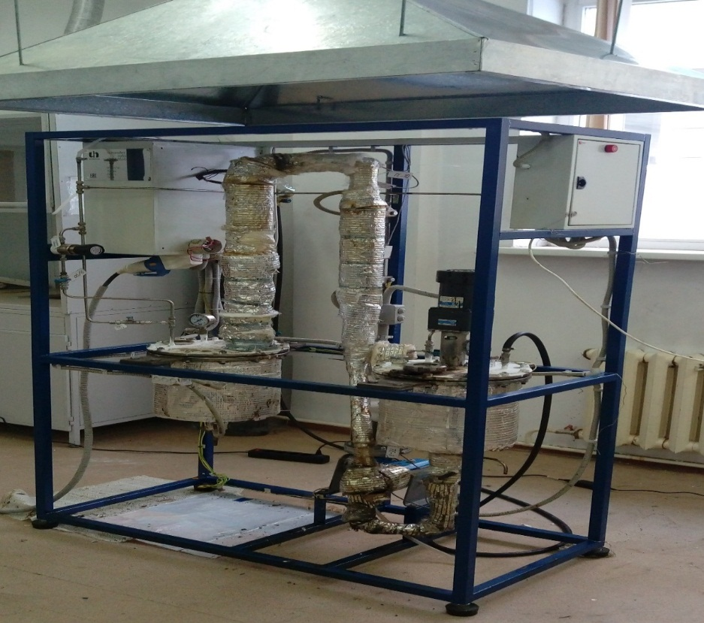

Figure 2 – Large scale laboratory unit for demetallization and desulfurization of heavy oil residues

2.3 Technique for coking heavy oil residues
The batch-type laboratory coking unit is designed to carry out the process of delayed coking of heavy oil residues. The general diagram of the laboratory coking plant is shown in Figure 3.
The vacuum residue sample, after demetallization and desulfurization by the adsorption method, is loaded into the reactor. After the top cover of the reactor has been wrapped and it is installed in its place in the installation, it is checked for tightness by performing a pneumatic test. For this, the coking gas evacuation system is disconnected and the nitrogen cylinder hose is attached to the connector. With the control valve 5, a pressure is set that exceeds the operating pressure by 1.5 times. The valve is closed and the system is tested for leaks for 5 minutes. Checking the tightness of the installation is carried out by soaping the flange, threaded and welded joints with soapy water. After checking the tightness, open the valve and release the pressure from the reactor. The detected defects are eliminated. Then the pressure is set back into the reactor. After the pressure is built up, valve 5 is closed, a system for removing gases and liquid coking products is connected to the connector. The temperature rise in the reactor is carried out at a rate of 2 °C per minute. The coking time is the time from the establishment of the operating temperature of the coking reactor to the end of coking. The pressure is measured by a manometer 3. After reaching the required pressure in the reactor, the pressure is manually controlled by slowly opening the valve 5 to release vapors and gases that increase the required pressure in the reactor. Hot vapors and gases from the reactor pass into refrigerator 6, part of the vapors, being cooled and condensed, passes into the coking distillate, which is collected in the separator. After cooling, the coking gases are sent to the gasometer, then to be removed from the laboratory unit to the exhaust ventilation system. Discharge of gases and vapors of the coking reactor and gases from the separator is carried out one hour before the end of coking. The pressure is released slowly through the valve. At the end of the process, turn off all electrical appliances at the installation, close the water supply to the refrigerators. The reactor is then cooled by natural ventilation of the air. After cooling the reactor, it is disassembled with the resulting coke unloaded.

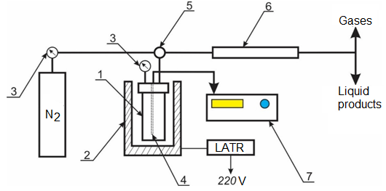

1 – coking reactor; 2 – electric furnace; 3 – pressure gauge; 4 – thermocouple; 5 – control valve; 6 – reflux condenser; 7 – thermostat

Figure 3 – Scheme of a plant for coking heavy oil residues

From the literature data for the experiment, the following operating technological parameters of the laboratory unit were selected during the coking process: process temperature – 490-510 °C; coking time 8 hours.

2.4 Sample Analysis Techniques
The mass fraction of volatile substances in the coke samples was determined according to GOST R 55660-2013, the ash content – according to GOST 11022-95, the mass fraction of total moisture – according to GOST 27588-91.
Sulfur content in vacuum residue and coke samples is determined in accordance with GOST 8606-2015 “Solid mineral fuel. Determination of total sulfur. Eshch’s method”.
The content of metals (vanadium, nickel, iron) in the coke samples was determined by inductively coupled plasma atomic emission spectrometry on an atomic emission spectrometer with microwave plasma type 4200 MP-AES Agilent Technologies in accordance with GOST 34242-2017.
The elemental composition of the adsorbent samples was determined using an Inca Energy energy dispersive spectrometer (Oxford Instruments, England) installed on a Superprobe 733 electron probe microanalyzer at an accelerating voltage of 25 kV and a probe current of 25 nA.

3 Optimization of the basic technological parameters of the process of demetallization and desulfurization of heavy oil residues (2018)

3.1 Manufacturing of a laboratory installation for demetallization and desulfurization of heavy oil residues
An enlarged laboratory unit for demetallization and desulfurization of heavy oil residues was manufactured. The unit module includes a feed tank with a nominal volume of 10 l, a mixing device, a transfer pump, a heating furnace, a reactor with a nominal volume of 1 l with two sections (demetallization and desulfurization), a product tank with a nominal volume of 10 l and a control panel.

3.2 Installation of a laboratory installation for demetallization and desulfurization of heavy oil residues
Installation of a unit for demetallization and desulfurization of heavy oil residues was carried out. The unit is designed for demetallization and desulfurization of the feedstock of the delayed coking unit for the subsequent production of petroleum coke with a low content of metals and sulfur.

3.3 Establishment of optimal technological parameters of the process of demetallization and desulfurization of heavy oil residues: temperature, pressure, volumetric feed rate
The process of demetallization and desulfurization of vacuum residue of Pavlodar Petrochemical Plant LLP in the presence of a zeolite adsorbent modified with vanadium (V) oxide was carried out. Table 1 shows the results of chemical analysis of the content of metals and sulfur in the composition of the original vacuum residue and after its processing. As can be seen from the tabular data, the degree of extraction of vanadium is 90-92 %. Unlike vanadium, the degree of removal of nickel and iron varies in a wide range - for nickel from 57,2 to 71,6 %, for iron – from 35,2 to 69,1 %. The maximum degree of metal recovery is observed at a temperature of 340 °С and a volumetric feed rate of 1 h⁻¹. After desulfurization, the sulfur content in the vacuum residue composition decreases from 1,97 to 1,36 %, which also occurs at a temperature of 340 °С. In general, the results of the vacuum residue analysis after the demetallization and desulfurization process in the presence of a zeolite adsorbent containing vanadium pentoxide at various temperatures and volumetric feed rates showed that the recovery rates of vanadium, nickel and iron averaged 90, 70, and 60%, respectively, and the sulfur content decreased from 1,97 to 1,36 %.
Thus, the optimal technological parameters of the process of demetallization and desulfurization of heavy oil residues were established: temperature – 340 °С, pressure – 1 atm, volumetric feed rate of 1 h⁻¹, process duration 3 hours. As a result of the process, the degree of extraction of vanadium, nickel and iron amounted to 90, 70 and 60 %, respectively, and the sulfur content decreased from 1,97 to 1,36%.

Table 1 – Content of metals and sulfur in vacuum resdiue before and after the process of demetallization and desulfurization

Volumetric feed rate, | Metal content, mg/kg |  |  | Sulfur content, % | Metal removal rate, %
h⁻¹ | V | Ni | Fe |  | V | Ni | Fe
Residue | 200,1 | 64,0 | 54,0 | 1,97 | - | - | -
Т = 300 °С
1 | 16,62 | 21,5 | 20,6 | 1,72 | 91,7 | 66,4 | 61,8
2 | 16,46 | 27,4 | 20,8 | 1,67 | 91,8 | 57,2 | 61,5
3 | 20,2 | 24,7 | 35,0 | 1,8 | 90,0 | 61,4 | 35,2
Т = 320 °С
1 | 17,2 | 19,3 | 20,6 | 1,6 | 91,4 | 69,8 | 61,8
2 | 16,1 | 26,5 | 23,5 | 1,65 | 92,0 | 58,6 | 56,5
3 | 18,3 | 24,3 | 21,1 | 1,7 | 90,8 | 62,0 | 60,9
Т = 340 °С
1 | 17,0 | 18,2 | 16,7 | 1,36 | 91,5 | 71,6 | 69,1
2 | 14,9 | 22,0 | 19,4 | 1,48 | 92,5 | 65,6 | 64,1
3 | 17,69 | 23,4 | 21,1 | 1,4 | 91,1 | 63,4 | 60,9
Т = 360 °С
1 | 17,4 | 21,6 | 20,1 | 1,49 | 91,3 | 66,2 | 62,8
2 | 17,7 | 23,0 | 29,7 | 1,56 | 91,1 | 64,1 | 45,0
3 | 20,3 | 26,6 | 29,6 | 1,52 | 89,8 | 58,4 | 45,2

3.4 Establishing the optimal composition of the chemical adsorbent for demetallization and desulfurization of vacuum residue
Table 2 shows the elemental composition of the chemical adsorbent before and after the process of demetallization and desulfurization of vacuum residue.
As can be seen from Table 2, in the composition of the adsorbent after vacuum residue treatment, the vanadium content increases from 0,59 to 1,07 %, iron from 0,13 to 0,20 % and sulfur from 0,01 to 0,51 %, which confirms it high adsorption capacity in relation to metals and sulfur.
Thus, the composition of the chemical adsorbent for demetallization and desulfurization of vacuum residue has been established. After the tar treatment, the content of vanadium, iron and sulfur in the adsorbent composition increases, which confirms its high adsorption capacity with respect to metals and sulfur.

Table 2 – Elemental composition of adsorbents before and after demetallization and desulfurization of vacuum residue
Sample | Content of elements, rel. %
 | С | O | Al | Si | S | Ca | V | Fe
Initial adsorbent | - | 47,49 | 7,37 | 43,16 | 0,01 | 0,13 | 0,59 | 0,13
Adsorbent after the process | 11,43 | 48,04 | 6,89 | 32,37 | 0,51 | - | 1,07 | 0,20
4 Demetallization and desulfurization of heavy oil residues on the modified chemical adsorbents (2019)

4.1 Optimization of technological conditions for modifying a zeolite carrier with nanostructured compounds of rare metals
The technological conditions for modifying the zeolite support with nanostructured compounds of rare metals have been optimized. To improve the sorption characteristics, the zeolite carrier is modified with 1 % vanadium (V) oxide xerogel and 1 % oxysulfate, chloride, or titanium oxide. To enhance the desulfurization process, an impregnated adsorbent based on zeolite modified with 1 % vanadium (V) oxide xerogel and 1 % nanocarbon was prepared. The composition of the improved adsorbent is a zeolite modified with 1 % vanadium (V) oxide xerogel and 1 % nanocarbon.

4.2 Determination of the physicochemical properties of the modified adsorbent
The physicochemical properties and characteristics of modified adsorbents based on zeolite have been determined. Table 3 shows the main physicochemical characteristics of adsorbents based on zeolite modified with titanium compounds and xerogel of vanadium (V) oxide obtained by the sol-gel method.

Table 3 – Physicochemical characteristics of adsorbents

Adsorbents | Specific surface, m²/g | Specific pore volume, cm³/g | Average pore size, nm
Zeolite original KN-4 | 329,0 | 0,173 | 1,713
Zeolite modified with 1% V₂O₅ xerogel | 376,5 | 0,161 | 1,714
Zeolite modified with 1% TiOSO₄ and 1% V₂O₅ | 336,6 | 0,144 | 1,713
Zeolite modified with 1% TiCl₄ and 1% V₂O₅ | 312,6 | 0,134 | 1,714

As can be seen from Table 3, when the zeolite is modified with vanadium (V) oxide xerogel, the specific surface area increases from 329 to 376,5 m²/g, but the specific pore volume decreases from 0,173 to 0,161 cm³/g, the average pore size increased slightly. Modification of the zeolite with titanium oxysulfate in an amount of 1 % also increases the specific surface area of ​​the support from 329 to 336,6 m²/g, while the specific pore volume also decreases, the average pore size remains unchanged. Zeolite modified with 1 % TiCl₄ and 1 % V₂O₅ showed lower values ​​of specific surface area and specific pore volume in comparison with the initial zeolite.

4.3 Conducting laboratory tests of the vacuum residue demetallization and desulfurization method on a modified chemical adsorbent
Laboratory tests of the method for demetallization and desulfurization of vacuum residue on modified chemical adsorbents were carried out.
Table 4 shows the results of testing an adsorbent – zeolite modified with 1 % titanium oxysulfate and 1 % vanadium oxide in the process of demetallization and desulfurization of vacuum residue at temperatures from 320 to 360 °C. As can be seen from the tabular data, the sulfur content in the vacuum residue composition decreases at a temperature of 340 °C from 1,72 to 1,28 %, which gives a degree of desulfurization of 25,6 %. The content of metals at all temperatures decreases slightly – vanadium from 0,054 to 0,017 %, nickel from 0,0058 to 0,0022 %, iron from 0,0033 to 0,0027 %.

Table 4 – Results of demetallization and desulfurization of vacuum residue with zeolite modified with 1 % TiOSO₄ and 1 % V₂O₅

Sample | S, % | V, % | Ni, % | Fe, %
Vacuum residue | 1,72 | 0,054 | 0,0058 | 0,0033
Vacuum residue, after demetallization  at 320 °С | 1,46 | 0,020 | 0,0023 | 0,0030
Vacuum residue, after demetallization  at 340 °С | 1,28 | 0,017 | 0,0022 | 0,0027
Vacuum residue, after demetallization  at 360 °С | 1,49 | 0,017 | 0,0023 | 0,0031

To increase the demetallizing and desulfurizing activity of the adsorbents, further experiments were carried out in the presence of an adsorbent - zeolite modified with vanadium (V) oxide and nanocarbon (Table 5).

Table 5 – Results of demetallization and desulfurization of vacuum residue with zeolite modified with vanadium (V) oxide and nanocarbon

Raw materials and type of adsorbent | Т, °С | Content of elements
 |  | V, mg/kg | Ni,mg/kg | S,%
Vacuum residue | - | 178,7 | 67,0 | 2,7
Vacuum residue after demetallization with zeolite without modification | 350 | 107,4 | 38,1 | 2,7
Vacuum residue after demetallization | 320 | 39,1 | 28,4 | 2,6
with zeolite modified with 1 % V₂O₅ | 350 | 36,1 | 11,9 | 2,1
 | 360 | 31,8 | 8,2 | 1,9
 | 380 | 33,7 | 9,8 | 2,0
Vacuum residue after demetallization with zeolite modified with 1 % V₂O₅ and 1 % nanocarbon | 350 | 28,4 | 8,8 | 1,7
When testing zeolite modified with vanadium (V) oxide and nanocarbon, the vanadium content in the vacuum residue decreases from 178,7 to 28,4 mg/kg, the nickel content – from 67,0 to 8,2 mg/kg, the sulfur content – from 2,7 to 1,7 %. The maximum recovery of metals and sulfur is observed at a temperature of 350-360 °С and when testing a zeolite additionally modified with nanocarbon. For the modified adsorbent, the optimum temperature is 360 °C. In general, the results of the analysis of the vacuum residue composition after the demetallization and desulfurization process in the presence of a zeolite adsorbent containing vanadium oxide and nanocarbon showed that the recovery of vanadium and nickel averages 84-88 %.
Thus, the results of testing the process of demetallization and desulfurization of vacuum residue on modified adsorbents showed the possibility of extracting 84-87% of vanadium and nickel from tar, the degree of desulfurization was 37%.

4.4 Determination of the residual content of metals and sulfur in vacuum residue after testing the modified adsorbent
The residual content of metals and sulfur in the vacuum residue after testing the modified adsorbents was determined.
Studies on demetallization and desulfurization of vacuum residue were also arried out on adsorbents with modified mineral bases. Serpentinite rock, wollastonite, and kaolin clay were chosen as the mineral base of the adsorbents. To increase the recovery of metals and sulfur, the process of demetallization and desulfurization was carried out at relatively high temperatures.
Table 6 compares the degrees of demetallization and desulfurization of vacuum residue on the tested adsorbents.

Table 6 – The degree of demetallization and desulfurization of vacuum residue on various adsorbents

Adsorbent | Desulfurization | Demetallization degree, %
 | degree, % | V | Ni | Fe
Zeolite | 3,4 | 39,9 | 43,1 | -
Zeolite modified with 1 % TiOSO₄ and 1% V₂O₅ | 25,6 | 68,5 | 62,1 | 18,2
Zeolite modified with 2 % V₂O₅ and 10% TiO₂ | - | 35,5 | 40,5 | 37,3
Zeolite modif. with 1 % V₂O₅ | 30,9 | 91,5 | 71,6 | 69,1
Zeolite modified with V₂O₅ and nanocarbon | 37,0 | 84,1 | 86,9 | -
Serpentine | 2,3 | 14,8 | 12,1 | 6,1
Zeolite with wollastonite and coke | 39,6 | 80,6 | 83,7 | 78,8
Kaolin clay with coke | 12,4 | 94,5 | 57,1 | 81,8

As can be seen from the tabular data, the adsorbent based on zeolite, wollastonite and coke shows the highest degree of desulfurization – 39,6 %, while the degree of demetallization is 78-83 %. The adsorbent based on kaolin clay and coke showed the maximum degree of demetallization for vanadium – 94,5 %, iron – 81,8 %, however, the degree of desulfurization is 12,4 %.

Thus, to reduce the content of metals in the vacuum residue composition, it is recommended to heat adsorption treatment on kaolin clay with coke at a temperature of 400 °C for 4 hours, to reduce the sulfur content - thermal adsorption treatment on zeolite with wollastonite and coke at a temperature of 450 °C for 3 hours.

5 Obtaining coke from demetallized and desulfurized vacuum residue and issue of practical recommendations (2020)

5.1 Carrying out coking of demetallized and desulfurized vacuum residue
Coking of demetallized and desulfurized vacuum residue was carried out. The yield of products during coking vacuum residue without and with preliminary demetallization and desulfurization in the presence of zeolite modified with vanadium (V) oxide xerogel is presented in Table 7. As can be seen from the table, the coke yield without preliminary demetallization and desulfurization was 18,9 wt.%, while while as a result of vacuum residue coking with preliminary demetallization and desulfurization, an increase in coke yield is observed. With an increase in the temperature and time of the demetallization and desulfurization process, the coke yield gradually increases by 2 times. Coke with a maximum yield of 34 wt. % is obtained by coking vacuum residue, demetallized and desulfurized at a temperature of 340 °С for 3 hours.
As can be seen from the table, the yield of gaseous products and losses during coking of vacuum residue without pretreatment was 9,5 %, coking of vacuum residue after preliminary demetallization and desulfurization led to a slight increase in gas yield and losses up to 10-13,2 %. The yield of the gasoline fraction during vacuum residue coking with pretreatment at 320 °C for 3 hours increased 2 times to 16 wt. % compared to the yield of the gasoline fraction formed during vacuum residue coking, which was 7,5 wt. %. As a result of vacuum residue coking after demetallization and desulfurization, a decrease in the yield of coke distillate from 68 to 47-49 % is observed.

Table 7 – Product yield during vacuum residue coking without and with preliminary demetallization and desulfurization

 | Raw material yield, wt. %
Name of raw materials | gas and losses | gasoline | coke distillate | coke
Vacuum residue without pretreatment | 9,5 | 7,5 | 68,0 | 18,9
Vacuum residue after demetallization and desulfurization at 320 °С for 2.5 h | 10,0 | 12,0 | 56,0 | 22,0
Vacuum residue after demetallization and desulfurization at 320 °С for 3 h | 11,0 | 16,0 | 49,0 | 24,0
Vacuum residue after demetallization and desulfurization at 340 °С for 2.5 h | 13,2 | 6,8 | 49,0 | 31,0
Vacuum residue after demetallization and desulfurization at 340 °С for 3 h | 11,0 | 7,0 | 47,0 | 34,0

Thus, coking of demetallized and desulfurized vacuum residue of Pavlodar petrochemical plant LLP was carried out at a temperature of 490-510 °C, the duration of the process is 8 hours. Experimental results of the vacuum residue coking process showed the effectiveness of the process with preliminary demetallization and desulfurization of raw materials. At the same time, as a result of coking, the yield of coke and gasoline fractions increases, and the yield of coke distillate decreases. Coke was obtained from vacuum residue after demetallization and desulfurization.

5.2 Determination of the physicochemical characteristics of coke and the content of sulfur and metals
The physicochemical characteristics of coke and the content of sulfur and metals were determined.
After carrying out the process of demetallization and desulfurization with various adsorbents at a temperature of 400 °C for 3 hours, the vacuum residue coking process was carried out to obtain coke with improved physicochemical characteristics.
Table 8 shows the values ​​of the yield and physicochemical characteristics of coke obtained from vacuum residue without pretreatment and after demetallization using various adsorbents and process conditions. As can be seen from the table, the yield of coke from vacuum residue without pretreatment was 18,9 % and it is characterized by high values ​​of the mass fraction of total moisture 2,9 %, ash content 0.5 %, mass fraction of volatiles in the coke 7,9 %. In the composition of coke obtained from vacuum residue after demetallization with zeolite at 400 °C for 3 hours, the mass fraction of total moisture significantly decreases to 1,0 %, the mass fraction of volatile substances and ash content decreases slightly to 7,8 and 0,4 %, respectively. The coke yield rises to 27,0 %. When using zeolite modified with 1 % vanadium oxide xerogel as an adsorbent, the coke is characterized by a low mass fraction of total moisture of 1,1 %, the mass fraction of volatiles also decreases to 6,0 %, and the ash content is 0,25 %. The coke yield was the maximum 34,4 %.
The use of serpentine as an adsorbent for tar demetallization made it possible to obtain coke with low mass fraction of total moisture and volatile substances, but the ash content was 0,4 %. Demetallization of vacuum residue with an adsorbent based on wollastonite and further coking resulted in the formation of coke characterized by a high mass fraction of total moisture (2,3 %) and ash content (0,6 %), while the coke yield decreased to 12,0 %. The modification of wollastonite with serpentine led to a decrease in the mass fraction of total moisture and ash content of coke, an increase in the yield of coke, but the mass fraction of volatiles increased to 8,3 %.
The coke obtained from vacuum residue after demetallization in the presence of kaolin clay has a yield of 32 %, the mass fraction of total moisture is 2,0 %, volatiles are 7,2 %, and the ash content is 0,4 %.
Of the coke samples presented in the table, the coke obtained from vacuum residue after preliminary demetallization with zeolite modified with vanadium (V) oxide xerogel has the most improved physicochemical characteristics. The coke sample meets the requirements of GOST 22898-78 in terms of basic physical and chemical parameters and the coke yield is 34,4%.
Thus, a thermal adsorption process of demetallization and desulfurization of vacuum residue of the Pavlodar petrochemical plant was carried out in the presence of various adsorbents and under various conditions. After preliminary demetallization and desulfurization, the vacuum residue coking process was carried out to obtain coke. Coke with improved physicochemical characteristics is obtained from vacuum residue after thermal adsorption treatment with zeolite modified with vanadium pentoxide xerogel, which showed the highest degree of demetallization. Subsequently, coke samples were analyzed to determine the content of metals and sulfur.

Table 8 – The yield and physicochemical characteristics of coke obtained from vacuum residue after demetallization with various adsorbents at 400 °C for 3 hours

Raw materials for | Physicochemical characteristics of coke
coke production | Mass fraction of total moisture, % | Mass fraction of volatile substances, % | Ash content, % | Output, %
Vacuum residue without pretreatment | 2,9 | 7,9 | 0,5 | 18,9
Vacuum residue after demetallization with zeolite | 1,0 | 7,8 | 0,4 | 27,0
Vacuum residue after demetallization with zeolite modified with V₂O₅ xerogel | 1,1 | 6,0 | 0,25 | 34,4
Vacuum residue after demetallization with serpentine | 1,4 | 4,6 | 0,45 | 32,0
Vacuum residue after demetallization with wollastonite | 2,3 | 5,7 | 0,6 | 12,0
Vacuum residue after demetallization with wollastonite and serpentine | 1,3 | 8,3 | 0,3 | 23,2
Vacuum residue after demetallization with kaolin clay | 2,0 | 7,2 | 0,4 | 32,0
Requirements of GOST 22898-78 | no more than 3,0 | no more than 9,0 | no more than 0,6 | -

Table 9 shows the results of the analysis of coke samples to determine the content of metals and sulfur. In the composition of coke obtained from vacuum residue without pretreatment, the vanadium content is 0,031 %, which does not meet the requirements of GOST, according to which it should be no more than 0,015 %. The product of vacuum residue coking after demetallization with zeolite is characterized by an underestimated vanadium content, which was 0,019 %. Modification of the zeolite with vanadium oxide xerogel and carrying out demetallization in its presence led to a significant decrease in the amount of vanadium in the coke to 0,008 %. The use of natural minerals – wollastonite, serpentine and kaolin clay as adsorbents for the demetallization process also led to a decrease in the vanadium content in the coke composition, however, its value turned out to be higher than in the case of using zeolite modified with vanadium oxide.

Table 9 – Content of metals and sulfur in coke samples obtained from vacuum residue after demetallization with various adsorbents at 400 °С for 3 hours

Sample | Content of elements, %
 | Vanadium | Nickel | Iron | Sulfur
Vacuum residue | 0,054 | 0,0058 | 0,0033 | 2,7
Coke obtained from vacuum residue without pretreatment | 0,031 | 0,0022 | 0,0030 | 2,5
Coke from vacuum residue after demetallization with zeolite | 0,019 | 0,0016 | 0,0025 | 1,87
Coke from vacuum residue after demetallization with zeolite modified with V₂O₅ xerogel | 0,008 | 0,0014 | 0,0011 | 1,45
Coke from vacuum residue after demetallization with wollastonite | 0,021 | 0,0022 | 0,0024 | 2,14
Coke from vacuum residue after demetallization with wollastonite and serpentine | 0,011 | 0,0021 | 0,0027 | 2,44
Coke from vacuum residue after demetallization with kaolin clay | 0,011 | 0,0020 | 0,0025 | 2,34
Requirements of GOST 22898-78 | no more than 0.015 % | - | no more 0.08 % | no more than 1.5%

The nickel content in the coke samples also decreases compared to its content in vacuum residue, with its lowest value of 0,0014 % observed in the composition of coke obtained from vacuum residue after pretreatment with zeolite modified with vanadium pentoxide.
The iron content in the coke is insignificant 0,003 %, since its amount in the vacuum residue itself was only 0,0033 %. By the amount of iron, all coke samples meet the requirements of the standard for its value.
The vacuum residue coking after pre-treatment resulted in a decrease in the sulfur content in the coke samples. The lowest sulfur content of 1,45 % was observed in the composition of coke obtained from vacuum residue after demetallization and desulfurization with zeolite modified with vanadium oxide xerogel. The use of the zeolite itself and other natural minerals made it possible to reduce the sulfur content in the coke to 1,87-2,44% in comparison with its initial value in the vacuum residue composition of 2,7 %.
Table 10 shows the physicochemical parameters of coke samples obtained without preliminary treatment and with preliminary demetallization and desulfurization of vacuum residue at 400 °C for 3 hours in the presence of zeolite modified with vanadium (V) oxide. The indicators are compared with the requirements of the standard for certain grades of coke in accordance with GOST 228989-78. As can be seen from the table, in comparison with a sample of coke obtained without preliminary demetallization and desulfurization, coke obtained with preliminary demetallization and desulfurization is characterized with improved performance, namely, the mass fraction of volatiles and ash content decreases.

Table 10 – Physical and chemical characteristics of coke obtained from vacuum residue

Coke quality parameters | KZA brand, first grade according to GOST 22898-78 | Coke from vacuum residue without preliminary demetallization | Coke from vacuum residue with preliminary demetallization
Mass fraction of volatile substances,% | no more than 9,0 | 7,9 | 6,0
Ash content,% | no more than 0,6 | 0,5 | 0,25
Mass fraction of total moisture, wt. % | no more than 3,0 | 2,9 | 1,1
Mass fraction of sulfur,% | no more than 1,5 | 2,5 | 1,45
Mass fraction of impurities, %,  vanadium  nickel  iron | no more than 0,015  not standardized  no more than 0,08 | 0,031  0,0022  0,0030 | 0,008  0,0014  0,0011

Figure 4 more clearly demonstrates the improvement in the physicochemical characteristics of coke obtained from vacuum residue after preliminary demetallization and desulfurization. As can be seen from the diagram, the mass fraction of volatile substances in coke in accordance with the requirements of the standard should be no more than 9,0 %. Both coke samples meet the requirements for this indicator, while the coke obtained from vacuum residue after processing is characterized by a lower volatile matter content of 6 %.
It can also be seen from the figure that coke samples in terms of ash content meet the requirements of the standard, i.e. no more than 0,6 %. Here, too, coke obtained from vacuum residue with pretreatment has a lower ash content (0,25 %) than coke from vacuum residue without treatment (0,5 %). The mass fraction of the total moisture of the coke sample obtained after the vacuum residue treatment is also lower (1,1 wt. %) than coke from vacuum residue (2,5 wt. %).

Figure 4 – Physical and chemical characteristics of coke

Figure 5 shows the sulfur content of coke samples compared to the standard requirement. In the original vacuum residue, the sulfur content was 2,7 %. As can be seen from the figure, the sulfur content in the coke obtained from vacuum residue without pretreatment is 2,5 %, which is much higher than that required by the standard (no more than 1,5 %). The sulfur content in coke from vacuum residue after preliminary demetallization and desulfurization is reduced to 1,45 %, which is in full compliance with regulatory requirements.
The content of metals in coke samples is shown in Figure 6. The mass fraction of vanadium in coke obtained from vacuum residue without pretreatment is 0,031 %, which is 2 times more than required by the standard (0,015 %). In the coke obtained from vacuum residue after preliminary demetallization and desulfurization, the vanadium content decreases by several orders of magnitude and is 0,0008 %, which confirms the improvement in the composition of the obtained coke. There are no regulatory requirements for the nickel content in the coke composition, however, as can be seen from the diagram, in the composition of coke from vacuum residue with preliminary treatment, its content also decreases by an order of magnitude and is 0,0014 %. According to the requirements of the standard, the mass fraction of iron in coke should be no more than 0,08 %. In both coke samples, the iron content meets the requirements of the standard and is 0,0011 and 0,0030 %.

Figure 5 – Sulfur content in coke samples

Figure 6 – The content of metals in coke samples

The product of vacuum residue coking with preliminary demetallization and desulfurization by the adsorption method in terms of physical and chemical characteristics and the content of sulfur and metals meets the requirements of GOST 22898-78 for the KZA coke grade, first grade.

Thus, the main physicochemical characteristics and the content of sulfur and metals in the composition of the obtained coke samples have been determined. The coke obtained from vacuum residue after preliminary demetallization and desulfurization has better indicators in terms of mass fraction of volatiles, ash content, sulfur and metals content. According to the indicated indicators, the coke sample meets the requirements for the KZA coke grade, first grade.

5.3 Testing of disposal methods for spent chemical adsorbent
Methods for the disposal of spent chemical adsorbent were tested. When demetallization of vacuum residue in the presence of adsorbents in the oil feed, the processes of destruction of asphaltenes and resins and the release of light hydrocarbons occur (Table 11).

Table 11 – Material balance of the vacuum residue heat treatment process in the presence of adsorbents, depending on time

Product yield, wt. % | Heat treatment time, min
 | 30 | 60 | 90 | 180
Gas | 1,8 | 3,65 | 9,7 | 14,1
Liquid products, including:  distillates, n.a.-540 °С  vacuum residue > 540 °С | 98,2  72,7  25,5 | 96,3  70,4  25,9 | 90,1  77,4  12,7 | 84,6  70,8  13,8
Coke | - | - | 0,1 | 1,2
Losses | - | 0,05 | 0,1 | 0,1

The carryover of adsorbents with demetallized vacuum residue seems unlikely due to their high adsorption capacity (absorption of organometallic compounds and compaction of the contact mass) and low mobility under high-temperature conditions.
Also, in the process of demetallization of vacuum residue in the presence of adsorbents that have adsorption capacity in combination with catalytic activity, catalytic transformations of adsorbed substances into coke-like carbon products inevitably occur.
Waste chemical adsorbents after demetallization and desulfurization processes are a potential source of secondary raw materials containing heavy metals. A feature of these sorbents is the presence in them, in addition to the main components – vanadium, nickel, iron, other metals, which are contained in oil, and accumulate in the adsorbent during demetallization and desulfurization. The high vanadium content in oil leads to its accumulation in the sorbent in amounts up to 1 wt. %. The main ways of disposal of spent adsorbents are: disposal, conversion of toxic components into an inactive form, regeneration and reuse, separation into components to obtain individual V₂O₅, SiO₂, Al₂O₃ and joint V₂O₅-SiO₂, SiO₂-Al₂O₃ compounds by pyro- and hydrometallurgical methods. Utilization of adsorbents is possible together with spent catalysts for catalytic cracking, hydrocracking, and Claus processes, for which hydrometallurgical methods are the most promising, providing their selective separation into main components in the form of high quality commercial products. Recycling such secondary raw materials will not only reduce environmental damage, but also return valuable components to the production cycle.
The existing methods of extracting vanadium, molybdenum and nickel from industrial waste involve the extraction of only one or two components, while most of the spent adsorbents contain, as a rule, compounds of all three metals simultaneously with a variable concentration of each of them. Methods for extracting vanadium, molybdenum and nickel compounds known in the world practice are based on their dissolution by acids and alkalis mainly in an oxidizing environment, since it is the compounds of the highest valence that have the highest solubility in aqueous solutions. Very often oxidation is carried out with solid oxidants or gases even before the leaching stage. Precipitation from solutions is carried out either by reagent methods in the form of sparingly soluble salts or by evaporation.
As a recommendation for the disposal of the spent adsorbent based on the data obtained, we propose a technological process based on alkaline treatment with an aqueous solution of ammonia. In this case, it is necessary to select the concentration depending on the content of metals in the recycled material. The estimated composition of the resulting waste is not hazardous and is taken to the landfill. Compounds of aluminum and silicon, aqueous solutions of vanadium and nickel after multiple dilution can be used as liquid fertilizer.
In practice, the regeneration of adsorbents based on zeolites is carried out by the method of thermal desorption, i.e. heated gas up to 300 °С, which naturally leads to the accumulation of coke-generating particles and progressively reducing the adsorption capacity. With an increase in temperature for the complete removal of carbon deposits (over 500 °С), the crystal structure of zeolites is destroyed, a decrease in temperature – the activity is not completely restored. This process of regeneration of spent zeolites is energy-intensive.
For the regeneration of the delayed coking unit of contact material used in the process of demetallization of the primary feedstock - chemical adsorbents of various compositions based on zeolite, modified with various additives, the following variant of their regeneration is proposed: extraction treatment in the presence of organic solvents: n-hexane, a mixture of light hydrocarbons from the primary atmospheric unit distillation of oil С₅-С₆.
Figure 7 shows the IR spectra of an adsorbent based on zeolite modified with vanadium pentoxide xerogel. The absorption bands in the frequency range 400-1300 cm⁻¹ correspond to the main vibrations of the alumino-silicon tetrahedra of the framework structure of zeolites. The observed absorption bands are attributed to two types of vibrations: 1 – vibrations characterizing the primary structural units – TO₄, where T – cations Si⁴⁺, A1³⁺; 2 – vibrations of TO₄ tetrahedra along external bonds. The second type of vibration depends on the nature of the joining of the tetrahedra into secondary structural units and the characteristics of the zeolite cavities.
The strong absorption band at 950-1250 cm⁻¹ is due to the stretching vibrations of T-O. The next in intensity band at 400-500 cm⁻¹ is assigned to bending vibrations (T-O₄). The absorption band in the region of 1650 cm⁻¹ was attributed to bending vibrations of water molecules. When testing and regenerating a sample of zeolite modified with vanadium oxide as an adsorbent, this band shifts to lower frequencies by 10-12 cm⁻¹. The band at 3460-3490 cm⁻¹ is due to the presence of a hydrogen-bonded state of hydroxyl groups. When testing the adsorbent, the band shifts to lower frequencies, which can be explained by the weakening of hydroxyl bonds. The band at 3650-3680 cm⁻¹ is due to acidic OH groups. The absence of a shift is explained by the equal silicon content in all samples, the invariability of the Si/Al ratio.

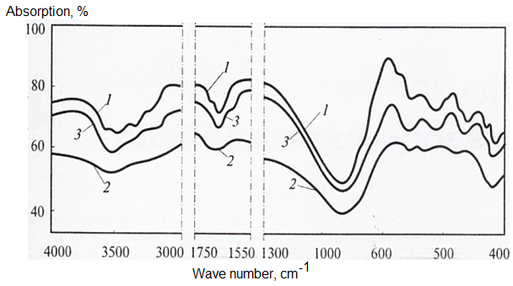

Figure 7 – IR spectra of adsorbents: 1 – in the initial state; 2 – spent (containing metals); 3 – regenerated

According to the images, the spectrum of the adsorbent regenerated with organic solvents approaches the spectrum of the original adsorbent sample, which indicates the restoration of adsorption activity.
In general, the regeneration process is carried out after 8-10 months of operation and the theoretical degree of coking (the period of deactivation of adsorption centers) is within 10-15%. After the regeneration of zeolite adsorbents from carbon deposits using organic solvents, the period of their active use will significantly increase.
The metal concentrate obtained after the regeneration of adsorbents contains such rare metals as vanadium, nickel, iron, etc.
Among them, vanadium stands out, which is used as an alloying additive to steel (to obtain corrosion-resistant and heat-resistant alloys), in the production of special and titanium alloys for the aerospace industry, for the manufacture of a permanent magnet, in the ceramic, textile, glass and paint and varnish industries (in in particular, vanadium oxide as a persistent chemical pigment), in the production of lithium batteries and accumulators and in other chemical technologies.
Vanadium in steel increases its strength, elasticity, toughness and hardness. It also helps to increase its creep and form hard carbides, which are used to make high speed steel.
Vanadium alloys are widely used in jet engines, aircraft, and frames. Particularly popular are titanium alloys with vanadium content, as well as chromium-vanadium alloy.
For the disposal of by-products and wastes obtained in the process of demetallization, a method of hydrochemical extraction of metals from a spent contact material is recommended (the method is also applicable for the processing of spent catalysts).
The essence of the method is as follows: vanadium is extracted from by-products and waste by leaching with hot water, solutions of mineral acids or alkalis, or liquid extraction with organic solvents. The solid residue is returned for afterburning, and vanadium and accompanying nickel are precipitated from the solutions.

5.4 Issue of practical recommendations for the processes of demetallization, desulfurization and coking of heavy oil residues
The studies carried out on the development of a method for demetallization and desulfurization of heavy oil feedstock of a delayed coking unit (DCU) – vacuum residue, indicate a high demetallizing ability of the tested adsorbents.
The increased sorption properties of zeolites are explained, first of all, by the fact that there are several different types of crystal frameworks and by methods of controlled ion exchange, the structural features of the frameworks can be modified, for example, by adding vanadium oxide xerogels.
One of the reasons for the stabilizing effect of the matrix on the zeolite is the migration of cations. Vanadium cations tend to be evenly distributed between the zeolite and the matrix during high temperature processing. During high-temperature treatment, vanadium cations migrate from the zeolite component to the matrix, and a decrease in the content of vanadium cations increases the stability of the zeolite structure, which in turn provides a higher activity of zeolite-containing sorbents as compared to pure zeolite.
Laboratory studies of zeolite-containing sorbents modified with vanadium oxide xerogel showed high activity. The efficiency of the degree of demetallization for vanadium reaches more than 90 %, and for nickel about 70 %, the degree of desulfurization was 37 %. The data obtained confirm the feasibility of introducing the technology at ultrasonic inspection.
The demetallization technology on the developed sorbents is very flexible, and when introduced into the ultrasonic testing scheme, it allows one to vary the yield of products (fraction and commercial coke) in a wide range in order to increase the production of the most desirable of them. Varying the parameters of the demetallization process allows, along with changing the yield of target products, to effectively regulate their quality.
These performance indicators of the developed sorbents must be worked out, all other things being equal, along with technological units (DCU) at the PPCP.
Severe operating conditions of sorbents at ultrasonic testing – high temperatures, exposure to water vapor, metals, nitrogen and sulfur compounds, high mechanical loads – cause significant changes in the physicochemical and sorption properties, leading to a decrease in the yield and a possible deterioration in the quality of the target products.
Figure 8 shows a diagram of the implementation of the processes of demetallization, desulfurization and coking of heavy oil residues.

Vacuum residue

Demetallization and desulfurization at 340-400 °C for 3 h, adsorbent - zeolite, mod. V₂O₅

,

Demetallized and desulfurized vacuum residue
Adsorbent with metals

Extraction of metals
Coking at 490-510°С for 8 h

Metal concentrate

Coke with low content of Me and S

Figure 8 – Scheme of implementation of the processes of demetallization, desulfurization and coking of heavy oil residues

The original oil feedstock (a mixture of West Siberian oils) is currently being processed in section 100, ELOU-AT (combined unit LK-6u). The process is carried out using physicochemical methods: desalting, dehydration, rectification, heat transfer.
This process is the primary oil refining and directly affects the secondary processes and the quality of the products obtained at the POCR.
Insufficient efficiency of the primary process of dehydration and desalination causes a number of the following problems in the refinery:
- silting up of electric dehydrators;
- reduction of the overhaul life of ELOU-AT units;
- burnout of furnace pipes at the ELOU-AT unit;
- deterioration of the properties of catalysts for secondary processes (catalytic cracking (section 200, KT-1), catalytic reforming (section-200, LK-6u), hydrotreating (section 300, LK-6u) and a promising demetallization unit of the USC);
- the formation of asphalt-resinous-paraffinic deposits on the walls of pipelines, tanks and electric dehydrators.
As an auxiliary purification of the initial petroleum feedstock and solving the above problems, it is proposed to develop a method for demetallization of the feedstock feedstock. Also the proposed method of demetallization will allow:
- to significantly improve the quality of the initial oil feedstock - to optimize the concentration of sulfur content, metal content (heavy metals), asphalt-resinous deposits, thereby reducing the load on individual oil processing plants;
- to increase the efficiency of the processing capacity of crude oil at all stages - to reduce the pressure at oil distillation units, reduce the consumption of electricity;
- to stabilize the operating mode of ELOU-AT units;
- to increase the time between overhaul runs of ELOU-AT units;
- to reduce the amount of wash water at the ELOU-AT units, thereby improving the environmental characteristics of the process - reducing salt deposits in the pipes of furnaces and heat exchangers (increasing the heat transfer coefficient, reducing the corrosion of the equipment of the ELOU-AT units by increasing the depth of the dehydration and desalting process);
- to increase the service life of catalysts for oil refining processes and to reduce the costs of regeneration, purchase and transportation;
- improve the quality characteristics of the products obtained.
Thus, the development of a method for demetallization of the initial petroleum feedstock, and research into the demetallization technology of ultrasonic testing can be used to solve problems related to the quality of petroleum feedstock and marketable products (including coke), optimize the production process and save energy at PPCP.
An integrated approach to the management of demetallization units (initial and secondary oil feedstock) will make it possible to achieve more than 90% efficiency in terms of demetallization degree.
The demetallization process will be accompanied by the formation of by-products and waste.
Mainly, a by-product from the demetallization process will be a spent contact material - zeolite with vanadium oxide xerogel (metal concentrate).
The recommended method for processing the by-product is the hydrochemical extraction of metals such as vanadium, nickel, etc. (obtaining pure concentrates). Further, the recovered metals can be transferred on a contractual basis to enterprises in the metallurgical and chemical industries.
The recovery of metals from the by-product of demetallization will be accompanied by the formation of residual waste. The waste will not contain metals, but will consist mainly of asphalt-resinous substances.
In order to prevent pollution of the components of the natural environment, the accumulation and disposal of this waste will be carried out in accordance with the Environmental Code of the Republic of Kazakhstan and the current regulations of the Republic of Kazakhstan, international standards, as well as internal standards of the Petrochemical Plant.
Thus, it is proposed to neutralize the resulting waste after the processing of by-products by a microbiological method in the accumulators of solid waste at the PPCP.
Neutralized (treated) waste can be used for the economic purposes of PPCP:
- use instead of the excavated soil (volume reduction), for backfilling / backfilling of sites and roads;
- construction of new roads and sites;
- construction of embankments for waste accumulation sites.
If necessary, the cleaned soil can be used for other necessary own purposes of PNHZ.
The actions of PPCP are aimed at properly protecting and preserving the natural environment, in particular, the ecological conditions of the region and Pavlodar. Therefore, ways have been found to resolve issues related to the processing and disposal of by-products and wastes from the demetallization process, as well as spent catalysts from catalytic cracking (section 200, KT-1), catalytic reforming (section-200, LK-6u) and hydrotreating (section 300, LK-6u).
Thus, PPCP can guarantee that actions to save energy and improve the quality of crude oil, as well as to process heavy residual petroleum products, will cause a minimum impact on the environment.
In the short term, vanadium consumption in steel production will continue to grow, and its cyclical market will reflect the situation in this industry. In addition, the demand for vanadium in new areas of its use may increase. The base of the world's natural reserves of vanadium is sufficient to meet the demand for this metal in the 21st century.
Below are the preliminary technical and economic indicators for predicting the effectiveness of the expediency of investment, the anticipated development needs, the presence of a sales market in the development of technology for demetallization of oil residues, crude oil.
The content of vanadium in oil residues is comparable to the content of this metal in ores and opens up new prospects for extraction from oil.
So, for example, during the construction of a site on the territory of a petrochemical plant, to separate vanadium oxide from heavy oil residues with a capacity of 6000 t / day, 4 autoclaves with a volume of 400 m3 will be required.
The approximate total capital investments, taking into account additional equipment, amount to $ 2.6 million.
The estimated cost of production of 1 ton of vanadium oxide will be $ 6200.
The price of vanadium oxide on the market is $ 7,500, then the cost of selling marketable products during the processing of 2,600 thousand tons of oil will be: 1290 x 7,500 = $ 9,675,000.0
The estimated economic effect will be:
9675000 - (1290 x 6200 + 0.15 x 2600000) = 1287000 $
The estimated payback period of capital investments will be:
2,600,000:1,287,000 = 2.02 years.
A more detailed and accurate calculation of economic efficiency, cost, total capital investments and other indicators can be given only at the stage of feasibility study of the installation of demetallization and processing of by-products.
These are only indicative economic indicators for the production of vanadium oxide.
Vanadium oxide is used:
- as a catalyst in gas-phase oxidation processes. For example, to convert sulfur dioxide to trioxide during the production of sulfuric acid;
- for the production of ink and pigments in the ceramic industry;
- as a filtration system in cars for cleaning from exhaust gas emissions.
The calculation does not take into account an increase in the yield of light hydrocarbon fractions and an improvement in the quality of crude oil.
Thus, practical recommendations were given for the processes of demetallization, desulfurization and coking of heavy oil residues. Published 1 article in a peer-reviewed publication indexed in the Web of Science or Scopus databases with a non-zero impact factor. A patent for a method for producing coke from heavy oil residues was obtained.

CONCLUSION

The use of thermal adsorption processes for demetallization and desulfurization of heavy oil residues in the presence of adsorbents is a very necessary and promising direction in the development of oil refining. They make possible the non-residual and environmentally friendly processing of hydrocarbon raw materials into high-quality fuels, which makes it possible to achieve the depth of processing of hydrocarbons up to 98-100% at oil refineries.
The enrichment of hydrocarbon residues in these processes is carried out by thermal destructive transformations of hydrocarbons and heteroatomic compounds and by the adsorption of the resulting resins, asphaltenes and carbides, as well as metal-, sulfur- and organo-nitrogen compounds on the surface of adsorbents.
This technology of demetallization and desulfurization on modified adsorbents makes it possible to efficiently separate metals (vanadium, nickel and iron) and sulfur from the tar composition. The developed process of demetallization and desulfurization of raw materials by DCU LLP “PPCP” using tested adsorbents improves the quality parameters of tar and coke obtained from it.
During the implementation of the project, the following conclusions were obtained:
1. An enlarged laboratory unit for demetallization and desulfurization of heavy oil residues was manufactured. Installation of a unit for demetallization and desulfurization of heavy oil residues was carried out.
2. The optimal technological parameters of the tar demetallization and desulfurization process of Pavlodar Petrochemical Plant LLP in the presence of a zeolite adsorbent containing vanadium oxide xerogel were determined: temperature 350-400 °С, pressure 1 atm, volumetric feed rate of raw materials 1 h⁻¹, process time 3 hours.
3. As a result of the process, the degree of extraction of vanadium, nickel and iron was 90, 70 and 60 %, respectively, and the sulfur content decreased from 1,97 to 1,36 %. The composition of the chemical adsorbent for demetallization and desulfurization of tar has been determined. After the tar treatment, the content of vanadium, iron and sulfur in the adsorbent composition increases, which confirms its high adsorption capacity with respect to metals and sulfur.
4. The technological conditions for modifying the zeolite carrier with nanostructured compounds of rare metals have been optimized. The physicochemical properties and characteristics of modified adsorbents based on zeolite have been determined. Laboratory tests of the method for demetallization and desulfurization of tar on modified chemical adsorbents were carried out. The results of testing the process of demetallization and desulfurization of tar on modified adsorbents showed the possibility of extracting 84-87 % vanadium and nickel from tar, the degree of desulfurization was 37 %.
7. Determined the residual content of metals and sulfur in the tar after testing the modified adsorbents. To reduce the content of metals in the tar composition, thermal adsorption treatment was carried out on kaolin clay with coke at a temperature of 400 °C for 4 hours, to reduce the sulfur content - thermal adsorption treatment on zeolite with wollastonite and coke at a temperature of 450 °C for 3 hours.
8. Coking of demetallized and desulfurized tar of Pavlodar petrochemical plant LLP was carried out at a temperature of 490-510 °С, the duration of the process is 8 hours. Experimental results of the tar coking process showed the efficiency of the process with preliminary demetallization and desulfurization of raw materials. At the same time, as a result of coking, the yield of coke and gasoline fractions increases to 34 %, and the yield of coke distillate decreases. Coke was obtained from tar after demetallization and desulfurization.
9. The main physical and chemical characteristics and the content of sulfur and metals in the composition of the obtained coke samples have been determined. The coke obtained from tar after preliminary demetallization and desulfurization has better indicators in terms of the mass fraction of volatiles (6 %), ash content (0,25 %), sulfur content (1,45 %) and metals (0,008 % V; 0,0014 % Ni; 0,0011 % Fe). According to the indicated indicators, the coke sample meets the requirements for the KZA coke grade, first grade.
10. The method of utilization of the spent chemical adsorbent has been tested. A method has been developed for the disposal of a spent chemical adsorbent by alkaline treatment with an aqueous solution of ammonia. For the regeneration of chemical adsorbents, an extraction treatment in the presence of n-hexane is proposed.
11. Practical recommendations were given for the processes of demetallization, desulfurization and coking of heavy oil residues for introduction into the technological scheme of the Pavlodar petrochemical plant. For the production of coke with a low content of metals and sulfur, a technological scheme has been developed, including the process of demetallization and desulfurization of tar at 340-400 °С for 3 hours in the presence of zeolite modified with vanadium oxide xerogel, the process of coking tar at 490-510 °С for 8 hours.
For 2018-2020, 16 publications were published, of which 4 articles in international journals indexed in the Web of Science or Scopus databases with a non-zero impact factor, 4 articles in republican journals from the List of Recommended Publications, 2 patents were received for the method of demetallization and obtaining coke from heavy oil residues.

LIST OF USED SOURCES

1 Shakirzyanova, G.I. Delayed coking as an effective technology for deepening oil refining / G.I. Shakirzyanova, O. Yu. Sladovskaya, A.G. Sladovsky et al. // Bulletin of the Technological University. – 2017. – T. 20. – No. 14. – P. 75-78. (In Russian).

2 Kemalov, R.A. Influence of the composition of high-viscosity oils on coking processes / R.A. Kemalov, A.F. Kemalov, A.Z. Tukhvatullina, T.N. Yusupova // Exposition Oil and Gas. – 2012. – No. 7. – P. 22-26. (In Russian).

3 Khairudinov, I.R. State and prospects for the production of coke and pitch from oil raw materials / I.R. Khairudinov, M.M. Akhmetov, E.G. Telyashev // Russian Chemical Journal. – 2006. – T. L. – No. 1. – P. 25-28. (In Russian).

4 Kositsyna, S.S. Koksovanie tars with different composition and properties / S.S. Kositsyna, F.A. Buryukin, A.O. Buza, D.A. Melchakov // Fundamental research. – 2016. – No. 6. – P. 288-293. (In Russian).

5 Varfolomeev, D.F. Raw materials for coking and the efficiency of its use / D.F. Varfolomeev, A.I. Stehun. – M .: TsNIITEneftekhim, 1987 . – 55 p. (In Russian).

6 Preparation of raw materials and improvement of technology for the production of petroleum coke for various purposes // Collection of scientific works of the BashNII NP. – 1979. – Issue. 18. – P. 38-40. (In Russian).

7 Method for obtaining liquid products in coking units: US Pat. 2260616 Rus. Federation / Slivkin L.G., Kuzora I.E., Tomin V.P. and others – Publ. 20.09.2005.

8 Method for producing petroleum coke: US Pat. 2079537 Rus. federation / Valyavin G.G. – Publ. 20.05.1997.

9 Pokhodenko, N.T. Obtaining and processing of petroleum coke / N.T. Pohodenko, B.I. Bronds. – M.: Chemistry, 1986. - 312 p. (In Russian).

10 Method for coking oil residues: Pat. 2277117 Rus. Federation / Gaskarov N.S., Zagidullin R.M., Khairudinov I.R. and others – Publ. 27.05.2006.

11 Method for producing petroleum coke: US Pat. 541 Rep. Kazakhstan / Kaldygozov E.K., Alimbaev K.R., Omaraliev T.O. – Publ. 15.03.1994.

12 Method of obtaining low-sulfur petroleum coke: US Pat. 2997 Rep. Kazakhstan / Omaraliev T.O., Kerimbekov S.K. – Publ. 15.04.1998.

13 Method of obtaining petroleum coke: Pat. 2331663 Rus. Federation / Khairudinov I.R., Zolnikov V.V., Zhirnov B.S., Telyashev E.G. – Publ. 20.08.2008. – Bul. No. 23.

14 Composition of raw materials for obtaining electrode coke of improved quality: US Pat. 2179175 Rus. Federation / Kuzora I.E., Doshlov O.I., Elshin A.I. and others – Publ. 10.02.2002.

15 Method for producing coke from petrochemical and oil refining residues: US Pat. 2330056 Rus. Federation / Mordkovich V.Z., Karaeva A.I., Kharitonova E.Yu. and others – Publ. 27.07.2008.

16 Method of obtaining low-sulfur petroleum coke: US Pat. 2330872 Rus. Federation / Mordkovich V.Z., Karaeva A.I., Zaglyadova S.V. and others – Publ. 10.08.2008.

17 Method of obtaining low-sulfur petroleum coke: US Pat. 2469067 Rus. Federation / Tikhonov A.A., Khairudinov I.R., Telyashev E.G. and others – Publ. 10.12.2012. – Bul. No. 34.

18 Kharitonova, E.Yu. Koksovanie heavy residues of various origins / E.Yu. Kharitonova, A.R. Karaev, V.Z. Mordkovich et al. // Petrochemistry. – 2007. – T. 47. – No. 4. – P. 318-328.

19 Method for producing coke: US Pat. 2469068 Rus. Federation / Akhmetov M.M., Tikhonov A.A., Khairudinov I.R., Telyashev E.G. – Publ. 10.12.2012. – Bul. No. 34.

20 Tileuberdi, E. Obtaining petroleum coke from high-viscosity oils and oil-bituminous rocks of Kazakhstan / E. Tileuberdi, A.N. Sharopin, Z.A. Mansurov et al. // Combustion and Plasma Chemistry. – 2016. – T. 14. – No. 1. – P. 60-65. (In Russian).

21 Kapustin, V.M. Physicochemical aspects of the formation of petroleum coke (review) / V.M. Kapustin, O.F. Glagoleva // Petrochemistry. – 2016. – T. 56. – No. 1. – P. 3-12. (In Russian).

APPENDIX A

List of published works in 2018-2020

List of published works in 2018

1 Ongarbayev Y., Oteuli Sh., Nurzhanova S., Maldybaev G., Tileuberdi Y., Imanbayev Y. Development of chemical adsorbents for demetallization and desulfurization of heavy oil residues // Industry of Kazakhstan. – 2018. – No. 1. – P. 13-16. (In Russian).
2 Ongarbayev Y.K., Oteuli Sh.A., Tileuberdi Y., Imanbayev Y.I., Maldybaev G.K., Nurzhanova S.B. Thermal adsorption upgrading of heavy oil residues // Combustion and Plasma Chemistry. – 2018. – T. 16. – P. 109-114. (In Russian).
3 Kudaibergenov K., Ongarbayev Y., Mansurov Z., Lesbayev B., Baitimbetova B., Nyssanbayeva G., Golovchenko O., Prikhodko N. Preparation of porous rice husks by pyrolysis methods for the removal of emulsified oils from wastewater // Transylvanian Review. – 2018. – Vol. XXVI. – No. 26. – P. 6409-6415.
4 Tileuberdi Y., Akkazyn Y.A., Ongarbayev Y.K., Imanbayev Y.I., Mansurov Z.A. Production of petroleum bitumen by oxidation of heavy oil residue with sulfur // IOP Conference Series: Materials Science and Engineering. – 2018. – Vol. 323, Issue 1. Article number 012004. doi:10.1088/1757-899X/323/1/012004.
5 Ongarbayev Y.K., Ashirbekov A.Zh., Muratov D.M., Oteuli Sh.K., Nurzhanova S.B. Demetallization and desulfurization of heavy oil residues // Materials of the republican scientific-practical conference "Modern problems of organic chemistry and ways to solve them", dedicated to the 80th anniversary of K.Kh. Tokmurzin. – Kokshetau, March 30, 2018 – P. 75-79. (In Kazakh).
6 Oteuli Sh.A., Ongarbayev Y.K., Nurzhanova S.B., Maldybaev G.K., Tileuberdi Y. Extraction of metals and sulfur of vacuum residue of the Pavlodar petrochemical plant // Materials of the international Russian-Kazakhstan scientific-practical conference "Chemical technologies functional materials". – Almaty, April 12-13, 2018. – P. 151-154. (In Russian).
7 Ongarbayev Y.K., Oteuli Sh.A., Tileuberdi Y., Imanbayev Y.I., Maldybaev G.K., Nurzhanova S.B. Removal of metals and sulfur tar with adsorbents modified with rare metal and nanocarbon // Materials of the X International Symposium "Physics and Chemistry of Carbon and Nanoenergetic Materials". – Almaty, September 12-14, 2018 – Part 5. – P.10-13. (In Russian).
8 Ongarbayev Y.K., Oteuli Sh., Tileuberdi Y., Imanbayev Y.I., Maldybaev G.K., Nurzhanova S.B., Muratov D.M. Thermal adsorption demetallization and desulfurization of vacuum residue // Materials of the XVII International Scientific and Practical Conference "Resource-producing, low-waste and environmental technologies of subsoil development". – Aktau: Sh.Esenov KSUTI. – September 17-20, 2018 – P. 228-230. (In Russian).

List of published works in 2019

1 Ongarbayev Y., Oteuli Sh., Tileuberdi Y., Maldybaev G., Nurzhanova S. Demetallization and desulfurization of heavy oil residues by adsorbents // Petroleum Science and Technology. – 2019. – Vol. 37. – Issue 9. – P. 1045-1052. Импакт-фактор по Web of Science за 2018 г. = 1,07.
2 Oteuli Sh.A., Nurzhanova S.B., Ongarbayev Y.K., Suyundikova F.O. Nanocomposite for demetallization of heavy hydrocarbon raw materials // Oil and gas. – 2019. – No. 3 (111). – S. 113-120. Impact factor for KazBC for 2017 = 0.171. (In Russian).
3 Patent of the Republic of Kazakhstan for utility model No. 4269. Method for demetallization of heavy oil raw materials / Ongarbayev Y.K., Nurzhanova S.B., Oteuli Sh.A., Maldybaev G.K., Tileuberdi Y. Application filing date 12.04.2019. Registration date 3.09.2019.
4 Oteuli Sh.A., Ongarbayev Y.K., Maldybaev G.K., Nurzhanova S.B. Demetallization of heavy oil residues with titanium-vanadium composites // Materials of the V International Russian-Kazakhstan scientific-practical conference "Chemical technologies of functional materials". – Novosibirsk. – May 16-18, 2019 – S. 288-290. (In Russian).
5 Oteuli Sh.A., Maldybaev G.K., Nurzhanova S.B., Ongarbayev E.K., Shi Q. Vanadium-containing compounds during thermal adsorption demetallization of tar // Proceedings of the X International Beremzhanov Congress on Chemistry and Chemical Technology. – Almaty. – October 24-25, 2019 – S. 228-229. (In Russian).

List of published works in 2020

1 Ongarbayev Y., Oteuli Sh., Tileuberdi Y., Maldybaev G., Nurzhanova S. Demetallization of heavy vacuum residuum by titanium-vanadium zeolite adsorbents // Studia UBB Chemia. – 2020. – Vol. LXV, No. 1. – P. 219-231. IF = 0,494; Q4 (WoS, 2018). 22 % (CiteScore, 2019).
2 Ongarbayev Y.K., Oteuli Sh.A., Tileuberdi Y., Maldybaev G.K., Nurzhanova S.B. Obtaining coke from heavy oil residues // Combustion and Plasma Chemistry. - 2020. – T. 18. – No. 1. – S. 43-48. (In Russian).
3 Patent of the Republic of Kazakhstan for utility model No. 5228. Method of producing petroleum coke / Ongarbayev Y.K., Nurzhanova S.B., Oteuli Sh.N., Maldybaev G.K., Tileuberdi Y. Registration date 30.07.2020.

APPENDIX B

These practical recommendations will be used during practical classes on the discipline “Chemistry of Oil and Gas” taught at the Faculty of Energy and Oil and Gas Industry of the Kazakh-British Technical University.
The figure shows a diagram of the implementation of the processes of demetallization, desulfurization and coking of heavy oil residues.

Vacuum residue

Demetallization and desulfurization at 340-400 °C for 3 h, adsorbent - zeolite, mod. V₂O₅

,

Demetallized and desulfurized vacuum residue
Adsorbent with metals

Extraction of metals
Coking at 490-510°С for 8 h

Metal concentrate

Coke with low content of Me and S

Figure – Scheme of implementation of the processes of demetallization, desulfurization and coking of heavy oil residues

Laboratory studies of zeolite-containing sorbents modified with vanadium oxide xerogel showed high activity. The efficiency of the degree of demetallization for vanadium reaches more than 90 %, and for nickel about 70 %, the degree of desulfurization was 37 %. The data obtained confirm the feasibility of introducing the technology at the delayed coking units of Pavlodar Petrochemical Plant LLP.
The initial raw material of the delayed coking unit – tar is preliminarily subjected to the process of demetallization and desulfurization in the temperature range from 340 to 400 °С for 3 hours at atmospheric pressure and the volumetric feed rate of 1 h⁻¹. The adsorbent of the process is a zeolite modified with 1 % vanadium (V) oxide xerogel.

APPENDIX C

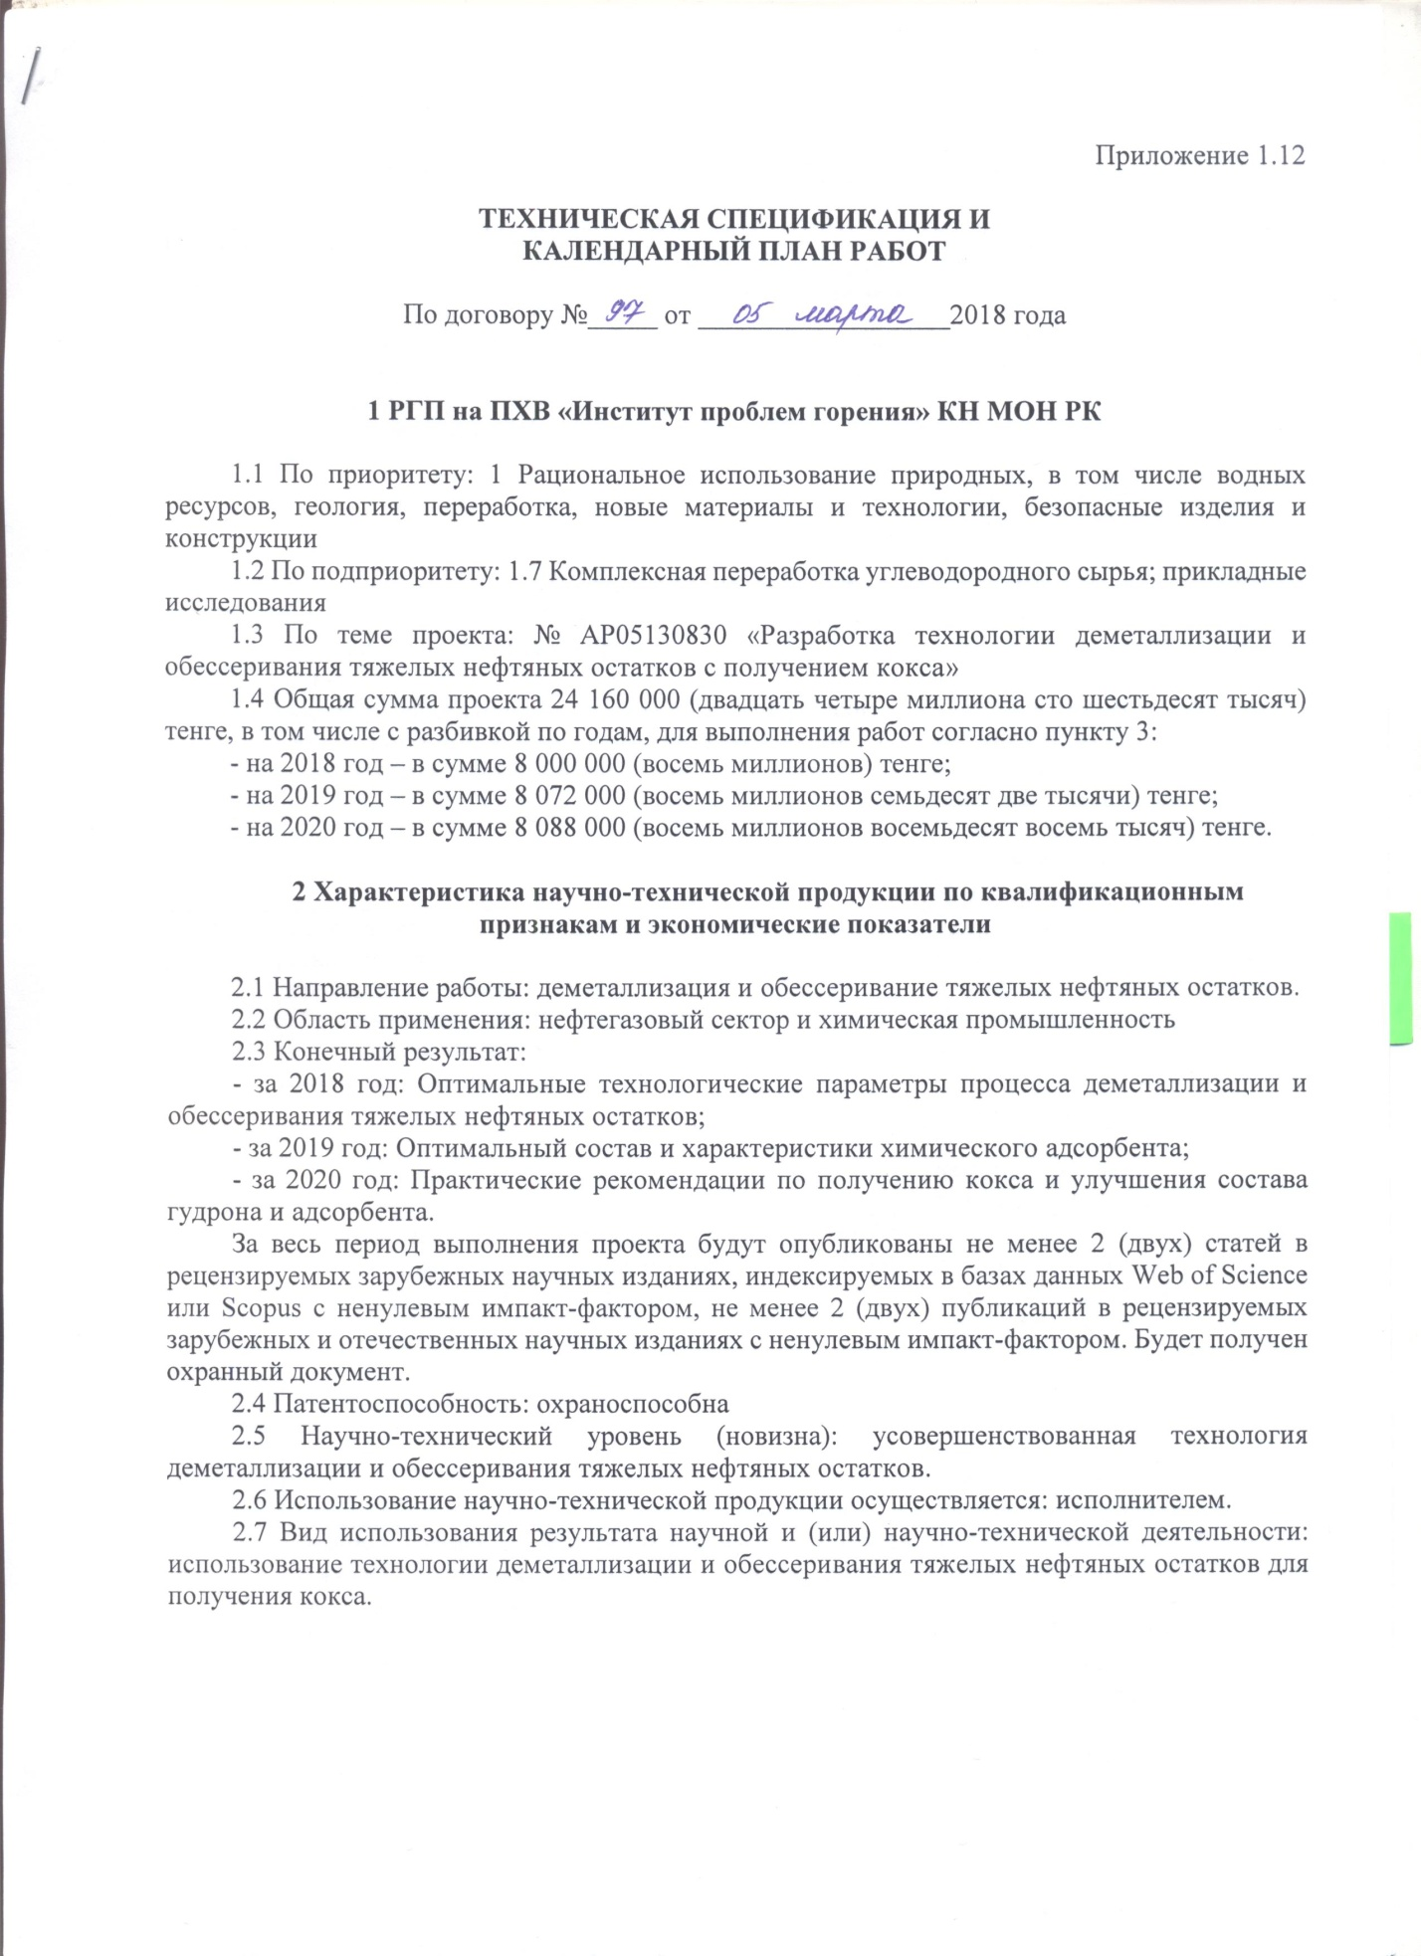

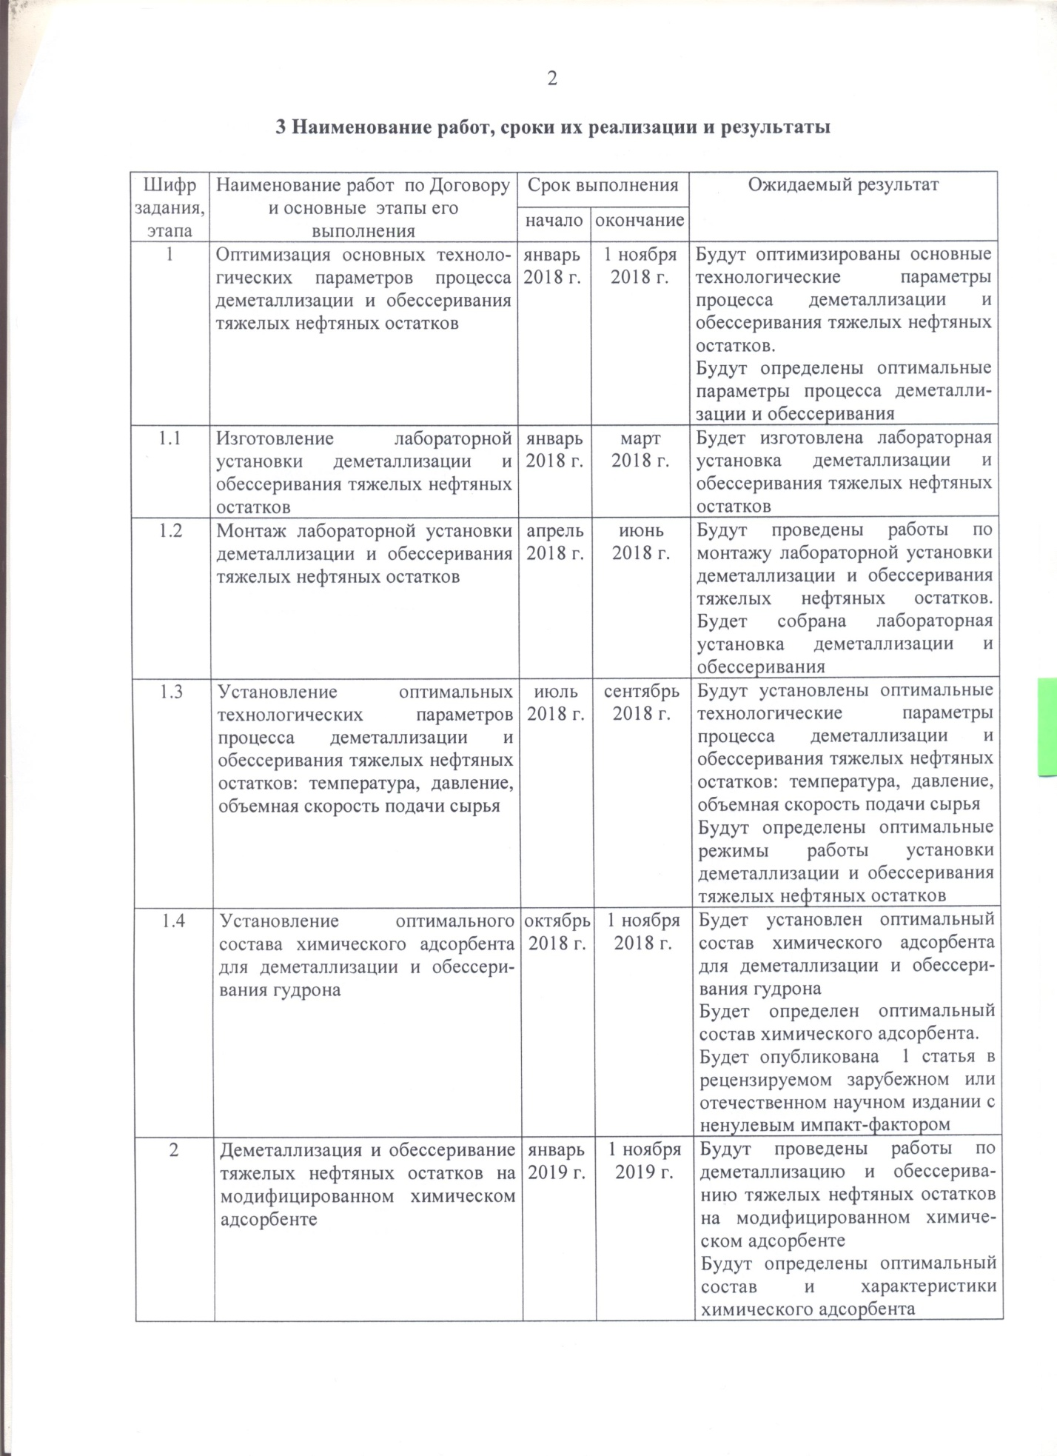

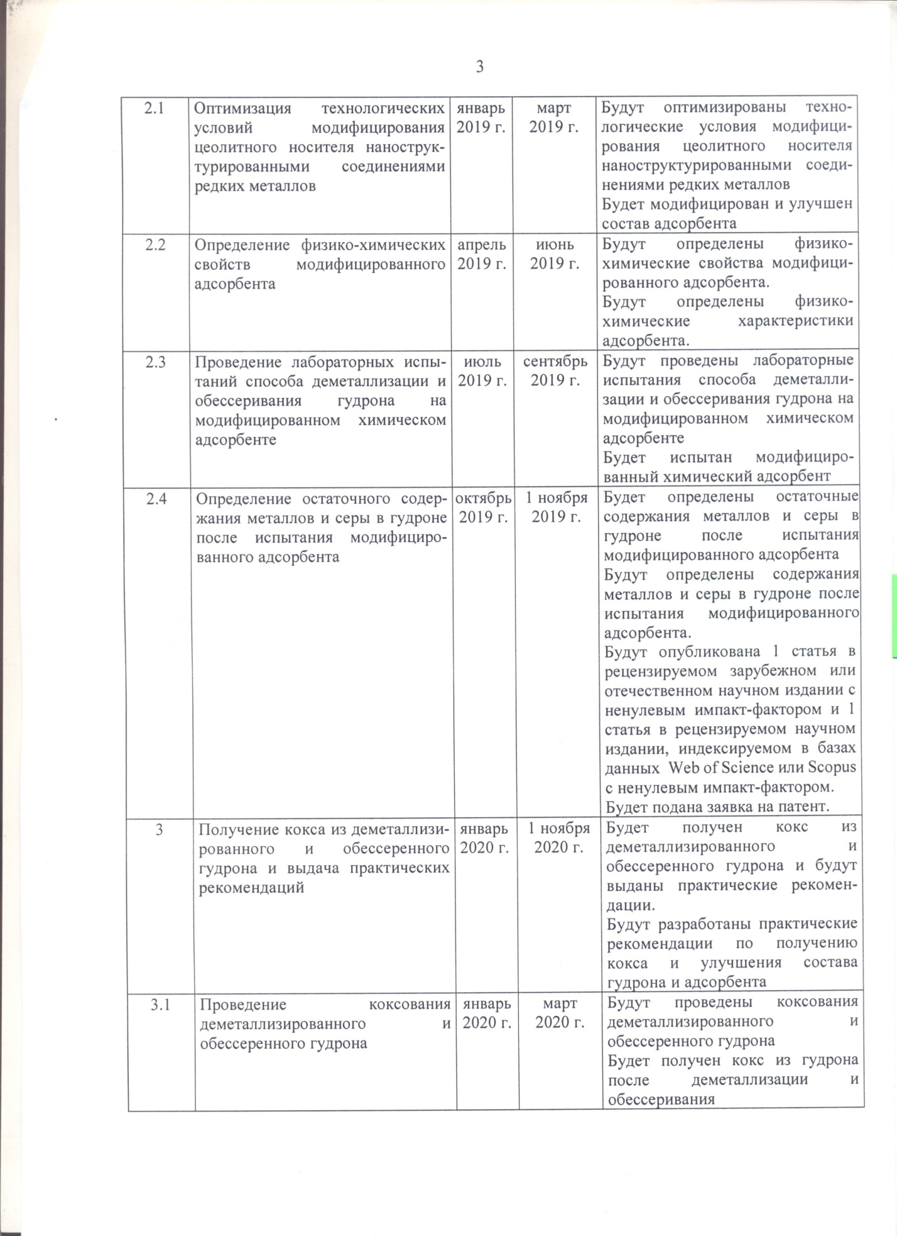

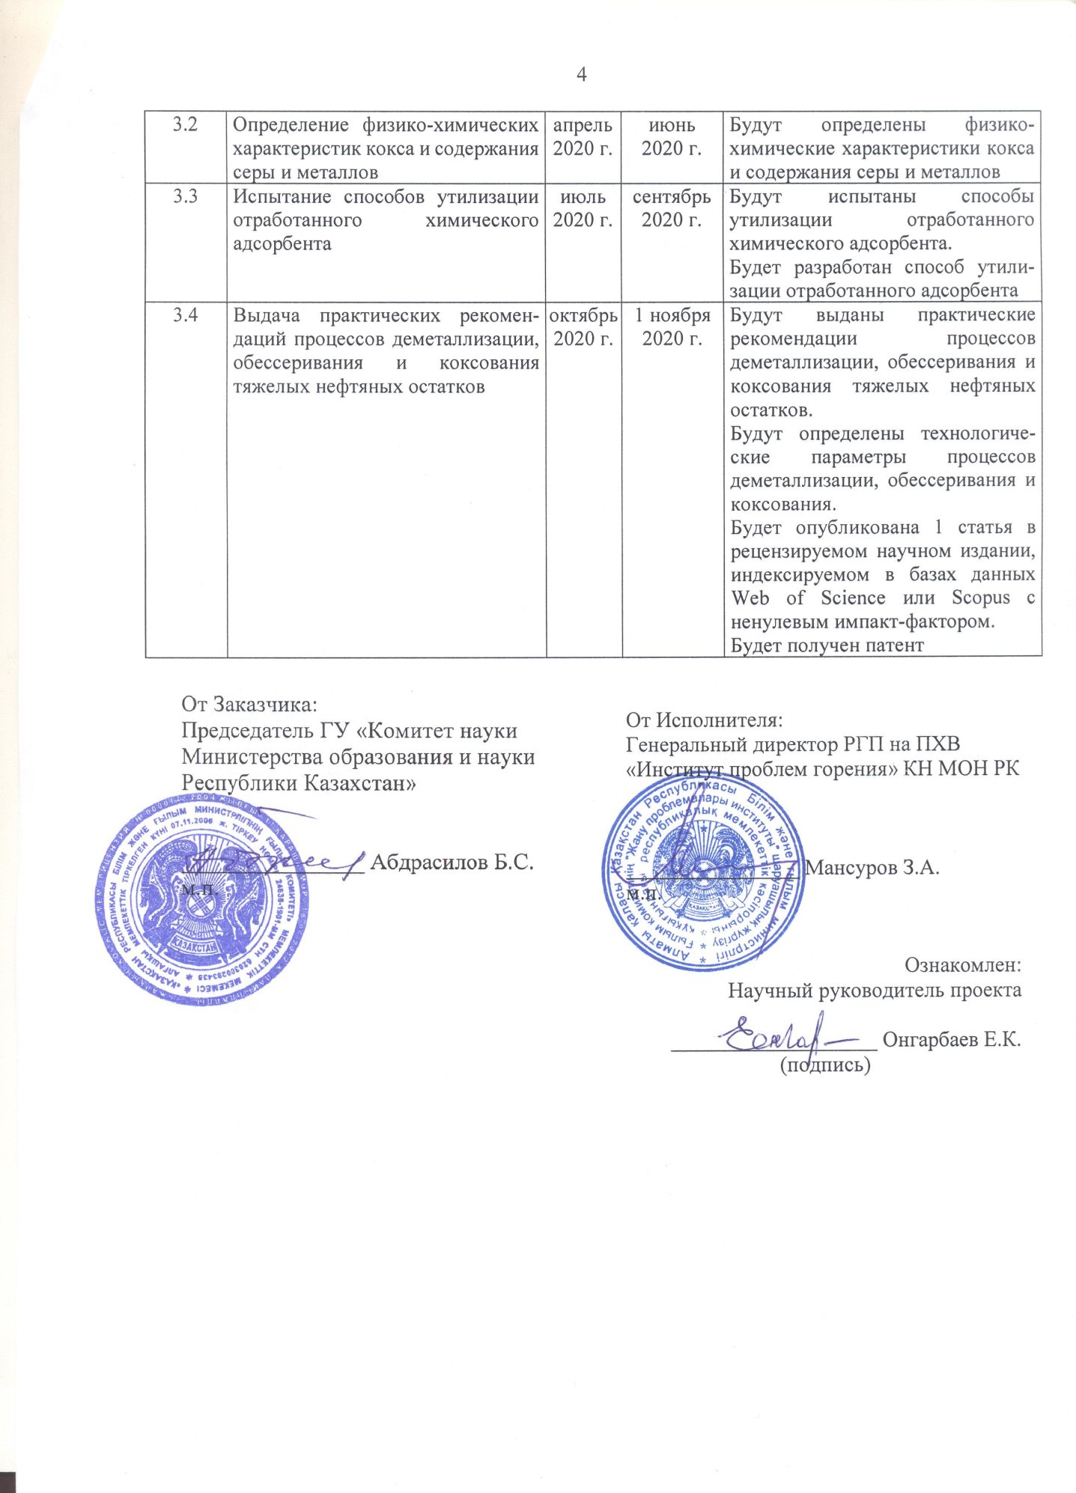

Appendix 1.12

TECHNICAL SPECIFICATIONS AND
CALENDAR WORK PLAN

Under contract No. 97 dated March 05, 2018

1 RSE on RK “Institute of Combustion Problems” KN MES RK

1.1 By priority: 1 Rational use of natural resources, including water resources, geology, processing, new materials and technologies, safe products and structures
1.2 By sub-priority: 1.7 Complex processing of hydrocarbon raw materials; applied research
1.3 On the subject of the project: No. AP05130830 “Development of technology for demetallization and desulfurization of heavy oil residues with coke production”
1.4 The total amount of the project is 24 160 000 (twenty four million one hundred sixty thousand) tenge, including with a breakdown by years, for the performance of work in accordance with paragraph 3:
- for 2018 – in the amount of 8,000,000 (eight million) tenge;
- for 2019 – in the amount of 8,072,000 (eight million seventy-two thousand) tenge;
- for 2020 – in the amount of 8,088,000 (eight million eighty-eight thousand) tenge.

2 Characteristics of scientific and technical products by qualification characteristics and economic indicators

2.1 Direction of work: demetallization and desulfurization of heavy oil residues.
2.2 Application: oil and gas sector and chemical industry
2.3 End result:
- for 2018: Optimal technological parameters of the process of demetallization and desulfurization of heavy oil residues;
- for 2019: Optimal composition and characteristics of the chemical adsorbent;
- for 2020: Practical recommendations for obtaining coke and improving the composition of vacuum residue and adsorbent.
Over the entire period of the project, at least 2 (two) articles will be published in peer-reviewed foreign scientific journals indexed in the Web of Science or Scopus databases with a non-zero impact factor, at least 2 (two) publications in peer-reviewed foreign and domestic scientific journals with non-zero impact factor. The title of protection will be received.
2.4 Patentability: Protectable
2.5 Scientific and technical level (novelty): improved technology for demetallization and desulfurization of heavy oil residues.
2.6 The use of scientific and technical products is carried out: by the contractor.
2.7 Type of use of the result of scientific and (or) scientific and technical activities: the use of technology for demetallization and desulfurization of heavy oil residues to produce coke.

3 Name of work, terms of their implementation and results

Task code, stage | Name of work under the Agreement and the main stages of its implementation | Period of execution |  | Expected Result
Task code, stage |  | Start | ending
1 | Optimization of the main technological parameters of the process of demetallization and desulfurization of heavy oil residues | January2018 | 1st of November 2018 | The main technological parameters of the process of demetallization and desulfurization of heavy oil residues will be optimized.  The optimal parameters of the demetallization and desulfurization process will be determined
1.1 | Manufacturing of a laboratory installation for demetallization and desulfurization of heavy oil residues | January2018 | March  2018 | A laboratory unit for demetallization and desulfurization of heavy oil residues will be manufactured
1.2 | Installation of a laboratory installation for demetallization and desulfurization of heavy oil residues | April 2018 | June  2018 | Works on installation of a laboratory installation for demetallization and desulfurization of heavy oil residues will be carried out.  A laboratory installation for demetallization and desulfurization will be assembled
1.3 | Establishment of optimal technological parameters for the process of demetallization and desulfurization of heavy oil residues: temperature, pressure, volumetric feed rate | July 2018 | September 2018 | Optimal technological parameters for demetallization and desulfurization of heavy oil residues will be established: temperature, pressure, volumetric feed rate.  Optimal operating modes of the unit for demetallization and desulfurization of heavy oil residues will be determined
1.4 | Determination of the optimal composition of the chemical adsorbent for demetallization and desulfurization of vacuum residue | October2018 | 1st of November2018 | The optimal composition of the chemical adsorbent for demetallization and desulfurization of vacuum residue will be determined.  The optimal composition of the chemical adsorbent will be determined.  1 article will be published in a peer-reviewed foreign or domestic scientific publication with a nonzero impact factor
2 | Demetallization and desulfurization of heavy oil residues on a modified chemical adsorbent | January2019 | 1st of November  2019 | Work will be carried out on demetallization and desulfurization of heavy oil residues on a modified chemical adsorbent  The optimal composition and characteristics of the chemical adsorbent will be determined
2.1 | Optimization of technological conditions for modifying a zeolite support with nanostructured compounds of rare metals | January2019 | March  2019 | Technological conditions for modifying the zeolite support with nanostructured compounds of rare metals will be optimized  The composition of the adsorbent will be modified and improved
2.2 | Determination of the physicochemical properties of the modified adsorbent | April 2019 | June  2019 | The physicochemical properties of the modified adsorbent will be determined.  The physicochemical characteristics of the adsorbent will be determined.
2.3 | Laboratory testing of the vacuum residue demetallization and desulfurization method on a modified chemical adsorbent | July 2019 | September 2019 | Laboratory tests of the vacuum residue demetallization and desulfurization method on a modified chemical adsorbent will be carried out.  Modified chemical adsorbent will be tested
2.4 | Determination of the residual content of metals and sulfur in vacuum residue after testing the modified adsorbent | October2019 | 1st of November2019 | The residual content of metals and sulfur in the vacuum residue after testing the modified adsorbent will be determined.  The content of metals and sulfur in the vacuum residue after testing the modified adsorbent will be determined.  1 article will be published in a peer-reviewed foreign or domestic scientific journal with a non-zero impact factor and 1 article in a peer-reviewed scientific journal indexed in the Web of Science or Scopus databases with a non-zero impact factor.  A patent application will be filed.
3. | Obtaining coke from demetallized and desulfurized vacuum residue and issuing practical recommendations | January2020 | 1st of November 2020 | Coke will be obtained from demetallized and desulfurized vacuum residue and practical recommendations will be given.  Practical recommendations for the production of coke and improvement of the vacuum residue and adsorbent composition will be developed
3.1 | Carrying out coking of demetallized and desulfurized vacuum residue | January2020 | March  2020 | Coking of demetallized and desulfurized vacuum residue will be carried out  Coke will be obtained from vacuum residue after demetallization and desulfurization
3.2 | Determination of the physicochemical characteristics of coke and the content of sulfur and metals | April 2020 | June  2020 | Physical and chemical characteristics of coke and sulfur and metal content will be determined
3.3 | Testing of methods for disposal of spent chemical adsorbent | July 2020 | September 2020 | Methods for the disposal of the spent chemical adsorbent will be tested.  A method for disposal of waste adsorbent will be developed
3.4 | Issuance of practical recommendations for the processes of demetallization, desulfurization and coking of heavy oil residues | October2020 | 1st of November2020 | Practical recommendations for the processes of demetallization, desulfurization and coking of heavy oil residues will be issued.  The technological parameters of the demetallization, desulfurization and coking processes will be determined.  1 article will be published in a peer-reviewed peer-reviewed scientific journal, indexed in the Web of Science or Scopus databases with a non-zero impact factor.  A patent will be obtained.

From the Customer:  Chairman of the State Institution  "Science Committee of the  Ministry of Education and Science  of the Republic of Kazakhstan" | From the Contractor:  General Director of the RSE on RK "Institute of Combustion Problems" of the KN MES RK
________________ Abdrasilov B.S. | ________________ Mansurov Z.А.
Familiarized with:
Scientific supervisor of the project

___________________ Ongarbayev Y.К.

APPENDIX D

APPENDIX E

