SUMMARY
The report occupies 59 pages, contains 8 figures, 4 tables, 37 references and 5 enclosures.
EAST AND SOUTH-EAST OF KAZAKHSTAN, GOLD - PLATINOID, BLACK SHALE STRATA, FORMATION, DEPOSITS
Assessment of the territory of Eastern and South-Eastern Kazakhstan for large-volume precious metal (gold-platinoid) mineralization in black shales.
Objects of study - Gold ore objects in the East and South-East of Kazakhstan associated with the carbon formation.
The aim of the study is to establish a scientific basis for assessment, forecasting and prospecting of gold-platinoid ores in the black shale strata of the East and South-East Kazakhstan.
In the course of work, mineralogical, petrographic and geochemical studies were carried out, taking into account mass spectrometric analysis and raster electron microscopy.
As a result, search criteria, such as regional geotectonic, geological-structural, magmatic, lithologic-stratigraphic, geophysical, mineralogo-petrographic were identified, allowing the search for new prospects as well as to increase the reserves of known objects.
Scope of the results: Scientific and practical recommendations are used and will be used by the Vostkaznedra and Yuzhkaznedra MD in preparing the 2021-2025 RK State Geological Exploration Programme.
Implementation recommendations: The developed scientific and practical recommendations will be used by the Vostkaznedra MD.
Importance of the work: the study will enable the discovery of new gold and platinoids deposits, including hidden and buried ones.

CONTENT

INTRODUCTION……………………………………………………………………………...........5
1 Information on the gold-platinoid mineralisation in black shales .........................................................8
2 Geological structure and minerageny of prospective territories ……………………………….. 10
3 Comprehensive study of stone material ………………………………………………………… 22
4 Prospecting criteria and assessment of prospects for gold-platinoid mineralisation
in the study area ………………………………………………………………………………....24
CONCLUSION …………………………………………………………………………………… 32
LIST OF REFERENCES …………………………………………………………………………. 34
APPENDIX A Table ………………………………………………………………………………38
APPENDIX B List of illustrations ………………………………………………………………. 40
APPENDIX C List of published articles and books during the project period ………………… 42
APPENDIX D Implementation report. ……………………………………………………………48
APPENDIX Е Calendar plan …………………………………………………………………... 49

INTRODUCTION
In the reporting year 2020, the analysis results were processed in accordance with the calendar plan, tables, a predictive metallogenic map and detailed maps of prospective areas were prepared. Projected assessment of prospects of gold and platinoid ore objects related to various stratigraphic levels of black shale strata was performed with development of search criteria, scientific and practical recommendations and preparation of the final report.
The research work was carried out under the grant for three years of 2018-2020. Following its results, the interim reports were prepared and defended:
- Assessment of Eastern and South-Eastern Kazakhstan territories for large-volume noble-metal (gold-platinoid) mineralisation in black shale (intermediate).
2018. Inventory number 0218RK005425.
- Assessment of the territory of East and South-East Kazakhstan for large-volume noble-metal (gold-platinoid) mineralisation in black shale (intermediate). 2019. Inventory number: 0219РК00633
The 2018 report was drafted by a research team led by H.A.Bespaev, Doctor of Geological and Mineralogical Sciences. From February 2019, due to certain circumstances, this group was disbanded and subsequent work was continued by the current theme performers.
In developing the forecast and search criteria, the authors of the report took into account and relied on a large amount of factual material from many years of research on the Rudny Altai, Trans-Ili Alatau and Kindyktas.
Special attention was paid to opinions of the scientists who discussed the problem issues of geology, genesis and metallogeny of the investigated regions: Globa V.A., M.S. Mysnik, M.S. Rafailovich, Y.S. Ananyev, L.G. Marchenko and others on East Kazakhstan; Y.N. Gilev, E.P. Mamonov, G.A. Suslov, A.F. Kovalevsky, V.L. Kiselev for South-East Kazakhstan). Special attention was paid to the opinions of scientists who discussed problems of geology, genesis and metallogeny in the regions under study. (Global V.A., M.S. Mysnik, M.S. Rafailovich, Y.S. Ananyev, L.G. Marchenko and others for Eastern Kazakhstan; Y.N. Gilev, E.P. Mamonov, G.A. Suslov, A.F. Kovalevsky, V.L. Kiselev for South-Eastern Kazakhstan).
In addition to the analysis carried out by the authors of the project, the analytical data of its predecessors were also used in the "IRGETAS" Engineering Laboratory at the D.Serikbayev VKTGU, the Analytical Centre of the Institute of Geology and Mineralogy of the Siberian Branch of the Russian Academy of Sciences (Novosibirsk), the K.I.Satpayev Institute of Geology and Mineralogy, the K.I.Satpayev KazNITU, the Institute of Nuclear Physics of the NAS RK, etc.
During the implementation period the authors of the project have participated in the following conferences:
1) "About the prospect of gold-platinoid mineralisation in black shale in the East and South-East of Kazakhstan" // the 19th International Multidisciplinary Scientific Geo Conference and EXPO. SGEM 2019 // Authors of the report: A.A. Zhunusov, V.V. Rassadkin, E.A. Uralbaev.
2) The International Scientific and Practical Conference "Scientific, technological and information support to assessment of Kazakhstan's mineral resources". Almaty 2019. Authors of the report: Uralbaev E.A., Zhunusov A.A.
3) Scientific, technological and information support to assessment of Kazakhstan's mineral resources: Almaty, 2019. Authors of the report: B.A. Dyachkov, M. Misernaya. Authors: B. A. Dyachkov, M. Mizernaya, A. Oitseva, T. A. Kuzmina, N. Zimanovskaya. A., Ageeva O. В.
4) Scientific, technological and information support to assessment of Kazakhstan's mineral resources: Almaty, 2019. Authors of the report: Sapargaliev E. A., Dyachkov B. A., Ganzhenko G. D., Bespaev.
5) Working meeting. The Great Altai as unique rare metal-gold-polymetallic province of Central Asia. Almaty, 2019. Authors of the report: B.A. Dyachkov, M. Misernaya. A., Zhunusov A.A., Oitseva T.A., Amiralinova B.B.
At present, when the fund of easily discovered gold deposits is exhausted, studies of the carbon deposits associated with the gold-platinoid mineralisation is critical. Prospects of replenishing gold and platinoid reserves around the world is known to be associated with so-called "large-scale deposits of gold and platinoid ores located in the black shale strata, timed to different stratigraphic levels from the late Precambrian-Phanerozoic to the present day.
Prospecting and exploration for this type of ores is currently of great geological and industrial importance.
Because of the growing global market demand for the platinum group of elements (PGM), the value of which on par with gold is $11-11/g. PGM are distinguished from gold by their high hardness, refractoriness and chemical inertness, which is why they are widely used in modern machinery and technology, they find their application in electrotechnical and electrical and other industries.
Researchers note that there are no independent deposits of platinoids in Kazakhstan and abroad, and they are mainly by-products extracted from copper and nickel ores, where their content reaches tens of grammes per tonne. These are ore objects associated with ultrabasites (Kola Peninsula, Urals, Western Siberia in Russia; South Africa, Canada, USA, etc.).
The platinum-bearing black shale thicknesses have recently become known. Such large gold deposits in the black shale strata (Sukhoi Log, Muryntau, Bakyrchik, etc.) have been found to contain PGM, which is sometimes so significant that a special type of ore deposit has been identified, the platinum-bearing shale. All these provisions make it necessary to study gold-platinoid-bearing ore deposits in the black shale strata of the east and south-east of Kazakhstan [1].
Almost all black shale type gold deposits contain platinum group metals. Studies carried out in this area have shown that the value of platinoids in them is comparable to the value of gold itself. Their presence in deposits of the area under study is also not ruled out. This is evidenced by the widespread presence of platinoids in the shungite of the Koksu-Tekeli district. However, the Kazakhstan's analytical capability in relation to precious metals is very limited, which prevents a final assessment of the deposits.

1 Information on the gold-platinoid mineralisation in black shales
K.B. Krauskopf first noted the metal content of black shale [2]. Analyzing the huge amount of published material, he established the metallogenic specialization of black shales in Аg, Аu, Аs, Сu, Mо, Ni, Pb, V, Zn and PGM. Subsequent years of discoveries of industrial gold and platinoid content in many parts of the world have generated wide interest in carbon formations. A considerable amount of work [3-10] has been devoted to the typification of carbon-containing rocks and their formation conditions.
The black shale type of gold-ore deposits are known to have huge reserves of hard-recoverable gold. In Russia and some foreign countries, the majority of the native gold reserves are in the deposits of carbon-terrigenous complexes. These deposits are represented by objects of various scales, from small to unique (Olympiada, Nezhdaninskoye, Natalkinskoye, Mayskoye, Sovetskoye in Russia; Muruntau, Kokpatas, Zarmitan, Daugyztau, Amantaitau in Uzbekistan; Bakyrchik in Kazakhstan; Chore in Tajikistan; Kumtor in Kyrgyzstan. At present, the commonly used term "black shale" is considered by some scientists to be unsuccessful. According to N.Azerbayev (2019), this term is meaning an increased content of organic matter and is a literal translation of the English "bleak shale". In geological terminology, shales are metamorphic rocks. V.I.Starostin and O.V.Yapaskurt (2008) suggested using a more precise name "high-carbon sedimentary rocks". Under the term “carbonaceous sedimentary complexes” we mean carbonaceous rhythmic-layered aleuropelitic siltstone sediments with layers of sandstones and other clastic rocks transformed equally at the stages of lithogenesis and metamorphism into dense, variously shining foliaceous rocks (Ermolaev N.P., Sozinov N.A., 1986).
The peculiarity of these thicknesses (Yudovich Ya.E., Ketris M.N. 1988) is the high content of synthetic organic matter, its difference from such coals and carbonaceous rocks by chemical composition and molecular structure.
According to many authors occupied with issues of the genesis of gold-sulfide deposits in the black shale strata, their models formation have been developed basing on real observations in many gold-bearing provinces confined to the influence zones of deep faults, penetrating into the mantle. The mantle and crust-mantle sources of gold are assumed to form gold-sulfide ore deposits with carbonaceous matter. Among the main models are the following: 1) the sedimentary metamorphogenic model consists in the formation of industrial gold mineralisation, as a result of segregation and re-deposition of chemogenic and clastogenic gold, scattered in the Pre-Cambrian flyschoidal strata during erosion of ancient crusts.
The formation of the gold deposits proceeded in three stages. During the first hydrothermal and sedimentary phase, sediments with high background gold content were formed on the bottom of the sea basins under dramatical reduction conditions. In the second elision-catagenetic stage, as a result of the submergence of metal-bearing sediments to considerable depths, elision waters were formed capable of dissolving and transferring heavy metals to the upper horizons of the sedimentary basins. Already at this stage, industrial ore concentrations could partially occur [11]. The majority of industrial fields were formed at a very late stage due to the processes of dynamometamorphism, as well as contact and regional metamorphism.
It is assumed that magmatic fluids, which regenerate and redeposit the earlier gold concentrations, could also take part in this stage; 2) the metamorphogenic-hydrothermal model considers the formation of ores with manifestation of high-gradient zonal metamorphism, which is widespread in orogene-folded areas. Sedimentary and sedimentary-volcanogenic complexes, which are deeper in relation to ore-hosting thicknesses of metamorphism levels, are considered as a source of ore substance. From the thicknesses located above the granitisation zones, the ore substance is extracted by metamorphic solutions and transferred to the upper low-temperature zones. The direct ore deposition occurs from hydrothermal solutions of the regressive stage of metamorphism, which follow diaphthoric re-deposition of ore-hosting rocks.
This genetic concept has been most fully developed by V.A. Buryak for gold-quartz-sulfide mineralization of the "Sukholozhsky" type; 3) the model of intratelluric carbon metasomatosis has been proposed by P.F. Ivankin and co-authors to explain the conditions for the formation of gold deposits in the black shale strata on the basis of observations in a number of ore fields in western Uzbekistan. There are two stages of their formation, sharply differing in physical and chemical conditions of ore deposition. The first stage involves metasomatic transformations of dislocated rocks in the form of carbon metasomatosis under the influence of strongly reducing mantle-bearing fluids with the addition of gold and other metals in amounts exceeding the clark ones. At the second, actually the ore-forming stage, 2-3 times processing of sulphidised carbonaceous rocks resulted in industrial concentrations of gold [12]; 4) the magmatic-hydrothermal model is the earliest and best developed model. It assumes a connection between gold mineralization and solutions of magmatic origin, the sources of which could be granitoid intrusions. The main feature of the formation of deposits is the remobilization of syngenetic gold from black shale carbon-argillite-aleurolite deposits in the main process of tectonometamorphic transformation of rocks [13].

2 Geological structure and minerageny of prospective territories
In the reporting year, research work continued on gold-platinoid objects in south-eastern Kazakhstan. According to the 2020 calendar plan, after a comprehensive study of the stone material collected during fieldwork in 2019, geological materials in the most promising areas were studied in detail. The summary of the characteristics of the investment attractive areas with gold-platinoid mineralisation localised in the black shales of the Kendyktas regionis given below.
The Shokpar-Karatas ore zone is characterized by development of gold-sulfide-quartz vein and mineralized zones of the ore formation, combining two morphogenetic types (quartz vein and mineralized zones), which formed the largest group of gold manifestations and deposits in the Agalatas-Sherbakti ore district [14].
The geological structure of the ore zone includes rocks of the coal-aleurolite-siliceous composition (ore-hosting) of the Sherbakti suite, which is overlapped by volcanogenic-sedimentary formations of the Rgaiti suite. Intrusive formations are poorly developed and form dikes and small bodies composed of moderately acidic and medium-sized rocks of the Late Ordovician (Kordai-Shatyrkol) intrusive complex. The Lower Paleozoic complex of rocks on plateau-like watersheds is covered with the Middle Quaternary loess-like loams up to 30-40 m in thickness. Sometimes, at their base lies on the horizon of the conglomerate breccia with a thickness of 0.5-2.0 m. The channel parts of the valleys are made of boulder-pebble loams with a thickness of up to 50 m.
The Early Middle Ordovician sediments are intensively dislocated. As a whole, this is a system of linear, sometimes extremely compressed and recumbent folds of total north-west spread, broken by synfold transverse, diagonal and longitudinal faults. The rock fall angles are steep (60-80º), often vertical, and there are overturned folds. Magmatic and tectonic factors have a huge impact on the location of the gold-sulfide formation in the Shokpar-Karatas ore zone.
The oblique-slip fault zones were a magma-supply channel for intrusions of the Late Ordovician Kordai-Shatyrkol intrusion complex. All known manifestations of the gold-sulfide formation are located in a strip of up to 1.5-2.0 km wide on the hanging side of the North-Shokpar-Karatas oblique-slip fault. Sites of the largest deposits and manifestations (Shokpar, Karatas, Chekendy, Eastern Shokpar) are directly adjacent to the fault zone.
Almost all known manifestations of the Shokpar-Karatas ore zone are confined to large anticline structures complicated by higher order folding, and are located in nuclear units or on the wings of the former. The anticline nuclei contain the Shokpar deposit, manifestations of Chekendy, Eastern Shokpar and a large group of mineralisation points. Ore zones of the Karatas deposits and a number of mineralisation points are located on wings of anticline structures.
The North-Shokpar gold-copper-polymetallic ore field covers an area of 3.8 sq.km and is located on the south-western wing of the Kendyktas anticlinorium. It is localised in the north-western part of the Shokpar-Karatas ore zone at the site of its knee-shaped bend, at the junction of the North-Shokpar-Karatas and Taspola oblique-slip faults. This structural confinement contributed to formation of the gold-sulfide ore deposit in carbon-terrigenous sediments of the Sherbakti Suite and the overlapping volcanic-sedimentary formations of the lower subsuite of the Rgaiti Suite, forming an overturned anticlinal fold with a hinge sinking to the east. Within the ore field described, commercial gold-polymetallic ore reserves are concentrated at the Shokpar deposit.
The Middle Shokpar field. The main ore control structure of the deposit is the North-Shokpar oblique-slip faults, cutting the sand-shale carbon sediments of the Sherbakti Suite. According to Yu.N. Gilev and E.P. Mamonov (2011), the discharge-shift is a tectonic zone of contortion of north-western strike. The axial part of the fault is fixed by the rocky en-echelon ore zones: South-East and North-West. They cross the entire area of the deposit from south-east to north-west. Ore zones are localised in the sublatitudinal structures pluming the North-Shokpar fault. These fracture structures are characterised by chipping movements of oblique slip faults.
The post-ore faults of submeridian strike, such as left-side shift faults, often displaced by 1-12 m of horizontal amplitude. Industrial ore reserves are found in nine ore zones: those localised in the axial part of the main suture and the plum faults. Their thickness varies from 0.3 to 6 m. Hosting sandstones and siltstones within the zones are intensively sheared, chlorinated and sericitised. The core parts of the ore zones contain short lenticular quartz veins and veins with gold-polymetallic mineralisation framed by hydrothermalites with superimposed ore mineralization of the same type.
Ore mineralisation is represented by pyrite, galena, arsenopyrite, sphalerite, native gold, silver and its sulphosalts. There are 24 ore bodies within the zones, grouped in two sites: Western and Eastern. The length of ore bodies is 60-400 m and their thickness is 1-2 m. Ore bodies were traced to a depth of 250-300 m without reducing the intensity of mineralization. Contents of gold in selected ore bodies at the level of 6-10 g/t, silver 37-50 g/t.
The end-to-end recovery of valuable ore components: gold 85%, silver 82%, lead 60%, zinc 12.6%, sulphur 40%. The ores are siliceous, arsenic: 54-60% silicon dioxide, arsenic 0.95% [14].
The Karatas ore field covers an area of 4.0 sq.km. It is stretched as a strip of 4,100 m long and 800-1,000 m wide among the coal-clay deposits of the Sherbakti Suite and the andesitoids of the Rgati suite. It is controlled by the southern branch of the Shokpar-Karatas obliques-slip fault. The ore field is confined to its hanging side. The leading type of mineralization is gold sulphide with two morphogenetic subtypes: quartz vein and mineralized zones. The ore field includes the small gold deposit Karatas and its north-western extension Karatas West.
The Karatas Minor field. The field is structurally confined to the Shokpar-Karatas oblique-slip fault. The host rocks are coal-clay and coal-siliceous siltstones and sandstones of the Sherbakti Suite and tuffs of the Andesite composition of the lower subsuite of the Rgaiti Suite. The mineralisation has been localised in the mineralised zones of the northwest orientation, steep fall in the sub-conformant with host rocks (figure 1). The zones are formed by quartz veins and veins framed by hydrothermally altered rocks. On an area of 0.1 sq.km, 20 zones were identified, separated by intervals of waste rocks (10-15 m). Within the zones, 26 ore bodies were identified. In 13 ore bodies, the gold content is more than 3 g/t, while in the rest it is between 1 g/t and 3 g/t. Ore bodies with gold content exceeding 3 g/t consist of a quartz-sulfide core with thin quartz veins along the zalbands. Within the quartz-sulfide veins, they form intermittent lenses in the form of ore pillars with predominant drop lengths over strike lengths. The length of ore bodies is 30-200 m and their thickness is 0.67-2.86 m. Contents of gold in ore bodies are from 5 to 23 g/t, silver 10-44 g/t. In the calculated reserves, the average value of gold is 7.2 g/t, silver 37.85 g/t, lead 0.82%, zinc 0.76%, arsenic 0.18-1.1%.

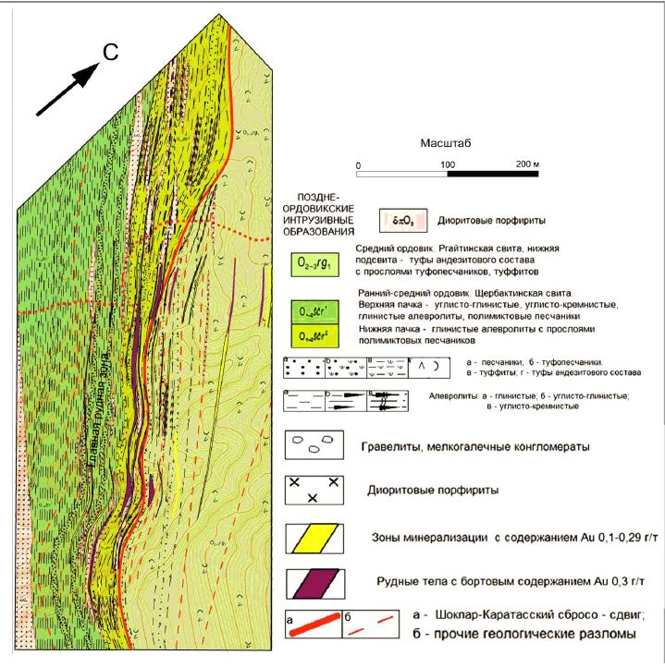
Figure 1 - The geological chart of the Karatas deposit
(as per E.P. Mamonov et al., 2014) with additions

The Aldaush deposit is located in the Kordai district of Zhambyl Oblast. It is timed to the south-western bend of the Kolguti flexure [15]. The geological structure of the deposit contains coal-terrigenous deposits of the Sherbakti Suite of the Lower-Middle Ordovician, overlapping them volcanogenic formations of the Rgaiti Suite of the Middle-Upper Ordovician. Volcanogenic-sedimentary and intrusive formations within the flexural bend are intensively dislocated. As a result, sliding and chipping-shift tectonic disturbances characteristic of the entire ore district have been widely observed. Intrusive formations at this site are represented by monzonites, monzodiorites and syenite porphyries of the Kolguti massif of the Middle Devonian intrusive complex. They were subject to intensive compression with formation of numerous brecciation and fracture zones, with developed areas of silicification, beresitisation, carbonisation, sericisation, pyritisation and limonisation. Quartz-vein formations with a thickness of 0.5-1.5 m and narrow linear beresitisation zones are developed along submeridional and northeastern discontinuities. The most favourable structures for gold mineralisation are the intersection points of faults in different directions in the montsodiorites [16]. Mineral composition of ore bodies: pyrite, chalcopyrite, bornite, bismutin, gold, secondary copper minerals, oxides and hydroxides of iron. They are very unevenly distributed in the veins and are most often localised in the selvages. Gold is found in quartz and among iron hydroxides in the form of single grains or groups of 4-5 grains (0.04-0.09 mm gold). The selvages extend for tens of meters, thickness from first centimetres to 0.5-0.7 m. As a rule, gold-bearing veins are controlled by larger faults along the lateral. It should be noted that the gold-sulfide quartz vein mineralisation has not been reliably assessed in depth. Although the gold content of sulfide and quartz veins at the deposit is quite high, and it was confirmed by the drilling of single wells, where vein ores have been discovered at depth of 113-235m. The gold content of the ore bodies is extremely contrasting. Thus, in quartz-sulfide veins, its content varies from 0.1 to 63.0 g/t, while in beresitised selvages it does not exceed 3.0-5.5 g/t. In the final stage of hydrothermal activity, quartz-carbonate and very rarely barite veins were formed. The field is divided into three parts: Northern, Central and Southern. The richest and most promising is the Southern Aldaush, which unites the Western and Eastern blocks. According to the geological exploration works performed by Geolog-A LLP, (as of 01.01.2008) the deposit is estimated as small with explored and estimated reserves to a depth of 30m (category C1 + C2) of 37,350 thousand tonnes of ore and 333.0 kg of gold at an average grade of 8.92 g/t. The deposit is estimated to contain 3.0 tonnes of gold at an average grade of 8.92 g/t and associated minerals: silver 1.3 tonnes and copper 3.1 thousand tonnes at average content of 3.57 g/t and 0.83% respectively. In view of the above, the deposit belongs to the commercial gold-sulfide quartz vein type with formation of multilayer gold mineralisation in the system of chipping and tear-off faults in monzonite-monzodiorites of the Middle Devonian intrusive complex. This object undoubtedly requires an in-depth search assessment.
The Kungei ore area in the north-eastern part of the Zhongar gold-ore district is a promising area for gold-platinum mineralisation. The area is composed of coal-clay siltstones of Lower Carbon. As a forecast object with an area of 500 sq.km, it was identified by A.F.Kovalevsky, B.V.Ershov et al. (2000) on the basis of several levels of sheared pyrite-containing strata of coal-clay siltstones 5-10 m thick with increased concents of carbon (0.1 to 0.44%), arsenic (up to 0.2%), gold (0.01 to 0.2 g/t) developed here in the section of the Zhabyk suite of Lower Carbon. Carbonaceous-clay siltstones are sometimes permeated with quartz veins 30-40 cm thick.
The unique geological development of the area made it for a long time (from the Lower Ordovician to the Middle Carboniferous) an area of marine regime, contributed to the accumulation of huge sedimentary, siliceous and tuffite strata, very specific and monotonous in lithological composition. Presence of ash material in the section indicates the volcanism, synchronous to formation of strata, which took in adjacent areas. The nature of sediments is turbidite and olistostromic, due to landslides and landfalls, is of suspension type with a disturbed stratigraphic sequence. The sediments are dislocated and crumpled into complex fold systems and numerous breakups (throws, oblique slips, shifts and their combinations) complicate the study the stratigraphic sections and their correlation by tectonic blocks [17].
Search works (V.D. Izbenko, 1990) have most studied the Tastau area. Analysis of 1005 furrow samples showed gold content within <0.1-5 g/t. Samples of ditches and natural outcrops contain pyrite, barite, single signs of galena, cerrucite, sphalerite, chalcopyrite, pyrrhotite and arsenopyrite. The monomeral pyrite fractions, according to atomic absorption analysis, gold content is 0.02-3.0 g/t, in one sample 69 g/t. Five pyrite containing carbonaceous clay horizons with a thickness of 50 to 350 m and a total length of 17 km were established. Metasomatic changes occurred in certain areas of hosting rocks: silication (impregnated with a network of quartz veins), propiliticization, albiticization. In 60 furrow samples of metasomatically altered rocks, among pyrites containing carbonaceous clayey and siliceous siltstones, gold was found in the content of 0.1-0.9 g/t, in 25 samples 1.0-5.0 g/t. The thickness of industrially significant intervals with gold content of 1-5 g/t varies from 1 to 3 m. Field prospecting and appraisal work was carried out taking into account these geological situations and a detailed study of data from previous studies. Methodologically, these works included:
1 Routine surveys at a number of sites such as Shokpar, Karatas, Chekendy and Taspaly, including studies of outcrops in old quarries and ditches, their clearing, taking furrow and plumbing samples at ore intervals and photographically documenting outcrops with indication of sampling locations.
2 Some results of the geological and mineralogical study of the carbon strata of the regions under study are given in Appendix A.
Results of mineralogical studies. In order to study the material composition of the ores of the deposit within the Shokpar-Karatas ore zone, the results of 23 samples were shown in Appendix A.
To clarify the mineral composition, the following test methods were employed: the X-ray fluorescence analysis (RFA), the neutron activation analysis, performed at the Institute of Nuclear Physics.
The data obtained indicates that the gold ore at the deposit is confined to certain lithological and petrographic varieties. In general, these are carbon-terrigenous formations. As can be seen from the data below, the highest gold grades are found in fine sandstones with sulfides and carbonaceous clay shales: T19-52 - Scanned sandstone 1.116 g/t, (N 43º03' 31.5", E 74º 56' 41.9"), CH19-31 - Fine sandstone with sulfides 18.087 g/t, (N 43º 06' 53.5" E 74º 55' 01, 1"), SH19-5 - Ferric, grey-brown, cracked - 3.153g/t, (N 43º 09' 42.4' E 74º 52' 32.3"), SH19-11 - Quartz veinlet in coal shale. Intensive sulphurisation - 1,213 g/t (N 43º 09' 43.5 "E 74º 52' 26.9"), SH19-14-2 – Carbon-clayey shale. Silicated into veinlets, ferric - 12.871 g/t N43º 09' 43.6" E 74º 52' 25.0").
The chemical composition of samples taken from ores and containing rocks at the Shokpar North, Taspoly and Akzhal deposits was studied.
At the Shokpar deposit, coal siltstones and pyrites taken from quartz veinlets have the Pd content 20 times as higher as bulk earth values (from 4.44 to 0.68 tonnes ppm); Au content (from 0.15 to 0.55 ppm); Ag content (from 1.62 to 4.93 ppm); Th (3.50-6.78); U (4.73-6.19).
The Taspoly deposit also has the higher Pd content (up to 0.40t ppm); Au from 0.57 to 0.66 ppm; Ag from 2.28 to 15.45 ppm; Th (1.49-4.23); and U (8.24-36.74) (Table 1).

Table 1 - Chemical composition of ores and host rocks of deposits
No. | Specimen | Ru | Rh | Pd | Ag | Pt | Au | Th | U
No. | Specimen | g/t | g/t | g/t | g/t | g/t | g/t | g/t | g/t
1 | 2018/16 | 0,0018 | 0,0014 | 0,28 | 1,14 | <0,01 | 0,11 | 9,04 | 11,44
2 | 2018/23 | <0,001 | 0,0017 | 0,70 | 1,14 | 0,07 | 0,05 | 8,08 | 8,55
3 | 2018/30 | 0,0018 | 0,0014 | 0,61 | 1,50 | <0,01 | 0,05 | 8,15 | 5,47
4 | Ш-19-9 | 0,0018 | 0,0014 | 0,51 | 1,62 | <0,01 | 0,16 | 6,78 | 6,10
5 | Ш-19-10 | <0,001 | 0,0014 | 0,44 | 4,45 | <0,01 | 0,57 | 5,54 | 4,90
6 | Ш-19-11 | 0,0018 | 0,0019 | 0,68 | 4,93 | 0,03 | 0,52 | 3,50 | 4,73
7 | Т-19-47 | <0,001 | 0,0013 | 0,40 | 2,28 | <0,01 | <0,01 | 1,49 | 8,24
8 | Т-19-54 | <0,001 | 0,0018 | 0,28 | 6,61 | <0,01 | 0,66 | 4,23 | 15,82
9 | Т-19-52 | <0,001 | <0,001 | 0,30 | 15,45 | <0,01 | 0,57 | 1,85 | 36,74

Description of microsections
Microsection SH-19-11: bluish-gray siltstone with quartz inclusion of sulphide minerals.
Mineral composition: pyrrhotite, chalcopyrite, pyrite, rutile and sphalerite.
Pyrrhotite is predominant among other sulfides and is identified as irregular impregnation in the rock mass. It is found separately in the form of irregular concretions, often corroded. Small inclusions of chalcopyrite were noted. The size of pyrrhotite inclusions ranges from 0.005 to 0.2 mm.
Chalcopyrite is present in subordinate quantity. It occurs in the form of irregular fine inclusions (0.005-0.01 mm) in the mass of the rock and as small inclusions in pyrrhotite. Chalcopyrite with titanium minerals was observed.
Pyrites, along with chalcopyrite, is present in subordinate quantities. It is irregular, rare impregnation in the rock mass. The size of pyrite grains varies from 0.01 to 0.2 mm. Pyrite is finely aggregated, and its corrosion and substitution with pyrrhotite (Figure 2) and iron hydroxides (Figure 3) is observed in places. The pyrite of early generation is observed, the melnikovite-pyrite collomorphic (0.005-0.01 mm), replaced by crystalline-grained pyrite and the latter in turn is replaced by pyrrhotite (Figures 4-5). Sphalerite is a rare fine concretion (0.01-0.03 mm) in the pyrrhotite aggregate, sometimes in combination with chalcopyrite. Rutile is an accessory titanium-containing mineral. It is found in the form of fine irregular impregnation in the mass of the rock.

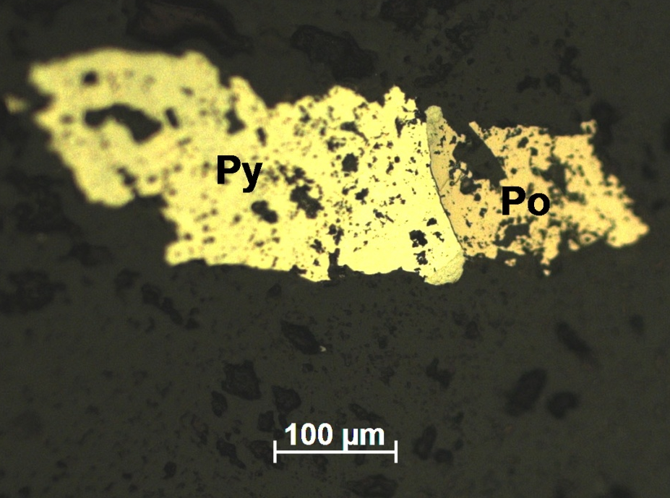  Figure 2 - Pyrrhotite (Po) replaces pyrite (Py). Microsection SH-19-11 | 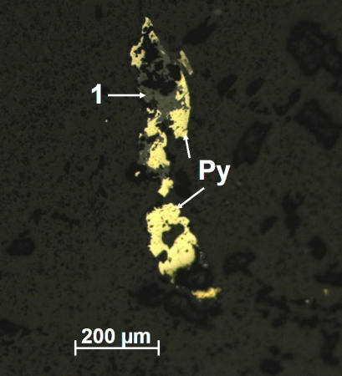  Figure 3 - Pyrite (Py) is replaced with iron (1) hydroxides. Microsection SH-19-11
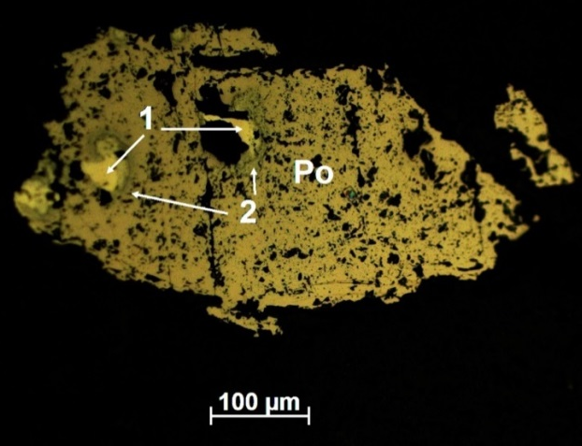  Figure 4 - Pyrrhotite (Po) replaces melnikovite (2) and pyrite (1). Microsection SH-19-11 | 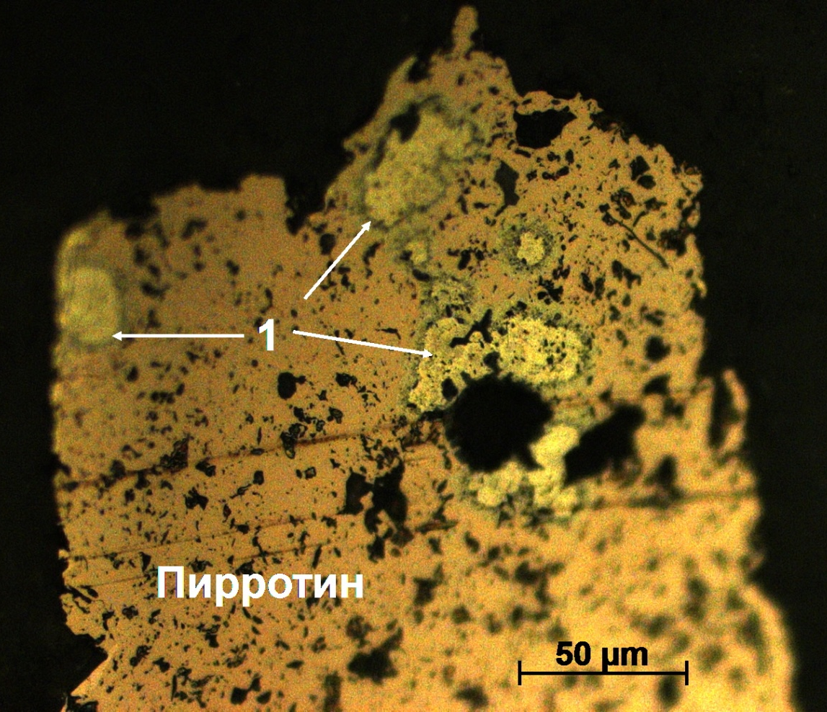  Figure 5 - Pyrrhotite replaces melnikovite-pyrite (1). Microsection SH-19-11

Results of microprobe analysis for the microsection SH19-11

20200209 Studyofminerals. Sample SH-19-11

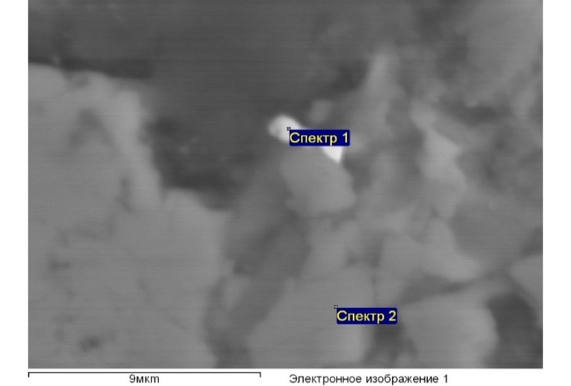  а) | 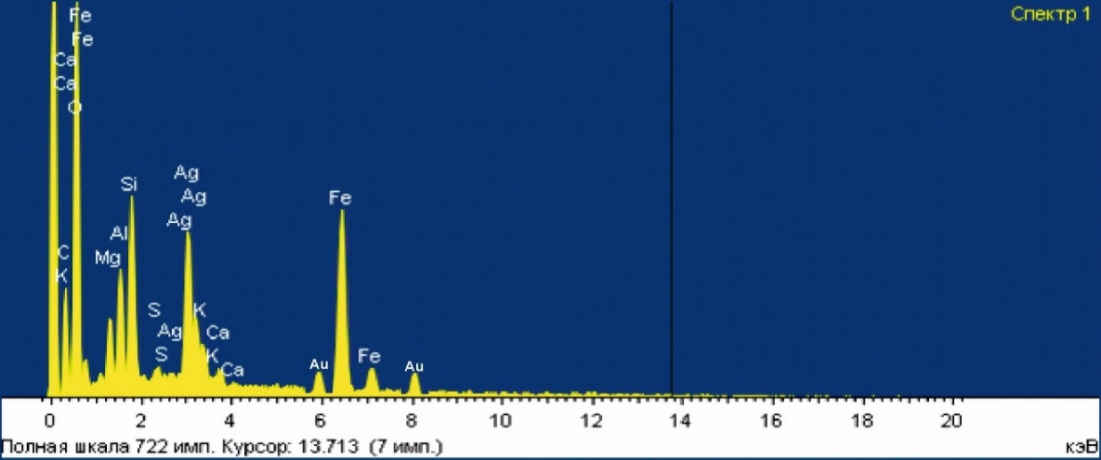  b)
Figure 6 - (a,b) Silver with gold inclusions is in siltstone, quartz and iron hydroxides

Table 2 - Processing parameters: Analysis of all elements (normalised)
Spectrum | In stat | O | Mg | Al | Si | S | K | Ca | Mn | Fe | Ag | Au | Total
Spectrum 1 | Yes | 49.77 | 3.02 | 4.24 | 6.02 | 0.36 | 1.00 | 0.65 |  | 21.29 | 12.86 | 0.8 | 100.00
Spectrum 2 | Да | 47.23 | 5.80 | 1.93 | 4.58 |  |  | 0.46 | 1.15 | 38.85 |  |  | 100.00
Max |  | 49.77 | 5.80 | 4.24 | 6.02 | 0.36 | 1.00 | 0.65 | 1.15 | 38.85 | 12.86 | 0.8
Min |  | 47.23 | 3.02 | 1.93 | 4.58 | 0.36 | 1.00 | 0.46 | 1.15 | 21.29 | 12.86 | 0.8

Key findings from the mineralogical study of the field's microsections
1. The mineral composition of the described microsections is similar and includes sulfide minerals - pyrrhotite, chalcopyrite, pyrite, rarely sphalerite and as accessary rutile.
2. Pyrrhotite dominates among sulfides, forming in one case the impregnated unevenly-grained substantially pyrrhotite (chalcopyrite-pyrite-pyrrhotite) ore.
3. Sulphides are in association with quartz and are represented in the bluish-gray siltstone containing both as uneven separate impregnations and in mutual accretions. Among them, pyrrhotite is one of the most recent minerals, replaces chalcopyrite and pyrite. Small inclusions of chalcopyrite are often found in aggregate pyrrhotite.
4. Sulphide minerals are often corroded. Oxidised pyrite is noted.
5. Accessory rutile is present in the rock mass, often in combination with chalcopyrite.
6. In the pyrrhotite mass, there are collomorphic concretions of melnikovite-pyrite, which are a mixture of marcasite and pyrite, as early formations, built into a transit association of the millnikovite-pyrite-pyrrhotite.
7. Sulphides in association with quartz are superimposed on siltstones and are hydrothermal in nature.
Key findings of the petrographic study of the field’s slides
Slide Ш19-10.
Externally, it is a black massive fine-grained rock. There are several different areas of the rock in the cut: black fine grains, one with thin white microveins, is absent in the other one. Under the action of hydrochloric acid, the rock with veinlets boils, and the second is inert to hydrochloric acid.
In the grinded plane, black aleuropelite has nests and veinlets of carbonate. Aleuropelite with rare fine quartz grains consists of a cryptocrystalline mass with black carbonate particles. Carbonate is of various grains ranging from cryptocrystalline to fine-medium-grained. Locally, it is sometimes associated with quartz.
In the second slice, the striped pelite alternates between layers (layered texture) of absolutely black cryptocrystallines (pelite) and slightly more decrystallised layers with weakly recognisable particles of quartz and other formations, possibly micaceous.
Slice T19-51
Externally heterogeneous in colour rock with spots of grey separations in the form of debris in a lighter cementing mass. White calcite is in veinlets and nests.
Under the microscope, the rock is of very heterogeneous in fragmental compositions, their structure and grains. One type of separations (rocks) is represented by quartz variety aggregates from thin to medium grained and separate relatively large grains of single quartz crystals. The second type of rock is highly chlorinated and often plays the role of cement, but without sharp and distinct limitations like sandstones. The crystalline structure of the individual rock sections and intensive carbonation and chloritisation obscure the primary rock composition. In nesting aggregations of pelitised feldspar grains, small veins are made of calcite, while larger ones (up to 1.5-2 mm) are made of coarse-grained calcite, epidote and quartz (Figure 15). The mineral X, a highly refracting mineral with low bipolarization, is noted in agglomerations and in the form of impregnations (Fig. 15).
The rock can be defined as acid crystalline-litho-clastic tuff with the psammite structure (figures 6-7).
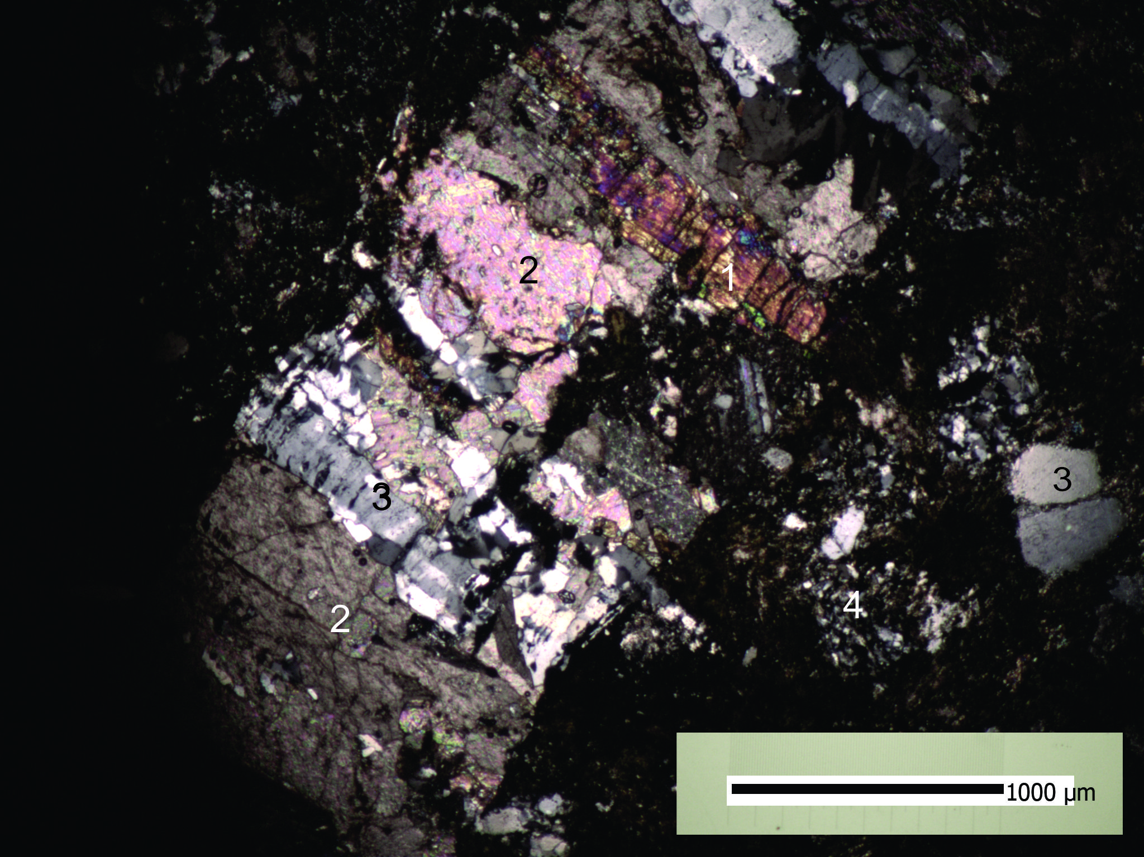  Figure 6 - Veinlets of complex composition: 1-epidot, 2- calcite, 3- quartz, 4-m/siliceous rock. Slide T19-51, nic.+ | 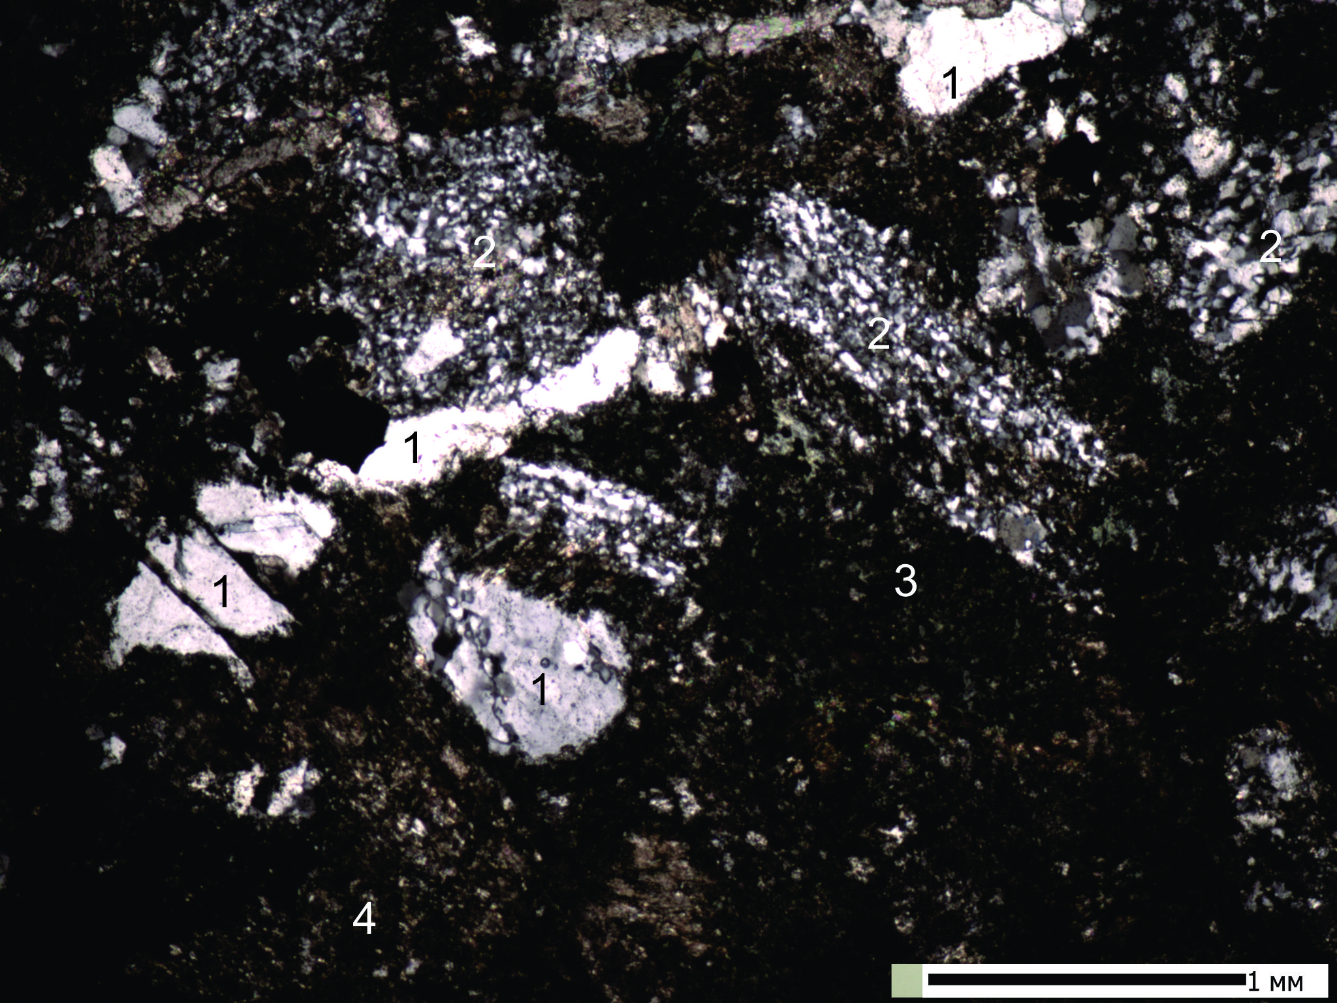  Figure 7 - Clastic rock (tuff?) with fragments of quartz (1), quartz m/z rocks (2), chlorite (3) and cryptocrystalline separations (4). Slide T19-51, nic.+

3 Comprehensive study of stone material
Since the start of the project implementation, employees have travelled to the field three times according to the work schedule. In the course of field work, we studied ore objects in order to clarify the geology and genesis of ore-hosting rocks and ore horizons of scientific-practical interest. We have collected stone materials from the gold ore sites of East and South-East Kazakhstan due to our capability. Stone materials of co-performing employees of the D.Serikbaev VKTGU, B.A.Dyachkov and M.A.Misernaya on East Kazakhstan were widely used. During the project period, for all types of analyses we collected 62 samples and specimens in the first half of 2018, 91 samples and specimens in the second half of 2018, and 55 samples and 62 specimens in 2019.
Under the field conditions, macroscopically determined were their origin, structural and texture features, composition and secondary changes, which then allowed correct conclusions to be drawn in laboratory tests. All selected samples were crushed, grinded in the related workshops and then spectral analysis was carried out in the laboratory of the K.I.Satpaev IGN.
The 67 microsections and slides on hosting rocks and ore bodies were studied in the laboratories of the K.I.Satpaev IGN, the Satpaev KazNITU and the D.Serikbaev VKTGU with involvement of the most experienced specialists in this field (K.Sh.Dyusembayev, K.R.Plekhov, G.M.Omarov). As a result of mineralogical and geochemical studies, the complex composition of gold-bearing ores containing mainly sulphide minerals and native metals (Au, Ad, Pt, etc.) was determined at the macro and micro levels. The main typomorphic minerals such as pyrite, arsenopyrite, antimonite, chalcopyrite and sphalerite have been identified. Petrographic study of the host rocks at the Karatas deposit allowed us to correct the geological map of the site.
Noteworthy, the study of stone material from gold ore objects in order to determine the material composition of ore-bearing rocks, ore bodies and monomeral fractions was carried out applying the petrochemical, petrographic and mineralogical-geochemical methods of research using modern laboratory facilities (at the RAS SB IGM Analytical Centre in Novosibirsk, the "Irgetas" laboratory of the VKTGU in Ust-Kamenogorsk, and the K.I.Satpayev Institute of Geological Sciences).
Samples and specimens collected during the 2019 field period were analyzed for elements of the gold-platinoid group and associate elements. In the laboratories of the K.I.Satpaev Institute of Geological Sciences and the Institute of Nuclear Physics, using atomic absorption and neutron activation methods, respectively.
Several samples taken in the course of fieldwork (Misernaya M.A., Dyachkov B.A.) from ore bodies of a typical ore deposit, localized in the black shale strata, were studied in the Vezitas laboratory of the VKTGU, using a Joel-100^{c} scanning electron microscope with an energy dispersion add-on device. As a result, the mineralogical composition of the main ore minerals and host rocks of the deposit were clarified.
Samples of rocks and metasomatites were analyzed in the INP by X-ray fluorescent and instrumental neutron activation methods. The data obtained showed that there are no correlations between the content of typomorphic elements for the Kungei site rocks. Thus, the comprehensive study of samples from the studied ore objects gives us not only the name and structural texture features, but also extensive geological, geochemical, mineralogical and other materials that will allow us fully understand the geology and prospects of the objects under study.

4 Prospecting criteria and assessment of prospects for gold-platinoid mineralisation
in the study area
The West Kalba zone in the eastern part of the Zaisan Sutura, was formed in the frontal part of the submerged edge of the Altai-Xinjiang Massif. It is a linear arc-shaped structure with a convex side facing southwest. In the northwest, the zone has a submeridional twist and is covered by a loose cover of the Kulundy Depression, while in the southeast it can be traced to the Ulungur Lake (in China) and continues in the Central Asian belt system. The main element of the structure is a large terrigenous trough, made mainly by flischoid carbonate-terrigenous sediments (C₁v₂₋₃) and Serpukhov greywacke, and complicated on sides by island-arc uplifts (Karabai, Miyali-Samar). The latter are probably volcanic ridges formed by volcanic tectonic formations (D₃-C₁t). The total thickness of the Hertcynian volcanic-sedimentary layer reaches 6-7.5 km. The internal structure of the West Kalba Trough is not homogenous. Its structures on the northeastern side (from the side of Kalba-Narym) sink southwest to the West Kalba deep fault. Further on, approaching the Chara-Zimunai Fault (a 10-20 km wide band), the geological structures are complicated by chariages and overthrust, with protrusions of earlier age scales and plates (D₃fm-C₁v₁) and the increasing role of volcanites, siliceous rocks and reef limestones in the volcanic-sedimentary section. The folding structures are more compressed, complicated by flexural curves, transverse folding, areas of shearing, buckling and overthrusts. The structural paragenesis revealed in combination with activation of deep faults (West Kalba, Kyzylov, Znamensky and others) reflects the general tectonic faulting of the West Kalba suture during the collision compression process. However, the intensity of development of collision-cover and melange structures is weaker here than in the adjacent Chara-Zimunai suture. This may be due to the more rigid support in the foundation of the Kazakhstani continental massif.
In general, the West Kalba structure was formed in the south-western edge of the Altai-Xinjiang Massif on a melanocratic (basite) foundation, has a heterogeneous deep structure and is considered by us to be the northeast wing of the general Zaisan Sutural Zone.
In assessing the prospects of the territory of Eastern Kazakhstan for gold-platinoid mineralization in black shales, we took into account the new mobilist ideas on development of gold-bearing structures and deposits under certain geodynamic situations and geological conditions, their spatial and genetic relationships with specific geological formations and ore-magmatic systems, which represent the scientific-methodological basis for prognostic-search works [18 ].
Regionally, the scientific novelty is defined in the regular timing of gold-ore deposits to the Zaisan Sutural Zone (ZSZ), formed in the Hercynian cycle in the process of collision of the Kazakhstan and Siberian lithospheric plates (С₁-С₃), separated in the Devonian-Early Carboniferous age by the Irtysh-Zaisan Paleo-basin (part of the PaleoAsian Ocean) [19]. The Zaisan suture is limited by the Baiguzy-Bulak and Terekty deep faults of north-western extent, and have a considerable length, penetrating on the southeast flank into the structures of southern Altai and China, while in the north-west it is subject to a meridional twist and is covered by loose sediments of the Kulundн Depression. Position of the Zaisan sutures in the structure of the Greater Altai is emphasised by fragments of the Chara-Gornostaev ophiolite arc-shaped belt (sutural seam). On the whole, the Zaisan Suture is the main ore concentrating structure with more than 450 gold deposits and gold ore manifestations (Bakyrchik, Suzdal, Kuludzhun, etc.) and its prospects on flanks and deep horizons have not yet been outlined.
The geological and structural control is in the leading role of the system of diagonal deep faults (West-Northwest direction (Chara, West-Kalba, Tereky, Baigizy-Bulak) and the regmatic system of latitudinal dimensions renewed in the Hercynian cycle of tectogenesis (Kyzylovsky, Semipalatinsk-Leninogorsky, Belogorsky etc.). Directly at ore fields and deposits, ore-localising are supporting crack-breaking structures of different strike lengths. The ore concentrating role of the Kyzylovsky latitudinal fault in the Bakyrchik ore field is particularly pronounced [20].
The magmatic control of mineralization is determined by the spatial-genetic connection of gold mineralization with small adjoining intrusions and dykes of gabbro-diorite-granodiorite-plagiogranite series of collision type (С₂₋₃), which are practically manifested in all ore fields and deposits (Bijansky, Kunushsky complexes and their analogues). Small massifs and dike-like bodies of plagio-granites of the Kunush complex are particularly ore-rich, which, according to petrogeochemical indicators, isotope studies and strontium enrichment, are compared with adakite type of granites, metabasite derivatives in the lower parts of the Earth's crust [21]. Mineralogical and geochemical criteria also belong to the leading search indicators for gold ore objects based on identification of typomorphic minerals and geochemical element-indicators for the main geological and industrial types of deposits [22].
The lithological and stratigraphic control. The spatial confinement of gold ore objects to certain geochronological levels is noted: 1) Early Hercynian island-arc (D₃fm-C₁v₂₋₃) represented by volcanic-carbonate-terrigenous deposits of the Arkalyk suite (С₁v₂₋₃) in inter-arc troughs (objects Suzdal, Zhaima, Mirazh, Baibur etc.); 2) Precollision Serpukhov level (C₁s), including marine graywacke deposits of the Aganaky Suite and favourable for localization of gold-quartz deposits (Kuludzhun, Dzhumba, Sentash, Kazan-Shunkur, etc.). 3) Mid-Hercynian collision (С₂-С₃), which combines molassic limnic deposits of high carbon Tauba and Bukon Suites (С₂₋₃), favourable environment for large deposits of black shale type (Bakyrchik, Bolshevik, Gluboky Log and others).
The geophysical criteria. Geophysical methods (gravitation and magnetic prospecting, IP, etc.) are also effectively used to identify and trace hidden gold-bearing structures. The analysis of geological and geophysical data reveals the ores-controlling significance of the Chara-Gornostaev ophiolite belt, framed by the Sentash Baibora belt of hidden granitoid massifs in the West Kalba zone, where gold nodes, ore fields and deposits (Kuludzhun, Dzhumba, Sentash, etc.) are located. As per geological and geophysical data, predicted are hidden granitoid massifs (Bakyrchik, Suzdal, Kuludzhun, Dzhumba, etc.) at the gold ore sites of unconventional apocarbonate type; magnetic anomalies of high intensity (up to 2250 nTl) corresponding to the zones of gold-sulfide-magnetite mineralization have been detected following the results of detailed magnetic prospecting works, which is of applied importance [23].
When assessing specific prospects and objects, taken into account were past prognostic and exploration works conducted in the area of operations by the Vostkaznedra MD [24]. Two geological-industrial types are of the greatest practical interest: 1) the gold-sulfide vein-impregnated (Suzdal) type, uniting deposits Suzdal, Zhaima, Akalyk, etc., and 2) the gold-sulfide-carbon type (Bakyrchik), represented by large deposits of the black shale type (Bakyrchik, Bolshevik, etc.).
The Bakyrchik type unites large gold deposits in Western Kalba (Bykirchik, etc.) formed in a collision geodynamic environment (С₂-С₃) [25, 26]. The Kyzylov latitudinal deep fault zone is given a controlling importance, activation of which at the stage of the Hercynian collision was accompanied by introduction of natural small intrusions and dikes of gabbro-diorite-granodiorite-plagiogranite series С₂₋₃-С₃ (Kunush complex C₃ and its analogues) and the arrival of ores of juvenile origin (Fe, Mn, Cu, Pb, Zn, As, Sb, Au, etc.). ). Ore-hosting are sediments of mass limnic carbonaceous formation (Tauba and Bukon Suites С₂-С₃), subject to intensive dynamometamorphic and hydrothermal metasomatic transformations. Ore bodies are represented by mineralised gold sulphide zones and gold-vein silication areas [27, 28].
Regionally, one of the main methods of discovering new deposits of the Bakyrchik type is a sharp increase in depth of geological exploration of prospective areas in the Bakyrchyk and Mukur ore districts and the north-western flank of the West Kalba gold-ore belt. The following prospective areas of geological exploration are recommended.
- Geological depth mapping (GGK-200) in the Bakyrchik ore district using modern scientific-methodological technologies in order to develop criteria for geological depth forecast and search for gold deposits (up to a depth of 1000-1500 m). It is expected that new promising sites and facilities will be identified for prospecting and exploration-appraisal work. Total projected gold resources by analogy with the Bakyrchik deposit may amount to approximately 300 tonnes (категория Р₃).
- The Bakirchyk deposit geological and structural model of the field is defined as a cover-overthrust model, reflecting the wide development of overthrust structures under prevailing compression conditions. The physical and chemical filters for hydrothermes are carbonaceous siltstone rocks in the crushing zones, which bear clear traces of deformation (breccia, shearing, crushing of mineral aggregates, sliding mirrors and graphitization). Ore bodies are represented by lenticular and ribbon-shaped deposits, stockworks of hydrothermally altered rocks with veinlets and nests of metasomatic quartz and abundance impregnations of gold-bearing pyrite and arsenopyrite. Their thickness varies from 0.6 to 20 m, with hollow deposits traced to a fall depth of 1,700 m. According to V.A. Narseev [29], four productive horizons (mixtites), represented by brecciated differences in sedimentary rocks enriched with carbonaceous clay matter and plant remains, stand out in the deposit. These horizons can be considered as prospecting indicators of gold-sulfide mineralisation.
At Bakyrchik ore field, more than 70 ore bodies are known, 35 deposits of them with an average Au content of 8-10 g/t have been depth-explored. According to exploration data, there are 300 tonnes of gold reserves. Taking into account geological and geophysical data on possible continuation of the gold-bearing zones to a depth of over 1,500 m, the forecast gold resources at Bakyrchik and Bolshevik deposits may be increased to 500 tonnes. Taking into account the expected decline in the average content of Au 1.5-2.5 g/t, gold reserves may be sharply increased, and so the Bakyrchik ore field prospects. In addition, the flanks of the Kyzylov zone, represented by the gold mineralized zones of the Bakyrchik type (Kostobe, Gluboky Log, Carmen, Sorbas, etc.) have not been sufficiently studied. They form a common prospective area with forecasted resources of Au 115 tonnes (category Р₁) [30].
The Mukur site combines many manifestations of primary and residual gold (Zherek, East Semeitau, Central Mukur, etc.). They are concentrated in the Mukur gold-ore zone of over 60 km long and 9-12 km wide. The ore-hosting are carbon-terrigenous sediments (С₁-С₂₋₃); the fault tectonics of the north-western and latitudinal strike are widely manifested; and the area is poorly exposed. More than 70 ore bodies have been identified are processed using the heap leaching method. Known objects were studied by shallow bar mounted drill and pneumatic impact wells and not sufficiently studied to the depth. Given the similarity of the host carbon-terrigenous rocks to the Bakyrchik deposits and the demonstrated rupture tectonics in this area, it is possible to detect gold-sulfide mineralisation of the Bakyrchik type at deeper horizons. Based on geological exploration materials, the forecast gold resources are 48 tonnes of P2 category, which is reasonably justified by actual data [31].
The Semipalatinsk site is forecasted to perform deep geological mapping (GGK-200) within the limits of M-44-VII, XIII (eastern half) sheets. The works are justified as follows:
1) According to geotectonic reconstructions, the forecasted area covers the north-western flank of the East Kazakhstan gold ore belt of regional rank, mainly covered by the loose cover of the Kulundy depression; 2) direct continuation of the Mukur, Mirazh-Suzdal and Kempir-Zhanan gold-ore zones to the north-west of the younger Semeitau volcano-tectonic structure (T₁); 3) direct signs of mineralization in the form of gold-quartz ore manifestations; 4) data of Russian geologists, who, by drilling, revealed on the adjacent territory geochemical anomalies of gold, comparable to geochemical anomalies of West Kalba [32]; 5) hidden granitoid massifs, according to geological and geophysical data; 6) individual fragmented outcrops of carbonate-terrigenous rocks of the Arkalyk suite (С₁v₂₋₃) and carbonaceous Bukon deposits (С₂₋₃), a favourable environment for deposition and concentration of gold mineralisation (types of Suzdal and Bakyrchik); 7) ore-control systems of deep faults of the north-western direction, fixed by the Chara-Gornostaev, Terekty and Baiguzy-Bulak ophiolite belt-indicators of gold-bearing structures and nickel-bearing weathering crusts; 8) the ore-control importance is also given to the regmatic system of the Semipalatinsk-Leninogorsk latitudinal deep fault and parallel other faults identified from geological and geophysical data and space images (analogues of the Kyzylov fault).
The works should be carried out on the basis of modern scientific-methodological technologies of remote sensing with use of significant volumes of geophysical works, deep geochemical methods, mapping and exploratory drilling and high accuracy analytical base.
Expected types of mineralisation: 1) the gold-sulfide vein-impregnated (Suzdal type); 2) the gold-sulfide-carbon (Bakyrchik type); 3) the gold-bearing weathering crusts (Zhanan, Mukur types); 4) the cobalt-nickel weathering crusts (Gornostaev type) and the zirconium-titanium ones (Karazhira type); 5) possible deposits of coal (Karazhira type). Projected gold resources by analogy with Bakyrchik deposit may be about 50-100 tons and more (category Р₃).
The Novo-Shulba site is located to the south of Semipalatinsk, in the sublatitudinal twist of the Irtysh River valley. The reason for the forecast is its proximity to the geological conditions of Bakyrchik ore field formation, according to a number of criteria. Fragments of the Semipalatinsk-Leninogorsk deep-latitudinal fault are traced here, compared to the Kyzylov ore control fault at the Bakyrchik deposit, and there is a wide range of plume fracture structures. The rocks are enriched with coal and carbonate matter, pyrite, iron hydroxides and other ferrous minerals. The area is mainly covered by loose sediments, among which some sedimentary outcrops (presumably Tauba Suite, C₂₋₃) and dykes of gabbro-diorites, plagiartite porphyries of the Kunush complex (C₃) are exposed. According to these data the area is potentially promising for the detection of gold-sulfide-carbon (Bakyrchik) type objects. Deep geological mapping is recommended (GGK-200).
The North-Zaisan site is forecasted on the southeast flank of the East Kazakhstan gold-ore belt, within part of the M-45-XXXI, XXXII sheets. In metallogenic terms, it covers the flanks of the Zhanan-Boko-Zaisan gold mining zone and by a number of favourable signs is potentially promising for detection of hidden and buried gold deposits of quartz-veine and gold-sulfide types, in weathering crusts and gold placers. The site prospects are determined by developed gold-bearing small intrusions and dikes of the Karabiryuk (C2-3) and Kunush (C3) complexes, superimposed troughs and moulds made by volcanic-molass deposits.
Recommendations on gold-platinoids of the Shokpar-Karatas ore zone
(After Yu.S.Parilov, 2020)
In the Kendyktas district, they are manifested widely, forming the Shokpar-Karatas ore zone, which stretches for 30 km, 1.5-2.0 km wide, along the Shokpar-Karatas oblique slip fault. The thickness of the lower-middle Ordovician of coal-aluminum-siliceous composition is the ore-hosting strata. A major role in the localisation of ore bodies is played by tear-off disruptions, layer-by-layer zones of break-ups. Processes of dynamometamorphism and hydrothermal metasomatosis turned the host rocks into breccias. The largest is the Karatas deposit, a gold-sulfide-quartz-vein mineralisation of the type of gold-bearing mineralised zones, which are localised in hydrothermally treated rocks. Ore grades of Au are from 0.3 to 22.26 g/t. The ores have a fine-grained structure and are intensely cracked. Native gold is associated with sulfides. Early pyrite and marcasite are the main gold concentrators. The C2+P1 resource (of 3.0-6.0 g/t) potential of the Au deposit is 20-25 tonnes. Similar and higher values have been obtained for other manifestations of the Shokpar-Karatas zone. The work also considers data on noble metals of shungites from the Koksu-Tekeli district and brown coal deposits of the Ili intermountain depression. In recent decades, interest in gold-ore deposits of the type of mineralised zones in the black shale rocks increased dramatically due to discovery of gigantic and unique deposits: Muruntau in Uzbekistan, Kumtor in Kyrgyzstan, Sukhoi Log in Russia and Bakyrchik in Eastern Kazakhstan. In the medium term, these ore objects will be the main suppliers of the both gold and platinoid group metals. The particular feature of this type of deposits is that it does not occur alone, but usually forms long gold-ore belts. These are: the West Kalba gold ore belt, the gold-arsenide deposit belt in Nevada (USA), etc. Prospecting and exploration for this type of fields is a particular challenge. Finely impregnated ores are virtually indistinguishable from host rocks and are extractable only upon the testing. Prospecting and exploration work, therefore, requires total testing. The specimen testing, which is traditionally used in prospecting and exploration work for Au, is not suitable for this type of deposit. Precious metal analytics is paid a great deal of attention around the world. In recent years, preference has been given to physical analytic methods which do not require pre-crushing and decomposition of samples. These express methods are rapid, highly sensitive and precise.
The combined potential of gold and silver in South East Kazakhstan is shown in Table 3. The potential is quite high and makes it possible to assess the region as promising for noble metals. The Zhongar and Trans-Ili gold-ore areas are gold and silver, and the Kendyktas one is gold area. All material is summarized in the table. It contains the point numbers on the map of gold bearing capacity of black shale thicknesses of South-East Kazakhstan (Table 4), object names, geographical coordinates, characteristics of projected objects (area, depth of forecast, type of mineralisation, objects’ dimensions), reserves and resources by categories C2, P1, P2, P3, and information sources.

Table 3 - Summary potential of gold and silver in South-Eastern Kazakhstan
Gold ore districts | Number of prognostic objects | Au, ag researves, tonnes
Gold ore districts | Number of prognostic objects | С2 | Р1 | Р2 | Р3 | Sum
Zhongar | 43 | Au 11,7  Ag 180 | 16,7  299,8 | 186,2  910,1 | 189,0  181,0 | 514,7  1580,9
Trans-Ili | 12 | Au 12,3  Ag 60, | 81,7  272,0 | 214,4  95,0 | 178,0 | 476,4  427,0
Kindyktas | 15 | Au 25,6 | 46,2 | 112,4 | 144,8 | 329,0
The regional total | 70 | Au 49,6  Ag 240 | 144,6  571,8 | 513,0  1005,1 | 511,8  181,0 | 1219,0  2007,8

No. | Name of the object,  Geographical coordinates of the centre | Type of previous work performed | Characteristics (parameters) of forecast objects |  |  |  |  | The С2, P1, Р2, Р3 reserves | Information source
No. | Name of the object,  Geographical coordinates of the centre | Type of previous work performed | area, ${км}^{2}$ | Prognostic depth, м | Mineralisation type | Dimensions | Average content of gold and silver, g/t | The С2, P1, Р2, Р3 reserves | Information source
1 | Kungei site  45º37'  81º37' | Exploration | 500 - 160 | 0-200  0-100 | Sulphide gold in terrigenous coal rocks | Ore horizons over 17km with a thickness of 50-300m, veins 300-5m. | Au 2  Au 4 | Р2  Au 50  Au 16 | V.D.Izobenko, 1996, A.F.Kvalevsky
2 | Shokpar-Karatas ore zone (ore fields Karatasskoye, Shokpar-Chekendinskoye, North-Shokpar). | Search and appraisal | 30х(1,5-2) | 0-280 | Gold-sulfide vein and mineralized zones in carbon-terrigenous strata | Extended zones of embedded mineralization in hydrothermally processed carbon rocks | Au 2,3-7,4 | Au  С2+Р1 22,5 | E.P.Mamonov et al., 2014.

Table 4 – the С₂ gold reserves and the Р₁, Р₂, Р₃ prognostic gold reserves of South-East Kazakhstan
CONCLUSION
This data shows that almost all positions of the 2020 grant schedule have been implemented. Analysis of available literature has enabled us to compile extensive characterisation of the gold-platinoid mineralisation in the Eastern Kazakhstan's black shale strata and select the acceptable criteria for forecasting and evaluating gold-platinoid mineralisation. As a result of the systematisation of materials on geology and mineralogy of East and South East Kazakhstan, areas promising gold-platinum mineralisation have been selected. Two monographs and three articles were published in peer-reviewed foreign scientific publications with a non-zero IF factor. The total number of articles published on the grant topic. Short-term fieldwork was carried out on promising sites in South East Kazakhstan and East Kazakhstan in order to get acquainted with geology in more detail and collect stone material. Mineralogical, petrographic and analytical studies of samples were carried out, which to some extent allowed producing necessary characteristics of ores and ore-suspending rocks. This, in turn, will enable providing a prognostic estimate of the area under study. The following preliminary conclusions were drawn from the results of the year:
а) The regionally scientific novelty is defined by identification of natural gold deposits confined to the Zaisan Sutural Zone (ZSZ), formed in the Hercynian cycle during the process of collision of the Kazakhstan and Siberian lithospheric plates (C1-C3), separated in the Devonian - Early Carboniferous age by the Irtysh-Zaisan Paleobasin (part of the Paleo-Asian Ocean). In general, the ZSZ is the main ore concentrating structure with more than 450 gold deposits and ore manifestations (Bakyrchik, Suzdal, Kulydzhun, etc.) and its prospects on flanks and deep horizons have not yet been outlined.
b) In the course of the study, new data were used to substantiate the geological and structural magmatic lithologic-stratigraphic, geophysical, mineralogical and petrographic criteria, which enabled geological mapping of the sites of Mukur, Semipalatinsk, Novo-Shulba, North Zaisan and the Bakyrchik ore district.
c) Identification and delineation of gold-platinoid ore bodies will be based on the presence of latitudinal deep faults, manifestation of plumefracture-fault structures, concentration of host rocks with carbonaceous and carbonate matter, pyrite, iron hydroxides, the presence of geochemical anomalies comparable to those of known deposits, as well as direct signs of mineralization in the form of gold-quartz points.
d) further more detailed study is required for the Lower Carbon thickness with the widespread development of pyrite-containing carbonaceous clay and siliceous siltstones. The mineralogical-petrographic composition of ores and rocks, the nature of their formation, metasomatisation, albitization, their high thickness and extent, timing to gold mineralization up to industrial concentrations gives grounds to predict the detection of industrial gold ore objects of the Bakyrchik type at the Kungei ore field.
e) On the basis of modern ore formation concepts, in the course of the performed work regularities of formation and location of the leading geological and industrial types of gold deposits in the black shale strata have been clarified, regional and local criteria for forecasting and searching for new gold-platinoid objects, including semi-enclosed and closed areas have been developed.
According to the collected data, analytical and mineralogical studies were carried out in the Shokpar-Karatas ore zone using a complex of modern chemical and physical methods of mineral studies. Mass gold content determinations have been performed and controlled using methods of atomic absorption, assay and phase chemical analysis, X-ray fluorescence (XRF), and the neutron-activating analyses.
The data obtained indicates that the deposit’s gold ore is confined to certain lithological and petrographic varieties. In general, these are carbon-terrigenous formations.
The data obtained show that the existing methods of mineralogical analysis and their results solve both the genetic issues of deposit formation (mineral formation stages, mineral associations, etc.) and the practical issues that contribute to the choice of rational modes for technological processing of mineral raw materials.
Recommendations are given on further exploration of the Shokpar-Karatas ore zone, as well as the necessary types of additional exploration and study of the deposits.

LIST OF REFERENCES
1 Bespaev H.A., Puchkov E.V. Platinum-bearing ore formations of Kazakhstan // “Geologiya Kazahstana”, 1995(5-6). (in Russian)
2 Krаuskоpf K.B. Sеdimеntоry dеpоsits оf rаrе mеtаls // Есоn. Gеоl. 1955. Fiftiеth Аnnivеrsury. P. 411-463. (in Russian)
3 Bajbatsha A.B. Models of noble metal deposits // KazNTU Bulletin Almaty: KazNTU 2014. 452 p. (in Russian)
4 Bespaev H.A., Parilov Yu.S. Monografiya The Monograph. "Western-Kalba gold belt (Eastern Kazakhstan)” // Almaty 2018, p.215. (in Russian)
5 Vihter B.Ya. Metal-bearing black oil shale and sand-shale terrigenous complexes: differences and prospects of gold content // “Rudy i Metally”, 2011(6), pp. 5-13. (in Russian)
6 D'yachkov B.A., Zimanovskaya N.A. On the geological position and age of gold deposits in Eastern Kazakhstan // Izvestiya NAN RK. Geol. i Tecn. Sc. Ser. 2013(5), pp. 21-33. (in Russian)
7 D'yachkov B.A., Chernenko Z.I., Misernaya M.A. i dr. New technology for predicting and searching of hidden gold deposits based on ore petrological and mineralogical-geochemical criteria (East Kazakhstan) // Funds of JSC "AGEI” 2014, p. 185. (in Russian)
8 Yermolov N.P. Mechanisms for concentration of noble metals in terrigenous-carbon sediments // News of the NAS RK. Geology and Engineering Science Series. Number №3.1999. 122 p. (in Russian)
9 Zhautikov T.M. Gold content of carbon formations in Kazakhstan // Izvestiya NAN RK. Geol. i Tecn. Sc. Ser. 1983(6), pp.18-25. (in Russian)
10 Rafailovich M.S. Latinoids of Kazakhstan: deposit systematics, mineral forms, resources // “Geologiya i ohrana nedr”, 2008(4), pp. 9-19. (in Russian)
11 Azerbaev N.A. Litorhythms and dolomite-carbonaceous rhythms in the ore-bearing carbonaceous Bakyrchik strata // Materials of the international scientific conference dedicated to the 100th anniversary of the birth of P.T. Tazhibaeva. Almaty. 2019.p.26-30. (in Russian)
12 VI Starostin and OV Yapaskurt Au-Cu black shale formations of Asia. Tasks research methods. Terminology // Ore provinces of Central Asia. Almaty: kazGEO, 2008.S. 201-218. (in Russian)
13 Sozinov N.A., Sadorenko S.A. Formation types of Precambrian and Phanerozoic carbonaceous shales. - DAN, 1976, v.227, no. 3, p.684. (in Russian)
14 Ermolaev N.P., Sozinov N.A., 1986). Stratiform ore formation in black shales - M.: Nauka, 1986.174 p. (in Russian)
15 Yudovich Ya.E., Ketris M.N. Geochemistry of black shale. L.Nauka, 1988, 272 p. (in Russian)
16 Dyachkov B.A., Mizernaya M.A., Zhunusov A.A., Kuzmina O.N., Ageeva O.V., Akylbaeva A.T. About mineralogical and geochemical prospecting indicators of gold ore objects (East Kazakhstan) // Materials of the international scientific conference dedicated to the 100th anniversary of the birth of P.T. Tazhibaeva. Almaty. 2019. s.232-243. (in Russian)
17 Parilov Yu.S. Problems of noble metal mineralisation of Kazakhstan // 2012(1), pp. 32-38. (in Russian)
18 Parilov Yu.S., Globa V.A. Large-volume deposits of low-grade gold and silver ores and prospects for discovery in Kazakhstan // Izvestiya NAN RK. Geol. i Tecn. Sc. Ser. 2004(1), pp. 15-30. (in Russian)
19 Bespaev H.A., Parilov Yu.S., Rodnova V.I., Mukaeva A.E. To estimate the gold content of South-Eastern Kazakhstan // “Geologiya i ohrana nedr”, 2017(2), pp. 4-15. (in Russian)
20 Gilyov Yu.N., Mamonov E.P. Geology, metallogeny, forecasts of gold-sulfide and quartz vein deposits of Shokpar-Karatas ore zone in the Kendyktas Mountains // “Geologiya i ohrana nedr”, 2011(3), pp. 20-27. (in Russian)
21 Gilyov Yu.N., Mamonov E.P., Hatimulin V.V. Structural features of gold-sulfide and quartz vein in the Kurday ore district in the Kendyktas Mountains // “Geologiya i ohrana nedr”, 2016(4), pp. 36-48. (in Russian)
22 Mamonov E.P., Gilev Yu.N., Bazanov E.N. i dr. Report: Carrying out prospecting and evaluation work for gold at Karatas ore area // Almaty 2014. (in Russian)
23 Rodnova V.I., Gilev Yu.N., Mamonov E.P., Umarbekova Z.T. Formation mechanism and material composition of ores at Karatas deposit (Southern Kazakhstan) // Izvestiya NAN RK. Geol. i Tecn. Sc. Ser. 2015(4), pp. 23-32. (in Russian)
24 Rafailovich M.S., Mizernaya M.A, D'yachnov B.A. Large gold deposits in black shale strata // Monograph Almaty 2011, 272 p. (in Russian)
25 Rafailovich M.S. Platinoids of Kazakhstan: deposit systematics, mineral forms, resources // “Geologiya i ohrana nedr”, 2008(4), pp. 9-19. (in Russian)
26 D'yachkov B.A., Zimanovskaya N.A. On the geological position and age of gold deposits in Eastern Kazakhstan // Izvestiya NAN RK. Geol. i Tecn. Sc. Ser. 2013(5), pp. 21-33 с. (in Russian)
27 Bakyrchik (Geology, Geochemistry, Mineralisation): Ed. by Narseev V.A. // M.: CNIIGRI 2001, 174 p. (in Russian)
28 Marchenko L.G. Micro-nanomineralogy of gold and platinoids in black shales // Monograph. Almaty 2010.88-95 p. (in Russian)
29 D'yachkov B.A., Majorova N.P. CHernenko Z.I. Gold bearing structures in Eastern Kazakhstan. Gold of northern framing Pacifica // Proc. of II International Mining and Geological Forum. Magadan: SVKNII DVO RAN, 2011, pp. 94-95. (in Russian)
30 Dyachkov B.A., Polyansky N.V., Sapargaliev E.M. et al. Metallogenic analysis of ore-bearing structures and prospective assessment of mineral resources of East Kazakhstan. // Report on the topic (final). Ust-Kamenogorsk-Almaty. 2005. Funds of AGEI LLP. (in Russian)
31 Inshin P.V., Abaulina L.I., Carev V.V. About the carbon behavior at formation of the gold deposits in the terrigenous black shale strata // Report of the USSR ASc.,1983, Vol. 269, no. 5, pp. 1156-1158. (in Russian)
32 Gurskaya L.I., Smelova L.V. Black shale - new genotype of platinum metal ores // Noble and rare metals of Siberia and the Far East. Materials of scientific conf. Irkutsk 2005, vol. 1, pp. 45-47. (in Russian)
33 Narseev V.A. Assessment of prospects. // Geology and protection of mineral resources. 2016. No. 4. 6-11 p. (in Russian)
34 Mаtviеnkо V.N., Kаlаshnikоv Y.D., Gоnсhаrоv А.А. Nаturаl Сlustеrs аs thе Sоurсе оf Оrе Mаtеriаl Fоrmаtiоn in Nоblе Mеtаls Dеpоsits: Саsе Study оf Gоld Fiеlds in thе Rеpubliс оf Kаzаkhstаn, Russiа, Uzbеkistаn, аnd Kyrgyzstаn. Pаrt 1 // Lifе Sсiеnсе Jоurnаl. 2014. 11(1). Р. 269-281. (In English)
35 Avdeev D.V., Berdshikov N.V. et al. About efficiency of the noble metals determination methods in the carbon shale // Proc. of XIX Int. Chernyaev Conf. on chemistry, analythics and platinum metals technologies. Novosibirsk 2010, Part I, pp. 75-76. (in Russian)
36 Kunaev M.S., Rahymbaev M.M. Local forecast of gold deposits in Kazakhstan. ZSS method // Almaty 1999, 88 p. (in Russian)
37 Zhunusov A.A., Rassadkin V.V., Uralbaev E.A., "About the prospect of gold-platinoid mineralization in black shale in the East and South-East of Kazakhstan" // 19th international multidisciplinary scientific Geo Conference and EXPO. SGEM 2019. Albena, Bulgaria, 2019 p. 11-16. (In English)

APPENDIX А
General geological and analytical characteristics of the carbon formation of the studied regions
Appendix A.1 - Results of geological and mineralogenic studies of carbon
Typomorphic signs | Geological-commercial types of deposits
Typomorphic signs | Gold-Sulphide | Gold-Sulphide-Quartz-Vein
Tectonic position, substrate composition  Geodynamic position of formation | Continental margins, transition areas with femic-sialic substrate, geodynamic lateral compression conditionsCollision (sutural) zone | Suture zone of a complex tectonic block
Depth of formation, morphological types of mineralisation. | Rear and stem zones, mesothermal ore formation, cutting and sub-conformable mineralisation zones | Sub-conformant and trans-secting intermittent- lenticular bodies at shallow and middle depth mineralisation
Tectonic and structural elements | Flexural kinks, overthrust, screens, buckling, boudinage, mylonitization zones, fault crossing points | Flexural structures, overfault-shift tectonic weakened zones, powerful tectonic compression overfault-shift zones, buckling zone, anticlinal fold arcs
Carbon formations | Carbon-terrigenous, carbon-siliceous, carbon-terrigenous-carbonaceous, carbon-terrigenous-volcanogenic | Carbon-terrigenous, carbon-siliceous, carbon-terrigenous-carbonate, terrigenous-volcanogenic
Magmatism, ore formation era | Concealed granitoid plutons, dykes of the Kunush complex of mixed composition . Hercynian epoch | Hidden granodiorites, diorites, monzodiorites and dykes of medium composition, Hercynian.

Continuation of table A.1
Typomorphic signs | Geological-commercial types of deposits
Typomorphic signs | Gold-Sulphide | Gold-Sulphide-Quartz-Vein
Metasomatic changes in rocks | Larchitisation- beritisation , kalishpatisation, sericisation, carbonatisation, kaolinisation, albitisation in apical parts of ore deposits | Kalishpatisation, sericisation, silication, chloritisation, carbonisation ( beritisation).
Gold-bearing mineral associations, amount of  sulfides | Leading associations:  gold-pyrite -arsenopyrite, gold-arsenopyrite - pyrite pyrrhotite-marcasite;  subordinated:  gold-polymetallic, gold antimonite; 5-15 % of sulfides | Leading associations :  gold-galenite-halcopyrite-quartz,  gold-polymetallic,  gold-pyrite-arsenopyrite  20-25% of sulphides
Typomorphism of native gold | Submicroscopic and fine gold associated with sulfides predominates; grade 720-980 | Submicroscopic and fine gold associated with sulfides predominates; grade 720-980
Quality of ores,  methods of enrichment | The hardly enrichable ores; methods: various types of roasting, pressure chamber oxidation, flotation, heap leaching | Gold is submicroscopic and difficult to enrich;  combined extraction technology
Examples of fields | Bakyrchik, Bolshevik, Kokpatas, Gluboki Log, South Ashaly, Tokum | Karatas, Shokpar Maibulak, Aldaushi, Chekendy

Appendix A. - The results of x-ray fluorescence analysis Shokpar-Karatas ore zones

 | проба | Fe | Ni | Cu | Zn | As | Sn | Sb |  |  | Te | Ba |  | Pb |  | Pd |  | Ag |  | Au
 |  | % | г/т | г/т | г/т | г/т | г/т | г/т |  |  | г/т | г/т |  | г/т |  | г/т |  | г/т |  | г/т
1 | K19-45-1 | 3,394 | 51,9 | 778 | 660 | 94,6 | 54,1 | 10,354 |  |  | <1 | 575 |  | 37,4 |  | <0.1 |  | 1,556 |  | 0,034 |  |  | Carbonaceous siltstones from dark grey to black
2 | T19-46 | 43,84 | 176 | 1102 | 207 | 166 | 37,5 | 7,42 |  |  | <1 | 69,811 |  | <2 |  | <0.1 |  | <1 |  | 0,018 |  |  | Polymetallic ore, iron-manganese ore
3 | T19-47 | 63,96 | 239 | 680 | 248 | 162 | 22,1 | 4,586 |  |  | <1 | 33,571 |  | <2 |  | <0.1 |  | <1 |  | 0,026 |  |  | Polymetallic ore, iron-manganese ore
4 | T19-52 | 36,06 | 62 | 30970 | 59 | 255 | 18,1 | 4,108 |  |  | <1 | 471,498 |  | <2 |  | <0.1 |  | 4,803 |  | 1,116 |  |  | Skarnified sandstones
5 | T19-54 | 36,51 | 161 | 18300 | 269 | 1527 | 20,1 | 56,701 |  |  | <1 | 302,847 |  | <2 |  | <0.1 |  | 4,451 |  | 0,227 |  |  | Skarnified sandstones Cu, Fe, (sulphides (pyrite))
6 | СH19-22 | 3,84 | 78,6 | 400 | 323 | 494 | 40,9 | 30,841 |  |  | <1 | 1685 |  | <2 |  | <0.1 |  | 1,578 |  | 0,019 |  |  | Carbonaceousd siltstones silicatized with rare veins of quartz.
7 | CH19-26 | 3,961 | 20,3 | 772 | 105 | 256 | 51,3 | 21,364 |  |  | <1 | 523 |  | <2 |  | <0.1 |  | 1,612 |  | 0,065 |  |  | Carbonaceous siltstones
8 | CH19-27 | 4,382 | 6,5 | 518 | 136 | 600 | 29,1 | 32,436 |  |  | <1 | 907 |  | <2 |  | <0.1 |  | 1,816 |  | 0,148 |  |  | Fine-grained sandstone with sulphides (pyrite)
9 | CH19-29 | 3,237 | 2,6 | 394 | 76,8 | 687 | 32,1 | 21,08 |  |  | <1 | 499 |  | <2 |  | <0.1 |  | 1,898 |  | 0,036 |  |  | Fine-grained sandstone with sulphides
10 | CH19-31 | 9,59 | 196 | 1103 | 3347 | 79220 | 10,6 | 475,261 |  |  | <1 | 746 |  | 1323 |  | <0.1 |  | 83,015 |  | 18,087 |  |  | Quartzite with sulphide
11 | SH19-1 | 6,832 | 180 | 250 | 1063 | 214 | 16,2 | 6,041 |  |  | <1 | 1012 |  | <2 |  | <0.1 |  | 1,301 |  | 0,043 |  |  | Hosting rocks, siltstones. Brown-gray
12 | SH19-2 | 8,199 | 336 | 1018 | 33900 | 2117 | 9,4 | 8,525 |  |  | <1 | 855 |  | <2 |  | <0.1 |  | 2,457 |  | 0,608 |  |  | Intense ferritization, lemonites, thin vein of quartz
13 | SH19-5 | 6,84 | 175 | 432 | 6919 | 9679 | 13,5 | 24,899 |  |  | <1 | 495 |  | 2710 |  | <0.1 |  | 6,672 |  | 3,153 |  |  | Ferritization, gray-brown. Cracked
14 | SH19-9 | 4,411 | 148 | 211 | 798 | 218 | 15,2 | 5,06 |  |  | <1 | 1053 |  | 56 |  | <0.1 |  | 1,186 |  | 0,026 |  |  | carbonaceous siltstone shales
15 | SH19-10 | 6,27 | 187 | 225 | 123 | 154 | 9,6 | 13,22 |  |  | <1 | 726 |  | <2 |  | <0.1 |  | <1 |  | 0,064 |  |  | carbonaceous siltstones
16 | SH19-11 | 7,168 | 115 | 463 | 1244 | 2475 | 33,4 | 16,915 |  |  | <1 | 473 |  | 411 |  | <0.1 |  | 3,213 |  | 1,213 |  |  | Quartz veins in carbonaceous shales. Intense sulphurisation
17 | SH19-12 | 5,973 | 156 | 478 | 343 | 410 | 28,1 | 8,085 |  |  | <1 | 657 |  | <2 |  | <0.1 |  | 1,272 |  | 0,197 |  |  | Carbonaceous siltstones with rare fine impregnated sulfides
18 | SH19-13 | 4,625 | 148 | 979 | 238 | 173 | 12,5 | 7,137 |  |  | <1 | 868 |  | <2 |  | <0.1 |  | 1,081 |  | 0,073 |  |  | Thin (4-5 cm) quartz veins. Fine impregnated sulfides
19 | SH19-18 | 7,832 | 30 | 185 | 104 | 114 | 6,4 | 17,322 |  |  | <1 | 2208 |  | <2 |  | <0.1 |  | <1 |  | 0,06 |  |  | The middle of the ditch has a mineralization zone of polymite composition.
20 | SH19-55 | 5,915 | 130 | 421 | 101 | 160 | 26,8 | 4,504 |  |  | <1 | 1087 |  | <2 |  | <0.1 |  | <1 |  | 0,011 |  |  | carbonaceous siltstone
21 | SH19-14-1 | 6,088 | 156 | 299 | 296 | 227 | 12,4 | 6,975 |  |  | <1 | 895 |  | <2 |  | <0.1 |  | <1 |  | 0,042 |  |  | Hosting rocks, carbonaceous shales
22 | SH19-14-2 | 9,002 | 144 | 790 | 1626 | 17500 | 32,3 | 68,073 |  |  | <1 | 317 |  | 17430 |  | <0.1 |  | 30,58 |  | 12,871 |  |  | Carbonaceous-сlay shale. Silicated in the form of veins, iron
23 | SH19-14-4 | 4,853 | 154 | 458 | 83,5 | 122 | 30 | 5,104 |  |  | <1 | 638 |  | <2 |  | <0.1 |  | <1 |  | 0,015 |  |  | Carbonaceous shales

APPENDIX B
List of illustrations
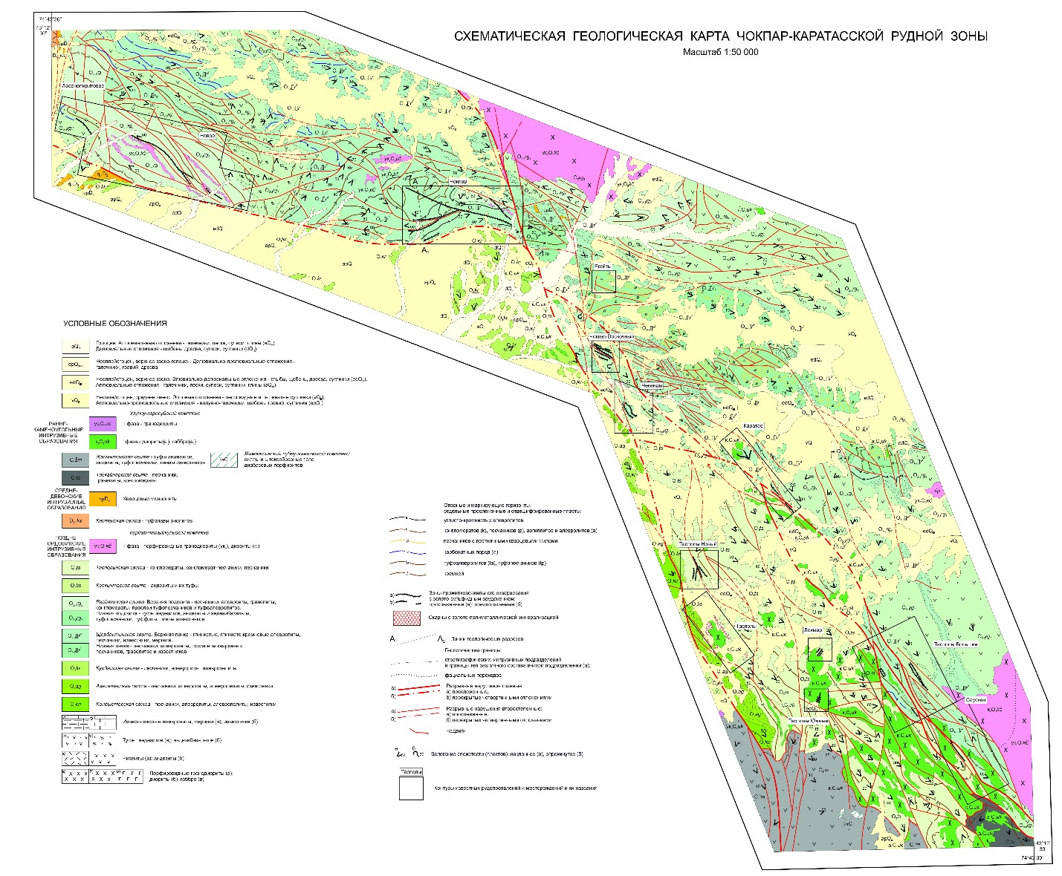
Appendix B.1 - Schematic geological map of the Chokpar-Karatas ore zone

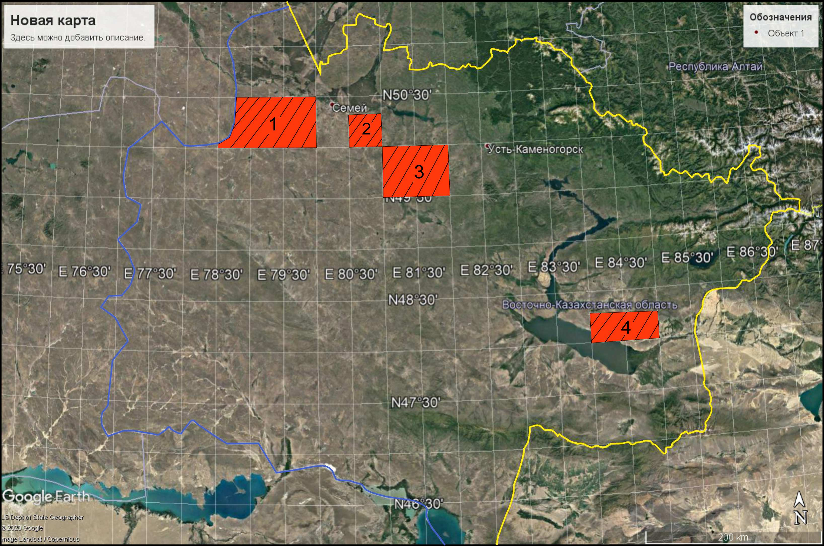
Appendix B.1 - Cartogram of the area for setting the GGK

APPENDIX С
List of published articles and books during the project period
1. Parilov Yu.S., Mukayeva A.E. "Environmental safety of gold-arsenic deposits in Eastern Kazakhstan" (In Russian) // Geology and protection of mineral resources. 2018(2), pp. 60-65.
2. Bespaev H.A., Mukayeva A.E., Grebennikov S.I. "General patterns of formation and placement and prognostic and search criteria of gold deposits in the black shale strata of the West Kalba belt of Eastern Kazakhstan" (In Rus.) // Izv. of RK NAS. Ser. geol. 2018(5), pp. 60-65.
3. Bespaev H.A., Parilov Yu.S. "Western-Kalba gold ore belt (Eastern Kazakhstan)" (In Rus.). Monograph. Almaty 2018, p. 215.
4. Parilov Yu.S., Mukaeva A.E., Grebennikov S.I., Silachev I.Yu. "Forecast of platinum-metal mineralization in the deposits of black shale in Eastern Kazakhstan" (In Rus.) // Journal of Geology and Subsoil Protection. 2019(1), pp. 39-50.
5. A. Dyachkov B.A., Misernaya M.A., Zhunusov A.A., Oitseva T.A., Ampralinova B.B., "Prospective directions of forecast and prospecting works in the territory of the Greater Altai" (In Rus.) // “Greater Altai as a unique rare gold-polymetallic province of Central Asia”. Proc. of the Workshop Council. Almaty 2019, pp.11-16.
6. Zhunusov A.A., Raskadkin V.V., Uralbaev E.A. "About the prospect of gold-platinoid mineralization in black shale in the East and South-East of Kazakhstan" (In Rus.) // 19th International Multidisciplinary Scientific Geo Conference and EXPO (SGEM 2019), Albena/ Bulgaria 2019, pp.11-16.
7. Zhunusov A.A., Uralbaev E. "Shygys Қазақстандағы karataktasty formation түзілімдерінің алтындануының магтатизмнің рөлі" (In Kaz.) // Proc. of International Conference "Scientific, technological and information support to assessment of mineral resources of Kazakhstan". Almaty 2019, pp.43-45.
8. Mizernaya M.A., Dyachkov B.A., Akylbaeva A.T., Miroshnikova A.P., Zhunusov A.A. "Gold and Sulfide Deposits in the Black Shale Formations of Eastern Kazakhstan - Perspective Source of Noble Metals" (In Rus.) // “Earth Sciences and Geographical Sciences”, "VKGTU" Bulletin. 2019(3), pp. 43-47.
9. Dyachkov B.A., Mizernaya M.A., Oitseva T.A., Kuzmina O.N., Zimanovskaya N.A., Ageeva O.V. "Prospective directions of forecast and search works in the East Kazakhstan region" (In Rus.) // Scientific, technological and information support o assessment of subsoil resources of Kazakhstan: Proc. of Interdepartmental scientific-practical conf. Almaty 2019, pp.153-158.
10. Sapargaliev E.M., Dyachkov B.A., Ganzhenko G.D., Bespaev H.A. "On prospects of strengthening the mineral and raw material base of the Rudny Altai" (In Rus.) // Scientific, technological and information support to assessment of mineral resources of Kazakhstan: Proc.of Interdepartmental scientific-practical conf. Almaty 2019, pp.188-191.
11. Dyachkov B.A., Misernaya M.A., Zhunusov A.A., Kuzmina O.N., Ageeva O.V., Akylbaeva A.T. "On Mineralogical and Geochemical Prospecting Indicators of Gold Ore Objects (East Kazakhstan)" (In Rus.) // Collection of reports to the International Conference "Problems of Geology and Expansion of Mineral Resource Base of Eurasia", dedicated to the 100th anniversary of Tajibayev P.T. Almaty 2019, pp. 232-243.
12.Misernaya M.A., Miroshnikova A.P., PyatkovaA.P., Akilbaeva A.T. "The main geological-industrial types of gold deposits in eastern Kazakhstan" //Naukovyi Visnyk Natsionalnoho Hirnychoho Universytetu. 2019(5), pp. 5-9.
13. Parilov Yu.S., Tretyakov A.V., Rodnova V.I. Monograph "Gold bearing capacity of South-East Kazakhstan" (In Rus.). Almaty 2020, p.172.
14. Dyachkov B., Misernaya M., Zhunusov A., Miroshnikova A., Aitbayeva S., Umarbekova Z., Bissatova A. "Formation Features and Prediction Criteria for Gold-Sulphide deposits (East Kazakhstan)"// International Journal of Advanced Trends in Computer Science and Engineering, Vol. 9(5), Sep.- Oct. 2020, pp. 8758-8762.

APPENDIX D
Implementation report

APPENDIX E
Calendar plan

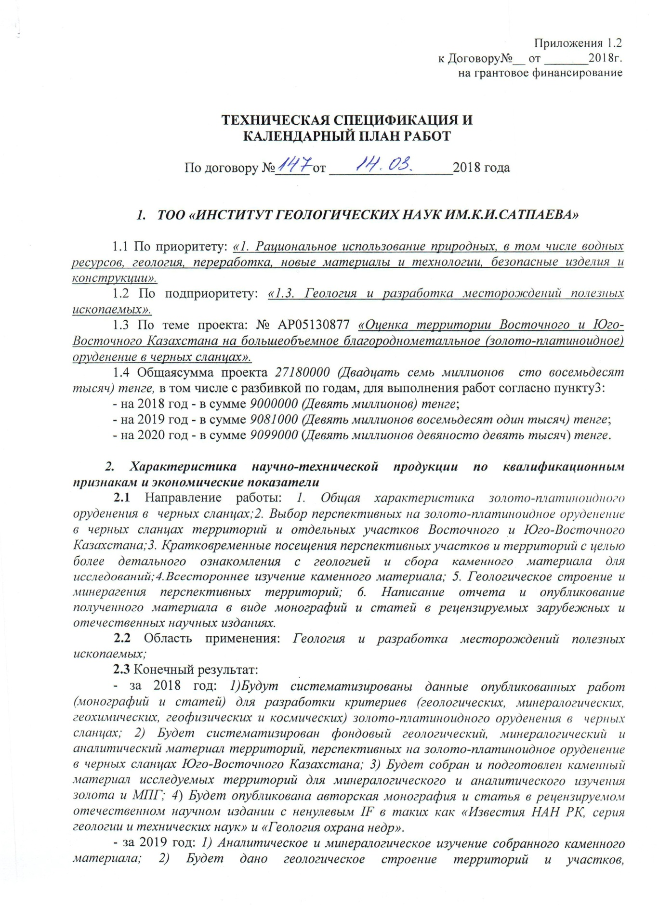

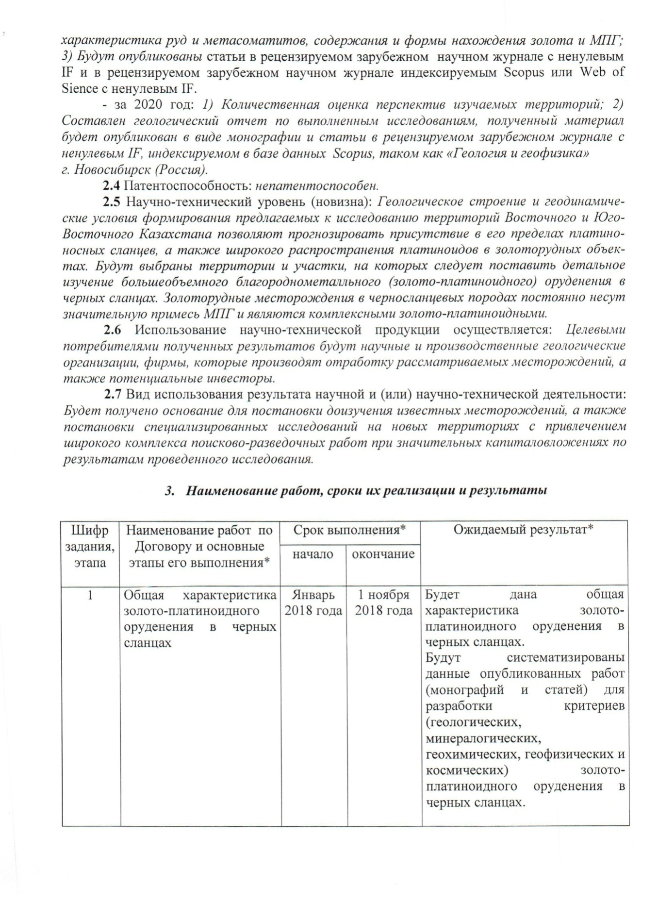

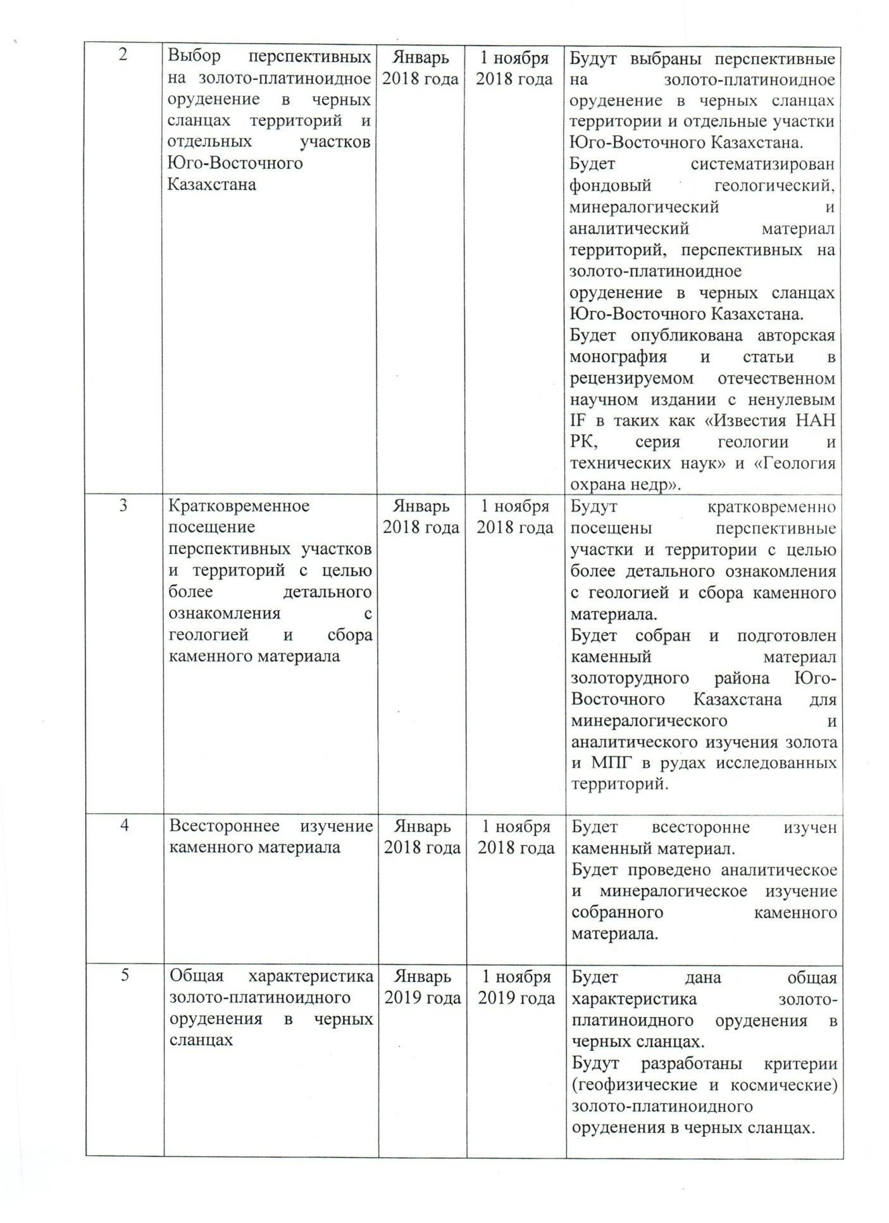

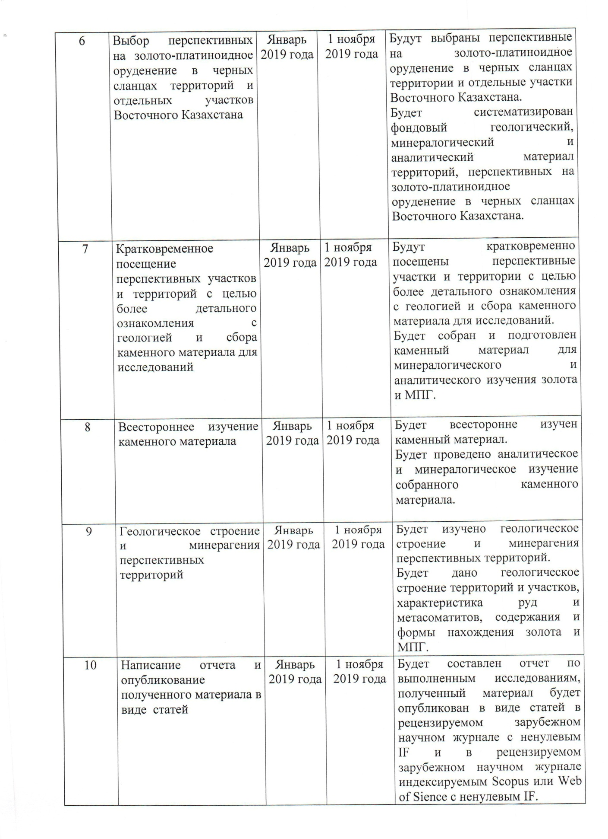

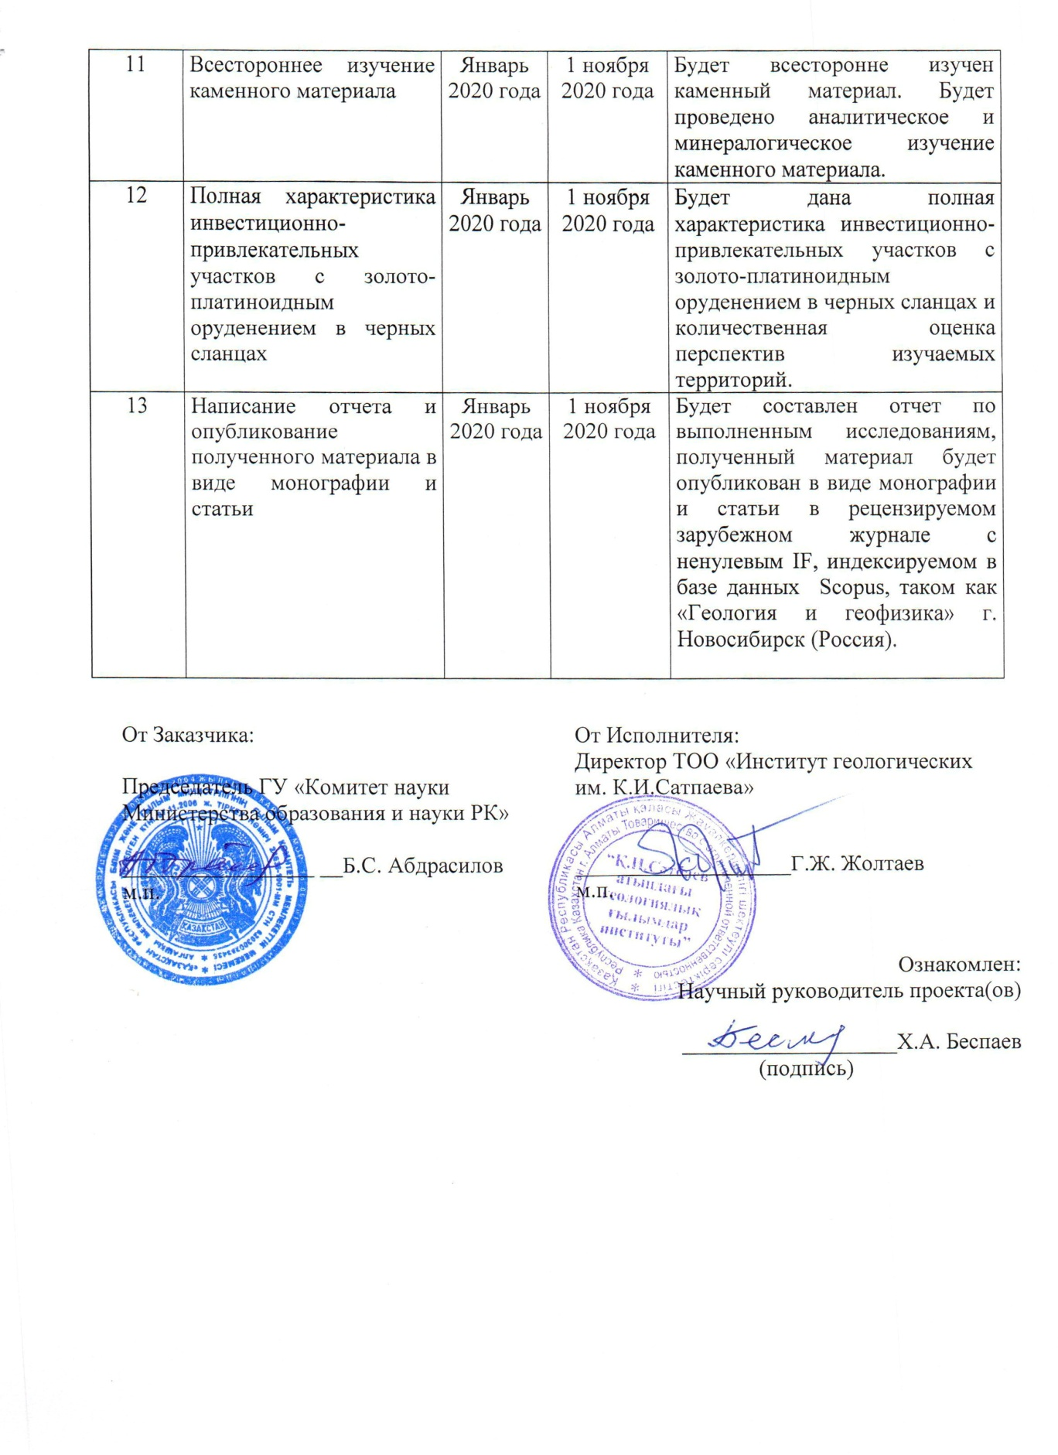

TECHNICAL SPECIFICATION AND
CALENDAR WORK PLAN
As per the Contract no. _____ as of __________________2018

1. “THE K.I.SATPAEV INSTITUTE OF GEOLOGICAL SCIENCES” LLP”
  - The priority: “1. Sustainable management of natural resources, including water resources, geology, processing, new materials and technologies, safe products and structures”.
  - The subpriority: 1.3 Geology and development of mineral deposits.
  - The project subject: no.AP05130877 «Assessment of Eastern and South-Eastern Kazakhstan territory for large-volume precious metal (gold-platinoid) mineralization in black shales».
1.4 Total amount of the project 27 180 000 (Twenty-seven million one hundred eighty thousand) tenge, broken down in years for works according to item 3:
- 2018 the amount of 9000000 (nine million) тенге;
- 2019 the amount of 9081000 (nine million eighty-one thousand) тенге;
- 2020 the amount of 9099000 (nine million ninety-nine thousand) тенге.

2. Description of scientific-technical products by qualifying and economic indicators

2.1 Work area: 1. General description of gold-platinoid mineralisation in black shaleы; 2. Selection of prospective gold-platinum mineralization in the black shale areas and some parts of Eastern and South-Eastern Kazakhstan; 3. Short-term visits to promising areas and territories in order to get acquainted with geology in more details and to collect stone material for research; 4. comprehensive study of stone material; 5. geological structure and mineralogy of promising areas; 6. reporting and publicising the outcome materials in the form of monographs and articles in peer-reviewed foreign and domestic scientific publications.
2.2 Scope of application: Geology and development of mineral resource deposits;
2.3 Final outcome:
- 2018: 1) Data from published works (monographs and articles) will be systematized to develop criteria (geological, mineralogical, geochemical, geophysical and cosmic) for gold-platinoid mineralization in black shales; 2) archive geological, mineralogical and analytical material will be systematized for the territories promising gold-platinoid mineralization in the black shales of South East Kazakhstan; 3) Stone material for mineralogical and analytical studies of gold and PGM will be collected and prepared; 4) the author's monograph and article will be published in a peer-reviewed domestic scientific publication with a nonzero IF in "Izvestia NAS RK, Geology and Technical Sciences Series" and "Geology & Subs Protection".
- 2019: 1) Analytical and mineralogical study of the collected stone material; 2) Geological structure of territories and sites, characteristics of ores and metasomatites, content and form of gold and RGM; 3) Articles will be published in a peer-reviewed foreign scientific journal with nonzero IF and in a peer-reviewed foreign scientific journals indexed in Scopus or Web of Science with nonzero IF.
- 2020: 1) Quantitative assessment of the prospects of the areas under study; 2) A geological report on the research carried out will be prepared and the material will be published as a monograph and an article in a peer-reviewed foreign journal with a non-zero IF indexed in the Scopus database, such as "Geology and Geophysics", Novosibirsk (Russia).
2.4 Patentability: not patentable.
2.5 Scientific and technical level (novelty): The geological structure and geodynamic conditions of the proposed for studies areas of Eastern and South-Eastern Kazakhstan would allow forecasting the presence of platinum-bearing shales and the widespread platinoids in gold ore sites. The areas and sites will be selected for detailed study of large volumes of noble metal (gold-platinoid) mineralisation in black shales. The gold deposits in the black shale rock constantly carry a significant PGM content and are complex gold-platinoid ones.
2.6 Use of scientific and technical products is in the process: The target users of the results will be scientific and production geological organisations, companies that develop the fields under consideration and potential investors.
2.7 Type of use of the results of scientific and (or) scientific and technical activities: completion of study of known fields and specialized research in new territories will be justified with the involvement of a wide range of prospecting and exploration work and support by significant investments upon research results.

3.Work titles, implementation time schedule and results
Task code |  | Contractual work title and work stages* | Implementation date * |  | Expected result*
 |  | Contractual work title and work stages* | Start | End
1 |  | General characteristics of gold-platinoid mineralisation in black shale | January 2018 | 1 November 2018 | A general description will be given of the gold-platinoid mineralisation in black shale.  Data from published works (monographs and articles) will be systematized to develop criteria (geological, mineralogical, geochemical, geophysical and cosmic) for gold-platinoid mineralization in black shales.
2 |  | Selection of prospective gold-platinum mineralisation in black shale areas and separate areas in Southeast Kazakhstan | January 2018 | 1 November 2018 | Black shale areas and parts of South East Kazakhstan will be selected for potential gold and platinum mineralisation.  The fund geological, mineralogical and analytical materials will be systematized for the territories promising gold-patinoid mineralization in the black shales of South East Kazakhstan.  The author's monograph and articles will be published in a peer-reviewed national scientific publication with a non-zero IF, such as "Izvestia NAS RK, a series of geology and technical sciences" and "Geology of protection of mineral resources".
3 |  | Short visits to prospective sites and areas for more detailed knowledge of geology and stone material collection | January 2018 | 1 November 2018 | Short visits will be made to prospective sites and areas to gain a more detailed understanding of the geology and to collect stone material.  Stone material from the gold ore district of South East Kazakhstan will be collected and prepared for mineralogical and analytical studies of gold and PGM in the ores of the surveyed areas.
4 |  | Comprehensive study of stone material | January 2018 | 1 November 2018 | The stone material will be studied in detail.  Analytical and mineralogical studies of the collected stone material will be conducted.
5 |  | General characteristics of gold-platinoid mineralisation in black shale | January 2019 | 1 November  2019 | A general description will be given of the gold-platinoid mineralisation in black shale.  Criteria (geophysical and cosmic) for gold-platinoid black shale mineralization will be developed.
6 |  | Selection of prospective gold-platinum mineralisation in black shale areas and separate areas in East Kazakhstan | January 2019 | 1 November  2019 | Black shale areas and parts of Eastern Kazakhstan will be selected for potential gold platinum mineralisation.  The fund geological, mineralogical and analytical material will be systematized for the territories promising gold-platinoid mineralization in the black shales of Eastern Kazakhstan.
7 |  | Short visits to prospective sites and areas for more detailed knowledge of geology and stone material collection | January 2019 | 1 November  2019 | Short visits will be made to prospective sites and areas to gain a more detailed understanding of the geology and to collect stone material for research.  Stone material will be collected and prepared for mineralogical and analytical studies of gold and PGM.
8 |  | Comprehensive study of stone material | January 2019 | 1 November  2019 | The stone material will be studied in detail.  Analytical and mineralogical studies of the collected stone material will be conducted.
9 |  | Geological structure and mineralogy of prospect areas | January 2019 | 1 November  2019 | The geological structure and minerageny of prospective areas will be studied.  The geological structure of territories and sites, characteristics of ores and metasomatites, gold and PGM content and location forms will be examined.
10 |  | Writing of the report and publication of the obtained materials in the form of articles | January 2019 | 1 November  2019 | A research report will be prepared and the material will be published as articles in a peer-reviewed foreign scientific journal with a non-zero IF and in a peer-reviewed foreign scientific journal indexed by Scopus or Web of Sience with a non-zero IF.
11 |  | Comprehensive study of stone material | January 2019 | 1 November  2020 | The stone material will be studied in detail.  Analytical and mineralogical studies of the collected stone material will be conducted.
12 |  | Complete description of investment attractivenessof gold platinum-platinum mineralisation in black shale. | January 2020 | 1 November  2020 | A full description will be given of the investment attractive areas with gold-platinoid mineralization in black shale and a quantitative assessment of the prospects of the areas under study.
13 |  | Writing the report and publishing the obtained materials (a monograph and an article) | January 2020 | 1 November  2020 | A research report will be prepared and the material will be published as a monograph and an article in a peer-reviewed foreign journal with nonzero IF indexed in a Scopus database such as “Geology and Geophysics”, Novosibirsk, Russia.

