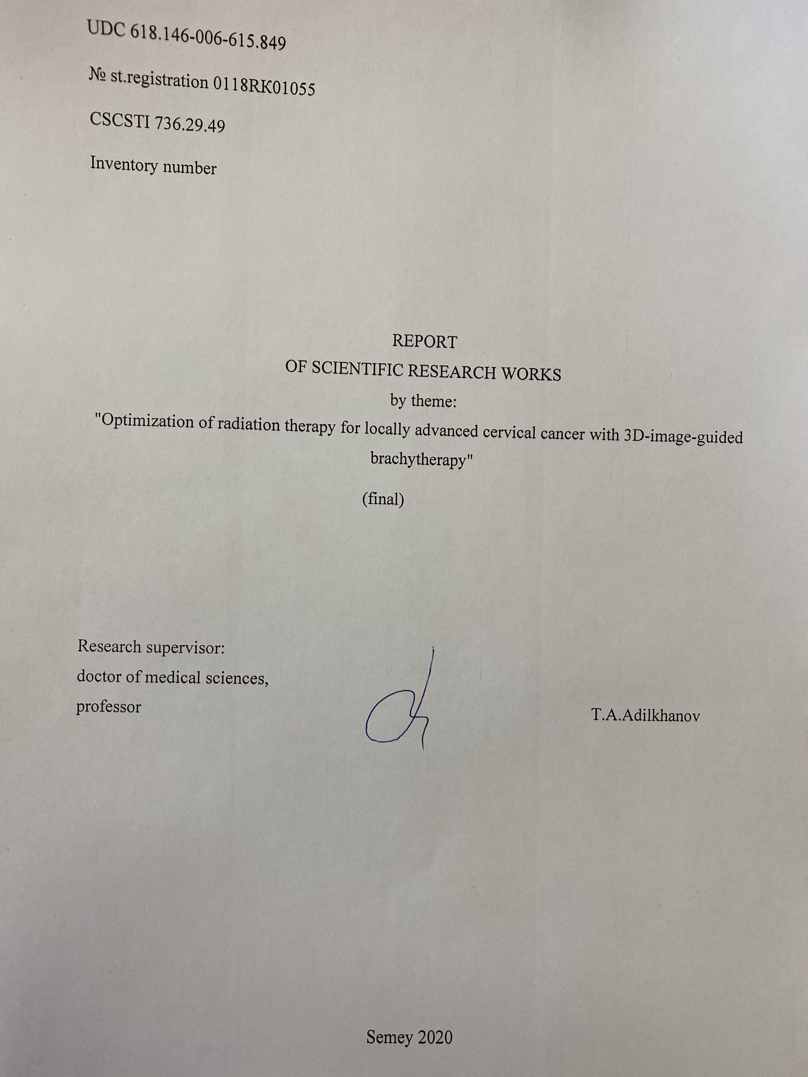

ESSAY
Report 82 p., 21 fig., 10 tables, 62 sources, 16 app.
CERVICAL CANCER, CHEMORADIATION THERAPY, BRACHYTHERAPY, 3D IGBT
The object of study - patients with an established diagnosis of cervical cancer (CC) (CC), stage IIB, IIIB and histological confirmation of the diagnosis "squamous cell carcinoma"
Research goal is to improve the treatment results of locally advanced forms of cervical cancer by 3D-image-guided brachytherapy (3D-IGBT).
Scientific novelty. The methodological aspects of three-dimensional planning of intracavitary radiation of cervical cancer were studied and implemented for high level local tumor control.The optimization ofdose load on tumor during brachytherapy for the first timewas carried with a single dose of 6-7 Gr and total focal dose of 24-28 Gr, reducing the total dose of combined radiation therapy (RT) from 80-85 Gr to 74-78 Grby preservation of isodose identical to clinical volume of the tumor.
The immediate results of the treatment, frequency, intensity and nature of expression of radial reactions in RT with 3D image (3D-IGBT) are evaluated. Theadvantages and expediency of use in treatment of RT 3D-IGBT cervical cancer have been identified compared to traditional methods.The use of 3D planning at the stage of brachytherapy in order to reduce the frequency of radial reactions makes it possible to increase the efficiency of LT with minimal effect on surrounding tissues and risk organs by developing a new mode of fractionation and reduction of total doses exposure, which creates the prerequisites for the continued and safe use of this treatment.
Practical significance. The effectiveness of RT in the treatment of locally advanced forms of cervical cancer is increased by using of brachytherapy, which makes it possible to bring high doses of ionizing radiation directly to the tumor with minimal effect on the surrounding healthy organs and tissues. RT with 3D image (3D-IGBT) allows to adequately optimize the dose distribution to give a given therapeutic dose to all target volume and minimize the stress on critical organs. 3D brachytherapy makes it possible to reduce the frequency and severity of radiation complications and to improve the quality of life of patients with cervical cancer.
The results of the study should be applied by practitioners in order to improve the efficiency and safety of RT inpatients with cervical cancer.Field of application: oncology, radiation oncology.
The target users are the Ministry of Health of the Republic of Kazakhstan, organizations providing oncological care.
CONTENT
 |  | PAGE
 | INTRODUCTION | 6
1 | MATERIALS AND METHODS | 9
2 | RESULTS OF OWN RESEARCH | 19
2.1 | Retrospective analysis of cervical cancer in the semey region of east kazakhstan in 2008-2017 years | 19
2.2 | Assessment of the frequency, nature and degree of acute and late toxicity of traditional radiation therapy with 3D image (3D-IGBT). | 27
2.3 | Assessment of the socio-economic effectiveness of radiation therapy with 3D image in patients with locally advanced cervical cancer of the uterus. | 35
2.4 | Development of the protocol by radiation therapy 3D-igbt of locally advanced forms of cervical cancer. | 41
 | CONCLUSION | 43
 | LIST OF USEDSOURCES | 48
 | APPLICATION A | 54
 | APPLICATION B | 55
 | APPLICATION C | 56
 | APPLICATION D | 57
 | APPLICATION E | 58
 | APPLICATION F | 59
 | APPLICATION G | 60
 | APPLICATION H | 68
 | APPLICATION I | 69
 | APPLICATION J | 70
 | APPLICATION K | 72
 | APPLICATION L | 74
 | APPLICATION M | 75
 | APPLICATION N | 76
 | APPLICATION O | 80

DEFINITIONS

The following terms and definitions are used in this SRW report.

BRACHYTHERAPY (contact radiation therapy) | is a type of radiotherapy where the source radiation (Ra-226, Ir-192, I-125, Cs-137, Co-60) is injected into the affected organ.
HISTOGRAM «DOSE-VOLUME» (Dose Volume Histogram, DVH) | is the medium of the quality evaluation of the radiation plan and represents the distribution of the dose in the radiated volume.
DOSE OF RADIATION | is the value used to estimate the effects of ionizing radiation on any substance and living organisms.
CRITICAL ORGANS | are vital organs and systems that are the first to be harmed in the dosage range of radiation therapy.
RADIATION THERAPY WITH USE OF 3D-IGBT | -beam therapy with total flashing dose of 40.0 Gr (20 fractions of 2.0 Gr) per small pelvic region and 10.0 Gr per small pelvis with central protection, followed by 4 brachytherapy sessions (at 6.0-7.0 Gr, total focal dose 26.0-28.0 Gr).
SINGLE HEARTH DOSE | is a dose that is given in a single procedure. The unit for measuring the dose of radiation is Grey (Gr).
TOTAL HEARTH DOSE | is the dose of radiation that is distributed over the entire radiation therapy course.
TRADITIONAL RADIATION THERAPY | – Radiation therapy with adding an aggregate focal dose 50
FRACTION | - In radiation therapy, the total dose divided into several parts is called.

.

SYMBOLS AND ABBREVIATIONS
EKR | - EastKazakhstanregion
Gr | - gray
EBT | - external beam therapy
EORTC | -European Organization for Cancer Research and Treatment
KAZSRIOR | - Kazakh Research Institute for Oncology and Radiology
QL | - qualityoflife
КТ | - CT scan
RT | - radiotherapy
LEC | - local ethical commission
MDG | - multidisciplinary group
MRI | - Magnetic resonance imaging
RK | - The Republic of Kazakhstan
SFD | - single focal dose
CC | - cervical cancer
TFD | - total focal dose
USI | - ultrasound imaging
CNMO | - Center for Nuclear Medicine and Oncology ( Semey)
3D-IGBT | - 3D-Image-guided brachytherapy
DVH | - Dose Volume Histogram
EORTC | - European Organization for Research and Treatment of Cancer
FIGO | - The International Federation of Gynecology and Obstetrics (2008)
FNCA | - Forum for Nuclear Cooperation in Asia
PALN | - Para-Aortic Lymph Node
PS | - Performance status(общее состояние больного) по шкале Карновского и ECOG-B03
INTRODUCTION
Relevance of the study.
Effective treatment of local advanced forms of CC is one of the most important medico-social tasks of modern oncogenesis [1-3]. For women with local CC, the standard of medical care has evolved from external beam therapy (EBT) to combined EBT and brachytherapy with parallel chemotherapy [4-5]. The GEC-ESTRO recommendations support the strategy of adaptive brachytherapy, as this treatment is based on volume radiation, where the target changes with each brachytherapy fraction based on the response to the treatment [6-10].
Although a large number of different brachytherapy regimes are known and used in practice, the choice of the optimal regime is still a matter of debate. Radiation complications of moderate and severe severity, manifested by ulcerative changes in risk organs, formation of rectal and vaginal fistulas, intrapelvic fibrosis, significantly impair the quality of life of patients and can lead to disability and death. In this case, the mode of fractionation and choice of total doses are decisive factors in the reduction of frequency development of complications in RT and doesn’t get worse the results of treatment [11]. Thus, in the development of methods of combined RT aimed primarily at increasing the results of treatment, the question of achieving an anti-tumor effect while simultaneously reducing the probability of radiation complications remains relevant [12-15].
Based on results of clinical research, the use of 3D-IGBT in the complex treatment program 3D-visualization at the stage of planning and carrying the brachyterapy creates clinically favorable conditions for effective therapy: reduces the risk of displacement of applicators, reduces load on patient [16-18]. Introduction of 3D planning and reduction of total doses, provide good local control in CC patients despite of tumor size and clinical stage, without increasing the frequency of severe late toxic effects, which is important, and remains relevant [19, 20]. Thus, the treatment of local advanced forms of CC requires the selection of rational fractionation schemes, the methodology of metering load accounting, the planning of therapy sessions at intracavitary gamma-therapy sources of high power, that it will be possible to optimize radiation programmes with account individual tumor parameters, the spatial relationship between the tumor and the risk organs, the constitutional characteristics of the patient, and to ensure adequate levels of absorbed doses of radiation to achieve an anti-tumor effect while reducing radiation loads on surrounding tissues [21-23].
The aim is to improve treatment results of local advanced forms of cervical cancer by RT with 3D image (3D-IGBT).
According to the calendar plan for 2018-2020, the following tasks were set:
- Analyse the results of treatment of cervical cancer according to basic predictive criteria and treatment methods.
- Evaluate the frequency, nature and degree of acute and late toxicity by traditional radiotherapy and 3D imaging (3D-BTIG).
- To assess the socio-economic effectiveness of radiation therapy with 3D image (3D-IGBT) for optimal treatment of patients with local advanced cervical cancer.
- To develop and implement a protocol for the treatment of local advanced forms of CC by radiation therapy with 3D image at the Regional Oncology Clinic of Semey (Centre for Nuclear Medicine and Oncology
Scientific novelty. The results of the treatment of patients with CC have been analysed according to the main predictive criteria and treatment methods. New methodological approaches have been introduced for the three-dimensional planning of intracavitary radiation in CC.
For the first time, the dose load on tumor has been optimized with a single dose of 6-7 Gr and total focal dose of 24-28 Gr, reduction of total combined dose of RT from 80-85 Gr to 74-78 Gr with preservation of isodose which identical to clinical volume of tumor (Copyright Certificate № 550 of 15.11.2018 (Appliction A), Copyright Certificate Training Manual "Advanced Intervention Technologies in the Treatment of Cervical Cancer" № 4409 of 27.06.2019 (Aplication B)). Assessment of the frequency, nature and degree of acute and late toxicity in traditional RT and optimized dose load on tumor using 3D planning (3D-IGBT). Advantages of use of RT with 3D-image (3D-IGBT) in CC have been established, and the socio-economic effectiveness of RT with 3D-IGBT in complex treatment of local advanced CC has been evaluated. (Copyright Certificate "EORTC QLQ CX24 " № 2968 dated 27.09.2018.(Application C)).
Practical significance.
The introduction of RT with 3D-IGBT in the treatment of CC in clinical practice, compared to traditional methods, ensures high social and economic efficiency in patients with local CC, by reducing the number of courses of RT, and by reducing the degree and risk of early and late post-radiation reactions (Rationalization Proposal № 2445 from 25.09.2019 (Application D)).
The individualized technique of intracavitary radiation therapy of common forms of cervical cancer by 3D planning for intracavitary irradiation in combination with radical remote irradiation programs allows to increase the effectiveness of radiation therapy and quality of life in patients with cervical cancer (Textbook "Advanced Interventional Technologies in the Treatment of Cervical Cancer" (Application E)).
The method of 3D-visual controlled brachytherapy has been introduced in the practice of treatment of locally advanced forms of CC based on «Center for Nuclear Medicine and Oncology of Semey» (previously Regional Oncological Dispensary, Renaming Order № 186 of 22 June 2018; Certificate of Re-registration from 27 July 2018) (Act of Introduction "Optimization of Radiation Therapy of locally advanced Cervical Cancer by 3D Visually Controlled Brachytherapy", May 2018. (Application F))
1 MATERIALS AND METHODS OF RESEARCH
The work was carried out within the framework of state order by budget program 217 «Development of science», subprogramme 102 «Grant funding of scientific research», on the specifics of «Payment of consulting services and research» on the basis of CNMO, Semey. The direction of this research is one of the fragments of multi-centric project Forum for Nuclear Cooperation of Asia (FNCA), which is implemented on the free basis (Application G) [24].
The results of the research and proposals for inclusion of the method in clinical protocol of treatment are presented at the meeting of the members of «Association of oncologists of the Republic of Kazakhstan». The approval was received for the continuation of the project (№ 9-3, 27.09.2018. (Application H).
Research design: longitudinal controlled clinical trial.
The subject of the study is the effectiveness of radiation treatment of patients with CC
by using three-dimensional dosimetry planning.
All patients have been diagnosed in accordance with the effective Clinical Protocol 56 «Cervical Cancer» approved by the Joint Committee on the Quality of Medical Services of the Ministry of Health of the Republic of Kazakhstan from «1» March 2019 [25]:
-General blood tests, biochemical blood tests, general urine tests;
-Ultrasonic examination of the abdominal and peritoneal organs;
-Ultrasonic examination of pelvic organs and regional lymph nodes;
-Examination of mirrors with a cervical tumor biopsy followed by a histological examination of the samples;
-Pap test (Pap test or pap smear);
-Finger rectal examination;
-X-rays of the thorax organs in two projections: straight and lateral;
-Cystoscopy
- MRI scans of the pelvic organs.
Eligible for inclusion
1. Squamous cell carcinoma of the uterine cervix
2. Stage IIB (≧4 cm in diameter) and IIIB disease (FIGO 2008)
3. Age; 20-70 years
4. PS; WHO 0-2
5. No prior chemotherapy, radiotherapy, and surgery to the pelvis
6. Life expectancy; longer than 6 months
7. Adequate bone marrow, hepatic, and renal functions: WBC≧3000/mm3, Hb≧10 g/dl, Platelet≧100,000/mm3, Total bilirubin≦1.5 mg/dl (≦25.65 µmol/L), AST/ALT≦2 times upper limit of normal, Serum creatinine≦1.5 mg/dl (≦132.6 µmol/L)
8. Written informed consent
9. Diagnostic images (CT of the abdomen and pelvis is needed, MRI of the pelvis is recommended but not mandatory) before starting EBRT.
10. No PALN metastasis on CT. (> 1 cm in minimum diameter)
Ineligible for inclusion
1. Severe concomitant illness
2. History of other malignancies within the past 5 years except basal cell carcinoma or squamous cell carcinoma in-situ of the skin
3. Tumor with infiltration of lower 1/3 of the vagina
4. Patients who are pregnant or lactating
Methods for evaluating the effectiveness of RT:
1. Physical examination (including pelvic and digital rectal studies).
2. Cytological swabs.
3. Targeted biopsy.
4. Radiographic studies (chest X-ray, intravenous pyelography).
5. Tumor markers (CEA, SCC) (optional).
6. Ultrasound, abdominal and pelvic organs MRI
Characteristics of study groups.
According to the inclusion and exclusion criteria, the present study included 66 patients with stage IIB and IIIB squamous cell cervical carcinoma, who did not have confirmed metastases and without previous chemotherapy, radiation therapy, and surgical interventions in this localization, which formed the following groups:
- basic group - 22 patients, who were conducted by RT within the framework of this research by 3D visualization (described in detail in section «Radiation therapy with 3D planning»).
- control group - 44 patients who received radiation therapy with 2D planning.
The socio-demographic and clinical data of the patients included in the study are presented in table 1.

Table 1 - Socio-demographic, clinical data of patients
Index |  | Study groups
 |  | Basic, n=22, 3D-planning | Control, n=44, 2D-planning
middle age |  | 55,4±13,2 | 56,0±12,8
Stage according to TNM classification (FIGO) | Stage IIB | 10 (45,5%) | 17 (38,6%)
 | Stage IIIB | 12 (54,5%) | 27 (61,4%)
Tumor size, sm: | < 5 | 9 (40,9%) | 19 (43,2%)
 | ≥ 5 | 13 (59,1%) | 25 (56,8%)
Growth pattern | Exophytic | 12 (54,5%) | 25 (56,8%)
 | Endophytic | 7 (31,8%) | 12 (27,3%)
 | Mixed | 3 (13,6%) | 7 (15,9%)
Differentiation degree | Low | 6 (27,3%) | 14 (31,8%)
 | Moderate | 13 (59,1%) | 25 (56,8%)
 | High | 3 (13,6%) | 5 (11,4%)
Histological type | non-specific | 7 (31,8%) | 12 (27,3%)
 | keratinizing | 8 (36,4%) | 15 (34,1%)
 | non-keratinizing | 7 (31,8%) | 17 (38,6%)

The distribution of patients by CC stage (FIGO) was: the proportion of women with CC IIB stage was 10 (45.5%) women in the main group and 17 (38.6%) in the control group. The number of CC IIIB cases in the main group was 12 (54.5 per cent) and in the control group 27 (61.4 per cent). In addition, the tumor size according to Magnetic Resonance Tomography (MRI) data for 9 (40.9%) women of the main group and 19 (43.2%) for the control group was less than 5 cm, and for 13 (59.1%) women of the study group and 25 (56.8%) women of the control group, more than 5 cm. By the degree of differentiation, the distribution of patients in both groups was: for the main group, 6 cases (27.3 %) and control group-14 cases (31.8%). Moderate degree was found in 13 (59.1 %) women in the main and 25 (56.8 per cent) control groups. Cases of high differentiation were found in 3 (13.6%) patients in the 3D group and in 5 (11.4%) women in the 2D group. According to the growth pattern of the patients included in the study, 12 (54.5 per cent) of the women in the main group and 25 (56.8 per cent) of the control groups registered with exophytic growth. The endophytic type of growth in the main group was 7 (31.8%) cases and 12 (27.3%) cases in the control group. Patients with mixed CC growth were registered in 3 (13.6%) cases in the group with 3D planning, and in 7 (15.9%) cases with 2D planning.
The retrospective analysis of the results of the treatment of patients with CC was carried during the period 2008-2017 by predictive criteria and therapeutic methods based on 405 patient records.
Registration of patient data was carried out using «Map of coding for cervical cancer» (the act of introduction received) (Application I ). The source of the information was: «Medical card of a stationary patient» (Form 003/y), «Discharge from a medical card of a stationary patient with malignant neoplasm» (Form 027-1/y), «Control card of dispensary surveillance» (Form 030-6/y), «Notification of pain with first-time established diagnosis of cancer or other malignant new-education» (Form 090/y), «Medical card of outpatient» (Form 025/y). Retrospective analysis of «Electronic Register of Oncological patients» data (Form 7) on annual incidence of PWM with calculation of «rough» extensive index per 100,000 population. Data from the Integrated Medical Information System (CMIS) and beam maps of patients with CC provided a promising source of information.
Research methods - analytical, statistical.
Ethical issues in the conduct of this research were observed according to the order of MH RK № 142 of 02.04.2018. «On the approval of the Rules for the Conduct of Biomedical Experiments, Preclinical (Non-clinical) and Clinical Investigations, as well as requirements for pre-clinical and clinical bases». The local Ethical Comission of NAO «Medical University of Semey» gave a positive opinion on ethics. A transcript of the meeting is available from 9th of 13.09.2017 (Application J).
Radiation therapy with 3D planning.
External beam therapy (EBT) with a fractionation mode of 2.0 Gr 5 fractions per week, the total dose of radiation (ODS) for the small pelvis was 50 Gr. (Figure 1).
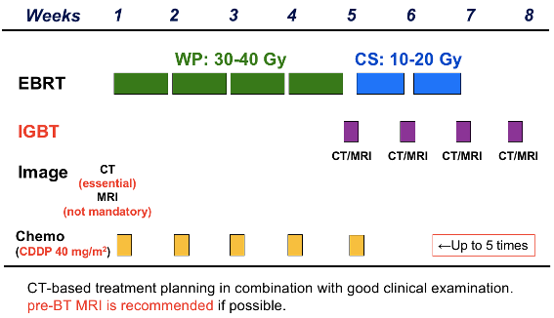
Figure 1 - Chemotherapy with 3D-IGBT
From the first day of EBT in both groups of patients was conducted competitive chemotherapy (CT) using intravenous infusions of preparation «Cisplatin». The dose calculation was performed individually for each patient: 40 mg/m 2 ; weekly administration prior to intraband TR. The number of chemotherapy courses depended on the severity of toxicity from the performed RT. (Table 2).
Table 2 - The number of cycles of chemotherapy received by patients in the two study groups
Number of chemotherapy cycles (abs.) | Basic, n=22  (3D-planning)  аbs. (% from the total) | Control, n=44  (2D-planning)  аbs. (%from the total)
3 | 0 | 2 (4,5)
4 | 4 (18,2%) | 12 (27,3)
5 | 18 (81,8%) | 27 (61,4)
6 | 0 | 3 (6,8)
Starting from 5 week, when the EBT dose was at least 40 Gr, 3D-visualizable brachyterapy with single doses of 6.0-7.0 Gr per week (while maintaining the limited dose load on the risk organs) were started and the TFD is 28 Gr.
Previously, 2D LT planning was used for EBT and brachytherapy, but this approach does not allow for the exact width of the sheaf in the section of the tumor and empirically bases its cylindrical geometry, The individual location of the tumor in each patient is not taken into account and there is a risk of overclogging of neighboring organs (Figure 2).

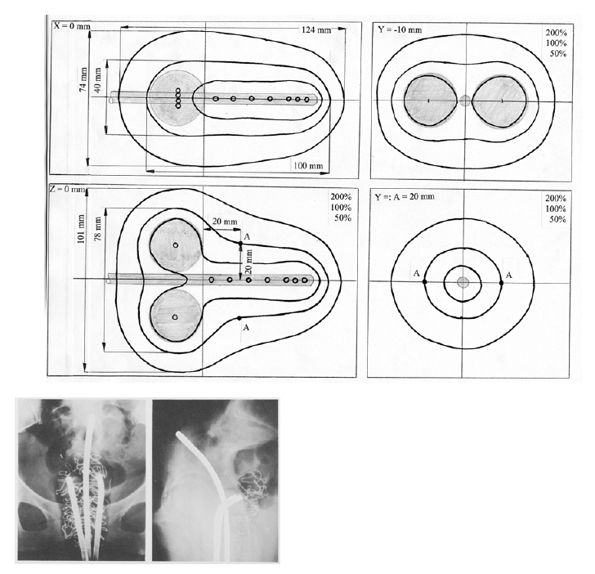
Figure 2 is an example of 2D planning for RT in patients with cervical cancer

In our study when applying 3D planning a priori the individual features of the tumor in each section were taken into account, which allowed the use of wedge-like filters and blocks in the formation of the radiation beam[26]. The recommendations of the International Commission - ICRU (International Comission on Radiation Units and Measurement [27] have been applied in the selection of the volume and distribution of the doses:
- a large tumor volume (GTV - gross tumor volume) - a volume that includes a visualized tumor, to this volume is supplied with the necessary tuberous dose for the tumor;
- the clinical volume of the target (CTV - clinical target volume) - the volume that includes not only the tumor but also the sub-clinical spread of the tumor process;
- the target volume (PTV - planning target volume) - the amount of irradiation that is greater than the target’s clinical volume and which guarantees the total amount of irradiation of the target. It is produced because the planning system on each scan automatically adds a specified radar indent, usually 1-1.5 centimetres, which takes into account the mobility of the tumor during respiration and various errors, and sometimes 2-3 centimetres, for example in the case of great respiratory mobility;
- the planned volume of irradiation, taking into account the tolerance of the surrounding normal tissues (PRV - planning organ at risk volume).
The pre-radiation training of patients in 3D planning was done using a CT scanner using fixing devices, head restraints (which were then also used in therapy), under identical conditions, In both planning and brachytherapy. Since using the initial topometric information of a set of computer images over the entire height of the tumor process and areas of preventive irradiation, the «delineation» of the target volumes and critical organs was wired.
The treatment is performed on the «Gammamedplus» machine with a source of 192 Ir in the high-dose mode (HDR). The radiation plans had been calculated by computer programmes. In CNMO, Semey in 2015, the modern radiotherapy complex of «Varian» company, which includes the planning system ECLIPSE. The 3D planning process was started with the generation of the three-dimensional model of each patient, series of parallel CT scans is used. The anatomical structures and the planned size of the target are determined on each of the scans by an automatic procedure based on knowledge of the Haunsfield range of numbers for each of the critical organs and other anatomical structures. The contours corresponding to the size of the tumor and the clinical and planned size of the target are constructed taking into account not only computer tomography information, but also all clinical data about the patient.
In order to assess the quality of the radiation plan, monitoring of histogram «dosage-volume» (DVH - Dose Volume Histogram) was carried out. DVH is a chart of the distribution of the dose in the irradiated volume. The dose-volume histogram is in the form of a rectangle in order to maximize the dose distribution relative to the target’s planned volume. The following characteristics of dose distributions can be determined with histograms: standard deviations of dose per tumor, minimum and maximum doses, average doses, median doses on critical organs (figure 3).
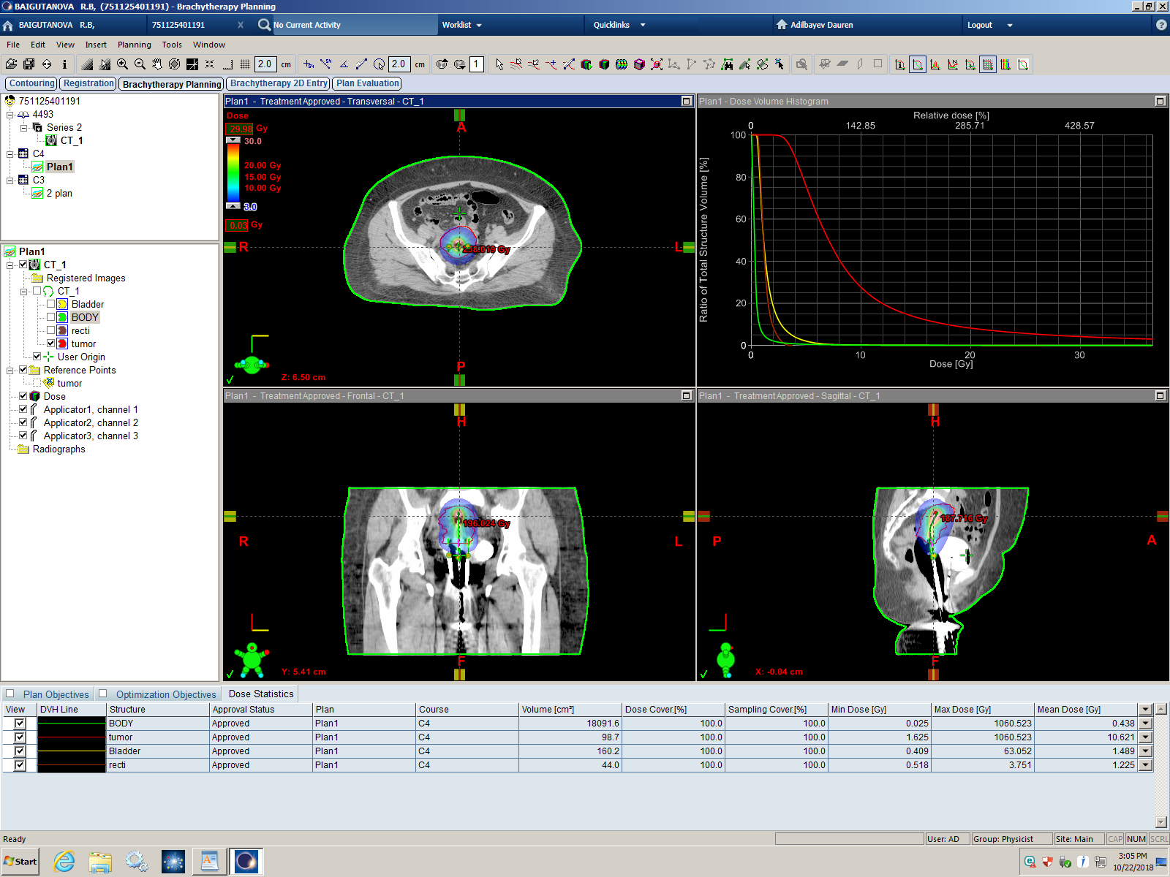
Figure 3 - 3D planning plan with histogram «dose-volume»
Medical physicist made calculations of several radiation plans in each case, and histograms «doses-volumes» were constructed for each plan: PTV and each critical organ. Based on the DVH analysis, the optimal plan was chosen for which the dose per tumor is maximum (at least 95% of the dose should be taken on PTV) and the critical organs are minimal (Table 3).
Table 3. Evaluation criteria for the 3D dosimetric plan
 | Volume | Dose
СTV | 85-90% | ≥90% (from the prescribed dose)
Bladder | 2% | 4-5Gr
Rectum | 2% | 4-5Gr
Sigmoid colon | 2% | 5Gr

In addition, the medical physicist determined the position of the centre of the irradiated volume (central point) relative to the reference point, indicating the distances between them in three planes in centimetres by means of automatic calculation by the planning system. In the process of laying the patient for irradiation, the known position of the centre point in three planes relative to the reference point on the skin (to direct the radiation beam to the center of the tumor) was used. When the radiation source rotates along an arc 360’, the center of the radiation beam will always fall into the center of the tumor (isocentric planning method). The EBT was conducted in the standard CC TFD - 50 Gr.
The number of brachytherapy sessions of 3D-IGBT was 4; the total dose of impute RT was 74.0-78.0 Gr. Doses were normalized in Manchester method at points A (point 2 cm lateral and 2 cm cranial to the lateral surface of the applicator and anatomically corresponding to the intersection of the uterine artery and the ureter) and B (3 cm lateral to point A and corresponding to the pelvis). Brachytherapy was performed with an ovoid -tandem applicator (figure 4).
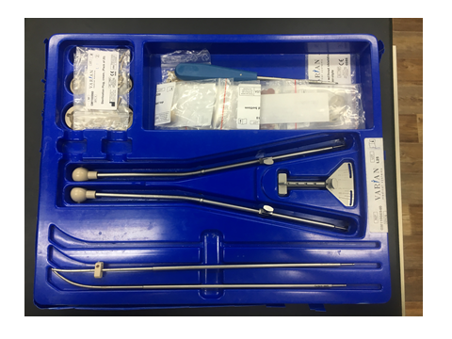
Figure 4 - Ovoid-tandem applicator for brachytherapy
Brachytherapy is an important part of CC RT when there is a common process in the small pelvis - the combination of chemolutic treatment is the main choice in the therapy and requires continuous improvement [28]. All areas of development are affected by dissatisfaction with its remote results, and the current range of instruments and techniques available for radiation treatment do not guarantee that women will not relapse into the disease. In this regard, the search for and implementation of a unified approach to RT requires continuous search and implementation in practice [29-31]. The improvement of the efficiency of RT patients with CC and the reduction of radiation complications to a large extent related to the modernization of equipment for intracavitary gamma therapy widely used radioactive sources of cobalt, caesium, iridium [32, 33]. Dosimetric planning is an integral part of the patient’s preparation for intracavitary radiation, the basis of which is information of dosimetric characteristics of the selected radiation sources as well as the patient’s topometric data. 3D intraband radiation planning makes it possible to obtain a more precise distribution of a given dose by target volume, depending on the geometry of the applicator location, which is very important at large tumor process volumes [34, 35].
Evaluation of the effectiveness of radiation therapy. Due to the variety of LT modes, the linear quadratic model (LQM) of cellular survival is now increasingly used as a tool for comparing treatment effects. Many authors in their writings point out that LQM reflects well the response of cells and tissues to radiation exposure [36-39]. LQM is used to calculate isoefficient total focal doses in order to compare different fractional exposure regimes. Important parameters of RT are indicators such as BED (biologically effective dose) and/or EQD2 (equivalent dose), not just dose per fraction [40, 41]. The essence of this method is in an equation that describes the dependence of a fraction of surviving cells (N/N0) on a dose of ionizing radiation (D) [42, 43].
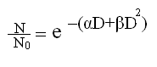
(1)
where
N/N0 - survivor cell fraction
е – biological effect
D - dose of ionizing radiation, Gr
α - coefficient of lethal, non-repairable damage (linear dose function) expressed in Gr-1
β - Coefficient of the cumulative sublethal component of damage (quadratic function of dose) expressed in Gr-2.
According to one theory, cell death caused by instantaneous double DNA breaks (fatal injury) is characterized by a linear function exp (-αD). The quadratic part of the exp (-βD2) equation describes how cell death is related to DNA helical breaks by accumulating single breaks (sublethal injuries).
Thus, according to LQM, the biological effect of radiation is a linear-quadratic function of the dose. Therefore, the effect (E) of equal fractions is mathematically expressed as follows:
E = - log S = (αd + βd2)n = αD + βdD = D(α + βd) (2)
where
Е – biological effect
S - survivor cell fraction
d - single focal dose
D - total focal dose
n - fraction number.
The advantage of LCM is that it reveals differences in dose-time ratios for rapidly proliferating (early radiation effects) and slow or non-proliferating (late effects) tissues. Early radiation damage of tissues, as well as the reaction to the irradiation of most malignant tumors, have α/β values of 6 to 35 Gy. For late radiation damage to human tissues, the absolute values of the ratio α/β are significantly smaller (1 - 6 Gr) [44-47].
Method for assessing early and late toxicity of radiation therapy.
The early toxicity in patients receiving radiation therapy with 3D planning (core group) and with 2D planning (control group), including laboratory displays, was prospectively determined in this study (general blood test, general urine test, biochemical blood test, examination), during treatment and after discharge within 90 days of the start of therapy. The evaluation of hematological and nonhematological toxicity indicators was performed according to the international scale -«General terminology criteria of undesirable phenomena of the National Cancer Institute» (NCI/CTCAE))[48] (Application K). The late radiation reactions of all CC patients included in the study were performed according to the international scale of the RTOG/EORTC Study Group [49]. The methodology for assessing the quality of life of patients in the main group of radiation therapy with 3D planning. In our study, as an assessment of the quality of life of patients with cervical cancer, we used the EORTCQLQCX24 questionnaire (a specific module for patients with cervical cancer, recommended by the European Organization for Cancer Research and Treatment (EORTC), which has officially passed the adaptation and validation of the Kazakh-language version (Appliction L). The version of the QLQ-CX24 questionnaire module in the state language is the result of a translation and adaptation process carried out according to the Translation Procedure Manual (3rd edition, March , 2009) developed by EORTC. The stages of language adaptation of the questionnaire are detailed in section 2.3.
2 RESULTS OF OWN RESEARCH
2.1 Retrospective analysis of cervical cancer of the semey region of east kazakhstan in 2008-2017
In Kazakhstan, cervical cancer is the most common form of malignant female reproductive system, occupying the 5th rank position among all neoplasias and taking the 10th place in mortality in the general population [50]. According to the literature, it has been noted that the incidence rate in women of reproductive age is 2.2 times lower than in persons of postmenopausal age [51].
The records of 405 patients were analysed and recorded in CNMO, Semey from January 2013 to December 2017. The retrospective study of outpatient maps of patients with CC D-counts to study the epidemiological indicators of CC did not require informed consent of patients for such investigations. Ethical issues in the course of this research are observed in accordance with the Decree of the Ministry of Health of the Republic of Kazakhstan, dated 19.11.09 «On the approval of the Rules for the Conduct of Clinical Research and (or) Tests of Pharmacological and Medicinal Products, Articles of Medical Use and Medical Equipment» [52].
Our analysis of the results of cervical cancer treatment based on the main predictive criteria and treatment methods showed that the total cancer rate for the Semey region has increased annually since 2007 by 15 per cent, There was a downward fluctuation in 2011. and 2016. The total cancer rate was consistently lower than the region’s 1.2 times (2007, 2017), but higher than the data of RK [53] (Figure 5).

Figure 5 - Trends in cancer rates 2007 - 2017. (cases per 100,000 population)
Annual mortality rates, in contrast, show a downward trend. In 2007, the regional rate was 131.9 per 100,000 population. In 2017, it was 110.0 per 100,000 population (figure 6). In 2010 and 2011, there was a slight increase in the mortality rate. However, there was a slight increase in the mortality rate. However, during the study period, the picture of high mortality rates in comparison with the Republic of Kazakhstan remained, but they were lower than the indicators of the whole region.

Figure 6 - Trends in cancer mortality rates for the period 2007-2017
(cases per 100,000 population)

The main prognostic factors influencing mortality were age, CC stages, morphological variant and type of tumor growth, somatic status. The main factors influencing the overall five-year survival rate were the optimal choice of treatment: surgical, radiation or chemotherapy. Surgical treatment is essential in the early stages of the disease (IA-IB), while RT, by itself or in conjunction with surgery or chemotherapy cycles, is widely used in the treatment of locally advanced CC (IB2-IVA). According to the literature, 5-year survival rate of compulsory use of RT is 65% and varies from 15% to 80% depending on the degree of tumour spread [54].
In the analysis of the total survival rate of 5 years (% of the total number of D-count), its stable values are shown, which are slightly higher than the region and RK, which can be explained, to some extent, by the decrease in the number of cancers neglected (IV of the State) From 18.7% to 14.0 % and improved quality of specialized treatment (Figure 7).

Figure 7 - Evolution of the five-year survival rate for the period 2007-2017.
(% of the total number of patients on D-count)

According to the assessment of the data on the incidence rate of cervical cancer among the female population of the Republic of Kazakhstan, in the studied period, there is a fluctuation from 8.0 to 10.4% 000 (Figure 8). There is a tendency for this indicator to increase in the period from 2008 to 2015. So in 2008, the incidence in the Republic of Kazakhstan was 8.0% 000, which is 1.3% higher than the same indicator in 2015 – 10.4% 000. Then, there is a stabilization of the incidence rate at 9.7% 000 and 9.6% 000 in 2016 and 2017, respectively.

Figure 8- Dinamics in the incidence of RFM for the period 2008-2017.
(per 100,000 population). RK, EKR
Analysis of the incidence of CC in the Semey region shows a maximum increase in 2013. – 20.0 cases per 100,000 population, followed by a maximum decrease in 2016. – 9.7 cases per 100,000 population; in 2017 – stabilized. It has been changed to the reference values in 2007- 11.4 cases per 100,000 population (figure 9). In the overall morbidity structure of CC, both in 2008 and in 2017 years ranked 6th place.
The mortality rate for the analyzed period indicates a downward trend on 1.7 times (in comparison with the initial period of 2007). In the structure of total mortality, cervical cancer in 2008 was on the 6th place, in 2017 – the 10th place.

Figure 9 – Trends in morbidity and mortality rates of CC in the Semey region of EKR for the period 2007-2017. (per 100,000 population)

The five-year survival rate for CC is, unfortunately, not very dynamic and uneven. In 2008, it was 64.4 per cent. Between 2013 and 2015. In 2017 it was 56% (according to world data, the CC’s 5-year survival rate is 70-90%) (Figure 10).

Figure 10 - Dynamics of the 5-year survival rate for cervical cancer,
for the period 2007-2017 (% of the total number of those registered with the D-account)
During the period under study, 423 cases were registered in the D-register of the Center for Nuclear Medicine in Semey with the first diagnosis of cervical cancer among the population of the city of Semey, which was 60.0% of all registered cases in the Semey region. Living in the city of Kurchatov - 22 (3.12%), in Urdzhar and Ayaguz districts - 79 (11.2%) and 69 (9.8%) cases of cervical cancer, respectively, in Borodulikha- 35 (4.9%) cases , in Beskaragay - 33 (4.7%), and in Zharma district, 29 cases of cervical cancer were detected (4.1). In the Abay district, in the period from 2013 to 2017, 15 women with cervical cancer were registered (2.1%) (Figure 11).
Semey city

Kurchatov city
Abay district
Ayaguz districts
Beskaragay
Borodulikha
Zharma district
Urdzhar
Figure 11 - Distribution of cervical cancer cases by districts of the Semey region (%).
An analysis of the distribution of cervical cancer cases by age strata showed that the most vulnerable in relation to this pathology are the age groups 40-44, 45-49 and 50-54 years old (Figure 12).
For the period from 2008 to 2017, 140 cases of cervical cancer were registered in women aged 40 to 44 years, which amounted to 19.9% ​​of the total number, 16.6% fell on the age group 45-49 years, 117 cases of cervical cancer were detected in given age stratum. At the age of 50-54, 105 cases of cervical cancer were detected, which amounted to 14.9% of the total number of those taken on the "D" -registration for five years. The frequency of detection in age strata 35-39 and 55-59 is somewhat lower. So, during the study period, 90 (12.8%) cases of cervical cancer were registered in women aged 35 to 39 years, and 58 (8.23%) cases - at the age of 55-59 years.

Figure 12 - Age distribution of cervical cancer cases in the Semey region
Among women aged 30-34, 53 cases of cervical cancer were identified - 7.5%, and 45 (6.4%) cases of cervical cancer were registered in women aged 60-64 years. The age groups 65-69 and 70-74 years old accounted for 27 (3.8%) and 18 (2.5%) registered cases, respectively. Among people under the age of 29, cervical cancer was less common, so in the age group from 20 to 24 years, cervical cancer was registered in 2 cases (0.3%), and in women 25-28 years old in 20 (2.8%) cases.
The distribution of cervical cancer patients by stages ( retrospective analysis for the period from 2008-2017, average annual values) made it possible to establish that stage I cervical cancer was detected among 378 women (53.6%), stage II in 189 patients - 26.8%, III stage in 123 women - 17.5%, stage IV in 15 patients (2.1%) (Table 4).
As a rule, the category of patients with stage II - III cervical cancer is shown a course of chemoradiation therapy. This method has many advantages [ 55]. Antineoplastic drugs enhance radiation damage to tumor cells by disrupting the repair mechanism of damaged DNA, synchronizing the entry of tumor cells into the phases of the cell cycle that are most sensitive to radiation damage, reducing the number of tumor cells in the resting phase, and the ability to kill radiation-resistant tumor cells located in a state of hypoxia. In addition, the antitumor drugs themselves have a cytostatic effect not only against the primary tumor and regional metastases, but are also able to control existing distant metastases. Thus, the combined use of RT and chemotherapy should increase the antitumor effect of treating patients with cervical cancer.
The advanced cases of cervical cancer (stage IV) were registered in Semey, Abay, Ayaguz, Beskaragay, Borodulikha and Urdzhar districts.

Table 4 - Distribution of cervical cancer cases by disease stage and place of residence (absolute numbers,% of the total number of registered cases), Semey region
Location |  | Stages |  |  |  | Total
 |  | I | II | III | IV
Semey city | abs. | 244 | 110 | 63 | 6 | 423
 | % | 57.7 | 26.0 | 14.9 | 1.4
Kurchatov town | abs | 10 | 7 | 5 | 0 | 22
 | % | 45.4 | 31.8 | 22.7
Abay district | abs. | 5 | 7 | 2 | 1 | 15
 | % | 33.3 | 46.7 | 13.3 | 6,7
Ayaguz district | abs. | 33 | 20 | 12 | 4 | 69
 | % | 47.8 | 20.0 | 17.4 | 5.8
Beskaragay district | abs. | 16 | 11 | 5 | 1 | 33
 | % | 48.5 | 33.3 | 15.2 | 3.0
Borodulikha district | abs. | 16 | 7 | 11 | 1 | 35
 | % | 45.7 | 20.0 | 31.4 | 2.9
Zharma district | abs. | 13 | 10 | 6 | 0 | 29
 | % | 44.8 | 34.5 | 20,7
Urjar region | abs. | 41 | 17 | 19 | 2 | 79
 | % | 51.9 | 21.5 | 24.1 | 2.5
Total | abs. | 378 | 189 | 123 | 15 | 705
 | % | 53.6 | 26.8 | 17.5 | 2.1

The age distribution (average annual values) made it possible to establish that the share of stage I was maximum in the age stratum of 20-29 years old (37.6%), the minimum in the age group over 80 years old (0.5%) (Figure 13).

Figure 13 - Age distribution of cervical cancer cases by disease stage (absolute figures,% of the total number of registered cases), Semey region

Stage IV cervical cancer cases are identical in frequently (26.6%) reported in age strata 40-49 and 50-59. The largest number of cases of cervical cancer stage II was also registered in the age stratum of 70-79 years (44.4%), the smallest number in the age stratum of 20-29 years (13.3%). In the age group over 80, cases of cervical cancer in stage III were recorded in 58.3% of cases.
Analysis of the age structure of the incidence of cervical cancer in the female population of the Semey region of the East Kazakhstan region for 2013–2017 showed that the peak incidence occurs in the age groups from 40 to 54 years. This category of women is able to work and plays an important social role. In the course of our study, it was found that the diagnosis of cervical cancer begins at the age of 20 years and older, in the Semey region not a single case of cervical cancer was registered at the age of less than 20 years, this is due to the fact that the risk of developing cervical cancer at this age is considered very low. In the age groups of 55 years and older, there is a decrease in the incidence of cervical cancer.
As a result of our study in the Semey region, elderly and senile women with registered cervical cancer (60-74 and 75 and more years) were mainly urban residents. The study of epidemiological indicators of this age category is given special attention due to the peculiarities of the clinical course of cervical cancer and the presence of concomitant somatic diseases in such patients, a worse prognosis and, accordingly, lower survival rates compared to patients under 45 years of age, which requires a careful and individual approach to the treatment of these age groups. sick.
Thus, the analysis of the results of treatment of patients with cervical cancer, depending on the main prognostic criteria and methods of treatment, showed that the most significant prognostic factors are the patient's age, cervical cancer stage, histological variant and type of tumor growth, somatic status, with the peak incidence in the reproductive and of working age, which makes it relevant and socially significant to introduce 3D-visually-controlled brachytherapy as a way to optimize RT for locally advanced cervical cancer.

2.2 ASSESSMENT OF FREQUENCY, CHARACTER AND DEGREE OF ACUTE AND LATE TOXICITY IN TRADITIONAL RADIOTHERAPY AND USING 3D IMAGE (3D-IGBT)
Description of study groups.
To determine the effectiveness of the developed and implemented RT method, 2 groups were identified , as indicated in the Materials and Methods section 2 [56]. (Table 5):
Table 5. Characteristics of the study groups according to the main criteria of the treatment.
Index  (according to the treatment regimen) | Study groups
 | Basic, n = 22, RT with 3D planning | Control, n = 44, RT with 2D planning
total focal dose, remote RT, Gr | 50 | 50
total focal dose, brachytherapy | 24-28 | 30-35
Sessions, brachytherapy | 4 | five
total focal doseof combined RT, Gr | 74-78 | 80-85
Number of beds / days | 50 ± 3 | 57 ± 3
As can be seen from the table, the main group consisted of 22 patients who underwent RT using 3D-IGBT, while:
- brachytherapy planning was carried out in volumetric 3D mode (creating the necessary dose distribution over the entire target volume with a maximum in the tumor area and a decrease to a minimum dose load in the area of ​​surrounding healthy tissues;
- the number of brachytherapy sessions - 4 with a single dose of 6.0 - 7.0 Gy;
- the total focal dose in brachytherapy (total focal doseBT) was 24-28 Gy;
- total focal doseremote RT - 50 Gy;
- the total dose of combined radiation therapy was 74-78 Gy;
- dose of the chemotherapy drug Cisplatin at the rate of 40 mg / m2.
The control group consisted of 44 patients who underwent RT in the two-dimensional planning (2D) mode of brachytherapy sessions with dose distribution over single-plane body sections at the mid-target level, with:
- the number of brachytherapy sessions - 5 with a single dose of 6.0-7.0 Gy;
- the total focal dose in brachytherapy (total focal dose BT) was 30-35 Gy;
- total focal dose for external beam therapy - 50 Gy;
- the total dose of combined radiation therapy was 80-85 Gy;
- dose of the chemotherapy drug Cisplatin at the rate of 40 mg / m2.
It is important to note that the use of a new approach to 3D-IGBT brachytherapy made it possible to reduce the number of RT sessions from 5 to 4, while the delivered dose of 24-28 Gy due to 3 D- planning is equivalent (EQD2) to the dose of the traditional technique of 30-35 Gy according to LMC calculations ( performance evaluation is detailed in the Materials and Methods section).
Evaluation of the frequency, nature and degree of acute toxicity with conventional radiotherapy and using 3D-image (3D-IGBT).
In our study, assessed results with chemoradiotherapy 3 D - planning, development of acute hematologic and nonhematologic toxicity obema- from the "target" and risk organs in order to assess the effectiveness of using international scales (procedure is represented in the section Materials and Methods).
It should be noted that "about organ target" - it is the neck of the uterus (including the vaginal mucosa), the body 's risk - the bladder, sigmoid colon and rectum.
When assessing hematological toxicity, the blood levels of hemoglobin, leukocytes and platelets were studied before the start of treatment, as well as the lowest levels during the treatment period. Table 6 presents data on the incidence of anemia, leukopenia and thrombopenia (CTC / RTOG ) depending on the method of RT treatment.

Figure 1. Frequency of occurrence of hematological toxicity in both groups. (CTC / RTOG).
Since the development of anemia, thrombocytopenia and leukopenia, can be corrected, respectively, were observed in 8 (36.4%) 9 (40.9%) and 6 (27.3%) women main group of 4-5 week treatment DLT , then both in the control group were diagnosed in 17 (38.6%), 19 (43.2%) and 11 (25.0%) cases, respectively, at 5-7 weeks, both at the stage of DRT and during brachytherapy sessions ... Among non-hematological complications were observed diarrheal disorders in the form of loss of appetite, nausea and vomiting 0- I of degree, as the expected reaction to the weekly sessions of chemotherapy, met with the same frequency in the groups studied. So dyspeptic disorders were found in the 3 D - IGBT group in 5 (22.7%) cases, and in the control group in 10 (22.7%) women. Other early non-hematologic complications were at-risk radiation reactions , which demonstrated that 3 D imaging was superior to the standard 2 D- planning technique (Table 7 ).
Table 7. Frequency of occurrence of early radiation reactions (CTC / RTOG).
RT | Radiation reaction  organ / tissue | CTC / RTOG degree
 |  | 0 degree | I degree | II degree | III degree | IV degree
3D-IGBT,  n = 22 | rectitis | 4 (18.2%) | 13 (59.1%) | 5 (22.7%) | 0 | 0
 | cystitis | 3 (13.6%) | 13 (59.1%) | 6 (27.3%) | 0 | 0
 | vaginal mucosa / cervix | 3 (13.6%) | 12 (54.6%) | 6 (27.3%) | 0 | 0
RT with 2D planning, n = 44 | rectitis | 0 | 29 (65.9%) | 13 (29.6%) | 2 (4.6%) | 0
 | cystitis | 0 | 27 (61.4%) | 14 (31.8%) | 3 (6.8%) | 0
 | vaginal mucosa / cervix | 1 (2.3%) | 25 (56.8%) | 14 (31.8%) | 4 (9.1%) | 0

Thus, the development of grade I rectitis (mild diarrhea, spasms, mucus and blood secretion in a small volume) and cystitis (slight increase in urine output , burning) in the main group occurred in 13 (59.1%) cases, while in the control group in 29 ( 65.9%) and 27 (61.4%) cases. Rectitis II degree ( diarrhea, requiring the appointment of parasympatholytics; mucous discharge in moderation; rectal or abdominal pain requiring the appointment of analgesics ) and cystitis II degree ( urination or nocturia no more than 1 time per hour, or persistent dysuria, bladder spasms, requiring appointment local anesthetics) in the main group were diagnosed in 5 (22.7%) and 6 (27.3%) cases, respectively, while in the control group they were recorded more often 13 (29.6%) and 14 (31.8%) cases respectively. Complications of grade III were reported in 5 (11.4%) patients of the control group, 2 (4.6%) women developed grade III rectitis (diarrhea requiring parenteral support; mucous or bloody discharge, abdominal distention), and in 3 (6 , 8%) of patients with grade III cystitis (frequent urination and nocturia; dysuria, pelvic pain or bladder spasms, requiring regular, frequent prescription of narcotic analgesics; macrohematuria). Such complications were not registered in the main group due to the optimization of the RT regimen. There were no cases of IV degree rectitis (intestinal obstruction, fistula or perforation, gastrointestinal obstruction, bleeding requiring blood transfusion; abdominal pain or tenesmus requiring decompression or withdrawal of contents) of severity in the main and control study groups were not recorded.
Radiation reactions from the vaginal mucosa and cervix of the 1st degree in the form of erythema and mild pain that does not require the appointment of analgesics developed in 12 (54.6%) women in the main group, and in 25 (56.8%) women in the control group. Signs of insular epithelitis, as well as the presence of moderate pain requiring adequate pain relief (grade II reaction) were recorded in 6 (27.3%) women in the study group, while in the control group, these reactions were noted in 14 (31.8%) cases. ... It is important to note that in the basic group with 3D-visualization reaction III degree were not diagnosed, whereas in the control group, with 2 D -planning reactions were noted III degree in 4 (9.1%) women, manifested in the form of membranous epithelitis, strong pain, requiring the appointment of a stronger anesthesia. Ulceration, hemorrhages and / or necrosis from the irradiated area (cervix), as a grade IV radiation reaction, were not diagnosed in both groups. Thus, we have developed a method for optimizing the treatment of locally advanced forms of cervical cancer with the use of 3 D - scheduling shows undoubted the advantage compared to RT with 2 D - planning.
2.2.2 Evaluation of the frequency, nature and degree of late toxicity with conventional radiotherapy and using 3D-image (3D-IGBT).
After 90 days from the start of treatment, late toxicity from the large intestine, urinary bladder and vaginal mucosa and cervix was determined among 22 women in the study group and 44 women in the control group (Table 8 ).
In the main group, radiation reactions of the 1st degree from the intestine were diagnosed in 15 (68.2%) cases, while in the control group in 32 (72.7%) women. Moderate diarrhea (5 or more times a day), the presence of spastic pain and mucus and episodes of bleeding, as a grade II reaction from the large intestine in the group with 3 D- planning were diagnosed in 2 (9.1%) women, while in group with 2 D - in 7 (15.9%) cases. It is important to note that the manifestation of late grade III radiation damage from the rectum (development of obstruction and / or bleeding, requiring urgent correction, up to surgery) was diagnosed in 3 (6.8%) women in the control group, while in the main group were not registered. Grade IV radiation reactions from the large intestine (necrosis / perforation / fistula) with the development of severe irreversible disorders in both groups were not recorded.
Table 8. Frequency of occurrence of late radiation injury (RTOG / EORTC) depending on the method of treatment.
RT | Organ / tissue | RTOG / EORTC degree
 |  | 0 degree | I degree | II degree | III degree | IV degree
3 D-IGBT  n = 22 | Colon | 5 ( 22.7 %) | 15 (68.2%) | 2 (9.1%) | 0 | 0
 | Bladder | 7 ( 31.8 %) | 13 (59.1%) | 2 (9.1%) | 0 | 0
 | Vaginal mucosa / cervix | 6 ( 27.3 %) | 13 (59.1%) | 3 (16.7%) | 0 | 0
RT with 2 D n = 44 | Colon | 2 ( 4.5% ) | 32 (72.7%) | 7 (15.9%) | 3 ( 6.8% ) | 0
 | Bladder | 1 ( 2.3% ) | 33 (75.0%) | 6 (13.6%) | 4 ( 9.1% ) | 0
 | Vaginal mucosa / cervix | 1 ( 2.3% ) | 33 (75.0%) | 6 (13.6%) | 4 ( 9.1% ) | 0

Postradiation cystitis in the form of moderate frequent urination, the possible presence of telangiectasias and episodes of macrohematuria were detected in 13 (59.1%) women of the main group, while in the control group, grade II reactions were recorded in 33 ( 75.0%) cases. Grade II cystitis (pronounced frequency of urination and dysuria, telangiectasia, possible signs of hematuria and decreased bladder capacity) was observed in 2 (9.1%) women in the group with 3D planning, while in the group with 2D imaging - in 6 (13.6%). Radiation reactions from the bladder of grade III in the late period were diagnosed in 4 (9.1%) women in the control group, while among the patients of the main group with 3D planning they were not registered. Grade IV radiation injuries from the bladder (pronounced hemorrhagic cystitis) with the development of severe irreversible disorders were not recorded in both groups.
In measured atrophy, telangiectasia, a decrease in the amount of mucus, as a radiation reaction of the 1st degree from the side of the vaginal mucosa and cervix among women of the main group were noted in 13 (59.1%) cases, while in the control group radiation reactions from the irradiated volume I degrees were 33 (75.0%). Grade II reactions from the vaginal mucosa and cervix in the form of atrophy with complete dryness were observed in 3 (16.7%) cases of the main and 6 (13.6%) control groups. Grade III reactions from the vaginal mucosa and cervix were registered in 4 (9.1%) women in the control group, while a combined problem in the late period in the form of intestinal obstruction and ... occurred in 2 (4.5%) women. In total, grade III radiation injuries in the control group amounted to 9 (25.0%) cases, while in the main group, in the case of using the introduced 3D technology, III reactions were not recorded. Radiation damage to the development degree IV resistant nonhealing ulcerations, poorly amenable to correction and treatment, including death, directly linked with late radiation effects in both groups - have not been established.
he analysis of the delivered dose to the organs of risk was carried out in patients with stages IIB and IIIB cervical cancer of both groups, who underwent RT with 2D and 3D planning on the basis of the “dose-volume” diagrams (Table 8).
Table 8. Doses applied to risk organs in patients with stages IIB and IIIB cervical cancer in the main and control groups.

Risk bodies |  | Radiation therapy method
 |  | 2D | 3D | p
Rectum  (D2cc) | Max. dose (Гр) | 49,2±2,3 | 46,9±1,1 | 0.0007**
 | Мин. доза (Гр) | 36,9±3,9 | 36,7±2,8 | 0.1690
Sigmoid colon (D2cc) | Max. dose (Гр) | 51,8±4,1 | 49,7±2,1 | 0.0293*
 | Мин. доза (Гр) | 31,2±3,8 | 31,8±3,8 | 0.2980
Bladder (D2cc) | Max. dose (Гр) | 49,8±3,3 | 48,5±1,6 | 0.0001**
 | Мин. доза (Гр) | 37,8±2,4 | 36,7±1,8 | 0.0367*
Note. according to international toxicity scales: rectum (D2cc) <75 Gy EQD2, sigmoid colon (D2cc) <75 Gy EQD2, bladder (D2cc) <90 Gy EQD2.
* p ≤ 0.05 - statistically significant (significant) differences were found
** p ≤ 0.01 - differences were found at a high level of statistical significance

The study analyzed the RT immediate results main group 3 patients with D - planirvoaniem , the key was to assess the degree of tumor regression in primary tumor focus in areas regional distribution and lymph nodes. At the first stage of the course of remote irradiation, at doses of 30 Gy to the pelvic area, all patients in the study groups showed a clinical decrease in pain syndrome, cessation of bleeding from the genital tract (Figure 14).

Figure 14 - Immediate RT results in study groups.
At the same time, according to the results of control examinations (described in the section Materials and methods), it was revealed that in women of the main group, tumor resorption reached 48-54%, while by the end of the course of combined radiation therapy, when the absorbed dose at point B reached 60 GH, Complete regression of tumor infiltrates was established in 55% of patients.
Evaluation of overall and disease-free survival.
When considering the indicators of overall survival (OS) in the study groups, depending on the stage of the disease, the following statistically significant results were obtained (Table 9).
Table 9. Indicators of one-year survival in both study groups.
Stage | Comparison group | One - year survival rate
 |  | abs. number of deaths | % | p
II B | Main group ( n = 10 (45.5%)) | 0 | 100 | 0,001*
 | Control group ( n = 17 (38.6%)) | 1 | 94,1
III B | Main group (n = 12 (54.5%)) | 0 | 100
 | Control group (n = 27 (61.4%)) | 1 | 96,3
* p ≤ 0.01 - differences were found at a high level of statistical significance

In the main group with 3 D - scheduling patients with subgroup II B stage were 10 (45.5%), with III B -12 (54.5%) cases. In the control group with 2 D women with stages II B and III B , 17 (38.6%) and 27 (61.4%) cases were registered, respectively. The one-year survival rates in the patients of the main group with 3 D with II B and III B stages were 100%, while in the control group with 2 D planning - in the subgroup with II B stage this indicator was 94.1%, and in the subgroup with III B - 96.3%.
Analysis of disease-free survival (relapse-free survival - RFS) showed that the percentage of the main group who underwent RT with 3 D -vizualizatsiey made in subgroups with II B and III B stages of 90.0% and 91.6%, respectively. (Table 10).
Table 10. Rates of disease-free survival in both study groups.
Stage | Comparison group | relapse-free survival
 |  | abs. number of cases  recurrence | % | p
II B | Main group ( n = 10 (45.5%)) | 1 | 90,0% | 0,001*
 | Control group ( n = 17 (38.6%)) | 2 | 88,2%
III B | Main group ( n = 12 (54.5%)) | 1 | 91,6%
 | Control group ( n = 27 (61.4%)) | 3 | 88,9%
Then in the control group this index was recorded at 88.2% and 88.9% with the subgroup II B and III B stages .
Thus , the assessment of the manifestations of toxicity in the early and late periods in the study groups showed that the patients of the main group had a lower percentage of early hematological reactions, while there was no degree III reactions from the risk organs in the early and late periods, the percentage of overall survival in the main group is higher than in the control group, which confirms the clinical effectiveness of this method for the optimal choice of therapy for patients with locally advanced cervical cancer .

2.3. Evaluation of the socio-economic effectiveness of 3D-imaging radiation therapy in patients with locally advanced cervical cancer
The increase in the survival time of patients raises at the same time the question not only of how many years a woman lived, but also how she lived them. Patients' perceptions of their own well-being are reflected in subjective indicators of quality of life, which are currently considered the ultimate goal of medical care. In this connection, the next task of our study was to assess the socio-economic efficiency of RT with 3D imaging for the optimal choice of therapy for patients with locally advanced cervical cancer.
In our study, the EORTC QLQ CX24 questionnaire was used as a tool for assessing the quality of life of patients - a specific module for patients with cervical cancer, recommended by EORTC [ 57] . ], as a tool for assessing the quality of life of patients. Work carried out on the language adaptation of the questionnaire (permission for language adaptation and validation of the Kazakh-language version of the EORTC QLQ CX24 questionnaire) and received supporting documents (Appendix O).
The process of language adaptation of the questionnaire consisted of the following stages:
- The first stage. At this stage, permission from EORTC was obtained to translate the special module QLQ-CX24 into Kazakh, and the original English version of the QLQ-CX24 questionnaire and instructions for translation were received from the project coordinator, an employee of the quality of life Department of the EOILR.
- The second stage. Translation. The initial translation of the questionnaires from English to Kazakh was done by two native speakers who are fluent in English. Based on the discussion, a single version was adopted, which was subsequently translated back into English by two other translators, who are also fluent in both languages and working independently of each other. All these steps were documented and sent to the project coordinator, who in turn conducted an analysis and sent the applicant questions and comments that arose during the verification. All comments were considered and appropriate corrections were made, after which was formulated a preliminary version of the questionnaire in Kazakh language, permission was received to conduct pilot testing, and from the EOIR coordinator was received a form to fill out if the patient had comments on or another question, the patient had the opportunity to express his opinion about the complexity, clarity of the question, indicating the number of the question that caused the difficulty.
- The third stage. Pilot testing. Kazakh version of the questionnaire was tested on a total of 10 patients (native speakers) diagnosed with cervical cancer to confirm its applicability in everyday practice. The patient survey was carried out with the informed consent of the respondents at the Center for Nuclear Medicine, Semey. Before starting the survey each respondent received an informed consent to participate in the study after explaining the goals and methods of its implementation. The questionnaires were filled out by the patients themselves. The criteria for inclusion of patients in the pilot testing were patients aged over 18 years, fluent in the Kazakh language, who had a histologically confirmed diagnosis of cervical cancer, with the absence of concomitant severe somatic illness and mental disorder. Upon completion of the patient questionnaire, a detailed report was generated for the EOIR coordinator on the progress and results of the pilot testing. The success rate for the pilot testing was the absence of controversial, embarrassing, or difficult questions for patients. Upon successful completion of all these stages, the coordinator of the Department for the study of QL of the EO-ILR, who oversees the entire process of linguistic validation of the questionnaire from English to Kazakh, approved the final version of the QLQ-CX24 questionnaire in the state language, after which this version became available on the organization's website for wide access to researchers and practitioners. After the linguistic and cultural adaptation of the EORTC QLQ-CX24 questionnaire-module, an official confirmation letter was received from the EOILR of the Quality of Life Department (headquartered in Brussels, Belgium).
Their general condition was assessed by the sum of the points scored (from 0 to 100), and the difference in the points was used to determine the effect of the treatment on the quality of life. So, the results of the calculated indicators can vary in the range from 0 to 100 points, while high values ​​of the functional indicator and the indicator of general health - quality of life determine a high, healthy level of functioning of the body (the principle "the more is the better"). High values ​​of symptomatic indicators indicate a more pronounced development and manifestation of symptoms of the disease (the principle "the more is the worse").
Assessment of the quality of life.
When analyzing the data among 22 women in the main group, it was found that symptoms such as sleep disturbance, fatigue, weakness, and decreased mood prevailed. These symptoms were primarily associated with a "reaction to the disease", fear of long-term treatment, and pain (figure 15)

Figure15. Assessment of the quality of life in patients with cervical cancer before radiation therapy.
In our study, this indicator of the general health status before the onset of RT in the main group was 53.6 out of 100 possible. At the same time, the analysis of functional scales made it possible to establish that women receiving RT had low levels of social (33 points), role (43 points), emotional functioning (37 points), which indicates the appearance of anxiety and emotional stress in general associated with both the very beginning of invasive treatment procedures, and the change in status from a healthy person to a patient, while the patients noted irritability and feelings of depression. In addition, the data obtained were associated with the development of hematological reactions and the development of rectitis and cystitis during treatment, which affected the general well-being of the woman and her life. These results are comparable with the literature data of studies carried out in different years. According to the literature, the general health status of patients averaged 52.8 ± 2 points before treatment with 2D brachytherapy, while after RT with a 2D planning mode, the studied indicators of functional scales were: social functioning - 32 points, role-playing - 44 points, emotional - 36 points [58, 59]. After the end of LT, after 3 months, the majority of patients in the main group had complaints of constipation, diarrhea, periodic nausea, which is quite explainable by the use of cytostatic therapy and the reaction to LT, while the evaluation of functional scales showed positive dynamics (figure 16).

Figure 16. Assessment of the quality of life 3 months after RT.
Symptoms such as weakness, sleep disturbance were less pronounced, while the overall health status was 63.6 points. The levels of social functioning were 35 points, role-playing - 47 points, emotional - 46 points. Whereas according to the literature 3 months after chemoradiation therapy with 2D fluctuations were not significant and the general health status was 53.5 ± 2 points, while the studied indicators of the functional scales were: social functioning - 33 points, role-playing - 45 points, emotional - 41 points out of 100 [58, 59].
A survey of patients after 6 months of radiation treatment showed that in the main group was noted an increase of the level of emotional functioning (68 points), which indicates a decrease of the degree of anxiety and emotional stress in general, while patients noted a decrease of the degree of irritability and feelings of depression (figure 17).

Figure 17. Assessment of the quality of life after 6 months of RT.
However, the level of social functioning remains at a low level - 39 points (women indicated that their physical condition and the treatment carried out continued to affect family life and constructive activity in society), which indicates the need for psychological support in the patient's social circle, as well as the use of all possible psychotherapy techniques on a permanent basis. At the same time, the level of role functioning was 61 points, and emotional - 72 points out of 100. According to the analysis of literature sources in patients who had previously received RT in 2D mode, the studied indicators were: general health status 56.3 ± 3 points, social functioning - 35 points, role functioning - 49 points, emotional - 56 points [60].
The obtained results indicate that, in comparison with traditional treatment, 3D-planning radiation therapy provides a higher level of quality of life by reducing both early and late radiation reactions and complications. All of the above allows us to judge the effectiveness of RT with 3D planning, while an integrated approach also involves ensuring the quality of life for patients, since after radical treatment most women tend to preserve their previous lifestyle, social status, and, consequently, labor activity.
2.3.2. Evaluation of economic efficiency.
Considering that the number of bed / days spent in the inpatient department of the radiological department was reduced to 50 ± 3 days, whereas with RT with 2D, this indicator was 57 ± 3 days. One bed-day of a patient with confirmed cervical cancer in a 24-hour hospital costs an average of 8635.9 tenge (USD 20.2) [61], while the average cost of a treated case under the conditions of the Center of Nuclear Medicine at the time of the study was about 1.2 million tenge (USD 2804.7) [61]. It is important to note that due to the improvement of brachytherapy, it becomes possible to reduce the number of sessions up to 4 times, whereas with the standard scheme, sessions were carried out at least 5 times, which also affected the total cost of treatment, given that the day of the accelerator operation, taking into account the treated cases, is on average 2.5 million tenge (USD 5850.25) [61], and an image-guided RT session (D92.246.026) - 39605.83 tenge (USD 92.68) [61] according to the data of actual costs for diagnostic and treatment procedures of the Center for Nuclear Medicine.
Considering the cost of one treated case, a "rough" calculation of the treatment of all cases with cervical cancer of the main and control groups was carried out. The difference between these two values will allow us to evaluate the economic efficiency [62]. Based on the data on the actual costs of diagnostic and treatment procedures of the Center for Nuclear Medicine in the framework of the current Clinical Protocol No. 56 "Cervical Cancer", approved by the Joint Commission on the Quality of Medical Services of the Ministry of Health of the Republic of Kazakhstan dated March 1, 2019 [14] on the basis of the Order of the Minister of Health of the Republic of Kazakhstan dated September 5, 2018 No. ҚР DSM-10 "On the approval of tariffs for medical services provided within the guaranteed volume of free medical care and in the system of compulsory social health insurance" (Registered with the Ministry of Justice of the Republic of Kazakhstan on September 7, 2018, No. 17353 [14], it can theoretically be stated that the proposed method gives an economic effect at the expense of funds spent on treatment, since on average the difference between 1 treated case of the main group in comparison with the group control amounted to 125,964.83 tenge (USD 294.77) [61]. At the same time, these calculations of the economic effect do not take into account the cost savings from reducing disability, re-treatment of patients with complications of grade 4, reducing the cost of rehabilitation, retraining and social adaptation of sick women, as well as the enormous social and economic value of the presence of an increasing number of recovered women in families and in the workplace.

2.4 Development of a 3d image radiation therapy algorithm for locally advanced forms of cervical cancer
Based on the analysis of the results of treatment of patients with cervical cancer, depending on the main prognostic criteria and methods of treatment, as well as the assessment of the frequency, nature and degree of acute and late toxicity, the social-economic efficiency of RT with 3D-image (3D-IGBT) therapy, an optimization method was developed complex treatment of locally advanced forms of cervical cancer and introduced into the practice of treatment of the Center for Nuclear Medicine in Semey. The reason for the implementation was the need to unify the treatment process and reproducibility of therapy methods, since these processes significantly affect the results of the therapeutic intervention. The implementation of the 3D planning method in brachytherapy was carried out in accordance with the stages of this study and the assessment of the effectiveness and safety of treatment (Figure 18).

Figure 18 – Scheme of introducing 3D planning for brachytherapy into the program of complex treatment of locally advanced cervical cancer.
As can be seen from the figure, radiation oncologists-gynecologists, medical physicists, and laboratory technicians for the maintenance of radiation devices were involved in the implementation of 3D-visually-controlled brachytherapy. The main and control groups of patients with cervical cancer were selected according to the criteria set out in the relevant section. At the end of the study, both early and late radiation injuries were assessed and corrected according to the severity and quality of life of patients with cervical cancer before and after 3 and 6 months of the treatment.
The stages of pre-radiation preparation and the peculiarities of radiotherapy with the use of 3D-visually-controlled brachytherapy are shown in Figure 19.
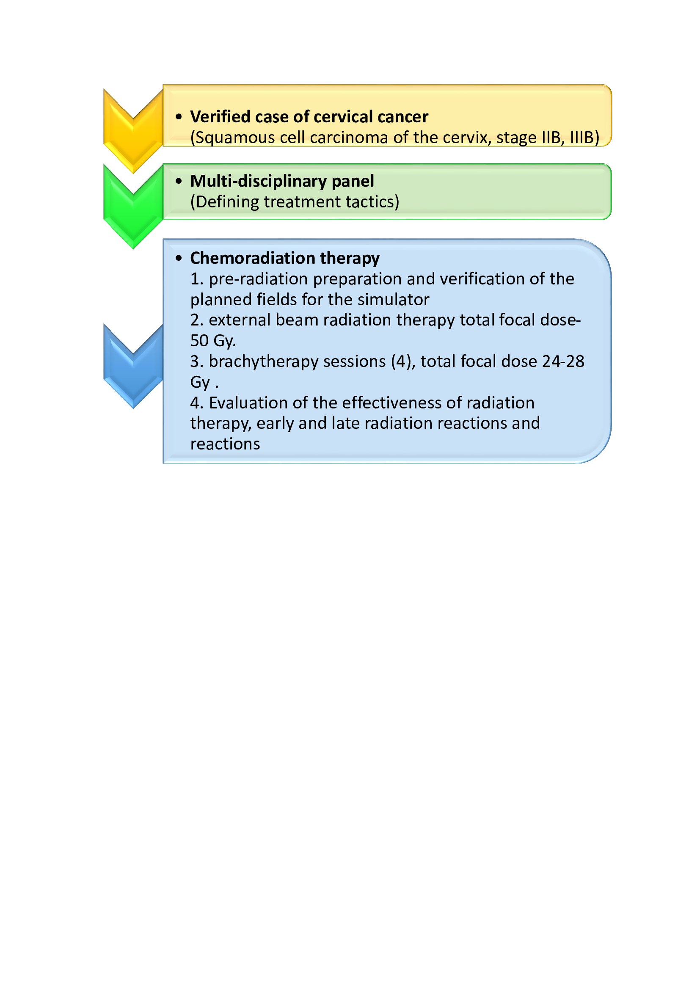
Figure 19 – stages of pre-radiation preparation and RT with 3D brachytherapy.
The choice of treatment tactics for patients with cervical cancer was based on the following data: stage of the disease; the presence of concomitant somatic and gynecological diseases; the size and nature of tumor growth; the ratio of tumor size and risk organs; clinical and morphological prognostic factors.
3D planning is the process of generating a three-dimensional model of a clinical case based on a series of parallel computed tomography scans (detailed) (Figure 20).
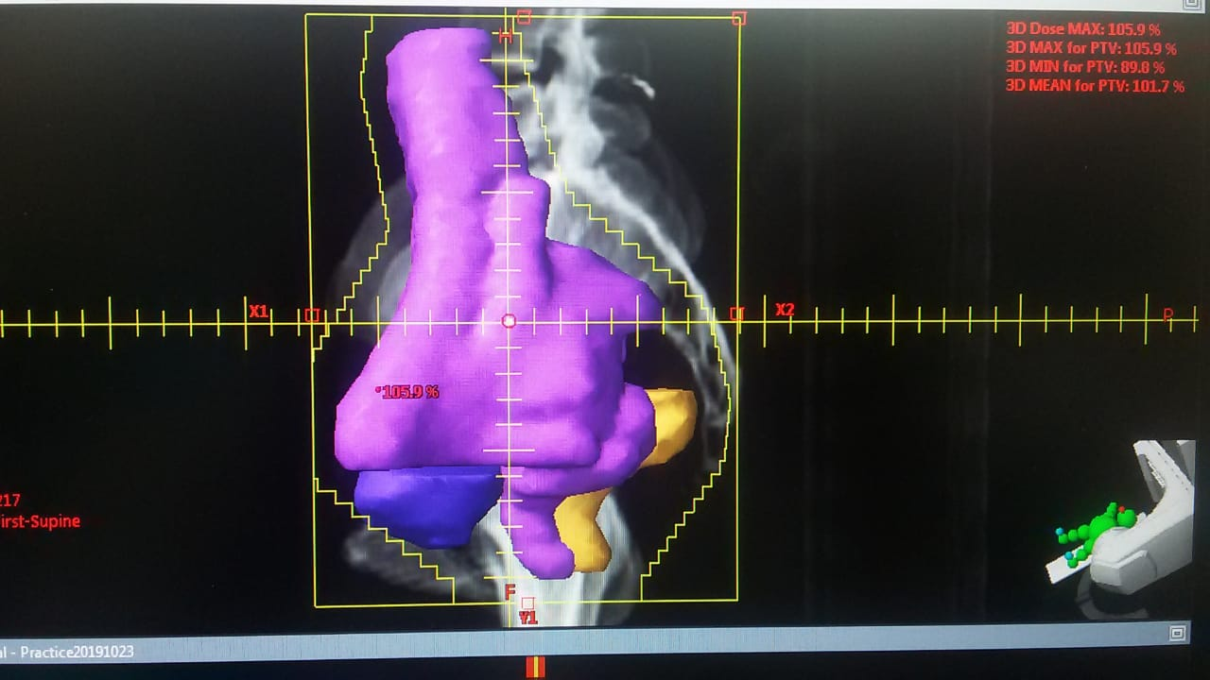
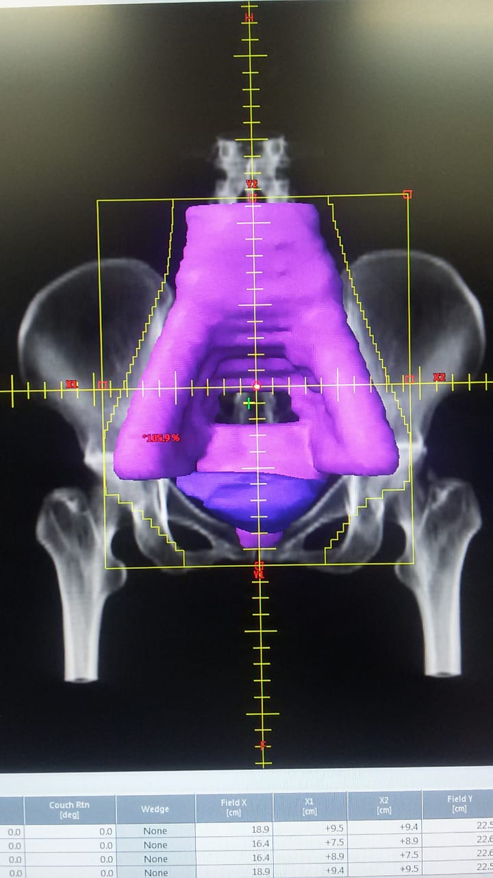
Figure 20 – the process of generating a three-dimensional model of a clinical case based on a series of parallel computed tomographic scans.
CONCLUSION
Effective treatment of locally advanced forms of cervical cancer of the uterus is one of the most important medical and social tasks of modern gynecological oncology. Even though that many different modes of brachytherapy are currently known and used in practice, the choice of the optimal mode is still a matter of debate. Radiation complications of moderate and severe degree, manifested by ulcerative changes in risk organs, the formation of rectal and vaginal fistulas, inside pelvic fibrosis, significantly worsen the quality of life of patients and can lead to disability and death. In this regard, the fractionation mode and the choice of total doses are decisive factors in reducing the incidence of complications during radiation therapy and, at the same time, do not worsen the treatment results. In view of the above, the aim of our study was to improve treatment outcomes for locally advanced cervical cancer with 3D-image radiation therapy (3D-IGBT). To achieve these goals, the following tasks were set:
To analyze the results of treatment of patients with cervical cancer, depending on the main prognostic criteria and treatment methods.
- To assess the frequency, nature and degree of acute and late toxicity with conventional radiation therapy and using a 3D image (3D-IGBT).
- To evaluate the social-economic effectiveness of 3D-image radiation therapy (3D-IGBT) for the optimal choice of therapy for patients with locally advanced cervical cancer
- To develop and implement on the basis of the Regional Oncological Dispensary of the city of Semey (currently the Center of Nuclear Medicine and Oncology (CNMandO)) a protocol for the treatment of locally advanced forms of cervical cancer by means of radiation therapy with a 3D image.
According to the inclusion and exclusion criteria, the present study included 66 patients with stage IIB and IIIB squamous cell carcinoma of the cervix, who did not have confirmed metastases and without previous chemotherapy, radiation therapy, and surgical interventions in this localization, who formed the following groups: the main group (22 patients who was performed RT with 3D imaging) and the control group (44 patients who received RT with planning in 2D mode). Ethical considerations during this study were followed in accordance with applicable regulations.
When choosing the volume and distribution of radiation doses in it were applied the recommendations of the International Commission - ICRU for determining the volume gradations. The treatment was carried out on a GammaMedPlus apparatus with a 192 Ir source in a high dose rate (HDR) mode. The calculation of the irradiation plans was carried out using the Varian radiotherapy complex, which includes the ECLIPSE planning system. The 3D radial planning process was started by generating a 3D model of each patient using a series of parallel computed tomography scans. The construction of contours corresponding to the tumor volume, clinical and planned target volume is carried out taking into account not only computed tomographic information, but also all clinical data about the patient. The DVH histograms were monitored to assess the quality of the exposure plan. The number of 3D-IGBT brachytherapy sessions was 4; the total cumulative dose of radiation therapy is 74.0-78.0 Gy.
Assessment of indicators of hematological and non-hematological toxicity was carried out according to the international scale (NCI / CTCAE)). The staging of late radiation reactions of all patients with cervical cancer included in the study was carried out in accordance with the international RTOG / EORTC scale. The quality of life of patients with cervical cancer was assessed using the EORTC QLQ CX24 questionnaire, which officially passed the adaptation and validation of the Kazakh-language version.
A retrospective analysis of the accounting and reporting documentation of 405 patients from January 2013 to December 2017 was carried out. Our analysis of the results of treatment of patients with cervical cancer, depending on the main prognostic criteria and treatment methods, showed that the overall cancer incidence rate in the Semey region shows an annual increase since 2007 by 15%. According to the assessment of the data on the incidence rate of cervical cancer among the female population of the Republic of Kazakhstan in the studied period, there is a fluctuation from 8.0 to 10.4% 000.
When analyzing the incidence rate of cervical cancer in the Semey region, its maximum growth was observed in 2013 - 20.0 cases per 100,000 population, then in 2017 this indicator was 11.4 cases per 100,000 population. In the structure of the overall incidence of cervical cancer, the survival rate was 56% for cervical cancer in 2017.
For the period from 2008 to 2017, the most frequent cases of cervical cancer occurred in the age group from 40 to 44 years old, which amounted to 19.9% ​​of the total number and in the age group 45-49 years old - 16.6%, respectively. The distribution of cervical cancer patients by stages made it possible to establish that stage II in 189 patients - 26.8%, stage III in 123 women - 17.5%. As a rule, the category of patients with stages II-III cervical cancer is shown a course of chemoradiation therapy.
The analysis of the results of treatment of patients with cervical cancer, depending on the main prognostic criteria and treatment methods, showed that the most significant prognostic factors are the patient's age, cervical cancer stage, histological variant and type of tumor growth, somatic status, at the same time, the peak incidence falls on the reproductive and working age, which makes it relevant and socially significant to introduce 3D-visually-controlled brachytherapy as a way to optimize RT for locally advanced cervical cancer.
Both groups were evaluated for early and late hematologic and non-hematologic toxicity. When assessing early hematological toxicity, the development of anemia, leukopenia and thrombocytopenia, amenable to correction, were observed, respectively, in 8 (36.4%), 9 (40.9%) and 6 (27.3%) women in the main group by 4-5 week of DLT treatment, while in the control group they were diagnosed in 17 (38.6%), 19 (43.2%) and 11 (25.0%) cases, respectively, at 5-7 weeks, both at the stage of DLT and during brachytherapy sessions. Among early nonhematological complications, dyspeptic disorders were noted in the group with 3D-IGBT in 5 (22.7%) cases, and in the control group in 10 (22.7%) women. Other early non-hematological complications were radiation reactions from the organs of risk, complications of III-degree were recorded in 5 (11.4%) patients, rectitis of III-degree were developed in 2 (4.6%) women of the control group (diarrhea requiring parenteral support; mucous membranes or bloody discharge, abdominal distention), and cystitis of III-degree were developed in 3 (6.8%) patients (increased urination and nocturia; dysuria, pelvic pain or bladder spasms, requiring regular, frequent prescription of narcotic analgesics; macrohematuria). Whereas complications of III-degree in the main group were not registered due to the optimization of the RT regimen. Early radiation reactions from the vaginal mucosa and cervix were not diagnosed reactions of III-degree in the main group with 3D visualization, while in the control group with 2D planning, reactions of III-degree were noted in 4 (9.1%) women, which manifested in the form of a membranous epithelitis, strong painful sensations, requiring the appointment of anesthesia of a stronger order. Late toxicity was assessed after 90 days of treatment initiation. In the main group, radiation reactions of III-degree from the rectum (development of obstruction and / or bleeding, requiring urgent correction, up to surgery) was diagnosed in 3 (6.8%) women in the control group, while in the main group were not registered. Post-radiation cystitis was detected in 13 (59.1%) women of the main group, while in the control group, reactions of II-degree were recorded in 33 (75.0%) cases. Cystitis of II-degree (pronounced frequency of urination and dysuria, telangiectasia, possible signs of hematuria and decreased bladder capacity) was observed in 2 (9.1%) women in the group with 3D planning, while in the group with 2D imaging - in 6 (13.6%). Radiation reactions from the bladder of III-degree in the late period were diagnosed in 4 (9.1%) women in the control group, while among the patients of the main group with 3D planning they were not registered.
Late radiation reactions from the vaginal mucosa and cervix among women in the main group of III-degree were registered in 4 (9.1%) women in the control group, while a combined problem in the late period occurred in 2 (4.5%) women. Total radiation injuries of the III-degree in the control group amounted to 9 (25.0%) cases, while in the main group, in the case of using the introduced 3D-technology, reactions of the III-degree were not registered.
Within the framework of the study, an analysis of the delivered dose to the risk organs of both groups was carried out on the basis of dose-volume diagrams, while statistically significant differences were found when analyzing the maximum supplied dose for the rectum and sigmoid colon, as well as when analyzing bladder.
Also, within the framework of the study, the analysis of the direct results of radiation therapy was carried out in the patients of the main group, while it was revealed that tumor resorption reached 48-54%. Upon completion of the course of combined radiation therapy, complete regression of tumor infiltrates was established in 55% of patients.
The one-year survival rates in patients of the main group with 3D with stage IIB-IIIB were 100%, while in the control group with 2D planning - in the subgroup with stage IIB this indicator was 94.1%, and in the subgroup with IIIB - 96.3%. The analysis of relapse-free survival showed that the percentage in the main group that underwent RT with 3D imaging was 90.0% and 91.6% in the subgroups with stages IIB and IIIB, respectively, while in the control group this indicator was recorded at the level 88.2% and 88.9% in subgroups with stage IIB and IIIB.
Thus, the method we developed for optimizing the treatment of locally advanced forms of cervical cancer using 3D planning according to toxicity criteria showed an undoubted advantage in comparison with RT with 2D planning. So the patients of the main group had a lower percentage of early hematological reactions, while there was a lack of reactions of the III-degree from risk organs in the early and late periods, the percentage of overall survival in the main group was higher than in the control group, which confirms the clinical effectiveness of this method for the optimal choice of therapy for patients with locally advanced cervical cancer.
Increasing of the survival time of patients simultaneously raises the question of assessing the social-economic efficiency of RT with 3D imaging for the optimal choice of therapy for patients with cervical cancer. In our study, this indicator of the general health status before the onset of RT, after 3 and 6 months of treatment in the main group was 53.6, 63.6 and 68 points, respectively. Whereas in the control group this indicator was recorded at the level of 52.8 ± 2 points before the onset of RT and was 53.5 ± 2 and 56.3 ± 3 points after 3 and 6 months of treatment, respectively.
The introduction of 3D brachytherapy made it possible to reduce the number of sessions up to 4 times, while with the standard scheme, sessions were carried out at least 5 times, which affected the total cost of treatment, given that the day of the accelerator's operation averages 2.5 million tenge (USD 5850.25). Theoretically, it can be stated that the proposed method gives an economic effect at the expense of funds spent on treatment, so on average the difference between 1 treated case of the main group in comparison with the control group was 125,964.83 tenge (USD 294.77). At the same time, these calculations of the economic effect do not take into account the cost savings from reducing disability, re-treatment of patients with grade 4 complications, reducing the cost of rehabilitation, retraining and social adaptation of sick women, as well as the enormous social and economic significance from the presence of an increasing number of recovered women in families and workplaces.
The developed method for optimizing the treatment of cervical cancer was introduced into the treatment practice of the Center of Nuclear Medicine and Oncology in Semey. The reason for the implementation was the need to unify the treatment process and reproducibility of therapy methods since these processes significantly affect the results of the therapeutic intervention. Radiation oncologists-gynecologists, medical physicists, and laboratory technicians for the maintenance of radiation devices were involved in the implementation of 3D-visually-controlled brachytherapy.
According to the results of our research, it can be stated that the optimization of RT for locally advanced cervical cancer using 3D brachytherapy creates clinically favorable conditions for effective therapy: reduces the risk of displacement of the applicators, reduces the burden on the patient, by reducing the total radiation doses, the frequency of severe early and late toxic effects, providing good indicators of local control regardless of the tumor size and clinical stage.
The study showed that the choice of rational fractionation schemes and the methodology for accounting for the dose load made it possible to optimize the irradiation programs taking into account the individual parameters of the tumor process, the spatial relationship of the tumor and risk organs, as well as the constitutional characteristics of the patient, and ensure a higher level of quality of life by reducing both early and late radiation reactions and complications.
It has been established that the introduction of 3D-IGBT in the treatment of cervical cancer in clinical practice, in comparison with traditional methods, provides high social and economic efficiency, both by reducing the number of RT courses and by reducing the degree and risk of early and late post-radiation reactions.
The results of our study confirm that the method of 3D brachytherapy needs to be widely used in the daily practice of cervical cancer treatment through inclusion in the Clinical protocol for the treatment of cancer in the Republic of Kazakhstan.

REFERENS

- Murakami N. et al. CT based three dimensional dose-volume evaluations for high-dose rate intracavitary brachytherapy for cervical cancer //BMC cancer. – 2014. – Vol. 14. – №. 1. – p. 447.
- Aaronson N.K., Ahmedzai S., Bergman B. et al. The European Organisation for Research and Treatment of Cancer QLQ-C30: A quality of life instrument for use in international clinical trilas in oncology // J. Nat. Cancer lnst. – 1993. – Vol.85. – p.365-375.
- Андреева О.Б., Адылханов Т.А., Жабагина А.С., Раисов Д.Т., Уразалина Н.М. Роль 3D-визуализации в программе лучевой терапии рака шейки матки. Обзор литературы // Наука и здравоохранение. 2019 - № 4. - Т.21. - c. 5-19.
- Viswanathan A. N. et al. International brachytherapy practice patterns: a survey of the Gynecologic Cancer Intergroup (GCIG) //International Journal of Radiation Oncology* Biology* Physics. – 2012. – Vol. 82. – №. 1. – p. 250-255.
- Banerjee R., Kamrava M. Brachytherapy in the treatment of cervical cancer: a review //International journal of women's health. – 2014. – Vol. 6.– p. 555.
- Luo N. et al. The European organization for research and treatment of cancer quality of life questionnaire (EORTC QLQ-C30): validation of English version in Singapore //Quality of Life Research. – 2005. – Vol. 14. – №. 4. – p. 1181-1186.
- Sreedevi A., Javed R., Dinesh A. Epidemiology of cervical cancer with special focus on India //International journal of women's health. – 2015. – Vol. 7. – p. 405.
- Choong E. S. et al. Hybrid (CT/MRI based) vs. MRI only based image-guided brachytherapy in cervical cancer: Dosimetry comparisons and clinical outcome //Brachytherapy. – 2016. – Vol. 15. – №. 1. – p. 40-48.
- Caro-Porras N. Epidemiological analysis of women with cervical squamous cell carcinoma 2007-2015 //Acta Médica Costarricense. – 2017. – Vol. 59. – №. 1. – p. 22-27.
- Darlin L. Cervical cancer studies on prevention and treatment. – Department of Obstetrics and Gynecology, Lund University, 2013. – Vol. 2013. – №. 142 – p. 13-18.
- Адылханов Т.А., Андреева О.Б. и др. «Метод визуализации с применением 3D-технологий при лучевой терапии рака шейки матки, в материалах V Петербургского международного онкологического форума «Белые ночи 2019», с. 307.
- Gill B. S. et al. MRI-guided high–dose-rate intracavitary brachytherapy for treatment of cervical cancer: The University of Pittsburgh experience //International Journal of Radiation Oncology* Biology* Physics. – 2015. – Vol. 91. – №. 3. – p. 540-547.
- Электронный ресурс, URL: http://adilet.zan.kz/rus/docs/V1800017353/history (дата обращения 15.10.2020 г.).
- Guzelant A. et al. The European Organization for Research and Treatment of Cancer QLQ‐C30: an examination into the cultural validity and reliability of the Turkish version of the EORTC QLQ‐C30 //European journal of cancer care. – 2004. – Vol. 13. – №. 2. – p. 135-144.
- "Оценка эффективности лучевой терапии с 3D-изображением для оптимального выбора терапии пациентов с раком шейки матки" в рамках Российской научно-практической конференции с международным участием (в режиме on-line) «Современные достижения в диагностике, хирургическом, лучевом и лекарственном лечении злокачественных опухолей», 10-11 июня 2020 года г. Барнаул,РФ, сборник тезисов, с. 9.
- Ohno T. et al. In-room computed tomography–based brachytherapy for uterine cervical cancer: results of a 5-year retrospective study //Journal of radiation research. – 2016. – Vol. 58. – №. 4. – p. 543-551.
- Charra-Brunaud C. et al. 152 oral Dosimetric and clinical results of a french prospective study of 3D brachytherapy for cervix carcinoma //Radiotherapy and Oncology. – 2011. – №. 99. – p.57.
- Groenvold M. et al. Validation of the EORTC QLQ-C30 quality of life questionnaire through combined qualitative and quantitative assessment of patient-observer agreement //Journal of clinical epidemiology. – 1997. – Vol. 50. – №. 4. – p. 441-450.
- Pötter R. et al. Value of magnetic resonance imaging without or with applicator in place for target definition in cervix cancer brachytherapy //International Journal of Radiation Oncology* Biology* Physics. – 2016. – Vol. 94. – №. 3. – p. 588-597.
- Saibishkumar E. P., Patel F. D., Sharma S. C. Evaluation of late toxicities of patients with carcinoma of the cervix treated with radical radiotherapy: an audit from India //Clinical Oncology. – 2006. – Vol. 18. – №. 1. – p. 30-37.
- Tan P. W., Koh V. Y., Tang J. I. Outpatient combined intracavitary and interstitial cervical brachytherapy: barriers and solutions to implementation of a successful programme–a single institutional experience //Journal of contemporary brachytherapy. – 2015. – Vol. 7. – №. 3. – p. 259.
- Zolciak-Siwinska A. et al. Computed tomography–planned high-dose-rate brachytherapy for treating uterine cervical cancer //International Journal of Radiation Oncology* Biology* Physics. – 2016. – Vol. 96. – №. 1. – p. 87-92.
- Scoring and Coding for the WHOQOL-HIV Instruments//Users Manual. World Health Organization CH-1211//Geneva 2002, p.6.
- Okonogi N., Adylkhanov T. et al. Preliminary survey of 3D image-guided brachytherapy for cervical cancer at representative hospitals in Asian countries //Journal of Radiation Research. – Vol. 61, No. 4, 2020, p. 608–615.
- Электронный ресурс, URL: http://rcrz.kz/docs/clinic_protocol/2015/%D0%A5%D0%B8%D1%80%D1%83%D1%80%D0%B3%D0%B8%D1%8F/%D0%9E%D0%BD%D0%BA%D0%BE%D0%BB%D0%BE%D0%B3%D0%B8%D1%8F/%D0%A0%D0%B0%D0%BA%20%D1%88%D0%B5%D0%B9%D0%BA%D0%B8%20%D0%BC%D0%B0%D1%82%D0%BA%D0%B8.pdf (дата обращения 17.10.2020 г.).
- Роль компьютерно-томографической визуализации в программе подготовки и контроле эффективности лучевой терапии при новообразованиях шейки матки // Наука и Здравоохранение. 2020. 1 (Т.22). С.72-79.
- Электронный ресурс, URL: https://icru.org/content/reports/prescribing-recording-and-reporting-brachytherapy-for-cancer-of-the-cervix-report-no-89(дата обращения 17.10.2020 г.).
- Skowronek J., Malicki J. Comparison of value of biologically equivalent dose (BED) in clinical target volume (CTV) and surrounding healthy organs after PDR and HDR brachytherapy //Brachytherapy. – 2007. – Vol. 6. – №. 2. – p. 112-113.
- Yoshio K. et al. Inverse planning for combination of intracavitary and interstitial brachytherapy for locally advanced cervical cancer //Journal of radiation research. – 2013. – Vol. 54. – №. 6. – p. 1146-1152.
- Charra-Brunaud C. et al. Impact of 3D image-based PDR brachytherapy on outcome of patients treated for cervix carcinoma in France: results of the French STIC prospective study //Radiotherapy and Oncology. – 2012. – Vol. 103. – №. 3. – p. 305-313.
- Chen S. W. et al. Comparative study of reference points by dosimetric analyses for late complications after uniform external radiotherapy and high-dose-rate brachytherapy for cervical cancer //International Journal of Radiation Oncology Biology Physics. – 2004. – Vol. 60. – №. 2. – p. 663-671.
- Электронный ресурс, URL: http://www.who.int/healthinfo/survey/whoqol-qualityoflife/en/ (дата обращения 15.10.2020 г.).
- Chong-Jong Wang, Eng -Yen Huang, Li-Min Sun et al. Clinical comparison of two linear-quadratic model-based isoeffect fractionation schemes of high-dose-rate intracavitary brachytherapy for cervical cancer // Int. J. Radiation Oncology Biol. Phys., 2004, V.59 (1), p.179-18.
- Dyk P. et al. Cervical gross tumor volume dose predicts local control using magnetic resonance imaging/diffusion-weighted imaging—guided high-dose-rate and positron emission tomography/computed tomography—guided intensity modulated radiation therapy //International Journal of Radiation Oncology* Biology* Physics. – 2014. – Vol. 90. – №. 4. – p. 794-801.
- Herrmann T., Knorr A., Dorner K. The RTOG/EORTC classification criteria for early and late radiation reactions //Radiobiologia, radiotherapia. – 1987. – Vol. 28. – №. 4. – p. 519-528.
- Nag S., Erickson B., Thomadsen B., Orton C. et al. The American brachytherapy society recommendations for high-dose-rate brachytherapy for carcinoma of the cervix // Int J Radiat Oncol Biol Phys, 2000, 48:201-11.
- Rajendra L. Bhalavat et al, Tata Memorial Hospital, India. HDR brachytherapy of the cervix: rectal retractor or gauze packing? // BRACHYTHERAPY, 2007, V. 6, №2, p.67-69.
- Saibishkumar E.P., Patel F.D., Sharma S.C. Evaluation of late toxicities of patients with carcinoma of the cervix treated with radical radiotherapy: An audit from India // Clin Oncol, 2006, V. 18, p.30-33.
- Shivkumar S.S., Solomon J.G., Supe S.S. et al. A Physical optimization technique in high dose rate brachytherapy for cervical carcinoma // J Med Physics, 2002, V.27, p.51-55.
- Vrdoljak E. et al. Concomitant chemobrachyradiotherapy with ifosfamide and cisplatin followed by consolidation chemotherapy in locally advanced squamous cell carcinoma of the uterine cervix: results of a phase II study // Int. J. Radiation Oncology Biol. Phys., 2005, V. 61, №. 3, p. 824–829.
- Wong L., Ngan A., Cheung A. Chemoradiation and adjuvant chemotherapy in cervical cancer // Journal of Clinical Oncology, 1999, V.17(7), p.2055–206.
- Chottaweesak P. etal. Comparison of bladder and rectal doses between conventional 2D and 3D brachytherapy treatment planning in cervical cancer //Biomedical Imaging and Intervention Journal. – 2014. – Vol. 10. – №. 1. – p. 1-7.
- Shin D. W. et al. Cross-cultural application of the Korean version of the european organization for research and treatment of cancer quality of life questionnaire-Core 15-palliative care //Journal of pain and symptom management. – 2011. – Vol. 41. – №. 2. – p. 478-484.
- Виноградов В. М., Коврыжкина Т. А., Акимов А. А. Расчет биологически изоэффективных доз при дистанционной лучевой терапии //СПб.: Изд-во Санкт-Петербургской медицинской академии последипломного образования. – 1997. – c. 30.
- Ярмоненко С.П., Вайнсон А.А. Радиобиология человека и животных. М.: Высш. Шк., 2004, с.549.
- Gordon G. Steel Basic clinical radiobiology, 3rd edition, ARNOLD, UK, 2002, p. 26.
- Tamaki T. et al. Dose–volume histogram analysis of composite EQD2 dose distributions using the central shielding technique in cervical cancer radiotherapy //Brachytherapy. – 2016. – Vol. 15. – №. 5. – p. 598-606.
- Электронный ресурс, URL: https://ctep.cancer.gov/protocolDevelopment/electronic_applications/ctc.htm (дата обращения 15.10.2020 г.).
- Электронный ресурс, URL: https://www.eortc.org/research_field/radiation-oncology/ (дата обращения 15.10.2020 г.).
- Шалгумбаева Г.М., Рахыпбеков Т.К., Сандыбаев М.Н. Заболеваемость и смертность от рака шейки матки в 2008-2012 годах на территории,прилегающей к бывшему Семипалатинскому ядерному полигону // Медицинская экология. 2014. c. 41–47.
- Даубасова И.Ш. О состоянии заболеваемости и смертности рака шейки.матки в РК // Вестник КазНМУ. 2013. Т. 3. № 2. c. 3–6.
- Adylhanov T.A.,Zhabagina A. S. i dr. Retrospektivnyj analiz zabolevaemosti ra-kom shejki matki v Semejskom regione Vostochno-Kazahstanskoj oblasti za 2013-2017 gody //Nauka i zdravoohranenie. – 2018. – №. 2 – T.20 – p.54-66.
- Эпидемиологическая оценка основных статистических показателей рака шейки матки в Республике Казахстан за десятилетний период (2008-2017 гг.), г. Киев 2018, Мультидисциплинарный научный журнал «Архивариус», с. 32-36.
- Thigpen T., Vance R. B., Khansur T. Carcinoma of the uterine cervix: current status and future directions //Seminars in oncology. – 1994. – Vol. 21. – №. 2 Suppl 2. – p. 43.
- Rose P. G. Locally advanced cervical carcinoma: the role of chemoradiation //Seminars in oncology. – 1994. – Vol. 21. – №. 1. – p. 47-53.
- Андреева О. Б. и др. Комплексная оценка общей токсичности при 3D-визуализируемой брахитерапии рака шейки матки //Наука и здравоохранение. – 2018. – №. 5. – Т.20 – с. 74-79.
- Качество жизни, ассоциированное со здоровьем при раке шейки матки" Мультидисциплинарный научный журнал «Архивариус», г.Киев, Украина, ISSN 2524-0935 №4 c. 18-22.
- Pasek M., Suchocka L., Urbański K. Quality of life in cervical cancer patients treated with radiation therapy //Journal of clinical nursing. – 2013. –Vol. 22. – №. 5-6. – p. 690-697.
- Pfaendler K. S. et al. Cervical cancer survivorship: long-term quality of life and social support //Clinical therapeutics. – 2015. – Vol. 37. – №. 1. – p. 39-48.
- Bjelic-Radisic V. et al. Quality of life characteristics inpatients with cervical cancer //European journal of cancer. – 2012. – Vol. 48. – №. 16. – p. 3009-3018.
- Электронный ресурс, URL: https://nationalbank.kz (дата обращения 15.10.2020 г.).
- Андреева О.Б., Адылханов Т.А., Сабеков Е.О. [и др.] Социально-экономическая эффективность лучевой терапии с 3D-изображением при лечении местно-распространенных форм рака шейки матки // Интернаука: электрон. научн. журн. 2020. № 36(165). URL: http://internauka.org/journal/science/internauka/165 (дата обращения: 09.10.2020).

APPLICATION А



APPLICATION B



APPLICATION C

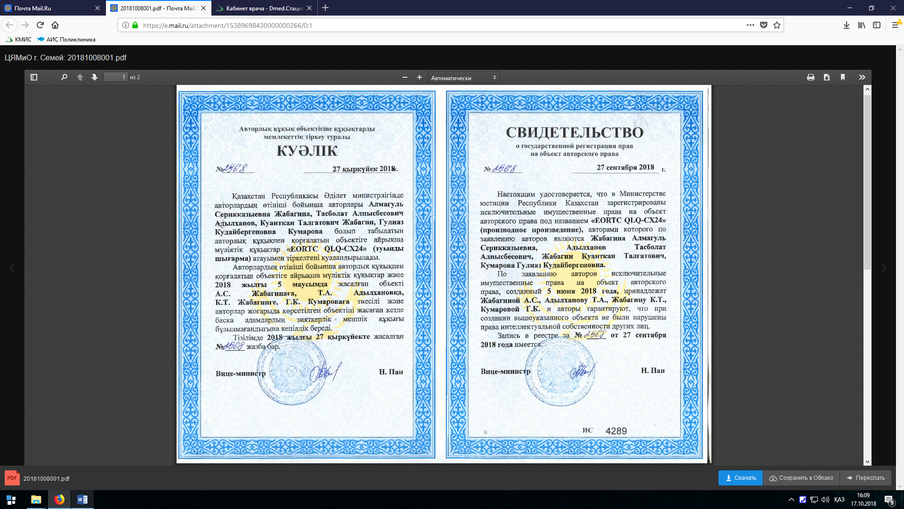

APPLICATION D

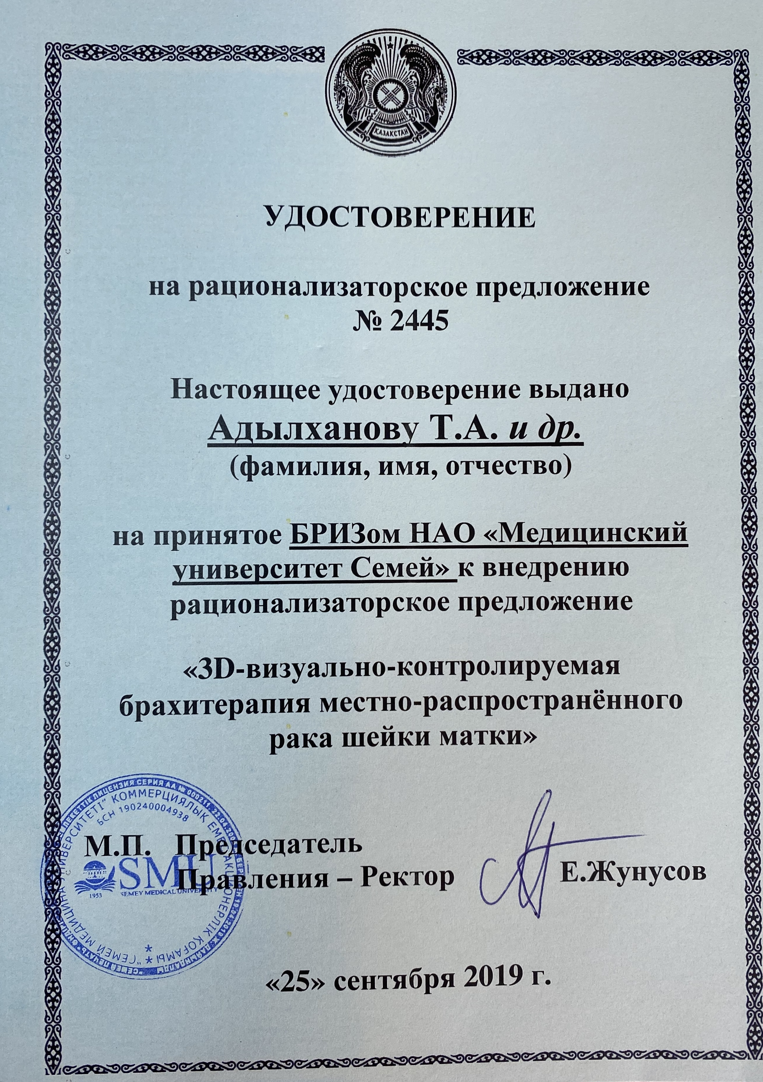

APPLICATION E

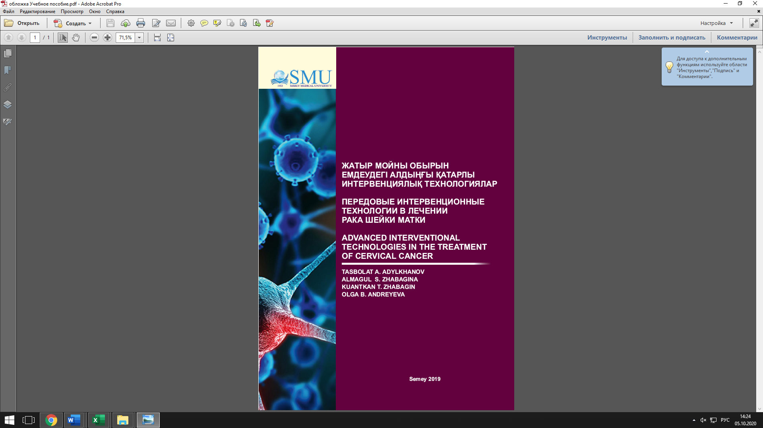

APPLICATION F

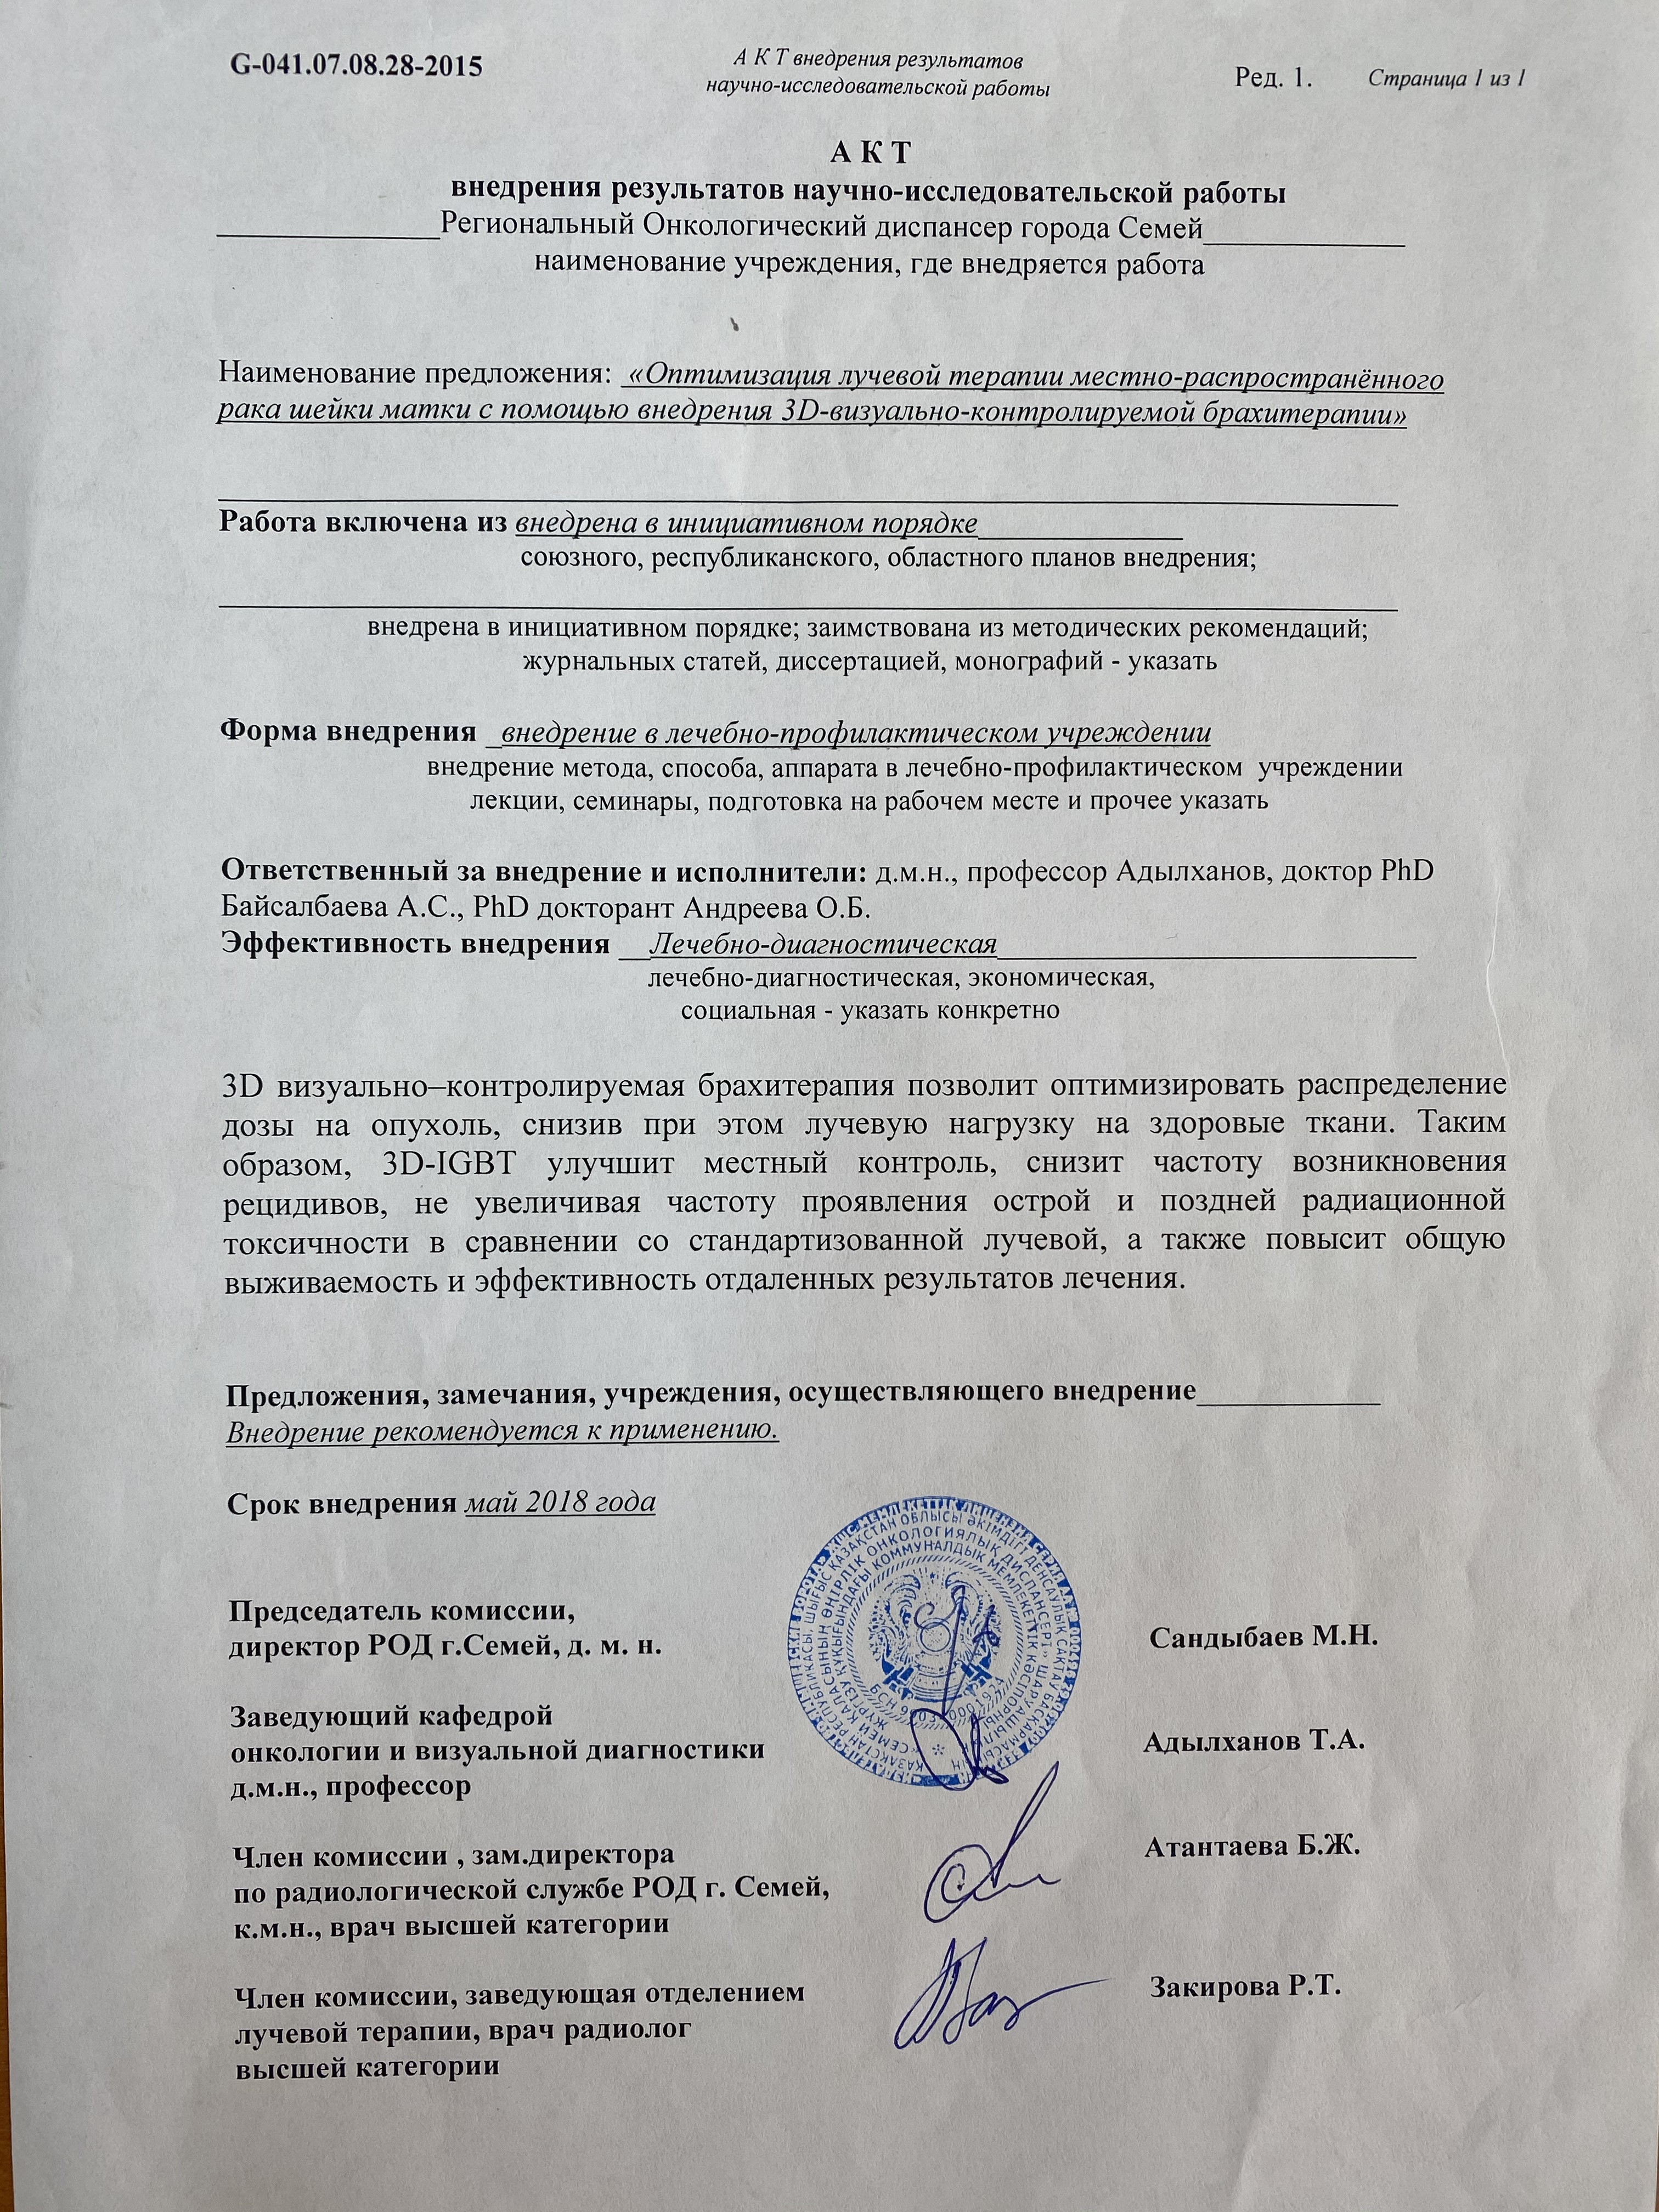

APPLICATION G
3D-Image-guided brachytherapyfor Locally Advanced Cervical Cancer
(Cervix-V)
Forum for Nuclear Cooperation in Asia (FNCA)
Application of Radioisotopes andRadiation for Medical Use
29th May. 2017
Outline of the study
1. Design of the study
Prospective observational study (Multi-national observational research)
2. Objectives
To determine the safety and efficacy of 3D-image guided radiation therapy (3D-IGBT) for patients with locally advanced cervical cancer in FNCA countries.

Primary endpoint: 2-year overall survival rate
Secondary endpoints: 2-year local control rate
Acute and late toxicities
3. Protocol Eligibility Criteria
3.1. Eligible for inclusion
1. Squamous cell carcinoma of the uterine cervix
2. Stage IIB (≧4 cm in diameter) and IIIB disease (FIGO 2008)
3. Age; 20-70 years
4. PS; WHO 0-2
5. No prior chemotherapy, radiotherapy, and surgery to the pelvis
6. Life expectancy; longer than 6 months
7. Adequate bone marrow, hepatic, and renal functions;
WBC≧3000/mm3
Hb≧10 g/dl
Platelet≧100,000/mm3
Total bilirubin≦1.5 mg/dl (≦25.65 µmol/L)
AST/ALT≦2 times upper limit of normal
Serum creatinine≦1.5 mg/dl (≦132.6 µmol/L)
8. Written informed consent
9. Diagnostic images (CT of the abdomen and pelvis is needed, MRI of the pelvis is recommended but not mandatory) before starting EBRT.
10. No PALN metastasis on CT. (> 1 cm in minimum diameter)
（See 4.3 for combination therapy）
3.2. Ineligible for inclusion
1. Severe concomitant illness
2. History of other malignancies within the past 5 years except basal cell carcinoma or squamous cell carcinoma in-situ of the skin
3. Tumor with infiltration of lower 1/3 of the vagina
4. Patients who are pregnant or lactating
（See 4.3 for combination therapy）
4. Treatment Protocol
4.1. Overall treatment times
Recommended overall treatment time is 6-7 weeks, and it should be no longer than 56 days (8 weeks) in this protocol.
4.2. Radiotherapy
4.2.1 External beam radiotherapy
Fractionation schedule: 1.8-2.0 Gy/fraction, 5 fractions/week
Total dose for pelvis: approximately 50 Gy
Whole pelvis 30-40 Gy, Central shielding 20-10 Gy or.
Whole pelvis 44.0-50.4 Gy without central shielding.
An additional 6-10 Gy of local irradiation is accepted to the bulky parametrial disease or gross lymph node metastasis to boost the total dose of 56-60 Gy.
4.2.2 Brachytherapy (Only IGBT allow)
All intracavitary brachytherapy sessions are performed on 3D-IGBT.
High dose rate (HDR) treatment: 24-28 Gy / 4 fractions (6-7 Gy/fraction) to HR-CTV D90. (recommended).
Other dose fractions (e.g. 21 Gy/ 3 fractions, 33 Gy/6 fractions) are allowed according to the institutional practice. But the overall treatment time should be less than 8 weeks. And dose constraints to organ at risks (OARs) should be kept as much as possible.
4.3. Concurrent chemotherapy
Cisplatin (CDDP) 40 mg/m2 intravenous drip, weekly, week 1-week 5. (recommended)
Other schedules of chemotherapy using CDDP is allowed (e.g. tri-weekly cisplatin administration), but other drugs (e.g. carboplatin or taxol) are not allowed in this trial.
4.4. Outline of the treatment

・Whole pelvis (WP) + Central shielding (CS)
・Whole pelvis (WP) alone
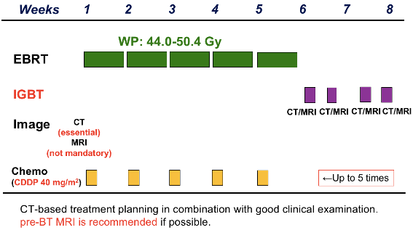
- Assessment of toxicity and efficacy
5.1. Toxicity
5.1.1. Acute toxicity
Acute toxicities for each patient are serially monitored during and after treatment (within 90 days from the beginning of treatment).
- Hematological toxicities (WBC, Neutrophils, Hb, Platelets)
- Nonhematological toxicities (Upper GI, Lower GI, Urinary bladder, Skin, Others)
Hematological toxicities are assessed according to the NCI/CTC version 4.0.
Nonhematological toxicities are assessed according to the RTOG acute radiation morbidity scoring system.
5.1.2. Late toxicity
Late toxicities for each patient are periodically monitored after treatment.
- Rectum and sigmoid
- Urinary bladder
- Small intestine
- Skin
- Others
Late toxicities are assessed according to the RTOG/EORTC late radiation morbidity scoring scheme.
5.2. Evaluation method for efficacy
Disease status for each patient is periodically monitored and assessed after treatment. Disease status is assessed by the exams as follows:
- Physical examination (including pelvic and digital rectal examinations)
- Cytological smears (Papanicolaou)
- Punch biopsies
- Radiographic studies (chest x-ray, intravenous pyelography)
- Optional
Tumor markers (CEA, SCC)
CT
MRI
Ultrasound
6. Sample size
100 patients
7. Period of patient accrual
5 years (29th, May, 2017 -)
8. Follow-up period, Study duration
Follow-up period: 2 years
Study duration: From the approval of IRB to 31st March, 2022.
9. Case report form, Procedure for data collection
Patient data will be collected using case report form (CRF). The CRFs must be completed and reported to data correction center according to the time table below. It is the responsibility of the investigator to check that all CRFs are completed correctly in a timely manner. After completion of a CRF, a hard copy should be kept in the investigator’s own patient study file.
10. Ethical considerations
10.1. Patient protection
This study will be conducted in agreement with the Declaration of Helsinki.
Each institute shall adhere to each local regulation. Considering the variety of local regulations, this study should be conducted in accordance with most strict standard among all, however, in case it is difficult, we can confirm regulatory compliance by means of each ethics committee approval. In Japan, this research adheres to “Ethical Guidelines for Medical and Health Research Involving Human Subjects”. The Copy of notice documents approved by the ethics committee in each country will be kept in the study office.
10.2. Subject identification
To ensure patient privacy, the name of the patient will not be asked for nor recorded at the Study Office in NIRS. A sequential identification number will be automatically assigned to each patient registered in the trial. This number will identify the patient and must be included on all case report forms. In order to avoid identification errors, patient’s initials (maximum of 4 letters) and date of birth and local chart number (if available) will also be recorded, only on the registration form. These procedures can be altered to such way that patient information of only de-identified or with limited identification can be registered, in accordance with local legislation and/or ethics committee’s decision.
The cross-reference table which identify patient’s number will be kept in a lockable cabinet in the Study office in NIRS. Only the person in charge of this research can access this table under the supervision of the research director.
10.3. Informed consent
Written informed consent is mandatory to enter this study. This informed consent form should be translated in each native language. It will be emphasized that the participation is voluntary and that the patient is allowed to refuse further participation in the protocol whenever she wants. Even if patient cancel participation, the patient will not suffer a disadvantage because of that. There is no additional benefit such as a reward for participation. Informed consent form described in each local language will be kept in the study office.
11. Cost and compensation
11.1. Cost
Calculation of the costs of treatment will be made in the same way as that for usual treatment. There is no additional burden on medical expenses for patients. There are no additional benefits such as a reward for participation.
11.2. Compensation
The hospital makes no commitment to provide free medical care or payment for any unfavorable outcomes resulting from participation in this study. Medical services will be offered at the usual charge. However, you are not precluded from seeking to collect compensation for injury related to malpractice, fault, or blame on the part of those involved in the study, including the hospital. No compensation in any form will be provided through the participations in this study.
12.1. Study coordination
Principal Investigator:
Shingo KATO, M.D., Ph.D
s_kato@saitama-med.ac.jp
Project leader of radiation oncology, FNCA
Professor, Department of Radiation Oncology, International Medical Center Saitama Medical University, Saitama, Japan.
Overall coordinators:
Takashi NAKANO, M.D., Ph.D
tnakano@gunma-u.ac.jp
Chairman and Professor, Department of Radiation Oncology, School of Medicine, Gunma University, Gunma, Japan
Director, Gunma University Heavy Ion Medical Research Center.
Director of Division of Integrated Oncology Research, Gunma University, Initiative for Advanced Research
Tatsuya OHNO, M.D., Ph.D
tohno@gunma-u.ac.jp
Professor, Gunma University Heavy Ion Medical Research Center.
Masaru WAKATSUKI, M.D., Ph.D
waka@jichi.ac.jp
Professor, Department of Radiology, Jichi Medical University, Tochigi, Japan.
Noriyuki OKONOGI, M.D., Ph.D
okonogi.noriyuki@qst.go.jp
Section chief of Gynecologic Tumor, National Institute of Radiological Science (NIRS), National Institutes for Quantum and Radiological Science and Technology, Japan (QST)
Database managers:
Yasuo OKUDA, Ph.D
okuda.yasuo@qst.go.jp
Section Head of Hospital Medical Informatics, Senior Principal Researcher
National Institute of Radiological Science (NIRS), National Institutes for Quantum and Radiological Science and Technology, Japan (QST)
Tomoko TAKAHASHI
takahashi.tomoko@qst.go.jp
Hospital, National Institute of Radiological Science (NIRS), National Institutes for Quantum and Radiological Science and Technology, Japan (QST)
12.2. Cooperative research institutes/cooperative hospitals in this study
A hospital in which IGBT has already been practiced clinical practice based on public insurance, and which has been recognized by FNCA members as sufficient level to use IGBT is defined as a cooperative research institute/cooperative hospital in this study. Participant countries in this study (FNCA cooperative countries) are Bangladesh, China, Indonesia, Kazakhstan, Korea, Malaysia, Mongolia, Philippines, Thailand, Vietnam, and Japan (As of April 2017). Following hospitals were judged as cooperative research institute/cooperative hospital in this study:
Hospital’s name: a parson in charge of this study
・International Medical Center Saitama Medical University, Saitama, Japan. :Prof. Shingo KATO
・Gunma University Hospital, Gunma, Japan: Prof. Takashi NAKANO
・Jichi Medical University Hospital, Tochigi, Japan. : Prof. Masaru WAKATSUKI
・Tokyo Women’s Medical University Hospital, Tokyo, Japan. : Prof. Kumiko KARASAWA
・Hospital, National Institute of Radiological Science (NIRS), National Institutes for Quantum and Radiological Science and Technology, Japan (QST) : Dr. Noriyuki OKONOGI
・Delta Limited Hospital, Dhaka, Bangladesh: Dr. Parvin Akhter BANU
・United Hospital Limited, Dhaka, Bangladesh: Dr. A.F.M.Kamal Uddin
・The First Affiliated Hospital of Soochow University, Soochow, China: Dr. XU Xiaoting
・The Affiliated Changzhou Tumor Hospital of Soochow University, Changzhou, China: Dr. Yang Yu-xing
・CiptoMangunkusumo General Hospital, Jakarta, Indonesia: Dr. Henry
Kodrat
・Dr. Sotomo General Hospital, Surabaya, Indonesia: Dr. DyahErawati
・Kazakh Scientific -Research Institute of Oncology and Radiology, Almaty, Kazakhstan: Dr. SavkhatovaAkmaral
・Semey Oncology Center, Semey, Kazakhstan: Prof. TasbolatAdylkhanov
・Korea Institute of Radiological & Medical Sciences (KIRAMS), Seoul, Korea: Dr. Wonil Jang
・Sarawak General Hospital, Kuching, Malaysia: Dr. C.R. Beena Devi
・National Cancer Institute, Putrajaya, Putrajaya, Malaysia: Dr. Lau Fen Nee
・National Cancer Center of Mongolia, Ulaanbaatar, Mongolia: Dr. YadamsurenErdenetuya
・Jose R. Reyes Memorial Medical Center (JRRMMC), Manila, the Philippines: Dr. Rey H. De Los Reyes
・St. Luke's Medical Center, Manila, the Philippines: Dr. Miriam Joy CALAGUAS
・Siriraj Hospital, Mahidol University, Bangkok, Thailand: Dr. YaowalakChansilpa
・National Cancer Hospital (K-Hospital), Hanoi, Vietnam: Dr. To Anh Dung
・Ho Chi Minh City Oncology Hospital, Vietnam, Vietnam: Dr. Dang Huy Quoc Thinh
12.3. Study-office Cervix-V (AT PRESENT: 4/2017)
Study office and data correction center:
Hospital, National Institute of Radiological Science (NIRS)
National Institutes for Quantum and Radiological Science and Technology, Japan. (QST)
Tel: +81-43-206-3306 Fax: +81-43-256-6506
13. Database registration for this study
This study information is registered to publicly available database (UMIN), in advance of the date of first patient registration.
14. Conflict of interests
There is no conflict of interests to be declared.
This research is carried out with the research funding of the facility which the research director belongs. For research funding, this work is supported by administrative grants of the National Institute of Radiological Sciences.

APPLICATION H

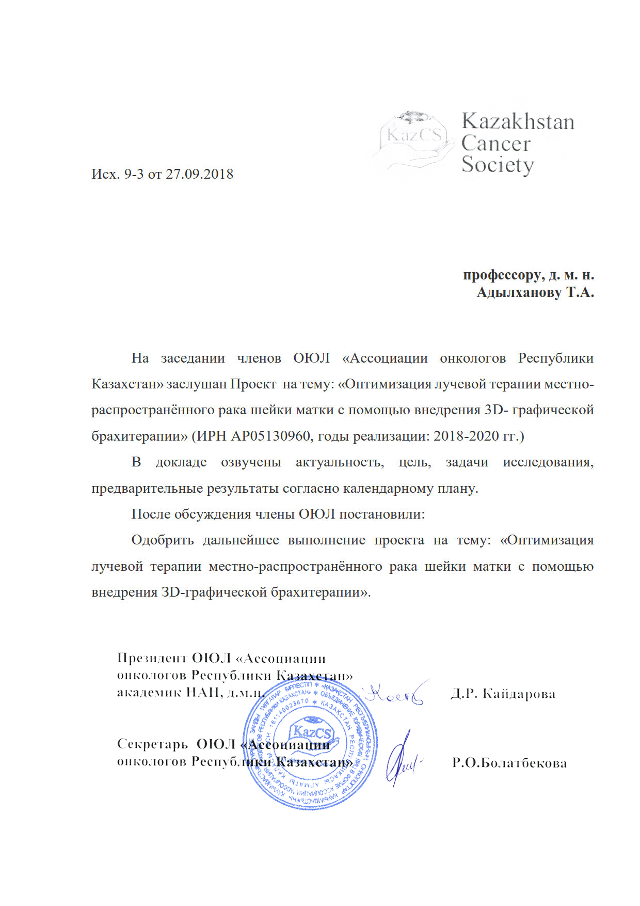

APPLICATION I

Общее состояние больного (Performancestatus) по шкале Карновского и ECOG-B03.

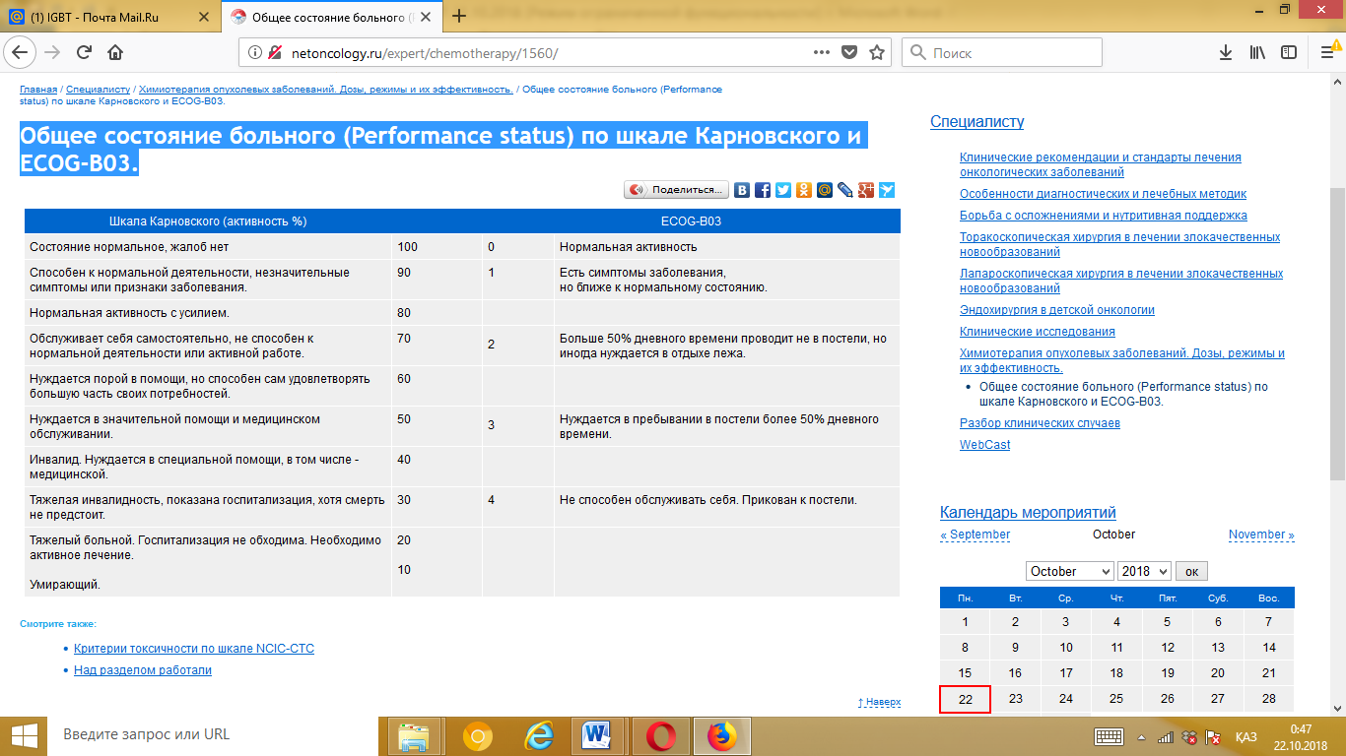

APPLICATION J

ИНФОРМИРОВАННОЕ ДОБРОВОЛЬНОЕ
СОГЛАСИЕ НА МЕДИЦИНСКОЕ ВМЕШАТЕЛЬСТВО по НИР

Я _________________________________________________________________________________________________
(фамилия, имя, отчество — полностью)
_____________ года рождения, проживающий (ая) по адресу: ______________________________________________

* Я, __________________________________________________ уд/личности №:_______, выдан: ____________ проживающий (ая) по адресу: _____________________________ являюсь законным представителем (мать, отец, усыновитель, опекун, попечитель) ребенка или лица, признанного недееспособным:
__________________________________________________________________________________________________
( Ф.И.О. ребенка или недееспособного гражданина — полностью, год рождения)
- Мне даны полные и всесторонние разъяснения о характере, степени тяжести и возможных осложнениях моего заболевания (здоровья представляемого) _________________________
- Добровольно даю свое согласие на проведение клинических испытаний нового метода лучевой терапии местно-распространённого рака шейки матки с помощью внедрения 3D-графической брахитерапии.
- Я информирован(а) о целях и методах оказания медицинской помощи, связанном с ними риске, возможных вариантах медицинского вмешательства, о его последствиях, а также о предполагаемых результатах оказания медицинской помощи. Мне была предоставлена возможность задать вопросы о степени риска медицинского вмешательства и врач дал мне понятные, исчерпывающие ответы. Я информирован(а) о характере и неблагоприятных эффектах диагностических и лечебных процедур, возможности непреднамеренного причинения вреда здоровью, а также о том, что предстоит мне (представляемому) делать во время их проведения _______________________
- Я извещен(а) о том, что мне (представляемому) необходимо регулярно принимать назначенные препараты и другие методы лечения, немедленно сообщать врачу о любом ухудшении самочувствия, согласовывать с врачом прием любых, не прописанных лекарств ____________________________
- Я предупрежден (а) и осознаю, что отказ от лечения, несоблюдение лечебно-охранительного режима, рекомендаций медицинских работников, режима приема препаратов, бесконтрольное самолечение могут осложнить процесс лечения и отрицательно сказаться на состоянии здоровья _______________________________
- Я уведомлен(а) о необходимости поставить в известность врача обо всех проблемах связанных со здоровьем, в том числе об аллергических проявлениях или индивидуальной непереносимости лекарственных препаратов, обо всех перенесенных мною (представляемым) и известных мне травмах, операциях, заболеваниях, об экологических и производственных факторах физической, химической или биологической природы, воздействующих на меня (представляемого) во время жизнедеятельности, о принимаемых лекарственных средствах. Я уведомлен (а) о необходимости сообщить правдивые сведения о наследственности, а также об употреблении алкоголя, наркотических и токсических средств _______________________________________
- Я согласен(на) на осмотр другими медицинскими работниками и студентами медицинских вузов и колледжей исключительно в медицинских, научных или обучающих целях с учетом сохранения врачебной тайны ___________
- Я ознакомлен(а) и согласен(на) со всеми пунктами настоящего документа, положения которого мне разъяснены, мною поняты и добровольно даю свое согласие на обследование и лечение в предложенном объеме __________
- Разрешаю, в случае необходимости, предоставить информацию о моем диагнозе, степени тяжести и характере моего заболевания моим родственникам, законным представителям, гражданам: ______________________________
_______________________________________________________________________________________________

┌ — — — — ─┐
«___»_____________ 20__ года. Подпись пациента/ законного представителя
└ — — — — ─┘

Расписался в моем присутствии:
┌ — — — — ─┐
Врач _______________________________________________ (подпись)
(Должность, И.О.Фамилия) └ — — — — ─┘
«___»_________________ 20__ года

ПРИМЕЧАНИЕ:
*Этот раздел бланка заполняется только законным представителем лиц, не достигших возраста 15 лет, или недееспособных граждан. Согласие на медицинское вмешательство (лечение) в отношении лиц, не достигших возраста 15 лет, и граждан, признанных в установленном законом порядке недееспособными, дают их законные представители (родители, усыновители, опекуны или попечители) с указанием Ф.И.О., паспортных данных, родственных отношений.

APPLICATION K
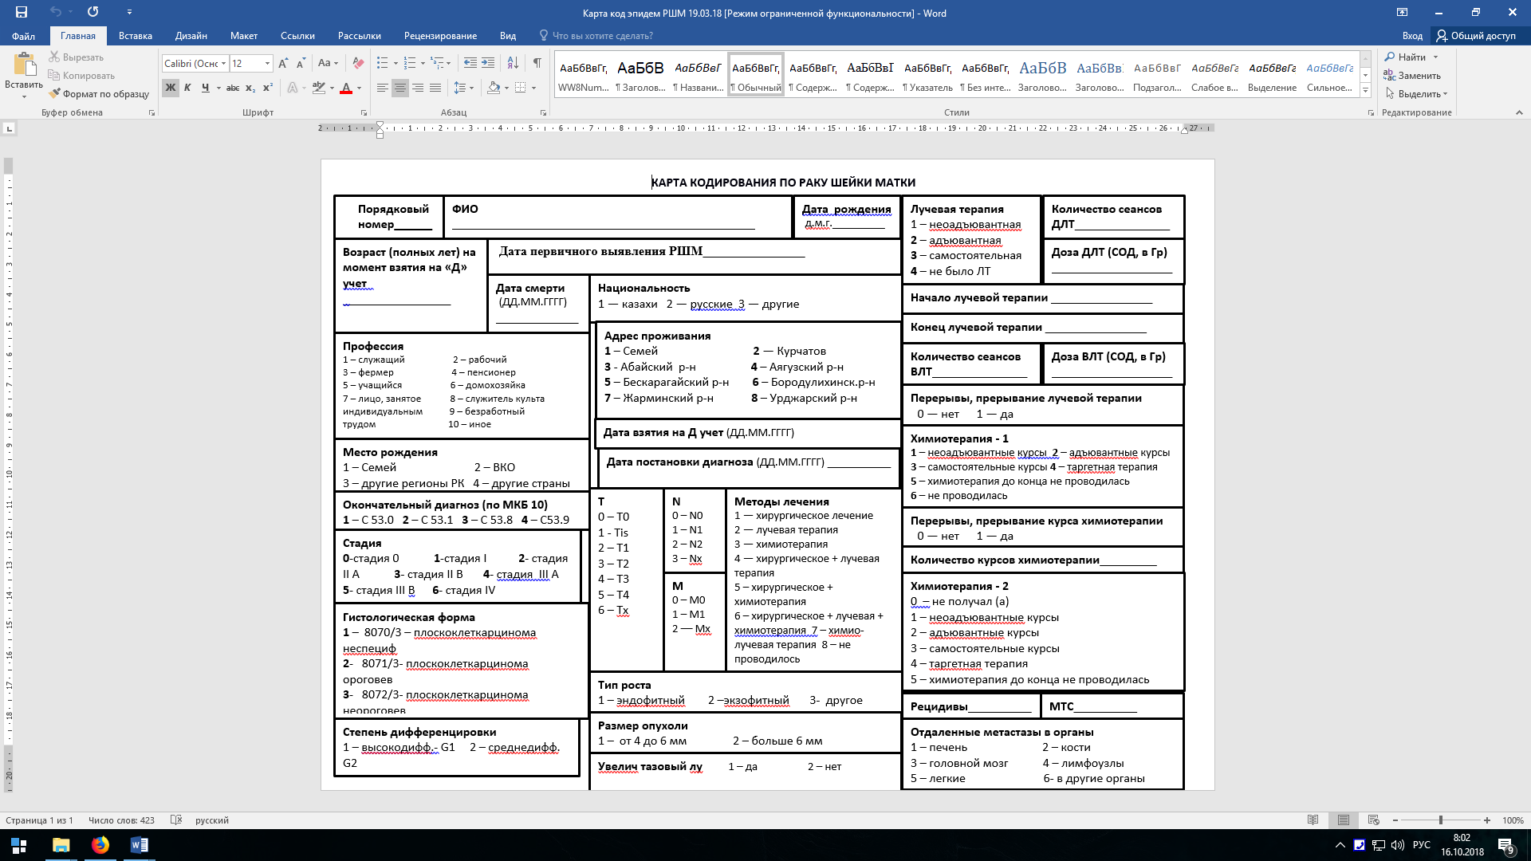
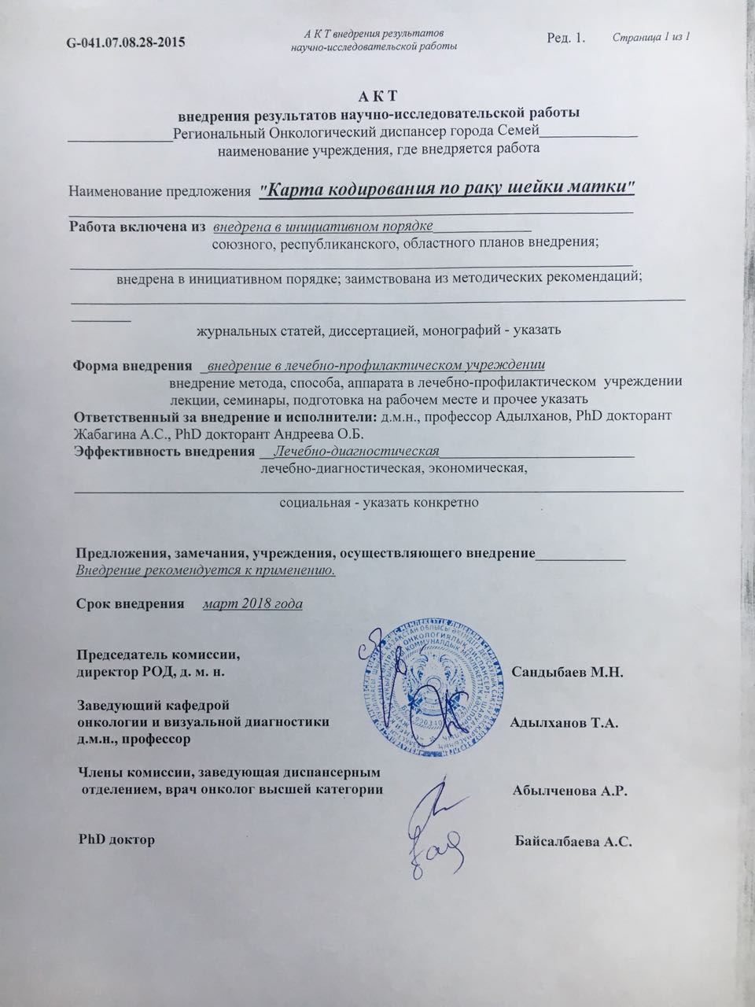

APPLICATION L

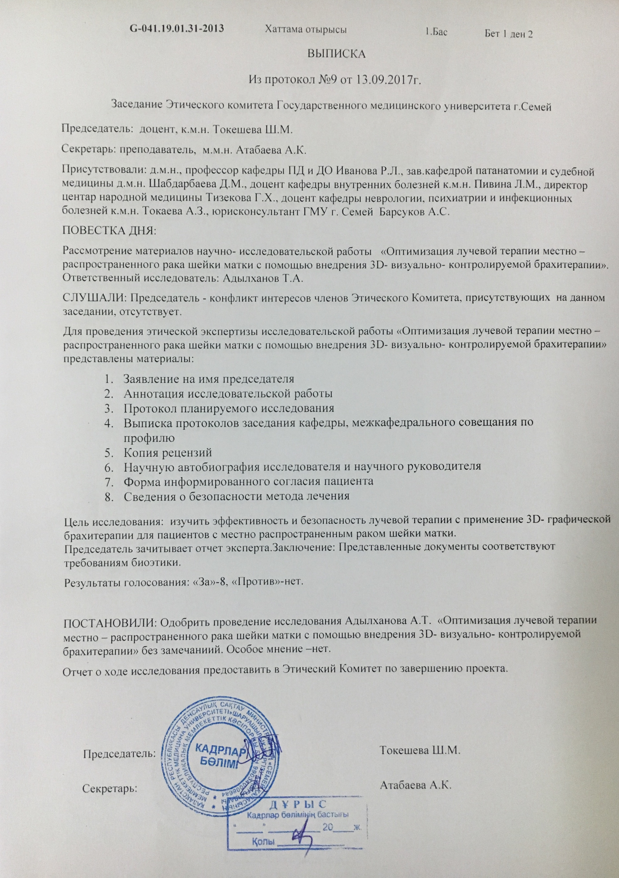

APPLICATION M

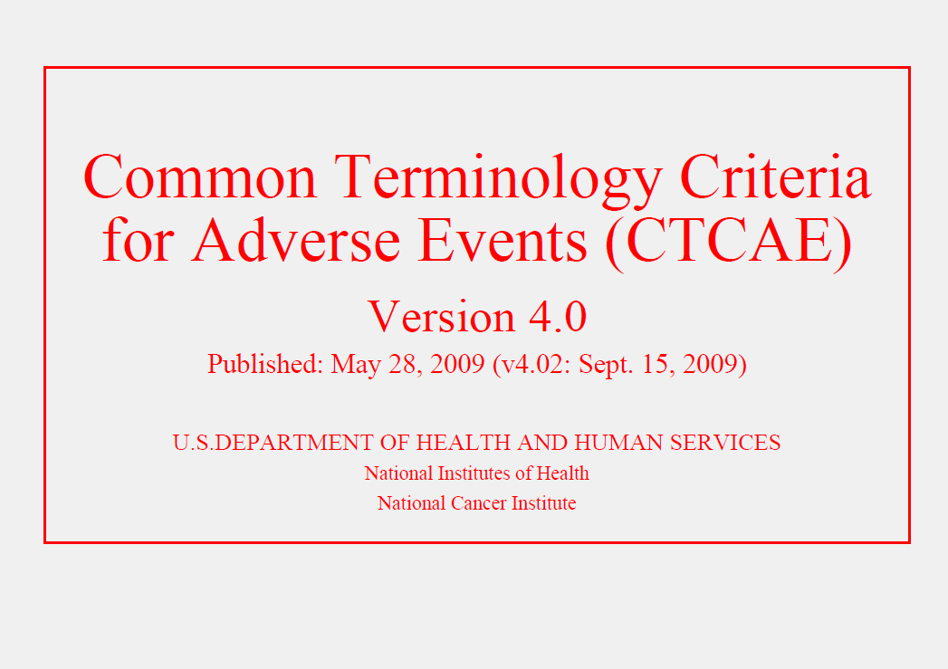

APPLICATION N

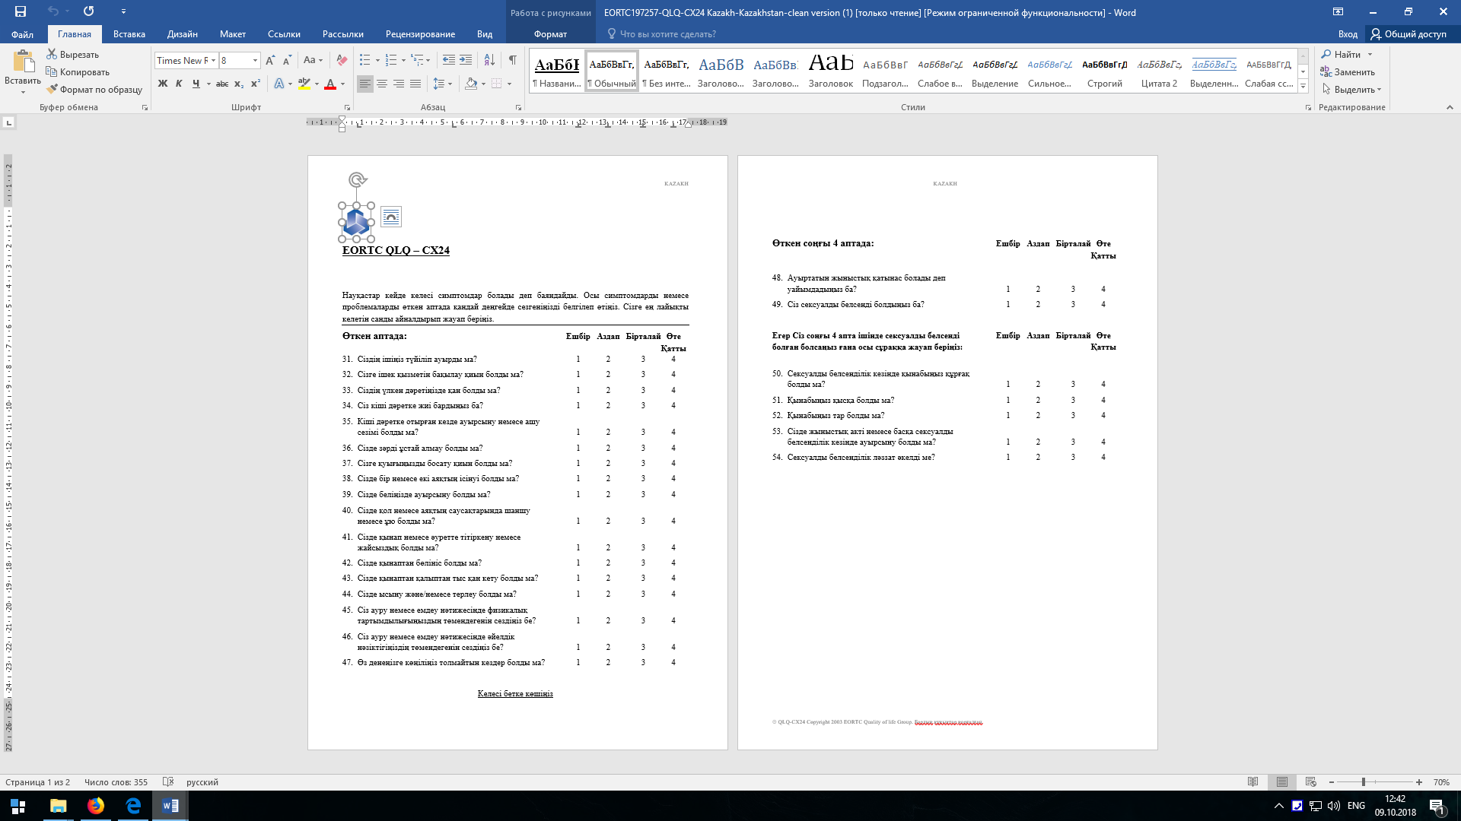

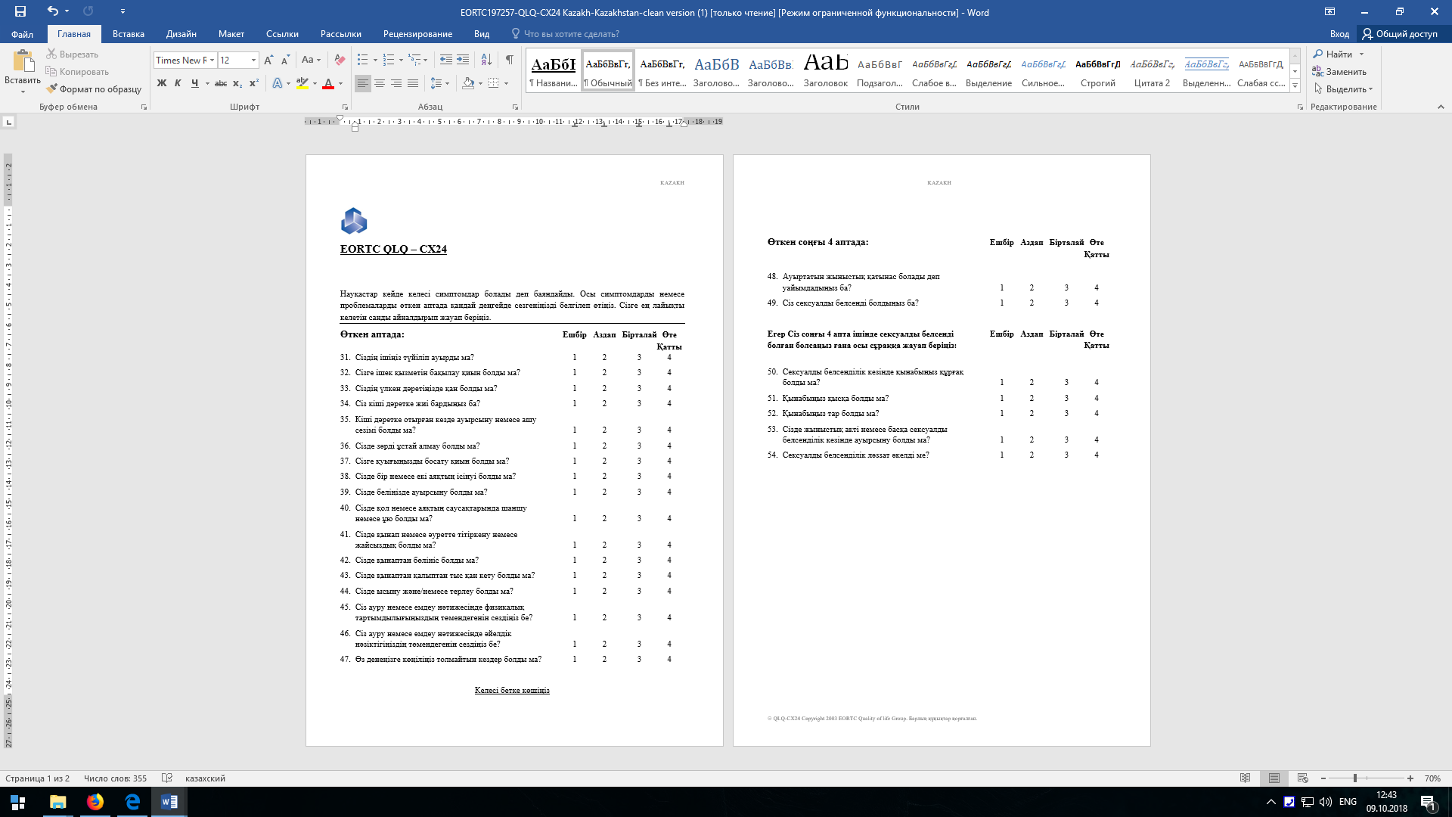

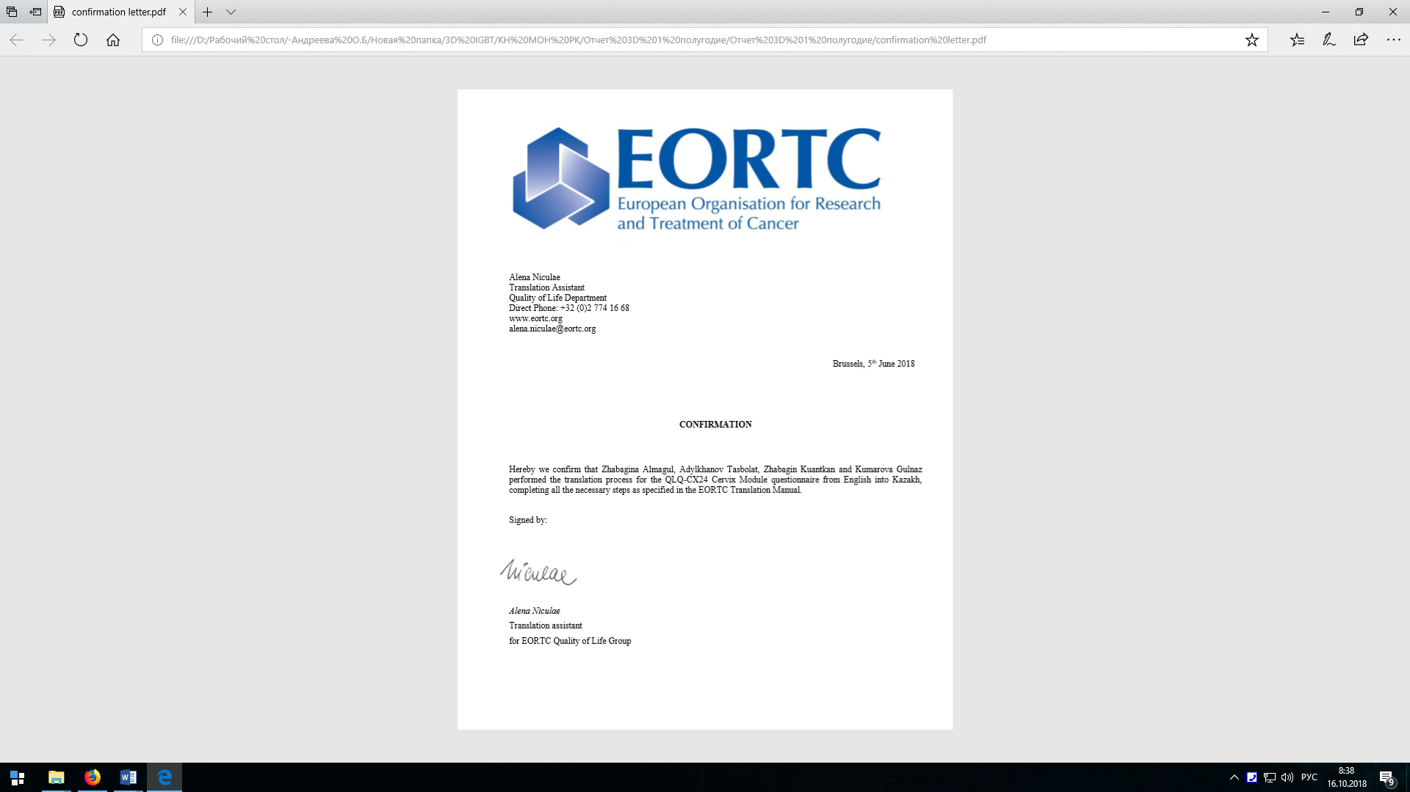

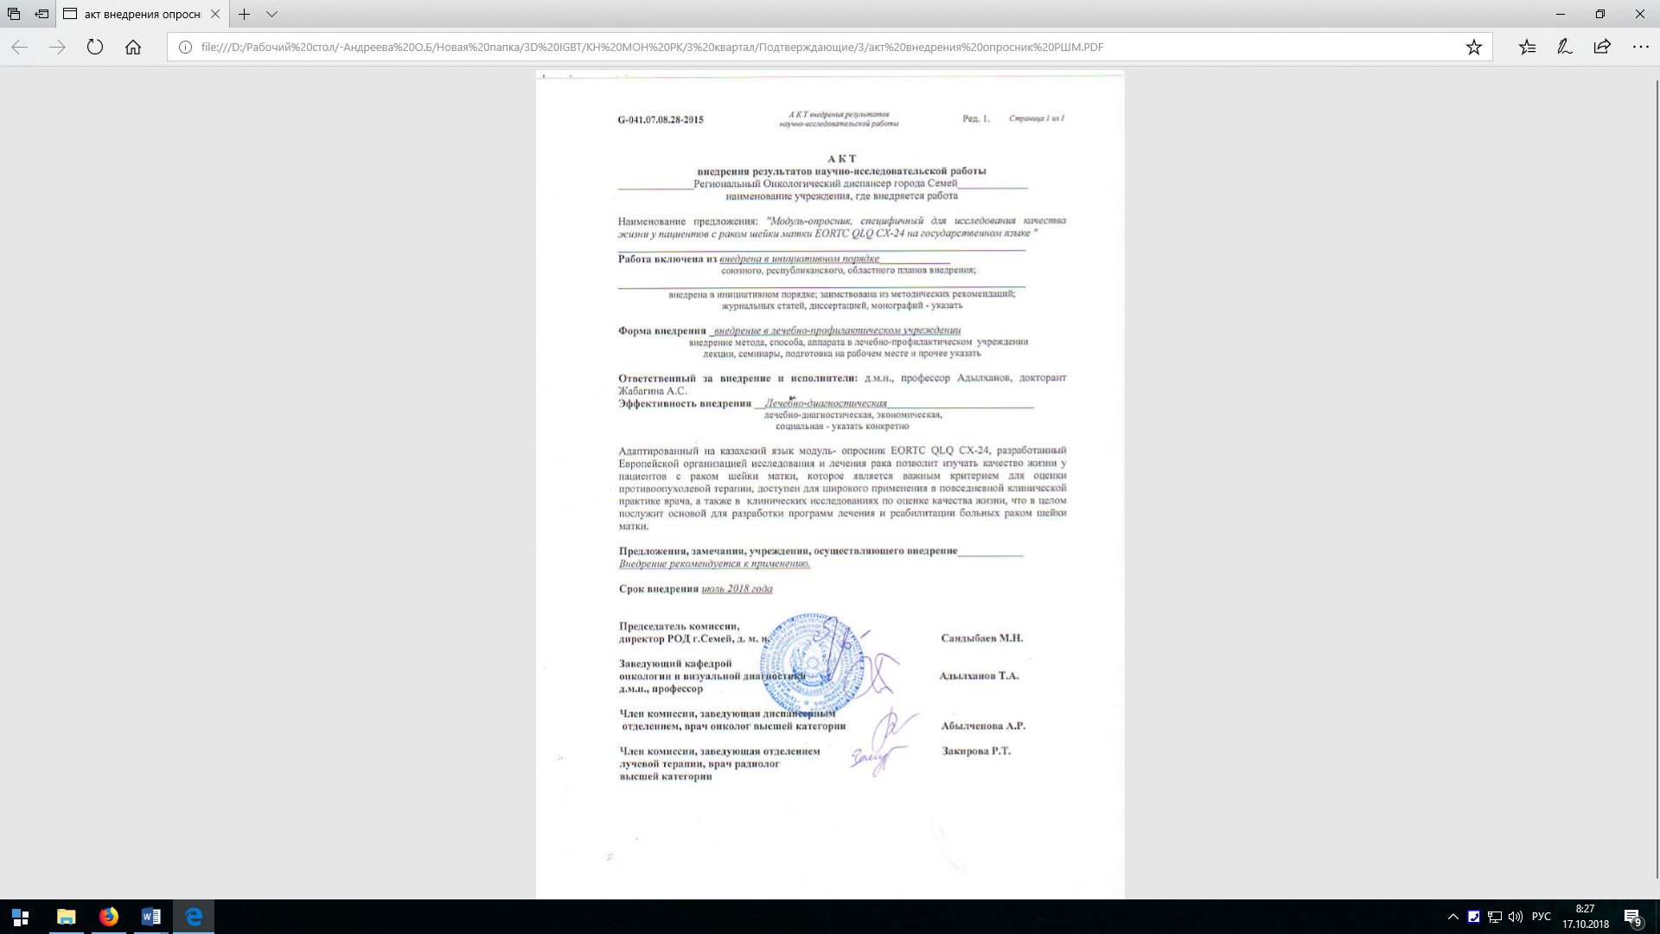

APPLICATION O
Статьи в рецензируемом зарубежном научном издании, индексируемом в базе данных Scopus и Web of Science:
- «Multi-institutional Observational Study of Prophylactic Extended-Field Concurrent Chemoradiation Therapy Using Weekly Cisplatin for Patients With Pelvic Node-Positive Cervical Cancer in East and Southeast Asia. International Journal of Radiation Oncology• Biology• Physics. – 2019. 183-189.
- Статья в медицинском научно-практическом журнале на тему «Preliminary survey of 3D image-guided brachytherapy for cervical cancer at representative hospitals in Asian countries» в журнале «Journal of Radiation Research» – 2020. pp 1-8, процентиль 67%, Q2, IF 2.014.
Статьи, опубликованные в журналах, рекомендованных ККСОН МОН РК:
- «Ретроспективный анализ заболеваемости раком шейки матки в Семейском регионе Восточно-Казахстанской области в период с 2013 по 2017 годы», журнал «Наука и здравоохранение», 2, 2018 V20. c. 54-66;
- Андреева О. Б. и др. Комплексная оценка общей токсичности при 3D-визуализируемой брахитерапии рака шейки матки //Наука и здравоохранение. – 2018. – №. 5. – Т.20 – с. 74-79.
- EORTC QLQ-CX24 сауалнама модулінің тілдік және мәдени бейімделуі (жатыр мойын обыры), «Вестнипк КазНМУ».
- Андреева О.Б., Адылханов Т.А., Жабагина А.С., Раисов Д.Т., Уразалина Н.М. Роль 3D-визуализации в программе лучевой терапии рака шейки матки. Обзор литературы // Наука и здравоохранение. 2019. 4 (Т.21). c. 5-19.
- «Роль компьютерно-томографической визуализации в программе подготовки и контроле эффективности лучевой терапии при новообразованиях шейки матки // Наука и Здравоохранение. 2020. 1 (Т.22). c.72-79».
Статьи в международно-практических журналах:
- «Эпидемиологическая оценка основных статистических показателей рака шейки матки в Республике Казахстан за десятилетний период (2008-2017 гг.)», г. Киев 2018, Мультидисциплинарный научный журнал «Архивариус», с. 32-36;
- "Качество жизни, ассоциированное со здоровьем при раке шейки матки" Мультидисциплинарный научный журнал «Архивариус» ISSN 2524-0935 №4 c. 18-22, Киев Украина.
- Андреева О.Б., Адылханов Т.А., Сабеков Е.О. [и др.] Социально-экономическая эффективность лучевой терапии с 3D-изображением при лечении местно-распространенных форм рака шейки матки // Интернаука: электрон. научн. журн. 2020. № 36(165). URL: http://internauka.org/journal/science/internauka/165 (дата обращения: 09.10.2020).
Тезисы:
- «Возрастная структура заболеваемости раком шейки матки в Восточно-Казахстанской области Республики Казахстан», материалы IV международного онкологического форума «Белые Ночи», г. Санкт-Петербург (3-8.07.2018 г.);
- «Первый клинический опыт внедрения 3D- визуализируемой брахитерапии в программу комплексного лечения местно-распространённого рака шейки матки» материалы IV международного онкологического форума «Белые Ночи», г. Санкт-Петербург (3-8.07.2018 г.);
- «Комплексная оценка общей токсичности при 3D-графической брахитерапии рака шейки матки», Журнал «Наука и здравоохранение» №5 (Т.20), 2018 г., ISSN 2410 – 4280, с. 13.
- «Comprehensive Assessment of Total Toxicitywith 3d-Imaged Guided Brachytherapy of Cervical Cancer», в материалах международной конференции «ICCCO 2018: 20th International Conference on Cancer and Clinical Oncology», Istanbul, Turkey, которая пройдет 20-21 декабря 2018 года.
- "Проявления острой и поздней токсичности при 3D-графической брахитерапии рака шейки матки", журнал "Наука и здравоохранение" (*рекомендован Комитетом по контролю в сфере образования и науки Министерства образования и науки Республики Казахстан), спец.выпуск, №1 (II), 2019, с.11.
- "Опыт внедрения метода 3D-планирования брахитерапии в программу лучевой терапии рака шейки матки: клиническая эффективность и экономические аспекты», материалы «X съезда онкологов России», 17-19.04.2019 г., г. Нижний Новгород, ISBN 978-5-9905908-5-4, с. 7
- «Дозиметрические аспекты внедрения брахитерапии с трехмерным изображением в программу комплексного лечения рака шейки матки», в материалах II Международного научного форума «Ядерная наука и технологии», 24–27 июня 2019 года, г. Алматы, РК, стр 233.
- "Оценка качества жизни, ассоциированное со здоровьем при раке шейки матки", в материалах V Петербургского международного онкологического форума «Белые ночи 2019», с. 295.
- «Метод визуализации с применением 3D-технологий при лчевой терапии рака шейки матки, в материалах V Петербургского международного онкологического форума «Белые ночи 2019», с. 307.
- «Предварительная оценка лучевых реакций раннего и позднего периола при применении 3D-планирования брахитерапии рака шейки матки» , Наука и здравоохранение, №4(I), 2019, Материалы XIV Международной научно-практической конференции "ЭКОЛОГИЯ. РАДИАЦИЯ. ЗДОРОВЬЕ» спец. выпуск с. 42.
- «Оценка ранней и поздней токсичности при применении 3D планирования на этапе брахитерапии в программе лучевой терапии рака шейки матки, "IX Съезд онкологов и радиологов стран СНГ и Евразии, 23 - 25 апреля 2020 г. г. Казань, Россия", Евразийский онкологический журнал №2, том 8, 2020, с.263.
- «Профилактика лучевых реакции со стороны органов риска при проведений лечения у пациенток с раком шейки матки» в сборнике тезисов VI Петербургского международного онкологического форума «Белые ночи 2020» с.189, ISBN 978-5-6043599-6-9.
- "Пути оптимизации лучевой терапии при раке шейки матки" в рамках Российской научно-практической конференции с международным участием (в режиме on-line) «Современные достижения в диагностике, хирургическом, лучевом и лекарственном лечении злокачественных опухолей», 10-11 июня 2020 года г. Барнаул, РФ, с. 38
- "Оценка эффективности лучевой терапии с 3D-изображением для оптимального выбора терапии пациентов с раком шейки матки" в рамках Российской научно-практической конференции с международным участием (в режиме on-line) «Современные достижения в диагностике, хирургическом, лучевом и лекарственном лечении злокачественных опухолей», 10-11 июня 2020 года г. Барнаул,РФ, сборник тезисов, c. 9.
- Тезис в сборнике международной конференции РК за рубежом для диссеминации основных результатов научной деятельности на тему «Организационные вопросы внедрения трехмерного планирования брахитерапии в протокол лечения местно-распространенных форм рака шейки матки» в сборнике тезисов VI Петербургского международного онкологического форума «Белые ночи 2020» с.188, ISBN 978-5-6043599-6-9.
- Тезис в сборнике международной конференции РК за рубежом для диссеминации основных результатов научной деятельности на тему «Анализ ранней и поздней токсичности при применении 3D-планирования на этапе брахитерапии рака шейки матки. Основы идентификации, профилактики и терапии»
Доклады на международных конференциях:
- Доклад в постерной секции по теме «Внедрение 3D-графической брахитерапии в программу комплексного лечения рака шейки матки» в рамках Российской научно-практической конференции с международным участием «Персонифицированные подходы к профилактике, диагностике и лечению злокачественных новообразований» (14-15.06.2018 г., г. Барнаул).
- Доклад на тему «Качество жизни: адаптация опросника EORTC у больных раком шейки матки в Республике Казахстан» в рамках IV Петербургского международного онкологического форума «Белые ночи-2018» (5-8.07.2018 г., г. Санкт-Петербург).
- «Метод 3D-визуализации при лучевой терапии рака шейки матки. Организационные и клинические аспекты», «Российская научно-практическая конференция с международным участием «Совеременные подходы к лечению основных локализаций злокачественных нообразований», 6-7 июня 2019 г., г. Барнаул, Российская Федерация.
- «Предварительные результаты оецнки ранних и поздних лучевых реакций при 3D-визуализируемой брахитерапии рака шейки матки», в рамках международной практической конференции «Современные направления развития клинической и радиационной онкологии. Мультидисциплинарные подходы», 22 мая 2019 г.
- «Дозиметрические аспекты внедрения брахитерапии с терхмерным изображением в программу комплексного лечения рака шейки матки» в рамках II международного научного форума «Ядерная наука и технологии», 24-27.06.2019 г.
- «Метод 3D-контроля брахитерапии рака шейки матки» в рамках Международной межвузовской научно-практической конференции «Инновации в сфере медицинской науки и образования», 17-19 октября 2019г., г.Чолпон Ата, Киргизская Республика.
- Результаты исследования доложены на международной научно-практической конференции (on-line) «Современные достижения в диагностике, хирургическом, лучевом и лекарственном лечении злокачественных опухолей», 10-11 июня 2020 года г. Барнаул,РФ с докладом на тему: "Оценка эффективности лучевой терапии с 3D-изображением для оптимального выбора терапии пациентов с раком шейки матки».
Прочее:
- Адылханов Т. А., Жабагина А.С., Жабагин К.Т., Андреева О. Б. Передовые интервенционные технологии в лечении рака шейки матки. – Учебное пособие. – г. Семей. – 2019 год.– 62 с.
- Рационализаторское предложение «Оптимизация лучевой терапии местно-распространённого рака шейки матки с помощью внедрения 3D-визуально-контролируемой брахитерапии» №2445 от 25.09.2019 г.
- Реализация научно-исследовательского проекта освещена в дайджесте мировой ядерной отрасли «Nuclear News», № 15-16 (759-760), 08.04.-22.04.2019 с использованием материалов WIN Global Weekly Industry News Briefing и NucNet, «Опыт международного сотрудничества в области радиационной онкологии Республики Казахстан на основе мирного использования ядерных технологий в рамках Форума по ядерному сотрудничеству в Азии (FNCA)», с. 15, www.nuclear.kz.

