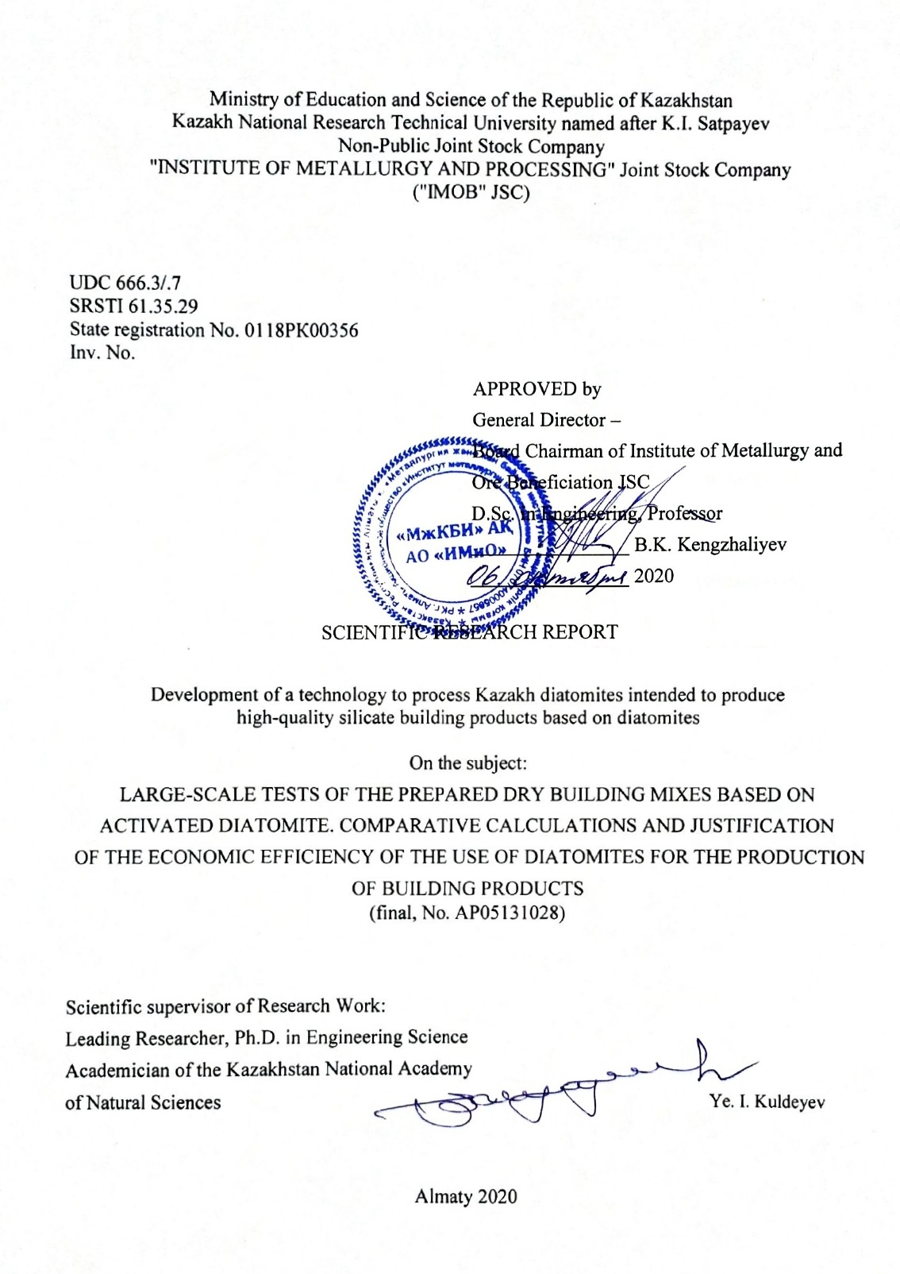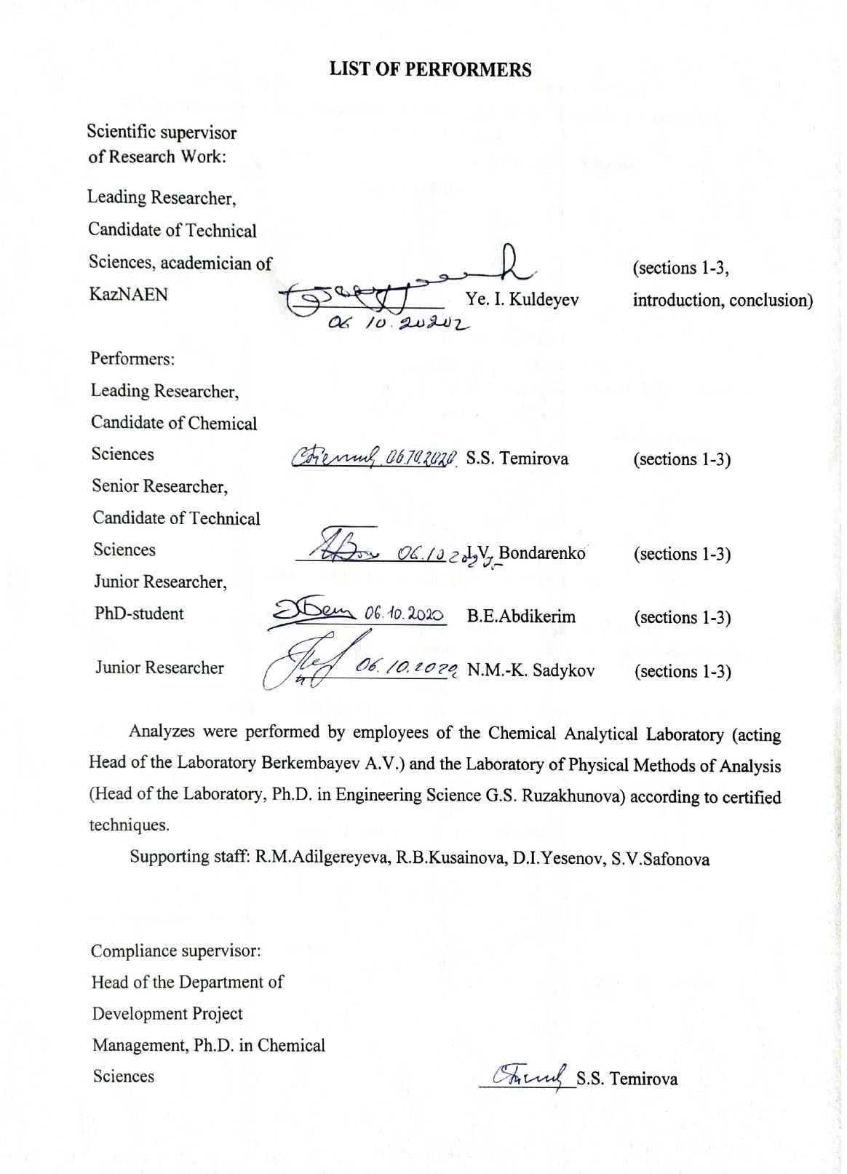

РЕФЕРАТ

Есеп 65 бет, 11 сур., 18 кесте, 20 әдеби деректерден тұрады, 6 қосымша
ДИАТОМИТТЕР, ӘК, БЕЛСЕНДІЛІК, СИЛИКАТТЫҚ КІРПІШ, ҚҰРЫЛЫС АРАЛАСҚАНДАР, СЫНАҚТАРДЫҢ КӨБЕЙУІ, АВТОКЛАВ, КҮШ
Зерттеу немесе өңдеу нысаны: Жалпақ кен орнының диатомиттері, Ақтөбе облысы.
Жұмыстың мақсаты: диатомиттерді активтендірілген диатомит негізіндегі құрылыс қоспаларының кеңейтілген зертханалық сынақтарын жүргізе отырып, олардың негізінде сапалы силикаттық құрылыс өнімдерін алу үшін өңдеу.
Жұмыс әдістері: алынған өнімдердің элементтік және сандық құрамын анықтау үшін химиялық, рентгендік фаза, рентгендік флуоресценция анализі.
Жұмыс нәтижелері және олардың жаңалығы. Диатомиттерді химиялық активтендіру бойынша зерттеулер жүргізілді. Үлкейтілген сынақтарға арналған диатомит негізіндегі темір оксиді пигменттерінің, көбік шыны, құрғақ құрылыс қоспаларының (ССС) және құрылыс кірпіштерінің үлгілері алынды. Автоклавта және автоклавсыз жағдайда диатомитті қолдана отырып, силикат кірпіштерін өндіру технологиясының ауқымды зертханалық сынақтары жүргізілді.
Жұмыстың жаңалығы сфералық пигменттердің ұнтағын алу процесінде табиғи диатомиттің физико-химиялық түрлендірулерін орнатуда, пенопласт әйнегін, силикат кірпішті өндіруде және геденбергит минералдары - Ca (Fe, Mg) Si₂O₆ және хлоритоид A - FeAl₂SiO₅ (OH)₂ түзілуімен CCC өндіруге арналған компонент.
Негізгі жобалық, технологиялық, техникалық және экономикалық көрсеткіштер. Таңдалған жабдық типтік болып табылады және жаңа өндірісті ұйымдастыруға сәйкес келеді. Диатомитті қайта өңдеудің техникалық-экономикалық көрсеткіштерінің салыстырмалы есептеулері кремнеземді құмды диатомитпен алмастырумен рентабельділіктің 5,3% -ға жоғарылағанын көрсетті.
Құрғақ қоспалар өндірісінде «ақ» күйені табиғи диатомитпен алмастырудың экономикалық тиімділігін анықтайтын есептеулер: NPV -36,42%, IRR-18%, өтелу мерзімі -6 жыл, жобаның кірістілігін және инвестициядан алынған кірісті негіздейді
Іске асыру дәрежесі. «ТНК Казхром» АҚ-на диатомит шикізатынан силикат кірпішін өндіру технологиясын «Лотос» ЖШС-де, ал «Сайлан Ақтөбе» ЖШС-де құрғақ қоспалар өндірісін әзірленген технология бойынша енгізу ұсынылды.
Қолдану саласы. Химия өнеркәсібі, құрылыс материалдары өндірісі.
Зерттеу объектісінің дамуы туралы болжамды болжамдар. Диатомиттер құрылыс индустриясындағы инновациялық технологиялардың перспективалы шикізат базасы бола алады.
Abstract

The report contains 65 pages, 11 figures, 18 tables, 20 references, 6 annexes.
DIATOMITES, LIME, ACTIVATION, SILICATE BRICK, BUILDING MIXTURES, LARGE-SCALE TESTS, AUTOCLAVE, STRENGTH
Objects of research or development: diatomites of the Zhalpak deposit in the Aktobe region.
Objective of the work: processing of diatomites to obtain on their basis high-quality silicate construction products and perform large-scale laboratory tests of building mixtures based on activated diatomite.
Research methods: chemical, X-ray phase, X-ray fluorescence analysis to determine the elemental and quantitative composition of the obtained products.
Results of the work. Research has been carried out on the chemical activation of diatomites. Samples of iron oxide pigments, foam glass, dry building mixtures (ССС) and building bricks based on diatomite for enlarged tests were obtained. Large-scale laboratory tests of the technology for producing silicate bricks using diatomite in autoclave and autoclave-free conditions have been carried out.
The novelty of the work lies in the establishment of physicochemical transformations of natural diatomite in the processes of obtaining powders of pigments of spherical shape, in obtaining foam glass, silicate bricks and a component for the production of CCC. X-ray phase analysis of the prototypes showed the presence of hedenbergite - Ca(Fe,Mg)Si₂O₆ and chloritoid A - FeAl₂SiO₅ (OH) ₂ in their composition.
Basic design, technological, technical and economic indicators. The selected equipment is typical and corresponds to the performance for the organization of new production. Comparative calculations of technical and economic indicators of diatomite processing with the replacement of silica sand with diatomite showed an increase in profitability of 5.3%.
Calculations to determine the economic efficiency of replacing "white" soot with natural diatomite in the production of dry mixes: NPV -36.42%, IRR-18%, payback period -6 years, justify the project's profitability and return on investment
The degree of implementation. It was proposed that TNK Kazchrome JSC introduce the technology for the production of silicate bricks from diatomite raw materials at Lotos LLP, and the production of dry mixes at the Sailan Aktobe LLP according to the developed technology.
Application area. Chemical industry, production of building materials.
Predictive assumptions about the development of the research object. Diatomites can become a promising raw material base for innovative technologies in the construction industry.
CONTENTS

INTRODUCTION........................................................................................................... | 6
MAIN PART OF RESEARCH WORK........................................................................... | 11
1 Laboratory studies to develop technology for the diatomite ore activation................................................................................................................... | 11
2 Development of prototypes of products based on chemically activated diatomite for further testing as a component of construction products............................................ | 15
3 Large-scaled tests of the accumulated dry building mixtures based on activated diatomite. Comparative calculations and justification of the economic efficiency of the use of diatomites intended to produce construction products........................................................................................................................ | 18
3.1 Large-scaled comparative tests of standard silicate bricks based on diatomite as a silica component using autoclave-free technology. Selection of recipes.......... | 18
3.2 Large-scaled tests of dry building mixtures based on diatomite………………… | 22
3.3 Comparative calculations of the economic efficiency to process diatomite ore and the release of autoclave-free silicate bricks on its basis............................... | 25
3.4 Determination of the economic efficiency of the production of dry building mixtures based on diatomite................................................................................ | 30
CONCLUSION …………………………………………………………...................... | 35
LIST OF THE REFERENCES USED ……………………........................................... | 40
ANNEX А Certificate of large-scale laboratory tests of dry building mixtures based on diatomite dated 28.09.2020……………………………………………….. | 42
ANNEX b List of the published works …………………………….......................... | 47
ANNEX C Calendar plan.............................................................................................. | 49
ANNEX D Supplementary Agreement.......................................................................... | 53
ANNEX e Review ……………………………………………..................................... | 63
ANNEX F Extract from the minutes of the the Academic Council.................................. | 65
INTRODUCTION

Assessment of the current state of the scientific and technical problem being solved. A review of modern research and technologies on the diatomites use as silicate additives in building materials showed that work in this direction is actively performed in industrialized countries, some of them are at the stage of practical implementation.
Diatomite that is a natural hydrated silicate, attracts more and more attention from scientists and specialists. A number of studies have been performed for the diatomites use as a pozzolanic additive and replacing part of the cement in concrete solutions. Chinese researchers propose to create a lime composition from diatomite and masonry waste powder as a filler in the preparation of solutions to save energy resources [1]. The introduction of diatomite reduced the density of the solutions, and also reduced the total amount of raw materials used, especially lime, while receiving the same volume of solutions. Replacing some of the lime with diatomite increases the compressive and flexural strength of hydraulic fluids. The authors [2] noted an improvement in the quality of cements and other building products with the introduction of diatomite additives.
Specialists from Dumlupınar University (Turkey) performed studies to use raw and calcined diatomite that has an amorphous and porous nature, in the production of cement [3]. Under the test results, mixed cements based on crude diatomite showed comparable strength values in relation to the reference cement before the addition of 10% additive; a further increase resulted in a decrease in strength due to the higher water absorption associated with the porosity of the material, while the Blaine and reactive SiO₂ values ​​increased. Calcination changed the porous diatomite structure and made it easier to grind and more efficiently used as a cement additive.
A set of studies was performed at the University of Tabriz (Iran) to study the properties of cement slurries containing a large volume of untreated diatomite powder as a replacement for cement [4]. The results obtained show a sharp reduction in the cost of cement and the cost of producing concrete based on it, as well as a decrease in the degree of environmental pollution caused by CO₂ emissions from cement plants. The test results showed that diatomite powder can be used as a cement substitute up to 40% without significant losses in compressive strength, and also improves tensile strength and prolongs the period of transportation of cement slurries to construction sites.
The comparative studies of construction and technological characteristics of dry building mixtures with various natural and man-made active mineral additives were performed in [5] to assess the effectiveness of the use of activated diatomite. The obtained data relate to the technology of production of dry building mixtures based on Portland cement binders.
Such valuable qualities of diatomite as high porosity and a significant content of active, partially hydrated SiO₂ that increase the pozzolanic number of cement and reduce its weight are used in the above studies.
Diatomites in compositions with lime can also act as independent components in the production of lime solutions and products. A number of studies performed by Russian scientists are devoted to the diatomites use to create formulations for dry building mixtures using various modifying additives.
It is shown in [6] that the strength parameters of lime-diatomite solutions depend on the fineness of grinding of the components. The dynamics of strength development is significantly influenced by the ratio of lime and activated diatomite.
It is known that the diatomite activity is determined by the content of substances in the diatomite in a chemically active form. Besides silica, diatomite contains crystals of salts of calcium, sodium, iron, aluminum, organic matter (up to 9%). Several methods of diatomite activation have been proposed in [7 - 10]. Its surface was modified by treating it with sodium hydroxide and soda ash to activate the diatomite. It was found that the activation of diatomite with alkali results in a significant increase in the compressive strength of calcareous-diatomite composites.
The authors of [11] have developed the compositions of a lime heat-insulating dry building mixture intended to finish the walls of buildings with the use of modified diatomite. Coatings based on the developed mixture are characterized by good applicability, high adhesive strength, amounting to 1.4-1.6 MPa.
In work [12] studied the possibility to use diatom deposits of the Inza region as a component of dry lime mixtures. Activation methods were used to increase the rediatomite activity to change the surface diatomite activity and its chemical composition. Diatomite was activated thermally by heating at various temperatures and chemically by treatment with silicic acid. Modification of diatomite with a silicic acid sol increases the content of silica, enhances the hydrophilic properties of its surface, reduces pore size, and increases its activity as a mineral additive.
Research under this project was based on theoretical work performed under the guidance of J.A. Khint (Estonia) for the synthesis of silicalcites [13]. The chemical interaction of silica and calcium hydroxide proceeds under the following reaction (1):

SiO₂ + 2 Ca(OH)₂ + n(H₂O) = 2CaO.SiO₂.(n+1)H₂O (1)

The speed and completeness of the course of this reaction mainly depends on the activity of its components. It is proposed to disintegrate it to a particle size of several nanometers and to interact by strong compression and preferably in a steam atmosphere in autoclaves to activate quartz sand. J.A. Khint developed disintegrator designs to crush river sand to a size of several nanometers.
Diatomite is an important component in the formulation of DBMs as acid additives. When mixed in finely ground form with air lime, they give it the properties of a hydraulic binder, and when mixed with Portland cement, they increase its sulfate resistance [14].
Kazakhstan is one of the countries with huge reserves of diatomite raw materials, the bulk of them are located in the Mugolzhar district of the Aktobe region. From the group of Kazakhstani diatomite deposits, the Zhalpak deposit is distinguished as it is characterized by surface occurrence and proximity to the large railway station of Emba. Therefore, diatomites of this deposit are an important object of study, both scientifically and practically, to obtain a whole range of industrial materials on their basis, including high-quality silicate construction products.
Basis and initial data for the topic development. The prerequisites for the need to perform the research and development work under this project is the practical absence of enterprises to process diatomite raw materials in Kazakhstan with relatively significant reserves and ease of opencast mining. The diatomites use will increase, as evidenced by the experience of the use of this raw material in construction and other industries of economically developed countries.
Information about the planned scientific and technical development level, patent research and conclusions from them. The analysis of scientific, technical and patent literature on the production of iron oxide pigments from industrial products and wastes of the steel and machine-building industries that indicates the novelty of the proposed technology to produce ultradispersed iron oxide pigments with a spherical shape of particles. A method is proposed for the first time to obtain a modern heat-insulating material of foam glass based on diatomite and an alkali-silica solution formed during the processing of ash after burning Ekibastuz coals. Based on research performed in the world for the diatomites use in the production of silicate building products, new technological solutions have been developed to produce silicate bricks and dry building mixtures.
Information about the metrological support of the research work. The laboratory of alumina and aluminum of the IMOB JSC that performed research on the project, is equipped with the required technological equipment: grinding equipment, granulators, kilns, autoclaves. The analysis of the raw materials and the resulting products and materials was performed by the accredited National Scientific Laboratory of IMOB JSC for the priority "Technologies for the hydrocarbon and mining and metallurgical sectors and related service industries."
Relevance. The project relevance is in the demand for technologies to produce iron oxide pigments and modern building materials (foam glass, silicate bricks, dry building mixtures) based on Kazakhstani diatomite raw materials. The research results will enable, due to the involvement of domestic technological silicon-containing raw materials in industrial production, to increase the production of construction products at enterprises (Lotos Aktobe LLP, Aktobe Ferroalloy Plant JSC, Koktas-Aktobe JSC and SBS Group, Aktobe LLP, etc.)
The topic novelty is in the development of a fundamentally new technology to produce high-quality construction products based on Kazakhstani diatomite raw materials. The technology is based on the results of physical and chemical studies of the behavior of natural diatomite in the processes intended to obtain powders of iron oxide pigments, foam glass, silicate bricks and dry building mixtures. The presence of such compounds as hedenbergite - Ca(Fe,Mg)Si₂O₆ and chloritoid А – FeAl₂SiO₅(OH)₂ in the composition of silicate bricks provides an increase in their strength characteristics.
The relationship of this work with other research works. This project has a relationship with the project "Development of an integrated waste-free technology to process refined ferrochrome slags at Aktobe Ferroalloy Plant JSC to obtain metal concentrate and construction products", since high-strength chrome pellets suitable for melting in furnaces on ferrochrome were obtained using diatomites.
Goals and objectives of the research, their place in the implementation of research in general. The goal of the project is to develop a technology to process diatomites intended to produce high-quality silicate building products on their basis.
The goal of the research phase for 2020 is to test the accumulated dry building mixtures based on activated diatomite; comparative calculations and justification of the economic efficiency of the use of diatomites intended to produce construction products.
Phase 2020 includes the following objectives:
- large-scale comparative tests of standard silicate bricks and diatomite-based bricks as a silica component using autoclave-free technology. Selection of recipes;
- large-scale tests of dry building mixtures based on diatomite;
- comparative calculations of the economic efficiency of diatomite ore processing and the production of autoclave-free silicate bricks on its basis;
- determination of the economic efficiency of the production of dry building mixtures based on diatomite.
The research results for the previous stages are presented in interim reports:
- "Laboratory research to develop technology to activate diatomite ore", 2018, Inv. No. 0218RK00439;
- "Development of prototypes of products based on chemically activated diatomite for further testing as a component of construction products", 2019, Inv. No. 0219RK00472.

MAIN PART OF RESEARCH WORK

1 Laboratory studies to develop technology for the diatomite ore activation

Choice of the research direction. The diatomites use that, due to their porosity, have high thermal insulation characteristics, manufacturability during grinding operations, and chemical activity, is increased in modern technologies.
The choice of research direction is determined by the fact that there is no technological base for their processing in Kazakhstan, with large reserves of diatomite raw materials.
Research methods. The dispersion, chemical, X-ray phase, X-ray fluorescence analyzes, BET-analysis, electronic and Mössbauer spectroscopy were used in the process of research.
The samples of diatomite ore were taken for laboratory research at the first stage of 2018 (Zhalpak plateau, Aktobe region). Physical and chemical analysis of samples of diatomite raw materials was performed.
The samples represent a porous, low-strength, easily disintegrating rock, the color of which changes from white to yellow. Samples of raw materials located on the surface of hills are more durable. They have an intense yellow color, sometimes turning yellow-brown, and contain a significant amount of iron hydroxide compounds.
Samples of diatomite raw materials are characterized by a significant variation in chemical composition. The SiO₂ content ranges from 73.087% in white raw materials to 25.845% in yellow (ocher-like) ones. The Fe₂O₃ content varies from 2.356% to 30.405%. The change in the content of minor components (Na₂O, MgO, Al₂O₃, K₂O, CaO, etc.) is insignificant. A slightly increased content of vanadium, rubidium and strontium compounds was noted but they are not of interest for their targeted extraction as concentrates.
X-ray phase analysis was performed on a D8 Advance diffractometer (BRUKER), a-Cu radiation to study the mineral composition of diatomite raw materials. It was found that the main phase in all samples of diatomite raw materials is quartz and muscovite. (Table 1).

Table 1 – X-ray Phase Analysis of Low Iron Diatomite Raw Materials

Component | Formula | Mass. % .
Quartz | SiO₂ | 42.9
Halite | NaCl | 17.9
Montmorillonite | (Ca,Na)_{0.3}A_{l2}(Si,Al)₄O₁₀(OH)₂·xH₂O | 15.6
Muscovite | H₄K₂(Al,Fe)₆Si₆O₂₄ | 12.8
Kaolinite | Al₂(Si₂O₅)(OH)₄ | 10.7

The topological characteristics of natural diatomites were determined as presented in Table 2.

Table 2 – Topological characteristics of natural diatomites

Description of characteristics of samples  No. 1001-1008 (the Zhalpakskoye deposit) | Parameters
Organogenic impurities and moisture,% | 9
Particle size, μm | 0.260-0.504
Coordination number | 2.7÷3.2
Fractal dimension of structural inhomogeneities, D_{s} | 2.78
Linear dimensions of structural inhomogeneities of the particle surface. R₁ HM | 3.9
Specific surface, m²/g | 10.0

The results of the physical and chemical analysis of diatomite ore show the possibility to use it as a raw material to obtain construction products.

Table 3 shows the physical and mechanical characteristics of natural diatomites.

Table 3 – Physical and mechanical characteristics of diatomites

Description of characteristics of samples  No. 1001-1008 (the Zhalpakskoye deposit) | Parameters
True density, kg/m³ | Up to 2200
Bulk density, kg/m³ | 250-400
Porosity,% | 82-89
Humidity,% | 5.0
Compressive strength, kg/cm² | 52.3-62.8

Research on the chemical activation of diatomites, determination of the optimal process parameters. The interaction of various forms of diatomite raw materials with calcium oxide was studied to improve the quality parameters of building products.
The mechanical grinding of the diatomite in the IV-3 abrasive was performed for 60 minutes. and thermal activation of ferruginous varieties to activate the diatomite in a laboratory furnace at a temperature of 600 °C for 1 hour, followed by grinding in an IV-3 grinder for 60 minutes. Mechanical grinding in a grinder enable to achieve an average effective particle size of 70-80 microns. Particles sized 5-10 nm were obtained during abrasion of fired ferruginous diatomite, that contributes to the formation of high-strength compounds: hedenbergite Ca(Fe, Mg) Si₂O₆ and chloritoid-A - FeAl₂SiO₅ (OH)₂. The optimal process parameters of chemical activation of diatomites are thermal activation of ferrous forms of diatomite enable to achieve compressive strength of 25.2 MPa, water absorption was 4.3%.
Work to use diatomite as an active mineral additive in obtaining construction products is actively performed by foreign scientists [15-17].
We propose a technological solution that differs from the classical DBM formulations based on cement and cement-gypsum mixtures that consists in replacing them with silicocalcites, including hydrated ferrosilicalcites. High-iron varieties of diatomite raw materials (flasks), containing from 20 to 30% Fe₂O₃, were used for the synthesis of ferrosilicocalcites. Flasks were crushed to a size less than 0.1 mm. One batch was fired in a laboratory muffle furnace at a temperature of 600 °C for 1 hour, the other batch was not thermally activated. Both batches were subjected to grinding in a laboratory grinder IV-3 to a particle size of 30-40 nm. Raw and thermally activated diatomite was mixed with cement powder, lime in mass proportions of 10: 1: 3 and in a number of experiments with gypsum. Gypsum with Grade "h" (up to 5 wt.%) was used as a plasticizer when receiving a part of the compositions. The mixture was sealed with water at L:S = 1: 5.
Compositions with calcined diatomite and gypsum showed high plasticity when applying a layer of plaster, its fast adhesion and strength when held on a vertical surface. Rapid setting of the plaster layer is due to the formation in the solution of complex hydrated iron-calcium silicates of the hedenbergite type - Ca (Fe, Mg) Si₂O₆ and chloritoid - A - FeAl₂SiO₅ (OH)₂.
Laboratory tests of prototypes of cubes and dry building mixtures using thermally activated diatomite are shown in Figure 1.

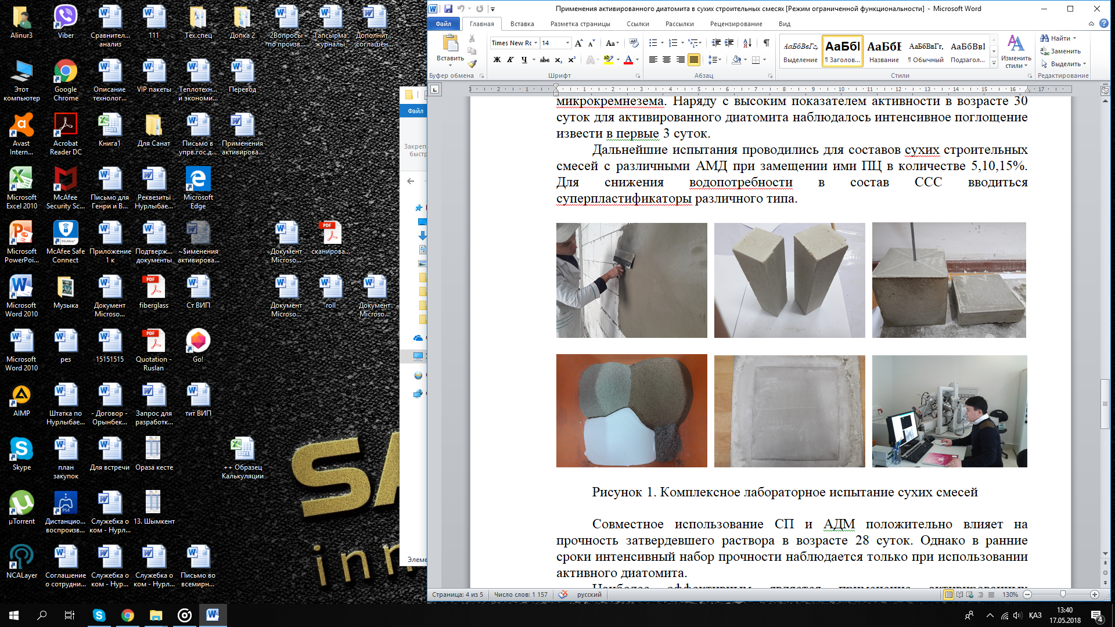

Figure 1 – Comprehensive laboratory tests of cube and dry samples
building mixtures using thermally activated diatomite

Thus, the possibility to use activated diatomite in technologies to obtain construction products has been studied. Comparison with the standards given for silicate bricks and stones in the Interstate Standard GOST 379–95 enables us to confidently assume that the use of diatomite as a silicate component enables to achieve the M 70 grade of building products even without the use of autoclave conditions. The possibility to obtain plaster mortar based on diatomite is confirmed. The obtained samples of cubes using thermally activated diatomite, especially its high-iron forms, correspond to or slightly exceed the standard parameters of GOST 379–95 applied to silicate stones and bricks. Compressive strength class was SC IV. Average dry density was 1482 kg/m³. The adhesion strength to the base is 0.42 MPa [18-20].

2 Development of prototypes of products based on chemically activated diatomite for further testing as a component of construction products

Representative samples of white (low-iron) diatomite ore (Zhalpak plateau, Aktobe region) weighing 300 kg were taken for pilot tests. Studies of the physical and chemical analysis of a diatomite ore sample with the determination of the main physical and technical parameters of the material (water absorption, thermal conductivity, frost resistance, environmental safety, etc.) were performed.
Research has been performed on the possibility intended to obtain components of construction products from diatomite raw materials: iron oxide pigments to produce corrosion-resistant paints and foam glass - a heat-insulating filler.
The chemical composition of the ferruginous varieties of diatomites from the Zhalpak deposit indicates that they can serve as raw materials to produce iron oxide pigments.
The data of scanning electron microscopy of powders obtained after preliminary drying, grinding and calcining of ferruginous diatomite showed the presence of highly dispersed particles (5-10 µm in size) of a spherical shape. Achievement of high dispersion of particles is explained by the physical nature of diatomites that are weakly bonded conglomerates of particles with sizes of several nanometers (Figure 2).

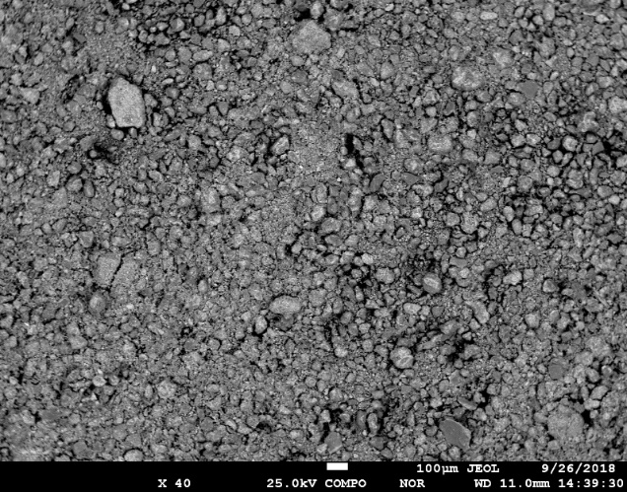
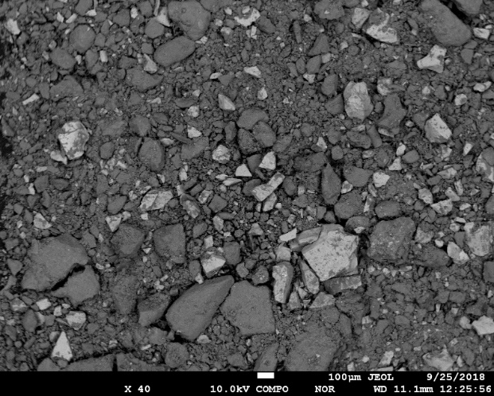
а) sample No. 1 b) sample No. 2

Figure 2 – Forms and sizes of particles of iron oxide pigments

BET analysis of the samples showed an increase in the specific surface area and total pore volume in the sample obtained by calcining and regrinding calcined diatomite. An increase in these parameters contributes to an increase in dispersity, hiding power, chemical resistance, especially when coloring cement mortars. Pigments with a high silica content have a significantly lower density than pigments that are almost entirely composed of iron oxide.
Mössbauer and X-ray phase analysis established the presence in the calcined sample of the obtained powder of hematite (α-Fe₂O₃ oxide) and goethite (α -FeOOH hydroxide) - the main components of iron oxide pigments currently produced by industry (Figure 3).

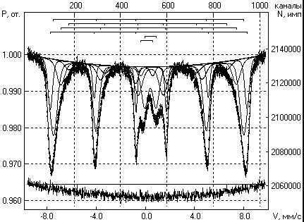 | 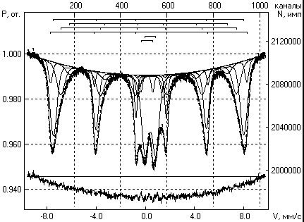
а) sample No. 1 | b) sample No. 2
Figure 3 – Mössbauer spectra of iron oxide pigments

Prototypes of foam glass were obtained using diatomite and silicate solutions. Diatomite was mixed with an alkali-silica solution obtained by chemical enrichment of ash from the combustion of Ekibastuz coals, and the mixture was subjected to heat treatment at a temperature of 1200 °C for 60 minutes. to obtain prototypes of foam glass. The results of experiments to obtain foam glass products from alkali-silica solutions and diatomite are given in Table 4 and Figure 4.

Table 4 – The results of experiments to obtain foam glass products from alkali-silica solutions and diatomite

Experiment No. | Diatomite,  g | Shubar-Kul  coal,  g | ASS,  ml | molar correlation SiO_{2 diatomite} /SiO₂ _{ASS} | Product type | Firing temperature,  ^{о}С | Specific gravity,  kg/dm³ | Tensile strength  for compression  N/cm²
1 | 100 | 2 | 30 | 0.01 | press. | 950 | 1.59 | 981
2 | 100 | 2 | 60 | 0.02 | press. | 950 | 1.61 | 863
3 | 100 | 2 | 90 | 0.03 | press. | 950 | 1.65 | 785
4 | 100 | 10 | 30 | 0.01 | press. | 1050 | 1.11 | 686
5 | 100 | 15 | 30 | 0.01 | press. | 1100 | 0.95 | 588
6 | 100 | 20 | 30 | 0.01 | press. | 1100 | 0.78 | 655
7 | 100 | 20 | 30 | 0.01 | pellet | 1100 | 0.70 | 624
8 | 100 | 20 | 30 | 0.01 | pellet | 1150 | 0.72 | 568
9 | 100 | 20 | 30 | 0.01 | pellet | 1200 | 0.84 | 554

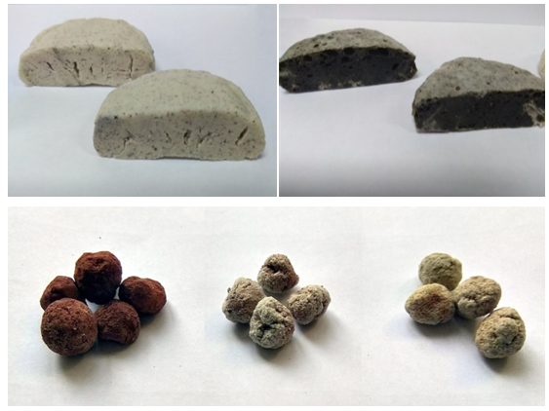

Figure 4 – Prototypes of foam glass from a solution of ASS and diatomite

A simple process flow diagram for the utilization of an alkali-silica solution, a middling product of the process intended to obtain alumina from coal ash of Ekibastuz power-generating coals, is proposed BASED on the studies performed. The conditions to obtain foam glass from ASS and natural diatomite have been determined. The technical parameters of the foam glass correspond to the characteristics of modern thermal insulation materials for construction.
Large-scale laboratory tests were performed on the production equipment of Sailan-Aktobe LLP with the determination of technological parameters to produce batches of autoclave-free and autoclave silicate bricks, dry building mixtures for further work.

3 Large-scaled tests of the accumulated dry building mixtures based on activated diatomite. Comparative calculations and justification of the economic efficiency of the use of diatomites intended to produce construction products

3.1 Large-scaled comparative tests of standard silicate bricks based on diatomite as a silica component using autoclave-free technology. Selection of recipes

Samples of fired diatomite with a low iron content in the amount of 110 kg and 100 kg of lump quicklime were prepared for tests. Lime corresponding to GOST 9179-2018 [17] was crushed to a particle size of -2 mm.
Chemical compositions of samples are given in Table 5 and 6.

Table 5 – Chemical composition of calcined diatomite

Sample | Na₂O | MgO | Al₂O₃ | SiO₂ | S0₃ | K₂O | CaO | TiO₂ | Fe₂O₃ | Cl | Others
No. 1 | 0.96 | 0.95 | 8.55 | 77.2 | 0.15 | 0.85 | 0.45 | 0.63 | 3.85 | 0.40 | 6.01

Table 6 – The chemical composition of construction lime

Chemical composition | Rate for lime, wt.%
 | Weakly hydraulic | Strong hydraulic
Active CaO + MgO:
- not more | 65 | 40
- not less | 40 | 5
active MgO, not more | 6 | 6
CO, not more | 6 | 5

The required amount of diatomite and slaked lime was calculated based on the production of 2CaO To fill one 50x50x50mm cube: SiO₂ with a molar ratio of calcium oxide to silicon oxide in a mixture of 2: 1. Changing the ratio up to 10%, taking into account the content of the components. The calculated ratio is 400 g of diatomite per 144 g of quicklime, taking into account 77% SiO₂ content in diatomite and 45% CaO in quicklime.
Before mixing, the lime was slaked with distilled water. Slaked lime for 1 hour was naturally cooled at room temperature and thoroughly mixed with diatomite. The resulting mixture is filled into the forms of building blocks. The molded cubes are kept for 28 days at a temperature of 25 °C in a laboratory room, and then the mixture is pressed at a pressure of 2 t/cm² in a hydraulic construction press. After the expiration of the exposure period, the cubes are removed from the metal mold and subjected to strength testing under the arithmetic mean of 5 identical samples on a laboratory measuring press MIP-25R (Figure 5).

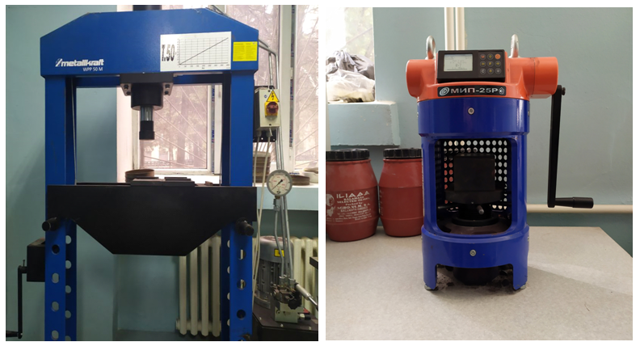
а) Hydraulic press  MetallkraftWPP-50M | b) Measuring  press MIP-25R

Figure 5 - Equipment for testing building blocks

The results of tests to determine the crushing strength of cubes are shown in Figure 6.

Figure 6 – Results for determining the strength of cubes depending on the exposure time and molar ratio 2CaO:SiO₂

Studies to determine the crushing strength of cubes obtained under autoclave-free conditions showed that the maximum strength for 28 days was achieved for a molar ratio of 2CaO to SiO₂ = 1: 1, and is 8.5 MPa that corresponds to a low grade of M70 brick. Under autoclave-free conditions, it is impossible to obtain bricks of grade M100 and higher.
The second stage of the research was performed under autoclave conditions to increase the strength of the silicate material. The optimal molar ratio of 2CaO to SiO2 and the weight ratio of lime and diatomite were determined during the previous series of large-scale tests. Studies on the autoclaving of the obtained cubes were performed on autoclave installations of drum and cartridge types in a thermal cabinet (Figure 7).

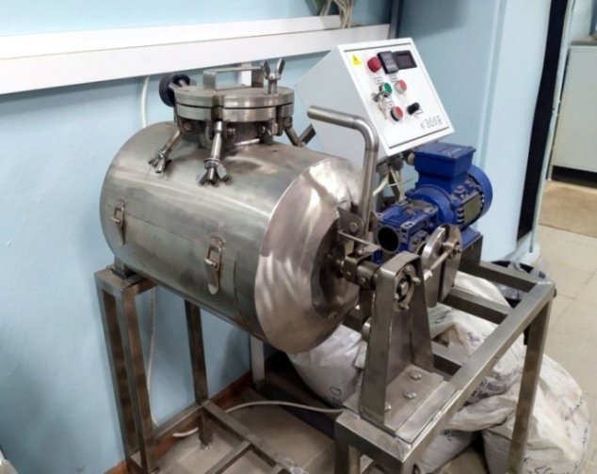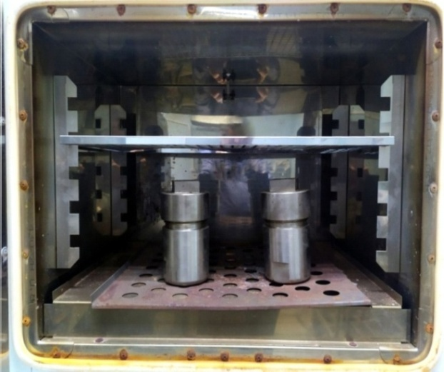

а) Laboratory autoclave  drum type | б) Laboratory autoclaves of cartridge  type in an oven

Figure 7 - Equipment for testing building blocks

The studies on autoclaving the cubes were performed under the conditions of the technology to produce silicate building bricks used at the Lotos plant, a structural unit of Aktobe Ferroalloy Plant JSC, a branch of TNK Kazchrome JSC.
The conditions to process "raw" cubes were: holding time 100 hours, temperature - 160°C, molar ratio 2CaO: SiO₂ from 1: 0.8 to 1: 1.2. Every 20 hours of exposure in an autoclave, 3 cubes of the same composition were crushed on a laboratory press MIP-25R with the determination of the arithmetic mean value of crushing strength. Cubes are shown in Figure 8.

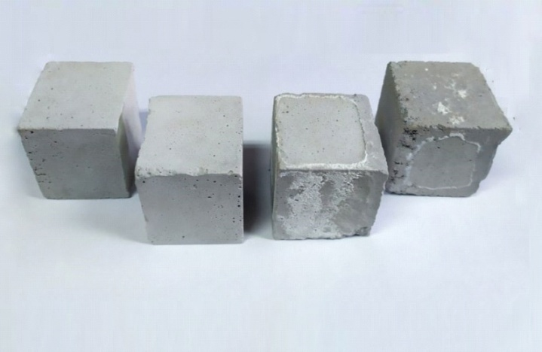

Figure 8 – Sample cube after autoclaving for 60 hours
at a temperature of 160 ºC
The results of tests to determine the crushing strength of cubes are shown in Figure 9.

Figure 9 – Results of determining the strength of cubes depending on the exposure time and molar ratio of 2CaO: SiO₂ in autoclave conditions

The results obtained show that when diatomite is used instead of ground quartz washed sand, as a substitute for the silicate component in the manufacture of silicate building bricks, the time to reach the maximum crushing strength is reduced from 60 to 50 hours. When using diatomite, it is possible to achieve grade M150. When autoclaving brick samples, the geometric parameters of the product sample are saved.

3.2 Large-scaled tests of dry building mixtures based on diatomite

The large-scale tests were performed based on the compositions of dry building mixtures (DBM) prepared at the previous stage with the definition of: crack resistance, bulk density, water-cement ratio, mix mobility, water holding capacity, water absorption during capillary suction.
The composition of experimental formulations No. 1-37 is given in приложении В. The compositions of the DBM were selected based on compositions existing in practice and with the possibility of replacing expensive filler components (mineral active additives, white soot) with natural Kazakhstani diatomite.
For testing, mixtures were prepared based on two finely dispersed mineral additives - diatomite and white soot (amorphous microsilica). The recipe for modified mixtures includes other components - slaked lime, sand, marble flour. The fillers did not contain water-soluble components such as alkali metal or magnesium salts. Their presence increases the hydrophilicity of the solution, resulting in an increase in the water-cement ratio.
Determination of crack resistance. Visual inspection of surfaces treated with mortars showed that in compositions No. 1-5, after receiving the mortar and applying it to a concrete surface with a thickness of up to 0.5-2 cm, cracks appeared on the plaster surface within a day, and subsequently plaster separation from the concrete surface was observed. Cracks were also formed on compositions no. 6-17. Bermokoll consumption depends on the planned thickness of the mortar application. When applied in thick layers (from 1.6-2 cm), an overdose of 0.2 to 0.5% is dangerous, because “caramel effect” appearsб and cracks appear on the surface (Figure 10).

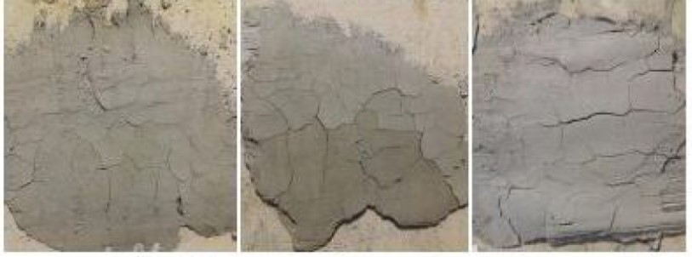

Figure 10 - Cracks on the surface of the concrete layer

Compositions No. 18-37 showed good crack resistance on the concrete surface.

Plaster thickness 0.5-2 cm (Figure 11).

а)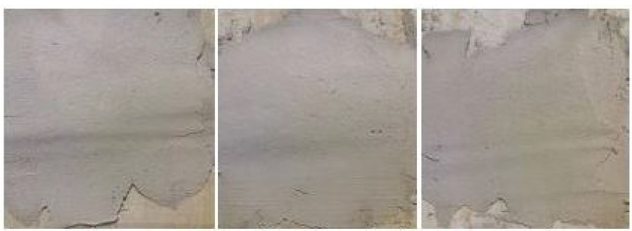
b)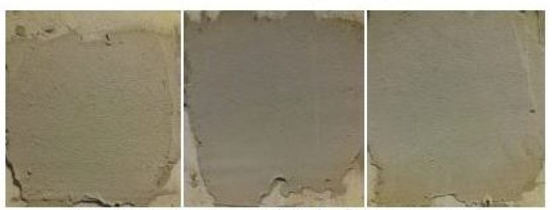

a) using white soot b) using diatomite

Figure 11 – Applying mixtures to a concrete surface

The technical parameters of dry building mixtures have been determined.
Bulk density of dry mix: No. 18-22 within 1300-1860 kg/m³; No. 23-27 in the range of 1640-1770 kg/m³; No. 28-32 within 1120-1520 kg/m³; No. 33-37 within 1530-1720 kg/m³.
Density of the ready-to-use mixture: No. 18-22 in the range of 1450-1910 kg/m³;
No. 23-27 within 1720-1803 kg/m³; No. 28-32 within 1205-1673 kg/m³; No. 33-37 within the range of 1628-1890 kg/m³. Under GOST 33083-2014, the dry mix, the solution of which has an average density of less than 1300 kg/m³, belongs to the group of light plaster mix, more than 1300 kg/m³- to the group of heavy plaster mix.
The amount of mixing water: No. 18-22 - 4 liters per 25 kg of dry mix; No. 23-27 - 4 liters per 25 kg of dry mix; No. 28-32 - 6.5-8.25 liters per 25 kg of dry mix; No. 33-37 - 4-5.75 liters per 25 kg of dry mix. Deviation from the optimum water-cement ratio degrades strength and results in cracking.
The mobility of the mixture was determined using a reference cone. It has been established that the thinner the filler (mineral active additives), the greater its specific surface area (Table 7).

Table 7 – Mobility data for dry building mixtures with water

Composition No | Mobility,  cm | Mobility  grade | Note
No 18-22 | from 4 to 7.5 | Pk2 | The mobility of a freshly prepared mortar mixture intended for plastering surfaces must correspond to the Pk3 grade (the immersion depth of the cone is 8-12 cm),  GOST 33083-2014
No 23-27 | from 6 to 7 | Pk2
No 28-32 | from 11 to 11.5 | Pk3
No 33-37 | from 10 to 11 | Pk3

The water retention of compositions No. 18-37 without mineral active additives is 75-80%, with mineral active additives - not less than 90.0-97.5% (Table 8). Water absorption was determined by capillary suction. The samples were placed with their end face in a bath on a mesh support. The bath was filled with water at a temperature of (20 ± 5)°C so that the end face was immersed in water by 5-10 mm. The water level in the bath was kept constant throughout the test. The use of active mineral additives enables you to reduce water absorption, regulate porosity and reduce the risk of efflorescence on the surface (Table 9).

Table 8 – Water retention capacity of mixtures

Composition No | Water-holding capacity,% | Water-holding capacity,%
No 18-22 | 90-93 | The water-holding capacity of ready-to-use mixtures must be at least 90%, containing water-holding additives must be at least 95%
No 23-27 | 92.5-96
No 28-32 | 97-97.5
No 33-37 | 96-97.5

Table 9 – Determination of water absorption during capillary suction

Composition No | Water absorption | Note
No 18-22 | Does not exceed 0.4 kg/h ^{0,5} within 24 hours | Water absorption during capillary suction within 24 hours should not exceed 0.4 kg/h ^{0,5}  (except for waterproofing mixtures),  for waterproofing mixtures -  not more than 0.2 kg/(m²·h ^{0,5})
No 23-27
No 28-32
No 33-37

Thus, as a result of the research:
- it was found that the introduction of finely dispersed mineral active additives (diatomite, white soot) increases the reactivity of the filled binder and results in an increase in its activity. - rational relationships have been established between the passive (sand) and active (diatomite, white soot) components of the mortar aggregate that make it possible to regulate the operational properties of the plaster;
- the possibility of modification of dry building mixtures on a cement binder with a complex action additive (ether-starch, M70, BERMOCOLL, ELOTEX, C-3, Technocel 500);
- the features of the change in the amount of mixing water, mixture mobility, application temperature, water retention capacity, water absorption at capillary suction were revealed;
- the features of the change in the rheological and technological properties of solutions based on dry mixtures are established, depending on the composition, bulk density and various dosages of additives.

3.3 Comparative calculations of the economic efficiency to process diatomite ore and the release of autoclave-free silicate bricks on its basis

The technology to produce silicate bricks at Lotos JSC, a branch of Aktobe Ferroalloy Plant JSC, is based on mixing finely dispersed (-0.07 mm) quicklime with finely dispersed crushed river sand (-0.07 mm), forming standard building bricks under pressure and autoclave treatment at a temperature of 155°C for 56 hours. In this case, there is a partial formation of dicalcium silicate 2SiO₂ CaO that is the main component in bricks that determines their strength. Autoclave-free bricks are characterized by a strong reduction in energy costs to process raw bricks with steam in autoclaves but they do not enable obtaining products with a grade higher than M75. At the same time, the diatomites use instead of ground sand results in a sharp decrease in energy costs for grinding, the time of steam treatment in autoclaves. Economic calculations under the existing technology of JSC "Lotos" for 2019 were provided by "TNK" Kazchrome JSC (Table 10) and make it possible to perform comparative calculations of the existing autoclave and the proposed autoclave-free and autoclave technologies to produce bricks in the conditions of Lotos JSC, a branch of Aktobe Ferroalloy Plant JSC (Table 11).

Table 10 – Technical and economic data of "Lotos" JSC plant intended to produce silicate bricks (a branch of "Aktobe Ferroalloy Plant" JSC) for 2019

Cost item | Unit rev. | Specific consumption | Price | Amount for 1 unit,  tenge | number | Amount, thousand tenge
1 | 2 | 3 | 4 | 5 | 6 | 7
VOLUME OF PRODUCTION | thousand pieces |  |  |  | 59095.0 | 42639925
 | tn |  |  |  | 216878.7
VOLUME OF SALES | thousand pieces |  |  |  | 59186.4 | 42707542
Basic and auxiliary materials |  |  |  | 5556.3 |  | 328349.4
Sand | tn/1000 | 3.324 | 610.67 | 2029.7 | 196414.4 | 119944.7
Lime | tn/1000 | 0.211 | 13687.31 | 2893.4 | 12492.4 | 170988.0
Coloring pigment | tn/1000 | 0.002 | 307735.3 | 563.4 | 108.2 | 33297.0
Lime dust | tn/1000 | 0.058 | 105.60 | 6.1 | 3417.1 | 360.8
Zilpebs | kg/1000 | 0.119 | 179.31 | 21.3 | 7036.0 | 1261.6
Balls | kg/1000 | 0.116 | 2.00 | 0.2 | 6884.0 | 13.8
Autoclave rubber | kg/1000 | 0.002 | 7123.35 | 17.3 | 143.7 | 1023.7
Recycled water | m3/1000 | 0.134 | 13.85 | 1.9 | 7929.8 | 109.8
Return of materials |  |  |  | -27.5 |  | -1624.4
Lime screening |  | 0.017 | 2992.00 | 50.3 | 994.1 | 2974.3
Process steam | G/cal | 0.374 | 1558.83 | 583.8 | 22130.0 | 34496.8
Compressed air | m3/1000 | 257.7 | 2.15 | 554.1 | 15229175 | 32742.8
Technological electricity | kWh/1000 | 43.414 | 16.81 | 729.6 | 2565528.0 | 43113.9
Wages of main production workers' wages. |  |  |  | 1679.9 |  | 99271.1
Deductions from wages |  |  |  | 265.5 |  | 15688.7
Upcoming payments-vacation reserve |  |  |  | 215.7 |  | 12745.7
The 13th salary |  |  |  | 122.8 |  | 7255.2
Total direct costs |  |  |  | 9707.5 |  | 573663.7
Overheads
Energy consumption |  |  |  | 308.5 |  | 18232.5
Power power | kWh/1000 | 2.838 | 16.84 | 47.8 | 167700.0 | 2823.7
Heating, steam, hot water |  | 0.062 | 2190.68 | 136.2 | 3675.0 | 8050.7
Water supply |  | 0.082 | 40.92 | 3.4 | 4848.0 | 198.4
Household. domestic wastewater |  | 0.423 | 286.48 | 121.2 | 24991.7 | 7159.6
Overhaul |  |  |  | 0.0 |  | 0.0
Maintenance |  |  |  | 2248.1 |  | 132851.3
Incl. wages |  |  |  | 553.6 |  | 32716.9
Deductions from salary |  |  |  | 69.8 |  | 4125.0
Table 10 continued

1 | 2 | 3 | 4 | 5 | 6 | 7
Upcoming payments-vacation reserve |  |  |  | 64.6 |  | 3817.6
The 13th salary |  |  |  | 35.1 |  | 2075.3
Materials and spare parts |  |  |  | 945.4 |  | 55871.2
SERVICES: |  |  |  | 579.5 |  | 34245.3
Repair of electric motors |  |  |  | 61.9 |  | 3660.5
Current repair of production building No. 2 |  |  |  | 505.4 |  | 29868.4
Repair of special equipment |  |  |  | 3.7 |  | 217.1
Manufacturing of cylinder rods (SPE) |  |  |  | 8.4 |  | 499.3
Maintenance of fixed assets |  |  |  | 2201.2 |  | 130082.7
Incl. wages |  |  |  | 791.9 |  | 46799.76
Deductions from salary |  |  |  | 103.5 |  | 6117.02
Upcoming payments-vacation reserve |  |  |  | 97.3 |  | 5748.40
13th salary |  |  |  | 69.9 |  | 4128.94
Materials and spare parts |  |  |  | 1070.1 |  | 63236.74
SERVICES: |  |  |  | 68.6 |  | 4051.8
Maintenance and repair of air conditioners |  |  |  | 6.2 |  | 367.38
Fire alarm services |  |  |  | 5.1 |  | 300.00
Prof. electrical testing |  |  |  | 25.7 |  | 1517.86
Expert examination of the hoisting mechanism and crane tracks |  |  |  | 4.8 |  | 285.92
NACEKS - instrument calibration |  |  |  | 5.5 |  | 322.08
Internal inspection and hydro-testing of autoclaves (Energo) |  |  |  | 19.9 |  | 1178.57
Service of presses |  |  |  | 1.4 |  | 80.00
Depreciation |  |  |  | 1359.6 |  | 80346.52
Cargo movement |  |  |  | 389.5 |  | 23018.8
Occupational Safety and Health |  |  |  | 253.6 |  | 14987.7
Overalls |  |  |  | 43.8 |  | 2591.28
Special milk |  |  |  | 60.8 |  | 3590.81
Materials |  |  |  | 53.2 |  | 3145.48
Payment for incapacity for work |  |  |  | 90.3 |  | 5335.08
Workwear washing |  |  |  | 5.5 |  | 325.00
Other expenses |  |  |  | 1237.6 |  | 73137.7
Incl. Wage |  |  |  | 478.1 |  | 28253.83
Deductions from salary |  |  |  | 61.1 |  | 3608.49
Upcoming payments-vacation reserve |  |  |  | 58.8 |  | 3476.94
13th salary |  |  |  | 44.4 |  | 2626.14
Materials and other expenses |  |  |  | 54.9 |  | 3241.76
Table 10 continued

1 | 2 | 3 | 4 | 5 | 6 | 7
Taxes and payments |  |  |  | 62.7 |  | 3707.14
Environmental monitoring |  |  |  | 22.6 |  | 1335.71
Product certification |  |  |  | 9.6 |  | 567.25
Insurance |  |  |  | 25.5 |  | 1509.27
Medical services |  |  |  | 214.1 |  | 12652.83
Communication costs |  |  |  | 1.0 |  | 57.00
Training costs |  |  |  | 68.9 |  | 4069.44
Occupational health and safety costs |  |  |  | 6.8 |  | 400.00
Maintenance costs transport |  |  |  | 22.9 |  | 1352.78
Special equipment services |  |  |  | 21.8 |  | 1291.00
Collection and storage of waste |  |  |  | 13.9 |  | 822.65
Environmental insurance |  |  |  | 4.1 |  | 245.23
Property protection services |  |  |  | 6.0 |  | 352.50
Facility security services |  |  |  | 0.0 |  | 0.00
Disinfection, pest control, deratization |  |  |  | 7.6 |  | 446.43
Profession certification |  |  |  | 1.0 |  | 60.00
Inspection for gas analysis equipment and environmental monitoring systems |  |  |  | 27.5 |  | 1627.36
Expert examination of the building and construction of Lotos Aktobe LLP |  |  |  | 0.0 |  | 0.00
Design and survey works |  |  |  | 22.0 |  | 1300.00
Development of electronic documentation |  |  |  | 2.3 |  | 133.93
Overheads |  |  |  | 7998 |  | 472657
Total production costs |  |  |  | 17705.7 |  | 1046320.8
Total costs for goods. products. |  |  |  | 17718.5 |  | 1048695.0
Period expenses including |  |  |  | 4263.1 |  | 252317.2
General administrative |  |  |  | 2483.3 |  | 146977.91
Implementation costs |  |  |  | 1779.8 |  | 105339.27
Total cost |  |  |  | 21981.6 |  | 1301012.2
Price per side |  |  |  | 29662.3 |  | 1755607.7
Profit |  |  |  | 7680.7 |  | 454595.5
Profitability | % |  |  | 34.9 |  | 40.2
Average cost of 1 pc. |  |  |  |  |  | 24.56
Average real price 1 pc. |  |  |  |  |  | 41.11

Table 11 – Comparative economic calculations for existing and proposed technologies to produce autoclave-free and autoclave bricks from diatomite

Cost item | Existing technology | Proposed technology
 |  | Autoclave-free, grade brick М75 | Autoclave, brick grade M125
Sand consumption (98 wt.%.) | 0.222 | - | -
Diatomite consumption | - | 0.317 | 0.317
Production and delivery costs, tenge | 2.119 | 8.95 | 8.95
Process steam costs, tenge | 1515.7 | 151.6 | 1300.0
Electricity costs, tenge | 904.1 | 210.0 | 600.0
Salary | 2.356 | 1.178 | 2.356
Other workshop costs | 8.472 | 6.60 | 8.472
Total: | 24.56 | 15.58 | 20.55
Selling price, tenge | 41.11 | 33.98 | 41.11
Profitability,% | 40.2 | 44.25 | 50.00
Profit for the entire volume of products manufactured in 2019, thousand tenge | 454595.5 | 500394.4 | 565417.2
Additional profit from the implementation of new technology, thousand tenge |  | 45798.9 | 110821.8

The calculations take into account the plant-wide costs per unit of production without changing the workshop, plant-wide costs for advertising and product sales. From the above data, it can be seen that when bricks are produced using autoclave-free technology and with the use of autoclave technology with the use of diatomite raw materials, the profitability of existing production increases by 4.05 and 9.8%, respectively. The proposed technology does not require significant changes in the transport equipment and plant shop equipment.
Based on the calculations, the following conclusions were made:
- replacing sand with diatomite in the technology of producing silicate bricks, even using autoclave-free technology, brings additional profit 45798.9 thousand tenge
when autoclaving raw sand-lime bricks, additional profit is up to 110,821.8 thousand tenge with an increase in grade from M75 to M125;
- the project of organizing the production of silicate bricks based on diatomites is not associated with additional capital and operating costs, since the plant of JSC "Lotos" has all the required equipment and personnel. Replacing silicate raw materials - washed river sand - with diatomite results in significant savings in energy costs, steam (autoclave technology) and salaries of some of the personnel serving the autoclaves that ultimately increases the profitability of production.

3.4 Determination of the economic efficiency of the production of dry building mixtures based on diatomite

The composition of the dry mortar No. 30 corresponds to the composition of the dry plaster mixture M150 manufactured by Rusean GOST No. 33083-2014. The compositions produced by the industry and proposed for production are given in Table 12. White soot is replaced by natural diatomite in the proposed composition.

Table 12 – Compositions of dry building mixtures produced by the industry and proposed for production

Recipe | Composition in %
 | No30 | No 35
Cement | 26.24 | 26.24
Sand | 67.76 | 67.76
White soot | 5.0 | -
BERMOCOLL | 0.1 | 0.1
ELOTEX | 1.0 | 1.0
Diatomite | - | 5.0

Brief calculations were made to produce dry building mixtures based on diatomite per 1000 kg and for an annual productivity of 10 thousand tons per year in the conditions of Aktobe Plant “Sailan Aktobe” LLP to assess the feasibility and economic efficiency of the organization of production. Table 13 shows the consumption coefficients per 1 ton of dry mortar and for 10 thousand tons of products.

Table 13 – Consumption coefficients for 1 ton of dry mortar and for an annual production of 10 thousand tons

Name | For 1 ton of mixture |  | Annual production  10 thousand tons
 | Unit of measurement | number
1 | 2 | 3 | 4
Enterprise "Rusean"
Cement | tenge | 0.2624 | 2664
Sand | tenge | 0.6776 | 6776
White soot | tenge | 0.05 | 500
Diatomite | tenge | -
BERMOCOLL |  | 0.001 | 10
ELOTEX |  | 0.01 | 100
fresh water | m³ | 0.005 | 50
Steam | Gcal | 0.05 | 500
Electricity | thousand kW/h | 0.022 | 220

Table 13 continued

1 | 2 | 3 | 4
Proposed technology
Cement | tenge | 0.2664 | 2664
Sand | tenge | 0.6776 | 6776
White soot | tenge | - | -
Diatomite | tenge | 0.07 | 705
BERMOCOLL |  | 0.001 | 10
ELOTEX |  | 0.01 | 100
fresh water | m³ | 0.05 | 50
Steam | Gcal | 0.05 | 500
Electricity | thousand kW/h | 0.032 | 320
Natural gas | thousand m³ | 0.013 | 130

The calculation of the cost to purchase the equipment is given in Table 14.

Table 14 – Calculation of costs for the purchase of equipment (diatomite 705 t is purchased through outsourcing)

Name | Type | Performance | Power, kWt | Quantity, pcs. | Price, thousand tenge | Cost, thousand tenge
Diatomite mining department (seasonal)
Diatomite |  |  |  | 705 | 8,5 | 5992,5
Department of grinding, mixing and packaging of dry construction mixture
Dry grinding mill | Ø 1.5*5.7 by Sinovatt-Gormash. | 3-5 t/h | 115 | 1 | 12213,6 | 12213,6
Silos for storage of finished materials | SCS-36 “Refey” plant. | 36 tons | 45 | 3 | 3456,0 | 19368
Ready mix silo | SPTSS-465 | 465 tn | 50 | 1 | 19500,0 | 9500
Packaging unit for dry bulk materials | DVS301-50-6 | 2 t/h |  | 1 | 6600,0 | 6600
Total |  |  |  |  |  | 53674.1
Unaccounted for equipment (20%) |  |  |  |  |  | 10734.82
Total |  |  |  |  |  | 64408.92
Installation work (8%) |  |  |  |  |  | 5152.71
Transport costs (7%) |  |  |  |  |  | 4508.62
Total |  |  |  |  |  | 74070.25
Process pipelines cost (10%) |  |  |  |  |  | 7407.03
Others (20%) |  |  |  |  |  | 14814.05
Total equipment cost |  |  |  |  |  | 96291.6

The Sailan Aktobe LLP plant has a wide range of technological equipment, including 11 pieces. drying tube furnaces 1-3 t/h, transport equipment for the transportation of bulk materials, supplied communications and is located in close proximity to the territory of "Aktobe Ferroalloy Plant" JSC in Aktobe.
Calculation of capital costs. SailanAktobe LLP plant has a building area 1000 m2. Besides the building, an extension of 200 m² of production space will be required that is easy to accomplish, since the workshop is assembled from easily erected metal structures with sandwich insulation. Considering that the cost of 1 m² is 210 thousand tenge, additional costs for the extension will amount to 42,000 thousand tenge.
The main technical and economic parameters of the new production of dry building mixtures are presented in Table 15-17.

Table 15 – Calculation of the number of employees

Staff units | Number of staff units | The number of staff units, taking into account the turnout rate. 1,2
Administrators:  Site manager  Shift master  Total  Main workers:  Administrator of receiving and preparing raw materials  Dry mix preparation machine operator  Apparatus for drying and filling finished products  Total  Auxiliary workers:  Laboratory assistant  Electrician  Locksmith repairman  Total  Total | 1  4  5  4  4  4  12  4  4  4  12  29 | 6  15  15  36

Table 16 – Calculation of the wage fund with accruals

Category of workers | Number of employees | Average annual salary, thousand tenge | Annual salary fund
Administrator | 6 | 1800.0 | 21600.0
Main workers | 12 | 3000.0 | 36000.0
Auxiliary workers | 12 | 2400.0 | 28800.0
Total | 29 |  | 86400.0

Table 17 – Operating costs to produce 10 thousand tons of dry mortars in year

Expenses | Unit of measurement | Annual demand | Price,  tenge | Amount, thousand tenge
1. Initial raw materials and reagents  Cement  Sand  Diatomite  BERMOCOLL  ELOTEX  Total  2. Energy consumption  Steam  Electricity  Water  Natural gas  Total  3. Salary  Deductions (30%)  Total  4. Maintenance costs and  equipment operation  Amortization of equipment and  vehicles (14.2%)  Content (2.2%)  Maintenance of equipment and vehicles (5%)  Intrafactory relocation  load reduction (0.5%)  Other expenses (0.4%)  Total | t  t  t  t  t  Gcal.  thousand kWh  m³  thousand m³ | 2664  6776  705  10  100  500  220  50  130 | 23500  640  8500  80000  73000  2703  3421  203  21000 | 62604.0  4336.64  5992.5  800.0  7300  81033.14  1351.5  752.6  10.15  2730  4844.25  60480.0  25920.0  86400.0  13673.4  2118.42  4814.6  481.46  385.17  21473.05
6. Factory costs (11.8%)  Other expenses (1.25%)  Total workshop costs  Total operating costs |  |  |  | 22862.55  2439. 49  197579.19

The calculation of the discounted payback period, NPV and IRR of the dry building mixtures plant in the conditions of SailanAktobe LLP is given in Table 18.
Such main economic performance parameters as net present value NPV 36 423 thousand tenge and internal rate of return IRR 18%, discounted payback period - 6 years are optimal and meet the requirements for successful production. Calculations substantiate project profitability and return on investment.

Table 18 – Calculation of the discounted payback period, NPV and IRR of a dry mortar plant in conditions SailanAktobe LLP

Parameter names | Unit of meas. | 2021 | 2022 | 2023 | 2024 | 2025 | 2026 | 2027 | 2028 | Total
Production volume of plaster drywall | thousand tenge |  | 10 | 10 | 10 | 10 | 10 | 10 | 10
Selling price | thousand tenge. |  | 283000 | 283000 | 283000 | 283000 | 283000 | 283000 | 283000
Total costs, including: | thousand tenge
Operational | thousand tenge |  | 176106.14 | 176106.14 | 176106.14 | 176106.14 | 176106.14 | 176106.14 | 176106.14
Expenses of the period (amortization + expenses for payment of% on the loan) | thousand tenge |  | 79073.05 | 78233.05 | 76721.05 | 74906.65 | 73213.21 | 70673.05 | 70673.05
Income before tax | thousand tenge |  | -6726.96 | -5886.96 | -4374.96 | -2560.56 | -867.12 | 1673.04 | 1673.04
Tax | thousand tenge |  | 0 | 0 | 0 | 0 | 0 | 501.91 | 501.93
Income after tax | thousand tenge |  | 0 | 0 | 0 | 0 | 0 | 1171.11 | 1171.11
Loan interest, including: | thousand tenge.
Interest on a capital construction loan (10% bank rate) | thousand tenge |  | 4200 | 3780 | 3024 | 2116.8 | 1270.08
Interest on a working capital loan (10% bank rate) | thousand tenge | 19800 | 19800 | 19800 | 19800 | 19800 | 19800 | 19800 | 19800
Current cash flow | thousand tenge |  | -6726.96 | -5886.96 | -4374.96 | -2560.56 | -867.12 | 1673.04 | 1673.04
Cumulative cash flow | thousand tenge |  |  | -1952.52 | 2197.43 | 1747.13 | 6092.62 | 20855.35 | 31813.75
NPV | thousand tenge |  |  |  |  |  |  |  |  | 36 422.59
IRR | % |  |  |  |  |  |  |  |  | 18 %
Payback period | years |  |  |  |  |  |  |  |  | 6

CONCLUSION

Brief conclusions under the results of research and development and its individual stages
Stage 2018. Representative samples of diatomite raw materials were taken from the Zhalpak deposit and its chemical and mineralogical compositions were determined.
Laboratory studies have been performed to use high-iron varieties of Kazakh diatomite raw materials as a component of dry building mixtures, indicating the production of high-quality plaster solutions based on cement-gypsum-lime-diatomite mixtures. Compositions with fired diatomite and gypsum showed high plasticity when applying a layer of plaster, its fast adhesion and strength that is due to the formation of complex hydrated iron-calcium silicates such as hedenbergite - Ca (Fe, Mg) Si₂O₆ and chloritoid - A -FeAl₂SiO₅(OH)₂.
The use of a plasticizer and thermally activated diatomite in mixtures can significantly reduce the water absorption of standard building blocks. Semi-dry pressing with subsequent autoclave steam treatment of the cubes sharply increases the compressive strength and grade of the products, reduces their water absorption and specific gravity. A sharp increase in the strength of cubes was established when using thermally activated high-iron diatomite (20-30% Fe2O3) that is associated with the partial formation of hydrated forms of ferrocalcites, and their number increases with autoclave steam treatment of the cube material. The obtained samples of cubes using thermally activated diatomite, especially its high-iron forms, correspond to the standard GOST 379–95 standards for silicate stones and bricks
Phase 2019. The chemical composition of the ferruginous varieties of diatomites of the Zhalpak deposit shows that they can serve as raw materials to produce iron oxide pigments. The data of scanning electron microscopy of powders obtained after preliminary drying, grinding and calcining of ferruginous diatomite showed the presence of highly dispersed particles (5-10 µm in size) of a spherical shape.
BET analysis of the samples showed an increase in the specific surface area and total pore volume in the sample obtained by calcining and regrinding calcined diatomite. An increase in these parameters contributes to an increase in dispersity, hiding power, chemical resistance, especially when coloring cement mortars. Pigments with a high silica content have a significantly lower density than pigments that are almost entirely composed of iron oxide.
Mössbauer and X-ray phase analysis established the presence in the calcined sample of the obtained powder of hematite (α-Fe₂O₃ oxide) and goethite (α -FeOOH hydroxide) - the main components of iron oxide pigments currently produced by industry.
A middling product of the process intended to obtain alumina from coal ash from Ekibastuz power-generating coals, is proposed based on the research performed, a simple process flow diagram for the utilization of an alkali-silica solution (ASS). The conditions to obtain foam glass from ASS and natural diatomite have been determined. The technical parameters of the foam glass correspond to the characteristics of modern thermal insulation materials for construction.
Organization of production of foam glass on an industrial scale will make it possible to dispose of ASS in large volumes, since the construction industry is very material-intensive. Taking into account the existing Kazakhstani base of scientific research in the field of ash processing and our own developments, an improved scheme for the complex processing of ashes from Ekibastuz power-generating coals has been proposed.
Phase 2020. Large-scaled studies were performed on the preparation and chemical processing of a sample of diatomite from the Zhalpak deposit using the production equipment of Sailan-Aktobe LLP. Based on activated diatomite, samples of standard building blocks and compositions of dry building mixtures were obtained. Their arithmetic mean crushing strength, water absorption and specific gravity of the obtained samples were studied. It is shown that even without autoclaving, the samples correspond to the grade for M70 bricks.
Samples of formulations of dry building mixtures have been developed. It has been established that diatomite can serve as an active mineral additive as white soot, as it increases the reactivity of the filled binder. that the use of diatomite in the production of silicate bricks simplifies and reduces the cost of grinding the starting material. During the heat treatment of ground diatomite, its chemical activation occurs, the strength of the silicate brick is 8.5 MPa that corresponds to brand M70.
Autoclaving of "raw" sand-lime bricks in autoclave conditions at a temperature of 160°C enables increasing the grade of sand-lime bricks up to M150. These bricks are the most expensive, durable and in demand in the industry.
Comparative calculations of the economic efficiency of processing diatomite ore and replacing river sand with diatomite showed an increase in profitability of 5.3% and additional profit in the production of silicate bricks using non-autoclave technology in the amount of 45788.9 thousand tenge and 110821.8 thousand tenge using autoclave technology (data for release in 2019), net discounted income NPV 36 423 thousand tenge and internal rate of return IRR 18%, discounted payback period - 6 years justify the profitability of the project and return on investment.
The main economic parameters of the efficiency of the new production to produce dry building mixtures showed that when replacing "white" soot with natural diatomite, NPV will be 36.42%, IRR-18%, the payback period is 6 years.
Assessment of the completeness of the solution of the tasks. Research work was performed in full accordance with the schedule. The selection of representative samples of diatomite raw materials was performed and its physical and chemical studies were performed. Chemical activation of samples of ferruginous forms of diatomite was performed to obtain ultrafine-dispersed iron pigments of a spherical shape. The issue of complex ash processing with the production of alumina concentrate and the processing of alkali-silica solutions and diatomite with the production of foam glass, a heat-insulating building material, has been studied. Large-scaled studies were performed to obtain samples of silicate bricks using autoclave-free technology and their tests were performed that showed their compliance with the M70 grade. Large-scaled batches of dry building mixtures have been produced for subsequent tests with the determination of the main technical parameters. Comparative calculations of the economic efficiency of diatomite ore processing were performed based on the results of large-scale tests of the produced dry building mixtures based on activated diatomite.
Recommendations and initial data on the specific use of research results. The results of the work can be used at enterprises of the country's construction industry. The developed technology is focused on its implementation at such enterprises as "Lotos" LLP, "Sailan-Aktobe" LLP and plants of construction products of "SBS Trade" LLP.
Assessment of the technical and economic efficiency of implementation. The developed technologies to produce iron oxide pigments, foam glass - a modern heat-insulating material, silicate bricks and dry building mixtures using diatomaceous earths can be recommended for industrial development at existing enterprises and become the basis for organizing new industries.
Assessment of the scientific and technical level of the performed research work in comparison with the best achievements in this area.
The proposed technical solutions to produce finely dispersed powders of iron oxide pigments of a spherical shape, including silicon dioxide, are innovative. An iron-rich variety of Kazakhstani diatomites was used as a raw material source, the main components of which are iron oxides and silica with a high specific surface area and micron-sized porosity that improves the technical parameters of the product.
Synthetic silica is used as the second component of the pigment that determines the multistage process in the published works.
An original technology is proposed for the disposal of alkali-silica solutions formed during the alkaline processing of ash from coal combustion, their interaction with natural diatomite and the production of foam glass. To date, there is no rational scheme to recycle alkali-silica solutions.
Organizational and material and technical provision to perform the research. Research work under the project was performed in the laboratory of alumina and aluminum by a team of performers, including 3 Ph.D. in Engineering Science, 1 Ph.D., 1 junior researcher with experience in the development of technologies to process mineral raw materials and the synthesis of materials.
There is the required research infrastructure: production facilities, modern research equipment, access to sources of scientific and technical information to implement the project.
Research work was performed under the international standard ISO 10006 “Administrative quality management. - Guidelines for Quality Assurance in Project Management”. Patent and license provision of research is performed by the relevant service of the organization at all stages of the project.
The analysis of the raw materials and the resulting products and materials was performed by the accredited National Scientific Laboratory of IMOB JSC under the priority "Technologies for the hydrocarbon and mining and metallurgical sectors and related service industries."
Economic feasibility of the requested amount of funding for R&D. Project expenses include the following items: salary with deductions, travel expenses, purchase of materials, others (translations, registration fees), maintenance of equipment, project support.

LIST OF THE REFERENCES USED

1 Shuqiang Xu, Julin Wang, Qinglin Ma, Xin Zhao, Tao Zhang. Study on the lightweight hydraulic mortars designed by the use of diatomite as partial replacement of natural hydraulic lime and masonry waste as aggregate // Construction and Building Materials. - 2014. - Vol.73. - P. 33-40. (in English)
2 Flower R.J. Diatom methods. Diatomites: Their Formation, Distribution, and Uses. Encyclopedia of Quaternary Science. - London: University College London, 2013. - P. 501-506.
3 Bülent Yılmaz, Nezahat Ediz. The use of raw and calcined diatomite in cement production // Cement and Concrete Composites. - 2008. - Vol. 30. - No. 3. - P. 202-211. (in English)
4 Zahra Ahmadi, Jamshid Esmaeili, Jamil Kasaei, Robab Hajialioghlia. Properties of sustainable cementmortars containing high volume of raw diatomite // Sustainable Materials and Technologies. - 2018. - Vol. 16. - P. 47-53. (in English)
5 Pustovgar A. The effectiveness of the use of activated diatomite in dry building mixtures "// Building materials. - 2006. - No. 10. - S. 62-64. (in Russian)
6 Pustovgar A. Experience of using activated diatomite in the production of dry building mixtures // Construction and real estate. - 2008.-№33.-С.25-27. (in Russian)
7 Loganina V.I., Davydova O.A., Simonov E.E. Influence of activation of diatomite on the properties of lime compositions // News of higher educational institutions. Construction series. - 2011. - No. 3. - S. 20-23. (in Russian)
8 Nikiforov E.A., Loganina V.I., Davydova O.A., Simonov E.E. Peculiarities of structure formation of lime composites using modified diatomite // Regional architecture and construction. - 2011. - No. 2. - S. 4-8. (in Russian)
9 Loganina V.I., Davydova O.A., Simonov E.E. Investigation of the regularities of the influence of silicic acid sol on the structure and properties of diatomite // Construction materials. - 2011. - No. 12.- S. 62-65. (in Russian)
10 Cherkasov V.D., Buzulukov V.I., Emelyanov A.I., Kisilev E.V., Cherkasov D.V. Active mineral additive based on chemically modified diatomite // Izvestia of higher educational institutions. Construction series. - 2011.- No. 12. - S. 50 - 55. (in Russian)
11 Karpova O.V., Loganina V.I., Simonov EE Efficiency of using lime-diatomite decorative plaster for finishing enclosing structures // Izvestia of higher educational institutions. Construction series. - 2012. - No. 5. -S. 44 - 47. (in Russian)
12 Loganina V., Simonov E., Ezerskij V., Malashkevich D. Application of activated diatomite for dry lime mixes // Construction and Building Materials. - 2014. -Vol. 65. - P. 29-37. (in English)
13 Hint Y.A. Silicalcite is a new building material. Tallinn. - 1957. - 46 p. (in Russian)
14 Loganina V.I., Simonov E.E. Heat-insulating dry building mixtures using modified diatomite. Penza: PGUAS. - 2013 .-- 128 p. (in Russian)
15 GOST 379–95. Interstate standard. Silicate bricks and stones. Technical conditions. -M .: Stroyizdat. 1996.- 19 p. (in Russian)
16 GOST 28013-98. Interstate standard. Building solutions. General technical conditions. -M .: Stroyizdat. 1999.- 23 p. (in Russian)
17 GOST 9179-2018 Interstate standard. Construction lime. Specifications -M .: Stroyizdat. 2019.- 15 p. (in Russian)
18 Grilo J, Faria P, Veiga R, Santos Silva A, Silva V, Velosa A. New natural hydraulic lime mortars - physical and microstructural properties in different curing conditions // Constr. Build. Mater. - 2014. - Vol.54. - P. 378 - 384. (in English)
19 Grist Er., Paine Ka, Heath A., Norman J., Pinder H. Compressive strength development of binary and ternary lime – pozzolan mortars // Mater. Des. - 2013. - Vol.52. - P. 514-523. (in English)
20 Baltazar Luis G., Henriques Fernando M.A., Jorne Fernando, Cidade M.T. Combined effect of superplasticizer, silica fume and temperature in the performance of natural hydraulic lime grouts // Constr. Build. Mater. - 2014. - Vol.50. - P. 584-597. (in English)

ANNEX A

Certificate of large-scale laboratory tests of dry building mixtures
based on diatomite dated 28.09.2020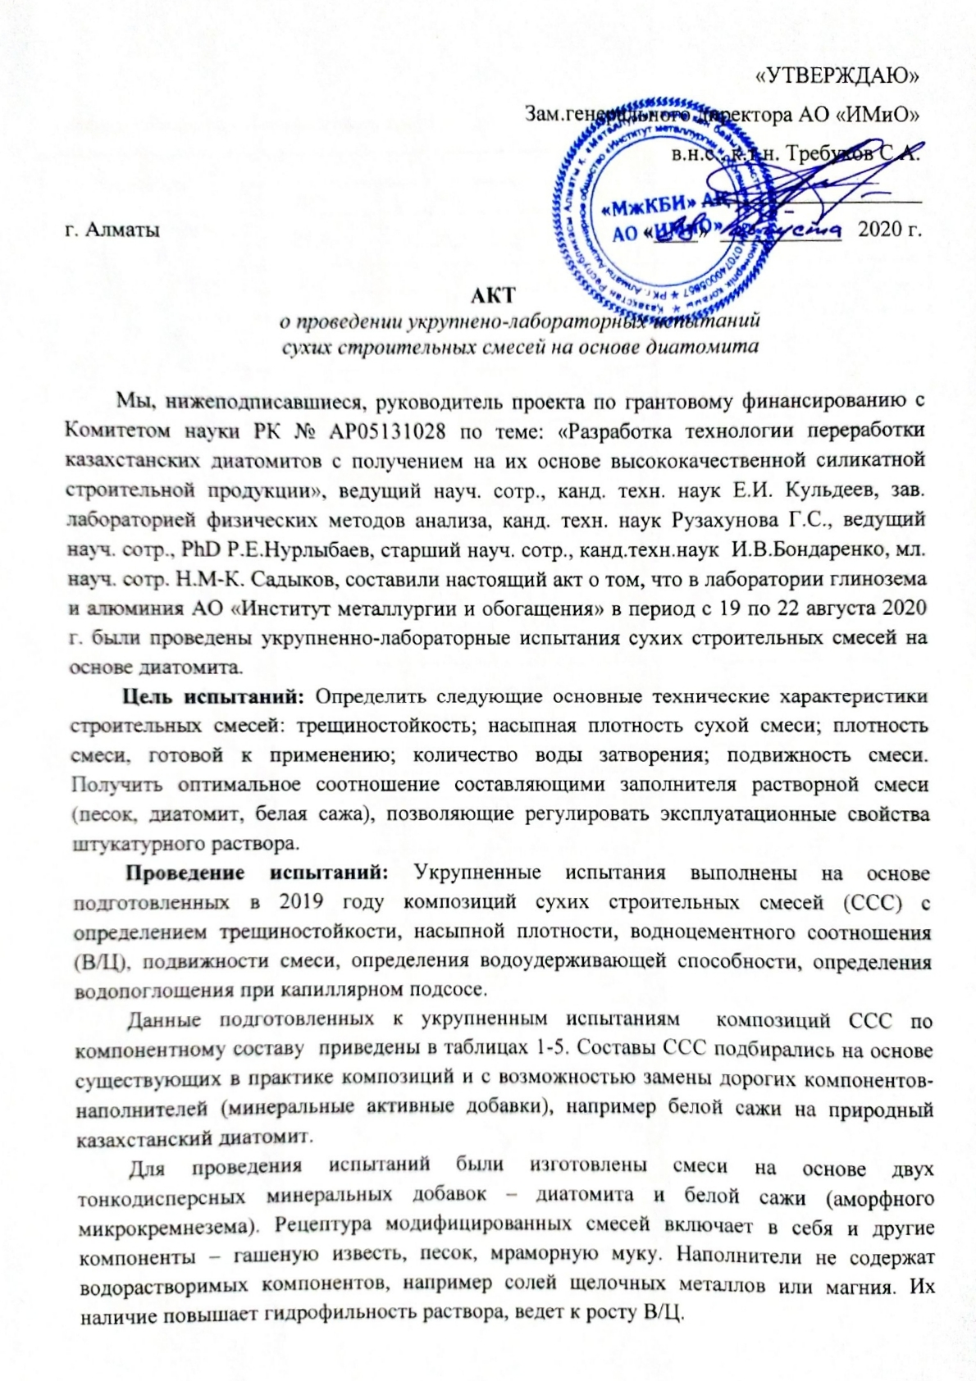
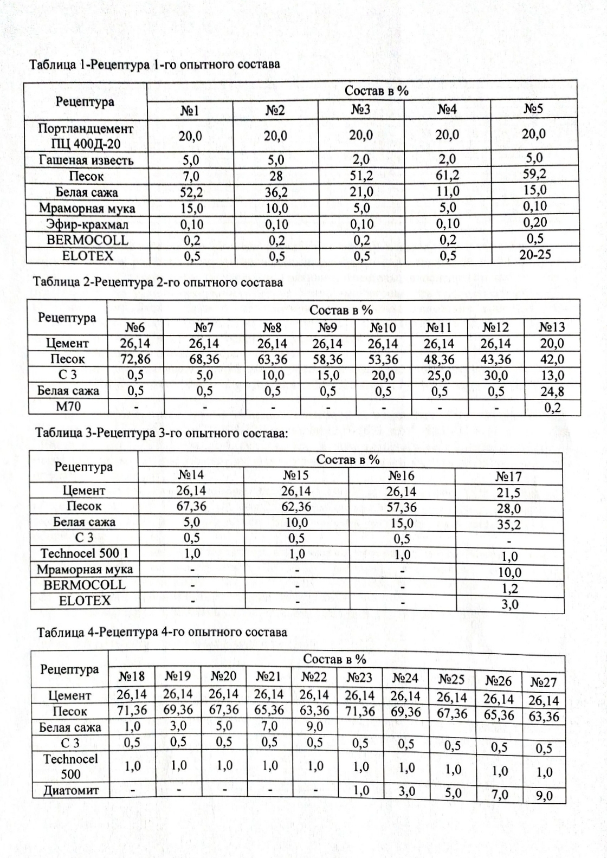
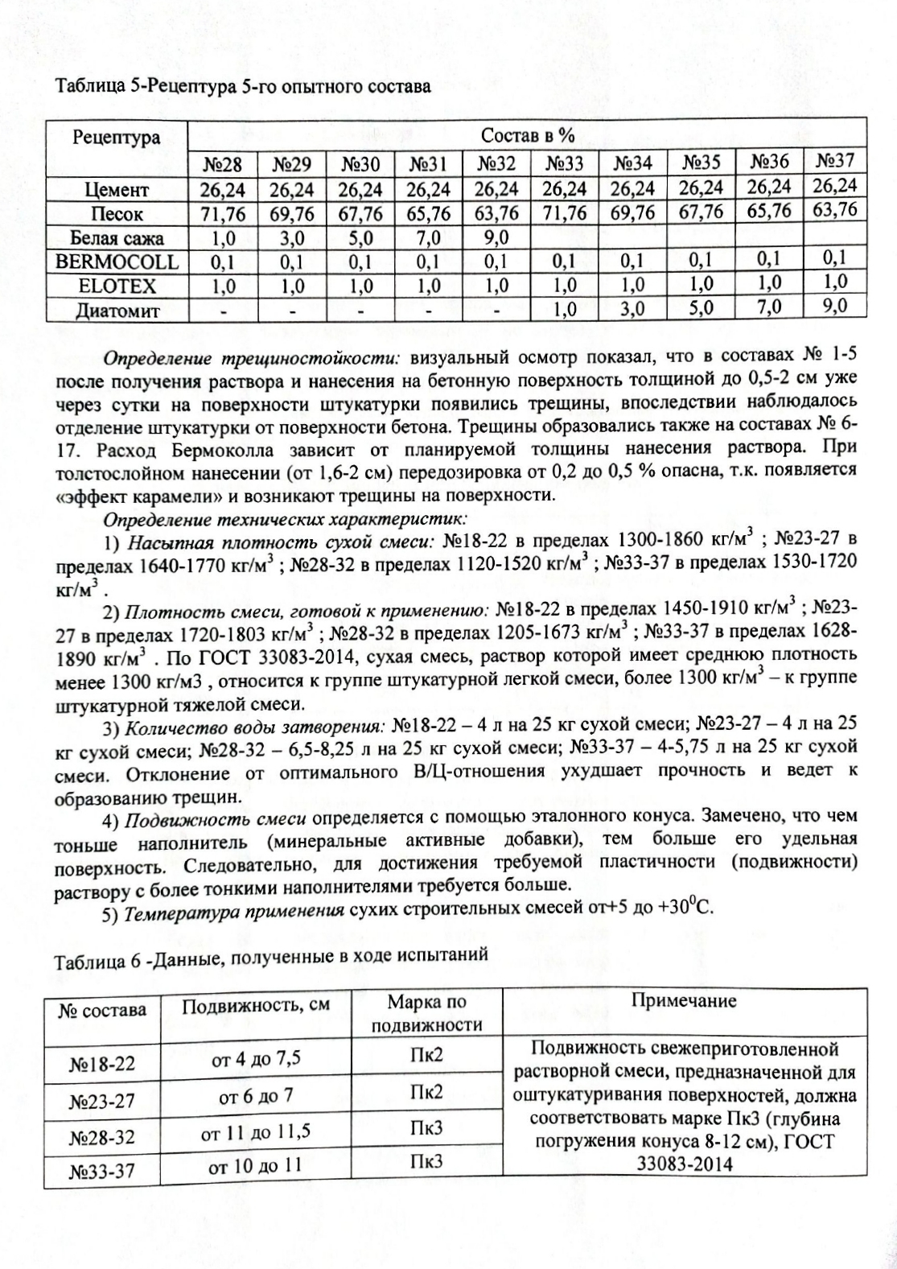
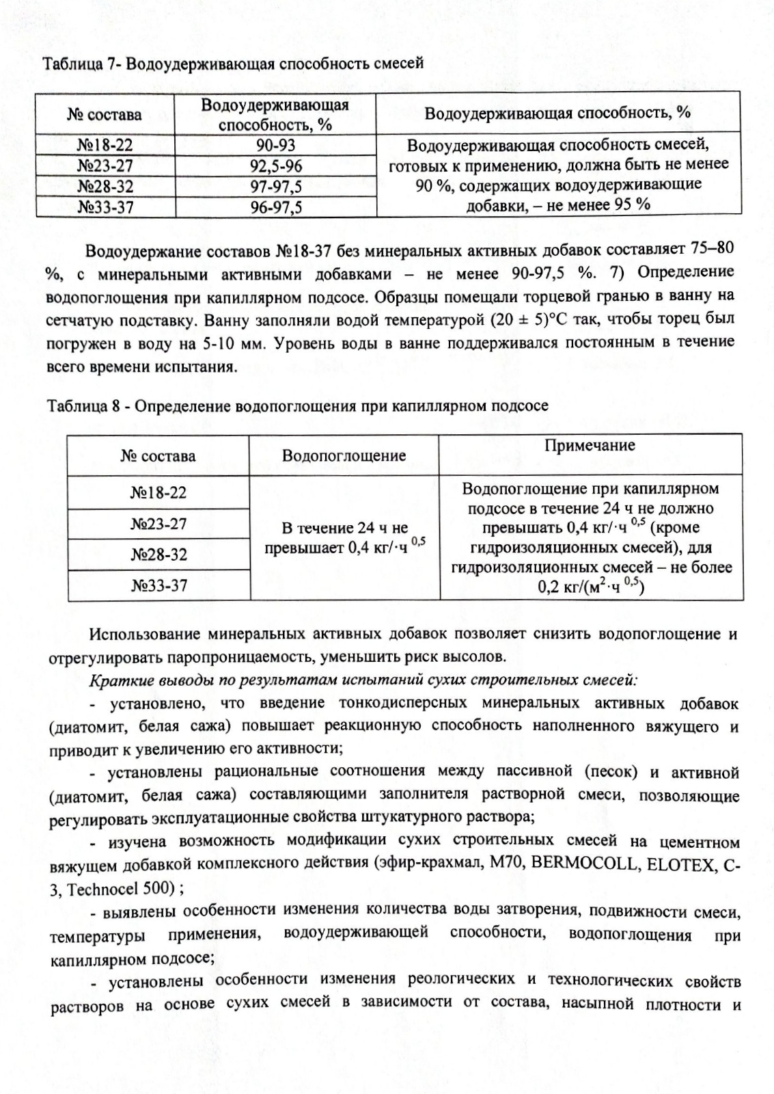
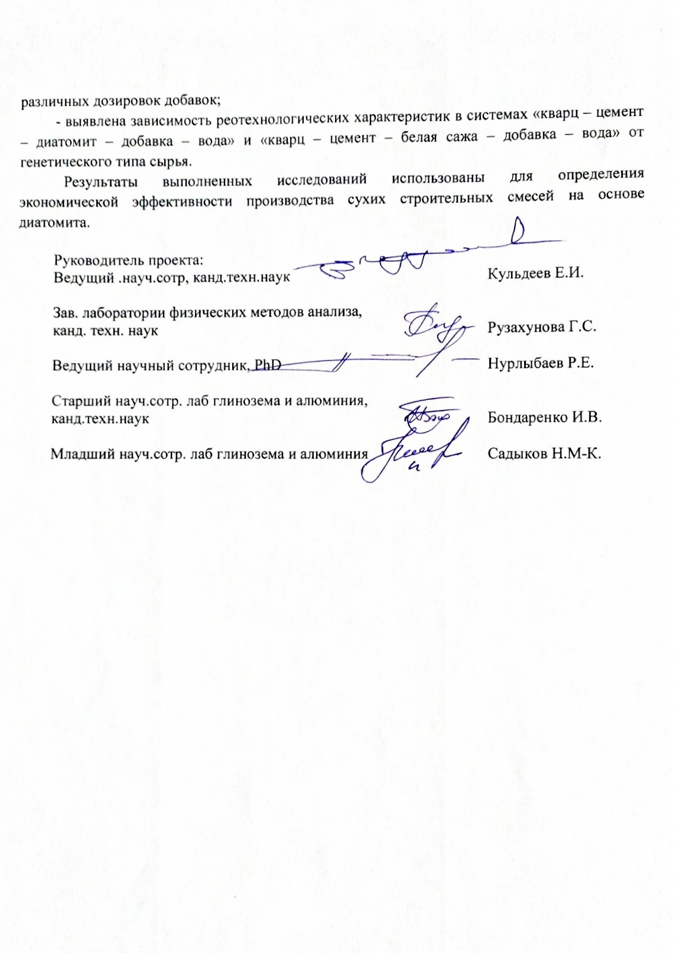
ANNEX B

List of the published works

2018
Articles in peer-reviewed Russian scientific journals:
1 Kuldeev E.I., Bondarenko I.V., Temirova S.S., Tastanov E.A., Nurlybaev R.E. Composition and properties of diatomite raw materials of Kazakhstan and the synthesis of silicalcites on their basis for obtaining construction products // Complex use of mineral raw materials. - 2018. - No. 4. - P.149-157. KazBC (2017) - 0.204. (in Russian) https://doi.org/10.31643/ 2018 / 6445.41
2 Kuldeev E.I., Bondarenko I.V., Orynbekov E.S., Nurlybaev R.E., Temirova S.S. Application of activated diatomite in dry building mixtures // Bulletin of KazNTU. - 2018. - No. 5. - S. 404-408. KazBC (2017) - 0.045. (in Russian) https://official.satbayev. university/dowload/document/7429/%D0%92%D0%95%D0%A1%D0% A2% D0% 9D% D0% 98% D0% 9A2018% 20% E2% 84 % 965.pdf
Conference materials:
1 Kuldeev E.I. Application of Kazakhstani diatomites as carriers of mineral fertilizers // Proceedings of the International Conference "Scientific, Technical and Innovative Developments" within the framework of the project "One Belt - One Road". - Astana. - 2018. - p. 23. (in Russian)
2019
Articles in peer-reviewed foreign scientific journals with a non-zero impact factor, indexed in the Scopus database:
1 B.K. Kenzhaliev, E.I. Kuldeev, V.A. Luganov, I.V. Bondarenko, I.Yu. Motovilov, S.S. Temirova. Production of Very Fine Spherical Particles of Ferriferous Pigments from the Diatomaceous Raw Material of Kazakhstan // Glass and Ceramics. - 2019. - Vol. 76. - Issue 5-6. R. 194-198. Scopus: SJR (2018) - 0.28; Q3. (in English) https://link .springer.com/article/10.1007/s10717-019-00163-w
Articles in peer-reviewed foreign scientific journals with a non-zero impact factor:
1 Orynbekov E.S., Selyaev V.P., Nurlybaev R.E., Kuldeev E.I. Dry building mixtures for plastering with finely dispersed active additives // Regional architecture and construction - 2019. - №2 (39). - P.72-79. RSCI (2017) - 0.488. (in Russian) https://elibrary.ru/item.asp?id=39323383
2 Kenzhaliev B.K., Kuldeev E.I., Luganov V.A., Bondarenko I.V., Motovilov I.Yu., Temirova S.S. Obtaining highly dispersed particles of spherical iron oxide pigments from Kazakhstani diatomite raw materials // Glass and ceramics. - 2019. - No. 5. - S.40-45. RSCI (2017) - 0.790. (in Russian) http://www.glass-ceramics.ru/archive.php
Conference materials:
1 Kuldeev E.I., Temirova S.S., Bondarenko I.V., Tastanov E.A. Diatomites - a new raw material for the development of the construction industry in Kazakhstan // Proceedings of the XII Congress of concentrators of the CIS countries. - Moscow.-2019. - S. 168-171. (in Russian)
RK patent:
1 Patent RK No. 33707 A method of producing amorphous silicon dioxide from silica-containing raw materials / Abdulvaliev R.A., Kenzhaliev B.K., Kuldeev E.I., Gladyshev S.V., Omarova S.A., Dyusenova S.B., Manapova A.I., Imangalieva L.M., applicant and patentee of JSC "Institute of Metallurgy and Beneficiation".-2019. Bul. No. 25. (in Russian)
2020
Articles in peer-reviewed foreign scientific journals with a non-zero impact factor, indexed in the Scopus database:
1 E. Kuldeyev, I. Bondarenko, R. Abdulvaliyev, S. Temirova, B. Abdikerim. Processing of low quality ekibastuz coals ashes and natural diatomites to obtain alumina and foamed glass // Metalurgija. - 2020. - No. 3. - R.351-354. Scopus: SJR (2018) - 0.39; Q2. (in English) https://hrcak.srce.hr/ index.php? show = toc & id_broj = 18867 & lang = en)

ANNEX C

Calendar plan

Appendix 1.18
to Agreement No._____ as of _______2018
for grant funding
TECHNICAL SPECIFICATION, and
TIME SCHEDULE

According to Agreement No._____ as of __________________2018

- EXECUTOR’S NAME

Institute of Metallurgy, and Ore Beneficiation JSC

1.1 Priority: Natural resources conservation, including water resources, geology, recycling, new materials, and technology, safe products, and structures.
1.2 Subpriority: New multi-purpose materials based on natural raw materials, and industrial wastes.
1.3 On the subject of the project: No. AP05131028 – Development of a technology for processing Kazakh diatomites to produce high-quality silicate construction products on their basis.
1.4 Total project amount: 12,080,000.0 (twelve million eighty thousand) tenge, including with a breakdown by years, for the execution of work under Clause 3:
- for 2018 – in the amount of 4,000,000.0 (four million) tenge;
- for 2019 – in the amount of 4,036,000.0 (four million thirty-six thousand) tenge;
- for 2020 – in the amount of 4,044,000.0 (four million forty-four thousand) tenge.

- Characteristics of scientific, and technical products based on qualification, and economic indicators

2.1 Direction of work: Development of applied research, and development on the priorities of forced industrial-innovative development.
2.2 Application: Construction industry.
2.3 Outcome:
- for 2018: developing a technology for the diatomite ore activation. 1 article will be published in a peer-reviewed domestic scientific journal with a non-zero impact factor (presumably in the following journals: “KazNITU Bulletin”, “Complex Use of Mineral Resources”);
- for 2019: accumulating prototypes of products based on chemically activated diatomite for further testing as a component of construction products. 1 article will be published in a peer-reviewed foreign scientific journal with a non-zero impact factor (presumably in the following journals: “St. Petersburg State Polytechnical University Journal”, “Architecture, and Construction”);
- for 2020: performing high-level tests of the accumulated dry construction mixtures based on activated diatomite. The project provides for performing comparative calculations, and presenting the justification of the economic efficiency of using diatomites to obtain construction products. 2 articles will be published in peer-reviewed foreign scientific journals indexed in the Scopus database (presumably in the following journals: “Minerals Engineering”, “Glass, and Ceramics”, “Chemical industry today”, “News of National Academy of Sciences of the Republic of Kazakhstan. Geology Series, and Technical Sciences”).
2.4 Patentability: the research outcomes are patentable.
2.5 Scientific, and technical level (novelty): The project provides for developing a technology applied for chemical beneficiation of diatomite raw materials found in Kazakhstan with obtaining a finely-dispersed porous product used as a component of dry construction mixtures, and silicate bricks.
2.6 The scientific, and technical products are used by: the Executor.
2.7 Type of use of the result obtained from the scientific, and (or) scientific, and technical activities: The results obtained will make it possible to determine the economic efficiency of producing dry construction mixtures based on diatomite.

3. Name of work, deadlines for their implementation, and results

The code of the task | Name of work  under the Agreement, and the main  stages of its implementation | Deadline |  | Expected result
 |  | beginning | ending
1 | Laboratory studies on the development of a technology applied to activate diatomite ore. | January,  2018 | 1 November,  2018 | The project provides for performing laboratory studies on the development of a technology applied to activate diatomite ore.
1.1 | Selecting a diatomite ore sample (Zhalpak plateau, Aktobe region) for laboratory research.A physical, and chemical analysis of the diatomite ore sample. | January,  2018 | March,  2018 | The project provides for selecting a diatomite ore sample (Zhalpak plateau, Aktobe region) for laboratory research, and performing a physical, and chemical analysis of the diatomite ore sample.
1.2 | Determining the physical, and mechanical parameters (true density, bulk density) of the diatomite ore sample. | April,  2018 | June,  2018 | The project provides for determining the physical, and mechanical parameters (true density, bulk density) of the diatomite ore sample.
1.3 | Research on chemical activation of diatomites, determination of the optimal process parameters. | July,  2018 | September,  2018 | The project provides for performing research on chemical activation of diatomites, and determining the optimal process parameters.
1.4 | Investigating the possibility of using activated diatomite in technologies for obtaining construction products. | October,  2018 | 1 November,  2018 | The project provides for investigating the possibility of using activated diatomite in technologies for obtaining construction products.  1 article will be published in a peer-reviewed domestic scientific journal with a non-zero impact factor (presumably in the following journals: “KazNITU Bulletin”, “Complex Use of Mineral Resources”);
2 | Accumulating prototypes of products based on chemically activated diatomite for further testing as a component of construction products. | January,  2019 | 1 November,  2019 | The project provides for accumulating prototypes of products based on chemically activated diatomite for further testing as a component of construction products.
2.1 | Preparing a representative batch of diatomite ore (Zhalpak plateau, Aktobe region) for pilot testing. A physical, and chemical analysis of the diatomite ore sample. | January,  2019 | March,  2019 | The project provides for preparing a representative batch of diatomite ore (Zhalpak plateau, Aktobe region) for pilot testing, and performing a physical, and chemical analysis of the diatomite ore sample.
2.2 | Refining the technological parameters for the preparation, and chemical processing of a diatomite sample by Sailan-Aktobe LLP. | April,  2019 | June,  2019 | The project provides for refining the technological parameters for the preparation, and chemical processing of a diatomite sample by Sailan-Aktobe LLP.
2.3 | Accumulating a batch of autoclave-free silicate bricks for pilot testing. | July,  2019 | September,  2019 | The project provides for accumulating a batch of autoclave-free silicate bricks for pilot testing.
2.4 | Accumulating a batch of dry construction mixtures for high-level tests. | October,  2019 | 1 November,  2019 | The project provides for accumulating batches of dry construction mixtures for high-level tests.  1 article will be published in a peer-reviewed foreign scientific journal with a non-zero impact factor (presumably in the following journals: “St. Petersburg State Polytechnical University Journal”, “Architecture, and Construction”);
3 | High-level tests of the accumulated dry construction mixtures based on activated diatomite. Performing comparative calculations, and presenting the justification of the economic efficiency of using diatomites to obtain construction products. | January,  2020 | 1 November,  2020 | The project provides for performing high-level tests of the accumulated dry construction mixtures based on activated diatomite.  It is planned to perform comparative calculations, and present the justification of the economic efficiency of using diatomites to obtain construction products.
3.1 | High-level comparative tests of standard silicate bricks, and diatomite-based bricks as a silica component using autoclave-free technology. Selection of recipes. | January,  2020 | March,  2020 | The project provides for performing high-level comparative tests of standard silicate bricks, and diatomite-based bricks as a silica component using autoclave-free technology. It is planned to select a recipe.
3.2 | High-level tests of dry construction mixtures based on diatomite. | April,  2020 | June,  2020 | The project provides for performing high-level tests of dry construction mixtures based on diatomite.
3.3 | Comparative calculations of the economic efficiency of diatomite ore processing, and production of autoclave-free silicate bricks on its basis. | July,  2020 | September,  2020 | The project provides for performing comparative calculations of the economic efficiency of diatomite ore processing, and production of autoclave-free silicate bricks on its basis.  2 articles will be published in peer-reviewed foreign scientific journals indexed in the Scopus database (presumably in the following journals: “Minerals Engineering”, “Glass, and Ceramics”, “Chemical industry today”, “News of National Academy of Sciences of the Republic of Kazakhstan. Geology Series, and Technical Sciences”).
3.4 | Determining the economic efficiency of producing dry construction mixtures based on diatomite. | October,  2020 | 1 November,  2020 | The project provides for determining the economic efficiency of producing dry construction mixtures based on diatomite.

From Customer:  Chairman, State institution “Science Committee of the Ministry of Education, and Science of the Republic of Kazakhstan”  _________________ Abdrassilov B.S.  stamp | From Executor:  Director General, and Chairman of the Management Board, Institute of Metallurgy, and Ore Beneficiation JSC  ___________________ Kenzhaliyev B.K.  stamp  Briefed on:  Scientific Project Leader  ________________________ Kuldeyev E.I.  (signature)

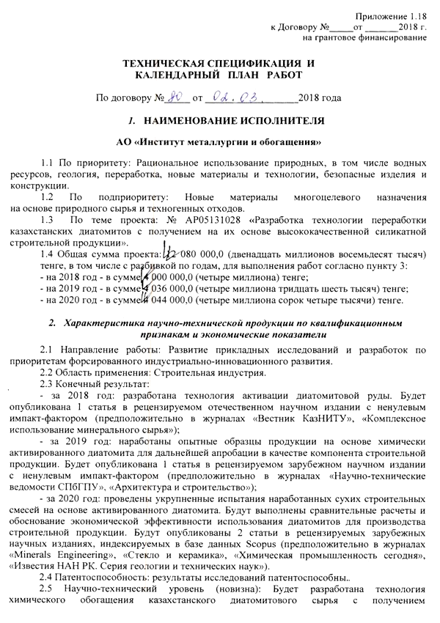

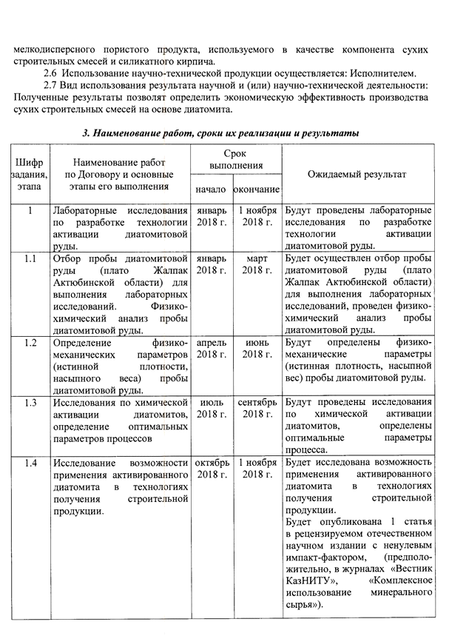

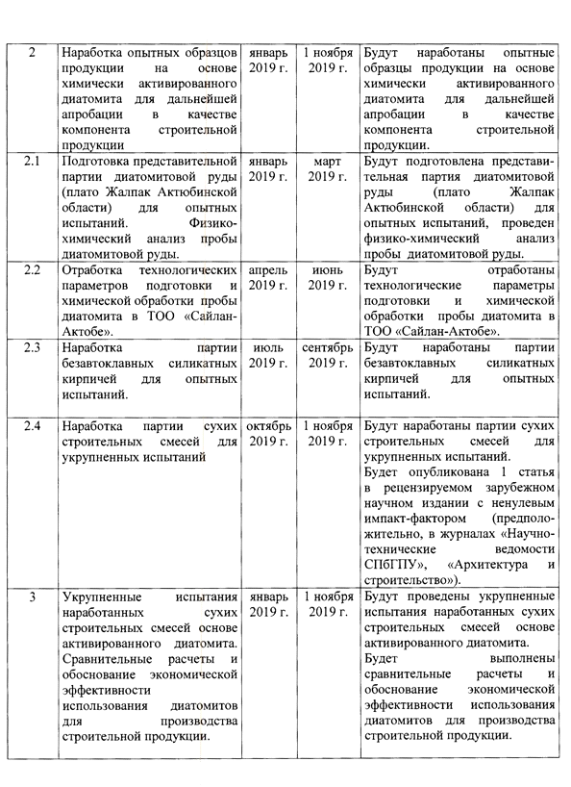

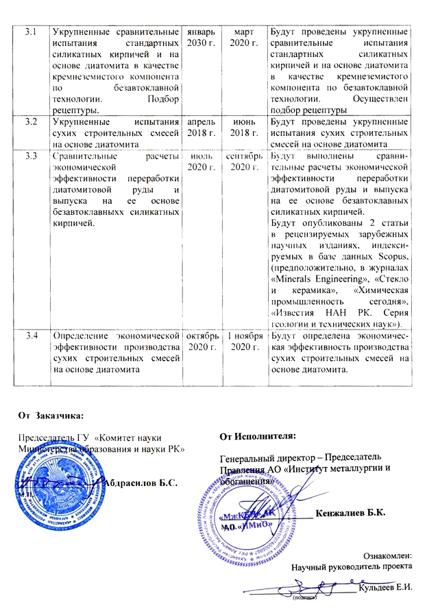

ANNEX D

Supplementary agreement
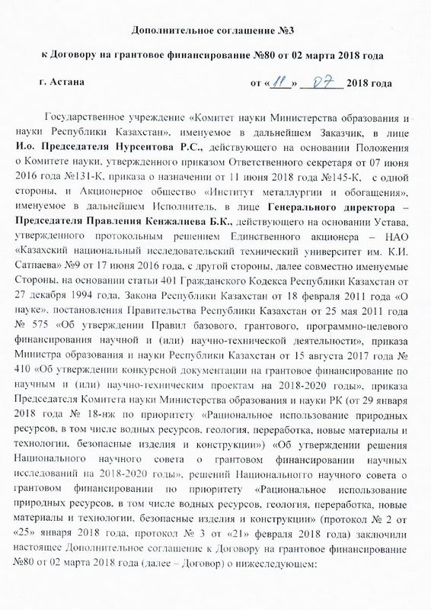
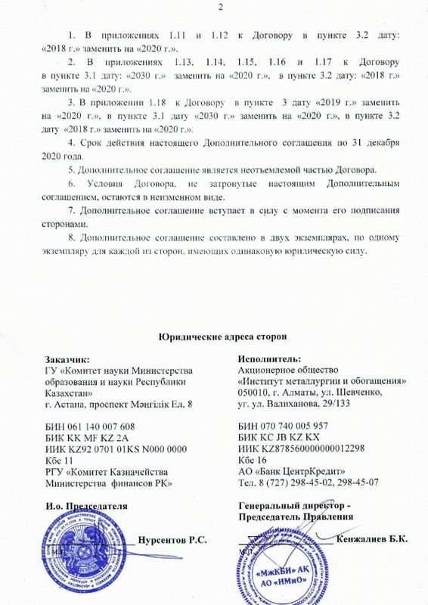

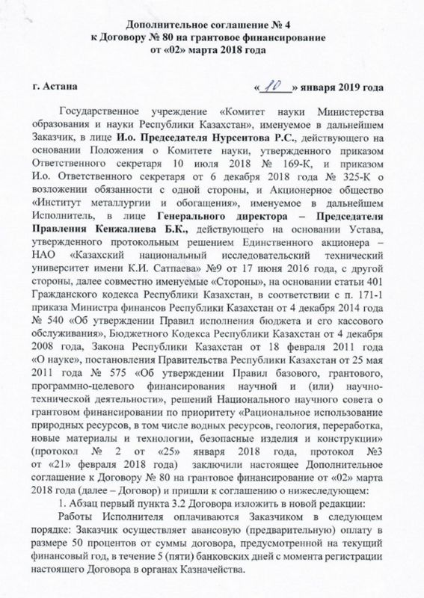

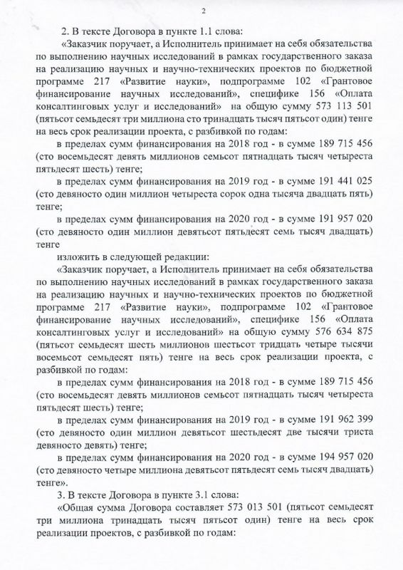

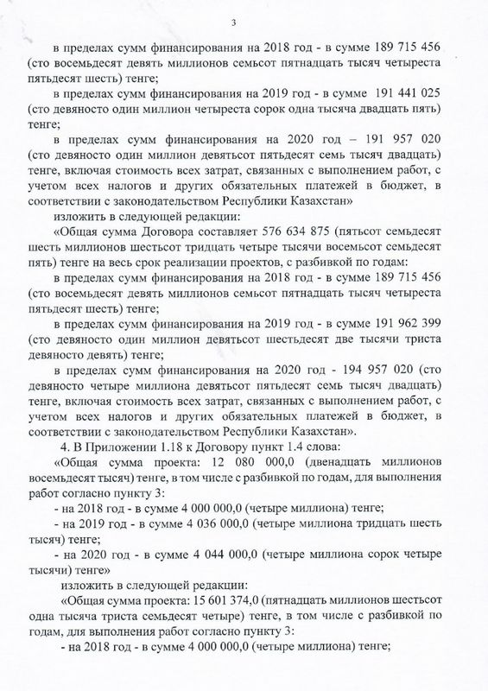

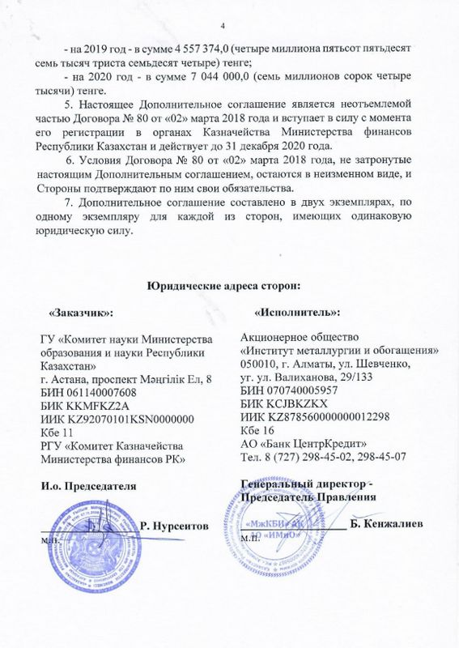
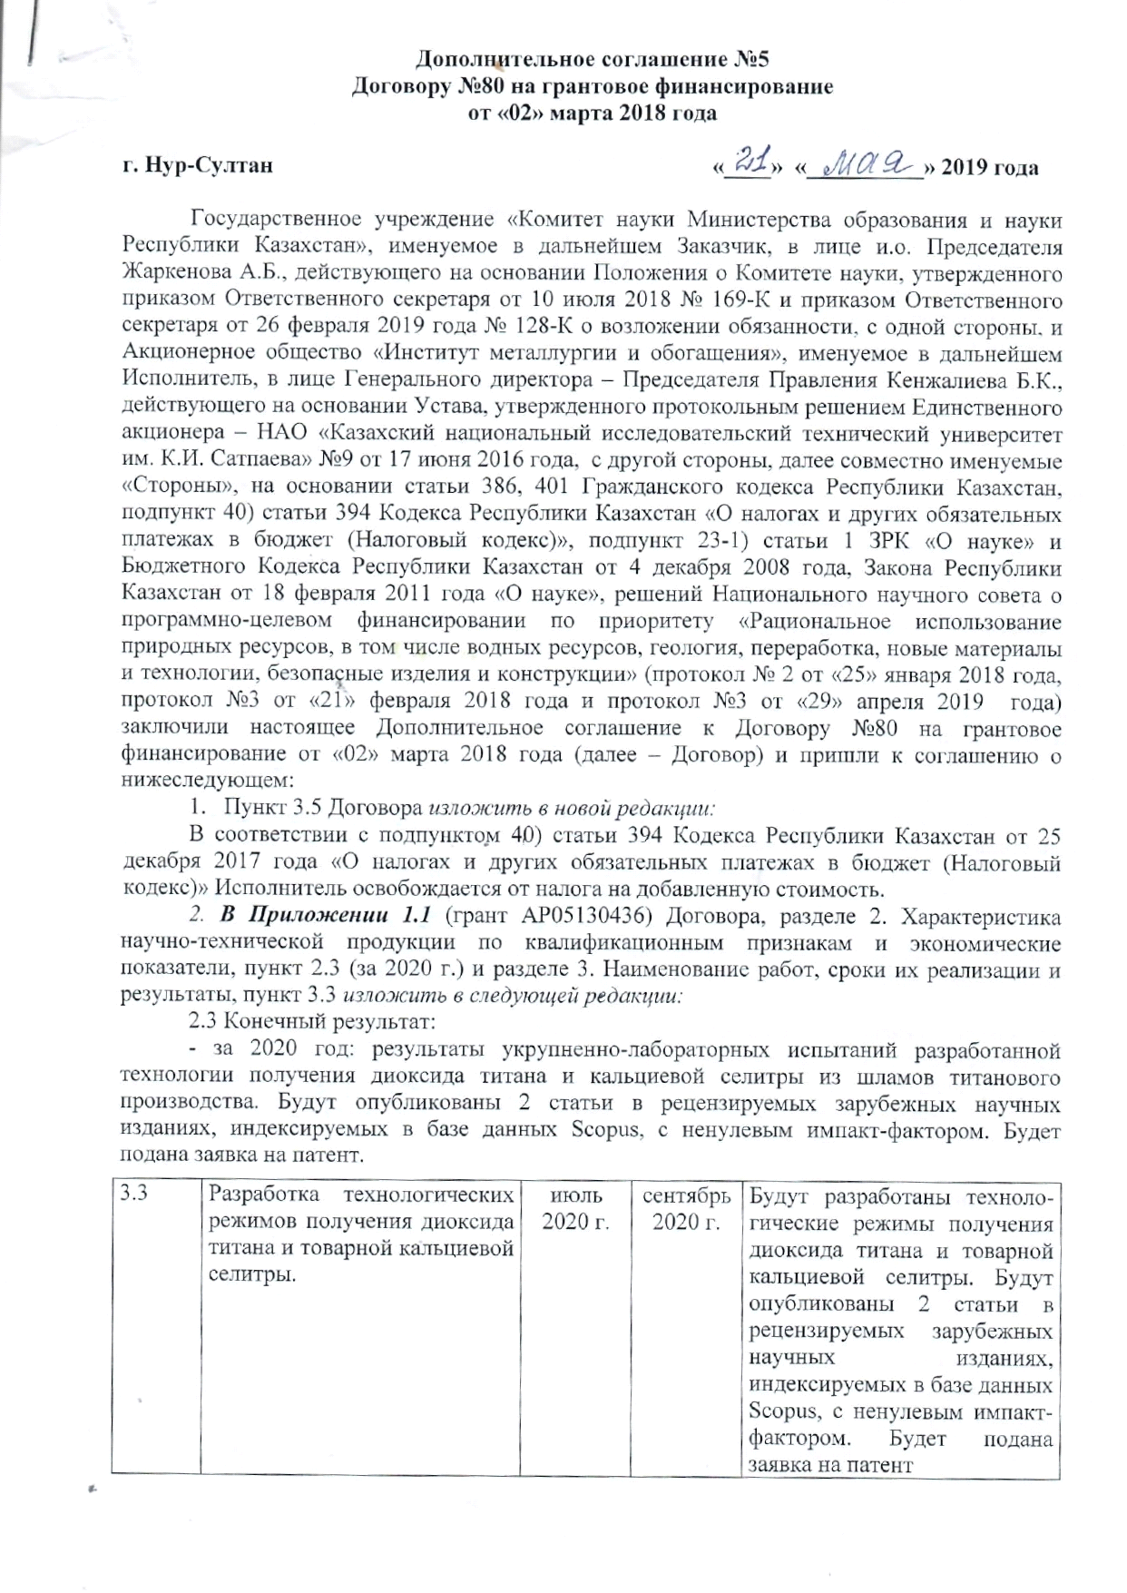
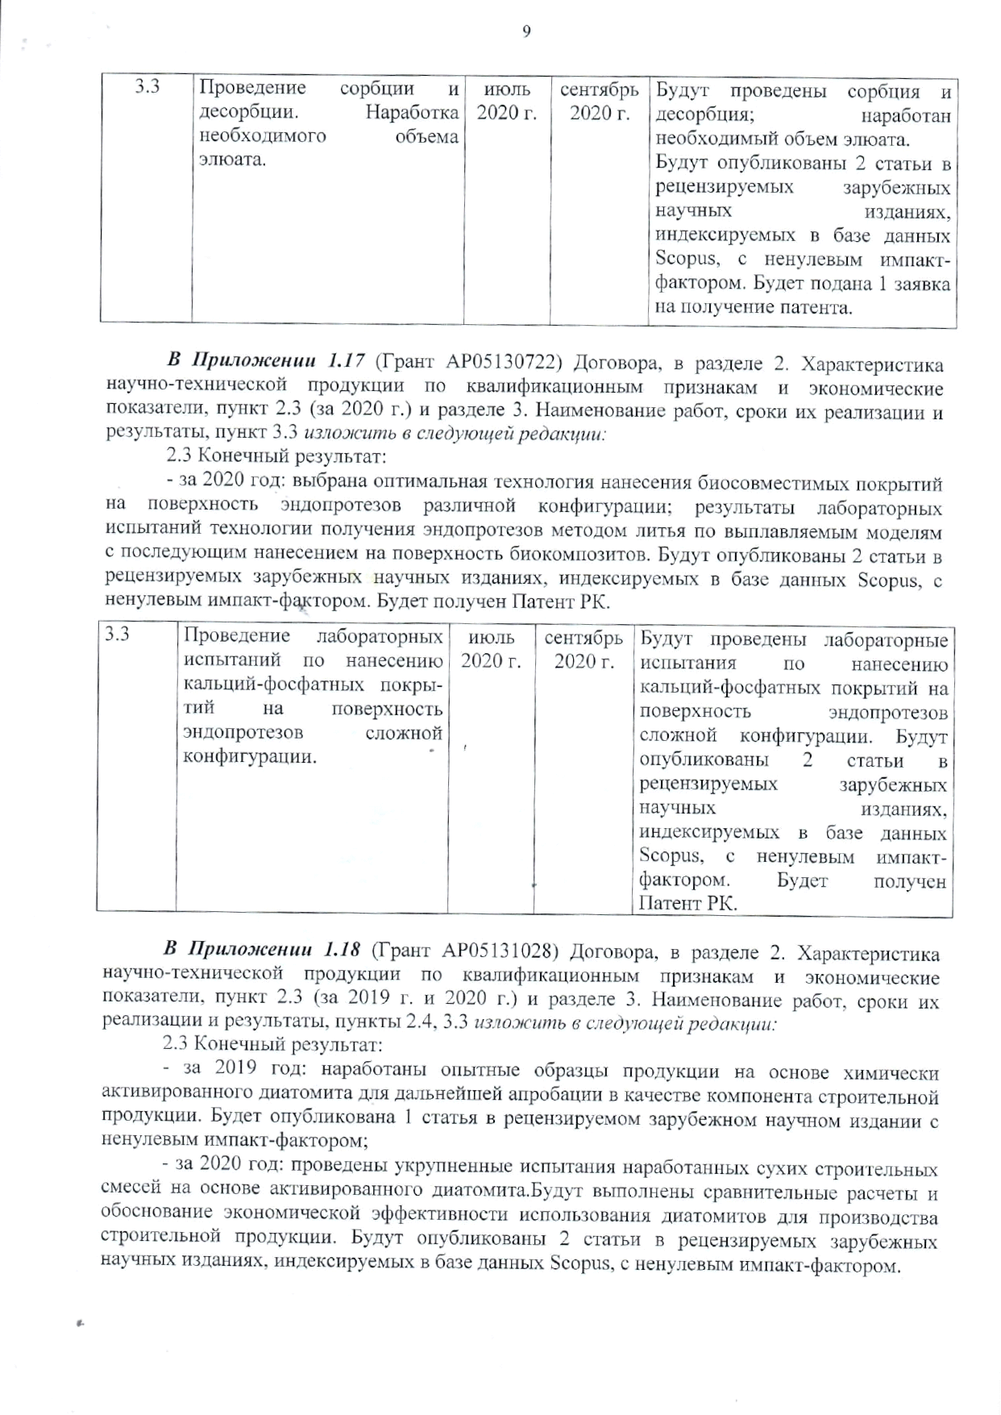

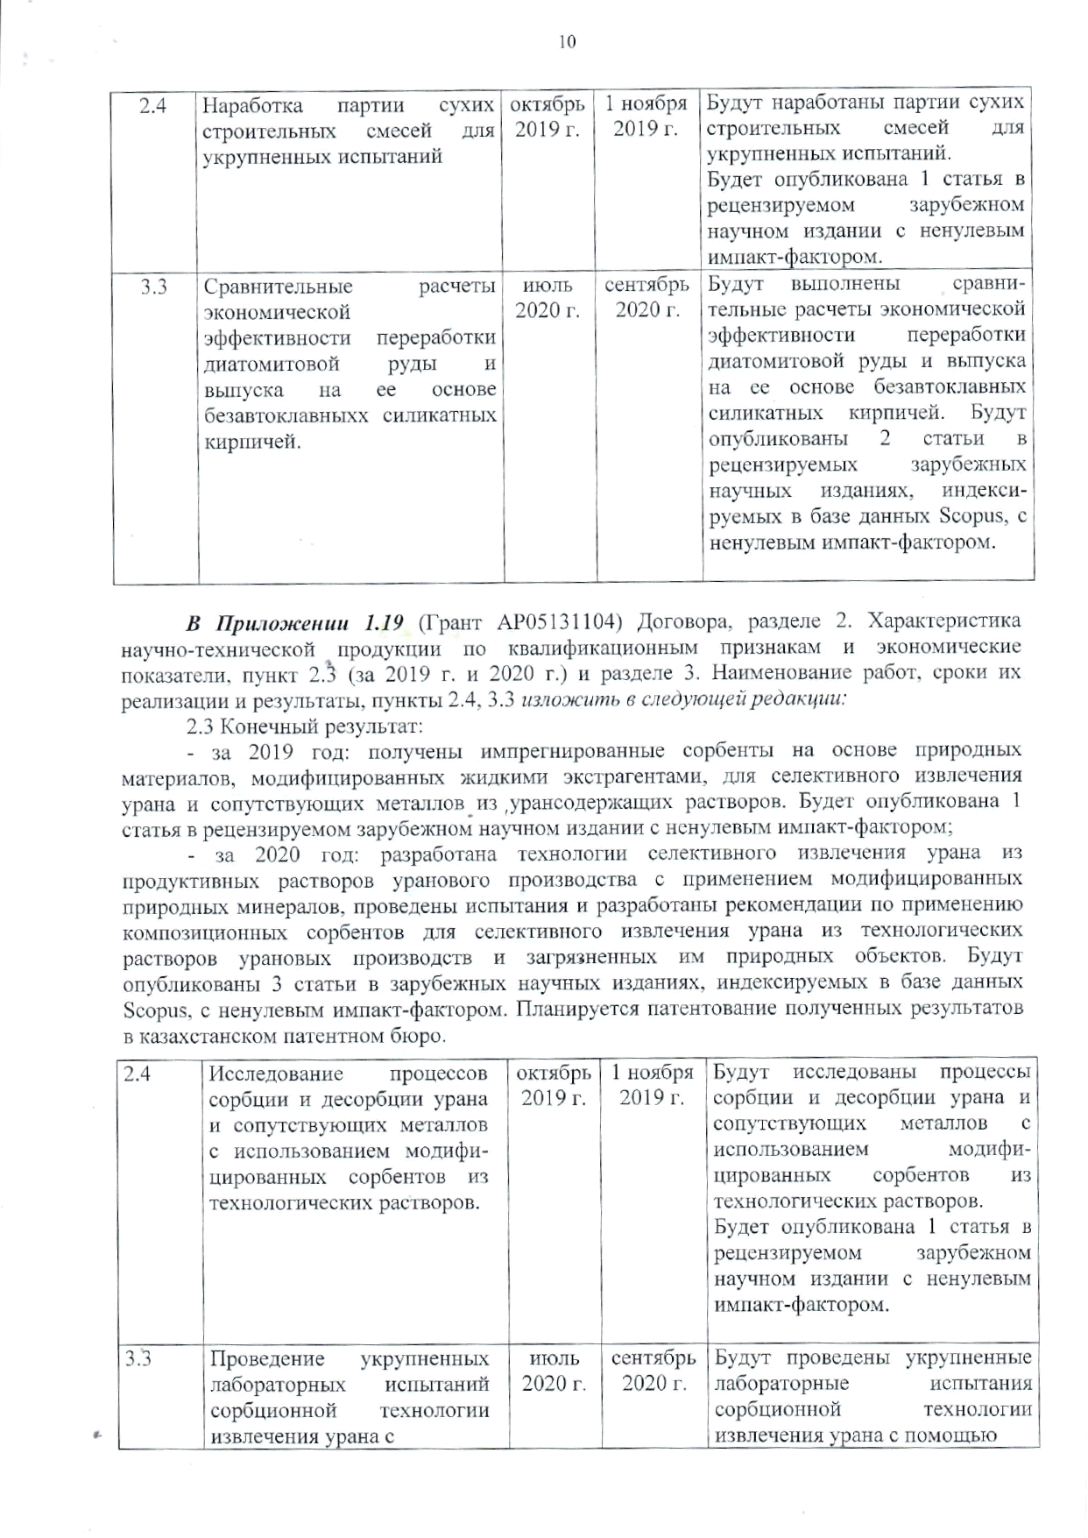
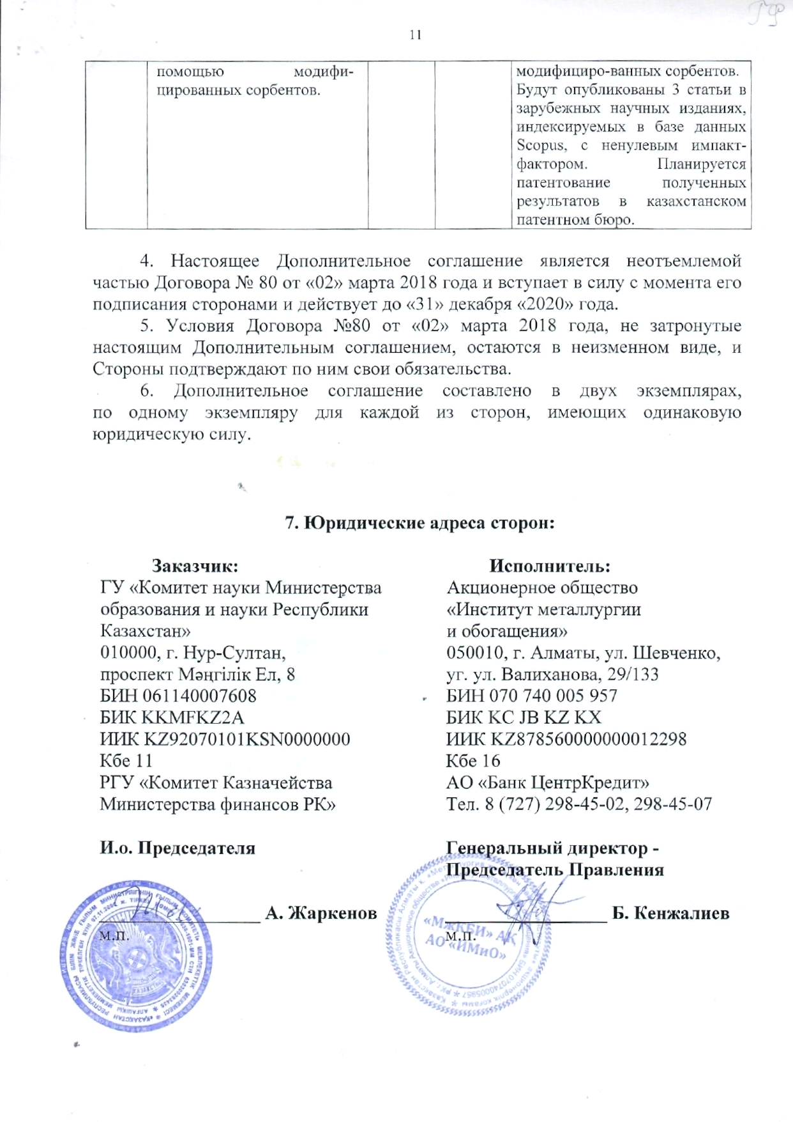

ANNEX E

Review
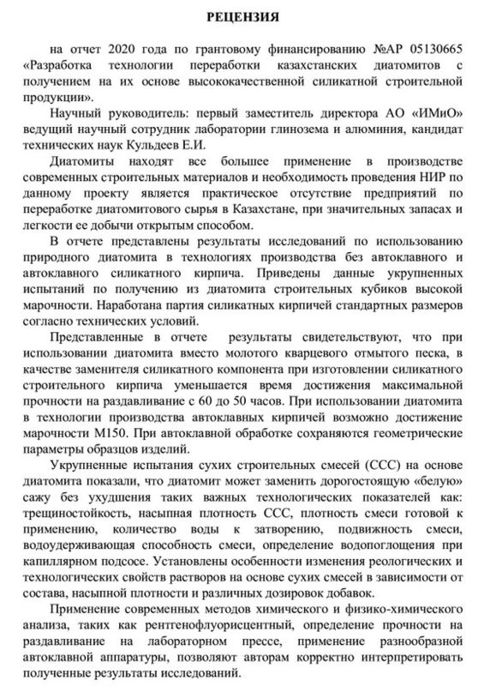

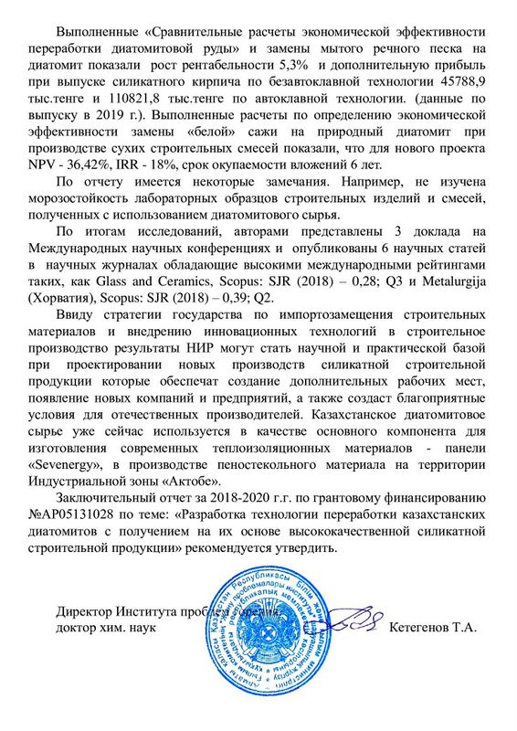

ANNEX F

Extract from the minutes no. 9
