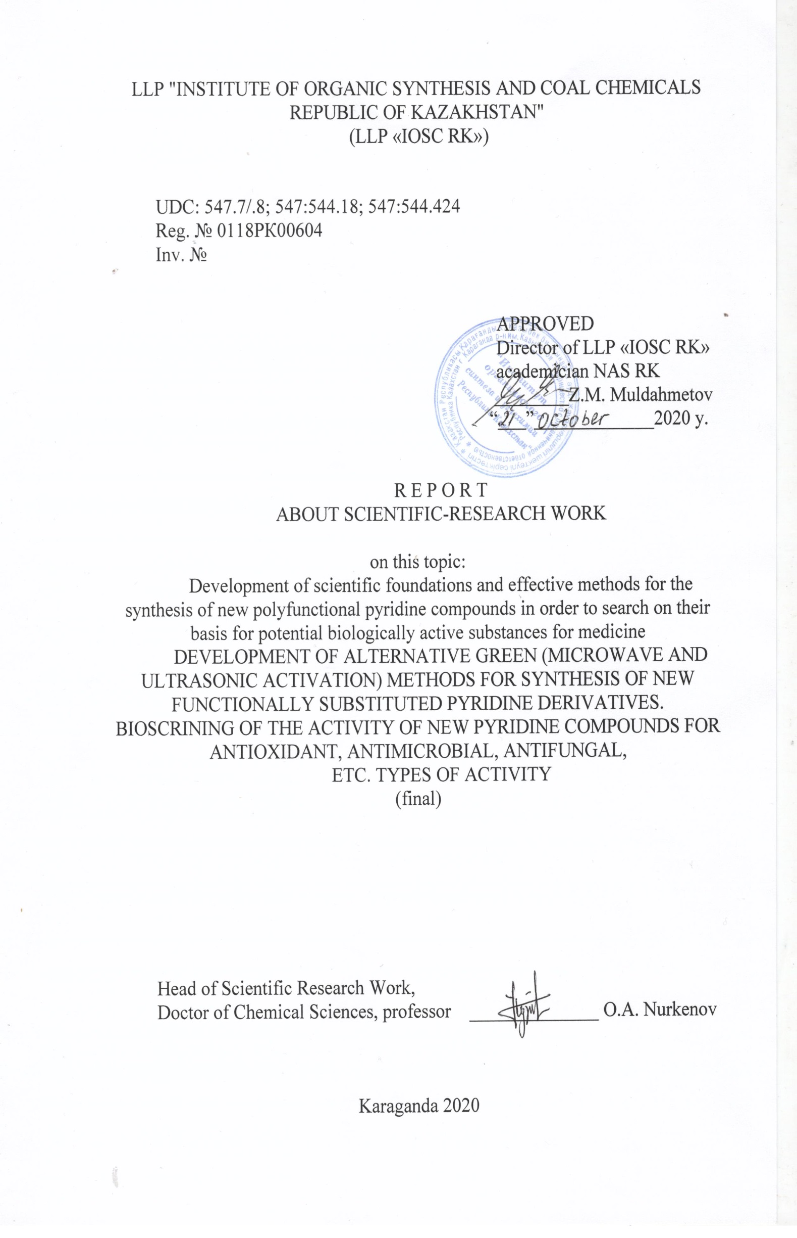

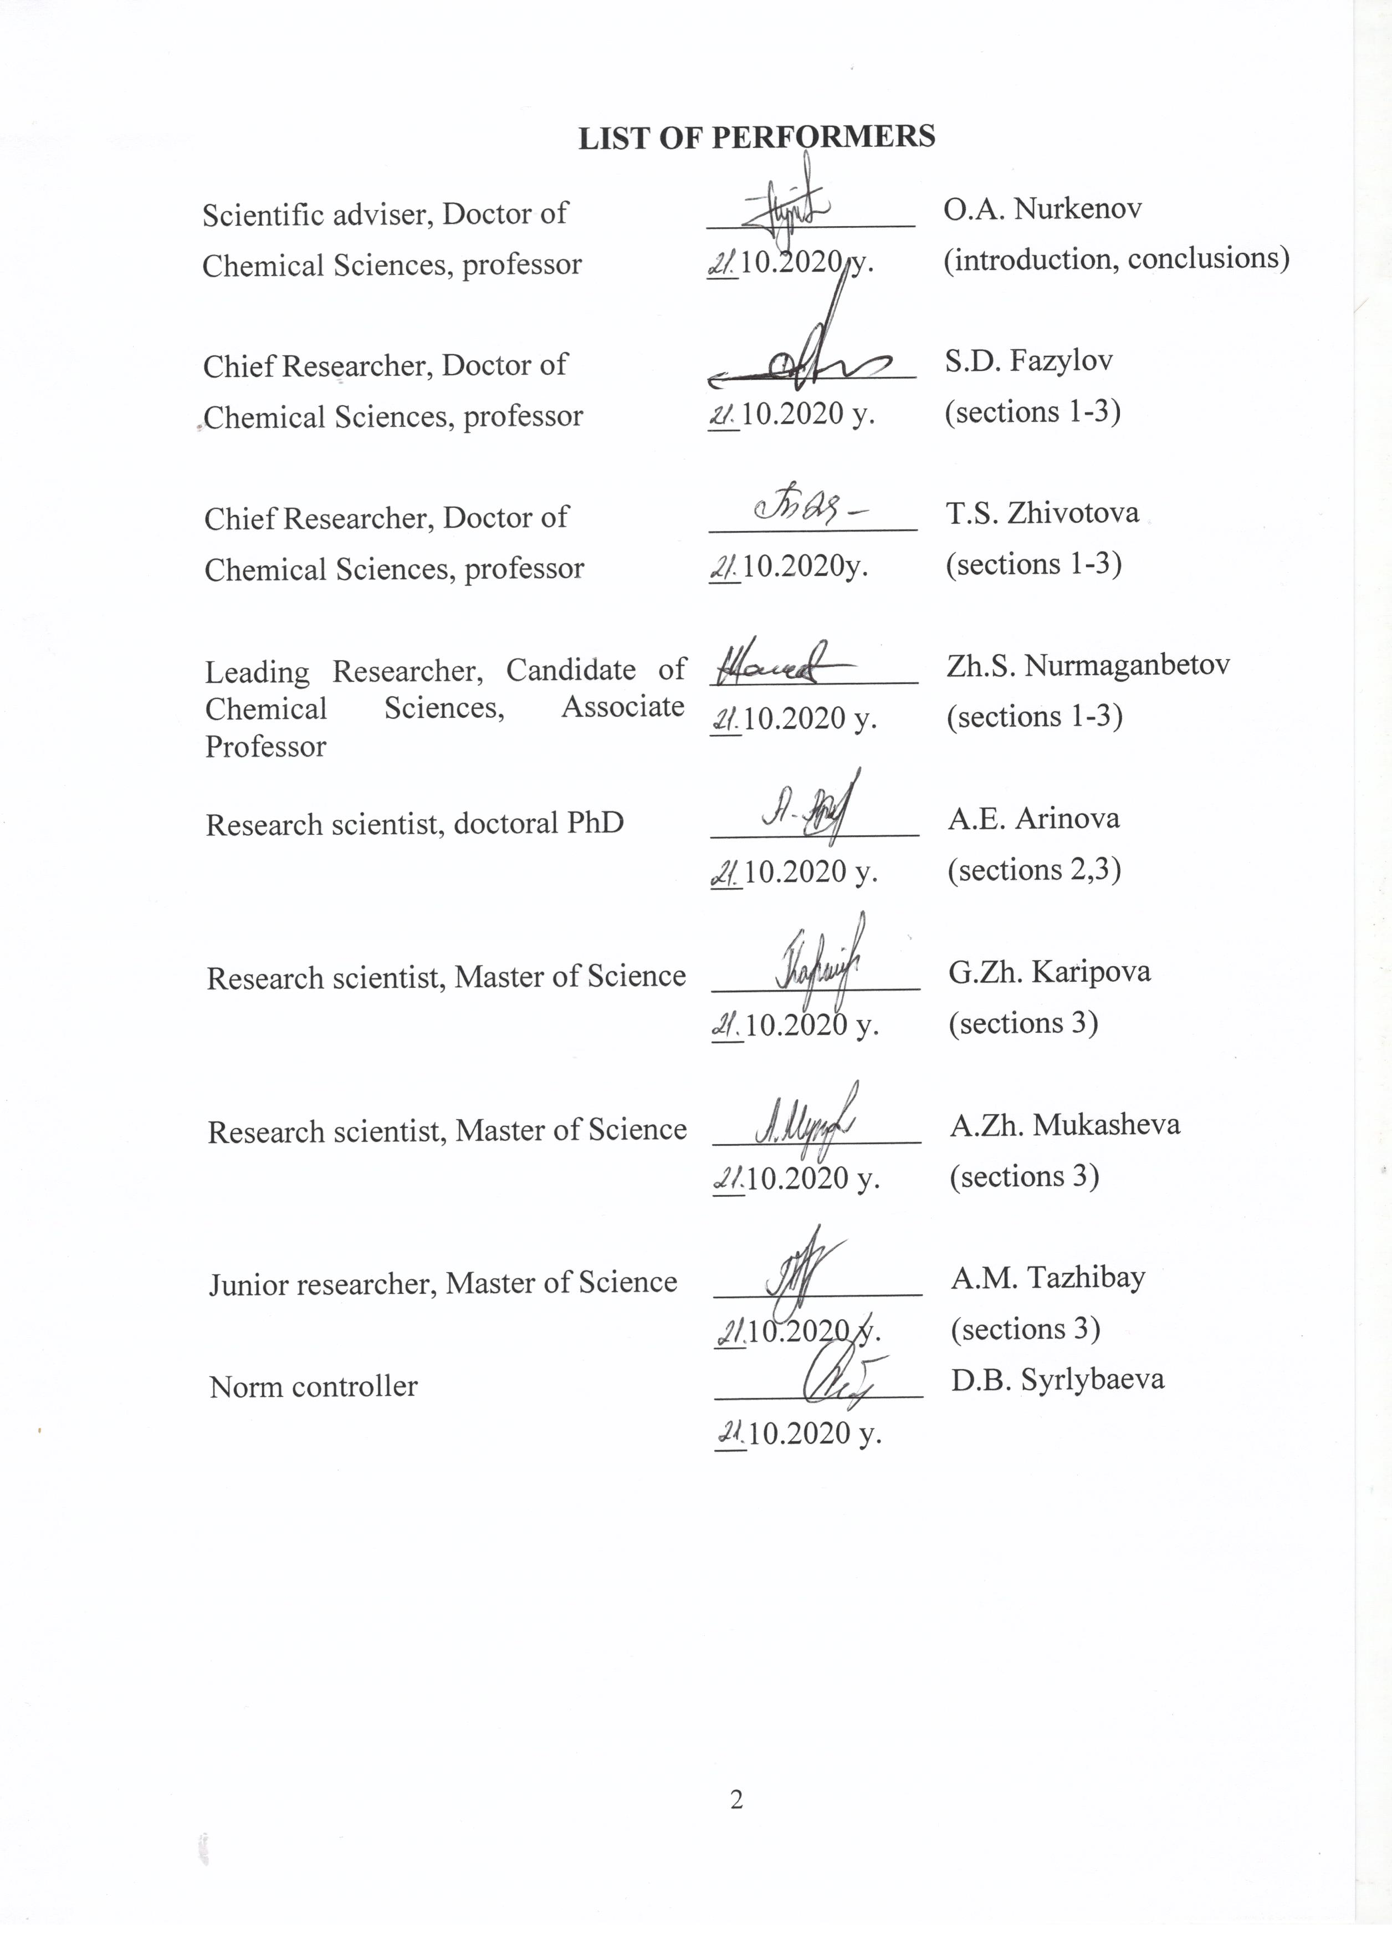

ABSTRACT

Report 122 p., 1 book., 18 figures, 5 tables., 29 sources., 5 appendix.
4-PYRIDINE CARBALDEHYDE, ISONICOTIC ACID HYDRASIDE, ACYLHYDRAZONE, FULLERENE C60, FULLEROPYRROLIDINE, PHARMACOLOGICAL ACTIVITY
The objects of investigation are 4-pyridinecarbaldehyde and its derivatives - hydrazones, acylhydrazones, fulleropyrrolidine, isonicotinic acid hydrazide, diethyl 2,6-dimethylpyridine-3,5-dicarboxylate.
The aim of the work is to develop methods for the preparation and optimal conditions for the synthesis of new derivatives of 4-pyridinecarbaldehyde under conditions of convection, microwave and ultrasonic activation, to study their structure, reactivity, and conduct bioscreening of the synthesized substances.
During the work, the synthesis reaction and structural features of N- (pyridin-4-ylmethylene)-4H-1,2,4-triazol-4-amine in ethanol (81.8%) were studied for the first time. A stereoslective synthesis of optically active 2-pyridine-3,4-dimethyl-5-phenyl-1,3-oxazolidine was carried out by the reaction of (1S,2S)-1-phenyl-2-methylaminopropanol-1 with 4-pyridinecarboxaldehyde. The synthesis of new acylhydrazones was carried out by the interaction of 4-pyridinecarbaldehyde with hydrazides of o- and p-hydroxybenzoic acids. The chemical modification of fullerene C60 by three-component condensation of fullerene C60, N-methylglycine (sarcosine) and pyridine-4-aldehyde was carried out to obtain N-methyl-2-(pyrid-4-yl)-3,4-fulleropyrrolidine. A method for the synthesis of 5-methyl-N-phenyl-7- (pyridin-4-yl)-4,7-dihydro-[1,2,4]triazolo[1,5-α]pyridine-6-carboxamide by the method fusion at 120-140°C. A comparative study of the synthesis of 2,6-dimethyl-1,4-dihydro-[4,4'-bipyridine]-3,5-dicarboxylate (Hantch reaction) and 6-methyl-4-(pyridin-4-yl)-2-thioxo-1,2,3,4-tetrahydropyrimidine-5-carboxylate (Bi-ginelli reaction) under convection heating, microwave and ultrasonic exposure. The structure of diethyl 2,6-dimethylpyridine-3,5-dicarboxylate was studied and its oxidative dehydrogenation was carried out. Bioscreening of new compounds for antiradical, antimicrobial, anti-inflammatory and cytotoxic activity was carried out.
Implementation degree - optimal methods for obtaining new potentially bioactive functionally substituted derivatives of 4-pyridinecarbaldehyde have been developed and studied, their physicochemical and biological properties have been studied. Structures of 11 new functionally substituted pyridine derivatives have been established using modern physicochemical methods (IR, ¹H NMR, ¹³C and COSY (¹H-¹H), HMQC (¹H-¹³C) spectroscopy, X-ray structural analysis).

CONTENT

LIST OF ABBREVIATIONS AND SYMBOLS …...…..………………………. |  | 6
INTRODUCTION ……………………………………………………………….. |  | 7
MAIN PART OF THE RESEARCH REPORT ………………………………….  1 Development of methods for obtaining and optimal conditions for the synthesis of new hydrazones, thiosemicarbazides, S, N-heterocycles based on isonicotinic acid hydrazide (INH), study of the mechanisms of reactions of their formation, determination of the structure (2018 y.)…………………………….  2 Chemical transformation of amino and methyl-substituted pyridines in order to obtain new potentially pharmacologically active agents (2019 у.)……………..  3 Development of alternative green (microwave and ultrasonic activation) methods for the synthesis of new derivatives of functionally substituted pyridine. Bio-screening of the activity of new pyridine compounds for antioxidant, antimicrobial, antifungal and other types of activity (2020 у.)……………… |  | 8  8  9  10
3.1 | Synthesis and structure of Schiff bases, hydrazones based on  4-pyridinecarbaldehyde…………………………………………… | 10
3.1.1  3.1.2 | Synthesis of N-(pyridin-4-ylmethylene) -4H-1,2,4-triazol-4 amine.......  Synthesis and spatial structure of 2-pyridine-1,3-oxazolidine………… | 11  13
3.1.3 | Synthesis and structure of acylhydrazones based on condensation  4-pyridinecarbaldehyde with o- and p-hydroxybenzoic acid hydrazides…………………………………………………………… | 15
3.1.4 | Synthesis, structure and study of the formation mechanism N-methyl-2- (pyrid-4-yl) -3,4-fulleropyrrolidine…….....……………… | 18
3.1.5 | Three-component reaction of interaction of pyridine-4-aldehyde, dicarbonyl compound and 3-amino-1,2,4-triazole under conditions of classical synthesis and ultrasonic activation …………………..... | 22
3.2 | Development of a preparative method for the synthesis of the most promising derivatives of functionally substituted pyridine using microwave irradiation and ultrasonic activation …………………... | 25
3.2.1  3.2.2  3.2.3  3.2.4  3.2.4.1  3.2.4.2  3.2.4.3 | Three-component condensation of 4-pyridinecarboxaldehyde, acetoacetic ether and ammonia according to the Ganch method under conditions of convection heating, microwave irradiation and ultrasonic impact …………………………………………………………………  Three-component condensation of 4-pyridinecarboxaldehyde, acetoacetic ether and thiourea according to Biginelli reactions under convection heating, microwave irradiation and ultrasonic impact….  Development of a synthesis method and study of the structure  diethyl 2,6-dimethylpyridine-3,5-dicarboxylate……..………………  Biological properties of the synthesized pyridine compounds ……...  Anti-radical activity test………………………...…………………...  Study of hydrazones for anti-inflammatory and cytotoxic activity….  Test for antimicrobial activity……………………………………….. | 25  28  31  35  35  36  37
CONCLUSION…………………………………………………………………… |  | 39
LIST OF USED SOURCES………………………….…………………………… |  | 42
APPENDIX А - Test reports.................................................................................... |  | 45
APPENDIX B - Technical specification and work schedule for 2018-2020……… |  | 54
APPENDIX C - Copy of RK patent for utility model…………………….....….. |  | 63
APPENDIX D - List of published works in the direction of the topic  for 2018-2020……………………………………………………………………….…  APPENDIX E - Copies of published works on the project topic for 2020 у……... |  | 64  70

LIST OF ABBREVIATIONS AND SYMBOLS

In this research report, the following abbreviations and symbols are used:

BAC | – | biological active compounds
BAS | – | biological active substances
INH | – | isonicotinylhydrazide
2-HP-β-CD | – | 2-hydroxypropyl-β-cyclodextrin
Hz | – | hertz
d. | – | doublet
d.d. | – | doublet of doublets
DМSО | – | dimethylsulfoxide
DМFА | – | dimethylformamide
IR-spectrum | – | infrared spectrum
SSCC | – | spin-spin coupling constant
q . | – | quartet
МHz | – | megahertz
m. | – | multiplet
m.s. | – | million shares
МWR  MWI | –  – | microwave radiation  microwave irradiation
s. | – | singlet
t. | – | triplet
Т_{mel.} | – | melting temperature
ТLC | – | thin layer chromatography
NMR | – | nuclear magnetic resonance
US | – | ultrasound
R_{f} | – | distribution ratio

INTRODUCTION

Relevance. For the pharmaceutical industry of sovereign Kazakhstan, the problem of finding and creating a wide range of biologically active substances is of particular relevance. In this case, the key role belongs to the so-called functionalized organic substances and materials with a certain set of properties that meet the requirements of a wide variety of areas of possible practical application. In this regard, 4-pyridinecarbaldehyde derivatives are of particular interest, since they are widely represented in plants and constitute an important structural fragment of many natural pyridine alkaloids. These compounds have a wide spectrum of physiological activity: antitumor, bactericidal, analgesic, vasodilating, etc. The introduction of a pyridine fragment into a molecule of pharmacologically active compounds can lead to the creation of new highly effective biologically active compounds.
There is very little information in the scientific literature on the reactions of obtaining Schiff bases, hydrazones, fullerene and other derivatives based on 4-pyridinecarbaldehyde, which are interesting as promising substrates in the search for new antibacterial, antimicrobial and anti-inflammatory drugs. An important group of bioactive derivatives of 4-pyridinecarbaldehyde with antibacterial action can be its chemical transformation with 1,2,4-triazole compounds.
In 2018 y., research work was devoted to the development of methods for obtaining and optimal conditions for the synthesis of new hydrazones, thiosemicarbazides, S, N-heterocycles based on isonicotinic acid hydrazide (state registration N 0118RK00604).
In 2019 y., research work was devoted to the chemical transformation of amino and methyl substituted pyridines in order to obtain new potentially pharmacologically active agents (state registration N 0219RK00414).
In 2020 y., the goal of this research work is to find new effective biologically active agents by modifying 4-pyridinecarboxaldehyde with various nucleophiles under the conditions of condensation reactions of Ganch, Biginelli, Prato, hydrazinolysis, heterocyclization, etc. In addition to traditional methods of synthesis, the use of modern physical methods for activating reaction media, such as microwave and sonochemical effects, is promising as innovative laboratory methods. With these alternative “green” methods, the results of some chemical transformations are many times greater than those obtained using traditional classical methods. When studying the structural features of new compounds, modern physicochemical methods of analysis are widely used.
Based on the results of the studies in 2018-2019, interim annual reports were prepared and submitted to JSC NCSTE (2018, inventory number 0118RK00604, 2019, inventory number 0219RK00414).

MAIN PART OF THE RESEARCH REPORT

1 Development of methods for obtaining and optimal conditions for the synthesis of new hydrazones, thiosemicarbazides, S,N-heterocycles based on isonicotinic acid hydrazide (INH), study of the mechanisms of reactions of their formation, determination of the structure (2018 y.)

On the basis of INH under the conditions of convection heating, microwave irradiation and ultrasonic activation, purposeful synthesis of new isonicotinic acid hydrazones has been carried out. It is shown that the optimal condition for microwave exposure is a radiation power of 150 W with a duration of the formation of products in 30-60 min, and for sonochemical activation, the exposure power is 20-35 V (130-227.5 W) for 20-30 min at a temperature of 50 ⁰C. As a result of a comparative analysis of the data obtained, it was determined that the use of microwave irradiation and ultrasonic exposure promotes an increase in the yield of the product and a decrease in the reaction time from 8-9 hours to 20-60 minutes than with traditional technology. For the first time, reactions of supromolecular complexes based on N-(diethylamino)benzylideneisonicotinohydrazide and N-(2-bromo-3-phenyl)allylideneisonicotinohydrazide with cyclodextrins (β-CD, 2-HP-β-CD) were obtained and studied. Comparison of the integral intensities of ¹H NMR signals of substrate molecules (hydrazones) and β- and 2-HP-β-CD receptors in supramolecular complexes showed that in all cases, complexes of 1 guest molecule per 2 host molecules are formed. The synthesis and intramolecular heterocyclization of new thiosemicarbazide derivatives were carried out by chemical modification of isonicotinic acid hydrazide with alkyl(aryl)- isothiocyanes. The cyclization of isonicotinic acid thiosemicarbazides was carried out by boiling for 2 h in an aqueous solution of sodium hydroxide followed by acidification with hydrochloric acid to form 4-alkyl(aryl)-3-(pyridin-4-yl)-1,2,4-triazole-5-tion.
A number of new synthesized compounds have been tested for various types of biological activity, in particular for antiradical, cytotoxic and antimicrobial activity. It was found that the compound N-(3-ethoxy-4-hydroxybenzylidene)-isonicotinohydrazide (NOK-16) showed antiradical activity. As a result of the study of the potential of antimicrobial activity, it was found that the compound N '- ((5-nitrofuran-2-yl)methylene) isonicotinohydrazide (NOK-8) shows pronounced antimicrobial activity.
As a result of the research, 29 new derivatives of INH were synthesized. Using modern physicochemical methods (IR-, ¹H-, ¹³C and ¹H-¹³C HSCQ spectroscopy, X-ray structural analysis), their structures have been established. During the reporting period, according to the results of the research performed, 7 scientific papers were published (4 scientific articles and 3 abstracts).

2 Chemical transformation of amino and methyl-substituted pyridines in order to obtain new potentially pharmacologically active agents (2019 у.)

This work was the first to study the interaction of functionally substituted 2-aminopyridines, acetoacetic acid anilide (or acetoacetic ester) and orthoformic acid ethyl ester under “one pot” reaction conditions. It was found that the studied reactions of three-component synthesis are successfully carried out with the formation of the corresponding 2-amino-methylene-3-oxo-N-phenylbutanamides in 39-82% yields. The data on the reaction of 2-amino-5-bromopyridine, 2-amino-3-hydroxypyridine and 2-aminomethylpyridine with ethyl- and phenyliso-thiocyanates in an alcoholic medium with the formation of the corresponding substituted pyridine-containing thioureas in 40-66% yields are given. Three methods of synthesis of practically important 4-styrylpyridines have been proposed. It has been established that under the conditions of classical synthesis, the reaction of interaction between methylpyridines and aromatic aldehydes can be carried out only in the presence of a ZnCI₂ catalyst in a sealed ampoule and at a high temperature (170-200⁰C) with a yield of 5-8%. The results of studying the sonochemical synthesis reaction (50 Hz, 150 min) led to an increase in the yield of 4-styrylpyridine up to 27-29%. A method has been developed for carrying out this reaction in a microwave field in the presence of a catalyst on a substrate (SiO₂). It was found that at a radiation power of 500 W and a reagent ratio of 1: 2: 0.5, the use of microwave irradiation increases the product yield to 72-74%. Supramolecular complexes based on functionally substituted N'-((5-nitrofuran-2-yl)methylene)isonicotinohydrazide with cyclodextrins (β-CD, hydroxypropyl-β-CD) have been obtained. It was shown that, in both cases, complexes of substrate inclusion into the cyclodextrin cavity of the receptors are formed. A new thiazoline derivative was synthesized and characterized by the interaction of isonicotinic acid hydrazide with 2,3-dibromopropyl isothiocyanate.
The structures of the new synthesized compounds were studied using modern ¹H and ¹³C NMR spectroscopy methods. The values of chemical shifts, multiplicity and integral intensity of ¹H and ¹³C signals in one-dimensional NMR spectra were determined. Using the spectra in the formats COSY (¹H-¹H) and HMQC (¹H-¹³C), homo- and heteronuclear interactions were established, confirming the structure of the compounds under study.
Based on the research results, 27 new derivatives of functionally substituted pyridines were synthesized. During the reporting period, according to the results of the research performed, 9 scientific papers were published (1 patent application, 1 monograph, 3 scientific articles and 4 theses of reports).

3 Development of alternative green (microwave and ultrasonic activation) methods for the synthesis of new derivatives of functionally substituted pyridine. Bio-screening of the activity of new pyridine compounds for antioxidant, antimicrobial, antifungal and other types of activity (2020 у.)

Pyridine derivatives are widespread in nature. Many of them are biologically active substances. The pyridine ring is a part of many vital organic compounds, which determines its one of the dominant roles among heterocycles. They are widespread in plant nature, because constitute a structural fragment of many natural pyridine alkaloids, for example, nicotine, anabasine, ricinin, and morferidine [1], [2]. Numerous synthetically obtained pyridine derivatives have found various practical applications, especially as anti-tuberculosis [3], anti-microbial, antiviral drugs [4], [5], anti-inflammatory [6] with a wide range of pharmacological action, in connection with which they traditionally are the focus of researchers.
At present, in connection with the development of high science-intensive technologies, approaches to synthesis methods in organic chemistry are changing, much attention is paid to the creation of the latest resource and energy-saving, environmentally friendly technologies for obtaining new materials according to the concept of "Green Chemistry" [7]. In this work, along with classical methods of organic chemistry, the MW-promotion technology will be used in the fine organic synthesis of biologically active compounds, which is one of the most rapidly developing technologies. The use of an alternative method of sonochemical activation in many cases shows significantly better results compared to carrying out reactions under traditional conditions [8]. It should be noted that the development of methods for organic synthesis under microwave irradiation in the technology of chemical and pharmaceutical production can become an essential factor in their development.

3.1 Synthesis and structure of Schiff bases, hydrazones based on 4-pyridinecarbaldehyde

There is very little information in the scientific literature on the reactions of obtaining Schiff bases, hydrazones, and other compounds based on 4-pyridinecarbaldehyde, which are interesting as promising "biobuilding" substrates in the search for new antibacterial, antimicrobial and antiviral agents. In order to expand the arsenal of biologically active substances, we conducted a search for new effective and safe biologically active agents by modifying 4-pyridinecarboxaldehyde with various nucleophiles under condensation conditions of Ganch, Biginelli, Prato, etc. The search for new methods for the preparation of 4-substituted derivatives of pyridine compounds is of great importance both from the point of view of the development of the chemistry of heterocycles and from the point of view of the practical significance of such studies.

3.1.1 Synthesis of N-(pyridin-4-ylmethylene)-4H-1,2,4-triazol-4-amine

One of the methods for implementing structural combinations in the search for highly effective antibacterial and antimicrobial drugs is the synthesis reaction of condensed systems with 1,2,4-triazoles. The triazole fragment, as a biofragment of many antibacterial drugs [9], can impart new useful properties to their conjugates with a pyridine heterocycle. In this regard, we have synthesized a new azomethine (1) (Schiff bases) by condensation of equimolecular amounts of 4-pyridinecarboxaldehyde and 4-amino-1,2,4-triazole by heating in ethanol with a yield of 81.8%.
The structure of the synthesized compound (1) was proved by ¹H and ¹³C NMR spectroscopy, as well as by the data of the two-dimensional spectrum of HMQC (¹H-¹³C).
The ¹H NMR spectrum of compound (1) is characterized by the presence of a doublet signal of the equivalent protons H³ and H⁵ of the pyridine ring at 7.71 ppm. with an integrated intensity of 2H with ³J 4.3 Hz (Figure 1). The signals of two other equivalent protons H² and H⁶, close to the electronegative nitrogen atom of pyridine, appeared as a doublet in a weaker field at 8.74 ppm with an integrated intensity of 2H with ³J 4.3 Hz.

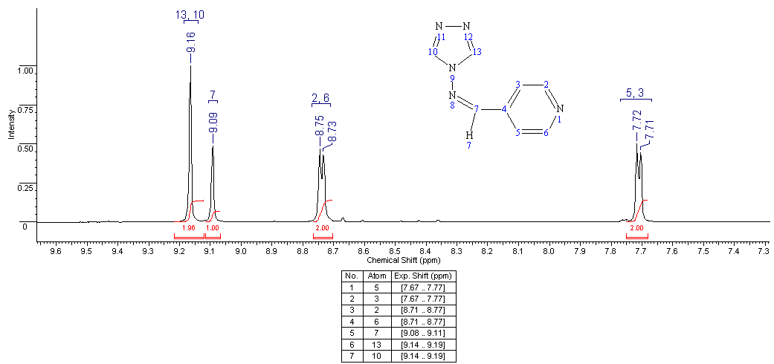
Figure 1 - ¹H NMR spectrum of N- (pyridin-4-ylmethylene) -
-4H-1,2,4-triazol-4-amine (1)

The H⁷ proton at the double bond appeared as a singlet at 9.09 ppm. with an integrated intensity of 1H. The equivalent protons of the triazole ring, H¹⁰ and H¹³, also resonated with a singlet signal at 9.16 ppm with an intensity of two protons.
In the ¹³C NMR spectrum of compound (1), the carbon atoms of the pyridine ring resonated at 122.34 (C^{3,5}), 139.76 (C⁴) and 151.28 (C^{2,6}) ppm (Figure 2). Chemical shift signal at 139.67 ppm corresponds to symmetric carbon atoms of the triazole ring C^{10,13}. The signal in the weak field region at 156.65 ppm belongs to the carbon atom double bonded to the C⁷ nitrogen atom.

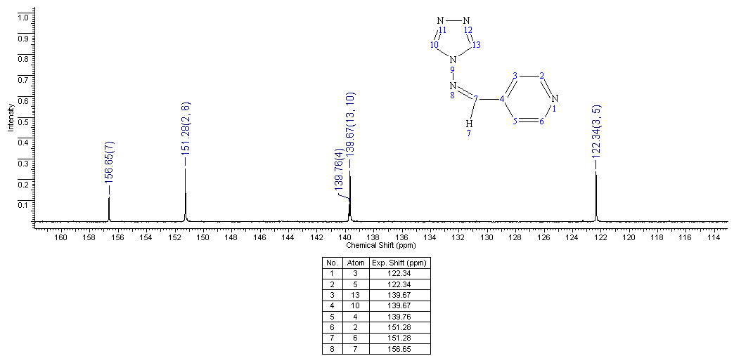
Figure 2 - ¹³C NMR spectrum of N-(pyridin-4-ylmethylene) -
-4H-1,2,4-triazol-4-amine (1)

The structure of compound (1) was also confirmed by the methods of two-dimensional NMR spectroscopy COSY (¹H-¹H) and HMQC (¹H-¹³C), which makes it possible to establish spin-spin interactions of homo- and heteronuclear nature. The observed correlations in the molecule are shown in Figure 3. In the ¹H-¹H COSY spectra of the compound, spin-spin correlations are observed through three bonds of the protons of the pyridine ring H²-H³ and H⁵-H⁶ by cross-peaks with coordinates at 8.72, 7.71 and 7, 69, 8.74. Heteronuclear interactions of protons with carbon atoms through one bond were established using ¹H-¹³C HMQC spectroscopy for all pairs present in the compound: H^{3,5}-C^{3,5} (7.69, 122.34), H^{2,6}-C^{2,6} ( 8.72, 151.26), H⁷-C⁷ (9.07, 156.64), H^{10,13}-C^{10,13} (9.14, 139.66).

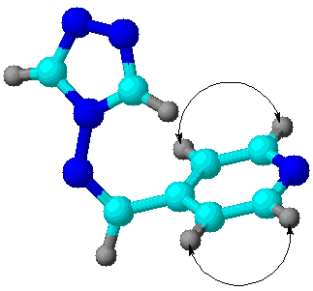а | 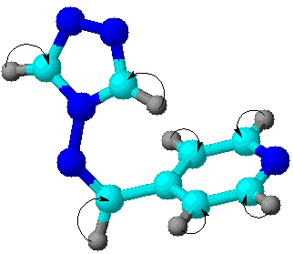 b
Figure 3 - Scheme of correlations in the spectra COSY (a) and HMQC (b) compounds (1)

Synthesis of N-(pyridin-4-ylmethylene)-4H-1,2,4-triazol-4-amine (1). To a solution of 0.5 g (0.006 mol) of 4-amino-1,2,4-triazole in 10 ml of ethanol was added dropwise 0.64 g (0.006 mol) of 4-pyridinecarboxaldehyde with stirring. The reaction mixture was heated at 60-70 °C for 7 hours. The completion of the reaction was monitored by TLC. Then the reaction mixture was cooled, the solvent was evaporated, the precipitated white powder was recrystallized from dioxane. Received 0.85 g (81.8%) of substance (1) with a melting point of 180-182 °C.
Thus, on the basis of 4-pyridinecarboxaldehyde and 4-amino-1,2,4-triazole, a very promising new azomethine (1) (Schiff bases) was obtained, the structure of which was established using IR and ¹H NMR spectroscopy.

3.1.2 Synthesis and spatial structure of 2-pyridine-1,3-oxazolidine

Much interest in 1,3-oxazolidine derivatives is due to the fact that these compounds have unique properties that allow them to be used for various practical purposes in medicine and industry, and are also of great scientific interest as products of enantioselective synthesis of planar chiral compounds [10-11].
Continuing research in this direction, we carried out the condensation of the alkaloid (1S,2S)-1-phenyl-2-methylaminopropanol-1 with 4-pyridinecarboxу-aldehyde by refluxing in an atmosphere of absolute benzene. The reaction was carried out until the end of the azeotropic distillation of water collected in the Dean-Stark trap. The reaction proceeds rather quickly and with a high yield (80%) of oxazolidine formation (2).

The structure of compound (2) was studied by ¹H NMR, ¹³C spectroscopy and X-ray structural analysis.
From the analysis of the ¹H NMR spectrum of compound (2) dissolved in DMSO, the manifestation of doublet and singlet signals in the range of 1.07-1.09 and 2.12 ppm is characteristic, which can be correlated with the protons of the methyl radicals of the five-membered ring with two heteroatoms. The protons H-2, H-4 and H-5 of the methine groups of this system resonate at 4.95 (singlet), 2.49-2.51 (doublet) and 4.66-4.68 ppm (doublet) respectively. In the weak-field region, signals of the phenyl and pyridine rings are observed: δ (H-17) = 7.31 ppm; δ (H-16, H-18) = 7.35-7.37 ppm; δ (H-15, H-19) = 7.39-7.40 ppm; δ (H-7, H-11) = 7.46-7.48 ppm; δ (H-8, H-10) = 8.57-8.59 ppm.
Analysis of the DEPT spectra made it possible to establish eight signals of CH and two signals of CH₃ groups in the carbon spectrum. In this case, methyl groups are observed at 14.47 (C-13) and 35.41 ppm (С-12). The signals of methine groups appear in the region of a weaker field: δ (С-4) = 68.67 ppm; δ (C-5) = 86.59 ppm; δ (C-2) = 97.38 ppm; δ (C-7, C-11) = 123.30 ppm; δ (C-15, C-19) = 127.27 ppm; δ (C-17) = 128.56 ppm; δ (C-16, C-18) = 128.90 ppm; δ (C-8, C-10) = 150.26 ppm. Signals at 140.43 and 149.02 ppm correspond to quaternary carbon atoms C-14 and C-4, respectively.
Using two-dimensional spectra of COSY (¹H-¹H) and TOCSY (¹H-¹H), it was possible to study the spin-spin interactions carried out through three bonds between the protons of neighboring carbon atoms. The results of this experiment are shown in Figure 4. Taking the spectrum in the HMQC format (¹H-¹³C) makes it possible to establish the presence of heteronuclear interactions in the molecule of the compound under study (Figure 5).
Figure 4 - Scheme of correlations COSY (¹H-¹H) and TOCSY (¹H-¹H) in compounds (2) | Figure 5 - Scheme of correlations HMQC (¹H-¹³C) in compounds (2)

To establish the spatial structure of 2-pyridine-3,4-dimethyl-5-phenyl-1,3-oxazolidine (2), its X-ray structural study was carried out. The structure of the molecule (2) is shown in Figure 6.
Picture 6 - Spatial structure of the molecule (2)

2-Pyridine-3,4-dimethyl-5-phenyl-1,3-oxazalidine (2). A mixture of 1.65 g (0.01 mol) of (1S,2S)-1-phenyl-2-methylaminopropanol-1 and 1.07 g (0.01 mol) of 4-pyridinecarboxaldehyde in 30 ml of absolute benzene was boiled for 30 min with azeotropic by distillation formed during the reaction of water. After the completion of the reaction, the solvent was distilled off, the residue crystallized. By recrystallization from 2-propanol, 2.0 g (80%) of product (2) were obtained with a melting point of 85-86⁰C.

3.1.3 Synthesis and structure of acylhydrazones based on condensation of 4-pyridinecarbaldehyde with hydrazides of o- and p-hydroxybenzoic acids

In recent years, interest in hydrazones has increased again [12], [13], which is associated with a wide range of their biological properties. Various hydrazones have antidepressant, anti-inflammatory, antimalarial, antimicrobial, antiviral, and antitumor activities [12]. Suffice it to recall ftivazide, saluside and related drugs used to treat tuberculosis [3]. On the basis of hydrazones, for example, inhibitors of such enzymes as cyclooxygenase, monoamine oxidase, epoxide hydrolase and various cathepsins have been synthesized [14]-[16]. Among the proteolytic enzymes, cathepsin E (EC 3.4.23.34) and neutrophil elastase (EC 3.4.21.37) play an important role in the pathogenesis of human autoimmune diseases and tumor progression [17]. Based on the foregoing, in this work we have synthesized derivatives of N-arylidenehydrazones (3), (4) and studied their anti-inflammatory activity in the cell system in vitro. The synthesis of hydrazones (3), (4) was carried out by condensation of o- and p-hydroxybenzoic acid hydrazides with 4-pyridinecarbaldehyde. The condensation reaction was carried out by heating equimolar amounts of aldehyde and o- and p-hydroxybenzoic acid hydrazides in ethanol at 60-70 °C for 3-5 hours.
The products of reaction (3), (4) are highly crystallizing white substances, soluble in many organic solvents, the yield of compounds is 70 and 90%, respectively.
In the IR spectra of N-arylidenehydrazones of o- and p-hydroxybenzoic acids (3), (4) there are no absorption bands of the NH₂ group. Absorption bands of stretching vibrations of the N-H group at 3285-3355 cm⁻¹, C = O of the hydrazone group at 1675-1690 cm⁻¹. The group of characteristic bands 1600-1440 cm⁻¹ refers to the stretching vibrations of the aromatic ring.
In the downfield part of the ¹H NMR spectrum of 2-hydroxy-N- (pyridin-4-yl-methylidene)benzohydrazide (3) in the region of 6.91-6.97 ppm the superposition of the doublet and triplet signals of the H-14 and H-16 protons of the aryl radical is observed. Triplet with a center of 7.41 ppm corresponds to the para-proton H-15. Located in the ortho position, H-17 resonates at 7.84-7.85 ppm in the form of a double. In the region of 7.63-7.64 and 8.62-8.63 ppm superposition of doublet signals of equivalent protons Н-3 and Н-5, Н-2 and Н-6 of the pyridine system is observed. Singlet at 8.42 ppm refers to the proton of the sp²-hybridized C-7 atom. In the area of ​​11.96 ppm in the form of low-intensity singlets, the resonance of the protons of the amino and hydroxy groups is expected.
The ¹³C NMR spectrum of 2-hydroxy-N-(pyridin-4-yl-methylidene) benzohydrazide (3) exhibits signals with chemical shifts 117.77, 119.61, 129.46, 134.47, 121.59 and 150.81 ppm methine groups of the aryl radical (C-14, C-16, C-17, C-15) and the pyridine ring (C-3.5 and C-2.6), respectively. Quaternary atoms C-4, C-12 and C-13 of these fragments resonate at 141.89, 116.83 and 159.17 ppm. For the carbonyl atom C-10 and sp2-hybridized C-7, the manifestation is characteristic in the region of 165.34 and 146.63 ppm.
The study of the ¹H NMR spectrum of hydrazone (4) indicated the presence of seven groups of proton signals, some of which belong to symmetrically located atoms of cyclic systems. Doublets with chemical shifts of 6.83-6.85 and 7.78-7.80 ppm. refer to the equivalent protons H-14,16 and H-13,17 of the aryl radical. In the area of 7.59-7.61 and 8.59-8.61 ppm. the superposition of the doublet signals of the protons H-3,5 and H-2,6 of the pyridine system is observed. Low intensity singlets at 8.37, 10.12 and 11.83 ppm correspond to the protons of the H-7 sp²-hybridized carbon atom, the H-9 amino group and the H-18 hydroxyl group.
Interpretation of the DEPT spectra of compound (4) made it possible to draw conclusions about the presence of four signals of methine groups in the carbon spectrum of the studied compound at 115.62 (C-14, C-16), 130.48 (C-13, C-17), 121, 41 (C-3, C-5) and 150.75 ppm (C-2, C-6), which can be assigned to the carbon atoms of the aryl radical and the pyridine ring. Quaternary atoms C-4, C-12 and C-15 of these fragments resonate at 142.26, 124.07 and 161.45 ppm. respectively. The sp²-hybridized C-7 is characterized by a manifestation in the region of 144.83 ppm.
The results of a detailed interpretation of the two-dimensional spectra of hydrazones (3) and (4) in the formats COSY (¹H-¹H) and HMQC (¹H-¹³C), which make it possible to establish the spin-spin interactions of homo- and heteronuclear nature, are presented in Figures 7 and 8 below.
а | b
Figure 7 - Correlations of COSY (¹H-¹H) (a) and HMQC (b) compound (3)
а | b
Figure 8 - Correlations of COSY (¹H-¹H) (a) and HMQC (b) of compound (4)

General procedure for the synthesis of acylhydrazones (3), (4). 0.005 mol of o- or p-hydroxybenzoic acid hydrazide was dissolved in 10 ml of 2-propanol. With top stirring, 0.0051 mol of 4-pyridinecarbaldehyde was added. The mixture was stirred for 30 min at a temperature of 60-70⁰C. The completion of the reaction was monitored by TLC. The solution was cooled, the formed fine crystalline precipitate was filtered off and recrystallized from ethyl acetate.
2-Hydroxy-N-(pyridin-4-yl-methylidene)benzohydrazide (3). Yield 1.09 g (91%), with a melting point of 238-239 °C (C₂H₅OH). ¹H NMR spectrum, (DMSO-d₆), δ, ppm: 6.95 m (2H, CH^{14,16}_{arom}), 7.41 t (1H, CH¹⁵_{arom}), 7.63 d (2H, CH^{3,5}_{arom}) , 7.84 d (1H, CH¹⁷_{arom}), 8.42 s (1H, N=CH), 8.62 d (2H, CH^{2,6}_{arom}), 11.96 br.s (2H, NH, OH). ¹³C NMR spectrum, δ, ppm: 116.83 (C¹²_{arom}), 117.77 (CH¹⁴_{arom}), 119.61 (C¹⁶_{arom}), 121.59 (CH^{3,5}_{arom}), 129.46 (CH¹⁷_{arom}), 134, 47 (CH¹⁵_{arom}), 141.89 (C⁴_{arom}), 146.63 (N=CH), 150.81 (CH^{2,6}_{arom}), 159.17 (C¹³_{arom}), 165.34 (C=O).
4-Hydroxy-N-(pyridin-4-yl-methylidene)benzohydrazide (4). Yield 1.07 g (89%), with a melting point of 261-263 °C (C₂H₅OH). ¹H NMR spectrum (DMSO-d₆), δ, ppm: 6.84 d (2H, CH^{14,16}_{arom}), 7.60 d (2H, CH^{3,5}_{arom}), 7.79 d (2H, CH^{13,17}_{arom}), 8.37 s (N=CH), 8.60 d (2H, CH^{2,6}_{arom}), 10.12 br.s (1H, NH), 11.83 s (1H, OH). ¹³C NMR spectrum (DMSO-d₆), δ, ppm: 115.62 (CH^{14,16}_{arom}), 121.41 (CH^{5,3}_{arom}), 124.07 (C¹²_{arom}), 130.48 (CH^{13,17}_{arom}), 142.26 (C⁴_{arom}), 144.83 (N=CH), 150.75 (CH^{2,6}_{arom}), 161.45 (C¹⁵_{arom}).
Thus, the condensation of 4-pyridinecarbaldehyde with hydrazides of o- and p-hydroxybenzoic acids under mild conditions and in good yields synthesized new previously undescribed acylhydrazones.

3.1.4 Synthesis, structure and study of the formation mechanism of N-methyl-2-(pyrid-4-yl)-3,4-fulleropyrrolidine

At present, bioorganic chemistry of fullerene C60 has acquired and is developing especially promising in chemical science, having turned abroad into an independent branch of organic chemistry. The presence of a fullerene fragment in the structure of a compound provides a significant improvement or the appearance of qualitatively new chemical, physical, biological, and other properties associated with the manifestation of nanoscale factors [18]. The literature describes many biologically active effects of various modified derivatives of fullerene C60, which have antibacterial, antiviral, immunomodulatory and other properties [19]. Preparations containing a fullerene fragment have shown efficacy against anti-AIDS and hepatitis C virus [20], [21], and are also capable of effectively trapping free radicals and can be used as a neuroprotective and other action [22].
Taking into account the scientific and applied prospects of the pyridine series and fullerene C60, we synthesized and carried out an NMR study of the structural features of the new fulleropyrrolidine (5) by three-component condensation of fullerene C60, N-methylglycine (sarcosine) and pyridine-4-aldehyde under the conditions of the Prato reaction. One of the main factors affecting the yield of the final product in this reaction is the homogeneity of the medium; therefore, the synthesis of fulleropyrrolidine (5) was carried out in xylene with heating the reaction medium for 4 h.

The presence in the reaction medium of an amino acid, which is a zwitterionic compound, possibly negatively affects the reaction rate (heterogeneity factor). The mechanism of formation of N-methyl-2-(pyrid-4-yl)-3,4-fulleropyrro-lidine (5) involves the condensation of an α-amino acid (sarcosine) with an aldehyde (pyridine-4-aldehyde), leading to the formation of an immonium salt, which undergoes a decarboxylation process to produce in situ azomethine ylide. The latter reacts with the 6,6-double bond of fullerene by 1,3-dipolar cycloaddition, forming a pyrrolidine ring.
The structure of the obtained new fulleropyrrolidine (5) was established by IR, UV, ¹H and ¹³C NMR spectroscopy, as well as by the data of two-dimensional spectra COSY (¹H-¹H) and HMQC (¹H-¹³C).
In the IR spectrum of compound (5), bands are observed for C–N bonds of the pyridine ring, vibrational frequencies of the fullerene skeleton, C–H and N–H bonds are present (Figure 9).

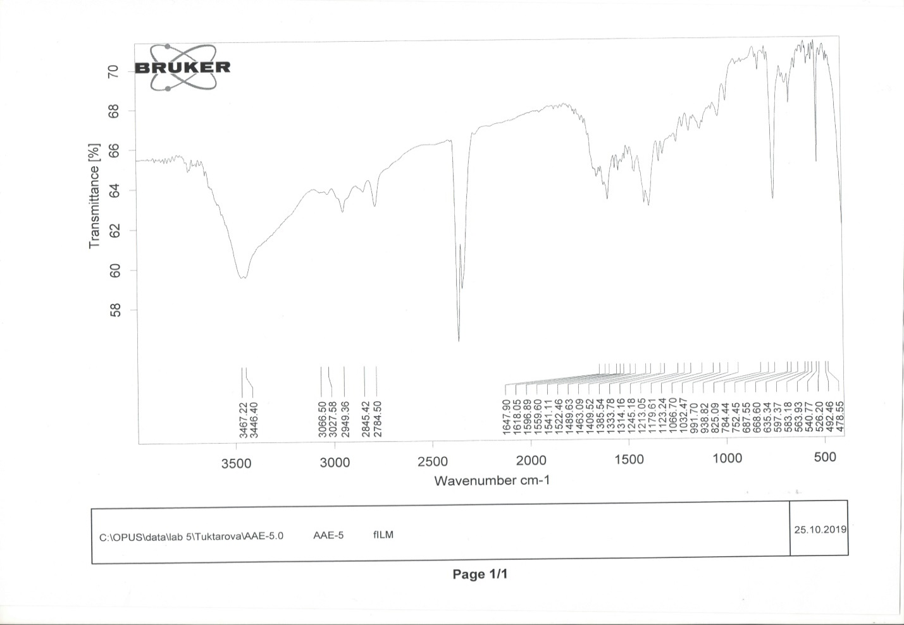
Figure 9 - IR spectrum of compound (5)
The UV spectrum of compound (5) has 310, 319 and 430 nm (Figure 10). A low-intensity peak at 430 nm is characteristic for all [6,6] - closed adducts of fullerene C₆₀.
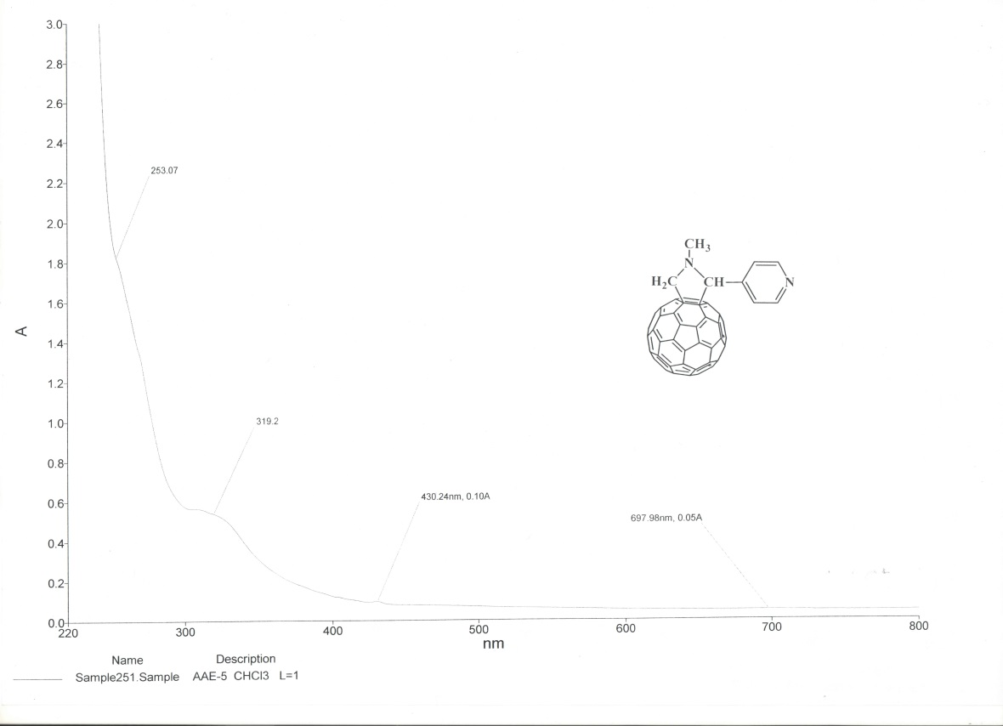
Figure 10 - UV spectrum of compound (5)

The ¹H NMR spectrum of compound (5) is characterized by the presence of a three-proton singlet signal at 2.86 ppm. protons H-6,6,6 of the N-methyl fragment of the pyrrolidine ring. Single-proton singlet signal at 4.97 ppm indicates the presence of the H-5 methine proton in the pyrrolidine ring. The appearance of two single-proton doublet signals at 4.33 and 5.04 ppm. with the same constant of spin-spin interaction ²J 9.4 Hz confirms the presence of two axial and equatorial protons Н-2х and Н-2eq of the pyrrolidine ring bound to the fullerene nucleus. The aromatic pyridine protons H-8.12 and H-9.11 appeared as broadened two-proton ciglets at 7.79 and 8.72 ppm. respectively.
In the ¹³C NMR spectrum of compound (5), the signals of the pyrrolidine ring with an N-methyl substituent are observed at 40.07 (C-6), 70.12 (C-2), and 82.42 (C-5) ppm. The carbon atoms of the pyridine fragment resonated at 124.24 (C-8.12), 150.13 (C-9.11), and 155.68 (C-7) ppm. Numerous signals in the range 136-148 ppm belong to sp2-hybridized carbon atoms of the fullerene nucleus.
The structure of compound (5) was also confirmed by the methods of two-dimensional NMR spectroscopy COSY (¹H-¹H) and HSQC (¹H-¹³C), which makes it possible to establish spin-spin interactions of homo- and heteronuclear nature. The observed correlations in the molecule are shown in Figure 11. In the spectra of ¹H-¹H COSY compounds, spin-spin correlations are observed through two bonds of methylene protons H^{2ax}-H^{2eq} (4.33, 5.04 and 5.04, 4.33) ppm etc. and through three bonds of protons of neighboring methine groups H^{8,12}-H^{9,11} (7.79, 8.72 and 8.72. 7.79) ppm pyridine ring. Heteronuclear interactions of protons with carbon atoms through one bond were established using ¹H-¹³C HSQC spectroscopy for the following pairs present in the compound: H⁶-C⁶ (2.86, 40.06), H^{2ax}-C² (4.33, 70.12) , H^{2eq}-C² (5.04, 70.12), H⁵-C⁵ (4.97, 82.42), H^{8,12}-C^{8,12} (7.79, 124.24), H^{9,11}-C^{9,11} (8.72, 150.13) ppm.
а | б
Figure 11 - Correlations in the COSY spectra (¹H-¹H) (a)
and HMQC (¹H-¹³C) (b) compounds (5)

The main problem that complicates biological studies of fullerene derivatives and the creation of medicinal preparations based on them is the insolubility of fullerenes in water. One of the possible options for overcoming this problem is the preparation of water-soluble complexes of fullerene derivatives with water-soluble polymers approved for use in medicine, for example, with poly-N-vinylpyrrolidone (PVP).
In this regard, a complex of compound (5) with poly-N-vinyl-pyrrolidone in methylene chloride medium was obtained:
Complex (5a) is formed as a result of solubilization of fullerenepyrrolidine (5) by PVP chains and physical interaction of the lactam group with the fullerene sphere. The resulting complex (5а) is soluble in water.
Procedure for the synthesis of N-methyl-2-(pyrid-4-yl)-3,4-fulleropyrrolidine (5). To a solution of 100 mg (0.13 mmol) C₆₀ in 20 ml of xylene were added 14.7 mg (0.13 mmol) pyridine-4-aldehyde and 123.6 mg (1.13 mmol) sarcosine (molar ratio of reagents 1: 1 respectively). The reaction mixture was boiled for 3 h at 110-120⁰C. After removal of the solvent, the residue was chromatographed on a silica gel column, eluting with toluene unreacted С₆₀ and product (5). Yield 28 mg (23%). ¹H NMR spectrum, δ, ppm (J, Hz): 2.86 s (3H, H-6.6.6), 4.33 d (1H, H-2ax, ²J 9.4), 4.97 s (1H, H-5) , 5.04 d (1H, H-2eq, ²J 9.4), 7.79 br. s (2H, H-8, 12), 8.72 br. s (2H, H-9.11). ¹³С NMR spectrum, δ_{С}, ppm: 40.07 (С-6), 70.12 (С-2), 82.42 (С-5), 124.24 (С-8, 12), 150 , 13 (C-9.11), 155.68 (C-7). IR spectrum, ν, cm⁻¹: 526, 825, 1409, 1596, 2784, 2949, 3446, 3467. UV spectrum (CHCl₃), λ_{max}, nm: 310, 319, 430.
Complex preparation procedure (5а). To a solution of 2 mg of fulleropyrro-lidine (5) in 2 ml of methylene chloride was added 200 mg of PVP in 3 ml of methylene chloride. The reaction mixture was stirred for 30 min at room temperature. After removal of the solvent, the residue was vacuum dried.
Thus, using the reaction [2+3] cycloaddition, the reaction of addition of pyridine-4-aldehyde to C₆₀-fullerene in the presence of sarcosine was carried out under the conditions of the Prato reactions. A new compound N-methyl-2-(pyrid-4-yl)-3,4-fulleropyrrolidine and its water-soluble derivative have been obtained. The structure of the obtained substances was proved by IR-, UV-, ¹H- and ¹³C-NMR spectroscopy, as well as by the data of two-dimensional spectra COSY (¹H-¹H) and HMQC (¹H-¹³C).

3.1.5 Three-component reaction of interaction of pyridine-4-aldehyde, dicarbonyl compound and 3-amino-1,2,4-triazole under conditions of classical synthesis and ultrasonic activation

1,2,4-triazole derivatives are widely used in various branches of technology, agriculture and medicine. Many of these compounds are promising intermediates for the synthesis of new drugs, triazole-containing macrocycles, as well as ordered two- and three-dimensional organometallic systems [9], [23]. Continuing research in this direction, we carried out a three-component reaction of the interaction of 4-pyridinecarboxaldehyde with acetoacetic acid anilide and 3-amino-1,2,4-triazole in the absence of a solvent and catalyst. The resulting compound (6) is a colorless crystalline substance, soluble in DMF, DMSO, when heated in ethanol, acetonitrile, insoluble in water.

We found that fusion at 120-140 °C of equimolecular amounts of 4-pyridinecarboxaldehyde with acetoacetic acid anilide and 3-amino-1,2,4-triazole leads to 5-methyl-N-phenyl-7-(pyridin-4-yl)-4,7-dihydro-[1,2,4]triazolo[1,5-α] pyridine-6-carboxamide (6). The mechanism of formation of this product apparently proceeds that, at the first stage of the reaction, an unsaturated compound (A) is formed, with which 3-amino-1,2,4-triazole reacts to form compound (6).
In the ¹H NMR spectrum of compound (6) methyl protons H-16,16,16 appeared as a three-proton singlet signal at 2.12 ppm. The methine proton H-7 appeared as a single-proton singlet at 6.47 ppm. Aromatic phenyl protons H-21-25 are recorded by a five-proton multiplet at 6.96-7.42 ppm. In two multiplet signals at 7.65-7.85 and 8.12-8.75 ppm protons H-3,5,10 and H-19,2,6 appeared, respectively. In the weakest part of the spectrum at 9.78 ppm the amine proton H-13 appeared as a single-proton singlet.
In the ¹³C NMR spectrum of compound (6), the signals of the carbon atoms of the methyl and carbonyl fragments appeared at 17.89 (C-16) and 165.20 (C-17) ppm. The C-7 tertiary carbon atom resonated at 59.88 ppm. The carbon atoms of cyclic systems appeared at 102.90 (C-15), 120.18 (C-21.25), 122.25 (C-3.5), 124.06 (C-23), 129, 17 (C-22.24), 137.78 (C-14), 139.20 (C-20), 148.51 (C-12), 149.28 (C-4), 150.48 (C -22) and 150.80 (C-2.6) ppm.
The structure of compound (6) was also confirmed by the methods of two-dimensional NMR spectroscopy COSY (¹H-¹H) and HMQC (¹H-¹³C), which makes it possible to establish spin-spin interactions of homo- and heteronuclear nature. The observed correlations in the molecule are shown in Figure 12.
а | б
Figure 12 - Correlations of COSY (¹H-¹H) (a) and HMQC (b) of compound (6)

In the ¹H-¹H COSY spectra of the compound, spin-spin correlations are observed through three bonds of neighboring methine protons of the phenyl fragment H²³-H^{22,24} (6.93, 7.17 and 7.17, 6.93) and H^{22,24}-H^{21,25} (7.16, 7.44 and 7.44, 7.16) ppm. Heteronuclear interactions of protons with carbon atoms through one bond were established using ¹H-¹³C HMQC spectroscopy for the following pairs present in the compound: H^{16,16,16}-C¹⁶ (2.09, 18.55), H⁷-C⁷ (6.46, 60.62), H^{22,24}-C^{22,24} (7.15, 129.48), H^{21,25}-C^{21,25} (7.40, 120.72) and H2.6-C2.6 (8.44 , 150.52).
Continuing research in the field of heterocyclic compounds, we carried out a three-component reaction of the interaction of 4-pyridinecarboxaldehyde with acetoacetic ether and 3-amino-1,2,4-triazole under the Biginelli reaction condi-tions. It was found that boiling equimolecular amounts of 4-pyridinecarboxal-dehyde, acetoacetic ether, and 3-amino-1,2,4-triazole in ethanol in the presence of catalytic amounts of concentrated HCl leads to the formation of 5-methyl-N-phenyl-7-(pyridin-4-yl)-4,7-dihydro-[1,2,4]-triazolo[1,5-α]pyridine-6-carboxamide (7).
In order to increase the yield of product (7), we carried out a three-component reaction of the interaction of 4-pyridinecarboxaldehyde with acetoacetic ether and 3-amino-1,2,4-triazole by the Biginelli method under ultrasonic treatment. As a result of the studies, the optimal condition (frequency 22 KHz and power 325 W) of ultrasonic synthesis of target product 7 was found, which allows obtaining the final product with a yield of 58%.
5-Methyl-N-phenyl-7-(pyridin-4-yl)-4,7-dihydro-[1,2,4]triazolo[1,5-α] pyri-dine-6-carboxamide (6). A mixture of 1 g (0.0056 mol) of acetoacetic acid anilide, 0.6 g (0.0056 mol) of pyridinaldehyde and 0.47 g (0.0056 mol) of 3-amino-1H-1,2,4-triazole kept at 120-140⁰C until gas evolution stopped. The formed precipitate was filtered off, dried, and recrystallized from ethanol. Yield 0.82 g (44%), with a melting point of 279-280⁰C.
The synthesis of ethyl 5-methyl-7-(pyridin-4-yl)-4,7-dihydro-[1,2,4] triazolo [1,5-α]pyridine-6-carboxylate (7) was carried out under classical conditions as follows: to a suspension of 1.01 g (0.01 mol) of 4-pyridinaldehyde, 1.3 g (0.01 mol) of acetoacetic ether and 0.84 g (0.01 mol) of 3-amino-1,2, 4-triazole in 10 ml of ethanol was added 0.5 ml (0.01 mol) of concentrated HCl. The reaction mixture was refluxed at 80°C for 3 h. The solvent was removed in vacuo and the residue was triturated with petroleum ether. Yield 1.03 g (36%), with a melting point of 143-145⁰C.
Ethyl 5-methyl-7-(pyridin-4-yl)-4,7-dihydro-[1,2,4]triazolo[1,5-α]pyridine-6-carboxylate (7) under conditions of ultrasonic activation. To a suspension of 1.01 g (0.01 mol) of 4-pyridinaldehyde, 1.3 g (0.01 mol) of acetoacetic ether and 0.84 g (0.01 mol) of 3-amino-1,2,4-triazole in 10 ml of ethanol was added 0.5 ml (0.01 mol) of concentrated HCl. The reaction mixture was subjected to US irradiation at 22 Hz (325 W) (20-25 min). The solvent was removed in vacuo and the residue was triturated with petroleum ether. Yield 1.65 g (58%), with a melting point of 143-145⁰C.
Thus, as a result of the research carried out for the first time, the synthesis of new 5-methyl-N-phenyl-7-(pyridin-4-yl)-4,7-dihydro-[1,2,4]triazolo[1,5-α]pyri-dine-6-carboxamide and ethyl 5-methyl-7-(pyridin-4-yl)-4,7-dihydro-[1,2,4] triazolo [1,5-α]pyridine-6-carboxylate and their structures by ¹H and ¹³C NMR spectroscopy, as well as the data of two-dimensional spectra COSY (¹H-¹H) and HMQC (¹H-¹³C).

3.2 Development of a preparative method for the synthesis of the most promising derivatives of functionally substituted pyridine using microwave irradiation and ultrasonic activation

In recent years, great success has been achieved in the creation of various designs of efficient generators of ultrasound (US) and microwave (MW) radiation, in connection with which there is an increased interest in the use of physical methods of action to intensify various chemical reactions [24]. Ultrasound and microwave radiation have a significant impact on the rate and mechanisms of organic reactions. Ultrasonic vibrations are most successfully used in processes associated with liquid states of reagents, since only in them a specific cavitation process occurs - mechanical vibrations of the ultrasonic range. Ultrasonic cavitation provides maximum energy impact on reactants. Therefore, studies of the synthesis of organic reactions and the mechanisms of formation of substances using microwave and ultrasonic radiation technologies, which are referred to as "green technologies", are an urgent task.

3.2.1 Three-component condensation of 4-pyridinecarboxaldehyde, acetoacetic ether and ammonia according to the Ganch method under conditions of convection heating, microwave irradiation and ultrasonic impact

Recently, a new class of heterocyclic compounds with a basic 1,4-dihydropyridine base, possessing high antihypertensive and nootropic activity, has been widely used in medical practice [25]. The Ganch method used for the synthesis of symmetric 1,4-dihydropyridines has a wide variety of used practically available aliphatic, aromatic or heterocyclic aldehydes, various derivatives of acetoacetic ether and ammonia (or primary amines), which makes it very promising for further search for new biologically active compounds and their chemical modification. At the same time, derivatives of 1,4-dihydropyridines containing a pyridine substituent are not described in the literature.
In this regard, we, according to the Ganch method - a three-component condensation of 2 moles of acetoacetic ether and 4-pyridinecarboxaldehyde in the presence of a 25% aqueous solution of ammonia in ethanol upon heating for 4 h was synthesized in 38% yield corresponding to 2,6-dimethyl-1,4-dihydro- [4,4'-bipyridine] -3,5-dicarboxylate (8).

The resulting derivative (8) is a white powdery substance readily soluble in many organic solvents.
In order to improve the method and increase the yield of the final product, the synthesis of 1,4-dihydropyridine (8) under microwave irradiation was studied. Undoubtedly, the greatest practical interest in the study of this reaction was to study the possibility of using an aqueous solution of ammonia under microwave irradiation [24]. There were fears that the ammonia would evaporate before it reacted. However, the yield of the desired product under these conditions was 40%, which is comparable to the yield of the corresponding product under convection heating conditions. We assumed that the yield of the reaction product could be increased by decreasing the volatility of ammonia. For this purpose, an aqueous solution of ammonia (25%) was dissolved in a threefold excess of acetic acid. The salt formed by a weak base and a weak acid is very easily hydrolyzed, but the volatility of ammonia is greatly reduced. It should also be noted that ammonium salts strongly absorb microwave radiation and this property is used for more intense heating of liquids that are not susceptible to microwave radiation. The ammonium ion, receiving a portion of radiation, heats up, passing into an excited state, which, in turn, leads to a faster and more complete reaction. The use of acetic acid as a solvent made it possible to increase the yield of the final product.
It has been found that the interaction of 4-pyridinecarboxyaldehyde with acetoacetic ether in the presence of a 25% aqueous ammonia solution under microwave conditions at various irradiation powers and reaction times allows the formation of diethyl-2,6-dimethyl-1,4-dihydro-[4,4'-bipyridine]-3,5-dicarboxylate (8) up to 40%. Thus, the duration of the synthesis and the yield of the final product depends on the power and time of microwave irradiation. The optimal reaction conditions for the preparation of 1,4-dihydropyridine (8) under conditions of MV activation are: irradiation power 150 W, irradiation time 30 min. The use of MW irradiation significantly accelerates the reaction rate, while the reaction time decreases from 4 h to 30 min.
The synthesis of compound (8) was also studied under conditions of ultrasonic activation using an Ultrasonic Homogenizer device on the JY92-IIDN model. In the experiments, the ultrasonic method of synthesis of the compound (8) was carried out in a DMF medium at a frequency of 22 kHz and with a duration of ultrasonic treatment from 20 to 60 min. The results of the study of the synthesis reaction of compound 8 showed that the optimal condition for obtaining the target product is achieved by cavitation treatment of the reaction media at a power of 300 W and a process duration of 60 min. Under these conditions, the maximum yield of the target product (8) was 64%, which is 2 times higher than under classical conditions. The results of studying the optimal conditions for the synthesis of compound (8) under the conditions of MV irradiation at various processing power of the reaction medium are shown in Table 1.

Table 1 - Yield of product (8) under conditions of MW irradiation at different powers

Compound | Irradiation power, W | Duration, min | Product yield,%
Diethyl 2,6-dimethyl-1,4-dihydro- [4,4'-bipyridine] -3,5-dicarboxylate | 150 | 30 | 40
 | 350 | 20 | 10
 | 500 | 10 | 20

Figure 13 shows the dependence of the change in product yield at different power of ultrasonic processing of the reaction medium.
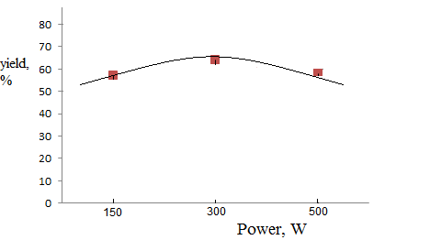
Figure 13 - Influence of ultrasound activation on product yield (8)
(processing time 60 min)

Thus, carrying out the synthesis reaction of 2,6-dimethyl-1,4-dihydro-[4,4'-bipyridine]-3,5-dicarboxylate (8) in microwave and ultrasonic fields can signifi-cantly reduce the duration of the synthesis reaction.
The structure of the synthesized compound (8) was confirmed by ¹H and ¹³C NMR spectroscopy data.
In the ¹H NMR spectrum of compound (8), the presence of a 1,4-dihydropyridine ring is confirmed by three characteristic singlets. In the range of 2.18-2.25 ppm two methyl groups at positions 2 and 6 are recorded as a singlet. In the regions of 4.95 and 8.95 ppm singlets of the corresponding protons in positions 1 and 4 are recorded. The presence of three ethoxyl groups with a triplet with an intensity of 9 N in the region of 1.04-1.12 ppm, corresponding to a methyl group and a multiplet with an intensity of 6H in the region of 3.85-3.98 m.d., characteristic of CH₂ groups. The phenyl substituent is characterized by corresponding bands in the form of a complex multiplet in the regions of 7.52-7.59 ppm. (t), 7.56-7.62 ppm (d), 7.94-8.05 ppm (m).
Synthesis of diethyl 2,6-dimethyl-1,4-dihydro-[4,4'-bipyridine]-3,5-dicarbo-xylate (8) under convection heating conditions. To a mixture of 0.006 mol of 4-pyridinecarboxaldehyde and 0.012 mol of ethyl acetate of acetoacetic acid, dissolved in 10 ml of ethanol, 5 ml of a 25% aqueous ammonia solution was slowly added with stirring. The reaction mixture was heated at 80 ° C and stirred for 4 h. The precipitate that formed was filtered off, washed with hexane, and then purified by recrystallization from ethanol. The yield of product (8) was 38%.
Synthesis of diethyl 2,6-dimethyl-1,4-dihydro-[4,4'-bipyridine]-3,5-dicarb-oxylate (8) under microwave irradiation. In a flat-bottomed heat-resistant flask with a capacity of 100 ml, 0.59 ml of glacial acetic acid was placed, then a 25% aqueous solution of ammonia was gradually added with stirring until a stable smell of ammonia appeared. Thereafter, 0.006 mol of 4-pyridinecarboxaldehyde and 0.012 mol of ethyl acetoacetic acid were added to the reaction mixture. The reaction mixture was subjected to microwave irradiation for 10-30 min at a power of 150-500 W with interruptions every 1-2 min. The precipitate formed after cooling the reaction mixture was recrystallized from ethanol.
Synthesis of diethyl 2,6-dimethyl-1,4-dihydro-[4,4'-bipyridine]-3,5-dicar-boxylate (8) under conditions of ultrasonic activation. To a mixture of 0.009 mol of 4-pyridinecarboxaldehyde and 0.009 mol of acetoacetic acid ethyl ester dissolved in 10 ml of ethanol, 5 ml of a 25% aqueous ammonia solution was slowly added with stirring. The reaction mixture is irradiated at 20 Hz, 50 Hz, 80 Hz for 20-60 minutes. The resulting powdery product was recrystallized from ethanol.

3.2.2 Three-component condensation of 4-pyridinecarboxaldehyde, acetoacetic ether and thiourea according to Biginelli reactions under convection heating, microwave irradiation and ultrasonic impact

Recently, the number of publications on the chemistry of 4-aryl-3,4-dihydropyrimidin-2-ones and 4-aryl-3,4-dihydropyrimidin-2-thiones, obtained by three-component condensation according to the Biginelli reaction, has significantly increased, which is not related only with their preparative availability, but also with the manifestation of a wide range of pharmacological activity - analgesic, antibacterial, etc. [26].
To date, the mechanism of the Biginelli reaction has been well studied, and a large number of 4-aryl-3,4-dihydropyrimidine-2-thion derivatives with various functional substituents have been synthesized. A variety of methods for their preparation have been developed and patented, and highly efficient catalysts have been found, which have led to a significant increase in yields and a reduction in the time of condensation [27]. We have synthesized 6-methyl-4-(pyridin-4-yl)-2-thioxo-1,2,3,4-ethyl ester 6-methyl-4-(pyridin-4-yl)-2-thioxo-1,2,3,4- tetra-hydropyrimidine-5-carboxylate (9).

The synthesis of compound (9) was carried out as follows: a mixture of 0.1 mol of 4-pyridinecarboxaldehyde, 0.1 mol of ethyl acetate of acetoacetic acid, and 9.1 g (0.12 mol) of thiourea in 10 ml of absolute DMF was refluxed for 5 h, then added another 10 ml of ethanol and boiled for another 5 h. The reaction mixture was cooled and poured into a glass with ice water. The formed precipitate was triturated under water, filtered off, dried, and then purified by recrystallization from ethanol or 2-propanol. The yield of product (9) was 65%.
The structure of the synthesized pyrimidinethione (9) was proved by ¹H NMR spectroscopy. Thus, in the ¹H NMR spectrum of compound (9) in the strong field region at δ 1.12 ppm in the form of a triplet, the protons of the methyl group of the ethoxy group resonate, and the methylene protons of this group are registered as a quartet in the region of δ 3.96 ppm, and the singlet at δ 2.22 ppm belongs to the protons of the methyl group. In the area of ​​3.72 ppm an intense singlet characteristic of the methoxy group of the aromatic ring is prescribed. The aromatic α- and β-protons of the phenyl ring are written in the regions of 6.89 and 7.14 ppm in the form of two doublets, respectively. The signal of the C (4) -H proton is in the region of 5.10 ppm. as a doublet. The protons N (1) -H and N (3) -H are written out at 9.15 and 7.68 ppm. respectively, in the form of two singlets.
In order to improve the method for obtaining 6-methyl-4-(pyridin-4-yl)-2-thioxo-1,2,3,4-tetrahydropyrimidine-5-carboxylate (9), we carried out a three-component reaction of 4-pyridinecarboxaldehyde, ethyl ester of acetoacetic acid and thiourea under microwave irradiation. A mixture of equimolecular amounts of 4-pyridinecarboxyaldehyde, acetoacetic ether, and thiourea dissolved in DMF was placed in a glass container. The reaction mixture was irradiated in an LG MS1724W microwave unit (150, 350, 500 W). The progress of the reaction was monitored by TLC, after the completion of the reaction, the reaction product was recovered by usual work-up in good yield. The results of the study showed that the optimal condition for the synthesis of compound (9) under MV conditions is: power 150 W, duration of irradiation - 120 min. Under these optimal conditions, the yield of the target product was 55%. Table 2 shows the data on the yield of the product (9) at various powers and reaction times.

Table 2 - Product yield (9) under conditions of MV and US activation

Compound | Irradiation power, W | Duration, min | Product yield,%
Ethyl 6-methyl-4-(pyridin-4-yl)-2-thioxo-1,2,3,4-tetrahydropyri-midine-5-carboxylate (9) | Microwave activation (MW)
 | 150 | 120 | 55
 | 350 | 60 | 40
 | 500 | 40 | 30
 | Ultrasonic activation (US)
 | 150 | 60 | 53
 | 300 | 60 | 61
 | 500 | 60 | 51

We also studied the synthesis of compound (9) under conditions of sonochemical activation. The conditions for the reaction of ultrasonic action were selected by varying the time (from 20 to 60 min) and the radiation power from 100 to 1000 W at a frequency of 22 KHz. The progress of the reaction was monitored by thin layer chromatography. The results of the study showed that the most favorable conditions for the synthesis reaction under conditions of sonochemical activation are the exposure power of 300 W, the frequency of 22 KHz and the reaction duration of 60 minutes (Table 2). The results obtained showed that the yields of the final target product, both under conditions of MW and USI, are comparable to the result of the classical method, however, the use of physical methods makes it possible to increase the reaction rate by a factor of 10.
Synthesis of 6-methyl-4-(pyridin-4-yl)-2-thioxo-1,2,3,4-tetrahydropyrimi-dine-5-carboxylate (9) under microwave irradiation. In a conical heat-resistant flask with a capacity of 250 ml was placed 5 g of a support, 0.03 mol of 4-pyridinecarboxaldehyde, 3.9 g (0.03 mol) of ethyl ester of acetoacetic acid and 3.12 g (0.041 mol) of thiourea, mixed thoroughly. The reaction mixture was subjected to microwave irradiation for 30 s at irradiation powers of 150, 350 and 500 W. After the end of the irradiation, the reaction mixture was dissolved by heating in ethanol. Then it was filtered off from silica gel, the solvent was distilled off. The precipitate formed after cooling was filtered off and recrystallized from ethyl alcohol.
Synthesis of 6-methyl-4-(pyridin-4-yl)-2-thioxo-1,2,3,4-tetrahydropyrimi-dine-5-carboxylate (9) under ultrasound conditions. A mixture of 0.007 mol of 4-pyridinecarboxaldehyde, 0.007 mol of ethyl ester of acetoacetic acid and 0.008 mol of thiourea in 10 ml of absolute DMF was irradiated at a frequency of 20, 50, and 80 Hz and an irradiation power of 150, 300, and 500 W for 60 min. The reaction mixture was cooled and poured into a glass of ice water. The resulting brown precipitate was purified by column chromatography, eluted with hexane.
Thus, the study of the synthesis reaction of 6-methyl-4-(pyridin-4-yl) -2-thioxo-1,2,3,4-tetrahydropyrimidine-5-carboxylate showed the possibility of using the methods of MV and US activation under the Biginelli reaction conditions.

3.2.3 Development of a synthesis method and study of the structure of diethyl 2,6-dimethylpyridine-3,5-dicarboxylate

1,4-Dihydropyridine compounds are of constant scientific interest in terms of their preparative modification in order to detect and identify compounds with new types of biological activity among the derivatives of this class [28], [29]. In order to obtain and further modify new derivatives of symmetric 1,4-dihydropyridines, a new previously undescribed product, diethyl 2,6-dimethylpyridine-3,5-dicarboxylicylate, was synthesized by the Ganch method. In our studies, instead of formaldehyde and ammonia in the classical version of the Ganch synthesis, we used urotropine and ammonium acetate. The reactions were carried out in ethanol at the boiling point of the solvent. The reaction time was monitored by TLC. As a result of the reaction, after 1 h of refluxing the mixture, a light yellow precipitate formed, which, after filtration, did not require additional purification. according to ¹Н- and ¹³С NMR spectra, it turned out to be an analytically pure product (10).
In the ¹H NMR spectrum of compound (10), the equivalent methyl protons of the H-15, 15, 15, 18, 18, 18 ethylcarboxylate groups appeared as a six-proton triplet at 1.14 ppm with ³J 7.2 Hz. Adjacent equivalent methylene protons H-14, 14, 17, 17 of the ethyl carboxylate substituent resonated, respectively, with a four-proton quadruplet signal at 4.01 ppm. with ³J 6.8 Hz. The equivalent methyl protons H-7, 7, 7, 12, 12, 12, which do not have protons splitting them in the vicinity, appeared as the expected six-proton singlet at 2.02 ppm. At 3.06 ppm the H-4, 4 atoms of the dihydropyridine fragment resonated with a two-proton singlet. In the weakest field at 8.25 ppm protons H-1 of the dihydropopyridine nucleus appeared as a single-proton singlet.
In the ¹³C NMR spectrum of compound (10), the signals of the equivalent ethyl carboxylate groups appeared at 14.92 (C-15, 18), 59.46 (C-14, 17) and 167.65 (C-8, 10) ppm. The carbon atoms of the equivalent methyl substituents C-7, 12 resonated at 18.47 ppm. Carbon atoms of the dihydropyridine fragment are observed at 25.23 (C-4), 97.52 (C-3, 5), and 147.09 (C-2, 6) ppm.
The structure of compound (10) was also confirmed by the methods of two-dimensional NMR spectroscopy COSY (¹H-¹H) and HMQC (¹H-¹³C), which ma-kes it possible to establish spin-spin interactions of homo- and heteronuclear na-ture.The observed correlations in the molecule are presented in Figures 14 and 15.
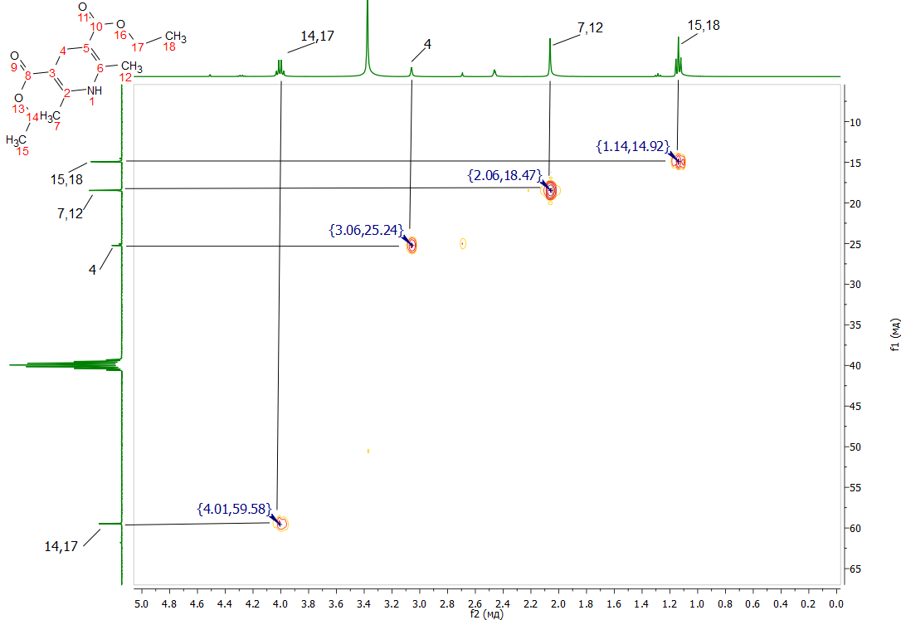
Figure 14 - Shooting of the HMQC spectrum of compound (10) in DMSO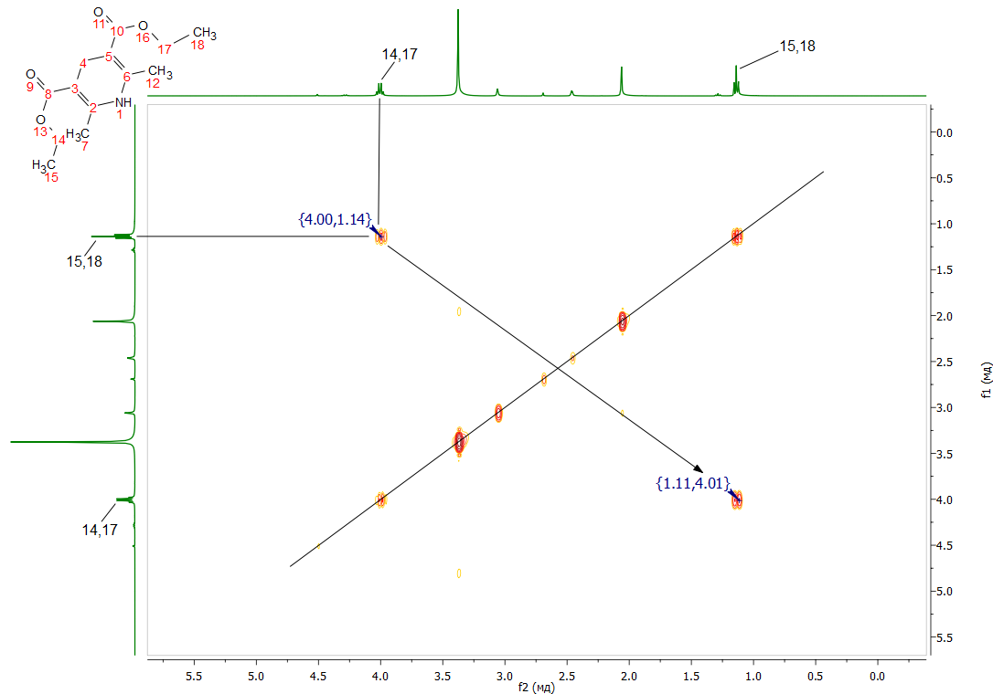
Figure 15 - Shooting of the COSY spectrum of compound (10) in DMSO

In the ¹H-¹H COSY spectra of compounds (10), spin-spin correlations are observed through three bonds of neighboring methyl and methylene protons of ethyl carboxylate fragments H^{15,18}-H^{14,17} with coordinates at 1.11, 4.01 and 4.00, 1.14 ppm. Heteronuclear interactions of protons with carbon atoms through one bond were established using ¹H-¹³C HMQC spectroscopy for all pairs present in the compound: H^{15,18}-C^{15,18} (1.14, 14.92), H^{7,12}-C^{7,12} ( 2.06, 18.47), H⁴-C⁴ (3.06, 25.24) and H^{14,17}-C^{14,17} (4.01, 59.58).
The oxidative dehydrogenation of diethyl 2,6-dimethyl-1,4-dihydropyridine-3,5-dicarboxylate (10) to the corresponding aromatic pyridine derivative (11) was carried out with sodium nitrite in acetic acid. As a result of the reaction, diethyl 2,6-dimethylpyridine-3,5-dicarboxylate (11) was isolated in analytically pure form with a yield of 89.7%.

In the ¹H NMR spectrum of compound (11), the equivalent methyl protons of H-15, 15, 15, 18, 18, 18 of ethyl carboxylate groups appeared as a six-proton triplet at 1.28 ppm with ³J 6.8 Hz (Figure 16). Adjacent equivalent methylene protons H-14, 14, 17, 17 of the ethyl carboxylate substituent resonated, respecti-vely, with a four-proton quadruplet signal at 4.27 ppm with ³J 6.8 Hz. The equivalent methyl protons H-7, 7, 7, 12, 12, 12, which do not have protons splitting them in the vicinity, appeared as the expected six-proton singlet at 2.67 ppm. In the aromatic region, a single-proton singlet at 8.44 ppm the pyridine proton H-4 resonated.
In the ¹³C NMR spectrum of compound (11), the signals of the equivalent ethyl carboxylate groups appeared at 14.53 (C-15, 18), 61.77 (C-14, 17) and 165.65 (C-8, 10) ppm (Figure 17). The carbon atoms of the equivalent methyl substituents C-7, 12 resonated at 25.00 ppm. Carbon atoms of the pyridine fragment are observed at 123.11 (C-3, 5), 140.43 (C-4), and 161.83 (C-2, 6) ppm.

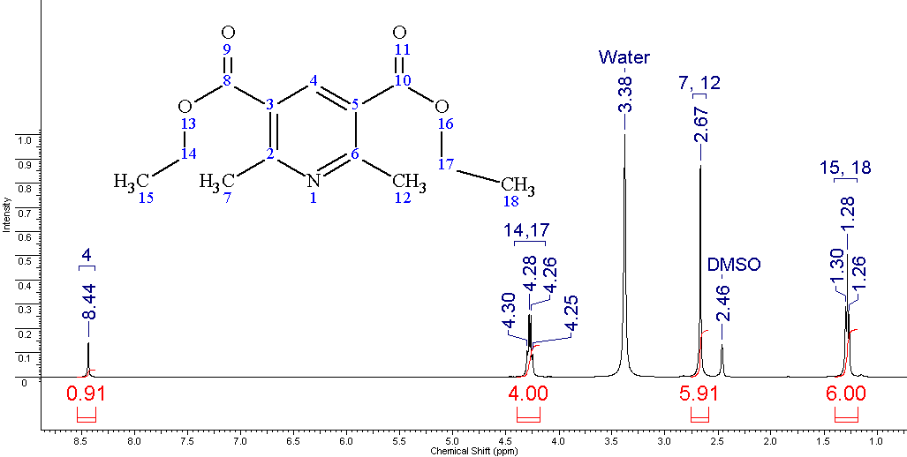
Figure 16 - Shooting of the ¹H NMR spectrum of compound (11) in DMSO
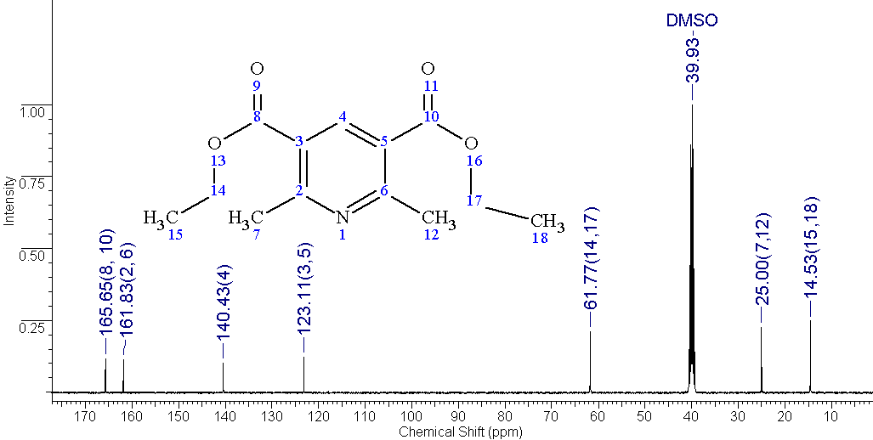
Figure 17 - Shooting of the ¹³C NMR spectrum of compound (11) in DMSO

The structure of compound (11) was also confirmed by two-dimensional NMR spectroscopy COSY (¹H-¹H) and HMQC (¹H-¹³C), which makes it possible to establish spin-spin interactions of homo- and heteronuclear nature (Figure 18). The observed correlations in the molecule are shown in the diagrams. In the spectra of ¹H-¹H COSY compounds, spin-spin correlations are observed through three bonds of neighboring methyl and methylene protons of the ethylcarboxylate fragments H^{15,18}-H^{14,17} with coordinates at 1.26, 4.27 and 4.26, 1, 28 ppm. Heteronuclear interactions of protons with carbon atoms through one bond were established using ¹H-¹³C HMQC spectroscopy for all pairs present in the compound: H^{15,18}-C^{15,18} (1.27, 14.63), H_{7,12}-C^{7,12} ( 2.66, 25.04), H^{14,17}-C^{14,17} (4.28, 61.57) and H⁴-C⁴ (8.42, 140.33).

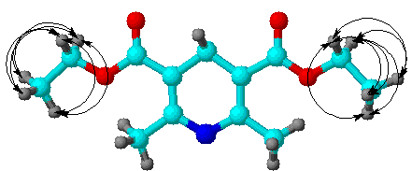а | 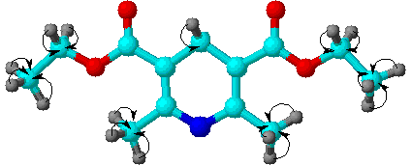b
Figure 18 - Scheme of correlations in the spectra COSY (a) and HMQC (b) compound (11)

Diethyl 2,6-dimethyl-1,4-dihydropyridine-3,5-dicarboxylate (10). A mixture of 15.6 g (0.12 mol) of acetoacetic ether, 1.54 g (0.01 mol) of urotropine and 4.62 g (0.06 mol) of ammonium acetate in 60 ml of ethanol is boiled for 1 h. The solution is cooled, the precipitate is filtered off. Yield 2.50 g (90.0%), with a melting point of 189-190 °C.
Diethyl 2,6-dimethylpyridine-3,5-dicarboxylate (11). To a suspension of 1.27 g (0.005 mol) of diethyl 2,6-dimethyl-1,4-dihydropyridine-3,5-dicarboxylate in 15 ml of acetic acid at room temperature and stirring, 0.69 g (0.01 mol) of nitrite was added in portions sodium. After adding all of the sodium nitrite, the reaction mixture was stirred for 2 hours at room temperature. Then it was poured onto ice, neutralized with ammonia, and the precipitated product (11) was filtered off, washed with water. Yield 1.13 g (89.7%), with a melting point of 74-75ºC.
Thus, we have synthesized diethyl 2,6-dimethyl-1,4-dihydropyridine-3,5-dicarboxylate and developed a fairly simple and effective method for the preparation of diethyl 2,6-dimethylpyridine-3,5-dicarboxylate, the structure of which has been proven by ¹H and ¹³C NMR spectroscopy, as well as by the data of two-dimensional spectra COSY (¹H-¹H) and HMQC (¹H-¹³C).

3.2.4 Biological properties of the synthesized pyridine compounds
3.2.4.1 Anti-radical activity test

The antiradical activity of the substances was studied on the basis of the National Center for Biotechnology of the Republic of Kazakhstan (Nur-Sultan) under the guidance of Ph.D. Shulgau Z.T. (Appendix A).
Research objectives: To evaluate the antiradical effect of the presented samples in relation to the 2,2-diphenyl-1-picrylhydrazyl radical (DPPH•).
An ethanol solution of DPPH (100 µM) was used to assess the antiradical activity of the samples under study in the test with DPPH radical. To select substances with pronounced antiradical activity, 2 ml of a 100 μM ethanol solution of DPPH were mixed with 20 μl of the test object using the example of N- (pyridin-4-ylmethylene)-4H-1,2,4-triazol-4-amine (internal code ANI-35) dissolved in ethanol at a concentration of 5 mM. The final concentration of the test substance in the reaction mixture was 50 µM. 10 minutes after the addition of the test compound solution to the DPPH radical solution, the decrease in absorbance at 515 nm is measured. For substances capable of reducing optical density by more than 50%, it is planned to carry out a test for interaction with DPPH-radical in the final concentrations of the investigated substances 50, 25, 20, 15, 10, 5 and 2.5 µM. After that, it will be possible to determine the concentration of the test substance capable of reducing the optical density by 50% - IC₅₀ (DPPH). The results of studies of the antiradical activity of the studied samples are presented in Table 3.

Table 3 - The values of the optical density of a solution of 100 µM DPPH radical after 10-minute incubation with the test substances at a final concentration of 50 µM

Compound | Code Connection | Optical density
1 | 2 | 3
N- (pyridin-4-ylmethylene) -4Н-1,2,4-triazol-4-amine (1) | ANI-35 | 1,122
2-Pyridine-3,4-dimethyl-5-phenyl-1,3-oxazali-dine (2) | NA-37 | 0,918
Сontinuation of table 3

1 | 2 | 3
2-Hydroxy-N- (pyridin-4-yl-methylidene) ben-zohydrazide (3) | NZH-11 | 1,013
4-Hydroxy-N- (pyridin-4-yl-methylidene) ben-zohydrazide (4) | NZH-10 | 1,02
Diethyl 2,6-dimethyl-1,4-dihydropyridine-3,5-dicarboxylate (10) | NOK-36 | 0,849
Diethyl 2,6-dimethylpyridine-3,5-dicarboxylate (11) | NOK-37 | 0,947
Control (DPPG solution without test sample) |  | 0,944

From the data in Table 3, it follows that none of the studied compounds decreases the optical density of the initial solution of DPPH radical, except for NOK-36, which reduces the optical density of the solution of DPPH radical by 10%, which indicates a weak antiradical effect of NOK-36 (diethyl-2,6-dimethyl-1,4-dihydropyridine-3,5-dicarboxylate). The rest of the compounds did not show antiradical activity under the conditions of this test system.

3.2.4.2 Study of hydrazones for anti-inflammatory and cytotoxic activity

The anti-inflammatory and cytotoxic activity of substances was studied on the basis of Departments of Immunology and Infectious Diseases (Montana State University, Bozeman, Montana 59717, United States) under the guidance of Ph.D. Shepetkin I.A. (Appendix A).
Two hydrazones (3) (NZh-11) and (4) (NZh-10) were studied to assess their anti-inflammatory and cytotoxic activity (in vitro) in cultures of human monocytic cell lines MonoMac-6 and THP-1Blue.
The anti-inflammatory effect was assessed as the ability of the compound to suppress lipopolysaccharide (LPS) -induced production of pro-inflammatory cytokines interleukin-6 (IL-6) and tumor necrosis factor (TNF) in MonoMac-6 cells, as well as NF-κB-dependent production of alkaline phosphatase (ALP ) in transfected cells with THP-1Blue. The cells were treated with the compound for 30 min, and then LPS (0.5 μg/ml) was added to the cell culture.
Cytokine or ALP levels were assessed after 24-hour incubation. Cytokines were measured in cell supernatants using enzyme-linked immunosorbent assay (ELISA). ALP production was measured using a specific substrate, Quanti-BlueTM. The cytotoxicity level was assessed using the CellTiter-Glo chemiluminescent kit. The effective concentration to suppress the response by 50% (IC₅₀) was found by regression analysis using dose-response curves (at least 5 concentrations). The biological activities of hydrazones (3) and (4) are shown in Table 4.

Table 4 - Effect of hydrazones (3) and (4) on LPS-induced production of cytokines (TNF and IL-6) and alkaline phosphatase (ALP) in cell culture and assessment of their cytotoxicityª

Compound | MonoMac-6 cells |  |  | THP-1 Blue cells
 | TNF | IL-6 | Toxicity | ALF | Toxicity
 | IC₅₀, µM
4-hydroxy-N'-(pyridin-4-yl-methyle-ne)benzohydrazide (NZh-10) | 35,5 | N.A. | N.T | N.A. | N.T
2-hydroxy-N'- (pyridin-4-yl-methyle-ne) benzohydrazide (NZh-11) | N.A. | N.A. | N.T | N.A. | N.T
Note - ªN.A. or N.T., no suppression of production or cytotoxicity at concentrations <100 μM

Studies have shown that hydrazones were non-cytotoxic and inactive in the anti-inflammatory test at concentrations <100 µM, but the NZH-10 compound has a weak activity, manifested in the suppression of the production of anti-inflammatory cytokine TNF.

3.2.4.3 Test for antimicrobial activity

In the educational microbiological laboratory for testing for antibacterial, antifungal activity on the basis of the Department of Clinical Immunology, Allergology and Microbiology "NAO" of the Karaganda Medical University under the leadership of Ph.D. Akhmetova S.B., the synthesized compounds were studied for the presence of antimicrobial activity of the following substances: 5-methyl-N-phenyl-7-(pyridin-4-yl)-4,7-dihydro-[1,2,4]triazole[1,5-a]pyrimidine-6-carboxami-de (comp. 6, HA-126), ethyl 5-methyl-N-phenyl-7-(pyridin-4-yl)-4,7-dihydrotet-razole[1,5-a]pyrimidine-6-carboxylate (comp. 7, HA-127), 4-hydroxy-N-(pyridin-4-yl-methylidene)-benzohydrazide (comp. 4, NZh-10), 2-hydroxy-N-(pyridin-4-yl-methylidene)-benzohydrazide (comp. 3, NZh-11).
The concentrations of the tested drugs were 1 μg for antibacterial activity and 1 μg for antifungal activity. The concentration of reference drugs was 1 mg. The antimicrobial activity of the samples was assessed by the diameter of the growth inhibition zones of the test strains (mm). The diameters of the zones are less than 10 mm and solid growth in the dish was assessed as the absence of antimicrobial activity, 10-15 mm - weak activity, 15-20 mm - moderately pronounced activity, over 20 mm - pronounced. Each sample was tested in three parallel runs. Statistical processing was carried out by the methods of parametric statistics with the calculation of the arithmetic mean and standard error.
Dilution was made at the rate of 1 mg of substance per 1 ml of solvent. The sensitivity of bacteria to these preparations was determined by the diffusion method using discs. Used bacteria: S. aureus, Bacillus subtilis; E. Coli; Ps.aerugiosa, Candida albicans.
These cultures were inoculated by the lawn method on the following nutrient media: YSA, Endo's medium, nutrient agar and Sabouraud's medium. Then the Petri dishes were incubated for a day at 37⁰C, for fungi at 28⁰C.

The antibiotic benzylpenicillin sodium salt, gentamicin and the third generation cephalosporin antibiotic - ceftriaxone - were chosen as the standard for antibacterial activity, and nystatin is the antifungal activity. The results of the detected growth retardation on the media are shown in Table 5.

Table 5 - Antimicrobial and antifungal activity of the samples. Growth retardation diameters of test strains. Solvent - 96% ethyl alcohol

Test substances | S.aureus | B.subtilis  6633 | E.coli | Ps.aerugiosa АТСС 9027 | C.albicans
5-methyl-N-phenyl-7-(pyridin-4-yl)-4,7-dihydro-[1,2,3] triazole-[1,5-a]pyrimidine-6-carboxamide (NA-126) | 14±1,0 | 15±1,0 | 11±1,0 | 10±1,0 | 12±1,0
Ethyl 5-methyl-N-phenyl-7-(pyridin-4-yl)-4,7-dihydrotetrazole[1,5-a]pyrimidine-6-carboxylate (NA-127) | 13±1,0 | 14±1,0 | 11±1,0 | - | 12±1,0
4-hydroxy-N-(pyridin-4-yl-methylidene) benzohydrazide (NZh-10) | 14±1,0 | 13±1,0 | 9±1,0 | 10±1,0 | 9±1,0
2-hydroxy-N- (pyridin-4-yl-methylidene) benzohydrazide (NZh-11) | 13±1,0 | 14±1,0 | 11±1,0 | - | -
Ethyl alcohol 96% | 9±1,0 | 9±1,0 | 9±1,0 | 9±1,0 | 9±1,0
Benzylpenicillin sodium salt | 15±1,0 | - | 16±1,0 | 12±1,0 | -
Gentamicin | 22±1,0 | 30±1,0 | 31±1,0 | 30±1,0 | -
Ceftriaxone | 30±1,0 | 30±1,0 | 29±1,0 | 22±1,0 | -
Nystatin | - | - | - | - | 25±1,0

As a result of the study, it was found that almost all the investigated substances show weak antibacterial activity.
CONCLUSION

Based on the results of the research work carried out in 2020 у., the following results were obtained:
1 Condensation of 4-pyridinecarboxaldehyde with 4-amino-1,2,4-triazole in equimolecular amounts of reactants has been carried out. The synthesis reaction of a new Schiff base - N-(pyridin-4-ylmethylene)-4H-1,2,4-triazol-4-amine was carried out in ethanol with a yield of 81.8%.
2 The reaction of stereoslective synthesis of optically active (1S, 2S) -1-phenyl-2-methylaminopropanol-1 with 4-pyridinecarboxaldehyde in absolute benzene is studied. It was shown that the reaction proceeds rather quickly and with a high yield (80%) of oxazolidine formation. The spatial structure of the synthesized oxazolidine was established using X-ray structural analysis. The results obtained are of significant scientific interest as products of enantioselec tive synthesis of planar-chiral compounds.
3 Condensation of 4-pyridinecarbaldehyde with hydrazides of o- and p-hydroxybenzoic acids under mild conditions and in good yields synthesized and studied the structure of previously undescribed new acylhydrazones, which are interesting compounds in terms of studying their biological activity.
4 Chemical modification of C60 fullerene by three-component condensation of C60 fullerene, N-methylglycine (sarcosine) and pyridine-4-aldehyde under the conditions of the Prato reaction to obtain a new fulleropyrrolidine - N-methyl-2- (pyrid-4-yl)-3,4-fulleropyrrolidine. Based on the analysis of UV, ¹H NMR and two-dimensional spectra of COSY (¹H-¹H) and TOCSY (¹H-¹H), a mechanism for the formation of a new fulleropyrrolidine has been proposed. Its water-soluble complex with poly-N-vinylpyrrolidone in methylene chloride was obtained.
5 A method for the synthesis of new 5-methyl-N-phenyl-7-(pyridin-4-yl) -4,7-dihydro-[1,2,4] triazolo[1,5-α] pyridine-6-carboxamide and ethyl 5-methyl-7- (pyridin-4-yl)-4,7-dihydro-[1,2,4]triazolo[1,5-α]pyridine-6-carboxylate by fusion at 120-140°C of equimolecular amounts 4-pyridinecarboxaldehyde with aceto-acetic acid anilide (acetoacetic ester) and 3-amino-1,2,4-triazole by the Biginelli method under convection heating and ultrasonic action.
6 A comparative study of the synthesis of 2,6-dimethyl-1,4-dihydro-[4,4'-bipyridine]-3,5-dicarboxylate (Ganch reaction) and 6-methyl-4-(pyridin-4-yl)-2 -thioxo-1,2,3,4-tetrahydropyrimidine-5-carboxylate (Biginelli reaction) under condi-tions of convection heating, microwave irradiation and ultrasonic exposure. It was found that carrying out the reaction under conditions of microwave and ultrasonic irradiation can increase the yield and significantly reduce the duration of the synthesis reaction.
7 For the first time, a synthesis method was developed and the structure of diethyl 2,6-dimethylpyridine-3,5-dicarboxylate was studied, the difference of which is the use of urotropine and ammonium acetate instead of formaldehyde and ammonia in the classical version of the Ganch synthesis. The oxidative dehydrogenation of the obtained diethyl 2,6-dimethyl-1,4-dihydropyridine-3,5-dicarboxylate to the corresponding aromatic pyridine derivative with sodium nitrite in acetic acid was carried out. As a result of the reaction, a new product was isolated - diethyl 2,6-dimethylpyridine-3,5-dicarboxylate in analytically pure form with a yield of 89.7%.
8 The synthesized compounds were bioscreened for antiradical activity at the National Center for Biotechnology of the Republic of Kazakhstan (Nur-Sultan) and anti-inflammatory, cytotoxic, and inhibitory activity in Departments of Immunology and Infectious Diseases (Montana, USA).
9 The structures of all new synthesized compounds have been studied using modern 1H and 13C NMR spectroscopy methods. The values of chemical shifts, multiplicity and integrated intensity of ¹H and ¹³C signals in one-dimensional NMR spectra were determined. Using the spectra in the formats COSY (¹H-¹H) and HMQC (¹H-¹³C), homo- and hetero-nuclear interactions were established, confirming the structure of the compounds under study.
10 Based on the research results, 11 new derivatives of functionally substituted pyridines were synthesized. During the reporting period, according to the results of the research performed, 13 scientific papers were published (1 - patent, 1 - patent application, 9 scientific articles and 2 theses of reports).

Final research results for 2018-2020 in this direction:

- On the basis of isonicotinic acid hydrazide under conditions of convection heating, microwave irradiation and ultrasonic activation, purposeful synthesis of new isonicotinic acid hydrazones was carried out. As a result of a comparative analysis of the obtained data, it was determined that the use of microwave irradiation and ultrasonic exposure promotes an increase in the yield of the product and a decrease in the reaction time from 8-9 hours to 20-60 minutes than with traditional technology.
- For the first time the reactions of supromolecular complexes based on isonicotinic acid hydrazones with cyclodextrins (β-CD, 2-HP-β-CD) were obtained and studied. Comparison of the integral intensities of ¹H NMR signals of substrate molecules (hydrazones) and β- and 2-HP-β-CD-a receptors in supramolecular complexes showed that in all cases, complexes of 1 guest molecule per 2 host molecules are formed.
- For the first time, the chemical modification of C60 fullerene was carried out by three-component condensation of C60 fullerene, N-methylglycine (sarco-sine) and pyridine-4-aldehyde under the conditions of the Prato reaction to obtain a new fulleropyrrolidine. Its water-soluble complex with poly-N-vinylpyrrolidone was obtained. Condensation of 4-pyridinecarbaldehyde with hydrazides of o- and p-hydroxybenzoic acids under mild conditions synthesized previously undescribed new acylhydrazones, which are interesting compounds in terms of studying their biological activity.
- Three-component condensation under the Biginelli reaction conditions, the interaction of 4-pyridinecarbaldehyde with acetoacetic acid anilide (acetoacetic ester) and 3-amino-1,2,4-triazole under convection heating and ultrasonic exposure conditions have synthesized and characterized biologically very promising new 4-pyridil-3,4-dihydropyrimidine-2-thiones - synthones for further chemical transformations and the search for new biologically active substances.

- Developed "green" ("one-pot" reaction, MW-, US-activation, etc.) methods for the synthesis of new functional-substituted pyridine derivatives. The structure of the synthesized new pyridine compounds was established and proved using modern physicochemical research methods (IR-, ¹H-, ¹³C and ¹H-¹³C HSCQ spectroscopy, X-ray structural analysis). The biological activity of the synthesized substances has been studied, among which substances with antioxidant, antimicrobial, and other activities have been found.

In total, for 2018-2020, 29 scientific works were published, of which 1 monograph, 15 scientific articles (3 - in Russian publications with a non-zero impact factor, 12 - in editions of the Republic of Kazakhstan recommended by KOKSON), 11 publications in materials of international and national conferences (2 - outside the Republic of Kazakhstan, 9 - held on the territory of the Republic of Kazakhstan), 1 patent of the Republic of Kazakhstan for a utility model was received and 1 application for a patent of the Republic of Kazakhstan for a utility model was filed.
LIST OF USED SOURCES

1 Belikov V.G. Synthetic and natural medicines. - M .:Higher school, 1993 .- 85 p. [Беликов В.Г. Синтетические и природные лекарственные средства. - М.: Высшая школа, 1993. – 85 с.]. [in Russ.].
2 Mashkovsky M.D. Medicines. - M .: OOO RIA "New Wave", 2012. - 1216 p. [Машковский М.Д. Лекарственные средства. – М.: ООО РИА «Новая волна», 2012. – 1216 с.]. [in Russ.].
3 Tulegenova A.U., Muminov T.A., Praliev K.D. The search for new anti-tuberculosis drugs is an urgent requirement of modern phthisiologies // Bulletin of the Kazakh State Medical Institute. - 1998. - No.1.- P. 14-22. [Тулегенова А.У., Муминов Т.А., Пралиев К.Д. Поиск новых противотуберкулезных препара-тов – насущное требование современной фтизиатрии // Вестник Казахского государственного медицинского института. – 1998. – № 1. – С. 14-22.]. [in Russ.].
4 Enyedy I.J., Sakamuri S., Zaman W.A. Pharmacophore-based discovery of substituted pyridines as noveldopamine transporter inhibitors // Bioorganic & Medicinal Chemistry Letters. – 2003. – Vol. 13. – P. 513-517. [in Eng.]
5 Pillai A. D., Rathod P. D., Franklin P. X. Novel drug designing approach for dual inhibitors as anti-inflammatory agents: implication of pyridine template // Biochem. and Biophysical Research Commun.–2003.–Vol.301.–P. 183-186. [in Eng.].
6 Zhao L. X., Moon Y. S., Basnet A. Synthesis, topoisomerase I inhibition and structure-activity relationship study of 2,4,6-trisubstituted pyridine derivatives // Bioorganic & Medicinal Chemistry Letters. – 2004. – Vol. 14. – P. 1333-1337. [in Eng.].
7 I.L. Odinets , Matveeva E.V. Application of "green chemistry" methods in organophosphorus synthesis // Usp. chemistry.-2012.-Volume 81, No. 3. - P. 221-238. [Одинец И.Л. , Матвеева Е.В. Применение методов "зеленой химии" в фосфорорганическом синтезе // Усп. химии.–2012.-Том 81, № 3.- С. 221-238.]. [in Russ.]
8 Nasir R.B., Varma S. Alternative energy input: mechanochemical, microware and ultraso-und-assisted organic synthesis // Chemical Society Reviews.–2012.–Vol 41.–Issue 4.–P.1559-1584. [in Eng.].
9 Engoyan A. P., Pivazyan V. A., Kazaryan E. A., Akopyan R. S. Synthesis of new derivatives of thiazolo[3,2-b][1,2,4]triazole and preliminary assessment of their biological properties // Journal general chemistry. -2019. – V.89, №1. - P.37-42. DOI:10.1134 / S0044460X19010062. [Енгоян А. П., Пивазян В. А., Казарян Э. А., Акопян Р. С. Синтез новых производных тиазоло[3,2-b][1,2,4]триазола и предварительная оценка их биологических свойств // Журн. общ. химии. -2019.–Т.89, №1. – С.37-42. DOI: 10.1134/S0044460X19010062.]. [in Russ.].
10 Neelakantan L. Asimmetric synthesis. I. Synthesis and absolute configuration of oxazolidines derived from (-)-ephedrine and aromatic aldehydes // J. Org. Chem.-1971.- Vol. 36, № 24.- P. 2256-2260. DOI: 10.1021/jo00815a012. [in Eng.]
11 Nurkenov O.A., Dzhandygulov A.R., Gazaliev A.M., Turdybekov D., Adekenov S.M. Synthesis and crystal structure of (2S,4S,5R)-2-(2-hydroxy-5-bromophenyl)-3,4-dimethyl-5-phenyl-1,3-oxazolidine // Journal general chemistry. - 2007. - V. 77, Issue. 9. - P. 1542-1545. [Нуркенов О.А., Джандыгулов А.Р., Газалиев А.М., Турдыбеков Д., Адекенов С.М. Синтез и кристалллическая структура (2S,4S,5R)-2-(2-гидрокси-5-бромфенил)-3,4-диметил-5-фенил-1,3-оксазолидинa // Журн. общ. химии. – 2007. – Т. 77, Вып. 9. – С. 1542-1545.]. [in Russ.].

12 El-Reash Y.G.A., Zaky R., Yaseen M.A. 2-(2-(2-Hydroxybenzyliden) Hydrazinyl)-2-Oxo-N-(Pyridine-2-Yl) Acetamide Complexes: Synthesis, Characterization and Biological Studies // Chemical Sciences Journal. – 2016. – Vol. 7, Issue 4. – P. 2-10. DOI:10.4172/2150-3494.1000145. [in Eng.]
13 Lisina S.V., Brel A.K., Mazanova L.S., Spasov A.A. Synthesis and antipyretic activity of new derivatives of salicylic acid // Chem.-pharm. zhurn.- 2008. - V.42, No. 10. - P. 24-26. DOI:10.1007/s11064-009-0184-4. [Лисина С.В., Брель А.К., Мазанова Л.С., Спасов А.А. Синтез и жаропонижающая активность новых производных салициловой кислоты // Хим.-фарм. журн.– 2008.– Т.42, №10.– С. 24-26. DOI:10.1007/s11064-009-0184-4.]. [in Russ.].
14 Evranos-Aksöz B., Baysal I., Yabanoğlu-Ģiftći s., Djikic T., Yelekći K., Ućear G., Ertan R. Synthesis and Screening of Human Monoamine Oxidase‐A Inhibitor Effect of New 2‐Pyrazoline and Hydrazone Derivatives // Arch. Pharm. - 2015. - Vol. 348, N 10. - P. 743-746. doi 10.1002/ardp.201500212. [in Eng.]

15 Raghav N., Singh M. SAR studies of differently functionalized chalcones based hydrazones and their cyclized derivatives as inhibitors of mammalian cathepsin B and cathepsin H // Bioorg. Med. Chem. - 2014. - Vol. 22, N 15. - P. 4233-4238. doi 10.1016/j.bmc.2014.05.037. [in Eng.]
16 Shen H.C. Soluble epoxide hydrolase inhibitors: a patent review // Expert Opin. Ther. Pat. - 2010. - Vol. 20, N. 7. - P. 941-945. doi. 10.1517/13543776.2010.484804. [in Eng.]
17 Soond S.M., Kozhevnikova M.V., Townsend P.A., Zamyatnin A.A. Cysteine Cathepsin Protease Inhibition: An update on its Diagnostic, Prognostic and Therapeutic Potential in Cance // Pharmaceuticals. – 2019. – Vol. 12(2). – P. 87-91. doi.org/10.3390/ph1202008. [in Eng.]
18 Dumpis M.A., Nikolaev D.N., Litasova E.V., Iljin V.V., Brusina M.A., Piotrovsky L.B. Biological activity of fullerenes – reality and prospects // Reviews on Clinical Pharmacology and Drug Therapy. – 2018. Vol.16. No. 1. P.4-20. DOI: 10.17816/RCF1614-20. [in Eng.]
19 Fullerenes: Textbook / L.N. Sidorov, M.A. Yurovskaya et al. - M .: «Exam» Publishing House, 2005. - 688 p. [Фуллерены: Учебное пособие / Л.Н. Сидоров, М.А. Юровская и др. – М.: Издательство «Экзамен», 2005.– 688 с.].
20 Sijbesma R., Srdanov G., Wudl F. Synthesis of a fullerene derivative for the inhibition of HIV enzymes // Journal of the American Chemical Society.- 1993. - Т. 115, №. 15. - С. 6510-6512. DOI: 10.1021/ ja00068a006. [in Eng.]
21 Zhu Z., Schuster D.I., Tuckerman M.E. Molecular Dynamics Study of the Connection between Flap Closing and Binding of Fullerene – Based Inhibitors of the HIV-1Proteas // Biochemistry. - 2003. - Vol. 42, No. 5. - P. 1326-1329. doi: 10.1021/bi020496s. [in Eng.]
22 Ikeda A., Doi Y., Nishiguchi K., et al. Induction of cell death by photodynamic therapy with water-soluble lipid-membrane-incorporated [60] fullerene //Organic &biomolecular chemistry. - 2007. - Т. 5, №. 8. - С. 1158-1160. [in Eng.]
23 Satpaeva Zh.B., Schulgau Z.T., Akhmetova S.B., Nurkenov O.A., Fazylov S.D., Burkeev M.Zh. Antiradical and Antimicrobial activity of Thiosemicarbazide and 1,2,4-triazole Derivatives of Hydroxybenzoic acid // Russian Journal of Bioorganic Chemistry. – 2020. – Vol. 46, No. 4. – pp. 404-409. [in Russ.].
24 Fazylov S.D., Khrustalev D.P., Muldakhmetov Z.M., Boldashevsky A.V. Organic synthesis reactions under microwave irradiation. - Karaganda-Pavlodar, 2010. - 304 p. [Фазылов С.Д., Хрусталев Д.П., Мулдахметов З.М., Болдашевский А.В. Реакции органического синтеза в условиях микроволнового облучения. – Караганда-Павлодар, 2010. – 304 с.]. [in Russ.].
25 Pattan S.R., Rasal V.P., Venkatramana N.V., Khade A.B., Butle S.R., Jadhav S.G., Desai B.G., Manvi F.V. Synthesis and evaluation of some 1,4-dihydropyridine and their derivatives as antihypertensive agents // Ind. Journal of Chem. Sect. B.– 2007. – Vol.46, №4. – Р. 698-701. [in Eng.].
26 Kurbanova M.M. Bicyclic compounds - products of the Biginelli reaction // Zh. organ. chemistry. - 2010. - V.46, Issue. 4. - P. 606-608. [Курбанова М.М. Бициклические соединения – продукты реакции Биджинелли // Журн. орган. химии. – 2010. – Т.46, Вып. 4. – С. 606-608.]. [in Russ.].
27 Vdovina S.V., Mamedov V.A. New possibilities of the classical Biginelli reaction //Advances in chemistry. 2008. - V. 77, Issue. 12. - P. 1091 -1128. [Вдовина С.В., Мамедов В.А. Новые возможности классической реакции Биджинелли // Усп. химии. - 2008. - Т. 77, Вып. 12. - С. 1091 -1128.]. [in Russ.].
28 Ramatchandiran N., Sumathi S., Buvaneswari G. Study of catalytic of ammonium dihydrogen orthophosphate in the synthesis of 3,4-dihidropyrimidin-2(1H)-one // Ind. Journal of Chem. Sect. B. – 2009. –Vol.48, № 6. – Р. 865-867. [in Eng.]
29 Martsevich S.Yu. Nifedipine: what has been shown by 30 years of clinical use // Cardiovascular therapy and prevention. –2005. –№2. - P. 4-7. [Марцевич С.Ю. Нифедипин: что показал 30-летний опыт клинического использования // Кардиоваскулярная терапия и профилактика. –2005. –№2. – С. 4-7.]. [in Russ.].

APPENDIX A
Test reports
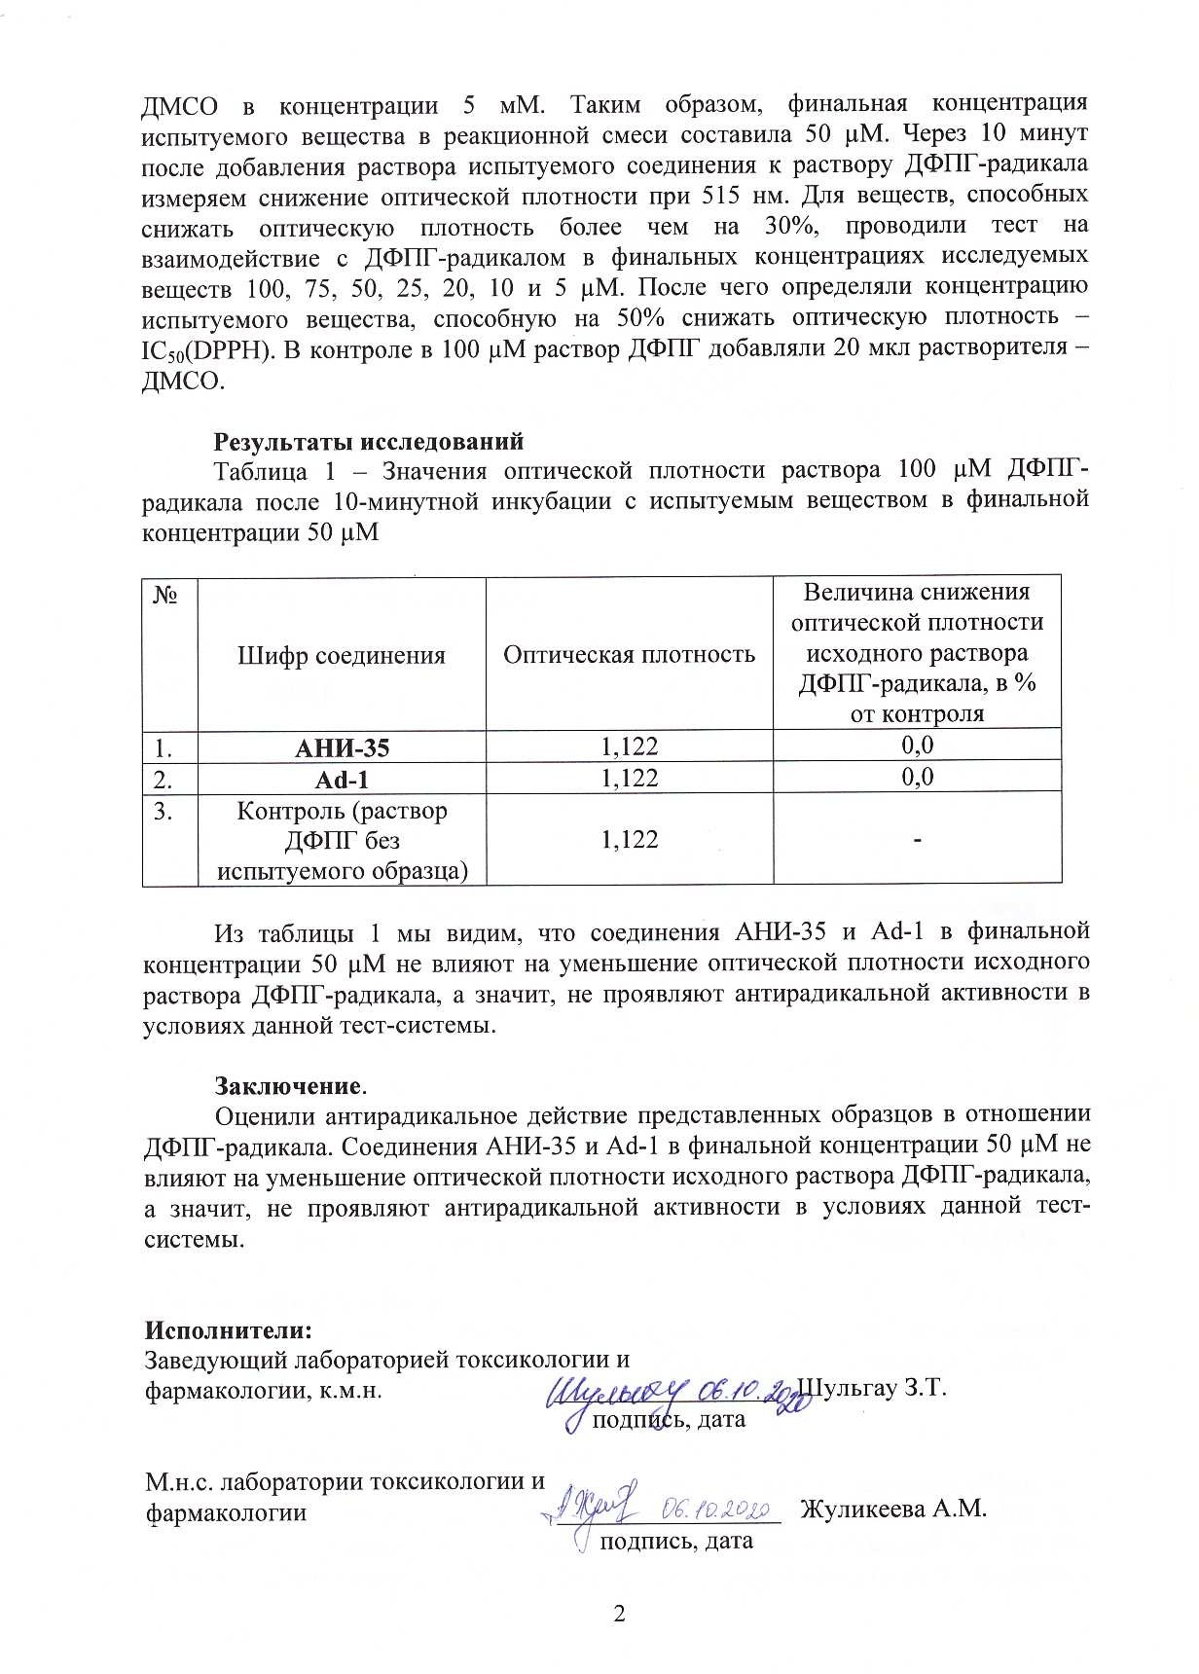
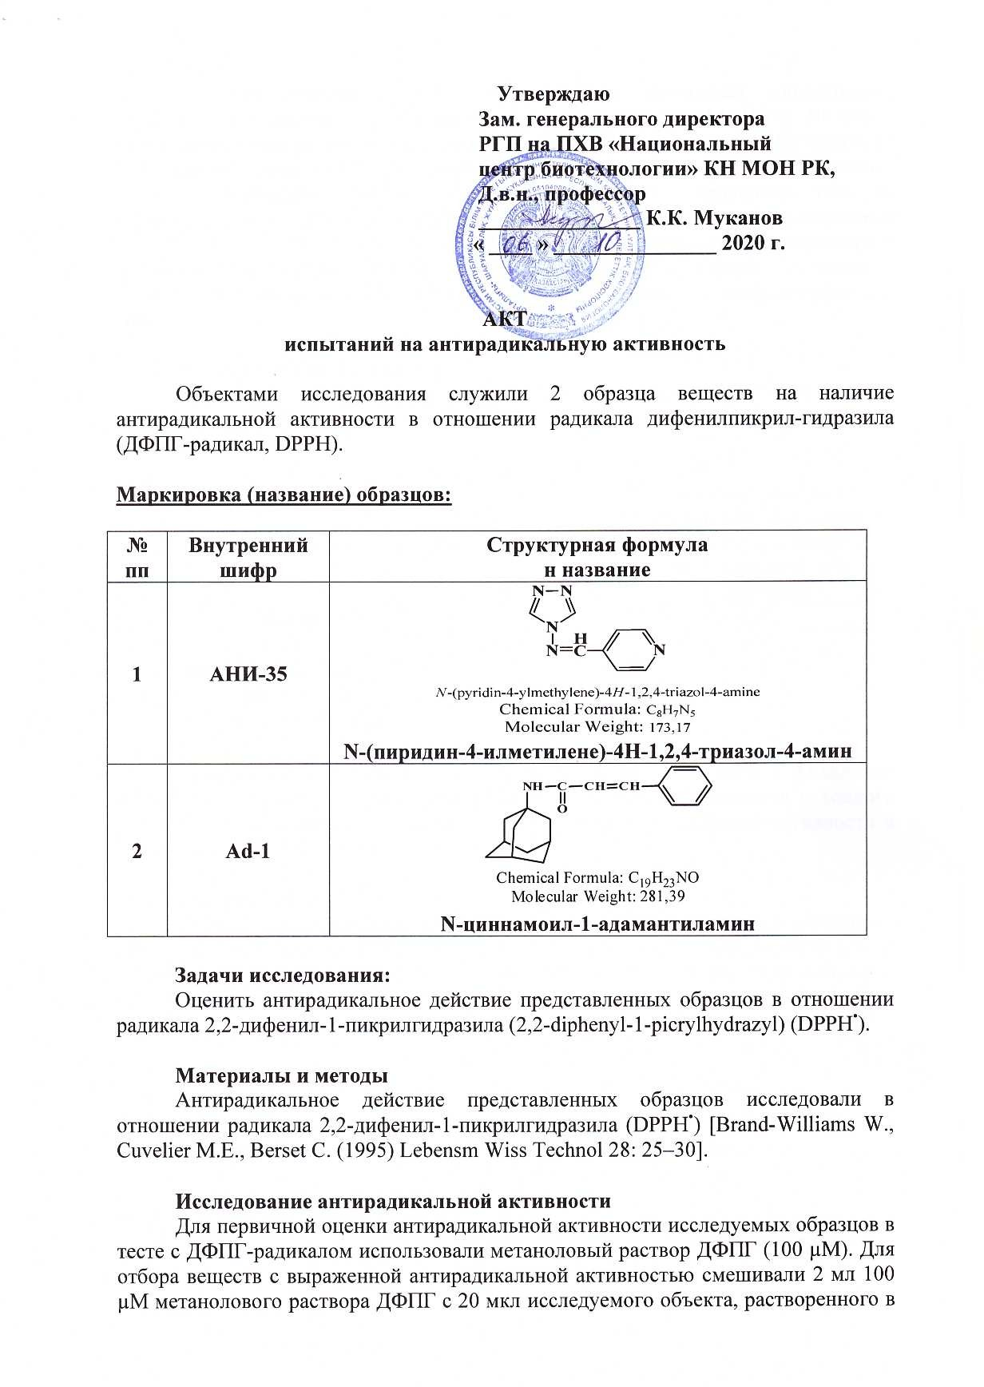

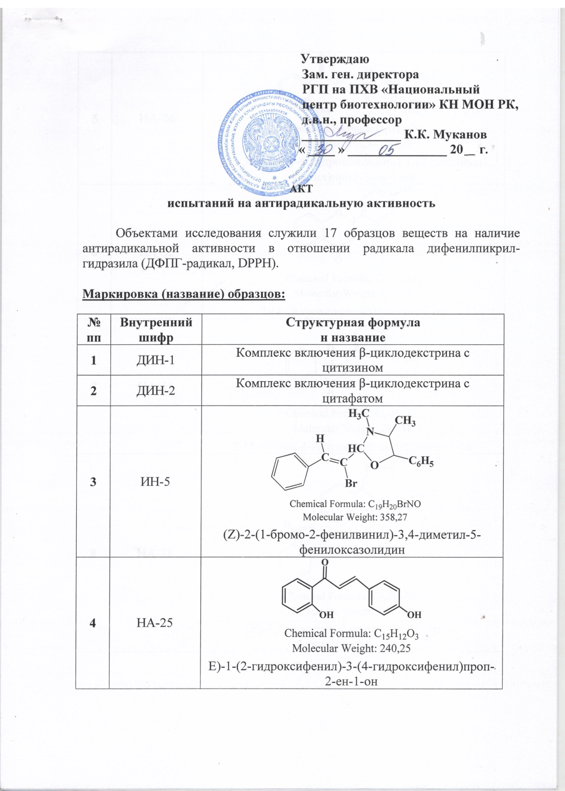
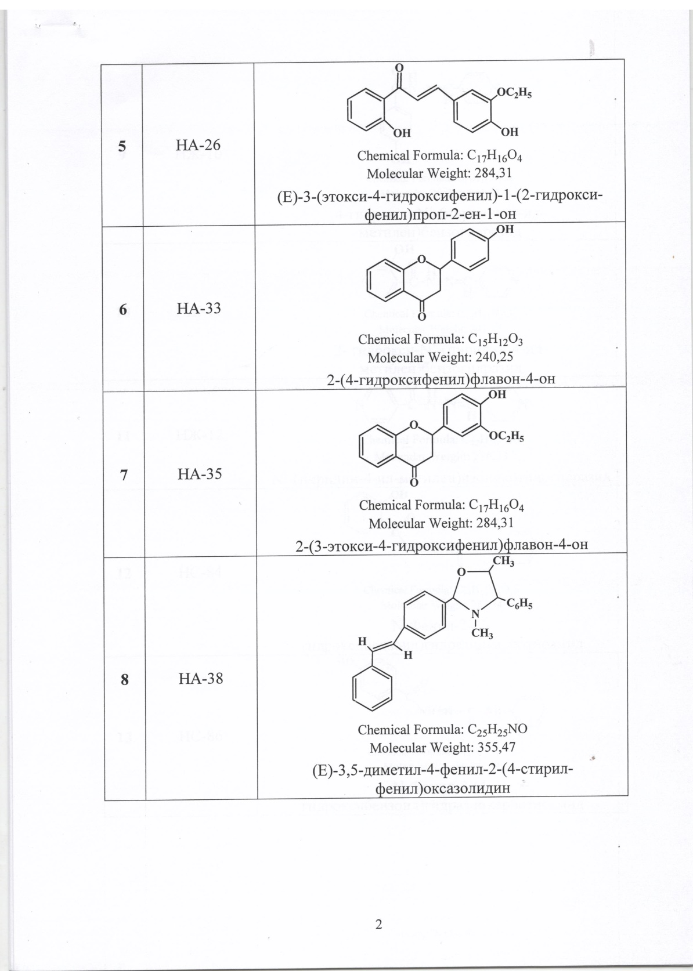

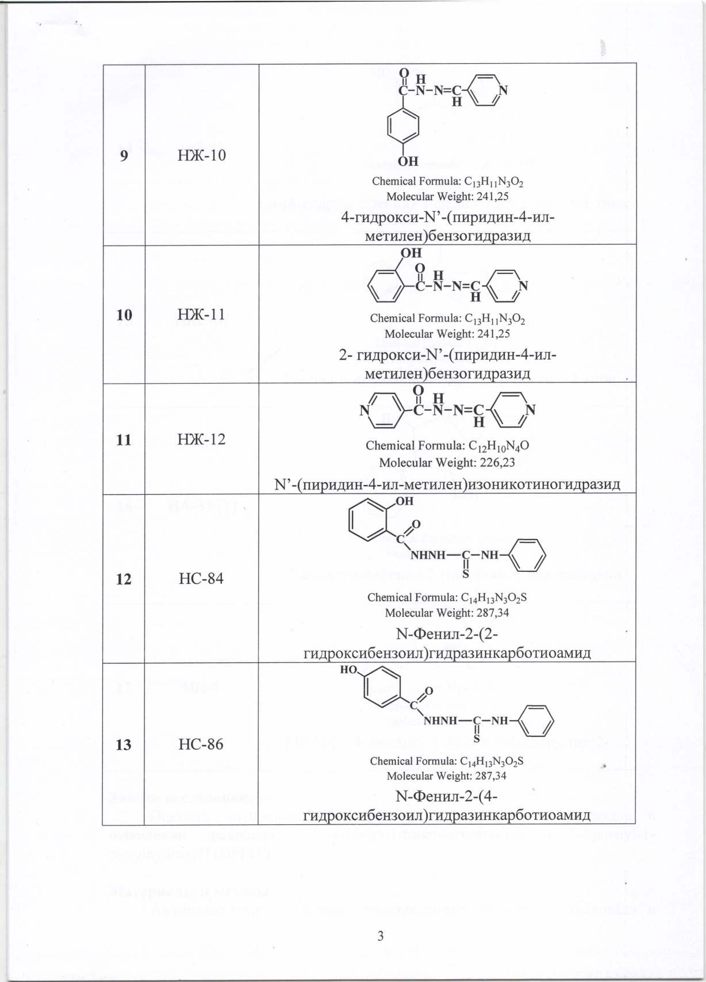
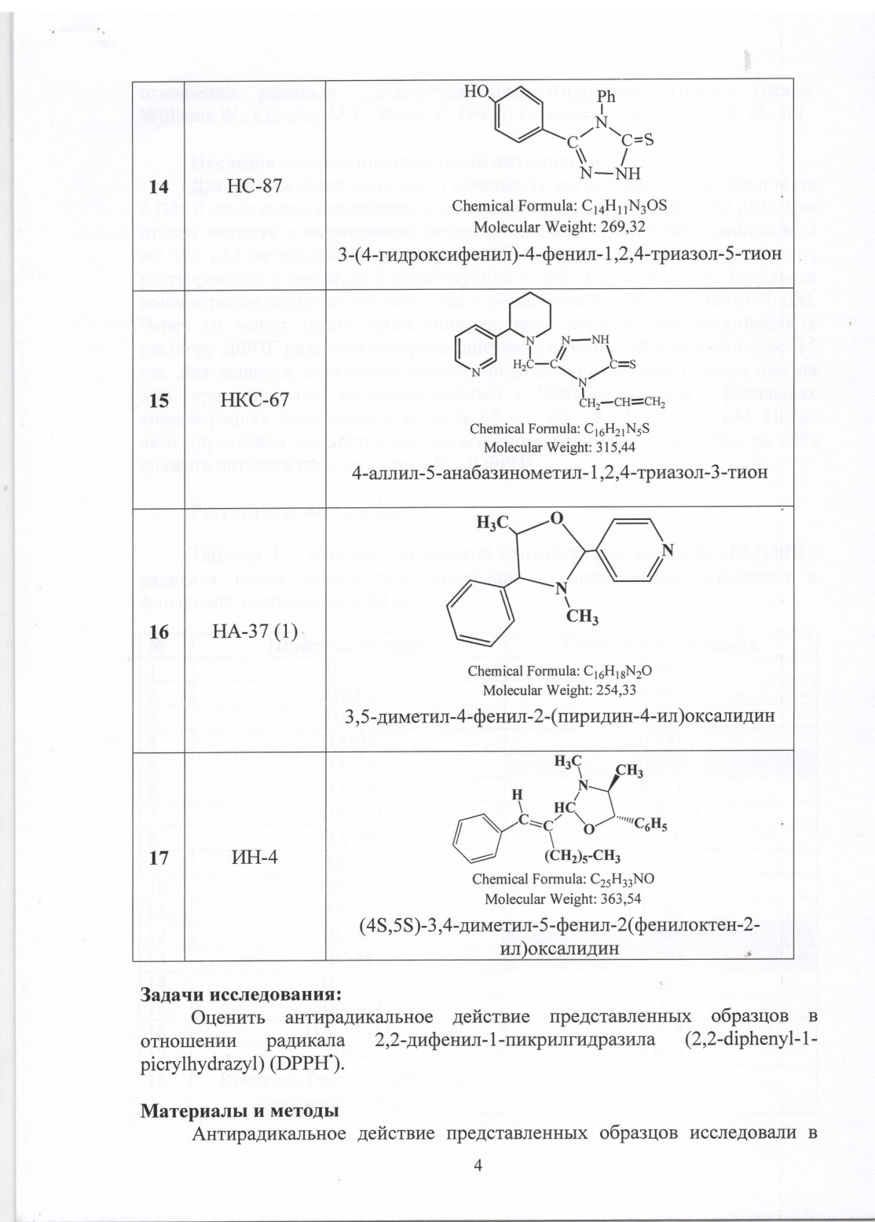

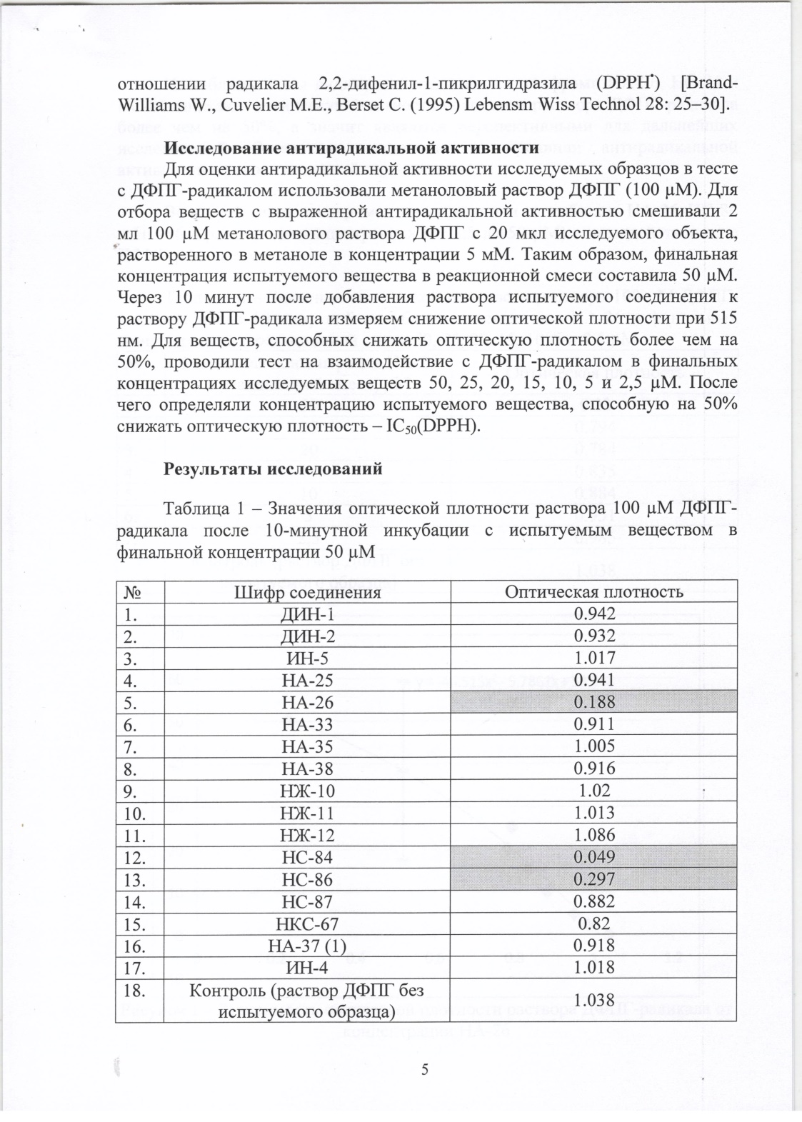

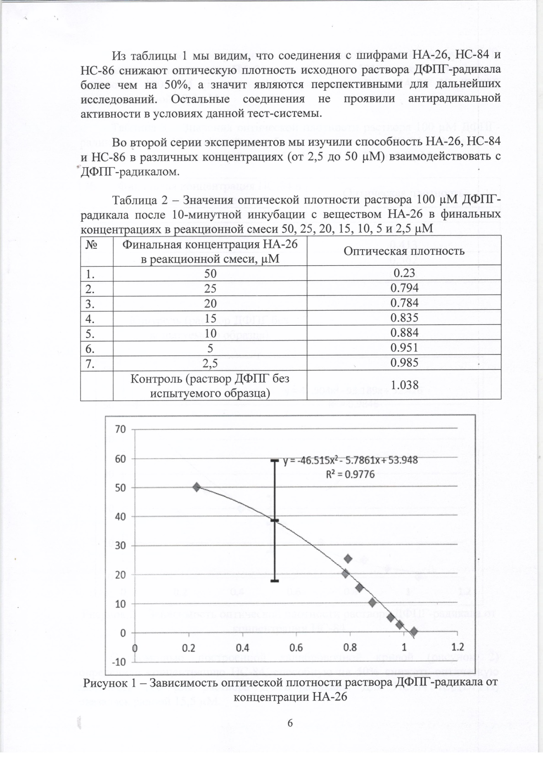

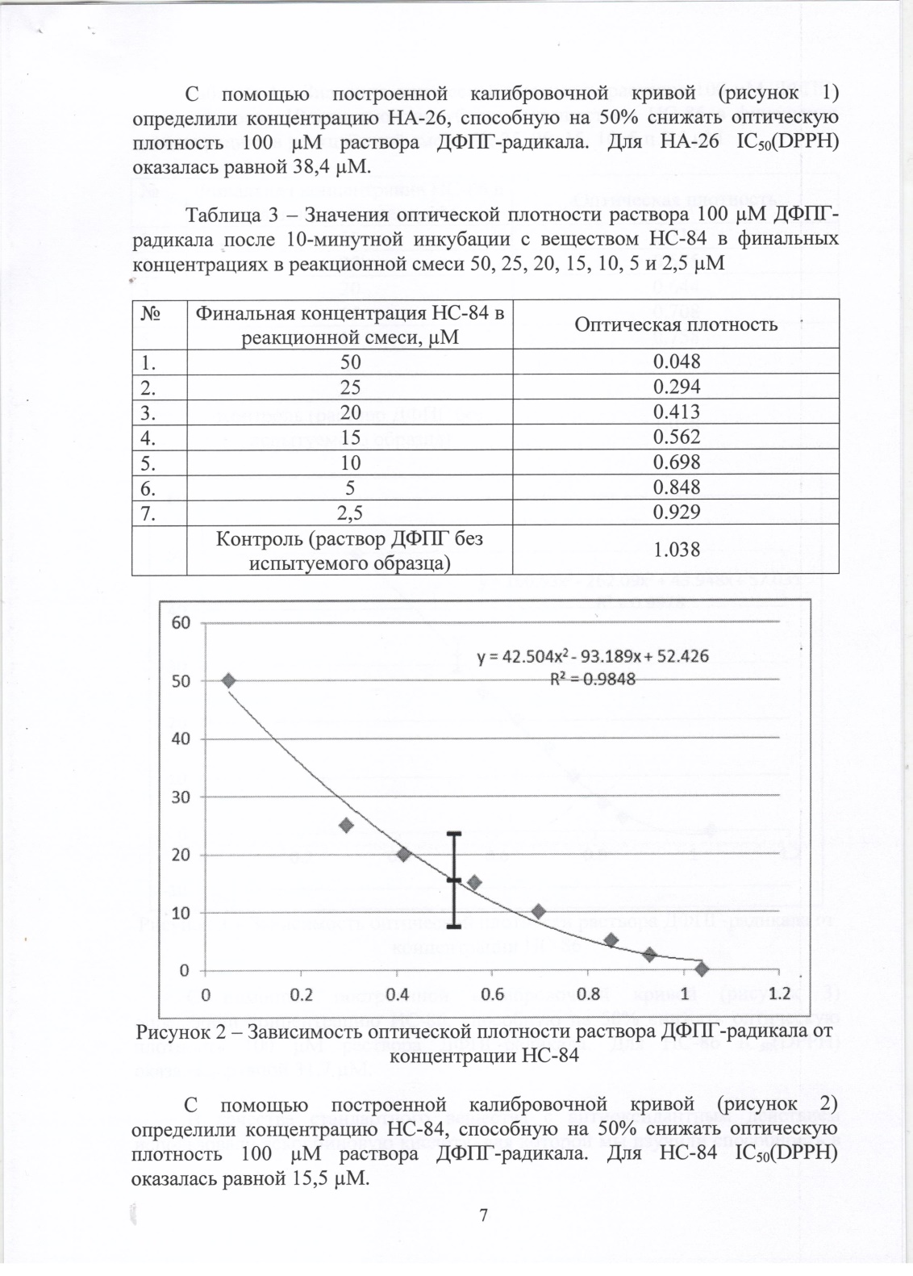

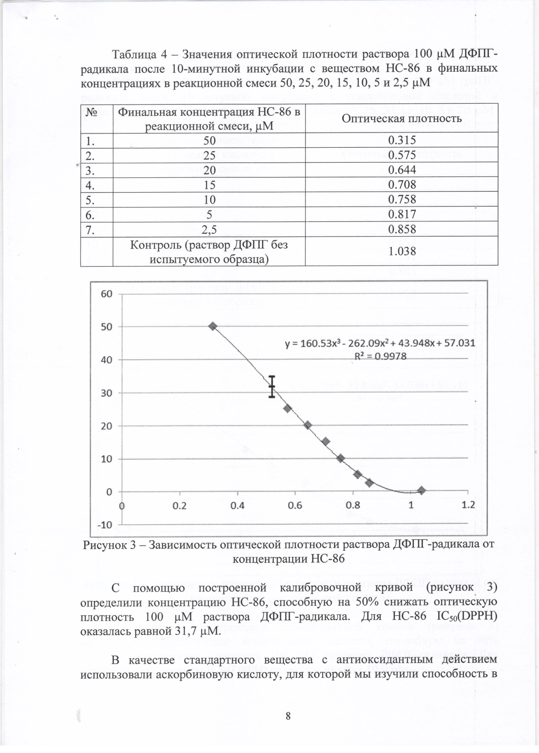

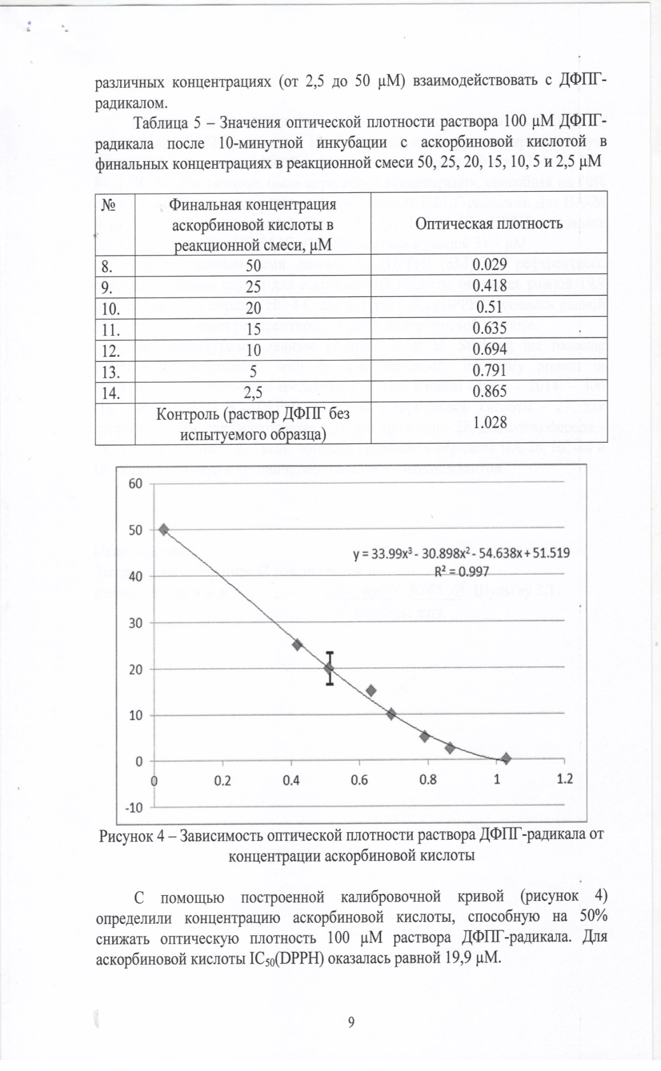

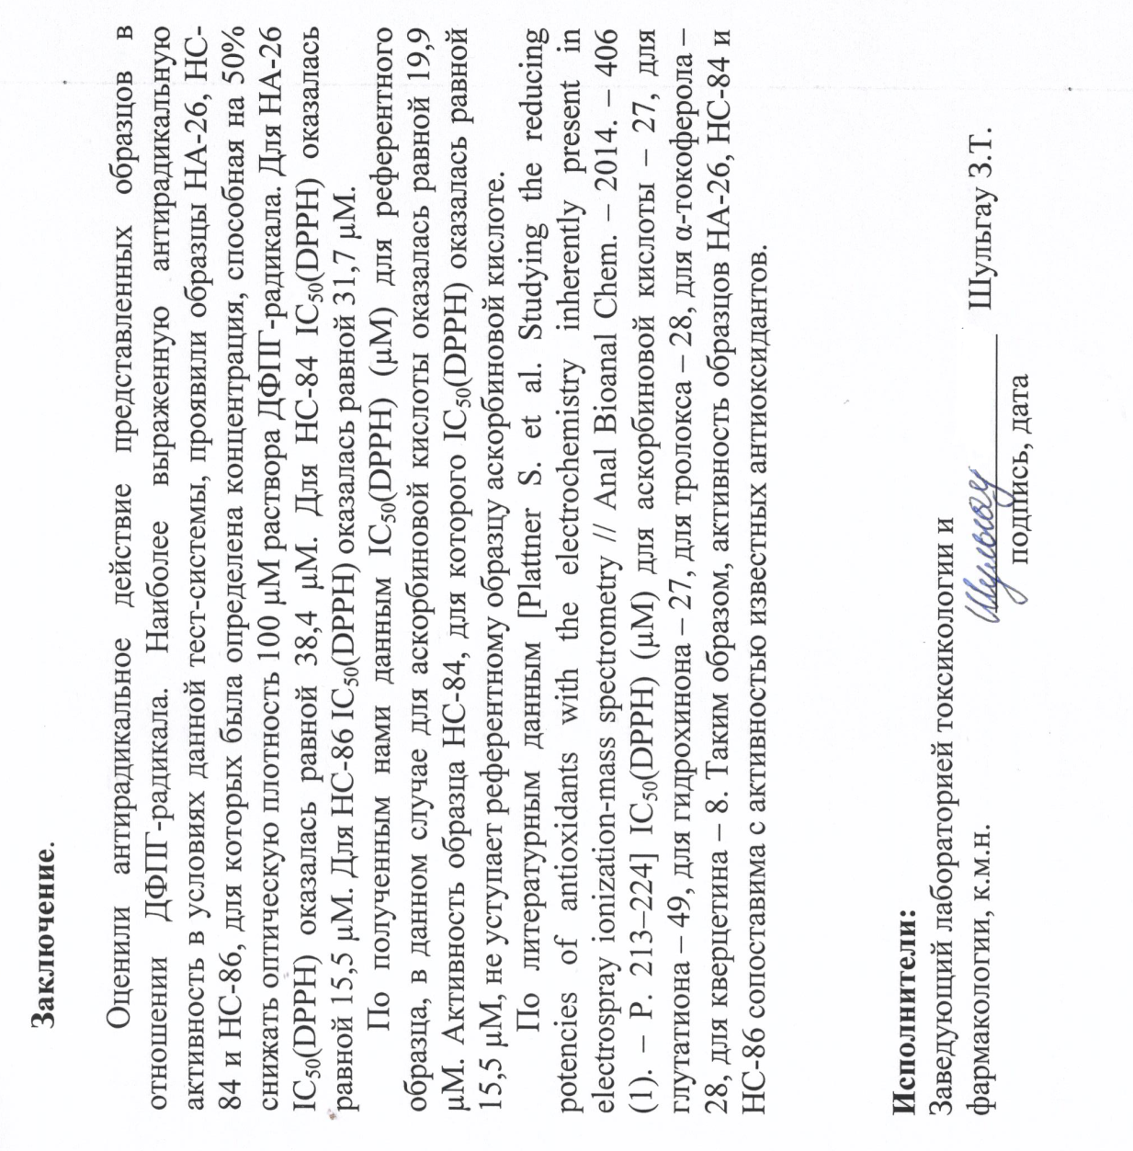

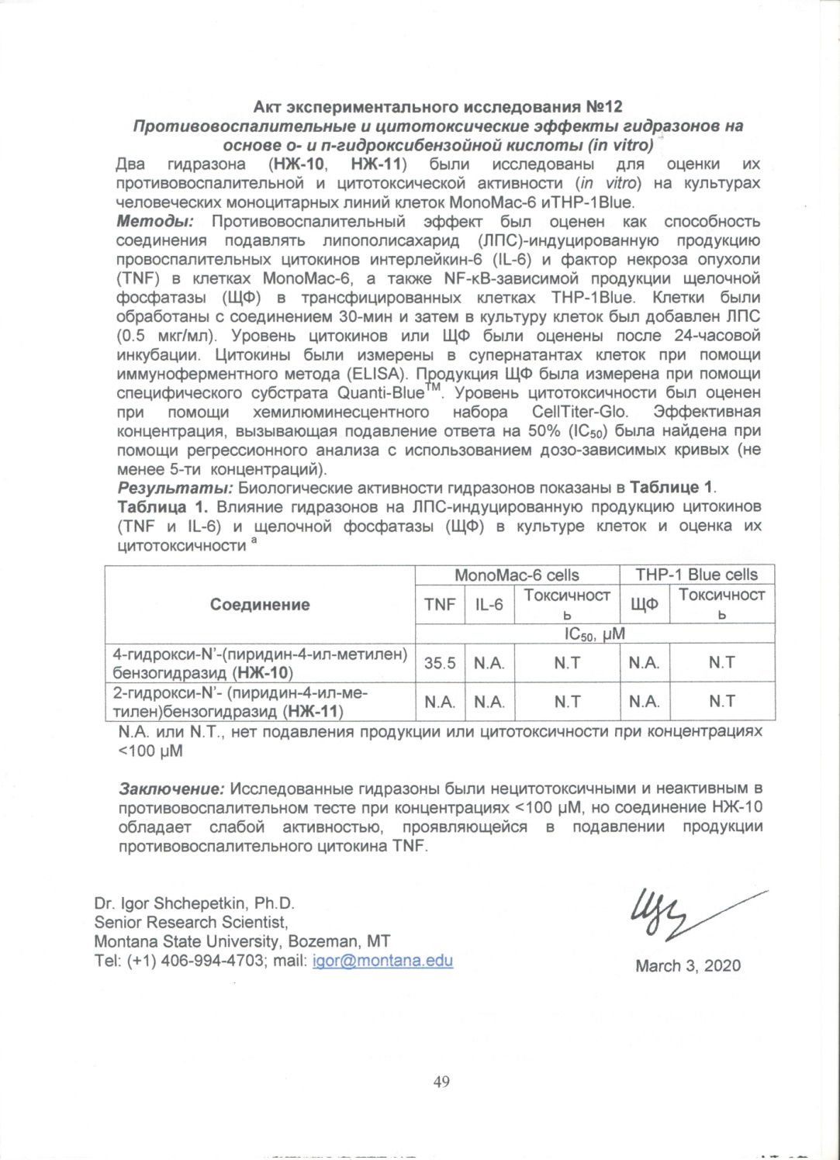

APPENDIX B
Technical specification and work schedule for 2018-2020
Task code, stage | Name of work under the Agreement and the main stages of its implementation | Period of execution |  | Expected result
 |  | start | ending
1 | Development of methods for obtaining and optimal conditions for the synthesis of new hydrazones, thiosemicarbazides, S,N-heterocycles based on isonicotinic acid hydrazide ( INH), study of the reaction mechanisms of their formation, determination of the structure. | february  2018 y. | until november 1  2018 y. | Methods for obtaining and optimal conditions for the synthesis of new hydrazones, thiosemi-carbazides, S, N-heterocycles based on isonicotinic acid hydrazide (INH) will be developed, the mechanisms of their formation reactions will be investigated, and their structure will be established.  Methods of obtaining new hydrazones, thiosemi-carbazides, S, N-heterocycles based on INH will be developed.
1.1 | Synthesis, study of the structure and properties of new hydrazones, thiosemi-carbasides of isonicotinic acid. | february  2018 y. | june  2018 y. | Will be synthesized, investigated the structure and properties of new hydrazones, isonicotinic acid thiosemicarbazides.  The structures of hydrazones and thiosemicarbazides of INH will be synthesized and investigated.
1.2 | Synthesis and implemen-tation of heterocyclization of new thiosemicarbazide derivatives of isonicotinic acid hydrazide. Bioscree-ning of synthesized com-pounds. | jule  2018 y. | until november 1  2018 y. | New thiosemicarbazide deriva-tives of isonicotinic acid hyd-razide will be synthesized and carried out. The synthesized compounds will be bioscreened.  Thiazines and thiazolines will be obtained by heterocyclization of thiosemicarbazides of INH, and bioscreening will be performed. An article will be published in a peer-reviewed national edition with a non-zero impact factor «News NAS RK. Ser. chemistry and technology». Abstracts will be published in the materials of international conferences.
2 | Chemical transformation of amino- and methyl-substituted pyridines in order to obtain new potentially pharmacolo-gically active agents. | january  2019 y. | until november 1  2019 y. | Chemical transformation of amino- and methyl-substituted pyridines will be carried out in order to obtain new potentially pharma-cologically active agents.  New nitrogen-, sulfur- and phosphorus-containing polyfunc-tional pyridine derivatives will be obtained.
2.1 | Purposeful synthesis of nitrogen-, sulfur- and phosphorus-containing derivatives of functionally substituted pyridine. | january  2019 y. | june  2019 y. | Purposeful synthesis of nitrogen-, sulfur- and phosphorus-containing derivatives of functionally substituted pyridine will be carried out. New carbohydrate-, sulfur- and phosphorus-containing pyridine derivatives will be obtained. Abstracts will be published in the materials of international conferences.
2.2 | Preparation of cyclodextrin inclusion complexes of pharmaceutically active pyridine derivatives and study of their structure using ¹H and ¹³C NMR spectroscopy. | june  2019 y. | until november 1  2019 y. | Cyclodextrin inclusion complexes of pharmaceutically active pyridine derivatives will be obtained and their structures will be studied using ¹H and ¹³C NMR spectroscopy.  Cyclodextrin inclusion complexes of new pyridine derivatives will be obtained and their structures will be investigated. Articles will be published: in a foreign peer-reviewed journal indexed in the Web of Science and Scopus databases with a non-zero impact factor «Journal of General Chemistry» and in peer-reviewed domestic publications with a non-zero impact factor - «Bulletin of Karaganda University. Ser. chemistry»,«News NAS RK. Ser. chemistry and technology»; 1 application for a patent of the RK for a utility model will be submitted; according to the results of scientific research carried out within the framework of this project, it is planned to publish the book in a Kazakh publishing house.
3 | Development of alternative green (microwave and ultrasonic activation) methods for the synthesis of new derivatives of functionally substituted pyridine. Bioscreening of the activity of new pyridine compounds for antioxidant, antimicrobial, antifungal and other types of activity. | january  2020 y. | until november 1  2020 y. | Alternative green (microwave and ultrasonic activation) methods for the synthesis of new derivatives of functionally substituted pyridine will be developed. The bioscreening of the activity of new pyridine compounds for antioxidant, antimicrobial, antifungal and other types of activity will be carried out.  Green («one-pot» reaction, MW-, US-activation, etc.) methods for the synthesis of new polyfunctional pyridine derivatives will be developed. Bioscreening of substances will be carried out.
3.1 | Synthesis and structure of Schiff's bases, hydrazones based on 4-pyridinecarb-aldehyde. | 03.01.2020 | 30.06.2020 | The structure of Schiff bases, hydrazones based on 4-pyridine-carbaldehyde will be synthesized and established.  Imines, hydrazones based on 4-pyridinecarbaldehyde will be obtained.
3.2 | Development of a preparative method for the synthesis of the most promising derivatives of functionally substituted pyridine using microwave irradiation and ultrasonic activation. | 01.07.2020 | 31.10.2020 | Preparative methods for the synthesis of the most promising derivatives of functionally substituted pyridine using microwave irradiation and ultrasonic activation will be developed.  Methods for the synthesis of the most promising substituted pyridine derivatives using microwave irradiation and ultrasonic activation will be developed. Articles will be published: 2 articles in a foreign peer-reviewed journal, indexed in the Web of Science and Scopus databases with a non-zero impact factor «Journal of General Chemistry» and in a peer-reviewed domestic publication with a non-zero impact factor «Bulletin of Karaganda University. Ser. chemistry», 1 patent application for a utility model will be filed.

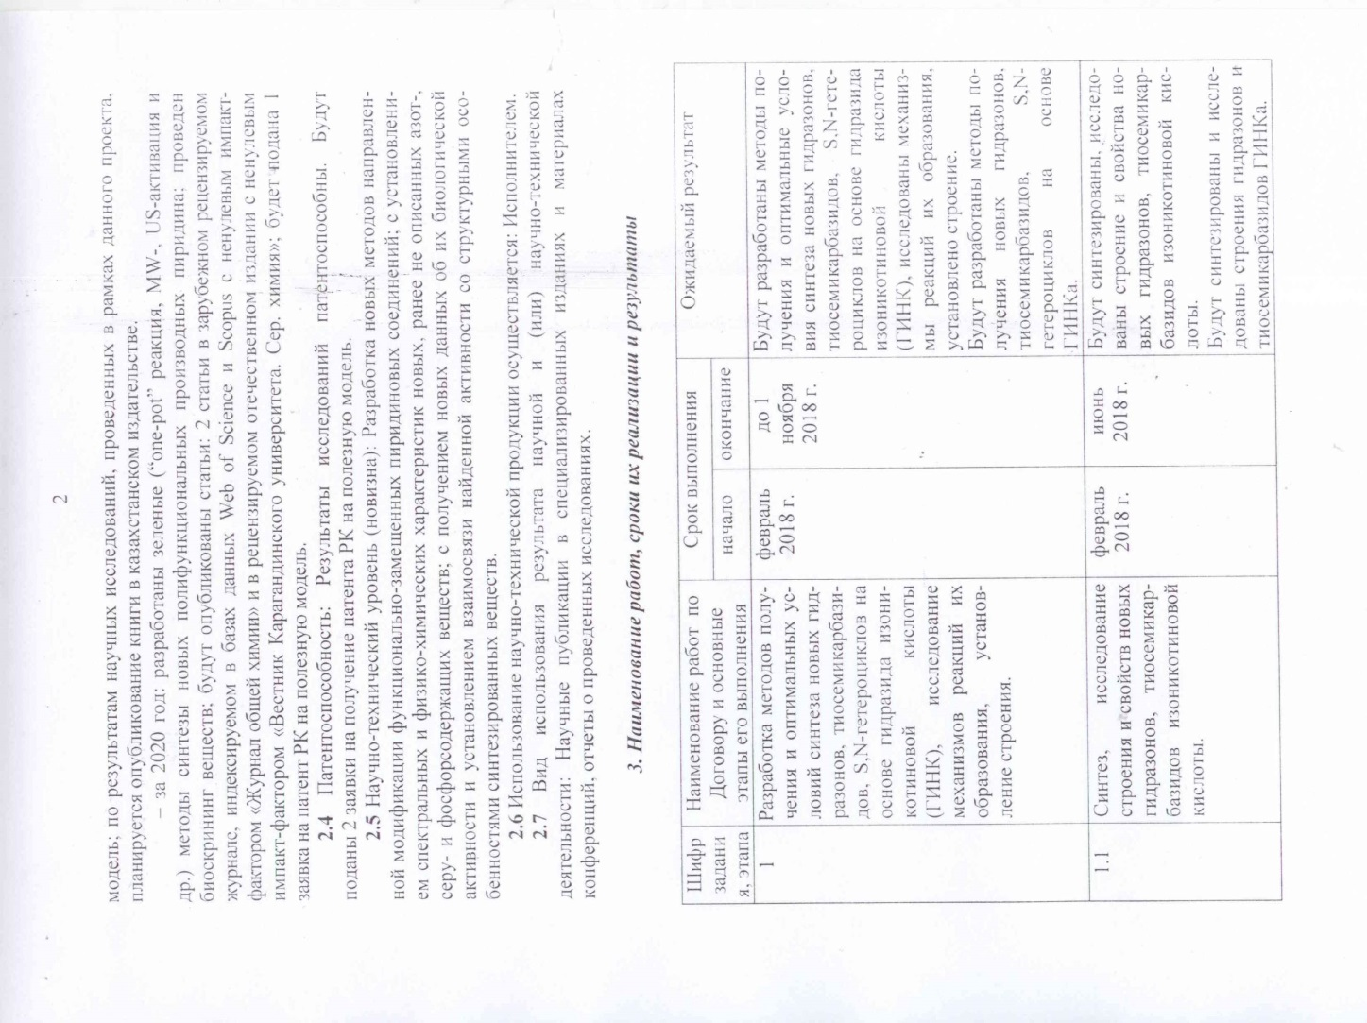
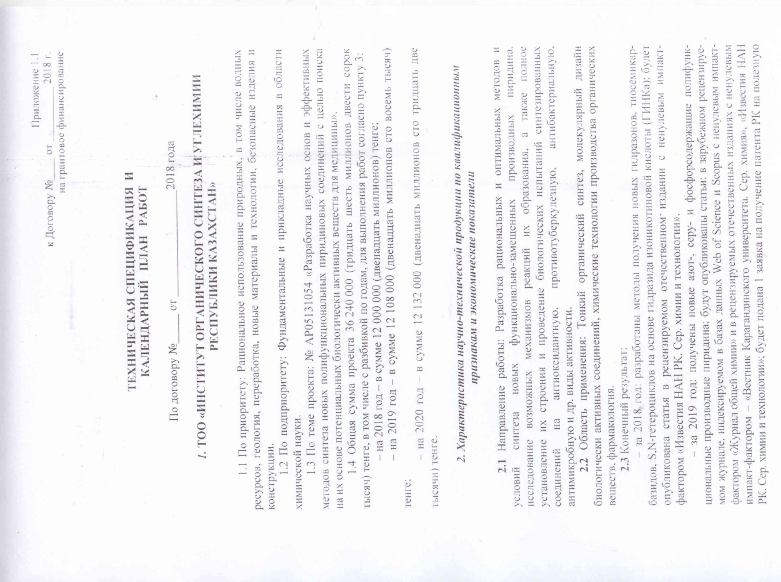

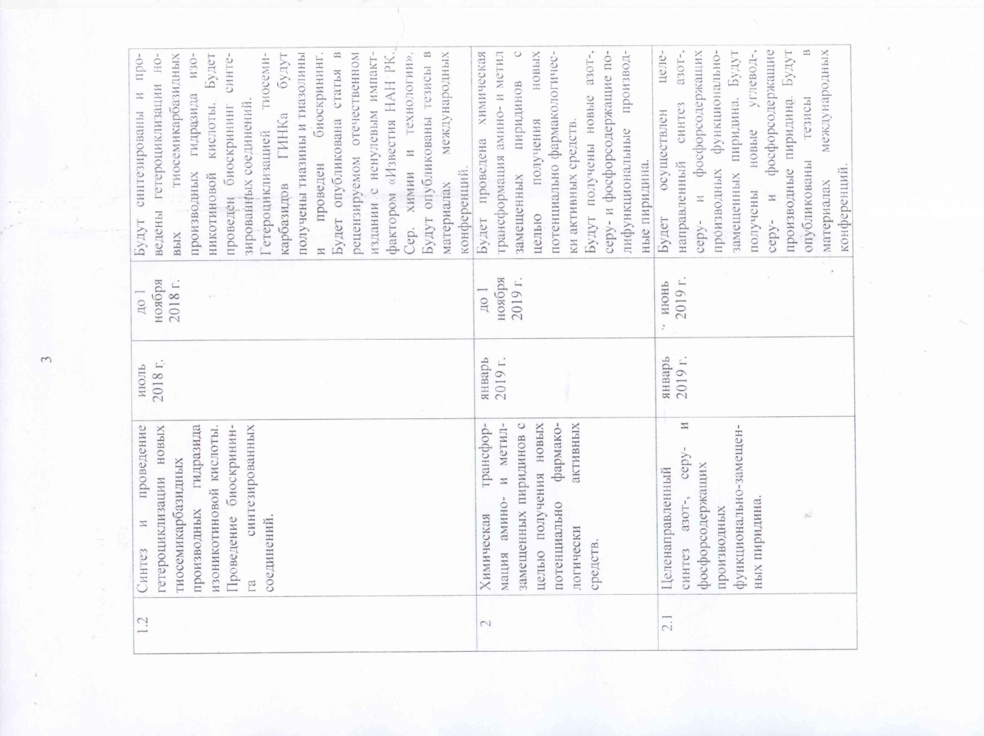


Supplementary Agreement No. 4 to the Agreement
for grant funding No. 99 dated March 5, 2018 y

Nur-Sultan 05.10.2020

State institution «Science Committee of the Ministry of Education and Science of the Republic of Kazakhstan», hereinafter referred to as the Customer, represented by the Chairperson Zh.D. Kurmangaliyeva, acting on the basis of the Regulation on the Science Committee, approved by order of the Executive Secretary on July 10, 2018 No. 169-C, and by order of the Minister Education and Science of the Republic of Kazakhstan dated December 25, 2019 No. 169-hc, on ​​the one hand, and the Limited Liability Partnership «Institute of Organic Synthesis and Coal Chemistry of the Republic of Kazakhstan», hereinafter referred to as the «Contractor», represented by Director Z.M. Muldakhmetov, acting on the basis of the Charter, approved on January 7, 2005, on the other hand, hereinafter collectively referred to as the «Parties», on the basis of Articles 401, 402 of the Civil Code of the Republic of Kazakhstan, the Law of the Republic of Kazakhstan dated February 18, 2011 «On Science», resolutions of the Government of the Republic of Kazakhstan dated May 25, 2011 No. 575 «On approval of the Rules for basic, grant, program-targeted financing on scientific and (or) scientific and technical activities», Resolution of the Government of the Republic of Kazakhstan dated May 16, 2011 No. 519 «On National Scientific Councils» and the protocol decision of the National Scientific Council on the priority direction «Rational use of natural resources, including water resources, geology , processing, new materials and technologies, safe products and structures» (Minutes No. 5 dated September 28-30, 2020) concluded this Supplementary Agreement to the Grant Funding Agreement No. 99 dated March 5, 2018 (hereinafter referred to as the Agreement) on the following:
1. The third paragraph of clause 2.3 of section 2 of appendix 1.1 of the Agreement shall be amended as follows:
«- for 2020: green («one pot» reaction, MW-, US-activation, etc.) methods for the synthesis of new polyfunctional pyridine derivatives have been developed; bioscreening of substances was carried out; articles will be published: 2 articles in foreign peer-reviewed journals indexed in the Web of Science and Scopus databases with a non-zero impact factor «Journal of General Chemistry» and «Journal of Bioorganic Chemistry» and in a peer-reviewed domestic publication with a non-zero impact factor «Bulletin of Karaganda University. Ser. chemistry»; 1 patent application for a utility model of the Republic of Kazakhstan will be filed. »;
2. Clause 3.2 for 2020 of Section 3 of аppendix 1.1 of the Agreement shall be amended as follows:
«
3.2 | Development of a preparative method for the synthesis of the most promising derivatives of functionally substituted pyridine using microwave irradiation and ultrasonic activation. | 01.07.2020 | 31.10.2020 | Preparative methods for the synthesis of the most promising derivatives of functionally substituted pyridine using microwave irradiation and ultrasonic activation will be developed.  Methods for the synthesis of the most promising substituted pyridine derivatives using microwave irradiation and ultrasonic activation will be developed. Articles will be published: 2 articles in a foreign peer-reviewed journal, indexed in the Web of Science and Scopus databases with a non-zero impact factor «Journal of General Chemistry» and «Journal of Bioorganic Chemistry» and in a peer-reviewed domestic publication with a non-zero impact factor «Bulletin Karaganda University. Ser. chemistry», 1 patent application for a utility model of the Republic of Kazakhstan will be filed.
».

3. This Supplementary Agreement is an integral part of Agreement No. 99 dated March 5, 2018 and comes into force from the moment it is signed by the parties and is valid until December 31, 2020.
4. The terms of Agreement No. 99 dated March 5, 2018, not affected by this Supplementary Agreement, remain unchanged, and the Parties confirm their obligations under them.
5. The supplementary agreement is made in two copies, one copy for each of the parties, having the same legal force.
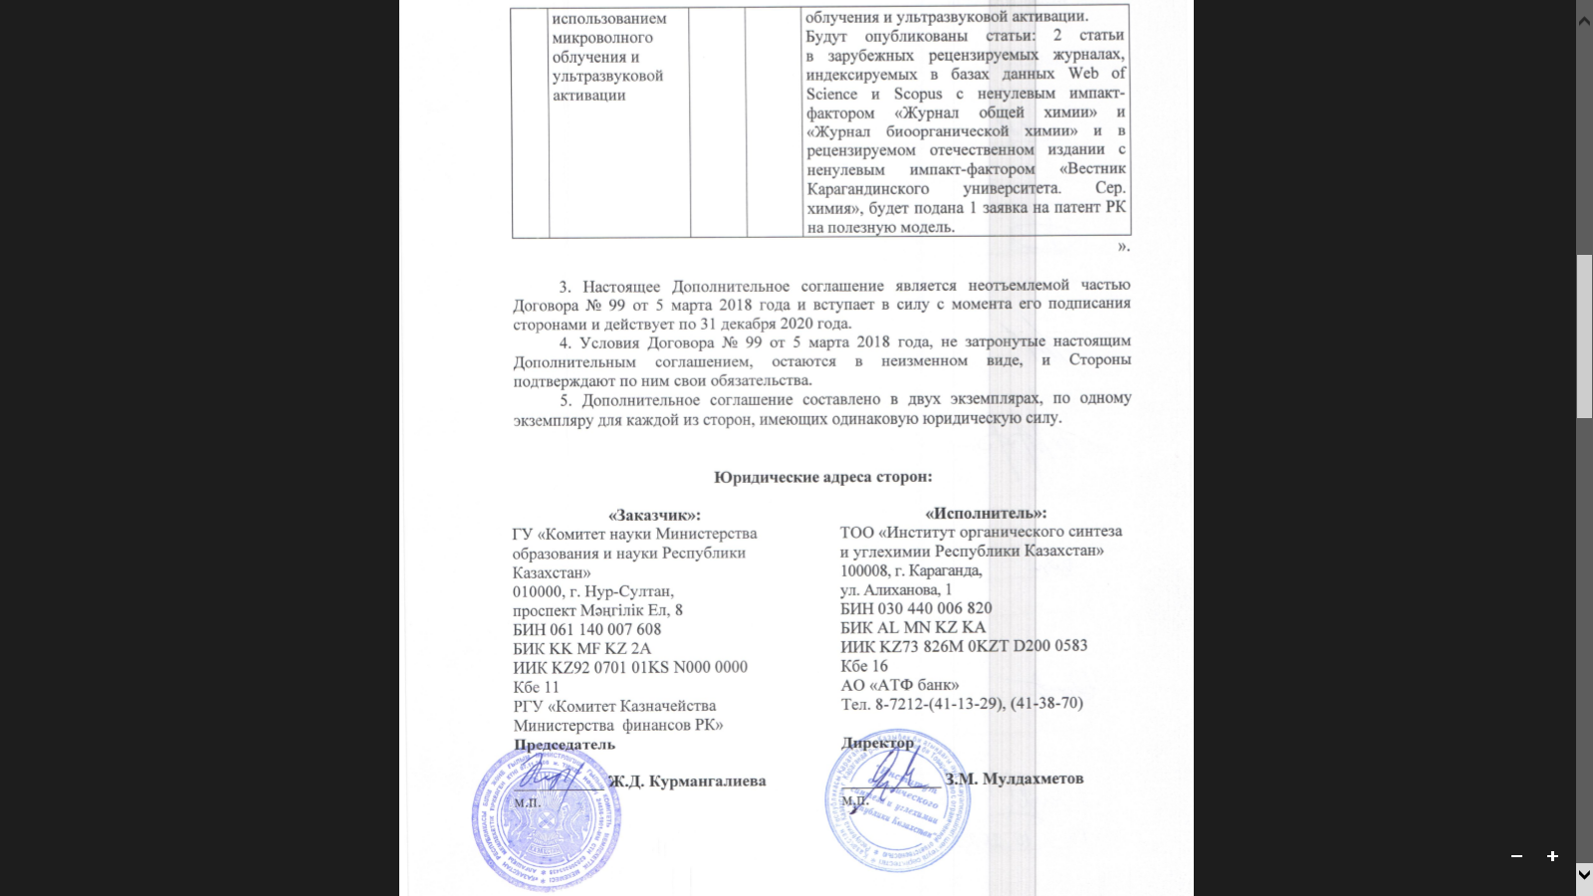
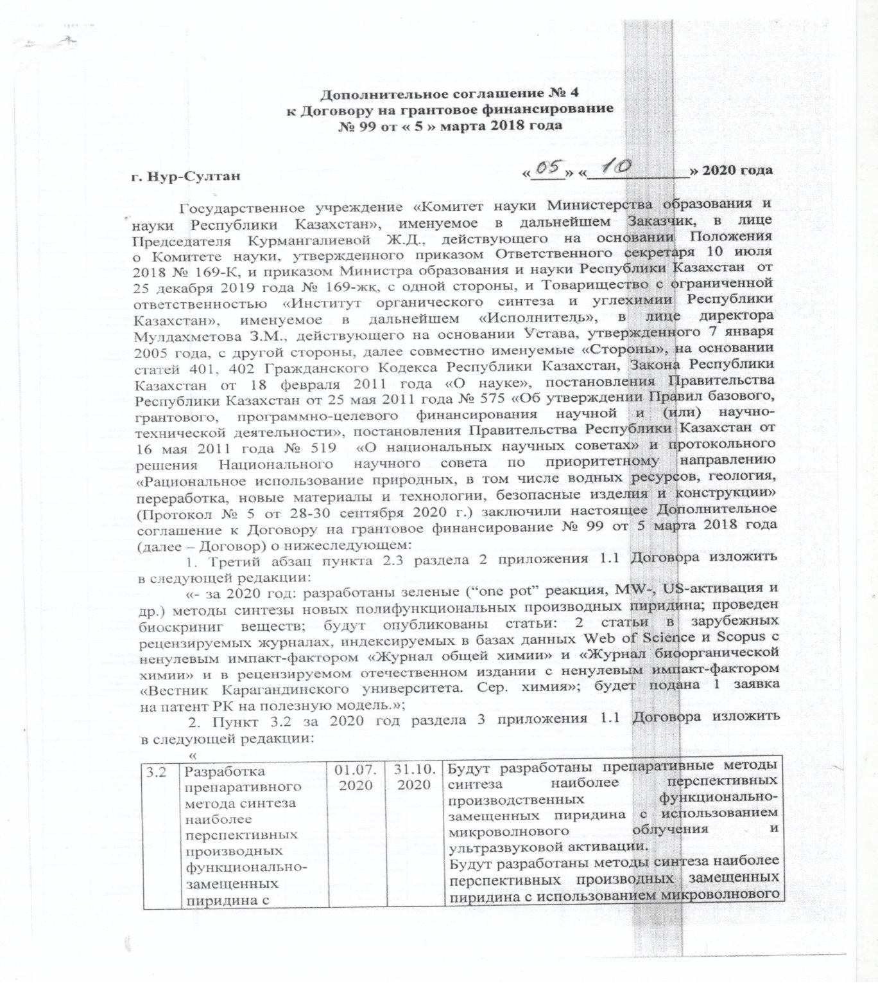

APPENDIX C
Copy of RK patent for utility model
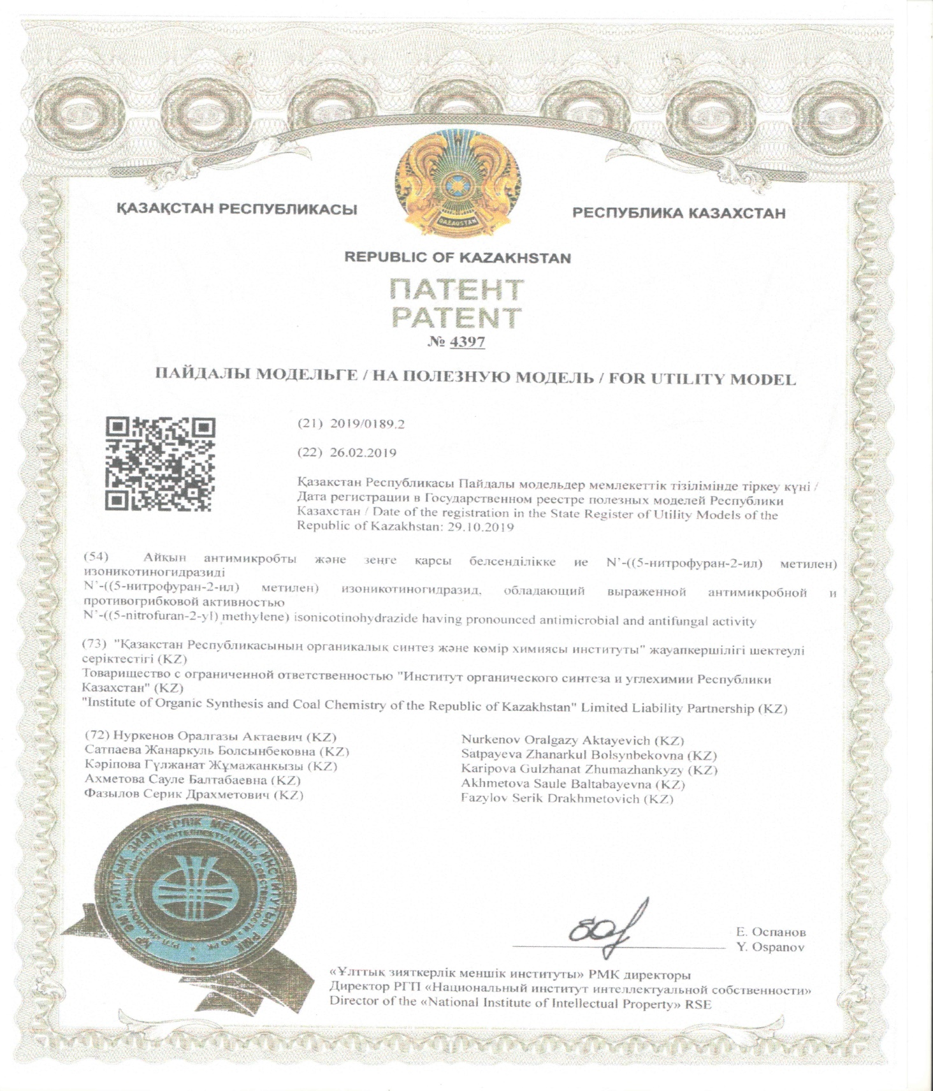

APPENDIX D
List of published works in the direction of the topic for 2018-2020

for 2018 y:
1 Fazylov S.D., Nurkenov O.A., Zhurinov M.Zh., Arinova A.E., Tuktarov A.R., Issayeva A.Zh. Catalytic cyclodridation of hydrazons to c60 fullerene catalyzed complexes of palladium // News of NAS RK. – 2018. - №5 (431). – pp. 26-31. http://nauka-nanrk.kz/en/%D0%B8%D0%B7%D0%B2%D0%B5%D1%81-%D1%82%D0%B8%D1%8F.html [in Eng.]
2 Nurkenov O.A., Ibrayev M.K., Satpaeva Zh.B., Dauletzhanova Zh.T., Seilkhanov T.M. Sythesis and study of antioxidant activity of hydrazine and thiosemicarbazidebased on N-morpholinoacetic acid hydrazide // Bulletin of the Karaganda university. – 2018. - №1 (89). – pp. 22-26. http://vestnik.ksu.kz [in Eng.]
3 Nurkenov O.A., Karipova G.Zh., Seilkhanov T.M., Tukhmetova Zh.K., Nurlan G. Synthesis, structure and determination of thermodynamic characteristics of isonicotinic acid hydrazones // Bulletin of the Scientific and Technical Society «KAKHAK». - 2018. - №. 2 (61). - P. 68-76. http://www.ntokaxak.kz/?page_id =235. [Нуркенов О.А., Карипова Г.Ж., Сейлханов Т.М., Тухметова Ж.К., Нурлан Г. Синтез, строение и определение термодинамических характе-ристик гидразонов изоникотиновой кислоты // Известия научно-технического общества «КАХАК». – 2018. - №2 (61). – С. 68-76. http://www.ntokaxak.kz/? page_id=235].
4 Tukhmetova Zh.K., Nurkenov O.A., Omarov T.S., Karipova G.Zh. Investigation of the thermodynamic properties of a number of isonicotinohydrazide derivatives // Actual problems of the humanities and natural sciences. - 2018. - №. 7 (114). - P. 12-15.http://www.publikacia.net/ [Тухметова Ж.К., Нуркенов О.А., Омаров Т.С., Карипова Г.Ж. Исследование термодинамических свойств ряда производных изоникотиногидразида // Актуальные проблемы гуманитарных и естественных наук.–2018.-№7(114).–С. 12-15. http://www.publikacia.net/.].
5 Satpayeva Zh.B., Nurkenov O.A., Karipova G.Zh., Fazylov S.D., Burkeev M.Zh., Seilkhanov T.M., Khavlichek D. New 1,2,4-triazole-5 ( 4H) thiones based on hydrazides of o- and p-hydroxybenzoic and isonicotinic acids//Mater. int. scientific-practical conf. «Science, Education and Manufacturing in the Fourth Industrial Revolution».-Karagandy,-2018.-P.83-85. http: //ksu.kz/?p=9532& lang=ru. [Сатпаева Ж.Б., Нуркенов О.А., Карипова Г.Ж., Фазылов С.Д., Буркеев М.Ж., Сейлханов Т.М., Хавличек Д. Новые 1,2,4-триазол-5(4Н)тио-ны на основе гидразидов о- и п-гидроксибензойных и изоникотиновой кислот // Матер. междунар. науч.-практ. конф. «Наука, образование и производство в условиях Четвертой промышленной революции». – Караганды, - 2018. – С. 83-85. http://ksu.kz/?p=9532&lang=ru.].
6 Isaeva A.Zh., Nurkenov O.A., Fazylov S.D., Muldakhmetov Z.M. The inclusion complex of functionally substituted N-benzylidene- and allylidene-isonicotinohydrazide with β-cyclodextrin // Mater. int. scientific-practical conf. «Science, Education and Manufacturing in the Fourth Industrial Revolution». - Karagandy, - 2018.- P. 188-189. http://ksu.kz/?p=9532&lang=ru. [Исаева А.Ж., Нуркенов О.А., Фазылов С.Д., Мулдахметов З.М. Комплекс включения функционально-замещенных N-бензилиден- и аллилиденизоникотиногидра-зида с β-циклодекстрином // Матер. междунар. науч.-практ. конф. «Наука, образование и производство в условиях Четвертой промышленной революции». – Караганды, - 2018.–С. 188-189. http://ksu.kz/?p=9532&lang=ru].
7 Nurlan G., Nurkenov O. A., Karipova G.Zh. Condensation of 4-diethyl-aminosalicylaldehyde with isonicotinic acid hydrazide // Mater. int. scientific-practical conf. «Integration of science, education and industry - the basis for the implementation of the Plan of the nation». - Karagandy, - 2018.- P. 158. http://www.kstu.kz/integratsiya-nauki-obrazovaniya-proizvodstva-osnova-realizatsii-plana-natsii-saginovskie-chteniya-10/ [Нурлан Г., Нуркенов О.А., Карипова Г.Ж. Конденсация 4-диэтил-аминосалицилальдегида с гидразидом изоникотиновой кислоты // Матер. междунар. науч.-практ. конф. «Интеграция науки, образования и производства – основа реализации Плана нации». – Караганды, - 2018. – С. 158. http://www.kstu.kz/integratsiya-nauki-obrazovaniya-proizvodstva-osnova-realizatsii-plana-natsii-saginovskie-chteniya-10/.].

for 2019 y:

1 Application for a patent of the Republic of Kazakhstan for a useful model №2019/0189.2 dated 02.26.2019y. N-((5-nitrofuran-2-yl)methylene)isonicotino-hydrazide, which has a pronounced antimicrobial and antifungal activity/Nurkenov O.A., Satpaeva Zh.B., Karipova G.Zh., Akhmetova S.B., Fazylov S.D. [Заявка на патент РК на полезную модель № 2019/0189.2 от 26.02.2019 г. N-((5-нитрофуран-2-ил)метилен)изоникотиногидразид, обладающий выраженной антимикробной и противогрибковой активностью / Нуркенов О.А., Сатпаева Ж.Б., Кәріпова Г.Ж., Ахметова С.Б., Фазылов С.Д.].

2 Nurkenov O.A., Fazylov S.D., Karipova G.Zh. Isonicotinic acid hydrazide and their derivatives. - Karaganda: Glasir, 2019 .- 156 p.[ Нуркенов О.А., Фазылов С.Д., Карипова Г.Ж. Гидразид изоникотиновой кислоты и их производные. – Караганда: Гласир, 2019. – 156 с.].
3 Nurkenov O.A., Karipova G.Zh., Seilkhanov T.M., Satpayeva Zh.B., Fazylov S.D., Nukhuly A. Synthesis and intramolecular heterocyclization of some thiosemicarbazides of isonicotinic acid//Journal of General Chemistry. - 2019. - Vol.89, Issue 9. - P. 1457-1461. http://sciencejournals.ru/contents /obkhim/2019/ obkhim9_19v89cont.pdf. IF (2019)=0,716 (Q3). [Нуркенов О.А., Карипова Г.Ж., Сейлханов Т.М., Сатпаева Ж.Б., Фазылов С.Д., Нухулы А. Синтез и внутримолекулярная гетероциклизация некоторых тиосемикарбазидов изоникотиновой кислоты // Журнал общей химии. – 2019. – Т. 89, Вып. 9. – С. 1457-1461. http://sciencejournals.ru /contents/obkhim/2019/obkhim9_19v89cont. pdf. (Impact-factor in 2019 – 0,716; квартиль Q3, процентиль 33%)].
4 Nurkenov O.A., Karipova G.Zh., Zhivotova T.S., Akhmetova S.B., Seilkhanov T.M., Fazylov S.D. Synthesis and anti-microbial activity of N'-(2-hydroxy-5-nitrobenzylidene)-isonicotinohydrazide // News of the Academy of sciences of the Republic of Kazakhstan. Series chemistry and technology. – 2019. – № 2(434). – С. 26-30. http://naukananrk.kz/ru/ assets/%D0%B6%D1%83% D1%80%D0%BD%D0%B0%D0%BB%202019%202/%D0%A5%D0%B8%D0%BC%D0%B8%D1%8F_02_2019.pdf [in Eng.]
5 Fazylov S.D., Nurkenov O.A., Seilkhanov T.M., Karipova G.Zh., Van Hecke K., Suleimen Ye.M., Gazaliyev A.M. Synthesis of hydrazine derivatives of isonicotinic acid under microwave activation conditions // Bulletin of the Karaganda university, Chemistry series. – 2019. – № 3(95). – P. 37-44. https:// physics-vestnik.ksu.kz/ru/srch/2019_Physics_3_95_2019.pdf [in Eng.]
6 Nurkenov O.A., Karipova G.Zh., Synthesis, structure and antiradical activity of new hydrazones of isonicotinic acid // Materials XX Int. scientific and practical. conf. named after prof. L.P. Kuleva students and young scientists. - Tomsk.-2019.-P.169-170.http://portal.tpu.ru:7777/science/konf/hht/ProgramHHT 2019.pdf [Нуркенов O.A., Kaрипова Г.Ж., Синтез, строение и антирадикальная активность новых гидразонов изоникотиновой кислоты // Материалы ХХ Межд. научно-практ. конф. имени проф. Л.П. Кулёва студентов и молодых ученых. – Томск. – 2019. – С. 169-170. http://portal.tpu.ru:7777/science/konf/hht/ ProgramHHT2019.pdf].
7 Isaeva A.Zh., Seilkhanov T.M., Nurkenov O.A., Fazylov S.D. Technology for obtaining supracomplexes based on isonicotinic acid hydrazones and cyclodextrins // Materials International. scientific practice. conf. «Innovation in the field of natural sciences as a basis for export-oriented industrialization of Kazakhstan». - Almaty, 2019. - P. 493-497. [Исаева А.Ж., Сейлханов Т.М., Нүркенов О.А., Фазылов С.Д. Изоникотин қышқылы гидразондары мен циклодекстриндер негізіндегі супракешендерді алу технологиясы // Материалы Межд. научно-практ. конф. «Инновации в области естественных наук как основа экспортоориентированной индустриализации Казахстана». – Алматы, 2019. – С. 493-497.].
8 Karipova G.Zh., Nurkenov O.A., Seilkhanov T.M. Synthesis and intramolecular heterocyclization of thiosemicarbazides of isonicotinic acid // Materials Mejd. scientific practice. conf. «Innovation in the field of natural sciences as a basis for export-oriented industrialization of Kazakhstan». - Almaty, 2019. - P. 503-508. [Карипова Г.Ж., Нуркенов О.А., Сейлханов Т.М. Изоникотин қышқылының тиосемикарбазидтері синтезі және молекулаішілік гетероцик-лизациясы // Материалы Межд. научно-практ. конф. «Инновации в области естественных наук как основа экспортоориентированной индустриализации Казахстана». – Алматы, 2019. – С. 503-508.].
9 Satpayeva Zh.B., Nurkenov O.A., Fazylov S.D., Seilkhanov T.M. Supramolecular complex of hydrazides o- and p-hydroxybenzoic acids with β-cyclodextrin // Proceedings of the VIII international symposium on specialty polymers. – Karaganda, 2019. – P. 111. [in Eng.]
for 2020 y:
1 Patent No. 4397 RK for a useful model. N-((5-nitrofuran-2-yl)-methylene) isonicotinohydrazide, which has a pronounced antimicrobial and antifungal activity / O.A. Nurkenov, Zh.B. Satpayev, G.Zh. Karipova, S.B. Akhmetova, S.D. Fazylov; publ. October 29, 2019 y. (In the list of publications for 2019 taken into account as application No. 2019 / 0189.2 dated 02.26.2019). [Патент № 4397 РК на полезную модель. N-((5-нитрофуран-2-ил)-метилен)изоникотиногидразид, обладающий выраженной антимикробной и противогрибковой активностью / О.А. Нуркенов, Ж.Б. Сатпаева, Г.Ж. Кәріпова, С.Б. Ахметова, С.Д. Фазылов; опубл. 29.10.2019 г. (В списке публикаций за 2019 г. учтен как заявка № 2019/0189.2 от 26.02.2019)].

2 RK patent application for utility model No. 2020/0754.2 dated 08/18/2020 N-(2-isonicotinoylhydrazinecarbonothioyl)-3-phenylacrylamide, which is a synthon in the synthesis of pharmacologically active compounds // O.A. Nurkenov, G. Zh. Karipova, S.D. Fazylov, Zh.B. Satpayeva, T.M. Seilkhanov. [Заявка на патент РК на полезную модель № 2020/0754.2 от 18.08.2020 г. N-(2-изоникотиноилгидразинкарбонотиоил)-3-фенилакриламид, являющийся син-тоном в синтезе фармакологически активных соединений // О.А. Нуркенов, Г.Ж. Кәріпова, С.Д. Фазылов, Ж.Б. Сатпаева, Т.М. Сейлханов].
3 Satpaeva Zh.B., Schulgau Z.T., Akhmetova S.B., Nurkenov O.A., Fazylov S.D., Burkeev M.Zh. Antiradical and Antimicrobial activity of Thiosemicarbazide and 1,2,4-triazole Derivatives of Hydroxybenzoic acid // Russian Journal of Bioorganic Chemistry. – 2020. – Vol. 46, No. 4. – pp. 537-541.). DOI: 10.1134/S1068162020040172. IF (2018)=0,794 (Q4 в базе Web of Science). [Сатпаева Ж.Б., Шульгау З.Е., Ахметова С.Б., Нуркенов О.А., Фазылов С.Д., Буркеев М.Ж. Антирадикальная и антимикробная активность тиосемикарбазидных и 1,2,4-триазольных производных гидроксибензойной кислоты // Биоорганическая химия. - 2020. – Т. 46, № 4. – С. 404-409].
4 Nurkenov O.A., Fazylov S.D., Arinova A.E., Seilkhanov T.M., Ibraev M.K., Tazhbaev E.M. Synthesis of New Chromene-Containing Pyrrolofullerenes // Russian Journal of General Chemistry. – 2020. – Vol. 90, No. 7. – pp. 1362-1364.. DOI: 10.1134/S1070363220070269. IF (2019)=0,716 (Q3 в базе Web of Science). [Нуркенов О.А., Фазылов С.Д., Аринова А.Е., Сейлханов Т.М., Ибраев М.К., Тажбаев Е.М. Синтез новых хроменсодержащих фуллеропирролидинов // Журнал общей химии - 2020. – Т. 90, вып. 7. – С. 1143-1145].
5 Nurkenov O.A., Seilkhanov T.M., Fazylov S.D., Karipova G.Zh., Ермек Д.М., Tishtykbayeva D.E. Synthesis and structure diethyl-2,6-dimethyl-pyridin-3,5-dicarboxylate // News of the Academy of sciences of the Republic of Kazakhstan. Series chemistry and technology. – 2020. - №1 (439). - С. 22-28. https://doi.org/10.32014/2020.2518-1491.3. [in Eng.]
6 Nurkenov О.А., Fazylov S.D., Zhurinov M.Zh., Satpaeva Zh.B., Burkeev М.Zh., Seilkhanov T.M., Satybaldin E.D. Hydrazide of o-hydroxybenzoic acid and its erivatives. Synthesis and properties // Bulletin of the National Academy of Sciences of the Republic of Kazakhstan. - 2020. - №1. - Р. 14-25. https://doi.org/10.32014/2020.2518-1467.2. [in Eng.]
7 Nurkenov O.A., Fazylov S.D., Seilkhanov T.M., Mukasheva A.Zh., Karipova G.Zh., Takibayeva A.T., Tomabayeva A.G. Production of cyclodextrin nanocomplexes based on N'-((5-nitrofuran-2-il)methylene)isonicotino-hydrazide and research of their structure by physical and chemical methods // Bulletin of the Karaganda university, Chemistry series. - 2020. - №1. – С.52-59. DOI 10.31489/2020Ch1/52-59. [in Eng.]
8 Satpaeva Zh.B., Nurkenov O.A., Schulgau Z.T., Fazylov S.D., Burkeev M.Zh., Havlicek D. Antiradical activity and bioprediction of o- and p-hydroxybenzoic acid hydrazide derivatives // Bulletin of the Karaganda university. Chemistry series. – 2020. – № 1(97). – P. 35-42. DOI 10.31489/2020Ch1/35-42. [in Eng.]
9 Fazylov S.D., Nurkenov O.A., Mukasheva A.Zh., Seilkhanov T.M., Shulgau Z.T., Zhanzhuman A.M. Supramolecular inclusion complexes of functionally substituted N-benzylidene and allylidene isonicotinohydrazides with oligosaccharides and their properties // Bulletin of the Karaganda university, Chemistry series. - 2020. – №2. –С. 22-34. DOI 10.31489/2020Ch2/22-34. [in Eng.]
10 Fazylov S.D., Nurkenov O.A., Arinova A.E., Seilkhanov T.M., Gazaliev A.M., Ibraev M.K., Fazylov A.S. Synthesis of properties N-methyl-2-(pyrid-4-yl)-3,4-fulleropyrrolidine // News of the Academy of sciences of the Republic of Kazakhstan. Series chemistry and technology. -2020.- №2. - Р. 62-68. https://doi.org/10.32014/2020.2518-1491.24. [in Eng.]
11 Fazylov S.D., Nurkenov О.А., Muldakhmetov Z.M., Gazaliev A.M., Аrinova А.Е., Ibraev M.K., Vlasova L.M., Fazylov A.S. Biologically active derivatives of fullerene C60. Current state and development prospects // Bulletin of the Karaganda university. Chemistry series. – 2020. – № 3(99). – P. 11-20. [in Eng.]
12 Nurkenov O.A., Fazylov S.D., Seilkhanov T.M. Synthesis and structure of 2-hydroxy- and 4-hydroxy-N-(pyridin-4-ylmethylidene)benzhydrazides// Transactions of Int. scientific and practical. online conf. «Integration of science, education and industry is the basis for the implementation of the Plan of the Nation» (Saginovskie Readings №12). Part 2 - Karaganda, 2020.- P. 839-840. [Нуркенов О.А., Фазылов С.Д., Сейлханов Т.М. Синтез и строение 2-гидрокси- и 4-гидрокси-N-(пиридин-4-илметилиден)бензгидразидов // Труды Межд. научно-практ. online конф. «Интеграция науки, образования и производства – основа реализации Плана нации» (Сагиновские чтения №12). Ч. 2 – Караганда, 2020. – С. 839-840].
13 Tomabaeva A. G., Nurkenov O. A. The mechanism of formation of nanostructures of coupling complexes on the basis of cyclodextrins // Transactions of Int. scientific and practical. online conf. «Integration of science, education and industry is the basis for the implementation of the Plan of the Nation» (Saginovskie Readings №12). Part 2 - Karaganda, 2020.- P. 895-896. [Томабаева Ә.Ғ., Нүркенов О.А. Циклодекстриндер негізінде қосу кешендерінің наноқұрылымдарының пайда болу механизмі // Труды Межд. научно-практ. online конф. «Интеграция науки, образования и производства – основа реализации Плана нации» (Сагиновские чтения №12). Ч. 2 – Караганда, 2020. – С. 895-896].

APPENDIX E
Copies of published works on the project topic for 2020 y.
