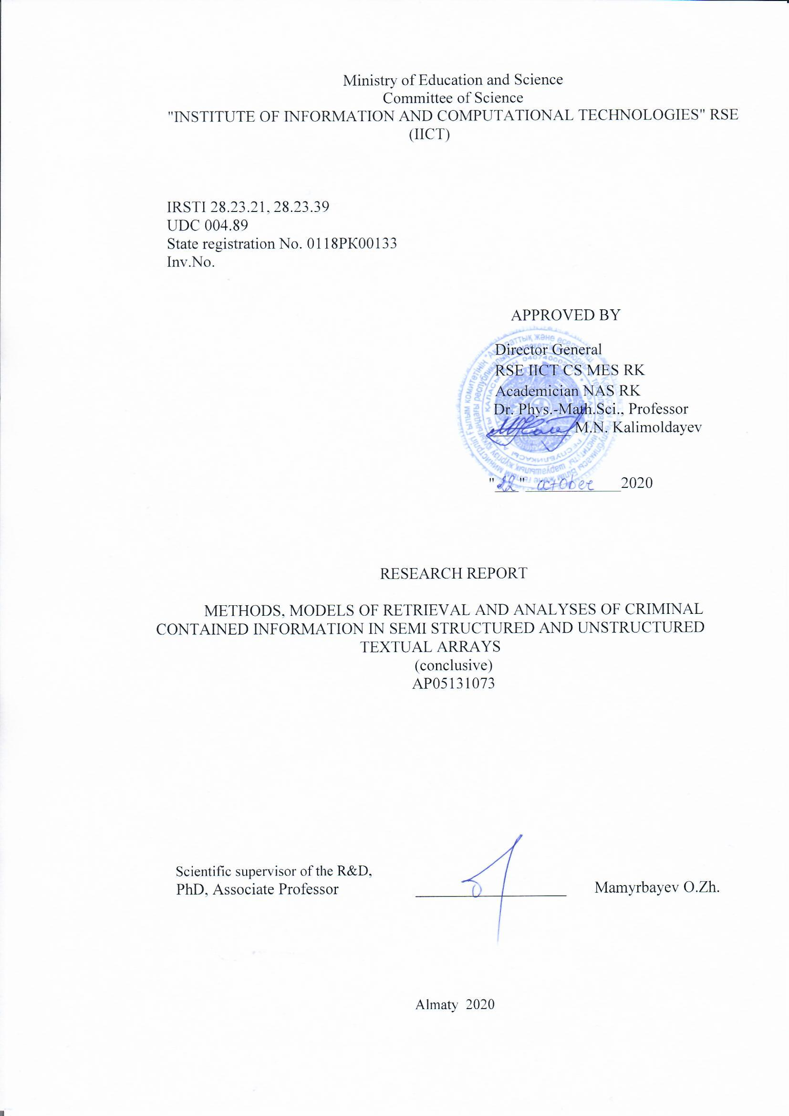
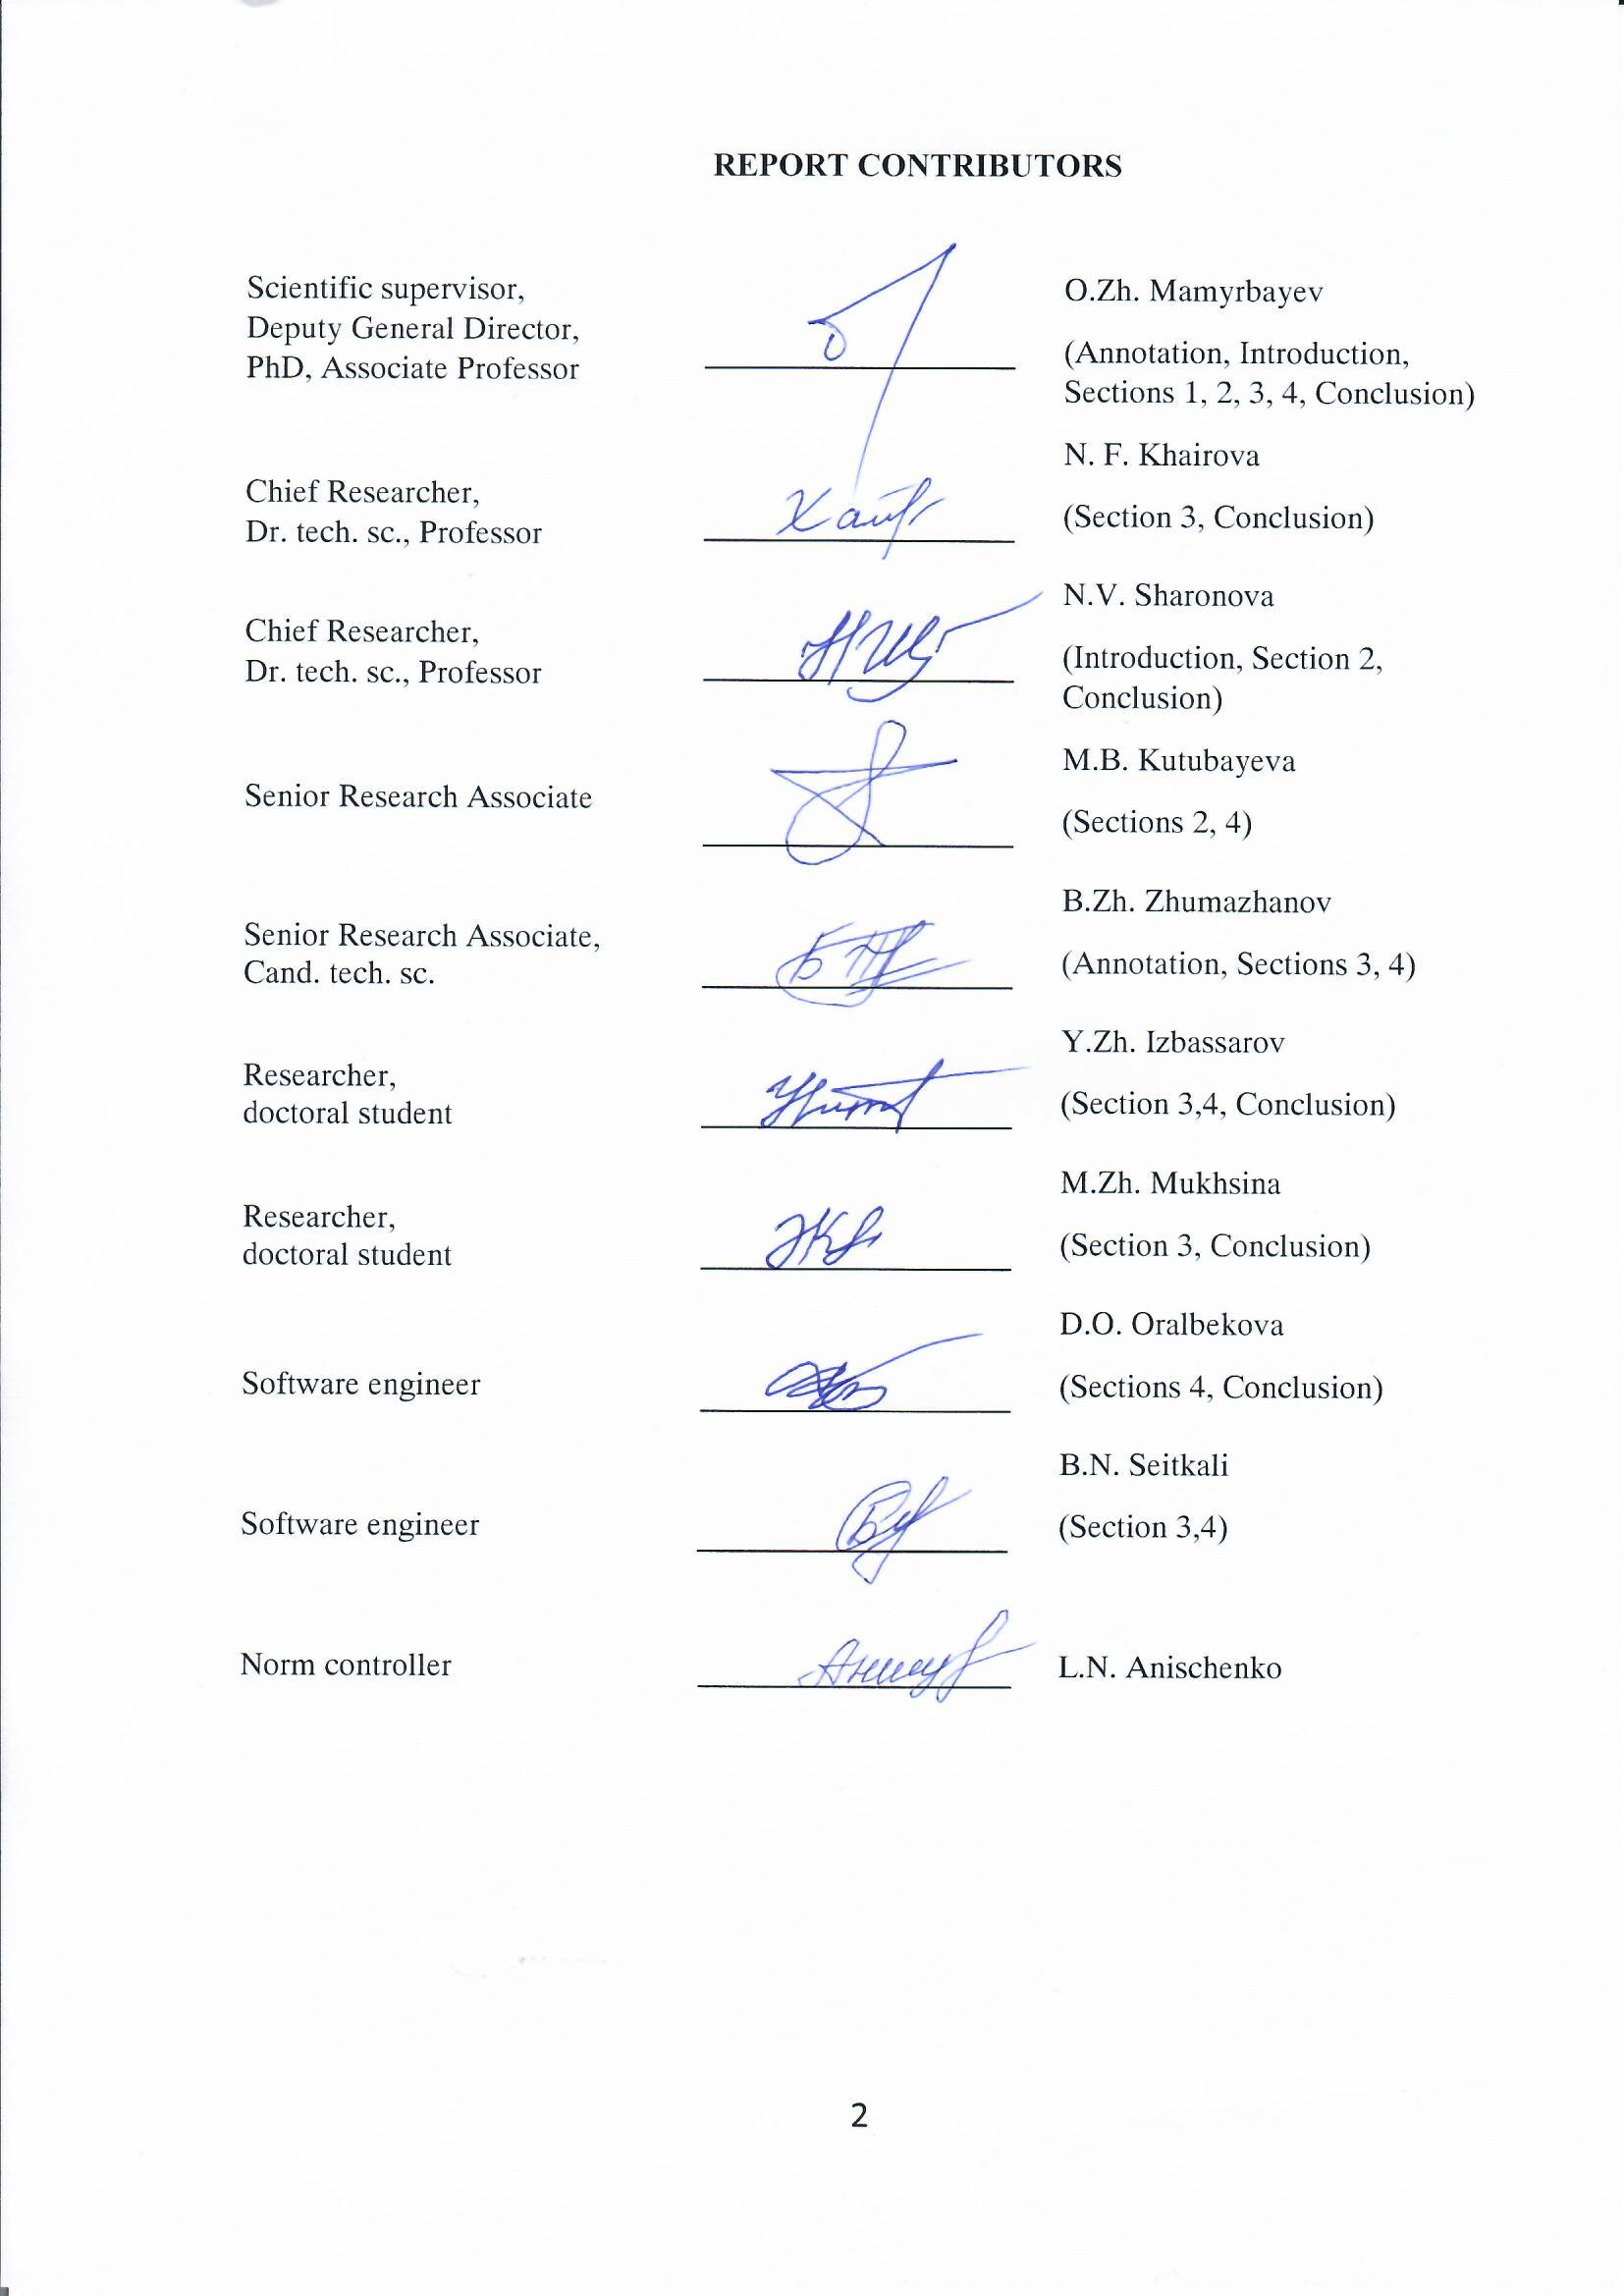

STRUCTURAL ABSTRACT
The report consists of 78 pages, 12 figures, 3 tables, 45 sources, 5 appendixes
CRIMINAL SIGNIFICANT INFORMATION, OPEN INFORMATION EXTRACTION, LOGICAL-LINGUISTIC MODEL, FACT IDENTIFICATION, MULTI-LINGUAL SYSTEMS, PARALLEL CORPUS OF KAZAKH-RUSSIAN LANGUAGE, SEMANTIC ANALYSIS.
Research object: methods and models of search and analysis of criminally significant information in text files of Kazakh, Russian and English languages; methods of Open Information Extraction, identification of facts in texts.
Project goal: The principal purpose of this project is the development of information and linguistic technology for automatic identification, extraction, search and analysis of criminally significant information in unstructured and semi-structured test arrays of multi-language systems.
Results obtained: logical-linguistic model of identification of facts in multi-lingual texts; parallel aligned corpus of Kazakh-Russian texts containing criminally significant information; information technology of identification, search and analysis of the facts in semi-structured and unstructured text files of Kazakh, Russian and English languages; annotated corpus of texts containing illegal information of Kazakh, Russian and English languages.
Main constructive and technical-economic indicators, efficiency: new technology for identification of criminally-significant information in the text, mathematical models, algorithms and methods for automatic detection of actual illegal information in the text files. Improving the quality of semantic analysis of texts in Kazakh, Russian and English: semantic annotation of criminally significant information.
Novelty: development of mathematical models and algorithms for solving the task of developing technology for retrieval and analyzing of CSI; development of algorithms for semantic analysis of multi-lingual text frames.
Field of application: State services of the Ministry of Internal Affairs, Prosecutor's Office and Security; social services, libraries, educational institutions and other state institutions.
Implementation: the results of the project were implemented in the National Innovation Centre.

РЕФЕРАТ
Есеп 78 бет, 12 сурет, 3 кесте, 45 әдебиет, 5 қосымша
ҚЫЛМЫСТЫҚ МАҢЫЗДЫ АҚПАРАТ, OPEN INFORMATION EXTRACTION, ЛОГИКО-ЛИНГВИСТИЧЕСКАЯ МОДЕЛЬ, ФАКТІЛЕРДІ СӘЙКЕСТЕНДІРУ, МУЛЬТИТІЛДІК ЖҮЙЕЛЕР, ҚАЗАҚ-ОРЫС ТІЛІНІҢ ПАРАЛЛЕЛЬДІ КОРПУСЫ, СЕМАНТИКАЛЫҚ ТАЛДАУ.
Зерттеу объектісі: ағылшын және орыс, қазақ тілдеріндегі мәтіндік корпустағы қылмыстық мәні бар ақпараттарды талдау және іздеу әдістері мен модельдері; Open Information Extraction, мәтіндердегі фактілерді идентификациялау.
Жобаның мақсаты: осы жобаның негізгі мақсаты, әртүрлі тілдегі құрылымданбаған және әлсіз құрылымданған мәтіндік массивтерден қылмыстық мәні бар құрауышты талдау және іздеу, белгілеу және автоматты анықтайтын ақпаратты-лингвистикалық технологияларды жасау.
Мульти тілдік мәтіндердегі фактілерді идентификациялаудың логика-лингвистикалық моделі; қазақ-орыс тілдеріндегі қылмыстық мәні бар мәтіндерінің параллельді корпусын түзетудің технологиясы құрылды, қазақ, орыс және ағылшын тілдеріндегі құрылымдалмаған және әлсіз құрылымдалған мәтіндік массивтерінен ҚМА фактілерін талдау және іздеу, анықтау ақпараттық технологиясы құрылды; қазақ, орыс және ағылшын тілдеріндегі құқыққа қарсы ақпараты бар мәтіндік корпусты аннотациялау.
Негізгі конструктивтік және техникалық-экономикалық көрсеткіштері, тиімділігі: мәтіндегі қылмыстық маңызды ақпаратты идентификациялаудың жаңа технологиясы, мәтіндік массивтердегі нақты құқыққа қарсы ақпаратты автоматты түрде анықтау әдістері және алгоритмдері, математикалық модельдері. Қазақ, орыс және ағылшын тілдеріндегі мәтінді семантикалық талдау спасын жоғарылату: қылмытық ақпаратты семантикалық аннотациялау.
Жаңалығы: қойылған міндетті шешу, мәтіндердегі ҚМА талдау және іздеу технологиясын өңдеу үшін математикалық модельдер мен алгоритмдерді дайындау; мульти тілді мәтіндік корпустарды семантикалық талдау алгоритмдерін өңдеу.
Қолдану облысы: Ішкі істер министрлігі, прокуратура және қауіпсіздік мемлекеттік қызметтері; әлеуметтік қызметтер, кітапханалар, оқу орындары және басқа мемлекеттік ұйымдар.
Енгізу дәрежесі: жоба нәтижесі «Ұлттық инновациялық орталығы» ЖСШ енгізілді.

CONTENT

 | INTRODUCTION | 7
1 | Analytical review of the main problems of the retrieval and analysis of criminally-significant information
 | 1.1 Current state and future prospects of development of formalization methods and the retrieval of criminal information in unstructured texts | 9
 | 1.2 General approach to formalizing and identifying criminally significant information in the text | 10
 | 1.3 Problems with the formation of aligned parallel corpora of specialized themes. | 12
2 | Logical-linguistic model for extracting facts from text files.
 | 2.1 Mathematical description of the model for extracting facts from unstructured and semi-structured texts | 16
 | 2.2 Implementation of a logical-linguistic model for extracting facts from Russian texts. | 18
 | 2.3 Information technology to extract facts from semi-structured English texts | 20
 | 2.4 Implementation of the Open IE logical-linguistic model for the Kazakh language. | 22
3 | Development and annotation of corpora of criminally colored texts
 | 3.1 Peculiarities of forming the Kazakh-Russian parallel corpus of criminal texts | 29
 | 3.2 Expert evaluation of the results of the semantic analysis of the Kazakh text corpus, which includes criminal significance. | 31
 | 3.3 Information technology for aligning of the created corpus of criminal texts | 33
CONCLUSION |  | 38
REFERENCES |  | 39
APPENDIX A List of publications for 2018-2020 |  | 43
APPENDIX B List of publications for 2020 |  | 55
APPENDIX C Reprints of publications for 2020 |  | 58
APPENDIX D List of foreign information resources used |  | 77
APPENDIX F Act of implementation |  | 78

LIST OF ABBREVIATIONS AND DESIGNATIONS

The following abbreviations and designations are used in this R&D report:

KLC – Kazakh Language Corpus
LSA – Latent Semantic Analysis
ML – Machine Learning
MT – Machine Translation
NLP – Natural Language Processing
NLTK – Natural Language Toolkit
POS-tagging – Part of Speech tagging
RDF – Resource Description Framework
RE – Relationship Extraction
RSS – Rich Site Summary
SD – Stanford Dependencies
UD – Universal Dependencies
АKLC – Almaty Kazakh Language Corpus
АFP – algebra of final predictors
DB – data base
TA – traffic accident
IAS – information and analytical systems
CSI – criminally-significant information
SI – subject field
CDNF – complete disjunctive normal form
MM – mass media

INTRODUCTION
In recent decades, due to the spread of networked computer technology, mobile communications and the Internet, the information resources of modern society have been under increasing threat from potential criminal activity in global networks. Crimes related to financial fraud, copyright infringement, distribution of child pornography, hacking, calls for terrorism and violent extremism pose security threats to both the individual and society as a whole [1]. Thanks to computer networks, such crimes can spread globally, maintaining low cost and high speed. Thus, the openness of a global network makes it more vulnerable to criminal attacks.
However, at the same time, the openness and global nature of the Internet creates enormous potential opportunities for criminologists and law enforcement officers. Current text processing technologies enable data analysts and police to perform preventive processing of computer network text information by collecting, connecting and analyzing 'weak signals' or 'digital traces' of huge text arrays that are present on the Internet. In some cases, such analysis can help identify the potential for wrongdoing before it is carried out.
Nevertheless, to carry out such preventive analysis, along with the existing traditional methods of combating crimes in the field of computer information security, it is necessary to use the practical achievements of artificial intelligence and mathematical linguistics related to NLP tasks. At the same time, one of the main problems in determining the criminal significance of Internet texts, along with the huge amount of information to be analyzed [2], remains the problem of weak "coloration" of criminal texts, which is an obstacle to the successful use of traditionally adopted approaches to classification, clustering and selection of linguistic templates. Today's traditional approaches to the identification of criminal codes and potentially terrorism-related texts are based on the analysis of the style of the text and the definition of its emotional component related to an implicit intent, without taking into account the topic and content of the text [3].
The goal of this project was to develop an information and linguistic technology for automatic identification, selection, search and analysis of the criminal component in semi-structured test arrays of different languages, based on the content of the text and selection of its factual information. In general, the project is aimed at solving a common fundamental problem of forming methodological foundations for creating logical-linguistic models for identifying cognitive and semantic identifiers of meaning in natural language texts.
As a result of the research, the following objectives were set and achieved:
- An analytical review of the main problems in the search and analysis of criminally-significant information in text files;
- development of a logical-linguistic model for extracting facts from natural language texts based on Open IE approaches and its implementation for Kazakh, Russian and English languages;
- creation of marked text corpus of web content texts containing criminally significant information for Kazakh, Russian and English languages;
- development of information technology for identification, relevant search, extraction and analysis of criminally significant information from semi-structured and unstructured text arrays.
The scientific novelty of the project lies in the formation of methodological foundations for creating logical-linguistic models for identifying cognitive and semantic criminal identifiers in natural language texts.
The results obtained in the study can find practical application in the integrated information and criminalistics systems of law enforcement agencies, as well as in integrated information and analytical systems of other government agencies for information search and analysis of texts of criminal content in Kazakh, Russian and English.
The research was conducted in accordance with the approved calendar plan (Appendix A). During the study 6 articles were published at conferences and scientific journals, 3 of which were published in a peer-reviewed journal that is part of SCOPUS and Clerative Analitic; a training manual and a monograph (Appendix B, C, D). A certificate of authorship (Appendix C) and a certificate of implementation of the project results in production activities (Appendix E) were received during the studies.
This final report is a continuation of Reports on the topic «Methods, models of retrieval and analyses of criminal contained information in semi structured and unstructured textual arrays»
with Inventory No. 0218РК00209 for 2018 and with Inventory No. 0219РК00480 for 2019.

1 Analytical review of the main problems in the search and analysis of criminally significant information in text files
1.1 Status and prospects of development of methods of formalization and search of criminal information in unstructured texts
Currently, one of the most popular and necessary areas of information research is the search and analysis of illegal information in text data, detection of crime patterns and risk assessment of cybercrime. More and more researchers will focus on the ways and forms of applying natural language processing technologies in a wide range of activities related to the prevention of terrorist and unlawful activity.
For example, most researches related to the prevention of terrorist attacks are aimed at analyzing the use of the Internet and social networks by terrorists and terrorist organizations [4], [5], [6], [7]. For example, one of the research areas devoted to the detection of "linguistic markers of violent extremism in the online environment" [8], focuses specifically on identifying digital traces that are relevant to a potential "single terrorist" [9]; other studies look at potential types of Internet violence [10]. In order to detect linguistic markers indicating potential "preventive" behavior, lists of violent words are often used, the preparation and search of which is based on standard text-processing approaches such as lemmatization and POS-tagging, as well as the use of lexical databases such as WordNet [11].
However, such linguistic markers, which are used as a supplement to standard text processing algorithms, can detect potential signs of specified, predicted radical violence. They cannot make automated decisions on any type of crime. In addition, if individual processing steps in the natural language contain some inaccuracies, the accuracy of the identification of linguistic markers will be significantly reduced and the number of errors will increase.
Another area of NLP used as part of the task of identifying criminally significant information is the analysis of the style of the text and the identification of its emotional component associated with the implicit expression of intent. This emotional component may include boasting, ideological statements or admiration of terrorist leaders (12). A textual style analysis, in this case, reveals patterns of phrases related to emotional motivations such as anger, humiliation or shame. In this case, the highlighted style of communication does not depend on a particular subject or content.
NLP classification and clustering methods are used to analyse large volumes of heterogeneous texts whose subjects are not known in advance. For example, clustering makes it possible to identify topics such as weapons, tactics or targets (12). In this case, the additional use of speech recognition and machine translation technologies may increase the amount of text available for analysis.
One type of classification is Sentiment Analysis. In some studies, elements of Sentiment Analysis are used to distinguish crime-significant texts from blogs and social networks. For example, in paper [7] Sentiment Analysis is used in tweet analysis to identify the authors' opinions on crime areas in real time.
The NLP classification methods are quite well developed and well-established. At the same time, their use in analyzing the emotional component of a text for identifying intent does not always lead to good results, due to non-specific patterns. For example, the patterns identified, even interpreted as threats, may be related to an individual's cultural and personal characteristics.
In addition, the review shows that in most cases the existing approaches to text analysis and classification exclude indirect terminology that does not explicitly refer to weapons or violent acts and does not include threatening vocabulary, i.e. excludes terminology that is not strictly criminal in nature. Traditional probability classifiers are used - the naive Bayes method, the maximum entropy or support vector machines and others. This approach greatly reduces the accuracy of identifying criminally relevant texts.
Thus, in most studies in this area, which include semantic analysis, sentences in which the author of the text expresses an opinion are considered, investigated and analyzed. At the same time, sentences containing factual information are generally ignored and excluded from the analysis.
In our research, on the contrary, we focus specifically on the factual material of texts related to its subject and content, and we have used technologies based on Open Information Extraction (IE) approaches, in particular methods for extracting facts from semi-structured texts [13].
In addition, by focusing on the detection of crime patterns, we use a method of data collection in their temporal variation, creating specialized criminal texts in Kazakh, Russian and English. Typically, such texts, except tweets, blogs and social networks, include media information for crime detection in each specific activity [14].
1.2 A general approach to the formalization and identification of criminally significant information in the text
An indicative sign of criminally significant information, which distinguishes it from ordinary information, is the concept of a crime. The offence consists of a system of objective and subjective elements, provided by the current legislation of the Republic of Kazakhstan, characterizing a certain socially dangerous act - i.e. a specific crime [15]. Interrelation of components which are primary components of the system " an offence " (object, a material element., subject, mental element ) is shown in Figure 1.1.
The IAS information supply to a law enforcement officer can only take into account three elements of the offence: object, subject and a material element, as the mental element does not have the necessary semantic load.
The main quality of criminally significant information is the content of information that facilitates the search for evidence and regularities specific to the illegal aspects of criminal activity. When predicting crimes, detecting signs of hidden crimes, establishing the relationship between the personal qualities of criminals and the choice of the crime scene, as well as other analytical investigative and search activities, a procedural person needs to process a large number of electronic text documents, extracting criminally significant information from them.
Object

Social relations which are damaged

An act of external behaviour, expressed in action or lack thereof
Subject
A person who has committed a crime with certain characteristics of a criminal offence

Mental attitude to what has been done and its consequences
Definition: «components of crime»
Figure 1.1 - Structure of indicative signs of criminally significant information

These electronic texts can be documents in electronic form: explanatory notes, memos, reports, verbal portraits of defendants, reports that have accumulated as a result of investigation, as well as electronic collections of internet publications, RSS - mailing lists, blogs and social networks.
All such electronic documents are presented in the form of semi-structured text information, which is understood to be a text electronic document that has a high degree of variability of content that changes depending on the specific situation. In general, these documents represent an accessible repository of forensic knowledge [16].
In general, information processes related to the investigation of a crime, the extraction of criminally significant information (CSI), as well as data and facts from arrays of electronic text documents and electronic resources can be presented in the form of a diagram shown in Figure 1.2.
The current CSI, which often has no causal link to the crime event but has potential forensic value, does not allow the use of only a pre-designed software thesaurus when searching for it. This is due to the fact that, on the one hand, this information is characterized by a lack of output indicators, and, on the other hand, the use of only keywords for its identification often makes it impossible to identify hidden facts describing criminal acts.
The final information process related to the CSI identification in the text for its further long-term use requires the transformation of relevant criminal information into knowledge, extracting new concepts that are not always explicit criminal identifiers, and then systematizing them in software ontology.
Features of information formalisation:
Dynamic identification of the crime-significant component by identifying latent patterns in the process of analytical search
1. Primary identification of CSI in text-based electronic resources
2. Extraction and analysis of CSI in semi-structured and unstructured texts

3. Dynamic identification of up-to-date criminally significant information in texts

4. Conversion of criminally significant information into knowledge with the aim of its automatic accumulation for multiple use.

Figure 1.2 - General scheme of information processes related to obtaining CSI from semi-structured text resources

Thus, the processing of text files potentially containing criminally significant information makes it possible to dynamically accumulate and spread knowledge on the CSI by processing new text information from specialized texts.
In addition, for semantic analysis of such corpora based on search and retrieval of factual information, it is possible to obtain facts on the basis of which it is also possible to conduct logical reasoning and draw conclusions about the criminal content of the text.
1.3 Problems of forming aligned parallel corpora of highly specialized subjects
One of the most actual and progressive directions of linguistic resources development is design, creation and improvement of high quality text corpora. Processed corpus, which was systematized with the help of a concordancer, allows to store a huge amount of linguistic information necessary for statistical analysis; diachronic changes and other studies of oral speech and written texts.
The existing corpora can be divided into specialized (genre, time, place), general, multi-lingual, training, historical or diachronic, monitoring and others. The multi-lingual corpora we are researching is divided into comparative and parallel or translation corpora. As a rule, parallel corpora are the most important in language learning, peculiarities of its translation, development of the syntactic parser and any tasks of semantic text analysis. The concept of parallel corpus is part of a broader and more complex concept such as machine translation. The quality of machine translation depends largely on the number of parallel sentences used in training. However, despite the rapid growth in the number of different programs and practical applications, machine translation still remains a challenge for computer linguistics.
Over the last decade, many bilingual and multi-lingual corpora have been created in the world, in our view, the most interesting ones are: EUROPARL - a European Parliament corpus with 20,000,000 words in 11 languages; CHEMNITZ GERMAN-ENGLISH TRANSLATION CORPUS with 1,000,000 words; KACENKA - an English-Czech corpus with 3,000,000 words; English-French Canadian Hansard - an English-French parallel corpus.
At the same time, there are quite a few linguistic corpora of the Kazakh language:
- The Almaty Corps of Kazakh Language (AKKJA), which contains more than 40 million words, 86% of which are grammatically parsed;
- Almaty Corpus of Kazakh [17];
- Kazakh text corpora on Sketch Engine [18];
- Open-Source-Kazakh-Corpus, created using the Wikipedia dump tool and including a collection of 20 million words (of which 600,000 are unique) [19];
- Kazakh Language Corpus or Kazakh Language Corpus (KLC ) [20].
At the same time, despite the existence of a large number of parallel multi-lingual corpora, the task of creating parallel corpora is still quite relevant for the Kazakh language. This task is significantly more complex when we talk about the development of a parallel Kazakh-Russian corpus, whose input language belongs to Turkic and output to Indo-European language families.
In order to realize its potential, modern parallel corpora should be aligned. Alignment involves the matching of certain parts of the original text with the corresponding parts of the translation text.
In most of the work on parallel corpora, two levels of alignment are distinguished directly or indirectly: sentence alignment and lexical alignment. The task of automatically comparing sentences, which involves comparing the words of the original text with their equivalents in translation, is usually very complex and time-consuming, as for many languages, sentences or words may not be compared "one to one". For example, several paragraphs in the Kazakh language may correspond to only one paragraph in the Russian language, and in addition, some words may be removed or replaced by remote synonyms or set expressions that may be completely different for different languages, etc.
We can divide the existing methods for sentence aligning into 3 categories. The first category methods are based on determining the lengths of sentences and paragraphs [21]. This approach is based on the hypothesis that the lengths of sentences in the original and its translation are approximately the same.
The second group of alignment methods uses lexical information from the corpus. The methods of this group are very rarely used, which is due to the difficult availability of bilingual dictionaries and the difficulty of automatic morphological analysis used to identify words in texts. To this day, most programs based on this group of methods use only texts from specialized topics, such as parliamentary speeches and legislative texts [22].
The third group of algorithms for aligning of parallel corpora is based on POS-tagging or morphological markings contained in annotated corpora [23].
However, the implementation of any method from these three groups is associated with a certain number of inaccuracies, and there is an ever-increasing interest in the creation of systems using a combination of all three methods. In particular, work [24] describes a hybrid method of aligning parallel texts that combines the length dependencies of fragments and translation elements. The study is based on Hungarian, Romanian and Slovenian.
The authors of the study [25] have shown that text alignment can be achieved without using additional resources in specific languages. They used an alignment algorithm based on sentence lengths and trained the MT system on texts that needed alignment.
Another approach to aligning sentences is described in study [26]. In this paper, its authors proposed an alignment algorithm for texts that uses a combination of length-based and vocabulary-based methods. The algorithm obtained the epithet of "fast" because it optimized the process of dividing the introduced bilingual text into small parts of the alignment. Work [27] provides an overview of the special InterText toolkit used for aligning parallel corpora. The application work is based on a hybrid alignment method. The same application was used to create the Kazakh-English corpus in the study [28]. The authors of the study used the Bitextor tool to generate the corpus based on multilingual websites.
The authors of the article [29] aligned their texts at sentence level using punctuation marks for segmentation. At the same time, the approach required manual debugging. The Finnish and Russian language corpora based on this approach have been aligned quite well [30].
An additional difficulty in creating an aligned binary parallel corpus is the choice of appropriate content to fill the corpus. Currently, there is a large number of studies describing how to obtain parallel sentences from non-parallel or comparable information. For example, such information can be obtained from the well-known Wikipedia resource [31], which includes similar articles in different languages. In addition, such articles can be connected via links annotated on Wikipedia by users. However, the possibility of creating parallel corpora even for such a global resource has not been fully explored so far [32].
Thus, it is obvious that the problem of creating parallel aligned corpora has not been fully solved to date, and universal aligning methods have not been defined. Moreover, it can be said that today, in most approaches, the choice of an alignment method depends directly on the pair of languages, the subject area and type of documents presented in the corpus [33].

2 Logical-linguistic model for extracting facts from text files
2.1 Mathematical description of a model for extracting facts from unstructured and semi-structured texts
Knowledge of a certain subject area is a collection of information about the objects/subjects of the software, their essential properties, relations and facts that describe the actions or properties of these objects/subjects. That is, a record of factual information must include a reference to the agent of the action, to an attribute or predicate of that object, and give a specific meaning to that attribute. Such a representation of factual information makes it possible to formalize, in semi-structured, criminally colored texts, information about component elements of a crime scene in the form of a triplet of fact Subject->Property -> Value or Subject -> Predicate → Object, where the Subject- and Object-are the participants of an action, the Property - some attribute, and the Predicate - an action uniting all participants of a sentence.
The identification of such semantic relationships is based on the grammar of semantic cases (34). A strict logical-linguistic model has been developed for this purpose [13], linking the information contained in the definition of semantic roles with elements of the superficial structure of natural language sentences.
The developed model uses semantic functions to describe the semantic relations of sentence elements, which clearly define the relations of morphological and semantic categories of sentence participants. The relations of morphological and semantic features of the participants in the action are described by means of the finite predicate algebra (FPC) [35].
Predicates 0 and 1 are used as the basic elements of FPA, as well as Predicates for recognizing a subject by a variable where

(2.1)

Disjunctive and conjunctive of predicates are used as basic operations in disjunctive and conjunctive algebra of predicates. Any predicate in this algebra can be written down by a formula in the form of its complete disjunctive normal form (СDNF) [36]:

(2.2)

Using FPC as the basic mathematical instrument, we enter a universum of U elements indicating the specifics of a given subject area. A finite subset of grammatical and semantic characteristics of the participants of the sentence M = {m1, ... , mn} is formed from the elements of the universal sum, where n is the number of specified characteristics. The relationship between the characteristics can be represented as mi - mj -...-mk, where mi, mj, ..., mk M, and a sign - indicates that these characteristics correspond to a particular noun.
On set M, we implement a system of predicates S so that any predicate P(qm) S equals 1 on a set of nouns with grammatical and semantic information of a word (or token) of a sentence corresponding to a certain semantic function and equals 0 otherwise.
The N-dimensional predicate defines the semantic role of the participant in the action through subject variables that name the grammatical and semantic characteristics of the word of a sentence:

(2.3)

Predicate if the analyzed word with a certain semantic function, has certain morphological and semantic characteristics of the language. Obviously, the grammatical relations described by the equation do not depend on a particular word.
In practice, a subset of coherent morphological, syntactic and semantic features of the participants in an action does not coincide with a Cartesian work of all features. On this basis, we define a predicate in a Cartesian work:

(2.4)

where , here h — is the number of participants and action attributes considered in the model. Predicate = 1 if the conjunctive grammatical characteristics of words in a sentence show some semantic role of the participant (Subject, Object) or attribute of the action; and = 0 otherwise. Thus, if relations between grammatical characteristics of sentence words do not express any constituent element of fact, they are excluded from the formula (2.4) by the predicate .
The created model clearly describes the semantic functions of participants and the attributes of action through the grammatical and semantic characteristics of the surface structure of the natural language (37). However, due to the fact that deep semantic relations are expressed in different natural languages by different superficial characteristics and structures, it is obvious that this logical-linguistic model must be implemented separately for different natural languages. The number and composition of semantic roles and therefore the subject variables that are allocated in the implementation of the model for each specific natural language vary significantly depending on the objectives of the description, the language and its degree of detail. We have considered the implementation of our Open IE logic-linguistic model for English [38], Russian [39] and Kazakh [40] languages.
Obviously, the application of this model makes it possible to extract the facts of a particular criminal case from the huge information flows of full-text information processed in the course of operational and service activities (summaries, explanatory/ service notes, reports, newspaper and internet publications, verbal portraits of defendants, etc.). In the vast majority of cases such facts include: information about the defendants, information about the object of the attack, information about the mechanism and manner in which the crime was committed.
2.2 Implementation of a logical-linguistic model for extracting facts from Russian texts
For Russian languages, the semantic roles or functions of the participants of a sentence are defined, in their majority, by grammatical cases. For the formal definition of the semantic cases of the Russian language, a clearly defined set of semantic-grammatical features has been defined, which is introduced with the help of an irreducible set of three variables: the X-sign of animation (with values): x^{о} - the subject variable characterising the semantic sign of an alive, x^{н} - the subject variable characterising the semantic sign of an inanimate;); Y - the element of the semantic meaning of a noun (y^{м} - mechanism, y^{с} - own name, y^{и} - instrument, y^{ч -} body part, y^{т} - plane/point, y^{о} - volumetric space, y^{в} - certain time, y^{п} -period, y^{ц} - destination); Z - grammatical case of a noun (z^{и}, z^{р}, z^{д}, z^{в}, z^{т}, z^{п} - subject variables describing properties of nouns).
The semantic function of a noun - participant of a sentence is described by the predicate P(x, y, z) = 1, which connects the elements of the semantic value of the noun x and y with its grammatical values z. Then, using the conjunction of predicates, it is possible to write down:

P (x, y, z) → P(x) •P(y) •P(z), | (2.5)

where • — conjunction.
The changes described in subsection 2.2 result in the predicate, semantic function of an Agence representing the subject of the action, usually the initiator of the action, the person or subject with the capacity to perform the action:
γ_{А}(x_{n}, y_{n}, z_{n}) = x_{n}^{о} z_{n}^{и}∨ z^{и} x_{n}^{н} y_{n}^{м} ∨ z^{и} x_{n}^{о} y_{n}^{с}. | (2.6)
The semantic function of object that defines the object over which an action is directly performed is expressed by a predicate:

γ_{О}(x_{n}, y_{n}, z_{n}) = z^{в} x_{n}^{н}∨ z^{в} x_{n}^{о}. | (2.7)
In addition, predicates for determining the attributes of semantic functions have been obtained, such as tools:

γ_{И}(x_{n}, y_{n}, z_{n}) = z_{n}^{т} x_{n}^{н} y_{n}^{и} ∨ z_{n}^{т} x_{n}^{н}y_{n}^{ч}; | (2.8)
location:

γ_{Л}(x_{n}, y_{n}, z_{n}) = z^{п} x_{n}^{н} y_{n}^{т} ∨ z^{п} x_{n}^{н}y_{n}^{м}∨z^{п} x_{n}^{н}y_{n}^{ц}∨ z^{п} x_{n}^{н}y_{n}^{о}; | (2.9)
time:

γ_{Т} (x_{n}, y_{n}, z_{n}) = z^{в} x_{n}^{н} y_{n}^{в} ∨ z^{п} x_{n}^{н} y_{n}^{п}. | (2.10)
and others [78].
Table 2.1 shows the semantic functions corresponding to the facts of a criminal act and identification of an identity, defines the corresponding predicates (formulas (2.6 - 2.10)) describing the relationship of morphological and semantic categories of noun participants of these facts and provides examples.
Table 2.1 - Formalisation of the Identification Model for Semantic Roles of Participants
Verb-defined action | Basic semantic functions | Predicates that implement semantic functions
roditsya(be born), pohischat (kidnap), pohitit(kidnap), ubivat(kill), ubit (murder), krast (steal), vyikrast (steal), ukrast(steal), obmanut(deceive), obmanyivat (cheat), grabit (rob), ograbit (rob) | Time (whenacted) | γ_{Т} (x_{n}, y_{n}, z_{n}) – formula 2.10
 | Location (whereacted) | γ_{Л} (x_{n}, y_{n}, z_{n}) – formula 2.9
 | Object (toactsmth) | γ_{О} (x_{n}, y_{n}, z_{n}) – formula 2.7
 | Agence (tobeactedbysmth) | γ_{А} (x_{n}, y_{n}, z_{n}) – formula 2.6
 | Tools (bysmth) | γ_{И} (x_{n}, y_{n}, z_{n}) – formula 2.8

2.3 Information technology to extract facts from semi-structured English texts
To formalize the semantic functions of English sentences and their explicit representation by means of the superficial structure of the simple sentence, the following grammatical categories were singled out: the preposition after the predicate; the apostrophe defining the possessive case; the position of a noun in the sentence; the presence of negation; the modal verb; and the presence of the verb to be and the form of the main verb:

z^{to} ˅ z^{by}˅ z^{with} ˅ z^{about} ˅ z^{of} ˅ z^{on}˅ z^{at} ˅ z^{in}˅ z^{out} =1,  y^{ap}˅ y^{aps} ˅ y^{out} =1,  x^{f} ˅ x^{l} ˅ x^{kos} =1,  m^{is} ˅m^{are} ˅m^{have} ˅m^{has} ˅ m^{had} ˅ m^{was} ˅ m^{were} ˅ m^{out} =1,  p^{III}˅p^{ed} ˅ p^{I} ˅ p^{ing} ˅ p^{II} =1,  f^{can} ˅ f^{may} ˅ f^{must} ˅ f^{should} ˅ f^{could} ˅ f^{need} ˅ f^{might} ˅ f^{would} ˅ f^{out} =1,  n^{not} ˅ n^{out}=1, | (2.11)
where:
- Subject variable z characterizes the presence of a preposition to, by, with, about, of, on, in, after a triplet predicate or its absence - out;
- subject variable y characterizes the presence or absence of an apostrophe at the end of a word that defines possessive case for a Triplet Subject - ap, aps, out;
- subject variable x characterizes the position of the noun defining the essence: before the verb in its personal form - f, after the verb in its personal form - l or after the indirect object - kos;
- subject variable m characterizes the presence of any form of verb to be - is, are, have, has, had, was, was, or its absence out;
- subject variable f characterizes the presence of a modal verb in a simple sentence - can, may, must, can, need, might, would or its absence - out;
- subject variable p characterizes the form of the main verb of the sentence: first, second/third and fourth form of the regular verb - I, II, III, ing, and third form of the irregular main verb - ed.
Then the semantic relations of the action participants in a simple English sentence are defined through P predicates:

P_{k} (x, y, z, m, p, n, f) = γ_{k} (x, y, z, m, p, n, f) ˄  ˄ P(x) ˄ P(y) ˄ P(z) ˄P(m) ˄ P(p) ˄P (n) ˄P(f), | (2.13)

where the predicate γ_{k} (x, y, z, m, p, n, f) similarly to formula (2.4) takes the value 1 or 0.
According to the model for extracting facts from English sentences, the semantic relationship that defines the subject of the action can be clearly determined by the following logical-linguistic equation:

γ₁(z, y, x, m, p, f, n) = y^{out} ((f^{can} ˅ f^{may} ˅ f^{must} ˅ f^{should} ˅ f^{could} ˅ f^{need} ˅ f^{might} ˅  ˅ f^{would} ˅ f^{out}) (n^{not} ˅ n^{out}) (p^{I} ˅ p^{ed} ˅p^{III}) x^{f} m^{out} ˅(x^{l} (m^{is} ˅ m^{are} ˅ m^{have} m^{has} ˅  ˅ m^{had} ˅ m^{was} ˅ m^{were} ˅ m^{be} ˅ m^{out} ) z^{by}) | (2.14)
The subject of the action is the second most important verb (action) argument after the subject of the action. We define the grammatical characteristics of the Object of an action in the facts of English sentences by the following logical-linguistic equation:

γ₂(z, y, x, m, p, f, n) = y^{out} (n^{not} ˅ n^{out}) (f^{can} ˅ f^{may} ˅ f^{must} ˅ f^{should} ˅ f^{could} ˅ f^{need} ˅  ˅ f^{might} ˅ f^{would} ˅ f^{out}) (z^{out} x^{l} m^{out} (p^{I} ˅ p^{ed} ˅p^{III}) ˅ x^{f} (z^{out} ˅ z^{by}) (m^{is} ˅ m^{are} ˅  ˅ m^{have} ˅ m^{has} ˅ m^{had} ˅ m^{was} ˅ m^{were} ˅ m^{be} ˅ m^{out} ) (p^{ed} ˅p^{III}) | (2.15)
Similarly, using a logical-linguistic model, action attributes such as time, place, type of action, possessiveness of the subject or object of the action, tool of action and others are defined. For example, we define the semantic function of action time as the disjunction of the following grammatical characteristics:

γ₃ (x, y, z, m, p, n, f) = (z^{on}x^{kos} y^{out} ∨ z^{in}x^{kos} y^{out} ∨ z^{at}x^{kos}) (p^{III} ∨ p^{ed} ∨ p^{I} ∨ p^{ing} ∨p^{II}) (m^{is} ∨ m^{are} ∨m^{have} ∨ m^{has} ∨ m^{had} ∨ m^{was} ∨ m^{were} ∨ m^{out}) (n^{not} ˅ n^{out}) (f^{can} ˅ f^{may} ˅  ˅ f^{must} ˅ f^{should} ˅ f^{could} ˅ f^{need} ˅ f^{might} ˅ f^{would} ˅ f^{out}) | (2.16)
We use both POS-tagging and syntactic Parser for correct fact identification when processing English-language texts. The reason for choosing Universal Dependencies (UD) parser is its ability for correctly analyzing syntactic verb groups, subordinate sentences and word combinations for a large group of languages. The syntactic relationships that link words to each other in a sentence and that are defined by the parser often express some semantic content. Similar to the structural scheme of the triplet of fact (Predicate→ Subject→ Object) in the grammar of verb dependencies, the verb is the central element and all participants depend on it directly or indirectly. Thus, using the syntax of subordination trees as a formal model is consistent with our semantic triplet of fact.
For our analysis we used 7 out of 40 syntactic word combinations of English sentences, which include UD version 1. For example, in order to define the subj-fact we distinguish three types of dependencies: nsubj, nsubjpass and csubj. The <nsubj> tag shows the syntactic dependency of the subject of action on the verb marked with the <Root> tag. The <csubj> tag shows a clause syntactic subject of the sentence (, i.e., the subject is itself a clause), while the <nsubjpass> tag shows the relation between the verb marked with the <Root> tag and the subject in the English passive voice sentence.
In order to determine obj_fact fact, we identified four types of UD parser dependencies: obj, iobj, dobj and ccomp. The < obj > tag indicates the entity to which the action is directed, or the state of which is changed or moved. The <iobj>, <dobj> and <ccomp> tags are used to denote more precise types of verb dependencies for action objects.
2.4 Implementation of Open IE logical-linguistic model for Kazakh language
At adaptation of the developed model of extraction of the facts from the semi-structured texts (see subsection 2.2) to the Kazakh language we added the accurately formed irreducible set M of ten grammatical and semantic attributes influencing a semantic role of participants of the Kazakh sentence [41]. Most of these attributes are morphological or semantic characteristics expressed in the superficial structure of the language by affixes. They are such characteristics as: position of the analyzed word in a phrase; presence of an auxiliary verb in a phrase; grammatical case of the analyzed noun; plural and person suffixes; affixes of predetermined action, and other morphological and semantic characteristics.
The presence of a large number of subject variables in the Kazakh language model is due to two main reasons: (1) the agglutinativity of the language, which requires the expression of a separate specific affix of each grammatical feature; (2) the need to highlight in the Kazakh language not only the participants of the action and their attributes, but also specific types of actions, i.e. the description of a predicate of fact.
The predicate P_{x}(x) determines the position of the analyzed word in the phrase. The selection of the word location attribute in the sentence is predetermined by the fact of knowing about the strict order of words in the Kazakh phrase, when the first place is occupied by the subject, then by the object and verb completes the sentence , and the attributive always precedes the dependent member.

(2.17)

where 1, 2, 3, -1, -2, -3 show the displacement of the word in the phrase, "minus" indicates the beginning of the countdown from the end of the phrase; 0 shows any other position of the word except the first three and last three words in the sentence.
The predicate P_{f}(f) determines if the phrase has an auxiliary verb:

(2.18)

where aux shows the existence of any verb from the list of 35 auxiliary verbs of the Kazakh language in the analyzed phrase [ал, бар, біт, бітір, бол, ғой, де, деген, дейтін, деп, е, еді, екен, емес, ер,ет, жазда, жат, жатыр, жет, жібер, жүр, кел, келеді, кет, кір, көр, қал, қой, cал, отыр, түс, тұр, шығ, шығар].
Predicate P_{z}(z) identifies seven grammatical cases of Kazakh language: nominative, genitive, dative, accusative, locative, instrumental and ablative:

(2.19)

where Nom — nominative case (атау септік); Gen — genitive case (ілік септік), defined by a list of case affixes [ның, нің, дың, дін, тың, тің]; Dat –dative case (барыс септік) a simple declination, defined by a list of case affixes [ға, ге, қа, ке, а, е, на, не]; Acc — accusative case (табыс септік), defined by a list of case affixes [ны, н, ні, ды, ді, ты, ті]; Loc — locative case (жатыс септік), defined by a list of case affixes [да, де, нда, нде, та, те]; Abl — ablative case (шығыс септік), defined by a list of case affixes [дан, ден, тан, тен, нан, нен]; Ins— instrumental case (көмектес септік), defined by a list of case affixes [мен, менен, бен, бенен, пен, пенен].
Due to the fact that there are two declension types of Kazakh nouns: simple (without regard to the owner) and possessive (with the indication of the owner), we introduce a predicate P_{a}(a), which defines two possible declension types of Kazakh nouns:

, | (2.20)
where, NSim — declension of a noun, а NPos – possessive of a noun, defined by a list of case affixes [м, ым, ім, ң, ың, ің, сы, ы, і, сі, ымыз, іміз, ыңыз, ныз, іңіз, ңіз, ы, і]. The simple declension suffixes refer to the suffixes of the corresponding cases defined by the formula (4.3).
Predicate P_{n}(n) identifies the features of negation in the Kazakh language sentence:

, | (2.21)
where me - a sign of a negation, which is represented by the presence of a particle from the list [ma, me, ba, be, pa, pe], emes and joq – a sign of a negation, which is represented by the presence in the sentence of «emes» и «joq», respectively; 0 shows that there is no sign of negation in the sentence.
The predicate Pc(c) determines the presence or absence of multiple suffixes:
(2.22)

where 0 shows that the word is used in the singular, i.e. the word has no multiple affix, and the values of tar, ter, dar, der, lar, ler show multiple affixes ofтар, тер, дар, дер, лар, лер respectively.
Predicate P_{y}(y) identifies presence of a word-formation affix of a specific part of speech - verb, participle, participle and noun:

, | (2.23)
where:
- 0 defines a verb base morpheme, in the form of a second-person singular of the future tense of the imperative mood when referring to the "you";
- y defines an affix of the infinitive form;
- Vad, Oad, VaP - signs of participle: Vad defines a sign of aparticiple by affixes [п, ып, іп]; Oad defines a participle in [а, е, й, и], VaP defines a participle in[ға, ғалы , ге, гелі, ғі, ғы, ке, келі, қа, қалы , қі, қон, қы];
- FuCo,UnFu signs of the future tense of the indicative mood of the verb: FuCo defines a list of affixes of verbs of the future inferred tense [ap, ep, ыр, ір], UnFu defines affixes of the indefinite future tense of the verb [мақ, мек, пақ, пеқ, бақ, бек, пақшы, мақшы, мекшы, пеқшы, бақшы, бекшы, пақшi, мақшi, мекшi, пеқшi, бақшi, бекшi];
– Part, ParP features of the word formation of the participle: Part specifies the affixes of the word formation of the participle from the list. [ған, ген, қан, кен, қон, ға, ге, қа, ке], ParP specifies the affixes of the word formation of the participle from the list [атын, етін, йтын, йтін]-;
Vpas defines 20 special word-formation affixes of the verb [ді, дік, діқ, дім, дің, ды, дык, дық, дым, дың, қ, ті, тік, тім, тің, ты, тык, тық, тым, тың];
– Psuf defines 189 productive verb word affixes, including voice affixes. [42];
— Usuf defines 65 low-productive verb formation affixes [азы, ақта, ал, ала, аңғыра, аура, бала, бе, беле, би, бі, бы, дала, ди, ді, ды, екте, ел, еңгіре, еуре, жи, жіре, жыра, зы, і, ін, ірей, іс, іт, қи, лі, лы, ма, мала, меле, ми, мсіре, мсыра, ңра, ңре, палапеле, пи, пі, пы, ра, ре, си, сіре, сый, сыра, т, ти, ті, ты, усіре, усыра, ши, ші, шы, ы, ын, ыра, ырай, ыс, ыт];
The four values of NoN, NoV, Ncom, Nder of the subject variable y determine the attribute of a token to a noun through lists of specific affixes:
NoN - determines the presence of an affix of a noun formation. [ғай, гей, гер, ғи, ғой, дас, дес, дік, дық, кер, кес, қай, қар, қи, қой, қор, лас, лес, ліқ, лық, ман, паз, пана, сақ, тас, тес, тік, тық, хана, ша, шақ, ше, шек, ші, шік, шы, шық];
NoV – determines an affix of verbal formation of a noun [ақ, ба, бе, ғақ, ғаш, гек , гі, ғіш, ғы, ғыш, дақ, дек, ек, ік, ім, іс, іш, к, кі, кіш, қ, қаш, қы, қыш, лақ, лек, м, ма, мақ, ме, мек, па, пақ, пе, пек, с, тақ, тек, уік, уық, ш, ық, ым, ыс, ыш];
Ncom – determines a complex noun formation affix [герлік, гіштік, ғыштық, дастық, дестік, ділік, дылық, кеәтік, қорлық, ластық, лестік, лілік, лылық, паздық, сақтық, сіздік, сыздық, тастық, тестік, тілік, тылық, шақтық, шілдік, шілік, шылдық, шылық];
Nder – determines an affix of expressive evaluation (diminutive-hypocoristic and pejorative shades) of noun formation [жан, ке, қан, сымақ, тай, ш, ша, шақ, ше, шік, шық].
The P_{d}(d) predicate determines whether there is a sign of a subjunctive action:

(2.24)

where the value of the subject variable shi determines whether the word under analysis has ші or ши suffixes and a value of 0 determines whether there are no suffixes.
The P_{m}(m) credit card determines the presence of a personal predictive or possessive verb flexion or verb form:

(2.25)

PrFl (personal predicative flexion) - determines personal predictive flexions of participles, gerund, main and auxiliary verbs глаголов [біз, бін, быз, бын, ды, міз, мін, мыз, мын, піз, пің, пыз, пын, сіз, сіздер, сіндер, сің, сыз, сыздар, сың, сыңдар, ті, ты];
PoFl (personal possessive flexion) - indicates a personal possessive flexion of certain verb forms [дар, йік, йін, йық, йын, іздар, к, қ, м, ндар, ң, ңдер, ңіз, ңіздер, ңыз, сіздер, сің, сіңдер, сыздар, сың, сыңдар, ыздар];
0 - determines the absence of a personal verb flexion.
The predicate P_{b}(b) determines the presence of some additional semantics or the meaning of the analyzed verb:

(2.26)

where the value mic shows the probability of an action defined by suffixes [мыс, міс]; the value se shows the existence of a conditional mood defined by suffixes [са, се].
Table 2.2 presents the subject variables and their areas of definition previously defined in the Open IE Kazakh language logical-linguistic model.
The resulting equations (2.17 - 2.26) allow us to convert the predicate of the consistency of grammatical and semantic features of words that are elements of fact (2.4) for Kazakh into the following kind:

(2.27)

The predicate of the initiator of an action or Subject of a fact is determined through γ_{1К}:

(2.28)

The semantic role of the Object of fact in the Kazakh phrase, i.e. the person or subject to which the action is directed, is defined by means of γ_{2К}:

(2.29)

Table 2.2 - Subject Variables and their Value Areas in the Logical-Linguistic Model of the Open IE of the Kazakh Language
Subject variable | Grammatical/semantic feature of the language described by the variable | Areas of change in the subject variable
1 | 2 | 3
x | location of the analyzed word in a phrase | (2.17)
f | The feature of an auxiliary verb in a phrase | (2.18)
z | grammatical case of the Kazakh noun | (2.19)
а | the type of the Kazakh noun declensions | (2.20)
n | the feature of negative sentence | (2.21)
с | the feature of plural suffixes | (2.22)
Continuation of table - 2.2
1 | 2 | 3
y | the derivational suffixes of a specific part of speech (verb, participle, gerund, noun) | (2.23)
d | the subjunctive action of the analyzed word | (2.24)
m | presence of a personal predictive or possesive flexion of a verb and verbal forms | (2.25)
b | the supplementary semantics of the analyzed words | (2.26)

Formalisation of the logical-linguistic equation of the Predicate of action in the Kazakh phrase is based on the identification of fact. According to the "New Philosophical Encyclopaedia" [43], fact is a real, concrete single event or the result of an action that has occurred or will occur. Thus, the Predicate action equation of the triplet takes into account only the indicative mood of the Kazakh language, leaving the imperative, optative and conditional mood beyond the boundaries of the study.
Predicate γ_{VK} defines a combination of semantic and grammatical features of the central part of the triplet of fact, namely the Action or Predicate of fact:

γ_{VK}= (x⁻¹∨x⁻²∨x⁻³) ((f^{tur} ∨f^{otur} ∨f ^{jatyr} ∨ f^{júr} ) m^{PrF}z ^{Vad} ∨ (y ^{Oad} ∨ y^{FuCo} )m^{PrFl}∨  y^{FuCo} (m^{PrFl} ∨ (m^{PrFl}f^{edi} ))∨ y^{у} (f^{edi}∨ f ^{eken}) ∨ (y ^{Vad} m^{PrFl} (p^{mic} ∨ p⁰ )) ∨  ∨m^{PoFl} ( (y^{Vart}∨y^{Vpa} ∨y^{Vpas}) ∨f ^{edi}(n^{joq}∨ n^{emes}∨ nme ∨ n⁰) ∧  ∧ (y^{Part}∨ y ^{Vad}∨ f^{otur}∨ f^{tur}∨ f^{jatyr}∨ f ^{júr}∨ f^{ParP}∨ f^{UnFu}))) | (2.30)

Figure 2.1 shows an example of a model implementation for Kazakh language sentence. In the Kazakh phrase «Операторлар үйде мылтық тапты» according to the formula (2.30), the verb "тапты” represents the action (long past tense). According to equation (2.28), the noun «Операторлар» is identified as the Subject of action or Subject of a fact. The predicate γ2K (2.29) identifies the noun «мылтық» as the Subject of fact, which is called by this phrase.

Операторлар үйде мылтық тапты.

Subject

Object

Predicate
γ_{1K=} x¹z^{Nom} y⁰c^{лар}
γ_{2K} = x³ z^{Acc}y^{NoV}a^{NSim}
γ_{VK} = x⁻¹m^{PoFl} y^{Vpas} n⁰
Грамматические и семантические характеристики представлены предикатом:

Figure 2.1 – An example of fact identification in Kazakh phrase. Predicate γ_{1К} defines grammatical features of the Subject of action; predicate γ_{2К} defines Object; and γ_{VK} ₋ is Predicate of fact

3 Development and annotation of corpora of criminally coloured texts
3.1 Peculiarities of forming the Kazakh-Russian parallel corpus of criminal texts
The developed corpus of Kazakh and Russian criminal texts is the file structure, shown in Figure 3.1.
The name of the text file must match the template:
порядковыйНомер_названиеАгенства_дата_язык_tag|row.txt
For example, a marked text file of text number 49 in Kazakh collected from the website of the news agency partrul on 7 September 2018 must have a name: 49_partrul_07.09.18_Kz_tag.txt
Marking is the addition of some extra linguistic meta-information to the text corpus. We used morphological, semantic and temporal marking in the created corpora of criminally significant information.
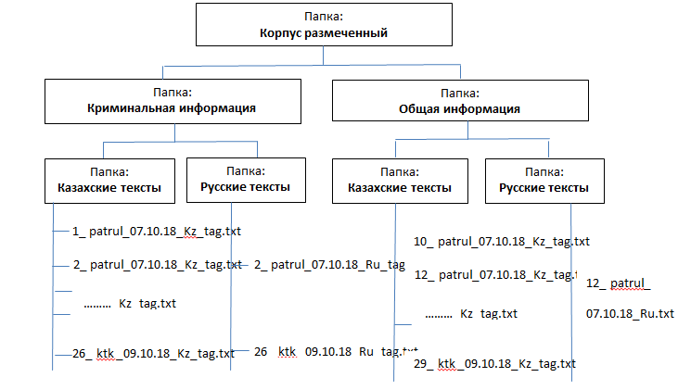
Figure 3.1 - File structure of the Kazakh-Russian corpus of criminally coloured texts

The use of the manual method of marking increases its accuracy, while at the same time it is labour-intensive and does not allow the marking of large corpora. On the contrary, the use of automatic marking increases the number of errors, reduces accuracy, but allows you to mark large corpora quickly enough.
In addition, in some cases, it is quite difficult to create algorithms for semantic, stylistic and some other types of markings. For this reason, in our study, some information, particularly POS-tagging, was added to the corpus automatically in most cases, and semantic information was added manually.
The structural macro-marking of the developed corpus includes the following document tags:
- the title of the text is highlighted with a tag: <head type=main> заголовок</head>;
- if there are subheadings in the text, they are highlighted with tags: <head type=h1> heading</head>;
- the date of publication is defined as: <date> </date>;
- the website of the information web agency from which the text is taken is highlighted by a tag: <site> </site>;
- if there is an author, he is marked with a tag: <author> автор < /author>.
One of the main steps in annotating the text corpus is to select multiple tags or multiple categories of words that will be applied to tokens (tagset). A tagset is a set of tags used for a given grammatical tagging task. The speed and accuracy of automatic processing depend on the selection of a correctly defined set of tags. In the development of a tagset, the following criteria for selecting tags have been defined and taken into account:
1) conciseness - short labels are more convenient than more detailed labels and therefore longer;
2) perspicuity - the labels must be easy for interpretation;
3) analyzability - the tags must be easy to decompose into logical parts, which will be easy to read both during machine processing and to understand by humans.
Based on the above-mentioned criteria, the following morphological and semantic labels were selected:
- the tags <s type=crim> sentence </s> highlight sentences with a criminal colouring;
- the tag <v type=crim> verb </v> is used to mark verbs that have a criminal colouring;
- the tag <n type=crim > noun </n> highlights nouns that have a certain criminal colouring;
- Tag <a type=crim > adjective and participle </a> highlights adjectives and participles that have a certain criminal coloring;
Tag names (types of elements) <s>, <v>, <n>, <a> define grammatical information of a part of speech and sentence as a syntactic unit. And the values of the attribute type=crim define semantic information. Figure 3.2 shows a fragment of a marked corpus file.
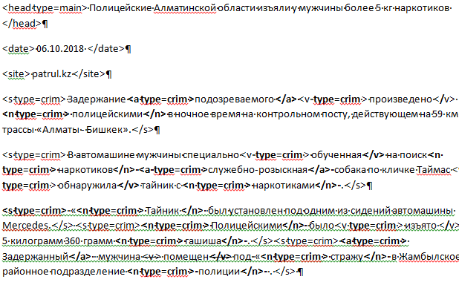
Figure 3.2 - File fragment of marked Kazakh-Russian corpus file
3.2 Expert evaluation of the results of the semantic analysis of Kazakh texts that include criminal meaning
POS-tagging of Kazakh texts was carried out using a developed tagger based on the RegexpTagger class of the NLTK Python package. Figure 3.3 shows a fragment of a regular expression that allows the identification of certain forms of nouns in Kazakh sentences.
patterns=[(r’.*бен$','NN'), (‘r.* пенен$','NN'), (‘r.* басшылық$','NN'), (r’.* іпқону$','NN'), (r’.* тармен$','NN'), (r’.* герлермен$','NN'), (r’.* здар$','NN')]
Figure 3.3 - Fragment of a regular expression that allows the identification of certain forms of nouns in Kazakh sentences

The semantic marking of the corpus of Kazakh texts containing criminally significant information consists in identifying a triplet of fact: Subject PredicateObject. The corpus has a horizontal format of markup. The use of the obtained names of morphological tags and some syntactic characteristics of words in a sentence as values of subject variables of equations (2.17 - 2.26) allows extracting Subject, Object and Predicate fact from Kazakh language sentences.
The subject of the action marked with the "_Sub" label, which is the person or subject that initiates the action, is determined on the basis of the formula (2.28). The object of the action marked with the "_Ob" label is the person or object to which the action is directed and determined on the basis of the formula (2.29). The triplet nucleus of a fact is a Predicate marked with the label "_Pred", indicates the action of a fact and determined on the basis of a logical-linguistic equation (2.27).
The following expert evaluation method was used to evaluate the results of automatic fact extraction from texts containing criminally significant information. About one thousand facts were randomly selected from the automatically extracted facts and presented to the expert for evaluation. The expert assessed the extracted fact as 1 if the triplet of fact was correctly identified. This means that all three elements of the fact have been correctly identified: the initiator of the action - Subject, the subject or person to whom the action is directed - Object, the action that unites all participants - Predicate. If at least one of the three elements of a triplet of fact is identified incorrectly, the expert evaluated the fact as 0 - an incorrectly identified and extracted fact. Figure 3.4 shows the application interface used to assess the correctness of the developed algorithm of semantically marked Kazakh texts containing criminally significant information. The expert evaluation was performed by two experts.

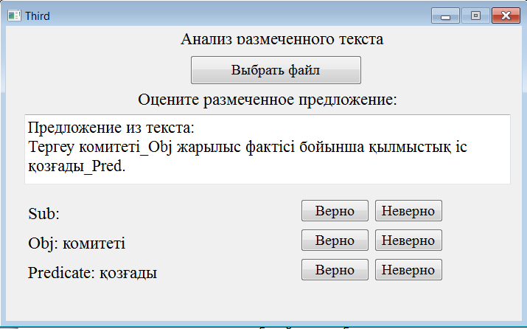
Figure 3.4 - Application interface allowing the expert to evaluate correctness of the application

Table 3.1 shows the obtained coefficients of accuracy and consistency (agreement) of the developed method of semantic marking of the corpus of criminal texts of Kazakh language.

Table 3.1. Precision and agreement of the developed method of semantic marking of the corpus of criminally texts in Kazakh.
Language | Corpus size  (how many words) | precision | agreement
Kazakh | 225 | 71,0 % | 0,72

3.3 Aligned parallel Kazakh-Russian corpus of criminal texts
The Kazakh-Russian parallel corpus of texts containing CI was formed on the basis of four bilingual websites in Kazakhstan: zakon.kz, caravan.kz, lenta.kz and nur.kz [44]. The selected sites are well-known and reliable portals of the Republic of Kazakhstan, one of the news areas of which is criminal news. The portals contain news about such criminal acts as robberies, car thefts, murders, traffic accidents and others. The texts of this particular field represent the basic resource of the created corpus. Also, these portals are bilingual and often contain news publications in Kazakh and Russian. As a result of scraping the abovementioned sites, 3,000 texts were received in two languages: Russian and Kazakh. For automatic collection (scraping) of website texts, a program has been developed that parses websites of a given structure and the required context.
The next step was to manually adjust the texts of criminal coloring. Thus, a corpus of more than 50410 words was obtained (about 25600 words belong to the Kazakh half of the corpus and about 24800 words to the Russian half) collected from four news sites in Kazakhstan from May to December 2018.
The structural organization of the corpus was determined by a demonstrative choice of the three basic corpus formats currently available, which are used depending on the pragmatic goals of the creators or users. The first is a traditional text format with translation references. The second format organizes the text corpus in a tabular "mirror" form, which is more convenient for reading and comparison. And the third way to organize the corpus is to use their database metadata (DB) to store the texts.
A third possible structure, a database, has been defined as the data storage format for the created corpus. The database is the most convenient structure for storing large amounts of data representing small text fragments, followed by the possibility of permanently expanding and extending the database. A fragment of the table of the created database including the ID, name, website address and text of the news article is shown in Figure 3.5.
The pymorphy2 Python package, designed specifically for morphological analysis of Russian texts, was used to perform POS-tagging of Russian texts. The libraries of the package use the OpenCorpora dictionary and draw hypothetical conclusions on words that cannot be recognized.
The complexity of the structural and standard annotation of Kazakh texts is related to their belonging to agglutinative languages. The agglutinative format, in which each agglutination (suffix or ending) has only one semantic or morphological meaning, is opposed to the flectional format, in which each morpheme has several indivisible meanings at once (e.g. case, gender and number).
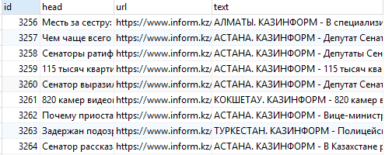
Figure 3.5 - Fragment of the Database of news websites in the Kazakh and Russian languages

POS tagging of Kazakh texts was carried out through regular expressions based on the RegexpTagger class of the nltk Python library and a number of syntactic rules. For example, we can identify some types of Kazakh nouns using the regular expression list shown in Figure 3.6. Here, the tag "_NNat" identifies the noun's nominative case (атау), the tag "_Nil" identifies the parent case (iлiк), and the tag "_NNba" identifies the dative case (барыс) (see also example Figure 3.3).
patterns=[(r’.*(шык|шы|пыр|мпыр|алар|ашыщ|лар|елер|ды) $', 'NNat'), (‘r.*( мның|енің|рдың|дың,)$','NNil'), (r’.*( да|те|та|нда|нде|ға|ге|қа|ке|на|не|тік|еге|ырға|рға}йға|ыға|аға|шаға|сіз|мға|ға)$','NNba')]
Figure 3.6 - Example of a regular expression that allows the identification of certain nouns of the nominative, genitive and dative case of the Kazakh language

To increase the precision of POS tagging, syntactic rules were additionally used. The basis for developing such rules was a strict word order in Kazakh sentences. For example, "If a token follows words from a special list, the token is marked as a verb":

[list_1 of words] tokeni => tagtokeni=’_VV’, | (3.1)
where list_1 of words = [қойды, қой, қалды, қал, салдым, салып, кетті, кетсеңші, бару, келу, шығу, жүру, түру, бар, қел, шық, жүр, қайт, шыққан, барған, түсті, түс, тұрыңдар, тұсын, көрме, …]
The next step was to choose a way to align the sentences. The first approach, based on matching the lengths of sentences of texts, ensures higher productivity. However, in our study, despite its advantages, this approach cannot produce accurate and objective results, as the Kazakh language often uses additional words to express some semantic and morphological information that fundamentally change the length of a sentence. It is for this reason that the difference in organizing the grammar and semantics of flectional and agglutinative languages is not effective in using sentence length alignment in our parallel Kazakh-Russian corpus.
The second, more resource-intensive approach we have chosen, uses lexical word alignment. A Kazakh-Russian dictionary based on an English-Kazakh-Russian dictionary containing approximately 50,000 elements was used as a "lexical alignment tool". Fragments of these dictionaries are shown in Figures 3.7. and 3.8, respectively.

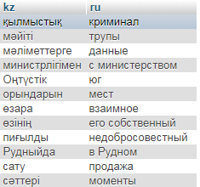
Figure 3.7 - Fragment of the created Kazakh-Russian dictionary

To make the best use of this dictionary method of automatic sentence alignment, we use the preliminary results of POS-tagging of bilingual texts [45]. The use of correct morphological markup allows us to correctly determine the correspondence between words by selecting reference tokens of aligned sentences.
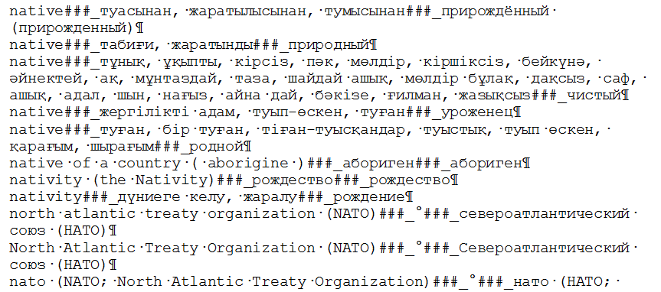
Figure 3.8 - Fragment of the basic English-Kazakh-Russian dictionary

To evaluate the accuracy of the automatic alignment of the sentences from the corpus, three experts were involved. They used a specially developed application whose user interface is shown in Figure 3.9. The application allows the experts to select text in any (Russian or Kazakh) language and automatically downloads a parallel file with text in the other language (Kazakh or Russian respectively). Sentences that have not received a parallel equivalent in the other language after automatic alignment are highlighted in bold. When working with the corpus, experts can mark texts, save them with tags, or correct aligned sentences manually.

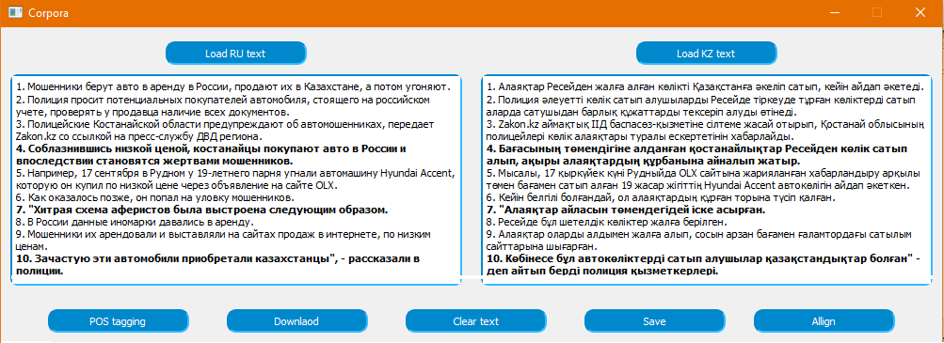
Figure 3.9 - User interface of the application used to work with the aligned parallel corpus

An expert evaluation of the results of the algorithm for automatic alignment of parallel Kazakh-Russian texts containing criminal-colored information showed that precision of automatically aligned sentences is about 60%, with an agreement coefficient of 0.83. The rest of the corpus sentences were aligned manually.
The analysis of the automatic alignment results made it possible to draw the following conclusions about the causes of existing errors and to develop prospective areas for further research.
- The main reason for the relatively low precision of the automatic alignment of the created corpus is the large difference in grammar between the Kazakh and Russian languages. The global difference in the syntactic structures of sentences often leads to the fact that one sentence of the Russian text is matched by several sentences of the Kazakh text. This generally affects the mismatch between the number of sentences in parallel files of the two parts of the corpus.
- The complexity and limited use of comparable grammar for Kazakh and Russian requires further work on contrastive linguistics.
- The result of the alignment method depends on the quality of the translation dictionary used. However, because Russian and Kazakh languages are in different language groups and a common vocabulary is used, there may be some translation errors related to polysemy and homonymy.
- The alignment of texts containing CСI requires the development of a specialized ontology on the subject of illegal Internet content, including knowledge of the patterns of semantic word classes and the relationship between the relevant concepts.

CONCLUSION

In the course of the project, an analytical review of existing problems in the field of searching technology of illegal information in text data was carried out. The current state and prospects of development of methods of formalization and information retrieval in unstructured and semi-structured text files were considered, and the existing possibilities of using IE methods to extract criminally significant information were analyzed. Based on this analysis, a general approach to formalizing and identifying IE has been developed.
The study developed a logical and linguistic model for extracting facts from files of semi-structured texts, which is adapted for Kazakh, Russian and English texts. In addition, the study investigated the relationship between linguistic formalisms in natural-linguistic texts and the real nature of a criminally or socially significant event in society. Based on this analysis, a method of generating structured machine-readable information based on unstructured text is proposed.
As a result of the research, a corpus of Kazakh and Russian criminal texts with about 50,000 words was developed. The report includes a description of the algorithm for semantic annotation of the corpus based on the developed model for extracting facts from unstructured texts, as well as a description of the method of expert evaluation of the results of semantic analysis of the corpus. The resulting markup precision is about 71%, with an agreement factor of 0.72. The method of alignment of the created parallel Kazakh-Russian corpus of criminal texts is considered, and a description of the developed application allowing work with the corpus is given.
The information technology developed as part of the project for the identification of knowledge in text files was introduced at the National Innovation Centre. Act of implementation dated 15 July 2020 (Annex D). The results obtained can also be used to identify in social networks, electronic media and other electronic resources multilingual information relevant to the prevention of illegal actions. The introduction and practical implementation of the developed set of models, methods and technologies will allow government agencies to automate the extraction of information with CSI elements from external text data sources. In the future, the results obtained during the survey may be commercialized.

REFERENCES

- Bondareva L.V., Borisenko T.I., Valentey T.V. Modern terrorism: the nature, causes, models and mechanisms of counteraction. – M.: Impuls, 2013. – 252 p. (original in Russian)
- Meloy J. R., Hoffmann J., Guldimann A., & James D. The role of warning behaviors in threat assessment: An exploration and suggested typology // Behavioral Sciences & the Law. – 2012. - № 30(3). – Р. 256–279.
- Mamyrbayev O. Zh., Mukhsina K. Zh., Khairova N. F., Kolesnyk A. S.. Linguistic tools for identifying criminally coloured text information in web content // Vestnik of the Almaty University of Energy and Communication. – 2018. – № 3(46). – pp. 112-117. (original in Russian)
- Cohen K., Johansson F., Kaati L., & Mork J.C. Detecting linguistic markers for radical violence in social media // Terrorism and Political Violence. – 2014. - № 26(1). – Р. 246–256.
- Cohn M.A., Mehl M.R. & Pennebaker J.W. Linguistic markers of psychological change surrounding // Psychological Science. - 2001. - № 15(10). – Р. 687–693.
- TE-SAT 2012: EU Terrorism situation and trend report // https://www.europol.europa.eu/activities-services/main-reports/te-sat-2012-eu-terrorism-situation-and-trend-report : 25.05.2018
- Shyam Varan Nath. Crime Pattern Detection Using Data Mining // IEEE/WIC/ACM International Conference on Web Intelligence and Intelligent Agent Technology Workshops. - 2006. - №4. – Р. 41–44.
- Meloy J.R., Hoffmann J., Guldimann A. & James D. The role of warning behaviors in threat assessment: An exploration and suggested typology // Behavioral Sciences & the Law. – 2012. - № 30(3). - Р. 256–279.
- Meloy J. R. Approaching and attacking public figures: A contemporary analysis of communications and behavior // Threatening communications and behaviour: Perspectives on the pursuit of public figures. - Washington, DC: The National Academies Press, 2011. - Р. 75–101.
- Meloy J.R., Mohandie K., Knoll J.L. & Hoffmann J. The concept of identification in threat assessment // Behavioral Sciences & the Law. – 2015. - № 33(2-3). – Р. 213–237.
- Cohen K., Johansson F., Kaati L. & Mork J.C. Detecting linguistic markers for radical violence in social media // Terrorism and Political Violence. – 2014. - № 26(1). – Р. 246–256.
- Paul K. Davis et al. Using Behavioral Indicators to Help Detect Potential Violent Acts: A Review of the Science Base. - RAND Corporation, 2013. – 258 р.
- Khairova N., Sharonova N. Logical-linguistic model for extracting facts from semi-structured text information // International Journal “Information Models and Analyses”. – Varna, Bulgaria, 2013. - Vol.2, № 2. – pp. 167 – 175. (original in Russian)
- Bolla Raja Ashok. Crime pattern detection using online social media // Masters Theses. – 2014. – Р. 7321.
- Criminal Code of the Republic of Kazakhstan dated 2014 July 3 - with amendments and additions. - Almaty: LEM , pp. 2018. – 268.
- Knyazkov A. S.. Criteria for the significance of the criminal profile of a crime // Vestnik of Tomsk State University. – Tomsk : TGU, 2007. – № 304. – pp. 122-128.(original in Russian)
- Madieva G.B., Umatova Zh.M. The Almaty corpus of the Kazakh language. // Vestnik of KazNU. Philological series. – 2015. №5 (157). – С. 98 -103. (original in Russian)
- Kilgarriff A., Baisa V., Bušta J., Jakubíček M., Kovář V., Michelfeit J., Rychlý P., VíSuchomel, V. The Sketch Engine: Ten Years On // Lexicography. - Springer, Berlin, Heidelberg, 2014. - Р. 7-36.
- Chapaev D., Turapbekov B. Building Kazakh language open source corpora using wikipedia resources // Suleyman Demirel University Bulletin. – Kaskelen, 2018. - Р. 153- 160.
- Makhambetov O., Makazhanov A., Yessenbayev Z., Matkarimov B., Sabyrgaliyev I., Sharafudinov A. Assembling the Kazakh Language Corpus // Proceedings of the Conference on Empirical Methods in Natural Language Processing. – Kazakhstan, 2013. - Р. 1022-1033.
- Gale W.A., Church K.W. A program for aligning sentences in bilingual corpora // ACL’93 29th Annual Meeting. – USA, NJ, 1993. - Vol. 19(1). - Р.75–102.
- Fung P., McKeown K. Aligning noisy parallel corpora across language groups: word pair feature matching by dynamic time warping // Proceedings of the First Conference of the Association for Machine Translation in the Americas. - Columbia, Maryland, USA, 1994. - Р. 81–88.
- Simard M., Foster G.F., Isabelle P. Using cognates to align sentences in bilingual corpora // Proceedings of the Fourth International conference on theoretical and methodological issues in Machine translation. - Montreal, Canada, 1992. - Р. 67–81..
- Varga D., Halacsy P., Kornai A., Nagy V., Nemeth L., Tron V. Parallel corpora for medium density languages. Amsterdam Studies // The Theory And History Of Linguistic Science Series. – 2007. - № 4(292). – Р. 247.
- Sennrich P., Volk M. Iterative. MT-based Sentence Alignment of Parallel Texts // Proceedings of the 18th Nordic Conference of Computational Linguistics. – Switzerland, 2011. - Р. 175-182.
- Li P., Sun M., Xue P. Fast-Champollion: A Fast and Robust Sentence Alignment Algorithm // Proceedings of the 23rd International Conference on Computational Linguistics: Posters. - Beijing, China, 2010. - Р. 710-718.
- Vondricka P. Aligning parallel texts with InterText // Proceedings of the Ninth International Conference on Language Resources and Evaluation. - European Language Resources Association, 2014. - Р. 1875-1879.
- Zhumanov Z., Madiyeva A., Rakhimova D. New Kazakh parallel text corpora with online access // Conference on Computational Collective Intelligence Technologies and Applications. - Almaty, Kazakhstan, 2017. - Р.501-508.
- Grabar N., Kanishcheva O., Hamon T. Multilingual aligned corpus with Ukrainian as the target language // SLAVICORP. – Prague, 2018. - Р. 53-57.
- Harme J. Last year but not yesterday? Explaining differences in the locations of Finnish and Russian time adverbials using comparable corpora // SLAVICORP. - Prague, 2018. - Р. 60-63.
- Smith J.R., Quirk C., Toutanova K. Extracting Parallel Sentences from Comparable Corpora using Document Level Alignment // Proceedings of the Human language Technologies/North American Assosiation for Computational Linguistics. – 2010. - Р. 403-411.
- Lewoniewski W., Węcel K., Abramowicz W. Quality and importance of Wikipedia articles in different languages // International Conference on Information and Software Technologies. - Poznan, Poland, 2016. - Р. 613 – 624.
- Rosen A.: In search of the best method for sentence alignment in parallel texts // Computer treatment of Slavic and East European languages. Third international seminar. - Bratislava, Slovakia, 2005. - Р. 174-185.
- Filmor Ch. The case of the case is reopened // new in foreign linguistics. – M.: Izd. inostr.lit., 1981. - Vyip. 10. – pp. 496-530. (original in Russian)
- Bondarenko M. F. Shabanov-Kushnarenko Yu. P. Theory of intellect: textbook. - Kharkov: Komp. SMIT, pp. 2007. — 576. (original in Russian)
- Bondarenko M. F. Brain structures: Reference manual. – Kiev : Naukova Dumka, 2011. – pp. 460. (original in Russian)
- Nina Khairova, Orken Mamyrbayev, Kuralay Mukhsina, Anastasiia Kolesnyk. Logical-Linguistic model for multilingual open information extraction // Cogent Engineering. - 2020, №7:1, 1714829.
- Khairova N.F., Petrasova S., Gautam A.P. The logical-linguistic model of fact extraction from English texts. Information and Software Technologies. Series Communications in Computer and Information Science. - Springer, 2016. – Vol. 639. - Р. 625-635 // doi> 10.1007/978-3-319-46254-7_51
- Nina Khairova, Włodzimierz Lewoniewski, Krzysztof Wecel. Estimating the Quality of Articles in Russian Wikipedia Using the Logical-Linguistic Model of Fact Extraction // Conference proceedings. BIS 2017. Part of the Lecture Notes in Business Information Processing book series. - Poznan, Poland, 2017. – Vol. 288. – P. 28-40.
- Nina Khairova, Svitlana Petrasova, Orken Mamyrbayev and Kuralay Mukhsina. Open Information Extraction as Additional Source for Kazakh Ontology Generation // ACIIDS 2020, Lecture Notes in Artificial Intelligence. - Phuket, Thailand, 2020. - Part I. - Р.86-96.
- Fillmore C.J. Verbs of Judging: An Exercise in Semantic Description // Studies in Linguistic Semantics. - NY., 1971. - P. 273-290.
- Khairova N., Mamyrbayev O., Mukhsina K. Some aspects of the technology for identifying criminally significant information in multilingual text files // Almaty: Institute of Information and Computing Technologies, pp. 2020. – 92. (original in Russian)
- New Philosophical Encyclopedia: in 4 t. // Institute of Philosophy of the Russian Academy of Sciences; National Social Science Foundation. — М.: Myisl, 2010. — ISBN 978-5-244-01115-9. (original in Russian)
- Khairova N., Kolesnyk A., Mamyrbayev O., Mukhsina K. The aligned Kazakh-Russian parallel corpus focused on the criminal theme // CEUR Workshop Proceedings. – 2019. - Р. 116-125.
- Khairova, N., Kolesnyk, A., Mamyrbayev, O., Mukhsina, K.. The aligned Kazakh-Russian parallel corpus focused on the criminal theme // Vestnik of the Almaty University of Energy and Communication № 1 (48) 2020. – pp .84-92. (original in Russian)

APPENDIX А
Work schedule for 2018-2020

Appendix 1
to the Additional agreement No. 1 dated _____June 2018
under the contract No. 211 dated March 19, 2018 on
grant financing

TECHNICAL SPECIFICATION AND WORK SCHEDULE

Under the Additional agreement No. 1 dated June 2018
to the contract No. 211 dated March 19, 2018

- Republican State Enterprise on the Right of Economic Use "Institute of Information and Computational Technologies" of the Committee of Science of the Ministry of Education and Science of the Republic of Kazakhstan

1.1 By priority: 3. Information, telecommunication and space technologies, scientific research in the field of natural sciences.
1.2 By subpriority: 3.1 Intelligent Information Technologies. Machine learning.
1.3 By the program subject: AP05131073 «Methods and models for searching for criminally significant information in unstructured and semi-structured text files».
1.4 Overall budget of the program 45 000 000 (fifty-four million) tenge, including breakdown by years, for work performance according to paragraph 3:
- for 2018-in the amount of 15 000 000 (fifteen million) tenge;
- for 2019 -in the amount of 15 000 000 (fifteen million) tenge;
- for 2020-in the amount of 15 000 000 (fifteen million) tenge.

2. Characteristics of scientific and technical products by qualification and economic indicators

2.1 Direction of work: Scientific research in the field of natural sciences.
2.2 Field of application: integrated information-criminalistics systems of law enforcement agencies, integrated information-analytical systems of other state institutions for information search and analysis of texts of criminal coloring of Web content in Kazakh, Russian and English languages. Information technology for search, retrieval and analysis of criminally-significant information from unstructured and semi-structured text data files can be used in government services of the Ministry of Internal Affairs, Prosecutor's Office and security; social services, libraries, educational institutions and other government agencies.
2.3 Final outcome:
- for 2018: An analytical review of the research topic will be carried out. Recommendations on creating an information technology will be developed. Corpora of modern Web content in three languages will be developed. The created corpora will be annotated (morphological with stylistic, temporal and semantic elements). Articles with the participation of Ukrainian scientists in peer-reviewed foreign and national scientific journals with non-zero impact factor will be published. There will be published 1 article in scientific journals indexed in the WebofScience or Scopus databases with non-zero impact factor.
- for 2019: Logical and linguistic models for extracting facts from Kazakh, Russian and English texts will be developed. Correlations between the linguistic formalisms of the texts of created corpora and the real nature of the event in society will be formalised. An automated electronic glossary of illegal actions in Kazakh, Russian and English will be developed. An information technology for identification, search, extraction and analysis of СSI from semi-structured and unstructured text files of Russian, Kazakh and English languages will be developed . A prototype of a system for identification, search, extraction and analysis of CSI will be developed. Articles with the participation of Ukrainian scientists in peer-reviewed foreign and national scientific journals with non-zero impact factor will be published. There will be published 1 article in scientific journals indexed in the WebofScience or Scopus databases with non-zero impact factor.
- for 2020: An information technology for identification, search, extraction and analysis of СSI from semi-structured and unstructured text files of Russian, Kazakh and English languages will be developed. A prototype of a system for identification, search, extraction and analysis of CSI will be developed. Recommendations on the creation of an information technology for the identification of knowledge in text files in order to distinguish information relevant to the prevention of illegal actions will be developed. Evaluation of the efficiency of the developed technology for the identification of CSI will be carried out. Articles will be published with the participation of Ukrainian scientists in peer-reviewed foreign and national scientific journals with non-zero impact factor. There will be published 1 article in scientific journals indexed in the WebofScience or Scopus databases with non-zero impact factor. A certificate of authorship for the final software product will be obtained. There will be published 1 monograph with participation of Ukrainian scientists.
2.4 Patentability: nonpatentable.
2.5 Scientific and technical level (novelty): The scientific novelty of this project is to present a new line of scientific and practical activities that have emerged in the information society at the intersection of legal and technical sciences, which is focused on the development of information technology to support interested state authorities, namely, the creation of information technology to identify knowledge in text files in order to extract information relevant to the prevention of illegal actions.
2.6 The use of scientific and technical products is carried out: by the contractor.
2.7 Type of the scientific and (or) scientific and technical activities result's use: The results obtained in the study can be used in the integrated information and criminalistics systems of law enforcement agencies, as well as in the integrated information and analytical systems of other government agencies for information retrieval and analysis of criminal texts of Web content in Kazakh, Russian and English languages.

3. Activities, implementation dates and results

Task cipher,stage | Activities under the Contract and the main stages of its implementation | Implementation date |  | Expected result
Task cipher,stage |  | Start | End | Expected result
1. | Study of literature in the research direction. Specification of the research direction. Identification of potential research directions. | January 2018 | April 2018 | The direction of research will be selected and specified. An analytical review of research will be carried out. Literature on the subject will be studied. Potential research directions will be identified. Recommendations on creating information technologies will be developed.
2. | Development of corpora with modern social network texts and Web media in Kazakh, Russian and English. | January 2018 | 1 November 2018 | The corpora of modern social network texts and Web media in Kazakh, Russian and English will be developed. The corpora of modern Web content in three languages will be created.
3. | Development of a system and identification of methods for automatic morphological marking of the created corpora with elements of stylistic, temporal and semantic annotation. | May 2018 | 1 November 2018 | Systems for automatic morphological marking of the created corpora with elements of stylistic, temporal and semantic annotation will be developed and defined. Annotation of created buildings will be carried out (morphological, with elements of temporal, stylistic and semantic).
4. | Preparation of publications in foreign and national scientific journals with a non-zero impact factor, as well as in scientific journals indexed in the WebofScience or Scopus databases and preparation of project reporting documentation. | January 2019 | 1 November 2019 | Articles with the participation of Ukrainian scientists in peer-reviewed foreign and national scientific journals with non-zero impact factor will be published. There will be published 1 article in scientific journals indexed in the WebofScience or Scopus databases with non-zero impact factor.
5. | Evaluation and improvement of created logical-linguistic models of fact extraction from Russian and English text files on created corpora. Development of logical-linguistic models for extracting facts from the texts of the Kazakh language, evaluation of models on the created corpora. | March 2019 | 1 November 2019 | The created logical and linguistic models for extracting facts from Russian and English text files on the created corpora will be evaluated and refined. Logical and linguistic models for extracting facts from Kazakh texts will be developed and models on the created corpora will be evaluated.
6. | Study of the dependence of linguistic formalisms in texts and the real nature of a criminal or socially significant event in society. | January 2019 | July 2019 | The dependencies of linguistic formalisms in texts and the real nature of a criminal or socially significant event in society will be investigated. Correlations between linguistic formalisms in texts and the real nature of a criminal or socially significant event in society will be formalised.
7. | Evaluation and improvement of created logical-linguistic models of fact extraction from Russian and English text files on created corpora. Development of logical-linguistic models for extracting facts from the texts of the Kazakh language, evaluation of models on the created corpora. | March 2019 | 1 November 2019 | The created logical and linguistic models for extracting facts from Russian and English text files on the created corpora will be evaluated and refined. Logical and linguistic models for extracting facts from Kazakh texts will be developed and models on the created corpora will be evaluated.
8. | Development of a method for identifying multi-lingual identifiers of criminally significant information based on logical and linguistic modelling of the function of understanding natural language by human intellect.. | March 2019 | October 2019 | Methods for identifying multi-lingual identifiers of criminally important information in Russian and English texts, based on logical and linguistic modelling of the function of understanding natural language by human intellect will be developed.
9. | Development of information technology for identification, search and retrieval of CSI from semi-structured and unstructured text files of Russian, Kazakh and English languages. Software implementation of the developed technology. | January 2019 | 1 November 2019 | An information technology for identification, search, extraction and analysis of СSI from semi-structured and unstructured text files of Russian, Kazakh and English languages will be developed . The software implementation of the developed technology will be created.
10 | Preparation of publications in foreign and national scientific journals with a non-zero impact factor, as well as in scientific journals indexed in the WebofScience or Scopus databases and preparation of the progress report. | January 2019 | 1 November 2019 | Articles with the participation of Ukrainian scientists in peer-reviewed foreign and national scientific journals with non-zero impact factor will be published. There will be published 1 article in scientific journals indexed in the WebofScience or Scopus databases with non-zero impact factor.
11. | Development of recommendations on the creation of an information technology for the identification of knowledge in text files with the aim of distinguishing information relevant to the prevention of illegal actions. | January 2020 | June 2020 | Recommendations on the creation of an information technology for the identification of knowledge in text files in order to distinguish information relevant to the prevention of illegal actions will be developed.
12. | Development of information technology for identification, search and retrieval of CSI from semi-structured and unstructured text files of Russian, Kazakh and English languages. Software implementation of the developed technology | January 2020 | July 2020 | An information technology for identification, search, extraction and analysis of СSI from semi-structured and unstructured text files of Russian, Kazakh and English languages will be developed . The software implementation of the developed technology will be created.
13. | Evaluation of the efficiency of developed technology for the identification of CSI on the basis of the Web content of social networks, forums and Web media in Kazakh, Russian and English. | July 2020 | 1 November 2020 | Evaluation of the efficiency of the developed technology for the identification of CSI, based on the Web content of social networks, forums and Web media of the Kazakh, Russian and English languages will be carried out.
14. | Preparation of publications in foreign and national scientific journals with a non-zero impact factor, as well as in scientific journals indexed in the WebofScience or Scopus databases and preparation of project reporting documentation. | January 2020 | 1 November 2020 | Articles will be published with the participation of Ukrainian scientists in peer-reviewed foreign and national scientific journals with non-zero impact factor. There will be published 1 article in scientific journals indexed in the WebofScience or Scopus databases with non-zero impact factor. A certificate of authorship for the final software product will be obtained. There will be published 1 monograph with participation of Ukrainian scientists and 1 book in Kazakhstan editions. The project reporting documentation will be prepared.

Requester:  Acting Chairman of SI  “The Committee of Science of the Ministry of Education and Science of Republic of Kazakhstan”  __________________ Y.T. Sadykov | Сontractor:  Director General of RSE on the basis of economic control rights IICT CS MES RK  _________________ M.N. Kalimoldayev
Agreed and accepted by
Scientific supervisor of the project
__________________ O.Zh Mamyrbayev

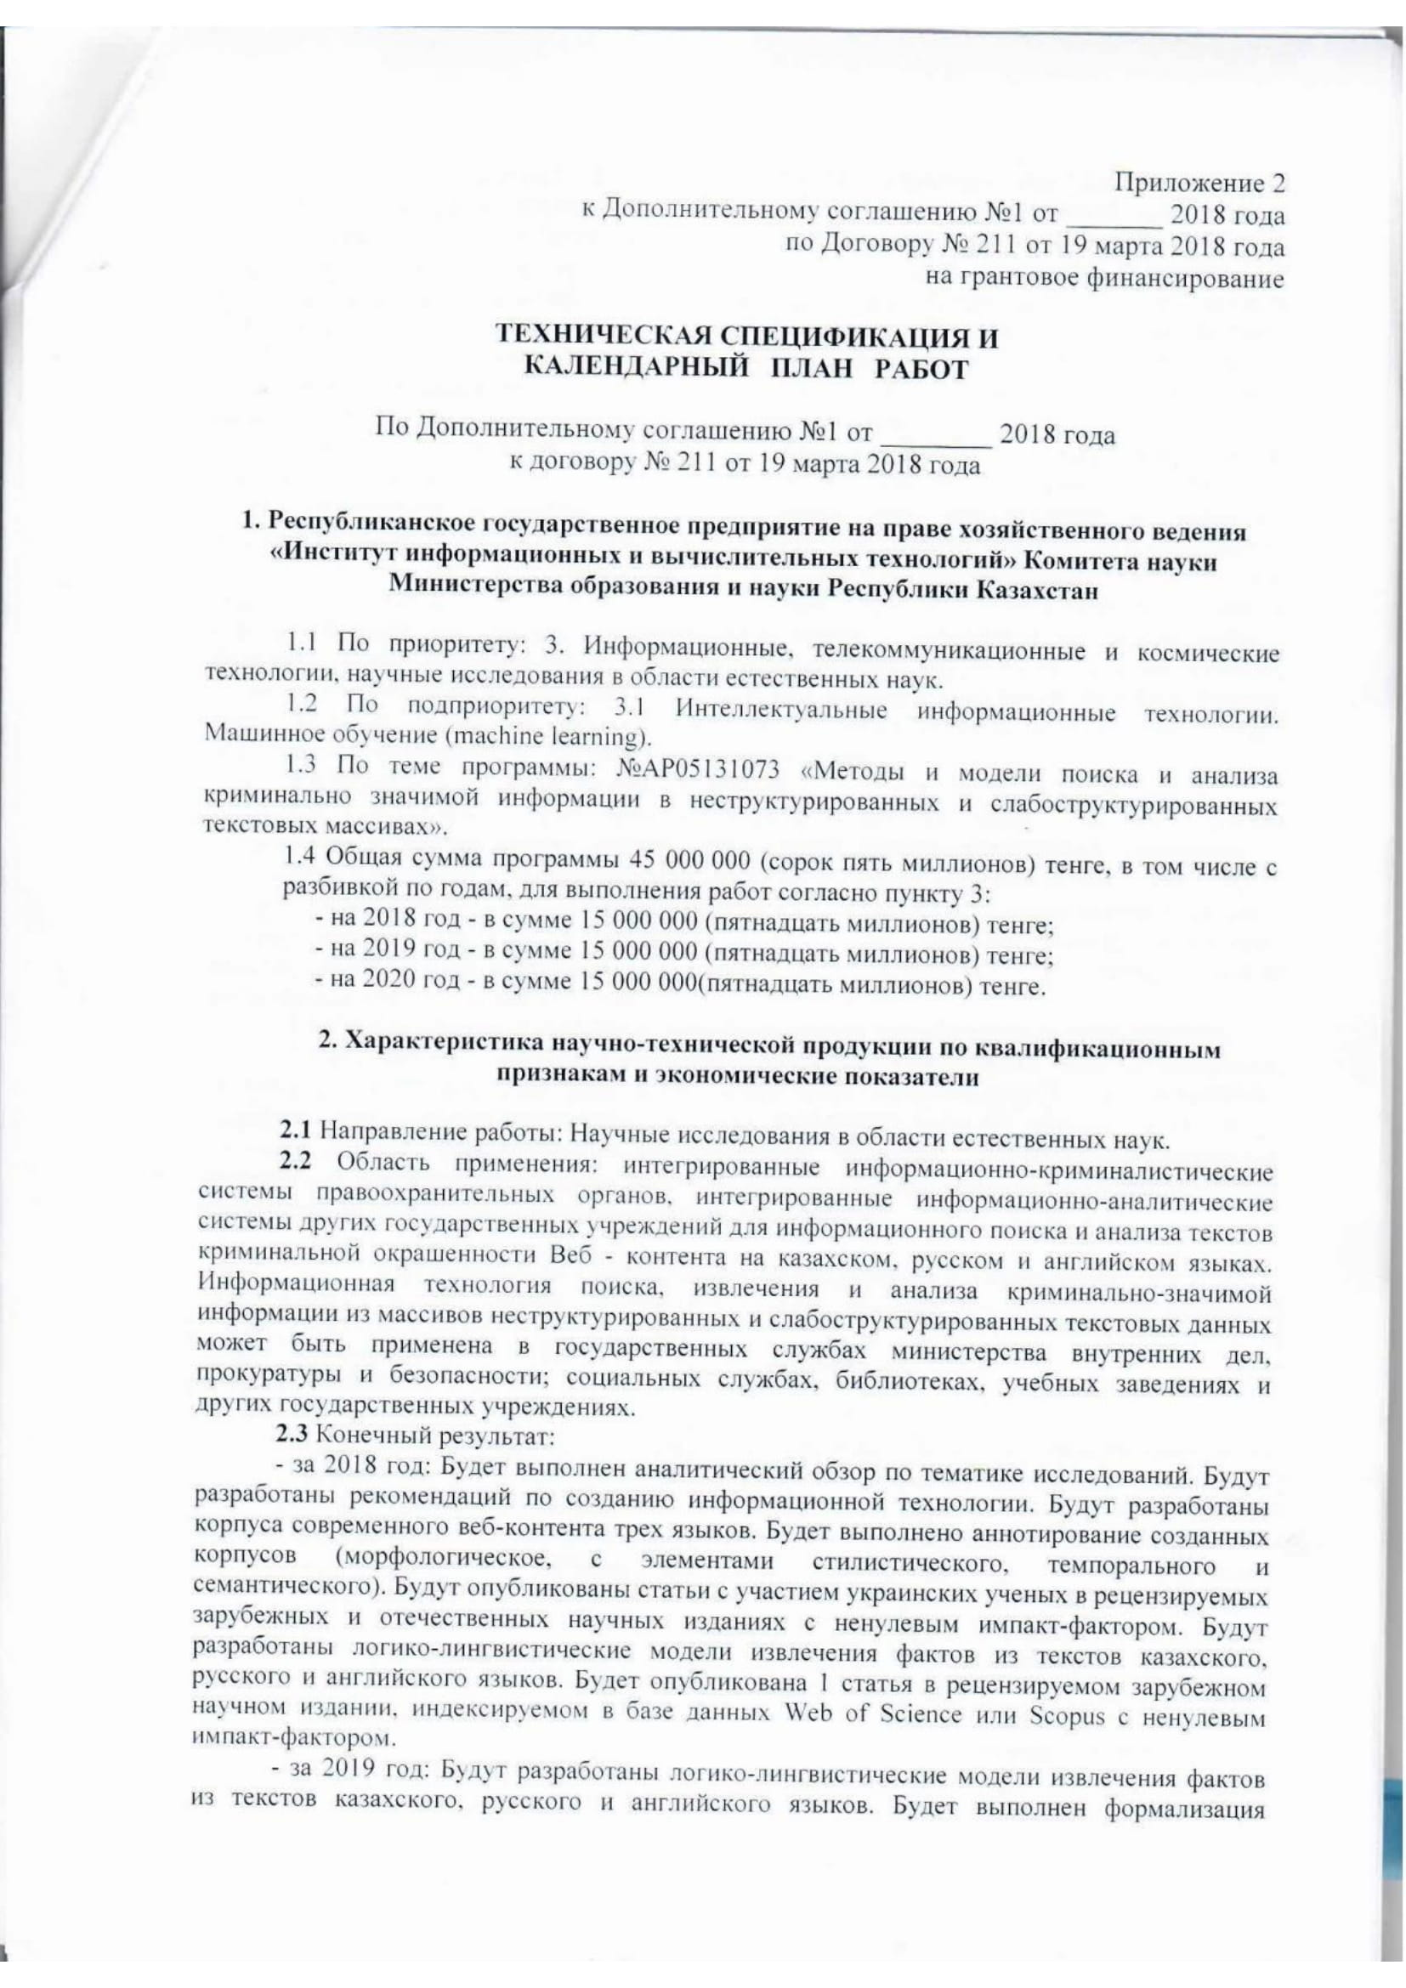
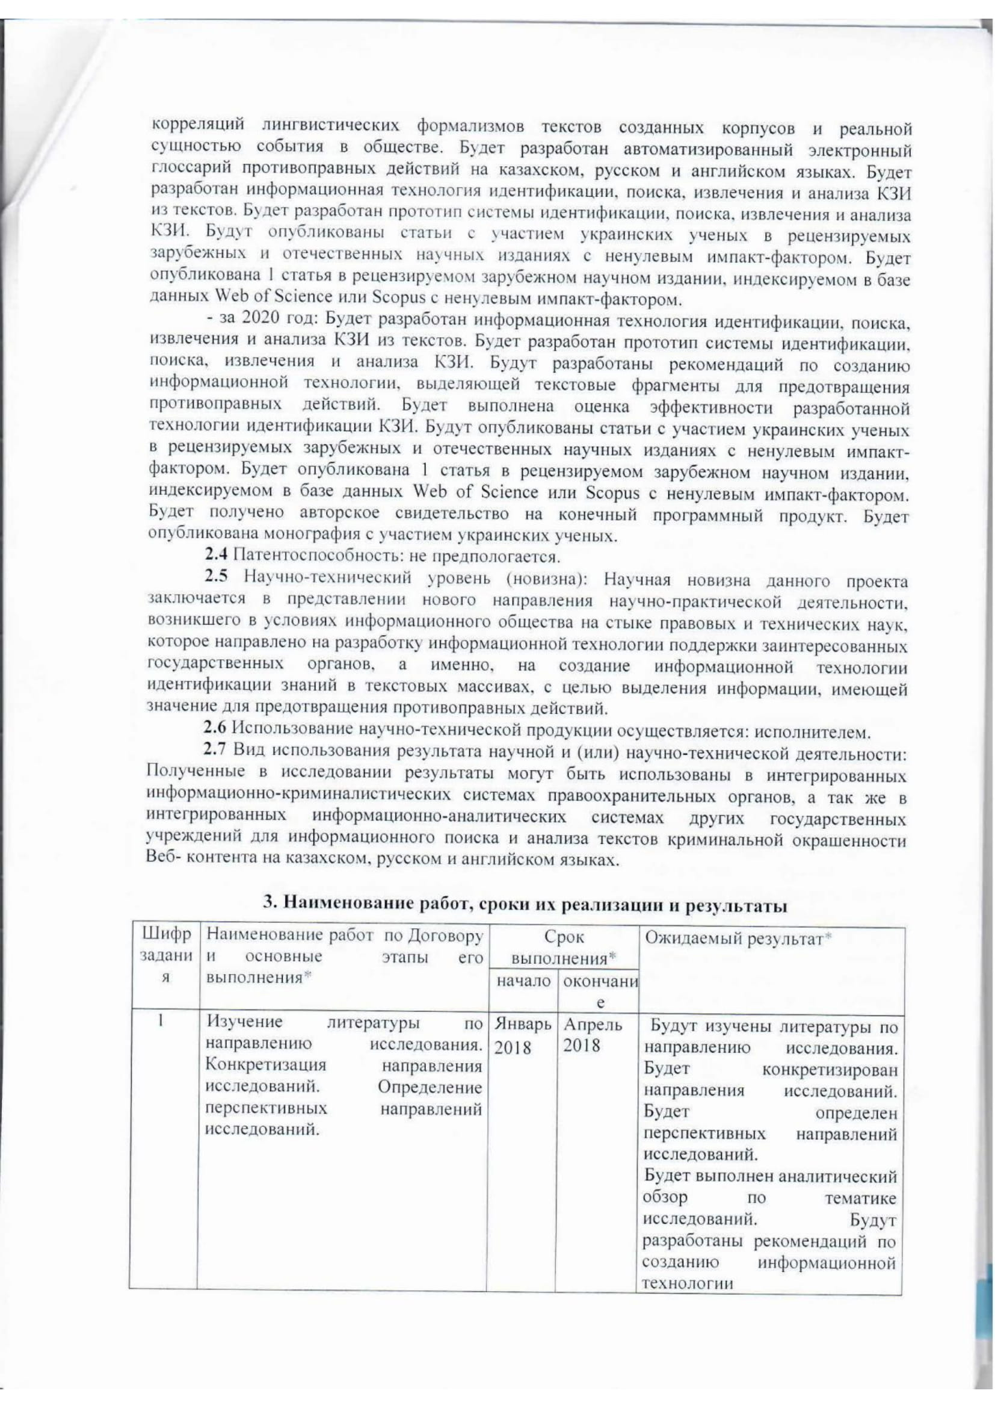

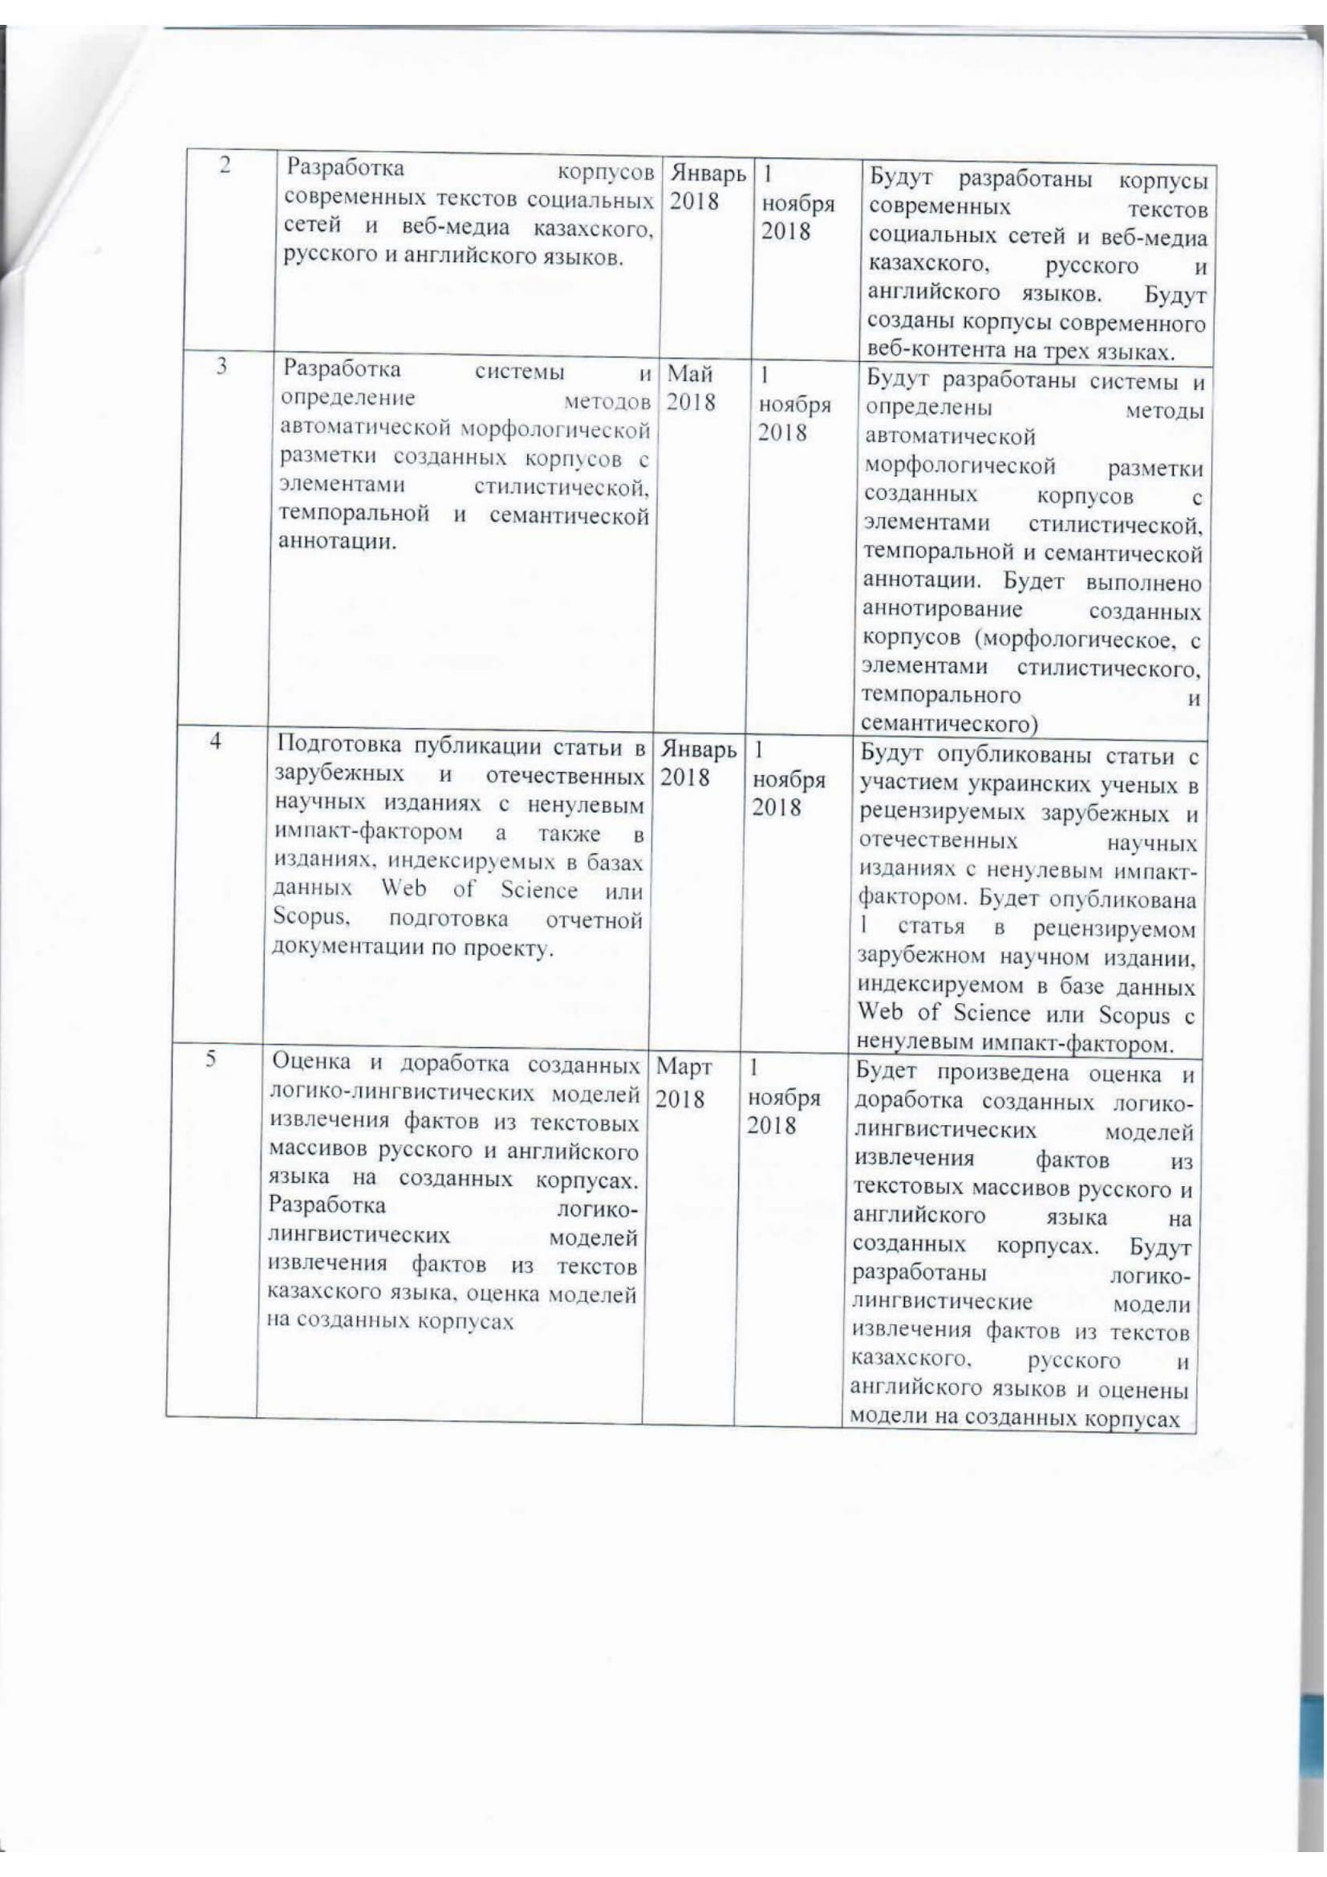
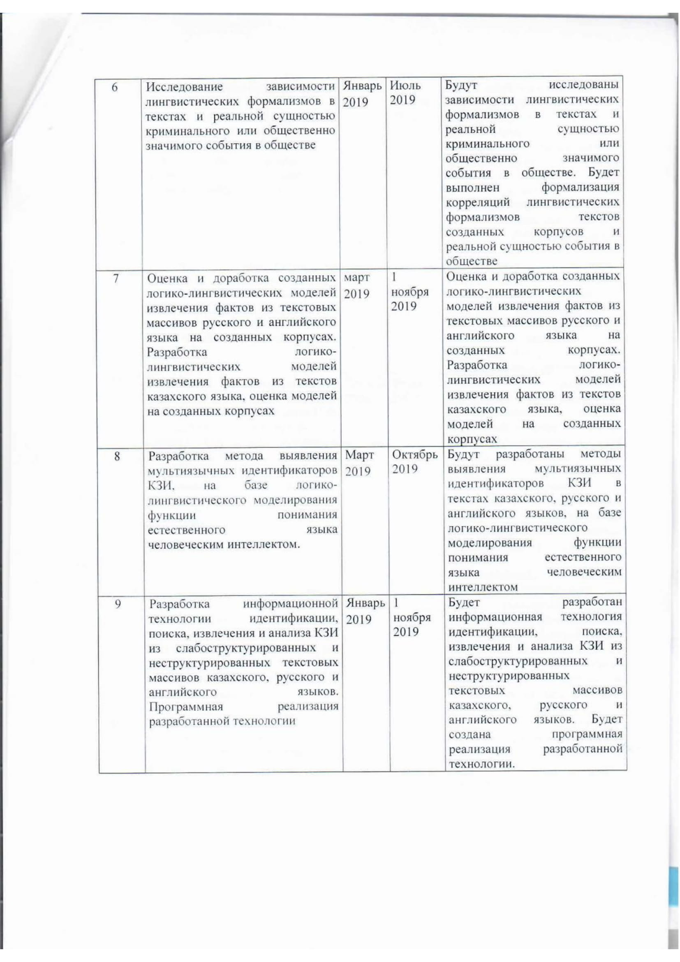

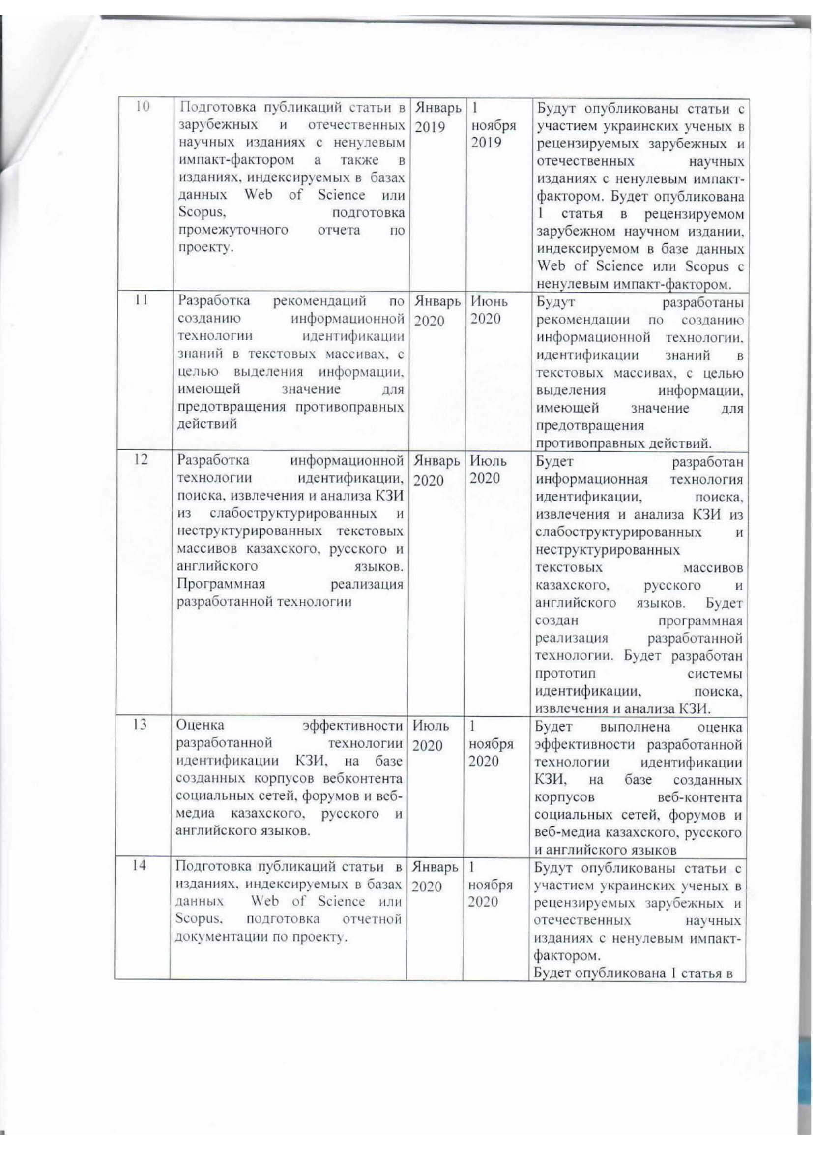
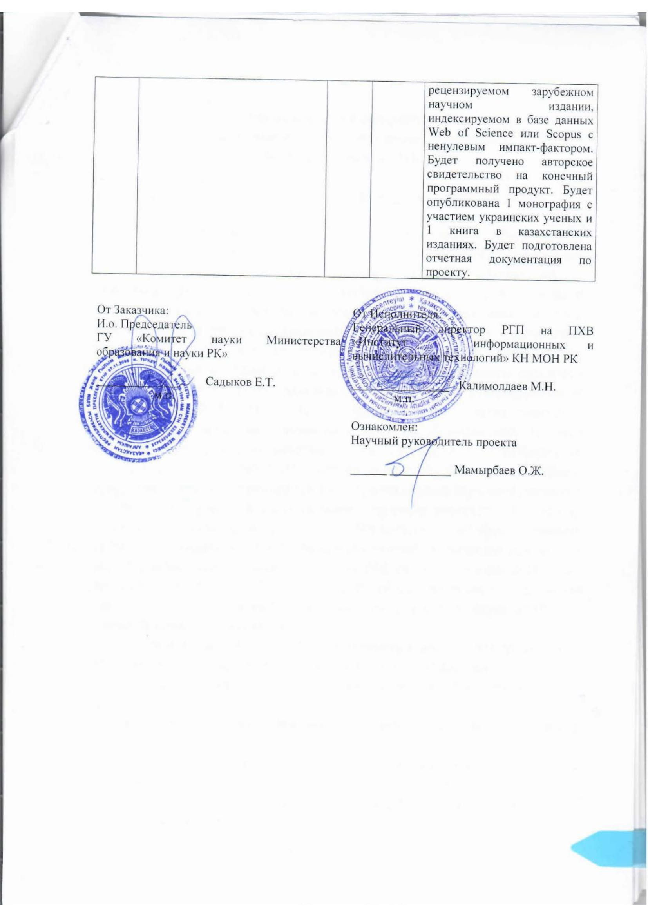

APPENDIX B

List of publications for 2020
Foreign:
- Nina Khairova, Anastasiia Kolesnyk, Orken Mamyrbayev, Svitlana Petrasova. Applying VSM to Identify the Criminal Meaning of Texts // COLINS. - 2020. - Р. 20-31 (Scopus).
- Nina Khairova, Svitlana Petrasova, Orken Mamyrbayev, Kuralay Mukhsina. Open Information Extraction as Additional Source for Kazakh Ontology Generation // Proceedings Asian Conference on Intelligent Information and Database Systems. - Phuket, Thailand, 2020. — Part I. — P. 86–96 // DOI: 10.1007/978-3-030-41964-6_8 (Scopus and Web of Science IF – 0.3, Q4)
- Nina Khairova, Orken Mamyrbayev, Kuralay Mukhsina, Anastasiia Kolesnyk. Logical-Linguistic model for multilingual open information extraction // Cogent Engineering. – 2020. – Vol. 7. – Р. 1-13 // DOI: 10.1080/23311916.2020.1714829. (Scopus, Процентиль – 76)
- Khairova N., Mamyrbayev O., Petrasova S., Mukhsina K.. Modern text data processing technologies based on the NLTK Python package: a training manual. - Kharkov: "V delo" LLC, pp. 2020. - 134. (original in Russian)
Domestic:
- Khairova N., Kolesnik A., Mamyrbayev O., Mukhsina K.. Aligned Kazakh-Russian parallel corpus focused on criminal theme // Bulletin of the Almaty University of Energy and Communication.. - 2020. - № 1 (48). –PP.84-92.(original in Russian)
- Khairova N., Mamyrbayev O., Mukhsina K.. Some aspects of the technology for identifying criminally significant information in multilingual text files: Monograph. - Almaty: Institute of Information and Computing Technologies, 2020. – p. 92. (original in Russian)
- Mamyrbayev O., Khairova N., Kolesnyk A., Mukhsina K.. Method of identification of criminal value of texts in Kazakh language, based on VSM // Coll. of scientific works: Computer processing of the Kazakh language. - Almaty: Қазақ Universityi, 2020. – pp. 104-120. (original in Russian)
- Khairova N., Kolesnyk A., Mamyrbayev O., Mukhsina K.. Using qualitative content analysis methods to study the distribution of illegal texts on news sites // In International scientific-practical conference "Informatics and applied mathematics". - Almaty, 2020. – pp. 223-231.
- А.с. № 9180. The system for creating and aligning of the Kazakh- Russian corpus of the criminal theme. Khairova N.F., Mamyrbayev O.Zh., Izbassarov E.Zh., Mukhsina K.Zh.. - 2020. – 1p.
List of publications for 2019

- Khairova N., Petrasova S., Mamyrbayev O. and Mukhsina K. Detecting Collocations Similarity via Logical-Linguistic Model // Proceedings of the Workshop on meaning relations between phrases and sentences. - Gothenburg, Sweden, 2019. – Р. 15-22.
- Khairova N., Kolesnyk A., Mamyrbayev O. and Mukhsina K. The Influence of Various Text Characteristics on the Readability and Content Informativeness // Proceedings of the 21st International Conference on Enterprise Information Systems. – 2019. – Vol. 1. – Р. 462-469 // DOI: 10.5220/0007755004620469.
- Petrasova S., Khairova N., Lewoniewski W., Mamyrbayev O., Mukhsina K. Similar Text Fragments Extraction for Identifying Common Wikipedia Communities // Data. - 2018.- № 3(4). – Р. 66.
- Khairova N., Kolesnyk A., Mamyrbayev O., Mukhsina K. The Aligned Kazakh-Russian Parallel Corpus Focused on the Criminal Theme // CEUR Workshop Proceedings. – 2019. – Р. 116-125.
- Mamyrbayev O., Mukhsina K., Khairova N., Kolesnyk A.. Linguistic tools for detecting criminally coloured text information of web content // Vestnik of the Kazakh-British Technical University.– 2018. – № 3(46). – С. 112-117. (original in Russian)
- Khairova N., Mamyrbayev O., Mukhsina K., Kolesnyk A.. Automatic generation of structured machine-readable information from multilingual texts // Informatics and applied mathematics: IV International Scientific Conf. - Almaty, 2019. – P.2. - pp. 509 – 519. (original in Russian)
- Mamyrbayev O.Zh., Skakov M.. Methods and models for searching and analyzing criminally significant information in unstructured and semi-structured text arrays // Informatics and applied mathematics: IV International Scientific Conf. - Almaty, 2019. – P.2. - pp. 393 – 401.(original in Russian)

List of publications for 2018

- Khairova N., Lewoniewski W., Węcel K., Mamyrbayev О., Mukhsina K. Comparative Analysis of the Informativeness and Encyclopedic Style of the Popular Web Information Sources // Business Information Systems. Lecture Notes in Business Information Processing. – Springer, Cham, 2018. - Vol 320. – Р. 333-347.
- Khairova N., Petrasova S., Lewoniewski W., Mamyrbayev O., Mukhsina K. Automatic Extraction of Synonymous Collocation Pairs from a Text Corpus // Proceedings of the Federated Conference on Computer Science and Information Systems. – 2018. - Vol. 15. - Р. 485–488.
- Khairova N.F., Mamyrbayev O.Zh., Mukhsina K.Zh., Pilipenko A.A.. Simulation of grammatical methods for expressing the semantics of fact in the English sentence // III International scientific conference "Informatics and Applied Mathematics", op. cit. 80th anniversary of Prof. Biyashev R.G. and 70th anniversary of Prof. Aidarkhanov M.B. - Almaty, 2018. – T. 2. – pp. 136–144. (original in Russian)
- Khairova N.F., Mamyrbayev O.Zh., Izbassarov E.Zh., Mukhsina K.Zh.. Formal model of quality assessment of extracting and identification of knowledge from semi-structured test information // Scientific conference of the Institute of Information and Computer Technologies of the Ministry of Education and Science of the Republic of Kazakhstan "Modern Problems of Informatics and Computer Technologies". - Almaty,2018. – pp. 306-310. (original in Russian)

APPENDIX C

Reprints of publications for 2020

- Nina Khairova, Anastasiia Kolesnyk, Orken Mamyrbayev, Svitlana Petrasova. Applying VSM to Identify the Criminal Meaning of Texts // COLINS. - 2020. - Р. 20-31 (Scopus).

- Nina Khairova, Svitlana Petrasova, Orken Mamyrbayev, Kuralay Mukhsina. Open Information Extraction as Additional Source for Kazakh Ontology Generation // Proceedings Asian Conference on Intelligent Information and Database Systems. - Phuket, Thailand, 2020. — Part I. — P. 86–96 // DOI: 10.1007/978-3-030-41964-6_8 (Scopus and Web of Science IF – 0.3, Q4)

- Nina Khairova, Orken Mamyrbayev, Kuralay Mukhsina, Anastasiia Kolesnyk. Logical-Linguistic model for multilingual open information extraction // Cogent Engineering. – 2020. – Vol. 7. – Р. 1-13 // DOI: 10.1080/23311916.2020.1714829. (Scopus, Процентиль – 76)

- Khairova N., Kolesnik A., Mamyrbayev O., Mukhsina K.. Aligned Kazakh-Russian parallel corpus focused on criminal theme // Bulletin of the Almaty University of Energy and Communication.. - 2020. - № 1 (48). –PP.84-92.(original in Russian)

- Khairova N., Mamyrbayev O., Petrasova S., Mukhsina K.. Modern text data processing technologies based on the NLTK Python package: a training manual. - Kharkov: "V delo" LLC, pp. 2020. - 134. (original in Russian)

- Khairova N., Mamyrbayev O., Mukhsina K.. Some aspects of the technology for identifying criminally significant information in multilingual text files: Monograph. - Almaty: Institute of Information and Computing Technologies, 2020. – p. 92. (original in Russian)

- Mamyrbayev O., Khairova N., Kolesnyk A., Mukhsina K.. Method of identification of criminal value of texts in Kazakh language, based on VSM // Coll. of scientific works: Computer processing of the Kazakh language. - Almaty: Kazakh University, 2020. – pp. 104-120. (original in Russian)

- Khairova N., Kolesnyk A., Mamyrbayev O., Mukhsina K.. Using qualitative content analysis methods to study the distribution of illegal texts on news sites // In International scientific-practical conference "Informatics and applied mathematics". - Almaty, 2020. – pp. 223-231.

- А.с. № 9180. The system for creating and aligning of the Kazakh- Russian corpus of the criminal theme. Khairova N.F., Mamyrbayev O.Zh., Izbassarov E.Zh., Mukhsina K.Zh.. - 2020. – 1p.

APPENDIX D

List of foreign information resources used

During the execution of the interim report, the following foreign information resources were used:
– Scopus;
– Clarivate Analytics;
– dblp Computer science bibliography;
– ACL Anthology.

APPENDIX E

Act of implementation

