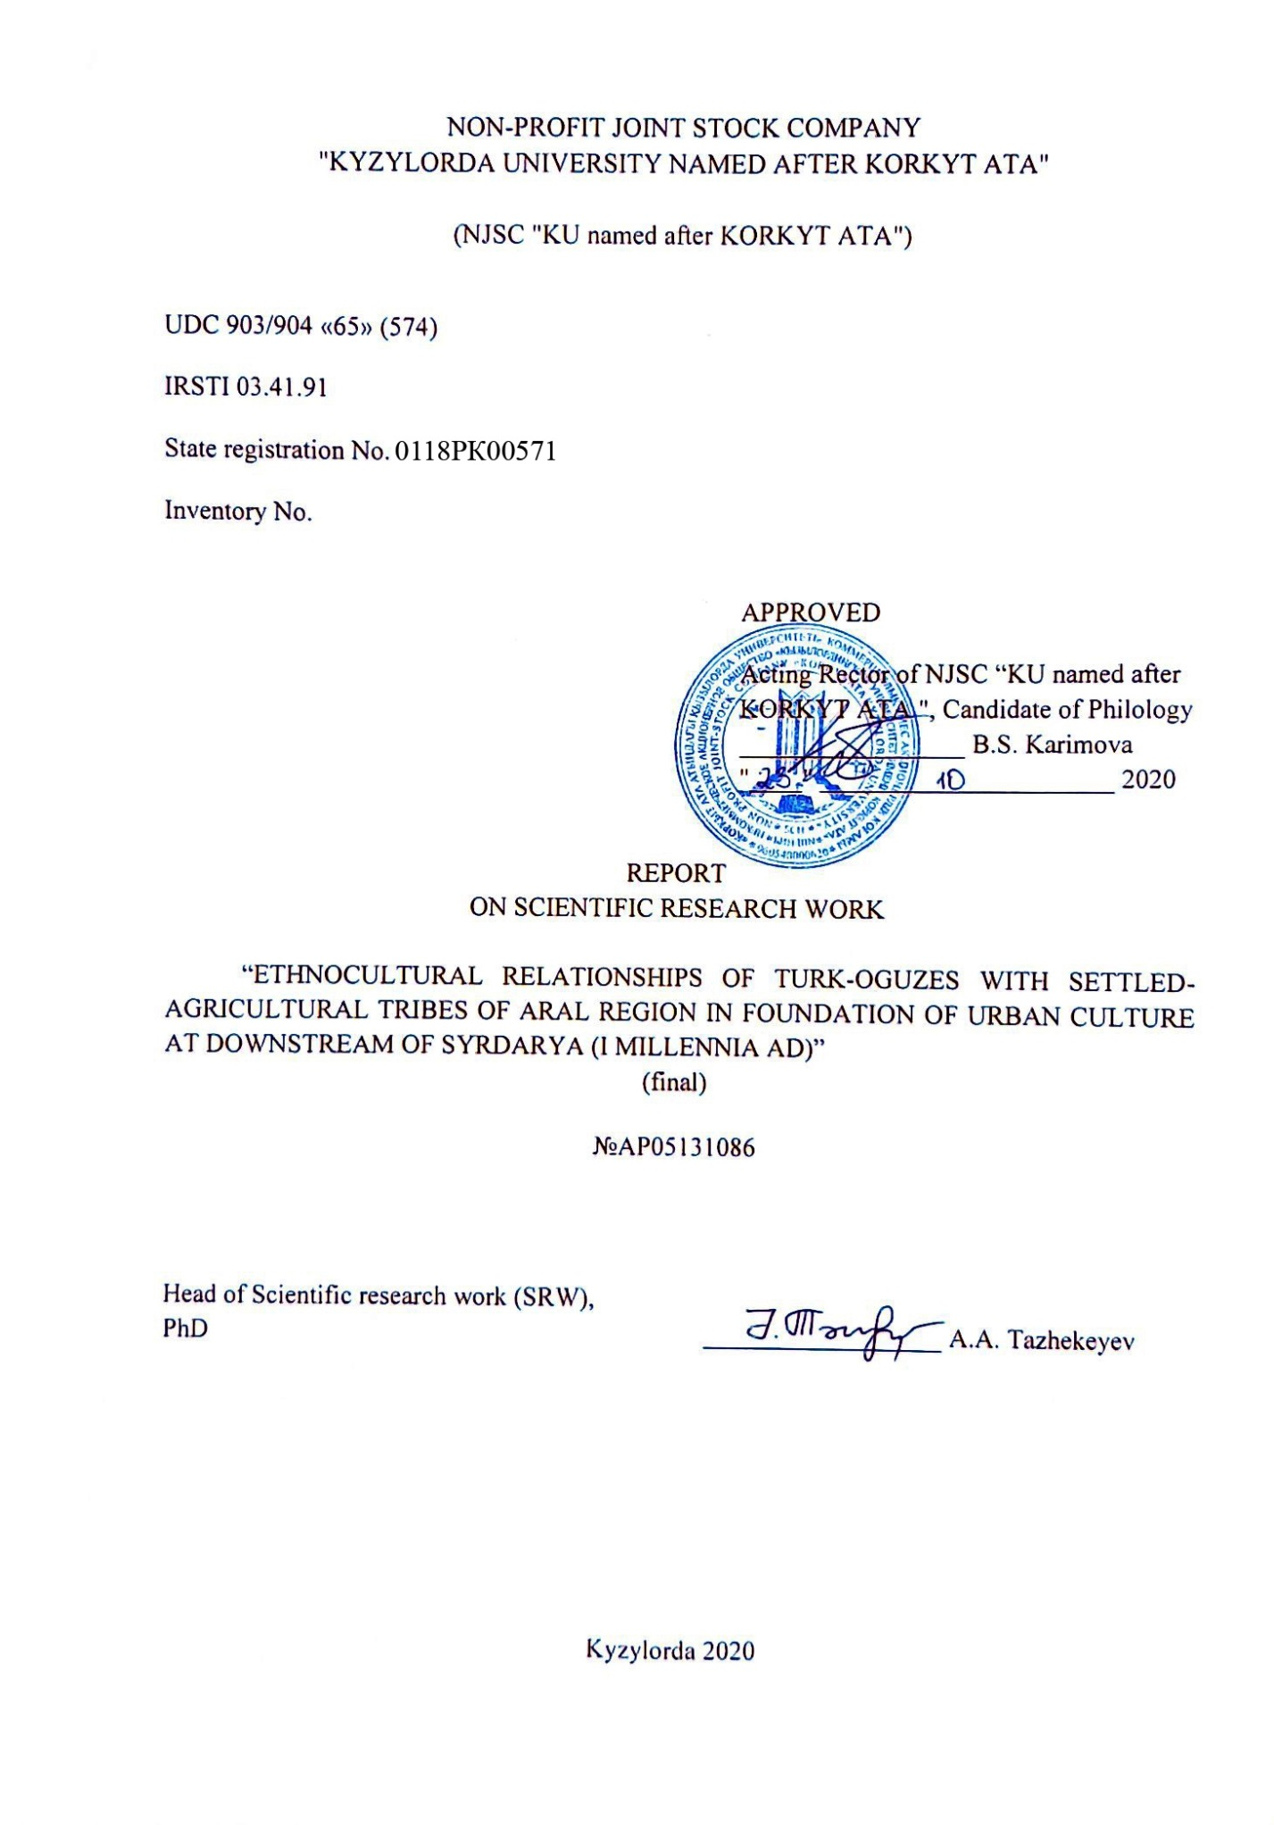
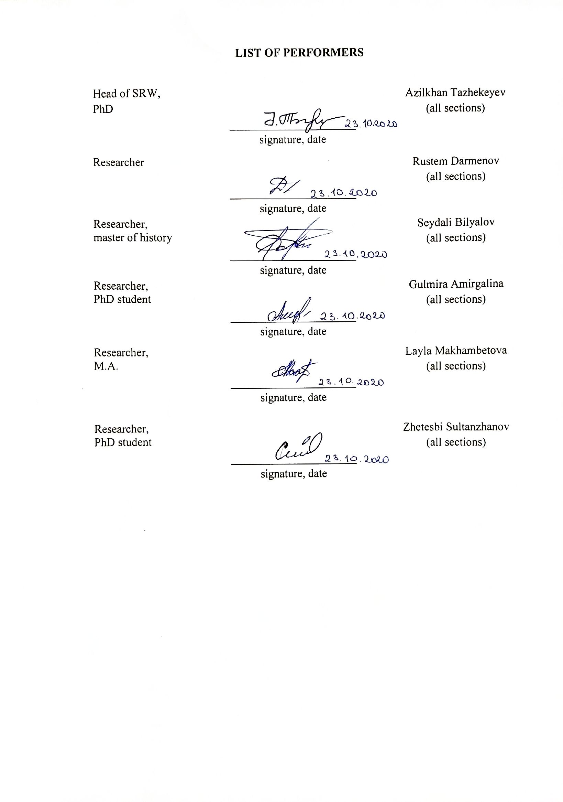

ABSTRACT

Report 127 p., 203 fig., 62 sources, 8 app.
DZHANKENT, ARCHEOLOGY, SITE, TRENCH, ARAL SEA REGION, NOMADS, SWAMP TOWNS, CERAMICS.
The object of this study is the town of Dzhankent and its environs that located in the Eastern Aral Sea region.
During the implementation of the project are carried out archaeological studies of the Dzhankent town, the analysis newly obtained during field work were conducted comparisons and contradiction with the already available data. An important place is given to the definition of the political, ethno-cultural, economic role of the tribes inhabiting the Eastern Aral Sea region and their relationship with the tribes of Central Asia and Eastern Europe.
The material and written sources collected in the course of research work were analyzed and compared with the latest published domestic scientific data. In the course of the research, new scientific research methods were applied, interdisciplinary communications were applied, there were taken into account the views of domestic and foreign archaeological scientists on this issue.
While carrying out the work, there were taken into account the theories related to agricultural and nomadic tribes, developed by archaeologists as K.M. Baypakov, S.P. Tolstov, B.V. Andrianov, M.A. Itina, B.I. Weinberg, L.M. Levina.
Archaeological sources are the main source study base in solving problems related to issues of a historical and cultural nature, as well as issues of interaction between different types of civilizations. In this study, the results of archaeological expeditions and the results of laboratory studies were used, which made it possible to illuminate in a new way the process of urbanization and subsidence of the nomadic tribes of the Aral Sea region from ancient times to the late Middle Ages.
In the field seasons of 2018-2020, archaeological work at the Dzhankent town was carried out by excavation and separate exploration teams. The excavation team conducted research work in a residential area in Shakhristan (Trench No.1), on a rural homestead in the vicinity of the site (Trench No.9). A separate reconnaissance detachment held research of sites in the vicinity of the Dzhankent town.
On the basis of the processed materials obtained from the town of Dzhankent, the source study base for the study of applied art and material culture of early medieval settlements was significantly replenished with new data.

CONTENT

INTRODUCTION……………………………………………………………  1 History of studying the lower Syr Darya. Literary review.…………..………  2 Archaeological field works in the town of Dzhankent……………………….…  2.1 Trench 1 and 9...……………………………………………………….  2.2 Archaeological exploration in the vicinity of the site……………..........  3 Analysis of archaeological material of Dzhankent for the field seasons 2018-2020........................................................................................  CONCLUSION..…….......................................................................  LIST OF REFERENCES…………………………….…………………………….  APPENDIX A List of published articles on the Project…………………………...  APPENDIX B Participation in conferences and seminars….……..................  APPENDIX C Participation of PhD students, undergraduates in research in the preparation of their dissertations……………………….….......................  APPENDIX D Work schedule..…………………………..........................  APPENDIX E Illustrations……………….…........................................  APPENDIX F Dates received by C14………………………………………….  APPENDIX G An illustration finds……………….………………………….  APPENDIX H Acceptance Certificate of Archaeological exhibits …..…………. | 5  8  14  14  25  28  38  41  46  51  54  55  68  110  112  121

INTRODUCTION

The goal of the work is to determine the role of the Eastern Aral Sea region in ethnocultural, political and economic relations with neighboring countries of Central Asia and Eastern Europe in antiquity and the Middle Ages.
Tasks: long-term stationary research at the archaeological sites of the Aral Sea region, by which it will be possible to obtain new information about the economy, material, spiritual culture and other spheres of life of the ancient nomads.
Local tasks:
a) a review of the main scientific literature on the study of the culture of the Eastern Aral Sea region and adjacent territories, processing and systematization of materials with summing up;
b) excavations at the Dzhankent town and rural settlements in its vicinity;
c) scientific analysis of the ceramic complex, glass and animal bones;
d) preparation for publication of thematic articles, exchange of theoretical views on the development of cities in the initial stage of early state formations.
The scientific problem to be solved by the project: The town of Dzhankent (Kazakh –Zhankent) occupies one of the key places in the early medieval history and archaeology not only the Aral Sea region, but the whole Kazakhstan. The site is located in the Kazaly district (Kyzylorda region), where in the Syr Darya delta there are large towns of the 7-10 centuries AD as Dzhankent (Yangikent), Kuyuk-kesken-kala and Kuyuk-kala that discovered and described by the Khorezm expedition in 1946. According to S.P. Tolstov's classification, these sites belong to the so-called “swamp towns” [1, p. 68]. The site has a rectangular shape, stretching from east to west; its area is about 15 hectares. The entrance gates are located on the west and east sides. At present time, the best preserved fortification is the outer walls with protruding semicircular towers. The square citadel is located in the northwest part of the town. On external examination, the lower part in the southeastern part of the site, as well as the northeastern hilly part (the most built-up), stands out clearly. Traces of the ancient layout are visible today only with aerial photography. Survey of the adjacent territory showed that there was also an unfortified part of the town. The Dzhankent was chosen for holding large-scale archaeological research for several reasons: 1. scientific significance for the study of ethnic and cultural processes not only for the Aral Sea region, but also for the southern Russian steppes; 2. well-preserved fortification and visually traced layout and zoning of the site; 3. poor knowledge of the “swamp towns” and the accompanying necropolises; 4. the presence in the micro-region of the infrastructure necessary for organizing the expedition. In the 9-12 centuries the southeastern part of the ancient Syr Darya delta (the upper flow of the Inkardarya) was the center of the town of the Oguz tribes that came here from the north from their ancestral regions – to the lower flow of the Pra-Kuandarya, where the so-called “swamp town”, sites, correlated with the early Guz were discovered in 1946. In addition, no later than the beginning of the 9th century AD, most likely, a part of the population of the Dzhetyasar tract advanced, which was, perhaps, one of the main groups of the population of the Inkardarya cities. The residence of the king of the Guz – “yabgu” in the 10th-11th centuries, as evidenced by a number of written sources, was the town of Yangikent (Dzhankent). The main fundamental problem, on decision which directed to expeditionary project, is associated with important aspects of ethnogenesis and history of the Kazakh people. To solve these problems, the period of the 8th-11th centuries, when the tribal unions of the Guz were formed, a network of cities on trade routes was formed and close contact was made between the nomadic population of the steppe and the sedentary population of the early medieval towns.
In connection with the solution of this problem, the main goal of the project is a comprehensive study of the Dzhankent town and its environs, as the most significant object of this region in the Middle Ages. The analysis of the vast ceramic material and metal finds will make it possible to draw conclusions not only about the presence or absence of continuity of cultural traditions between the Dzhetyasar circle of sites and “swamp towns”, but also significantly clarify the dates. The study of the supposed mound necropolis, discovered as a result of exploration in the vicinity of the settlement, will have opportunity to determine the ethnic composition of the ancient population of the city and the entire region.
A specific task within the framework of the problem, to be solved by the project. The expeditionary project involves detailed archaeological work to identify the historical topography of the city in the most information-intensive areas of the site, such as the Citadel, residential areas, fortification. During the expeditionary work, it was planned to determine various economic and residential zones of the ancient city, zones of water bodies, to identify different structures of life support systems. Analysis of the ceramic material and coin material gives opportunity to develop a fractional chronological scale and significantly clarify the dating of the monument, especially its lower layers. In the course of the work, it was suggested to study building technologies and building materials. Analysis of metal finds will reveal the sources of raw materials, as well as the level of the metalworking industry existing at that time. Detailed route studies in the vicinity of the monument will aim at identifying the accompanying necropolis and landscape features. The work at the Dzhankent necropolis will help determine the ethnic composition of the population and the peculiarities of the funeral rite.
The current state of research on this problem, the main directions of research in world science: In 1946, the KhAEE summer group visited the site. During this expedition, aerial photography was carried out and lifting material was collected. S.P. Tolstov put forward a hypothesis that the settlement existed continuously from ancient times (from the beginning of our era) to the 10th-11th centuries. The dating of the site proposed by Tolstov remained unchanged for a long time and was only corrected in the works of L.M. Levina, who believed that the site survived until the 14th century. At present time, in the IEA RAS keeps an archive related to the work of the Khorezm expedition in this region. All these aerial photographs were repeatedly used by members of the expedition during archaeological research. Especially noteworthy are the works of B.V. Andrianov, who in the study of the ancient irrigation systems of the Aral Sea region [2; 3; 4] widely used all kinds of aerial photographic materials. These works by B.V. Andrianov were preceded by many years of work by archaeologists in the oases of Khorezm and the lower flow of the Syr Darya, and above all by S.P. Tolstov, Ya.G. Gulyamov (Khorezm), A.I. Terenozhkin (Right-Bank Khorezm). Since the 1950 geomorphologists (A.S. Kes, Institute of Geography, RAS) and periodically soil scientists were involved in the field work.
Archaeological work in the left-bank Khorezm and the delta regions of the Syr Darya in the 1960s and subsequent years made it possible to continue this entire complex of studies and even expand it. Much specialized work was carried out by A. A. Tazhekeyev on the study of materials from the Syrdarya delta. He defended his doctorial dissertation on the theme “History of the development of the Southeastern Aral Sea region from ancient times to the end of the 1st millennium AD”, in which were processed both archival and the latest materials. Despite the enormous and fruitful work done by the predecessors to compare aerial photography and available archaeological materials, the “swamp towns”, the problems of which were repeatedly raised in the scientific literature, remain practically unexplored from the point of view of archeology. Since “swamp settlements” are a feature of the cultural and historical landscape of the Aral Sea region, there are no analogues in the world practice for such studies.
Inventory №0219RK00442 of the interim report for 2018; Inventory №0218RK00373 of the interim report for 2019.

1 History of studying the lower Syr Darya. Literary review

The area of the lower Syrdarya is part of the Turan plain [5, p. 675]. Academician V. V. Barthold wrote: “Turan is the basin of the Aral Sea” [6, p. 231]. The lower reaches of the Syrdarya river are located on the eastern coast of the Aral Sea. In this regard, in the scientific literature, this territory is also called the Eastern Aral Sea Region.
In the area of the lower Syr Darya or in the Eastern Aral Sea region, there are many archaeological sites containing the remains of architectural structures. These sites are mainly represented by fortified settlements – the remains of towns or fortified settlements. The earliest news about these cities is found in medieval written sources. The writings of medieval historians, geographers and travelers contain information about the cultural and historical processes that took place in this territory in the 9th-12th centuries, as well as about social relations, the system of management and life of the nomadic tribes that lived in the territory of the Eastern Aral Sea region during this period.
All known written sources regarding the history of the Oghuz and medieval towns of the lower reaches of the Syr Darya were analyzed and described in detail in the 2018 report.
Historical and geographical study of the archaeological sites of the Eastern Aral Sea region begins in the middle of the 18th century as a result of the establishment of relations between the Russian Empire and the Kazakh Khanate. By an agreement of 1731 between the khan of the junior zhuz Abulkhair and the empress Anna Ioannovna, the territory of the junior zhuz (eng. union) joined the Russian Empire. Already in the first half of the 19th century, the traditional khan system of power was abolished. After a series of reforms, the khan's form of government was replaced by a system of regional governors general (The Turkestan province, etc.). By the end of the 19th century, the entire territory of modern Kazakhstan was annexed to the Russian Empire [7]. The construction of fortification lines began, first on the border, then in the steppes themselves [8].
This political situation contributed to the beginning of the cultural and historical study of the annexed territories. Tazhekeyev notes that the study of the Kazakh lands, first of all, pursued a political goal. Military and civilian officials of the Russian Empire, who collected geographic, strategic and other information about the Kazakh steppes, simultaneously collected information about antiquities [9, p. 15]. According to L.S. Klein, in the East (Central Asia, the Caucasus, Siberia) and the West (Europe and America), archaeological science was formed simultaneously, but in the East the process proceeded more slowly. “The archeology of Central Asia and the Caucasus was, as in the West, closely linked with philological Orientals; As in the West, officers played a huge role in its development at first” – wrote L.S. Klein [10, p. 257].
The travel notes and reports of Russian officers of the 18th-19th centuries contain descriptions of the geographical situation of the lower reaches of the Syr Darya, information about ancient sites, and the results of cartographic work. In 1740-1741 the territory of the lower Syr Darya was visited by the lieutenant of the Orenburg Dragoon regiment D. Gladyshev and the geodesist Muravin, who were following the way from Orsk to Khiva. According to Khanykov, the purpose of the trip of D. Gladyshev and Muravin was to study the route with a geodetic method, while they created a route map on the section from the Orsk fortress through the mouth of the Syrdarya to the city of Khiva. For the first time the location of the settlement of Dzhankent (Yankent, after Muravin) is indicated on the map [11].
In 1762 P.I. Rychkov, a historian of the Orenburg region, published the work "Topography of the Orenburg province" [12]. Rychkov's book describes the location of the ancient delta of the Syr Darya, mentions the settlement of Dzhankent and tells the folk legend associated with it [12, p. 185]. The huge ruins of Dzhankent and the legends associated with it could not fail to attract the attention of researchers. A.A. Tazhekeyev, in his dissertation work, analyzed the historical and geographical works of the 18th-19th centuries, which mention ancient monuments, including Dzhankent. He noted that almost all authors of the 18th-19th centuries cite folk legends about the fall of Dzhankent in connection with the invasion of snakes [9, p. 41].
Research into the archaeological sites of the Eastern Aral Sea region in the 19th century is associated with a new stage in the colonial policy of Russia. From the middle of the 19th century, the tsarist empire began building military fortifications on the territory of Kazakhstan [13, p. 274-280; 14, p. 349; 15]. As a result, since 1847, constant topographic and geodetic works were carried out in the lower reaches of the Syr Darya. This political situation contributed to the expansion of the study of the region and the increase in information about archaeological sites. Such information is presented in the works of state and military personnel of the Russian Empire - A.I. Lyovshina [16], A.I. Maksheeva [17-19], L.L. Meyer [13] and others.
We must agree with the opinion of Tazhekeyev about the nature of the differences between the works of researchers of the 18th and 19th centuries [9, p. 15-17]. According to him, the researchers of the XVIII century. (D. Gladyshev, Muravin, P.I. Rychkov) limited themselves to describing the region and fixing antiquities. In the works of the researchers of the 19th century – A.I. Levshin, A.I. Maksheev, L.L. Meier, the first scientific hypotheses are expressed; a comparison is made with the information of medieval written sources.
Archaeological study of the sites of the Eastern Aral Sea region begins in the second half of the 19th century, which was associated with the formation of archeology as a science and the creation of various scientific structures in the Russian Empire [20; 21].
In 1867, on behalf of the Archaeological Commission P.I. Lerch and his assistant M.K. Priorov visited the territory of the lower reaches of the Syrdarya. For research work P.I. Lerh was given an "Open Sheet" [22, p. 786].
P.I. Lerkh examined several monuments in the lower reaches of the Syr Darya and for the first time conducted archaeological excavations at the Dzhankent town. Captain M.K. Priorov conducted a survey of the area in the vicinity of the site. Unfortunately, the survey drawings were not published in P.I. Lerh. He gives a more detailed description of Dzhankent, in comparison with its predecessors [22, p. II]. He excavated four objects in the central and western parts of the town. The researcher came to the conclusion that the site represents the remains of the Yangikent town, mentioned in medieval written sources [22, p. I-VII].
P.I. Lerkh was interested in the location of the cities of Jend and Asanas (Eshnas, according to him), which in written sources, as well as Dzhankent, are mentioned among the Oguz towns. Comparing medieval written sources, Lerkh came to the conclusion that Dzhend is located in the area of the Korkhut cemetery on the right bank of the Syr Darya [Ibid, p. VII-VIII]. Regarding the town of Asanas, he made the following assumption: "... he [Plano Karpini] on the Syr saw a city named by him Ornas (maybe it is Rashid-ad-Din’s and the Juveini’s city of Eshnas" [22, p. 9].
The subsequent study of the sites of the Eastern Aral Sea region was associated with the emergence of the Turkestan Circle of Archeology Amateurs (TCAA) – the first scientific community in Central Asia. TCAA was founded by the efforts of the largest orientalist V.V. Barthold in 1895. The center of the TCAA activity was the city of Tashkent. About the Turkestan circle of B.V. Lunin wrote: "... it was a local lore research organization specialized in the humanities, for more than twenty years (1895-1917) carrying out work on the study of archeology and the history of the material culture of the Middle" [23, p. 9-10].
The names of prominent representatives of Russian oriental studies, such as V.V. Barthold [24; 25], I.V. Anichkov, P.S. Spiridonov [26], E.T. Smirnov [27], V.A. Kallaur [28], I.A. Castanier [29] and others. Their scientific works were repeatedly published in the edition of the circle called "Messages of meetings of members of the Turkestan Circle of Archeology Amateurs" [23, p. 11].
In the middle of the 20th century, the Khorezm archaeological and ethnographic expedition (KhAEE) of the USSR Academy of Sciences began large-scale studies of archaeological sites in the south-eastern Aral Sea region. The leader of the expedition was the authoritative Soviet archaeologist Sergey Tolstov. As part of the Khorezm expedition, reconnaissance (air reconnaissance and ground), excavation and topographic detachments worked. In the fall of 1946, during the fourth and final route of the air reconnaissance detachment of the KhAEE, the northern part of the Kyzylkum desert, between the Amu Darya and Syrdarya rivers, was explored. The result of the reconnaissance expedition was the discovery of about two hundred archaeological sites of different eras - from the Early Iron Age to the late Middle Ages [30, p. 61-62].
Medieval archaeological sites were mainly studied in the vicinity of the Dzhan-kala settlement and as part of the Yangikent group of sites.
In the Dzhend region, the town of Dzhend and the fortified settlements of Beshtam-kala, Kum-kala 1 and 2 were examined. Their descriptions were compiled, aerial and topographic surveys were carried out. As a result of these works, S.P. Tolstov came to the conclusion that in the XII-XIII centuries. Dzhend District was a densely populated area [30]. This date was determined on the basis of Khorezm ceramics found in the vicinity of the sites.
From the sites of the Yangikent group, the medieval sites of Kesken Kuyuk-Kala, Dzhankent and Bolshaya Kuyuk-Kala were described in detail, their aerial and instrumental survey was carried out, and lifting material was collected. All three towns were dated by S.P. Tolstov period from the beginning of our era to the 10th-11th centuries [1, p. 57-68]. In 1963, archaeological excavations were carried out on the southern wall of the Kesken Kuyuk-kala settlement under the leadership of V.I. Weinberg.
The problems of studying medieval fortified settlements in the lower reaches of the Syr Darya are covered in special articles and sections of the monograph by S.P. Tolstov [1; thirty; 31]. As a result of his research on the territory of the Yangikent group of sites, Tolstov discovered a kind of culture, the carriers of which were sedentary cattle breeders, farmers and fishermen of the Eastern Aral Sea region of the first millennium of our era. The population of this culture formed the core of the early medieval Oghuz state [30, p. 62]. Tolstov called the culture - the culture of “swamp towns”. According to S.P. Tolstov, a group of sites of this culture is located "not far from Kazalinsk on a flat, low-lying, humid plain, bounded in the north by the Syr Darya, in the west by the Aral Sea and in the east by a strip of swamps and reed floodplains, which ends in the Kuvan-Darya old rheum" [1, p. 58; 31, p. 276].
In 1959-1961, during the research of the KhAEE route detachment, the southern group of Oguz sites was discovered, located in the basins of the Zhanadarya and Inkardarya rivers. These sites include the fortress Khoja-kazgan 1, the medieval towns of Syrlytam-kala, Zangar kala and Asanas. On Zhanadarya, the towns of Dzhend, Beshtam-kala and the Kum-kala fortress were re-examined, which gave materials of the "Khorezmshakh time" (12th-14th centuries) [31, p. 273-294].
According to the results of long-term research of archaeological sites of the Dzhetysar tract, an employee of the KhAEE L.M. Levina published in 1971 the monograph "Ceramics of the lower and middle Syr Darya in the 1st millennium AD", in which the ceramic complexes of the Dzhetyasar, Kaunchi and Otrar-Karatau cultures were thoroughly analyzed [32]. The work also considers the ceramic materials of the culture of "swamp towns". L.M. Levina touched upon the problem of the time of the existence of the medieval towns of this culture. It should be noted that until that time, the chronology of the culture of the “swamp towns” proposed by S.P. Tolstov. However, L.M. Levina, having analyzed the ceramics of the “swamp towns”, came to the conclusion that there are also ceramics of the developed Middle Ages in Dzhankent. In her opinion, ceramic vessels from the settlements of Kesken Kuyuk-Kala and Bolshaya Kuyuk-Kala are of the same type and are identical to the ceramics of the 3rd stage of the Dzhetyasar culture, which dates from the 7th – early 9th centuries [32, p. 77-85]. Thus, the conclusions of L.M. Levina confirmed the dating of V.I. Weinberg.
In 1960, Soviet archaeologists began to create an "Archaeological Map of Kazakhstan" [33]. As a result of expeditionary work, during which materials for the "Archaeological Map of Kazakhstan" were collected, brief descriptions of medieval towns (Yangikent, Kesken Kuyuk-Kala, Bolshaya Kuyuk-Kala, etc.) were made in the lower reaches of the Syrdarya River [33, p. 192-193].
Modern research of the archaeological sites of the Eastern Aral Sea region begins in the 2000s. It was carried out thanks to the adoption in the Republic of Kazakhstan of the state program "Cultural Heritage". As part of the implementation of this program in 2004-2006, a survey of the archaeological sites of the Kyzylorda region was carried out. In the course of research Zh.K. Kurmankulov and A.A. Tazhekeyev determined the GPS coordinates of the towers and photographed them. The results of the work are presented in the “Code of historical and cultural monuments of the Republic of Kazakhstan. Kyzylorda region” [34].
The study of the fortified sites near the Syr Darya began after a conference on the problems of the Aral Sea archeology in 2004. (Kyzylorda, Kazakhstan). At the conference, researchers from Kazakhstan and Russia signed an agreement on cooperation in the field of archeology. In this regard, joint work of the Korkyt Ata Kyzylorda State University (Korkyt Ata KSU), the A.Kh. Margulan of the Ministry of Education and Science of the Republic of Kazakhstan (IA MES RK) and the Institute of Ethnology and Anthropology named after N.N. Miklukho-Maclay of the Russian Academy of Sciences (IEA RAS).
The initiator of archaeological research in the Aral Sea region was Korkyt Ata KSU, on the basis of which the “Dzhankent Archaeological Expedition” was formed in 2005, and in 2011 the Research Center “Archeology and Ethnography” was established. On the basis of a cooperation agreement, 6 specialists entered the postgraduate course at the IEA RAS named after N.N. Miklukho-Maclay. To date, two of them have defended their PhD theses, and are engaged in research in the region [35, p. 176-177].
The reconnaissance expedition organized in 2005 set itself two main tasks:
1) inspection of the archaeological sites of the Kyzylorda region, partially investigated by the KhAEE, and fixing their current state;
2) selection of a site for carrying out stationary archaeological research.
The reconnaissance route passed in two directions, while the archaeological sites of the Kazaly and Karmakchy districts of the Kyzylorda region were investigated. The total length of the route was more than 3000 km. As a result of the work of this expedition, the town of Dzhankent was chosen for carrying out stationary archaeological research. The choice was explained by insufficient study of the site and favorable conditions for the base of the expedition [36, p. 4-5]. After that, from 2005 to the present, stationary archaeological work has been carried out on Dzhankent, in which Kazakh, Russian and German archaeologists take part.
In 2017, the Sortobe detachment of the Dzhankent archaeological expedition began archaeological work at the medieval town of Sortobe, located in the Karmakchy district, on the left bank of the Syrdarya [37, p. 62-75].
The research results of the Dzhankent archaeological expedition have been published and are being published in conference proceedings and in scientific journals of various levels [38-43; 44-47; 48-49; 50-51; 52-53; 54-55]. To date, two volumes of summary reports and a collection of articles have been published, which present the results of archaeological research at the Dzhankent town [36; 56; 57].

2 Archaeological field works in the town of Dzhankent
2.1 Trench 1 and 9

The Dzhankent archaeological expedition of the Korkyt Ata Kyzylorda University, archaeological work was continued at the Dzhankent town, located in the Kyzylorda region of the Republic of Kazakhstan, in 2018-2020.
The objects of research were living quarters at the Dzhankent town (Trench 1) and a rural estate located in the vicinity of the ancient settlement (Trench 9). Illustrations are presented in Appendix D.
Trench 1 (hereinafter Tr.1) was laid in 2005 (the first field season) in the northeastern part of the site on a vast oval hill 35 × 30 m in size. Tr.1 was laid out along the northwestern steep slope of the hill, i.e. oriented along the relief; therefore its meridional axis had a deviation of 30 ° to the north-east of the north-south line. Archaeological work at the Tr.1 site was also carried out in 2006-2007, 2009-2010, and in 2011-2017, 2018-2020.
The tasks of archaeological research on Tr.1 and the adjacent part of the settlement included the determination of the structural and structural features of residential and commercial buildings, a detailed study of stratigraphy, the identification of early cultural layers and building horizons, as well as the determination of the relative and absolute chronology of the construction and functioning of the housing and economic complex opened on this place by previous works.
Research methodology. In the course of work at Tr.1, complex methods of field archaeological research were used, used in the excavation of sites containing elements of architectural structures. As already noted, due to the orientation of Tr.1 along the topography of the hill, the meridional axis of the excavation site is deflected by 30°. The startigraphic excavation is divided along the axial edge, oriented along the E-W line, measuring 16 × 8 m. Initially, the excavation area (2005) was 100 sq. m (10 × 10 m). Taking into account the work and expansion of the excavation, which were carried out in 2006-2007, 2009-2010, and in 2011-2017, by the time of the resumption of work on it in 2018-2020, its area amounted to more than 1000 sq. m. The conventional zero benchmark for Tr.1 was an iron stake driven into the southern side of the excavation site (in 2016 it was interrupted due to the fact that this area fell under the excavation site). All depth marks on the excavation site were taken from its top. Benchmark Tr.1 is included in the general leveling grid of the town, which makes it easy to correlate the leveling marks of various objects on the site.
In the field seasons 2018-2019, 2019-2020, the main work was aimed at identifying stratigraphy and early planning at Tr.1. As shown by previous works, the upper construction horizon Tr.1 had two periods of existence. At this time, the planigraphy within Tr.1 did not change. In the upper construction period there were houses with one- or two-room living quarters. These are premises No. 6, 15, 32, 33a, 34, 42,44, 45, 46, 47, 48, 49, 51, 52, 53 (figure E.1, E.2). The walls are made of adobe bricks with dimensions of 31.5 × 21.5 × 6 cm and 20.7 × 22 × 5 cm. In the lower building horizons, the dimensions of bricks expanded to 40-39 × 21-20 × 6-7 cm.
In the field seasons 2018-2019, 2019-2020, 15 residential premises of various sizes and purposes were opened.
1st construction horizon
Room 32. On the western side of the room 15, the room 33 is adjacent (figure E.3). This rectangular room, 4.5 × 3.5 m in size, was most likely included in the complex of houses on the west side of Tr.1, since the entrance door or passage to the room was in the northwest corner. To the left of the entrance to the northern wall, a sufa with dimensions of 90 × 210 × 40 cm was attached. The sufa was faced with adobe bricks placed vertically, however, the facing remained to a height of 15-20 cm.Its wall was made of adobe bricks measuring 20 × 30 × 6 cm in one row.
The floor of the room was completely covered with wet clay, in several layers. In the western part of the room, a dense obstruction was opened, possibly from a fallen vaulted ceiling. The fallen adobe bricks lie with an edge in a horizontal position in 4-5 rows, the debris was not cleared completely to the floor level, and this prevents the ability to visually cover the room completely. For this reason, it is also impossible to talk about the presence or absence of a hearth in the room.
The southern wall of room 32 is a continuation of the southern wall of room 15. The wall starts at squares 109/102 and goes under the southern edge at squares 110/98. The wall is 10 m long. Within room 15 (about 3.2 m) the wall is 60 cm thick. Further it becomes wider and reaches 90 cm in wide. Three rooms have been uncovered along this southern wall. The western wall of room 32 can be designated twice; the first part (attached to room 33) is 1.8 m, 55 cm thick. Further, the wall turns to the west at 90°, forming a small angle of 50 cm, and the second part is 3 m long, also 55 cm thick. The eastern wall of the room divides it with room 15, the thickness is 90 cm. The northern wall, according to the general plan, is load-bearing, starts in squares 107/102, excavated in last year's field seasons and reaches a long of 10-11 m. Very bad the upper part of the wall has been preserved, lower at the level of ▼-150, -160 cm it reaches a thickness of 80-90 cm.
Room 33. The small room was probably a utility room, as several hums were found in situ under the rubble. Fragments of hums show that they were crushed by the fallen earth. The room has not been cleared to floor level, but the placement of the objects found suggests that they were on the floor. Hand-made pottery of poor firing, when removed, they crumble. The dimensions of the room are 2.05 × 2.50 m. The thickness of the western wall is 60 cm. In the northern part of the room, a small section of the floor (1.50 × 0.70 m) was cleared; it was filled with clay, or plastered with it in several layers. In the southwestern corner of the room, a fragment of a vessel was found, inside which was the skull of the small-horned cattle (figure E.4).
Room 34 (Figure E.5). It is a narrow but rather long room. Dimensions – 1.50 × 4.10 m. The room was cleared to the floor level, fixed at a deep of ▼ -129 cm. The floor is filled with light gray clay in several layers; it was probably periodically smeared over. A ceramic dastarkhan with a diameter of 60 cm was found in the center of the room; it was fixed upside down. The state of its fragments at the time of excavation shows that the dastarkhan stood on the surface or on the floor, and then it was broken under the weight of the fallen rubble (wall). Thus, the floor surface was at a shallow depth from the day surface, and the discovered dry clay is most likely an adhesion layer. Near the dastarkhan, a small red-clay ceramic vessel was discovered that was in situ. The south side of the narrow room goes to the edge.
Room 35 (figure E.6). It is adjacent to room 33 on the north side. Only a small part of the room got into Tr.1, its dimensions in the eastern part are equal to 2.5 m. The room has not been cleared to floor level. In the central part, traces of a tandoor are visible, in the western profile, traces of backfilling are clearly visible interspersed with coals and lumps of clay.
Room 42 was located in the northeastern part of the Trench (figure E.7). The room had a rectangular shape, measuring 4.60 × 3.15 m. The walls of the room consisted of a loose mud block, which is clearly visible on the profiles. A lot of pottery fragments were found in the filling, mainly hums were found here.
The wide of the southern wall of room 42 is 70 cm. Its height is 35 cm above the floor level. No bricks were found in the upper layer of the masonry. The eastern wall was 25 cm wide and 15 cm high above the floor. The southern edge of the wall of the room is the main load-bearing wall, which runs through the entire excavation, and is 4.60 cm long in room 42. Within the excavation, 3 rows of raw bricks with dimensions of 36-38 × 20 × 6 cm were traced on the load-bearing walls "spoons".
The west wall is 48 cm wide and 35 cm high from the floor. A sufa 97 cm wide and 3.15 m long was made along the western wall. The sufa retaining wall is 25 cm high. The horizontal surface of the sufa is covered with clay plaster with a layer thickness of 10 cm. The inner filling of the sufa is not selected.
The floor of the room is paved with adobe brick in 2 rows, fixed on clay mortar. Several layers of clay with a total thickness of 5 cm are traced. In the middle of the floor there was a hearth. It is a rectangular structure with a size of 93 × 98 cm. The walls of the hearth were made of fragments of adobe bricks placed on the end. Its width is 6 cm. The height of the wall is 10 cm. The walls are calcined; the filling consisted of sandy loam with ash. In the southeast corner of the room, a large hum was placed on the floor, which was broken due to the collapse of the load-bearing eastern wall.
Room 43 – utility room, apparently, was a corridor that connected with room 44 (figure E.8) located in the eastern part of trench. The room had a rectangular shape, its length along the west-east axis was 4 m and its wide along the north-south axis was 1.50 m.
Room 44 was located in the central part of the excavation site on the north side (figure E.9). The room had a rectangular shape, its length along the west-east axis was 6.30 m and its width along the north-south axis was 3.50 m. The walls of the room consisted of a loose mud block. A lot of pottery fragments were found in the filling, mainly hums and animal bones.
The width of the surviving walls of room 44 varies from 70 to 90 cm. Their height varies from 25 to 40 cm above the floor level (2-4 layers of bricks).
Here, in the central part of the western wall, there is a passage that connected this room with room 46. The northern wall has not survived completely; it is the main load-bearing wall, also for rooms 42 and 43. Its width is 90 cm. In our opinion, there is also a passage connecting room 44 with room 45.
As noted above, the excavation area suffered from the impact of dense vegetation and rodent burrows, and no residential floor was found in this area of the excavation. However, in the southeast corner of room 44, a central hearth was identified. It was also possible to reveal that the central hearth of the dwelling in the eastern part of the excavation rose above the backfill level, at the mark ▼-107 cm. The hearth is a rectangular construction with dimensions of 70 × 90 cm. The walls of the hearth were made of fragments of adobe bricks placed on the end. Their width reached 6 cm. The height of the walls was 10 cm. The walls were calcined; the filling consisted of sandy loam with ash. Here, in the eastern part of the room, an entrance vestibule was revealed, measuring 68 × 145 cm. It is made of adobe bricks, like the main load-bearing walls. Due to the poor preservation of the eastern wall of the room, the dimensions of the passage to the room could not be identified.
Room 45 was located in the central part of the excavation site (figure E.10). It had a rectangular shape, its long along the west-east axis was 4.90 m and its wide along the north-south axis was 1.30 m. The walls of the room consisted of a loose mud block. A passageway connected room 45 to room 44 on the south side. The wide of the passage in some places reaches 1.50 m. This room, apparently, was a utility room. Inside the premises, during the clearing, no interior details were found that could indicate its functional purpose. A small amount of bat and fragmented ceramics, as well as animal bones, were found here.
Room 46 was located in the central part of the excavation site on the south side (figure E.11). It had a rectangular shape, its long along the north-south axis – 1.90 m and wide along the west-east axis – 4.15 m. The walls of the room consisted of a loose mud block. It was connected by a passage to room 44 on the south side. The width of the passage in some places reaches 1 m. It is possible that room 46 was also an auxiliary one. The lack of interior details inside the premises does not allow testifying to its functional purpose.
Room 47 is a residential section heavily disturbed by vegetation (figure E.12). It was located in the western part of the excavation site. The room had a rectangular shape, its long along the west-east axis was 6.00 m and its wide along the north-south axis was 3.10 m. The residential floor here, as in other rooms, was strongly disturbed, and was detected at the ▼-106 cm mark see. The interior is represented by the remains of a sufa that ran along the northern wall of the room. Its wide is 82 cm.
Room 48 – utility room was also badly damaged by vegetation and rain runoff, which fell on the western side of the block where the street was running (figure E.13). The room is located in the western part of the excavation site. It has a rectangular shape, its length along the west-east axis is 4.20 m and its width along the north-south axis is 3.10 m. There are no interior details in the room.
Room 49 was found at the level of ▼-128 cm (figure E.14). The preservation of the walls at the level of one row of brickwork was recorded. The interior of the room is not traced.
Room 50 – The utility room was apparently a corridor that connected to room 48 (figure E.15) located in the western part of the excavation site. The room had a rectangular shape, its long along the west-east axis was 5.50 m and its wide along the north-south axis was 3.10 m. Here, at the level of the residential floor, an accumulation of broken ceramics and a table – dastarkhan was revealed (figure E.16). No remnants of the interior were found.
Room 51 is a residential area also heavily disturbed by rainfall and vegetation. It is located in the western side of the excavation site, adjacent to the street (figure E.17). The building has a rectangular shape, its length along the west-east axis is 5.40 m and the wide north-south is 3.20 m. The walls here have been preserved at the level of one or two bricks, so the interior details are poorly preserved. In the southwestern part of the room, a tandoor stove with a diameter of 70 cm was found (figure E.18). In the eastern part of the room, a whole table – "dastarkhan" was also found near the wall (figure E.18). No other details were found in the room.
Room 52 – residential area, also heavily disturbed by rainfall and vegetation (figure E.19). It is located on the eastern side of the excavation site; the area of the room has not been fully disclosed. The room has a rectangular shape, its long along the west-east axis is 4.00 m and the wide north-south is 2 m. The walls here have been preserved at the level of two or three bricks, so the interior details are poorly preserved. A fragment of a rectangular hearth was found in the southeastern part of the room. The upper part of the ritual hearth in the form of a protome of rams looking in different directions has not been preserved.
2nd construction horizon
Room 32 in the second building horizon was oriented along the north-south axis. The residential floor was found at a deep of ▼-263 cm. The floor is made of adobe bricks measuring 30 × 20 × 6 cm, arranged in several rows (figure E.21-E.27). The clearing of the room did not reveal the interior elements inside; there are no even hearths and stoves in the form of tandoors. Here, in the western wall in the second building horizon, there is a passage to the street (figure E.28), which was laid during the renovation of the building in a later period. The passage, up to 1 m wide, is laid with bricks measuring 30 × 20 × 6 cm. A long corridor, made up of large adobe blocks that lay under room 34, departs from the entrance.
Internal filling of the room is meager, and is represented by broken ceramics, bones of small ruminants. As the work showed, the building in the early period was an entrance room – an iwan.
Room 33а. Clearing of the lower layers showed that in the earlier period, rooms 33 and 35 were one room. Perhaps it was also auxiliary. Here we did not find any traces of interior elements. It is a rectangular room, measuring 4.60 × 2.70 m, made of large pakhsa blocks, measuring 80 × 100 cm. The western wall rests on the street, where it was slightly deformed by late construction works. Here we have a passage from the street, blocked by adobe bricks. The width of the passage is about 1 m. At the mark ▼-269 cm, several rows of adobe bricks have been preserved (figure E.29-E.32).
Room 34. When clearing the lower layers, it was revealed that there was a narrow corridor under the living quarters at the level of the early construction horizon. The walls of the corridor are made of pakhsa blocks measuring 80 × 100 cm and 5 m long. The corridor connected the living quarters with the street. The internal filling of the corridor consists of seasonal (most likely winter) waste in the form of organic matter, ash and coal. The filling layers are placed in layers alternately with the ground (figure E.33-E.35).
Room 53 (figure E.36). It is located in the western part of the excavation site, adjacent to the side of Trench 1. The size of the room is 5.00 × 2.60 m. Here, prior to the excavation, the damaged walls of the dwelling were visually traced, with a slight slope towards the street. Clearing showed that the level of the first building horizon is not completely fixed; only small remnants of the walls have survived. In the lower layers under the walls of the dwelling, the level of the residential floor is fixed; it is a dense layer of trampled clay with an admixture of organic matter. The floor is marked at the ▼-286 cm mark. Here, in the center, a utility pit with a diameter of 80 × 80 cm was revealed. The depth of the pit floor was revealed at the mark ▼-341 cm (figure E.37).
It should be noted that after the end of archaeological work, conservation and primary restoration were carried out on the exposed areas (figure E.38-E.40).
Test Pit 1 (2018-2020). The purpose of laying a pit is to identify the lower layers of the settlement, as well as to establish the depth to which the cultural layers of the monument lie. As we deepened, we traced several building horizons overlapping each other.
Test Pit 1 was laid in room 15 of Trench 1 (figure E.41-E.45). The size of the pit is 460 × 250 cm. In this pit, a section was made of the inner wall of a residential building, and the cultural layers on which the residential building stands were revealed. Layers will be described from top to bottom.
The mainland is recorded in a pit at the level of ▼-605 cm. It should be noted that the level of the mainland surface has a natural inclination from north to south and from east to west up to 30-60 °. Moreover, it should be noted that the decline is sharp, thus, it can be seen how the cultural layers and backfilling of raw bricks lay down, obliquely falling down. The following profile stratigraphy was revealed here.
The profile of the Western side (figure E.46). We found that the western wall was rebuilt and repaired several times. Moreover, it was noted that the bricklaying technique and its dimensions for the two upper horizons do not change. The transition is marked by a dense layer of clay. The upper part of the wall has been preserved at the level of ▼-76 cm; this level is characterized by raw bricks measuring 31.5 × 21.5 × 6 cm and 20.7 × 22 × 5 cm. The layer can be conditionally divided into periods marked by the repair of the walls. This horizon includes the appearance of a curbstone in the western corner, revealed at the level of ▼-81 cm and reaching the mark of ▼-221 cm. It overlaps the second construction horizon. Also at this time, in the southern part of the room, a sufa is being built, going along the entire perimeter of the southern wall, 2.5 m long and up to 1 m wide. Sufa is marked at a depth of ▼-153 cm.
The second building horizon was found at the mark ▼-140 – -160 cm, no signs of an interior interior were found, it can only be noted that in the western corner there may have been an entrance, which was covered by a curbstone. The southern part of the room is closed by a sufa and this part has not yet been opened.
The third building horizon was identified at the level of ▼-221 cm, with a density of up to 1-1.2 m.This period is characterized by an increase in bricks, reaching dimensions of 40 × 20-25 × 10 cm. There is also a lining of walls with bricks laid flat in order to level the walls below the ▼-320 cm mark there are powerful filling layers. Layers of rather dense gray earth with fragments of broken adobe bricks. The thickness of this layer varies from 18-20 cm in the northern part of the pit and up to 50 cm in the southern part. Tilt up to 30-50°.
Under it is a dense massive layer of light gray clay. The thickness of this layer ranges from 20 to 30 cm.
Below is a layer of ash and coals, with a thickness of 5 cm and which grows obliquely to the south, expanding to 40 cm. This layer lay in several stages, rolling down.
Further, under the layer of ash and coals, there is a thick layer of lumpy gray clay, overlapping the earliest layers. The thickness of this layer reaches 1 m.
Below the layer of dense lumpy clay at the level of ▼-420 cm, another level of the building horizon is recorded - 4, in the form of a backfill layer with fragments of adobe bricks. The thickness of the layer is from 10 cm to 20-25 cm. Below it lies a saturated cultural layer of sandy loam with a large admixture of ash, coal, organic matter and fragments of ceramics. The layer is light red. The thickness of the layer at the northern corner reaches 50 cm and decreases to the south to 10-15 cm.
The floor level of the 4th building horizon was found at a depth of ▼-450 cm. It lies on a loose layer of sandy loam with organic matter and ash. The thickness of the layer reaches half a meter.
Below is a heavily compacted clay layer, which has leveled the continental surface. The thickness of this layer reaches 1 m.
The continental layer consists of yellow fine-grained sand. Directly on the mainland there is a layer of rather dense earth of light gray color, with a lot of sand. The thickness of this layer ranges from 30 to 50 cm.
The profile of the Eastern side (figure E.47) is laid along the N-S axial wall, which divided the estate (Tr.1) into the eastern and western parts. A fragment of a wall 460 cm long fell into the test pit. The upper 17-18 rows of brickwork, about 130 cm high, are the eastern wall of the 1st upper construction horizon. In the eastern corner at the mark ▼-190 cm, a tandoor with a diameter of 45-50 cm was opened, the wall of the tandoor is thick, 2-3 cm thick, all-ceramic, the height has been preserved up to 25-30 cm. On the wall of the tandoor, a tube with a diameter of 12 is attached to the bottom – 15 cm. Both tandoor and sufa, uncovered in this area, refer to the first building horizon (figure E.43). The tandoor cut the 2nd construction horizon, which has a density of up to half a meter. Here we have a brick wall severely disturbed and deformed. The outer wall was lined with bricks lying flat.
Below there is a layer from the mark ▼-220 – -230 cm to a deep of ▼-280 cm, which refers to the 3rd building horizon. Attached to the eastern wall is a sufa, 90 cm wide and 30 cm high. The dimensions of the bricks are 40-39 × 21-20 × 6-7 cm.
Below the sufa, down to the level of ▼-420 cm, there is a series of backfill layers inclined in the south direction:
At the level of ▼-320 cm, there is a thin layer of green clay, which, as it moves away from the northern wall at a distance of 120 cm in the south, sharply tilts downward. The thickness of the layer is 10-15 cm. At the same level, in the southern part of the profile, we see a backfill made of fragments of adobe bricks.
Below there is a homogeneous layer of lumpy clay of light gray color, the thickness of the layer is more than 1 m. The layer has inclusions of heterogeneous strata containing broken adobe bricks. Their thickness ranges up to 40-45 cm.
Also here, at the level of ▼-400 – -420 cm, in the northern part of the profile, a small layer of ash and coals is recorded. Its size is 120 cm in length and 20-30 cm in height. This layer rests on a new building horizon.
The floor level of the 4th building horizon was found at a depth of ▼-450 – -470 cm. It lies on a loose layer of sandy loam with organic matter and ash. The thickness of the layer reaches half a meter. Here, in the northern part of the profile, there are layers of strata of pure ash - ash pits. Their thickness is 12-15 cm.
Below is a heavily compacted layer of clay, two colors of light gray and gray, which has leveled the continental surface. The thickness of this layer reaches 1 m.
The continental layer consists of yellow fine-grained sand. Directly on the mainland there is a layer of rather dense earth of light gray color, with a lot of sand. The thickness of this layer ranges from 30 to 50 cm.
The profile of the Northern side is laid along the west-east wall and is 2.5 m long (figure E.48). Here, at the mark ▼-153 cm, there is a sufa, from which 6 rows of bricks have survived. Under it is a thick layer of broken bricks, which goes up to level 3 of the construction horizon.
The third building horizon was revealed as a small layer, with a density of up to 40-50 cm. The layer is homogeneous, in the form of a gray-green mass with small impregnations of organic matter. Below is a thin layer of ash. The layer thickness is 5-10 cm.
Further, under the 3rd construction horizon, there is a thick layer of backfilling with fragments of adobe bricks. The layer thickness reaches 50-70 cm.
Below is a homogeneous layer of lumpy clay, light gray in color. The thickness ranges from 40 to 60 cm.
Next comes the level of the 4th construction horizon, which is revealed at a depth of ▼-420 – -520 cm. Unlike other profiles, the process of formation of this horizon is clearly visible here.
The 4th construction horizon consists of 7 heterogeneous layers of occurrence.
The upper layer at the level of ▼-420 cm consists of a loose layer of sandy loam with a large percentage of ash, coal, organic inclusions and ceramic fragments. Has a light red color.
Below there is a layer of a homogeneous dense mass of light green clay, intended, most likely, for leveling the surface. The thickness ranges from 20 to 30 cm.
Further, a lens of an ash pan with a thickness of 5 to 12 cm is visible, below which there is a dense layer of green clay. The thickness of the layer is 5-12 cm. Then, an ash pan with a thickness of 5 to 12 cm is again fixed.
Under it there is a dense layer of light gray loam interspersed with organic waste, ash, coal and broken ceramics. The thickness of the layer ranges from 20 to 40 cm.
Below it is the last layer of the 4th building horizon in the form of a dense layer of green clay. Layer thickness – 5-10 cm.
Below is a homogeneous layer of dense compacted clay. Gray layer. The layer thickness reaches 1 m.
Next comes a homogeneous layer of light gray loam, 20-30 cm thick. Beneath it lies the mainland.
The profile of the Southern side (figure E.49) oriented by walls along the W-E axis. Here, in our profile, we can trace several building changes covering all periods of the estate's existence.
The first construction horizon was identified at the level of ▼-74 cm. It is represented by the walls of a residential building and has remained up to 1 m high. The floor is residential, fixed at the mark ▼-164 cm.
The second construction horizon is distinguished by the appearance of a square bollard, which is installed in the western corner. It covers the second construction horizon and descends to the third horizon. The curbstone is made of adobe bricks in two rows, and its inner space is filled with clay. The preserved dimensions are 1 × 0.9 m. Apparently, the curbstone blocked the entrance to the premises in the second construction period. The height of the walls of the first building horizon is 140 cm. The second building horizon on this profile is marked by laying bricks in the interior - the front part. The bricks were specially laid with the end part to straighten the walls. Only one row has survived, the rest was destroyed during the rebuilding of the building. The layer is preserved in density - 60 cm thick. The residential floor was revealed at the mark ▼-214 cm.
Below the layer from the mark ▼-220 – -230 cm to a depth of ▼-280 cm refers to the 3rd building horizon. It is distinguished by the appearance in the interior of the room of an early sufa in the western part of the room, fixed at the mark ▼-223 cm. A sufa 90 cm wide and 30 cm high is attached to the eastern wall. The dimensions of the bricks are 40-39 × 21-20 × 6-7 cm.
Below the sufa, down to the level of ▼-240 cm, there is a thick layer of light gray clay. The layer is homogeneous.
At the level of ▼-260 cm, there is the reference of the residential floor of the third building floor. The floor is laid out of two layers of raw bricks, 40-39 × 21-20 × 6-7 cm in size. The top is coated with a thin layer of clay. Floor thickness is about 20 cm.
Below is a homogeneous layer of lumpy clay of light gray color. The layer has inclusions of heterogeneous strata containing broken mud brick. Their thickness ranges up to 40 cm.
Also here, at the level of ▼-400 – -420 cm, in the southern part of the profile, two small layers of ash and coals are recorded. The thickness of each of them is up to 10-15 cm. This layer rests on a new building horizon.
The floor level of the 4th building horizon was found at a depth of ▼-450 – -470 cm. It lies on a loose layer of sandy loam with organic matter and ash. The thickness of the layer reaches half a meter.
Below is a heavily compacted layer of clay, two colors of light gray and gray, which has leveled the continental surface. The thickness of this layer reaches 1 m.
The continental layer consists of yellow fine-grained sand. Directly on the mainland there is a layer of rather dense earth of light gray color, with a lot of sand. The thickness of this layer ranges from 30 to 50 cm.
The street.
The western part of Trench 1 ran into a street, which, in the course of archaeological work, was partially covered with dumps formed as a result of previous archaeological work. The thickness of the backfill in some places is 0.50 m, and sometimes it reaches 1.50 m.
The archaeological survey of the street covered an area of 12 × 6 m (figure E.50). Oriented along the N-S axis. Not fully opened. The area adjacent to the outer walls of the residential area has been cleared. The filling of the street shows that it was formed from the waste products of the people who threw it here. Garbage consists mostly of osteological materials – the bones of cattle and small-horned livestock, scales and bones of large fish (presumably, carp) are also found. There are few ceramics. Debris deposition is oriented to the west. Three large sediment layers have been identified; the first at the level of ▼-167 cm; second ▼ -207 cm; third ▼ -250 cm (figure E.51-E.54).
Trench 9 explored a rural estate, which is located in the vicinity of the Dzhankent settlement, between the settlement and the rural cemetery of the modern village of Dzhankent. Before the excavations, the monument was a small hill of sand covered with fragments of ceramics (figure E.55; E.56).
An excavation with an area of 16 × 8 m was laid out, oriented to the cardinal points. After removing a 50 cm layer of sand and inflatable loess, it was found that there was already a residential floor under it. The walls have not survived, apparently damaged as a result of the economic activities of people, since during the removal of the soil, traces of later digging and removal of burnt bricks were visible (figure E.57). Further removal of the soil showed that only 3 bricks remained from the bearing walls, which were found in the southern corner of the excavation site (figure E.58).
In the process of investigations, the dates for C14 were also obtained, which are presented in Appendix F (figure F.1).

2.2 Archaeological exploration in the vicinity of the site

During the field seasons of 2018-2020, a separate exploration team of the Dzhankent expedition explored the areas to the north, east and south of the medieval town of Dzhankent (Zhankent) (figure E.59). More than 20 archaeological searches have been carried out. The task of these works is to search for a necropolis dating back to the period of the settlement's existence, to identify and map archaeological sites, to determine geographic coordinates, describe them and photograph them. Illustrations are presented in Appendix E.
In the course of archaeological work in the vicinity of Dzhankent, it was revealed that the necropolises of the archaeological time were in the area of agricultural work. At present, the security zone of the settlement has been destroyed. From the north, the village is adjacent to the village of Zhankent and the road leading to the village of Kaukei. In the west, an airfield of light aviation adjoins the town; during the period of agricultural work, AN-2 aircraft are based here. From the east and south, there are canals serving rice fields, which are filled with water in the spring and summer. Therefore, at present it seems difficult to identify the necropolis where the inhabitants of the Dzhankent town were buried. The found burial sites in the vicinity date back to a later time – the Golden Horde era and belong to the nearby site – Myn-tobe.
However, thanks to exploration work in 2018, the following objects were identified:
Burial ground 1 (?) is located 1.5 km south of the village of Zhankent (the former name of the village of Urkendeu). Geographic coordinates: 45°36'35.4 " N.; 61°56'13.3" E. Height above sea level 61 m. The burial ground is located on natural lowland, which is an irregular triangle in plan (figure E.60). The dimensions of the lowland area: 1 km along the north-south axis and 600-700 m along the east-west axis. Two earthen burial mounds are visually recorded here, and about a dozen funeral ritual pits in the vicinity of these mounds.
Currently, the lowland is used as a reservoir for the discharge of collector waters from the nearest canals. Therefore, due to climatic and hydrographic conditions and the process of deflation, burials are extremely poorly identified, since the earthen embankments have hardly been preserved from them.
Mound 1. Geographic coordinates: 45°36'35.4 " N.; 61°56'13.3" E. Height above sea level 56 m. At present it rises above the modern surface to a height of 0.4 m, diameter - about 9 m (figure E.61). The mound is surrounded by an annular ditch 0.5-0.7 m wide. On the surface of the embankment, a layer of river silt is traced, which settled during the discharge of water into the lowland. Not far from mound 1 (15 meters to the west), a memorial (presumably) pit 1 is recorded (figure E.62). A pit 3 m in diameter and 0.7 m deep. At a distance of 100 m south of mound 1, there is a group of the same pits stretching out in a chain from west to east.
Mound 2. Geographic coordinates: 45°36'42.1" N.; 61°56'09.8" E. Height above sea level 56 m. It rises above the modern surface to a height of 0.4-0.5 m (figure E.63). The mound is surrounded by an annular ditch, 0.3-0.5 m deep, 2.2-2.5 m wide. On the surface of the embankment, a layer of river silt is traced, which settled during the discharge of water into the lowland. Particularly interesting is the shape of the mound, which visually represents the shape of a "pear" (two unequal in diameter, partially aligned circles). Perhaps the eastern, larger, half of the mound is earlier, and the western part was added to it at a later time. The diameter of the mound along the east-west axis is about 20 m, and along the north-south axis 15 m.
Myn-tobe. According to preliminary studies (mainly exploration work without excavation, collection of lifting material), the monument belongs to the Golden Horde period. The site is located about a kilometer west of the Urkendeu village. Geographic coordinates: 45°37'18.8" N.; 61°54'29.7" E. Height above sea level 63 m. The settlement is a cluster of separate small earthen hills. The modern surface of the Myn-tobe town is severely disturbed by heavy equipment due to the plowing of the land; therefore it is very difficult to determine the clear boundaries of the site. The approximate area of the town is 300 × 400 m. There is a citadel in the center of the town. The size of the citadel is 60 × 60 m, the remaining height of the wall is 1-1.5 m (figure E.64). On the territory of the town, separate small earthen elevations up to 12 m in diameter and up to 1 m in height are recorded.
Myn-tobe mound (?) is located 1 km west of the Urkendeu village. Geographic coordinates: 45°37'18.8" N.; 61°54'29.7" E. Height above sea level 62 m. At present it rises above the modern surface to a height of about 0.5 m, and a diameter of about 12 m (figure E.65). The mound is surrounded by a ring ditch, 0.3-0.4 m deep, 2 m wide.
Mound of Tenizbay bulak 1 (?) is located 8.6 km south of the Urkendeu aul, on the right bank of the oxbow. Geographic coordinates: 45°32'37.1" N .; 61°55'32.7" E. Height above sea level 59 m. At present it rises above the modern surface to a height of about 0.5 m. The diameter of the mound is about 13 m (figure E.66). The mound is surrounded by an annular moat 0.3-0.4 m deep and 1.5 m wide.
Mound of Tenizbay Bulak 2 (?) is located 400 m south of the Mound Tenizbay Bulak I, on the right bank of the oxbow. Geographic coordinates: 45°32'32.5" N .; 61°55'16.5" E. Height above sea level 58 m. At present it rises above the modern surface to a height of about 0.5 m. The diameter of the mound is about 10 m (figure E.67). The mound is surrounded by an annular ditch 0.5-0.7 m deep and 1 m wide. From the north, the mound is framed by a group of pits.
All the described mounds have not been previously studied; therefore it is difficult to determine their cultural and temporal affiliation. Judging by their external features (low earthen embankment, ring ditches), they may belong to the same historical and cultural period as the Dzhankent town.
In the field seasons of 2019-2020, the territory of research work was expanded, and the exploration team examined the area of distribution of the culture of "swamp towns", to which the Dzhankent town belongs. During exploration work in 2019-2020 the following objects were identified:
The Karauyl tobe town is located 20 km north-east of the Dzhankent town, on the left bank of the Syrdarya (the administrative location of the site is the village of Abai, Kazaly district, Kyzylorda region) (figure E.68).
The pentagonal in the form of a settlement has been preserved in the form of a high hill (about 6-7 m). The size of the site is about 200 × 150 m (figure E.69). Note that its eastern part has been expanded. In this part, there is a square citadel with a size of 50 × 50 m. Fragments of ceramics of the Oguz period (Dzhankent) are recorded on the surface of the town, which makes it possible to preliminarily date it to the 9th-11th centuries.18 km south of Dzhankent along the old river bed of the Syr Darya (Eskidaryalyk) there is the Asar tobe town (figure E.70; E.71). To the south of the site, the dry bottom of the Aral Sea begins, and from the northern side, 750 m away, there is a trace of the old channel. There are also water bodies in the southern part of the site. The structure of the town is similar to the sites of the Dzhetyasar culture, that is, it is a large multi-storey, fortified round-shaped manor (for example, the “Big House” in Altyn-Asar, Bidaik-asar, Zhol-asar, Tompak-asar). The southern high part of the town has a height of 6-7 m, and the northern lower part is 4-5 m. Fragments of ceramics have been preserved on its surface. The site is tentatively dated to the early middle Ages.
A map of localization of “swamp towns” and new sites is presented in Appendix E (figure E.72).

3 Analysis of archaeological material of Dzhankent for the field seasons 2018-2020

Archaeological material found at the Dzhankent site in the field seasons of 2018-2020 within Trench 1 (Tr.1) – residential complex, rural settlement outside the site – Trench 9 (Tr.9), Trench 7 (Tr.7) – at the gate on the eastern wall of the site, on one of the towers of the defensive wall near Trench 2 (Tr.2) - the section of the outer bypass wall is extensive and interesting. The finds are represented by ceramic materials, glassware, minerals, bone and metal. Illustrations of the finds are presented in Appendix E (figure G.1-G.130). In the field, all archaeological material was recorded and collected. Further, cameral processing of all material was carried out. Pottery, glassware and bones were washed and encrypted. They were assigned an appropriate cipher indicating the data found. Then the products were glued and restored. Further, individual items were selected and drawn. The metal finds were dry cleaned and also encrypted. The metal finds have been analyzed and dry cleaned and encrypted. The analysis and description of ceramics was carried out according to the same principle as all archaeological material, in squares and the corresponding code was assigned to them. Some fragments of ceramics and whole items have been drawn. The most massive finds are pottery, mostly highly fragmented. In this regard, profiling fragments were selected to provide information on statistics, morphology, and typology of ceramics.
In general, a ceramic material can be characterized as follows. Hand-molded ceramics prevail quantitatively, fewer fragments of circular ceramics. This is already a characteristic indicator for Dzhankent ceramics as a whole [57, p. 188-241]. A visual analysis of the revealed ceramics gives such a recipe for the molding mass - clay with the addition of chamotte and organic matter (C + CH + O), there are fragments with the presence of an admixture to the clay in the form of chamotte and grit (C + CH + G) or organic matter (C + CH + O). Moreover, in most cases, highly iron-rich clay was used, as evidenced by the brick-red color of the shards. Less commonly used is low-iron clay. Firing of ceramics is usually of good quality, with the exception of fragments from kitchen utensils or hearth coasters. The surface of the ceramics is treated, some of the surfaces of kitchen pots and mugs. Fragments from table pots or mugs covered with engobe (red and dark brown), there are fragments (a fragment of a cauldron, perhaps a dining room?), On which there is a horizontal banded glaze over the engobe, there are fragments with a solid mirror glaze without an engobe. There are fragments with a coating of the outer surface with thick clay in the form of finger stains. The surfaces of kitchen pots and mugs are processed in this way.
The decoration on the Dzhankent ceramics collection of recent years is well represented. Basically, this is a carved ornament of straight and wavy lines, there is a geometric carved or stamped, and there are stamps.
By categories, ceramics can be divided into utensils (kitchen, dining room, container), which is represented by the majority of fragments, household items, household inventory. According to profiling shards and whole products, such categories of tableware are distinguished as kitchen and table pots, table and kitchen mugs, kitchen and dining pots, pans, lids, container dishes - hums, household production containers – chigiri. Spinning wheels, fragments of lamps, fragments of stands were found from household items. Fragments of hearth stands, as well as fragments of outbuildings were found from household items.
During the three-year period of research of the town on Tr.1, several new premises were uncovered (No. 15, 32, 33, 34, 53), interesting material was found in rooms 33, 34 at the level of ▼-150 – -270 cm. For the most part, these are ceramic products utensils.
On Tr.1, in addition to dishes, various stucco ceramics were found: spinning wheels (figure G.20), fragments of stands (figure G.65), and facing tiles (figure G.66; G.67). The finds of ceramic figurines are very interesting, including the found figures of a bird (figure G.69) and a boot (figure G.70). Among the interesting finds are fragments of necessary home ceramic structures. So some fragments can be identified as debris from the tashnau (figure G.72, G.81) and elements of the hearth (figure G.71).
On Tr.7, the largest accumulation of ceramic material was recorded in the filling of squares 106/98, 107/97, 106/97, 108/98 at levels ▼-300 – -440 cm.
On the tower near Tr.2, only a few fragments of ceramics and two digirs were found - vessels for drawing water from a chigir – a device for extracting water.
On Tr.9, practically no archaeological material was found, with the exception of several fragments of the walls of ceramic dishes and one fragment of a hearth support.
Analysis of the individual archaeological material of 2018.
1. Three stucco ceramic covers (figure G.2, G.5, G.69) were found in rooms Tr.1 at depths from ▼-79 to -104 cm. One of the covers has a round shape with a cylindrical top in the center; the top of the top is lost. A vertical handle is stuck in the center.
The second lid is round with a central looped handle. Another cover has a pyramidal pommel (figure G.69). The outer surfaces of the lids have a carved floral ornament made of wavy lines.
2. A ceramic circular vessel (figure G.3), found in square B3, at a deep of ▼-60 cm. A medium-sized vessel is a pot with a pear-shaped body, a low neck and a narrowed bottom.
3. A ceramic molded mug (figure G.1), found in square B3, cylindrical in shape with a rim slightly curved outward and a ring handle stuck in a vertical line. On the outer and inner surfaces of the mug, traces of engobe and burnishing are recorded. The inner surface of the product is engobed only along the neck. On the outer surface of the mug, opposite the handle, there is a carved ornament in the form of a flower bud, made of carved lines.
4. A ceramic molded vessel (figure G.4), archaeologically intact, was found in square A3, at a depth of ▼-117 cm. The vessel is a large ceramic cauldron with four oppositely located handles, an egg-shaped body and carved floral ornament. The vessel is imitated for a metal forged boiler. The entire surface of the vessel is engobed and polished. On the outer surface of the vessel there is an original decor made of carved and stamped ornaments. After office processing, the vessel underwent a complete restoration and restored.
5. Almost an entire ceramic dastarkhan - a round table (figure G.9) was found in square A6, at a depth of ▼-117 cm. There is a hollow cylindrical leg in the center. Dastarkhan is molded on a potter's wheel. On the inner surface of the table top, there is an ornament of straight and wavy lines drawn with two fingers radially from the center to the edge.
6. An identical dastarkhan (figure G.10) was found in square B5 at a depth of ▼-123 cm. There is an ornament in the form of zigzag finger patterns on the inner surface of the tabletop around the circumference and inside the cylindrical leg.
7. A fragment of a ceramic tube (figure G.13), found in square A2 at the level of the upper layer. The product has a hollow cylindrical shape, one end of which is shaped as a rim with a narrowed diameter, at the other end the pipe is broken. The item is molded on a potter's wheel.
8. Ceramic hum (figure G.11) was found in square B1, at a depth of ▼-105 cm and below. The vessel is highly fragmented and made by hand molding. On the outer surface of the hum from the neck, streaks of dark brown engobe are applied along the entire body. On the rim and the entire shoulder of the hum, there is an ornament of carved wavy lines, reminiscent of hanging garlands. Another fragment of hum's neck was found in square A7, at the level of the upper layer (figure G.6).
9. A fragment of a ceramic support (figure G.15) was found in square A7, at a depth of ▼-70 cm. The object was made by hand molding, from highly ferrous clay with an admixture of chamotte, the firing is of poor quality, the color of the shard ranges from brick-red to dark gray. There are no traces of engobe or burnishing on the surface of the product. On the outer surface there is a carved floral ornament.
10. A fragment of the bottom of a ceramic vessel (figure G.7) was found in square B4, at a depth of ▼-98 cm. The fragment is notable for the presence on the outer surface of the bottom of a carved tamga in the form of an oval with radii inside and two parallel lines outside.
11. A ceramic vessel (figure G.12a, G.12b) was found in square B6, at a depth of ▼-105 cm. It is a large pot with a wide neck and a swollen body. There is a trace from a molded handle. Traces of textiles are clearly recorded on the bottom of the dishes. This is evidence of the use of coarse fiber in the formation of a vessel.
12. A ceramic spindle (figure G.8) was found in square A1, at a depth of ▼-45 cm. On the outer surface there is a carved ornament in the form of a four-petal flower.
13. A bone object (figure G.103) was found in square A3, at a depth of ▼-61 cm. The object is an object carved from the tubular bone of an animal with through holes in the center.
14. A bone object (figure G.104) was found in square A7, at a depth of ▼-70 cm. The object is an object cut from the tubular bone of an animal with processed surface and deep transverse sections.
15. Several sheep asyks were found in squares A2 and B1, at a depth of up to 1 m. One asyk has a through central hole (figure G.105).
16. Fragments of crystal (figure E.126) were found in square A3, at a depth of ▼-86 cm. No traces of processing were found on the objects.
17. A round bead of black mineral (figure G.130) was found in square B2, at a depth of ▼-60 cm. There is a through hole in the center.
18. A tubular bone bead (figure G.112) was found in square B1, at a depth of ▼-45 cm. There is a through hole in the center. There is a carved sign on the outer surface.
19. A cowrie shell bead (figure G.113) was found in square B1, at a depth of ▼-45 cm. A bead with a through hole in the center.
20. A copper coin (figure G.114) was found in square B3, at a depth of ▼-69 cm. The diameter of the coin is 2.2 cm. The outer surface is highly oxidized.
21. Several metal (copper, iron) items were found in squares A2, A5, B3 at depths from ▼-51 to -71 cm (figure G.115; G.116).
Analysis of the individual archaeological material of 2019.
1. Archaeologically, a whole hand-made kitchen pot with traces of carbon deposits on the outer surface was found on Tr.1, room 33, depth ▼-164 cm (figure G.16). The vessel was fixed almost in situ in one of the southern corners of the indicated room. At the time of fixation, the dishes were broken in half, almost along a vertical line. In the center of the pot, practically on the floor, lay the skull of a ram. The rim of the vessel is ornamented with horizontal herringbones and dimple impressions on the body.
2. On Tr.1 in room 6, on the upper horizon, a whole vessel with a manufacturing defect was found (figure G.17). The vessel was fixed at Tr.1 in the previous field seasons [58, p. 111, fig. 78]. It was dug into the floor of this room in front of the hearth and remained intact until the 2019 field season.
3. Almost an entire canteen mug, molded by hand, was found on Tr.1 in room No. 33 at a depth of ▼-211 cm (figure G.18). The mug has a straight cylindrical shape with a straight neck, the edge of which is widened, without a rim.
4. An archaeological whole large mug with one molded handle was found on Tr.1 in room 34 at a depth of ▼-200 cm, according to its external signs, it looks like a mug (figure G.19). Along the rim of the dish there is an ornament of oblique notches.
5. Fragments of rims of molded hums and kitchen pots were found on Tr.1 in rooms 15, 33, 34 at depths from ▼-200 to -270 cm and at Tr.7 at a depth of up to ▼-400 cm (figure G.25-G.31; G.37).
6. In the same rooms, at a depth of ▼-192 – -270 cm, fragments of the necks of table pots with low rims and molded handles were found (figure G.33; G.34; G.36; G.38-G.40).
7. Several fragments of ceramic cone-shaped lids were found in rooms Tr.1 at a depth of ▼-192 – -200 cm and at Tr.7 at a depth of up to ▼-370 cm (figure G.35; G.41-G.43).
8. A fragment of a molded cauldron with horizontal ears on the inner edge of the neck was found at Tr.7 at a depth of ▼-396 cm (figure G.44).
9. Here, at a depth of ▼-425 cm, a fragment of a stucco stand was found (figure G.47). The product is a fragment of a corner of some object with a carved linear ornament on the outer surface.
10. Two digirs, one archaeologically intact, the second fragment of the bottom molded on a potter's wheel were found at Tr.2 (tower) at a depth of ▼-129 cm (figure G.23-G.24). Inside each of the vessels, one egg was found, most likely chicken (?), The inside of the eggs was filled with earth. The outer surface of the eggs was painted in Arabic script with black paint (figure G.48).
11. Archaeologically, a whole object molded on a potter's wheel was found in room 53 at a depth of ▼-242 cm (figure G.21). The product has a truncated-conical shape with a horizontally elongated handle stuck to the upper edge, with a massive base, in the inner part of which there is a deep groove. Outside, at the base of the product, there are two disc-shaped moldings located side by side.
12. Several fragments from glazed dishes were found on Tr.1 and Tr.7 (figure G.45; G.46; G.100-G.102). Fragments with traces of green and transparent glaze. In some cases, the underglaze base of the dish is white engobe applied to both surfaces of the dish. A painted ornament is applied to the white engobe in brown and marsh green. Analogies to such dishes can be traced among Afrasiab glazed ceramics (early medieval ceramics of Uzbekistan) dating back to the 10-11th centuries [59, p. 781].
13. On Tr.1 in room 53 at a depth of ▼-242 cm, there is an oval-shaped bronze plate with a through hole (figure G.118, 1).
14. At Tr.1 at a depth of ▼-154 cm, fragments of bronze items were found, one of which resembles a nail (figure G.118, 3).
15. At Tr.1, at a depth of ▼-187 cm, a fragment of an object was found resembling a fragment of the neck of a bronze cauldron (figure G.117, 2).
16. On Tr.1 in room 25 at a depth of ▼-181 cm a fragment of a flat bronze object was found (figure G.118, 4).
17. Alchiks were found in rooms Tr.1 at depths from ▼-124 cm to ▼ -282 cm (figure G.106-G.107). The same one of them with a cut out ornament in the form of a petal (figure G.108).
Analysis of individual archaeological material in 2020.
1. An interesting collection of canteens, both fragmented and whole mugs, was found in rooms Tr.1, among which mugs can be distinguished whole products (figure G.49-G.52). Among the new material there are early fixed celindrical circles, as well as a new pear-shaped circle with a tray (figure G.52).
2. No less interesting is the shape of a spherical pot with an interesting cut plant ornament (figure G.52). This is an earlier type of mugs, similar shapes with similar zoomorphic handles are found in the settlement of the Tashkent oasis Ak-tobe 2. However, these mugs do not have a base [7, p.134, fig. 47, 27-29, 34; p. 181, fig. 59, 99]. Previously, such forms have already been encountered on Dzhankent in isolated cases, but without the lower support, therefore this form is still a new type.
3. A fragment of the bottom of a red-clay vessel, possibly a jug, was found within the limits at Tr.1 at a depth of ▼-378 cm (figure G.55).
4. Almost whole hum was found dug into the ground in room 67 at a depth of ▼-180 cm (figure G.56). The dishes are practically intact, the bottom and a small fragment from the side parts are lost. There is a whitish carbonate deposit on the entire outer surface of the vessel. It is possible that the vessel was used again as a tashnau, as evidenced by the knocked out bottom.
5. In Tr.1, room 60, at a depth of ▼-118 cm, the body of an amphora-shaped circular vessel with a lost neck and handles was found (figure G.57).
6. A red clay lamp was found on Tr.1 in room 65 within the range at a depth of ▼-110 cm (figure G.59).
7. A fragment of the mouth of a large kitchen boiler was found in room 60 at a depth of ▼-104 cm (figure G.64).
8. In room 66 within the square 123/103 at a depth of ▼-103 cm, an archaeological almost complete collapse of an amphora-shaped jug was recorded (figure G.65). The parametric data of the vessel will be determined only after its complete gluing.
9. Fragments of red clay dining bowls were found on Tr.1 and Tr.7 in room 65 at a depth of ▼-121 cm (figure G.79, G.89).
10. A fragment of a kitchen lid was found within the 110/95 square at a depth of ▼-163 cm and -372 cm (figure G.69).
11. A fragment of a ceramic figure in the form of a bird was found in one of the sections of the street, within the 110/95 square at a depth of ▼-187 cm (figure G.70). The object is small in size, with a lost head and lower parts. The figure was made in a state of "rest", its two massive wings folded on two sides of the bird's body. The wings are oval at the base; their ends are narrowed and raised to the top. Three carved lines are applied along the contour of the wings, imitating plumage. The brisket of the bird is also massive, convex. The head, tail and lower parts of the bird are broken off. A similar figure of a larger form was previously discovered at the Dzhankent town [61, p. 24]. In addition, the ornament in the form of a bird is often found on the rims of the hums of Dzhankent.
12. A fragment of a ceramic figure in the form of a boot was found at Tr.1 on a section of the street, in the same square 110/95 at a depth of ▼-187 cm (figure G.71). The item is small in size, with a lost heel and shaft. The item closely follows the shape of the shoe, an oriental boot with a pointed toe. The preserved shaft base shows its rounded shape. The entire surface of the boot has an ornament of carved lines and dotted impressions, and along the center of the sole there is a carved line, from which oblique segments extend on both sides, creating a Christmas tree pattern or something like an arrow or a feather. Hand-sculpted object, high-quality shard, furnace fired. A large boot similar to this item was previously discovered at one of the Kesken-Kuyuk kala bog towns [61, p. 35].
13. A fragment of a ceramic object was found on the section street within of Tr.1 at the square 107/95 a depth of ▼-250 cm (figure G.71). The nature and purpose of the object is difficult to determine. This is a fragment of an arcuate flat rim, the inner edge of which is bent and broken off at a right angle. The surface of the broken-off surface has a line of stamped ornament made of quadrangles with circles inscribed in them, in the center of which there are dimples. High-quality hand-sculpted item.
14. A fragment of a ceramic object was found in a section of the street, within the 103/96 square at a depth of ▼-250 cm (figure G.27). The object resembles a massive brick or a fragment of a tashnau brick lining. The front surface of the object has a stepped design. An item of low quality, made by hand molding, made of highly ferrous clay with an admixture of chamotte. High-quality roasting, furnace. There is no engobe or glazing on the outer surface of the figure. The color of the shard is brick-red.
15. A very interesting item from the pit is the rim of a large hum, found at a depth of ▼-500 cm (figure G.63). It is a massive rim with an oval edge in cross-section. We find analogies of this hum in the materials of Khorezm, the Afrigid period, dating back to the 6th-8th centuries. The similarity can be traced with the rims of hums and khumches [32, p. 237, fig. 3, 7; p. 241, fig. 5, 10; p. 257, fig. 12, 27]. This hum is a chronological indicator of the lower layers of the Dzhankent town.
16. A fragment of a frying pan was found within the 102/98 square at a depth of ▼-372 cm (figure G.80). The dishes are a typical type of frying pans for the Dzhankent town, many fragments of which have already been encountered here. In this case, the sides of the pan are higher. On the edge of the mouth of the fragment, parallel to the bottom of the dish, there is a triangular protrusion, which, most likely, is a support for the lid.
17. Fragments of an ovoid molded kitchen pot were found within Tr.1 at a depth of ▼-448 cm (figure G.81). On the rim of the vessel there is an extruded tourniquet with fingertips on top.
18. A fragment of a pot was found within a square 105/98 at a depth of ▼-489 cm (figure G.83). The crockery is a table pot typical of the Dzhankent town with a molded handle from the neck to the body. There is a through hole from the repair in the center of the rim.
19. A fragment of oinakhoid vessels was found within Tr.1 at a depth of ▼-437 cm (figure G.84). The shard is thin, molded of gray clay, covered with black engobe on top and polished almost to a shine. The dishes are made by hand molding with lime admixture. The shard is of high quality, has a good furnace firing. This type of shards was practically not found on Dzhankent. This is an earlier type of tableware found on the sites of the Dzhetyasar culture. Such shards and whole vessels were found in the Eastern Asars - at the Shirkeili Kos-asar town.
20. A fragment of the neck of an amphora-shaped jug was found within Tr.1 at a depth of ▼-256 – -462 cm (figure G.85).
21. The top of the lid was found in the near-wall layers at a depth of ▼-462 cm (figure G.96). The pommel is a very original form of large size. It is a vertically standing figurine of a ram's head with well-defined spiraling horns. The pyramidal shape acts as a torso, on which the head is fixed. A handle is stuck on one of the faces of this pyramid, and on the other three there is a pineal molding. The same adhesion is found on the very top of the head. The entire surface of the lid and top has an ornament of carved lines, dotted and triangular impressions.
22. A fragment of a large wall vessel was found within the area between the 3rd and 4th towers of the settlement at a depth of ▼-55 cm (figure G.99). This is a unique fragment of an unusual character, molded as an analogue of a metal vessel. The vessel is molded by hand and refined on the circle. On the outer surface there are a number of carved vertical segments in the form of herringbones or crosses, between which there are vertically stuck ropes, cut in the raw state in such a way that they create the appearance of metal rods twisted during forging stuck to the vessel. A fragment with such ornamentation is encountered for the first time, however, thin-walled gray-clay shards are characteristic of the upper layers; this is a later material found in the upper layers of the site.
23. A fragment of a table dish with irrigation was found on site 5 of the tower at a depth of ▼-112 cm (figure G.100). The item is made by hand molding of highly iron-rich clay.
24. A stone whetstone (sharpener) was found in room 60 at a depth of ▼-108 cm (figure G.127). The object has a form of natural origin, there are no traces of stone carving on it, on the contrary, there are many traces of its use as a grinding tool.
25. Stone pebbles were found in room 65 at a depth of ▼-108 cm (figure G.128).
26. A small bone object was found in room 65 in square 121/103 at a depth of ▼-80 cm (figure G.41). Earlier, a similar figure was found on Dzhankent, which was identified as a chess piece [36, p. 256, No. 46].
27. Very interesting is a bone object found at site 5 of the tower as a lifting material (figure G.110). This is a small rectangular object, cut from bone and processed in a special solution. Both flat surfaces of the object are smooth, polished. Perhaps this is a tool for polishing the surface of ceramic dishes.
28. Another bone object was found at Tr.7 at a depth of ▼-450 - -480 cm (figure G.111). It is a small bone with a multi-serrated edge. The density of the object also indicates its exposure in a special solution. This item can be a ceramicist's tool for applying an ornament.
29. A bronze bell with a pendant was found in room 64 in square 122/105 at a depth of ▼-97 cm (figure G.42).
30. Several copper coins were found in rooms Tr.1 at depths ▼-97 – -125 cm (figure G.120-G.125).
31. A stone whetstone (sharpener) was found in room 60 within the square 120/107 at a depth of ▼-140 cm (figure G.129).
Thus, the study of archaeological material from the Dzhankent town for the period from 2018 to 2020 made it possible to obtain different material. Most of the material is identical to the products of previous years. As before, ceramics prevail. Moreover, there are fewer hand-made ceramics and fewer items molded on a potter's wheel. The categories of ceramics find the same variety, with the advantage of crockery. Fragments of hums and tandoors prevail from dishes in the current field season; there are many fragments of mugs. A large number of fragments, both rims and walls of the bodies of oinakhoid vessels, kitchen pots, and pans, should be noted. They are often only presented in a fragmented state.
An equally interesting object for research is a pot with a manufacturing defect from room 6 with Tr.1 (figure G.3), which will make it possible in the future to draw conclusions about the technology of ceramics firing, about the temperature regime.
The pot from room 33 with Tr.1 (figure G.1) is planned to include some of its fragments in the composition of ceramics for analysis to identify food residues. This will also reveal some questions about the culture of food among the residents of the residential complex.
The object of further study will be the chigiri towers with eggs painted in ligature, discovered during excavations. The preservation of the inscriptions is still only fragmentary, and many signs are blurred. At the moment, it is quite obvious that these objects do not relate directly to the period of the town of Dzhankent itself (9-12 centuries). This is argued by the following facts: Digiri were not found in the cultural layers of the excavated objects; the chigiri found earlier at the site have a different shape than the vessels found in this season. They have a wide bottom, the diameter of which is about 12-13 cm, handles are not typical for them, instead of them there are nipple-like moldings [57, p. 237, fig. 50-51], most likely these are earlier forms of this type of product, and chigiri with a narrowed bottom, with a loop-shaped handle on the neck are later forms of chigir; together with the chigiri, a fragment of glazed dishes with blue glaze was discovered, which is similar to the materials of the Myntobe settlement, located near Dzhankent and dating from about 13th-14th centuries [61, p. 28]. That is, it is quite possible that the chigiri with the eggs laid in them were buried in a later period, and could have a magical character, perhaps it is a talisman against the evil eye or a prayer, etc., which is typical for the peoples of Central Asia in the middle Ages [62, p. 180-181].
For further storage, the processed archaeological artifacts of 2018-2019 were transferred to the fund of the Kyzylorda Regional Museum of History and Local Lore. The act of acceptance and transfer of exhibits is given in Appendix H.

CONCLUSION

The study of the history of the medieval Oguz and their political unification is associated with the task of archaeological study of the town of Dzhankent in the lower flow of the Syr Darya River. The report describes the history of the study of medieval fortified cities in the region, the problems and results of archaeological research in 2018-2020 at the Dzhankent town.
The process of urbanization in the lower part of the Syr Darya basin begins later than on the southern channels and was a consequence of the retransmission of urban planning ideas of the Dzhetyasar culture, located on the opposite channel of the Syr Darya – Kuvandarya, the banks of which were occupied by tribes with a predominantly agricultural and cattle breeding economy based on artificial irrigation.
Cities and settlements were concentrated along the channels of the Syr Darya, which was both a branch of the Great Silk Road and an early relay of cultural ties. The qualitative changes were taken place in the second half of the 1st millennium AD. There is a quantitative increase in urbanization, which was, first of all, due to the emergence of cities as local centers of trade.
Great changes in the process of urbanization of the Lower Syr Darya basin took place in the 9th-10th centuries. The formation of the Oguz state and the establishment of power over the steppe regions of Central and Western Kazakhstan, as well as the subordination of the agricultural oases of the Syr Darya and Khorezm led to the creation of trans-state trade, the development of culture, urban planning. A new stage of urbanization in the Lower Syrdarya basin, the growth and development of cities was due to the rise of productive forces, the concentration of handicraft production and trade in them. The migration of the pastoralist population to cities has greatly increased not only the number, but also their economic growth.
The excavations of Dzhankent provided valuable material not only on the structure of the city, but also on the general problems of the development of a Central Asian medieval city, not only in the basin of the Lower Syr Darya, but also on the urbanization of all of Central Asia. There were obtained new materials, allowing to look at the process of urban planning not only in the Aral Sea region, but also in the entire Central Asian region.
The ceramic complex, tools and imports let us outline the relationship of the inhabitants of the town of Dzhankent with the outside world, its trade and dominance. During the excavations of these seasons, a significant number of fragments of kitchen pots, namely, their profiling parts were revealed, which already allows us to talk about a series of such dishes and deduce their approximate statistics, and highlight its typology. Particularly interesting in the current field season are such items from the collection of individual material – ceramic figurines of a bird and a boot, fragments of stands.
An important point is the results of the study of the Test pit at Tr.1, where were identified chronologically earlier materials. These are fragments of dishes from deeper layers of the monument, which confirm the version of an earlier origin of the settlement than the IX century. Thus, fragments of ceramics with a depth of ▼-500 – -520 cm show their similarity with materials from the Dzhetyasar culture and materials from Khorezm, dating from the 7th-8th centuries.
The items found are represented by various products from several types of materials, which suggests that different crafts were established in Dzhankent. First of all, this is developed pottery, which confirms the prevailing amount of ceramics among the finds, the remains of molding raw materials for ceramics, and the corresponding tools for the ceramist.
At the same time, there were also developed metalworking and the manufacture of bone products. In parallel with the development of local craft, foreign trade apparently refined, as evidenced by the finds of fragments of glass and stone products, glazed dishes.
A significant point in the study of the ceramic material of the Dzhankent site is to conduct appropriate analyzes to identify food residues on the walls of ceramic dishes and petrographic analysis to identify the composition of the molding mass of ceramics.
For this purpose, during the implementation of this Project, there was prepared a selection of pottery fragments, most of which were found at the Dzhankent town in the 2018 field season. Laboratory studies were carried out in the UK in the laboratories of the University of Cambridge and Bristol for the analysis of food residues. The research is carried out within the framework of a tripartite agreement (dated 05/15/2019) between the Korkyt Ata Kyzylorda University, the University of Cambridge (UK) and the University of Bristol (UK). There were 43 pieces of pottery prepared for analysis.
Thus, summarizing the information from archaeological excavations and written sources, it is possible to formulate a number of general patterns and conclusions on the topic of study:
1. In Dzhankent, during the Oguz state, buildings were built according to the Central Asian urban planning technology, mainly from clay, pakhsa and mud bricks with the use of wooden structures.
2. Cities of the Lower Syrdarya in the 9th-10th centuries structurally consisted of shakhristan (the town proper), citadel (kuhendiza), rabat.
3. During the development of the Oguz state, on the basis of local historical traditions, for the first time in the Aral Sea region was created a developed typology of buildings and structures, consisting of garden and park ensembles, burial structures (mausoleums, mazars, cemeteries), palaces and castles of rulers, landowners and other structures, testifying to the prosperity of urban spiritual and material culture.
4. There was a mature monumental art and architecture of the 9th-10th centuries with its new artistic style, which had a great influence on the subsequent development of the culture of the peoples of the Aral Sea region.
5. In the period of 9th-10th centuries on the territory of the Lower Syr Darya is characterized by the continuity of artistic and architectural traditions with the formation of a single style.
6. The development of many towns of the Oguz state was facilitated by the presence of favorable social-economic conditions, geographical location, the presence of fertile irrigated lands, pastures, minerals and others.

LIST OF REFERENCES

1 Tolstov S.P. Guz cities // SE. 1947. – No.3. – P. 55-102.
2 Andrianov B.V. Ancient irrigation systems of the Aral Sea region. – M.: Nauka, 1969. – 252 p.
3 Andrianov B.V. Study of the Karakalpak irrigation in the Zhanadarya basin in 1956-1957. // OCE. 1960. – Issue. 4. – P. 172-190.
4 Andrianov B.V., Levina L.M. Some questions of the historical ethnography of the Eastern Aral Sea region in the 1st millennium AD // Ethnography and archeology of Central Asia. – M., 1979. – P. 94-99.
5 Encyclopedic Dictionary of Geographical Names. – M., 1973. – 808 p.
6 Barthold V.V. Works on the historical geography and history of Iran // Works. – M.: Nauka, 1971. – Vol. VII. – 664 p.
7 History of Kazakhstan (from ancient times to the present day). – А.: “Atamura”, 1997. – Vol. II. – 622 p.
8 History of the East. East in modern times (late 17th – early 20th centuries). - M.: Eastern Literature, 2004. – Vol. IV. – 608 p.
9 Tazhekeyev A.A. The history of the development of the southeastern Aral Sea region from ancient times to the end of the 1st millennium BC..: dissertation for the degree of candidate of historical sciences: 07.00.07. – M., 2011. – 184 p.
10 Klein L.S. History of archaeological thought. – St. Petersburg: Publishing house of St. Petersburg State University, 2011. – Vol. I. – 688 p.
11 Khanykov Ya.V. A trip from Orsk to Khiva and back, made in 1740-1741 by Gladyshev and Muravin. – SPb., 1851. – 88 p.
12 Publishing of the Orenburg province. The composition of P.I. Rychkov in 1762. – Orenburg: Topography of B. Breslin, 1887. – 405 p.
13 Meyer L. Kyrgyz steppe of the Orenburg department // Materials for geography and statistics of Russia, collected by officers of the General Staff. SPb., 1865. – 288 p.
14 Encyclopedic Dictionary / publishers Brockhaus F.A., Efron I.A. – SPb., 1898. – Vol. XXIII. – 474 p.
15 Blaramberg I.F. Memories. – M .: Nauka, 1978. – 357 p.
16 Lyovshin A.I. Description of the Kirghiz-Kazach or Kirghiz-Kaisak hordes and steppes. – The first part. – SPb., 1832. – 264 p.
17 Maksheev A.I. Description of the lower flow of the Syrdarya // Marine collection. - SPb., 1856. – Vol. XXIII. – P. 448-527.
18 Maksheev A.I. A few more words about the ruins of Dzhany-Kent // Russian Invalid. 1867. – No.87.
19 Maksheev A.I. Remains of the ancient city on the Syr Darya // Saint-Petersburg Bulliten. 1867. – No.60.
20 Imperial Archaeological Commission (1859-1917): To the 150th anniversary of its foundation. At the origins of Russian archeology and protection of cultural heritage. – SPb.: Dmitry Bulanin, 2009. – 1185 p.
21 Dluzhnevskaya G.V. Archaeological research in Central Asia and Siberia in 1859-1959 (according to documents of the Scientific Archive of the Institute of History and Material Culture of the Russian Academy of Sciences). – SPb.: ElekSys, 2011. – 296 p.
22 Lerkh P.I. Archaeological trip to the Turkestan region in 1867 // IAK report. – SPb .: Printing house IAN, 1870. – P. I-X.
23 Lunin B.V. From the history of Russian oriental studies and archeology in Turkestan. TCLA (1895-1917). – Tashkent: Publishing house of the Academy of Sciences of the Uzbek SSR, 1958. – 320 p.
24 Barthold V.V. Works on historical geography // Works. – M .: Nauka, 1965. – Vol. III. – 711 p.
25 Barthold V.V. Turks: Twelve lectures on the history of the Turkish peoples of Central Asia. – А.: “Zhalyn”, 1998. – 192 p.
26 Spiridonov P.S. A trip to the ruins of Zhankent // MTCAA. 1898. – No.3. – P. 68-72.
27 Smirnov E.T. Antiquities in the middle and lower flow of the river Syr-Darya // MTCAA. 1897. – P. 1-44.
28 Kallaur V.A. Ancient cities and villages (ruins) in the Perovsky district in the valley of the Syr-Darya and Yana-Darya // MTCAA. 1903. – P. 59-69.
29 Kastane I.A. Antiquities of the Kyrgyz steppe and the Orenburg region // Proceedings of the Orenburg Scientific Archival Commission. - Orenburg, 1910. – Issue XXII. – 331 p.
30 Tolstov S.P. In the footsteps of the ancient Khorezm civilization. – M.–L.: Publishing house of the Academy of Sciences of the USSR, 1948. – 328 p.
31 Tolstov S.P. Along the ancient deltas of the Oks and Yaksart. – M.: Eastern literature, 1962. – 323 p.
32 Levina L.M. Ceramics of the Lower and Middle Syr Darya in the 1st millennium AD // WKhAEE. – M.: Nauka, 1971. – Vol. VII. – 263 p.
33 Archaeological map of Kazakhstan. – А.: Publishing house of the Academy of Sciences of the Kazakh SSR, 1960. – 450 p.
34 Code of historical and cultural monuments of the Republic of Kazakhstan. Kyzylorda Region. – А.: “Aruna”, 2007. – 376 p.
35 Bisenov K.A. The Syr region is a place of civilizations // Civilization covered by sand. – Astana, 2013. – P. 176-179.
36 Arzhantseva I.A., Zilivinskaya E.D., Karamanova M.S., Ruzanova S.A., Utkelbaev K.Z., Sydykova Zh.T., Bilalov S.O. Summary report on archaeological work at the Dzhankent town in 2005-2007, 2009. – Kyzylorda: “Compass Kyzylorda”, 2010. – 162 p.
37 Bilalov S.U., Tazhekeev A.A., Darmenov R.T. Archaeological research of the medieval settlement of Sortobe // Bulletin of Al-farabi Kazakh National University, 2017. – No.4 (87). – P. 62-75.
38 Sydykova Zh.T. The role of cities in the lower flow of the Syr Darya in the ethnocultural ties of the Middle Ages // National values: traditions and modernity. Materials of the conference of young scientists. – M., 2006a. – P. 153-160.
39 Sydykova Zh.T. Ethnocultural ties of the population of the lower flow of the Syr Darya in the IX-XII centuries // Materials of the international scientific conference “Aral-Caspian region in the history and culture of Eurasia”. – Aktobe, 2006. – Part 2. – P. 113-117.
40 Sydykova Zh.T. Archaeological sites of the lower flow of the Syrdarya River (based on materials from the Khorezm archaeological and ethnographic expedition) // RA. – 2008. – No.4. – P. 43-51.
41 Sydykova Zh.T. Study of archaeological sites in the Lower Syrdarya in the XVIII – XIX centuries // Crossroads of history. Actual problems of historical science: materials of the All-Russian scientific conference for the 450th anniversary of the city of Astrakhan. – Astrakhan: Astrakhan University Publishing House, 2008. – P. 119-124.
42 Sydykova Zh.T. The place of Dzhankent in the medieval history of the Aral Sea region: the Oguzes and their cities according to medieval written sources // Complex studies of the Dzhankent town (works 2011-2014). – Almaty.: “Arys”, 2014. – P. 11-15.
43 Sydykova Zh.T. Excavation 1. Housing and economic complex of the settlement // Comprehensive studies of the settlement of Dzhankent (works 2011 - 2014). – Almaty: “Arys”, 2014. – P. 100-115.
44 Arzhantseva I.A., Ruzanova S.A. Research of “swamp towns”: archives and new materials // Archeology and paleoanthropology of the Eurasian steppes and adjacent territories. ¬ – M.: TAUS, 2010. – P. 394-410.
45 Arzhantseva I.A., Ruzanova S.A. The Dzhankent settlement and the problem of “swamp settlements” // Ancient civilizations in the Middle East. Archeology, history, culture (Materials of the international scientific conference dedicated to the 80th anniversary of G.V. Shishkina. – M.: State museum of East, 2010. – P 11-13.
46 Arzhantseva I.A., Bilalov S.O. Building materials, equipment, structural and planning features of the Citadel according to a comprehensive study of 2011 - 2014 // Comprehensive studies of the Dzhankent town (works 2011-2014). - Almaty: “Arys”, 2014. – P. 29-33.
47 Arzhantseva I.A., Harke G., Tazhekeyev A.A. Results and prospects of studying the Dzhankent town. Problems of interpretation of the obtained 79 materials // Comprehensive studies of the Dzhankent town (works 2011-2014). – Almaty: “Arys”, 2014. – P. 293-295.
48 Tazhekeyev A.A. Research and location of medieval sits in the suburbs of Zhankent // Bulletin of Al-Farabi Kazakh National University. – 2011. No.2 (61). – P. 74-79.
49 Tazhekeyev A.A., Sultanzhanov Zh.K. On the building art of medieval Oguzes // Bulletin of Al-Farabi Kazakh National University. – 2018. – No.1 (88). – P. 239-246.
50 Amirgalina G.T., Ramazankyzy A., Bilalov S.O. On the issue of ornamentation of ceramics of the Zhankent town // Margulanov readings – 2012. Materials of the annual scientific-practical conference. – Astana, 2012. – P. 136-141.
51 Amirgalina G.T. Ceramic complex // Comprehensive studies of the Dzhankent town (works 2011 - 2014). – Almaty: “Arys”, 2014. – P. 188-217.
52 Bilalov S.O., Amirgalina G.T. Brief results of archeological works carried out in 2013 in the medieval town of Zhankent // Scientific and practical conference dedicated to the 90th anniversary of K.A. Akishev. – Astana, 2014. – P. 187-201.
53 Bilalov S.O., Sultanzhanov Zh.K. Archaeological work at the medieval town of Zhankent (based on materials 2016) // Materials of the international scientific conference “Continuity of archaeological 80 sites of the Turkestan oasis”, dedicated to the 20th anniversary of the scientific research center of archeology. – Turkestan: “Seit”, 2017. – P. 170-177.
54 Sultanzhanov Zh.K. History of archaeological study of the town of Dzhankent // Materials of the 55th International Scientific Student Conference ISSC-2017: Archeology.– Novosibirsk: IPC NSU, 2017. – P. 73-74.
55 Sultanzhanov Zh.K. Integrated research at the Dzhankent town // Actual archeology 4. Integrated research in archeology. Materials of the International Scientific Conference of Young Scientists (St. Petersburg, April 2-5, 2018). – SPb.: Publishing house of IIMK RAS, 2018. – P. 272-274.
58 Zilivinskaya E.D., Bilalov S.U., Sydykova Zh.T. Excavations of a residential area at the Dzhankent town // “Questions of the history and archeology of medieval nomads and the Golden Horde”. – Astrakhan, 2011. – P. 27-39.
59 Gul E.F. Glazed ceramics of Uzbekistan: stages of development // Glazed ceramics of the Mediterranean and Black Sea regions of the X-XVIII centuries. – Vol. 2. – P.779-793.
60 Nerazik E.E. Ceramics of Khorezm of the Afrigid period // Ceramics of Khorezm. –WKhAEE. – Vol. IV. – M.: AS SSSR, 1959. – P. 222-260.
61 Baypakov K.M., Voyakin D.A., Ilyin R.V. The cities of Khuvara and Yangikent are the old and new capitals of the Oghuz State // IICAR Bulletin. – Issue 16, 2012. – P. 22-44.
62 Pigarev E.M. Finds of the shells of bird eggs at the medieval burial ground “Mayachiy Bugor” // Russian archeology. – M.: “Nauka”, 2013. – No.1. – P. 179-182.

APPENDIX А
List of published articles on the Project

1 Tazhekeyev A.A., Sultanzhanov Zh.K. On the building art of medieval Oguzes // Al-Farabi Kazakh national university. Journal of history. – No.1 (88). – 2018. – P. 239-246. (Kazakh)
2 Bilalov S.U. Fortification buildings of the Dzhetyasar culture sites // Al-Farabi Kazakh national university. Journal of history. – No.1 (88). – 2018. – P. 229-238. (Kazakh)
3 Bilalov S.U., Tazhekeyev A.A., Darmenov R.T. Results of archaeological research at the Dzhankent town (2010-2017) // Collection of materials of the international scientific-practical conference "Margulan readings – 2018. Spiritual modernization and archaeological heritage”. – Almaty-Aktobe, 2018 . – P. 380-391. (Russian)
4 Darmenov R.T., Tazhekeyev A.A., Bilalov S.U. Archaeological research of the town of Shirkeili Kos-asar // Collection of materials of the international scientific-practical conference "Margulan readings – 2018. Spiritual modernization and archaeological heritage”. – Almaty-Aktobe, 2018. – P. 402-408. (Russian)
5 Amirgalina G.T. Analysis of ceramic material from the Shirkeili Kos-asar town of the field seasons 2015-2017 // Collection of materials of the international scientific-practical conference "Margulan readings – 2018. Spiritual modernization and archaeological heritage”. – Almaty-Aktobe, 2018. – P. 364-371. (Russian)
6 Amirgalina G.T. List of archaeological material from the Sortobe town for the 2017 field season // Collection of materials of the international scientific-practical conference "Margulan readings – 2018. Spiritual modernization and archaeological heritage”. – Almaty-Aktobe, 2018. – P. 372-379. (Russian)
7 Makhambetova L.A. A collection of beads found in the medieval town of Zhankent (based on materials from 2011-2014) // Collection of materials of the international scientific-practical conference "Margulan readings – 2018. Spiritual modernization and archaeological heritage”. – Almaty-Aktobe, 2018. – P. 320-324. (Kazakh)
8 Bilalov S.U. Results of research carried out at the Sortobe town // International scientific conference "Orazbayev readings-2018". – Almaty, 2018. – P. 209-215. (Russian)
9 Darmenov R.T., Tazhekeyev A.A., Utubaev Zh.R. History of the research of religious buildings in the Eastern Aral Sea region // Materials of the international scientific-practical conference "III Argynbaev Readings - 2018". – Almaty, 2018. – P. 314-317. (Russian)
10 Tazhekeyev A.A., Kurmaniyazov I.S. New research of ancient sites in the Eastern Aral Sea region // Materials of the international scientific-practical conference "Botai culture and other Eneolithic sites of Central Asia". – Almaty: "Kazakh University", 2019. – P. 73-76. (Russian)
11 Tazhekeyev A.A., Historical and cultural heritage of the Syrdarya in local history // Materials of the scientific and practical conference “N. Nazarbayev: the future begins today ”. – Vol. 1. – Kyzylorda, 2019. – P. 319-326. (Kazakh)
12 Tazhekeyev A.A., Bolelov S.B., Darmenov R.T., Bilalov S.U. Archaeological work at the town of Sortobe // "Margulan readings – 2019": materials of the international archaeological scientific-practical conference dedicated to the 95th anniversary of the birth of the outstanding Kazakh archaeologist K.A. Akishev. – Astana, 2019. – P. 592-603. (Russian)
13 Amirgalina G.T. Ceramics with signs from the towns of Sortobe and Dzhankent // "Margulan Readings – 2019": materials of the international archaeological scientific and practical conference dedicated to the 95th anniversary of the birth of the outstanding Kazakh archaeologist K.A. Akishev. – Astana, 2019. – P. 418-428. (Russian)
14 Bilalov S.U. Archaeological research at the fortifications of the medieval town of Dzhankent in the 2018 field season // "Margulan Readings – 2019": materials of the international archaeological scientific and practical conference dedicated to the 95th anniversary of the birth of the outstanding Kazakh archaeologist K.A. Akishev. – Astana, 2019. – P. 439-450. (Russian)
15 Makhambetova L.A. Bone products found in medieval towns in the Syrdarya region (based on new materials) // "Margulan Readings – 2019": materials of the international archaeological scientific and practical conference dedicated to the 95th anniversary of the birth of the outstanding Kazakh archaeologist K.A. Akishev. – Astana, 2019. – P. 523-528. (Kazakh)
16 Heinrich Harke, Bilalov S., Amirgalina G. Preliminary results of archaeological research the western gate of the medieval settlement Dzhankent in 2018. // Al-Farabi Kazakh national university. Journal of history. – Almaty: «Kazakh University». – No.2 (93). – 2019. – P. 30-40. (English)
17 Tazhekeyev A.A., Sultanzhanov Zh.K. Towers are the basis of cult monuments // Syr boyi. – No. 122-123 (19800-19801). – August 17, 2019. – 5 p. (Kazakh)
18 Arzhantseva I.A., Harke H., Tazhekeyev A.A., Bilalov S.U., Amirgalina G.T. Some results and prospects of studying the Zhankent town // Great steppe: history and culture. The world of the ancient Turks. Exhibition catalogue. – Vol. III. – Nur-Sultan, 2019. – 454 p. (Russian)
19 Tazhekeyev A.A., Tyulebaeva N.B. Some questions about the sacred places of the Syrdarya region // Al-Farabi Kazakh national university. Journal of history. – Almaty: «Kazakh University». – No.3 (94). – 2019. – P. 82-88. (Kazakh)
20 Bilalov S.U., Bolelov S.B., Tazhekeyev A.A., Darmenov R.T. Archaeological research of burial structures in the vicinity of Sortobe 2 town // Bulletin of the Eurasian National University named after L.N. Gumilyov, 2 (127) / 2019, – Nur-Sultan, 2019 .– P. 56-70. (Russian)
21 Arzhantseva I.A., Tazhekeev A.A. «Ethnoarchäologie und Stalinismus. Eine Fallstudie aus der Sowjetzeit Kasachstans» в сборнике материалов Международной конференции «Archäologisches Erbe und soziale Praxis. Reflexionen aus Archäologie, Bauforschung und Ethnologie». – Berlin, Germany, 2019. – P. 51-62. (German) (Note: Publication not included in the 2019 interim report.)
22 Arzhantseva I.A., Harke H., Tazhekeyev A.A. «Nomad state formation and urbanization: the early medieval town of Dzhankent (Aral Sea region, Kazakhstan)» // ANTIQUITIES OF EAST EUROPE, SOUTH ASIA AND SOUTH SIBERIA IN THE CONTEXT OF CONNECTIONS AND INTERACTIONS WITHIN THE EURASIAN CULTURAL SPACE (NEW DATA AND CONCEPTS): Proceedings of the International Conference, – St. Petersburg, 2019 – Vol. I. – P. 239-241. (English) (Note: Publication not included in the 2019 interim report.)
23 Tazhekeyev A.A. Dombra "Cossaz" IV century AD // Materials of the international scientific-practical conference "Ancient musical instruments found during archaeological excavations: problems of collection and study". – Almaty, 2019. – P. 34-37. (Kazakh) (Note: Publication not included in the 2019 interim report.)
24 Tazhekeyev A.A., Tuylebaeva N.B. Historical heritage of the Karatau ranges (Kyzylorda region) // History of Kazakhstan. – No.4 (181). – 2020. – P. 2-4. (Kazakh)
25 Bilalov S.U., Tazhekeyev A.A., Darmenov R.T. Archaeological work at the early medieval town of Sortobe I // Electronic scientific journal "edu.e-history.kz". – No.1 (21). – 2020. (Russian)
26 Bilalov S.U., Tazhekeyev A.A. Archaeological work at the main entrance gates of the medieval town of Dzhankent in 2019 // KazNU Bulletin: Historical Series. – Vol. 96. – No.1 (2020). – P. 155-171. (Russian)
27 Tazhekeev A.A., Kurmaniyazov I.S., Sultanzhanov Zh.K. The history of the Syrldarya region is deep // Syr boyi. – No. 122-123 (19800-19801). – August 17, 2019. – 4 p. (Kazakh) (Note: Publication not included in the 2019 interim report.)
28 Tazhekeyev A.A., Karamanova M.S., Abylaev B. Between the Aral and Zhanakorgan - the legacy of the Orenburg-Tashkent railway // History of Kazakhstan. – No.5 (182). – 2020. – P. 13-16. (Kazakh)
29 Tazhekeyev A.A., Darmenov R.T., Bilalov S.U., Sultanzhanov Zh.K., Sharapova K.A. Archaeological research at the Dzhankent town in 2019 // Materials of the international scientific-practical conference "The Great Steppe in the light of archaeological and interdisciplinary research". – Vol. 2. – Almaty, 2020. – P. 409-421. (Russian)
30 Tazhekeyev A.A., Darmenov R.T., Bilalov S.U., Kurmaniyazov I.S., Sultanzhanov Zh.K. Archaeological work at the Sortobe town 1 in 2019 // Materials of the international scientific-practical conference "The Great Steppe in the light of archaeological and interdisciplinary research". – Vol. 2. – Almaty, 2020. – P. 434-441. (Russian)
31 Tazhekeyev A.A., Bolelov S.B., Darmenov R.T., Shoraev B.K., Sharapova K.A., Sultanzhanov Zh.K. Archaeological research at the town of Sortobe 2 in 2019 // Materials of the international scientific-practical conference "The Great Steppe in the light of archaeological and interdisciplinary research". – Vol. 2. – Almaty, 2020. – P. 442-453. (Russian)
32 Tazhekeyev A.A., Darmenov R.T., Nazarov A.Zh. Field conservation and strengthening of adobe monuments in the Aral Sea region // Materials of the international scientific-practical conference "The Great Steppe in the light of archaeological and interdisciplinary research". – Vol. 2. – Almaty, 2020. – P. 211-218. (Russian)
33 Härke H., Arzhantseva I. A., Tazhekeyev A.A., Bronnikova M., Modin I. N., Panin A.V. Interdisciplinary fieldwork at Jankent: exploring early medieval urbanization on the lower Syrdarya // proceedings of the international scientific and practica conference «Great Steppe in the light of archaeological and interdisciplinary research». – Vol. 1, – Almaty, 2020. – P. 219-229. (Note: Publication not included in the 2019 interim report.)
34 Haruda A.f., Ventresca Miller A.R., Paijmans J.L.A., Barlow A., Tazhekeyev A.A., Bilalov S., Hesse Y., Preick M., King T., Thomas R., Hаrke H., Arzhantseva I.A. The earliest domestic cat on the Silk Road // Scientific RepoRtS (2020) 10:11241 https://doi.org/10.1038/s41598-020-67798-6 р. 1-12. Web of Science: Q1, Scopus: 93%
35 Tazhekeyev A.A., Darmenov R.T., Sultanzhanov Zh.K. Organization of the security zone and conservation work on Dzhankent// Kazakhstan archeology. – No.1 (7). – 2020. – P. 88-97. (Russian)
36 Bekseitov G.T., Tazhekeyev A.A., Kurmaniyazov I.S. Ancient sites along the ancient channels of the lower reaches of the Syr Darya // Materials of the international scientific and methodological conference "XI Orazbayev readings". – Almaty, 2019. – P. 75-80. (Kazakh) (Note: Publication not included in the 2019 interim report.)
37 Arzhantseva I.A., Härke H., Tazhekeyev A.A. Geoarchaeology at Dzhankent: urbanization and state formation on the northern silk road // Proceeding International Scientific and Practical Conference «Methods and methodology of natural sciences in archaeological field research». – Almaty, 2019. – P.4-11. (Note: Publication not included in the 2019 interim report.)
38 Tazhekeyev A.A., Karamanova M.S., Tuylebaeva N.B. Technological maps of thematic excursions to holy places along the Syrdarya // Materials of the international scientific conference "Geography of the Holy Lands of Kazakhstan". – Nur-Sultan, 2019. – P. 321-325. (Kazakh) (Note: Publication not included in the 2019 interim report.)
39 Tazhekeyev A.A., Kurmaniyazov I.S. New research of ancient sites in the Eastern Aral Sea region // Otan tarikhy. – No.4 (88). – 2019. – P. 178-190. (Russian)
40 Tazhekeyev A.A., Alibay B. Ceramic material from the towns Sortobe 1 and 2 for the 2019 field season // Materials of the international scientific and methodological conference "XII Orazbayev readings" on the topic "Historical and cultural heritage of ancient and traditional societies of Central Asia: problems of study, interpretation and preservation”. – Almaty, 2020. – P. 159-163. (Russian)
41 Amirgalina G.T. Archaeological finds from the town of Dzhankent for the 2019 field season // Materials of the international scientific-practical conference "The Great Steppe in the light of archaeological and interdisciplinary research". – Volume 2. – Almaty, 2020. – P. 422-433. (Russian)
APPENDIX B
Participation in conferences and seminars

1 Darmenov R.T., Tazhekeyev A.A., Utubaev Zh.R. "History of the study of religious buildings in the eastern Aral Sea region". International scientific-practical conference "III Argynbaev readings". Modern ethnographic science and its role in the modernization of public consciousness. – Almaty, 2018. (Russian)
2 Bilalov S.U., Tazhekeyev A.A., Darmenov R.T. Results of archaeological research at the site of Dzankent (2010-2017), Archaeological study of the site of Shirkeili Kos-asar. International scientific-practical conference "Margulan readings – 2018". – Aktobe, 2018. (Russian)
3 Amirgalina G.T. Analysis of ceramic material from the Shirkeili Kos-asar town of the field seasons 2015-2017; List of archaeological material from the Sortobe town for the 2017 field season. International scientific-practical conference "Margulan readings – 2018. Spiritual modernization and archaeological heritage". – Aktobe, 2018. (Russian)
4 Makhambetova L.A. A collection of beads found in the medieval town of Zhankent (based on materials from 2011-2014). International scientific-practical conference "Margulan readings – 2018. Spiritual modernization and archaeological heritage". – Aktobe, 2018. (Kazakh)
5 Bilalov S.U. Results of research carried out at the Sortobe town. International scientific conference "Orazbayev readings-2018". – Almaty, 2018. (Russian)
6 Sharapova K.A. Issues of national independence in the works of Mustafa Shokay. International symposium dedicated to politics, economics and cultural development of the Turkic world. Al-Farabi Kazakh National University, April 24-27. – Almaty, 2018. (Kazakh)
7 Bilalov S.U. Zhankent in the writings of researchers of the Russian Empire. International symposium on political, economic and cultural developments in the Turkish world at the latest from 20th century 25-27 Nisan / April 2018, – Almaty, 2018. (English)
8 Tazhekeyev A.A., Amirgalina G.T., Bilalov S.U., Makhambetova L.A., Sharapova K.A., Sultanzhanov Zh.K. International field seminar and round table "Nomadic education and urbanization on the northern branch of the Great Silk Road: the early medieval town of Dzhankent (Aral Sea region, Kazakhstan)", conducted according to a joint project of the Korkyt Ata Kyzylorda University and the University of Tubingen., September 11-14, Zhankent. – Kyzylorda, 2018. (Russian, English)
http://www.korkyt.kz/index.php/ru/2018-04-04-03-20-25/novosti/884-mezhdunarodnyj-polevoj-seminar-na-gorodishche-dzhankent
9 Tazhekeyev A.A., Kurmaniyazov I.S. New research of ancient sites in the Eastern Aral Sea region. International scientific-practical conference "Botai culture and other Eneolithic sites of Central Asia". – Almaty, 2019. (Russian)
10 Tazhekeyev A.A. Historical and cultural heritage of the Syrdarya in local history. Scientific and practical conference “N. Nazarbayev: the future begins today”. – Kyzylorda, 2019. (Kazakh)
11 Tazhekeyev A.A., Bolelov S.B., Darmenov R.T., Bilalov S.U. Archaeological work at the town of Sortobe. "Margulan readings – 2019": International archaeological scientific-practical conference dedicated to the 95th anniversary of the birth of the outstanding Kazakh archaeologist K.A. Akishev. – Astana, 2019. (Russian)
12 Amirgalina G.T. Ceramics with signs from the towns of Sortobe and Dzhankent // "Margulan Readings – 2019": international archaeological scientific and practical conference dedicated to the 95th anniversary of the birth of the outstanding Kazakh archaeologist K.A. Akishev. – Astana, 2019. (Russian)
13 Bilalov S.U. Archaeological research at the fortifications of the medieval town of Dzhankent in the 2018 field season. "Margulan Readings – 2019": international archaeological scientific and practical conference dedicated to the 95th anniversary of the birth of the outstanding Kazakh archaeologist K.A. Akishev. – Astana, 2019. (Russian)
14 Makhambetova L.A. Bone products found in medieval towns in the Syrdarya region (based on new materials). "Margulan Readings – 2019": international archaeological scientific and practical conference dedicated to the 95th anniversary of the birth of the outstanding Kazakh archaeologist K.A. Akishev. – Astana, 2019. (Kazakh)
15 Sultanzhanov Zh.K., Zhusupnazar M.I., Alibay B.E. International archaeological conference of young scientists dedicated to the 80th anniversary of the outstanding archaeologist Serzhan Musatayevich Akynzhanov "Akynzhanov readings – 2019". – Almaty, 2019. (Kazakh)
16 Tazhekeyev A.A. 750th anniversary of the Golden Horde: complex of sites Asanas.
https://www.facebook.com/aigul.bermakhanova/videos/pcb.673039876646444/673033376647094/?type=3&theater (Kazakh)
17 Republican scientific and practical field seminar on the topic "Open-air museum and the results of field research at the Zhankent town". (Kazakh)
https://www.facebook.com/QorqytAta/photos/pcb.2005701672900582/2005698839567532/?type=3&theater
18 Tazhekeyev A.A., Darmenov R.T., Bilalov S.U., Sultanzhanov Zh.K., Sharapova K.A. Archaeological research at the Dzhankent town in 2019. International scientific-practical conference "The Great Steppe in the light of archaeological and interdisciplinary research". – Almaty, 2020. (Russian)
19 Tazhekeyev A.A., Darmenov R.T., Bilalov S.U., Kurmaniyazov I.S., Sultanzhanov Zh.K. Archaeological work at the Sortobe town 1 in 2019. International scientific-practical conference "The Great Steppe in the light of archaeological and interdisciplinary research". – Almaty, 2020. (Russian)
20 Tazhekeyev A.A., Bolelov S.B., Darmenov R.T., Shoraev B.K., Sharapova K.A., Sultanzhanov Zh.K. Archaeological research at the town of Sortobe 2 in 2019. International scientific-practical conference "The Great Steppe in the light of archaeological and interdisciplinary research". – Almaty, 2020. (Russian)
21 Tazhekeyev A.A., Darmenov R.T., Nazarov A.Zh. Field conservation and strengthening of adobe monuments in the Aral Sea region. International scientific-practical conference "The Great Steppe in the light of archaeological and interdisciplinary research". – Almaty, 2020. (Russian)
22 Bekseitov G.T., Tazhekeyev A.A., Kurmaniyazov I.S. Ancient sites along the ancient channels of the lower reaches of the Syr Darya. International scientific and methodological conference "XI Orazbayev readings". – Almaty, 2019. (Kazakh)
23 Tazhekeyev A.A., Karamanova M.S., Tuylebaeva N.B. Technological maps of thematic excursions to holy places along the Syrdarya. International scientific conference "Geography of the Holy Lands of Kazakhstan". – Nur-Sultan, 2019. (Kazakh)
24 Tazhekeyev A.A., Alibay B. Ceramic material from the towns Sortobe 1 and 2 for the 2019 field season. International scientific and methodological conference "XII Orazbayev readings" on the topic "Historical and cultural heritage of ancient and traditional societies of Central Asia: problems of study, interpretation and preservation”. – Almaty, 2020. (Russian)
25 Amirgalina G.T. Archaeological finds from the town of Dzhankent for the 2019 field season. International scientific-practical conference "The Great Steppe in the light of archaeological and interdisciplinary research". – Almaty, 2020. (Russian)

APPENDIX C
Participation of PhD students, undergraduates in research in the preparation
of their dissertations

1 Bilalov S.U. PhD student of the Department of Archeology, Ethnology and Museology of Kazakh National University named after Al-Farabi, specialty 6D020800 – Archeology and Ethnology. Thesis topic: "Typology and fortification of medieval towns in the lower reaches of the Syr Darya".
2 Kurmaniyazov I.S. PhD student of the Department of Archeology, Ethnology and Museology, Kazakh National University named after Al-Farabi, specialty 6D020800 – Archeology and Ethnology. Dissertation topics: "Geoarchaeological characteristics of the sites of the lower reaches of the Syrdarya during the formation of the anthropogenic landscape".
3 Sharapova K.A. Master student of the Department of History of Kazakhstan, Kyzylorda State University named after Korkyt Ata with a degree in 5B011400 – History.
4 Sultanzhanov Zh.K. Ministry of Education and Science of the Russian Federation, Kemerovo State University. Master's degree in the specialty 46.04.01 – History. In 2018 he defended his master's thesis on the topic "Medieval towns in the lower reaches of the Syr Darya".
5 Amirgalina G.T. Student Dr.phil (German equivalent PhD) at the Eberhard-Karl Universitat of Tübingen. Dissertation topic: The pottery of Dzhankent in its regional context.
6 Sultanzhanov Zh.K. Student Dr.phil (German equivalent PhD) at the Eberhard-Karl Universitat of Tübingen. Dissertation topic: The domestic architecture of Dzhankent: development, functions and analogies.

APPENDIX D
Work schedule

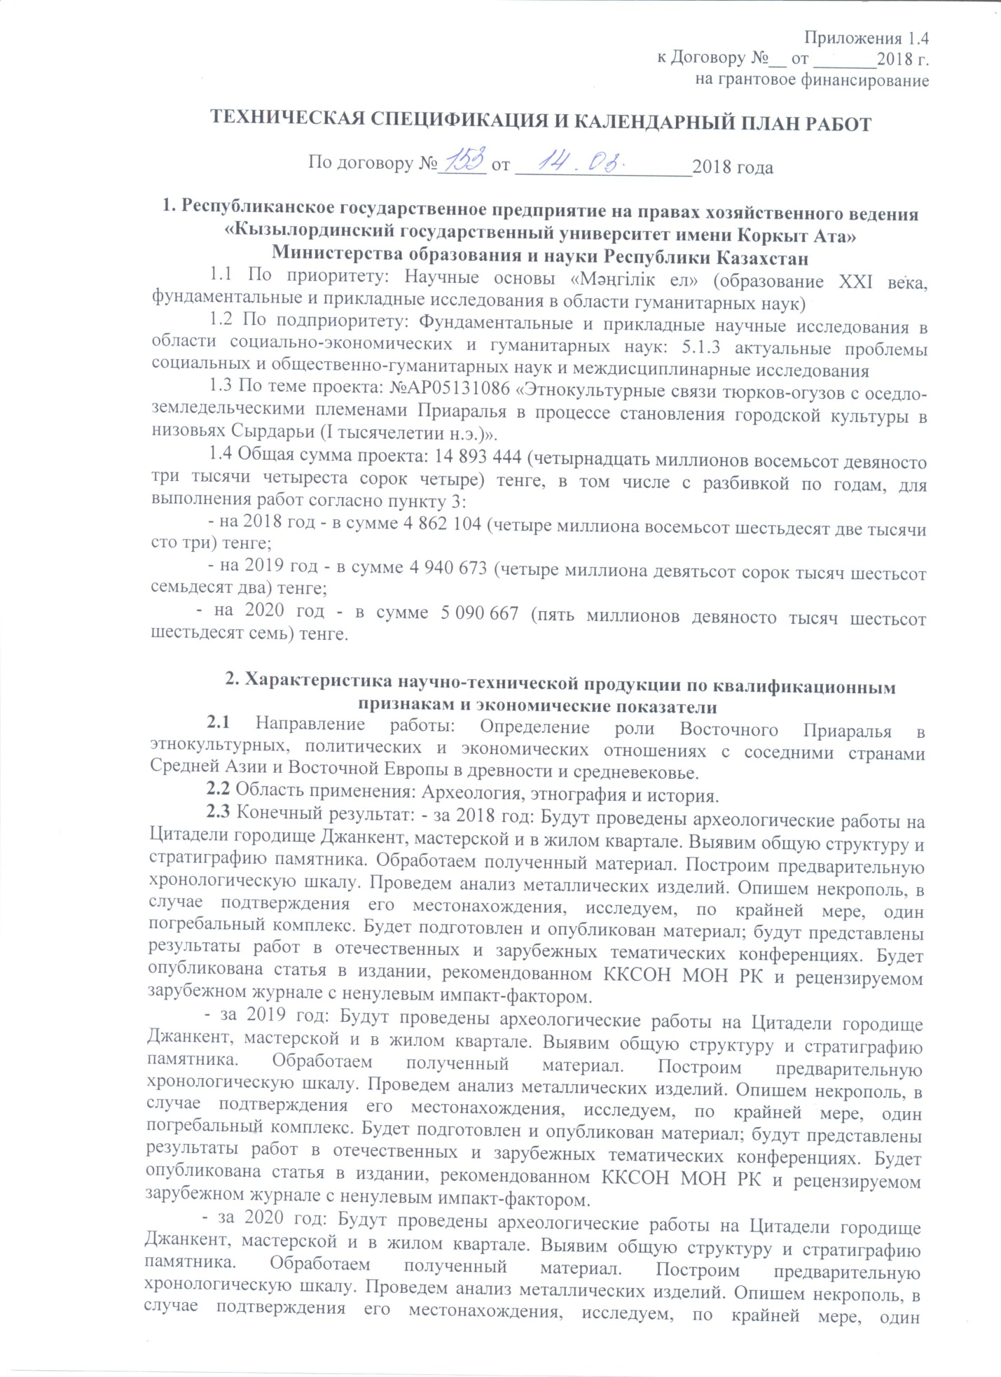
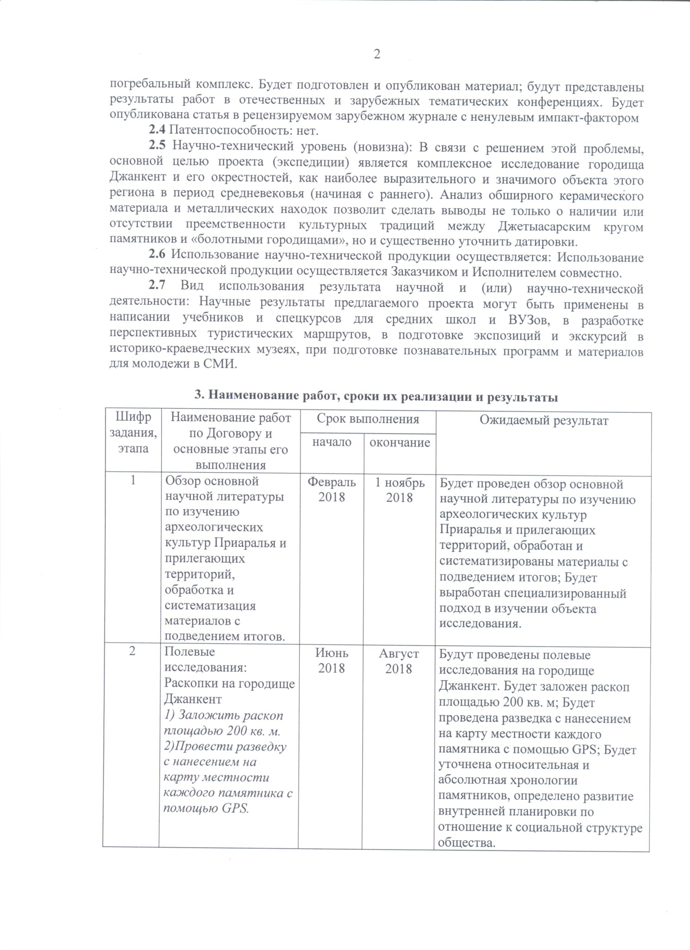
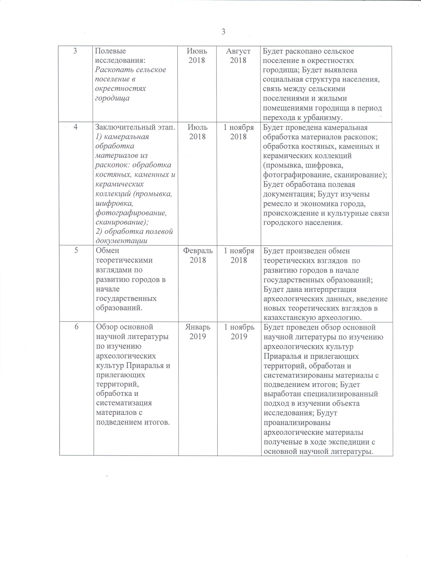
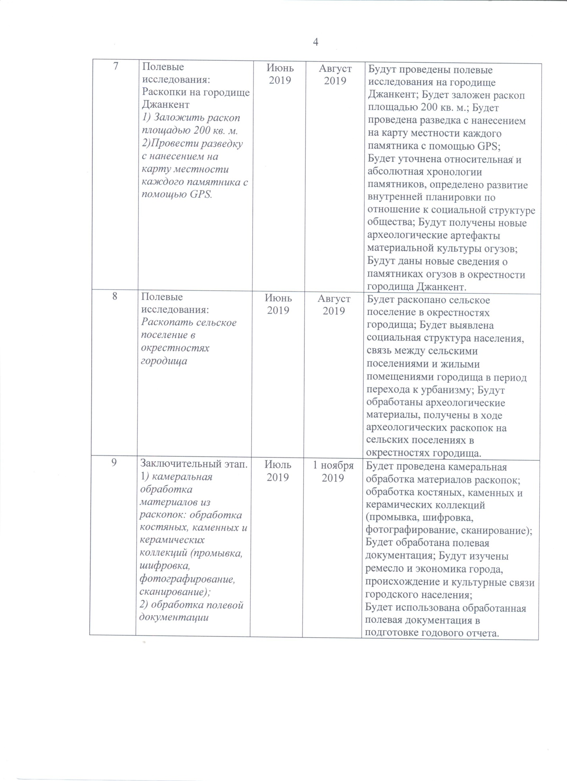
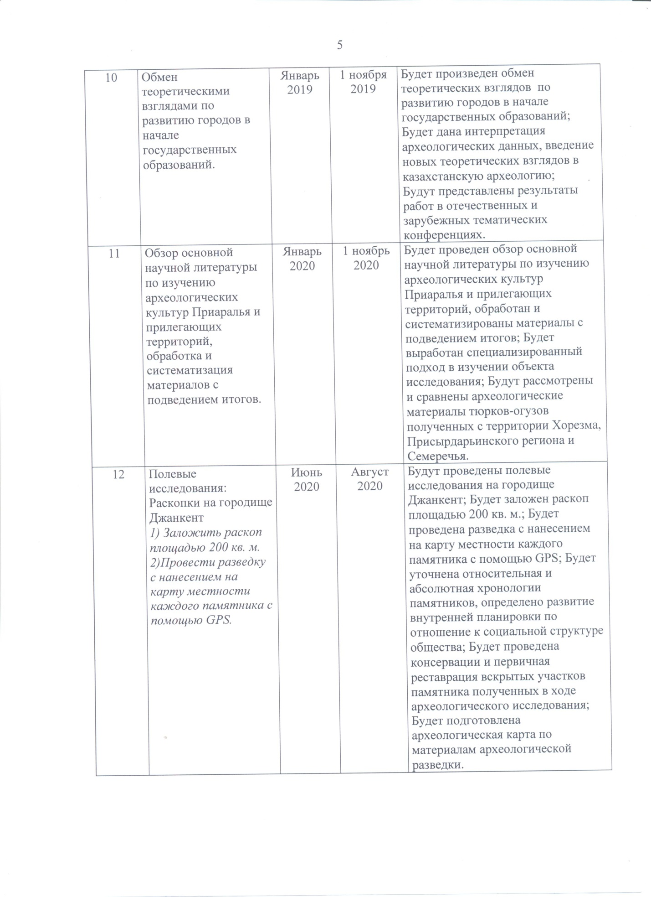
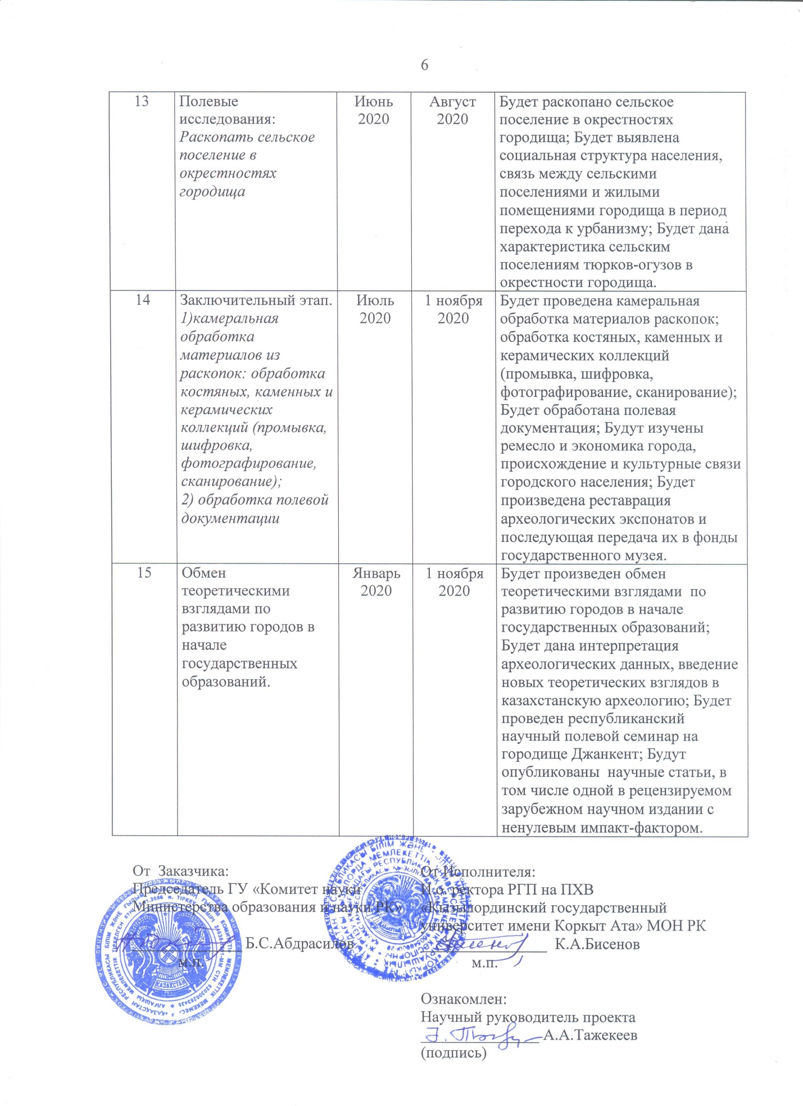

APPENDIX D
Appendix 1.4
to contract No. 153 dated April 14, 2018
for grant funding

Technical specifications and work schedule
1. Republican State Enterprise on the Rights of Economic Management
"Kyzylorda State University named after Korkyt Ata"
Ministry of Education and Science of the Republic of Kazakhstan
1.1 Priority: Scientific foundations of "The Eternity Nation" (the formation of the XXI century, fundamental and applied research in the humanities).
1.2 Priority Under: Fundamental and applied research in the field of social, economic and humanitarian sciences: 5.1.3.Actual problems of social and social sciences and humanities and interdisciplinary research.
1.3 Title of the project: AP05131086 Ethno cultural relationships of Turk-oguzes with settled- agricultural tribes of Aral region in foundation of urban culture at downstream of Syrdarya (I millennia AD).
1.4 Total project amount: 14 893 444 (fourteen million eight hundred ninety three thousand four hundred forty four) tenge; including with a breakdown by years, for the performance of work in accordance with paragraph 3:
2018 – 4 862 104 (four million eight hundred sixty two thousand one hundred three) tenge;
2019 – 4 940 673 (four million nine hundred forty thousand six hundred seventy three) tenge;
2020 – 5 090 667 (five million ninety thousand six hundred sixty seven) tenge.

2. Characteristics of scientific and technical products by qualification characteristics and economic indicators

2.1 Direction of work: Determination of the role of the Eastern Aral Sea region in ethnocultural, political and economic relations with neighboring countries of Central Asia and Eastern Europe in antiquity and the Middle Ages.
2.2 Application area: archeology, ethnography and history.
2.3 Final result:
For 2018 – Archaeological work will be carried out at the Citadel of the Dzhankent town, a workshop and in a residential area. The general structure and stratigraphy of the site will be revealed. We will process the received material; build a preliminary chronological scale; analyze metal products; we will describe the necropolis if its location is confirmed, we will investigate one burial complex. Material will be prepared and published; the results of work will be presented in domestic and foreign thematic conferences.
For 2019 – Archaeological work will be carried out at the Citadel of the Dzhankent town, a workshop and in a residential area. The general structure and stratigraphy of the site will be revealed. We will process the received material; build a preliminary chronological scale; analyze metal products; we will describe the necropolis if its location is confirmed, we will investigate one burial complex. Material will be prepared and published; the results of work will be presented in domestic and foreign thematic conferences.
For 2020 – Archaeological work will be carried out at the Citadel of the Dzhankent town, a workshop and in a residential area. The general structure and stratigraphy of the site will be revealed. We will process the received material; build a preliminary chronological scale; analyze metal products; we will describe the necropolis if its location is confirmed, we will investigate one burial complex. Material will be prepared and published; the results of work will be presented in domestic and foreign thematic conferences. An article will be published in a peer-reviewed foreign journal with a non-zero impact factor.
2.4 Patentability: no
2.5 Scientific and technical level (novelty): In connection with solving this problem, the main goal of the project (expedition) is a comprehensive study of the Dzhankent town and its environs, as the most expressive and significant object of this region during the Middle Ages (starting from the early one). The analysis of the vast ceramic material and metal finds will make it possible to draw conclusions not only about the presence or absence of continuity of cultural tradition between the Dzhetyasar circle of sites and "swamp towns", but also to significantly clarify the dating.
2.6 The use of scientific and technical products is carried out: by the Customer and the Contractor jointly.
2.7 Type of use of the result of scientific and (or) scientific and technical activities: The scientific results of the proposed project can be used in writing textbooks and special courses for secondary schools and universities, in the development of promising tourist routes, in the preparation of expositions and excursions in local history museums, with preparation of educational programs and materials for youth and the media.

3. Name of work and terms of their implementation and results
Task code, stage | Name of work under the Contract and the main stages of its implementation | Period of execution |  | Expected Result
 |  | Start | Ending
1 | Review of the main scientific literature on the study of archaeological cultures of the Aral Sea region and adjacent territories, processing and systematization of materials with summing up | February, 2018 | November 1, 2018 | А review of the scientific literature on the study of the archaeological cultures of the Aral Sea region and adjacent territories will be carried out; processed and systematized materials with summing up; a specialized approach to the study of the object of research will be developed
2 | Field studies:  Excavations at the Dzhankent town  1) Lay an excavation area of 200 sq. m.  3) Conduct reconnaissance with mapping the terrain of each site using GPS. | June, 2018 | August,  2018 | Field research will be carried out at the Dzhankent town; an excavation with an area of 200 square meters will be laid; reconnaissance will be carried out with mapping the terrain of each site using GPS; the relative and absolute chronology of the monuments will be clarified, the development of internal planning in relation to the social structure of society will be determined.
3 | Field studies:  Excavate a rural settlement in the vicinity of the town | June, 2018 | August,  2018 | A rural town will be excavated in the vicinity of the settlement; the social structure of the population, the relationship between rural settlements and residential premises of the town during the transition to urbanism will be revealed.
4 | The final stage.  1) office processing of materials from excavations: processing of bone, stone and ceramic collections (washing, encryption, photographing, scanning);  2) processing of field documentation (drawing drawings on a Whatman paper, reprinting the diary); | July,  2018 | November 1, 2018 | Office processing of excavation materials will be carried out; processing of bone, stone and ceramic collections (washing, encrypting, photographing, and scanning); field documentation will be processed; will study the craft and economy of the city, the origin and cultural ties of the urban population.
5 | Exchange of theoretical views on urban development in early state formations. | February,  2018 | November 1, 2018 | An exchange of theoretical views on the development of cities at the beginning of state formations will be carried out; the interpretation of archaeological data, the introduction of new theoretical views in Kazakhstan’s archeology will be given.
6 | Review of the main scientific literature on the study of archaeological cultures of the Aral Sea region and adjacent territories, processing and systematization of materials with summing up | January,  2019 | November 1, 2019 | А review of the scientific literature on the study of the archaeological cultures of the Aral Sea region and adjacent territories will be carried out; processed and systematized materials with summing up; a specialized approach to the study of the object of research will be developed; will analyze the archaeological materials obtained during the expedition from the main scientific literature.
7 | Field studies:  Excavations at the Dzhankent town  1) Lay an excavation area of 200 sq. m.  3) Conduct reconnaissance with mapping the terrain of each site using GPS. | June, 2019 | August,  2019 | Field research will be carried out at the Dzhankent town; an excavation with an area of 200 square meters will be laid; reconnaissance will be carried out with mapping the terrain of each site using GPS; the relative and absolute chronology of the monuments will be clarified, the development of internal planning in relation to the social structure of society will be determined; new archaeological artifacts of the Oguz material culture will be obtained; new information will be given about the Oguz sites in the vicinity of the Dzhankent settlement.
8 | Field studies:  Excavate a rural settlement in the vicinity of the town | June, 2019 | August,  2019 | A rural town will be excavated in the vicinity of the settlement; the social structure of the population, the relationship between rural settlements and residential premises of the town during the transition to urbanism will be revealed; archaeological materials obtained during archaeological excavations in rural settlements in the vicinity of the settlement will be processed.
9 | The final stage.  1) office processing of materials from excavations: processing of bone, stone and ceramic collections (washing, encryption, photographing, scanning);  2) processing of field documentation (drawing drawings on a Whatman paper, reprinting the diary). | July,  2019 | November 1, 2019 | Office processing of excavation materials will be carried out; processing of bone, stone and ceramic collections (washing, encrypting, photographing, and scanning); field documentation will be processed; will study the craft and economy of the city, the origin and cultural ties of the urban population; processed field documentation will be used in preparing the annual report.
10 | Exchange of theoretical views on urban development in early state formations. | January,  2019 | November 1, 2019 | An exchange of theoretical views on the development of cities at the beginning of state formations will be carried out; the interpretation of archaeological data, the introduction of new theoretical views in Kazakhstan’s archeology will be given; the results of work will be presented in domestic and foreign thematic conferences.
11 | Review of the main scientific literature on the study of archaeological cultures of the Aral Sea region and adjacent territories, processing and systematization of materials with summing up | January,  2020 | November 1, 2020 | А review of the scientific literature on the study of the archaeological cultures of the Aral Sea region and adjacent territories will be carried out; processed and systematized materials with summing up; a specialized approach to the study of the object of research will be developed; the archaeological materials of the Oghuz obtained from the territory of Khorezm, the Syr Darya region and the Semirechye will be considered and compared.
12 | Field studies:  Excavations at the Dzhankent town  1) Lay an excavation area of 200 sq. m.  3) Conduct reconnaissance with mapping the terrain of each site using GPS. | June, 2020 | August,  2020 | Field research will be carried out at the Dzhankent town; an excavation with an area of 200 square meters will be laid; reconnaissance will be carried out with mapping the terrain of each site using GPS; the relative and absolute chronology of the monuments will be clarified, the development of internal planning in relation to the social structure of society will be determined;
 |  |  |  | сonservation and primary restoration of the excavated sites of the monument, obtained in the course of archaeological research, will be carried out; an archaeological map will be prepared based on the materials of archaeological exploration.
13 | Field studies:  Excavate a rural settlement in the vicinity of the town | June, 2020 | August,  2020 | A rural town will be excavated in the vicinity of the settlement; the social structure of the population, the relationship between rural settlements and residential premises of the town during the transition to urbanism will be revealed; a characteristic will be given to the rural settlements of the Oguzes in the vicinity of the town.
14 | The final stage.  1) office processing of materials from excavations: processing of bone, stone and ceramic collections (washing, encryption, photographing, scanning);  2) processing of field documentation | July,  2020 | November 1, 2020 | Office processing of excavation materials will be carried out; processing of bone, stone and ceramic collections (washing, encrypting, photographing, and scanning); field documentation will be processed; will study the craft and economy of the city, the origin and cultural ties of the urban population; the restoration of archaeological exhibits will be carried out and their subsequent transfer to the funds of the state museum.
15 | Exchange of theoretical views on urban development in early state formations. | January,  2020 | November 1, 2020 | An exchange of theoretical views on the development of cities at the beginning of state formations will be carried out; the interpretation of archaeological data, the introduction of new theoretical views in Kazakhstan’s archeology will be given; a republican scientific field seminar will be held at the Dzhankent settlement; scientific articles will be published, including one in a peer-reviewed foreign scientific publication with a zero impact factor.

From customer:  Chairman of the State Institution "Science Committee" MES RK  _____________________ B.S. Abdrasilov | From the Contractor:  Acting Rector of "Korkyt Ata Kyzylorda State University" MES RK  _______________________ K.A. Bisenov
Familiarized:
Scientific supervisor of the project
___________________ A.A. Tazhekeyev
APPENDIX E
Illustrations

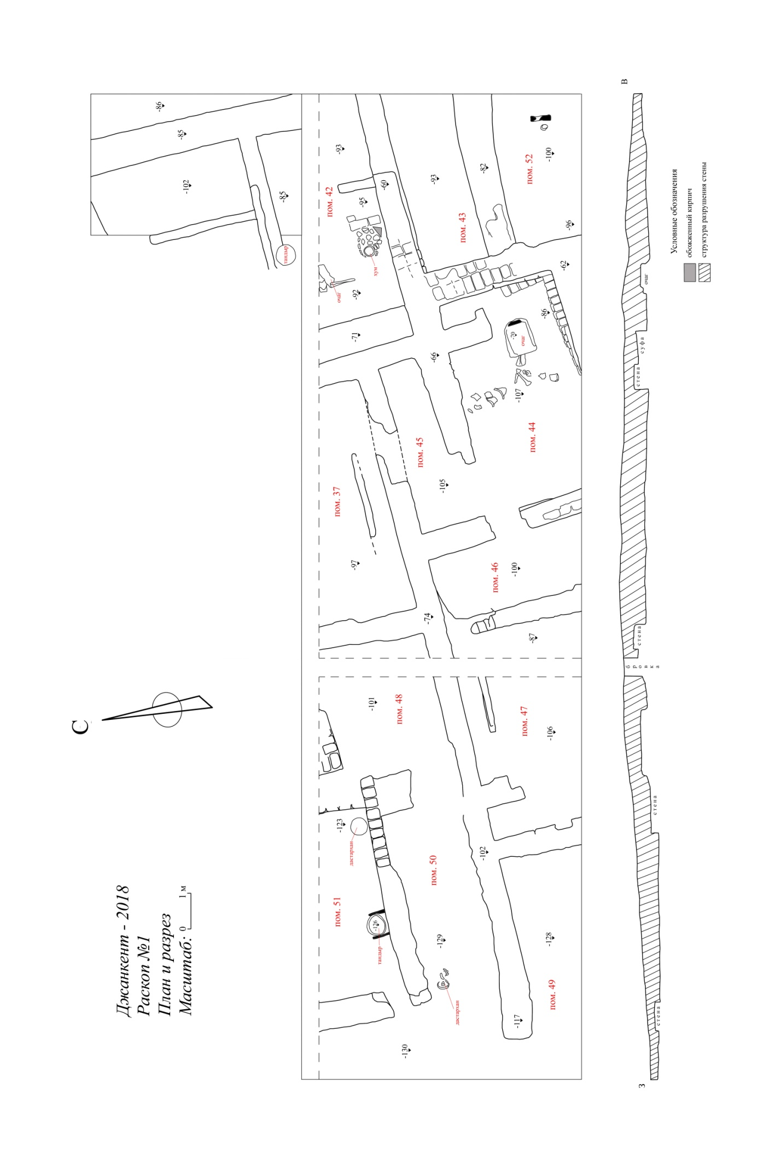
Figure E.1 – Plan and section of trench 1, 2018
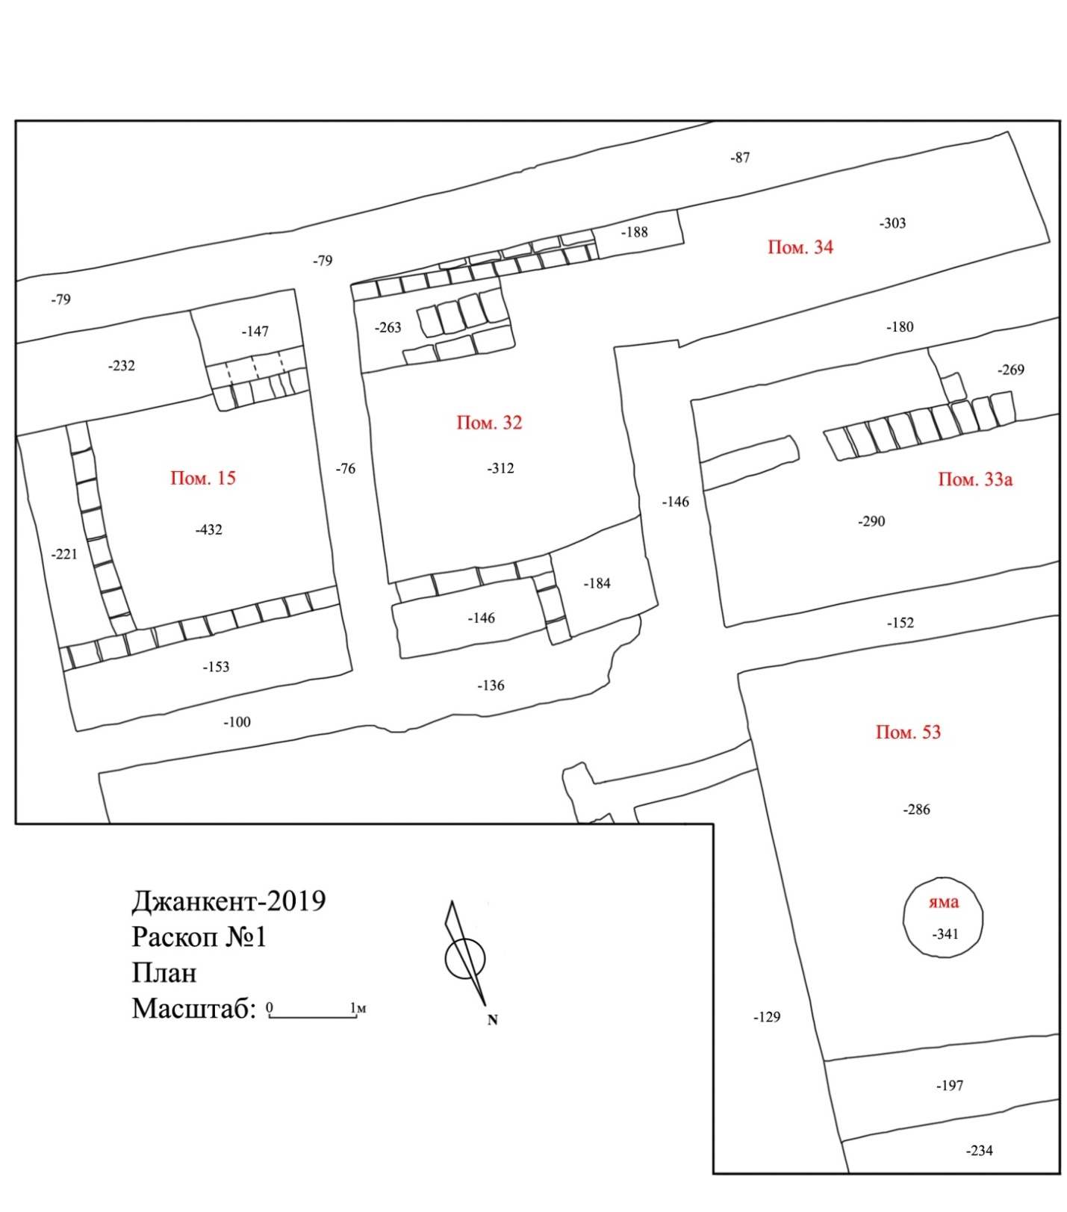
Figure E.2 – Plan of trench 1, 2019
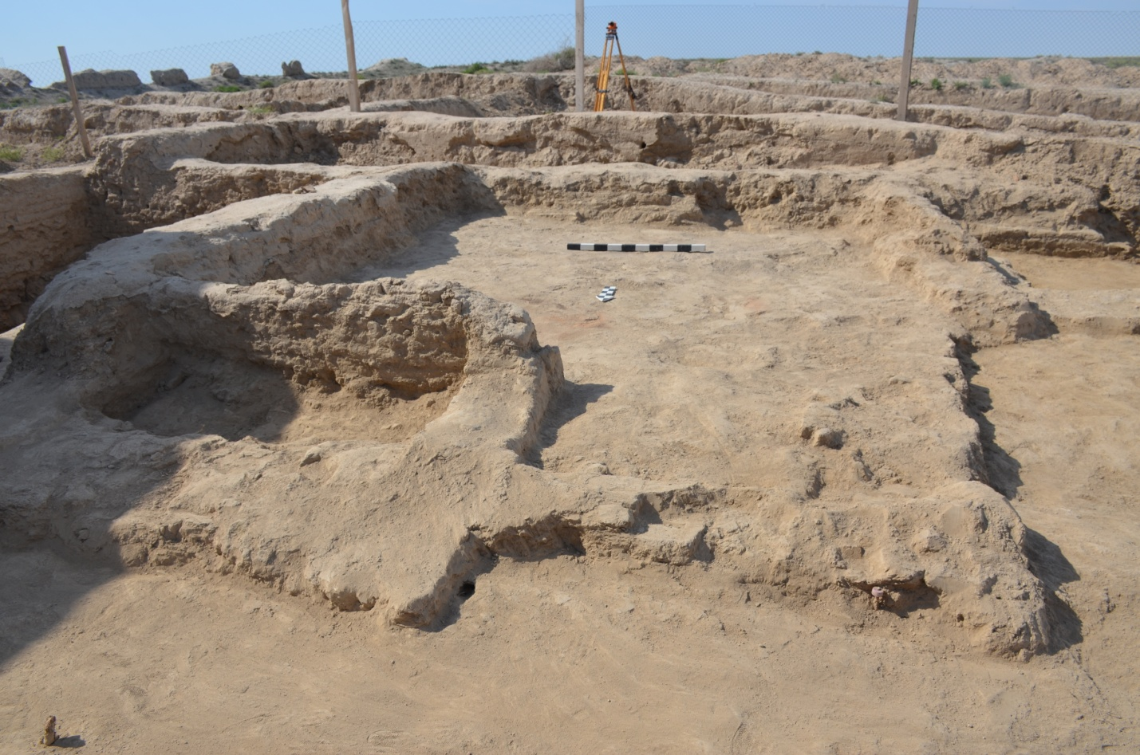
Figure E.3 – Trench 1. Room 32

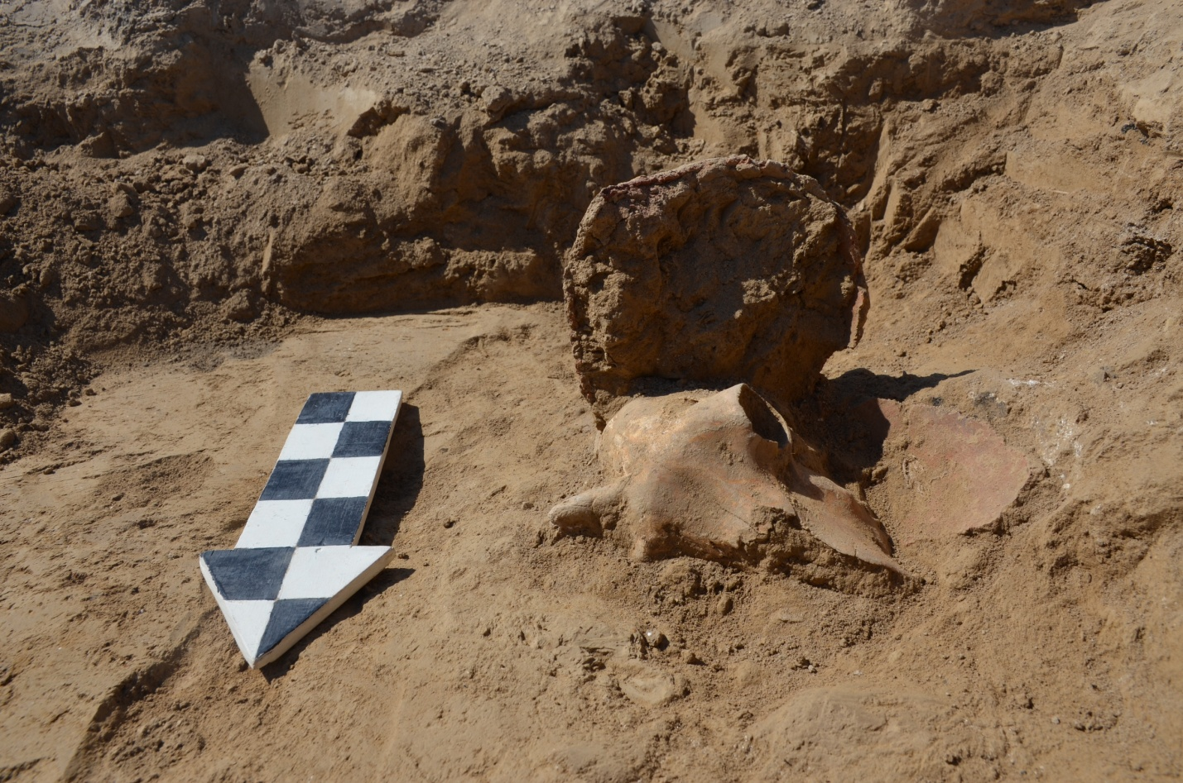
Figure E.4 – Trench 1. Room 33. Fragment of a vessel with the MRS skull

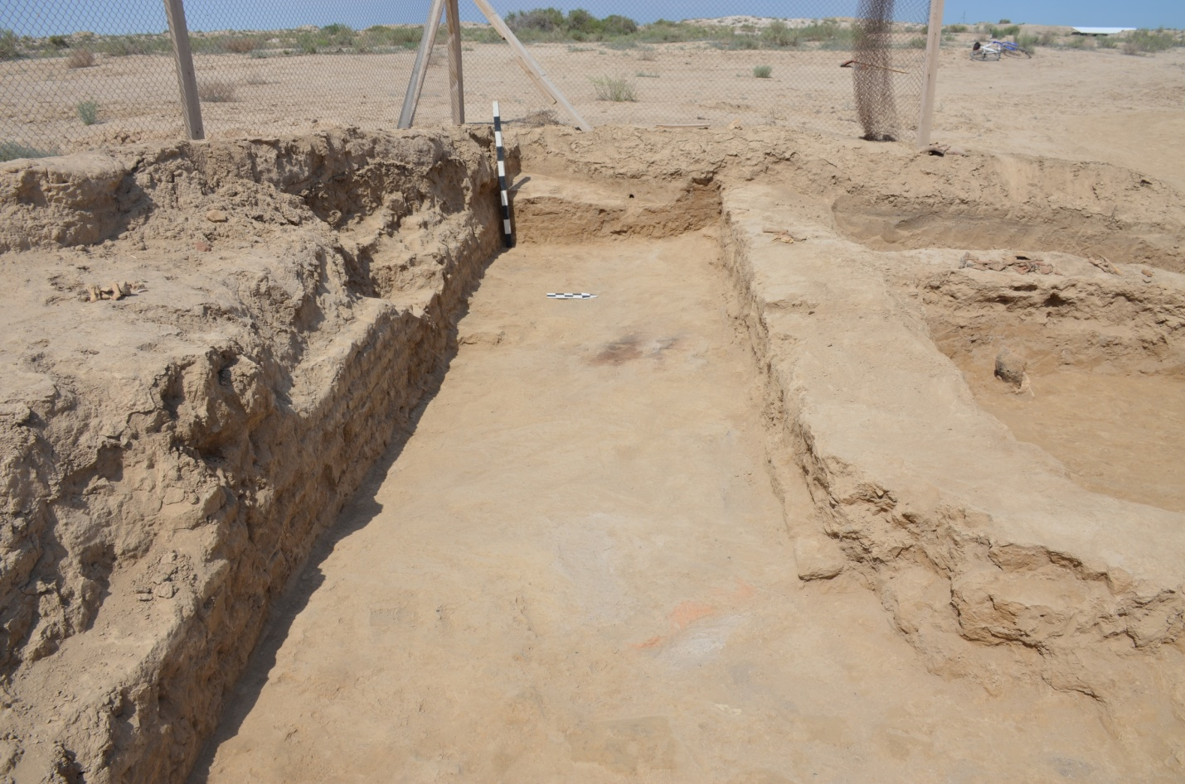
Figure E.5 – Trench 1. Room 34

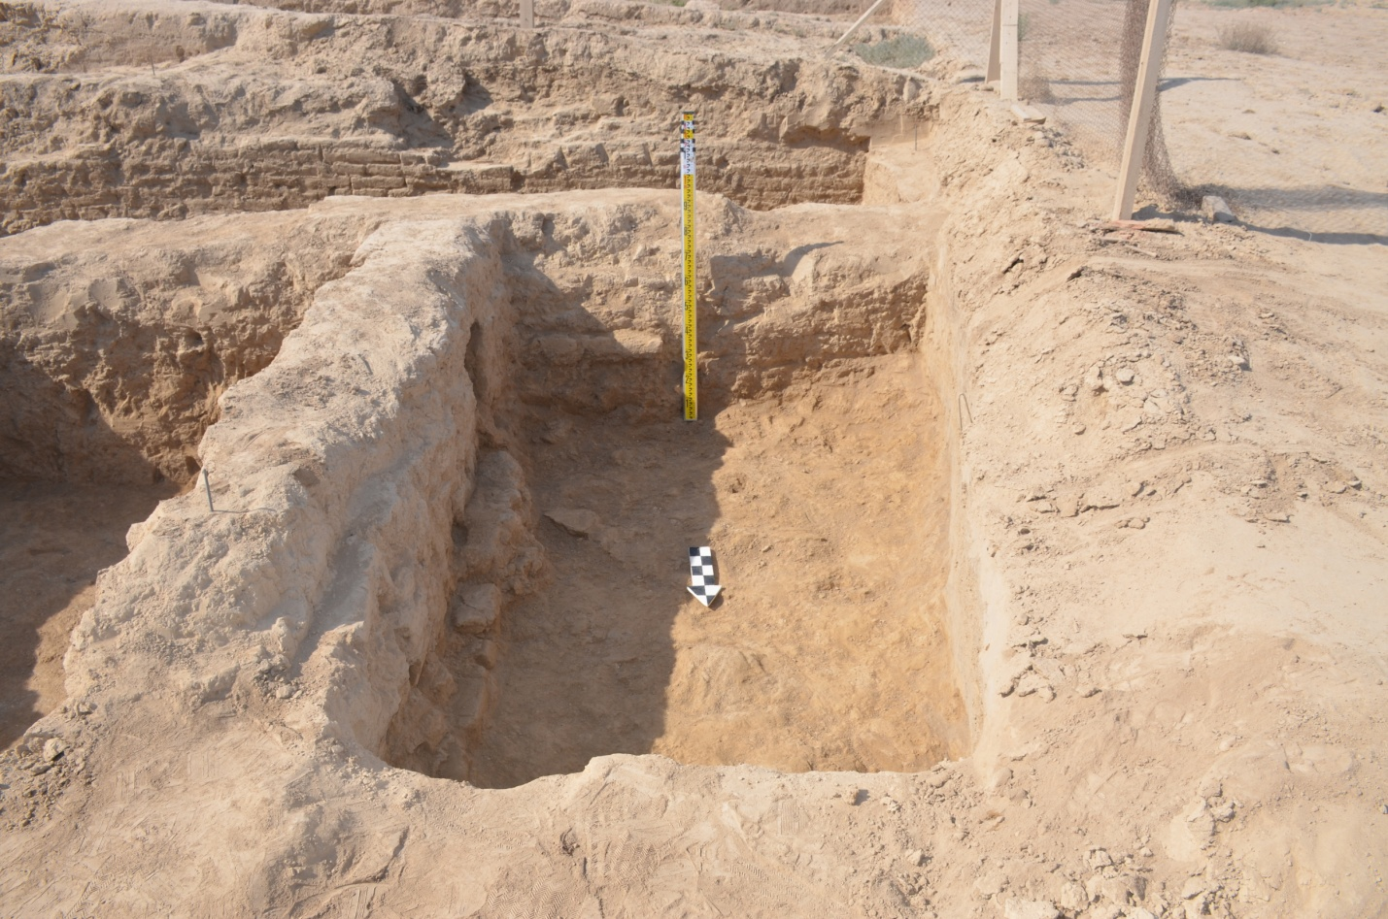
Figure E.6 – Trench 1. Room 35
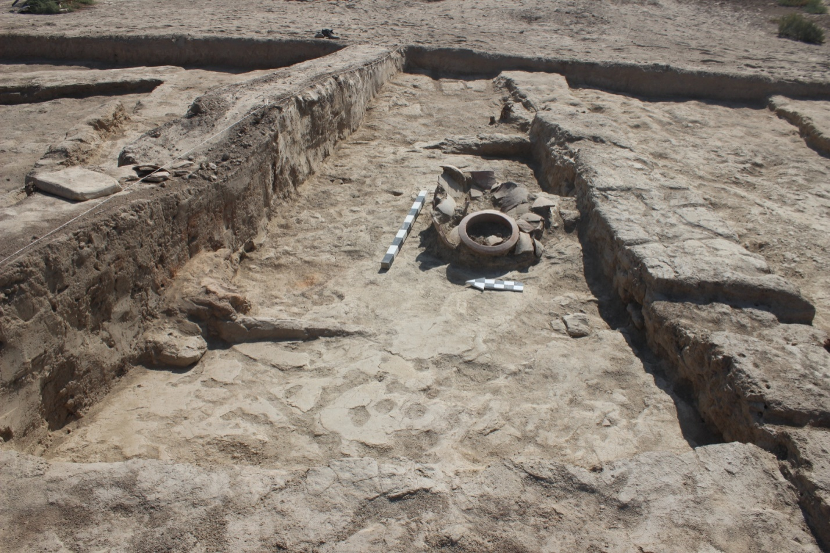
Figure E.7 – Trench 1. Room 42

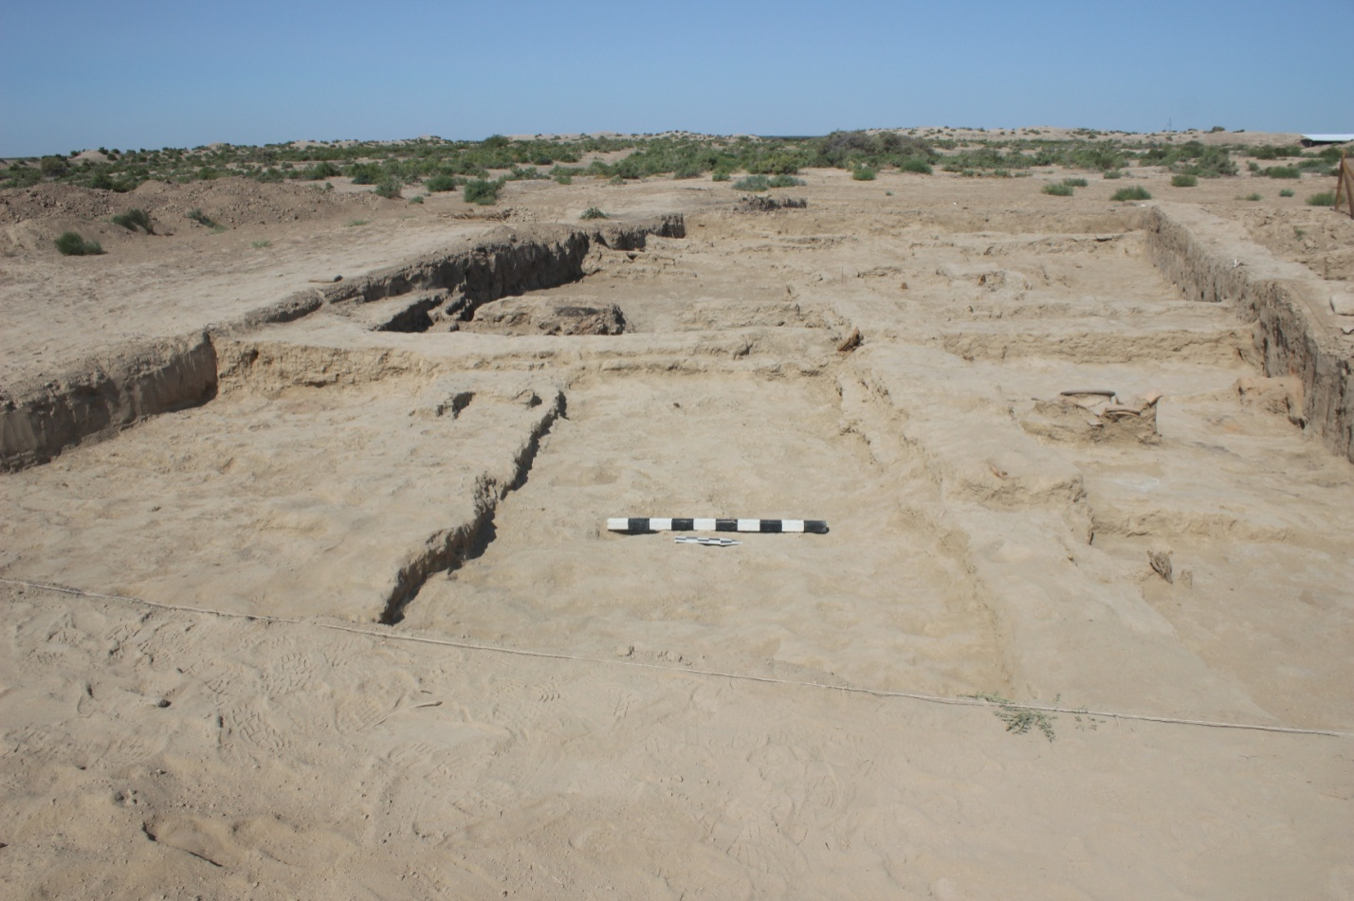
Figure E.8 – Trench 1. Room 43

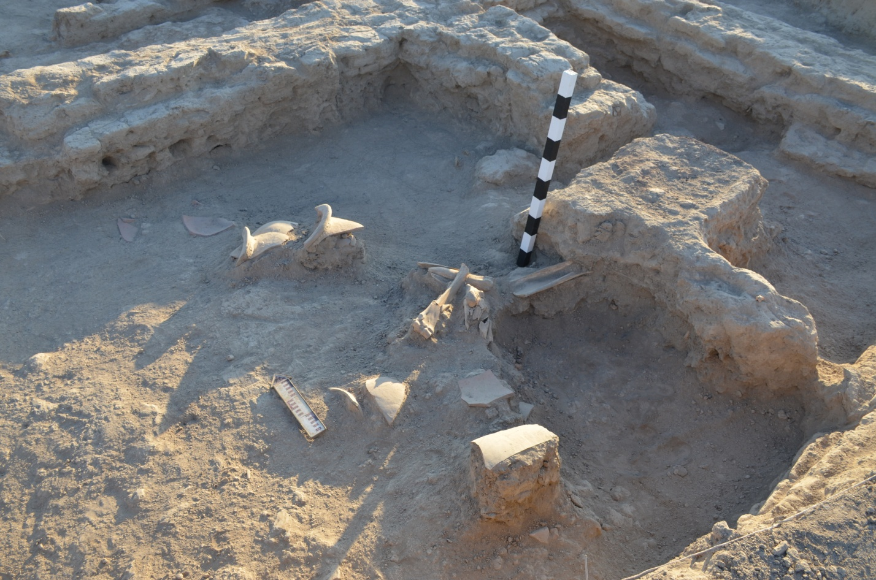
Figure E.9 – Trench 1. Room 44

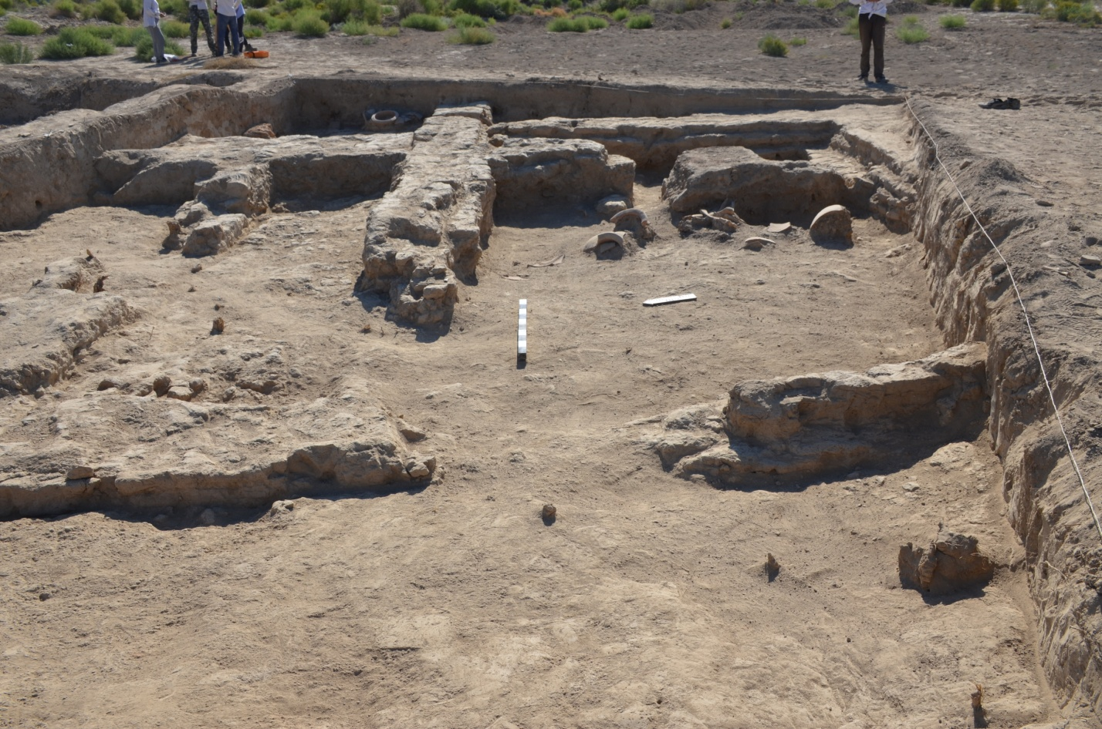
Figure E.10 – Trench 1. Room 45
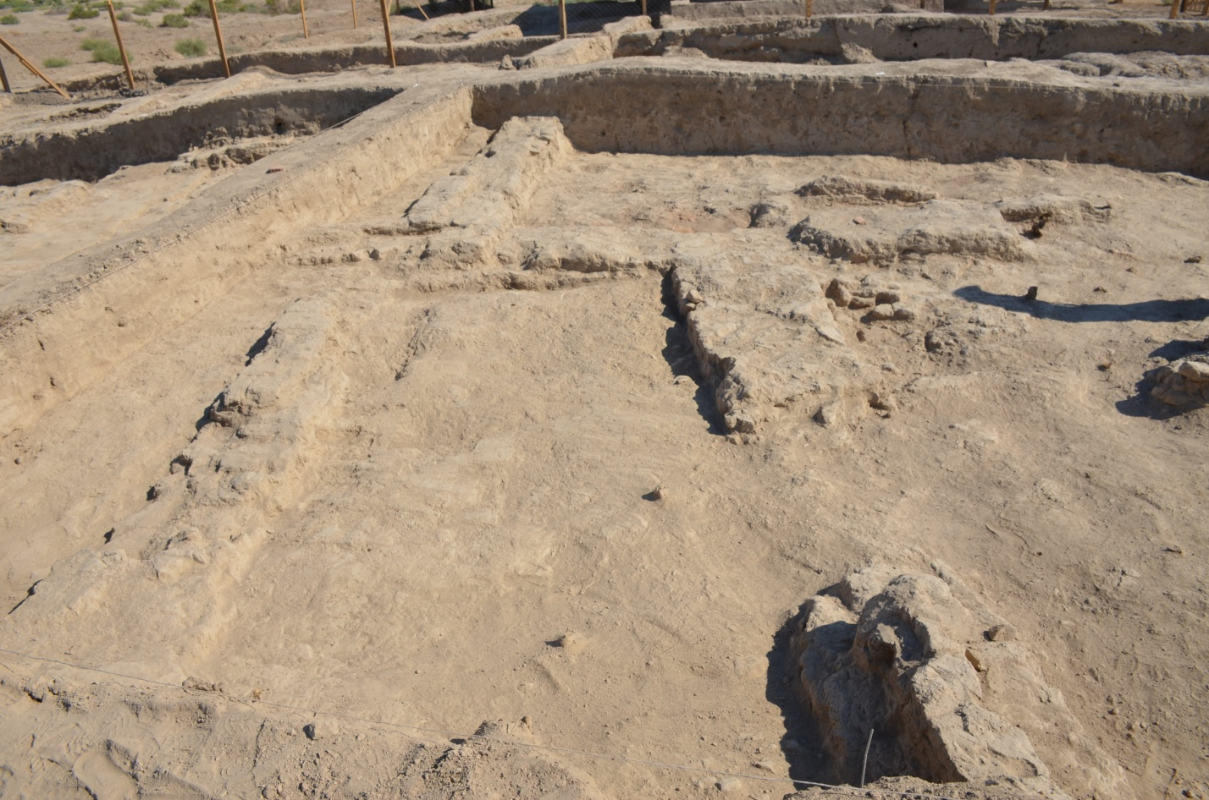
Figure E.11 – Trench 1. Room 46

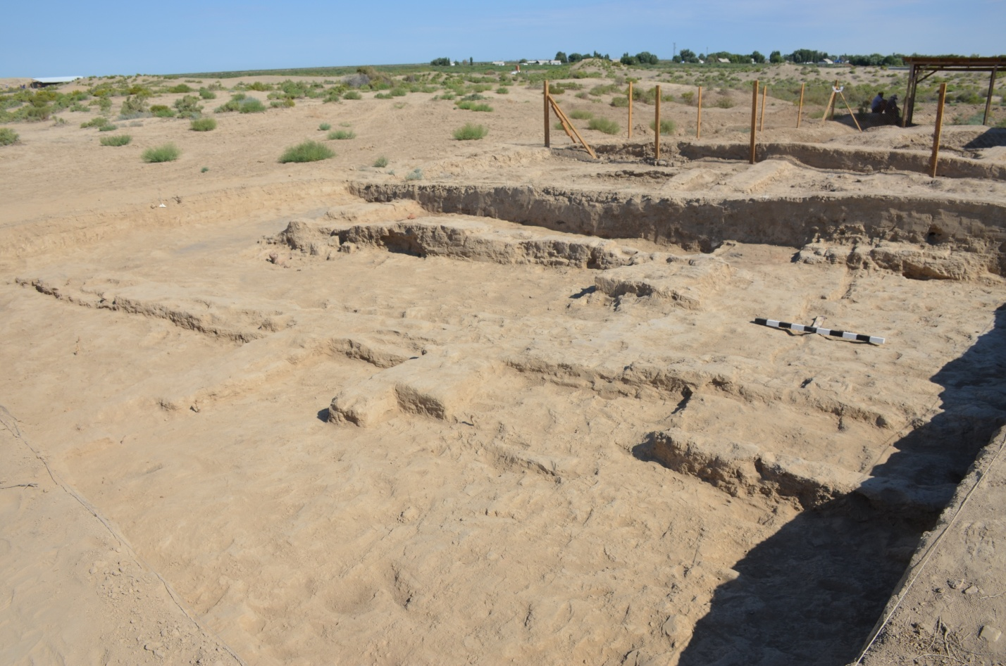
Figure E.12 – Trench 1. Room 47
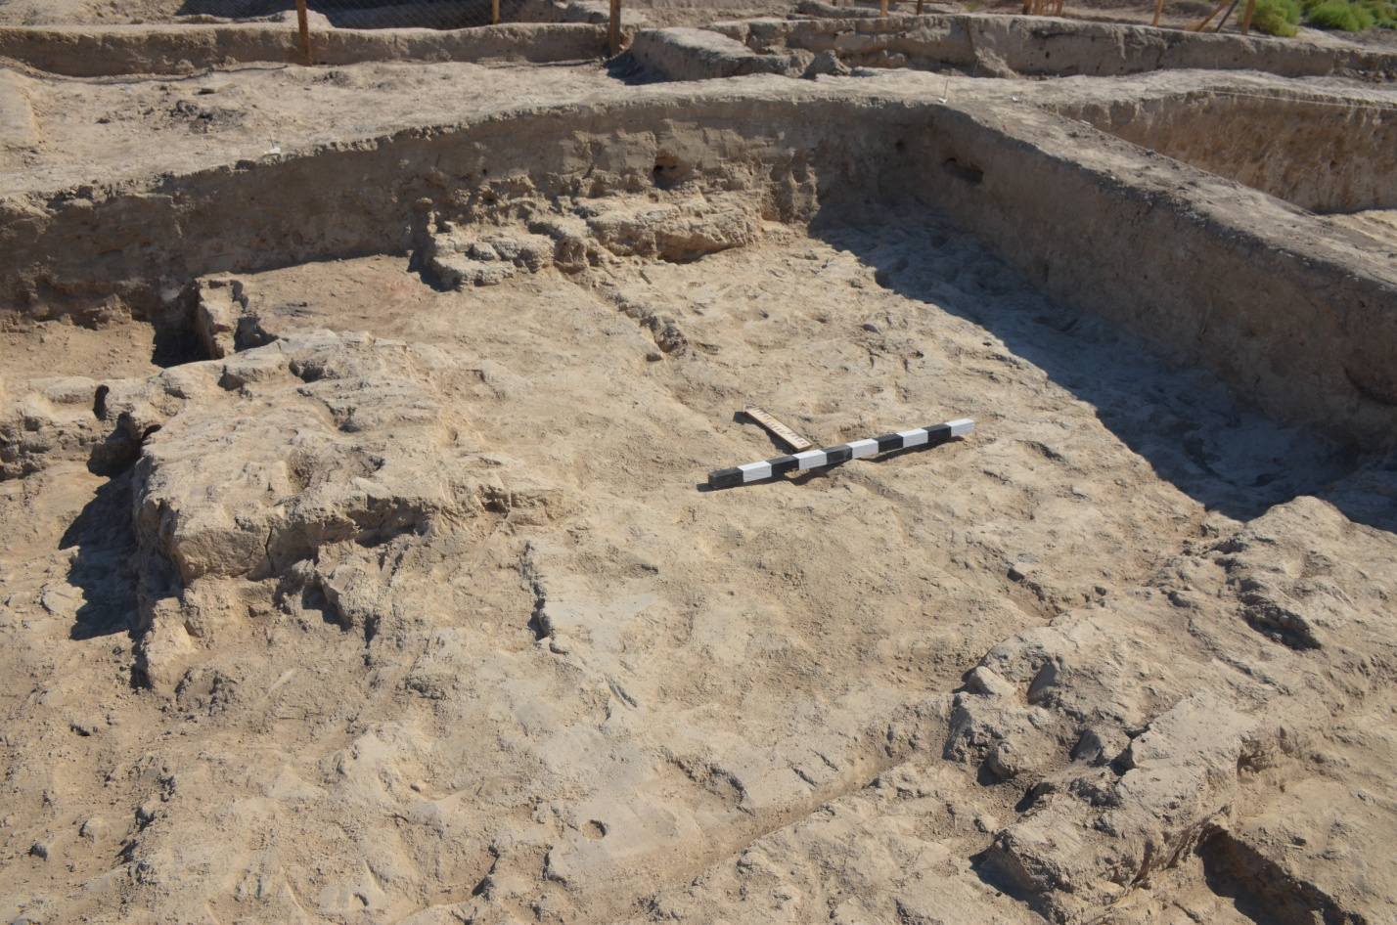
Figure E.13 – Trench 1. Room 48

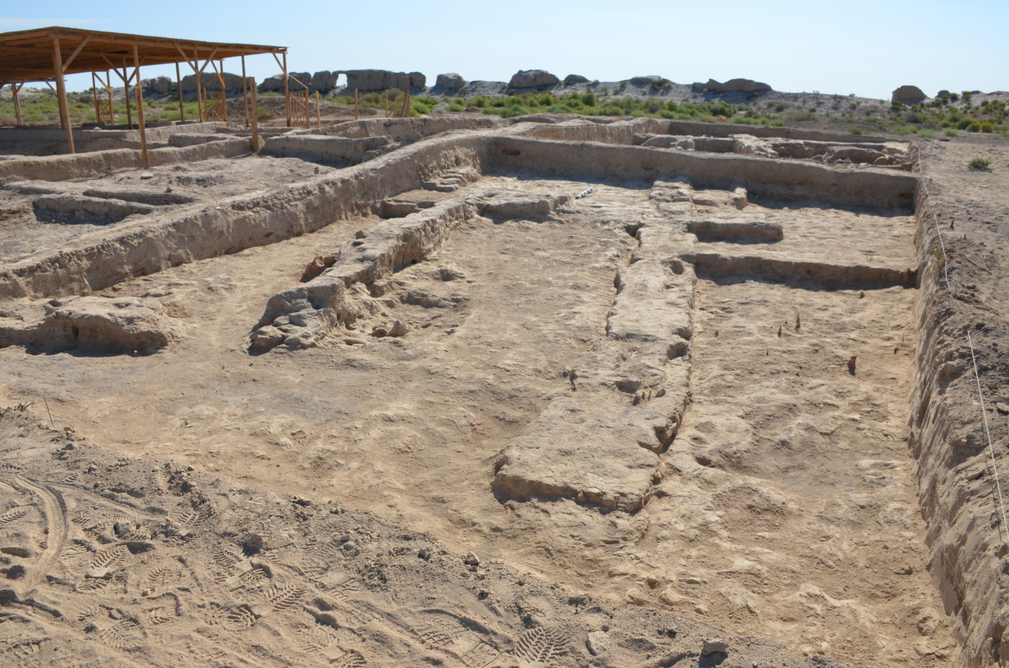
Figure E.14 – Trench 1. Room 49

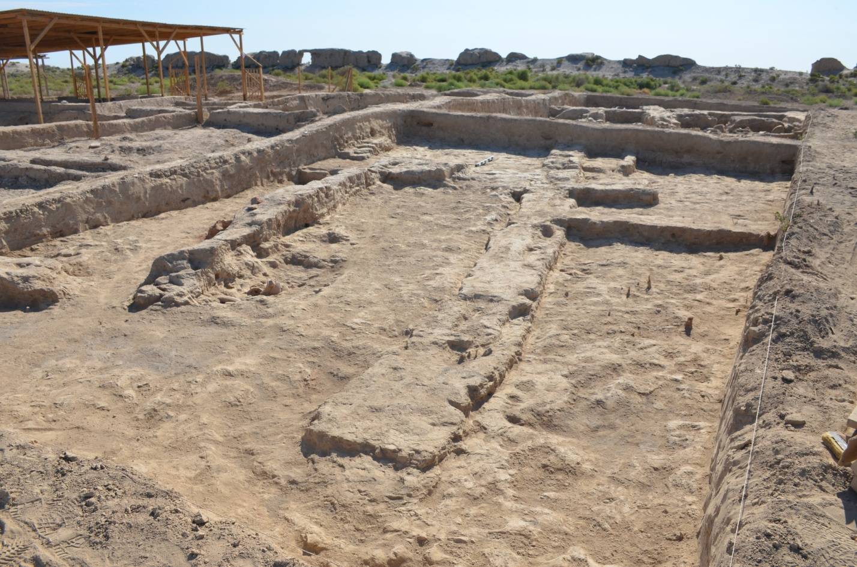
Figure E.15 – Trench 1. Room 50

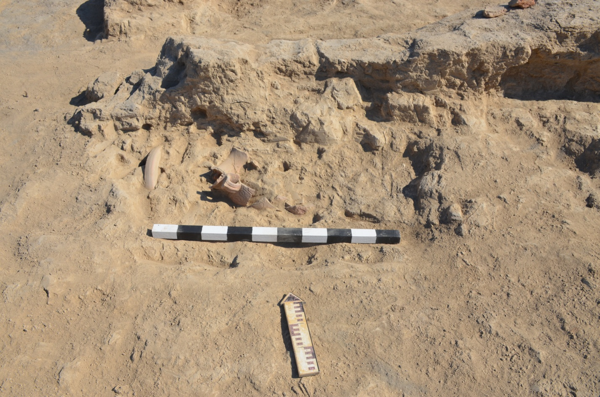
Figure E.16 – Trench 1. Room 50.
Accumulation of broken ceramics and "dastarkhan"
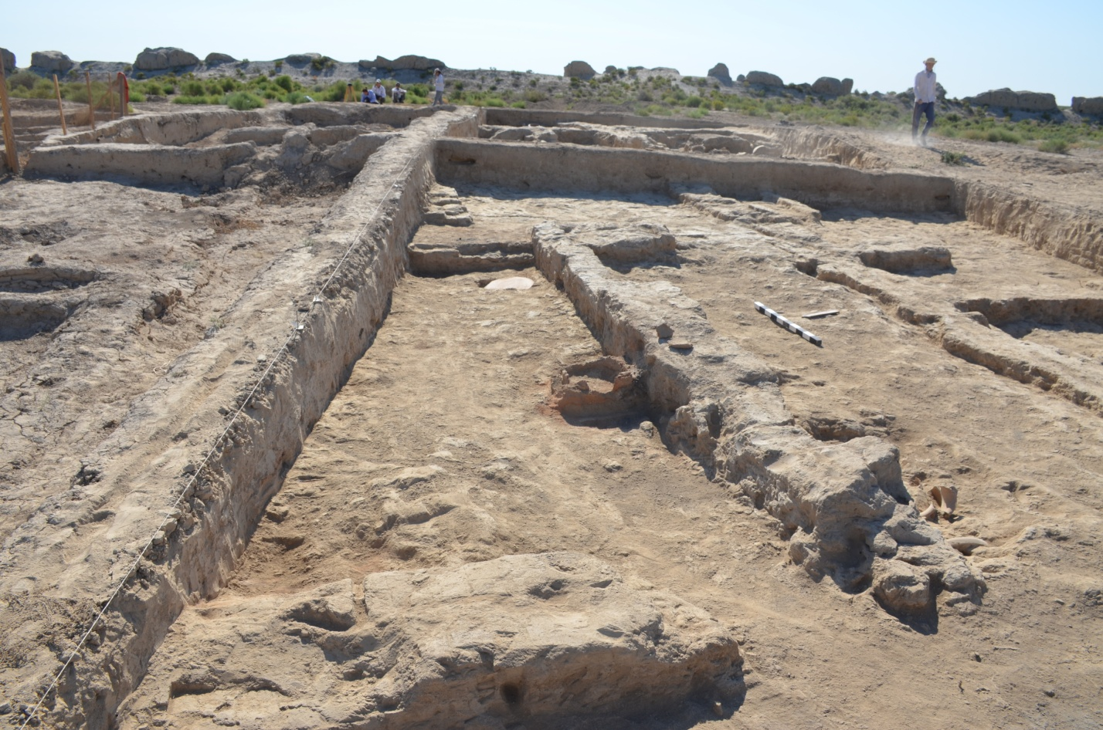
Figure E.17 – Trench 1. Room 51

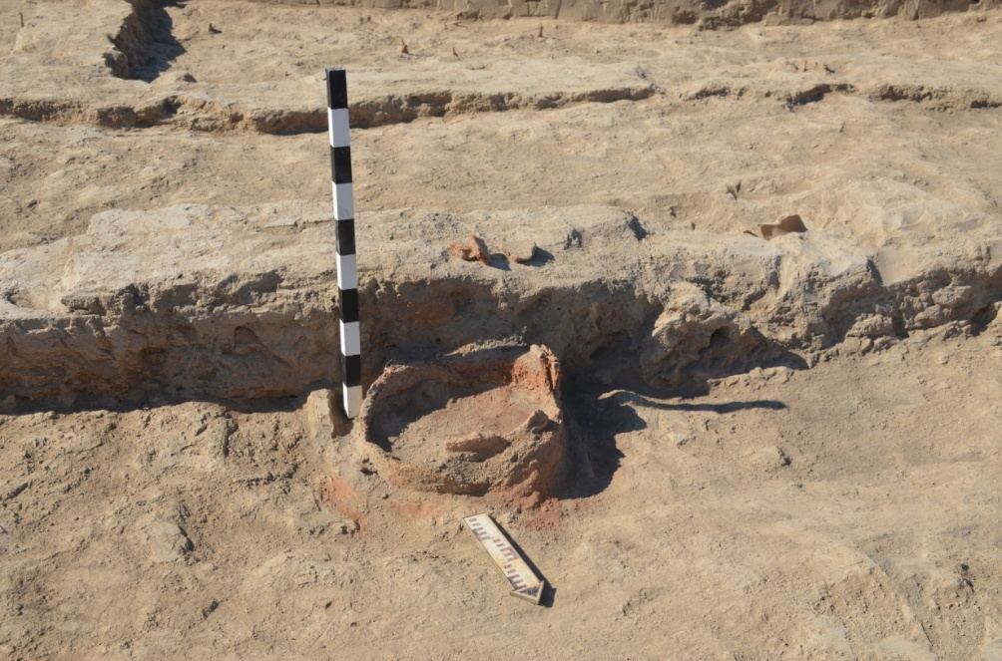 | 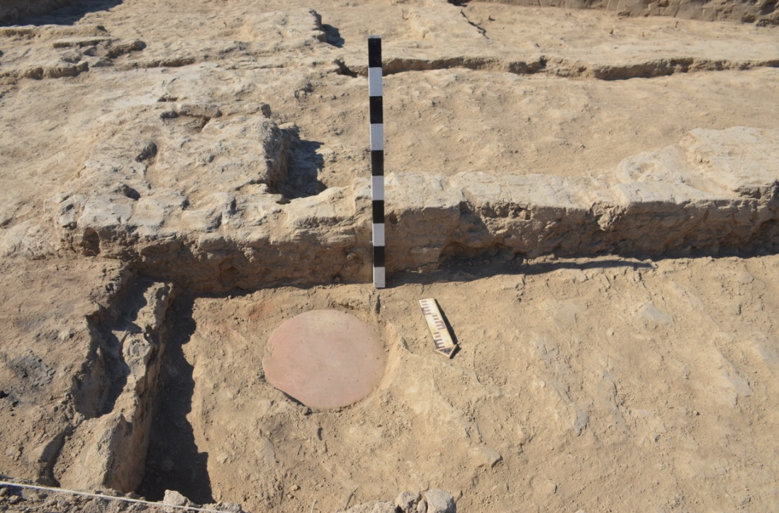
Figure E.18 – Trench 1. Room 51.
Stove - tandoor, "dastarkhan"
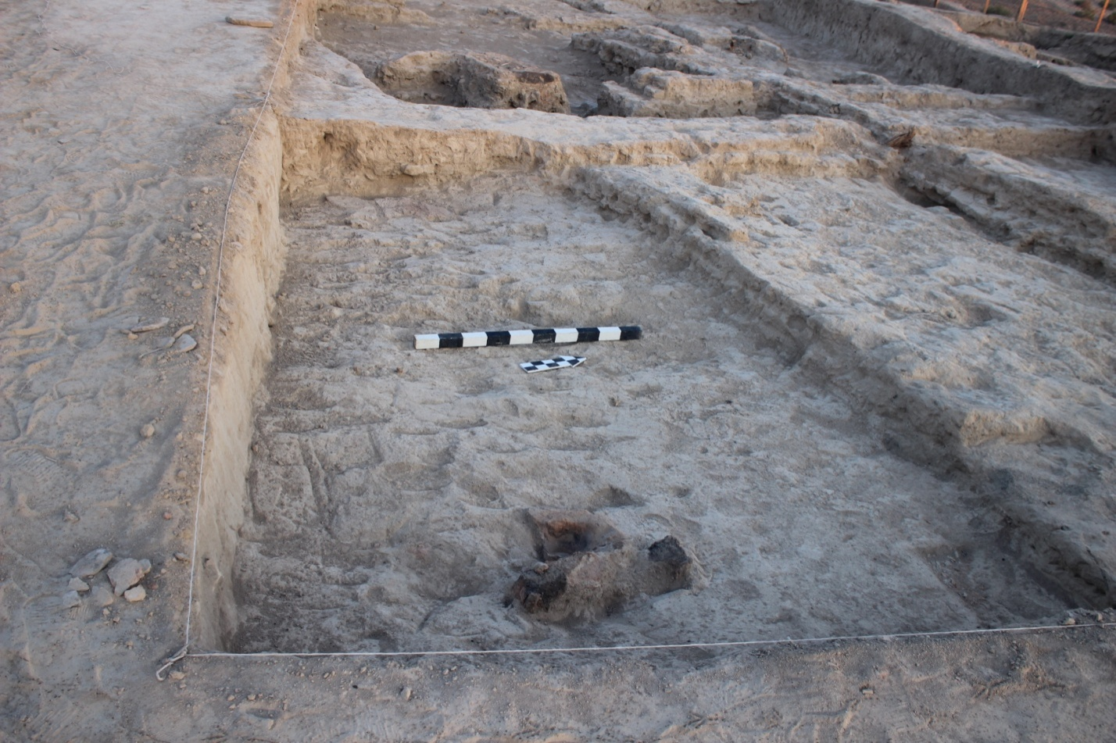
Figure E.19 – Trench 1. Room 52

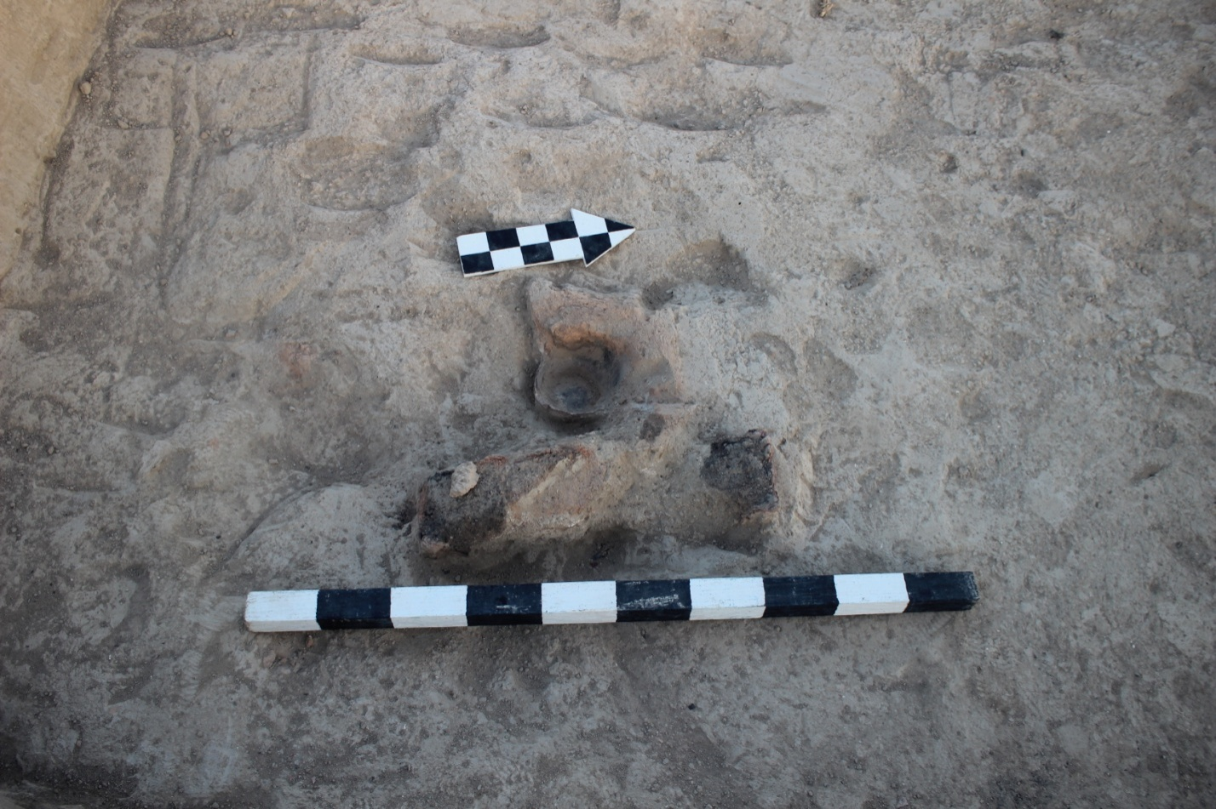
Figure E.20 – Trench 1. Room 52.
Hearth with a stand in the form of a ram protome
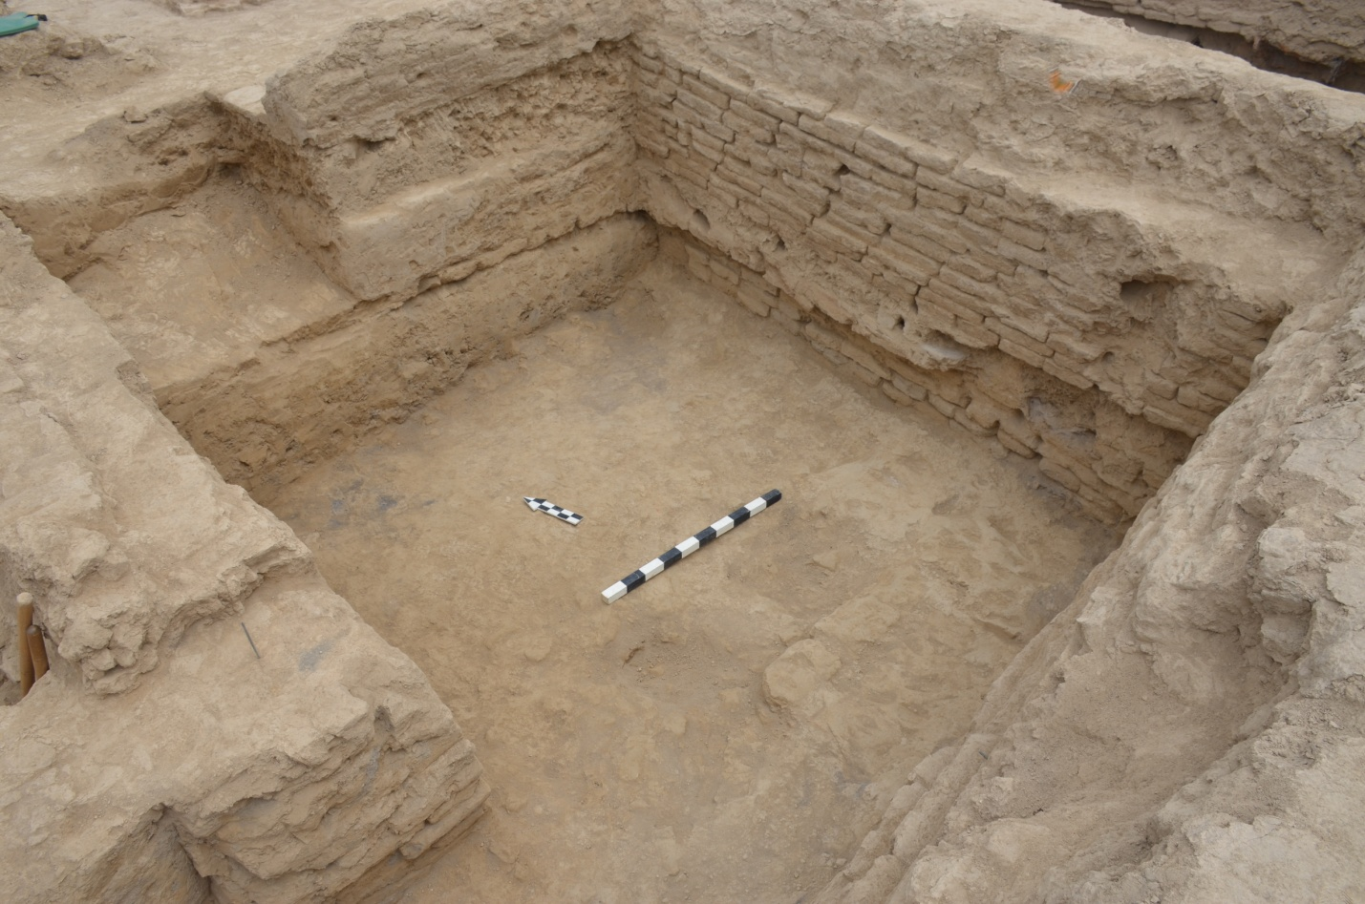
Figure E.21 – Trench 1. Room 32

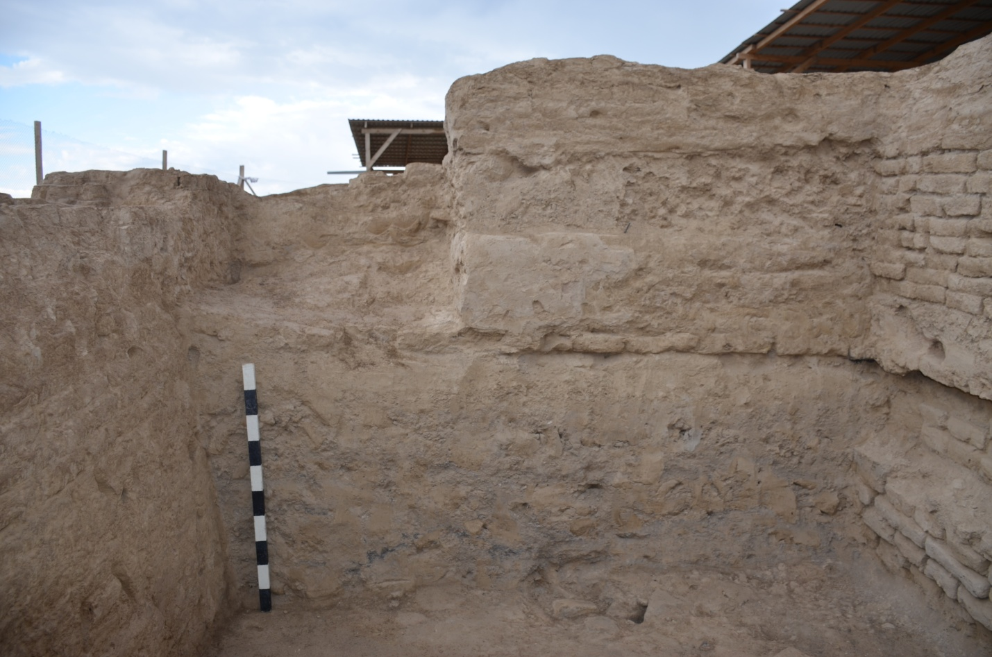
Figure E.22 – Trench 1. Room 32. North face profile
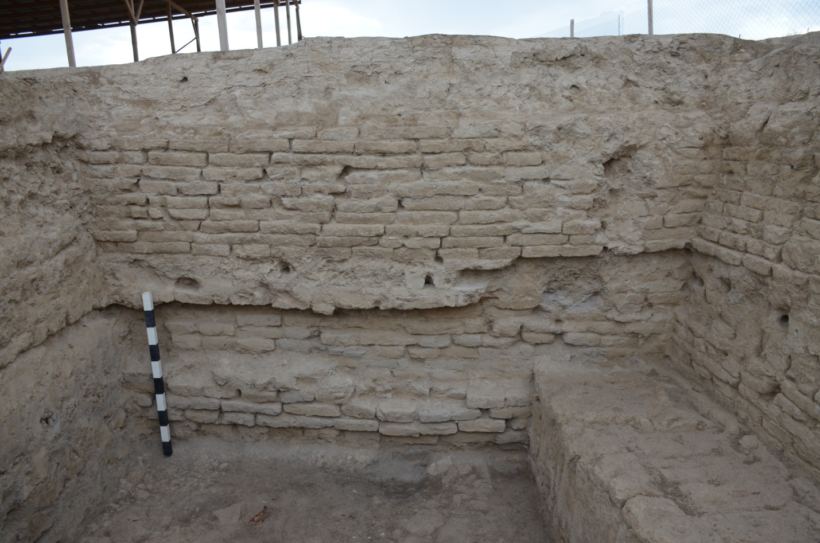
Figure E.23 – Trench 1. Room 32. East face profile

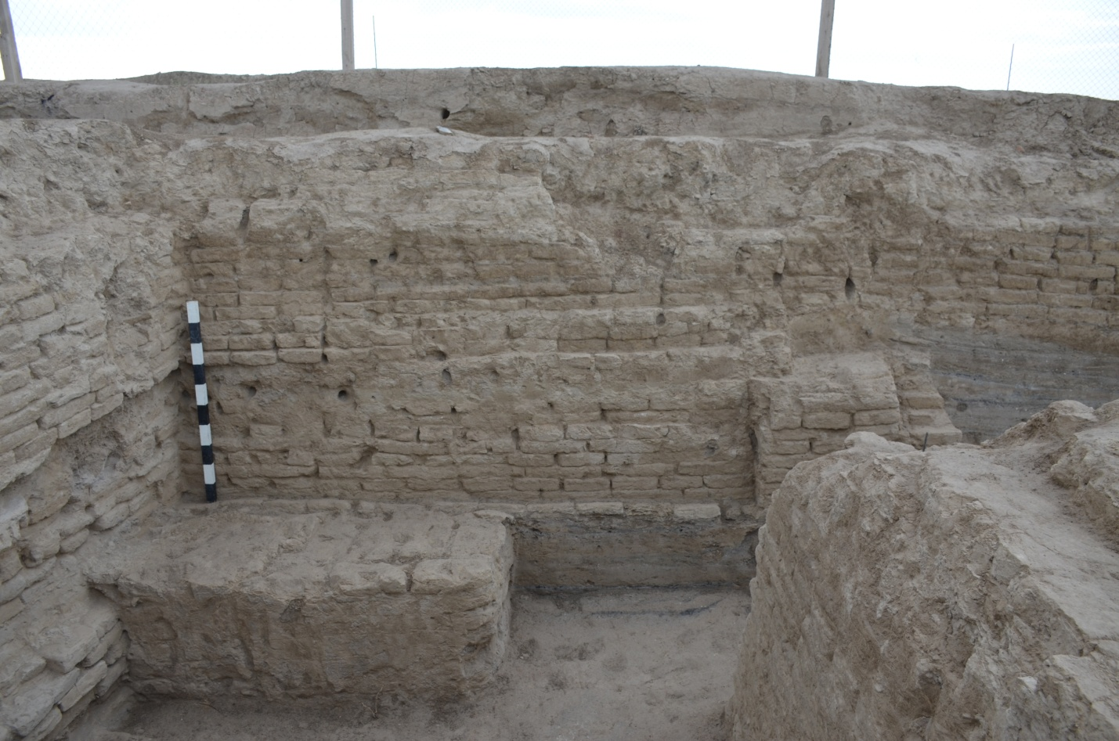
Figure E.24 – Trench 1. Room 32. South face profile

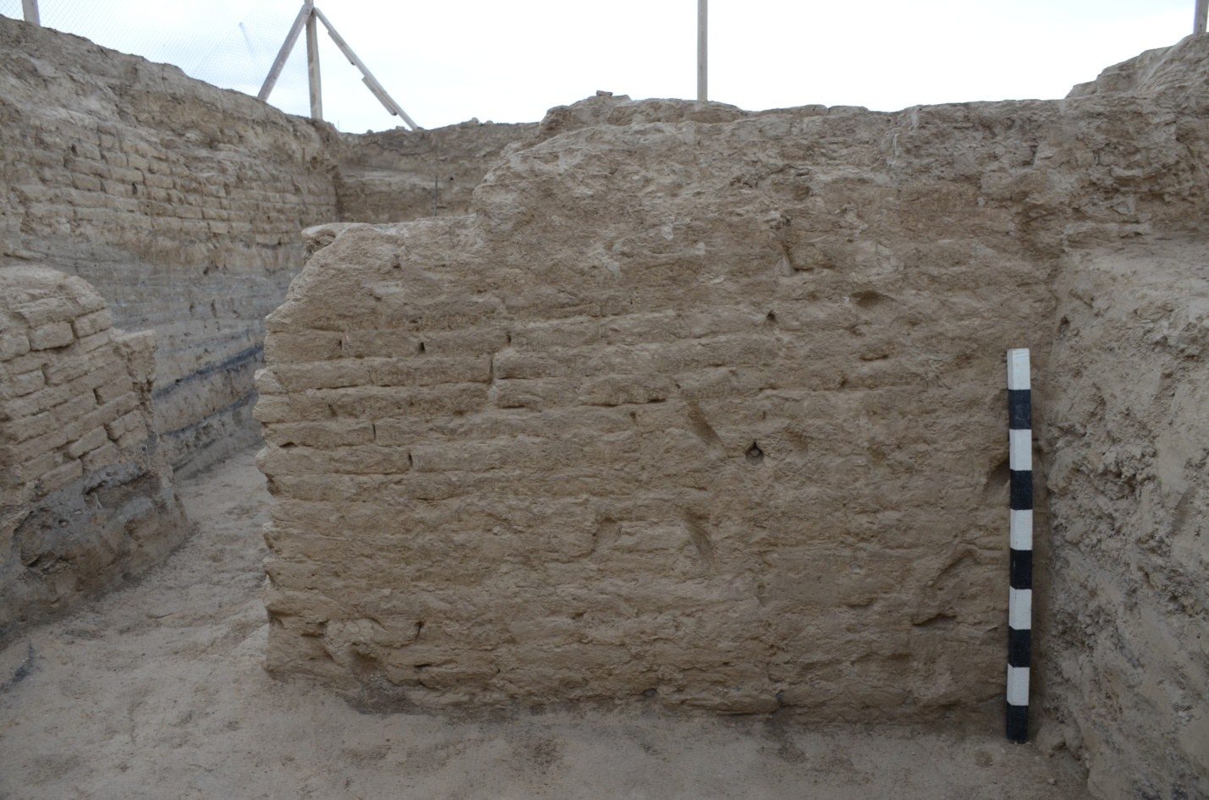
Figure E.25 – Trench 1. Room 32. Western face profile

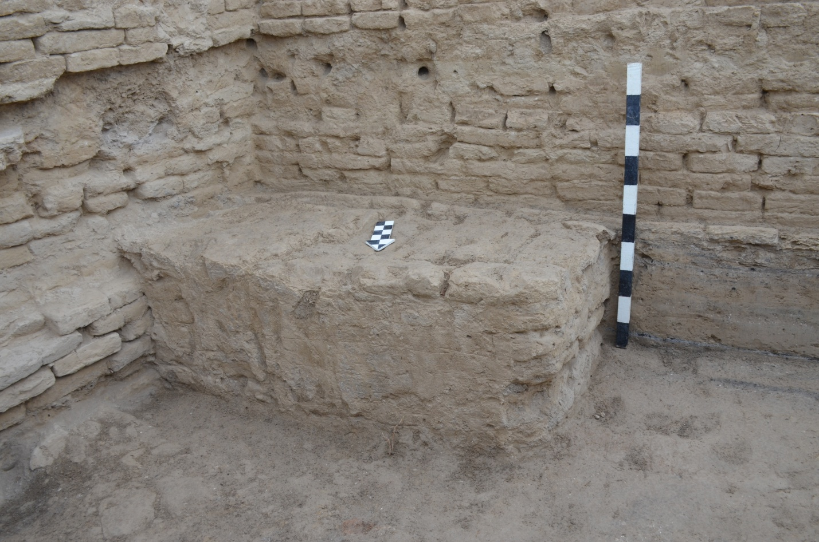
Figure E.26 – Trench 1. Room 32. Floor of the 2nd construction period
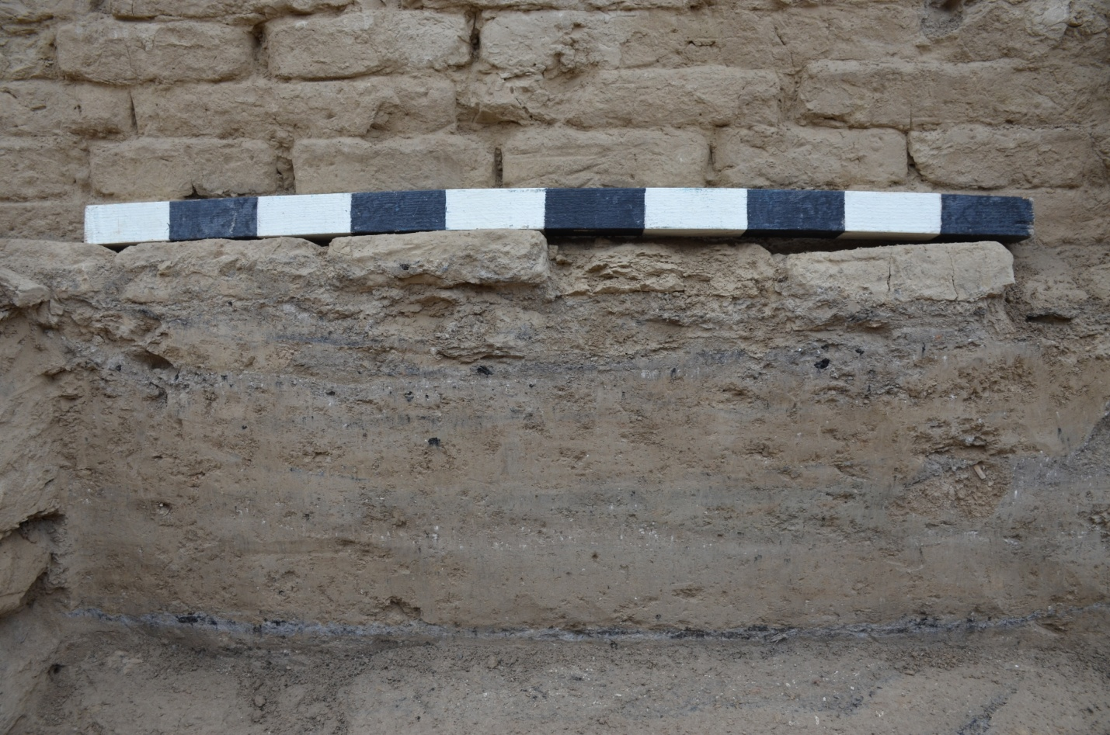
Figure E.27 – Trench 1. Room 32. Floor of the 2nd construction period

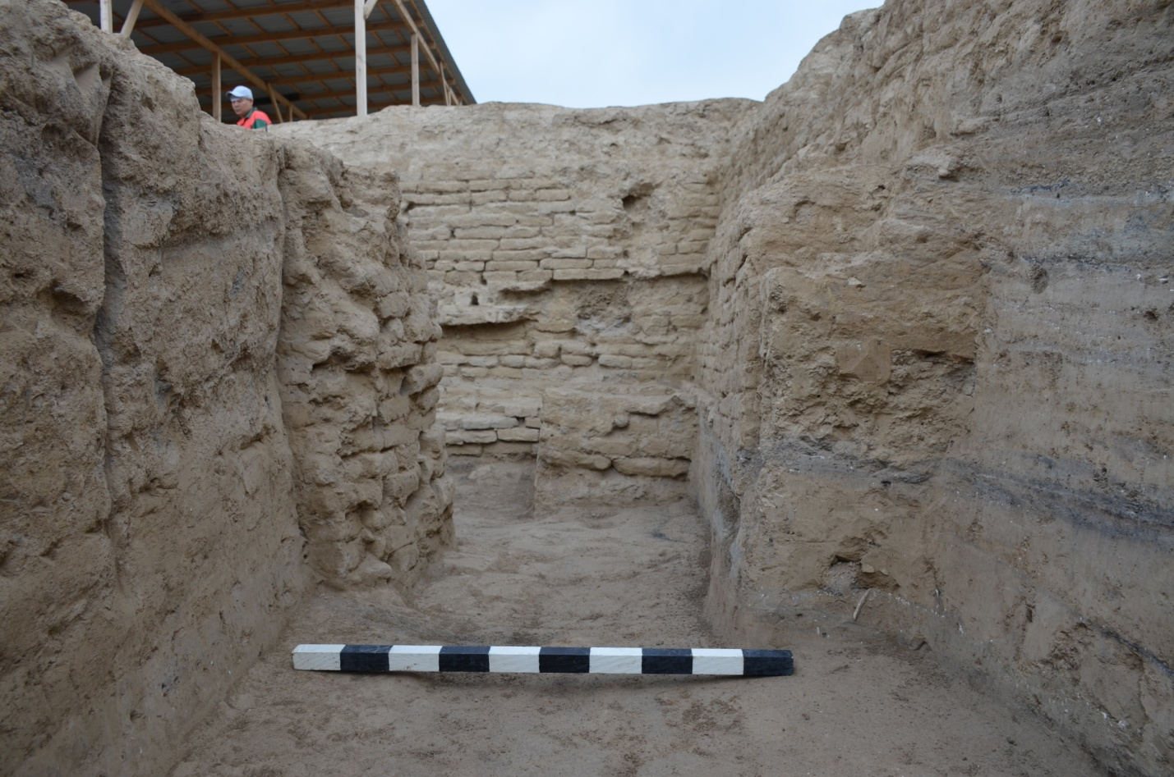
Figure E.28 – Trench 1. Room 32.
2nd construction horizon. Passage to the street
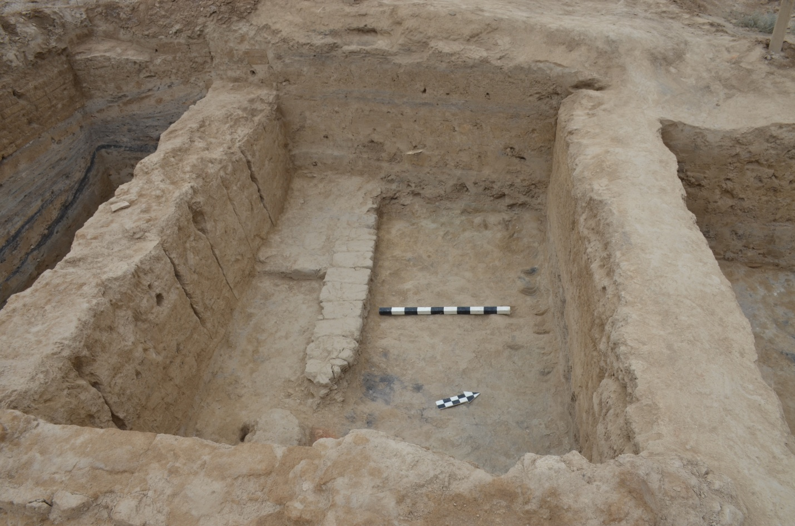
Figure E.29 – Trench 1. Room 33а. View from the east

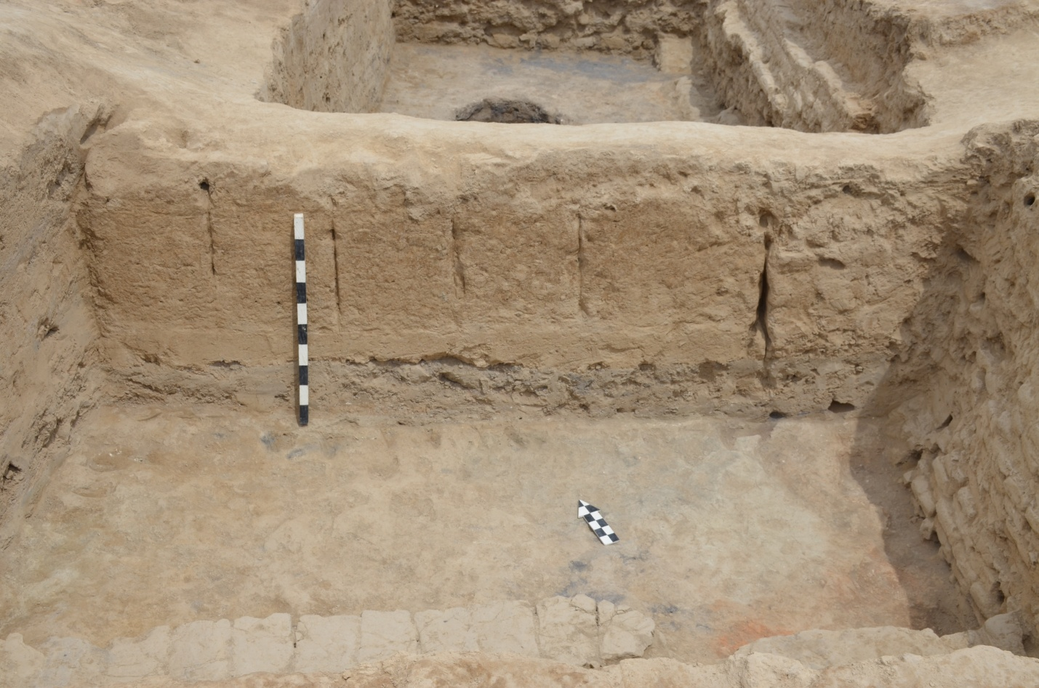
Figure E.30 – Trench 1. Room 33а. North wall profile
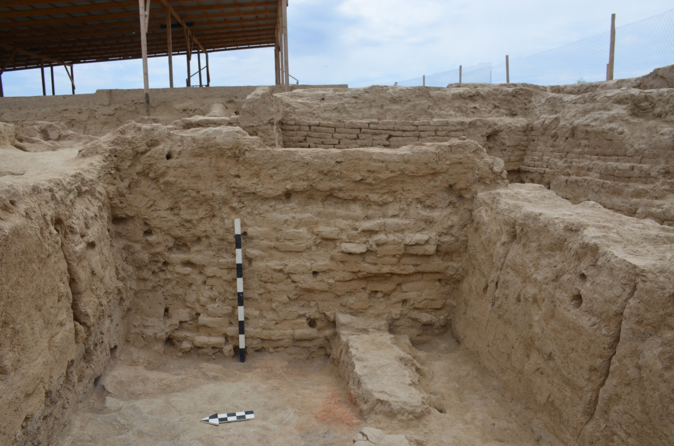
Figure E.31 – Trench 1. Room 33а. East wall profile

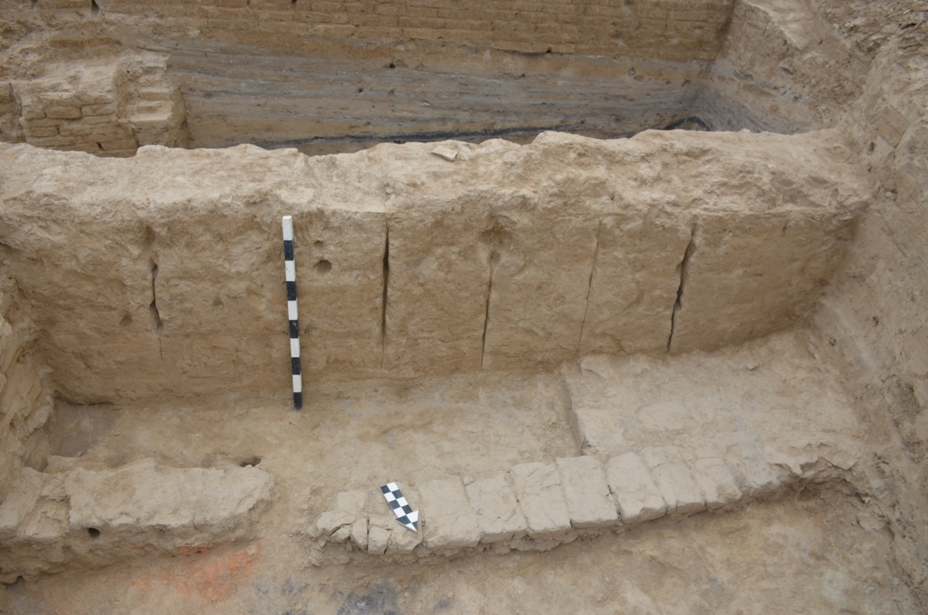
Figure E.32 – Trench 1. Room 33а. South wall profile
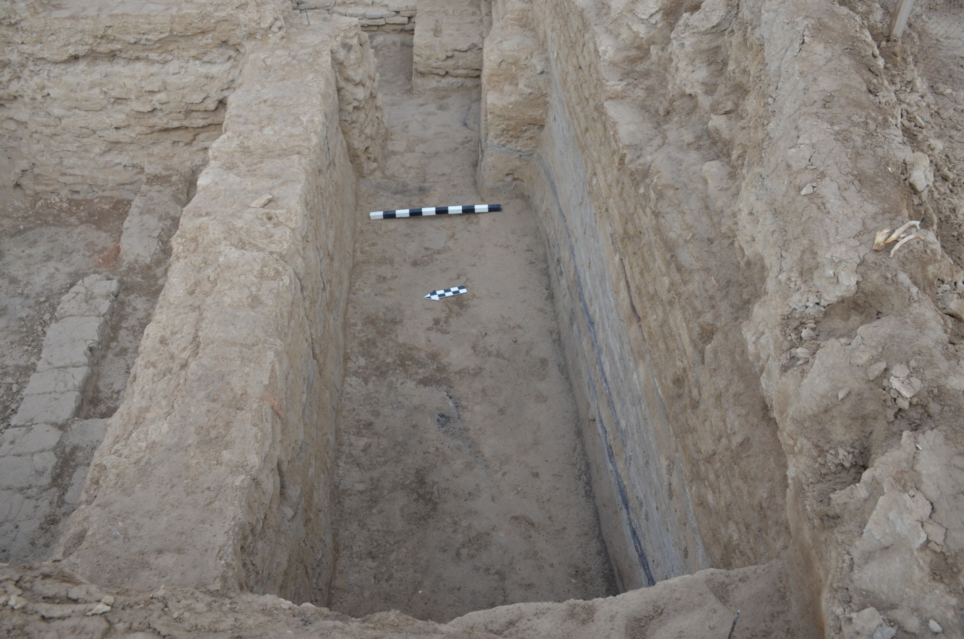
Figure E.33 – Trench 1. Room 34. View from the west

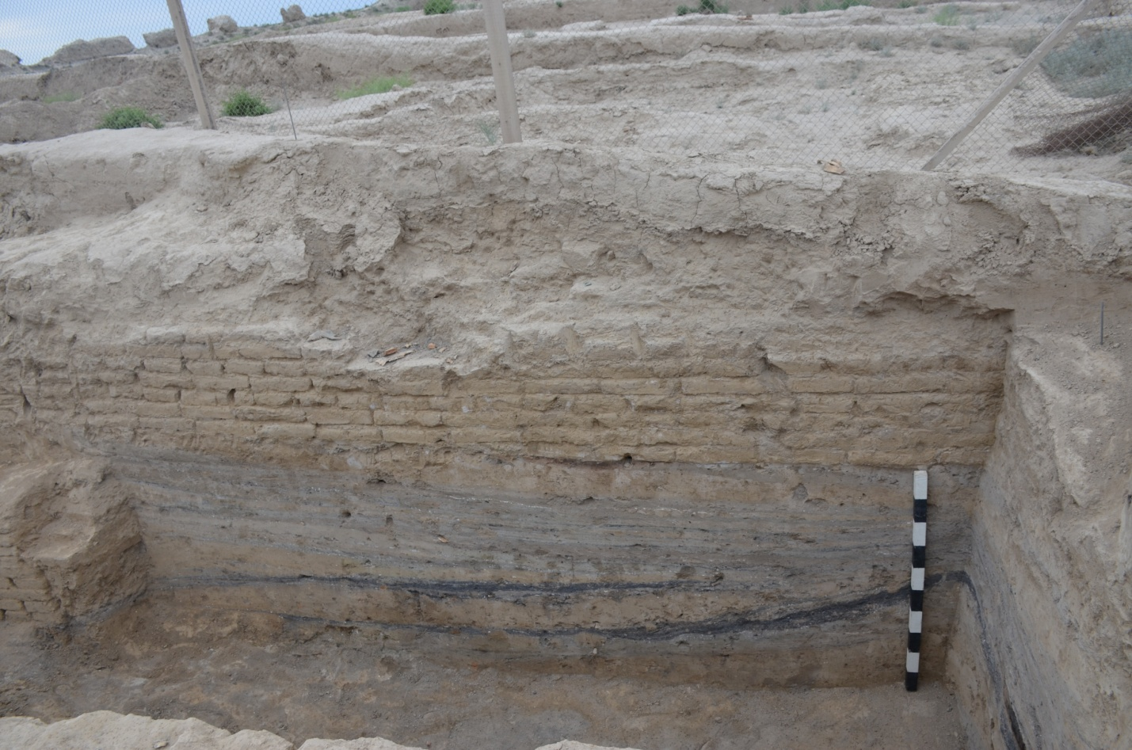
Figure E.34 – Trench 1. Room 34. South wall profile

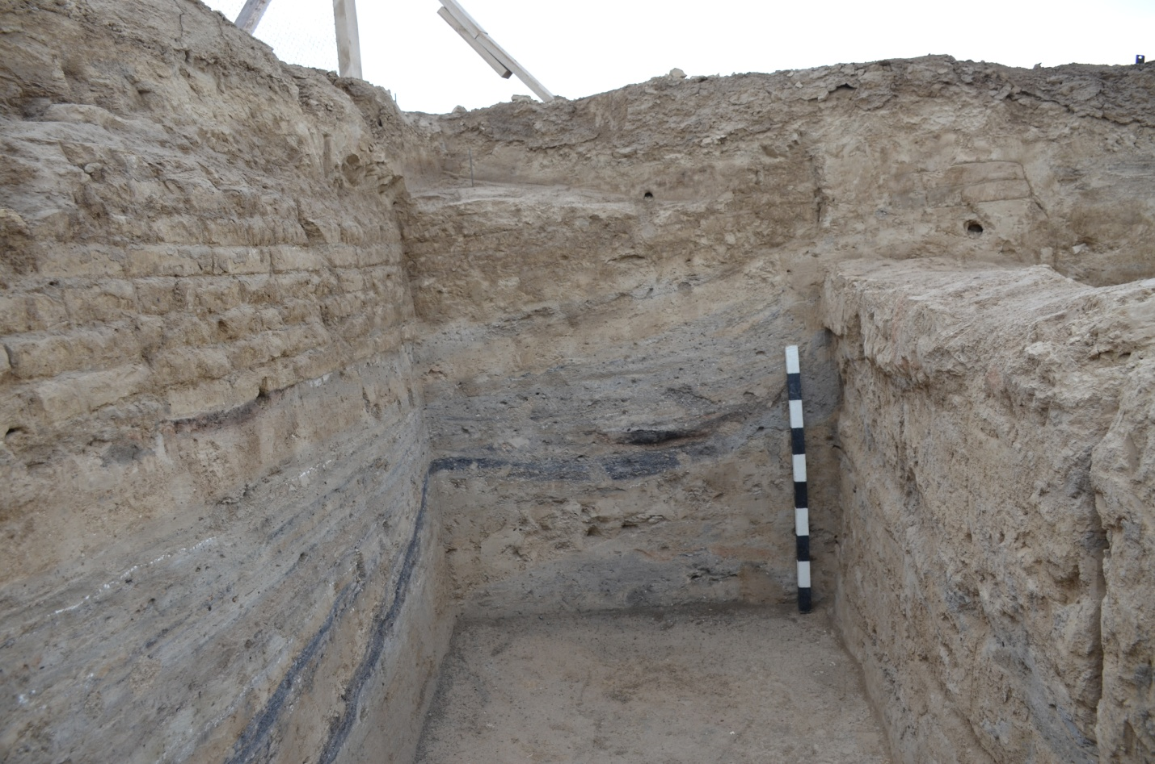
Figure E.35 – Trench 1. Room 34. West wall profile

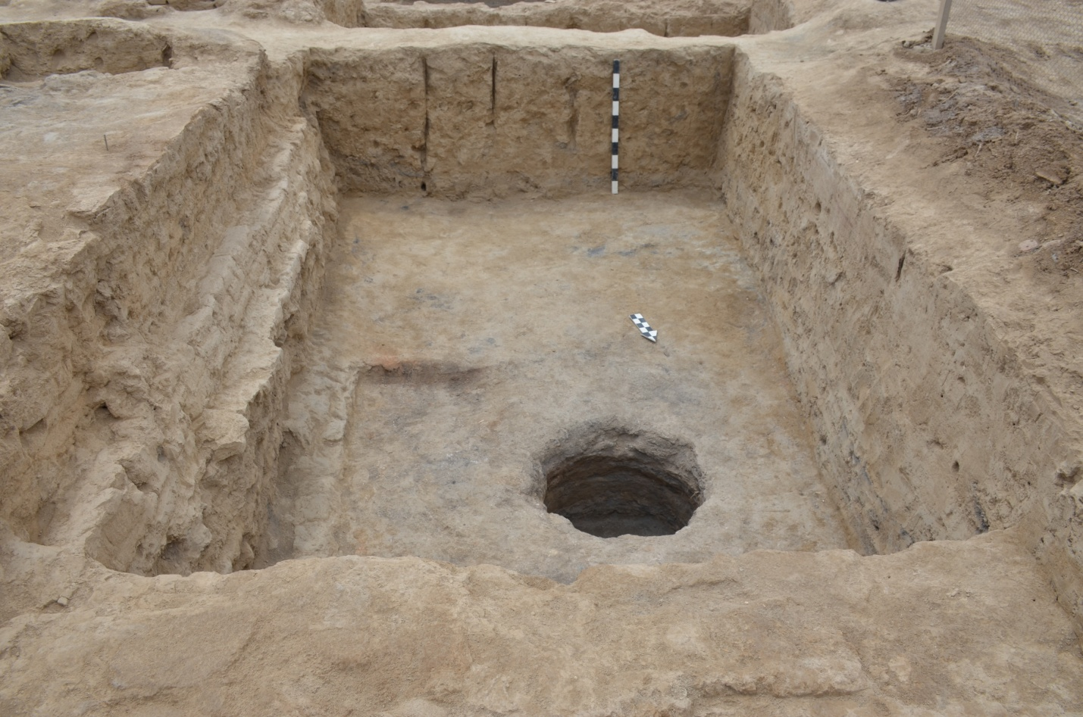Figure E.36 – Trench 1. Room 53. View from the north

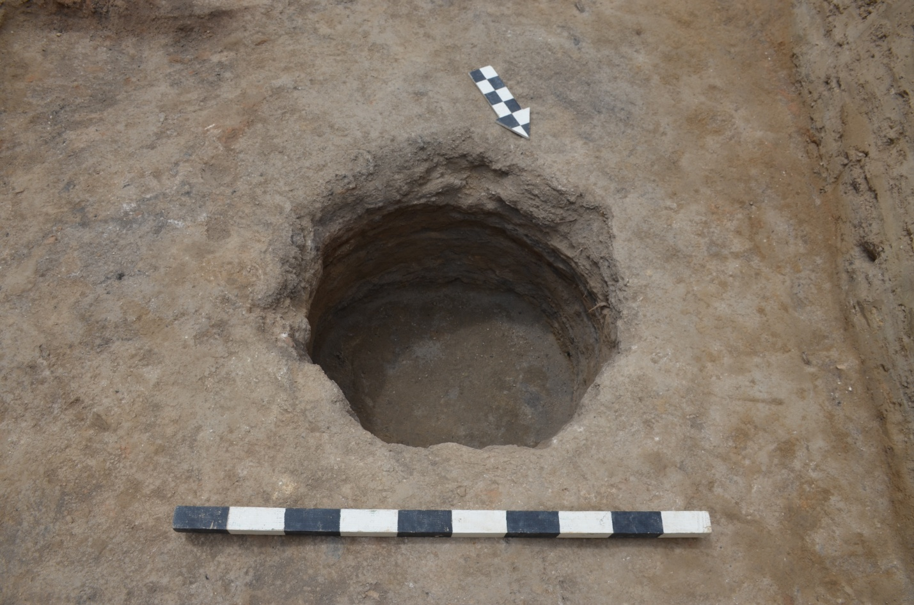
Figure E.37 – Trench 1. Room 53. Pit

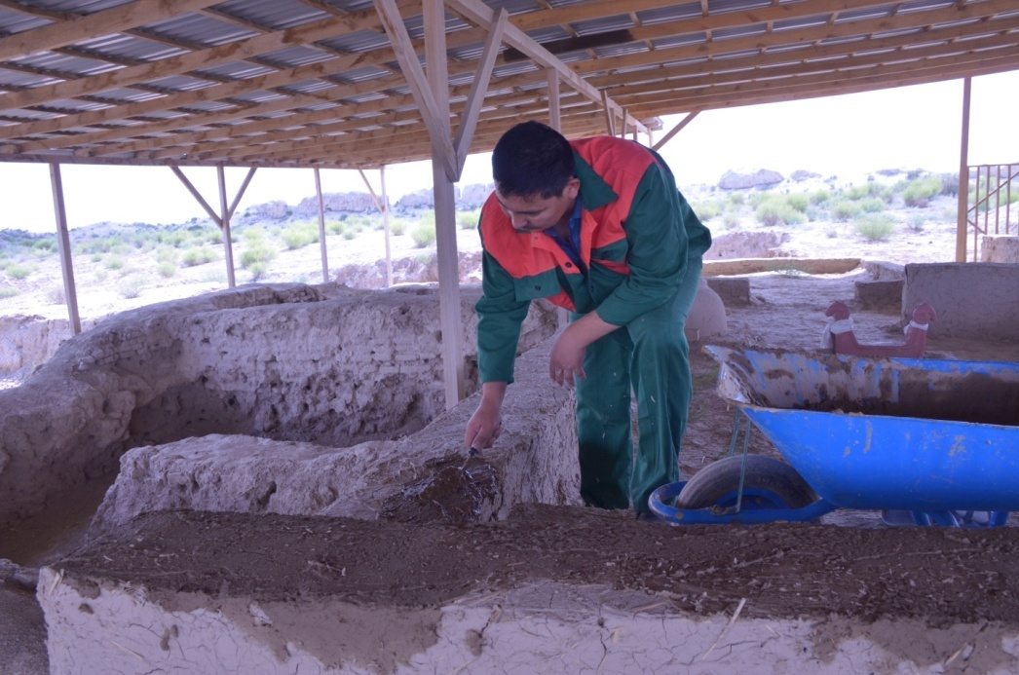
Figure E.38 – Trench 1. Temporary conservation of adobe structures
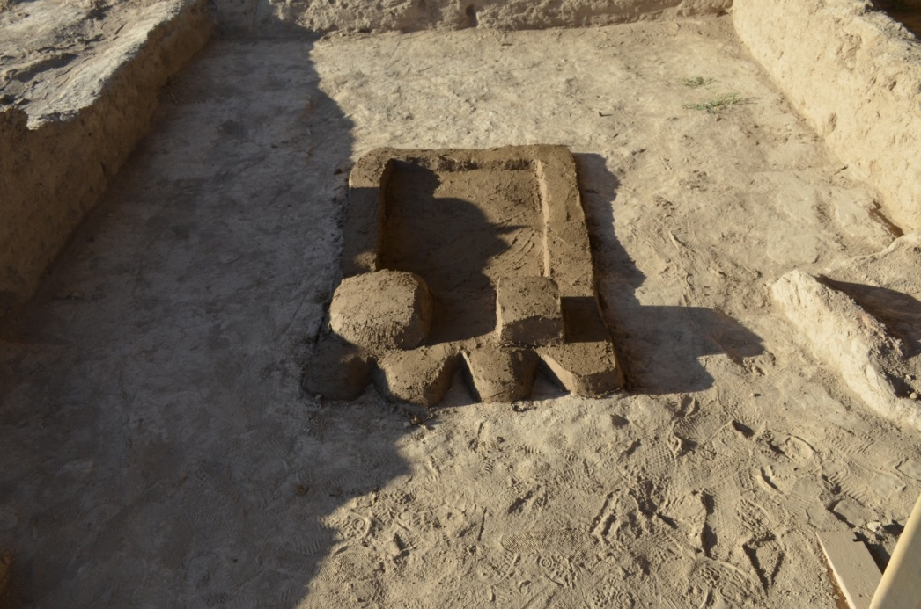
Figure E.39 – Trench 1. Primary restoration of the central hearth of room 6

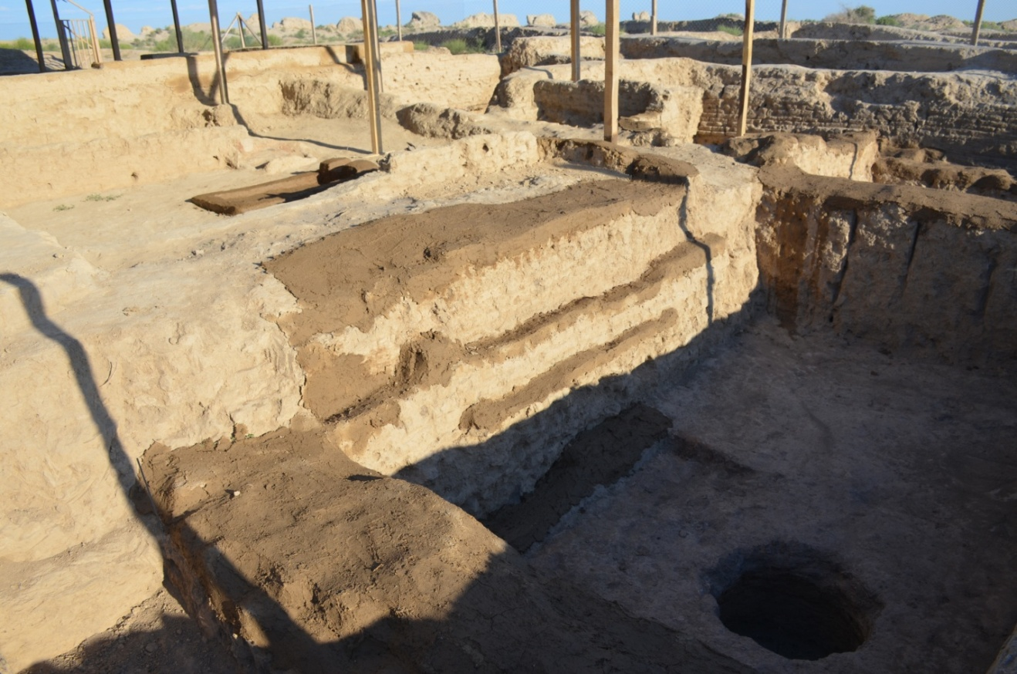
Figure E.40 – Trench 1. Temporary conservation of adobe structures
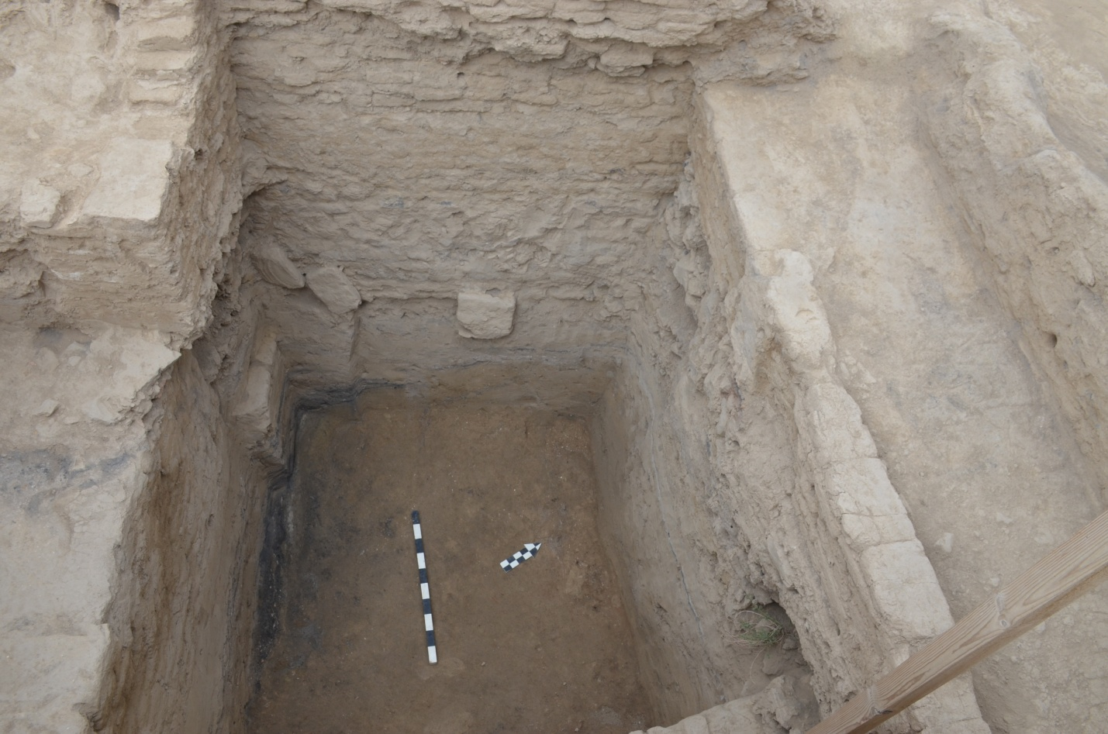
Figure E.41 – Trench 1. Test pit 1, 2019

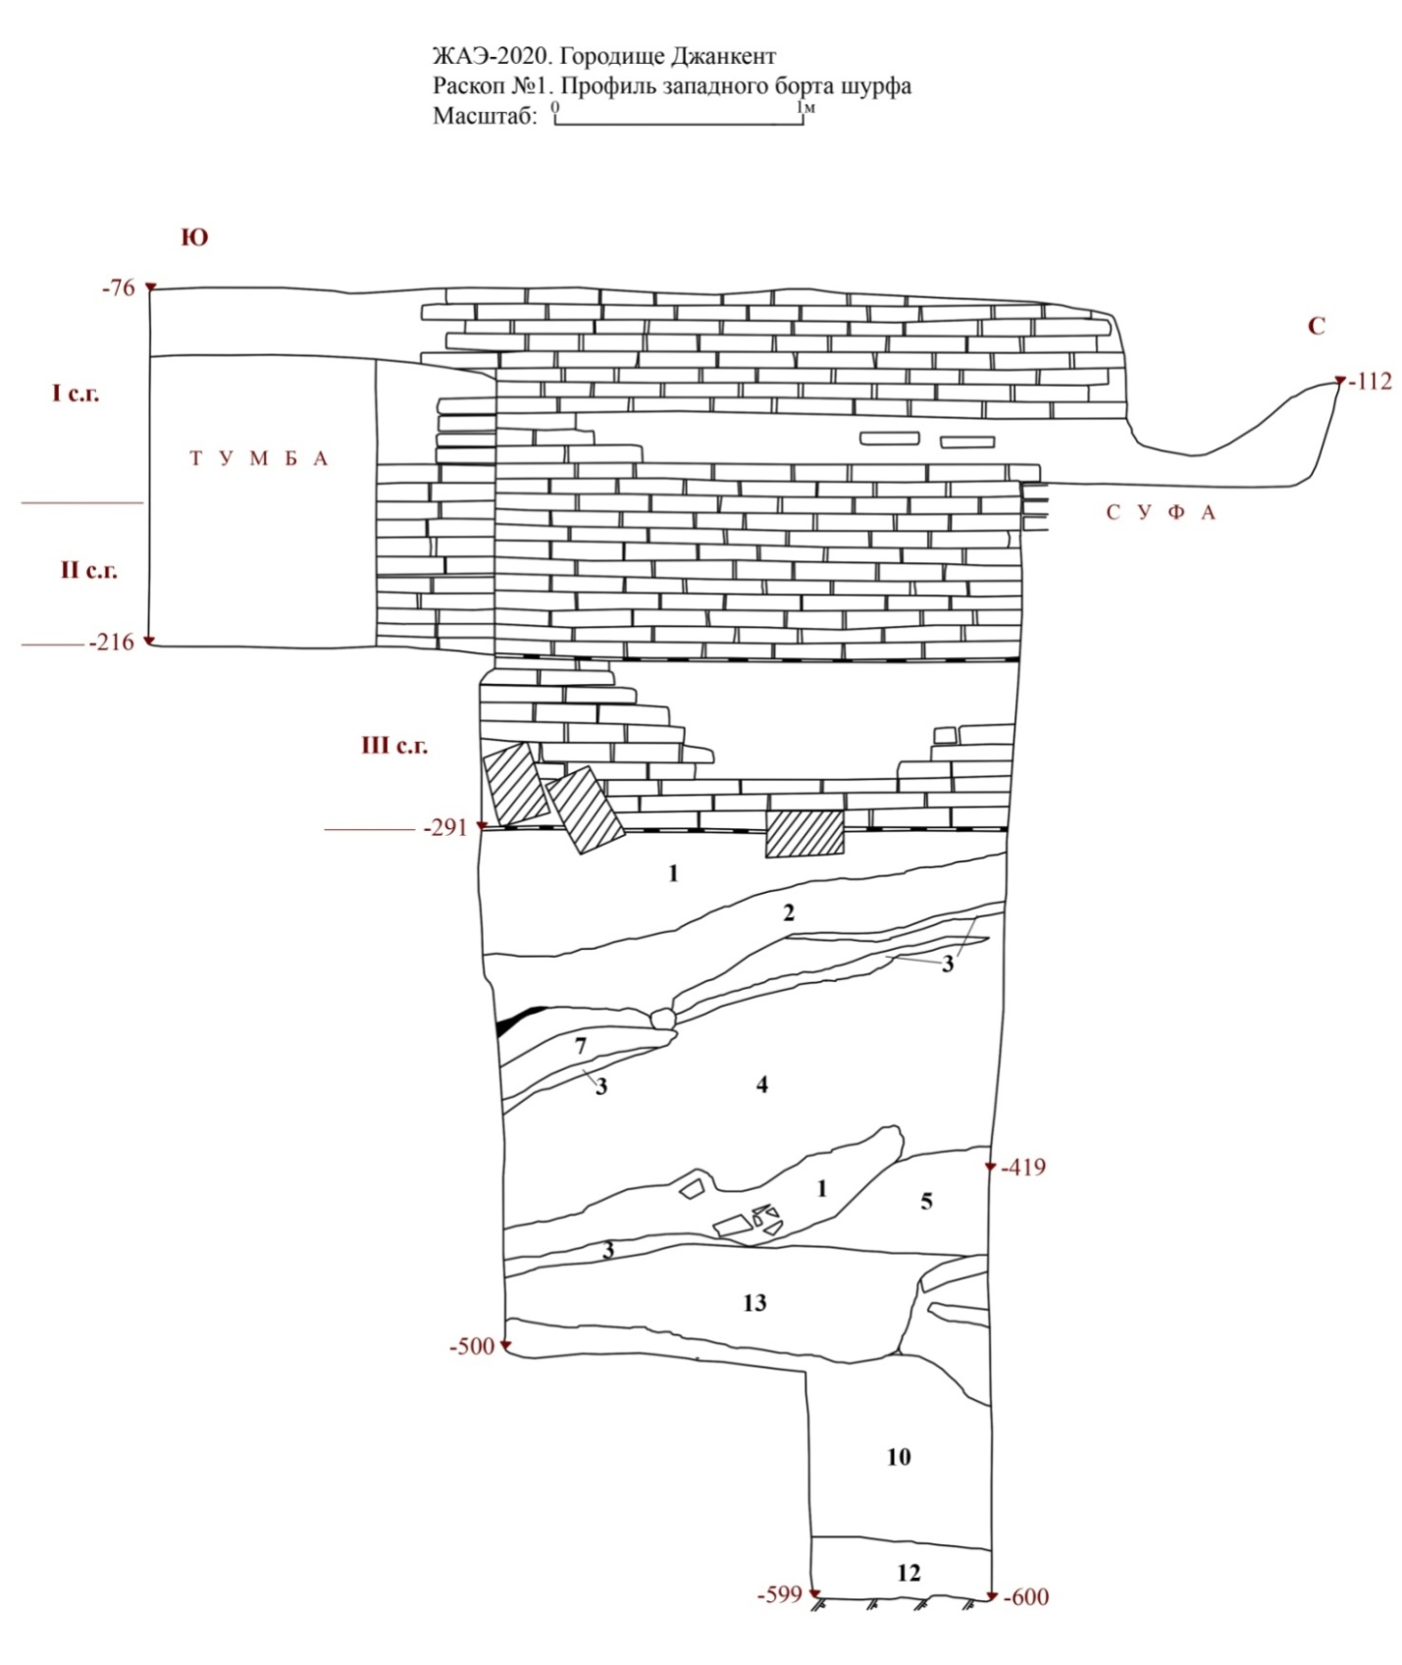
Figure E.42 – Trench 1. Test pit 1-2020. West side profile
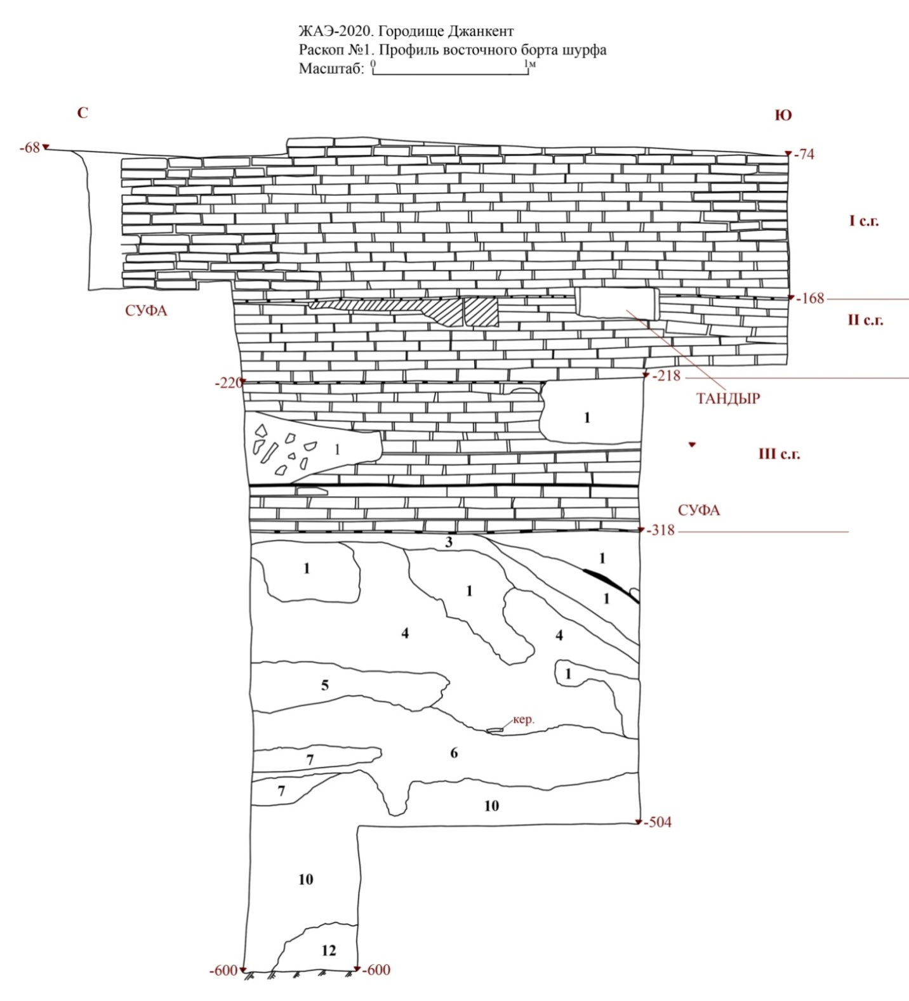
Figure E.43 – Trench 1. Test pit 1-2020. East side profile

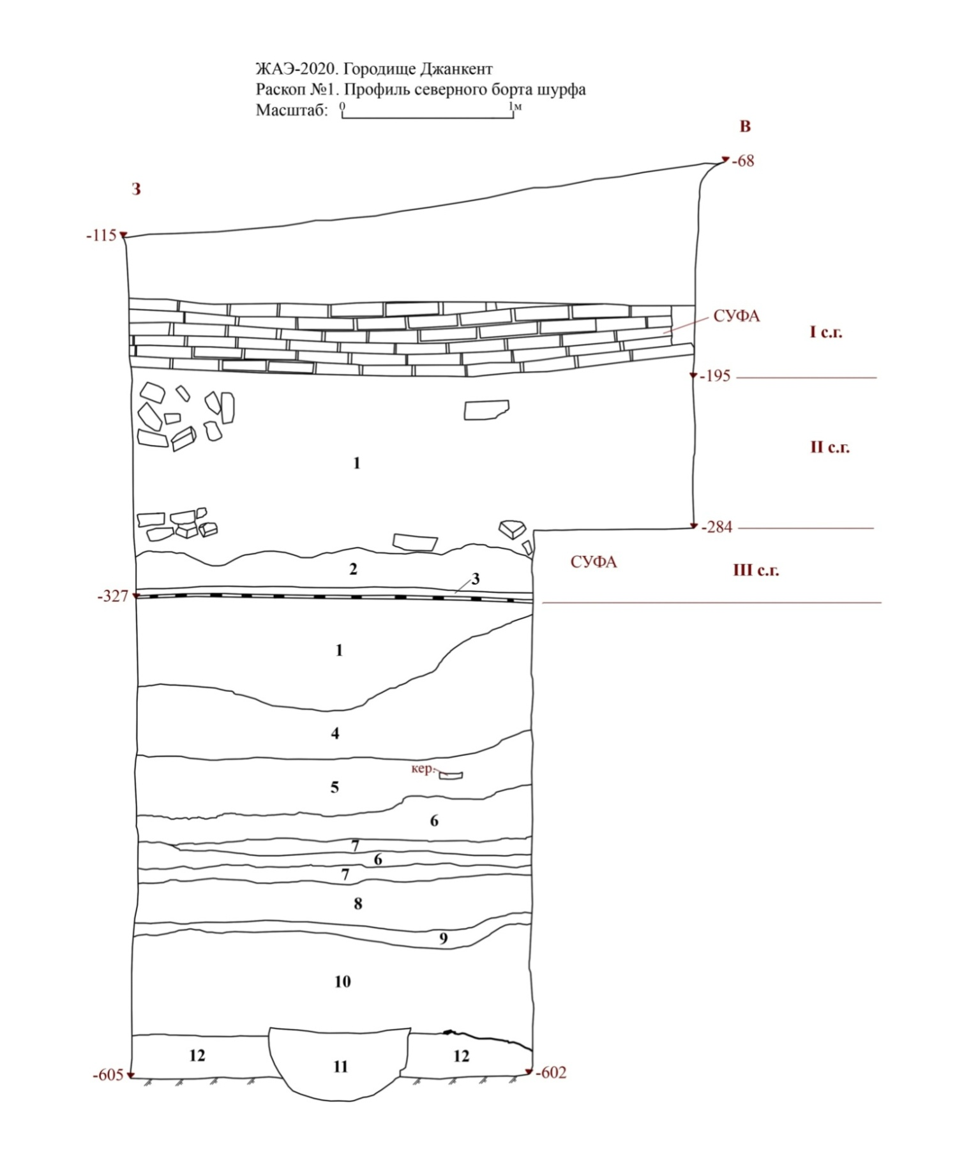
Figure E.44 – Trench 1. Test pit 1-2020. North side profile
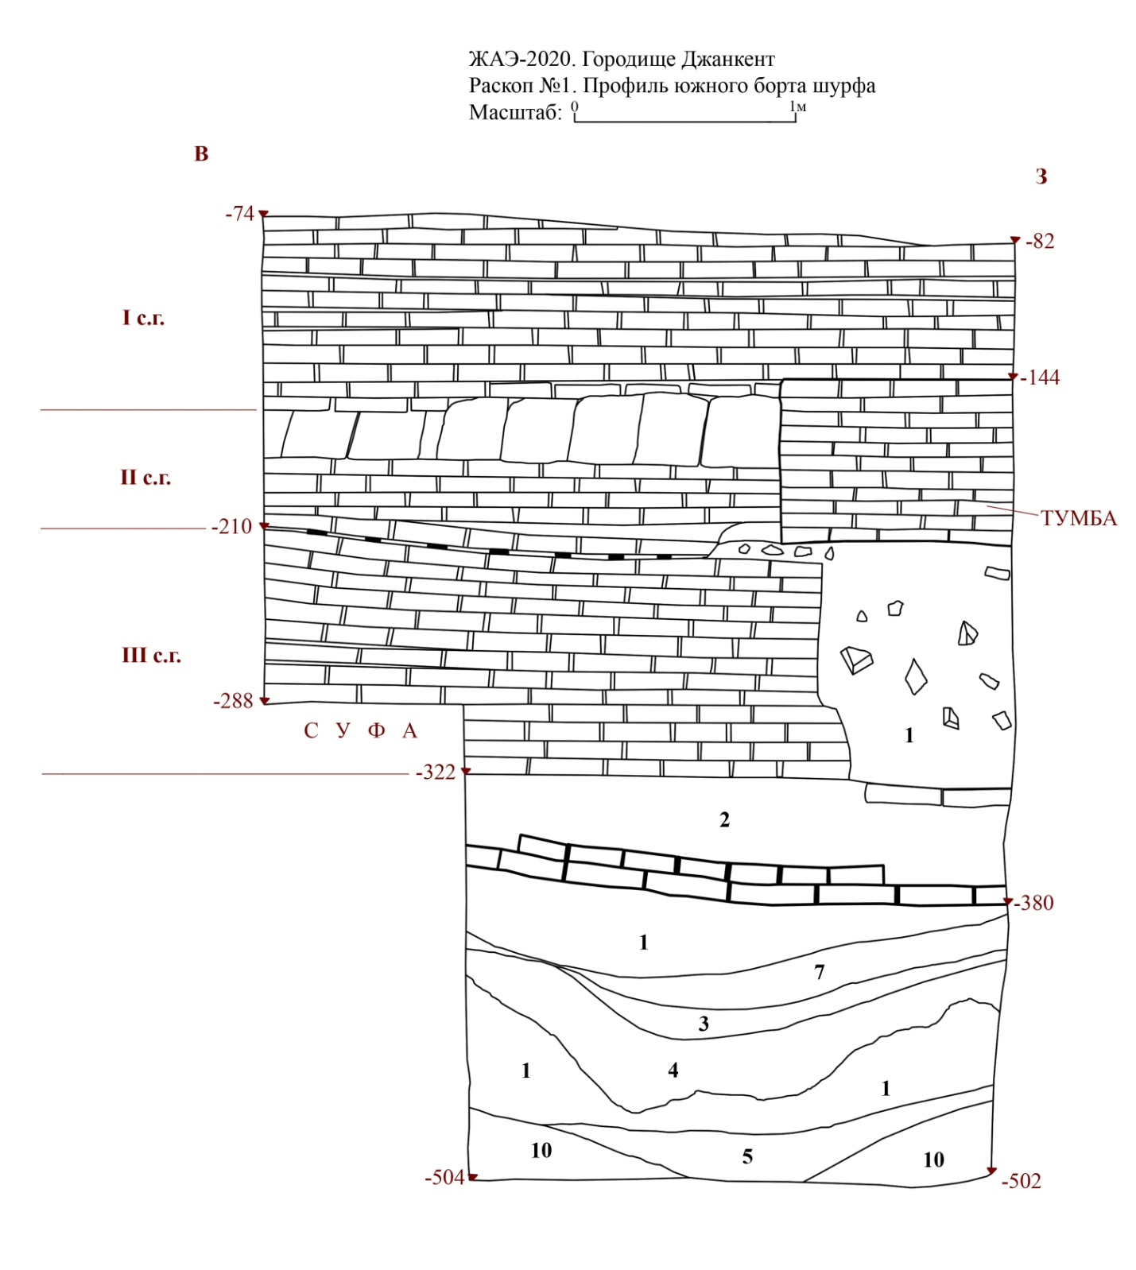
Figure E.45 – Trench 1. Test pit 1-2020. South side profile
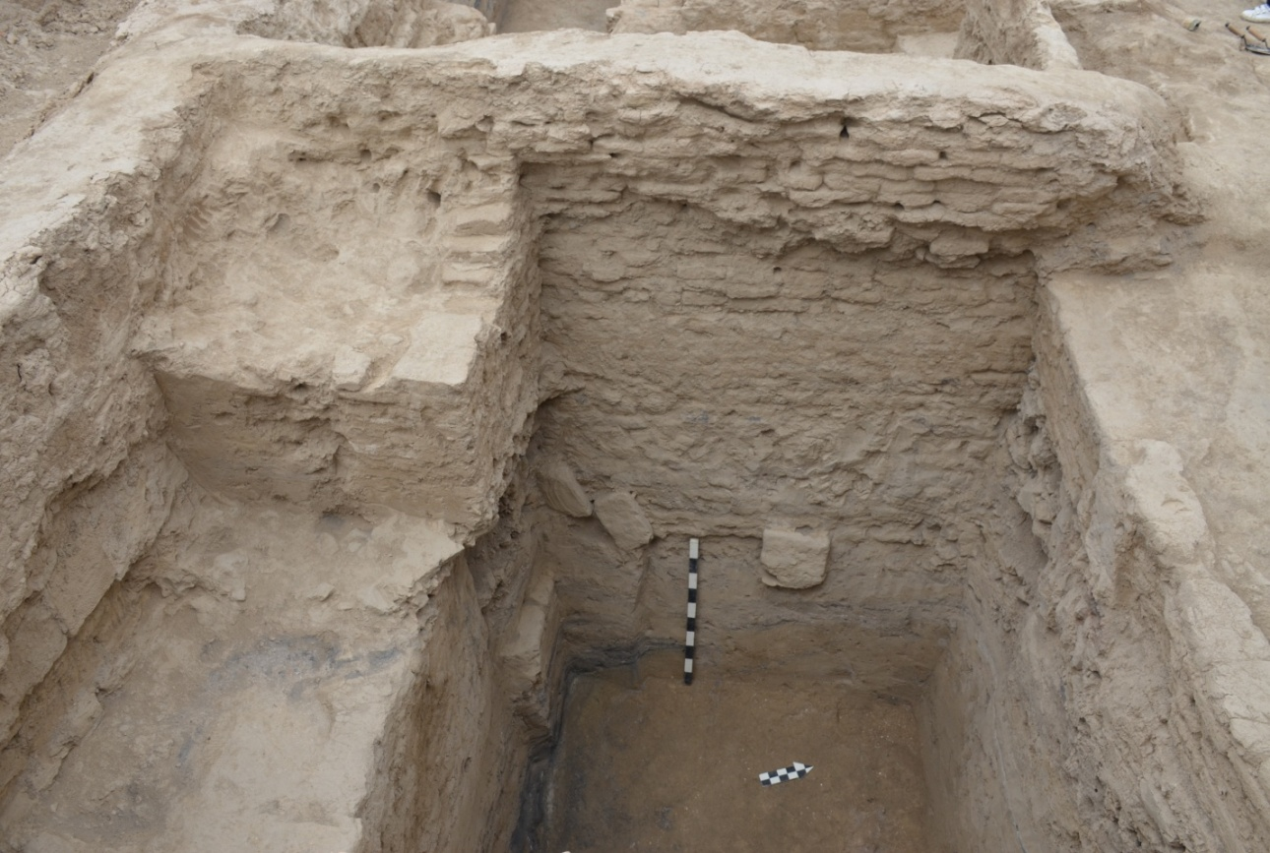
Figure E.46 – Trench 1. Test pit 1-2019. West side profile

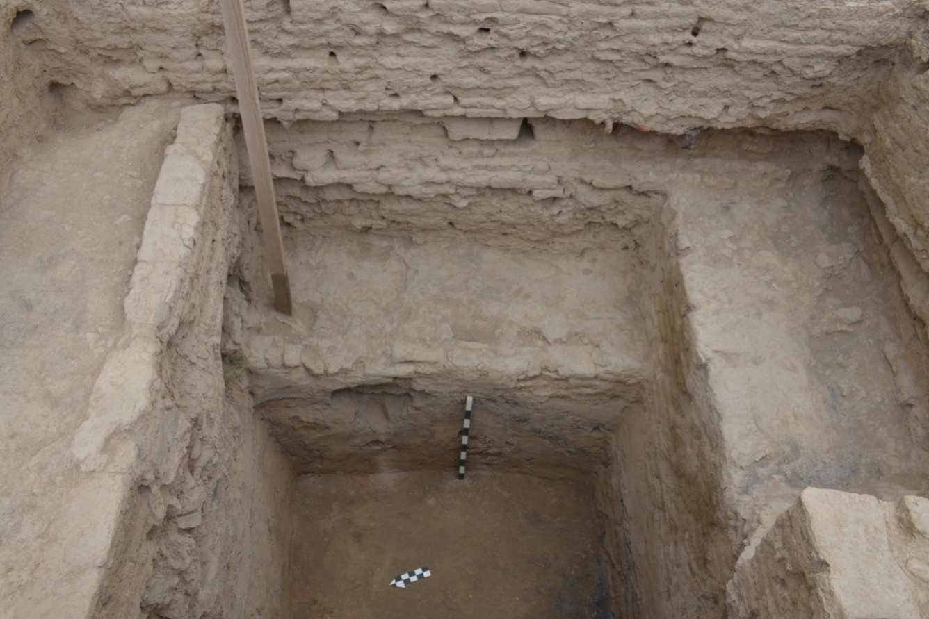
Figure E.47 – Trench 1. Test pit 1-2019. East side profile
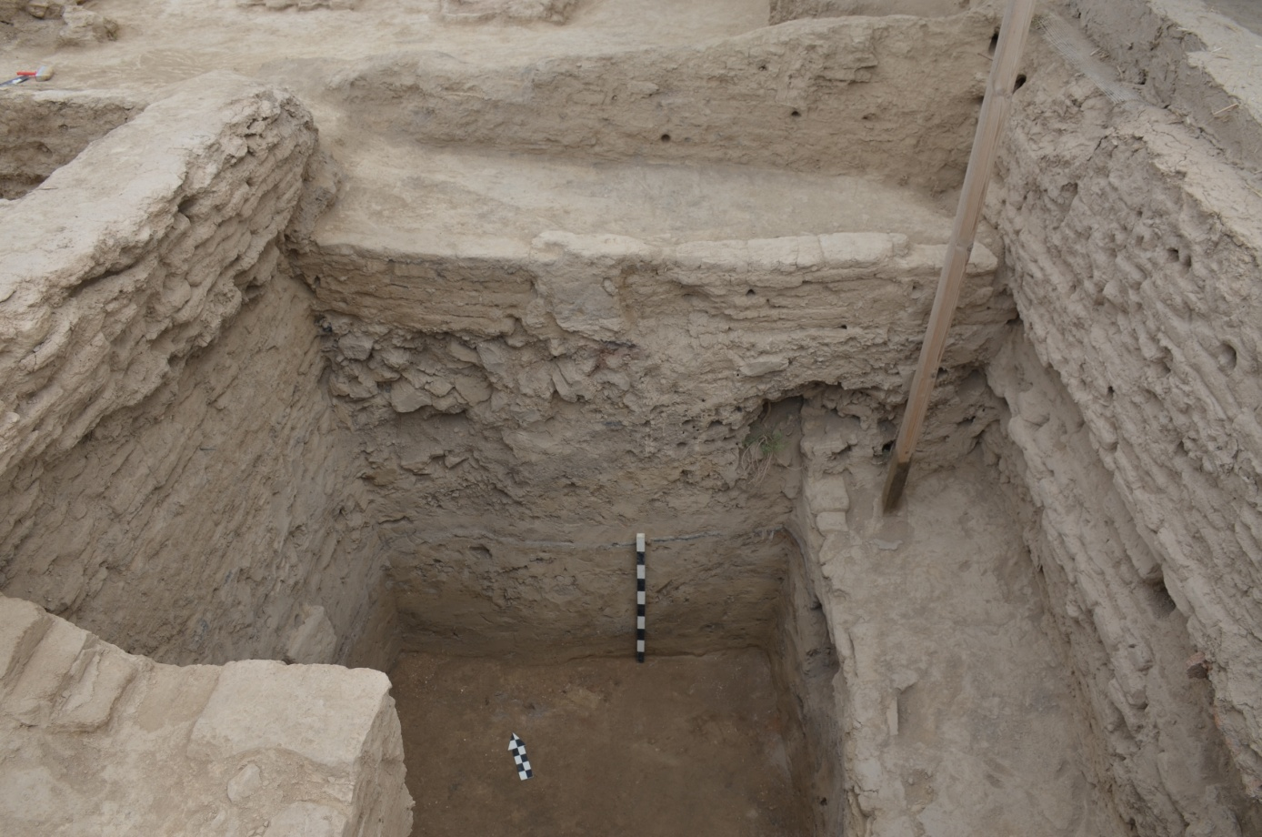
Figure E.48 – Trench 1. Test pit 1-2019. North side profile

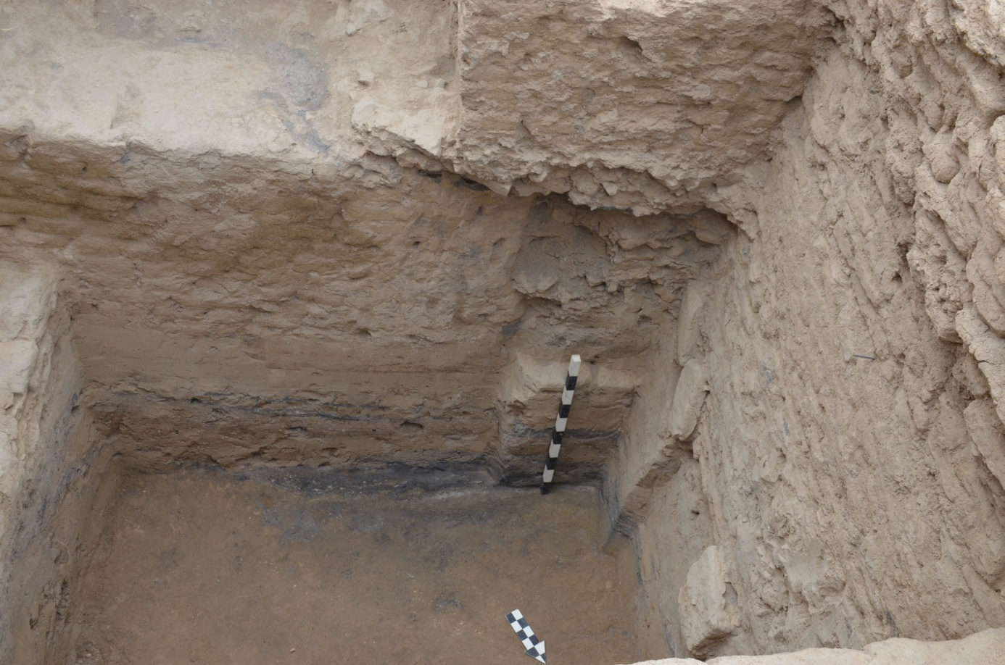
Figure E.49 – Trench 1. Test pit 1-2019. South face profile.
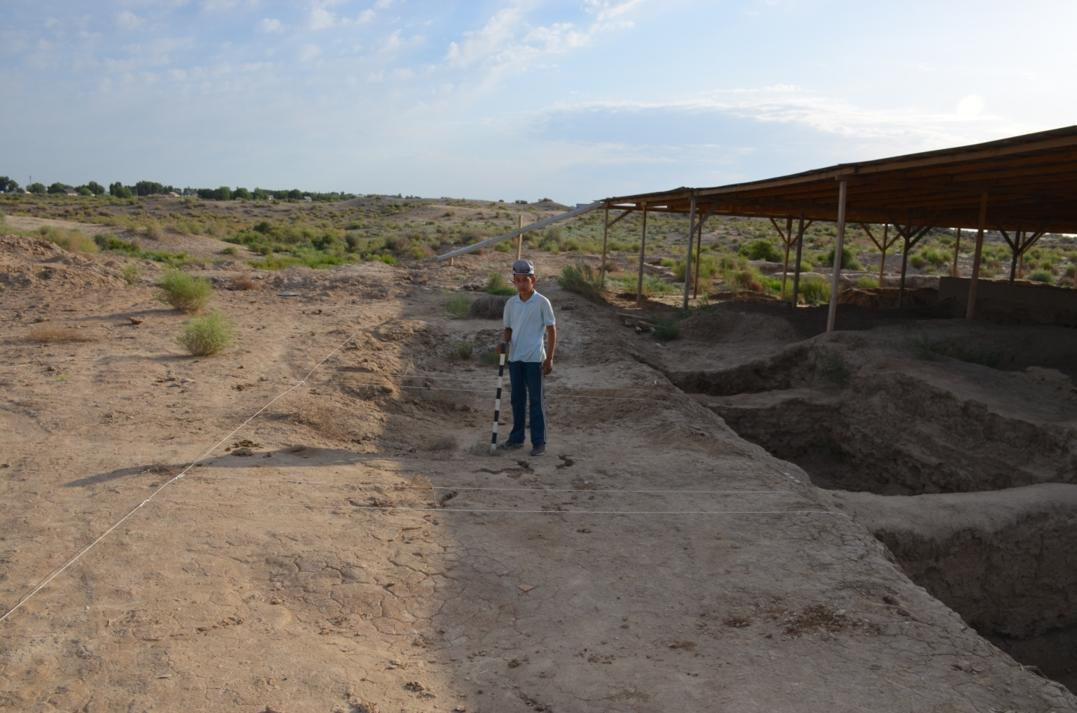
Figure E.50 – Trench 1. The street. View before the excavation

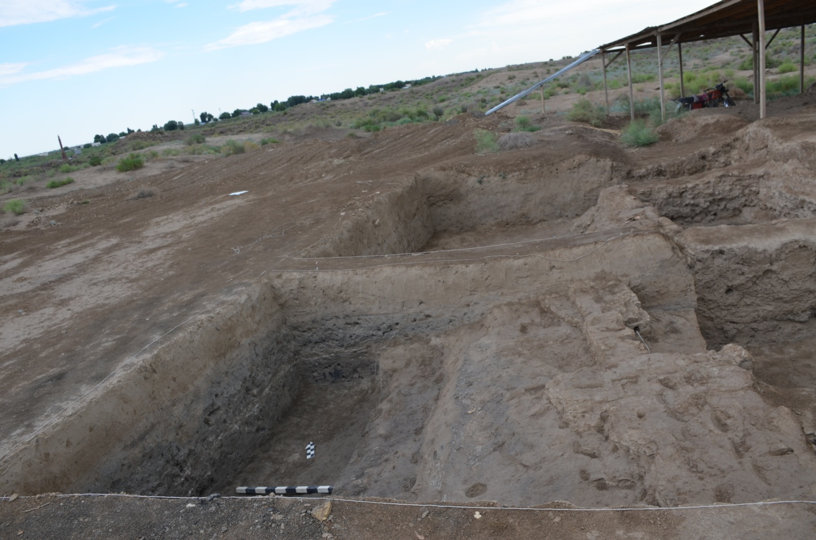
Figure E.51 – Trench 1. The street. View from the south
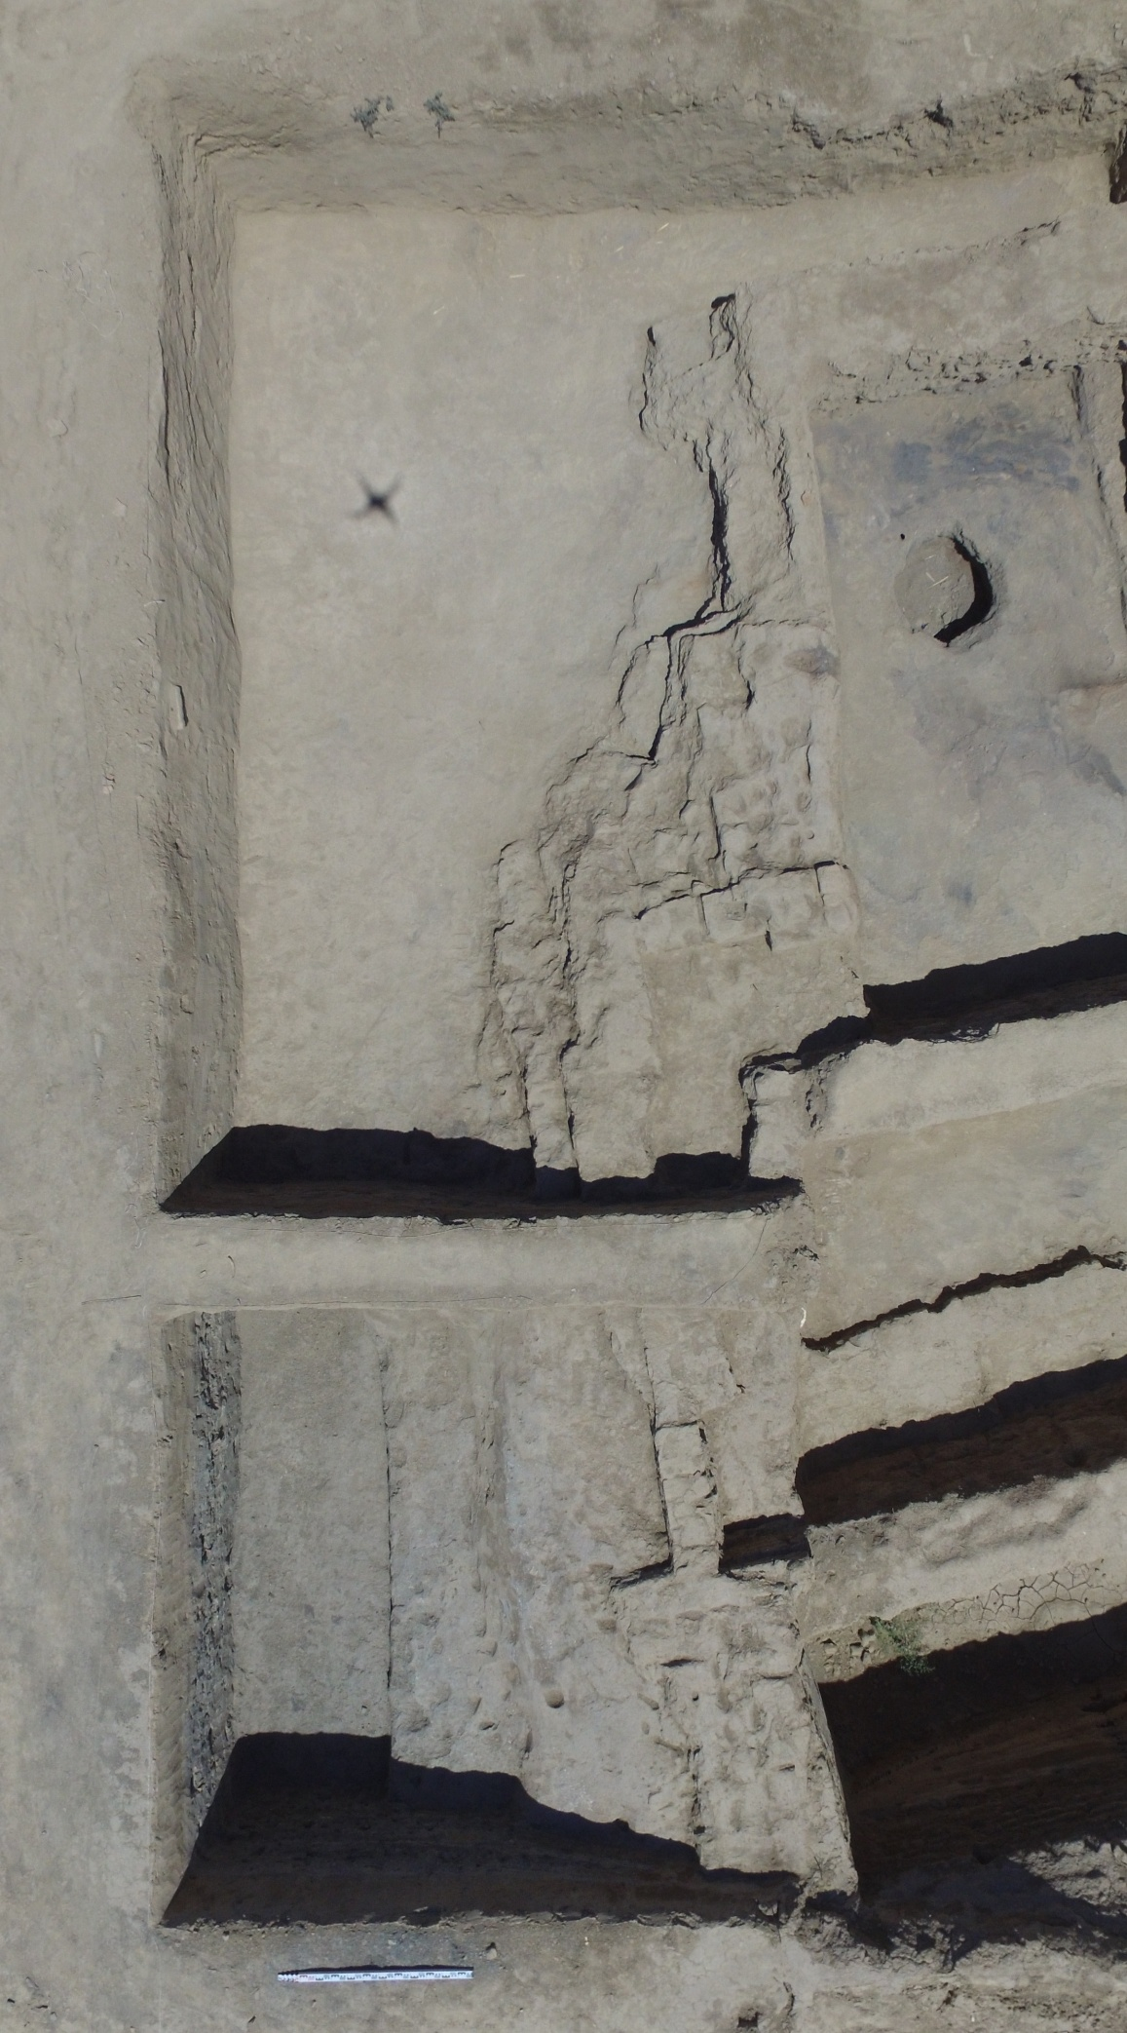
Figure E.52 – Trench 1. The street. Bird's eye view
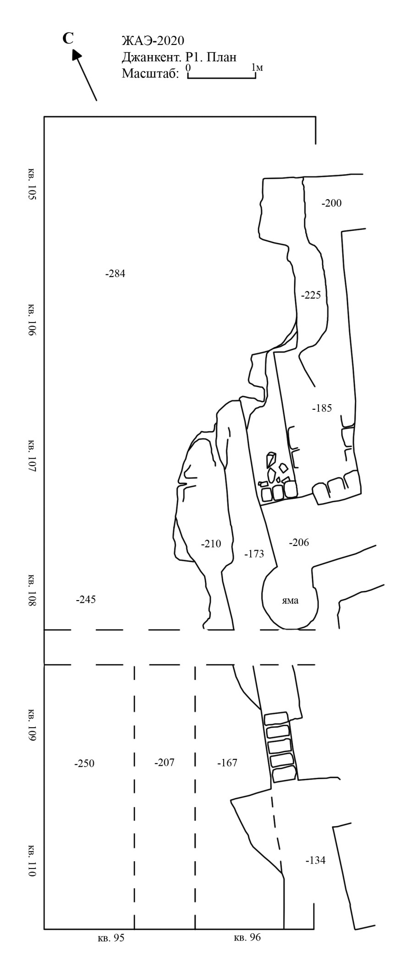
Figure E.53 – Trench 1. The street. Plan of excavation
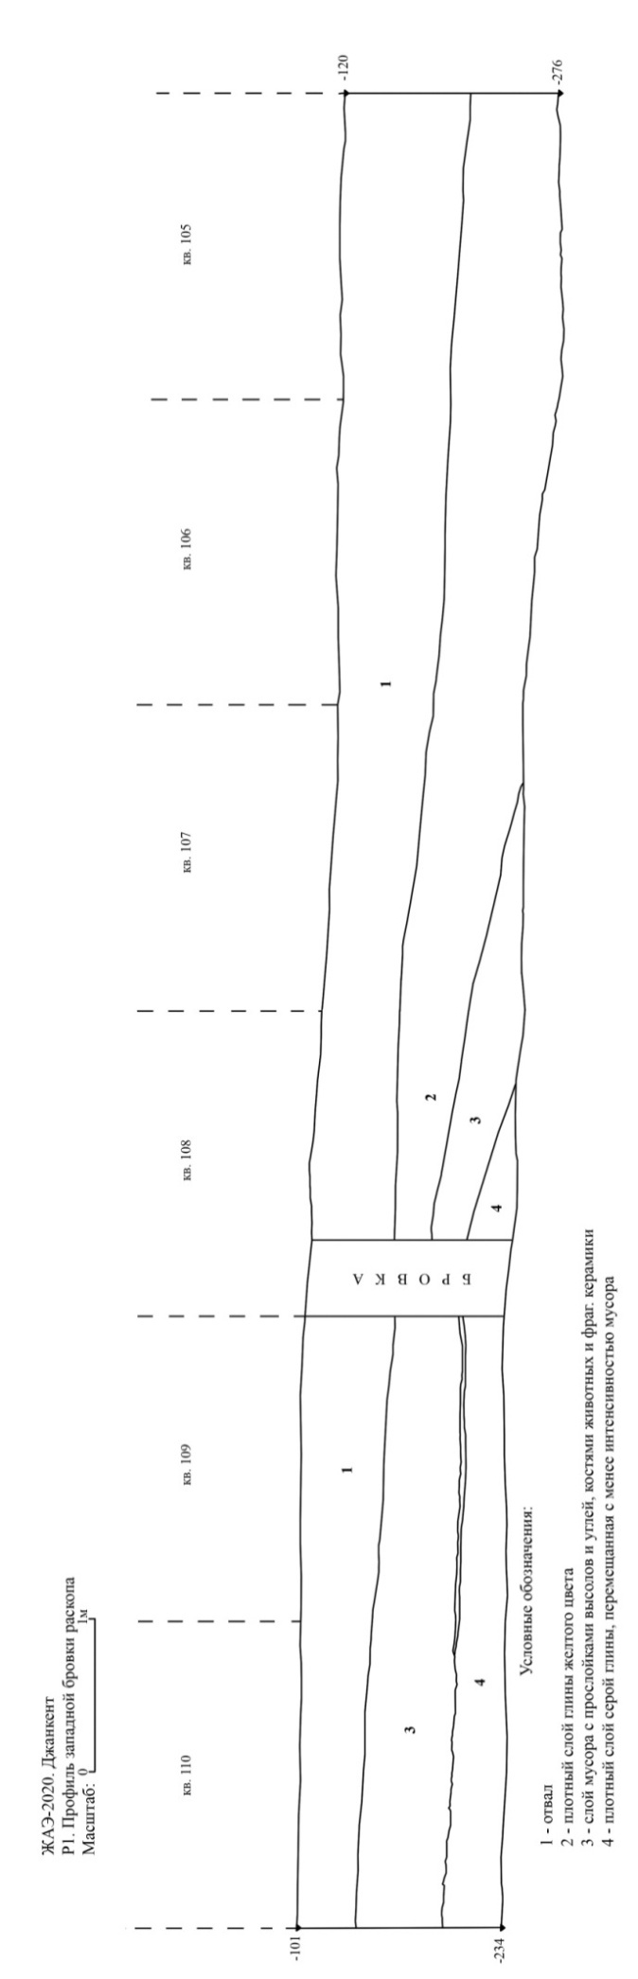
Figure E.54 – Trench 1. The street. West side profile
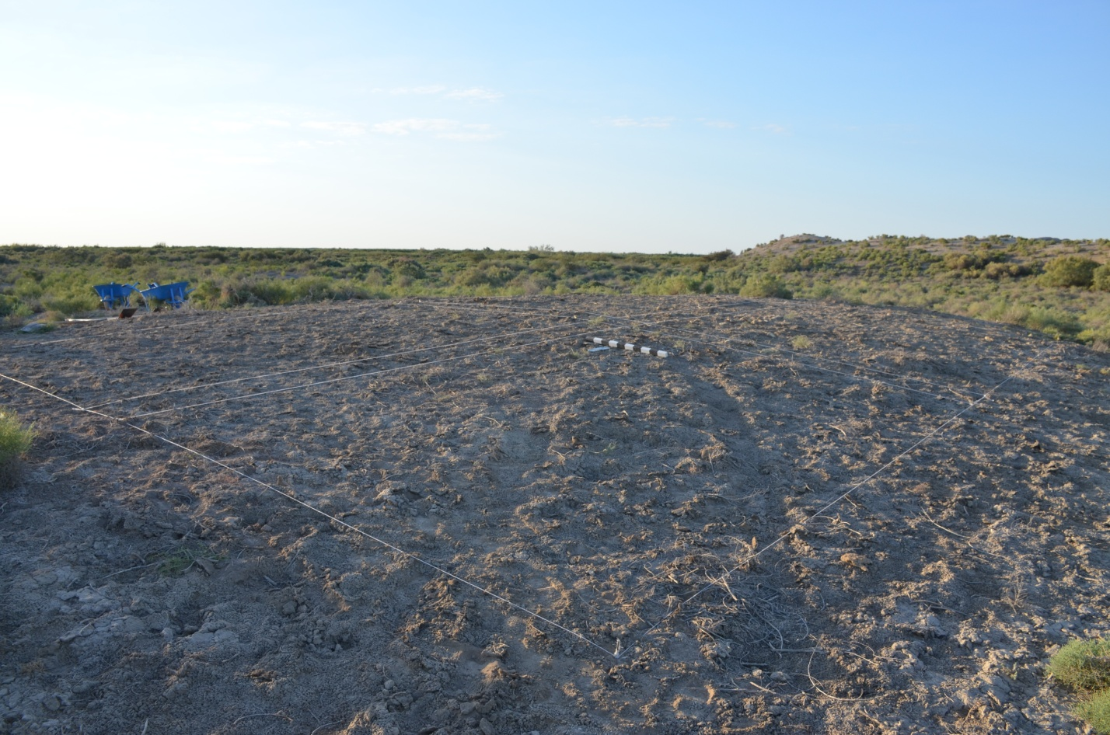
Figure E.55 – Trench 9. View before the excavation

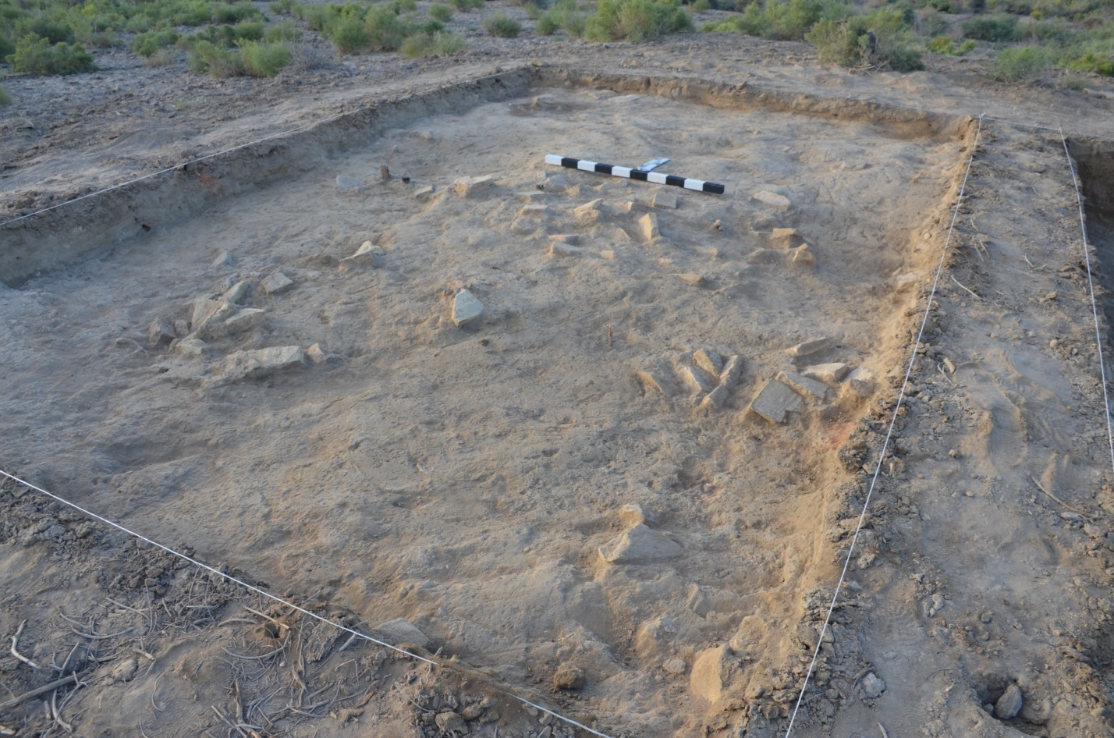
Figure E.56 – Trench 9. View from the north

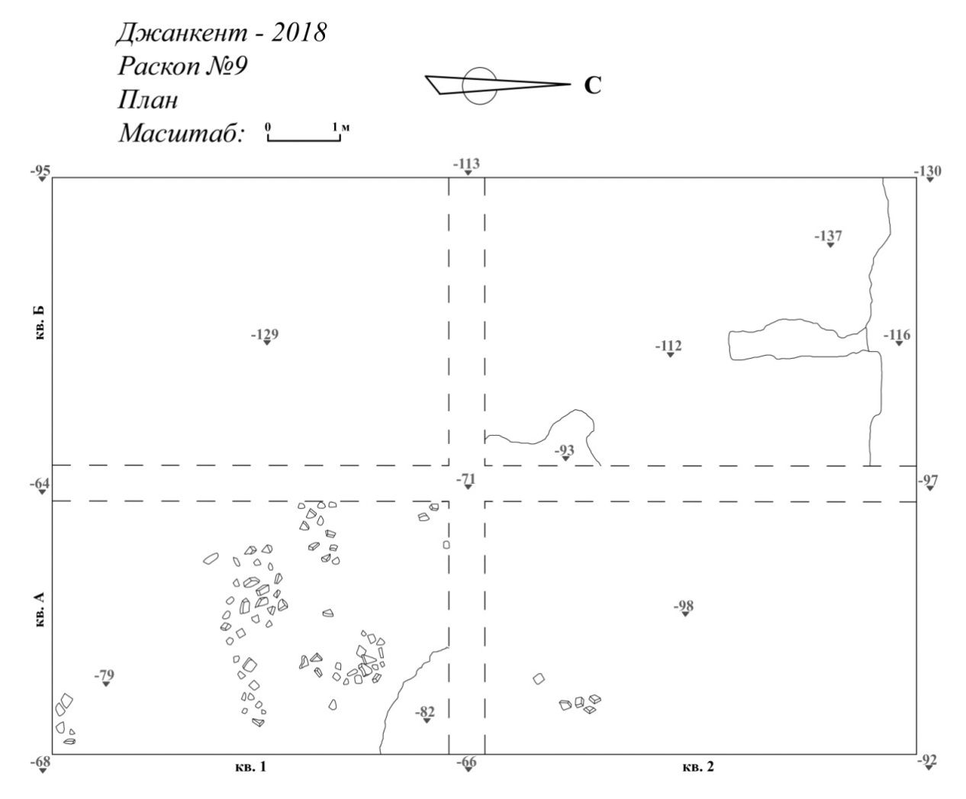
Figure E.57 – Trench 1. Plan of the first layer

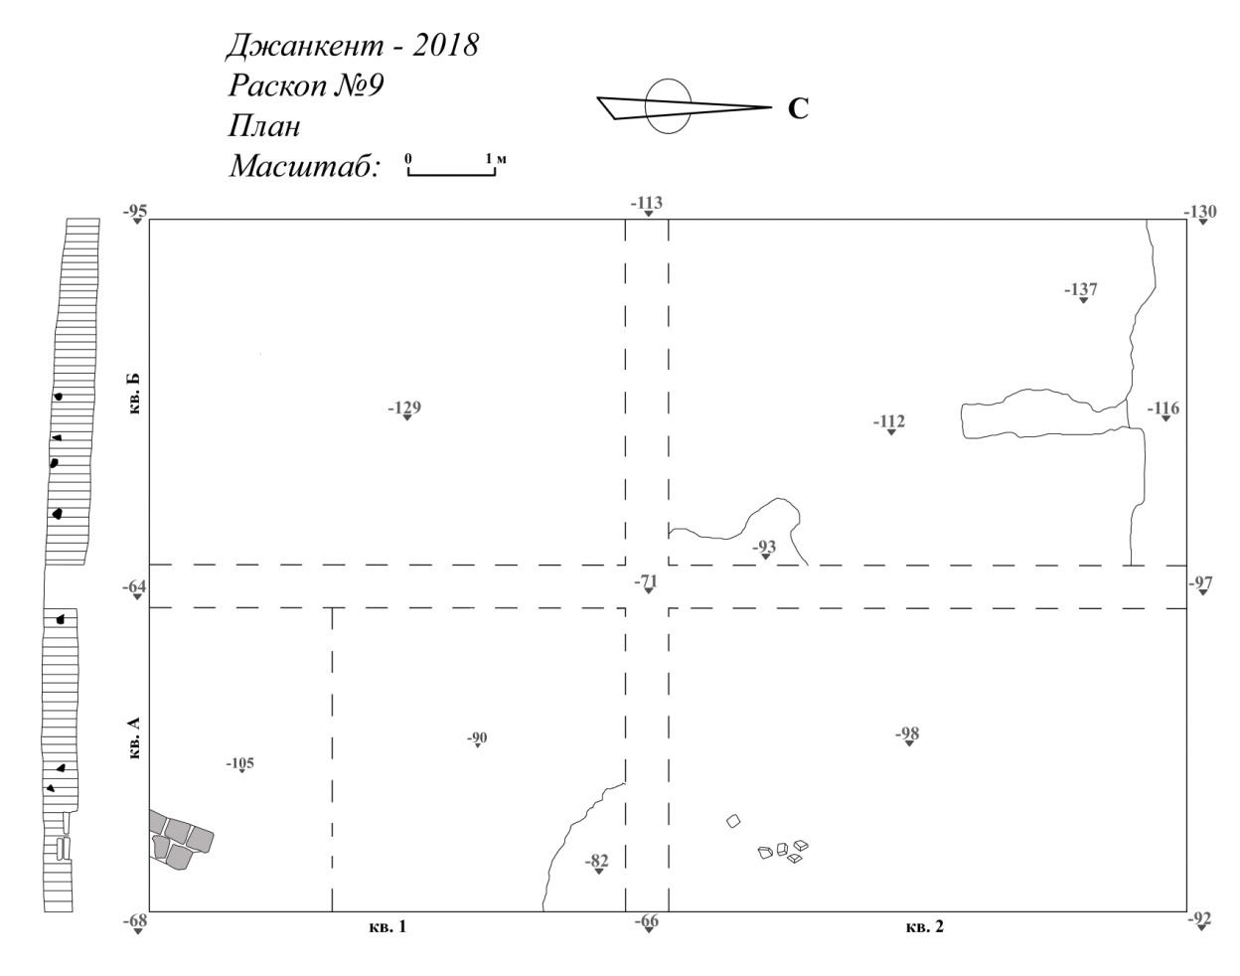
Figure E.58 – Trench 1. Plan and section of the second layer
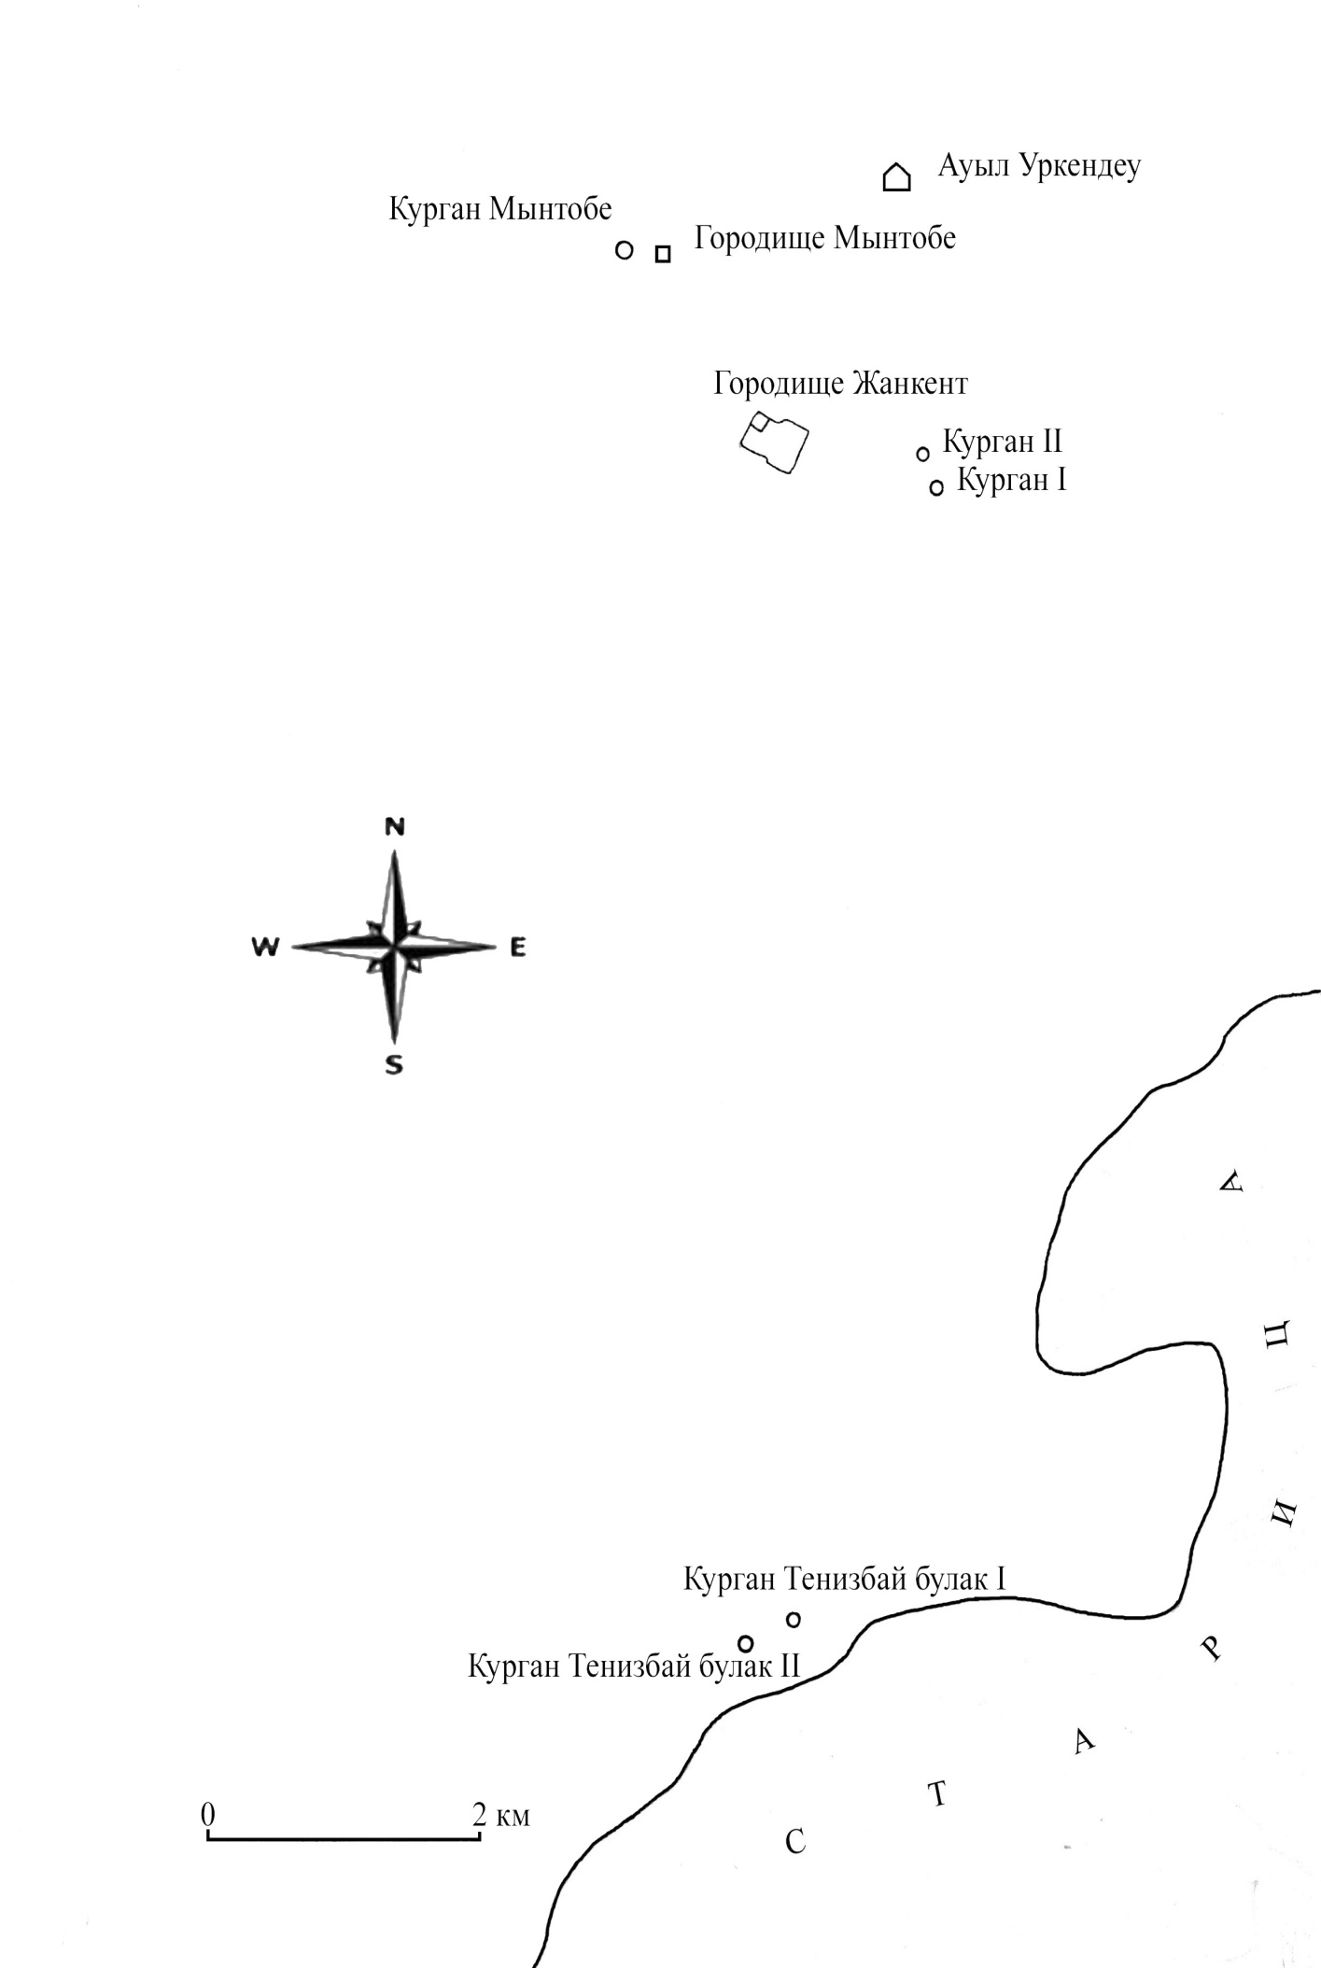Figure E.59 – Situational map of the vicinity of Dzhankent 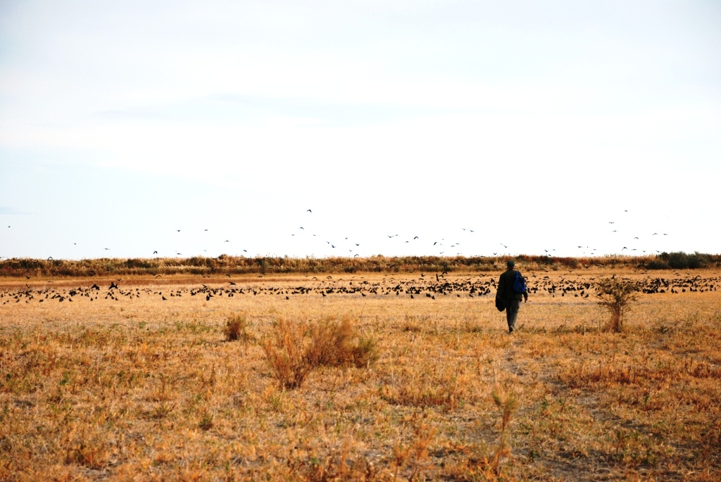
Figure E.60 – General view of the lowland

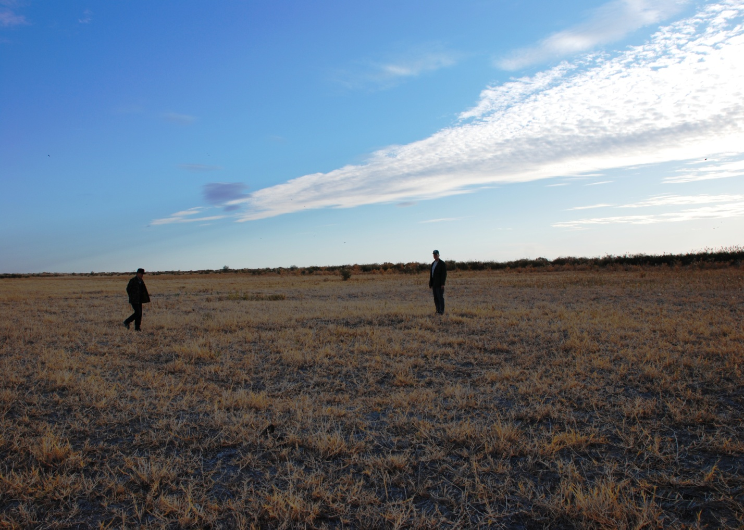
Figure E.61 – Mound 1
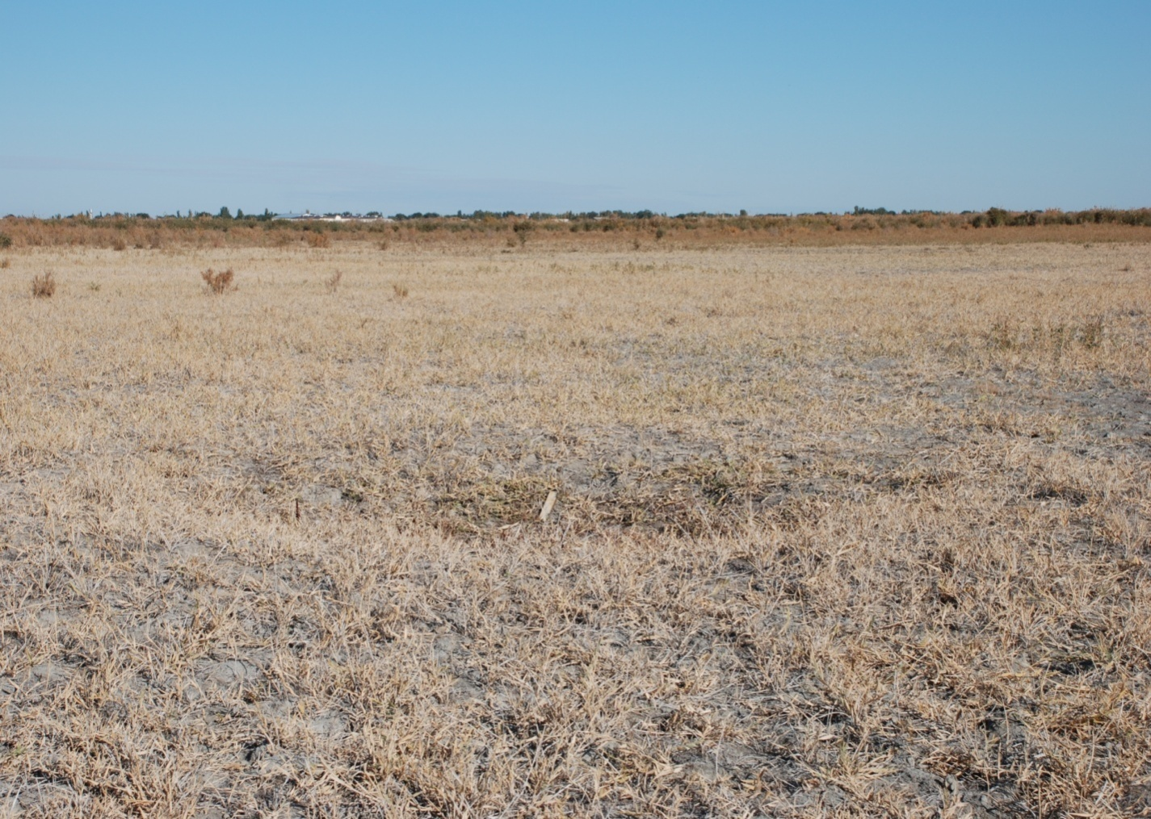
Figure E.62 – Pit 1

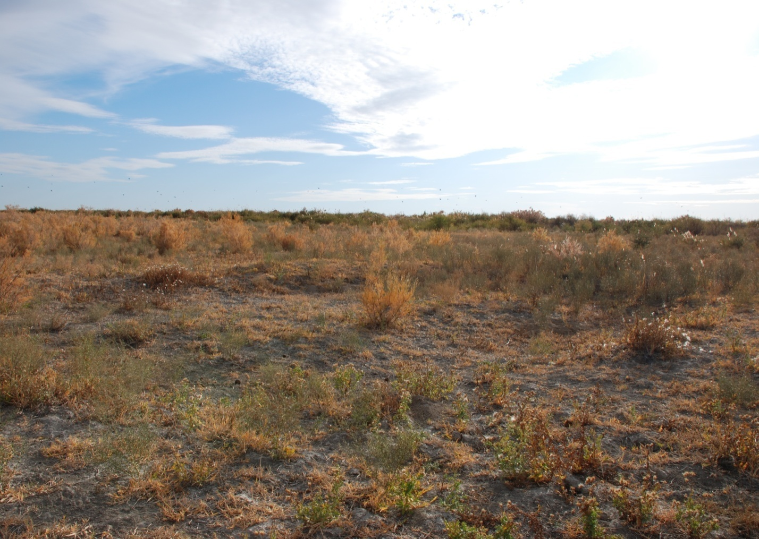
Figure E.63 – Mound 2
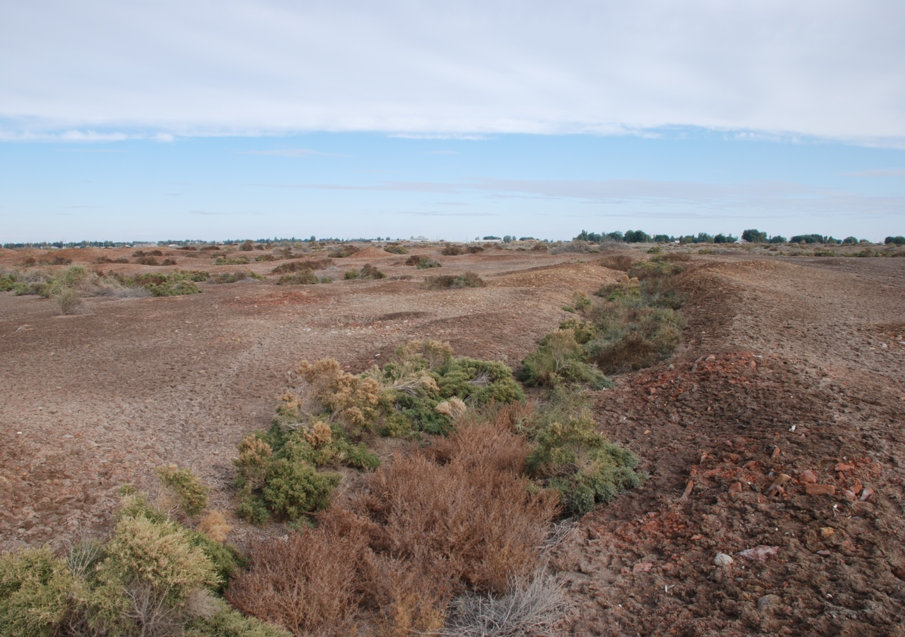
Figure E.64 – South-western wall of the Myn-tobe town

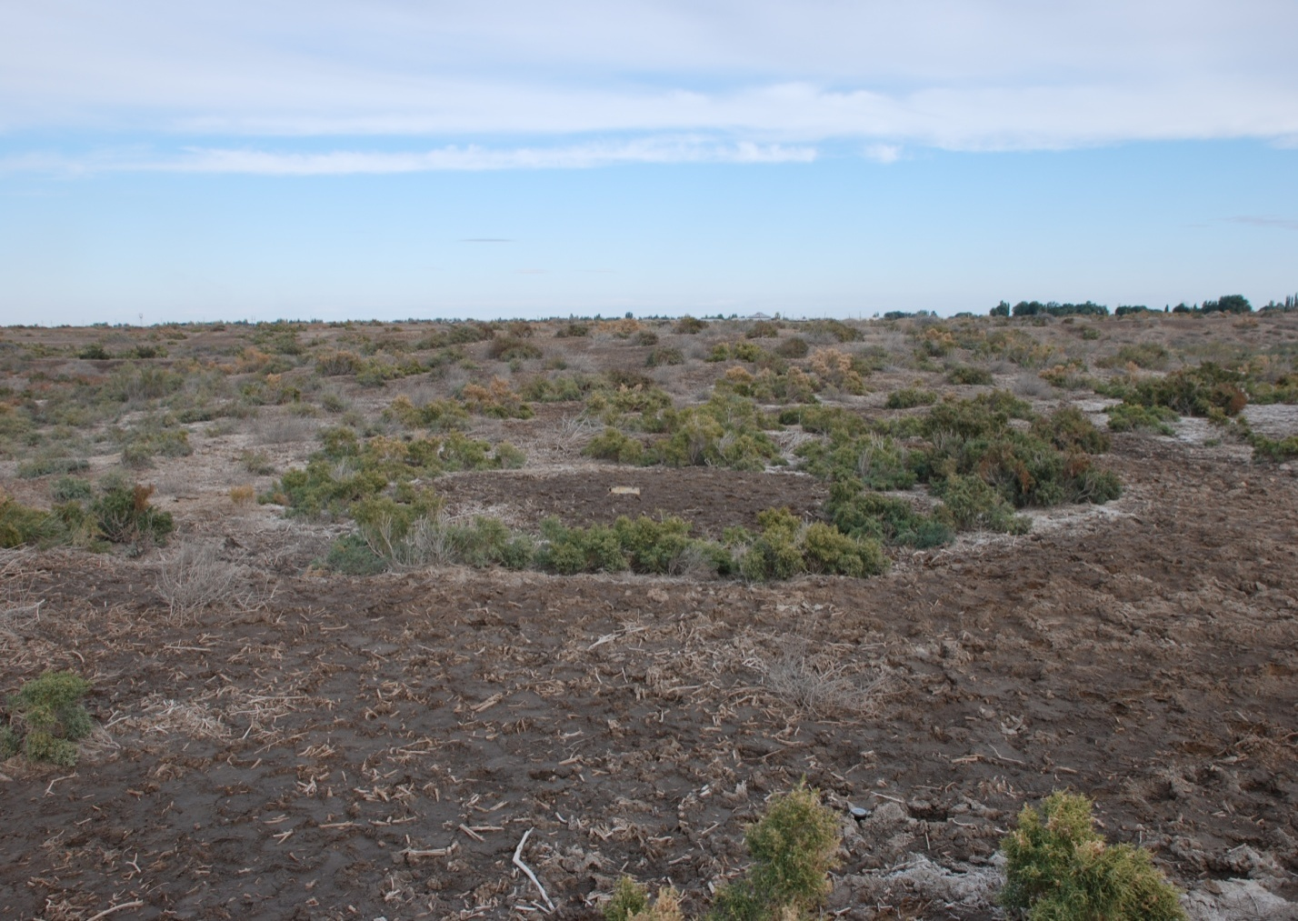
Figure E.65 – Mound of Myn-tobe
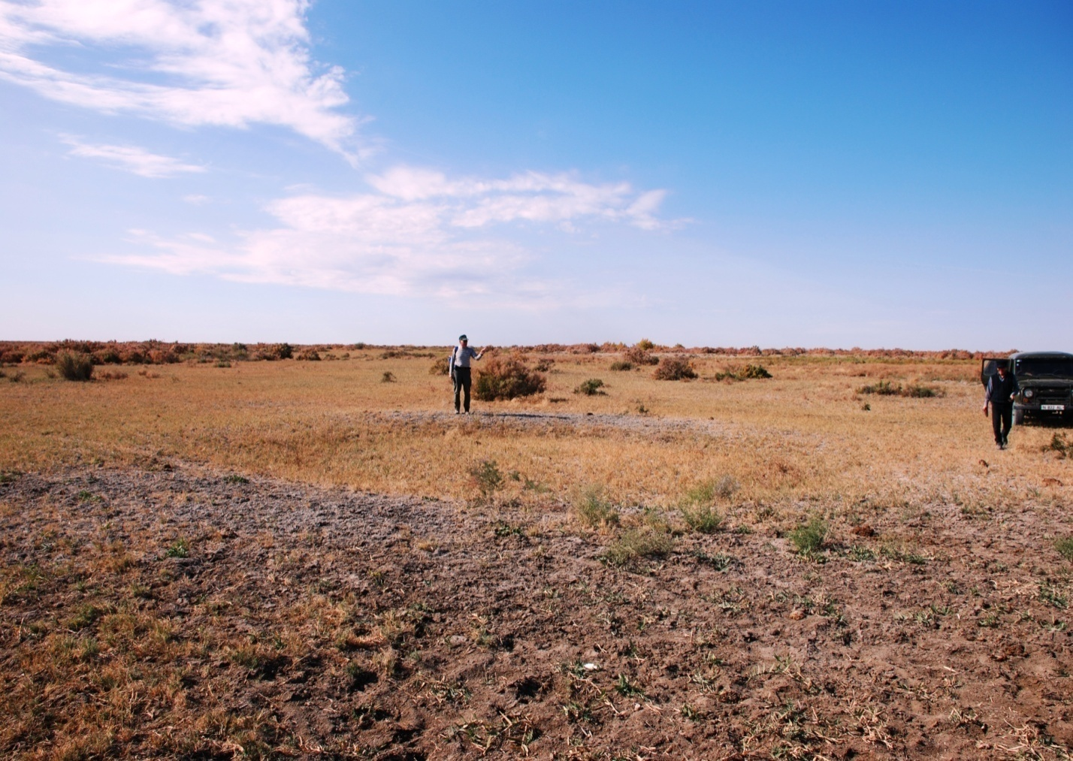
Figure E.66 – Mound of Tenizbay Bulak 1

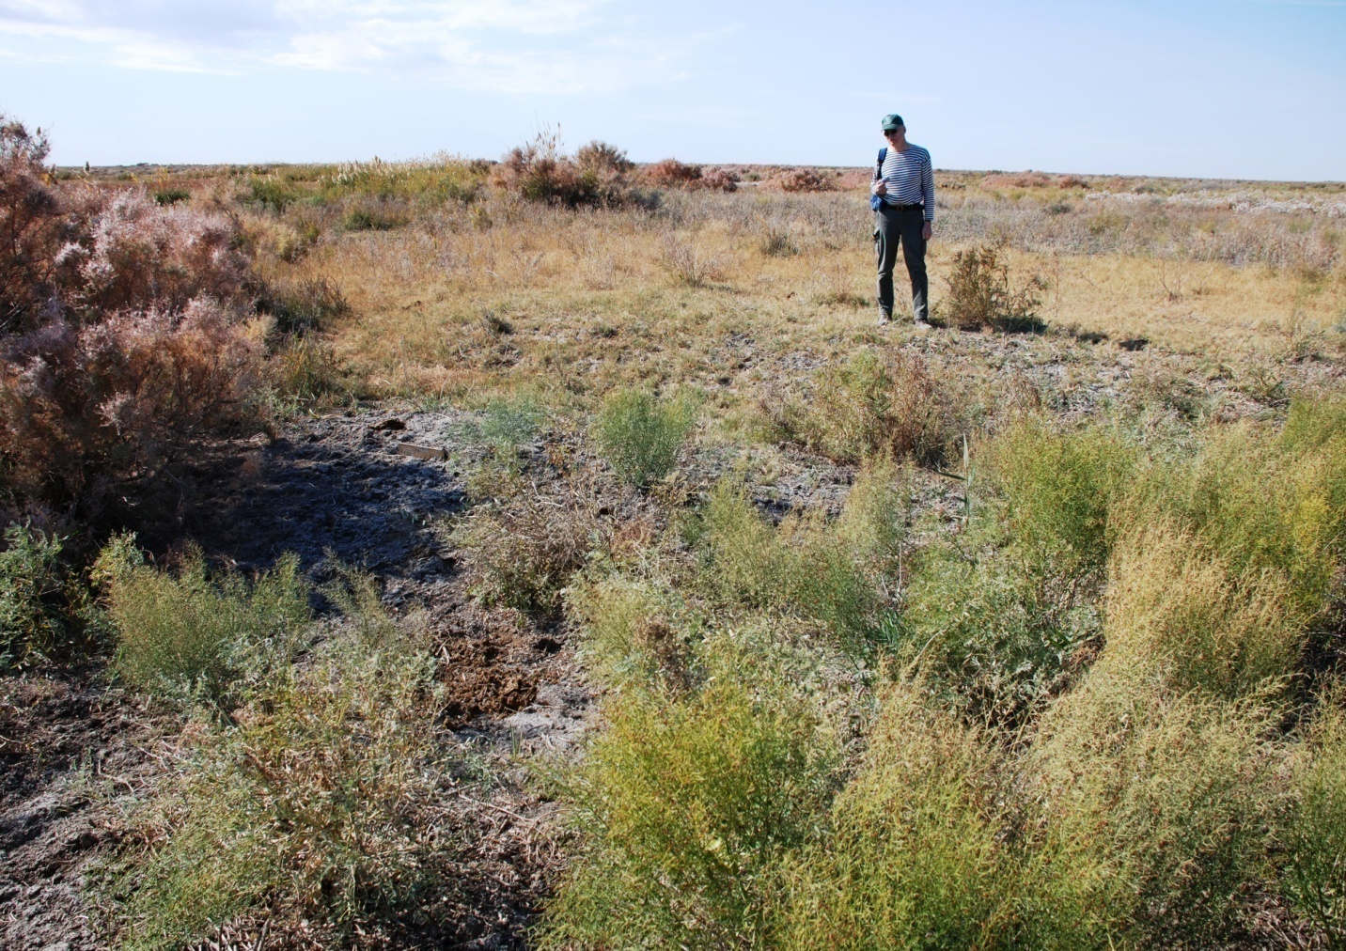
Figure E.67 – Mound of Tenizbay Bulak 2
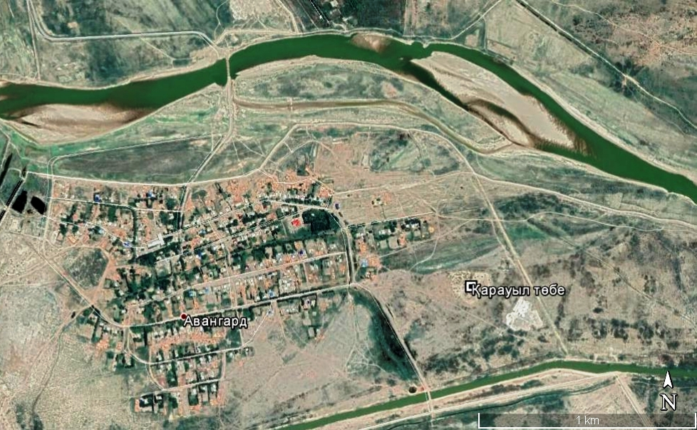
Figure E.68 – Town of Karauyl tobe.. Space photo

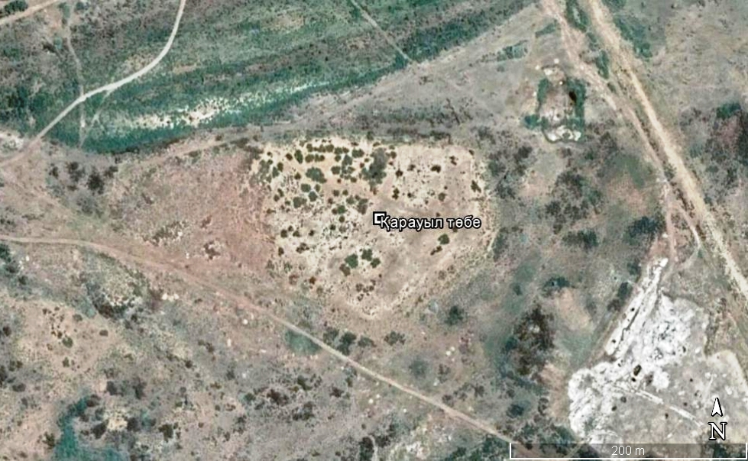
Figure E.69 – Town of Karauyl tobe. Space photo
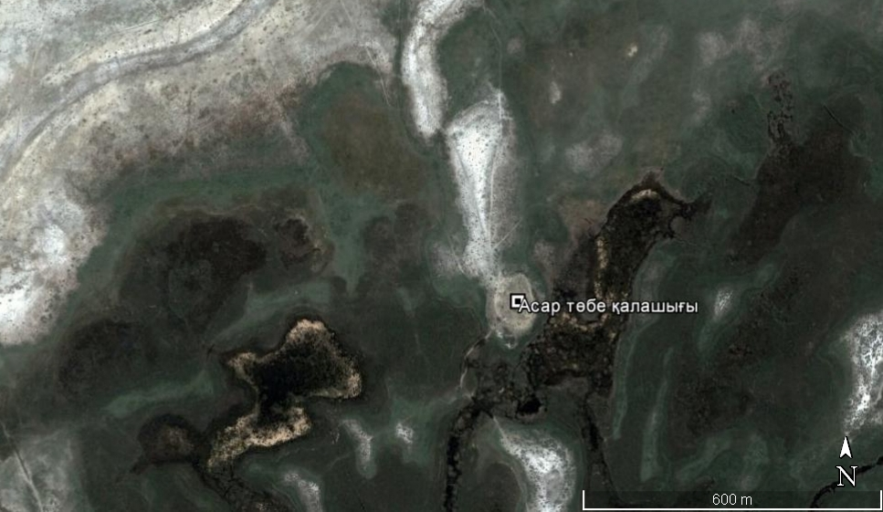
Figure E.70 – Town of Asar tobe. Space photo

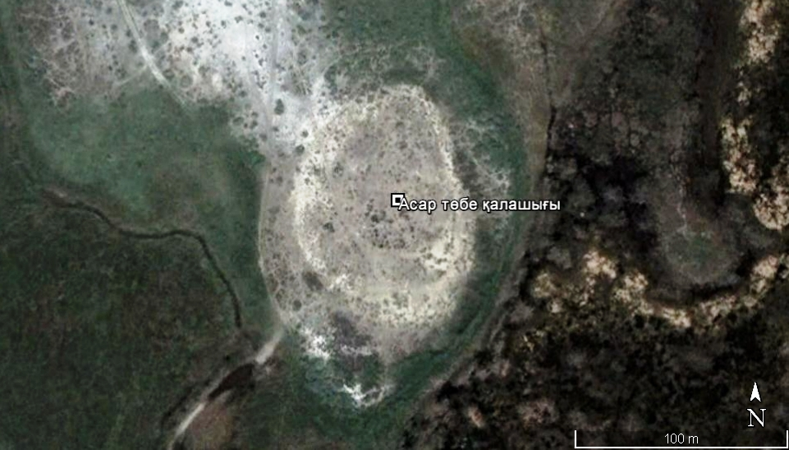
Figure E.71 – Town of Asar tobe. Space photo

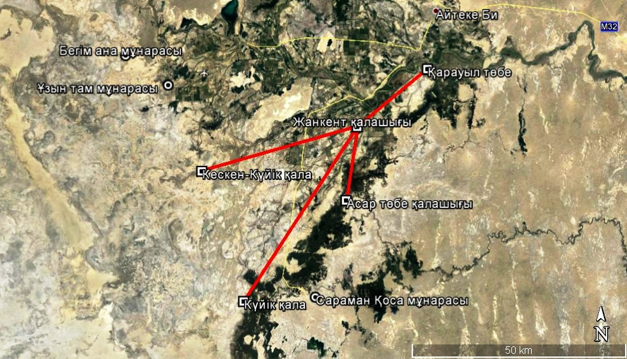
Figure E.72 – Map of localization of "swamp towns" and new sites

APPENDIX F
Dates received by C14

Lab. No.  IGAN | Sample descriptin | Material | Radiocarbon age, years ago BR | Calibrated age interval at 1a: Cal BR- years ago, relative area under probability distribution
4118 | Sample No.14,  Trench 2, Test Pit sq. 105/100  -620 cm | HA | 1130±80 | 961 - 1095 0.793 1103 - 1140 0.174 1161 - 1168 0.033
4114 | Sample No.8,  cultural layer, level 6 | HA | 780±200  (explosion  acetylene, little  exit) | 559 - 602 0.117 629 - 917 0.883
4119 | Sample No.9, cultural layer (Trench 5), layer 8, sq. 8, -463 cm | HA | 1040±80 | 803 - 808 0.019 831 - 852 0.087 906 - 1057 0.894
4122 | Sample No.3, cultural layer, level 3/1 sq. 98/100, -70 cm | Coal | 1080±70 | 929 - 1061 1.000
4115 | Sample No.4, cultural layer, above level 3/3, -186 cm | HA | 990±180  (explosion  acetylene, little  exit) | 725 - 1069 1.000
4121 | Sample No.5, cultural layer, filling the pit, level 5,  -258 cm | Coal | 960±70 | 794 - 930 1.000
4120 | Sample No.7, cultural layer above level 3/3, sq. 100/100, Roof of coal-ash layer | HA | 880±110 | 725 – 915 1.000
4168 | Sample No.10 | collagen | 930±70 | 786 - 923 1.000
4169 | Sample No.1 | collagen | 880±60 | 731 - 802 0.557  810 - 829 0.124  858 - 904 0.319
4171 | Sample No.9 | collagen | 830±100 | 674 - 799 0.779  813 - 826 0.058  866 - 901 0.163

RADIOCARBON CALIBRATION PROGRAM
CALIB REV 6.0.0
Copyright 1986-2011 M Stuiver and PJ Reimer
References for calibration datasets: PJ Reimer, MGL Baillie, E Bard, A Bayliss, JW Beck, PG Blackwell, C Bronk Ramsey, CE Buck, GS Burr, RL Edwards, M Friedrich, PM Grootes, TP Guilderson, I Hajdas, TJ Heaton, AG Hogg, KA Hughen, KF Kaiser, B Kromer, FG McCormac, SW Manning, RW Reimer, DA Richards, JR Southon, S Talamo, CSM Turney, J van der Plicht, CE Weyhenmeyer (2009) Radiocarbon 51:11111150.
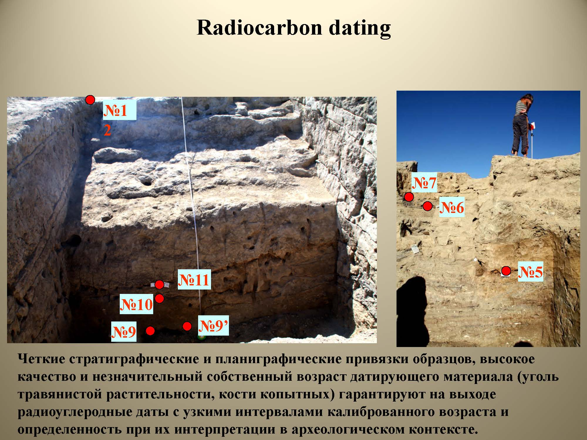
Figure F.1

APPENDIX G
An illustration finds

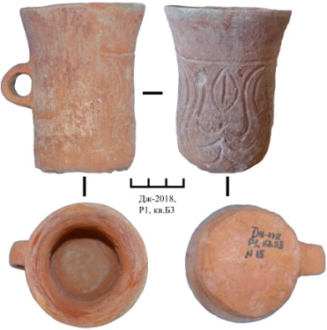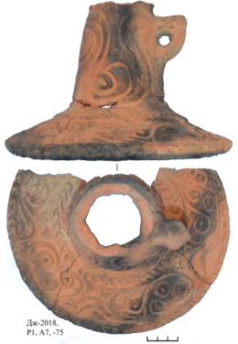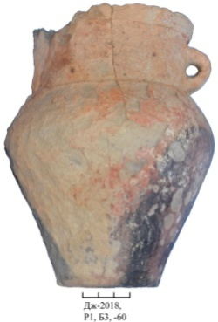
Figure G.1 Figure G.2 Figure G.3

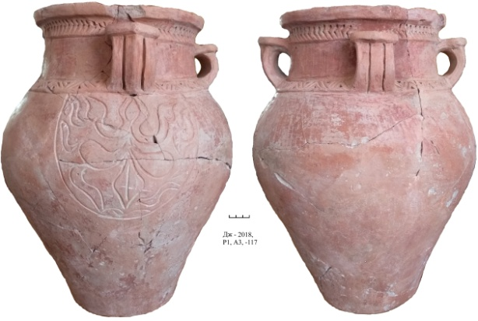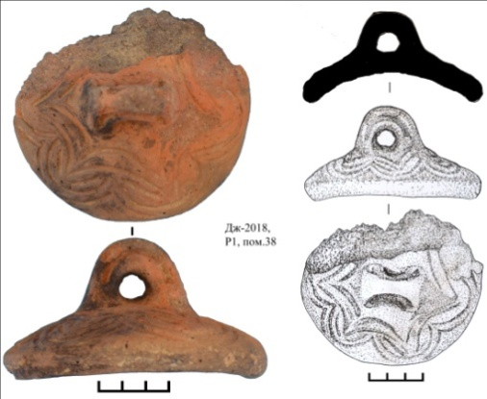
Figure G.4 Figure G.5

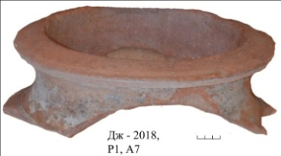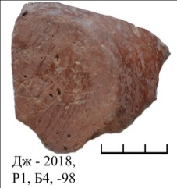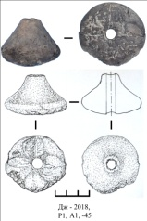
Figure G.6 Figure G.7 Figure G.8

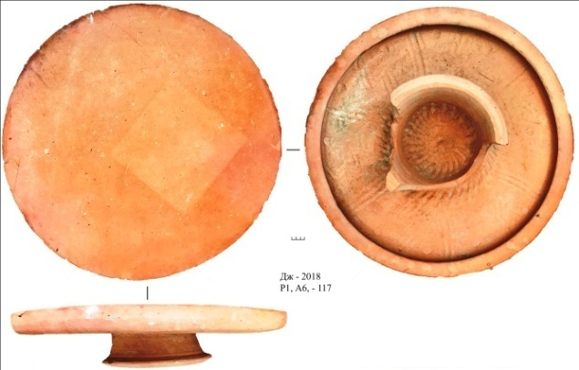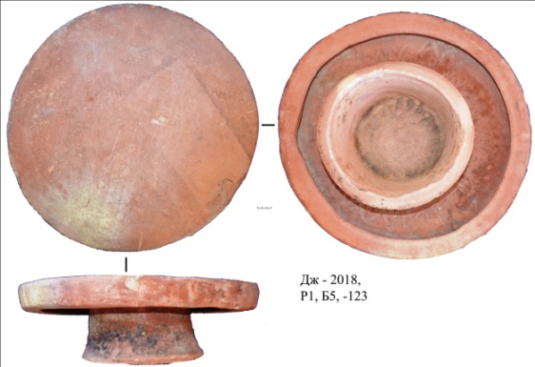
Figure G.9 Figure G.10
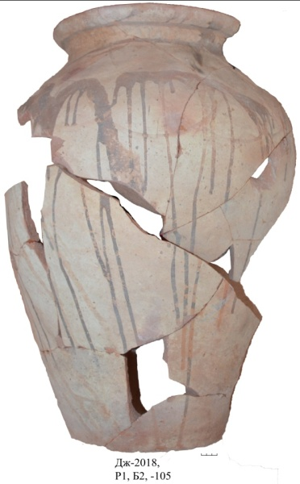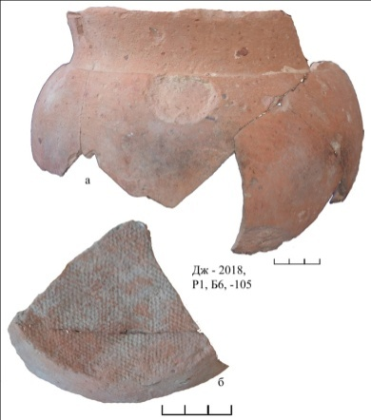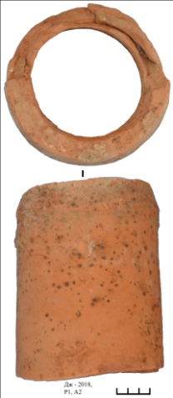
Figure G.11 Figure G.12 Figure G.13

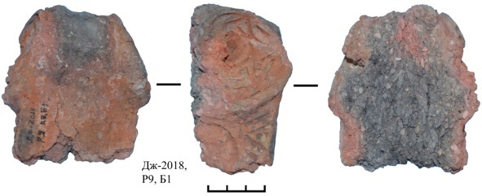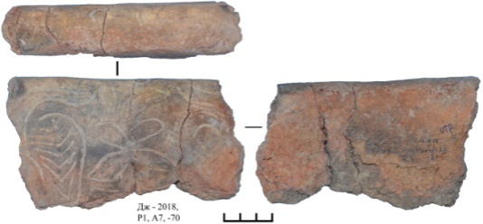
Figure G.14 Figure G.15

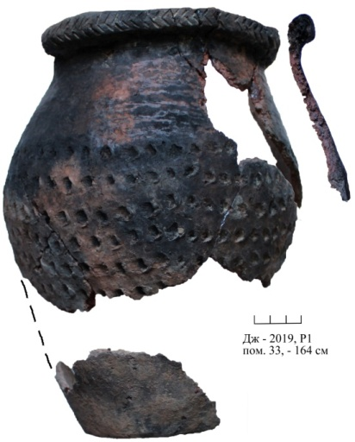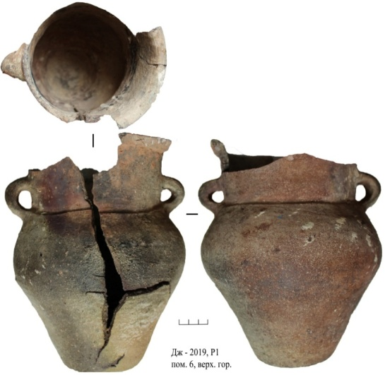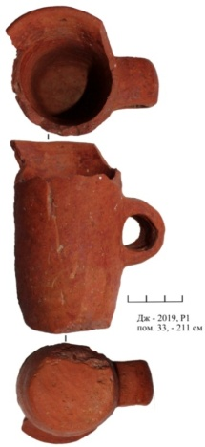
Figure G.16 Figure G.17 Figure G.18

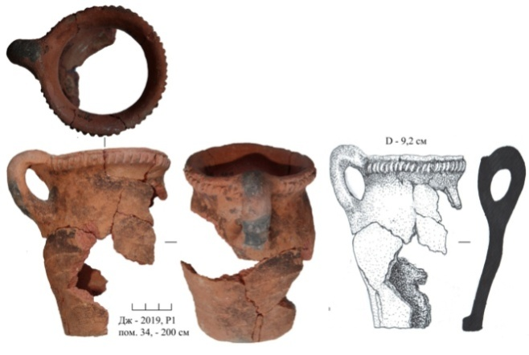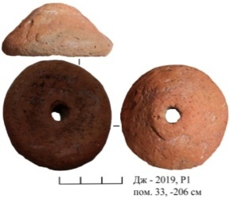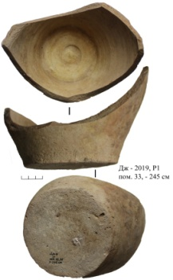
Figure G.19 Figure G.20 Figure G.21
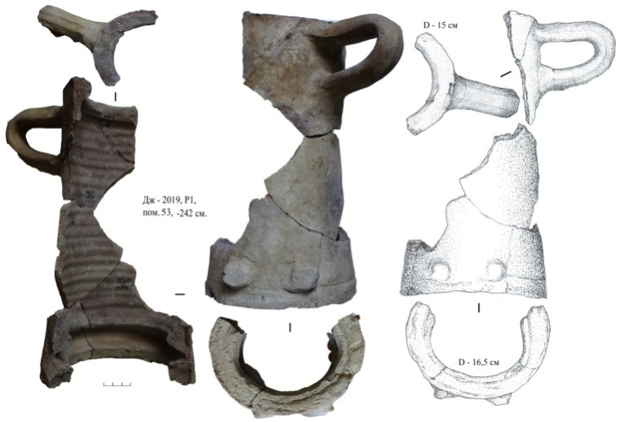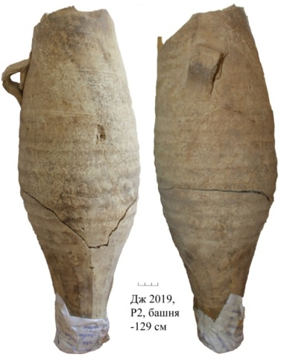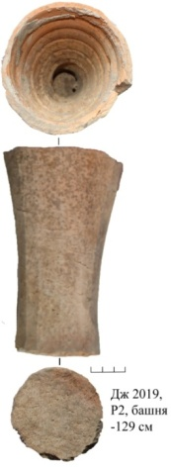
Figure G.22 Figure G.23 Figure G.24

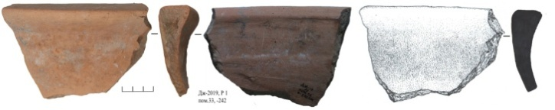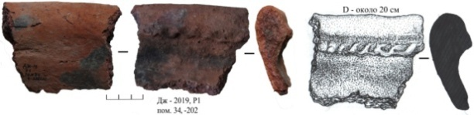
Figure G.25 Figure G.26

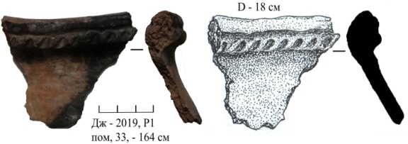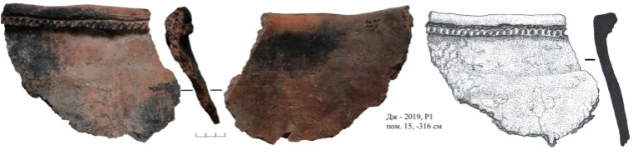
Figure G.27 Figure G.28

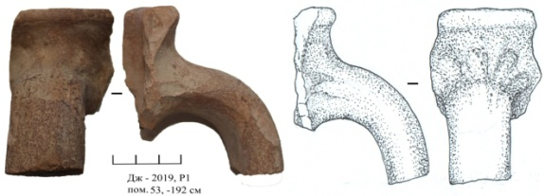
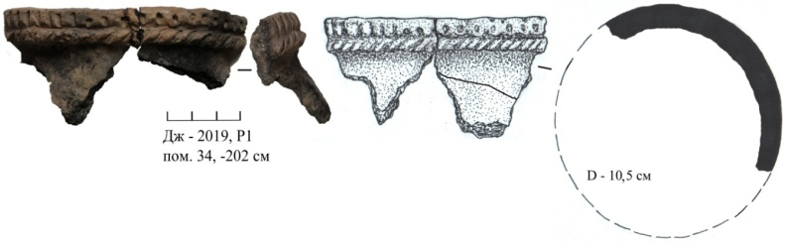
Figure G.29 Figure G.30

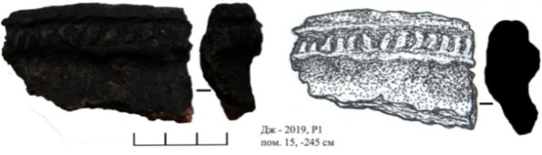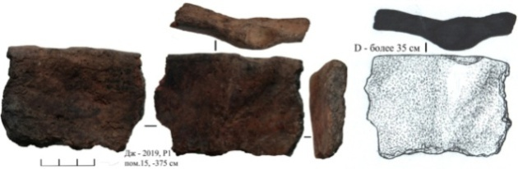
Figure G.31 Figure G.32

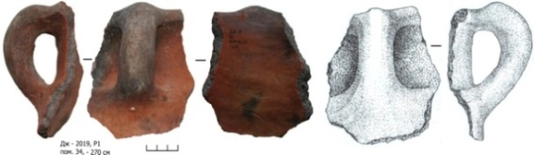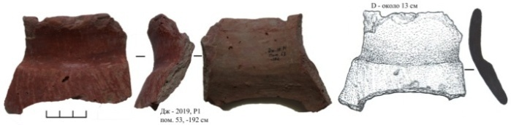
Figure G.33 Figure G.34
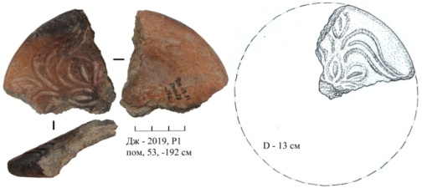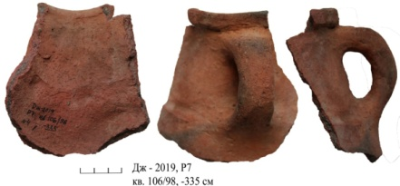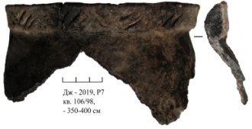
Figure G.35 Figure G.36 Figure G.37

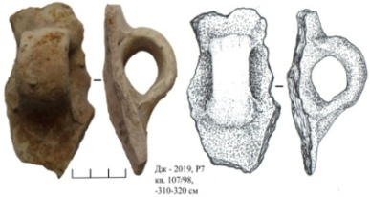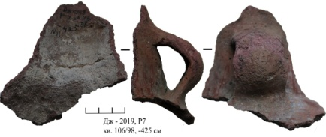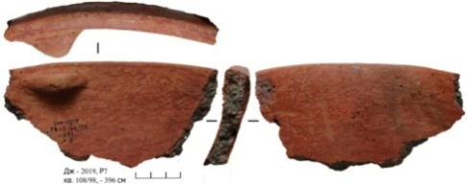
Figure G.38 Figure G.39 Figure G.40

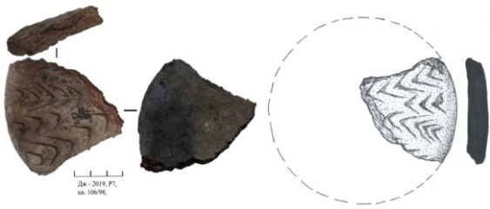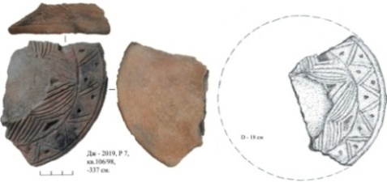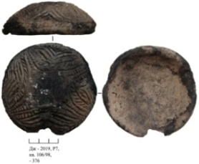
Figure G.41 Figure G.42 Figure G.43

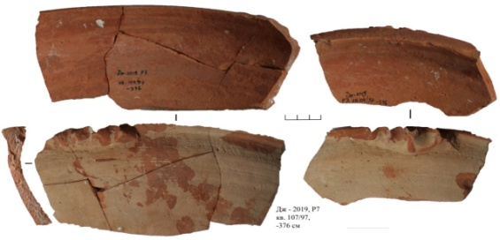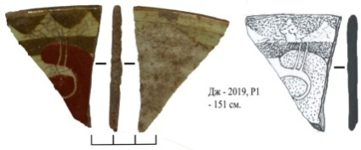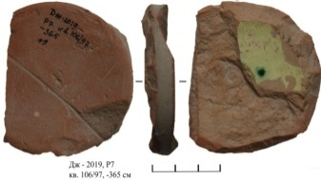
Figure G.44 Figure G.45 Figure G.46

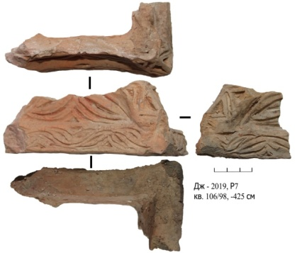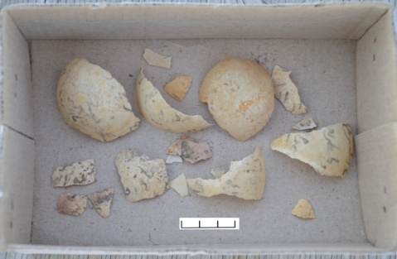
Figure G.47 Figure G.48
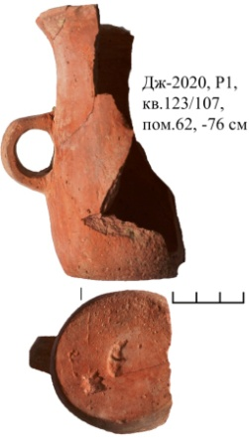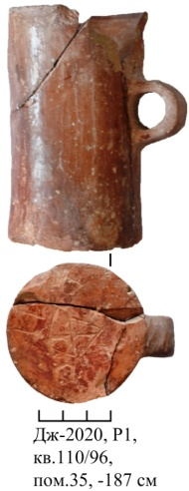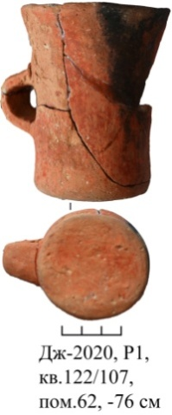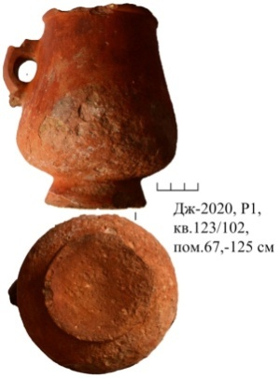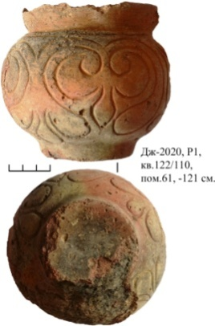
Figure G.49 Figure G.50 Figure G.51 Figure G.52 Figure G.53

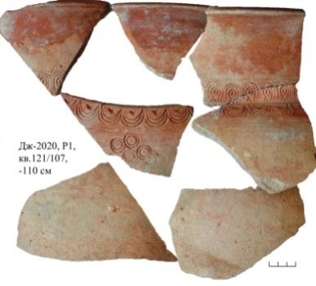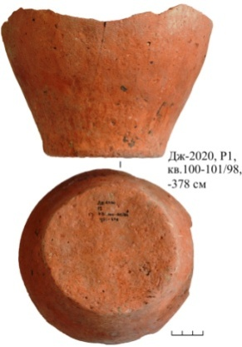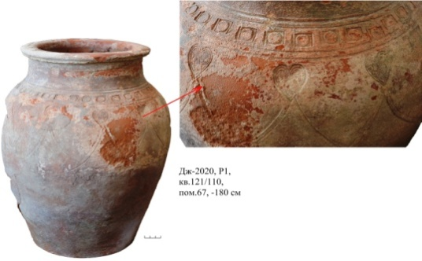
Figure G.54 Figure G.55 Figure G.56

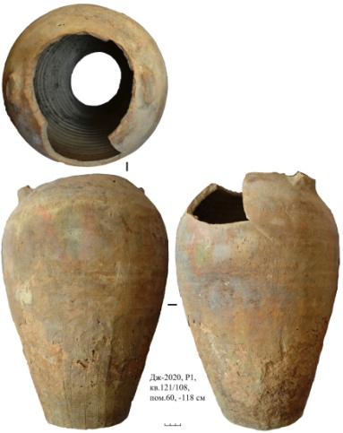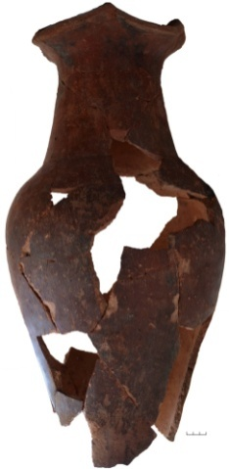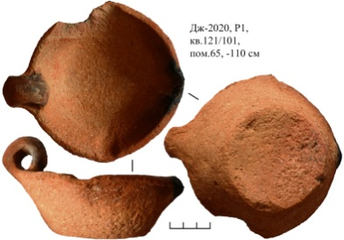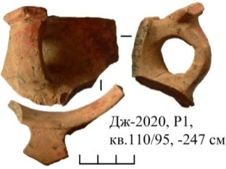
Figure G.57 Figure G.58 Figure G.59 Figure G.60

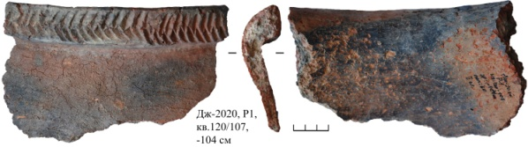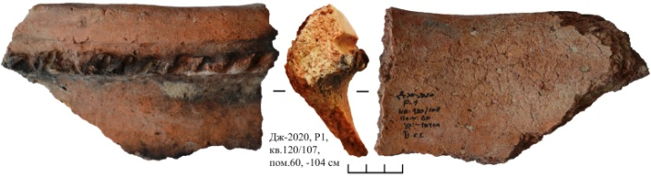
Figure G.61 Figure G.62

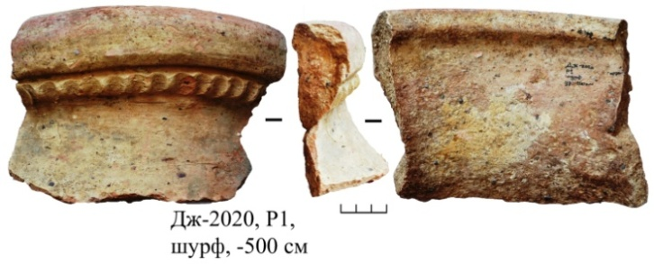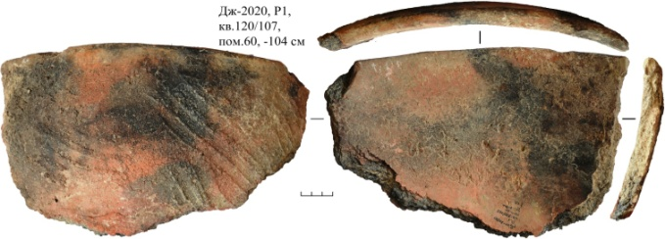
Figure G.63 Figure G.64

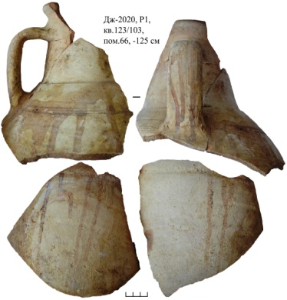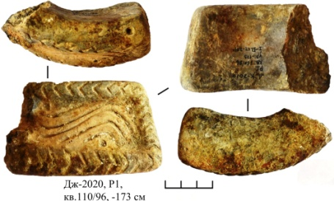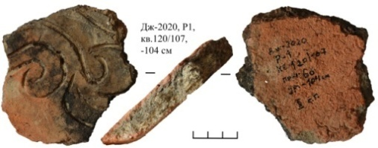
Figure G.65 Figure G.66 Figure G.67

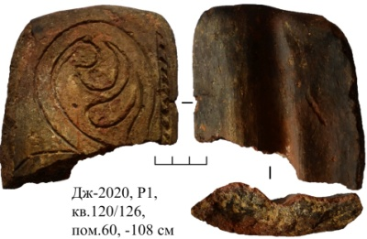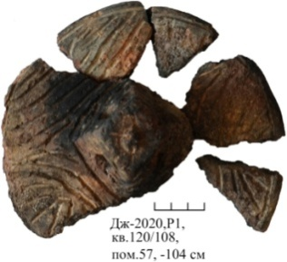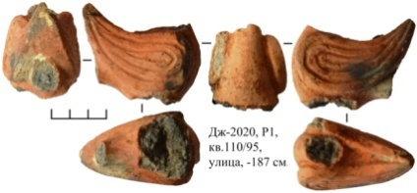
Figure G.68 Figure G.69 Figure G.70

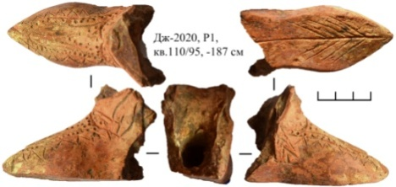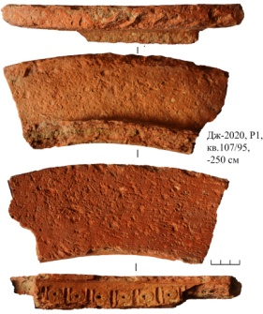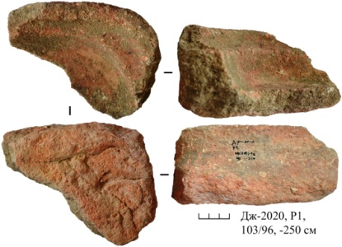
Figure G.71 Figure G.72 Figure G.73

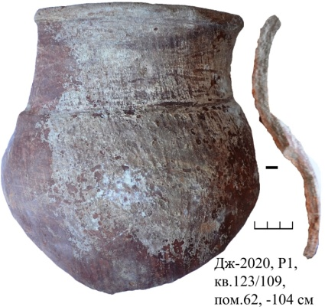
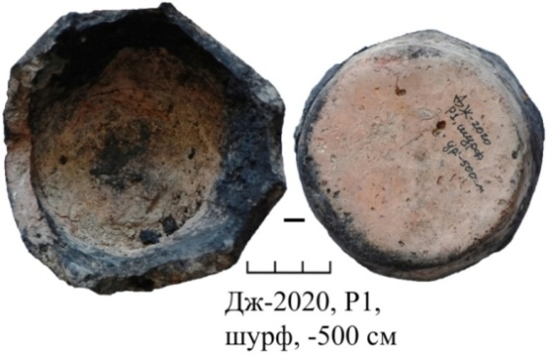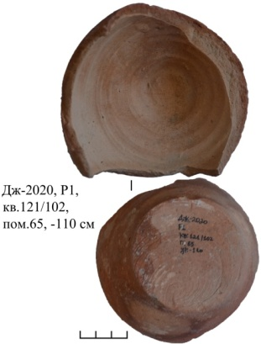
Figure G.74 Figure G.75 Figure G.76
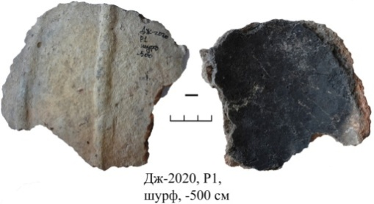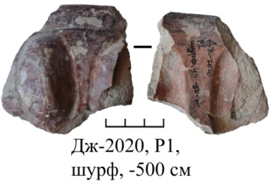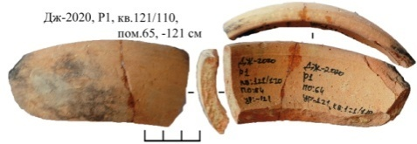
Figure G.77 Figure G.78 Figure G.79

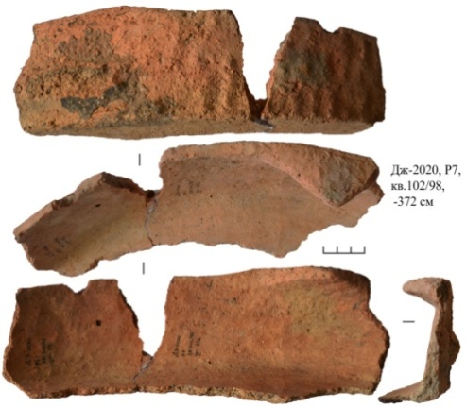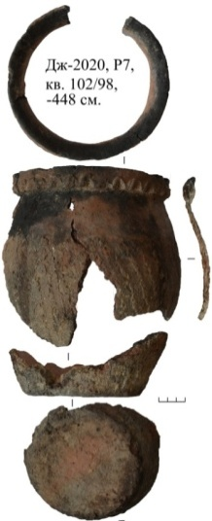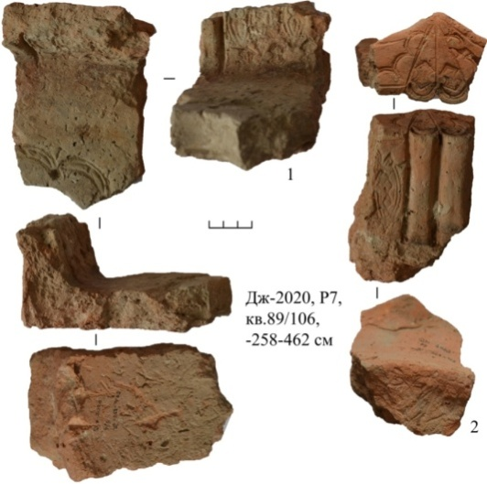
Figure G.80 Figure G.81 Figure G.82

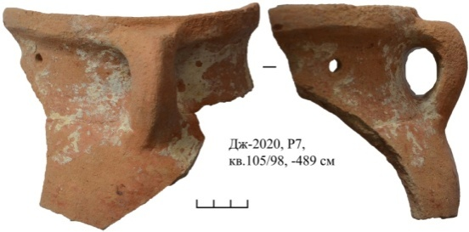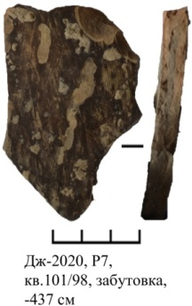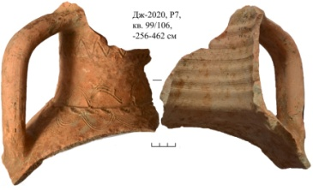
Figure G.83 Figure G.84 Figure G.85

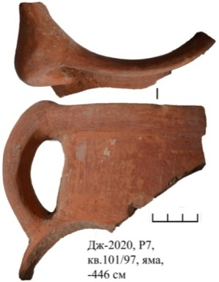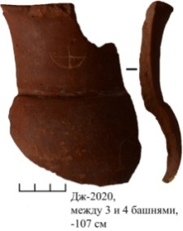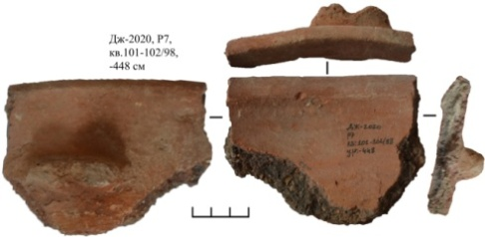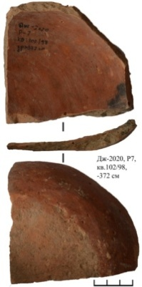
Figure G.86 Figure G.87 Figure G.88 Figure G.89

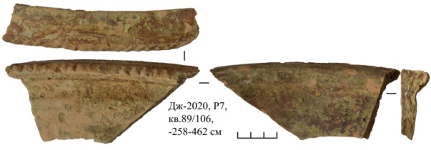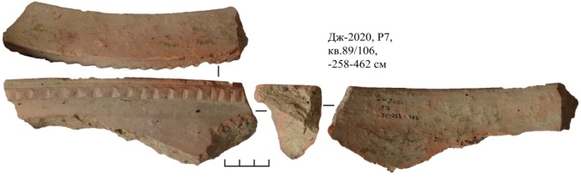
Figure G.90 Figure G.91

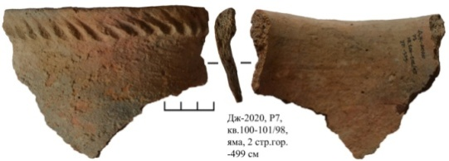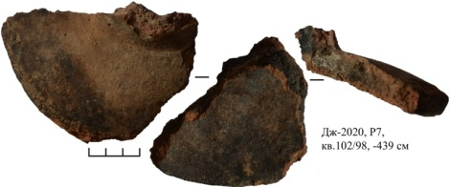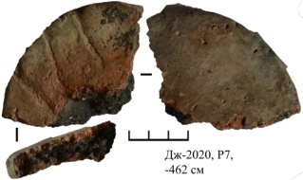
Figure G.92 Figure G.93 Figure G.94
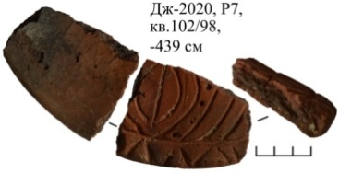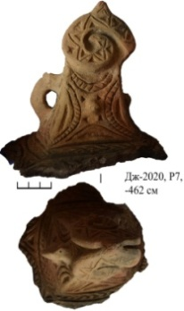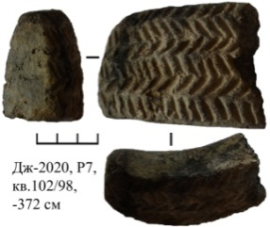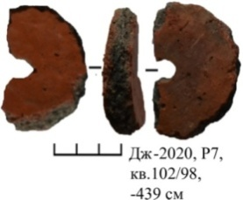
Figure G.95 Figure G.96 Figure G.97 Figure G.98

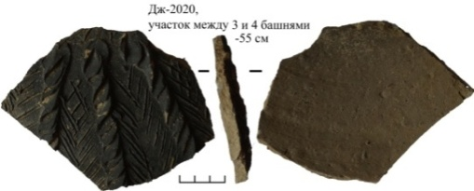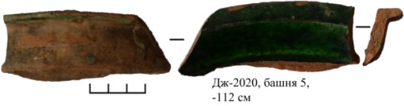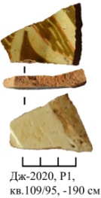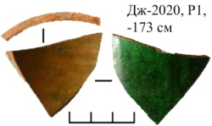
Figure G.99 Figure G.100 Figure G.101 Figure G.102

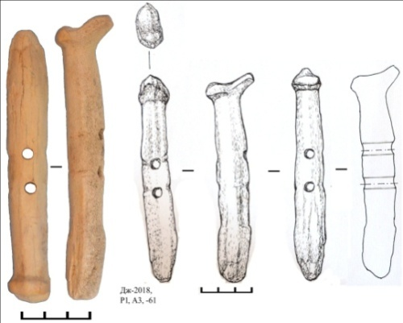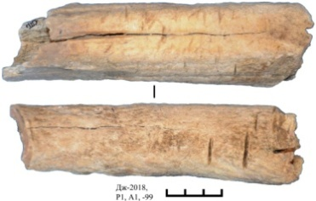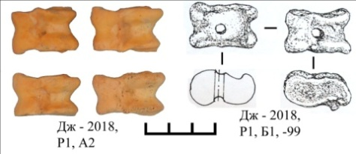
Figure G.103 Figure G.104 Figure G.105
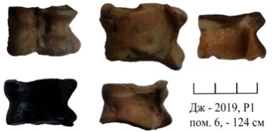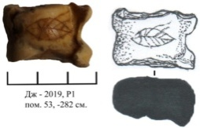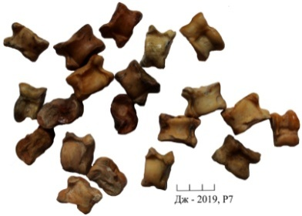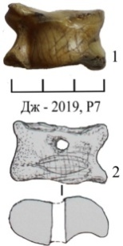
Figure G.106 Figure G.107 Figure G.108

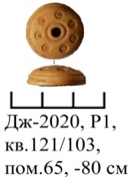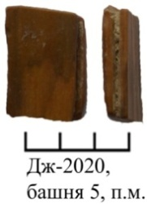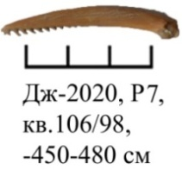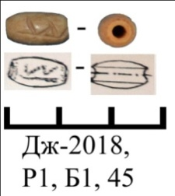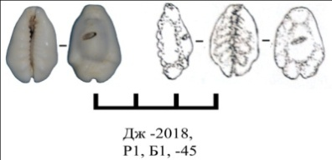
Figure G.109 Figure G.110 Figure G.111 Figure G.112 Figure G.113

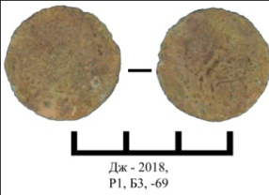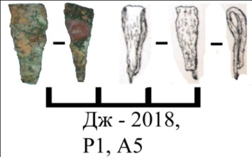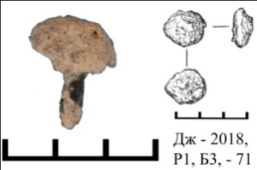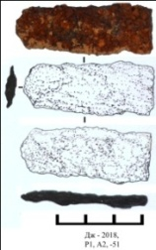
Figure G.114 Figure G.115 Figure G.116 Figure G.117

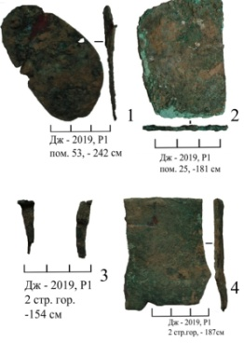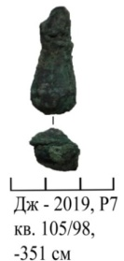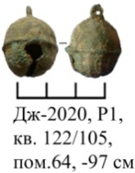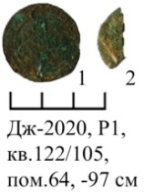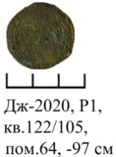
Figure G.118 Figure G.119 Figure G.120 Figure G.121 Figure G.122

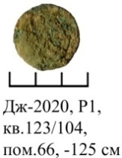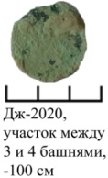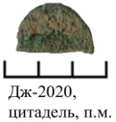
Figure G.123 Figure G.124 Figure G.125

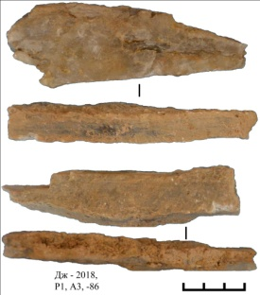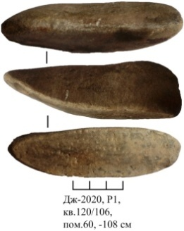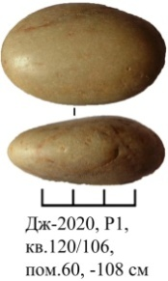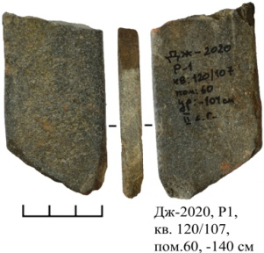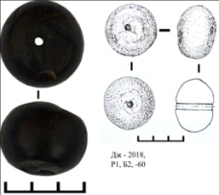
Figure G.126 Figure G.127 Figure G.128 Figure G.129 Figure G.130

APPENDIX H
Acceptance Certificate of Archaeological exhibits 