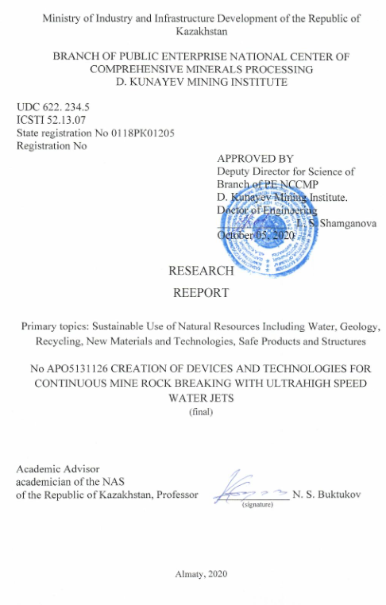

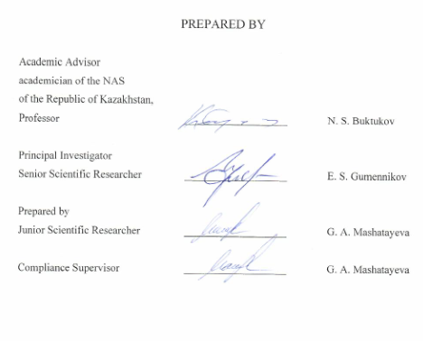

**ABSTRACT**

Report 105 p., 23 figures, 7 tables, 12 sources, 4 annexes.

ROCK, MINE FACE, SINKING, WATER PULSE JET, REVERSE GRADIENT, PENETRATION, MINE DEVELOPMENT, BACKFILLING.

The purpose of the work is a technical substantiation of a non-explosive flow technology for conducting underground mining operations on rocks of various hardness and abrasiveness with high productivity and environmental safety.

As a result of the work, new opportunities have been identified for creating more advanced energy devices to provide a highly efficient technology for opening and mining compact ore bodies by an underground method. In particular, devices and methods for the formation of high energy liquid jets.

The present project has developed in several modifications the main units of hydraulic impulse devices with the power of hydraulic shots, an order of magnitude higher than modern achievements in the mining industry.

In this case, the control of intra-unit power processes is carried out at an ultra-high (up to 1000 MPa) volumetric compression of water, generated by the method of rapid accumulation of thermal energy for each shot [1].

The project has developed new technological schemes for opening and underground mining of compact ore bodies using hydraulic impulse devices both for breaking hard rocks, and for driving transport devices, as well as stowing complexes.

In theoretical terms, the new system of opening and mining of a compact ore body was applied in the form of a Feasibility Study (FER) as an example for the development of the Akmai stockwork tungsten deposit, which does not have an effective technology. The calculation was made in comparison with the fuel and energy resources, performed according to the requirements of the drilling and blasting method of opening and working out.

The result of the comparative analysis is to ensure the conditions for the development of a small-section stockwork from the surface to its full depth up to the mark of 450 m with one system with a productivity more than 3.4 times higher than for fuel and energy resources with drilling and blasting technology, while the drilling and blasting method can only quarry and only the upper part of the stockwork to the mark of 150 m. This will result in more than $ 9 million in losses, and more than $ 378 million in net profit in a new way.

**TABLE OF CONTENTS**

|  |  |  |
| --- | --- | --- |
|  | INTRODUCTION…………………………………………………………….. | 6 |
| 1 | REVIEW OF BLAST FREE HARD ROCK BREAKING TECHNOLOGIES USED IN THE WORLD…………………………………………………… | 8 |
| 1.1 | Interaction between ultra-high-speed impact impulse loads and crushed objects | 8 |
| 1.2 | Technical and economic feasibility of water jet method………………………. | 9 |
| 2 | DEVELOPMENT OF AUTOMATIC SHUT OFF VALVE FOR WATER JET CANNON WITH OPERATING PRESSURE 2000 ATMOSPHERES … | 10 |
| 2.1 | Shut off valve for water jet cannon with externally controlled discharges……. | 10 |
| 2.2 | Device for external control of shut off valve of cannon Unit 2 WD HG -2000. 01. 000. AS…………………………………………………………………… | 11 |
| 2.3 | Shut off valve with operating pressure from 2000 atm. And more with valve body attached to the rear end of cannon barrel……………………………… | 12 |
| 3. | DEVELOPMENT OF ELECTRODISCHARGE DRIVE AND MEANS FOR SEALING ITS CHAMBER AND ENSURING ELECTRICAL INSULATION IN SUPERACID MEDIA AT THE TEMPERATURE UP TO 9000 WITH OPERATING PRESSURE 2000 ATM………………………….. | 13 |
| 3.1 | Axial electrodischarge drive of water cannon………………………………… | 13 |
| 3.2 | Electrodischarge drive of water jet cannon with axial position and graphite heat generator………………………………………………………………………. | 14 |
| 3.3 | Electrodischarge drive of water jet cannon with inductive heat generator with central-lateral position relative to the space inside of the barrel……………… | 14 |
| 3.4 | Electrodischarge drive of water jet cannon with inductive or ohmic heat generator with heat transmitting coupler…………………………………… | 15 |
| 4 | DEVELOPMENT OF GENERAL DESIGN OF WATER CANNON WITH OPERATING PULSE STRENGTH NOT LESS THAN 70 KJ……………… | 16 |
| 4.1 | Detail drawing of general design…………………………………………… | 16 |
| 4.2 | Water supply pump of water cannon with pressure up to 50 MPa……………. | 17 |
| 4.3 | Automatic electrical switch of water cannon………………………………. | 17 |
| 5 | DEVELOPMENT OF TECHNOLOGICAL SCHEMES FOR DEVELOPMENT AND EXPLOITATION OF CLOSE PACKED ORE BODIES USING UNDERGROUND MINING METHODS WITH WATER PULSE DEVICES FOR ROCKS BREAKING................................................ | 18 |
| 5.1 | Development of mine with inclined mine openings………………………….. | 18 |
| 5.2 | Hydraulic transport pipelines………………………………………………… | 19 |
| 5.3 | Vertical access to deep seated ore bodies…………………………………….. | 21 |
| 5.4 | Standard development scheme for ore bodies adapted to development with steeply inclined shafts………………………………………………………… | 23 |
| 5.5 | Extraction and haulage equipment…………………………………………… | 26 |
| 5.6 | Methods of worked out space backfilling.......................................................... | 27 |
| 6 | DEVELOPMENT OF COST-BENEFIT ANALYSIS (CBA) OF DEVELOPMENT OF CLOSE PACKED ORE BODY USING CONTINUOUS WATER JET TECHNOLOGY BY THE EXAMPLE OF DEVELOPMENT OF STEEPLY DIPPING TUNGSTEN STOCKWORK AT AKMAYA DEPOSIT… | 29 |
| 6.1 | Mining Operations………………………………………………………………. | 29 |
| 6.2 | Worked out space backfilling…………………………………………………… | 31 |
| 6.3 | Economic performance of commercial resources extraction using underground mining method from the depth of -50 m to - 450 m…………… | 33 |
| 6.4 | Key performance indicators of the new project involving dressing operations.. | 34 |
| 6.5 | Key performance indicators of underground mining operations from the depth of - 50 m to 450 m based on the data on additionally explored and approved reserves……………………………………………………………………….. | 36 |
| 6.6 | Estimate of costs of development of akmaya deposit using traditional drill and blast method (for reference)............................................................................... | 38 |
|  | CONCLUSION………………………………………………………………... | 42 |
|  | LIST OF LITERATURE SOURCES USED…………………………………. | 44 |
|  | APPENDIX A – cost benefit analysis of innovative project: The development of the steeply dipping tungsten Akmaya deposit by a combined method using hydraulic pulse technology……………………………………. | 45 |
|  | APPENDIX B – Critical Review of Cost-Benefit Analysis (CBA) Development of Steeply Dipping Tungsten Stockwork at Akmaya deposit (Karaganda region).................................................................................................................. | 98 |
|  | APPENDIX C - technical specification and timing schedule……………… | 101 |
|  | APPENDIX D – Scientific support on the topic for 2018-2020.......................... | 104 |

**INTRODUCTION**

Majority of scientific papers published in our country and abroad in this sphere are devoted to study of solid rocks cutting with water jet devices, including addition of bulky abrasive materials to water jets.

Scientists in the world place much attention to study of the processes of water assisted well drilling with a complex of power components comprising water jets and machine cutting tools [1],[2].

Since the beginning of the eighties of the last century, mining science has not paid due attention to full-fledged studies of the volume destruction of rocks in the massif.

Over the last decades the situation with replenishment of raw materials in the RK has been aggravated significantly. Development of numerous deposits with scarce reserves or reserves that are hard to recover using traditional drill and blast method is not feasible from technical and economical points of view.

In Kazakhstan mainly in underdeveloped areas there are several thousands of small gold fields and rare metals deposits which are classified as low profit or off balance or are not even included in the register of reserves of the State Committee for Mineral Reserves due to small volumes of reserves, geological conditions and content of useful components because many ore manifestations and mineralized areas are underexplored and poorly studied [3].

The first stage provides for sinking operations in mines with rock hardness up to 10 units according to the scale of Professor M.M. Protodyakonov with fluid pressure 2000 atm. This allows to resolve problems connected with sinking and extraction operations mainly at coal pits, where there is risk of methane explosions and coal dust pollution, as well as in open pit mines providing possibility of contact free crushing of overdimensioned rocks.

This Project allows to resolve the problem of quick generation and accumulation of small volumes of energy with internal power control using physical properties of water with volumetric compression under high pressure. Several variants of different types of generating units with different designs have been developed [4].

In particular there have been developed 4 variants of shut off valves for ensuring proper operation of water jet devices with fluid pressure up to 600 MPa and 5 variants of electrical drives for water jet rock breaking device with impact pulse strength not less than 70 kJ having outstanding useful properties.

Project team have developed new schemes for development and exploitation of close packed ore bodies using underground mining methods with transition from cyclic technologies to new continuous techniques. New schemes allow to ensure cost effective development of small sized and low profit deposits.

In particular there have been developed downhole transport unit allowing to develop ore bodies using underground mining methods with inclined small section drifts from top downward, including those drilled in conditions of increased water content.

This downhole transport unit allows to prepare new mine for development with production output up to 500 thousand tons with minimum volume of civil engineering and mine construction works.

For deep and ultra-deep mines with depth starting from 250-300 m and more there is provided a new technical solution for construction of downhole pneumatic lift with minimum capital and operational costs for ensuring sufficient reliability and productivity.

In order to demonstrate an example of practical application of innovations developed under this Project there have been prepared CBA for development of steeply dipping tungsten stockwork at Akmaya deposit for which no any practicable methods exist.

According to estimations exploitation of the stockwork to the depth of 450 m will generate profit amounting to $360 million. Term of exploitation will be reduced 3 times.

The results obtained at the previous stages of research are given in the interim reports on research and development on the topic АР05131126 " Creation of devices and technologies for continuous mine rock breaking with ultrahigh speed water jets " (No. GR0118РК01205) for 2018 (Inventory No. 0218РК00401) and 2019 (Inventory No. 0219РК00991).

**1 REVIEW OF BLAST FREE HARD ROCK BREAKING TECHNOLOGIES USED IN THE WORLD**

Majority of scientific papers published in our country and abroad in this sphere are devoted to study of solid rocks cutting with water jet devices, including addition of bulky abrasive materials to water jets.

Scientists in the world place much attention to study of the processes of water assisted well drilling with a complex of power components comprising water jets and machine cutting tools [1], [2]/

Since 1980-s mining science has not paid due attention to comprehensive studies of volumetric rock mass destruction.

Theoretical and empirical researches devoted to volumetric rock mass and concrete blocks destruction performed under this project are based mainly on the theoretical and empirical researches of DONGIROSHAKHTSTROI Institute and Donets State University (DONSU).

In 1985 DONGIPROUGLEMASH developed sinking machine КИВ-1 with water jet breaking unit with impact pulse strength 54 kJ and tested the machine in sinking operations [3], [4].

Effect obtained after contact of long jet (length = 2.5 m and more) with rock, where pressure for shock crushing is generated mainly by wide head portion of jet formed due to atmospheric air resistance, the remaining portions of jet approach crushed object in reversed phase relative to blast pressure wave from the head portion of jet, and prevent its discharge phase to certain extent.

**1.1 Interaction between ultra-high-speed impact impulse loads and crushed objects**

Water pulse method consists in directing cumulative water jet or charge in the form of a short cylinder or ball, which penetrate into rocks mass at the speed of 1000 m/s [5],[6].

Determinant factor in all the compared methods is quantity of energy used for breaking certain volume of material. Absolute criterion of destruction volume is duration of impact interaction with crushed object. Explosions with duration of contact from 0.003 to 0.008 sec are the most efficient due to energy consumption about 7-10 J/cm depending on rock hardness.

For comparison - in mechanical breaking where breaking tool, such as cone roller, impacts rock mass at a low speed energy consumption is 200-250 J/cm3.

When head portion of water charge penetrates into rock mass, due to instant deceleration there is created tangential thrust allowing fluid to penetrate into natural cracks or cracks formed after impact, as a result certain volume of rock in the shape of a funnel is detached from rock mass.

**1.2 Technical and economic feasibility of water jet method**

Comparative values of energy potential of different flammable substances are shown in Table 1.

According to the table energy capacity of explosive materials is much lower than that of fuel types with the lowest heating-value.

Development of devices for quick accumulation of electrical energy and instant discharge would make it possible to create a powerful energy pulse non inferior to that of explosives used in mining industry.

Table 1. COMPARATIVE VALUES OF ENERGY POTENTIAL OF DIFFERENT FLAMMABLE SUBSTANCES

|  |  |  |  |
| --- | --- | --- | --- |
| Fuel type | Energy capacity W | | |
| MJ/kg | Kkal/kg | KWh/kg |
| 1 | 2 | 3 | 4 |
| Gunpowder | 3.8 | 900 | 1.06 |
| Dynamite 75% | 5.4 | 1280 | 1.5 |
| Rocket fuel | 4,2-10,5 | 1000-2500 | 1.17-2.85 |
| Wood | 8.4-11.0 | 2000-2500 | 2.33-2.85 |
| Black dirt | 10.5-14.5 | 2500-3500 | 2.1-4.0 |
| Diesel fuel | 42.7 | 10200 | 11.9 |
| Hydrogen | 120 | 28600 | 33.36 |
| Natural gas | 41-49 | 9800-11700 | 11.46-13.07 |

**2 DEVELOPMENT OF AUTOMATIC SHUT OFF VALVE FOR WATER JET CANNON WITH OPERATING PRESSURE 2000 ATMOSPHERES**

4 variants of valve mechanism have been developed. Modified configurations have been developed first of all for obtaining patent protection for the subject matter of the invention in maximum number of areas of application in various conditions [7].

**2.1 Shut off valve for water jet cannon with externally controlled discharges (Figure 1)**

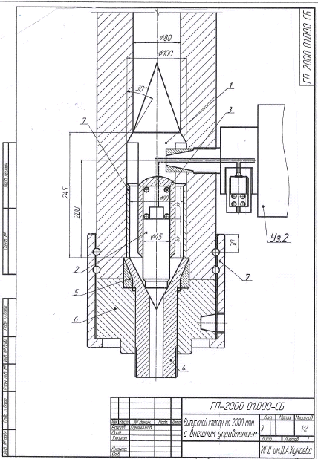

1 - valve actuator case; 2 - valve; 3 - valve spring; 4 - nozzle; 5 - O-ring; 6 - end plate; 7 - swivel nut; Unit No 2 – water discharge control unit

Figure 1 - Shut off valve with externally controlled discharges *WD HG-2000. 01. 000. AS*

**2.2 Device for external control of shut off valve of cannon Unit 2 WD HG -2000. 01. 000. AS (Figure 2)**

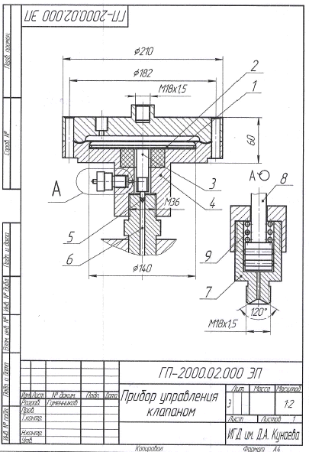

1 - elastic membrane; 2 - rigid disk; 3 - central reaming lug; 4 - cases; 5 - needle; 6 - connecting channel; 7,8,9 - push bar mechanism

Figure 2 - Device for external control of water cannon valve *WD HG -2000. 01. 000. AS*

**2.3 Shut off valve with operating pressure from 2000 atm. And more with valve body attached to the rear end of cannon barrel (Figure 3)**

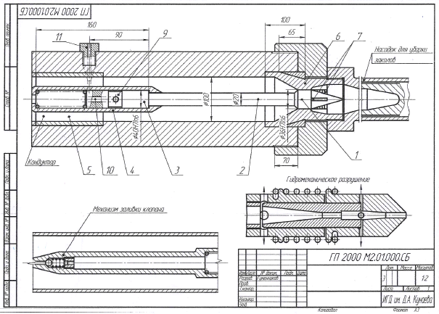

1- valve; 2- stem; 3- valve piston; 4- cylinder; 5- conductor; 6- nozzle block; 7- guide ribs; 8- ball valve; 9- circular groove; 10- axial channel; 11 - radial channel;12- barrel wall

Figure 3 Shut off valve of water cannon with valve body attached to the rear end of cannon barrel *WD HG -2000 М2. 01. 000. AS*

**3 DEVELOPMENT OF ELECTRODISCHARGE DRIVE AND MEANS FOR SEALING ITS CHAMBER AND ENSURING ELECTRICAL INSULATION IN SUPERACID MEDIA AT THE TEMPERATURE UP TO 9000 WITH OPERATING PRESSURE 2000 ATM**

**3.1 Axial electrodischarge drive of water cannon**

Electrodischarge drive installed axially relative to the space inside of water cannon’s barrel Drive is installed inside of the barrel and equipped with spring-piston mechanism for automatic supply of cold water to the reactor in the process of fluid overheating. New mechanism extends duration of electrical discharge in the process of overheating of water steam which becomes electroconductive and correspondingly increases water discharge strength (Figure 4).

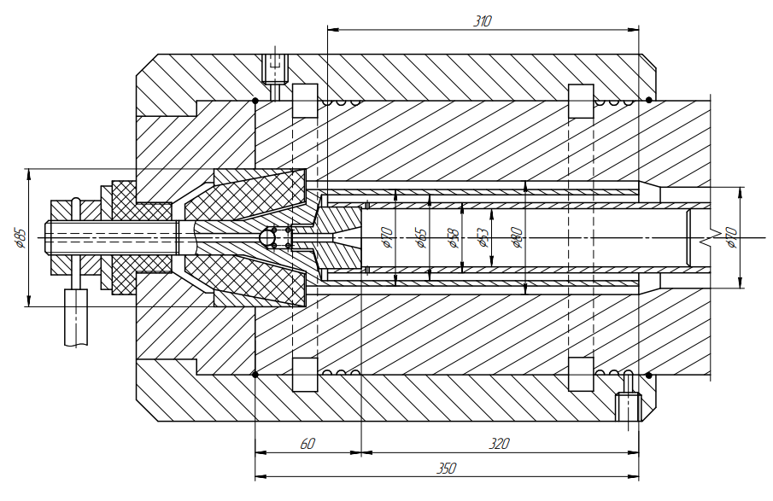

Figure 4 - Water cannon electrodischarge drive

Design of the drive allows to operate water cannon with fluid (mineral water) pressure from 2000 to 3500 atm at the temperature up to 900-9500 С.

**3.2 Electrodischarge drive of water jet cannon with axial position and graphite heat generator**

Electrodischarge drive with graphite heat generator ensures overheating of water steam to the temperature 14000С. Hydrostatical pressure in the space inside of the barrel may be as high as 4000-4500 atm. (Figure 5).

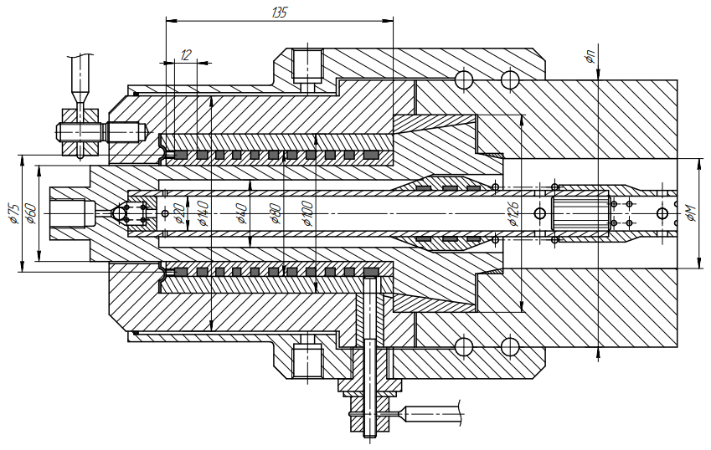

Figure 5 - Electrodischarge drive of water jet cannon with graphite heat generator

**3.3 Electrodischarge drive of water jet cannon with inductive heat generator with central-lateral position relative to the space inside of the barrel**

This variant is of certain interest because it may be used as a pilot model with the highest energy parameters (Figure 6).

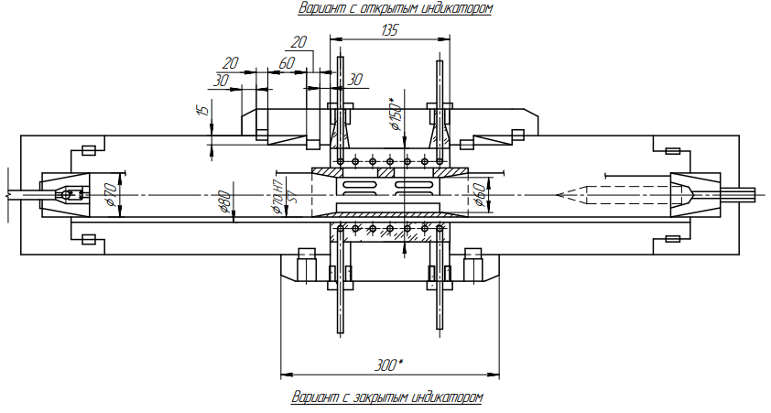

Figure 6 - Electrodischarge drive of water jet cannon with inductive heat generator with two variants of interaction with heated medium

**3.4 Electrodischarge drive of water jet cannon with inductive or ohmic heat generator with heat transmitting coupler**

Variant shown in figure 7 has the most advanced design with inductive or ohmic heat generator. Heating element may be made from tungsten wire 1 or tungsten-molibdenic tube with individual cooling system. Fluid medium is heated through heatproof corrugated coupling 2 which is functions as pressurizing and connecting element for the two parts of the barrel - 3 and 4 [7].

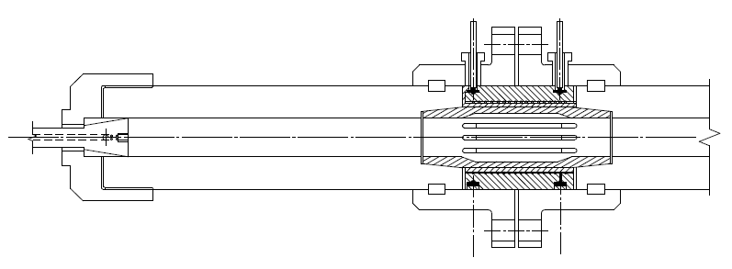

Figure 7 - Electrodischarge drive of water jet cannon with inductive or ohmic heat generator with heat transmitting coupler

**4 DEVELOPMENT OF GENERAL DESIGN OF WATER CANNON WITH OPERATING PULSE STRENGTH NOT LESS THAN 70 KJ**

**4.1 Detail drawing of general design**

Experimental design of water jet cannon with discharge power not less than 70 kJ is shown in Figure 8.

Scheme of drilling attachment (unit 2) for drilling advance bores during development of mines where sudden outbursts of rocks or pressure water may occur.

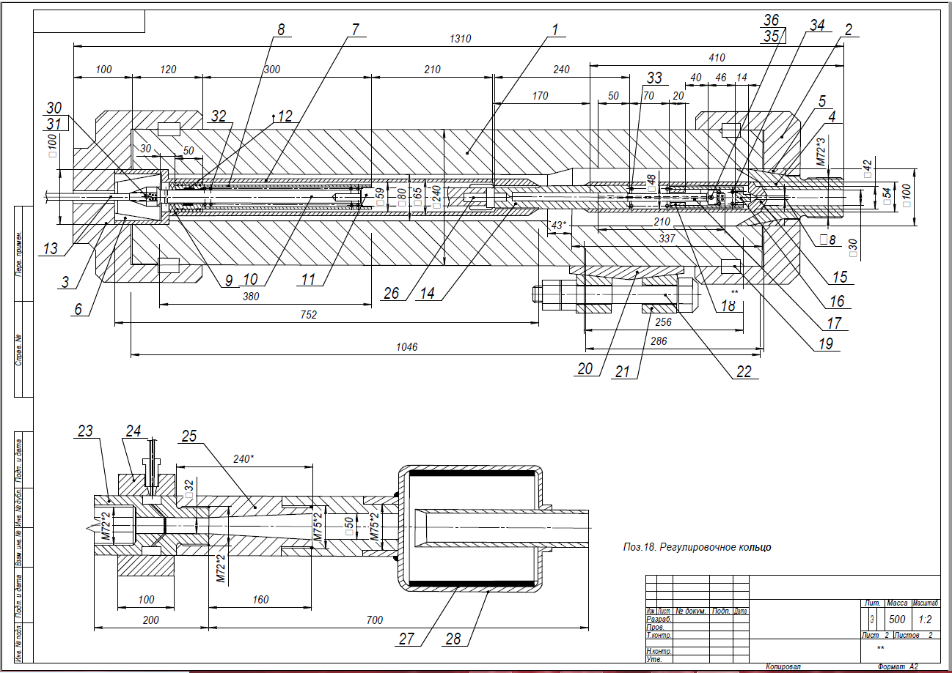

Figure 8 - Water jet cannon with discharge power not less than 70 kJ. Development of auxiliary equipment.

**4.2 Water supply pump of water cannon with pressure up to 50 MPa (Figure 9)**

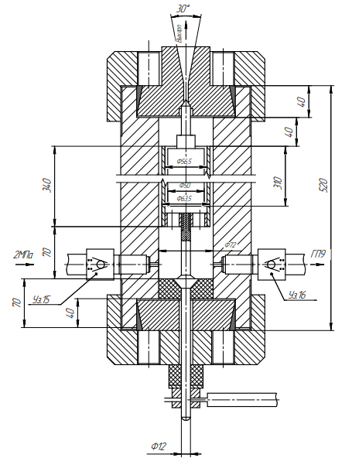

Figure 9 - Overall view of water supply pump with pressure up to 50 MPa

**4.3 Automatic electrical switch of water cannon (Figure 10)**

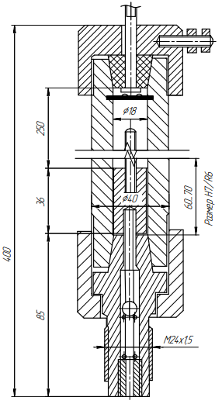

Figure 10 - Overall view of automatic switch of water cannon

**5 DEVELOPMENT OF TECHNOLOGICAL SCHEMES FOR DEVELOPMENT AND EXPLOITATION OF CLOSE PACKED ORE BODIES USING UNDERGROUND MINING METHODS WITH WATER PULSE DEVICES FOR ROCKS BREAKING**

**5.1 Development of mine with inclined mine openings**

D. Kunayev Mining Institute for several years have been searching for new technological solutions for reducing prime cost of mine construction and prime cost of extraction of mineral resources. Emphasis should be placed on development of deposits with small volumes of reserves of valuable ores and metals that have not been developed earlier.

Works are performed currently on development of method for fine rock breaking and crushing of especially hard rocks with powerful water jet devices [8].

Development of cost-effective blocking out schemes for ore bodies that may be exploited effectively is aimed at ensuring continuous and safe performance of sinking operations with steeply dipping drifts from the surface even with increased water content.

Transition from drill and blast method of development and extraction to destruction with water jet devices with electrical drive due to environmental compatibility will allow to reduce significantly volume of works connected with ventilation still in strict compliance with sanitary standards applicable to mine conditions.

Design of water cannon АГИР-500 with working power of water jet up to 500 KJ is shown in construction diagram According to estimations technical performance of one АГИР-500 unit is up to 500 thousand tons a year, whilst standard value for drill and blast method is 40 thousand tons a year.

The project offers a scheme of new deposits development with a pair of steeply inclined conveyorways with cross section not more than 10 m2 (Figures 3 and 4) with heigh reduced in order to ensure convenient maintenance of mine roof and its anchoring mainly with woodwork and meshwork.

During sinking operations, the conveyorways will be equipped with a pair of looped hydraulic pipelines that can be moved with advance in sinking operations for delivering rock to the surface from the mine face (Figures 11 and 12).

Ore body 1 opened with two inclined drifts 1 and 2 embracing ore body 3 from the two sides located in adjacent rock. Decline of the drifts - 30 - 350.

One of them is equipped with looped hydraulic pipeline for delivery of rock to the surface. Drift 2 is equipped with pipeline for delivery of materials from the surface to production sites for backfilling operations.

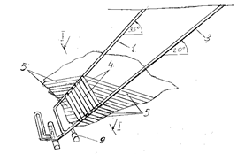

1- steeply inclined ventilation shaft; 3- steeply inclined conveying shaft; 4- cross drifts; 5- steeply inclined panel entry ways; 9- freezing units’ chamber

Figure 11 - Scheme of development and preparation of close packed ore body

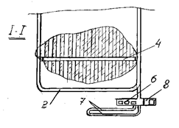

1- circular drift; 4 - haulage cross drift; 6- pumping room; 7- water collecting header; 8- electrical substation chamber

Figure 12 - Cross section view of drift 1-1

**5.2 Hydraulic transport pipelines**

Belt conveyors cannot be used for making inclined drifts from top downward with decline 300 and more and often in case of inflow of large volumes of water to mine face.

This problem may be solved through creation of effective hydraulic pipeline-based transport, for example with ball dividers for bulk materials acting like pistons and pigs at the same time. Water jet flushing allows to prevent jamming of these dividers at the points where materials are loaded and unloaded [5], [6].

In order to increase productivity of hydraulic transport at deep levels it is possible to use high pressure air blowing along the route.

Technical problem of hydraulic pipeline-based transport is that it requires rocks to be broken into blocks of certain size. This problem may be resolved successfully through use of rock breaking water jet devices.

Figure 13 shows the scheme of downhole transport equipment at the sinking of a steeply inclined opening.

Figure 14 shows the General scheme of the hydraulic transport complex at the sinking of a steeply inclined opening.

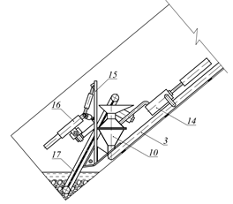

3-Transport pipeline; 10-displacement hopper; 14-double-acting pump; 15-Shield; 16-hydraulic Pulse gun

Figure 13 - Shows the scheme of downhole transport equipment at the sinking of a steeply inclined opening

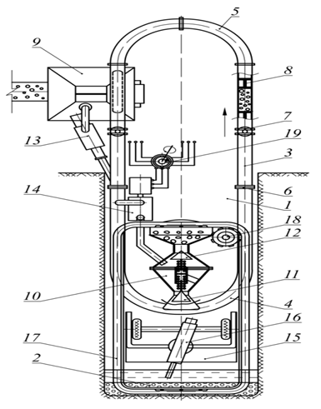

1 - steeply falling mine; 2 - Submerged bottom face; 3 - Transport pipeline; 4 - Lower ring of the pipeline; 5 - Upper ring; 6 - Sectional flanges; 7 - gate Valves; 8 - Free-floating pistons-scrapers; 9 - sludge treatment tank; 10 - Intake and displacement apparatus; 11-exhaust valve; 12 - Loading valve; 13 - jet drive Pump; 14 - two - way pump for pumping pressure water; 15 - shield; 16 - hydraulic Pulse gun; 17 - Downhole loader

Figure 14 –The General scheme of the hydraulic transport complex at the sinking of a steeply inclined opening

**5.3 Vertical access to deep seated ore bodies**

Development of deep-seated ore bodies (over 400 m) is performed with vertical shafts (wells) with diameter from 2.2 to 3.0 m. Wells with diameter 2.2 m are drilled with the existing equipment. Shafts sinking will be performed with mountable water jet cannon, broken fine rocks will be transported by hydraulic pipeline transport with circulating water flow.

In the process of deep drifts operation rock mass will be delivered to the surface by a downhole pneumatic lift with new design that differs from other developed variants in that it provides for installation of rolling resilient seals in the walls of vertical shaft for lifting containers.

The offered decision provides for use of lift (Figures 15 and 16) with balanced scheme including two vertical haulage shafts 1 and 2 connected by a cut-through at the bottom. Between links 4 and 5 of cut through 3 there are installed wind blowers 6 able to suck and blow air to shafts 1 and 2 alternately.

When one of the blowers is set to blowing air to one of the shafts and suck air from the other shaft, there is created lifting force that lifts loaded platform to the surface and lowers empty platform.

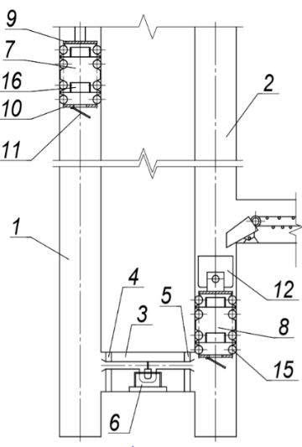

Figure 15 - Overall view of balanced pneumatic lift

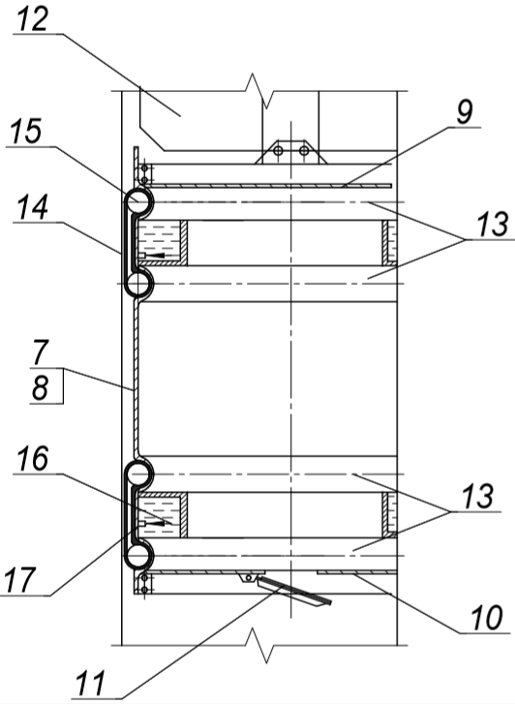

Figure 16 - Vertical section of lifting platform of pneumatic lift

When platforms move resilient seals strutted by the frictional walls of vertical shafts 13 roll without sliding, whilst on polished or wet with water side surface of ducts and cylindrical walls of platforms they slide easily. Seals are fixed tightly due to ducts and balls attached to them inside of elastic membranes.

Pneumatic lift with rolling seals will allow to perform underground mining operations without limitation of depth and ensure minimum wear and tear of seals with high reliability. Thus, requirements for the quality of the walls of shafts, for example fixed with tubings with smooth walls, and to axial displacement of shafts.

New means and methods for preparation of ore bodies for extraction using underground mining methods will significantly simplify mining technology with significant reduction of the volume of works on development of infrastructure on the mine surface and physical volume of mining operations. As a result, mine’s productivity will be increased significantly, as well as environmental and occupational safety [9].

**5.4 Standard development scheme for ore bodies adapted to development with steeply inclined shafts**

For close packed ore bodies developed with one or two declined shafts there may be used declined haulage shaft for creation of new development system (figure 17). Depending on the shape of ore body it may run under ore body, above ore body or diagonally near to its side surface.

Development shaft may adjoin ore body and may be used in underground mining operations together with declined stratified panels, each of which is developed sequentially from bottom to the top with declined dead locked entry ways.

Short lateral drifts are made sequentially along with level lowering directly from shaft side walls transversely to the side surface of ore body. Then horizontal cross drifts are made from the mine face of lateral drifts at the right angle on either side of lateral drifts, from the walls of cross drifts along the whole route there are made steeply inclined entry ways for ore extraction alternating with solid blocks in one plane of stratified block. Worked out entry ways are backfilled with ice and ore. Then ore pillars are mined out and backfilled. Then the next level is mined out in the same order. Roof of underlaying panel is the base for the overlying panel.

Extraction drifts with decline 25-300 are made from top downward with continuous fine breaking of rocks with water jet devices.

Ore will be delivered from extraction shafts (to the exit to common haulage facilities) to corresponding cross drift, to lateral drift by pneumatic-hydraulic pipeline and then to pipeline transport line along declined shaft.

Project team have studied the method and developed mechanisms for mine development with backfilling of mined out space with thrusting material that takes up rock pressure immediately.

High thrust occurring in mined out space when water in backfilling material freezes and takes up rock pressure allows to ensure safety and prevent rockfalls in the process of ore bodies development and damages to development drifts.

These technical solutions will allow to replace cyclical technology of mining operations performance with continuous technology.

New technological scheme provides for performance of extraction works with declined stratified panels sequentially from the bottom of ore body to the top. Stratified panels in this case are developed with parallel dead locked entry ways from the top to the bottom from the side walls of corresponding (lateral drifts) horizontal cross drifts connected with development shaft and the second declined shaft or ascending ventilation shaft equipped with mechanically propelled lift (Figure 18).

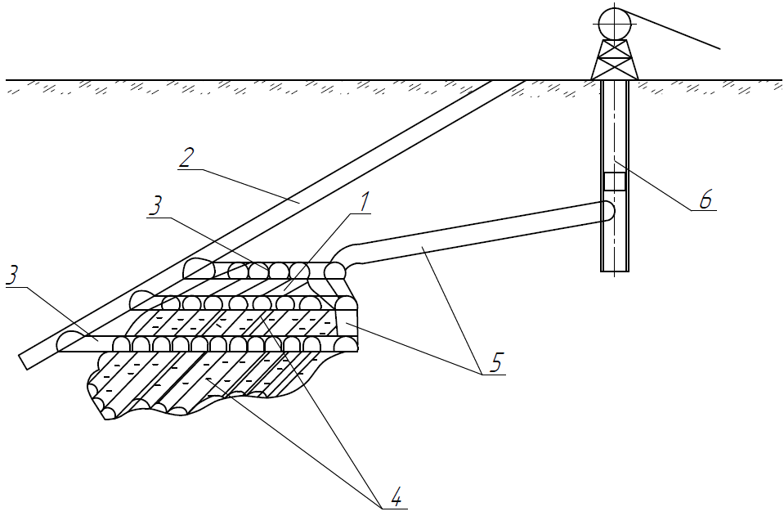

1 - ore body; 2 - steeply inclined shaft; 3 - lateral drifts; 4 - declined stratified blocks; 5 - declined ventilation shaft; 6 - ascending ventilation shaft equipped with man hoist attached to КПВ-1

Figure 17 - Standard scheme of development of close packed ore body with laterally positioned development drift

Standard scheme of development with declined panels with backfilling of worked out shafts 5 with ice and rock ensuring thrust is shown in Figures 18, 19, 20.

In Figure 18 ore body is developed with a declined (ramp) shaft 2 and auxiliary ascending ventilation shaft 7 equipped with self propelled mechanical lift, for example unit for making ascending shafts such as КПВ-1. Compressed air is supplied to КПВ-1 through a suspended type flexible hose from the surface, this allows to eliminate limitations on lifting height for КПВ-1 due to capacity of standard hose winch.

Declined (ramp) shaft 2 may run above or under ore body. In close proximity to ore body ramp may bypass its side surface.

Unfixed location of permanent development drift relative to extraction works site allows to use new method of underground mining operations with backfilling of declined worked out space with ice and rock with high thrust, which reliably ensures integrity of rock mass located above the ore body.

Two short horizontal lateral shafts 3 are made directly from declined (ramp) shaft and penetrate into ore body to a certain degree. From the point of penetration on either side throughout the ore body length there are made horizontal cross drifts 4 at the right angle [10].

Ore body 1 is developed from the bottom upwards and is started from drilling dead locked entry ways 5 from the lowest cross drift 4 (upper shaft 3), which form the bottom stratified block being the bottom of ore body.

All cross drifts are linked through lateral drifts 3 and shaft 2 to ventilation shaft 6, which is linked to ascending auxiliary ventilation shaft 7 used for ventilation, delivery of backfilling materials by pipelines and the second mechanically propelled exit to the surface for people.

Ore is delivered to the surface through declined (ramp) shaft 2 by pipeline.

After working out and backfilling of the bottom panel the second panel is developed with similar dead locked entry ways from the next lateral drift located at the lower level of shaft (ramp) in stepwise manner with designed increments. Soil stratum for the second layer will be the roof of the previous bottom panel.

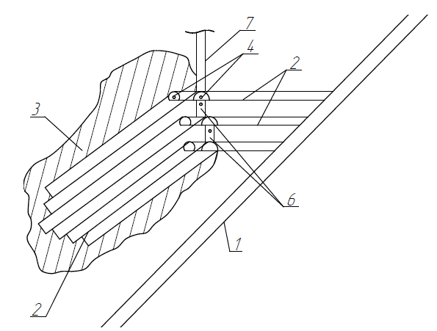

1 - steeply inclined shaft; 2 - sublevel lateral drifts; 3 - ore body; 4 - horizontal sublevel drifts; 5 - panels of extraction shafts with reverse slope; 6. - ventilation links between drifts;

Figure 18 - Scheme of development of ore body with underlying entry way

Then development is performed in the same manner, i.e. each new panel is mined out from underlying lateral drift. All lateral drifts are parallel to each other and are located with certain intervals depending on angle of ramp and parameters of ore body.

Panel entries in ore bodies are made with supporting ore pillars of equal width and are backfilled with spacing material immediately upon completion of sinking operations. After backfilling of entry ways ore pillars are mined out from the both sides. After development of the whole panel the next panel is mined out in a similar manner.

Worked out dead locked entry way is backfilled with ice and rock material with application of new high-performance freezing units and new backfilling method.

Scheme of development of ore body with underlying entry way made from the surface is shown in Figure 18.

Scheme of development with development drift located above ore body is shown in Figure 19.

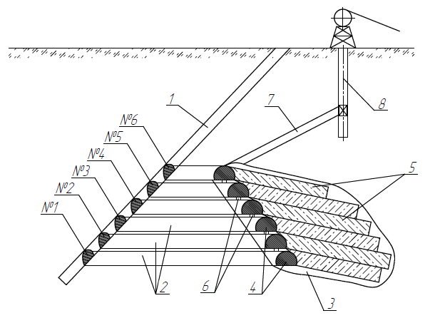

1 - steeply inclined shaft; 2 - sublevel lateral drifts; 3. Ore body; 4 - horizontal sublevel drifts; 5 - panels of extraction shafts with reverse slope; 6 - ventilation links between drifts; 7 - ventilation lateral drift; 8 - ascending ventilation shaft with mechanically propelled lift.

Figure 19 - Scheme of development of close packed ore body with development drift located above.

**5.5 Extraction and haulage equipment**

Extraction and haulage equipment include water jet cannon 1 with water discharge power up to 500 KJ. Pneumatic-hydraulic single pipe ore transporter 2 for transportation of fine broken ore to corresponding lateral drift and further to haulage way (Figure 20).

Water jet cannons may have capacity of about 500 thousand tons a year. Broken rocks are not larger than 100 mm, majority (80-90%) of rocks have size 50 mm [11].

Broken rocks are transported from mine face flooded with mine water to loading chamber 3 located at the bottom end of pneumatic-hydraulic transport pipeline by a suspended type self priming pipeline 4, 5, 6.

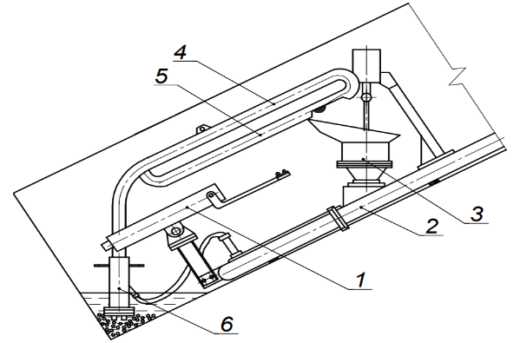

Figure 20 - Extraction and haulage equipment in dead locked entry way

Length of declined extraction drifts complies with design parameters of mined block, i.e. about 50-60 m. Taking into account finely broken rocks and ability to break large rocks from cavings with water jets, new method of rock mass development allows to use single thread pneumatic-hydraulic transport pipeline at mine face directly.

Pipeline 3 is assembled and extended with 6 m sections with diameter of 180-200 mm using nipple joints allowing to move the whole assembled unit on metal plates along with relocation of mine face.

Bulk materials will be transported by compressed air under pressure 1.5-2.0 MPa generated by hydraulic compressor (Figure 21). Loaded ore portion contains certain volume of water for air sealing ore plug in transport pipeline.

In the process of underground works hydraulic shock compressor’s drive is electrodischarge steam generator functioning based on the principle of water jet cannon’s drive with capacity of 500 KJ.

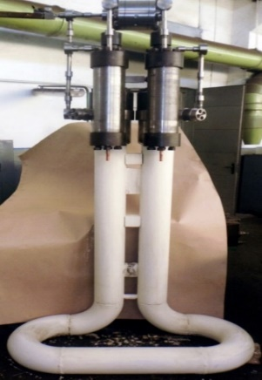

Figure 21 - Hydraulic shock compressor КГУ-1

**5.6 Methods of worked out space backfilling**

Worked out drifts are backfilled with tailings containing water and barren rock with compaction to ensure thrust and subsequent freezing. Steep incline of drifts and natural increase in volume of water in the process of ice formation contribute to the process.

Volume of water during freezing is increased by 8%, which allows to create a sufficiently strong support for performing the second, third and further horizontal drifts to overhanging side of ore body with a gradual transfer of rock pressure to backfilling with strength of about 10-12 MPa and more [12].

For backfilling there are used two limited swing drums installed at the entry to backfilled drift. One drum is filled with water, the second - with solid backfilling material, such as barren rock. Lump ice may be used together with rocks.

The two drums are linked by cold air supply pipelines from freezing unit. Water cooled to the temperature about freezing point runs downwards to the mine face.

Natural material or ice cooled to maximum negative temperature, for example to (–) 70…(-) 1000С, slides down on frozen backfilling material forming the roof of the previously used extraction drift located in the underlying panel or by chutes and then is poured to the mine face.

Due to low temperature of the solid material, when it is mixed with maximally cooled water, the mixture turns into an ice-rock mass within the shortest possible time that can immediately take up rock pressure.

Hydraulic compressor (Figure 3) equipped with compressed air-cooling system and devices for recuperation of its heat by compressor drive is used for freezing. Thus, up to 60-65% of heat energy may be recuperated in the drive of freezing unit directly.

Adiabatic compression of atmospheric air to 10 MPa and more in one stage forms its temperature 5500 С. Cooling with instantaneous radiator to 50 - 600 С and subsequent reduction of pressure to 0.3 MPa at the entry to freezing collector or freezing drums will ensure temperature about -110…-1200 С.

Safe increase of outlet pressure of compressed air by hydraulic compressor is ensured due to use of lubricating oil.

Estimated annual economic benefit of development system with backfilling with solidified material with annual product output 500 thousand tons of ore from difference between the cost of backfilling material only will be about $5-6 million.

More significant environmental and social effect will be achieved due to dramatic reduction of number occupational injuries connected with rock pressure control and improvement of environmental conditions in underground mines.

Freezing time of backfilling material in the climate of Kazakhstan, for example worked out ore body with dimensions 250х250 х100 m, will exceed 30 years.

**6 DEVELOPMENT OF COST-BENEFIT ANALYSIS (CBA) OF DEVELOPMENT OF CLOSE PACKED ORE BODY USING CONTINUOUS WATER JET TECHNOLOGY BY THE EXAMPLE OF DEVELOPMENT OF STEEPLY DIPPING TUNGSTEN STOCKWORK AT AKMAYA DEPOSIT**

**6.1 Mining Operations**

Additional exploration with a combination of partial mining of the ore body is carried out by inclined workings 1 and 2 broken in the opposite direction with an angle of inclination of 30-350, passing from both sides of the stockwork in the contact zone (figure 22). At the points of turning in the opposite direction between these two workings, a ventilation breaks 3 also passes into the circumference of the ore body in the contact zone of the ore body. From the sides of the inclined workings 1 and 2, difficult arty 4 are passed in such a way that the inclined panels 5 passed from their sides are superimposed on each other with full fit on each other (Appendix A).

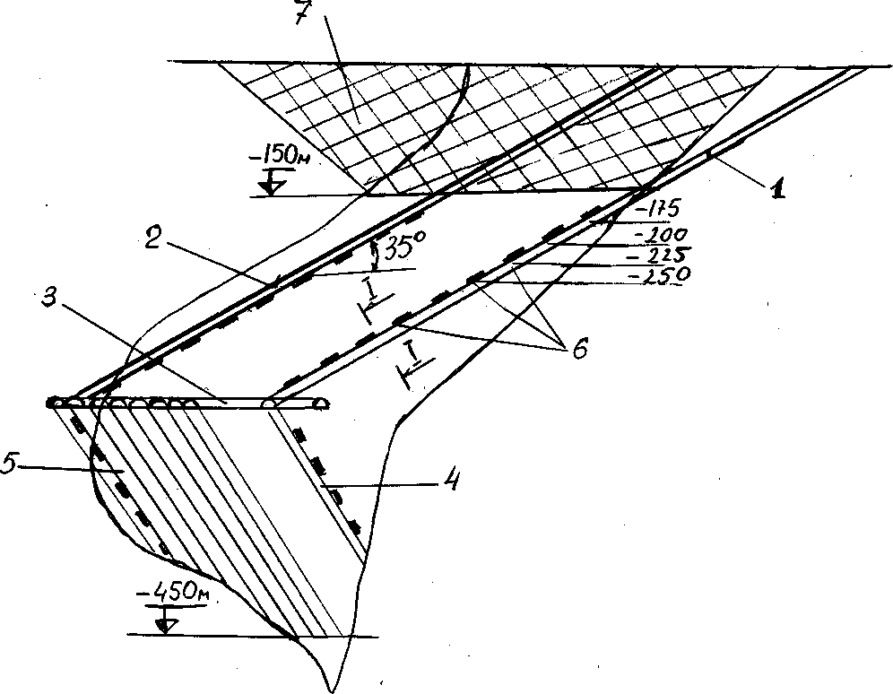

1 - left-flank declined cross drift; 2 - right-flank declined cross drift; 3 - horizontal link; 4 - left-flank panel extraction drift; 5 - right-flank extraction drift; 6 - points of drilling and exploratory equipment location; 7 - outline of mine with commercial resources

Figure 22 - Scheme of development of Akmaya stockwork deposit

Full testing (figure 23) of the stockwork can be carried out in tiers according to special projects that ensure the safety of work when closing tiers.

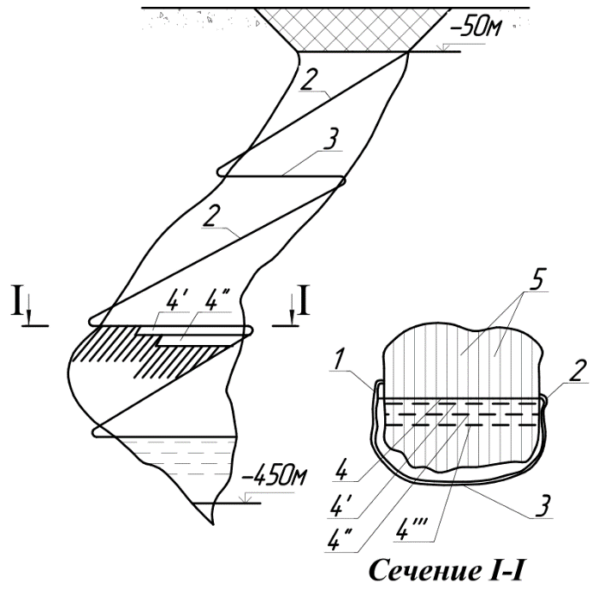

1-left-Flank inclined trunk; 2-right-Flank

inclined trunk; 3-horizontal Ventilation break between the trunks;

4-Ore cakes with a consistent height along the trunk slope; 5-Layer panels

Figure 23-Mining system for tungsten stockwork at the Akmaya field

Underground development of ore body is performed with horizontal layers of steeply inclined dead locked entry ways from the surface of the pit bottom.

The first blocking out row of inclined entry ways begins from the bottom layer of ore outline. Entry ways are made with ore pillars with width multiple of the width of entry ways.

When entry ways are completed, they are backfilled with solidified spacing material, when backfilling material is solid enough to take up rock pressure without settlement of overlaying rocks adjacent drifts are made. When all blocking out row of entry ways making up a continuous layer is completed and backfilled, similar works are performed in the next row of entry ways with bottoms adjoining the roof of the previous layer.

Destruction of solid ore with dead locked entry ways is performed with water jet cannons such as АГИР-500. Technical performance of one АГИР-500 water jet cannon is about 500 thousand tons a year. Broken material - rocks with size up to 100 mm. Majority of rocks (80-90%) - less than 50 mm.

Cannon will be installed on the steel plate of downhole loading machine (Figure 15) and will be controlled by operator, who will be protected from ore debris. Cannon come down gradually with advance in extraction operations together with loading machine and transport hydraulic pipeline by gravity along the slope till it arrives at the working face. In contrast to Figure 14 transport pipeline is made of one pipe without ball dividers and is designed for delivery of ore mass in portions using the principle of concrete paver БУК-1.

When drift is worked out to the full depth loading machine and water jet cannon will be lifted to the surface by hauling cable.

When drift’s depth reaches the mark of 40 m people and materials will be lifted with one ended lift with rubber-tyred carrier attached to rope with diameter 15.5 mm. That is why sinking hoist ЛВД-33 with lifting capacity 1800 kg is installed on the surface on travelling platform that can be towed gradually in parallel to the long axis of ore body normally to the axes of drilled steeply inclined entry ways.

**6.2 Worked out space backfilling**

Steeply inclined entry ways drilled to the final point are backfilled with tailings with low water content from own ore-dressing plant with gravity driven pressing and thrusting

with subsequent freezing. Steep incline of drifts and natural increase in volume of water in the process of ice formation contribute to the process.

Volume of water during freezing is increased by 8%, which allows to create a sufficiently strong support for performing the second, third and further horizontal drifts to overhanging side of ore body with a gradual transfer of rock pressure to backfilling with strength of about 10-12 MPa and more.

For freezing purposes there is used atmospherics air under pressure up to 15 MPa shock compressed in a single stage process by hydraulic compressor КГУ-1 with mountable cooling unit with subsequent reduction of pressure to 0.3 MPa. Temperature of cold air may fall to -1150С.

Advantage of shock air compression without non flexible pistons and lubricating oil is possibility of compressing atmospheric air in a single stage process with considerably high adiabatic temperature (up to +600 0С). This outlet temperature allows to accumulate heat effectively up to 90-95 degrees with recuperation of energy in the same cycle. Cold air cools solid elements of backfilling material that are thrown down the slope to the face of worked out drift. Water is also cooled to 00С and drained to the face. As a result, mixture freezes quickly and takes up rock pressure.

Backfilling operations, as well as mining operations, are performed 24 hours a day. Concentration tailings are delivered by two dumptrucks that were used previously in open pit mines.

15 290 running meters of drifts will be made and backfilled in 1 year. 861.3 m3 of drifts are made and backfilled in a day. Backfilling of worked out space is performed 24 hours a day. 36 m3 are backfilled in 1 hour.

Backfilling material consists of 100% tailings from own ore-dressing plant and water that filled free space between solid particles. Volume of free space in sand like tailings compacted by gravity does not exceed 10-15% of the total volume, i.e. 100-150 l/m3.

Volume weight of compacted tailings is 2.65 t. Weight of water per m3 - 150 kg.

Maximum temperature in Akmaya region + 42°С. Is achieved in July. In order to determine drive power, od freezing unit we assume maximum temperature + 420 С.

Thus, maximum drive energy of hydraulic compressor required to freeze 2.65 t (1 m3) of tailings from +42 0С to – 10 0С is 2650 kg х 0.8 KJ.kg.deg х 52 deg = 110240 KJ.

Energy required to cool water and ice from +42 0С to – 10 0С is 150 kg х 4.19 KJ.kg.deg х 52 deg = 32682 KJ.

Energy required to cool water and ice from +42 0С to – 10 0С is 150 kg х 4.19 KJ.kg.deg х 52 deg = 32682 KJ.

Energy required for ice formation is 150 kg х 334 KJ.kg.deg = 50100 KJ.

Total amount of energy required for backfilling 1 m3 in the hottest period is 193022 KJ or 53.6 KW.h/1 m3

Total amount of energy required for backfilling during one hour is 6948792 KJ, thus driver power of hydraulic compressor required is 6948792/ 3600 =1930 kW. Taking into account 10% loss maximum energy consumption of hydraulic compressor is 2123 kW.

Maximum annual temperature in Akmaya region is + 42°С, minimum temperature - -51°С.

In order to calculate annual cost of electric energy we assume average annual temperature 0°С.

Thus, average annual energy required for cooling tailings from 0 0С to – 10 0С is 2650 kg х 0.8 KJ.kg.deg х 10 deg = 21200 KJ.

Energy required to cool water and ice from 0 0С to – 10 0С is 150 kg х 4.19 KJ.kg.deg х 10 deg = 6285 KJ.

Energy required for ice formation is 150 kg х 334 KJ.kg.deg = 50100 KJ.

Average annual amount of energy required to backfill 1 m3 is 58505 KJ.

Total amount of energy required for backfilling during 1 hour is 2106180 KJ. Taking into account 10% loss energy consumption will be 2316798 KJ or 643.6 kW.h.

Average annual energy consumption for freezing of 1 m3 of backfilling material is about 17.88 kW.h/m3.

Annual energy consumption for freezing of backfilling material is 5.48 million kW.h, annual cost of electric energy - 298.4 thousand US dollars.

In order to calculate amount of energy required for backfilling operations we must take into account daily temperature variations which reduce significantly maximum temperature value. It is necessary also to bear in mind that ore extracted from underground mines had relatively low temperature before processing (+8…+10 0 С). Artesian water used for tempering also has low temperature, that is why in order to reduce expenses on electric energy in hot periods it is necessary to take measures for protection against tailings heating by sun till the moment of backfilling of worked out space.

Annual wages fund for 12 employees - 215.6 US dollars.

Cooling pipes - 61 300 running meters (nominal diameter = 100 mm, wall thickness = 3.5 mm, 529 t) - 140.0 thousand US dollars.

Diesel fuel - 31.2 thousand tons.

Total annual cost of backfilling operations - 685.2 thousand US dollars.

Unit cost of backfilling operations per ton of ore will be 0.8 USD.

Design and experimental activities, introduction into service and maintenance of commercial prototype during the whole period of mining operations at Akmaya deposit - 750 thousand USD (110 million KZT).

Prime cost per unit of equipment - 95 thousand USD.

**6.3 Economic performance of commercial resources extraction using underground mining method from the depth of -50 m to - 450 m**

Annual ore output of pilot enterprise - 550 thousand tons. Thus, water jet cannon АГИР-500 will be operated less than 40% of working time. Energy consumption based on weighted average power 630 х 0.386 = 243.4 kW. Annual expenses on electric energy used for destruction of solid ore - 1814600 kW.h.

Annual energy consumption of rock-loading machine with average power 20 kW - 150 mW/h. Secondary ventilation fan СВМ-6 - 59 500 kW.h. Portative steeply inclined conveyor used in dead locked extraction drift with average length of 125 m with average drive power 65 kW consumes 484 600 kW.h a year.

Total annual energy consumption for mining operations - 2508700 kW.h. Taking into account cost of 1 kW.h in Karaganda region - 8 KZT, cost will be 20 million KZT (136 thousand UDS), i.e. 1 ton of ore requires 23.5 kW.h, which costs 188 KZT/t.

Assumed average monthly salary per employee is 1200 USD, provided that one shift requires 4 people working at one mine face: breaking activities operator, loading operations operator, signal operator, shift I&C Technician. Surface personnel - 4 people working in three 8 hours shifts: skip winch operator, 3 drivers of dump trucks МАЗ-525.

Face crew working in three 7 hours shifts with rolling schedule consists of 16 people. Surface personnel - 16 people as well.

Total number of people in working team - 32.

Net annual salary of the face crew - 460.8 thousand USD. Salary fund of the face crew with extra payments and social deductions - 575.0 thousand USD.

Annual consumption of rubber covered peipes for ventilation - 26 thousand USD.

Annual consumption of filtered water 12 600 m3 with approximate cost 15 thousand USD.

Annual consumption of diesel fuel for 3 МАЗ 525 trucks used only in extraction operations - 31.2 thousand USD (half of working time dump trucks are used for delivery of concentration tailings for mine tunnels backfilling).

Total cost of operations connected with ore extraction and delivery to crushing-and-concentrating plant is:

С доб. = 575.0 +136.0 + 26 + 15 + 31.2 = 783.2 thousand USD.

Unit cost of extraction of 1 ton of ore will be 0.92 USD.

Unit cost of backfilling - 0.8 USD per ton of ore.

**6.4 Key performance indicators of the new project involving dressing operations (Table 2)**

Table 2 - KEY PERFORMANCE INDICATORS OF DRESSING OPERATIONS ARE SHOWN

|  |  |  |  |
| --- | --- | --- | --- |
| No  . | Indicator | Unit  of measurement | Value |
| 1 | 2 | 3 | 4 |
| Concentrating plant | | | |
| 1 | Working site area | ha | 0.5 |
| 2 | Capital cost  of construction | thousands of USD | 4500 |
| 3 | Working regime |  | Year round  continuous |
| 4 | Life | years | 14.5 |
| 5 | Number of workers  (taking into account tailings storage) | persons | 56 |
| 6 | Productivity | thousands of tons a year | 300 |
| 7 | Tungsten trioxide in merchantable ore  - content  - quantity | %  tons | 0.253  759 |
| 8 | concentrate yield | %  thousand tons | 15  45 |
| 9 | Tungsten trioxide concentration | % | 72 |
| 10 | Tungsten trioxide in concentrate  - content  - quantity | %  tons | 1.214  546.5 |
| 11 | Processing cost  1 ton of ore | US dollars | 4.4 |
| Tailings storage | | | |
| 1 | Land plot area | ha | 50 |
| 2 | Capital cost  of construction | thousands of USD | 1000 |

Capital investments in construction of ore dressing plant at Akmaya deposit are shown in the table 3.

Table 3 - CAPITAL INVESTMENTS IN CONSTRUCTION OF ORE DRESSING PLANT AT AKMAYA DEPOSIT ARE SHOWN

|  |  |  |
| --- | --- | --- |
| Indicator | Unit  of measurement | Value |
| *Capital investments* | | |
| Administration building | thousands USD | 1890.0 |
| Technological equipment | -«- | 3353.0 |
| Ancillary equipment | -«- | 438.0 |
| Concentrating plant | -«- | 4500.0 |
| Tailings storage | -«- | 1000.0 |
| Automobile road 20 km | -«- | 10000.0 |
| External water-intake facility | -«- | 182.1 |
| External power supply | -«- | 312.5 |
| Extension of the existing power transmission lines from the pit envelope - overhead line 35 kW and overhead line 110 kW. | -«- | 200.0 |
| Rotational camp (12 portable  trailers) | -«- | 300.0 |
| Total amount of capital investments: | -«- | 22175.6 |

Cost of primary equipment are shown in Table 4.

Table 4 - COST OF PRIMARY EQUIPMENT

|  |  |  |  |
| --- | --- | --- | --- |
| Description  and identification data | Q-ty | Cost  thousands USD | |
| Units | general |
| 1 | 2 | 3 | 4 |
| Water jet cannon АГИР-500 | 5 | 115 | 575.0 |
| Steeply inclined ore loading machine | 1 | 95.0 | 95.0 |
| Transport pipeline (10 sections with length of 90 m) | 10 | 76.5 | 765.0 |
| Cable man and cargo hoist | 2 | 11.0 | 22.0 |
| Freezing unit | 1 | 95.0 | 95.0 |
| Drilling bottom hole unit for geological prospecting operations НКР – 100 mV | 4 | 9.0 | 36.0 |
| ПР-10 compressor with capacity of 10 m3/min, pressure 8 atm. | 2 | 17.5 | 35.0 |
| Bulldozer Б-10М 180 horse powers | 2 | 120.0 | 240.0 |
| Diesel power station ДЭС-60, ДЭС-100 | 2 | 18.5 | 37.0 |
| Drain pump ЦНС-38-176 | 2 | 5.5 | 11.0 |
| Pull winch ЛТ-750 | 1 | 18.5 | 18.5 |
| СВМ -6м fan | 1 | 16 | 32 |
| ТМШ -630 transformer | 1 | 12.5 | 12.5 |
| Dump truck МАЗ -525, capacity 8 m3 | 1 | 128.0 | 128.0 |
| Total |  |  | 2102.0 |
| Unrecorded equipment and materials (15%) |  |  | 315.0 |
| Total: |  |  | 2417.0 |

**6.5 Key performance indicators of underground mining operations from the depth of - 50 m to 450 m based on the data on additionally explored and approved reserves are shown in Table 5.**

Table 5 - KEY PERFORMANCE INDICATORS OF UNDERGROUND MINING OPERATIONS FROM THE DEPTH OF - 50 M TO 450 M BASED ON THE DATA ON ADDITIONALLY EXPLORED AND APPROVED RESERVES

|  |  |  |
| --- | --- | --- |
| Indicators | Unit  of measurement | Value |
| 1 | 2 | 3 |
| *General data* | | |
| Enterprise’s productivity  in terms of ore extraction and processing | thousand t  year | 550.0 |
| Mining interval - from - 50 m to 450 m . | year | 27.33 |
| Working regime |  | Continuous, 355 days a year, 4 shifts a day |
| Number of workers | persons | 170 |
| *Marketable products* | | |
| Geological reserves  - ore  - tungsten trioxide (WO3)  - average content | thousand t  tons  % | 14875.0  28682.0  0.22 |
| Losses | % | 3.0 |
| Depletion | % | 6.5 |
| Commercial reserves (merchantable ore):  - ore  - tungsten trioxide  - content | thousand t  tons  % | 15395.6  27821.0  0.18 |
| Tungsten trioxide  concentration | % | 72 |
| Tungsten trioxide in concentrate  - quantity  - content | tons  % | 20031.0  15 |
| concentrate yield | t | 133540.0 |
| Agreed price of 10 kg of concentrated WO3 | US  dollar | 300 |
| Income from sale of marketable concentrate | thousands of US dollars | 600930,0 |
| *Production costs per ton of ore* | | |
| Prime cost of ore extraction and transportation  to concentrating plant | -«- | 1.72 |
| Prime cost of ore processing at concentrating plant | -«- | 4.76 |
| General administration and management costs | -«- | 0.5 |
| *General production expenses* | | |
| Ore extraction and transportation to concentrating plant | -«- | 2648.0 |
| Ore processing at concentrating plant | -«- | 73283.0 |
| Boiler house maintenance | -«- | 8199.0 |
| Transportation of paratungstate from concentrating plant to railroad  station Zharyk at the distance of 20 km | -«- | 650.0 |
| Expenses on professional training  of employees (0.5% of extraction costs) | -«- | 115.5 |
| Expenses on development and maintenance  of social environment (4% of extraction costs) | -«- | 923.7 |
| Contributions to abandonment fund (1% of  extraction costs) | -«- | 230.9 |
| General administration and management costs | -«- | 7697.5 |
| Taxes | -«- | 1616.5 |
| *Total production expenses* | -«- | 95319.1 |
| Full writing off to performance of pilot testing works for extraction of balance reserves for ГПЭ-630 and КПУ-1, loading machine, backfilling operations | -«- | 5000.0 |
| Final depreciation of fixed assets | -«- | 16718.0 |
| Total depreciation of primary equipment and machines for the period of balance reserves extraction |  | 5508,0 |
| *Total amount of deductions from incomes* | -«- | 122545.1 |
| Income (loss) | -«- | +478384.9 |
| Corporate tax, 25% | -«- | 119596.0 |
| Net income (with mining operations ath the depth from - 50 m to 450 m) | -«- | 358788.9 |

The results of the Technical and Economic Calculation were certified by the technical expertise of a specialized organization (Appendix B).

**6.6 Estimate of costs of development of akmaya deposit using traditional drill and blast method (for reference)**

This section of CBA has been prepared with use of Work Program and Financial and Economic Model from subsoil use contract and similar materials from the repository of the Design Department of D. A. Kunayev Mining Institute

It must be noted that drill and blast method allow to develop only the upper portion of tungsten stockwork to the depth of 150 m with open pit mining. The is no technology allowing to develop the remaining portion of stockwork (more than 300 m) with cross section 200 x 250 m and decline up to 55 degrees.

Capital investments in construction of ore dressing plant at Akmaya deposit are shown in the table 6.

Table 6 - CAPITAL INVESTMENTS IN CONSTRUCTION OF ORE DRESSING PLANT AT AKMAYA DEPOSIT

|  |  |  |
| --- | --- | --- |
| Indicator | Unit  of measurement | Value |
| *Capital investments* | | |
| Administration building | thousands of US dollars | 1890,0 |
| Technological equipment | -«- | 3353,0 |
| Ancillary equipment | -«- | 438.0 |
| Concentrating plant | -«- | 4500.0 |
| Tailings storage | -«- | 1000,0 |
| Automobile road 20 km | -«- | 10000.0 |
| External water-intake facility | -«- | 182,1 |
| External power supply | -«- | 312,5 |
| Extension of the existing power transmission lines from the pit envelope - overhead line 35 kW and overhead line 110 kW. | -«- | 200,0 |
| Rotational camp (12 portable  trailers) | -«- | 300,0 |
| Total amount of capital investments: | -«- | 22175.6 |

Data on technical and economic feasibility of commercial exploitation of Akmaya deposit taking into account approved reserves are shown in the table 7.

Table 7 - DATA ON TECHNICAL AND ECONOMIC FEASIBILITY OF COMMERCIAL EXPLOITATION OF AKMAYA DEPOSIT TAKING INTO ACCOUNT APPROVED RESERVES

|  |  |  |
| --- | --- | --- |
| Indicator | Unit  of measurement | Value |
| 1 | 2 | 3 |
| *General data* | | |
| Total area of land plot for the enterprise’s facilities | ha | 270 |
| Enterprise’s productivity  in terms of ore extraction and processing | thousand t  year | 300.0 |
| Life | years | 17.5  (14.5) |
| 1 | 2 | 3 |
| Working regime |  | Year round  continuous  355 days a year  Two 12 hours shifts |
| Number of workers | persons | 170 |
| *Marketable products* | | |
| Geological reserves  - ore  - tungsten trioxide (WO3)  - content | thousand t  tons  % | 4198.0  11351.0  0.27 |
| Losses | % | 3.0 |
| Depletion | % | 6.5 |
| Commercial reserves (merchantable ore):  - ore  - tungsten trioxide  concentrate yield | thousand t  tons  thousand t | 4355.0  11010.0  653.3 |
| concentrate yield | thousand t | 653.3 |
| Tungsten trioxide  concentration | % | 72 |
| Tungsten trioxide in concentrate  - quantity  - content | tons  % | 7927.2  1.21 |
| Agreed price of 10 kg of  concentrated WO3 | US dollars | 100.0 |
| Income from sale of marketable  concentrate | thousands USD | 79272.0 |
| Recoverable value per ton of ore | US dollars | 18.2 |
| *Production costs per ton of ore* | | |
| Prime cost of extraction, transportation and disposal of overburden rocks | US dollars | 8.2 |
| Prime cost of ore extraction and transportation to concentrating plant | -«- | 0.7 |
| Prime cost of ore processing at concentrating plant | -«- | 4.4 |
| Prime cost of transportation of 1 t/km of concentrate from concentrating plant to Zharyk  railroad station | -«- | 0.043 |
| General administration and management costs | -«- | 0.5 |
|  |  |  |
| *General production expenses* | | |
| Extraction, transportation and disposal of overburden rocks | thousands USD | 35711.0 |
| Ore extraction and transportation to concentrating plant | -«- | 3048.5 |
| Ore processing at concentrating plant | -«- | 19162.0 |
| Transportation of concentrate from concentrating plant to Zharyk railroad station at the distance of 20 km | -«- | 555.3 |
| Expenses on professional training of employees (0.5% of extraction costs) | -«- | 193.8 |
| Expenses on development and maintenance of social environment (4% of extraction costs) | -«- | 1550.4 |
| Contributions to abandonment fund (1% of extraction costs) | -«- | 387.6 |
| General administration and management costs | -«- | 2177.5 |
| *Total production expenses* |  | 62786.1 |
| Taxes and deductions | -«- | 4916.2 |
| Depreciation of fixed assets (93% of capital investments) | -«- | 20623.3 |
| *Total amount of deductions from incomes* | -«- | 88325.6 |
| Income (loss) | -«- | -9053.6 |
| Corporate tax | -«- | - |
| Net income | -«- | - |

**CONCLUSION**

1) Use of water jet devices with electrical drive for rocks breaking in performance of sinking and extraction activities at mines will be completely environmentally safe.

2) Exclusion of rock breaking explosions in the process of sinking operations and massive explosions in the process of extraction with transportation of all the broken rocks by conveyor with similar productivity can reduce three times number of ventilation openings and 2-2.5 times cross section of haulage drifts, their operational stability will be increased significantly, because the rock mass located outside of deposit outline will not suffer from dangerous deformations resulting from massive explosions.

3) Possibility to make 100% of drifts using smooth bore method will allow to exclude use of heavy monolithic supports in majority of cases. In cases where drill and blast method requires use of monolithic concrete it will be enough to use shotcrete. In cases where shotcrete was required, it will be possible to work without any supports.

4) New rock destruction method will allow to prevent severe injuries connected with drilling and blasting activities.

5) Works under the project have been performed subject to engineering assessment of the possibility of creating new equipment for continuous destruction of hard rocks with high intensity accumulated energy for ensuring high productivity, reducing process costs and ensuring maximum environmental and occupational safety in performance of underground operations.

6) Design of shut off valves and energy accumulating drive units create opportunities for future performance of pilot testing works with satisfactory results.

7) All the developed devices are unprecedented and have sufficient technical and economic feasibility to be used in practice. These devices will be protected by patents covering wide range of areas of application.

All the 5 variants of electrical drives for water jet breaking device can achieve impact pulse strength not less than 70 kJ. All the variants have outstanding useful properties.

8) Set objective - to make drifts in mines with rock hardness up to 10 units according to the scale of Professor M.M. Protodyakonov with fluid pressure 2000 atm. and water discharge strength up to 70 kJ was achieved theoretically.

This stage allows to resolve problems connected with drilling and mining operations mainly at coal pits, where there is risk of methane explosions and coal dust pollution, as well as in open pit mines for contact free crushing of overdimensioned rocks.

9) Practical application of the proposed innovations after test by experiment will allow to simplify significantly scheme of development, preparation and technology of extraction of ore and nonmetallic mineral resources with increased productivity of mine facilities and significant reduction of capital and operating expenses.

10) Method of development of Akmaya stockwork having day holes shown as an example of effective use of the Project’s results will allow to develop rщсл ore directly from the surface without waste mining.

New technology allows to continue development of ore body below the mark of - 50 m to 450 m without changes in methods and equipment.

11) New technology allows to perform additional exploration activities and transfer of reserves to category А+В+С1 using commercial process with simultaneous extraction of ore in steeply inclined dead locked entry ways in ore body.

12) New worked out space backfilling method with freezing of water containing tailings allows to use stratification system without ore pillars and recuperate up to 65% of electric energy of hydraulic compressors’ drive for reusing in the same cycle.

13) New technology creates opportunities for development of numerous gold fields and rare metals deposits in Kazakhstan that are currently profitless both with open pit mining and underground mining methods.

**LIST OF LITERATURE SOURCES USED**

1 Brener V.A. Hydromechanical Rock Destruction / V.A. Brenner, A.B. Zhabin, A.E. Pushkarev, M.M. Shchegolevskiy, – М.: Publiching House АГН, 2000. – 343 p.

2 Merzlyakov V.G. Physical and Technical Basics of Water Jet Technologies in Mining Industry / V.G> Merzlyakov – М.: A.A. Skochinskiy National Mining Science Center - Mining Institute, 2004 – 645 p.

3 Atanov G.A. Water Jet Units for Rock Breaking /G.A. Atanov. – К.: Vishcha Shkola, 1987. – 155 p.

4 Zhabin, A.B. Rock Destruction with High Speed Water Jets / A.B. Zhabin, K. A. Golovin, A.B. Polyakov // Mining Equipment and Electromechanics – 2006. No. 4. – P. 43 – 46.

5 Water Jet Cannons for Rock Destruction: Review of Information Series: Mining Industry - M.: National Scientific Research Institute of Basic Metals, Economics and Information, 1978.

6 Malyushevskiy P.P. Basics of Pulse Discharge Technology - Kiev: Nauk. Dumka, 1983-272 p.

7 Patent No КG №2128, Hydraulic shock device, Assanov A.A., Gumennikov E.S. Bulletin No 2, 28.02.2019.

9 Zhalgassuly N., Gumennikov E.S. Possibility of Deposits Development Using Continuous Technology/ - Publishing House: K.I. Satpayev Kazakh National Technical Research Institute, Institute of Metals and Dressing, Almaty No 3, 2018, p 7-14.

10 N.S. Butukov, E.S. Gumennikov, New Technology of Water Jet Assisted Destruction of Rock - Promising Way to Effective Exploitation of Subsoil Resources. Integrated Minerals Use, Almaty, No 3, 2018, p 7-14.

11 Mulukhov K.K. Transport Vehicles at Mining Enterprises in the USA. М.: Nedra. 1981.

12 Patent issued in the Russian Federation 1505861, Device for Transportation of Bulk Materials/ Gumennikov E.S. published on 23/12/1989 Bulletin No47, 1989.

13 Volkov A.P., Buktukov N.S., Volkov Y.A. Development of Suite of Safe and effective Methods of Development of Inclined and Steeply Inclined Gold Veins // Mining Journal of Kazakhstan. No 9 2015, p. 4-8.

**APPENDIX A**

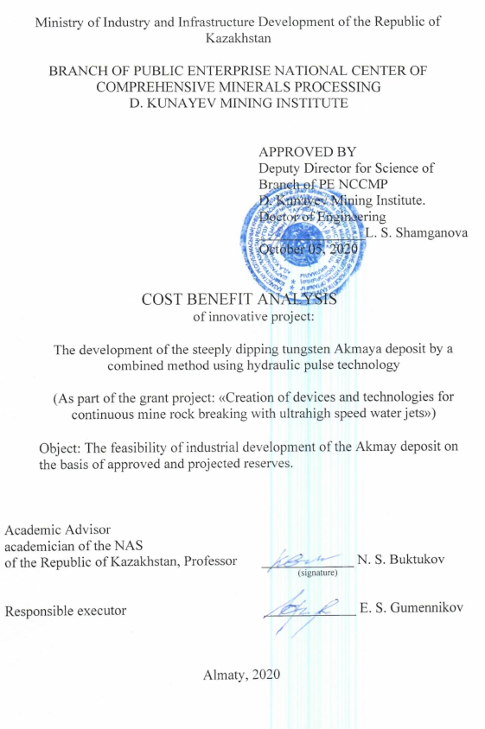

**TABLE OF CONTENTS**

|  |  |  |
| --- | --- | --- |
|  | Introduction |  |
| 1 | Geological-industrial characteristics of the Akmaya deposit |  |
| 1.1 | General information |  |
| 1.2 | Geological characteristics of the deposit. The material composition of ore bodies |  |
| 1.3 | Mining and hydrogeological conditions of the deposit. |  |
| 1.4 | Geological and operational balance reserves (up to a depth of 150 m) |  |
| 1.5 | Assessment of the degree of exploration of the field. Additional exploration work |  |
| 1.6 | Protection of mineral resources |  |
| 2 | The experimental development of the Akmaya tungsten deposit by a combined method |  |
| 2.1 | General part. Productivity, parameters, and lifetime of the mine. Working regime of the enterprise |  |
| 2.2 | The concept of deposit opening. Calendar plan of mining operations |  |
| 2.3 | Occupational health and safety |  |
| 2.4 | Processing of low-grade concentrating ore |  |
| 2.5 | General plan and external communications |  |
| 2.6 | Description of new methods of mining the Akmaya deposit |  |
| 2.6.1 | Object and scope of the new technology |  |
| 2.6.2 | Operational exploration of Akmaya deposit |  |
| 2.6.3 | Mining operations |  |
| 2.6.3.1 | Development of the oxidized zone by open method |  |
| 2.6.3.2 | Underground mining. Transport of ore in the mine |  |
| 2.6.3.3 | General mine transport |  |
| 2.6.3.4 | Worked out space backfilling |  |
| 2.7 | Cost benefit analysis of new technological solutions |  |
| 2.7.1 | Continuous extraction of ore by hydro-pulse method |  |
| 2.7.2 | Existing groundwork on the problem of flow failure of strong and abrasive rocks |  |
| 2.7.3 | Calculation of the productiveness of ГПЭ-630 |  |
| 2.7.4 | New means of downhole shipment of recaptured ore |  |
| 2.7.5 | General mine delivery of ore to the surface |  |
| 2.7.6 | Energy supply and economy of stowing operations |  |
| 2.8 | Economic indicators of the Akmaya deposit mining up to -50 m. |  |
| 2.9 | Economic indicators of underground mining of balance reserves from - 50m to -150m |  |
| 2.10 | Economic indicators of mining of additional in-mine exploration by underground method from -150 m to - 450m |  |
|  | Conclusion |  |

**INTRODUCTION**

Cost-Benefit Analysis (CBA) «Expediency of industrial development of the Akmaya field on the basis of approved reserves» was carried out on the basis of the letter of LLP «NTC-Geo Consulting» on February 8, 2011.

The CBA is based on the balance reserves of tungsten ores of the Akmaya deposit in the contoured ore stockwork according to the expert opinion of the State Commission on Mineral Reserves of the RoK dated May 29, 2006, approved by the State Commission on Mineral Reserves of the USSR (Protocol No. 7434 of 29.05.1952) with the right to design the mining enterprise, in the amount of: ore 4198.0 thousand tons with a content of tungsten trioxide (WO3) 0,27%. At the same time, tungsten trioxide (WO3) in the specified amount of ore is 11351,0 tons. These reserves are listed on the state balance of the Republic of Kazakhstan as of 1.01.2005.

In 1991, the Territorial Administration "Tsentrkaznedra" expressed an opinion about the north-west - south-east strike of the ore stockwork. In this regard, the field was re-evaluated in 1992-1994 and its flanks were examined on drilling profiles which are oriented from the south-west to the north-east. However, with the discontinuation of funding, work was not completed and suspended in 1996. The drilling works stipulated by the project were completed by 60%; evaluation of the deposit from the surface and study of the technological properties of ores were not carried out.

Based on the results of evaluation works and exploration materials of 1941-1952, based on the design parameters approved by the State Commission on Mineral Reserves of the USSR for the Severniy Katpar deposit (4 km to the south-west), the reserves of the Akmaya deposit as of January 1, 1996 were preliminarily calculated and estimated in the amount of: ore-12077 thousand tons, tungsten trioxide-24902.0 tons with a content of 0.206%.

These reserves, with little knowledge of the technological properties of ores and lack of their geological-economic evaluation by the Territorial Administration of the «Tsentrkaznedra» was classified in categories С1 and С2 and accounted for without a balance (Protocol No. 76-0 of March 3, 1997).

For this reason, the subsoil contract for the Akmaya deposit, in the first stage of the work - preliminary geological and industrial evaluation of the field provides for the implementation of consolidated technical-economic calculations to determine the feasibility of industrial development on the basis of approved reserves.

The objective of this CBA is to identify the main technical and economic indicators of a mining and processing enterprise with a capacity of up to 850,000 tons of ore per year in accordance with the regulatory materials currently in force in the territory of the Republic of Kazakhstan, taking into account the current situation and evaluating the prospects for industrial development of the Akmaya deposit.

The source materials used are:

1. «Report to the calculation of reserves of the Akmainskiy rare-metal deposit as of 1.03.1952» Kazgeolupravlenie, 1952.

2. Contractual agreement «Exploration and production of tungsten at the Akmaya deposit» Metal-Tech LTD, 2006 (work program and financial-economic model).

As a result, for open-pit mining to a depth of 50 m, it is established:

- reserves of tungsten balance ores, represented by a contoured steeply dipping stockwork, with an average specific weight of 2,3 tonn/m3 are 1,3 million tons. Overburden volume 2,16 million m3. The average overburden ratio is 1,66 m 3/tonn, and as a result, the cost of excavation, transportation and dumping of overburden rocks will be 1,7 USD per 1 tonn of ore;

- the amount of ore reserves for such mining and processing enterprises limits the optimal lifetime of the enterprise;

- studies on ore enrichment were conducted 60 years ago with the result of extraction of tungsten trioxide into concentrate in the amount of 72%. This result is currently unsatisfactory. Additional industrial ore enrichment tests are needed, which could improve the commercial concentrate with extraction of tungsten trioxide in concentrate up to 82-85%;

- the capital expenditures do not include the boiler house object, the construction costs of the administrative building, repair and mechanical workshops, service stations, external networks and a shift camp are underestimated, which should be 1890, 694,6 and 300,0 thousand USD respectively;

- operating costs, calculated in the financial-economic model, are significantly underestimated due to the size of wages of workers and depreciation deductions from capital costs;

- at the first stage, testing is performed in an open way up to the level of -50 m. The geometric dimensions of the quarry at a depth of 50 m will be 410 x 180 m respectively. Mining time with increasing productivity up to 850 thousand tons of ore per year – 3 years.

- further development of the deposit is carried out in an underground way by steeply inclined layered entry way to the full depth of occurence with an ice formation of each completed entry way with alternating pillars along the strike of horizontal layers. Between each pair of laid entry ways, a full entry way on a pillar is passed, which is also laid with a spacer ice formation;

- additional exploration of the field is performed from a pair of priority delineating steeply inclined entry ways to a depth of 450 m by underground method.

- in order to substantiate the specified productivity for ore mining, it is necessary to envisage, in the future, sequential involvement of other nearby tungsten raw materials deposits for processing and enrichment according to the new technology on the basis of the regional branch «Akmaya»;

- in addition, to use new means of dry enrichment with the help of X-ray radiometric separation apparatus of the SRF 4-50 type, as well as an enrichment hydrometallurgical process with the receipt of the final product - paratungstate. This will reduce the weight of the final product to 8530 tons and, accordingly, reduce transport costs.

**1 GEOLOGICAL-INDUSTRIAL CHARACTERISTICS OF THE AKMAYA DEPOSIT**

**1.1 General information**

The Akmaya rare metal deposit is located on the territory of the Chetsky district of the Karaganda region. The regional center Aksu-Ayula (Chetsk) is 70 km to the east. The nearest railway station, Zharyk, is 20 km to the south-west.

Geographically, the area of the deposit is a plain slightly inclined to the north-west. Among the plains there are rarely low rows of volcanos or single volcanos folded by ancient Paleozoic rocks. The absolute heights vary within 700 m in the flat part, 850 m in the area of the development of hummock. The relative elevations of individual volcanos above the valley level is between 15 and 250 m.

The climate is sharply continental with large amplitudes of air temperature fluctuations both during the year and during the day. The maximum temperature is observed in July, reaching +42°C, and the lowest in January, at -51°C. The average annual rainfall is 300-360 mm. The rainfall distribution over the year is very uneven. The average wind speed is 3.5 m/s. Strong winds are frequent, snowy squalls and blizzards in winter, dry in summer.

The soil cover is typical for the steppe zone: grayish-brown and dark chestnut soils. From the grasses here grows only the feather grass and several kinds of wormwood.

The district is home to several previously operating and currently mothballed mining facilities that make up the district's industrial potential. In the immediate vicinity of the deposit, 4 km to the south-west, there is the newly developed Severniy Katpar tungsten ore deposit. The main occupation of the rural population is livestock and agriculture.

**1.2 Geological characteristics of the deposit. The material composition of ore bodies**

The Akmaya deposit is located in the western part of the Uspenskaya zone and characterized by a complex geological structure. This zone is basically a synclinal structure, complicated by second- and third-order folds.

The Akmaya deposit is located in the sedimentary-metamorphic stratum of the Famennian. There are no intrusive rock outcrops within the field. It is assumed that the rare-metal mineralization of the deposit is associated with the Permian intrusion not yet exposed by erosion, but the outcrops of which are observed 8-10 km west of it.

A distinctive feature of the Akmaya ore field, distinguishing it from all the deposits of Central Kazakhstan, is the presence of a large number of ore-bearing quartz and quartz-feldspar veins in a relatively small area, which allows mining the deposit within the industrial contour of reserves

The area on which the ore veins are concentrated has an elongated shape, located with a long axis along the strike of a calcareous member of rocks.

Dimensions of the ore zone on the long axis is up to 250 m, on the short axis 40-50 m.

In this area, more than 250 ore veins with a thickness of 5-15 cm, rarely up to 0.5 m and a length of 10-15 m, rarely 30-50 m have been counted. Both along the strike and along the dip, the veins quickly pinch out, being replaced by others.

Examination of the material composition of ores shows that the content of useful components in them are obtained only due to the mineralized quartz and quartz-feldspar veins, some of which are substituted by chlorite. The adjacent veins, hornblendes, skarns and marbles are practically barren.

This circumstance predetermines the morphology of the ore stockwork as its position in space entirely depends on the location and degree of concentration of ore veins. The ore veins have a general strike range of 15° and dip south-west at an average angle of 60°.

The main vein minerals of the deposit are quartz, feldspar, fluorite and topaz, vesuvian and garnet; ore minerals are represented by pyrite, pyrrhotite, wolframite, hubnerite, scheelite, native bismuth, molybdenite, beryl, helvine, cassiterite and others.

In practice, only tungsten minerals reach industrial concentrations, and bismuth, molybdenite, cassiterite and selvine can only be meaningful as associated minerals if they are extracted together with tungsten minerals.

The average contents of the components in the ore contour are: tungsten trioxide - 0.28%, native bismuth - 0.035%, molybdenum - 0.019%, tin - 0.028%, beryllium oxide - 0.018%.

Within the area over which the ore veins extend to the surface the contour of industrial ores is formed. This contour is taken for the configuration of an ore stockwork or ore body on the surface. The configuration of the ore body at deep horizons generally does not change, plunging in a south-west direction at an angle of 40-50°. The stockwork has a declination only in the strike plane of the calcareous member. In the plane of incidence of this member, the stockwork is directed vertically; so at deep horizons, ore veins in a larger percentage than on the surface lie in the shale of the footwall.

At depths of about 150-250 m, the stockwork width increases from 40-60 to 75-100 m. At the same time and at the depth, the power is expected to increase from 100 to 150 m. The dispersal of veins leads to a drop in the tungsten content, decreasing in the south-west direction to non-industrial.

Thus, as the ore body declines to a depth in the south-west direction, its cross-sectional area in the plan, without changing its configuration, increases, and the percentage of veins to rock mass and the content of tungsten trioxide decrease, which leads to the pinching out of the industrial ore contour.

**1.3 Mining and hydrogeological conditions of the deposit**

*The stability of the field rocks* depends on the degree of their fracturing. The least stable rocks are within the ancient weathering crust, the area of development of which coincides with the assumed zone of wolframite oxidation in the deposit. The depth of the lower boundary of the weathering crust ranges from 5-15 m on the north-east flank of the stockwork and up to 40-60 m on the south-west flank. The rocks are stable deeper under the lower boundary of the weathering crust. According to geological surveys (1944-1952), the field is classified in the XII - XIV categories according to 14-point scale in terms of drillability of rock. The specific flow rate of ammonite 6 GW during underground roadways was 3,7-4,2 kg/m3. The rock hardness according to Protodyakonov will be 15 - 18 units, the rocks are very difficult to drill and very difficult to blast.

The analysis of the available physical-geographical, geological, hydrogeological and mining data allows us to conclude that the rocks in the contours of the quarry can be assigned to group I in terms of stability.

Volume weight of ores: oxidized ores from the weathering crust zone – 2.0 tonn / m3, mixed semi-oxidized ores (30 m horizon) - 2.3 tonn/m3, primary ores (50 m horizon) and below-2.61 tonn / m3.

*Hydrogeological conditions*. The water content of the deposit rocks is insignificant. Calculated by the balance method, water inflows reach 3,5 l/sec in the quarry to a depth of 50 m and 7,0 l/sec at a depth of 100 m. Due to the minor fracturing of rocks deeper than 100 m water inflows into the projected quarry with depth will change little.

The water demand of the future mine can be met primarily by water intake from wells of underground water of upper Devonian limestones in the area located up to 2,5 km away from the deposit. The resources of these underground waters of limestone lying in the synclinal structure are determined by the following figures: for category В – 1470 m3/day, category В+С1 –6900 m3/day.

**1.4 Geological and operational balance reserves (up to a depth of 150 m)**

The CBA is based on the balance reserves of tungsten ores of the Akmaya deposit according to the expert opinion of the State Commission on Mineral Reserves of the RoK dated May 29, 2006, approved by the State Commission on Mineral Reserves of the USSR (Protocol No. 7434 dated May 29, 1952), in the amount of: ore 4198,0 thousand tons of tungsten trioxide 11351,0 tonn with the content of tungsten trioxide (WO3) of 0.27% (table. 1). These reserves are listed on the state balance of the Republic of Kazakhstan as of 1.01.2005.

Taking into account the experience of the quarries using a similar ore mining technology for the conditions of the Akmaya deposit, the values of losses and dilution are taken as 3 and 6.5%. Then the values of the operational reserves of tungsten ores of the Akmaya deposit are as follows: ore 4355,0 thousand tons, tungsten trioxide 11010 tons with a tungsten content of 0.253%.

The term of development of balance reserves to the level of -150 m - 6.0 years.

**1.5 Assessment of the degree of exploration of the field. Additional exploration work**

As noted above, according to the results of exploration work in 1941-1952, an ore stockwork was contoured at the deposit, localized in limestones of sedimentary-metamorphogenic thickness. The reserves for this stockwork were approved in 1952 by the All Union Society Commission on Mineral Reserves of the USSR (Protocol No. 7434 of May 29, 1952) with the right to design the mining enterprise (table 1).

In 1991, the Territorial Administration "Tsentrkaznedra" expressed an opinion about the north-west - south-east strike of the ore stockwork. In this regard, the field was re-evaluated in 1992-1994 and its flanks were examined on drilling profiles which are oriented from the south-west to the north-east. However, with the discontinuation of funding, work was not completed and suspended in 1996. The drilling works stipulated by the project were completed by 60%; evaluation of the deposit from the surface and study of the technological properties of ores were not carried out.

Based on the results of evaluation works and exploration materials of 1941-1952, based on the design parameters approved by the State Commission on Mineral Reserves of the USSR for the Severniy Katpar deposit (4 km to the south-west), the reserves of the Akmaya deposit as of January 1, 1996 were preliminarily calculated and estimated in the amount of: ore-12077 thousand tons, tungsten trioxide-24902.0 tons with a content of 0.206%.

These reserves, with little knowledge of the technological properties of ores and lack of their geological-economic evaluation by the Territorial Administration of the «Tsentrkaznedra» was classified in categories С1 and С2 and accounted for without a balance (Protocol No. 76-0 of March 3, 1997).

Therefore, the task of the subsoil user for the Akmaya field is to resume work on additional exploration of the field and fully determine its prospects, as stipulated in the Subsoil Use Contract.

**1.6 Protection of mineral resources**

The main requirements in the field of subsoil protection are: maximum extraction and rational use of mineral reserves, reduction of raw material losses to a minimum.

In order to ensure the clean mining and the rational use of the subsoil, it is necessary to organize a geological survey service at the quarry, the complex of the main tasks of which includes:

- control over the correctness and completeness of the development of the deposit, which consists in performing regular topographic surveys and assigning the directions of mining operations;

- mine surveying record of the amount of mined minerals and overburden;

- accounting of the state and movement of reserves according to their readiness for extraction.

**2 THE EXPERIMENTAL DEVELOPMENT OF THE AKMAYA TUNGSTEN DEPOSIT BY A COMBINED METHOD**

**2.1 General part. Productivity, parameters, and lifetime of the mine. Working regime of the enterprise**

The productivity of the Akmaya mine is taken from the calculation of sequential involvement in the development of nearby tungsten deposits and is 850 thousand tons of ore per year.

As indicated in the geological part of the CBA, the Akmaya rare-earth deposit is confined to the Uspenskaya formation of rocks, represented by shales, limestones, tuff shales and tuff sandstones. The total thickness of these rocks within the field is 240-270 m. The strike north-east with a dip to the south-east at angles of 70-85°. The morphology of the ore body is characterized by the presence of a large number of ore-bearing quartz and quartz-feldspar veins, which allows the development of the deposit for the entire rock mass within the industrial contour of reserves, starting from the surface. The size of the ore zone on the long axis is up to 250 m, on the short axis-40-60 m. The ore veins have the general strike range of 115° and fall to the south-west at an average angle of 60°.

*Lifetime*. Based on the volume of commercial ore up to the level of -150 m, there are 4355 thousand tons of balance reserves. With a production capacity of 850 thousand tons of ore per year, the development period of previously explored reserves of the Akmaya deposit will be 6.0 years. Assuming the period for reaching the design capacity (term) of 3 years, the total construction period of the enterprise, taking into account the construction of the concentrating plant and the boiler house, the existence of the enterprise on the proven balance reserves will be 9 years.

The lifetime of the enterprise, taking into account additional exploration to a depth of -450 m with estimated reserves of 12077 thousand tons with a content of 0.206% (tungsten trioxide - 24902.0 tons) is extended for another 14,3 years. In total, the approximate total lifetime of the enterprise at Akmaya deposit, taking into account the annual period of liquidation of the enterprise, will be 24,3 years.

The company operates on a rotational basis with a shift duration of 15 days. For workers on the surface there are 3 shifts of 8 hours. For the underground group there is 4 shifts work with a shift duration of 6 hours is provided. Number of working days per year 355.

**2.2 The concept of deposit opening. Calendar plan of mining operations**

The author of the present CBA considers appropriate for 3 years of the preparatory period organization, the subsoil user on the basis of new technical solutions to build and equip an experimental production to create and piece production of fundamentally new techniques for in-line pulse breaking of rock mass of high strength and abrasiveness of type ГПЭ-630, the system pneumohydrodrives transport on the testing sloping panels on the forward sloping stem, a new system of laying-out space by the method of quick freezing of hydrogen backfilling, as well as new means of continuous delivery from the faces of the rock mass along the opening inclined shaft to the processing plant by a single pipe-belt conveyor КПУ-1, capable of bending in two planes. The estimated costs for the creation of an experimental production, development and implementation work will amount to about 5.0 million USD.

The new fender and transport technology for the development of the Akmaya deposit should be fully developed at the first stage of the ore mining of the oxidized and semi-oxidized zone by open pit mining up to a mark of -50 m.

The geometrical dimensions of the open pit on the surface at a depth of 50 m will be 410 x 180 m, respectively. The volume of ore mined is 1.3 million tons. Stripping volume is 2,16 million m3. The average stripping ratio is 1,23. Mining time with increasing productivity up to 850 thousand tons of ore per year is 3 years.

According to SNIP of the RoK 1.02-01-2007, paragraph 4, 9, the developed and approved project documentation is valid for three years from the date of its approval. Therefore, the mining schedule was drawn up for the first three years, which coincided with the transition from open pit mining to underground (table A.1).

Table A.1 - THE CALENDAR PLAN OF MINING OPERATIONS WAS DRAWN UP FOR THE FIRST THREE YEARS, WHICH COINCIDED WITH THE TRANSITION FROM OPEN PIT MINING TO UNDERGROUND MINING

|  |  |  |  |  |  |  |
| --- | --- | --- | --- | --- | --- | --- |
| Years  of operation | Ore extraction,  thousand tons | Overburden  amount  thousand m3 | Losses,  % | Dilution,  % | Content  WO3,  % | Mining depth, m |
| 1 | 150 | 720,0 | 3 | 6,5 | 0,253 | 0-5,4 |
| 2 | 300 | 720,0 | 3 | 6,5 | 0,253 | 5,4- 18 |
| 3 | 850 | 720,0 | 3 | 6,5 | 0,253 | 18-50 |
| Total | 1300,0 | 2160,0 |  |  |  | 50,0 |

During this period, it is necessary to modernize the ГПЭ-630 suspension system. Manufacture and put into production other new technical means for layer mining with dead-end steep-slope approaches, namely: a steep-slope rock loader with a hitch ГПЭ -630, an end rope man shaft lift based on a serial one with the ability to move for alternate maintenance of each approach in each layer panel.

In addition, we can manufacture and put into operation a high-performance freezing unit for stowing operations based on a hydro-shock compressor.

The transition to underground mining begins with the sinking of a pair of steeply inclined flank contouring stockwork opening shafts along the ore contact at an angle of 30 degrees at a depth of up to 450 m, which are simultaneously exploratory with associated production. Starting from a depth of 150 m from these roadways with successive declines, geological exploration works are carried out in an industrial manner. The result of additional exploration will be confirmation and clarification of significant volumes of undiscovered industrial reserves, which are almost three times higher than the current balance sheet reserves.

After the approval of new reserves, purely mining operations are carried out by layer approaches to the full depth of the ore body. In this case, the specified productivity can be provided by a single face. If necessary, two or more downhole recesses can be used. The period of underground mining of reserves from the -50 m mark to the - 150 m mark will be 3.5 years. Development of further explored reserves to the level of -450 m will be carried out for 14.3 years. The total period of development of the field will be approximately 20.3 years. The period of existence of the enterprise with preparatory and liquidation periods is 24.3 years.

Having estimated technical performance pulse gun of the ГПЭ -630 to more than 900 thousand m3/year, to equip the quarry with a capacity of 150 to 850 thousand tonsof ore and overburden volumes performed ahead of the ore excavation in an equal volume of 720 thousand m3, will require the simultaneous operation of 2 water gun. Hydropushers are installed on the balance manipulators of manual control over the loading paws of continuous-action rock loaders ПНБ-3Д2 (the productivity of the machine on a fine fraction will be at the level of 6 m3/min.).

Technical characteristics of ПНБ-3Д2 loading machine

Yasnogorsk machinery plant.

Maximum submerged part ................ 800mm

Performance ………………………………..5 m3/min

Installed capacity ...............................134 kW

Basic dimensions .................................9000 x 2700 x 1900 mm

Weight ……………………………………………… ..27 t

The cost .................................................250 thousand USD

To work out the quarry to a depth of 15 m, loading of rock mass in the face is carried out in 2 КрАЗ 65055 dump trucks with a load capacity of 20 tons. One at a time on ore and rock. To do this, the conveyor boom ПНБ-3Д2 in the first version is lengthened by the manufacturer to allow loading into the bodies of dump trucks at the request of the user. In the second variant (for example, the purchase of a car on the secondary market) can be used in series with the ПНБ-3Д2 mine cantilever loader of the ПСК -1 type.

At a depth of more than 15 m, overburden rocks and ore are reloaded into КПУ -1 pipe-belt conveyors, respectively, on the ore and rock ledges. Conveyors are mounted in the entrance trench, passed along the long axis of the ore body, and are directly adjacent at one end to the rock loaders ПНБ-3Д2, and at the other end, respectively, to the receiving platform of the concentration plant and rock dump. The maximum length of the mine transport pipeline is 450 m, that of the rock transport pipeline is 500 m.

At temperatures below-300 C the oil system is heated by a rock-loading machine ПНБ–3Д2 from the exhaust of the ГПЭ -630 hydro-pulse gun. Power supply of ГПЭ -630, ПНБ–3Д2 loader and КПУ -1 conveyor drives is network. Water is supplied to the hydropushers via flexible pipelines. In winter, the water is preheated. Water consumption at a capacity of 850 thousand tons per year for two units of 9.6m3/ hour. The actual power consumption of two hydrofoils for a capacity of 850 thousand tons per year is 500 kW/h.

At the end of mining of the oxidized zone of the open pit, the transition to underground mining is carried out to the full depth of the location of the previously discovered reserves.

Underground excavation begins with the sinking of a pair of supplementary exploration of ore and steeply inclined roadways, passed with passing production, developed other elements of new technology, namely steeply inclined face paratopological with a built in pulse cannon ГПЭ -630, modified КПУ-1 for steeply inclined position, a freezing unit high performance for backfilling operations on the basis of hydraulic compressor, one-ended rope man shaft lift is capable of serving alternately all mining entry way in all layers of the ore body (mounted on a tow truck).

Exploration drilling is carried out by 4 core drilling rigs of the НКР-100МВ type, equipped with ring crowns and core receiving tools.

Technical characteristics of the drilling unit НКР-100МВ

Глубина скважин ……………………………80 м

The depth of the wells .................................80 m

Compressed air consumption...........................7 m3 /min

Rod diameter .....................................63,5 mm

Basic dimensions .........................1500 x 665 x 672 mm

Unit weight (without rods) ........................800 kg

The cost .............................................9 thousand USD

Technical characteristics of the maneuvering winch of the man shaft lifting unit ЛВД-33

Pull capacity………………………..18 kN

The speed of coiling rope ..................1 m/s

Rope capacity of the drum ..................600 m

The diameter of the rope ..............................15,5 mm

Engine power ........................22 kW

Basic dimensions ...............980 x 1940x 1040 mm

Weight ............................................1600 kg

The cost with a tow truck ... 11 thousand USD

The new technology will ensure the productivity of the mining and processing enterprise at least 850,0 thousand tons of ore per year and obtain positive results during its operation.

The main task of mining operations of this period is to ensure the opening of the ore body from the surface to the horizon of strong ores for subsequent transition to underground mining of the Deposit with the implementation of industrial pre exploration of the ore body to a depth of up to 450 m.

During the three-year preparatory period all production and social facilities should be built, which will allow the enterprise to reach the design productivity for the extraction and processing of commercial ore in the amount of 850,0 thousand tons per year. These facilities include: a concentrating plant with a tailing’s storage facility, a boiler house for 25 tons of steam per hour with a coal warehouse, power supply, water supply, sewerage facilities, a railway dead end 4 km to the existing branch of the Zharyk railway station, a rotational camp.

During the preparatory period, plus the time of open development of the oxidized zone of the ore body, a new technology for underground mining of the deposit should be created and tested in pilot conditions. The estimated time frame for creating and testing the new technology in full on-site and underground operations is 5 years.

**2.3 Occupational health and safety**

Each mining company developing a mineral deposit must have appropriate project documentation.

All work in the quarry must be carried out in accordance with «The requirements of industrial safety at development of useful mineral deposits by open-pit», «The general industrial safety requirements».

To reduce the dustiness of the air of the quarry, water is used to irrigate the recaptured rock mass in the places of loading, as well as watering the roads.

All workers and engineering-technical workers entering the workplace are subject to a preliminary medical examination.

People who have passed special training, passed exams and received a certificate for the right to drive the corresponding machine are allowed to drive mining and transport vehicles.

For heating people engaged in mining operations, and shelter them during the rains in the quarry, mobile premises are provided, in which a barrel with drinking water is installed, there is always a first-aid kit.

The management of the enterprise should annually draw up plans for ongoing measures on occupational safety and health.

Control over the implementation of measures related to safety, labor protection and industrial sanitation is assigned to the safety engineer of the enterprise.

**2.4 Processing of low-grade concentrating ore**

A combined method is planned for the enrichment of poor ores into concentrate. The ore entering the factory with a volume of 100 tonn / h contains up to 15% of the sand-like mass (15 tonn/h), up to 20% of the lump from 5 to 10 mm (20 tonn/h), 35% from 10 to 50 mm (35 tonn/h) and 30% of the grain size from 50 to 150 mm (30 tonn/h).

Ore removal both in the quarry and on the underground way is performed by hydro-pulse guns. The size of the maximum pieces is 150 mm, so there are no means of large crushing at the concentrator plant. Ore enters the hammer crusher М-13-16В with a hinged connection of hammers in which the material is crushed in a volume of 55-65 tonn/h with a piece from 10 to 150 mm.

Characteristic of М-13-16В:

- The maximum size of the loaded material - 300mm

- Width of the output slot of the grid – 10mm

- Approximate capacity-150-200 tonn / h

- Electric motor power-180 kW

- Weight of the crusher -12,5 tons

- Overall dimensions-2200 x 2425 x 1900 mm

- Selling price-74000 USD.

After screening, the above-screen product piece from 6 to 10 mm in the volume of up to 100 tonn/h is delivered to the dry enrichment devices-sorting rengeno-fluorescent separators СРФ4- 3П-150 with 4 feed streams (having the ability to obtain 3 useful components). According to the productivity of separators on a piece of 6-10 mm, equal to 6-8 tonn/h, it is necessary to simultaneously use 16 devices.

The cost of 16 СРФ4-3П-150 separators and comprehensive adjustment of all technological equipment will amount to 3440.0 thousand USD.

This enrichment scheme will allow the poor ore to get a primary concentrate with a content of up to 15% of tungsten trioxide, which is sent for hydrometallurgical processing.

Under the screen product (-5 mm) after screening in a volume of up to 1,5 tonn/h is sent to the site for temporary storage of tails. At the same site, screenings of waste rock from each dry enrichment unit are sent in a total volume of 97 tonn/h.

In total, the total hourly volume of tailings at the temporary site is 98,5 tons, which is constantly consumed for laying operations in the amount of 80 tonn/h. The volume of the tailings pond accumulates at a rate of 18,5 tonn/h (11,5 m3/h). The annual volume of tailings storage is98500 m3, for 6 years 590000m3. The maximum tailstock area is 5 ha.

Concentrate with a content of 15% of tungsten trioxide in a volume of up to 1,5 tonn/h is sent for hydrometallurgical processing.

Technological equipment of the hydrometallurgy plant with a capacity of up to 100 tonn/h is estimated to cost 2500 thousand USD.

The construction of a crushing-and-preparation plant building with communications for a given performance has a cost of about 3600 thousand USD.

The cost of loading and transport equipment at the receiving and delivery sites is about 320 thousand USD.

In total the total (Table A.2, A.3) cost of capital expenditures for the crushing-and-preparation plant will be 9934 thousand USD.

Production costs for maintenance of the concentrator plant consist of the following components:

1. Salary of 56 workers (average monthly salary of 1200 USD) for 6,5 years – 5,17 million USD.

2.Electricity on an aggregate basis in the total load – 1200 kW for 6.,5 years – 3,63 million USD.

3. Depreciation of concentrating plant and metallurgical equipment for 6,5 years – 2,465 million USD.

Total 11,265 million USD.

With other unreported costs (20%) the total cost of the enrichment cycle for 6,5 years of operation is 13.52 million USD.

The unit cost of 1 tonn of processing is 3,1 USD.

Production of the final product is planned in a hydrometallurgical cycle with the production of ammonium paratungstate according to the scheme:

Scheelite concentrate

Leaching in the autoclave

The purification of solutions from silicon

Extraction of tungsten by amines

Re-extraction of ammonia

Cleaning solutions from phosphorus and arsenic

Evaporation of fluids and precipitation of ammonium paratungstate.

Table A.2 - ANNUAL TECHNICAL AND ECONOMIC INDICATORS FOR THE ORE BENEFICIATION STAGE

|  |  |  |  |
| --- | --- | --- | --- |
| № | Indicator | Unit of measument | Value |
| 1 | 2 | 3 | 4 |
| Concentrating plant | | | |
| 1 | Industrial site area | ha | 1,0 |
| 2 | Capital expenditures for the construction of CPP with a capacity of 850 tonn/year. | thousand USD | 9934,0 |
| 3 | Woking regime |  | Year round, continuous |
| 4 | Term of existence, taking into account the involvement of nearby tungsten deposits | years | 30 |
| 5 | Number of workers | persons | 56 |
| 6 | Productivity | thousand tons per year | 850 |
| 7 | Tungsten trioxide in concentrate  - content  - quantity | %  tons | 0,253  2150,5 |
| 8 | Dry extraction of tungsten trioxide in primary concentrate | % | 72 |
| 9 | Tungsten trioxide in primary concentrate:  - content  -quantity | %  tons | 15  1548,4 |
| 10 | Primary concentrate yield | tons | 10322,7 |
| 11 | Paratungstate yield | tons | 1720,4 |
| 11 | Cost of processing 1 tonn of ore | USD | 3,1 |
| Tailings | | | |
| 1 | Land plot area | ha | 5 |
| 2 | Capital expenditures for the construction of a tailings | thousand USD | 100 |

Table A.3-TECHNICAL AND ECONOMIC INDICATORS OF THE BOILER HOUSE

|  |  |  |  |
| --- | --- | --- | --- |
| № | Indicator | Unit of measurement | Value |
| 1 | 2 | 3 | 4 |
| Boiler house | | | |
| 1 | Industrial site area | Ha | 0,2 |
| 2 | Capital expenditures for the construction of a boiler house with coal storage and ash | thousand USD | 3800 |
| 3 | Working regime |  | Year round, continuous |
| 4 | Lifetime | years | 20 |
| 5 | Number of employees  (including tailings storage facility) | persons | 16 |
| 6 | Boiler house capacity in winter time | tonn / h | 25 |
| 7 | Boiler house capacity in summer time | tonn / h | 4,0 |
| 8 | Average annual coal consumption | tons | 5500,0 |
| 9 | Annual cost of coal | thousand USD | 165,0 |
| 10 | Annual operating expenses | thousand USD | 300,0 |
| 11 | Cost of maintenance of the boiler house for the period of working off of balance reserves | thousand USD | 2976,0 |

**2.5 General plan and external communications**

The main objects of the master plan are: a quarry opened to strong ores with a depth of 50 m, a processing plant with a tailing’s storage facility for the remainder of tailings not laid in underground, a hydrometallurgy shop, an industrial site of the mine, a shift village.

The complex of objects of an industrial site included: administrative-residential building, mechanical repair workshop in the unit with logistical warehouse, fuel depot, fire-fighting tank.

The shift settlement includes living quarters, a canteen, and a medical center.

The general plan is based on the principles of "minimum distance" of ore transportation, "minimum area" of land allotment using the worst lands in terms of their agricultural suitability and "best sanitary and living conditions" for the location of residential and administrative premises.

When constructing residential, administrative, and technical buildings and structures, block-modular structures in the form of mobile wagons will be used to the maximum extent possible.

When forming a general plan, one should be guided by the following provisions:

- the size of the sanitary protection zone (SPZ) – the distance from the concentrating plant to the shift settlement must be at least 100 m;

- the shift settlement is located on the side of the approach to the enterprise by road from Zharyk railway station.

- the boiler house with a capacity of 25 tons of steam per hour with a coal storage capacity of 500 tons and an ash dump site is the second largest water consumer. It is located near the processing plant on the leeward side of the wind rose

Table A.4 - SIZE OF LAND PLOTS FOR MAIN OBJECTS AND GENERAL LAND PLOT

|  |  |  |  |  |
| --- | --- | --- | --- | --- |
| Object | Land plot size in meters | | | |
| Length | Width | Depth,  height | Area,  ha |
| 1 | 2 | 3 | 4 | 5 |
| Concentrating plant | 80 | 60 | - | 0,5 |
| Tailings | 70 | 70 | - | 5 |
| Boiler house for 10 tons of steam per hour with coal storage and ash | 35 | 24 |  | 0,5 |
| Rotational camp | 70 | 40 | - | 0,3 |
| Total: |  |  |  | 6,3 |

*External communication*

The power supply of the enterprise will be connected to a 35 kVA substation located in the area of the Severniy Koptar field, 4 km south-east of the Akmaya deposit.

The company's water supply will be provided by underground water from upper Devonian limestones on a site located up to 2,5 km away from the deposit. Wherefore, one need to build an appropriate water intake and conduit. The resources of this underground water are sufficient to meet the needs of the mine in the amount of about 35 l/sec.

Heat supply to industrial and social facilities of the mine will be provided from the central electric boiler house and individual electric heating devices.

For the collection of household waste in the right places, outdoor latrines and cesspools are equipped with their subsequent cleaning and removal of household waste to the designated places.

**2.6 Description of new methods of mining the Akmaya deposit**

**2.6.1 Object and scope of the new technology**

The present concept justifies the possibility of creating a new technology for pilot development of a deposit type as the "Akmaya", which is a whole class of small ore bodies with a small content of valuable components.

In Kazakhstan there are many small deposits of polymetallic and rare metal ores, lying at different depths or having an outlet to the surface, such as the Akmaya tungsten deposit. Most of them are classified as off-balance sheet due to the unprofitability of their involvement in working out with existing technologies of mining and ore proceccing.

Pilot development of the Akmaya deposit, used as a test site for the latest scientific achievements in mining production, should open up new opportunities for effective development of such deposits.

As a result, technical means will be created and tested for high-speed opening of small deposits by steep-sided man shafts with a cross section of about 10-12 m2 with a direct approach to the ore body with a minimum amount of airing of mine roadways based on the physiological needs of people.

**2.6.2 Operational exploration of Akmaya deposit**

Previously performed geological exploration of the Akmaya deposit determined the contours of the ore body and its content WO3 with balance reserves in the amount of 4,355 million KZT to a depth of 150 m.

Subsequent additional exploration, performed by 60%, determined the continuation of the ore body to a depth of 450 m and a sharply narrowed vertical discharge to 600-700 m. Complete additional exploration of the stockwork section up to the 450 m level with the transfer of new reserves to the category A+B+C1 is planned during the cutting of the ore body along its lying side by underground steep-slope roadways with a cross section of up to 20 m2. In fact, when such roadways are excavated, the necessary amount of industrial additional exploration is performed from the inherent drilling chambers of this roadways.

The previously established trend of falling from the depth of the roughly prismatic stockwork in the same direction with a slight expansion and corresponding decrease in the content of tungsten trioxide will allow us, together with mining operations in the process of sinking steep-sided dead ends, to perform fairly high-quality and full-scale additional exploration to the final depth of the ore body.

**2.6.3 Mining operations**

**2.6.3.1 Development of the oxidized zone by open method**

The new technology of development of the Akmaya stockwork deposit will be fully tested at the first stage of ore extraction of the oxidized and semi-oxidized zone by open pit up to the mark of -50 m.

The geometrical dimensions of the quarry on the surface at a depth of 50 m will be 410 x 180 m respectively the volume of extracted ore is 1,3 million tons. Overburden volume is 2,160 thousand m3. The average overburden rate is 1,23. Mining time with increasing productivity of up to 850 thousand tons of ore per year is 3 years.

Having estimated technical performance of the pulse gun ГПЭ -630 to more than 900 thousand m3/year, to equip the quarry with a capacity of 150 to 850 thousand tonsof ore and overburden volumes performed ahead of excavation of the ore with maximum capacity up to 950 thousand m3, will require the simultaneous operation of 2 water gun and 2 in reserve. Water guns are installed on the balance manipulators of manual control over the loading paws of continuous-action rock loaders ПНБ-3Д2 (performance at a shallow fraction of more than 6 m3/min.).

To work out the quarry to a depth of 15 m, loading of rock mass in the face is carried out in КрАЗ 65055 dump trucks with a load capacity of 20 tons. One at a time on ore and rock. Wherefore, the loading machine ПНБ-3Д2 is lengthened to allow loading into the bodies of dump trucks. For the same purpose, an additional console loader of the ПСК-1 type can be used.

At a depth of more than 15 m, overburden rocks and ore are reloaded into КПУ -1 pipe-belt conveyors, respectively, on the ore and rock ledges. Transport pipelines are mounted in the entrance trench, passed along the long axis of the ore body, and are directly adjacent at one end to the rock loaders ПНБ-3Д2, and at the other end, respectively, to the receiving platform of the concentrating plant and rock dump. The maximum length of the ore transport pipeline is 450 m, that of the rock transport pipeline is 500 m.

At temperatures below 30°C the oil system is heated by a rock loading machine ПНБ–3Д2 from the exhaust of the ГПЭ-630 hydro-pulse gun. Power supply of ГПЭ-630, ПНБ–3Д2 loader and КПУ-1 transport pipeline drives is main-powered. Water is supplied to the water guns via flexible pipelines. In winter, the water is preheated. Water consumption at a capacity of 850 thousand tons per year for two units of 9,6 m3/h. The actual power consumption of two water guns for a capacity of 850 thousand tons per year is 500 kW/h.

During the period of open pit, it is necessary to modernize the ГПЭ-630 hitching facilities. To make and introduce into production other new technical means for layer working with dead-end steep-slope approaches, namely: steep-slope rock loader with the ГПЭ-630 attachment, end rope man shifts lifts with the ability to move itself for alternate maintenance of each approach in each layer.

In addition, we can manufacture and put into operation a high-performance freezing unit for stowing operations based on a hydro-shock compressor.

The transition to underground mining begins with the sinking of a pair of steep-sided flank roadways outlining the stockwork on the ore to a depth of up to 450 m, which are exploratory with associated production. Starting from a depth of 150 m, geological exploration works are performed from these roadways with successive declines. The result of additional exploration will be confirmation and clarification of significant volumes of undiscovered industrial reserves, which are almost three times higher than the current balance reserves.

After the approval of new reserves, purely mining operations are carried out by layer approaches to the full depth of the ore body. In this case, the specified productivity can be provided by a single face. In case of a sharp change in the tracing of steep-slope faces along the actual contour of the ore body, two or more downhole recesses can be used. Underground mining of reserves up to the 150 m level takes 3,5 years. Development to proven reserves based on previously completed additional exploration – 14,3 years. The total term of development of the field is approximately 20,3 years.The period of existence of the enterprise with preparatory and liquidation periods is 24,3 years.

**2.6.3.2 Underground mining. Transport of ore in the mine**

At the end of mining of the oxidized zone of the open pit, the transition to underground mining is carried out to the full depth of the location of the previously discovered reserves.

Underground excavation begins with the sinking of a pair of supplementary exploration of ore and steeply inclined roadways, passed with passing production, developed other elements of new technology, namely steeply inclined face rock loader with a built in pulse gun ГПЕ-630, modified КПУ-1 for steeply inclined position, a freezing unit high performance for backfilling operations on the basis of hydraulic compressor, one-ended rope man shif lift is capable of serving alternately all mining entry ways in all layers of the ore body. There are 2 lifts provided. One has been serving the excavation and exploration. The second one serves backfilling operations.

The estimated time frame for creating and testing the new technology in full on-site and underground operations is 5 years.

Underground mining of the ore body is provided with horizontal layers of steeply sloping dead-end approaches from the surface. Sinking is carried out in conditions of reduced ambient temperature in passable roadways to no less than -5-8°C. In this case, the exhaust of the spent steam of the water gun is connected to a polyethylene pipeline with its delivery to the surface.

The first horizontally contouring row of entry ways begins along the ore contour of the lying side. Entry ways are made with the goal posts left between them, multiples of the width of the entry ways themselves.

After sinking each entry way to full depth, they are laid with a hardening and simultaneously spacer laying material, and only after the required strength of the backfilling is set, which is able to redistribute the mountain pressure to itself without shrinking the underlying rocks, are adjacent entry ways passed. After sinking and laying the entire circumscribing row of entry ways forming a continuous layer, similar works are performed in the next row of entry ways, which are adjacent to the roofs of the previous row with their soles.

Destruction of the ore mass at the sinking of dead ends is carried out by pilot-industrial hydro-pulse guns of the ГПЭ-630 type. The technicalcapacity of the ГПЭ-660 hydro-pulse gun will be more than 1500 thousand tons per year. The destruction product is a piece up to 150 mm. The predominant piece (80-90%) is less than 50 mm.

The scheme of downhole equipment is given in figure A.1.

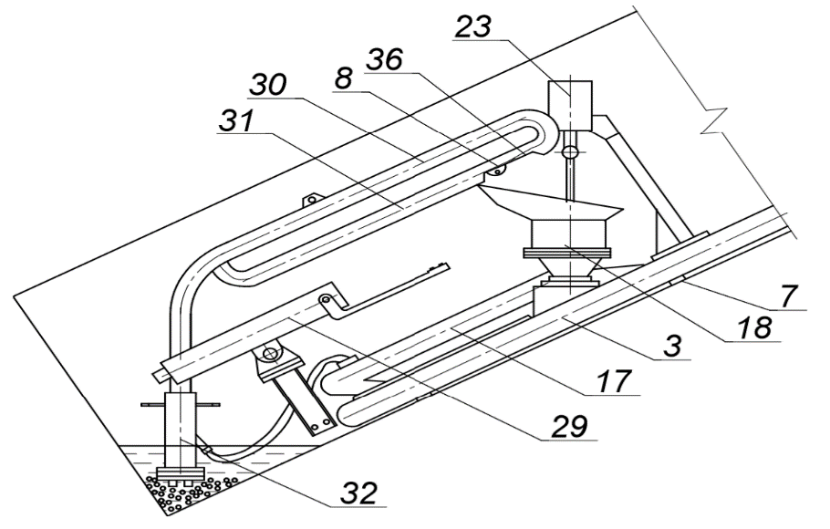

1 – Hydro-shock gun; 2 - Circular hydro-transport pipeline; 3 - Cargo-tight chamber; 4,5,6 - Suspended pipeline loader;

Figure A.1-Downhole transport complex

The gun 29 is mounted on the head part of the pneumatic hydro intensifier 3 and is controlled by the operator. The bottom-breaking loader 30,31,32 is suspended over the pipeline 3 and is controlled by the operator alternately with the process of breaking. Its successive descent as the mining roadways deepen is carried out together with the loader under its own weight along the slope up to the stop in the chest of the face.

Lifting the loader with a water gun to the surface after working out the entry way to full depth is carried out by towing in series with disassembly of the pipeline.

When the roadways reach a depth of 40 m the descent lifting of people and materials is carried out using a single ended lift with a pneumatic wheeled cart on a rope with a diameter of 15,5 mm. In this case, the ЛВД-33 deepening winch with a lifting capacity of 1800 kgf is installed on the surface on a mobile cart, which can be moved sequentially by towing parallel to the long axis of the ore body normally to the axes of the worked-out steep-slope entry ways.

A variant of the technological scheme for the development of the Akmaya deposit is given in figure A.2.

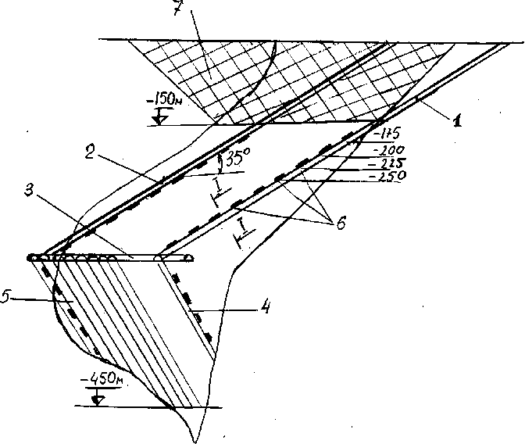

a-Scheme of opening and working out of the Akmaya stockwork Deposit

1-left-Flank sloping overshoot; 2-right-Flank

sloping overshoot; 3-Horizontal break-ORT; 4 - left-

Flank panel mining approach; 5-right-Flank mining approach;

6 - Places where drilling equipment is installed; 7-pit Contour with

balance reserves



b - system for working off the tungsten stockwork of the Akmaya field

1-left-Flank inclined trunk; 2-right-Flank

inclined trunk; 3-horizontal Ventilation break between the trunks;

4-Ore cakes with a sequential height of the location along the trunk slope; 5-Layer panels

Figure A. 2-Technological schemes for mining the Akmaya Deposit

**2.6.3.3 General mine transport**

As it was noted above, to work out the quarry to a depth of 15 m, the loading of rock mass in the face is carried out in 2 КрАЗ 65055 dump trucks with a load capacity of 20 tons. One at a time on ore and rock.

At a depth of more than 15 m, overburden rocks and ore are reloaded into КПУ-1 pipe-belt transport, respectively, on the ore and rock ledges. Transport pipelines are mounted in the entrance trench, passed along the axis of the lying side of the ore body, and are directly adjacent at one end to the faces of inclined opening shafts, and at the other end to the receiving platform of the concentrating plant and rock dump, respectively. The maximum inclined length of ore and rock transport pipelines mounted on the sides of a quarry with a depth of 50 m to 100 m.

The transition opencast mining to underground at around 50 m is carried out after rewiring ore transport pipelines adjacent its mouth to tie the first steeply inclined exploration vehicle opening the trunk with an angle of inclination of 30 deg. The second opening shaft on the opposite side of the ore body with the same angle of inclination is carried out with the build-up of the rock transport pipelines as it is deepened to full depth and also with industrial additional exploration to the mark-450m. Shaft penetration is performed by combines equipped with ГПЭ-630 hydro-pulse guns built into modern rock loaders ПНБ–3Д2.

Associated with rock loaders empty branches of transport pipeline КПУ-1 move in the direction of the face in an expanded form over the soil of the roadways. At the point where the transport pipeline head is adjacent to the ПНБ–3Д2 for loading it wraps from the bottom up around the guide rollers and after loading, it is folded into a teardrop shape and moves to the surface as a cargo branch along the upper level. At the upper level, a pair of rubber cable traction ropes interact frictionally with dispersed electric drives.

A thin transport pipeline belt (with two or three plugs) is used as a load-bearing body. The belt is suspended by means of the covering belts distributed along its length through 1,5 m. the ends of the belts are equipped with cap rollers, supported on flexible steel rods, which are connected to each other in a semi-rigid structure in separate sections of 15 m. The sections are connected to each other by flexible elements.

This design has the ability to bend along the actual track of roadways in two planes. The drop-shaped cross-section of the cargo branch with its belt interceptors after 1,5 m allows transporting rock mass along a steep-slope development without spillage and without internal cargo spillage along the slope inside the belt.

The cap rollers are connected in series by flexible rods, which interact with intermediate (after 30 m) drives. This allows you to increase the length of the transport pipeline on the surface to any size without changing its working regime. Since the transmission of tractive effort is transmitted from the drives to the connected cap rollers and then to the covering belts, the tape itself can consist of separate, rigidly unconnected sections with the ability to mount new sections overlap if necessary (for example, repair of worn sections). This allows you to extend or shorten the length of the transport pipeline at any part of it.

The bearing rods of the transport pipeline in the head loading part are shaped to be suitable for ore handling in steep-slope mining conditions, and are connected to the loader. The bottom hole is removed and the loader with water gun is moved accordingly, and as a result, the transport pipeline is towed.

At a belt speed of 1,5 m/s, the productivity of transport pipeline delivery will be about 170 -180 m3 /h.

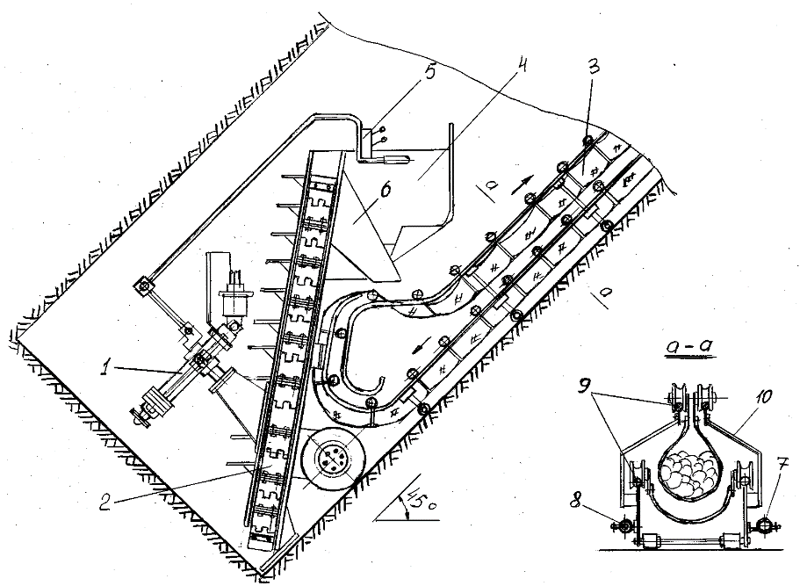

1-Hydro-pulse gun. 2-Two-elevator ore reloader. 3-Steeply inclined belt transport pipeline КПУ-1M. 4-Operator's cabin. 5-Control panel. 6-Ore transfer tray. 7-High-voltage cable. 8 - Plumbing for water gun. 9-Rod frame of transport pipeline rigidity.

Figure 3-Technological scheme of sinking of steep-slope opening roadways

**2.6.3.4 Worked out space backfilling**

Steeply inclined entry ways drilled to the final point are backfilled with tailings with low water content from own ore-dressing plant with gravity driven pressing and thrusting with subsequent freezing. Steep incline of drifts and natural increase in volume of water in the process of ice formation contribute to the process

Volume of water during freezing is increased by 8%, which allows to create a sufficiently strong support for performing the second, third and further horizontal drifts to overhanging side of ore body with a gradual transfer of rock pressure to backfilling with strength of about 10-12 MPa and more.

Two non-rotating drums installed at the entrance to the roadways to be laid are used for filling operations. One drum is filled with water, the other with a solid filling material, such as empty rock. It is possible to use lump ice in combination with the rock.

Both drums are connected by piping cold air from the freezer to the station. After cooling the entire volume of water to a point close to freezing, it drains down the slope of the soil into the bottom of the roadways.

Cooled rock or ice material to the maximum negative temperature, for example, up to (–) 70...(-) 1000C rolls down the frozen stowage material in the ceiling part of the previous mining entry way of the underlying panel, or along the laid troughs, also spills out into the face.

Due to the low temperature of the solid fraction, when mixed with the most chilled water, the mixture in the shortest possible time turns into an icy mass, capable of immediate perception of mountain pressure.

As a means of freezing, the use of a hydro-shock compressor is provided (Fig. 3), equipped with a compressed air-cooling system and means of recovering its heat directly by the compressor drive itself. In this way up to 60-65% of the heat energy can be recovered directly in the drive of the freezer unit.

Adiabatic compression of atmospheric air up to 10 or more MPa in one step forms its temperature up to 550°C. Cooling with a flow-through radiator up to 50-60°C and subsequent throttling to 0,3 MPa when entering the freezer collector or freezer drums will ensure its temperature of the order of -110...-120°C.

The safe achievement of a high output pressure of compressed air in the design of a hydro-shock compressor is ensured by the exception of lubricating oil in the design.

The estimated annual economic effect on the system of working with a hardening backfilling at an annual capacity of 500 thousand tons of ore will be only from the difference in the cost of the material of backfillings of about 5-6 million USD.

A more significant effect is achieved in environmental and social terms due to a sharp reduction in industrial injuries associated with the management of mountain pressure and improving the environmental situation at underground operations.

The defrosting time of the laying material in the climate of Kazakhstan, for example, a spent ore body with a size of 250x250x100 m, will be more than 30 years.

**2.7 Cost benefit analysis of new technological solutions**

**2.7.1 Continuous extraction of ore by hydro-pulse method**

The new method of removing rock mass is carried out with the help of the hydro-pulse gun ГПЭ-630 type, which is currently in an experimental stage of development. Prior to the start of underground operations at the Akmaya deposit, the equipment will be transferred to the pilot-industrial stage.

Tapping is performed in a continuously controlled manner with a productivity that is an order of magnitude higher than that of cyclic drilling and blasting technology.

The continuously controlled hydraulic pulse breakout performs the main production task of underground production - to completely eliminate the use of drilling and blasting operations, and in an environmentally friendly and safe mode for the maintenance personnel and the environment.

The average productivity for mining of rock mass per downhole worker during cyclical work, even in the best mines of the CIS, does not exceed 2,2 m3 per person/shift, and at the enterprises of non-ferrous metallurgy of Kazakhstan this output is about 1,4 – 1,6 m3 in the whole. Only on well-organized high-speed passages, when during a calendar month the equipment and people work at the maximum pace, reaching productivity of 6-8 m3 or more per person/shift.

With the use of flow-through hydro-pulse technology the output of rock mass for 1 person. in a shift will reach about 25-30 m3 .

The main criterion for evaluating the methods of rock destruction is the energy intensity of the process.

Among the known methods, the mechanical method with a high-speed impact, which can be equated to an explosion, has a coefficient of energy consumption of the order of 0,07 and is the smallest of all used in practice after the explosion.

Processes with shock-pulse force loading of the surface of the destroyed object for 0,003 – 0,008 s proceed as explosive and are characterized by an absolute energy intensity (little dependent on the strength and more significantly on the viscosity of rocks) of the destruction of rocks 0.6 kgf.m/cm3 or 5,9 J/cm3.

For comparison, ball drilling uses energy from 12,6 to 25,3 kgf.m/cm3 (from 123,6 J/cm3 to 248,2 J/cm3).

These data are fully confirmed by practical studies at the open-pit LPC mines (Ridder-Sokolny, Tishinsky, Zyryanovsky).

The power characteristics of rock destruction by explosive method and hydro-pulse method coincide much more in relation to open works, where the ratio of the face area relative to the depth of loading reaches a large value. In this case, the clamping of the explosion by the side strut is much less than in the bottom of the tunneling work, and the specific flow of explosives decreases sharply.

In our case, the depth of penetration of the water projectile into the rock wall on strong rocks is relatively small (0,4-0,5 m) relative to the face area. There is practically no compression, so the area of the funnel is the largest compared to the depth.

The specific energy consumption in this case will be even less than the one shown above. However, the calculation takes into account practically the destruction energy consumption determined for downhole blasting in open-pit mining operations, namely: for rocks with a strength of 8-12 units – 5,9 J/cm3, for rocks 12-15 units – 7.2 J/cm3, for rocks 16-20 units-8.8 J/cm3 (Table A.5).

Table A.5 - ENERGY POTENTIALS OF FLAMMABLE SUBSTANCES

|  |  |  |  |
| --- | --- | --- | --- |
| Fuel type | Energy capacity W | | |
| MJ /kg | kcal/kg | kW h /kg |
| Powder | 3,8 | 900 | 1,06 |
| Dynamite 75% | 5,4 | 1280 | 1,5 |
| Rocket fuel | 4,2-10,5 | 1000-2500 | 1,17-2,85 |
| The wood | 8,4-11,0 | 2000-2500 | 2,33-2,85 |
| Peat | 10,5-14,5 | 2500-3500 | 2,1-4,0 |
| Diesel fuel | 42,7 | 10200 | 11,9 |
| Hydrogen | 120 | 28600 | 33,36 |
| Natural gas | 41-49 | 9800-11700 | 11,.46-13,07 |

It follows that the effective destruction of rocks depends not on the energy intensity of combustible substances, but on the speed of its release. Creating technical conditions for the accumulation and instantaneous conversion of electrical energy into mechanical energy solves the problem of destruction even more effectively than explosives. At the same time, the process becomes constantly managed and environmentally friendly.

**2.7.2 Existing groundwork on the problem of flow failure of strong and abrasive rocks**

The hydro-pulse gun is manufactured on the basis of and using copyrighted patents. An experimental sample with a shot power of at least 70 kJ is given in figure A.4.

Experimental industrial design - ГПЭ-630 is designed for a supply voltage of up to 1000 V. For the use of high temperatures and pressures in the design of the power drive, fireproof ceramic and metal-ceramic sealants and electrical insulators are used, which can work in the zone of superheated high-pressure steam, for example, made of aluminum oxide or titanium carbide. Refractory electrodes made of tungsten or titanium will also be used.

Mine water, purified from solid impurities, can be used for the operation of the water gun drive. To ensure a constant discharge power, the electrical conductivity of the mine water must be within the specified limits.

Experimental industrial design - ГПЭ-630 is designed for a supply voltage of up to 1000 V. For the use of high temperatures and pressures in the design of the power drive, fireproof ceramic and metal-ceramic sealants and electrical insulators are used, which can work in the zone of superheated high-pressure steam, for example, made of aluminum oxide or titanium carbide. Refractory electrodes made of tungsten or titanium will also be used.



Figure A.4 - Experimental hydro-pulse gun with a shot power of at least 70 kJ

Mine water, purified from solid impurities, can be used for the operation of the water gun drive. To ensure a constant discharge power, the electrical conductivity of the mine water must be within the specified limits.

The new equipment provides continuous rock mass removal, while completely eliminating the most labor-intensive drilling and blasting cycle in mining production. Small-fraction crushing will allow you to use a simple construction elevator loader. The cost of airing roadways is drastically reduced and the quality of the mine atmosphere improves.

The exclusion of rock-crushing explosions on the sinking of roadways significantly increases their operational stability, since the contour array is not subjected to dangerous deformations from the action of powerful explosions.

The ability to pass 100% of the roadways by the smooth-walled method and the short lifetime before the backfilling will completely eliminate the mounting of steep-slope entry ways.

**2.7.3 Calculation of the productiveness of ГПЭ-630**

The creation of powerful destruction pulses by the ГПЭ-630 water gun will allow high-productuve destruction of the strongest and most abrasive rocks.

The operation of the water gun consists in creating a shock pulse when interacting with a water charge weighing 1,5-2,0 kg, after which, at a shock pressure of 450-500 MPa, the water is accelerated in the confusor injection head to a speed of 800 m/s. When meeting the face of the compact water shell produces a funnel-shaped destruction of strong rock.

The electric power supplied to a 6 kV hydraulic pump via a distribution transformer must be at least 630 kVA

Taking into account that the effective power of a three-phase sinusoidal current is about 2 times less than that of a direct current, the setting effective power will be 315 kW.

The time of discharge of the network is assumed by the overheating of a given mass of water to the temperature T=700°C at a pressure P=65 MPa. The mass of superheated water is taken by the volume of the storage chamber, for example, by the volume of 1,5 liters. With the above parameters T and P, the specific volume mass with energy according to the nomogram will be 3450 kJ/kg with a specific weight of 0,0055 m3/ kg or 0,273 kg, and the accumulated energy will be 940 kJ, respectively.

In this case, the time of accumulation of heat energy for the production of a shot should be equal to 940/315 = 3s.

The ГПЭ-630 hydro-pulse gun has a two-drive design. Two electric split-line steam generators are in opposition interaction with alternating overheating of the working medium and the production of shots.

The working cycle time consists of the time of filling water (weak electrolyte) into the steam generator and simultaneously into the hydro-shock under the piston chamber in the upper barrel is equal to 1,5 s. Plus the time of overheating and then the production of a shot is 1,5 s. In total, 3s is spent on the production of a shot.

The power calculation takes only effective power, i.e. DC power of similar parameters, which is 2 times less than the sinusoidal three-phase current. Therefore, the power of the steam portion accumulated in 3s in the shot cycle is provided in the required volume, i.e. 940 kJ.

With continuous operation of the hydro-pulse gun, the power consumption is consistently 630 kJ/s. Each shot consumes 0,525 kW.h of electricity.

(For destruction of 1 m3 of rock fortress up to 20 units according to Protodyakonov, it is necessary to make up to 20 shots. electricity consumption is 10.5 kWh. the corresponding cost of electricity for the Karaganda region is 84 KZT / m3. For comparison, the cost of only 3,0 kg of igdanite consumed per 1 m3 in open-pit operations will be 1,05 USD or 152 KZT. Significantly higher costs are spent here on drilling wells and charging them).

To determine the power of a water projectile ejected from the injection head of a water gun, we set the volume of expansion of steam in the cavity of the upper barrel, for example, Vfloor. = 33l.

Then the degree of adiabatic expansion will be

(33/1,5) k = 47,64,

where k = 1,26.

From where the

Pdis = 700/47,64 = 1,47 MPa,

Let’s find the discharge temperature:

Тdis. = T1 x (Pdis. / P1) (k-1) / k

Тdis. = 973°K x (1,47/ 65) (1,26-1) / 1,26 = 467°K = 194°C.

Hence, according to the nomogram, the discharge of the water gun is 100% condensate with a residual thermal energy of 850 kJ/kg. In our case, for 0,273 kg of working steam in each cycle, the thermal energy of the discharge will be 232 kJ, and the useful spent energy converted into the shock energy of the massive upper – stage piston will be 940-232 = 708 kJ.

Hydro-mechanical losses along the route will be up to a maximum of 10% of the total spent energy, then the impact power of the water projectile will be 637 kJ.

The efficiency of the process 637/940 = 0,677.

Let’s find the speed of a water projectile weighing 2 kg

U = V 2 x 64944 kgm / 0,2 = 806 m / s.

Experimental data on the energy intensity of destruction of rocks with different strengths (section 2.1.1) were used to calculate the volume of rock mass recovery from a single shot.

The specific energy intensity of ore mass destruction with the ratio of the exposed face area to the depth of the destruction funnel on average as 20:0,3 is 7,2 J/cm3.Then the amount of destruction per shot will be:

U= 637000 J: 7,2 J/cm3 = 88500 cm3 = 88,5 dm3

Technical performance at the rebound will be 20 x 0,0885 = 1.77 m3 per minute in the target, 106,2 m3 per hour, 2548.0 m3 per day in the target, and 904540 m3 per year (355 working days) 904540 m3 (2,36 million tons)

If we adopt the standard of machine time for the operation of pilot samples of 0,5, the real productivity in the first year of operation can reach 1,1 million tonsof ore per year. Further operation will provide higher productivity.

The absence of metal power collisions in the hydraulic tank, which operates in a lower temperature regime than the internal combustion engine, really pushes the limit of fatigue wear of the material to 5 million cycles or more, which can ensure the service life of the ГПЭ-630 with its full technological load of up to 9 months or more. With a margin of safety, a 6-month service life is assumed until complete wear and tear.

The cost of a unit of ГПЭ for piece production at its own production is 112.5 thousand USD. The number of units of equipment for the period of open – pit mining is 8 pieces, 7 pieces for underground mining of balance reserves up to the 150 m level. In total, there are 15 items on the balance sheet. The total cost of equipping with water guns is 1,690 thousand USD.

On the development of additional explored reserves for 14 days, 28 pieces will be required. Total costs reproduction of 28 units on further explored reserves 3150 thousand USD.

The total cost of reproduction of hydro-pulse equipment will amount to 4840 thousand USD.

The cost of production work on the development, manufacture and maintenance of hydraulic impulse equipment for the period of development of the Akmaya deposit is 1260 thousand USD (185 million KZT).

The total cost of hydro-pulse equipment for 21,3 years will be 6,100 thousand USD (407 million KZT).

**2.7.4 New means of downhole shipment of recaptured ore**

A special loading mechanism is designed for new working conditions. The need to create such equipment is determined both by the steep slope of the passable roadways, and by the permanent placement of a continuously operating ГПЭ-630 water gun at the bottom of the face.

The loading mechanism is designed in the form of a pair of inclined steel plates, between which an opposing pair of tracks are assembled on spring-loaded articulated rods. Track tracks are equipped with rigid removable scrapers. A given space between the opposing tracks with scrapers, bounded at the top and bottom by steel plates, forms a steeply inclined elevator tray.

Both tracks are spring-loaded towards each other. This ensures that the piece material passes between the scrapers if they are stacked together. The two upper drive sprockets of the tracks are equipped with rotary drives (electric gear motors with a capacity of 25 kW each). Plates are connected with each other by stiffening ribs and is installed with the help of a pneumatic wheel pair obliquely to the face so that the absolute angle of its inclination will be up to 75°. The leading edge of the plate in cantilever fashion rests on the soil of the roadways. In the wide part of the slab adjacent to the face at its full width, trucks with scrapers scoop up the broken rock from the sides of the roadways to the central line and lure it into a steeply inclined elevator tray.

To transport the loader, a removable trolley is placed under the bottom edge.

Both plates have a through opening, covered with a strong lattice and sublattice armor glass. In front of the opening on the hanging side of the loader, the operator's cabin is equipped to control the operation of the ГПЭ-630 hydro-pulse gun. In addition, on the hanging side there is a workplace for the operator who controls the loader operation.

Both operators' workplaces have free access to the bottom-hole space both for preventive work and for the purpose of protecting people in emergency situations. The estimated productivity of the loader of the repulsed ore by hydro-pulse method is 6 m3 per minute.

Given the scheme of simultaneous drilling of 2 exploration-mining flank entry ways to ensure the required capacity of 850 thousand tons of ore per year when combining exploration, which are made from skin-to-skin cameras in the sides of steeply inclined excavations are made 2 ore loader.

The approximate weight of the ore loader is 6 tons.

The cost of development work with the production of 2 ore loaders, introduction into production and maintenance at the development of the deposit 600 thousand USD (90 million KZT).

The cost of a piece-by-piece production of a unit of equipment when sold on the side is 75 thousand USD.

**2.7.5 General mine delivery of ore to the surface**

A new type of abrasive-resistant steeply inclined belt transport pipeline for the delivery of lump ore along broken transport ramps has been proposed for the development of the Akmaya tungsten deposit. The transport pipeline is able to bend in two dimensions and transport without spillage in a single transport line along a complex route.

The primary use of the transport pipeline is intended for mining of vein and steep-falling ore bodies.

The transport pipeline, which occupies about 1,0-1,2 square meters in the cross-section of the roadways and works in combination with hydroimpulsive means of fine-fraction mining, can provide a high-productive and highly profitable on-line method of mining.

The transport pipeline does not need under-belt rollers and end tensioners, which significantly increases the wear resistance of a conventional belt for the delivery of abrasive rock mass. The transport pipeline does not have problems with sticking of clay materials, since the cargo surface is always inside the pipe and the stuck mass flakes off when interacting with lump material

Currently, the authors of this fuel and energy complex have developed and protected patents in Russia and Kazakhstan for several modifications of new designs of a steep-slope suspended transport pipeline for the delivery of lump ore in a drop-shaped rolled rubber-cloth belt.

At the pre-design stage, the technical task of driving, loading and unloading a suspended transport pipeline structure for extended underground roadways was solved. The transport pipeline does not need under-belt rollers and end tensioners, which significantly increases the wear resistance of a conventional belt for the delivery of abrasive rock mass.

The transport pipeline in modification changes can be used both in open and underground mining operations.

Figures 5 and 6 show the scheme of an experimental sample of the КПУ-1 transport pipeline.

The load-bearing organ is made of ordinary and mainly low-layer rubber-fabric tape, which is picked up through 1,5-2,0 m by flexible suspensions, and fastened with free ends to the traction rope. The traction rope is hung on special support rollers that securely hold the rope on both straight and curved sections of the route.

As a result, the tape takes a drop-shaped shape in any section and covers the load by approximately 270 degrees. The absence of end tensioners provides some slackening of the loaded sections of the belt between the suspensions. At the same time, the suspensions tighten the cross-section of the belt and reliably pinch the bulk cargo from spilling down on steeply inclined sections of the route.

The teardrop shape of the section completely eliminates spillage and dusting of the material. At the same time, the load in the cross-section of the load-bearing body from loading to unloading on the track is in a relatively stationary state and therefore does not cause abrasive wear of the tape covering its surface, as it occurs on sublent roller-supported transport pipelines.

Depending on the angle of inclination, the length of the transport pipeline track, as well as the speed of the belt movement and the section of cargo flow, the power and number of drives distributed along the length of the transport pipeline are taken into account.

The transport pipeline is able to load and unload at any point of the route or simultaneously at many points, while due to its closed design, it does not allow spillage and dusting of material, including during intensive blowing.

The КПУ-1 transport pipeline has the ability to bend freely in two planes and serve branched mine roadways or poured areas on the surface of the ring, and the boundary positive and negative angles of inclination of the transport pipeline can reach 450.

КПУ-1 is not sensitive to sticking or freezing of material on the working side of the belt, since both its surfaces do not structurally contact with the elements of the engine and guides, for example, tension and drive drums, track rollers, etc.in conventional transport pipelines.

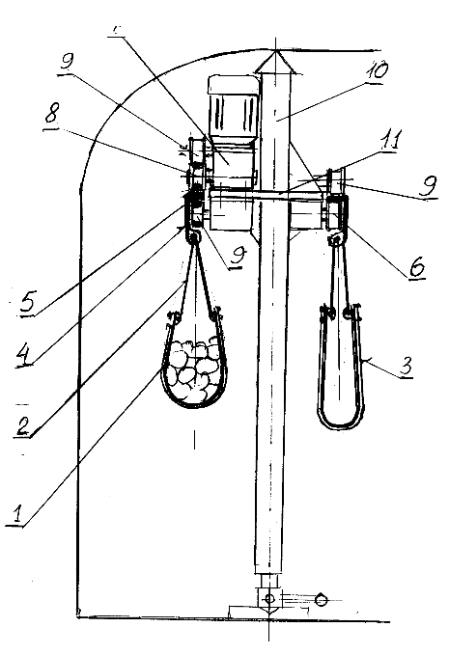

1 - Rubber-cloth transport pipeline belt. 2 - Suspension elements. 3 - Flexible belt. 4 - Suspension brackets. 5 - Tension closed rope. 6 - Rollers for the tension rope. 7 - Intermediate drives. 8 - Transfer mechanism from the drive to the tension rope. 9 - Pressure rollers. 10 - Spacer posts. 11 – Traverses

Figure A.5 - Intermediate section of the suspended version of the pipe-band transport pipeline

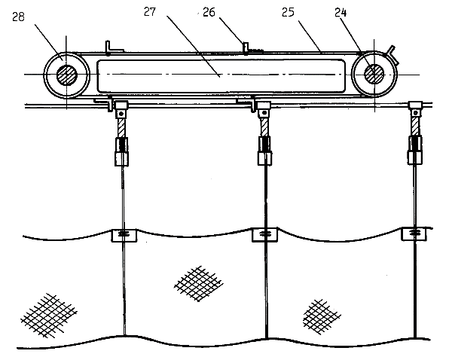

24 - Drive shaft; 25 - Scraper chain; 26 - Bracket; 27 - Chain guide; 28 - End sprocket.

Figure A.6 - Diagram of the intermediate drive device

A layer of adhering material is always placed inside the load-bearing body, rolled up in a pipe or in a deep chute, and as its thickness and stiffness increases, it is destroyed and unloaded with the main mass. Moreover, the adhesive layer further protects the tape from abrasive wear.

In underground application, the КПУ-1 will allow opening the ore body with steeply inclined transport pipeline shafts of small cross-section according to its technical capabilities. Driving such trunks from top to bottom is provided by the КПУ-1.

The use of КПУ-1 in conjunction with water guns will fundamentally change the technological concept of mining production from a cyclic to a flow-through one. Reduce capital costs by 2-2,5 times and reduce operating costs by 1,7-1,9 times.

Technical and economic characteristics of КПУ-1

- Speed of movement of the load-bearing body, m/s from 1,5 to 3,5

- Construction of a load-bearing body - a pair of riveted rubber-fabric belts

600 mm wide

- Technical capacity, m3/ h up to 500

- Maximum slope angle of the track, deg + 45

- Металлоёмкость на 100 line m., tonn 3, 2

- Minimum installation area of the transport pipeline cross-section in the working area, m2 1,4

- Minimum cross-section area of a passable mining roadways with a rock harvesting machine 2ПНБ-2Б, m2 8

- Nominal lifetime, year 7,0

- The cost of manufacturing every 100 lline. m of transport pipeline in-house production, thousand USD 85,0

In relation to the Akmaya deposit, the rack structure of a steep-slope belt transport pipeline of the КПУ-1 type will be replaced with a floor structure with a flexible rod frame of the КПУ-1M stiffness. This is dictated by the complexity of downhole transport pipeline extension in the conditions of passable steep-slope roadways with continuous movement of the downhole loader.

However, all the required properties of the new design are preserved. The required capacity of the КПУ-1M according to the technical capabilities of the ГПЕ-630 hydro-pulse gun will be about 180 tonn/h. For this purpose, a riveted pair of thin tapes with a width of 400 mm is used.

A total of 3 transport pipelines with a total length of 1,400 m will be manufactured for the development of the Akmaya deposit at its own pilot production. One main transport pipeline on the surface, installed parallel to the length of the cross-section axis of the ore body, and 2 downhole transport pipelines according to the scheme of simultaneous sinking of exploration and production enty ways.

The total cost of production of transport pipelines will be 1655 thousand USD, including the cost of development work on the creation of a prototype and maintenance during the entire period of development of the deposit 890 thousand USD.

To ensure the discharge of chipped ore from the inclined panels, a pneumatic tube - driven downhole transport complex is proposed (figure 4).

**2.7.6 Energy supply and economy of stowing operations**

Stowing operations, as well as mining operations, are performed 24 hours a day. The enrichment tailings are delivered by 2 dump trucks that previously served open-pit mining operations.

As freezing means, a U-shaped hydro-compressor with a shock method of compressing atmospheric air up to 15 MPa in one stage and a heat exchange radiator are provided (Figure 7).

The hydro-compressor is driven by a pair of electric discharge steam generators (ГПЭ-630 water gun drive).

The resulting hot air temperature is up to +770°C is cooled by running water to a temperature of (+) 200°C (473°K), and then throttled to 0,3 MPa when entering the cooling pipeline loop. The contour for one production consists of 4 pipelines Ф100 mm laid along it and dispersed in its section. In this case, the compressed air temperature drops to (- ) 95°C.

The discharge air from the cooling system is fed back to the hydro-compressor suction cup.

Thus, at least 95 % of the energy spent on impact compression of air in a hydro-shock compressor is spent on thermal transformation of the compressible medium.

15 290 running meters of drifts will be made and backfilled in 1 year. 861,3 m3 of drifts are made and backfilled in a day. Backfilling of worked out space is performed 24 hours a day. Accordingly, 36 m3 are backfilled in 1 hour.

Backfilling material consists of 100% tailings from own ore-dressing plant and water that filled free space between solid particles. Volume of free space in sand like tailings compacted by gravity does not exceed 10-15% of the total volume, i.e. 100-150 l/m3.

Volume weight of compacted tailings is 2,65 tonn. Weight of water per m3 - 150 kg.

Maximum temperature in Akmaya region + 42°С. Is achieved in July. In order to determine drive power, od freezing unit we assume maximum temperature + 420 С.

Thus, maximum drive energy of hydraulic compressor required to freeze 2,65 tonn (1 m3) of tailings from +42°С to – 10°С is 2650 kg х 0,8 kJ.kg.deg х 52 deg = 110240 kJ.

Energy required to cool water and ice from +42°С to – 10°С is 150 kg х 4,19 kJ.kg.deg х 52 deg = 32682 kJ.

Energy required for ice formation is 150 kg х 334 kJ.kg.deg = 50100 kJ.

Total amount of energy required for backfilling 1 m3 in the hottest period is 193022 kJ or 53,6 kW.h/1 m3.

Total amount of energy required for backfilling during one hour is 6948792 kJ, thus driver power of hydraulic compressor required is 6948792/3600 =1930 kW. Taking into account 10% loss maximum energy consumption of hydraulic compressor is 2123 kW.

Maximum annual temperature in Akmaya district is + 42°С, minimum temperature - -51°С.

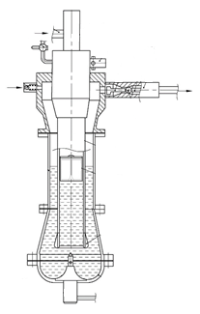

Figure A.7 - Schematic diagram of a hydraulic shock compressor

In order to calculate annual cost of electric energy we assume average annual temperature 0°С.

Thus, average annual energy required for cooling 2,65 tonn (1 m3) of tailings from 0°С to – 10°С is 2650 kg х 0,8 kJ.kg.deg х 10 deg = 21200 kJ.

Energy required to cool water and ice from 0°С to – 10°С is 150 kg х 4,19 kJ.kg.deg х 10 deg = 6285 kJ.

Energy required for ice formation is 150 kg х 334 kJ.kg.deg = 50100 kJ.

Average annual amount of energy required to backfill 1 m3 is 58505 kJ.

Total amount of energy required for backfilling during 1 hour is 2106180 kJ. Taking into account 10% loss energy consumption will be 2316798 kJ or 643.6 kW.h.

Average annual energy consumption for freezing of 1 m3 of backfilling material is about 17,88 kW.h/m3.

Annual energy consumption for freezing of backfilling material is 5,48 million kW.h, annual cost of electric energy – 298,4 thousand USD.

In order to calculate amount of energy required for backfilling operations we must take into account daily temperature variations which reduce significantly maximum temperature value. It is necessary also to bear in mind that ore extracted from underground mines had relatively low temperature before processing (+8…+10 0 С). Artesian water used for tempering also has low temperature, that is why in order to reduce expenses on electric energy in hot periods it is necessary to take measures for protection against tailings heating by sun till the moment of backfilling of worked out space.

Annual wages fund for 12 employees – 215,6 USD.

Cooling pipes - 61 300 running meters (nominal diameter = 100 mm, wall thickness = 3.5 mm, 529 t) - 140,0 thousand USD.

Diesel fuel – 31,2 thousand tons.

Total annual cost of backfilling operations – 685,2 thousand USD.

Unit cost of backfilling operations per tonn of ore will be 0,8 USD.

Design and experimental activities, introduction into service and maintenance of commercial prototype during the whole period of mining operations at Akmaya deposit - 750 thousand USD (110 million KZT).

Prime cost per unit of equipment - 95 thousand USD.

The advantage of hydraulic shock compression of air, carried out without the use of lubricating oils, is a very high adiabatic temperature of the compressed air and, accordingly, the radiator cooling system, which allow you to take heat with high efficiency with heating up to 90-95 degrees of large volumes of circulating water. In our case, the volume of hot water is about 7-8 tonn/h. Hot water will be used for heating technological, office and household buildings. Thus, you can usefully use up to 65% of the total electrical power spent on freezing the backfilling.

Another way to use the heat generated by the cooling radiator can be its direct conversion to ensure the operation of the second pair of hydraulic shock compressor drives in the water plug acceleration cycles. In this case, the actual power consumption can be reduced by 45-48%.

According to calculations, natural thawing of the backfilling material (without the use of protective cooling of rows along the contour of the ore body) will occur no earlier than 12-15 years.

Safety cooling is carried out during the cold season by mechanical blowing of the cooling pipelines left in the backfilling material with cold atmospheric air. For this purpose, the outlets of the cooling pipelines of all contours of the ore body are sequentially connected into several collector units, which in winter are connected to the discharge pipes of the ТВ-1200 blowers of the Khabarovsk plant "Energomash".

The deaf pit does not need reclamation, since the surface practically remains in its original form.

**2.8 Economic indicators of the Akmaya deposit mining up to -50 m**

According to calculations, the power consumption for 1 m3 of the rock mass of the ГПЕ 630 hydro-pulse gun is 10,5 kW.h. the time of breaking 1 m3 at 40% loading (on the ore) the corresponding time will be 28 seconds on a breed with 80% loading, the corresponding time will be 14 seconds.

From this calculation, the power consumption of the ПНБ–3Д2 rock-loading machines with an installed capacity of 134 kW will be 1,04 kWh for the ore, and 0,52 kWh for the rock.

Electricity consumption for delivery to the concentration plant or dump of 1m3 transport pipeline transport with an installed capacity of 80 kW will be on the ore 0.62 kW. h., and on the rock 0,31 kW.h.

In total, 12,16 kWh was spent on the development and delivery of 1m3 ore also, 11,33 kWh was spent for stripping operations. At the cost of 1 kW.h in the Karaganda region, 8,4 KZT the cost of electricity for the ore will be 102 KZT/m3 (39 KZT / tonn or 0,26 USD / tonn), respectively on the rock 95 KZT/m3 (0,64 USD / m3).

With three shifts of work, the number of workers in mining and transport works is 45 people. The average monthly salary of a worker is accepted at the rate of 1200 USD.

The direct annual salary of this group is 648 thousand USD. With additional payments and social deductions, the annual salary fund of the slaughter group is 875,00 thousand USD. According to the staff placement, the number of workers on the ore and rock is the same.

Then the unit cost of wages for 1 tonn of ore is 1,0 USD, and on stripping for 1 m3 – 0,6 USD.

Total costs for mining and delivery of 1 tonn of ore will be with unrecorded costs of 20% - 1,5 USD, and for 1 m3 of rock 1,45 USD.

Table A.6 - CAPITAL INVESTMENTS FOR THE CONSTRUCTION OF A MINING AND PROCESSING ENTERPRISE AT THE AKMAYA DEPOSIT

|  |  |  |
| --- | --- | --- |
| Indicator | Unit of measurement | Value |
| *Capital investments* | | |
| Construction and equipping of a new technology pilot workshop | thousand USD | 1500,0 |
| Construction of a railway dead end 4 km | -«- | 1700,0 |
| Construction of on-site roads | -«- | 450,0 |
| Administrative building, machinery and repair workshop and service station | thousand USD | 1890,0 |
| Concentrating plant with equipment | -«- | 9934 ,0 |
| Boiler house with coal storage and ash | -«- | 3800,0 |
| External water-intake facility | -«- | 182,1 |
| External power supply | -«- | 312,5 |
| Extension of the existing power transmission lines from the pit envelope - overhead line 35 kW and overhead line 110 kW. | -«- | 200,0 |
| Rotational camp (12 portable  trailers) | -«- | 300,0 |
| Total amount of capital investments: | -«- | 20268,6 |

Inventory and cost of equipment for the open development period.

Table A.7-LIST AND COST OF EQUIPMENT FOR OPEN PIT

|  |  |  |  |
| --- | --- | --- | --- |
| The name and  designation | Q-ty | Cost,  thousand USD | |
| units | total |
| 1 | 2 | 3 | 4 |
| Water gun ГПЭ-630  (lifetime of the unit at full load is 6 months) | 8 | 112,5  own manufacture | 900,0 |
| Rock loading machine ПНБ–3Д2 | 2 | 250,0 | 500,0 |
| Cantilever rock loader UC-1 | 2 | 45,0 | 90,0 |
| ПЛК-1 transport pipeline | 2 | 382,5 | 765,0 |
| Dump truck МАЗ -525- | 1 | 55,0 | 55,0 |
| Compressor ПР-10 with a capacity of 10 m3/min, pressure 8 ATM | 2 | 17,5 | 35,0 |
| Dump truck КрАЗ 65055 g / p 20 tonn, body capacity 12 m3 | 2 | 70,0 | 140,0 |
| Bulldozer Б-10М 180 horse powers | 2 | 120,0 | 240,0 |
| Diesel power station ДЭС-60, ДЭС-100 | 2 | 18,5 | 37,0 |
| Drain pump ЦНС-38-176 | 2 | 5,5 | 11,0 |
| Pull winch ЛТ-750 | 1 | 18,5 | 18,5 |
| Участковый эл.трансформатор ТМШ -630 | 2 | 12,5 | 25,0 |
| Total |  |  | 2816,5 |
| Unrecorded equipment and materials (15%) |  |  | 422,5 |
| Total: |  |  | 3239,0 |

Table A.8 - MAIN TECHNICAL AND ECONOMIC INDICATORS OF INDUSTRIAL DEVELOPMENT OF THE AKMAYA DEPOSIT BY OPEN PIT TO A DEPTH OF 50 M ON THE BASIS OF APPROVED RESERVES

|  |  |  |
| --- | --- | --- |
| Indicator | Unit  of measurement | Value |
| 1 | 2 | 3 |
| *General data* | | |
| Total area of land plot for the enterprise’s facilities | ha | 30 |
| Enterprise’s productivity  in terms of ore extraction and processing | thousand tons  year | 850,0 |
| Lifetime | years | 3,0 |
| Working regime |  | Year round continuous  355 days per year,  3 8 hours shifts |
| Number of workers | persons | 110 |
| *Marketable products* | | |
| Geological reserves  - ore  - tungsten trioxide (WO3)  - average content | thousand tons  tons  % | 1300  3510,0  0,27 |
| Losses | % | 3,0 |
| Depletion | % | 6,5 |
| Commercial reserves (merchantable ore):  - ore  - tungsten trioxide  - content | thousand tons  tons  % | 1337,0  3404,0  0,254 |
| Tungsten trioxide concentration | % | 72 |
| Tungsten trioxide in concentrate  - quantity  - content | tons  % | 2451,0  15 |
| Concentrate yield | tonn | 16339,0 |
| Output paratungstate from hydrometallurgical process | tonn | 10890,0 |
| Agreed price of 10 kg of concentrated WO3 | USD | 300 |
| Income from sale of marketable concentrate | thousands USD | 73530,0 |
| Recoverable value per ton of ore | USD | 56,56 |
| *Production costs per ton of ore* | | |
| Prime cost of extraction, transportation and disposal of overburden rocks | USD | 1,45 |
| Prime cost of ore extraction and transportation to concentrating plant | -«- | 1,5 |
| Prime cost of ore processing at concentrating plant | -«- | 3,1 |
| Prime cost of transportation of 1 t/km of concentrate from concentrating plant to Zharyk  railroad station | -«- | 0,043 |
| General administration and management costs | -«- | 0,5 |
| *General production expenses* | | |
| Extraction, transportation and disposal of overburden rocks | thousands USD | 3132,0 |
| Ore extraction and transportation to concentrating plant | -«- | 1950,0 |
| Ore processing at concentrating plant | -«- | 4030,0 |
| Boiler house maintenance | -«- | 900,0 |
| Transportation of concentrate from concentrating plant to Zharyk railroad station at the distance of 20 km | -«- | 468,3 |
| Expenses on professional training of employees (0.5% of extraction costs) | -«- | 97,5 |
| Expenses on development and maintenance of social environment (4% of extraction costs) | -«- | 780,0 |
| Contributions to abandonment fund (1% of extraction costs) | -«- | 195,0 |
| General administration and management costs | -«- | 650,0 |
| *Total production expenses* |  | 12202,8 |
| Taxes and deductions | -«- | 1830,0 |
| Full writing off to performance of pilot testing works for extraction of balance reserves for ГПЭ-630 and КПУ-1 (46% of the amount of 2150 thousand USD) | -«- | 989,0 |
| Total depreciation of fixed assets during the development of balance reserves 6.5 years (46% of capex) | -«- | 9323,5 |
| Total depreciation of primary equipment and machines for the period of balance reserves extraction 6,5 years (46%) |  | 1490,0 |
| *Total amount of deductions from incomes* | -«- | 25835,3 |
| Income (loss) | -«- | +47694,7 |
| Corporate tax, 20% | -«- | 9538,9 |
| Net profit (for the first 3 years of mining operations at the depth from zero to -50 m) | -«- | 38155,8 |

**2.9 Economic indicators of underground mining of balance reserves from - 50m to -150m**

Calculation of the cost of ore extraction

With the transition to underground mining of the deposit, the number of workers does not change. The personnel serving the two processing lines (ore, overburden) are reallocated to the mining sinking and laying complex.

The method of processing and transportation remains the same with the same costs.

Thus, the unit cost of mining and delivery of 1 tonn of ore remains 1,5 USD, for laying 0,8 USD on 1 m3 of the laid space.

Table A.9 - INVENTORY AND COST OF SERIAL EQUIPMENT FOR THE DEVELOPMENT PERIOD

|  |  |  |  |
| --- | --- | --- | --- |
| Description  and identification data | Q-ty | Cost  thousands USD | |
| units | general |
| 1 | 2 | 3 | 4 |
| Water gun ГПЭ-630 | 6 | 112,5 | 675,0 |
| Steeply inclined ore loading machine | 1 | 95,0 | 95,0 |
| Transport pipeline КПУ-1 (L = 900m) | 1 | 765,0 | 765,0 |
| Cable man and cargo hoist | 2 | 11,0 | 22,0 |
| Freezing unit | 1 | 95,0 | 95,0 |
| Drilling bottom hole unit for geological prospecting operations НКР – 100 mV | 4 | 9,0 | 36,0 |
| ПР-10 compressor with capacity of 10 m3/min, pressure 8 atm. | 2 | 17,5 | 35,0 |
| Bulldozer Б-10М 180 horse powers | 2 | 120,0 | 240,0 |
| Diesel power station ДЭС-60, ДЭС-100 | 2 | 18,5 | 37,0 |
| Drain pump ЦНС-38-176 | 2 | 5,5 | 11,0 |
| Pull winch ЛТ-750 | 1 | 18,5 | 18,5 |
| СВМ -6м fan | 1 | 16 | 32 |
| ТМШ -630 transformer | 1 | 12,5 | 12,5 |
| Dump truck МАЗ -525, capacity 8 m3 | 1 | 28,0 | 28,0 |
| Total |  |  | 2102,0 |
| Unrecorded equipment and materials (15%) |  |  | 315,0 |
| Total: |  |  | 2417,0 |

Table A.10 - MAIN TECHNICAL AND ECONOMIC INDICATORS OF UNDERGROUND MINING FROM-50M TO-150M ON THE BASIS OF APPROVED RESERVES

|  |  |  |
| --- | --- | --- |
| Indicator | Unit  of measurement | Value |
| 1 | 2 | 3 |
| *General data* | | |
| Enterprise’s productivity  in terms of ore extraction and processing | thousand t  year | 850,0 |
| Mining interval - from - 50 m to 450 m . | years | 3,0 |
| Working regime |  | Continuous, 355 days a year,  4 shifts a day |
| Number of workers | persons | 110 |
| *Marketable products* | | |
| Geological reserves  - ore  - tungsten trioxide (WO3)  - average content | thousand tons  tons  % | 3055,0  8248,0  0,27 |
| Losses | % | 3,0 |
| Depletion | % | 6,5 |
| Commercial reserves (merchantable ore):  - ore  - tungsten trioxide  - content | thousand tons  tons  thousand tons | 3141,0  8000,0  0,254 |
| Tungsten trioxide concentration | % | 72 |
| Tungsten trioxide in concentrate  - quantity  - content | tons  % | 5760,0  15 |
| Concentrate yield | tonn | 38400,0 |
| Output paratungstate from hydrometallurgical process | tonn | 25600,0 |
| Agreed price of 10 kg of concentrated WO3 | USD | 300 |
| Income from sale of marketable concentrate | thousands USD | 171900,0 |
| *Production costs per ton of ore* | | |
| Prime cost of ore extraction and transportation to concentrating plant | -«- | 1,5 |
| Prime cost of ore processing at concentrating plant | -«- | 3,1 |
| Prime cost of transportation of 1 t/km of concentrate from concentrating plant to Zharyk railroad station | -«- | 0,043 |
| General administration and management costs | -«- | 0,5 |
| *General production expenses* | | |
| Ore extraction and transportation to concentrating plant | -«- | 4711,5 |
| Ore processing at concentrating plant | -«- | 9737,0 |
| Boiler house maintenance | -«- | 900,0 |
| Transportation of concentrate from concentrating plant to Zharyk railroad station at the distance of 20 km | -«- | 1651,2 |
| Expenses on professional training of employees (0.5% of extraction costs) | -«- | 235,6 |
| Expenses on development and maintenance of social environment (4% of extraction costs) | -«- | 1884,6 |
| Contributions to abandonment fund (1% of extraction costs) | -«- | 471,1 |
| General administration and management costs | -«- | 2355,0 |
| *Total production expenses* |  | 21946,0 |
| Taxes and deductions | -«- | 3292,0 |
| Full writing off to performance of pilot testing works for extraction of balance reserves for ГПЭ-630 and КПУ-1, loading machine, backfilling operations | -«- | 2416,0 |
| Total depreciation of fixed assets during the development of balance reserves 6.5 years | -«- | 10945,1 |
| Total depreciation of primary equipment and machines for the period of balance reserves extraction |  | 3765,1 |
| *Total amount of deductions from incomes* | -«- | 42364,2 |
| Income (loss) | -«- | +129535,8 |
| Corporate tax, 20% | -«- | 25907,2 |
| Net income | -«- | 103628,6 |

**2.10 Economic indicators of mining of additional in-mine exploration by underground method from -150 m to - 450m**

Deepening of underground mining is carried out by a similar method using the same technical means with the same number and organization of works. However, as the depth increases, all the preparatory and final operations are performed with more time. Electricity costs increase 3-4 times. As a result, hydraulic pulsing of ore is performed in a more forced mode, or paired water guns are installed. Specific cost indicators of road transport operations are increasing by 20%. An increase in the volume of processing at the concentration plant due to a decrease in the useful content in the ore also increases costs by 15%

The useful content of geological reserves at the levels from -150 to-450m decreases to 0,206 %.

Economic indicators of the development of additional explored reserves are given without depreciation charges, which were repaid earlier on the development of balance sheet reserves by 100%.

Table A.11 - MAIN TECHNICAL AND ECONOMIC INDICATORS OF UNDERGROUND MINING FROM-150M TO-450M

|  |  |  |
| --- | --- | --- |
| Indicators | Unit of measurement | Value |
| 1 | 2 | 3 |
| *General data* | | |
| Enterprise’s productivity  in terms of ore extraction and processing | thousand t  year | 850,0 |
| Mining interval - from - 50 m to 450 m . | year | 14,3 |
| Working regime |  | Continuous, 355 days a year, 4 shifts a day |
| Number of workers | persons | 110 |
| *Marketable products* | | |
| Geological reserves  - ore  - tungsten trioxide (WO3)  - average content | thousand tons  tons  % | 12077,0  24902,0  0,206 |
| Losses | % | 3,0 |
| Depletion | % | 6,5 |
| Commercial reserves (merchantable ore):  - ore  - tungsten trioxide  - content | thousand tons  tons  % | 12476,0  24155,0  0,194 |
| Tungsten trioxide concentration | % | 72 |
| Tungsten trioxide in concentrate  - quantity  - content | tons  % | 17392,0  15 |
| Concentrate yield | tonn | 115944,0 |
| Output paratungstate from hydrometallurgical process | tonn | 77296,0 |
| Agreed price of 10 kg of concentrated WO3 | USD | 300 |
| Income from sale of marketable concentrate | thousands USD | 521760,0 |
| *Production costs per ton of ore* | | |
| Prime cost of ore extraction and transportation to concentrating plant | -«- | 1,8 |
| Prime cost of ore processing at concentrating plant | -«- | 3,56 |
| Prime cost of transportation of 1 t/km of concentrate from concentrating plant to Zharyk railroad station | -«- | 0,043 |
| General administration and management costs | -«- | 0,5 |
| *General production expenses* | | |
| Ore extraction and transportation to concentrating plant | -«- | 22456,8 |
| Ore processing at concentrating plant | -«- | 44414,6 |
| Boiler house maintenance | -«- | 4290,0 |
| Transportation of concentrate from concentrating plant to Zharyk railroad station at the distance of 20 km | -«- | 3323,7 |
| Expenses on professional training of employees (0.5% of extraction costs) | -«- | 1122,8 |
| Expenses on development and maintenance of social environment (4% of extraction costs) | -«- | 8982,7 |
| Contributions to abandonment fund (1% of extraction costs) | -«- | 2245,7 |
| General administration and management costs | -«- | 6238,0 |
| *Total production expenses* |  | 93074,4 |
| Taxes and deductions | -«- | 18614,9 |
| Total amount of deductions from incomes | -«- | 111689,3 |
| Income (loss) | -«- | + 410070,7 |
| Corporate tax, 20% | -«- | 82014,0 |
| Net income (with mining operations at the depth from - 50 m to 450 m) | -«- | 328056,7 |

**CONCLUSION**

1. The total net profit for the development of the Akmaya deposit for 20,3 years will be 469840,0 thousand USD.

2. New technology allows to continue development of ore body below the mark of - 150 m without changes in methods and equipment.

3. New technology allows to perform additional exploration activities and transfer of reserves to category А+В+С1 using commercial process with simultaneous extraction of ore in steeply inclined dead locked entry ways in ore body.

4. The use of hydro-pulse rock destruction with an electric drive at tunneling and cleaning operations ensures complete environmental safety in mines

5. New worked out space backfilling method with freezing of water containing tailings allows to use stratification system without ore pillars and recuperate up to 65% of electric energy of hydraulic compressors’ drive for reusing in the same cycle.

6. New technology creates opportunities for development of numerous gold fields and rare metals deposits in Kazakhstan that are currently profitless both with open pit mining and underground mining methods.

7. This innovative project has every reason to receive benefits and preferences, both in terms of taxes and in terms of preferential lending.

**APPENDIX B**

**Critical Review**

**of Cost-Benefit Analysis (CBA)**

**Development of Steeply Dipping Tungsten Stockwork at Akmaya deposit**

**(Karaganda region)**

CBA prepared by: Laboratory of Technologies of Underground Development of Ore Deposits of D.A. Kunayev Mining Institute

Application was submitted for critical review of Cost-Benefit Analysis (CBA) of development of tungsten stockwork at Akmaya deposit (two variants) for comparison of effectiveness of technical solutions used.

1. Variant - open pit mining with traditional drill and blast method at the upper portion of steeply dipping stockwork to the depth of 150 m. Life of mine - 24 years.

From the pit bottom to the depth of 450 m the deposit was shut down for the future periods, development will be resumed after creation of new effective technology. Nowadays in Kazakhstan there are no any methods for development of ore body with relatively small cross section (50 x 60 m) and decline of 50-55 degrees.

Results of calculations under the project show negative economic effect - losses amounting to more than 9 million USD.

1. Innovative combined variant. First stage - construction of infrastructure at the working site Second stage - open pit mining activities at the upper portion of the stockwork with 50 m deep day hole. The period of the two stages is complies with the period of development and manufacture of new equipment provided for by the innovative variant.

Then ore body will be developed to the whole depth according to the new scheme with simultaneously performed works on additional exploration.

Life of mine - 19.3 years.

Results of calculations under the project show economic effect - net income amounting to 328.0 million USD.

Results of comparison of feasibility analysis of the two variants show significant superiority of the innovative variant. Moreover, traditional drill and blast variant is not applicable not only due to its unprofitability, but also because it does not resolve the problem of complete development of the deposit of valuable resources. At the same time CBA with drill and blast method does not contain even proposals for possible resolution of this problem.

Laboratory of Technologies of Underground Development of Ore Deposits of D.A. Kunayev Mining Institute have performed a great amount of research works that in my opinion allows to resolve the problem not only of underground development of stockwork ore bodies but also deposits with any other modes of occurrence with sufficient economic and environmental efficiency.

There have been developed an innovative technological complex, which after field studies and commercial tests will allow to make any drifts in ores of different strength within designed pit limits and preform extraction works with high productivity and safety.

New technology undoubtedly will provide good opportunity for use at mining enterprises in Kazakhstan and abroad.

Under the innovative project there have been developed and partially tested in laboratory conditions a new method of destruction of solid rocks with supersonic water charges. Free-flight velocity of water charges may be as high as 950-1000 m/s (almost Mach 3). Water jet cannon with discharge power up to 500 kJ may be successfully used in drilling inclined and even steeply inclined drifts for any purposes, including those where mine face is flooded with mine water. Destruction product in this case is finely broken rock mass, which allows to use any continuous transport means without preliminary preparation.

Under the project there have been developed pipe belt conveyor with two variants - suspended type and floor standing. Distinctive peculiarity of modified design variants is ability to bend in two planes, work in steeply inclined mines without spillage and dust generation.

There have been developed principal schemes for development of ore bodies with steeply inclined drifts equipped with continuous transport devices such as looped hydraulic pipeline for delivery of mined rock. Construction and operation of mine openings are performed with use of the abovementioned equipment.

There have been developed schemes for ore bodies development with inclined panels with reverse slope using water jet devices for destruction and pneumatic hydraulic pipeline transport, primarily not looped.

Incline of stratified ore panels consisting of inclined dead locked entry ways allows to use the cheapest and the most effective worked out space backfilling method - with rock and water with quick freezing ensuring high thrust. This method ensures maximum safety of development system and provides a wide choice of ore bodies of different parameters with the least volumes of waste rock drilling.

This method allows to prevent geomechanical displacement of overlaying strata in the process of extraction works without destruction of permanent openings in working area.

According to expert opinion this CBA should be considered as a long-term action plan prepared by the scientists of Mining Institute for creation of a mine of future in the Republic of Kazakhstan.

One of disadvantages is too small part devoted to experiments. I would like to see more results of tests and their comparison with the existing technologies.

I must be also noted that the author of economical section omitted data on consumption and cost of electric energy used by common haulage facilities from the depth - 50 m to 450 m. According to approximate data on transportation of ore for the whole period (19.3 years) these costs may amount additionally to 0.5 million USD.

Summarizing the results of works performed with the aim of ensuring effective exploitation of Akmaya tungsten deposit the following conclusions can be drawn:

1. Innovative project of new technology of solid ores and rocks destruction allows to increase productivity of Akmaya deposit 3 times and more, in case of drilling mine openings and development drifts - 5-6 times.

2. New technology allows to start development of the stockwork from the surface to the depth of 450 m without changes in mining methods and type of equipment.

3. New technology allows to perform additional exploration activities at the deposit and transfer reserves to category А+В+С1 using commercial process when drilling mine openings.

4. Use of water jet devices with electrical drive for rocks breaking in performance of sinking and extraction activities ensures complete ecological safety for personnel at the mine.

5. Use of method of method of backfilling space of inclined panels with high thrust with quick freezing of water containing tailings allows to develop steeply inclined stockwork with minimum amount of waste rock drilling and minimum depletion.

6. New technology creates opportunities for development of numerous gold fields and rare metals deposits in Kazakhstan that are currently profitless both with open pit mining and underground mining methods.

Reviwer: Ph.D. in Engineering Science, international expert in mining and occupational safety, expert of Professional Association of Independent Experts on Subsoil Resources, Associate Member of the National Academy of Mining Science of the RoK,

Chief Project Engineer of Viridi Navitas LLP Zh. Kadybergenov

**APPENDIX C**

to Agreement No – dated___2018

for Grant Financing

**TECHNICAL SPECIFICATION**

**AND TIMING SCHEDULE**

for Agreement No___ dated______2018

**1 Branch of Public Enterprise National Center of Comprehensive Minerals Processing OF THE REPUBLIC OF KAZAKHSTAN OF THE COMMITTEE OF INDUSTRY OF THE MINISTRY OF INNOVATIONS AND DEVELOPMENT OF THE REPUBLIC OF KAZAKHSTAN D. KUNAYEV MINING INSTITUTE**

* 1. Primary topics: sustainable use of natural resources including water, geology, recycling, new materials and technologies, safe products and structures.
  2. Secondary topics: Geology and development of mineral deposits.

On topic of Project No АРО5131126 Creation of Devices and Technologies for Continuous Solid Ores and Rock Breaking with Ultrahigh Speed Water Jets

1.4. Total amount of the Project – 24 160 000 (twenty-four million one hundred sixty thousand) tenge, including with breakdown by years for performance of works according to Clause 3:

* For year 2018 – 8 000 000 (eight million) tenge;
* For year 2019 – 8 072 000 (eight million seventy-two thousand) tenge;
* For year 2020 – 8 088 000 (eight million eighty-eight thousand) tenge.

1. ***Qualification characteristics and economic performance of research and development deliverables*** 
   1. Focal area: application studies, design and development activities aimed at creation of water cannon and blast free technology for destruction of rock masses with ultrahigh speed water jets.
   2. Area of application: sinking of underground drifts and extraction works at mining enterprises.
   3. Final result: Technological schemes for development and exploitation of ores with water jet devices.

* in 2018: Development of Electrical power equipment and high-pressure valve system; one article will be published in domestic scientific publications with non-zero impact factor;
* in 2019: Development of electrodischarge drive and means for sealing its chamber and general design of water cannon; One article will be published in foreign scientific publications indexed in Web of Science or Scopus data bases and one article – in foreign scientific publications with non-zero impact factor;
* in 2020: Development of technological schemes for development and exploitation of ore deposits.

Technical and economic feasibility of exploitation of close packed ore body. Two applications will be submitted for registration of invention/utility model and method/device, one article will be published in peer-reviewed foreign scientific publications indexed in Web of Science or Scopus data bases.

* 1. Patentability: The Project is inventive
  2. Scientific and technical level (novelty): the Project is unprecedented.
  3. Utilization of research and development deliverables: deliverables under the Project will be used at coal industry enterprises in Kazakhstan where there is risk of methane explosions and coal dust pollution.
  4. Example of utilization of research and development and (or) scientific and engineering deliverables: Creation of Alkor plant at the facilities of Almaty Mechanical Engineering Plant for manufacture of rock breaking water jet cannons for enterprises performing underground activities in Kazakhstan to be sold under direct contracts.

1. ***Description of works, terms of implementation and results***

|  |  |  |  |  |
| --- | --- | --- | --- | --- |
| Code of stage | Description of works under Agreement and the main stages of implementation | Term of implementation | | Expected result |
| Beginning | Completion |
| 1 | Study of existing in the world methods of blast free destruction of solid rocks.  Theoretical justification of advantages of water jet destruction method. | February 2018 | May 2018 | Study of existing in the world methods of blast free destruction of solid rocks will be performed.  Theoretical justification of advantages of water jet destruction method will be prepared.  Report on the results of theoretical studies and justification of water jet method will be prepared. |
| 2 | Development of automatic shut off valve for water cannon with operating pressure 2000 atm. | May 2018 | Till November 1, 2018 | Design documentation for automatic shut off valve for water cannon with operating pressure 2000 atm. will be prepared. One article will be published in peer-reviewed domestic scientific publications with non-zero impact factor. |
| 3 | Development of electrodischarge drive and means for sealing its chamber and ensuring electrical insulation in superacid media at the temperature up to 9000 with operating pressure 2000 atm | January 2019 | June 2019 | Design documentation for electrodischarge drive and means for sealing its chamber and ensuring electrical insulation in superacid media at the temperature up to 9000 with operating pressure 2000 atm. |
| 4 | Development of general design of water jet cannon with water jet power not less than 70 kJ. | July 2019 | Till November 1, 2019 | Package of design documentation for water jet cannon ГПЭ-70 with water jet power not less than 70 kJ. One article will be published in peer-reviewed foreign scientific publications with non-zero impact factor, one article will be published in peer-reviewed foreign scientific publications indexed in Web of Science or Scopus data bases with non-zero impact factor. |
| 5 | Development of technological schemes for development and exploitation of close packed ore bodies using underground mining method with water jet devices for rocks destruction. | January 2020 | April 2020 | Technological schemes for development and exploitation of close packed ore bodies using underground mining method with water jet devices for rocks destruction using continuous-flow method will be developed. |
| 6 | Development of Cost Benefit Analysis (CBA) for exploitation of close packed ore body using continuous-flow water jet method by the example of steeply inclined tungsten deposit Akmaya. | April 2020 | Till November 1, 2020 | Cost Benefit Analysis (CBA) for exploitation of close packed ore body using continuous-flow water jet method by the example of steeply inclined tungsten deposit Akmaya will be prepared.  One article will be published in peer-reviewed foreign scientific publications indexed in Web of Science or Scopus data bases with non-zero impact factor. Two applications will be submitted for registration of invention/utility model and method/device. |

**APPENDIX D**

Scientific support on the topic for 2018-2020:

|  |  |  |
| --- | --- | --- |
| № | Results of works | Link |
| 2018 год | | |
| 1 | N. S. BUKTUKOV*, E. S. GUMENNIKOV New technology based on hydroimpulse destruction of rocks – a promising way to effective development of the earth's interior Integrated use of mineral raw materials. № 3. 2018, (7-14). [In Russ] (RISC) | <https://doi.org/10.31643/2018/6445.11> |
| 2019 год | | |
| 1 | Buktukov N. S., Gumennikov E. S., Mashatayeva G. A. «MASS DESTRUCTION OF STRONG ROCKS BY PERIODIC EMISSIONS OF HYDRO CHARGES». Kompleksnoe Ispol’zovanie Mineral’nogo Syr’a. №2. 2019 (42-50) ISSN: 2616-6445 (Online), ISSN: 2224-5243 (Print) [In Eng.] (RISC) | <https://doi.org/10.31643/2019/6445.15> |
| 2 | Buktukov N. S., Gumennikov E. S., Mashataeva G. A. In-situ gasification of steeply  dipping coal beds with production hole making by supersonic hydraulic jets. MIAB. Mining Inf. Anal. Bull. 2019;(9):30-40. [In Russ] (Scopus percentile 18%) | DOI: 10.25018/0236-1493-2019-09-0-30-40 |
| 3 | Buktukov N. S., Gumennikova E. S., Asanov A. A., "New technology of drilling deep wells on the basis of mechanical-pulse destruction of rocks”. JOURNAL of KYRGYZ STATE TECHNICAL UNIVERSITY named after I. RAZZAKOV 50/2019 ISSN 1694-5557 [In Russ] (RISC 0,087) |  |
| 4 | N. S. Buktukov, E. S. Gumennikov, G. A. Mashataeva " the Prospect of using hydro-pulse crushing of oversized waste at the output from treatment units and bunkers». International scientific and practical conference "Innovations in the field of natural Sciences as the basis for export-oriented industrialization of Kazakhstan" April 4-5, 2019 p. 93-97 ISBN 978-601-332-285-8 [In Russ] | Presentation of paper and electronic publication |
| 5 | N. S. Buktukov, E. S. Gumennikov, G. A. Mashatayeva "technology of underground coal gasification with well sinking by supersonic hydrocharges" of the International mining and metallurgical Congress "ASTANA MINING & METALLURGY" Nur-Sultan June 12-13, 2019 [In Russ] | Presentation of paper and electronic publication |
| 2020 год | | |
| 1 | Buktukov N.S., Gumennikov E.S. Mashatayeva G.A. «New Solutions to the Problems of Rill Cut-And-Fill Stoping of Ore Bodies» XXth International Multidisciplinary Scientific GeoConference. Surveying, Geology and Mining, Ecology and Management – SGEM 2020. - Albena, Bulgaria. - 2020. p. 187-194 SJR = 0.211 ISBN of the book is 978-619-7603-05-7 the ISSN – 13142704 (SCOPUS 17%) [In Eng.] |  |
| 2 | Buktukov N.S., Gumennikov E. S., Аsanov A.A. Mashataeva G. A. New solutions to the problems of stripping of ore bodies using inclined workings driven downward in conditions of increased water cut. Kompleksnoe Ispol’zovanie Mineral’nogo Syr’a. = Complex Use of Mineral Resources = Mineraldik Shikisattardy Keshendi Paidalanu. - 2020. № 4 (315), pp. 25-32. (RISC 0,327) [In Eng.] | <https://doi.org/10.31643/2020/6445.33> |
| 3 | 2020/0841.2- «Water hammer device», | the application for a utility model |
| 4 | 2020/0842.2- «Hydraulic pulse device», | the application for a utility model |
| 5 | 2020/0843.2- «Air lift», | the application for a utility model |
| 6 | 2020/0844.2- «Complex for transportation of bulk cargo» | the application for a utility model |