Ministry of Education and Science of the Republic of Kazakhstan

NON-PROFIT JOINT-STOCK COMPANY «NARXOZ UNIVERSITY»

(NJSC «NARXOZ UNIVERSITY»)

IRSTI: 06.35.51; 06.61.33; 06.54.31

UDC: 338.2

No. of state registration: 0118РК00999

Inventory No.

I AFFIRM

Vice-rector for Academic Activities

\_\_\_\_\_\_\_\_\_\_\_\_\_\_\_\_\_\_S.Umirzakov

«9th» September 2020

REPORT

ON SCIENTIFIC-RESEARCH WORK

DIFFUSION OF INNOVATION, KNOWLEDGE “SPILLOVER” AND

ECONOMIC GROWTH OF KAZAKHSTAN’S REGIONS:

CONCEPTUAL FOUNDATIONS AND IMPLEMENTATION MECHANISMS

(final)

By priority: «The scientific foundations of «Mangilik El» (education of XXI century, fundamental and applied research in the field of humanitarian sciences)»

By sub-priority: Research of the social and economic conditions of the development of knowledge-based competitive industries (economies)

Head of the SRW,

Doctor of Economics, CRF \_\_\_\_\_\_\_\_\_\_\_\_\_\_\_\_\_\_\_\_\_\_\_\_\_\_\_\_\_\_ L.S.Spankulova

Аlmaty 2020

**LIST OF EXECUTIVES**

|  |  |  |
| --- | --- | --- |
| Head of SRW, CRF,  Doctor of Economics, Prof. | \_\_\_\_\_\_\_\_\_\_\_\_\_\_\_\_\_\_\_\_  (signature, date) | L.S.Spankulova  (introduction, sections 1-5, conclusion) |
| Executives: |  |  |
| CRF, Doctor of Economics, Prof. | \_\_\_\_\_\_\_\_\_\_\_\_\_\_\_\_\_\_\_\_  (signature, date) | B.M.Mukhamediyev (section 1) |
| LRW, PhD | \_\_\_\_\_\_\_\_\_\_\_\_\_\_\_\_\_\_\_\_  (signature, date) | A.R.Kerimbayev (sections 1-5) |
| JRF, PhD student | \_\_\_\_\_\_\_\_\_\_\_\_\_\_\_\_\_\_\_\_  (signature, date) | Ye.Nuruly (sections 2-4) |
| JRF, Master of Humanities | \_\_\_\_\_\_\_\_\_\_\_\_\_\_\_\_\_\_\_\_  (signature, date) | A.R.Kongyrbay (section 3) |
| Compliance manager,  Master of Technology degree | \_\_\_\_\_\_\_\_\_\_\_\_\_\_\_\_\_\_\_\_  (signature, date) | B.Syzdykov |

**ABSTRACT**

Report 124 pages, 1 book, 2 figures, 5 tables, 33 sources, 8 appendixes.

GROWTH, TECHNOLOGICAL INNOVATION, EDUCATION, HEALTHCARE, SOCIAL FILTER, PANEL DATA, FIXED EFFECTS, RUSSIA, KAZAKHSTAN

The subject of research are the regions of the Republic of Kazakhstan.

The purpose of the work is to evaluate quantitatively the impact of innovation activity presented in the form of research works and R&D and technological innovations, and knowledge spillovers on the economic activity of the regions of Kazakhstan.

The method used factor analysis, fixed-effect panel data analysis, and relational database design were used in the work.

Results of the work and their novelty. The models of catching-up development based on annual data from 2005 to 2016 were developed for 16 regions of Kazakhstan. Fixed-effect panel calculations confirmed that the costs of technological innovation, regional spillovers, health-care costs, and the rate of increase of the global price of oil had a positive impact on economic growth in the regions. The given research work also provides a comparative analysis for 95 regions of Russia and Kazakhstan. The panel data basic model is established on traditional models of catching-up economic growth.

The scope of application of results: management of innovation activity, governmental bodies of the region, research organizations. The results of the research can be used by the state bodies in the formation of the regional innovation policy in the Republic of Kazakhstan, including the justification of strategic national priorities in modernization of the regional economy.

The extent of the implementation: implemented. It is recommended that the results of the work should be used in the research of the applied themes described by models based on the theory of diffusion of innovation and knowledge spillovers across regions, and that the work should be implemented as a model for assessment of the impact of knowledge spillovers on regional growth.

The forecasts of the development of the subject of the research: quantitative evaluations of the impact of sectors of the knowledge economics on the regional growth.

**CONTENTS**

|  |  |
| --- | --- |
| INTRODUCTION...………………………………………………………………………. | 5 |
| MAIN PART OF THE RESEARCH REPORT |  |
| 1 Update the database for subsequent calculations to build a panel regression model of catch-upgrowth………………………………………………....…………………………. | 9 |
| 2 Build a panel regression model of catch-upgrowth……...………………………………. | 10 |
| 3 Presentation of scientific results at an indexed international conference…...…………… | 30 |
| 4 Preparation and publication of articles in peer-reviewed international scientific journals with nonzero impact factor-2 (two), and 1 (one) publication in journals recommended by the CQAES MES RK……………………....…………………………….………………... | 31 |
| 5 Preparation and publication of a monograph on the research topic...……………………. | 32 |
| CONCLUSION..………………………………………………………………………...... | 33 |
| LIST OF USED SOURCES………………………….………………….………………... | 34 |
| APPENDIX A – Updating the database for subsequent calculations to build a panel  regression model of catch-upgrowth: Database “Comprehensive analysis of regional growth and identification of latent factors of innovation”…..………………………………………………………… | 37 |
| APPENDIX B – Program code (SQL) for creating database tables………………...……... | 38 |
| APPENDIX C – Changes to the database of preliminary results of econometric modeling:  variables used in the analysis of economic growth in the regions of the Republic of Kazakhstan…..……………...…………………………….. | 50 |
| APPENDIX D – Scientific and organizational activities in 2020...……….…....…………. | 54 |
| APPENDIX E – List of published works and received protection documents for 2018-2020……………………………………………………………………. | 55 |
| APPENDIX F – Prints of works and security documents……….…………........................ | 59 |
| APPENDIX G – Acts of implementation…………………………………...…………….. | 112 |
| APPENDIX H – Technical specification and work schedule……………………...…...…. | 119 |

**INTRODUCTION**

This final report (the third year of the project) presents the results of the research on the impact of innovation activity on the economic growth of the regions of Kazakhstan and other developed countries. This is an important issue that has been studied in a small extent in the respect of countries with transition economies. The given report presents the results of its research for the regions of Kazakhstan and Russia. The model of catching-up development was developed according to the data for 2005-2016. It includes costs for R&D and technological innovation, costs for education, socio-economic conditions and their spillover across regions, as well as costs for healthcare and investments in capital. In particular, fixed-effect panel calculations have shown that R&D and technological innovation’s costs, education costs, and spillovers have had a positive impact on regional economic growth. The results of the study confirm that innovative activities, expressed through R&D and technological innovation costs and costs of education, as well as the transfer of knowledge, are factors of endogenous growth in the regions of Kazakhstan.

Significance of the project. The research of impact of innovation and diffusion of knowledge on economic growth of European regions and other developed countries is increasingly attracting attention of scholars. In the meantime, this essential problem is studied least in respect of the countries with transit economics. The present report represents the results of the research of the problem for the regions of Kazakhstan. The model of the catching-up development has been developed according to the data from 2005 to 2016. The models consist of costs for R&D and technological innovations, costs for education, social-economic conditions and their spillovers between the regions, and costs for healthcare and investments in the capital.

The fundamental difference between the ideas of the Project and existing analogues. The presented work has a number of significant economic and mathematical results. Below are the results, which are achievements, applied to the analysis of innovation-driven regional growth processes.

Innovation and knowledge spillovers. Griliches [1] pioneered the idea of spatial diffusion of innovation and knowledge spillovers by studying the spread of hybrid wheat seeds in the United States. Hagerstrand [2] indicated that innovation in space is propagated by the law of diffusion of innovation, and the speed and direction of diffusion of innovation depends on the distance from the center of origin of innovation, as well as on the innovative potential of the region. This has also been confirmed in studies by Acs and Varga [3], Marrocu et al. [4]. The theory was further developed in articles by Romer [5] and Grossman and Helpman [6] on innovation and knowledge spillover. Research shows that the spread of knowledge has a significant impact on economic growth. Moreno and others [7] studied the spatial effects of innovation activity in Europe. Varga and others [8] carried out similar studies for the United States.

Audretsch and Feldman [9] note that innovations can transcend administrative boundaries and stimulate technological change both within the region and in neighbouring territories. The ability to absorb knowledge from participants is reduced inversely in proportion to the distance between them [10]. Along with this the efficiency of knowledge spillover depends on the absorptive capacity of the territory. Most often in the economic literature, R&D costs, technological innovation costs and spillovers are considered as indicators of innovation.

The absorptive capacity of a region to new knowledge depends directly on the quality of its human capital. The development of human capital is primarily impacted by the financing of science, higher education and healthcare. In addition, the social and economic conditions of the region, in particular R&D, industrial and agricultural employment, the proportion of the population with higher education, the unemployment rate and regional spillovers may affect the receptiveness to innovation.

Among the external factors of economic growth, the world price of oil is the most important, both for the oil-exporting country and the oil-importing countries. Along with this, changes in oil prices and economic growth can be both unidirectional and bi-directional, depending on the state of the economics. Moreover, the impact of the world oil price on economic growth may vary not only among oil-producing countries, but also across regions of the country.

Research rationale. Kazakhstan is a country with a relatively large territory and uneven development of regions. The country has a fairly high level of human capital. The new economy therefore requires new forms of state science and technology policy. The main problem facing Kazakhstan is the development of a strategy to transform the country from an exporter of oil and other raw materials into a technologically advanced economy. These factors forces the country to seek development priorities based on commodity income, including through the creation and borrowing of new technologies.

The authors of the report offer a method of database development, which is independent of the structure of the data bank design.

The purpose of the research is to conduct quantitative evaluation of the fluctuation in the price of oil, R&D, technological innovation, socio-economic conditions, investment in the creation of new knowledge, as well as their spillovers from neighboring regions, taking into account their geographical remoteness on growth in the regions of the country, where oil is produced and where there is no oil production.

The objectives of the research are:

1) to update the database for subsequent calculations to develop a panel regression model of catch-up growth (catch-upgrowth).

2) to develop a panel regression model of catching growth (catch-upgrowth).

3) to present scientific results at an indexed international conference.

4) to prepare and publish articles in peer-reviewed foreign scientific journals with non-zero impact factor-2 (two), as well as 1 (one) publications in journal recommended by the CCQES of the Ministry of Education and Science of RK.

5) to prepare and publish a monograph on the subject of the research.

The extent of the implementation of the set objectives:

All objectives have been achieved, despite the fact that the implementation of the project itself has encountered subjective difficulties, with project funding amounting to one third of the funds requested.

The most important results are:

1) A model set of analysis of the impact of innovation and the knowledge spillover has been developed, combined with an assessment of the impact of fluctuations in the world oil price on the economic growth of the regions of Kazakhstan. Models confirm that the cost of technological innovation, its spillover across regions, the cost on healthcare, and the rate of increase in the world price of oil have had a positive impact on economic growth in the regions. Along with this, socio-economic conditions reinforced their positive impact on growth. It is defined that changes in the world price of oil and in the cost of technological innovation and their spillover across regions are the effects of the same order, and the impact of the costs on healthcare and socio-economic terms on the growth of the region is rather less.

2) An expanded basic panel model of catching-up economic growth has been developed, it allows to separate the effects of factors between the two countries (Kazakhstan and Russia). The research let to found that the costs of technological innovation and R&D, education, healthcare, and socio-economic conditions are significant endogenous factors of economic growth of the regions. It has been proved that, herewith their impact, which is relevant to the regions of one country, may not be relevant to the regions of another country. Consequently, there are no common rules, and the government of each country should adhere to its own rules of economic policy in the regions.

The degree of novelty of the obtained results is high.

The used methods and approaches. Methods of analysis of panel data with random and fixed effects and design of relational databases were used.

Data. The study is based on annual data from 2005 to 2016 for all 14 regions and 2 major cities of Kazakhstan. Data for these two cities (Astana (since 2019 Nur Sultan), the current capital, and Almaty, the former capital) were excluded from the data for the respective regions. For calculations we used the real price of Brent’s oil from database of World Development Indicators of World Bank and data on Gross Regional Product (GRP), as well as on expenditures on R&D, technological innovation, education, healthcare in fixed capital at constant 2010 prices, as well as data on socio-economic conditions in the regions of the country from the website of the Statistical Committee of the Ministry of National Economics.

The used calculations used data for 79 regions of the Russian Federation and 16 regions of Kazakhstan, 95 regions in total, from 2003 to 2018. Total number of the observations is 1,520. The following regions are excluded from consideration for Russia: Crimea, Sevastopol, Nenets, Khanty-Mansiysk, Yamal-Nenets, Evenki. In Kazakhstan, all 16 regions were considered, including 14 oblasts and 2 cities. The recently designated city of national importance of Shymkent has not been considered separately and its data have been taken into account in the data for Turkestan region, where it is located. All data according to the regions of Russia are obtained from the site of the Federal State Statistics Service Rosstat (2020) [11] and for the regions of Kazakhstan are obtained from the site of the Statistical Committee of the Ministry of National Economics Kazstat (2020) [12].

All calculations are performed in Stata 12 package.

The various economic sources, both monographs and journal articles, where used in the course of the project. All necessary references to the sources used are provided in the text of the report.

List of interim reports:

Report for 2018: Inventory No. 0218RK00598; IRN: AP05131186-OT-18 “Diffusion of innovations, knowledge “spillovers” and economic growth of the regions of Kazakhstan: conceptual foundations and implementation mechanisms”.

Report for 2019: Inventory No. 0219RK00653; IRN: AP05131186-OT-19 “Diffusion of innovations, knowledge “spillovers” and economic growth of the regions of Kazakhstan: conceptual foundations and implementation mechanisms”.

**MAIN PART OF THE RESEARCH REPORT**

**1 Update the database for subsequent calculations to build a panel regression model of catch-upgrowth**

In order to carry out the work on item 11 of the calendar plan, the database “Comprehensive analysis of regional growth and identification of latent factors of innovation” was updated. New data on socio-economic characteristics of 78 regions of the Russian Federation were added to the previously created database for 17 regions of the Republic of Kazakhstan.

For this section, according to the expected result of the calendar plan, the database has been updated for subsequent calculations in order to develop a panel regression model of catch-up growth.

The scope of application of the database is the actions of users who want to develop a catch-up growth panel regression model.

The database "Comprehensive Analysis of Regional Growth and Identification of Latent Factors of Innovation Activity" is intended to verify the calculations for the endogenous growth model for the regions of the Republic of Kazakhstan in 2005-2018.

The functionality of the database makes it possible to implement it for Linux operating systems platforms, Apache web server, MySQL DBMS.

Programming language: Objective - C, Java, PHP.

Operating system type and version: Windows and Linux

Computer database size: 1 megabyte

Implementing computer type: portable computing devices, stationary personal (single-user) computers in the network.

Main technical characteristics: The database consists of 15 interconnected tables.

The work on this item of the calendar plan has been completed in full. For the main result, a certificate was received that was entered into the state register of rights to objects protected by copyright to the database “Comprehensive analysis of regional growth and identification of latent factors of innovation”, No. 9313 dated 09.04.2020 (Appendix A, B).

**2 Build a panel regression model of catch-upgrowth**

In order to carry out the work on item 12, according to the expected result of the calendar plan of the contract, a panel regression model of catch-up growth was developed. The criteria for a comprehensive analysis of regional growth have been worked out, and the latent factors of innovation have been identified.

Diffusion of innovations and knowledge spillovers in the regions of Kazakhstan

Since the early 2000s, the level of human capital began to be considered as another significant factor of economic growth (O'hUallachain and Leslie [13]; Marrocu and others [4]; Charlot and others [14]). At the same time, the set of growth factors began to include the costs of education and their spillovers, taking into account the matrix of geodetic distances of regional centers. For example, Charlot and others [14] introduce the regional knowledge production function as a function of R&D expenditures in a percentage of the region's GRP.

Education is the main factor in the formation of human capital. Ramesh and Jani [15] consider in their article educational factors that have helped to strengthen and expand the quality of available human capital in the case of Malaysia. A cause-effect-link analysis by Andrade, Duarte, and Simões [16] showed ambiguous results regarding the costs for education and healthcare within and between groups of OECD countries. Nevertheless, for a group of high-income OECD countries, their research categorically supports the use of social policy variables as a means of stimulating economic growth.

Empirical analysis by Beraldo, Montolio and Turati [17] for 19 OECD countries confirms that costs for healthcare and education have a positive effect on growth. Moreover, the perceived impact on health is stronger than on education. Zhou and Luo [18] conclude that contributions to higher education is an important source and driving force of technological innovation, and technological innovation will drive further economic growth. However, this impact is delayed and immediate benefits should not be expected.

Oil prices and economic growth. Evidently, the world oil price affects the economic growth of countries. However, not everything is unambiguous here. Mohaddes and Pesaran [19] note that the fall in oil prices since the 2008 financial crisis has challenged the conventional wisdom that lower oil prices are good for the US and the global economy. Nevertheless, they show that this relationship was unstable, if it will be reviewed over a longer period of time, and that the impact of falling oil prices on real output is positive.

Apergis and others [20] carried out a research on the dynamic relationship between oil prices and growth of the US based on panel data. They point out that long-term coefficient are statistically significant in all empirical models, herewith positive oil prices decrease output and negative oil prices increase output. At the same time, they found evidence of a unidirectional cause-effect link from both positive and negative oil prices to production based on annual data.

Li [21] conducted a research of the relationship between crude oil prices and the US economy and came to the following conclusion. Oil prices have a significant negative impact on the US economy during expansion, while the relationship between them is positive when the US economy is in recession.

The results of research of Jayaramanand and Choong [22] for some small Pacific island countries show that oil prices, gross domestic product and international reserves are cointegrated. Moreover, there is a unidirectional relationship in both the long and short term.

Naser [23] affirms that the level of world prices for crude oil plays a decisive role in determining economic growth in Russia, China, India, South Korea. Its results show that there is a unidirectional cause-effect link between real GDP and oil consumption in China and South Korea, while in India there is a bi-directional relationship between oil consumption and real GDP growth. Alkhateeb and Sultan [24] show that the price of oil in India negatively impacts the country's economic growth. Likewise, the results of the research by Akhmad and others [25] prove that that higher prices for heavy fuel oil have a negative impact on the Indonesian economy.

According to Ozekicioglu [26], changes in crude oil prices give different results, respectively, in countries that export, transport and import. For countries that export and import gasoline, the rise and fall in gasoline prices can have multidirectional effects. As a result of analyzis of the time series for 1980-2006 for the EU and Turkey, the author showed that the rise in crude oil prices is not the reason for the increase in GDP and CPI. It is defined in the article of Katircioglu, Katircioglu, Altun [27] that oil prices negatively mitigate the impact of foreign trade, trade of services and tourism, and thereby have a negative impact on the growth of real incomes of the Turkish population.

For Russia, the relationship between institutional quality as measured by the corruption perception index, world oil prices, and Russian GDP indicators has been observed. The results of the study show that oil prices, the quality of institutions, and economic growth in Russia in the long term are linked to each other. The results Granger causality test results show a unidirectional causality from oil prices and institutional quality to economic growth.

Initial data. The research is based on annual data from 2005 to 2016 for all 14 regions and 2 large cities of Kazakhstan. Data for these two cities (Astana, current capital, and Almaty, former capital) were excluded from the data for the respective regions. For the calculations, we used the real price of Brent oil from the World Development indicators of the World Bank database and data on GRP, as well as on R&D, education, healthcare costs in constant 2010 prices, as well as data on socio-economic conditions in the regions of the country with website of the Committee on Statistics of the Ministry of National Economics of the Republic of Kazakhstan.

Methodology. The endogenous catch-up growth model is used in the research. At the moment, an econometric approach is being applied to modeling the return of knowledge spillovers to regional growth. Therefore, along with various factors of economic growth, we included in the model the spillovers of socio-economic conditions between regions, spillovers of costs for R&D, healthcare, technological innovation and education. In addition, the model investigates the joint influence of factors of innovative development of regions, diffusion of knowledge and the world oil price.

First, we note that the econometric model of regional economic growth takes into account the costs of education and healthcare, socio-economic conditions, as well as the growth rate of the world oil price.

Second, the list of independent variables includes the social filter and its spillovers between regions. The social filter is a composite index that characterizes the integral level of human capital development and the demographic structure of the region. Charlot and others [14] were the first to point out the importance of the social filter in assessment innovation in a region. The authors argue that territories with a large proportion of young people, a highly educated population and more employment in high-tech industries have a higher innovative potential. Innovation in such regions contributes to a larger increase in GRP compared to other regions. Audretsch and Feldman [9] revealed a positive impact of the socio-economic filter during quantifying the impact of regional innovation activity on the rate of increase in GRP per capita.

The basic model is described by an equation with panel data of the following form:

$${growth}_{it}=α+β_{1}\ln\left(y_{it-1}\right)+β_{2}{R\&D+β_{3}{Spill_R\&D}_{it}+β_{4}Inno}_{it}+β_{5}{Spill_{Inno}}_{it}+β_{6}{HEDU}_{it}+β_{7}{Spill_{HEDU}}_{it}{+β}_{8}{Health}_{it}+β_{9}{SocFilter}_{it}+β_{10}{ExtSocFilter}_{it}+β_{11}{FixInv}_{it}{+β}_{12}{rPoil}_{t}+u_{i}+ε_{it}, (1)$$

where *i* – region index; *t* – period of time; dependent variable ${growth}_{it}$– growth rate of gross regional product per capita, %; $\ln\left(y_{it-1}\right)$– natural logarithm of GRP per capita with a 1-year lag. The lag for this variable allows us to test the convergence hypothesis, according to which lagging regions grow at a higher rate; *R&Di,t* – R&D costs as a percentage of the region's GRP; ${Spill_R\&D}_{it}$– flow of R&D costs to region i from other regions; *Innoi,t* – expenditures on technological innovations as a percentage of the region's GRP; ${Spill_Inno}_{it}$– flow of expenditures on technological innovations to region *i* from other regions; ${SocFilter}_{it}$– index of socio-economic conditions in this region; ${ExtSocFilter}_{it}$– influence of socio-economic conditions of all other regions on this region or “flow of socio-economic conditions”; ${HEDU}_{it}$– education costs as a percentage of the region's GRP; $Spill_{HEDU}_{it}$– flow of education costs to region *i* from other regions; ${Health}_{it}$– healthcare costs as a percentage of the region's GRP; ${FixInv}_{it }$– share of fixed capital investment as a percentage of the region's GRP; ${rPoil}_{t}$– rate of change in the real oil price; $u_{i}$– individual effect of region *i*; $ε_{it}$– random model error.

Following Kaneva and Untura [28], we calculated the social filter for the regions of Kazakhstan using the principal component method based on the factor analysis of the indicators presented in Figure 1.

As a result, two variants of the social filter were selected: the first with the inclusion in the analysis of the share of employed in industry from the total number of employed, and the second, in which the set of analyzed indicators included the share of those employed in agriculture in the region of the total number of employed.

Kaneva and Untura [28] offered to estimate knowledge spillovers based on the availability index.

Figure 1 – Indicators of factor analysis

Kaneva and Untura [28], along with knowledge spillovers, for the first time considered the impact of socio-economic conditions on the economic growth of the region and their impact on other regions. Variables ${Spill_R\&D}_{it}$ of the spillover of costs of R&D, ${ExtSocFilter}_{it}$ of the spillover of socio-economic conditions and variable $Spill_{HEDU}_{it}$ of the spillover of the cost for education between the regions is calculated according to the formulas (2) and (3) with choice as a function of the activity of the variables $g_{j}$ of ${R\&D}_{it},$ ${SocFilter}_{jt}$ and ${HEDU}_{jt}$, respectively. The following two hypotheses are checked in the research.

H1: R&D expenditures, technological innovations, human capital, socio-economic conditions, fixed capital investment, and global oil price dynamics have a significant and positive impact on the region's economic growth.

H2: Spillovers of human capital expenditures, technological innovations, R&D, and socio-economic conditions have a significant and positive impact on the region's growth.

In order to separately identify the impact of changes in oil prices on growth in the regions in which oil is extracted or processed, and in other regions in the model instead of ${rPoil}_{t}$ included two variables ${rPoil}_{t}*{Oil}_{i}$ and ${rPoil}_{t}*{(1-Oil}_{i})$. Here ${Oil}_{i}$ is a dummy variable equal to 1 for the regions of Atyrau, West Kazakhstan, Mangistau, South Kazakhstan, and Pavlodar associated with oil production or processing, and equal to 0 for the rest of the regions.

Research results. Table 1 contains the results of estimating panel regression with fixed effects using the catch-up growth model (1) for 16 regions of Kazakhstan based on annual data for the period from 2005 to 2016. The dependent variable is the growth rate of the gross regional product.

Table 1 – Panel regression with fixed effects based on the catch-upgrowth model

|  |  |  |  |  |
| --- | --- | --- | --- | --- |
| Independent variables | Eqations | | | |
| I | II | III | IV |
| $$\ln\left(y_{it-1}\right)$$ | -2.37 (9.63) | -8.56 (12.3) | -5.68 (10.36) | -10.75 (11.87) |
| *R&Di,t* | -8.31 (17.0) | -7.89 (13.8) | -8.20 (16.2) | -7.29 (13.3) |
| $${Spill_R\&D}_{it}$$ | -32.7 (32.1) | -36.1 (32.3) | -38.1 (32.7) | -39.2 (34.9) |
| *Innoi,t* | 2.15\*\*\* (0.60) | 2.19\*\*\* (0.65) | 2.14\*\*\* (0.59) | 2.20\*\*\* (0.65) |
| $${Spill_{Inno}}_{it}$$ | 11.8\*\*\* (1.9) | 11.0\*\*\* (2.0) | 11.6\*\*\* (1.9) | 10.9\*\*\* (2.0) |
| $${HEDU}_{it}$$ | 1.27 (2.27) | 2.13 (2.35) | 1.36 (2.36) | 2.33 (2.42) |
| $$Spill_{{HEDU}_{it}}$$ | -5.19 (4.03) | -5.30 (4.11) | -4.43 (3.85) | -4.35 (4.02) |
| $${Health}_{it}$$ | 5.66\*\* (2.57) | 5.66\*\* (2.45) | 5.51\*\* (2.61) | 5.37\*\* (2.53) |
| 0.93\*\* (0.32) | 0.83\*\* (0.34) |
| $${SocFilter}_{it}$$ |  | 12.23 (10.63) |  | 12.75 (10.7) |
| $${IndustrExtSocFilter}_{it}$$ | -1.37 (1.12) |  | -1.51 (1.09) |  |
| $${AgricultExtSocFilter}_{it}$$ |  | -16.43 (13.58) |  | -17.9 (13.4) |
| $${FixInv}_{it }$$ | 0.20\* (0.11) | 0.14 (0.11) | 0.19\* (0.11) | 0.12 (0.10) |
| $${rPoil}_{t}*{(1-Oil}_{i})$$ | 0.48\*\*\* (0.04) | 0.47\*\*\* (0.04) |  |  |
| $${rPoil}_{t}*{Oil}_{i}$$ |  |  | 0.53\*\*\* (0.09) | 0.54\*\*\* (0.08) |

Continuation of table 1

|  |  |  |  |  |
| --- | --- | --- | --- | --- |
| $${rPoil}_{t}$$ |  |  | 0.45\*\*\* (0.04) | 0.43\*\*\* (0.04) |
| Constanta | 24.1 (79.4) | 68.8 (94.4) | 51.0 (86.0) | 83.4 (91.0) |
| Fixed effect  Number of observations | Yes | Yes | Yes | Yes |
| 175 | 175 | 175 | 175 |
| R2 | 0.66 | 0.65 | 0.66 | 0.65 |
| Fisher test | F(12, 15) =  26.83  [0.0000] | F(12,15) = 50.61  [0.0000] | F(13,15) =  44.65  [0.0000] | F(13,15) =  105.7  [0.0000] |

The first column of table 1 contains the names of independent variables. Columns two through five show the estimated coefficients of the four model specifications (I-IV). In order to eliminate the problem of simultaneity, the variable "logarithm of GRP per capita" was included in all specifications with a 2-year lag, and other variables, except for the variables of the oil price growth rate, were used with a 1-year lag.

In equations I and III, the set of independent variables includes a social filter, as well as the spillover of socio-economic conditions, calculated taking into account employment in industry. The equations II and IV use the social filter and the spillover of socio-economic conditions calculated taking into account employment in agriculture.

Equations I and II investigate the impact of the global oil price growth rate on regional growth, while equations III and IV investigate its impact on growth separately in the oil-producing regions and in other regions. Since the set of regions is unchanged by year, it is usually advisable to use the panel data approach with fixed effects in calculations in this situation. Nevertheless, the Hausman test is performed to confirm this choice. In order to eliminate the consequences of possible heteroscedasticity, table 1 presents robust estimates of the significance of the coefficients.

According to table 1, the H1 hypothesis is confirmed at a 1% significance level for the variables "Costs of technological innovation" and" Impact of rising oil prices on regional growth", and is also confirmed at a 5% significance level for the variables "Costs for healthcare" in all four equations and "Social filter taking into account industrial employment " in the first and third equations. We should note that the coefficients for these variables are positive. Although the coefficients for the variable "costs for education" are also positive, the H1 hypothesis is not confirmed for it in all four equations, and is weakly confirmed at the 10% significance level for the variable "investment in fixed assets" only in equations I and III.

The H2 hypothesis is confirmed at the 1% significance level for the variable ${Spill_Inno}_{it}$ in all four equations. However, it is not confirmed for the flow of R&D and education expenditures, as well as for the spillover of socio-economic conditions between regions.

The coefficient for the variable "Impact of oil price growth on regional growth" is positive and significant at the 1% level in the first and second equations. The coefficients for the variables "Impact of rising oil prices on growth in oil-producing regions" and "Impact of rising oil prices on growth in non-oil-producing regions" are also positive and significant at the 1% level in the third and fourth equations.

The negative signs of the coefficients for the variable "Logarithm of GRP per capita" in Table 1 are consistent with the neoclassical growth theory of catching up with the development of lagging regions. This conclusion was made for the Russian regions in the research of Kaneva and Untura [28]. However, the coefficients for this variable in Table 1 are statistically insignificant, and the hypothesis of convergence of its regions is not confirmed for Kazakhstan.

This research work shows the impact of innovative and other factors combined with the dynamics of the world oil price on the economic development of the regions of Kazakhstan. It is revealed that the economic growth of Kazakhstan's regions is significantly affected by the costs of technological innovations and their spillovers between regions.

At the same time, R&D expenditures, as well as their spillovers between regions, did not significantly support the economic growth of the regions. This means that the research and development activities carried out in the regions of the country do not give proper results and are ineffective. Similarly, there is no positive significant impact on the rate of regional growth of education costs and their spillover between regions. This can be explained by the fact that the return on investment in education occurs with a large delay, and their consequences are not detected with a 1-year lag. The same can be said about contributions in fixed assets.

But healthcare costs contribute to regional economic growth. Indeed, in contrast to education costs, healthcare costs can provide rapid returns by maintaining the working capacity of the region's population, for example, through flu vaccination and more effective treatment methods.

Socio-economic conditions estimated with industrial employment significantly contributed to the region's economic growth rate, while those estimated with agricultural employment did not have a significant impact on them. In addition, there was no influence of the spillover of socio-economic conditions between regions, both taking into account employment in industry and taking into account employment in agriculture.

As expected, there is a direct relation between changes in the global oil price and the pace of economic growth in the regions. This is illustrated in figure 2, where *rPoil* is the growth rate of the world oil price, and *growth\_avr* is the average GRP growth rate for all regions of Kazakhstan.

Figure 2 – World oil price growth rate and average GRP growth rate the regions of Kazakhstan in 2006-2016

The correlation coefficient between these variables is 0.87. It is unlikely that we can expect an endogeneity problem here, and assume that the GRP of Kazakhstan's regions can affect the world oil price. According to Table 1, a 1% rise in the world oil price increases the GRP growth rate by about 0.48% on average. Moreover, the increase in the GRP growth rate in the regions that produce or process oil is approximately 0.54%, while in other regions it is on average 0.44%.

It is interesting to compare the impact of changes in the world oil price and factors of innovative development on the growth rate of GRP. Table 2 shows estimates of the impact on the GRP growth rate of three variables in Table 1, under the coefficients which are significant at least at the 5% level. The second column contains these coefficients. The third column shows the average standard deviations of variables. The fourth column contains the products of the corresponding values from the second and third columns.

As it can be seen in the last column of Table 2, the impact on GRP growth of changes in technological innovations and their spillovers between regions is quite comparable to the impact of changes in the price of oil. The impact of the costs on healthcare costs and socio-economic conditions in the region is several times weaker than the impact of changes in the price of oil.

Conclusion. Fluctuations in the price of oil definitely affect the economics of Kazakhstan, which exports it to world markets. In addition, economic growth can be influenced by R&D, technological innovation, socio-economic conditions, and other factors. Investment in the creation of new knowledge, as well as its spillover from neighboring regions, taking into account their geographical remoteness, increases regional productivity. This research had a purpose to assess their impact on growth in regions of the country, where oil is produced, as well as in those regions, where there is no oil production.

Table 2 – Comparison of the impact of various factors on GRP growth

|  |  |  |  |
| --- | --- | --- | --- |
| Independent variables | Coefficients | The average standard deviations | Assessing the effect of a variable on GRP growth |
| The oil price growth, % | 0.48 | 22.7 | 10.90 |
| The technological innovation costs as a percentage of GRP with a lag of 1 year | 2.15 | 11.43 | 3.07 |
| The spillover of technological innovation costs between regions with a lag of 1 year | 11.8 | 0.83 | 9.80 |
| Health expenditures as a percentage of GRP with a lag of 1 year | 5.66 | 0.30 | 1.70 |
| Social filter based on employment in industry with a lag of 1 year | 0.93 | 2.26 | 2.10 |

The developed models of catch-up development based on annual data from 2005 to 2016 for 16 regions of Kazakhstan contain variables of the world oil price, R&D costs, technological innovations, their spillovers between regions, and other factors that contribute to the innovative development of the country's regions. Calculations based on panel data with fixed effects confirmed that the costs of technological innovations, their spillovers between regions, costs on healthcare, as well as the growth rate of the world oil price significantly positively affected economic growth in the regions. Moreover, socio-economic conditions that take into account industrial employment increased their positive impact on growth. While socio-economic conditions that take into account employment in the agricultural sector do not have this feature. There was also no statistically significant impact on the growth of R&D and education costs, their spillovers between regions, and investments in fixed assets.

The increase in the world oil price significantly increased the rate of economic growth in Kazakhstan's regions, and this influence was stronger for the oil-producing regions than for the rest of the regions. In particular, this is one of the explanations for the fact that the convergence of the regions of Kazakhstan is not confirmed. The positive impact of the oil price on the growth of non-oil producing regions can be explained both by the production relationships of the regions in the country and by changes in demand for their products from the oil-producing regions.

The impact of the spillovers of the costs to technological innovation, education, and healthcare on regional economic growth.

The forerunner of modern research on the impact of endogenous factors on regional economic growth were the theoretical works of the 1950s and 60s, when the authors offered to measure innovation using indirect indicators, such as the number of patents issued to an organization or its employees, the cost of research and development, etc.

Research on innovation models began to develop after the work, in which the linear model was developed. The subsequent development of innovation models in the large extent was in the spirit of this work. The multi-factor model of economic growth theory emphasizes the role of the population, investment, and the growth of savings with increasing income.

Exogenous growth models, as part of the general theory of economic growth, originate in early empirical work, which identifies two main drivers of economic growth: increased labor costs and the concept of knowledge-based capital. With the advent of spatial econometrics, human capital has been recognized as a driver of economic growth. The sources of growth that underlie non-diminishing returns on capital are knowledge and learning from experience.

In the second half of the XX century, empirical research appeared that focuses on knowledge as a source of economic growth. The level of human capital is considered as a growth factor. Human capital as a potential source of social welfare and the formation of benefits for individual economic entities was considered in the work of Ramesh and Jani [15], which modified the Solow-Swan model with the addition of human capital to the Cobb-Douglas type of production function. Scholars using econometric analysis prove the importance of human capital among the factors that form the level of economic development of countries in the presence of cross-country differences in income. Andrade, Duarte, and Simões [16] show that the impact of migration processes on the convergence of countries by GDP is due to the exchange of ideas.

The concept of the production function of knowledge (PFK), put forward in Griliches [1], was offered to explain the relationship "innovation – regional economic growth". Grossman and Helpman [6] have empirically proved that innovation is necessary for economic growth in countries.

In the work of Acs and Varga [3], the model of U-shaped dependence of innovation activity on the level of competition was tested. As noted by the authors, the restriction of the market mechanism blocks economic incentives for innovation, but the maximum innovation is provided in conditions of imperfect competition, not absolute. At the same time, innovations contribute to the emergence of new knowledge. The creation of new knowledge precede the constant innovation that ultimately enables companies to obtain competitive advantages. They also offer the first provisions of the theory of knowledge spillovers. The authors called the social processes that occur between individuals "knowledge spillovers".

This assumption was later developed in the spatial econometrics of innovation by Acs and Varga [3], Marrocu and others [4].

In the knowledge economy, knowledge spillovers are the key to innovation, which are the basis of positive externalities and the source of economic growth in countries and subsequently regions.

In the works of Acs and Varga [3], Marrocu and others [4]. the influence of innovation processes on the level of regional development in Western Europe, the USA, Mexico, etc. is studied. Scholars were able to apply the developed theoretical provisions to the analysis of real innovation processes in the macroeconomic system.

Features of the impact of innovation on economic growth in Lithuania during the 2007-2009 recession were studied by Snieska and Valodkiene [29]. They argue that in transition countries, the main driver of long-term economic growth is not exports, but on the contrary, growth is impossible without stimulating consumer spending by households. The results of similar studies for the assessment innovation activity in Russia are presented in the works of Kaneva & Untura [28].

Kangjuan and others [30] observed the influence of education factors on economic growth in China's provinces over the period 1996-2010. In particular, they found that these factors have spatial spillover effects, and that there are regional differences in the impact of educational factors.

The use of empirical estimates for the analysis and evaluation the contribution of innovation activity factors to regional economic growth has taken place in the works of Moreno and others [7] and Varga and others [8].

As the literature review shows, a number of models prove the existence of an indirect relationship between science, innovation and growth through the indicator of technological progress.

In this work, the authors relied on a series of scientific articles devoted to the study of the relationship between R&D results and regional growth in Western Europe, the United States, Mexico, and Russia. Taking into account the main foreign theories of innovation and models of endogenous growth, we studied how the economic growth of territories is associated with innovation.

The model and the data.

Endogenous growth model.

Romer [5] and Grossman and Helpman [6] concluded that costs on science and higher education can be significant endogenous factors of economic growth. In this research, the baseline model corresponds to traditional models of catch-up endogenous growth. The novelty in this research is conducted for a combination of regions of two neighboring countries, Russia and Kazakhstan. They are the largest countries of the Eurasian Economic Union (EEU) both in terms of territory and GDP, where their total GDP at purchasing power parity is approximately 95%. The geographical proximity of regions, the presence of a common border, and the historical past within a single state suggest the possibility of knowledge spillover and socio-economic conditions between regions, especially between border regions. At the same time, the modification of the model makes it possible to identify differences between the regions of these two countries. The following equations define the basic panel data model:

$${growth}_{it}=α+β_{1}\ln{(y_{it-1})+} β_{2}{Inno}_{it}+β_{3}{SpillInno}_{it}+β_{4}{SocFilt}_{it}+β_{5}{SpillSocFilt}_{it}+ β_{6}{EduRK}_{it}+β_{7}{SpillEdu}_{it}+β_{8}{Health}_{it}+{β_{9}SpillHealth}_{it}+u_{i}+ε_{it}, (2)$$

Model (1) was evaluated based on data from all regions of Russia and Kazakhstan included in the research. At the same time, it is interesting to identify differences in the impact of different factors on the economic growth of regions in these two countries. Model (2) allows us to estimate their impact separately by regions of Russia and by regions of Kazakhstan.

$${growth}_{it}=α+β_{1}\ln\left(y_{it-1}\right)+ β_{2}{InnoRF}_{it}+β_{3}{InnoRK}_{it}+ β_{4}{SpillInnoRF}_{it}+β_{5}{SpillInnoRK}_{it}+ β_{6}{SocFilt}_{it}+ β_{7}{SpillSocFilt}_{it}+ β_{8}{EduRF}_{it}+β_{9}{EduRK}_{it}+ β_{10}{SpillEduRF}_{it}+β_{11}{SpillEduRK}_{it}+ β_{12}{HealthRF}_{it}+ β_{13}{HealthRK}_{it}+β_{14}{SpillHealthRF}_{it}+β_{15}{SpillHealthRK}_{it}+u_{i} +ε_{it}, (3)$$

where in addition to variables in models (1):

${InnoRF}_{it}={Inno}_{it}$, if i is a region of Russia, and ${InnoRF}_{it}=0$ otherwise;

${InnoRK}_{it}={Inno}_{it}$, if i is a region of Kazakhstan, and ${InnoRK}_{it}=0$ otherwise;

${SpillInnoRF}_{it}={SpillInno}_{it}$, if i is a region of Russia, and $Spill{InnoRF}_{it}=0$ otherwise;

, if i is a region of Kazakhstan, and otherwise;

, if i is a region of Russia, and otherwise;

, if i is a region of Kazakhstan, and otherwise;

, if i is a region of Russia, and otherwise;

, if i is a region of Kazakhstan, and ${HealthRK}_{it}=0$ otherwise;

${SpillHealthRF}_{it}={SpillHealth}_{it}$, if i is a region of Russia, and $Spill{HealthRF}_{it}=0$ otherwise;

${SpillHealthRK}_{it}={SpillHealth}_{it}$, if i is a region of Kazakhstan, and ${SpillHealthRK}_{it}=0$ otherwise;

Note that the model (2) calculations are not equivalent to the model (1) calculations separately for the regions of Russia and for the regions of Kazakhstan, since the model (2) calculations use a combination of data for all regions of both countries.

Data. The calculations used data for 79 regions of Russia and 16 regions of Kazakhstan, a total of 95 regions, from 2003 to 2018. A total of 1520 observations. The following regions are excluded from consideration for Russia: Crimea, Sevastopol, Nenets, Khanty-Mansi, Yamalo-Nenets, and Evenki. In Kazakhstan, all 16 regions were considered, including 14 regions and 2 cities. The recently allocated city of national significance of Shymkent was not considered separately, and data on it is included in the data for Turkestan region, where it is located. All data for the regions of Russia are obtained from the Rosstat website [11], and for the regions of Kazakhstan are obtained from the website of the Statistics Committee of the Ministry of National Economics [12].

As a result of factor analysis, two variants of the "social filter" were identified (table 3).

Table 3 – Coefficients of social filter variables calculated by the principal component method (first factor) [11-12]

|  |  |  |
| --- | --- | --- |
| Coefficient | Social filter with a variable share of people employed in agriculture | The social filter variable is the share of employed in industry |
| Percentage of people employed in agriculture | -0.7452 | - |
| Share of employed in industry | - | 0.6846 |
| Percentage of people employed in R&D | 0.7854 | 0.5794 |
| Unemployment rate | -0.4144 | - |
| Percentage of the population with higher education | 0.6445 | -0.5718 |
| Percentage of young people employed | - | -0.6823 |

In one of them, the first factor explained 44% of the overall variation. It includes indicators: the share of people employed in agriculture, the share of people employed in R&D, the unemployment rate, and the share of the population with higher education. In another version of the "social filter", the first factor explained 40% of the total variation. It contains indicators: the share of people employed in industry, the share of people employed in R&D, the share of young people employed, and the unemployment rate.

Therefore, models (1) and (2) were estimated in two variants with the change of variables ${SocFilt}_{it}$ and ${SpillSocFilt}_{it}$ in the first variant, the variable ${SocFiltAg}_{it}$ and ${SpillSocFiltAg}_{it}$– including employment in agriculture, in the second variant, the variable ${SocFiltIn}_{it}$ and ${SpillSocFiltIn}_{it}$- including employment in industry, respectively.

Regions do not function in isolation, and there is a constant spillover of knowledge, socio-economic conditions, costs on innovation, education, and healthcare between them. Variables with the prefix Spill reflect the spillovers of corresponding indicators between regions. They are evaluated based on the availability index offered by Kaneva and Untura [28]. The accessibility index formula for region i is as per following:

$$I_{i}=\sum_{j}{g_{j}f_{ij}}, \left(4\right)$$

where $g_{j}$ is a function of the activity, and $f_{ij}$ is a function of resistance.

Variables of the spillover of socio-economic conditions and variables of the spillover of the costs on education and healthcare between regions are also calculated using formulas (2) and (3) with the selection of social filter variables, costs on education and healthcare, as a function of activity, respectively.

In this research work, distances between regions were estimated as geodetic distances between their administrative or business centers. It is easy to derive a formula for the distance between the centers of regions *i* and *j*:

|  |  |
| --- | --- |
| $$d_{ij}=2R∙arcsin\left\{\frac{1}{2}\left[{\left(\sin{β_{j}}{-}\sin{β_{i}}\right)}^{2}+\right.\right.{\left(\cos{β_{j}}\cos{α_{j}-}\cos{β_{i}}\cos{α_{i}}\right)}^{2}+\left.{\left.{\left(\cos{β_{j}}\sin{α_{j}}{-}\cos{β_{i}}\sin{α_{i}}\right)}^{2}\right]}^{1/2}\right\}$$ | $$\left(5\right)$$ |

Here $α_{i}$ is the geographical longitude, $β_{i}$ is the geographical latitude of the city i in radians, and $R$ is the radius of the Earth, approximately equal to 6367.4 km. The geographical coordinates of all the centers of the regions of Russia and Kazakhstan were obtained from the YandexMaps site [31].

Estimation of the model with general coefficients.

The following two hypotheses are tested in the work:

Hypothesis H1. The costs for innovation and R&D, education and healthcare, and socio-economic conditions have a significant and positive impact on the region's growth.

Hypothesis H2. Spillovers of expenditures on R&D and innovation, education and healthcare, as well the socio-economic conditions have a significant and positive impact on the region's growth.

Table 4 contains the results of model (1) calculations based on panel data for all 95 regions of Russia and Kazakhstan. In order to avoid the problem of endogeneity, the GRP per capita logarithm variable is included in the calculations with a 2-year lag, all other variables were used in the calculations with a one-year lag.

Calculations were made for two specifications, the first with a social filter calculated based on employment in agriculture, and the second with employment in industry. All calculations were performed using the STATA econometric package.

The tests performed show the presence of individual effects, the absence of heteroscedasticity and serial correlation at a high level of significance. The results of the Hausman test confirm the preference for using a panel data model with fixed effects over a panel data model with random effects. Since the purpose of the research is to identify the impact of expenditures on innovation, education, and healthcare and their spillovers on the economic growth rates of regions, other significant factors of economic growth, such as investment, are not included in the model. This results in small values of the coefficient of determination R2.

Estimates for both specifications confirm the hypothesis of regional convergence in economic development, since the coefficients for the logarithm of the IRP per capita are negative and significant at the 1% level. The coefficient for the social filter variable, taking into account employment in agriculture, is positive and significant at the 5% level. This means that an increase in this indicator of socio-economic conditions contributes to the economic growth of the region.

For both specifications, the coefficients for higher education costs with a 1-year lag are significant at the 1% level and positive, i.e. these costs support economic growth in the regions. However, the coefficients for their spillovers, as well as for health care costs, are insignificant. The coefficients for the variable ${Spill_Health}_{it}$ are positive and significant at the 10% level.

Analysis and evaluation of a model with fixed effects and separated coefficients.

Table 5 shows the results of calculations based on model (2). As for model (1), calculations were made for two variants of the social filter and spillovers of socio-economic conditions between regions: the first – taking into account employment in agriculture and the second – taking into account employment in industry in the region. The estimates of the coefficients for the first and second options are shown in the second and third columns of table 5, respectively.

We should note that the coefficients’ estimates in table 5 reflect the impact on the growth of the Russian or Kazakhstani region of the corresponding indicators of all other regions of not one country, but both countries.

Table 4 – Models based on panel data for all 95 regions of Russia and Kazakhstan

|  |  |  |
| --- | --- | --- |
| Independent variable | Specifications | |
|  | I | II |
| $\ln\left(y_{it-1}\right)$- logarithm of GRP per capita with a lag of 2 years | -23.69\*\*\*  (2.60) | -21.47\*\*\*  (1.92) |
| ${Inno}_{it}$– costs for technological innovation and R&D with a lag of 1 year | 0.118  (0.127) | 0.151  (0.127) |
| ${SpillInno}_{it}$– flow of costs for technological innovation and R&D from other regions of Russia and Kazakhstan 1 year | 0.225  (0.774) | -0.113  (0.610) |
| ${SocFiltAg}_{it} -$ index of socio-economic conditions taking into account employment in agriculture with a lag of 1 year | 0.141\*\*  (0.070) |  |
| ${SpillSocFiltAg}_{it}$– overflow of socio-economic conditions taking into account employment in agriculture with a lag of 1 year | 0.171  (0.141) |  |
| ${SocFiltIn}_{it} -$ index of socio-economic conditions taking into account employment in industry with a lag of 1 year |  | 0.115  (0.169) |
| ${SpillSocFiltIn}_{it}$– overflow of socio-economic conditions taking into account employment in industry with a lag of 1 year |  | -0.136  (0.298) |
| ${Edu}_{it}$- expenses for higher education with a lag of 1 year | 1.306\*\*\*  (0.374) | 1.312\*\*\*  (0.388) |
| $Spill{Edu}_{it}$– overflow of costs for higher education from other regions of Russia and Kazakhstan with a lag of 1 year | -0.562  (0.749) | -0.428  (0.750) |
| ${Health}_{it}$– healthcare costs with a lag of 1 year | -0.082  (0.230) | -0.155  (0.221) |
| ${SpillHealth}_{it}$– flow of healthcare costs from other regions of Russia and Kazakhstan with a lag of 1 year | 1.119\*  (0.625) | 1.198\*  (0.637) |
| Constant | 288.4\*\*\*  (32.65) | 260.5\*\*\*  (23.66) |
| Number of observations | 1092 | 1092 |
| Number of groups | 95 | 95 |
| R2 | 0.209 | 0.203 |
| Fisher's test for the significance of the coefficients | F(9, 94) =16.54  Prob > F = 0.0000 | F(9, 94) =20.07  Prob > F = 0.0000 |
| Note 1 – For specification I F (94, 988) = 3.18, Prob > F = 0.0000; chi2(95) = 30722.8, Prob > chi2 = 0.0000; F(1, 94) = 13.349, Prob > F = 0.0004, Hausman test: Chi2(9) = 185.37, Prob > chi2 = 0.0000.  Note 1 – For specification II, F (94, 988) = 3.19, Prob > F = 0.0000; chi2(95) = 13144.7, Prob > chi2 = 0.0000; F(1, 94) = 11.052, Prob > F = 0.0013, Hausman test: Chi2(9) = 184.66, Prob > chi2 = 0.0000. Source: The calculations of the authors based on data from Rosstat (2020) and Kazstat (2020). | | |

Just as in table 4, tests here show the presence of individual effects, hypotheses about the presence of heteroscedasticity and serial correlation are rejected at a high level of significance. The Hausman test shows the preference for using a panel data model with fixed effects over a panel data model with random effects.

The results of calculations in table 5 also confirm the hypothesis of convergence of the regions of Russia and Kazakhstan in terms of GRP growth rates per capita, because the coefficient for the variable $\ln\left(y_{it-1}\right)$ is negative and significant at the 1% level for both equations.

If we compare the results in table 4 and 5, the coefficient for the variables *Innoi*, t and *R&Di,t* for both specifications is positive and significant at the 1% level for the regions of Kazakhstan, but insignificant for the regions of Russia. It turns out that expenditures on technological innovations and R&D in the regions of Kazakhstan contributed to the growth of GRP per capita, while for Russian regions this was not revealed.

For the variables of the spillover of expenditures on technological innovation and R&D, the social filter taking into account employment in agriculture and industry, and the impact of socio-economic conditions in all other regions, the coefficient estimates in table 5 are also insignificant, as in table 4. In other words, there are no differences between the regions of Russia and Kazakhstan in terms of the impact on GRP growth rates per capita.

The coefficients for the variable cost of education in table 4 are significant at the 1% level and positive in both specifications for the regions of Russia and insignificant for the regions of Kazakhstan. In table 4, the corresponding coefficients are insignificant. It can be concluded that the cost of education more effectively supports the growth of GRP in the Russian regions, than in the Kazakhstani regions.

The coefficients for the variable of the spillover of cost on education in table 5 are insignificant for Russian and Kazakh regions. We should note that in table 4, the corresponding coefficients were also insignificant.

The situation is the opposite with costs on healthcare. In table 5, the coefficients for this variable are positive and at the 1% level are significant for Kazakhstani regions and insignificant for Russian regions. This means that cost on healthcare increased the growth rate of GRP per capita in Kazakhstan's regions, but there is no clear conclusion for Russian regions.

But as for the spillover of costs on healthcare between regions, its positive impact is observed for Russian regions, since the coefficients for it are significant at the 5% level and positive in both specifications, while for Kazakhstani regions the coefficients for the variable of the spillover of costs on healthcare are insignificant. The explanation may be as follows. Healthcare costs are used more effectively in the regions of Kazakhstan than in the regions of Russia. However, the spillovers of the cost on medical purposes play a more prominent role in Russia than in Kazakhstan.

It is interesting to compare estimates of the influence of various factors and their spillovers between all regions of the two countries with previously obtained estimates for the Russian regions Kaneva and Untura [28]; Untura and Miroshkina [32]. They also confirm the hypothesis of convergence of Russian regions. However, in these research works, the impact of technological innovations, the social filter including the share of people employed in agriculture or industry, education costs, R&D costs, and healthcare costs, as well as regional spillovers of socio-economic conditions taking into account agricultural employment, education and healthcare costs on the growth rate of GRP per capita was insignificant or not considered.

Table 5 – Panel regression with fixed effects

|  |  |  |
| --- | --- | --- |
| Independent variables | Specifications | |
| I | II |
| Logarithm of GRP per capita with a lag of 2 years | -23.53\*\*\*  (2.56) | -22.07\*\*\*  (1.91) |
| ${InnoRF}_{it}-$ expenditures on technological innovations and R&D for the *i* region of Russia with a 1-year lag | -0.098  (0.140) | -0.073  (0.148) |
| ${InnoRK}_{it}-$ technological innovation and R&D expenditures for region *i* of Kazakhstan with a 1-year lag | 0.436\*\*\*  (0.134) | 0.444\*\*\*  (0.132) |
| ${SpillInnoRF}_{it}$ $-$ spillover of expenditures on technological innovations and R&D to region *i* of Russia with a 1-year lag | 0.127  (0.751) | -0.268  (0.595) |
| ${SpillInnoRK}_{it}$ $-$ spillover of expenditures on technological innovations to region *i* of Kazakhstan with a 1-year lag | 6.37  (5.85) | 6.81  (5.97) |
| ${SocFiltAg}_{it}$*–* index of socio-economic conditions taking into account employment in agriculture with a 1-year lag | 0.082  (0.073) |  |
| ${SpillSocFiltAg}_{it}$*–* spillover of socio-economic conditions taking into account employment in agriculture with a 1-year lag | 0.184  (0.145) |  |
| ${SocFiltIn}_{it}$*–* index of socio-economic conditions including industrial employment with a 1-year lag |  | 0.075  (0.171) |
| ${SpillSocFiltIn}_{it}$*–* spillover of socio-economic conditions taking into account employment in industry with a 1-year lag |  | -0.070  (0.308) |
| ${EduRF}_{it}$– higher education costs in region *i* of Russia with a 1-year lag | 1.517\*\*\*  (0.412) | 1.541\*\*\*  (0.411) |
| ${EduRK}_{it}$– higher education costs in region *i* of Kazakhstan with a 1-year lag | 0.724  (0.832) | 0.662  (0.791) |

Continuation of table 5

|  |  |  |
| --- | --- | --- |
| $Spill{EduRF}_{it}$– flow of higher education costs to region *i* of Russia from other regions with a 1-year lag | -0.654  (0.741) | -0.553  (0.748) |
| $Spill{EduRK}_{it}$– spillover of higher education costs to region i of Kazakhstan from other regions with a 1-year lag | 3.323  (3.486) | 3.218  (3.419) |
| ${HealthRF}_{it}$– healthcare costs in the region *i* of Russia with a 1-year lag | -0.296  (0.226) | -0.378\*  (0.218) |
| ${HealthRK}_{it}$– healthcare costs in region *i* of Kazakhstan with a 1-year lag | 2.342\*\*\*  (0.851) | 2.569\*\*\*  (0.810) |
| $SpillHealth$– transfer of health care costs to region *i* of Russia from other regions with a 1-year lag | 1.286\*\*  (0.603) | 1.356\*\*  (0.616) |
| $SpillHealth$– spillover of healthcare costs to region *i* of Kazakhstan from other regions with a 1-year lag | -5.423  (6.118) | -5.201  (6.074) |
| Constant | 285.3\*\*\*  (31.98) | 266.8\*\*\*  (23.19) |
| Number of obs. | 1092 | 1092 |
| Number of groups | 95 | 95 |
| R2 | 0.218 | 0.214 |
| Fisher's test for the significance of coefficients | F(15, 94) =13.94  Prob > F = 0.0000 | F(15, 94) =16.17  Prob > F = 0.0000 |
| Note 1 – Adjusted robust standard errors are shown in parentheses; \*, \*\*, \*\*\* – the significance of the coefficients at the 10%, 5%, and 1% levels, respectively.  Note 2 – For the specification I: F(94, 982) = 3.22, Prob > F = 0.0000; chi2(95) = 11820.5, Prob > chi2 = 0.0000; F(1, 94) = 18.202, Prob > F = 0.0000, Housman test: Chi2(15) = 196.20, Prob > chi2 = 0.0000.  Note 3 – For specification II: F(94, 982) = 3.20, Prob > F = 0.0000; chi2(95) = 6614.7, Prob > chi2 = 0.0000; F(1, 94) = 14.906, Prob > F = 0.0002, Hausman test: Chi2(15) = 192.91, Prob > chi2 = 0.0000.  Source: Authors ' calculations based on data from Rosstat (2020) and Kazstat (2020). | | |

In contrast, in the given research work, as it can be seen in table 3, spending on education in Russia and on healthcare in Kazakhstan significantly contributed to the growth of GRP in the regions of these countries. Some discrepancies in the results can be explained by the fact that they were obtained for different time intervals. In addition, there are differences in the composition of independent variables in panel data models with fixed effects. For example, in the article of Untura and Miroshkina [32], the model contains an independent variable of investment, the impact of which on the growth rate of GRP per capita, as expected, is significant and positive. In addition, in this research work, coefficient estimates are derived from a combined database of the two countries.

In conclusion, we should note once again that the work examines the impact of spending on innovation, education, healthcare, as well as socio-economic conditions on the economic growth of the regions of Russia and Kazakhstan. The research work is based on annual panel data for 95 regions of the two countries for 2006-2018.

As a result, two variants of the social filter were identified, one of which included the share of people employed in agriculture, and the other – the share of people employed in industry.

Socio-economic conditions of the region, taking into account employment in agriculture, have a positive impact on the economic growth of the regions of the two countries. The effect of shifting socio-economic conditions was insignificant. In the article of Kaneva and Untura [29], using a similar model for the social filter, taking into account employment in industry, it is found that spillovers of socio-economic conditions have a negative impact on the growth of Russian regions, which is difficult to explain. The research work showed that costs of higher education are a significant positive factor of economic growth in the basic model, however, in the model with separated variables, they significantly and positively affect economic growth only in Russian regions. Russian regions are more susceptible to increasing business activity by attracting young professionals with higher education to the production sector than Kazakhstan regions.

But costs on healthcare have a significant positive impact on growth in the regions of Kazakhstan, but are insignificant in the Russian regions. Interestingly, spillovers of costs on healthcare have a positive impact on growth in the regions of Russia, but this is not the case for the regions of Kazakhstan. There is probably a wide variation in the efficiency of using costs on healthcare across Russian regions, however, significant funding for large medical centers that exist in Russia, such as in Moscow, has a significant impact on the health of the population of neighboring regions and contributes to their economic growth.

The work on this item of the calendar plan has been completed in full. The main results are published in our papers (Appendix G).

**3 Presentation of scientific results at an indexed international conference**

According to the expected result of the agreement's calendar plan, scientific results are presented and published in the collection of materials at the indexed international conference "Innovative technologies for managing the socio-economic development of Russian regions" Ufa Federal research center of the Russian Academy of Sciences. A certificate of participation was also received (an impression of the article and the certificate are presented in Appendix F).

Work on this item of the calendar plan has been completed in full.

**4 Preparation and publication of articles in peer-reviewed international scientific journals with nonzero impact factor-2 (two), and 1 (one) publication in journals recommended** **CQAES of MES of RK**

Under this section, the expected result according to the schedule of the contract, prepared and published articles in peer-reviewed international scientific journals with nonzero impact factor is 2 (two), and 1 (one) publication in the publications of the CQAES of MES of RK.

Work on this item of the calendar plan has been completed in full. The results and prints of the works are presented in Appendix F.

**5 Preparation and publication of a monograph on the research topic**

A monograph was prepared and published on the theme "Diffusion of innovations, knowledge spillover and economic growth of the regions of Kazakhstan" (a printed version is attached – please see Appendix G).

Security document No. 9243 dated April 14, 2020 was received. "Diffusion of innovation and knowledge spillover in the regions of Kazakhstan" / Spankulova L.S., Kerimbayev A.R., Nuruly E. (a printed version is attached – attachment F).

The key issues of empirical analysis of the relationship between regional growth and innovation activity in the world, including in Kazakhstan are considered in the monograph. A systematic description of the genesis of the theories of diffusion of innovations and knowledge spillovers as a method of knowledge production is provided. The process of diffusion of innovations is studied in close connection with innovation activity, as one of the decisive factors of regional development.

In the monograph the object of research is the regions of Kazakhstan. The methodological basis of the research is an interdisciplinary approach based on the application of general postulates of natural and social-humanitarian sciences, physics, and econometrics, - in order to explain the diffusion processes occurring today in the field of innovative economics.

The publication is intended for researchers, tutors, doctoral students, undergraduates and students, as well as all specialists, experts in the field of socio-economic policy, as well as a wide range of readers interested in innovative economics.

Thus, the work on this item of the calendar plan is fully completed.

**CONCLUSION**

Thus, this final report of the third year of the project presents the results of research on updating the database and developing a panel regression model of catch-up growth (catch-upgrowth).

The results of the carried out research show that the costs of technological innovation and R&D, education, healthcare, and socio-economic conditions are significant endogenous factors of regional economic growth. However, it was found that the impact of these factors can vary significantly across countries. This leads to the conclusion that there are no general rules, and the government of each country should adhere to its own rules for conducting economic policy in the regions.

Modification of the basic model by identifying factors that affect the GRP growth rate of Russian regions and regions of Kazakhstan separately made it possible to detect specific significant factors of economic growth in each country's regions separately. A significant and positive impact of innovation and R&D expenditures on economic growth was found in the model with the separation of variables for the regions of Kazakhstan, but not for the regions of Russia. The reason for this phenomenon may be the presence of a greater spread in the absorption capacity of investments in the innovative development of Russian regions than in Kazakhstani regions.

Thus, the carried out research reveals internal and external factors of regional growth in Kazakhstan. It is established that changes in the world oil price and costs of technological innovations and their spillovers between regions are of the same order for GRP growth, while the impact on GRP growth of costs on healthcare and socio-economic conditions in the region is noticeably weaker. Similar results may occur for other oil-producing countries. The scientific results of the project can be applied by public authorities in the formation of regional innovation policy in the Republic of Kazakhstan, including:

- justification of offers for the public administration system of STP;

- effective use of the resource potential and competitive advantages of each region by forming appropriate specialization of regions in the republican division of labor;

- improving the quality of human capital, including investment in the development of education, science, training of scientific personnel, and promotion of professional and territorial mobility.

**LIST OF USED SOURCES**

1. Griliches Z. Issues in assessing the contribution of research and development to productivity growth // The Bell Journal of Economics - 1979. - Vol. 10, No. 1. P.92-116. doi:10.2307/3003321
2. Hägerstrand T. Innovation diffusion as a spatial process / Postscript and translation by Allan Pred; Translated with the assistance of Greta Haag. University of Chicago Press: OCLC 536383, 1967.
3. Acs Z., Varga A. Geography, endogenous growth, and innovation // International Regional Science Review - 2002. - Vol. 25, No. 1. P.132-148.
4. Marrocu E., Paci R., Usai S. Proximity, networking and knowledge production in Europe: what lessons for innovation policy? // Technological Forecasting and Social Change - 2013. - Vol. 80. P.1484-1498.
5. Romer D. Endogenous technological change // Journal of Political Economy - 1990. - Vol. 98, No. 5. P.71-102.
6. Grossman G.M., Helpman E. Innovation and Growth in the Global Economy. - Cambridge: MIT Press, 1991. doi:10.1257/aer.p20151068
7. Moreno R., Paci R., Usai S. Spatial spillovers and innovation activity in European regions // Environment and Planning - 2005. - Vol. 37. P.1793-1812.
8. Varga A., Anselin L., Acs Z.J. Regional innovation in the US over space and time / In: Maier G., Sedlacek S., editors. // Spillovers and Innovations. Interdisciplinary Studies in Economics and Management. - Ch. 4. - Berlin: Springer, 2005. P.93-104.
9. Audretsch D.B., Feldman M.P. R&D spillovers and the geography of innovation and production // American Economic Review - 1996. - Vol. 86, No. 3. P.630-640.
10. Meissner D. The economic impact of spillovers from R&D and innovation // Foresight-Russia - 2012. - Vol. 6, No. 4. P.20-31.
11. Russtat. - URL: https://rosstat.gov.ru/ (дата обращения 2020-04-15).
12. Kazstat. – URL: https://stat.gov.kz/ (дата обращения 2020-04-15).
13. Ó hUallacháin B., Leslie T. Rethinking the regional knowledge production function // Journal of Economic Geography - 2007. - No. 7. P.737-752.
14. Charlot S., Crescenzi R., Musolesi A. Econometric modelling of the regional knowledge production function in Europe // Journal of Economic Geography - 2015. - Vol. 15, No. 6. P.1227-1259.
15. Baburin V.L., Zemtsov S.P. Factors of patent activity in the regions of Russia // World of Economics and Management, Vestnik NSU. Series: Social and Economics Sciences - 2016. - Vol. 16, No. 1. P.86-100.
16. Ramesh R., Jani R. Spurring economic growth through education: The Malaysian approach // Educational Research and Reviews - 2009. - Vol. 4, No. 4. P.135-140.
17. Andrade J.A.S., Duarte A.P.S., Simões M.C.N. Education and health: Welfare state composition and growth across country groups // Eastern Journal of European Studies - 2018. - Vol. 9, No. 2. P.111-144.
18. Beraldo S., Montolio D., Turati G. Healthy, educated and wealthy: A primer on the impact of public and private welfare expenditures on economic growth // Journal of Socio-Economics - 2009. Vol. 38, No. 6. P.946-956.
19. Zhou G., Luo S. Higher education input, technological innovation, and economic growth in China // Sustainability - 2018. - Vol. 10, No. 8. P.2615.
20. Mohaddes K., Pesaran M.H. Oil prices and the global economy: Is it different this time around? // Energy Economics - 2017. - Vol. 65. P.315-325.
21. Apergis N., Aslan A., Aye G.C., Gupta R. The asymmetric effect of oil price on growth across US States // Energy Exploration and Exploitation - 2015. - Vol. 33, No. 4. P.575-590.
22. Li M.Y.L. Reexamining the relationship between oil prices and the US economy using a quantile regression approach // Energy Sources, Part B: Economics, Planning, and Policy - 2013. - Vol. 8, No. 3. P.304-311.
23. Jayaraman T.K., Choong C.K. Growth and oil price: A study of causal relationships in small Pacific Island countries // Energy Policy - 2009. - Vol. 37, No. 6. P.2182-2189.
24. Naser H. Oil market, nuclear energy consumption and economic growth: Evidence from emerging economies // International Journal of Energy Economics and Policy - 2014. - Vol. 4, No. 2. P.288-296.
25. Alkhateeb T.T.Y., Sultan Z.A. Oil price and economic growth: The case of Indian economy // International Journal of Energy Economics and Policy - 2019. - Vol. 9, No. 3. P.274-279.
26. Akhmad R.B., Karim K., Tajibu M.J., Syukur M. The impact of fuel oil price fluctuations on Indonesia’s macro economic condition // International Journal of Energy Economics and Policy - 2019. - Vol. 9, No. 2. P.277-282.
27. Ozekicioglu H. The macroeconomic effects of changes in petrol prices: The case of EU and Turkey // International Journal of Interdisciplinary Social Sciences - 2010. - Vol. 5, No. 2. P.245-253.
28. Katircioglu S., Katircioglu S., Altun O. The moderating role of oil price changes in the effects of service trade and tourism on growth: the case of Turkey // Environ Sci Pollut Res - 2018. - Vol. 25. P.35266-35275. doi:10.1007/s11356-018-3448-2
29. Kaneva M., Untura G. Innovation indicators and regional growth in Russia // Economic Change and Restructuring - 2017. - Vol. 50, No. 2. P.133-159.
30. Snieska V., Valodkiene G. Impact of innovations upon economic growth during recession // Technological and economic development of economy - 2015. - Vol. 21, No. 4. P. 626-642. doi:10.3846/20294913.2015.1055615.
31. Kangjuan L.V., Anyu Y.U, Siyi G., Maoguo W.U., Xiaohong X.U. Impacts of educational factors on economic growth in regions of China: a spatial econometric approach // Technological and economic development of economy - 2017. - Vol. 23, No. 6. P. 827-847. doi:10.3846/20294913.2015.1071296.
32. YandexMaps. - URL: https://yandex.com/maps/?ll=115.903081%2C10.904569&z=2 (дата обращения 20.09.2020).
33. Untura G.A., Miroshkina O.N. Assessment of the dynamics of economic growth: the influence of the components of the knowledge economy of the regions of the Russian Federation // Paper presented at XX Aprel'skaya mezhdunarodnaya nauchnaya konferentsiya po problemam razvitiya ekonomiki i obshchestva. 9-12 aprelya 2019 g. Moskva / Nats. issled. un-t «Vysshaya shkola ekonomiki», World Bank. - Sessiya S-08. Nauka i innovatsii: kolichestvennyye otsenki. – 2019. - P.245-256.

**APPENDIX A**

**Updating the database for subsequent calculations to build a catch-upgrowth panel regression model: Database “Comprehensive analysis of regional growth and identification of latent factors of innovation”**

The database is designed to verify the calculations for the endogenous growth model for the regions of the Republic of Kazakhstan in 2005-2018. The database consists of 15 interconnected tables.

Table A.1 – Database Tables

|  |  |  |  |
| --- | --- | --- | --- |
| № | Table name | Note | Number of records |
| 1 | ACTIVEPOPULATIONEDUCATION | Fact table | 10 143 |
| 2 | ACTIVEPOPULATIONED | Fact table | 8 724 |
| 3 | DEDUCATION | Measurement table | 7 |
| 4 | DINNOVATION | Measurement table | 3 |
| 5 | DED | Measurement table | 6 |
| 6 | DLABORINDICATORS | Measurement table | 10 |
| 7 | DREGIONS | Measurement table | 92 |
| 8 | DSCIENCE | Measurement table | 3 |
| 9 | GROSSREGIONALPRODUCT | Fact table | 4 250 |
| 10 | LABORMARKETINDICATORS | Fact table | 4 028 |
| 11 | LABORMARKETINDICATORSYOUNG | Fact table | 10 143 |
| 12 | NIOKRINDICATORS | Fact table | 2 775 |
| 13 | TECHINNOVATIONEXPENCES | Fact table | 1 337 |
| 14 | EDUCATIONEXPENCES | Fact table | 1 365 |
| 15 | MEDEXPENCES | Fact table | 1 365 |

Tables are divided into two types: the fact table contains the actual values of the parameter under study; and a measurement table contains a description of the sections of the investigated parameter.

**APPENDIX B**

**Code (SQL) for creating database tables**

Table B.1 – Active Population Education

|  |  |  |  |  |
| --- | --- | --- | --- | --- |
| ACTIVEPOPULATIONEDUCATION | | | | |
| Field name | Fields type | key | Не NULL | Description |
| id | Serial | Перв. ключ | Yes | Recording code |
| measure | Numeric |  |  | Indicator value, number of people |
| ideducation | Integer |  |  | Education type code |
| idregion | Integer |  |  | Region code |
| reportingdate | Date |  |  | reporting date |

Table creation code

CREATE TABLE "IID"."ACTIVEPOPULATIONEDUCATION" (

id SERIAL,

ideducation INTEGER,

idregion INTEGER,

reportingdate DATE,

measure NUMERIC,

CONSTRAINT "ACTIVEPOPULATIONEDUCATIONpkey" PRIMARY KEY(id)

)

WITH (oids = false);

COMMENT ON COLUMN "IID"."ACTIVEPOPULATIONEDUCATION".id

IS 'код записи';

COMMENT ON COLUMN "IID"."ACTIVEPOPULATIONEDUCATION".ideducation

IS 'код типа образования';

COMMENT ON COLUMN "IID"."ACTIVEPOPULATIONEDUCATION".idregion

IS 'код региона';

COMMENT ON COLUMN "IID"."ACTIVEPOPULATIONEDUCATION".reportingdate

IS 'отчетная дата';

COMMENT ON COLUMN "IID"."ACTIVEPOPULATIONEDUCATION".measure

IS 'значение индикатора, количество человек';

Table B.2 – ACTIVEPOPULATIONED

|  |  |  |  |  |
| --- | --- | --- | --- | --- |
| ACTIVEPOPULATIONED | | | | |
| Field name | Field type | Key | Не NULL | Description |
| id | Serial | Перв. ключ | Да | Entry code |
| idregion | Integer |  |  | Region code |
| ided | Integer |  |  | Code of the type of economic activity |
| reportingdate | Date |  |  | Reporting date |
| measure | Numeric |  |  | The value of the indicator employed in the economy |

Table creation code

CREATE TABLE "IID"."ACTIVEPOPULATIONED" (

id SERIAL,

idregion INTEGER,

ided INTEGER,

reportingdate DATE,

measure NUMERIC,

CONSTRAINT "ACTIVEPOPULATIONEDpkey" PRIMARY KEY(id)

)

WITH (oids = false);

COMMENT ON COLUMN "IID"."ACTIVEPOPULATIONED".id

IS 'код записи';

COMMENT ON COLUMN "IID"."ACTIVEPOPULATIONED".idregion

IS 'код региона';

COMMENT ON COLUMN "IID"."ACTIVEPOPULATIONED".ided

IS 'код вида экономической деятельности';

COMMENT ON COLUMN "IID"."ACTIVEPOPULATIONED".reportingdate

IS 'отчетная дата';

COMMENT ON COLUMN "IID"."ACTIVEPOPULATIONED".measure

IS 'занятые';

Table B.3 – DEDUCATION

|  |  |  |  |  |
| --- | --- | --- | --- | --- |
| DEDUCATION | | | | |
| имя поля | тип поля | клавиша | не null | описание |
| ideducation | serial | перв. ключ | да | код типа образования |
| nameeducation | varchar |  |  | название степени образования |

Table creation code

CREATE TABLE "IID"."DEDUCATION" (

ideducation INTEGER,

nameeducation VARCHAR

)

WITH (oids = false);

COMMENT ON COLUMN "IID"."DEDUCATION".ideducation

IS 'код типа образования';

COMMENT ON COLUMN "IID"."DEDUCATION".nameeducation

IS 'название степени образования';

Table B.4 – DINNOVATION

|  |  |  |  |  |
| --- | --- | --- | --- | --- |
| DINNOVATION | | | | |
| Field name | Field type | Key | Не NULL | Description |
| Idinnovation | Integer | Перв. ключ | Да | The code for the type of innovation |
| nameinnovation | Varchar |  |  | Name of innovation types |

Код создания таблицы

CREATE TABLE "IID"."DINNOVATION" (

idinnovation INTEGER NOT NULL,

nameinnovation VARCHAR,

CONSTRAINT "DINNOVATIONpkey" PRIMARY KEY(idinnovation)

)

WITH (oids = false);

COMMENT ON COLUMN "IID"."DINNOVATION".idinnovation

IS 'код типа инноваций';

COMMENT ON COLUMN "IID"."DINNOVATION".nameinnovation

IS 'название типов инноваций';

Table B.5 – DLABORINDICATORS

|  |  |  |  |  |
| --- | --- | --- | --- | --- |
| DLABORINDICATORS | | | | |
| Field name | Field type | Key | Не NULL | Description |
| idlaborindicator | Integer | Перв. ключ | Да | Labor market indicator code |
| namelaborindicator | Varchar |  |  | Indicator name |

Код создания таблицы

CREATE TABLE "IID"."DLABORINDICATORS" (

idlaborindicator INTEGER,

namelaborindicator VARCHAR

)

WITH (oids = false);

COMMENT ON COLUMN "IID"."DLABORINDICATORS".idlaborindicator

IS 'код индикатора рынка труда';

COMMENT ON COLUMN "IID"."DLABORINDICATORS".namelaborindicator

IS 'наименование индикатора';

Table B.6 – DNIOKRINDICATORS

|  |  |  |  |  |
| --- | --- | --- | --- | --- |
| DNIOKRINDICATORS | | | | |
| Field name | Field type | Key | Не NULL | Description |
| idindicator | Integer | First. key | Yes | R&D indicator code |
| nameindicator | Varchar |  |  | The name of the indicator |

Код создания таблицы

CREATE TABLE "IID"."DNIOKRINDICATORS" (

idindicator INTEGER,

nameindicator VARCHAR

)

WITH (oids = false);

COMMENT ON COLUMN "IID"."DNIOKRINDICATORS".idindicator

IS 'код показателя НИОКР';

COMMENT ON COLUMN "IID"."DNIOKRINDICATORS".nameindicator

IS 'название показателя';

Table B.7 – DED

|  |  |  |  |  |
| --- | --- | --- | --- | --- |
| DED | | | | |
| Field name | Field type | Key | Не NULL | Description |
| ided | Integer | Перв. ключ | Да | Code of the type of economic activity |
| nameed | Varchar |  |  | Name of the type of economic activity |

Код создания таблицы

CREATE TABLE "IID"."DED" (

ided INTEGER,

nameed VARCHAR

)

WITH (oids = false);

COMMENT ON COLUMN "IID"."DED".ided

IS 'код вида экономической деятельности';

COMMENT ON COLUMN "IID"."DED".nameed

IS 'наименование вида экономической деятельности';

Table B.8 – DREGIONS

|  |  |  |  |  |
| --- | --- | --- | --- | --- |
| DREGIONS | | | | |
| Field name | Field type | Key | Не NULL | Description |
| idregion | Integer | Перв. ключ | Да | Region code |
| nameregion | Varchar |  |  | The name of the region |

Код создания таблицы

CREATE TABLE "IID"."DREGIONS" (

idregion INTEGER NOT NULL,

nameregion VARCHAR,

CONSTRAINT "DREGIONSpkey" PRIMARY KEY(idregion)

)

WITH (oids = false);

COMMENT ON COLUMN "IID"."DREGIONS".idregion

IS 'код региона';

COMMENT ON COLUMN "IID"."DREGIONS".nameregion

IS 'название региона';

Table B.9 – DSCIENCE

|  |  |  |  |  |
| --- | --- | --- | --- | --- |
| DSCIENCE | | | | |
| Field name | Field type | Key | Не NULL | Description |
| idscience | Integer | Перв. ключ | Да | Code of the branch of science |
| namescience | Varchar |  |  | Name of the branch of science |

Код создания таблицы

CREATE TABLE "IID"."DSCIENCE" (

idscience INTEGER NOT NULL,

namescience VARCHAR,

CONSTRAINT "DSCIENCEpkey" PRIMARY KEY(idscience)

)

WITH (oids = false);

COMMENT ON COLUMN "IID"."DSCIENCE".idscience

IS 'код отрасли науки';

COMMENT ON COLUMN "IID"."DSCIENCE".namescience

IS 'название отрасли науки';

Table B.10 – GROSSREGIONALPRODUCT

|  |  |  |  |  |
| --- | --- | --- | --- | --- |
| GROSSREGIONALPRODUCT | | | | |
| Field name | Field type | Key | Не NULL | Description |
| id | Serial | Перв. ключ | Да | Write key |
| idregion | Integer |  |  | Region code |
| reportingdate | Date |  |  | Reporting date |
| measure | Numeric |  |  | Gross regional product |

Код создания таблицы

CREATE TABLE "IID"."GROSSREGIONALPRODUCT" (

id SERIAL,

idregion INTEGER,

reportingdate DATE,

measure NUMERIC

)

WITH (oids = false);

COMMENT ON COLUMN "IID"."GROSSREGIONALPRODUCT".id

IS 'ключ записи';

COMMENT ON COLUMN "IID"."GROSSREGIONALPRODUCT".idregion

IS 'код региона';

COMMENT ON COLUMN "IID"."GROSSREGIONALPRODUCT".reportingdate

I 'отчетная дата';

COMMENT ON COLUMN "IID"."GROSSREGIONALPRODUCT".measure

IS 'ВРП, за 1990 и 1991 гг. сумма представлена в рублях';

Table B.11 – LABORMARKETINDICATORS

|  |  |  |  |  |
| --- | --- | --- | --- | --- |
| LABORMARKETINDICATORS | | | | |
| Field name | Field type | Key | Не NULL | Description |
| id | Serial | Перв. ключ | Да | Write key |
| idregion | Integer |  |  | Region code |
| idlaborindicator | Integer |  |  | Labor market indicator code |
| reportingdate | Date |  |  | Reporting date |
| measure | Numeric |  |  | Parameter value |

Код создания таблицы

CREATE TABLE "IID"."LABORMARKETINDICATORS" (

id SERIAL,

idregion INTEGER,

idlaborindicator INTEGER,

reportingdate DATE,

measure REAL

)

WITH (oids = false);

COMMENT ON COLUMN "IID"."LABORMARKETINDICATORS".id

IS 'ключ записи';

COMMENT ON COLUMN "IID"."LABORMARKETINDICATORS".idregion

IS 'код региона';

COMMENT ON COLUMN "IID"."LABORMARKETINDICATORS".idlaborindicator

IS 'код индикатора рынка труда';

COMMENT ON COLUMN "IID"."LABORMARKETINDICATORS".reportingdate

IS 'отчетная дата';

COMMENT ON COLUMN "IID"."LABORMARKETINDICATORS".measure

IS 'значение параметра';

Table B.12 – LABORMARKETINDICATORSYOUNG

|  |  |  |  |  |
| --- | --- | --- | --- | --- |
| LABORMARKETINDICATORSYOUNG | | | | |
| Field name | Field type | Key | Не NULL | Description |
| id | Serial | Перв. ключ | Да | Write key |
| idregion | Integer |  |  | Region code |
| idlaborindicator | Integer |  |  | Labor market indicator code |
| reportingdate | Date |  |  | Reporting date |
| measure | Numeric |  |  | Parameter value |

Код создания таблица

CREATE TABLE "IID"."LABORMARKETINDICATORSYOUNG" (

id SERIAL,

idregion INTEGER,

idlaborindicator INTEGER,

reportingdate DATE,

measure REAL,

CONSTRAINT "LABORMARKETINDICATORSYOUNGpkey" PRIMARY KEY(id)

)

WITH (oids = false);

COMMENT ON COLUMN "IID"."LABORMARKETINDICATORSYOUNG".id

IS 'ключ записи';

COMMENT ON COLUMN "IID"."LABORMARKETINDICATORSYOUNG".idregion

IS 'код региона';

COMMENT ON COLUMN "IID"."LABORMARKETINDICATORSYOUNG".idlaborindicator

IS 'код индикатора рынка труда';

COMMENT ON COLUMN "IID"."LABORMARKETINDICATORSYOUNG".reportingdate

IS 'отчетная дата';

COMMENT ON COLUMN "IID"."LABORMARKETINDICATORSYOUNG".measure

IS 'значение индикатора';

Table B.13 – NIOKRINDICATORS

|  |  |  |  |  |
| --- | --- | --- | --- | --- |
| NIOKRINDICATORS | | | | |
| Field name | Field type | Key | Не NULL | Description |
| id | Serial | Перв. ключ | Да | Write key |
| idregion | Integer |  |  | Region code |
| reportingdate | Date |  |  | Reporting date |
| measure | Numeric |  |  | Parameter value |
| idindicator | Integer |  |  | R & d indicator code |

Код создания таблицы

CREATE TABLE "IID"."NIOKRINDICATORS" (

id INTEGER DEFAULT nextval('"IID"."NIOKRcompanyidseq"'::regclass) NOT NULL,

idregion INTEGER,

reportingdate DATE,

measure NUMERIC,

idindicator INTEGER,

CONSTRAINT "NIOKRcompanypkey" PRIMARY KEY(id)

)

WITH (oids = false);

COMMENT ON COLUMN "IID"."NIOKRINDICATORS".id

IS 'ключ записи';

COMMENT ON COLUMN "IID"."NIOKRINDICATORS".idregion

IS 'код региона';

COMMENT ON COLUMN "IID"."NIOKRINDICATORS".reportingdate

IS 'отчетная дата';

COMMENT ON COLUMN "IID"."NIOKRINDICATORS".measure

IS 'значение параметра';

COMMENT ON COLUMN "IID"."NIOKRINDICATORS".idindicator

IS 'код показателя НИОКР';

Table B.14 – TECHINNOVATIONEXPENCES

|  |  |  |  |  |
| --- | --- | --- | --- | --- |
| TECHINNOVATIONEXPENCES | | | | |
| Field name | Field type | Key | Не NULL | Description |
| Id | Serial | Перв. ключ | Да | Write key |
| idinnovation | Integer |  |  | The code for the type of innovation |
| idregion | Integer |  |  | Region code |
| reportingdate | Date |  |  | Reporting date |
| Measure | Numeric |  |  | Spending on technological innovation |

Код создания таблицы

CREATE TABLE "IID"."TECHINNOVATIONEXPENCES" (

id SERIAL,

idinnovation INTEGER,

idregion INTEGER,

reportingdate DATE,

measure NUMERIC,

CONSTRAINT "TECHINNOVATIONEXPENCESpkey" PRIMARY KEY(id)

)

WITH (oids = false);

COMMENT ON COLUMN "IID"."TECHINNOVATIONEXPENCES".id

IS 'ключ записи';

COMMENT ON COLUMN "IID"."TECHINNOVATIONEXPENCES".idinnovation

IS 'код тип инноваций';

COMMENT ON COLUMN "IID"."TECHINNOVATIONEXPENCES".idregion

IS 'код региона';

COMMENT ON COLUMN "IID"."TECHINNOVATIONEXPENCES".reportingdate

IS 'отчетная дата';

COMMENT ON COLUMN "IID"."TECHINNOVATIONEXPENCES".measure

IS 'расходы на технологические инновации';

Table B.15 – EDUCATIONEXPENCES

|  |  |  |  |  |
| --- | --- | --- | --- | --- |
| EDUCATIONEXPENCES | | | | |
| Field name | Field type | Key | Не NULL | Description |
| id | Serial | Перв. ключ | Да | Write key |
| idregion | Integer |  |  | Region code |
| reportingdate | Date |  |  | Reporting date |
| measure | Numeric |  |  | The cost of education |

Код создания таблицы

CREATE TABLE "IID"."EDUCATIONEXPENCES" (

id SERIAL,

idregion INTEGER,

reportingdate DATE,

measure NUMERIC,

CONSTRAINT "EDUCATIONEXPENCESpkey" PRIMARY KEY(id)

)

WITH (oids = false);

COMMENT ON COLUMN "IID"."EDUCATIONEXPENCES".id

IS 'ключ записи';

COMMENT ON COLUMN "IID"."EDUCATIONEXPENCES".idregion

IS 'код региона';

COMMENT ON COLUMN "IID"."EDUCATIONEXPENCES".reportingdate

IS 'отчетная дата';

COMMENT ON COLUMN "IID"."EDUCATIONEXPENCES".measure

IS 'расходы на образование';

Table B.16 – MEDEXPENCES

|  |  |  |  |  |
| --- | --- | --- | --- | --- |
| MEDEXPENCES | | | | |
| Field name | Field type | Key | Не NULL | Description |
| Id | Serial | Перв. ключ | Да | Write key |
| idregion | Integer |  |  | Region code |
| reportingdate | Date |  |  | Reporting date |
| measure | Numeric |  |  | Health care costs |

Код создания таблицы

CREATE TABLE "IID"."MEDEXPENCES" (

id SERIAL,

idregion INTEGER,

reportingdate DATE,

measure NUMERIC,

CONSTRAINT "MEDEXPENCESpkey" PRIMARY KEY(id)

)

WITH (oids = false);

COMMENT ON COLUMN "IID"."MEDEXPENCES".id

IS 'ключ записи';

COMMENT ON COLUMN "IID"."MEDEXPENCES".idregion

IS 'код региона';

COMMENT ON COLUMN "IID"."MEDEXPENCES".reportingdate

IS 'отчетная дата';

COMMENT ON COLUMN "IID"."MEDEXPENCES".measure

IS 'расходы на здравоохранение';

**APPENDIX C**

**Changes to the database of preliminary results of econometric modeling: variables used in the analysis of economic growth in the regions of Republic of Kazakhstan**

Table D1 – Correlation matrix

|  |  |  |  |  |  |  |  |  |  |
| --- | --- | --- | --- | --- | --- | --- | --- | --- | --- |
|  | growth | lnyt1 | rdmk | rdspillmk | innotot | spillinnotot | sf1 | spillsf1 | spillgrppc |
| growth | 1 |  |  |  |  |  |  |  |  |
| lnyt1 | -0,164 | 1,000 |  |  |  |  |  |  |  |
| rdmk | -0,044 | 0,305 | 1,000 |  |  |  |  |  |  |
| rdspillmk | -0,007 | -0,476 | -0,132 | 1,000 |  |  |  |  |  |
| innotot | 0,052 | -0,004 | -0,057 | -0,102 | 1,000 |  |  |  |  |
| spillinnotot | 0,021 | 0,088 | -0,079 | -0,337 | 0,099 | 1,000 |  |  |  |
| sf1 | -0,104 | 0,816 | 0,541 | -0,443 | -0,011 | 0,136 | 1,000 |  |  |
| spillsf1 | -0,198 | 0,043 | -0,386 | -0,202 | 0,161 | 0,421 | -0,079 | 1,000 |  |
| spillgrppc | 0,038 | 0,227 | -0,329 | -0,312 | 0,067 | 0,206 | 0,012 | 0,728 | 1,000 |

Table D2 – Descriptive statistics

|  |  |  |  |  |  |
| --- | --- | --- | --- | --- | --- |
| Variable Obs | Mean | Std. Dev. | Min | Max |  |
| growthr | 192 | 3,465948 | 12,44668 | -36,75603 | 28,78786 |
| lnyt1 | 192 | 13,15484 | 0,7026281 | 11,79 | 14,7846 |
| rdmk | 192 | 0,1349896 | 0,1410419 | 0,007 | 0,709 |
| rdspillmk | 192 | 0,1290436 | 0,0400846 | 0,070671 | 0,3184642 |
| innotot | 192 | 0,9937145 | 2,34024 | 0 | 26,32711 |
| spillinno~t | 192 | 0,9799449 | 0,8098122 | 0,1261234 | 4,927601 |
| sf1 | 192 | -13,95651 | 11,14001 | -36,15127 | 6,938339 |
| spillsf1 | 192 | -14,23959 | 3,343959 | -22,22231 | -6,398832 |
| spillgrppc | 192 | 654920,4 | 145433,9 | 330502,9 | 1024939 |

Table D3 – Descriptive statistics

|  |  |  |  |  |  |
| --- | --- | --- | --- | --- | --- |
| Variable | Obs | Mean | Std. Dev. | Min | Max |
| growth | 192 | 5,237 | 13,050 | -26,880 | 40,430 |
| lnyt1 | 192 | 13,155 | 0,703 | 11,790 | 14,785 |
| rdmk | 192 | 0,135 | 0,141 | 0,007 | 0,709 |
| rdspillmk | 192 | 0,129 | 0,040 | 0,071 | 0,318 |
| innotot | 192 | 0,994 | 2,340 | 0,000 | 26,327 |
| spillinno~t | 192 | 0,980 | 0,810 | 0,126 | 4,928 |
| sf1 | 192 | -13,957 | 11,140 | -36,151 | 6,938 |
| spillsf1 | 192 | -14,240 | 3,344 | -22,222 | -6,399 |
| spillgrppc | 192 | 654920,400 | 145433,900 | 330502,900 | 1024939,000 |

Table D4 – Descriptive statistics

|  |  |  |  |  |  |
| --- | --- | --- | --- | --- | --- |
| Variable Obs | Mean | Std. Dev. | Min | Max |  |
| growth | 192 | 5,236927 | 13,05003 | -26,88 | 40,43 |
| lnyt1 | 192 | 13,15484 | 0,7026281 | 11,79 | 14,7846 |
| rdmk | 192 | 0,1349896 | 0,1410419 | 0,007 | 0,709 |
| rdspillmk | 192 | 0,1290436 | 0,0400846 | 0,070671 | 0,3184642 |
| innotot | 192 | 0,9937145 | 2,34024 | 0 | 26,32711 |
| spillinno~t | 192 | 0,9799449 | 0,8098122 | 0,1261234 | 4,927601 |
| sf1 | 192 | -13,95651 | 11,14001 | -36,15127 | 6,938339 |
| spillsf1 | 192 | -14,23959 | 3,343959 | -22,22231 | -6,398832 |
| spillgrppc | 192 | 654920,4 | 145433,9 | 330502,9 | 1024939 |

Table D5 – Model with RD

|  |  |  |  |  |  |  |
| --- | --- | --- | --- | --- | --- | --- |
| Robust |  |  |  |  |  |  |
| growth | Coef. | Std. Err. | t | P>t | [95% Conf. | Interval] |
| l1lngrp | -0,69368 | 4,957879 | -0,14 | 0,891 | -11,2612 | 9,873787 |
| l1rd | -10,3965 | 12,07424 | -0,86 | 0,403 | -36,1322 | 15,3391 |
| l1sf1 | -0,48021 | 0,275535 | -1,74 | 0,102 | -1,06749 | 0,107083 |
| l1spill | -321,277 | 83,27835 | -3,86 | 0,002 | -498,781 | -143,774 |
| l1sfspill1 | 0,15583 | 0,338094 | 0,46 | 0,651 | -0,5648 | 0,876461 |
| l1spgrp | -0,00012 | 2,02E-05 | -5,83 | 0 | -0,00016 | -7,5E-05 |
| cons | 129,9487 | 64,26181 | 2,02 | 0,061 | -7,02209 | 266,9195 |





Table D6 – Model TI

|  |  |  |  |  |  |  |
| --- | --- | --- | --- | --- | --- | --- |
| growth | Coef. | Std. Err. | t | P>t | [95% Conf. | Interval] |
| l1lngrp | 15,45956 | 10,02937 | 1,54 | 0,144 | -5,91754 | 36,83665 |
| l1inno | 2,289721 | 0,806528 | 2,84 | 0,012 | 0,570646 | 4,008795 |
| l1sf1 | -0,60172 | 0,155438 | -3,87 | 0,002 | -0,93303 | -0,27042 |
| l1spillinn | 13,49368 | 3,99371 | 3,38 | 0,004 | 4,981286 | 22,00607 |
| l1sfspill1 | -0,60478 | 0,705937 | -0,86 | 0,405 | -2,10945 | 0,899886 |
| l1spgrp | -6,4E-05 | 1,33E-05 | -4,81 | 0 | -9,2E-05 | -3,6E-05 |
| cons | -186,215 | 140,0953 | -1,33 | 0,204 | -484,821 | 112,3911 |



Table D7 – Factor analysis

|  |  |  |  |  |  |
| --- | --- | --- | --- | --- | --- |
| Variable | Comp1 | Comp2 | Comp3 | Comp4 | Unexplained |
| gradl | 0,7246 | 0,1068 | 0,1993 | 0,651 | 0 |
| unemp | 0,1305 | 0,7544 | 0,4885 | -0,4185 | 0 |
| young | -0,0088 | 0,5966 | -0,7878 | 0,1531 | 0 |
| agriln | -0,6766 | 0,2521 | 0,3178 | 0,6145 | 0 |

**APPENDIX D**

**Scientific and organizational activities in 2020**

1. Staff:

Doctor of Economics – 2,

PhD (project management) – 1,

Master of Humanities, PhD – 3.

2. Funding:

In total, for 3 years – 17,406,731 (seventeen million four hundred and six thousand seven hundred and thirty-one) tenge, including for 2020 – 5,928,429 (five million nine hundred and twenty-eight thousand four hundred and twenty-nine) tenge.

3. Training:

a) supervising the research work of doctoral students and undergraduates:

Daulet Saparaliyev, Narxoz University, doctoral, 3rd year, specialization "Economics", specialty – 6D090800 "Economy", 2019, supervisor Spankulova L.S.

Gulziya Aldashova, Kazakh-Russian International University, doctoral, 2nd year, topic: "Optimization Mechanisms of financing innovative activities of enterprises", specialization "Finance" specialty – 6D050900 "Finance", 2019, supervisor Spankulova L.S.

Olga Sokolova, Almaty Technological University, master's degree, 2nd year, topic: "Implementation of IT innovations in the hospitality and tourism industry of Kazakhstan", specialty – "Restaurant business and hotel business", specialty code-6M11162, 2019, Scientific supervisor Spankulova L.S.

Anar Shametova, Almaty Technological University, master's degree, 1st year, topic: "Innovations in the training of professionals in the hospitality industry and tourism of Kazakhstan", specialty "Restaurant business and hotel business", specialty – 7М11162, 2019, supervisor Spankulova L.S.

Adilet Kongyrbay, al-Farabi Kazakh National University. Topic: "Formation of a New Silk Road: economic potential and prospects for Kazakhstan", the specialty "Oriental studies", specialty – 6D020900 "Orientalism", 2019.

**APPENDIX E**

**List of published works and received protection documents for 2018-2020**

For 2018

Foreign:

1. Saiymova, M., Spankulova, L., Saparaliyev, D., et al. (2018). The knowledge-based economy and innovation policy in Kazakhstan: Looking at key practical problems. Academy of Strategic Management Journal, 17(6). (Scopus – Q2 (53), Q3 (48)). (UK) (eng)
2. Smagulova, S., Nurseiytova, G., Spankulova, L., et al. (2018). Entrepreneurship and investment environment in the Central Asian transition countries: Case Kazakhstan. Academy of Entrepreneurship Journal, 24(4). (Scopus – Q3 (36-31)). (UK) (eng)
3. Mukhamediyev, B., Spankulova, L., Kerimbayev, A. Diffusion of innovations, knowledge spillovers and economic growth of the regions of Kazakhstan // 86th International Atlantic Economic Conference 2018. – New York, USA, 2018. October 11-14. <https://iaes.confex.com/iaes/86am/webprogram/Paper14749.html> (eng)

Domestic:

1. Certificate of state registration of rights to the copyright object (computer program). No. 2955 of September 21, 2018 “Database of innovative indicators” / Spankulova L.S. (rus)
2. Spankulova L.S., Korgasbekov D.R. Analysis of the theoretical and empirical models of “diffusion of innovations, knowledge spillovers and economic growth” // Economy: strategy and practice. – Almaty, 2018. – №3 (47). – P. 56-64. (kaz)
3. Spankulova L.S., Kaneva M.A. Knowledge spillovers and regional economic growth in Kazakhstan // Industrial transport of Kazakhstan. – Almaty, 2018. – No. 2 (59). – P. 152 156. (rus)
4. Saparaliyev D.T., Spankulova L.S., Joshibayev S. Issues of an integrated approach to the innovative activity of a medical institution // Statistics, accounting and audit. – Almaty, 2018. – No. 1 (68). – P. 150-157. (rus)
5. Spankulova L.S., Kerimbayev A.R. Analysis of the relationship between economic regional growth and innovation // Industrial transport of Kazakhstan. – Almaty, 2018. – No. 3 (60). – P. 127-131. (rus)
6. Saparaliev D.T., Spankulova L.S. The problem of innovations and new technologies in medicine // Materials of the International Scientific and Practical Conference "Problems and Prospects for the Development of Economy and Education in the Conditions of the Fourth Industrial Revolution". – Almaty: AAEiS, 2018. – P. 172-175. https://www.aesa.kz/upload/iblock/8c0/8c016329840fa18a80d3e077f1e19284.pdf (rus)

For 2019

Foreign:

1. Mukhamediyev, B., Spankulova, L., & Kerimbayev, A. (2019). Diffusion of innovation, knowledge spillover and economic growth in the regions of Kazakhstan. International Advances in Economic Research, 25(4), 487-488. doi:10.1007/s11294-019-09750-7 (Scopus – Q3 (37), Q4 (22); Web of Science). (Switzerland) (eng)
2. Saparaliyev, D., Spankulova, L., Zhaxylykova, A., et al. (2019). Impact of new technologies, innovations & barriers on the service delivery and financial income of the private business in transitional economies: The case of health centers. Academy of Strategic Management Journal, 18(3). (Scopus – Q2 (53), Q3 (48)). (UK) (eng)
3. Mukhamediyev, B., Spankulova, L., Kerimbayev, A. (2019). Innovation and regional growth in Kazakhstan // Vision 2025: Education excellence and management of innovations through sustainable economic competitive advantage – Proceedings Paper. 34th International-Business-Information-Management-Association (IBIMA) Conference (Madrid, Spain), pp. 3643-3650. (Web of Science). (eng)
4. Spankulova, L., Chulanova, Z., Mukhamediyev, B. (2019). Approaches to the analysis of inequality of innovative development of regions of Kazakhstan // Vision 2025: Education excellence and management of innovations through sustainable economic competitive advantage – Proceedings Paper. 34th International-Business-Information-Management-Association (IBIMA) Conference (Madrid, Spain), pp. 5921-5929. (Web of Science). (eng)

Domestic:

1. Spankulova L.S., Kerimbayev A.R., Nuruly Ye., Kongyrbay A.R. Spatial diffusion of innovations and economic growth of regions of Kazakhstan: monograph / under the scientific ed. L.S. Spankulova. – Almaty: "Salem", 2019. – 223 p. (rus)
2. Spankulova L.S., Kerimbayev A.R., Taukebayev O.Zh., Nuruly Ye., Kongyrbay A.R. Diffusion of innovations, knowledge spillovers and economic growth of regions of Kazakhstan: conceptual foundations and mechanisms of implementation: monograph / under the scientific ed. L.S. Spankulova. – Almaty: Almaty Bolashak, 2019. – 100 p. (rus)
3. Spankulova L.S., Kerimbayev A.R., Nuruly Ye., Korgasbekov D.R. Diffusion of innovations, knowledge spillovers and economic growth of the regions of Kazakhstan // News of the National Academy of sciences of the Republic of Kazakhstan. Series of social and human sciences. – 2019. – Vol. 2, N. 324. – p. 290-300. doi:10.32014/2019.2224-5294.84 (eng)
4. Saparaliyev D.T., Spankulova L.S., Joshibayev S. Impact of new technologies and innovations to the income of companies // Central Asian Economic Review. – 2019. – Vol. 1. – No. 124. – P. 34-41. (eng)
5. Spankulova L. S., Chulanova Z. K., Ibraimova S.Zh. Influence of innovative activity, human capital, knowledge spillovers on the economic growth of regions // Economy: strategy and practice. – 2019. – № 4 (14). – P. 53-66. (rus)
6. Certificate of entering information into the state register of rights to objects protected by copyright (maps related to geography, topography and other sciences). No. 4326 of June 28, 2019 "Innovative activity of the regions of the Republic of Kazakhstan" / Spankulova L.S., Kerimbayev A.R., Taukebayev O.Zh., Nuruly Ye. (rus)
7. Certificate of entering information into the state register of rights to objects protected by copyright (database). No. 4052 dated June 14, 2019 “Verification of the endogenous growth model for the regions of the Republic of Kazakhstan” / Spankulova L.S., Kerimbayev A.R., Nuruly Ye. (rus)
8. Certificate of entering information into the state register of rights to objects protected by copyright (a work of science). No. 1435 of January 23, 2019 “Diffusion of innovations, knowledge spillovers and economic growth of the regions of Kazakhstan: conceptual foundations and implementation mechanisms” / Spankulova L.S., Kerimbayev A.R., Taukebayev O.Zh., Nuruly Ye., Kongyrbay A.R. (rus)

For 2020

Foreign:

1. Mukhamediyev, B., & Spankulova, L. (2020). The impact of innovation, knowledge spillovers and oil prices on economic growth of the regions of Kazakhstan. International Journal of Energy Economics and Policy, 10(4), 78-84. doi:10.32479/ijeep.9034 (Scopus – Q1 (88), Q2 (65)). (Turkey) (eng)
2. Spankulova, L., Karatayev, M., Clarke, M. (2020). Trends in socioeconomic health inequalities in Kazakhstan: National household surveys analysis. Communist and Post-Communist Studies, 53(2), 177-190. doi:10.1525/cpcs.2020.53.2.177 (Scopus – Q1 (75), Q2 (64); Web of Science Q3). (USA) (eng)
3. Aldashova, G., Zhakupova, B., Spankulova, L., et al. (2020). The role of management strategies for start-up growth: A case study of Xiaomi technology company. Academy of Entrepreneurship Journal, 26(1), 1-10. (Scopus – Q3 (36-31)). (UK) (eng)
4. Spankulova L.S., Chulanova Z.K. Economic growth of regions in the context of innovative activity of human resources // XII All-Russian Scientific and Practical Conference "Innovative technologies for managing the socio-economic development of Russian regions", August 27-28, 2020 <https://konf.ufa-isei.ru/spankulova-chulanova-2020/> (Russia) (rus)

Domestic:

1. Spankulova, L., Kaneva, M., Chulanova, Z. (2020). Diffusion of innovations, knowledge spillovers and economic growth of the regions of Kazakhstan: Mutual impact. Bulletin of the National Academy of Sciences of the Republic of Kazakhstan, 3, 151-159. doi:10.32014/2020.2518-1467.81 (Web of Science). (eng)
2. Spankulova L.S., Kerimbayev A.R., Nuruly Ye. Diffusion of innovations and knowledge spillovers in the regions of Kazakhstan: monograph. Third edition: revised and enlarged / under the scientific ed. L.S. Spankulova. – Almaty: "Salem", 2020. – 233 p. (rus)
3. Spankulova L.S., Kerimbayev A.R., Nuruly Ye., Korgasbekov D.R., Lakhbayeva Zh.A. Knowledge spillovers and diffusion of innovations as a driving force of economic development on the example of labor migration of scientific workers // Economics: strategy and practice. – 2020. – No. 2 (15). – P. 115-126. (rus)
4. Certificate of entering information in the state register of rights to objects protected by copyright (database). No. 9313 of April 20, 2020 “Comprehensive analysis of regional growth and identification of latent factors of innovation” / Spankulova L.S., Kerimbayev A.R., Nuruly Ye. (rus)
5. Certificate of entering information in the state register of rights to objects protected by copyright (work science). No. 9243 of April 14, 2020 “Diffusion of innovations and knowledge flows in the regions of Kazakhstan” / Spankulova L.S., Kerimbayev A.R., Nuruly Ye. (rus)

**APPENDIX F**

**Prints of works and security documents**

|  |  |
| --- | --- |
|  |  |
|  |  |
|  |  |
|  |  |
|  |  |
|  |  |
|  |  |
|  |  |
|  |  |
|  |  |
|  |  |
|  |  |
|  |  |
|  |  |
|  |  |
|  |  |
|  |  |
|  |  |
|  | |
|  | |
|  | |
|  |  |
|  | |
|  | |
|  | |
|  |  |
|  |  |
|  |  |
|  |  |
|  |  |
|  |  |
|  |  |
|  |  |
|  |  |
|  |  |
|  |  |
|  |  |
|  | |
| C:\Users\Triumph\Desktop\Спанкулова ЛС\Охранные документы\ilovepdf_com-2.jpg | |
|  |  |
|  |  |
|  |  |
|  |  |
|  |  |
|  |  |
|  |  |
|  |  |
|  |  |
|  |  |
|  |  |
|  |  |
|  |  |
|  |  |

**APPENDIX G**

**Acts of implementation**

Suggestions and recommendations of the project study were used and implemented:

1) in the Auyezov South Kazakhstan State University in the educational process: in lectures, practical, laboratory classes and new course design in the discipline “Regional economy”;

2) in the Municipal State Institution “Kogamdyk kelisim” apparatus of Akim of South Kazakhstan region in scientific and expert activities of the Assembly of the people of Kazakhstan, under the preparation of the report of the first president of the Republic of Kazakhstan N.A. Nazarbayev on the implementation of the IV reform “Identity and unity”;

3) in the “Kazakh-Russian Medical University” used in the master's program to create author's courses on the discipline “Innovative management”;

4) in "Scientific and clinical center of cardiac surgery and Transplantology" LLP, they are used in conducting research and R&D necessary for the development of innovative technologies on the example of the healthcare industry to explain the speed of distribution of various product and process innovations in medicine;

5) in the activities of the Department of education, Department of culture and development of languages of Akimat of Merke district, when conducting a promotion program article of the President "look into the future: the modernization of public consciousness" in Merke district, updating the content of education programs for a areas: Knowledge – Research – Innovation, as well as conducting a series of seminars for teachers on topics: "Features of the program for updating the content of education", “Innovative approaches in the organization of the educational process”;

6) in the “Scientific and Technological Park” of the al-Farabi Kazakh National University when preparing the information base necessary for scientific research. In particular, the provisions on setting priorities and determining the governing parameters of scientific and technical policy at the regional level and methods of econometric modeling of GRP growth rates per capita were used in the development of the data bank necessary for scientific projects.

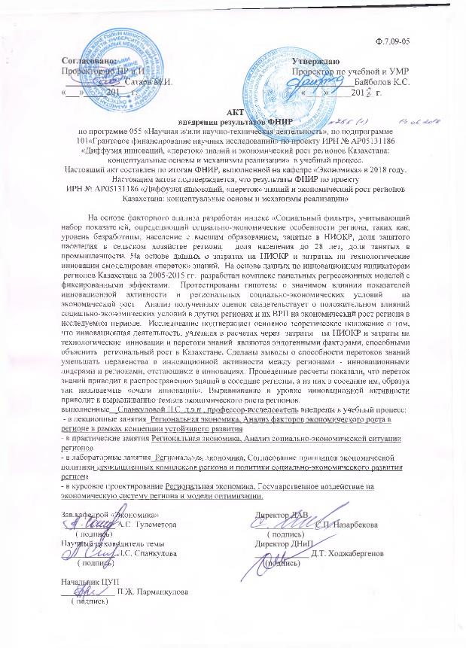

Figure G.1 – Implementation Act in the Auyezov South Kazakhstan State University

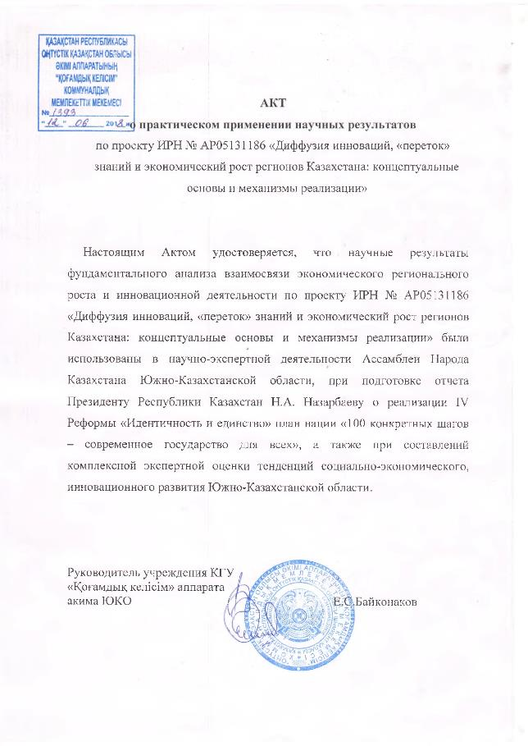

Figure G.2 – Implementation Act of the Apparatus of the Akim of the South Kazakhstan region in scientific and expert activities at “Kogamdyk kelisim” Assembly of the People of Kazakhstan

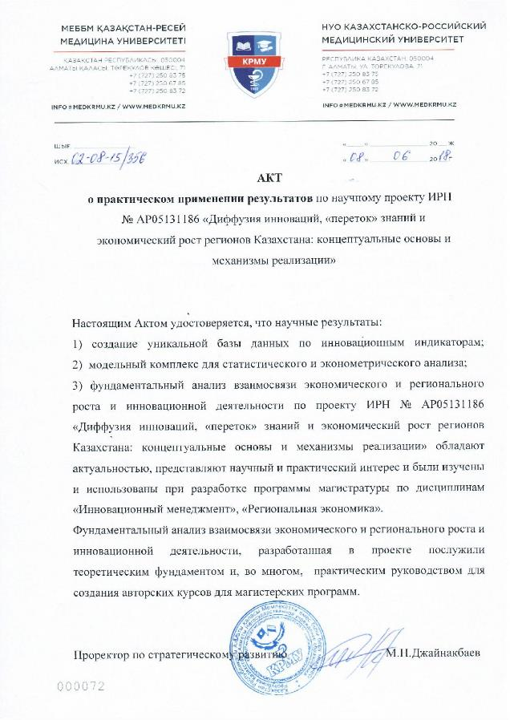

Figure G.3 – Act of implementation in the Kazakh Russian Medical University

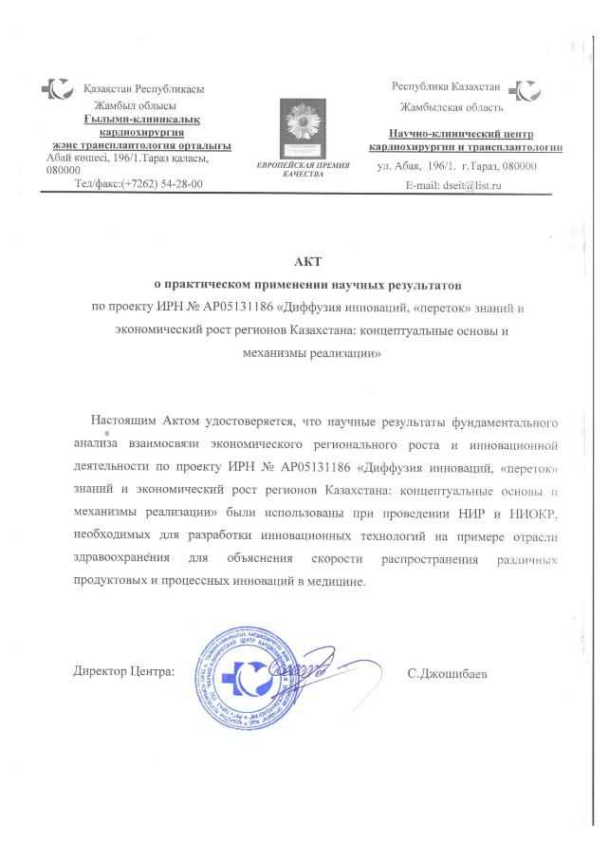

Figure G.4 – The act of implementation in the "Scientific Clinical Center Cardiac Surgery and Transplantology" LLP

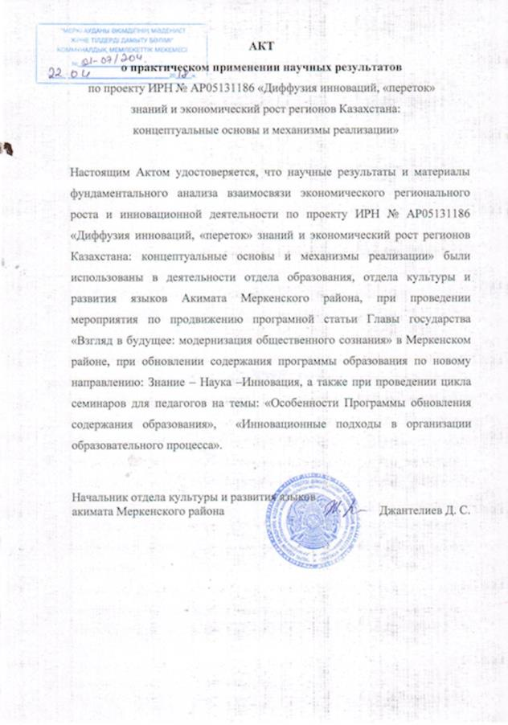

Figure G.5 – The act of implementation in the activities of the education department, the department of culture and language development of the Akimat of the Merken region

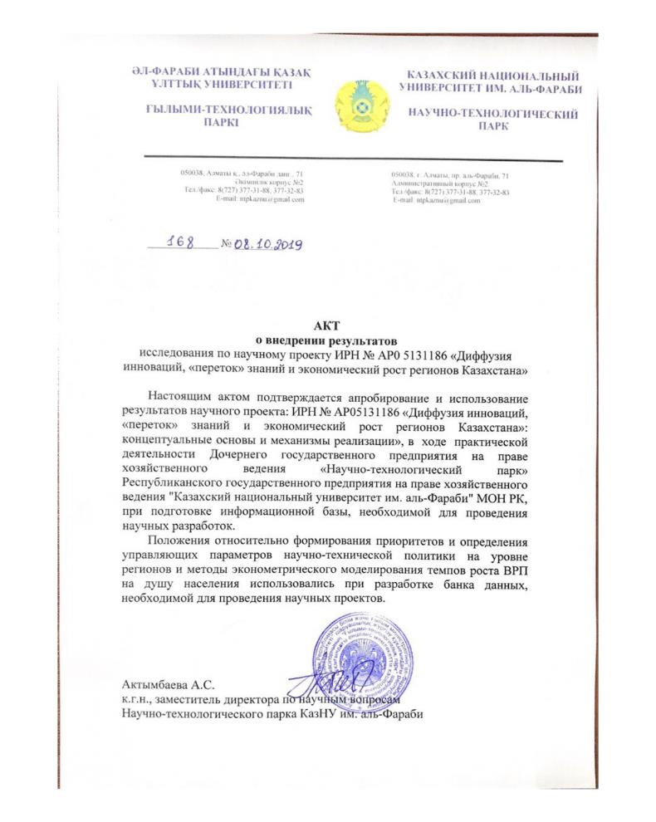

Figure G.6 – The act of implementation in the "Science and Technology Park" al-Farabi KazNU

**APPENDIX H**

**Technical specification and work schedule**

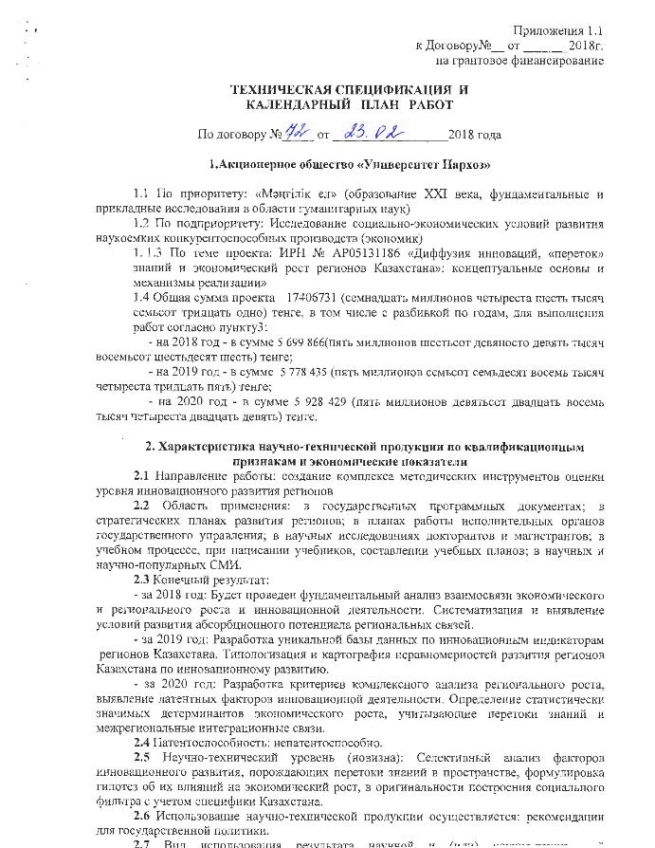

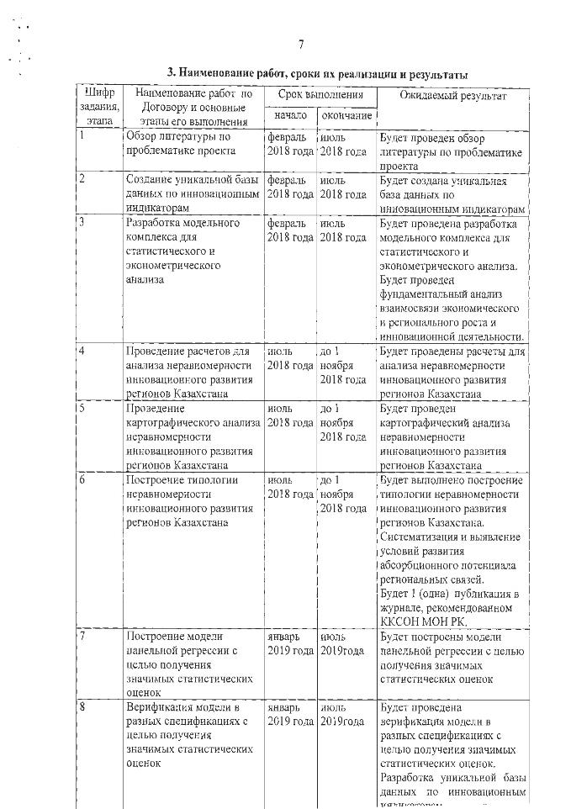

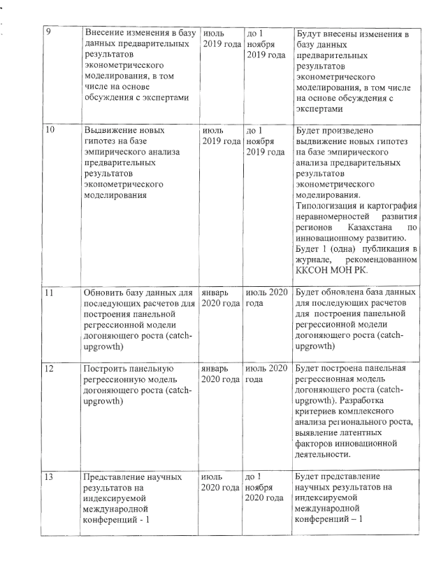

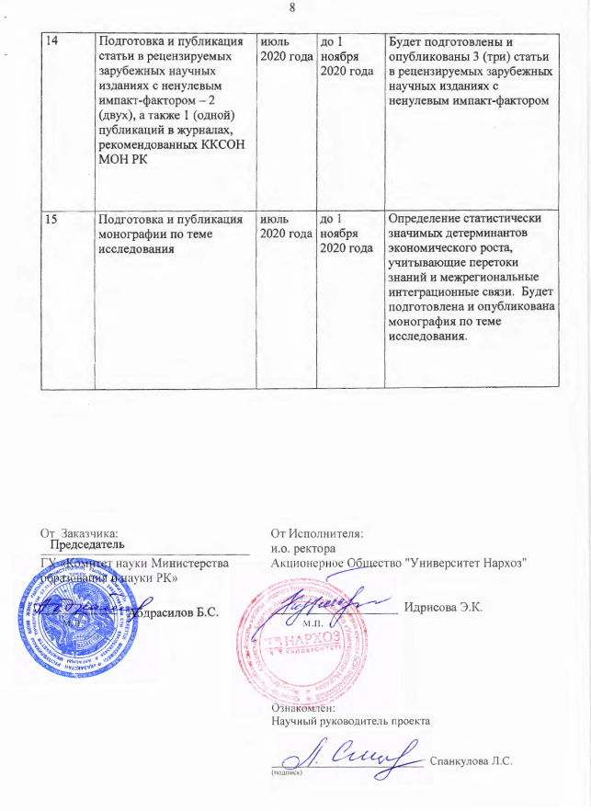

|  |  |  |  |  |
| --- | --- | --- | --- | --- |
| Code, tasks, stages | Name of work under the Agreement and the main stages of its implementation | Period of execution | | Expected results |
| 1 | Review of literature on the problem of the project | February 2018 | July 2018 | A literature review on the subject of the project will be carried out |
| 2 | Creation of a unique database of innovative indicators | February 2018 | July 2018 | A unique database of innovative indicators will be created |
| 3 | Development of a model complex for statistical and econometric analysis | February 2018 | July 2018 | The development of a model complex for statistical and econometric analysis will be carried out. A fundamental analysis of the relationship between economic and regional growth and innovation will be carried out. |
| 4 | Calculations to analyze the unevenness of the innovative development of the regions of Kazakhstan | July 2018 | Until November 1, 2018 | Calculations will be carried out to analyze the unevenness of the innovative development of the regions of Kazakhstan |
| 5 | Cartographic analysis of the unevenness of the innovative development of the regions of Kazakhstan | July 2018 | Until November 1, 2018 | Cartographic analysis of the unevenness of the innovative development of the regions of Kazakhstan |
| 6 | Building a typology of uneven innovative development of the regions of Kazakhstan | July 2018 | Until November 1, 2018 | The construction of a typology of uneven innovative development of the regions of Kazakhstan will be carried out. Systematization and identification of conditions for the development of the absorption potential of regional ties. There will be 1 (one) publication in the journal recommended by the KKSON MES RK. |
| 7 | Building a panel regression model to obtain meaningful statistical estimates | January 2019 | July 2019 | Panel regression models will be built in order to obtain meaningful statistical estimates |
| 8 | Model verification in different specifications in order to obtain meaningful statistical estimates | January 2019 | July 2019 | The model will be verified in different specifications in order to obtain significant statistical estimates. Development of a unique database of innovative indicators. |
| 9 | Making changes to the database of preliminary results of econometric modeling, including through discussions with experts | July 2019 | Until November 1, 2019 | Changes will be made to the database of preliminary results of econometric modeling, including through discussions with experts |
| 10 | Formulation of hypotheses based on empirical analysis of preliminary results of econometric modeling | July 2019 | Until November 1, 2019 | Hypotheses will be advanced based on empirical analysis of preliminary results of econometric modeling. Typologization and cartography of uneven development of the regions of Kazakhstan for innovative development. There will be 1 (one) publication in the journal recommended by the Committee for control in the field of education and science of the Ministry of education and science of the Republic of Kazakhstan. |
| 11 | Update the database for subsequent calculations to build a catch-up growth panel regression model (catch-upgroowth) | January 2020 | July 2020 | The database will be updated for subsequent calculations to build a catch-up growth panel regression model (catch-upgroowth) |
| 12 | Build a Panel Catch-Up Regression Model (catch-upgroowth) | January 2020 | July 2020 | A panel regression model of catch-upgrowth will be built. Development of criteria for a comprehensive analysis of regional growth, identification of latent factors of innovation. |
| 13 | Presentation of scientific results at indexed international conferences-1 | July 2020 | Until November 1, 2020 | There will be presentation of scientific results at indexed international conferences-1 |
| 14 | Preparation and publication of an article in peer-reviewed foreign scientific journals with a non-zero impact factor-2 (two), as well as 1 (one) publications in journals recommended by the KKSON MES RK. | July 2020 | Until November 1, 2020 | 3 (three) articles will be prepared and published in peer-reviewed foreign scientific journals with a non-zero impact factor |
| 15 | Preparation and publication of a monograph on the research topic | July 2020 | Until November 1, 2020 | Determination of statistically significant determinants of economic growth, taking into account knowledge flows and interregional integration links. A monograph on the research topic will be prepared and published. |