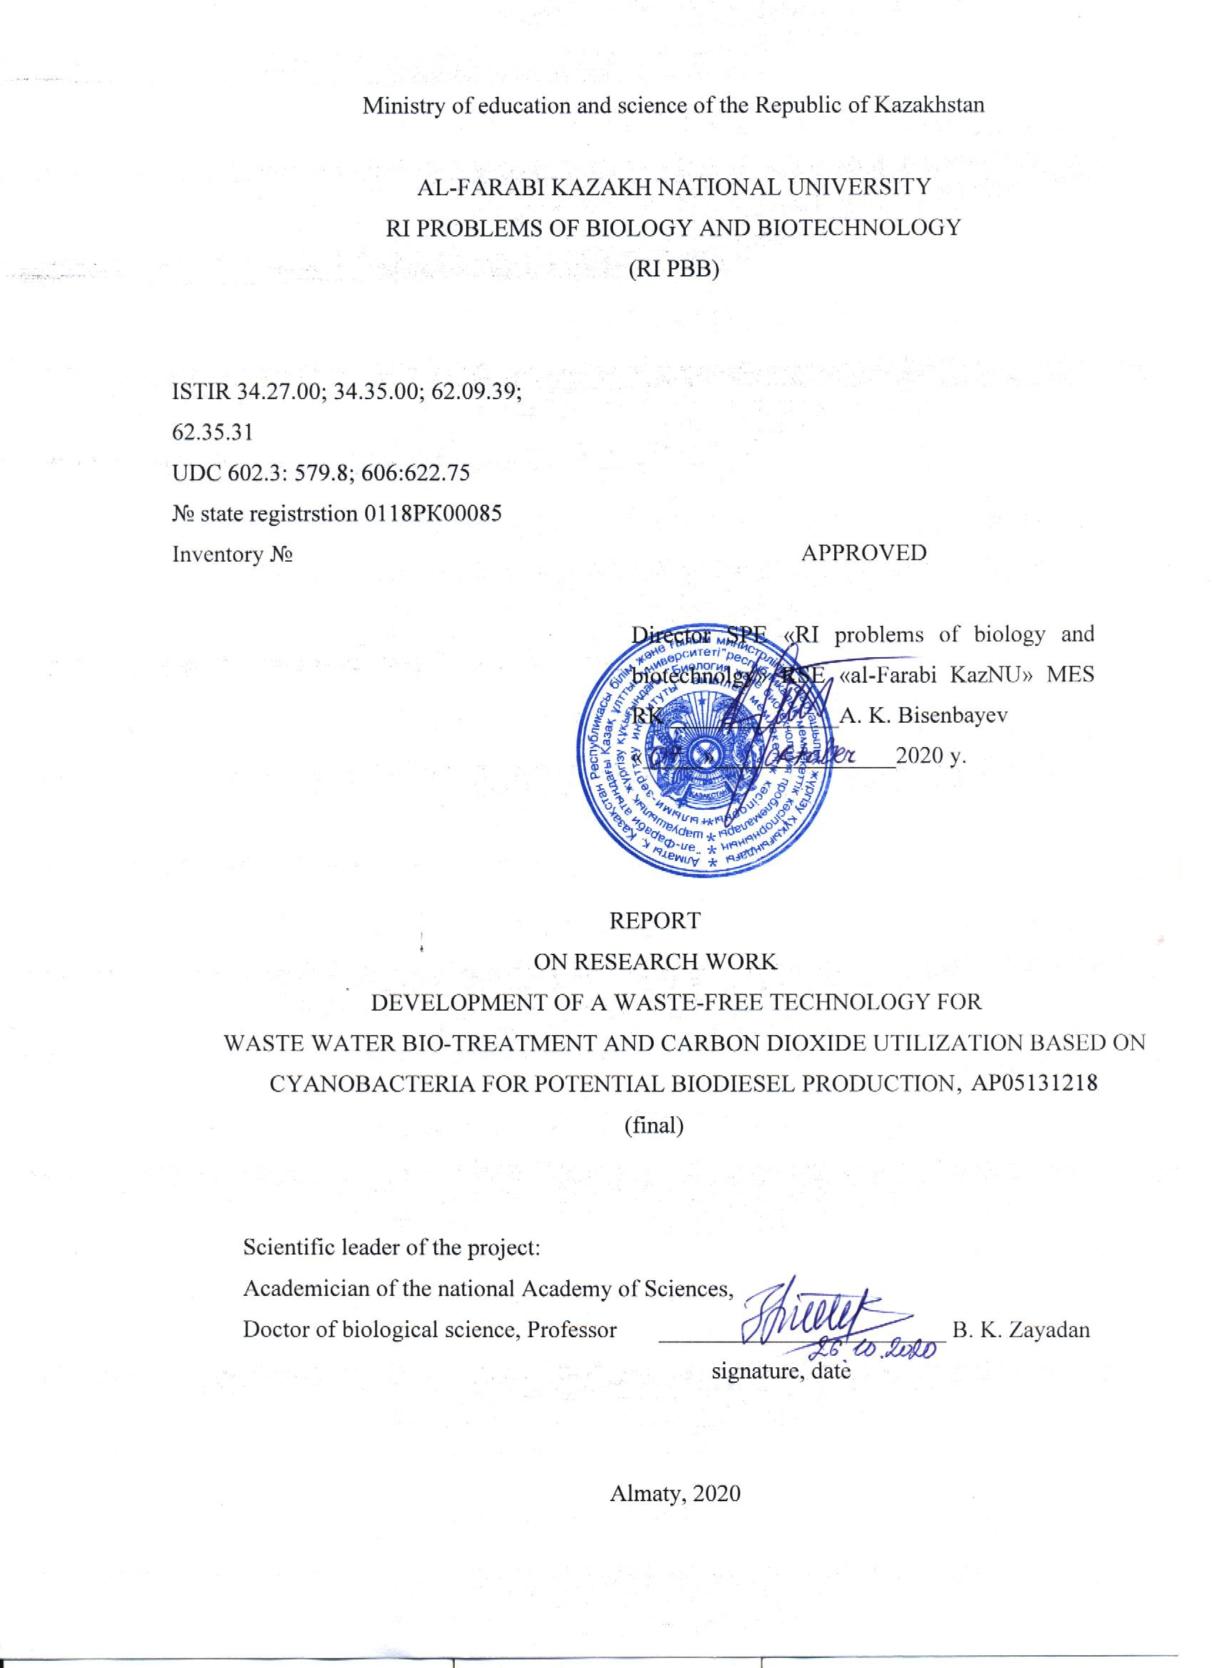

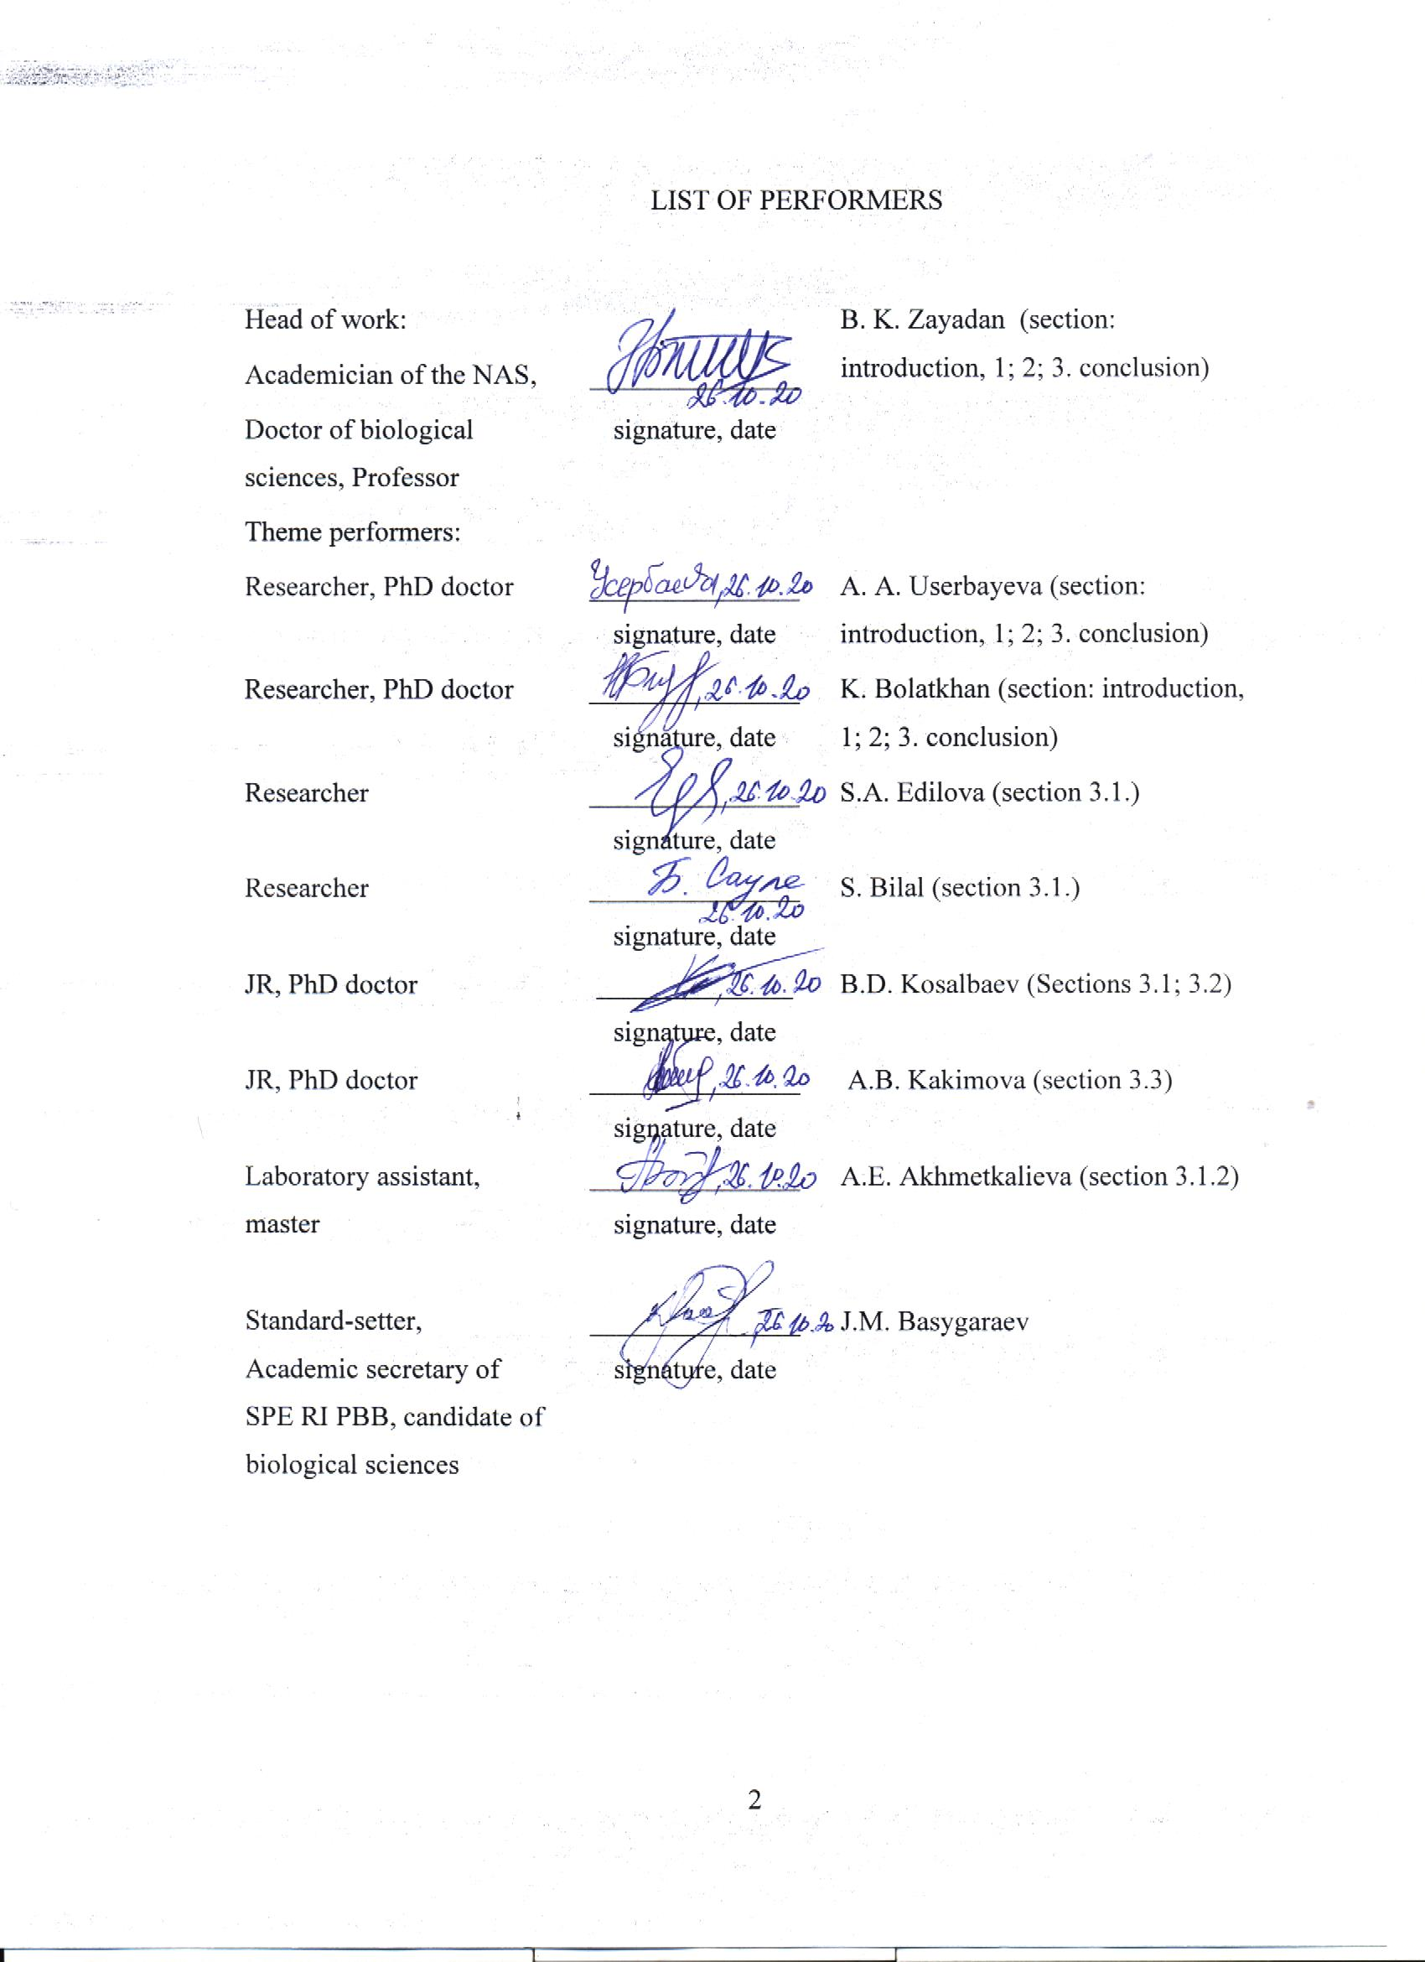

ABSTRACT
The abstract consists of 58 p., 14 fig., 6 tabl., 65 references, 2 appendices.
CYANOBACTERIA, BIODIESEL, WASTEWATER TREATMENT, CARBON DIOXIDE UTILIZATION, GENOME SEQUENCING
Object of research: Newly isolated (Anabaena variabilis R-I-5 and Nostoc calsicola RI-3) and collection strains of cyanobacterium (Cyanobacterium sp. IPPAS B-1200, Cyanobacterium aponium IPPAS B-1201, Synechococcus elongatus 7942, Desertifilum sp. IPPAS B-1220 and Prochlorothrix hollandica) from the al-Farabi Kazakh national University collection of phototrophic microorganisms.
Aim of work: To develop a waste - free technology for wastewater biorefining and carbon dioxide utilization based on cyanobacteria for the potential production of biodiesel.
Research methods: microbiological, biotechnological, biochemical and molecular biology methods
Research results: Axenic cyanobacteria cultures were isolated and identified as Anabaena variabilis R-I-5 and Nostoc calsicola RI-3. As a result of productivity screening, collection strains of Cyanobacterium sp IPPAS B-1200, Cyanobacterium aponium IPPAS B-1201 and isolated Anabaena variabilis R-I-5 strain were selected. It was found that the Cyanobacterium sp. B-1200 strain, along with C16 FA, had a large number of C14 FA. The optimal concentration of CO2 for the cultivation of cyanobacteria was established. The prospects of using the Cyanobacterium sp IPPAS B-1200 strain in wastewater treatment are shown. The ratio of waste water to the nutrient medium optimal for the cultivation of cyanobacteria is determined. The genome size of the studied Cyanobacterium sp. IPPAS B-1200 strain was found to be 3410249 base pairs, the genome contains only 3119 genes, of which 2934 protein-coding genes, 137 pseudogenes, 4 rRNA - coding genes, 40 tRNA - coding genes, 4 non-coding RNA genes, and 2 CRISPR sites were also found in the genome. The results obtained allow us to recommend the strains Cyanobacterium sp. IPPAS B-1200 and Desertifilum sp. IPPAS B-1220 both for bioremediation of municipal wastewater and carbon dioxide utilization, as well as for obtaining biomass for the production of biodiesel.
Degree of implementation: number of published works 31, including textbooks – 4 and monograph -2, articles in peer-reviewed foreign scientific publications indexed in the Web of Science or Scopus databases with a non - zero impact factor- 10, articles in journals recommended by CCEFS MES RK – 6, abstracts in proceedings of international conferences – 6, patent-1 and copyright certificate -2.

CONTENT
INTRODUCTION ……………………………………………………………...……. | 6
MAIN PART .............…….……………………………………………...…………... | 8
1 Literature review ...……………………………..…………………………………... | 8
2 Research materials and methods................................................................................. | 11
2.1 Object of research .........………………………………...……… ........................ | 11
2.2 Water sampling and isolation of axenic cyanobacteria cultures ..............………. | 11
2.3 Cultivation of cyanobacteria in the laboratory condition ............…………......... | 11
2.4 Determination of the species composition of cyanobacteria …………................ | 12
2.5 Determination of growth rate, fluorescence, and biomass ......………………...... | 12
2.6 Total lipid extraction and fatty acid analysis .................. …..................……....... | 13
2.7 Determination of physical and chemical parameters of wastewater ……............. | 13
2.8 Preparation of fatty acid methyl esters................................................................... | 13
2.9 Sequencing and annotation of the cyanobacteria genome..................................... | 13
3 Results and discussion................................................................................................ | 14
3.1 Isolation and screening of cyanobacteria strains - producers of fatty acids........... | 14
3.1.1 Isolation of axenic cyanobacteria cultures from various ecosystems............... | 14
3.1.2 Screening of isolated and collectible cyanobacteria strains by productivity in  order to determine their biotechnological potential.................................……. | 16
3.2 Study of the possibility of using municipal wastewater for the cultivation of  strains of cyanobacteria - producers of fatty acids................................................. | 18
3.3 Determination of the fatty acid composition of lipids of cyanobacteria strains –  producers of fatty acids cultivated in municipal wastewater................……........ | 20
3.4 Optimization of methods for extracting lipids from cells of cyanobacteria  strains - producers of fatty acids..................……...……...……...……...……..... | 22
3.5 Study of the ability to absorb carbon dioxide by cyanobacteria strains –  producers of fatty acids......................................................................……...…… | 23
3.6 Development of technology for mass cultivation of cyanobacteria strains –  producers of fatty acids in municipal wastewater for biomass production…….... | 26
3.6.1 Determination of optimal wastewater concentrations for growth of  cyanobacteria strains – producers of fatty acids............................................... | 26
3.6.2 Determination of the lipid content and fatty acid composition of  cyanobacteria biomass............……...……...……...……...……...………....... | 29
3.7 Development of technology for the production of biodiesel based on  cyanobacteria strains - producers of fatty acids..................................................... | 32
3.7.1 Semi-continuous cultivation of Cyanobacterium sp. IPPAS B-1200 and  production of fatty acid methyl esters in laboratory conditions....................... | 32
3.7.2 Economic efficiency of obtaining biodiesel from cyanobacteria using waste-  free technology...................................................……...……...……...……...... | 34
3.8 Sequencing of the genomes of cyanobacteria are producers of fatty acids........... | 36
3.9 Abstract and characteristics of the genomes of cyanobacteria – producers of  fatty acids............................................................................................................... | 38
CONCLUSION…………….…………………………………………….………….... | 40
REFERENCES............................................................………...…..……….………… | 43
APPENDIX A List of published works on the project.................................................. | 49
APPENDIX B Calendar plan………………………………………............................. | 53

INTRODUCTION

In recent decades, the world's population has experienced a shortage of fresh water and energy [1]. Cyanobacteria are promising biofuel producers [2], mainly due to high reproduction rate, high photosynthetic capacity and low nutritional requirements [3]. The cultivation of cyanobacteria in wastewater can, simultaneously with its purification, ensure efficient production of biodiesel. Such an integrated approach can form the basis of an economically viable and environmentally friendly technology for the production of biofuels from biomass of cyanobacteria, since a huge amount of wastewater and nutrients in it (for example, nitrogen and phosphorus) can be reused by them for the growth of photosynthetic cells. [4]. At the same time, for the efficient production of cyanobacterial biomass, additional sources of CO₂ are required, since atmospheric carbon dioxide is insufficient for the rapid accumulation of biomass [5], despite an increase in the concentration of CO₂ in the atmosphere on a planetary scale. In this regard, it seems rational to use CO₂, which is emitted into the atmosphere by operating enterprises and amounts to 60-70% of industrial gaseous emissions [6]. The photosynthetic system of plants and phototrophic microorganisms provides the renewal of oxygen in the atmosphere along with the conversion of carbon into potentially useful biomass. At the same time, cyanobacteria and microalgae are the most promising production facilities capable of effectively fixing СО₂ several times more per unit area than plant objects [7]. Since, along with wastewater treatment, the reduction of industrial CO₂ emissions into the atmosphere is a global task, cyanobacteria are in the focus of multifaceted applications: a) bioremediation of wastewater, b) utilization of industrial gases, and c) production of biomass on this basis for further biofuel production. The basis of any modern industrial production is the provision of environmental safety, which is achieved by the introduction of new waste-free technologies based on biochemical processes [8]. Such technologies require a preliminary study of the influence of the investigated factors on the vital activity of the producers used. Thus, the technologies of using phototrophic microorganisms in the processes of removing excess CO₂ from the atmosphere require a detailed study of the effect of carbon dioxide on the viability of the studied organisms and the selection of its optimal concentrations favorable for the growth and accumulation of biomass [9, 10].
Project goal: to develop a non-waste technology for biological treatment of waste water and utilization of carbon dioxide based on cyanobacteria for the potential production of biodiesel.
Based on the results of the previous stages, reports were prepared:
Stage 1. Isolation and screening of cyanobacterial strains - producers of fatty acids and the study of the possibility of using municipal wastewater for their cultivation. (Inventory No. 0215РК00852 – 2018).
Stage 2. Determination of fatty acid composition of lipids of cyanobacterial strains - producers of fatty acids cultivated in municipal wastewater. Optimization of methods for extracting lipids from cells of cyanobacterial strains and studying their ability to absorb carbon dioxide (Inventory No. 0216RK00687 - 2019).
The purpose of stage 3 of the work is to develop a technology for mass cultivation of strains of cyanobacteria - producers of fatty acids in municipal wastewater to obtain biomass.
In accordance with the schedule for the implementation of research work at stage 3, the following tasks were set:
- Isolation and screening of cyanobacterial strains - producers of fatty acids.
- Development of technology for mass cultivation of cyanobacterial strains - producers of fatty acids in municipal wastewater for biomass production.
- Development of technology for the production of biodiesel fuel based on strains of cyanobacteria - producers of fatty acids.
- Sequencing of genomes of cyanobacteria - producers of fatty acids.
- Abstract and characteristics of the genomes of cyanobacteria - producers of fatty acids.
MAIN PART

- Literature review

Cyanobacteria are the most efficient biological producers of natural hydrocarbons in the form of fatty acids, and, therefore, a universal renewable source of biomass suitable for rapid processing into biodiesel and other types of biofuels. Unlike other renewable energy sources, biomass can be converted directly into a liquid fuel called "biofuel". One of the most common biofuels in use today is biodiesel, which represents the first generation of biofuel technologies [11].
Cyanobacteria are modern and promising producers of biodiesel fuel. They represent a diverse group of gram-negative bacteria capable of oxygenic photosynthesis [12]. Cyanobacterial fatty acids can be potential precursors for the renewable production of cyanodiesel and other useful products. The main advantage of using cyanobacteria as a raw material for biomass production is the high rate of their reproduction, the ability to accumulate a significant amount of fat and, in the presence of favorable conditions, grow throughout the year. Usually, with an optimal supply of nutrients and the presence of all growth factors (sunlight, water, carbon dioxide and mineral salts), the mass of these crops can double per day. Moreover, it can serve as a source of not only triacylglycerides and hydrocarbons used in the production of biofuels, but also many other high-value substances: pigments, sugars, vitamins, antibiotics [13].
Due to the global increase in population and the rise in living standards of people, there is a high level of water pollution around the world. Wastewater usually contains organic matter such as proteins, carbohydrates, lipids, volatile acids, and inorganic substances containing sodium, calcium, potassium, magnesium, chlorine, sulfur, phosphate, bicarbonate, ammonium salts and heavy metals [14]. Many species of cyanobacteria are able to grow in wastewater due to their ability to use organic carbon and inorganic nitrogen and phosphorus in excess of wastewater. In addition, the efficient production of cyanobacterial biomass requires enriched CO₂ sources, since the rate of supply from the atmosphere is limited by the rate of diffusion through the surface resistance of water in the cultivation system [15]. So an alternative solution to this problem is the cultivation of cyanobacteria near thermal power plants and other industrial plants. Advantages of locating cyanobacterial biomass production next to CO₂-emitting production facilities [16]. This project is aimed at the production of biofuels based on cyanobacteria that can grow in wastewater while utilizing carbon dioxide in the atmosphere using it as a carbon source. Thus, the reduction of additional costs for the provision of nutrients to cyanobacteria and the optimization of highly efficient biological treatment of wastewater, the transesterification system to create continuous production of biodiesel increases the possibilities of obtaining renewable biofuel, which is ecologically and economically viable for Kazakhstan (Figure 1).
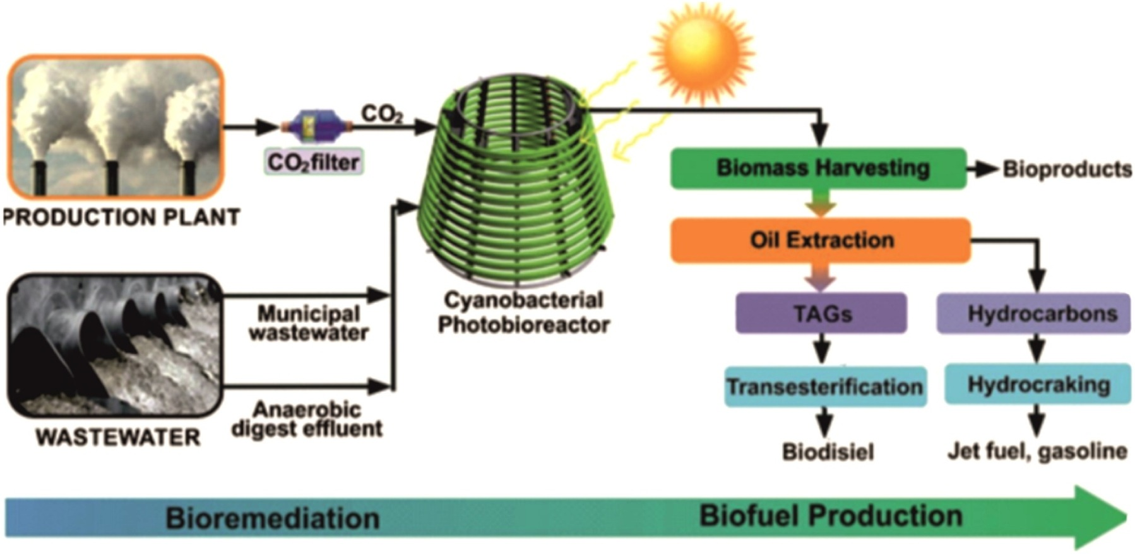

Figure 1 - Removal of excess carbon dioxide from the atmosphere and bioremediation of wastewater by cyanobacteria for sustainable production of biodiesel

With the tendency to increase the concentration of carbon dioxide in the atmosphere, caused not only on a local but also on a global scale, studies in the aspects of the impact of carbon dioxide on the environment are becoming increasingly important. Recognized deficiencies in sustainable development, as well as severe environmental degradation and global warming problems caused by anthropological CO₂ emissions, are major challenges facing the world today [17]. It should be recognized that, in contrast to extensive studies of the effect of carbon dioxide on the human and animal body, the effect of carbon dioxide on the metabolic processes of the plant cell has been studied to a much lesser extent. The mechanisms of photosynthesis inhibition by excess CO₂ concentration remain unreported to date [18, 19]. A decrease in the intensity of photosynthesis at high CO₂ concentrations was associated with "narcotic poisoning." In later works, the inhibition of photosynthesis was explained from the point of view of acidification of the cytoplasm as a result of the formation of acidic products of hydration of carbon dioxide [20]. Microalgae and cyanobacteria are much more resistant to high CO₂ concentrations than higher plants. An increase in the concentration of CO₂ in the environment up to 1-5% activates the growth and photosynthesis of microalgae [21]. Resistance to inhibitory CO₂ concentrations is species-specific and varies over a wide range of values. Some strains are capable of growing in a 100% CO₂ atmosphere. The latter is possibly related to the participation of these organisms in the change in the gas composition of the atmosphere from anoxic, rich in CO₂, to oxygen and in the formation of the biosphere [21, 22]. It has been shown that an extremely high concentration of CO₂, being a stress factor, causes profound changes in the structure and metabolism of microalgae, leading to the transition of cells to specialized biosynthesis and hypertrophied accumulation of lipids and carbohydrates [22]. Interest in the influence of high concentrations of carbon dioxide on the activity of cyanobacterial microalgae has arisen in the last 30 years, in particular, in connection with projects for cleaning the atmosphere from industrial pollution using microalgae as biofilters [23], due to their ability to grow intensively under conditions of increased CO₂ content in the atmosphere [24]. Microalgae and cyanobacteria have the potential for CO₂ recycling and bioremediation, as well as for the production of chemical energy in the form of biomass [23]. The potential production of renewable energy and valuable products (eg carotenoids, antioxidants and polyunsaturated fatty acids) makes large-scale microalgae cultivation an attractive application. Lipid metabolism plays an important regulatory role in the adaptation of plant cells to stress. In recent years, studies have shown an increase in lipid metabolism with elevated CO₂ concentrations [25].
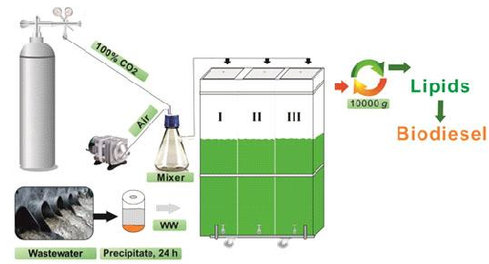
Designation: I – Cyanobacterium sp. IPPAS B-1200 (50% wastewater +50% BG-11); II – Cyanobacterium aponium IPPAS B-1201 (25% wastewater +75% BG-11); III – Desertifilum sp. IPPAS B-1220 (25% wastewater +75% BG-11).
Figure 2 - Scheme of obtaining biodiesel by cultivating strains of cyanobacteria on BG-11 medium and wastewater using CO₂

In this regard, cyanobacteria have a triple application - biomass production for sustainable biofuel production, wastewater bioremediation, and carbon dioxide utilization (Figure 2).

- Materials and research methods

  - Research objects

The objects of this work were collection strains of cyanobacteria Cyanobacterium sp. IPPAS B-1200, Cyanobacterium aponinum IPPAS B-1201, Desertifilum sp. IPPAS B-1220, Synechococcus elongatus 7942 and Anabaena variabilis R-I-5 and Nostoc calcicola RI-3 were taken from the collections of the Institute of Plant Physiology. K.A. Timiryazev [26, 27] and the collection of phototrophic microorganisms of the Kazakh National University named after al-Farabi. As well as isolated cultures of cyanobacteria from hot springs and bioponds of the “TengryFish” fish farm located in the village of Chundzha, Uygur district of Almaty region, from the Beskainar and Kyzylkayrat rivers of Talgar district, Almaty region, rivers of Enbekshikazakh district, Almaty region, and soil samples were taken from rice fields of Baghlan province (Afghanistan).

  - Water sampling and isolation of axenic cultures of cyanobacteria

Water sampling for microbiological studies was carried out according to the generally accepted method [28]. Isolation of axenic cultures of cyanobacteria was carried out according to standard methods [29, 30.].

  - Cultivation of cyanobacteria in the laboratory

The cultivation of the enrichment culture was carried out on liquid media BG-11, Gromov No. 6, Zarruk [31, 32]. The cultivation was carried out in a laboratory luminostat in a continuous mode at a temperature of 25–40 ° C, under artificial lighting. The cells of the studied cyanobacteria were continuously grown in 500 ml vessels on BG-11 liquid nutrient medium with glass tubes at 25 ° C and 28 ° C and artificial illumination with a light intensity of 300 μmol / m2 / sec, as well as aeration with sterile gas and air enriched with 0%, 5%, 10%, 15% and 20 CO2. Aeration was carried out using a BOYU air compressor with an S-4000B air pump (China). The concentration of СО2 was controlled by a rotameter РМА-0.063 G (Russia). Large-scale cultivation (100 L) was carried out in a homemade laboratory photobioreactor with a volume of 200 L.
The cultivation of the enrichment culture was carried out on liquid media BG-11, Gromov No. 6, Zarruk [31, 32]. The cultivation was carried out in a laboratory luminostat in a continuous mode at a temperature of 25–40 ° C, under artificial lighting. The cells of the studied cyanobacteria were continuously grown in 500 ml vessels on BG-11 liquid nutrient medium with glass tubes at 25 ° C and 28 ° C and artificial illumination with a light intensity of 300 μmol / m2 / sec, as well as aeration with sterile gas and air enriched with 0%, 5%, 10%, 15% and 20 CO2. Aeration was carried out using a BOYU air compressor with an S-4000B air pump (China). The concentration of СО2 was controlled by a rotameter РМА-0.063 G (Russia). Large-scale cultivation (100 L) was carried out in a homemade laboratory photobioreactor with a volume of 200 L.

  - Determination of the species composition of cyanobacteria

Determination of the preliminary taxonomic affiliation of cyanobacteria based on morphological characters was carried out according to Komarek and Anagnostidis [33-36].

  - Determination of growth rate, fluorescence and biomass

The growth of the cultures was measured as a change in optical density on a PD-303UV spectrophotometer (Japan). The productivity of the culture biomass was determined by the Sirenko method [28]. The growth rate coefficient of cyanobacterial cultures was calculated from the increase in the number of cells in experimental vessels by the following level (1):

k=ln (1)

Where N0 is the initial number of cells; Nt is the number of cells in time t.
The constant fluorescence of chlorophyll, a (F0) in the cells of the studied cyanobacteria [37] was measured using an AquaPen AP 100 fluorometer (Czech Republic). To study the effect of CO2 concentration on cell growth, the studied cultures were aerated with sterile gas and a mixture of air enriched with 0%, 5%, 10%, 15%, and 20 CO2. Aeration was carried out using a BOYU air compressor with an S-4000B air pump (China). The concentration of СО2 was controlled by a rotameter РМА-0.063 G (Russia). Statistical analyzes of the data obtained were investigated by analysis of error (ANOVA) with a 95% confidence level.

  - Extraction of total lipids and analysis of fatty acids

To determine the total amount of lipids in the cells of the studied cyanobacteria, the following methods were used: Folch [38] (chloroform / methanol 2/1 (v / v)), Bligh and Dyer [39] (chloroform / methanol 1/2 (v / v)) , Khara and Radina [40] (hexane / isopropanol 3/2 (v / v)). Distillation was used using an IKARV10 basic vacuum rotary evaporator (IKA, United States). Fatty acid composition analysis was determined by capillary gas chromatography (CGC Agilent 6850 Series GC system).

  - Determination of physical and chemical parameters of waste water

The analysis of the physical and chemical parameters of wastewater was carried out in cooperation with the testing laboratory of LLP RSPIC KAZECOLOGY (Almaty, Kazakhstan). To determine BOD5, we used a Dissolved oxygen meter YSI 5100 (Great Britain) [41]. To assess the effect of wastewater on the growth rates of cyanobacteria, the following variants of the experiment were prepared containing a nutrient medium and wastewater in different ratios:
Option 1 - BG-11;
Option 2 - WW;
Option 3 - 75% WW + 25% BG-11;
Option 4 - 50% WW + 50% BG-11;
Option 5 - 25% WW + 75% BG-11.

  - Obtaining methyl esters of fatty acids
Fatty acid methyl esters (FAME) were obtained by the method of alkaline transseterification [42].
  - Cyanobacterial genome sequencing and annotation

The genome DNA of Cyanobacterium sp. IPPAS B-1200 was isolated using the Williams method [43] with additional purification [44]. To carry out the sequencing, we used the Ion PGM Hi-Q Sequencing Kit and the Ion 316 ™ Chip v2 BC microchip. Throughout all procedures, the peak manufacturer's protocol (Thermo Fisher Scientific) was strictly followed. For de novo assembly of the Cyanobacterium sp. IPPAS B-1200 was used by accembler SPAdes 3.1.0, included in the Torrent Suite software package [45]. The generated gene was annotated with the help of the automated program NCBI - Prokaryotic Genome Annotation Pipeline (PGAP).
- Results and its discussion

3.1 Isolation and screening of cyanobacterial strains - producers of fatty acids

3.1.1 Isolation of axenic cultures of cyanobacteria from various ecosystems and the study of their morphological and cultural properties
In order to isolate promising strains of cyanobacteria, water samples were collected from hot springs and bioponds of the “TengryFish” fish farm, the village of Chundzha, Uygur district, Almaty region, from the Beskainar and Kyzylkayrat rivers of Talgar district, Almaty region, rivers of Enbekshikazakh region, Almaty Soil samples were taken from rice fields in Balkhash province (Afghanistan).
As a result of microscopy, it was found that cyanobacteria in samples from rice fields in Baghlan province are represented by 29 species. Most of the identified species belong to the genera Anabaena (42% of the total cyanobacteria) and Nostoc - 35%. 35 species of cyanobacteria belonging to 7 genera were identified from the hot springs in Chundzha. The dominant species were representatives of the genus Phormidium (14 species). In water samples from bioponds of the fish farm “TengryFish”, 26 species of cyanobacteria were found, representatives of the genera Phormidium and Nostoc occupied a dominant position. As a result of analysis of water samples in the Beskaynar and Kyzylkairat rivers, 23 species of cyanobacteria were found. Representatives of the genera Oscillatoria and Synechocystis occupied the dominant position in the algal groupings. As a result of microscopic examination of the studied water samples from the rivers of the Enbekshikazakh region, about 22 species of cyanobacteria were found, from certain species of cyanobacteria the genus Phormidium in total is 42%, the genus Oscillatoria - 26%, the genus Synechocystis - 21%, and 11% - the genus Anabaena and genus Leptolyngbya.
From the taken water samples, 9 enrichment cultures of cyanobacteria were obtained, from which 2 axenic cultures were isolated by repeated passages. The resulting axenic cultures of cyanobacteria were isolated from soil samples from rice fields in Baghlan province (Afghanistan) and belonged to the genera Anabaena and Nostoc. To determine the species belonging of the isolated cultures of cyanobacteria, their morphological and cultural properties were studied.
The study of the morphological and cultural characteristics showed that the cells of the Anabaena sp. form strongly curved threads. Trichomes are single-row, unbranched. The predominant cell shape is ellipsoidal. Vegetative reproduction with hormogonia (thread fragments). Sporogenic culture. Young spores are larger than vegetative cells, slightly ellipsoid, 5.0x7.0 microns in size. The spore shell is smooth. The strain belongs to the heterocyst forms. Heterocysts are spherical with a diameter of 5.0 microns, located in the filament intercalary outside the natural connection with spores. Macroscopic colonies grow over the entire surface of the nutrient medium. It grows well at a temperature of 25-27 ° C on liquid and agar BG-11 media. Based on its morphological and cultural properties, the isolated strain was identified as Anabaena variabilis R-I-5 (Figure 3).

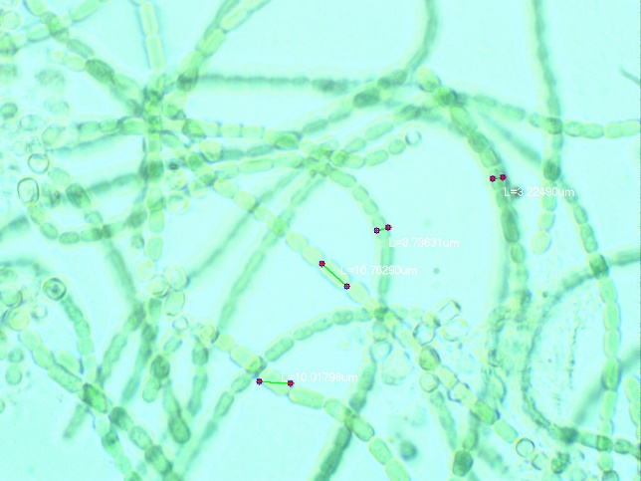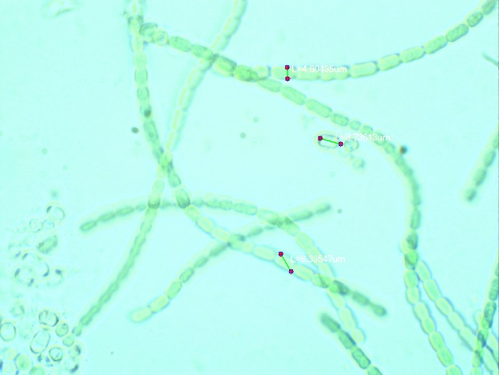
Figure 3 - Cell morphology of Anabaena variabilis R-I-5 (magnification 1x100)

Culture of cyanobacteria Nostoc sp. I form long filaments, occasionally with layered transparent sheaths, trichomes with intense constrictions at the transverse septa, bright blue-green. The vegetative cells of the isolated strain have from spherical to elongated and cylindrical shapes, with granular contents in the center, 7-8 µm in length, 4-6 µm in width. Heterocysts are formed in a nitrogen-free environment. Heterocysts are round, less often oval, intercalary, wider than vegetative cells, light brown, 6-9 microns in diameter. Akinetes are single and / or up to 10 in a row, rounded, occasionally slightly elongated, with many granules inside, sometimes 3-4 cellular, sometimes with layered transparent sheaths, 7-11 microns in diameter. As well as the previous species grows well at a temperature of 25-27 ° C on liquid and agar BG-11 media. The suspension in the mass is blue-green, slimy. Based on its morphological and cultural properties, the isolated strain was identified as Nostoc calcicola RI-3 (Figure 4).

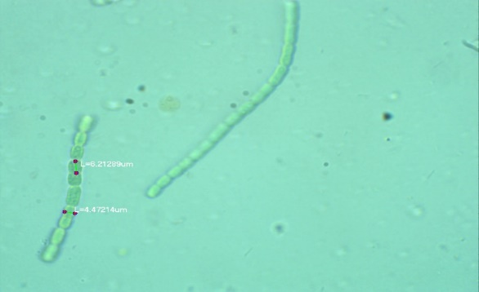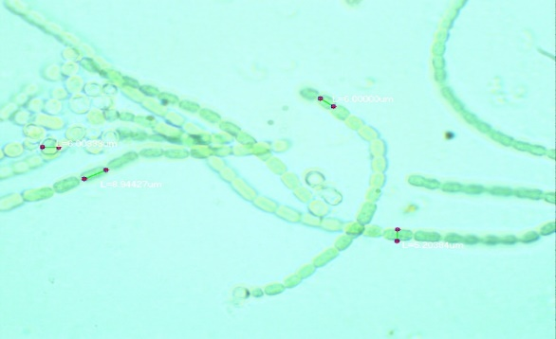
Figure 4 - Morphology of cells of Nostoc calcicola RI-3 (magnification 1x100)

Thus, as a result of the work carried out, pure algological cultures of cyanobacteria were obtained from the hot springs and bioponds of the “Tengryfish” fish farm in Chundzhi village, the Beskaynar and Kyzylkairat rivers, which will be further studied. Two axenic cultures of cyanobacteria were obtained from soil samples from rice fields in Baghlan province (Afghanistan), identified as Anabaena variabilis R-I-5 and Nostoc calcicola RI-3 based on morphological and cultural properties. Strains Anabaena variabilis R-I-5 and Nostoc calcicola RI-3 were selected for performance screening.

3.1.2 Screening of isolated and collection strains of cyanobacteria by productivity in order to determine their biotechnological potential

The most important indicators of the productivity of phototrophic microorganisms include growth rate, photosynthetic activity, dry biomass yield, and total lipid content. In connection with this, we carried out a screening of collection and isolated cyanobacteria strains by productivity. The objects of research were collection strains of Cyanobacterium sp. IPPAS B-1200, Cyanobacterium aponinum IPPAS B-1201, Synechococcus elongatus 7942 and isolated strains of Anabaena variabilis R-I-5 and Nostoc calcicola RI-3. Screening of experimental cultures of cyanobacteria was carried out on the basis of the results of a comparative analysis of productivity, which included the determination of the growth rate, fluorescence, dry weight and total lipids. The initial optical density in all variants was 0.03. Measurement of the optical density of cells of the experimental strains was carried out every day.
The results of testing the growth of experimental strains of cyanobacteria showed that within 8 days there was an exponential growth of cells of the strains Anabaena variabilis R-I-5, Cyanobacterium aponinum IPPAS B-1201 and Cyanobacterium sp. IPPAS B-1200, then a decrease in growth activity is noted. Growth curves of Cyanobacterium sp. IPPAS B-1200, Anabaena variabilis R-I-5, Nostoc calcicola RI-3, Cyanobacterium aponinum IPPAS B-1201 and Synechococcus elongatus 7942 are shown in Figure 5.

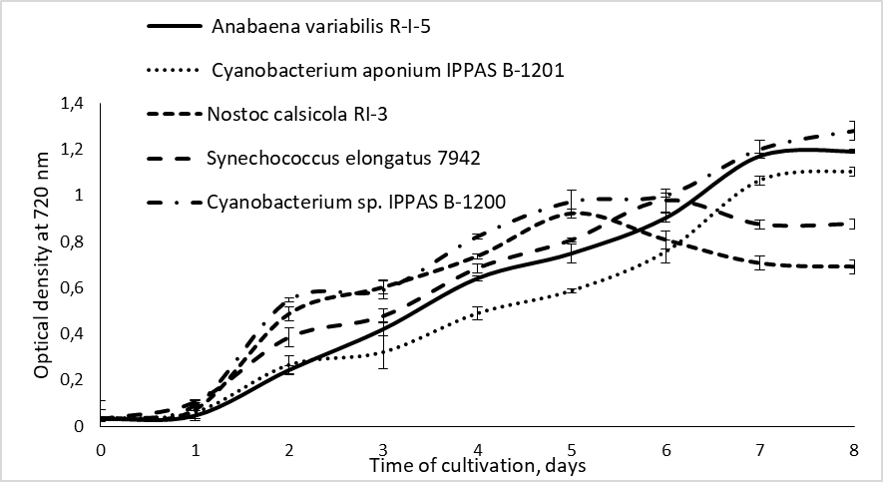

Figure 5 - Curves of growth of cells of collection and isolated strains of cyanobacteria

As seen in Figure 5, the culture of Cyanobacterium sp. IPPAS B-1200, Anabaena variabilis RI-5 and Cyanobacterium aponinum IPPAS B-1201 are characterized by more linear growth compared to Nostoc calcicola RI-3 and Synechococcus elongatus 7942. In addition to the optical density of the studied cultures for determining the concentration of cyanobacteria in suspension and assessing their growth rate constant fluorescence used - F₀ [46]. In the work, measurements F₀ were carried out for all experimental strains during 8 days of cultivation. The measurement results are shown in Figure 6.
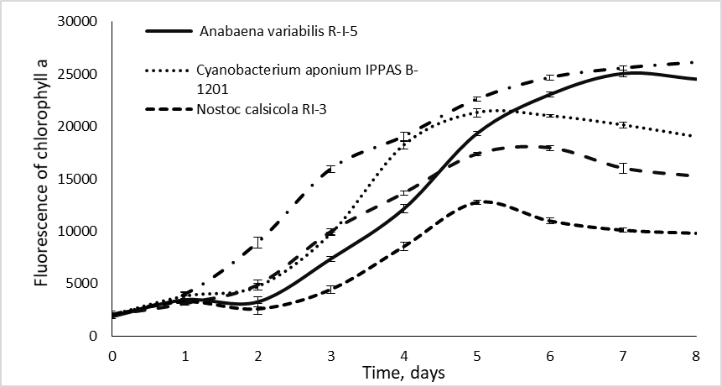

Figure 6 - Curve of constant fluorescence (F₀) of collection strains of cyanobacteria

According to the results of our experiments, the greatest photosynthetic activity is manifested in the cyanobacteria Cyanobacterium sp. IPPAS B-1200 and Anabaena variabilis R-I-5 and is 26101 and 25054 relative units, respectively. While in the rest of the collection strains, the maximum values ​​of this parameter were in the range of 12775-21310 relative units, which caused the slowdown of their growth already on the 6-7th day of cultivation. After 8 days of cultivation, the accumulation of dry matter in the cells of all subjects was determined. Based on the data obtained, it was found that the average indicators for the accumulation of dry biomass were for the culture of Cyanobacterium sp. IPPAS B-1200 - 1.36 g / l, for Anabaena variabilis RI-5 strain - 1.19 g / l, for Cyanobacterium aponium IPPAS B-1201 strain - 1.11 g / l, for Nostoc calsicola RI-3 strain - 0.45 g / l and for the culture of Synechococcus elongatus 7942 - 0.56 g / l.
And the average indicators of the total lipid content in the cells of the strain Cyanobacterium sp. IPPAS -1200 is 28%, while for Anabaena variabilis RI-5 this figure is 15.8%, Cyanobacterium aponinum IPPAS B-1201 - 14.7%, Nostoc calcicola RI-3 - 13.5% and for culture Synechococcus elongatus 7942 - 7%.
It was found that collection strains of Cyanobacterium sp. IPPAS B-1200, Cyanobacterium aponium IPPAS B-1201 and the isolated Anabaena variabilis R-I-5 strain have the highest growth rates, fluorescence, biomass yield and total lipid content, which determine their high productivity.
In this way, as a result of screening, collection strains of Cyanobacterium sp. IPPAS B-1200 and Cyanobacterium aponinum IPPAS B-1201, as well as Anabaena variabilis R-I-5 isolated from rice fields in Baghlan province, Afghanistan for further study of their physiological and biochemical properties in order to determine potential producers of biodiesel fuel.

3.2 Study of the possibility of using municipal wastewater for the cultivation of cyanobacterial strains - producers of fatty acids

The purpose of the next stage of our work was to study the possibility of using municipal wastewater for the cultivation of cyanobacterial strains - producers of fatty acids. The objects of study of this work were the Anabaena variabilis R-I-5 strain isolated from rice fields of Baghlan province (Afghanistan) and collection cultures of Cyanobacterium sp. IPPAS B-1200 and Cyanobacterium aponinum IPPAS B-1201. For work we have chosen a treatment plant in Almaty.
To study the possibility of using municipal waste water as a nutrient medium for cyanobacteria, strains of Cyanobacterium sp. IPPAS B-1200, Cyanobacterium aponinum IPPAS B-1201 and Anabaena variabilis R-I-5 were cultivated on waste water from a water utility after biological treatment of treatment facilities in Almaty and the Sorbulak storage pond. Experimental cultures were cultivated on four media options: option 1 (waste water sampled from a water utility after biological treatment), option 2 (waste water from the Sorbulak storage tank), option 3 (waste water from a water utility with a nutrient medium in a 1: 1 ratio) , option 4 (waste water from Sorbulak with nutrient medium in a ratio of 1: 1). Incubation was carried out for 14 days with an initial density of all studied cultures - 0.04 units. OP (Figure 7).

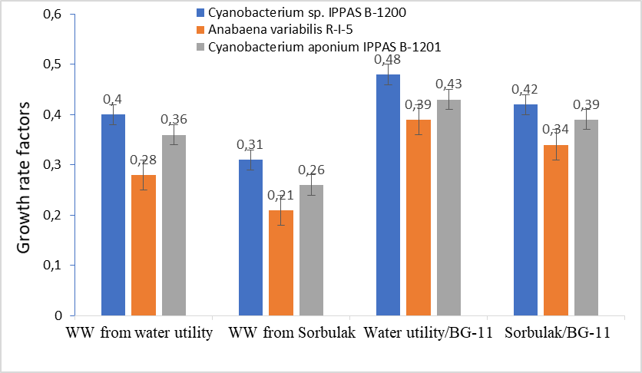
Figure 7 - Coefficients of the growth rate of strains of Cyanobacterium sp. IPPAS B-1200, Cyanobacterium aponium IPPAS B-1201 and Anabaena variabilis R-I-5, when cultured on various media

As can be seen from this graph, the nutrient medium most optimal for the growth of the studied crops was option 3, where the waste water from the water utility was diluted with the nutrient medium in a 1: 1 ratio. The crops were characterized by intensive growth, which is undoubtedly associated with the rich mineral composition of the environment. At the same time, the highest indicators of the growth rate coefficient in variant 3 were noted for the strains of Cyanobacterium sp. IPPAS B-1200 and Cyanobacterium aponinum IPPAS B-1201, which were 0.48 and 0.43, respectively. Undoubtedly, it can be argued that the addition of micro- and macroelements to waste water accelerates the growth of the studied crops and, as a consequence, the process of bioremediation of this waste water. In order to determine the bioremediation ability of the studied strains of cyanobacteria, the physicochemical composition of wastewater from a water utility after biological treatment before and after cultivation of cyanobacteria in it was analyzed and the percentage of the decrease in indicators for each strain was revealed (Figure 8).
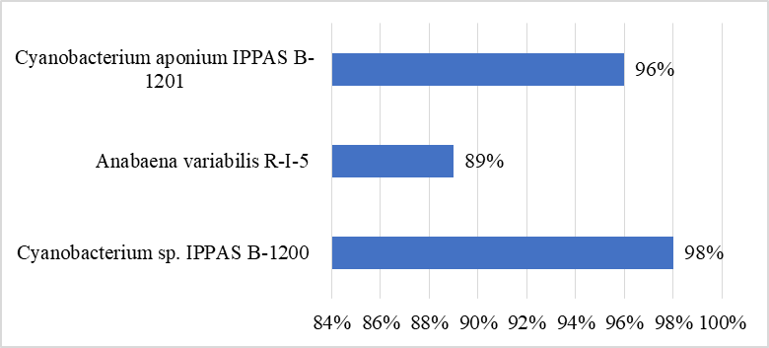
Figure 8 - Bioremediation ability of Cyanobacterium sp. IPPAS B-1200, Cyanobacterium aponium IPPAS B-1201 and Anabaena variabilis R-I-5 cyanobacterial strains

As a result of the analysis, it was possible to reduce the concentration of organic pollutants and physicochemical indicators by an average of 94.3% after growing experimental cyanobacteria cultures on wastewater from a water utility after biological treatment (The data obtained as a result of this experiment are described in more detail in the report for 2018 year). In turn, this proves that algolization can be an effective method of wastewater treatment. As shown in Figure 8, the maximum rate of purification of the studied wastewater - 98% is observed in the collection strain Cyanobacterium sp. IPPAS B-1200, which indicates its high capacity for wastewater bioremediation.

3.3. Determination of fatty acid composition of lipids of cyanobacterial strains - producers of fatty acids cultivated in municipal wastewater

Due to the fact that one of the important criteria for selecting a potential producer of biodiesel is a stable and high synthesis of FA, in this work we analyzed the FA composition of cells of collection strains of cyanobacteria cultivated in municipal wastewater. The research objects of this work were the strains of Desertifilum sp. IPPAS B-1220, Cyanobacterium sp. IPPAS B-1200, Cyanobacterium aponium IPPAS B-1201 and Prochlorothrix hollandica. The studied cultures were cultivated on wastewater from a water utility after biological treatment of treatment facilities in Almaty with a nutrient medium BG-11 in a ratio 1:1, established as the optimal medium as a result of the work done earlier. Incubation was carried out for 14 days with an initial density of 0.05 units of OD. for all studied cultures. After the lapse of time, the FA composition of the lipid extracts of the studied cyanobacterial strains was determined on a gas-liquid chromatograph. During the work, chromatographic profiles were obtained and the content of individual FAs in cyanobacteria Desertifilum sp. IPPAS B-1220, Cyanobacterium sp. IPPAS B-1200, Cyanobacterium aponium IPPAS B-1201 and Prochlorothrix hollandica.
The fatty acid composition of the total lipids of the studied species included 12 fatty acids, which are presented in Table 1. The length of their carbon chains ranged from 14 to 18 atoms (Table 1).

Table 1 - Spectrum of fatty acids of cyanobacterial cultures
Fatty acids |  | Mass fraction of fatty acids,%
 | Desertifilum sp. IPPAS B-1220 |  | Cyanobacterium sp. IPPAS B-1200 | Cyanobacterium aponium IPPAS B-1201 | Prochlorothrix hollandica
14:0 |  | 0,4 | 30,0 | 30,8 | 14,0
14:1∆9 |  | - | 9,6 | 2,1 | 17,4
15:0 |  | - | 1,5 | - | -
16:0 |  | 23,0 | 16,5 | 13,1 | 29,6
16:1∆7 |  | 3,5 | 0,3 | 0,4
16:1∆9 |  | 0,8 | 39,3 | 41,5 | 23,0
16:1∆11 |  | - | 0,3 | - | -
16:2∆7,10 |  | 40,0 | - | - | -
18:0 |  | 1,5 | 1,2 | 1,5 | 10,2
18:1∆9 |  | 3,3 | 0,1 | 2,4 | 5,8
18:1∆11 |  | 0,5 | 0,9 | - | -
18:2∆9,12 |  | 26,0 | 0,1 | - | -

As can be seen from Table 1, saturated and unsaturated fatty acids were present in the lipid extracts of the cultures. Of the saturated fatty acids in the studied species, myristic, palmitic and stearic acids were predominantly found. Unsaturated monoenic acids are mainly represented by myristooleic, palmitoleic, oleic, vaccenic acids. The ratio of individual acids and their amount depend on the species characteristics of cyanobacteria. For example, the amount of myristic acid (C14: 0) in Cyanobacterium aponium IPPAS B-1201 (30.8%) and Cyanobacterium sp. IPPAS B-1200 (30.0%) is significantly higher than in other species. A large proportion of the total number of fatty acids accounted for C16 unsaturated acids. Of the monoenic fatty acids, palmitoleic acid (C16:1∆9) prevailed in the total lipids; it accounted for 39.3% in Cyanobacterium sp. IPPAS B-1200, for 41.5% in Cyanobacterium aponium IPPAS B-1201 and for 23.0% in Prochlorothrix hollandica. Also the Desertifilum sp. IPPAS B-1220 culture is characterized by a high content of C18:2∆9.12 acid and is 26.0%. According to literary data, both in single cells and in filamentous cyanobacteria, including the presenters of the species Prochlorococcus, C14 FA in such a large number are not available. At the same time, exactly 14: 0 and ∆9-14: 1 FA are the most promising raw material for the production of biofuel.
As a result of the work, it was revealed in the Cyanobacterium sp. B-1200 strains a large number of C14 FA were supplied next to C16 FA - saturated myristic and monounsaturated myristoleic acids - in the amount of 40%. The same high content of C14 FA was found in the cyanobacteria Prochlorothrix hollandica - in the amount of about 31% relative to other investigated cyanobacteria. Proceeding from this, for further investigation, the strains of Cyanobacterium sp. B-1200 and Prochlorothrix hollandica were selected as the most promising producers of biodiesel.

3.4 Optimization of the method of extraction of lipids from cells of cyanobacteria strains - producers of fatty acids

Currently, considerable experimental data on the extraction of the lipid fraction from phototrophic microorganisms have been accumulated, which indicate that a sufficiently complete extraction of lipids can be performed if a mixture of a polar solvent and a non-polar or weakly polar one is used [47, 48]. In this work, the cells of Cyanobacterium sp. IPPAS B-1200 and Prochlorothrix hollandica were grown for 3-4 days in flasks in 200 ml of liquid nutrient medium under conditions of laboratory luminescence. Then the undergrowth culture was transferred to a photobioreactor and cultivated for 6 days under optimal conditions. To extract lipids from the dry biomass of the studied cultures, three methods of lipid extraction were used: the Folch method, the Bligh and Dyer method, and the method proposed by Hara and Radin, which differ in the use of different solvents and in different ratios. As a result of experiments, data were obtained to determine the quantitative content of lipids in the strains of Cyanobacterium sp. IPPAS B-1200 and Prochlorothrix hollandica extracted with various solvents (figure 9).
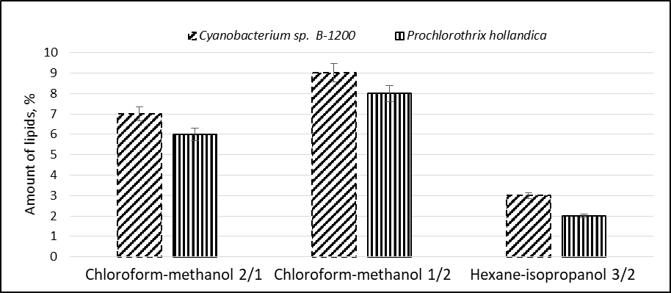
Figure 9 - The amount of lipids in different extraction methods

As can be seen from Fig. 9, the highest lipid yield of 90 mg/g and 80 mg/g dry matter of Cyanobacterium sp. IPPAS B-1200 and Prochlorothrix hollandica biomass were respectively observed during the extraction of biomass with a mixture of chloroform: methanol in a ratio of 1:2 according to the Bligh and Dyer method.
When analyzing the obtained results, it is possible to conclude that the use of the Bligh and Dyer method provides the maximum extraction of lipids and biomass of the studied strains. It was established that the extraction of lipids from the cells of Cyanobacterium sp. IPPAS B-1200 and Prochlorothrix hollandica in the presence of chloroform-methanolic mixture(1:2) is optimal, which allows us to recommend this method for obtaining biodiesel based on these strains. At the same time, the highest lipid yield was 9% in the Cyanobacterium sp. IPPAS B-1200.

3.5 Study of the ability to absorb carbon dioxide by cyanobacterial strains - producers of fatty acids

Compared to plants, phototrophic microorganisms have the best ability to absorb CO2 and thus convert it into their own biomass, which can be used to utilize it or reduce its concentration in the atmospheric air while obtaining their useful biomass. At the same time, the assimilation of CO₂ by different types of cyanobacteria can be different, and this fact undoubtedly requires the search for promising cultures of cyanobacteria with a high potential for assimilating carbon dioxide for use in waste-free technologies. To study the ability to absorb carbon dioxide by cyanobacterial strains, we carried out a comparative analysis of the indicators of the cell growth rate in collection strains of cyanobacteria: Cyanobacterium sp. IPPAS B-1200, Desertifilum sp. IPPAS B-1220, Cyanobacterium aponium IPPAS B-1201 and Synechococcus elongatus 7942 under the influence of various CO₂ concentrations.
For this, cyanobacterial cells were grown in flasks under artificial illumination with a light intensity of 300 μmol/m²/sec and aeration with a gas-air mixture containing 5%, 10%, 15%, 20% CO₂ for 8 days; in the control variant, the cyanobacterial biomass was aerated with conventional air a mixture with a carbon dioxide content of 0.03%. The productivity of cyanobacteria was assessed by the change in the optical density of cells, the measurement of this indicator was carried out every 24 hours. The initial optical density in all variants of the experiment and control was OD₇₂₀ = 0.03. According to the results obtained, the saturation of the medium with carbon dioxide as a whole significantly accelerated the growth of cyanobacterial cells; however, as expected, the species-specific response of cyanobacteria to various carbon concentrations was observed.
Thus, a relatively rapid growth from the first day of cultivation was observed in the Cyanobacterium sp. IPPAS B-1200. The growth rate coefficient of 0.92 for this culture was recorded on the 6th day of the experiment at a concentration of 10% CO₂. For the strain Desertifilum sp. IPPAS B-1220 the maximum growth rate among all variants of the experiment was also observed when the medium was enriched with 10% CO₂. The increase in cell numbers for the other two strains, Cyanobacterium aponium IPPAS B-1201 and Synechococcus elongatus, was characterized by a slower rate compared to the previous strains. In this case, the optimal concentration of СО₂ for their growth was 5%. The growth rate coefficients for them at a given CO₂ concentration were 0.51 - 0.62, respectively. The calculated data of the growth rate coefficients for cyanobacteria are presented in Figure 10.
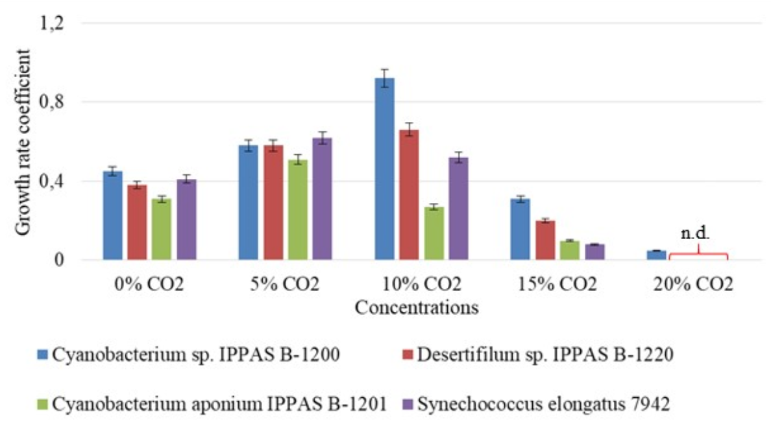 Abbreviation: n.d. - not detected
Figure 10 - The influence of different concentrations of carbon dioxide on the growth of the studied strains of cyanobacteria

Our results are consistent with published data and indicate the existing differences in the attitude to CO2 of the studied strains of cyanobacteria. [50-54].
However, it should be noted that for the cultures studied by us under the conditions of the supply of a significantly high concentration of carbon dioxide in the medium (80%), a strong inhibition of the growth of all studied strains was recorded as compared with the control. Despite a slight increase in the number of cyanobacterial cells on the first day, after 3 days, the onset of the phase of death of the cell cycle was observed in all strains. Thus, phototrophic microorganisms, despite the fact that they need carbon sources, have different tolerances to carbon dioxide. Undoubtedly, high concentrations of CO₂ can affect the pH of the chloroplast stroma and, consequently, lead to inhibition of the process of photosynthesis, as well as cause various other negative processes leading to the cessation of growth and often to the death of crops [55].
Thus, according to our results, the optimal CO₂ concentration for the cultivation of cyanobacteria Cyanobacterium sp. IPPAS B-1200 and Desertifilum sp. IPPAS B-1220 was 10%, for the Cyanobacterium aponium IPPAS B-1201 strain the optimal value was 5%.

3.6 Development of technology for mass cultivation of cyanobacterial strains - producers of fatty acids in municipal wastewater to obtain biomass

3.6.1 Determination of optimal wastewater concentrations for the growth of cyanobacterial strains - producers of fatty acids

It is known that the combination of water purification and the consumption of flue gases, including carbon dioxide, with the production of cyanobacteria and microalgae biomass will significantly improve the environmental friendliness and efficiency of the process of obtaining biomass of a biodiesel producer.
For this purpose, in our experiment we used municipal wastewater from the Sorbulak storage pond. The Sorbulak reservoir is a natural closed basin located in the north-western part of the city of Almaty, used for collecting, post-treatment and storage of municipal wastewater in the city. To assess the effect of wastewater on the growth indicators of cyanobacteria, 4 variants of experimental samples were prepared containing pre-filtered and sterilized wastewater and a nutrient medium in various ratios, and BG-11 medium was used as a control. According to the results of the previous experiment, 3 strains were selected, which were distinguished by the highest growth rates under conditions of high CO₂ concentrations. Thus, the studied cultures of cyanobacteria were grown on five different media (see Materials and Methods) with an initial density of OD₇₂₀ = 0.03 units for 14 days (Figure 11). CO₂ was added based on the results of preliminary studies. In all variants for the strains Desertifilum sp. IPPAS B-1220 and Cyanobacterium sp. IPPAS B-1200 - 10% CO₂ concentration in air was 10% and for Cyanobacterium aponium IPPAS B-1201 - 5%.
The results obtained indicate that wastewater in a certain ratio can be effectively used as a nutrient medium for the accumulation of cyanobacterial cells with simultaneous bioremediation.
In variants of experiment No. 4 and No. 5, with the ratios of wastewater to the nutrient medium 25:75 and 50:50, active growth of all studied strains of cyanobacteria was observed. Thus, the highest indicators of the growth rate coefficient were observed in the Cyanobacterium sp. IPPAS B-1200 and were 0.9 and 0.8 in these experimental variants, respectively. For the strain Desertifilum sp. IPPASB-1220 these parameters were between 0.7 and 0.6. Comparatively lower indices of the growth rate coefficient were noted for the Cyanobacterium aponium IPPAS B-1201 strain - 6.5 and 5.7, respectively. An increase in wastewater in the experimental sample up to 75% significantly reduced the growth of cyanobacterial cells, as in experimental variant 2, where pure wastewater was used for their cultivation. As is known, in addition to biogenic elements, wastewater can also contain various toxins, including surfactants, oil products and other compounds of unknown nature, the presence of which inhibits the growth of phototrophic microorganisms [56]. Therefore, dilution of wastewater with water or a nutrient medium reduces its toxic properties, and dilution with a nutrient medium also supplements the elements necessary for nutrition. All this undoubtedly has a positive effect on the growth of cyanobacteria.
Thus, the ratio of wastewater to nutrient medium, the most optimal for the growth of the studied cyanobacteria, were 25:75 and 50:50.
It was found that the most active growth in all experimental variants among the studied cyanobacteria was characteristic of the Cyanobacterium sp. IPPAS B-1200.

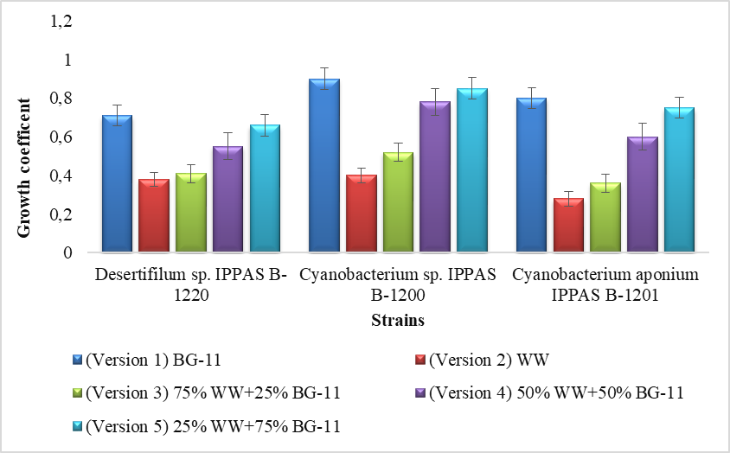
Figure 11 - Growth of cyanobacteria during cultivation in wastewater with diluted BG-11 nutrient medium in different proportions. Abbreviation: WW - wastewater, BG-11 - BG-11 medium

In order to determine the capabilities of cyanobacteria in the purification of this wastewater, the physicochemical composition of the water was analyzed before and after cultivation in it of the most active among the tested cultures, the strain Cyanobacterium sp. IPPAS B-1200 in experimental variants 2 (wastewater - WW) and 4 (wastewater and nutrient medium - WW + NM, in a ratio of 50:50) (Table 2).

Table 2 - Physicochemical composition of wastewater before and after cultivation in it of the strain Cyanobacterium sp. IPPASB-1200
Defined characteristic | Unit of measurement | Wastewater |  |  | 50NM+50WW
Defined characteristic | Unit of measurement | Before cultivation | After cultivation | Treatment,  % | Before cultivation | After cultivation | Treatment,  %
рН | - | 7,8 | 7,4 | 76% | 7,2 | 7,0 | 100%
Suspended substances | mg/l | 58 | 14,64 | 73% | 41 | 2,7 | 95%
Smell | points | 5 | 1,5 | 80% | 3,9 | 0,1 | 95%
BOD₅ | mg/l | 56 | 12,28 | 77% | 43 | 1,2 | 100%
COD | mg О₂/l | 33,5 | 8,5 | 86% | 31,5 | 7,9 | 92%
Oxidizability | mg О₂/l | 38 | 7,6 | 85% | 24 | 0,01 | 100%
Ammonia | mg/l | 14,9 | 2,7 | 76% | 4,9 | 0,12 | 100%
Nitrites | mg/l | 0,65 | 0,15 | 79% | 0,9 | 0,04 | 100%
Nitrates | mg/l | 0,97 | 0,24 | 63% | 1,5 | 0,2 | 95%
Phosphates | mg/l | 3,9 | 0,3 | 66% | 34,6 | 0,7 | 92%
Calcium | mg/l | 50,9 | 8,6 | 79% | 70,6 | 5,6 | 97%
Magnesium | mg/l | 14,81 | 3,9 | 69% | 44,5 | 2,6 | 95%
Chlorides | mg/l | 50,7 | 17,5 | 80% | 68 | 6,8 | 93%
Sulphates | mg/l | 59,17 | 11,2 | 76% | 75,6 | 9,2 | 90%
Hydrocarbonates | mg/l | 536,45 | 20,12 | 80% | 595 | 18,6 | 96%
Mineralization | mg/l | 540 | 95,3 | 74% | 760 | 86,3 | 100%
Iron | mg/l | 0,21 | 0,013 | 80% | 0,18 | 0,005 | 100%
Copper | mg/l | 0,008 | 0,005 | 75% | 0,0075 | 0,0006 | 100%
Zinc | mg/l | 0,07 | 0,021 | 70% | 0,043 | 0,002 | 100%

The results obtained indicate that the cultivation of the cyanobacteria Cyanobacterium sp. IPPASB-1200 on wastewater from the storage tank reduces the concentration of organic pollutants and, accordingly, improves the physicochemical properties of water. The percentage of purification in general for individual pollutants is 68-100%, which indicates a high prospect of using wastewater for the cultivation of cyanobacterial strains in order to obtain their biomass and at the same time purify water from pollution.
It should be noted that in experimental variant 2, containing only waste water, despite a significant decrease in the growth rate of the investigated strain, the chemical composition of the water significantly improved, and the percentage of purification for certain groups of pollutants was 68-80%. In experimental variant 4, complete removal of nutrients and an improvement in water quality were observed. Undoubtedly, it can be argued that the additional addition of a nutrient medium to wastewater promotes rapid growth of culture and, accordingly, accelerates the absorption of various water compounds by cyanobacterial cells [57]. An increase in the pH value that occurs during photosynthesis as a result of disturbance of the bicarbonate-carbonate equilibrium is compensated by the introduction of carbon dioxide, which avoids inhibition of the growth of cyanobacteria [58].
Thus, our results indicate the prospects for using the Cyanobacterium sp. IPPAS B-1200 in wastewater purification, the percentage of organic pollutants purification and improvement of physicochemical parameters of water of which has reached 68-100%. It was also found that the most optimal ratio of waste water to nutrient medium for the cultivation of cyanobacteria was 25:75, 50:50.

3.6.2 Determination of lipid content and fatty acid composition of cyanobacterial biomass

It is known that the optimal strain of cyanobacteria suitable for biofuel production must have a number of necessary characteristics, the main ones of which are not only a high level of biomass accumulation, but also lipid productivity (up to 20-40%) and the composition of produced fatty acids, which is optimal for obtaining biodiesel [59]. In this regard, in the next part of this work, the determination of dry weight, total lipid content and analysis of the fatty acid composition of the studied strains of cyanobacteria were performed after cultivation in municipal wastewater. The strains under study were cultivated on wastewater from the Sorbulak storage pond with diluted nutrient medium in a ratio of 50:50, established on the basis of previously performed work as the most optimal medium. Incubation was accomplished for 8 days with an initial density of OD₇₂₀ - 0.03 in all studied cultures. At the end of the incubation time, the biomass was selected for lipid extraction.
Since, due to the different productivity of cyanobacteria, the yield of dry biomass in the studied strains was different, the percentage of lipids in 1 g of dry weight was calculated. The total lipid content and dry biomass yield are shown in Figure 12.

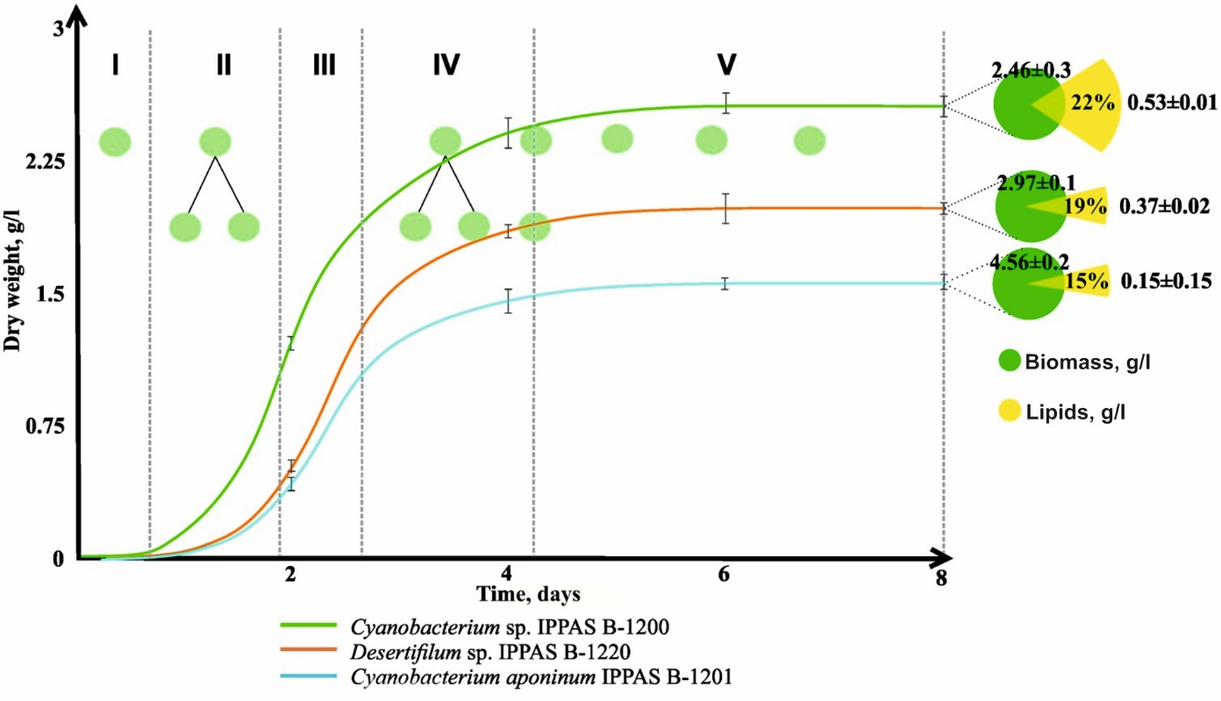
Figure 12 - Growth, dry biomass yield and total lipid content
in the studied cyanobacterial strains

It has been established that the content of lipids in the biomass of cyanobacteria ranges from 15-22% of the dry weight of the biomass. Thus, the highest lipid content is observed in the Cyanobacterium sp. IPPASB-1200 - 22% of dry weight. A good indicator of lipid accumulation (19%) in the biomass was also found in the strain Desertifilum sp. IPPASB-1220. The Cyanobacterium aponium IPPAS B-1201 strain accumulates lipids significantly less, up to 15%.
Further, the content of fatty acids was determined in lipid extracts. During the work, chromatographic profiles were obtained and the content of individual FAs in cyanobacteria Desertifilum sp. IPPAS B-1220, Cyanobacterium sp. IPPAS B-1200 and Cyanobacterium aponium IPPAS B-1201 (Table 3).

Table 3. FA composition of cyanobacterial lipids
Fatty acids | Mass fraction of fatty acids,%
Fatty acids | Cyanobacterium sp. IPPAS B-1200 | Cyanobacterium aponium IPPAS B-1201 | Desertifilum sp. IPPAS B-1220
12:0 | 0,1 | 0,1 | -
14:0 | 30 | 30,8 | 0,4
14:1∆9 | 8,6 | 3,1 | -
15:0 | 1,5 | - | -
16:0 | 16,5 | 13,1 | 23,0
16:1∆7 | 0,3 | 0,4 | 3,5
16:1∆9 | 37,3 | 41,5 | 0,7
16:1∆11 | 0,3 | - | -
16:2∆7,10 | - | - | 40,0
17:1∆10 | 0,1 | -
18:0 | 1,5 | 1,5 | 1,5
18:1∆9 | 0,1 | 3,4 | 3,3
18:1∆11 | 0,9 | - | 0,5
18:2∆9,12 | 0 | - | 26,0
The amount of saturated fatty acids,% | 48,0 | 45,4 | 25,9
Fatty acid content, mg/g dry weight | 59,6 | 52,2 | 51,9

The results of determining the mass fraction of fatty acids in the cells of the strains of the studied cyanobacteria are presented in Table 3. Analysis of total lipids showed the presence of 14 basic FAs with a carbon chain length from 14 to 18 atoms.
It was determined that only saturated and monounsaturated FAs are present in the lipids of strains of the gender Cyanobacterium. While in the cells of the strain Desertifilum sp. IPPAS B-1220, in addition to these acids, diene FAs were also synthesized. Of the saturated fatty acids in the studied species, myristic, palmitic and stearic acids were found. Unsaturated monoenoic acids are represented by myristooleic, palmitoleic, oleic, cis-vaccenic acids. As a result of the studies, it was found that of the three cultures studied, the strains of the gender Cyanobacterium were characterized by approximately the same composition of fatty acids and significantly exceeded the strain of Desertifilum sp. IPPASB-1220 by the content of saturated and monounsaturated FA with an average chain length from C₁₄ to C₁₈, which are of great interest for the production of biodiesel. It is known that biofuel containing compounds with a large number of saturated bonds is more resistant to oxidation, and when it burns, glycerin does not polymerize, which increases the reliability of engines. Despite the insignificant difference in fatty acid composition, the strain Cyanobacterium sp. IPPAS B-1200 was selected as a promising candidate for biofuel production for further experiments, because it was characterized by a higher growth rate in wastewater and high CO₂ concentration, respectively, an active accumulation of biomass and lipids. However, it should be noted that Cyanobacterium aponium IPPAS B-1201 is promising, the fatty acid composition of which also allows us to consider them as a feedstock for biofuel production. It is allowed to consider the possibility of obtaining biodiesel by cultivating these strains both in monoculture and in mixed culture.
Thus, during the work, it was established that the lipid content in the biomass of cyanobacteria ranges from 15-22% of the dry weight of the biomass. It was also determined that of the three cultures studied, the strains of the gender Cyanobacterium were characterized by approximately the same composition of fatty acids and significantly exceeded the strain of Desertifilum sp. IPPASB-1220 by the content of saturated and monounsaturated FA with an average chain length from C14 to C18, which are of great interest for the production of biodiesel.

3.7 Development of technology for the production of biodiesel fuel based on strains of cyanobacteria - producers of fatty acids

3.7.1 Semi-continuous cultivation of Cyanobacterium sp. IPPAS B-1200 and obtaining methyl esters of fatty acids in laboratory conditions

At the next stage, mass cultivation of the Cyanobacterium sp. IPPAS B-1200 in laboratory conditions was performed and the volume of the obtained biomass and methyl esters of fatty acid was recorded. In this case, further scaling of the fermentation process was carried out by a semi-continuous (quasi-continuous) method of cultivation in a photobioreactor of a larger volume (100 L). The main task of this scaling was not only to maintain a high yield of biomass and, accordingly, target metabolites, but also to increase it due to the duration of cyanobacteria cultivation with a reduction in the time of the adaptation period, which is economically feasible in the production of biodiesel.
Thus, the cultivation of cells of the strain Cyanobacterium sp. IPPAS B-1200 was executed for 28 days under optimal conditions determined in previous experiments. At the same time, after obtaining accumulative biomass in order to reduce the effect of cell inhibition by metabolic products and deficiency of substrate, 2/3 of the culture liquid was selected and the suspension was fed with the same volume of fresh medium (50/50) every 4 days. The exposure time for obtaining accumulative biomass was 8 days, while the optical density (OD₇₂₀) increased from - 0.3 to 1.53 ± 0.08. Then, upon selection and dilution of the culture liquid, the optical density decreased to 0.52 ± 0.05, followed by an increase in biomass in the next 92 hours again to the optical density of 1.52 ± 0.05. The dilution procedure was performed 5 times throughout the experiment. As can be seen from the results obtained, the dynamics of culture growth after dilution repeated the previous dynamics and was characterized by fluctuations in the concentration of microorganisms about the same constant value with a constant average specific population rate (Figure 13). As a result, continuous growth of the culture in the photobioreactor was observed, with the extension of the exponential phase and the phase of linear growth of the cell cycle, without transition to the stationary growth phase. Cell biomass was removed in the logarithmic phase and dried.

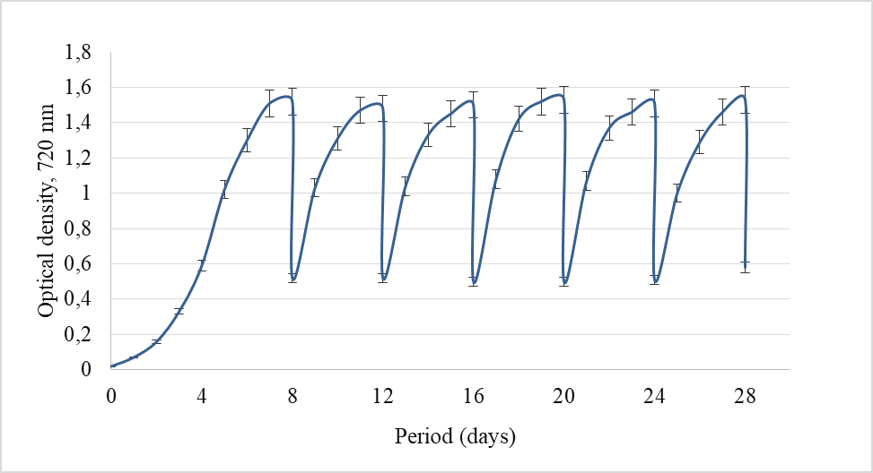
Figure 13 - Intensive cultivation (50% wastewater + 50% BG-11, 10% CO₂) of the Cyanobacterium sp.IPPAS B-1200 strain in a laboratory photobioreactor

So for the experimental period (28 days) the yield of dry biomass was 1074.85 ± 0.087 g per 100 l of suspension volume.
Further, we obtained methyl extracts of fatty acids from the obtained biomass using a mixture of solvents hexane-isopropanol. According to the results obtained, the yield of FA methyl esters (biodiesiel) was 94.7% from the volume of 248.29 ± 2.11 g of the biomass of the strain Cyanobacterium sp. IPPAS B-1200, which in recalculation is 0.21 ± 0.013 g/l per 1 g of dry biomass (Table 4).

Table 4. The content of lipids and methyl esters of FA in the biomass of the strain Cyanobacterium sp. IPPAS B-1200
Strain | Dry biomass (g/PBR*/28 days) | The amount of lipids (g/PBR/28 days) | Total lipid content (% per DW) | The amount of MEFA (g/PBR/28 days) | The amount of MEFA  (% на DW)
Cyanobacterium sp. IPPAS B-1200 | 1074,85 ±5,62 | 248,29±2,11 | 23,1 | 235,13±3,11 | 94,7
*Volume PBR is 100 l
Abbreviation: DW-dry weight

Thus, as a result of mass cultivation in a semi-continuous way in laboratory conditions, the strain of Cyanobacterium sp. IPPAS B-1200, characterized by a high accumulation of lipids and a fatty acid composition, suitable for the production of biodiesel, has been shown to be capable of producing methyl esters of FA. The total content of methyl esters of FA to the total lipid content was 94.7%.

3.7.2 Economic efficiency of producing biodiesel from cyanobacteria using waste-free technology

When conducting economic research, we made calculations of the costs of chemical elements of the BG-11 nutrient medium when cultivating cyanobacteria for 28 days in an industrial photobioreactor with a total yield of 1 ton of dry biomass, which averaged 166 920 tenge (tg). Accordingly, replacing 50% of this nutrient medium with wastewater can save 83 460 tg. In addition, given that phototrophic microorganisms are capable of fixing carbon dioxide in a volume of ~ 0.5 g CO₂/l/day, a cyanobacterial culture grown in a 1 ton photobioreactor is capable of absorbing 14 kg CO₂ over a full cultivation period of 28 days (500 g of carbon dioxide during photosynthesis per day) [60-63]. According to the calculations of scientists from Stanford Uinversity (Stanford), if the price of 1 kg of CO₂ is 941 tg, then the costs for 14 kg will be 13182 tg. Therefore, the use of CO₂ collected from production points for cultivation will undoubtedly save these costs, reducing the price of biodiesel by 390 tg per liter.
Thus, based on the above calculations, by replacing 50% of the nutrient medium for cyanobacteria with wastewater and supplying CO2 collected from production points, we reduce the cost of cultivating the biodiesel producer strain and thereby reduce the cost of biodiesel production by 98 525 tg. For example, biodiesel (B20) costs 1 236 tg per gallon. However, biodiesel obtained from cyanobacteria meets the B100 purity standard, so our economic calculations were made at the price of high quality biodiesel. According to the USA Department of Energy 2020, the cost of biodiesel that complies with the B100 purity standard (B99-B100) is 1 802 tg per gallon [64], which in terms of 1 liter of biodiesel is equal to 475 tg, which we have chosen as the initial cost for economic calculations (Table 5).

Table 5. Economic forecast analysis of the production of environmentally friendly biofuel - biodiesel based on the strain of Cyanobacterium sp. IPPAS B-1200
Name  Nut.medium | DW, g/l | Cost of 1 nutrient, tg/t/28 d | CO₂, kg/t/28 d |  |  | Biodiesel, l/t/28 d |  |  | Biodiesel price, tg
Name  Nut.medium | DW, g/l | Cost of 1 nutrient, tg/t/28 d | Absorption, kg | Cost, tg | Cost, tg (industrial CO₂) | Quantity, l/t cells | Quantity, l/ 2/3PBR ²/28d | Profit, tg 2/3PBR²/28d | Primary | After CO₂ purification
BG-11 | 3,0 | 166920 | 42 | 39547 | 0 | 0,75 | 1,99 | 945 | 475 | 433
25%BG-11+75% WW | 3,1 | 54784 | 43,4 | 40865 | 0 | 0,77 | 2,05 | 971 | 454 | 411
50% BG-11+50% WW | 3,4 | 83460 | 47,6 | 44820 | 0 | 0,88 | 2,34 | 1112 | 433 | 390
*¹ Calculated nutrient prices
*² PBR - 666.3 L
*³ Price for 1 liter of biodiesel 475 tg

As a result of the preliminary calculations, the estimated price for 1 liter of biodiesel may be 390 tg. It should be noted that the cost of a diesel engine obtained by the traditional method today is 342 tg per 1 liter.
Considering the fact that the difference in the price of diesel and biodiesel is not too large, as well as the positive trend of reducing the cost of biodiesel over the past 10 years, scientific research in this area is very relevant and necessary.

3.8 Sequencing of genomes of cyanobacteria - producers of fatty acids

The analysis of the fatty acid composition of the total lipids of Cyanobacterium cells using gas-liquid chromatography in tap with mass spectrometry (GLC-MS) showed a high content of myristic acid - 14:0 and myristoleic acid - 14:1^{Δ9} (30% and 10% of the total fatty acids, respectively) (section 3.3), what is rare for cyanobacteria [65]. In addition, it was found that the production of eco-friendly biodiesel on the bases of Cyanobacterium sp. IPPAS B-1200 strain is much more economical than traditional sources. In this regard, it is advisable to study this strain of cyanobacteria at the genomic level.
The purpose of this work was to determine the nucleotide sequence of the cyanobacterium genome Cyanobacterium sp. IPPAS B-1200.
For the sequencing of the cyanobacterium genome Cyanobacterium sp. IPPAS B-1200, the culture was preliminarily cultivated on a nutrient medium Zarruk at a temperature of 30˚C, constant illumination with an intensity of 110 µE∙m⁻ ²∙s⁻ ¹ and aeration of a sterile gas-air mixture enriched with CO₂ up to a concentration of 1.5%. The cells were grown under these conditions to an optical density of OP₇₅₀ = 1-2, after which DNA was extracted. An electrophoregram of the genetic DNA of the studied strain is shown in Fig. 14.

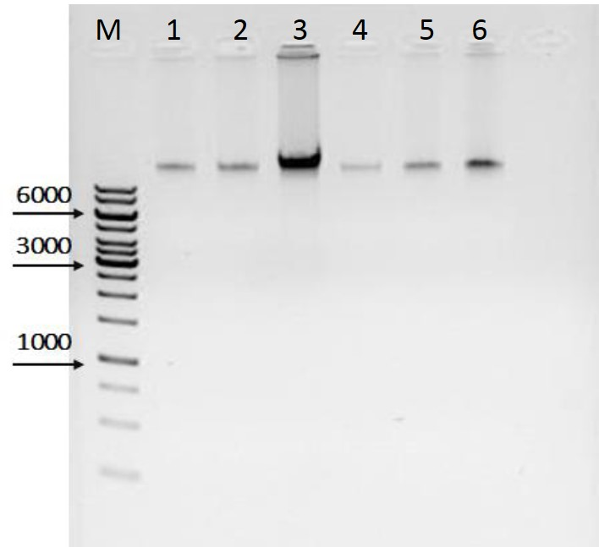
Designations: M - molecular weight detector, 1-3 - the first sample (30, 60, 100 ng DNA, respectively); 4-6 - the second sample (30, 60, 100 ng DNA, respectively)
Figure 14 - Electrophoregram of the genomic DNA of the cyanobacteria Cyanobacterium sp. IPPAS B-1200

As can be seen in Figure 14, the provided genetic DNA samples do not contain significant PNA or degraded DNA.
The isolated DNA was used as a matrix for the preparation of a genomic DNA library for sequencing. Despite the incomplete loading of the chip, the distribution of the read length corresponds to the optimum and sufficient for the assembly of a full genome.
The total volume of received information is 444 m.bp. With the size of the genome of the order of 4 m.bp., the value of the cover is more than 100 times. This coating ensures the accuracy of the sequencing results. Then, the genome was assembled using the accemblepa SPAdes version 3.1.0. Assembly parameters: -k 21,33,55,77,99,127, -s, --iontorrent. During genome-wide sequencing, individual short nucleotide sequences of the cyanobacteria genome Cyanobacterium sp. IPPAS B-1200 were collected in contigue. The data obtained showed that the estimated genome size of the studied strain is 3,410 t. p. o., the number of contigs is 119, the average coverage is 200×, N50 = 80222 bp, the proportion of HZ bases in the genome is 37.7% (according to this Quast 3.0).
As a result of our work, we received a so-called "black" gene. It represents its own set of DNA contigs (separate fragments). It is believed that it is unique DNA sequences that are "collected" in the first place, and not repeated sections, so among such a set of fragments, there is a high probability that genes of interest for research will also be found.
Thus, in the result of the work was sequenced de novo the genome of a cyanobacterium strain Cyanobacterium sp. IPPAS B-1200. It was found that the genome size of the studied strain is about 3.4 million bp, the number of contigs is 119, the average coverage is 200×, N50 = 80222 bp, and the proportion of HZ bases in the genome is 37.7%. The source data (SRA) is available under the number SAMN04633587. Specific nucleotide sequences are available in the international GeneBank database under the numbers KM502966 (sequence 16S RNA) and LWHC00000000 (PGAP). The annotated genome of Cyanobacterium sp. IPPAS B-1200 is also available in the international database under the numbers PRJNA318169 (BioProject) and SAMN04633587 (BioSample).

3.9 Annotation and characterization of the genomes of cyanobacteria - producers of fatty acids
As a result of annotation of genome Cyanobacterium sp. IPPAS B-1200 was established that the total length of the ring chromosome of the studied strain is 3 410 249 base pairs. The genome contains 137 pseudogenes, 4 rRNA-coding genes, 40 tRNA-coding genes, 4 genes of non-coding RNAs, and 2934 protein-coding genes.
Found 4 rRNA - coding genes, provided with three 16S RNA and one 23S RNA. The number of genes encoding tRNA in the genome of Cyanobacterium sp. IPPAS B-1200 is considered sufficient for the recognition of all codes for a given strain. Also, when annotating the genome of the B-1200 strain, 2 CRISPR sites were found (CRISPR loci and cas-CRISPR operons interact to form an inherited adaptive immune system found in many bacteria and most archaea). The total number of potential protein-coding genes is 2934, which takes 94% of the total genome. The full names of all protein-coding genes are listed in the GeneBank with the input number LWHC00000000. Among 2934 protein-coding genes, 1460 (49.8%) were homologous to genes with a well-known function, 1088 (37.1%) showed similarity to genes coding hypothetical proteins and 384 (13.1%) had no similarity to any registered genes. All 2934 genes were classified into 17 categories, according to their biological roles. Table 6 shows the distribution of all protein-coding genes into the appropriate functional categories.

Table 6 - Functional analysis of protein-coding genes of the Cyanobacterium sp. IPPAS B-1200
strain
Functional categories of identified genes | Number of genes
1 | 2
Biosynthesis of amino acid | 89
Continuation of table 6
1 | 2
Biosynthesis of cofacters, prosthetic groups and transmitters | 87
Cellular shell | 50
Cellular processes | 75
Central Metabolism | 29
Energy exchange | 110
Lipid and fatty acid metabolism | 41
Photosynthesis and Breathing | 121
Purines, pyrimidines, nucleosides and nucleotides | 36
Regulatory functions | 123
Replication, reduction, recombination and DNA repair | 83
Transcription | 48
Translation | 147
Transport and binding proteins | 167
Other categories | 254
Hypothetical proteins | 1088
Function unknown | 384
Total | 2934

According to the data shown in table 6, in the Cyanobacterium sp. IPPAS B-1200 strain 121 genes involved in various processes of photosynthesis were identified based on homology with known photosynthetic genes.
Thus, as a result of this work, in the studied strain 2934 protein-coding genes were obtained, which were classified into 17 categories, in compatibility with their biological roles. The obtained results will be applied in further research in genetic engineering, namely in the work on modification of fatty acid genes, to increase the productivity of the Cyanobacterium sp. IPPAS b-1200 strain in the production of biodiesel.

CONCLUSION

According to the calendar plan for the reporting period, a technology was developed for mass cultivation of cyanobacterial strains - producers of fatty acids in municipal wastewater to obtain biomass and produce biodiesel fuel based on them. At the same time, the selection of the optimal CO₂ concentration and the ratio of wastewater and nutrient medium for the growth of cyanobacteria was performed, their ability to wastewater treatment was determined; the total lipid content in their biomass was determined and the FA composition was studied. The possibilities of cyanobacteria in obtaining biofuel with their simultaneous use in the processes of wastewater treatment and CO₂ utilization are also considered.
The availability of information about the fully sequenced genome of cyanobacteria allows us to study the problems of structural and functional genomics of photosynthetic organisms. Information about the structural and functional organization of genomes is of practical importance for the development of breeding and genetic engineering methods. The first time the nucleotide sequence of the Cyanobacterium sp. IPPAS B-1200 genome was determined, its bioinformatic analysis was performed, and the genes involved in lipid and FA metabolism were identified.
The results allow us to draw the following conclusions:
- A total of 135 different species and varieties of cyanobacteria were found in water samples from hot springs, bioponds of the fish farm “TengryFish”, the Beskaynar and Kyzylkairat rivers, the rivers of the Enbekshikazakh region and rice fields of the Baghlan province.
- Two axenic cultures of cyanobacteria were isolated from soil samples of rice fields in Baghlan province (Afghanistan), on the basis of morphological and cultural properties identified as Anabaena variabilis R-I-5 and Nostoc calsicola RI-3.
- As a result of productivity screening, collection strains of Cyanobacterium sp. IPPAS B-1200, Cyanobacterium aponium IPPAS B-1201 and the isolated strain Anabaena variabilis R-I-5, characterized by relatively high growth rates, fluorescence, biomass yield and total lipids, were selected.
- It was shown that the cultures selected during the screening have an intensive growth in option 3 (wastewater from a water utility with a nutrient medium in a ratio of 1:1). At the same time, the highest growth rate is in the collection strain Cyanobacterium sp. IPPAS B-1200 - 0.48, for Cyanobacterium aponium IPPAS B-1201 - 0.43.
- It was found that as a result of the cultivation of experimental cultures of cyanobacteria on wastewater from a water utility after biological treatment, it was possible to reduce the concentration of organic pollutants and physicochemical indicators by an average of 94.3%.
- It was revealed that a large number of C14 FA next to C16 FA were supplied in the strain Cyanobacterium sp. B-1200 - saturated myristic and monounsaturated myristoleic acids - in the amount of 40%. The same high content of C14 FA was found in the cyanobacteria Prochlorothrix hollandica - in the amount of about 31% relative to other studied cyanobacteria.
- It was found that the extraction of lipids from cells of cyanobacteria Cyanobacterium sp. IPPAS B-1200 and Prochlorothrix hollandica in the presence of chloroform-methanolic (1:2) mixture is optimal, which will allow to recommend this method when production biodiesel.
- It was found that the optimal concentration of CO₂ for the cultivation of Cyanobacterium sp. IPPAS B-1200 and Desertifilum sp. IPPAS B-1220 was 10%, and the optimal value for the Cyanobacterium aponium IPPAS B-1201 strain was 5%.
- The perspectives of using the strain Cyanobacterium sp. IPPAS B-1200 in wastewater treatment was represented, the percentage of organic pollutants purification and improvement of the physicochemical parameters of water up to 68-100%. The ratio of wastewater to nutrient medium, optimal for the cultivation of cyanobacteria, has been determined - 25:75, 50:50.
- It has been shown that as a result of mass cultivation in a semi-continuous way in laboratory conditions of the strain Cyanobacterium sp. IPPAS B-1200 the total content of methyl esters of FA to the total lipid content was 94.7%.
- Preliminary calculations have determined that by replacing 50% of the nutrient medium with wastewater and replacing carbon dioxide obtained by the traditional method with CO₂ extracted from thermal power stations, the cost of biodiesel can be reduced by 85,6 tenge. The estimated price of biodiesel in this case will be 390 tenge per liter.
- It has been established that the size of the genome of the strain Cyanobacterium sp. IPPAS B-1200 contains 3410249 base pairs, number of contigs - 119, average coverage was 200×, N50 = 80222 bp, for HZ bases in gen. - 37.7%.
- It has been shown that the genome of the strain Cyanobacterium sp. IPPAS B-1200 contains a total of 3119 genes, of which 2934 protein-coding genes, 137 pseudogenes, 4 rRNA-coding genes, 40 tRNA-coding genes, 4 non-coding RNA genes, and 2 CRISPR sites were also found in the genome.
- It was shown that among 2934 protein-coding genes, 1460 (49.8%) were homologous to genes with a known function, 1088 (37.1%) showed similarity with genes encoding hypothetical proteins, and 384 (13.1%) had no similarity with any registered genes. All genes were classified into 17 categories, according to their biological roles.
- The results obtained allow us to recommend Corynebacterium sp. IPPAS B-1200 and Desertifilum sp. IPPAS B-1220 strains both for bioremediation of municipal wastewater and carbon dioxide utilization, as well as for obtaining biomass for the production of biodiesel.
- Obtained the patent for utility model "a Photobioreactor for the cultivation and screening of phototrophic microorganisms". № 4566, 19.12.2019.
Assessment of the completeness of the solution of the tasks. All the tasks were completed.
Recommendations. The results obtained allow us to recommend the strains of Cyanobacterium sp. IPPAS B-1200 and Desertifilum sp. IPPAS B-1220 both in bioremediation of municipal wastewater and carbon dioxide utilization, as well as for biomass production for the production of biodiesel.
Assessment of the technical and economic efficiency of implementation.
The obtained data on the fully sequenced genome of Cyanobacterium SP. IPPAS B-1200 allows us to study the problems of structural and functional genomics of photosynthetic organisms. As a result of research work, a patent was obtained for the utility model "Photobioreactor for growing and screening phototrophic microorganisms". № 4566, 19.12.2019.
The results were implemented in the educational process at the Department of biotechnology of the al-Farabi Kazakh national University, in the course "Bioenergetics of phototrophic microorganisms", 1st year of PhD doctoral studies in the specialty"6D070100-biotechnology".

REFERENCES

- Khetkorn W., Baebprasert W., Lindblad P., Incharoensakdi A. Redirecting the electron flow towards the nitrogenase and bidirectional Hox-hydrogenase by using specific inhibitors results in enhanced H₂ production in the cyanobacterium Anabaena siamensis TISTR 8012 // Bioresource technology. – 2012. – Vol. 118. -P. 265–71.
- . Rodionova M.V., Poudyal R.S., Tiwari I., Voloshin R.A., Zharmukhamedov S.K., Nam H.G., Zayadan B.K., Bruce B.D., Hou HJM., Allakhverdiev S.I. Biofuel production: Challenges and opportunities // Int J Hydrogen Energy. – 2017. – Vol.42. – P.8450–61.
- Kossalbayev, B.D., Tomo, T., Zayadan, B.K., Sadvakasova, A.K., Bolatkhan, K., Alwasel, S., Allakhverdiev, S.I. Determination of the potential of cyanobacterial strains for hydrogen production // International Journal of Hydrogen Energy.- 2020.- Vol.45 (4). - P. 2627-2639.
- Bolatkhan K, Kossalbayev BD, Zayadan BK, Tatsuya Tomo, Veziroglu TN, Allakhverdiev SI. Hydrogen production from phototrophic microorganisms: Reality and perspectives // Int J Hydrogen Energy. – 2019. -Vol. 44. - P.5799–811.
- J. Sheehan, T. Dunahay, J. Benemann, and P. Roessler A look back at the US Department of Energy’s Aquatic Species Program - Biodiesel from algae // Tech. Rep. NREL/TP. – 1998. –P. 580.
- Sadvakasova AK, Kossalbayev BD, Zayadan BK, Bolatkhan K, Alwasel S, Najafpour MM, Tomo T, Allakhverdiev SI. Bioprocesses of hydrogen production by cyanobacteria cells and possible ways to increase their productivity // Renewable and Sustainable Energy Reviews. – 2020. -Vol.133. -P.110054.
- Zeng, X., Danquah, M.K., Chen, X.D., Lu, Y., Microalgae bioengineering: From CO₂ fixation to biofuel production // Renewable and Sustainable Energy Reviews. – 2011. – Vol. 15. – P. 3252–3260.
- Asemgul K. Sadvakasova, Nurziya R. Akmukhanova, Kenzhegul Bolatkhan, Bolatkhan K. Zayadan, Aizhan A. Usserbayeva, Meruert O. Bauenova, Akbota E. Akhmetkaliyeva, Suleyman I. Allakhverdiev, Search for new strains of microalgae-producers of lipids from natural sources for biodiesel production // International Journal of Hydrogen Energy. -2019. – Vol.44 (12), - P. 5844-5853.
- Ghasemi, Y., Rasoul-Amini, S., Naseri, A., Montazeri-Najafabady, N., Mobasher, M., &Dabbagh, F. Microalgae Biofuel Potentials (Review) // Journal of Applied Biochemistry and Microbiology. - 2012. – Vol.48 (2). – P.126-144.
- Brennan L. and Owende P., Biofuels from microalgae—a review of technologies for production, processing, and extractions of biofuels and co-products // Renewable and Sustainable Energy Reviews. – 2010. - Vol.14. – P.557–577.
- Hankamer, B., Lehr, F., Rupprecht, J., Mssgnug, J.H., Posten, C., Kruse, O. Photosynthetic biomass and H2 production by green algae: from bioengineering to bioreactor scale-up // Physiol. Plant. – 2007. – Vol.131. - P.10–21.
- Griffiths M.; Harrison S. Lipid productivity as a key characteristic for choosing algal species for biodiesel production // J. Appl. Phycol. – 2009. – V. 21 - Р. 493–507.
- Sarsekeyeva F., Zayadan B.K., Usserbaeva A., Bedbenov V.S., Sinetova M.A., Los D.A., Cyanofuels: biofuels from cyanobacteria: Reality and perspectives // Photosynth. Res. – 2015.-V. 125, (1-2).-P. 329-340.
- Sevgi Ertuğrul Karatay and Gönül Dönmez Microbial oil production from thermophile cyanobacteria for biodiesel production //Applied Energy. – 2011. - Vol. 88(11). - P.3632-3635.
- I Rawat, R. Ranjith Kumar, T. Mutanda, and F. Bux, Dualrole of microalgae: phycoremediation of domestic wastewater and biomass production for sustainable biofuels production,” // Applied Energy. – 2011. - Vol. 88(10). - P. 3411–3424.
- Schenk P., Thomas-Hall S., Stephens E., Marx U., Mussgnug J., Posten C. et al. Second generation biofuels: high-efficiency microalgae for biodiesel production // BioEnergy Res. – 2008. – V.1. – P.20–43.
- Xianhai Zeng, Michael K. Danquah, Xiao Dong Chen, Yinghua Lu, Microalgae bioengineering: From CO2 fixation to biofuel production // Renewable and Sustainable Energy Reviews. – 2011. – Vol. 15. – P. 3252-3260.
- Gademann and Portmann C. Secondary metabolites from cyanobacteria: complex structures and powerful bioactivities // Curr Org Chem. – 2008. – Vol.12(4). – P. 326-341.
- Bingtao Zhao, Yaxin Su, Process effect of microalgal-carbon dioxide fixation and biomass production: A review // Renewable and Sustainable Energy Reviews. – 2014. – Vol. 31. – P. 121-132.
- Tamme, Rainer & Laing, Doerte & Steinmann, Wolf-Dieter. Advanced Thermal Energy Storage Technology for Parabolic Trough // Journal of Solar Energy Engineering. -2003. – Vol.126. – P.794-800.
- Khan, M. I., Shin, J. H., & Kim, J. D. The promising future of microalgae: current status, challenges, and optimization of a sustainable and renewable industry for biofuels, feed, and other products // Microbial cell factories. - 2018. – Vol.17(1). – P.36.
- Xu, Z., Jiang, Y., Jia, B., & Zhou, G. Elevated-CO2 Response of Stomata and Its Dependence on Environmental Factors // Frontiers in plant science. - 2016. – Vol.7. – P. 657.
- Molazadeh, M., Ahmadzadeh, H., Pourianfar, H. R., Lyon, S., & Rampelotto, P. H. The Use of Microalgae for Coupling Wastewater Treatment With CO₂ Biofixation. // Frontiers in bioengineering and biotechnology. - 2019. – Vol.7. – P.42.
- Yen, Hong-Wei & Ho, Shih-Hsin & Chen, Chun-Yen & Chang, Jo-Shu. CO2, NOx and SOx removal from flue gas via microalgae cultivation: A critical review // Biotechnology journal. - 2015.
- Bita, C. E., & Gerats, T. Plant tolerance to high temperature in a changing environment: scientific fundamentals and production of heat stress-tolerant crops // Frontiers in plant science. - 2013. – Vol.4. – P.273.
- Sinetova, M.A., Sidorov, R.A., Starikov, A.Y., Voronkov, A.S., Medvedeva, A.S., Krivova, Z.V., Pakholkova, M.S., Bachin, D.V., Bedbenov, V.S., Gabrielyan, D.A., Zayadan, B.K., Bolatkhan, K., Los, D.A. Assessment of biotechnological potential of cyanobacteria and microalgae strainsfrom IPPAS culture collection. Biotekhnologiya. – 2019. – Vol.35 (3). - P. 12-29.
- Maria A. Sinetova, Kenzhegul Bolatkhan, Roman A. Sidorov, Kirill S. Mironov, Alexandra N. Skrypnik, Elena V. Kupriyanova, Bolatkhan K Zayadan, Maria Shumskaya and Dmitry A. Los Polyphasic characterization of the thermotolerant cyanobacterium Desertifilum sp. Strain IPPAS B-1220 // FEMS Microbiology Letters. – 2017. -P. 1-10.
- Sirenko L. A., Sakevich A. I. and others. Methods of physiological and biochemical research of algae in hydrobiological practice. Monograph. - Kiev: Naukova Dumka, - 1975. - 248 p. ( in russian)
- Zayadan B. K., Onerkhan G. The isolation of the pure culture of microalgae and methods of active cultivation. - Kokshetau, - 2008. – 95p. ( In Kazakh)
- Egorov N. S. Practical work on Microbiology, Moscow: MSU publishing House, 1976, Pp. 56-124. ( in russian)
- Semenenko V. E. Catalog of microalgae cultures in the collections of the USSR. - M.: Publishing house of the Russian Academy of Sciences, - 1991. - 228 p. ( In Russian)
- Zayadan B. K. Akmuhanova N. R., Sadvakasova A. K. Collection of microalgae and their cultivation, - Almaty. - 2013. - 144 p. ( in russian)
- Komárek J., Anagnostidis K. Cyanoprokaryota 1. Teil: Chroococcales // Süsswasserflora von Mitteleuropa. - Bd. 19/1. Jena; Stuttgart; Lübeck; Ulm,- 1998.- 548 p.
- Komárek J., Anagnostidis K. Modern approach to the classification system of cyanophytes. 2 – Chroococcales; 4 – Nostocales // Arch. Hydrobiol. - 1986. - Vol. 73(2). - P. 157–226.
- Hoffmann, L., Komárek, J., and Katovsk, J., System of Cyanoprokaryotes (Cyanobacteria). - Luxemburg, - 2004.- P. 42
- Komárek J. Cyanoprokaryota I. Oscillatoriales// Suβwasserflora von Mitteleuropa. München, - 2005. – Vol. 19(2). – P. 643.
- Raeesossadati M.J, Ahmadzadeh H., McHenry M.P., N.R. Moheimani. CO2 bioremediation by microalgae in photobioreactors: Impacts of biomass and CO2 concentrations, light, and temperature // Algal Research. – 2014. – Vol. 6. – P. 78-85.
- Folch et al. A simple method for the isolation and purification of total lipids from animal tissues // J BiolChem. – 1957. – Vol.226. - P. 497.
- Bligh E.G., Dyer W.J., A rapid method for total lipid extraction and purification // Can.J.Biochem.Physiol. - 1959.-Vol. 37. - P.911- 917.
- Hara A., Radin N.S. Lipid extraction of tissues with a low-toxicity solvent // Analytical biochemistry. - 1978.-Vol.90.-P. 420-426.
- . [Sha, 2008] Sha, O. & Ma, W.-X & Guo, Y. & Xu, X.-Y & Peng, D.-D. Determination of biochemical oxygen demand (BOD5) in water samples by potassium iodate-starch spectrophotometry. - 2008. - Vol.28. – P. 23-27.
- Jayasree N.B, Aneesh.T.P, Prabhakar V. GC-MS, HPLC and AAS analysis of Fatty acids, Amino acids and Minerals in Red algae Ampheroa anceps // International Journal of Pharmacy and Pharmaceutical Sciences. -2012. – Vol.4, № 1. – P. 459-468.
- Williams J.G.K. Construction of specific mutations in photosystem II photosynthetic reaction center by genetic engineering methods in Synechocystis 6803 // Methods in Enzymology. - 1988. - Vol. 167. - P. 766–778.
- Maniatis T., Sambrook J., Fritsch E.F. Molecular cloning: a laboratory manual // Cold spring harbor laboratory press. - 1989. – Vol. 2. – 520 p.
- Edgar R.C. MUSCLE: multiple sequence alignment with high accuracy and high throughput // Nucleic Acids Research. - 2004. - Vol. 32. - P. 1792–1797.
- Matorin D. N., Osipov V. A., Yakovleva O. V., Pogosyan S. I. Determination of the state of plants and algae by chlorophyll fluorescence:Textbook. - M.: MAX Press, -2010. -116 p. ( in russian)
- Murata N. Lipids and Fatty Acids of Prochlorothrix hollandica.// Plant & Cell Physiology, -1991. –Vol. 32.7- P.3-77.
- Gopinath S.M, Ashalatha, Niruba J., Meghana R. Isolation, Molecular Identification and Comparative Lipid Profiling of Microalgae and Cyanobacteria // International Journal of Science and Research. – 2014. – Vol. 3(7). – P. 2319-7064.
- Selvan B.K., M. Revathi, P.S. Piriya, P.T. Vasan Biodiesel production from marine cyanobacteria cultured in plate and tubular photobioreactors // Indian jounal of experimental biology. – 2013. – Vol.51. – P. 262 – 268.
- [Ji, 2017] Ji X, Verspagen JMH, Stomp M, Huisman J. Competition between cyanobacteria and green algae at low versus elevated CO2: who will win, and why? // J Exp Bot. – 2017. – Vol.68(14).- P.3815-3828.
- Papazi A, Makridis P, Divanach P, Kotzabasis K. Bioenergetic changes in the microalgal photosynthetic apparatus by extremely high CO2 concentrations induce an intense biomass production // Physiol Plant. – 2008. – Vol.132(3). – P.338-349.
- Kanervo, Eira, Kirsi Lehto, Kurt Ståhle, Harry J. Lehto and Pirkko. Mäenpää.Characterization of growth and photosynthesis of Synechocystis sp. PCC 6803 cultures under reduced atmospheric pressures and enhanced CO 2 levels. - 2005.
- Nobutaka Hanagata, Toshifumi Takeuchi, Yoshiharu Fukuju, David J. Barnes, Isao Karube. Tolerance of microalgae to high CO2 and high temperature, Phytochemistry. – 1992. -Vol.31(10). – P.3345-3348.
- Agnieszka Generowicz and Zygmunt Kowalski and Joanna Kulczycka, Planning of Waste Management Systems in Urban Area Using Multi-Criteria // Journal of Environmental Protection. - 2011. - Vol.2. - P.736-743.
- Morais M.G.D., Costa J.A.V. Biofixation of carbon dioxide by Spirulina sp. and Scenedesmus obliquus cultivated in a threestage serial tubular photobioreactor // J. Biotechnol. – 2007. – Vol. 129. – P. 439–445.
- Van Hamme, J. D., Singh, A., & Ward, O. P. Recent advances in petroleum microbiology // Microbiology and molecular biology reviews: MMBR. – 2003. – Vol. 67(4). - P. 503–549.
- Olguín E.J. Dual purpose microalgae-bacteria-based systems that treat wastewater and produce biodiesel and chemical products // Biorefinery. Biotechnol Adv. – 2012 – Vol.30. – P.1031–1046.
- Sadvakasova, A.K., Akmukhanova, N.R., Bolatkhan, K., Zayadan, B.K., Usserbayeva, A.A., Bauenova, M.O., Akhmetkaliyeva, A.E., Allakhverdiev, S.I. Search for new strains of microalgae-producers of lipids from natural sources for biodiesel production. // International Journal of Hydrogen Energy. – 2019. – Vol.44 (12). - P.5844-5853.
- Alishah Aratboni, Hossein et al. Biomass and lipid induction strategies in microalgae for biofuel production and other applications // Microbial cell factories. – 2019. - Vol. 18(1). – P.178.
- Lu Lu, Jeremy S. Guest, Catherine A. Peters, Xiuping Zhu, Greg H. Rau and Zhiyong Jason Ren. Wastewater treatment for carbon capture and Utilization. Nature Sustainability. – 2018. - Vol. 750(1). – P. 750–758.
- Li, Y. et al. Quantitative multiphase model for hydrothermal liquefaction of algal biomass // Green Chem. – 2017. – Vol.19. -P. 1163–1174.
- Leow, S. et al. Prediction of microalgae hydrothermal liquefaction products from feedstock biochemical composition // Green Chem.- 2015. – Vol.17. P. 3584–3599.
- Sydney EB, Sturm W, de Carvalho JC, Thomaz-Soccol V, Larroche C, Pandey A, et al. Potential carbon dioxide fixation by industrially important microalgae // Bioresour Technol. - 2010. - Vol.101(15) - P. 5892–5896.
- Web source: (energy.gov) https://afdc.energy.gov/fuels/prices.html
- Zayadan B.K., D.A. Los, F.K. Sarsekeyeva, K. Bolatkhan, A. Usserbayeva, A. Baizhigitova. Isolation of new cyanobacteria strains-fatty acids producers as perspective source for biodiesel production from different ecosystems of Kazakhstan // 17th International Conference on the Cell and Molecular biology of Chlamydomonas, Kyoto International Conference Center. - Kyoto, 2016. - P. 72.

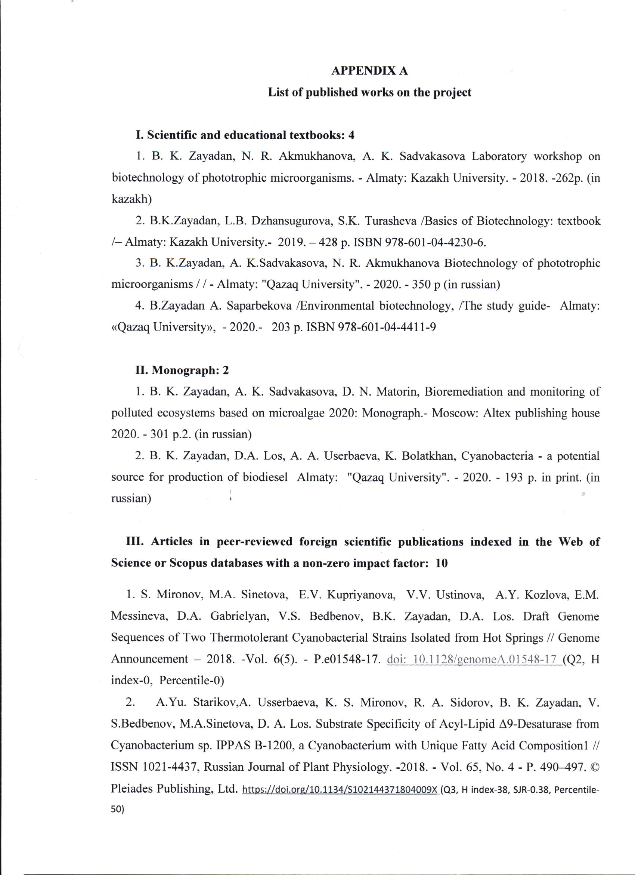

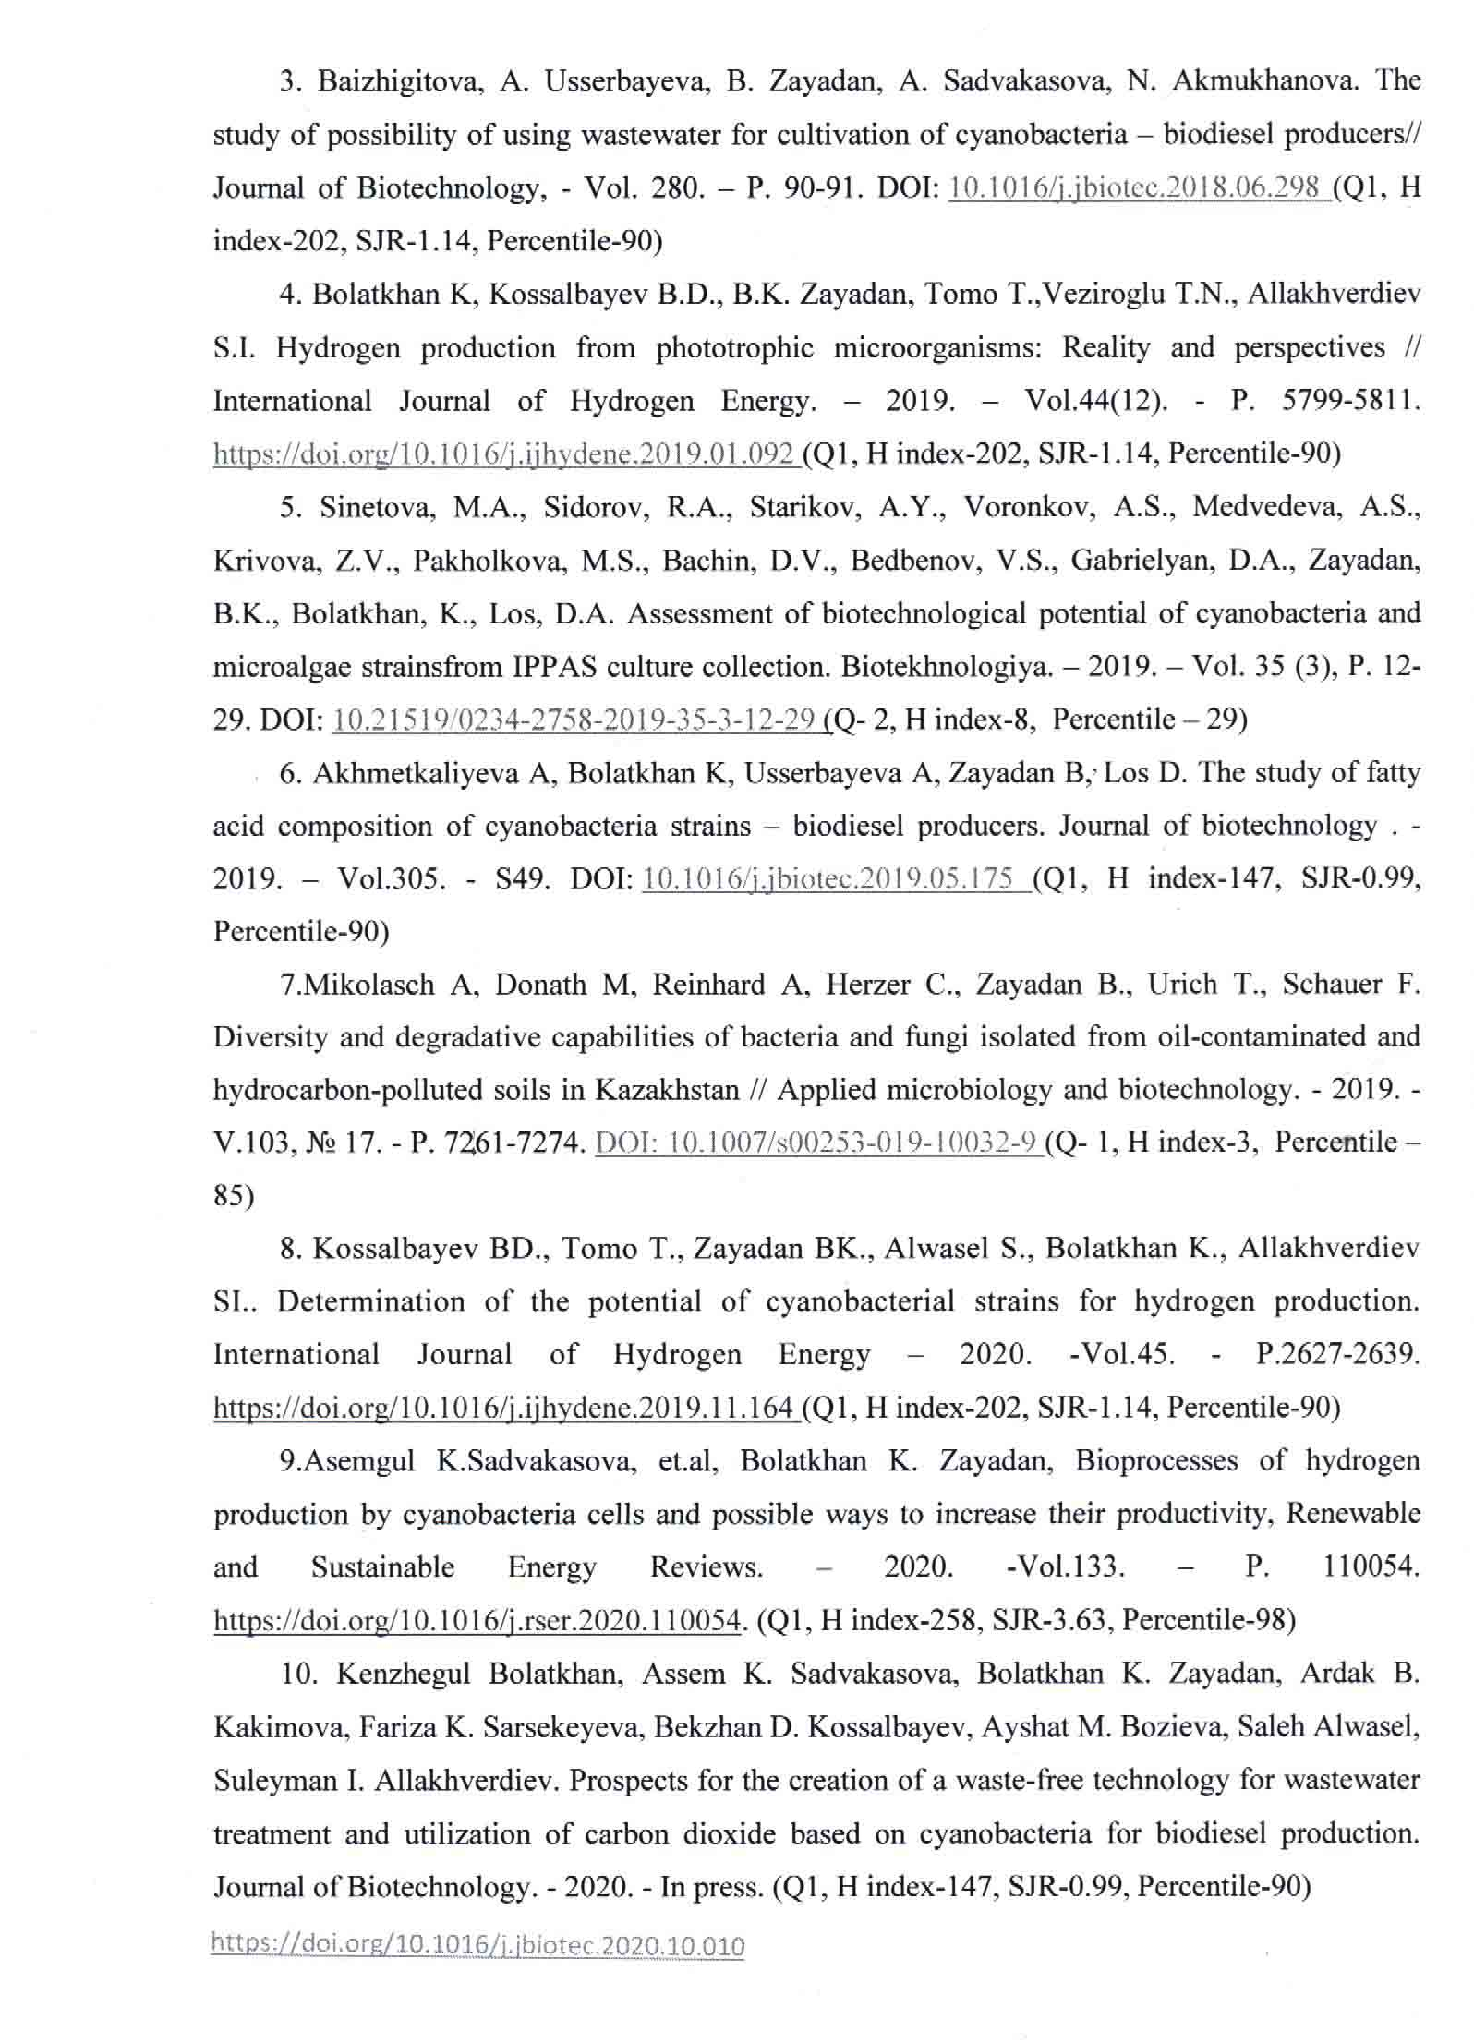

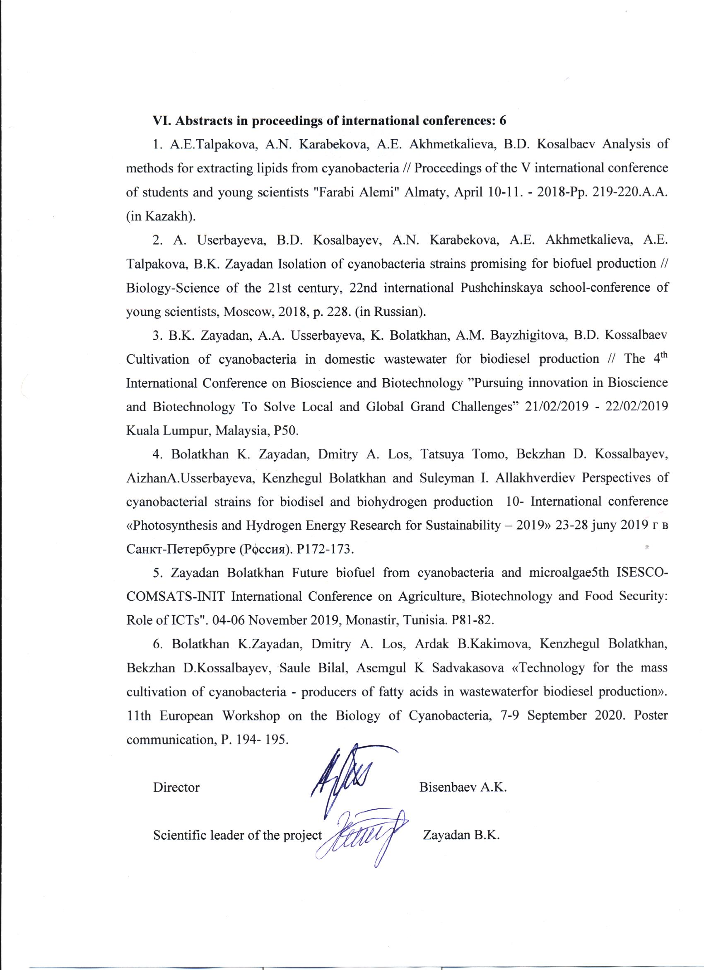

APPENDIX B Calendar plan 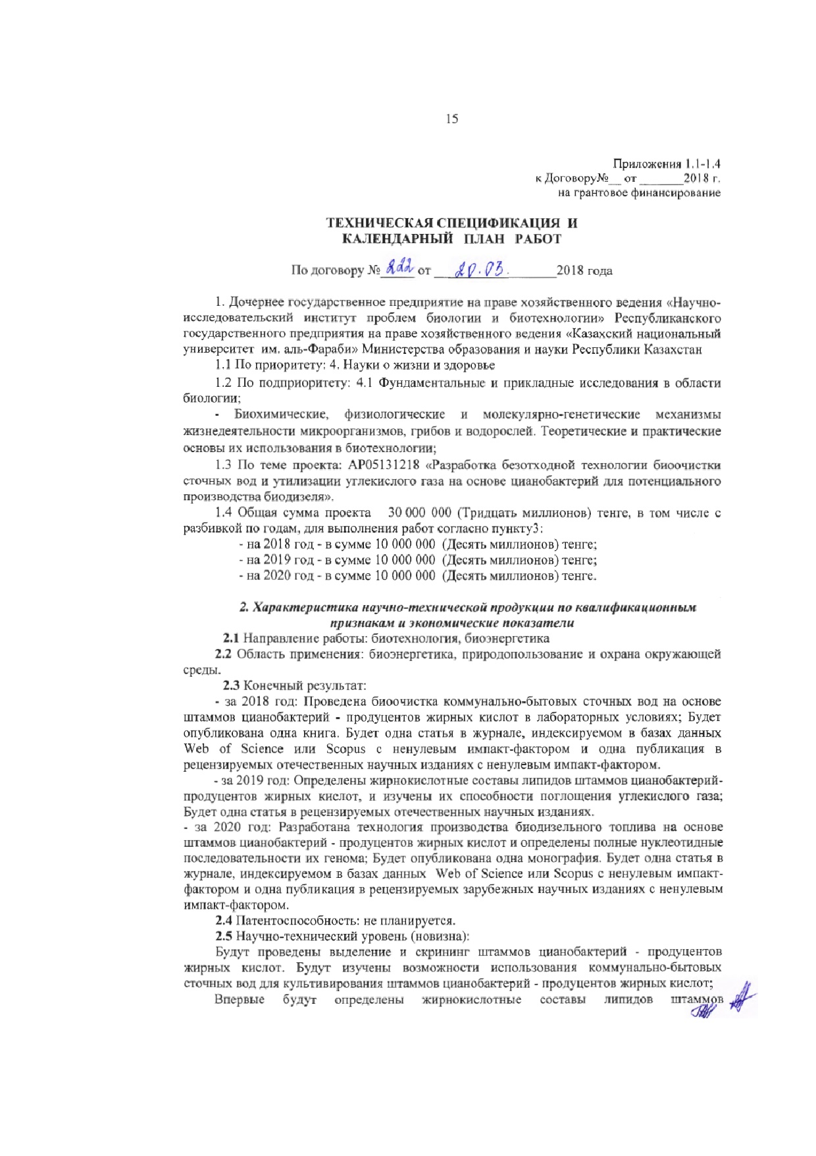
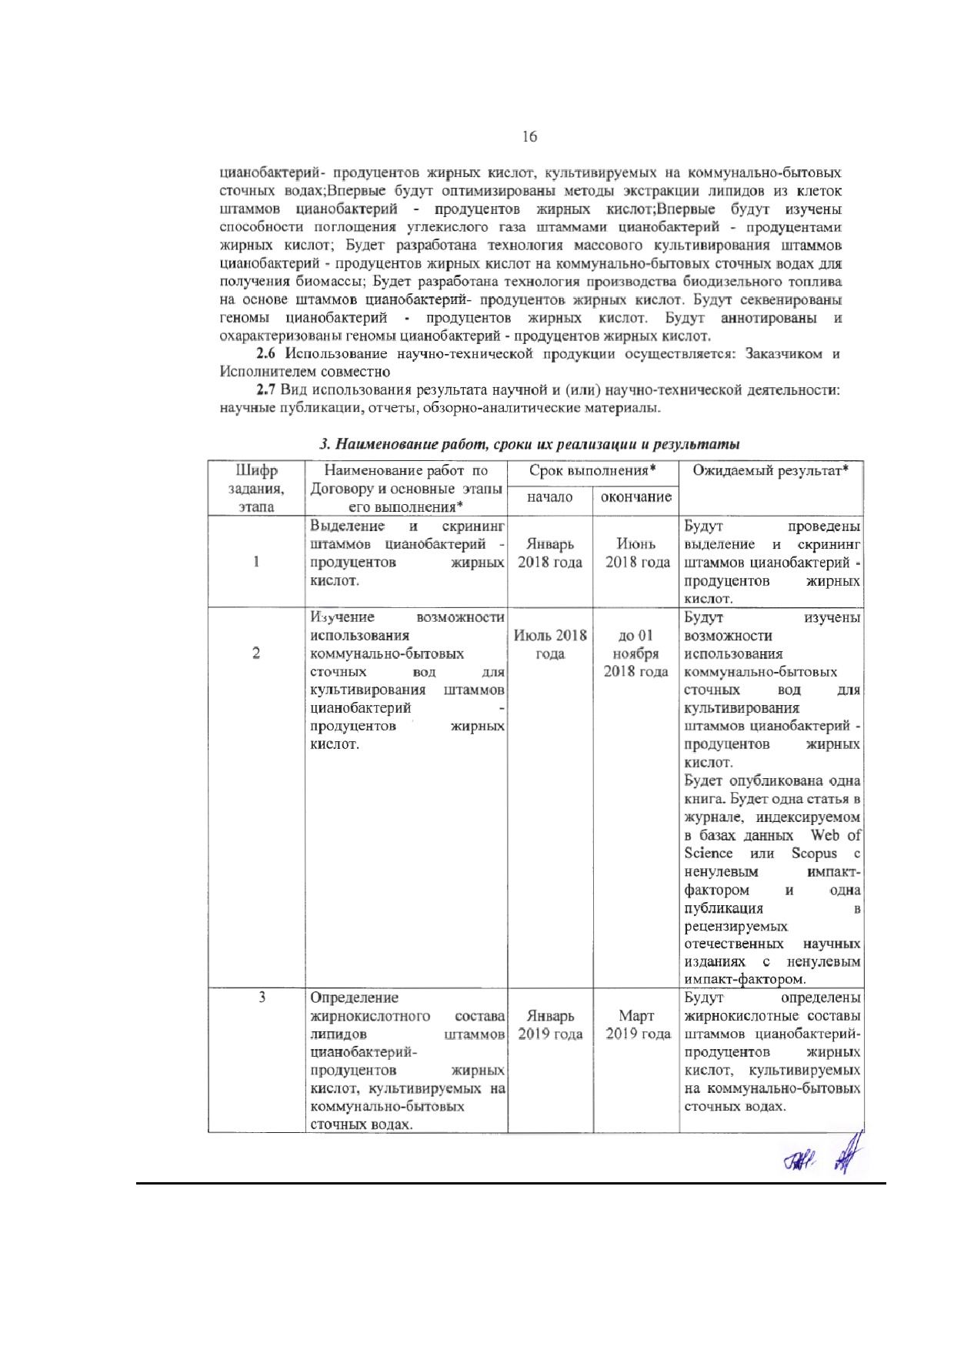
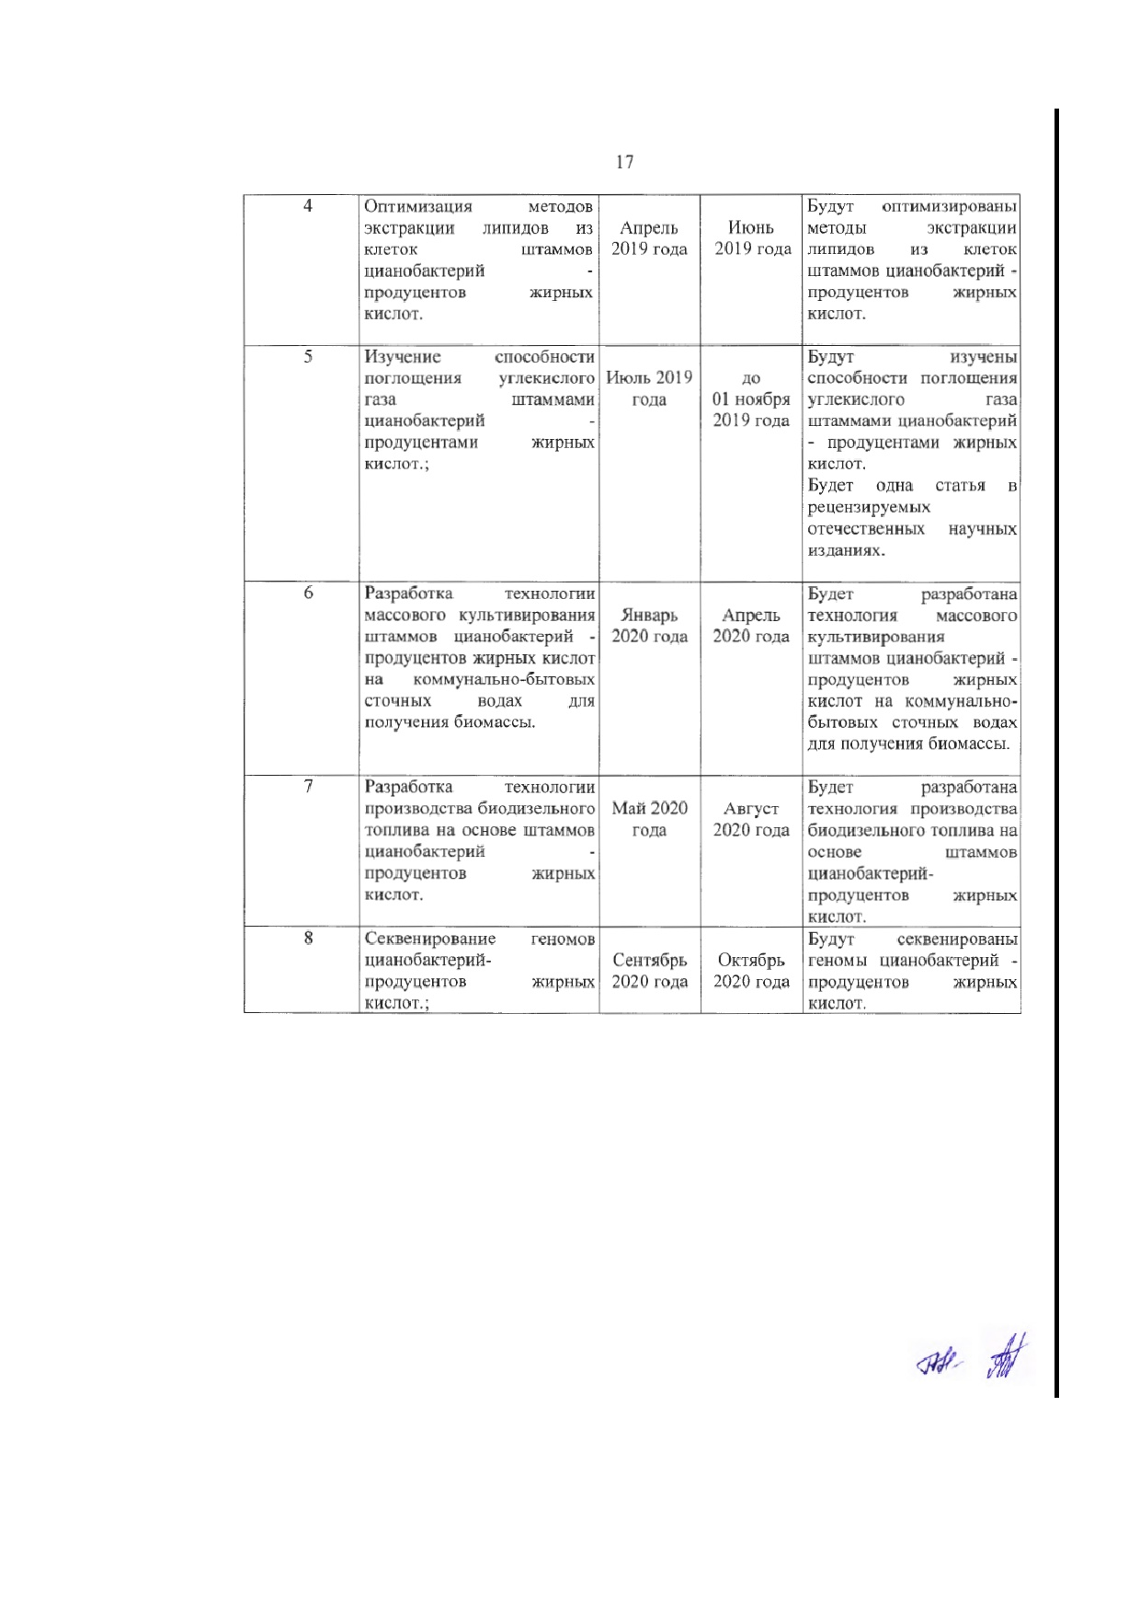

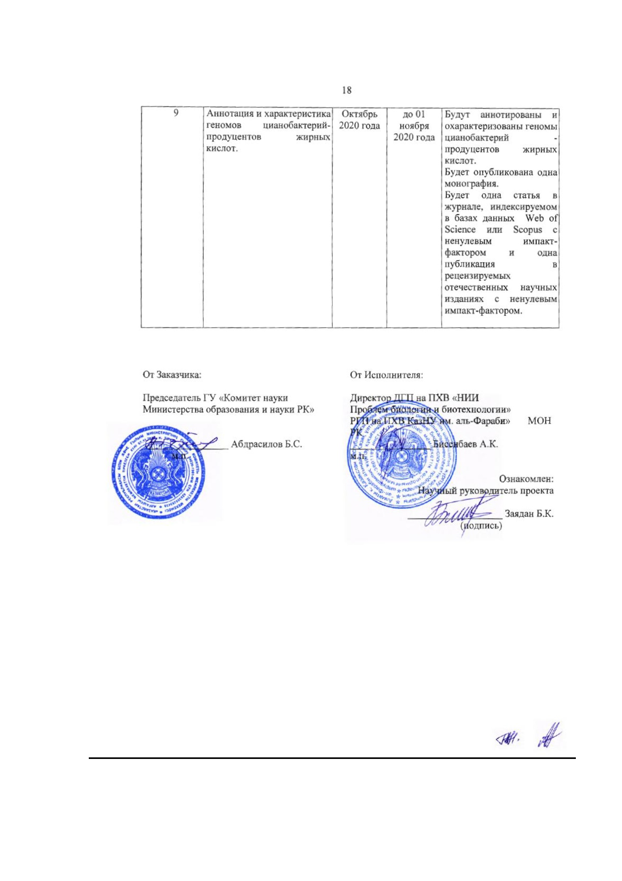

Appendix 1.1 -1.4
to the Agreement
No. __ of 2018 for grant financing

TECHNICAL SPECIFICATIONS AND CALENDAR WORK PLAN
Under Agreement No.___ of 2018

- Subsidiary state enterprise on the right of economic management "Research Institute of Biology and Biotechnology" of the Republican State Enterprise on the right of economic management "Al-Farabi Kazakh National University"of the Ministry of Education and Science of the Republic of Kazakhstan
1.1 By priority: 4. Life and health sciences
1.2 By sub-priority: 4.1 Basic and applied research in the field of biology;
Biochemical, physiological and molecular-genetic mechanisms of the life of microorganisms, fungi and algae. Theoretical and practical foundations of their use in biotechnology;
  - On the topic of the project: AP05131218 "Development of a waste-free technology for biological treatment of wastewater and utilization of carbon dioxide based on cyanobacteria for the potential production of biodiesel."
  - The total amount of the project is 30,000 000 (Thirty million) tenge, including with a breakdown by years, for the performance of work in accordance with point 3:
- for 2018 - in the amount of 10,000,000 (Ten million) tenge;
- for 2019 - in the amount of 10,000,000 (Ten million) tenge;
- for 2020 - in the amount of 10,000,000 (Ten million) tenge.

Characteristics of scientific and technical products by qualification characteristics and economic indicators
2.1 Direction of work: biotechnology, bioenergy
2.2 Application area: bioenergy, nature management and environmental protection.
2.3 Final result:
- For 2018: Biological treatment of municipal wastewater based on strains of cyanobacteria - producers of fatty acids in laboratory conditions; One book will be published. There will be one article in a journal indexed in the Web of Science and Scopus databaseswith a non-zero impact factor and one publication in peer-reviewed domestic scientific journals with a non-zero impact factor.
- For 2019: The fatty acid compositions of lipids of strains of cyanobacteria - producers of fatty acids were determined, and their ability to absorb carbon dioxide was studied; There will be one article in peer-reviewed domestic scientific journals.
- For 2020: A technology for the production of biodiesel fuel based on strains of cyanobacteria - producers of fatty acids was developed and the complete nucleotide sequences of their genome were determined; One monograph will be published. There will be one article in a journal indexed in the Web of Science and Scopus databases with a non-zero impact factor and one publication in peer-reviewed foreign scientific journals with a non-zero impact factor.
2.4 Patentability: not planned.
2.5 Scientific and technical level (novelty):
Isolation and screening of strains of cyanobacteria - producers of fatty acids will be performed. The possibilities of using municipal wastewater for the cultivation of strains of cyanobacteria - producers of fatty acids will be studied;
For the first time, the fatty acid compositions of the lipids of cyanobacteria - producers of fatty acids cultivated in municipal wastewater will be determined;
For the first time, methods of lipid extraction from cells of strains of cyanobacteria - producers of fatty acids will be optimized;
For the first time, the ability to absorb carbon dioxide bystrains of cyanobacteria - producers of fatty acids will be studied;
A technology for mass cultivation of strains of cyanobacteria - producers of fatty acids in municipal wastewater to obtain biomass will be developed;
A technology for the production of biodiesel fuel based on strains of cyanobacteria - producers of fatty acids will be developed.
The genomes of cyanobacteria - producers of fatty acids will be sequenced.
The genomes of cyanobacteria - producers of fatty acids will be annotated and characterized.
2.6 The use of scientific and technical products is carried out: by the Customer and the Contractor together.
2.7 Type of use of the result of scientific and (or) scientific and technical activities: scientific publications, reports, review and analytical materials.

3. Name of work, terms of their implementation and results

Cipher  tasks,  stage | Name of work under the Agreement and the main stages of its implementation* | Period of execution* |  | Expected Result*
Cipher  tasks,  stage |  | start | end | Expected Result*
1 | Isolation and screening of strains of cyanobacteria - producers of fatty acids | January 2018 | June 2018 | Isolation and screening of strains of cyanobacteria - producers of fatty acids will be performed.
2 | Study of the possibility of using municipal wastewater for the cultivation of strains of cyanobacteria - producers of fatty acids. | July 2018 | until 01 November 2018 | The possibilities of using municipal wastewater for the cultivation of strains of cyanobacteria - producers of fatty acids will be studied. One book will be published. There will be one article in a journal indexed in Web of science or Scopus databases with a non-zero impact factor and one publication in peer-reviewed domestic scientific journals with a non-zero impact factor.
3 | Determination of fatty acid composition of lipids of cyanobacteria strains - producers of fatty acids cultivated in municipal wastewater. | January  2019 | March 2019 | Fatty acid compositions of strains of cyanobacteria - producers of fatty acids cultivated in municipal wastewater will be determined.
4 | Optimization of lipid extraction methods from cells of strains of cyanobacteria - producers of fatty acids. | April 2019 | June 2019 | Methods for extracting lipids from cells of strains of cyanobacteria- producers of fatty acids will be optimized.
5 | Study of the ability to absorb carbon dioxide by strains of cyanobacteria - producers of fatty acids. | July 2019 | until 01 November 2019 | The ability to absorb carbon dioxide by strains of cyanobacteria - producers of fatty acids will be studied.  There will be one article in peer-reviewed domestic scientific journals.
6 | Development of technology for mass cultivation of strains of cyanobacteria - producers of fatty acids in municipal wastewater for biomass production. | January 2020 | April 2020 | A technology for mass cultivation of strains of cyanobacteria - producers of fatty acids in municipal wastewater to obtain biomass will be developed.
7 | Development of technology for the production of biodiesel fuel based on strains of cyanobacteria - producers of fatty acids. | May 2020 | August 2020 | A technology for the production of biodiesel fuel based on strains of cyanobacteria - producers of fatty acids will be developed.
8 | Sequencing of genomes of cyanobacteria - producers of fatty acids. | September 2020 | October 2020 | The genomes of cyanobacteria - producers of fatty acids will be sequenced.
9 | Annotation and characteristics of the genomes of cyanobacteria - producers of fatty acids | October 2020 | until 01 November 2020 | The genomes of cyanobacteria - producers of fatty acids will be annotated and characterized. One article monograph will be published.  There will be one article in a journal indexed in the Web of Science or Scopus database with a non-zero impact factor and one article publication in peer-reviewed domestic journals with a non-zero impact factor.

