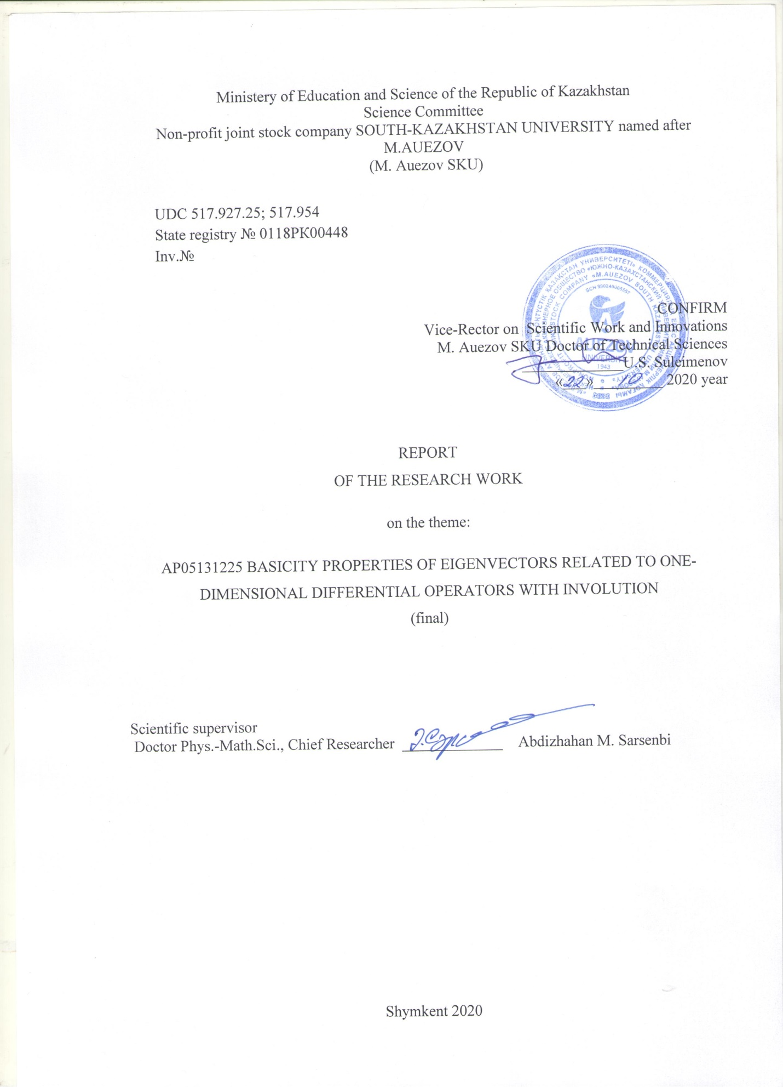

LIST OF RESEARCHERS

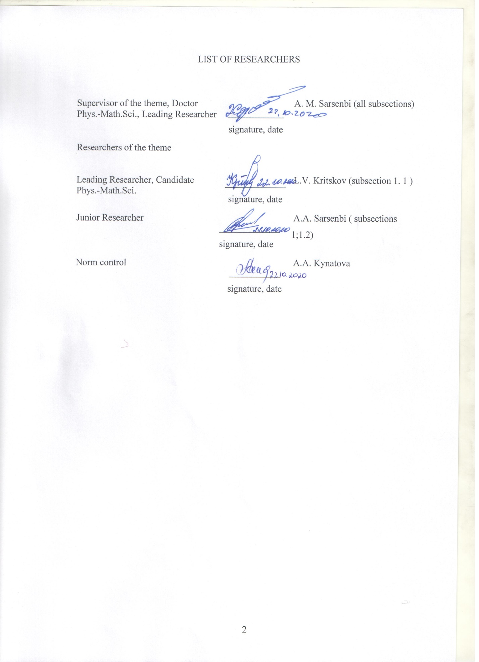

**РЕФЕРАТ**

Есeп 57 б., 33 әдебиет, 2 қосымша.

МЕНШІКТІ ФУНКЦИЯ, РИСС БАЗИСІ, БИОРТОГОНАЛДЫ ЖІКТЕУЛЕР, ИНВОЛЮЦИЯСЫ БАР ДИФФЕРЕНЦИАЛДЫ ТЕҢДЕУЛЕР, ГРИН ФУНКЦИЯСЫ

Зерттеу нысаны ретінде инволюциясы бар екіншіі ретті дифференциалды операторлар үшін спектралдық есептер қарастырылған.

Жұмыстың мақсаты – инволюциясы бар екінші ретті дифференциалды операторлардың меншікті функциялар жүйесінің базистік қасиеттерін зерттеу.

Зерттеу әдістері – дифференциалды теңдеулер теориясының аналитикалық тәсілдері, гильберт кеңістігіндегі сызықты операторлардың абстрактілі теориясының, дифференциалды операторлар теориясының, функционалды анализдің, сандар теориясының тәсілдері. Алынған нәтижелер. Инволюциясы бар екінші ретті дифференциалды операторлардың меншікті функциялар жүйесінің базис болуы үшін жеткілікті шарттар Грин функциясының бағалауы түрінде, сондай ақ шеттік шарттар түрінде алынған. Қосымша алынған функциялар саны шексіз көп болатын инволюциясы бар екінші ретті дифференциалды оператор мысалы құрастырылып, оның түпкілікті векторлар жүйесінің базис болатындығы анықталған.

Инволюциясы бар параболалық, гиперболалық және эллипстік түрдегі теңдеулер үшін аралас есептердің шешімділігі көрсетілген. Зерттеу нәтижелері дифференциалды операторлардың спектралдық теориясында, инволюциясы бар дербес туындылы дифференциалды теңдеулер теориясында, әрқилы қолданбалы есептерде жүзеге асырылуы мүмкін.

**ANNOTATION**

Report 57 pp., 33 references, 2 append.

EIGENFUNCTION, RIESZ BASIS, BIORTHOGONAL EXPANSIONS, DIFFERENTIAL EQUATIONS WITH INVOLUTION, GREEN’S FUNCTION

Subject of the research are the spectral problems for second-order differential operators with involution.

The aim of the work is to study basicity properties second-order differential operators with involution.

The research applies analytic methods of the theory of differential equations, methods of the abstract theory of linear operators and theory of linear differential operators in Hilbert spaces, methods of functional analysis and number theory.

Results obtained. Sufficient conditions for the basicity of eigenfunctions related to second-order semi-bounded differential operators with involution are obtained in terms of Green’s function estimates and boundary conditions. An example of the second-order differential operator with involution and infinite number of adjoint functions is constructed, Theorem on the basicity of root function is proved.

Solvability of mixed problems for equations of parabolic, hyperbolic, and elliptic types with involution is proved.

Research results could by used in the spectral theory of differential operators, in the theory of differential equations with partial derivatives and involution, and also in several applied problems.

|  |
| --- |
| **CONTENT** |
|  |
| |  | | --- | | INTRODUCTION ………………………………………………………………… 6  MAIN SECTION ………………………………………………………………………….. 8 | | |  |  |  |  |  | | --- | --- | --- | --- | --- | | 1 | Basicity properties of eigenfunctions related to second-order differential operators with involution ........................................................................ | | | 8 | | 1.1  1.1.1  1.1.2  1.1.3  1.2  1.2.1  1.2.2  1.2.3  1.2.4 | Basicity of eigenfunctions related to a semi-bounded second-order differential operator with involution. ........................................................................  Equiconvergence and basicity theorems for the eigenfunctions related to second-order differential perators with involution in terms of the Green’s function’s estimates ...................................................................................................  Equiconvergence and basicity theorems for the eigenfunctions related to second-order differential operators with involution in terms of boundary conditions ……………………………………………………………………...  Spectral problem with an infinite number of adjoint functions ………………..  Solvability of the mixed problems with involution ……………………………  Solvability of the mixed problems for the perturbed heat equation with involution …………………………………………………………………….  Existence and uniqueness of the solution of the mixed problems for the perturbed wave equation with involution ……………………………………  Solvability of some problems for the perturbed Poisson equation with involution ……………………………………………………………………  Solvability of the inverse problem for a parabolic equation of fractional order with involution ……………………………………………………………………..  CONCLUSION………………………………………………………………..  LIST OF REFERENCES ……………………. . . . …………………………  APPENDIX А…………………………………………………………………  APPENDIX B ………………………………………………………………… | | | 8  11  19  23  24  24  28  29  33  38  39  42  44 | |  | |  | |  | |  | | |

**INTRODUCTION**

The aim of the project is to prove theorems on basicity of eigenvectors (if necessary supplied by the adjoint vectors) of the second-order differential operators with involution.

Research on the project has been accomplished in accordance with the calendar plan and the application for the grant funding competition. All the planned research is completely fulfilled. There are 32 papers published on the research results of the project. Among them there are 6 papers that appeared in the journals with impact factor in the Web of Science data base and 1 paper in the journal from the Scopus data base. The list of the principal published papers on the project’s results is given in Appendix A. Appendix B contains the calendar plan of the project’s tasks implementation.

The main results of the project’s research are as follows:

1) developing the theory of Green’s function for one-dimensional second-order differential operators with involution;

2) theorems on basicity and unconditional basicity of eigenfunctions in the space  and equiconvergence theorems for the eigenfunction expansions of an arbitrary function from the class  with respect to one-dimensional second-order differential operators with involution;

3) the uniform convergence of eigenfunction expansions related to one-dimensional second-order differential operators with involution;

5) the theorem on basicity in the class  of eigen- and adjoint functions related to the second-order differential operator with involution in the case when there are an infinite number of adjoint functions in the system;

6) theorems on existence and uniqueness of solutions to the mixed problems for equations of parabolic, hyperbolic and elliptic types with involution.

The report for the year 2018 (state registry № 0118РК00448; inv. № 0218РК00615) presented research results for the case of Dirichlet-type boundary conditions. The report for the year 2019 (state registry № 0118РК00448; inv. № 0219РК00034) presented results for the case of Neumann-type boundary conditions. The research in 2020 considered conditions of periodic and antiperiodic types.

The current report contains one section and two subsections. The first subsection presents the main results on equiconvergence, basicity and unconditional basicity of eigenfunctions related to second-order differential operators with involution, and the theory of Green’s functions for one-dimensional second-order differential operators with involution. Sufficient conditions for the basicity of eigenfunctions related to the second-order differential operators with involution were obtained in terms of estimates for the Green’s function and in terms of boundary conditions. An example of the second-order differential operator with involution that has an infinite number of adjoint functions is constructed. A complete spectral analysis of this problem has been performed. The theorem on basicity of its root functions in the class  is proved.

The second subsection presents research results on solvability of the mixed problems for equations of parabolic, hyperbolic and elliptic types with involution. Theorems on existence and uniqueness of solutions to these problems are obtained by applying the Fourier method. An inverse problem for an equation of fractional order was studied.

**MAIN SECTION**

**1 Basicity properties of eigenfunctions related to second-order differential operators with involution**

**1.1 Basicity of eigenfunctions related to a semi-bounded second-order differential operator with involution.**

This subsection presents research on the spectral properties of the second-order differential equations with involution. An important aspect of the spectral theory of differential operators is the question of basicity of operator’s eigenfunctions. Answering this question admits the use of the Fourier method while solving different problems for equations with partial derivatives. The Fourier method is applied in [1,2] while studying inverse problems for differential equation with involution, and in [3] while studying solution’s behavior for equation with partial derivatives and involution. Theory of Green’s function for differential equations with involution has systematically started in [4,5]. The studies of spectral properties for differential operators with involution was presented in [6-18]. The solvability of problems for partial differential equations with involution was discussed in [19 - 21].

In this research the Fourier method is verified for solving mixed problems for perturbed heat equations with involution and for perturbed wave equations with involution. Equiconvergence and basicity of eigenfunctions for the second-order differential operator with involution and specified boundary conditions are studied by a modified Cauchy method which is well-known for conventional differential operators. In the interim report for the year 2018 of this project these problems were studied in the case of Dirichlet-type boundary conditions, and in the report for the year 2019 they were complemented by the case of Neumann-type conditions. In 2020 this approach was applied to the period and anti-periodic problems. It is worth mentioning that the essential difficulty in the study lies in constructing the Green’s function related to the one-dimensional boundary value problems for the second-order differential equation with involution and its further evaluation.

The problem of justifying the Fourier method for classical equations is extensively studied by V.A.Steklov [22], V.A.Il’in [23]. Further development of the Fourier method justification which allowed to lower demands on smoothness of initial data was given by V.A.Chernyatin [24], A.P.Khromov [25].

Let us consider the mixed problem for the perturbed heat equation with involution over the domain 

 (1)

 (2)

Equation (1) contains the involution transform of the argument. The transform  of a function  is called involutive if . Therefore the transform  is involutive. Further, let coefficients  be some real numbers. Everywhere further the parameter  satisfies the condition , the function  is continuous on . If is the system of eigenfuctions of the spectral problem

 (3)

then the series

 (4)

gives a formal solution to the mixed problem (1), (2).The validity of the initial condition



demands solving the question of expanding the initial function in the eigenfunction series. For the differentiable function (4) one should study the uniform convergence of the latter series.

Consider the boundary value problem

 (5)

The functions

,

are linearly independent solutions to the homogeneous equation (5).

The function is called the Green’s function of the boundary value problem (5) if the function



gives the solution to the boundary value problem



where  is a continuous function. Note that the poles of the Green’s function coincide with the eigenvalues of the spectral problem (5). We know [14] that the spectral problem (5) with Neumann-type boundary conditions  has two sequences of eigenvalues

,

moreover the system of its eigenfunctions



forms the orthonormal basis of the space . If the number  is not even then all the eigenvalues of the Neumann problem are simple. This condition in several particular cases replaces the condition of absence of multiple eigenvalues. If this condition holds true then the Cauchy integral method is applicable. In [14] the boundary value problems of Dirichlet type, of periodic and anti periodic types are also considered.

Let all the eigenvalues  of the spectral problem (5) be simple and have no accumulation points on a finite interval. We introduce the numbers . On the complex plane we consider the circles  with the common center at the origin:



These circles are assumed non intersecting (e.g. in the case of the Dirichlet or Neumann-type problems this could always be organized) and missing the points . It means that each point  has some neighborhood which contains no other points of the spectrum. For  the circles , transform into the circles  on the complex - plane. Now we can proceed with the study of basicity of eigenfunctions under the above mentioned conditions.

1.1.1 Equiconvergence and basicity theorems for the eigenfunctions related to second-order differential operators with involution in terms of the Green’s function’s estimates

We are interested by the question if it is possible to expand an arbitrary function  in the convergent eigenfunction series related to the spectral problem (3) with a continuous complex-valued coefficient  on the interval . The convergence of the eigenfunction expansion of an arbitrary function  in the class  follows from the equiconvergence theorem for the eigenfunction expansions related to the spectral problems (3) and (5).

Denote by  the Green’s function of the problem (3) and by  the Green’s function of the problem (5) which has poles at the points . Since almost everywhere on the interval (-1,1) the following relations are sarisfied:





then



The function  meets the boundary conditions (3). Therefore, outside the poles of  the function  has the following representation

 (6)

We will show existence of the solution to the integral equation (6). This solution will coincide with the Green’s function of the boundary value problem (3).

Let us introduce the function .

Let  be a disk of a sufficiently small radius.

The following theorem holds true.

Theorem 1. Let the Green’s function  of the boundary value problem (5) satisfy the estimate



outside the circles, i.e. for . Then, for sufficiently large values of  the solution to the integral equation (6) exists.

Proof. We apply the iteration method. Let  and

 (7)

for all sufficiently large values of . The relation (7) with  gives the first estimate:



In further formulas we use the following notation



 (8)

where the maximum is taken over all for any fixed  and all sufficiently large values of  outside the poles of the function . We have to verify the estimate

 (9)

For  the estimate (9) follows from the first relation in (8). Suppose that the estimate (9) holds for  and let us prove that this estimate (9) is true also for . Then the second relation in (8) implies the inequality

 (10)

It follows from its definition that





The triangle inequality implies



The inequality



implies the estimate



and also the relation



implies the inequality



Moreover



Thus we get the inequality

.

This inequality together with inequality (10) leads to the estimate



For sufficiently large values of  the inequality



holds true. Therefore the estimate



holds true for all thus verifying the estimate (9). The obtained estimate implies the uniform convergence of the series



and its sequence of partial sums

.

It means the uniform convergence of the sequence  to the limit function which satisfies the integral equation (6). Theorem 1 is proved completely.

It is important to note that the estimate for the Green’s function in Theorem 1 holds true also for the Green’s function  of the spectral problem (3). This fact plays an important role in verifying equiconvergence theorems. In the reports for the years 2018 and 2019 the validity of estimates for the Green’s function (under the assumptions of Theorem 1) was proved for both cases of problems with Dirichlet and Neumann-type conditions. Later the validity of these estimates was proved for problems with periodic and antiperiodic conditions.

Let



be partial sums of eigenfunction expansions related to the spectral problem (5) with . The partial sums of eigenfunction expansions related to the spectral problem (3) will be denoted by

.

The sequence  is called equiconvergent with the sequence on the interval  if  uniformly on this interval as 

Now we formulate the equiconvergence theorem.

Theorem 2. If outside the circles, i.e. for , the Green’s function  of the boundary value problem (5) satisfies the estimate



and all the eigenvalues of (5) are simple then, for any function , the sequence  equiconverges with the sequence 

Proof. Consider the difference of the partial sums of the eigenfunction expansions related to the spectral problems (3) and (5) :

 (11)

The proof of the previous theorem implies that



By virtue of this estimate, the relation (8) yields the inequality



The relation (11) yields the following inequality





If we denote

,

then we have



Let us split the considered interval into two parts  where





and is sufficiently small. Thus we can rewrite the latter inequality in the form



(12)



Since

,

the second term on the right-hand side of (12) will be less than  for appropriate value of . Denote by  the radius of the circle . Then the relation





yields the inequality



Choosing integer number  sufficiently large one can always make the first term in (12) less than . Theorem 2 is proved.

This theorem immediately implies the basicity of eigenfunctions for the spectral problem (3). This fact is worth being formulated as a separate theorem.

Theorem 3. If all eigenvalues of the spectral problems (5) are simple and the corresponding eigenfunctions form the basis in  then the system of eigenfunctions of the spectral problem (3) also forms the basis of the space .

Proof. Let  denote the norm in the space . Then, for any function  , one have

.

The first term is less than  due to the basicity of eigenfunctions of the spectral problem (3), and the second term is less than  by the equiconvergence theorem 2. Theorem 3 is proved.

Theorem 3 states the basicity of eigenfunctions of the spectral problem (3). But there is still a question whether this basis is unconditional, i.e. the Riesz basis, or not. About this question we can assert the following.

Theorem 4. Let the eigenvalues of the spectral problem (3) satisfy the following two conditions: 1)  2)  Then any basis consisting of eigenfunctions for the spectral problem (3) forms the unconditional basis of the space .

To prove this theorem, it is sufficient to mention the fact that, under the assumptions of the theorem, i.e. if the system of eigenfunctions to the spectral problem (3) forms the basis of the space , we will always have the uniform estimate

, (13)

where  is the system dual to the system and consists of eigenfunctions of the spectral problem dual to (3). It follows from the paper by L.V.Kritskov and A.M.Sarsenbi [26] that, for the spectral problem (3), the condition (13) is necessary and sufficient for the system of eigenfunctions of (3) to be the unconditional basis. Therefore, Theorem 4 is proved.

1.1.2 Equiconvergence and basicity theorems for the eigenfunctions related to second-order differential operators with involution in terms of boundary conditions

In the case of particular boundary conditions, it is possible to verify the estimate of the Green’s function in Theorem 2. Consider the boundary value problems

 (14)

 (15)

with one of the following four boundary conditions:

 (16)

Let be the partial sums of the eigenfunction expansion of function  related to the boundary value problem (14) with one of the boundary conditions (16), and  be the partial sums of the same function  but for the eigenfunction expansion related to the boundary value problem (15) with the same boundary condition (16). Let us formulate the equiconvergence theorem in the case of problems (14).

Theorem 5. If the number  is not even then, for an arbitrary function , the sequence  equiconverges with the sequence  in all the cases of problems (16).

In order to prove this theorem it is sufficient to verify the estimate of the Green’s function in Theorem 2. Then the validity of the statement in Theorem 5 follows from Theorem 2. The condition in Theorem 5 excludes multiple eigenvalues in any of the problems (14), (16).

Theorem 5 will be proved in the case of the Neumann-type boundary conditions (16.2). In this perspective we assert the following facts.

Lemma 1. If λ is not the eigenvalue of the homogeneous boundary value problem (14), (16.2) then the problem



is solvable for an arbitrary continuous function  and its solution could be represented in the form



where



The proof of the Lemma is accomplished through direct calculation.

Theorem 1 yields the following important assertion.

Corollary. The Green’s function of the boundary-value problem (14), (16.2) has the form



We note that the construction of the Green’s function is a non-trivial task and plays a crucial role in the study of boundary value problems. The Birkhoff-Tamarkin method was originally introduced to study convergence of eigenfunction expansions related to ordinary differential operators and is based on estimates of the Green’s function of the considered operator. The constructed Green’s function allows to transfer the Birkhoff-Tamarkin theory on the case of differential operators with involution.

Further we need to obtain the estimate of the Green’s function of the boundary value problems (14), (16). The proof will be conducted in the case of the Neumann-type problem (16.2). The obtained estimates hold true for all boundary conditions in (16).

Let  be a disk of a sufficiently small radius .

Lemma 2. If  and  then the Green’s function  of the boundary value problem (14), (16.2) satisfies the following uniform estimate



for  where

.

Proof. If  then the Green’s function takes the form



Since , we have , and therefore,



if  and



if.

Thus, in the case when  the Greens’ function satisfies the following estimate



In the case  similar reasoning yields the estimate



The case  produces the estimate in the from



All these estimates could be written in the general form:



Lemma 2 is proved.

Thus, the boundary value problem (14), (16.2) satisfies all the conditions of Theorem 2. Hence Theorem 5 could be reformulated in terms of boundary conditions

Theorem 6. If the number  is not even then the systems of eigenfunctions related to each of the spectral problems (15), (16) form bases of the space .

Proof. It is proved in [14] that the system of eigenfunctions related to each of the spectral problems (14), (16) forms an orthonormal basis of the space . Let  denote the norm in the space . Then, for any function , one have



for each of the spectral problems (15), (16). The first term is less than  by virtue of the basicity of eigenfunctions related to the spectral problems (14), (16), and the second term is less than  by the equiconvergence Theorem 5. Theorem 6 is proved.

1.1.3 Spectral problem with an infinite number of adjoint functions

In the interim report for the year 2018 there was a full spectral analysis of the problem

 (17)

where ; here the differential expression contains the involutive transform of the independent variable in the second derivative while the boundary conditions have a non-local character. It is proved that if  is irrational then the system of eigenfunctions is complete and minimal in , but does not form a basis. In the case of rational  the technique of choosing adjoint functions is specified to provide the system of all the root functions to form the unconditional basis in . This spectral problem contains infinite number of adjoint functions which complement its eigenfunctions.

Thus we established the fact that the problem (17) has all intrinsic features of essentially non-self-adjoint problems and its spectral properties may crucially change under small variations of the parameter $α.$

In the reported period the problem (17) is considered in the space . The main result of this subsection is in the following theorems.

Theorem 7. Let the number  be irrational and . Then the system of root function of the problem (17) contains only eigenfunctions, it is complete and minimal in , but does not form a basis in this space.

Theorem 8. Let the number  be rational and . Then the spectrum of the problem (17) splits into to sequences:  where each  relates to the one-dimensional root subspace with one eigenfunction and each  relates to a two-dimensional root subspace with one eigenfunction and one adjoint function. The system of root functions is complete and minimal in , and one can choose adjoint functions in such a way that the whole system forms the basis in .

We note that the functional-differential equations similar to (17) were studied by several authors. The algebraic and analytic aspects of theory of ordinary differential equations with involution were discussed in [4,5]. The spectral issues connected with differential equations with involution were studied for the first-order operators in [6 – 9, 10 – 12] and for the second-order operators in [13 – 18].

The full proofs of Theorems 7 and 8 are published in the scientific journal with impact factor (see Appendix A). Due to the limits on the number of pages in the interim report we omit here the proof of Theorems 7 and 8.

**1.2 Solvability of the mixed problems with involution**

The results obtained above help to verify existence and uniqueness of solutions to the mixed problems for several equations of parabolic, hyperbolic and elliptic types with involution by applying the variables separation method. The following theorem approves the positivity of eigenvalues for the boundary value problems (3), (16).

1.2.1 Solvability of the mixed problems for the perturbed heat equation with involution

Theorem 9. If the function  for all then all the eigenvalues  of each of the spectral problems (3) are positive.

Proof is accomplished by multiplying both sides of equation (3) by the function  and integrating over the interval .

The absolute and uniform convergence of eigenfunction series related to the boundary value problems (3), (16) is verified in the following assertion.

Theorem 10. If the number  is not even and the coefficient  of the equation (3) is real-valued then, for any twice differentiable function  that satisfies the conditions , the Fourier series

 (18)

with respect to the complete orthonormal system  of eigenfunctions related to each of the spectral problems (3), (16) converges absolutely and uniformly.

The proof uses the representation of the form

 .

Hence the coefficients  in expansion (18) could be transformed with further applying of the Green’s function’s properties and the Bessel inequality for orthonormal systems.

Let us formulate the theorem on existence and uniqueness of the solution to the mixed problems related to the perturbed heat equation with involution.

We consider the following mixed problem for the equation of parabolic type on the domain :

 (19)

 (20)

Equation (19) contains the involution transform of the argument. The parameter  satisfies the condition , and the function  is continuous of the interval . Let us denote by  the system of eigenfunctions of the spectral problem

 (21)

Theorem 11. Let the following conditions be satisfied:

1) the real-valued continuous function  is non-negative;

2) the number  is not even and .

Then, for any twice differentiable function  which satisfies the conditions , the solution to the mixed problem (19), (20) exists, is unique and could be presented by the series

. (22)

Proof. To verify the theorem, it is sufficient to obtain the uniform convergence of the series (22) and also the series

,  (23)

. (24)

By virtue of Theorem 9 all the values of  are positive. Therefore,  for any  and . By virtue of Theorem 10, the series  converges uniformly. Hence the series (22) also converges absolutely and uniformly. Further, the inequalities , for some integer , yield the uniform convergence of the series (23). We rewrite the series (24) in the following way:

 (25)

The series on the right-hand side of (25) converge absolutely and uniformly for all . The series on the left-hand side of (25) is also absolutely and uniformly convergent for all . Hence we obtain the absolute and uniform convergence of the series

 (26)

Let us multiply the series (26) by  and add to the series (25). The new series



is also absolutely and uniformly convergent for all . Thus, all the series (22), (23), (24) are absolutely and uniformly convergent for all . This fact means that the function (22) is the solution to the equation (19) and satisfies the conditions (20).

Let us proceed with the proof of the uniqueness. Suppose there are two solutions  and  of the mixed problem (19), (20). Then the function  satisfies the equation (19) and the initial condition



Multiplying both sides of equation (19) by the function , we integrate with respect to the variable 





Then we integrate the obtained equality with respect to the variable . Hence we get the relation





Applying the inequality  and using the non-negativity of the function  and the relation , we come to the inequality

,

which yields the equality . Theorem 11 is proved.

1.2.2 Existence and uniqueness of the solution of the mixed problems for the perturbed wave equation with involution

Theorem 11 can be transfered to the case of equations of hyperbolic and elliptic types with involution. Let us consider the hyperbolic case. In the two-dimensional domain  we study the mixed problem for the equation of hyperbolic type:

 (27)

. (28)

Applying the variables separation method we get two problems: the problem (21) and the following problem

 (29)

. (30)

Denote by the system of eigenfunctions of the spectral problem (21) corresponding to the eigenvalues .

The solution to the equation (29) has the form . The solution to the mixed problem (27), (28) is constructed in the form of the series

 (31)

The results of subsection 1 give the base for verifying the Fourier method for this mixed problem.

The following theorem holds true.

Theorem 12.Let the following conditions be satisfied:

1) the real-valued continuous function  is non-negative;

2) the number  is not even and ,

3) the initial data functions  are twice continuously differentiable and satisfy the conditions , . Then the solution to the mixed problem (27), (28) exists, is unique and could be written in the form of the series (31).

In order to prove this theorem it is sufficient to obtain uniform convergence of the series (31) and the following four series on the interval  for all :

;

;

;

.

It is easy to note that the uniform convergence of these series follows from the uniform convergence of the series

.

We skip the full proof of their uniform convergence as it goes similar to the proof of previous statements.

In the same way one can formulate and proof the existence and uniqueness theorem for the equation of elliptic type with involution. In the latter case we managed to solve the problem of a more general character.

1.2.3 Solvability of some problems for the perturbed Poisson equation with involution

Let  be a unit disk, ,  be the unit sphere,  be a real orthogonal matrix: . Suppose that there exists the integer number  such that .

Let us note that if , or , then, for any , one have inclusions , or respectively . It is true as the transform of the space  with matrix  is isometric: .

We give simple examples of these transforms.

Example 1. Each point  maps into the point . In this case . It is clear that  and , and therefore .

Example 2. Evidently the transform with matrix  may be a rotation in , e.g., if  where

,

 is the identity - matrix and . It follows from the fact that  and , and therefore . Besides one should take  where .

Let  be any real numbers,  and  be functions defined on  and  respectively. We introduce the operator

.

We consider the following boundary value problems in the domain .

Dirichlet problem. Find the function  which satisfies the conditions

, (32)

. (33)

Neumann problem. Find the function  which satisfies the equation (32) and the condition

 (34)

where  is the external normal vector to the sphere .

Robin problem. Find the function  which satisfies the equation (32) and the following condition

, (35)

where  is a real number.

In the case when  we get the classical Dirichlet, Neumann and Robin problems for the conventional Poisson equation. Note that in [27] the classical Laplace equation was considered in the case  with non-local boundary conditions and the transform  from Example 2.

Theorem 13. Let for all  the inequalities  hold true and the solutions to the Dirichlet, Neumann and Robin problems exist. Then:

1) the solution to the Dirichlet problem (32), (33) is unique;

2) the solution to the Neumann problem (32), (34) is unique with respect to a constant term;

3) if  then the solution to the Robin problem (32), (35) is unique.

Lemma 3**.** Let  for . Then the matrix  has the structure similar to that of the matrix 

,

where

 (36)

for . Moreover, for  the relation  holds where  and .

The following assertion for the problem (32), (33) holds true.

Theorem 14. Let the numbers  be such that  for  where  are roots of the unity of degree  and. Then the solution to the problem (32), (33) exists, is unique and has the representation



where

,

and  for  could be found from (36): .

Let us study the necessary and sufficient conditions for solvability of the Neumann problem (32), (34). Let  be the Green’s function of the classical Neumann problem. Note that the explicit form of the Green’s function  for the ball  in the cases  is given in the textbooks on partial differential equations (see, e.g., [28,29]), while, in the case of higher dimensions , it is constructed in [30, 31].

The following assertion holds true.

Theorem 15. Let  . Then the condition



is necessary and sufficient for solvability of the problem (32), (34).

If the solution to the problem exists then it is unique with respect to a constant term and could be represented in the form



where the coefficients  come from relations (36) and

.

Now we give the main statement on the problem (32), (35). Let  be the Green’s function of the classical Robin problem. Note that the explicit formula for this Green’s function  is given in [32, 33].

The following assertion holds true.

Theorem 16. Let  and numbers  be such that  for , where  are roots of the unity of degree  and . Then the solution to the problem (32), (35) exists, is unique and could be represented in the form



where

, ,

and the coefficients  are given by relations (36).

1.2.4 Solvability of the inverse problem for a parabolic equation of fractional order with involution

This subsection considers the problem of modeling the thermodiffusion process in a circled metallic wire wound around a thin plate of isolating material.

Consider the equation

 (37)

in the domain . Here the right-hand function  characterizes an exterior source that does not alter in time;  is the starting time mark and  is the final time mark of the process. The derivative  is defined by the relation



and is called the derivative of order  in the Caputo sense, here  denotes the fractional Riemann-Liouville integral



The Caputo derivative allows us to consider the initial conditions in the natural manner.

As the additional information we fix the values of an initial and a final temperature condition:

 (38)

As the wire in circled it is natural to suppose that the temperatures on the wire’s end-points coincide:

 (39)

Consider the process when the temperature at one end-point at any time  is proportional to the (fractional) velocity of average temperature changing over the whole wire. Thus, we have

 (40)

Here  denotes the proportionality coefficient.

Thus we come to the following inverse problem: Find the right-hand side ** of the subdiffusion equation (37) and its solution ** satisfying the initial and final conditions (38), the boundary condition (39) and the condition (40).

Note that this problem with  is studied in the subsection 1.2 of the report.

The condition (40) is non-local. Applying the method of A.A.Samarskii we transform this condition. By virtue of the equation (37), the condition (40) yields the relation



Hence



Introducing the notation



we get the new inverse problem:

Find two functions  and  in the domain ** that satisfy the equation

 (41)

the initial condition

 (42)

the final condition



and the boundary conditions

 (43)

Here  and  are given sufficiently smooth functions;  is a non-zero real number satisfying  and 

Let us proceed with the definition of the problem’s solution. The pair of functions  is called the regular solution to the inverse problem (41)-(43) if they belong to the classes:   satisfy the equation (41) and conditions (42)-(43).

The pair of functions  is called the generalized solution to the inverse problem (41)-(43) if they belong to the classes: , satisfy the equation (41) and conditions (42)-(43) almost everywhere.

Applying the Fourier method to the problem (41)-(43) we get the spectral problem for the operator defined by the following differential expression

 (44)

and the boundary conditions

 (44)

where  is the spectral parameter.

Thus the problems (41)-(43) and (37)-(40) also coincide. Therefore, further we will consider only the problem (37)-(39) with the boundary condition

 (45)

In other words, we will consider the inverse problem (37)-(39), (45).

Now we give the theorem on existence and uniqueness of this inverse problem.

Theorem 17. Let  and  be such that the condition (43) holds for all indices .

1. Let  and satisfy the boundary conditions (44). Then, for any real number : , the inverse problem (37)-(39), (45) has a unique generalized solution which is stable with respect to the norm:



where the constant  does not depend on .

1. Let  and functions ** and ** satisfy the boundary conditions (44). Then for any real number : , the inverse problem (37)-(39), (45) has a unique regular solution.

**CONCLUSION**

The report presents research results on basicity properties of eigenfunctions of the second-order differential operators with involution. The following results are obtained:

- the Green’s functions are constructed for semi-bounded one-dimensional second-order differential operators with involution and boundary conditions of Dirichlet, Neumann types, of periodic and antiperiodic types;

- theorems on the basicity of eigenfunctions and on equiconvergence of eigenfunction expansions related to the one-dimensional second-order differential operators with involution and general boundary conditions are verified;

- theorems on the basicity of eigenfunctions and on equiconvergence of eigenfunction expansions related to the one-dimensional second-order differential operators with involution and particular boundary conditions are proved;

- an example of the one-dimensional second-order differential operator with involution is given with an infinite number of adjoint functions; the basicity of its root functions in the space , is verified;

- theorems on existence and uniqueness of solutions to the mixed problems for equations of parabolic, hyperbolic and elliptic types with involution are proved.

The obtained results form a base for applying the Fourier method to initial boundary value problems in the case of partial differential equations with involution. In the case of the second-order derivative operator with involution, the important task is fulfilled – the Green’s function is constructed for several boundary value problems. The explicit form of the Green’s function demonstrates its essential distinction from that of the conventional differential operator. The Green’s functions which are constructed in the research have been used to prove the equiconvergence theorems for eigenfunction expansions in the case of one-dimensional second-order differential operators with involution.

The results of this research let us state the creation of the theory of basicity of root vectors for differential operators with involution. These results could be applied in the solvability theory for partial differential equation with involution, for solving inverse problems etc.

**LIST OF REFERENCES**

1 Kirane M., Nasser A.S. Inverse problems for a nonlocal wave equation with an involution perturbation // J. Nonlinear Sci. Appl. – 2016. – Vol. 9. – P. 1243 – 1251. (In English)

2 Ahmad B., Alsaedi A., Kirane M., Tapdigoglu R.G. An inverse problem for space and time fractional evolution equations with an involution perturbation // Quaestiones Mathematicae. – 2017. – Vol. 40, no. 2. – P. 151 – 160. (In English)

3 Wiener J. Generalized solutions of functional differential equations. – Singapore: World Sci. 1993. – P. 160 – 215. (In English)

4 Cabada A., Adrian F.Tojo. Existence results for a linear equation with reflection, non-constant coefficient and periodic boundary conditions // Journal of Mathematical Analysis and Application. – 2014. - V. 412, №1. – P. 529 – 546. – DOI: 10.1016/j.jmaa. (In English)

5 Cabada A., Adrian F. Tojo. Solutions and Green’s function of the first order linear equation with reflection and initial conditions // Boundary Value Problems. – 2014. – V. 99. (In English)

6 Burlutskaya M.Sh., Khromov A.P. Verifying the Fourier method in mixed problems with involution // Izv. Sarat. Univ-ta. New series. Ser. Mathematics. Mechanics. Informatics. – 2011. – V.11, №4. – P. 3 – 12 (in Russian).

7 Burlutskaya M.Sh., Khromov A.P. Fourier method in the mixed problem for an equation with first-order partial derivatives and involution // J. vychisl. matem. matem. fiz. – 2011. – T.51, №12. – P. 2233 – 2246 (in Russian).

10 Kopzhassarova А. А., Lukashov A. L., Sarsenbi A. M. Spectral properties of nonself-adjoint perturbations for a spectral problem with involution *//* Abstr. Appl. Anal. – V. – 2012. – Article ID 590781. – P. 5. (In English)

11 Sadybekov M.A., Sarsenbi A.M. Mixed problem for a differential equation with involution under boundary conditions of general form // Edited by: Ashyralyev A; Lukashov A, in Book Series: AIP Conference Proceedings, 2012. – V. 1470. – P. 225 – 227. (In English)

12 Sadybekov M.A., Sarsenbi A.M. Solving main spectral problems for all boundary value problems for a first-order differential equation with a deviating argument // Uzbek math. J. – 2007. - № 3. – P. 88 – 94 (in Russian).

13 Sarsenbi A.M. Unconditional bases related to a non-classical second-order differential operator  [// Differential Equations. –](http://elibrary.ru/item.asp?id=13726688) 2010. – V. 46, №4. – P. 506 – 511. (In English)

14 Kopzhasarova A.A, Sarsenbi A.M. Basis Properties of Eigenfunction of Second-Order Differential Operators with Involution // Abstract and Applied Analysis. – 2012. – V. 2012. – P. 6 – Article ID 576843. – DOI:10.1155/2012/576843. (In English)

15 Sadybekov M.A., Sarsenbi A.M. Criterion for basicity of a system of eigenfunctions of the multiple derivative operator with involution // Differential Equations. – 2012. – V. 48, №8. – P. 1126 – 1132. (In English)

16 Sadybekov M.A., Sarsenbi A.M. On the regularity of boundary value problems for the second-order differential equation with a deviating argument // Math. J. – 2007. – V.7, № 1(23). – P. 82 – 88. (in Russian).

17 Sadybekov M.A., Sarsenbi A.M. Unconditional convergence of spectral expansions connected with the second-order differential operator with a deviating argument // Vestnik KazNU.– 2006. № 2(49). – P. 48 – 54. (in Russian).

18 Sarsenbi A.M., Tengaeva A.A. [On the basis properties of root functions of two generalized eigenvalue problems](http://www.scopus.com/scopus/inward/record.url?eid=2-s2.0-84859756791&partnerID=K84CvKBR&rel=3.0.0&md5=fc08b31053c77f77bff026e232cadaa2) // Differential Equations. – 2012. – V 48, № 2. – P. 306 – 308. (In English)

19 Przevorska-Rolewicz D. Equations with transformed argument: an algebraic approach. – Warszawa, 1973. – 354 р. (In English)

20 Ashyralyev A., Sarsenbi A.M. Well-posedness of an elliptic equation with involution // Electronic Journal of Differential Equations. – 2015. – Vol. 2015, no. 284. P. 1 – 8. (In English)

21 Ashyralyev A., Sarsenbi A.M. Well-Posedness of a Parabolic Equation with Involution // Numerical Functional Analysis and Optimization. – 2017. – P. 1–10. – Doi.org/10.1080/01630563.2017.1316997. (In English)

22 Steklov V.A. Osnovnye Zadachi Matematicheskoi Fiziki. – Moskva, 1983 (in Russian)

23 Il'in V.A. The solvability of mixed problems for hyperbolic and parabolic equations // Russ. Math. Surveys. – 1960. - № 15(2). – P. 85 – 142. (in Russian)

24 Chernyatin V.A. Refinement of an existence theorem for a classical solution of a mixed problem for a one-dimensional wave equation // Differential Equations. – 1985. – Vol. 21(9). – P. 1070 – 1075. (In English)

25 Khromov A.P. Behavior of the formal solution to a mixed problem for the wave equation // Comp. Math Math. Phys. – 2016. – Vol.56 (2). – P. 243 – 255. (In English)

26 Kritskov L.V., Sarsenbi A.M. Riesz basis property of system of root functions of second-order differential operator with involution // Differential Equations. – 2017. – Vol. 53, no. 1. – P. 33 – 46. (In English)

27 Przeworska-Rolewicz D. Some boundary value problems with transformed argument. //Commentarii Mathematici Helvetici – 1974. - 17: 451-457. (In English)

28 Evans L.C. Partial Differential Equations. Graduate Studies in Mathematics. Providence, RI, USA: AMS, 1998. (In English)

29 Koshlyakov N.S., Gliner E.B., Smirnov M.M. Differential Equations of Mathematical Physics. Amsterdam, the Netherlands: North-Holland, 1964. (In English)

30 Sadybekov M.A., Torebek B.T., Turmetov B.K. Representation of Green’s function of the Neumann problem for a multi-dimensional ball //Complex Variables and Elliptic Equations – 2016. (61). – P. 104-123. (In English)

31 Sadybekov M.A., Torebek B.T., Turmetov B.K. Construction of Green’s function of the Neumann problem in a ball //Eurasian Mathematical Journal -2016.- 7 (2). – P. 102-107.

32 Karachik V.V., Turmetov B.K. On Green’s function of the Robin problem for the Poisson equation // Advances in Pure and Applied Mathematics – 2018. – 2018. - P 1-11. (In English)

33 Sadybekov M.A., Torebek B.T., Turmetov B.K. Representation of Green’s function of the Neumann problem for a multi-dimensional ball// Complex Variables and Elliptic Equations - 2016. – 61. – P. 104-123. (In English)

**APPENDIX А**

**List of published papers in the journals with an impact factor.**

2018 jear

1 Borodinova D. Yu. and Kritskov L. V. Estimates of the Root Functions of a One-Dimensional Schrodinger Operator with a Strong Boundary Singularity // Differential Equations. – 2018. – Vol. 54, no. 5. – P. 567–577 (Q2) (In English)

2 Kritskov L.V., Sarsenbi A.M. Equiconvergence Property for Spectral Expansions Related to Perturbations of the Operator  with Initial Data// Filomat – 2018, (32:3). – P. 1069-1078. doi.org/10.2298/FIL1803069K. (Q2) (In English)

2019 jear

3 Kritskov L.V., Sadybekov M.A., Sarsenbi A.M., Properties in Lp of root functions for a nonlocal problem with involution. //Turkish Journal of Mathematics - 2019, (43: 393). – P. 1809-12401 © TÜBİTAK doi:10.3906/mat (Q3) (In English)

4 Kirane M., Sadybekov M.A., Sarsenbi A.A., On an inverse problem of reconstructing a subdiffusion process from nonlocal data// Mathematical Methods in the Applied Sciences. – 2019. – Vol. 42. Issue - 6. – P. 2043-2052. (Q 2) (In English)

5 Karachik V.V., Sarsenbi A.M., Turmetov B.K., On the solvability of the main boundary value problems for a nonlocal Poisson equation.// Turkish Journal of Mathematics – 2019, (43) – P. 1604 – 1625 (Q3) (In English)

2020 jear

6 L. V. Kritskov Uniform Convergence of Spectral Expansions on the Entire Real Line for General Even-Order Differential Operators // Differential Equations – 2020. - Vol. 56, No. 4. - P. 426–437. (Q3) (In English)

**List of published papers in journals in the Web of Science database.**

7 Kritskov L.V., Sadybekov M.A., Sarsenbi A.M., Nonlocal spectral problem for a second-order differential equation with an involution// Bulletin of the Karaganda University. Mathematics¿ series. Special issue. 3(91)/2018, pp. 53-61. (In English)

8 Sarsenbi A.A. Unconditional basicity of eigenfunctions’ system of Sturm-Liouville operator with an involutional perturbation// Bulletin of the Karaganda University. Mathematics¿ series. Special issue. 3(91)/2018, pp. 117-127 (In English)

9 [Abdizhahan Manapuly Sarsenbi](https://aip.scitation.org/author/Sarsenbi%2C+Abdizhahan+Manapuly), and [Madina Utelbayeva](https://aip.scitation.org/author/Utelbayeva%2C+Madina), [The Green’s function and the basis property of the eigenfunctions of a boundary value problem with involution](https://aip.scitation.org/doi/10.1063/1.5049069)

//AIP Conference Proceedings **1997**, 020075 (2018); <https://doi.org/10.1063/1.5049069>(In English)

10 [Abdisalam Sarsenbi](https://aip.scitation.org/author/Sarsenbi%2C+Abdisalam) [Existence of Green’s function of the boundary value problem with involution//](https://aip.scitation.org/doi/10.1063/1.5049023)  AIP Conference Proceedings **1997**, 020029 (2018);  [doi.org/10.1063/1.5049023](https://doi.org/10.1063/1.5049023)(In English)

11 Sarsenbi A.А. Solvability conditions of mixed problems for equations

of parabolic type with involution// Bulletin of the Karaganda University. Mathematics¿ series. -4(92)/2018, pp. 87-93 (In Russian)

**List of published papers in journals in the Scopus database.**

12  Sarsenbi А.А., Turmetov B. Kh. , Basis property of a system of eigenfunctions of a second-order differential operator with involution//*Vestn. Udmurtsk. Univ. Mat. Mekh. Komp. Nauki*. -  **29**:2 (2019). P. 183–196 (Cite Score in Scopus 51) (In Russian)

**List of published paper in the foreign journals.**

13 Sarsenbi А.А., The ill-posed problem for the heat transfer equation with involution // Zhurnal Srednevolzhskogo Matematicheskogo Obshchestva (In Russian). — 2019. — Т. 21, № 1. — С. 48–59.

14 M.A. Sadybekov M.A., Sarsenbi А.А., On one inverse problem of reconstructing a subdiffusion process with degeneration from nonlocal data // Doklady Adygskoi Mezhdunarodnoi Akademii nauk (Russian). – 2019. – Т. 19. - № 1. – С. 31 – 41. (In Russian)

**List of published papers in international conferences’ materials.**

15 A.M. Sarsenbi, L.V. Kritskov, Criterion for the unconditional basicity of the root functions related to the second-order di_erential operator with involution. THE ABSTRACT BOOK of the conference ICAAM 2018, 6-9 September, 2018, Near East University, Lefkosa (Nicosia), Mersin 10, Turkey.

16 Sarsenbi А.А., Solvability of a Mixed Problem for a Heat Equation with an Involution Perturbation //The abstract book of the 3rd International conference of mathematical science ICMS 2019. - Maltepe University, Istanbul, Turkey: 4-8 September, 2019. – P. 108.

17 Sarsenbi А.М., Utelbaeva М., Mixed Problem for a Wave Equation with an Involution Perturbation //The abstract book of the 3rd International conference of mathematical science ICMS 2019. - Maltepe University, Istanbul, Turkey: 4-8 September, 2019. – P. 109.

**APPENDIX В**

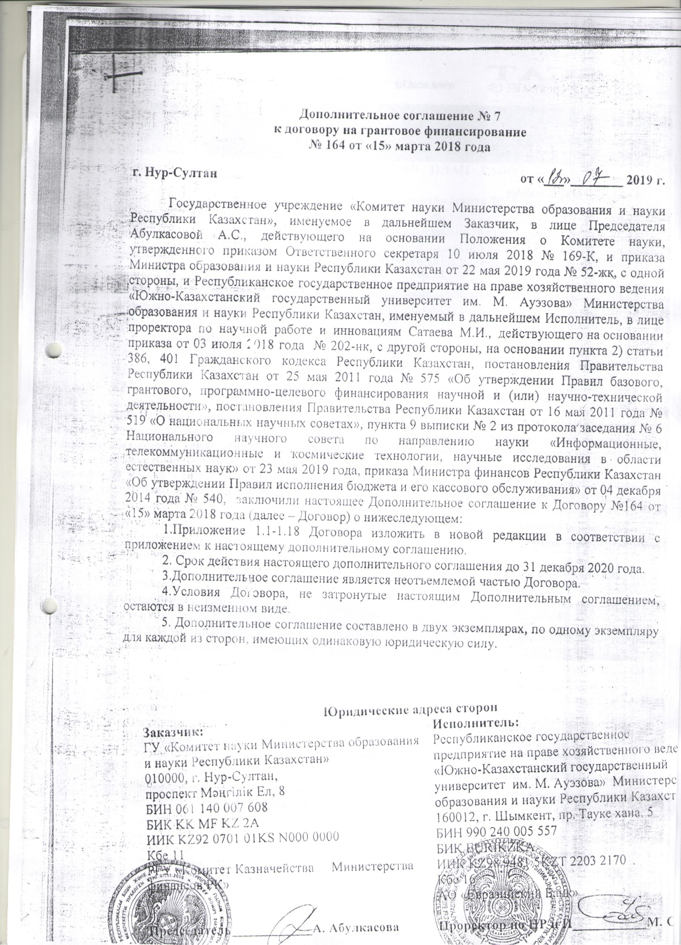

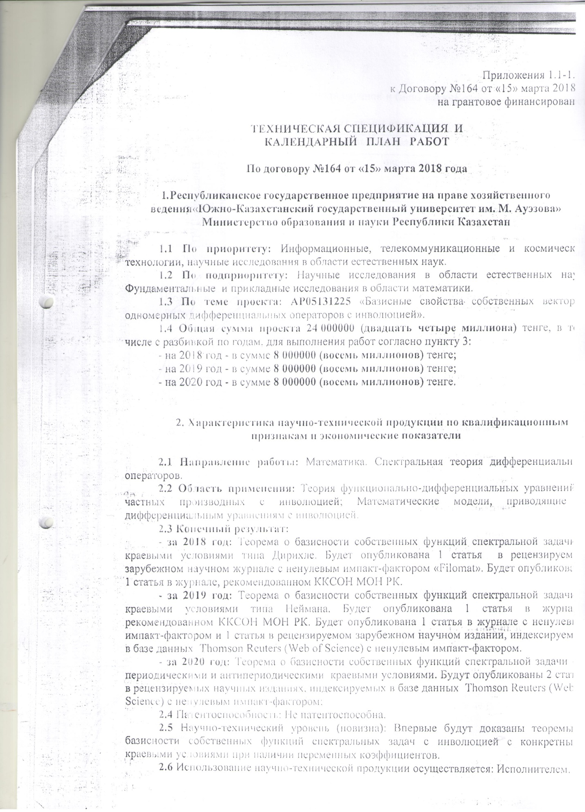



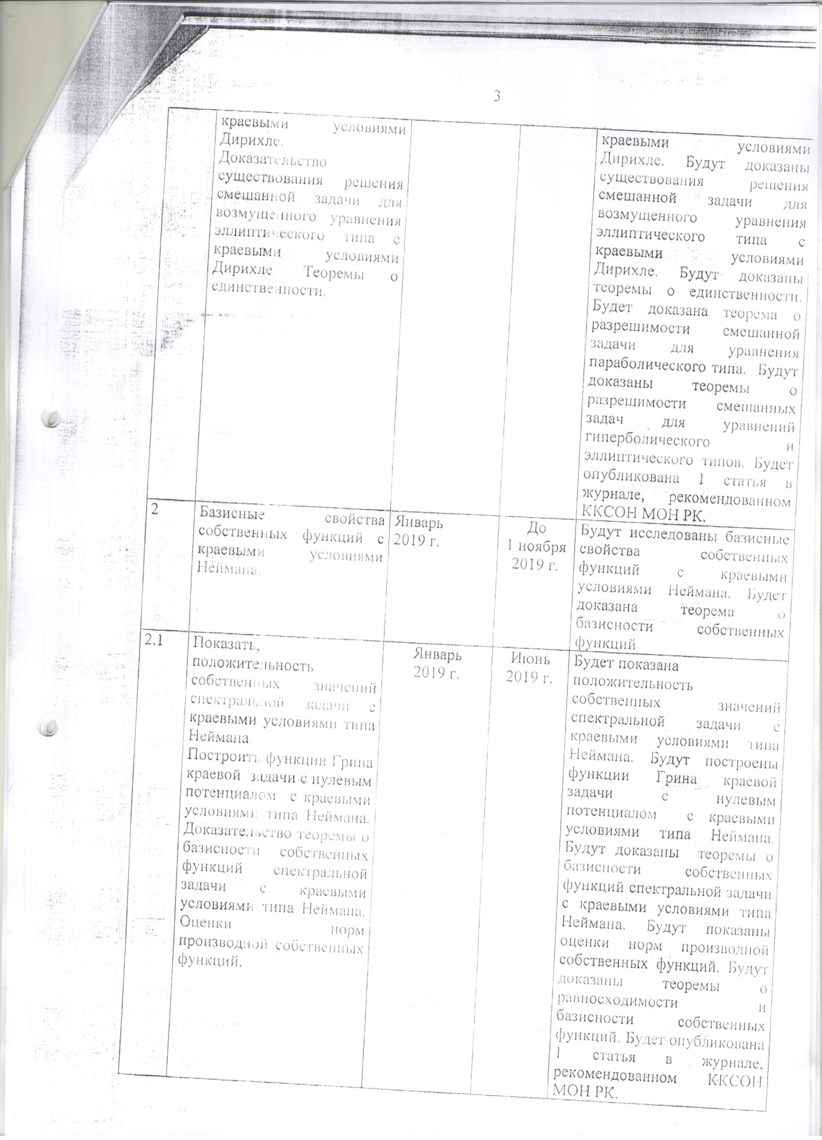



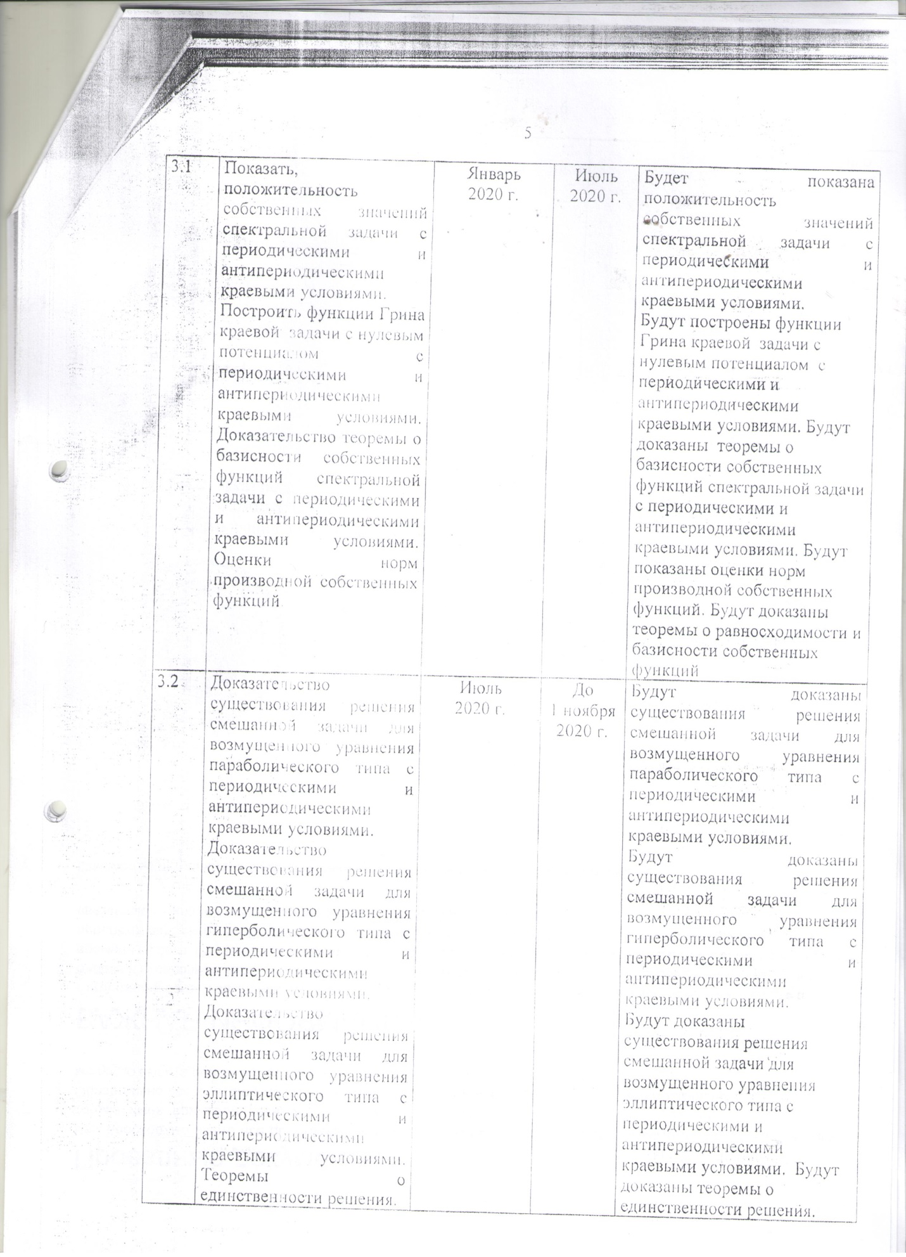

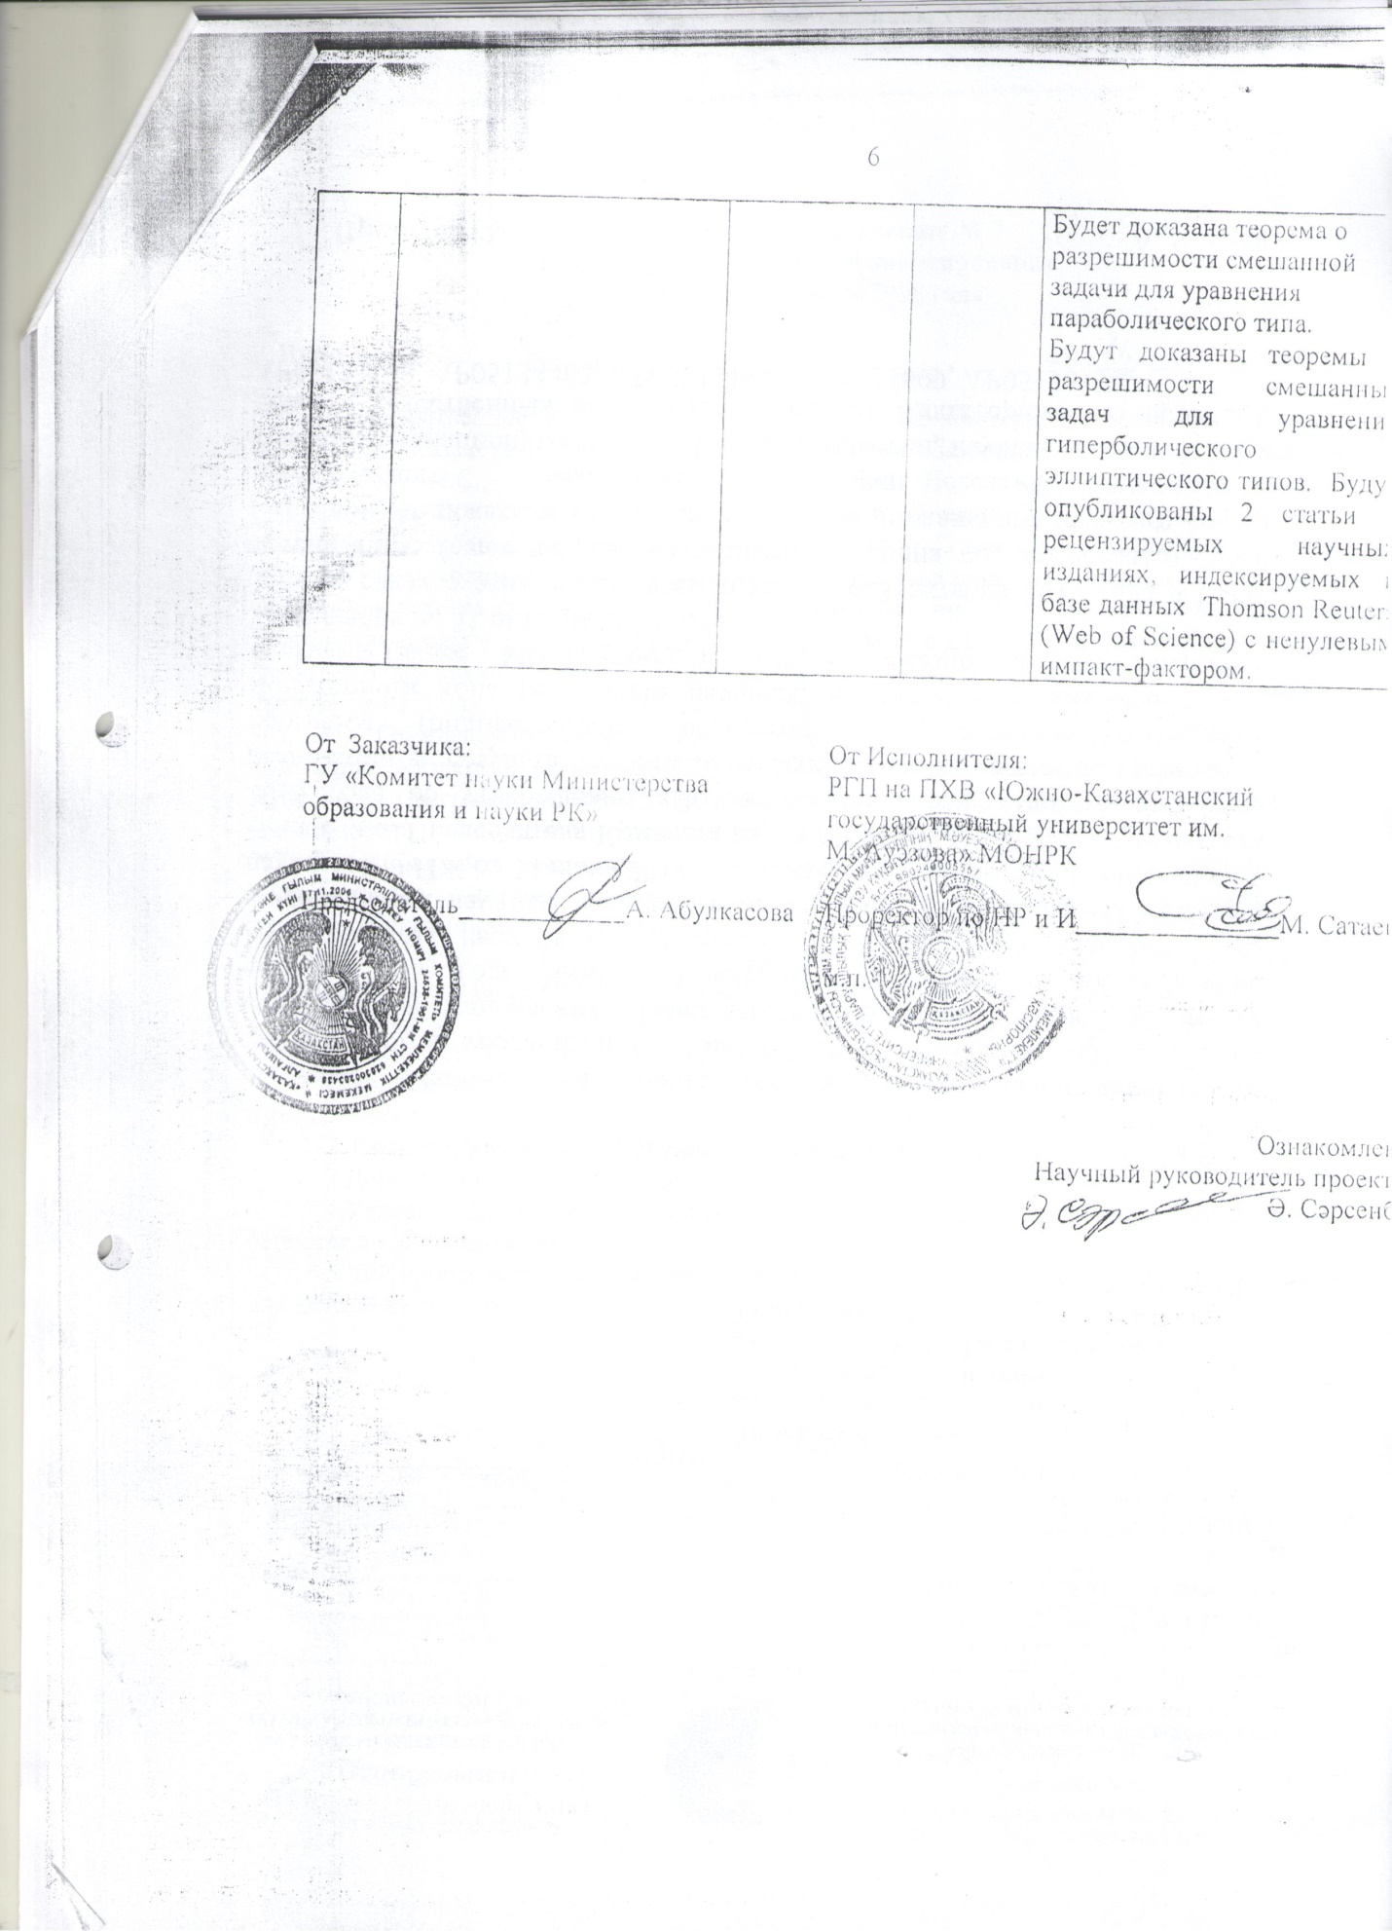

TECHNICAL SPECIFICATIONS AND

CALENDAR WORK PLAN

**1.** Republican state enterprise on the right of economic management "South Kazakhstan State University named after M. Auezov "Ministry of Education and Science of the Republic of Kazakhstan

**1.1** **Name of the priority scientific research branch for this application**.3. Information, telecommunications, and space technologies, scientific research in the field of natural sciences.

**1.2** **Name of a specialized scientific research branch for this application, type of research.**  3.6. Scientific research in the field of natural sciences. Fundamental and applied research in the field of mathematics*.*

**1.3** **Title of the Project’s theme.** AP 05131225«Basicity properties of eigenvectors related to one-dimensional differential operators with involution».

**1.4** **The total amount of the project** is 24,000,000 (twenty four million) tenge, including with a breakdown by years, for the performance of work in accordance with paragraph 3:

- for 2018 - in the amount of 8,000,000 (eight million) tenge;

- for 2019 - in the amount of 8,000,000 (eight million) tenge;

- for 2020 - in the amount of 8,000,000 (eight million) tenge. Supposed dates of the

**2.** ***Characteristics of scientific and technical products by qualification characteristics and economic indicators***

**2.1** Direction of work: Mathematics. Spectral theory of differential operators.

**2.2** Applications: Theory of functional partial differential equations with involution; Mathematical models leading to differential equations with involution.

**2.3** End result:

- for 2018: The theorem on the basis property of the eigenfunctions of the spectral problem with boundary conditions of the Dirichlet type. 1 article will be published in a peer-reviewed foreign scientific journal with a non-zero impact factor "Filomat". 1 article will be published in the journal recommended by the Committee for Control in the Sphere of Education and Science;

- for 2019: The theorem on the basis property of the eigenfunctions of the spectral problem with boundary conditions of the Neumann type. 1 article will be published in the journal recommended by the Committee for Control in the Sphere of Education and Science. 1 article will be published in a journal with a non-zero impact factor and 1 article in a peer-reviewed foreign scientific journal indexed in the Thomson Reuters (Web of Science) database with a non-zero impact factor;

- for 2020: The theorem on the basis property of the eigenfunctions of the spectral problem with periodic and antiperiodic boundary conditions. 2 articles will be published in peer-reviewed foreign scientific journals, indexed in the Thomson Reuters database with a non-zero impact factor

**2.4** Patentability: Not patentable.

**2.5** Scientific and technical level (novelty): For the first time, theorems on the basis property of eigenfunctions of spectral problems with involution with specific boundary conditions in the presence of variable coefficients will be proved.

**2.6** The use of scientific and technical products is carried out: by the Contractor.

**2.7** Type of use of the result of scientific and (or) scientific and technical activities: Formulas and theorems.

***3. Name of work, terms of their implementation and results***

|  |  |  |  |  |
| --- | --- | --- | --- | --- |
| Task code, stage | Name of work under the Agreement and the main stages of its implementation | Period of execution | | Expected Result |
| start | finishing |  |
| 1 | Name of the task.  The basicity properties for the eigenfunctions of the spectral problem with Dirichlet boundary conditions | 03.01.2018 . | Until November 01, 2018 | We will investigate the basic properties of the eigenfunctions of the spectral problem with Dirichlet boundary conditions. We will prove a theorem on the basis property of the eigenfunctions. |
| 1.1 | Name of the event.  To show the positivity of eigenvalues of the spectral problem with Dirichlet boundary conditions.  To construct the Green’s function of the boundary value problem with zero potential and Dirichlet boundary conditions.  To prove the theorem on basicity of eigenfunctions for the spectral problem with Dirichlet boundary conditions. | 03.01.2018 . | 30.06.2018 . | The positivity of the eigenvalues of the spectral problem with Dirichlet-type boundary conditions will be shown. Green's functions of a zero-potential boundary value problem with Dirichlet-type boundary conditions will be constructed.  Theorems will be proved on the basis property of the eigenfunctions of the spectral problem with boundary conditions of the Dirichlet type. 1 article will be published in a peer-reviewed foreign scientific journal with a non-zero impact factor "Filomat". |
| 1.2 | Name of the task.  The basicity properties for the eigenfunctions of the spectral problem with Dirichlet boundary conditions | 02.07.2018 . | Until November 01, 2018 | The existence of a solution to the mixed problem for a perturbed parabolic equation with Dirichlet boundary conditions will be proved.  The existence of a solution to the mixed problem for a perturbed hyperbolic equation with  Dirichlet boundary conditions. The existence of a solution to the mixed problem for a perturbed elliptic equation with Dirichlet boundary conditions will be proved. Uniqueness theorems will be proved. A theorem on the solvability of the mixed problem for an equation of parabolic type will be proved. Theorems about the solvability of mixed problems for equations of hyperbolic and elliptic types will be proved. 1 article will be published in the journal recommended by the Committee for Control in the Sphere of Education and Science. |
| 2 | Name of the task.  The basicity properties for the eigenfunctions of the spectral problem with Neumann boundary conditions. | 03.01.2019 . | Until November 01, 2019 | We will investigate the basic properties of eigenfunctions with Neumann boundary conditions. We will prove a theorem on the basis property of the eigenfunctions |
| 2.1 | Name of the event.  To show the positivity of eigenvalues of the spectral problem with Neumann boundary conditions.  To construct the Green’s function of the boundary value problem with zero potential and Neumann boundary conditions.  To prove the theorem on basicity of eigenfunctions for the spectral problem with Neumann boundary conditions. To obtain the estimates for the derivative of the eigenfunctions. | 03.01.2019 . | 30.06.2019 . | It will be shown that the eigenvalues of the spectral problem with Neumann-type boundary conditions are positive. Green's functions of a zero-potential boundary value problem with Neumann-type boundary conditions will be constructed. Theorems on the basis property of the eigenfunctions of the spectral problem with Neumann-type boundary conditions will be proved. Estimates of the norms of the derivative of the eigenfunctions will be shown. Theorems on the equiconvergence and basis property of the eigenfunctions will be proved. 1 article will be published in the journal recommended by the Committee for Control in the Sphere of Education and Science. |
| 2.2 | Name of the event.  To prove existence of the solution to the mixed problem for the perturbed equation of the parabolic type with Neumann boundary conditions.  To prove existence of the solution to the mixed problem for the perturbed equation of the hyperbolic type with Neumann boundary conditions.  To prove existence of the solution to the mixed problem for the perturbed equation of the elliptic type with Neumann boundary conditions. Theorems of uniqueness. | 01.07.2019 . | Until November 01, 2019 | The existence of a solution to the mixed problem for a perturbed parabolic equation with Neumann boundary conditions will be proved.  The existence of a solution to the mixed problem for a perturbed hyperbolic equation with Neumann boundary conditions will be proved. The existence of a solution to the mixed problem for a perturbed elliptic equation with Neumann boundary conditions will be proved. Theorems about the uniqueness of the solution will be proved. A theorem on the solvability of the mixed problem for an equation of parabolic type will be proved. Theorems on the solvability of mixed problems for equations of hyperbolic and elliptic types will be proved. |
|  |  |  |  | 1 article will be published in a journal with a non-zero impact factor and 1 article in a peer-reviewed foreign scientific journal indexed in the Thomson Reuters (Web of Science) database with a non-zero impact factor; |
| 3 | Name of the task.  The basicity properties for the eigenfunctions of the spectral problem with periodic and antiperiodic boundary conditions. | 03.01.2020 . | Until November 01, 2020 . | The basic properties of the eigenfunctions with periodic and antiperiodic boundary conditions will be investigated. The theorem on the basis property of the eigenfunctions will be proved. |
| 3.1 | Name of the event.  To show the positivity of eigenvalues of the spectral problem with periodic and antiperiodic boundary conditions.  To construct the Green’s function of the boundary value problem with zero potential and periodic and antiperiodic boundary conditions.  To prove the theorem on basicity of eigenfunctions for the spectral problem with periodic and antiperiodic boundary conditions. To obtain the estimates for the derivative of the eigenfunctions. | 03.01.2020. | 30.06.2020 . | The positivity of the eigenvalues of the spectral problem with periodic and antiperiodic boundary conditions will be shown.  Green's functions of a boundary value problem with zero potential with periodic and antiperiodic boundary conditions will be constructed. Theorems on the basis property of the eigenfunctions of the spectral problem with periodic and antiperiodic boundary conditions will be proved. Estimates of the norms of the derivative of the eigenfunctions will be shown. Theorems on the equiconvergence and basicity of the eigenfunctions will be proved |
| 3.2 | Name of the event.  To prove existence of the solution to the mixed problem for the perturbed equation of the parabolic type with periodic and antiperiodic boundary conditions.  To prove existence of the solution to the mixed problem for the perturbed equation of the hyperbolic type with periodic and antiperiodic boundary conditions.  To prove existence of the solution to the mixed problem for the perturbed equation of the elliptic type with periodic and antiperiodic boundary conditions. Theorems of uniqueness. | 01.07.2020. | Until November 01, 2020 . | The existence of a solution to the mixed problem for a perturbed parabolic equation with periodic and antiperiodic boundary conditions will be proved.  The existence of a solution to the mixed problem for a perturbed hyperbolic equation with periodic and antiperiodic boundary conditions will be proved.  The existence of a solution to the mixed problem for a perturbed elliptic equation with periodic and antiperiodic boundary conditions will be proved. Theorems on the uniqueness of the solution will be proved.  A theorem on the solvability of the mixed problem for an equation of parabolic type will be proved.  Theorems about the solvability of mixed problems for equations of hyperbolic and elliptic types will be proved. 2 articles will be published in peer-reviewed scientific journals, indexed in the Thomson Reuters (Web of Science) database with a non-zero impact factor. |