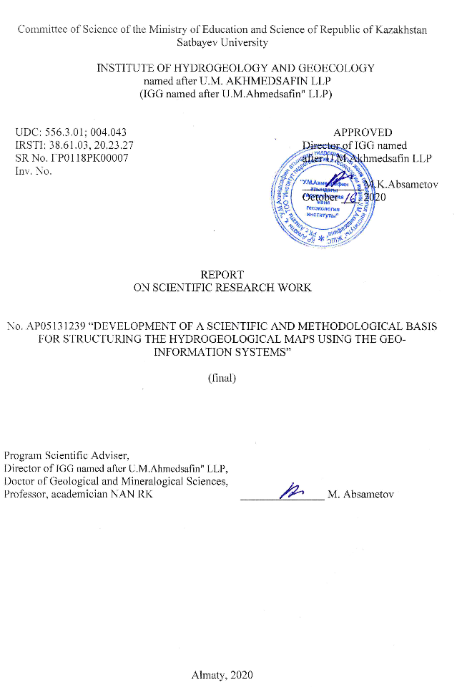
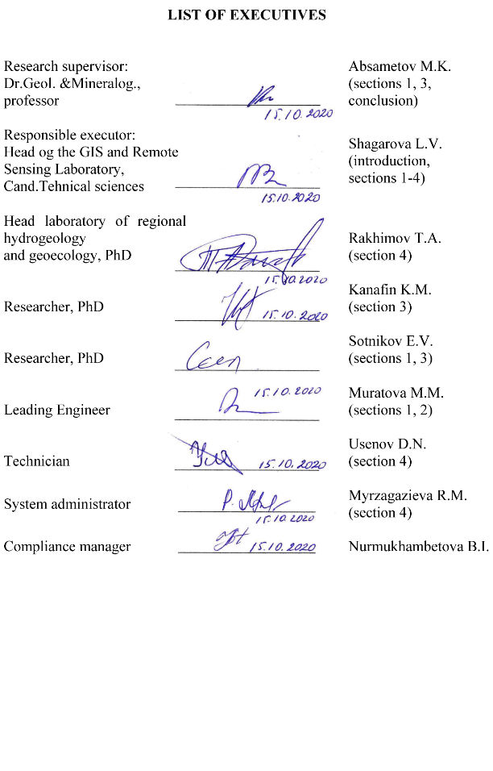
ABSTRACT

Report 43 pages, 10 figures, 3 tables, 3 annexes, 14 sources
GIS, HYDROGEOLOGY, CARTOGRAPHY, THE GEODATA BASE, THE HYDROGEOLOGICAL CROSS-SECTIONS, ERS, CATALOGUE
Study objects: ArcGIS geodata base for hydrogeological maps unification, hydrogeological map data.
Aim of the project: Development of a scientific and methodological basis for structuring the hydrogeological maps using the geo-information systems.
Basic results 2018-2020: requirements to electronic version of hydrogeological maps were generalized; experience of creating hydrogeological and geological geoinformation systems (GIS) was analyzed; structure of geodata base in ArcGIS environment was developed; conventional signs libraries “Hydrogeology” and “Geochronometry” were created; respective styles for hydrogeological objects and phenomena visualization on electronic maps and stratigraphy color displaying were developed.
A template of file database of ArcGIS geodata related to hydrogeology was developed. Analyzed was object data on hydrogeological maps that are converted into digital format with assignment of spatial geometry or attributive information to relevant classes and subclasses. Referencing and digitalization of hydrogeological maps archived sheets was performed on paper with scale of 1:500000 within borders of Almaty region. Mosaic of digitalized hydrogeological maps archived sheets was carried out: K-43-Б, K-43-А, L-43-Б, L-43-Г, K-44-А, L-43-А, L-44-Б, L-44-А, L-44-Г, L-44-В. Developed hydrogeological styles and classifiers were applied to digitalized data. Electronic hydrogeological map of Almaty region in ArcGIS format was prepared as a reference sample.
Hydrogeologic cross-sections were digitalized for Almaty region maps. Hydrogeologic cross-sections to the map were prepared. Cartographic base was updated. ERS data was processed; the limits of surface-water bodies on Almaty region map were vectorized and updated. Developed were guidelines for drawing hydrogeological maps in ArcGIS. The guidelines describing procedure of mapping in ArcGIS with the use of developed styles and database of geodata classifiers were executed. Methodological documentation, template of file database of ArcGIS geodata and a reference digital hydrogeological map of Almaty region was published on the Institute website. Catalogue of web-links to the developed materials related to hydrogeological maps structuring was created.
Scope of application: hydrogeology, geology, cartography and a number of allied subjects.
МАЗМҰНДАМА

Есеп 43 бет, 10 сурет, 3 кестелер, 3 қосымша, 14 дереккөздер
ГАЖ, ГИДРОГЕОЛОГИЯ, КАРТОГРАФИЯ, ГЕОДЕРЕКТЕР БАЗАСЫ, ГИДРОГЕОЛОГИЯЛЫҚ ҚИМАЛАР, ЖҚЗ, КАТАЛОГ
Зерттеу нысаны: Гидрогеологиялық карталарды біріктіру үшін ArcGIS геоақпараты, гидрогеологиялық картаның деректері.
Жұмыстың мақсаты: Гидрогеологиялық карталардың электрондық нұсқасына қойылатын талаптар жалпыланады; гидрогеологиялық және геологиялық ГАЖ құру тәжірибесі талданады; Геодеректер базасының құрылымы ArcGIS ортасында жасалады.
2018-2020жж. негізгі нәтижелері: Гидрогеологиялық карталардың электрондық нұсқасына қойылатын талаптар жинақталған; гидрогеологиялық және геологиялық ГАЖ құру тәжірибесі талданды; ArcGIS ортасында геодеректер базасының құрылымы жасалды; «Гидрогология» және «Геохронология» шартты белгілерінің жинағы құрылды; гидрогеологиялық нысандар мен құбылыстарды электронды карталарда визуалдауға және стратиграфияны түрлі-түсті көрсетуге арналған стильдер жасалды.
Гидрогеологиялық тақырыптар бойынша ArcGIS файлдық геодеректер базасына шаблон жасалды. Гидрогеологиялық карталарда объектілік мәліметтер талданды, олар кеңістіктік геометрияны тағайындаумен сандық форматқа немесе тиісті класстар мен ішкі класстар үшін атрибутивті ақпаратқа ауыстырылады. Алматы облысы бойынша гидрогеологиялық карталардың мұрағаттық парақтарын 1:500000 масштабта қағаз бетіне түптеу және цифрландыру орындалды. Мұрағаттық гидрогеологиялық карталардың цифрланған парақтарының мозаикасы жасалды: K-43-Б, K-43-А, L-43-Б, L-43-Г, K-44-А, L-43-А, L-44-Б, L-44-А, L-44-Г, L-44-В. Сандық мәліметтерге әзірленген гидрогеологиялық стильдер мен классификаторлар қолданылды. Алматы облысының картасына гидрогеологиялық қималар цифрландырылып, дайындалды. Картографиялық негізді жаңарту орындалды. Қашықтықтан ЖҚЗ деректері өңделді, Алматы облысы картасының жерүсті су нысандарының контурлары векторланды және жаңартылды.
ArcGIS форматында анықтама үлгісі ретінде 1: 500000 масштабта Алматы облысының электронды гидрогеологиялық картасы дайындалды. ArcGIS-те гидрогеологиялық карталарды құрастыруға арналған әдістемелік ұсыныстар жасалды. ArcGIS-те жасалған стильдер мен классификаторлар көмегімен картаға түсіру процедурасын сипаттайтын нұсқаулық шығарылды. Институттың сайтында әдістемелік құжаттама, ArcGIS файлдық геодеректер базасының үлгісі және Алматы облысының анықтамалық цифрлық гидрогеологиялық картасы жарияланды. Өңделген материалдарға веб-сілтемелер каталогы құрылды.
Қолдану саласы: Геодеректер базасының әзірленген құрылымы гидрогеология, геология, экология, картография салаларындағы мамандарға және бірқатар бір-бірімен шектес пәндер мамандарына да бағытталады.
CONTENS

INTRODUCTION | 7
1 Digitalization of hydrogeological cross-sections for Almaty region maps. Preparation of hydrogeological cross-sections to the map | 11
2 Update of cartographic base. ERS data processing, vectorization and updating of limits of surface-water bodies on Almaty region map | 17
3 Development of guidelines for hydrogeological maps drawing in ArcGIS | 22
4 Publishing of methodological documentation, template of file database of ArcGIS geodata and a reference digital hydrogeological map of Almaty region on the Institute website | 25
CONCLUSION | 27
REFERENCES | 29
ANNEX А – Work Schedule | 30
ANNEX B – Hydrogeological cross-sections of the Almaty region | 34
ANNEX C – List of Published Works of 2018-2020 | 42

LIST OF DESIGNATIONS AND ABBREVIATIONS

In this report on scientific research the following abbreviations and conventions apply:

GW | – | Groundwater
GIS | – | Geographic Information System
GB | – | Geodata Base
IRN | – | Individual Registration Number
RK | – | Republic of Kazakhstan
SGEM | – | International Multidisciplinary Scientific Geoconferences
GOST | – | Interstate Standard
MODIS | – | Moderate Resolution Imaging Spectroradiometer
ERS | – | Earth Remote Sensing
NDVI | – | Normalized Difference Vegetation Index
NDWI | – | Normalized Difference Water Index

INTRODUCTION

The objective of transition to fourth industrial revolution was set by the Message of the President of the Republic of Kazakhstan N. Nazarbayev to people of Kazakhstan (10.01.2018). Successful achieving of this objective will be determined in many ways by implementation of the Digital Kazakhstan State Program approved by the Resolution of the Government of Kazakhstan No.827 dated 12.12.2017 as amended as of 20.12.2019.
Objects and phenomena of the real world are converted into digital form by means of GIS, and information data is stored in bases of geodata. The most science-intensive form of displaying groundwater (GW) distribution and formation peculiarities are digital hydrogeological maps.
Hydrogeological mapping has gone a long development way from recording individual GW manifestations to up-to-date maps that include a wide range of objects, phenomena and processes. Here, it should be noted that cartographic data of hydrogeology are represented in Kazakhstan mainly on paper media and in graphic editor formats. Another part of application-specific maps was compiled so that they do not meet criteria determining their belonging to up-to-date information systems. Such form of information presentation makes spatial analysis difficult and hinders data integration, makes it difficult to work with data while information exchange between organizations. For spatial analysis of hydrogeological data by objects characterized simultaneously by several criteria, the insufficiently elaborated structure of geodata base classes taking part in computations, is one of the material factors reducing overall performance of specialists-hydrogeologists. Such situation was preconditioned by initial complexity of hydrogeological maps semantic message and existing problem of absence of a unified approach to creating structured GIS databases in the Republic of Kazakhstan.
With the purpose of digitization, unification, development and maintaining of spatial data integrity, necessary is the updating of the state geodetic provision system, drawing maps based on unified data structures. The use of developed guidelines for making hydrogeological maps in ArcGIS, graphic interface of the developed hydrogeological information styles and notation conventions, “Hydrogeology” and “Geochronometry” classifiers, set of attributive data facilitate the uniformity of digital information representation in ArcGIS environment, its effective spatial analysis, and also ensures continuity of archived and up-to-date cartographic information.
The aim of the project is creation of scientific and methodological aspects for structuring of geo-databases based on archival and modern hydrogeological maps in ArcGIS environment for effective spatial analysis and storage of cartographic data on hydrogeology.
Novelty: The submitted project represents a new study since methodological issues of creating full-fledged electronic hydrogeological maps standardization remained understudied. Resolving scientific-and-methodological issues related to the project objectives is a new scope of scientific research in the area of information technology.
Based on examined information displayed on hydrogeological maps and analysis of regulatory documents setting rules of its displaying, connections between hydrogeological objects were identified, which allowed their being structured into sets of classes and data classes, having created a new scheme. The developed database of geodata represents a new effective solution of hydrogeological information arrangement in GIS. Meanwhile subtypes and domains were introduced to improve data integrity. Use of domains reduced uncertainty of original values selection.
Use of the developed style is improvement of the data generation process on hydrogeological maps, since it allows setting a definite (required, not accidental) type and color of displaying objects being edited based on the created conventional symbols library as the result of automatic comparison of GDB attributive fields subtypes or domains with the styles file by unique codes of its elements. Codes were identified in the developed classifiers.
Novelty of the study outcomes was confirmed by publications in a «News of the National Academy of Sciences of the Republic of Kazakhstan», Series of Geology and Technical Sciences, that is in the third quartile of bibliographic bases. https://www.scimagojr.com/journalsearch.php?q=21100781874&tip=sid&clean=0
Its individual registration number (IRN) AP05131239 is specified in all the articles published within the project frameworks.
Prospectivity of the studies: Use of GIS-technology in scientific research facilitates the transformation of cartographic works methods. Taking into account that the structured information plays a strategic role in the development of science, arrangement of cartographic databases, accessibility of methodological aspects of their creation, provide basis for conducting further fundamental and applied research up-to-date. Creation of a hydrogeological map demonstration reference sample will allow using developed templates and guidelines for digitization of cartographical documents and its analysis by various organizations dealing with creation of cartographic databases of hydrogeological geodata, which confirms importance of the project at the national scale. Creation of a series of map sheets and their use in the work of ArcGIS software product with uniform notation conventions is as topical as in other Central Asian countries, which is confirmed by discussions at international conferences.
Basis for conducting scientific research: Based on the Budget Code of the Republic of Kazakhstan dated December 4, 2008, Law of the Republic of Kazakhstan dated February 18, 2011 “On science”, resolutions of the Government of the Republic of Kazakhstan dated May 25, 2011 No. 575 “On approval of Rules of basic, grant, program-specific financing of scientific and(or) scientific-and-technical activity”, order of the Minister of Education and Science of the Republic of Kazakhstan dated August 15, 2017 No. 410 “On approval of tender documentation for grant financing of scientific and(or) scientific-and-technical projects in 2018-2020”, order of the Chairperson of the Committee of Science of RK Ministry of Education and Science dated January 29, 2018 No. 18-нж “On approval of decision of the National Scientific Council on grant financing of scientific research in 2018-2020”, decisions of National Scientific Councils on grant financing of priority “Sustainable use of natural resources including water resources, geology, processing, new materials and technologies, safe articles and structures” (minutes No. 2 dated January 25, 2018, minutes No. 3 dated February 21, 2018). Contract No.82 dated March 02, 2018 between the State Institution “Science Committee of the Ministry of Education and Science of the Republic of Kazakhstan” and Hydrogeology and Geoecology Institute named after U.M. Akhmedsafin Limited Liability Partnership for grant financing of the project.
Key objectives of the first phase 2020: Digitize hydrogeological cross-sections for Almaty region maps.
Expected outcomes of the first phase 2020: Hydrogeological cross-sections for Almaty region maps will be digitalized. Hydrogeological cross-sections to the map will be made.
Key objectives of the second phase 2020: To update cartographic base. To process ERS data, to carry out vectorization and updating of limits of surface-water bodies on Almaty region map.
Expected outcomes of the second phase 2020: Cartographic base will be updated. ERS data will be processed, limits of surface-water bodies on Almaty region map will be vectorized and updated.
Key objectives of the third phase 2020: To develop guidelines for hydrogeological maps drawing in ArcGIS.
Expected outcomes of the third phase 2020: Guidelines for drawing hydrogeological maps in ArcGIS will be developed. Guidelines describing procedure of mapping in ArcGIS with the use of developed styles and classifiers GDB will be executed.
Key objectives of the fourth phase 2020: To publish methodological documentation, template of file database of ArcGIS geodata and a reference digital hydrogeological map of Almaty region on the Institute website.
Expected outcomes of the fourth phase 2020: Methodological documentation, template of file database of ArcGIS geodata and a reference digital hydrogeological map of Almaty region will be published on the Institute website. Catalogue of web-links to the developed materials related to hydrogeological maps structuring will be created. Published were: chapter in a book at Kazakhstan publishers, article in reviewed foreign publishing house included into Scopus database with non-zero impact-factor in materials of international cross-disciplinary scientific geo-conference SGEM.
Project implementation period – 2018-2020, project financing volume for 2018 – 9,000,000 (nine million) tenge; for 2019 – 9,081,000 (nine million eighty one thousand) tenge; for 2020 – 9,099,000 (nine million ninety nine thousand) tenge.
Basic results of 2020 are given in the report. Results obtained in 2018 and 2019 became a basis for the development of summary guidelines (section 3), which together with other data obtained within frameworks of the project implementation were published in the public domain (chapter 4). Detailed results of 2018 and 2019 are presented in reports on scientific research registered with IRN No. AP05131239-OT-18 and No. AP05131239-OT-19 (inventory numbers No. 0218РК00056, No. 0219РК00146 respectively).
Works of the project have been completed. The report is final.

1 Digitalization of hydrogeological cross-sections for Almaty region maps. Preparation of hydrogeological cross-sections to the map

Hydrogeological maps are the basic form of hydrogeological studies results graphic presentation. Hydrogeological structures are mapped both by area as well as to the depth of territory under study. In their turn, geological sections display the most important characteristics of geology at depth and have their own notation conventions. Hydrogeological cross-section displays geology and hydrogeological conditions along the set direction (section), where hydrogeological well are located. Thus, hydrogeological cross-section – is a hydrogeological map in vertical plane.
Hydrogeological cross-sections supplement cartographical documents and allow evaluating conditions of groundwater flow dynamics, identification of flows direction, calculate changes in groundwater hydraulic slope at various sites. The position of the groundwater table and the piezometric surface, the outlets of the spings are marked using the data of measurements of water levels in wells and maps of hydroisobaths and hydroisopiezes. Aquifers and the water-tight strata separating them are distinguished based on the filtration parameters.
Discontinuities of homogeneous deep-seated deposits are possible due to a significant depth of the cross-section. Based on well data, geological and lithological columns are built, based on which lithological and geological boundaries are established. Taking into account the peculiarities of the groundwater accumulation and circulation in lithological and stratigraphic rock units in the Almaty region, these lithological and stratigraphic rock units are divided into following complexes:
- paleozoic rocks distributed in mountain-folded areas and occurring from the surface;
- paleozoic rocks distributed in intermontane and intramontane depressions, lying under the Mesozoic and Cenozoic sea basin;
- loose pore deposits distributed in mountain-folded areas among the extension of predominantly Paleozoic rocks;
- loose pore deposits of the Mesozoic and Cenozoic sea basin in the intermontane and intramontane depressions
Hydrogeological cross-sections are prepared while studying hydrogeological conditions of the region and are attached to maps, explaining and supplementing them, in some cases the cross-sections have independent meaning.
Each hydrogeological cross-section shows geology, lithological composition of aquiferous and water-resistant formations, their facies changes, tectonic disturbances. Fundamentally, structure of hydrogeological cross-sections does not defer from the structure of geological sections. However, in addition to geological part, hydrogeological cross-sections contain information about aquifers –hydrogeological parameters. At the same time, surface geometry character is displayed. Based on observations of water ingresses in wells, exploratory shafts, shafts, springs aquifers are distinguished on cross-sections: groundwater surface occurrence depth, pressure heads, piezometric surface occurrence depth, artesian aquifers thickness, discharge sites, flow rates, groundwater salinity etc. Based on examinations and observations on hydrometric stations, marks and depths of surface water bodies are plotted on cross-sections. Hydrogeological cross-sections are accompanied by description of hydrogeological conditions of this or that site. Nature of aquifers and conditions of their occurrence are established based on analysis of lithological composition of reservoirs and water manifestations data of wells, exploratory shafts and springs.
The cross-sections are constructed, coloured and indexed in accordance with the hydrogeological map, i.e. they are correlated with the hydrogeological map legend in content and in the way information is reflected. The basic requirements for the information presented on maps in the ArcGIS environment are the following: a map has to contain full hydrogeological information of the region and it has to be unambiguously readable. Conventional signs must meet hydrogeological conditions in accordance with the approved recommendations for colouring, indexing, etc. Conventional symbols include colour, line, as well as alphabetic and digital indexes among others. Indexes are a combination of Latin letters, Arabic and Roman numerals used to indicate age, and Greek lowercase letters to indicate the genetic components of sediments and rocks. The age of all rocks, regardless of their origin, is indicated by indexes that are used to indicate the main stratified units.
Hydrogeological units are represented in solid colour, hatching, or lines in accordance with the colour scale of the stratigraphic units of the geological basis.
Stratigraphic units are represented using colouring, indexes and specks. At the same time, the age of stratigraphic units is indicated by colour and its shades, geological indexes, and the composition is indicated by specks. Notation conventions of digitalized hydrogeological cross-sections of Almaty region are shown on Figures 1.1-1.2.

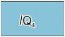 | 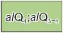 | 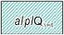 | 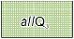 | 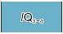 | 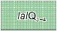
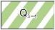 | 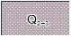 | 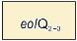 | 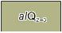 | 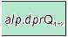 | 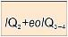
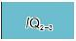 | 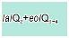 | 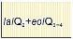 | 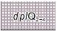 | 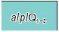 | 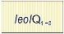
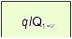 | 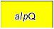 | 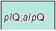 | 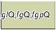 | 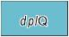 | 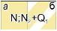
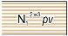 | 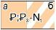 | 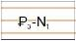 | 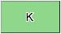 | 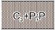 | 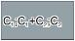
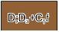 | 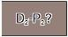 | 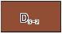 | 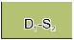 | 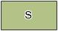 | 
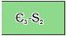 | 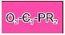 | 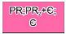 | 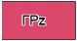 |  | 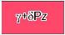
Figure 1.1 – Notation conventions of digitalized hydrogeological cross-sections of Almaty region – Distribution of aquifers and aquifer systems
Lithological composition of reservoirs
 | sands |  | acidic effusives and their tuffs
 | sands with pebbles |  | mixed effusives
 | pebble-stone |  | effusive main composition and their tuffs
 | sandy loam |  | pebbles with interlayers of clay and loam
 | loams |  | intrusive rocks: granites, granitoids
 | sandstones |  | limestones
 | sand and clay rocks |  | tuff sandstones, porphyrites, sandstones
 | slates |  | tuffs
 | clay |  | crushed stone deposits
 | sands with gravels, pebbles |  | sandstones, siltstones, shales

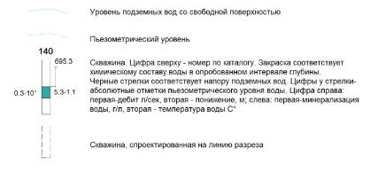
Chemical composition of water in wells
 | water with a predominance of bicarbonate anion |  | water mixed with two components
 | water with a predominance of sulfate anion |  | water mixed with three components
 | chloride anion-dominated water |  | wells with unknown water composition

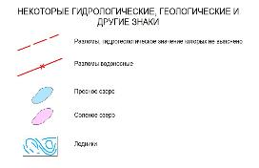
Figure 1.2 – Notation conventions of digitalized hydrogeological cross-sections of Almaty region
The zero line of the Baltic Sea Level Datum of 1977, vertical scale with divisions in 1 cm, letter designations correlating the cross-section with the map shall be indicated in each cross-section. The hypsographic profile is digitalized taking into account the scale of the subsea depths of the wellheads and the topographic map, the hypsographic profile reflects the surface topography and location of the wells in the form of vertical lines.
Geographical reference points through which the cross-section line passes are marked with signs above the hypsographic line and are accompanied by the names of reference points. The position in the cross-section of orographic and hydrographic reference points and geological boundaries should correspond to their position on the map.
Hydrogeological units, lithological and petrographic composition of reservoirs, lines of free and pressure groundwater levels (ground and artesian waters); hydrogeochemical and hydrogeothermic indicators and water points (wells) have to be reflected in hydrogeological cross-sections in addition to the general requirements for geological cross-sections. There are some fine points in water points data digitalization depending on the water point type. Tested depth intervals of hydrogeological wells have to be marked; these depths are characterized by the composition, salinity and temperature of the water, level of flow rates, decreases and heads, subsea depths of the piezometric level; conventional symbols of wells are accompanied by fixation of the subsea depth of groundwater, its chemical composition and salinity; and for the springs only chemical composition and salinity of the groundwater have to be reflected. The point at which the groundwater surface reaches its highest position is the established position of the groundwater shed for the groundwater flow.
The remarkable thing is that the aeration zone is not represented in the cross-sections and the water transmissibility is not shown.
Suite is the main cartographic stratigraphic unit for the breakdown of a cross-section by wells. The suite is divided into sub-suites, assises, which are named and indexed in accordance with the developed geochronology classifier.
Cross-sections display:
- hydrogeological units of the explored part of a cross-section showed in accordance with this Instruction;
- lithologic-and-petrographic peculiarities of these units’ formations composition represented by additional symbols provided for in GOST 2.850-75 – GOST 2.857-75;
- lines of free and head levels of groundwater;
- borders of hydrochemical zones; it is recommended to mark zones with salinity in g/l: up to 1, up to 3, 10-25, 50-150, 150-320 and more 320;
- hudroisotherms with 2-5 degrees Celsius interval; these are represented by lines of three colors: green – for negative temperatures, black – within limits of temperatures of 0 to 20 degrees and dark red – above 20 degrees;
- hydrogeological wells with characteristics of water composition and salinity within the tested interval of depths, value of groundwater head, elevations of piezometric level, flow rate and lowering, with which it was achieved, water temperature;
- wells with indication of groundwater level elevation, salinity and water composition;
- key wells, geological, geothermal and dry ones.
The cross-sections are placed under the map bottom frame. Use of hyperlinks for cross-sections displaying is relevant for electronic maps. The choice of their directions is determined by the specifics of the hydrogeological structures of the mapped area. Cross-section lines are drawn through reference water points (wells), deviations from a straight line of not more than 30 degrees are allowed. If there is a network of boreholes, it is recommended to correlate the cross-section line with the deepest wells. Cross-sections should cross the entire sheet. In dealing with complex structures, it is allowed to construct a cross-section along a broken line and additional fragmentary cross-sections limited only by the selected area or areas.
The position of the cross-sections on the hydrogeological map is indicated by thin black lines. The points of intersection of the cross-section line and the borders of the sheet (or the extreme points of fragmentary cross-sections) and the break points are indicated by the uppercase Russian letters. If the fracture point coincides with the well, then the fracture point symbol designation is placed above the fracture point, and its number is indicated on the map below the well.
The horizontal scale of the cross-sections corresponds to the map scale, and the vertical scale should provide a clear reflection of the conditions of occurrence and the relationship of aquifers. It increases by 20-200 times for lowland areas and by 5-40 times for mountainous areas.
Almaty region is characterized by a variety of relief. The day surface is divided into two sharply different parts: southern - mountainous surface, northern - plain surface. There are mountain ranges in the south and southeast of the region, and there is a semi-desert plain in the north and northwest of the region. The relief is slightly inclined towards the Balkhash Lake and it is dissected by the river beds. Therefore, three following vertical scales were used in the cross-sections digitalization at a horizontal scale of 1:500,000: 1:5,000, 1:10,000 and 1:50,000 [1].

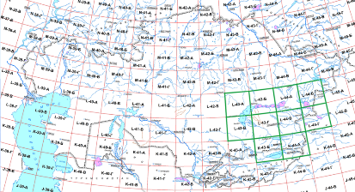
Figure 1.3 – Map of map blocks identification. Scale 1 : 500 000
At least two cross-sections are necessary for the most complete reflection of hydrogeological conditions on the map. Their number depends on the degree of complexity and facies variation of the territory. While drawing Almaty region electronic map, 16 hydrogeological cross-sections were prepared, sheets L-44-В, L-44-Г, L-44-Б, L-43-Г, L-43-Б, L-43-B, K-44-А, K-43-Б, L-44-A, layout of blocks is shown in Figure 1.3. Digitalization results are given in Annex B.
A number of hydrogeological parameters are determined according to the information presented in the cross-sections.
The hydraulic nature of the aquifers, the conditions for their occurrence are established based on the lithologic and facies analysis and data on groundwater occurrence in wells, test pits and springs.
Groundwater recharging and discharging conditions are determined for pressure water based on analysis of the shape and depth marks of the piezometric curve: the maximum depth marks are in the groundwater recharge area, and the minimum are in the discharge area.
The confined aquifer exposing depth is determined by the difference between the ground level and the top of the water containing bed, and the flow rate is determined by the difference between the level of the top and the bottom of the confined aquifer.
The depth to groundwater is determined by the difference between the ground level and the groundwater level, and the flow rate is determined by the difference between the level of the groundwater table and the water-resistant aquifer bottom.
The direction of flow is established in correlation from the areas with large elevations of the piezometric curve to areas with lower elevations. The groundwater shed identifies a place of a change in flow direction. The slope of the flow (pressure gradient) is determined as the ratio of the difference between the subsea depth or relative depth in the flow cross-sections to the distance between the cross-sections.
The expected standing confined water level during well drilling is calculated as the difference between the ground level and the piezometric curve.
The pressure over the top of bed is determined by the difference between the standing level and the level of top of bed.
Sites of flowing are possible in the areas where the ground surface is below the piezometric curve.
Thus, constructing of hydrogeological cross-sections is necessary when carrying out any types of hydrogeological studies, representing research results and analyzing digitized information.

- Update of cartographic base. ERS data processing, vectorization and updating of limits of surface-water bodies on Almaty region map

Water bodies are modified taking into account anthropogenic and climatic impacts. To draw a reference hydrogeological map, it is necessary to use updated cartographic base. For this purpose, the contours of the surface water bodies in Almaty region were vectorized and updated based on the thematic processing of the Earth Remote Sensing data (ERS).
Remote sensing technologies development is characterized with regular multispectral survey of the earth surface. ERS data processing mathematical methods allow receipt of information about the Earth surface spatial-temporal parameters, including water bodies. One of such parameters is a water mask that allows, as the result of satellite images specific processing, identification of pixels where water bodies are located. Terra/MODIS space images for June 21, 2020, and Jule 16, 2019, were used for interpretation of the water bodies in Almaty region. Spectroradiometer’s coverage width is 2,330 km, which allowed selecting a scene from the time series, characterized by the cloudless nadir location of the investigated region.
MODIS (Moderate Resolution Imaging Spectroradiometer) is one of key tools onboard of American satellites Terra and Aqua. 36 MODIS spectral zones cover the range with wavelength from 0.4 to 14.4 μm. Observations in red and infrared electromagnetic wavelength ranges are done with resolution of 250 m, in five zones of visible and near infrared range with resolution of 500 m, and others – 1 km. Data is freely available.
752 MB source historical data Terra/MODIS was downloaded in “raw” format PDS (MOD00F by EOS products classification), scene identifiers:
- MOD00F.A2019197.0535.20191970506.001.PDS;
- MOD00F.A2020173.0555.20201730447.001.PDS.
The Level 0 file was converted into Level1A and Level 1B products standardized within the EOS program. Processing included data reformatting, georeferencing, and calibration.
At the initial stage, the Level 0 file was unpacked into Level 1A data in HDF format (MOD01 by EOS product range). MOD01 contains detectors’ data sets, as well as onboard service information and metadata added to the file during processing. The MODIS Level1A data file was geo-referenced by filling the Level1A file’s fields which describe the geographic location. Thus, a geolocation file (MOD03 product by EOS product range) with latitude and longitude arrays, survey geometric parameters such as scanning angles, the position of the sun, and some other parameters was created.
Level 1A and geolocation data (i.e. MOD01 and MOD03 files simultaneously) are the input data for MODIS calibration. As a result of the calibration, a standard product in the HDF format was created. Each type of output files has its standard identifier according to the spatial resolution of the channels.
In the initial data set, each pixel is represented by a DN number (Digital Number) obtained after the conversion of “raw” values registered by the satellite sensor. DN values do not have any physical significance, as each sensor has its gain and offset values, which are applied to the signal at the moment of image array formation. Different absolute physical values can correspond to the same DN. Radiometric calibration was performed – the DN was recalculated into reflectance which is a physical parameter of the reflectivity of the surface. Geometric calibration is the transformation of data into UTM 43 projection.
The water bodies’ contours were detected based on spectral indices - indicators calculated using mathematical operations with different spectral ranges (channels) of the ERS related to certain parameters. The spectral characteristics of Terra/MODIS of the respective ranges are given in Table 2.1.

Table 2.1 – Spectral characteristics of Terra/MODIS for channels 1-4
Spectral channel | Bandwidth, nm | Spatial resolution, m
band 1 – Red | 620 - 670 | 250
band 2 – NIR | 841 - 876 | 250
band 3 – Blue | 459 - 479 | 500
band 4 – Green | 545 - 565 | 500

The spectral satellite information allows calculating:
- vegetation indices characterizing the properties of the vegetation cover based on the knowledge that the strongest feature of the plant spectrum is the minimum in the red part of the spectrum and the maximum in the infrared one.
- a water index based on the knowledge that the strongest feature of the water spectrum is the minimum in the infrared part of the spectrum and the maximum in the green part.
To detect water bodies by space multispectral images NDWI, NDVI indices given in formulas 2.1 and 2.2, respectively, were used.

(2.1)
(2.2)

Both indices give the results allowing to unambiguously detect a water body. Figures 2.1 and 2.2 illustrate the profiles of index images by the example of the Kapchagay Reservoir water surface detection.

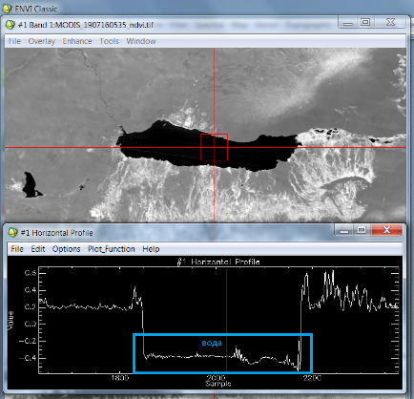

Figure 2.1 – Spectral profile NDVI of the Kapchagay Reservoir

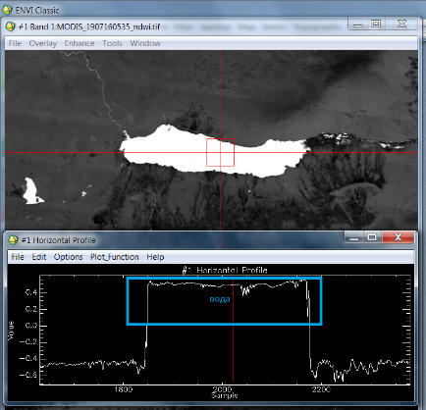

Figure 2.2 – Spectral profile NDWI of the Kapchagay Reservoir
The vectorization of water body contours was done using the EXPOLRAS procedure, as shown in Figure 2.3. This stage of processing allows converting the input raster image into a binary one with the help of the specified threshold values; to build polygons based on the created binary image; to filter them based on the area and compactness of values and to save the result into a vector layer. The EXPOLRAS procedure format: expolras (fili, dbic, thrtype, tval, areaval, compval, filo, ftype); parameters are described in Table 2.2.

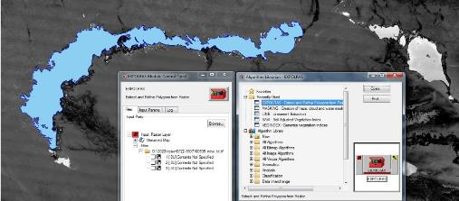
Figure 2.3 – EXPOLRAS in Geomatica

Table 2.2 – Parameters of EXPOLRAS procedure
Name | Тип | Caption | Value
FILI | str | Input raster file name | NDVI.tif / NDWI.tif
DBIC | List[int] | Input index channel number | index channel
THRTYPE | str | The type of threshold used to convert the input raster to a binary image. | pixel value
TVAL | List[float] | Minimum and maximum thresholds | value NDVI/NDWI
AREAVAL | List[float] | The minimum and maximum area values, in pixels, by which to filter the extracted objects based on their size. | 25
COMPVAL | List[float] | Minimum and maximum compactness values for target polygons.Compactness is the ratio of the area of the polygon to the perimeter =4 * 3.14 * Area / Perimeter² | 0 - 1
FILO | str | Output file name. | bitmap
FTYPE | str | The type of output file format, represented by the file extension.  SHP: Arcview shapefile format | shp

Smoothing of stepped lines obtained by converting a raster into a vector was done in two consecutive stages. To truncate rectangular corners of raster pixels the bit2poly procedure was applied; the further smoothing of vertices was done using the McMaster's averaging algorithm implemented in the SMMCMASTER procedure. The algorithm gives good results for stepped vector lines created by the raster-to-vector conversion or by digitization. The result of editing is shown in Figure 2.4.

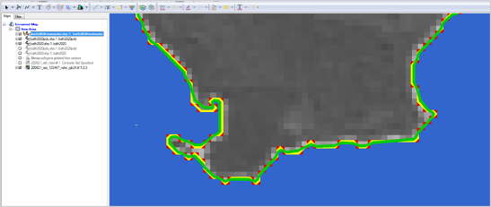
- NDWI - EXPOLRAS - BIT2POLY - SMMCMASTER

Figure 2.4 – Smoothing the vector polygon in Geomatica
Using this abovementioned technology and the ERS data, the contours of the following water bodies have been vectorized: the Kapchagay Reservoir, Lake Balkhash, and Lake Alakol, the southern part of which is within the borders of Almaty region, as shown in Figure 2.5. The thematic processing has been performed using ENVI and Geomatica licensed software.
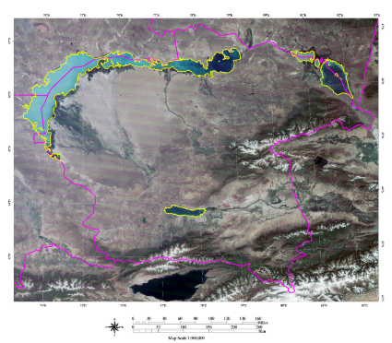
Figure 2.5 – Vectorized contours of the surface water bodies in Almaty region
Thus, thematic maps created using satellite images allowed to update vector contours of water bodies coastline in the territory being mapped.
3 Development of guidelines for hydrogeological maps drawing in ArcGIS

To effectively achieving the objective of drawing unified hydrogeological maps in ArcGIS, it is required to use up-to-date capabilities of geodata bases, applying developed styles and classifiers Hydrogeology and Geochronometry to hydrogeological objects. Works of functional organization of necessary work processes were executed within the project frameworks in 2018 and 2019 and included the following key stages of hydrogeological map reference sample preparation: analysis of regulatory data related to maps drawing; development of structure and file base of ArcGIS geodata, development of notation conventions and classifiers library, use of created ArcGIS styles to digitalized objects of the mosaic 10 sheets K-43-Б, K-43-А, L-43-А, L-43-Б, L-43-Г, K-44-А, L-44-Б, L-44-А, L-44-Г, L-44-В of Almaty region [2-7].
Hydrogeological data are grouped by thematic attribute in 9 sets of classes: horizons and systems; hydrodynamics; tectonics; hydrogeological zoning; cross-sections; wells – natural and artificial water and gas ingress; deposits, resources, groundwater use, intake structures; indicators and processes having hydrogeological meaning; intermap relationship. All sets of classes in their turn are structured by object classes. Information for each set of object classes: object classes, their spatial geometry (loops, lines, pinpoint) or attributive data identifiers and aliased names assigned to classes. While describing the structure for maintaining data integrity, subtypes and domains were introduced. Data class subtype – is internal classification of data class. Data class table attributive field domain imposes a limit to possible choice of values for an individual field of data class with the purpose of excluding user errors while filling in the attributive table.
Based on the developed structure, created was a template of file geodata base meeting the requirements of GDB universality, where list of data classes and its attributes takes into consideration the possibility of managing historical and up-to-date cartographical documents; requirement of non-redundancy and modern requirements to GIS creation. Example of hydrogeological data arrangement was given for Almaty region. To present other hydrogeological maps in digital form, developed was a template of geodata base ready to be filled out. Template of geodata base “Hydrogeological-MapTemplate.gdb” was created in ArcGIS environment with account to geodata base structure and «Hydrogeology» classifier.
Notation conventions library and ArcGIS style Hydrogeology were developed for hydrogeological objects and phenomena visualization on electronic maps with account to rules of their displaying. Electronic map notation conventions library represents a systematized set of conventional symbols formal descriptions, text part of which is represented by Hydrogeology classifier with unique codes of conventional symbols, and graphic part – by a notation convention symbol in ArcGIS. Hydrogeology.style style file was created in ArcGIS, version 10.4.1 and comprises 863 polygonal, linear and pinpoint conventions. All elements of ArcGIS style file were assigned unique numerical codes in accordance with developed classifier, used in GDB subtypes and domains.
«Hydrogeology» classifier comprises eight-digit numerical code of ААББВВГГ format, where АА contains information about subject belonging of its element (for instance, Wells, natural and artificial water- and gas showings), ББ – about objects category (for instance, Wells), ВВ – about subcategory (for example, Standard single wells, ГГ – identify uniqueness of the element within the subcategory (e.g. Standard well with predomination of sulphate anion). Such structure of the classifier allows expanding the library or edit elements without breaking data general sequence. Necessity of including additional lines into classifier is predetermined by found differences in conventions denoting the same object on up-to-date and historical maps [8-13].
As the result while working with a hydrogeological map, when it is required to show a certain class of data using conventions, subtypes of domains of GDB attributive fields are automatically compared with «Hydrogeology.style» style file by unique codes of its elements.
To display age of hydrogeological horizons, Classifier «Geochronometry» was created – set of 165 conventions corresponding to todays’ international geochronological scale. Classifier «Geochronometry» is represented by eight-digit code of АБВГДЕЖЗ format. Code decoding: (А) means belonging of the classifier element to a geological era (e.g. Cenozoic era has classifier code of 10000000, and Mesozoic era - 20000000). (Б) codes a Period (System), for instance, code of Cretaceous period will be written as 21000000. Epoch and Age are coded by the same principle (В, Г). The following four characters are provided for the expansion of the classifier by the regional Series of Suites, Suites, Subsuites and Assises. The classifier provides that the aquifers of different ages or aquifers of uncertain age will be included in the classifier.
«Geohronology.style» style file was compiled based on effective regulations and instructions by assigning its elements with filling matching standard coloration of geological units on geological and hydrogeological maps. While working with a map, when it is necessary to show a stratigraphical horizon with some color matching its age, subtypes or domains of GDB attributive fields are automatically compared with «Geohronology.style» style file by unique codes of its elements.
Guidelines for mapping in ArcGIS with the use of developed styles and GDB classifiers are presented in methodological documentation were made publicly available on the Institute website. Guidelines were approved on October 8, 2020, as shown in Figure 3.1 [14].
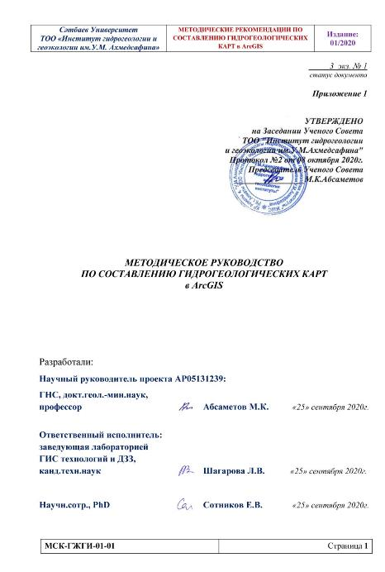
Figure 3.1 – Title page of the Methodological Guide

Methodological documentation was developed in accordance with the requirements and documentation based on the standards of ST RK ISO 9001-2016 (ISO 9001:2015 Quality management system).

- Publishing of methodological documentation, template of file database of ArcGIS geodata and a reference digital hydrogeological map of Almaty region on the Institute website

The developed guidelines for compiling hydrogeological maps in ArcGIS, ArcGIS file geodata base template and hydrogeological map of Almaty region were approved to be placed on website of the Institute based on the results of their consideration at the Scientific Council (Minutes No.2 of the meeting of the Scientific Council of «Hydrogeology and Geoecology Institute named after U.M. Akhmedsafin» Limited Liability Partnership dated October 8, 2020).
As the result, materials obtained within the frameworks of the project are placed on the Institute website https://www.hydrogeology.kz on newsfeed The Institute activities in «Projects» tab as shown in Figure 4.1.

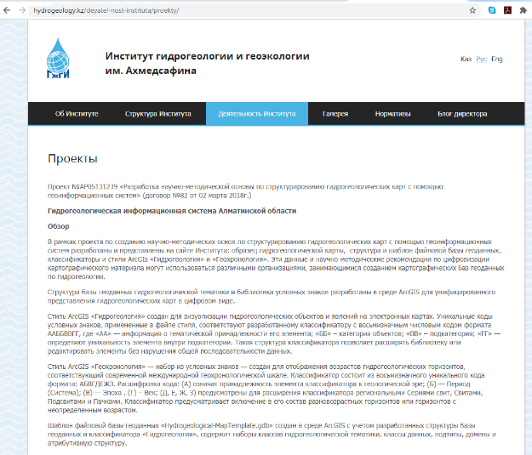
Figure 4.1 – Interface of page «Institute Activities» - Projects

Web resource: https://www.hydrogeology.kz/deyatel-nost-instituta/proekty/
Group «Review» presents a description allowing users understand the contents of the developed and provided ArcGIS solution.
Group «Requirements» specifies software and its version required for «Solution» deployment.
Group «Scientific Research Basis» gives information about project title within the frameworks of which «Solution» was prepared; specified are project IRN, contract number and source of financing.
Tile of the next group «What you get» is self-explanatory, it gives a list of data proposed by a potential user for drawing hydrogeological maps on his/her workplace in his/her organization, and data brief description is given.
- Template of ArcGIS file geodata base «Hydrogeological-MapTemplate.gdb» was created in ArcGIS environment with account to developed geodata base structure and «Hydrogeology» classifier, comprises sets of hydrogeological classes, data classes, subtypes, domains and attributive structure;
- ArcGIS style «Hydrogeology» – style for hydrogeological objects and phenomena visualization on electronic maps;
- ArcGIS style «Geochronometry» – set of conventions – created for displaying age of hydrogeological horizons corresponding to todays’ international geochronological scale;
- methodological recommendations – guidelines describing mapping procedure with the use of developed styles and classifiers;
- hydrogeological map – a reference hydrogeological map of Almaty region with the scale of 1: 500000.
Data available for downloading are given in the group Web-links Catalogue in source formats: *.gbd, *.style, *.pdf, *.zip, *.ttf, as shown in table 4.1.

Table 4.1– Catalog web Links
Name | Description | File
File GDB template ArcGIS | Scheme of object classes displayed on hydrogeological maps | Hydrogeological-MapTemplate.gdb
Style ArcGIS «Hydrogeology» | Style for visualization of hydrogeological objects and phenomena on electronic maps | Hydrogeology.style
Style ArcGIS «Geochronology» | Style for displaying the ages of hydrogeological horizons, corresponding to the modern international geochronological scale | Geochronology.style
Guidelines | Manual describing the mapping procedure using the developed styles and classifiers | Documentation.pdf
Hydrogeological map | Reference hydrogeological map of Almaty region | Alm-Hydrogeological-Map.zip
GeoF | Geological Inscription Font | GEOF____.ttf

Having imported the proposed style and scheme into ArcGIS, users will be able to deploy Hydrogeological Geoinformation System, use templates for uploading their data and creating their own hydrogeological maps. Almaty region hydrogeological map is proposed as an example.
CONCLUSION

Within scientific research under project “Development of scientific-and-methodological basis for structuring hydrogeological maps with the use of geoinformation systems” within implementation period 2018-2020, the following key outcomes were obtained.
Requirements to electronic version of hydrogeological maps were generalized; domestic and international experience of developing GIS databases in hydrogeology was analyzed.
Structure of ArcGIS geodata base for hydrogeological maps was developed to standardize the approach to creation, storing and analyzing of large volumes of hydrogeological cartographic information with the use of geoinformation systems.
Possible values of GDB variables were analyzed to create a comprehensive and at the same time non-redundant classifier. All elements of developed classifiers Hydrogeology and Geochronometry are built based on the principle of data normalization and have unique codes.
Conventional signs library was developed - systematized set of hydrogeological conventional symbols formal descriptions, text part is represented in the form of a classifier with unique codes of conventional symbols, and graphic part – by a notation convention symbol in ArcGIS.
ArcGIS «Hydrogeology.style» styles were created to visualize hydrogeological objects and phenomena on electronic maps, ArcGIS Geohronology.style – for colored displaying of stratigraphy.
Template of hydrogeological mapping file geodata base ready to be filled out was developed. Template of geodata base «Hydrogeological-MapTemplate.gdb» was created in ArcGIS environment with account to geodata base structure and classifier.
10 archived sheets of hydrogeological maps on paper media with the scale of 1:500000 within Almaty region were digitalized. Raster maps parent sheets were registered by coordinates in geographical projections of WGS-84 geodetic system, positional accuracy was evaluated, new converted bitmaps and bitmap positioning files were created. Mosaic of sheets K-43-Б, K-43-А, L-43-А, L-43-Б, L-43-Г, K-44-А, L-44-Б, L-44-А, L-44-Г, L-44-В was created.
Cartographic base was updated. ERS data was processed; limits of surface water bodies of Almaty region were vectorized: Lake Balkhash, Kapchagai water-storage reservoir, Lake Alakol. The following stages of ERS data processing were completed: unpacking of “raw” satellite images, their geocoding and calibration, geometrical and radiometric correction, index images creation, separation of water surface, filtration with account to area and compactness of values, vectorization and planarization of marked loops. Specific processing of satellite images was carried out in licensed software ENVI and Geomatica.
Digitized were 16 hydrogeological cross-sections of sheets of Almaty region maps L-44-В, L-44-Г, L-44-Б, L-43-Г, L-43-Б, L-43-B, K-44-А, K-43-Б, L-44-A. Prepared were hydrogeological cross-sections to the map with the scale of 1:500 000 in the form of hyperlinks.
Almaty region electronic hydrogeological map was prepared in ArcGIS format. Developed styles and classifiers were applied to digitalized objects. As the result, the reference sample hydrogeological map was created.
Methodological recommendations for hydrogeological maps drawing in ArcGIS were developed. Guidelines describing mapping procedure in ArcGIS with the use of developed styles and GDB classifiers was executed.
Methodological documentation, template of file database of ArcGIS geodata and a reference digital hydrogeological map of Almaty region was published on the Institute website. Catalogue of web-links to the developed materials.
Schedule tasks completed. Results of studies obtained in 2018-2020 are given in reports: Absametov M.K., Shagarova L.V. Development of scientific-and-methodological basis for structuring hydrogeological maps with the use of geoinformation systems No. ГР 0118РК00007: interim for 2018 Inv.No. 0218РК00056, interim for 2019 Inv.No. 0219РК00146.
Research findings were published in the reviewed domestic scientific journal –Izvestiya NAN RK (Bulletin of RK National Academy of Sciences). Series Geology and Engineering Sciences with non-zero impact-factor (SJR: 0.21, Q3) and in a reviewed foreign publishing house included into Scopus database with non-zero impact-factor in materials of international cross-disciplinary scientific geo-conference SGEM (Metrics from SCOPUS – SJR ELSEVIER: H-index:10, SJR: 0.23, Impact: 0.25; Metrics from Web of Science: H-index: 12, Impact: 0.45). Indexed in SCOPUS & Engineering Village / Ei Compendex - ELSEVIER, Web of Science - CLARIVATE ANALITYCS (former Thomson Reuters), EBSCO Academic Search Complete (ASC) database, ProQuest, Google Scholar Citations, Crossref Database, Russian Scientific Citation Index, British Library, Mendeley abstracting - ELSEVIER), also a chapter was published in a book at Kazakhstan publishers (ISBN 978-601-323-213-3).
Number of articles published in reviewed scientific publications corresponds to planned ones in the project application. List of publications is given in Appendix В with indication of article DOI and publication percentile in Scopus base in the year of publishing. Project individual registration number is given in every publication.
Finding of the research conducted were reported on April 13, 2018 at the International Research-to-Practice Conference “Geosystemic approach to the study of the Republic of Kazakhstan natural environment”, Astana; July 1, 2019 at the XIX International Multidisciplinary Geoconference SGEM, Albena, Bulgaria; October 24, 2019 at the XXV Esri Software Users' Conference.

REFERENCES

1 Instructions for the preparation and preparation for publication of the state hydrogeological map of Kazakhstan at a scale of 1: 200000. B.S. Uzhkenov, D.A. Kasymbekov, O. V. Podolny, B.A. Espaev. Ministry of Energy and Natural Resources of the Republic of Kazakhstan. Committee for Geology and Subsoil Use. Kokshetau, 2006 - p.88.
- Methodical guidelines for the compilation and preparation for publication of sheets of the State Geological Map of the Russian Federation at a scale of 1: 200,000 (second edition). St. Petersburg, 2009.
- Methodological guidelines for the compilation and preparation for publication of sheets of the State Geological Map of the Russian Federation at a scale of 1: 1,000,000 (third generation). St. Petersburg, 2009.
- Musin R.Kh. Methodical instructions for drawing up a hydrogeological map and an explanatory note to it / Kazan: KSU, 2004. - 38 p.
- Interactive geological map of the Committee of Geology and Subsoil Use of the Republic of Kazakhstan. URL: https: // gis.geology.gov.kz/geo/ (date of access 2020-10-08).
- GOST 28441-99 - 1999. Digital cartography. Terms and Definitions.
- Order of the Minister for Investment and Development of the Republic of Kazakhstan No. 403 dated May 30, 2018 "On approval of the block identification card with the corresponding coordinates and individual codes".
- Radu Constantin Gogu, Guy Carabin, Vincent Hallet, Valerie Peters, Alain Dassargues GIS-based hydrogeological databases and groundwater modelling / Hydrogeology Journal, 2001. Pp. 555–569.
- Arifulov R.Ch. Prospects for creating digital models of geological maps using personal geodatabase // ArcReview №2 (53), Moscow: ESRI CIS, 2010.
- Geoinformation systems in hydrogeology: Textbook / Sennov A.S., Shvarts A.A. - St. Petersburg: St. Petersburg University Press, 2005. - 62 p.
- Batu Vedat, Aquifer Hydraulics. A comprehensive guide to hydrogeologic data analysis. John Wiley & Sons, INC. 1998.
- RGB color model (for creating state geological maps). URL: http://www.geokniga.org/books/1003 (date of access 2020-10-08).
- Samples of coloring of geological objects on maps of geological content (for computer preparation and printing reproduction of maps). Third edition. St. Petersburg: FSBI "VSEGEI", 2000.
- Cohen K.M., Harper D.A.T., Gibbard P.L., Fan J.-X. International Chronostratigraphic Chart // International Commission on Stratigraphy. 2020. URL: https://stratigraphy.org/icschart/ChronostratChart2020-01.pdf.

ANNEX А

WORK SCHEDULE

Under Agreement No. 82 dated March 02, 2018

Code of the task, stage | Description of works under the Agreement and key phases of its execution | Execution period |  | Expected result
Code of the task, stage |  | Works starting | Works closing | Expected result
2018
1. | To carry out the analysis of regulatory data on registration of cards.  To develop the libraries of conventional signs and the structure of ArcGIS geo-database for unification of hydrogeological maps. | January 2018 | Until November 1, 2018 | An analysis of the regulatory data on card design will be carried out. libraries of conventional symbols and the structure of ArcGIS geodatabase will be developed to unify hydrogeological maps.  The actual data on the standards for issuing of maps on hydrogeology will be summarized and systematized; the structure and styles of ArcGIS geo-database file base on hydrogeology will be developed.
1.1 | To carry out the analysis of normative legal documentation and the requirements for designing of maps on hydrogeology. | January 2018 | March  2018 | An analysis of regulatory documents and requirements for the design of maps on hydrogeology will be performed. Requirements for electronic version of hydrogeological maps will be summarized; the experience in development of GIS databases on hydrogeology will be analyzed.
1.2 | To develop the geo-database structure for hydrogeological topics | April  2018 | June  2018 | The structure of the geodatabase of hydrogeological topics will be developed, in ArcGIS environment.
1.3 | To create a library of "Hydrogeology" conventional signs. | July  2018 | September  2018 | The library of symbols "Hydrogelogy" will be created. The style of ArcGIS "Hydrogelogy" will be developed for visualization of hydrogeological objects and phenomena on electronic maps.
1.4 | To create a library of "Geochronology" conventional signs. | October  2018 | Until November 1, 2018 | The library of conventional symbols "Geochronology" will be created. The ArcGIS "Geochronology" style will be developed for color display of stratigraphy.  One article will be published in a peer-reviewed domestic scientific journal with a non-zero impact factor, one article in a peer-reviewed foreign edition included in the Scopus database with a non-zero impact factor - in the materials of the international scientific geo-conference SGEM.
2019
2. | To develop a template geo-database. To create a reference hydrogeological map sample in accordance with the developed structure of the geo-database. | January 2019 | Until November 1, 2019 | A geodatabase template will be developed. A reference sample of the hydrogeological map will be created in accordance with the developed structure of the geodatabase.  An ArcGIS geo-database file template on hydrogeology will be developed.
2.1 | Create a geo database template in ArcGIS | January 2019 | February  2019 | A geodatabase template will be created in ArcGIS.  A template of geo-database will be developed for creation of ready for filling hydrogeological maps.
2.2 | To bind and digitize 10 archival sheets of hydrogeological maps on paper carriers of scale 1: 500,000 within the region | March  2019 | September  2019 | Binding and digitization of 10 archive sheets of hydrogeological maps on paper at a scale of 1: 500000 within the region.  A mosaic of digitized sheets of archival hydrogeological maps will be performed: K-43-Б, K-43-А, L-43-Б, L-43-А, L-43-Г, K-44-А, L-44-Б, L-44-А, L-44-Г, L-44-В).
2.3 | To apply the developed hydrogeological styles and classifiers to the digitized fragments | October  2019 | Until November 1, 2019 | The developed hydrogeological styles and classifiers will be applied to the digitized fragments.  An electronic hydrogeological map of Almaty region will be prepared in ArcGIS format.  One article will be published in a peer-reviewed domestic scientific journal with a non-zero impact factor, one article in a peer-reviewed foreign edition included in the Scopus database with a non-zero impact factor - in the materials of the international scientific geo-conference SGEM.
2020
3. | Develop guidelines for the compilation of structured hydrogelogic maps in GIS. Publish for download from the website of the Institute a demo reference sample of a digital hydrogeological map. | January 2020 | Until November 1, 2020 | Methodological recommendations for the compilation of structured hydrogeological maps in GIS will be developed. A demo reference sample of a digital hydrogeological map will be published for download from the Institute's website. Scientific and methodological documentation and a reference hydrogeological map available for free download will be compiled and published on the website of the Institute.
3.1 | Digitize hydrogeological cross-sections for Almaty region maps. | January 2020 | March  2020 | Hydrogeological cross-sections for Almaty region maps will be digitalized. Hydrogeological cross-sections to the map will be made.
3.2 | To update cartographic base. To process ERS data, to carry out vectorization and updating of limits of surface-water bodies on Almaty region map. | April  2020 | June  2020 | Cartographic base will be updated. ERS data will be processed, limits of surface-water bodies on Almaty region map will be vectorized and updated.
3.3 | To develop guidelines for hydrogeological maps drawing in ArcGIS. | June  2020 | September  2020 | Guidelines for drawing hydrogeological maps in ArcGIS will be developed. Guidelines describing procedure of mapping in ArcGIS with the use of developed styles and classifiers GDB will be executed.
3.4 | To publish methodological documentation, template of file database of ArcGIS geodata and a reference digital hydrogeological map of Almaty region on the Institute website. | October  2020 | Until November 1, 2020 | Methodological documentation, template of file database of ArcGIS geodata and a reference digital hydrogeological map of Almaty region will be published on the Institute website. Catalogue of web-links to the developed materials related to hydrogeological maps structuring will be created. Published were: chapter in a book at Kazakhstan publishers, article in reviewed foreign publishing house included into Scopus database with non-zero impact-factor in materials of international cross-disciplinary scientific geo-conference SGEM.

On behalf of the Employer:  Chairperson of SE «Committee for Science of the Ministry of Education and Science RK»  _____/Signed/____________ Abdrasilov B.S.  Seal: /SE Science Committee of RK Ministry of Education and Science/ | On behalf of the Implementer:  Director of the Institute of Hydrogeology and Geoecology named after U.M. Ahmedsafin LLP  _______/Signed/_________ Absametov M.K.  Seal: /Institute of Hydrogeology and Geoecology named after U.M. Ahmedsafin LLP, Almaty, Republic of Kazakhstan/
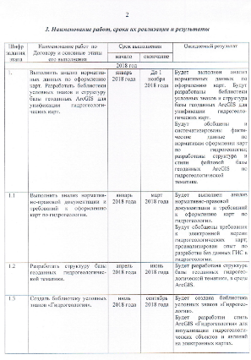 | 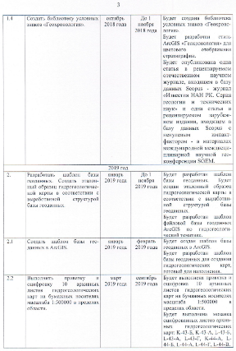
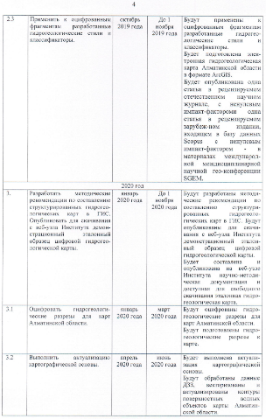 | 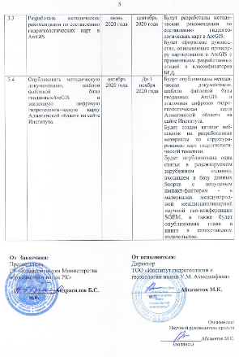

Figure A1 – Scan of work schedule

ANNEX B

Hydrogeological cross-sections of the Almaty region
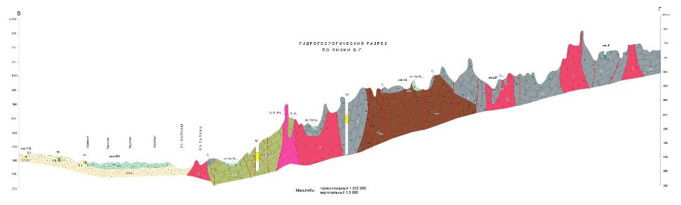
Figure B1 – Hydrogeological cross-sections of the sheet L-43-Б
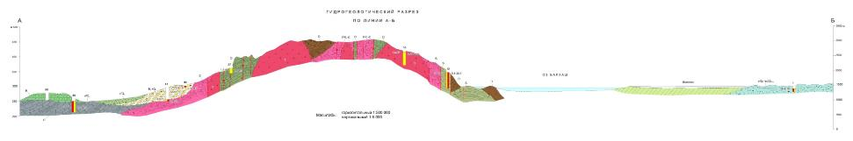
Figure B2 – Hydrogeological cross-sections of the sheet L-43-B

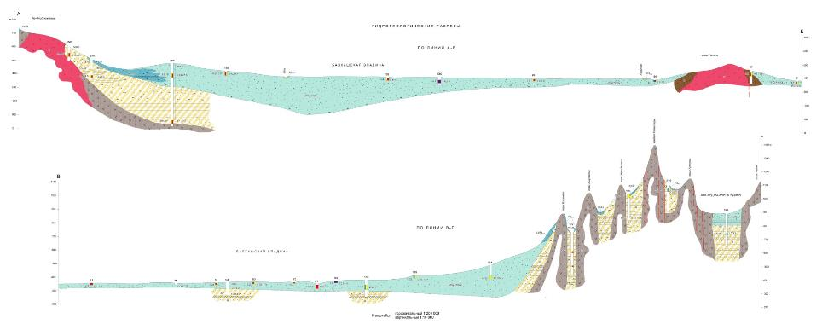
Figure B3 – Hydrogeological cross-sections of the sheet L-43-Г

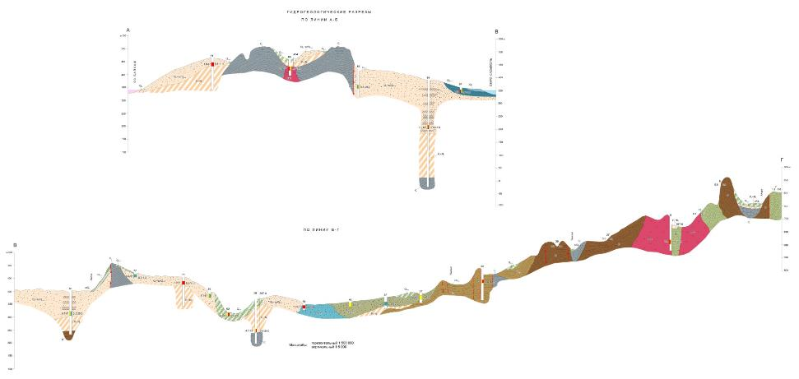
Figure B4 – Hydrogeological cross-sections of the sheet L-44-A

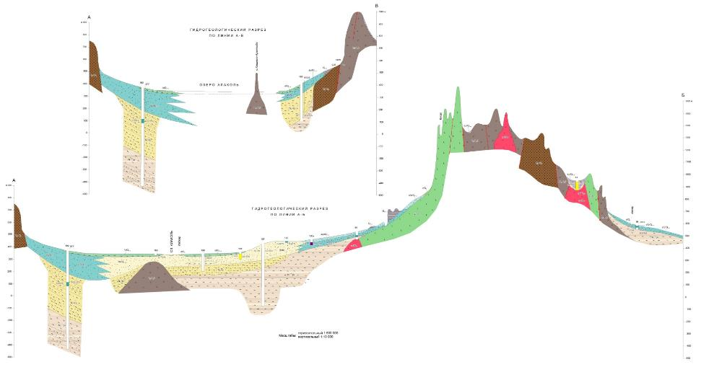
Figure B5 – Hydrogeological cross-sections of the sheet L-44-Б
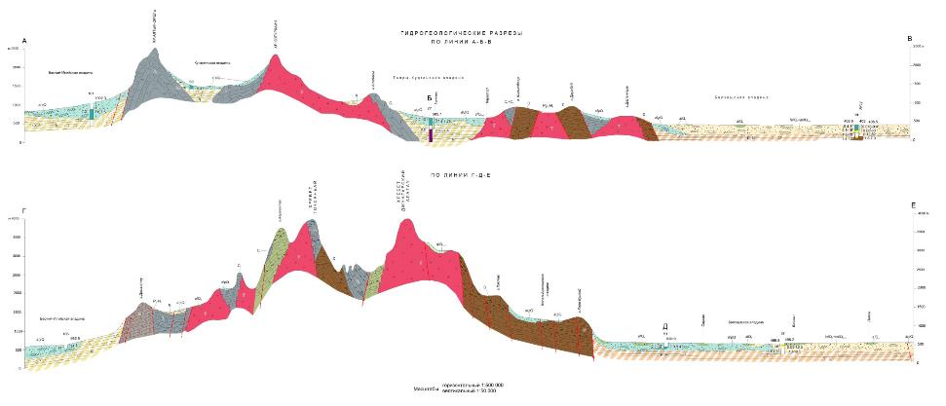
Figure B6 – Hydrogeological cross-sections of the sheet L-44-В
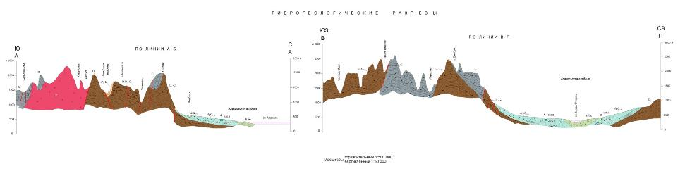
Figure B7 – Hydrogeological cross-sections of the sheet L-44-Г

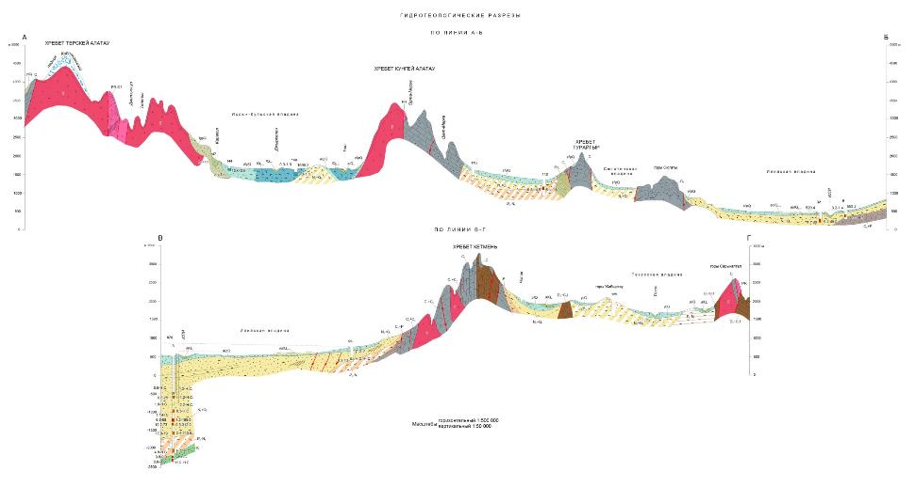
Figure B8 – Hydrogeological cross-sections of the sheet K-44-А

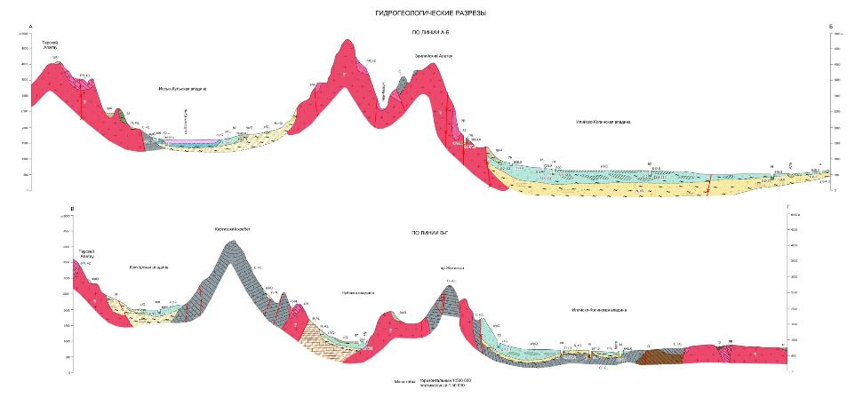
Figure B9 – Hydrogeological cross-sections of the sheet K-43-Б

ANNEX C

List of Published Works for 2018-2020

1. Shagarova L.V., Absametov M.K., Cheredov V.O., Muratova M.M. Creation of a geoinformation system in ArcGIS for hydrogeological mapping // Materials of the International Scientific and Practical Conference "Geosystem approach to the study of the natural environment of the Republic of Kazakhstan", April 13-14, 2018 Volume 2. - Astana: ENU named after L.N. Gumilyov, 2018. - P. 110-113.
2. L. Shagarova, M. Muratova, V. Cheredov On the structuring of hydrogeological maps using geoinformation systems // International Multidisciplinary Scientific GeoConference Surveying Geology and Mining Ecology Management SGEM 2018: Informatics, Geoinformatics and Remote Sensing, Issue 2.3 Cartography and GIS, Volume 18 – Albena, 2018. – P. 511-518. ISBN 978-619-7408-41-6, ISSN 1314-2704, DOI:10.5593/sgem2018/2.3/S11.065. Scopus Percentile 2018 - 16th (https://www.scopus.com/sourceid/21100274701).
3. M.K. Absametov, L.V. Shagarova, О.А. Matushkina Library of Legends of Hydrogeological Maps in ArcGIS // News of the National Academy of Sciences of the Republic of Kazakhstan, Series of Geology and Technical Sciences, Volume 5, Number 431 (2018), P. 9-11. Almaty, 2018. ISSN 2224-5278 https://doi.org/10.32014/2018.2518-170X.2 Scopus percentile for 2018 - 10. (https://www.scopus.com/sourceid/21100781874).
4. L. Shagarova, M. Absametov, M. Muratova Creation of the Classifier and the ArcGIS Style «Geochronology» for Displaying Aquifers and Aquifer Systems on the Hydrogeological Maps // International Multidisciplinary Scientific GeoConference Surveying Geology and Mining Ecology Management SGEM 2019. Issue 2.2 Cartography and GIS, Volume 19 – Albena, 2019. – P. 767-774. ISBN 978-619-7408-80-5, ISSN 1314-2704, DOI: 10.5593/sgem2019/2.2/S11.094. Scopus 2019 percentile - 17 (https://www.scopus.com/sourceid/21100274701).
5. M.K. Absametov, L.V. Shagarova, A. Gafurov Digitalization of hydrogeological surveys results in ArcGIS // News of the National Academy of Sciences of the Republic of Kazakhstan, Series of Geology and Technical Sciences, Almaty, 2019. ISSN 2224-5278, 3(435), P. 14-20 DOI: 10.32014/2019.2518-170X.62. Scopus 2019 Percentile - 26 (https://www.scopus.com/sourceid/21100781874).
- Rational use and protection of underground waters of the Republic of Kazakhstan in conditions of climatic and anthropogenic changes, ed. M.K. Absametova / M.K. Absametov, L.V. Shagorova, E.V. Sotnikov, M.M. Muratova, D.N. Usenov Scientific and methodological foundations for structuring hydrogeological maps using geographic information systems. Almaty, 2020. - S. 249-265. ISBN 978-601-323-213-3.
- M. Absametov, K.Svetlakova, M. Muratova Hydrogeological cross-sections digitalization // International Multidisciplinary Scientific GeoConference Surveying Geology and Mining Ecology Management SGEM 2020. Cartography and GIS, Albena, 2020. - P.8. ISBN 978-619-7408-80-5, ISSN 1314-2704.

