Ministry of agriculture of the Republic of Kazakhstan

«KAZAKH RESEARCH INSTITUTE OF PROCESSING AND FOOD INDUSTRY» Ltd
(«KazRIPFI» Ltd.)

UDC 637.33
Reg. № 0118 РК00517
MRSTI 65.63.39
Inv. №

APPROVED
The Chairman «KazRI PFI» Ltd Dr., Prof., corr.member of NAS RK ____________________A.Ospanov
«____» _______________ 2020

RESEARCH REPORT

on the theme:
" TECHNOLOGY DEVELOPMENT OF NEW TYPES OF FUNCTIONAL WHEY CHEESES AND BEVERAGES WITH THE USE OF PLANT-BASED DIETARY SUPPLEMENTS»
(final)

under the budget program 217 "Science development"
subprogram 102 "Grant financing of scientific research»

Project manager:  Dr., Academician of AAS RK | __________________T.Tultabayeva

Almaty 2020

LIST OF PERFORMENCES

ABSTRACT

Report 71 p., figures 12, tables 12, references 16, appendix 10.
COW MILK, STARTER CULTURE, DIETARY SUPPLEMENT, VEGETABLE RAW MATERIALS, CHEESE, WHEY.
The objects of research are cow's milk, starter cultures, dietary supplements, whey, and whey drinks.
Research objective: Development of a waste-free technology for processing dairy and secondary dairy raw materials. Development of technology for export-oriented cheeses and beverages from functional whey with the use of plant-based dietary supplements.
Scope of research results. Dairy industry.
Economic efficiency or significance of the work
The development of technology for new types of functional cheeses and whey drinks with the use of natural dietary supplements from vegetable raw materials will provide the population of the Republic with full-fledged and biologically enriched dairy products with a low cost. The most favorable ratios of the various components will be determined, which will guarantee a product with high consistency and organoleptic evaluation, as well as with functional properties.
Predictive assumptions about the development of the research object
The technology of new types of functional cheeses and whey drinks with the use of BAA supplements from vegetable raw materials is a new scientific direction and will allow product manufacturers to take a leading position in the development and production of new types of export-oriented products.
The technology of production of cheeses and whey drinks with biologically active additives from vegetable raw materials will be patented in the Kazakhstan patent office.

CONTENT

INTRODUCTION............................................................................................................... |  |  | 6
MAIN PART…………………………………………………………………………… |  |  | 9
1 | Choosing the research direction ...………………………………………………….. |  | 9
2 | The objects and research methods …………………………………………………. |  | 16
3 | EXPERIMENTAL PART …………………………………………………………. |  | 17
3.1 Establishment of the shelf life of beverages made from whey with the use of dietary supplements from vegetable raw materials …………………………………………….. |  |  | 17
3.2 Study of the nutritional, biological and energy value of whey beverages with the use of plant-based supplements ……………………………………………………….. |  |  | 20
3.3 Production of experimental batches of new types of cheeses with bioadditives from vegetable raw materials in laboratory and production conditions, optimization of technological parameters ………………………………………………………………. |  |  | 23
3.4 Production of experimental batches of beverages made from whey with the use of dietary supplements from vegetable raw materials.…………………………….............. |  |  | 33
CONCLUSION.................................................................................................................... |  |  | 38
LIST OF REFERENCES..................................................................................................... |  |  | 41
APPENDIX А - Patent report ................................................................................... |  |  | 42
APPENDIX B - Calendar plan 2020 ............................................................................. |  |  | 43
APPENDIX C - |  | Results of the analysis of microbiological parameters in the process of storage of whey beverages............................................................. | 55
APPENDIX D - |  | Results of analysis of the content of vitamins and trace elements in whey drinks........................................................................................ | 56
APPENDIX E - |  | Act of cheese production in the laboratory ........................................ | 57
APPENDIX F - |  | The act of production of soft cheeses with vegetable supplements at the enterprise “Turan” farm.............................................................. | 60
APPENDIX G - |  | Act of production of whey drinks at the “Turan” farm ........................ | 62
APPENDIX H - |  | Act of introduction into production…………………………………. | 64
APPENDIX J - |  | Patent applications of the Republic of Kazakhstan ........................... | 66
APPENDIX K - |  | List of published articles.................................................................... | 68
LIST OF ABBREVIATIONS AND DESIGNATIONS

The following terms and definitions are used in this research report:
BAA | – | biological active additive (dietary supplement)
pasteurization | ‒ | the process of heating milk once to 60 °C for 60 minutes or at a temperature of 70-80 °C for 30 minutes
ultrasonic treatment | ‒ | the effect of ultrasound on substances in technological processes
enzyme preparations | ‒ | complex protein molecules, ribozymes or their complexes that accelerate chemical reactions in living systems
starter cultures | ‒ | microbiological (bacterial) composition that causes fermentation
t | ‒ | ton
min | ‒ | minute

INTRODUCTION

Today, due to the difficult situation in the economy and changes in the international situation, new approaches are being considered that can ensure high-quality growth in the agro-industrial sectors, including the dairy industry. Dairy farming and the dairy industry are one of the most important subsystems of the agro-industrial complex of the Republic of Kazakhstan. The dairy industry is a set of enterprises engaged in the preparation and complex processing of milk for whole milk, fermented milk products, butter and ghee, natural cheeses, processed, brine, cheese, whole milk powder, etc.
The milk and cheese market is one of the most popular food markets in Kazakhstan. According to experts of this industry, the capacity of the Kazakhstan market today is more than 40 thousand. Tons per year. The top three major importers are as follows: Russia, Ukraine, Belarus [1].
In Kazakhstan, the average annual consumption of cheese per capita is 2.5 kg. The most active consumers are residents of Almaty and Astana. If a resident of Astana has 3.8 kg of cheese, it is 4.5 kg for a resident of Almaty [2].
Today, Kazakh-made cheeses account for about 35 % of the total sales of this category. An overview analysis of the data Of the customs control Committee of the Republic of Kazakhstan shows an increase in import volumes for the following groups of dairy products: processed liquid milk and cream, butter, cheese and cottage cheese and condensed milk.
The main exporter of processed liquid milk and cream, as well as milk powder, in Kazakhstan is Russia. The share of imports of milk and cream produced in the Russian Federation in 2018 was 38% of all imported products of this type to Kazakhstan.
For cheese and cottage cheese in 2017, the main share of deliveries falls on Russia – 20195 tons, which is 87.7 %.
On average, cheese production has increased by 10% over the past three years. As for demand, its volume in the same year amounted to 32.8 thousand tons, showing an increase of 1.8%. Thus, domestic production covers only 55.4% of demand [2].
Today, one of the major problems in this industry is the quality of products, in particular, the high proportion of palm oil and preservatives in the product. This also applies to imported suppliers, as an example, in April 2014, when a ban was adopted on the import and sale of cheese from five Ukrainian producers: PE "ROS", JSC "Piryatinsky cheese factory", LLC "Gadyach cheese", PJSC "Zolotoshsky butter factory" and LLC "Tehmolprom" due to non-compliance of products with domestic quality standards [1].
Despite the significant market capacity, the assortment presented in stores is limited to hard cheese varieties: brynza, Suluguni, Kostroma, Dutch, etc. As for soft varieties, they are mostly represented by foreign producers. The presence of imported mozzarella, buratta and ricotta cheese on sale, taking into account their shelf life of one to ten days, indicates the presence of preservatives in their composition. The domestic market for these types of products is represented by only two companies: "SabaFood"and "LATTE", whose main market is Almaty and Almaty region. Taking into account the above, we can conclude that the domestic market is not saturated with this product [2].
Our country has all the prerequisites for the development of mass production of cheeses and whey drinks of a new generation using raw materials from plant origin that have antioxidant and radioprotective properties.
Already today, various fermented milk drinks, processed and soft cheeses, cottage cheese products and many other products are produced on a dairy basis using a wide range of different food components of plant and animal origin.
The theoretical and practical foundations for creating combined dairy products are laid and developed in the works of Dilanyan Z.X, Grannikov D.A., Bogdanov V.M., Ostroumov L.A., Sviridenko Yu.A., Gavrilova N.B., Poznyakovsky V.M., kuzlyakin A.K., Chomanov U.Ch., Alimardanova M.K., Tultabayeva T.Ch. and others.
When creating functional dairy products, they strive to correct their amino acid, fatty acid, carbohydrate, and mineral composition, giving the products therapeutic and preventive properties. Special attention is paid to the enrichment of products with biologically active additives from plant raw materials [3].
The technology we are developing for the production of new types of cheeses and whey drinks will allow us to produce products of increased biological value for mass, children's, school, and functional purposes. The advantage of the technology is the use of only whole milk and natural raw materials in the production, the absence of semi-finished products and other additives, which will have a positive effect on the taste of products [4].
The goal is to develop a waste - free technology for processing dairy and secondary dairy raw materials. Development of technology for export-oriented cheeses and beverages from functional whey with the use of plant-based dietary supplements.
In accordance with the set goal and the calendar plan, the following tasks were defined for 2020:
- establishment of the shelf life of beverages made from whey with the use of dietary supplements from vegetable raw materials;
- study of the nutritional, biological and energy value of whey beverages with the use of plant-based supplements;
- production of experimental batches of new types of cheeses with bioadditives from vegetable raw materials in laboratory and production conditions, optimization of technological parameters;
- production of experimental batches of beverages from whey with the use of dietary supplements from vegetable raw materials.
The name of the prepared interim reports:
In 2018
Research report on the topic "Technology development of new types of cheeses and beverages from functional whey with the use of herbal supplements", No. 0218RK00666
In 2019
Research report on the topic " Technology development of new types of cheeses and beverages from functional whey with the use of herbal supplements ", No. 0219RK00659

MAIN PART

1 Choosing the research direction
Cheese is one of the most valuable food products. It contains almost all the substances necessary for the human body in an easily digestible form. The digestibility of cheese proteins is 95 %, fat – 96 % and carbohydrates – 97 %.
An analysis of the economic and technological features of the production of various types of cheese has shown that at this stage of development of cheese making, the production of soft cheeses is promising, which is associated with the efficiency of using raw materials, the possibility of selling them without maturation, as well as their high biological value [4].
The nutritional and biological value of cheese is due to its high content of milk protein and calcium, the presence of essential amino acids, fatty and other organic acids, vitamins, mineral salts, and trace elements necessary for the human body.
When creating dairy products with functional properties, adding vegetable fillers to them is promising. They are well combined with dairy raw materials and are characterized by a high content of biologically valuable substances. Vegetables and fruits are essential sources of vitamins, mineral salts, cell membranes, and other biologically active substances that have a therapeutic effect [5].
Plant – based products are a rich source of a number of essential nutrients for the body, the supply of which cannot be provided only at the expense of animal products. Combining the milk base with raw materials of plant origin makes it possible not only to obtain products with the necessary medical and biological properties, but also to protect them from oxidation due to the presence of compounds with antioxidant activity, for example, polyphenols [11].
Dietary fiber (DF) is a complex of biopolymers that includes cellulose, hemicellulose, pectin substances, lignin and related protein substances that form the walls of plants. It consists not only in partially supplying the body with energy, releasing a number of food metabolites and pollutants from it, but also in regulating physiological and microbiological processes in the digestive organs [6].
L. A. Ostroumov developed a scheme of six directions that make up the main raw material groups of non—dairy origin for the production of combined soft acid-rennet cheeses: 1.Fruit and berry; II. Vegetable; III. Wild vegetation;. IV Marine products; V. bee products; VI. Enriching agents for therapeutic and prophylactic purposes [3].
The physiological role of vegetables is determined by their pronounced effect on the digestive system. One of the most profitable both economically and in terms of nutritional value from this type of raw material are carrots and pumpkins.
Carrots are easily digested, so they occupy a strong place in the human diet. Carrots are a valuable source of carotene. Carotene has a beneficial effect on the secretion of gastric juice. Lack of vitamin A causes a violation of the functions of the skin and gastrointestinal tract, the development of anemia, vision impairment. The daily requirement for vitamin A (1-1. 5 mg) can be met by eating 50-100 g of raw carrots.
Carrots have a hematopoietic, bactericidal, tonic, anti-inflammatory, choleretic, diuretic, laxative, wound healing, analgesic, anti-sclerotic effect.
Carrots are widely used in dietary and medical nutrition. It is used for anemia, scurvy, rheumatism, vision disorders, cardiovascular diseases, and loss of strength.
Pumpkin is a low - calorie vegetable (25 calories per 100 g), which includes various vitamins, macro-and microelements, and organic acids. In addition, it is rich in dietary fiber and pectin.
The plant contains energy substances: fats, proteins and carbohydrates. The seeds contain fatty and essential oils. Fatty oil includes glycerides of linoleic, oleic, palmitic and stearic acids; phytosterol – cucurbitol, amino acids, resinous substances containing oxycerotinic acid, organic acids, vitamins C, B1, and carotenoids are found. The pumpkin pulp contains sugars (the main one is sucrose), fiber, potassium, calcium, magnesium, and iron salts; trace elements: copper, cobalt, and others; vitamins C, B1, B2, B5, E, PP, and carotenoids [6].
In the conditions of transition to functional forms of nutrition, vegetables and fruits, having a high nutritional and biological value, are becoming increasingly important. In recent years, there have been many studies and recommendations on the use of fruit and vegetable additives in the production of flour confectionery and bakery products. Vegetables, herbs, fruits as components of flour dough are widely used in the form of dry powders, pulp, crushed raw or boiled mass, juices, extracts and flakes. They are used to reduce energy-intensive components in the product formulation, enrich it with dietary fiber, and improve organoleptic quality indicators. For example, the use of pumpkin and carrot powder in the production of pastry and pastry products can not only enrich products with fiber, minerals and vitamins, but also increase the yield of products, reducing their energy value by 10-30 % [3, 6].
The possibility and feasibility of using vegetable and fruit powders in the production of flour and confectionery products is due to the peculiarities of their chemical composition and technological properties. The nutritional value of vegetables is determined mainly by the content of sugars, organic acids, nitrogenous substances and dietary fiber, as well as vitamins and alkali metal salts. Among vegetables, white cabbage and carrots, along with potatoes, are widely distributed in the diet of the population and are well preserved, which allows them to be used for processing throughout the year. The chemical composition of these vegetables varies depending on the variety, place of growth, degree of maturity and other factors [5].
Research shows that carrot and cabbage powder can act as components that improve the structure of food products. In turn, the technological properties of vegetable powder depend crucially on the nature of changes in the polysaccharide complex of cell walls during hydrothermal treatment. In the process of heat cooking, the vegetable tissue softens due to the destruction of polysaccharides, mainly protopectin. So, in the process of bringing vegetables to readiness, the protopectin content decreases in carrots – by 24.1 %, in cabbage – by 44 %, as a result of which the amount of soluble pectin increases in boiled products. The presence of soluble pectin, nitrogenous substances, and fibrous structures of polysaccharides in vegetable powder is a prerequisite for their use as additives that affect structure formation in food systems.
Whey is a by – product in the production of traditional protein-fat products such as cheese, cottage cheese and casein. The serum is a homogeneous liquid of a greenish color without foreign impurities, with a pure taste peculiar to the type of whey, without foreign tastes and odors. It contains about half of the milk's nutrients – soluble protein, which makes up 20% of milk protein, all milk sugar, mineral salts, and water-soluble vitamins [7].
The biological value of whey is determined by the protein nitrogenous substances, carbohydrates, lipids, mineral salts, vitamins, organic acids contained in it, which characterizes it as a biologically active liquid. Whey proteins are rich in deficient essential amino acids, which makes them one of the most biologically valuable parts of milk proteins. The fat contained in the serum in the amount of 0.1-0.3 % is more dispersed than in milk, which has a positive effect on its digestibility.
The mineral composition of whey is diverse. It contains almost all the salts and trace elements of milk, potassium, sodium, calcium, magnesium, iron, and trace elements predominate. Minerals in the serum are in the state of molecular solution or colloidal – in the form of salts of organic and inorganic acids. The vitamin value of the serum is significant. It contains almost all the water-soluble vitamins of milk, and in some cases, they are more than in milk, due to the synthesis of lactic acid bacteria. Up to 50% of fat-soluble milk vitamins are converted to whey. During the production of cheese, cottage cheese and casein, about 50% of milk solids are converted to whey, which allowed Professor Kovalenko M. S. to figuratively consider it a “half-milk” [6, 8].
The main component in the composition of whey solids is lactose (milk sugar), the proportion of which reaches 70%. The qualitative composition of whey carbohydrates is similar to the carbohydrate complex of milk – monosaccharides (glucose and galactose), oligosaccharides, including lactulose, arabinose, amyloid and amino saccharides (more than 20 names). Curd whey contains up to 1.5% glucose, which is due to the enzymatic hydrolysis of lactose in the production of cottage cheese. Of the amino sugars in the serum, there are neuramic and sialic acids, as well as ketopentose. Serological active oligosaccharides close to blood group substances (L) were found in the serum.
Milk whey contains 0.5-0.8% of protein substances, which have a generic name – whey proteins, which seems to bring them closer to blood proteins. In addition, non-protein nitrogen-containing compounds of the feedstock with proteolysis products formed during the technological process are transferred to the serum. Therefore, in terms of protein, the content of nitrogen-containing compounds in serum is about 1%. The main fractions of whey proteins: lactoalbumin (0.4-0.5%), lactoglobulin (0.06-0.08%) and proteosopeptone (0.06-0.18%). The amino acid pool of whey is rich and diverse. Attention is drawn to the fact that the content of free amino acids in the subsurface whey is 4 times higher than in milk This highlights the value of whey, especially in terms of food production [9].
It is known that the content of tryptophan in albumin is 4 times higher than in casein. The content of the sulfur-containing amino acid cystine in globulin is almost 7 times, and in albumin 19 times more than in casein. In General, whey proteins are full-fledged proteins that can be used for structural metabolism, including liver regeneration, and the formation of hemoglobin in blood plasma.
Milk whey contains 0.05 – 0.5% fat, which is due to its content in the feedstock and the technology of production of the main product. Whey from whole milk processing is usually separated. In this case, the mass fraction of fat in the serum is reduced to 0.05-0.1%. Milk fat in the serum is dispersed to a greater extent in comparison with whole milk. This creates certain difficulties when extracting it. In addition, the serum contains so-called casein dust, which is subject to isolation, which also creates additional process difficulties in the isolation of fat and requires specific hardware design (two-section separator drums). In the household and in mini-productions, the subsurface whey is also separated by periodically exposing the separator drum to disassembly and cleaning from the casein precipitate (the so-called “protein belt”) (approximately after 30-45 minutes of operation).
Almost all mineral salts and microelements of milk, as well as salts introduced during the production of the main product (CaCl2, nitrates) and compounds from the surface of the equipment (Cu, Fe, etc.) pass into whey. The serum contains: potassium up to 0.19; calcium up to 0.11; sodium 0.05; magnesium 0.02; phosphorus 0.1 and chlorine 0.11%. Minerals in the serum are in the form of true and molecular solutions and colloidal state, in the form of salts of organic and inorganic acids. Of the cations in the serum, potassium, sodium, calcium, magnesium, and iron predominate; of the anions – the remains of citric, phosphoric, lactic, and hydrochloric acids. Thus, whey, ultrafiltrates and the casein-free phase are products with a natural set of vital mineral compounds.
Water-soluble vitamins are almost completely transferred to milk whey, and there are much more of them in podsyrny whey than in curd. The amount of pyridoxine, choline and Riboflavin in serum exceeds their content in milk, which is due to the vital activity of lactic acid bacteria. The content of vitamins in the serum is subject to fluctuations and decreases sharply during storage. However, in General, whey is a biologically complete product in terms of the set and absolute content of vitamins.
From organic acids, lactic, citric, nucleic, and volatile fatty acids – acetic, propionic, butyric, and formic-were found in the serum. Under the action of proteolytic enzymes produced by lactic acid bacteria, the breakdown of serum protein substances occurs, for inactivation of which heat treatment of the product at a temperature above 60 ° C is necessary. In addition, it is necessary to take into account enzymes (lipase and phosphorylases) that can lead to rancid serum [10].
Of particular importance is the enzyme lactase (beta-galactosidase), secreted by bacteria and involved in the breakdown of lactose. Whey contains gases (carbon dioxide, nitrogen, and oxygen) in slightly smaller amounts than the original milk. This is due to the fact that milk is subjected to heat and mechanical processing during the production of cheese and cottage cheese. During the storage of serum, especially if it is seeded with foreign microflora, the amount of gases can increase sharply, which leads to its foaming.
During the production of some types of cheese (Russian, Poshekhonsky, etc.), part of the whey (about 30%) is salty. The content of table salt in salty cheese whey can vary from 0.5 to 2.3% [11]. Useful properties of whey:
- whey normalizes the digestive system;
- whey-based beverages have a calming effect on the nervous system;
- whey is an excellent remedy for beriberi;
- whey is used to treat obesity.
Whey is recommended for children and the elderly, and is used in children's and dietary nutrition.
Drinks based on whey are not only delicious, but also have a positive effect on human health.
The mass season of whey production (summer) coincides with the maximum consumption of beverages, which creates favorable conditions for their sale. The technology of preparing beverages based on whey is based on the use of its components in full or after the separation of whey proteins (clarification). The serum is clarified by thermal denaturation or membrane methods. In milk-whey drinks, whey is used together with other types of dairy raw materials. Drinks made from whole whey are particularly valuable, as they contain all the components of whey. These drinks are opaque, they may have flake-like precipitation, but they have dietary and medicinal properties. The technology of whole whey drinks is quite simple. To improve their taste and increase their nutritional and biological value, biological processing and the introduction of fillers are used. Isolation of a significant part of the protein from the serum allows you to get clear refreshing drinks. Proteins increase turbidity, reduce shelf life and weaken the refreshing effect. In the clarified whey, the specific whey taste is weakened. Biological treatment increases the nutritional value of beverages due to an increase in the mass fraction of certain water-soluble vitamins and lactates. Fermentation of lactose to lactic acid and other substances allows you to change the protein-carbohydrate ratio in the desired direction and improve the taste of the drink. The good foaming and gas-retaining properties of whey have a positive effect on the refreshing properties of whey drinks. This property is based on the technology of preparation of carbonated refreshing drinks using carbon dioxide. Due to the low dry matter content and rapid spoilage, it is advisable to concentrate the serum. Concentrates can be transported over long distances, stored for a long time, and used as needed. The preparation of products from a mixture of milk and whey makes it possible to directly regulate the composition of components for obtaining certain types of beverages [12,13].
Recently, juice-containing milk drinks have appeared on the Kazakh market. A significant share is occupied by drinks enriched with vitamins, the so-called "Breakfast "and" sports " drinks. Milk raw materials for their production are most often whey. Combining it with natural fruit juices allows you to get fundamentally new delicious and healthy products [13].
A method for preparing a drink from whey (RU 2 290 821, A 23C 21/08) has been developed, which involves adding a filler to the whey, which uses carrot puree with a particle size of no more than 0.1 mm, “Herbal” syrup, “Lactusan” syrup and food organic acid. Then the resulting mixture is simultaneously heated to a temperature of 45-50°C, homogenized and deaerated at a residual pressure of 28-21 kPa for 8-10 minutes. After filling, the drink is sterilized. The invention makes it possible to increase the shelf life of the drink without changing its organoleptic characteristics and noticeable stratification, to expand the range of drinks with a balanced composition for the main food and mineral components, increased biological value, expanded target preventive orientation, high organoleptic indicators, uniform consistency, and available to all population groups [14].
There is a known method for producing a drink from whey (RU 2 403 795 C1), which provides for heating the whey to 95-96°C, holding at this temperature for 0.8-1.2 minutes, cooling at a speed of at least 7.5°C/min to 5-10°C, filtration, adding a flavor additive to the filtrate, sugar syrup. In the filtered serum, watermelon peel is introduced as a flavor additive, pre-treated with steam at a temperature of 90-120°C and pureed or pre-processed watermelon rind and watermelon juice in an amount of 1-25% and 5-10%, respectively, of the mass of filtered whey, followed by mixing. The invention makes it possible to increase the nutritional value of the finished drink and get a drink without the taste and smell of whey. [15]
The production of the drink based on milk whey-based method, which involves heating the whey up to 75-78°C, the exposure to a temperature of 23±2°C, filtration, blending with sugar syrup, juice, phytocomponents, pasteurization, cooling and bottling, characterized in that the feedstock used isomerized whey with lactulose prebiotic content, as phytocomponents use the extract of lemon balm, which is obtained by pouring herb balm part obtained serum and subsequent filtration, blend the main part of the serum with the addition of apple pectin and citric acid, mango juice is used as juice with the following content of the initial components, wt.%: Melissa extract 13-14, mango juice 17-18, apple pectin 0.6-0.7, lactulose 0.6, sugar syrup 11-12, citric acid 0.35-0.5, whey the rest. The invention is aimed at obtaining a drink with a low caloric content, a high level of biological and nutritional value, and high organoleptic properties [16].
Based on the data, it can be seen that whey drinks are of paramount importance in their properties, they are well absorbed by the human body and have a high biological value. However, the production of beverages in our country is currently insufficient. Therefore, increasing production volumes and expanding their range is one of the main tasks of the dairy industry.
A wide range of dairy-based products with additives of plant origin is due to the variety of forms of raw materials and methods of processing. A number of dairy products have been developed with the use of both plants as a whole and its individual components [11,13]

2 The objects and research methods

The object of research was cow's milk, vegetable raw materials, additives from vegetable raw materials, cheeses with vegetable additives, and beverages made from cheese whey with vegetable additives.
The following methods were used to determine the chemical composition and properties of milk and finished products:
- Methods for determining the mass fraction of moisture and dry matter were determined according to GOST R 54668-2011, the mass fraction of fat, protein, SOMO on the"Milkoscope" device
- active acidity on the pH meter pH - 121 in the measurement range from 4 to 9 pH units, with a measurement error of 0.05 pH units ;
- titrated acidity according to GOST 3624-92;
- the content of vitamins in raw materials and finished products according to GOST 30627-98.

- Experimental part
3.1 Establishment of the shelf life of beverages made from whey with the use of dietary supplements from vegetable raw materials
The problem of full and rational use of available whey resources exists in all countries with a developed dairy business, regardless of the form of ownership and the system of economic relations. The solution to the problem of complete and rational use of whey for food purposes, as well as any type of dairy raw materials, is possible only on the basis of its industrial processing.
A fundamentally new methodological approach to the assessment of raw materials in the dairy industry allowed us to start solving the scientific problem of developing a new generation of technologies for products made from whey, some of which are still not used, which causes not only economic but also environmental damage.
The problem of using whey arose at the dawn of industrial production of cheese, cottage cheese and casein, the mass of which is 10-20% of milk, while 80-90% is whey. Whey produced at mini – cheese factories and in the household is also subject to full use, which is problematic, especially during the period of mass milk supply – summer. Whey is a homogeneous liquid of a greenish color without foreign impurities, with a clean, characteristic type of whey taste (for cheese – sweet, for cottage cheese or casein – sour), without foreign tastes and odors.
A brief analysis of the main directions of processing whey into food products, technical semi-finished products and feed concentrates allows us to assert the possibility of processing milk on the principles of waste-free technology. The use of such products in the dairy industry allows you to save natural milk, increase the biological value and increase the volume of food production. Along with the nutritional value of whey, and products from it have a dietary, and even therapeutic value.
In the process of storing milk drinks from whey with a vegetable Supplement (pumpkin, carrot), interrelated microbiological and biochemical processes occur. The microflora changes (table 1, APPENDIX C).
According to the results of studies (table 1), the microflora in whey drinks changed during storage, the most rapid reproduction of microflora in samples of whey drinks with pumpkin and carrot supplements was noted for the first 3 days of storage. The next 2 days, their number was kept at a relatively high level, and then on the 6th day of storage, a sharp reduction was observed. The range of changes in QMAFAnM was (CFU/g): in whey drinks with pumpkin Supplement – 1.2*102-2,2*103; with carrot Supplement – 1.8*102-2,1*103.

Table 1– changes in microbiological parameters in whey drinks with plant supplements during storage
Storage duration, day | Whey drinks with dietary supplements
Storage duration, day | carrot | pumpkin | carrot | pumpkin | carrot | pumpkin
Storage duration, day | QMAFAnM CFU/см³ |  | Bgcp (coliforms), in 0.1 g/cm3 |  | Pathogenic microorganisms, including Salmonella, in 25 g/cm3
0 | 1,8*10² | 1,2*10² | not detected |  | not detected
1 | 1,1*10³ | 1,0*10³ | not detected |  | not detected
2 | 1,7*10³ | 1,8*10³ | not detected |  | not detected
3 | 2,1*10³ | 2,2*10³ | not detected |  | not detected
4 | 2,0*10³ | 2,1*10³ | not detected |  | not detected
5 | 1,7*10³ | 1,6*10³ | not detected |  | not detected
6 | 1,6*10² | 1,8*10² | not detected |  | not detected
7 | 1,1*10¹ | 1,2*10¹ | not detected |  | not detected

In order to establish the shelf life of new types of whey drinks with vegetable supplements (pumpkin, carrot), changes in organoleptic and physico-chemical parameters during storage were studied. Whey drinks were stored for 7 days in plastic bottles under temperature conditions: 2-40C, relative humidity 80±5%. Changes in organoleptic parameters such as taste, smell, and active acidity were monitored over the entire shelf life. the results are shown in table 2.
According to the results of studies (table 2), the color of beverages almost did not change during storage, which is explained by the complete dissolution of the supplement. При этом активная кислотность напитков из сыворотки при хранении до 7 суток несколько понижалась в напитке с тыквенной биодобавкой от 6,68±0,03 до 4,42±0,10, с морковной – от 6,67±0,02 до 4,41±0,01.
Thus, during storage at a temperature of 2-40C of whey drinks, the deterioration of organoleptic parameters occurred on the 5th day. During the first 3 days of storage, organoleptic parameters remained unchanged. After 5 days of storage, these indicators begin to deteriorate. The product gets a slightly bitter taste. With further storage of beverages (up to 7 days), the bitter taste increases, the active acidity decreases, thereby reducing the product rating.

Table 2 – Physico-chemical and organoleptic parameters of whey beverages with dietary supplements during storage
Storage duration, day | Indicator in beverages with dietary supplements
Storage duration, day | Active acidity, pH |  | Taste and smell, score |  | Color, score
Storage duration, day | carrot | pumpkin | carrot | pumpkin | carrot | pumpkin
0 | 5,67±0,02 | 5,68±0,03 | 14,3 | 14,2 | 9,5 | 9,4
1 | 4,68±0,03 | 4,68±0,01 | 14,5 | 14,3 | 9,6 | 9,5
2 | 4,18±0,01 | 4,17±0,02 | 14,6 | 14,5 | 9,8 | 9,8
3 | 3,96±0,02 | 3,95±0,01 | 14,8 | 14,8 | 9,7 | 9,7
4 | 3,86±0,03 | 3,85±0,02 | 14,3 | 14,2 | 9,1 | 9,2
5 | 3,60±0,01 | 3,62±0,01 | 13,4 | 13,1 | 8,5 | 8,6
6 | 3,49±0,02 | 3,50±0,02 | 10,7 | 10,4 | 7,0 | 7,5
7 | 3,41±0,01 | 3,42±0,01 | 7,7 | 7,6 | 5,9 | 5,4

When determining the shelf life of whey drinks, the titratable acidity was evaluated. The dynamics of changes in titrated acidity during storage of whey beverages with plant-based supplements was studied (figure 1).
The results of the study of the dynamics of titrated acidity during the storage of whey beverages showed that the titrated acidity increased from 40⁰T to 68⁰T for 4 days, then on days 5 and 6 it was 72⁰ and 75⁰T in drinks with carrot and pumpkin supplements, respectively, and then went down, and the control sample titrated acidity increased over the entire shelf life and reached 93⁰T.

Figure 1 – changes in titrated acidity of beverages during storage
Based on the conducted experimental studies, the guaranteed shelf life of whey drinks with the use of vegetable supplements (pumpkin, carrot) was established – 4 days at a temperature of 2-4⁰ C, which is 2 days more than drinks made from pasteurized whey.
Thus, the introduction of herbal supplements in the production of functional beverages from whey can not only improve the taste of the product, balance the micronutrient composition, but also enhance the probiotic effect and give the product symbiotic properties.

3.2 Investigation of the nutritional, biological and energy value of whey beverages with the use of plant-based supplements
The use of vegetable supplements in the production of whey beverages allows you to expand their range, reduce the cost, as well as more efficient use of valuable secondary raw materials (whey). In addition, the use of vegetable supplements allows you to get a product with high biological value, enriched with fiber, dietary fiber, vitamins and minerals.
The chemical composition of whey drinks with dietary supplements in comparison with the control version (whey) and vegetable juices is shown in table 3.

Table 3 – chemical composition of beverages with dietary supplements (g/100 g of product)
Indicator | Test control | Drinks
Indicator | Test control | Whey with pumpkin additive | Pumpkin juice | Whey with carrot additive | Carrot juice
Protein | 2,10 | 2,12 | 0,5 | 2,14 | 0,7
Fat | 0,11 | 0,10 | - | 0,10 | -
Carbohydrates | 4,52 | 4,65 | 12,7 | 4,85 | 9,8
Water | 93,68 | 93,24 | 85,4 | 92,76 | 88,4
Ash | 0,70 | 0,73 | 0,40 | 0,74 | 0,40
Energy value, kcal/100g | 26.34 | 26,82 | 49,63 | 27,65 | 39,55

Table 3 shows that the energy value of new beverages with a vegetable Supplement (pumpkin, carrot) differs from the control sample, thus it has dietary properties. According to the chemical composition of beverages with vegetable supplements (pumpkin, carrot), it can be observed that they contain more (in %) – carbohydrates – (4.65; 4.85), ash (0.73; 0.74), protein (2.12; 2.14) than the control sample.
The useful substances contained in plant supplements enrich whey drinks, since they are contained in small amounts in whey. Comparative characteristics of the content of vitamins and minerals in the control sample of the whey drink and new fortified drinks, as well as in comparison with carrot and pumpkin juices, are shown in tables 4 and 5 (APPENDIX D).
Vitamins are organic compounds of various chemical nature that play an important role in human nutrition. They take part in the redox processes of the body and are of great importance for normal metabolism.
The role of minerals in human nutrition is very significant. In new drinks with plant-based supplements (pumpkin, carrot), the content of vitamins was studied, the result is shown in table 4.

Table 4 – vitamin content in beverages, (in 100 g)
Vitamins | Test sample | Drinks
Vitamins | Test sample | Whey with pumpkin additive | Pumpkin juice | Whey with carrot additive | Carrot juice
Vitamin А, mcg | 47 | 71,5 | - | 81,4 | -
Β-carotene, mcg | - | 34,5 | 32 | 700 | 8
В₁, mg | 0,03 | 0,04 | 0,3 | 0,04 | 0,2
В₂, mg | 0,14 | 0,15 | 0,6 | 0,15 | 0,6
Vitamin С, mg | 0,50 | 0,96 | 12 | 1,08 | 83
Vitamin Е, mg | 0,05 | 0,05 | - | 0,05 | -

It was found that due to the introduction of plant supplements, whey drinks are enriched with betta-carotene (34.5 and 700 mcg), and the content of vitamins A and C is doubled.
Table 5 shows the mineral composition of fortified whey drinks. From the above data, it is clear that the developed beverages show an increase in the content of all trace elements due to the introduction of vegetable supplements. For example, the content of iron increases by 2 times, potassium – by 18%, calcium – up to 8%, magnesium – more than 30% and phosphorus – by 7% compared to the control sample of a whey drink.
The developed new whey drinks have a high biological value primarily due to the content of vitamins and minerals due to the enrichment of vegetable supplements.
All samples of drinks with pumpkin and carrot supplements from cheese whey received a high rating. The color of the added dietary Supplement complemented the color of the podsyrny serum, giving the product a healthy soft orange hue. The drinks had a milky-whey smell and taste, with a hint of pumpkin and carrot. The sample of the drink with the addition of pumpkin Supplement had a uniform, liquid consistency, and the sample with carrot Supplement was more viscous.
To meet the daily nutritional needs of a person when consuming one serving of functional whey drinks with plant-based supplements, see table 6.

Table 5 – mineral content, (mg per 100 g of product)
Vitamins | Test sample | Drinks
Vitamins | Test sample | Whey with pumpkin additive | Pumpkin juice | Whey with carrot additive | Carrot juice
Potassium | 125,3 | 148,3 | 1,70 | 148,1 | 1,41
Calcium | 57,8 | 59,3 | 0,24 | 62,6 | 0,27
Sodium | 40,7 | 40,8 | 0,12 | 43,1 | 0,11
Magnesium | 7,3 | 8,2 | 0,10 | 9,6 | 0,12
Phosphorus | 76,2 | 79,2 | 0,19 | 81,9 | 0.40
Iron | 0,054 | 0,114 | 0,009 | 0,104 | 0,007

Table 6 – Nutritional value of one serving (200g) of a beverage with dietary supplements
The component name | Daily need | Content of the component in one serving of a drink with dietary supplements
The component name | Daily need | without dietary supplements | carrot | pumpkin
Protein, g | 80-100 | 4,20 | 4,28 | 4,24
Fat, g | 80-100 | 0,22 | 0,20 | 0,20
Carbohydrates, g | 370-400 | 9,04 | 9,70 | 9,30
Mineral substance, mg
sodium | 2400 | 81,4 | 86,2 | 81,6
potassium | 3500 | 250,6 | 296,2 | 296,6
phosphorus | 1000 | 152,4 | 163,8 | 158,4
magnesium | 400 | 14,6 | 19,2 | 16,4
iron | 14 | 0,108 | 0,208 | 0,228
Vitamins
В₁, mg | 1,5 | 0,06 | 0.08 | 0,08
В₂, mg | 1,8 | 0,28 | 0,30 | 0,30
С, mg | 70 | 1,00 | 2,16 | 1,92
Beta-carotene, mcg | 1000 | - | 1400 | 69

Analyzing the data obtained in table 6, it can be concluded that fortified whey drinks will make it possible to fill a person's daily need for nutrients and vitamins, as well as expand the range of drinks made from whey.
For example, the use of 200 g of whey drinks with vegetable supplements can meet 25-50% of the daily requirement for vitamins B1 and B2, about 10% in minerals. Drink with carrot Supplement meets the human body's need for betta-carotene by 140%.

3.3 Production of experimental batches of new types of cheeses with bioadditives from vegetable raw materials in laboratory and production conditions, optimization of technological parameters
Under laboratory conditions, the production of soft cheeses was carried out according to the developed recipe and technological modes (figure 2). The act of producing soft cheeses in the laboratory (APPENDIX E).

Pasteurization of milk | The introduction of yeast, calcium chloride and pepsin | Cheese grain
Self-pressing of cheese | Cheese storage

Figure 2 – cheese production under laboratory conditions

The obtained combined soft cheeses with vegetable supplements (carrot, pumpkin and without additives) were examined for physico-chemical and organoleptic parameters (Tables 7 and 8).

Table 7 - Physical and chemical parameters of cheeses
Name  of indicators | Test sample | Combined soft cheese with  a dietary supplement
Name  of indicators | Test sample | carrot | pumpkin
Protein, % | 17,62 | 17,23 | 17,18
Fat, % | 22,50 | 21,90 | 21,40
Carbohydrates, % | 5,71 | 6,57 | 6,31
Water, % | 52,00 | 51,45 | 52,32
Ash | 2,11 | 2,45 | 2,39
Energy value, kcal/100g | 294 | 291 | 285

Table 7 shows that the energy value of the new combined soft cheeses with vegetable supplements differs from the control soft cheese. According to the chemical composition of combined soft cheeses, it can be seen that they contain less (in %) – fat (21,9; 21,4), protein (17,23; 17,18), but more carbohydrates due to vegetable supplements than control cheese from cow's milk and have a low energy value, which proves their dietary properties.

Table 8 – Organoleptic parameters of experimental cheeses
Option of cheese | Organoleptic indicator
Option of cheese | taste and smell |  | consistency |  | drawing |  | total score
Option of cheese | characteristic | score | characteristic | score | characteristic | score | total score
Test sample | poorly expressed | 35 | soft | 20 | the lack of eyes | 7 | 62
Carrot additive | sour milk | 40 | a fine, homogeneous | 25 | the lack of eyes | 9 | 74
Pumpkin additive | sour milk | 40 | a fine, homogeneous | 26 | the lack of eyes | 9 | 75

Thus, as a result of experimental research, the technology of combined soft cheeses with vegetable supplements has been developed. Laboratory development of experimental batches of combined soft cheeses with dietary supplements was carried out. The purpose of the development was to check the compliance of technological modes for the production of cheeses in production conditions. Was held tasting of experimental batches of combined soft cheese with the supplements in a laboratory environment. When developing new types of combined cheeses with dietary supplements, the preservation of organoleptic indicators should be a necessary condition (table 8). Organoleptic quality indicators of new types of cheese are primarily evaluated by consumers and significantly affect their competitiveness and sales volume. For this purpose, for an objective assessment of organoleptic indicators, experimental batches of new combined soft cheeses with bioadditives obtained using the developed technology were tasted in the laboratory with the participation of leading specialists.
Since 2015, the “Turan” farm has been operating a mini-factory with a capacity of 2 tons of milk per hour, producing fermented milk products and drinking pasteurized milk. For the farm, the creation of a processing shop was economically profitable, since its own and combined milk was processed on the spot.
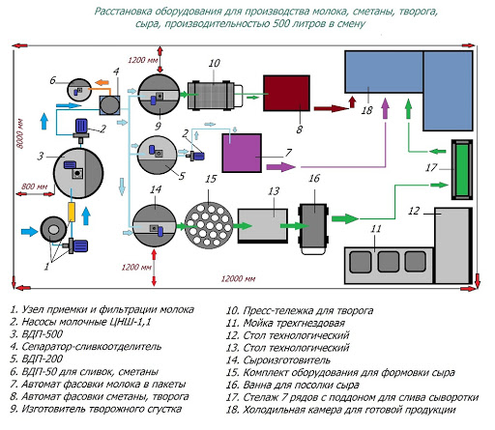
Figure 3 – technological equipment of the dairy shop

The production line (figure 3) includes the following equipment:
- container for temporary storage of milk with a stirrer, with a capacity of 2.5 t, 2 pcs;
- plate cooler with a capacity of 3 t/h;
- pasteurization and cooling unit OPO-2,5 with flow meter, capacity 1250 l/h;
- separator-cream separator, with a capacity of 3 t/h;
- milk homogenizer with a capacity of 2250 l/h;
- long-term pasteurization tank with heating jacket (cream, yogurt), 350 l capacity, 3 pcs;
- capacity long pasteurization, with a capacity of 500 litres, 2 pcs;
- technological tank with heating and cooling jacket, with agitator for cutting the clot, 2000 l, 1 pc;
- press cart for cottage cheese, 0,6 t, 1 piece;
- 3-section guidance and heating station for cleaning solutions;
- packaging equipment with a capacity of 1 t/h.
- self-priming, centrifugal pump with a capacity of 12.5 t/h, 2 pcs.
The developed recipes and technologies of soft combined cheeses and whey drinks with vegetable supplements were tested in the production conditions of “Turan” farm.
The technology of production of soft cheeses with vegetable supplements in industrial conditions was as follows:
- acceptance and preparation of milk for coagulation;
- production of cheese grain;
- molding;
- pressing (self-pressing);
- salting;
- maturation and storage.
The production of combined soft cheeses with vegetable supplements was carried out according to the technological scheme using industrial equipment (figure 4). At the stage of acceptance and preparation of milk for coagulation, milk was weighed, necessary analyses were performed to determine its quality on the lactane device, cleaning, cooling the milk, storing it, pasteurization and separation.
The production of cheese grains was carried out in cheese baths. In these devices, a number of operations are performed: normalization of milk (if it was not carried out at the stage of preparing milk for coagulation), heating to the coagulation temperature, adding the necessary components (rennet, bacterial starter culture, calcium chloride, etc.). Cutting the clot, selecting part of the whey, kneading and setting the cheese grain.
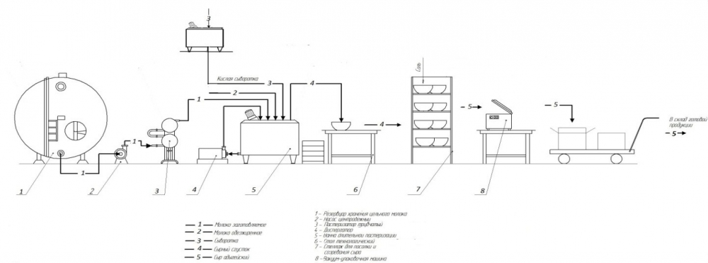
Figure 4 – soft cheese production line

Since a small batch of milk was produced, as well as the absence of molding machines and whey separators in the shop, cheese was formed from the layer in cheese-making baths.
Vertical presses were used at the pressing stage. Self-pressing was performed in forms with their periodic inversion. The salting of the cheese is performed by way of rubbing with dry salt.
Maturation and storage of cheese was carried out in chambers with the necessary humidity and temperature conditions. The cheese blocks were placed on the shelves on the stationary racks in polymer films.
All stages of cheese production were performed manually (figures 5-9).
Cheese with vegetable supplements was produced from pasteurized milk by fermentation with bacterial starter cultures for cheese, followed by self-pressing. Cheese production technology includes the following operations. Preparation of milk to clot. For the production of combined cheeses, milk with an acidity of no more than 20°t is used. Vegetable supplements were added to the milk in an amount of 10% by weight of milk, pasteurized at a temperature of 63-65°C in long-term pasteurization baths (in which fermented milk drinks are produced).
In the milk-vegetable mixture cooled to a temperature of 39-42°C , sourdough is added in an amount of 1%, rennet and calcium chloride, according to the recipe (figure 2), and left to curdle the milk-vegetable mixture for 25-30 minutes (figure 3). The finished clot should be smooth, protein flakes should not stick to the spatula, the serum should be yellowish in color with an acidity of 30-33°T.
Forming and self-pressing of cheese. The curdled protein that floats up is kept in the bath for 5 minutes, then part of the whey (50%) is removed and the cheese mass is quickly spread out with a mesh ladle into cheese molds. During the spread of the cheese mass, the whey from the bath is drained, but not completely, in order to avoid the protein sticking to the walls of the bath.
Cheese in molds is placed on tables, where they are self-pressed for 30-45 minutes (figure 4). During this time, the cheese is turned over once and the mold is shaken. During self-pressing, the cheese gets the necessary shape.
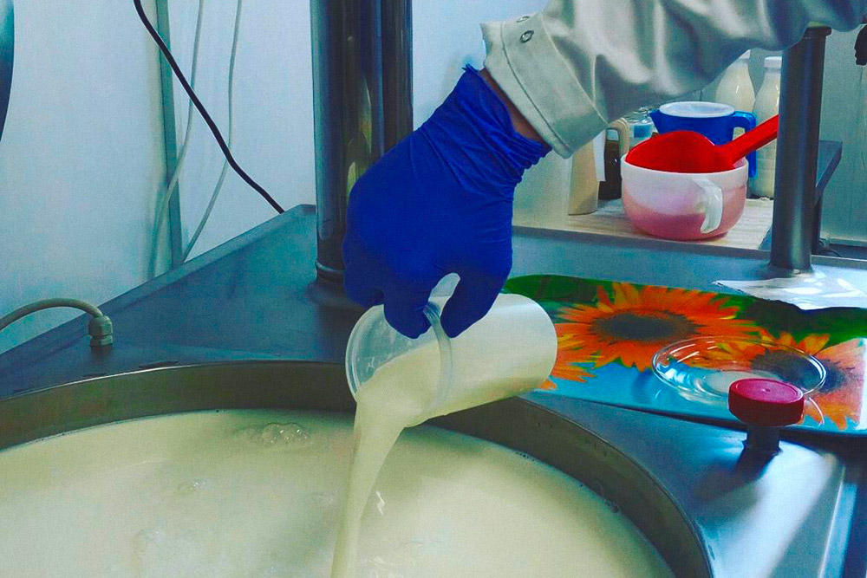
Figure 5 – Introduction of sourdough, rennet and calcium chloride

Salting and drying the cheese. After self-pressing, the cheese from the molds is transferred to the surface for dry salting of the cheese with salt at the rate of 2-4% in the finished product. Salt is applied with a 20-25 g spoon to the bottom of the mold and the upper surface of the cheese (figure 5).
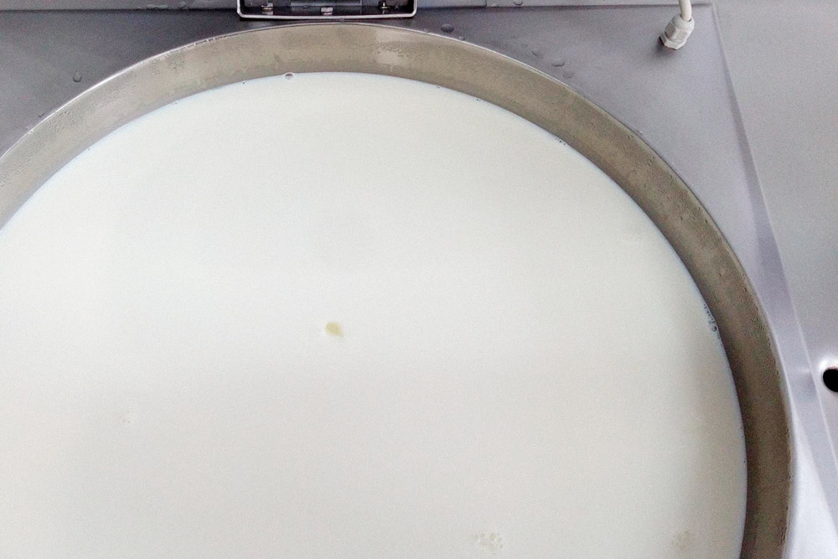
Figure 6 – The formation of cheese curd
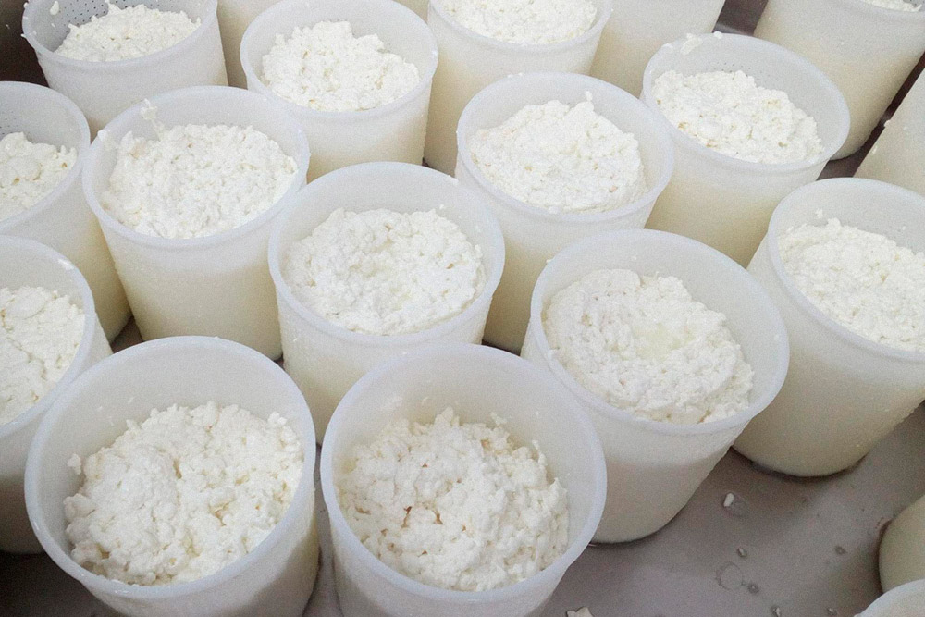
Figure 7 – Self-pressing in forms

Cheese forms are installed on carved mobile racks in the shop and when the cheese cools down, they are transported on racks to a chamber with a temperature of 8-10°C (figure 6). Cheese in the forms is kept for 16-18 hours. During this time, for better drying and drying, the cheese in the forms is turned over. At the end of salting, the cheese is removed from the molds and placed on racks for drying for 6-8 hours, to preserve the shape, the cheese is turned 1 time.

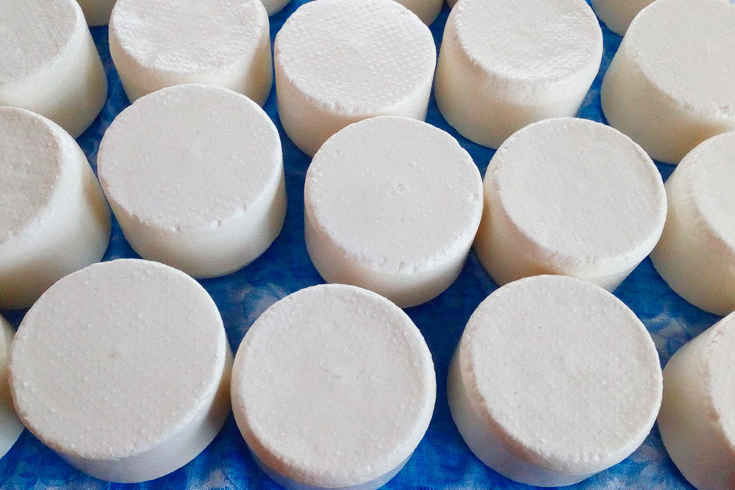
Figure 8 – Cheese salting
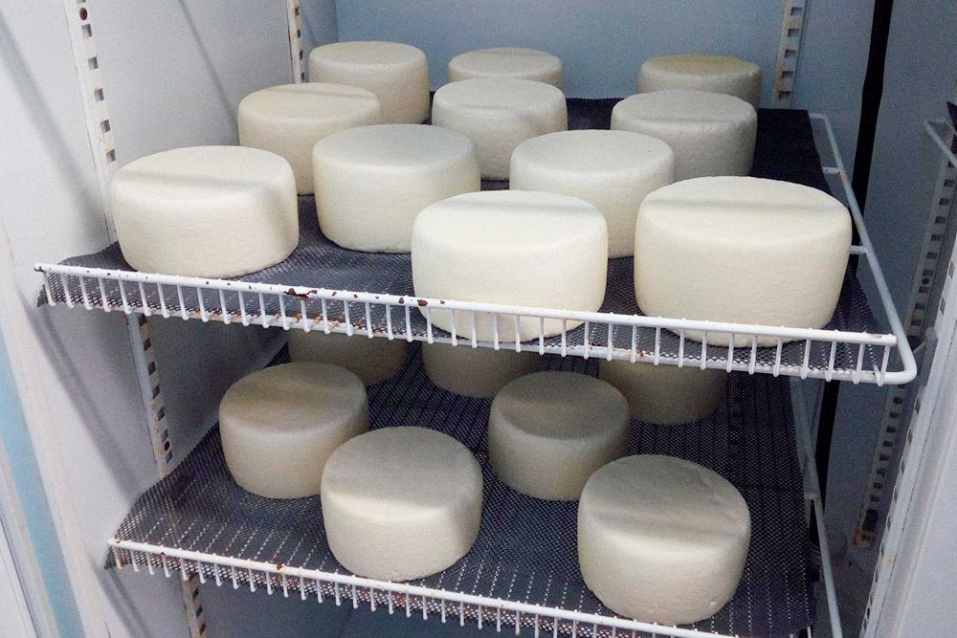
Figure 9 – Cheese racks in the storage room

Packaging, labeling and storage of cheese. Cheese is Packed in barrier bags under vacuum, stored at a temperature of 0-6°C and a relative humidity of 80% for no more than 35 days.
The technological scheme for the production of combined soft cheeses is shown in figure 10.
Act of production testing of combined soft cheese production technology (APPENDIX F).

Milk maturation at
10-12⁰C, 10-12 h
Bacterial starter culture from pure cultures of lactic acid streptococci. Application dose of 1 % of the amount of the mixture
Calcium chloride in the form of a solution at the rate of 40 g of salt per 100 kg of milk mixture
Rennet in the amount of (2±0.5)% per 100 kg of the mixture
Clot cutting, grain setting, temperature 20-22⁰C, 30 min
Bulk forming
Salting in the form of 2-4% salt in the finished cheese
Packaging in barrier polymer films
Self-pressing in cheese form (30-45 min)
Implementation. Store at a temperature of 2-4 ⁰C relative humidity 80%, the duration of 35 days.
Drying at a temperature of 8-10⁰C, 16-18 hours
Acceptance and evaluation of dairy and vegetable raw materials
Preparation of a milk-vegetable mixture according to the recipe
Preparation of a milk-vegetable mixture according to the recipe
Pasteurization of milk-vegetable mixture, temperature
63±20 ⁰C, holding time 30 min.

Cooling to a temperature of 40-42⁰C.

Coagulation of the milk-vegetable mixture at a temperature of 40±1 ⁰C,
25-30 min
Figure 10 – technological scheme for the production of combined soft cheeses

3.4 Production of experimental batches of beverages made from whey with the use of dietary supplements from vegetable raw materials.
A pilot batch of new types of whey drinks was produced in production conditions and optimization of technological modes on production equipment. The purpose of the development was to check the compliance of technological modes of selected equipment for the production of beverages in production conditions. According to the developed recipe, samples of products were presented for the development of experimental batches. According to the results of organoleptic evaluation (presentation, smell, color and taste), experimental batches of beverages with dietary supplements received a positive rating and were recommended for production on an industrial scale. The technology of whey drinks with herbal supplements was tested at the Turan dairy farm (Karashik village, Turkestan region).
The production of whey drinks with herbal supplements was carried out according to the following technological scheme.
- The production flow chart (figure 11) consists of the following operations:
- separation of serum;
- preparation of a mixture of whey with a vegetable Supplement;
- pasteurization of the mixture;
- cooling, fermentation of the mixture;
- packaging and labeling.
For the production of whey drinks with dietary supplements (pumpkin, carrot), we used fresh cheese whey obtained in the production of cheeses, and a dietary Supplement (carrot, pumpkin). The technological scheme for the production of whey beverages is shown in figure 8. When composing the mixture, a 20% pumpkin Supplement and 15% carrot Supplement were added to the separated whey, and the mixture was thoroughly mixed. In order to destroy pathogenic bacteria, the mixture was pasteurized at a temperature of 92-940C for 30 minutes. Then the mixture was cooled to a temperature of 350C and introduced starter cultures of lactic acid bacteria in an amount of 0.1%, fermented for 6-7 hours. Then the drink was Packed in plastic containers and hermetically packed. The shelf life of beverages enriched with plant supplements is 15 days at a temperature of 2-4 ⁰C.
As a result of the development of beverages in production conditions, an act was drawn up on the development of new types of whey beverages. Act of development of 02.09.2020. (APPENDIX G).

Acceptance and preparation of raw materials (separation, filtration)

Preparation of herbal supplements
Milk whey

Making a drink mix:
adding pumpkin supplements - 20%,
carrot Supplement– 15%

Pasteurization of the mixture at a temperature of 92-94⁰C with an exposure of 30 minutes, then cooling to 35⁰C

Introduction of sourdough in the amount of 0.1% of the serum

Fermentation of the mixture (temperature 24⁰C),
the active acidity of the mixture is 5.68±0.01

Filling, storage
Filling in plastic bottles. Storage at a temperature of 2-4 ⁰C, humidity 80-85%, duration of 5 days

Implementation

Figure 11 – Technological scheme for the production of beverages from whey
with herbal supplements

The selection of the equipment available at the enterprise was carried out and the following hardware and process scheme for the production of whey drinks with vegetable supplements was recommended (figure 12).


1- serum collection container, 2- clarifier, 3- a tank for collecting the fine fraction, 4- separator, 5- plate pasteurization and cooling plant, 6- capacity for the production of whey drinks
Figure 12 – Technological line for the production of beverages with dietary supplements

During the production of soft cheeses and beverages, a tasting of new types of combined cheeses and whey drinks enriched with vegetable supplements was held with the management and employees of the dairy plant. The results of the tasting are reflected in the acts of production testing.
As a result of the conducted production tests of technological modes of production of soft cheeses and beverages from whey with vegetable supplements, conducted in the conditions of the «Turan» dairy farm, three types of soft cheeses with carrot and pumpkin supplements and without supplements were produced, as well as 3 types of whey drinks with 50 liters of each drink.
The requirements for the production process and raw materials in the production of dairy products should be set out in the regulatory documentation. Since there are no regulatory documents, the Commission recommended that the organization's Standard and technological instructions (SRT, TI) for the production of soft cheeses and beverages from whey with vegetable supplements for the «Turan» farm be developed and approved by the relevant authorities, which is reflected in the Implementation act (APPENDIX H)
Thus, the conducted research and production of developed new types of soft cheeses and whey drinks with plant-based supplements give grounds for the feasibility of producing these types of dairy products on an industrial scale.
2 applications for the invention were submitted to the patent office of the Republic of Kazakhstan: "Production of soft cheeses with vegetable additives" No. 2020/0499.1 from 27.07.2020 and "production of a drink from whey" No. 2020/0498.1 from 27.07.2020 (APPENDIX J).
According to the results of the research, 10 scientific articles were published in domestic and foreign journals over 3 years, including those included in the Scopus database with a non-zero impact factor, as well as in journals recommended by the CCFES (Committee for control in the field of education and science) (APPENDIX K).
Calculation of the cost of cheese and whey beverages (tables 9-12). The cost of one kilogram of cheese consists of raw materials and other expenses.

Table 9 – cost of raw materials for 1 kg of cheese
Raw material | Quantity per 1 kg of cheese | Cost, KZT
Milk, l | 10 | 1000
Salt, g | 3 | 0,1
Starter, g | 0,1 | 20
Enzyme, g | 0,1 | 2,7
Vegetable supplement, kg | 1 | 200
Packaging, pcs | 2 | 100
Total |  | 1 322,8
Total expenses per month |  | 3 307 000

Table 10– Production costs
Name of the expense item | Cost
The cost of wages, KZT | 300 000
Production expenses, KZT | 62 500
The cost of raw materials | 3 307 000
Total, KZT | 3 669 500
Total cost of 1 kg of cheese, KZT | 1 467,8

Table 11– cost of raw materials for 1 liter of whey drink
Raw material | Quantity per 1 liter of drink | Cost, KZT
Serum, l | 1 | 0
Starter, g | 0,1 | 20
Vegetable supplement, g | 10 | 20
Packaging, pcs | 1 | 40
Total |  | 80
Total expenses per month |  | 1 600 000

Table 12 – Production costs
Name of the expense item | Cost
Production expenses, KZT | 62 500
The cost of raw materials | 1 600 000
Total, KZT | 1 662 500
Total cost of 1 liter of drink, KZT | 83
Taking into account direct material, direct labor and General production costs, the cost of soft cheeses with vegetable supplements will be 1,468 tenge, whey drinks – 83 tenge.
Thus, the production of these types of combined cheeses is advisable in the southern regions of Kazakhstan for a number of reasons: the relative cheapness of raw milk, the simplicity of production and the lack of development of the soft cheese market by domestic producers.

CONCLUSION

As a result of the experimental studies conducted in 2018-20, the following results were obtained:
In 2018
- It was found that the season of the year has a significant impact on the composition and properties of cow's milk supplied to the Turan dairy farm. It should be noted that the chemical composition and the ratio of milk components to each other practically does not change or changes slightly. Our results of the chemical composition and technological characteristics of cow's milk indicate the feasibility of using milk for the production of not only whole milk products, but also various types of cheeses.
- It was revealed that out of 3 variants of the starter culture, the third variant: the Streptococcus salivarius thermophilus culture is optimal for the production of fresh soft cheeses at the Turan dairy plant. The culture was activated for 20 minutes, forming a dense clot without the release of serum and gas bubbles.
- It was found that biologically active additives from fermented vegetable cakes contain 14 times less carbohydrates than in the original form, which confirms the hydrolysis of carbohydrates and their transition to soluble and easily digestible forms under the action of enzyme preparations.
- It is established that for more complete coagulation of proteins in the mixture and better separation of whey in the production of soft fresh cheeses with bioadditives, the following pasteurization modes should be used: with carrot bioadditive (70-72)0 S, with an exposure of 15-20 seconds at a dose of 15%, with pumpkin bioadditive ( 65-67 )0 S, with an exposure of 15 minutes. At a dose of 15%.
- 2 recipes for the production of cheeses from cow's milk with the use of dietary supplements from vegetable raw materials.
In 2019
- The dependence of the cheese hardness index during maturation was established, this indicator increases from 4.03 N to 11.22 N in the control sample and from 5.97 N to 9.05 N in cheese with carrot Supplement, and in cheese with pumpkin Supplement – from 5.90 N to 10.01 N. The elastic ratio of cheese also varies in the direction of increasing in all cheese samples with increasing maturity.
- It is proved that in combined soft cheeses with dietary supplements, the amount of non-protein nitrogen increased from 13% after pressing to 42% at 10 days of age, and in the control cheese over the same period, the amount increased from 12 to 36 %. The organoleptic evaluation of the experimental samples shows that combined soft cheeses with vegetable supplements received high scores (71 and 72 points), while the control sample received the lowest score (56 points).
- Studied the composition and properties of whey and its use in food production (dry matter, density, lactose). It was found that among the indicators of dry substances, the highest level in the serum obtained in the manufacture of cheese with a carrot Supplement of 6.5%, with a pumpkin Supplement of 6.4% and a control sample of 5.9%. The whey obtained in the manufacture of cheese with pumpkin Supplement contains a large lactose index of 4.4%.
- Technological modes (t,τ) were studied, the optimal amount of the dose of vegetable supplements (15-20%) was determined in the production of beverages from whey. As a result of the conducted research, the pasteurization temperature was set at 62-640C, with an exposure time of 30 minutes.
- Set the optimal range of titrated acidity, which determines the end of the fermentation process, the range of acidity values from 45 to 550T. The duration of fermentation was 3-3. 5 hours for drinks with 5-15% bioadditive,2-2. 5 hours – with 20% bioadditive and 5-5.5 hours for the control sample.
- The range of changes in QMAFAnM during storage was (CFU/g): in a whey drink with a pumpkin supplement – 1.3*103-2,1*104; with the use of a carrot Supplement – 1.1*102-1,8*104.
- Studied the composition and properties of whey and its use in food production (dry matter, density, lactose). It was found that among the indicators of dry substances, the highest level in the serum obtained in the manufacture of cheese with a carrot Supplement is 6.5%, with a pumpkin Supplement – 6.3% and a control sample – 5.9%. The whey obtained in the manufacture of cheese with pumpkin supplement contains a large lactose index of 4.5%.
- Studied the composition and properties of whey and its use in food production (dry matter, density, lactose). It was found that among the indicators of dry substances, the highest level in the serum obtained in the manufacture of cheese with a carrot Supplement is 6.5%, with a pumpkin Supplement – 6.3% and a control sample – 5.9%. The whey obtained in the manufacture of cheese with pumpkin Supplement contains a large lactose index of 4.5%.
- Technological modes (t,t) were studied and the optimal amount of carrot Supplement application dose (5% -20%) was established for the production of whey beverages using an enzyme complex with carrot Supplement. As a result of the research, the pasteurization temperature was set to 62-640C, with an exposure of 30 minutes at a dose of 15% pumpkin supplement.
In 2020
- According to the results of research during storage, the microflora in whey drinks changed,the range of changes in Kmafanm was (CFU/g): in a whey drink with a pumpkin Supplement – 1.2*102-2, 2*103; in a whey drink with a carrot Supplement – 1.8*102-2,1*103. Guaranteed shelf life of beverages made from whey with dietary supplements (pumpkin, carrot) is 4 days at a temperature of 2-40 C, which is 2 days longer than drinks made from pasteurized whey.
- The technological scheme is drawn up, the technological processes of production of milk drinks with bioadditives (pumpkin, carrot) are described.
- The nutritional, biological and energy value of whey drinks with dietary supplements (pumpkin, carrot) was studied. According to the chemical composition of whey drinks with dietary supplements (pumpkin, carrot), it can be observed that they contain more (in %): carbohydrates (4.65; 4.85), ash (0.73; 0.74), protein (2.12; 2.14) than the control sample. It was found that due to the introduction of plant supplements, whey drinks are enriched with betta-carotene (34.5 and 700 mcg), and the content of vitamins A and C increases by 2 times. The quantitative content of iron increases by 2 times, potassium – by 18%, calcium – up to 8%, magnesium – more than 30% and phosphorus – by 7% compared to the control sample of the whey drink.
- Production of experimental batches of combined cheeses and beverages from whey with bioadditives (pumpkin, carrot) in the production conditions of the Turan farm, selection of production equipment, optimization of technological parameters taking into account technological equipment. The hardware and process scheme for the production of soft cheeses and beverages from whey with vegetable supplements has been compiled.
- The calculation of the cost of soft combined cheeses and whey drinks in the conditions of the Turan dairy plant was carried out. Taking into account direct material, labor and General production costs, the cost of soft cheeses with vegetable supplements was 1,468 KZT, and beverages – 83 KZT.

LIST OF REFERENCES

- Expert of Kazakhstan. Cheese share. http://expertonline.kz/a12719/ (In Russian).
- food consumption per capita on average for the 1st quarter of 2020. https://kazsut.com/potreblenie-molochnyh-produktov-pitaniya-v-srednem-na-dushu-naseleniya-za-1-kvartal-2020-god/ (In Russian).
- Tikhomirova, N. A. functional food products / N. A. Tikhomirova // Dairy industry. ‒ 2013. ‒ No 6. ‒ Pp. 46-48. (In Russian)
- Gudkov A.V. Cheese-making: biological and physical-chemical indicators. -M., 2003.-P. 266. (In Russian)
- Gabrielyan, D. S. technologies of enriched fermented milk products D. S. Gabrielyan, V. A. Grunskaya // Milk processing. - 2017. ‒ No 2 (208). ‒ P. 30-35. (In Russian)
- Khodunova O. S. Development of the composition and technology of soft cheese with sprouted oat grains // processes and devices of food production. -2006. - no. 1. -P. 100. (In Russian)
- Kalakura M. M., Samokhvalova O. V. Use of food fibers in food production: mater.Republ.nauchn.konf. – M.: 2006. – 138 p. (In Russian)
- Hasan H. Salhab // application of ultrafiltration in the production of cream cheese. — 1998. — The University Of Alberta. — 99pp. (in English)
- Gavrilov B. G. functional ingredients and food products from whey [Text] / B. G. Gavrilov // Materials of the conference. SIMP. "Lactose and its derivatives "and the regional conference" fermented Milk products – technologies and nutrition", Moscow, 2007 – pp. 38-39(In Russian)
- Khramtsov A. G. protein products from whey // Milk processing. 2011.-No1.- P. 18-21(In Russian)
- Khramtsov, A. G. Innovative priorities of industrial processing of universal agricultural raw materials – whey – based on the principles of food biotechnology / A. G. Khramtsov // Innovations in food biotechnology. Collection, 2018. ‒ Pp. 93-96. (In Russian)
- Bergovin A.M. membrane filtration in the dairy Industry // Milk processing. — 2008. — No3 — P. 10-11. (In Russian)
- Kravchenko E. F., Plisov N. V. Progressive technologies for processing dairy Raw Materials // Cheese and butter making. - 2005. — No 2. — P. 30-31. (In Russian)
- Method of preparation of a drink from whey (RU 2 NO. 290 821, A 23C 21/08), 2007.
- Method of producing a drink from whey (RU No. 2 403 795 C1), 2010.
- Method of producing a drink based on whey (RU NO. A23C21/00), 2013.

APPENDIX А

Patent report
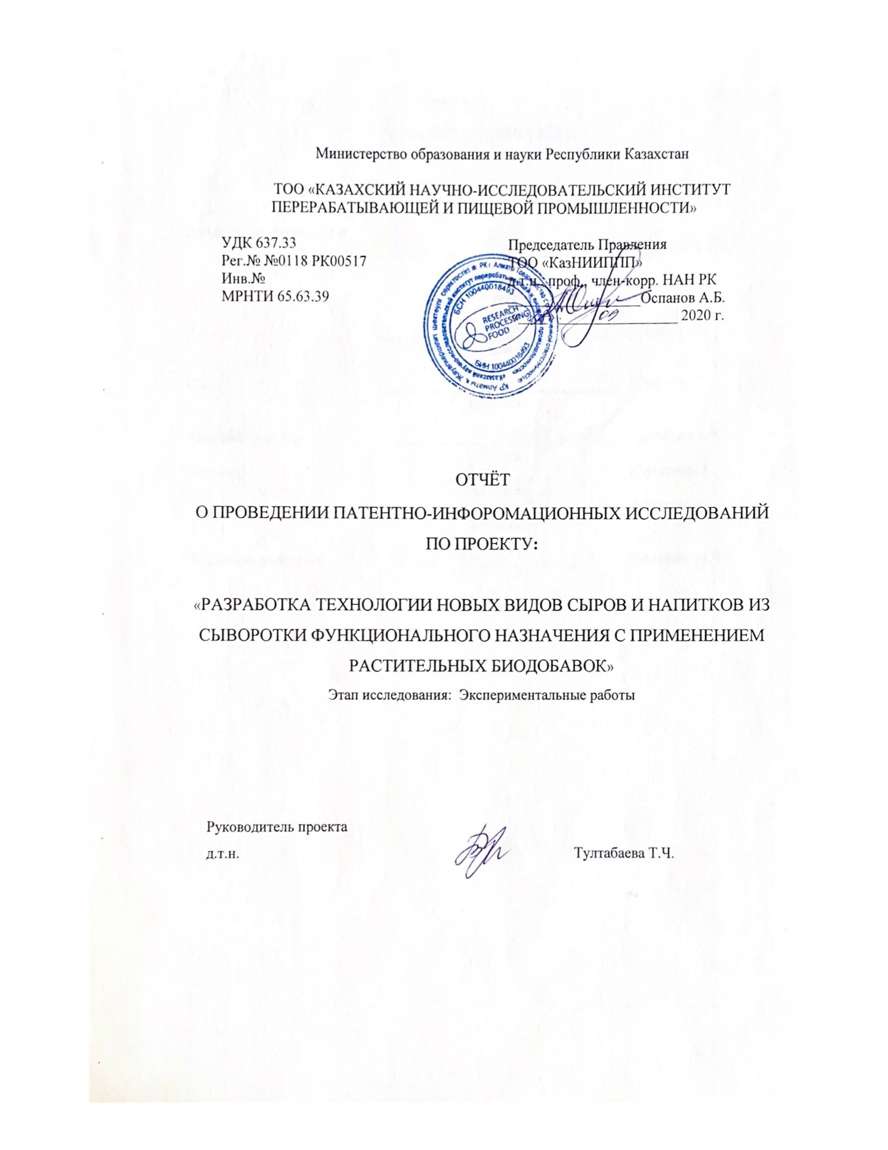

APPENDIX B

Calendar plan 2020

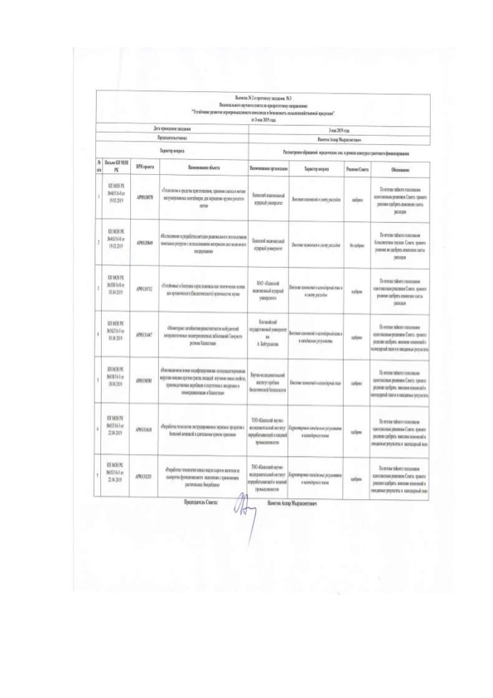

Appendices 1.1-1.1
to agreement №. _ _ of ______2018
for grant funding

TECHNICAL SPECIFICATION AND
WORK SCHEDULE

Under contract №.______dated __________________2018 years

«KAZAKH RESEARCH INSTITUTE OF PROCESSING AND FOOD INDUSTRY LLP»

1.1 Priority: sustainable development of the agro-industrial complex and safety of agricultural products.
1.2 By sub-priority: implementation and commercialization of the results of scientific and technical activities.
1.3 Project topic: no. AR05131255 "Technology development of new types of cheeses and beverages from functional whey with the use of plant-based dietary supplements»
1.4 The total amount of the project is 48,000,000 (forty-eight million) KZT, including broken down by year, for the performance of works in accordance with paragraph 3:
- for 2018 - in the amount of 16,000,000 (six hundred million) KZT;
- for 2019 - in the amount of 16,000,000 (six hundred million) KZT;
- for 2020 - in the amount of 16,000,000 (six hundred million) KZT.

2. Characteristics of scientific and technical products by qualification criteria and economic indicators
2.1 Direction of work: Increasing the range of domestic cheeses and beverages from functional whey with vegetable supplements.
2.2 Field of application: Dairy industry.
2.3 Final result:
- for 2018: The technology of plant-based supplements will be developed and recipes for new types of cheeses with plant-based supplements will be compiled.
- for 2019: A technology for the production of beverages from whey with herbal supplements will be developed.
- for 2020: Industrial testing and implementation of the developed technology for the production of new types of cheeses and beverages in production conditions will be carried out at the “Turan” dairy plant.
2.4 Patentability: an application for a patent of the Republic of Kazakhstan, a Eurasian patent will be filed.
2.5 Scientific and technical level (novelty): development of technological modes for the production of new types of cheese with the use of dietary supplements from vegetable raw materials, waste-free processing of secondary dairy raw materials to obtain an import-substituting product intended to expand the range of beverages.
2.6 The use of scientific and technical products is carried out: the development of a new technology of whey products and beverages. The results obtained will be used to promote Kazakhstan's dairy products to the markets of other countries as new functional products with useful properties and support domestic producers.
2.7 Type of use of the result of scientific and (or) scientific and technical activities: the Technology of new types of functional cheeses and beverages is a new scientific direction and will allow product manufacturers to take a leading position in the development and production of new types of products.

3. Name of works, terms of their implementation and results
Task and stage |  | Name of Work under the agreement and the main stages of its implementation* | Due date * |  |  | Expected result *
 |  |  | beginning |  | ending
1 |  | Research of milk rawness depending on the season of the year, feeding and breed of cows. | January 2018 |  | March  2018 | The raw suitability of milk will be investigated depending on the season of the year, feeding and breed of cows.
1.1 |  | Determination of the content of fat, protein, vitamins, macro - and microelements of cow's milk depending on the region, feeding and breed of cows. | January 2018 |  | March 2018 | The content of fat, protein, vitamins, macro - and microelements of cow's milk will be determined depending on the region, feeding and breed of cows.
2 |  | Development of technology for obtaining dietary supplements from fruit and vegetable crops of a given chemical composition and medicinal properties. Selection of starter cultures for cheese production. | April  2018 |  | June  2018 | A technology for obtaining dietary supplements from fruit and vegetable crops of a given chemical composition and medicinal properties will be developed. Selection of starter cultures for cheese production will be carried out.
2.1 |  | Study of the chemical composition of dietary supplements from plant raw materials. | April 2018 |  | June  2018 | The chemical composition of dietary supplements from plant raw materials will be investigated.
3 |  | To study the influence of pasteurization modes on the curdability of milk in the production of new types of cheeses. Study of the biochemical processes of maturation of cheeses with dietary supplements. | July  2018 |  | September  2018 | The influence of pasteurization modes on milk coagulability in the production of new types of cheeses will be studied. The biochemical processes of maturation of cheeses with dietary supplements will be studied.
4 |  | Preparation of recipes for new types of cow's milk cheeses with the use of dietary supplements from vegetable raw materials. | October 2018 |  | Up to 1st of November 2018 | A recipe for new types of cheeses made from cow's milk with the use of dietary supplements from vegetable raw materials will be compiled.
5 |  | Research of structural and mechanical (rheological) properties of new types of cheeses with bioadditives from vegetable raw materials. | January 2019 |  | March  2019 | The structural and mechanical (rheological) properties of new types of cheeses with bioadditives from vegetable raw materials will be investigated.
6 |  | Study of the development of lactic acid microflora in the process of maturation of new types of cheeses from vegetable raw materials. | April  2019 |  | June  2019 | The development of lactic acid microflora during the maturation of new types of cheeses from vegetable raw materials will be studied.
7 |  | Research of the composition and properties of whey and its use in food production. | June  2019 |  | September  2019 | The composition and properties of whey and its use in food production will be investigated.
8 |  | Study of technological modes (t,τ), determination of the optimal amount of the dose of adding a dietary Supplement (5% -20%) from vegetable raw materials in the production of beverages from whey | October 2019 |  | Up to 1st of November 2019 | The technological modes (t,τ) will be studied, and the optimal amount of the dose of adding bioadditives (5% -20%) from growing raw materials in the production of beverages from whey will be determined.
8.1 |  | Study of biochemical processes in the process of storage of beverages from whey with the use of dietary supplements from vegetable raw materials. | October 2019 |  | Up to 1st of November 2019 | We will study the biochemical processes in the process of storing beverages from whey with the use of bio-additives from vegetable raw materials.
9 |  | Establishment of the shelf life of beverages made from whey with the use of dietary supplements from vegetable raw materials. | January 2020 |  | March  2020 | The shelf life of beverages made from whey with the use of plant-based supplements will be set.
10 |  | Research of nutritional, biological and energy value of whey beverages using a Supplement made from vegetable raw materials. | April  2020 |  | June  2020 | The nutritional, biological and energy value of whey beverages with the use of plant-based supplements will be investigated.
11 |  | Production of experimental batches of new types of cheeses with bioadditives from vegetable raw materials in laboratory and production conditions, optimization of technological parameters. | July  2020 |  | September 2020 | The production of experimental batches of new types of cheeses with bioadditives from growing raw materials will be carried out in laboratory and production conditions, and the optimization of technological parameters will be carried out.
12 |  | Production of experimental batches of beverages made from whey with the use of dietary supplements from vegetable raw materials. | October 2020 |  | Up to 1st of November 2020 | The production of experimental batches of whey beverages with the use of a plant-based Supplement will be carried out.
12.1 |  | Submission of 2 applications for an invention for the production of cheese and beverages from whey using a dietary Supplement from vegetable raw materials. | October 2020 |  | Up to 1st of November 2020 | 2 applications will be submitted for a patent of the Republic of Kazakhstan and a Eurasian patent for an invention for the production of cheese and beverages from whey using a dietary supplement from vegetable raw materials.
 | from the customer:  SA "Committee of science of the Ministry of education and science of the Republic of Kazakhstan»  8 Mangilik El Avenue, Astana  BIN 061 140 007 608  BIK KK MF KZ 2A  IIC KZ92 0701 01KS N000 0000  Kbe 11  RSU "Treasury Committee of the Ministry of Finance of the Republic of Kazakhstan»  ________________  stamp here. |  |  | from the performer:  Kazakh research institute of processing and food industry LLP,  238 "G" Gagarin Ave., Almaty, 050060  Tel. 396-05-09, Fax 396-05-09  IIC-KZ366010131000132964  JSC "Halyk Bank of Kazakhstan"  BIC HSBKKZKX  KBE-17  BIN 100 440 018 493  Acting General Director  ________________ Alimkulov Zh.  stamp here  Reviewed by:  project Supervisor  _____________ T.Tultabayeva  (signature)

Correction of expected results of the project no. AR05131255 “Technology development of new types of functional whey cheeses and beverages with the use of plant-based dietary supplements”

№ | Name of work under the Contract | Term of execution | Approved version | Proposed revision
1 | Study of biochemical processes in the process of storage of beverages from whey with the use of dietary supplements from vegetable raw materials | Until November 1, 2019 | Will study the biochemical processes in the storage of beverages made from whey with the use of plant-based supplements. 1 article will be published in the foreign journal Agricultural and Food Science | Will study the biochemical processes in the storage of beverages made from whey with the use of plant-based supplements. 1 article will be published in a foreign journal, in the Scopus database
2 | Production of experimental batches of milk whey beverages with the use of plant-based supplements | Until November 1, 2020 | The production of experimental batches of beverages from whey with the use of dietary supplements from vegetable raw materials will be carried out. One article will be published in the foreign Journal journal Agricultural Science | The production of experimental batches of beverages from whey with the use of dietary supplements from vegetable raw materials will be carried out. One article will be published in a foreign journal included in the Scopus database

Project manager __________________ Т.Tultabayeva

APPENDIX C

Results of the analysis of microbiological parameters in the process of storage of whey beverages
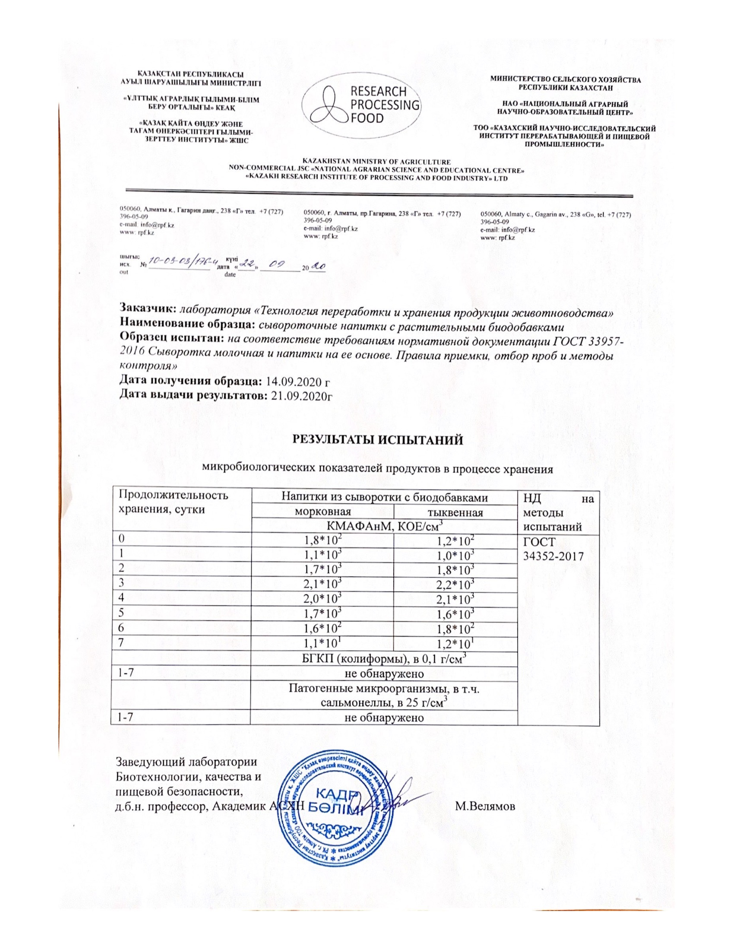

APPENDIX D

Results of analysis of the content of vitamins and trace elements in whey drinks

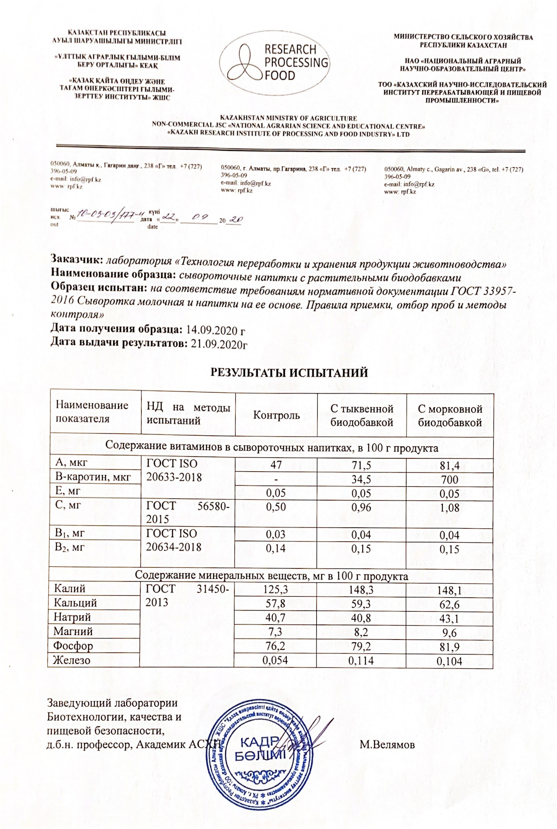

APPENDIX E

Act of cheese production in the laboratory
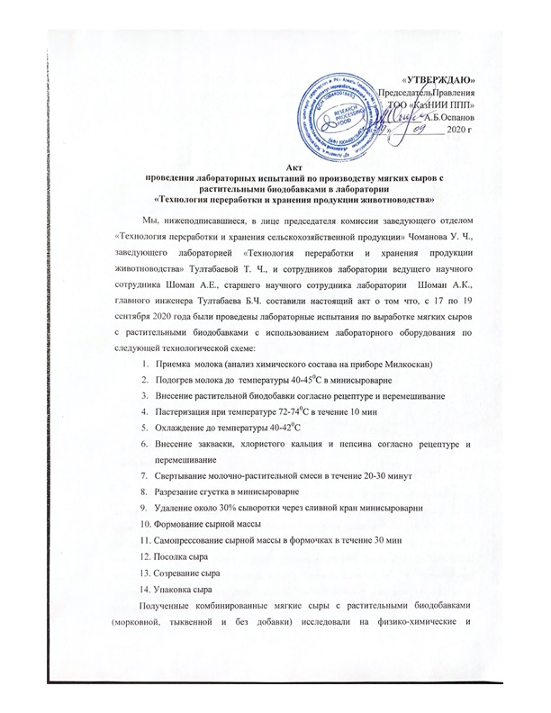
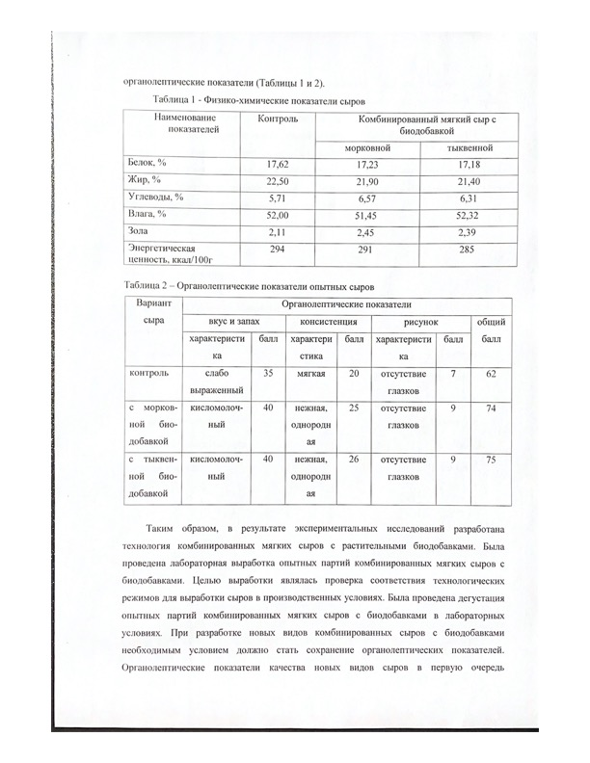
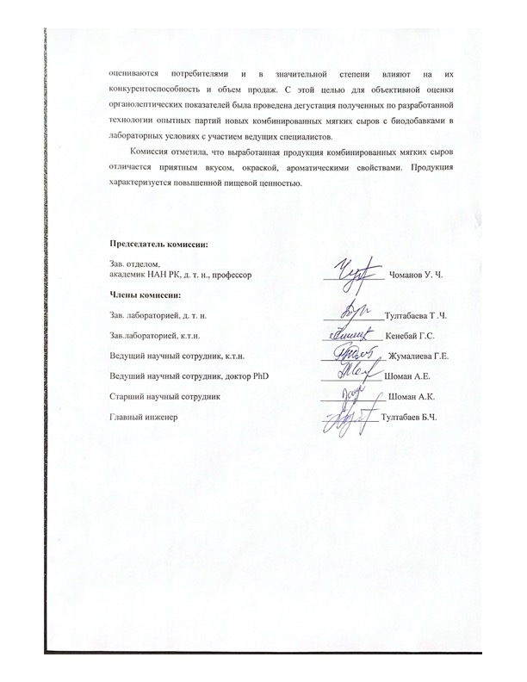

APPENDIX F

The act of production of soft cheeses with vegetable supplements at the enterprise “Turan” farm
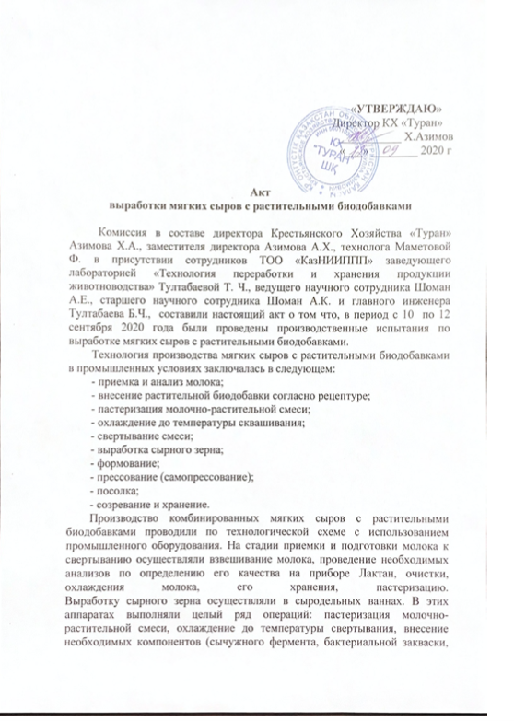
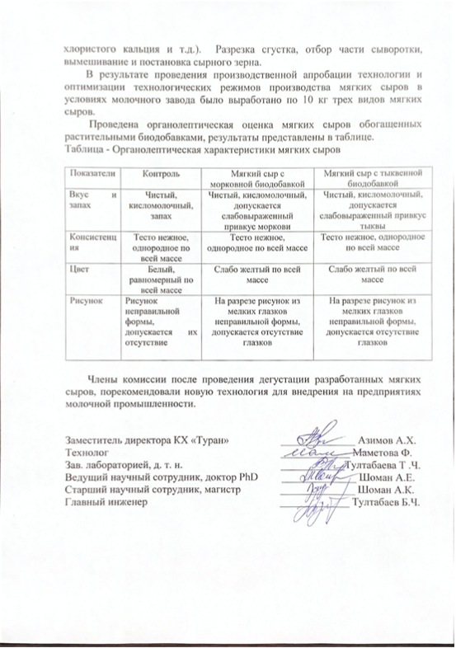

APPENDIX G

Act of production of whey drinks at the “Turan” farm
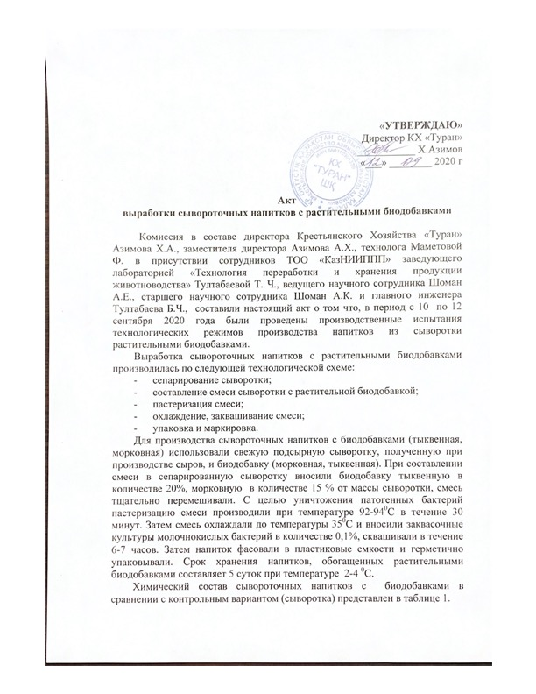

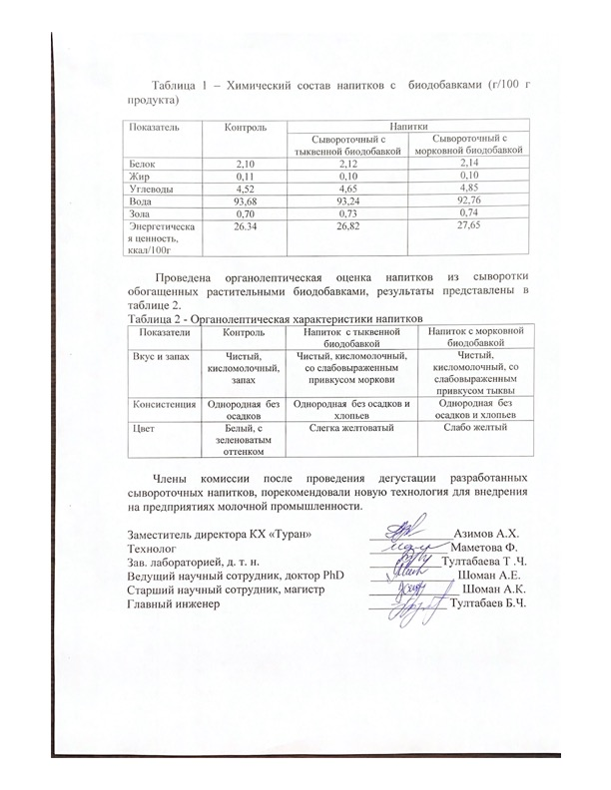

APPENDIX H

Act of introduction into production 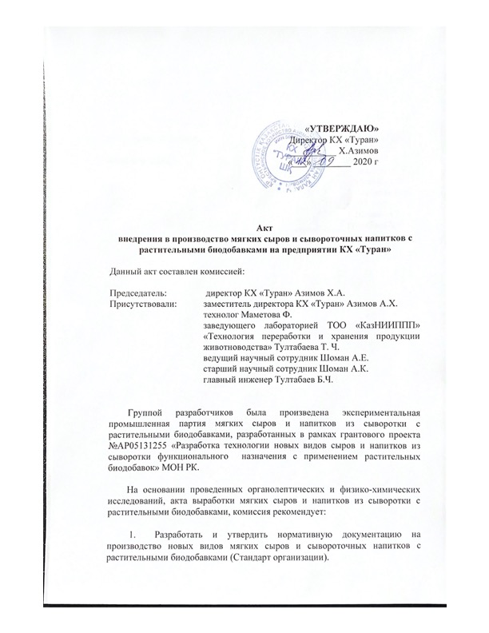


APPENDIX J

Patent applications of the Republic of Kazakhstan

APPENDIX K

List of published articles

In 2018
Domestic publications
- Zhonysova M. U., Tultabayeva T. CH., Abay G. K. prospects for the use of local vegetable raw materials in the production of fermented milk products // ATU Bulletin, 2018, NO. 3.P.9-13 (in Russian)
In 2019
Domestic publications
- Abay G. K., Jonasova M. U., Tultabaev including the Effect of ultrasonic treatment on the quality supplements based on artichoke for use in cheesemaking. ATU Bulletin, issue no. 1.2019,pp. 71-77. (in Russian)
2 Abay G. K., Jonasova M. U., Tultabaev including a Study of the vitamin additive of carrots in order to enrich dairy products functional purpose. The ATU Bulletin, Issue No. 3.2019.With.52-56. (in Russian)
3 Abay G. K., Tultabaev i.e., Tultabaev M. H., Tultabaev B. C. the Effect of herbal supplements on the sensory characteristics of combined soft cheese. Intl. scientific and practical Conf. "Innovative development of food, light industry and hospitality industry", October 24-25, 2019, ATU, Almaty. (in Russian)

Foreign publications
4 Tultabayeva, T., Chomanov, U., Kenenbay, G., Zhumaliyeva, G., Shoman A.E. Formulation of multicomponent mixture in the production of combined soft cheese Journal of Hygienic Engineering and Design, 2019, 29, p. 125-131. (percentile 14%)

In 2020
Domestic publications
1 Gulshara Abay, Tamara Tultabayeva, Urishbay Chomanov, Aruzhan Shoman, Assiya Shoman The microflora of fermented mare's milk and koumiss / Journal "Mechanics and technologies" No. 3, 2020, tarsu named after M. H. Dulati. Pp. 107-118 (in English)

Foreign publications
1 Gulzhan Y. Zhumaliyeva, Urishbay C. Chomanov, Tamara C. Tultabayeva, Mukhtar C. Tultabayev, Rabiga Kasymbek. Formation of Processes of Intensification of Crop Growth for the Formation of Business Structures. Academy of Entrepreneurship Journal. 2020 26(1), p.1-5,335 (Print ISSN: 1087-9595; Online ISSN: 1528-2686), (percentile 36%)
2 Tamara C. Tultabayeva, Urishbay Ch. Chomanov, Mukhtar Ch. Tultabayev, Gulmira S. Kenenbay, Gulzhan E. Zhumaliyeva, Aruzhan Y. Shoman, Assiya K. Shoman. Analyzing Soft Cheeses with Vegetable Additives with Neural Network, International Journal of Advanced Trends in Computer Science and Engineering, Vol. 9, No. 4, 2020, pp. 5476-5480, (percentile 36%).
3 Tamara Tultabayeva, Urishbay Chomanov, Aruzhan Shoman. The Rheological Characteristics of Cheese with Vegetable Additive. IX International research conference Proceedings, Istanbul Turkey January 30-31 2020 Vol. 2416-2419 (in English)
4 Zhumaliyeva G., U Chomanov.., T Tultabayeva., M Tultabayeva A Shoman G Aktokalova R Kassimbek. Study of grain mixture crushing to a given granulometric composition and selection of optimal particle size. IX International research conference Proceedings, Istanbul Turkey January 30-31 2020 Vol. 2412-2415 (in English)

Speech on TV "Khabar 24" program "Food for thought»
1. Vegetable milk. May 19, 2020. (In Russian)
2. Condensed milk and milkshake. May 26, 2020. (In Russian)
3. Baby food. June 7, 2020. (In Russian)
Online seminar
1. Prospects for processing Mare's milk in Kazakhstan. Speaker Tultabayeva T. CH., may 12, 2020. (In Russian)
2. Opportunities and prospects for the development of family mini-bakeries. Speaker A. E. Shoman, may 12, 2020. (In Russian)
3. Prospects for the use of Mare's and camel's milk in the dairy industry of Kazakhstan. Speaker Shoman A. K., June 29, 2020. (In Russian)
4. Processing of Mare's milk and production of functional fermented milk products Speaker A. K. Shoman, September 25, 2020. (In Russian)
Online scientific conferences
1. Socio-economic efficiency of development and implementation of resource-saving technologies in agriculture, speaker A. E. Shoman 27.05. 2020 (In Russian)
2 Lecture at the international summer school for undergraduates. Opportunities and prospects for the development of family mini-bakeries. The speaker Shoman, A. E., 04.06.2020 year. (in English)
Instagram Facebook/Social media post
1. Development of technology for dairy products. Shoman, A.K. (In Russian)
2. Dairy products for social purposes. Tultabayeva T. (In Russian)
3. Lifehack for storage of dairy products. Shoman, A.E. (In Russian)

