PROJECT EXECUTORS:

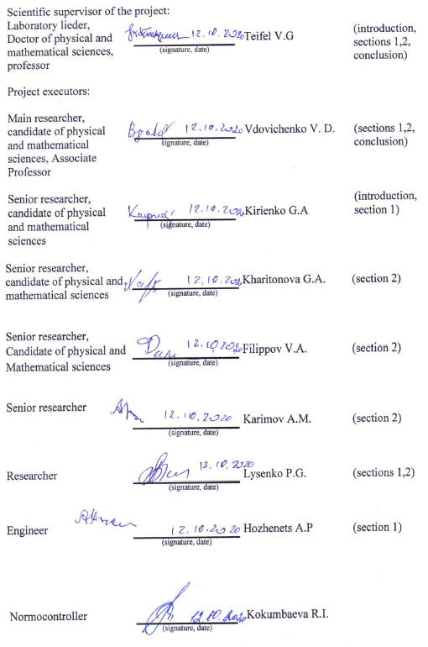
АНДАТПА
Есеп 53 бет., 1 кітап, 25 суреттер, 4 кесте, 48 көздер, 2 қосымша.
ЮПИТЕР, АТМОСФЕРА, БҰЛТТАР, МЕТАН, АММИАК, СІҢІРУ ЖОЛАҚТАРЫ, СПЕКТРОФОТОМЕТРИЯ.
Зерттеу нысаны - алып планетаның атмосферасы – Юпитер.
Жұмыстың мақсаты - спектрдің жақын инфрақызыл аймағындағы (600-950 нм) бақылаулар негізінде Юпитердегі негізгі бұлт белдеулері мен жергілікті бұлт құрылымдарының құрылымдық ерекшеліктерін салыстырмалы зерттеу.).
Зерттеу әдісі – Юпиттің спектрофотометриялық бақылаулары, планетаның әртүрлі аймақтарындағы молекулалық сіңіру жолақтарының өзгеруін талдау.
Жұмыс нәтижелері - Юпитердің спектрофотометриялық жазбаларының үш циклі орындалды, 8500 спектрограмм алынды. 600-950 нм диапазонында метан мен аммиактың молекулалы сіңіру жолақтарының ендік өзгерістерізерттелді. Аммиак 645 және 787 нм жолақтарында да, метан 619, 702 және 725 нм жолақтарында да эквивалентті ені экстремумдарының орналасуында айқын айырмашылық табылды. Ең айқын сіңіру қысымы 787 нм аммиак жолағында байқалады. EZ және NEB арасындағы шекараның жанындағы +15 градусқа жуық ендікте, онда миллиметрлік диапазондағы радиоастрономиялық бақылаулар бойынша ең жоғары жарықтық температура тіркеледі, бұл планетаның осы бөлігіндегі аммиактың төмендеуіне байланысты.
Қолдану саласы – Нәтижелерді басқа әдістермен алынған және осы планетаға ғарыштық миссиялардың нәтижелерімен салыстырмалы түрде қолдануға болады.

Жобалаудың негізгі және техникалық-экономикалық көрсеткіштері және жұмыстың маңыздылығы - Қазақстан еуропалық және американдық обсерваториялар арасындағы бойлық бойынша үлкен алшақтықты жабатын ерекше маңызды географиялық аймаққа ие және жер үсті обсерваторияларынан мониторингтік бақылауды қажет ететін планеталар мен Күн жүйесінің басқа денелеріне ғарыштық миссияларды астрофизикалық сүйемелдеу үшін маңызды серіктес болып табылады. Жоба бойынша жүзеге асырылатын зерттеулер Юпитерге ғарыш миссиясын, оның ішінде қазіргі Juno миссиясын жер үсті астрофизикалық сүйемелдеу міндеттері аясында пайдалы болуы мүмкін екенін ерекше атап өткен жөн.
ABSTRACT

Report 53 p., pictures - 25, tables - 4, sources - 48, appendixes – 2.
JUPITER, ATMOSPHERE, CLOUDS, METHANE, AMMONIA, ABSORPTION BANDS, SPECTROPHOTOMETRY.
The object of research – the atmosphere of the giant planet - Jupiter.
The purpose of the work – to conduct a comparative study of the structural features of the main cloud belts and local cloud formations on Jupiter based on observations in the near infrared spectral region (600-950 nm.).
Research method - Spectrophotometric observations of Jupiter, analysis of variations in molecular absorption bands in different regions of the planet.
Results of work - During the period 2018-2020, three cycles of spectrophotometric observations of Jupiter were performed, 8500 spectrograms were obtained. The latitudinal variations of the molecular absorption bands of methane and ammonia in the range of 600-950 nm are studied. Comparison of the latitudinal behavior of absorption in the bands of ammonia at 645 and 787 nm and methane at 619, 702, and 725 nm reveals a well-pronounced difference in the arrangement of the extrema of the equivalent widths for both the ammonia bands and the methane bands. The most pronounced depression of absorption is observed in the 787 nm ammonia band at a latitude of about +15 degrees near the border between the Equatorial Zone and the Northern Equatorial Belt. It is at this latitude that radio astronomical observations in the millimeter range register the highest brightness temperature, which is interpreted as a consequence of the low ammonia abundance in this part of the planet.
Application area. The data obtained from spectral studies of the Jupiter atmosphere can be used in a comparative analysis of data obtained by other methods and with the results of space missions to this planet.
Basic and technical and economic design indicators and significance of the work - Kazakhstan occupies a particularly important geographical position, covering a large gap in longitude between European and American observatories, and is an important partner for astrophysical tracking of space missions to planets and other bodies of the solar system that require monitoring observations from ground-based observatories. It should be especially noted that the studies carried out under the project may be useful in the framework of the tasks of ground-based astrophysical tracking of the space mission to Jupiter, including the current JUNO mission.
CONTENT

INTRODUCTION……………………………………………………………………......… |  | 7
MAIN PART ………………………………………………………………..……………… |  | 12
1 | Spectral observations of Jupiter in the near infrared range during the planet's visibility season in 2020.………………………..……………………………………….……….. | 12
2 | Comparative analysis of the behavior of absorption bands of different intensities in the latitudinal belts of Jupiter and determination of structural features in the density and altitude differences of the Jupiter cloud cover based on new observational data from 2018-2020.……………………………………………………………………….…..… | 15
CONCLUSION……………………………………...…………………………………....… |  | 36
LIST OF USED SOURCES………………………………………………….…………...… |  | 40
APPENDIX А. List of published works…………………………………………….……… |  | 45
APPENDIX B. Work schedule 2018 - 2020………………………………………………... |  | 48

LIST OF SYMBOLS AND ABBREVIATIONS

In this Scientific research report, the following terms are used with appropriate definitions:
FAI | – | Fesenkov Astrophysical Institute
Å | – | angstrom
mμ | – | micrometer
nm | – | nanometer
GRS | – | Great Red Spot (on Jupiter)
EZ | – | Equatorial zone
NEB | – | Northern equatorial belt
SEB | – | South equatorial belt
NTrZ | – | Northern tropical zone
STrZ | – | South tropical zone
rk | – | correlation coefficient
IR | – | infrared radiation
CM | – | central meridian
λ | – | wavelength

INTRODUCTION

Assessment of the current state
At present, a significant part of information about the atmospheres of giant planets is obtained with the help of space probes flying near the planet or orbiting it. Now the JUNO spacecraft is actively working near Jupiter and has transmitted useful information when flying past Jupiter [1]. No less intensive are observations from ground-based observatories, including astrophysical support for space missions [2]. Any new data on the planets of our solar system are also of interest in the study of exoplanets, which are now being discovered in large quantities. Among them there are planets similar to terrestrial planets and giant planets.
Now the dominant position in this direction is occupied by the NASA-sponsored center for space research of planets - the Jet Propulsion Laboratory (Pasadena, California, USA), where studies of giant planets in the thermal IR range (from 4 microns and further to the region of 10 18 μm) are being carried out. The observations are being carried out with the large telescopes of the Mauna Kea Observatory in Hawaii led by Glenn Orton and Leigh Fletcher [3-7]. So far, a more distant range of the intrinsic thermal radiation of planets, mainly near Jupiter, is being investigated using a system of large radio telescopes in the millimeter wavelength range (frequencies from 4 to 20 GHz) under the leadership of Imke de Pater [8-10].

Basis and initial data for the development of the program: thermal infrared and radio measurements make it possible to probe Jupiter's atmosphere to depths that optical radiation in the visible spectrum cannot reach, since it is absorbed and scattered in the upper cloud layer. A lot of useful information can be obtained from the intensity of radiation diffusely reflected from the cloud cover at different wavelengths due to the fact that the formation of this reflected radiation occurs at different effective optical depths depending on the wavelength, especially in the parts of the planet's spectrum occupied by molecular bands with different intensities. Both the transmission of thermal radiation through the atmosphere and the intensity of molecular absorption bands in the visible and near-IR spectral regions depend on the abundances of absorbing gases in the planet's atmosphere. For Jupiter, they are mainly methane and ammonia. IR radiation with wavelengths of a few microns can be scattered and absorbed by cloud particles of the same order of magnitude. Longer wavelength radiation is mainly absorbed by gas molecules. Here, the spectral region of about 4.8 mm is of interest, where absorption by methane is absent [11-12]. The output of IR radiation at this wavelength on Jupiter is regulated mainly by cloud layers, their bulk density and particle sizes.
Despite the low relative abundances (about 10⁻³ for methane and 10⁻⁴ for ammonia [13-15]), both methane and ammonia play an important role in the atmosphere of Jupiter. Methane appears to be fairly uniformly distributed in the atmosphere, since it does not condense under the temperature conditions of this planet. But by creating strong infrared absorption bands, methane regulates the release of thermal radiation from deep layers.
Ammonia condenses in the upper troposphere of Jupiter, forming the planet's upper cloud layer. In addition, it participates in the formation of a deeper layer of ammonium hydrosulfide NH₄SH, and can also enter the aqueous ammonia cloud layer, located even lower. All this should affect the relative abundance of gaseous ammonia in different regions of Jupiter.
On the other hand, methane and ammonia create absorption bands in both the visible and near-IR regions of the spectrum, the intensity of which can also be used to study the features of the cloud cover at different latitudes, since the formation of these absorption bands occurs in a scattering cloudy medium. The intensity of the bands depends not only on the absorption coefficients that determine the profile of the absorption band, but also on the scattering and absorption properties of the clouds. The variations in the intensity of the absorption bands can also be used to study the structural features of various cloud belts characteristic of the cloudy atmosphere of Jupiter.
The formation of absorption bands of methane and ammonia is not the same precisely because the ammonia condenses, forming clouds at the atmospheric level below the tropopause, and at high altitudes its abundance drops sharply. The methane’s quantity in the above-cloud atmosphere changes with altitude according to the barometric law, like hydrogen and helium, without changing the value of the relative abundance. Therefore, in strong absorption bands of methane, to which the CH₄ band at 887 nm belongs, a significant part of the intensity is determined by the presence of methane in the atmosphere above the cloud. Thus, we can assume that the formation of the absorption bands of ammonia observed in the visible and near-IR spectral regions occurs inside the cloud layer in the process of multiple scattering. Therefore, the visible variations in the intensity of the NH₃ absorption bands can be interpreted as a consequence of changes in the structural characteristics of clouds - the sizes and concentrations of cloud particles. However, the reality is not so simple, because, as noted above, the concentration of gaseous ammonia can vary depending on temperature conditions.
The direct sounding of the atmosphere of Jupiter, carried out in 1995 by the descent vehicle of the GALILEO space probe [16-17], turned out to be indicative in this respect. The lander entered Jupiter's atmosphere on December 7, 1995 at a latitude of +7.80 - near the border between the Equatorial Zone (EZ) and the Northern Equatorial Belt (NEB). Analysis of the data obtained from the descent vehicle showed that it fell into a not quite typical region of Jupiter with an anomalously "dry" atmosphere - the abundance of gaseous ammonia there was almost twice as low as estimated for the composition of Jupiter's atmosphere from ground-based observations [18-19]. Subsequently, it was shown from radio astronomical observations that, indeed, at low latitudes of the Northern Hemisphere of Jupiter, the brightness temperature of radio emission is increased compared to other latitudes. This meant that, indeed, there is less ammonia in the NEB belt, due to which thermal radio emission can escape from deeper layers of the atmosphere [20]. Since the cloud layers are practically transparent for this radio emission, we can speak of a reduced concentration of gaseous ammonia. Recent more detailed measurements of radio brightness temperatures at 8–12 GHz [21] with high angular resolution have shown that there is longitudinal variability in the NEB.
Information about the scientific and technical level of research work: The scientific and technical level corresponds to that adopted for similar tasks in world practice. The project was carried out in accordance with the schedule. The results are published in world famous journals with a high impact factor (Appendix A).
Relevance: back in 2004, according to spectral observations of Jupiter, the authors of the project discovered a depression of the intensity of the ammonia NH₃ absorption band at 787 nm, which falls exactly at the same latitudes in the NEB belt [22]. Long-term observations since 2005 have shown that this depression persists in all years, although to varying measures [23]. This means that the concentration of gaseous ammonia does not remain constant over longitudes. Therefore, a variable character of depression is observed at the absorption band at 787 nm. Comparison of measurements in this band with radio maps of Jupiter in the millimeter (gigahertz) range for the same year and longitude also showed an amazing coincidence.
Research novelty and perspective: Comparison of the latitudinal behavior of absorption in the bands of ammonia at 645 and 787 nm and methane at 619, 702, and 725 nm reveals a clearly pronounced and repeated in different years difference in the locations of the extrema (maximums and minimums) of equivalent widths in the ammonia bands as compared to the positions in the methane bands. The most pronounced depression of absorption is observed in the 787 nm ammonia band. This depression occurs at a latitude of about +15 degrees near the border between the Equatorial Zone and the Northern Equatorial Belt. It is at this latitude that radio astronomical observations in the millimeter range record the highest brightness temperature, which is interpreted as a consequence of the low ammonia abundance in this part of the planet, since ammonia absorbs at these frequencies and determines the measure of thermal radio emission and its brightness temperature.
Scientific significance: Studies of the behavior of the molecular absorption bands of methane and ammonia in the visible and near infrared spectral regions actually constitute an important part of the overall complex of studying the atmosphere of Jupiter. This complex covers observations of processes occurring on the planet in a wide range of the electromagnetic spectrum of reflection and radiation of the planet, including the regions of the thermal infrared spectrum and the spectrum of thermal microwave radio emission.
The relationship of this work with other research works: Kazakhstan occupies a particularly important geographical position, covering a large gap in longitude between European and American observatories. And it is an important partner for astrophysical support of space missions to planets and other bodies of the solar system, requiring monitoring observations from ground-based observatories. It should be especially noted that the research carried out under the project can be useful in the framework of the tasks of ground-based astrophysical tracking of the space mission to Jupiter, including the current JUNO mission. This work is part of a large long-term program of spectral studies of the atmosphere of Jupiter, carried out since 2004 and calculated for two full revolutions of Jupiter around the Sun, that is, until 2028-2030, since the main goal of this program is to study the instability and active processes in the atmosphere of Jupiter. On the other hand, spectral observations of Jupiter in the near and infrared regions of the spectrum serve as one of the components of the complex of ground and space studies of the planet, covering also the ranges of thermal infrared and microwave intrinsic radiation of Jupiter.

Basis for Execution of the research work (RW):
- Decision of the National Scientific Council "Information, telecommunication and space technologies, scientific research in the field of natural sciences" for grant funding (Protocol No. 1 dated January 10, 2018)
- Decision of the National Scientific Council "Information, telecommunication and space technologies, scientific research in the field of natural sciences" on the adjustment of calendar plans (Protocol No. 2 dated February 15, 2018)
- Agreement with the Science Committee of the Ministry of Education and Science of the Republic of Kazakhstan No. 109 dated March 05, 2018.
- Decision of the National Scientific Council in the direction of science "Information, telecommunication and space technologies, scientific research in the field of natural sciences" on the further implementation of the project (Protocol No. 13 dated December 08, 2018).
- Decision of the National Scientific Council in the direction of science "Information, telecommunication and space technologies, scientific research in the field of natural sciences" on the further implementation of the project (Protocol No. 14 dated December 10, 2019).

List of interim reports
- "Investigation of the structural features of Jupiter's cloud cover based on observations in the near infrared region of the spectrum": report on research (intermediate) / Subsidiary limited liability company "Astrophysical Institute named after V.G. Fesenkov ": leader Teifel V.G.- Almaty. – 2018 -- 45p. Inv. number No. 0218RK00302.
- "Investigation of the structural features of Jupiter's cloud cover based on observations in the near infrared region of the spectrum": research report (intermediate) / Subsidiary limited liability company "Astrophysical Institute named after V.G. Fesenkov ": leader Teifel V.G. - Almaty. - 2019.- 47p. Inv. number No. 0219RK01284.

The implementation period - 2018-2020.
Funding volumes for 2018-2020 - Total - 30,000.0 thousand tenge, including: in 2018 - 10,000.0 thousand tenge, in 2019 - 10,000.0 thousand tenge, in 2020 - 10,000.0 thousand tenge.

MAIN PART
- Spectral observations of Jupiter in the near infrared range during the planet's visibility season in 2020
Observation technique.
As in previous years, during the period of Jupiter's visibility near the opposition, a cycle of spectral observations was carried out in order to obtain new materials and replenish the multi-year databank accumulated since 2004. Like almost all cosmic bodies, Jupiter is a non-stationary object - a planet with a powerful atmosphere, in which various active processes take place. These processes manifest themselves, in particular, in changes in the albedo and color of the visible cloud cover and the corresponding changes in the molecular absorption bands of methane and ammonia observed in the planet's spectrum. In parallel, corresponding variations in the outgoing thermal radiation of Jupiter are observed at different latitudes, which are studied with large optical and radio telescopes in the infrared and millimeter wavelength ranges, for example, [1,2]. Recall that our observations are carried out using a diffraction spectrograph installed at the 7.5 m Cassegrain focus in the 0.6 m Zeiss-600 telescope. The main characteristics of the equipment used are shown in Table 1.

Table 1 - Equipment parameters
Telescope | Zeiss-600 0.6 m
Focus | Cassegrain 7.5 m
Spectrograph | SGS SBIG
Dispersion | 4.3 A/pixel
Scale | 4.08 arcsec/pixel
CCD-camera | ST-7XE SBIG
Matrix | 750x550 pixels
Pixel size | 9x9 μm

The observation technique consisted in the following: basically two methods of obtaining and recording the spectra of Jupiter, determined by the orientation of the entrance slit of the spectrograph, were used. In the first method, the slit was oriented along the central meridian of Jupiter. On the spectrogram recorded in the standard SBIG program, the spectrum width from the south to the north pole is about 160 pixels in accordance with the angular size of the polar diameter of Jupiter and the image scale indicated in Table 1. In this case, the region of the visible and near infrared optical spectrum is recorded in the wavelength range of 580 - 900 nanometers.
The meridional spectra were recorded sequentially with an interval of about three minutes, starting approximately 30 minutes before the climax of Jupiter to half an hour after. This makes it possible to trace some longitudinal variations in molecular absorption bands, including in the case of pre-calculated times of passage through the central meridian of a special long-lived formation on Jupiter - the Great Red Spot.
And the second method consists in sequential scanning of the Jupiter disk from the south pole to the north with the spectrograph slit oriented parallel to the planet's equator. In the course of such scanning, a series of spectra of individual zones of the planet is recorded, consisting of seventy or more spectrograms. This makes it possible to study the distribution of the intensity of the molecular absorption bands along each of the zones, as well as to obtain estimates of the intensity of absorption bands on the central meridian at different latitudes, as an additional control of the estimates obtained from the meridional spectra. In addition to the spectra of Jupiter, as a rule, the spectra of Jupiter's satellite, Ganymede, were recorded. Since Saturn during this observation period was at a relatively small angular distance from Jupiter, the spectrum of Saturn's ring was also recorded, which, like the spectrum of Ganymede, could be used as a reference comparison spectrum to distinguish molecular absorption bands in the spectrum of Jupiter.

Observation results
It should be noted that the observation season in June – August 2020 was not very favorable due to the small number of clear nights. In addition, the large negative declination of Jupiter and the related relatively low position of the planet above the horizon, limited the time duration of the spectra recording. Nevertheless, as can be seen from Table 2, it was possible to obtain a fairly extensive observational material in the amount of more than 1400 meridional and zonal spectrograms.

Table 2 - Information on observations of Jupiter in 2020

Data | Time  Twinter | Expos., s | De” | Dp” | Be | Bs | Phase  angle | File number
1 | 2 | 3 | 4 | 5 | 6 | 7 | 8 | 9
19-20.06.2020 | 01.37 - 03.25 | 100 | 46.5 | 43.4 | -1,2 | -1,4 | -5.0 | 20
20-21.06.2020 | 19.04 - 02.32 | 20, 100 | 46.6 | 43.4 | -1,2 | -1,4 | -4.6 | 81
21-22.06.2020 | 03.26 - 04.44 | 20, 100 | 46.6 | 43.4 | -1,2 | -1,4 | -4.8 | 92
25-26.06.2020 | 01.14 - 03.49 | 20, 100 | 46,9 | 43,8 | -1,2 | -1,4 | -3,8 | 145
29-30.06.2020 | 01.13 - 03.37 | 100 | 47,2 | 44,1 | -1,3 | -1,4 | -3,0 | 38

Continuation of Table 1

1 | 2 | 3 | 4 | 5 | 6 | 7 | 8 | 9
04-05.07.2020 | 00.59 - 02.49 | 100 | 47,4 | 44,3 | -1,3 | -1,4 | -2,0 | 31
06-07.07.2020 | 00.43 - 02.56 | 20, 100 | 47,5 | 44,4 | -1,3 | -1,4 | -1,6 | 86
09-10.07.2020 | 00.14 - 02.20 | 20, 100 | 47,6 | 44,5 | -1,3 | -1,3 | -1,0 | 141
12-13.07.2020 | 00.14 - 02.31 | 20, 100 | 47,6 | 44,5 | -1,3 | -1,3 | -0,3 | 148
14-15.07.2020 | 00.06 - 02.15 | 20, 100 | 47,6 | 44,5 | -1,3 | -1,3 | 0,1 | 137
15-16.07.2020 | 00.05 - 02.17 | 20, 100 | 47,6 | 44,5 | -1,3 | -1,3 | 0,3 | 133
23-24.07.2020 | 23.08 - 01.45 | 20, 100 | 47,5 | 44,4 | -1,3 | -1,3 | 2,0 | 141
27-28.07.2020 | 23.03 - 01.21 | 20, 100 | 47,2 | 44,1 | -1,3 | -1,3 | 2,8 | 143
06-07.08.2020 | 22.21 - 00.15 | 100 | 46,7 | 43,6 | -1,3 | -1,2 | 4,8 | 37
14-15.08.2020 | 21.50 - 00.34 | 100 | 46,0 | 43,0 | -1,3 | -1,2 | 6,3 | 47
Files 2018 |  |  |  |  |  |  |  | 4817
Files 2019 |  |  |  |  |  |  |  | 2376
Files 2020 |  |  |  |  |  |  |  | 1420
Total files |  |  |  |  |  |  |  | 8613

2 Comparative analysis of the behavior of absorption bands of different intensities in the latitudinal belts of Jupiter and determination of structural features in the density and altitude differences of the Jupiter cloud cover based on new observational data from 2018-2020

а) Spectrogram processing technique
During observations, each spectrum displayed on the computer from the matrix (CCD camera of the spectrograph) was recorded as a separate file. In the course of further laboratory processing, the file was output in digital form, and further operations were performed either using spreadsheets or using a specially compiled program in the DELPHI system. The procedure consisted in the following: the background was sequentially taken into account in the digital spectrum array, then the ratio to the standard reference spectrum was calculated, which, as a rule, was the standard spectrum of the Ring of Saturn or Jupiter's moon Ganymede, which made it possible to distinguish molecular absorption bands belonging to Jupiter, and compensate for the changes of the spectral sensitivity of the CCD matrix. An exception was the 787 nm ammonia NH3 absorption band, which is overlapped by a more powerful methane absorption band. Therefore, to isolate it, the ratio of the spectrum of Jupiter to the spectrum of the center of Saturn's disk was calculated, taking into account the fact that in the spectrum of Saturn, ammonia absorption in this band is practically imperceptible. Then, the levels of the continuous spectrum in the region of absorption bands were calculated by interpolation, and the absorption profiles of methane and ammonia were derived in relation to them in units of residual intensity. These profiles were used to determine the values ​​of the equivalent widths of the absorption bands, which are a characteristic of the total intensity of the band for a given point of the Jupiter disk. Further analysis of the behavior (space-time variations) of each of the absorption bands was based on the consideration of the corresponding graphs of the latitudinal or longitudinal variations of the equivalent widths of the bands. In addition, for control, the equivalent width of the telluric absorption band of oxygen at 760 nm was measured. The absence of its variations along the zone or meridian allows us to consider the obtained estimates of the intensity of the Jovian absorption bands as real, but not caused by instrumental errors. From the obtained profiles of the absorption bands, the equivalent widths were calculated as evaluations of the total absorption in the given bands. Some distortions of the profiles of weak absorption bands can also be caused by weak telluric bands of water vapor. But this fact practically does not affect the relative variations of a band intensity at different points of the planet's disk. An example of a comparison of the variations of the intensity of the absorption band of methane at 725 nm and the telluric band of oxygen at 760 nm, measured on the spectra of the central meridian of Jupiter, is shown in Figure 1.

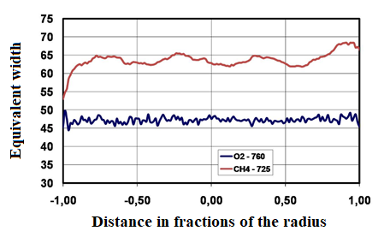
Figure 1 – Meridional profiles of equivalent widths of the methane CH₄ 725 nm absorption band
on Jupiter and telluric oxygen O₂ band at 760 nm

b) Comparative analysis of latitudinal variations in 2019
Studies of previous years indicate that the intensity of molecular absorption bands at different latitudes of Jupiter does not remain constant and undergoes noticeable changes, both in time and in the longitudinal direction, which is the result of dynamic processes of vertical and horizontal heat transfer and zonal circulation in the Jupiter atmosphere. The latter manifests itself, in particular, in large differences in the velocities of horizontal flows in different latitudinal belts.
Figures 2-6 show as an example the results of measurements of the latitudinal variations of the equivalent widths of the absorption bands of methane and ammonia in 2019.

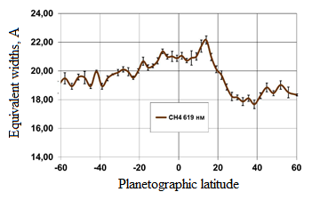
Figure 2 – Latitudinal variations of equivalent widths of the
methane CH4 619 nm absorption band in 2019

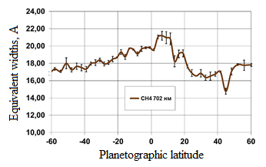
Figure 3 – Latitudinal variations of equivalent widths of the
methane CH4 702 nm absorption band in 2019

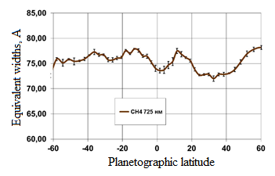
Figure 4 – Latitudinal variations of equivalent widths of the
methane CH4 725 nm absorption band in 2019
.

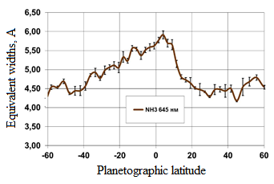
Figure 5 – Latitudinal variations of equivalent widths of the
ammonia NH₃ 645 nm absorption band in 2019

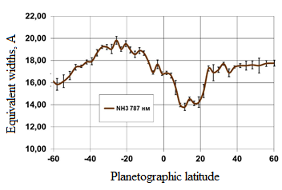
Figure 6 – Latitudinal variations of equivalent widths of the
ammonia NH₃ 787 nm absorption band in 2019

c) Comparative analysis of latitudinal variations in 2020
Observations of Jupiter in 2020 were carried out from June to September. Therefore, in this report, the results of only preliminary processing of large observational material are given, since the complete processing does not fit into the deadline for submitting the report. The observations were carried out using the same technique as described above. The main emphasis of processing the observational data was made on the comparative analysis of the variation of the equivalent widths of the absorption bands of ammonia and methane in various zonal cloud belts of the planet, including the Great Red Spot.
Figures 7-14 show the results of meridional variations of the equivalent widths of eight absorption bands of ammonia and methane at the time of the passage of the GRS through the central meridian and without it.
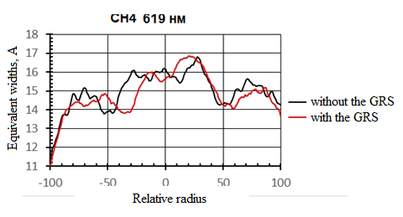
Figure 7 – Meridional variations of the equivalent widths
of the methane 619 nm absorption band

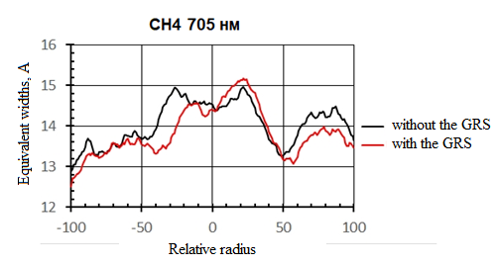
Figure 8 – Meridional variations of the equivalent widths of the methane 705 nm absorption band

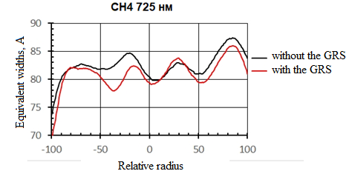
Figure 9 – Meridional variations of the equivalent widths of the methane 725 nm absorption band

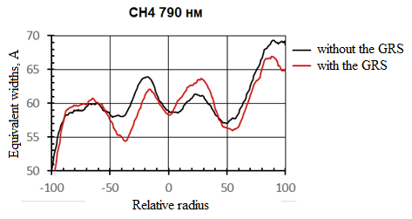
Figure 10 – Meridional variations of the equivalent widths of the methane 790 nm absorption band

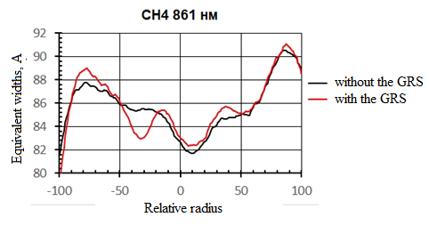
Figure 11 – Meridional variations of the equivalent widths of the methane 861 nm absorption band

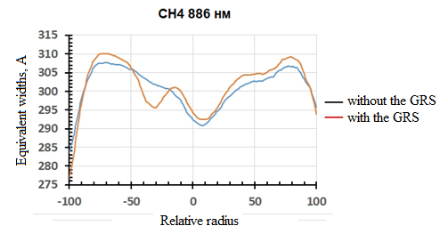
Figure 12 – Meridional variations of the equivalent widths
of the methane 886 nm absorption band

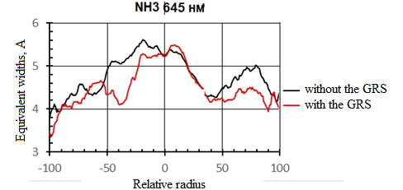
Figure 13 – Meridional variations of the equivalent widths
of the ammonia 645 nm absorption band

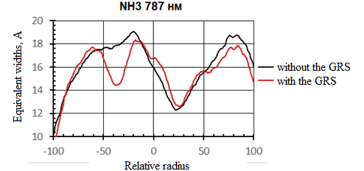
Figure 14 – Meridional variations of the equivalent widths
of the ammonia 787 nm absorption band

For a comparative analysis of latitudinal variations of absorption in the observed absorption bands and in different years, we calculated the relative values ​​of the absorption band intensities by normalizing to the absorption at the equator of Jupiter. Therefore, the following graphs are given exactly in the normalized values ​​of the equivalent widths.
Figures 15-17 show examples of the results obtained on the latitudinal behavior of molecular absorption in the period from 2017 to 2020. For ease of comparison, the graphs show the variations of equivalent widths normalized to the center of the disk (CD) in the equatorial zone in relative units.

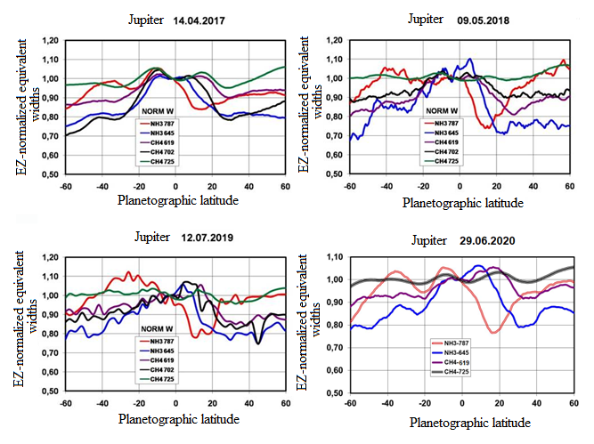

(a) (b)

(c) (d)

(a) – latitudinal behavior of molecular absorption according to data for 14.04.2017
(b) – latitudinal behavior of molecular absorption according to data for 09.05.2018
(с) – latitudinal behavior of molecular absorption according to data for 12.07.2019
(d) – latitudinal behavior of molecular absorption according to data for 29.06.2020

Figure 15 – Latitudinal variations of equivalent widths of methane and ammonia absorption bands normalized to the equatorial zone, from observations 2017-2020

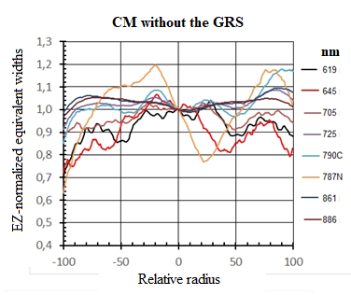

Figure 16 – Meridional (without the GRS) variations of equivalent widths of methane and ammonia absorption bands normalized to the equatorial zone, from observations 2020

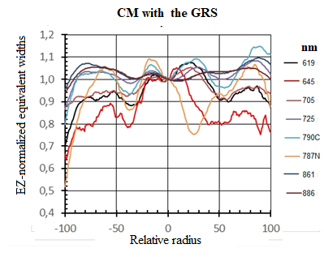

Figure 17 – Meridional (with the GRS) variations of equivalent widths of methane and ammonia absorption bands normalized to the equatorial zone, from observations 2020

It can be seen that the general nature of absorption in latitudes is approximately the same. Extremes are observed near certain latitudinal belts, which correspond to the minimum or maximum equivalent widths of the bands. The general trend is that the lowest values ​​are mostly in the northern hemisphere. The most prominent is the 20-25% depression in the ammonia absorption near the NH₃ 787nm band in 2018 and 2020, which is approximately in the region bordering the equatorial zone and the southern side of the Northern Equatorial Belt (NEB). The same depression is observed in the area of ​​the Great Red Spot. The highest absorption values ​​correspond approximately to the light zones. Attention is drawn to the fact that the positions of the extrema in different bands do not exactly coincide with each other, but show, although small, but obvious shifts in latitude. This feature persists from year to year, although there may not be an exact repetition, in particular, because not the same longitudes were observed on the planet, along which variations in the intensity of absorption bands are also possible. However, a certain representativeness of the data obtained remains within the same observation season.
Based on the results of the research, an article was published: V.D. Vdovichenko, A.M. Karimov, G.A. Kirienko, P.G. Lysenko, V.G. Teifel, V.A. Filippov, G.A. Kharitonova, A.P. Khozhenets. Molecular absorption bands in the study of the troposphere of Jupiter // Izvestiya the NAS RK, Physics and Mathematics series. - 2020. - V.3. - P. 26-33 (Appendix A, Publications in the Republic of Kazakhstan [5])
As an example, we present the results of measurements of latitudinal variations in the equivalent widths of ammonia NH3 absorption bands for several dates in May 2018 (Figure 18).

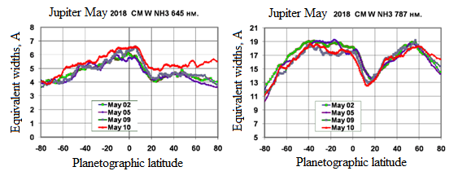
(а) (b)
(a) – absorption at a wavelength of 645 nm
(b) – absorption at a wavelength of 787 nm

Figure 18 – Variations in the equivalent widths of the absorption bands of ammonia at 645 and 787 nm along the central meridian of Jupiter in May 2018

Similar features, that is, latitudinal shifts of extrema for different absorption bands, were noted by us earlier from observations in 1999, when we studied latitudinal variations of methane absorption bands at all longitudes of Jupiter [24] (Tejfel et al, 2001). There is some temptation to attribute the noticeable discrepancies between the positions of absorption extrema in the methane and ammonia bands to differences in the concentration of these gases at different latitudes. This is possible in principle, but the differences in the extrema of the methane bands already mentioned above indicate rather other reasons for such discrepancies. These, of course, interesting features require further systematic research.
Studies of latitudinal variations of absorption bands were carried out earlier: the intensities of the NH₃ 645 nm band were measured in several belts of Jupiter (see Table 3).

Table 3 – Equivalent widths of the absorption band NH₃ 645 nm for different cloud belts of Jupiter as observed by different authors in different years

Area |  | 2018 | Tejfel et al (2018) |  |  | Moreno et al (1988, 1991) |  | Lutz , Owen (1980)
 |  | W(A) | W(A) | sW | W(A) |  | W (cm ⁻¹) |  | W(A)
SPR |  | 4.2 |  |  | 5.6
STB |  | 5.1 |  |  | 5.7
STrZ |  | 5.7 | 5.92 | 0.49 | 7.8 |  | 26.4 |  | 11.00
SEB |  | 6.0 | 6.78 | 0.45 | 9.8 |  | 30.9 |  | 12.90
EZ |  | 6.2 | 6.75 | 0.32 | 7.7 |  | 23.1-33.0 |  | 9.6-13.8
NEB |  | 5.5 | 6.35 | 0.35 | 4.9 |  | 20.1 |  | 8.30
NTrZ |  | 4.4 | 5.38 | 0.36
NTB |  | 4.7 |  |  | 5.7
NPR |  | 4.6 |  |  | 7.2
GRS |  | 4.7 |  |  |  |  | 22.2 |  | 9.3

The first column of Table 3 gives the names of the latitudinal belts, the second column shows the data of our observations carried out in 2018 - the values ​​of the equivalent widths of a band in angstroms. The third and fourth columns contain the mean values ​​and standard deviations of the equivalent widths that we calculated from observations for the period from 2005 to 2015. The fifth column contains data on the work of Spanish researchers. Lutz and Owen presented their estimates of the equivalent widths of the 645 nm band in units of wavenumbers (sixth column), so these values ​​are converted to angstroms in the seventh column.
The table shows that different authors obtained rather different absolute estimates of the equivalent widths of that band, although the latitudinal differences are of a similar nature. Most likely, the main reason for these differences is the technique of isolating the absorption profiles of ammonia against the background of the short-wave weak wing of the methane absorption band and the drawing of a continuous spectrum level. It can be noted that our estimates of the equivalent widths of this band are in good agreement with measurements [25] (Cochran, 1980), according to which the average value of the equivalent width of the NH₃ 645 nm band is 6 ± 1 angstroms.

d) Comparison of latitudinal and zonal variations in molecular absorption
Of particular interest is the comparison of the diametric variations in the absorption of methane and ammonia along the central meridian of Jupiter from pole to pole and along the equator from one edge of the disk to the other. As Figures 19 - 23 show, there is a significant difference between the resulting absorption profiles. Each of these figures on the left shows the normalized absorption behavior along the equator as observed in 2019. The shape of the curves is well approximated by the corresponding parabola Y = 1-K * x2, where x is the relative distance from the center of the disk in fractions of the radius. The parameter K, as the graphs show, varies from band to band. The right side of each of the figures shows a comparison of the meridional and equatorial variations of the equivalent widths of each absorption band according to the 2018 observations.

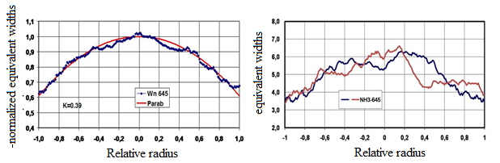
(a) (b)

(a) – running of the equivalent widths of the 645 nm NH₃ band normalized to the center of the disk, along the equator of Jupiter in 2019
(b) – running of the equivalent width of the same band along the central meridian and along the equator of Jupiter in 2018

Figure 19 – Running of the equivalent widths of the 645 nm NH₃ band

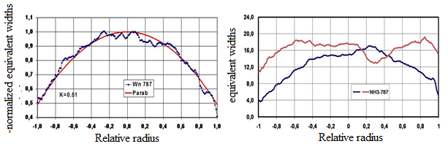
(a) (b)

(a) – running of the equivalent widths of the 787 nm NH₃ band normalized to the center of the disk, along the equator of Jupiter in 2019
(b) – running of the equivalent width of the same band along the central meridian and along the equator of Jupiter in 2018

Figure 20 – Running of the equivalent widths of the 787 nm NH₃ band

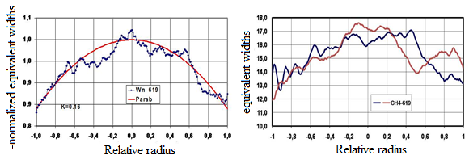
(a) (b)

(a) – running of the equivalent widths of the 619 nm NH₃ band normalized to the center of the disk, along the equator of Jupiter in 2019
(b) – running of the equivalent width of the same band along the central meridian and along the equator of Jupiter in 2018

Figure 21 – Running of the equivalent widths of the 619 nm NH₃ band

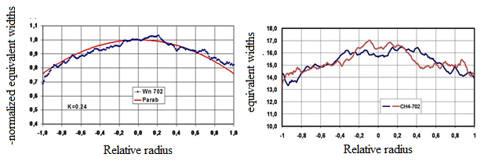
(a) (b)

(a) – running of the equivalent widths of the 702 nm NH₃ band normalized to the center of the disk, along the equator of Jupiter in 2019
(b) – running of the equivalent width of the same band along the central meridian and along the equator of Jupiter in 2018

Figure 22 – Running of the equivalent widths of the 702 nm NH₃ band

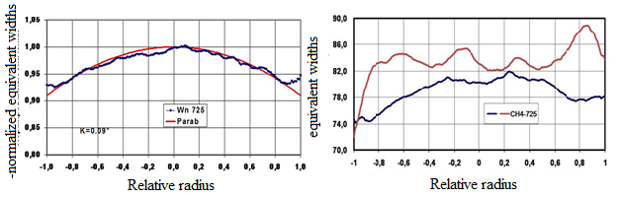
(a) (b)

(a) – running of the equivalent widths of the 725 nm NH₃ band normalized to the center of the disk, along the equator of Jupiter in 2019
(b) – running of the equivalent width of the same band along the central meridian and along the equator of Jupiter in 2018

Figure 23 – Running of the equivalent widths of the 725 nm NH₃ band

The weakest bands show the greatest steepness and weakening towards the edges of the disk. Here, the main role is most likely played by the geometric effect, which is qualitatively predicted by the theory of radiation transfer in an optically thick medium with multiple scattering. However, as will be noted in the next section, interpretation is not unambiguous. The fact that the meridional absorption variations turn out to be significantly different deserves special attention and consideration in the future.
The absorption behavior along all the latitudinal zones of Jupiter also shows a similar parabolic appearance, while small distortions of a profile can be created by local variations in absorption in the longitudinal direction.
Based on the results of the research, an article was published: V. D. Vdovichenko, A. M. Karimov, G. A. Kirienko, P. G. Lysenko, V. G. Teifel, V. A. Filippov, G. A. Kharitonova, A. P. Khozhenets. Behavior of the methane and ammonia absorption bands on Jupiter //Icarus 2020, (in print). Импакт-фактор =3.513, Q1 (Appendix A, Publications in foreign publications, [8])

e) Comparison with thermal range
As noted above, the molecular absorption bands of methane and ammonia play a very significant role not only in the optical range, but also in the ranges of thermal infrared and microwave radiation. If in the visible range of the spectrum molecular absorption manifests itself in the formation of solar radiation diffusely reflected by the atmosphere of Jupiter, then, already starting from wavelengths of about 4 microns and beyond, its influence manifests itself in the modulation of thermal radiation emerging from the deep layers of the planet. This is revealed by variations in the brightness temperature, which characterizes the intensity of the observed fluxes of the outgoing thermal radiation in different parts of Jupiter.
Research in these areas of radiation is very extensive and is described in a large number of publications based on observations with the largest optical and radio telescopes. Without referring to the review of all these publications, we note the most recent ones, in which we are talking not only about the analysis of individual parts of the planet, but also about the construction of complete maps of the distribution of brightness temperature over latitudes and longitudes of Jupiter. In the region of infrared thermal radiation in the ranges of 8-14 μm, such maps are published in works [26,27] Orton et al (2017), Fletcher et al (2016). The maps demonstrate a well-pronounced zonal character of brightness temperatures with noticeable local colder or hotter regions. The short-wavelength region of the thermal range near the 5-micron wavelength stands out. In this region, although to a lesser extent than in the visible region of the spectrum, the cloud cover of Jupiter still plays a significant role in the transfer of radiation, since the size of particles of ammonia clouds, reaching one or more microns, can affect the transmission of this radiation. The Great Red Spot (GRS) is indicative in this respect. On maps and images of Jupiter at a wavelength of about 5 microns, it seems the darkest in comparison with other regions of the planet, despite the fact that it is at this wavelength that there is practically no absorption by methane molecules, creating a kind of transparency window. It is known that in the strong absorption band of methane CH₄ 887nm, the Great Red Spot stands out as the brightest object on the Jupiter disk. According to our measurements, the intensity of ammonia absorption in the bands at 645 and 787 nm in the Great Red Spot is significantly lower than in the neighboring regions of the planet [28] (Tejfel et al, 2018). Taken together, all these results most likely indicate a significantly higher cloud density in the Great Red Spot.
Figure 24 shows the longitudinal changes of absorption in the 787 nm ammonia band for two of Jupiter's belts: for the Southern Equatorial Belt at the latitude of the Great Red Spot and in the Northern Equatorial Belt (NEB).
As you can see, at all longitudes in the specified range, there is no noticeable difference in ammonia absorption. In the South Equatorial Belt, weakening of absorption in the Red Spot stands out, while at all longitudes of the NEB belt, absorption in this band is noticeably lower. For comparison, the right side of Figure 14 shows a fragment of one of the brightness temperature distribution maps at a wavelength of 4.7 µm, taken from [29] by Fletcher et al (2017) for the region of longitudes where the Great Red Spot is located. In this fragment and in the accompanying map in visible rays, north is at the top, and longitudes are given in the third system, while on the left: longitudes are given in the second system.

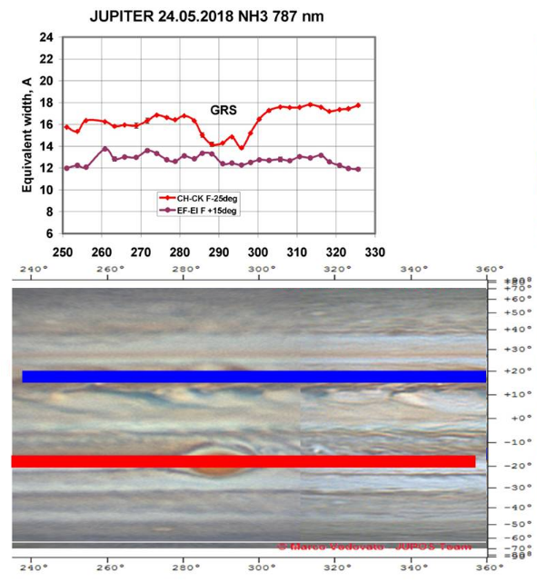 | 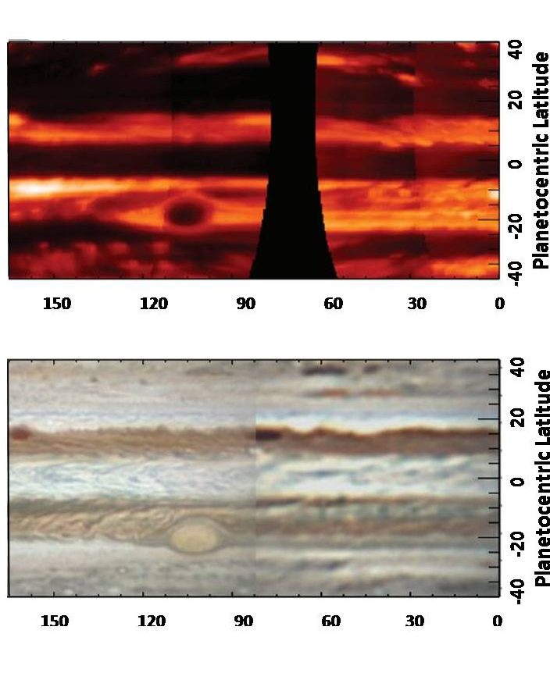
(а) (b)

(a) – comparison of the longitudinal variations of ammonia absorption in the SEB and NEB belts for the NH₃ 787 nm band
(b) – a fragment of the map of the brightness temperature distribution on Jupiter at a wavelength of 4.7 μm
Figure 24 – Longitudinal variations of ammonia absorption and a fragment of the map of the brightness temperature distribution on Jupiter (Fletcher et al, 2017)

Based on the results of the research, an article was published: V.D. Vdovichenko, A.M. Karimov, G.A. Kirienko, P.G. Lysenko, V.G. Teifel, V.A. Filippov, G.A. Kharitonova, A.P. Khozhenets. Zonal features of the behavior of weak molecular absorption bands on Jupiter // Astronomical Vestnik. (Russia, RAS). Impact Factor =1.412, Q3 (Appendix A, Publications in foreign publications [7])
Starting with the work [21] by de Pater et al (2016), observations with the Very Large Array radio telescope system have yielded results of radio measurements of Jupiter with a high spatial resolution, on the basis of which the brightness temperature distribution maps in the microwave radio emission ranges of 12-18 GHz are created. The first comparison of our observations of the latitudinal variation of ammonia absorption on Jupiter with such maps [30] (Tejfel et al, 2016) showed that the observed depression of the intensity of the 787 nm ammonia band near the northern equatorial belt practically coincided in position with the zone of maximum brightness radio temperature. Since the output of thermal radio emission at these frequencies is modulated by the absorption of ammonia, and the cloud layer does not affect the transmission of radio waves, it follows that the variation in ammonia absorption on Jupiter is associated not only with optical effects, but also with real variations in the ammonia abundance in different regions of Jupiter. In subsequent publications [31, 32] (de Pater et al, Wong et al), new maps of the radio brightness temperature at different frequencies are placed. The variations in thermal radio emission shown on these maps also reflect variations in ammonia and methane absorption, which affects the position of the effective depth of the radio emission. We tried to compare our data on the latitudinal behavior of the intensities of the absorption bands of methane and ammonia with a series of latitudinal profiles of the radio brightness temperature published in [33] (de Pater et al, 2019). Figure 25 on the right side shows graphs taken from this work as observed in 2017. The left part of the graph shows the relative behavior of the equivalent widths of the absorption bands of methane and ammonia according to our observations at the beginning of 2017. All curves represent the values ​​of the equivalent widths normalized to the equatorial zone in relative units, but they are plotted with a vertical shift. The spatial resolution on these curves is, of course, much worse. However, it is clearly visible that the depression of ammonia absorption in the 787 nm band coincides in position with the sharp maximum of the brightness temperature observed at a latitude of about 15 degrees, that is, near the northern equatorial belt.

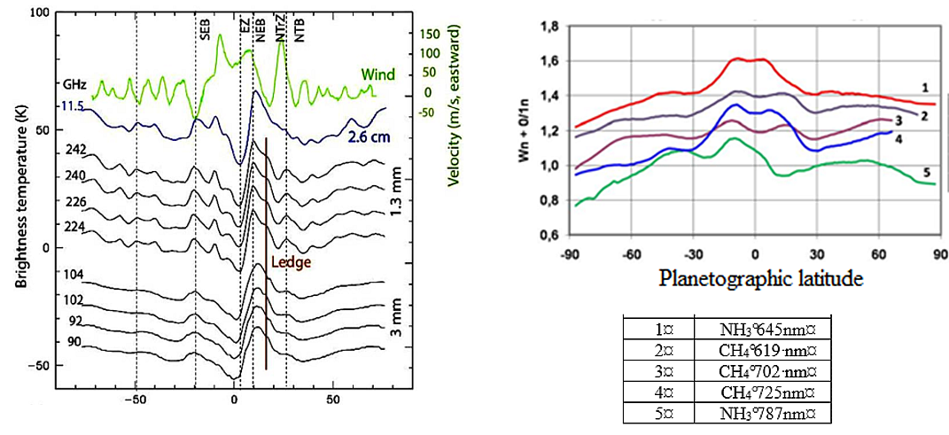
(а) (b)
(a) – graphs based on our observations in early 2017
(b) – graphs taken from [33] (de Pater et al, 2019), based on observations in 2017

Figure 25 – Comparison of latitudinal variations in brightness temperatures in a number of microwave radio emission ranges (de Pater et al, 2019) and equivalent widths of methane and ammonia absorption bands normalized to the equator in the visible spectral region

Of course, it is still impossible to make a correct comparison of the two systems of graphs in separate details due to the differences in spatial resolution, but we can note a certain, although not very clearly distinguished, tendency towards an increase in brightness radio temperatures towards high latitudes. At the same time, the opposite tendency is traced in the absorption bands of methane and ammonia - a decrease towards high latitudes. This can be regarded as agreement between the results of radio observations and optical observations, since an increase in the brightness radio temperatures should be associated with a decrease in the abundance of methane and ammonia and a weakening of their absorption.
Based on the results of the research, an article was submitted for publication: V. D. Vdovichenko, A. M. Karimov, G. A. Kirienko, P. G. Lysenko, V. G. Teifel, V. A. Filippov, G. A. Kharitonova, A. P. Khozhenets. Behavior of the methane and ammonia absorption bands on Jupiter //Icarus 2020. IF=3.513, Q1 (Appendix A).
f) The problem of studying the structure of the cloud layer of Jupiter in the light of modern data
Weak absorption bands of methane and ammonia, observed in the visible and very near-infrared region of the Jupiter spectrum, can serve as a good tool for remote optical sensing of the Jovian troposphere, including the ammonia cloud layer and its deeper parts. Unfortunately, it is still difficult to speak about the correct interpretation of all the observed variations in the intensities of these bands in different regions of Jupiter, since, despite numerous observations and theoretical calculations, there is still no definite picture in the concepts of the real structure of the cloud cover and the underlying troposphere.
As noted above, the observed variations in molecular absorption bands should be considered as evidence of the presence of zonal and local inhomogeneities in the structure of that part of the Jupiter troposphere that participates in the formation of these bands. Two alternative models can be called extreme cases. The first one assumes the existence of a geometrically and optically thick ammonia cloud layer. Only part of the scattered radiation can penetrate through this layer deep into the atmosphere, while direct sunlight does not pass through this layer. In this case, the theory of radiation transfer can consider this layer as semi-infinite (in the accepted terminology). Almost all of the observed absorption in weak and moderate molecular bands is formed by multiple scattering within this cloudy environment. A small fraction of absorption in the methane bands can be created in the above-cloud atmosphere, while the ammonia concentration above the cloud layer sharply decreases, by several orders of magnitude. In this model, the observed absorption variations can be associated with variations in the concentration and volume scattering coefficient of cloud particles and some other factors that influence the effective absorption path. This path is estimated from the intensity of absorption bands and it cannot be considered an estimate of the relative fbundance of absorbing gas in the troposphere.
An alternative model assumes that the ammonia cloud layer has a relatively small geometric thickness and transmits a significant part of direct solar radiation into the atmosphere. In this case, direct sunlight at least reaches the deeper cloud layer. Such a layer, according to most models of the Jupiter atmosphere, is the ammonium hydrosulfide NH₄SH layer. This substance has a significant color, but its albedo is not yet known. If it is not too close to zero, then some of the diffusely reflected sunlight from this layer can escape outside. In this case, the intensity of the observed absorption bands will be determined by the double passage through the gas mass located between the two cloud layers. With a very dark substrate of ammonium hydrosulfide, we could not observe absorption in a pure gas. In this case, the presence of scattering particles inside the gas layer is required.
Even these two idealized models point to the complexity of the formation of molecular absorption bands observed in the visible and near infrared regions of the spectrum of Jupiter. In the more distant region of thermal infrared and microwave radio emission, the picture is completely different, since the aerosol component is transparent for these emissions. The zonal and local brightness temperatures of the outgoing thermal radiation are determined by other factors, as discussed in a number of papers by Jupiter researchers in these ranges of electromagnetic waves.
The three-cloud model of the Jupiter troposphere has been considered by many authors, starting with the publication [34] by Lewis (1969), [35] Weidenschilling and Lewis (1973). We have considered a number of published models of these and other authors, shown in Table 4, differing mainly in the accepted initial values ​​of the abundances of condensable gases. Estimates of the maximum values ​​of the concentration of particles in the ammonia cloud layer in these models, as a rule, refer to the base of the cloud layer and range from 1 * 10⁻⁶ g / cm³ to 7 * 10⁻⁶ g / cm³. In all models, the cloud density decreases with height, but the total thickness of the aerosol layer can be 10 km or more. However, it should be noted that the horizontal and vertical scales of the details of the Jupiter cloud cover are incommensurable, since even the smallest details, distinguishable on the best ground images of the planet, have a horizontal length of 1000 kilometers or more. Therefore, significant local variations in the thickness and density of the ammonia cloud layer are quite possible.

Table 4 – Boundary characteristics of intercloud space on Jupiter according to models by different authors

Авторы | Ammonia, clouds,  P₁ – P₂ boundaries |  | Hydrosulfide,  P₃ – P₄, boundaries |  | Temperature T₂ - T₃
1 | 2 |  | 3 |  | 4
Weidenschilling –Lewis 1973 | 0,60 - 0,80 |  | 1,10 – 2,40 |  | 157 - 170
Moreno-Molina 1991 | 0,30 - 0,60 |  | 1,00 – 2,10 |  | 140 – 160
Sanchez-Lavega 2003 | 0,50 - 0,80 |  | 1,58 – 2,50 |  | 150
Atreya et al 2005 |  | 0,40 - 0,85 |  | 1,32 – 2,20 | 155 – 190
Wong et al. 2015 |  | 0,50 - 0,82 |  | 1,31 – 2,30 | 150 – 190
Fletcher et al 2017 |  | 0,60 - 0,80 |  | 1,50 – 2,50 | 150
Cosentino R. G. 2017 |  | 0,55 - 0,70 |  | 1,62 – 2,00 | 148
Bjoraker G. L. 2018 |  | 0,30 - 0,70 |  | 1,10 – 2,00 | 147 – 165
Grassi D. 2018 |  | 0,50 - 0,75 |  | 1,31 – 2,25 | 148 – 190
de Pater et al 2019 |  | 0,20 - 0,80 |  | 1,18 – 2,50 | 150 – 170
Ragen et al 1998 |  | 0,50 - 0,53 |  | 1,00 – 2,30 | 140 – 160

As for the question of the presence of a scattering medium in the space between the ammonia and hydrosulfide cloud layers, so far we can only refer to the unique experiment on direct sounding of the atmosphere of Jupiter by a descent vehicle in the Galileo Jupiter Mission project (1998). Although it is believed that the probe fell into a not quite typical area of ​​the planet. Based on the probe's nephelometer data, there is a low-density aerosol haze rising above the cloud layer of ammonium hydrosulfide.
To interpret the results of studies of the behavior of molecular bands on the Jupiter disk, in addition to theory, laboratory data on these bands are also needed. Ammonia bands in the visible region of the spectrum were investigated in [36] Giver et al (1975), [37] Lutz and Owen (1980). And also discussed in recent works [38] Bowles et al (2008), [39] Bowles (2009), [40-41] Irwin et al (2018-2019). As for the absorption bands of methane, we mention [42] Fink et al (1977), as well as the work [43] by Karkoschka (1994), in which the absorption coefficients for methane bands were derived from the Jupiter spectrum. We are interested in the growth curves showing the relationship of the equivalent width of an absorption band on the equivalent absorption path in units m-amagat, which can be obtained in the laboratory. Such growth curves were obtained [37] by Lutz and Owen (1980) for the absorption bands of ammonia at 645 nm and methane at 619 nm. Weak and moderate bands fall on the linear part of the growth curve, so for the 645nm ammonia band, one angstrom of equivalent width corresponds to the equivalent path of 4 m-amagat, and for the 619 nm band, the equivalent width of one angstrom requires an equivalent path of 22 m-amagat. Using the average data on the above atmospheric models, it can be shown that when these bands are formed inside the intercloud gas layer, their equivalent widths can be close or even coincide with the observed ones. This means that it can be rather difficult to separate the two models discussed above for the formation of molecular absorption bands without additional analysis of a large set of observational data. This complex should include both measurements in the visible region of the spectrum and the currently being successfully conducted research in the field of thermal infrared and microwave radiation.
The question of some properties of the upper cloud layer on Jupiter, consisting of crystals of frozen ammonia, still remains a subject of discussion. The rather varied light shades of cloudy details indicate the presence in these crystals or in between of some substance - a chromophore or several substances that affect the color of colorless ammonia crystals themselves. Even models with a separate layer of chromophores inside the cloud layer are discussed [44] Braude et al (2020), and the red color of the central part of the Great Red Spot is proposed to be explained by the presence of a certain colored film above the main cloud in the Spot [45] Baines et al (2019). In light of these assumptions, we would like to draw your attention to the appearance of very rare and small in size dark brown cloud formations, appearing mainly in the South Tropical zone and called "barges", due to their specific configuration.

Prospects for further research
This project is part of a general long-term program for studying the atmosphere of Jupiter from the standpoint of studying long-term changes and activity of processes occurring in the troposphere and the cloudy layer of the planet. Jupiter, like almost all cosmic bodies, is a non-stationary object. Powerful zonal circulation processes associated with the rapid rotation of Jupiter and the release of internal thermal energy are reflected not only in large differences in the zonal horizontal velocities of atmospheric masses, but also in variations in the structure of the planet's visible cloud layer located at levels of 0.3-0.5 bar. Despite the fact that the internal processes in the troposphere are primarily due to the convective transfer of thermal energy and gas flows, the upper part of the troposphere and the surface of the cloud layer, like the stratosphere, receive additional energy due to the flow of solar radiation. Due to the ellipticity of Jupiter's orbit, its heliocentric distance in ophelia and at perihelion differs by 0.5 astronomical units, that is, by 10%. Accordingly, the influx of solar energy in the form of optical radiation differs by 20%. Added to this are variations in ultraviolet x-rays and solar wind fluxes, driven by solar activity, and affecting the stratosphere and thermosphere. The role of these factors in the impact on the upper troposphere has hardly been studied. It can be suspected that a change in the magnitude of insolation and heating of particles in the upper cloud layer can affect the intensity of convection in this layer. To detect and study the role of these factors, as well as the effects associated with the transfer of internal heat, regular long-term and uniform observation of the processes occurring on Jupiter are required. A complex of studies of this kind should include observations in a wide range of wavelengths, covering both the ultraviolet and visible regions of the optical spectrum, and the ranges of thermal infrared and microwave radiation using both space and terrestrial means, which provide the possibility of regular and long-term monitoring of Jupiter processes. All this is included in the strategic objectives of studying the solar system, formulated in a number of NASA documents and in recent ones - [46] Wong et al, 2020, [47] Sayanagi et al, 2020, [48] Kofman et al, 2020.
The authors of the project have at their disposal the material of spectral observations of Jupiter for more than a complete revolution of the planet around the Sun since 2004. This material is a bank of several thousand CCD spectrograms of Jupiter - the central meridian and latitudinal belts of the planet. Plans for further research envisage replenishment of this bank, at least until the completion of the next 12-year Jupiter revolution around the Sun, that is, until 2028-2030. This is necessary to identify certain patterns, periodicities and interrelationships of the processes occurring on Jupiter, assessed according to certain criteria and parameters of the state of the atmosphere.
As one of the characteristics of spatial-temporal changes on Jupiter, along with variations in the morphological features of cloud belts, the measurement of the intensity of the molecular absorption bands of methane and ammonia observed in the visible and near infrared regions of the spectrum is used. The relatively weak and unsaturated molecular bands in their variations reflect the changes occurring in the cloudy-gas environment of the Jovian troposphere. They can serve as one of the criteria for assessing its state at different latitudes and longitudes of the planet and one of the means of sounding. In this case, comparison with the results of observations of Jupiter in the spectral ranges of thermal infrared (micron) radiation and thermal microwave radio emission in the millimeter range, conducted at optical observatories and radio telescopes in the United States, is of great importance.
CONCLUSION
Main results in accordance with the calendar plan of the tender application
for 2018 – 2020
The studies carried out during the reporting period, in addition to their independent significance according to the results obtained, are part of an extensive long-term program of studies of the instability of the Jupiter atmosphere and the search for patterns in its structure associated with the planet's revolution around the Sun and with other possible internal and external factors. This program is based on obtaining a homogeneous material of spectral observations and analysis of the changes occurring on the planet, which are manifested in space-time variations in the intensity of molecular absorption bands of methane and ammonia. The reporting period falls on the beginning of the second twelve-year orbital period of Jupiter, while the previous full revolution has already been covered by observations under this program. Ongoing observations reveal previously unknown features.

Main results according to the competition application for 2020
A cycle of spectral observations of Jupiter in the visible and near infrared optical spectrum in the wavelength range of 580 - 900 nanometers was carried out in order to obtain new materials and replenish the long-term data bank accumulated since 2004. In this case, two methods were used to obtain and register the Jupiter spectra, determined by the orientation of the entrance slit of the spectrograph:
- In the first method, the slit was oriented along the central meridian of Jupiter.
- The second method consisted in sequential scanning of the Jupiter disk from the South Pole to the North Pole with the spectrograph slit oriented parallel to the planet's equator.
- As a result, we managed to obtain a fairly extensive observational material in the amount of more than 1400 meridional and zonal spectrograms.

The results of meridional variations of the equivalent widths of 8 absorption bands of ammonia and methane at the time of the passage of the GRS through the central meridian and without it are obtained. The general nature of absorption in latitudes is approximately the same. Extremes are observed near certain latitudinal belts, which correspond to the minimum or maximum equivalent widths of the bands. The general trend is that the lowest values ​​are mostly in the northern hemisphere. The most prominent is the 20-25% depression in the ammonia absorption near the NH₃ 787nm band in 2018 and 2020, which is approximately in the region bordering the equatorial zone and the southern side of the Northern Equatorial Belt (NEB). The same depression is observed in the area of ​​the Great Red Spot. The highest absorption values ​​correspond to the light zones. Attention is drawn to the fact that the positions of the extrema in different bands do not exactly coincide with each other, but show, although small, but obvious shifts in latitudes.
Comparison of the absorption behavior of methane and ammonia along the central meridian of Jupiter from pole to pole and along the equator from one edge of the disk to the other shows a significant difference between the resulting absorption profiles. The weak bands show the greatest steepness and attenuation towards the edges of the disk in the diametrical direction, while the meridional absorption variations turn out to be significantly different and deserve special attention for future studies.
Comparison of our observations of the latitudinal behavior of ammonia absorption on Jupiter with maps in the ranges of thermal infrared and microwave radiation shows a practical coincidence in the position of the observed depression of the intensity of the 787 nm ammonia band near the northern equatorial belt at a latitude of about 15 degrees with the zone of maximum brightness radio temperature.
Based on the results of the research, the following articles were published: Appendix A, Publications in foreign publications [7, 8], Publications in the Republic of Kazakhstan [5,6],

In general, over three years, within the framework of the project, the following has been completed: During the period 2018-2020, three cycles of spectrophotometric observations of Jupiter were performed with the registration of the spectra of the planet's central meridian and zonal spectra belonging to the latitude belts from the southern to the northern belt of Jupiter. In general, the obtained observational data is more than 8500 CCD spectrograms of the central meridian and latitudinal belts of the planet, adding to the bank of uniform spectral observations of Jupiter since 2004.
A study was carried out and data on latitudinal-temporal variations in the intensity of the absorption bands of ammonia NH₃ 645 and 787 nm were obtained.
The latitudinal variations of the molecular absorption bands of methane and ammonia in the 0.6-0.9 μm range have been investigated and some previously unknown features of these variations have been revealed, indicating the variable nature of the behavior of molecular absorption in different cloud belts of the planet and for different absorption bands.
The long-term existence of a well-pronounced depression in the NH₃ 787 nm absorption band in the latitude region of about +15 degrees, which we discovered in 2004, coincides in position with the anomalously increased brightness temperature of thermal radio emission from Jupiter in the millimeter wavelength range, which is interpreted as a consequence of a low ammonia abundance in this part of the planet, since ammonia absorbs at these frequencies and determines the degree of thermal radio emission and its brightness temperature.
The feature discovered in previous years in the latitudinal variations of the absorption bands of methane and ammonia in the visible and near infrared regions of the spectrum, which is expressed in the fact that the extremes (maxima and minima) of the intensity of these bands, do not coincide in latitude, is confirmed.
Studies of ammonia absorption in the Great Red Spot on Jupiter showed a noticeable weakening in comparison with the surrounding cloudy surface, which, together with the reduced brightness temperature of the Spot at a wavelength of 4.8 microns, can be considered as a sign of increased volume density of clouds inside the Spot.
A significant difference was found between the intensity variations of absorption bands along the central meridian and along the equator and other latitudinal belts, including the dependence of the steepness of the decrease in absorption towards the eastern and western edges of the disk on the intensity of the absorption band.
When comparing the latitudinal variations of the studied absorption bands of methane and ammonia with the data of radio observations in the microwave range, a general tendency of an increase in the brightness radio temperatures towards high latitudes is traced with a decrease in the intensity of the molecular absorption bands.
Comparison of the latitudinal absorption in the bands of ammonia at 645 and 787 nm and methane at 619, 702, and 725 nm reveals a well-pronounced difference for different years in the location of the extrema (maxima and minima) of the equivalent widths for both the ammonia bands and the methane bands.
It was discovered, but requires further research, a noticeable connection of the average characteristics of ammonia absorption with the heliocentric distance of Jupiter.
The present final report on the topic "Investigation of the structural features of Jupiter's cloud cover based on observations in the near infrared region of the spectrum" has been compiled on the work done for the period 2018-2020.
It should be especially noted that the studies carried out under the project may be useful in the framework of the tasks of ground-based astrophysical tracking of the space mission to Jupiter, including the current JUNO mission.
Based on the results of the research, works were published in scientific journals (see Appendix A).
Assessment of the completeness of solutions to the assigned tasks. The project was completed in full, all the tasks were solved.

Assessment of the scientific and technical level of the completed research work in comparison with the best achievements in this area: Spectral observations of Jupiter in the visible and near infrared region of wavelengths presented in this report are largely unique, since foreign studies are mainly focused on the study of thermal infrared and microwave radiation of Jupiter using the largest optical and radio astronomy telescopes. The possibility of a comparative analysis of data obtained in different regions of the spectrum for studying the structure of the atmosphere of Jupiter and its space-time variations is valuable. In the future, such complex results can be used as ground-based astrophysical support for space missions, especially since planetary exploration is also provided for by the Law on Space Activities of Kazakhstan.
LIST OF USED SOURCES

- Matcheva K.I., Conrath B.J., Gierasch P.J., Flasar F.M. The cloud structure of the Jovian atmosphere as seen by the Cassini/CIRS experiment. //Icarus. – 2005. – Vol.179. – P.432–448 (IF= 3.813, Q1, 45.49%, США).
- Orton G.S. Ground–based support for giant planet missions //Earth, Moon & Planets. – 2009. – Vol.105. – P.143–152 (IF=0.271, Q3, 38.00%, Нидерланды).
- Orton G.S., Friedson A. J., Yanamandra–Fisher P. A., Caldwell J., Hammel H., Baines K. H., Bergstralh J. T, Martin T. Z., West R. A., Veeder G. J., Lynch D. K., Russell R., Malcom M. E., Golisch W. F., Griep D. M., Kaminski C. D., Tokunaga A. T., Baron R., Herbst T. and Shure M. Thermal maps of Jupiter: Spatial organization and time dependence of tropospheric temperatures, 1980–1993. //Science. – 1994. – Vol.265. – P.625–631.
- Hanel R. A., Conrath B. J., Jennings D. E., and Samuelson R. E. Exploration of the Solar System by Infrared Remote Sensing //2nd ed. Cambridge University Press. 2003.
- Fletcher, L. N., Orton, G. S., de Pater, I., Edwards, M., Yanamandra–Fisher, Hammel H. B. Lisse C. M. The Aftermath of the July 2009 Impact on Jupiter: Ammonia, Temperatures and Particulates from Gemini Thermal Infrared Spectroscopy. //Icarus. – 2011. – Vol. 211. – P. 568–586. (IF= 2.542, Q1, 52.18%, США).
- Fletcher L. N., Orton G. S., Mousis O., Yanamandra–Fisher P., Parrish P. D., Irwin P. G. J., Fisher B. M., Vanzi L., Fujiyoshi T., Fuse T., Simon–Miller A. A., Edkins E., Hayward, T. L., De Buizer J. Thermal structure and composition of Jupiter’s Great Red Spot from high–resolution thermal imaging. //Icarus. – 2010. – Vol.208. – P.306–328. (IF= 2.717, Q1, 50.86%, США).
- Fletcher L. N., Orton G. S., Yanamandra–Fisher P., Fisher B. M., Parrish P. D., Irwin P. G. J., Mar. Retrievals of atmospheric variables on the gas giants from ground–based mid–infrared imaging. //Icarus. – 2009. – Vol.200. P.154–175. (IF= 2.668, Q1, 47.44%, США).
- De Pater I., Deboer D., Marley M., Freedman R., Young R. Retrieval of water in Jupiter’s deep atmosphere using microwave spectra of its brightness temperature. //Icarus. – 2005. – V.173. – P.425–438. (IF= 3.813, Q1, 45.49%, США).
- Gibson W.J. Welch Imke de Pater. Accurate Jovian radio flux density measurements show ammonia to be subsaturated in the upper troposphere. //Icarus. – 2005. – Vol.173. – P.439–446. (IF= 3.813, Q1, 45.49%, США).
- Sault R.J., Chermelle Engel,b and Imke de Pater Longitude–resolved imaging of Jupiter at λ = 2 cm. //Icarus. – 2004. – Vol.168. – P.336–343. (IF= 2.686, Q1, 42.90%, США).
- Roos–Serot M., Drossart P., Encrenaz T., Lellouch E., Carlson R. W., Baines K. H., Kamp L., Mehlman R., Orton G. S., Calcutt S., Irwin P., Taylor F., Weir A. Analysis of Jupiter North Equatorial Belt hot spots in the 4–5 –μm range from Galileo/Near–Infrared mapping spectrometer observations: Measurements of cloud opacity, water, and ammonia. //Journal of Geophysical Research. – 1998. – Vol.103. – P.23023–23042.
- Orton G. S., Appleby J. F., and Martonchik J. V. The effect of ammonia ice on the outgoing thermal radiance from the atmosphere of Jupiter. //Icarus. 1982. Vol.52. P.94–116.
- Cox A.N., Tejfel V.G., Tholen D.J. Planets and Satellites. Chapter 12 of Handbook "Astrophysical Quantities”. //Springer–Verlag. – 2000. – Р.293–313. (IF= 4.055, Q1, 305.40%, Германия).
- Bagenal, Dowling and Mc Kinnon. Jupiter: The Planet, Satellites and Magnetosphere. //Cambridge Univ. Press. Cambridge. UK. – 2005.
- Irwin P.G.J. Giant Planets of Our Solar System. Second Edition. //Springer. – 2009. (IF= 6.740, Q1, 229.13%, Германия).
- Irwin, P. G. J., Dyudina, U. The retrieval of cloud structure maps in the equatorial region of Jupiter using a principal component analysis of Galileo/NIMS data. //Icarus. – 2002. – Vol.156. – P. 52–63. (IF= 2.101, Q1, 39.49%, США).
- Ragen B. T., Colburn D. S., Rages K. A., Knight T.C. D., Avrin P., Orton G. S., Yanamandra–Fisher P. A., and Grams G. W. The clouds of Jupiter: Results of the Galileo Jupiter mission Probe Nephelometer experiment. //Journal of Geophysical Research. – 1998. – Vol.103. – P. 22891–22910.
- Orton G. S., Fisher B. M., Baines K. H., Stewar S. T. t, Friedson A. J., Ortiz J. L., Marinova M., Hoffmann W., Hora J., Ressler M., Hinkley S., Krishnan V., Masanovic M., Tesic J., Tziolas A., Parija K. Characteristics of the Galileo Probe entry site from earth–based remote sensing observations. // Journal of Geophysical Research. – 1998. – Vol.103. – P. 22791–22814.
- Orton G., Ortiz J. L., Baines K., Bjoraker G., Carsenty U., Colas F., Deming D., Drossart P., Frappa E., Friedson J., Goguen J., Golisch W., Griep D., Hernandez C., Hoffmann W., Jennings D., Kaminsk C., Kuhn i, J., Laques P., Limaye S., Lin H., Lecacheux J., Martin T., McCabe G., Momary T., Parker D., Puetter R., Ressler M., Reyes G., Sada P., Spencer J., Spitale J., Stewar S. T., Varsik J., Warel J. L., Wild W., Yanamandra–Fisher P., Dayal A., Deutsch G., Fazio L., Hora J. Results of Earth–Based Observations of the Galileo Probe Entry Site. //Science. – 1996. – Vol.272. Р.839–840.
- Showman, A. P., and de Pater, I. Dynamical implications of Jupiter’s tropospheric ammonia abundance //Icarus. – 2005. – Vol.174. – Р.192–2004. (IF= 3.813, Q1, 45.49%, США)
- De Pater I., Sault R. J., Butler B., DeBoer D., Wong M. H. Peering through Jupiter’s clouds with radio spectral imaging. Research Reports. Gas Giant Planets. //Science. – 2016. – Vol.352. – Issue 6290. – P.1290–1294. (IF= 13.745, Q1, 18.76 %, США).
- Tejfel V.G., Karimov A.M., Vdovichenko V.D. Strange latitudinal variations of the ammonia absorption on Jupiter. //Bulletin American Astronomical Society. – 2005. – Vol.37. – № 3. – P. 682. (США).
23 Tejfel V.G., Vdovichenko V.D., Kirienko G.A., Kharitonova G.A., Sinjaeva N.V., Karimov A.A. Spatially resolved variation in the methane and ammonia absorption in the atmosphere of Jupiter. //Astronomical and Astrophysical Transactions. – 2005. – Vol.24. – No.4. – Р. 359–363. (Великобритания).
24 Tejfel` V. G. Kharitonova G.A, Glushkova E.A., Sinyaeva N.V. Variations of the methane absorptions on Jupiter’s disk from zonal CCD spectrofotometry data. //Solar System Reseach. – 2001. – Vol.35. – № 4. – P. 261–277. (Россия).
25 Cochran, W.D., Cochran, A.L. Longitudinal Variability of Methane and Ammonia Bands on Jupiter. //Icarus. – 1980. – Vol.42. – P. 102–110. (США).
26 Orton G. S., Hansen C., Janssen M. A., Bolton S., Brown S., Eichstaedt G., Rogers J., Ingersoll A. P., Li Ch., Momary T. W., Tabataba–Vakili F., Fletcher L., Fujiyoshi T., Greathouse T. K., Kasaba Y., Simon A. A., Sinclair J. A., Stephens A. W., Wong M. H., Donnelley P., Sanchez–Lavega A. M., Hueso R. Juno–Support Observing Team. Characterization of the Great Red Spot from observations by Juno and the Earth–based supporting campaign //American Astronomical Society. – 2017. – 49–th DPS AASMeeting. – Abstract 205.2. (США).
27 Fletcher, L. N., Greathouse, T. K., Orton, G. S., Sinclair, J. A., Giles, R. S., Irwin, P. G. J., & Encrenaz, T. Mid–infrared mapping of Jupiter’s temperatures, aerosol opacity and chemical distributions with IRTF/TEXES. //Icarus. – 2016. –Vol.278. – P. 128–161. (IF= 2.380, Q1, 56.38 %, США).
28 Tejfel` V.G., Vdovichenko V.D., Lysenko P.G., Karimov A.M., Kirienko G.A., Filippov V.A., Kharitonova G.A., Khozhenets A.P. The Great Red Spot on Jupiter: some features of the ammonia absorption. //Izvestija NAN RK, ser. fiz.– mat. – 2018. – №3. – P. 23–31. (Казахстан).
29 Fletcher L.N., Orton G.S., Rogers J.H., Giles R.S., Payne A.V., Irwin P.G.J., Vedovato M. Moist Convection and the 2010–2011 Revival of Jupiter’ South Equatorial Belt. //Icarus. – 2017. – Vol.286. – P. 94–117. (IF= 2.037, Q1, 56.99 %, США).
30 Tejfel` V.G., Vdovichenko V.D., Karimov A.M., Lysenko P.G., Kirienko G.A., Bondarenko N. N., Kharitonova G.A., Filippov V.A. On the NH3 absorption depression observable at Northern low latitudes of Jupiter. //American Astronomical Society. – 2016. – 48–th DPS /EPSC 11 Meeting.
31 De Pater I., Sault R. J., Wong M. H., Fletcher L. N., DeBoer D., & Butler B. Jupiter’s ammonia distribution derived from VLA maps at 3–37 GHz. //Icarus. – 2019. Vol. 322. P. 168–191. (IF= 1.837, Q1, 58.55 %, США).
32 Wong, M. H., Atreya, S. K., Kuhn, W. R., Romani, P. N., & Mihalka, K. M. Fresh clouds: A parameterized updraft method for calculating cloud densities in one–dimensional models. //Icarus. – 2015. – Vol.245. – P. 273–281. (IF= 2.314, Q1, 60.66 %, США).
33 De Pater, I., Sault, R. J., Moeckel, C., Moullet, A., Wong, M. H., Goullaud, C., Cosentino, R. First ALMA Millimeter–wavelength Maps of Jupiter, with a Multiwavelength Study of Convection //The Astronomical Journal. – 2019. – Vol.158. – № 4. – P. 139–145. (IF= 2.374, Q1, 64.16 %, США).
34 Lewis, J. S. The clouds of Jupiter and the NH3–H2O and NH3–H2S systems. //Icarus. – 1969. – Vol.10. – № 3. – P. 365–378; (США).
35 Weidenschilling, S. J., Lewis, J. S. Atmospheric and cloud structures of the Jovian planets. //Icarus. – 1973. – Vol.20. – P. 465–476; (США).
36 Giver L.P., Miller J.H., Boese R.W. A laboratory atlas of the 5ν1 NH3 Absorption Band at 6475 A with Applications to Jupiter and Saturn. //Icarus. 1975. Vol.25. P. 34–48; (США).
37 Lutz, B.L., and Owen T. The visible bands of ammonia: band strengths, curves of growth, and the spatial distribution of ammonia on Jupiter. //Astronomical Journal. – 1980. – Vol.235. – P. 285–293; (США).
38 Bowles N., Calcutt S., Irwin P., Temple J. Band parameters for self–broadened ammonia gas in the range 0.74 to 5.24 μm to support measurements of the atmosphere of the planet Jupiter. //Icarus. – 2008. – Vol.196. – P. 612–624. (IF= 2.584, Q1, 43.86 %, США).
39 Bowles N. 2009. Private communication.
40 Irwin P.G.J., Bowles N., Braude A.S., Garland R., Calcutt S. Analysis of gaseous ammonia (NH3) absorption in the visible spectrum of Jupiter. //Icarus. – 2018. – Vol.302. – P. 426–436. (IF= 2.241, Q1, 61.99 %, США).
41 Irwin, P. G., Bowles, N., Braude, A. S., Garland, R., Calcutt, S., Coles, P. A., & Tennyson, J. Analysis of gaseous ammonia (NH3) absorption in the visible spectrum of Jupiter–Update. //Icarus. – 2019. – Vol.321. – P. 572–582. (IF= 1.837, Q1, 58.55 %, США).
42 Fink U., Benner D. Ch., Dick K.A. Band model analysis of laboratory methane absorption spectra from 4500 to 10500 A. //Journal of Quantitative Spectroscopy and Radiative Transfer. – 1977. – Vol.18. – P. 447–457; (Великобритания).
43 Karkoschka E. Spectrophotometry of Jovian Planets and Titan at 300–to1000–nm Wavelength: The Methane Spectrum. //Icarus. – 1994. – Vol.111. – P. 174–192. (США).
44 Braude A. S. Irwin P. G. J., Orton G. S., Fletcher L. N. Colour and tropospheric cloud structure of Jupiter from MUSE/VLT: Retrieving a universal chromophore. //Icarus. –2020. – Vol.338 – P. 113589–113607. (IF= 3,513 Q1, США).
45 Baines, K. H., Sromovsky, L. A., Carlson, R. W., Momary, T. W., & Fry, P. M. The visual spectrum of Jupiter's Great Red Spot accurately modeled with aerosols produced by photolyzed ammonia reacting with acetylene. //Icarus. – 2019. – Vol.330. – P. 217–229. (IF= 1.837, Q1, 58.55 %, США).
46 Wong, M. H., Simon, A. A., Tollefson, J. W., de Pater, I., Barnett, M. N., Hsu, A. I., ... & Januszewski, W. High–resolution UV/Optical/IR Imaging of Jupiter in 2016–2019. //The Astrophysical Journal Supplement Series. – 2020. – Vol.247(2). – P. 58. (IF= 3.335 Q1, 77.69 %, США).
47 Sayanagi K. M; Becker T; Brooks S; Brueshaber S; Dahl E; de Pater I; Ebert R; El Moutamid M; Fletcher L; Jessup K. L; McEwen A; Molyneux P. M; Moore L; Moses J; Nénon Q; Orton G; Paranicas C; Showalter M; Spilker L; Tiscareno M; Westlake J; Wong M. H; Young C. Priority Questions for Jupiter System Science in the 2020s and Opportunities for Europa Clipper. //arXiv preprint arXiv:2007.08609. – 2020.
48 Kofman V., Mockel C., Orton G., Venditti F., Migliorini A., Faggi S., Cordiner M., Liuzzi G., Lippi M., Knutsen E. W., de Pater I., Rivera–Valentín E. G., Bodewits D., Milam S. N., Villard E., Villanue G. L. Synergies between ground–based and space–based observations in the solar system and beyond. //arXiv preprint arXiv:2008.01080. – 2020.

APPENDIX А
List of published works

List of publications on the theme of Project at 2018 year.

Monograph
Vdovichenko V.D. and Teifel V.G. Studies of planets in Kazakhstan: monograph / Almaty, 2018. 400 p. (in Russian).

Publications in foreign editions:
- E. Saquet, N. Emelyanov, V. Robert, J.-E. Arlot, P. Anbazhagan, K. Bailli´e, J. Bardecker, A. A. Berezhnoy, M. Bretton, F. Campos, L. Capannoli, B. Carry, M. Castet, Y. Charbonnier, M. M. Chernikov, A. Christou, F. Colas, J.-F. Coliac, G. Dangl, O. Dechambre, M. Delcroix, A. Dias-Oliveira, C. Drillaud, Y. Duchemin, R. Dunford, P. Dupouy, C. Ellington, P. Fabre, V. A. Filippov, J. Finnegan, S. Foglia, D. Font, B. Gaillard, G. Galli, J. Garlitz, A. Gasmi, H. S. Gaspar, D. Gault, K. Gazeas, T. George, S. Y. Gorda, D. L. Gorshanov, C. Gualdoni, , K. Guhl, K. Halir, W. Hanna, X. Henry, D. Herald, G. Houdin, Y. Ito, I. S. Izmailov, J. Jacobsen, A. Jones, S. Kamoun, E. Kardasis, A. M. Karimov, M. Y. Khovritchev, A. M. Kulikova, J. Laborde, V. Lainey, M. Lavayssiere, P. Le Guen, A. Leroy, B. Loader, O. C. Lopez, A. Y. Lyashenko, P. G. Lyssenko, D. I. Machado, N. Maigurova, J. Manek, A. Marchini, T. Midavaine, J. Montier, B. E. Morgado, K. N. Naumov, A. Nedelcu, J. Newman, J. M. Ohlert, A. Oksanen, H. Pavlov, E. Petrescu, A. Pomazan, M. Popescu, A. Pratt, V. N. Raskhozhev, J.-M. Resch, , D. Robilliard, E. Roschina, E. Rothenberg, M. Rottenborn, S. A. Rusov, F. Saby, L. F. Saya,G. Selvakumar, F. Signoret, V. Y. Slesarenko, E. N. Sokov, J. Soldateschi, A. Sonka, G. Soulie, J. Talbot, V. G. Tejfel, W. Thuillot, B. Timerson, R. Toma, S. Torsellini, L.L. Trabuco, P. Traverse, V. Tsamis, M. Unwin, F. Van Den Abbeel, H. Vandenbruaene, R. Vasundhara, Y. I. Velikodsky, A. Vienne, J. Vilar, J.-M. Vugnon, N. Wuensche and P. Zeleny . The PHEMU15 catalogue and astrometric results of the. Jupiter’s Galilean satellite mutual occultation and eclipse observations made in 2014–2015 // MONTHLY NOTICES OF THE ROYAL ASTRONOMICAL SOCIETY. – 2018. - V.474. - P.4730–4739. Impact Factor = 5.356, Q1 (Web of Science) (UK) https://doi.org/10.1093/mnras/stx2957
- A. S. Ovsak, A. M. Karimov, P. G. Lysenko. Aerosol Component of the Atmosphere of Saturn: Comparison of the Vertical Structure Characteristics in Latitudinal Belts // Kinematics and Physics of Celestial Bodies. – 2018. - Vol. 34. - P. 88–97. Impact Factor =0.654, Q4 (Web of Science) (USA) DOI: 10.3103/S088459131802006X https://link.springer.com/article/10.3103%2FS088459131802006X
- A. S. Ovsak, V. G. Teifel’, A. M. Karimov, P. G. Lysenko. A Comparison of Values of the Imaginary Part of the Refractive Index of Aerosol Particles in the Latitudinal Belts of Saturn’s Northern Hemisphere // Kinematics and Physics of Celestial Bodies. - 2018.- Vol. 34. - P. 161–165. Impact Factor =0.654, Q4 (Web of Science) (USA) DOI: 10.3103/S0884591318030066 https://link.springer.com/article/10.3103%2FS0884591318030066
- V. G. Tejfel, V.D Vdovichenko., P. G. Lysenko, A. M. Karimov, G.А. Kiriyenko, N. N. Bondarenko, V.A. Filippov, G.A. Kharitonova, A.P. Khozhenets Ammonia in Jupiter’s Atmosphere: Spatial and Temporal Variations of the NH3 Absorption Bands at 645 and 787 Nm //Solar System Research. – 2018. - Vol. 52. - No. 6. - P. 480–494. Impact Factor =0.756, Q4 (Web of Science) (USA) DOI: 10.1134/S0038094618060072 https://link.springer.com/article/10.1134/S0038094618060072

Publications in RK (Kazakhstan):
- V.G. Teifel, V.D. Vdovichenko, P.G. Lysenko, A.M. Karimov, G.A. Kirienko, V.A.Filippov, G.A. Kharitonova, A.P. Khozhenets. The Great Red Spot on Jupiter: some features of the ammonia absorption // Bulletin of the National Academy of Sciences of the Republic of Kazakhstan, Physics and Mathematics series. - 2018. - Vol.3. - P. 23-27. (in Russian).

List of publications on the theme of Project at 2019 year.
Publications in foreign editions:
- V.G. Teifel, V.D. Vdovichenko, P.G. Lysenko, A.M. Karimov, G.A. Kirienko, V.A. Filippov, G.A. Kharitonova, A.P. Khozhenets. The weak ammonia absorption bands study from zonal spectrophotometry of Jupiter // EPSC Abstracts. - Vol. 13. - EPSC-DPS2019-134. – 2019. - EPSC-DPS Joint Meeting. - September 2019. - Geneva, Switzerland. - 2pp.
- V.D. Vdovichenko, A.M. Karimov, G.A. Kirienko, P.G. Lysenko, V.G. Tejfel, V.A. Filippov, G.A. Kharitonova, A.P. Khozhenets. Zonal features of the weak ammonia absorption bands behavior on Jupiter // 10-th Moscow Symposium on Solar System. - October 2019. - Abstract 2pp. (in Russian).

Publications in RK (Kazakhstan):
- V.G. Teifel, P.G. Lysenko, A.M. Karimov, G.A. Kirienko, V.A. Filippov, G.A. Kharitonova, A.P. Khozhenets. JUPITER: ZONAL SPECTROPHOTOMETRY OF WEAK AMMONIA ABSORPTION BANDS IN 2018 //News NAS RК. - Physics and Mathematics series. – 2019. - V.3. - No. 325. - P. 158 – 165. ISSN 1991-346Х https://doi.org/10.32014/2019.2518-1726.35., (peer-reviewed in Web of Science).
- G.S. Minasyants, T.M. Minasyants, V.D.Vdovichenko, A.G. Bibosinov. Properties of ultraviolet emission at development of solar flares. Izvestiya the NAS RK, Physics and Mathematics series. - 2019.-Vol.3, № 325.- P. 56-63.
- F.G. Alzhanova, and V.G. Teiffel. Some organizational problems of Kazakhstan’s science and ways to solve them // Miscellany of materials of the conference "Science and education in the modern world: challenges of the XXI century." -2019. - P. 121-126. (in Russian).

List of publications on the theme of Project at 2020 year.
Publications in RK (Kazakhstan):
- V.D. Vdovichenko, A.M. Karimov, G.A. Kirienko, P.G. Lysenko, V.G. Teifel, V.A. Filippov, G.A. Kharitonova, A.P. Khozhenets. Molecular absorption bands in the study of the troposphere of Jupiter // Izvestiya the NAS RK, Physics and Mathematics series. - 2020. - Vol.3. - P. 26-33. (in Russian), (peer-reviewed in Web of Science).
- Vdovichenko V., Karimov A., Kiriyenko G., Lysenko P., Teifel V., Filippov V., Kharitonova G, Khozhenets A.. 50 years of the laboratory of physics of the Moon and planets AFIF. //Astronomical research in Kazakhstan, Kazakhstan space research series. – Almaty, 2020.- P. 343-375. (in Russian).

In print:
- V.D. Vdovichenko, A.M. Karimov, G.A. Kirienko, P.G. Lysenko, V.G. Teifel, V.A. Filippov, G.A. Kharitonova, A.P. Khozhenets. Zonal features of the behavior of weak molecular absorption bands on Jupiter // Astronomical Vestnik. (Russia, RAS). Impact Factor =1.412, Q3.
- V. D. Vdovichenko, A. M. Karimov, G. A. Kirienko, P. G. Lysenko, V. G. Teifel, V. A. Filippov, G. A. Kharitonova, A. P. Khozhenets. Behavior of the methane and ammonia absorption bands on Jupiter //Icarus 2020, (in print). Impact Factor =3.513, Q1.

APPENDIX B

CALENDAR WORK PLAN 2018 - 2020

Under contract No. 109 dated March 05, 2018

1. Subsidiary Limited Liability Company “Astrophysical Institute Named After V.G. Fesenkov "

Priority: Information, telecommunication and space technologies, scientific research in the field of natural sciences.
The project’s theme: IRN АР05131266 “Study of structural features of Jupiter's cloud cover from observations in the near infrared region of the spectrum”
Task code, stage | Name of work under the Contract and the main stages of its implementation | Period of execution |  | Expected Result
Task code, stage |  | start | ending
1. | Spectral observations of Jupiter in the near infrared range Obtaining spectrograms of Jupiter and their digital processing and analysis . | January 2018 | Before the 1-st of November 2018 | Spectral observations of Jupiter in the near infrared range will be held.  Spectrograms of Jupiter will be obtained and digitally processed and analyzed. Materials of spectral observations of Jupiter in the near infrared range during the visibility season of the planet in 2018 and their digital processing. Measurement data of absorption band profiles in Jupiter spectra obtained as a result of spectrogram processing.
1.1 | Preparation for spectral observations of Jupiter in the near infrared range during the seasons of the planet's visibility | January 2018 | March 2018 | Preparations will be made for spectral observations of Jupiter in the near-IR range during the seasons of the planet's visibility. Debugging the equipment for obtaining  spectrograms of Jupiter in the near infrared range.
1.2 | Spectral observations of Jupiter in the near IR range during the visibility season of the planet in 2018 | April 2018 | July 2018 | Spectral observations of Jupiter in the near IR-range will be held during the season of the planet's visibility in 2018.  Materials of spectral observations of various cloud belts of Jupiter in the near infrared range in the 2018 season.
1.3 | Processing of spectrograms of Jupiter in 2018 and determination of the parameters of planetary absorption bands in different latitudinal belts of Jupiter | August  2018 | Before the 1-st of November 2018 | The spectrograms of Jupiter 2018 will be processed and the parameters of planetary absorption bands in different latitudinal belts of Jupiter will be determined. Measurement data of absorption band profiles in the spectra of Jupiter. Profiles of the meridional and zonal variations of the intensities of the absorption bands obtained by the improved method of processing IR spectrograms in 2018.  Publication of the results of work in a Russian scientific journal with a non-zero impact factor.
2. | Determination of the parameters of planetary absorption bands in different latitudinal belts of Jupiter based on the results of processing and analysis of new spectral observations in the IR spectral range | January 2019 | Before the1-st of November 2019 | The parameters of planetary absorption bands in different latitudinal belts of Jupiter will be determined based on the results of processing and analysis of new spectral observations in the IR spectral range.  Materials of spectral observations of Jupiter for 2019 and their processing. Estimates of the main parameters of absorption bands in different latitudinal belts of Jupiter. Profiles of the meridional and zonal variations in the intensity of absorption bands.
2.1 | Continued processing of spectrograms of Jupiter 2018 and determination of the parameters of planetary absorption bands in different latitudinal belts of Jupiter | January 2019 | May 2019 | The processing of the spectrograms of Jupiter 2018 will continue and the parameters of the planetary absorption bands in different latitudinal belts of Jupiter will be determined.  Estimation of the parameters of infrared absorption bands in different latitudinal belts of Jupiter .
2.2 | Spectral observations of Jupiter in the near infrared range during the planet's visibility season in 2019. | June 2019 | August 2019 | Spectral observations of Jupiter in the near infrared range in the visibility season of 2019 will be held.  Materials of spectral observations of various cloud belts of Jupiter in the near infrared range in the 2019 season.
2.3 | Determination of the profiles of planetary absorption bands, their central depths and equivalent widths for the central meridian and various latitudinal belts of Jupiter | September 2019 | Before the1-st of November 2019 | Profiles of planetary absorption bands, their central depths and equivalent widths for the central meridian and various latitudinal belts of Jupiter will be determined.  Profiles of the meridional and zonal variations in the intensity of absorption bands.  Publication of 1 article in a peer-reviewed foreign scientific journal indexed in the Web of Science or Scopus databases with a nonzero impact factor and 1 publication in a foreign or domestic scientific publication with a nonzero impact factor.
3. | Comparative analysis of the behavior of absorption bands of different intensities in the latitudinal belts of Jupiter and determination of structural features in the density and altitude differences of the Jupiter cloud cover based on new observational data. | January 2020 | Before the 1-st of November 2020 | A comparative analysis of the behavior of absorption bands of different intensities in the latitudinal belts of Jupiter will be carried out and structural features in the density and altitude differences in the Jupiter cloud cover will be determined based on new observational data. Materials of spectral observations in 2020 and their processing. Results of determination and comparative analysis of structural differences in densities and altitudes of the upper boundary of the cloud cover in different latitudinal belts of Jupiter.

