Ministry of Agriculture of the Republic of Kazakhstan

«S. SEIFULLIN KAZAKH AGRO TECHNICAL UNIVERSITY» JSC
(«S. SEIFULLIN KATU» JSC)

UDC 639.3: 626.885 (574) (083.94)
State registration number 0118RK00636
Inv. No.
APPROVED
Deputy Chairman of the Board for Science, Innovation Activity and International Relations of
«S.SEIFULLIN KATU» JSC
________________ I.T. Tokbergenov
"___" _________________ 2020

REPORT
ABOUT SCIENTIFIC - RESEARCH WORK

ВIOPRODUCTIVITY EVALUATION OF INLAND WATERS OF NORTHERN AND CENTRAL KAZAKHSTAN AND DETERMINATION OF FOOD SAFETY OF FISH PRODUCTS
(final)

Head of the research,
PhD, associate professor ________________ G.A. Aubakirova

Nur-Sultan 2020
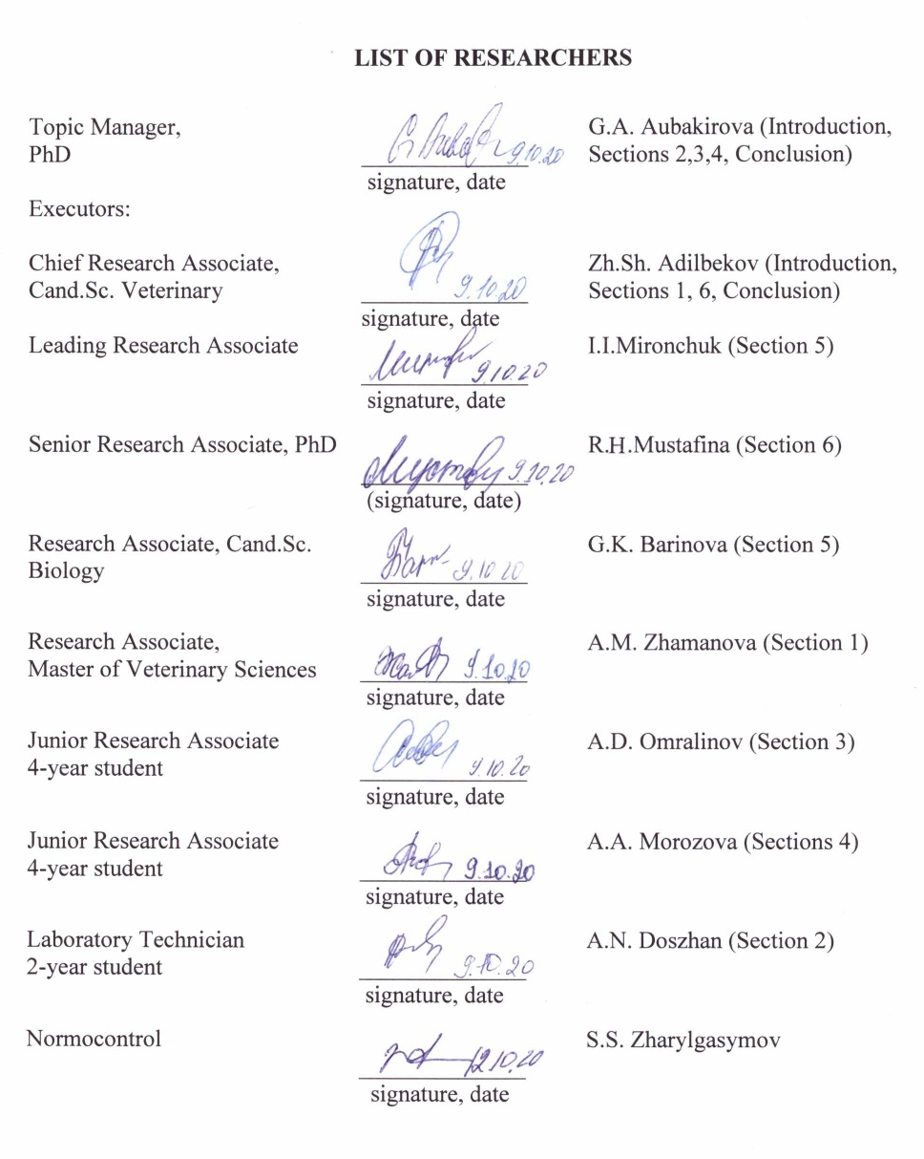

ABSTRACT
Report 134 p., 6 tables, 2 figures, 28 references, 12 appendices, Book 1.
BIOLOGICAL PRODUCTIVITY, HYDROCHEMISTRY, HYDROBIOLOGY, ICHTHYOLOGY, SAFETY, QUALITY, FISH.
The subject of research is samples of water, zooplankton, benthos and fish from the water basins of North and Central Kazakhstan.
The goal of work is to investigate the biological productivity potential, evaluate the fishery value and safety of fish products, give scientific credence to the sustainable use of biological resources of the inland water bodies of North and Central Kazakhstan.
Research methods. During the research, hydro-chemical, hydrobiological, ichthyological, organoleptic, biochemical, helminthological, toxicological, radiological and statistical methods were used.
As a result of investigation, peculiarities of hydrochemical regime of water, taxonomic composition, composition of zooplankton and benthos in the water basins and its impact on the productivity are studied. Age-length and species composition of fish is determined, safety and quality of fish in the water basins of North and Central Kazakhstan is investigated, a new method of wet fish quality determination is developed as well.
The main functional and technical-and-economic indices: scientifically grounded evaluation of water basins’ biological productivity is given, which will allow the subsoil users to use the water basins efficiently for the successful fishery management in present-day conditions. Besides, the results obtained may be used in scientific institutions and laboratories, engaged in environmental monitoring and food safety.
Extent of adoption. The obtained results of investigations may be used in the production activity of fish farms of North and Central Kazakhstan, and recommendation for the subsoil users for their rational use are prepared.
Effectiveness. The results of investigations will be used in the production activity of fish farms of the North-Kazakhstan region, in the work of laboratories for food safety.
Field of use. Users of natural resources (fisheries), veterinary medicine (laboratories of veterinary and sanitary expertise).

TABLE OF CONTENTS
INTRODUCTION………………………………………………………………………………………. | 7
THE MAIN PART OF THE RESEARCH……………………………………………………………… | 9
1 Selection of the line of research………………………………………………………………………. | 9
2 Research methods……………………………………………………………………………………... | 10
3 Results of researches………………………………………………………………………………….. | 13
3.1 Results of patent-information researches, literature review and monitoring of internal  water bodies of the North-Kazakhstan region…………………………………………………….. | 13
3.2 Hydrochemical regime of water basins of the North-Kazakhstan region and its impact on the  Productivity……………………………………………………………………………………….. | 14
3.3 Taxonomic composition, composition of zooplankton and benthos in the water bodies of  the North-Kazakhstan region…………………………………………………………………….. | 16
3.4 Average seasonal biomass of zooplankton and benthos in the water basins and possible output  of products of these communities…………………………………………………………………. | 19
3.5 Age-length and species composition of fish in the water basins of the North-Kazakhstan region…………………………………………………………………………………………….. | 20
3.6 Investigation of safety and quality of fish in the water basins of the North-Kazakhstan region,  as well as development of new research methods………………………………………………… | 23
4 Summary and evaluation of the research results……………………………………………………… | 26
CONCLUSION…………………………………………………………………………………………. | 29
REFERENCES………………………………………………………………………………………….. | 33
APPENDIX A – Сalendar plan for 2018-2019…………………………………………………. | 35
APPENDIX B – Patent review………………………………………………………………….. | 49
APPENDIX C – Ichthyofauna of the lakes of the North-Kazakhstan region…………………… | 50
APPENDIX D – Age and length structure of lakes Lastochka and Bolshoy Kak………………. | 51
APPENDIX E – Morpho-biological indices of fish ……………………………………………. | 52
APPENDIX F – Contamination of fish with helminthoses ……………………………………. | 53
APPENDIX G– Contamination of fish with toxic elements and radioactive nuclides…………. | 54
APPENDIX I – Utility model patent…………………………………………………………… | 55
APPENDIX J – Application for grant of a patent of the RK for utility model…………………. | 56
APPENDIX K – List of published works on project for 2020…………………………………. | 58
APPENDIX L – List of published works on project for 2019………………………………….. | 90
APPENDIX M – List of published works on project for 2018…………………………………. | 124

TERMS AND DEFINITIONS
The following terms with relevant definitions are used in this research report:
TERMS | DEFINITIONS
FOOD SAFETY | – is an absence of unacceptable risk in all processes (at stages) of development (creation), production (manufacture), turnover, utilization and destruction of food products, related to the infliction of damage to the human life and health and violation of consumers’ legal interests considering the combination of hazard probability and severity of its consequences.
BENTHOS | – is a biota, living on the ground and in the ground of water bottom.
VETERINARY AND SANITARY SAFETY | – is a state of the objects of state veterinary supervision that does not pose a risk to animal and human health under normal (established) conditions of their use.
VETERINARY-SANITARY EXAMINATION | – is a separate field of veterinary that studies sanitary-hygienic methods of research and veterinary-sanitary assessment of products and technical raw materials of animal origin.
ZOOPLANKTON | – is passively swimming animal bodies, moving due to streams, which cannot resist the streams and move together with the water masses.
NUTRITION VALUE | – is an ability pf the product to meet the demands of human for energy, nutrients and biologically active substances, required to ensure health and normal human life, it is determined by the chemical composition and physical structure of the product.
PRODUCTIVITY OF WATER BASINS | – is a quantity of organic matter, produced in the water basin by its dwellers in unit of time (usually, year) per unit of bottom area or unit of water volume. The basis of the water basins’ productivity is formed by the aquatic plants, which serve as a food for aquatic animals.
TROPHICITY | – is a characteristic of a water basin by its biological productivity, conditioned by the content of biogenic elements and natural supply.

LIST OF ABBREVIATIONS AND NOTATIONS
The followings notations and abbreviations are used in this research report:
Bq/kg | – Becquerel per kilogram
g | – gram
ea. | − units
L. | – lake
kg | – kilogram
l | − liter
mg | – milligram
ml | − milliliter
mM | − millimole
% | − percent

INTRODUCTION
Evaluation of current state of scientific challenge addressed. In the vast areas of Kazakhstan, a great number of lakes, belonging to the southern lake zone of the Northern hemisphere, is dissipated [1,2]. According to G.G. Muravlyev (1973), there are 48262 lakes, among which 45248 fall into lakelets, with an area less than 1 km². Lakes in the northern part of Kazakhstan are especially large in number.
The majority of lakes, mainly small in surface area, is located in the forest steppe and northern part of steppe zone [3]. In the steppe zone, in the mountains and in the valleys of large rivers fresh lakes prevail, and in the semi-deserts, deserts and intermountain troughs – salt lakes do [4]. According to the data [5,6, 7], total area of lake surfaces in the Northern Kazakhstan is more than 19 000 km2 . Here are 11195 fresh lakes and 2513 salt lakes with surface area of 0.01 to 50 km² and more.
According to the published works of contemporary authors [8, 9, 10, 11], in Kazakhstan the lakes of Ile-Balkhash water economy system, lakes of Aral-Syr Darya basin (the Institute of Geography of the Republic of Kazakhstan), lakes of Shchuchinsk-Borovoye resort zone in Akmola region (“Kazhydromet” RSE) are actively investigated, KazNIIRKh published a number of research papers within the investigations of water biological resources of lakes [12-14].
Thus, to this date the analysis of commercial fishing importance of internal water bodies with the evaluation of their biological productivity, as well as safety of fish from food perspective in Kazakhstan is an under-investigated problem. Therefore, to solve this problem, a need arises to examine the structures and dynamics of biocenoses systematically and carefully of internal water bodies with the purpose of fuller employment of its potential productivity.
Data on expected scientific and technical level of development, findings from them. Scientifically grounded evaluation of biological productivity potential, fishery value of internal water bodies and food safety of fish was given, practical recommendations for their rational use under current conditions are offered. Results of researches will be used in the production activity of fish farms in North and Central Kazakhstan, in the work of the laboratories for food safety.
Data on patent researches and findings from them. The investigations have been performed in accordance with GOST 15.011-96 and search depth of 20 years. Patent-information researches confirm the relevance of study on evaluation of biological productivity of the interna water bodies of North and Central Kazakhstan with determination of food safety of fish products
Data on metrological support of the research activity. Metrological support of R&D is performed by the affiliate of JSC “National Center for Expertise and Certification” in Nur-Sultan c. by verification of laboratory instruments and measuring equipment.
Relevance. At the moment a great number of internal water bodies, use of which is mainly of irrational nature. To that end, this brings up the question of the need for large-scale research of the fish feasibility of Kazakhstan water basins for the needs of fishing industry. This primarily includes the lakes, located in the vicinity of large industrial cities, provision of population of which with high-quality fish products must be state’s special concern. Therefore, investigation of issues of biological productivity, fishery value of water basins and safety of food products in general is highly relevant.
Novelty. Comprehensive research of water basins by a range of parameters – hydrochemical, hydrobiological regime – was performed. Evaluation of environmental factors’ impact on the generation of their numerical and production indicators was made, species and age-length composition of ichthyofauna was investigated. Besides, the contamination degree of the fish of internal water bodies with toxic elements, radioactive nuclides, infection with helminthoses and bacterioses will be established. Based on the obtained data, calculation of natural biological productivity of water basins under investigation was performed and scientifically grounded assessment of biological feasibility of water basins and safety of fish products was made, and recommendations for their rational use were given.
All the investigations were performed in accordance with the approved work schedule, according to contract no.242 dated 27.03.2018 (APPENDIX А - Сalendar plan for 2018-2019).
Interim research reports: 0219РК00849 (AP05131273-OT-19), 0218РК00300 (AP05131273-OT-18).

THE MAIN PART OF THE RESEARCH
1 Selection of the line of research
One of the promising areas in the system of agro-industrial complex is lake fishery. The field of fish farming is highly-profitable, as rearing is performed using natural food supply of the water basins, without using additional expenses for the feed stuff. As we know, fish products refer to renewable natural resources, therefore, to preserve the biological balance, it is necessary to use natural water basins with systematic investigation of dynamics and structure of biocenoses, for the full employment of their potential productivity. Investigation of lake hydrobiocenoses as a whole is one of the most important lines in the modern fishery science.
Kazakhstan has a strong potential for using internal water bodies for the fish farming, with full reclamation of which significant increase in the fishery product is possible.
In the number of Kazakhstan regions up to date utilization of natural basins for fish-culture is virtually ill-developed. This all can be explained by insufficient state of bioresources exploration. The need to develop the lake fishery in Kazakhstan is obvious. At this stage, the arising question is investigation of medium and small water basins of Kazakhstan for the development of fish industry in general. This refers primarily to the lakes, located in the vicinity of large industrial cities, provision of population of which with high-quality fish products must be state’s special concern.
During the work, the water basins were investigated by a range of parameters – hydrochemical, hydrobiological regime, investigation of species, age-length composition of fish, determination of general qualitative indicators of fish, investigation for contamination with helminthoses and bacterioses, as well as establishing the degree of fish contamination with toxic elements and radioactive nuclides. Influence of environmental factors on the generation of numerical and production indicators of zooplankton was given. Based on the obtain data, calculation of natural fish capacity of water basins under investigation was performed.

2 Research methods
Research activity was performed at the premises of RDE “Rybnoye khozyaistvo” under Department of Game management and fish industry, laboratory of food safety to the department of “Veterinary hygiene” of JSC “KATU after S. Seifullin”, laboratory of LLP “Astana auyl sharuashylyk onimderin zertkhanasy” and at the premises of RSE on REU “Republican veterinary laboratory” to the RoK Ministry of Agriculture in Nur-Sultan c.
In the course of scientific researches, hydrochemical, hydrobiological, ichthyological, organoleptic, microscopical, biochemical, toxicological, radiological, helminthologic, clinical and statistical methods were applied.
Field works on collection of materials for scientific research were performed in three stages: first (in the period from 08.06 to 17.06.2020), second (from 22.07 to 31.07. 2020), third (from 20.08 to 29.08.2020).
Total amount of reserve water basins (sections) in the North-Kazakhstan region as at Y2020 was 171 water basins. During investigation of monitoring of fish products manufacture at internal water bodies, 28 users were determined, to which water basins are assigned for Y2020, where fishing is performed on 3286.4 ha of water-surface area.

Having investigated the data on water basins in these areas, were selected Tastemirovka and Bolshoy Kak (of Timiryazev district) lakes and Lastochka lake (Shak akyn district) for the scientific research.
Samples of water, zooplankton, benthos and fish from the water basins of the North-Kazakhstan region served as a material for this work. During site visits of lakes 120 hydrobiological, 90 – hydrochemical samples and samples of various fish species were taken and investigated. Research design is given in figure in Appendix B.
Hydrochemical observations were performed simultaneously with the main hydrobiological researches. Sampling was performed from surface and bottom waters in accordance with the established procedures, i.e. the water was sampled from the depth of 30-40 cm and gathered into plastic ware of 1 l in volume. All the ware was preliminarily prepared according to the rules of ware preparation prior to sampling to prevent contamination [15, 16].
Investigation of hydrochemical regime of water was performed with the help of field laboratory of water quality analysis.
Permanganate index was performed by Kubel method. Investigation of turbidity and transparency were conducted by Snellen method. Determination of general hardness as total molar concentration of calcium and magnesium cations, sulphates, carbonates, hydrocarbonates and alkalinity were determined by titration method.
Determination of dissolved oxygen and biochemical oxygen uptake was implemented using Winkler iodimetric method and thermo-oximeter. Investigation of oxygen regimen was performed both from the basin surface and from the depth of lake, to calculate the amount of oxygen balance. Water pH was measured with pH-meter testo 206 - Testo AG Germany.
Determination of manganese, nitrites, phosphates, ammonium, iron, silicon was performed by colorimetric method. The stained sample was measured visually by color control scale. Nitrates were determined visually – by colorimetric method. Chlorides were determined by argentometric titration. Color value was determined in two options - by visual-colorimetric and photocolorimetric.
Collection and processing of zooplankton, benthos and fish were performed using established procedures [17-24].
Investigation of quality and safety of fish, caught in the water basins of the North-Kazakhstan region, was performed by determination of general qualitative indicators, investigation for contamination with helminthoses and bacterioses, as well as by establishing the degree of fish contamination with toxic elements and radioactive nuclides. Sampling of fish was implemented directly during fishing from the water basins.
Establishing of general qualitative indicators was performed by methods of organoleptic and biochemical investigation of fish according to GOST 7631-2008 “Fish, non-fish objects and products from them. Methods of sensory and physical characteristics identification”. Sampling of fish was performed from the water basins of Shak akyn and Timiryazev districts of the North-Kazakhstan region. 45 samples of fish (crucian – 18, roach – 9, perch – 18) were taken in total.

Establishing the infection of fish with helminthoses and bacterioses. Infection of fish with helminthoses was determined by complete helminthological investigation, which included investigation of scale, gills, eyes, internal organs and muscles by visual and compressor methods [25]. Four species of fish (crucian, perch, roach, ide) were investigated, total of 151 specimens of fish were researched.

Investigation of fish for bacterioses was performed by clinical examination. First and foremost, skin cover and flippers were carefully inspected, attention was paid to the quality and quantity of mucus, discoloration, presence of swelling, hemorrhages, ulceration, cicatricial, cysts, disheveling of scale and so on, then opercula were lifted, gills were examined. Record of sick fish was kept in absolute and percentage terms (morbidity) [26].
Determination of the degree of fish contamination with residual quantities of toxic elements compounds and radioactive nuclides was performed at the premises of RSE on REU “Republican veterinary laboratory” to the Committee for veterinary control and supervision of RoK MoA in the accredited laboratory “Analysis of food safety” (international standard ISO/IEC17025).
Investigation for the presence of toxic elements (lead, mercury, cadmium and arsenic) in fish was conducted using voltammetric analyzer ТА-Lab. Radioactive contamination was established by the number of radioactive nuclides of cesium-137 and strontium-90 on beta-gamma spectrometric complex “Progress BG” (manufactured in Russia by “TOM-ANALIT”). Total of 27 samples of fish were investigated.

Statistical analysis of the obtained results of investigation was carried out with the help of application package Microsoft Excel. The difference between the average values was assessed by Student criterion and Р probability, which was recognized as statistically significant with Р ≥ 0.95, by algorithms of A.N. Plokhinsky (1961), G.F. Lakin (1973), L.A.Vasilyeva (2004) [27,28].

3 Results of researches
3.1 Results of patent-information researches, literature review and monitoring of internal water bodies of the North-Kazakhstan region
According to the schedule, patent-information researched with the depth of 20 years, search of literature data by local and foreign authors were carried out and their analysis was performed (APPENDIX B- Patent review).
The search was performed in accordance with the minimum volume of documents for the conduction of information search, established WIPO, according to the Rule 34 of the Instruction to the Patent cooperation treaty “Minimum documentation РСТ”.
As a result, in the period from 2000 to 2020, 20 patents for inventions were found. Among them, 18 titles of protection are the closest to the subject of scientific researches under investigation, among which 4 are Kazakhstani and 14 - foreign. Also, more than 25 literature sources for the last 15 years were reviewed on the subject.
There are 3425 beds of existing or extinct lakes within the territory of the North-Kazakhstan region. By the area of water surface, the largest among them are: Siletyteniz (777 km²), Teke (265 km²), Shagalalyteniz (240 km²), Kishi-Karaoy (102 km²). The beds of such lakes as Siverga, Mengiser, Stanovoye, Bolshoy Tarangul (Tarankol) have the area of up to 30-50 km² and more. In terms of quantity, lakes and lake beds with areas of about 1 km² prevail. Lakes of Kokshetau hill are notable for the inmost depth: Shalkar — 15 m, Zhaksy-Zhalgyztau — 14.5 m, Imantau — 10 m; lakes with depths of less than 3—5 m prevail. There is Sergeyevskoye water storage basin with the area of about 117 km² at Ishim river within the region.
Total amount of reserve water basins (sections) in the North-Kazakhstan region as of Y2020 was 171 water basins. In Aiyrtau district there are 8 basins (sections) with total area of 319.5 ha, in Akkaiyn district - 6 basins (sections) with total area of 791.4 ha, Akzharkyn district - 5 basins (sections) with total area of 542 ha, Yessil district - 13 basins (sections) with total area of 541.8 ha, Zhambyl district - 45 basins (sections) with total area of 6865.7 ha, Magzhan Zhumabayev - 2 basins (sections) with total area of 750 ha, Kyzylzhar district - 33 basins (sections) with total area of 3105.8 ha, Mamlyutsky district - 20 basins (sections) with total area of 1531.5 ha, Gabit Musrepov - 6 basins (sections) with total area of 4311 ha, Taiynshinsky district - 6 basins (sections) with total area of 1550 ha, Ualikhanov district - 9 basins (sections) with total area of 79408.4 ha, Shal akyn district - 9 basins (sections) with total area of 281.6 ha, Timiryazev district - 9 basins (sections) with total area of 4145.4 ha.
Thus, patent-information researches and analysis of literature data, performed by us, as well as monitoring of internal water bodies confirm the relevance of investigation on evaluation of biological productivity of internal water bodies of North and Central Kazakhstan with the determination of food safety of fish products.

3.2 Hydrochemical regime of water basins of the North-Kazakhstan region and its impact on the productivity

Peculiarities of hydrochemical regime of three water basins in the North-Kazakhstan region were investigated: Lastochka lake of Shal akyn district, Bolshoy Kak and Tastemirovka lakes of Timiryazev district.
During the hydrochemical investigation of the aforementioned water basins we took 90 samples of water from three stations. In result of investigations conducted, we obtained the following data. Thus, odor and taste of water in three water basins was 1 point.
When determining the color value in Lastochka lake, limit concentration of color value (48⁰С) was observed, which, as a rule, affects the transparency of water (42 cm), which shows the maximum allowable concentration. The color value of water in remaining water basins was also at MAC.

Transparency of water also showed limit value in the remaining two water basins – Bolshoy Kak and Tastemirovka. Turbidity by Formazine did not exceed 0.2 mg/l.
During our investigations, the level of permanganate index in the water basins (Lastochka, Tastemirovka lakes) was averagely 4.01 mg/l. In Bolshoy Kak lake the index showed the highest concentration (7.03 mg/l). The indices of oxidation in natural water sources vary, and depend on biological productivity of the water basin (table 1).

Table 1 – Oxidation and oxygen regimen of water, mg/l

Index | Lakes
Index | Lastochka | Bolshoy Kak | Tastemirovka
Oxidation, mg/l | 4.0 ±0.34** | 7.03±0.95** | 4.1±0.34***
O₂ content in water, mg/l:  at the surface  at the bottom  balance | 7.9±1.2 ***  5.12±0.68*  2.78±0.01 | 7.4±0.97***  4.4±0.37*  3.0±0.14 | 8.0±1.3  6.48±0.72*  1.52±0.01
Note – * Р < 0.95; ** Р<0.99; *** Р< 0.999.

As shown by the table, the highest oxygen content was within allowable concentrations (7.4-8.0 mg/l). The high content of oxygen was noted in Tastemirovka L. (8.0 mg/l). Oxygen balance was at the level of 1.52- 3.0 mg/l. Oxygen deficiency in the water basins under investigation was not observed.
Results of water mineralization in the lakes of the North-Kazakhstan region are given in table 2.

Table 2 – Mineralization of water in the water basins of the North-Kazakhstan region, mg/l

Water basins | Mineralization, mg/l
Water basins | May | July | September
Lastochka lake | 154+1.78 | 220+2.34 | 207+2.85
Bolshoy Kak lake | 107+1.24 | 178+2.01 | 156+2.12
Tastemirovka lake | 122+1.39 | 164+2.87 | 145+2.49

The mineralization degree of lake waters of the North-Kazakhstan region ranges: from 107 to 220 mg of salts per 1 liter. According to the existing classification, they refer to waters with low mineralization.
According to the classification of I.V. Baranov (Alekin, 1970, 1973), the investigated water basins are low-mineralized.
Investigation of hydrochemical regime’s effect on productivity. Using Lastochka lake as an example, the influence of water mineralization on the zooplankton’s productivity was investigated.
When analyzing the obtained data, we noted inverse relation between the numerical strength of zooplankton and water mineralization in Lastochka lake. When water mineralization increases in July from 154 to 220 mg/l, reduction of zooplankton number from 102 to 101.01 thousand specimen/m³ is noted.
Dependence of zooplankton’s development level on the total water mineralization in Lastochka lake is given in figure 1. The higher the mineralization, the lower the numerical strength. Similar trend is observed for the pair “mineralization – biomass” as well.

A B
Figure 1 – Influence of water mineralization (A – on zooplankton’s numerical strength,
B - on zooplankton’s biomass)

With the increase of water mineralization in Lastochka lake from 102 (June) to 220 mg/l (July), reduction of zooplankton’s biomass from 5.41 to 4.93 mg/m³ is noted.
To confirm it, correlation factor in these pairs of indicators was calculated, in “mineralization –zooplankton’s numerical strength” pair it was r= -0.88, and in pair “mineralization –zooplankton’s biomass” - r= -0.92.
Thus, hydrochemical indices of water in the water basins under investigation were within the level of maximum allowable concentration. When investigating the impact of water mineralization on productivity, we noted that with the increase of mineralization in July by 66 mg/l, the number of zooplankton is reduced from 102 to 101.01 thousand specimen/m³. Similar trend was observed for the pair “mineralization – biomass” as well. Reduction of zooplanktonic organisms from 5.41 g/m³ to 4.93 g/m³ was noted. According to the classifier of O.A. Alekin, Lastochka lake refers to hydrocarbonate class, calcium group, third type; Bolshoy Kak lake refers to chloride class, natrium group, second type; Tastemirovka lake – to hydrocarbonate class, calcium group, second type.

3.3 Taxonomic composition, composition of zooplankton and benthos in the water bodies of the North-Kazakhstan region
To characterize the zooplankton, samples from three stations were taken throughout the lakescape. The number of individual organisms in the sample was established.
Taxonomic composition, zooplankton’s structure in the water basins under investigation were as follows, thus, in Lastochka lake 9 species were found, among them, three referred to cladocerans (Daphnia pulex (Leydig), D. cuсullata Sazs.,D.longispina M.,), three – to copepods – (Diaptomus sp, Cyclops sp, Nauplii) and three – to rotifers (Hexarthe miza H., Keratella quadrata, Asplanchna priodonta). In Bolshoy Kak lake - 7, among them - 2 species of cladocerans, 2 - copepods, 3 rotifers. In Tastemirovka lake - 5 species of zooplankton, among them 2 – species of cladocerans, 1 - copepods, two - rotifers.
During earlier investigation of morphometric peculiarities of index species of zooplankton in the middle lakes of North Kazakhstan it was established that index species in the water basins of the North-Kazakhstan region are rotifer Asplanchna priodonta. Cladocerans Daphnia pulex (Leydig) were met in all three water basins under investigation. Predominant species among cladocerans was noted to be Daphnia longispina.
We have established that in Lastochka lake great numerical strength of Asplanchna priodonta was noted in August, which was 49.25 thousand/m³, and the lowest – in July (46.11 thousand/m³⁾. Сусlops sp. was from 6.88 to 10.30% in community (table 3).
Table 3 – Numerical strength and specific abundance of zooplankton in Lastochka lake

Index | Months
Index | June |  | July | August
Total number, thousand/n³ | 102.00 +11.02 *** |  | 101.01 +11.65** | 109.73 +12.01*
Asplanchna priodonta | 48.34+5.3 |  | 46.11+5.1 | 49.25+5.8
Daphnia longispina | 31.55 +3.76 |  | 30.47+3.54 | 32.47 +3.93
D.pulex (Leydig) | 15.10 +2.01 |  | 14.54 +4.03 | 16.69+4.01
Сусlops sp. | 7.01+ 1.01 |  | 9.89+ 1.15 | 11.32+ 1.98
Specific abundance, %
Asplanchna priodonta | 47.39 | 45.65 |  | 44.89
Daphnia longispina | 30.93 | 30.17 |  | 29.60
D.pulex (Leydig) | 14.80 | 14.39 |  | 15.21
Сусlops sp. | 6.88 | 9.79 |  | 10.30
Note – * Р < 0.95; ** Р< 0.99; *** Р< 0.999.

The numerical strength of Daphnia longispina varied from 30.47 to 32.47 thousand/m³ with specific abundance of up to 30.93%. Three taxons prevailed in the community of Bolshoy Kak lake. Herewith, specific abundance of Asplanchna priodonta ranged from 36.2 to 38.1, and of Сyclops – up to 10.33 %. In the community of Tastemirovka lake two taxons prevailed. Specific abundance of Asplanchna priodonta ranged from 44.2 to 48.9 %, and of D. longispina – from 25.3 to 27.62 %.
We investigated the production characteristic of individual dominant species Asplanchna priodonta. Individual mass of cancroid was determined by the formula, that connects the length and the mass of animal body (Balushkina, Vinberg, 1979). Empirical variation curve that describes the population of Asplanchna priodonta by body mass, has two peaks, consequently, the population is divided by body mass into two groups: before 0.35 mg and after. Theoretical curve is of regular shape (figure 2).

A B
Figure 2 – Distribution polygons (А - Asplanchna priodonta by body mass,
B - Asplanchna priodonta by body length)

Theoretical distribution polygon, calculated for the Asplanchna priodonta population by body length, is approximated to Gauss curve, with high concentration of specimens in modal and near-modal classes – 78.5% with theoretical calculations and 60% with empirical. Curve asymmetry factor is 0,06. This suggests that population is in a state of dynamic equilibrium.
We established the average seasonal biomass od zooplankton in the water basins of the North-Kazakhstan region. Thus, the highest total biomass in Lastochka lake was noted in August – 5.85 g/m³, the lowest – in June – 4.93 g/m³. In total biomass Asplanchna priodonta prevailed (lim 1.79- 1.95 g/m³). The lowest biomass had Сусlops sp.– average of 0.89 g/m³ (table 4).

Table 4 – Biomass and specific biomass of zooplankton in Lastochka lake

Index | Months
Index | June | July | August
Total biomass, g/m³ | 5.41 +0.73 | 4.93 +0.69 | 5.85 +0.78
Asplanchna priodonta | 1.85 +0.15 | 1.79+ 0.14 | 1.95 +0.18
Daphnia longispina | 1.52 +0.13 | 1.23 +0.11 | 1.67+ 0.13
D.pulex (Leydig) | 1.10+ 0.1 | 1.02 +0.09 | 1.19 +0.1
Сусlops sp. | 0.94 + 0.1 | 0.89 +0.07 | 1.04 +0.09
Specific biomass, %
Asplanchna priodonta | 34.20 | 36.31 | 33.34
Daphnia longispina | 28.09 | 24.95 | 28.55
D.pulex (Leydig) | 20.33 | 20.68 | 20.33
Сусlops sp. | 17.38 | 18.06 | 17.78

The highest total biomass in Bolshoy Kak lake was noted in June – 4.01 g/m³, the lowest – in July (3.85 g/m³). Daphnia longispina prevailed in total biomass (1.56 g/m³). The highest total biomass in Tastemirovka lake was noted in August – 3.24 g/m³, the lowest – in July (2.68 g/m³). Asplanchna priodonta prevailed in total biomass (1.37 g/m³). The lowest biomass had Сусlops sp. with specific biomass from 18 %.
In result of investigation of species composition, numerical strength and prevalence of benthic organisms in the water basins of the North-Kazakhstan region, it was established that in benthic community oligochaetes were prevalent. Their number in the lakes was 13 specimens/m². The lowest prevalence had Mollusca – about 5 specimens/m². In the lakes of the North-Kazakhstan region oligochaetes were prevalent, by average seasonal biomass in the water basins Mollusca prevail – from 32 to 34 % of specific biomass, herewith, their total biomass varies within 7.3 to 7.5 g/m². The lowest biomass and numerical strength were noted in chironomids – from 0.15 to 0.31g/m² with specific biomass of 2.03- 3.1%.
Thus, taxonomic composition of zooplankton is represented in Lastochka lake with 9 species, in Bolshoy Kak lake - 7, Tastemirovka lake – with 5 species. By morphometrical peculiarities, index species in the lakes under investigation is Asplanchna priodonta. By production characteristics the number of Asplanchna priodonta specimens in modal and near-modal classes for theoretical calculations was 78,5%, for empirical – 60%, which suggests that population is in a state of dynamic equilibrium. The highest total average seasonal biomass of zooplankton in the investigated lakes was noted in August - 5.85 g/m³. In benthic community, oligochaetes were prevalent in the water basins under investigation. By average seasonal biomass of benthos, Mollusca prevail in the lakes – from 32 to 34 % of specific biomass, herewith, their total biomass was within 7.3 to 7.5 g/m².

3.4 Average seasonal biomass of zooplankton and benthos in the water basins and possible output of products of these communities
In result of our investigations average seasonal biomass of zooplankton was established, thus, in Lastochka lake average seasonal biomass was 4.93-5.85, g/m³, with specific biomass up to 33.34 %. The lowest average seasonal biomass had Сусlops sp.– 0.94 g/m³ in average.
In Bolshoy Kak lake average seasonal biomass was 3.54-3.79 g/m³, with specific biomass of 32.7-35.9%. In total average seasonal biomass Daphnia longispina was prevalent (1.56 g/m³).
In total average seasonal biomass in Tastemirovka lake Asplanchna priodonta prevailed (1.37 g/m³). The lowest biomass had Сусlops sp. with specific biomass from 18 %.
Among benthic organisms, by average seasonal biomass in the water basins Mollusca dominate – from 32 to 34 % of specific biomass, herewith, their total biomass was within 7.3 to 7.5 g/m². On the basis of average seasonal biomass of zooplankton and benthos in the investigated water basins, possible production of output by these communities was calculated.
High production of output by zooplankton and benthos communities was noted in Lastochka lake (254.3 kg/ha), the lowest – in Tastemirovka lake – 99.7 kg/ha. Characterization of zooplankton included species, such as cladocerans (Daphnia pulex (Leydig), D. cuсullata Sazs.,D.longispina M.,), copepods – (Diaptomus sp, Cyclops sp, Nauplii) and rotifers (Hexarthe miza H., Keratella quadrata, Asplanchna priodonta). Characterization of benthic organisms included prevalence of Mollusca, chironomids, oligochaetes, caddis flies and other organisms. Their number in the lake was averagely 351 specimens/m², Mollusca had the lowest prevalence –5 specimens/m².
Calculation of fish capacity of the lakes in the North-Kazakhstan region was carried out on the basis of evaluation of natural food supply. The lowest natural fish capacity was in Tastemirovka lake – 33.1 kg/ha, and in the remaining water basins it was much higher. Which is, for Lastochka lake – 103.2 kg/ha, Bolshoy Kak lake – 56.4 kg/ha (table 5).

Table 5 – Generation of products in the lakes of the North-Kazakhstan region

Index | North-Kazakhstan region
Index | Lastochka lake | Bolshoy Kak lake | Tastemirovka lake
Products, raised from: zooplankton and benthos | 254.3*** | 117.8* | 99.7**
Natural fish capacity, kg/ha | 103.2 | 56.4 | 33.1
Quantity of fish products in the basin, kg. in theory | 35654 | 7497 | 4845
in practice by TAC, kg | 200 | 150 | 100
Note – * Р <0.95; ** Р<0.99; *** Р< 0.999.

When determining the biological productivity of water basin, Lastochka lake is promising in the context of fish products - 35654 kg/ha.
Thus, when performing lakes classification by trophicity (food capacity), it was established that Lastochka lake is eutrophic, Bolshoy Kak and Tastemirovka lakes – mesotrophic water basins. In Lastochka lake TAC according to data of net fishing was 200 kg, in Bolshoy Kak lake – 150 kg, and in Tastemirovka lake - 100 kg. It is explained by low numbers of populations of game fish in these lakes.

3.5 Age-length and species composition of fish in the water basins of the North-Kazakhstan region
Observation over the diversity of ichthyofauna was carried out in the water basins of the North-Kazakhstan region of Kazakhstan in 2020. Lastochka, Bolshoy Kak and Tastemirovka lakes were investigated.
We established the age-length and species composition of fish in the water basins of the North-Kazakhstan region. The greatest species diversity was noted in Lastochka lake – roach (Rutilus rutilus), river perch (Perca fluviatilis), golden carp (Carassius gibelio), ide (Leuciscus idus). 2 species were found in Kak lake 2 - river perch (Perca fluviatilis) and golden carp (Carassius gibelio). In Tastemirovka lake, crucian carp (Carassius carassius) is a dominant species, northern pike (Esox lucius) and peled (Coregonus peled) were caught in single quantities, the data are presented in APPENDIX С (table C.1).
In Lastochka lake, river perch and roach form a basis of commercial ichtyomass, golden carp and ide belong to rare species. Bolshoy Kak lake is on the list of fishery waters of local significance, but the ichthyofauna is poor and represented by 2 species only. In Tastemirovka lake, crucian carp is numerous, northern pike and peled may have got there occasionally or their numerical strength reduced.
In the nets, there were three specimens of ide in Lastochka lake with similar size of 43 cm. By numerical strength, roach and river perch are met in dimension classes from 15 to 35 cm. Roach dominates both in small dimension classes (15 -17 cm) and in middle (29-31 cm), accounting for 56.5% of population. River perch was mainly seen in small sizes, and numerical strength of large ones was only 2.3%. This species is the most frequent in net yields in the investigated water basin. Among all yield, 82 % is accounted for the nets with mesh size of 20 and 30 mm. Golden carp was seen in dimension classes from 31 to 37 cm. The majority was noted in the dimension groups from 31 to 33 cm and constitutes 71%. In Lastochka L. dominating age group are species from two to five years, maximum life span in this water basin is 8+ years, the data are presented in APPENDIX D (table D.1, table D.2).
In Lastochka L. dominating age group of roach is sampling of 2+ to 5+ years, river perch is mostly junior from 2+ to 4+ years, golden carp - 7+, 8+ years. Roach, river perch in the lake are represented by all age groups. Golden carp was met only in adult age groups.
By the numerical strength, in Bolshoy Kak lake among river perch dimension group from 23 to 27 cm dominates, among golden carp – from 15 to 21 cm. River perch is met in all dimension classes from 15 to 37 cm. The majority was observed in dimension groups from 23 to 29 cm and accounts for 62 %. River perch usually got caught in set nets with mesh size of 20 to 30 mm. Golden carp is met in dimension classes from 15 to 33 cm. The majority was observed in small dimension groups of 15-21 cm and constitutes 84 %. Among all yield, 94 % are accounted for the nets with mesh size of 20 and 30 mm, the data are presented in APPENDIX D (table D.3).
When determining the age composition in Bolshoy Kak lake, dominant age group is sampling from two to three years, and maximum age is 7+ years, the data are presented in APPENDIX D (table D.4).
In Bolshoy Kak lake dominant age group of river perch is 3+ - 4+ years, golden carp - 2+ - 3+. Golden carp in the water basin is represented by junior age groups.
Indices of dimension population of fish in Tastemirovka lake are given in table 6.

Table 6 – Dimensional structure of population in Tastemirovka lake

Dimension classes, % |  |  |  |  |  |  |  |  |  | Average length, cm
15.1-17 | 17.1-19 | 19.1-21 | 21.1-23 | 23.1-25 | 25.1-27 | 27.1-29 | 29.1-31 | 31.1-33 | 33.1-35 | Average length, cm
Carassius carassius
0.6 | 6.7 | 28.5 | 26.7 | 15.8 | 4.2 | 4.8 | 5.5 | 4.8 | 2.4 | 23.6

Crucian carp is met in dimension classes from 15 to 35 cm. The majority is observed in dimension groups of 19 to 25 cm. big specimens are met in small quantities and constitute 13% only. More than 67% of yield was accounted for the net with mesh size of 20 and 30 mm.
Populations of crucian carp in our yields were represented by age groups from 2+ to 7+ years. Peculiarity of investigated sampling is dominant age group of 3+ - 4+ years. According to the results of yields, crucian carp is met mainly in junior age groups. During investigation in Lastochka L., river perch and roach were met the most and caught in net with mesh size of 20 to 60 mm. Golden carp was met in significantly smaller quantities, herewith, larger specimens with body length of average 33 cm, mass of 771,4 g, Fulton’s condition factor was 4. In Lastochka L., ide was caught in 3 specimens, average length was: 43 cm, body mass 1487 g, Fulton’s condition factor – 2.5.
According to the data of morpho-biological characteristics, the body length of river perch was averagely: 20.6 cm, body length without tail fin was 17.2 cm, body mass 160.7 g, Fulton’s condition factor – 2.5. The length of head averages 17.99 %, maximum body height – 34.24 %, maximum body width 21.30 %. Body length of roach averaged: 24.1 cm, body length without tail fin 19.8 cm, body mass 247.4 g, Fulton’s condition factor 2.5. The length of head averages 16.04 %, maximum body height – 37.46 %, maximum body width 18.85 %. In Lastochka L. fish were met both in small and large sizes and with considerably high body mass. Fulton’s condition factor is compliant for each species. It implies sufficient food supply for existence of each species. As a result of investigation, in Bolshoy Kak L. golden carp and river perch were met the most and they were caught in nest with mesh size of 20 to 60 mm. Morpho-biological characteristics of golden carp was in average: 19.3 cm, body length without tail fin 15.1 cm, body mass 135.3 g, Fulton’s condition factor 3.8. The length of head averages 18.46 %, maximum body height 46.68 %, maximum body width 22.89 %. Body length of river perch was in average: 24.5 cm, body length without tail fin 20.9 cm, body mass 233.9 g, Fulton’s condition factor 2.4. The length of head averages 18.58 %, maximum body height 33.17 %, maximum body width 23.58 %, the data are presented in APPENDIX E (table E.1, table E.2).
In Bolshoy Kak L., golden carp is met with not very large sizes, maximum value of Fulton’s condition factor was 5.3. River perch, compared to crucian, is met with relatively large sizes and masses, Fulton’s condition factor is compliant for this species.
In result of investigation, in Tastemirovka L. crucian carp is a dominant species, it was caught in the net with mesh size of 20 to 50 mm. According to the findings, body length of crucian carp was in average: 23.6 cm, body length without tail fin 19.3 cm, body mass 321.3 g, Fulton’s condition factor 4.1. The length of head averages 20.02 %, maximum body height 46.45 %, maximum body width 22.55 %, the data are presented in APPENDIX E (table E.3).
In Tastemirovka L., crucian carp is met in large numbers. The majority of fish is of medium size, maximum value of Fulton’s condition factor was 5.8. Northern pike with body length of 40 cm, body mass of 423 g, peled with body length of 16 cm, body mass of 54 g were found in single quantities.
Thus, we have established the following species composition of ichthyofauna in Lastochka lake – 4, in Tastemirovka lake – 3, in Bolshoy Kak lake – 2 representatives of ichthyofauna.
By species composition, in Lastochka lake populations of roach, river perch, golden carp and ide were found; in Tastemirovka lake – crucian carp, northern pike, peled; in Bolshoy Kak lake – river perch, golden carp.
The prevalence by length frequency was noted for roach, river perch in Lastochka lake, river perch in Bolshoy Kak lake, crucian carp in Tastemirovka lake. It is evidence that the population is in good living conditions.
By age composition, in Lastochka lake roach, river perch are met in all age groups. In Bolshoy Kak lake river perch is met in all age groups, golden carp – in junior age groups. In Tastemirovka lake dominant age group is 3+ - 4+ years.
In general, by biological indicators the population of fish in the lakes under investigation is in stable condition. Fulton’s condition factor is compliant for each species. It suggests sufficient food supply for the existence of each species.

3.6 Investigation of safety and quality of fish in the water basins of the North-Kazakhstan region, as well as development of new research methods
Determination of common qualitative indicators (organoleptic and physical-chemical studies). To conduct the studies, we took samples from individual water basins of the North-Kazakhstan region (Lastochka lake of Shal akyn district, Bolshoy Kak and Tastemirovka lakes of Timiryazev district). In result of studies conducted it was established that fish, caught from these water basins, complied with the requirements for high-quality fish by organoleptic and biochemical indicators. Organoleptic indicators were as follows: mucus on the surface was not copious, was transparent, without foreign smell; the scale fitted tightly to the skin, it was smooth, shining, scarcely pulled out; eyes are prominent, clear, cornea is transparent; mouth is closed; gills are bright red, opercula fit tightly; belly is not swollen, it is resilient; internal organs are well distinguishable; consistency is resilient.
Biochemical indicators of sampled fish from the lakes were within normal as well – tissue smears were poorly stained, during microscopy microbial bodies were not found, pH degree in all samples of fish was within normal and ranged from 6.2±0.2 (Tastemirovka lake), 6.3±0.2 (Lastochka lake) to 6.6±0.02 (Bolshoy Kak lake). Reactions to ammonia and hydrogen sulfide are negative, to peroxidase – positive in all samples, which is specific to high-quality fish.
Thus, we established that organoleptic and biochemical indicators of fish from the investigated water basins of the North-Kazakhstan region correspond to norms in all cases.
Establishing infection with helminthoses and bacterioses of fish in the water basins of the North-Kazakhstan region. When investigating the fish, caught from Lastochka lake, infection with helminthoses of crucian and perch was not found, for roach, among 12 investigated 2 demonstrated instar of post-diplopstomiasis (caused by trematode Posthodiplostomum cuticola), herewith, prevalence was 16.6% and intensity - 3-6 cysts, the data are presented in APPENDIX F (table F.1).
When investigating the fish from Bolshoy Kak lake, among 18 investigated specimens of roach, 3 specimens showed cysts of post-diplopstomiasis, prevalence as 16.6%, intensity varied from 3 to 5 cysts. In crucian, perch and ide samples, helminthoses were not found.
During investigation of fish from Tastemirovka lake, 3 from 23 investigated crucians showed ligulas, prevalence was 13.04% and intensity - 5-6 slugs. In roach and perch infection with helminthoses was not found.
Thus, the most common condition of fish in individual water basins of the North-Kazakhstan region is post-diplopstomiasis, which was diagnosed in roach from two water basins, infection with ligulas was found more rarely in crucian from one water basin.
During clinical investigation of fish for bacterioses, typical signs of diseases were not found.
Determination of residual quantities of toxic elements and radioactive nuclides in fish flesh. When determining the content of residual quantities of toxic elements in fish flesh of the North-Kazakhstan region water basins, residual quantities of toxic elements were found in insignificant amounts, and exceedance of MAC was not observed. Thus, content of cadmium in the highest amount was determined in fish flesh from Tastemirovka lake, where its quantity was equal to 0.0076±0.00001 mg/kg, in the lowest – in fish from Bolshoy Kak lake – 0.0012±0.0001 mg/kg. In the fish from Lastochka lake the content of cadmium was 0.0027±0.0002 mg/kg, the data are presented in APPENDIX G (table G.1).
The content of lead in fish from Lastochka, Bolshoy Kak and Tastemirovka lakes had no significant differences, and was equal to 0.0027±0.0001, 0.0046±0.0002 and 0.0042±0.0002 mg/kg, respectively. Residual quantities of mercury were found not in all samples of fish. Thus, in Lastochka lake, among 9 samples its quantities were present in three samples only and averaged 0.0026±0.0001 mg/kg, in Bolshoy Kak lake residual quantities of mercury were found in all samples and accounted 0.00206±0.0001 mg/kg. In fish from Tastemirovka lake trace quantities of mercury were found.
Content of arsenic in maximum amount was found by us in the samples of fish from Lastochka lake, where it was equal to 0.0132±0.002 mg/kg, then in Tastemirovka lake – 0.0130±0.0001 mg/kg and in Bolshoy Kak lake – 0.0027±0.0001 mg/kg.
To sum up, residual quantities of toxic elements in fish flesh from individual water basins of the North-Kazakhstan region do not exceed the normal value. By their content, the highest amount of lead was found in the fish from Lastochka lake, arsenic - in the fish from Tastemirovka lake, the content of cadmium had no significant differences and mercury was found not in all samples, thus, in fish from Tastemirovka lake its trace quantities were found.
Exceedance of MAC was not observed, herewith, residual quantities of radioactive nuclides were found not in all samples of fish. Thus, content of cesium 137 in fish from Lastochka lake was found in six samples and accounted 7.04 Bq/kg, in the fish from Bolshoy Kak lake, in four samples – 4.46 Bq/kg, in the fish from Tastemirovka lake- in 7 samples and was in average 1.34 Bq/kg, the data are presented in APPENDIX G (table G.2).
Residual quantities of strontium 90 were found in all samples. Thus, in the fish from Lastochka lake its content was 6.56 Bq/kg, in the fish from Bolshoy Kak lake – 5.12 Bq/kg and in the fish from Tastemirovka lake – 6.7 Bq/kg.
To sum up, we established the presence of insignificant residual quantities of radioactive nuclides, herewith, the content of cesium in individual samples of fish was not found, exceedance of maximum allowable concentrations was not noted, which implies safety of fish.
Development of new methods of fish investigation. We tested physical method with determination of refraction coefficient of water extracts from fish flesh of various degrees of freshness to develop the new method of quality determination of fresh fish.
To set up an experiment, we prepared 3 samples of fish of various degrees of freshness: fresh, of doubtful freshness and old fish.
Water extracts at a ratio of 1:10 were prepared from each sample of fish. The prepared extracts from fish flesh were exposed to investigation for determination of refraction index using manual refractometer atago (Japan).
Determination of refraction index by refractometer is based on measurement of light rays refraction depending on the content and ratio of dry matter and water in the solution. The more dry matter there is, the higher the refraction index.

As a result of experiment carried out, we established that the refraction index of water extract from fresh fish flesh was in average 1.334, of doubtful freshness – 1.322, and of old fish – 1.301, i.e. significant decrease of refraction coefficient is observed.
Thus, determination of refraction coefficient may be used as an additional method of determination of fish freshness.
4 Summary and evaluation of the research results
In the period from 2018 to 2019, hydrochemical regime of the water in the water basins of Akmola (Shnet L., Shelkar L., Maidan dam, Uyaly-Shalkar L.), Karagandy (Toksumak L., Balyktykol L., dam of station no. 1 of Pokornoye village, dam DSU-58), North-Kazakhstan (Lastochka L., Bolshoy Kak L., Tastemirovka L.) regions was investigated. Indicators of the hydrochemical regime of water in the investigated water basins was within allowable concentrations, only in two lakes moderate contamination was noted (Shelkar L. of Akmola region, Toksumak L. of Karagandy region). In Shelkar and Toksumak lakes color index exceeded MAC by 3-5 degrees. Also, it can be noted that in Shelkar lake increase of this index is possibly related to the absence of fish in the water basin.
When investigating the influence of hydrochemical regime on the productivity, using the example of water mineralization for the numerical strength and biomass of zooplanktons. Three water basins from three regions were investigated (Uyaly-Shalkar L. of the Akmola region, Toksumak L. of the Karagandy region, Lastochka L. of the North-Kazakhstan region). The influence of the increased level of mineral substances on reduction of numerical strength and biomass of zooplankton was observed. For hydrochemical regime, the water basins of Akmola (Shnet L., Shelkar L., Maidan dam, Uyaly-Shalkar L.), Karagandy (Toksumak L., Balyktykol L., dam of station no. 1 of Pokornoye village, dam DSU-58), North-Kazakhstan (Lastochka L., Bolshoy Kak L., Tastemirovka L.) regions were classified in accordance with the O.A.Alekin’s classifier. In the water basins under investigation in Akmola, Karagandy, North-Kazakhstan regions the taxonomic composition of zooplankton is represented: in Uyaly-Shalkar L. - 12, Shnet lake - 7, Shelkar lake - 6, Maidan dam – 9; in Toksumak L. -11, Balyktykol L. -9, in dam no.1- 7, dam DSU-58- 13; Lastochka L.- 9, Bolshoy Kak L.- 7, Tastemirovka L.- with 5 species of zooplanktons. Morphometrical peculiarities of index species in Uyaly-Shalkar lake of the Akmola region, in Toksumak lake of the Karagandy region, in Lastochka lake of the North-Kazakhstan region were studied. Theoretical distribution polygon by body length and mass of dominating species of three species was calculated, which was approximated to Gauss curve, prompting suggestions that population of dominating species of Uyaly-Shalkar, Toksumak and Lastochka lakes are in a state of dynamic equilibrium. Also, average seasonal biomass of zooplankton and benthic organisms was studied and possible production of output by these communities was calculated. Classification by trophicity (food capacity) of water basins was carried out and species composition of ichthyofauna was investigated: in Uyaly-Shalkar L. - 9, in Shnet L. - 4, in Maidan dam – 3, Toksumak L. -6, in dam DSU-58 – 4, dam no. 1 -1, Balyktykol L.- 1, Lastochka L. – 4, Tastemirovka L. – 3, Bolshoy Kak L. – 2 representatives.
During assessment of quality and safety of fish in the period from 2018 to 2020 in the water basins of Akmola, Karagandy and North-Kazakhstan regions, we studied the fish, sampled from nine water basins (three water basins in each region). At the same time, it was established that organoleptic and physical-chemical parameters met the regulatory requirements, which is specific to freshly-caught healthy fish, good sanitary state of water basin and satisfactory conditions of fish catching and transportation. However, in individual cases red spots on the bodies of fish were observed, specific to bacterial hemorrhagic septicemia, namely, in solver porgy in Akmola (Shnet lake of Tselinograd district), Karagandy regions (dam DSU-58 of Nurinsky district), this disease was not found in the fish of water basins of the North-Kazakhstan region. This disease occurs in the water basins, often contaminated with organic waste, it is possible that neat the water basin there is a pastureland of live-stock animals and cattle farms present. The causative agent, Aeromonas pseudomonas punctata, is conditionally pathogenic for virtually all freshwater fish, particularly, for the cyprinoid fishes.
Determination of residual quantities of toxic elements in the fish flesh was carried out in the context of species and in the context of water basins in various districts and regions. Herewith, it was established that accumulation of toxic elements in the flesh of various fish species is uneven, they are mostly concentrated in the flesh of such fish as - crucian, roach, carp, and in lesser amounts – in pike. This uneven accumulation of toxic elements is most likely related to nutrition of fish, where pike is on the top of food chain and prone to contamination least of all.
During analysis of contamination degree with toxic elements of fish by water basins in Akmola region, the most dangerous is fish from Uyaly-Shalkar lake (Korgalzhyn district), where residual quantities of cadmium exceed the quantities in Shnet lake (Tselinograd district) and Maidan dam (Arshaly district) by 3.5 times, mercury – by 1.8 times and lead – by 1.5 and 2.8 times. This, most probably, is due to the fact that the latter two water basins are undrained for the last two years, nourishment of lakes takes place due to precipitations, while Uyaly-Shalkar lake is nourished along with that due to Nura river overflow in spring period, which, according to the data of environmental bureau, is adverse by contamination with toxic elements.
When determining the residual quantities of toxic elements in the fish flesh from the water basins of Karagandy region, exceedance of maximum allowable concentrations was not found as well. The fish from dam DSU-58 (Nurinsky district), located in the vicinity of Nura river, turned out to be most contaminated with mercury and lead. This water basin is close to Nura river, which is often contaminated with manmade wastes by metallurgical complexes of Temirtau c., during spring overflow the water from it may get to the water basin. Besides, this water basin is undrained, which may also contribute to higher accumulation of toxic elements.
In the fish from water basins of the North-Kazakhstan region, residual quantities of lead, arsenic and cadmium were found in insignificant amounts, and residual quantities of mercury were found in individual samples, in the fish from Tastemirovka lake its trace amounts were found. This region is the least exposed to man-made impact and has environmental benefits.
Residual quantities of radioactive nuclides in the fish flesh from water basins in Akmola region were found in virtually all samples, while in the fish flesh from water basins in Karagandy region residual quantities of radioactive nuclides were almost not found, apart from individual cases. Similar pattern is observed in the fish from the water basins in the North-Kazakhstan region as well (presence of residual quantities of radioactive nuclides in insignificant amounts was established, herewith there was no content of cesium in fish flesh in the majority of cases). In Akmola region, there is a number of mining and concentrating plants on uranium production, where mining was earlier open, cases of smog and dust generation, which may cause radioactive contamination of environment, including water basins, were not infrequent. While in Karagandy and North-Kazakhstan region the number of such facilities is much lower. As far as is known, in case of single contamination of fish even with large amounts of radioactive isotopes their accumulation in the body happens to be insignificant.
During investigation for helminthoses, the most widespread diseases of fish in the water basins of Akmola, Karagandy and North-Kazakhstan regions are post-diplopstomiasis, opisthorchiasis was diagnosed with high prevalence (Maidan dam of Arshaly district), infection with ligulas and diplopstomiasis were diagnosed more rarely. This is most likely associated with the inhabitation of fish-eating birds (gulls, egrets and peepers) and large amount of volutes, pond snails and small crustaceans in these water basins, which are the main elements of helminths’ life span, as well as location in the vicinity of settlements (primary source of opisthorchiasis spread is human and carnivorous animals).
CONCLUSION
1. Patent-information researches were carried out for the period from 1998 to 2020. 102 patents for inventions were found, 65 titles of protection are the closest to the subject of research being investigated. More than 111 literature sources were reviewed.

2. Hydrochemical regime of water in the water basins under investigation in Akmola, Karagandy and North-Kazakhstan regions was within allowable concentration (Shnet L., Maidan dam, Uyaly-Shalkar L. of Akmola region; dam of station no. 1 of Pokornoye village, dam DSU-58 of Karagandy region; Lastochka L., Bolshoy Kak L., Tastemirovka L.). Moderate contamination was observed in individual water basins only (Shelkar L. of Akmola region, Toksumak L. of Karagandy region).
When investigating the impact of hydrochemical regime on productivity, three water basins in three regions (Uyaly-Shalkar L. of Akmola region, Toksumak L. of Karagandy region, Lastochka L. of North-Kazakhstan region) were studied. It was noted that with the increase of water mineralization in July from 205 to 508 mg/l, productivity of zooplanktons is reduced in Uyaly-Shalkar lake from 170.03 to 152.6 thousand specimens/m³, in Toksumak lake – from 114.79 to 101.14 thousand specimen/m³, in Lastochka lake – from 102 to 100.01 thousand specimens/m³. Similar trend was observed for the pair “mineralization – biomass” as well.
3. The lakes of Akmola, Karagandy and North-Kazakhstan regions under investigation were determined according to the classifier of O.A.Alekin for hydrochemical composition. Uyaly-Shalkar lake is of hydrocarbonate class, group of calcium, first type; Shnet lake – sulfate class, calcium group, first type; Shelkar lake is of chloride class, natrium group, second type; Maidan dam – hydrocarbonate class, calcium group, second type; Toksumak L. is of hydrocarbonate class, natrium group, second type; Balyktykol L. refers to hydrocarbonate class, calcium group, first type; dam no. 1 – sulfate class, calcium group, first type; dam DSU-58 – chloride class, calcium group, first type; Lastochka lake is of hydrocarbonate class, calcium group, third type; Bolshoy Kak lake – chloride class, natrium group, second type; Tastemirovka lake is of hydrocarbonate class, calcium group, second type.
4. In the water basins of Akmola, Karagandy, North-Kazakhstan regions under investigation, taxonomic composition of zooplankton is represented: in Uyaly-Shalkar L. – with 12 species of zooplanktons, Shnet lake - 7, Shelkar lake - 6, Maidan dam– 9; in Toksumak L. -11, Balyktykol L. -9, in dam no. 1- 7, dam DSU-58- 13; Lastochka L. - 9, Bolshoy Kak L.- 7, Tastemirovka L. – with 5 species of zooplanktons.
5. By morphometrical peculiarities, the index species in Uyaly-Shalkar lake of Akmola region is Daphnia longispina, in Toksumak lake of Karagandy region - Daphnia pulex, in Lastochka lake of North-Kazakhstan region - Asplanchna priodonta. Theoretical distribution polygon, calculated for the population of Daphnia longispina in modal and near-modal classes, was 82.4% for theoretical calculations, for empirical – 70%; for Daphnia pulex, theoretical calculations - 81%, empirical – 70%; Asplanchna priodonta with high concentration of specimens in modal and near-modal classes – 78,5%, with theoretical calculations and 60%. The data suggest that populations of dominant species are in a state of dynamic equilibrium.
6. As a result of investigations, average seasonal biomass of zooplankton and benthic organisms in the water basins of Akmola, Karagandy and North-Kazakhstan region was established. Average seasonal biomass of zooplankton in Uyaly-Shalkar L. was 5.73-6.02, g/m³, Shnet L. – 5.2-5.53 g/m³, Shelkar L. – 3.14 g/m³. In total average seasonal biomass in Maidan dam Daphnia longispina prevailed with specific biomass of 65.2-75.1 %. In water basins of Karagandy region – in Toksumak L. – 4.43-5.33, g/m³, Balyktykol L. – 2.91-3.58 g/m³, dam no.1 – 3.25 g/m³, dam DSU-58 D.pulex prevailed with specific biomass of 45.2-63.2 %. In the water basins of the North-Kazakhstan region, in Lastochka L. average seasonal biomass was 4.93-5.85, g/m³, Bolshoy Kak L. – 3.54-3.79 g/m³, in Tastemirovka lake Asplanchna priodonta was prevalent (1.37 g/m³). Among benthic organisms, by average seasonal biomass in the lakes of Akmola region under investigation oligochaetes dominate – from 45.2 to 48.5 % of specific biomass, herewith, their total average seasonal biomass varies from 8.61 to 8.98 g/m². Among benthic organisms, by average seasonal biomass in the water basins of Karagandy region oligochaetes dominate as well – from 35.4 to 39.2 % of specific biomass, herewith, their total biomass varies from 6.02 to 7.05 g/m². Among benthic organisms, by average seasonal biomass in the water basins of North-Kazakhstan region Mollusca dominate – from 32 to 34 % of specific biomass, herewith, their total biomass varies from 7.3 to 7.5 g/m². The lowest biomass and numerical strength were noted in chironomids – from 0.15 to 0.31 g/m² with specific biomass of 2.03- 3.1 %.
7. Based on the average seasonal biomass of zooplankton and benthos in investigated water basins, possible production of output was calculated for these communities in Akmola region (Uyaly-Shalkar L.- 784.55 kg/ha, the lowest is in Shnet L. – 120.43 kg/ha), in Karagandy region (Toksumak L. – 423.1 kg/ha, the lowest is in dam no.1- 156.3 kg/ha) and North-Kazakhstan region (Lastochka L. - 254,3 kg/ha, the lowest is in Tastemirovka L.- 99.7 kg/ha).
8. When performing classification by trophicity (food capacity), it was established that water basins of Akmola region (Uyaly-Shalkar, Shnet lakes are eutrophic, Maidan dam and Shelkar lake - mesotrophic), water basins of Karagandy region (Toksumak L. and dam DSU-58 are eutrophic, dam no.1 and Balyktykol lake – mesotrophic), water basins of North-Kazakhstan region (Lastochka L. is eutrophic, Bolshoy Kak and Tastemirovka lakes - mesotrophic).
9. Species composition of the ichthyofauna in the water basins of Akmola, Karagandy, North-Kazakhstan region are represented: in Uyaly-Shalkar L. – with 9species, in Shnet L. - 4, in Maidan dam – 3, Toksumak L. - 6, in dam DSU-58 – 4, dam no.1 -1, Balyktykol L. - 1, Lastochka L. – 4, Tastemirovka L. – 3, Bolshoy Kak L. – with 2 representatives of ichthyofauna.
10. Among the water basins of Akmola region, in Uyaly-Shalkar L. Golden carp and bream were found in all age-length groups, in Shnet lake crucian carp was mainly met in junior age groups, while golden carp was mainly in senior age groups. The prevalence of Siberian roach and perch in Maidan dam was observed in all age-length groups, which is indicative of good conditions of existence of these populations. Among the water basins in Karagandy region, by numerical strength in Toksumak L. dimension group from 13 to 19 cm dominates. Roach is met in dimension classes from 9 to 21 cm. In the remaining water basins fish of junior age groups mainly prevailed as well in the net yields. By numerical strength, in dam DSU-58 dimension group from 15 to 21 cm dominates. By age composition, in Toksumak lake - roach, river perch and golden carp, and in dam DSU-58 golden carp and tench are met in all age groups. In dam no. 1 and Balyktykol lake golden carp is met mainly in junior age groups. In the water basins of North-Kazakhstan region with regards to the prevalence by length frequency roach, river perch in Lastochka lake, river perch in Bolshoy Kak lake, crucian carp in Tastemirovka lake were noted. By age composition, in Lastochka lake roach, river perch are met in all age groups. In Bolshoy Kak lake river perch is met in all age groups, golden carp – in junior age groups. In Tastemirovka lake dominant age group is 3+ - 4+ years. In general, by biological indicators fish population in the water basins under investigations are in stable state.
11. When determining the qualitative indicators, it was established that organoleptic and biochemical indicators of fish from water basins in Akmola, Karagandy, North-Kazakhstan regions have no deviations from normal and have signs, specific to high-quality fish.
12. When investigating the fish from water basins of Akmola region for helminthoses, high infection rate with opisthorchiasis of roach from the Maidan dam (Arshaly dam) with high prevalence of 72% and intensity of 1-8 was established. The fish in the water basins of Karagandy region was most frequently infected with post-diplopstomiasis, which was diagnosed in roach in all water basins of three districts, herewith, the highest infection rate was observed in the fish from DSU-58 of Nurinsky district, where prevalence was 42.8%. In rare cases diplopstomiasis was found in roach from Toksumak L., where prevalence was 12.5%, as well as infection with ligulas in roach and crucian from dam DSU-58, where prevalence was relatively 27 and 14.2%. In the North-Kazakhstan region the most common condition of fish is also post-diplopstomiasis, which was diagnosed in roach from two water basins, herewith the prevalence was 16.6% and intensity - 3-6 cysts, more rarely – infection with ligulas of crucian, which was registered in Tastemirovka lake only, where prevalence was 13.04%.
13. When investigating the infection of fish with bacterioses, isolated cases of infection of golden carp with bacterial hemorrhagic septicemia in Shnet lake (Tselinograd district of Akmola region) and dam DSU–58 (Nurinsky district of Karagandy region) were found, in the fish from water basins of the North-Kazakhstan region clinical signs of bacterioses were not found.
14. In Akmola region the most contaminated with toxic elements is fish from Uyaly-Shalkar lake of Korgalzhyn district, where residual quantities of cadmium exceed those levels in water basins of Tselinograd (Shnet lake) and Arshaly (Maidan dam) regions by 3.5 times, for mercury – by 1.8 times and lead – 1.5 and 2.8 times. In Karagandy region the most contaminated with mercury and lead is from dam DSU-58, where their quantities were respectively 0.0026 and 0.0031mg/kg, residual quantities of arsenic and cadmium had no differences. In the fish from water basins in North-Kazakhstan region contamination with toxic elements was insignificant, cadmium content in the highest amount was found in fish flesh from Tastemirovka lake, where its amount was 0.0076±0.00001 mg/kg, the quantity of lead and arsenic had no significant differences, mercury was found in trace quantities. Herewith, in all investigated water basins exceedance of MAC of toxic elements in fish was not found.
15. During determination of residual quantities of radioactive nuclides, we established that in the fish from water basins in Akmola and North-Kazakhstan regions radioactive nuclides were found in individual samples, in Karagandy region they were virtually not found, herewith, exceedance of maximum allowable concentrations was not observed, which suggests safety of fish by this parameter.
16. Raid test methods for determination of good quality of fresh fish were developed that allow quickly and reliably determining the quality of fish. Utility model patent was received for one of the methods – no.4463, 13.11.2019, one application for invention rights was filed to the republican patent bureau as well (APPENDIX I- Utility model patent, APPENDIX J- Application for grant of a patent of the Republic of Kazakhstan for utility model).
17. In 2020, 2 articles, recommended by CCES RK were published, 1 article in foreign peer-reviewed journal, included in Scopus base (percentile by international sciences -72. 1 recommendation for the production in the field of fishing industry was issued (APPENDIX K- List of published works on project for 2020). In 2019, 3 articles, recommended by CCES RK, and 1 article in foreign peer-reviewed journal, included in Scopus base, were published (percentile by zoology -39), utility model patent was obtained (APPENDIX L - List of published works on project for 2019). In 2018, 1 article was published in peer-reviewed scientific journal from RSCI (APPENDIX M- List of published works on project for 2018).
REFERENCES
1 Ivanov P.V. Classification of world lakes by size and their average depth // Bul. LGU, 1948. – no.21. – pp. 29-36. (Russian)
2 Doganovsky A.M. Hydrology of land: (guideline)/A.M. Doganovsky. – SPb.: pub. RGGMU, 2012. – 524 p. (Russian)
3 Kazakhstan / Ed.-in-chief B.A. Fedorovich, O.R. Nazaryevsky. – M.: Nauka, 1969. – 481 pp. (Russian)
4 Soviet Union: Geographical description: scientific publication 128 Kazakhstan/N.N. Palgov et al; Ed.-in-chief N.N. Palgov, M.Sh. Yarmukhamedov. – M.: Mysl, 1970. – 408 p. (Russian)
5 Lakes of Kazakhstan and Kirgizia and their history / Academy of Sciences of USSR, Institute of limnology. – L.: pub. “Nauka” Leningrad dep-t, 1975. – 279 p. 94. (Russian)
6 Lakes of North Kazakhstan: collected papers / Academy of Sciences of Kazakh SSR. Geography department. Alma-Ata: pub. AS KazSSR, 1960. – 239 p. (Russian)
7 Filonets P.P. Lakes of North, West and East Kazakhstan: (Guide) / P.P. Filonets, T.R. Omarov. – Leningrad: Gidrometeoizdat, 1974. – 138 p. (Russian)
8 Amirgaliyev N.A. Aral-Syr Darya basin: (hydrochemistry, issues of aquatic toxicology) / N.A. Amirgaliyev. – Almaty: “Bastau” Publishing house” LLP, 2007. – 224 p. (Russian)
9 Dostay Zh.D. Management of hydro-ecosystem of Balkhash lake / Zh.D. Dostay. – Almaty: Institute of Geography, 2009. – 236 p. (Russian)
10 Malkovsky I.M. Geographical basics of water supply of natural and economic systems of Kazakhstan / I.M. Malkovsky. Almaty, 2008. – 204 p. (Russian)
11 Romanova S.M. Man-induced transformation of hydrochemical regime and quality of waters in undrained water basins of Kazakhstan: abstract of a thesis of… PhD Geography: 25.00.27 / Romanova Sofiya Maksimovna. – Almaty, 2006. – 44 p. (Russian)
12 Goryunova A.I., Lake fund of Kazakhstan: Section I Lakes of Kokchetav region (1964-1998) / A.I. Goryunova Ye.K. Danko. – Almaty, 2009. – 70 p. (Russian)
13 Goryunova A.I., Lake fund of Kazakhstan: Section II Lakes of Kostanay region (1958-2006) / A.I. Goryunova, Ye.K. Danko. – Almaty, 2009. – 88 p. (Russian)
14 Goryunova A.I., Lake fund of Kazakhstan: Section III Lakes of Pavlodar region (1958-2008) / A.I. Goryunova, Ye.K. Danko. – Almaty, 2010. – 64 p. (Russian)
15 Alekin O. A. Basics of hydrochemistry. – L.,: Gidrometizdat, 1970.- 444 p. (Russian)
16 Shishkina L.A. Hydrochemistry / L. A. Shishkina. M.; –L.: Gidrometeoizdat, 1974.- 326p. (Russian)
17 Balushkina Ye. V. Dependence between mass and length of body in zooplankton organisms / Ye. V. Balushkina, G. G. Vinberg // Common basics of aquatic ecosystems investigation. – L., 1979а. – P. 169–172. (Russian)
18 Borutsky Ye. V. Detector of Calanoida of USSR fresh waters / Ye. V. Borutsky, L. A. Stepanova, M. S. Kos. – L.: Nauka, 1991. – 504 p. (Russian)
19 Vinberg G. G. Determination methods of aquatic animals’ products. Method, guideline and materials / Vinberg G. G. // –Minsk: Higher school, 1968. - 245 p. (Russian)
20 Manuilova Ye. F. Cladocera of USSR fauna / Ye. F. Manuilova. – M.; L: Nauka, 1964. – 328 p. (Russian)
21 Determination methods of aquatic animals’ products. Methodological guideline and materials. (Ed. G.G.Vinberg). – Minsk: 1968. – 245p. (Russian)
22 Detector of freshwater Invertebrata in the European part of USSR. – L.: Gidrometeoizdat, 1977. – 486 p. (Russian)
23. Pravdin I.F. Guide on fish examination. –M.: Pishchevaya promyshlennost, 1966. 306p. (Russian)
24. Kushnarenko A.I., Lugaryev Ye.S. Estimate of fish abundance by yields with passive fishing gears// Issues of ichthyology. – M., 1989. – T. 23. –Vol. 6. (Russian)
25. MG 3.2.988-00 Methods of sanitary-parasitological expertise of fish, Mollusca, crustacea, amphibia, repents and their derives products. “Epidemiological response”: Blue book. Volume 1. - M.: 2006. (Russian)
26. Malovastiy K.S. Disease diagnostics and veterinary-sanitary inspection of fish. “Lan” Publishing house. – 2013. – 512 p. (Russian)
27 Lakin G.F., Biometry/ G.F. Lakin– M.: Higher school, 1973. – 342 p. (Russian)
28 Vasilyeva L.A. Statistical methods in biology / L.A. Vasilyeva // Study guide to series of lectures “Biometry”. – Novosibirsk, 2004. – 128 p. (Russian)

APPENDIX A
Сalendar plan for 2018-2019
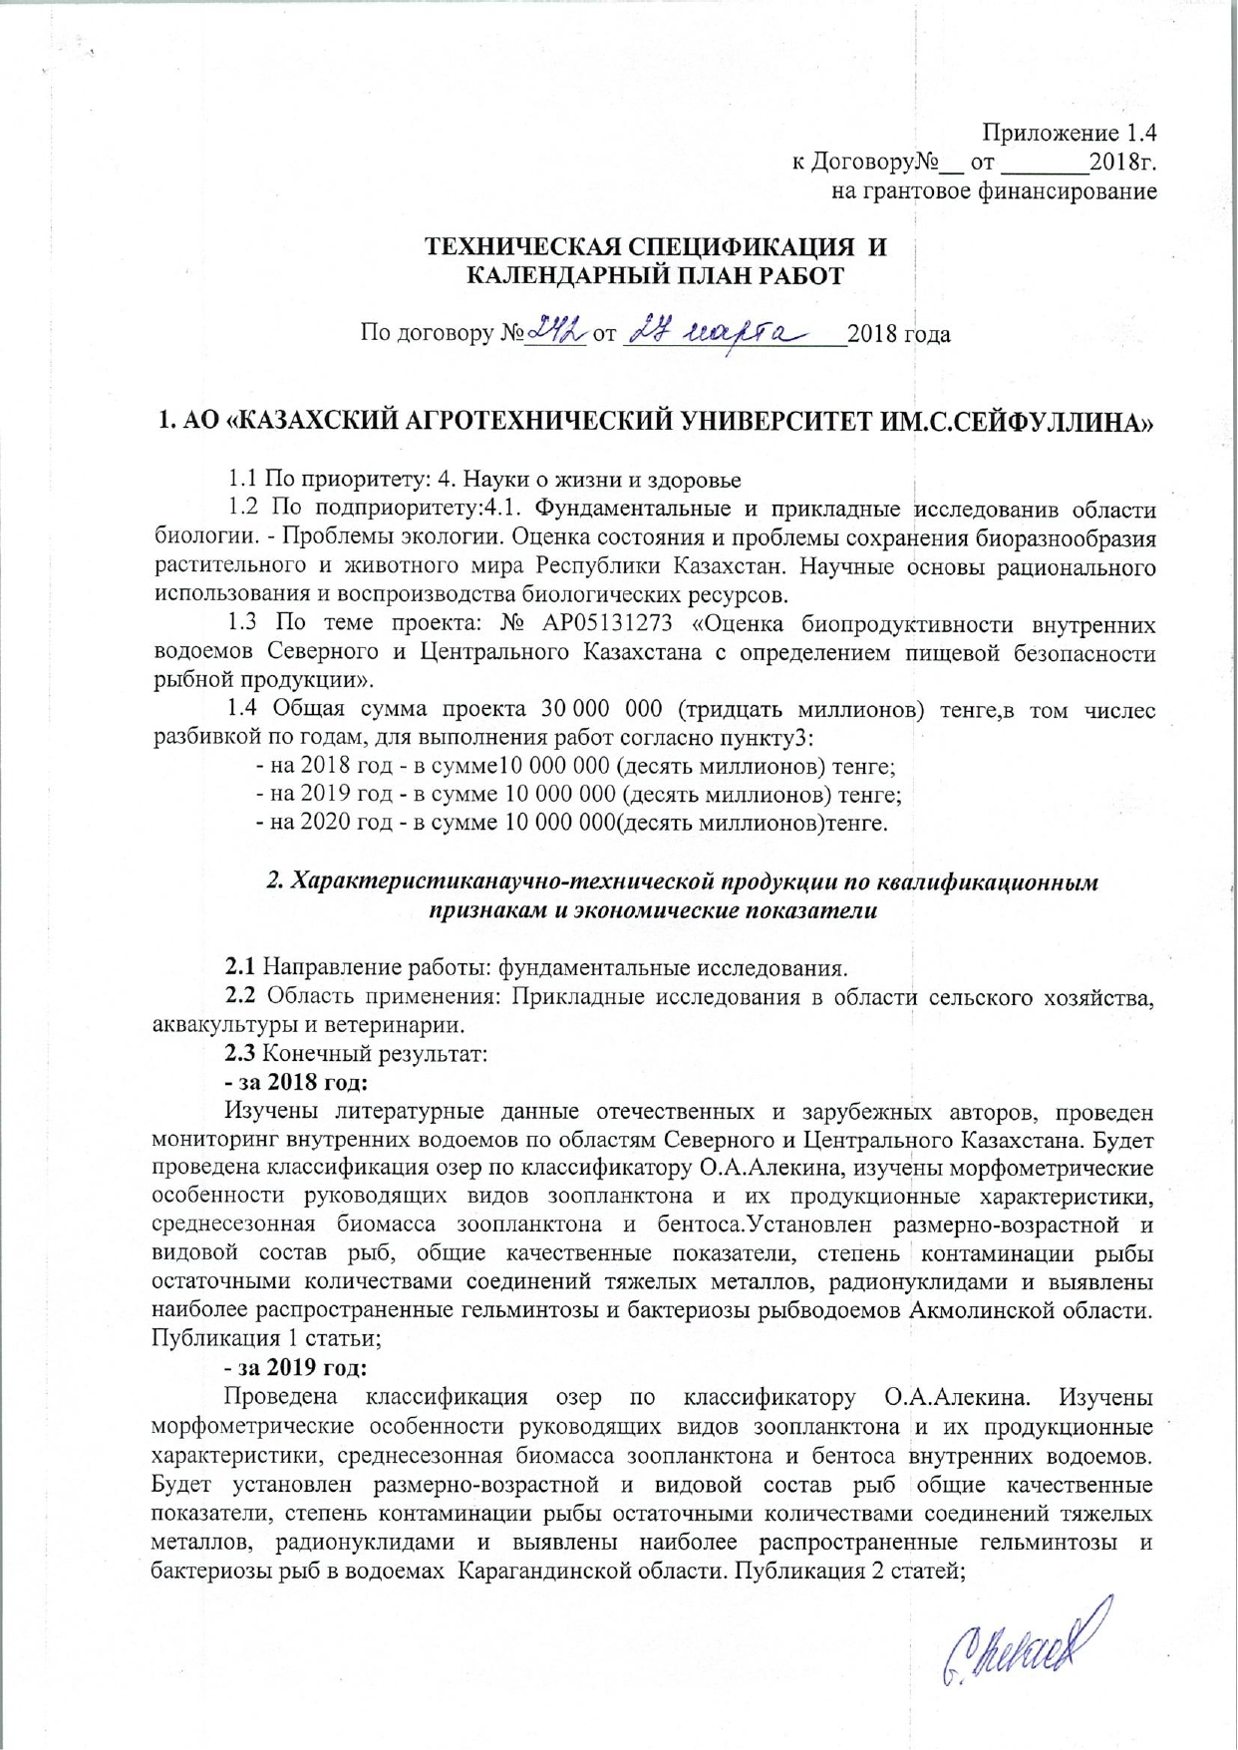

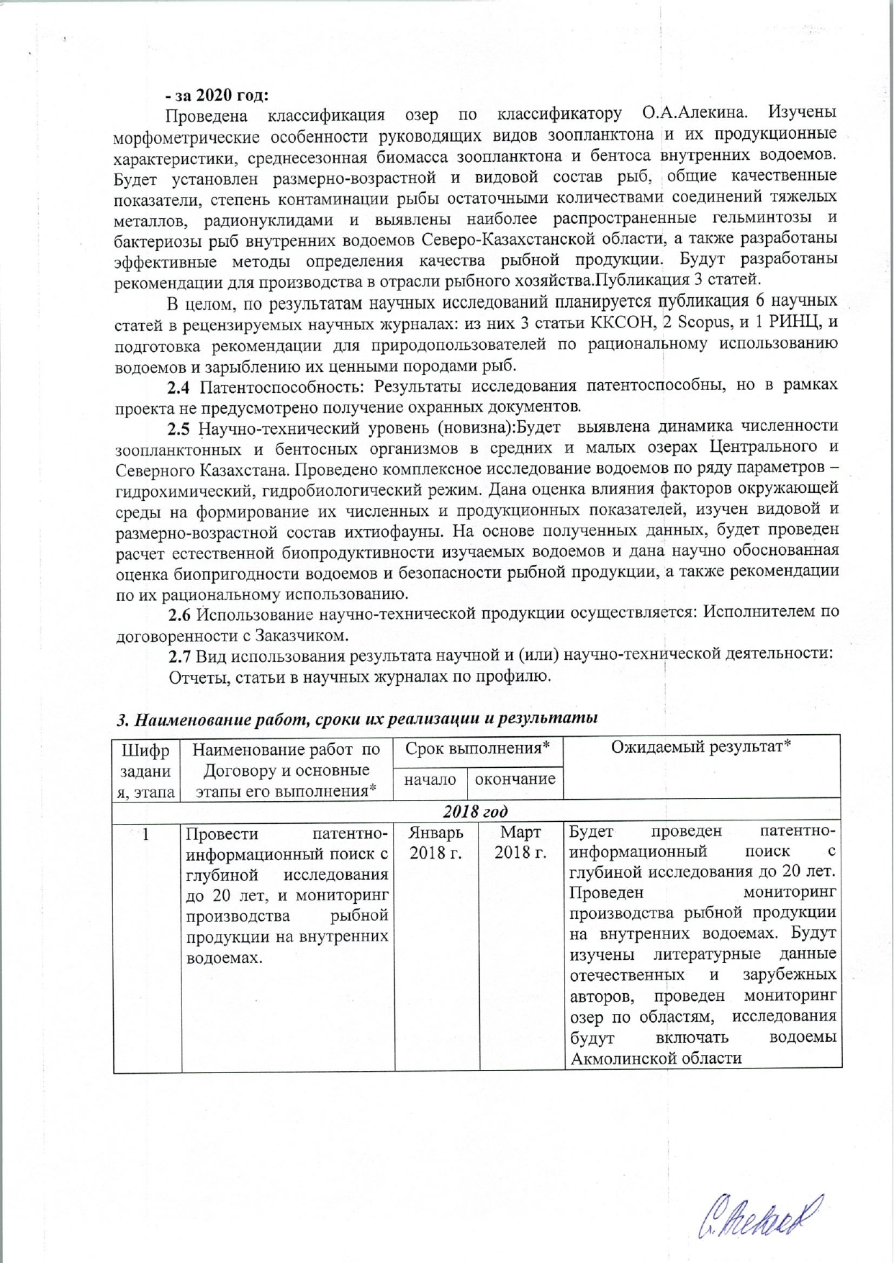

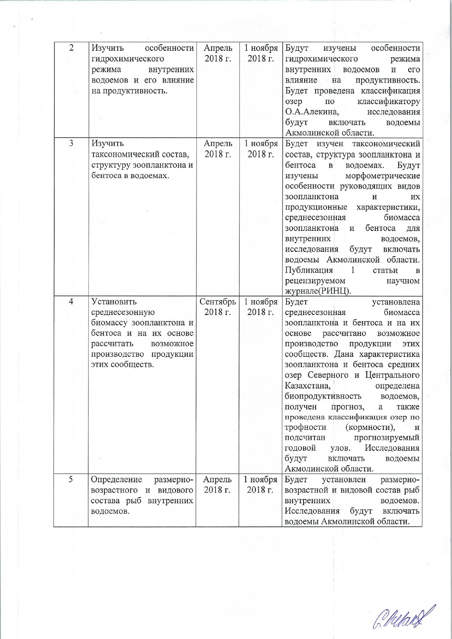

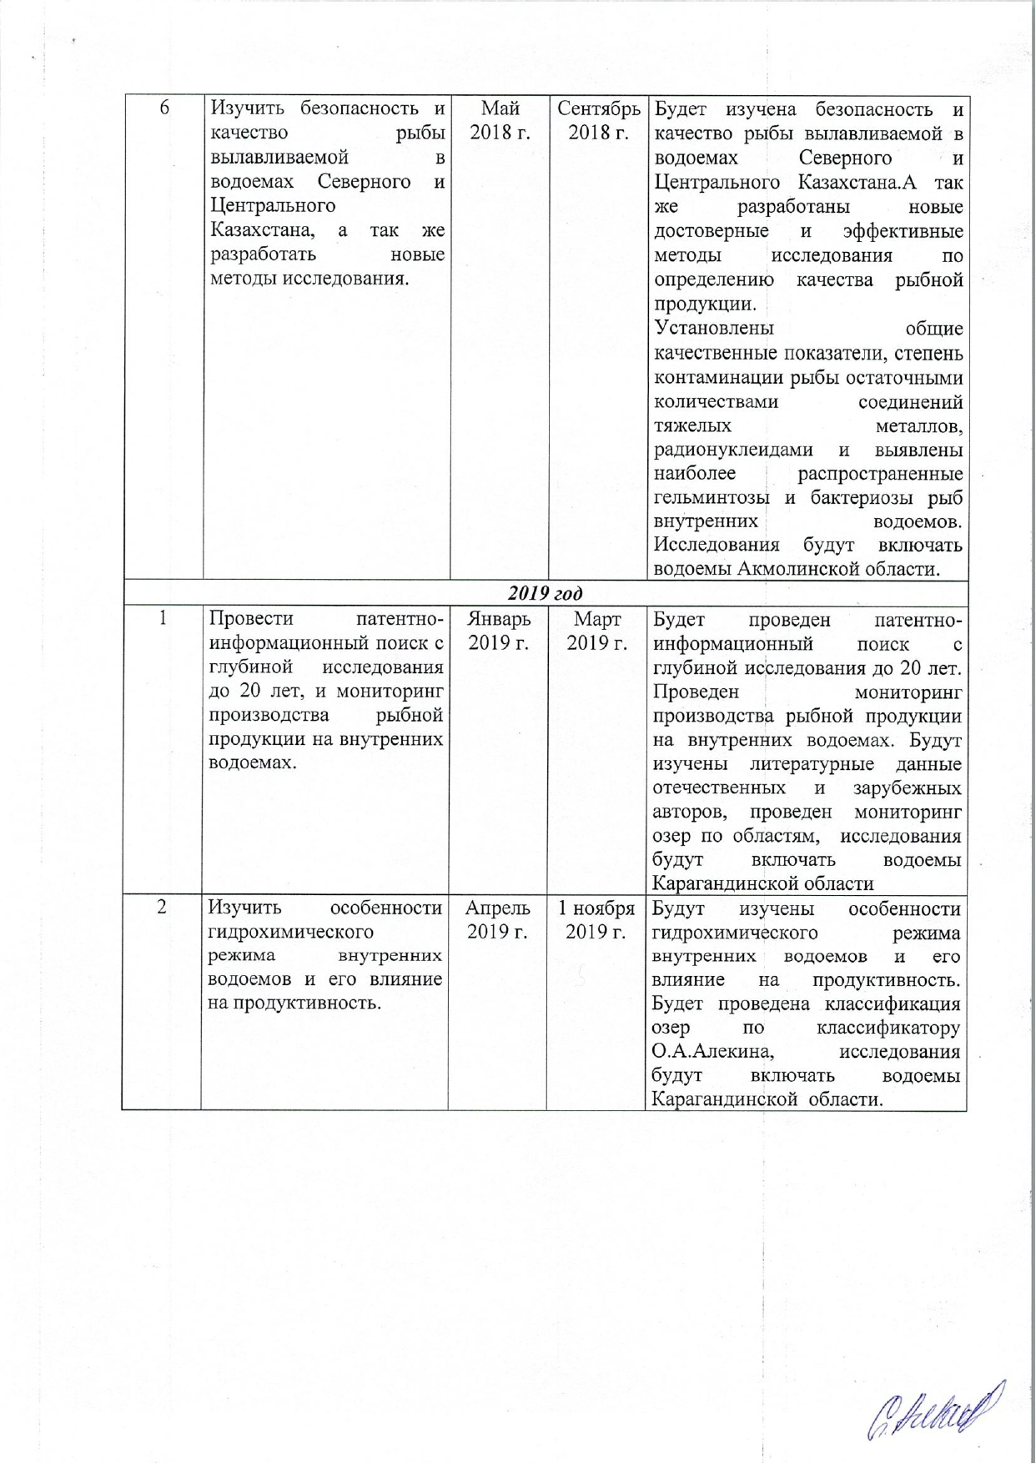

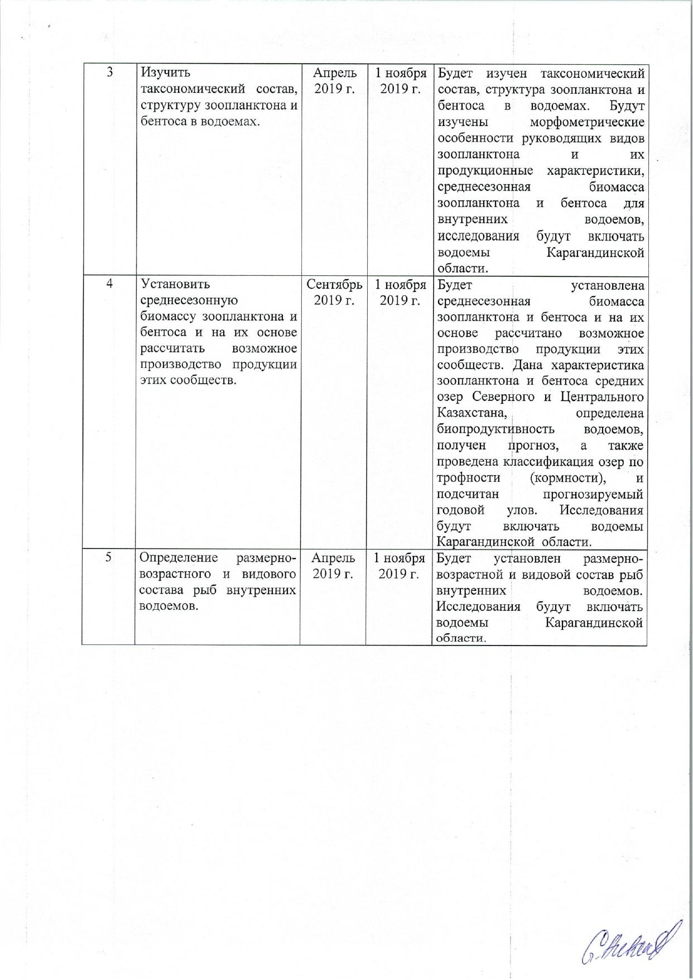

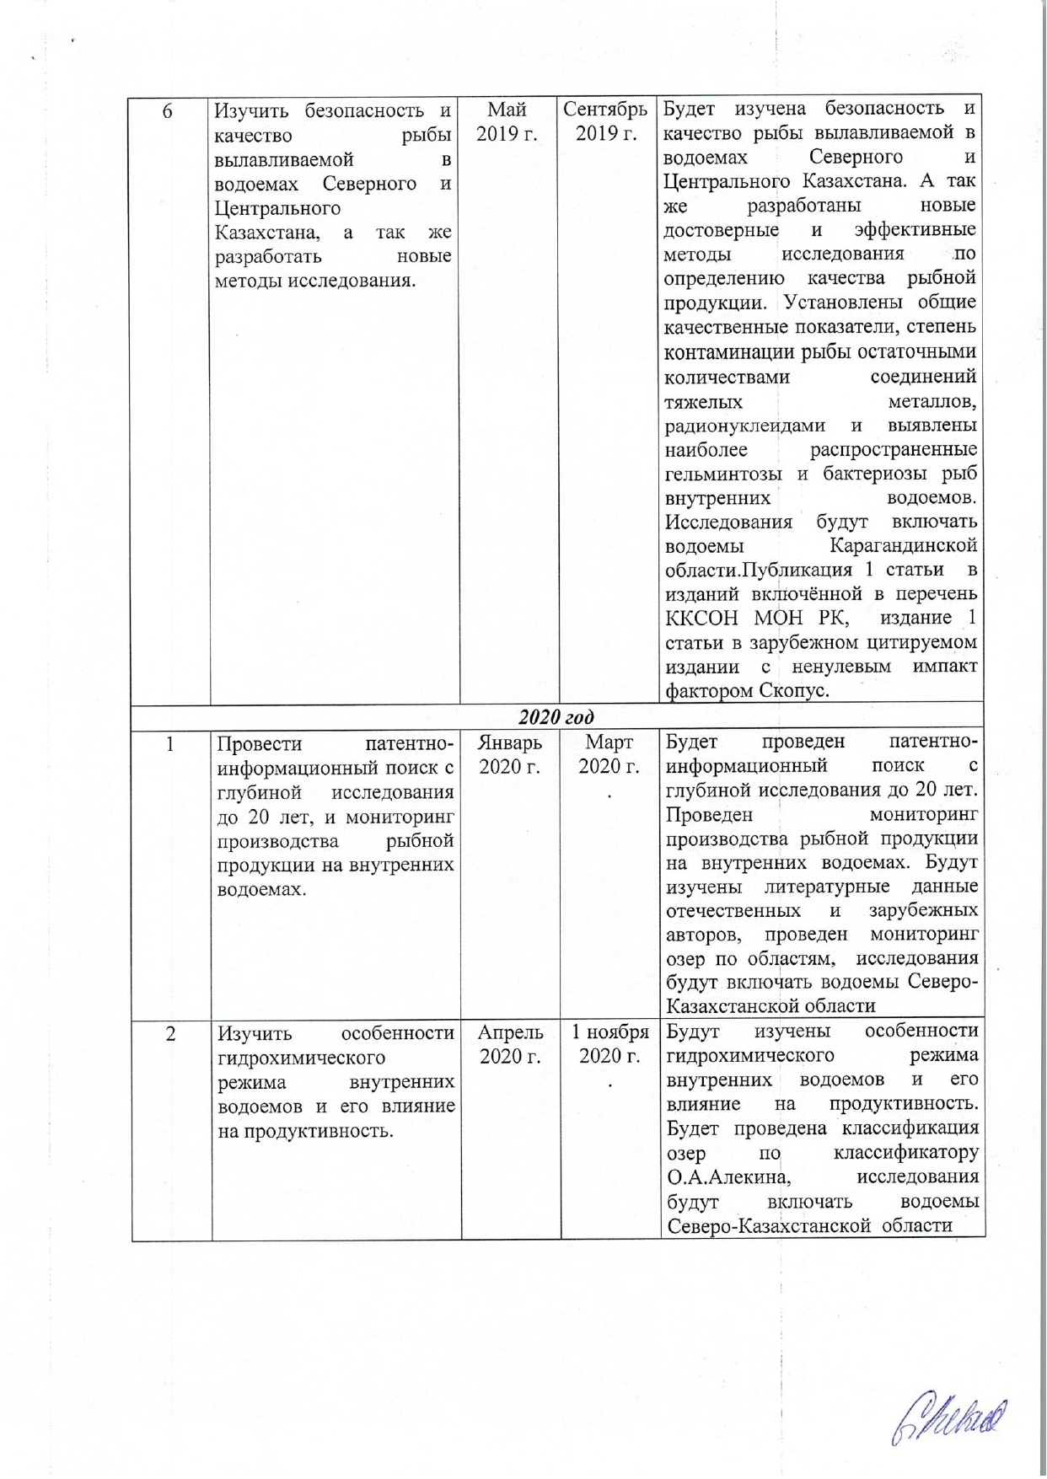

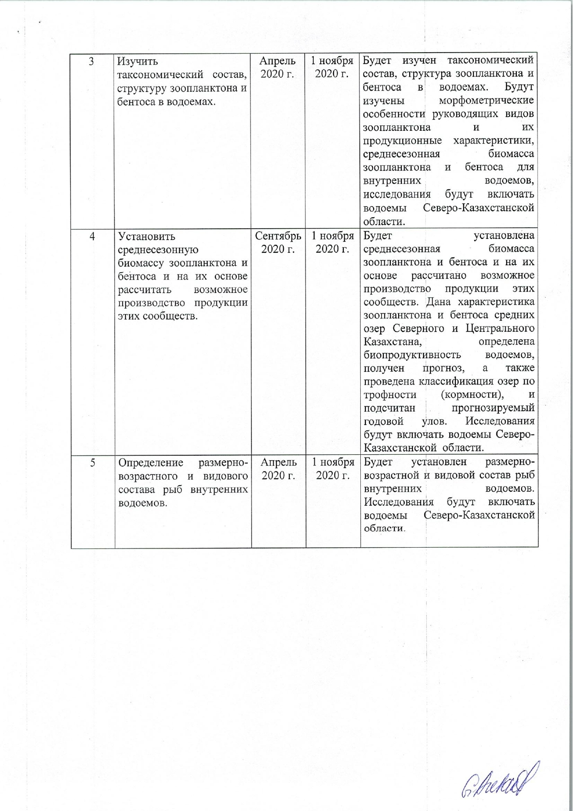

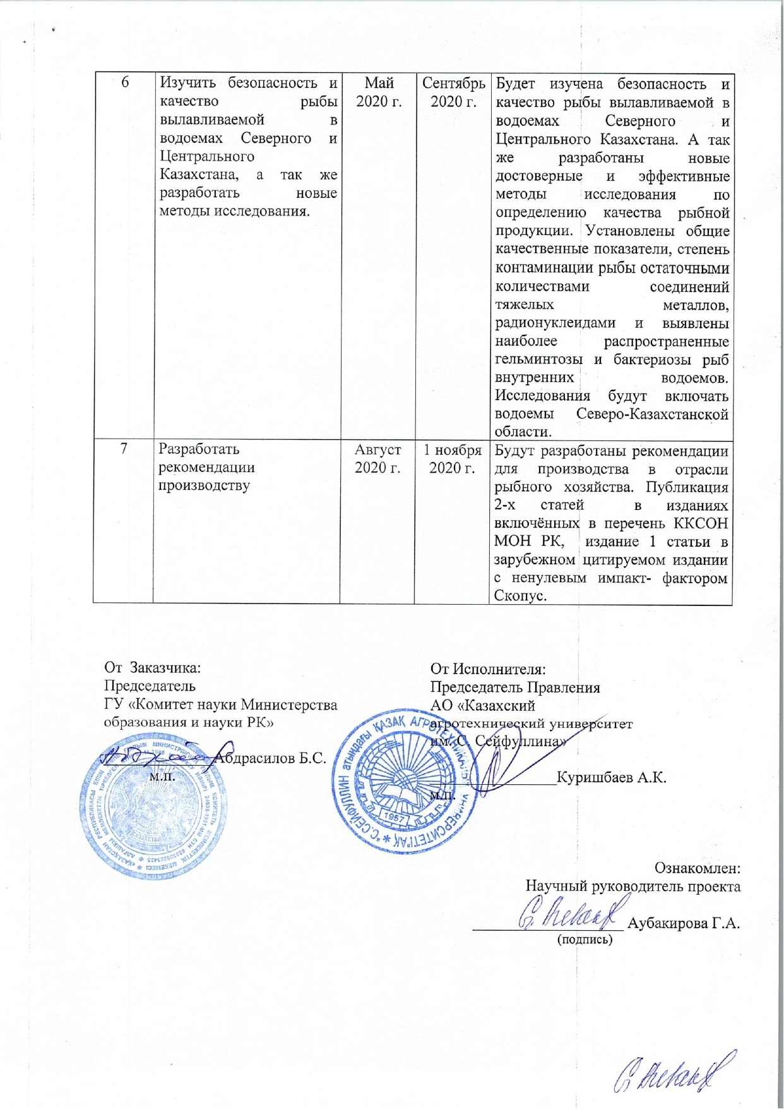

Annex 1.4
to the Agreement №__ dated _______ 2018
for grant funding

TECHNICAL SPECIFICATIONS AND
CALENDAR WORK PLAN

By agreement №_____ dated __________________2018 year

1. «S. SEIFULLIN KAZAKH AGRO TECHNICAL UNIVERSITY» JSC

1.1 By priority: 4. Life and health sciences
1.2 By sub-priority: 4.1. Basic and applied research in the field of biology. Ecological problems. Assessment and problems of biodiversity conservation of flora and fauna of the Republic of Kazakhstan. Scientific basis for the rational use and reproduction of biological resources.
1.3 On the topic of the project: № AP05131273 "Assessment of the bioproductivity of inland water bodies of Northern and Central Kazakhstan with the definition of food safety of fish products."
1.4 The total amount of the project is 30,000,000 (thirty million) tenge, including a breakdown by years, for the performance of work in accordance with paragraph 3:
- for 2018 - in the amount of 10,000,000 (ten million) tenge;
- for 2019 - in the amount of 10,000,000 (ten million) tenge;
- for 2020 - in the amount of 10,000,000 (ten million) tenge.

2. Characteristics of scientific and technical products by qualification features and economic indicators

2.1 Direction of work: basic research.
2.2 Field of application: Applied research in the field of agriculture, aquaculture and veterinary medicine.
2.3 Final result:
- for 2018 year:
Literary data of domestic and foreign authors will be studied, monitoring of inland water bodies in the regions of Northern and Central Kazakhstan will be carried out. The lakes will be classified according to the O.A. Alekin's classifier, the morphometric features of the leading species of zooplankton and their production characteristics, the average seasonal biomass of zooplankton and benthos will be studied. The size-age and species composition of fish, general quality indicators, the degree of fish contamination with residual amounts of heavy metal compounds, radionuclides will be established, and the most common helminthiases and bacterioses of fish reservoirs of the Akmola region will be identified. Publication of 1 article;
- for 2019 year:
The lakes will be classified according to O.A. Alekin's classifier. The morphometric features of the leading zooplankton species and their production characteristics, the average seasonal biomass of zooplankton and benthos of inland water bodies will be studied. The size, age and species composition of fish, general quality indicators, the degree of fish contamination with residual amounts of heavy metal compounds, radionuclides will be established, and the most common helminthiases and bacteriosis of fish in water bodies of the Karaganda region will be identified. Publication of 2 articles;
- for 2020 year:
The classification of the lakes will be carried out according to the classifier of O.A. Alekin. The morphometric features of the leading zooplankton species and their production characteristics, the average seasonal biomass of zooplankton and benthos of inland water bodies will be studied. The size-age and species composition of fish, general quality indicators, the degree of fish contamination with residual amounts of heavy metal compounds, radionuclides will be established, and the most common helminthiases and bacterioses of fish in inland water bodies of the North Kazakhstan region will be identified, and also effective methods for determining the quality of fish products will be developed. Recommendations for production in the fisheries’ industry will be developed. Publication of 3 articles.
In general, based on the results of scientific research, it is planned to publish 6 scientific articles in peer-reviewed scientific journals: of which 3 articles in the list of publications recommended by the Committee for Control of Education and Science of RK for publication of scientific results, 2 articles in Scopus, and 1 article in RSCI (Russian Science Citation Index), and preparation of recommendations for nature users on the rational use of water bodies and stocking them with valuable fish species.
2.4 Patent ability: The research results are patentable, but the project does not provide obtaining titles of protection.
2.5 Scientific and technical level (novelty): The changes in the number of zooplankton and benthic organisms in medium and small lakes of Central and Northern Kazakhstan will be revealed. A comprehensive study of reservoirs will be carried out according to a number of parameters — hydro chemical, hydro biological regime. The assessment of the influence of environmental factors on the formation of their numerical and production indicators will be given, the species and size-age composition of the ichthyological fauna will be studied. Based on the data obtained, the calculation of the natural bioproductivity of the studied reservoirs will be carried out. The scientifically substantiated assessment of the bioavailability of reservoirs and the safety of fish products, as well as recommendations for their rational use will be given.
2.6 The use of scientific and technical products is carried out: by the Contractor by agreement with the Customer.
2.7 Type of the result use in scientific and (or) scientific and technical activities:
Reports, articles in scientific journals by profile.

3. Name of work, terms of implementation and results
Task code, stage | Name of work under the Agreement and the main stages of its implementation * | Date for the implementation * |  |  | The Expected Result *
Task code, stage |  | start | ending
2018 year
1 | Conduct the patent information search with a depth of research up to 20 years, and monitor the production of fish products in inland waters. | January  2018 year |  | March  2018 year | The patent information search will be carried out with a depth of research up to 20 years. The monitoring of fish production in inland waters will be conducted. The literature indicates of domestic and foreign authors will be studied, monitoring of lakes by regions will be carried out. The studies will include reservoirs of Akmola region.
2 | Study the features of the hydrochemical regime of inland water bodies and its effect on productivity. | April 2018 year |  | 1 November,  2018 year | The peculiarities of the hydro chemical regime of inland water bodies and its impact on productivity will be studied. The lakes will be classified according to O.A. Alekin's classifier. The studies will include water bodies of Akmola region.
3 | Study the taxonomic composition, structure of zooplankton and benthos in water bodies. | April 2018 year |  | 1 November,  2018 year | The taxonomic composition, structure of zooplankton and benthos in water bodies will be studied. The morphometric features of the leading zooplankton species and their production characteristics, the average seasonal biomass of zooplankton and benthos for inland water bodies will be studied. The research will include water bodies of Akmola region. Publication of 1 article in a peer-reviewed scientific journal (Russian Science Citation Index).
4 | Establish the average seasonal biomass of zooplankton and benthos . On their basis, calculate the possible production of products of these communities. | September  2018 year |  | 1 November,  2018 year | The average seasonal biomass of zooplankton and benthos will be determined and the potential production of these communities will be calculated on their basis. The characteristics of zooplankton and benthos of middle lakes in Northern and Central Kazakhstan will be given, the bio productivity of reservoirs will be determined, a forecast will be obtained, and the classification of lakes by trophicity (feeding) will be carried out, and the predicted annual catch will be calculated. The research will include reservoirs of Akmola region.
5 | Determination of the size, age and species composition of fish in inland waters. | April 2018 year |  | 1 November,  2018 year | The size, age and species composition of inland fish will be established. The research will include reservoirs of Akmola region.
6 | Study the safety and quality of fish caught in the water bodies of Northern and Central Kazakhstan, as well as to develop new research methods. | May  2018 year |  | September  2018 year | The safety and quality of fish caught in the water bodies of Northern and Central Kazakhstan will be studied. New reliable and effective research methods will be developed to determine the quality of fish products.  General quality indicators, the degree of fish contamination by residual amounts of heavy metal compounds, radionuclides will be established, and the most common helminthiases and bacterioses of fish in inland waters will be identified. The research will include reservoirs of Akmola region.
2019 year
1 | Conduct patent information search with a depth of research up to 20 years, and monitor the production of fish products in inland waters. | January  2019 year |  | March  2019 year | The patent information search will be carried out with a depth of research up to 20 years. Monitoring of fish production in inland waters will be carried out. Literary data of domestic and foreign authors will be studied, monitoring of lakes by regions will be conducted. The studies will include water bodies of Karaganda region.
2 | Study the features of the hydrochemical regime of inland water bodies and its effect on productivity. | April 2019 year |  | 1 November,  2019 year | The features of the hydrochemical regime of inland water bodies and its impact on productivity will be studied. The lakes will be classified according to O.A. Alekin's classifier, the studies will include water bodies of Karaganda region.
3 | Study the taxonomic composition, structure of zooplankton and benthos in water bodies. | April 2019 year |  | 1 November,  2019 year | The taxonomic composition, structure of zooplankton and benthos in water bodies will be studied. The morphometric features of the leading zooplankton species and their production characteristics, the average seasonal biomass of zooplankton and benthos for inland water bodies will be studied. The research will include water bodies of Karaganda region.
4 | Establish the average seasonal biomass of zooplankton and benthos and, on their basis, calculate the possible production of products of these communities. | September  2019 year |  | 1 November,  2019 year | The average seasonal biomass of zooplankton and benthos will be determined and the potential production of these communities will be calculated on their basis. The characteristics of zooplankton and benthos of middle lakes in Northern and Central Kazakhstan will be given, the bio productivity of reservoirs will be determined, a forecast will be obtained, and the classification of lakes by trophicity (feeding) will be carried out, and the predicted annual catch will be calculated. The research will include water bodies of Karaganda region.
5 | Determination of the size, age and species composition of fish in inland waters. | April 2019 year |  | 1 November,  2019 year | The size, age and species composition of inland fish will be established. The research will include water bodies of Karaganda region.
6 | Study the safety and quality of fish caught in the water bodies of Northern and Central Kazakhstan, as well as to develop new research methods. | May  2019 year |  | September  2019 year  . | The safety and quality of fish caught in the water bodies of Northern and Central Kazakhstan will be studied. And also new reliable and effective research methods will be developed to determine the quality of fish products. General quality indicators, the degree of fish contamination by residual amounts of heavy metal compounds, radionuclides will be established. The most common helminthiases and bacterioses of fish in inland waters will be identified. The research will include water bodies of Karaganda region. Publication of 1 article in the edition included in the list by the Committee for Control of Education and Science of RK for publication of scientific results, publication of 1 article in a foreign cited edition with a non-zero impact factor Scopus.
2020 year
1 | Conduct patent information search with a depth of research up to 20 years, and monitor the production of fish products in inland waters. | January  2020 year |  | March  2020 year  . | Patent information search will be carried out with a depth of research up to 20 years. Monitoring of fish production in inland waters will be carried out. Literary data of domestic and foreign authors will be studied, monitoring of lakes by regions will be conducted. The studies will include water bodies of North Kazakhstan region.
2 | Study the features of the hydrochemical regime of inland water bodies and its effect on productivity. | April 2020 year |  | 1 November,  2020 year  . | The features of the hydrochemical regime of inland water bodies and its impact on productivity will be studied. The lakes will be classified according to O.A. Alekin's classifier. The studies will include water bodies of North Kazakhstan region.
3 | Study the taxonomic composition, structure of zooplankton and benthos in water bodies. | April 2020 year |  | 1 November,  2020 year | The taxonomic composition, structure of zooplankton and benthos in water bodies will be studied. The morphometric features of the leading zooplankton species and their production characteristics, the average seasonal biomass of zooplankton and benthos for inland water bodies will be studied. The studies will include water bodies of North Kazakhstan region.
4 | Establish the average seasonal biomass of zooplankton and benthos . On their basis, calculate the possible production of products of these communities. | September, 2020 year |  | 1 November,  2020 year | The average seasonal biomass of zooplankton and benthos will be determined and the potential production of these communities will be calculated on their basis. The characteristics of zooplankton and benthos of middle lakes in Northern and Central Kazakhstan will be given, the bio productivity of reservoirs will be determined, a forecast will be obtained, and the classification of lakes by trophicity (feeding) will be carried out, and the predicted annual catch will be calculated. Research will include reservoirs of North Kazakhstan region.
5 | Determination of the size, age and species composition of fish in inland waters. | April 2020 year |  | 1 November,  2020 year | The size, age and species composition of inland fish will be established. The research will include reservoirs of North Kazakhstan region.
6 | Study the safety and quality of fish caught in the water bodies of Northern and Central Kazakhstan, as well as to develop new research methods. | May  2020 year |  | September  2020 year | The safety and quality of fish caught in the water bodies of Northern and Central Kazakhstan will be studied. New reliable and effective research methods will be developed to determine the quality of fish products.  General quality indicators, the degree of fish contamination by residual amounts of heavy metal compounds, radionuclides will be established, and the most common helminthiases and bacterioses of fish in inland waters will be identified. The research will include reservoirs of North Kazakhstan region.
7 | Develop the recommendations for production | August  2020 year |  | 1 November,  2020 year | The recommendations for production in the fisheries industry will be developed. Publication of 2 articles in the list of publications recommended by the Committee for Control of Education and Science of RK for publication of scientific results, publication of 1 article in a foreign cited edition with a non-zero impact factor Scopus.

APPENDIX B
Patent review
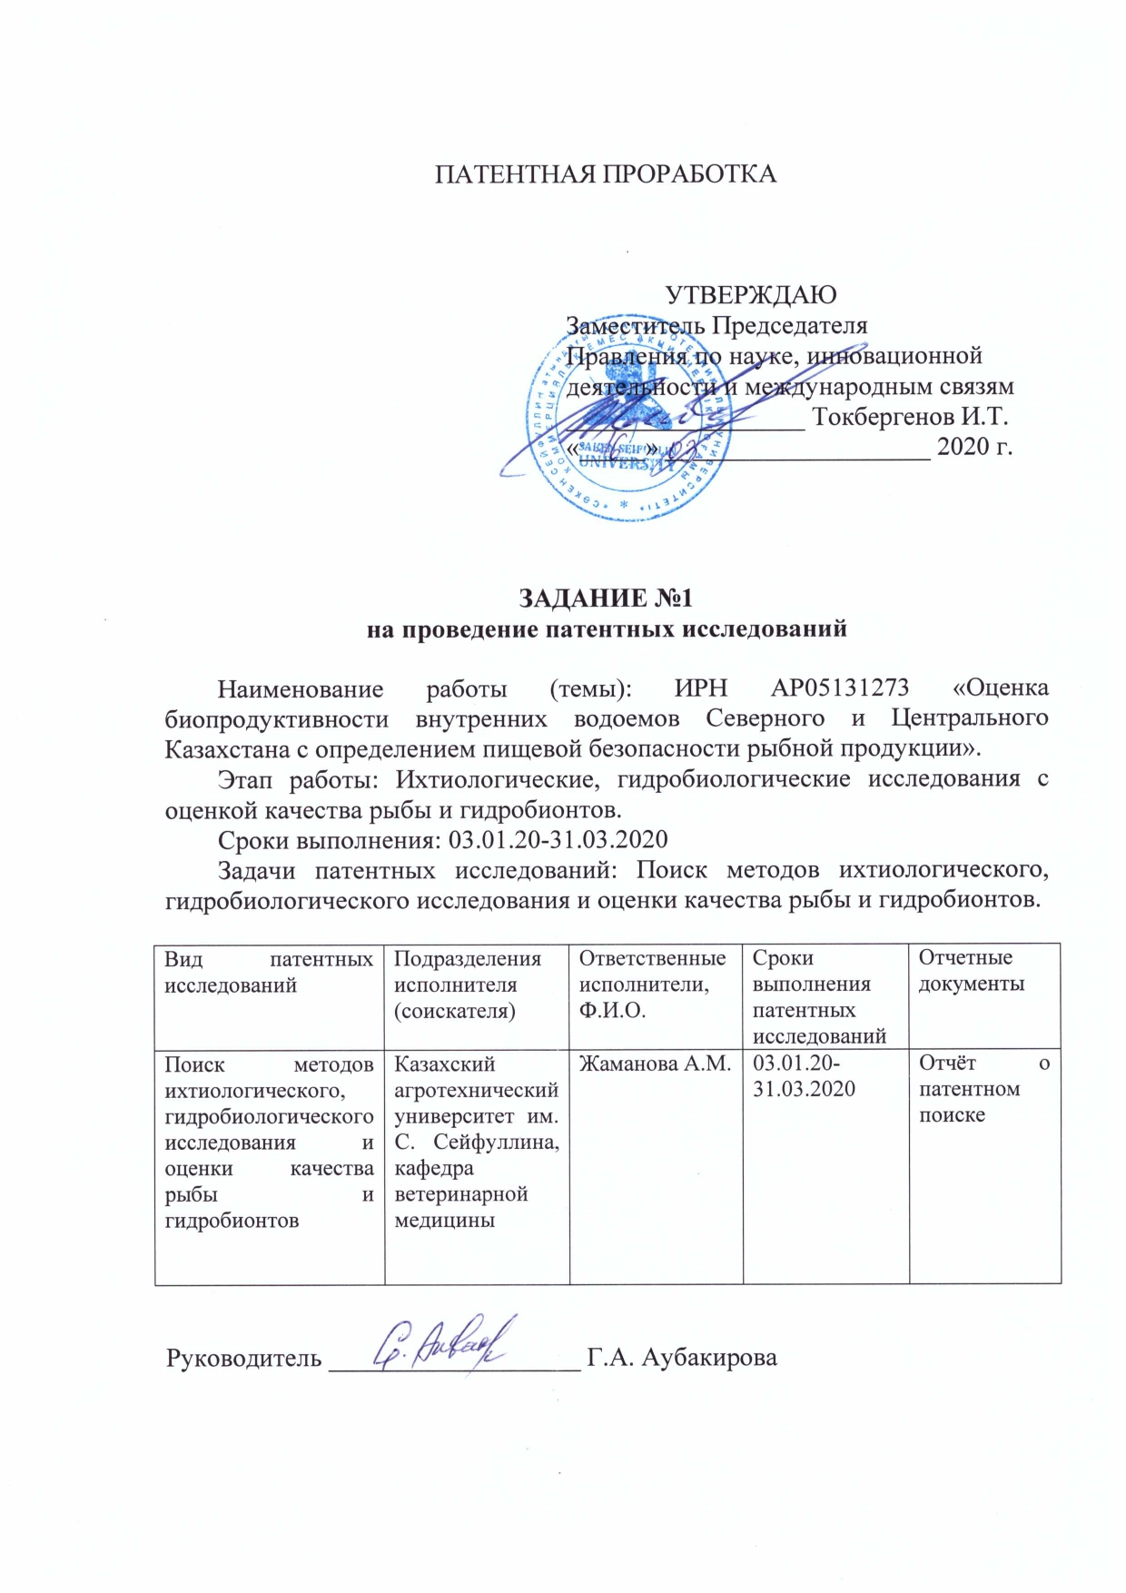

APPENDIX C
Ichthyofauna of the lakes of the North-Kazakhstan region

Table C.1 – Ichthyofauna of the lakes of the North-Kazakhstan region
Name |  |  | Characteristics | State of population
Kazakh | Russian | Latin | Characteristics | State of population
Lastochka lake
Торта | Плотва | Rutilus rutilus (L., 1758) | Commercial, indigenous | Dominant species
Кәдімгі алабұға | Окунь обыкновенный | Perca fluviatilis (L.,1758) | Commercial, indigenous | Dominant species
Табан | Серебряный карась | Carassius gibelio (Bloch,1782) | Commercial, indigenous | Numerically insignificant species
Аққайран | Язь | Leuciscus idus (L., 1758) | Commercial, indigenous | Numerically insignificant species
Kak lake
Кәдімгі алабұға | Окунь обыкновенный | Perca fluviatilis (L.,1758) | Commercial, indigenous | Dominant species
Табан | Серебряный карась | Carassius gibelio (Bloch,1782) | Commercial, indigenous | Dominant species
Tastemirovka lake
Кәдімгі мөңке | Золотой карась | Carassius carassius  (L. ,1758) | Commercial, indigenous | Dominant species
Шортан | Northern pike | Esox lucius (L.,1758) | Commercial | Numerically insignificant species
Пелядь | Пелядь | Coregonus peled (Gmelin, 1788) | Commercial, introduced species | Numerically insignificant species

APPENDIX D
Age and length structure of lakes Lastochka and Bolshoy Kak

Table D.1 – Length structure of population of Lastochka lake
Dimension classes, % |  |  |  |  |  |  |  |  |  |  | Average length, cm
15.1-17 | 17.1-19 | 19.1-21 | 21.1-23 | 23.1-25 | 25.1-27 | 27.1-29 | 29.1-31 | 31.1-33 | 33.1-35 | 35.1-37 | Average length, cm
Rutilus rutilus
26.1 | 13.1 | - | 15.3 | - | - | 4.3 | 30.4 | 6.5 | 4.3 | - | 24.1
Perca fluviatilis
29.9 | 24.1 | 13.8 | 12.7 | 2.3 | 1.1 | - | 6.9 | 6.9 | 2.3 | - | 20.7
Carassius gibelio
- | - | - | - | - | - | - | - | 71.4 | - | 28.6 | 32.7

Table D.2 – Age structure of population of Lastochka lake, %
Age, years
2+ |  | 3+ |  | 4+ |  | 5+ |  | 6+ |  |  | 7+ | 8+
Rutilus rutilus
25.3 |  | 16.1 |  | 19.6 |  | 23.1 |  | 8.7 |  |  | 5.9 | 1.3
Perca fluviatilis
29.3 |  | 30.1 |  | 19.7 |  | 10.1 |  | 4.8 |  |  | 3.4 | 2.6
Carassius gibelio
- | - |  | - |  | - |  | - |  | 84.6 | 15.4

Table D.3 – Length structure of population of Bolshoy Kak lake
Dimension classes, % |  |  |  |  |  |  |  |  |  |  | Average length, cm
15.1-17 | 17.1-19 | 19.1-21 | 21.1-23 | 23.1-25 | 25.1-27 | 27.1-29 | 29.1-31 | 31.1-33 | 33.1-35 | 35.1-37 | Average length, cm
Perca fluviatilis
4.5 | 14.5 | 5.5 | 4.5 | 21 | 29.1 | 11.8 | 6.4 | - | 0.9 | 1.8 | 24.6
Carassius gibelio
34.7 | 16 | 33.3 | 13.9 | 0.7 | - | - | 0.7 | 0.7 | - | - | 19.3

Table D.4 – Age structure of population of Bolshoy Kak lake, %
Age, years
2+ | 3+ | 4+ | 5+ | 6+ | 7+
Perca fluviatilis
9.4 | 37.7 | 34.1 | 13.1 | 3.2 | 2.5
Carassius gibelio
49.3 | 38.1 | 11.4 | 1.2 | - | -

APPENDIX E
Morpho-biological indices of fish

Table E.1 – Morpho-biological indices of river perch, roach and golden carp from Lastochka L.
Indices | river perch |  | roach |  | golden carp
Indices | min-max | M±m | min-max | M±m | min-max | M±m
L | 15-35 | 20.67±4.13 | 16-35 | 24.1±6.12 | 30-36 | 32.7±2.04
l | 12-30 | 17.24±3.79 | 13-29 | 19.83±5.10 | 24-29 | 26.7±2.04
Q | 47-600 | 160.7±114.3 | 46-563 | 247.4±171.9 | 586-924 | 771.4±124.6
Fulton | 1.47-3.41 | 2.51±0.23 | 1.4-3.1 | 2.54±0.22 | 3.7-4.5 | 4.02±0.26
В % from l:
lc | 12.5-31.5 | 17.99±4.48 | 13.3-21.9 | 16.04±1.55 | 17.8-23.6 | 20.33±1.41
H | 28.5-40.6 | 34.24±2.32 | 12.1-42.8 | 37.46±2.50 | 45.8-55.2 | 49.05±2.29
HTT | 15.8-35.7 | 21.30±2.57 | 13.7-23,0 | 18.85±2.17 | 20.6-24 | 21.41±0.74

Table E.2 – Morpho-biological indices of golden carp and river perch from Bolshoy Kak L.
Indices | golden carp |  | river perch
Indices | min-max | M±m | min-max | M±m
L | 15-32 | 19.31±2.07 | 16-37 | 24.55±3.25
l | 12-25 | 15.12±1.55 | 13-31 | 20.94±2.95
Q | 65-618 | 135.32±38.70 | 59-1019 | 233.97±84.08
Fulton | 2.1-5.3 | 3.79±0.44 | 1.73-4.03 | 2.36±0.22
В % from l:
lc | 14.2-23.1 | 18.46±1.65 | 12.5-34.78 | 18.58±5.69
H | 27.4-56.2 | 46.68±3.29 | 20.41-41.93 | 33.17±3.08
HTT | 16.5-26.6 | 22.89±1.54 | 15.8-38.6 | 23.58±3.38

Table E.3 – Morpho-biological indices of crucian carp from Tastemirovka L.
Indices | min-max | M±m
L | 16.3-35 | 23.61±3.12
l | 14-29.2 | 19.29±2.68
Q | 107-1081 | 321.27±144.42
Fulton | 3.1-5.8 | 4.06±0.35
В % from l:
lc | 16.66-26.92 | 20.02±1.91
H | 39.47-55.0 | 46.45±2.25
HTT | 16.66-28.57 | 22.55±1.60

APPENDIX F
Contamination of fish with helminthoses

Table F.1 – З Contamination with helminthoses of fish in the water basins of the North-Kazakhstan region
Fish species | Quantity if fish |  | Parasite type | Prevalence,  % | Intensity,  Specimen
Fish species | investigated | Infested | Parasite type | Prevalence,  % | Intensity,  Specimen
Lastochka lake
Crucian | 24 | Not found | - | - | -
Roach | 12 | 2 | Posthodiplostomum cuticula | 16.6 | 3-6
Perch | 12 | Not found
Bolshoy Kak lake
Crucian | 21 | Not found | - | - | -
Roach | 18 | 3 | Posthodiplostomum cuticula | 16.6 | 3-5
Perch | 12 | Not found | - | - | -
Ide | 3 | Not found
Tastemirovka lake
Crucian | 23 | 3 | Ligula intestinalis | 13.04 | 5-6
Roach | 18 | Not found | - | - | -
Perch | 8 | Not found

APPENDIX G
Contamination of fish with toxic elements and radioactive nuclides

Table G.1 – Contamination with toxic elements of fish, sampled from various water basins on the North-Kazakhstan region, mg/kg
Toxic elements | MAC | Water basins
Toxic elements | MAC | Lastochka lake  n=9 | Bolshoy Kak lake  n=9 | Tastemirovka lake  n=9
cadmium | 0.2 | 0.0027±0.0002 | 0.0012±0.0001 | 0.0076±0.00001
lead | 1.0 | 0.0027±0.0001 | 0.0046±0.0002 | 0.0042±0.0002
mercury | 0.6 | 0.0026±0.0001 | 0.00206±0.0001 | 0
arsenic | 1.0 | 0.0132±0.002 | 0.0027±0.0001 | 0.0130±0.0001

Table G.2 – Contamination with radioactive nuclides of fish, sampled from various water basins on the North-Kazakhstan region, mg/kg
Toxic elements | MAC | Water basins
Toxic elements | MAC | Lastochka lake n=9 | Kak lake  n=9 | Tastemirovka lake  n=9
cesium 137 |  | 7.04±0.062  (6 samples) | 4.46±0.056  (4 samples) | 1.34±0.066  (7 samples)
strontium 90 |  | 6.56±0.024 | 5.12±0.026 | 6.7±0.026

APPENDIX I
Utility model patent

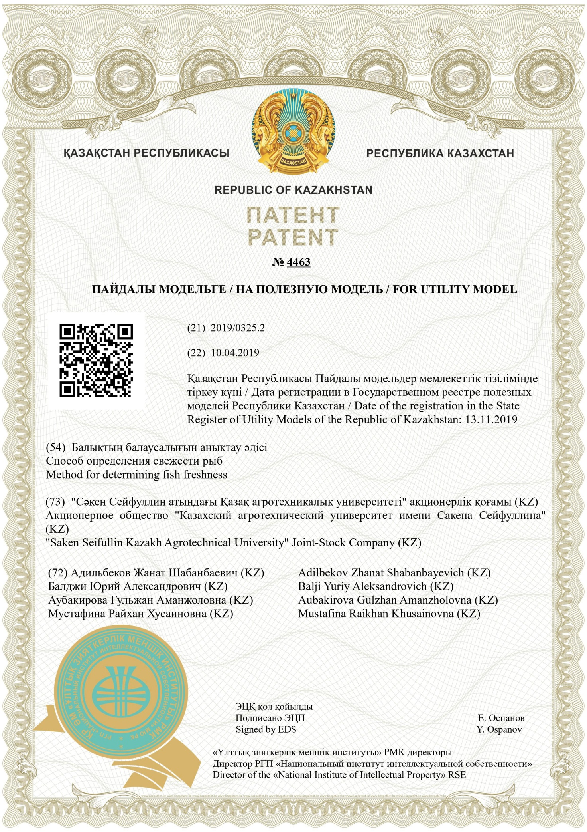

APPENDIX J
Application for grant of a patent of the RK for utility model
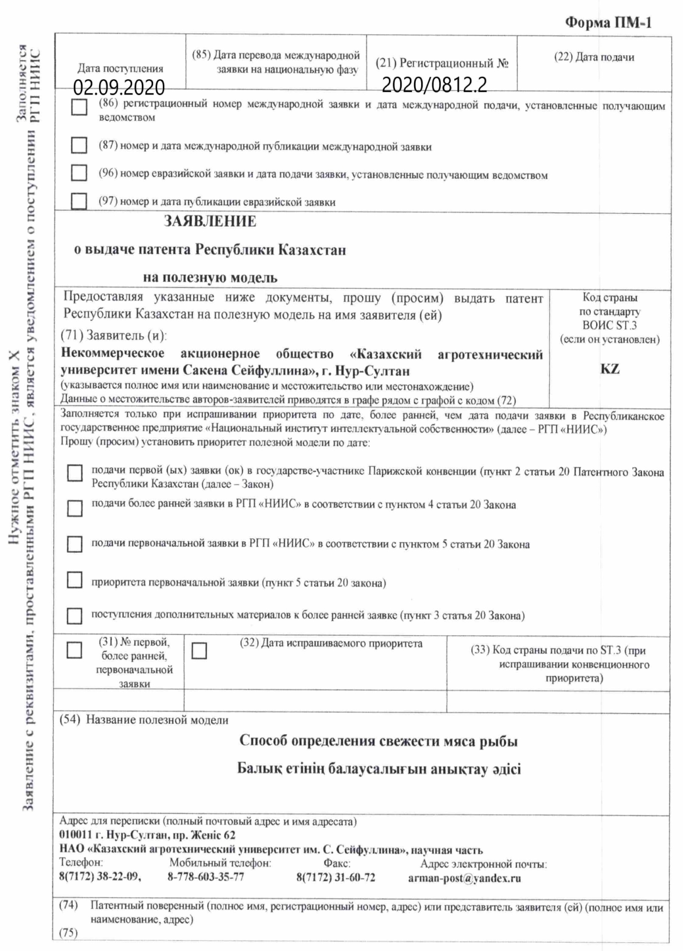

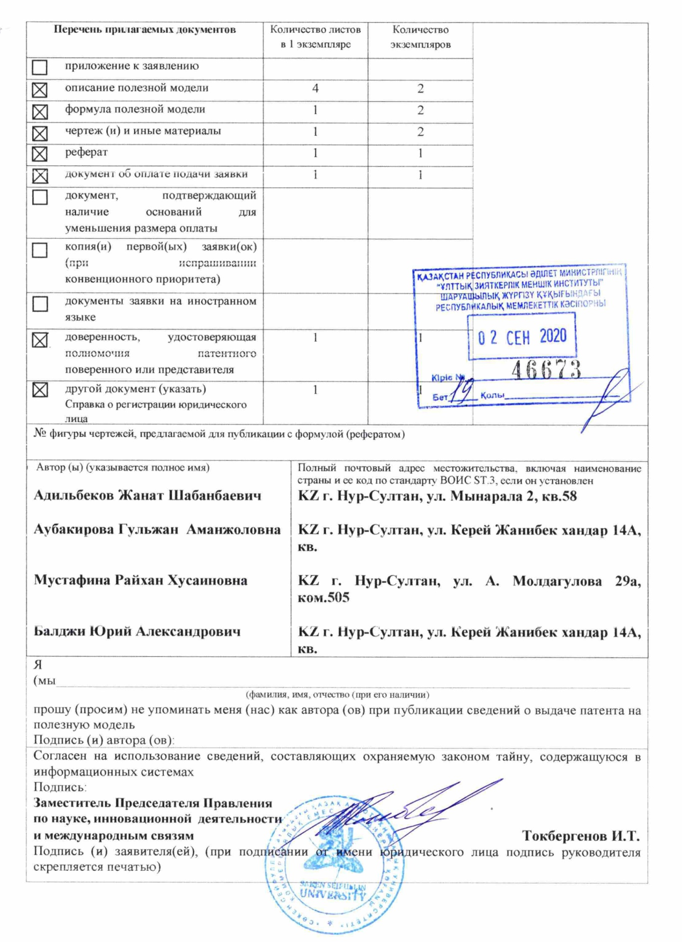

APPENDIX K
List of published works on project
for 2020

№  Ser.no. | Name | Published or as manuscript | Publishing house, journal (name, number, year) | Number of sheets | Last names of co-writers
1 | 2 | 3 | 4 | 5 | 6
1 | Current issues of food safety of fish from the water basins in Karagandy region  (Russian) | Published | Scientific bulletin of Seifullin Kazakh Agro Technical University, Nur-Sultan, no.2 (105), 2020, p.30-38 | 5 | Adilbekov Zh.Sh., Pishchenko Ye.V., Aubakirova G.A., Mustafina R.Kh. Zhamanova A.M.
2 | Assessment of safety of fish from individual water basins of Karagandy region  (Russian) | Published | Multidisciplinary scientific journal of A.Baitursynov Kostanay state university, Kostanay, no.2 2020, p.3-7 | 6 | Adilbekov Zh.Sh., Aubakirova G.A., Mustafina R.Kh.
3 | INFLUENCE OF WATER MINERALIZATION ON ZOOPLANKTON PRODUCTIVITY IN RESERVOIRS OF AKMOLA REGION  (English) | Published | Periodico Tche Quimica, Vol.34, pp520-527, 202  The journal is included in Scopus base, percentile by interdisciplinary sciences – 65. https://www.scopus.com/authid/detail.uri?authorId=56414823900 | 8 | G.Aubakirova, Zh. Adilbekov, S.Narbayev
4 | Recommendations for production in the field of fishery  (Russian) | Published | Recommendations are reviewed and approved for printing by the scientific and technology council of Seifullin Kazakh Agro Technical University, minutes no. 7 dated September 22, 2020 | 21 | G.A. Aubakirova, Zh.Sh. Adilbekov, I.I.Mironchuk, R.Kh. Mustafina, A.M.Zhamanova

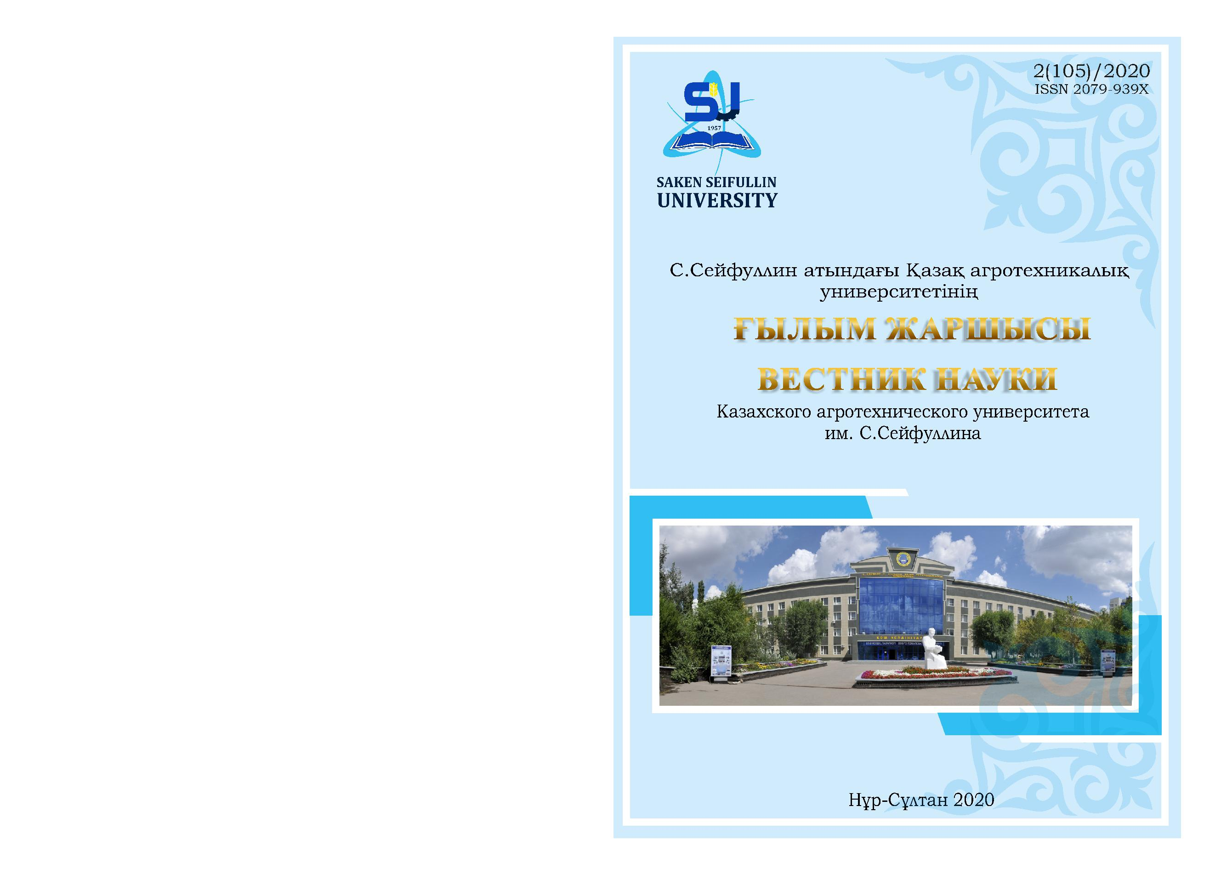

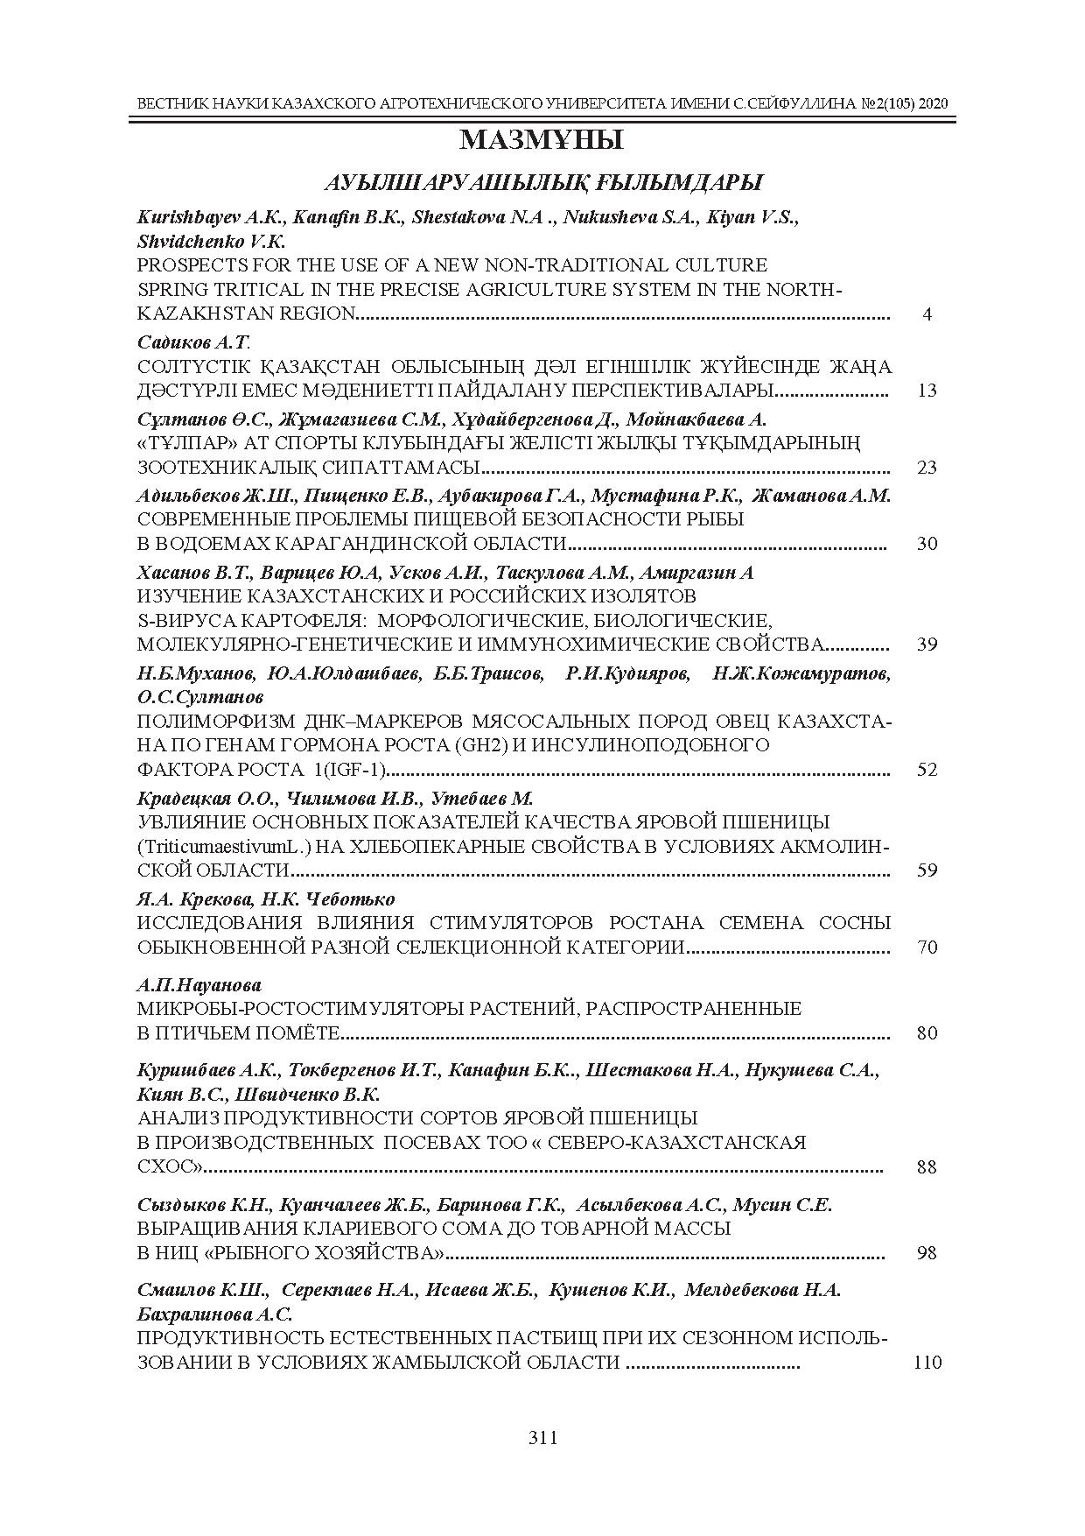

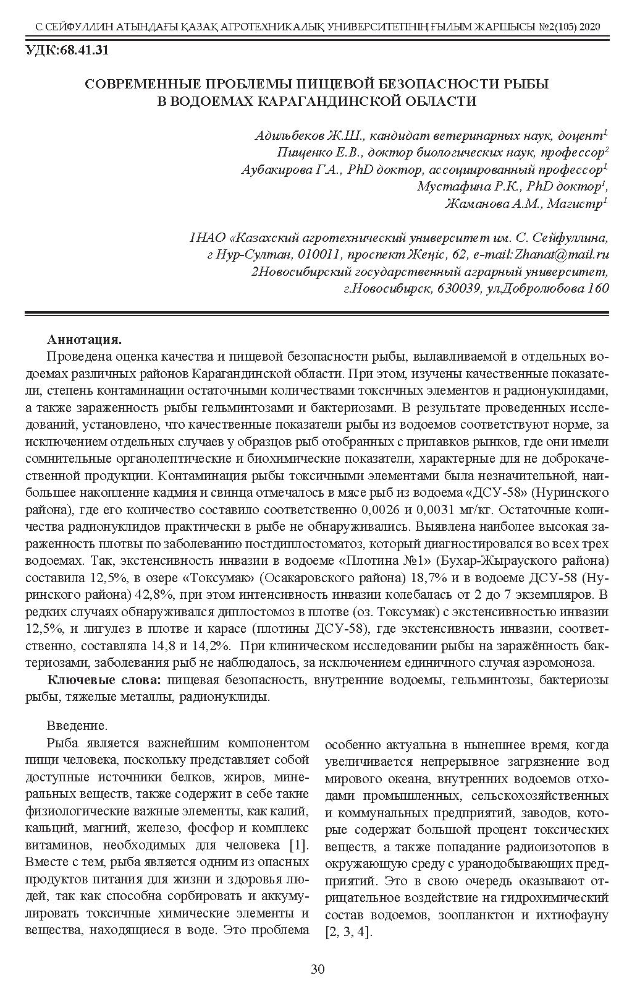
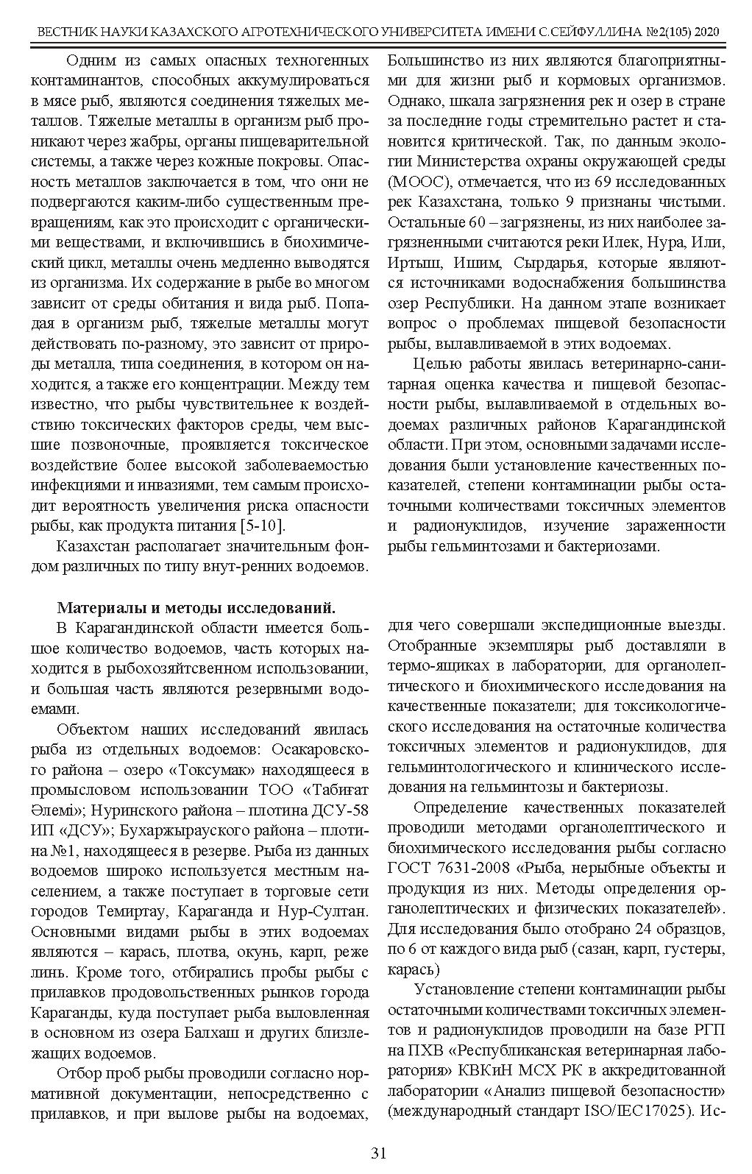

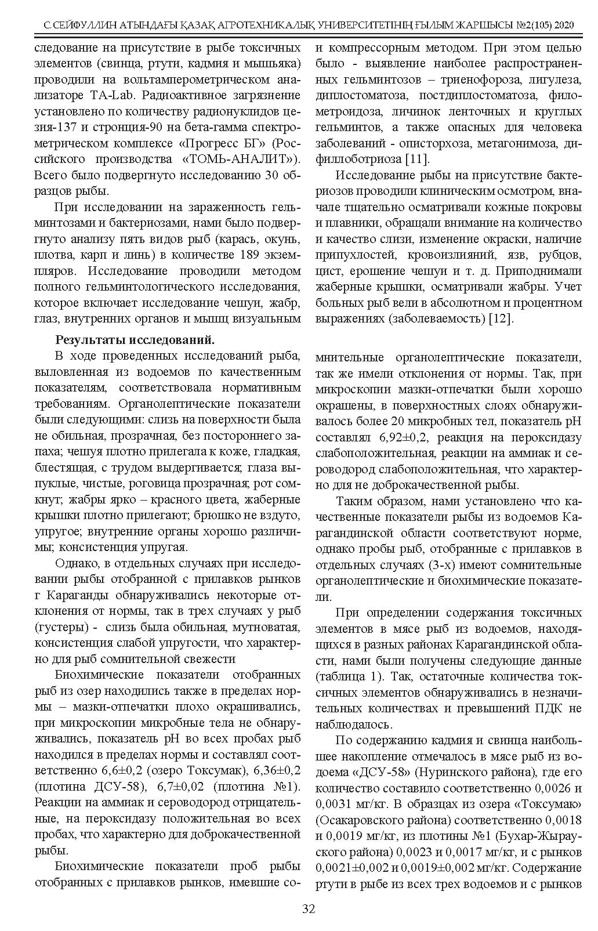

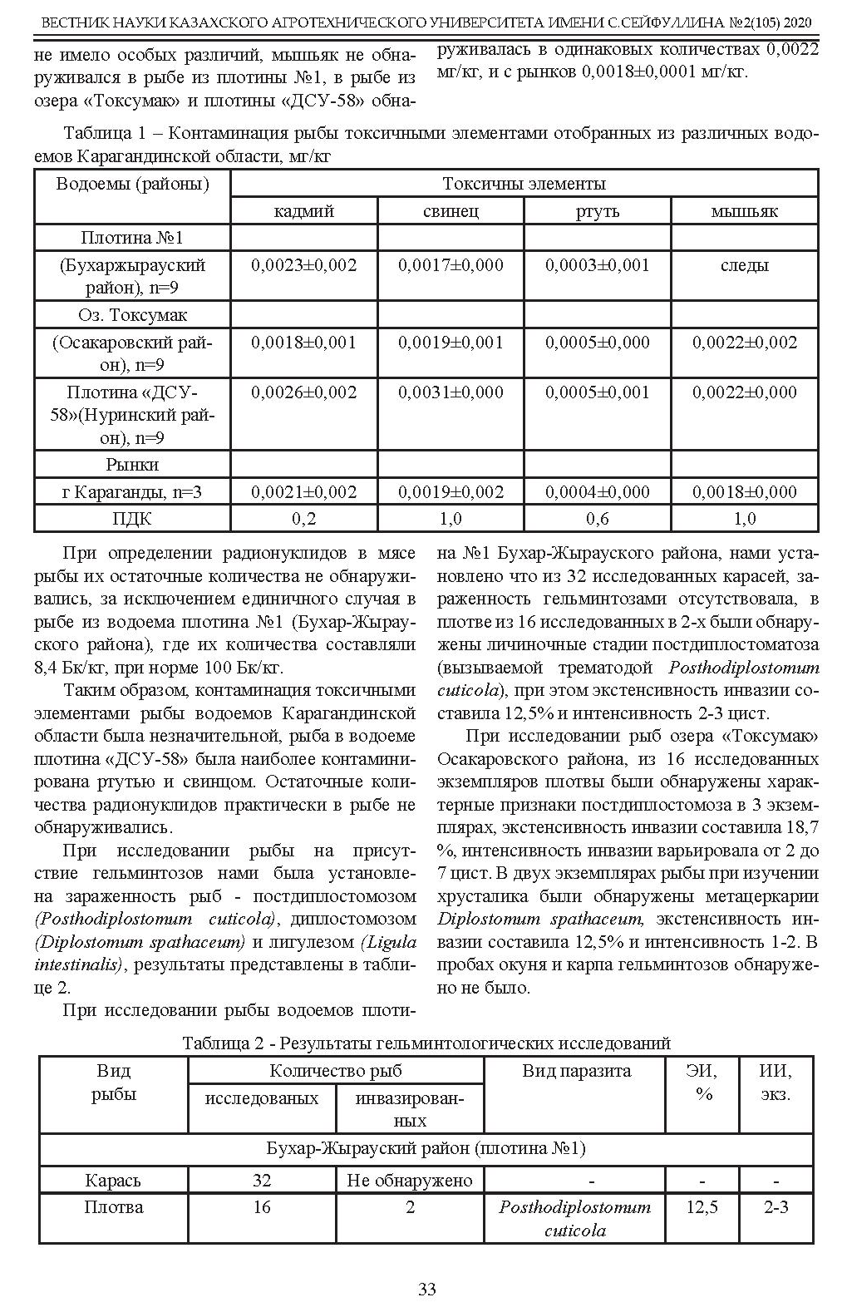

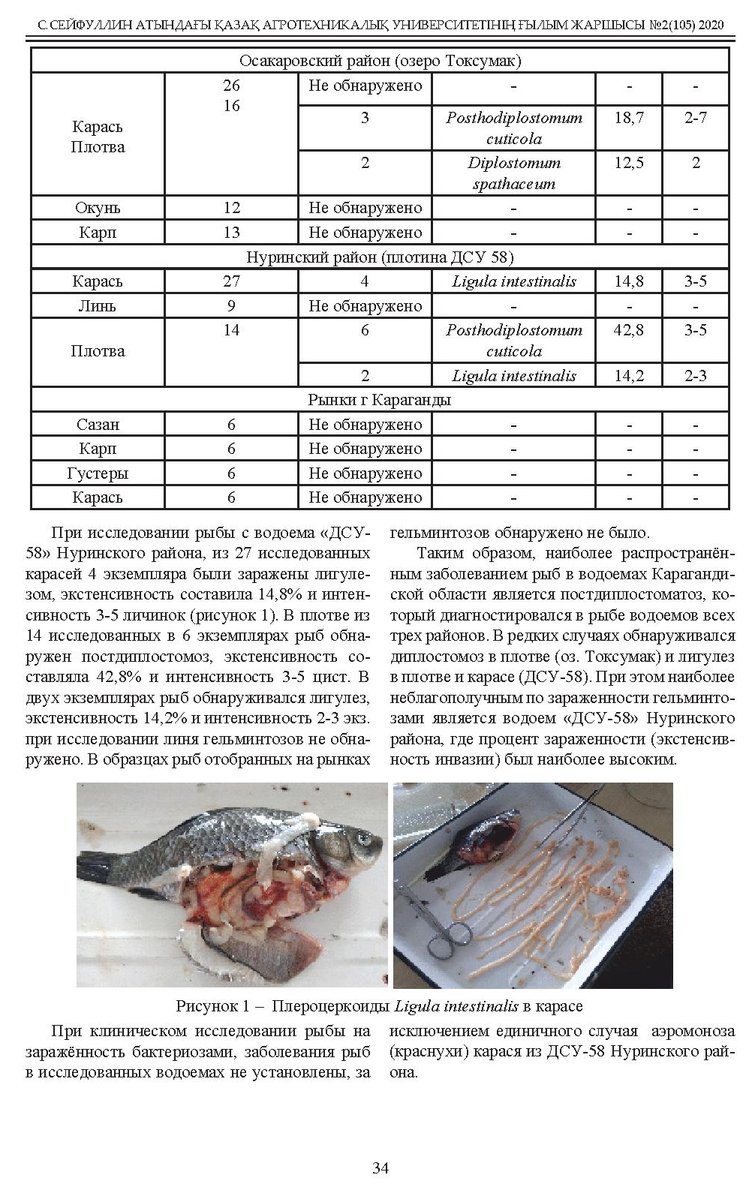

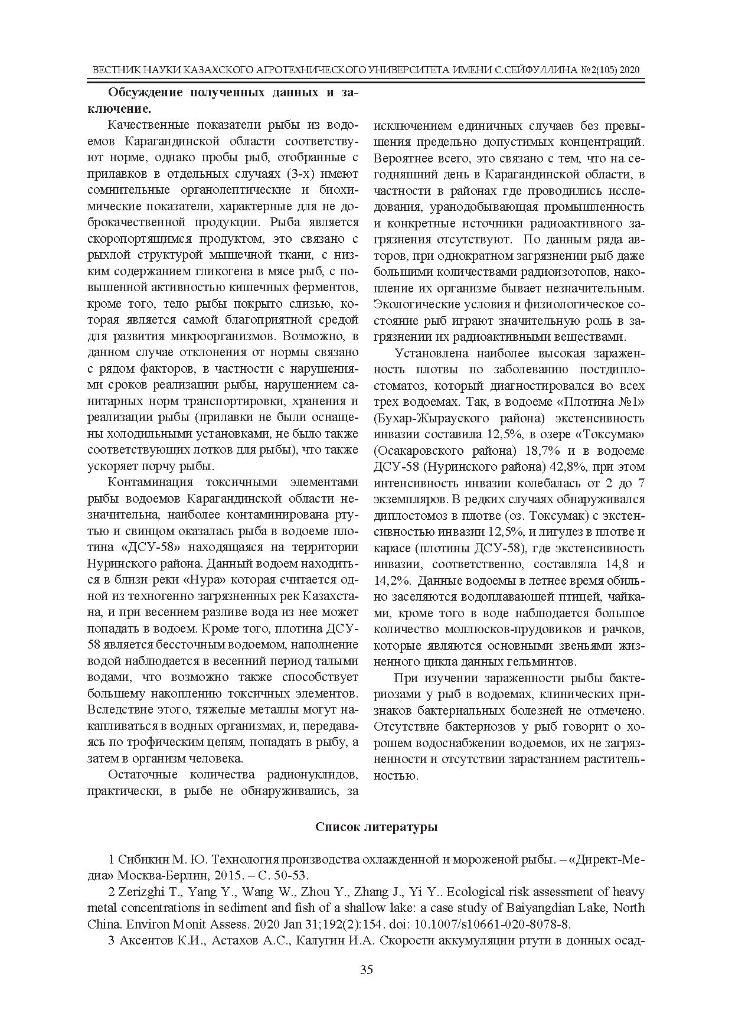

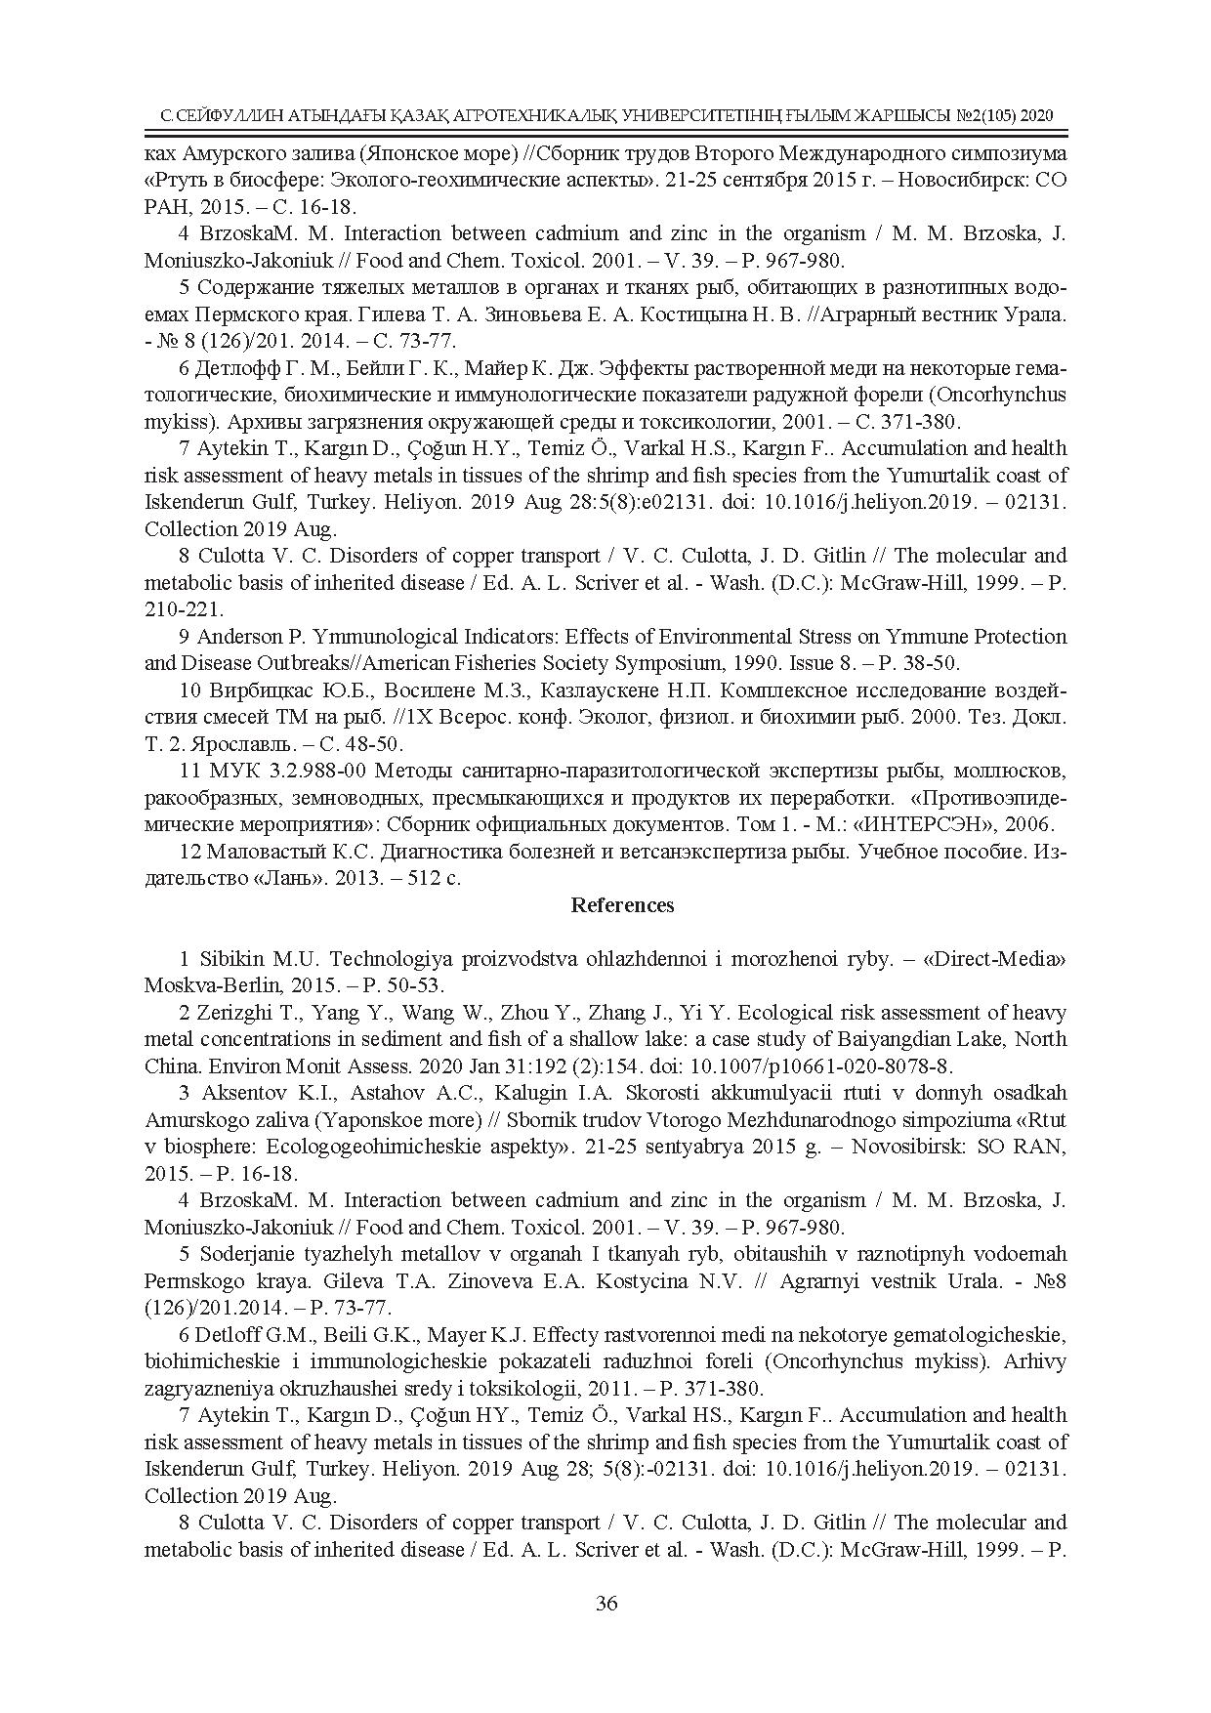

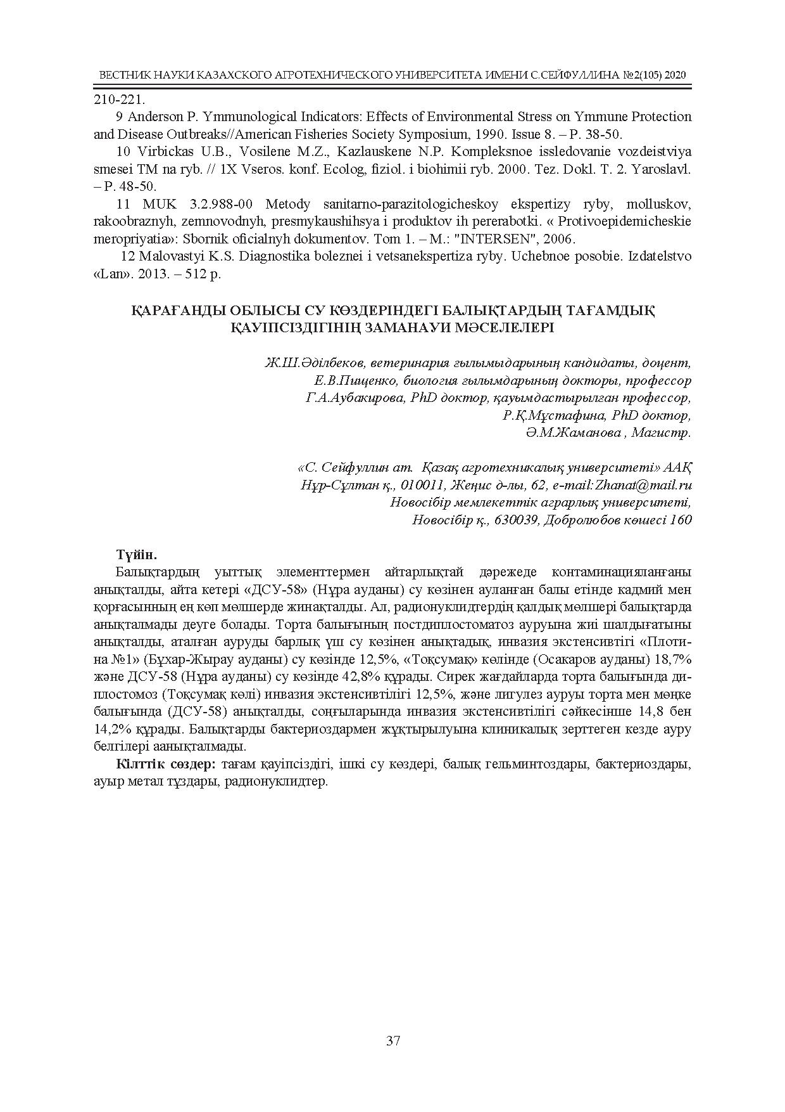

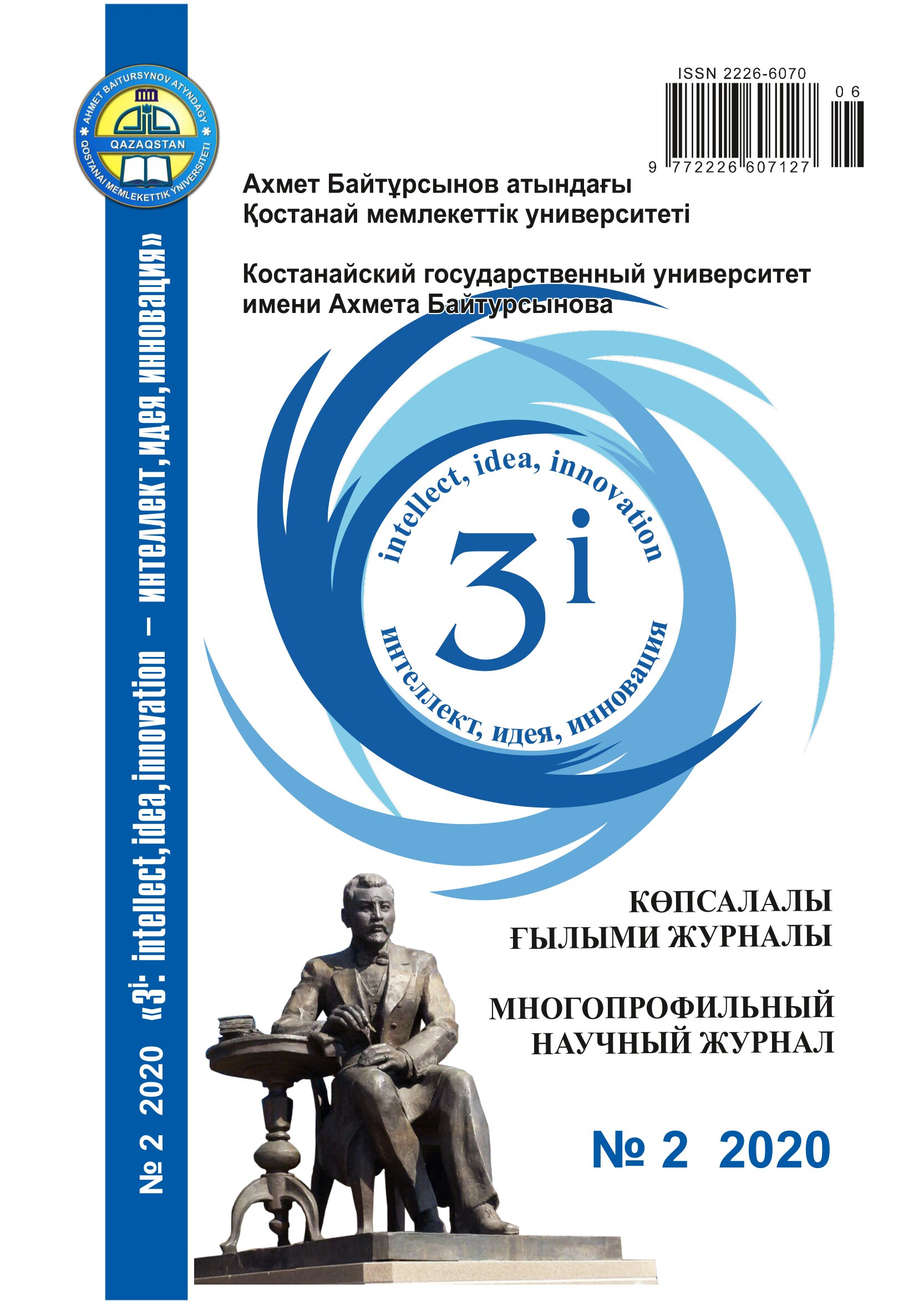

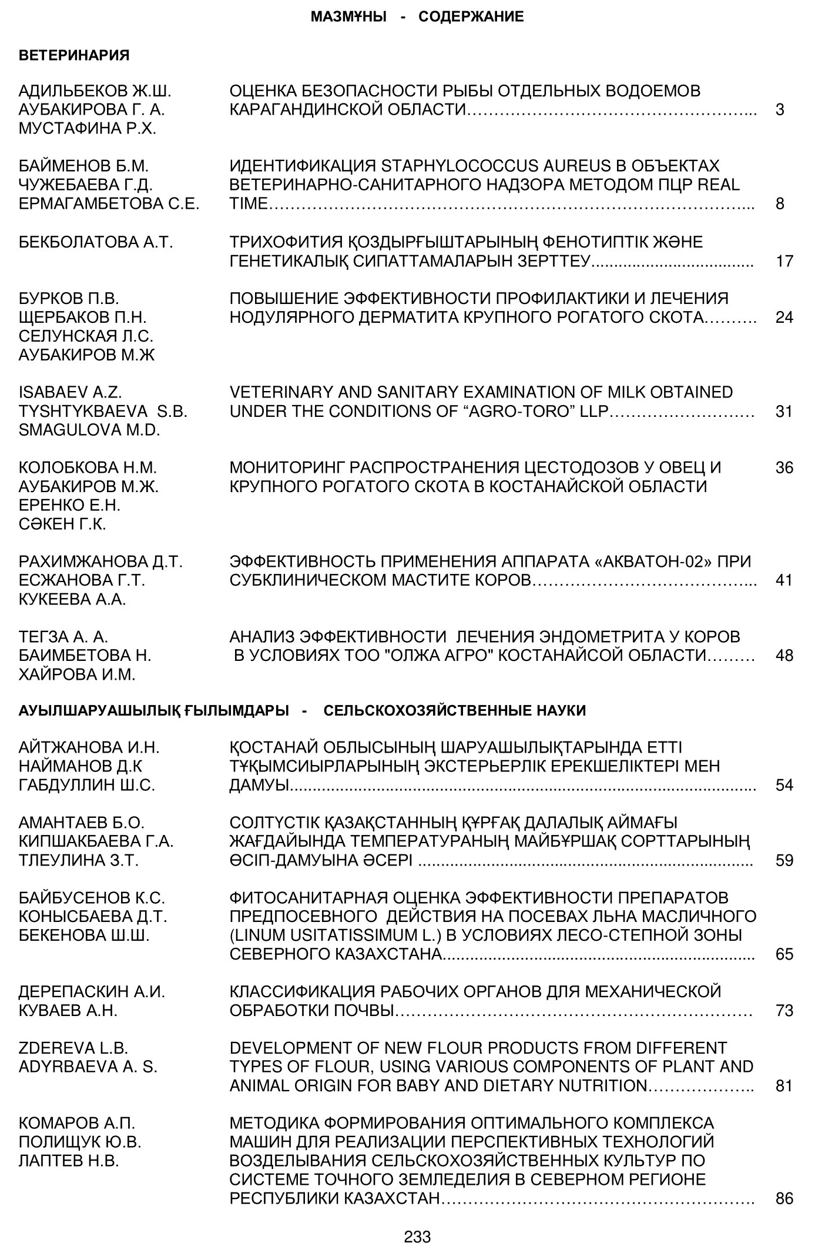

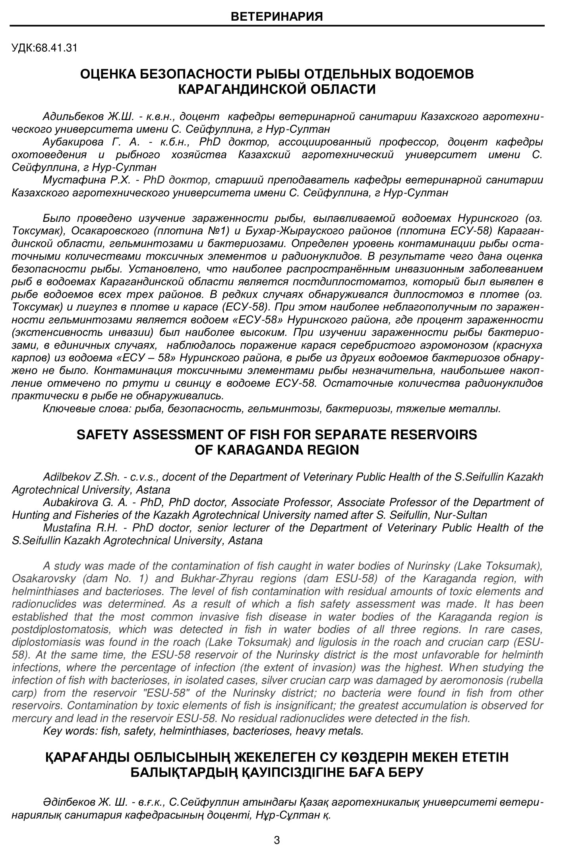

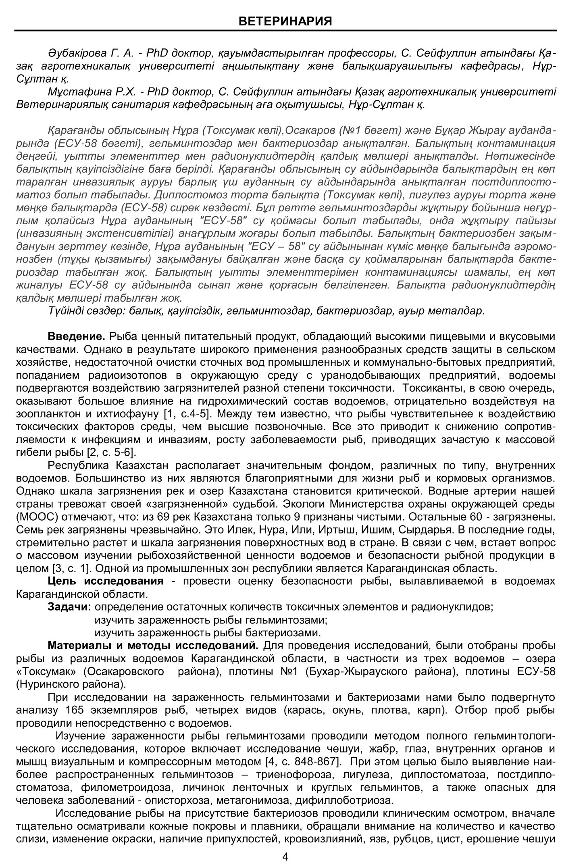

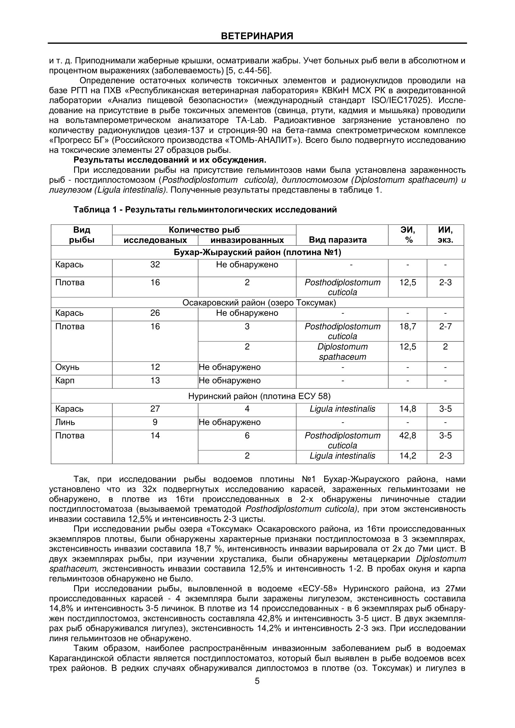

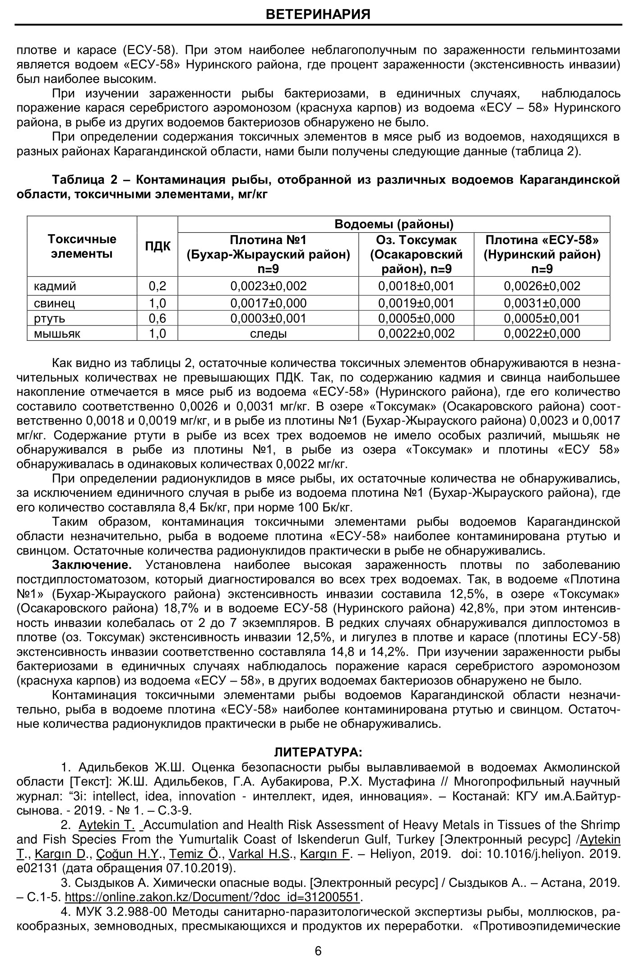

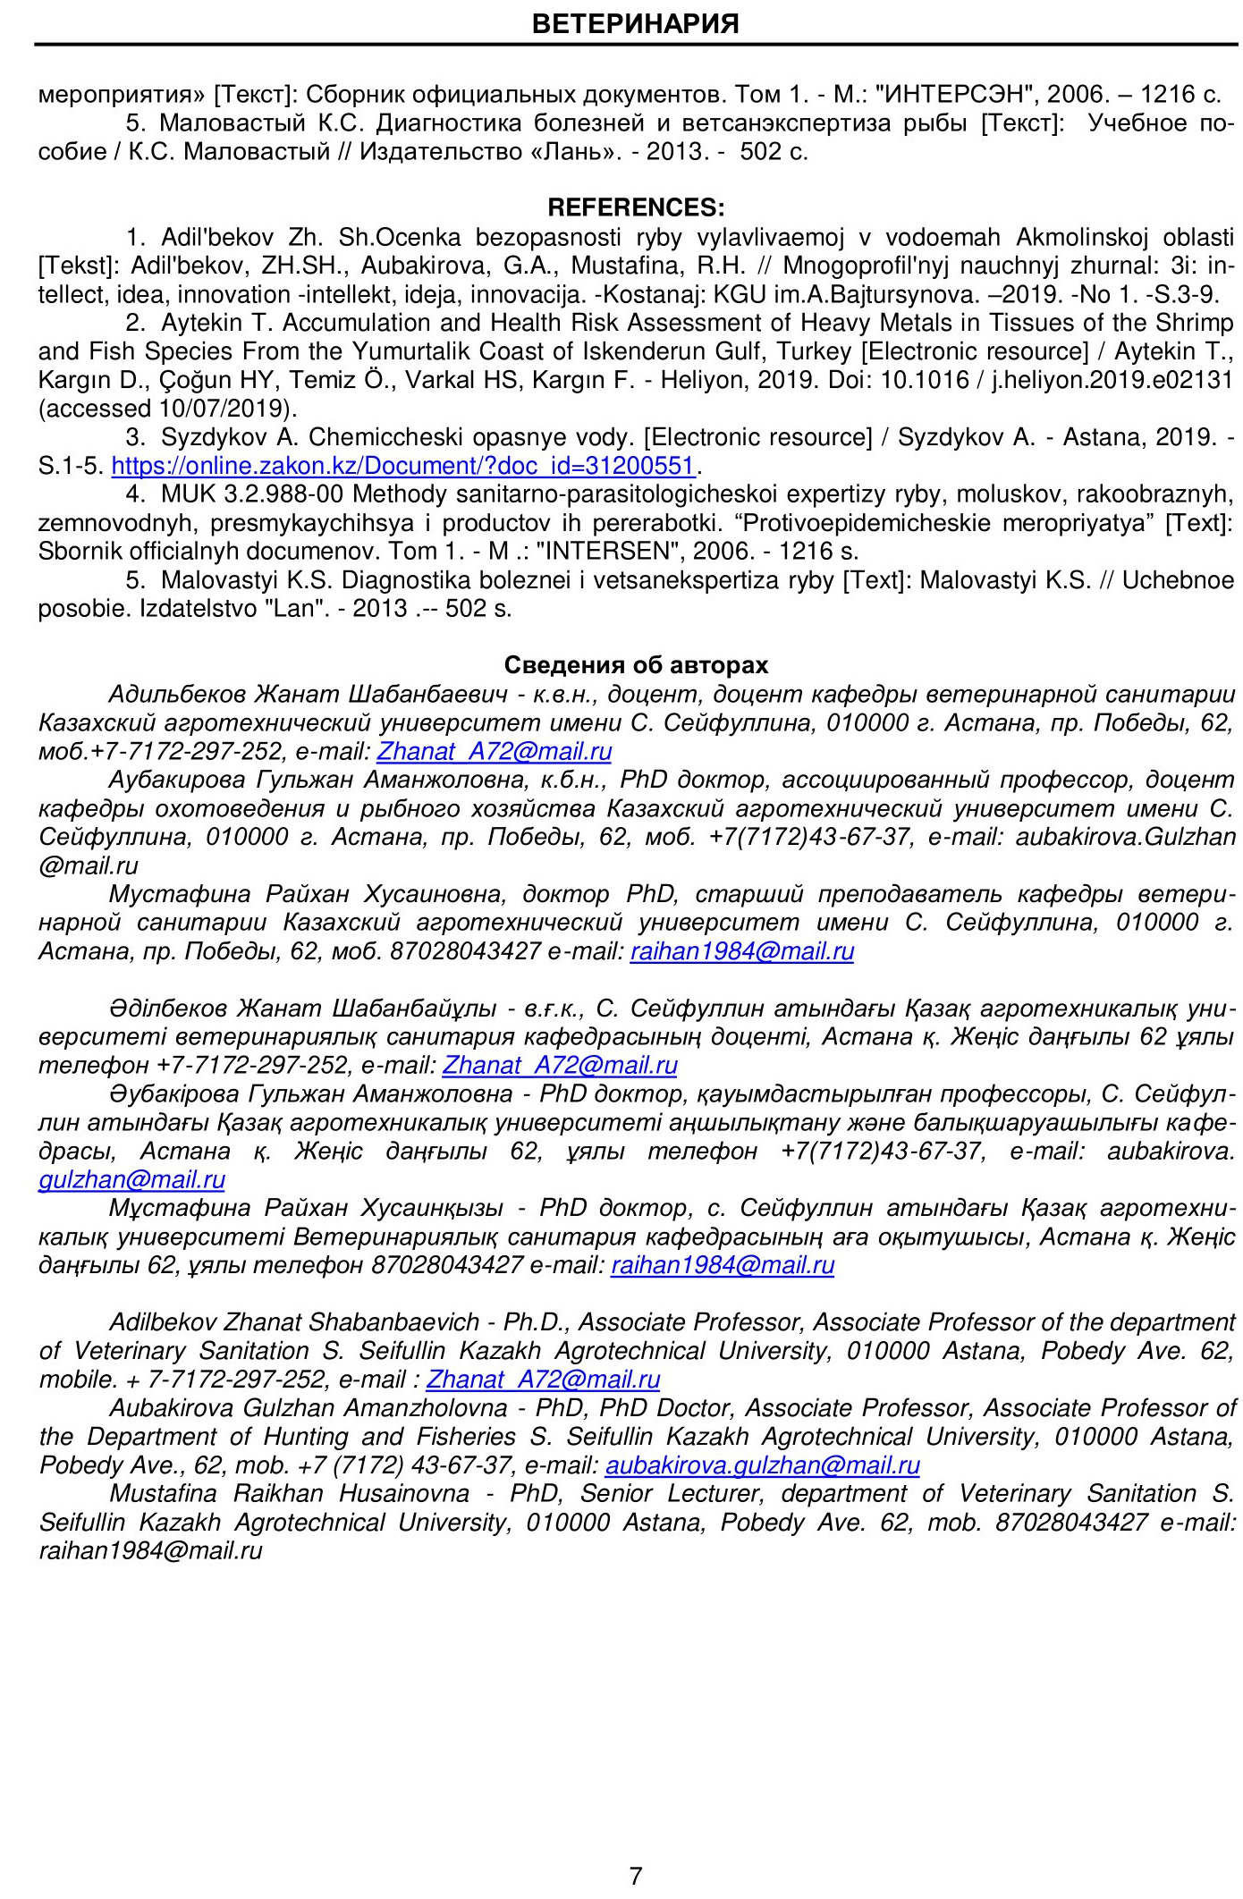

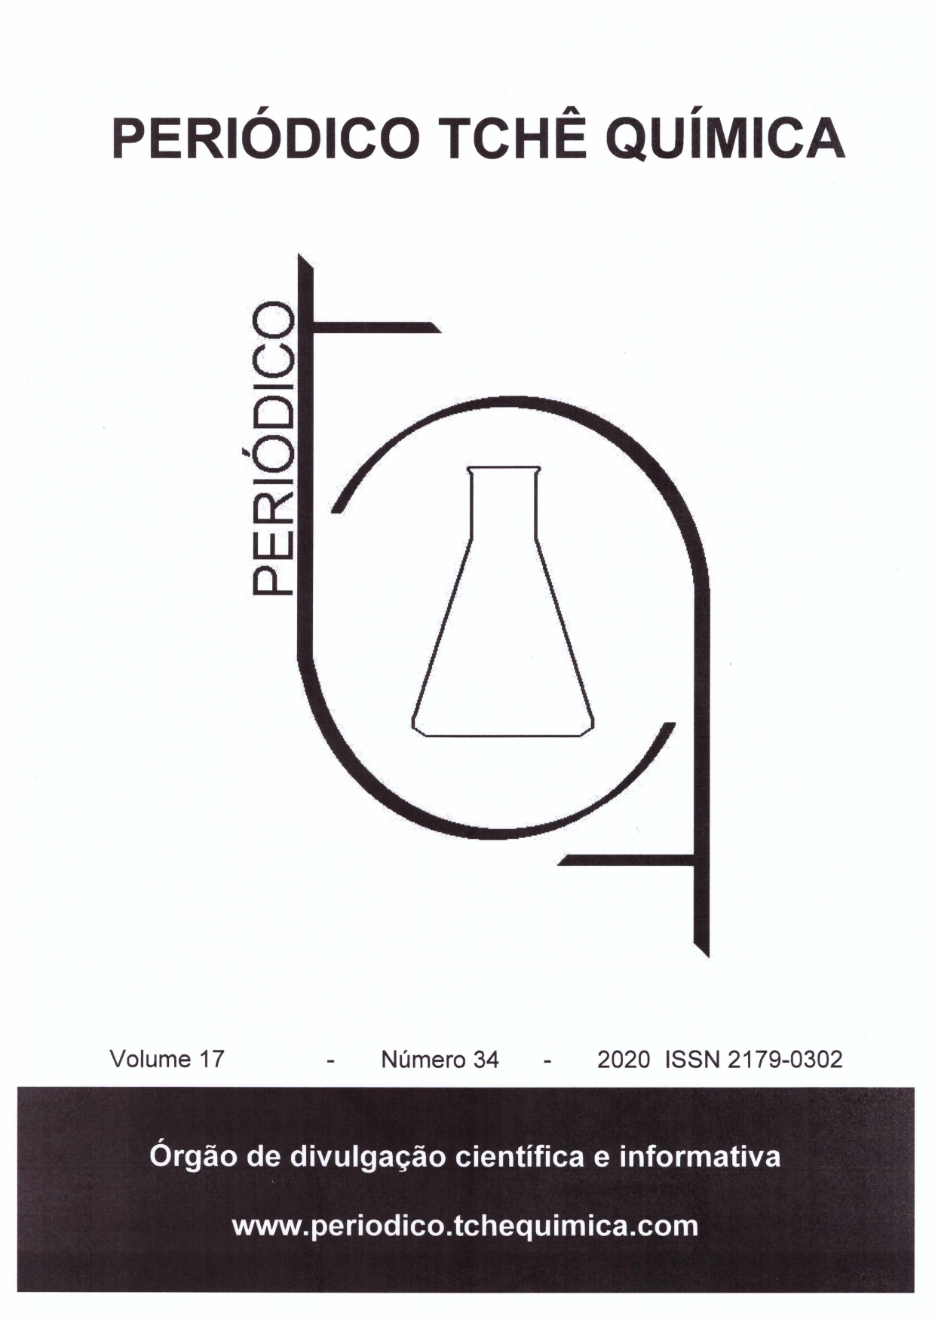

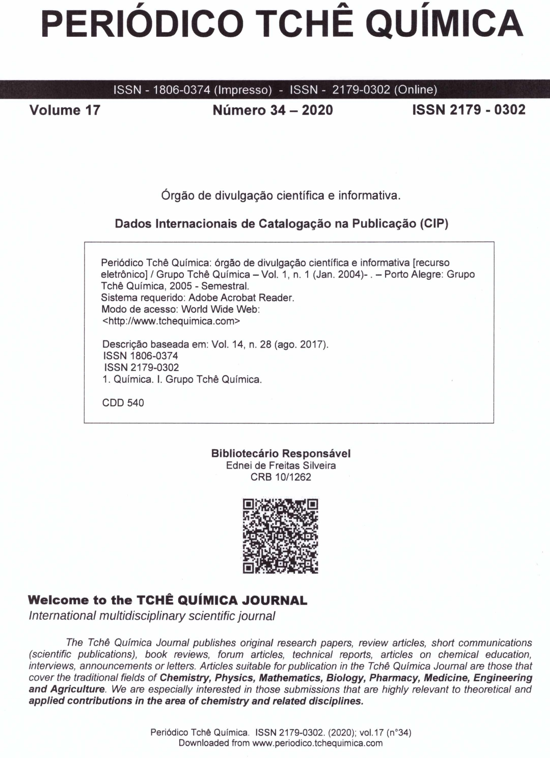
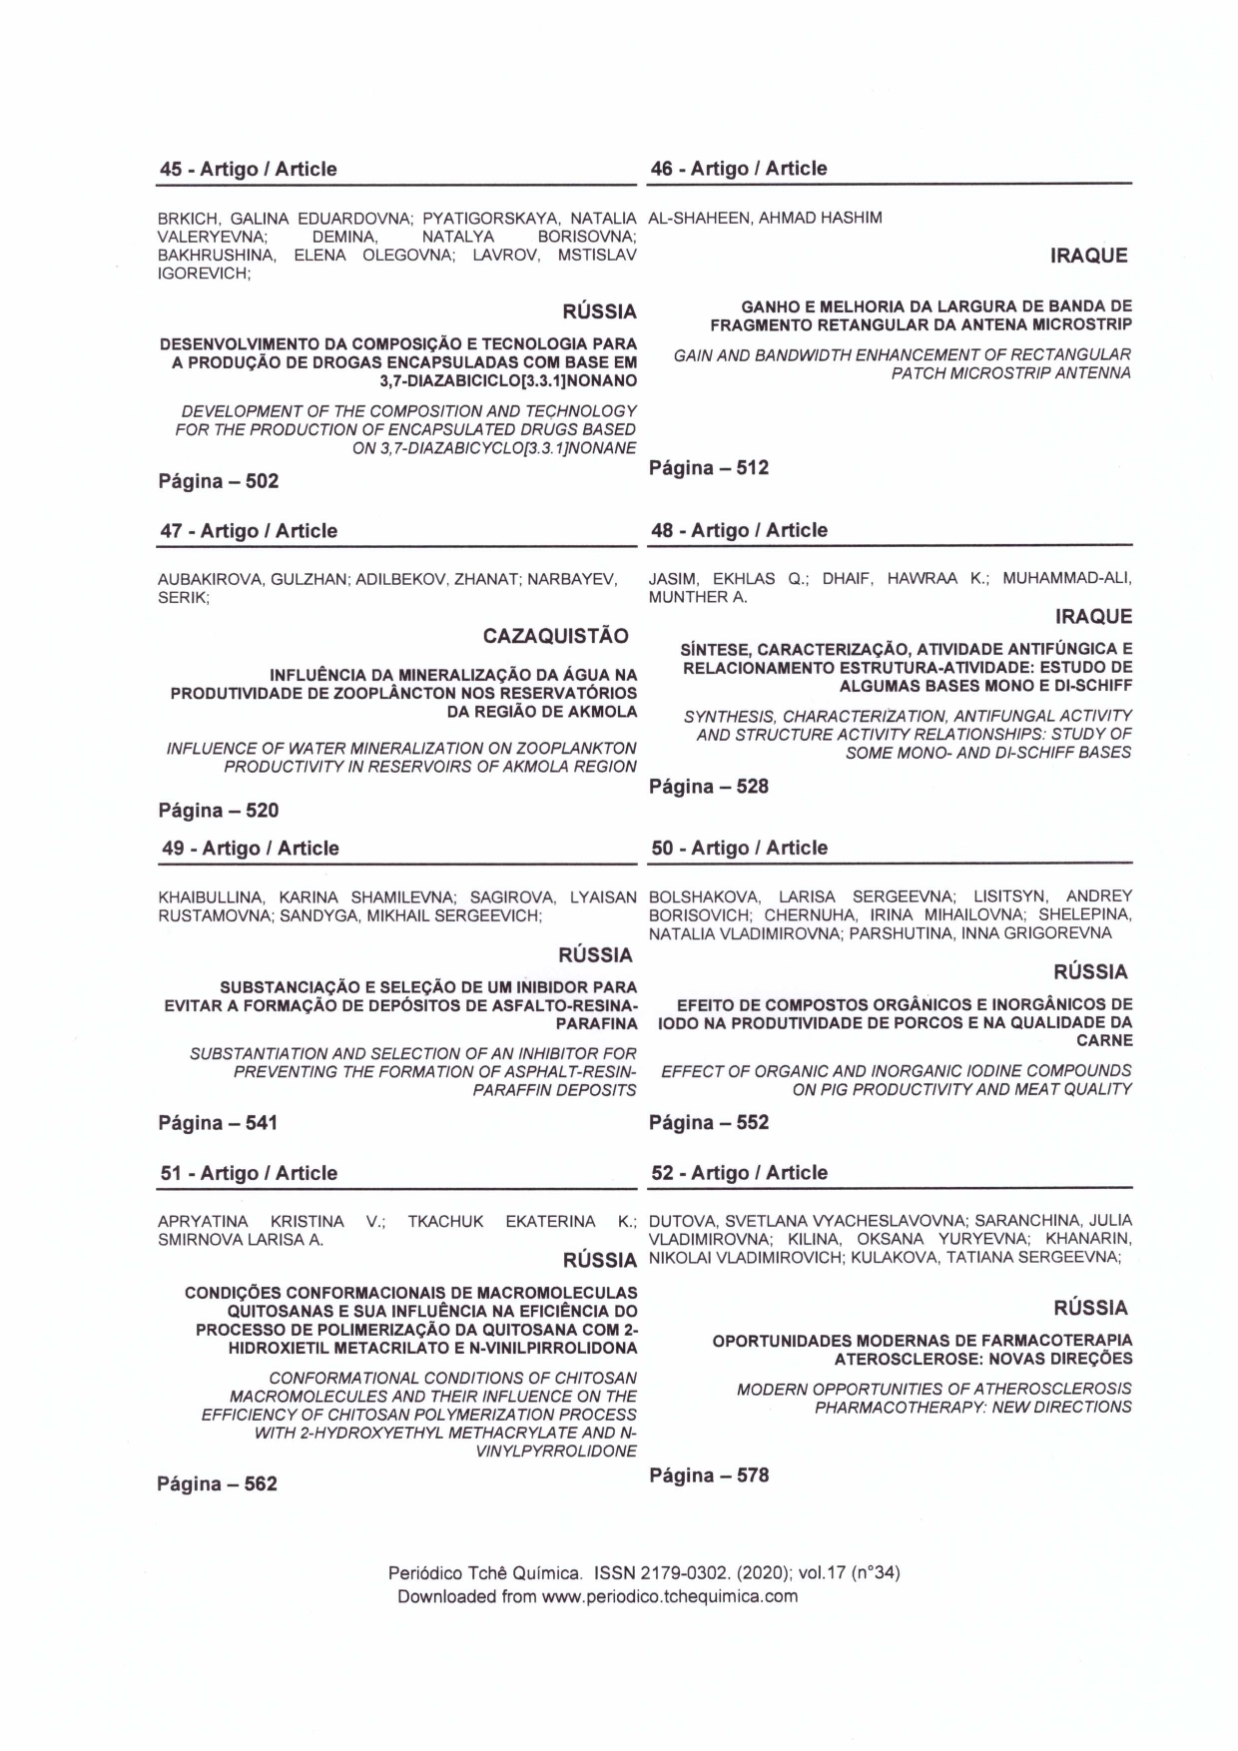
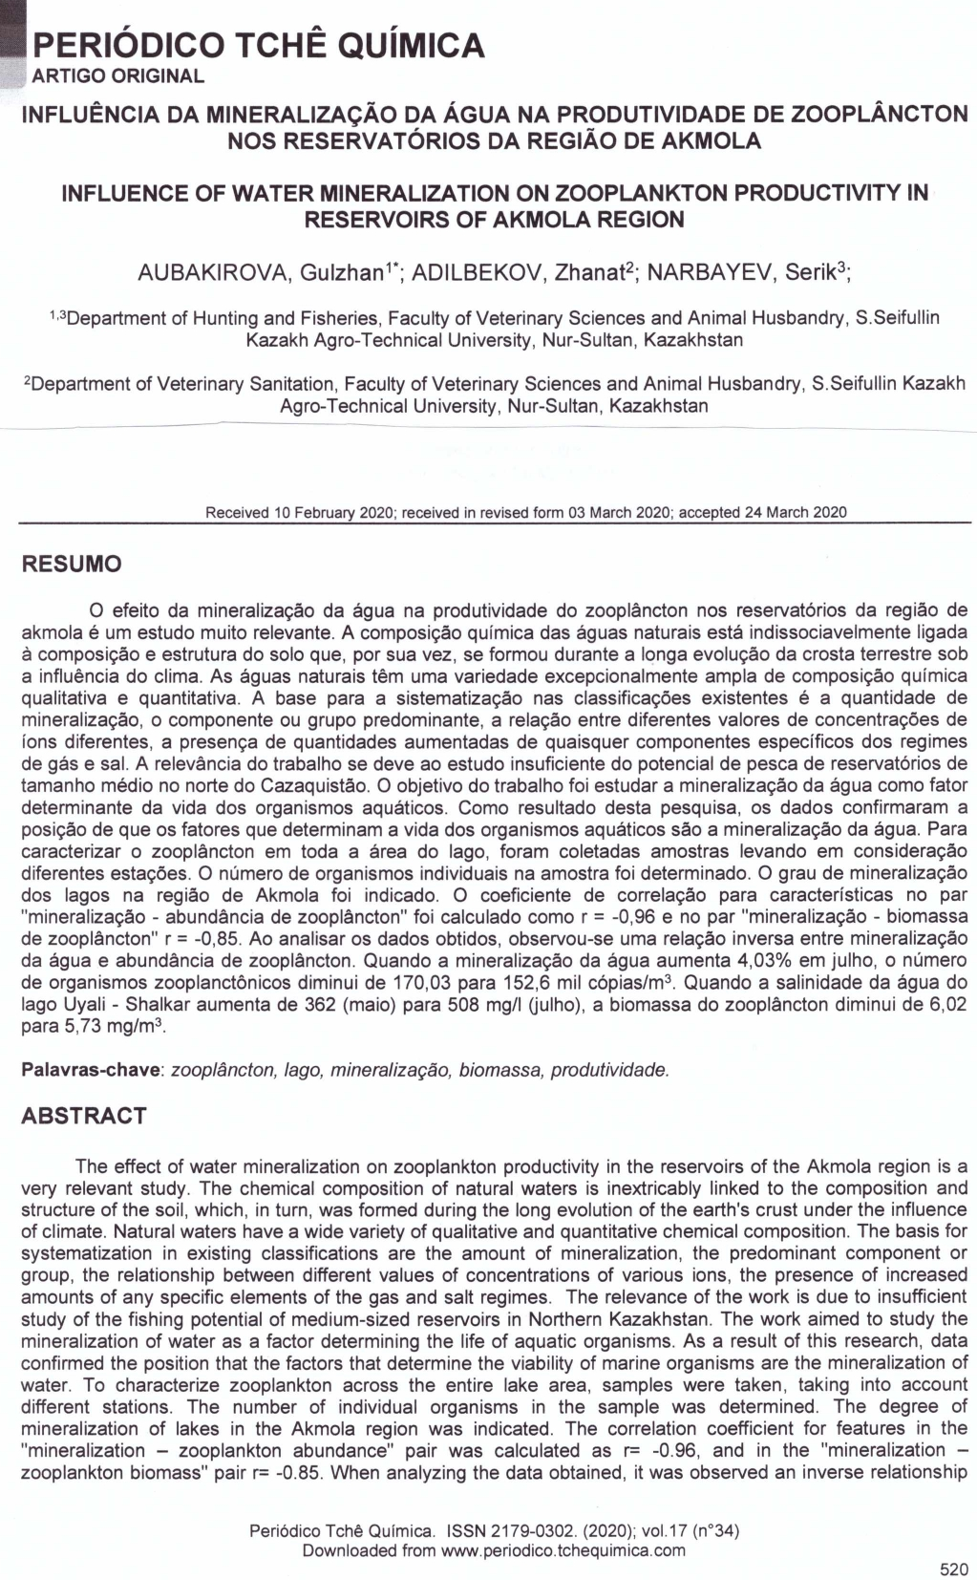
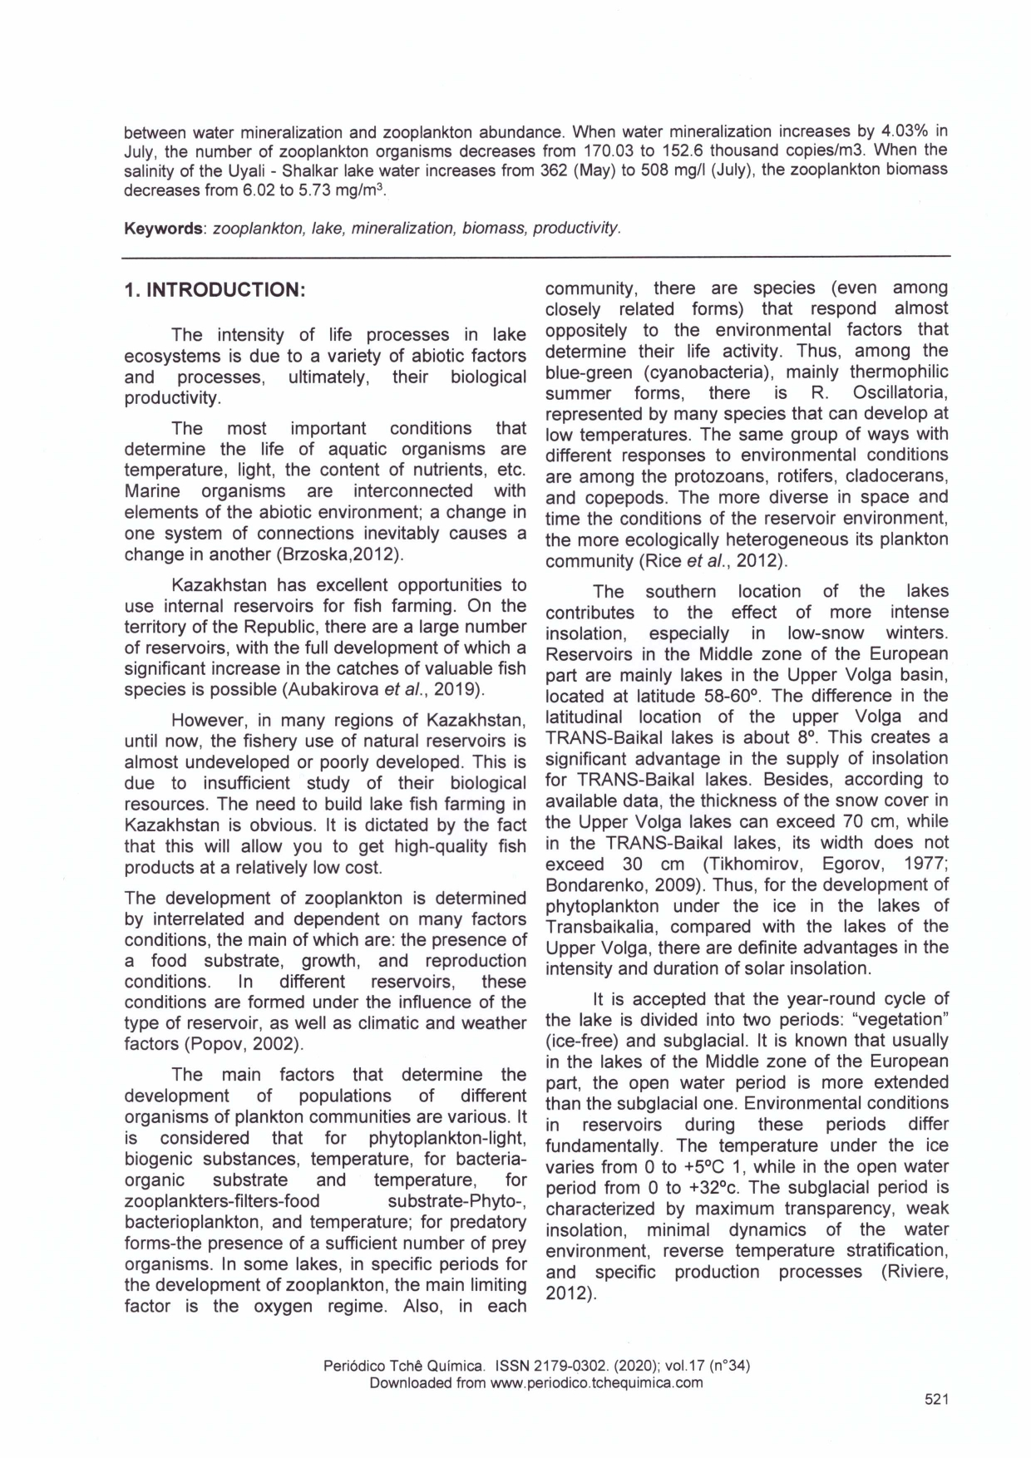

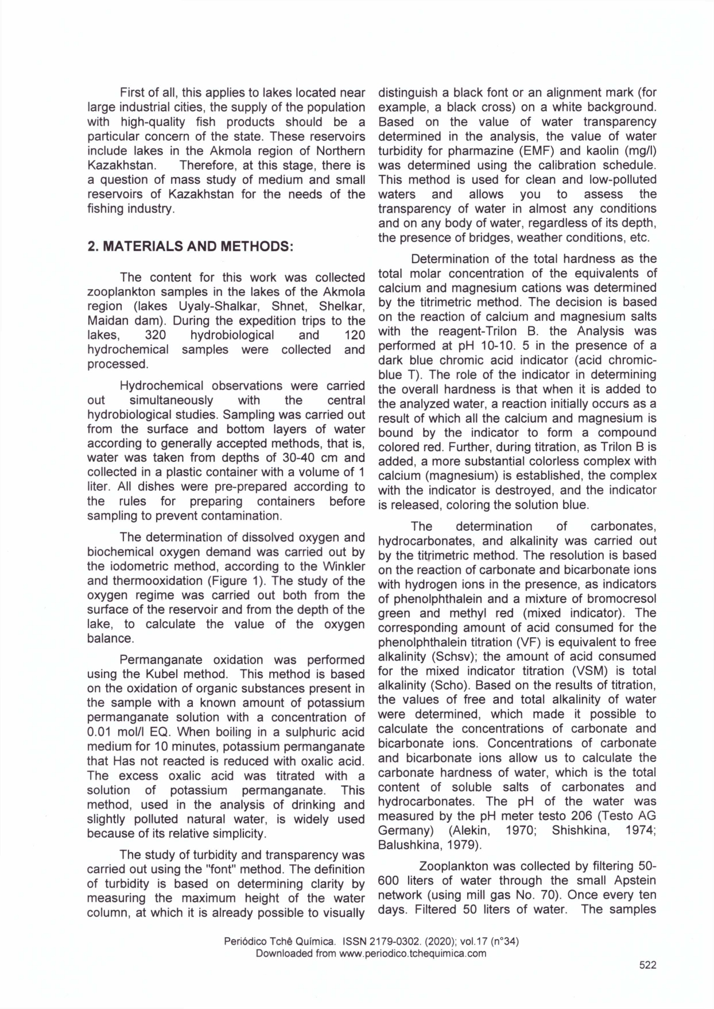

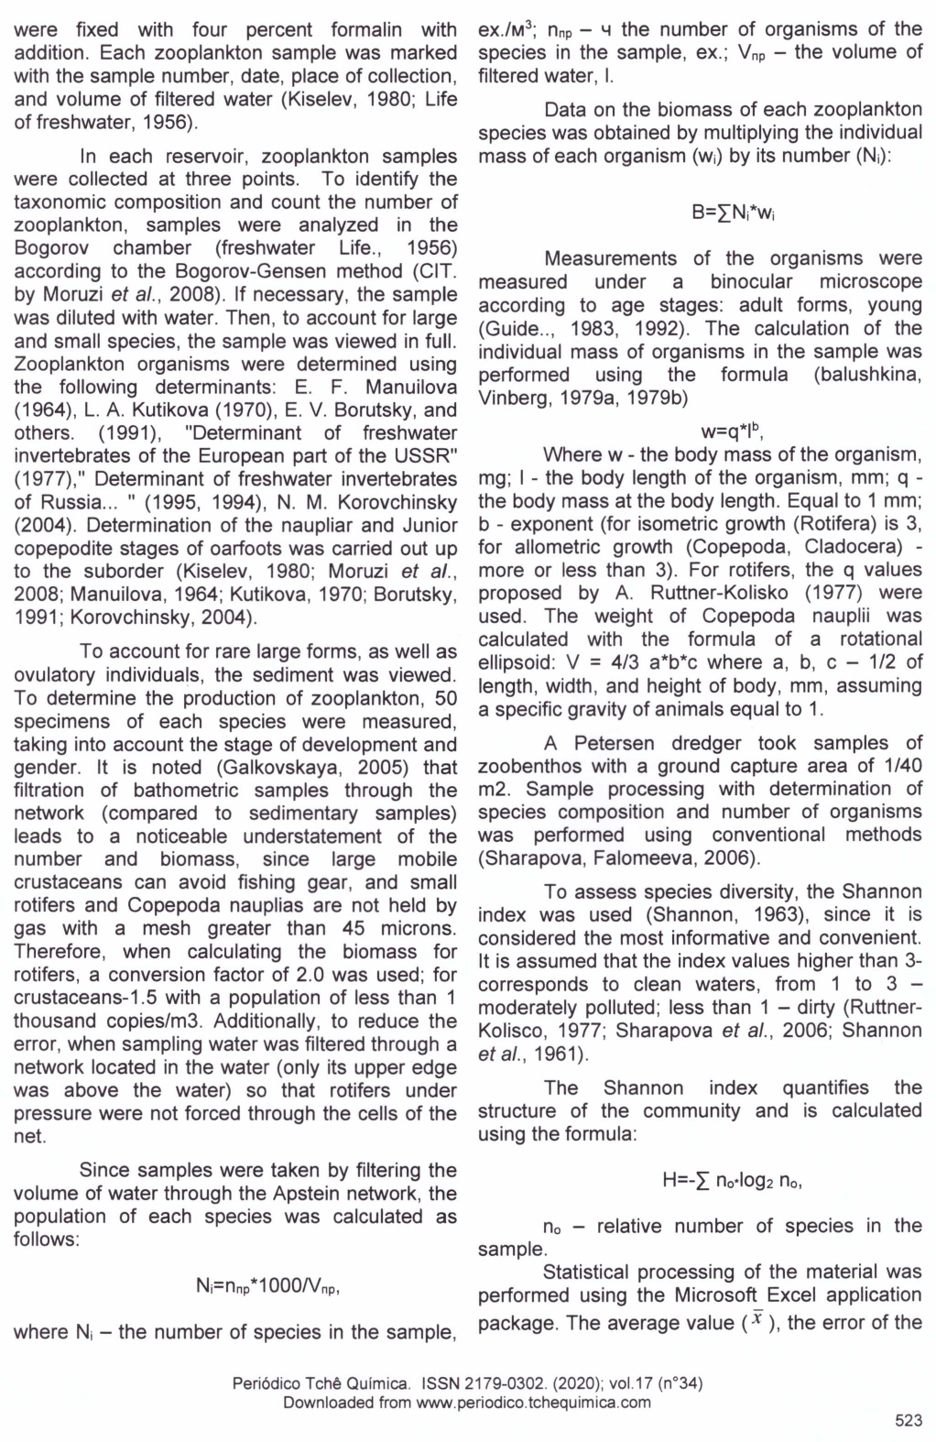

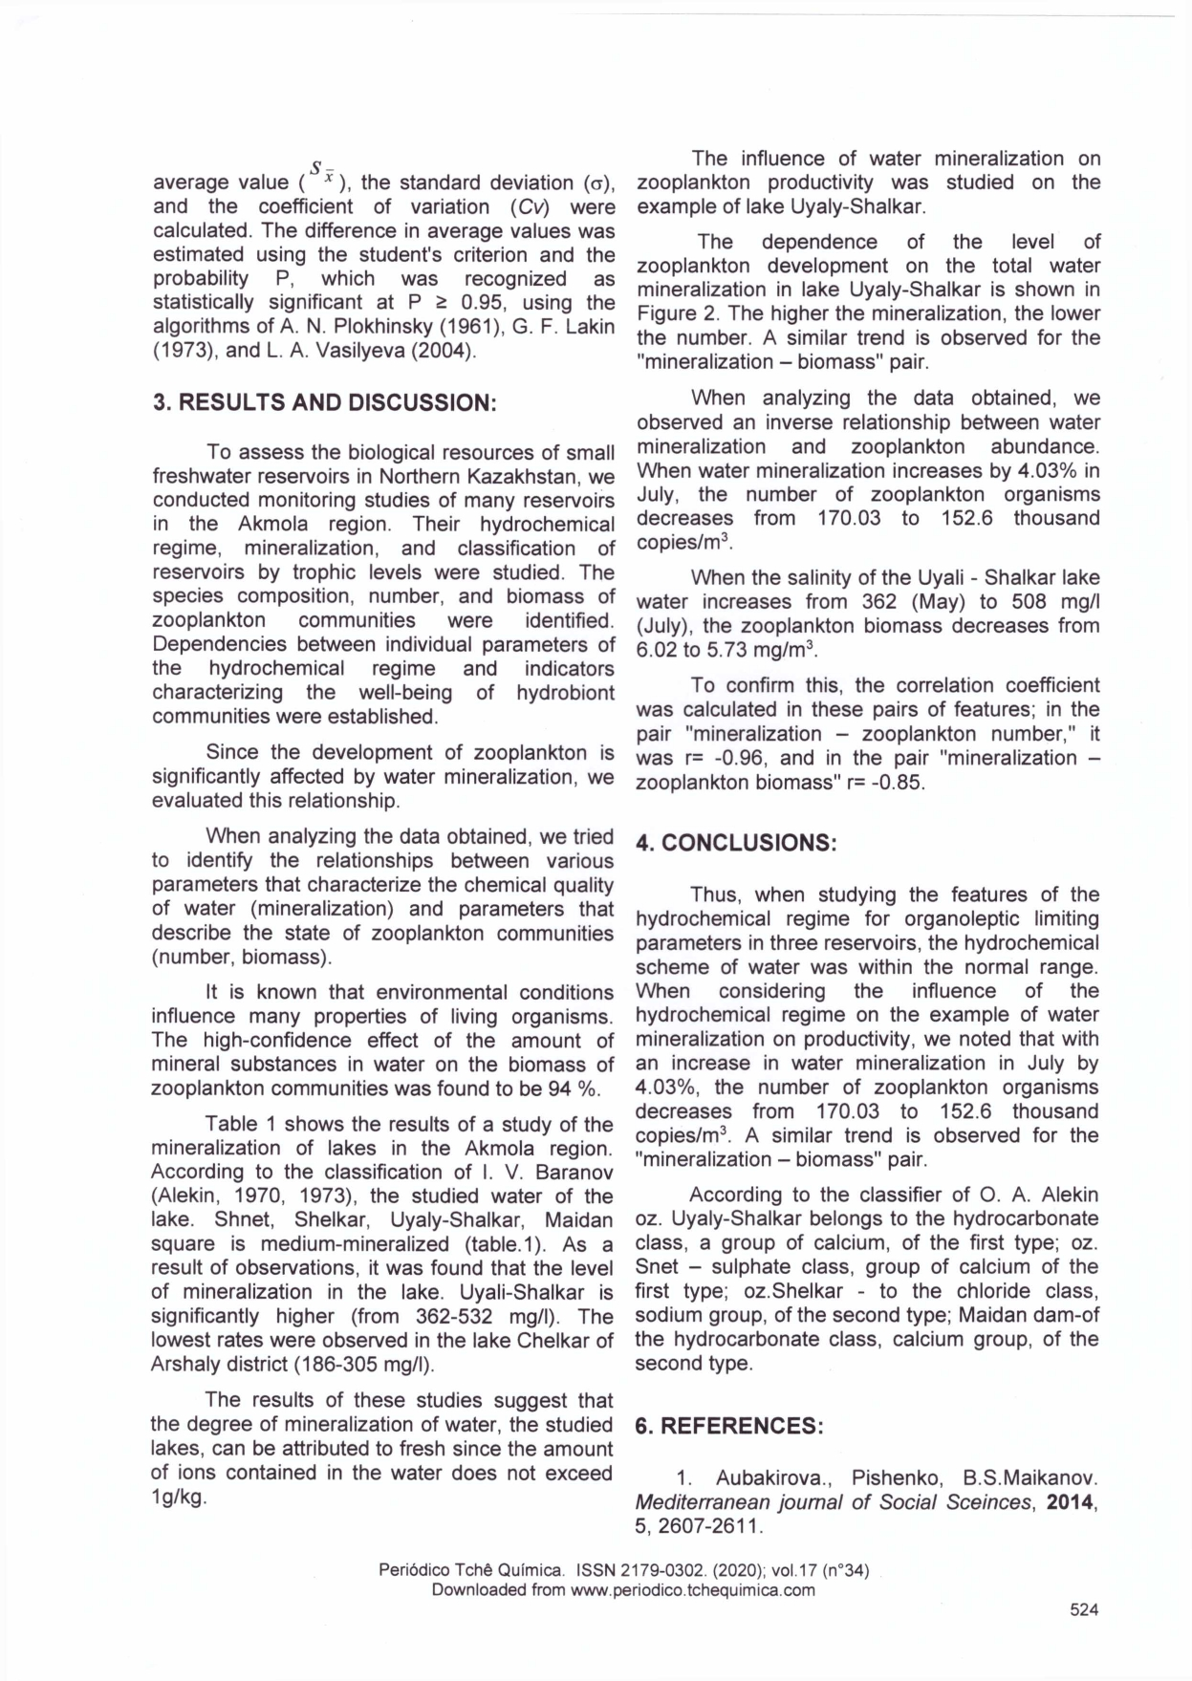

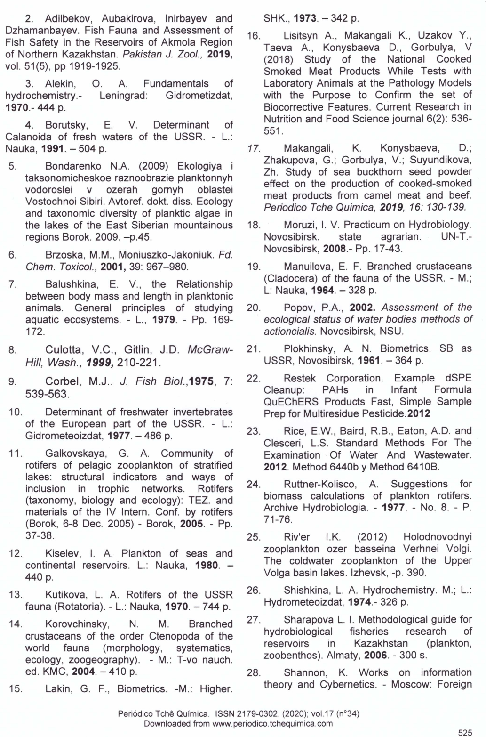

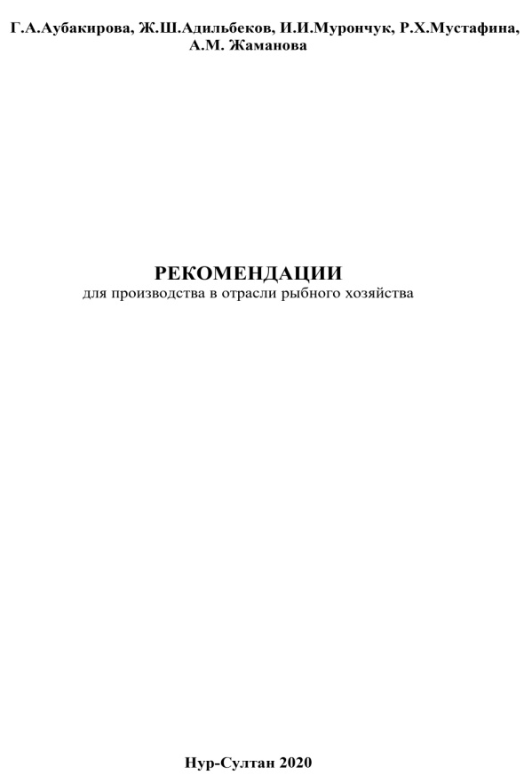 | 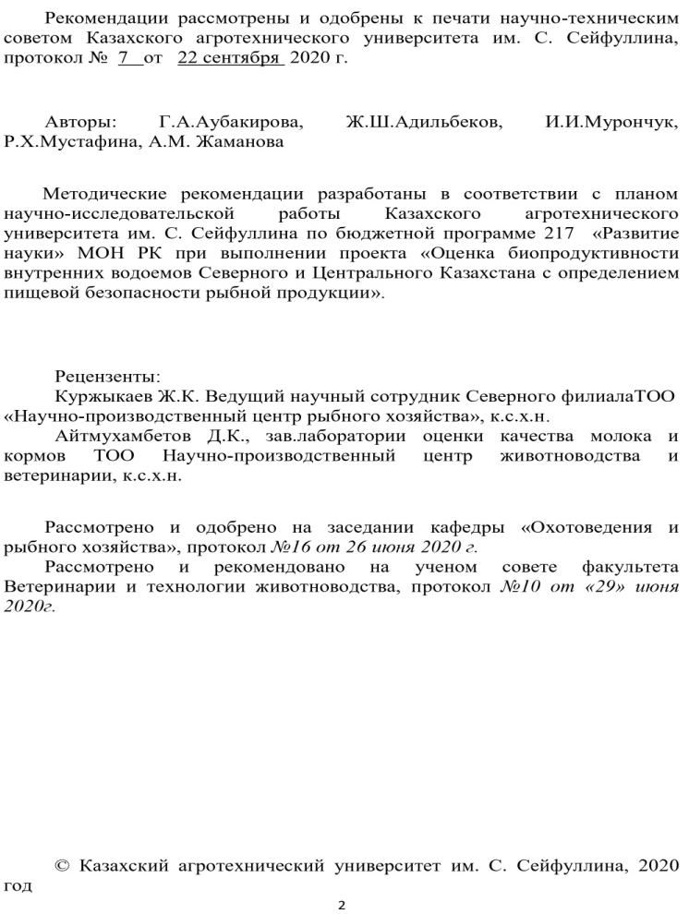
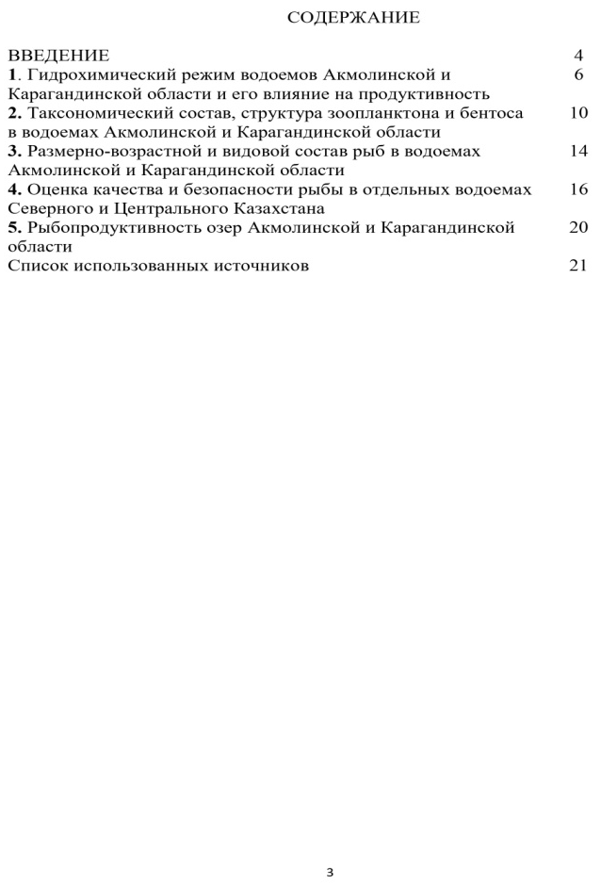 | 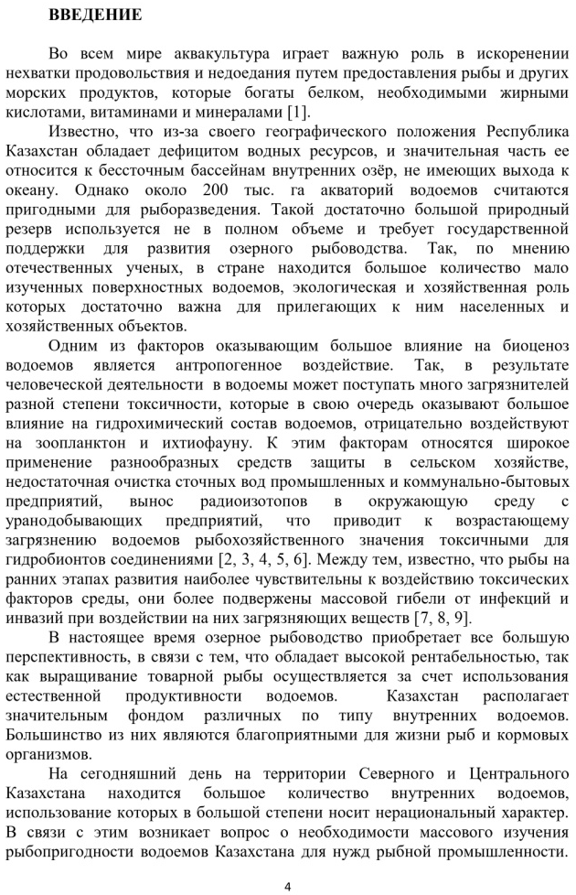

 | 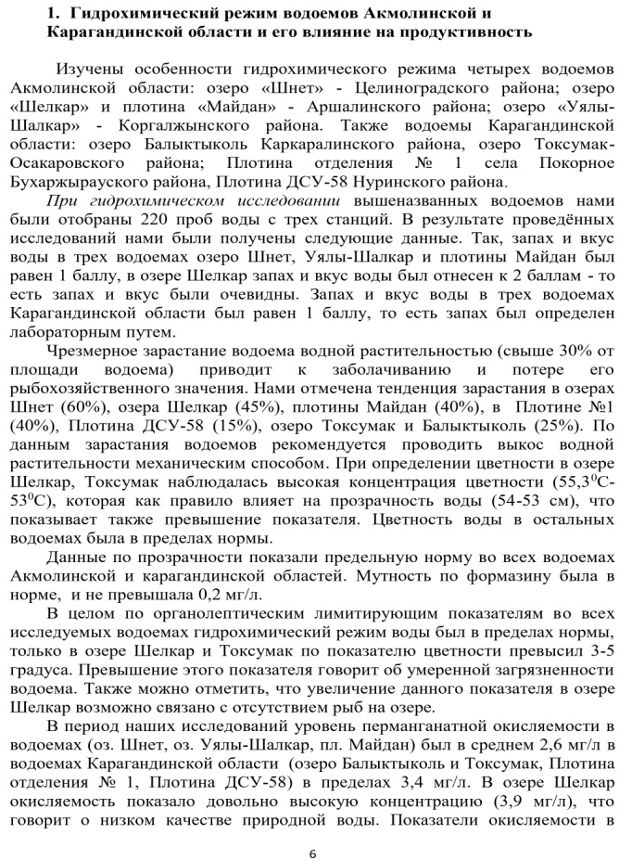
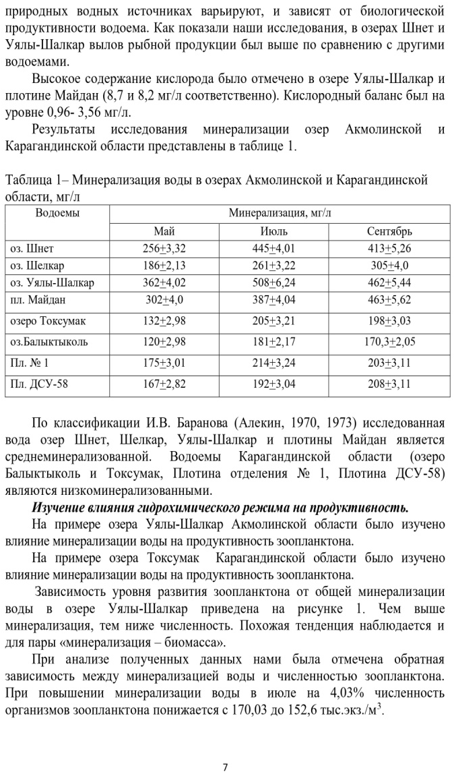 | 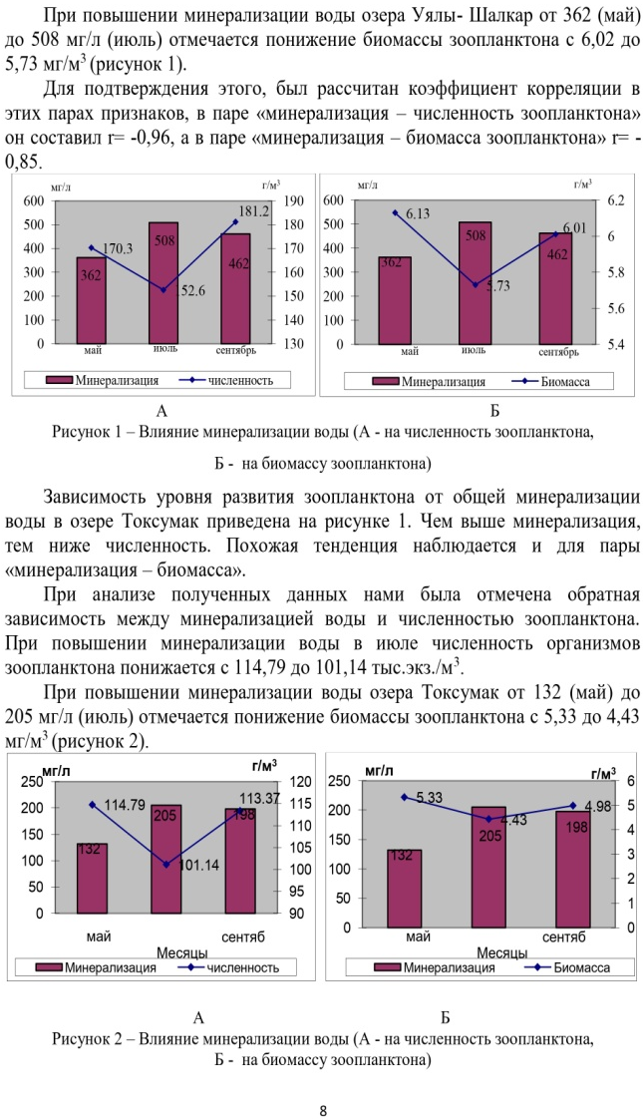

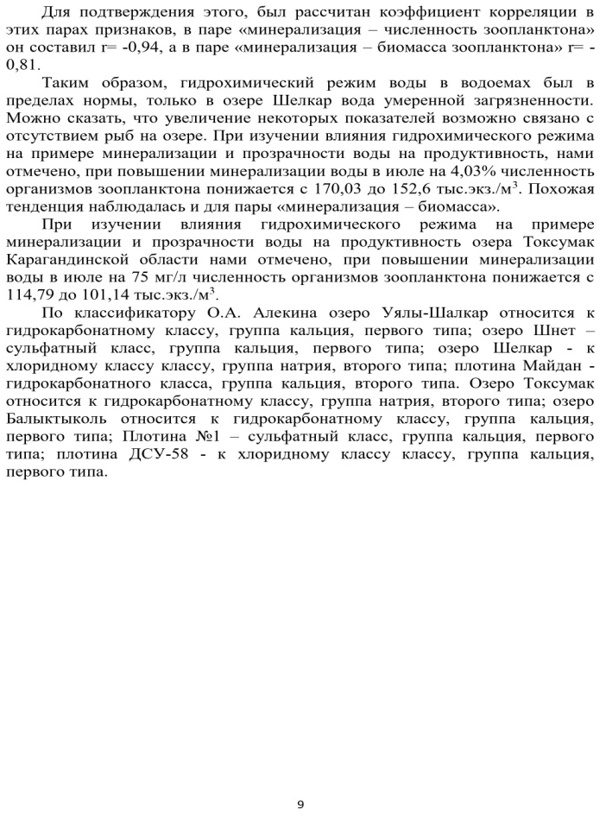 | 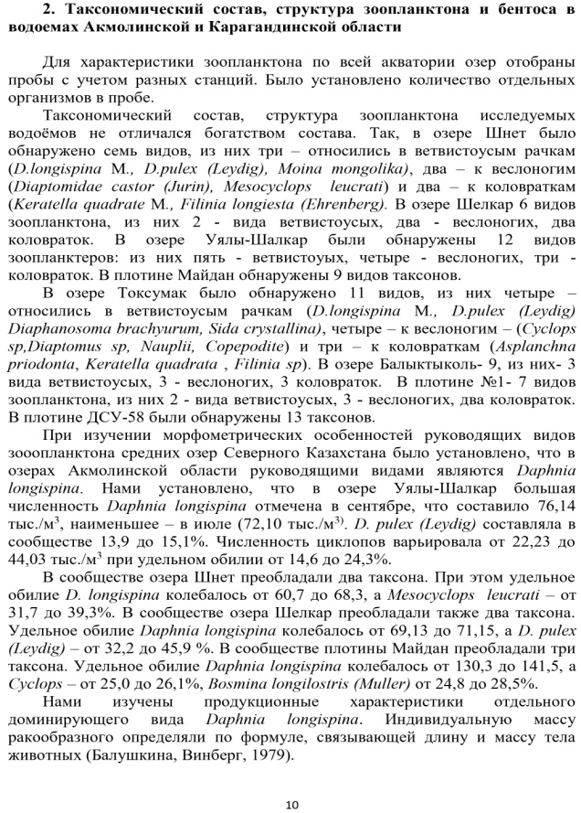
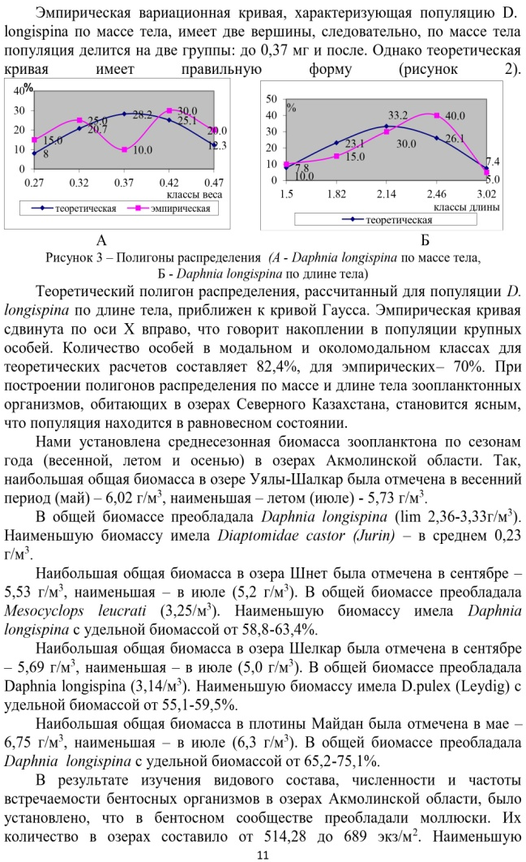 | 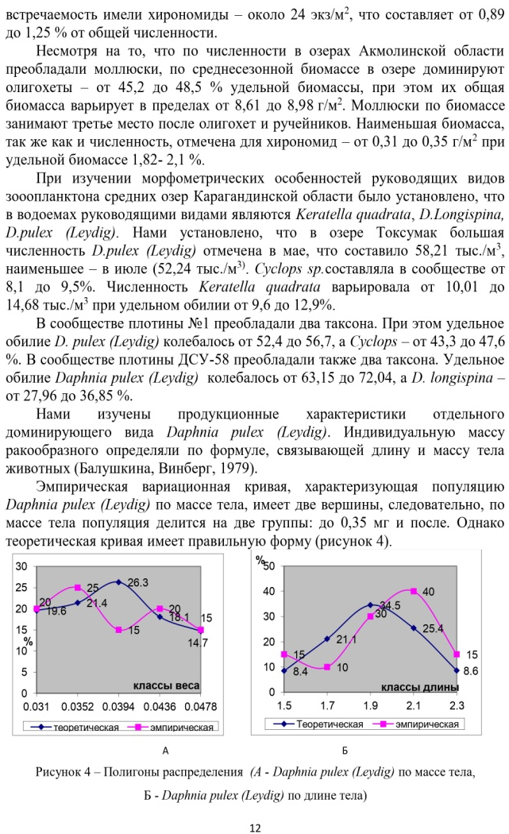

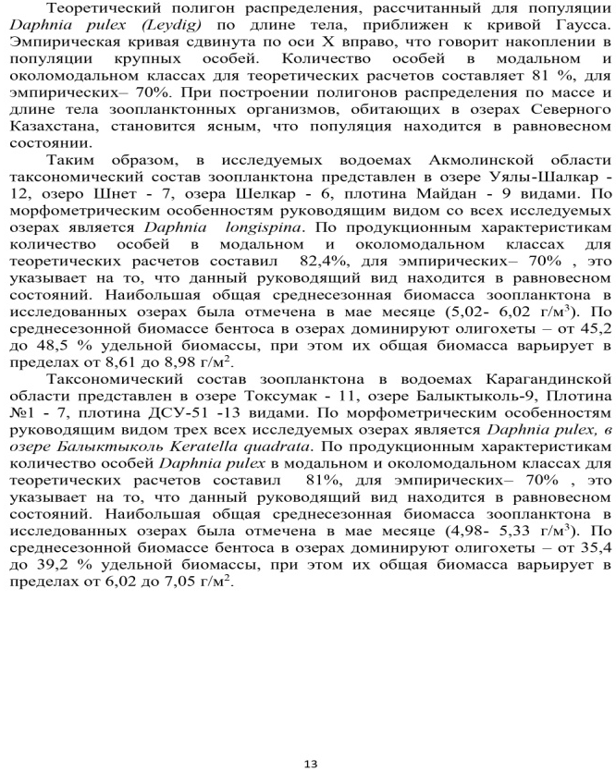 | 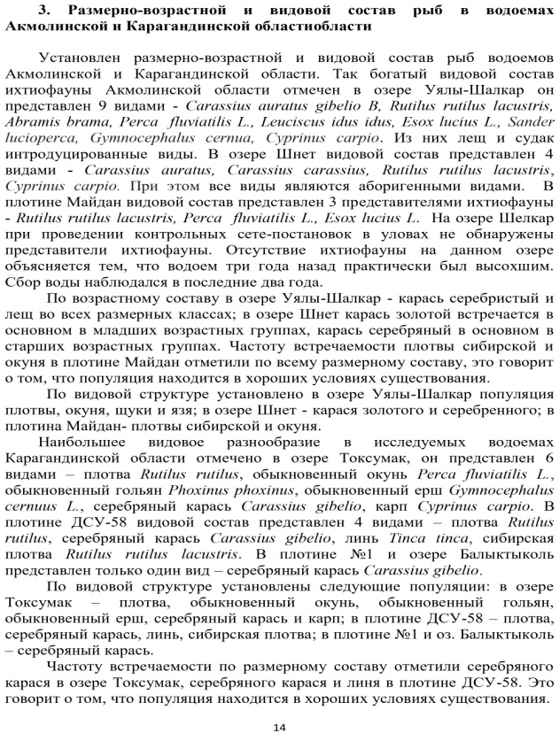
 | 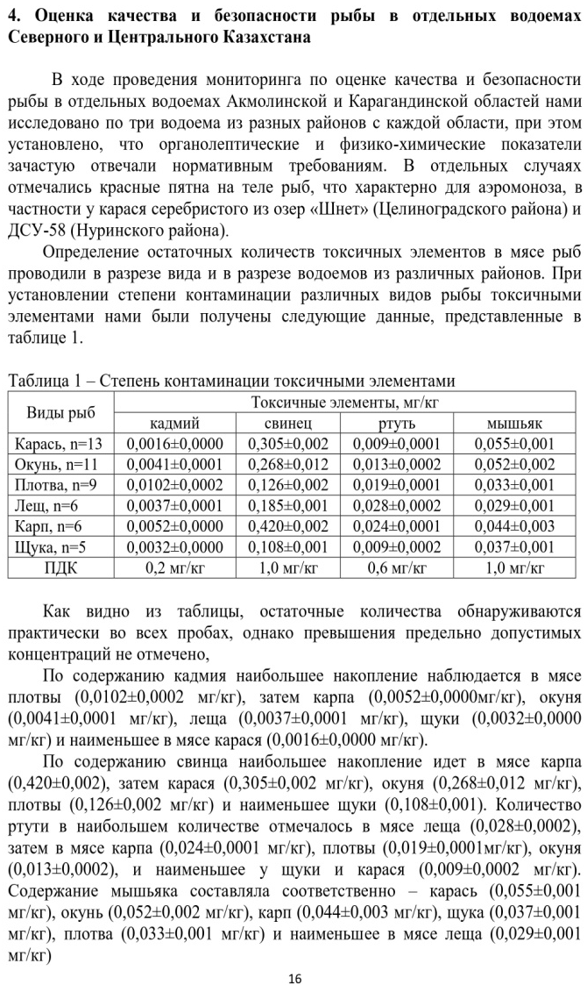

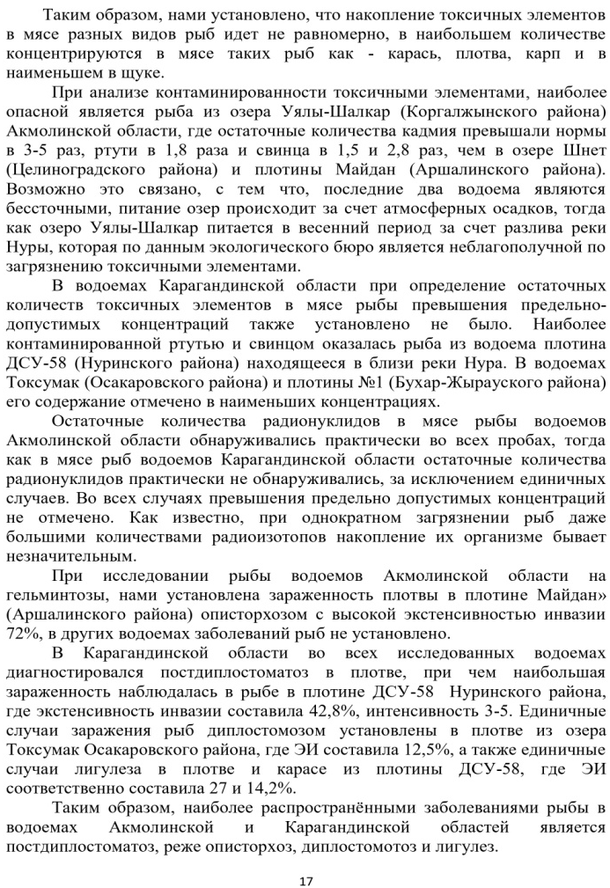 | 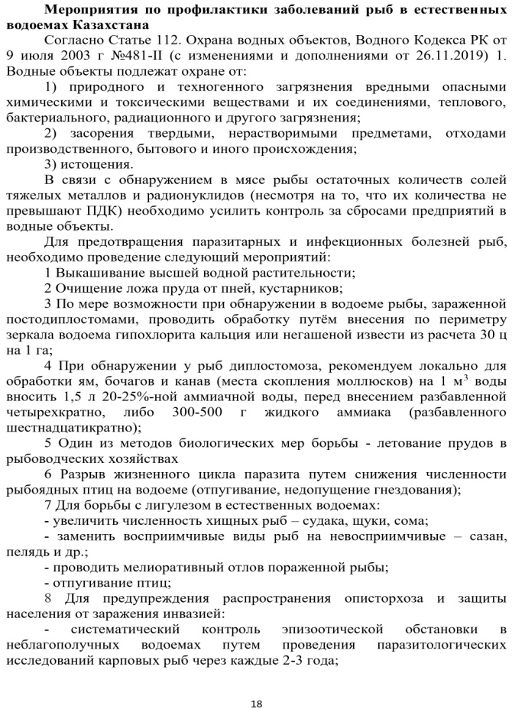
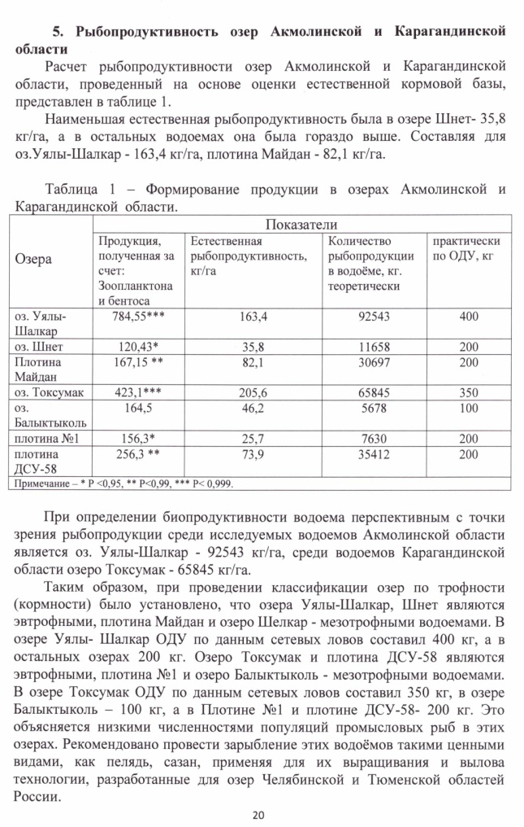 | 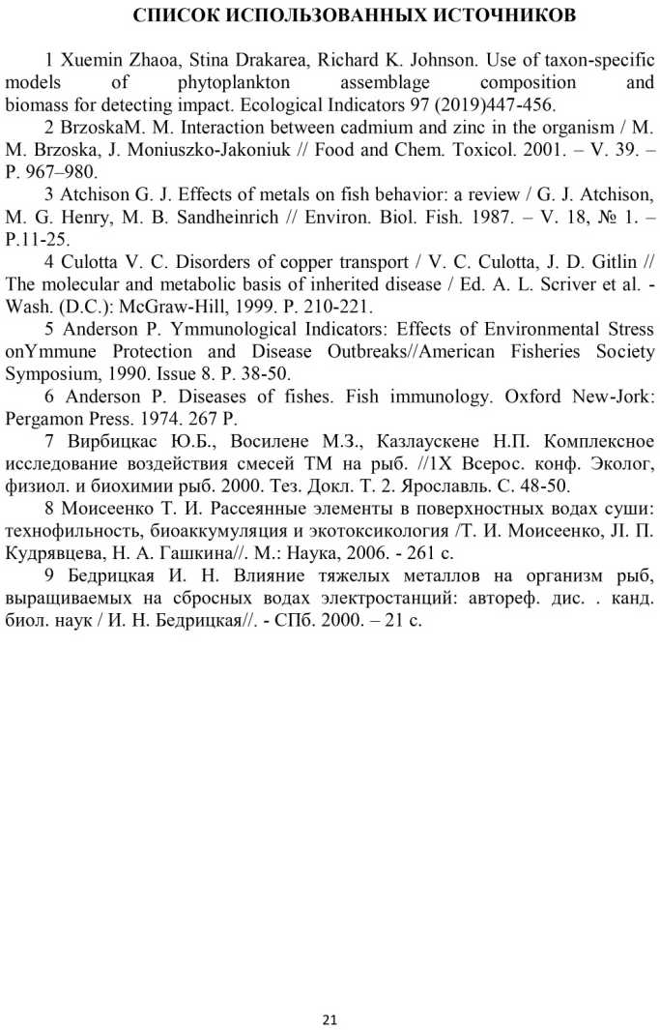

APPENDIX L
List of published works on project
for 2019

№  Ser.no. | Name | Published or as manuscript | Publishing house, journal (name, number, year) | Number of sheets | Last names of co-writers
1 | 2 | 3 | 4 | 5 | 6
1 | Assessment of safety of fish, caught in the water basins of Karagandy region  (Russian) | Published | Multidisciplinary scientific journal of A.Baitursynov Kostanay state university, Kostanay, no.1 2019, p.3-8 | 6 | Adilbekov Zh.Sh., Aubakirova G.A., Mustafina R.Kh.
2 | Age-length and species composition of fish in Uyaly-Shalkar lake of Akmola region  (Russian) | Published | Bulletin of Shakarim state university, Semey, no.2 (86), 2019, p.248-252 | 5 | Aubakirova G.A., Adilbekov Zh.Sh.
3 | Influence of water mineralization on zooplankton’s productivity  (Russian) | Published | Bulletin of Shakarim state university, Semey, no.2 (86), 2019, p.309-312 | 4 | Aubakirova G.A., Adilbekov Zh.Sh.
4 | Fish Fauna and Assessment of Fish Safety in the Reservoirs of Akmola Region of Northern Kazakhstan  (English) | Published | Pakistan journal of Zoology. Vol.51 (5), pp 1919-1925, 2019.  The journal is included in Scopus base, percentile by zoology – 39. https://www.scopus.com/authid/detail.uri?authorId=56414823900 | 7 | G.Aubakirova, Zh. Adilbekov, A.Inirbayev, T. Dzhamanbayev
5 | Determination method of degree of fish freshness  (Russian) | Published | Utility model patent. No. 4463, 13.11.2019 | 1 | Adilbekov Zh.Sh., Baldzhi Yu.A., Aubakirova G.A., Mustafina R.K.

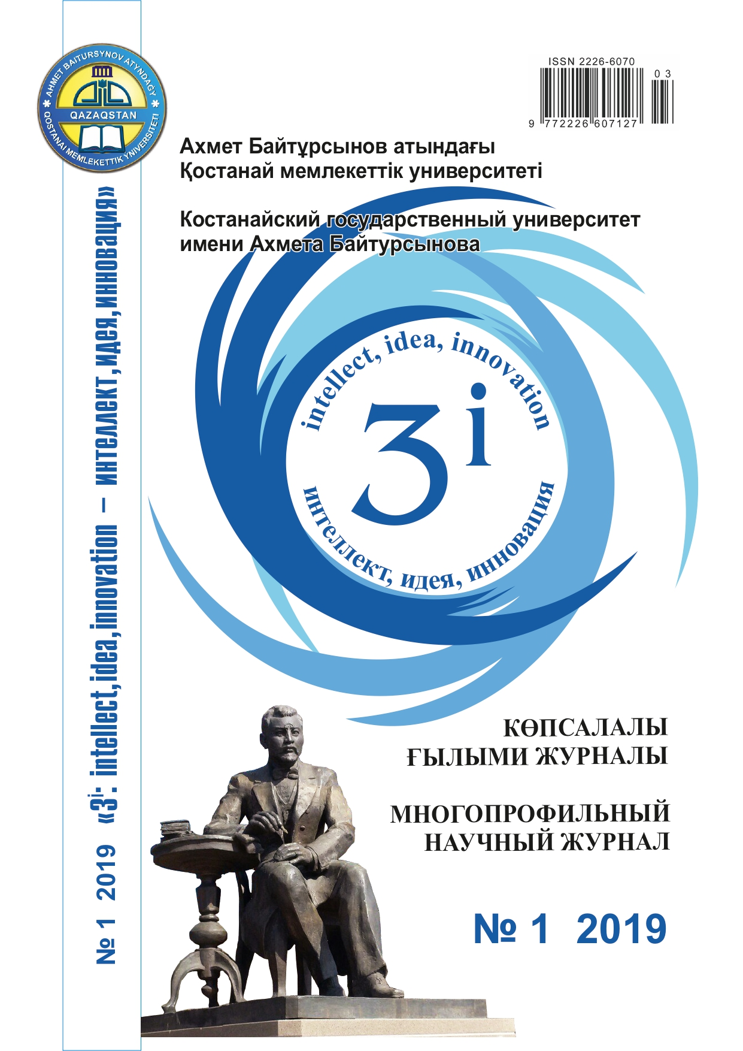 | 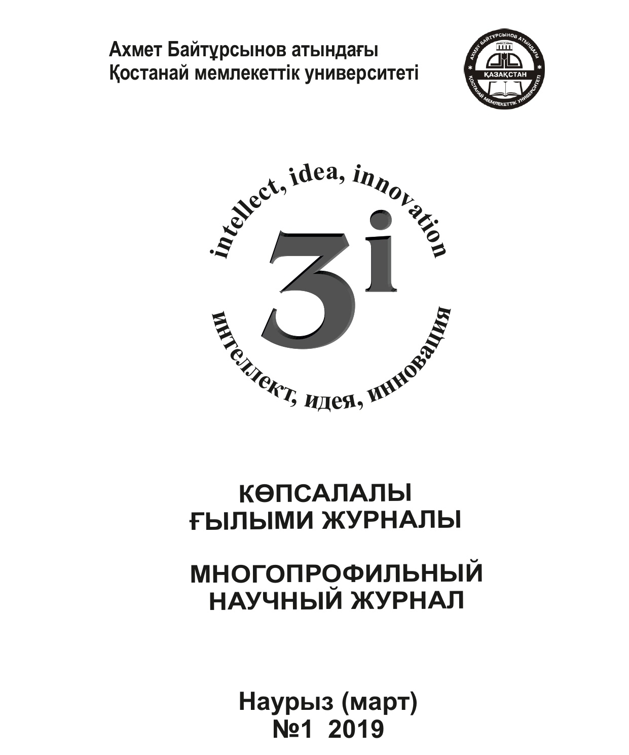

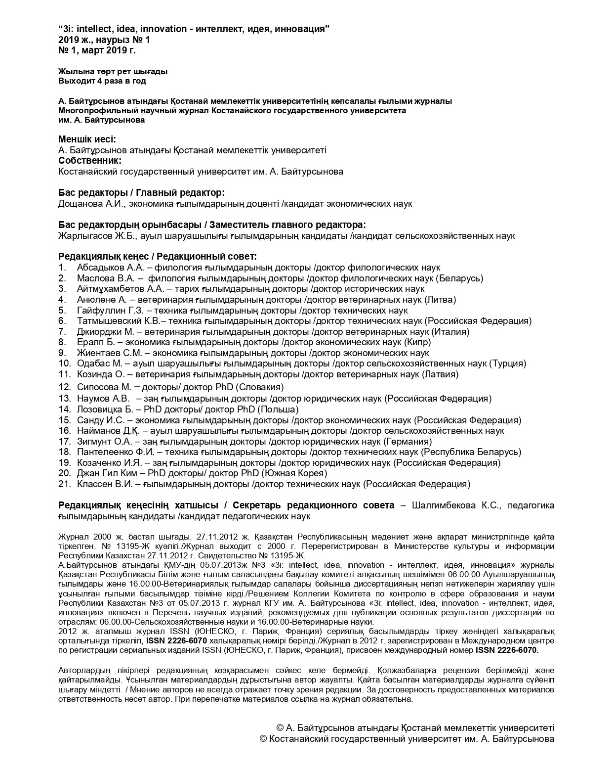

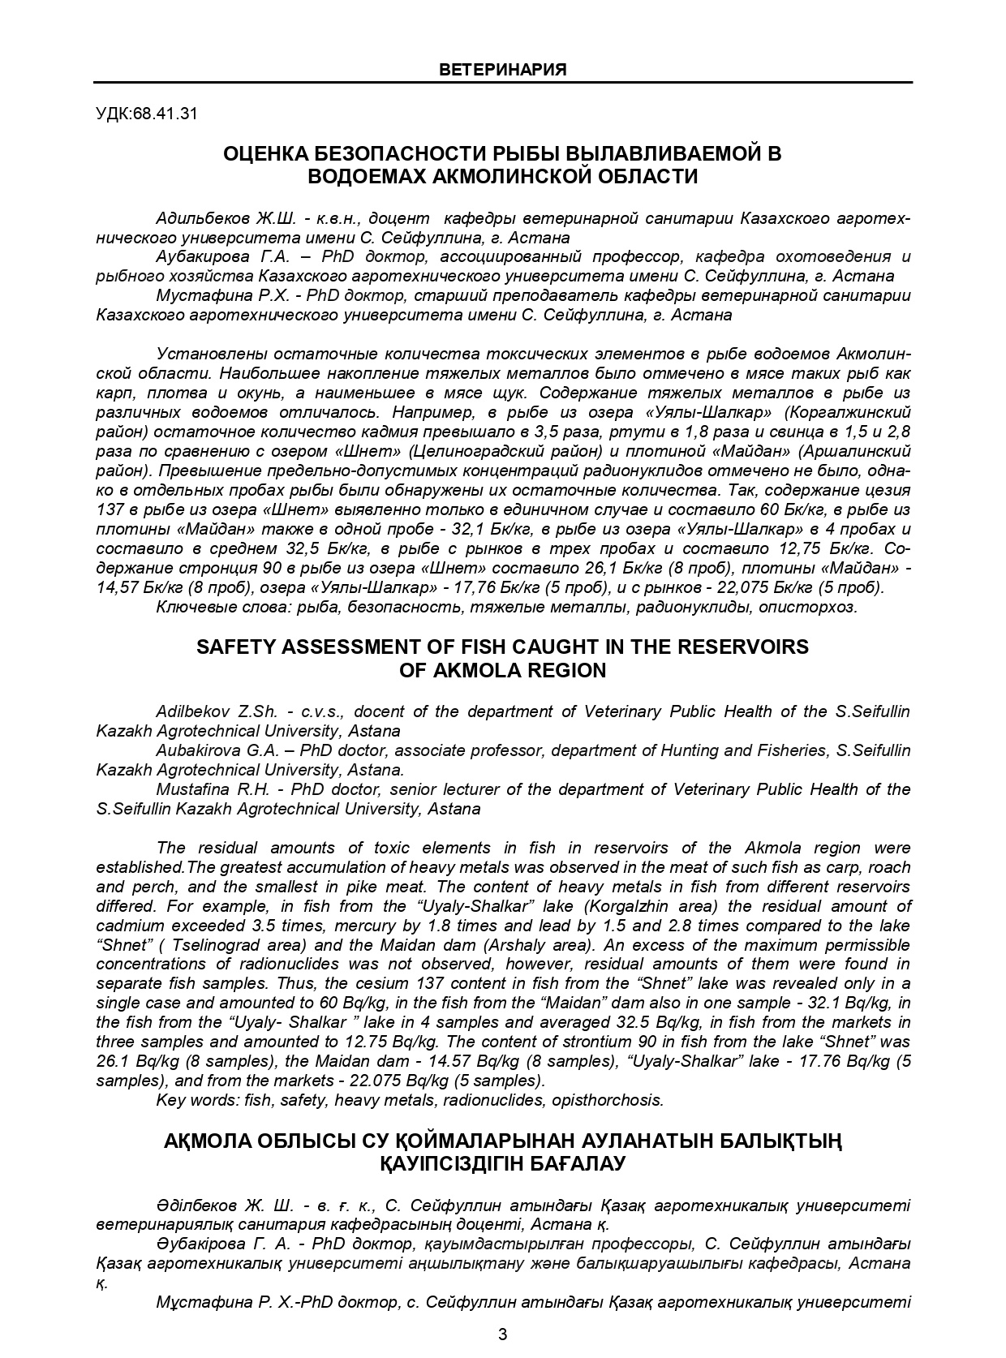

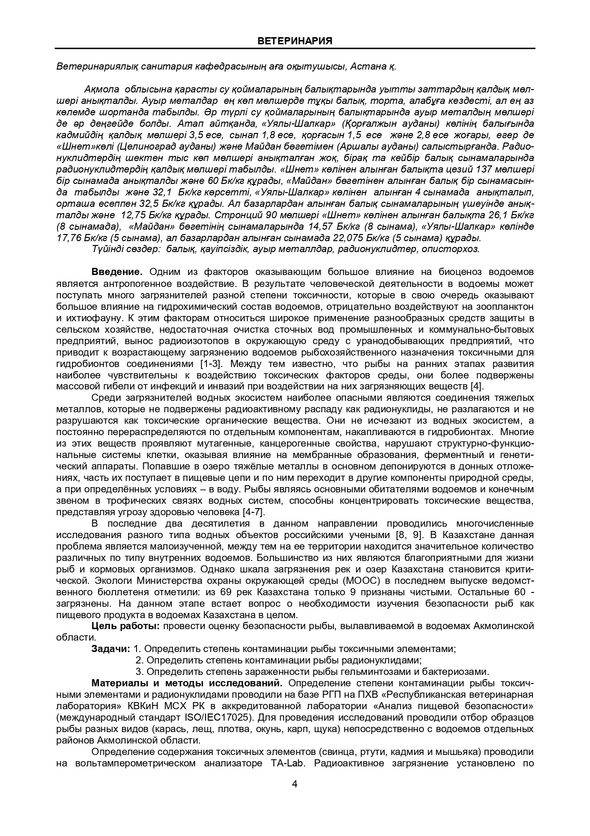
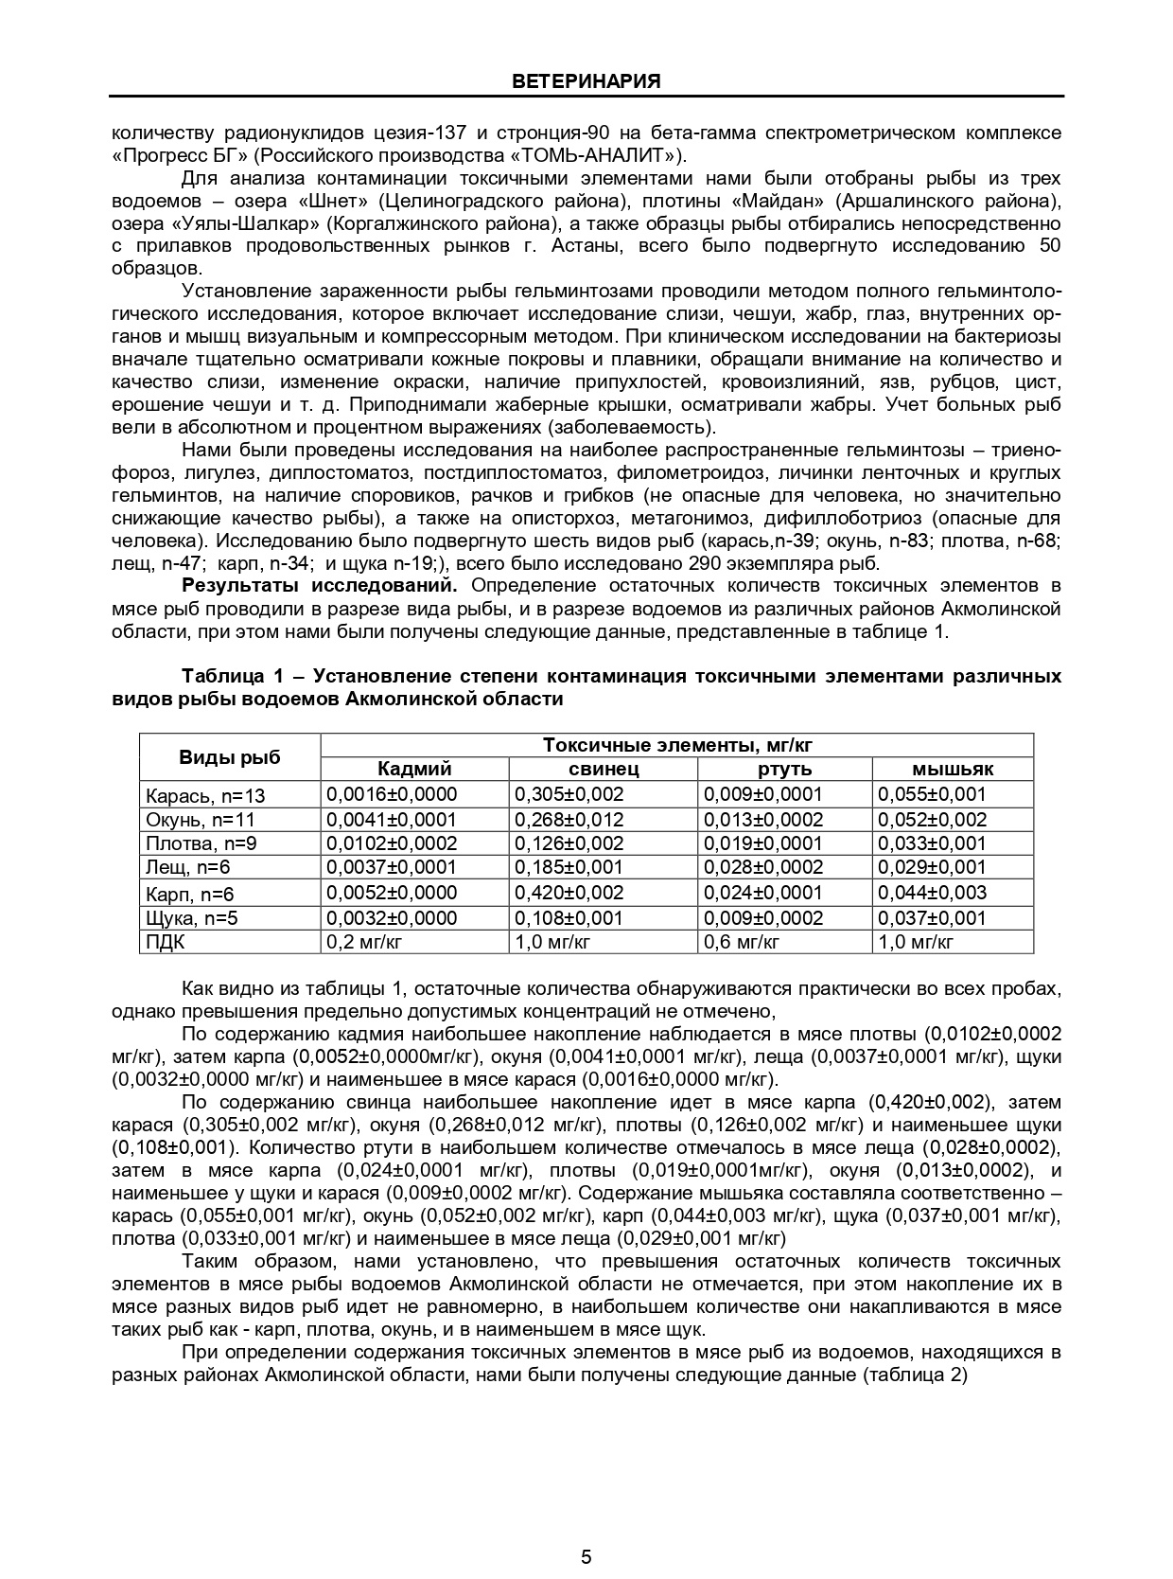

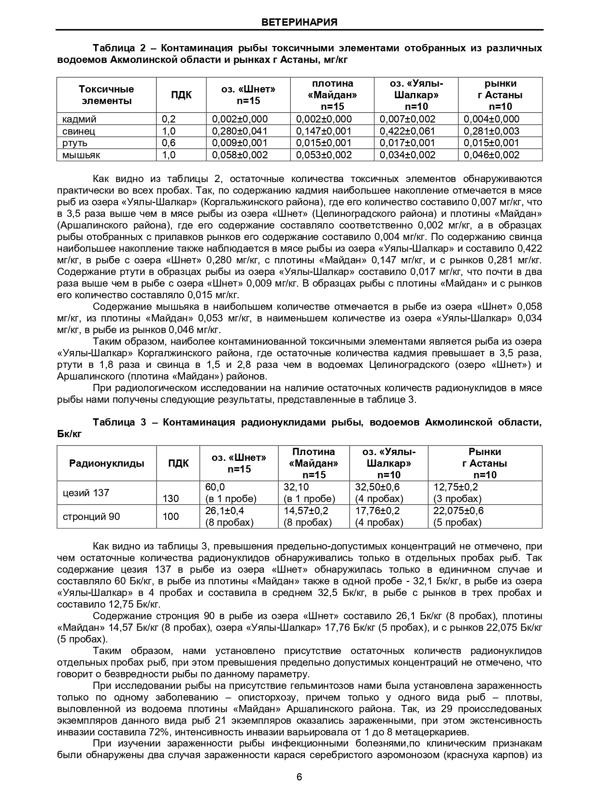

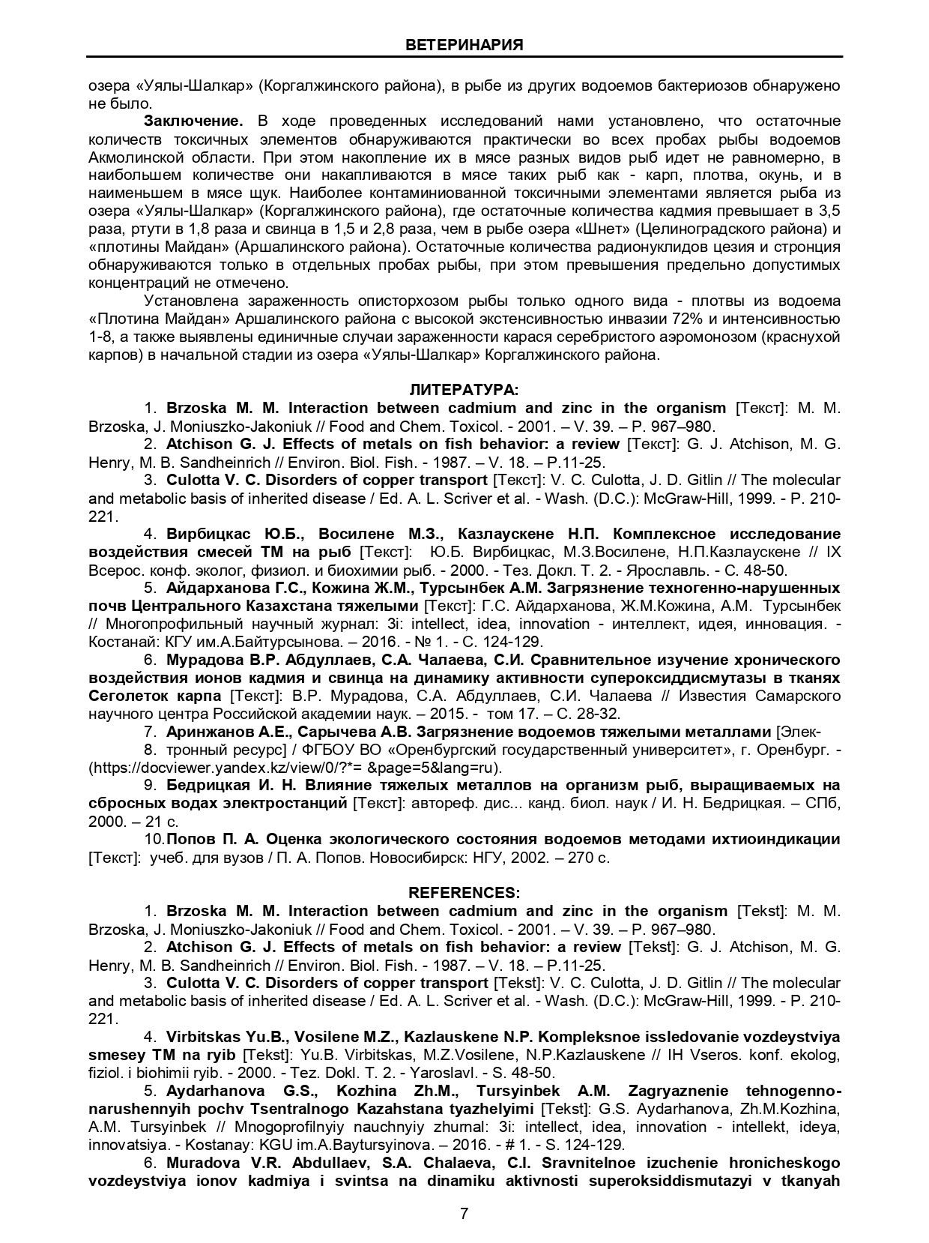

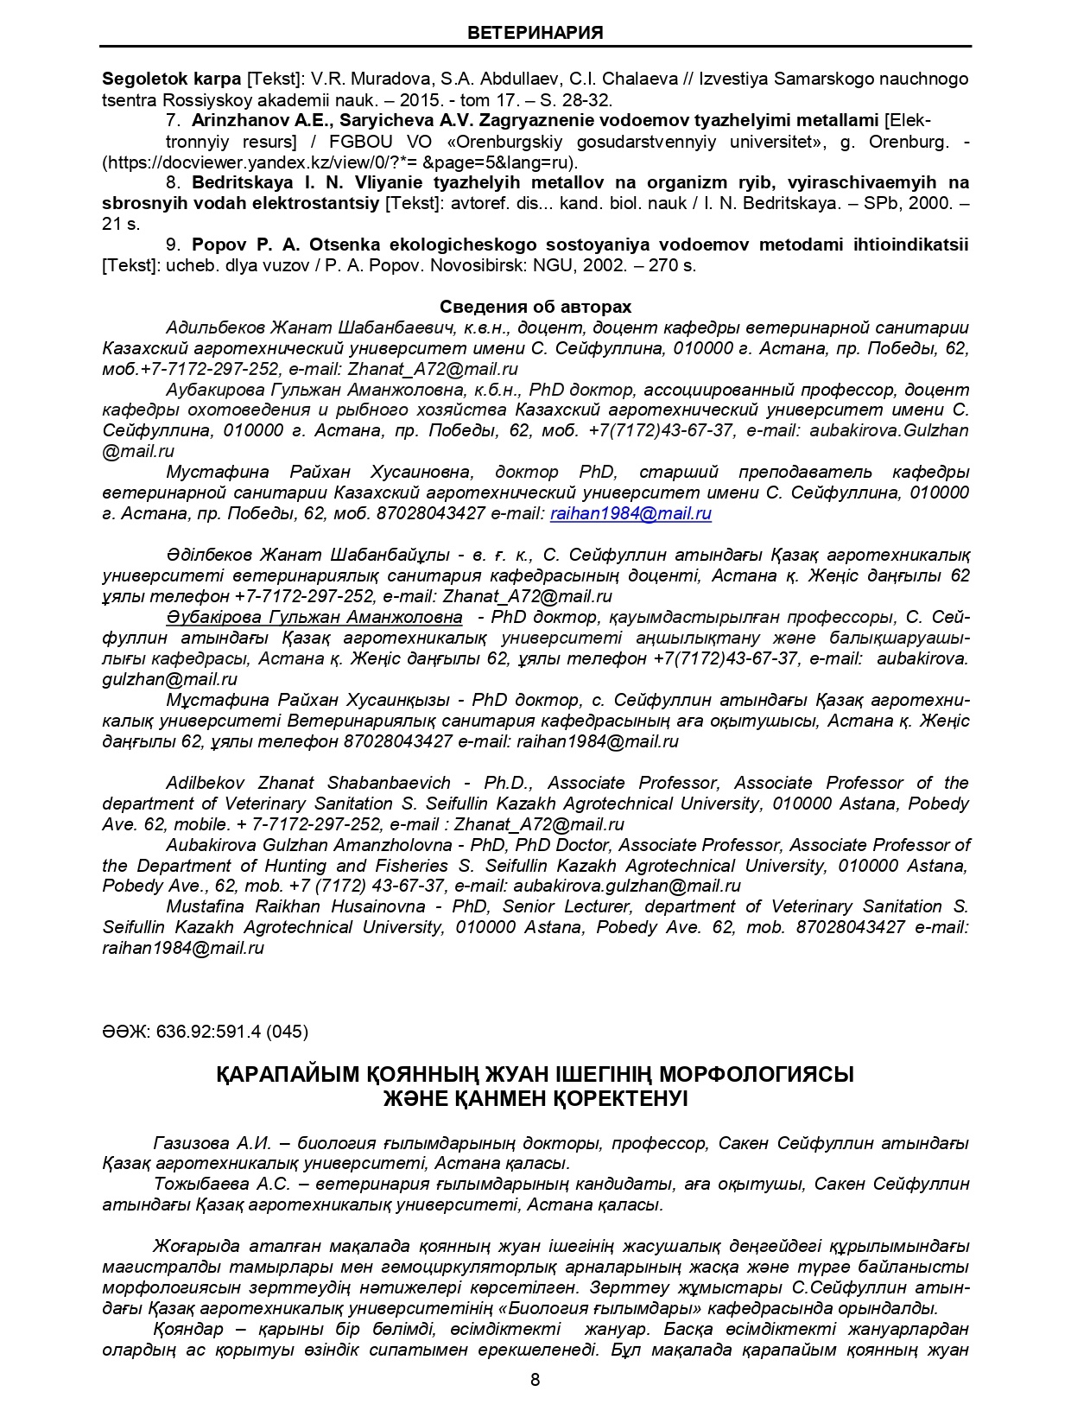
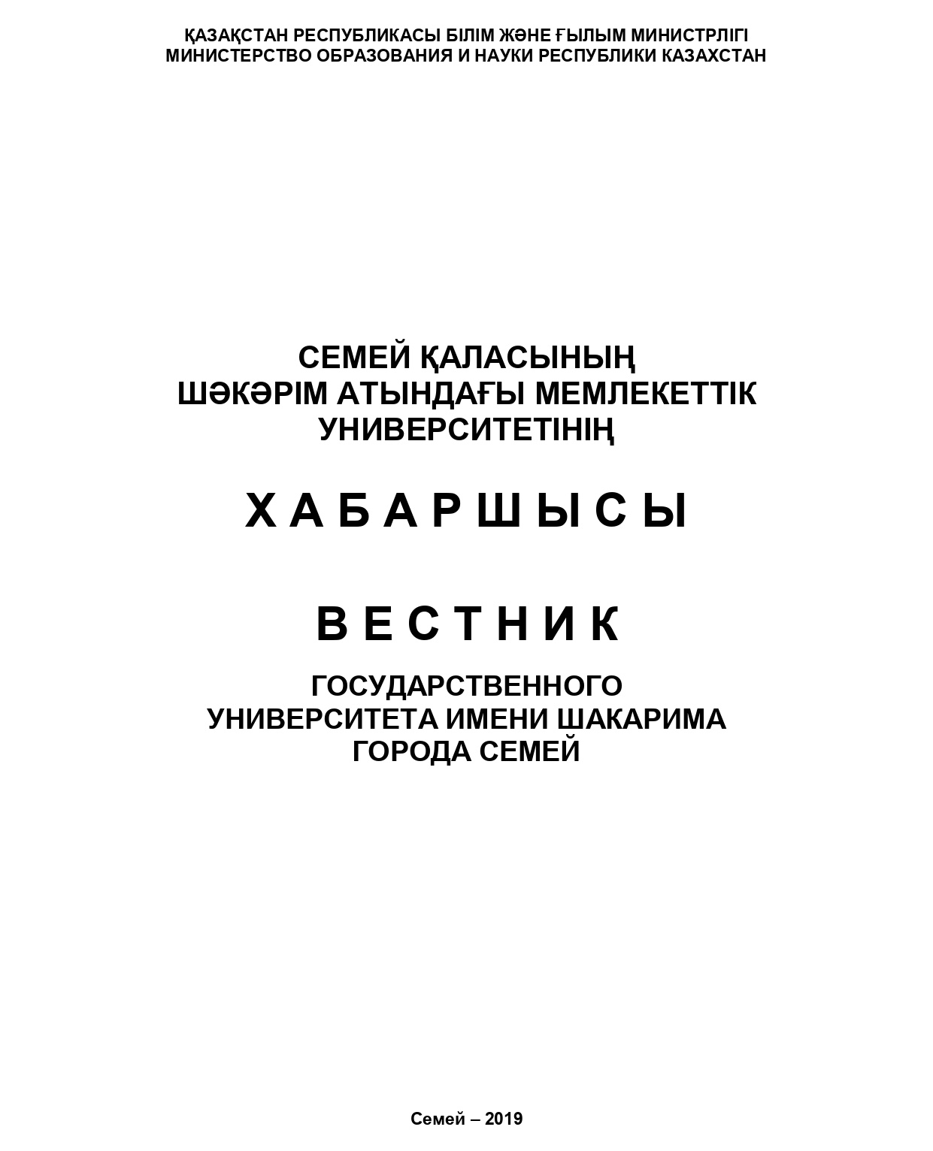

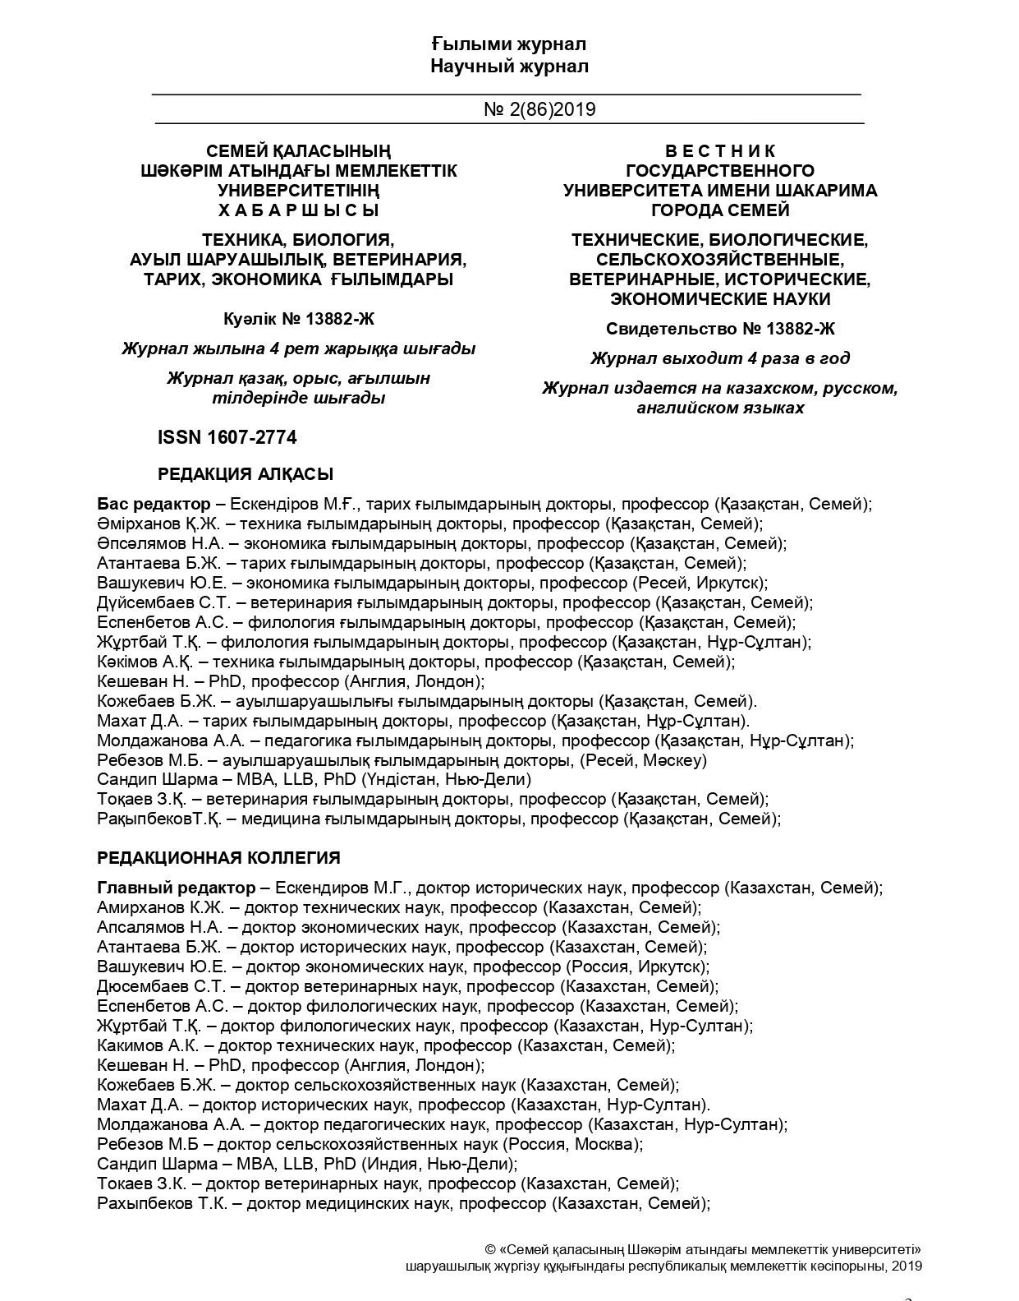

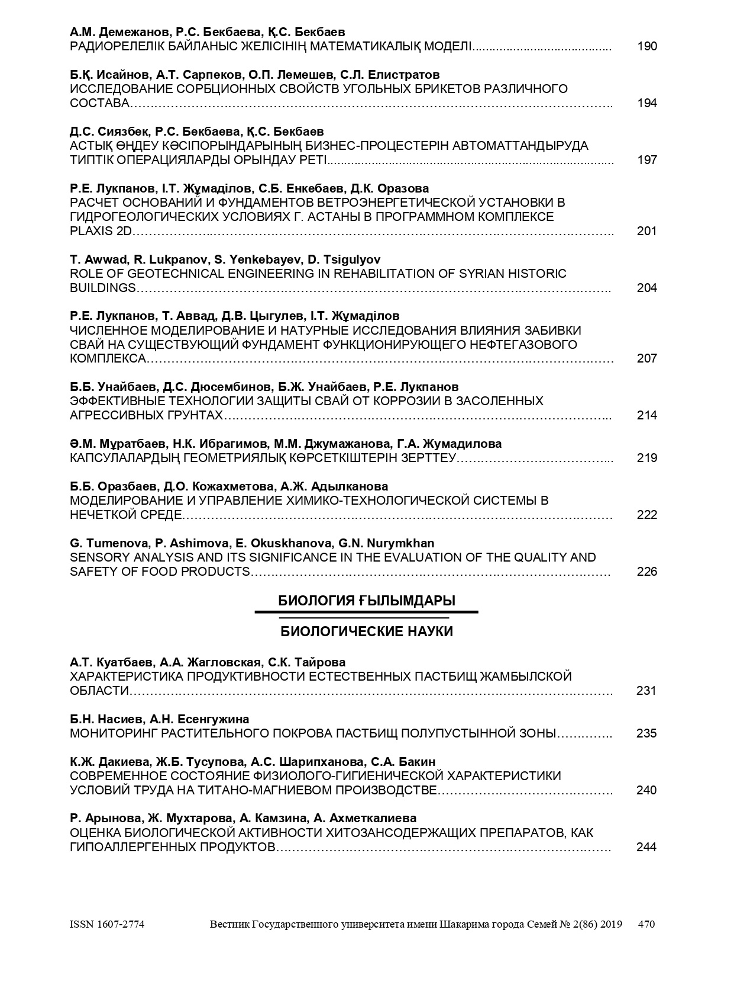

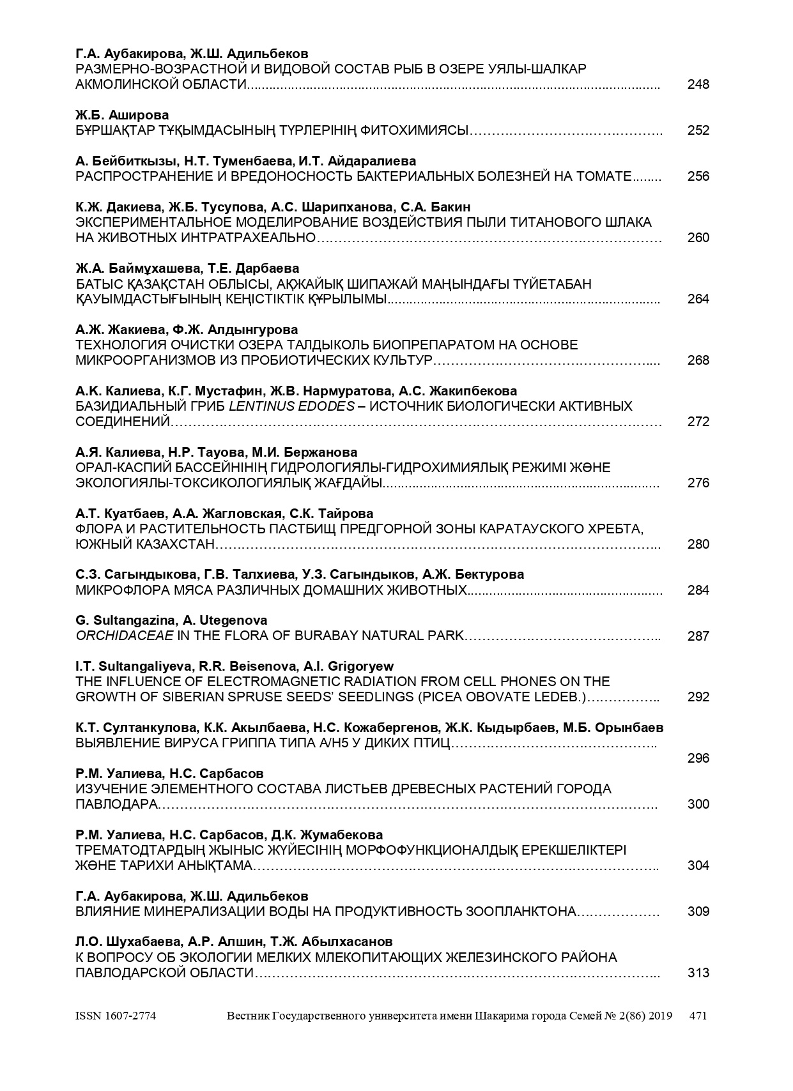

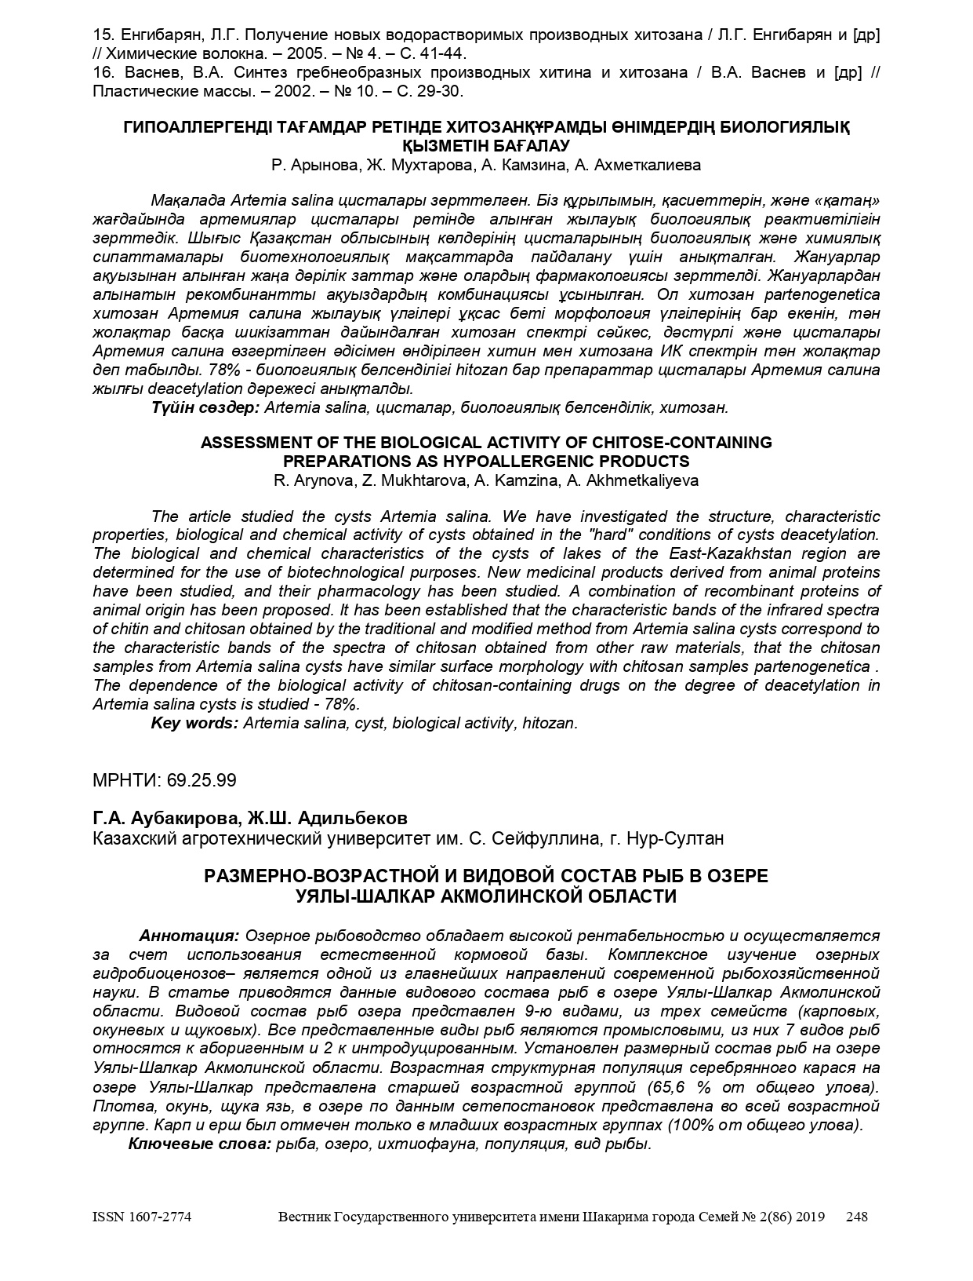

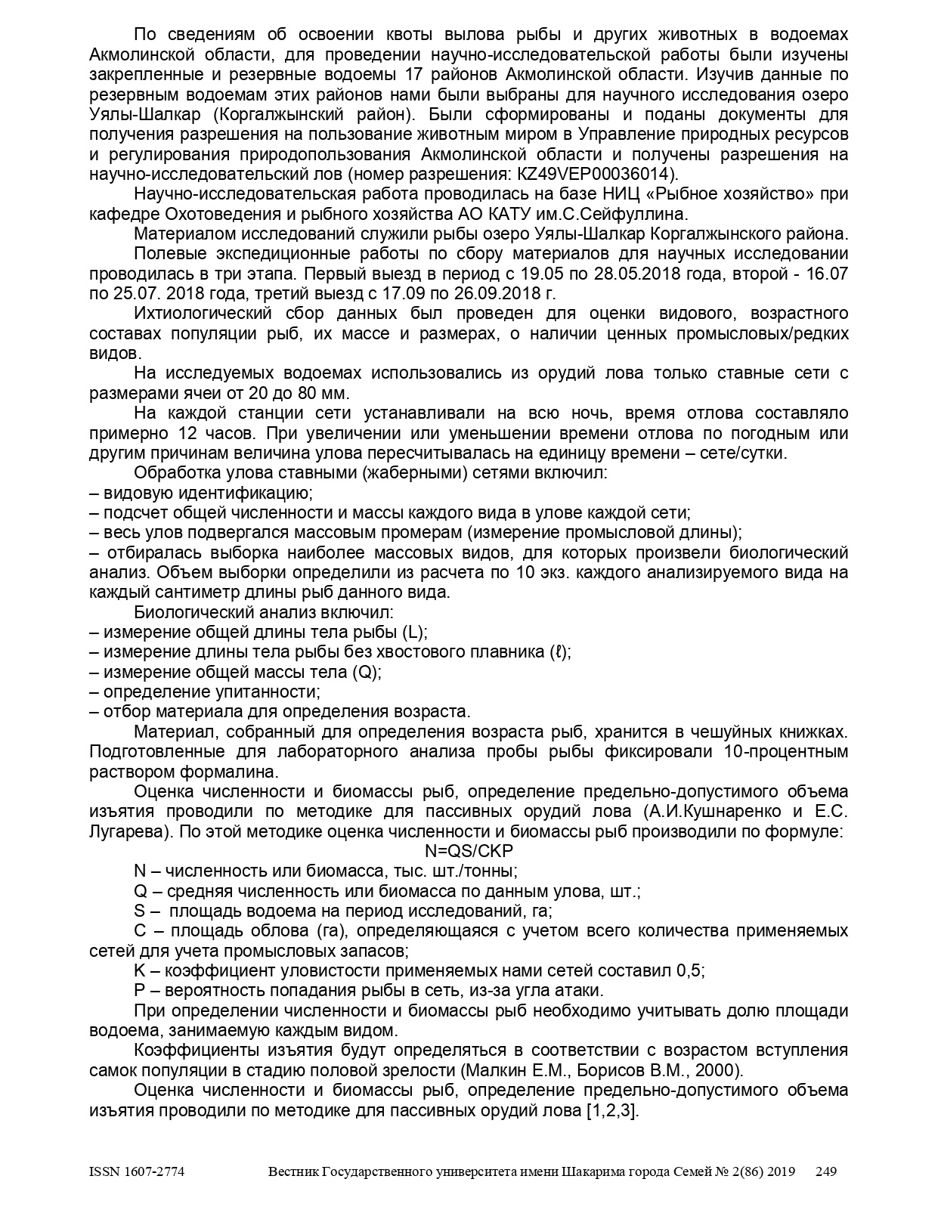

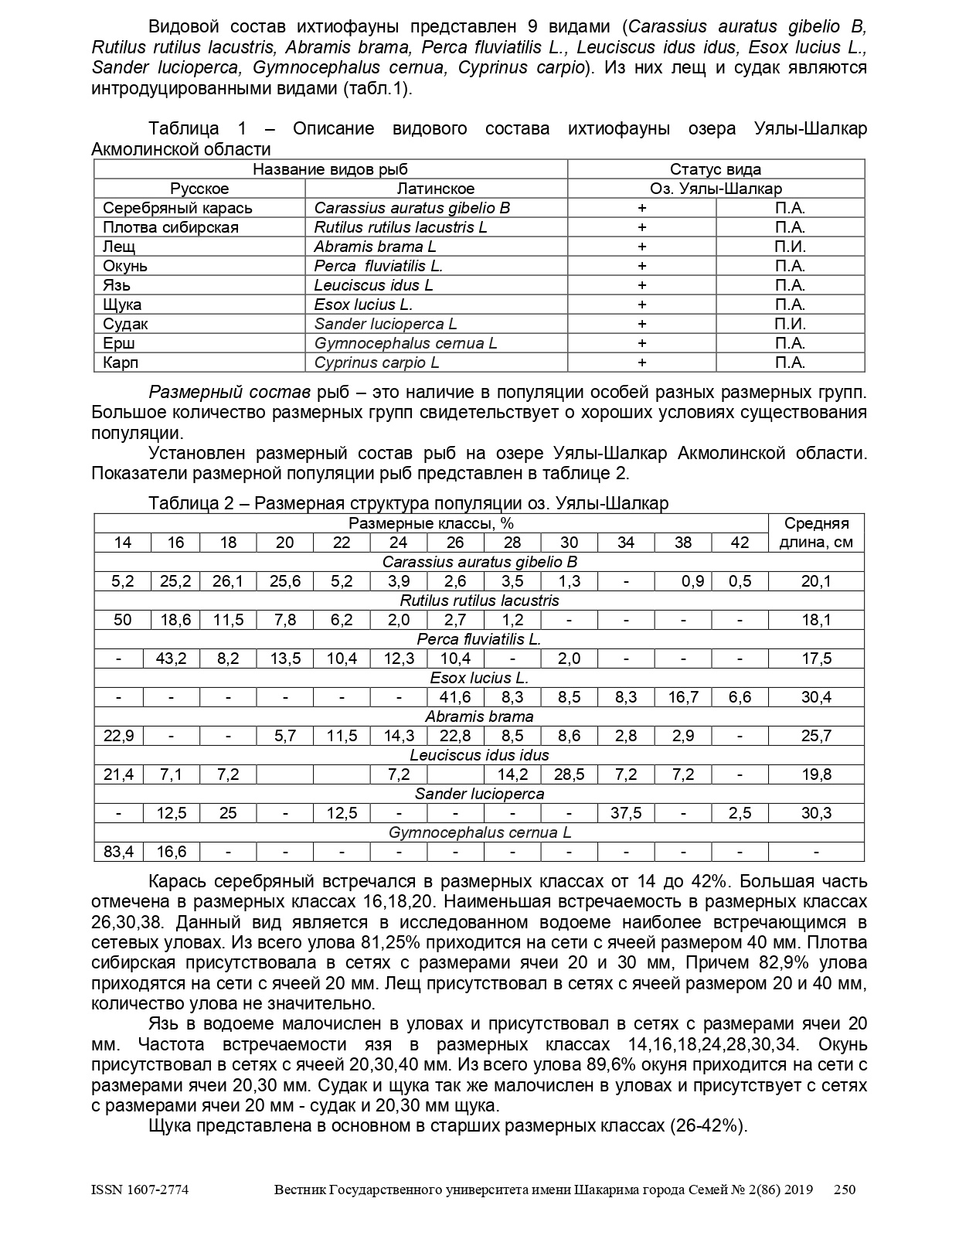

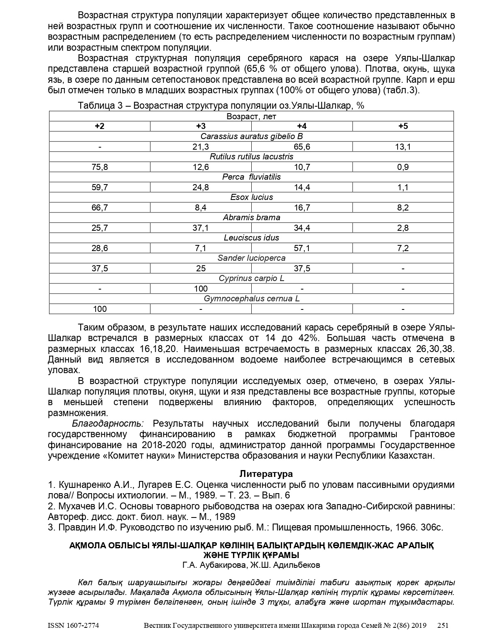

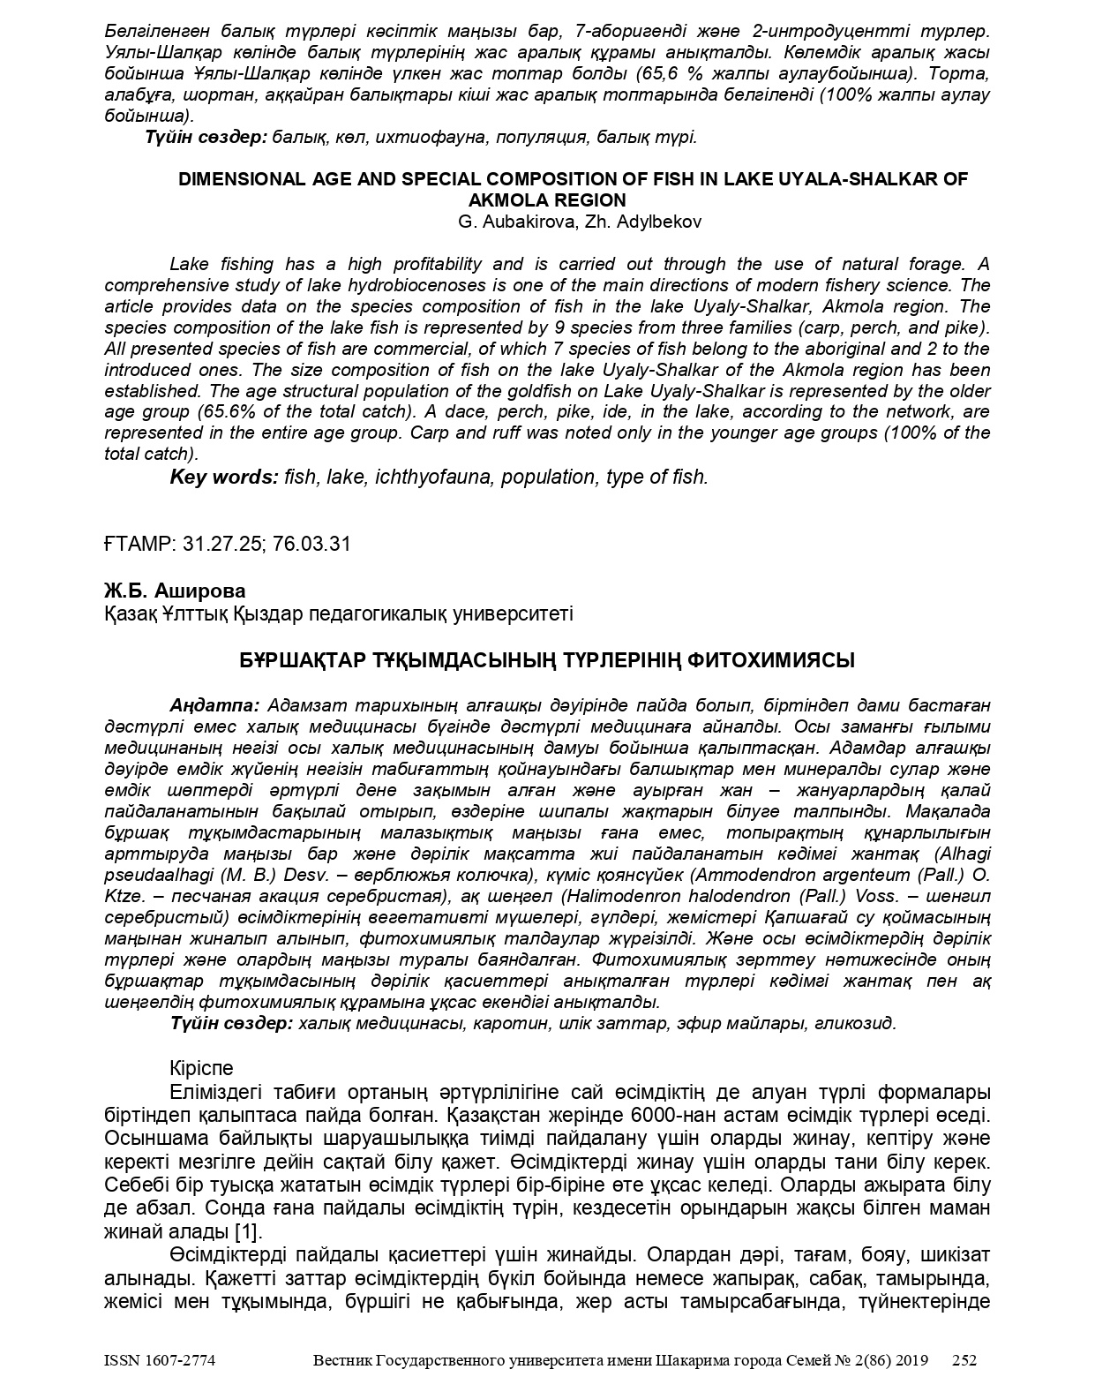

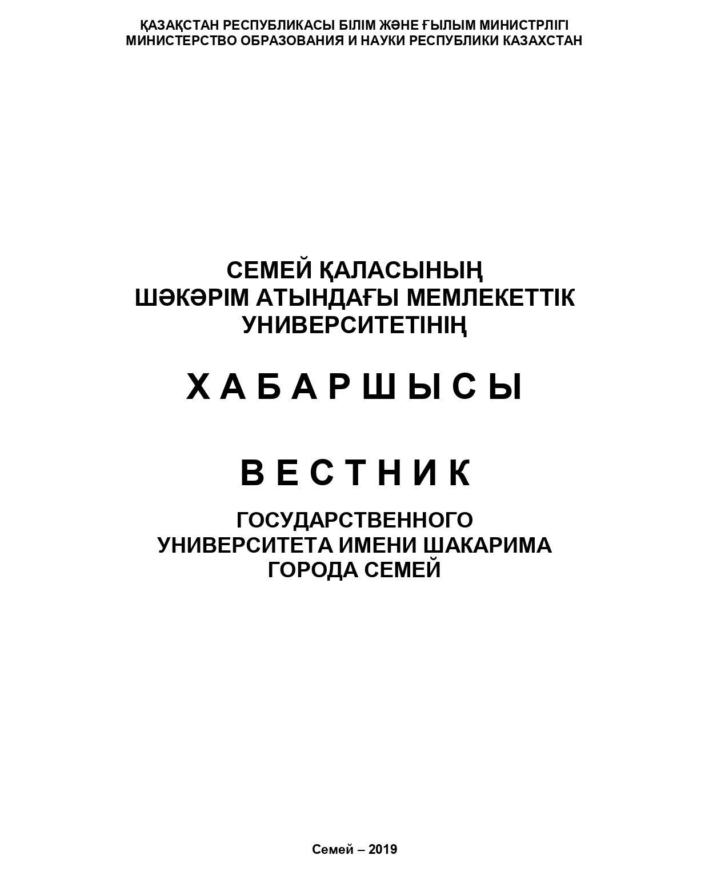

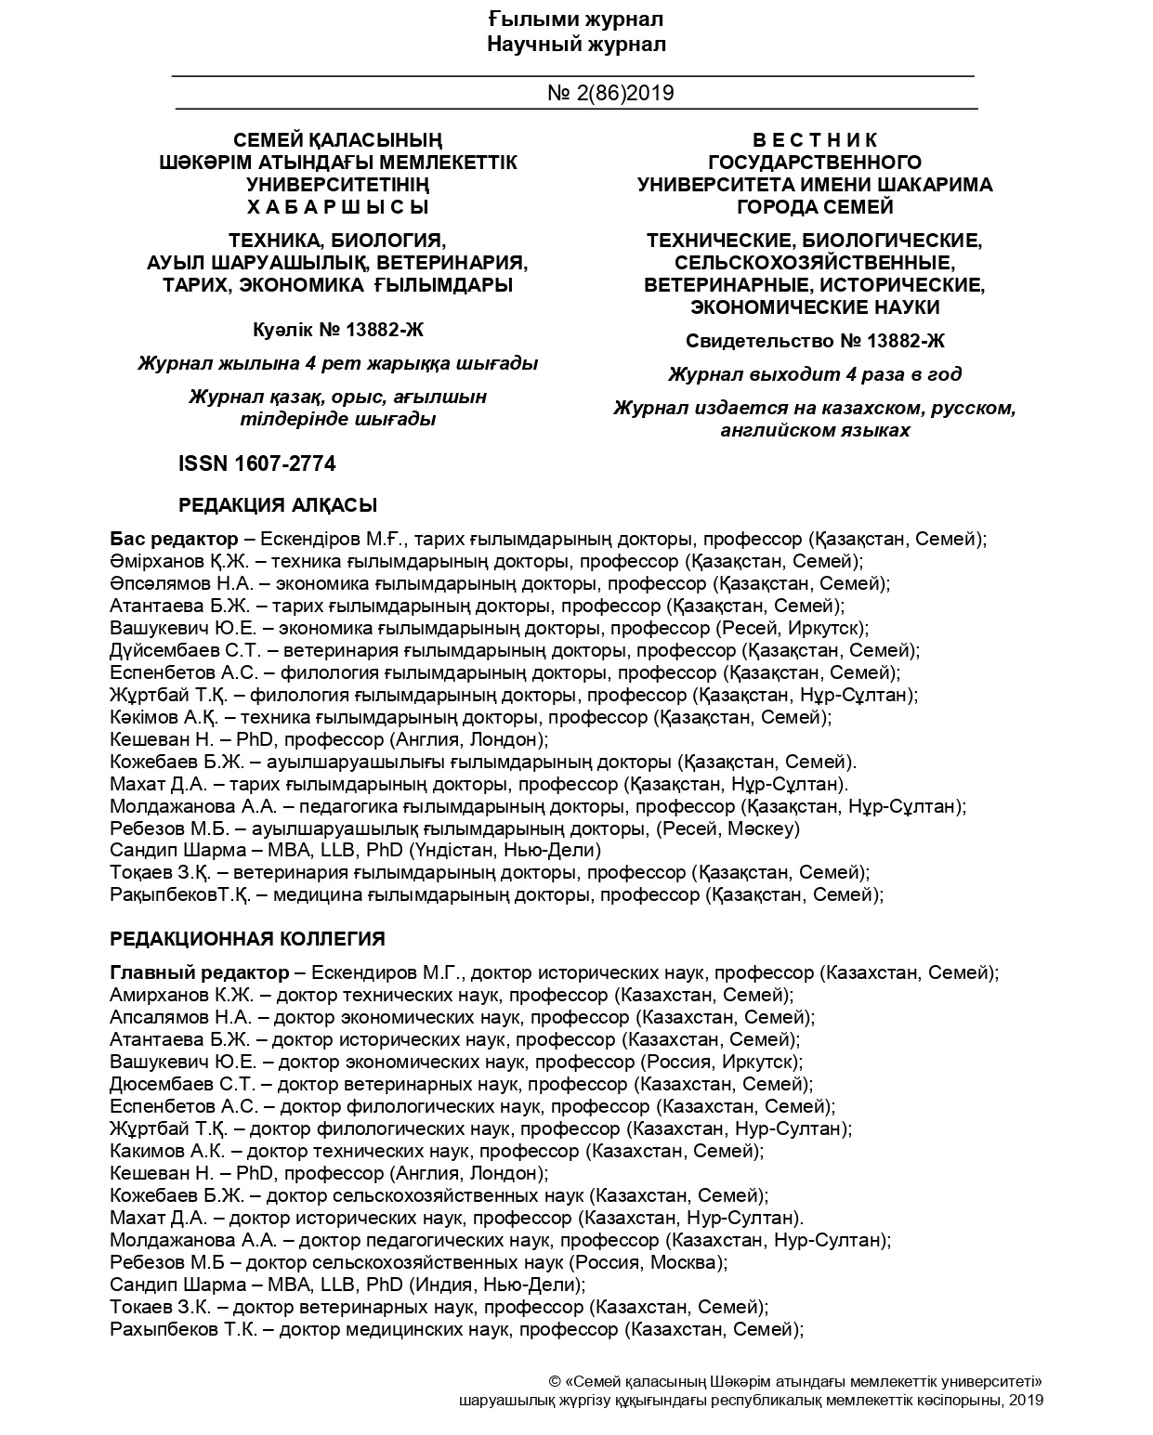
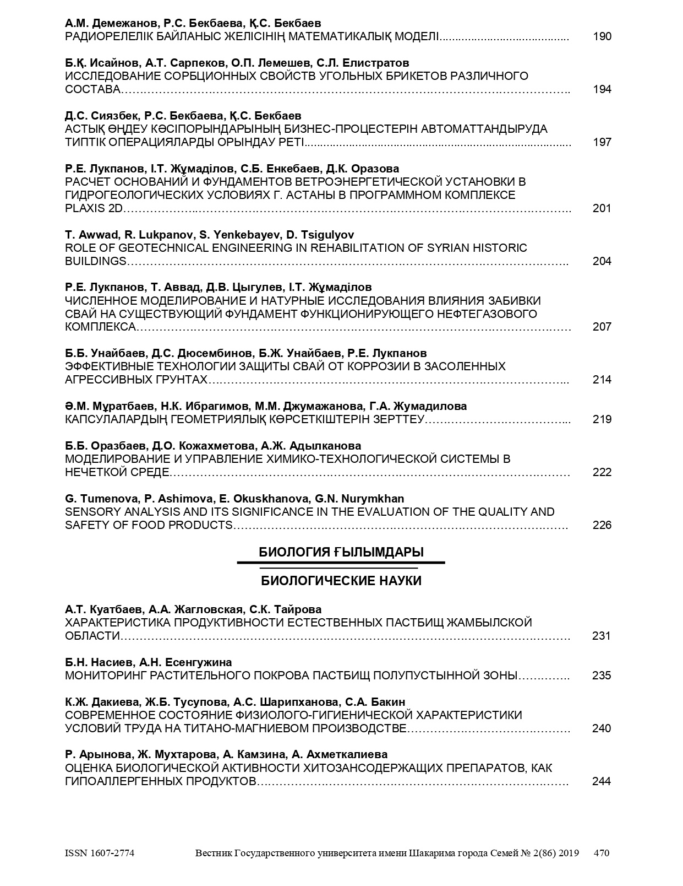

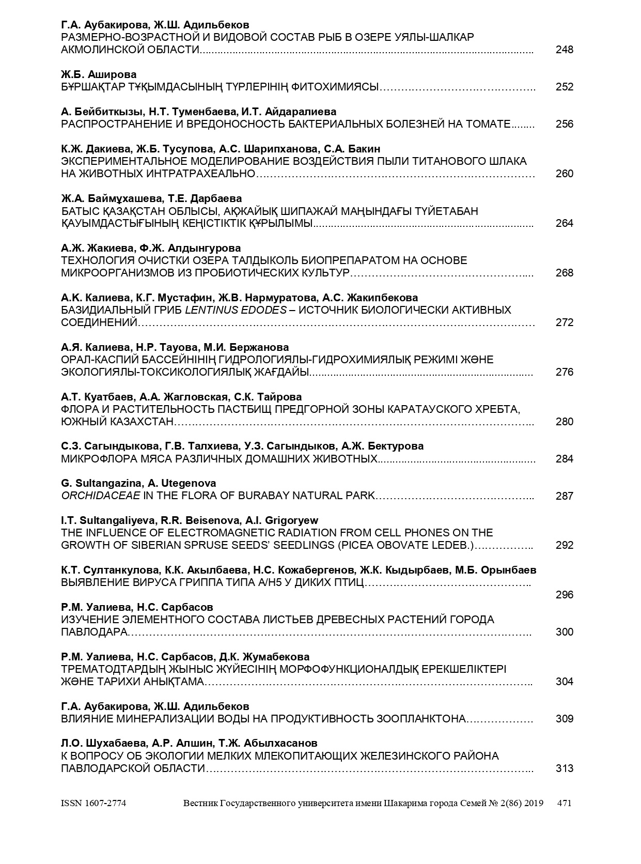

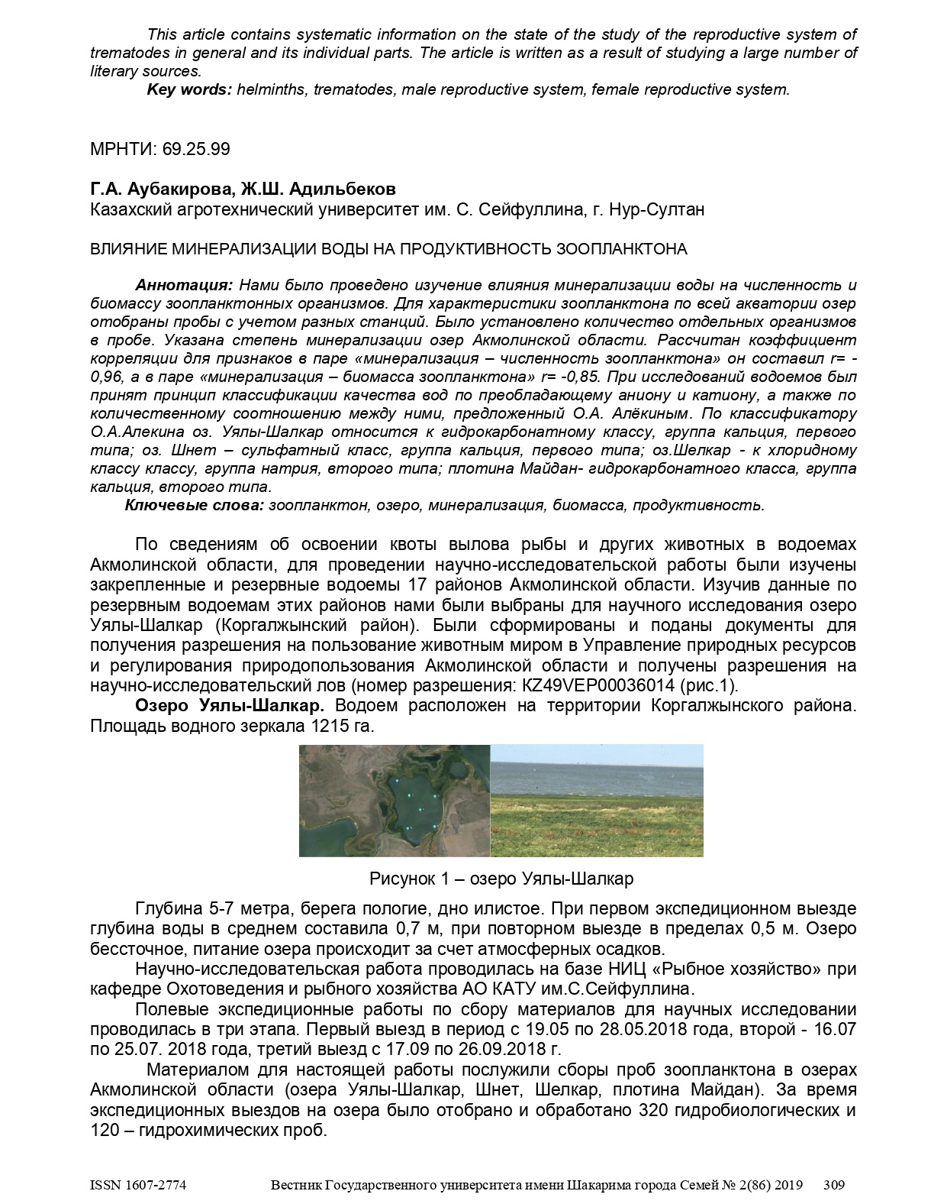

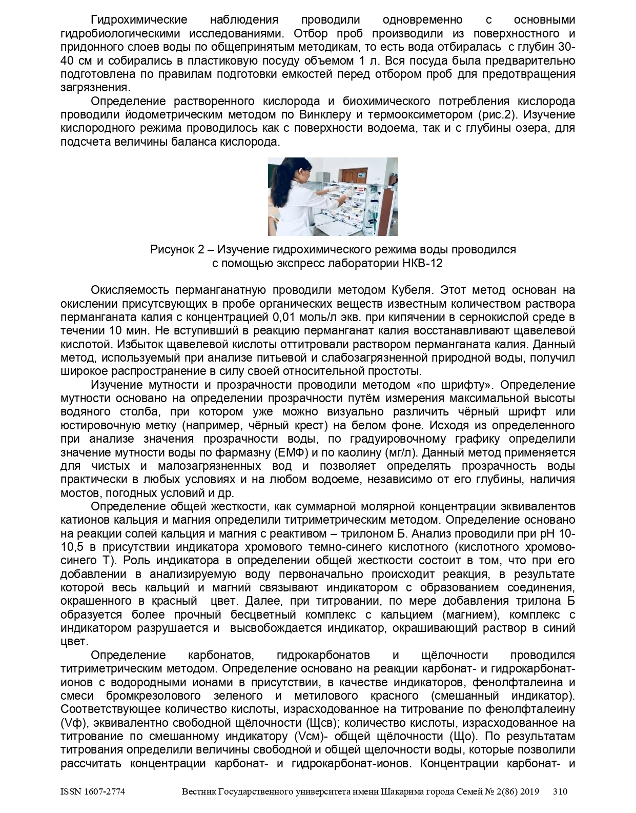

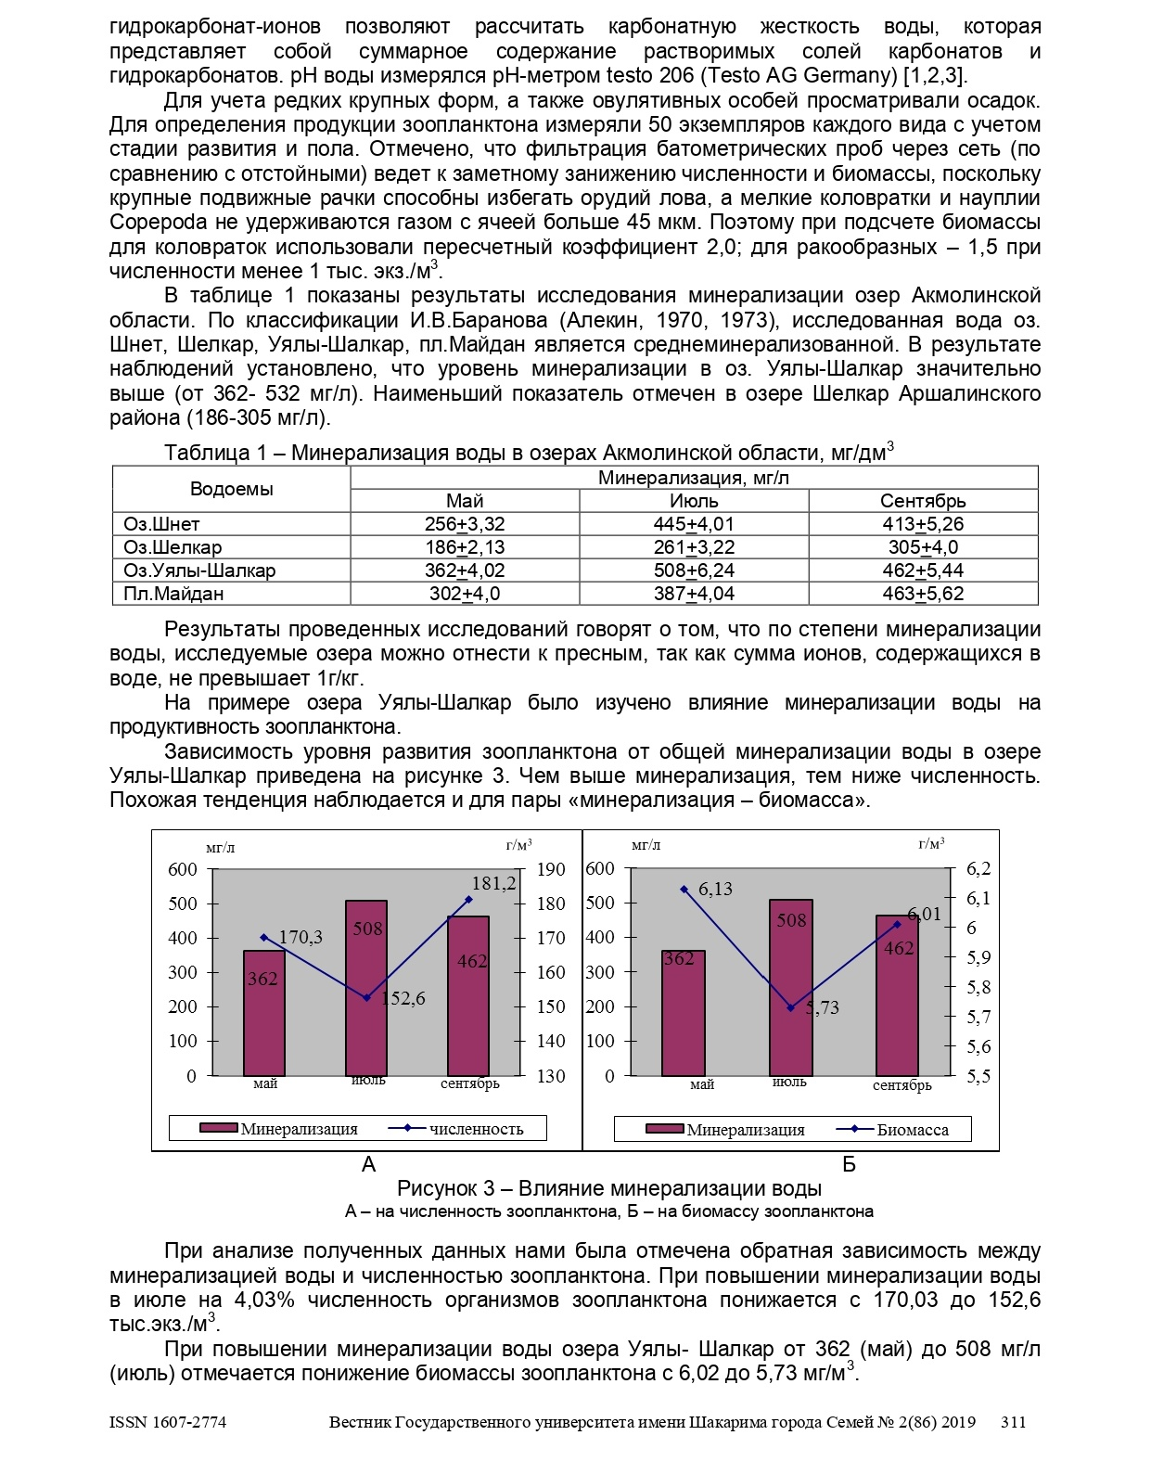

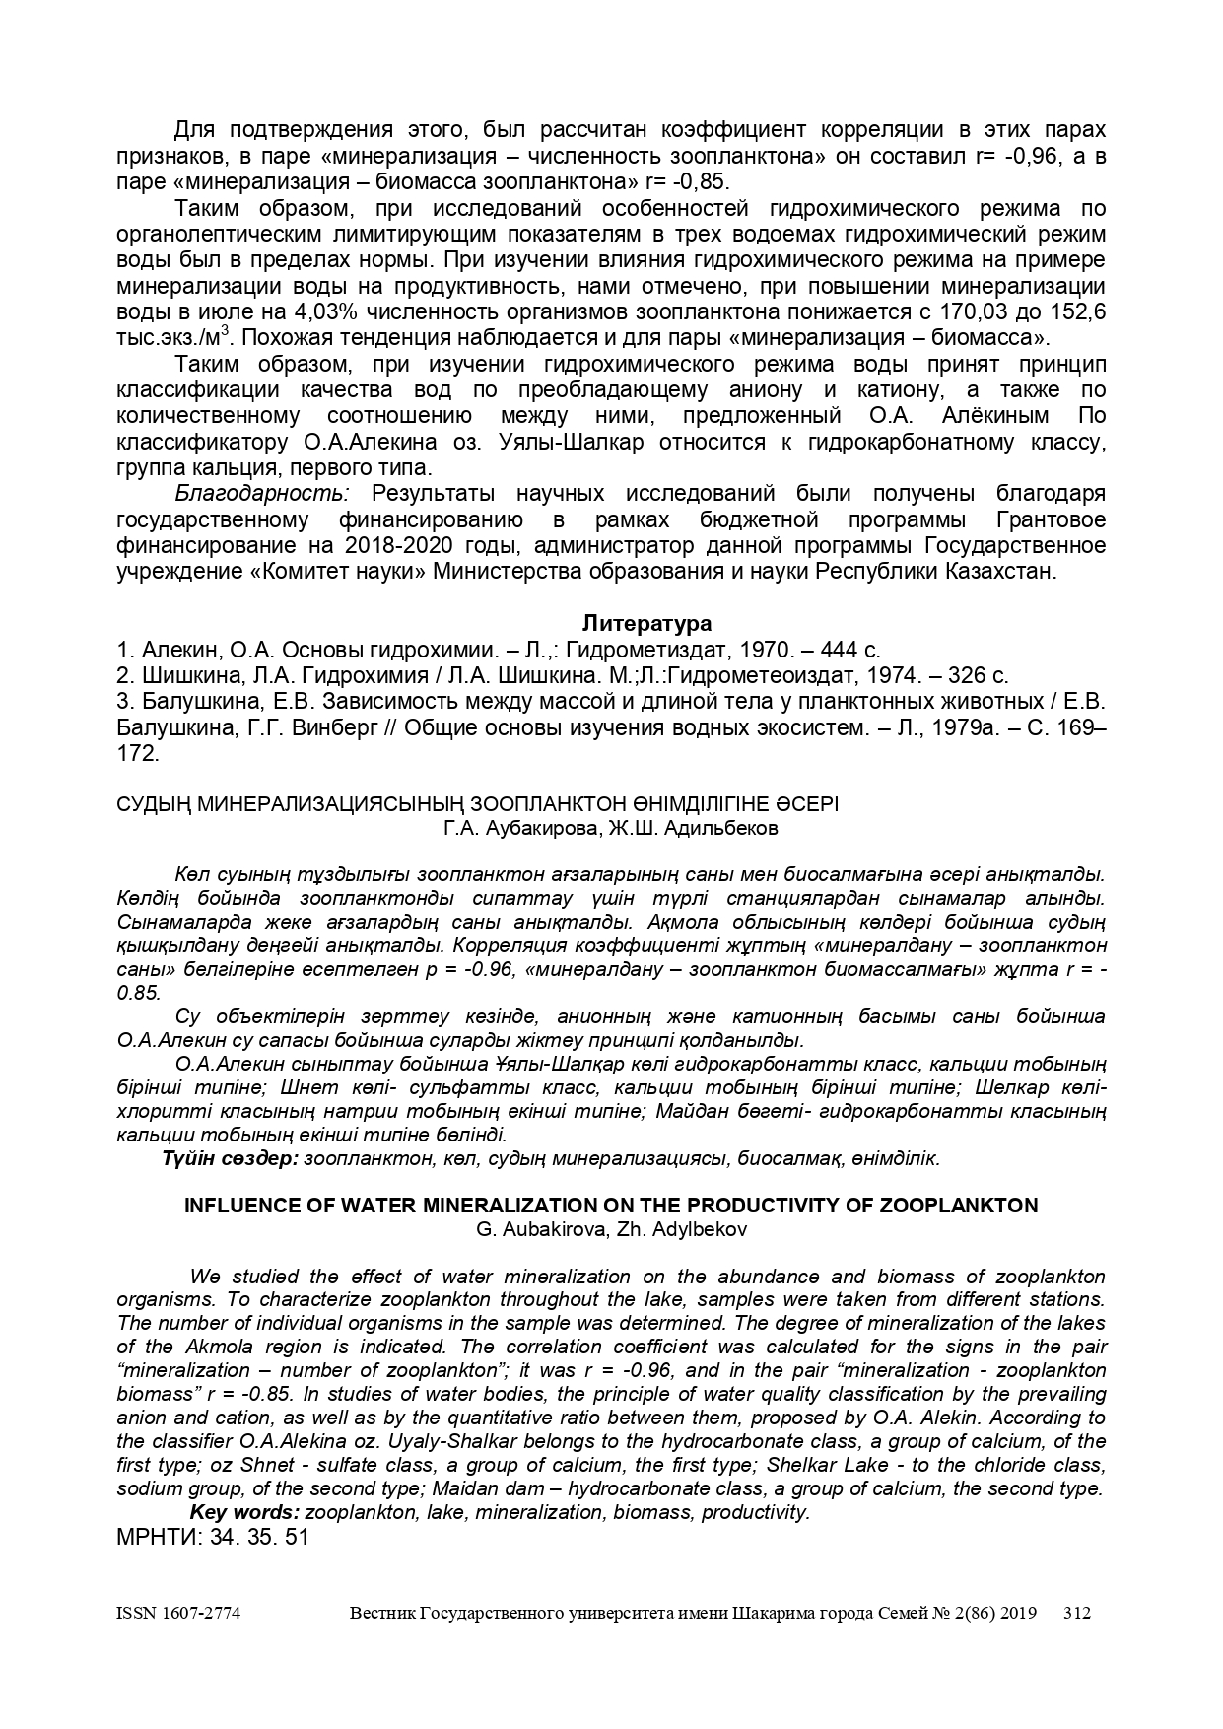

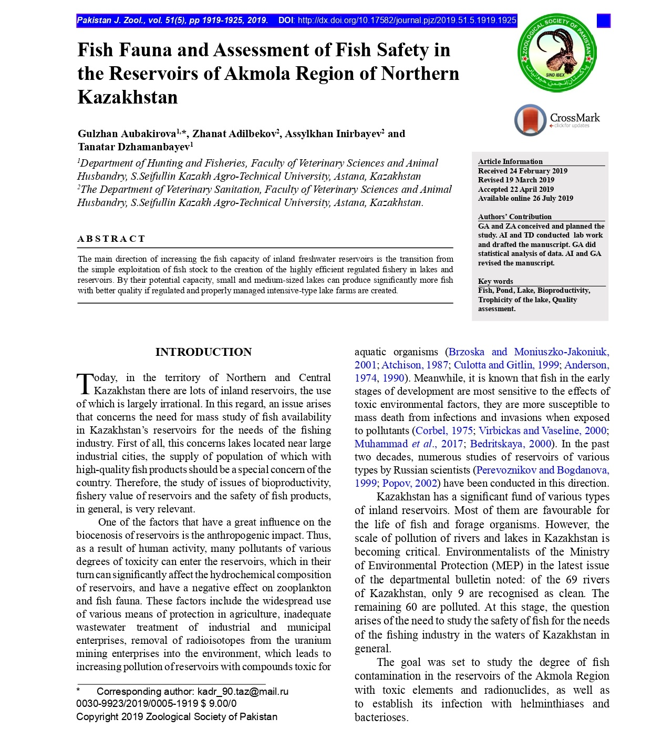

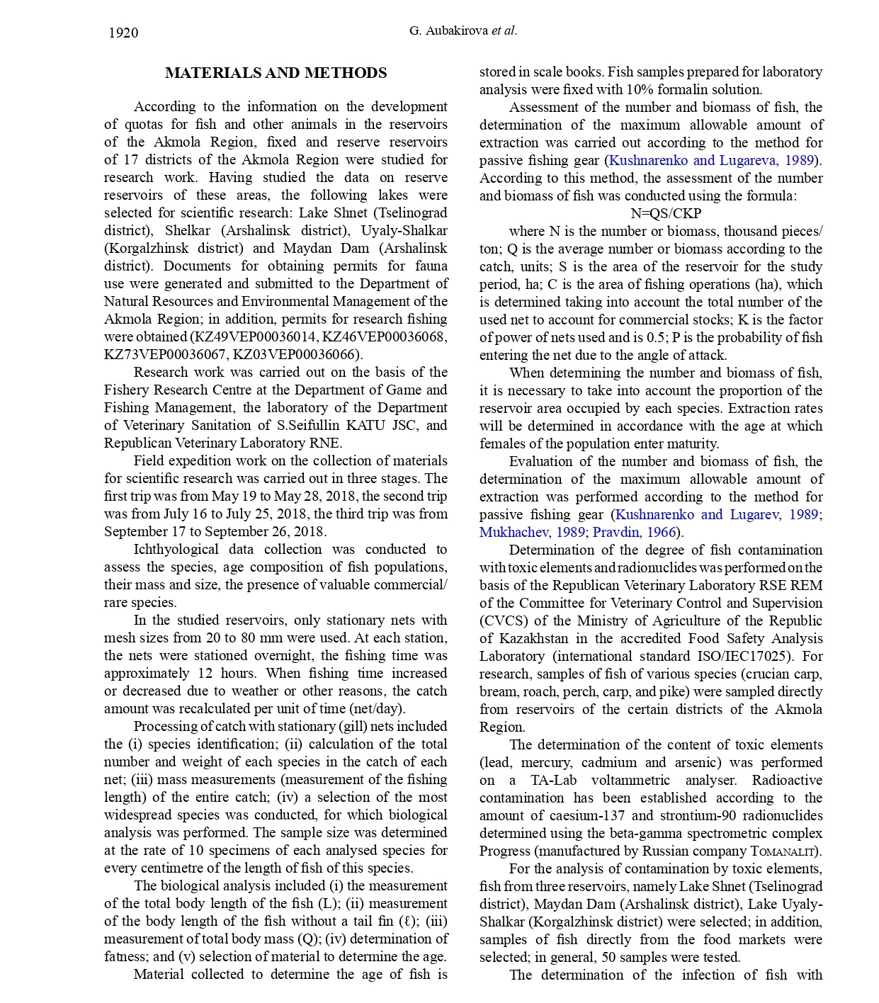

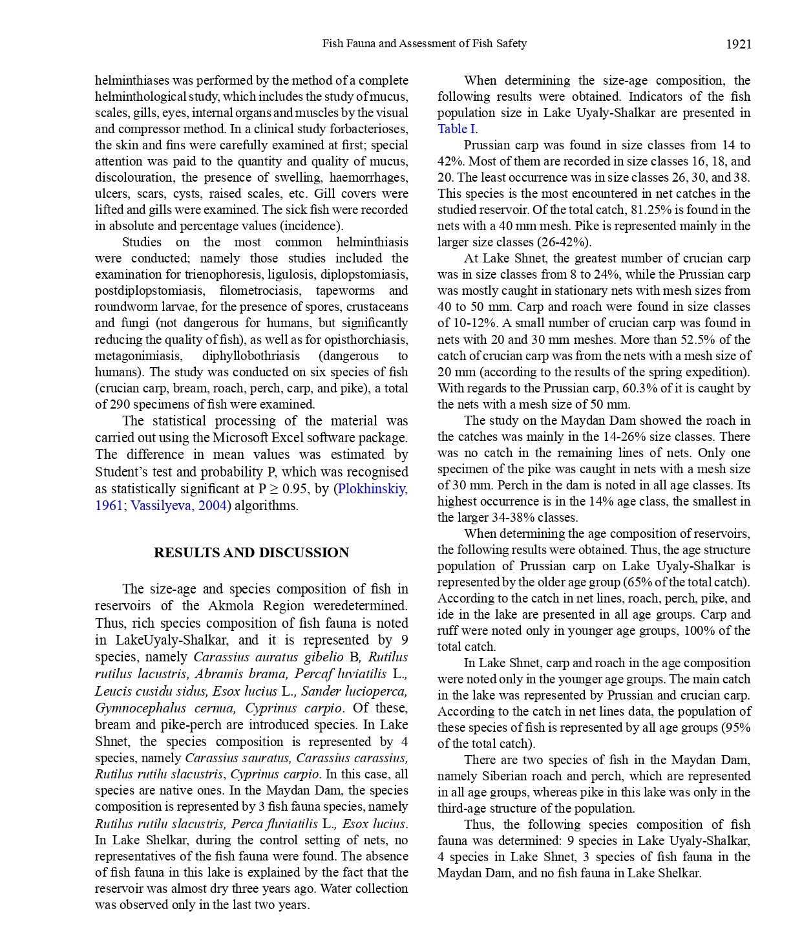

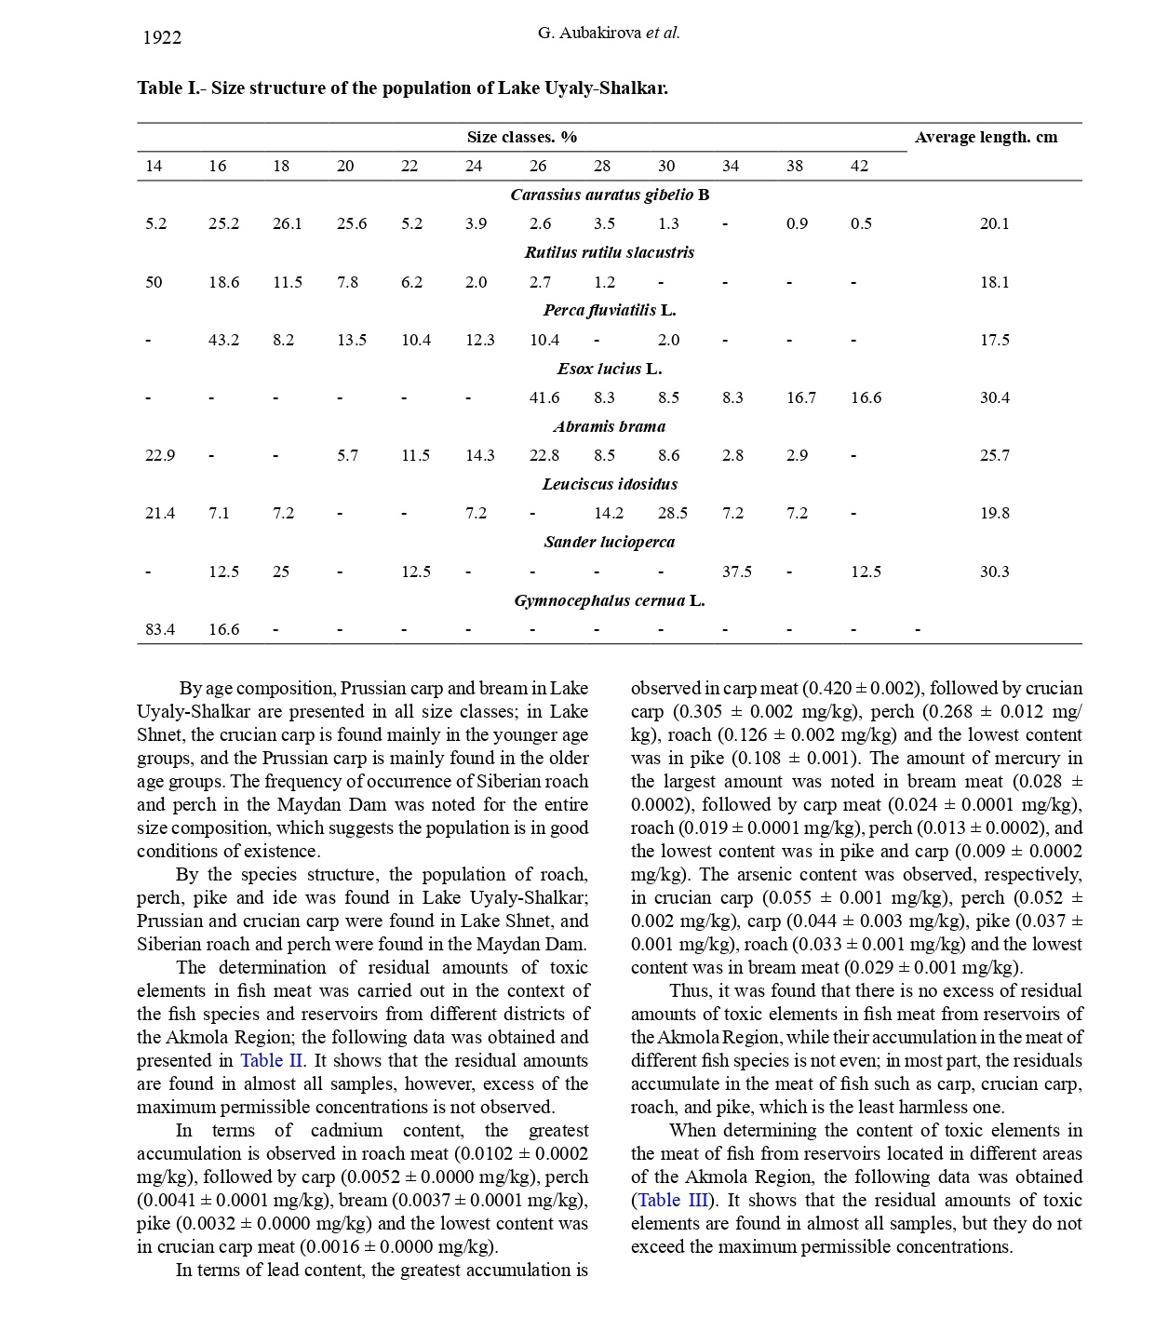

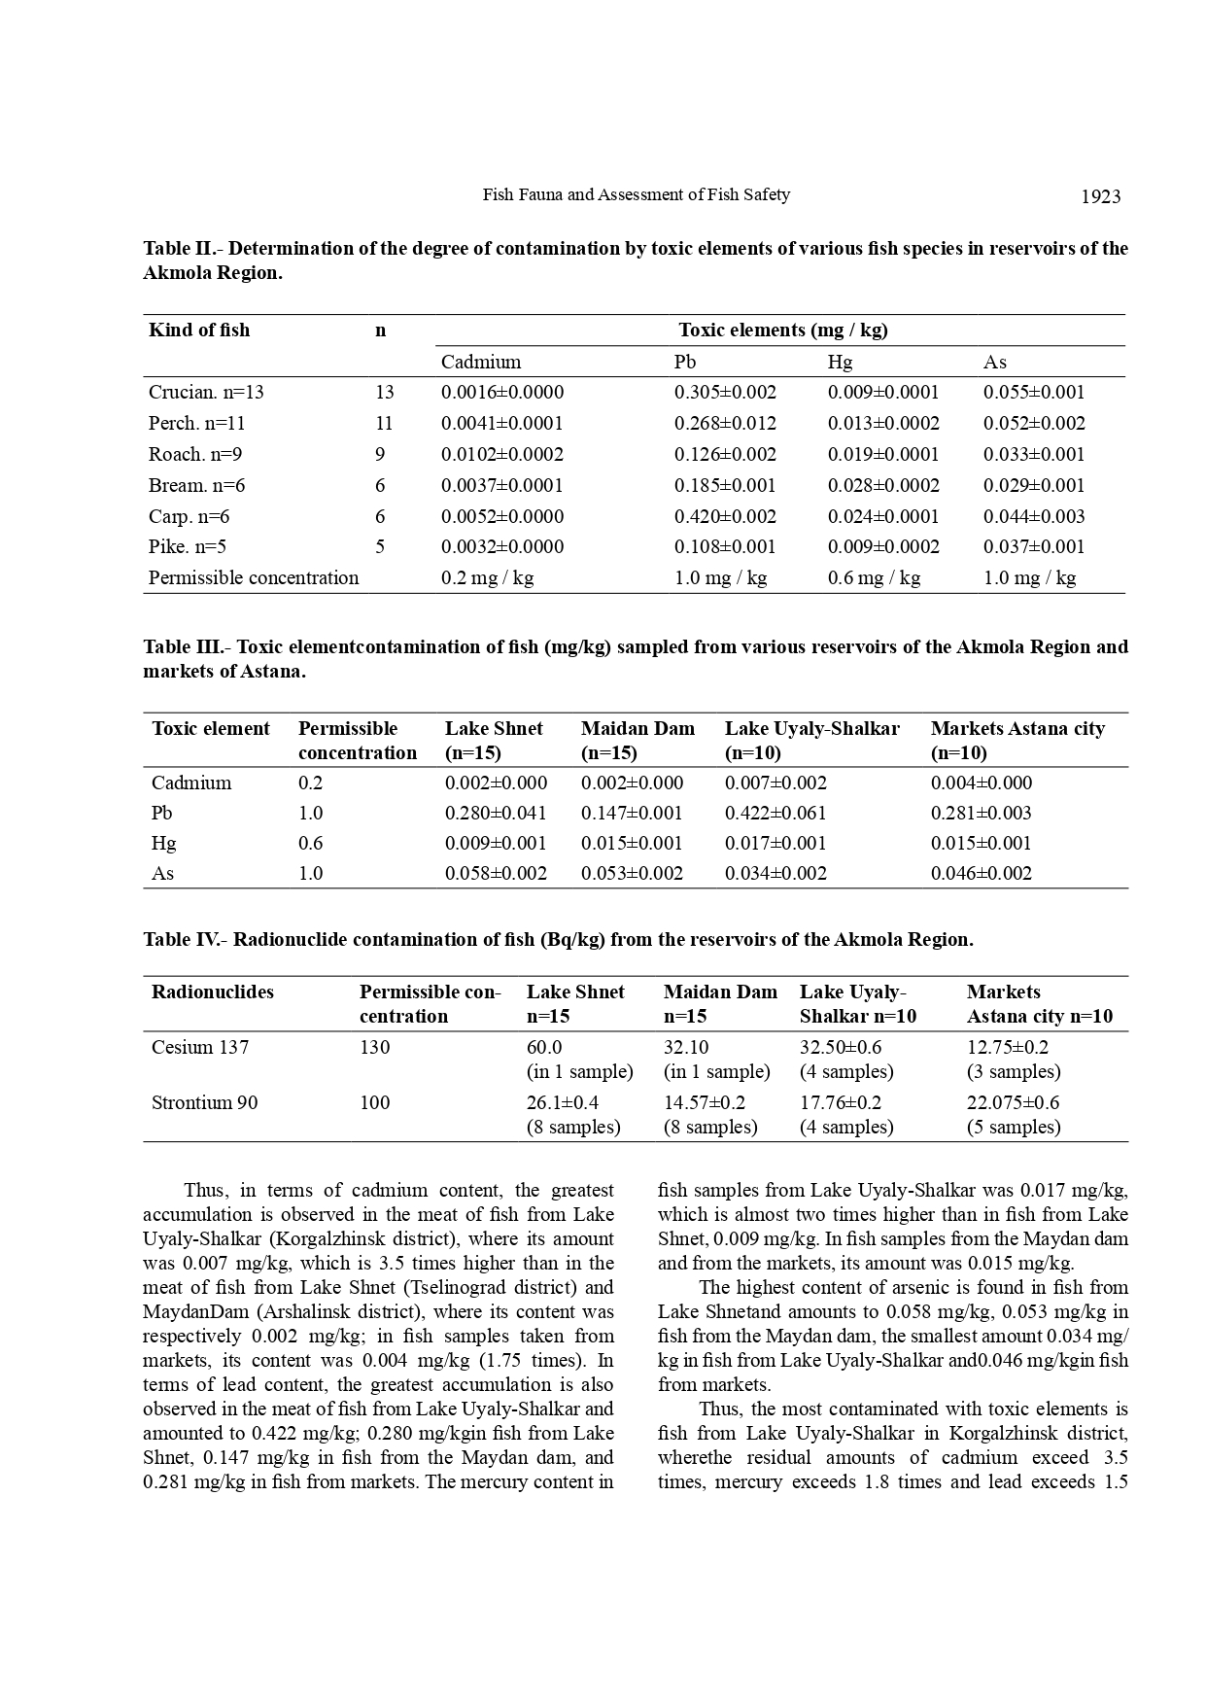

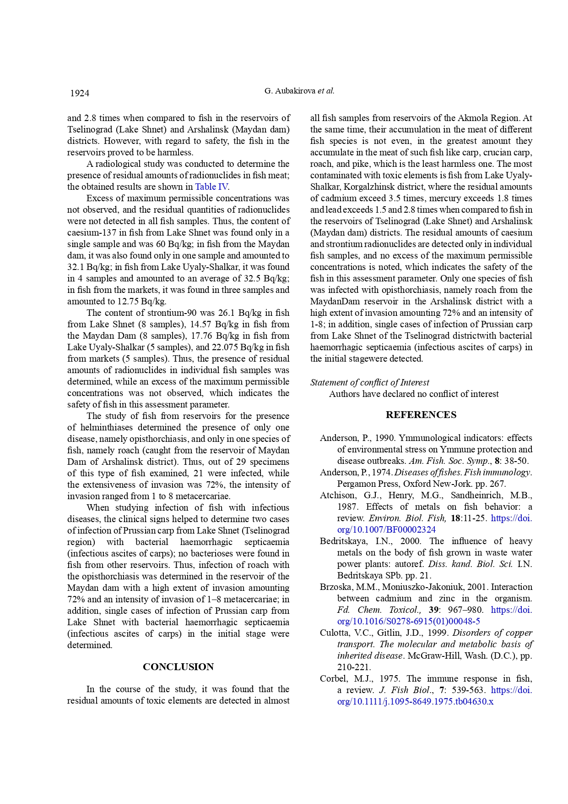
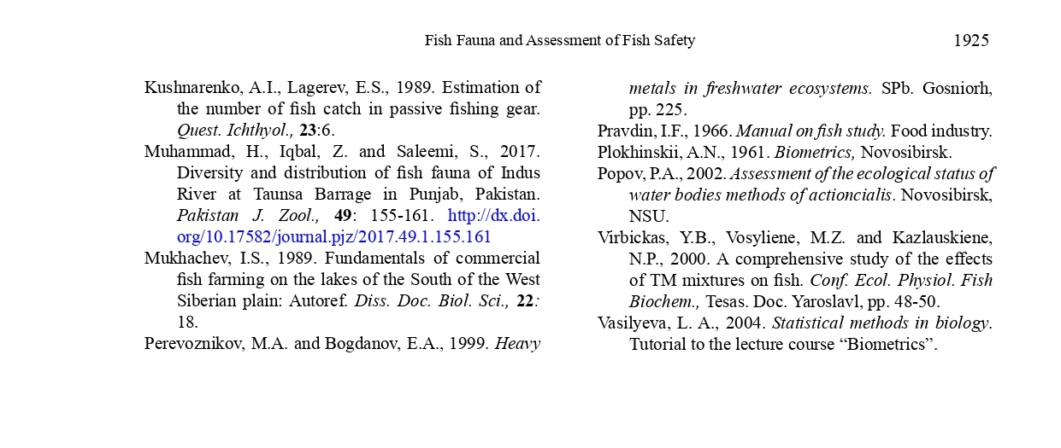

APPENDIX M
List of published works on project
for 2018

№  Ser.no. | Name | Published or as manuscript | Publishing house, journal (name, number, year) | Number of sheets | Last names of co-writers
1 | 2 | 3 | 4 | 5 | 6
1 | Hydrochemical regime of water basins in Akmola region of the Republic of Kazakhstan  (Russian) | Published | Journal of research and practice Rybovodstvo i rybnoye khozyaistvo no. 8/2018. p.30-34 | 6 | Aubakirova G.A., Pishchenko Ye.V., Rakhimzhanova D.T

