реферат

Есеп 91 бет, 1 кітап, 10 сурет, 26 кест., 101 дерек., 6 қос.
ПОЛИМЕРЛІК ГИДРОГЕЛДЕР, ӨЗАРАӨТІМДІ ПОЛИМЕРЛІК ТОРЛАР, МОЛЕКУЛАЛЫҚ ТАҢБАЛЫ ПОЛИМЕРЛЕР, ИНТЕРГЕЛДІ ЖҮЙЕЛЕР, СОРБЦИЯ, НЕОДИМ, РЕНИЙ, СКАНДИЙ ИОНДАРЫ, ОРНАТУ.
Зерттеу нысаны: табиғаты қышқылдық және негіздік жекелеген сиректігілген гидрогелдер және олардың негізінде құрылған интергелді жүйелер; өзараөтімді полимерлік торлар және молекулалық таңбалы полимерлер.
Жұмыстың мақсаты: «қашықтан әрекеттесу әсері» негізінде неодим, рений және скандий иондарына сұрыпты жаңа полимерлік жүйе дайындау.
Зеттеу әдістері: колориметрия, атомды-эмиссионды спектроскопия.
Алынған нәтижелер және өзектілігі: жаңа электрохимиялық, конформациялық және сорбциялық қасиеттерге ие сиректігілген полиқышқылдар мен полинегіздер синтезделді. Олардың негізінде интергелді жүйелер құрылды. Жекелеген полимерлік гидрогелдер мен олардың негізінде құрылған интергелді жүйелердің неодим, рений және скандий иондарына қатысты сорбциялық қасиеттері зерттелді.
Сиректігілген полиқышқылмен тізбекті полинегіз негізінде өзараөтімді полимерлік торлар (ӨПТ) синтезделді. ӨПТ негізінде интергелді жүйелер құрылды. Жекелеген ӨПТ және интергелді жүйелердің неодим, рений және скандий иондарына қатысты сорбциялық қасиеттері зерттелді.
Интергелді жүйелерде (гидрогелдер және ӨПТ негізіндегі) полимерлік құрылымдардың «қашықтан әрекеттесу әсерінен» олардың бастапқы сорбциялық қасиеттері айтарлықтай өседі (30% дейін).
Неодим, рений және скандий иондарына сұрыпты молекулалық таңбалы полимерлер (МТП) синтезделді. МТП сорбциялық қасиеттері зерттелді.
Неодим, рений және скандий иондарын сұрыптап шығару үшін қондырғы үлгісі дайындалды. Бұл үлгі интергелді жүйелердегі сорбенттердің мольдік қатынастарын; сорбенттің түрін жылдам өзгертуге болатын қарапайымдылығымен ерекшеленеді. Бұл үлгі оргшыныдан дайындалған, агрессивті ортаға тұрақты, жоғарыда аталған металдардың иондары бар ерітіндімен реакцияға түспейді.
Модельдік және өнеркәсіптік ерітінділерден неодим, рений және скандий иондарын сұрыптап шығару үшін әзірленген сорбенттерге және қондырғы үлгісіне зертханалық, жартылай өнеркәсіптік және тәжірибелік-өнеркәсіптік сынақтар жүргізілді.
ABSTRACT

Report 91 p., 1 book., 10 fig., 26 tabl., 101 ref., 6 app.
POLYMER HYDROGELS, INTER-PENETERING POLYMER NETWORK, MOLECULARLY IMPRINTED POLYMERS, INTERGEL SYSTEMS, SORPTION, IONS OF NEODYMIUM, RHENIUM, SCANDIUM, UNIT
Objects of research: individual readily cross-linked hydrogels of acidic and basic nature and intergel systems based on them; interpenetrating polymer networks and polymers with molecular imprints.
Goal of work: Development of new selective polymer systems with respect to neodymium, rhenium and scandium ions based on the "long-range effect".
Research methods: colorimetry, atomic emission spectroscopy.
Results and novelty: Rare-crosslinked polyacids and polybases with new electrochemical, conformational and sorption properties were synthesized. Intergel systems based on them were created. Sorption properties of individual rare-crosslinked polymer hydrogels and intergel systems in relation to neodymium, rhenium and scandium ions were studied.
Interpenetrating polymer networks (IPNs) based on rare-crosslinked polyacids and linear polybases were synthesized. Intergel systems were created on the IPNs basis. Sorption properties of individual IPNs and intergel systems in relation to neodymium, rhenium and scandium ions were studied.
In intergel systems (based on hydrogels and based on IPN), the initial sorption properties significantly increase (up to 30%) due to the "long-range effect" of polymer structures.
Molecularly imprinted polymers (MIPs) were synthesized for selective sorption of neodymium, rhenium and scandium ions. Sorption properties of these MIPs were studied.
A sample unit for selective extraction of neodymium, rhenium and scandium ions was developed. This sample is notable for its simplicity of design, which makes it possible to promptly change the molar ratio of sorbents in intergel pairs; change the type of sorbent. This sample is made of plexiglass, is resistant to aggressive environments, does not react with a solution containing the above metal ions.
Laboratory, semi-industrial and pilot-industrial tests of the developed sorbents and the developed unit sample for selective extraction of neodymium, rhenium and scandium ions from model and industrial solutions were carried out.

CONTENT

INTRODUCTION.……………………………………………………...………..................... | 8
MAIN PART OF REPORT ON SRW...……………………………………………………... | 14
1 Creation of intergel systems based on rare-crosslinked hydrogels for selective extraction of neodymium, rhenium and scandium ions………………………………………………... | 14
1.1 Synthesis of hydrogels of different nature with required properties..…………………... | 14
1.1.1 Synthesis of PAA and PMAA hydrogels.…………………………………………… | 15
1.1.2 Synthesis of P4VP and P2M5VP hydrogels................................................................. | 15
1.1.3 Purification of the synthesized PAA, PMAA, P4VP, P2M5VP hydrogels………...... | 16
1.2 Study of sorption properties of hydrogels in relation to neodymium, rhenium and scandium ions……...…………………………................................................................. | 16
1.3 Creation of intergel systems based on the obtained hydrogels of acidic and basic nature for selective extraction of neodymium, rhenium and scandium ions. Determination of the optimal conditions for the selective extraction of neodymium, rhenium and scandium ions……………………………………………………………........................ | 17
1.3.1 Study of the sorption properties of intergel systems hPAA-hP4VP, hPMAA-hP4VP, hPAA-hP2M5VP, hPMAA-hP2M5VP in relation to Nd, Re, Sc ions……… | 18
1.3.2 Determination of optimal ratios of hydrogels in intergel systems for sorption of neodymium, rhenium and scandium…….…………………………………………… | 21
2 Creation of intergel systems based on interpenetrating polymer networks for selective extraction of neodymium, rhenium and scandium ions……………………………………. | 22
2.1 Synthesis of interpenetrating polymer networks with the required properties….............. | 23
2.2 Study of sorption properties of the interpenetrating polymer networks in relation to neodymium, rhenium and scandium ions………..……………………………………… | 24
2.3 Creation of intergel systems based on the obtained interpenetrating polymer networks for selective extraction of neodymium, rhenium and scandium ions. Determination of the optimal conditions for extraction of neodymium, rhenium and scandium ions…….. | 25
3 Creation of highly selective structures based on molecularly imprinted polymers for selective extraction of neodymium, rhenium and scandium ions…………………………... | 27
3.1 Synthesis of molecularly imprinted polymers with required properties…………...…… | 29
3.2 Study of sorption properties of molecularly imprinted polymers in relation to neodymium, rhenium and scandium ions………..……………………………………… | 31
3.3 Creation of highly selective structures based on the obtained molecularly imprinted polymers for selective extraction of neodymium, rhenium and scandium ions. Determination of the optimal conditions for selective extraction of neodymium, rhenium and scandium ions……………………………………………………………... | 32
4 Development of structure units and elements of laboratory unit and a technological scheme for selective extraction of neodymium, rhenium and scandium ions. Carrying out of laboratory and pilot-industrial tests on selective extraction of neodymium, rhenium and scandium ions......................................................................................................................... | 33
4.1 Development of technical requirements for assemblies and elements of a plant designed for selective extraction of neodymium, rhenium and scandium ions………..... | 33
4.2 Development of a laboratory unit sample for selective extraction of neodymium, rhenium and scandium ions............................................................................................... | 33
4.3 Development of a technological scheme for selective extraction of neodymium, rhenium and scandium ions............................................................................................... | 36
4.3.1 Development of a technological scheme based on intergel systems............................ | 36
4.3.2 Development of a technological scheme based on molecularly imprinted polymers.. | 37
4.4 Carrying out laboratory and pilot-industrial tests on selective extraction of neodymium, rhenium and scandium ions using the developed unit…………………….. | 37
4.4.1 Laboratory tests of developed sorbents………………...……………………………. | 38
4.4.2 Semi-industrial tests of developed sorbents…………………….…………………… | 41
4.4.3 Pilot-industrial tests of the developed sorbents…………………………………….... | 44
CONCLUSION......................................................................................................................... | 45
REFERENCES………………………..………………………...……………......................... | 48
APPENDIX A Technical specification and calendar plan of works…………………………. | 56
APPENDIX B List of publications…………………………………………………………... | 61
APPENDIX C Experimental part.……………………………………………………………. | 65
APPENDIX D Act of carrying out of laboratory tests……………………….......................... | 68
APPENDIX E Act of carrying out of semi-industrial tests....................................................... | 72
APPENDIX F Act of carrying out of pilot-industrial tests.………………………………….. | 76

LIST OF ABBREVIATIONS AND SYMBOLS

In this research report, the following abbreviations and symbols are used:

α | – swelling degree, g/g
η | – extraction degree of metals ions, %
IER | – ion-exchange resins
ECH | – epichlorohydrin
MBAA | – methylene bis-acrylamide
DMFA | – dimethylformamide
AIBN | – azobisisobutyronitrile
EGDMA | – ethylene glycol dimethacrylate
DEGDMA | – diethylene glycol dimethacrylate
HEC | – hydroxyethyl cellulose
MAA | – methacrylic acid
4VP | – 4-vinylpyridine
REM | – rare-earth metals
RM | – rare metals
hPAA | – polyacrylic acid hydrogel
hPMAA | – polymethacrylic acid hydrogel
hP4VP | – poly-4-vinylpyridine hydrogel
hP2M5VP | – poly-2-methyl-5-vinylpyridine hydrogel
IPN | – interpenetrating polymer networks
SIPN | – semi-interpenetrating polymer meshes
IPN 1 | – IPN(hPAA-hP4VP)
IPN 2 | – IPN(hPMAA-hP4VP)
MIP | – molecularly imprinted polymers
MIP 1 | – MIP, in the synthesis of which EGDMA was used
MIP 2 | – MIP, in the synthesis of which DEGDMA was used

INTRODUCTION

It is not for nothing that the demand for rare and rare-earth metals (RM and REM) has sharply increased in recent years all over the world, due to their increased role in leading industries that ensure the economic and defense security of any state.
The Republic of Kazakhstan is one of the largest regions in the world with significant reserves and prospects for expanding the mineral resource base of rare and rare-earth metals. However, today the production of RM, REM and their compounds in Kazakhstan can be characterized as unstable, far from corresponding to its potential. The production of these metals has decreased, and at some enterprises has stopped. Meanwhile, taking into account the current and future requirements of the development of science and technology in the world, the demand for rare metal and rare earth products is increasing, and the production of pure RM and REM and their compounds is highly profitable. This means that for the Republic of Kazakhstan the priority direction in the future is extraction, selection, production of pure RM and REM and their compounds.
Neodymium is one of the most widely used metals from the lanthanide group, along with samarium, cerium, and lanthanum. The most important fields of application of neodymium are: alloying of structural alloys and steels; production of powerful permanent magnets.
Alloying with neodymium significantly increases the strength of thermoelectric materials based on bismuth and antimony tellurides and selenides and increases the thermo-EMF of these materials. There is an indication that doping thermoelectric alloys of the bismuth-tellurium-cesium system with neodymium also increases their strength, thermo-emf and temporary stability. Neodymium oxide is used as a dielectric with an ultra-low coefficient of linear thermal expansion and for the production of neodymium glass. Neodymium glass is a mineral glass containing neodymium oxide, sometimes a mixture of oxides of other rare earth elements and has several names: neodymium glass, didyme glass, chameleon glass, alexandrite glass [1], Moser glass ("Alexandrite", "Geliolite", "Royal") and many other trade names, among which "Neofan" or "neophanous glass" stands out [2]. Neodymium fluoride is used to produce high quality fiber optic light guides for fiber optics. Neodymium telluride is a very good thermoelectric material and a component of thermoelectric alloys, which gives increased strength and improves electrophysical characteristics (thermo-EMF is about 170 μV/K).
Rhenium under standard conditions is a dense, silvery-white transition metal. The most important properties of rhenium that determine its use are a very high melting point, resistance to chemical reagents, and catalytic activity (in this it is close to platinoids). However, rhenium is an expensive and rare metal, so its use is limited to those cases where it offers exceptional advantages over other metals.
Prior to the discovery of platinum-rhenium reforming catalysts, the main field of application of rhenium was high-temperature alloys [3]. Alloys of rhenium with molybdenum, tungsten and other metals are used to create parts for rocketry and supersonic aircraft. Nickel and rhenium alloys are used for the manufacture of combustion chambers, turbine blades and exhaust nozzles of jet engines. These alloys contain up to 6% rhenium, making the construction of jet engines the largest consumer of rhenium. In particular, monocrystalline nickel-containing rhenium-containing alloys with increased heat resistance are used for the manufacture of blades for gas turbine engines [4]. Rhenium is of critical military-strategic importance due to its use in the manufacture of military jet and rocket engines [5].
Tungsten rhenium thermocouples can measure temperatures up to 2200°C. As an alloying additive, rhenium is introduced into alloys based on nickel, chromium and titanium. Rhenium promotion of platinum metals increases their wear resistance. Such alloys are used to make nibs for automatic pens and spinnerets for artificial fibers. Also, rhenium is used in alloys for the manufacture of precision instrument parts, such as springs. Rhenium is used for the manufacture of filaments in mass spectrometers and ion pressure gauges, and cathodes. In these cases, rhenium-coated tungsten is also used. Rhenium is chemically resistant, so it is used to create coatings that protect metals from the action of acids, alkalis, sea water and sulfur compounds.
Since the discovery of platinum-rhenium reforming catalysts [6], rhenium has been actively used for the industrial production of such catalysts. This made it possible to increase the efficiency of production of high-octane gasoline components used to obtain commercial gasoline that does not require the addition of tetraethyl lead. The use of rhenium in oil refining has significantly increased the global demand for it.
In addition, self-cleaning electrical contacts are made from rhenium. When the circuit is closed and broken, an electrical discharge always occurs, as a result of which the contact metal is oxidized. Rhenium is also oxidized, but its oxide Re₂O₇ is volatile at relatively low temperatures (boiling point is only + 362.4°C), and during discharges it evaporates from the contact surface, so rhenium contacts serve for a very long time.
Scandium is a monoisotopic element; only one stable isotope Sc45 is found in nature. The use of scandium in the form of a microalloying impurity has a significant effect on a number of practically important alloys, for example, the addition of 0.4% scandium to aluminum-magnesium alloys increases the ultimate tensile strength by 35%, and the yield strength by 65-84%, and at the same time the relative elongation remains at the level of 20-27%. The addition of 0.3-0.67% to chromium increases its oxidation resistance up to a temperature of 1290°C, and has a similar, but even more pronounced effect on heat-resistant alloys of the "nichrome" type, and in this area the use of scandium is much more effective than yttrium. Scandium oxide has a number of advantages for the production of high-temperature ceramics over other oxides, for example, the strength of scandium oxide when heated increases and reaches a maximum at 1030°C, at the same time, scandium oxide has a minimum thermal conductivity and the highest resistance to thermal shock. Yttrium scandate is one of the best materials for high temperature structures. Scandium oxide is constantly used for the production of germanate glasses for optoelectronics [7].
The main application of scandium in terms of volume is its use in aluminum-scandium alloys used in sports equipment (motorcycles, bicycles, baseball bats, etc.) – wherever high-strength materials are required. Alloyed with aluminum, scandium provides additional strength and ductility. An important and practically unexplored area of application of scandium is the fact that, like alloying aluminum with yttrium, alloying of pure aluminum with scandium also increases the electrical conductivity of wires, and the effect of sharp hardening has great prospects for using such an alloy for electricity transportation (power lines). Scandium is used to produce superhard materials. For example, alloying titanium carbide with scandium carbide sharply raises the microhardness (2 times), which makes this new material the fourth in hardness after diamond. In recent years, high-melting alloys (intermetallic compounds) of scandium with rhenium (melting temperature up to 2575°C), ruthenium (melting temperature up to 1840°C), iron (melting temperature up to 1600°C), ( heat resistance, moderate density, etc.). Scandium oxide (melting point 2450°C) plays an important role as a special-purpose refractory material in the production of steel-pouring nozzles for casting high-alloy steels; scandium oxide surpasses all known and used materials in terms of resistance in a stream of liquid metal. Widespread use is hindered only by the high price; therefore, an alternative solution in this area is the use of yttrium scandates, reinforced with whiskers of aluminum oxide to increase strength), as well as the use of scandium tantalate [8].
For selective extraction of neodymium, rhenium and scandium from industrial solutions of hydrometallurgy in the Republic of Kazakhstan, synthetic ion-exchange resins (IER) of foreign production are widely used. As you know, ion-exchange resins are used in hydrometallurgy for the selective extraction of metal from a lean solution and obtaining a more concentrated solution of the recoverable metal, separating elements with similar properties, obtaining high-purity and softened water, purifying various industrial solutions from impurities and neutralizing wastewater, oxidizing ions in solutions with simultaneous sorption, for the recovery of metals with their sorption from dilute solutions and in other cases. Currently produced ion-exchange resins with high capacity, chemical resistance and mechanical strength have replaced other ion-exchange materials [9-16].
Synthetic IERs are high molecular weight compounds with a three-dimensional tightly cross-linked macroporous structure, which contain functional groups of acidic or basic nature, capable of ion exchange reactions. These resins are obtained by polymerization or polycondensation [17-23]. Synthetic ion exchange resins are organic ion-exchangers. An organic matrix is made by polymerization or polycondensation of monomeric organic molecules. Ionogenic groups (fixed ions) of the acidic or basic type are chemically introduced into this matrix. Modern ion-exchange resins have a high exchange capacity and stability in operation [24]. Ion-exchange resins are solid water-insoluble substances capable of absorbing positive or negative ions from solutions or pulps in exchange for equivalent amounts of other ions having a charge of the same sign. According to the sign of the charge of the exchanged ions, cation resins (cation resins) and anion exchange resins (anion resins) are distinguished. The ability to ion-exchange is determined by the structure of ion-exchanger. Each ion-exchanger consists of a framework connected by valence or lattice forces. The framework has a positive or negative charge, which is compensated by the charge of ions of the opposite sign, called counterions. Counterions are mobile inside the framework and can be replaced by other ions with a charge of the same sign [25-28].
It should be noted that ion-exchange resins are capable of swelling in water due to the presence of hydrophilic fixed groups capable of hydration. However, cross-linking prevents the infinite swelling of IER, that is, dissolution. The degree of cross-linking is set during the synthesis of ion exchangers through the amount of cross-linking agent introduced. In general, the degree of swelling of ion exchangers is determined by the amount of crosslinking, the concentration of hydrophilic ionogenic groups in the volume of the ion exchanger grain, and what counterions are in the exchanger. Usually singly charged ions, especially hydrogen and hydroxyl ions, lead to the greatest swelling; multiply charged counterions lead to some compression and a decrease in the volume of grains [29–31].
The most widespread are ion-exchange resins obtained from crosslinked polystyrene. In fact, the ion-exchange regions are introduced after the polymerization process. Crosslinking is of great importance (uncrosslinked polymers dissolve in water); in the case of polystyrene, it is introduced by copolymerizing styrene with a small amount of divinylbenzene. Crosslinking leads to a decrease in the ion exchange capacity of the resin and an increase in the time required for the ion exchange process, but at the same time the reliability of the resin is increased. Also, the resin parameters are influenced by the particle size, smaller particles have a large outer surface, but at the same time there is a large loss of pressure in columnar processes [32-35]. Although ion exchange resins are produced as beads, they are also often produced as membranes. Membranes, which are made of highly crosslinked ion exchange resins that allow the passage of ions, but not water, are used for electrodialysis [36]. However, anion and cation resins are the two most common types of resins used in ion exchange processes. While anionic resins attract negatively charged ions, cation exchangers attract positively charged ions [37-51].
Regeneration process of ion-exchange resins is the treatment of the resin with a solution (basic for anion exchangers and acidic for cation exchangers). During regeneration, the regenerating agent passes through the resin, capturing negative or positive ions for the anion and cation exchangers, respectively, and flushing them out, renewing the resin's ion-exchange capacity.
Ion exchange processes are used for the separation and purification of metals, including the separation of uranium from plutonium and other actinides, as well as lanthanum and thorium; neodymium, ytterbium, samarium and lutetium from each other and from other lanthanides [52-56]. There are two series of rare earth metals: lanthanides and actinides. The metals in each row have similar physical and chemical properties. A very important case is the PUREX process (plutonium-uranium extraction process), which is used to extract and separate plutonium and uranium from spent fuel products of a nuclear reactor, and then be able to dispose of the waste. Thereafter, plutonium and uranium can again be used in the production of nuclear energy materials such as new reactor fuel and nuclear weapons. Ion exchange resins are also an important component in uranium mining by in situ leaching. Underground leaching involves the extraction of uranium-bearing water through boreholes. The leach solution containing the uranium is then passed through the resin. Resin granules extract uranium from solution by ion exchange. The process of ion-exchange uranium extraction is based on the ability of ion-exchange resins to selectively and quantitatively absorb uranium from solutions and slurries after leaching. In sulfuric acid solutions, hexavalent uranium can be present in the form of uranyl cation (UO22 +) and anionic sulfate complexes, which are in dynamic equilibrium with each other. After sulfuric acid leaching, uranium can be recovered from solutions and pulps using cation- or anion-exchange resins. Resins containing uranium are transported to a processing plant, where UO2 is separated from the resin pellets and yellowcake is produced. After that, the resin is regenerated and sent to re-recover uranium from the leach solution.
At present, there are no fundamentally new ideas designed to create new sorption technologies for the selective separation and extraction of neodymium, rhenium, and scandium ions from product solutions. Existing developments in the concentration and extraction of metal ions presuppose, in the main, the use of foreign-made ion-exchange resins (USA, France). It should be noted that ion exchangers do not have a high degree of metal recovery and their regeneration is a rather complicated process. In addition, the use of ion-exchange resins is aimed at selective extraction of only one metal, while the accompanying valuable components remain in the volume of product solution.
The innovativeness of the research is that, for the first time in world practice, for the selective sequential separation and extraction of neodymium, rhenium and scandium ions, it is planned to create fundamentally new highly selective polymer structures based on intergel systems, interpenetrating polymer networks (IPNs) and molecularly imprinted polymers (MIPs) with higher sorption properties (compared to existing analogues) and selectivity in relation to neodymium, rhenium and scandium ions.
The results of the previous stages of research are fully reflected in the intermediate reports for 2018 y. (Inv. No. 0218RK00595) and 2019 y. (Inv. No. 0219RK00661).

MAIN PART OF REPORT ON SRW

1 Creation of intergel systems based on rare-crosslinked hydrogels for selective extraction of neodymium, rhenium and scandium ions
Hydrogels are formed in a variety of reactions from both monomers and macromolecules; they can be represented by one type of monomers and semi-interpenetrating networks, in which one monomer is polymerized within an already formed network. Varying the type of hydrogel allows systems with different properties. The mechanisms of gel formation are different; hydrogels are formed as a result of physical and chemical gelation [57]. Polymer gels are long polymer chains swollen in a solvent, crosslinked to each other by cross-linked covalent bonds (crosslinks) into a single spatial network [58]. The properties of hydrogels (swelling, mechanical properties, degradability) are important for determining their scope. Hydrogels have low mechanical properties due to their high water content. A common way to control the mechanical properties of hydrogels is to change the crosslinking density of the polymer. The structure of hydrogels (lightly crosslinked polyelectrolytes) can be represented in the form of polymer chains consisting of monomer units containing ionic groups crosslinked with another comonomer, the so-called crosslinking agent.

1.1 Synthesis of hydrogels of different nature with required properties
In the preparation of polymer hydrogels by polymerization, the purification of the starting materials is of particular importance. Often, the course of reactions is significantly influenced by impurities present even in very small amounts (from 10⁻¹ to 10 wt%). In unsaturated monomers, the following impurities are mainly present: by-products of the reaction formed during the preparation of the monomer; added stabilizers; inhibitors; products of oxidation and decomposition of monomers; impurities that get into the monomer during storage.
When choosing a purification method, it is necessary to be guided by the nature of the monomers, the expected impurities and, above all, the polymerization mechanism (for example, radical polymerization in an aqueous emulsion or ionic polymerization with a sodium naphthalene complex). Since it is impossible to create a universal cleaning scheme, in each case the most effective cleaning method should be chosen.
There are the following purification methods: fractional, azeotropic, or extractive distillation in an inert gas, crystallization, sublimation, and column chromatography.
Preparation of acrylic and methacrylic acid monomers consisted of vacuum distillation of the available monomers. Linear polymers of poly-4-vinylpyridine and poly-2-methyl-5-vinylpyridine were synthesized by Sigma-Aldrich (USA). These polybases were of high purity and did not require purification.

1.1.1 Synthesis of PAA and PMAA hydrogels
The synthesis of polyacrylic and polymethacrylic acid hydrogels (hPAA and hPMAA, respectively) was carried out according to the synthesis procedure based on the preparation of lightly crosslinked polymer hydrogels in the medium of a crosslinking agent N, N-methylene-bis-acrylamide (MBAA); a redox initiator was used as a polymerization initiator. system K₂S₂O₈–Na₂S₂O₃. The polymerization process was carried out as follows: 12 ml of monomer was added to a 100 ml volumetric flask, then 45 ml of water was added, then a crosslinking agent dissolved in water when heated was added to the solution, after which 1.5 ml of a reaction initiator was added. Then the mixture in the flask is brought to the mark with distilled water. After that, the entire mixture is poured into special ampoules and placed in an oven preheated to a temperature of 65°C for 60 minutes. The rare distribution of crosslinks along the chain length was ensured by a low concentration of the crosslinking agent in the polymer. The degree of swelling of the synthesized PAA and PMAA hydrogels is: α(hPAA) = 29.33 g/g; α(hPMAA) = 22.97 g/g.

1.1.2 Synthesis of P4VP and P2M5VP hydrogels
The synthesis of poly-4-vinylpyridine and poly-2-methyl-5-vinylpyridine hydrogels (hP4VP and hP2M5VP, respectively) was carried out according to the synthesis method, which is based on the crosslinking of linear polymers using a crosslinking agent - epichlorohydrin (ECH) in a solvent of dimethylformamide (DMFA). The synthesis was carried out as follows: a weighed portion of a linear polymer of 4 g is poured with 15 ml of solvent until the polymer sample is completely dissolved. This process includes the stage of polymer swelling. Thereafter, 2 ml of the crosslinking agent is added dropwise to the solution with stirring at 65°C. The degree of swelling of the synthesized hydrogels P4VP and P2M5VP is: α(hP4VP) = 3.15 g/g; α(hP2M5VP) = 2.99 g/g.

1.1.3 Purification of the synthesized PAA, PMAA, P4VP, P2M5VP hydrogels
The synthesized hydrogels PAA, PMAA, P4VP, P2M5VP were purified from unreacted products and soluble polymer fractions by long-term washing (for 14 days) under stationary conditions with two to three daily water changes. The synthesized hydrogel is washed in wash columns. The water is changed 2-3 times a day. The control of the degree of purification was carried out by determining the specific electrical conductivity and pH of water after gel purification. After 14 days, the values of specific electrical conductivity and pH of the wash water remained constant. This indicates that the process of purification of polymer hydrogels from unreacted products is over. Then the obtained samples of hydrogels were subjected to dispersion by grinding in a mortar.

1.2 Study of sorption properties of hydrogels in relation to neodymium, rhenium and scandium ions
An electrochemical equilibrium exists in salt solutions. Any interference into solution leads to a change in this balance. Rare-crosslinked polymer hydrogels are weak electrolytes, despite this, macromolecules interact with the metal ions present in solutions. Polyacids are prone to dissociation of carboxyl groups, sorption of neodymium, rhenium and scandium ions by attaching it to the oppositely charged carboxylate anion. Polybases undergo ionization of heteroatoms, leading to a change in their conformation.
Table 1 shows the values of the degrees of extraction of ions of neodymium, rhenium, scandium hydrogels PAA, PMAA, P4VP, P2M5VP at 48 hours of interaction of polymers with salt solutions. Extraction (sorption) degree of neodymium ions by hydrogels of PAA, PMAA, P4VP, P2M5VP is 61.6%; 59.9%; 54.6%; 51.5% respectively. Sorption degree of rhenium ions by hydrogels of PAA, PMAA, P4VP, P2M5VP is 66.5%; 63.3%; 58.1%; 54.9% respectively. Sorption degree of scandium ions by hydrogels of PAA, PMAA, P4VP, P2M5VP is 63.7%; 62.1%; 56.9%; 52.5% respectively. The highest values of the sorption degree are observed for hPAA, which is associated with a high degree of ionization of the polyacid. The difference in the values of sorption degree of rare-crosslinked polymer hydrogels is associated with different rates of ionization of the initial macromolecules. Ionization can be complicated if a bulky substituent (eg methyl) is present in the polymer structure.

Table 1 – Extraction degree of Nd, Re, Sc by PAA, PMAA, P4VP, P2M5VP hydrogels

η, % | PAA | PMAA | P4VP | P2M5VP
η(Nd), % | 61.6 | 59.9 | 54.6 | 51.5
η(Re), % | 66.5 | 63.3 | 58.1 | 54.9
η(Sc), % | 63.7 | 62.1 | 56.9 | 52.5

The results obtained on sorption of Nd, Re, Sc ions indicate that individual hydrogels of PAA, PMAA, P4VP, P2M5VP do not exhibit sufficiently high extraction degree of these metals ions. Extraction degree of these ions does not exceed 70%, what is directly related to low degree of their ionization. Different values of extraction degree in the case of each ion (Nd, Re, Sc) directly depend on the nature of the ions, atomic radius, charge density, and polarizability.

1.3 Creation of intergel systems based on the obtained hydrogels of acidic and basic nature for selective extraction of neodymium, rhenium and scandium ions. Determination of the optimal conditions for the selective extraction of neodymium, rhenium and scandium ions
Intergel systems hPAA-hP4VP, hPMAA-hP4VP, hPAA-hP2M5VP, hPMAA-hP2M5VP were created from the synthesized polymeric hydrogels of PAA, PMAA, P4VP, P2M5VP. The main feature of intergel systems is the absence of direct contact between polymer hydrogels in solution - there is a remote interaction of hydrogels. Intergel system is schematically shown in figure 1.

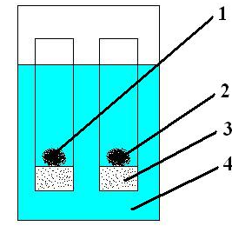

1 – polyacid, 2 – polybasis, 3 – glass filter, 4 – solution

Figure 1 – Scheme of intergel system

During remote interaction of hydrogels, dissociation of carboxyl groups into carboxylate anions and protons occurs, and it depends on dissociation degree. Due to association of a proton by heteroatoms of polybasis, the total number of protons in solution decreases, what leads to additional dissociation (according to the Le Chatelier principle due to a shift in equilibrium towards the formation of protons) of other (non-dissociated) carboxyl groups. These interactions lead to the formation of uncompensated, similarly charged functional groups on the interstitial units of both hydrogels (acidic and basic), which, in turn, repel each other according to the laws of electrostatics and lead to the unfolding of the macromolecular coil. As can be seen from the above processes, as a result of the "long-range effect" of polymer hydrogels, their mutual activation occurs. Mutual activation involves the transition of hydrogels to a highly ionized state. This results in a significant change in the electrochemical properties (specific conductivity, pH) of solutions, as well as changes in the conformational and sorption properties of macromolecules.

1.3.1 Study of the sorption properties of intergel systems hPAA-hP4VP, hPMAA-hP4VP, hPAA-hP2M5VP, hPMAA-hP2M5VP in relation to Nd, Re, Sc ions
Table 2 shows the dependence of extraction degree of Nd, Re, Sc ions on the ratios of hPAA:hP4VP at 48 hours of interaction. Sorption degree in intergel pairs hPAA-hP4VP is much higher than in individual hydrogels. This is due to high degree of ionization of the initial polymers in the intergel system during their remote interaction as a result of mutual activation. The lowest values of sorption degree are observed in the presence of individual PAA and P4VP hydrogels, the parameter does not exceed 70%. The maximum values of sorption degree of neodymium are observed at ratios of 83%hPAA-17%hP4VP and 50%hPAA-50%hP4VP, sorption degree is 93.5% and 91.7%, respectively. The highest ionization of polymers during sorption of rhenium occurs at ratios of 50%hPAA-50%hP4VP and 17%hPAA-83%hP4VP, which leads to the fact that at these ratios, the maximum values of the degree of sorption are noted (93.5% and 95.1%, respectively). The maximum amount of scandium (94.3% and 92.8%, respectively) is extracted at ratios of 50%hPAA-50%hP4VP and 33%hPAA-67%hP4VP.

Table 2 – Extraction degree of Nd, Re, Sc ions by intergel system hPAA-hP4VP

η, % | hPAA:hP4VP, mol.%:mol.%
η, % | 100% | 83%:17% | 67%:33% | 50%:50% | 33%:67% | 17%:83% | 100%
η(Nd), % | 61.6 | 93.5 | 86.7 | 91.7 | 61.6 | 93.5 | 86.7
η(Re), % | 66.5 | 74.9 | 90.4 | 93.5 | 66.5 | 74.9 | 90.4
η(Sc), % | 63.7 | 73.8 | 89.6 | 94.3 | 63.7 | 73.8 | 89.6

Table 3 shows the dependence of extraction degree of Nd, Re, Sc ions from the ratios of hPMAA:hP4VP at 48 hours of interaction. Low ionization of individual PMAA and P4VP hydrogels leads to the fact that they adsorb no more than 65% of these metals, while intergel pairs adsorb from 70% to 95%. The largest amount of neodymium (90.6% and 92.4%, respectively) is extracted at a ratio of 83%hPMAA-17%hP4VP and 67%hPMAA-33%hP4VP. Intensive sorption of rhenium occurs at ratios of 50%hPMAA-50%hP4VP and 33%hPMAA-67%hP4VP, while the recovery is 94.3% and 92.4%, respectively. The overwhelming majority of scandium ions are sorbed at ratios of 33%hPMAA-67% hP4VP and 17%hPMAA-83%hP4VP, the recovery rates are 91.7% and 93.1%, respectively.
Table 3 – Extraction degree of Nd, Re, Sc ions by intergel system hPMAA-hP4VP

η, % | hPMAA:hP4VP, mol.%:mol.%
η, % | 100% | 83%:17% | 67%:33% | 50%:50% | 33%:67% | 17%:83% | 100%
η(Nd), % | 59.9 | 90.6 | 92.4 | 84.3 | 59.9 | 90.6 | 92.4
η(Re), % | 63.3 | 89.3 | 74.5 | 94.3 | 63.3 | 89.3 | 74.5
η(Sc), % | 62.1 | 71.3 | 87.8 | 73.6 | 62.1 | 71.3 | 87.8

Table 4 shows dependence of extraction degree of Nd, Re, Sc ions from ratios of hPAA:hP2M5VP at 48 hours of interaction. Intensive sorption of neodymium occurs at ratios of 50%hPAA-50%hP2M5VP and 17%hPAA-83%hP2M5VP, extraction degree is 91.9% and 88.3%. The maximum amount of rhenium (91.7% and 93.6%, respectively) is sorbed at ratios of 67%hPAA-33%hP2M5VP and 33%hPAA-67%hP2M5VP. Areas of high scandium sorption are the ratios of 67%hPAA-33%hP2M5VP and 33%hPAA-67%hP2M5VP, with 92.7% and 90.1% of the metal being recovered, respectively.

Table 4 – Extraction degree of Nd, Re, Sc ions by intergel system hPAA-hP2M5VP

η, % | hPAA:hP2M5VP, mol.%:mol.%
η, % | 100% | 83%:17% | 67%:33% | 50%:50% | 33%:67% | 17%:83% | 100%
η(Nd), % | 61.6 | 82.3 | 65.4 | 91.9 | 61.6 | 82.3 | 65.4
η(Re), % | 66.5 | 87.8 | 91.7 | 76.1 | 66.5 | 87.8 | 91.7
η(Sc), % | 63.7 | 85.6 | 92.7 | 74.3 | 63.7 | 85.6 | 92.7

Table 5 shows the dependence of the degree of extraction of Nd, Re, Sc ions on the ratios of hPAA:hP2M5VP at 48 hours of interaction. At the ratios of 50%hPMAA-50%hP2M5VP, 33%hPMAA-67%hP2M5VP, the maximum sorption of neodymium occurs, extraction degree is 86.0% and 90.7%. In intergel pairs of 67%hPMAA-33%hP2M5VP and 50%hPMAA-50%hP2M5VP, the maximum sorption of rhenium occurs, extraction degree is 89.9% and 92.7%. The areas of maximum sorption of scandium are ratios of 83%hPMAA-17%hP2M5VP and 67%hPMAA-33%hP2M5VP, the recovery rates being 91.5% and 88.3%.

Table 5 – Extraction degree of Nd, Re, Sc ions by intergel system hPMAA-hP2M5VP

η, % | hPMAA:hP2M5VP, mol.%:mol.%
η, % | 100% | 83%:17% | 67%:33% | 50%:50% | 33%:67% | 17%:83% | 100%
η(Nd), % | 59.9 | 61.8 | 66.1 | 86.0 | 59.9 | 61.8 | 66.1
η(Re), % | 63.3 | 69.1 | 89.9 | 92.7 | 63.3 | 69.1 | 89.9
η(Sc), % | 62.1 | 91.5 | 88.3 | 82.6 | 62.1 | 91.5 | 88.3

A significant increase (by more than 30%) of sorption degree of Nd, Re, Sc ions in intergel systems in comparison with individual hydrogels is primarily associated with a high degree of ionization of hydrogels. The initial rare-crosslinked polymers undergo transition to highly ionized state during their remote interaction, as a result of which there is a significant increase in sorption properties due to formation of an optimal conformation for the sorption of Nd, Re, Sc ions.

1.3.2 Determination of optimal ratios of hydrogels in intergel systems for sorption of neodymium, rhenium and scandium
An analysis of the obtained results showed that each of the studied intergel systems has a certain hydrogels ratio, at which maximum sorption of Nd, Re, Sc ions occurs. Tables 6-8 show the maximum values of extraction degrees of Nd, Re, Sc ions of intergel systems hPAA-hP4VP, hPMAA-hP4VP, hPAA-hP2M5VP, hPMAA-hP2M5VP.

Table 6 – Extraction degree of Nd ions by the intergel systems

Intergel system | 83%hPAA-  17%hP4VP | 67%hPMAA-  33%hP4VP | 50%hPAA:  50%hP2M5VP | 33%hPMAA:  67%hP2M5VP
η(Nd), % | 93.5 | 92.4 | 91.9 | 90.7

Table 7 – Extraction degree of Re ions by the intergel systems

Intergel system | 17%hPAA-  83%hP4VP | 50%hPMAA-  50%hP4VP | 33%hPAA:  67%hP2M5VP | 50%hPMAA:  50%hP2M5VP
η(Re), % | 95.1 | 94.3 | 93.6 | 92.7

Table 8 – Extraction degree of Sc ions by the intergel systems

Intergel system | 50%hPAA-  50%hP4VP | 17%hPMAA-  83%hP4VP | 67%hPAA:  33%hP2M5VP | 83%hPMAA:  17%hP2M5VP
η(Sc), % | 94.3 | 93.1 | 92.7 | 91.5

As can be seen from the obtained data, among the studied intergel systems, the highest values of extraction degree of Nd, Re, Sc ions are observed in the intergel system hPAA-hP4VP. The lowest values of sorption degree sorption of the above mentioned ions are observed in the intergel system hPMAA-hP2M5VP. The difference in the values of these parameters in intergel systems is due to the fact that systems containing PMAA or P2M5VP hydrogels are less susceptible to mutual activation due to the presence of a bulky methyl substituent in the structure of these hydrogels, which interferes with the unfolding of the polymer globe, and, as a consequence, limits the transition of the macromolecules into a highly ionized state.
2 Creation of intergel systems based on interpenetrating polymer networks for selective extraction of neodymium, rhenium and scandium ions
An interpenetrating polymer network (IPN) is a polymer made up of two or more networks that are partially entangled with the polymer, but not covalently bound to each other. The network cannot be separated if there is no breaking of chemical bonds. Two or more meshes can be intertwined in such a way that they are connected and cannot be separated, but there are no chemical bonds. In other words, interpenetrating polymer networks (IPNs) are a monolithic system consisting of two or more three-dimensional network polymers, in which individual networks are not chemically linked to each other, but are inseparable due to the mechanical interlacing of chains, determined by the conditions of their synthesis [59- 69].
Figure 2 reflects two main methods of synthesis (sequential and parallel) of IPNs [70-77]. The general sequential synthesis procedure of IPN requires mixing monomer 1 and crosslinker 1 and polymerization to form network 1. Then monomer 2 and crosslinker 2 are swollen and polymerized in situ. Parallel synthesis of IPN, as the name suggests, begins with the combined use of both monomers and both polymers. They are polymerized at the same time, but in different ways, such as chain and step polymerization. Thus, during the reaction, the two polymers do not interfere with each other, but only dilute the mixture.
Investigation of effective density of nodes of network polymers filled with inorganic fillers introduced into the polymer at the stage of the formation of a three-dimensional network showed that in the presence of a developed surface a more defective network is formed than during polymerization in the absence of a filler [78–81]. This is due to the fact that a highly developed filler surface at the initial stage of the reaction can lead to an increase in the rate of termination of reaction chains on the surface, as a result of which the network density decreases and it becomes more defective. At deep stages of the reaction, due to the adsorption of growing polymer chains on the filler surface, a significant decrease in their mobility occurs, which is also reflected in both the growth rate and the termination rate. All this contributes to the appearance of a more defective structure of the three-dimensional mesh.

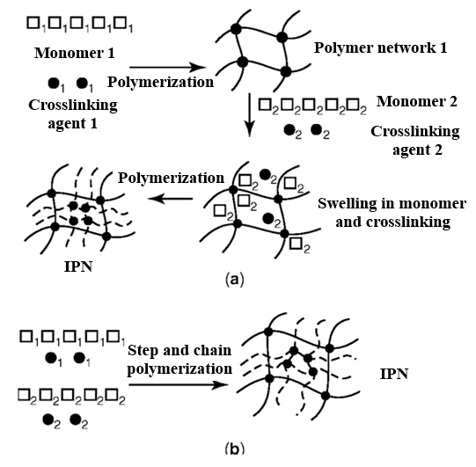

Figure 2 – Methods of obtaining of IPN: sequential (a) and parallel (b)

2.1 Synthesis of interpenetrating polymer networks with the required properties
To study the sorption properties of pseudo-interpenetrating polymer networks, IPNs based on polyacrylic acid (PAA) and poly-4-vinylpyridine (P4VP) hydrogels (content of linear P4VP relative to PAA is 20 mol%) and polymethacrylic acid (PMAA) and poly-4- vinylpyridine (P4VP) (the content of linear P4VP relative to PMAA is 20 mol%) were obtained. The IPNs structure is shown in figure 3 (a and b).
The synthesis of the above IPNs was carried out as follows: synthesis of PAA and PMAA hydrogels was carried out in the medium of the MBAA crosslinking agent, initiator was the K₂S₂O₈–Na₂S₂O₃ redox system. The polymerization process was carried out as follows: 12 ml of monomer was added to a 100 ml volumetric flask, then 45 ml of water was added, then a crosslinking agent dissolved in water when heated was added to the solution, after which 1.5 ml of a reaction initiator was added. Then the mixture in the flask is brought to the mark with distilled water. After that, the whole mixture is poured into special ampoules and placed in an oven preheated to a temperature of 65°C for 60 minutes. The rare distribution of crosslinks along the chain length was ensured by a low concentration of the crosslinking agent in the polymer. Swelling degree of synthesized PAA and PMAA hydrogels is: α(hPAA) = 29.33 g/g; α(hPMAA) = 22.97 g/g. The synthesized lightly crosslinked hydrogels of polyacrylic and polymethacrylic acids were taken in the amount of 0.036 g, the linear poly-4-vinylpyridine hydrogel was taken in the amount of 0.0105 g. The redox system K₂S₂O₈–Na₂S₂O₃ (1 ml) was used as an initiator, temperature – 65-70°C. The polymerization time is 6 hours. After synthesis, the IPNs were washed with distilled water for 7 days to remove unreacted impurities. After that, these samples of IPNs: IPN(hPAA-gP4VP), IPN(hPMAA-hP4VP)) were subjected to dispersion.

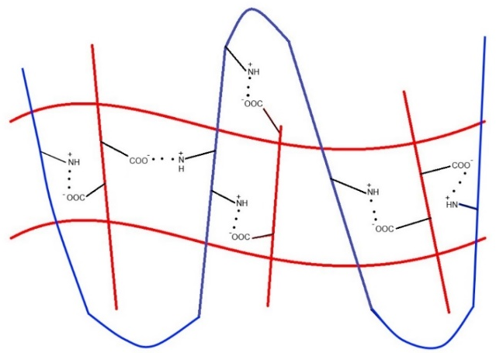 | 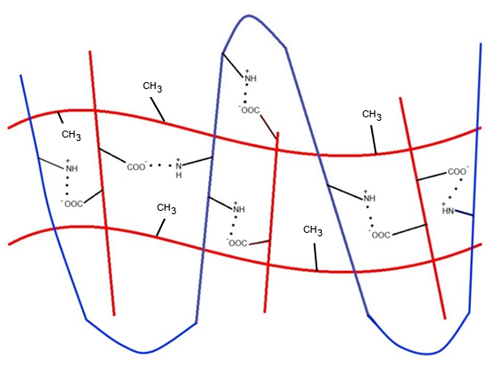
а) | б)

Figure 3 – IPNs based of PAA and P4VP (а) and PMAA and P4VP (b)

2.2 Study of sorption properties of the interpenetrating polymer networks in relation to neodymium, rhenium and scandium ions
Table 9 shows the sorption properties of IPN(hPAA-hP4VP) and IPN(hPMAA-hP4VP) in relation to Nd, Re, Sc ions at 48 hours of interatction with the corresponding salt solutions. The maximum values of extraction degree of Nd ions (52.6% and 50.9%) are reached at 48 hours. The maximum values of extraction degree of Re ions (56.3% and 54.4%) are observed at 48 hours. The maximum values of extraction degree of Sc ions (53.9% and 52.5%) are observed at 48 hours.

Table 9 – Extraction degree of IPNs in relation to Nd, Re, Sc ions

η, % | IPN(hPAA-hP4VP) | IPN(hPMAA-hP4VP)
η(Nd), % | 52.6 | 50.9
η(Re), % | 56.3 | 54.4
η(Sc), % | 53.9 | 52.5

As can be seen from the results obtained, insufficiently high values of the degree of sorption of Nd, Re, Sc ions are associated with the fact that the process of ionization of these polymer structures (IPNs) is hampered by the fact that the structure contains interlacing of polymer chains. This complicates the unfolding of the macromolecular coil upon interaction with the solution and subsequent ionization.

2.3 Creation of intergel systems based on the obtained interpenetrating polymer networks for selective extraction of neodymium, rhenium and scandium ions. Determination of the optimal conditions for extraction of neodymium, rhenium and scandium ions
Intergel systems were developed on the basis of the previously synthesized IPNs IPN(hPAA-hP4VP), IPN(hPMAA-hP4VP). The basic hydrogel of P4VP was chosen as the second component in intergel pairs. Intergel systems IPN(hPAA-hP4VP)-hP4VP (hereinafter IPN1-hP4VP) and IPN(hPMAA-hP4VP)-gP4VP (hereinafter IPN2-hP4VP) were obtained.
Table 10 shows the values of extraction degree of Nd, Re, Sc ions of the intergel system IPN1-hP4VP at 48 hours of interaction. The individual structures of IPN1 and hP4VP sorb about 55% of the metal.

Table 10 – Extraction degree of Nd, Re, Sc ions of the intergel system IPN1-hP4VP

η, % | IPN(hPAA-hP4VP):hP4VP, mol.%:mol.%
η, % | 100% | 83%:17% | 67%:33% | 50%:50% | 33%:67% | 17%:83% | 100%
η(Nd), % | 52.6 | 71.5 | 80.9 | 66.3 | 91.6 | 61.1 | 54.6
η(Re), % | 56.3 | 77.7 | 67.4 | 93.7 | 71.5 | 86.9 | 58.1
η(Sc), % | 53.9 | 83.5 | 69.6 | 65.2 | 74.6 | 92.5 | 56.9

Table 10 shows that the highest amount of neodymium ions is sorbed by the intergel system at ratio 33%IPN-67%hP4VP, extraction degree of neodymium ions is 91.6%. The maximum amount of rhenium (93.7%) is sorbed at ratio of 50%IPN1-50%hP4VP. The maximum sorption area of scandium is the ratio 83%IPN1-17%hP4VP, extraction degree is 92.5%.
Table 11 shows values of extraction degree of Nd, Re, Sc ions of the intergel system IPN2-hP4VP at 48 hours of interaction. Extraction degree of Nd, Re, Sc ions by individual structures of IPN2 and hP4VP does not exceed 55%. The maximum sorption of neodymium ions occurs at ratio of 17%IPN2-83%hP4VP at 48 hours of interaction, while 90.5% of the metal is sorbed. The maximum sorption of rhenium (93.1%) is observed at ratio 33%IPN2-67%hP4VP. The highest amount of scandium (91.8%) is sorbed at ratio 50%IPN2-50%hP4VP.

Table 11 – Extraction degree of Nd, Re, Sc ions of the intergel system IPN1-hP4VP

η, % | IPN(hPMAA-hP4VP):hP4VP, mol.%:mol.%
η, % | 100% | 83%:17% | 67%:33% | 50%:50% | 33%:67% | 17%:83% | 100%
η(Nd), % | 50.9 | 70.1 | 60.3 | 78.9 | 64.6 | 90.5 | 54.6
η(Re), % | 54.4 | 84.8 | 74.3 | 69.9 | 93.1 | 65.4 | 58.1
η(Sc), % | 52.5 | 67.3 | 81.6 | 91.8 | 72.7 | 63.4 | 56.9

In both intergel systems (IPN1-hP4VP, IPN2-hP4VP), there is significant increase (about 30%) of sorption degree of neodymium, rhenium and scandium ions due to "long-range effect" of polymer structures. High ionization degree of macromolecules leads to the formation of optimal conformation for sorption of neodymium, rhenium, and scandium ions. High values of extraction degree in intergel pairs are the result of high ionization of the initial polymers. Additional activation of functional links occurs in the process of mutual activation of macromolecules. Compared to individual IPN1 and IPN2, intergel pairs extract more than 30% ions of neodymium, rhenium and scandium.
3 Creation of highly selective structures based on molecularly imprinted polymers for selective extraction of neodymium, rhenium and scandium ions
A molecular imprinted polymer (MIP) is a polymer was treated by using a special molecular imprinting technique, which results in the appearance of cavities in the polymer matrix with an affinity for the selected molecular "template" [82-83]. This process typically involves initiating the polymerization of the monomers in the presence of a template molecule, which is subsequently removed, thus leaving complementary cavities. Molecular imprinting is, in fact, an artificial tiny “lock” for a particular molecule, which serves as a miniature “key” [84]. Like macromolecular receptors, the molecularly imprinted polymer captures specific chemicals.
Molecular imprinting is a fairly effective technique for incorporating specific pattern recognition of the analyzed object into polymers. Molecular recognition characteristics of these polymers directly depend on complementary size, shape of binding objects, imparted to the polymers by template molecules. The concept of complementarity includes the correspondence of an imprint to a template both in size and shape, and in the presence of complementary functional groups in the imprint that are capable of interacting with the functional groups of the template molecule. The selectivity of MIP is based on molecular recognition. Molecular recognition is the selective binding between two or more molecules through non-covalent interactions. It differs from the usual binding between molecules in selectivity. Molecular recognition is based on the presence in one molecule (receptor, or "host") of a site (region) of selective binding to another molecule (ligand, or "guest"). For this, the "host" and "guest" must show complementarity, that is, structurally and energetically correspond to each other.
Molecular recognition can be subdivided into static molecular recognition and dynamic molecular recognition (figure 4) [85-88]. Static molecular recognition is compared to the interaction between a key and a keyhole. It is a 1:1 type of complexation reaction between a host molecule and a guest molecule to form a host-guest complex. To achieve enhanced static molecular recognition, it is necessary to synthesize recognition regions that are specific to guest molecules. In the case of dynamic molecular recognition, the binding of the first guest to the first host binding region affects the association constant of the second guest with the second host binding region [89]. Figure 4 shows a comparison between static molecular recognition and dynamic molecular recognition.

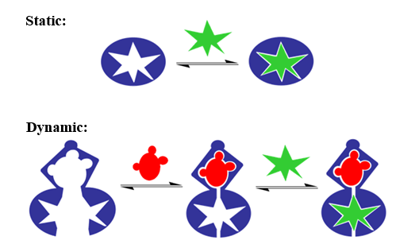

Figure 4 – Static and dynamic molecular recognition

In recent studies based on molecular concepts and adherence constants, molecular recognition is defined as an organization phenomenon. The difficulties associated with molecular recognition are that even for small molecules such as carbohydrates, the recognition process cannot be predicted or developed even if the strength of each individual hydrogen bond is known precisely [90]. However, as Mobley and colleagues [91] concluded, accurate prediction of molecular recognition events must go beyond the static snapshot of a single frame between guest and host. Entropies are key factors in the binding of thermodynamics and must be accounted for to more accurately predict the molecular recognition process. Entropies are not observed in single linked structures (static recognition).

3.1 Synthesis of molecularly imprinted polymers with required properties
Figure 5 shows the process of MIP obtaining. First, a prepolymerization complex is formed between functional monomers and template, followed by formation of a polymer matrix containing template molecules in its structure. The final step is the removal of the molecular template and the formation of cavities that are complementary to the template molecule.

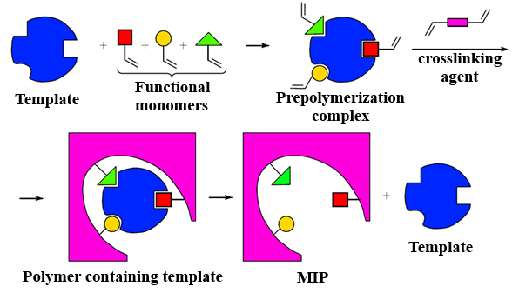

Figure 5 – Synthesis of molecularly imprinted polymers

Currently, the most widely used method for the synthesis of MIP is bulk polymerization [92-94], which includes several stages:
1) Preparation of the reaction mixture. The template is added to the polymerization mixture, which contains a functional monomer and a crosslinking agent, as well as a polymerization initiator and a solvent required for pore formation [95–99].
2) Polymerization reaction. Polymerization can be initiated either by heating the reaction mixture to 50-60°C, or by ultraviolet irradiation. The reaction consists of three stages — initiation, growth of polymer chains, and their break [100].
3) Obtaining of polymer particles. Since MIPs are most often used in the form of a powder of micron-sized particles, the resulting rigid porous polymer monolith is mechanically ground to obtain inhomogeneous particles. Size homogenization is carried out by repeated sieving through sieves with a certain pore diameter and subsequent sedimentation. The loss of polymer material during these procedures can be 50% or more [101].
4) Washing off the polymer. The final stage of obtaining MIP is the release of molecular imprints from the template. How the template is removed depends on the nature of its bond with the monomer. With covalent imprinting, chemical destruction of bonds is carried out, with non-covalent imprinting, repeated extraction with a mixture of organic solvents. Vacuum-dried particles are stored for a long time without prejudice to their physicochemical and applied properties.
MIP Synthesis. Molecularly imprinted polymers were synthesized by suspension polymerization. Neodymium, rhenium, and scandium nitrates were chosen as templates. Methacrylic acid (MAA) and 4-vinylpyridine (4VP) were chosen as functional monomers, ethylene glycol dimethacrylate (EGDMA) and diethylene glycol dimethacrylate (DEGDMA) were used as a crosslinking agent, azobisisobutyronitrile (AIBN) was used as an initiator, and hydroxy ethyl cellulose (HEC), toluene was chosen as a blowing agent. Deionized water was used as a polymerization medium. The composition of the reaction mixture is as follows: metal ion (Nd³⁺, Re³⁺, Sc³⁺):MAA:4VP:EGDMA = 1:2:2:8. The polymerization reaction was carried out in a 500 ml three-necked round bottom flask (reactor) with a mechanical stirrer. The components were added to the reactor in the following sequence: MAA, 4VP, metal salt, EGDMA, 10 ml of toluene, HEC in an amount of 3% of the amount of the monomer system (MAA + 4VP). Stirring speed - 250 rpm. The reaction was carried out for 15 minutes at room temperature, then for 6 hours at 70°C in a stream of nitrogen. After polymerization, the resulting MIP1 and MIP2 particles (in the synthesis of MIP1 EGDMA was used, in the synthesis of MIP2 DEGDMA was used) were thoroughly washed with deionized water and acetone to remove impurities and residues of unreacted monomers. The resulting granules were vacuum dried for 24 hours. To control the selectivity of MIP1 and MIP2, control samples cMIP1 and cMIP2 were synthesized, differing in that no metal salt is added during their synthesis (template). To remove the template, 1M nitric acid was used with stirring for 1 hour. To completely remove the metals, the washing cycle was repeated 30 times, after which the MIPs were washed with deionized water and dried in vacuum for 24 hours.

3.2 Study of sorption properties of molecularly imprinted polymers in relation to neodymium, rhenium and scandium ions
Tables 12-14 show the values of extraction degree of Nd, Re, Sc ions of structures MIP1(Nd) and MIP2(Nd); MIP1(Re) and MIP2(Re); MIP1(Sc) and MIP2(Sc) at 48 hours of interaction with salt solutions. The maximum values of sorption degree of neodymium ions are 88.9% for MIP1(Nd) and 85.5% for MIP2 (Nd). The maximum values of sorption degree of rhenium ions are 92.1% and 90.9%, respectively, for MIP1(Re) and MIP2(Re). The maximum values of the degree of sorption of scandium ions are 90.9% and 88.3% for MIP1(Sc) and MIP2(Sc).

Table 12 – Extraction degree of Nd, Re, Sc ions by structures MIP1(Nd) and MIP2(Nd)

η, % | MIP1(Nd) | MIP2(Nd)
η(Nd), % | 52.6 | 50.9
η(Re), % | 0 | 0
η(Sc), % | 0 | 0

Table 13 – Extraction degree of Nd, Re, Sc ions by structures MIP1(Re) and MIP2(Re)

η, % | MIP1(Re) | MIP2(Re)
η(Nd), % | 0 | 0
η(Re), % | 56.3 | 54.4
η(Sc), % | 0 | 0

Table 14 – Extraction degree of Nd, Re, Sc ions by structures MIP1(Sc) and MIP2(Sc)

η, % | MIP1(Sc) | MIP2(Sc)
η(Nd), % | 0 | 0
η(Re), % | 0 | 0
η(Sc), % | 53.9 | 52.5

Each MIP exhibits selectivity only for the metal ion that was used as a "template" in its synthesis. This feature can become the main advantage when creating fundamentally new methods for extracting ions of target metals.

3.3 Creation of highly selective structures based on the obtained molecularly imprinted polymers for selective extraction of neodymium, rhenium and scandium ions. Determination of the optimal conditions for selective extraction of neodymium, rhenium and scandium ions
From the obtained results (tables 12-14), it can be seen that MIP1 shows better results in sorption of Nd, Re and Sc in comparison with MIP2. This is directly related to the use of a cross-linking agent (when using EGDMA, less dense cross-linking occurs compared to DEGDMA). In the case of a denser crosslinking (when using DEGDMA), the ionization of MIP2 becomes more difficult, which is reflected in the lower values of sorption degree.
Maximum values of extraction degree of neodymium, rhenium, scandium ions by macromolecular structures MIP1(Nd) and MIP2(Nd); MIP1(Re) and MIP2(Re); MIP1(Sc) and MIP2(Sc) are achieved at 48 hours of interaction of these MIPs with the corresponding salt solutions.
For selective sorption of neodymium, rhenium, and scandium ions from a common solution, it is advisable to use the following MIPs: MIP1(Nd), MIP1(Re), MIP1(Sc). Moreover, these MIPs have one indisputable advantage over the previously developed intergel systems and IPNs – each MIP (MIP1(Nd), MIP1(Re), MIP1(Sc)) will sorb only the "template" metal, since the cavity in its structure is complementary only to that or another metal (neodymium, rhenium, scandium). This advantage can be used to create a technology for selective extraction of neodymium, rhenium, and scandium ions from industrial solutions.
4 Development of structure units and elements of laboratory unit and a technological scheme for selective extraction of neodymium, rhenium and scandium ions. Carrying out of laboratory and pilot-industrial tests on selective extraction of neodymium, rhenium and scandium ions
The development of a unit for selective extraction of neodymium, rhenium and scandium ions presupposes the development of requirements to be met by the developed sample of the unit, the drawing and the subsequent development of the layout of the unit, creation of a technological scheme for selective extraction of the above-mentioned metals ions. After creating a sample of the unit, it is necessary to conduct laboratory and pilot-industrial tests to assess the feasibility of application in industry.

4.1 Development of technical requirements for assemblies and elements of a plant designed for selective extraction of neodymium, rhenium and scandium ions
The creation of a prototype of a unit for selective extraction of neodymium, rhenium, and scandium ions presupposes the initial development of technical requirements for the structure of the unit itself. The following basic requirements were developed:
1) The design and elements of the unit must be resistant to aggressive environments, since testing involves interaction with strongly acidic solutions (pH = 3.5-4.5) containing ions of rare-earth and rare metals.
2) The material from which the sample of the unit is made should not enter into chemical reactions with product solutions;
3) The sample of the unit should provide the ability to quickly change the filling polymer structures with sorbed ions of neodymium, rhenium and scandium to unused ones (ready for sorption). The laboratory unit should be able to be relatively easily reconstructed for the use of various highly selective polymer structures: highly selective intergel systems, interpenetrating polymer networks, molecularly imprinted polymers.

4.2 Development of a laboratory unit sample for selective extraction of neodymium, rhenium and scandium ions
Work on the design of a prototype installation for the selective extraction of neodymium, rhenium and scandium ions from industrial solutions of hydrometallurgy has been carried out. Figure 6 is a photograph of an assembled installation sample. The laboratory sample of the installation is a structure made of plexiglass, glued with dichloroethane, containing 2 cartridges inside. The placement of the cartridges inside the unit is shown in figure 7. Operational removal of the cartridges is shown in figure 8 (the cartridges move along special skids back and forth). Each cartridge is covered with a special polymer membrane (material - polypropylene). A pair of cartridges enables remote interaction of polymer structures (polyacids are placed in one cartridge, and polybases in the other) in the case of using intergel systems for sorption of neodymium, rhenium, scandium ions. The dimensions of the installation sample (outer contour) – 300x200x500 mm. The size of the cartridges is 280x18x480 mm. The pore size in the membrane is 1 micron. The cartridges involve the loading of functional polyacids and polybases in intergel pairs (certain molar ratios) hPAA-hP4VP, hPMAA-hP4VP, hPAA-hP2M5VP and hPMAA-hP2M5VP, which have the maximum sorption capacity with respect to neodymium, rhenium and scandium ions. In addition to the above intergel systems, in the developed laboratory sample of the installation, it is possible to use interpenetrating polymer networks and polymers with molecular imprints.

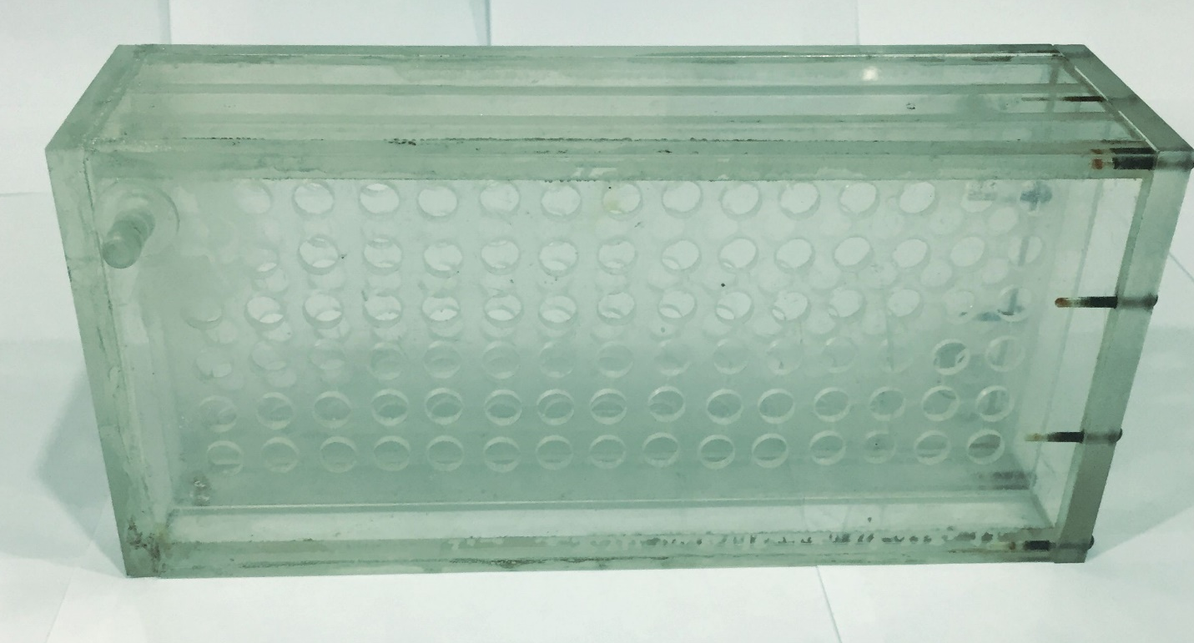

Figure 6 – Unit for selective sorption of neodymium, rhenium and scandium ions

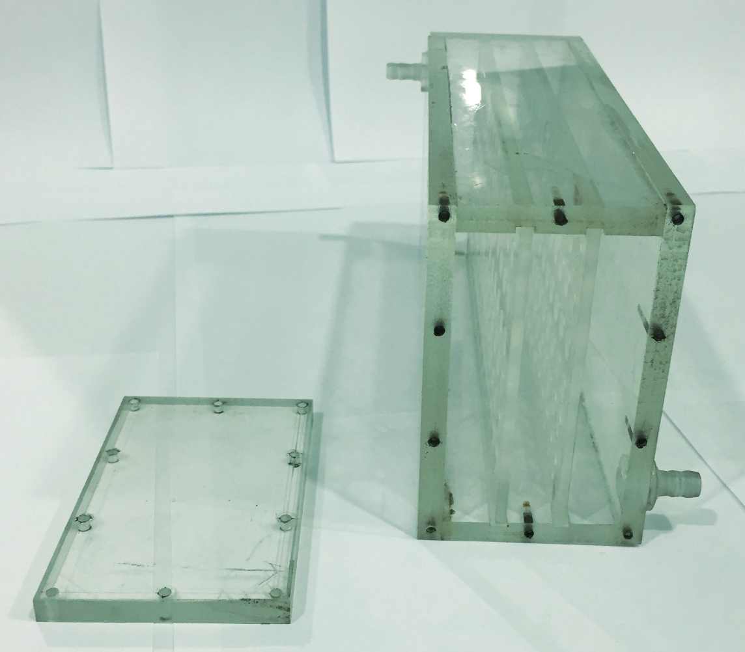

Figure 7 – Location of cartridges inside the unit

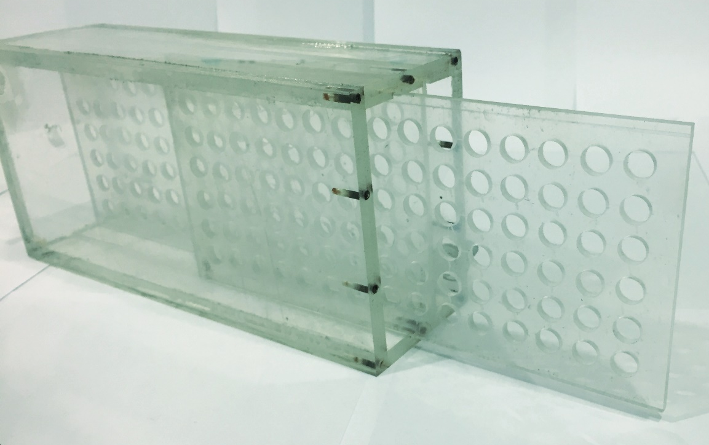

Figure 8 – Way of quickly removement of the cartridge

4.3 Development of a technological scheme for selective extraction of neodymium, rhenium and scandium ions
The developed IPNs do not have a sufficiently high extraction degree; therefore, it is proposed to use the intergel systems and the MIPs for development of technological scheme.

4.3.1 Development of a technological scheme based on intergel systems
Among the developed intergel systems, the hPAA-hP4VP system exhibits the best sorption properties (in relation to Nd, Re, Sc ions); therefore, this system is supposed to be used.
Figure 9 shows the scheme of selective extraction of Nd, Re, Sc ions using the developed unit sample and the hPAA-hP4VP intergel system. For sorption of the above-mentioned ions from the common solution, it is proposed to use 3 identical samples of the developed unit, each of which will be sequentially supplied with a common solution (the solution is supplied to each sample of the unit for 48 hours for maximum sorption of each ion). For sorption of neodymium 83%hPAA-17%hP4VP system will be used; for sorption of rhenium – 17%hPAA-83%hP4VP; for sorption of scandium – 50%hPAA-50%hP4VP.

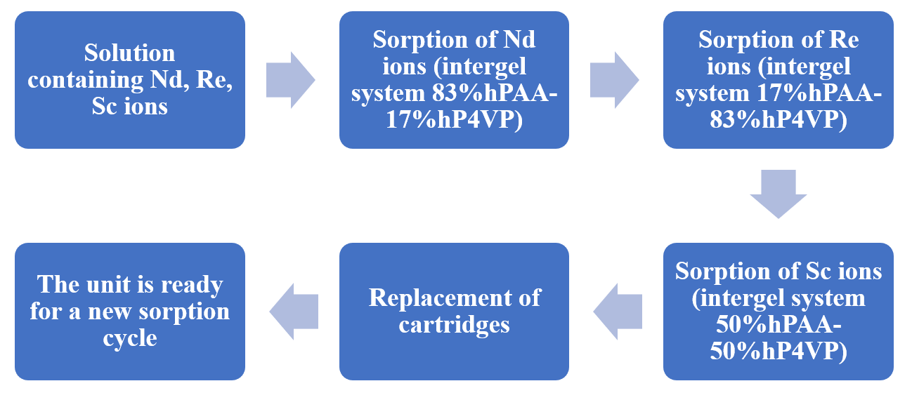

Figure 9 – Scheme of Nd, Re, Sc ions extraction by intergel system hPAA-hP4VP

4.3.2 Development of a technological scheme based on molecularly imprinted polymers
Figure 10 presents a scheme for the selective extraction of Nd, Re, Sc ions using the developed unit sample and structures MIP1(Nd), MIP1(Re), MIP1(Sc). For sorption of the above-mentioned ions from the common solution, it is proposed to use 3 identical samples of the developed unit, each of which will be sequentially supplied with a common solution (the solution is supplied to each sample of the installation for 48 hours for maximum sorption of each ion). For the sorption of neodymium MIP1(Nd) structure will be used; for sorption of rhenium – MIP1(Re); for sorption of scandium – MIP1(Sc).

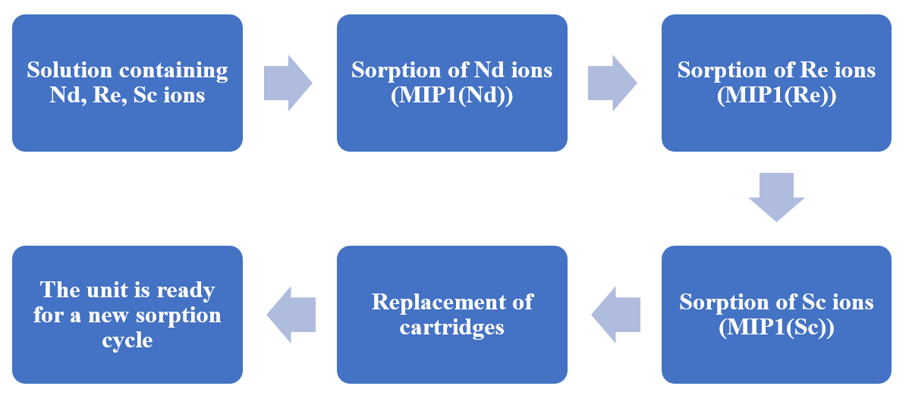

Figure 10 – Scheme of Nd, Re, Sc ions extraction by structure MIP1(Nd), MIP1(Re), MIP1(Sc)

4.4 Carrying out laboratory and pilot-industrial tests on selective extraction of neodymium, rhenium and scandium ions using the developed unit
For laboratory, semi-industrial, and pilot-industrial tests, the intergel system hPAA-hP4VP and the structures MIP1(Nd), MIP1(Re), MIP1(Sc) were chosen as a sorbent for selective extraction of Nd, Re, Sc ions. Preliminary studies have shown that maximum sorption of these ions occurs when they are extracted by these polymer structures.

4.4.1 Laboratory tests of developed sorbents
Laboratory tests of the developed unit sample of and the developed sorbents were carried out in the enrichment and flotation reagents laboratory of JSC “Institute of Metallurgy and Ore Beneficiation”. The experiment is described in details in Appendix C (paragraph 3.1). The laboratory test report is attached in Appendix D.
Tables 15-17 show values of extraction degrees of Nd, Re, Sc ions during their sorption by the intergel systems 83%hPAA-17%hP4VP, 17%hPAA-83%hP4VP, 50%hPAA-50%hP4VP from the total solution.

Table 15 – Values of extraction degree of Nd, Re, Sc ions of intergel system 83%hPAA-17%hP4VP

τ, h | 83%hPAA-17%hP4VP
τ, h | η(Nd), % | η(Re), % | η(Sc), %
0 | 0 | 0 | 0
0.5 | 15.84 | 1.88 | 2.15
1 | 26.37 | 2.17 | 2.65
2 | 39.61 | 3.87 | 4.33
6 | 51.22 | 5.63 | 7.08
24 | 73.67 | 8.44 | 11.01
48 | 81.43 | 13.41 | 18.22

Table 16 – Values of extraction degree of Nd, Re, Sc ions of intergel system 17%hPAA-83%hP4VP

τ, h | 17%hPAA-83%hP4VP
τ, h | η(Nd), % | η(Re), % | η(Sc), %
0 | 0 | 0 | 0
0.5 | 1.78 | 16.87 | 1.92
1 | 1.95 | 35.62 | 2.33
2 | 2.84 | 48.41 | 3.15
6 | 6.37 | 57.88 | 6.89
24 | 9.06 | 71.35 | 10.01
48 | 11.54 | 83.44 | 12.77

Table 17 – Values of extraction degree of Nd, Re, Sc ions of intergel system 50%hPAA-50%hP4VP

τ, h | 50%hPAA-50%hP4VP
τ, h | η(Nd), % | η(Re), % | η(Sc), %
0 | 0 | 0 | 0
0.5 | 1.17 | 1.54 | 19.87
1 | 1.76 | 1.90 | 32.45
2 | 2.33 | 2.56 | 50.58
6 | 4.09 | 5.01 | 60.20
24 | 7.06 | 7.89 | 71.23
48 | 10.58 | 11.94 | 82.57

Tables 18-20 show values of extraction degrees of Nd, Re, Sc ions during their sorption by the structures MIP1(Nd), MIP1(Re), MIP1(Sc) from the total solution.

Table 18 – Values of extraction degree of Nd, Re, Sc ions of structure MIP1(Nd)

τ, h | MIP1(Nd)
τ, h | η(Nd), % | η(Re), % | η(Sc), %
0 | 0 | 0 | 0
0.5 | 18.10 | 0 | 0
1 | 29.95 | 0 | 0
2 | 41.13 | 0 | 0
6 | 61.60 | 0 | 0
24 | 83.45 | 0 | 0
48 | 88.78 | 0 | 0

Table 19 – Values of extraction degree of Nd, Re, Sc ions of structure MIP1(Re)

τ, h | ПМО1(Re)
τ, h | η(Nd), % | η(Re), % | η(Sc), %
0 | 0 | 0 | 0
0.5 | 0 | 23.41 | 0
1 | 0 | 36.55 | 0
2 | 0 | 46.26 | 0
6 | 0 | 65.37 | 0
24 | 0 | 88.34 | 0
48 | 0 | 91.80 | 0

Table 20 – Values of extraction degree of Nd, Re, Sc ions of structure MIP1(Sc)

τ, h | ПМО1(Sc)
τ, h | η(Nd), % | η(Re), % | η(Sc), %
0 | 0 | 0 | 0
0.5 | 0 | 0 | 21.30
1 | 0 | 0 | 33.56
2 | 0 | 0 | 44.69
6 | 0 | 0 | 62.43
24 | 0 | 0 | 85.78
48 | 0 | 0 | 90.81
From the results of laboratory tests, it can be seen that the intergel system hPAA-hP4VP exhibits selectivity to Nd, Re, Sc ions at certain ratios of hydrogels. The developed sorbent possesses a sufficiently high degree of extraction; the unit design allows one to quickly change the molar ratios of hydrogels. The disadvantage of the developed sorbent is the associated sorption of the metals present in the solution in small amounts. The developed MIP structures showed a higher sorption degree of the ions; it can also be considered an advantage that associated metals are not recovered. However, the main disadvantage of each developed MIP – is its focus on selective extraction of only one metal.

4.4.2 Semi-industrial tests of developed sorbents
Semi-industrial tests of the developed unit sample of and the developed sorbents were carried out in the enrichment and flotation reagents laboratory of JSC “Institute of Metallurgy and Ore Beneficiation”. The experiment is described in details in Appendix C (paragraph 3.2). The laboratory test report is attached in Appendix D.
Tables 21-23 presents values of extraction degrees of Nd, Re, Sc ions during their sorption by the intergel systems 83%hPAA-17%hP4VP, 17%hPAA-83%hP4VP, 50%hPAA-50%hP4VP from the total solution.

Table 21 – Extraction degree of Nd, Re, Sc ions of intergel system 83%hPAA-17%hP4VP

τ, h | 83%hPAA-17%hP4VP
τ, h | η(Nd), % | η(Re), % | η(Sc), %
0 | 0 | 0 | 0
0.5 | 15.05 | 1.79 | 2.04
1 | 25.05 | 2.06 | 2.52
2 | 37.63 | 3.68 | 4.11
6 | 48.66 | 5.35 | 6.73
24 | 69.99 | 8.02 | 10.46
48 | 77.36 | 12.74 | 17.31

Table 22 – Extraction degree of Nd, Re, Sc ions of intergel system 17%hPAA-83%hP4VP

τ, h | 17%hPAA-83%hP4VP
τ, h | η(Nd), % | η(Re), % | η(Sc), %
0 | 0 | 0 | 0
0.5 | 1.69 | 16.03 | 1.82
1 | 1.85 | 33.84 | 2.21
2 | 2.70 | 45.99 | 2.99
6 | 6.05 | 54.99 | 6.55
24 | 8.61 | 67.78 | 9.51
48 | 10.96 | 79.27 | 12.13

Table 23 – Extraction degree of Nd, Re, Sc ions of intergel system 50%hPAA-50%hP4VP

τ, h | 50%hPAA-50%hP4VP
τ, h | η(Nd), % | η(Re), % | η(Sc), %
0 | 0 | 0 | 0
0.5 | 1.11 | 1.46 | 18.88
1 | 1.67 | 1.81 | 30.83
2 | 2.21 | 2.43 | 48.05
6 | 3.89 | 4.76 | 57.19
24 | 6.71 | 7.50 | 67.67
48 | 10.05 | 11.34 | 78.44

Tables 24-26 show values of extraction degrees of Nd, Re, Sc ions during their sorption by the structures MIP1(Nd), MIP1(Re), MIP1(Sc) from the total solution.

Table 24 – Values of extraction degree of Nd, Re, Sc ions of structure MIP1(Nd)

τ, h | MIP1(Nd)
τ, h | η(Nd), % | η(Re), % | η(Sc), %
0 | 0 | 0 | 0
0.5 | 17.20 | 0 | 0
1 | 28.45 | 0 | 0
2 | 39.07 | 0 | 0
6 | 58.52 | 0 | 0
24 | 79.28 | 0 | 0
48 | 84.34 | 0 | 0
Table 25 – Values of extraction degree of Nd, Re, Sc ions of structure MIP1(Re)

τ, h | MIP1(Re)
τ, h | η(Nd), % | η(Re), % | η(Sc), %
0 | 0 | 0 | 0
0.5 | 0 | 22.24 | 0
1 | 0 | 34.72 | 0
2 | 0 | 43.95 | 0
6 | 0 | 62.10 | 0
24 | 0 | 83.92 | 0
48 | 0 | 87.21 | 0

Table 26 – Values of extraction degree of Nd, Re, Sc ions of structure MIP1(Sc)

τ, h | MIP1(Sc)
τ, h | η(Nd), % | η(Re), % | η(Sc), %
0 | 0 | 0 | 0
0.5 | 0 | 0 | 20.24
1 | 0 | 0 | 31.88
2 | 0 | 0 | 42.46
6 | 0 | 0 | 59.31
24 | 0 | 0 | 81.49
48 | 0 | 0 | 86.27

From the results of semi-industrial tests (Tables 21-26), it can be seen that the developed sorbents (intergel system hPAA-hP4VP and structures MIP1(Nd), MIP1(Re), MIP1(Sc)) selectively sorb Nd, Re, Sc ions from the total solution. In the case of the intergel system, there is a slight decrease (up to 5%) in extraction degree in comparison with laboratory tests. This is directly related to the fact that the reaction medium is acidic, while ionization of polymer hydrogels is hindered, and some of the links of the polymer chain undergo insignificant degradation. The MIP structures showed a higher degree of extraction of ions of n Nd, Re, Sc, also the advantages of higher strength compared to polymer hydrogels.

4.4.3 Pilot-industrial tests of the developed sorbents
Pilot-industrial tests of the developed sample of the installation and sorbent (intergel system hPAA-hP4VP) were carried out in the laboratory for research and analysis of materials of LLP “Institute of High Technologies”. The experiment is detailed in Appendix C (paragraph 3.3). Act of carrying out of pilot-industrial tests is attached in Appendix F.
The maximum values of extraction degree of cerium and neodymium ions are observed at 48 hours of interaction of the above-mentioned polymer structures with saline solutions. The sorption of cerium ions by individual polymeric hydrogels of PAA and P4VP in the hydrometallurgical solution is not intensive enough; after 2 days sorption degree is 58.6% and 51.3%, respectively, for PAA and P4VP. The maximum extraction of cerium ions from the solution is observed at a molar ratio of hydrogels of 17%hPAA-83%hP4VP, while extraction degree is 86.4%. The extraction of neodymium ions by individual PAA and P4VP hydrogels in the product solution does not reach sufficiently high values; sorption degree is 56.5% for hPAA and 50.3% for hP4VP. The intergel system hPAA-hP4VP maximally sorbs neodymium ions at a ratio of the initial hydrogels of 83%hPAA-17%hP4VP, sorption degree of neodymium ions is 85.3%.
The results of pilot-industrial tests showed that sorption of cerium and neodymium ions by the intergel system hPAA-hP4VP is almost 30% more efficient than the individual components. It should be especially noted the following advantage of using an intergel system – the ability to "control" the selectivity of a given polymer system by changing the molar ratio of the components. The developed sample of sorption unit seems to be promising for the selective extraction of cerium and neodymium ions from real industrial hydrometallurgical solutions.

CONCLUSION

Based on the obtained data during research and testing, the following conclusions can be drawn:
- Polymer hydrogels of PAA, PMAA, P4VP, P2M5VP sorb neodymium, rhenium and scandium ions. Extraction degree of neodymium ions by PAA, PMAA, P4VP, P2M5VP hydrogels is 61.6%; 59.9%; 54.6%; 51.5% respectively. Extraction degree of rhenium ions by PAA, PMAA, P4VP, P2M5VP hydrogels is 66.5%; 63.3%; 58.1%; 54.9% respectively. Extraction degree of scandium ions by PAA, PMAA, P4VP, P2M5VP hydrogels is 63.7%; 62.1%; 56.9%; 52.5% respectively.
- In intergel systems hPAA-hP4VP, hPMAA-hP4VP, hPAA-hP2M5VP, hPMAA-hP2M5VP hydrogels of PAA, PMAA, P4VP, P2M5VP undergo ionization at remote interaction during sorption of neodymium, rhenium and scandium ions, as a result of what their properties increase significantly. It should be noted that the highest ionization of macromolecules occurs during 6 hours of remote interaction as a result of mutual activation of the initial polymer hydrogels.
- The maximum values of extraction degree of neodymium ions are observed at the following ratios of hydrogels: 83%hPAA-17%hP4VP (93.5%), 67%hPMAA-33%hP4VP (92.4%), 50%hPAA-50%hP2M5VP (91.9%), 33%hPMAA-67%hP2M5VP (90.7%). The maximum values of the degree of extraction of rhenium ions are observed at the following ratios of hydrogels: 17%hPAA-83%hP4VP (95.1%), 50%hPMAA-50%hP4VP (94.3%), 33%hPAK-67%hP2M5VP (93.6%), 50%hPMAA-50%hP2M5VP (92.7%). The maximum values of extraction degree of scandium ions are observed at the following ratios of hydrogels: 50%hPAA-50%hP4VP (94.3%), 17%hPMAA-83%hP4VP (93.1%), 67%hPAA-33%hP2M5VP (92.7%), 83%hPMAA-17%hP2M5VP (91.5%).
- The above-mentioned REM differ in atomic radius, charge density and polarizability, which affects different values of sorption properties both in individual hydrogels PAA, PMAA, P4VP, P2M5VP, and in intergel systems hPAA-hP4VP, hPMAA-hP4VP, hPAA-hP2M5VP, hPMAA-hP2M5VP.
- Individual IPNs do not have sufficiently high degree of sorption: at 48 hours extraction degree of neodymium ions is 52.6% for IPN(hPAA-hP4VP) and 50.9% for IPN(hPMAA-gP4VP); sorption degree of rhenium ions is 56.3% for IPN(hPAA-hP4VP) and 54.4% for IPN(hPMAA-hP4VP); extraction degree of scandium ions is 53.9% for IPN(hPAA-hP4VP) and 52.5% for IPN(hPMAA-hP4VP).
- In intergel systems IPN1:hP4VP and IPN2:hP4VP there is significant increase (about 30%) of sorption degree of neodymium, rhenium and scandium ions due to "long-range effect" of polymer structures. Additional activation of functional units occurs in the process of mutual activation of macromolecules.
- The optimal ratios for sorption of neodymium, rhenium and scandium ions are 33%IPN1-67%hP4VP, 50%IPN1-50%hP4VP, 17%IPN1-83%hP4VP, extraction degree is 91.6%; 93.7%; 92.5% respectively. The maximum amount of neodymium, rhenium and scandium ions in the intergel system IPN2-hP4VP is extracted at ratios 17%IPN2-83%hP4VP, 33%IPN2-67%hP4VP, 50%IPN2-50%hP4VP, sorption degree is 90.5%; 93.1%; 91.8% respectively. The difference in the values of extraction degree lies in the presence of a bulky methyl substituent in the structure of the IPN2, as a result of which the degree of ionization is lower in the system of IPN2-hP4VP.
- When comparing sorption properties of MIP1 and MIP2, it can be seen that MIP1 shows better results on the sorption of Nd, Re and Sc in comparison with MIP2. This is directly related to the use of a crosslinking agent (when using EGDMA, less dense crosslinking occurs compared to DEGDMA). In the case of denser crosslinking, the ionization of MIP2 becomes more difficult, which is reflected in lower values of the degree of extraction.
- The maximum values of extraction degree of neodymium ions (89.9% and 85.5%) by the MIP1(Nd) and MIP2(Nd) polymers are observed at 48 hours. The highest amount of rhenium ions is sorbed at 48 hours, sorption degree is 92.1% and 90.9% respectively for MIP1(Re) and MIP2(Re). The highest sorption degree of scandium ions is observed at 48 hours, extraction degree is 90.9% and 88.3% for MIP1(Sc) and MIP2(Sc).
- For the selective sorption of neodymium, rhenium and scandium ions from the total solution, it is advisable to use the following MIPs: MIP1(Nd), MIP1(Re), MIP1(Sc).
- The developed unit sample for selective extraction of neodymium, rhenium and scandium ions is distinguished by its versatility, which makes it possible to quickly remove the cartridges to change the molar ratio of sorbents in intergel pairs. This sample is made of plexiglass, is resistant to aggressive media, does not react with a solution containing the above-mentioned rare earth ions.
- When sorption of neodymium, rhenium and scandium ions by intergel systems from real solutions, there is a slight decrease (up to 5%) of extraction degree of macromolecules in comparison with directly related to the fact that the reaction medium is acidic (pH = 3.5). As a result, ionization of polymer hydrogels becomes difficult, and some of the links of the polymer chain undergo insignificant degradation.
- Technological scheme for extraction of neodymium, rhenium and scandium from total solution was developed using the developed intergel systems and the molecularly imprinted polymers.
- As a result of laboratory, semi-industrial and pilot-industrial tests, it was established that the developed sample of the sorption unit and the developed sorbents seem to be promising for selective extraction of neodymium, rhenium and scandium ions from industrial hydrometallurgical solutions.

REFERENCES

- Bray C. Dictionary of glass: materials and techniques. – Pennsylvania: University of Pennsylvania Press, 2001. – P. 102. (in English)
- Weyl W.A. Coloured Glasses. – Chapeltown: Society of Glass technology, 1999. – P. 221-222. (in English)
- Kindyakov P.S. Chemistry of rare and trace elements. – Moscow: Higher school, 1969. – 638 p. (in Russian)
- Korovin S.S., Bukin V.I., Fedorov P.I., Reznik A.M. Rare and scattered elements. – Moscow: MISIS, 2003. – 438 p. (in Russian)
- Kablov E.N., Toloraia V.N., Orekhov N.G. Metallurgy and heat treatment of metals // Monocrystalline nickel rhenium-containing alloys for turbine blades of gas turbine engines. – 2002. – № 7. – P. 7-11. (in Russian)
- Lebedev K.B. Rhenium. – Moscow: Metallurgizdat, 1960. – 100 p. (in Russian)
- Corbett J.D. Extended metal-metal bonding in halides of the early transition metals // Accounts of chemical research. – 1981. – Vol. 14. – P. 239-246. (in English)
- Smith R.E. Diatomic Hydride and Deuteride Spectra of the Second Row Transition Metals // Proceedings of the Royal Society of London. Series A, Mathematical and Physical Sciences. – 1973. – Vol. 332. – P. 113-127. (in English)
- Ergozhin E.E., Begenova B.E. Polyelectrolytes and complexones. – Almaty: Print-S, 2010. – 164 p. (in Russian)
- Furukawa J., Saegusa T. Polymerization of aldehydes and oxides. – Moscow: World, 1965. – 479 p. (in Russian)
- Eastham A. Cationic polymerization. – Moscow, 1966. – 302 p. (in Russian)
- Jafarov V.D., Alyev N.A., Guseinov E.T., Efendiev A.A. Synthesis of polymerizable oligomers by cationic polymerization of α-oxides // High-molecular compounds. – 2008. – Vol. 50. – P. 726-731. (in Russian)
- Ergozhin E.E., Menligaziev E.Zh. Multifunctional ion exchangers. – Alma-Ata: Science, 1986. – 304 p. (in Russian)
- Krasavin I.A., Orlova G.V., Polosin V.M., Vysokova N.N., Dolzhnikova E.N., Ryabokobylko Yu.S., Evdokimova N.N., Belyakov E.A. Complex-forming sorbent, method of its production and use // Ecological systems and devices. – 2007. – No. 1. – P. 54-58. (in Russian)
- Novakov I.A., Vaniev M.A., Shilina V.V., Bondarenko L.A. Polyepichlorohydrin - polymethyl methacrylate composites // Bulletin of higher educational institutions. Light industry technology. – 2011. – Vol. 12. – P. 41-44. (in Russian)
- Menligaziev E.Zh., Ergozhin E.E., Chalov A.K. Sulfonic cation exchangers based on diglycidyl ethers of some dioxybenzenes, aniline and its derivatives // News of Academy of sciences of KazSSR. Chemical series. – 1987. – No. 4. – P. 88-93. (in Russian)
- Ivanov V.A., Gorshkov V.I. 70 years of the history of the production of ion exchange resins // Sorption and chromatographic processes. – 2006. – Vol. 6, No. 1. – P. 5-31. (in Russian)
- Saldadze K.M., Pashkov A.B., Titov V.S. Ion-exchange high-molecular compounds. – Moscow: Goskhimizdat, 1960. – 356 p. (in Russian)
- Pashkov A.B., Samborskiy I.V., Vakulenko V.A., Grachev L.L., Kas'yanova E.I. Polycondensation ion exchange resins // Plast. masses. – Moscow: Chemistry, 1970. – P. 119-123. (in Russian)
- Kazantsev E.I., Pakholkov V.S., Kokoshko Z.Yu., Chupakhin O.N. Ion exchange materials, their synthesis and properties. – Sverdlovsk: Ural Polytechnic Institute, 1969. – 149 p. (in Russian)
- Lustgarten E.I., Brutskus T.K., Pashkov A.B. New directions in the synthesis of polymerization-type ion exchangers. – Moscow, 1977. – 31 p. (in Russian)
- Vezentsev A.I., Trubitsin M.A., Goldovskaya-Peristaya L.F., Volovicheva P.A. Sorption soil cleaning from heavy metals // Scientific Bulletin of Belgorod State University. Natural Sciences. – 2008. – Vol. 3. – P. 172-175. (in Russian)
- Ergozhin E.E., Chopabaeva N.N., Nikitina A.I., Tairova B.T. Ionites based on wood waste for sorption of non-ferrous metals // Cooperation for solving the problem of waste: materials of the 5th international conference, Kharkov, 2008. – P. 277-278. (in Russian)
- Ergozhin E.E., Chalov T.K. Ion exchange and semi-permeable membranes. – Almaty: EVERO, 2004. – 245 p. (in Russian)
- Ergozhin E.E., Nikitina A.I., Bektenov N.A., Kabulova G.K. Sorption of Cu²⁺ ions by sulfonic cation exchangers based on vegetable raw materials and glycidyl methacrylate // News of National academy of sciences of the Republic of Kazakhstan. Chemistry and Technology Series. – 2011. – No. 3. – P. 14-16. (in Russian)
- Porubaev V.P., Lebedev K.B., Pyatigorets L.F., Salin A.A. The use of ion exchange resins for wastewater treatment from chromium, copper, nickel, cobalt, lead, zinc and cadmium // Proceedings of Kazmekhanobr. – Alma-Ata, 1970. – № 3. – P. 161-168. (in Russian)
- Ergozhin E.E., Chalov T.K., Melnikov E.A., Khakimbolatova K.Kh., Nikitina A.I. Sorption of Cu²⁺ and Ni²⁺ ions by polyfunctional anion exchangers based on epoxy derivatives of aromatic amines and polyethyleneimine // Water: chemistry and ecology. – 2012. – № 8. – P. 74-79. (in Russian)
- Ergozhin E.E., Chalov T.K., Melnikov E.A., Khakimbolatova K.Kh., Nikitina A.I., Tasmagambet A.T. A new sorbent based on benzylamine, epichlorohydrin and polyethyleneimine for the extraction of transition metal ions // Materials of the international scientific-practical conference "Actual problems of science and education in the field of natural and agricultural sciences", Petropavlovsk, Kazakhstan, 2012. – P. 148-149. (in Russian)
- Ergozhin E.E. Achievements in the field of fundamental and applied research in the chemistry of ion exchange and membrane technologies for 20 years of independence of the Republic of Kazakhstan // Reports of National academy of sciences of the Republic of Kazakhstan. – 2011. – № 6. – P.32-41. (in Russian)
- Kirsh Yu.E. Ion exchange membranes: polymer materials, molding methods, hydration features and electrochemical properties // Highmolecular compounds. – 1993. – Vol. 35. – P.163-170. (in Russian)
- Wiinberg B. Ion exchange plant for nickel extraction in South Africa // Non-ferrous metals. – 2010. – № 2. – P. 55-57. (in Russian)
- Polyansky N.G., Gorbunov G.V., Polyanskaya N.L. Research methods of ion exchangers. – Moscow: Chemistry, 1976. – 208 p. (in Russian)
- Saldadze K.M., Kopylova-Valova V.D. Complexing ion exchangers (complexites). – Moscow, 1980. – 336 p. (in Russian)
- Tulupov P.E. Resistance of ion exchange materials. – Moscow: Chemistry, 1984. – 232 p. (in Russian)
- Tulupov P.E., Polyansky N.G. Thermal stability of anion exchange resins // Achievements in chemistry. – 1973. – Vol. 42. – P.1650-1680. (in Russian)
- Mulder M. Basic Principles of Membrane Technology. – Springer, 2007. – 564 p. (in English)
- Selitskiy G.A., Galkin Yu.A. Purification of waste water from ions of heavy metals by the method of sodium cationization // Metallurgy and mechanical engineering. – 2008. – № 2. – P. 5-7. (in Russian)
- Gnusin N.P., Grebenyuk V.D., Pevnitskaya M.V. Electrochemistry of ion exchangers. Novosibirsk: Science, 1972. – 200 p. (in Russian)
- Lebedev K.B., Kazantsev E.I., Rozmanov V.M., Pakholkov V.S., Chemezov V.A. Ion exchangers in nonferrous metallurgy. – Moscow: Metallurgy, 1975. – 352 p. (in Russian)
- Ergozhin E.E., Chalov T.K., Melnikov E.A., Nikitina A.I., Khakimbolatova K.Kh. Sorption of heavy metal ions by polyfunctional anion exchangers based on epoxyamines // Chemical Journal of Kazakhstan. – 2012. – № 1. – P. 29-33. (in Russian)
- Chelnakova P.N., Kolodyazhny V.A. Selective extraction of non-ferrous metal cations from wastewater by weakly basic anion exchangers // Journal of applied chemistry. – 2004. – Vol. 77. – P. 78-82. (in Russian)
- Ergozhin E.E., Chalov T.K., Khakimbolatova K.Kh., Nikitina A.I., Melnikov E.A. Extraction of copper (II) ions by anion exchangers based on epichlorohydrin and some amines // Chemical Journal of Kazakhstan. – 2012. – № 1. – P. 44-49. (in Russian)
- Khakimbolatova K.Kh., Ergozhin E.E., Chalov T.K., Nikitina A.I., Melnikov E.A. New sorbents based on epichlorohydrin and various amines for the extraction of Ni²⁺ ions // Chemical Journal of Kazakhstan. – 2012. – № 2. – P. 105-108. (in Russian)
- Koganovsky A.M. Adsorption and ion exchange in water treatment and wastewater treatment. – Kiev: Naukova Dumka, 1983. – 240 p. (in Russian)
- Ergozhin E.E., Chalov T.K., Kovrigina T.V., Iskakova R.A., Nikitina A.I. Investigation of the complexing ability of anionites based on some polyamines, allyl and epoxy compounds // Journal of applied chemistry. – 2004. – Vol. 77. – P. 1693-1698. (in Russian)
- Ergozhin E.E., Chalov T.K., Melnikov E.A., Khakimbolatova K.Kh., Nikitina A.I. Study of the selectivity of the sorption of Cu²⁺ and Co²⁺ ions by anion exchangers based on an epoxy derivative of aniline and polyamines // Chemical Journal of Kazakhstan. – 2012. – № 2. – P. 93-98. (in Russian)
- Grachek V.I., Shunkevich A.A., Martynkevich R.V. Synthesis and sorption properties of new fibrous nitrogen-phosphorus-containing ion exchangers // Journal of applied chemistry. – 2011. – Vol. 84. – P. 1270-1275. (in Russian)
- Ergozhin E.E., Chalov T.K., Nikitina A.I., Kovrigina T.V., Khakimbolatova K.Kh. Sorption of ions of heavy non-ferrous metals from solutions of complex composition by polyfunctional anion exchangers // Non-ferrous metals. – 2008. – № 3. – P. 35-37. (in Russian)
- Blokhin A.A., Amosov A.A., Murashkin Yu.V., Evdoshenko S.A., Mikhailenko M.A., Nikitin N.V. Sorption of rhenium (VII) on gel and macroporous anion exchangers of different basicity from solutions of mineral acids and their ammonium salts // Journal of applied chemistry. – 2005. – Vol. 78. – P. 1436-1439. (in Russian)
- Chopabaeva N.N., Ergozhin E.E., Tasmagambet A.T., Nikitina A.I. Sorption of perrhenate ions by new lignin anion exchangers // Chemistry of solid fuel. – 2009. – № 2. – P. 43-47. (in Russian)
- Ergozhin E.E., Chalov T.K., Nikitina A.I., Melnikov Ye.A. Тhe sorption of vanadium ions by new polyfunctional anionites from ammonium metavanadate solutions // Chemical journal of Kazakhstan. – 2014. – № 3. – Р. 32-38. (in English)
- Kunaev A.M., Dadabaev A.Yu., Tarasova E.G. Ion exchange processes in the hydrometallurgy of non-ferrous metals. – Alma-Ata: Science, 1986. – 248 p. (in Russian)
- Khaing Z. N., Troshkina I. D. Kinetics of sorption of rhenium from sulfuric acid solutions by ion exchanger PuroliteA 170 // Sorption and chromatographic processes. – 2006. – Vol. 6. – P. 972-976. (in Russian)
- Fedorov P.I., Filippova N.V., Andreev V.K. Ion exchange separation of vanadium (V) and rare-earth elements // Journal of analytical chemistry. – 1976. – Vol. 31. – P.392-394. (in Russian)
- Mikhailyuk E.L., Ergozhin E.E., Menligaziev E.Zh., Nurlybaev I.N. Sorption of vanadium from solutions by ion exchangers based on glycidyl ethers with di- and polyamines // News of KazSSR. Chemical series. – 1979. – № 4. – P.70-71. (in Russian)
- Alekseeva S.L., Bolotin S.N., Tsyupko T.G. Investigation of the sorption of chromium (VI) compounds on ion-exchange materials and sorbents // Journal of Applied Chemistry. – 2007. – Vol. 80. – P. 378-380. (in Russian)
- Bekturov E.A., Suleimenov I.E. Polymer hydrogels. – Almaty: Gylym, 1998. – 238 p. (in Russian)
- Filippova O.E. "Smart" polymer hydrogels // Nature. – 2005. – № 8. – P. 11-17. (in English)
- Klempner D., Sperling L.H., Utracki L.A. Interpenetrating Polymer Networks. – Washington D.C.: American Chemical Society, 1994. – 427 p. (in English)
- Sperling L.H. Polymeric Multicomponent Materials: An Introduction. – New York: Wiley-Interscience, 1997. – 416 p. (in English)
- Sperling L.H., Ferguson К.В., Manson I.A., Corevin E.M., Siegfried D.L. Isomeric graft copolymers and interpenetrating polymer networks: Theory and experiment // Macromolecules. – 1976. – Vol. 5. – P. 743-749. (in English)
- Frisch K.C., Klempner D., Frisch H.L., Chiradella H. Topologically interpenetrating polymer networks // Recenf advances in polymer blends, grafts and blocks / Sperling L.H. – New York, London, 1974. – P. 395-414. (in English)
- Lipatov Yu.S., Sergeeva L.M. Interpenetrating polymer networks. – Kiev: Naukova Dumka, 1979. – 160 p. (in Russian)
- Sperling L.H., Arnts R.R. Simultaneous interpenetrating networks // Journal of applied polymer science. – 1971. – Vol. 9. – P. 2317-2319. (in English)
- Lipatov Yu.S., Khramovti Т.S., Sergeeva L.M., Karabanova L.V. Some properties of intermediate regions in interpenetrating polymeric networks // J. Polym. Sci.: Polym. chem. ed. – 1977. – Vol. 2. – P. 427-432. (in English)
- Lipatov Yu.S., Sergeeva L.M. Synthesis and properties of interpenetrating grids // Successes of chemistry. – 1976. – Vol. 1, № 45. – P. 138-159. (in Russian)
- Sbytoye Yu.G. Statistical theory of the structure of polymer networks // Structure and properties of rubbers and vulcanizates. – Moscow, 1975. – P. 38-59. (in Russian)
- Dushek K. Statistics of the formation of three-dimensional polymer networks // Composite polymer materials. – Kiev: Naukova dumka, 1975. – P. 14-28. (in Russian)
- Lipatov Yu.S., Sergeeva L.M., Mozzhukhina L.V., Apukhtina N.P. Some physical and chemical properties of filled interpenetrating networks // High-molecular compounds. – 1974. – № 10. – P. 2290-2295. (in Russian)
- Sperling L.H. Interpenetrating Polymer Networks and Related Materials. – New York: Plenum Press, 1981. – 263 p. (in English)
- Lipatova T.E., Kuzmenko L.S., Shilov V.V., Minenko N.N., Lipatov Yu.S. Synthesis and heterogeneous structure of anionic networks from oligoester acrylates // High molecular compounds. – 1978. – № 4. – P. 758-762. (in Russian)
- Lipatov Yu.S., Khramova T.S., Sergeeva L.M., Karabanova L.V. On some properties of the transition region in interpenetrating polymer networks // Reports of the USSR Academy of Sciences. – 1976. – № 6. – P. 1360-1363. (in Russian)
- Tager A.A. Thermodynamic stability of polymer-solvent and polymer-polymer systems // High-molecular compounds. – 1972. – № 12. – P. 2690-2706. (in Russian)
- Bamford C., Eastmond G. The synthesis and properties of multicomponent polymer networks // American chemical society polymer preprints. – 1974. – Vol. 1, № 15. – P. 105-110. (in English)
- Donatelli A.A., Sperling L.Н„ Thomas D.A. A semiempirical derivation of phase domain size in interpenetrating polymer networks // J. Appl. Polvm. Sci. – 1977. – Vol. 5, № 21. – P. 1189-1197. (in English)
- Sperling L.H. Interpenetrating polymer networks and related materials // J. Polymer Sci. – 1977. – Vol. 2, № 12. – P. 141-180. (in English)
- Sperling L.H. Interpenetrating polymer networks // Encyclopedia of polymer science and technology / Gaylord N.G., Bikales N.M., Mark H.F. – NewYork: Interscience, 1977. – P. 288-306. (in English)
- Shilov V.V., Lipatova T.E. The structure of interpenetrating polymer networks obtained by anionic polymerization // High-molecular compounds. – 1978. – № 1. – P. 62-69. (in Russian)
- Frisch К.C., Frisch H.L. Morphology of a polyurethane—polyacrylate interpentrating polymer network // Polym. Eng. and Sci. – 1974. – Vol. 9, № 14. – P. 76-78. (in English)
- Klenin V.I., Prozorova M.Yu., Andrianova L.S., Brestkin Yu.V., Belonovskaya G.P., Frenkel S.Ya. Investigation of the structure of interpenetrating polymer systems by methods of turbidity spectrum and X-ray diffractometry // High-molecular compounds. – 1977. – № 5. – P. 1138-1143. (in Russian)
- Lipatov Yu.S., Karabanov L.V., Sergeeva L.M. Thermodynamic studies of the swelling of filled interpenetrating polymer networks based on polyurethane and styrene-divinylbenzene copolymer // High-molecular compounds. – 1977. – № 5. – P. 1073-1081. (in Russian)
- Gendrikson O.D., Zherdev A.V., Dzantiev B.B. Molecularly imprinted polymers and their application in biochemical analysis // Advances in biological chemistry. – 2006. – Vol. 46. – P. 149 - 192. (in Russian)
- Dmitrienko S.G., Apyari V.V. Polymers with molecular imprints: synthesis, properties, application in the analysis of real objects. – Moscow: Science, 2015. – P. 332-374. (in Russian)
- Zahedi P., Ziaee M., Abdouss M., Farazin A., Mizaikoff B. Biomacromolecule template-based molecularly imprinted polymers with an emphasis on their synthesis strategies: a review // Polymers for advanced technologies. – 2016. – Vol. 9. – P. 413 – 427. (in English)
- Zhang J., Landry M.P., Barone P.W., Kim J.-H., Lin S., Ulissi Z.W., Lin D., Mu B., Boghossian A.A, Hilmer A.J., Rwei A., Hinckley A.C., Kruss S., Shandell M.A., Nair N., Blake S., Şen F., Şen S., Croy R.G, Li D., Yum K., Ahn J.-H., Jin H., Heller D.A., Essigmann J.M., Blankschtein D., Strano M.S. Molecular recognition using corona phase complexes made of synthetic polymers adsorbed on carbon nanotubes // Nature nanotechnology. – 2013. – Vol. 8. – P. 959 – 968. (in English)
- Mannige R.V., Haxton T.K., Proulx C., Robertson E.J., Battigelli A., Butterfoss G.L., Zuckermann R.N., Whitelam S. Peptoid nanosheets exhibit a new secondary-structure motif // Nature. – 2015. – Vol. 526. – P. 415 – 420. (in English)
- Baron R., McCammon J.A. Molecular recognition and ligand binding // Annual review of physical chemistry. – 2013. – Vol. 64. – P. 151 – 175. (in English)
- Lehn J.-M. Supramolecular Chemistry. – Weinheim: Wiley-VCH, 1995. – 281 p. (in English)
- Shinkai S., Ikeda M., Sugasaki A., Takeuchi M. Positive allosteric systems designed on dynamic supramolecular scaffolds: toward switching and amplification of guest affinity and selectivity // Accounts of chemical research. – 2001. – Vol. 34. – P. 494 – 503. (in English)
- Grunenberg J. Complexity in molecular recognition // Physical chemistry chemical physics. – 2011. – Vol. 13. – P. 10136 – 10146. (in English)
- Mobley D.L., Dill K.A. Binding of small-molecule ligands to proteins: "what you see" is not always "what you get" // Structure. – 2009. – Vol. 17. – P. 489 – 498. (in English)
- Wulff, G. Molecular imprinting in cross-linked materials with the aid of molecular templates – a way towards artificial antibodies // Angewandte chemie international edition in English. – 1995. – Vol. 34. – P. 1812 – 1832. (in English)
- Mosbach K., Ramström O. The emerging technique of molecular imprinting and its future impact on biotechnology // Nature biotechnology. – 1996. – Vol. 14. – P. 163 – 170. (in English)
- Ansell R.J., Ramström O., Mosbach K. Towards artificial antibodies prepared by molecular imprinting // Clinical chemistry. – 1996. – Vol. 42. – P. 1506 – 1512. (in English)
- Andersson H.S., Karlsson J.G., Piletsky S.A., Koch-Schmidt A.-C., Mosbach K., Nicholls Y. Study of the nature of recognition in molecularly imprinted polymers, II: Influence of monomer–template ratio and sample load on retention and selectivity // Journal of chromatography A. – 1999. – Vol. 848. – P. 39 – 49. (in English)
- Baggiani C., Anfossi L., Giovannoli C., Tozzi C Binding properties of 2, 4, 5-trichlorophenoxyacetic acid-imprinted polymers prepared with different molar ratios between template and functional monomer // Talanta. – 2004. – Vol. 62. – P. 1029 – 1034. (in English)
- Yilmaz E., Mosback K., Haupt K. Influence of functional and cross-linking monomers and the amount of template on the performance of molecularly imprinted polymers in binding assays // Analytical communications. – 1999. – Vol. 36. – P. 167 – 170. (in English)
- Cormack P.A., Elorza A.Z. Molecularly imprinted polymers: synthesis and characterisation // Journal of chromatography B. – 2004. – Vol. 804. – P. 173–182. (in English)
- Masque N., Marce, R.M., Borrul, F. Molecularly imprinted polymers: new tailor-made materials for selective solid-phase extraction // Trends in analytical chemistry. – 2001. – Vol. 20. – P. 477 – 486. (in English)
- Billmeyer F.W. Textbook of Polymer Science. – New York: Wiley, 1984. – 608 p. (in English)
- Nicholls I.A., Ramström O., Mosbach K. Insights into the role of the hydrogen bond and hydrophobic effect on recognition in molecularly imprinted polymer synthetic peptide receptor mimics // Journal of chromatography A. – 1995. – Vol. 691. – P. 349 – 353. (in English)

APPENDIX A
Technical specification and calendar plan of works
Appendix 1.1
to Agreement No. ____ dated ____________ 2018
for grant funding

TECHNICAL SPECIFICATION AND
CALENDAR PLAN OF WORKS

On Agreement No. ____ dated ____________ 2018

1. JOINT-STOCK COMPANY
«INSTITUTE OF CHEMICAL SCIENCES AFTER A.B. BEKTUROV»

1.1 On priority: 1. Rational use of natural resources, including water resources, geology, processing, new materials and technologies, safe products and structures.
1.2 On sub-priority: 1.26 Polymeric materials with special properties, applied researches.
1.3 On project theme: № AP05131302 «Creation of new selective polymer systems in relation to neodymium, rhenium and scandium ions based on “long-range effect”».
1.4 Total sum of the project 27 180 000 (Twenty seven million one hundred eighty thousand) tenge, including with a breakdown by years, for the performance of work in accordance with paragraph 3:
- for 2018 year – in the amount of 9 000 000 (Nine millions) tenge;
- for 2019 year – in the amount of 9,081,000 (Nine million eighty-one thousand) tenge;
- for 2020 year – in the amount of 9,099,000 (Nine million ninety-nine thousand) tenge.

2. Characteristics of scientific and technical products by qualification characteristics and economic indicators
2.1 Direction of work: Creation of technology for group selective extraction of ions of rare-earth elements from industrial solutions of hydrometallurgy.
2.2 Field of application: Chemical industry.
2.3 Final result:
- for 2018: Intergel systems based on rare-crosslinked hydrogels for selective extraction of neodymium, rhenium and scandium ions are created. Articles are published in a domestic scientific journal with a non-zero impact factor;
- for 2019: Intergel systems based on interpenetrating polymer networks for selective extraction of neodymium, rhenium and scandium ions are created. Highly selective structures based on molecularly imprinted polymers are created for selective extraction of neodymium, rhenium and scandium ions. 1 monography is published. An application for a patent for a utility model is submitted to the Kazakhstan patent office. Articles are published in a domestic scientific publication with a non-zero impact factor;
- for 2020: Structure units and elements of laboratory unit and a technological scheme for selective extraction of neodymium, rhenium and scandium ions are developed. Laboratory and pilot-industrial tests for the selective extraction of neodymium, rhenium and scandium ions are carried out. 2 articles in foreign scientific journals included in the SCOPUS or Web of Science databases are published. 1 chapter in the book of a foreign publishing house is published. 1 Chapter is published in the book of a Kazakh publishing house. Articles are published in a domestic scientific journal with a non-zero impact factor.
2.4 Patentability: Patentable.
2.5 Scientific and technical level (novelty): High, as it allows the development of new methods for the selective extraction of rare earth elements from industrial solutions
2.6 The use of scientific and technical products is carried out: by the Contractor.
2.7 The type of use of the result of scientific and (or) scientific and technical activities: Providing initial data for the creation of highly selective to neodymium, rhenium and scandium ions polymer systems based on lightly cross-linked polymer hydrogels, interpenetrating polymer networks and polymers with molecular imprints.

3. Name of work, terms of their implementation and results
Task code, stage |  | Name of works under the Agreement and the main stages of its implementation | Period of execution |  |  | Expected Result
 |  |  | start |  | end | Expected Result
1. |  | Creation of intergel systems based on rare-crosslinked hydrogels for selective extraction of neodymium, rhenium and scandium ions. | January 2018 |  | until November 1, 2018 | Intergel systems based on rare-crosslinked hydrogels for selective extraction of neodymium, rhenium and scandium ions will be created. Articles will be published in a domestic scientific journal with a non-zero impact factor
1.1 |  | Synthesis of hydrogels of different nature with required properties. | January 2018 |  | March 2018 | Hydrogels of different nature with required properties will be synthetized.
1.2 |  | Study of sorption properties of hydrogels in relation to neodymium, rhenium and scandium ions. | April 2018 |  | June  2018 | Sorption properties of hydrogels in relation to neodymium, rhenium and scandium ions will be studied.
1.3 |  | Creation of intergel systems based on the obtained hydrogels of acidic and basic nature for selective extraction of neodymium, rhenium and scandium ions. Determination of the optimal conditions for the selective extraction of neodymium, rhenium and scandium ions. | July  2018 |  | until November 1, 2018 | Intergel systems based on the obtained hydrogels of acidic and basic nature for selective extraction of neodymium, rhenium and scandium ions will be created. The optimal conditions for the selective extraction of neodymium, rhenium and scandium ions will be determined.
2. |  | Creation of intergel systems based on interpenetrating polymer networks for selective extraction of neodymium, rhenium and scandium ions. | January 2019 |  | June  2019 | Intergel systems based on interpenetrating polymer networks for selective extraction of neodymium, rhenium and scandium ions will be created. 1 monograph will be published. An application for a patent for a utility modewill be submitted to the Kazakhstan patent office l. Articles will be published in a domestic scientific journal with a non-zero impact factor.
2.1 |  | Synthesis of interpenetrating polymer networks with the required properties. | January 2019 |  | January 2019 | Interpenetrating polymer networks with the required properties will be synthetized.
2.2 |  | Study of sorption properties of the interpenetrating polymer networks in relation to neodymium, rhenium and scandium ions. | January 2019 |  | January 2019 | Sorption properties of the interpenetrating polymer networks in relation to neodymium, rhenium and scandium ions will be studied.
2.3 |  | Creation of intergel systems based on the obtained interpenetrating polymer networks for selective extraction of neodymium, rhenium and scandium ions. Determination of the optimal conditions for extraction of neodymium, rhenium and scandium ions. | February 2019 |  | June  2019 | Intergel systems based on the obtained interpenetrating polymer networks for selective extraction of neodymium, rhenium and scandium ions will be created. The optimal conditions for extraction of neodymium, rhenium and scandium ions will be determined.
3 |  | Creation of highly selective structures based on molecularly imprinted polymers for selective extraction of neodymium, rhenium and scandium ions. | July  2019 |  | until November 1, 2019 | Highly selective structures based on molecularly imprinted polymers for selective extraction of neodymium, rhenium and scandium ions will be created.
3.1 |  | Synthesis of molecularly imprinted polymers with required properties. | July  2019 |  | July  2019 | Molecularly imprinted polymers with required properties will be synthetized.
3.2 |  | Study of sorption properties of molecularly imprinted polymers in relation to neodymium, rhenium and scandium ions. | July  2019 |  | July  2019 | Sorption properties of molecularly imprinted polymers in relation to neodymium, rhenium and scandium ions will be studied.
3.3 |  | Creation of highly selective structures based on the obtained molecularly imprinted polymers for selective extraction of neodymium, rhenium and scandium ions. Determination of the optimal conditions for selective extraction of neodymium, rhenium and scandium ions. | August  2019 |  | until November 1, 2019 | Highly selective structures based on the obtained molecularly imprinted polymers for selective extraction of neodymium, rhenium and scandium ions will be created. The optimal conditions for selective extraction of neodymium, rhenium and scandium ions will be determined.
4 |  | Development of structure units and elements of laboratory unit and a technological scheme for selective extraction of neodymium, rhenium and scandium ions. Carrying out of laboratory and pilot-industrial tests on selective extraction of neodymium, rhenium and scandium ions. | January 2020 |  | until November 1, 2020 | Structure units and elements of laboratory unit and a technological scheme for selective extraction of neodymium, rhenium and scandium ions will be developed. Laboratory and pilot-industrial tests on selective extraction of neodymium, rhenium and scandium ions will be carried out. 2 articles will be published in foreign scientific journals included in SCOPUS or Web of Science databases. 1 chapter will be published in the book of a foreign publishing house. 1 chapter will be published in the book of a Kazakh publishing house. Articles will be published in a domestic scientific publication with a non-zero impact factor.
4.1 |  | Development of technical requirements for assemblies and elements of a plant designed for selective extraction of neodymium, rhenium and scandium ions. | January 2020 |  | March  2020 | Technical requirements for assemblies and elements of a plant designed for selective extraction of neodymium, rhenium and scandium ions will be developed.
4.2 |  | Development of a laboratory unit sample for selective extraction of neodymium, rhenium and scandium ions. | April 2020 |  | June  2020 | Laboratory unit sample for selective extraction of neodymium, rhenium and scandium ions will be developed.
4.3 |  | Development of a technological scheme for selective extraction of neodymium, rhenium and scandium ions. | July  2020 |  | September  2020 | Technological scheme for selective extraction of neodymium, rhenium and scandium ions will be developed.
4.4 |  | Carrying out laboratory and pilot-industrial tests on selective extraction of neodymium, rhenium and scandium ions using the developed unit. | October  2020 |  | until November 1, 2020 | Laboratory and pilot-industrial tests on selective extraction of neodymium, rhenium and scandium ions using the developed unit will be carried out.
 | From customer:  The chairman  State Institution "Science Committee of the Ministry of Education and Science of the Republic of Kazakhstan"  __________________Abdrasilov B.S.  s.p. |  |  | From the Contractor:  General director  JSC "Institute of Chemical Sciences  named after A.B. Bekturov ",  academician of NAS RK  ________________ Ergozhin E.E.  s.p.  Familiarized with:  Scientific supervisor of the project  ___________________ Kondaurov R.G.  (signature)

APPENDIX B
List of publications
2018 year:
Articles published in scientific journals indexed in WoS/Scopus databases:
- Jumadilov T.K., Kondaurov R.G., Kozhabekov S.S., Tolegen G.A., Eskalieva G.K., Khakimzhanov S.A. Influence of polyacrylic acid hydrogel’s swelling degree on sorption ability of intergel system polyacrylic acid hydrogel – poly-4-vinylpyridine hydrogel in relation to neodymium ions // Journal of Chemical Technology and Metallurgy. – 2018. – Vol. 53, № 1. – P. 88-93. (included in the WoS/Scopus databases, percentile by CiteScore – 39) (in English)

Articles published in domestic scientific journals recommended by CQAESA MES RK:
- Jumadilov Т.К., Kondaurov R.G., Khakimzhanov S.А., Himersen H., Yeskaliyeva G.К. Influence of initial state of hydrogels on self-organization of polymer networks of polymethacrylic acid and poly-4-vinylpyridine at their remote interaction in an aqueous medium // Chemical journal of Kazakhstan. – 2018. – № 1. – P. 47-53. (in English)
- Jumadilov Т.К., Kondaurov R.G. Selectivity of intergel system based on hydrogels of polymethacrylic acid and poly-4-vinylpyridine to lanthanum and cerium ions // Chemical journal of Kazakhstan. – 2018. – № 1. – P. 205-214. (in English)

Articles and abstracts published in materials of international conferences:
- Jumadilov T.K., Kondaurov R.G., Yeskalieva G., Khakimzhanov S.A. Selectivity of intergel system based on hydrogels of polyacrylic acid and poly-4-vinylpyridine to neodymium and cerium ions // Proceedings of ІX International scientific-technical conference “Advance in petroleum and gas industry and petrochemistry” (APGIP-9), Lviv, Ukraine, 14-18 may 2018. – P. 155-158. (in English)
- Jumadilov T.K., Kosunov A.O., Kondaurov R.G., Imangazy A.M., Kopbaeva M.P., Eskalieva G.K., Khakimzhanov S.A. "Long-range effect" of polymer structures - the basis of new sorption technologies // Collection of abstracts of the Uzbek-Kazakh symposium "Modern problems of polymer science", Tashkent, the Republic of Uzbekistan, September 28-29, 2018 – P. 16-17. (in Russian)

2019 year:
Monograph:
- Jumadilov T.K., Kondaurov R.G. Highly selective to rare-earth metals ions intergel systems. – Almaty, 2019. – 217 p. (in Russian)

Chapter in a collective monograph:
- Jumadilov T.K., Kondaurov R.G. Features of selective sorption of lanthanum ions from solution containing ions of lanthanum and cerium by intergel system hydrogel of polymethacrylic acid – hydrogel of poly-2-methyl-5-vinylpyridine // Research methodologies and practical applications of chemistry / A.K. Haghi, L. Pogliani, A.F. Ribeiro. – AAP press, 2019. – P. 167-192. (in English)

Articles published in domestic scientific journals recommended by CQAESA MES RK:
- Jumadilov T.K., Kondaurov R.G., Imangazy A.M. Comparison of the sorption properties of individual polymeric hydrogels of polyacrylic and polymethacrylic acids in relation to ions of rare earth metals // Chemical journal of Kazakhstan. – 2019. – № 1. – P. 50-60. (in Russian)
- Dzhumadilov T.K., Kondaurov R.G., Imangazy A.M. Comparison of the sorption properties of individual polymeric hydrogels of polyacrylic and polymethacrylic acids in relation to ions of rare earth metals // Chemical journal of Kazakhstan. – 2019. – № 1. – P. 201-213. (in Russian)
- Jumadilov T.K., Kondaurov R.G., Imangazy A.M. Comparative characteristics of sorption properties of poly-4-vinylpyridine and poly-2-methyl-5-vinylpyridine in relation to rare earth elements ions // Chemical journal of Kazakhstan. – 2019. – № 2. – P. 40-48. (in English)

Articles and abstracts published in materials of international conferences:
- Jumadilov T.K., Kondaurov R.G. “Long-range Effect” – Basis of new sorption technologies // Proceedings of 11th Poliimides and high performance polymers (STEPI 11), Montpellier, France, 2-5 june 2019. – P. 74-76. (in English)
- Jumadilov T.K., Kondaurov R.G., Imangazy A.M. Self-organization of functional polymers in intergel systems during rare-earth metals sorption // Proceedings of 18th IUPAC International Symposium on MacroMolecular Complexes (MMC-18), Moscow, Russia, 10-13 June 2018. – P. 126-127. (in English)
- Jumadilov T.K., Kosunov A.O., Kopbayeva M.P., Kondaurov R.G., Imangazy A.M., Utesheva A.A., Zhora A.D. Impact of initial state of polymer structures of KU-2-8 and poly-4-vinylpyridine on ionization in intergel system // Proceedings of 6th International Caucasian Symposium on Polymers and Advanced Materials, Batumi, Georgia, 17-20 July 2019. – P. 54. (in English)
- Jumadilov T.K., Kondaurov R.G., Imangazy A.M. Features of development of highly selective intergel systems in relation to rare-earth elements ions // Proceedings of the VIII international symposium on specialty polymers, Karaganda, the Republic of Kazakhstan, 23-25 August 2019. – P. 63. (in English)
- Kondaurov R.G., Jumadilov T.K., Imangazy A.M., Zhora A.D. Features of creation of selective intergel systems in relation to rare-earth elements ions // Proceedings of XXI Mendeleev congress on general and applied chemistry, Saint-Petersburg, Russia, 9-13 September 2019. – Vol. 2b, section 2. – P. 213. (in English)
- Kondaurov R.G., Dzhumadilov T.K., Imangazy A.M., Zhora A.D. Features of the creation of selective intergel systems with respect to ions of rare earth elements // Proceedings of XXI Mendeleev congress on general and applied chemistry, Saint-Petersburg, Russia, 9-13 September 2019. – Vol. 2b, section 2. – P. 256. (in Russian)

2020 year:
Monograph:
- Jumadilov T.K., Kondaurov R.G., Imankazy A.M. Features of group extraction of rare-earth and rare elements from industrial solutions. – Almaty, 2020. – 162 p. (in Russian)

Chapters in a collective monograph:
- Jumadilov T.K., Kondaurov R.G. Features of selective sorption of lanthanum from solution, which contains ions of lanthanum and cerium by intergel system hydrogel of polymethacrylic acid: hydrogel of poly-2-methyl-5-vinylpyridine // Chemistry and industrial techniques for chemical engineers / A.K. Haghi, L. Pogliani, A.F. Ribeiro. – AAP press, 2020. – P. 149-174. (in English)
- Jumadilov T.K., Kondaurov R.G., Imangazy A.M., Khimersen Kh. Functional polymer structures for selective extraction of neodymium, rhenium and scandium ions // Innovative functional compounds for use in promising technologies / Jumadilov T.K., Kondaurov R.G. – Almaty, 2020. – P. 3-34. (in Russian)

Articles published in scientific journals indexed in WoS/Scopus databases:
- B. Totkhuskyzy, L.K. Yskak, I.S. Saparbekova, N.O. Myrzakhmetova, T.K. Jumadilov, J.V. Gražulevicius. Features of the extraction of yttrium and lanthanum with an intergel system based on hydrogels of polyacrylic acid and poly-4-vinylpyridine // Bulletin of the Karaganda university. Chemistry series. – 2020. – Vol. 97, № 1. – P. 60-67. (included in the WoS database) (in English)
- Jumadilov T.K., Kondaurov R.G., Imangazy A.M. Features of sorption of rare-earth metals of cerium group by intergel systems based on polyacrylic acid, polymethacrylic acid and poly-4-vinylpyridine hydrogels // Bulletin of the Karaganda university. Chemistry series. – 2020. – Vol. 98, № 2. – P. 58-67. (included in the WoS database) (in English)

Articles published in domestic scientific journals recommended by CQAESA MES RK:
- Jumadilov T.K., Malimbaeva Z.B., Saparbekova I.S., Kondaurov R.G., Imangazy A.M., Suberlyak O.V. Features of extraction of neodymium by an intergel system based on hydrogels of polymethacrylic acid and poly-4-vinylpyridine // Chemical Journal of Kazakhstan. – 2020. – No. 1. – P. 54-61. (in Russian)
- Jumadilov T.K., Kondaurov R.G., Imangazy A.M., Khimersen H., Zhora A.D., Malimbaeva Z.B. Peculiarities of remote interaction of interpenetrating polymer networks during the sorption of neodymium, rhenium and scandium ions // Chemical Journal of Kazakhstan. – 2020. – No. 2. – P. 68-76. (in Russian)

Patents:
- Patent of the Republic of Kazakhstan for a useful model No. 4755. Method for extracting neodymium from solutions / Jumadilov T.K., Kondaurov R.G., Eskalieva G.K., Khimersen H., Zhora A.D., Imanғazy A.M. Bulletin No. 9 dated 03.05.2020. (in Russian).
APPENDIX C
Experimental part
Оборудование. To measure the specific electrical conductivity and pH during sample purification, a conductometer MAPK 603 (Russia) and a Metrohm 827 pH-Lab pH meter (Switzerland) were used. The mass of swollen samples of hydrogels for subsequent calculation of the degree of swelling (α) was determined by weighing on a SHIMADZU AY220 electronic analytical balance (Japan). Determination of the optical density of neodymium nitrate solutions for subsequent calculation of the concentration of neodymium ions was carried out on a Jenway-6305 spectrophotometer (UK) and on iCE 3400 atomic absorption spectrometer (USA). Determination of the concentration of rhenium and scandium ions was performed on iCE 3400 atomic absorption spectrometer (USA) and on ARCOS Simultaneous ICP Spectrometer (ICP-AES) atomic emission spectrometer (Germany).
Experiment. Swelling degree of hydrogels in determining of their initial conformational properties was calculated by the formula:

$$α=\frac{m_{2}-m_{1}}{m_{1}}$$ | (1)

where m₁ – mass of dry hydrogel, m₂ – mass of swollen hydrogel.
1 The study of the sorption properties of individual polymer hydrogels, interpenetrating polymer networks and molecularly imprinted polymers was carried out as follows:
The calculated amount of each polymer structure is placed in a glass beaker. Sorption of Nd, Re and Sc ions is carried out for 2 days from solutions of the corresponding salts (concentration 0.005 M). During this time, aliquots were taken for the subsequent determination of the concentration of these ions.
2 The study of the sorption properties of intergel systems based on rare-crosslinked hydrogels and interpenetrating polymer networks was carried out as follows:
The calculated amount of each macromolecule in dry form was placed in a special glass filter, the pores of which are permeable to low molecular weight ions, but impermeable to polymer dispersion (thus, remote interaction is achieved). Sorption of Nd, Re and Sc ions is carried out for 2 days from solutions of the corresponding salts (concentration 0.005 M). During this time, aliquots were taken for the subsequent determination of the concentration of the above ions.

Extraction (sorption) degree was calculated by the equation:

$$η=\frac{С_{initial}-С_{residual}}{С_{initial}}*100\%$$ | (2)

where С_{initial} – initial concentration of metal in solution, g/L; С_{residual} – residual concentration of metal in solution, g/L.
3. Carrying out of laboratory, semi-industrial and pilot-industrial tests of the developed unit sample and the developed sorbents
3.1 Carrying out of laboratory tests
3.1.1 Sorption of neodymium, rhenium, scandium ions by intergel system hPAA-hP4VP
One cartridge is filled by rare-crosslinked polyacrylic acid hydrogel, the other cartridge is filled by rare-crosslinked poly-4-vinylpyridine hydrogel. After that, both cartridges are placed in the unit. The unit is fed with a model solution containing neodymium, rhenium, scandium ions m (concentration 0.005 mol/L). Aliquots of the solution are taken after 0.5 h; 1 h; 2 h; 6 h, 24 h; 48 h after the start of the experiment. The determination of the residual concentration is carried out by the method of atomic emission spectroscopy.
3.1.2 Sorption of neodymium, rhenium scandium ions by molecularly imprinted polymers
The cartridge contains a polymer with molecular imprints, complementary to neodymium, rhenium and scandium ions. The unit is fed with a model solution containing neodymium, rhenium, scandium ions m (concentration 0.005 mol/L). Aliquots of the solution are taken after 0.5 h; 1 h; 2 h; 6 h, 24 h; 48 h after the start of the experiment. The determination of the residual concentration is carried out by the method of atomic emission spectroscopy.
3.2 Carrying out of semi-industrial tests
3.2.1 Sorption of neodymium, rhenium, scandium ions by intergel system hPAA-hP4VP
One cartridge is filled by rare-crosslinked polyacrylic acid hydrogel, the other cartridge is filled by rare-crosslinked poly-4-vinylpyridine hydrogel. After that, both cartridges are placed in the unit. The unit is fed with a model solution containing neodymium, rhenium, scandium ions m (concentration 0.005 mol/L). The solution has a pH of 3.5, which corresponds to industrial conditions. Aliquots of the solution are taken after 0.5 h; 1 h; 2 h; 6 h, 24 h; 48 h after the start of the experiment. Determination of the residual concentration is carried out by the method of atomic emission spectroscopy.
3.2.2 Sorption of neodymium, rhenium scandium ions by molecularly imprinted polymers
The cartridge contains a polymer with molecular imprints, complementary to neodymium, rhenium and scandium ions. The unit is fed with a model solution containing neodymium, rhenium, scandium ions m (concentration 0.005 mol/L). The solution has a pH of 3.5, which corresponds to industrial conditions.Aliquots of the solution are taken after 0.5 h; 1 h; 2 h; 6 h, 24 h; 48 h after the start of the experiment. The determination of the residual concentration is carried out by the method of atomic emission spectroscopy.
3.3 Carrying out of pilot-industrial tests
The calculated equimolar amount of each polymer in dry form was placed in special cartridges. Previously, all macromolecules (intergel system hPAA-hP4VP and individual hydrogels PAA and P4VP) were swollen and activated. Subsequently, the cartridges were loaded into a sorption unit, into which solutions of 6-aqueous cerium nitrate (Ce(NO₃)₃*6H₂O, concentration by Ce³⁺ ions = 100 mg/L) and 6-aqueous neodymium nitrate (Nd(NO₃)₃*6H₂O , concentration for Nd³⁺ ions = 100 mg/L). The salt solution has a pH of 3.5, which corresponds to real product solutions of hydrometallurgy. The sorption of cerium and neodymium ions by individual polymer hydrogels PAA and P4VP, as well as by the intergel system hPAA-hP4VP, was carried out for 48 hours. The determination of the residual concentration was carried out by atomic emission spectroscopy.
APPENDIX D
Act of carrying out of laboratory tests
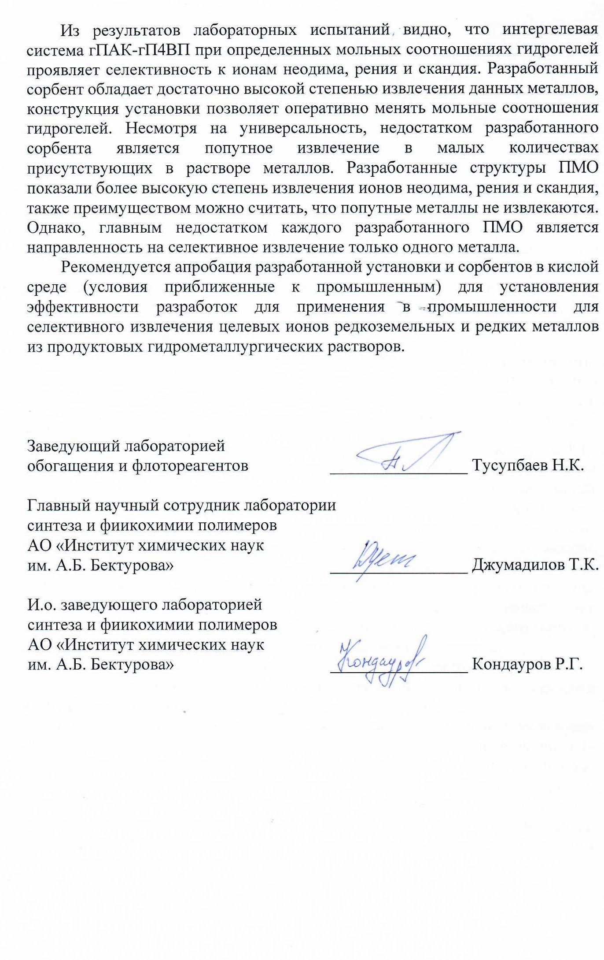
APPROVED"
General director
JSC "Institute of Metallurgy and Ore Beneficiation"
____________ B.K. Kenzhaliev
"___" __________ 2020

ACT

on laboratory tests of an intergel system consisting of rare-crosslinked hydrogels of polyacrylic acid and poly-4-vinylpyridine and polymers with molecular imprints based on methacrylic acid, 4-vinylpyridine and ethylene glycol dimethacrylate as sorbents for the selective extraction of neodymium, rhenium and scandium ions in an aqueous medium (within the framework of the grant financing project AR05131302).
We, the undersigned members of the commission consisting of the General Director of JSC "Institute of Metallurgy and Ore Beneficiation" Kenzhaliev B.K., Head of the laboratory for enrichment and flotation reagents Tusupbaev N.K. and employees of the laboratory of synthesis and physical chemistry of polymers of JSC "Institute of Chemical Sciences named after A.B. Bekturov" Jumadilov T.K. and Kondaurov R.G. carried out laboratory tests of a unit sample for group extraction of rare-earth elements ions. Sorbent (intergel system of polyacrylic acid hydrogel – poly-4-vinylpyridine hydrogel (hPAA-hP4VP) was developed under the guidance of doctor of chemical sciences, professor Jumadilov T.K. Sorbent (molecularly imprinted polymer MIP) based on methacrylic acid, 4- vinylpyridine and ethylene glycol dimethacrylate (Nd, Re, Sc ions were chosen as a template) was developed under the guidance of PhD Kondaurov R.G. The sorption unit is a parallelepiped design, consisting of an outer casing, cartridges in the amount of 2 pieces, drain and filler holes.
Laboratory tests of sorbents were carried out as follows:
1. Selective sorption of neodymium, rhenium and scandium ions by the intergel system hPAA-hP4VP
One cartridge holds a rare-crosslinked polyacrylic acid hydrogel, the other cartridge holds a rare-crosslinked poly-4-vinylpyridine hydrogel. After that, both cartridges are placed in the unit housing. The unit is fed with a model solution consisting of neodymium and scandium nitrates and rhenium chloride (concentration 0.005 mol/L). The selection of aliquots of the solution occurs after 0.5 h; 1 h; 2 h; 6 h, 24 h; 48 h after the start of the experiment. The determination of the residual concentration is carried out by the method of atomic emission spectroscopy.
  - Selective sorption of neodymium ions. For the selective sorption of neodymium ions, the intergel system 83%hPAA-17%hP4VP was used. The maximum values of extraction degree of neodymium ions and accompanying metals are shown in table 1.
Table 1 – Extraction degree of Nd, Re, Sc ions of the intergel system 83%hPAA-17%hP4VP

τ, h | η(83%hPAA-17%hP4VP), %
τ, h | Nd | Re | Sc
48 | 81.43 | 13.41 | 18.22

  - Selective sorption of rhenium ions. For the selective sorption of rhenium ions, the intergel system 17%hPAA-83%hP4VP was used. The maximum values of extraction degree of neodymium ions and associated metals are shown in table 2.

Table 2 – Extraction degree of Nd, Re, Sc ions of the intergel system 17%hPAA-83%hP4VP

τ, h | 17%hPAA-83%hP4VP, %
τ, h | Nd | Re | Sc
48 | 11.54 | 83.44 | 12.77

  - Selective sorption of scandium ions. For the selective sorption of rhenium ions, the intergel system 50%hPAA-50%hP4VP was used. The maximum values of extraction degree of neodymium ions and accompanying metals are shown in table 3.

Table 3 – Extraction degree of Nd, Re, Sc ions of the intergel system 50%hPAA-50%hP4VP

τ, h | 50%hPAA-50%hP4VP, %
τ, h | Nd | Re | Sc
48 | 10.58 | 11.94 | 82.57

2. Selective sorption of neodymium, rhenium and scandium ions by molecularly imprinted polymers
The cartridge contains molecularly imprinted polymer. After that the cartridge is placed in the unit body. The unit is fed with a model solution consisting of neodymium and scandium nitrates and rhenium chloride (concentration 0.005 mol/L). Aliquots of the solution are taken after 0.5 h; 1 h; 2 h; 6 h, 24 h; 48 h after the start of the experiment. The determination of the residual concentration is carried out by the method of atomic emission spectroscopy.
  - Selective sorption of neodymium ions. Molecularly imprinted polymer (template – neodymium) – MIP(Nd) is placed in the cartridge. The maximum values of extraction degree of neodymium ions and associated metals are shown in table 4.

Table 4 – Extraction degree of Nd, Re, Sc ions of the polymer structure MIP(Nd)

τ, h | η(MIP(Nd)), %
τ, h | Nd | Re | Sc
48 | 88.78 | 0 | 0

  - Selective sorption of rhenium ions. The cartridge contains molecularly imprinted polymer (template - rhenium) – MIP(Re). The maximum values of extraction degree of rhenium ions and associated metals are shown in table 5.

Table 5 – Extraction degree of Nd, Re, Sc ions of the polymer structure MIP(Re)

τ, ч | η(MIP(Re)), %
τ, ч | Nd | Re | Sc
48 | 0 | 91.80 | 0

  - Selective sorption of scandium ions. The cartridge contains molecularly imprinted polymer (template - scandium) – MIP(Sc). The maximum values of extraction degree of scandium ions and associated metals are shown in table 6.

Table 6 – Extraction degree of Nd, Re, Sc ions of the polymer structure MIP(Sc)

τ, h | η(MIP(Sc)), %
τ, h | Nd | Re | Sc
48 | 0 | 0 | 90.81

From the results of laboratory tests, it can be seen that the intergel system hPAA-hP4VP at certain molar ratios of hydrogels exhibits selectivity to neodymium, rhenium and scandium ions. The developed sorbent possesses a sufficiently high degree of extraction of these metals; the design of the unit allows one to quickly change the molar ratios of the hydrogels. Despite its versatility, the disadvantage of the developed sorbent is the associated sorption of the metals present in the solution in small amounts. The developed structures of the MIP showed a higher degree of extraction of neodymium, rhenium and scandium ions; it can also be considered an advantage that the associated metals are not extracted. However, the main disadvantage of each developed PMO is its focus on selective extraction of only one metal.
It is recommended to test the developed installation and sorbents in an acidic medium (conditions close to industrial ones) to establish the effectiveness of developments for use in industry for the selective extraction of target ions of rare earth and rare metals from product hydrometallurgical solutions.

Head of laboratory
enrichment and flotation reagents ________________ Tusupbaev N.K.

Chief Researcher of the Laboratory
synthesis and chemical chemistry of polymers
JSC "Institute of Chemical Sciences
after A.B. Bekturov"________________ Jumadilov T.K.

Acting head of laboratory
synthesis and chemical chemistry of polymers
JSC "Institute of Chemical Sciences
after A.B. Bekturov "________________ Kondaurov R.G.
APPENDIX E
Act of carrying out of semi-industrial tests
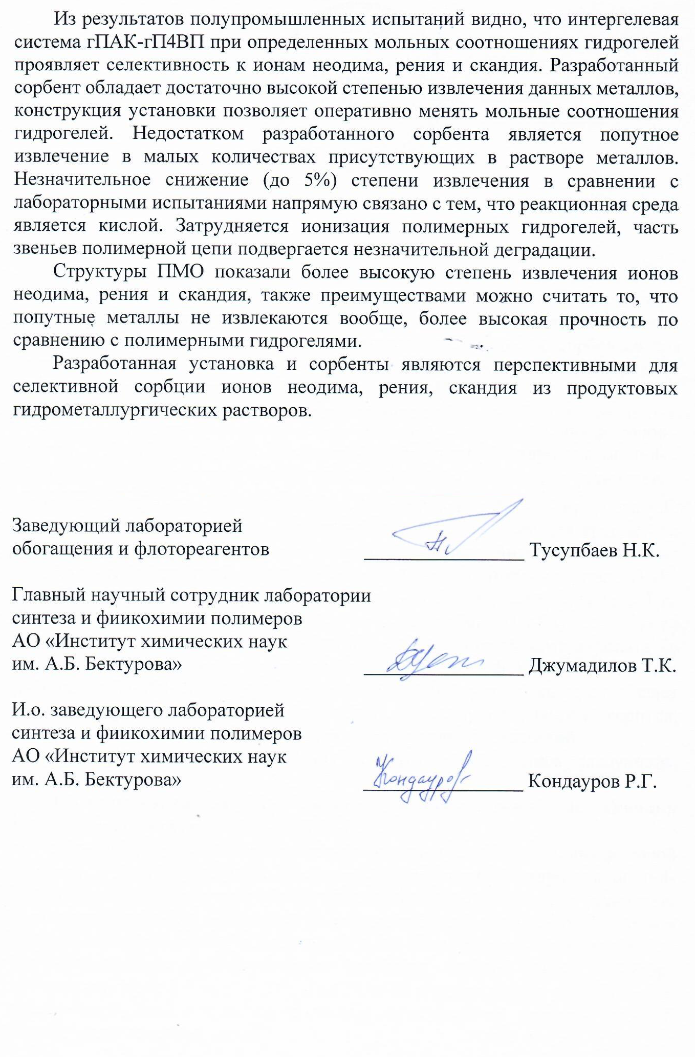
APPROVED"
General director
JSC "Institute of Metallurgy and Ore Beneficiation"
____________ B.K. Kenzhaliev
"___" __________ 2020

ACT

on semi-industrial tests of an intergel system consisting of rare-crosslinked hydrogels of polyacrylic acid and poly-4-vinylpyridine and polymers with molecular imprints based on methacrylic acid, 4-vinylpyridine and ethylene glycol dimethacrylate as sorbents for the selective extraction of neodymium, rhenium and scandium ions in an aqueous medium (within the framework of the grant financing project AR05131302).
We, the undersigned members of the commission consisting of the General Director of JSC "Institute of Metallurgy and Ore Beneficiation" Kenzhaliev B.K., Head of the laboratory for enrichment and flotation reagents Tusupbaev N.K. and employees of the laboratory of synthesis and physical chemistry of polymers of JSC "Institute of Chemical Sciences named after A.B. Bekturov" Jumadilov T.K. and Kondaurov R.G. carried out laboratory tests of a unit sample for group extraction of rare-earth elements ions. Sorbent (intergel system of polyacrylic acid hydrogel – poly-4-vinylpyridine hydrogel (hPAA-hP4VP) was developed under the guidance of doctor of chemical sciences, professor Jumadilov T.K. Sorbent (molecularly imprinted polymer MIP) based on methacrylic acid, 4- vinylpyridine and ethylene glycol dimethacrylate (Nd, Re, Sc ions were chosen as a template) was developed under the guidance of PhD Kondaurov R.G. The sorption unit is a parallelepiped design, consisting of an outer casing, cartridges in the amount of 2 pieces, drain and filler holes.
Semi-industrial tests of sorbents were carried out as follows:
1. Selective sorption of neodymium, rhenium and scandium ions by the intergel system hPAA-hP4VP
One cartridge holds a rare-crosslinked polyacrylic acid hydrogel, the other cartridge holds a rare-crosslinked poly-4-vinylpyridine hydrogel. After that, both cartridges are placed in the unit housing. The unit is fed with a model solution consisting of neodymium and scandium nitrates and rhenium chloride (concentration 0.005 mol/L). The solution has a pH of 3.5, which corresponds to industrial conditions. The selection of aliquots of the solution occurs after 0.5 h; 1 h; 2 h; 6 h, 24 h; 48 h after the start of the experiment. The determination of the residual concentration is carried out by the method of atomic emission spectroscopy.
  - Selective sorption of neodymium ions. For the selective sorption of neodymium ions, the intergel system 83%hPAA-17%hP4VP was used. The maximum values of extraction degree of neodymium ions and accompanying metals are shown in table 1.

Table 1 – Extraction degree of Nd, Re, Sc ions of the intergel system 83%hPAA-17%hP4VP

τ, h | η(83%hPAA-17%hP4VP), %
τ, h | Nd | Re | Sc
48 | 77.36 | 12.74 | 17.31

  - Selective sorption of rhenium ions. For the selective sorption of rhenium ions, the intergel system 17%hPAA-83%hP4VP was used. The maximum values of extraction degree of neodymium ions and associated metals are shown in table 2.

Table 2 – Extraction degree of Nd, Re, Sc ions of the intergel system 17%hPAA-83%hP4VP

τ, h | 17%hPAA-83%hP4VP, %
τ, h | Nd | Re | Sc
48 | 10.96 | 79.27 | 12.13

  - Selective sorption of scandium ions. For the selective sorption of rhenium ions, the intergel system 50%hPAA-50%hP4VP was used. The maximum values of extraction degree of neodymium ions and accompanying metals are shown in table 3.

Table 3 – Extraction degree of Nd, Re, Sc ions of the intergel system 50%hPAA-50%hP4VP

τ, h | 50%hPAA-50%hP4VP, %
τ, h | Nd | Re | Sc
48 | 10.05 | 11.34 | 78.44

2. Selective sorption of neodymium, rhenium and scandium ions by molecularly imprinted polymers
The cartridge contains molecularly imprinted polymer. After that the cartridge is placed in the unit body. The unit is fed with a model solution consisting of neodymium and scandium nitrates and rhenium chloride (concentration 0.005 mol/L, pH=3.5). Aliquots of the solution are taken after 0.5 h; 1 h; 2 h; 6 h, 24 h; 48 h after the start of the experiment. The determination of the residual concentration is carried out by the method of atomic emission spectroscopy.
  - Selective sorption of neodymium ions. Molecularly imprinted polymer (template – neodymium) – MIP(Nd) is placed in the cartridge. The maximum values of extraction degree of neodymium ions and associated metals are shown in table 4.

Table 4 – Extraction degree of Nd, Re, Sc ions of the polymer structure MIP(Nd)

τ, h | η(MIP(Nd)), %
τ, h | Nd | Re | Sc
48 | 84.34 | 0 | 0

  - Selective sorption of rhenium ions. The cartridge contains molecularly imprinted polymer (template - rhenium) – MIP(Re). The maximum values of extraction degree of rhenium ions and associated metals are shown in table 5.

Table 5 – Extraction degree of Nd, Re, Sc ions of the polymer structure MIP(Re)

τ, ч | η(MIP(Re)), %
τ, ч | Nd | Re | Sc
48 | 0 | 87.21 | 0

  - Selective sorption of scandium ions. The cartridge contains molecularly imprinted polymer (template - scandium) – MIP(Sc). The maximum values of extraction degree of scandium ions and associated metals are shown in table 6.

Table 6 – Extraction degree of Nd, Re, Sc ions of the polymer structure MIP(Sc)

τ, h | η(MIP(Sc)), %
τ, h | Nd | Re | Sc
48 | 0 | 0 | 86.27

It can be seen from the results of semi-industrial tests that the intergel system hPAA-hP4VP at certain molar ratios of hydrogels exhibits selectivity to neodymium, rhenium, and scandium ions. The developed sorbent possesses a sufficiently high degree of extraction of these metals; the design of the unit allows one to quickly change the molar ratios of hydrogels. The disadvantage of the developed sorbent is the associated extraction of metals present in the solution in small amounts. A slight decrease (up to 5%) in the recovery rate in comparison with laboratory tests is directly related to the fact that the reaction medium is acidic. The ionization of polymer hydrogels is hindered, and some of the links of the polymer chain undergo insignificant degradation.
The MIP structures showed a higher degree of extraction of neodymium, rhenium and scandium ions, and the advantages can also be considered the fact that the associated metals are not extracted at all, higher strength compared to polymer hydrogels.
The developed unit and sorbents are promising for the selective sorption of neodymium, rhenium, scandium ions from product hydrometallurgical solutions.

Head of laboratory
enrichment and flotation reagents ________________ Tusupbaev N.K.

Chief Researcher of the Laboratory
synthesis and chemical chemistry of polymers
JSC "Institute of Chemical Sciences
after A.B. Bekturov"________________ Jumadilov T.K.

Acting head of laboratory
synthesis and chemical chemistry of polymers
JSC "Institute of Chemical Sciences
after A.B. Bekturov "________________ Kondaurov R.G.
APPENDIX F
Act of carrying out of pilot-industrial tests

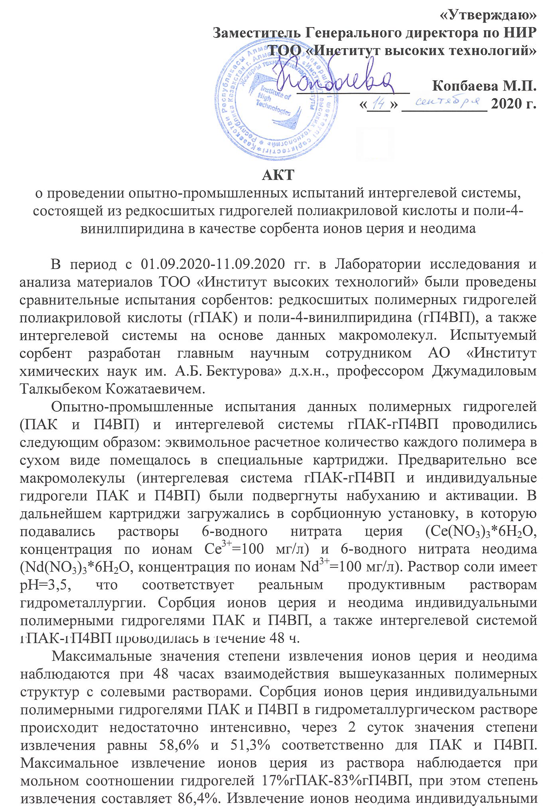
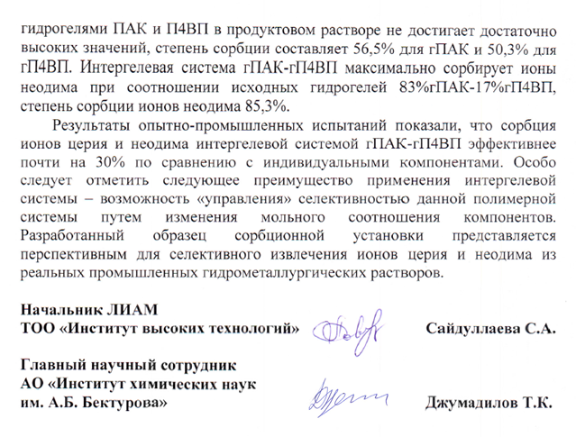

"APPROVED "
Deputy of General Director on SRW
LLP "Institute of High Technologies"
____________ Kopbaeva M.P.
"___" ___________ 2020

ACT
on pilot testing of an intergel system consisting of lightly crosslinked hydrogels of polyacrylic acid and poly-4-vinylpyridine as a sorbent for cerium and neodymium ions

In the period from 09/01/2020 - 09/11/2020 comparative tests of sorbents were carried out in the Laboratory of Materials Research and Analysis of Institute of High Technologies LLP: lightly crosslinked polymer hydrogels of polyacrylic acid (hPAA) and poly-4-vinylpyridine (hP4VP), as well as an intergel system based on macromolecules data. The tested sorbent was developed by the chief researcher of JSC "Institute of Chemical Sciences after A.B. Bekturov" doctor of chemical sciences, professor Jumadilov Talkybek Kozhatayevich.
Pilot tests of these polymer hydrogels (PAA and P4VP) and the hPAA-hP4VP intergel system were carried out as follows: the equimolar calculated amount of each polymer in dry form was placed in special cartridges. Previously, all macromolecules (intergel system hPAA-hP4VP and individual hydrogels PAA and P4VP) were swollen and activated. Subsequently, the cartridges were loaded into a sorption unit, into which solutions of 6-aqueous cerium nitrate (Ce(NO₃)₃*6H₂O, concentration by Ce³⁺ ions = 100 mg/L) and 6-aqueous neodymium nitrate (Nd(NO₃)₃*6H₂O, concentration for Nd³⁺ ions = 100 mg/L). The salt solution has a pH of 3.5, which corresponds to real product solutions of hydrometallurgy. The sorption of cerium and neodymium ions by individual polymer hydrogels PAA and P4VP, as well as by the intergel system hPAA-hP4VP, was carried out for 48 h.
The maximum values of the degree of extraction of cerium and neodymium ions are observed at 48 hours of interaction of the above polymer structures with saline solutions. The sorption of cerium ions by individual polymeric hydrogels PAA and P4VP in the hydrometallurgical solution is not intensive enough; after 2 days, the recovery rates are 58.6% and 51.3%, respectively, for PAA and P4VP. The maximum extraction of cerium ions from the solution is observed at a molar ratio of hydrogels of 17%hPAA-83%hP4VP, while the degree of extraction is 86.4%. The extraction of neodymium ions by individual PAA and P4VP hydrogels in the product solution does not reach sufficiently high values, the degree of sorption is 56.5% for hPAA and 50.3% for hP4VP. The intergel system hPAA-hP4VP maximally sorbs neodymium ions at a ratio of the initial hydrogels of 83%hPA-17%hP4VP, the degree of sorption of neodymium ions is 85.3%.
The results of pilot tests showed that the sorption of cerium and neodymium ions by the intergel system hPAK-hP4VP is almost 30% more efficient than the individual components. It should be especially noted the following advantage of using an intergel system - the ability to "control" the selectivity of a given polymer system by changing the molar ratio of components. The developed sample of the sorption unit seems to be promising for the selective extraction of cerium and neodymium ions from real industrial hydrometallurgical solutions.

Head of LMRA
LLP "Institute of High Technologies" Saidullaeva S.А.

Chief Researcher
JSC "Institute of Chemical Sciences
after A.B. Bekturov" Jumadilov T.K.

