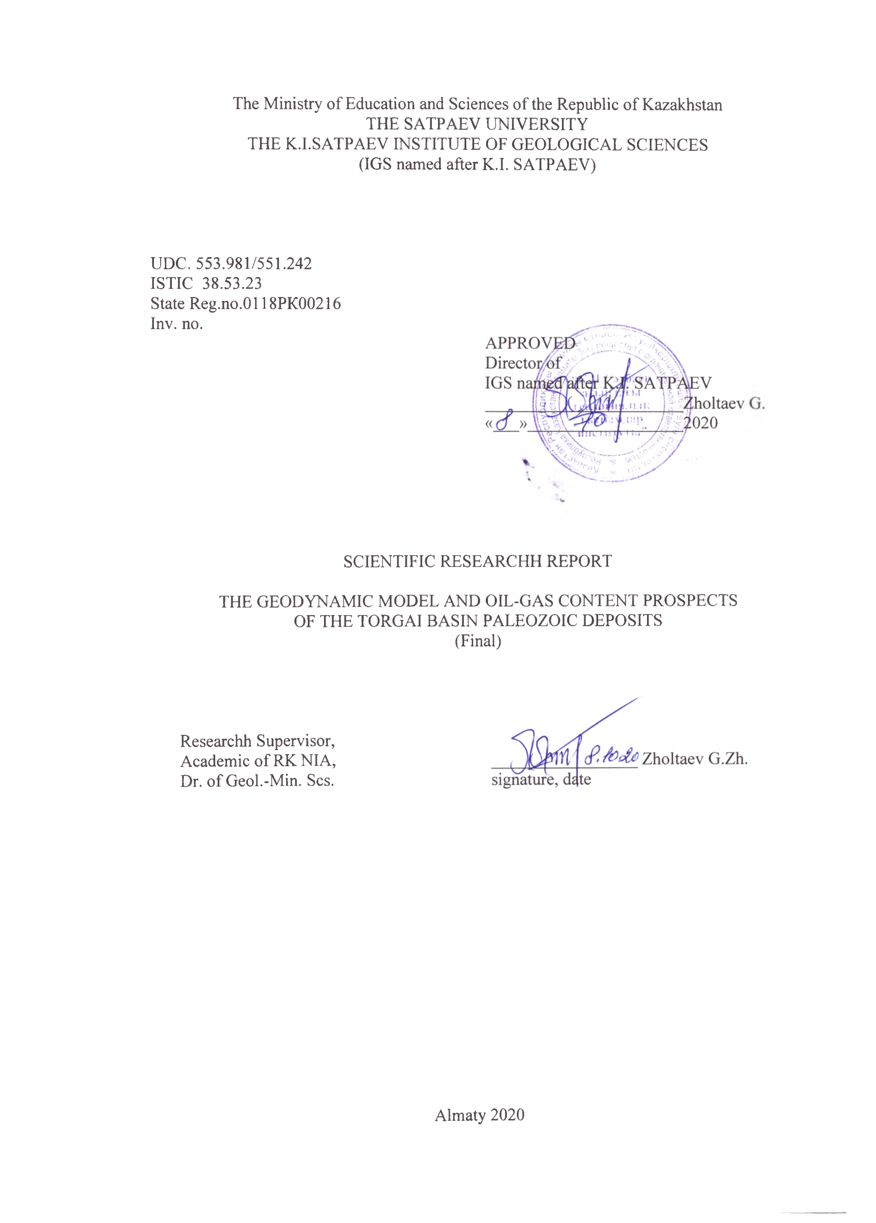
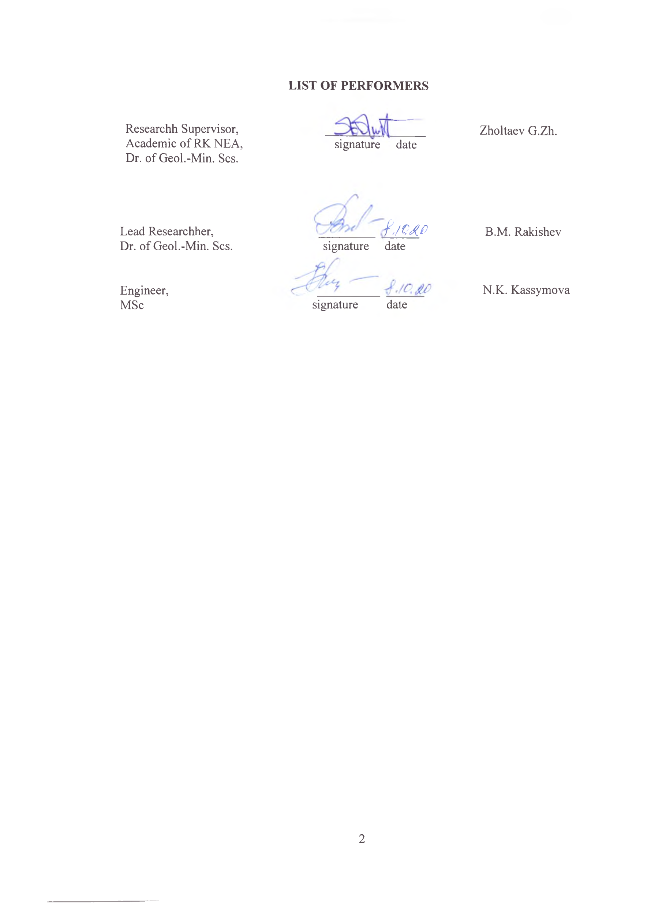
РЕФЕРАТ

Есеп 65 б.,1 кіт., 10 сур., 2 кесте., 23 дереккөзд., 3 қосымш.
ШӨГІНДІ БАССЕЙН, ТЕРЕҢДІК ЖАРЫЛЫМДАР, МҰНАЙГАЗДЫЛЫҒЫ, ГОРИЗОНТ, ШОҒЫР, РИФ, ӘКТАС, ШАҒЫЛЫСТЫРУШЫ ГОРИЗОНТТАР, ГЕОДИНАМИКАЛЫҚ МОДЕЛЬ, АЛЛОХТОН, ТАҚТАЛАР ТЕКТОНИКАСЫ, ПАССИВТІ КОНТИНЕНТТІК ЖАҒАЛАУЛЫҚ БАССЕЙНІ
Зерттеу объектісі Солтүстік Торғайдың палеозой шөгінділері болып табылады.
№АР05131331 "Торғай бассейнінің палеозой шөгінділерінің геодинамикалық моделі және мұнайгаздылығының перспективалары" гранттық жобасының мақсаты Торғай бассейнінің палеозой шөгінділері құрылымының геологиялық ерекшеліктерін ескере отырып, көмірсутек шикізатын іздеу тиімділігін арттыруға бағытталған.
Сейсмика мен ҰГЗ материалдарын салыстырмалы талдау негізінде корреляциялық схемалар жасалды; бассейннің геодинамикалық эволюциясын қайта жаңарту жүргізілді, тақталар тектоникасы позициясынан Торғай бассейні құрылысының геодинамикалық моделі салынды және бассейннің палеозой шөгінділерінің мұнайгаздылығы болжанды. Девон-турней жасындағы рифтік құрылысқа орайластырылған мұнайға аса перспективті Ибрайхан объектісінің паспорты жасалды.

SUMMARY

The report contains 65 pages of textual material, 3 annex, 10 illustrations, utilising 23 information sources
SEDIMENTARY BASIN, DEEP FAULTS, OIL AND GAS CONTENT, HORIZON, DEPOSIT, REEF, LIMESTONE, REFLECTING HORIZONS, GEODYNAMIC MODEL, ALLOCHTON, PLATE TECTONICS, PASSIVE CONTINENTAL MARGIN BASIN
The object of research is Paleozoic sediments of the Northern Sparrow.
The purpose of the grant project No.АР05131331 "Geodynamic model of Paleozoic sediments of the Turgay Basin and oil and gas prospects" is aimed at improving the efficiency of hydrocarbon exploration, taking into account the geological features of the structure of Paleozoic sediments of the Turgay Basin.
Correlation schemes have been drawn up on the basis of comparative analysis of seismic and well logging materials; geodynamic evolution of the basin has been reconstructed; a geodynamic model of the Torgai basin structure has been built according to the position of plate tectonics; the oil and gas bearing capacity of the basin’s Paleozoic deposits has been predicted. A passport was drawn up for the Ibraikhan object, highly promising for oil and dated to the reef structure of the Devonian-Tournai age.

CONTENT
INTRODUCTION……………………………………………………………….............. | 6
- The problem of oil-gas content of the Torgai basin palezoic deposits …………….…. | 8
1.1 Review of the problem’s studies …………………………………………….……… | 8
1.2 New data on the Paleozoic deposit structure ……………………………………..… | 9
- Lithologic-facial stratigraphic section characteristics …………………………. | 11
3 New geophysical data on the Torgai basin paleozoic deposit structure ………………. | 17
4. The geodynamic model and geodynamic evolution of the Torgai basin …………. | 24
4.1 The geodynamic model of the given area ………………..………………………… | 25
4.2 The geodynamic evolution of the North-Torgai basin ……………………….…. | 29
5 Prediction of oil-gas content of the Torgai basin paleozoic deposits ……………....…. | 33
5.1 General information on oil and gas showings ……………………......................... | 33
5.1.1 Stratigraphic levels of oil and gas showings and their characteristics ……...…. | 35
5.2 Prediction of oil and gas content and recommendations for prospecting and  exploration work ……………………………………………………………….….. | 38
CONCLUSION…………………………………………………………….…………… | 40
LIST OF REFERENCES…………………………………………………………….….. | 41
ANNEX А. Description of cores.………….…………………………………………….. | 43
ANNEX B Description to the Ibraikhan structure by seismic survey of the Paleozoic  complex for exploration drilling in the North-Torgai sedimentary  basin.…………………………………………………………………….….. | 45
ANNEX С Published articles for the report....................................................................... | 58

INTRODUCTION

Since the early thirties of the last century, studies of the Torgai Basin have been conducted by various organisations in the Soviet Union, resulting in neither oil inflows nor significant scientific results.
Targeted system work on oil and gas began in 2012, when Energy Resources LLP drilled the H-1 well in Novonezhinskaya Site and received an inflow of liquid oil from 562.5 m of lower carbonate limestone. This company, having listened to our opinion, carried out seismic works MOGT 2D and 3D, the results of which confirmed our construction based on the slab tectonics concept. Analysing all collected geological and geophysical material from the funds of Sevkaznedra CBM, Energy Resources LLP, Zapakaznedra CBM, PGD and BGP and published articles and monographs as part of the project assignment, the project has been compiled:
- Geodynamic model and scheme of evolution of the North-Torgai basin into the Paleozoic and Mesocaenozoic;
- for the first time, a comparative lithologic-facial analysis of the Devonian and coal-bearing sections of the Valerianov zone, the North-Torgai Trough and the Kokshetau massif was made;
- tectonic and oil-and-gas-geological zoning of the entire Torgai Basin was carried out;
- prepared a passport most promising for exploration of new oil and gas fields in the Ibraikhan site in the eastern part of the North-Torgai basin, where we identified a reef massif in Devon and Carboniferous and which aroused great interest among Kazmunaigas JSC, Energoresursy LLP and foreign specialists from Iran, Turkey, Russia and China.
The researchh outcomes have been published in papers in full compliance with the project plan:
1. G.Zh. Zholtaev, M.I. Nalibaev. The geodynamic model and prospects of oil and gas bearing capacity in the North-Torgai basin. Izvestia NAS RK. Series of Geology and Technical Sciences, 2018(3).
2. R.N. Khairutdinov, S.M. Ilimbaeva, G. Zholtaev. Development of a unified electronic database of downhole seismic exploration for oil and gas regions of Kazakhstan. The "Karotazhnik" Scientific and Technical Bulletin, 2019(297), p. 139 RINZ (IF 0,24).
3. Zholtaev G. Definition of porosity and permeability of coarse-fragmented terrigenous reservoirs based on well logging data // The "Karotazhnik" Scientific and Technical Bulletin 2019, RINZ (IF 0,24).
4. A. Akhmetzhanov, G. Zholtaev, A. Djeddou, G. Akhmetzhanova, B. Oraz. The post-salt trapping mechanism of the south-east Caspian and its application to petroleum exploration // Journal of Petroleum Exploration and Production Technology, 09, August 2020, the journal's percentile is 59%.
5. G.Zh. Zholtaev, R.B. Abuyev, G.A. Akhmetzhanova, B.B. Oraz. Reservoir porosity and permeability and petrophysical parameters of terrigenous-carbonate reservoirs in the south-east of the Caspian depression // "Karotazhnik" 2020(3).
6. Z.T. Umarbekova, G.Zh. Zholtaev1, B.B. Amralinova, I.E. Mataibaeva. Silver Halides in the Hypergene Zone of the Arkharly Gold Deposit as Indicators of their Formation in Dry and Hot Climate (Dzungar Alatau, Kazakhstan)// International Journal of Engineering Researchh and Technology. ISSN 0974-3154, Volume 13, Number 1 (2020), pp. 181-190 International Researchh Publication House. http://www.irphouse.com., the journal's percentile is 13%.
We hope that our recommendations will result in the opening of a new oil and gas bearing basin in the north of the country.

1 The problem of oil-gas content of The Torgai basin palezoic deposits

1.1 Review of the problem’s studies
A prerequisite for starting the study of the oil and gas content of the northern part of the Torgai Trough was the discovery of bitumen in 1936 by geologists V.G. Chernyshov and A.A. Ershov near the border with the Kostanai region of Kazakhstan. In 1937, N.P. Tuaev conducted researchh on this bitumen (analyst V.A. Uspensky) and came to the conclusion about its oil nature. The bitumen consisted for 83,95% of C, for 11,77% of H, for 0,9% of S, and for 3,3% of both O+N .
In 1952-53, the “Tyumenneftegazgeologiya” trust drilled a general profile through the northern part of the Torgai Trough and in the area of the Kazanbasy railway station with 4 wells (No. 1,2,6,8) at depths of 179-321 m and recorded oil and bitumen manifestations in the limestone of the Lower Carboniferous. In 1957, A.A. Sultanaev in his paper "Paleozoic deposits of the Urals eastern slope and prospects for their oil-bearing capacity" recommended prospecting for oil and gas in the Lower Carboniferous sediments of the north-eastern part of the Torgai Trough. In 1958-60 and 1961-63, the North-Kazakhstan Territorial Geological Department carried out oil prospecting works at the Novonezhinskaya site (F.Z. Batalov, 1961). There were 16 wells 277.3 to 1010.7 m deep, 9 wells of which (No. 100, 108, 120, 123, 119, 130, 123, 128, 115) showed manifestations of drip-liquid oil and bitumen in terrigenous carbonate sediments of the Lower Carboniferous, and 1.0 ton of oil inflow was obtained by bailing tube in the well No. 119 at the interval of 499-592 m. Analysis of oil from the well 119 was carried out in the VNIGRI laboratory. In terms of hydrocarbon composition, the studied oil was classified as naphthenic-methane with a significant amount of aromatic hydrocarbons.
The numerous manifestations of oil and bitumen identified were the basis for long-term (1963-1973) exploration-structural drilling for oil and gas in the northern part of the Torgai Trough (N.P., Kirda, 1973) and for development of geological surveys on the scale of 1:50,000 - 1:200,000 (K.P. Udris, 1960), B. A. Yankelevich 1961, A. F. Dragun 1988, 1991). Oil and gas exploration drilling operations were concentrated at the Shcherbakovskaya site, located directly north-west of North-Torgai site at the Kostanay reference profile and at the Novonezhinskaya and Lesnaya sites. Profile drilling was carried out across the stretch of Paleozoic structures. The distance between wells ranged from 4.0 km to 1,000-500 m and the depth of the wells ranged from 300 to 1,500 metres. As a result of these works, a large volume of rock porosity and permeability definitions, C_{org} definitions in rocks D₃₋С₁, and paleontological studies were performed, and the oil nature of bitumen (M.A. Adrianova, VNIGRI 1971-1973) was determined, the presence of cavernous, lumpy and intensively cracked carbonate rocks with a porosity of 15-20% and permeability of 12-48 mD was established. More than 25 wells with manifestation of drip-liquid and semi-liquid oil, bitumen and gas in secondary reservoirs at depths of 330-862 m were identified. The well No. 138 in the Novonezhinskaya site 8 km south of well No. 119 revealed at depths of 779-862 m the presence of liquid bitumen in Medium to Upper Carboniferous sinter tuffs covered with Triassic basalt.
The SNIIGGIMSA laboratory analysed bitumen and obtained the following data: hydrocarbon content - 84.83%, hydrogen - 13.55%, asphalt - 3.78%, benzene resin - 5.16%, alcohol-benzol - 4.05%, oils - 8.7%. Prospecting-structural drilling for oil and gas in the northern part of the Torgai Trough conducted in 1963-73 allowed the authors (N. P. Kirda et al. 1973) to positively evaluate the prospects for oil and gas of the area.
The authors recommended drilling an exploratory parametric well 3,000 m deep at the Novonezhinskaya site, 180-200 m east of the well 119, where a non-industrial flow of oxidised oil was obtained from deposits. In various years from 1948 to 1996, as the prospecting and exploration methodology improved, numerous seismic surveys were carried out by the Torgai, Kustanai, Trans-Tobol GFE, BazhGFE and TU Sevkaznedra, which were mainly limited by construction of the "isodepth maps of the Paleozoic folded foundation roof topography"; in some cases, the first information was obtained on the layering of intermediate floor sediments and the possibility of finding favourable structural oil and gas promising forms.
At the time, most geologists were guided by the geosyncline concept that Paleozoic sediments should be strongly dislocated in the Hercynian tectogenesis phase, which was a kind of psychological barrier to hydrocarbon exploration in the Paleozoic section. Some excitement in studies of geological structure occurred in 2002 with implementation of the contract "Hydrocarbon Exploration in the North-Torgai site" by Sevkazgra LLP, who carried out seismic MOGT 2D work and drilled a well 2,800 m deep in unfavourable structural conditions however with no signs of oil and gas. Seismic materials of low resolution and traceability allowed only predicting the presence of structural and, possibly, reef traps.

1.2 New data on Paleozoic deposit structure
Targeted systemic oil and gas exploration work began in 2012 with the “Energoresoursy” LLP, which, having drilled the N-1 well at the Novonezhinskaya site, received an inflow of liquid oil from a depth of 562.5m from Lower Carboniferous limestone.
Taking the basalt thickness of the Lower Triassic as a regional fluid seal in various geophysical anomalies, the T-1, U-1 wells were drilled with opening of the Lower Carboniferous limestone, which did not yield positive results. Inflow of liquid oil and results of paleogeodynamic reconstructions according to the plate tectonics [1 and 2], holding that the entire territory of the North-Torgai basin represented and was developed under the passive continental margin of the Ural paleo-ocean in the Devonian and Early Carboniferous with its characteristic sedimentation conditions, served as the basis for the MOGT 2D/3D seismic studies in the license site of “Energoresursy” LLP.
A series of 2D MOGT regional seismic profiles from west to east through the North-Torgai basin have shown that Devonian and Carboniferous deposits are not dislocated, are clearly visible and several parallel reflective horizons can be traced regionally (Figure 1.1). After making sure that our concept was correct, it was decided to move on to the next stage - the detailed study of the section.
As a result of these works, structural traps Shokai, Shakhmardan and Sagadat on the western side of the North-Torgai Trough in the area of its junction with the Kostanai Anticlinory and the development zone of Devonian and Lower Carboniferous reefs on the eastern side of the Trough - Ibraikhan and Kalkul reefs - were identified and prepared for exploratory drilling [6].
In the light of new geological and geophysical data, it is time to change the views of specialists and scientists on the geodynamic evolution of the vast territory covering the junction zone of the Ural fold system with the Kokshetau-Ulytau ancient massifs in the Paleozoic, namely that this area from the Middle Devonian to the Early Visean i.e. during the last cycle of the geodynamic evolution of the Ural Paleozoic (it was documented and can be proved by the geological materials available to geologists) developed under regime of the passive continental margin of the Kazakhstan continent, changed from the Late Visean to the end of the Paleozoic to the back-archh basin regime. The Paleozoic deposits are not at all dislocated or metamorphosed as would be expected from a geosynclinal perspective and are of practical interest for oil and gas exploration. The available geological and geophysical information is, from our point of view, a sufficient basis for forecasting the discovery of a new oil and gas-bearing North-Torgai region in the subsequent oil production in the north of the country where economically important companies and corporations, powerful consumers of oil products, are present there.

2 Lithologic-facial stratigraphic section characteristics

Geological characteristics of the section are given on the basis of the materials of previous geological survey, prospecting and exploration work and structural mapping drilling for oil and gas (N.P. Kirda, 1973), parametric drilling (site 2P, depth 2951 m) and new data on drilling of prospecting and exploration wells by various companies in the last 10 years.
The geological structure of the area includes rock complexes ranging in composition and age from the early Paleozoic to modern ones.
The undivided Lower Paleozoic.
Formations of this age are developed on the erosion section of the foundation in the extreme south-eastern part of the area where they form the Aksuat trough. The thickness is composed of clay-siliceous shales, interstratified silts and polymict sandstones, rarely limestone and andesit-basalt porphyrytes. The thickness is estimated at 2.0-2.5 km.
The Devonian system. It involves the formation of the Lower-Middle Devonian and the Frasnian and Famennian tiers.
The Lower and Middle Devonian deposits are eroded in the underlying formations and are mainly represented by pinkish-gray and purple-brown quartz and trachyte porphyries interlaid with litho-crystal-clastic tuffs and tuffobreccias. They are mapped in the western part of the territory. Their age is determined by their lithological similarity to that of Central Kazakhstan. Thickness of these formations has not been determined and is estimated at 400-1200 m. Well No. 129, 1002 m deep, passed by N.P. Kird (1973), uncovered andesit-basalt porphyrytes of this age, which have not been re-drilled.
Frasnian sediments have been discovered by mapping wells in the northern and eastern parts of the territory. They appear to be intermittent in the underlying sediments and are composed of red and grey-coloured polymite sandstones, gravelites, conglomerates, siltstones, rarely andesite porphyrites and their tuffs. Limestone and calcareous silts are found at the top of the section. In the upper part of the described thickness, stable and extended seismic boundaries and a number of proposed reefs are often identified from seismic materials. This suggests that the top of the section may also be of interest for hydrocarbon prospecting. The thickness thickness is estimated by various researchhers at 800 to 1500-2000 m. According to drilling data, well No. 1 deposits of the Frasnian tier were found at a depth of 2760m and did not come out of it before the bottom of well No. 2800m. They are represented as well as overlying Famennian deposits of limestone mainly gray, dark grey, thin and hidden crystalline organogenic-clastic deposits, mainly recrystallised with blastopsamite, blastomilonite structures, siliconized to almost complete substitution of calcium with silicon (CASO₃ 11-24%), highly brecciated, sometimes silicified in the form of veins and quartz nests, contain rare low-power layers of black argillites (Figure 2.1).
The Famennian sediments are represented by marine and coastal-marine sediments dominated by grey and dark grey dolomised limestone, karsted, containing a layer of dark grey argillites and calcareous silts and anhydrites. This thickness contains a significant amount of organic matter and, together with sediments of the Lower Carboniferous age, is considered by us to be the bottom of a potential oil-source section. The age of the thickness is determined by the fauna and micro fauna. In parametric well No 2P we obtained a closed section of this thickness. Its capacity is estimated at 500-600m. The capacity of the Famennian layer deposits in well no.1 is 230m. The well entered these sediments at a depth of 2530m and exited at a depth of 2760m. These sediments are visually difficult to distinguish from the underlying Frasnian sediments. Here they are also siliconised, almost to the point where calcium is replaced by silicon, limestone, which is more or less recognisable by the shape of its skeleton. It should be noted that well No. 1 was largely in the tectonic active zone, which is why there have been significant changes in the appearance of limestones that have become siliceous rocks.
The coal system. Sediments of this age are deposited without any visible break in the Upper Devonian sediment and are widespread. In addition to the Famennian sediments, this thickness forms the basis of the area's oil-source rocks. The well no.2P uncovered a complete stratified section of rocks of this age.
The Lower Tournai sediments are represented by limestones of grey and dark grey organogenic-clastic, clayey sections of bituminous, karsted and intensively cracked, containing remains of crinoid shells, bryophytes, brachiopods, corals and sometimes charred plant remains. The cracks are filled with calcite and sutural seams are not uncommon.
Drip-liquid and semi-liquid oil (sites Nos. 510, 619, 120) have been identified in cracks, caverns and leaching voids in limestone. The capacity of the described sediments is 600-700m.
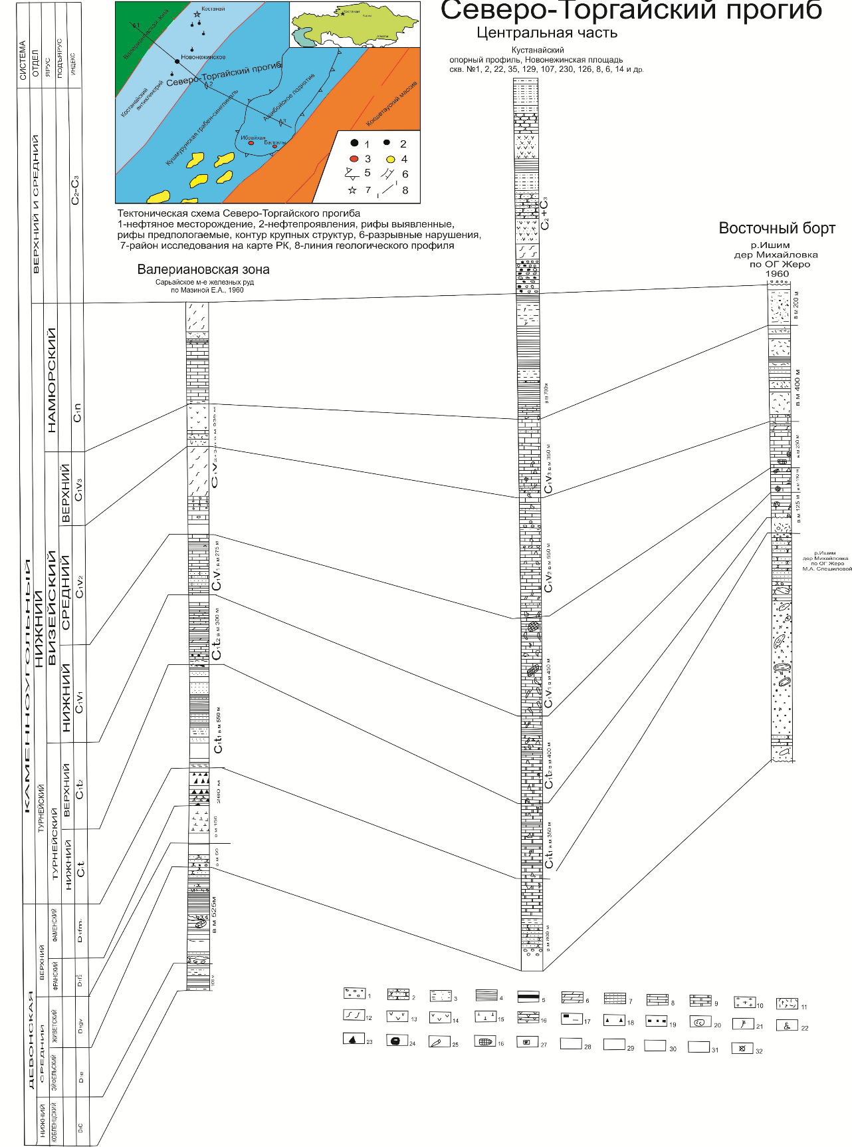
1-conglomerates, gravelites; 2-sandstones; 3-alevrolites; 4-argillites; 5-coals; 6-margels; 7-sandy limestones; 8- limestones; 9-dolomites; 10-anhydrites; 11-tuffites; 12-effusive-sedimentary rocks with medium-quality pyroclastic material; 13-effusives of fine composition; 14-effusives of medium composition; 15-effusives of the basic composition; 16-scarns; 17- silicon in concretions; 18- solid silicon; 19-piritization; 20-red colour; 21-flora; 22-foraminifera; 23-brachiopods; 24-pelecypods; 25-corals; 26- moss animals; 27-crinoids; 28-lithological composition as per logging; 29- interruptions in sediment accumulation; 30-visible thickness; 31- oil and gas shows; 32 - locations of the surveyed sections.
Figure 2.1 – Correlation of Paleozoic sediment sections in the North-Torgai basin
Sediments of the Upper Tournai - Lower Visean age lie conformingly on the Lower Tournai deposits and are represented by limestones of organogenic-detrite, riffogenic, clayey, fine crystalline, grey and dark grey, containing fragments of brachiopod, crinoid, moss animals, sometimes replaced by calcite. Limestone is often cracked and karsted (there were failures when drilling the 2P well to 8.0 m). Cracks and caverns in wells 127 and 131 revealed semi-liquid oil and bitumen. The thickness is 400 m in site 2P. According to drilling data from the well No. 1, Tournai deposits have not been separated. The total thickness of Tournai sediments in well No. 1 is almost 3 times less (210 m) than in well 2P (about 700 m). The difference in the Tournai formations thickness in not so distant wells is explained by the fact that well No. 1 is in the fracture zone, where both vertical and horizontal movements took place. The Tournai deposits were found in the depth range of 2290-2500m. The sediments of the undivided Tournai tier are mainly dark grey argillites, black unknown or weakly calcareous, with limestone grey and dark grey organogenic-fragmented, intensively siliceous to lime-siliceous rocks (СаСО₃ 12-21%) cataclastised and, in spots, recrystallised, with sliding mirrors and blastopelite and blastopsammite structures. These sediments contain veins of quartz and sometimes pyrite nests.
Age of both these sediments and those described above are dated as per foraminifera found by both the RK NAS Institute of Geological Sciences and the AktobeNIGRI.
Mid-Upper Visean age sediments occur conformingly on the above described sediments and are represented by interchange of limestones of thin and fine crystalline, gray and dark grey (prevailing in the section) with argillites, siltstones and sandstones of greenish grey, gray and dark grey colour and cracked. There are manifestations of liquid oil (sites Nos. 618, 119, 505, 108, 120), solid and semi-liquid bitumen (sites Nos. 624, 131) in cracks and caverns of limestones and sandstones. The identified by drilling thickness of these sediments is 300-350 m. In the well No. 1 they are 870 m, which is more than twice as much as the adjacent areas. These sediments are found in the depth range of 1420-2290m. They are mainly represented by limestone, organogenic-clastic, grey, light grey, in parts dolomitised (CaMg(CO₃)₂ 9-25%) and clayey, siliceous areas. Encountered are imprints of fragments of bryozoans, foraminifera, needle-skinned; there are interlayers of up to 2-3m of argillites, calcareous sandstone and siltstones. These deposits contain rare grains of bitumen, as well as the deposits described above, which rarely fluorescence, slightly more often fluorescence is observed when reacting with a solvent, and in these cases there is a slight dim glow with a pale yellow ring. Core drilling was performed in these sediments in intervals of 1712.5-1721.5m and 1977.8-1983.4m. Core output in the first interval was 100%, in the second interval 90%.
Deposits attributed to the Serpukhovian layer (C1 s) are mainly represented by coastal and marine facies. They lie without any visible interruption on sediments of the Middle to Upper Visean and are composed of interlaid argillites and grey, brownish green, dark grey calcareous siltstones, quartz and polymict sandstone, rarely effusive of medium and basic composition, tuff sandstone and grey limestone of fine and hidden crystalline, cracked and cavernous, containing solid and semi-liquid bitumen and liquid oil (wells nos. 119,134). The clay-terrigenous component prevails in the section described. The thickness of terrigenous interlayers varies from 4.0 to 30 m and limestone from the first m to 22 m. The thickness of the described sediments is 350-450 m.
For well no.1, deposits of the Serpukhovian layer were found in the depth range of 995-1420m. Interlayers of siltstones, argillites, sandstones, tuff-sandstones, tuffites, limestones of beige grey, dark grey, greenish grey colour are represented. Limestones finely and hiddenly crystallised, sandstones and tuff-sandstones thin and fine grained on calcareous siltstone cement, siltstones are carbonised to varying degrees. Between 1121-1129.2m, core drilling was carried out and 100% raised.
Mid- to Upper Carboniferous deposits eroded on the above described sediments were formed under continental conditions. They are represented by interlayers of reddish-brown and red-brown polymict sandstones, conglomerates, andesite-basalt porphyrites and their tuffs with reddish-brown, dark green and greenish-brown colouring. They are widely developed in the western part of the Contract site. In the adjacent area, these formations 400-500 m thick have been re-drilled (sites 135 and 118, Novonezhinskaya site). According to literature sources, their thickness within the eastern framing of the Torgai Trough can reach 1,000-1100 m (Geologiya SSSR, vol.34, 1971).
For the first time in the North-Torgai Trough, deposits of the Bashkirian section were identified in the well no.1, during the interval from 690m down to 995m, making 305m of the sediments. They are represented by interlayers of siltstones, argillites, polymite sandstones, grey, reddish-brown with sharp horizons of clay limestones, andesit-basalts and their tuffs. The age of rocks is determined by foraminifera at the RK NAS Institute of Geological Sciences. Core drilling was carried out here in the 849.3-856.6m interval and 100% of the rock was lifted.
The Triassic system
Formations of this age are developed in the most part (up to 90%) of the Kushmurun graben. They comprise two continental strata: predominantly effusive Lower-Middle-Triassic age and reddish terrigenous Upper-Triassic age.
The Triassic sediment section is characterized by core from the Ubagan-1 well. Formations of the Lower-Middle Triassic as it follows from the description of the U-1 section are mainly basalts, dolerites, liparites, representing fractured trap-type outflows.
The Jurassic system
Jurassic deposits are developed in the eastern part of the territory and form the large Ubagan lignite basin (6 industrial lignite deposits with total reserves within the Contract Site over 5.0 bln tons of lignite).
The Cretaceous-Quaternary formations are widely developed over the entire area. The total thickness of their deposits varies from 50-80 m in the eastern part of the territory to 140-195 m in its western part.

3 New geophysical data on The Torgai basin paleozoic deposit structure

Conditioned 2D/3D seismic surveys were conducted in 2014-2015 at Novonezhinskaya site, 2D-225 line km and 3D-78 sq. km by the “NPF DANK” company. The seismic works were aimed at study of the Devonian-Carboniferous complex of sediments at the contractual territory of “Energoresursy” LLP.
The 2D seismic survey work covered 225 line km on 18 profiles within the Borovsk zone, Ubagan and Tomar sites. Processing and interpretation of seismic survey data was performed by PGDServices LLP (Figure 3.1). Some 2D seismic data (10 profiles) on the site’s southern part in the Ubagan area were processed using a package of GMDS programs (pre-summing depth migration) in order to identify velocity parameters of the environment and build deep seismic sections. The volume of processing amounted to 107.6 line km.
As a result of processing and interpretation of seismic survey data, GIS data and drill hole results, the geological structure of the Novonezhinskaya site was clarified.
The structural interpretation process included stratification of reflecting horizons and their correlation by area. Structural constructions were made for reflective horizons characterising the geological structure of the Mesozoic-Palaeozoic deposits. It should be noted that to date there are no common criteria for stratification of reflective horizons in the North-Torgai sedimentary basin. In total, correlation has been made for reflective horizons that are more or less confidently linked to wells and characterise the geological structure of the main Paleozoic and partially Mesozoic complexes:
Т is a conditional reflective horizon in the lower undivided thickness of the Lower and Middle Triassic;
C1s_top is the bottom of undivided volcanic sedimentary rocks of the Carbon-Triassic or the roof of sediments of the Serpukhovian layer of the Carboniferous age;
C1v_top is the roof of sediments of the Visean layer of Carbon;
C1t_top is the roof of sediments of the Tournai Carboniferous tier;
D3_top is the roof of sediments of the Upper Devonian-Famennian level;
D3_bot is, the bottom of the Upper Devonian sediment, the Famennian stage;
D2-3 is conditional reflective horizon in the upper undivided thickness of Mid-Upper Devonian-Frasnian stage;
Pz is the erosion surface of Lower Paleozoic formations, the foundation.

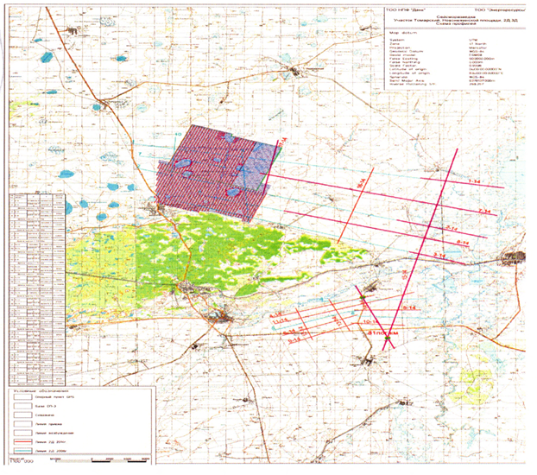
Figure 3.1 – Seismic surveys in the Novonezhinskaya site: 2D (seismic lines) and 3D (about the centre of the topographic map)
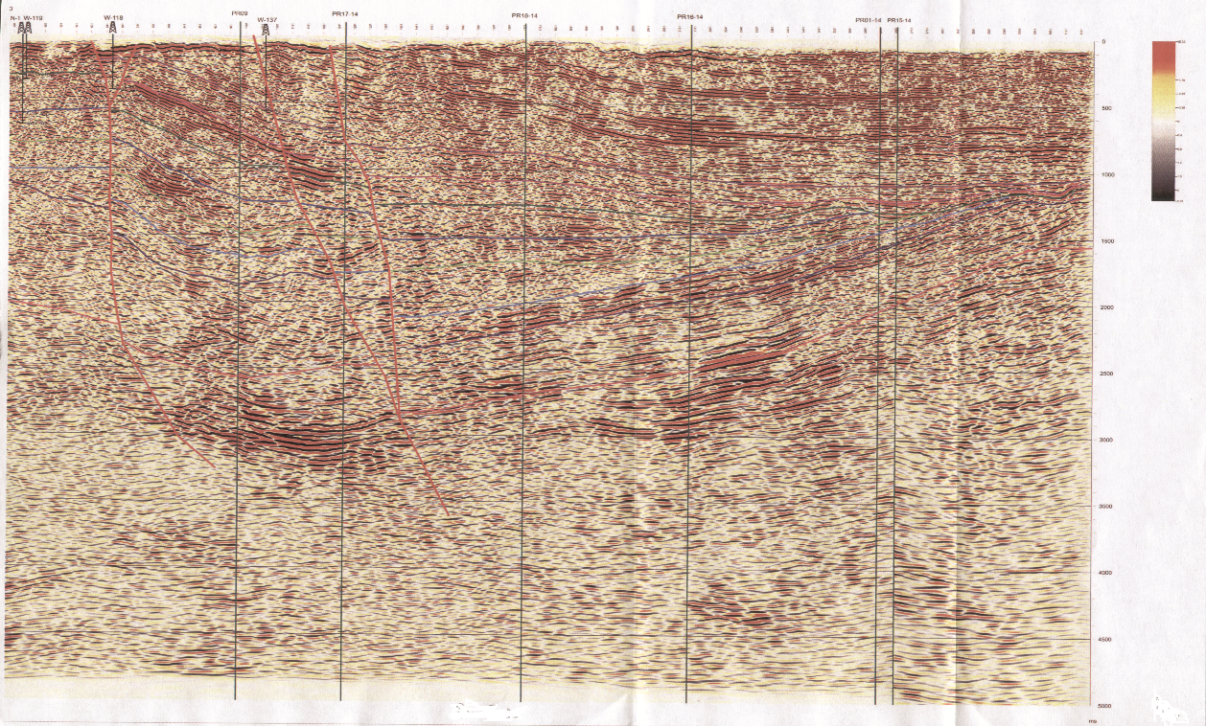
Figure 3.2 – The North-Torgai Trough
The conditional seismic section along the PR 01-01-14 profile
(source: PGDServices 2015)

The reflective horizon C1s_top is stratigraphically confined to the bottom of the volcanic sedimentary rocks (trap rocks) of the Triassic (or the roof of the Serpukhovian layer of Carboniferous deposits) and correlated everywhere. In terms of its dynamic parameters, this reflective horizon is quite stable. The correlation of this reflective horizon over the area under consideration was not particularly difficult due to the fact that it is relatively easy to recognise visually along the boundary of the angular non-conformity of the cophased axes of overlying volcanogenic (trap) formations of the Triassic and Middle Carboniferous with the roofing part of the Serpukhovian rocks of the Lower Carboniferous. The visible frequency of the elastic oscillations of this reflective horizon varies between 30-35 Hz and in the wave field they are recorded at depths of 600-2500 m.
The reflective horizon C1v_top is stratigraphically confined to the roof of Visean deposits of Carboniferous (the bottom of the Serpukhovian layer). This reflective horizon in the western part of the study area is provided with drilling materials for wells 2-P and N-1 and is monitored everywhere in the study area.
The reflective horizon C1t_top is stratigraphically characterised by the roofing of sediments on the Tournai Carboniferous tier (the bottom). Dynamically, it is weakly expressed by a single, sometimes 2-phase elastic oscillation with a relatively low visible frequency in relation to the reflecting horizon described above of 25-30 Hz.
The reflective horizon D3_top is timed to the roof of sediments of the Upper Devonian (the bottom of the Tournai coal formations or the roof of the Famennian tier). In the wave field it is matched by a seismic boundary in the form of one (sometimes two) phase oscillation of average (sometimes weak) intensity with a visible frequency of elastic oscillations within 25-30 Hz. Within the study area, this reflective horizon is fixed at depths of 1650-4150 m.
The reflective horizon D3_bot corresponds to the anticipated bottom of the Upper Devonian Famennian tier sediments. It correlates most confidently in the area of the Tomar site. In the eastern part of this section, near the Aschiboi Paleozoic protrusion, the D3_bot reflective horizon controlled sediments pinch out into overlying Lower Carboniferous Visean formations. Depths of the Upper Devonian Famennian bottom rocks range from 2,400-5,000 m.
D2-3 is a conditional reflective horizon in the upper undivided Middle-Upper Devonian (Frasnian tier) thickness. The wave field is represented as a 1-2-phase reflected wave packet with a visible frequency of 20-25 Hz. In the area, this reflective horizon with varying intensity and traceability is recorded almost everywhere. Sediment occurrence are within 1800-2500 m of the Ubagan site and 40000-5000 m in the eastern part of the Tomar site.
The reflective horizon R shows presumably the roof (surface) of Devonian carbonate bioherm buildings. It should be noted that a certain proportion of conditionality is accepted when correlating the carbonate body surface, and the horizon in the wave field corresponds to areas where zones of expected development of reef structures are lacking stable layered wave packs ("transparent" wave field typical of isotropic media) or have chaotic sporadic waves observed. The upper, lower and lateral boundaries of these reflections (carbonates) are the zones where layering of the investigated section is intended (quite stable reflections observed in the wave field). In addition, horizontal (sometimes, subhorizontal) substrates (the base) are often present at foots of reef bodies, limiting bottoms of reef structures. In our case, the conditional reflective horizon Pz serves as the substrate.
The reflective horizon Pz corresponds to the erosion surface of the Lower Paleozoic formations, the foundation, and is traced everywhere in a wide range of depths from 3,000-3,300 m in the Ubagan area to 6,000-7,000 m in the Tomar area.
The 2D/3D seismic materials are mainly of good and satisfactory quality.
Based on the results of structural interpretation of seismic survey materials, the structure of the Devonian section is characterized by more or less dynamically traceable reflecting horizons D₃top (D₃bot), R and PZ.
The D3top reflective horizon in the western part of the Borovsk zone shows small (0.3-0.9 x 0.5-15 km) anticlines separated by synclinal kinks.
The most important information on this horizon is obtained in the central zone of the North-Torgai basin. The Shakhmardan, Shokai and Sagadat structures stand out in the zone.
The Shahmardan structure is an anticline, limited from the north, east and west by submeridional faulting. Dimensions of the Shakhmardan anticline for this (D3_top) reflective horizon along -3050 m level line are 4.0 х 2.4 km with elevation amplitude of about 250 m, and 5.0 х 2.5 km along -3800 m level line (D3_bot) with elevation amplitude of more than 150 m.
The Shokai structure is limited from west by the Amankaragai deep fault of NE direction and is stretched along it. Its dimensions are 3.0 х 05 km along -2500 m level line (D3_top) with elevation amplitude of 100 м, and 2.0 х 0.5 km along -3100 m level line (D₃ bot) with elevation amplitude of 50 m.
The Sagadat structure is represented by an anticline complicating the structural “nose”, stretched near-meridianally. Its dimensions are along -2600 m (D₃_top) are about 1.5 х 1.0 km with elevation amplitude exceeding 50 m.
On the east side of the North-Torgai basin at the Ubagan site, judging by the D3top reflective horizon, this Famennian part of the Devonian period is fuzzy.
The geological structure of the Frasnian stage is characterised by the reflective horizon D₂₋₃.
Along this horizon in the central part of the basin, notable are the same local structures asthat of the D₃top, namely Shakhmardan, Shokai and Sagadat local anticlines.
The Shakhmardan structure is limited from east, west and north by meridianal and sub-meridianal faulting. Its dimensions are 4.0 х 2.5 km (-4500 m level line) with elevation amplitude more than 100 m.
The Shokai structure is represented by a small (0.5х0.3 km) anticline, limited from northwest by the Amankaragai deep faulting of northeast direction.
The Sagadat structure is represented by the brachyanticline stretched to northeast and complicated by flat structural terrace. Its dimensions are 3.2 х 0.8 km along -4200 m level line with elevation amplitude more than 30 m.
In the east at the Ubagan part, there are structures of Ibraikhan, Ubagan and Kalkul along the D2_3 reflecting horizon.
The Ibraikhan structure is presented as a narrow anticline stretched in a latitudinal direction. Its size is about 2.0 x 0.8 km along -2175 m level line with elevation amplitude of about 50 m.
The structure of Ubagan is represented as an anticline stretched in the submeridional direction. Its presupposed dimensions (no seismic materials are available for the southern part of the Ubagan part) along -1775 m level line are 5.0 x 3.5 km with elevation amplitude of more than 100 m.
The Kalkul anticline bend along the D2_3 reflecting the horizon has not been studied due to lack of seismic data. At this stage, only the PR14-14 profile is identified.
The conditional reflective horizon R is stratigraphically confined to the lower half of the Mid-Upper Devonian sedimentary formations and stands out visually by certain characteristic patterns of wave packets inherent to bioherm (reef) structures (Figure 3.5).
From this reflective horizon, 2 presumed reef bodies, conditionally named Ibraikhan and Kalkul, are identified in the Ubagan area.
The assumed Ibraikhan reef along the R reflective horizon is represented as brachianticline, stretched in a sublatitudinal direction with the complexly cut shape having steep northern and flat southeast sides. The brachianticline dimensions are about 4.3 х 2.0 km along -2,800 m level line, with elevation (reef) of about 250 m and an area of 7.6 km². The total height of the reef structure from the base (the Pz reflecting horizon) to the apical part is about 800-850 m and the reef structure base area can be about 9.6 km².
The Ubagan brachianticline also stands out along the reflective R horizon. It is stretched in a latitudinal direction and its dimensions are about 3.5 x 2.2 km along -2700 m with elevation amplitude of more than 100 m.
Given the high oil-gas potential of the bioherm structures, it is recommended that in the archh of the Ibraikhan reef an exploratory well R1 4,500 m deep should be put to cover the entire reef and open the erosion surface of the Lower Paleozoic rocks controlled by the Pz reflecting horizon.
The reflective horizon Pz shows the geological structure of the erosion surface of the Lower Paleozoic formations.
Along the reflective horizons of C1t, C1v and C1s, the structural plan of the study area is kept undergoing minor changes. As can be seen from the conditional sections along the profiles PR-01-01-14, PR-08-08-14, attached to this report, we cannot talk about strong folding of Devonian and Carboniferous deposits in the North Torgai basin. They are the subject of a targeted study to find oil and gas accumulations with significant reserves.
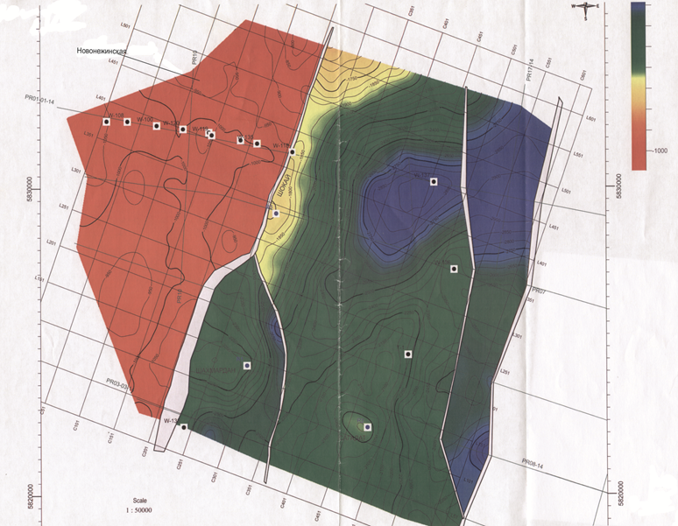
Figure 3.3 – The Novonezhinskaya site. The structural map along the roof of Tournai sediments with identified local structures (source: BGP 2018)

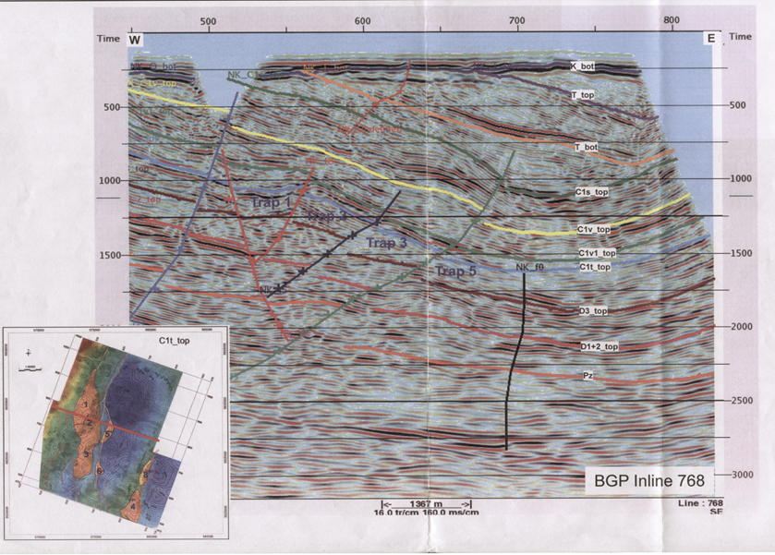
Figure 3.4 – The Novonezhinskaya site. The conditional seismic section as per Inline 768
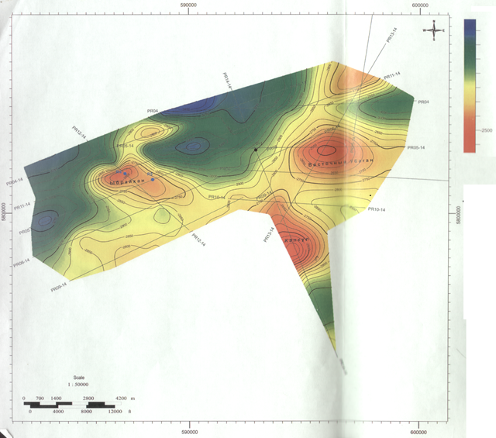 |  | Reflective horizons R level lines  Drilled wells  Recommended wells  Seismic profiles
Figure 3.5 – The North-Torgai Trough. The structural map along the reflecting horizon R (along the roof of Paleozoic bioherm formations)
(source: PGD Services 2015)

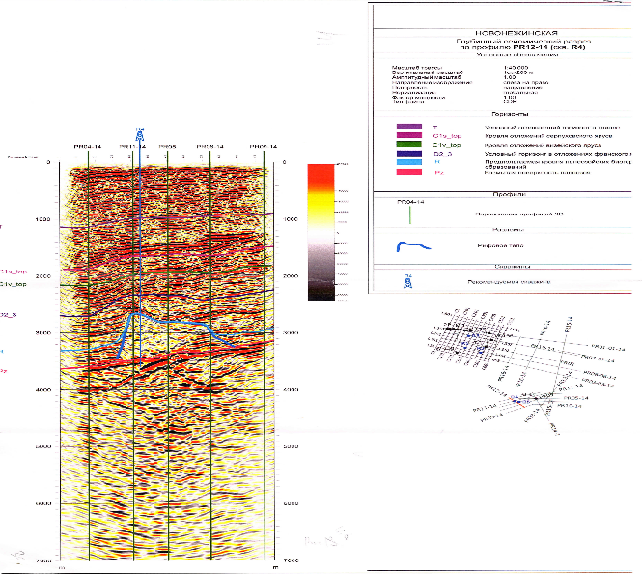 | 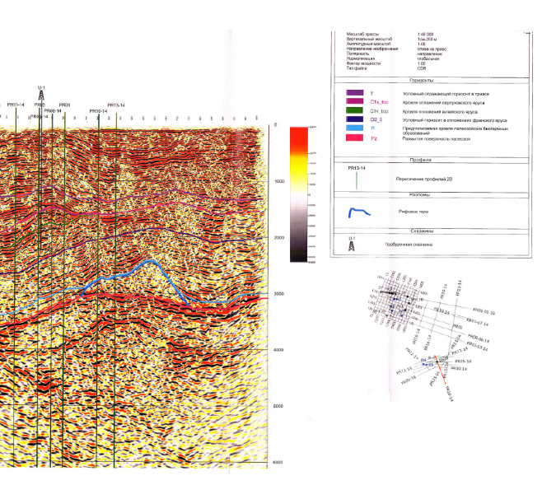
Figure 3.6 – The North-Torgai Trough. The Ibraikhan reef. Conditional seismic section along the PR-12-14 profile. The recommended well R-4 (source: PGD Services 2015) | Figure 3.7 – The North-Torgai Trough. The Kalkul reef. Conditional seismic section along the PR-14-14 profile. R-4 (source: PGD Services 2015)

4 The geodynamic model and geodynamic evolution of The Torgai basin

The North Torgai is famous for its magnetite deposits such as Kachar, Sokolov-Sarbai, the Lisakovsk group's oolithic iron ore deposits, the Shaimerden polymetallic deposit and the large bauxite bearing Denisov-Fyodorov and Valeryanov zones. All these deposits are located in the joint zone of the Ural fold system with the North-Torgai trough, all of them were formed in the joint zone of the western edge of the Kazakhstan plate with the eastern branch of the Ural Paleozoic Ocean and the East Ural microplate.
To the east of these famous ore deposits, most of the territory is covered by the Meso-Cenozoic cover, which in literature is marked as the North-Torgai trough proper. To the east, it borders the Kokshetau and Ulytau uplands, and in the north it passes into the West Siberian syneclise rich in gas and oil reserves 1 [1], [4], [7], [9] и [18].
Historically, since the times of N.G. Kassin and R.A. Borukayev, the concept of "Geology of Eastern Kazakhstan" has been developed in geological literature, meaning the entire area of Kazakhstan starting from the Kokshetau-Ulytau zone in the west, the entire area of Paleozoic outcrops and older sediments, as it was the outcrops that were studied for solid minerals. Numerous works of the Kazakhstan's geology coryphaei R.A. Borukayev, I.F. Nikitin, V.N. Lyubetsky, V.Ya. Koshkin, A.V. Avdeev and others are dedicated to tectonics and paleogeodynamic reconstructions of "Eastern Kazakhstan".
Another group of geologists headed by L.A. Yanshin, A.A. Abdullin and others were involved in the Ural-Mugojar zone [12], [14], [17] и [20].
Among the first works showing the possible relation of the largest structures at the Paleozoic level on both sides of the North-Torgai Trough is the "Tectonic Map of the Kazakh SSR and the adjacent territories of the Union republics", edited by B.F.Bespalov, G.V.Garkovets, V.K.Eremin and others (1971), and the "Tectonic map of Paleozoic folds in Kazakhstan and adjacent territories", edited by A.A.Abdullin and G.V.Zaitsev (1976).
The capital collegial work "Deep Structure and Mineral Resources of Kazakhstan" (Alma-Ata, 2002) notes that "The Torgai-Syrdarya Trough divides the structures of Eastern and Western Kazakhstan. The structure of the trough foundation is relatively poorly understood, so the Kazakhstan geodynamic reconstruction charts show that this region remains largely a white spot (p.188).
On maps of oil and gas-bearing regions of the USSR (A.N.Shardanov et al. 1983, G.H.Dikenshtein et al. 1984), the entire territory of North Torgai was classified as land with unclear prospects or with no prospects. In “The Deep Structure and Mineral Resources of Kazakhstan, Oil and Gas", Volume III, edited by S.Zh.Daukeev, B.S.Uzhkenov, A.A.Abdulin et al. (2002), and in the work titled "Integrated study of sedimentary basins of the Republic of Kazakhstan: the North-Torgai basin", edited by O.A.Aksholakov and A.B.Bigaraev (2011), the Central-Torgai perspective oil and gas region was identified. Unfortunately, there is no scientific justification for the possible oil and gas bearing capacity of Paleozoic sediments, except for a brief description of the Paleozoic in the Kostanay reference profile and individual shallow wells.
The oil and gas geologic zoning in the above works was based on the theory of geosynclines and the main criteria were the stratigraphic range of sedimentary deposits and structural and morphological features of the cover structure. The main factors, such as the formation (genesis) of the basin itself and its geodynamic evolutionary conditions, which predetermined the sedimentation features, possible changes in the thermal regime and the impact of tectonic processes occurring in the Ural folded system, especially in the Valerianov volcanic zone, were not taken into account.
These shortcomings are largely taken into account and eliminated when approaching to the study of the basin from the perspective of the plate tectonics theory.

4.1 The geodynamic model of the area
Analysis of the association of magmatic and sedimentary rocks and new seismic materials in the area between the Urals fold system and the Kokshetau ancient massif, some of which are briefly described in the previous chapters, allows identifying a number of geodynamic zones, which satisfactorily explain the location regularities for both solid mineral deposits with different mineralisation and abundant oil occurrences, and provides a scientific basis for assessing the prospects of oil and gas bearing capacity of the North-Torgai basin. Summing up the numerous publications on the tectonics of the territory under consideration, it is worth highlighting in the region the East-Ural zone, limited from the east by the Zhetygara regional fault; the Denisov contortion zone up to the Livanov fault; the Valeryanov zone, comprising the northern part of a regional volcanic archh and gradually passing into the Kostanay anticline zone, limited from the east by the Central-Torgai fault. This anticline zone forms the western side of the North-Torgai Basin, a major object for oil and gas exploration, bounded in the east by the ancient rises of the Kokshetau and Ulytau [1], [2], [7].
The East-Urals zone is represented by an allochton plate limited in the east by the Zhetygara regional fault, well mappable by outcrops of ancient heavily metamorphosed and strongly dislocated rocks of the Rifean, Vendian and the Lower Paleozoic. This fault zone can be traced several hundred kilometres and consists of several sections (?) sandwiched behind each other. The allochton plate, which now forms the East-Ural meganticlinorium, advanced on it in the Late Paleozoic during the closure phase of the eastern branch of the Ural Paleocean due to the convergence and collision of the Kazakhstan continent with the East-Ural microcontinent.
The Valerianov zone between the Denisov and Apanov regional faults, according to the classic geodynamic zoning principle, can be considered as part of a regional volcanic arch in the west of the Kazakhstan lithospheric paleoplate formed as a result of subduction of the ocean floor of the eastern branch of the Ural Paleocean under the Kazakhstan plate.
The Valerianovsky zone is part of the regional volcanic belt known in literature as the Valerianov-Bel’tau-Kurami, with a total length of over 2,000 km, including over 1,100 km of the Kazakhstan territory. Formation of the belt is connected to the island-arch process in the western pericraton frame of the Kazakhstan lithospheric plate. The main iron ore region of Torgai and the West Torgai bauxite-bearing district are associated with the Valerianov zone. The mellogenic status of the Valerianov zone is determined by the volcanic-sedimentary Visean suite and the Serpukhovian tier, represented by the terrigenous-carbonate-volcanogenic layer, which is divided into three suites: the Sarbai substantially basalt-andesite (C_{1,v}), the Sokolov carbonate-volcanogenic (C_{1,v2-3}) and the Korzhynkul andesite (C_{1,v-s}).
By analogy with the Kurami zone in Uzbekistan, non-ferrous metals are predicted in the Valerianov zone: copper, lead, zinc, and gold. The Schaimerden zinc deposit here is the first sign for polymetallic mineralisation.
The main role in the structure of the Valerianov zone is played by sedimentary and volcanogenic formations of the Lower Carbon, crumpled into brachyanticlinal folds of submeridional stretch complicated by faulting. They are represented by sandstones, argillites and limestones and lie without any visible disconformity on the Famennian sediments.
The section studied in the region begins with red-coloured continental Devonian sediments, above which lies the carbonate thickness of the Famennian and the Lower Tournai, which is overlapped by the carbonate-terrigenous thickness of the Upper Tournai - Lower Visean. The section is completed by a powerful volcanic sedimentary thickness of the Middle Visean and the Namurian, consisting of limestone and reddish-grey sandstones with tuff material and layers of basalt, spilite and andesite-basalt, which is the main ore-bearing suite, to which dated are the largest magnetite ore deposits. The Valerianov suite at the Sarbai deposit field contains bituminous limestone.
The results of the study of samples from numerous structural wells and outcrops suggest that the content of volcanic strata in the section decreases significantly eastward from the Urals, and the Kostanay (Borovsk) anticline section is represented by terrigenous carbonate rocks with inclusions and volcanogenic interlayers.
The Valerianov zone, as a whole, flaky overridden to the east, is limited by the Apanov regional fault, beyond which the influence of tangential stresses, naturally directed from the Urals to the east, is sharply subsided.
In terms of its deep structure, the Valerianov structure was formed during the closure of the Irgyz zone of the Ural Paleocean, and as a result of the compression and mass overthrust of the Middle Paleozoic marginal marine deposits onto the Kazakhstan continent.
The Borovsksk (Kostanay) subzone is a relatively elevated, weakly worked-out site of the Kazakhstan paleocontinent involved in the Devonian and Early Carboniferous into moderate deflection due to formation of a passive continental margin facing the Irgyz branch of the Ural Ocean.
New data obtained indicate that the Kostanai zone is a transitional one between the linear structures of the Trans-Urals and the mosaic-site structures of the Kazakhstan massif.
The North-Torgai basin during the Devonian and early Carboniferous was a passive continental margin of the Kazakhstani continent facing the Ural Ocean. Beginning with the Late Visean, i.e. from the collision of the Kazakhstan plate with the East-Ural microplate and the East-European plate, the Valerian volcanic belt was formed behind the main island archs of the Urals, formed by andesites, andesite-basalts, dacites and the diorites and granodiorites that break through them.
During the Middle-Late Carboniferous and Permian period, there was a significant reduction in the area of the sea basin, formation of Middle-Paleozoic back-arch deflections and accumulation within of terrigenous sediments with conglomerates consisting of limestone gravels and Devonian and Lower Carboniferous effusions, which at that time were exposed in collision orogens in the East-Ural anticlinoria, Denisov and Valerianov zones of the eastern Urals.
The geophysical survey materials indicate to a sharp difference between the North-Torgai trough and the Valeryanov zone. Within the Valerianov zone, the gravitational and magnetic fields are of high intensity and linearly stretched in submeridian direction. The North-Torgai deflection is characterized by mosaics, a weak disjointed low-intensity form of both gravitational and magnetic fields.
The structure of the North-Torgai basin is well studied by seismic surveying. In regional latitudinal profiles, behaviour of the eight nearly parallel reflective horizons indicate that Devonian and Carboniferous deposits over 4,000 m thick are not dislocated.

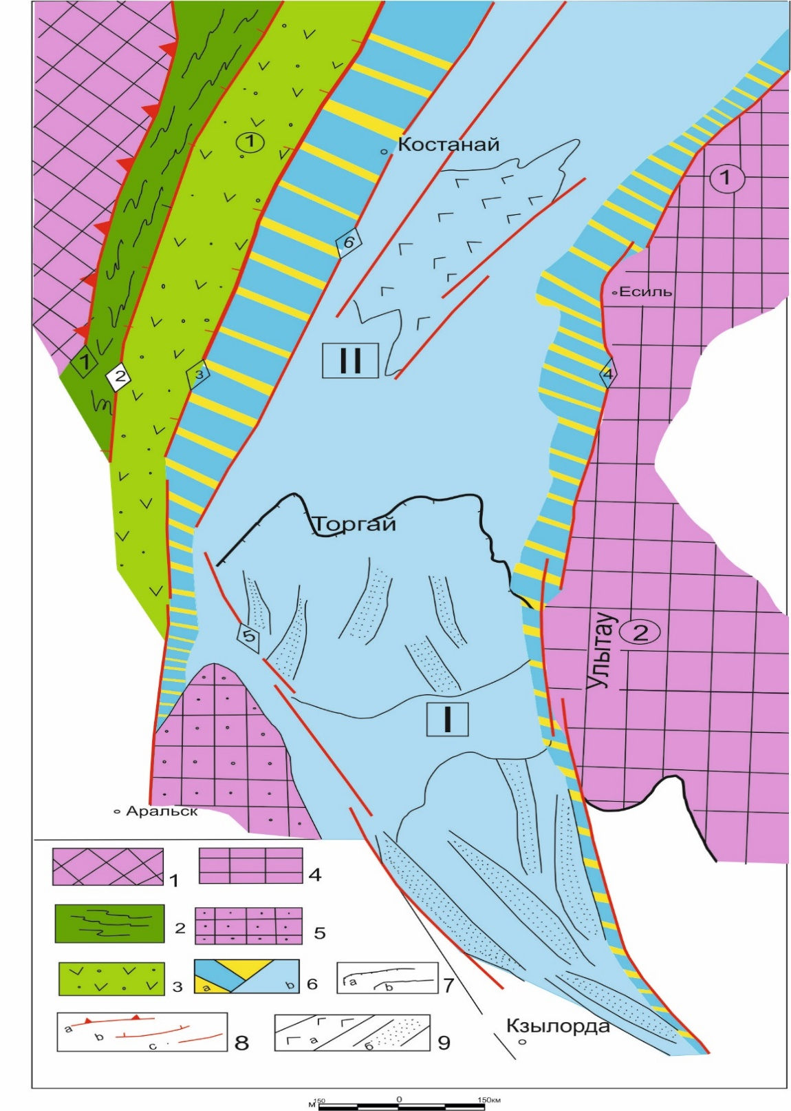
1-East-Ural anti-clinorium; 2-Denisov contortion zone; 3-Valerjanov volcanic arch; 4 ancient pre-Cambrian massifs: 1-Kokshetau and 2-Ulytau; 5-Zhusaly arch; 6- Torgai basin: a-central part and b-branch zones; 7-branch boundaries of regional structures: a) between South Torgai (I) and b) North Torgai (II) troughs and c) inside South Torgai trough; 8- tectonic disturbances: a-Zhetygara (1) overthrust, b- regional reverse-overthrust faults: 2-Denisov, 3-apanov, Central-Torgai and downthrow faults: 4-Amangeldy and 5-Karatau; 9-Kushmurun (a) graben and graben-syncline (b) in the South-Torgai trough.
Figure 4.1 – The tectonic map of the Torgai basin and adjacent territories
(after G.Zh.Zholtaev)

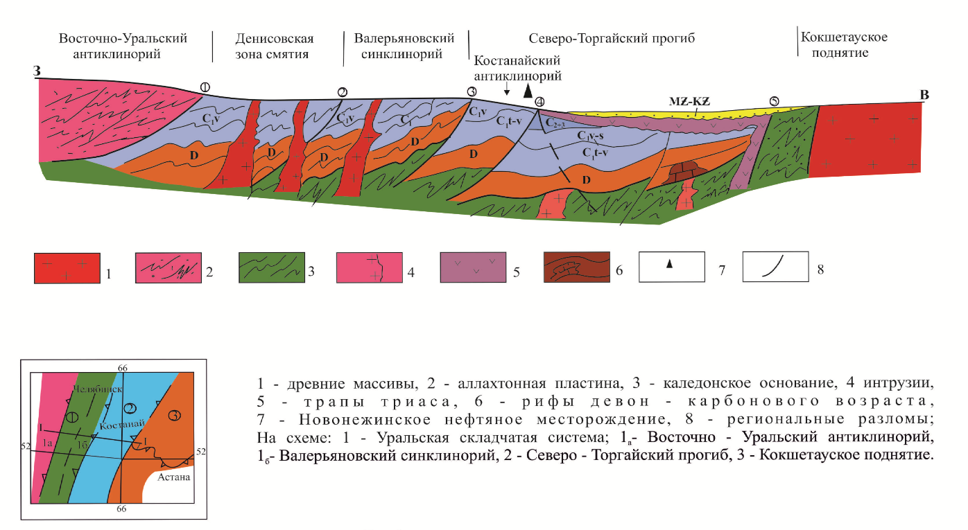
Figure 4.2 – The regional profile via the North-Torgai trough

From the position of the geosyncline concept, the area under consideration is located within the Ural-Mongolian Hercynide belt, where strongly dislocated Devonian and Carboniferous deposits should be expected, as in the Valerianov zone. The new information confirms our correct approach to study of the North-Torgai basin structure from the standpoint of plate tectonics theory [7].
On the western slope of the Aschiboi Rise in the central part of the basin, the Devon-Tournai reefs of 600-750 m high have been identified as the Ibraikhan reef. As noted above, in the area adjacent to the Kostanai anticline, several local prospective uplifts have been mapped out as Shokai, Shahmardan and Sagadat, which may serve as structural traps for oil and gas in Devonian and Lower Carboniferous sediments.

4.2 The geodynamic evolution of the North-Torgai basin
In our previous publications [1], [2] and [7], we repeatedly discussed the existing North Torgai tectonic and structural-formation maps drawn by various authors based on the geosyncline concept. Specific geological and geophysical materials contradicting this concept have been shown with existing tectonic charts. The results of a comprehensive analysis of existing geological and geophysical materials and reconstruction of geodynamic evolution proved that the most suitable theoretical basis for understanding the history of formation and subsequent geodynamic development of the Torgai basin is the plate tectonics [1], [2]. According to available at present materials, in the history of formation and development of the Torgai basin, confidently seen are: stages of passive continental margin of the Ural Paleocean from the side of the Kazakhstan continent, the development stage under the back-arch basin mode towards the end of Carbon, the stage of active riftogenesis in the Late Permian and Early Triassic, and the stage of platform development.
The North-Torgai basin during the Devon and Early Carboniferous was a passive continental margin of the Kazakhstan continent facing the Ural Ocean (the Planchette of Geodynamic Evolution of the Torgai Basin). Beginning with the Late Visean, i.e. from the collision of the Kazakhstan plate with the East-Ural microplate and the East-European plate, the Valerianov volcanic belt was formed behind the main island archs of the Urals, composed of andesites, andesite basalts, dacites and the diorites and granodiorites that break through them [6], [8].
During the Middle-Late Carboniferous and Permian periods, there was significant reduction in the area of the sea basin, the formation of Middle Paleozoic arched deflections and accumulation of terrigenous sediments within terrigenous sediments with conglomerates consisting of limestone gravels and Devonian and Lower Carboniferous effusions, which at that time were exposed in collision orogens in the East-Urals anticlinoria, Denisov and Valerianov zones of the Eastern Urals.
Devonian deposits are exposed on the western and eastern sides and uncovered in boreholes in central parts of the Torgai trough. They are represented by a sedimentary effusive thickness consisting of red coloured conglomerates and sandstones interlayered with acidic effusion covers. Clay shale, limestone and tuffites are found in some places. Dark grey bituminous karsted limestones of the Givetian age up to 1,300 m thick have been found. The Upper Devonian deposits formed under geodynamic conditions have been identified everywhere as part of the Frasnian and Famennian tiers. The Frasnian tier is represented by interlaid carbonate and terrigenous rocks with a total thickness of 500 m. Famennian formations in the lower part of the section are composed of red coloured, brown conglomerates, coarse-grained sandstone and argillites, sometimes with effusive interlayers. The upper part of the section is dominated by grey, organogenic, cavernous-cracked limestone, where oil occurrences were observed and oil inflows were obtained at the Novonezhinskaya and Shcherbakovskaya sites. In general, the total thickness of Devonian deposits is increasing sharply towards the Urals, i.e. the former paleocean, and the content of effusive rocks in the section is increasing in the same direction.
Lower Carboniferous deposits are divided in three thicknesses. Below is the Lower Tournai, represented by not very common terrigenous carbonate sediments. The average thickness of the Upper Tournai - Lower Visean age in different structural-facial zones has different composition and varies from west to east, from carbonate-terrigenous to terrigenous-carbonate and further to carbonate. There are numerous inclusions of liquid and thickened oil in cracks and caverns of limestone. The thickness of an average layer reaches 1,000-1,200 m in the west and decreases to 300-500 m in the east. The Serpukhovian sediments are represented by grey cavernous bituminous limestones.
Younger terrigenous formations, conditionally referred to the Upper Paleozoic, formed under the conditions of the back-arch basin are spread only in the west, mainly in the Kostanai zone; they are represented by polymict conglomerates, sandstones and siltstones; occasionally there are horizons of effusions.
Red-coloured volcanogenic-clastic rocks (conglomerates, gravelites and sandstones with a total thickness of up to 400-500 m) can be traced in narrow intermittent strips along the Apanov and Tobol faults. Among them are limestone fragments with Lower and Middle Visean fauna and flora found on outcrops, but no fragments of intrusions of the Sokolov-Sarbai complex have been found, which served as the basis for the conclusion by A.E. Bekmukhambetov [16] that the formation of rocks of red colour thickness occurred prior to this complex intrusion.
The main stage of tectonic dislocations caused by compressive tectonic movements was timed to the end of the Paleozoic, resulting in an overthrow of the Denisov zone of the East-Ural anticlinorium onto the Valeryanov zone, of the Valeryanov zone onto the Kostanay zone and the formation of systems of anticlinical folds tilted to the east, as well as numerous thrust-faults. The geodynamic evolution of the Torgai trough, which changed over time, created conditions in the Devonian and Early Carboniferous for sedimentation of the passive margin and then of the back-arch basin in the Late Paleozoic.
In the central part of the North-Torgai trough, the washed surface of the Paleozoic contains non-conforming Lower Triassic sediments of considerable thickness in grabens.
Judging by multiple interchanges of effusives with sedimentary rocks, the formation of graben-synclines took place in alternating periods of volcanic activity with periods of sedimentation. Thickness of the horizons of effusive rocks varies from 5-10 to 100-160 m, while that of sedimentary rocks represented by sandstones, conglomerates and clays, often enriched with sapropelic material, vary from several metres to 60-100 m. This sedimentary volcanogenic thickness is known as the Turin series. At its base, usually lie layers of coarse conglomerates. The total thickness of the series is variable and in many grabens exceeds 1,500.
The central part of the North-Torgai trough is covered by low-thickness terrigenous deposits of the Meso-Cenozoic.
The simultaneous emergence (the end of the Permian and the beginning of the Triassic) of grabens and their confinement to regional faults, which conducted the basalt magma, the similar lithological composition of the filling sediments up to 3,000-4,000 m thick, a common meridional orientation for 600 km, parallel to the Urals, with the graben development band of 50-150 km wide allows combining them into a single East Urals paleorift system. The riftogenesis within the Torgai trough was polycyclic in nature. It occurred in the Early Carboniferous, Triassic and Jurassic periods. The rejuvenation of riftogenic structures can be clearly seen to the south-east of the Zharyk graben, formed in the Carboniferous, and of Kushmurun in the late Permian and Early-Middle Triassic to grabens of the Ishim group (Late Triassic) and South Torgai (Jurassic), inseparably linked with the change in the activation of regional deep faults over time. The Triassic riftogenesis cycle proved to be a slightly shorter in development. The Kushmurun graben, for example, undergone through the gobbing up phase and, due to the changed tectonic environment, namely the sharp rise, it did not experience the phase of subsidence and formation of a supra-rift depression.
The Jurassic cycle covered a vast territory, almost the entire central and southern part of the Torgai trough, and significant Jurassic grabens were formed within the Early Carboniferous and Triassic grabens, i.e. there was a second generation of grabens in the same area.
The Jurassic grabens and graben-synclines are relatively well studied in South Torgai thanks to discovery of oil and gas deposits with significant reserves, the Kumkol and Aryskum deposits. In the northern half of the Torgai trough, the grabens have a northeastern submeridional (Uralian) orientation, and in the southern part, mainly the north-western one (Ulutau).

5. Prediction of oil-gas content of The Torgai basin paleozoic deposits

5.1 General information on oil and gas showings
In the north of the Torgai trough, which separates the Urals fold system from the ancient Kokshetau massif, the signs of oil are long known, starting with the finds of bitumen by geologists V.G. Chernyshov, A.A. Ershov and N.P. Tuaev in the 1930s [3], [4], [5]. As noted above, work to assess the prospects for oil and gas bearing capacity was undertaken in the 1950s by VNIGRI geologists. In 1958-1973, the North Kazakhstan Territorial Geological Department carried out oil exploration work in the Novonezhinskaya, Shcherbakovskaya, Lesnaya and Koskol sites, drilling numerous prospecting and structural wells down to 1500 m (N.P. Kirda et al., 1973). Many wells exhibited drip-liquid oil and bitumen in terrigenous and carbonate sediments of the Lower Carboniferous age.
In 1957-1960, special attention is paid to studying the oil and gas saturation of sections. For the first time abundant oil showings in cracks and caverns and in limestones of Namurian age were obtained from a well no.100 in the interval of 417-616 m, which was drilled for exploring coal deposits. The appearance of liquid oil was the reason for drilling structural wells in the Novonezhinskaya site, where intensive oil showings were obtained in wells nos.108, 113 and 120. The well no.119 received an oil inflow when the interval of 490-519 m was tested. In the course of the well deepening, oil continued to flow at a rate of 25-30 l/day, and the inflow test at a depth of 555.1 m (29 October - 06 November 1959) gave 220 litres of oil. Upon reaching the depth of 625 m, the test was continued during 11 December 1959 - 23 February 1960 with hydrochloric acid treatment in the near-bottomhole zone. These activities had no tangible success.
The produced oil was analysed by the VNIGRI laboratory and classified by its hydrocarbon composition to naphthenic-methane type oil with significant content of aromatic hydrocarbons: the oil is resinous and highly paraffinous, the sulphur content is insignificant; the yield of light fraction at 300°C was 14%.
The drilling-out operation of the sublatitudinal Kostanai profile, which started in 1964 and was completed in 1973, was of great importance. Three wells of the reference profile in the Shcherbakovskaya site saw intensive oil showings and produced an influx of combustible gas, which led to drilling works in the Shcherbakovskaya and Lesnaya sites. In the Shcherbakovskaya site, well no. 3 received a non-industrial gas inflow along with abundant oil showings. The oil was highly resinous and highly paraffinous. Gas manifestations in the form of ejection and flush fluid degassing were also observed in wells 1-P, 2щ, 7щ 22, 15, and other.
At the Kushmurun gravel-syncline, in the basalt trap development field, the well 138 at depths of 779.2-862.1 m revealed liquid oil in andesite-basal porphyrites. The oil was analysed in the SNIIGGIMS laboratory, where it was characterized as having high oils and low asphaltene contents.
A new impetus for studying the oil and gas potential of the Torgai basin was provided upon drilling the well N-1 in the Novonezhinskaya Site, near the well 119, in September and November 2011 at a depth of 1,500 m. According to the logging data, 8 formations with varying degrees of oil saturation of up to 70.1% were identified in the well section (418.4-1302.5 m). Perforation was performed in the most oil-saturated formations as followes: 1297-1302 m, 639.5-640.5 m, 622.7-625.2 m, 559-562 m and 548-557 m. On 13 Marchh 2013, the interval of 549-640.5 m produced the oil inflow of 2.5 m³.
In 1973-1975, the deepest parametric well 2-P of 2,961m was drilled on the Novonezhinskaya site which opened up the Lower-Middle Devonian rocks; gas displays (bubbles in clay mud) were observed in the course of drilling. The gas samples contained 70% methane, 24% pentane and 27.8% hexane, which indicates to the presence of hydrocarbon accumulations in the subsoil. The structural and gypsometric positions of the well in relation to the H-1 well remained unclear.
The oil analysis results showed decrease in paraffin and resin content as the sampling depth increased and the well approached the deep faults. With deepening, there is also decrease in specific gravity and viscosity of oil and increase in the oil content. It is also characteristic that all oil and gas manifestations are confined to fractures and caverns in rocks of wide stratigraphic range starting from the Lower Carbon, including Triassic basalts.
A certain pattern can be seen from a regional perspective. All oil and gas manifestations have been recorded in the area eastward of the Apanov fault, which limits the Valerianov volcanic arch, being the western boundary of the Torgai basin. Despite the significant number of wells drilled to the west of the Apanov fault, no oil shows have been detected.
The central part of the Torgai basin is known to be significantly submerged in the Mesocenozoic, which was accompanied by formation of new faults and renewal of older faults, which in turn could serve as channels for oil migration from the deep oil and gas producing strata of the Devonian and Lower Carboniferous. The nature of solid bitumen and viscous oil and gas in sections of the same age strata suggests several phases, the stages, of oil migration from deep horizons as tectonic movements resume therein.
Researchher S.S. Chudin noted that objects in Goodle Earth space images similar to paleomud volcanoes are dated to two regional faults, Central-Torgai and Sevastopol. In the opinion of this researchher, the formation of clearly visible ring structures like a mud volcano took place in areas of activated tectonic disturbances which channelled from the depths the liquid mud mixture of gas-, water- and, possibly, oil-saturated, of sandy-clay composition, forming the diapir hillocks. As pressure grew in cracks sealed by the hillocks, new portions of the mud mixture rose and changed, forming diapir-shaped structures that can be clearly seen on space images. Not far from paleo-mud volcanoes, in one mapping well 160, in the interval of 300-360 m, the drip-liquid oil was observed in the Lower Carboniferous limestones, in cracks and caverns under Triassic basalts.
Formation of such object can be appraised as a sign of oil and gas migration from deep horizons through cracks that periodically opened up in times of increased tectonic disturbances. The study of bituminological characteristics of rocks, the content of organic matter and organic carbon by researchhers N.P. Kirda (1973) and V.N. Adrianov (1974) led to identification of oil-producing strata in the Famennian and Tournai formations.

5.1.1 Stratigraphic levels of oil-gas showings and their characteristics
Manifestations of oil, gas and bitumen are found in many areas and in a fairly wide stratigraphic range. They are mainly associated with the carbonate-terrigenous strata of the Upper Paleozoic (D₃fm-C₁), but in some cases have been identified among effusive rocks of the Permian-Triassic and Rhaetian-Liasic (the Turin series).
In Devonian sediments, oil showings have been recorded in some wells (wells 30, 32, 1-P) of the Kostanai reference profile. In the well 30, encountered in the limestone interval of 741.8-748.5 m, presumably Givetian tier of the Middle Devonian, were solid bitumen, abundant and weak oil manifestations in cracks and caverns of Famennian limestones.
In the Lower Carboniferous sediments, signs of oil and gas are the most abundant. They were found in rocks of all tiers of the system. Signs of oil also differ by nature of their manifestation: from the gasoline smell in rock samples to oil inflows (the Novonezhinskaya site, wells 119 and N-1, free gas emissions (the Shcherbakovskaya site, well 3-щ).
When drilling wells in the Kostanai reference profile, signs were recorded in sediments of the Tournai, Visean and Serpukhovian tiers, in sections of over 33 wells. According to the section descriptions, these features are manifestations of oil (from weak to abundant), as well as inclusions of solid bitumen in caverns, cracks and sliding mirrors in the rock samples.
Signs of oil and gas in Paleozoic sediments were also observed along the Kostanai reference profile on the Shcherbakovskaya and Lesnaya sites. According to the VNIGRI, oil, recorded in the form of abundant manifestations and inclusions in the Lower Visean limestone cracks at Shcherbakovskaya Site (site 17-щ, interval 537-777 m), is heavy and resinous. Aromatic hydrocarbons predominate in the area (68%), including heavy hydrocarbons (56%). According to K.I.Satpaev Institute of Geological Sciences (1970), fuel gas obtained from the 3-щ well (interval 552.0-637.5 m, C₁) of the same site with a flow rate of 8-10 m³/day had the following chemical composition (%): N2+rare - 24.46; СН₄ – 74,3; С₂Н₆ – 0,67; С₃Н₈ – 0,35; С₄Н₁₀ – 0,14; С₅Н₁₂ – 0,008; Аr – 0.131; Не - 0.057 vol.
In the Lower Carboniferous limestone, oil signs have also been observed in a number of other wells, both to the north and south from the route of the Kostanai reference profile.
The most intense oil displays were obtained in the Upper Visean - Serpukhovian cracked-cavernous limestones and sandstones.
About 1.5 tons of oil were collected in the well 119. According to the VNIGRI, the oil is heavy, resinous and paraffinous. The sulphur content is insignificant. The yield of light fractions boiling out before 300°С is 14%. In terms of hydrocarbon composition, oil is classified as naphthenic-methane with significant amount of aromatic hydrocarbons. Naphthenic hydrocarbons account for 46.3% of the distillate part and 25.3% of the total oil volume, while methane hydrocarbons account for 33.3 and 18.2%, and aromatic hydrocarbons for 20.4 and 11.2%, respectively.

Table 5.1 – Characteristics of hydrocarbon composition of oils
Specific weight | Fraction composition, % GOST 2177-48 |  |  |  | Sulphur,% |  | Nitrogene,% | Asphaltene, % | Resin silicagel, % | Paraffin w/o destruction | Melted paraffin | Viscosity at 70⁰С
 | НК  0⁰С | below 2000⁰С | below 250⁰С | below 270⁰С | below 300⁰С
0,9141 | 180 | 0,8 | 3,2 | 5,5 | 14,0 | 0,45 | 0,21 | 3,2 | 10,1 | 5,3 | 50,5 | 34

In terms of hydrocarbon composition, the oil refers to naphthenic-methane type with significant amount of aromatic hydrocarbons.
The exploration well Novonezhinskaya 1 (N-1) was drilled to 1,500 m near the well 119. The logging data were used to identify terrigenous-carbonate rock formations with the highest oil saturation (41.2-70.1%) in the intervals: 1297-1302 m, 639.5-640.5 m, 622.7-625.2 m, 559.5-562.0 m and 548-557 m. Some of these were perforated (PC-114, PC-89, Dynawell and Schlumberge-340PJ charges). As a result, 2.5 m³ inflow of liquid oil was obtained.
The study of oil extracted by the chloroform of limestone (562.5-562.7m, C₁) from the Novonezhinskaya-1 site was conducted according to a plan developed under supervision of Academician A.E. Kontorovich at the SNIIGGIMS and refined in the Laboratory of Oil and Gas Geochemistry at the SB RAS INGG named after A.A. Trofimuk. The hydrocarbons researchh plan included determination of chloroform extracts yield from uncrushed rock, their group composition. Special attention was paid to the study of oil at the molecular level using gas-liquid chromatography and chromato-mass-spectrometry methods. The saturated fraction of oil extracted from limestone, was studied against the composition and distribution of hydrocarbons (biomarkers, normal alkanes, isoprenoids, sterans and terpanes). Study of the molecular composition of saturated and aromatic hydrocarbon fractions, as well as sulfur organic compounds, allows obtaining reliable indicators of sedimentation conditions of scattered organic matter, its genotype and degree of transformation, and to conduct genetic correlations of "organic rock matter→oil". As a result of their comparative analysis in combination with other geological and geochemical characteristics, it is possible to identify oil and gas generation systems and to detect hydrocarbon generation centres [Petrov, 1984; Petrov, Arefiev, 1990; Kontorovich et al. 1991; Kontorovich, 2004; Peters, Walters, Moldowan, 2005, oth.]. The chloroform extract yield was 0.13% per rock. The group composition of oil was dominated by hydrocarbons, 79.56% per rock (the ratio of saturated HC to aromatic HC = 2.27). Resins account for 18.23% per rock. The resin to asphalt ratio was 8.25. In terms of group composition, according to the V.A.Uspensky's classification with clarifications by Kontorovich A.E. and Stasova O.F., Kolganova M.M. [Siberian Platform, 1981], the studied extract related to oil. At the molecular level, a fraction of HC saturated bitumen has been studied. Identified there were alcans of the Сю-Сю composition, isoprenoids of C13-C25, cyclic CH-biomarkers of stera-new (C21-C22 and C27-C30) and terpane (C19-C35) series. For the studied oil (ratios: h-C27/h-Ci7=l,02, Pr/Ph=0,74, sterans C29/C27=3,76, heilantanes 2(Ci9+C2o)/XCi (i = 23, 24, 25, 26)=0,5, the content of heilantanes from the sum of terpanes (C19-Cz5)=8) indicate mixed organic matter with an admixture of terragene, accumulated in a increased salinity basin (gammazeran up to 3.5% of the sum of terpans).
The well 2-P Novonezhinskaya 2,951 m deep, was placed on a wing of the structure of the same name, not in its arch, where oil was previously received from the structural well. It opened the Lower Carboniferous and Upper Devonian, mainly, carbonate formations. Clay mud degassing was observed during its drilling. Gas samples were taken from the intervals contained: methane 70%, pentane 2.4% and hexane 27.6%.
The Koskol structure, located to the north of the Novonezhinskaya and more elevated relative to the latter, also recorded oil displays of semi-liquid oil and inclusions of solid bitumen in caverns and cracks of the Lower Carboniferous limestone.
In the Upper Paleozoic sediments, oil signs were recorded in the 20-K well at the Vorobyevsky town. Traces of liquid oil and soluble bitumen, mainly resinous and oily fractions, are present here in red-coloured sandstones, presumably of the Middle Carboniferous and Permian age.
In the Permian-Triassic and the Rhaetian-Liasic effusive formations of the North-Torgai basin, direct signs of oil and gas bearing capacity have been identified in a number of wells. In particular, bitumen content of 0.01-0.1% has been established in the red-coloured sandstone interlayers of the Turin series’ effusive thickness (wells 138, 9-K, 8-K and 20-K).
Oil from the well 138 is characterized by high oils content and low asphaltene content.

5.2 Prediction of oil-gas content and recommendations for prospecting and exploration work
A generalisation of geological and geophysical materials shows that the Torgai trough has developed marine and coastal-marine sediments of weakly dislocated Devonian and Carboniferous age which are capable of generating hydrocarbons, as evidenced by numerous oil occurrences and oil inflows from these sediments, which contain organogenic limestone, sandstone, regional and zonal caps and various types of traps. Given the abundance of oil and gas developments, sedimentation conditions and the geodynamic evolution of the North-Torgai basin, it is possible to identify the probable oil and gas complexes.
Analysis of organic matter and bitumen concentrations shows that part of the sedimentary rocks of the Upper Paleozoic complex, namely the Upper Devonian and Lower Carboniferous age of the Torgai sedimentary basin, can be classified as oil and gas-source rocks. The submergence depths of the Upper Paleozoic rocks, in general, are 1.5-6 km, while the thermobaric conditions favour both liquid and gaseous HC generation. The content of organic carbon in potential oil and gas generating rocks is shown in Table 5.1 (based on results of works conducted in the Novonezhinskaya district).
The geodynamic evolution of the Torgai trough favoured the accumulation of marine and coastal-marine sediments in a passive continental margin, which ensured that oil and gas, reservoir and regional and zonal tyre thicknesses and various types of trap like Devonian reefs were present in the section.
It should be noted when considering oil and gas exploration atn the Kushmurun graben-syncline that the crucial role was played by the Lower-Middle Triassic trap complex, composed mainly of basalts, dolerites and liparites, the products of crack outflow. Some geologists, the majority of them, referred to this phenomenon as a negative factor in assessing the oil and gas potential of the entire Kushmurun graben-syncline, while others, including the authors of this paper, took them positively, as a regional fluid seal and a factor that created favourable thermodynamic conditions for the full realization of the productive potential of the Devonian and Carboniferous oil and gas sequences.

Table 5.2 – Content С_{org} in potential oil-gas generating rocks of the North-Torgai basin
Stratigraphic timing | Limestone |  | Argillites |  | Sandstones,  aleurolites
Stratigraphic timing | Content С_{орг},% | Anomalous content С_{орг},% | Content С_{орг},% | Anomalous content С_{орг},% | Content С_{орг},% | Anomalous content С_{орг},%
C₁s | 0,03-1,55 | 1,95; 2,20 | 0,03-1,11 | 1,79 | 0,007-0,49 | 0,84; 0,91
C₁v³ | 0,01-0,82 | 1,24 | 0,66-0,87 | - | 0,05-0,23 | -
C₁v² | 0,11-1,08 | 2,77 | - | - | - | -
C₁v¹ | 0,05-1,13 | 1,44 | 0,44 | - | 0,03-0,08 | -
C₁t² | 0,06-0,76 | 2,97 | - | - | - | -
C₁t¹ | 0,04-1,12 | 2,46 | - | - | - | -
D₃fm  (carbonates) | 0,04-0,28 | 1,24-1,39 | 0,08-0,39 | - | - | -
D₃fm  (terrigenous) | - |  | 0,015-0,06 | 1,88 | 0,016-0,08 | -

The existence of favourable geodynamic conditions for the formation and conservation of local oil and gas accumulations allows us to highly evaluate the prospects for finding new oil and gas fields with significant reserves, as our articles have been published in international and national high-rated journals [2], [6], [7].
Our top-priority activities include drilling the exploration wells at the Ibraikhan and Shokai seismic objects, large-scale seismic surveying across the entire trough area to identify new traps attractive to investors. We hope the oil inflows in these structures will be the start for the opening of a new North-Torgai oil-bearing region. We also hope that the above actual geological and geophysical information and the results of its interpretation are of some interest to researchhers of the structure of Paleozoic deposits and the assessment of their prospects for oil and gas in the area where the Urals fold system joins the West Siberian oil and gas province in the Russian part of the basin.
Description to the Ibraikhan structure prepared by seismic survey of the Paleozoic complex for the 4500m exploration drilling in the North-Torgai sedimentary basin is provided in the attachment (ANNEX А.). Many companies such as Energy Resources, Kazmunaigas JSC, and foreign companies from Iran, Turkey, Russia, China, England, etc. are interested in this structure.

CONCLUSION

The results of a comprehensive analysis of available geological and geophysical data provide the basis for the conclusion that the geodynamic evolution of the North-Torgai basin in Devon and Carboniferous has favoured the accumulation of marine and coastal-marine sediments under the passive continental margin of the Kazakhstan lithospheric plate on the eastern shore of the Ural Paleocean. The high content of C_{org} in rocks of this age and numerous oil occurrences and tributaries demonstrate the presence of hydrocarbon-generating thicknesses across the basin, while thermodynamic conditions caused by magmatic and effusive processes up to the early Triassic also created a favourable regime for hydrocarbon generation.
Tectonic processes associated with the emergence of the Ural fold system and the resulting tangential stresses directed towards the Torgai basin led to formation of various types of structural traps and fractured reservoirs in the bends of the reservoirs. Organogenic limestone in reef structures, sandstones and siltstones studied from structural wells in the Kostanay anticline zone have a special place as reservoirs. Wave fields on seismic transects, reflecting the alternation of terrigenous and carbonate rocks, give grounds to assume a wide development in the basins of both collector rocks and cap rocks. In the central part of the Torgai basin, where tectonic stress from the Urals has been moderate, there are probably favourable conditions for the accumulation and conservation of hydrocarbon accumulations. Special conditions for the formation and preservation of oil and gas accumulations existed in Devonian and Carboniferous reef structures. All of this leads to an optimistic conclusion about the high potential of the Torgai basin for finding new oil and gas fields with significant reserves.
In order to study the Devonian - Lower Carboniferous structure in detail, extensive seismic surveys must be conducted to identify new traps that are attractive to investors. Drilling of exploration wells should be started at sites prepared for exploration drilling, such as Ibyraikhan, Shokai, Shakhmardan and others. Targeted exploration work will hopefully lead to the discovery of not only one or two new oil and gas fields, but also a new oil and gas bearing and, in the future producing, area in the north of our country.

LIST OF REFERENCES
1 Zholtaev G. Zh. Geodynamic models and prospects of oil and gas bearing capacity of sedimentary basins of Western and Southern Kazakhstan// Abstract of Geological and Mineralogical Sciences Doctoral Thesis, 04.00.17. - Almaty 1992.(in Russian)
2 Zholtaev G.Zh., Nalibaev M.I. Geodynamic model and prospects of oil and gas bearing capacity of North-Torgai basin // Izvestia NAS RK. Geology and Technical Sciences series, Almaty 2018(3), pp. 290-299. (in Russian)
3 Tyaev N.P. Main features of the geological structure of the southwest West Siberian lowland and the North-Torgai trough and prospects for their oil and gas bearing capacity// CNIGRI. – Moscow., 1957. (in Russian)
4 Klubov A.A. Geology and oil and gas bearing capacity of the Torgai Trough // Moscow 1957. (in Russian)
5 Kirda N.P. Devonian and coal deposits of the Turgai Trough and prospects of their oil and gas bearing capacity// Proceedings of the Kazakh SSR Academy of Sciences, 1971. (in Russian)
6 Zholtaev G.Zh., Nalibaev M.I. Devonian reefs of North Torgai as highly promising objects for searchh of new oil and gas fields// Izvestia NAS RK. Geology and Technical Sciences series, Almaty 2017(2), pp. 5-11. (in Russian)
7 Zholtaev G.Zh. Theoretical basis for estimation of oil and gas bearing prospects in Paleozoic sedimentary basins of Kazakhstan// Izvestia NAS RK, Almaty 2018, pp. 29-36. (in English)
8 Abidov A.A. Petroleum and gas bearing capacity of lithospheric plates // FAN, Tashkent 1994, 128 p. (in Russian)
9 Editors K.A.Kleshchev, V.S.Shein. Geology and geodynamics of oil and gas bearing basins of the USSR // M.: VNIGNI 1990, 196 p. (in Russian)
10 The Geodynamic Evolution of Sedimentary Basins // Paris: Edition tectonic, 1996, 446 p. (in English)
11 Kleshchev K.A., Shein V.S. Prospects for oil and gas bearing capacity of West Siberian foundation // M.: VNIGRI 2004, 214 p. (in Russian)
12 Deep structure and geodynamics of the South Urals (the Uralseis project) // Tver' 2001, 283 p. (in Russian)
13 Zaharov A.M. Structural and formation zoning of the foundation in the Western part of the Turgai Trough // Izv. ASc KazSSR, Geology series, Almaty 1977(1), pp. 13-21. (in Russian)
14 Semifonov E.M., Golev V.N., Nazarov V.N. et al. The Valerianov structural and formation zone. Torgai trough // In: “Earth Sciences in Kazakhstan”, Almaty 2008, pp. 257-264. (in Russian)
15 Yazeva R.G., Bochkarev V.V. Geodynamics of Paleozoic Subduction Processes in the Urals Paleozoic Subduction Tectonics, Magmatism and Sedimentogenesis // Yekaterinburg 1999, pp. 165-167. (in Russian)
16 Bekmagambetov B.I. Rylov Yu.I., Yakubovskij V.I. Oil bearing capacity prospects for the Upper Devon of the Lower Carboniferous of the Torgai Trough // “Geologiya i ohrana nedr” 2002(1), pp. 9-15. (in Russian)
17 Abdulin A.A., Tsirelson B.S., Volozh Yu.L. et al. Geology and Minerals in the Southeast of the Torgai Trough and Northern Ulytau // Alma-Ata: “Nauka” 1984, 231 p. (in Russian)
18 Akchulakov, Zholtaev G. Iskaziev K.O., Kuandykov B.M., Kovrizhnyh P.P., Ogaj E. Scientific Justification of the Hydrocarbon Potential of the Republic of Kazakhstan // Astana 2013, pp. 98-105. (in Russian)
19 Perrodon A. Tectonigue geobale et prouince petroliere: The 27th International Geological Congress, 1984. Val. VII. (in French)
20 Shabalina L.V., Paragul'gov H.H., Fazylov E.M. Depth structure, geodynamics and oil and gas bearing capacity prospects of the Torgai Trough based on geophysical data // In: “Geology and mineralogy problems in the development of mineral resources”, Almaty 2010, pp. 362-367. (in Russian)
21 Paragulgov H.H., Paragul'gov T.H., Fazylov E.M., Shabalina L.V. The Torgai-Syrdarya region as evolution of deep structure and mineralogical problems // Izvestiya NAS RK 2013. (in Russian)
22 A.E. Bekmuhambetov, I.I. Kuznecov. Lithological and stratigraphic control of magnetite equipment and prospects for new deposits in the Turgai Trough of Mugodzhars // Izv. AN. KazSSR, Geology series. - 1973(4). - pp. 15-26. (in Russian)
23 Paragul'gov T.H., Paragul'gov H.H. Geological structure and prospects of oil and gas bearing capacity of the North-Torgai sedimentary basin //Geologiya i razvedka nedr Kazahstana. - 1998(3). pp. 27-32. (in Russian)

Annex A
Description of cores
The well no.119 core log

The depth interval, m | Lithologic characteristics
0-218,6  K₁-Q | Sand and clay formations
218,6-239,2  С₁n | Aleurite marl, dark gray siltstones with interlayers of clay limestone, cracked, cracks healed with calcite, layered at an angle of 2-10°. Cracks from a depth of 223 m with hollows filled with liquid oil
239,2-281,3  С₁n | dark grey limestone, siliconised, with layers of siltstone. Oily spots are marked along the layer cracks
281,3-309,1  С₁n | Sandstone greenish-gray, fine-grained, in places layered at an angle of up to 30°; fragments of plant detritus are marked in the layer;
309,1-328,7  С₁n | Argillite is dark grey, sometimes black, dense, with an angular-cancerous fracture, limy. Cracks in the calcite cavities contain semi-liquid oil
328,7-342,0  С₁n | Limestone is clayey, organogenic in layers, grey to dark grey, dense, cracked. Oil in cracks
342,0-355,0  С₁n | The siltstone is dark grey, with thin layers of sandstone, layered at an angle of 5° with inclusions of plant detritus. Cracks are occasionally marked by oil
355.0- 362,3  С₁n | Limestone grey, dense, cracked, with signs of oil
362.3- 371,3  С₁n | Sandstone is grey, finely grained, cracked, with layers of siltstone at an angle of 20°. Oil in cracks
393,7-456,9  C_{l}n | Limestone is grey, dark grey, siliconised and cracked. There are oil smears all over the layer
456.9- 472,0  Cln | Siltstone, dark grey, cracked, with layers of clay limestone. Oil in cracks
472.0- 522,5  C₁v₃ | The limestone is siliconised, grey to dark grey, dense, cracked and cavernous. Oil in cracks and caverns
522.5- 580,6  C₁v₃ | Transmission at an angle of 10-20° of siltstones, sandstones and argillites of dark grey, greyish and greenish grey. Oil in cracks
580.6- 625,2  C₁v₃ | Limestone is clayey, grey to dark grey, with layers of argillite, cracks with oil manifestations.
The exploration well N-1 core brief description
Coring interval 561,8 - 566,8 = 5 m в/к = 100%
The depth interval, m | Lithologic characteristics
561,8 -565,8 = 4м | Limestone is dark grey, organogenic-fragmentary, thin-crystalline, massive and severely cracked. Calcite cracks, abundant manifestations of liquid oil with sharp smell of gases.
565,8 - 566,8 =1м | Black, carbonaceous, cracked argillites with gas smell.
566,8 - 620 = 53,2 м | Aleurolites are dark grey, dense, cracked, with layers of dark grey, black and white limestone argillites.
620 - 645 = 25 м | Limestone is up to 90%, dark grey, brownish, fine crystalline with bitumen inclusion. Aleurolites are light, greenish-gray, polymict with plant residues.
645 - 665 = 20 м | Silts are grey, light green, quartz feldspar, fine grains, with the inclusion of plant residues. Limestone 5-10% brown, white, clayey.
665-816,6 =151,6 м | Limestone is dark grey, brownish, less often white, clayey, fine crystalline with subordinate siltstone layers.
Coring interval 816,6- 822,8=6,2 m в/к = 100%
The depth interval, m | Lithologic characteristics
816,6-822,8 = 6,2 м | Limestones are organogenic, grey, dark grey, hidden crystalline and severely cracked. The calcite cracks dominate, less often of clay material. Traces of oil. When splitting the core, sharp gas small is emitted
822,6 - 1130,8 = 318,2 м | Organogenic limestone, clayey, dark grey, dark brown, finely crystalline, cracked limestone.

Coring interval 1130,8- 1137,2 = 6,4 m в/к = 100%
The depth interval, m | Lithologic characteristics
1130,8- 1137,2 = 6,4м | Limestones are organogenic-detrite, grey, dark grey, hidden crystalline, recrystallised, massive, cracked.
1137,2-1175=37,8 м | limestone grey, white, dark brown, organogenic-detrite, clayey, weakly dolomised.
1175 -1445 = 270 м | Organogenic-detrite limestone interlays, clayey, hidden crystalline, massive limestone, cracked with dark grey siltstones.
1445 -1450 = 5 м | Dolomites are 75% yellow, pink, crystalline and massive. Limestone dark brown to black, clayey, crystalline.
1450 -1455 = 5 м | Limestone 80% dark brown to black, siliconised, massive.
145- 1496.1 =41 м | Limestone organogenic-clastic, clayey, grey, dark brown to black, finely crystalline.

Coring interval 1496,1 - 1500,1 = 4 m в/к = 2 м

The depth interval, m | Lithologic characteristics
1496,1-1 500,1=4,0 м | Limestone is grey, dark grey, organogenic-fragmented and cracked. Single fragments of brachiopods and single corals are noted.

ANNEX B

DESCRIPTION

of the Ibraikhan structure prepared by seismic survey of the Paleozoic complex
for exploratory drilling
in the North-Torgai sedimentary basin (Kostanay region)

Scientific substantiation of the North-Torgai basin
Paleozoic deposits' oil and gas content prospects

By the K.I.Satpaev Institute of Geological Sciences
The 2018-2020 RK MES Grant no.АР05131331

2020
Content

General information on the structure
Brief geological characteristics and projected oil and gas content estimates
Recommendations for the exploration drilling
Conclusion

1 General information

  - Location, region, district
The Republic of Kazakhstan, the Kostanay region, the Amankaragai district, 82 km east of the Kostanay city.

  - Geotectonic region, the nearest deposits
The North-Torgay sedimentary basin, the Kushmuryn graben.

  - Discovery information

For the first time, the Ibraikhan structure was identified on the structural maps for Horizon R based upon results of complex processing and interpretation of 2D-3D MOGT seismic materials.

    - Identification method
For the first time, a detailed 2D/3D seismic survey was recommended based on the results of four regional seismic profiles, which identified a series of local structures on the eastern side of the North-Torgai basin.

    - The entity, discoverer of the object
The "Energoresursy" LLP in 2014-2015 assigned “Dank” LLP and “PGD Services” to carry out 2D/3D MOGT seismic surveys at the Novonezhinskaya site. Scientific and expert support was provided by Professor G.Zholtaev.

    - The year of inclusion into the revealed resource fund - 2013.

2016-2019, years of recommendations to include to the "Energoresursy" LLP company

  - Preparing the structure
In 1970-1972, The Kostanay Geophysical Expedition conducted seismic survey work for KMPV and MOU in combination with profile gravel and magneto-exploration on I, II, III Novonezhinskaya profiles for the purpose of structural mapping of Paleozoic deposits. As a result of the work performed, new data was obtained on the structure of Paleozoic deposits and on the prospects for oil and gas exploration of the area.
The materials of the following years, in which the Novonezhinskaya site was mentioned, did not reveal any fundamentally new information, searchh features, criteria and regularities of oil and gas bearing structures location.
In 2006, the GG "Centre for Management and Marketing in the Field of Earth Sciences of the IGN NA of Ukraine" conducted electric prospecting by methods of short-pulse field (SKIP) and vertical electric resonance sounding (VERS) in the amount of 47 points. Based on the results of geophysical surveys (VERS), two large anomalies of deposit type were mapped at the Tomar and Ubagan sites, on the basis of which in 2006, the "AktyubNIGRI" have drawn the "Project of prospecting works in the Novonezhinskaya area within the site x-36 limits".
In the same year, for the purpose of a detailed study of the geological structure and identification of a site for oil and gas in Novonezhinskaya site, the "Energoresursy" carried out seismic survey MOGT 2D on two sites in the amount of 176.6 linear km.
10 seismic profiles were developed in the Contract Area, of which 7 seismic profiles of 145 line km were developed in Novonezhinskaya site and 3 seismic profiles of 31.6 line km in the Ubagan site. The field work was performed by the JSC “Azimut Energy Services”. Processing and interpretation of seismic data was carried out by the “PGD Services”.
In 2010-2011, the wells T-1 (Tomar 1,620 m), U-1 (Ubagan 2,250 m) and N (Novonezhinskaya 1,500 m) were drilled by “Energoresursy” on the basis of the "Project of prospecting works in Novonezhinskaya area within the site X-36limits", drawn up by the “AktyubNIGRI”. The well T-1 (1620 m) was drilled on PR02 seismic profile within A' Novonezhinskaya. The well drilled volcanogenic, sedimentary and effusive formations of the Turin series and Medium-Upper Stone age at a depth of 1,615 m uncovered terrigenous sediments of Lower Carboniferous. Due to organizational and financial reasons, the well was temporarily shut down. The well U-1 (2250 m) was drilled in the south-eastern part of the Contract area on PR05 seismic profile. The well was laid upon the recommendation of Ukrainian scientists in the most intense part of the geoelectric anomaly of "oil deposit" "Chernigovskaya" type. As a result, drilling of the wells did not reveal the expected productive horizons.
In 2011, “Energoresursy” drilled the well N-1 at the Novonezhinsky site to a depth of 1,500 m on the PR01 seismic profile. During the drilling of the well, a core of dark grey limestone, organogenic-clastic and highly cracked limestone was lifted from the 561.5-566.8 m interval. Cracks in the core caused by calcite showed abundant liquid oil manifestations with a sharp smell of gas.
As a result of comprehensive processing of well logging materials, it was recommended to perforate the interval of 548-551 m of the well N-1 section to obtain hydrocarbon inflows and to clarify the nature of reservoir saturation in the intervals of 418.4-422.5 m, 1297.5-1298.8 m and 1300.8-1302.5 m. This well was the first to produce liquid oil inflows.
As a result of the work performed, a number of new data were obtained on the geological structure of Paleozoic deposits and oil bearing capacity of the area.
In 2012, MOGT 2D seismic data were processed and re-interpreted taking into account the results of well drilling by “PGD Services”.
In 2013, “AktyubNIGRI” prepared a "Project of appraisal works on Novonezhinskaya area", which provided for 2D/3D seismic works and drilling of 3 appraisal wells.
In 2014-2015, 2D/3D seismic survey works (2D-225 line km and 3D-78 sq. km) were carried out at Novonezhinskaya area by NPF “DANK”. The seismic surveying was to study the contractual territory of “Energoresursy” for the Devonian-Carboniferous deposit complex.
2D seismic survey work in the amount of 225 line km was carried out within the Borovskaya zone of the Ubagan and Tomar sites, and 3D seismic survey within the Borovskaya zone and Tomar site.
Processing and interpretation of seismic exploration data was performed at “PGD Services”.
The seismic survey work of the 2D and 3D modification on the Novonezhinskaya area was carried out by NPF “DANK” for “Energoresursy”. The 3D seismic data of 78 sq.km of full-scale observations and the 2D seismic survey data of 225 line km have been obtained from 18 profiles.
The 2D/3D seismic survey work was carried out at two sites for the purpose:
1. Based on 2D/3D seismic work in the Tomar site, to study in detail the geological structure of Carboniferous and Devonian sediments within the study area in order to assess their oil and gas bearing potential and to identify sites and individual objects in order to make a decision on further geological and geophysical studies and to identify favourable structures for the formation of HC deposits, including bioherm deposits, their morphology and gypsometry.
2. Based on the 2D seismic survey at the Ubagan area, to study the geological structure of Carboniferous and Devonian sedimentary deposits and identify favourable deposit traps, including bioherm ones, to define their morphology and gypsometry, and make recommendations on the establishment of oil and gas exploration wells.
The 2D/3D fieldwork was carried out by the NPF “DANK” seismic team no.2. Field seismic survey work was carried out in two stages: 2D modification seismic survey and 3D modification seismic survey. Prior to the start of 2D and 3D seismic operations, experimental work was carried out to select field observation systems.
    - The period of preparing - 2016-2019
1.4.2 The entity that prepared the structure (trust, field parties, processing, interpretation, name of report, year of preparation, authors, storage place)
- "Energoresursy" LLP
- “NPF Dank” LLP conducted seismic surveys 2D/3D MOGT
- “PGD Services” LLP have implemented seismic data processing and interpretation
- Reprocessing and re-interpretation of the seismic data have been implemented by the “BGP Geological services (Kazakhstan)”
- A comprehensive analysis of geological and geophysical data for the North-Torgai basin and the Ibraikhan structure was carried out at the Satpaev Institute of Geological Sciences in 2018-2019 financed by the Grant No. AN05131331 of the Science Committee of the Ministry of Education and Science of the Republic of Kazakhstan.

1. 4.3 Methods of preparation, scope of surveys conducted, profile density, availability of parametric data (VSP, SC, AK, GTK, etc.)
2D/3D seismic data processing was performed using the FOCUS (Paradigm Geophysical) processing complex softwares. The digital computing system: supercomputer SGI02R5000.
The volume of 3D seismic data was 78 sq.km of full-scale observations, and volume of 2D seismic survey data was 225 line km taken in 18 profiles.
The processing of seismic data mainly consisted in isolating of useful signals against the background of various regular and random interference. Regular interference includes all surface and refracted waves as well as multiple reflections. The purpose of any seismic data processing is to improve the tracking of target reflections and to increase the recording resolution. Some 2D seismic data (10 profiles) in the southern part of the study area at the Ubagan site have been processed using a package of GMDS (presumming depth migration) programmes to identify the velocity parameters of the environment and to build deep seismic sections.

  - Costs of exploration and preparation of structure (object), including regional, searchh and detailed works of all types, KZT2.2 billion. Grant financing in the amount of KZT 24,160,000.00 for complex analysis in order to substantiate the prospects of Paleozoic deposits.

2. Brief geological characteristics and oil and gas content prediction estimates

  - Features of the structure (object)
The Ibraikhan object has been revealed at different stratigraphic levels, appearing as brachyanticline stretched in latitudinal direction with dimensions 2.0х0.8 km along level lines -2175 m of the horizon D₂₋₃, and as a reef along the reflecting horizon R with amplitude exceeding 800m. The reef buildups are visible in deposits of the Upper Devonian and the Lower Carboniferous (horizon R) ages (Annexes 2.1 and 2.2).

2.1.1 The trap type and justification of its choice
The expected trap type is a massive one, timed to reef structures of the Devonian and Lower Carboniferous age (fig. 2.3)

    - Brief description on the trap
The assumed Ibraikhan reef along the R reflective horizon is represented as brachianticline, stretched in a sublatitudinal direction with the complexly cut shape having steep northern and flat southeast sides. The brachianticline dimensions are about 4.3 х 2.0 km along -2,800 m level line, with elevation (reef) of about 250 m and an area of 7.6 km². The total height of the reef structure from the base (the Pz reflecting horizon) to the apical part is about 800-850 m and the reef structure base area can be about 9.6 km².To the north-east of this site, separated by a synclinal bend, another reef is located, supposedly, small in size (1.25 x 0.6 km) and about 50 m in elevation.

    - Reflecting horizons, index, age
Well logging materials obtained from drill holes were used for stratification of reference (target) reflecting horizons within the area under consideration.
It should be noted that to date there are no common criteria for stratification of reflective horizons in the North-Torgai sedimentary basin. In total, correlation has been made for reflective horizons that are more or less confidently linked to wells and characterise the geological structure of the main Paleozoic and partially Mesozoic complexes:
Т is a conditional reflective horizon in the lower undivided thickness of the Lower and Middle Triassic;
C1s_top is the bottom of undivided volcanic sedimentary rocks of the Carbon-Triassic or the roof of sediments of the Serpukhovian layer of the Carboniferous age;
C1v_top is the roof of sediments of the Visean layer of Carbon;
C1t_top is the roof of sediments of the Tournai Carboniferous tier;
D3_top is the roof of sediments of the Upper Devonian-Famennian level;
D3_bot is, the bottom of the Upper Devonian sediment, the Famennian stage;
D2-3 is conditional reflective horizon in the upper undivided thickness of Mid-Upper Devonian-Frasnian stage;
Pz is the erosion surface of Lower Paleozoic formations, the foundation.
Reflecting horizon T characterises the geological structure of the lower-middle Triassic undivided sediments. This reflective horizon is monitored almost everywhere in the study area. In the wave field, this reflective horizon is represented by dynamic features mainly as a reflection of the average (sometimes strong) seismic recording intensity. In the area under consideration, this wave is recorded at a depth of 200-770 m (western part of the Tomar site) and 1850-2150 m in the eastern part of the Tomar site with a visible frequency of elastic fluctuations of 40-45 Hz.
The reflective horizon C1s_top is stratigraphically confined to the bottom of the volcanic sedimentary rocks (trap rocks) of the Triassic (or the roof of the Serpukhovian layer of Carboniferous deposits) and correlated everywhere. In terms of its dynamic parameters, this reflective horizon is quite stable. The correlation of this reflective horizon over the area under consideration was not particularly difficult due to the fact that it is relatively easy to recognise visually along the boundary of the angular non-conformity of the cophased axes of overlying volcanogenic (trap) formations of the Triassic and Middle Carboniferous with the roofing part of the Serpukhovian rocks of the Lower Carboniferous. The visible frequency of the elastic oscillations of this reflective horizon varies between 30-35 Hz and in the wave field they are recorded at depths of 600-2500 m.
The reflective horizon C1v_top is stratigraphically confined to the roof of Visean deposits of Carboniferous (the bottom of the Serpukhovian layer). This reflective horizon in the western part of the study area is provided with drilling materials for wells 2-P and N-1 and is monitored everywhere in the area under study. In the wave field this reflection corresponds to an elastic 1-2 phase seismic oscillation with a visible frequency of 30-35 Hz of medium, sometimes weak intensity, in the depth range of 300-2800 m. In the area of the Aschiboi anticline (the Aschiboi Paleozoic ledge), this reflection can be easily recognized visually by the angular unconformity between the cophased axes, which characterizes the hollow part of the bottom part of the Visiean formations with the Upper Devonian and Tourney Carboniferous deposits pinched out beneath them in the form of oblique syphase axes.
The reflective horizon C1t_top is stratigraphically characterised by the roofing of sediments on the Tournai Carboniferous tier (the bottom). Dynamically, it is weakly expressed by a single, sometimes 2-phase elastic oscillation with a relatively low visible frequency in relation to the reflecting horizon described above of 25-30 Hz.
In the eastern part of the study area within the Tomar area (the Ashchiboi Paleozoic Protrusion), this reflective horizon is not correlated due to tapering out of Tournai sediment under the Visean formations. In the Ubagan site, the reflective horizon C1t_top is also not correlated due to the above reason (absence of rocks from the Tournai layer). In the area under consideration, this horizon is recorded in the depth range of 950-3500 m.
The reflective horizon D3_top is timed to the roof of sediments of the Upper Devonian (the bottom of the Tournai coal formations or the roof of the Famennian tier). In the wave field it is matched by a seismic boundary in the form of one (sometimes two) phase oscillation of average (sometimes weak) intensity with a visible frequency of elastic oscillations within 25-30 Hz. This reflective horizon in the western part of the study area was referenced stratigraphically to the well 2-P (P), and its correlation by study area was not particularly difficult. Within the study area, this reflective horizon is fixed at depths of 1650-4150 m.
The reflective horizon D3_bot corresponds to the anticipated bottom of the Upper Devonian age Famennian tier sediments. It correlates most confidently in the area of the Tomar site. In the eastern part of this section, near the Aschiboi Paleozoic protrusion, the D3_bot reflective horizon controlled sediments pinch out into overlying Lower Carboniferous Visean formations. In the Ubogan area, this reflective horizon is absent due to the erosion of the Upper Devonian formations. The apparent frequency of elastic oscillations on this RH is about 20-25 Hz, and depths of the Upper Devonian Famennian bottom rocks range from 2,400-5,000 m.
D2-3 is a conditional reflective horizon in the upper undivided Middle-Upper Devonian (Frasnian tier) thickness. The wave field is represented as a 1-2-phase reflected wave packet with a visible frequency of 20-25 Hz. In the area, this reflective horizon with varying intensity and traceability is recorded almost everywhere. Sediment occurrences are within 1800-2500 m of the Ubagan site and 4,000-5,000 m in the eastern part of the Tomar site.
The reflective horizon R shows presumably the roof (surface) of Devonian carbonate bioherm buildings. It should be noted that a certain proportion of conditionality is accepted when correlating the carbonate body surface, and the horizon in the wave field corresponds to areas where zones of expected development of reef structures are lacking stable layered wave packs ("transparent" wave field typical of isotropic media) or have chaotic sporadic waves observed. The upper, lower and lateral boundaries of these reflections (carbonates) are the zones where layering of the investigated section is intended (quite stable reflections observed in the wave field). In addition, horizontal (sometimes, subhorizontal) substrates (the base) are often present at foots of reef bodies, limiting bottoms of reef structures. In our case, the conditional reflective horizon Pz serves as the substrate.
The reflective horizon Pz corresponds to the erosion surface of the Lower Paleozoic formations, the foundation. In the wave field it is characterised by high intensity seismic recording and is easily recognisable as a 2-3- or sometimes 4-phase wave packet, and is traced everywhere in a wide range of depths from 3,000-3,300 m in the Ubagan area to 6,000-7,000 m in the Tomar area.
The 2D/3D seismic materials are mainly of good and satisfactory quality.

    - Dimensions, amplitude, area
The size of the trap along the reflective horizon R along the contour line - 2800 m is 4.3x2.0 km, with the amplitude of the reef structure about 250 m and the area is 7.6 km2. The total height of the reef from the base (reflective horizon Pz) to its apical part is 800-850 m and the area of the reef construction is 9.6 km2.

    - Lithology
Organogenic limestone.
2.1.6 Relation of structural plans
In general, the structural plans of the site for the main reflecting horizons coincide. Reef structures are located on the archh of the anticline along the lower reflective horizons.

2.2 Oil saturation estimates
It is assumed that there will be an oil deposit in Devonian and Lower Carboniferous reef structures at depths of 3500-4500 m.

2.2.1 Prospective P50 oil and gas resources
The oil and gas bearing capacity of the Novonezhinskaya site was established during the 1:50,000 scale exploration and survey work to study the geological structure and tectonics of Paleozoic sediments in the area of oil showings and to isolate oil and gas deposits in 1963. In the process of drilling structural prospecting and mapping wells to a depth of 200-1000m, oil displays in the form of gasoline smell, liquid and semi-liquid oily spots, solid resinous bitumen in the cracks and caverns of carbonate rocks of the Lower Carboniferous, basalt porphyryites of the Lower Middle Triassic were identified in 18 wells. And from the well 119 there was a non-industrial oil flow of 1.5 tons. In addition to oil displays, there were weak gas displays when drilling the wells 100 and 119. More intensive gas manifestations were observed during the drilling the well 132, where at a depth of 450 m short-term gas discharges up to 2m were observed. Weak degassing of the flushing fluid was also observed during the 500-600m interval.
In subsequent years, three structural wells with depths ranging from 478-1186m were drilled west of the Novonezhinskaya site in the field of basalt trap developments of the Kushmurun graben-syncline (Kirda, 1973). One of them (well 138) at a depth of 721m, having drilled basalt porphyrites of the Turin series, entered the powerful thickness of agglomerate tuffs of andesite-basalt porphyrites, possibly Medium to Upper Carboniferous. This well, at depths of 779.3, 782, 794-795 and 841-862.1, revealed liquid oil manifestations in tuff cracks. According to the analysis, oil from this well has high oil content of up to 87% and low asphaltene content of 3.78%.
In 2011, the well N-1 was drilled at the Novonezhinskaya site near the well 119. The drilling core was selected in limestone, presumably in the Serpukhovian layer saturated with liquid oil. Based on the results of detailed reservoir correlation and mud logging data, five oil-saturated horizons were identified in the well N-1 in the following intervals: 1297.5-1302.5; 622.7-647; 513.9-561.4; 456-484.9 and 418.4-422.5m. The horizons’ thickness varies from 4.1 to 47.5m, the oil-saturated thickness varies from 3 to 19m. The total oil-saturated thickness of the well amounts to 43 m. Tests of six intervals in three lower horizons revealed water with oil and paraffin impurities frozen on walls of the well tubing. After acid treatment of the perforation interval 549-640.5, a heavy oil inflow of 2.5 m³ was obtained.
Total prospective P50 resources of the Ibraikhan site are 38616.9 thousand tons of geological oil and 11585.07 tons of recoverable oil.

Evaluation of prospective C3 oil resources in Paleozoic sediments of the Ibraikhan site
Methodology for evaluation of prospective oil resources
Calculation of prospective resources utilised the 2D/3D seismic data, as well as the generalised field averages timed to Reef structures, since we expect a similar structure in our object in the North-Torgai basin; there are currently no deposit fields that could be relied on for calculations of prospective resources.

The area size and calculated level lines are taken from the graphical annexes.

1. Prospective geological resources of oil:
Q_{n} = V • m • β_{n} γ_{n} • θ,
where:
Q_{n} - geological resources of oil, thousand tons;
V - volume of oil and gas saturated rocks, thousand m²;
m - coefficient of open porosity, fraction of units;
β_{n} - oil and gas saturation coefficient, fractions of units;
n - oil and gas saturation coefficient, fractions of units;
γ_{n} - specific gravity of oil under surface conditions, g/cm ,
θ - conversion factor, which takes into account oil shrinkage under surface conditions, fractions of units

2. Prospective recoverable oil resources:
Q_{n}._{recov} = Q_{n} • η,
where: Q_{n}._{recov} – recoverable oil resources, thousand tons;
Q_{n} – geological resources of oil, thousand tons;
η - coefficient of oil and gas recovery, fractions of units

The Ibraikhan structure
Prompt assessment of prospective С₃oil deposit resources
(pls see calculations in Table 1)
The C₁V reflective horizon along the level line -1550m, amplitude 50m, area 1.8 км²
Geological resources:
Q_{n} = V • m • β_{n} γ_{n} • θ= 1800* 30 * 0.07 * 0.55 * 0.812 * 0.75 = 1273.02 thousand tons
Recoverable oil resources:
Q_{n}._{recov} = Q_{n} • 0,3 = 381.91 thousand tons
The D₂₋₃ reflective horizon along the level line -2175m, amplitude 40m, area 1.6 км²
Geological resources:
Q_{n} = V • m • β_{n} γ_{n} • θ = 1600* 20 * 0.07 * 0.5 * 0.812.* 0.75 = 682.08 thousand tons Recoverable oil resources:
Q_{n}._{recov} = Q_{n} • 0.3 = 204.62 thousand tons
The R reflective horizon along the level line -2800m, amplitude 550м, area 8.6 км²
Geological resources:
Q_{n} = V • m • β_{n} γ_{n} • θ = 8600* 200 * 0.07 * 0.5 * 0.812 * 0.75 = 36661.8 thousand tons
Recoverable oil resources:
Q_{n}._{recov} = Q_{n} • 0.3 = 10998.54 thousand tons
Total: the С₃ recoverable oil resources at the Ibraikhan structure:
Geological resources / Recoverable oil resources:
38616.9 thousand tons /11585.07 thousand tons

- Recommendations for exploratory drilling

The Paleozoic section of the territory under consideration is composed mainly of carbonate-terrigenous differences of rocks lying at depths accessible for drilling. The prospect of carbonate-terrigenous deposits for oil and gas is not in doubt, as evidenced by drilling data within the Borovskaya uplift zone, where an oil inflow was obtained from the Serpukhov layer deposits in the depth range of 548-640 m in well N-1. Also, in the section of lower Carboniferous deposits, oil occurrences were observed in the form of solid bitumen and liquid oil along cracks and caverns in terrigenous and carbonate rocks. All this may indicate a certain perspective of the section of Paleozoic deposits in search of hydrocarbon deposits. In this regard, given the lithofacies composition of Paleozoic rocks for hydrocarbon formation (carbonate structure), and taking into consideration the presence of favorable structural conditions for the formation of oil and gas traps, and noting the existence of a reliable fluid seal, it is recommended that the inception of exploration wells at the facility, produced on the reef the construction of Ibraikhan depth of 4500 m.

Conclusion

Follow-up on the structure:
1. Year of commissioning structures in exploratory drilling: the year 2021.
2. The expected year of opening of the field: 2022.
3. Productive horizons: the Carbonate-clastic strata of Paleozoic reef building in Ibraikhan
4. assessment of the operational oil and gas reserve and trial operation.

ANNEX С

Published articles for the report
1 Aitbek Akhmetzhanov, Geroy Zholtayev, Abdelkader Djeddou, Gauhar Akhmetzhanova, Bauyrzhan Oraz. Post-salt trapping mechanism of south-east Pre-Caspian and its application to petroleum exploration//Journal of Petroleum Exploration and Production Technology, Number 07, August 2020., pp. 2645-2653, the journal's percentile is 59%.
2 G. Zh. Zholtaev, R. B. Abuyev, G. A. Akhmetzhanova, B, B. Oraz. Filtration-capacity properties and petrophysical parameters of terrigenous-carbonate reservoirs in the South-East of the Caspian basin//Karotazhnik No. 3, 2020. p. 39-49 (IF 0,24)
3 Zamzagul T. Umarbekova, Geroy Zh. Zholtayev1, Bakytzhan B. Amralinova2 and Indira E. Mataibaeva. Silver Halides in the Hypergene Zone of the Arkharly Gold Deposit as Indicators of their Formation in Dry and Hot Climate (Dzungar Alatau, Kazakhstan)// International Journal of Engineering Research and Technology. ISSN 0974-3154, Volume 13, Number 1 (2020), pp. 181-190 International Research Publication House. http://www.irphouse.com, the journal's percentile is – 13%.

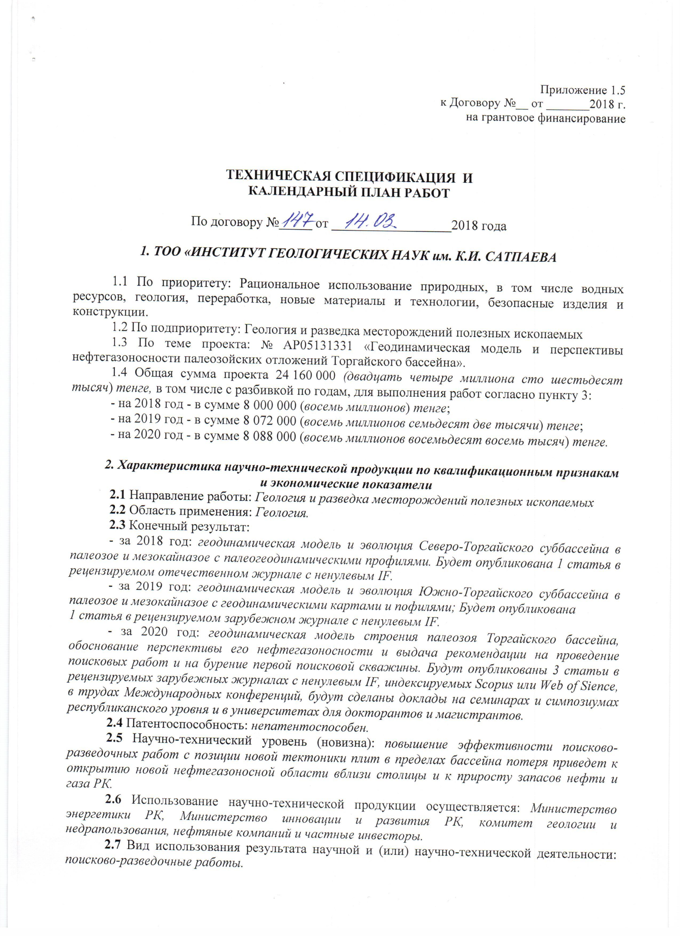
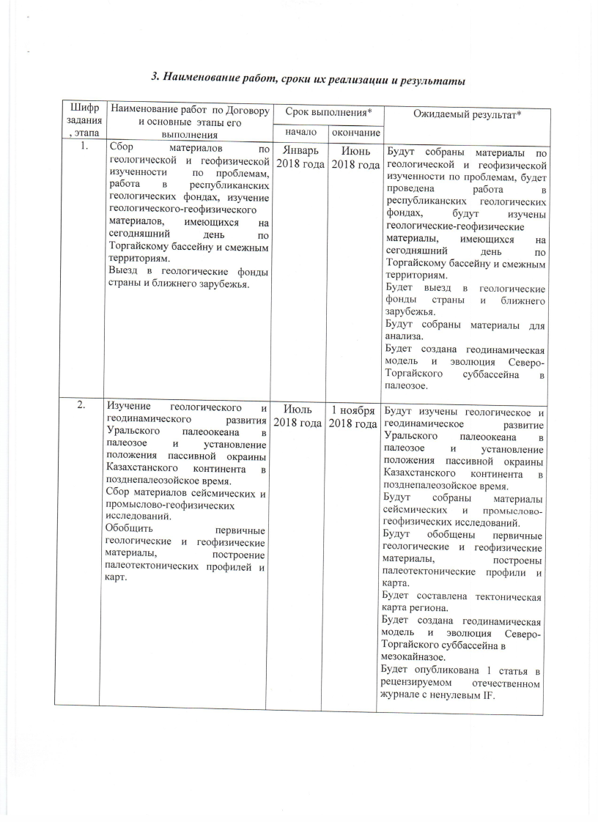
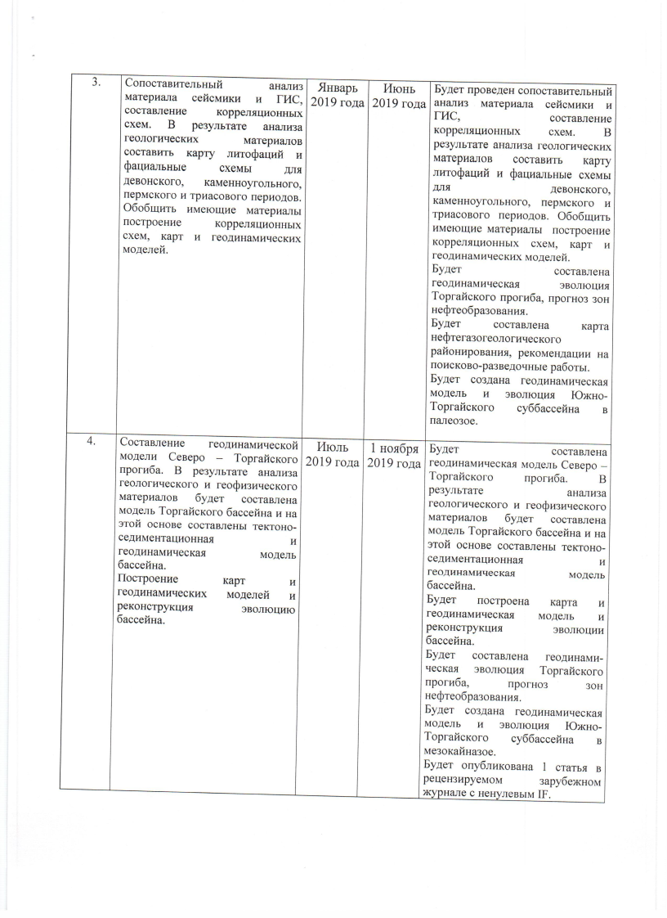
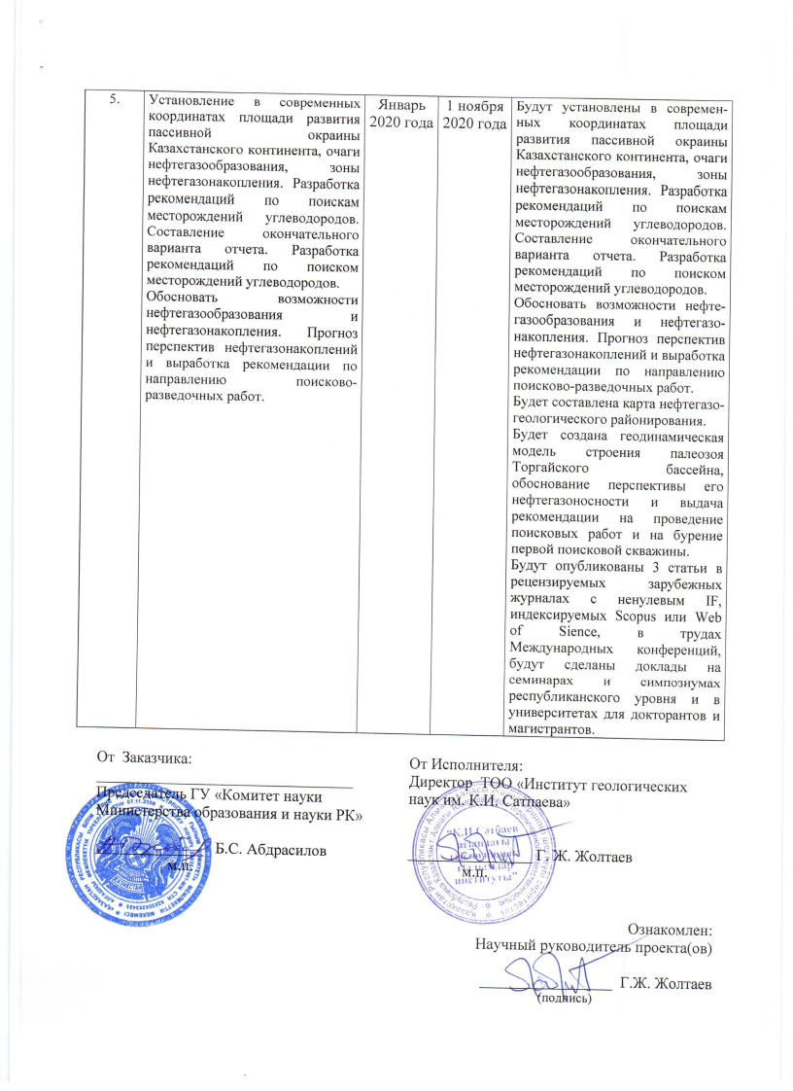
Annex 1.5 to
the Funding Agreement no. __
Dated _______2018

TECHNICAL SPECIFICATION AND
WORK CALENDAR PLAN

As per the agreement no._____ dated __________________2018

1. “THE INSTITUTE OF GEOSCIENCE NAMED AFTER K.I.SATPAEV” LLP

1.1 By priority: the rational use of natural resources, including water resources, geology, processing, new materials and technologies, safe products and structures.
1.2 By sub-priority: Geology and exploration of mineral deposits.
1.3 The project theme: no. АР05131331 «Геодинамическая модель и перспективы нефтегазоносности палеозойских отложений Торгайского бассейна».
1.4 The total project sum is KZT24,160,000.00 (twenty-four million one hundred sixty thousand), scheduled in years of work implementation as per p.3:
- 2018: KZT8,000,000.00 (eight million);
- 2019: KZL8,072,000.00 (eight million seventy-two thousand);
- 2020: KZT8,088,000.00 (eight million eighty eight thousand).

2. Description of scientific-technical produce
by qualification attributes and economic indicators

2.1 The work field: Geology and exploration of mineral deposits.
2.2 The application area: Geology
2.3 The final result:

2018: the geodynamic model and evolution of the North-Torgai sub-basin into the Paleozoic and Mesocaenozoic with paleogeodynamic profiles. One article will be published in a peer-reviewed national journal with a non-zero IF.
2019: the geodynamic model and evolution of the South-Torgai sub-basin in the Paleozoic and Mesocaenozoic with geodynamic maps and profiles; 1 article to be published in a peer-reviewed foreign journal with a non-zero IF.
2020: a geodynamic model of the structure of the Paleozoic structure of the Torgai basin, substantiation of its oil and gas bearing potential and issuing recommendations on conducting prospecting works and drilling the first prospecting well. Three articles will be published in peer-reviewed foreign journals with non-zero IF, indexed by Scopus or Web of Sience, in the proceedings of international conferences, reports will be made at seminars and symposia at the national level and at universities for doctoral and master's students.

2.4 Patentability: none.
2.5 Scientific and technical level (novelty): increased efficiency of prospecting and exploration works according to new plate tectonics within the basin will lead to the opening of a new oil and gas bearing area near the capital and increase of oil and gas reserves in Kazakhstan.
2.6 Use of the scientific and technical produce is carried out by: the RK Ministry of Energy, the RK Ministry of Innovation and Development, the Committee for Geology and Subsoil Use, oil companies and private investors.
2.7 Type of use of the result of scientific and (or) scientific and technical activities: prospecting and exploration work.

3. Work titles, implementation time schedule and results
Task code |  |  | Contractual work title and work stages* | Implementation date * |  |  |  |  | Expected result*
 |  |  | Contractual work title and work stages* | Start |  |  | End
2018
1. |  | Collection of materials on problems of geological and geophysical studies, work in the republican geological funds, study of geological and geophysical materials currently available for the Torgai Basin and adjacent areas.  Visit to geological archhives of the country and abroad. |  |  | January 2018 |  | June  2018 | Materials will be collected on geological and geophysical studies of problems, work will be carried out in the republican geological funds, and geological and geophysical materials currently available for the Torgai Basin and adjacent areas will be studied.  The geological funds of the country and neighbouring countries will be visited.  Materials will be collected for analysis.  A geodynamic model will be created and the evolution of the North-Torgai sub-basin into the Paleozoic.
2. |  | Study of the geological and geodynamic development of the Ural Ocean in the Paleozoic and establishing the position of the passive margin of the Kazakhstan continent in the late Paleozoic.  Collection of seismic, field and geophysical researchh materials.  Summary of primary geological and geophysical materials, construction of paleotectonic profiles and maps. |  |  | July  2018 |  | 01-11- 2018 | The geological and geodynamic development of the Ural Ocean in the Paleozoic and the determination of the position of the passive margin of the Kazakhstan continent in the Late Paleozoic time will be studied.  Materials from seismic, field and geophysical studies will be collected.  Primary geological and geophysical materials will be generalised and palaeotectonic profiles and maps will be constructed.  A tectonic map of the region will be drawn.  A geodynamic model will be created and the evolution of the North-Torgai sub-basin in the Mezocenozoic will be carried out.  1 article will be published in a peer-reviewed national magazine with a non-zero IF.
3. |  | Comparative analysis of seismic and mud logging materials, drawing up correlation schemes. Drawing a map of lithographs and facial diagrams for the Devonian, Carboniferous, Permian and Triassic periods as a result of the analysis of geological materials. Summary of accumulated materials, drawing up correlation diagrams, maps and geodynamic models. |  |  | January 2019 |  | June  2019 | Comparative analysis of seismic and mud logging materials will be carried out, and correlation charts will be drawn up. The analysis of geological materials will result in a map of lithophases and facial diagrams for the Devonian, Carboniferous, Permian and Triassic periods. Summarize existing materials,  building correlation schemes, maps and geodynamic models.  The geodynamic evolution of the Torgai Trough and the forecast of oil formation zones will be compiled.  An oil and gas geologic zoning map and recommendations for prospecting and exploration work will be drawn up.  A geodynamic model and evolution of the South-Torgai sub-basin to the Paleozoic will be created.
4. |  | Development of a geodynamic model of the North-Torgai trough. As a result of the analysis of geological and geophysical materials, a model of the Torgai basin will be developed and a tectonic-sedimentary and geodynamic model of the basin will be developed on this basis.  Map and geodynamic model construction and reconstruction of the basin evolution. |  |  | July  2019 |  | 01-11-2019 | A geodynamic model of the North-Torgai trough will be developed. As a result of analysis of geological and geophysical materials, a model of the Torgai basin will be developed and a tectonic-sedimentary and geodynamic model of the basin will be developed on this basis.  A map and a geodynamic model will be constructed and the evolution of the basin will be reconstructed.  Geodynamic evolution of the Torgai Trough and forecast of oil formation zones will be compiled.  A geodynamic model and evolution of the South-Torgai sub-basin to the Mesokainazoic will be created.  1 article will be published in a peer-reviewed foreign journal with a non-zero IF.
5. |  | Establishment of the development area of the passive margin of the Kazakhstan continent, oil and gas formation zones and oil and gas accumulation zones in modern coordinates. Development of recommendations on searchhing for hydrocarbon deposits. Drawing up the final version of the report. Development of recommendations on searchhing for hydrocarbon deposits.  Justification of oil and gas formation and oil and gas accumulation zones. Forecast the prospects for oil and gas accumulation and development of recommendations on the direction of prospecting and exploration work. |  |  | January 2020 |  | 01-11- 2020 | Modern coordinates will be established for the development area of the passive margin of the Kazakhstan continent, oil and gas formation zones and oil and gas accumulation zones. Development of recommendations on searchhing for hydrocarbon deposits. Drawing up the final version of the report. Development of recommendations on searchhing for hydrocarbon deposits.  Justification of oil and gas formation and oil and gas accumulation zones. Forecast the prospects for oil and gas accumulation and development of recommendations on the direction of prospecting and exploration work.  An oil and gas geological zoning map will be drawn up.  A geodynamic model of the structure of the Paleozoic structure of the Torgai basin will be created, as well as a substantiation of its oil and gas bearing potential, and recommendations will be issued on conducting prospecting work and drilling the first prospecting well.  Three articles will be published in peer-reviewed foreign journals with nonzero IF, indexed by Scopus or Web of Sience, in the proceedings of international conferences, and presentations will be made at seminars and symposia at the national level and at universities for doctoral and master's students.
 | On behalf of the Client:  Chairman of the State Administration  “The Science Committee  at the RK Ministry of Education and Science”  ______________ B.S.Abdrasilov  [Stamp] |  |  |  |  | On behalf of the Contractor:  Director of “The K.I.Satpaev Institute of Geological Science” LLP  _________________ G. Zholtaev  Familiarised:  Project Researchh Supervisor  ___________________ G. Zholtaev  (signature)

