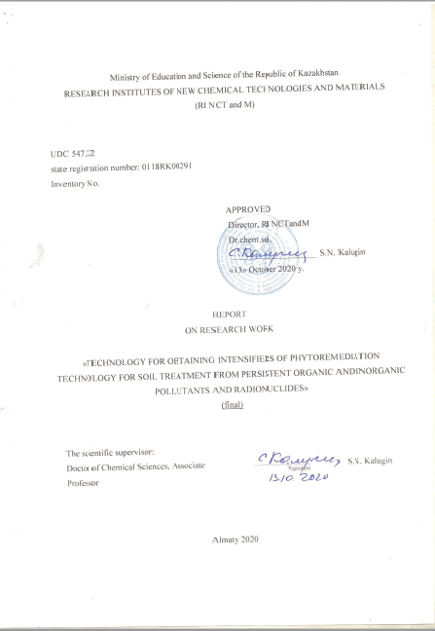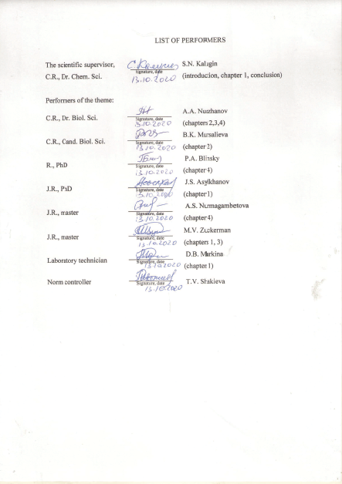
REFERAT

Report 66 pag., 17 fig., 17 tabl., 67 art., 3 app.
INTENSIFICATORS, SERUM, ORGANIZATIONAL AND NEORGANIZATIONS, RADIOnUKLIDES
Objects of study: sulphur-containing compounds, soil of Kanzhugan deposit, phytoremedicines, pollutants.
Objective: To create an effective technology for obtaining plant growth regulators and stimulants (intensifiers) for the remediation of areas contaminated with persistent organic and inorganic pollutants and radionuclides.
Research methods: chemical, spectrometric, biological.
The results of the work and their novelty:
Technologies for obtaining sulfur-containing intensifiers have been developed for the first time. Plants have been selected - remediants for soil remediation. For the first time, the effect of sulfur-containing regulators on the stimulating effect and phytoremediation potential of plants was studied and the effectiveness of the regulators was shown.
Scope of application: ecology, agriculture.

РЕФЕРАТ

Есеп 66 б., 17 сур., 17 кесте, 67 әд., 2 қосымша.
күкіртқұрамды интенсификаторлар, топырақ, органикалық және бейорганикалық ластаушылар, радионуклидтер
Зерттеу нысандары: құрамында күкірті бар қосылыстар, Канжуган кен орнының топырағы, фиторемедиаттар, ластаушы заттар.
Жұмыстың мақсаты: Тұрақты органикалық және бейорганикалық ластағыштармен және радионуклидтермен ластанған аймақтарды қалпына келтіру үшін реттеушілер мен өсімдіктердің өсу стимуляторларын (интенсификаторлары) алудың тиімді технологиясын құру.
Зерттеу әдістері: химиялық, спектрометриялық, биологиялық.
Жұмыс нәтижелері және олардың жаңалығы:
Күкірті бар күшейткіштерді өндірудің технологиялары алғаш рет жасалды. Таңдалған өсімдіктер - топырақтың мелиорациясы үшін қалпына келтіру құралдары. Алғаш рет өсімдіктердің ынталандырушы әсері мен фиторемедиация әлеуетіне күкірті бар реттегіштердің әсері мен тиімділігі зерттелді.
Қолдану аясы: экология, ауыл шаруашылығы.

Contents

LIST OF DESIGNATIONS AND ABBREVIATIONS ………………………………………. | 7
INTRODUCTION ……………………………………………………………………………... | 8
1 Development of technology for obtaining sulfur-containing intensifiers for phytoremediation technology................ | 12
1.1 Technology for producing 3-(2-chloroquinoline-3-yl)-2-(4-phenyl-1,3-thiazole-2-yl) acrylonitrile......................................................................................................................... | 12
1.1.1 Characteristics of finished products …………………………………………… | 12
1.1.2 Characteristics of raw materials ……..…………………………………………. | 13
1.1.3 Chemical scheme description 3-(2-chloroquinoline-3-yl)-2-(4-phenyl-1,3-thiazole-2-yl)acrylonitrile …………………………………………………………….. | 14
1.1.3.1 Synthesis of 2-chloroquinoline-3-carbaldehyde ………………………….. | 14
1.1.3.2 Synthesis of 3-(2-chloroquinoline-3-yl)-2-ciano-p-2-entioamide…………. | 15
1.1.3.3 Synthesis of 3-(2-chloroquinoline-3-yl)-2-(4-phenyl-1,3-thiazole-2-yl) acrylonitrile………………………………………………………………………… | 17
1.2 2.2-dimethyltetrahydro-tyopiran-4-one seven-carbazone production technology…… | 19
1.2.1 Characteristics of finished products...................................................................... | 19
1.2.2 Characteristics of raw materials ………………………………………………... | 20
1.2.3 Block diagram of the technological process …………………………………… | 20
1.2.4 Production technology β,β-dimethyldivinyl ketone ……………………………. | 22
1.2.5 Production technology 2.2-dimethyltetrahydrotyopiran-4-one…………………. | 23
1.2.6 Synthesis technology for semicarbazone 2,2-dimethyltetrahydrotyopiran-4-one. | 24
1.3 Synthesis of 2-amino-4-phenyl-1,3-thiazole ............................................................... | 25
2 Laboratory studies of the effect of sulphur-containing regulators on the stimulating effect of plant bio-test compounds…………………………………………………………………. | 26
2.1 Bio-testing on wheat seeds …………………………………………………………... | 26
2.2 Bio-testing on cucumber seeds ………………………………………………………. | 31
3 Laboratory study of the effect of sulfur-containing regulators and plant growth stimulants (intensifiers) on the phytoremediation potential of phytoremediatric plants………………. | 36
4 Testing of phytoremediation technology for cleaning soils brought from the South Kazakhstan region and evaluation of the effectiveness of the technology application …… | 40
CONCLUSION ……………………………………………………………………………….. | 42
LIST OF SOURCES……..…………………………………………………………………….. | 46
APPENDIX А Technical specification and work schedule……………………………………. | 53
APPENDIX B List of publications…………………………………………………………….. | 63

LIST OF DESIGNATIONS AND ABBREVIATIONS

The following designations and abbreviations are used in this research report

A-4a | - | 3-(2-chlorechinoline-3-yl)-2-(4-phenyl-1,3-thiazole-2-yl)acrylonitryle;
А-5 | - | semicarbazone 2.2-dimethyl-tetrahydrotyopiran-4-one;
⁰C | - | temperature, expressed in degrees Celsius;
rpm | - | the number of revolutions per minute;
NMR ¹H | - | proton magnetic resonance spectroscopy;
NMR ¹³C | - | Nuclear magnetic resonance spectroscopy in a carbon isotope;
m.d. | - | the value of the chemical shift, expressed in millions of shares;
t.boil. | - | boiling point;
n^{D}₂₀ | - | the refractive index of the substance at a wavelength corresponding to the D-line and temperature of 20⁰C;
IRS | - | infrared spectroscopy;
cm⁻¹ | - | wavelength, expressed in reverse centimetres;
mm.Hg | - | pressure expressed in millimetres of mercury column;
2,4-D | - | 2.4-dichlorophenoxyuksic acid;
GA | - | gibberellinic acid;
sm | - | centimetre;
g | - | gramm

INTRODUCTION

Currently, the most promising methods of purifying water and soil from a wide range of pollutants, including oil hydrocarbons, are bioremediation techniques based on the biochemical potential of biological objects, primarily microorganisms and plants [1, 2]. The main areas of bioremediation include the development of methods for phytoremediation of soils contaminated with heavy metals, radionuclides and pesticides using plants - hyperaccumulators [3-48].
In this connection, the main objective of the project "Technology for obtaining intensifiers of phytoremediation technology for soil purification from persistent organic and inorganic pollutants and radionuclides" was to create an effective technology for obtaining regulators and plant growth stimulants (intensifiers) for reclamation of areas contaminated with persistent organic and inorganic pollutants and radionuclides.
The project is implemented under the state order for the implementation of scientific and (or) scientific and technical projects under the budget programme 217 "Development of Science", subprogram 102 "Grant financing of scientific research", specifics 156 "Payment for consulting services and research" on the priority: "Sustainable use of natural resources, including water resources, geology, recycling, new materials and technologies, safe products and structures".
For 2018 and 2019, interim reports on research "Technology for obtaining intensifiers of phytoremediation technology for cleaning soil from persistent organic and inorganic pollutants and radionuclides" were prepared, inventory numbers No. 0218RK00578 and No. 0219RK00645, respectively.
The main results of the project studies in 2018 and 2019 were [49 - 53]:
- development of technologies for obtaining oxygen-containing intensifiers for phytoremediation technology: phenylhydrazone 2,2-dimethyltetrahydropyran-4-one, 2,2-dimethyl-4-(5'-amino-1',2',4'-triazolo-3'-thiopropynyl) tetrahydropyran-4-ola and 3-amyltetrahydropyran-4-ola.
- choice of ordinary, red, Kazakh poplar and giant Miskantus as plants - phytoremedians for reclamation of contaminated soils;
- an assessment was made of the environmental condition of soils in the South Kazakhstan region (Kanzhugan deposit area) contaminated with inorganic and radioacidic substances; it was found that the soil around the uranium mining region (uncontaminated soil) and in the places of technological strait (contaminated soil) contains elements of hazard class 1 (Cd, Zn, Pb, As), hazard class 2 (Cu, Cr) and hazard class 3 (V, Mn, Mg);
- a study of the effect of oxygen and nitrogen-containing regulators on the stimulating effect of compounds using plant biotest and assessed the phytotoxicity of soil; it was found that the growth indices of wheat and cucumber when treated with phenylhydrazone 2.2-dimethyl tetrahydropyran-4-one and 3-amyl tetrahydropyran-4-one in concentrations of 0.1 and 0.01 mg/l exceeded those of water and gibberellinic acid, i.e. they have a stimulating effect;
- laboratory studies of the effect of oxygen and nitrogen-containing regulators on the phytoremediation potential of phytoremedian plants; it has been shown that treatment with this reagent at a concentration of 0.01 mg/l increases the growth performance of ordinary and red-width cockpits and increases the accumulation capacity (extraction of metal ions) of these plants. However, the accumulation occurs in the root system.
- development of technologies for obtaining nitrogen-containing intensifier-cators for phytoremediation technology: 1-propyl-4-(3'-amino-1'2'4'-triazol-3'-thiopropynyl) piperidine-4-ola, 2,2-dimethyl-4-(5'-amino-1'2'4'-triazol-3'-thiopropynyl) -oxane-4-ola;
- a study of the effect of nitrogen-containing regulators on the stimulating effect of compounds using plant biotest and assessed the phytotoxicity of soil; it was shown that 1-propyl-4-(3'-amino-1',2',4'-triazolo-3'-thiopropinyl)piperidin-4-ola at a concentration of 0.0001 wt. % significantly increases the growth of wheat;
- laboratory studies of the effect of nitrogen regulators on the phytoremediation potential of phytoremedian plants; it has been established that 1-propyl-4-(3'-amino-1',2',4'-triazolo-3'-thiopropynyl) piperidin-4-ol increases the biomass by (10-30)%, as well as the length of the underground and aboveground part of the hazelnut and the width of the red part by (5-13)%, which contributes to the greater accumulation of pesticides by plants and allows to reduce the amount of 4'4-DDD, 4'4-DDD, 2'4-DDD in soil by 4-5 times.
The results obtained in 2018 and 2019 are new areas of synthesis of biologically active compounds, which are not described in the literature.
The tasks for 2020 were the following research works:
- Development of a technology to produce sulfur-containing intensifiers for phytoremediation technology;
- Laboratory testing of the effect of sulphur-containing regulators on the stimulating effect of a vegetable bio-test compound;
- Laboratory studies of the effect of sulphur-containing regulators on the phytoremediation potential of phytoremedian plants.
- Testing phytoremediation technology for cleaning soils brought from the South Kazakhstan region and evaluating the effectiveness of the technology.
Justification for choosing a destination
The essence of phytoremediation soil remediation technology is that plants with maximum absorption capacity of pollutants and radionuclides are systematically planted in the soil. The sprawling biomass of the plants, enriched with persistent organic and inorganic pollutants, is extracted from the soil and recycled. Under this technology, the cycle "accumulator cultivation" - "removal of vegetation mass from the soil" - "recycling" is repeated until the soil condition is in compliance with environmental safety standards.
From an economic point of view, phytoremediation has advantages over "chemical" and "mechanical" methods of soil remediation, as its implementation does not require large capital investments, and the operating costs of this technology are low.
There is an urgent need to develop phytoremediation technology for soils contaminated with persistent organic and inorganic pollutants, as well as radionuclides, due to the fact that there are sources of these contaminants in Kazakhstan, such as areas of former plant protection chemicals storage facilities, waste from former uranium mining enterprises (Kazatomprom), dumps and tailings dumps of mining and processing plants (Kazzinc, Kazakhmys). These sources of pollution have now become so-called 'hot spots', which pose a high environmental and human health hazard [20]. Therefore, in order to minimise the environmental risk in the contaminated areas, the development and use of phytoremediation technology seems relevant and expedient.
In our view, a promising trend in phytoremediation technology for soil treatment is the use of plant growth stimulants. They increase the growth characteristics and biomass of phytoremediation plants and their phytoaccumulating potential (32, 45). Using the example of soils contaminated with pesticides from former pesticide storage facilities in the Almaty region, it has been established that the application of a tetrahydropyransfer-containing composition to the soil increases physiological parameters and the total biomass of C. Rumpkin and Xanthium strumarium by 10%. The concentration of pesticides in the near-root zone of plants was reduced by 30-40 %.
Thus, the use of plant growth stimulants and regulators will intensify phytoremediation technology to clean the soil from persistent organic and inorganic pollutants and radionuclides. This is the main fundamental difference between the project idea and its existing counterparts.
This year, 3-(2-chloro-quinoline-3-yl)-2-(4-phenyl-1,3-thiazole-2-yl)acrylonitrile (A-4a), seven-carbazone 2,2-dimethyl-tetrahydrotyopiran-4-one (A-5) and 2-amino-4-phenyl-1,3-thiazole were used as sulfur-containing intensifiers of phytoremediation technology.
The 1.3-thiazole derivatives are important heterocyclic compounds with low toxicity to mammals and a wide range of biological activity, including insecticide, antifungal, herbicide, and plant growth control [54-60]. Many thiazole derivatives such as thiamethoxam, imidaclotysis, thiabendazole [61] and bentiavalvalicarbisopropyl [62] have been commercialized as agrochemicals. In addition, compounds with the amide or ester group represent a universal class of agrochemicals with a wide spectrum of biological activity [63] and have also been used as insecticide, fungicide, herbicide and antiviral agents [64]. In order to obtain new compounds for the field of agrochemistry with a wide range of biological activity, especially systemic acquired resistance, a series of 20 new derivatives of 2-amino-1,3-thiazole-4-carboxylic acid was developed and synthesized (60). They have been found to have good activity, increase systemic acquired resistance of plants and provide better antimicrobial protection than known plant protection products.
The use of thiazole-based elysifiers is a new modern measure for pesticide development and environmental protection, as elysifiers can stimulate the plant's immunological system to ensure systemic acquired resistance at the physical and physiological level of plants [65, 66].
Scientific and practical significance of the work
Development of methods for obtaining intensifiers of phytoremediation technology for soil treatment is a new area of synthesis of biologically active substances. The results of research on this project task will contribute to solving fundamental issues of organic chemistry, chemical technology of organic substances, such as the reactivity of organic substances, the dependence of biological properties of reagents on their nature.
The results obtained from the project have an important practical value. The development of technology for obtaining heterocyclic plant growth regulators for soil treatment will make it possible to use them in solving regional environmental problems. It should be noted that intensifiers are not produced in Kazakhstan and plant growth stimulants are imported from abroad. Therefore, commercialisation and industrialisation of the results of the Intensifier Production Technology Project will be aimed at import substitution and reduction of technological dependence in Kazakhstan.

1 Development of a technology to produce sulfur-containing intensifiers for phytoremediation technology

This year, technologies have been developed to produce 3-(2-chloro-quinoline-3-yl)-2-(4-phenyl-1,3-thiazole-2-yl)acrylonitrile (A-4a), seven-car-basone 2,2-dimethyltetrahydrotyopiran-4-one (A-5) and 2-amino-4-phenyl-1,3-thiazole.

  - Technology for producing 3-(2-chloroquinoline-3-yl)-2-(4-phenyl-1,3-thiazole-2-yl) acrylonitrile

At present, there are many ways of obtaining substituted 1.3-thiazoles, which are used in various fields of science and technology. After studying the numerous methods for synthesizing thiazole derivatives, we concluded that the most convenient and affordable method for us is the classical Hantzsch reaction using thioamides as precursors, which were synthesized from the Kneuvenagel reaction.
This synthesis strategy makes it easy to vary the type of substituent in the thiazole ring at position C2, which is consistent with the purpose of this work.
By optimising the standard Hantzsch synthesis procedure to improve yield and selectivity, we obtained 3-(2-chloroquinoline-3-yl)-2-(4-phenyl-1,3-(2-chloroquinoline-3-yl)acrylonitrile from 3-(2-chloroquinoline-3-yl)-2-ciano-p-2-entioamide, optimal conditions have been selected and the technology for obtaining 3-(2-chloroquinoline-3-yl)-2-(4-phenyl-1,3-thiazole-2-yl)acrylonitrile (thiazoloquinoline) has been developed.

1.1.1 Characteristics of finished products

Product name: 3-(2-chloroquinoline-3-yl)-2-(4-phenyl-1,3-thiazole-2-yl)acrylonitrile
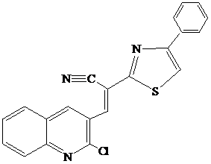
Empirical formula: C₂₁H₁₂ClN₃S.
Molecular weight: 373.86 g moth.
Regulatory indicators are given in Table 1.

Table 1 - Characteristics of the technical product

Name | NTD designation | Indicators that are mandatory for verification | Regulatory indicators with permissible deviations
Tiazoloquino-Lin | Tiazoloquino-Lin | Appearance | Yellow-brown powder
Tiazoloquino-Lin | Tiazoloquino-Lin | Tiazoloquinoline, % | At least 99.00
Tiazoloquino-Lin | Tiazoloquino-Lin | Organic impurities, % | No more than 0.50
Tiazoloquino-Lin | Tiazoloquino-Lin | Moisture, % | No more than 0.50
Tiazoloquino-Lin | Tiazoloquino-Lin | Melting point, C | 185-190
Tiazoloquino-Lin | Tiazoloquino-Lin | Solubility | DMFA, DMSO

1.1.2 Characteristics of raw materials and supplies

The name of the raw material and its indicators, which are mandatory for inspection, are given in Table 2.

Table 2 - Characteristics of raw materials and supplies

Name | Quality or part number | Indicators that are mandatory for verification | Note
1 | 2 | 3 | 4
Chinoline aldehyde | Semiproduct, 99.0% | Colourless crystals, Tm = 57.2 ºC; main substance concentration at least 99.0% | Reagent.
Ethyl alcohol | GOST 11547-65 | Colourless liquid, bp = 78.4 ºC; main substance concentration at least 96.0% | Solvent, PLWH
Continuation of Table 2
1 | 2 | 3 | 4
Cyanthioacetamide . | Semiproduct, 99.0% | Pink crystals, Tm = 118 ºC; main substance concentration at least 99.0% | Reagent
N-methylmorpholine . | Semiproduct, 99.0% | Transparent liquid, bp = 115 ºC; main substance concentration at least 99.0% | Reagent
Tioamide | Semiproduct, 99.0% | Orange powder, Tm = 131 ºC; main substance concentration at least 99.0% | Reagent
Bromacetophenone | Semiproduct, 99.0% | Pale yellow crystals, Tm = 116 ºC; main substance concentration at least 99.0% | Reagent
Isopropyl alcohol | GOST  9805-84 | Colourless liquid, bp = 82.4 ºC; main substance concentration at least 99.0% | Solvent, PLWH

1.1.3 Description of the chemical scheme 3-(2-chloroquinoline-3-yl)-2-(4-phenyl-1,3-thiazole-2-yl)acrylonitrile

1.1.3.1 Synthesis of 2-chloroquinoline-3-carbaldehyde

The initial carbonyl component for the Kneuvenagel 2-chloroquinoline-3-carbaldehyde reaction was obtained from aniline, which is first acetylated using acetic anhydride according to the scheme below:
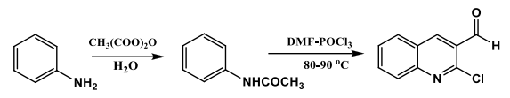

The structure of intermediate acetanilide has been proved by the melting point and Rf value.
The structure of 2- chloroquinoline-3-carbaldehyde is confirmed by NMR ^{1H} (400 MHz, DMSO) spectroscopy (Figure 1).
The following signals are observed in the proton spectrum of 2-chloroquinoline-3-carbaldehyde (Figure 4): 5 10.34 (s, 1H), 8.91 (s, 1H), 8.22 (d, J = 8.1 Hz, 1H), 7.97 (m, J = 9.1 Hz, 2H), 7.72 (t, J = 7.2 Hz, 1H). The absorption band at 10.34 mE indicates the presence of a proton in the aldehyde group; signals 8.22, 7.97, 7.72 mE correspond to an aromatic system with values of spin-spin constants lying within the limits for the vicinal arrangement of protons, which coincides with the multiplicity of these signals.

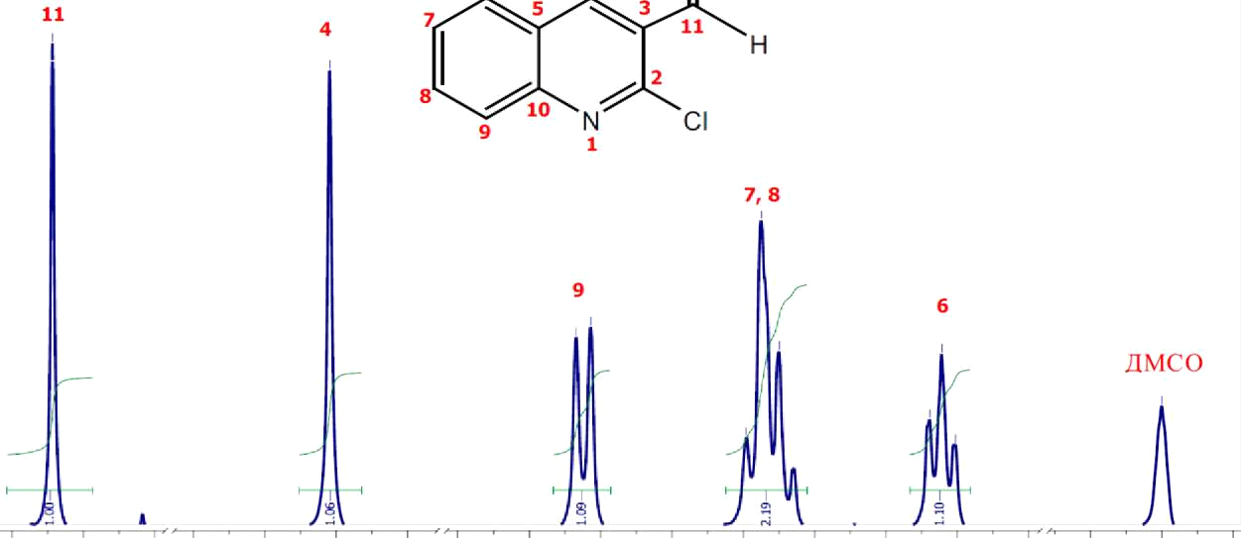

L0.4 10.3 10.2 9.1 9.0 8.9 8.8 8.4 8.3 8.2 8.1 8.0 7.9 7.8 7.7 7.6 2.6 2.5 2.4 M 1mpL
Figure 1 - NMR spectrum ¹H 2-chloroquinoline-3-carbaldehyde

1.1.3.2 Synthesis of 3-(2-chloroquinoline-3-yl)-2-cyano-p-2-entioamide

3-(2-Chloroquinoline-3-yl)-2-cyano-P-2-entioamide was obtained by the interaction of 2-Chloroquinoline-3-Carbaldehyde with 2-Cyanoethanthyoamide in ethanol, in the presence of catalytic amounts of N-methylmorpholine.
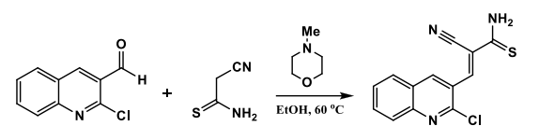

An ultrasonic bath was used to reduce reaction time, providing better dissolution of the original aldehyde and more thorough mixing. We carried out a number of syntheses, varying in duration, starting from 15 minutes using ultrasound. Under normal conditions, without the use of ultrasound, the reaction time is 2-3 hours with moderate outputs. With the use of ultrasonic baths, reaction times can be reduced by several times.
Based on the data obtained, it can be concluded that 30 minutes in an ultrasound bath is more than enough for this reaction; increasing the duration of exposure to ultrasound over 30 minutes did not increase the output value of the reaction. The results are presented in Table 3.

Table 3 - Optimization of synthesis conditions for 3-(2-chloroquinoline-3-yl)-2-cyano-P-2-entioamide

No. of experience | Solvent | Temperature, °C | Time, min | Output, %
1* | EtOH | 60 °C | 180 | 71
2* | EtOH | 60 °C | 120 | 69
3 | EtOH | 60 °C | 60 | 86
4 | EtOH | 60 °C | 45 | 85
5 | EtOH | 60 °C | 30 | 86
6 | EtOH | 60 °C | 15 | 76
* tests performed without ultrasound

The identification of the structure was confirmed by NMR ^{1H} (400 MHz, DMSO) spectroscopy (Figure 2).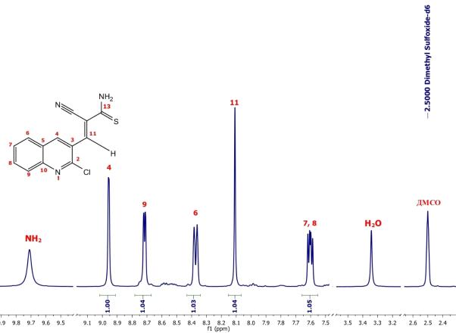
Figure 2 - NMR spectrum 1H 3-(2-chloroquinoline-3-yl)-2-cyano-p-2-entioamide
The resulting spectrum contains signals: 5 9.71 (s, 1H), 8.96 (s, 1H), 8.72 (d, J = 3.9 Hz, 1H), 8.37 (d, J = 8.1 Hz, 1H), 8.11 (s, 1H), 7.60 (dd, J = 8.0, 4.9 Hz, 1H) (Figure 4).

1.1.3.3 Synthesis of 3-(2-chloroquinoline-3-yl)-2-(4-phenyl-1,3-thiazole-2-yl) acrylonitrile

The desired 3-(2-chloroquinoline-3-yl)-2-ciano-p-2-entioamide with bromacetophenone was obtained by cyclo-condensation of 3-(2-chloroquinoline-3-yl)-2-(4-phenyl- 1,3-thiazole-2-yl)acrylonitrile by the Hantzsch reaction:
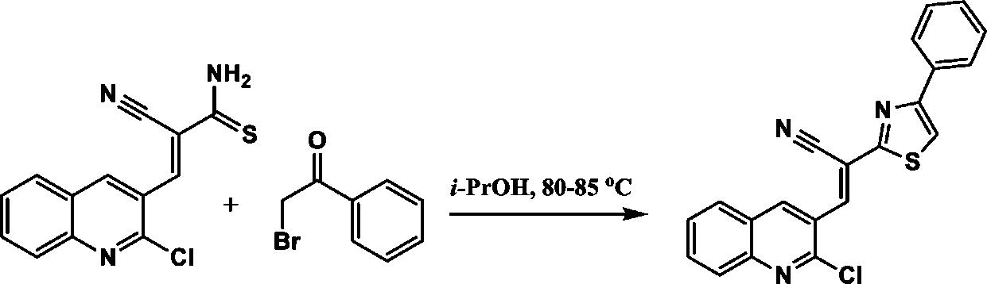

The reaction follows a standard mechanism typical of Hantzsch synthesis with the formation of an intermediate ketone with bromine detachment and cyclisation into thiazolin followed by dehydration. Practice has shown that the speed and quality of the reaction depends on the nature of the original thioamide, so we have optimised the standard Hantzsch reaction procedure for a more effective interaction of our 3-(2-chloroquinoline-3-yl)-2-ciano-p-2-entioamide with bromactofenone.
Above all, it was necessary to select the most favourable solvent for the reaction. During the experiments it became clear that the classic solvent in Hantzsch ethanol synthesis is not suitable for our thioamide, nor is dimethylformamide (DMFA). These solvents produced moderate yields of 47-57%. Pyridine was also not a particularly suitable solvent, with lower-than-average yields in the medium.
In order to improve yield in the above solvents, it has been proposed that the nucleophilic base diisopropylene (DIPEA) and microwave radiation (MW) be used as catalysts. The modifications proposed have not been as effective, although they have improved reaction outputs by 7-10%, especially with microwave exposure to DIPEA. It was therefore decided to replace these solvents with isopropyl alcohol, which was perfectly suited to this reaction, resulting in an improved yield of up to 74%.
The results of the experiments are shown in Table 4.

Table 4 - Optimization of synthesis conditions for 3-(2-chloroquinoline-3-yl)-2-(4-phenyl-1,3-thiazole-2-yl) acrylonitrile

No. of experience | Solvent | Catalyst . | Temperature, X | Time, h | Output, %
1 | EtOH | - | 60 | 8 | 57
2 | EtOH | ₋ | 78 | 6 | 63
3 | DMFA | ₋ | 60 | 10 | 47
4 | DMFA | DIPEA | 60 | 5 | 53
5 | DMFA | DIPEA | 80 (MW) | 2 | 62
6 | Pyridine | DIPEA | 60 | 6 | 46
7 | Pyridine | DIPEA | 80 (MW) | 2 | 55
8 | isoPrOH | - | 60 | 6 | 64
9 | isoPrOH | - | 83 | 4 | 74

The structure of the obtained 3-(2-chloroquinoline-3-yl)-2-(4-phenyl-1,3-thiazole-2-yl)acrylonitrile was proved by NMR spectroscopy (Figure 3):
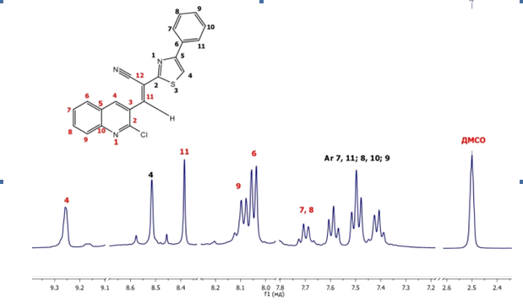
Figure 3 - NMR Spectrum ¹H 3-(2-chloroquinoline-3-yl)-2-(4-phenyl-1,3-thiazole-2-yl)acrylonitrile

The ¹H NMR spectrum (Figure 6) contains signals from protons 5 9.26 (s, 1H), 8.52 (s, 1H), 8.39 (s, 1H) and 8.09 (d, J = 7.6 Hz, 2H), 8.05 (d, J = 7.5 Hz, 2H), 7.73 - 7.65 (m, 2H), 7.59 (t, J = 7.6 Hz, 1H), 7.50 (t, J = 7.5 Hz, 2H), 7.41 (t, J = 7.3 Hz, 1H).

1.2 Production technology for semicarbazone 2.2-dimethyltetrahydrotiopiran-4-one

1.2.1 Characteristics of finished products

Product name: semicarbazone 2.2-dimethyltetrahydrotiopi-ran-4-one

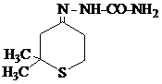

Empirical formula: C8H15ON3S.
Molecular weight: 201.00 g moth.
Regulatory indicators are given in Table 5.

Table 5 - Characteristics of the technical product

Name | NTD designation | Indicators that are mandatory for verification | Regulatory indicators with permissible deviations
Semiсarbazon 2,2-dimethyltet-rahydrotyopi-ran-4-ona | Semiсarbazon 2,2-dimethyltet-rahydrotyopi-ran-4-ona | Appearance | Yellow-brown powder
Semiсarbazon 2,2-dimethyltet-rahydrotyopi-ran-4-ona | Semiсarbazon 2,2-dimethyltet-rahydrotyopi-ran-4-ona | Semikarbazon 2.2-di-methyltetrahydrotiopi-ran-4-ona, % | At least 99.00
Semiсarbazon 2,2-dimethyltet-rahydrotyopi-ran-4-ona | Semiсarbazon 2,2-dimethyltet-rahydrotyopi-ran-4-ona | Organic impurities, % | No more than 0.50
Semiсarbazon 2,2-dimethyltet-rahydrotyopi-ran-4-ona | Semiсarbazon 2,2-dimethyltet-rahydrotyopi-ran-4-ona | Moisture, % | No more than 0.50
Semiсarbazon 2,2-dimethyltet-rahydrotyopi-ran-4-ona | Semiсarbazon 2,2-dimethyltet-rahydrotyopi-ran-4-ona | Melting point, C | 185-190
Semiсarbazon 2,2-dimethyltet-rahydrotyopi-ran-4-ona | Semiсarbazon 2,2-dimethyltet-rahydrotyopi-ran-4-ona | Solubility | DMFA, DMSO

1.2.2 Characteristics of raw materials and supplies

The name of the raw material and its indicators, which are mandatory for inspection, are given in Table 6.

Table 6 - Characteristics of raw materials and supplies

Name | Quality or  part number | Indicators that are mandatory for verification | Note
Dimethylvinyl-ethylcarbinol | Source product | Colourless liquid, bp = 60 ºC (10 mmHg); main substance concentration at least 99.0% | Reagent
Ethyl alcohol | GOST 11547-65 | Colourless liquid, bp = 78.4 ºC; main substance concentration at least 96.0% | Solvent, PLWH
Sulfuric oxide mercury | GOST  5558-50 | Crystals, main substance concentration at least 99.0% | Reagent
Acetone | GOST  2603-79 | Transparent liquid, bp = 56 ^{oC}; main substance concentration at least 99.0% | Solvent, PLWH
Hydrogen sulfide | GOST  5542-2014 | Gas with an unpleasant odor; main substance concentration at least 99.0% | Reagent .
Sodium is acetic,  3-water | GOST  199-78 | White crystals, Tm = 328 ºC; main substance concentration at least 99.0% | Reagent
Semikarbazid hydrochloride | GOST  5842-75 | White crystals, etc. = 173 ºC (decomposition); main substance concentration at least 99.0% | Reagent

1.2.3 Block diagram of the technological process.

A block diagram of the technological process of obtaining semicarbazone 2,2-dimethyltetrahydrotyopiran-4-one is shown in Figures 6 - 8.
The block diagram includes the stages of allen-acetylene rearrangement of dimethylvinylethynylcarbinol (TP-1), cyclisation of β,β-dimethyl divinyl ketone into 2,2-dimethyltetrahydrotyopyran-4-one (TP-2) and synthesis of semicarbazone 2,2-dimethyltetrahydrotyran-4-one.
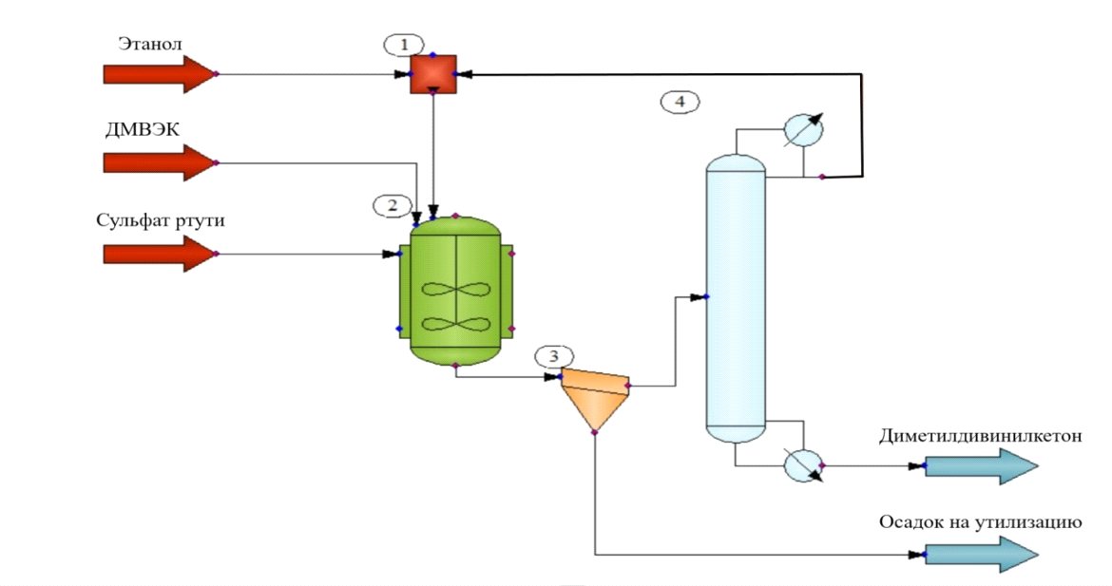
1 - mixer; 2 - reactor; 3 - filter; 4 - rectification column

Figure 4 - Core receipt scheme β,β-dimethyldivinyl ketone

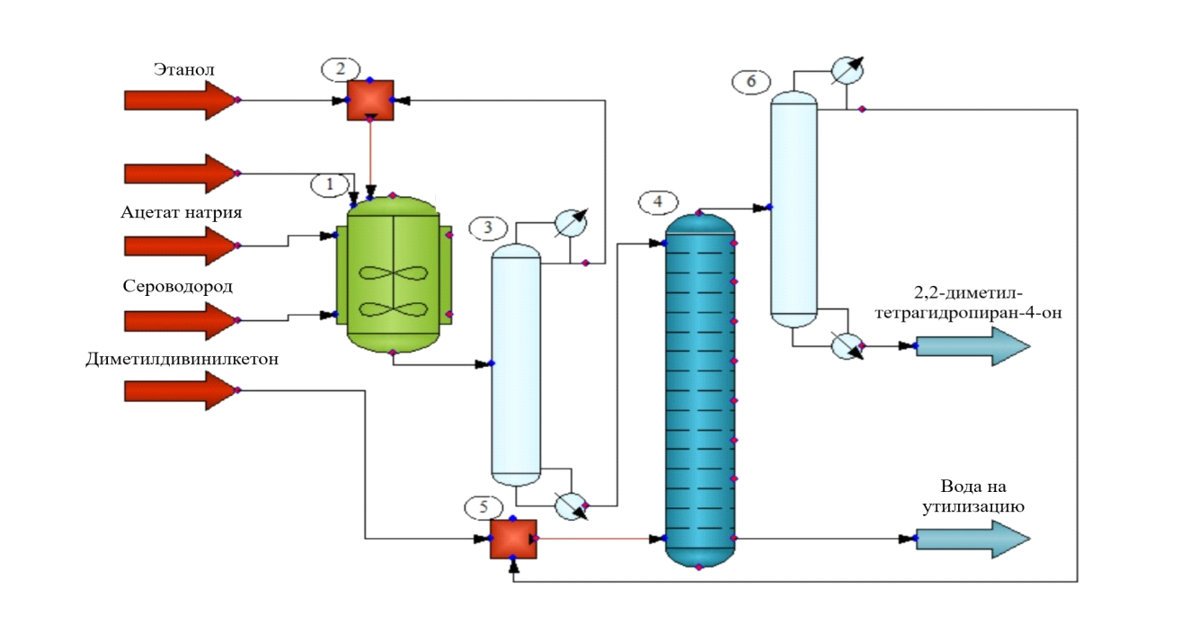
1 - reactor; 2.5 - mixers; 3.6 - rectification column; 4 - extractor

Figure 5 - Core receipt scheme 2.2-dimethyltetrahydrotyopiran-4-one

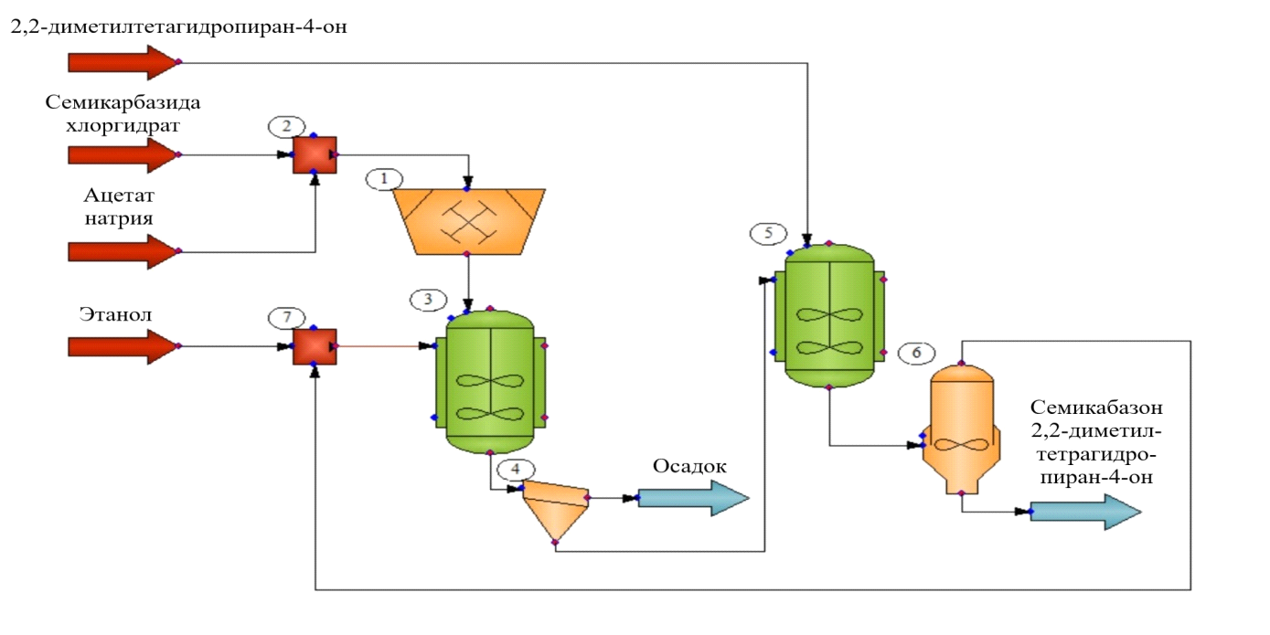
1 - mill; 2.7 - mixers; 3.5 - batch reactors; 4 - filter; 6 - crystallizer

Figure 6 - Core receipt scheme semicarbazone 2.2-dimethyltetrahydrotyopiran-4-one

1.2.4 Technology for obtaining β,β-dimethyldivinyl ketone

β,β-Dimethyldivinyl ketone was obtained by isomerisation of dimethyl-vinyl-ethylcarbinol in the presence of mercury sulphide.
The acetylene allene regrouping process takes place both in acetone at room temperature and when heated in ethanol.

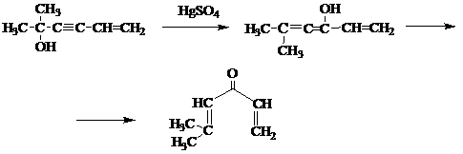

The principal scheme for obtaining β,β-dimethyldivinyl ketone is shown in Figure 4.
The principle diagram includes a mixer, reactor, filter and rectification column.

1.2.5 Technology for the production of 2.2-dimethyltetrahydrotyopiran-4-one
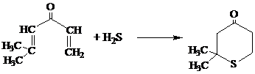
Dimethyltetrahydrotyopiran-4-one was synthesized by the interaction of β,β-dimethyldivinyl ketone with hydrogen sulphide in ethyl alcohol in the presence of sodium acetate.
The principal scheme for obtaining 2.2-dimethyltetrahydrotyopiran-4-one is shown in Figure 5.
The principle diagram includes mixers, reactor, extractor and rectification columns.
The structure of the compound has been proven by elemental analysis, infrared spectroscopy (Figure 7) and comparison of physical constants with literature data.
The infrared spectrum shows absorption bands in the areas of 2800-3000, 1460 and 1380cm⁻¹ corresponding to the valence and deformation oscillations of the C-H bond of methyl and methylene groups. The absorption band in the area of 1716 cm⁻¹ corresponds to the valence oscillations of the carbonyl group.
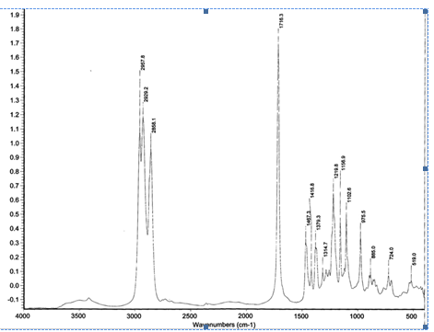

Figure 7 - IR spectrum 2.2-dimethyltetrahydrotyrotyopiran-4-one
1.2.6 Semicarbazone synthesis technology 2.2-dimethyltetrahydro-tyopyran-4-one

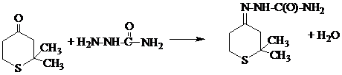

The interaction of semicarbazide hydrochloride with sodium acetate and 2.2-dimethyltetrahydrotyrotyopyran-4-one-4 in ethyl alcohol produced semicarbazine 2.2-dimethyltetrahydrotyopiran-4-one.
The functional composition of the resulting product has been proven using infrared spectroscopy (Figure 8).
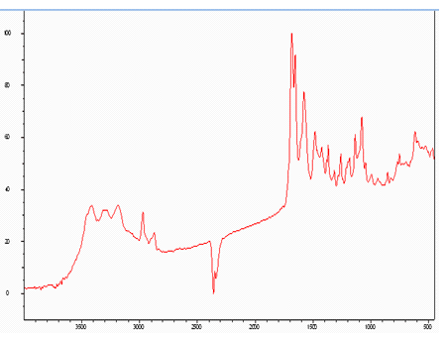

Figure 8 - IR spectrum of the seven-carbage zone 2.2-dimethyltetrahydrotyopiran-4-one

The infrared spectrum shows absorption bands in the areas of 2800-3000, 1460 and 1380 cm-1 corresponding to the valence and deformation oscillations of the C-H bond of methyl and methylene groups. Absorption bands in the area of 1670 - 1710 cm-1 correspond to the valence oscillations of the carbazine group.
The schematic scheme for the production of semicarbazone 2,2-dimethyltetra-hydrotyopiran-4 is shown in Figure 6.
The principle diagram includes mixers, batch reactors, filter, mill and crystalliser.

1.3 Synthesis of 2-amino-4-phenyl-1,3-thiazole

2-amino-4-phenyl-1,3-thiazole was obtained using a known method.

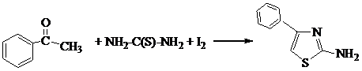

To the mixture of 24 g of acetophenone and 30.4 g of thiourea add 50.8 g of iodine. The mixture is heated in an autoclave in a water bath for 24 hours and then diluted with water until a homogeneous solution is formed. A small amount of sulphur is filtered out; the filtrate is cooled and alkalised with aqueous ammonia. The released crystalline base is filtered out and recrystallised from ethyl alcohol. The yield of 2-amino-4-phenylthiazole with the help of ammonia. 147 ºC is 85 %.

2 Laboratory studies of the effect of sulphur-containing regulators on the stimulating effect of a plant bio-test compound

3-(2-chloro-quinoline-3-yl)-2-(4-phenyl-1,3-thiazole-2-yl)acrylonitrile (A-4a) and 7-car-base 2,2-dimethyl-tetrahydrotyopyran-4-one (A-5) were used as sulphur-containing compounds. Regulating activity was assessed against 2.4 D-sodium salt and gibberellinic acid (GA). The influence of chemical compounds was assessed by bioassay on germination of seeds of single- and double-sided plants using the Rakitin Yu.V. and Mine V.E. method [67].

2.1 Bio-testing on wheat seeds

The scheme of experience on wheat seeds of Mironovskaya 808 variety is as follows. Water (control1), gibberellinic acid (GA) at a concentration of 10 mg/l and sodium salt of 2.4-dichlorophenoxy acetic acid (2.4 D-Na) at a concentration of 10 mg/l were chosen as controls.
Aqueous solutions of 3-(2-chloro-quinoline-3-yl)-2-(4-phenyl-1,3-thiazole-2-yl)acrylonitrile (A-4a) and semicarbasone 2,2-dimethyltetrahydrotyopiran-4-one (A-5) in concentrations were used in the pilot versions: 100 mg/l (10⁻² wt%), 10 mg/l (10⁻³ wt%), 1 mg/l (10⁻⁴ wt%), 0.1 mg/l (10⁻⁵ wt%), 0.01 mg/l (10⁻⁶ wt%). Duration of treatment - 18 hours. After treatment, the seeds were germinated in a thermostat at 25ºC for 48 hours. For better aeration, the cuvettes were ventilated every 24 hours (coverings were removed for 10 minutes each time). Repetition of the experience was 2 times 30 seeds each (two cuvettes per option).
The following growth parameters were identified in the studies:
1) germination rate of seeds;
2) the length of the longest root;
3) total mass of roots;
4) the length of the shoot;
5) mass of shoot.
Measurements with millimetre paper under glass.
The effect of 3-(2-chloro-quinoline-3-yl)-2-(4-phenyl-1,3-thiazole-2-yl)acrylo-nitrile (A-4a) and semicarbazone 2,2-dimethyltetrahydrotyopyran-4-one (A-5) on
wheat germination is shown in Table 7 and Figure 9.
Table 7 - Impact of 3-(2-chloro-quinoline-3-yl)-2-(4-phenyl-1,3-thiazole-2-yl)-acrylonitrile (A-4a) and semicarbazone 2,2-dimethyltetrahydrotyopiran-4-one (A-5) on wheat seed germination capacity

Preparation, concentration, mg/l | germination capacity, % | % to control
А 5
100 | 70,0 | 83,3
10 | 52,0 | 61,9
1 | 80,0 | 95,2
0,1 | 80,0 | 95,2
0,01 | 96,0 | 114,3
A4a
100 | 52,5 | 62,5
10 | 75,0 | 89,3
1 | 90,0 | 107,1
0,1 | 92,5 | 110,1
0,01 | 90,0 | 107,1
Regulators of plant growth
2.4 D-Na | 67,0 | 79,8
GA | 95,0 | 113,1
Control - water | 84,0 | 100

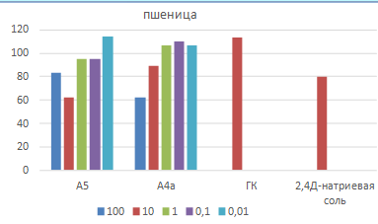

Figure 9 - Influence of 3-(2-chloro-quinoline-3-yl)-2-(4-phenyl-1,3-thiazole-2-yl)-acrylonitrile (A-4a) and semicarbazone 2,2-dimethyltetrahydro-tyopyran-4-one (A-5) on wheat seed germination capacity

Tabular data show that the germinating capacity of wheat when treated with semicarbazone 2.2-dimethyltetrahydrotyopiran-4-one (A-5) solutions in concentra-tions above 0.1 mg/l is inferior to that of control. However, at concentrations of 0.01 mg/l (10-6 wt %), germination is better than in water and gibberellinic acid solution.
A similar trend is observed for 3-(2-chloro-quinoline-3-yl)-2-(4-phenyl-1,3-thiazole-2-yl)-acrylonitrile (A-4a). The maximum germination rate is observed when treated with a solution with a concentration of 0.1 mg/l (10⁻⁵ wt %). However, this sulphur-containing compound is inferior to gibberellinic acid but superior to water.
The effect of 3-(2-chloro-quinoline-3-yl)-2-(4-phenyl-1,3-thiazole-2-yl)-acrylo-nitrile (A-4a) and semicarbazone 2,2-dimethyltetrahydrotyopyran-4-one (A-5) on wheat seed germination is shown in Tables 8 and 9 and Figures 10-13.

Table 8 - Impact of 3-(2-chloro-quinoline-3-yl)-2-(4-phenyl-1,3-thiazole-2-yl)-acrylonitrile (A-4a) and semicarbazone 2,2-dimethyltetrahydrotyopiran-4-one (A-5) on wheat seed germination in absolute units

Concentration, mg/l | Length of root, see | Weight of roots, d | Shoot’s length, see | Mass of shoots, d
А5
100 | 2,26±0,61 | 013 | 1,14±0,43 | 0,13 ±0,09
10 | 2,88±0,61 | 0,17 | 1,82±0,46 | 0,13
1 | 2,65±0,47 | 0,14 | 1,52±0,63 | 0,09
0,1 | 2,83±0,75 | 0,16 ± 0,08 | 1,85±0,72 | 0,14 ±0,06
0,01 | 3,28±0,8 | 0,19 ± 0,01 | 1,92±0,79 | 0,17 ±0,02
A4a
100 | 1,52 ±0,48 | 0,05±0,01 | 0,83 ± 0,33 | 0,05 ±0,01
10 | 2,13 ± 0,68 | 0,14±0,02 | 1,23 ± 0,85 | 0,09 ±0,01
1 | 2,34 ±0,57 | 0,11 ±0,02 | 1,19 ±0,6 | 0,09 ±0,01
0,1 | 2,58 ±0,79 | 0,13 ± 0,01 | 1,52 ±0,65 | 0,1 ± 0,01
0,01 | 2,59 ±0,6 | 0,17 ±0,02 | 1,84 ±0,66 | 0,14 ±0,02
Growth regulators
2.4 D-Na | 1,75 ± 0,25 | 0,1 ± 0,03 | 1,25 ± 0,14 | 0,09 ± 0,03
GA | 2,77 ± 0,93 | 0,16 ± 0,09 | 1,77 ± 0,89 | 0,15 ± 0,04
Control water | 2,57 ± 0,28 | 0,15 ± 0,04 | 1,58 ± 0,19 | 0,11 ± 0,01

Table 9 - Influence of 3-(2-chloroquinoline-3-yl)-2-(4-phenyl-1,3-thiazole-2-yl)-acrylo-nitrile (A-4a) and semicarbazone 2,2-dimethyltetrahydrotyopiran-4-one (A-5) on wheat seed germination as a percentage of water control

Concentration, mg/l | The length of the root | Weight of roots | Shoot’s length | Mass of shoots
А5
100 | 87,94 | 86,67 | 72,15 | 118,18
10 | 112,06 | 113,33 | 115,19 | 118,18
1 | 103,11 | 93,33 | 96,2 | 81,82
0,1 | 110,12 | 106,67 | 117,09 | 127,27
0,01 | 127,63 | 126,67 | 121,52 | 154,55
A4a
100 | 59,14 | 33,32 | 52,53 | 45,45
10 | 82,88 | 93,33 | 77,85 | 81,82
1 | 91,05 | 73,3 | 75,32 | 81,82
0,1 | 100,39 | 86,67 | 96,2 | 90,91
0,01 | 100,78 | 113,3 | 116,46 | 127,77
Growth regulators
2.4 D-Na | 68,09 | 66,67 | 79,11 | 81,82
GA | 107,78 | 110 | 112,03 | 136,36

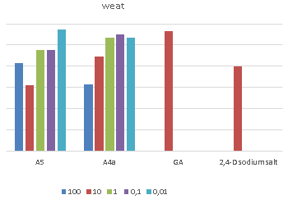

Figure 10 - Influence of 3-(2-chloro-quinoline-3-yl)-2-(4-phenyl-1,3-thiazole-2-yl)-acrylonitrile (A-4a) and semicarbazone 2,2-dimethyltetrahydrotyopiran-4-one (A-5) on root length
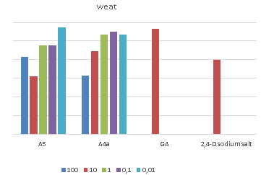

Figure 11 - Influence of 3-(2-chloro-quinoline-3-yl)-2-(4-phenyl-1,3-thiazole-2-yl)-acrylo-nitrile (A-4a) and semicarbazone 2,2-dimethyltetrahydrotyopiran-4-one (A-5) on root mass

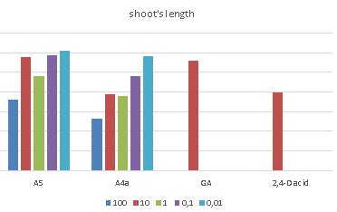

Figure 12 - Influence of 3-(2-chloro-quinoline-3-yl)-2-(4-phenyl-1,3-thiazole-2-yl)-acrylo-nitrile (A-4a) and semicarbazone 2,2-dimethyltetrahydrotyrotyopyran-4-one (A-5) on the length of the shoo

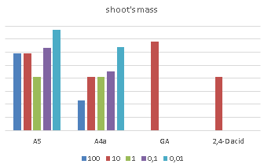

Figure 13 - Influence of 3-(2-chloro-quinoline-3-yl)-2-(4-phenyl-1,3-thiazole-2-yl)-acrylo-nitrile (A-4a) and semicarbazone 2,2-dimethyltetrahydrotyopiran-4-one (A-5) on the mass of the shoot.

Tabular data and data in Figures 10-13 show that seed treatment with solutions of semicarbazone 2.2-dimethyltetrahydrotiopiran-4-one (A-5) in concentrations of 0.1 mg/l (10⁻⁵ wt %) and 0.01 mg/l (10⁻⁶ wt %) increases the length and weight of roots, length and weight of wheat shoots. Growth rates are superior to growth rates when treated with gibberellinic acid solutions and water.
The same data show that seed treatment with a 3-(2-chloro-quinoline-3-yl)-2-(4-phenyl-1,3-thiazole-2-yl)-acrylo-nitrile (A-4a) solution in a concentration of 0.01 mg/l (10⁻⁶ wt%) increases the length and weight of the roots, the length and weight of wheat shoots. At the same time, the growth rates are higher than those of gibberellinic acid solutions and water.

2.2 Bio-testing on cucumber seeds

Scheme of experience on cucumber seeds TCHA-98 F1 Next.
Water (control1), gibberellinic acid (GA) at a concentration of 10 mg/l and sodium salt of 2.4-dichlorophenoxy acetic acid (2.4 D-Na) at a concentration of 10 mg/l were chosen as controls. Aqueous solutions of 3-(2-chloro-quinoline-3-yl)-2-(4-phenyl-1,3-thiazole-2-yl)acrylonitrile (A-4a) and semicarbasone 2,2-dimethyltetra-hydrotyopiran-4-one (A-5) in concentrations were used in the pilot versions: 100 mg/l (10⁻² wt%), 10 mg/l (10⁻³ wt%), 1 mg/l (10⁻⁴ wt%), 0.1 mg/l (10⁻⁵ wt%), 0.01 mg/l (10⁻⁶ wt%). The duration of the treatment was 6 hours. After treatment, the seeds were germinated in a thermostat at 25ºC for 48 hours. For better aeration, the ditches were ventilated every 24 hours of germination (coverings were removed for 10 minutes each time). Repeat experience - 2 times 10 seeds in repeat (two cuvettes per option).
The growth parameters were the length of the root and the total mass of the roots. Measurements using millimetre paper under glass. The effect of 3-(2-chloro-quinoline-3-yl)-2-(4-phenyl-1,3-thiazole-2-yl)acrylo-nitrile (A-4a) and semicarbazone 2,2-dimethyltetrahydrotyopyran-4-one (A-5) on cucumber seed germination is shown in Table 10 and Figure 14.

Table 10 - Influence of 3-(2-chloroquinoline-3-yl)-2-(4-phenyl-1,3-thiazole-2-yl)acrylonitrile (A-4a) and semicarbazone 2,2-dimethyltetrahydrotyopiran-4-one (A-5) on cucumber seed germination

Preparation, concentration, mg/l | germination capacity, % | % to control
А 5
100 | 57,1 | 59,8
10 | 68,2 | 71,4
1 | 65,0 | 68,1
0,1 | 90,5 | 94,8
0,01 | 95,0 | 99,5
A4a
100 | 95,2 | 99,7
10 | 90,5 | 94,8
1 | 94,7 | 99,2
0,1 | 90,0 | 94,2
0,01 | 100,0 | 104,7
Regulators of plant growth
2.4 D-Na | 50,2 | 52,6
GA | 94,4 | 98,9
Control - water | 95,5 | 100

Tabular data show that when treating cucumber seeds with 3-(2-chloro-quinoline-3-yl)-2-(4-phenyl-1,3-thiazole-2-yl)acrylonite-ril (A-4a) solutions at a concentration of 0.01 mg/l (10-6 wt%), cucumber germination is better than in water and gibberellinic acid solution.
At concentrations greater than 0.01 mg/l (10⁻⁶ wt %), there is a deterioration in results compared to controls.
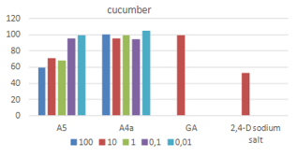

Figure 14 - Influence of 3-(2-chloro-quinoline-3-yl)-2-(4-phenyl-1,3-thiazole-2-yl)acrylonitrile (A-4a) and semicarbazone 2,2-dimethyltetrahydrotyopiran-4-one (A-5) on cucumber seed germination

When treating cucumber seeds with semicarbazone solutions, 2.2-dimethyltetrahydrotyopiran-4-one (A-5) in a wide range of concentrations results in lower germination rates of cucumbers compared to gibberellinic acid and water. The effect of 3-(2-chloro-quinoline-3-yl)-2-(4-phenyl-1,3-thiazole-2-yl)-acrylo-nitrile (A-4a) and semicarbazone 2,2-dimethyltetrahydrotyopyran

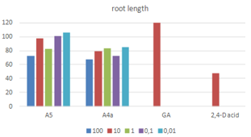

Figure 15 - Influence of 3-(2-chloro-quinoline-3-yl)-2-(4-phenyl-1,3-thiazole-2-yl)acrylonitrile (A-4a) and semicarbazone 2,2-dimethyltetrahydrotyopiran-4-one (A-5) on cucumber root length
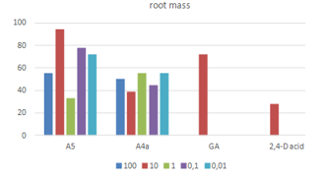

Figure 16 - Influence of 3-(2-chloro-quinoline-3-yl)-2-(4-phenyl-1,3-thiazole-2-yl)acrylonitrile (A-4a) and semicarbazone 2,2-dimethyltetrahydrotyopiran-4-one (A-5) on cucumber root mass

Table 11 - Influence of 3-(2-chloro-quinoline-3-yl)-2-(4-phenyl-1,3-thiazole-2-yl)acrylonitrile (A-4a) and semicarbazone 2,2-dimethyltetrahydrotyopyran-4-one (A-5) on cucumber seeds germination

Concentration, mg/l | The length of the root |  | Weight of roots
Concentration, mg/l | sm | % to control | g | % to control
А5
100 | 1,27 ± 0,85 | 72,2 | 0,1 | 55,6
10 | 1,72 ± 0,55 | 97,7 | 0,17 | 94,4
1 | 1,45 ± 0,69 | 82,4 | 0,06 | 33,3
0,1 | 1,77 ± 0,47 | 100,6 | 0,14 ± 0,04 | 77,8
0,01 | 1,87 ± 0,56 | 106,3 | 0,13 ± 0,00 | 72,2
A4a
100 | 1,19 ± 0,34 | 67,6 | 0,09 ± 0,01 | 50
10 | 1,39 ± 0,55 | 79 | 0,07 ± 0,02 | 38,9
1 | 1,47 ± 0,42 | 83,5 | 0,1 ± 0,01 | 55,6
0,1 | 1,28 ± 0,4 | 72,7 | 0,08 ± 0,01 | 44,4
0,01 | 1,5 ± 0,56 | 85,2 | 0,1 ± 0,01 | 55,6
Growth regulators
GA | 2,16 ± 0,39 | 122,7 | 0,134 ± 0,02 | 72,2
2.4 D- Na | 0,84 ± 0,25 | 47,7 | 0,05 ± 0,01 | 27,8
Control water . | 1,76 ± 0,66 |  | 0,18 ± 0,06
Studies on the effect of sulfur-containing compounds on cucumber seed germination show that 3-(2-chloro-quinoline-3-yl)-2-(4-phenyl-1,3-thiazole-2-yl)acrylonitrile (A-4a) in the entire concentration range and semicarbazone 2,2-dimethyltetrahydrotyopiran-4-one (A-5) in concentrations above 0.01 mg/l (10⁻⁶ wt. %) show worse results than controls.
Treatment of cucumber seeds with a 7-carbazon 2.2-dimethyltetra-hydrotyopiran-4-one (A-5) solution at a concentration of 0.01 mg/l (10⁻⁶ wt %) gives better results than water, but worse results than gibberellinic acid.
Thus, laboratory assessment of the rostregulating activity of sulfur-containing compounds in the plant biotest system showed that 3-(2-chloro-quinoline-3-yl)-2-(4-phenyl-1,3-thiazole-2-yl)acrylonitrile (A-4a) and semicarbazone 2,2-dimethyl-tetrahydrotyopiran-4-one (A-5) show rostregulating activity on wheat at a concentration of 0.01 mg/l (10⁻⁶ wt). %). At high concentrations, an inhibitory effect is observed.

3 Laboratory study of the impact of sulfur regulators and plant growth stimulants (intensifiers) on the phytoremediation potential of phytoremediatric plants

To study the phytoremediation potential in the greenhouse, the plants (Xanthium strumarium and Cucurbita pepo L. Pumpkin) were planted both on contaminated soil from the Kanzhugan area and on uncontaminated soil around the field (control). The experience was repeated twice.
Before the experiment, contaminated and uncontaminated soil was sifted through a sieve with a pore diameter of 3 mm, after which it was thoroughly mixed. The bottom of the vessel (1.0 kg weight) was then filled with drainage.
The drainage was then covered with gauze and river sand (1.0 kg of sand) was poured over the top and gauze was closed again. Then the vessel was filled with the studied soil (soil mass 8.0 kg). To prevent the soil from drying out, a single layer of sand was poured from above. After filling, the vessel was weighed. The total weight of the contents of the vessel was 10 kg.
After planting, the soil was once treated with 2.2-dimethyltetrahydrotyopiran-4-one and 2-amino-4-phenyl-1.3-thiazole solutions of semicarbazone in a concentration of 0.001 wt%. Subsequently, plants were irrigated with water.
Before planting and during the blooming of annual species, soil and vegetative organ samples were taken to determine pesticide content and growth performance.
The content of pesticides in soil was determined on the Colour chromatograph using the HP-5 capillary column and an electron capture detector.
The total content of pesticides (4'4 - DDE, 4'4 - DDT, 2'4 - DDT) in soil (beginning of the experiment) was found to be (740 ± 10) µg/kg.
Previously, it was found that the phytoremediation potential depends on the growth performance of the plants - phytoremedians. The greater the length and weight of the roots and above-ground part of the plant, the greater the storage capacity of the plant.
Growth indices and residual pollutants in the above-ground and underground parts of plants were used as assessment criteria for plant storage capacity.
The impact of sulphur-containing compounds on growth performance is shown in Tables 12 and 13.
Tabular data show that the semicarbazone 2,2-dimethyl-tetrahydrotyrotyopiran-4-one and 2-amino-4-phenyl-1,3-thiazole are exhibiting growth stimulating activity.
Thus, 2-amino-4-phenyl-1,3-thiazole increases the height of phyto-remedial plants by (10-28) %, root length by (6-10) % and biomass by 1.5 times.

Table 12 - Impact of the Xanthium strumarium and Cucurbita pepo L treatment. Pumpkin 0.001 % by 2-amino-4-phenyl-1.3-thiazole solution on plant growth - phytoremediants

Experience option | Height of plants, see | Length of root, see | Biomass, g
Xanthium strumarium
Pesticide-contaminated soil | 65,09 ± 2, 10 | 9,59 ± 0,20 | 9,80 ± 0,30
Soil contaminated with pesticides sprayed with 2-amino-4-phenyl1,3-thiazole solution | 72,12 ± 2,50 | 10,18 ± 0,60 | 18,50 ± 0,40
Cucurbita pepo L. Pumpkin
Pesticide-contaminated soil | 51,54 ± 2,52 | 8,27 ± 0,70 | 18,50 ± 1,30
Soil contaminated with pesticides sprayed with 2-amino-4-phenyl1,3-thiazole solution | 66,0 ± 3,54 | 9,12 ± 0,72 | 24,54 ± 1,04

Table 13 - Impact of the Xanthium strumarium and Cucurbita pepo L treatment. Pumpkin 0.001 % by 7-carbazone 2.2-dimethyltetrahydrotyopiran-4-one solution on plant growth - phytoremediants

Experience option | Height of plants, see | Length of root, see |  | Biomass, g
Xanthium strumarium
Pesticide-contaminated soil | 65,09 ± 2, 10 | 9,59 ± 0,20 |  | 9,80 ± 0,30
Soil contaminated with pesticides sprayed with a semicarbazone solution 2.2-dimethyltetrahydro-tiopiran-4-one | 83,30 ± 2,50 | 10,90 ± 0,50 |  | 19,10 ± 0,50
Cucurbita pepo L. Pumpkin
Pesticide-contaminated soil | 51,54 ± 2,52 | 8,27 ± 0,70 | 18,50 ± 1,30
Soil contaminated with pesticides sprayed with a semicarbazone solution 2.2-dimethyltete-rahydrotyopiran-4-one | 66,0 ± 2,50 | 9,80 ± 1,00 |  | 22,50 ± 1,00

Semycarbazone 2.2-dimethyltetrahydrotyopiran-4-one increases the height of Phytoremedian plants by (28 - 30) %, root length by (13 - 18) % and biomass by (1.5 - 2) times. The impact of sulphur-containing compounds on the content of pesticides in vegetative organs is shown in Tables 14 and 15.

Table 14 - Impact of the Xanthium strumarium and Cucurbita pepo L treatment. Pumpkin 0.001 % by 2-amino-4-phenyl-1.3-thiazole solution on pesticide content in the vegetative organs of phytoremediatricians

Experience options | Pesticide concentration in ground part of plant, µg/kg | Pesticide concentration in the underground part of the plant, µg/kg
Xanthium strumarium
Without treatment | 106,8 ± 5,1 | 247,0 ± 10,5
With processing | 118,1 ± 10,3 | 439,0 ± 10,0
Cucurbita pepo L. Pumpkin
Without treatment | 163,4 ± 17,5 | 339,8 ± 12,5
With processing | 193,4 ± 13,5 | 391,5 ± 11,5

Table 15 - Impact of the Xanthium strumarium and Cucurbita pepo L treatment. Pumpkin 0.001 % by 7-carbazone 2.2-dimethyltetranitetranitrothiopiran-4-one solution on the pesticide content of phytoremedian vegetative organs

Experience options | Pesticide concentration in ground part of plant, µg/kg | Pesticide concentration in the underground part of the plant, µg/kg
Xanthium strumarium
Without treatment | 106,8 ± 5,1 | 247,0 ± 10,5
With processing | 124,0 ± 10,0 | 450,0 ± 10,0
Cucurbita pepo L. Pumpkin
Without treatment | 163,4 ± 17,5 | 339,8 ± 12,5
With processing | 210,0 ± 10,0 | 425,0 ± 10,0

Tabular data show that the treatment of phytoremedian 0.001 % with a solution of 2-amino-4-phenyl-1.3-thiazole increases the accumulation of pesticides in the above-ground part by (10 - 18) % and in the underground part by (15 - 70) %.
Phytoremedian treatment of 0.001 % with a semicarbazone 2.2-dimethyltetrahydrotyrotyopiran-4 solution increases the accumulation of pesticides in the above-ground part by (16-28) % and in the underground part by (25-80%) %.
Xanthium strumarium and Cucurbita pepo L. Pumpkin mainly accumulates pesticides in the underground part of plants - phyto-medicals.
Thus, the treatment of phytoremediants with solutions of semicarbazone 2,2-dimethyltetrahydrotyopiran-4-one and 2-amino-4-phenyl-1,3-thiazole stimulates plant growth and enhances its storage capacity, and these sulfur-containing compounds are intensifiers of phytoremediation technology for soil treatment.

- Testing of phytoremediation technology for cleaning soils brought from the South Kazakhstan region and evaluation of the effectiveness of the technology application

A site at the existing mining site of the Kanzhugan uranium production enterprise was selected for pilot testing under the project.
The enterprise is located in the central part of the Chu-Sarysu depression, in the south-western part of the Betpak-Dala plateau, in Suzak district of Turkestan region.
The pilot site is a part of the ~20 sq m mining area contaminated by spills of technological solutions.
On the site, the seeds of common (Xanthium strumarium) and red (Amaranthus) cockpit were sown in a row without pre-treatment (control) and with a solution of 2.2-dimethyl-4-(5'-amino-1'2'4'-triazolo-3'-thiopropynyl) tetrahydropyrane-4-ola (C = 0.0001 wt. %). Plant seeds were sown at the rate of 1.5-2 g per 1 m2.
Experimental work was conducted over a 6-month period (April - September 2020). In order to obtain maximum seed germination, the site was irrigated during the entire period of the pilot work (Figure 1).

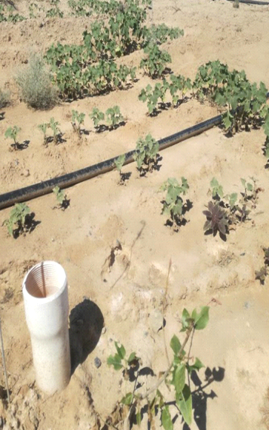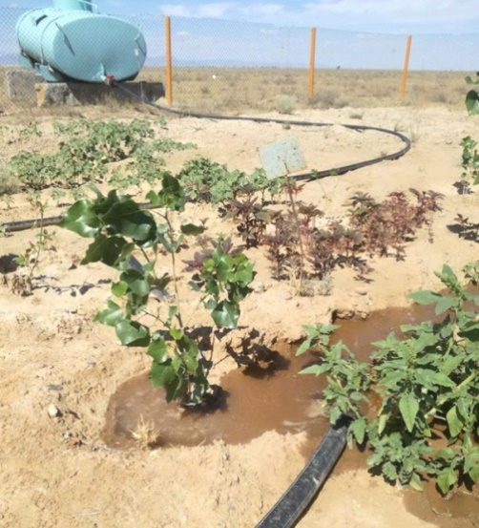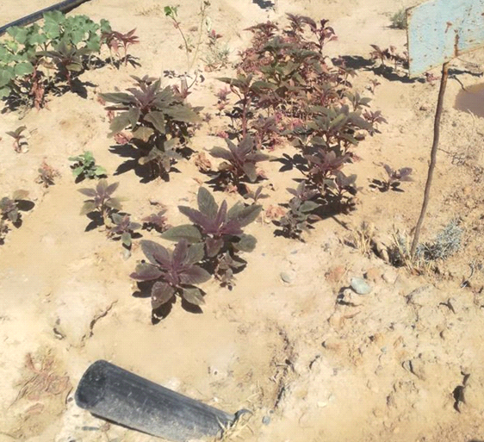

Figure 1 - Pilot plot with planted plants
(Waste well is marked in red)

At the end of the survey, the plants were extracted from the soil, distributed in groups (root, stem), dried, crushed in a mortar and osulated in a muffle kiln at 400 ºC ^{for} one hour.
The resulting ash was grinded to a homogeneous powder and subjected to autoclave decomposition in a mixture of concentrated acids in a microwave oven at 160 ºC until it was completely dissolved.
Uranium and metal content in samples was determined by ICP MS method (Tables 1 and 2).

Table 1 - Uranium content (mg/kg) in the vegetative organs Xanthium strumarium and Amaranthus (soil uranium content 166 mg/kg)

Plant | Underground part | Ground part
Xanthium strumarium (control) | 117 ± 2,5 | 84,2 ± 2,0
Xanthium strumarium | 149,9 ± 3,0 | 98,5 ± 2,0
Amaranthus (control) | 137,2 ± 2,0 | 145,3 ± 2,5
Amaranthus | 162,5 ± 2,0 | 175,0 ± 3,0

Table 2 - Metal content (mg/kg) in vegetative organs of Xanthium strumarium and Amaranthus and soil

Element | Soil | Xanthium strumarium |  |  | Amaranthus
Element | Soil | Root .  (control) | root | stalk | Root .  (control) | root | stalk
Pb | 106,1± 0,5 | 42,6 ± 0,5 | 57,3± 0,5 | 23,8± 0,5 | 37,9± 1,0 | 47,6± 1,0 | 21,9± 1,0
Zn | 82,6 ± 0,5 | 30,4± 0,5 | 39,5± 0,5 | 18,6± 0,5 | 20,4± 1,0 | 23,1± 1,0 | 14,6± 1,0
Cu | 19,0 ± 0,5 | 10,7± 0,5 | 12,4± 0,5 | 9,7± 0,5 | 8,3± 1,0 | 10,6± 1,0 | 7,9± 1,0
Cr | 79,4 ± 0,5 | 25,8± 0,5 | 32,5± 0,5 | 16,6± 0,5 | 21,6± 1,0 | 27,9± 1,0 | 11,4± 1,0
Fe | 26,5 ± 0,5 | 16,6± 0,5 | 19,3± 0,5 | 13,8± 0,5 | 14,8± 1,0 | 17,2 ± 1,0 | 11,0 ± 1,0
Mn | 64,6 ± 0,5 | 15,9± 0,5 | 24,7± 0,5 | 13,5± 0,5 | 24,9± 1,0 | 32,1± 1,0 | 19,6± 1,0

Tabular data show that Xanthium strumarium and Amaranthus accumulate uranium and metals by (20-30 % more than the same untreated phytoremediants after planting with a 2.2-dimethyl-4-(5'-amino-1'2'4'-triazolo-3'-thiopropynyl) solution. This compound is an intensifier of technology for cleaning soil from persistent inorganic pollutants and radionuclide - uranium.
In addition, the results of the survey show that uranium and metals mainly accumulate in the underground part of plants.

CONCLUSION

The following conclusions were drawn from the results of these studies:
- Technologies for obtaining sulfur-containing intensifiers for phytoremediation technology have been developed (task 3 of the calendar plan).
A technology has been developed to produce 3-(2-chloroquinoline-3-yl)-2-(4-phenyl-1,3-thiazole-2-yl) acrylonitrile by cyclo-condensation of 3-(2-chloroquinoline-3-yl)-2-ciano-p-2-entioamide with bromacetophenone. It has been established that the reaction takes place using a standard mechanism typical of Ganch synthesis, with the formation of intermediate ketone with bromine detachment and cyclization into thiazolin with subsequent dehydration. Replacing ethyl alcohol with isopropyl, all other things being equal, leads to an increase in the yield of the final product from 47-57% to 74%.
A technology has been developed to produce 2.2-dimethyl-tetrahydrotyrothiopiran-4-one with sevencarbazide. In turn, 2.2-dimethyltetrahydrothyo-Piran-4-one was obtained by the interaction of β,β-dimethyldivinyl ketone with hydrogen sulphide.
. It has been established that β,β-dimethyldivinyl ketone can be obtained by isomerisation of dimethyldivinyl ethinylcarbinol in the presence of mercury sulfate both in acetone and ethanol environments.
A technology has been developed to produce 2-amino-4-phenyl-1,3-thiazole by condensing acetophenone with thiourea and iodine. A study of the process has shown that the maximum yield (85%) of the product is achieved by interaction of reagents in an autoclave within 24 hours.
The structure of the products obtained has been proven by infrared, ^{13C} NMR and ^{1H} NMR spectroscopy.
- A study of the effect of sulphur-containing regulators on the stimulating effect of compounds using plant biotests was carried out and an assessment of soil phytotoxicity was made (task 3.1 of the schedule).
It was found that the treatment of wheat seeds with seven-carbazone 2.2-dimethyltetrahydrotiopiran-4-one (A-5) solutions in concentrations of 0.1 mg/l (10^{-5 wt} %) and 0.01 mg/l (10⁻⁶ wt %) increases the length and weight of roots, length and weight of wheat shoots. Growth rates are superior to growth rates when treated with gibberellinic acid solutions and water.
Treatment of wheat seeds with a 3-(2-chloro-quinoline-3-yl)-2-(4-phenyl-1,3-thiazole-2-yl)-acrylonitrile (A-4a) solution in a concentration of 0.01 mg/l (10⁻⁶ wt%) increases the length and weight of the roots, the length and weight of wheat shoots. At the same time, the growth rates are higher than those of gibberellinic acid solutions and water.
Studies on the effect of sulfur-containing compounds on cucumber seed germination show that 3-(2-chloro-quinoline-3-yl)-2-(4-phenyl-1,3-thiazole-2-yl)acrylonitrile (A-4a) in the entire concentration range and seven-carbazone 2,2-dimethyltetrahydrotyopiran-4-one (A-5) in concentrations above 0.01 mg/l (10⁻⁶ wt). %) show worse results than controls.
Treatment of cucumber seeds with a 7-carbazon 2.2-dimethyltetra-hydrotyopiran-4-one (A-5) solution at a concentration of 0.01 mg/l (10⁻⁶ wt %) gives better results than water, but worse results than gibberellinic acid.
Thus, laboratory assessment of the rostregulating activity of sulfur-containing compounds in the plant biotest system showed that 3-(2-chloro-quinoline-3-yl)-2-(4-phenyl-1,3-thiazole-2-yl)acrylonitrile (A-4a) and seven-carbazone 2,2-dimethyltetrahydrotyopiran-4-one (A-5) show rostregulating activity on wheat at a concentration of 0.01 mg/l (10⁻⁶ wt). %). At high concentrations, an inhibitory effect is observed.
- Laboratory studies of the impact of sulfur-containing regulators on the phytoremediation potential of phytoremediatric plants were conducted (section 3.2 of the schedule).
In order to study the phytoremediation potential of greenhouses, we chose the hazelnut, red width, Kazakhstan poplar and giant Miskantus as the phytoremediation plants.
It has been established that the phytoextraction potential of plants depends on biomass: a reduction in plant biomass reduces the phytoremediation potential, while an increase in biomass, on the contrary, increases.
Phytoremedian treatment of 0.001 % by a solution of 2-amino-4-phenyl-1.3-thiazole increases pesticide accumulation in the above-ground part by (10 - 18) %, in the underground part by (15 - 70) %.
Phytoremedian treatment of 0.001 % with a seven-carbazone 2.2-dimethyltetrahydrotyrotyopiran-4 solution increases the accumulation of pesticides in the above-ground part by (16-28) % and in the underground part by (25-80%) %.
Xanthium strumarium and Cucurbita pepo L. Pumpkin mainly accumulates pesticides in the underground part of plants - phyto-medicals.
Thus, the treatment of phytoremediants with solutions of seven-carbazone 2,2-dimethyltetrahydrotyopiran-4-one and 2-amino-4-phenyl-1,3-thiazole stimulates plant growth and enhances its storage capacity, and these sulfur-containing compounds are intensifiers of phytoremediation technology for soil treatment.
- Phytoremediation technology for cleaning soils brought from the South Kazakhstan region was tested and the effectiveness of the technology was assessed.
A site has been selected at the existing mining site of the Kanzhugan uranium production facility. At the site, seeds of Siberian (Xanthium strumarium) and red (Amaranthus) cockpit were sown in series without pre-treatment (control) and with 2.2-dimethyl-4-(5'-amino-1'2'4'-triazolo-3'-thiopropynyl) tetrahydropyrane-4-ola solution (C = 0.0001 wt%). Plant seeds were sown at the rate of 1.5-2 g per 1 m2.
Experimental work was conducted over a 6-month period (April - September 2020). At the end of the pilot work, plant samples were analysed for uranium and other elements.
Xanthium strumarium and Amaranthus have been found to accumulate uranium and metals by (20-30 % more than the same untreated phytoremediants after planting with a 2.2-dimethyl-4-(5'-amino-1'2'4'-triazolo-3'-thiopropynyl) solution. This compound is an intensifier of technology for cleaning soil from persistent inorganic pollutants and radionuclide - uranium.
In addition, the results of the survey show that uranium and metals mainly accumulate in the underground part of plants.
Scientific novelty of the results obtained
The technologies developed to produce sulfur-containing intensifiers for phytoremediation technology are new directions in the synthesis of heterocyclic compounds. The compounds obtained in the project are new objects for studying the reactivity of organic compounds, biological and surface activity. The experimental and theoretical results obtained in the course of the project will contribute to solving the main issue of fundamental chemistry - the relationship between the structure of an organic substance and its surface and biological activity.
Practical significance
The results of the research on this project will make it possible to expand the possibilities of chemical methods for producing sulphur-containing monocyclic structures and attract new substances with specified properties to the industry.
Based on the results of project studies, sulphur-containing intensifiers may be recommended for use in agriculture and the environment.
The results obtained are subject to commercialization. Competitiveness of the results obtained in comparison with foreign studies. The results obtained are competitive in terms of Kazakhstan content and the absence of systematic research in this area abroad.
Assessment of the completeness of tasks and social significance.
The tasks set in the project for 2019 have been successfully completed.
The high assessment of the level of the study carried out under the project "Technology for obtaining intensifiers of phytoremediation technology for soil treatment from persistent organic and inorganic pollutants and radionuclides" is confirmed by publications:
- Issenova G., Mitrofanova A., Kalugin S., Efremov S., Sagitov A., Effect of compositions of derivatives of oxane and carbon minerals on the growth and development of wheat crop// Crop research and research on crops - International Journal on Crops, Farming and Agri-Management - 2018 - Vol. 19. No. 2 - P. 191-199 (Q 3, Impact Factor 2018: 1.3 , SJR:0,24).
- Nurzhanova A.A., Pidlinuik V., Muratova A.Y., Berzhanov R.J., Abit K., Nurmagambetova A., Nurzhanov C., Mukasheva TD, Bektileuova N.K. Phytoremediation of soils contaminated with metals by means of bioenergy type miscanthus giganteus// Messenger of Al-Farabi Kazakh National University, Environmental Series - Almaty 2018 - No. 3 - C. 32-45.
- Nurzhanova A., Pidlisnyuk V., Abit K., Nurzhanov Ch., Kenesov B., Stefanovska T. Using of miscanthus x giganteus for phytoremediation of the contaminated soil: case of military and mining sites // The ^{15th} international ,phytotechnology conference - Novi Sad, Serbia - 2018 - P.158.
- Assylkhanov Zh.S., Kalugin S.N., Russinov V.L., Mursalieva V.K., Nurzhanova A.A., Kozhebayevs Zh.S., Safarova K.A. Initial assessment of the growth-regulating activity of some oxane and piperidine derivatives in the system of plant biotests // Izvestia of the Scientific and Technical Society "Kahaq". – 2019. - № 2 (65). – С. 4 – 14.
- K. Kishibayev, Zh. Assylhanov, D. Markina, S. Kalugin, V.Russinov. Preparation and study of growth stimulating activity of 1-propyl-4-(3'-amino-1', 2', 4'-tiazolo-3'-thiopropinyl)piperidin-4-ol // Studia UBB Chemia. – 2019. - LXIV. - № 4. - P. 177-189. (Q 4, Impact factor 2019: 0.494, SJR:0,17).
- Markina D.B., Belskaya N.P., Kalugin S.N., Tsukerman, M.V., Asylkhanov, J.S., Nurzhanova, A.A. Synthesis of 1,3-thiazole derivatives as plant growth stimulants and fluorophores (in Russian) // Izvestia S.T. "Kahak" Scientific and Technical Society. - – 2020.- № 2 (69) – С.67 – 75.
LIST OF USED SOURCES

1 Prasad M.N. Bioremediation and Bioeconomy. – London: Elsevier, 2015. – 730 p. (in Eng.).

2 Khalid R.H. Soil Remediation and Plants / S. Muhammad, O. Munir, R.M. Ahmet. – London: Elsevier, 2015. – 707 p. (in Eng.).
3 Barcelo J., Poschenrieder C. Phytoremediation: Priciples and Perspectives // Contribution to Science. – 2003. – № 2. – P.333 – 334. (in Eng.).
4 Tsao D.T. Overview of phytotechnologies // Advances in Biochemical Engineering / Biotechnology Phytoremediation. – Springer-Verlag: Berlin. – 2003. – Vol. 78. – Р. 50. (in Eng.).
5 Nurzhanova А., Kulakow P., Rubin E., Rakhimbayev I., Sedlovskiy A., Zhambakin K., Kalugin S., Kalmykov L., Erickson L. Plant species monitoring for phytoremediation of pesticide-contaminated soil // 7 International HCH and Pesticides Forum: Abstracts. – Kiev, Ukraine, 2003. – Р. 38. (in Eng.).
6 Prasad M. N. Practical use of plants for restoration of ecosystems contaminated with metals // plant Physiology. – 2003. – Vol. 50. – No. 5. – P. 764-780. (in Russ.).
7 Nurzhanova A. Analysis of residual amounts of pesticides in the soils of some objects of the Almaty region / A. Sedlovsky, K. Zhambakin, S. Kalugin // Bulletin of al-Farabi Kazakh national University. Chemical series. - Almaty, 2003. – No. 3 (31). – P.283-286. (in Russ.).
8 Nurzhanova A. The need for remediation of pesticide-contaminated soils of Kazakhstan / P. Kulakow, G. Turner, A. Sedlovskiy, I. Rakhimbayev, K. Zhanbakin, S. Kalugin, L. Niketevich, L. Erickson // 8 International FZK/TNO conference on contaminated Soil. Abstracts of Presentations. – Gent: Belgium, 12-16 May, 2003. – P. 199. (in Eng.).
9 Karthikeyan R., Рotential of plant-based remediation of pesticide contaminated soil and water using non-target plants such as trees, shrubs, and grasses / D C. Lawrence, L.E. Erickson и др. // Critical Reviews in Plant Sciences, 2004. – Vol. 23, № 1. – С. 1-11. (in Eng.).
10 Nurzhanova A. Problems of soil cleaning in Kazakhstan from pesticide contamination / G. Turner, P. Kulakov, A. Sedlovsky, K. Zhambakin, L. Erikson, S. Kalugin / / Biotechnology. Theory and practice. – 2004. – No. 2. – P. 43-48. (in Russ.).
11 Elizabeth Pilon-Smits. Phytoremediation // Ann. Rev. Plant Biol. – 2005. – Р. 15-39. (in Eng.).
12 Ghosh M., Singh S.P. A review on phytoremediation of Heavy Metals and Utilization of It’s by products // As.Journal Energy Env. – 2005. – №6. – P.214-231. (in Eng.).
13 Nurzhanova A., Kulakow P., Rubbin E., Rakhimbayev I., Sedlovskiy A., Zhambakin K., Kalugin S., Kalmukow L. Use of wild plants for phytoremediation of Kazakhstan soils polluted with pesticides // Consoil 2005. «ISTC Science Workshops at the International Conference on Contamination Soil»: Abstracts. – Bordaux: France, 2005. – P. 64-69. (in Eng.).
14 Nurzhanova А., Kulakow P., Rubin E., Rakhimbaev I., Sedlovskiy A., Zhambakin K., Kalugin S.N., Kalmykov L., Erickson L. The quantitative and qualitative analysis of residual pesticides in plant tissue // 8 International HCH and Pesticides Forum: Abstracts. – Sofia: Bulgaria, 2005. – P. 345. (in Eng.).
15 Nurzhanova A., Kulakow P., Turner G., Sedlovskiy A., Zhanbakin K., Kalugin S., Niketevich L. Use of wild plants for detoxication chlororganic pesticides in soill // VII Inetrmational Scientific Conference «Current and Future Challenges in Environmental Health, Toxicology, and Food Safety in Eastern and Central Europe»: Abstracts – Kyiv: Ukraine, 2006. – P. 62. (in Eng.).
16 Pashkevich M. A., Ponurova I. K. Geoecological features of technogenic pollution of natural ecosystems in the zone of impact of tailings dumps of the Mikhailovsky GOK // Mining information and analytical Bulletin. – 2006. – No. 5. – P.349-356. (in Russ.).
17 Nurzhanova А, Kulakow P., Rubin E., Rakhimbayev I, Sedlovskiy A., Zhambakin K.,.Kalugin S, Kolysheva O., Erickson L. Studing of Accumulation and Distribution Chlororganic Pesticides in Tissue of Colonizing Plants Species on Pesticide Polluted Soil in Kazakhstan // The International Conference «Application of Phytotechnologies for Cleanup of Industrial, Agricultural and Wastewater Contamination»: Book of Abstracts. – Kamenetz-Podilsky, Ukraine, 2007. – P. 21. (in Eng.).
18 Dowling D.N., Doty S.L. Improving phytoremediation through biotechnology // J. Curr. Opin. Biotechnol., – 2009. – Vol. 20. – Р. 204-206. (in Eng.).

19 Nikolaeva N. Phytoremediation as a modern and effective way to clean the soil. – London: LAP Lambert Academic Publishing, 2010. – 124 p. (in Russ.).
20 Nurzhanova A., Kulakow P., Rubin R., Rahimbaev I., Sedlovskiy A., Zhambakin K., Kalugin S., Kolysheva E., Erickson L. Obsolete pesticides pollution and phytoremediation of contaminated soil in Kazakhstan // Application of phytotechnologies for cleanup of industrial, agri-cultural and wastewater contamination / Edited by P.Kulakow, V.Pidlisnyuk – London: Springer, 2010 – P. 87 – 106. (in Eng.).
21 Kalugin S. N., Nurzhanova A. A. and others. Use of wild plant species for phytoremediation of soils contaminated with pesticides // Ecological and biological problems of Siberia and adjacent territories: materials of the I International scientific and practical conference-Nizhnevartovsk: Russia, 2010. – С.40-47. (in Russ.).
22 Nurzhanova A. Obsolete Pesticides and Phytoremediation of Polluted Soil in Kazakhstan / K. Zhambakin, S. Kalugin and all. // Journal of Life Sciences – 2011. – № 5. – Р. 526–538. (in Eng.).
23 Nurzhanova A. A., Kalugin S. N., Zhambakin K. Zh. Recommendations for phytoremediation of soils contaminated with pesticides. – Almaty, 2011. – 54 p. (in Russ.).
24 Nurzhanova A. Organochlide pesticide and university Pumkin germplasm in Kazakhstan / S. Kalugin, M. Ermekova, Q. Tagaev, Z. Aytasheva // International Journal of Biology and Chemistry. – 2012. – No. 4. –P. 13-17. (in Eng.).
25 Martynychev A.V. Application of phytoremediation of soil to clean agricultural land // Bulletin of the NGIEI.– 2012. – No. 10. – P. 56-63. (in Russ.).
26 Timofeeva S. S. Modern phytotechnologies in solving ecological problems of the Baikal region // Irstu Bulletin. – 2012. – Vol. 2. – P. 52-58. (in Russ.).
27 Montinaro S., Concas A., Pisu V., Cao G. Remediation of heavy metals contaminated soils by ball milling // Chemical Engineering Tranaction. – 2012. – V28. – P.921-928. (in Eng.).
28 Nurzhanova A., Kalugin S., Zhambakin K. Obsolete pesticides and application of colonizing plant species for remediation of contaminated soils in Kazakhstan // Environmental Science and Pollution Research. – 2013. – Vol. 20. – P. 2054-2063. (in Eng.).
29 Subhashini V., Swamy A. Phytoremediation of Pb and Ni contaminated soils using Catharanthus roseus // Universal Journal of Environmental Research and Technology. – 2013. – №3. – P.465-472. (in Eng.).
30 Ali H., Khan E., Sajad M. Phytoremediation of heavy metals – Concepts and application // Chemoshere. – 2013. – P.869-881. (in Eng.).
31 Kavitha B., Jothimani P. Phytoremediation of heavy metals – a review // International Journal of Research Studies in Biosciences. – 2013. – P.17-23. (in Eng.).
32 Kalugin S. N., Nurzhanova A. A., Baizhumanova R. A., Mitrofanova A. A., Zhumasheva Zh. E. Induced phytoremediation of pesticide-contaminated soils using oxane derivatives // Proceedings of the Samara scientific center of the Russian Academy of Sciences. – 2013. – Vol.15. – No3. – P. 1306-1310. (in Russ.).
33 Nurzhanova A. A., Aytasheva Z. G., Kalugin S. N., Zhumashev Zh. E., Oraz S., K. Kashcheev Possibilities of using cucurbito pepo for phytoremediation of soils contaminated with DDT matabolites // Bulletin of KazNU, environmental series.– 2013. – No. 2. – P. 259-263. (in Russ.).
34 Nurzhanova A. A., Aytasheva Z. G., Kalugin S. N., Zhumashev Zh. E., Oraz S., Kashcheev K. Kusainova Zh., S. Turashev Features of adaptive processes in plants of the Cucurbitaceae family growing under conditions of pesticide contamination // The Bulletin Treasury, a series of environmental. – 2014. – No. 2. – P. 301-304. (in Russ.).
35 Nurzhanova A.A., Kalugin S.N., Turasheva S. Reducing the concentration of organochlorine pesticides in the soil with the help of wild plant species / / Bulletin of KazNU, ecological Series.– 2014. – No. 2. – P. 305-308. (in Russ.).
36 Orekhova N.N. Scientific substantiation and development of technology for complex processing and utilization of technogenic copper-zinc waters of mining enterprises. Dis. doctor of technical Sciences. – Magnitogorsk, 2014. – 388 с. (in Russ.).
37 Mukasheva A. A., Doszhanov E. O., orazbaev A. E. Purification of oil-contaminated soil using phytoremediation processes // Bulletin of KazNU, environmental Series. – 2014. – №2. – P.113-117. (in Russ.).
38 Oh K., Cao T., Li T., Cheng H. Study application of phytoremediation technology in management and remediation of contaminated soils // Journal of Clean Energy Technologies. – 2014. – №2. – P. 216-220. (in Eng.).
39 Mitrofanova A.A., isenova G.D., Efremov S.A., Nechipurenko S.V., Kalugin S.N., Yelibaeva N. Influence of growth-stimulating compositions of the oxan series on the growth and development of wheat // Bulletin of KazNTU.– 2014. – No. 5. – P. 302-305. (in Russ.).
40 Ulrich D.V., Timofeeva S. S. Current state of the tailings dump in the city of Karabash and its impact on the technogenesis of the adjacent territory // Ecology and industry in Russia. – 2015. – Vol.19. – P.56-59. (in Russ.).
41 Nurzhanova A., Podlisnyuk V., Kalugin S., Stefanovska T., Drimal M. Miscantus X Giganteus as a new highly efficient phytoremediation agent for improving soils contaminated by pesticides residues and supplemented contaminants. // Comm. Appl. Biol. Sci. – 2015. – P. 361-366. (in Eng.).
42 Nurzhanova A., Kalugin S., Baizhumanova R., Mukasheva T., Berzhanova R. Phytoremediation of DDT-contaminated soils in Kazakhstan // 12-th International Conference of Phytotechnology Society. – USA. – 2015. – P.110. (in Eng.).
43 Nadeem S. Phytoremediation strategies for soils contaminated with heavy metals: Modifications and future perspectives / I. Muhammad, R. Muhammad, I. Wajid, K. Asif, M. Amar, R. Abdur, H. Saddam // Chemoshere. – 2016. –№ 2. – P. 223-235. (in Eng.).
44 Amanullah M., Ping, W., Amjad A., Mukesh K.A., Altaf, H.L., Quan W., Zengqiang Z. Challenges and opportunities in the phytoremediation of heavy metals contaminated soils: A review // Ecotoxicology and Environmental Safety. –2016. – Vol.126. – P.111-121. (in Eng.).
45 Kalugin S.N., Nurzhanova A.A., Elibaeva N.S., Efremov S. A., R. Aligulov Optimization of phytoremediation of soils contaminated with organochlorine pesticides using tetrahydropyran-containing compositions // Proceedings of the National Academy of Sciences of the Republic of Kazakhstan. The series of biological – 2016. – No. 5. – P. 154-161. (in Russ.).
46 Erzhanov K.B., Kurmankulov N.B., Batyrbekova A.B., Samiratov A.S. Effect of plant growth regulators on the germination of barley // Scientific and practical Conf. on topical issues of chemicalization of rural households: TEZ. Dokl. - Tashkent,2002. – P. 76. (in Russ.).
47 Behzad J., M. Ospanov, S. Ejaz , N. Yelibayeva, Sh. Khan, S. Tayyeba, S. Safarov, Zharylkasyn A. Abilov, Mirgul Zh. Turmukhanova, Sergey N. Kalugin, Peter Ehlers, Joanna Lecka, Jean Sevigny, Jamshed Iqbal, Peter Langer. 2-Substituted 7-trifluoromethyl-thiadiazolopyrimidones as alkaline phosphatase inhibitors. Synthesis, structure activity relationship and molecular docking study // European Journal of Medicinal Chemistry – 144 (2018) – P.116-127. (in Eng.).
- Issenova G., Mitrofanova A., Kalugin S., Efremov S., Sagitov A.. Effect of compositions of derivatives of oxone and carbon minerals on the growth and development of wheat crop // Research on crops. – 2018 – №2. – P.191-199. (in Eng.).
- Nurzhanova A.A., Pidlinuik V., Muratova A. Yu., Berzhanov R. Zh., Abit K., Nurmagambetova A., Nurzhanov C.H., Mukasheva T. D., Bektileuova N. K. Phytoremediation of metal-contaminated soils using the bioenergetic species miscanthus giganteus // Bulletin of the al-Farabi Kazakh National University, environmental series, Almaty.– 2018 – No. 3 – P. 32-45. (in Russ.).
- Nurzhanova A., Pidlisnyuk V., Abit K., Nurzhanov Ch., Kenesov B., Stefanovska T. Using of miscanthus x giganteus for phytoremediation of the contaminated soil: case of military and mining sites // The 15th international ,phytotechnology conference – Novi Sad, Serbia – 2018 – P. 158. (in Eng.).
- Assylkhanov Zh.S., Kalugin S.N., Russinov V.L., Mursalieva V.K., Nurzhanova A.A., Kozhebayevs Zh.S., Safarova K.A. Initial assessment of the growth-regulating activity of some oxane and piperidine derivatives in the systeme of plant biotests // News of the scientific and technical society "Kahak». – 2019. – No. 2 (65). – P. 4 – 14. (in Eng.).
- K. Kishibayev, Zh. Assylhanov, D. Markina, S. Kalugin, V.Russinov. Preparation and study of growth stimulating activity of 1-propyl-4-(3’-amino-1’, 2’, 4’-tiazolo-3’-thiopropinyl)piperidin-4-ol // Studia UBB Chemia. – 2019. – LXIV. - № 4. - P. 177-189. (Q 4, Impact factor 2019: 0.494, SJR:0,17). (in Eng.).
- Markina D. B., Belskaya N. P., Kalugin S. N., Zukerman M. V., Asylkhanov Zh. S., Nurzhanova A. A. Synthesis of 1,3-thiazole derivatives as plant growth stimulators and fluorophores // News of the scientific and technical society "Kahak». – 2020.- No. 2 (69) – P. 67 – 75. (in Russ.).
- Liu C.L., Li L., Li Z.M. Design, synthesis, and biological activity of novel 4- (3,4-dimethoxyphenyl)-2-methylthiazole-5-carboxylic acid derivatives // Bioorg. Med. Chem. - 2004. - № 12. - P. 2825-2830. (in Eng.).
- Jalilian A.R., Sattari S., Bineshmarvasti M., Shafiee A., Daneshtalab M. Synthesis and in vitro antifungal and cytotoxicity evaluation of thiazolo-4H-1,2,4- triazoles and 1,2,3-thiadiazolo-4H-1,2,4-triazoles // Arch. Pharm. Med. Chem. - 2000. 333. - P. 347-354. (in Eng.).
- Vengurlekar S., Prachand S., Jain S., Gupta R. Synthesis and evaluation of some thiazole derivatives as an antifungal agent // Int. J. Pharm. Life Sci. - 2014. - № 5. - P. 3526-3530.
- Wang T.T., Bing G.F., Zhang X., et al. Synthesis and herbicidal activities of 2- cyano-3-benzylaminoacrylates containing thiazole moiety // Bioorg. Med. Chem. Lett. 2010. - № 20. - P. 3348-3351. (in Eng.).
- Qin X., Yu H.B., Dai H., et al. Synthesis and plant-growth regulatory activities of novel imine derivatives containing 1H-1,2,4-triazole and thiazole rings // Chin. Chem. Lett. - 2010. - № 21. - P. 283-286. (in Eng.).
- Dai H., Xiao Y.S., Li Z., Xu X.Y., Qian X.H. The thiazoylmethoxy modification on pyrazole oximes: synthesis and insecticidal biological evaluation beyond acaricidal activity // Chin. Chem. Lett. - 2014. - № 25. - P. 1014-1016. (in Eng.).
- Maienfisch P., Angst M., Brandl F., et al. Chemistry and biology of thiamethoxam: a second generation neonicotinoid // Pest Manag. Sci. - 2001. - № 57.P. 906-913. (in Eng.).
- Lee M.H., Pan S.M., Ng T.W., et al. Mutations of b-tubulin codon 198 or 200 indicate thiabendazole resistance among isolates of Penicillium digitatum collected from citrus in Taiwan // Int. J. Food Microbiol. - 2011. - № 150. - P.157-163. (in Eng.).
- Huang J., Wu D., Ge H.J., Liu S.H., Yin J. Fluorinated 1,8-naphthalimides: synthesis, solid structure and properties // Chin. Chem. Lett. - 2014. - № 25. - P. 13991402.
- Chen Y.B., Li J.L., Shao X.S., Xu X.Y., Li Z. Design, synthesis and insecticidal activity of novel anthranilic diamides with benzyl sulfide scaffold // Chin. Chem. Lett.2013. - № 24. - P. 673-676. (in Eng.).
- Li F., Guoa X., Fan Z., Zhanga Y., Zonga G., Qian X., Maa L., Chena L., Zhua Y., Tatiana K., Yu Y., Morzherin Y., Belskaya N.P. Synthesis and biological activities of novel 2-amino-1,3-thiazole-4-carboxylic acid derivatives // Chinese Chemical Letters. - 2015. - Vol 26, №10. - P. 1315-1318. (in Eng.).
- Fan Z.J., Liu X.F., Liu F.L., Bao L.L., Zhang Y.G. Progress of researches on induced resistance of plant activator // Acta Phytophy. Sin. - 2005. - № 32. - P. 8792. (in Eng.).
- Kalugin S.N., Nurzhanova A.A., Baizhumanova R.A., Mitrofanova A.A., Zhumasheva Zh.E. Induced phytoremediation of pesticide-contaminated soils using oxane derivatives // Proceedings of the Samara scientific center of the Russian Academy of Sciences. - 2013. - Vol. 15, No. 3(4). - P.120-125. (in Russ.).
- Rakitin Yu. V., Rudnik V. V. Primary biological assessment of chemical compounds as plant growth regulators and herbicides // In the book: Methods for determination of growth regulators and herbicides. From-in Science, M., 1966, p. 182-197. (in Russ.).

APPENDIX A
Annex 1.2
to the grant financing
Contract No. 148
of March 14, 2018

Technical specification and work schedule

Under contract No. 148 of March 14, 2018

1. SSE “SRI of New Chemical Technologies and Materials” RSE “AL-FARABI KAZAKH NATIONAL UNIVERSITY”.
1.1 By priority: 1. Geology, mining and processing of mineral and hydrocarbon raw materials, new materials, technologies, safe products and structures.
1.2 By sub priority: Monitoring of environmental objects and "green" technologies
1.3 By project topic: АР05131348 «Technology for preparing intensifiers for phytoremediation technology for cleaning soils from persistent organic and inorganic pollutants and radio nuclides».
1.4 The total amount of the project is 33 220 000,0 (thirty-three million two hundred twenty thousand) tenge, including broken down by year, for the performance of works under paragraph 3:
- for 2018-in the amount of 11 000 000,0 (eleven million) tenge;
- for 2019-in the amount of 11 099 000,0 (eleven million ninety nine thousand) tenge;
- for 2020-in the amount of 11 121 000,0 (eleven million one hundred twenty one thousand) tenge.
2. Characteristics of scientific and technical products by qualification criteria and economic indicators
2.1 Field of work: applied research
2.2 Scope: enterprises of the agro-industrial complex, enterprises of JSC NAC Kazatomprom.
2.3 Final result
- for 2018: A technology has been developed for producing an oxygen-containing intensifier for phytoremediation technology. Publication of 1 article in a journal with a non-zero impact factor abroad, indexed in the database of Web of Science or Scopus.
- for 2019: A technology has been developed for producing a nitrogen-containing intensifier for phytoremediation technology. Publication of 1 article in journals with a non-zero impact factor abroad, indexed in the database of Web of Science or Scopus, and 1 article in a peer-reviewed Kazakh journal with a non-zero impact factor.
- for 2020: A technology for producing a sulfur-containing intensifier for phytoremediation technologies has been developed. Publication of 1 article in a peer-reviewed foreign or domestic journal with a non-zero impact factor.
2.4 Patentability: research results are patentable.
2.5 Scientific and technical level (novelty): The development of scientific foundations and technologies for obtaining effective nitrogen-, oxygen- and sulfur-containing intensifiers for phytoremediation technology for cleaning soils from pollutants will provide valuable information on the dependence of the biological activity of the obtained compounds on their structure, on new directions in the development of industrial organic chemistry.
2.6 The use of scientific and technical products is carried out: by the customer and the performer together
2.7 Type of use of the result of scientific and (or) scientific and technical activities: report, publications.

3. Title of works, terms of their implementation and results

Code of the task, stage | The name of tasks for the Contract and the main stages of its execution | Period of execution |  | Expected results
Code of the task, stage |  | Starting | Finishing | Expected results
1 | Development of techno-logy for producing oxygen-containing intensi-fiers for phytoremediation technology | January  2018 | before  1 november 2018 | A technology for producing oxygen-containing intensifiers for phytoremediation technology will be developed
1.1 | Selection of phytoreme-diation plants for reclamation of soils contaminated with persistent organic and inorganic pollutants and radionuclides on the basis of literature and experimental data | January  2018 | 01.03.2018 | Phytoremediation plants will be selected for reclamation of soils contaminated with persistent organic and inorganic pollutants and radionuclides based on literature and experimental data. The optimal plant species - phytoremediates with a high selective ability to absorb heavy metals, pesticides and radionuclides - will be determined.
1.2 | Assessment of the ecological state of the soils of the South Kazakhstan region, contaminated with inorganic and radioactive substances, based on indicators of biological activity and agrochemical characteristics of soil substrates. | 01.04.2018 | 01.06.2018 | The ecological state of the soils of the South Kazakhstan region, contaminated with inorganic and radioactive substances, will be assessed on the basis of indicators of biological activity and agrochemical characteris-tics of soil substrates.  Laboratory studies of the effect of oxygen-containing regulators on the stimulating effect of compounds will be carried out, using a plant bioassay, to assess the phytotoxicity of the soil.
1.3 | Laboratory studies of the effect of oxygen-containing regulators on the compound stimulating effect using a plant biotest, assessment of soil phytotoxicity. | 01.05.2018 | 01.07.2018 | Laboratory studies of the effect of oxygen-containing regulators on the stimulating effect of compounds using a plant bioassay, assessment of soil phytotoxicity will be carried out. Areas for testing phytoremediation technology will be determined. Analysis of soil samples.
1.4 | Laboratory studies of the influence of oxygen-containing regulators on the phytoremediation potential of phytoremedia-tion plants. | 01.03.2018 | before  1 november 2018 | Laboratory studies of the effect of oxygen-containing regulators on the phytoremediation potential of phytoremediation plants will be carried out. 1 article will be published in a journal with a non-zero impact factor abroad, indexed in the database of Web of Science or Scopus.
2 | Development of techno-logy for producing nitrogen-containing inten-sifiers for phytoremedia-tion technology. | 03.01.2019 | before November 1, 2019 | Technologies for obtaining a nitrogen-containing intensifier for phytoremediation technology will be developed.
2.1 | Laboratory studies of the effect of nitrogen-containing regulators on the stimulating effect of the compound using a plant biotest | 01.03.2019 | 01.05.2019 | Laboratory studies of the effect of nitrogen-containing regulators on the stimulatory effect of the compound will be carried out using a plant bioassay.
2.2 | Laboratory studies of the effect of nitrogen-containing regulators on the phytoremediation potential of phytoremedia-tion plants. | 01.02.2019 | before November 1, 2019 | Laboratory studies of the effect of nitrogen-containing regulators on the phytoremediation potential of phytoremediation plants will be carried out. There will be published 1 article with a non-zero impact factor abroad, indexed in the database of the Web of Science and Scopus agencies, and 1 article in a peer-reviewed Russian journal with a non-zero impact factor..
3 | Development of technology for obtaining sulfur-containing intensifiers for phytoremediation technology | January  2020 | before  1 november 2020 | A technology for obtaining a sulfur-containing intensifier for phyto-mediated technologies will be developed
3.1 | Laboratory studies of the influence of sulfur-containing regulators on the stimulating effect of the compound using a plant biotest. | 01.03.2020 | 01.05.2020 | Laboratory studies of the effect of sulfur-containing regulators on the stimulatory effect of the compound will be carried out using a plant bioassay.
3.2 | Laboratory study of the effect of sulfur-containing regulators and plant growth stimulators (intensifiers) on the phytoremediation potential of phytoremediation plants. | 03.02.2020 | 01.08.2020 | Laboratory studies of the effect of sulfur-containing regulators and plant growth stimulators (intensifiers) on the phytoremediation potential of phytoremediation plants will be carried out.
3.3 | Approbation of phytoremediation techno-logy for cleaning soils brought from the South Kazakhstan region and assessment of the effectiveness of the technology | 20.03.2020 | before  1 november 2020 | Approbation of phytoremedia-tion technology for cleaning soils brought from the South Kazakhstan region will be carried out and the effectiveness of the technology will be assessed.  Planting samples of phytoremediated plants. Systematic monitoring of the sites and sampling of phytoremediated plants for chemical analysis will be carried out. Final report. 1 article will be published in a peer-reviewed foreign or domestic journal with a non-zero impact factor.



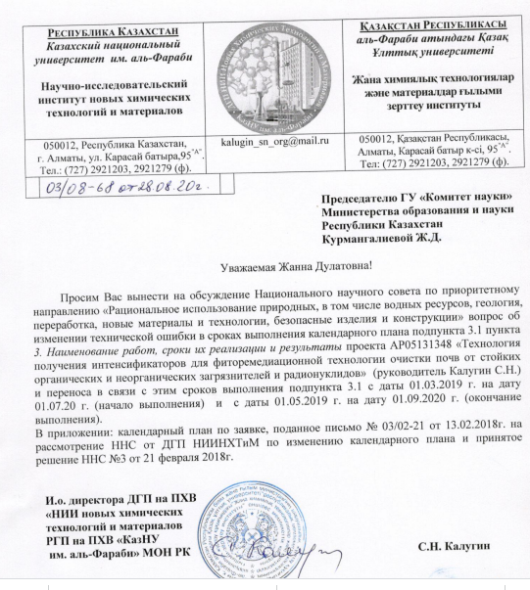

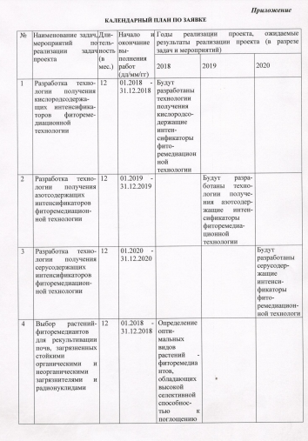

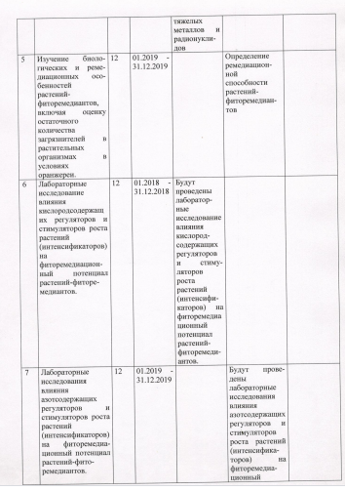

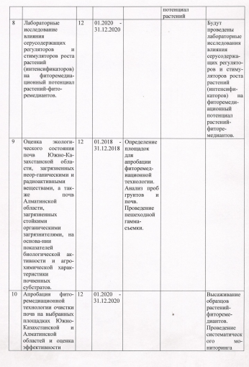

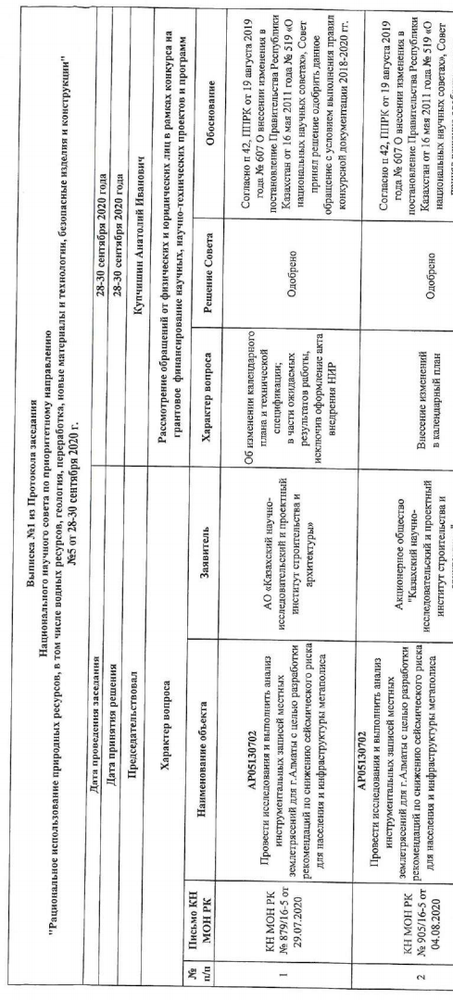
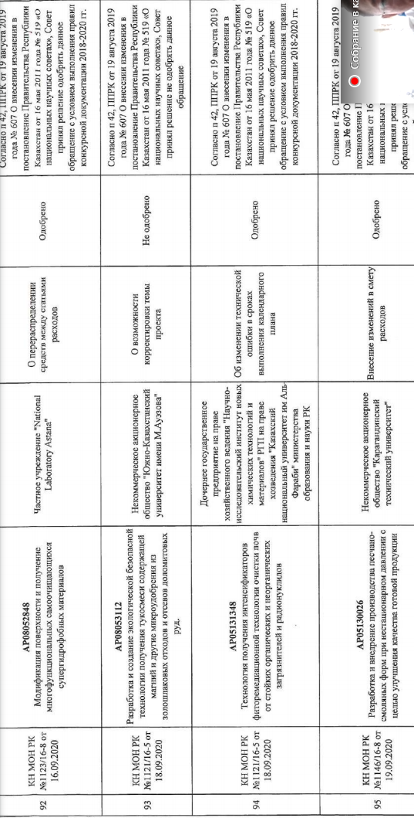

APPENDIX B

List of publications

2018 year

- Jafari B., Ospanov M., Ejas S.A., Yelibayeva N., Khan Sh.U., Amjad S.T., Safarov S., Abilov Zh.A., Turmukhanova M.Zh., Kalugin S.N., Ehlers P., Lecka J., Sevigny J., Iqbal J., Langer P. 2-Substituted 7-trifluoromethyl-thiadiazolopyrimidones as alkaline phosphatase inhibitors. Synthesis, structure activity relationship and molecular docking study//European Journal of Medicinal Chemistry – Elsevier – 2018 - Vol. 144 P 116-127 (Q1) (in Eng.).
- Kalugin S.N. Synthesis of α, β, α ', β'-divinyl ketones, piperidin-4-ones and tetrahydropyran-4-ones in the works of K. Kh. Tokmurzin // Republican scientific-practical conference "Modern problems of organic chemistry and ways of their solution" dedicated to the 80th anniversary of the birth of Academician of the National Academy of Sciences of the Republic of Kazakhstan, Doctor of Chemical Sciences, Professor Tokmurzin K.Kh.”– Кокshetau: Kazakhstan, 2018 – P. 42-45 (in Russ.).
- Issenova G., Mitrofanova A., Kalugin S., Efremov S., Sagitov A., Effect of compositions of derivatives of oxane and carbon minerals on the growth and development of wheat crop// Crop research and research on crops - International Journal on Crops, Farming and Agri-Management – 2018 – Vol. 19 – No 2 – P. 191-199 (Q3) (in Eng.).
- Nurzhanova А.А., Pidlisnyak В., Muratova А., Berzhanov R., Аbit К., Nurmugambetova А., Nurzhanov Ch., Mukasheva Т., Bektleuova N. Phytoremediation of soils contaminated with metals using the bioenergetic species Miscanthus giganteus // Vestnik of al-Farabi Kazakh National University, serie ecological – Аlmaty – 2018 – №3 – P. 32-45 (in Russ.).
- Nurzhanova A., Pidlisnyuk V., Abit K., Nurzhanov Ch., Kenesov B., Stefanovska T. Using of miscanthus x giganteus for phytoremediation of the contaminated soil: case of military and mining sites // The 15th international phytotechnology conference – Novi Sad, Serbia – 2018 – P. 158 (in Eng.).

2019 year

- Asylkhanov Zh.S., Kalugin S.N., Rusinov V.L., Mursalieva V.K., Nurzhanova A.A., Kozhebaeva Zh.S., Safarova K.A. The initial assenssment of the growth-regulating activity of some oxane and piperidine derivatives in the system of plant biotests // Izvestiya NTS «Kahak» - 2019. - №2. – P. 4 -14. (in Eng.).
- Behzad Jafari, Saquib Jalil, Sumera Zaib, Sayfidin Safarov, Muattar Khalikova, Meirambek Ospanov, Nazym Yelibayeva, Zharylkasyn A.Abilov, Mirgul Z.Turmukhanova, Sergey N.Kalugin, Peter Ehlers, Jamshed Iqbal, Peter Langer. Synthesis and Inhibitory Activity towards Monoamine Oxidase A and B of 8-Functionalized 3-Fluoro-2-methyl-benzo[4,5]thiazolo[3,2-a]pyrimidin-4-ones // Chemistry Select – 2019. – No 4. – P.7284 – 7291 (Q2) (in Eng.).

2020 year

- K. Kishibayev, Zh. Assylhanov, D. Markina, S. V. Nechipurenko, A. A. Atchabarova, R. R. Tokpaev, S. A. Yefremov, S. N. Kalugin, V. L. Russinov, K. O. Kishibayev. Preparation and study of growth stimulating activity of 1-propyl-4-(3’-amino-1’, 2’, 4’-tiazolo-3’-thiopropinyl)piperidin-4-ol // Studia UBB Chemia. – 2019. – LXIV. - № 4. - P. 177-189. (Q 4, Impact factor 2019: 0.494, SJR:0,17) (in Eng.).
- Markina D., Belskaya N.P., Kalugin S.N., Tsukerman M., Asylkhanov Zh., Nurzhanova A.A. Synthesis of 1,3-thiazole derivatives as plant growth stimulants and fluorophores // Izvestiya NTS «Kahak». – 2020.- № 2 (69) – P.67 – 75 (in Russ.).

