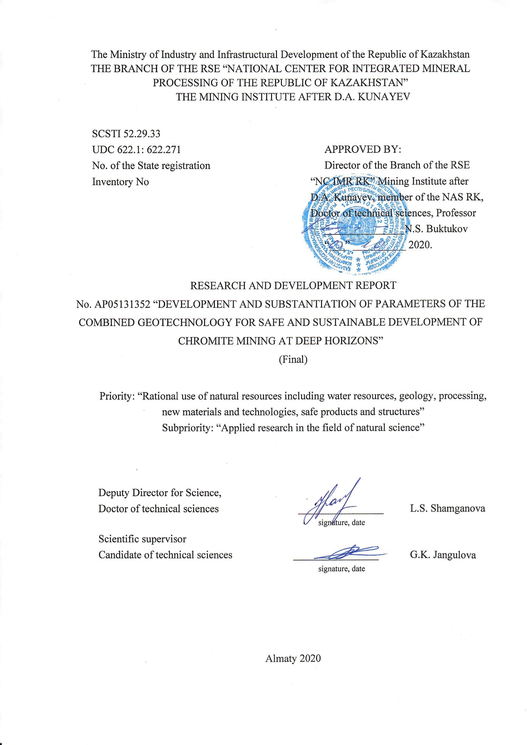
IST OF CONTRIBUTORS

Scientific supervisor:  Senior researcher, Candidate of technical sciences | ______________ | Jangulova G.K. (Sections 1-4)
Contributors:
Head of the Laboratory  “Integrated Development of Mineral Resources,” Candidate of technical sciences | ______________ | Bekbergenov D. K. (introduction,  Sections 1-4, conclusion)
Researcher | ______________ | Bektur B.K. (Sections 1,4)
Researcher, PhD | ______________ | Abakanov A.T. (Section 2)
Junior researcher | ______________ | Rakhimov N.D. (Section 3)
Engineer-economist | _____________ | Duysenbaev D. (Section 2)
Junior researcher, Master degree | ______________ | Seydakhmetova Zh.I. (Sections 1,3, report formalization)
Compliance manager | ______________ | Mashataeva G.A.
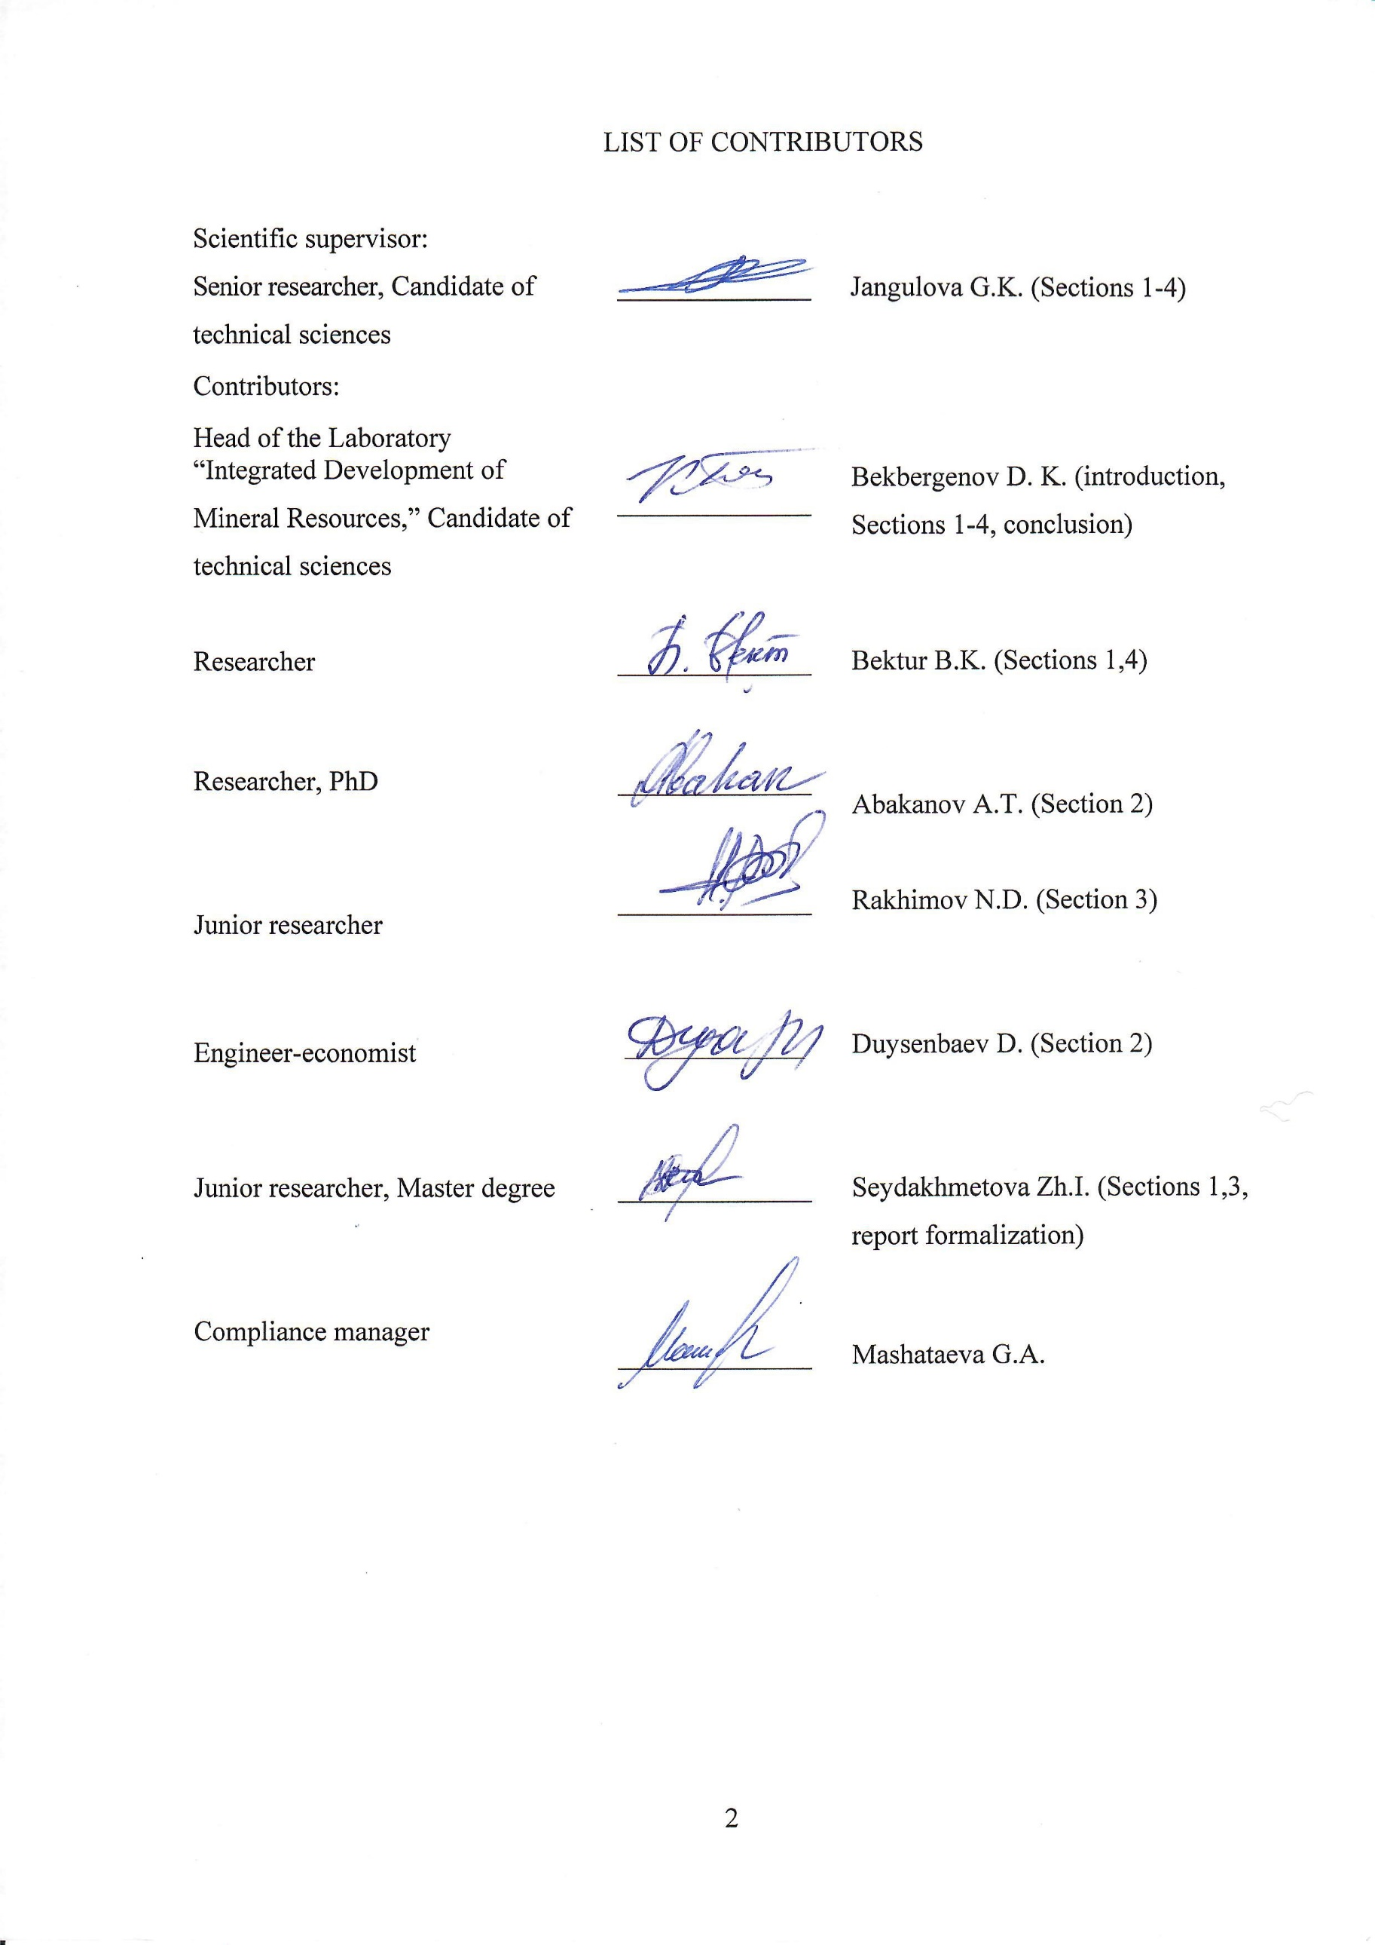
ТҮЙІН
Есеп:25 бет, 3 сурет, 15 библиографиялық көздер, 5 қосымшалар
АРАЛАС ГЕОТЕХНОЛОГИЯ, ХРОМИТТЕРДІ ЖЕР АСТЫ ТӘСІЛІМЕН ҚАЗЫМДАУ, ТӨМЕНГІ КӨЛДЕНЕҢ ҚАБАТТАРЫН ТОЛТЫРМАЛАУ ЖӘНЕ КЕНДІ ӨЗДІГІНЕН ҚҰЛАТА ҚАЗУ ЖҮЙЕСІ, ТЕХНОЛОГИЯЛЫҚ РЕГЛАМЕНТ ЖАСАУ, ТАҢДАУ ӘДІСТЕМЕСІН НЕГІЗДЕУ, ТЕХНИКАЛЫҚ-ЭКОНОМИКАЛЫҚ КӨРСЕТКІШТЕРІН ЕСЕПТЕУ, «DNK” mine КЕНОРЫНДАРЫН ҚАЗЫМДАУ ТӘРТІБІН ҰСЫНУ.
Зерттеулер нысаны «DNK” mineкен орнының 480/-640м қабатының жағдайында біріктірілген геотехнологияны таңдау негіздемесі мен әдістемесі болып табылады.
Зерттеулер мақсаты – хромит кенінің «DNK” mine кенішінің терең горизонттарында аралас геотехнологияларды бірлескен тәртіппен және кенді өздігінен құлау жүйелермен және кенқабаттарын көлденең толтыру түсу жүйесімен хромитті қазымдау қауіпсіздігі мен тұрақты дамуын қамтамасыз етуге бағытталған әдістеме мен технологиялық регламентті негіздеу.
Жобаның ғылыми жаңалығы DON Mining and Processing Plant шахтасының терең қабатына өту жағдайында тау-кен жұмыстарын жүргізу тәртібі мен реттілігі кезінде кенді өздігінен құлата қазу және игерілген кеңістікті сала отырып еңіс көлденең қабатты қазу жүйелерінде хромиттерді жер астында өндірудің қауіпсіз және тұрақты дамуын қамтамасыз ететін аралас геотехнологияларды таңдау әдістемесін негіздеу болып табылады.
Блоктардан пайдалы кенді жүйелі түрде қазымдау үшін жасанды көпқабатты темірбетон платформаларын нығайту арқылы тірек конструкция элементтері ретінде аралық және кентіректердің бойымен жасанды блок түбін құруға бағытталған, өздігінен жүру жабдықтарымен қамтамасыздандырылған аралас геотехнологиясы ұсынылады.
Алынған нәтижелер, кен орнын қауіпсіз және рентабельді пайдалану принципімен бірге өндіріс шығындарын есепке ала отырып, уақыт бірлігіне кен орнының теңгерімдік кенінің 1 тонна ең жоғары құндылығын алатын терең және күрделі-оқшауланған кен шоғырларында жер асты аралас геотехнология нұсқасы бойынша қорларды өңдеуді тұрақты дамыту үшін DON Mining and Processing Plant кен орнының 480м/-640 м қабатының жағдайында хромит өндіруді өңдеу кезінде одан әрі және мақсатқа сай көшуге ықпал етеді.
ABSTRACT

The report 25 pages, 3 figures, 15 bibliographic sources, 5 appendices
COMBINED GEOTECHNOLOGY, UNDERGROUND CHROMITE MINING, UNCONTROLLED CAVING AND DESCENDING SLICING AND BACKFILLING, DEVELOPMENT OF OPERATING PROCEDURE, SUBSTANTIATION OF THE SELECTION METHOD, CALCULATION OF TECHNICAL AND ECONOMIC INDICATORS, RECOMMENDATION REGARDING THE MINING SEQUENCE OF THE DNK MINE
The object of the research is the substantiation and selection method of the combined geotechnology in the conditions of the -480/-640m level of the “DNK” mine of the Don mining and processing plant.
The purpose of the work is to substantiate the methodology and develop operating procedure for the application of the combined geotechnology at deep horizons of the DNK mine of a chromite deposit ensuring the safety and sustainable development of chromite mining at the joint order and sequence of uncontrolled caving and descending horizontal slicing and backfilling.
The scientific novelty of the project is the substantiation of the selection method of the combined geotechnology, which ensures the safe and sustainable development of underground chromite mining at the joint order and sequence of mining operations by means of combined geotechnology in combination with uncontrolled caving and descending horizontal slicing and backfilling of the mined space in the conditions of transition to deep horizons of the mine of the DON Mining and Processing Plant.
The combined geotechnology is proposed with the creation of an artificial stope sill and the use of a scraper, self-propelled equipment on the horizon of release and delivery in the area of entry and stump pillars as load-bearing structural elements by strengthening with artificial multi-support reinforced concrete platforms for the systematic release of ore from blocks.
The obtained results contribute to further rational transition to the development of chromite mining in the conditions of the -480m/-640m level of the DON Mining and Processing Plant for the sustainable development of the reserves mining using the combined option of underground geotechnology at deep and multiple isolated ore deposits with a maximum recovery of value of 1 t of recoverable ore of the deposit per unit of time with due account for production costs.
TABLE OF CONTENTS
 | INTRODUCTION………………..……………………………………….…….……..…........ | 7
 | 1 Study of Condition and Causes of Rock Caving Around Preparatory and Haulage Workings at Deep Horizons of Mines of the Don Mining and Processing Plant.................... | 8
 | 2 Substantiation of the Combined Geotechnology in the Conditions of the -480m/-640 m Level of the “Millionnoye” Deposit ………………………………………………………. | 10
 | 3 Recommendations on the Sequence and Development of Operating Procedure for the Application of the Combined Geotechnology and Calculation of Technical and economic Efficiency at Deep -480m/-640 m Horizons of the “DNK” Mine of the DON Mining and Processing Plant..................................................................................................................... | 14
 | 3.1 Development of Recommendations on the Application of the Combined Geotechnology at Deep Horizons of Mines of the DON Mining and Processing Plant... | 14
 | 3.2 Development of Operating Procedure of the Application of the Combined Geotech-nology at Deep -480/-640 m Horizons of the “DNK” Mine of the DON Mining and Processing Plant……………………………………. | 14
 | 3.3 Calculation of Economic Efficiency of Application of the Combined Geotechnology at Deep -480/-640 m Horizons of the “DNK” Mine of the DON Mining and Processing Plant…………………………………………………………………………………………. | 19
 | CONCLUSION ………………………………………………………….......….…………. | 21
 | LIST OF REFERENCES …………………...........….……………………………………... | 24
 | APPENDIX a Schedule of works for the years 2018-2020................................................... | 26
 | APPENDIX b List of publications on the subject during 2018-2020.................................... | 32
 | APPENDIX c Method and calculation of technical economic efficiency of application of the combined geotechnology at the development of chromite reserves using the descending trapezoid slicing in combination with the technology of uncontrolled caving and ore delivery with the application of self-propelled equipment in the conditions of the artificial stope sill at deep -480m/-640m horizons as exemplified by the “DNK” mine of the Don mining and processing plant……………………………………………………….. | 35
 | APPENDIX D Operating Procedure of Combined Geotechnology at Deep Levels -480/-640 m of the DNK Mine of the DON Mining and Processing Plant...................................... | 42
 | APPENDIX E Protocol of the technical meeting with the Deputy Director of the Don Mining and Processing Plant ................................................................................................. | 124
 | APPENDIX F Copies of security documents………………………………………………. | 126
LIST OF SYMBOLS AND ABBREVIATIONS

RSE | Republican state enterprise
MI | Mining Institute
MYIK | Mine ten years of independence of Kazakhstan
DMPP | Donskoy ore mining and processing plant
ESRMMINFM | Eastern Scientific Research Mining and Metallurgical Institute of Non-Ferrous Metals
SPS | Special interchangeable profile for shaft support
Krivoy Rog basin | Krivoy Rog iron ore basin
SP | Software packages
LLP | Limited Liability Partnership
KHIDMEAB | Kazakhstan head institute for the design of non-ferrous metallurgy enterprises
AB | Artificial bottom
EE | End element
LDC | Loading- delivery car
SBRAS | Siberian Branch of the Russian Academy of Sciences

INTRODUCTION

One of the main and defining indicators at the selection of a method and a process chart for the development of ore deposits are the mining geological conditions of occurrence of ore bodies and host rocks, their geostructure, strength, deformability and stability.
In this regard, it becomes necessary to understand the nature of these complications and based on patterns of mining technical processes accompanying the development, to reasonably choose the methods of development, determine their parameters in order to exclude accidents and ensure rational subsoil use.
At this stage, the existing technology of uncontrolled caving at the “DNK” mine has exhausted its technical capabilities and does not adequately meet the new mining technical conditions at the transition to deeper horizons of mines. To further mine chromite ores at the transition to deep structurally disturbed masses as well as to technogenic-hazardous mining conditions, currently there is no method has been developed and no designs and parameters have been substantiated for the uncontrolled caving technology as well as of descending horizontal slicing and backfilling, which are undergoing pilot industrial tests at the “DNK” mine carried out by the “VNIITSVETMET” Institute and will ensure the assessment of their economic efficiency and profitability.
Therefore, the research carried out during 2020 includes a set of works related to the development of “Operating Procedure of Combined Geotechnology at Deep Levels -480/-640 m of the DNK Mine of the DON Mining and Processing Plant” based on the proposed combined geotechnology at deep horizons of chromite mining at the joint order and sequence of mining operations by means of uncontrolled caving and descending horizontal slicing and backfilling with the calculation of economic efficiency in production conditions as exemplified by the “DNK” mine of the DON Mining and Processing Plant.
More detailed results obtained at the previous stages of research are given in the interim research reports on the topic AR05131352 "Development and justification of parameters of combined Geotechnology for the safe and sustainable development of chromite mining in deep horizons" (no. GR0118RK01228) for 2018. (Inv. No 0218RK00400) and 2019 (Inv. No. 0219РК01142).

1 Study of condition and causes of rock caving around preparatory and haulage workings at deep horizons of mines of the don mining and processing plant

As a result of the research on the subject “Development and Substantiation of Parameters of the Combined Geotechnology for Safe and Sustainable Development of Chromite Mining at Deep Horizons” within the framework of the calendar plan for 2018, the following main results were obtained:
1. It has been established that the rock mass of the Don chromite deposits is highly disturbed. Four main systems of cracks, their intensity (from 3 to 20 per linear meter), spatial orientation of morphology were identified. There are no significant positive changes in these indicators as development depth increases, which makes it possible to apply the technology of uncontrolled caving of ore and enclosing rocks at the design of mining lower horizons and adjacent deposits.
2. Based on the systematization of the qualitative and quantitative indicators of the rock mass with due account for the degree of the influence of geotechnological factors, the ore mass of the Don chromites was classified as the lowest fifth category of stability.
3. To enhance the safety of mining operations and the balance of the main technological processes, the predominant type of support used at the mine is a three-layer fastening with prefabricated metal support made of special interchange profile SVP-27 for the uncontrolled caving as well as a mining system involving a descending slicing and backfilling of the mined space with several activities aimed at the elimination of rock failures and inrush.
4. As a result of analytical studies of the geotechnical state of the drawing-off horizon and haulage working, the experience of using systems of uncontrolled caving of ore and host rocks at the Kryvbas mines was considered. Based on the assessment of the geotechnical situation in the area of mine workings, and process charts of Don chromites, it was found that the formation of rock pressure is affected by the degree of load on horizontal mine workings.
5. Based on previously performed studies by scientists of the MI after D.A. Kunayev, the nature of the stress distribution around the workings is considered because they influence the operation of the haulage horizon [1-3].
The nature of stress distribution with due account for its values made it possible to determine the conditional boundaries of the stoping zone of influence with two established areas: the area of increased vertical stress A and the area of reduced stress B [4].
6. The stability of the drawing-off horizon stope sill was calculated. The calculation was done using the software (PC) “Lira soft” based on the numerical method of calculation using finite elements. Based on the numerical modeling of the scraping drift stope sill, the largest displacements of over 75 cm were revealed, which led to the destruction of the timbering and further collapse of the rock mass [4].
7. With the transition of mining operations to deeper horizons at the “Millionnoye” mines, the project of KAZGIPROTSVETMET Ltd proposed the preparation and development of reserves of the second stage of construction of the “Millionnoye” and “Almaz-Zhemchuzhina” deposits from the boundary of the applied development systems and the pilot testing using a system of descending horizontal slicing and backfilling and self-propelled equipment [5].
8. To increase the economic efficiency of reserves development at deep horizons, to reduce the cost of stowing works without deteriorating the commercial value of the mined ore, it is proposed to use the combined underground geotechnology for the development of chromite reserves at the -480 m, -640m level of the “Millionnoye” deposit and to construct the artificial stope sill in the form of a stable reinforced concrete platform used at the uncontrolled caving at deep horizons of mines of the DON Mining and Processing Plant [3].
2 Substantiation of the combined geotechnology in the conditions of the -480m/-640 m level of the “millionnoye” deposit

As a result of conducted research on the subject “Development and Substantiation of Parameters of the Combined Geotechnology for Safe and Sustainable Development of Chromite Mining at Deep Horizons” within the framework of the calendar plan for 2018, the following main results were obtained [6]:
1. The mining technical conditions of the applied development system at the Don chromite deposit were studied and the geotechnology for the effective development of the reserves of the Millionnoye deposit in conditions of the -480m/-640m level was improved.
2. With all its advantages related to the maximum production capacity and the lowest cost, the application of geotechnology of uncontrolled caving of ore and host rocks in the mines of the DON Mining and Processing Plant in the absence of a timely, worthy alternative is rather a necessity than an effective technical solution for rational sustainable mining. Therefore, we have proposed the combined underground geotechnology for the development of reserves at deep and multiple isolated ore deposits with a thickness of up to 80-100 m. This is a development system involving trapezoid backfilling with an angle of slope of the block sidewalls 70-80⁰ from the upper layer at an angle of repose [6,7].
3. For the development of combined geotechnology in the conditions of the -480m/-640m level of the “Millionnoye” field, we have considered several options of the process chart [6]:
Option 1- development system using descending horizontal slicing of the mined space under the artificial roof where 100% of stoping is done in line with this chart;
Option 2- development system using uncontrolled caving where reserves are mined up to 100%;
- Option 3- Combined underground geotechnology for the reserves development at deep and multiple isolated ore deposits involving the trapezoid backfilling with the angle of slope of the block sidewalls 70-80° from the upper layer under the angle of repose. In this option, the solidifying mixture reduces up to 40% of the volume of the backfill and on the level in the adjacent block the volume of caved rock mass decreases up to 30-40% with the unchanged volume of development and face heading in combination with the uncontrolled caving technology.
Comparative technical and economic analysis for the assessment of the stoping cost for various options of development systems, the selection method of an effective development technology with due account for the changes in the mining geological, technological and economic conditions of deposits of the DON Mining and Processing Plant as well as a methodology that satisfies the basic requirements are set out in the main part of the 2019 intermediate report.
Based on the calculation of the technical and economic indicators of the compared options of the proposed geotechnology, the expediency of transition to the combined option of underground chromite mining in the conditions of the -480m/-640m level of the “Millionnoye” at deep and multiple ore deposits was substantiated. The development system involves descending horizontal slicing and trapezoid backfilling at an angle of slope of the block sidewalls 70-80 ° from the upper layer at an angle of repose along with the uncontrolled caving of ore and host rocks.
4. A method of reasonable selection of a development system at the deposit of the DON Mining and Processing Plant was proposed.
To develop and substantiate the parameters of the artificial stope sill at the application of the uncontrolled caving system at the deep horizons of the “DNK” mines, the application of an underground mining technical structure of workings of the drawing-off horizon at uncontrolled caving system was analyzed with regard to the issue of creating the artificial stope sill at the chromite reserves mining at deep -480 m/-640 m horizons of the mine of the DON mining and processing plant.
We have proposed the geotechnology for the creation of the artificial stope sill at the drawing-off and delivery horizon in the area of entry and stump pillars as load-bearing structural elements that can withstand extremely high rock pressure during mining excavation using uncontrolled caving of ore and host rocks by means of reinforcing artificial multi-support reinforced concrete platforms for the systematic release of ore from blocks shown in Figures 2.1 A, B, C, and the detailed technological process of the layer-by-layer erection of the artificial stope sill (Figures 2.2-2.5 in the 2019 progress report).
The method of calculating the strength of the proposed ASS with multi-support reinforced concrete platform provides for the assessment of the strength of artificial stope sills with multi-support reinforced concrete platform where a strength of a vertical square reinforced concrete pillar-support with a height of hоп=7÷9 m and the safety factor of the element of the vertical square reinforced concrete pillar-support equalling n = 1.51 corresponds to their safety factor (for n ≥ 1, 4) [6,7].
To confirm the analytical calculations of the ASS strength, the simulation of the artificial reinforced concrete stope sill was carried out for the uncontrolled caving system (a three-dimensional 3D model on the ANSYS PC). Based on the calculation results, the influence of loads on the nodes of reinforced concrete structures ID, which are subject to the greatest impact, was analyzed. Deformations are most pronounced in the junctions of the funnels, and the stresses are most pronounced in the lower parts of the overhead pillar located above the scraping drift.
Based on the calculation results, the influence of loads on the nodes of reinforced concrete ASS, which are subject to the greatest impact, was analyzed. The most pronounced deformations are in the junctions of the funnels, and stresses are maximal in the lower parts of the stump pillar located above the scraping drift. The strength and stability of the complex monolithic reinforced concrete ASS consisting of funnels, ore passes, and drifts is fully ensured for the 560m, 720m, 920m depths in the conditions of the DNK mine (Figure 2.1).
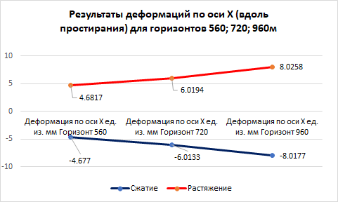
Figure 2.1 Results of deformations in millimeters along the X axis (along the strike) at the -560; -720; -960m horizons

To determine the parameters of ore extraction at the drawing-off horizon from the artificial stope sill in the uncontrolled caving system, laboratory tests were performed on physical models.
In addition to analytical calculations, physical modeling of the ore mass release process at the uncontrolled caving systems is one of the most common methods for determining the standard recovery rates for these systems.
Based on the results of the experiment, the method of physical modeling for laboratory testing was developed, where the main criteria of mechanical similarity [9-11] are complied with, the dimensions of the models were changed on a 1:500 scale compared to the corresponding full-scale dimensions (geometric similarity).
The release of the ore mass was simulated by means of loading the drawing-off funnel, with due account for the mass of the empty and filled receiving and discharging containers. At the first release α = 56º, the surface of the funnel was damaged along the entire contour, at α = 60º, the fracture surface of the sidewalls increased, at α = 65º, large 1.5 cm wide and up to 1.0 mm deep chips were observed from the upper left side of the funnel at certain specified points from 1.0 mm to 29.3 mm. As a result, the dilution of the ore mass was determined at each angle of slope of the funnel separately and for the whole physical model. The dilution rates (P) at three releases increased and resulted in the following data:
- At α=56º increase in Р=2,5%,
- At α=60º increase in Р=1,5-2,0%;
- At α=65º increase in Р=1,2 -1,5 %.
Using the obtained data of the ore drawing from each horizontal layer, an output planogram was plotted, which reflects the volumes contained in each dose throughout the entire course of the experiment.
According to the 2019 schedule, to determine the boundary effect of the stoping performed by means of the combined geotechnology at deep horizons of mines, according to the developed methodology and parameters at the corner of displacement of the chromite deposits, a safety pillar and safety berms were built against the impact of stoping at the underground chromite mining using the combined geotechnology at the deep horizons of the “DNK” mines of the DON Mining and Processing Plant [6,12] .
To study the above-mentioned issue, the particularities of the influence of the hardening backfill in the stopes at deep horizons of mines, the forms of manifestation of rock pressure and the influence of stoping by means of the combined geotechnology of uncontrolled caving [13-15] were taken into account, and a safety pillar and safety berm was built against the influence of stoping at underground chromite mining using the combined geotechnology at the deep horizon of the “DNK” mines of the DON Mining and Processing Plant (Figure 4.4 in the main part of the 2019 progress report) [6,12].
3 Recommendations on the Sequence and Development of Operating Procedure for the Application of the Combined Geotechnology and Calculation of Technical and economic Efficiency at Deep -480m/-640 m Horizons of the “DNK” Mine of the DON Mining and Processing Plant
3.1 Development of Recommendations on the Application of the Combined Geotechnology at Deep Horizons of Mines of the DON Mining and Processing Plant

The recommended sequence of development of chromite reserves according to the proposed combined geotechnology has been presented in detail in the main part of the Operating procedure of Combined Geotechnology at Deep Levels -480/-640 m of the DNK Mine of the DON Mining and Processing Plant (Appendix C).
The essence of the mining procedure is as follows: according to the proposed combined geotechnology in the conditions of deep horizons of the -480m / -640m floor of the DON Mining and Processing Plant for the development of chromite reserves in combination with the descending slicing and trapezoid backfilling of the mined space under the artificial roof with an angle of slope of the block sidewalls 70-80⁰ from the upper layer at an angle of repose, it is recommended to use a general development sequence from the center of the deposit to the flanks and, layer-by-layer in the descending direction. At that, the primary block (I) is developed using horizontally descending slicing and backfilling, after which the next reserve block (II) is developed by means of uncontrolled caving (Figure 3.1).
The recommended mining sequence of chromite reserves in blocks is in the direction of the front of stoping in sections from the beginning of the blocks’ flank with stopes and their backfilling with hardening stowing in a staggered pattern and is expanded in the Operating procedure (Section 5, Appendix D).
3.2 Development of Operating Procedure of the Application of the Combined Geotechnology at Deep -480/-640 m Horizons of the “DNK” Mine of the DON Mining and Processing Plant
The Operating procedure was developed as a result of the research work No. AP05131352 “Development and Substantiation of Parameters of the Combined Geotechnology for Safe and Sustainable Development of Chromite Mining at Deep Horizons” performed by the laboratory “Integrated Development of Mineral Resources” of the MI after D.A. Kunayev during 2018-2020.

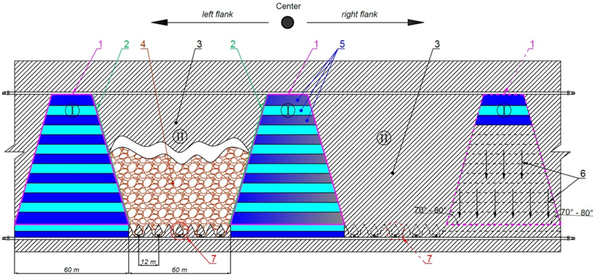
1 – Trapezoid-shaped block; 2 – Angle of slope of the block sidewalls; 3 – Adjacent blocks; 4 – Uncontrolled caving technology; 5 – Backfilled layers; 6 – Direction of descending development; 7 - Ore drawing-off level; I and II is a sequence of block mining at the combined geotechnology.
Figure 3.1 Recommended mining sequence of chromite deposits by means of the combined geotechnology
The main sections of the Operating procedure include the following research:
1 Methodical substantiation for the application of the combined geotechnology in the conditions of the DON Mining and Processing Plant.
2 Mining geological, mining technical features and an overview of possible development systems in the mining conditions of chromite reserves of the “DNK” mine of the DON Mining and Processing Plant.
3 Regulatory parameters for the application of the combined geotechnology in the conditions of the “DNK” mine at the underground mining of chromite reserves.
4 The proposed combined geotechnology using self-propelled equipment in the conditions of the artificial stope sill.
5 Development of recommendations regarding the sequence of the combined geotechnology at deep horizons of the DON Mining and Processing Plant.
6 Method and calculation of economic efficiency of application of the combined geotechnology at -480/-640m deep horizons of the “DNK” mine.
As an object, natural-technogenic conditions of the -480/-640m level of the “DNK” mine of the DON Mining and Processing Plant were determined.
The purpose of the scientific and methodological substantiation and development of technological regulations for the use of the combined geotechnology at deep horizons of -480/-640m of the DNK mine of the DON mining and processing plant is to provide regulatory parameters for the sustainable development of underground mining of a chromite deposit with a high extraction of ore from blocks and safe mining operations using the combined geotechnology by means of highly adaptive and efficient self-propelled equipment for the development of deep inclined thick highly fractured masses in the conditions of increased rock pressure.
The tasks of the Operating procedure are as follows:
1) Justification of the methodology for choosing combined geotechnology in the conditions of mines of the DON mining and processing plant.
2) Overview and analysis of the possibility of using the mining system with ore caving in the conditions of chromite reserves of the DNK mine of the DON mining and processing plant.
3) The essence and particularities of the process chart of the proposed options of systems with the combined geotechnology for underground mining of chromite reserves in deep horizons of the DNK mines.
4) Development of the operating procedure for the use of the combined geotechnology in the conditions of the DNK mine for underground mining of chromite reserves.
5) Selection of excavation equipment, preparatory and stoping works and a list of geotechnological equipment for the proposed combined geotechnology for the development of chromite reserves at the DNK mine of the DON mining and processing plant.
6) Development of recommendations for the procedure of mining and determination of parameters of ore losses and dilution in the combined geotechnology in the conditions of mining reserves by the example of a local block of the DNK mine.
7) Technical and economic indicators of the application of the recommended combined geotechnology in conditions of the DNK mine of the DON mining and processing plant.
The practical significance of the development of the operating procedure has no analogues not only in the Republic of Kazakhstan, but also abroad, therefore, the proposed operating procedure “Operating Procedure of Combined Geotechnology at Deep Levels -480/-640 m of the DNK Mine of the DON Mining and Processing Plant” ensures real technological regulatory parameters for sustainable development of underground mining of a chromite deposit at deep -480/-640 m horizons of the DNK mine of the DON mining and processing plant using the combined geotechnology with high efficiency of ore extraction from blocks and safe mining operations.
Based on the developed methodology for substantiating regulatory parameters for the application of the proposed combined geotechnology in real conditions of underground mining of a chromite deposit at deep -480/-640 m horizons of the “DNK” mine of the DON Mining and Processing Plant, it is possible to reduce the cost of mining and development operations without compromising the commercial value of mining in combination with the uncontrolled caving technology.
The main part of the developed Operating Procedure includes mining geological, mining technical features and an overview of the possible application of the mining system with uncontrolled caving at domestic and foreign mines with the indication of the technical and economic indicators as well as a description of their advantages, disadvantages at the development of chromite reserves of the “DNK” mine of the DON Mining and Processing Plant.
With the transition of mining operations to deep horizons, the geomechanical situation becomes much more complicated, especially for the stope sill workings, which will predetermine the need to resolve issues related to the development of measures aimed at the increase in the stability of workings. One of the most radical measures is the development of artificial stope sill design. As the analysis showed, it was used as the basis for designing options of development systems for the lower horizons of the “DNK” mine.
In this regard, in the main part of the Operating procedure, several options of mining process charts were considered and proposed (Appendix C). According to the designers’ concept (Kazgiprotsvetmet), in the conditions of high rock pressure the creation of a monolithic concrete mass (artificial stope sill) is more cost effective despite the high initial cost compared to the used stope sill designs in the conditions of the DON mining and processing plant, because there are no additional expenses for repair and restoration of the stope sill. However, the designers did not substantiate the technological parameters of the drawing-off horizon for the construction of the artificial stope sill. Therefore, we have proposed the combined geotechnology of sustainable development of underground chromite mining in the conditions of the horizons of the DNK mine with the substantiation of the ASS construction and its parameters at the combined geotechnology taking into account the methodology of substantiation of the calculation of the ASS strength with multi-support reinforced concrete platform.
Based on the results of the calculations and modeling, the influence of loads on the nodes of reinforced concrete ASS, which are subject to the greatest impact, was analyzed. The most pronounced deformations are in the junctions of the funnels, and stresses are maximal in the lower parts of the stump pillar located above the scraping drift. The strength and stability of the complex monolithic reinforced concrete ASS consisting of funnels, ore passes, and drifts is fully ensured.
The stress-strain states at the application of the combined geotechnology are calculated based on finite elements depending on the angle of slope of the block sidewall. The calculation was done using the software package “Lira soft version 10.6”, the number of elements is 17,012, the number of nodes is 17,711. Descriptions of finite elements are given in FE 24, 27 (plane stress, deformation). The thickness of the finite elements is 1m.
The calculation results are presented in the Operating procedure, Figures 4.4 to 4.23. The results show the absolute displacements (mm) of the structure in the direction of effective loads for the horizons of 560, 720 and 960 meters at the angles of inclination of the block sidewall = 65, 75 and 85 degrees.
Four options of process charts of the application of the combined geotechnology and self-propelled equipment in the conditions of construction of the artificial stope sill are proposed (Figures 4.1-4.4, Appendix C). We have adopted the classic Christmas tree-parallel scheme (Figure 3.2) based on the proposed process chart of the artificial stope sill for the ore drawing using the classic rectangular funnel and delivery of the ore mass by self-propelled equipment (LHD) from the loading drive.
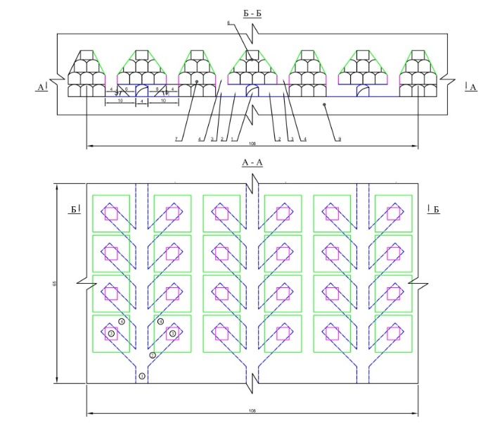
Figure 3.2 Selected process chart of the artificial stope sill
The essence of the selected option of the combined geotechnology is in the division of mined deposits within a level in a staggered pattern where the front of mining operations is performed using the combined underground geotechnology - descending slicing and backfilling of the mined space under the artificial roof and uncontrolled caving technology and ore delivery using self-propelled equipment in the conditions of the erected artificial stope sill providing high productivity of the block according to the process chart with the ASS option.
Based on the results of three-year studies, the Operating procedure includes the substantiation of the method of calculating the technical and economic efficiency of new options of underground mining of highly fractured and unstable ore deposits at great depths of the mine using the combined geotechnology. The most detailed calculations are presented in the main part of the developed “Operating Procedure of the Application of the Combined Geotechnology at Deep -480/-640 m Horizons of the “DNK” Mine of the DON Mining and Processing Plant”.

3.3 Calculation of Economic Efficiency of Application of the Combined Geotechnology at Deep -480/-640 m Horizons of the “DNK” Mine of the DON Mining and Processing Plant
According to a comparative technical and economic analysis, the selection method provides for an estimate of the cost of stoping for various options of development systems and the calculation of the costs of preparing and placing a hardening stowing into the stope as well as the costs of uncontrolled caving technology (3.1).
С комб. = Ств.закл. + Ссор → min. (3.1)
The economic comparison of development systems includes material and labor costs C (tg/t), ore losses P (%), dilution R (%), specific capital investments k (tenge per 1t/year).
The comparison is done for the minimum amount of comparative losses. The comparison criterion in this case is determined based on the expression (3.2):
С+У_{пр} →min (3.2)
where У_{пр}=У^{п}+У_{р} is an economic damage from losses and dilution calculated using the formulas (3.3 и 3.4):
(3.3)

(3.4)

where С_{пер.п.п -} is costs for the processing of waste rocks, tenge/t;
α_{хв.п.п} - is metal content in tailing pits of waste rocks or in smelter slags.
In view of the insignificant difference in the losses and dilution within the systems under consideration, it is necessary to account for the economic effectiveness of the systems in terms of the volume of preparatory and face heading.
The proposed method of block preparation with the use of self-propelled equipment allows to reduce the specific volume of preparatory development in the production of ore mass using the uncontrolled caving technology and increase in the productivity of ore delivery by over 1.5 times in comparison with the scraper driving.
In monetary terms, calculating the difference in ore extraction for the two proposed options 3 and 4 in terms of the cost of ore extraction and technical and economic indicators are presented in Table 6.2 in the Operating procedure (Appendix D).
The calculation of the technical and economic indicators of the compared options revealed that the cost of mining and development operations reduces without compromising the commercial value of mining in combination with the uncontrolled caving technology. At the same time, the level of economic efficiency of option 4, proposed by the Mining Institute of D.A. Kunaev is 25.4% compared to option 3 which equals 22%, which shows the profitability of the proposed option involving the use of self-propelled equipment by 11.5% which is equal to the sum of 1 million 631 thousand 223 tenge.
The calculation method of efficiency of the combined geotechnology at deep -480/-640m levels of the “DNK” mine of the DON Mining and Processing Plant is set out in detail in the Operating procedure (Appendix C).

CONCLUSION

The results of the research on the subject “Development and Substantiation of Parameters of the Combined Geotechnology for Safe and Sustainable Development of Chromite Mining at Deep Horizons” within the framework of the calendar plan for 2018-2019 are given in the progress reports. Within the 2020 R&D, the following main results were obtained:
1 The methodical justification was drawn up for the application of the combined geotechnology in the conditions of the DON mining and processing plant with the indication of the urgency of the problem, goal and tasks as well as scientific novelty and practical significance, the expected result of the development of Operating Procedure;
2 Based on the mining geological and mining technical conditions, an analytical review of all possible development systems of chromite reserves at the DNK mine of the DON mining and processing plant was done with the presentation of the main technical and economic indicators of the system.
3 Based on current activities and mining technical characteristics, which represent the urgent problems of developing a chromite deposit at the DNK mine of the DON mining and processing plant, there are factors showing the feasibility of transiting to the combined geotechnology of uncontrolled caving with the artificial stope sill and delivery of ore in the conditions of rock pressure at the “DNK” mine of the DON mining and processing plant:
- The proposed combined underground geotechnology in the conditions of the -480/-640m; mining the reserves by the trapezoid cut-and-fill system with an angle of slope of the block sidewalls 70-80° from the upper layer of mining at an angle of repose. In this option, the reduction of the hardening stowing is up to 40% of the volume of the backfilling and in the adjacent block on the level allows the increase in the ore production by 30% with the same volume of preparatory and face heading in combination with the uncontrolled caving technology.
The proposed combined geotechnology in combination with the uncontrolled caving system with the artificial stope sill using a scraper are patented (Appendix B).
4. An explanatory flow chart is presented for the creation of the artificial stope sill at great depths with a stable reinforced concrete platform at uncontrolled caving as load-bearing structural elements that withstand extremely high rock pressure at stoping by means of reinforcing artificial multi-support reinforced concrete platforms for the systematic release of ore from blocks as well as the methodology for justifying the calculation of the strength of the artificial stope sill;
5. To calculate a three-dimensional 3D model, the artificial reinforced concrete stope sill was modelled for uncontrolled caving of ore on the ANSYS PC at values of the total deformation of the ASS at a depth of 560, 720 and 960 m. According to the calculation results, the influence of loads on the nodes of ASS reinforced concrete structures was analyzed. The nodes are most affected at the junctions of the funnels, and the stresses are maximum in the lower parts of the stump pillar located above the scraping drift;
6. According to the method of calculating the strength of the proposed ASS, the bearing capacity was determined, the load on the reinforced concrete pillars, on the horizontal reinforced concrete beam and the horizontal stump pillar was determined, and the safety factor was calculated. According to the performed calculations of the strength of a vertical square reinforced concrete pillar-support with a height of h_{оп}=7÷9 m for the proposed multi-support reinforced concrete stope sill, the safety factor of the element of the vertical square reinforced concrete pillar-support is equal to n = 1.51 and corresponds to their safety factor (for n ≥ 1, 4).
7. Four options of process charts of the artificial stope sill are proposed in combination with the uncontrolled caving and ore delivery using the self-propelled equipment:
1) process chart for ore production using a classic rectangular funnel and delivery of ore mass by self-propelled equipment (LHD) from the loading drive according to the classic Christmas tree-parallel scheme;
2) process chart for the artificial stope sill using a classic rectangular funnel and delivery of ore mass by LHD from the loading drive according to the classic Christmas tree-step scheme;
3) process chart for the artificial stope sill for ore drawing from the rhomboid funnel and delivery of ore mass by LHD from the loading drive according to the classic Christmas tree-parallel scheme;
4) process chart for the artificial stope sill for ore drawing from the rhomboid funnel and delivery of ore mass by LHD from the loading drive according to the classic Christmas tree-step scheme.
8. The stress-strain states at the application of the combined geotechnology are calculated by means of the computational scheme based on finite elements depending on the angle of slope of the block sidewall. The calculation was done using the software package “Lira soft version 10.6”, the number of elements is 17,012, the number of nodes is 17,711. The calculation was done in a flat computational scheme; FE 24,27 from the program library were used as finite elements (FE). According to the results, the absolute displacements of the structure in mm in the direction of the acting loads are given for the horizons of 560, 720 and 960 meters at the angles of slope of the block sidewall = 65, 75 and 85 degrees.
10. According to the method and the performed calculation of the technical and economic efficiency of the proposed method of the combined underground geotechnology for the extraction of chromites according to the selected option, it is evident that it is necessary to increase the economic efficiency of mining operations at the development of reserves in deep and multiple isolated ore deposits using a trapezoid cut-and-fill system with an angle of slope of the block sidewalls 80-85⁰ from the upper layer of mining at an angle of repose with a decrease in the hardening stowing to 40% of the volume of the backfill and in the adjacent block on the level, because the volume of the caved ore increases by 30% at the use of uncontrolled caving. This makes it possible to reduce the cost of mining and development without compromising the commercial value of mining in combination with the uncontrolled caving technology. At the same time, the level of economic efficiency of option 4 proposed by the Mining Institute after D.A. Kunayev is 25.4% compared to option 3 equalling 22%, which shows that the proposed option with the use of self-propelled equipment is 11.5% more profitable equalling the sum of 1 million 631 thousand 223 tenge.
The studies were performed in full accordance with the 2018-2020 schedule.
The Methodology and calculation of the economic efficiency of using combined Geotechnology at deep horizons -480/-640m of the dongoka DNA mine are described in detail in the Technological regulations (Appendix C and D).
lIST OF REFERENCES

1 Zherebko L., Shamganova L., Dzhangulova G., Kassymkanova Kh., Bektur B. Specific character of Don chromites development in complex mining and geological conditions. 16thInternational multidisciplinary scientific geoconference. Exploration and mining. Mineral processing. SGEM 2016. 30 June - 6 July, 2016. Albena, Bulgaria. P.775-780. [in English]
2 Bekberenov D.K., Dzhangulova G.K., Kabdeshev A.N., Toktarov A.A. Geomechanical essence and technological particularities of the uncontrolled caving technology at deep horizons of the “DNK” mine of the DON Mining and Processing Plant / International scientific and technical conference “Problems and ways of innovative development of the mining and metallurgical industry.” November 27-29, 2014, Tashkent. – P. 112-116. [in Russian]
3 Development and substantiation of parameters of combined geotechnology for the safe and sustainable development of chromite mining at deep horizons // R&D report. Funds of the MI after D.A. Kunayev. - Almaty, 2018. – 53 p. [in Russian]
4 Study of engineering and geological conditions of development of the southern part of the “Almaz-Zhemchuzhina” chromite ore deposit. R&D report. VIOGEM, Belgorod, 1979. [in Russian]
5 Study of engineering and geological conditions of development of the deep section of the “Central” mine of the Don Mining and Processing Plant. R&D report. VIOGEM, Belgorod, 1979. [in Russian]
6 Development and substantiation of parameters of combined geotechnology for the safe and sustainable development of chromite mining at deep horizons // R&D report. Funds of the MI after D.A. Kunayev. - Almaty, 2019. – 72. [in Russian]
7 Yakovlev Yu.I., Zherebko L.N., Dzhangulova G.K., Pivovarova L.M. Prospects of development of deep horizons of the Don Mining and Processing Plant using a caving system // Scientific and technical support of mining production. Proceedings of the MI after D.A. Kunayev. –Almaty, – V.69– 2005.-P.67-70 [in Russian]
8 Evgeny Fedorov, Dosanbay Bekbergenov and Gulnar Dzhangulova. Modeling and methodology for calculating the strength of a man-made bottom in a system with self-destruction of ore for ecologically safe mining/ VIII International Scientific Conference “Problems of Complex Development of Georesources. E3S Web of Conferences 192, 03018 (2020) [in English]
9 Pepelev R.G. Ore drawing under caved rocks: Textbook. - M.: MSMU, 2012.- P. 56. [in Russian]
10 Modeling in geomechanics / G.N. Kuznetsov, F.P. Glushihin, M.F. Shklyarsky and others. М.: Nedra, 1991. 240 p. [in Russian]
11 Modeling rock pressure manifestations / G.N. Kuznetsov, M.N. Budko, Yu.I. Vasilyev and others. L.: Nedra, 1968. 280 p. [in Russian]
12 Bekbergenov D. K., Dzhangulova G. K., Bektur B. K. Determination of the boundary effect of stoping at the combined geotechnology at deep horizons of the Don chromite mines / Complex Use of Mineral Resources. No.1 (312), 2020. P.69-77 [in Russian]
13 R&D report “Study of the stress-strain state of the rock mass with the purpose of finding effective ways to control rock pressure in the mines of the Don Mining and Processing Plant” // SP “ECO-TRENDS LTD” Engineering Trend, M, 1982. – 86 p. [in Russian]
14 Zherebko L.N., Pivovarova L.M., Dzhangulova G.K. Particularities of rock pressure manifestation and determination of loads on the timbering of workings of the lower horizons of mines of the Don Mining and Processing Plant // Monograph of the RSE NC IMP of the RK No.2-УС-03 Mining science and problems of Kazakhstan subsoil development, volume I, 2003. – P. 66-74. [in Russian]
15 Dzhangulova G.K. Development of scientific and methodical regulations for predicting the ehaviour of the surface over the stoping zone in structurally disturbed rock masses. Candidate thesis. Almaty. – 2009. – 125 p. [in Russian]

APPENDIX А
Appendix 1.3
To grant financing
Agreement No.__dated__2018
TECHNICAL SPECIFICATION AND
SCHEDULE OF WORKS
Under Agreement No.125 dated 12 March 2018
- THE BRANCH OF THE RSE “NATIONAL CENTER FOR INTEGRATED MINERAL PROCESSING OF THE REPUBLIC OF KAZAKHSTAN” OF THE COMMITTEE OF INDUSTRY OF THE MINISTRY OF INNOVATIONS AND DEVELOPMENT OF THE REPUBLIC OF KAZAKHSTAN “MINING INSTITUTE AFTER D.A.KUNAYEV”
  - Priority: “Rational use of natural resources including water resources, geology, processing, new materials and technologies, safe products and structures.”
  - Subpriority: “Fundamental research in the field of natural science.”
  - Project theme: No. AP05131352 “Development and Substantiation of Parameters of the Combined Geotechnology for Safe and Sustainable Development of Chromite Mining at Deep Horizons.”
  - The total project sum is 24,160,000 (twenty four million one hundred and sixty
thousand) tenge divided by years for realization of works in line with point 3:
- Year 2018 – the sum of 8,000,000 (eight million) tenge;
- Year 2019 – the sum of 8,072,000 (eight million seventy two thousand) tenge;
- Year 2020 – the sum of 8,088,000 (eight million eighty eight thousand) tenge;
- Characteristics of the scientific technical product by qualifying properties and economic parameters
  - Direction of work: grand research
  - Field of application: mining industry
  - Final result:
- In 2018, the rock mass condition will be studied, and stability of the drawing-off level at the application of uncontrolled caving will be researched. The combined geotechnology within the KAZGIPROTSVETMET project for chromite deposit will be assessed. One article in domestic scientific editions with a non-zero impact-factor will be published;
- In 2019, the method will be developed and parameters of the combined geotechnology and its joint application for safe and sustainable development of chromite mining at deep horizons will be substantiated. One article in peer-reviewed foreign scientific editions indexed in the Web of Science or Scopus databases with a non-zero impact-factor and one article in peer-reviewed domestic scientific editions with a non-zero impact-factor will be published. An application for patenting the new technical solutions in Kazakhstan will be submitted;
- In 2020, recommendations regarding the mining sequence will be given and the Operating procedure of application of the combined geotechnology at deep horizons (480m/640m) of the Don mining and processing plant will be developed with the economic calculation. One article in peer-reviewed foreign scientific editions indexed in the Web of Science or Scopus databases with a non-zero impact-factor and one article in peer-reviewed domestic scientific editions with a non-zero impact-factor will be published.
  - Patentability: the research results can be patented.
  - The scientific and technical level (novelty): The project scientific novelty is the method of substantiating the parameters of the combined geotechnology ensuring the safe and sustainable development of underground mining of chromites at the joint sequence of mining operations using the uncontrolled caving and artificial stope sill with the application of self-propelled equipment and descending slicing and backfilling in the conditions of transition to deep horizons of the Don mining and processing plant.
  - The scientific and technical product will be consumed by the Customer and Contributor.
  - The ways the result of the scientific and (or) scientific technical activity will be used: copyright protection documents, publications.

- Works, period of their realization and results
Code of the task, stage | Works under the agreement and main stages of their realization | Period of realization |  | Expected result
Code of the task, stage |  | Beginning | End | Expected result
1 | Study of the state and causes of the rock mass caving around preparatory and haulage workings at deep horizons of mines of the Don mining and processing plant | January 2018 | March 2018 | The state and causes of the rock mass caving around preparatory and haulage workings at deep horizons of mines of the Don mining and processing plant will be studied
2 | Analytical research of the geotechnical state of the drawing-off horizons and haulage working | April 2018 | June 2018 | Analytical research of the geotechnical state of the drawing-off horizons and haulage working will be held
3 | Research of the impact of stoping on the stability of the drawing-off horizon at the application of the uncontrolled caving system at deep horizons of the DNK mine | July 2018 | September 2018 | The impact of stoping on the stability of the drawing-off horizon at the application of the uncontrolled caving system at deep horizons of the DNK mine will be researched
4 | Evaluation of the combined geotechnology of the KAZGIPROTSVETMET project at the transition to the -480m/-640m horizon of the “Millionnoye” deposit | October 2018 | Until 1 November 2018 | The combined geotechnology of the KAZGIPROTSVETMET project at the transition to the -480m/-640m horizon of the “Millionnoye” deposit will be evaluated. One article in domestic scientific editions with a non-zero impact-factor will be published.
5 | Substantiation of the method of the combined geotechnology in the conditions of the -480m/-640m horizon of the “Millionnoye” deposit | January 2019 | March 2019 | The method of the combined geotechnology in the conditions of the -480m/-640m horizon of the “Millionnoye” will be substantiated
6 | Development and substantiation of parameters of the artificial stope sill at the application of the uncontrolled caving system at deep horizons of the DNK mine | April 2019 | June 2019 | Parameters of the artificial stope sill at the application of the uncontrolled caving system at deep horizons of the DNK mine will be developed and substantiated. An application for patenting the new technical solutions in Kazakhstan will be submitted
7 | Determination of ore parameters at the drawing-off horizon with the artificial stope sill at the application of the uncontrolled caving system | July 2019 | September 2019 | Ore parameters at the drawing-off horizon with the artificial stope sill at the application of the uncontrolled caving system will be determined
8 | Establishing the boundary impact zone of stoping at the application of the combined geotechnology at deep horizons | October 2019 | Until 1 November 2018 | The boundary impact zone of stoping at the application of the combined geotechnology at deep horizons will be established. One article in peer-reviewed foreign scientific editions indexed in the Web of Science or Scopus databases with a non-zero impact-factor and one article in peer-reviewed domestic scientific editions with a non-zero impact-factor will be published.
9 | Development of recommendations regarding the sequence of application of the combined geotechnology at deep horizons | January 2020 | March 2020 | Recommendations regarding the sequence of application of the combined geotechnology at deep horizons will be developed
10 | Development of the Operating procedure for the application of the combined geotechnology at the deep -480m/-640m horizons of the DNK mine of the Don mining and processing plant | April 2020 | June 2020 | The Operating procedure for the application of the combined geotechnology at the deep -480m/-640m horizons of the DNK mine of the Don mining and processing plant will be developed.
11 | Calculation of economic efficiency of the combined geotechnology at the deep -480m/-640m horizons of the DNK mine of the Don mining and processing plant | July 2020 | September 2020 | Economic efficiency of the combined geotechnology at the deep -480m/-640m horizons of the DNK mine of the Don mining and processing plant will be calculated. One article in peer-reviewed foreign scientific editions indexed in the Web of Science or Scopus databases with a non-zero impact-factor will be published.
12 | Preparation and defense of the 2018-2020 final R&D report | October 2020 | Until 1 November 2018 | The 2018-2020 final R&D report will be prepared and defended.

On the part of the Customer: On the part of the Contributor:
Chairman Director of the Branch of RSE “NC IMP RK”
State administration of the Mining Institute after D.A. Kunayev
Committee of Science of the RK Ministry Buktukov N.S.
of Education and Science Stamp signature
Abdrasilov B.S.
Stamp signature

Acknowledged by Project advisor
Dzhangulova G.K.
Stamp signature

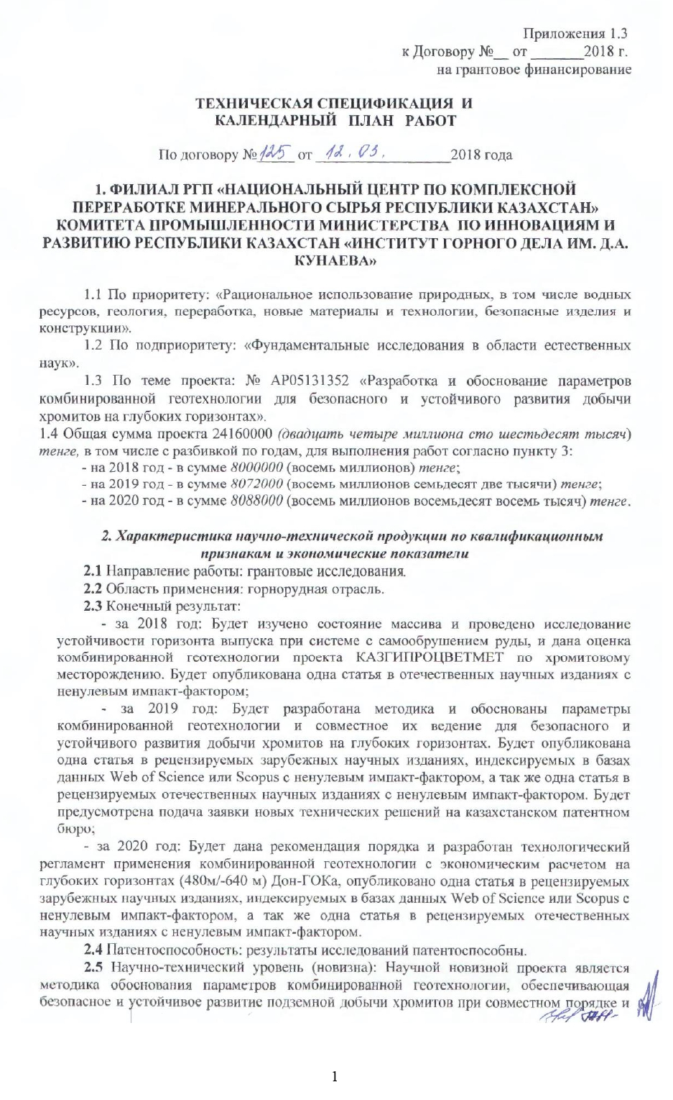
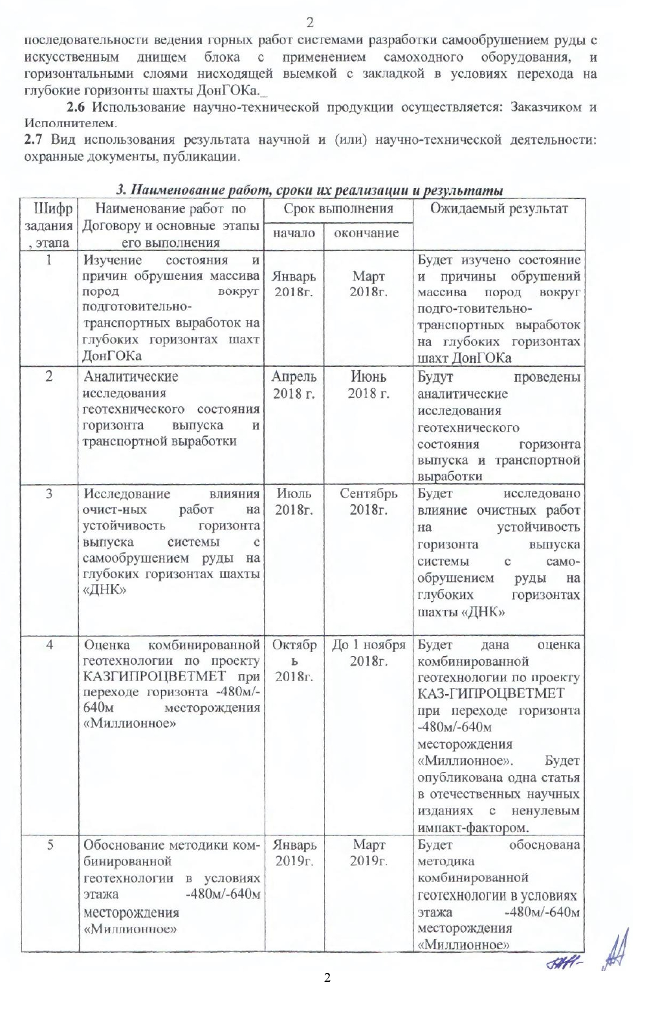
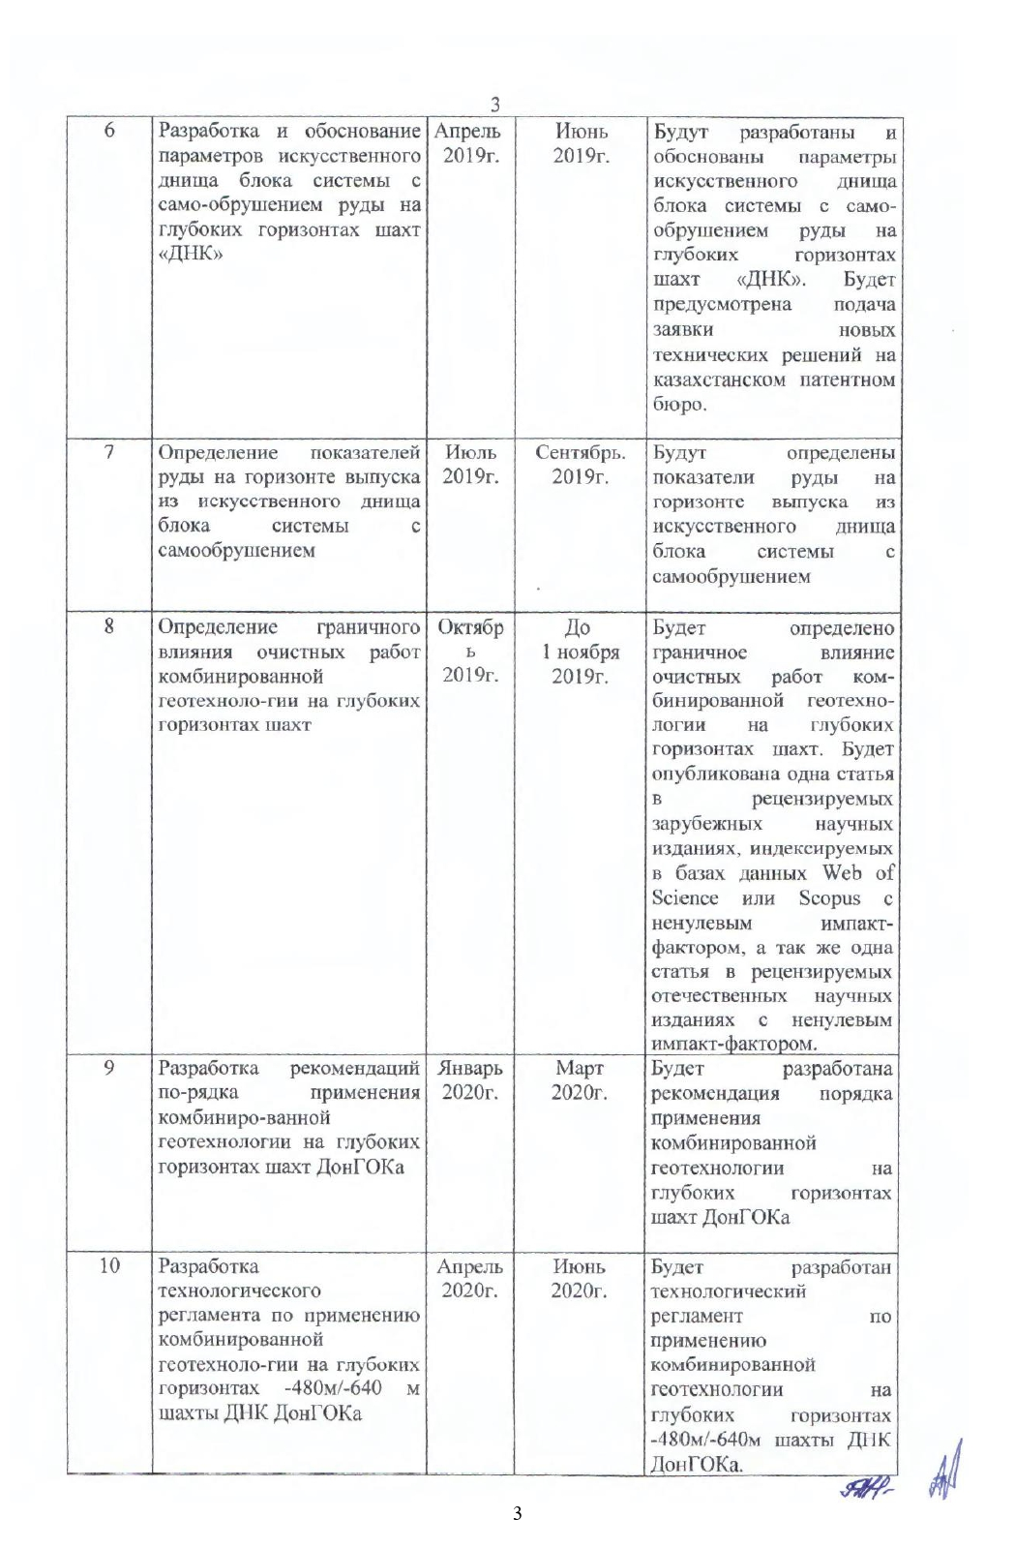

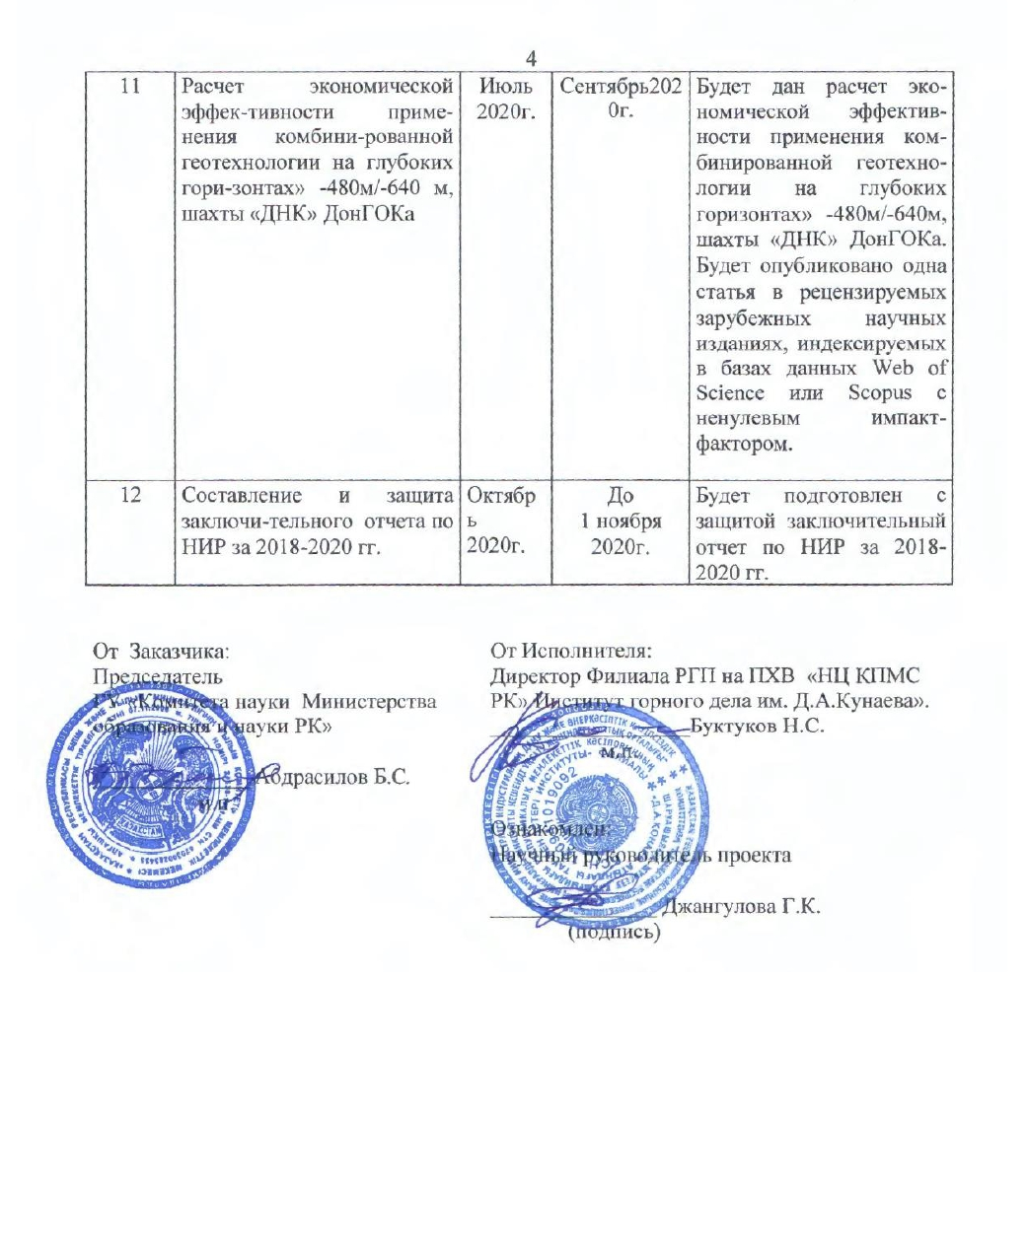
APPENDIX B

List of publications on the subject during 2018-2020:

No | Results of works | Link
Year 2018
1 | David Kaplunov, Dosanbay Bekbergenov and Gulnar Dzhangulova  Particularities of solving the problem of sustainable development of chromite underground mining at deep horizons by means of combined geotechnology// E3S Web of Conferences 56, 01015 (2018) [in English] | https://doi.org/10.1051/e3sconf/20185601015
2 | Kh. Kassymkanova, G. Jangulova, R. Bekseitova, N. Miletenko, G. Baidauletova, V. Turekhanova, Y. Zhalgasbekov, I. Shmarova/ Express-assessment of geomechanic condition of the rock massive and development methods of its strengthening and reinforcing for safe ecological developing of the fields of mineral resources in hard mountain-geological and mining engineering conditions. Series of Geology and Technical Sciences. 6. 2018, Volume 5, Number 431 (2018), 37 – 46 [in English] | https://doi.org/10.32014/2018.2518-170X.33
Year 2019
1 | D. K. Bekbergenov, G. K. Jangulova, B. K. Bektur Current condition and outlooks of sustainable development of chromite underground mining at lower horizons of mines of the Don mining and processing plant// News of the Academy of Sciences of the Republic of Kazakhstan. - Volume 1, Number 433 (2019), 90 – 97 [in English] | https://doi.org/10.32014/2019.2518-170X.11
2 | Dossanbay Bekbergenov, Gulnar Jangulova, Leonid Zherebko, Bakytbek Bektur  Study of the effect of refining on the sustainability of the level of the system with uncontrolled caving at the deep levels of the “DNK” colliery// International Journal of Civil Engineering and Technology (IJCIET), Volume 10, Issue 01, January 2019, pp. 2090-2103, Article ID: IJCIET_10_01_188. [in English] | Available online at http://www.iaeme.com/ijciet/issues.asp?JType=IJCIET&VType=10&IType=01  ISSN Print: 0976-6308 and ISSN Online: 0976-6316.
3 | D. Bekbergenov, G. Dzhangulova, A. Abakanov, Zh. Seydakhmetova Assessment of the geotechnical situation in the zone of drawing-off workings at the uncontrolled caving for the safe and sustainable development of chromite mining at deep horizons of mines of the DON Mining and Processing Plant/ Kazakhstan industry. No.1 (105), 2019 P. 57-59. [in Russian] | The copy is attached
Year 2020
1 | Bekbergenov D.K., Dzhangulova G.K., Bektur B.K. Determination of the boundary effect of stoping at the combined geotechnology at deep horizons of the Don chromite mines / Complex Use of Mineral Resources. No.1 (312), 2020. P.69-77 [in Russian] | https://creativecommons.org/licenses/by-nc-nd/3.0/
2 | Evgeny Fedorov,*, Dosanbay Bekbergenov and Gulnar Jangulova. Modeling and methodology for calculating the strength of a man-made bottom in a system with self-destruction of ore for ecologically safe mining/ VIII International Scientific Conference “Problems of Complex Development of Georesources. E3S Web of Conferences 192, 03018 (2020) [in English] | https://doi.org/10.1051/e3sconf/202019203018
3 | Bekbergenov D.K., Dzhangulova G.K., Nasyrov R.Sh., Aymbetov M.M. and others. Patent No.34565 registered in the State Register of Inventions of the Republic of Kazakhstan dated 29.09.2020 for the invention “The method of creating an artificial stope sill at great depths with a stable reinforced concrete platform at uncontrolled caving.” [in Russian] | The copy is attached
4 | Bekbergenov D.K., Dzhangulova G.K., Nasyrov R.Sh., Aymbetov M.M. and others. Patent No.34538, registered in the State Register of Inventions of the Republic of Kazakhstan dated 29.09.2020 for the invention “The method of creating an artificial stope sill at great depths with a stable reinforced concrete platform at uncontrolled caving.” [in Russian] | The copy is attached
5 | Bekbergenov D.K., Dzhangulova G.K., Seydakhmetova Zh.I. Patent No. 34564 The method of constructing the stope sill by means of cable-injection consolidation at the development of unstable ore deposits at deep levels [in Russian] | The copy is attached

APPENDIX С

THE MINISTRY OF INDUSTRY AND INFRASTRUCTURAL DEVELOPMENT OF THE REPUBLIC OF KAZAKHSTAN
THE BRANCH OF THE RSE “NATIONAL CENTER FOR INTEGRATED MINERAL PROCESSING OF THE REPUBLIC OF KAZAKHSTAN”
THE MINING INSTITUTE AFTER D.A. KUNAYEV

Approved by
Director of the Institute, member of the NAS RK, Professor, Doctor of technical sciences
_____________ N.S. Buktukov
“___” _______________ 2020.

The Method and Calculation of Technical and Economic
Effectiveness of the Combined Underground Geotechnology at the Development of Chromite Reserves using a System of Horizontal Descending Slicing and Backfilling in the Form of a Trapezoid Block in Combination with Uncontrolled Caving and Ore Delivery Using Self-Propelled Equipment in the Conditions of an Erected Artificial Stope Sill at Deep -480m/-640m Horizons as Examplified by the “DNK” Mine of the Don Mining and Processing Plant

Head of the Laboratory
“Integrated Development of Mineral Resources”
MI after D.A. Kunayev,
Candidate of technical sciences Bekbergenov D.K.

Almaty 2020
The Method and Calculation of Economic Efficiency of the Combined Geotechnology at Deep -480/-640m Horizons of the “DNK” Mine of the DON Mining and Processing Plant

1. The calculation Method of Technical and economic Efficiency of New Options of Underground Development of Highly Fractured and Unstable Ore Deposits at Great Depths of the Mine Using the Combined Geotechnology.
The calculation method for the selection of development systems as optimization criteria, in addition to the reduced costs, should account for the economic damage from losses and dilution and a number of other economic factors.
Analysis of the development of the previous stopes helps to identify several features that affect the choice of the system, the main of which are:
- Insignificant outcropping of rock masses (up to 10-12 m²), which leads to collapse and uncontrolled caving of ore and rock;
- Easy explosiveness of ore and rock masses;
- The presence of many cracks in masses with different thickness from 0.1 mm to 2-3 cm and intensity due to the concentration of rock pressure;
- The process of ore uncontrolled caving intensifying at 400-600 m² outcrops.
A preliminary technical and economic comparison under these conditions was done for three options under identical conditions:
Option 1. Descending horizontal slicing and backfilling of the mined space under the artificial roof, where 100% of the mining operations are performed according to this development system.
Option 2. Technology with uncontrolled caving, where up to 100% of the reserves are mined using this system.
Option 3. Combined underground geotechnology for the development of reserves in deep and multiple isolated ore deposits using a cut-and fill development system which have a standard block shape with 100% hardening backfilling and in an adjacent block on a level with 100% stoping in combination with uncontrolled caving technology.
Option 4. Combined underground geotechnology for the development of reserves in deep ore trapezoid deposits using a cut-and-fill development system with an angle of slope of the block sidewalls = 80-85⁰ from the upper layer of development at an angle of repose with a decrease in the volume of the hardening mixture and mining operations up to 40%, and in the adjacent block on the level in combination with the uncontrolled caving technology using self-propelled equipment in the conditions of ASS (Figure 1) with a constant volume of stoping increases the volume of the caved ore mass up to 30%.
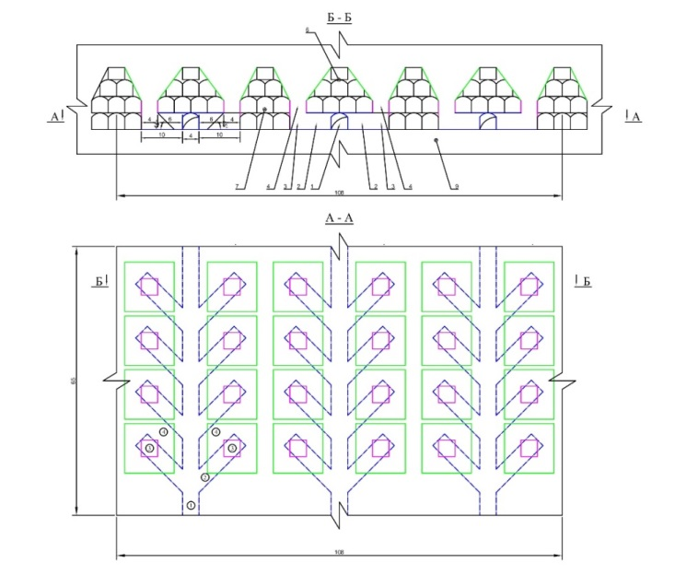
Figure 1 Process chart of the artificial stope sill for ore drawing with the classical rectangular funnel and delivery of the ore mass by the LHD from the loading drive according to the classical Christmas tree-parallel scheme
To select the most effective underground geotechnology for the extraction of chromite ores, the methodology of competing development systems is substantiated on the basis of which the most effective of them is selected.
According to a comparative technical and economic analysis, the selection method provides for an estimate of the cost of stoping for various options of development systems and the calculation of the costs of preparing and placing a hardening stowing into the stope as well as the costs of uncontrolled caving technology (1).
С _{комб}. = С_{тв.закл.} + С_{сор} → min. (1)

The method must meet the following basic requirements. It must:
- Account for the indicators that affect the result of the performance assessment and reflect all the positive and negative aspects of competing development systems;
- Include indicators of the completed technological cycle;
- Contain indicators that can be easily determined in the conditions of a given enterprise and are not based on assumptions;
- Proceed from the need for the coincidence of the interests of the national economy and mining enterprises;
- Be extremely simple both in form and in content;
- Provide comparable conditions for competing development systems.
For our conditions, the ultimate goal is to maximize the value per 1 ton of recoverable ore from the deposit per unit of time, taking into account production costs in combination with the principle of safe and profitable exploitation of the Almaz-Zhemchuzhina deposit.
Employees of the Mining Institute after D.A. Kunayev propose option 4. The combined underground geotechnology for the development of reserves in deep and multiple isolated ore deposits using trapezoid cut-and fill with an angle of slope of the block sidewalls 80-85⁰ from the upper layer of mining at an angle of repose with a decrease in the hardening stowing up to 40% of the volume of stowing work and on the level, in combination with the uncontrolled caving technology with a constant volume of stoping, increases the volume of caved ore mass up to 30%
Taking into account the mining geological and geomechanical conditions, a system of development with uncontrolled caving and delivery of ore by self-propelled equipment is adopted in the conditions of the artificial stope sill including delivery workings, entryways, ore passes, and funnels are made. Further, the block is undercut by blasthole rings drilled from drilling chambers located above the level of the drawing-off horizon (representing structural elements from artificial drawing-off workings) at the height of 10-20 m.
The economic comparison of development systems revels that there are material and labor costs C (tg/t), ore losses P (%), dilution R (%), specific capital investments k (tenge per 1t/year).
The comparison is done for the minimum amount of comparative losses. The comparison criterion in this case is determined based on the expression (2):
С+У_{пр} →min (2)
where У_{пр}=У^{п}+У_{р} is an economic damage from losses and dilution calculated using the formulas (3 and 4):
(3)

(4)

where С_{пер.п.п} - is costs for the processing of waste rocks, tenge/t;
α_{хв.п.п} - is metal content in tailing pits of waste rocks or in smelter slags.
In view of the insignificant difference in the losses and dilution within the systems under consideration, it is necessary to account for the economic effectiveness of the systems in terms of the volume of preparatory and face heading.
2. Calculation of Technical and Economic Efficiency of the Proposed Method of Combined Underground Geotechnology

For specific sections of the mine field, calculations reveal the technical and economic advantages (in the conditions of the designed section of the mine field) of the adopted option of the development system: this is a decrease in the specific volume of preparatory and face heading, an increase in labor productivity, a decrease in labor intensity, and a decrease in consumed materials.
The proposed method of block preparation with the use of self-propelled equipment allows to reduce the specific volume of preparatory development in the production of ore mass using the uncontrolled caving technology and increase in the productivity of ore delivery by over 1.5 times in comparison with the scraper driving.
Considering that the main scope of work within the proposed combined geotechnology at the preparation of the block is different, the coefficient of preparatory and face heading is calculated using the formula (5) and (Table 6.1 and 6.2):

m/1000t, (5)
where ∑V - is the total lengths and volumes of mining in the block m(m³); Б_{бл} is recoverable ore reserves in the block, t.
Table 1 The volume of preparatory development in the block for option 4 proposed by the Mining Institute after D.A. Kunayev:
Workings | Number of workings | The total length of workings, m |  |  | Working’s section, m² | Working’s volume, m³
Workings | Number of workings | Ore | Rock | Total | Working’s section, m² | Ore | Rock | Total
Preparatory development
Load-haul drift | 3 | 50,1 | 0 | 150,4 | 14,8 | 2226,7 | 0 | 2226,7
Drilling and loading drive | 24 | 13,8 | 0 | 331,2 | 14,8 | 4901,7 | 0 | 4901,7
 |  | 63,9 | 0 | 481,6 |  | 7128,4 | 0 | 7128,4
Block parameters: width = 36m, length = 60m and height = 70m.
The conventional block reserves: Б_{бл} = 36 x 60 x 80 = 151,200 m³ x 3.86 = 583,632 tons.
Next, we determine the parameters of the block panel: width = 108m, length = 60m and height = 70 meters. Panel reserves: П_{зп} = 108 x 60 x 70 = 453,600m³ x 3.86 = 1,750,896 tons.
In monetary terms, calculating the difference in ore extraction for the two proposed options 3 and 4 in terms of the cost of ore extraction and technical and economic indicators are presented in Table 7.2:
The calculation of the technical and economic indicators of the compared options with the results of the proposed option revealed the following results: compared with option 3, the cost savings is 1,631,223 tenge.
The technical and economic analysis of the compared options of the proposed underground geotechnology at the development of reserves in deep and multiple isolated ore deposits using a trapezoid cut-and fill system with an angle of slope of the block sidewalls 80-85⁰ from the upper layer of mining under the angle of repose with a decrease in the hardening stowing to 40% of the volume of the backfill and in the adjacent block on the level with the same volume of development and face heading reveals that the volume of caved ore mass increases up to 30% in combination of the uncontrolled caving technology using self-propelled equipment under conditions of artificial stope sill.
Thus, according to the selected option, it is rational to increase the economic efficiency of mining operations at the development of reserves in deep deposits using a trapezoid cut-and-fill system with an angle of slope of the block sidewalls 80-85⁰ from the upper layer of mining at an angle of repose with a decrease in the hardening stowing to 40% of the backfilled volume and in an adjacent block on the level, because the volume of the caved ore mass increases by 30% in combination with the uncontrolled caving technology.
This makes it possible to reduce the cost of mining and development operations without compromising the commercial value of mining in combination with the uncontrolled caving technology. At the same time, the level of economic efficiency of option 4, proposed by the Mining Institute of D.A. Kunaev is 25.4% compared to option 3 which equals 22%, which shows the profitability of the proposed option involving the use of self-propelled equipment by 11.5% which is equal to the sum of 1 million 631 thousand 223 tenge.

Table 2 The cost of ore mining and technical and economic indicators of options 3 and 4:
No | Name | Unit | Option 3 | Option 4
No | Name | Unit | Combined underground technology for the development of reserves in deep deposits using descending trapezoid horizontal slicing and backfilling with a block angle of slope 80-85° in combination with the uncontrolled caving and delivery of ore using a scraper | Combined underground technology for the development of reserves in deep deposits using descending trapezoid horizontal slicing and backfilling with a block angle of slope 80-85° in combination with the uncontrolled caving and application of LHD.
1 | Ore mining volume (conventional annual volume) | ton | 10000 | 10000
2 | Losses | % | 15,5 | 13
3 | Dilution | % | 16 | 17
4 | Chrome content | % | 40 | 40
5 | Metal content in chrome ore | ton | 4000 | 4000
6 | Ore mining with due account for losses and dilution | ton | 10100 | 10400
7 | Metal extraction | % | 60 | 60
8 | Metal in the concentrate | ton | 6060 | 6240
9 | Estimated planned price of goods | tenge | 24000 | 24000
10 | Sale price | tenge | 145440000 | 149760000
11 | Preparatory development | m3 | 213,0 | 157,0
12 | Stowing | m3 | 136 | 127
13 | Costs of development heading | tenge/m3 | 25600 | 24300
14 | Costs of stowing | tenge/m3 | 5947 | 5947
15 | Costs of ore mining | tenge/ton | 10600 | 10300
16 | Full production cost | tenge. | 113321592 | 111690369
17 | Saving + excess expenses | tenge. |  | -1631223

Engineer-economist of the laboratory
«Integrated development of mineral
resources» of D.A. Kunaev Mining Institute Duisenbaev D.

Head of the Laboratory
«Integrated development of mineral
resources» of D.A. Kunaev Mining Institute
Cand. tech. sciences Bekbergenov D. K.
APPENDIX D

The Ministry of Industry and Infrastructural Development
of the Republic of Kazakhstan
The Branch of the RSE “National Center for Integrated Mineral Processing
of the Republic of Kazakhstan”

THE MINING INSTITUTE AFTER D.A. KUNAYEV

THE BRANCH OF JSC TNK KAZCHROME OF DON mining and processing plant

AGREED WITH:  Deputy Director of the  DON mining and processing plant  JSC TNK Kazchrome  ________________ R.Sh. Nasyrov  “____”______________2020. | APPROVED BY:  Director of the Branch of the RSE “NC IMR RK” Mining Institute after D.A. Kunayev, member of the NAS RK, Professor, Doctor of technical sciences  ________________ N.S. Buktukov  «____»______________2020.

OPERATING PROCEDURE
of Combined Geotechnology at Deep Levels
-480/-640 m of the DNK Mine of the DON Mining and Processing Plant

Head of the Laboratory
“Integrated Development of Mineral Resources”
MI after D.A. Kunayev,
Candidate of technical sciences ________________ D. K. Bekbergenov
^{signature, date}

Almaty-Khromtau 2020

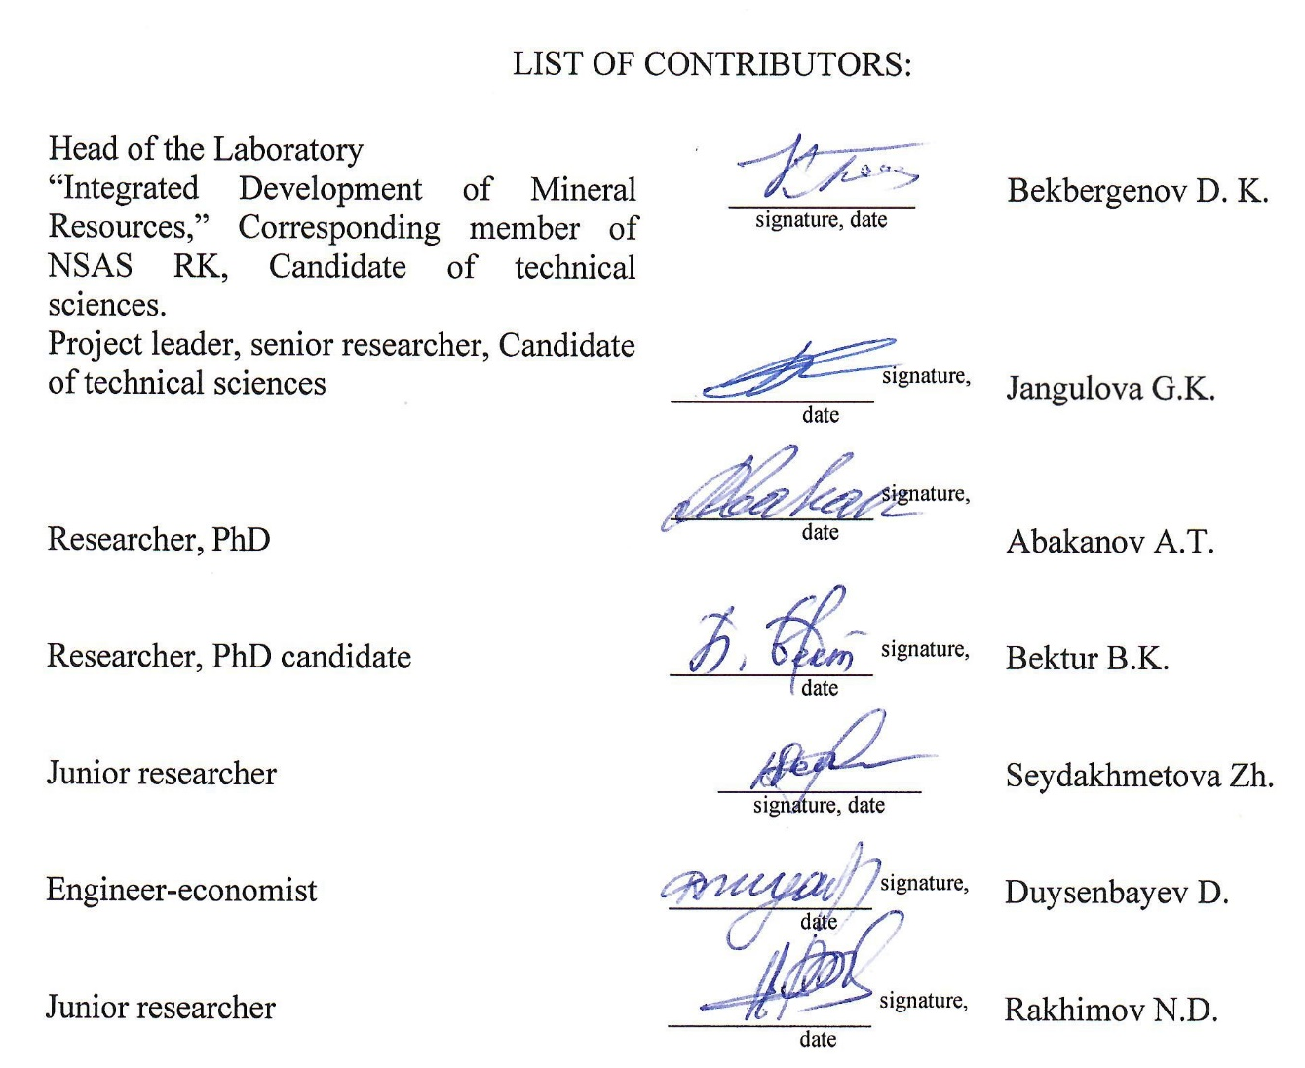
LIST OF CONTRIBUTORS:

Head of the Laboratory  “Integrated Development of Mineral Resources,” Corresponding member of NSAS RK, Candidate of technical sciences. | ___________  ^{signature, date} | Bekbergenov D. K.
Project leader, senior researcher, Candidate of technical sciences | ____________ ^{signature, date} | Jangulova G.K.
Researcher, PhD | ____________ ^{signature, date} | Abakanov A.T.
Researcher, PhD candidate | ____________ ^{signature, date} | Bektur B.K.
Junior researcher | ____________  ^{signature, date} | Seydakhmetova Zh.
Engineer-economist | ____________ ^{signature, date} | Duysenbayev D.
Junior researcher | ____________ ^{signature, date} | Rakhimov N.D.

TABLE OF CONTENTS

 | INTRODUCTION…………..……………………………………..………………….......… | 46
1 | Components of Methodological Justification of the Application of the Combined Geotechnology in the Conditions of the Mine of the DON Mining and Processing Plan | 47
1.1 | Urgency of the Problem …………………………………………………………......……… | 47
1.2 | The Purpose of Developing the Operating Procedure ..…………………………….......…… | 48
1.3 | Tasks of the Operating Procedure ……………………………………………………......…. | 48
1.4 | Scientific Novelty, Practical Significance and Expected Result from the Development of the Operating Procedure ………..……………………………………………........………. | 49
2 | Mining Geological, Mining Technical Particularities and Overview of Possible Development Systems in the Mining Conditions of Chromite Reserves of the DNK Mine of the DON Mining and Processing Plant………………………………………...............… | 50
2.1 | Particularities of Mining Geological and Mining Technical Conditions of Development of Chromite Reserves at Deep -480/-640 m Levels of the DNK Mine of the DON mining and processing plant…………………………………………………………….......................... | 50
2.2 | Experience of Application of the Mining System with Ore Caving in the CIS Countries and in the Conditions of the DNK Mine of the DON Mining and Processing Plant ….....… | 52
2.3 | Foreign Experience of Application of the System of Uncontrolled Caving at the Kiruna mine Sweden)…………………………………………………………………………......…. | 53
2.4 | The practice of Application of Uncontrolled Caving System at Underground Mines of Kazakhstan ….….………………………………………………………….......……………. | 54
2.5 | Particularities of the Development of Chromite Reserves at the DNK Mine Using the Traditional Mining System with Uncontrolled Ore Caving and Scraper Haulage ……......... | 51
2.6 | On the Possibility of Using Geotechnology with the Development System - Block Cave (Mechanized Block Uncontrolled Caving) in the Conditions of Mines of the DON Mining and Processing Plant ……………………………………………………............................... | 60
2.7 | Block Caving Development System with Artificial Stope Sill with Scraper, Conveyor Delivery and Vibro-Drawing of Ore …..……………………………………….....……….. | 64
2.8 | Experimental Development System Using Horizontal Descending Slicing with Solid Stowing of the Mined-Out Space Under Artificial Roof at the Development of Reserves of the Pervomayskoye Deposit ………………………………………….........................……. | 71
3 | Regulatory Parameters for the Application of Combined Geotechnology in the Conditions of the DNK Mine at Underground Mining of Chromite Reserves…....................................... | 73
3.1 | Current Activities of the DNK Mine of the DON Mining and Processing Plant for Underground Mining of Chromite Deposits…………………………………………….… | 73
3.2 | Factors Affecting the Technological Feasibility of Transition to the Combined Geotechnology of Uncontrolled Caving System with the Artificial Stope Sill and Ore Delivery Using a Scraper in the Conditions of Increased Rock Pressure at the "DNK” mine of the DON Mining and Processing Plant….……………………………………………….. | 75
3.3 | Proposed Combined Geotechnology for Sustainable Development of Underground Chromite Mining in the Conditions of Deep Horizons of the “DNK” Mine……………… | 76
3.3.1 | The Essence of Application of the Combined Patented Geotechnology in the Conditions of the DNK Mine of the DON Mining and Processing Plant ………………………………… | 76
3.3.2 | Development of Underground Geotechnology with the Artificial Stope Sill and Justification of Its Parameters Within the Combined Geotechnology .............................. | 78
3.4 | The Method for Substantiating the Calculation of Strength of Artificial Stope Sills (ASS) with Multiple Support Reinforced Concrete Platform …………………………..………… | 85
3.5 | Modelling the Artificial Reinforced Concrete Stope Sill Within the Uncontrolled Caving System .………………………………………………………………………….………… | 87
3.5.1 | Input Data for the Calculation of 3D Model Using ANSYS PC………………………...… | 87
3.5.2 | Results of Simulation at Various Levels...........................................................................… | 88
3.6 | Method and Sample Strength Calculation of the Proposed ASS ……………………….… | 91
4. | Proposed Combined Geotechnology with the Application of Self-Propelled Equipment in the Conditions of the Artificial Stope Sill ………………………………………………… | 96
4.1 | Selection of the Excavation Unit, Development Heading, Stoping and a List of Geotechnological Equipment for the Use of Combined Geotechnology in the Conditions of Deep -480/-640 m Horizons of the DNK mine of the DON Mining and Processing Plant………………………………………………………………………….……………… | 99
4.2 | Determination of Ore Losses and Dilution at the Development of Chromite Reserves Using Combined Underground Geotechnology and Self-Propelled Equipment in the Conditions of the Erected Stope Sill …………………………………………………….……………… | 101
4.3 | Computational Scheme and Stress-Strain State of the Combined Geotechnology Based on Finite Elements Depending on the Angle of Inclination of the Block Sidewall ……….... | 101
5 | Development of Recommendations for the Application of the Combined Geotechnology at Deep Horizons of Mines of the DON Mining and Processing Plant………………………… | 107
6 | The Method and Calculation of Economic Efficiency of the Combined Geotechnology at Deep -480/-640m Horizons of the “DNK” Mine of the DON Mining and Processing Plant | 110
6.1 | The calculation Method of Technical and economic Efficiency of New Options of Underground Development of Highly Fractured and Unstable Ore Deposits at Great Depths of the Mine Using the Combined Geotechnology………………………………… | 110
6.2 | Calculation of Technical and Economic Efficiency of the Proposed Method of Combined Underground Geotechnology ……………………………………………….. | 113
 | CONCLUSION.................................................................................................................. | 116
 | LIST OF REFERENCES..................……………………………………………………. | 120
INTRODUCTION

The proposed geotechnology of development by means of descending slicing with cut-in-fill stoping under artificial roof combined with the system of uncontrolled caving and application of self-propelled equipment and artificial stope sill for the mining of chromite reserves ensures high productivity in the conditions of deep and highly fractured and unstable ore masses.
Based on the research results of the proposed combined geotechnology, the operating procedure has been developed for developing reserves at deep -480/-640 m horizons of the DNK mine of the DON mining and processing plant.
This operating procedure was developed in accordance with the program “Grant financing of scientific research” based on the research results of the laboratory “Integrated Development of Mineral Resources” of the MI after D.A. Kunayev held in 2018-2020.
The materials presented in the operating procedure are the result of generalization and systematization in accordance with Grant funding for 2018-2020 by the RK Ministry of Education and Science and conducted research No. AP05131352 "Development and substantiation of the parameters of combined geotechnology for the safe and sustainable development of chromites at deep horizons" and represent a technological solution of the task of safe and sustainable development of underground mining of chromites using the combined geotechnology in the conditions of deep horizons of mines of the DON mining and processing plant.
1 Components of methodological justification of the application of the combined geotechnology in the conditions of the mine of the DON mining and processing plant

  - Urgency of the Problem
Underground mining of a thick ore body using a system of uncontrolled caving at the DNK mine of the DON mining and processing plant includes road heading, driving a scraping drift (SD) from the roof of the loading ort connected to the transport haulage drift at the discharge level. The contours of the ore body along the SD at the appropriate distance are driven with niches to the right and left at an angle of 7-10° horizontally and from the bottom of the face, with vertical workings - draw points and receiving funnels for the release of caved ore mass and prepared by the ore volume by blast holes from the undercut drift in the conditions of a highly fractured and unstable rock mass. As the caved ore mass is released from the block at the scraping drift, the ore caving spreads to the upper parts of the block. At the same time, the main mass in the contour of the ore undercut with the drilling-and-blasting method in the block is deprived of support, is strongly fractured and is self-collapsing under the weight of the surrounding mass. This method is applicable in the mass of the fourth and fifth stability categories using a system of uncontrolled caving at the lower horizons of the mine and will make it impossible to maintain the access crosscut in working condition regardless of its fastening [1, 2]. A disadvantage of the system of ore uncontrolled caving is large losses and dilution of ore, the oversized ore at the release of the ore as well as additional costs for mining operations aimed at the re-consolidation and restoration of the stope sill.
One of the existing geotechnologies for underground mining of a high flat ore body is its breakdown into longitudinal strips, carrying out the necessary development and face heading and sequential mining of each strip by a separate stope and filling of the mined-out space with solid stowing [3,4]. This geotechnology is applicable at any depth of occurrence, but only in stable or medium stable rock masses, because to carry out stowing operations it is necessary to have an open mined space, which is technically very difficult and expensive in an unstable rock mass with a high probability of sudden uncontrollable collapse of its sides and roofing. So it is characterized by high costs of ore extraction, a significant part of which is the cost of stowing work.
In this regard, for the development of deposits in areas with highly fractured and unstable masses of the mine field at the deep horizons (over 500-600 m) of mines of the DON mining and processing plant of the Pervomayskoye deposit using a development system of horizontal descending slicing with filling the worked-out space under artificial roof, the block preparation includes driving a haulage roadway and ramps for each slice.
Block reserves are mined by means of descending slicing. The stoping is carried out simultaneously in two and three sublevels with a vertical distance between the simultaneously mined slices in adjacent sublevels of at least 20 m. Mining operations at each sublevel begin with the driving of stoping drifts and horizontal cuts at an angle of 6÷8° to the horizon with the purpose of developing ore slice reserves and stowing. The mined ore from each cut is delivered to the ore pass. In the conditions of a very unstable and highly fractured ore, an artificial roof is created on the upper layer to mine in the cuts. The roof is reinforced with an arch support made of a special interchange profile and filled with a stowing [5].
A disadvantage of this method is the high cost of stowing, fastening materials in the conditions of the development system using descending horizontal slicing with the stowing of the worked-out space under an artificial roof.
To increase the economic efficiency of stoping due to the reduction of the cost of stowing works without deteriorating the commercial value of the ore mined using the system of descending horizontal slicing with stowing the worked-out space under artificial roof and to reduce rock pressure in the stope sill as well as additional costs for retimbering in combination with geotechnology of uncontrolled caving, it is proposed to use the combined underground geotechnology [6], which ensures the rational development of reserves in conditions of deep ore deposits with a thickness of up to and more than 80 m and highly fractured and unstable ore reserves and enclosing rock masses (sometimes in the form of an isolated deposit).

1.2 The Purpose of Developing the Operating Procedure
The purpose of the scientific and methodological substantiation and development of technological regulations for the use of the combined geotechnology at deep horizons of -480/-640m of the DNK mine of the DON mining and processing plant is to provide regulatory parameters for the sustainable development of underground mining of a chromite deposit with a high extraction of ore from blocks and safe mining operations using the combined geotechnology by means of highly adaptive and efficient self-propelled equipment for the development of deep inclined thick highly fractured masses in the conditions of increased rock pressure.

1.3 Tasks of the Operating Procedure
1) Justification of the methodology for choosing combined geotechnology in the conditions of mines of the DON mining and processing plant.
2) Overview and analysis of the possibility of using the mining system with ore caving in the conditions of chromite reserves of the DNK mine of the DON mining and processing plant.
3) The essence and particularities of the process chart of the proposed options of systems with the combined geotechnology for underground mining of chromite reserves in deep horizons of the DNK mines.
4) Development of the operating procedure for the use of the combined geotechnology in the conditions of the DNK mine for underground mining of chromite reserves.
5) Selection of excavation equipment, preparatory and stoping works and a list of geotechnological equipment for the proposed combined geotechnology for the development of chromite reserves at the DNK mine of the DON mining and processing plant.
6) Development of recommendations for the procedure of mining and determination of parameters of ore losses and dilution in the combined geotechnology in the conditions of mining reserves by the example of a local block of the DNK mine.
7) Technical and economic indicators of the application of the recommended combined geotechnology in conditions of the DNK mine of the DON mining and processing plant.
1.4 Scientific Novelty, Practical Significance and Expected Result from the Development of the Operating Procedure
Scientific novelty is the development of a method and substantiation of the regulatory technological parameters for the use of the combined geotechnology with local design and calculation of technical and economic efficiency for the safe and sustainable development of chromite reserves in the conditions of the DNK mine of the DON mining and processing plant using the combined geotechnology.
The practical significance of the development of the operating procedure has no analogues not only in the Republic of Kazakhstan, but also abroad, therefore, the proposed operating procedure “Operating Procedure of Combined Geotechnology at Deep Levels -480/-640 m of the DNK Mine of the DON Mining and Processing Plant” ensures real technological regulatory parameters for sustainable development of underground mining of a chromite deposit at deep -480/-640 m horizons of the DNK mine of the DON mining and processing plant using the combined geotechnology with high efficiency of ore extraction from blocks and safe mining operations.
Expected result from the development of the operating procedure
The operating procedure will be developed on the basis of the developed method for substantiating regulatory parameters for the application of the proposed combined geotechnology in real conditions of underground mining of a chromite deposit at deep -480/-640 m horizons of the DNK mine of the DON mining and processing plant.

2 Mining Geological, Mining Technical Particularities and Overview of Possible Development Systems in the Mining Conditions of Chromite Reserves of the DNK Mine of the DON Mining and Processing Plant

2.1 Particularities of Mining Geological and Mining Technical Conditions of Development of Chromite Reserves at Deep -480/-640 m Levels of the DNK Mine of the DON mining and processing plant

The geotechnical conditions of the reserve development are classified as complicated, and the mining conditions (according to the findings of the VIOGEM Institute) are classified as very difficult [7,8].
Ores and ore-bearing rocks in accordance with the “Instruction for the Prevention and Suppression of Underground Endogenous Fires...” are not prone to spontaneous combustion, and the deposits as a whole are not fire hazardous. Ores and rocks are not hazardous in terms of dust explosion.
The swell factor for ores and rocks is 1.5-1.6 [9].
Ore-bearing rocks are mainly characterized as moderate abrasive with the below the average degree of abrasiveness, belong to classes III-IV of abrasiveness and have an abrasive index from 10-18 to 18-30 mg. Chromium ores have an increased degree of abrasiveness, belong to class VI and are characterized by an abrasive index of 45-65 mg.
In accordance with SNiP RK 2.03-30-2006 “Construction in Seismic Regions. Design Norms,” seismicity of the area where the fields are located is 5 points, so there are no additional requirements to building structures.
A negative feature of the mass of serpentized ultrabasic rocks is the manifestation of accelerated and intense weathering of rocks in some areas of mine workings. According to the VIOGEM data, these areas are characterized by the development of apodunite serpentinite containing hydroxyl ferromagnesian minerals (ferrobrusite, pyroaurite, sjogrenite) in an amount of over 10%.
A decrease in density leads to an increase in volume, and in the absence of free space, to the occurrence of internal stress in the rock. These processes, in turn, weaken the stability of the roof and walls of mine workings (talus, falls, collapse) and to heaving of the soil of mine workings. Observations at the Molodezhnaya mine revealed that the maximum rate of destruction of the working walls is 2-3 m to the deep during 5-6 months, and the maximum heaving of the floor of the mine working reached 0.4 m.
Geomechanical studies of the state of the rock mass within the multipurpose program for studying the manifestation of rock pressure in underground mine workings of operated mines are carried out by the Institute of Mining of the Ural Branch of the Russian Academy of Sciences (IGD UrO RAN) [10].
Within the limits of the allotment area of the DNK mine, two types of groundwater are developed: interstitial water in Cretaceous and Paleogene sediments, and fissure water in the rocky Paleozoic mass.
Fissure water developed in the rocky ore-bearing mass is the main source of watering of mine workings and is subdivided into fissure-ground and fissure-vein. Its distribution is confined to the zones of open fracturing of metamorphosed intrusive rocks of basic and ultrabasic composition represented by gabbro-amphibolites and serpentinites over dunites and peridotites.
The results of calculations of predicted water inflows are shown in Table 2.1[11].
Table 2.1 Predicted water inflows into Underground Working of the Mine:
Stages of reserve development | Deposits (mine workings) | Standard water inflow rate, m³/h
I | No.21 (pit reserves) | 70
I | Millionnoye, Almaz-Zhemchuzhina, Pervomayskoye and Western deposit | 770
II | Millionnoye, Almaz-Zhemchuzhina | 1170
III | Almaz-Zhemchuzhina | 1220

An unfavorable mining technical factor in the development of chrome ores is their caking, which sharply reduces the mobility of the ore and complicates the technology of its extraction.
For the current period of operation, the main type of fastening of the undercut workings is flexible metal supports with different installation spacing. However, as studies show, the role of supports in the stability of the stope sill is not in its carrying capacity, which is limited, but in retarding the process of mass destruction around the bottom.
This concept is primarily applied to scraping drifts. This was confirmed by analytical calculations of the process of formation of loads on the support of the working during its driving. At the undercutting, all development workings are beyond the zone of influence of mining operations and, with due account for these conditions, loads are formed on the support of workings, due to the development of the zone of inelastic deformation (ZID) above the working. The ZID radius determines the value of the dome of natural equilibrium, where the ore mass is in a weakened state similar to that of caved rocks. In this regard, the stump pillar completely falling into the zone of inelastic deformations or, in the dome of natural equilibrium, does not perform its main functions, the stump pillar loses its functional purpose.

2.2 Experience of Application of the Mining System with Ore Caving in the CIS Countries and in the Conditions of the DNK Mine of the DON Mining and Processing Plant

A distinctive feature of this mining system is the caving of an ore mass cut at the bottom or on the side in the sublevel or level, after which, as the caved ore is released, the barren rocks cave and fill the worked-out space.
Mining systems with massive caving of ore and enclosing rocks are used in thick and medium-thick deposits. The stope is not supported (except for the formed chambers or crevices). Mainly long-hole stoping is used, sometimes uncontrolled caving.
Underground mines of the CIS, including Kazakhstan, employ this development system to mine iron and phosphate ores, for example, in Kryvbas Gornaya Shoria, the mines of the Nizhne-Tagil plant as well as at a number of large non-ferrous metallurgy enterprises (the Tyrnyauzskiy, Zyryanovsky, Salairskiy, Leninogorskiy) [12]. The option with stump breaking and bottom discharge of ore is used, for example, at the mines of the Zyryanovskiy, Tyrnyauzokiy and Karatau plants in thick steep deposits of strong ores and the Apatit plant in highly thick inclined ore deposits of medium strength.
Ore is transported through the stope by gravity and discharged at the bottom of a block or sublevel. As the general ore drawing proceeds, the enclosing rocks fall on the broken ore and fill the worked-out space. As a result, a significant part of the ore is mined under overlying caved rocks, which is the main feature of these mining systems. In steep deposits, the block height is divided into levels and sublevels. The ore from the block is developed sequentially in descending order because of the caved rocks.
Conditions of application. These systems are used in thick and medium-thick deposits provided that it is not required to support the earth’s surface.
System parameters. The main element of the sublevel caving system is the draw figure, which, as shown by studies, is almost an ellipsoid. The formation of the figure is influenced by the section of the sublevel drifts, their location, and the degree of ore crushing. Otherwise, when the narrow section in the middle of the stream is drawn faster, the upper flanks of the broken layer of ore are blocked by the collapsing rock resulting in ore wastage.
Parameters: the height of the sublevel is usually 20-30m, the dimensions of the drifts are 5.5x5.1m, the distance between the sublevels along the axes is 10-17m, the width of the pillar is 6-12m. The thickness of the broken layer with a borehole diameter of 50-80mm is 1.5-2.5m.
The system parameters do not remain constant, they change depending on the specific conditions of the fields and with due account for the accumulated experience.
Technical and economic indicators: ore losses 15-25%; ore dilution 20-25%; face man’s productivity 100-300 t/shift; the amount of development and face headings per 1,000 tons of ore is 5-8 m; specific consumption of explosives for breaking is 0.35-0.45 kg/t.
Advantages: high mining speed and the possibility of high productivity; safety in the normal organization of undercutting works with proper ore drawing; low consumption of explosives, low consumption of materials and mechanical energy.
Disadvantages: limited conditions of use; the complexity and inflexibility of the system; high ore losses and dilution.

2.3 Foreign Experience of Application of the System of Uncontrolled Caving at the Kiruna mine (Sweden).

At the Kiruna mine (Sweden), a thick (50-200 m) steeply dipping (560) magnetite 4 km ore body with a depth of 1,000 m is mined by a sublevel caving system (Figure 2.1, Table 2.2). The preparation of the ore body included inclined ramps between the horizons of 370-590 m with an interval of 400 m from each other along the strike [13].
Figure 2.1 Sublevel caving system

The ramp has holing-throughs on each sublevel. The haulage sublevel roadway runs in the ore body at a distance of 20-30 m from its contact with the host rocks. Sublevel drifts run every 11 m from the haulage roadway in both directions. Draw points are located in the rock at a distance of 10-30 m from the ore body. One of them serves as a ventilation shaft, for communication and installation of communication lines.
Sublevels are drilled with ring holes. Each ring consists of 10 holes drilled at an angle of 80⁰ to the hanging wall of the ore body. The borehole diameter is 51 mm, the distance between the ring is 1.8m.
Table 2.2 Major parameters of the system:
Parameters | Dimensions
Sublevel height, m | 25-30
Cross section of sublevels (width х height), m: | 7х5
Main haulage roadways | 5,5х5,1
Pillars’ width, m | 6-18
Distance between draw points, m | 250
Number of draw points at a section | 4-6
Distance between ramps, m | 400-500
Angle of slope of borehole rings, degree | 80
Borehole diameter, mm | 51
Number of boreholes in a ring, mm | 10
Distance between rings, m | 1,8
Total length of boreholes in a ring, m | 85
Length of boreholes per 1 m^{3 of} rocks in the rock mass, m | 0,48

The system of sublevel caving in the conditions of the Kiruna mine is very effective. The face man’s productivity in the stoping reaches 320 t/shift, and in general, taking into account the drifting, transportation of ore and repair work it reaches 110 t/person-shift.

2.4 The practice of Application of Uncontrolled Caving System at Underground Mines of Kazakhstan
Uncontrolled caving systems have always attracted particular interest in terms of underground mining of large thick ore deposits due to their low production costs and relative simplicity. It is obvious that it is profitable to release finely crushed ore from mine workings only by means of drilling and blasting for undercutting, which is less than 15% of the mined floor, thus significantly saving on explosives, explosive materials, timbering, ventilation and stability issues.
At present, uncontrolled caving is successfully used at a number of Kazakhstan mines. The first place in the world in terms of production indicators belongs to: Sokolovskiy underground mine of the Sokolovsko-Sarbaiskiy mining and processing plant, which develops the northern section of the Sokolovskiy magnetite ore deposit [14]. The ore zone, about 650 m wide, bounded by a fault, extends 7.3 km in the meridian direction. It contains 11 commercial ore bodies alternating with skarns and metasomatites.
The uncontrolled caving system is used at the Nurkazgan mine, which is located a few kilometers away from the city of Temirtau in the Karaganda Region. The ores of the deposit contain 0.3% of copper, while the copper content in the Nurkazgan ore is about 1%. Also, gold, silver and other precious metals are also a by-product. The mine began with the production of 6 thousand tons of ore per day, and today this figure has risen to 9 thousand.

2.5 Particularities of the Development of Chromite Reserves at the DNK Mine Using the Traditional Mining System with Uncontrolled Ore Caving and Scraper Haulage
The essence of the uncontrolled caving system is that the ore deposit prepared by the level or sublevel method is divided into separate mining blocks, the ore reserves in which are mined by uncontrolled caving along the entire height of the level (sublevel) and the ore is released under gravity. The enclosing rocks of the roof is caved under control.
The uncontrolled caving technology is of great interest due to its low cost and simplicity. The experience of application of this technology at underground mines of DeBeers (South Africa) has shown that the cost of production is commensurate with the cost of open pit mining. Interesting is the experience of those applying this technology and the experience of the authors [15], a description of the experience of the effective work of several foreign mining enterprises: the Finch, Premier and Koffiefontein diamond mines (South Africa), the Northsparks copper-nickel mine (Australia), the Henderson copper-molybdenum mine of the Climax company (USA) and the El Teniente mine (Chile). For a long time, uncontrolled caving systems have been considered the main technology for the extraction of chromite ores at the DON mining and processing plant. The effectiveness of this system is associated with solving the problems of geomechanical stability of mine workings at the stope sill, lowering the bearing pressure that increases with the start of mining operations, choosing and justifying the optimal design of the stope sill, the procedure for developing adjacent production units and drawing up a timetable of ore production.
Terms of use. The system is used in the development of steeply dipping, powerful and very powerful ore deposits with low value and highly fractured and unstable ores and with unstable host rocks. The ore should not cake, oxidize and ignite spontaneously.
Conditions of application. The system is used in the development of steeply dipping, thick and very thick ore deposits with low value and highly fractured and unstable ores and with unstable host rocks. The ore should not cake, oxidize and ignite.
Development and face heading. The ore deposit, across the strike, is divided into excavation 20-80 m high and 50-60 m wide blocks. Preparation consists in driving haulage and ventilation orts, manway and ventilation raises. Preparatory development consists of driving haulage orts to the level of the scraping horizon of ore draw points, drifts for scraper haulage, ventilation ort, draw-off workings (ore chutes, funnels), drilling chambers (niches) from raises as well as sill cuts. Subsequently, sill cuts form compensation space.
Stoping. Under gravity and pressure of the overlying rocks, the ore cut from below begins to cave gradually filling the undercut space. Uncontrolled caving is intense, and the caved ore is released through the bottom draw-off workings (ore chutes, funnels) connecting the undercut space with the scraping level, then it is delivered to the decks of the haulage horizon by winches.
The system of uncontrolled caving has long been traditionally considered the main technology for the extraction of chromite ores at the mines of the DON mining and processing plant. The effectiveness of this system is associated with solving the problems of geomechanical stability of mine workings in the stope sill.
Mining geological and mining technical conditions of development of a chromite deposit are classified as very complicated due to the instability and high fracturing of ores and host rocks; the strength coefficient of ores and rocks does not exceed 4-6. These properties of the rock mass create certain conditions for the application of the system of uncontrolled caving, however, this instability and tendency to caving are the source of a constant strong manifestation of rock pressure during all mining operations at the mines of the DON mining and processing plant.
When using a system of uncontrolled caving, the costs of mining and blasting operations are minimal. First, it solves the issue of stability of mine workings.
When solving the issues of stability of mine workings during the development of thick deposits using the system of uncontrolled caving of ore, the most indicative and meeting all the requirements of the tasks is the mine “Ten Years of Kazakhstan Independence” (DNK) [16].
The DNK mine is in many ways unique and the largest in the world in terms of underground mining of chromite ore. Over 50 ore bodies are located within the mine field, the explored depth of the ore bodies can be traced up to over 1,500 meters. In addition, the ore bodies of the deposits are distinguished by a complex morphology and geostructure of the rock mass.
The general strike of the ore bodies is submeridional and coincides with the strike of the ore zones. The majority of the ore deposits sinks southward at an angle of 10-15⁰. The widespread development of transverse faults leads to the formation of a step-block form of deposits.
The ore bodies dip gently to the west and east, often in the cross section the ore bodies do not have a pronounced dip with a complex lenticular shape and weathering of the deposits.
All commercial deposits are characterized by clear contacts of ore bodies with host rocks. Gradual transitions of disseminated ores in serpentinites over dunites are observed only in low-grade ore deposits.
At present, further chrome mining and increasing production capacity at the mines of the DON mining and processing plant are associated with the involvement of deeper deposits.
The transition to deeper levels entails a tightening of mining technical conditions, mainly geomechanical and technological. This, in turn, causes new difficulties in ensuring safe working conditions, and negatively affects the labor intensity and the indicators of quality and completeness of extraction, and as a result entails an increase in the cost of production.
With all its advantages in terms of the maximum production capacity and the lowest cost price, the use of the technology uncontrolled caving of ore and enclosing rocks at the mines of the DON mining and processing plant (Figure 2.2) is a forced necessity rather than an effective technical solution of rational sustainable mining due to the absence of a decent alternative.
Therefore, the choice of the development system and its structural elements is one of the most important tasks for the sustainable development of chromite mining at a depth over 500 m in the conditions of the -480m/-640m level of the Millionnoye deposit.
The system of sublevel uncontrolled caving at the Molodezhnaya mine of the DON mining and processing plant is used to develop the deposits, the reserves of which are above the level of haulage workings. Stope sills of such reserves are constructed on the rock, above the haulage workings of the horizons.
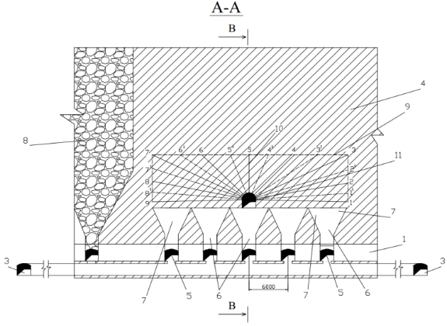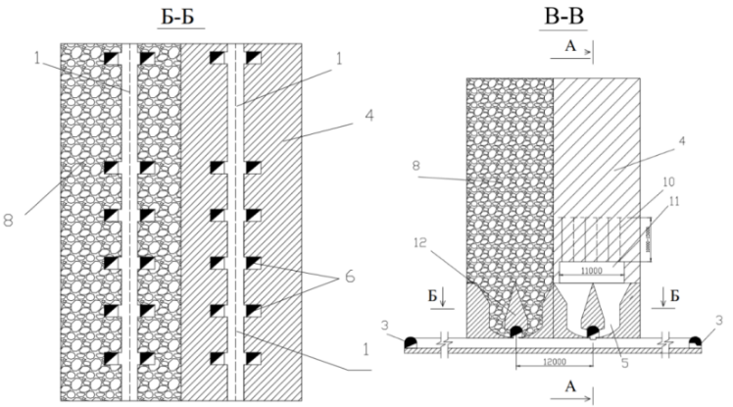
1 – Scraper drift; 2 – Loading ort; 3 – Haulage roadway; 4 – Ore body; 5 – Niche; 6 – Ore pass; 7 – Funnel; 8 – Caved ore mass; 9 – Contours of undercut block for uncontrolled caving; 10 – Borehole rings for blasting of undercut blocks; 11 – Undercut drift; 12 – Stump pillar
Figure 2.2 Underground development with uncontrolled ore caving and scraper haulage.

To determine the technical and economic indicators for this system, an estimated block is taken as an analogue, the reserves of which are located in the sublevel between the horizons.
Dimensions of the estimated block are:
- Block length: 50-200 m in terms of the ore body thickness;
- Block width: 60 m;
- Sublevel height: 20-60 m.

Development and face heading begins with the construction of the bottom of sublevel reserves after the driving of vertical blocks and sublevel workings from haulage crosscuts.
Stoping is done with 25-30 m wide panels. The panels are undercut by 10-15 m shallow blasthole rings.
The blasthole rings are drilled from the drilling drifts every 2-3 m using the NKR100MPA drilling rig, the dimensions of the hole spacing (line of least resistance) are 2-3 m, the diameter of the boreholes is 105 mm.
After the ore mass is undercut, the ore of the entire part of the ore mass of the panel (block) collapses.
Ore caving is controlled (regulated) by means of the ore release from the ore passes.
Design of the development system is shown in Figure 2.3.
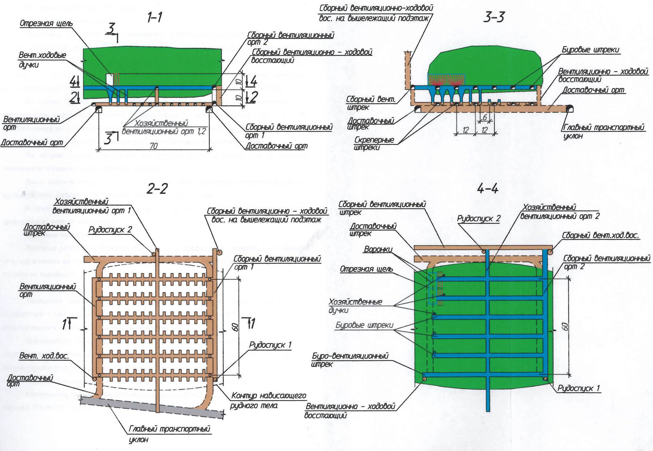
Figure 2.3 Sublevel development system of controlled caving.
Table 2.3 represents the main technical and economic parameters of the system.
Table 2.3 Technical and economic parameters of the system:
No. | Parameter | Unit | Value
1 | Input data for calculation:
 | - Thickness of an ore body; | m | 31
 | - Angle of plunge; | degree | 0-20
 | - Ore density; | t/m³ | 3,77
 | - Rock density; | t/m³ | 2,7
 | - Ore hardness coefficient; |  | 4-8
 | - Swell factor; |  | 1,5-1,6
 | - Size limit. | mm | 600
2 | Specific weight of the development system | % | 30
3 | Annual production, total | thous.t | 630
 | Including: - stoping; | thous.t | 600
 | - preparatory development; | -"- | 30
 | - development heading. | -"- | 0,24
4 | Annual volume of development heading, total | m³ | 13419
 | Including: - in ore; | -"- | 63
 | - in rock; | -"- | 13356
 | - vertical; | -"- | 252
 | - horizontal. | -"- | 13167
5 | Specific weight of the development heading per 1000 t of salable ore, total, | m³/1000t | 21,3
6 | Annual volume of preparatory development, total | m³ | 22743
 | Including: - in ore; | -"- | 18585
 | - in rock; | -"- | 4158
 | - vertical; | -"- | 13671
 | - horizontal. | -"- | 9072
7 | Specific weight of the preparatory development per 1000 t of salable ore, total | m³ | 36,1
8 | Losses | % | 16,1
9 | Dilution | % | 17,0
10 | Labor productivity at road-heading:
 | - vertical; | m³/person.shift. | 2,8
 | - horizontal. | -"- | 3,5
11 | Labor productivity of a face man:
 | - at stoping; | t/ person.shift | 107
 | - in terms of the system: rock mass  ore | m³/ person.shift  t/ person.shift | 11,3  38,2
12 | Number of workers a day:  - at stoping; | people | 5,8
 | - at road-heading (vertical); | -"- | 5,9
 | - at road-heading (horizontal); | -"- | 9,8
 | - in terms of the system. | -"- | 21,5
Technical and economic indicators of the system of uncontrolled caving of ore: ore losses 12-20%; ore dilution 15-25%; face man’s productivity 50-80 t/shift; the amount of preparatory and face heading per 1,000 tons of ore is 3-6 m; specific consumption of explosives for breaking is 0.05-0.100 kg/t.
Advantages: high mining speed and the possibility of high productivity; safety in the normal organization of undercutting works with proper ore drawing; low consumption of explosives, low consumption of materials and mechanical energy.
Disadvantages: limited conditions of application; the complexity and inflexibility of the system; high ore losses and dilution.

2.6 On the Possibility of Using Geotechnology with the Development System - Block Cave (Mechanized Block Uncontrolled Caving) in the Conditions of Mines of the DON Mining and Processing Plant
Mechanized Block Caving System (MBC) is used at the Kiruna mine (Sweden) and at the Palabora mine in South Africa.
Figure 2.4 shows the most frequently used horizontal layouts for the mining horizon, layouts of El Teniente.

Figure 2.4 An isometric view of the undercut and mining horizons of the El Teniente mine and the layout of the drawing chutes (Laubscher, 2005).

The block caving method (hereinafter referred to as BCM) is mainly used for massive deposits with a developed system of cracks. The essence of the system is as follows (Figure 2.8): after uncovering the reserves by means of an inclined ramp, the block is divided into two horizons: the haulage horizon and the undercut (drill) horizon.

Figure 2.8 Structural process chart of block development using the block caving method

The block’s reserves are undercut by blasting the ring holes drilled from the drilling horizon. The drilling horizon is located at a height of 20 m from the haulage horizon. The ore is broken into a slot or without a compensatory slot. Prior to the blasting of boreholes, funnels are made. A characteristic feature of systems with block caving is the height of the level - from 100 to 400 m [17].
The main advantages of the system of block uncontrolled caving are low cost and high productivity (up to 60 thousand tons per day). The use of BCM makes it possible to automate the main technological processes and to create the so-called “smart mine” system.

1. High productivity:
– operating mines 10 – 20 mln.t/year;
2. Low production cost:
– Caving – $4 – $7/t;
– Sublevel caving– $10 –$20/t.
3. Possibility to develop large ore bodies occurring at deep levels.
4. Possibility to automate processes
The optimal development system for the development of reserves of the 2nd stage will be selected by means of comparative assessment of parameters. After the preliminary selection of systems, a comparative table with the economic assessment of development systems is made up, where each indicator is assessed based on a certain score (Table 2.4).
According to the selection data, the most effective system for the development of ore body reserves at the Almaz-Zhemchuzhina deposit is the block caving with various subtypes (block caving with bottom ore drawing and mechanized block caving). The transition to block caving will reduce capital costs for capital development as a result of increasing the level height from 80 m to 300 m.
Table 2.4 Comparative table of economic assessment of systems based on the totality of parameters:
Technical economic parameters | Development systems (scores)
Technical economic parameters | Block caving with bottom ore drawing | BCM | Descending cut-and-fill system
Productivity of a stope | 4 | 5 | 2
Productivity of a face man | 4 | 5 | 2
Specific weight of preparatory development per 1 thous.t of ore | 3 | 5 | 1
Costs for roadway repair | 2 | 3 | 4
Consumption of explosives | 4 | 4 | 2
Cost of ore production | 3 | 4 | 1
Ore losses | 3 | 2 | 5
Ore dilution | 3 | 1 | 4
Operating expenses for the processing of 1 t of commercial ore | 3 | 1 | 4
Depreciation of fixed assets per 1 t of commercial ore | 3 | 2 | 1
Number of accidents per 1 thous. t of ore. | 2 | 4 | 3
Sum of scores | 34 | 36 | 29

Foreign specialists of the НАТСН company are conducting research on the topic “Research of Caving Methods for DNK-2 Mine of JSC TNK “KAZCHROME” for the purpose of application of the Block Cave development system in the conditions DNK-2 Mine.
The system can be implemented at the minus 480 m horizon of the Almaz-Zhemchuzhina deposit, and the system parameters can be tested at the minus 240 m horizon of the Millionnoye deposit (Figure 2.5).
The transition to block caving as well as the combination of existing systems at individual sections is one of the main conditions for ensuring the design productivity and integrated use of the subsoil. The development system with BCM allows to extract rich (with a content of over 48%) chrome ore up to 50-70% of the total production.
The benefits of using the BCM development system are:
- the interval of drifting zones here is more consistent. The draw points and a funnel are aligned ensuring the best loading and excavation as well as support for the draw points and the edge of the mouth. An LHD machine can return to opposite draw points if the mouth limits are mined out;
- the simulation revealed an increase in the strength of the structure compared to the staggered pattern;
- one of the initial benefits was ease of development. The haulage and undercut horizons are interconnected by huge ore receiving funnels on both sides providing bottom ore drawing;

Figure 2.5 Pilot site for testing the BCM systems.

Additional advantages of the use of the BCM system:
1. High performance:
- operating mines 10-20 million tons/year;
- current projects - more than 40 million tons/year.
2. Low production cost:
- block caving - $4 ÷ $7/t;
- sublevel caving - $10 ÷ - $20/t.
3. Possibility of developing large ore bodies at great depths.
4. The ability to automate the processes.
Possible limiting factors:
- high initial capital costs;
- a large volume of design studies, high quality construction, strictly controlled operations are required;
- there may be a problem with rock pressure.
Disadvantages of the BCM system:
- The layout of the El Teniente field is inconvenient for electric LHD machines;
- If the ore passes are located only on one side of the mine, then the LHD moves with the bucket forward when loading the draw point from one side of the mine - visibility is limited and dust caused by the movement remains in the air.
Conclusions regarding the application of the BCM system with uncontrolled ore caving:
The BCM system with the application of uncontrolled ore caving and self-propelled equipment and strengthening of active support (shotcrete with anchors) at deep horizons of the 2nd stage of the DNK mine makes it possible to increase the productivity of the system and reduce the cost of drifting and maintenance of stopes and reduce the length of haulage ways by constructing the necessary pillars beyond the zone inelastic deformation (ZID) or leaving them between the haulage and production horizons.

2.7 Block Caving Development System with Artificial Stope Sill with Scraper, Conveyor Delivery and Vibro-Drawing of Ore
It is planned to construct an artificial (concrete) stope sill for the mining system with uncontrolled ore caving in order to reduce the pressure and preserve all reserves of the block of development and face heading during the period of mining [18].
Based on the technological and mining technical conditions of the block’s reserves mining, it is planned to construct the artificial stope in three stages.
First, the block’s reserves are mined out to create the artificial (concrete) stope sill. After the construction of the artificial (concrete) stope sill, the reserves of the block located above the level of haulage workings are mined out.
Last of all, the main reserves of the block are mined out after development and face heading in the artificial (concrete) stope sill of the block.

Development and face heading.
The 12-m high stope sill is constructed by means of mining out the reserves of the stope sill using horizontal descending slicing and backfilling. The slice height is 4 m.
The basic structural elements in the slice of this development system are stope drifts (orts), which are driven from the inclines that were driven first.
According to this design of the stope sill mining, the main one is a stope drift, which is holed with the ventilation manway raise and with ore passes.
After holing the stope drift with the ventilation manway raise, through ventilation is provided due to the general mine depression and emergency exits. Cut orts are driven from the stope drift. Stope drifts and stopes are driven at an angle of 3-5⁰ towards the spreading of the stowing. After the ore is removed from the stopes, the worked-out space is filled with a solidifying mixture.
Upon completion of the development of the stope sill reserves located at the roof level of the haulage workings, filling the worked-out space with a solidifying mixture, the stope sill reserves located above the haulage workings level are developed (high undercut of panels).
Ventilation manway raises are driven from the haulage orts and holed with a ventilation drift.
Scraper orts are driven every 12 m in the roof of storage drifts. From the scraper orts, 2.5-m niches are driven under the ore passes, from which the 12-m ore passes are driven. Drilling orts are driven in the roof of the ore passes to undercut the reserves by means of 10-m blasthole rings. Ore passes and funnels are constructed prior to ore caving.
The development of reserves with high undercutting is done right after the development of the stope sill reserves with a low undercutting and backfilling of the worked-out space with a solidifying mixture.
After the concrete reaches at least 4 MPa strength, development and face heading is done in the artificial (concrete) stope sill.
Drilling drifts are driven through the ore, from which blasthole rings are drilled.

Stoping.
Blasthole rings are drilled with a drilling rig NKR-100 m, the rings are drilled every 2-3 m, a grid of holes is 2-3 m, the line of least resistance is 3 m.
Ore is broken in 24-m wide and 60-m long panels. As the ore mass is broken, bells are made using the drilling-blasting method.
After undercutting the ore mass of the panel, the ore is caved, which is regulated by the ore release from the ore passes. The released ore is delivered to the storage drifts using 55LS scraper winches via the scraper orts and then transferred the to the haulage workings via ore passes and loaded into electric locomotives.
At the low undercutting, the caved ore is delivered to the reloading deck via the scraper drifts using winches and loaded into electric locomotives.
The blasthole rings are charged using the Ulba-400 or Ulba-150 charging installation.
Application area. It should be noted that, according to the results of the studies performed with regard to the system of uncontrolled caving, the workings driven in the stope sill are the most difficult from the geomechanical point of view [19].
Despite the SVP 27 three-layer fastening of the scraper workings with a fairly dense installation of frames, it did not always turn out to be reliable and stable. Therefore, in the conditions of mining of the lower horizons of the DON mining and processing plant, it is necessary to switch to the construction of the artificial concrete stope sill [20].
The wide development of thick fractured deposits has caused an urgent need to improve the stope sill designs in order to significantly increase their strength characteristics, stability, capability to withstand large dynamic loads created by large masses of the caved ore mass. As noted above, the traditionally used funnel-shaped and then trench-type stope sill designs in systems with massive ore caving do not provide reliable resistance to both the caved mass and the growing rock pressure.
At the same time, an alternative was required to the gravity discharge of ore through funnels and ore passes, which is an bottleneck in high-performance caving systems. At domestic mining enterprises, with the purpose of intensifying the ore production process, vibration mechanisms began to be used, which played a positive role in the growth of mining productivity.
To solve issues of the design of an artificial concrete stope sill, employees of the Mining Institute after D.A. Kunayev designed the artificial concrete stope sill [21] based on the bottom-support principle, which ensures sufficient reliability, stability and performance of the scraping drifts.
With the transition of mining operations to deep horizons, the geomechanical situation becomes much more complicated, especially for the stope sill workings, which will predetermine the need to resolve issues related to the development of measures aimed at the increase in the stability of workings. One of the most radical measures is the development of artificial stope sill design. As the analysis showed, it was used as the basis for designing options of development systems for the lower horizons of the “Ten Years of Kazakhstan Independence” mine.
The schematic diagram of the concrete stope sill is shown in the figure 2.6 [21].
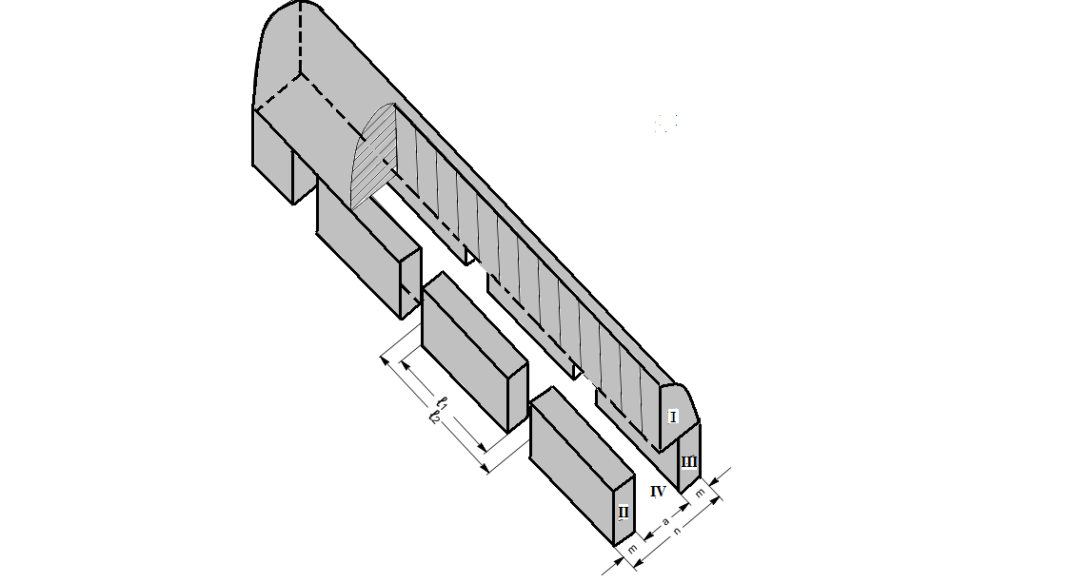

Figure 2.6 The schematic diagram of the concrete stope sill
The work [22] proposes a development system - Block caving with an artificial stope sill and conveyor delivery of ore to the southern part of the “Almaz-Zhemchuzhina” deposit at the -40/-560m level.
With the transition of mining operations to deep horizons, the geomechanical situation becomes much more complicated, especially for the stope sill workings, which will predetermine the need to resolve issues related to the development of measures aimed at the increase in the stability of workings. One of the most radical measures is the development of artificial stope sill design. As the analysis showed, it was used as the basis for designing options of development systems for the lower horizons of the “Ten Years of Kazakhstan Independence” mine.
The work [22] proposes a development system - Block caving with an artificial stope sill and conveyor delivery of ore to the southern part of the “Almaz-Zhemchuzhina” deposit at the -40/-560m level.
After constructing the artificial stope sill, ore will be mined using the block caving and the use of vibrating mechanisms for the release, delivery and loading of ore.
Face man’s labor productivity working with the system of block caving and conveyor delivery of ore is as follows:
- Face man’s labor productivity at stoping is 336.2 t/person.shift or 87.1 m³/ person.shift;
- Face man’s labor productivity working with the system (ore) is 53.3 t/person.shift;
- Face man’s labor productivity working with the system (in terms of rock mass) is 15.1 m³/person.shift.
It is also planned to develop a part of the Almaz-Zhemchuzhina deposit at the level from minus 400 to 560 m using the block caving development system with an artificial stope sill and vibro-drawing of ore. To this end the mine field is divided into blocks, the length of which along the strike is 60 m, the width is equal to the thickness of the ore body across the strike, the height is 160 m (double level).
The essence of this development system is in the fact that it is a combination of two development systems - the stope sill design is made in a concrete mass created after mining the lower part of the block using horizontal slicing and backfilling. The undercutting of the ore mass, ore drawing, and loading is done by means of uncontrolled caving. The main difference from the conveyor delivery system is the flat stope sill design, which has no haulage workings.
In this uncontrolled caving system with the artificial stope sill the ore is released directly into the vehicles. All workings of the flat stope sill are concentrated on one horizon. In the stope sill there are minimum number of workings: haulage crosscut and inclines, ventilation and stowed workings, chambers of vibration feeder and undercut workings. By creating a monolithic concrete mass, the stability of the flat stope sill is increased providing a high efficiency of the development system.
Preparation of the mining block for stope excavation by means of block caving with an artificial stope sill and vibro-drawing of ore is similar to the systems described above - block caving with an artificial stope sill and conveyor delivery of ore. The artificial stope sill is also formed.
After the completion of works on the creation of the artificial pillar at the stope sill, the broken ore is released through the chambers of vibration feeder. The ore from the funnels (ore passes) is delivered and loaded into mine cars using a VPDU-4TM-type vibrating load-haul dumper. It is possible to release and load large pieces up to 1 m in size. If necessary, secondary ore crushing can be performed on the VPDU-4TM platform.
Face man’s labor productivity working with the block caving development system with an artificial stope sill and vibro-drawing of ore is as follows:
- Face man’s labor productivity at stoping is 335.4 t/person cm. or 86.9 m³/ person.shift;
- Face man’s labor productivity working with the system (ore) is 56.6 t/person.shift;
- Face man’s labor productivity working with the system (in terms of rock mass) is 15.2 m³/person.shift.
Advantages. Block caving systems with the artificial stope sill includes mining the reserves of the 12 m stope sill with three 4-m layers of stowing in order to reduce rock pressure and preserve all reserves of the block during development and face heading [23].
To drive and maintain the development heading in the backfilled mass as well as to study the stress-strain state of the backfilled mass and the stability of the workings, currently there is very little information regarding the mining practice (at the underground mines of the Polar Division of JSC Mining and processing plant “Norilsk Nickel” in Talnakhskoye and Oktyabrskoye field) [24].
One of the promising directions of the development and improvement of process charts of preparation of excavation sections is the placement of development heading in the backfilled mass. For this purpose, at mine 2 of the Oktyabrsky mine the 248 m working was driven in the backfilled mass at a depth of about 1,000 m.
The project belongs to Kazgiprotsvetmet Ltd. For the block caving development system, the project of Kazgiprotsvetmet Ltd provides for the creation of an artificial (concrete) stope sill (Figure 2.7).
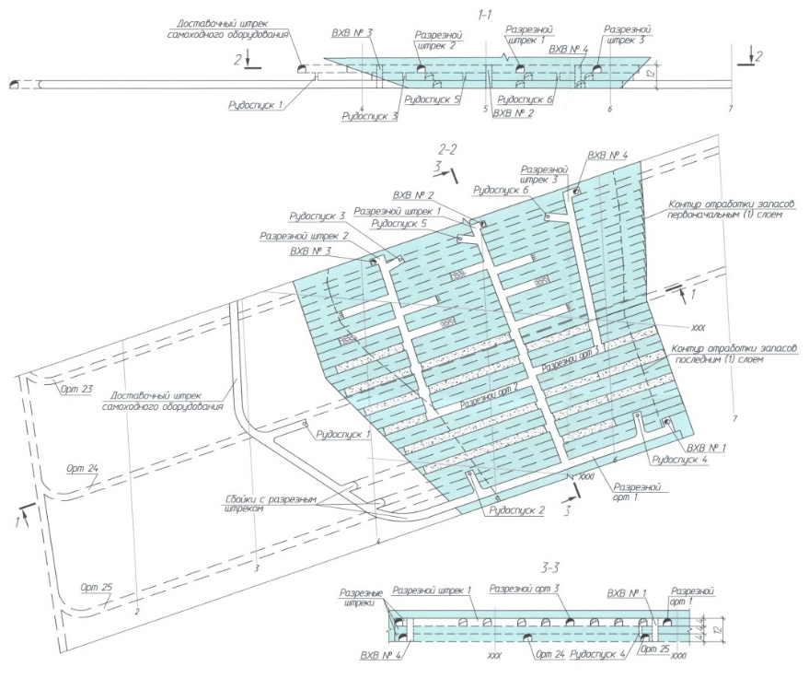
Figure 2.7 Block caving system with the artificial stope sill made of solidifying stowing
The disadvantage is that in the process of deformation of the marginal rock mass as the mining span increases, the intensity of deformation in the marginal rock mass also progresses especially in the second zone with a length of about 50 m accompanied by the cracks in concrete. Displacements on the working contour increase and reach about 40-50 mm. In the third 120-m zone in the backfilled mass, the displacement sharply increases to 80 and more mm on the working contour, and the process of germination and opening of cracks begins in the concrete, layers of backfilled mass are chipped. The destruction of the backfilled mass is manifested in the formation of squeezing zones in the working’s walls, soil heaving, balm stones in the layers of the backfilled mass and the collapse of detached concrete slabs. Such types of destruction occurred mainly in the areas fastened using the combined support.
There are also destruction of the walls of mine workings driven in the backfilled mass at the Taimyrsky mine, Polar Division of JSC Mining and processing plant “Norilsk Nickel” [25]. The greatest destruction of the walls of the mine working driven in the backfilled mass occurred in the middle of the working’s wall.
At the same time, the wall bent into the mass, as evidenced by a wooden pole, the lower part of which rests against the undestroyed mine wall. Figure 2.8a shows the initial stage of destruction of the mine wall. The change in shape is accompanied by the destruction of the marginal part of the backfilled mass. The depth of destruction of the working’s wall is about 40 cm, which is evident from the length of the parts of the anchor rods protruding from the wall (the anchors are 1.8 m long). Cracking occurs in the lower part of the working’s wall, which has not yet exfoliated from the main backfilled mass. Figure 2.8b shows on a larger scale the subsequent stage of wall destruction with a network of large and small cracks parallel to the sidewall.
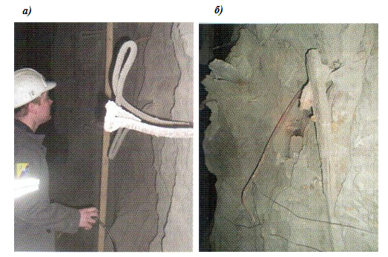
a) Initial stage of destruction of the working’s wall, b) Subsequent stage of wall destruction

Figure 2.8 Stages of destruction of the mine working’s wall driven in the backfilled mass

Figure 2.9 a shows the “final” stage of destruction of the backfilled mass in the wall of the mine working driven far from the junctions. With a change in the mining situation, the destruction of the backfilled mass in this place of the mine wall can continue. In this case, the depth of the vault of destruction of the working’s wall is about 2 m, which can be seen from the wooden pole placed along the original contour of the working’s wall.
Figure 2.9 b shows the destruction of the backfilled mass at the junction of the mine workings occurred along the entire contour of the wall where only the roof with an overhanging piece of the backfilled mass did not cave.
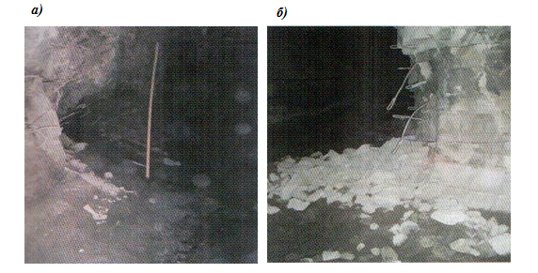
a) Mine workings driven far from the junctions, b) Mine workings driven in the backfilled mass
Figure 2.9 Final stage of destruction of the backfilled stage in the working’s wall.
In addition, it was noted that the staged destruction of the concrete wall occurred despite the fact that this outcrop was fixed by horizontally installed reinforced concrete rods and is ineffective, since the rods turned out to be parallel to the layerage, and they did not connect the layers and did not increase the stability of the concrete outcrop.
According to the foregoing pictures of the destruction of the backfilled mass as well as based on the work experience at the underground mines of “Norilsk Nickel” in the Talnakhskoye and Oktyabrskoye deposits with regard to road heading in the backfilled mass, currently, it is possible to say that the research and practical work has just started.

2.8 Experimental Development System Using Horizontal Descending Layers with Solid Stowing of the Mined-Out Space Under Artificial Roof at the Development of Reserves of the Pervomayskoye Deposit at the DNK Mine of the DON mining and processing plant

Since 2017, the VNIITSvetmet Institute has been conducting pilot industrial tests of concrete stowing operations during the development of reserves of the Pervomayskoye deposit [26].
This method of deposit development in areas with highly fractured and unstable masses of the mine field at a depth of over 500-600 m is applied using the descending horizontal slicing with backfilling of the worked-out space under an artificial rood, as shown in the Figure 2.10.
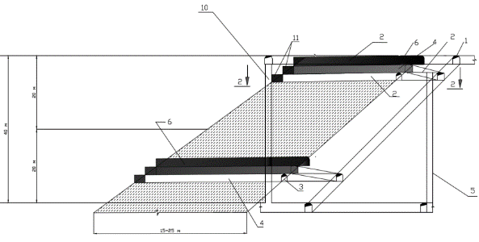
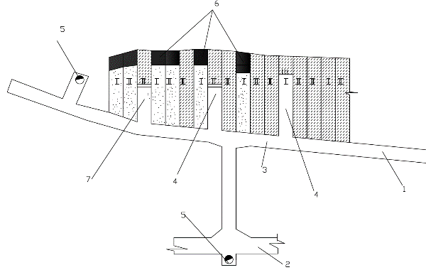
1 – Haulage roadway; 2 – Entrance ramp onto each layer; 3 – Stoping drift; 4 – Stopes; 5 – Ore pass; 6 - Artificial roof; 7 - Ore pillars; 8 - Stopes of the second stage; 9 – Filled stopes; 10 – Ventilation manway rise (VMR).
Figure 2.10 Horizontal descending cut-in-fill stoping.
The essence of the system is that the ore deposit prepared by the block caving method is divided into separate mining blocks, the ore reserves in which are mined in descending order using self-propelled equipment, and the mined-out space is backfilled with solidifying stowing.
Conditions of application. The system is used in the development of thick and very thick ore deposits with very valuable ore, where ores are unstable and prone to dynamic manifestations of rock pressure with the purpose of improving the safety of mining operations especially at great depths.
Development and face heading. Preparation consists in driving a delivery drift, incline, ventilation and fill raises, ore pass and orts. Preparatory development consists of driving stoping drifts.
Stoping. The block is developed by means of stopes located at an angle of 40-90⁰. Self-propelled drilling rigs are used for drilling horizontal boreholes. Broken ore from the stopes is transported to the ore pass using loading and hauling machines. After the extraction of ore, a stopping is erected at the mouth of the stope and the mined space is backfilled with a solidifying mixture. In the process of backfilling, the ventilation channel at every third stope is left unfilled which ensures ventilation during the development of the lower layer. To supply the backfilling mixture and ventilate the workings, a ventilation-filling drift must be driven at the hanging side of the ore body. Self-propelled equipment is delivered along an inclined ramp driven in the rocks of the deposit footwall and connected to the stoping drift with a driveway.
Technical and economic indicators: ore losses 2-6%; ore dilution 4-8%; face man’s labor productivity 25-30 t/shift; the amount of development and face headings per 1000 tons of ore is 4-5 m; specific consumption of explosives for breaking is 0.45-0.55 kg/t.
Advantages: high ore recovery; insignificant ore dilution; safety of operations in the stope; the possibility of simultaneous development of several levels which ensures significant production at a small area.
Disadvantages: significant costs for transportation and storage of stowing material in the stope; low productivity of face men.

3 Regulatory parameters for the application of combined geotechnology in the conditions of the dnk mine at underground mining of chromite reserves
3.1 Current Activities of the DNK Mine of the DON Mining and Processing Plant for Underground Mining of Chromite Deposits
For the last 30 years, the DON Mining and Processing Plant has been doing underground mining at the DNK mine using a caving system of development. This system is a well-known development system in the conditions of deep horizons of the Kempirsay field with the following accepted parameters (Figure 3.1), namely:
- The distance between horizons is 80 m;
- The -480m horizon is partially prepared;
- The “Ventilation” shaft has already been driven to the -825m level;
- The “Skipovoy” shaft is being now driven and is driven to -400m;
- The “Kletevoy” shaft was driven to the -560m level;
- Additional shafts to ensure access to and requirements for ventilation of mine workings were driven:
- The “Auxiliary” shaft is driven to -252m;
- The “Skipo-Kletevoy” shaft;
- The “Severo-Ventilyatsionny” shaft is driven to -180m.
The volume of production at the 2nd stage will depend on the following factors:
• Completion of shaft sinking;
• Sinking and fitting out of underground crushers;
• Driving and fitting out of main openings;
• Preparation and cutting of blocks for the development of the planned ore bodies.
In this regard, the mining requirement during the 2nd stage in the year 2023 depends not only on the sinking and fitting out of shafts, but more importantly, on the road heading and fitting out of the horizon with cross-drifts and crushing chambers ensuring the ore crushing and transportation to the shafts. In addition, sinking of main openings and development heading must be completed to ensure the operation of production units immediately after the shafts are put into operation.
According to the project of "DNK-2" mine, the ore bodies “Almaz-Zhemchuzhina” and “Millionnoye” include the following horizons: -320m, -400m, -480m, -560m, -640m shown in the Figure 3.2.

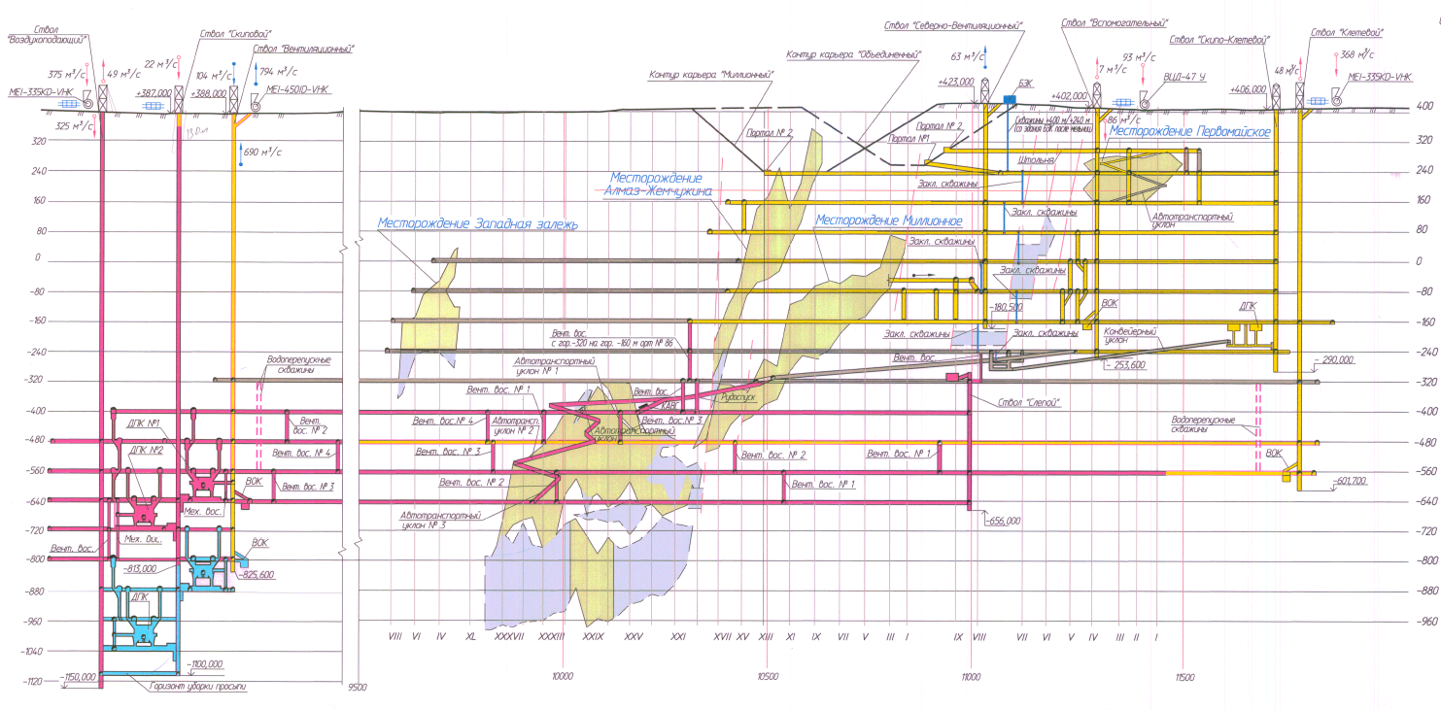

Figure 3.1 Opening-up scheme according to the current approved project for the “DNK-2” mine

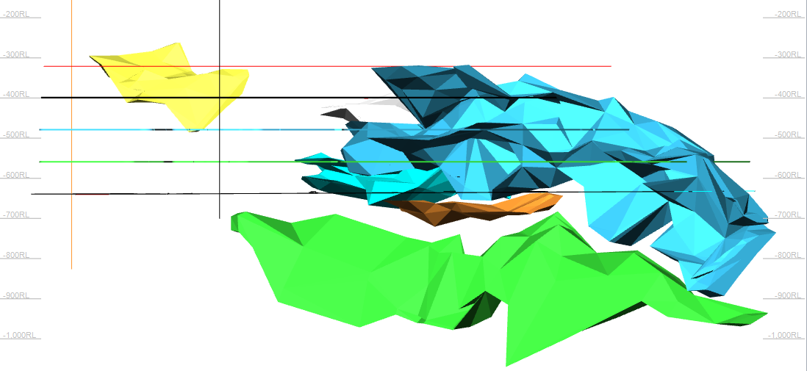
Figure 3.2. Ore bodies of the 2nd stage (blue: 2nd stage of the “Almaz-Zhemchuzhina” deposit development; yellow: 2nd stage of the “Millionnoye” deposit development and green: 3rd stage

3.2 Factors Affecting the Technological Feasibility of Transition to the Combined Geotechnology of Uncontrolled Caving System with the Artificial Stope Sill and Ore Delivery Using a Scraper in the Conditions of Increased Rock Pressure at the "DNK” mine of the DON Mining and Processing Plant
As a result of studies performed within the 2018 schedule with regards to the state and causes of the rock mass caving around the preparatory transport workings at the deep horizons of the DON mining and processing plant, the following results were obtained [27, 28]:
- It was established that the rock mass of the Don chromite deposits is greatly fractured. There are four main systems of fractures; their intensity (from 3 to 20 per linear meter), spatial orientation and morphology were identified. It was established that there are no significant positive changes in these indicators as the depth of development increases, which makes it possible to apply the technology of uncontrolled caving of ore and host rocks at the design of mining of lower horizons and adjacent deposits.
- Based on the systematization of the qualitative and quantitative indicators of the rock mass and with due account for the impact degree of geotechnological factors, the ore mass of the Don chromites is classified as the lowest fifth category of stability.
- To enhance the safety of mining operations and the balance of the main technological processes, the predominant type of support used at the mine is a three-layer fastening with prefabricated metal support made of special interchange profile SVP-27 for the uncontrolled caving. In addition, the VNIITSvetmet Institute is conducting a pilot testing of a mining system involving a descending slicing and backfilling of the mined space.
As a result of the research carried out within the 2019 schedule, the following results were obtained [29]:
- The mining technical conditions of the applied development system at the Don chromite deposit were studied for the purpose of effective reserves development of the “Millionnoye” deposit in the conditions of -480m/-640m levels.
- The combined underground geotechnology is proposed for the conditions of the -480m/-640m level of the “Millionnoye” deposit; several options for the process chart are considered where option 3 is a combined underground geotechnology with the development of reserves using a cut-and-fill development system and a trapezoid-shaped block with an angle of the side walls of the block 70-80⁰ from the upper layer of mining at an angle of repose [30, 31]. In this option, the solidifying mixture reduces up to 40% of the volume of the backfill and on the level in the adjacent block the stoping decreases up to 40%. At that the amount of caved mass is also reduced.
- A method of reasonable selection of a development system at the “Millionnoye” deposit, which is being mined by the Don mining and processing plant, has been proposed. The technical and economic indicators of the compared options are calculated.
- The technical and economic analysis of the compared options according to the proposed geotechnology shows that in the conditions of the -480m/-640m level of the “Millionnoye” deposit it is feasible to transit to the combined geotechnology for developing reserves using a cut-and-fill development system, trapezoid-shaped block, with an angle of the sidewalls of the block 70-80⁰ in combination with the uncontrolled caving of ore and host rocks.
- The parameters of the artificial stope sill have been developed and substantiated for the system of uncontrolled caving at the deep horizons of the DNK mines.

  - Proposed Combined Geotechnology for Sustainable Development of Underground Chromite Mining in the Conditions of Deep Horizons of the “DNK” Mine
    - The Essence of Application of the Combined Patented Geotechnology in the Conditions of the DNK Mine of the DON Mining and Processing Plant
The essence of the proposed idea is that the front of mining operations is divided for mined deposits within a level and is staggered. Also, it implies the application of combined underground geotechnology - a descending horizontal slicing and backfilling of the mined space under the artificial roof (Figure 2.10) and the technology of uncontrolled caving (Figure 2.2) ensuring the rational development of reserves in the conditions of deep ore deposits with a thickness of over 80 m and highly fractured and unstable ore reserves and host rock masses (sometimes in the form of a separate deposit). This proposed combined geotechnology is patented [3, 33].
In this option of the combined underground geotechnology with high completeness of ore extraction and rational and efficient mining of deep multiple separate ore deposits, the stopes are located across the strike of the ore body (Figures 3.3 and 3.4).
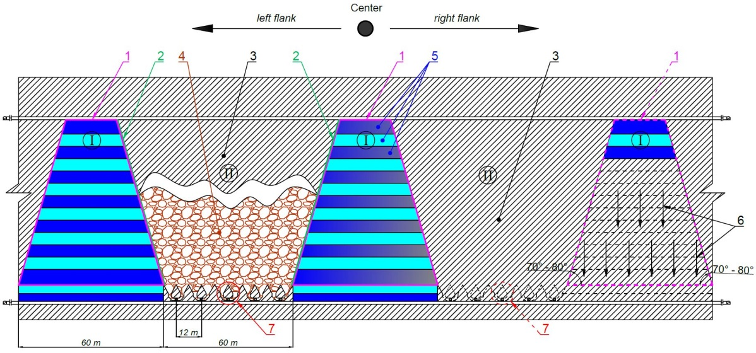
1 – Trapezoid-shaped block; 2 – Angle of slope of the block sidewalls; 3 – Adjacent blocks; 4 – Uncontrolled caving technology; 5 – Backfilled layers; 6 – Direction of descending development; 7 – Ore drawing-off level.
Figure 3.3 Proposed trapezoid-shaped scheme of combined geotechnology with rational and efficient development of ore reserves at deep multiple separate chromite deposits

To increase the ore mining productivity, reserves in the primary blocks (1 Figure 3.3 and 3.4) are developed top-down by means of several layers of backfilling, from the center to the flanks by means of several blocks on the level, leaving sections of reserves in neighboring blocks for the secondary mining. The corresponding parameters of the stope sills are calculated based on the technological workings that are optimal for the release of caved ore mass from production blocks using the uncontrolled caving technology (3, Figure 3.3 and 3.4) at a given production horizon.
With the development of the mining front within the level, mining is done from the center to the flanks in horizontal and descending directions. First of all, the central block (1, Figure 3.3) is mined using the cut-and-fill system under the artificial trapezoid-shaped roof that differs from the standard version (Figure 3.4) with an angle of the side walls of the block 70-80° from the upper layer of mining under angle of repose. This increases the stability of the backfilled mass during the development of reserves of the primary block (1 and 2, Figure 3.3) and improves the uncontrolled caving process of highly fractured ores during the development of reserves of neighboring blocks using the uncontrolled caving technology (4, Figures 3.3 and 3.4) at the level immediately after the formation of the staggered backfilled mass (5, Figures 3.3 and 3.4) in the previous blocks.
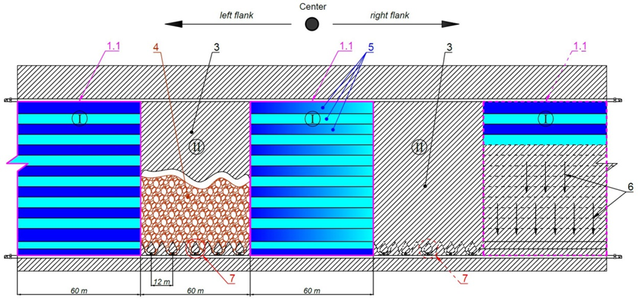
1.1 – Trapezoid-shaped block; 3 – Adjacent blocks; 4 – Uncontrolled caving technology; 5 – Backfilled layers; 6 – Direction of descending development; 7 – Ore drawing-off level.
Figure 3.4 Proposed standard rectangular scheme and sequence of development at deep chromite deposits using the underground combined geotechnology

After the formation of the backfilled mass in the primary blocks, in the sections left between them, a caved ore mass is released from the stope sill of the adjacent secondary block (7, Figures 3.3 and 3.4) using the uncontrolled caving technology.
The applied combined geotechnology (Figure 3.3) with backfilling will ensure additional stability of the inclined outcrop of the artificial mass due to the inclination of the primary block walls and reduce the solidifying mixture down to 40% of the backfill volume. The development and face heading on the level in the adjacent block will remain the same compared to the increased volume of the ore mass caved using the combined uncontrolled caving technology.
With an increase in the depth of mining operations at the deposit using combined geotechnology in combination with uncontrolled caving technology, on the drawing-off level in the place of the extracted ore layer, a monolithic strip of the artificial stope sill is formed made of the solidifying backfilled mass which is used as a bearing element of the development system at increased rock pressure ensuring its high stability and reliability as well as safety for the entire period of stoping when mining ore in blocks. In addition, favorable conditions are created for the safe operation of the drawing-off and delivery workings, the independent operation of the ore delivery and haulage. And the low structure height ensures the elimination of possible hovering of the ore mass and the reduction in capital and operating costs.

    - Development of Underground Geotechnology with the Artificial Stope Sill and Justification of Its Parameters Within the Combined Geotechnology
According to the designers’ concept (Kazgiprotsvetmet), in the conditions of high rock pressure the creation of a monolithic concrete mass (artificial stope sill) is more cost effective despite the high initial cost compared to the used stope sill designs in the conditions of the DON mining and processing plant, because there are no additional expenses for repair and restoration of the stope sill. However, the designers did not substantiate the technological parameters of the drawing-off horizon for the construction of the artificial stope sill.
The proposed geotechnology implies the creation of the artificial stope sill on the drawing-off and delivery horizon in the area between the entry pillars and stump pillars as load-bearing structural elements. They can withstand extremely high rock pressures during stoping using the uncontrolled caving of ore and host rocks by means of reinforcing artificial multi-support reinforced concrete platforms for the systematic ore drawing from blocks (Figure 3.5 A and B, C).
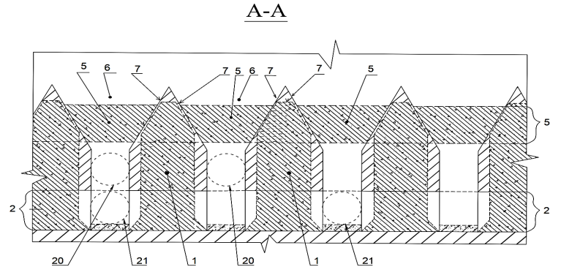
1 – Vertical artificial support of the entry pillar; 2 – Scraper drift; 5 – Reinforced concrete beam connecting concrete supports (1) at the level of the first layer (funnel); 6 - Funnel; 7 – Sidewalls of the funnel; 20 – Ore pass
Figure 3.5 A. Proposed technology of stable supporting reinforced concrete platform of the stope sill made of concrete solidifying backfill for uncontrolled caving system
The proposed method is used to erect the artificial stope sill with a stable supporting reinforced concrete platform which represents a structure (Figure 3.5 A, B and C) of vertical reinforced concrete pillars (1, Figure 3.5 A, B and C) in the form of an elongated rectangular obelisk of an artificial pillar (1, Figure 3.5 A and B) between the scraping drifts (1, Figure 2.2) with
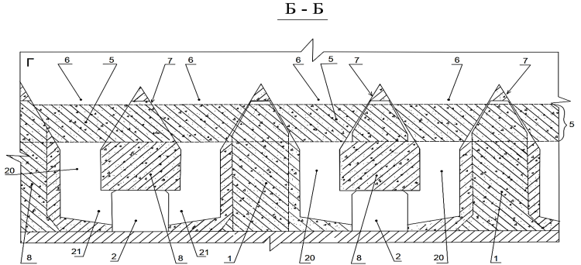
1 - Vertical artificial support of the entry pillar; 2 - Scraper drift; 5 - Reinforced concrete beam connecting concrete supports (1) at the level of the first layer; 6 - Funnel; 7 - Sidewalls of the funnel; 8 – Artificial reinforced concrete stump pillar; 20 - Ore pass; 21 - Niche.

Figure 3.5 B. Proposed technology of stable supporting reinforced concrete platform of the stope sill made of concrete solidifying backfill for uncontrolled caving system
dimensions up to 7.5-9 m in three 2.5-3,0-m layers (Figure 3.5 B). In the first layer, which is the upper part of the support (1, Figure 3.5 A), the width is 2.5÷3.0 m, every 5 m, the length is equal to the distance of the stope drift (3, Figure 3.6) to the ventilation and filling drift (4, Figure 3.6)
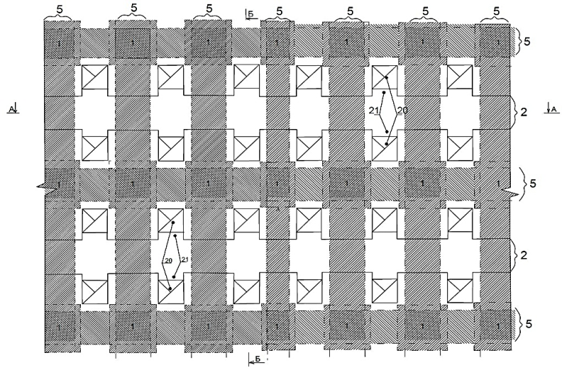
1 – Vertical artificial support of the entry pillar; 2 – Scraper drift; 20 – Ore pass ; 21- Niche; 5 – Reinforced concrete beam connecting concrete supports (1) at the level of the first layer;
Figure 3.5 C. Proposed technology of stable supporting reinforced concrete platform of the stope sill made of concrete solidifying backfill for uncontrolled caving system (in plan)

This part of the support is cross-connected with 2-m wide reinforced concrete strips in both directions (5, Figure 3.5 A, B and C) the length of which is equal to the width of the funnel (6, Figure 3.5 A, B), which is 5 m along the upper contour, to the entire height from the upper contour down the cone wall (7, Figure 3.5 A, B) between the funnel (6, Figure 3.5 A, B) of the first layer. On the second and third layers, the width of the supports (1, Figure 3.5 A, B and C) is 5 m, and relative to the 1st layer these parts of the supports are displaced by 1.5 m along the axis on both sides of the reinforced concrete pillars (1, Figure 3.5 A, B and C).
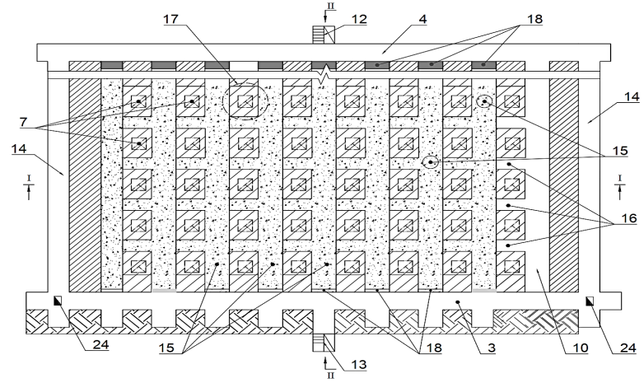
3 – Stope drift; 4 – Ventilation-fill drift; 10 - Stopes; 12 – Manway raise; 13 – Manway and ventilation-fill raises; 14 - Ventilation-fill ort; 15 – Concrete stowing (material); 16 – Holing between the funnels; 17 – Funnel contours left in the form of an ore pillar; 18 - Stoppings; 24 – Ore pass
Figure 3.6 Plan of the 1st layer, section III-III
An element of the proposed method for erecting a stope sill is an artificial reinforced concrete stump pillar (8, Figure 3.5 B) instead of an ore stump pillar (12, Figure 2.2) above the roof and along the entire length of the scraper drift (2, Figure 3.5 B) connected to the cross horizontal reinforced concrete beams (5, Figure 3.5 A, B and C) associated with the upper part on the 1st layer of stope (10, Figure 3.6) between vertical elongated artificial reinforced concrete pillars-supports (1, Figure 3.5 A, B and C). The parameters of this design are: a total height above the scraping drift (2, Figure 3.5 B) is 5 m, its length on the 1st layer is equal to the distance from the stope drift (3, Figure 3.6) to the ventilation-filling drift (4, Figure 3, 6) and on the 2nd layer, up to the ventilation-filling drift (4, Figure 3.7), the width on the 1st layer is 2.5÷3.0 m and on the 2nd layer is 5 m, i.e. are similar to the parameters of the previous design (1, Figure 3.5 A, B).
The erected artificial stope sill using a stable supporting reinforced concrete platform is a very necessary mining structure (Figure 3.5 A, B, C) to increase the stability of structural bottom workings in complicated mining and geological conditions of unstable deep masses with increased rock pressure, and contributes to an increase in the service life of operating blocks.
The proposed method for erecting the stope sill using a reinforced concrete stable support platform from the loading and hauling ort (11, Figure 3.8 - 3.9) includes a sinking of a manway raise (12, Figure 3.6 - 3.7) where the stope drift is extended (3, Figure 3.6) to the first layer.
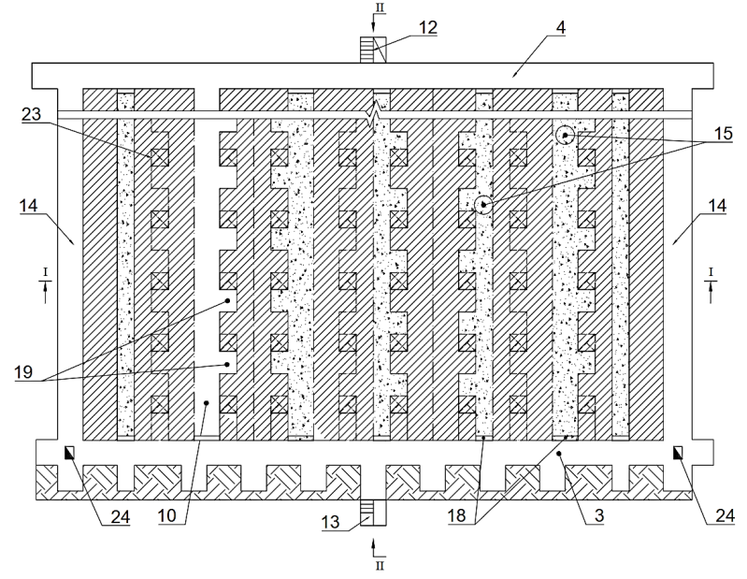
3 - Stope drift; 4 - Ventilation-fill drift; 10 - Stopes; 12 - Manway raise; 13 - Manway and ventilation-fill raises; 14 - Ventilation-fill ort; 15 - Concrete stowing (material); 18 - Stoppings; 19 - Holing between future ore passes; 23 – Unmined ore mass, contours of drawing-off workings for the ore pass; 24 - Ore pass
Figure 3.7 Plan of the 2nd layer, section IV-IV
In the hanging wall, the 9÷12-m high manway and ventilation-fill raises (13, Figure 3,6) are driven (depending on the distance to the ore in the stope). Along the left contour of the block, a ventilation-fill ort (14, Figure 3.6) for the first layer is driven. At this height, on the upper part of this level of the artificial stope sill, the stope drift (3, Figure 3,6) is the upper first layer with the 3x3 m section with the use of an LS-55 winch to the block boundaries. Then, on this layer, stopes (10, Figure 3,6) are driven from the stope drift (3, Figure 3,6) across the strike of the block every 5 meters with a section of 3x3 m at a distance of ~ 60 m to the hanging wall of the deposit. At the same time, all stopes (10, Figure 3,6) of the 1st stage are holed through the ventilation-fill drift (4, Figure 3,6) at this height. The concrete stowing (15, Figure 3.5) is fed through pipelines to these stopes (10, Figure 3.6) of the 1st stage driven along the block flanks.
All stopes (10, Figure 3,6 and 3,7), during the sinking of the 1st stage, are connected by 2x3 m holes (16, Figure 3,6). These holes (16, Figure 3,6) are located between the funnel contours (17 - left as an ore pillar, Figure 3,6). The ore pillar (17. Figure 3,6) left between the holes (16. Figure 3,6) equals 5 meters and forms a funnel (7, Figure 2.2).
When the stopes (10, Figure 3,6) and holes (16, Figure 3,6) are ready, a metal reinforcement is installed in them to create multi-support artificial pillars and then the concrete stowing is supplied (15, Figure 3,6) through the installed stoppings (18, Figure 3,6 and 3.7).
The order of holing (16, Figure 3,6) between the stopes (10, Figure 3.6) the installation of the reinforcement and the supply of the stowing (15, Figure 3,6) is estimated for 2-3 stopes (10, Figure 3, 6). The stowing must begin from the flank in order to start road heading on the 2nd layer of the block when the concrete mixture has gained strength and hardened.
The mining procedure for driving stopes (10, Figure 3.7), the stope drift (3, Figure 3.7) and holing (16, Figure 3.6) on the 2nd layer is the same as on the 1st layer (Figure 3.6). To this end, a stope drift is also driven on the 2nd layer (3, Figure 3.7) and from it stopes of the 1st stage are driven (10, Figure 3.7). They are displaced by 1.5 m (half) of the cross-section in relation to the stopes (10, Figure 3.7), which are holed by the manway and ventilation-fill raise (13, Figure 3.7) upward to the ventilation-fill drifts (4, Figure 3.7) of the 2nd layer. In addition, for ventilation and supply of stowing (15, Figure 3.7), the stope drift (3, Figure 3.7) from the flanks through an inclined ventilation-fill ort (14, Figure 3.7) is connected to the ventilation-fill drift (4, Figure 3.7) of the 2nd layer. Further, according to the project sequence, 2.5-m wide stopes (10, Figure 3.7) of the 2nd layer are driven at a 5-m wide section and divided into half distances between future workings-niches (5, Figure 2.2 ). The length of the stope (10, Figure 3,7) starts from the stope drift (3, Figure 3,7) to the ventilation-fill drift (4, Figure 3.7) where the latter is connected with the ventilation-filling raise (13, Figure 3.7) of the 1st layer of the artificial stope sill (13, Figure 3.6). These stopes (10, Figure 3.7) along the penetration length are connected with the left and right holes (19, Figure 3.7) 2.5 m wide and 2 m deep along the contour of the workings of the future ore pass (6, Figure 2.2).
After the preparation of the stopes (10, Figure 3.7), they are reinforced with steel frames for concrete stowing after the installation of the stoppings (18, Figure 3.7). Also, when the stowing gains the standard strength (15, Figure 3.7) on the 2nd layer, it is possible to start mining of the 3rd layer to create the future scraper drift (1, Figure 2.2).
Stoping of the 3rd layer for the creation of a support for the artificial reinforced concrete pillar of the stope sill (1, Figure 3.5 A and B) begins with driving a stope drift (3, Figure 3.8), after which a ventilation-fill ort (5, Figure 3.8) and a ventilation-fill drift (7, Figure 3.8) are erected. Then, stopes are driven from the stope drift (3, Figure 3.8) of the 3rd layer (6, Figure 3.8), and for ventilation and an emergency exit they are holed with the ventilation-fill raise (2, Figure 3.8) of the 3rd layer, which is vertically driven from the lower 3rd layer through the 2nd layer to the upper 1st layer of the block.
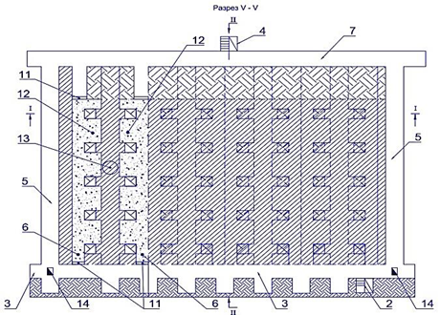
2 - Manway and ventilation raise; 3 – Stope drift; 4 – Manway raise; 5 - Ventilation-fill ort; 6 - Stopes; 7 - Ventilation-fill drift; 11 – Stoppings; 12 – Holing between future ore passes; 13 - Unmined ore mass, contours of the scraper drift; 14 – Ore pass
Figure 3.8 Plan of the 3rd layer, section V-V
The stoping sequence (6, Figure 3.8) on the 3rd layer is in harmony with the proposed scheme, similarly to the 2nd layer. To this end, from the stope drift (3, Figure 3.8) of the 3rd layer, stopes (6, Figure 3.8) of the 1st stage is driven. Then, according to the project sequence, other 2,5-m wide stopes are performed (6, Figure 3.8) and divided into two stopes (6, Figure 3.8) in the area between the future 2x2 m niche (5, Figure 2.2) located in the entry pillar (1, Figure 3.5 A) at a distance of 5 m. Along the stopes (6, Figure 3.8) between the future contour of the niche (5, Figure 2.2) on this section at a depth of 5 meters, 5.0-m wide and 3.0-m deep hole-throughs are erected on the left and right sides (12, Figure 3.8) along the contour of one of the walls of the future ore pass (6 Figure 2.2). After the preparation of the stopes (6, Figure 3.8) on the 3rd layer and their reinforcement with steel frames, it is also necessary to install stoppings (11, Figure 3.8) for concrete stowing.
After sinking and gaining the necessary strength of the concrete stowing (15, Figure 3.6 and 3.7) in the backfilled workings (6, Figure 3.8), to create the artificial reinforced concrete platform stope sill, the following workings are driven in all unmined layers of the ore mass (17, Figure 3.6, 23, Figure 3.7 and 13, Figure 3.8) with the contours of the drawing-off workings formed in the openings between the supports of the reinforced concrete platform by means of low impact explosions: scraping drift (1, Figure 2.2), niche (5, Figure 2.2), ore passes (6, Figure 2.2 and funnels (7, Figure 2.2). To this end, niches (5, Figure 2.2) are made by means of low impact explosion in the remained contour of the ore mass of the scraper drift (13, Figure 3.8) as well as to the left and right of it, and ore passes rise to the second layer (6, Figure 2.2, 23, Figure 3.7 ). Further, also by means of low impact explosion, the workings are raised to form the funnel-like cavities (6, Figure 2.2) located on the 1st layer of the reinforced concrete platform (17, Figure 3.6). The connections between the niche (5, Figure 2.2) and ore passes (6, Figure 2.2) are fixed according to the timbering standard, their cross-sections correspond to the approved standard. The ore from each stope (6, Figure 3.6-3.8) is delivered by scraping before an ore pass (24, Figure 3.6 and 3.7, as well as 14, Figure 3.8) located in the stope drift (3, Figure 3.6-3.8) of each layer on the left and right flank of the block.
After the completion of operations for the creation of the artificial stope sill on the horizon of the drawing-off workings reinforced with artificial multi-support reinforced concrete platforms (Figure 3.5 A, B and C), a 3x3 m sill drift (25, Figures 3.9 and 3.10) is driven before the drawing-off workings (1,5,6 and 7, Figure 2.2) formed in the openings between the supports of the reinforced concrete platform, on top at the roof level of the 1st layer from the right to the left flank of the block between the ventilation-fill orts (14, Figure 3.6).
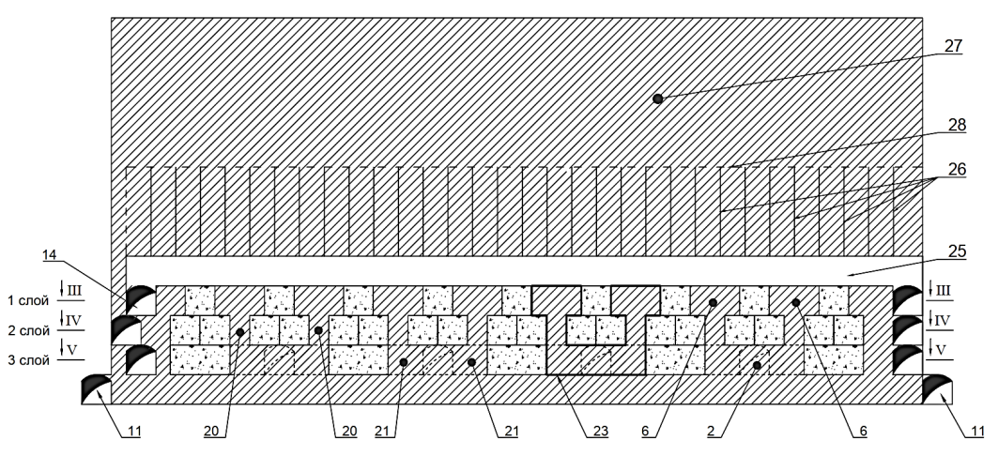
2 – Scraper drift; 6 - Funnel; 11 – Load-haulage ort; 14 – Ventilation-fill ort; 20 - Ore pass; 21 - Niche; 23 – Unmined ore mass, contours of the drawing-off workings: scraper drift, niche, ore pass and funnels; 25 – Sill drift; 26 – Blasthole drifts for exploding undermined ore body; 27 – Ore body; 28 – Contour of the blastholes
Figure 3.9 Sectional drawing I-I
Further, according to the work description, ring holes are drilled (26, Figures 3.9 and 3.10) at a height of 10-12 m and the distance between the rings is 2.3-2.5 m along the ore body (27, Figures 3.9 and 3.10) to create the undermined volume of the ore mass (28, Figures 3.9 and 3.10) in the stopes. And after all the explosions, the above-mentioned drawing-off workings are made along the contour of the undermined volume of the ore mass by means of the low impact blasting (2, 21, 20 and 6 Figure 3.9).
Based on the above-mentioned development and face heading, the artificial stope sill with a stable reinforced concrete platform is erected (Figure 3.5 A, B and C) which ensures the safe and sustainable development of ore mining in difficult mining conditions at the deep horizons of mines.
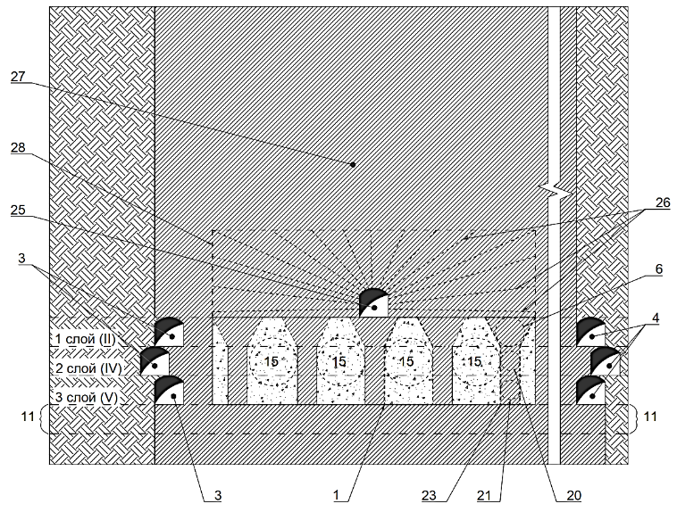
1 – Vertical artificial concrete support of the entry pillar; 3 – Stope drift; 4 - Ventilation-fill drift; 6 - Funnel; 11 - Load-haulage ort; 15 – Concrete stowing (material); 20 - Ore pass; 21 - Niche; 23 – Unmined ore mass, contours of the drawing-off workings: scraper drift, niche, ore pass and funnels; 25 - Sill drift; 26 – Blasthole rings to blast the undermined volume of the ore body; 27 - Ore body; 28 - Contour of the blastholes
Figure 3.10 Cross sectional drawing II - II
As a result of the creation of the artificial stope sill (Figure 3.5 A, B and C) and blasted volume of the ore mass undermined along the contour (28, Figure 3.9 - 3.10), the mining operations end with the process of the systematic release of caved ore mass (8, Figure 2.2) from the blocks (Figure 2.2).

  - The Method for Substantiating the Calculation of Strength of Artificial Stope Sills (ASS) with Multiple Support Reinforced Concrete Platform

The methodology for the development and substantiation of parameters of the combined geotechnology for safe sustainable development of chromite mining at deep horizons must meet the following conditions:
– Safety of the proposed combined geotechnology and provision of safe technological parameters in terms of rock pressure and stress-strain state;
– Ease of manufacturing - substantiation of the parameters of combined geotechnology at deep mining in connection with rock pressure and stress-strain state of the filling mass of the drawing-off horizon with due account for the applied technological equipment;
– Cost-effectiveness - cost-effective development and profitability of combined geotechnology at the development of reserves in the conditions of transition of mining operations to deep horizons.
The safety of the proposed combined geotechnology is substantiated using an estimation of the strength of artificial stope sills with a multi-support reinforced concrete platform according to the following geotechnical parameters:
- Determination of the bearing capacity of the ASS;
- Determination of the load on the ASS;
- Calculation of ASS safety factor.
The proposed uncontrolled caving technology and erection of the ASS with a multi-support reinforced concrete platform is a structure (Figure 3.5 A and B), consisting of vertical reinforced concrete elongated 8-m high pillars between a scraper drift located in pillar 1 (hereinafter the entry pillar pillar) between scraper drifts 2 with the following parameters in the plan: width - 5 m. Above their upper part along and across a scraper drift there are connecting horizontal reinforced concrete beams 5 (Figure 3.5 A, B) 5 m thick, 6 m and 12 m long, respectively (relative to the scraper drift axis).
Also, an element of the proposed design of the ASS is a horizontal reinforced concrete stump pillar 8 (Figure 3.5 B) passing directly above the roof and along the entire length of the scraper drift (instead of the stump pillar), which is connected to transverse horizontal reinforced concrete beams 5 (Figure 3.5 A, B) connected with the upper part between vertical rectangular elongated reinforced concrete pillars 1 (Figure 3.5 A, B).
Based on the foregoing, to calculate the strength of this ASS we have adopted the following calculation schemes:
- Vertical reinforced concrete square shaped supports located in the pillar between the scraping drift and used in accordance with the calculation of the rib pillar at the room-and-pillar development system;
- A horizontal reinforced concrete beam 5 (Figure 3.5 A, B) connecting with the upper part of the vertical square reinforced concrete pillars located in the pillar between the scraping drift along and across the scraping drift;
- Vertical rectangular reinforced concrete pillars located in the pillar between the scraping drift (instead of vertical square reinforced concrete pillars in the form of a rectangular elongated reinforced concrete barrier pillar) used for the calculation of the barrier pillar at the room-and-pillar development system. They connect the upper part with horizontal reinforced concrete slabs (beams) across the scraping drift. The height of elongated rectangular reinforced concrete supports as a barrier pillar is equal to the height of a vertical square reinforced concrete pillars;
- Horizontal reinforced concrete stump pillar located directly above the roof and along the entire length of the scraper drift connecting the upper part between the cross horizontal reinforced concrete beam, connected between vertical reinforced concrete square pillars erected in entry pillars or between vertical rectangular reinforced concrete barrier supports.

  - Modelling the Artificial Reinforced Concrete Stope Sill Within the Uncontrolled Caving System.
    - Input Data for the Calculation of 3D Model Using ANSYS PC
The volumetric computational model was built in the automatic design system AutoCAD and imported into the ANSYS Workbench environment using the compatible CAD/CAM/CAE systems through the export and import of solid bodies in the ACIS SAT file format.
The computational model consists of the drawing-off workings. The dimensions of each drawing-off workings workings are shown in Figure 3.11 a), the general layout is shown in Figure 3.11 b) [32].
The parameters shown in Figure 2.6 were set for the calculation. The computational scheme represents a monolithic draw points in the form of a block with the dimensions of the scraper drift: 4.46x3m at the height of the attic zone, the dimensions of the funnel are 10.3x6 meters. Chromite rocks were selected as a rock mass. Below are the average mechanical properties of the rock and lining material (Table 3.1). The computational scheme of the artificial stope sill within the uncontrolled caving is a monolithic reinforced concrete structure with strength equal to class B25 concrete. Loads are specified for depths of 560, 720, 960 m, the values of which are given in Table 3.2.
a) b)
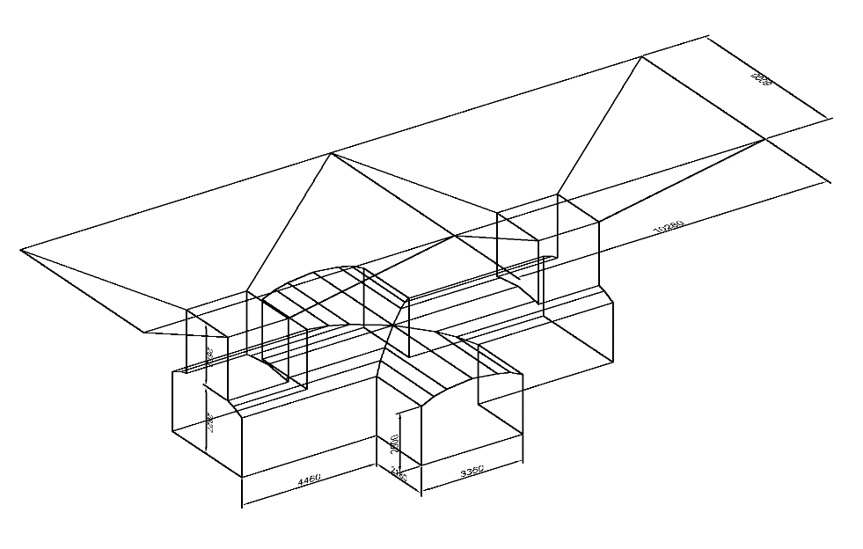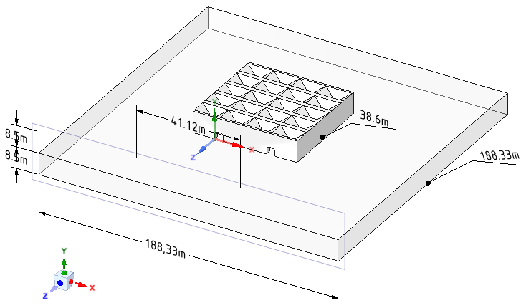
a) Parameters of drawing-off workings; b) General computational scheme
Figure 3.11 Parameters of the computational model
Table 3.1 Average mechanical characteristics of rock and timbering material:

Rock and material | Volume weight, gf/cm³ | Elastic modulus E*10⁻³ kgf/cm²  (hPa) | Poisson ratio ν | Compressive strength kgf/cm² | Tensile strength, kgf/cm² | Shear strength kgf/cm² | Hardness factor f | Internal friction angle degree | Adhesion kgf/cm²
Chromite rocks | 2,7 | 65 | 0,22 | 144 | 10 | 26 | 6,1 | 36 | 48
B25 concrete | 2,5 | 300 | 0,2 | 224

Table 3.2 Load values at various levels of mines:

No. | Horizon depth (m) | Pressure (load) unit  tf/m² | Pressure (load) unit  MPa | System of coordinates
1 | 560 | 2016 | 19,770 | Y axis
2 | 720 | 2592 | 25,419 | Y axis
3 | 960 | 3456 | 33,892 | Y axis

3.5.2 Results of Simulation at Various Levels
The computational model consists of 27,000 nodes of 13,080 finite elements. Based on the calculation results, an increase in the values of deformations, stresses and displacements at large depths was determined. The reinforced concrete funnels gradually abrade under continuous intense exposure to loads, which leads to additional dilution.
The intensity of abrasion depends on the strength of reinforced concrete structures. Figure 3.12 shows the results of total deformations at depths of 560, 720, 960 meters.
Table 3.2 below shows the results of maximum displacements, deformations and stresses for reinforced concrete ASS for the 560m, 720m, 920m depths in the conditions of DNK mine.
Figures 3.13 - 3.14 show graphs of deformations in millimeters at different depths of horizons in accordance with Table 3.3.
Figure 3.13 Results of deformations in millimeters along the X axis at the -560; -720; -960m horizons
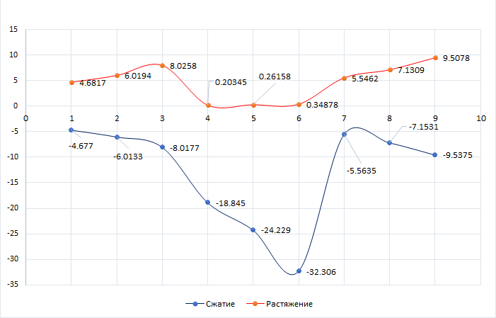
Figure 3.14 Results of deformations in millimeters along all directions (X, Y, Z) at the -560; -720; -960m horizons
Based on the results of the calculations, the influence of loads on the nodes of reinforced concrete ASS, which are subject to the greatest impact, was analyzed. The most pronounced deformations are in the junctions of the funnels, and stresses are maximal in the lower parts of the stump pillar located above the scraping drift. The strength and stability of the complex monolithic reinforced concrete ASS consisting of funnels, ore passes, and drifts is fully ensured.
Table 3.3 Maximum values of deformations and stresses based on the ASS calculation results at the -560m; -720m; -960m horizons:
Name | Total deformation unit  (mm) | Deformation along the Х axis unit  (mm) | Deformation along the Y axis  unit  (mm) | Deformation along the Z axis unit  (mm) | Stress along the Х axis  unit (MPa) | Stress along the Y axis  unit (MPa) | Stress along the Z axis  unit (MPa)
horizon -560m
Compression | 0. | -4.677 | -18.845 | -5.5635 | -34.421 | -105.54 | -38.922
Tensile | 18.871 | 4.6817 | 0.20345 | 5.5462 | 21.648 | 12.393 | 20.017
horizon -720m
Compression | 0. | -6.0133 | -24.229 | -7.1531 | -44.256 | -135.7 | -50.043
Tensile | 24.263 | 6.0194 | 0.26158 | 7.1309 | 27.833 | 15.933 | 25.736
horizon -960m
Compression | 0. | -8.0177 | -32.306 | -9.5375 | -59.008 | -180.93 | -66.724
Tensile | 32.351 | 8.0258 | 0.34878 | 9.5078 | 37.111 | 21.245 | 34.314

RESULTS OF DEFORMATIONS AND STRESSES
 | Load deformation values for horizon -720м | Load deformation values for horizon -960м
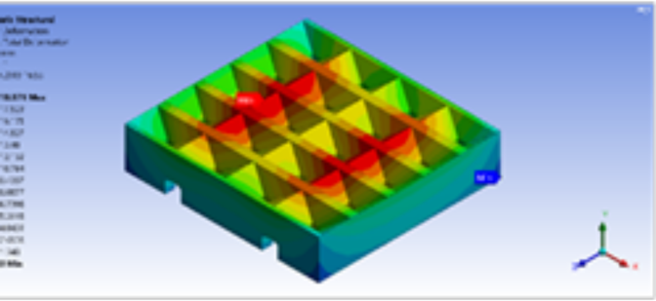 | 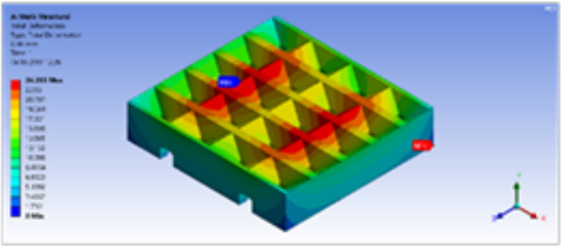 | 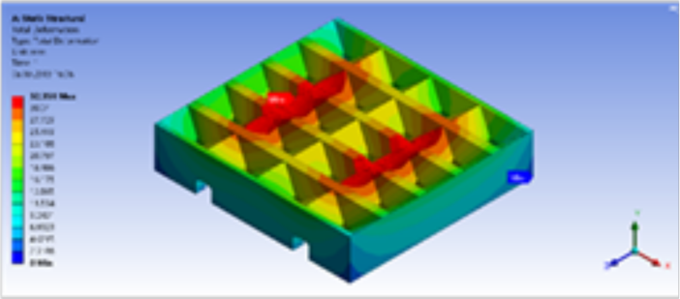
Load deformation values | Load deformation values | Load deformation values
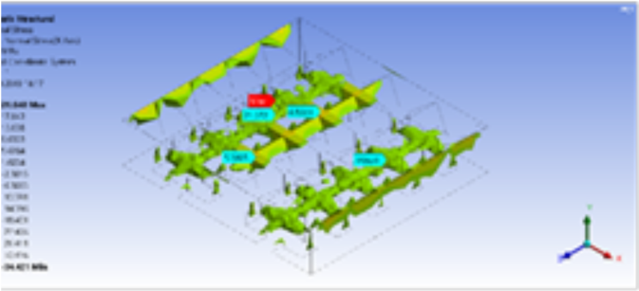 | 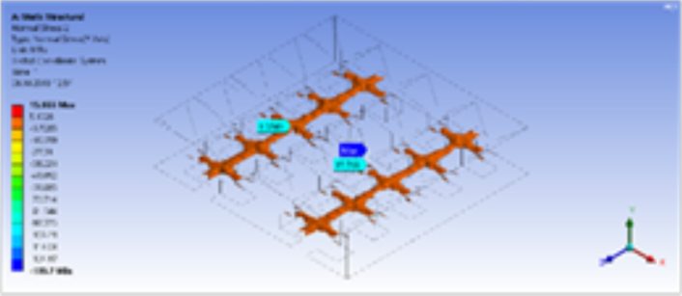 | 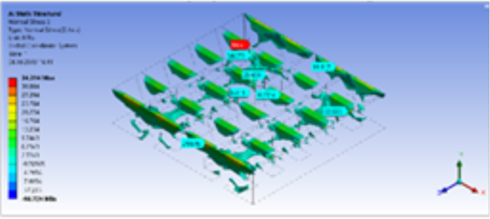
Stress values at the compression of element along X axis | Stress values at the compression of element along Y axis | Stress values at the compression of element along Z axis
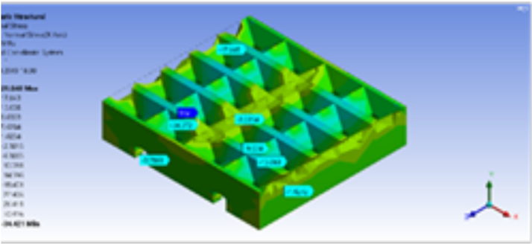 | 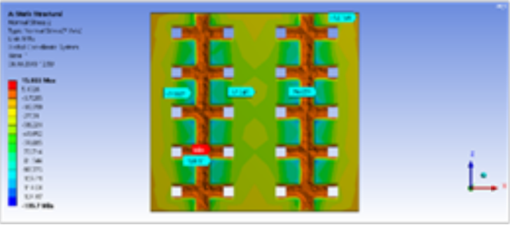 | 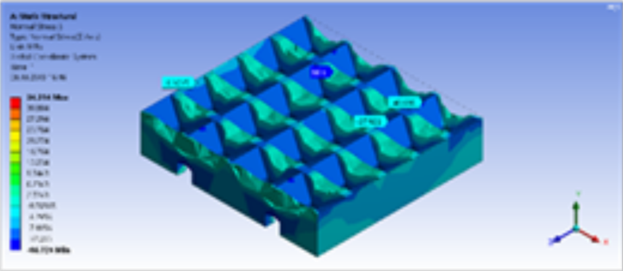
Stress values at the tensile of element along X axis | Stress values at the tensile of element along Y axis | Stress values at the tensile of element along Z axis

Figure 3.12 Values of complete deformation at the depth of 560, 720 and 960 m at the artificial stope sill

3.6 Method and Sample Strength Calculation of the Proposed ASS

The uncontrolled caving technology by means of creating the ASS with a multi-support reinforced concrete platform is a structure consisting of vertical reinforced concrete elongated pillars, both in the form of between a scraper drift located in a pillar between the scraper gates, up to 8 m high with parameters in terms of a width of 5 m and above their upper partly along and across the AL is a mesh connecting horizontal reinforced concrete beams up to 5 m thick, respectively 6 m and 12 m long (relative to the AL axis).
The uncontrolled caving technology and erection of the ASS with a multi-support reinforced concrete platform is a structure, consisting of vertical reinforced concrete elongated 8-m high pillars between a scraper drift located in pillar between scraper drifts with the width of 5 m in the plan. Above their upper part along and across a scraper drift there are connecting horizontal reinforced concrete beams 5 (Figure 3.5 A, B) 5 m thick, 6 m and 12 m long, respectively (relative to the scraper drift axis).
An element of the proposed design of the ASS is a horizontal reinforced concrete stump pillar 8 passing directly above the roof and along the entire length of the scraper drift (instead of the stump pillar), which is connected to transverse horizontal reinforced concrete beams connected with the upper part between vertical rectangular elongated reinforced concrete pillars.
Based on the foregoing, to calculate the strength of this ASS we have adopted the following calculation schemes:
- Vertical reinforced concrete square shaped supports located in the pillar between the scraping drift and used in accordance with the calculation of the rib pillar at the room-and-pillar development system;
- A horizontal reinforced concrete beam connecting with the upper part of the vertical square reinforced concrete pillars located in the pillar between the scraping drift along and across the scraping drift;
- Vertical rectangular reinforced concrete pillars located in the pillar between the scraping drift (instead of vertical square reinforced concrete pillars in the form of a rectangular elongated reinforced concrete barrier pillar) used for the calculation of the barrier pillar at the room-and-pillar development system. They connect the upper part with horizontal reinforced concrete slabs (beams) across the scraping drift. The height of elongated rectangular reinforced concrete supports as a barrier pillar is equal to the height of a vertical square reinforced concrete pillars;
- Horizontal reinforced concrete stump pillar located directly above the roof and along the entire length of the scraper drift connecting the upper part between the cross horizontal reinforced concrete beam, connected between vertical reinforced concrete square pillars erected in entry pillars or between vertical rectangular reinforced concrete barrier supports.
The calculation of the strength of an artificial stope sill with a multi-support elongated rectangular reinforced concrete platform shows that, based on the use of the theoretical results of solid mechanics, structural mechanics, rock mechanics and the practice of using uncontrolled caving and technology of concrete application in mining with the summarizing the actual state of mining at the chromite deposit, we have presented the method for calculating the strength of the proposed artificial stope sill and the creation of a multi-support reinforced concrete platform with an option of a rectangular elongated reinforced concrete platform support.
The calculation of the ASS strength includes [32]:
-Determination of its bearing capacity;
- Determination of the load on reinforced concrete pillars, horizontal reinforced concrete beam and horizontal reinforced concrete stump pillar;
- Calculation of safety factor k_{з}.п.
Based on the calculation of the strength, the optimal parameters of the supporting elements of the structure of the proposed ASS are substantiated for the uncontrolled caving technology and are as follows:
- Vertical reinforced concrete square shaped supports, vertical rectangular elongated reinforced concrete barrier supports (with the following estimated parameters: height 6-8 m);
- Vertical rectangular elongated reinforced concrete barrier supports installed in the entry pillar (with the following estimated parameters: 5 m);
- Horizontal reinforced concrete beams located in lengthwise and across the scraping drift (with the beam thickness - 5 m) with a mesh connection of the upper part of the vertical rectangular elongated reinforced concrete supports installed in the entry pillar;
- Horizontal reinforced concrete beams in the form of a prismatic pillar located above the roof and along the entire length of the scraping drift connecting the upper part of the cross horizontal reinforced concrete beam and also the upper part between the vertical rectangular elongated reinforced concrete pillars with located in the entry pillar.
The ASS element is calculated according to the bearing capacity of a vertical reinforced concrete rectangular pillar-support similar to the method for calculating an rib barrier pillar at the room-and-pillar development system (i.e. in our case it corresponds to a vertical artificial barrier pillar) and similar to the bearing capacity of a vertical rectangular reinforced concrete pillar-support.
The bearing capacity of a vertical rectangular reinforced concrete pillar-support with a height of h_{оп} = 7 ÷ 9 m is calculated using the formula (1):

N_{с} =δ_{сж.б} ·F_{ί} ·K_{ф} ·K_{Г} ·K_{α} (1)
where: N_{с} is bearing capacity of a vertical rectangular reinforced concrete pillar-support, t;
σ_{сж.б} is a concrete compression strength, t/m²;
F - is a sectional area of a vertical rectangular elongated reinforced concrete pillar-support, m²;
K_{Г} - is a coefficient accounting for the joint effect of mining geological and technological factors on the bearing capacity of a vertical reinforced concrete pillar-support.
K_{α} - is a coefficient accounting for the effect of a deposit angle of bedding.
K_{ф} - is a shape factor accounting for the effect of the geometric dimensions of the pillar on its bearing capacity (2):
K_{ф} = , (2)
where 𝑎 - is a width of a vertical reinforced concrete pillar-support, m;
h - is a height of a vertical reinforced concrete pillar-support, m.
The structural elements of the ASS in our case correspond to an artificial square rib pillar and are characterized by a safety margin in the rib pillar, according to the formula (3):

(3)

where Q - is a load on a vertical reinforced concrete pillar-support, t.
For workings located in the stoping impact zone, all components of the safety factor k_{з.пр} are established by the analytical calculation, and are expressed in the following form (4):

k_{з.пр} = k₁ · k₂ · k₃ … k_{i} , (4)

where: k₁ - is a complexity index of mining geological structure, k₁ = 1.05;
k₂ - is a coefficient of high mining geological structural fracturing, k₂ = 1.16;
k₃ - is a coefficient of deflection from accurate calculation of bearing pressure parameters for workings located in the stoping impact zone, k₃ = 1.075;
k₄ - is a coefficient of deflection from accurate calculation of the weight of overlying rock, k₄ = 1.035;
k₅ - is a coefficient of deflection from accurate calculation of depth of a mine working, k₅ = 1.03.

k_{з.пр} = k₁ · k₂ · k₃ · k₅ = 1.05 · 1.075 · 1.035 · 1.03 = 1.4

It should be noted here that the proposed vertical and horizontal structural elements of artificial stope sills are located around the stoping impact zone - the scraping drift, i.e. in entry and stump pillars. Based on the calculated safety factor according to the research results [12], k_{з.пр} ≥ 1.4 is complied.
In accordance with the foregoing, the calculation of the strength of a vertical square reinforced concrete pillar-support located in the entry pillar of the scraper drift for the proposed design of artificial multi-support platform stope sills at the underground mining with uncontrolled caving technology consists of the following parameters.
A. Mining and geological conditions and geometrical parameters:
1. Parameters of a vertical square reinforced concrete pillar-support is 2.8 m wide and 2.8 m long;
2. Height of a vertical square reinforced concrete pillar-support varies from 5 to 8 m;
3. The distance along the axis between the scraping drifts in the panel is 12 m;
4. The distance along the axis between the workings of the niches along the scraping drift is 6 m;
5. Thickness or transverse height of horizontal reinforced concrete beams ≈ 5.0 m;
6. Width of horizontal reinforced concrete beams is 2.8 m;
7. Length of horizontal reinforced concrete beams along and across the scraping drift is 3.2 m and 9.2 m, respectively;
8. The length of the horizontal stump reinforced concrete beams located directly above the roof of the scraping drift is 3.2 m;
9. The thickness of the overlying strata is H = 880 m.
10. Width of the panel = 30 m;
11. The deposit angle of bedding is up to 10-15°;
12. The volumetric weight of the overlying strata is γ = 2.5 t/m³;
13. The height of the caving roof is 80 m high, h_{св.о} ≈ 200 m;
14. The strength of ore sandstone rocks δ_{сж} is 20,000 t/m² (200 MPa) [16]:
15. The compressive strength of concrete σ_{сж.б} = 15.0 ÷ 30.0 MPa (150 ÷ 300 kg/cm² or 1,500÷3,000 t/m²). According to the project, the proposed platform is made of a reinforced concrete structure, therefore, for the design indicator of the strength of reinforced concrete, we assume that the compressive strength of concrete equals σ_{сж.ж/б} = 150 MPa or (σ_{сж.ж/б} = 15,000 t/m²).
B. Determination of the load on a vertical elongated rectangular reinforced concrete pillar-support.
1. Bearing capacity of a vertical reinforced concrete pillar-support:
N_{с} = δ_{сж.п} ·Fί ·k_{ф} ·k_{Г} ·k_{α} = 700 х 18.6 ··0.75 · 1 = 88,200 t.
2. Load on a vertical reinforced concrete pillar-support:
Q = K_{н} · {(γ_{р} · L₁ · L₂ · h_{к}) + (γ_{п} · L₁ · L₂ H)} = 1{(3,6·12·6·80) + (2,6·12·6·200)} = 20736 + 37440 = 58176 t.
3. Safety factor of a vertical reinforced concrete pillar-support:
n_{р} = N_{с} / Q = 88200 : 58176 = 1.51.
C. Determination of the load on horizontal beams located along the stump pillar and relative to the scraper drift with a cross-horizontal grid connection with the upper part of the vertical reinforced concrete pillar-support.
1. Bearing capacity of horizontal reinforced concrete beams transversely connected above the scraper drifts between segments of niches with the upper part of vertical reinforced concrete supports erected in an entry pillar:
N_{лмкц} = 20000 · 15 · · 0,75 = 159750 t.
2. Load on a rib pillar: Q = 80 · 500 · 2,5 = 100000 t.
3. Safety factor of a rib pillar: n_{лмкц} = 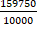 = 1,6
According to the performed calculations of the strength of a vertical square reinforced concrete pillar-support with a height of h_{оп} = 7÷9 m for the proposed multi-support reinforced concrete stope sill, the safety factor of an element of a vertical square reinforced concrete pillar-support equals to n = 1.51 and corresponds to the safety factor (for n ≥ 1,4).
4. The proposed combined geotechnology using the descending cut-and-fill development system under artificial roof in combination with the uncontrolled caving and ore delivery using self-propelled equipment in the conditions of the artificial stope sill
The essence of the proposed option of combined geotechnology is, as noted in Section 3.3 of this Operating procedure, that the front of mining operations is divided for mined deposits within a level, is staggered and performed using combined underground geotechnology - descending horizontal slicing and backfilling of the mined space under the artificial roof (Figure 2.10) and the technology of uncontrolled caving and delivery of ore using self-propelled equipment in the conditions of the erected artificial stope sill (Figure 2.2). This ensures providing high productivity of the combined geotechnology in line with the process chart for the ASS option within the system of uncontrolled caving with the use of self-propelled equipment for delivery of released ore mass to the ore pass in the conditions of deep and highly fractured ore deposits with unstable ore mass.
According to the proposed option of the process chart, an artificial stope sill (ASS) with a stable supporting reinforced concrete platform is erected for the release and delivery of ore mass using high-performance self-propelled equipment with the uncontrolled caving system. At the same time, in the conditions of increased rock pressure, we proposed a new method combined with the uncontrolled caving system for erecting the artificial stope sill with a multi-support reinforced concrete platform, according to the process chart of the geotechnology with descending cut-and-fill mining aimed at solving the problems of effective development of deep horizons of the Don chromite deposit using high-performance self-propelled equipment.
The proposed process chart for ASS includes such structural elements as 4x4 m haulage orts (1, Figure 4.1) and 4x4 m loading ramps (2, Figure 4.1), taking into account the LHD parameters - length and sizes of ore mass piling under 45° angle of repose for loading and delivery of ore mass from blocks by self-propelled haulage equipment (3 - LHD, Figure 4.1). At the same time, loading ramps (2, Figure 4.1) are constructed from the haulage ort according to the classic Christmas tree-parallel installation driven from one junction place.
According to the process chart, the haulage port (1, Figure 4.1) for the ASS is located under a structural element - an artificial stump pillar (4, Figure 4.1) and between an artificial entry pillar (5, Figure 3.5) in the form of a vertically elongated reinforced concrete artificial support (6, Figure 4.1).
According to the proposed process chart of the ASS, the produced caved ore mass is supplied through artificial square funnels under gravity (7, Figure 4.1) and along the contour of the upper boundary between the funnels with dimensions equal to three meters in width, a concrete beam is drawn (7, Figure 4.1) and through an ore pass (8, Figure 4.2) with a cross-section of 4x4 m and a height of 4 m. Next, the caved ore supplied to the loading ramp (2, Figure 4.1) forms a 45° muck pile under an angle of repose for filling of the LHD bucket (3, Figure 4.1) and delivered from the driveway (2, Figure 4.1), then it is delivered via the haulage ort (1, Figure 33.1) to the block ore pass (9, Figure 4.1).
a)
b)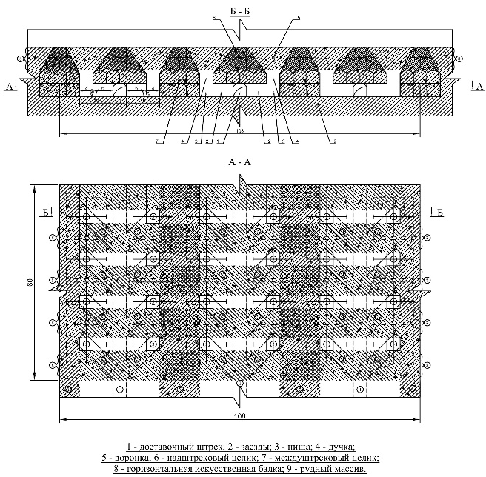
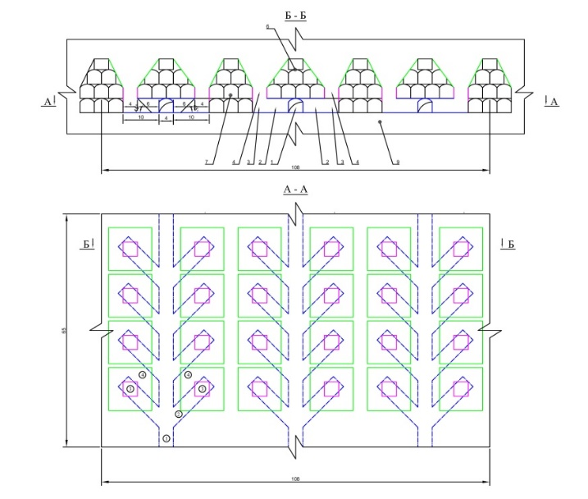
Figure 4.1 Process chart of the artificial stope sill for the extraction of ore with a classic rectangular funnel and the delivery of ore mass by self-propelled equipment (LHD) from the loading drive according to the classic Christmas tree-parallel installation.
The essence of the proposed second option of the process chart of the ASS using self-propelled equipment is in the fact that the artificial stope sill is erected on the stable supporting reinforced concrete platform for the release and delivery of ore mass using high-performance self-propelled equipment within uncontrolled caving (Figure 4.1). It differs in the design of loading ramps, where from the haulage ort it is drawn according to the Christmas tree installation (2, Figure 4.2). There is no conjunction at the wellhead with the haulage ort, there are low costs for fastenings in conditions of greater conjunction when using LHD, and in addition, rectangular funnels and ore passes with the same parameters will be replaced to connect to loading ramps according to the Christmas tree installation.
a) | 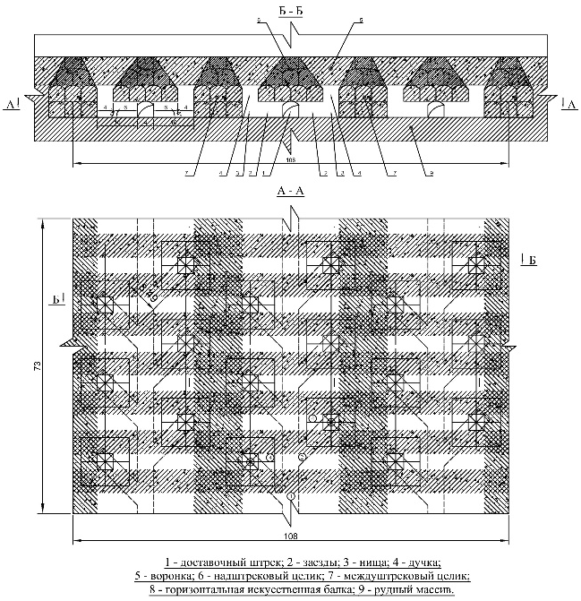
b) | 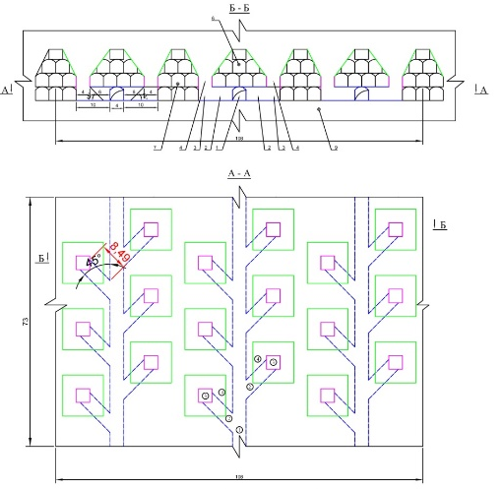

Figure 4.2 Process chart of the artificial stope sill for the extraction of ore with a classic rectangular funnel and the delivery of ore mass by LHD from the loading drive according to the classic Christmas tree installation.
The essence of the third proposed option of the process chart of the ASS using self-propelled equipment is that the artificial stope sill is constructed on a stable support reinforced concrete platform for the release and delivery of ore mass using high-performance self-propelled equipment within uncontrolled caving system (Figure 4.1). In this option, the difference is the design of the funnel in a rhombic shape. Next, the structural elements of the ore pass and loading ramps for the ore release and delivery of the rock mass are connected to the haulage working (ort) and the block is prepared in the same way according to the classical Christmas tree-parallel installation and driven from one place with a greater conjunction at the mouth of the ort with high costs for the maintenance when using LHD.
The essence of the fourth proposed option of the process chart of the ASS using self-propelled equipment is the same as the proposed third option of the ASS with a stable-supporting reinforced concrete platform for the release and delivery of ore mass using high-performance self-propelled equipment within the uncontrolled caving system with a rhombic funnels (Figure 4.4, left).
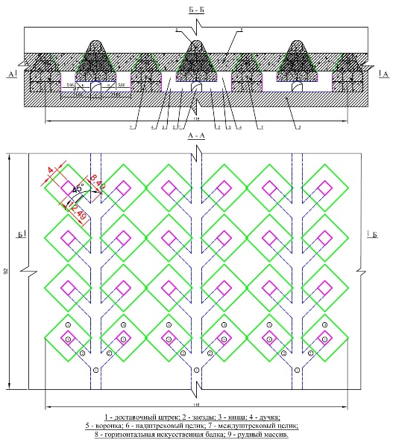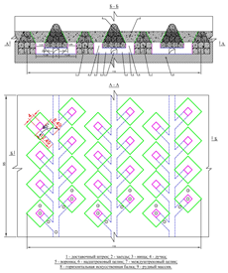

Figure 4.3 Process chart of the artificial stope sill for the extraction of ore with a rhomboid funnel and the delivery of ore mass by LHD from the loading drive according to the classic Christmas tree installation (right Figure).

However, in the fourth proposed option, the process chart differs from the location of loading ramps relative to haulage orts, where they are constructed according to a Christmas tree installation (Figure 4.3, right) in the same way as in the proposed ASS option (Figure 4.1). In this option of the ASS, according to the process chart, there will be no areas of greater conjugation at the wellhead with the delivery ort, which ensures low costs for fastening when using the LHD as well as rhomboid-shaped funnels and ore passes with the same parameters will be replaced to connect with loading ramps according to the process chart.
4.1. Selection of the Excavation Unit, Development Heading, Stoping and a List of Geotechnological Equipment for the Use of Combined Geotechnology in the Conditions of Deep -480/-640 m Horizons of the DNK mine of the DON Mining and Processing Plant.
For the application of the combined geotechnology using descending cut-and-fill systems under the artificial roof with a trapezoidal block shape and in combination with the uncontrolled caving system in the mining-geological and mining technical conditions of reserves development, adequate mining blocks are blocks No. 21-27 at the -480 m horizon of the “DNK” mine of the DON mining and processing plant.
According to the proposed combined geotechnology using a descending cut-and-fill system under the artificial roof with a trapezoidal block and in a combination with the uncontrolled caving system, all parameters of the development system are accepted and the development heading and stoping are performed according to the Operating procedures of the VNIItsvetmet [33, 34].
In this option of the combined geotechnology, the reserves of primary blocks are developed (1, Figure 3.1) top-down in several layers of backfill. At the same time, it is done from the center to the flanks in several blocks leaving sections of reserves of neighboring blocks for their secondary development.
Regarding the second part of the proposed geotechnology, i.e. combined with the uncontrolled caving and delivery of the ore mass, it is done under the conditions of the erected artificial stope sill from a backfilled mass using self-propelled equipment.
The list of technological equipment for development heading and stoping is given in Table 4.1 [34].
Table 4.1 The list of technological equipment for development heading and stoping:
Name and type of equipment | Quantity, pc.
Name and type of equipment | Employed | Enlisted
Stoping
Load-haulage machine, TORO–301 type | 10 | 10
Drill rigs, Boomer type | 10 | 10
Drill rig NKR-100 | 12 | 13
Hole charging installation, Ulba-400 type | 6 | 6
Ventilator ВМ-12 | 8 | 13
Ventilator ВМ-6 | 12 | 12
Pneumatic charger EP-2 | 12 | 12
Preparatory development
Load-haulage machine, TORO–301 type | 5 | 5
Drill rigs, Boomer type | 5 | 5
Perforator, PP-63 type | 11 | 11
Perforator, PT-48 type | 18 | 18
Ventilator ВМ-12 | 3 | 3
Ventilator ВМ-6 | 6 | 6
Pneumatic charger ЗП-25 | 9 | 9

4.2. Determination of Ore Losses and Dilution at the Development of Chromite Reserves Using Combined Underground Geotechnology and Self-Propelled Equipment in the Conditions of the Erected Stope Sill
Based on the experience of the Orlovsky and Tishinsky mines of the East Kazakhstan Region as well as taking into account the recommendations of the Operating Procedures of the VNIItsvetmet Institute, the DON mining and processing plant, “10th Anniversary of Kazakhstan Independence” (“DNK”) mine, VIOGEM, Mining Institute, in compliance with the “Industry instructions for the determination, accounting and standardization of ore losses during the development of iron ore, manganese and chromite deposits at the enterprises of the Ministry of Ferrous Metallurgy of the USSR” (Belgorod, 1975), the estimated standards for losses and dilution for the horizontal descending cut-and-fill and for the development system with uncontrolled caving of ore and host rocks, including the use of self-propelled equipment, were determined by the Kazakh Lead Design Institute for the design of non-ferrous metallurgy enterprises “Kazgiprotsvetmet” [34].
The results of calculating losses and dilution for the adopted development systems for the fields “Almaz-Zhemchuzhina”, “Millionnoye” and “Pervomayskoye” are presented in Table 4.2 [34].
Table 4.2 Ore losses and dilution:
Development systems | Losses,  % | Dilution, %
Block caving | 16 | 19
Block caving with the artificial stope sill | 15,0 | 17,0
Sublevel caving | 16,5 | 20,0
Horizontal descending slicing and backfilling | 4,8 | 7,3

Parameters of mineral extraction for each extraction unit are calculated as the operations proceed in the framework of the agreed local project.

4.3 Computational Scheme and Stress-Strain State of the Combined Geotechnology Based on Finite Elements Depending on the Angle of Inclination of the Block Sidewall

The calculation was done using the software package “Lira soft version 10.6.” The number of elements is 17,012, the number of nodes is 17,711. The calculation was done with regard to a plane scheme. Finite elements (FE) 24,27 from the program library were used. Descriptions of finite elements are given in FE 24, 27 (plane stress, deformation). The thickness of the finite elements is 1m.
This FE is designed for the calculation of the strength of plates loaded on their plane (plane X1OZ1). By default, a finite element can simulate a plane stress state and can be represented both as the universal triangular FE 24 of the plane problem (Figure 4.4) and the universal quadrangular FE 27 of the plane problem (Figure 4.4). The figures show schematic images of FE with the sequence numbering of nodes. The presence of intermediate nodes in Figure 5.2 (5, 6, 7, 8) is optional. The nodes must be numbered anticlockwise.
Each of the FE nodes has the following degrees of freedom:
• U - linear movement along the X axis, the positive direction of which coincides with the direction of this axis;
• V - linear movement along the Y axis, the positive direction of which coincides with the direction of this axis;
• W - linear movement along the Z axis, the positive direction of which coincides with the direction of this axis.
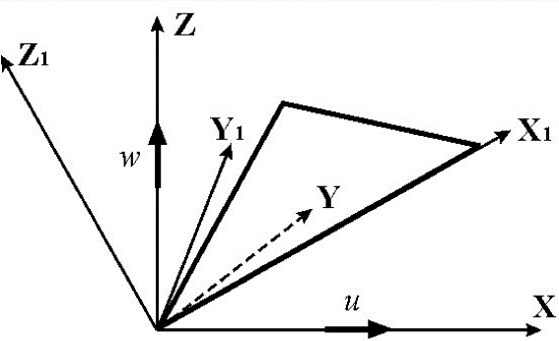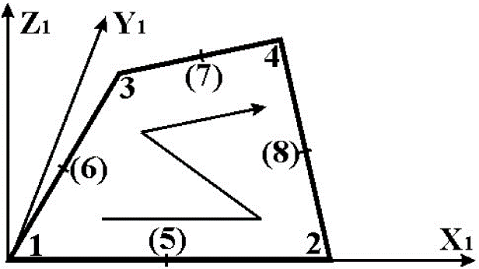

Figure 4.4 Schematic representation of FE24 Figure 4.5 Schematic representation of FE 27
Table 4.3 contains the average physical and mechanical properties of the rock.
Table 4.4 contains the values of the assigned loads for the computational scheme.
- Properties of B20, B25, B30 concrete are specified in accordance with SNiP 2.03.01-84* “Concrete and reinforced concrete structures.”
- The loads were set with due account for the combinations of loads of constant and proper weights of the structure and long-term pressure of rocks depending on the depths of 560m, 720m and 960m according to SNiP 2.01.07-85* “Loads and impacts” with due account for values from Table 4.3.
- The mass is assumed to be equal to the strength of B30 concrete.

Table 4.3 Average mechanical characteristics of rock:

Rock and material | Volume weight, gf/cm³ | Elastic modulus Eх10⁻³ kgf/cm²  (hPa) | Poisson ratio, ν | Compressive strength kgf/cm² | Tensile strength, kgf/cm² | Shear strength kgf/cm² | Hardness factor f | Internal friction angle degree | Adhesion kgf/cm²
Chromite rocks | 2,7 | 65 | 0,22 | 144 | 10 | 26 | 6,1 | 36 | 48

Table 4.4 Values of loads at various horizons:
No. | Load of the cave roof (m) | Depth of the horizon (m) | Pressure (load) unit  t.f/m² | System of coordinates
1 | 50 | 560 | 135 | Y axis
2 | 150 | 710-720 | 270 | Y axis
3 | 250 | 950-970 | 675 | Y axis

Figures 4.4 - 4.6 show the computational schemes for the angles of slope of the concrete block at the angles of slope of the block sidewall equalling 65 degrees, 75 degrees and 85 degrees.

Table 4.5 Rules of stresses in finite elements of slabs:

Index | Dimension | Description | Positive stress affects
Мх | FL/L | Moment affecting the sectional view orthogonal to X1 axis | Tensile of lower fiber relative to Z1 axis
Му | FL/L | The same relative to Y1 axis | Tensile of lower fiber relative to Z1 axis
Мху | FL/L | Torque | Curvature of a diagonal 1-4 (or the median going from node 1) directed relative to the Z1 axis with a downward convexity.
Qх | F/L | Shearing force along Z1 axis in the sectional view orthogonal to X1 axis | Coincidence with the direction of Z1 axis on the part of the FE where node 1 is missing
Qy | F/L | The same in the sectional view orthogonal to Y1 axis | Coincidence with the direction of the Z1 axis on the part of the FE where node 1 is missing
Rz | F/L2 | Pressure on the soil | Soil tensile

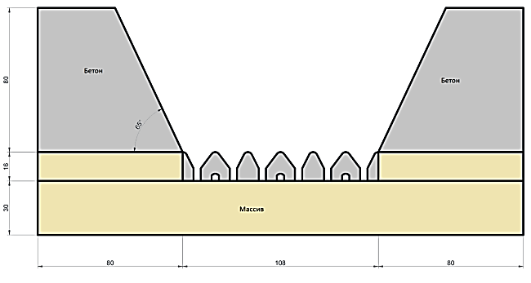 | 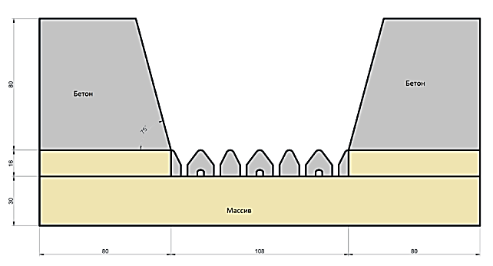 | 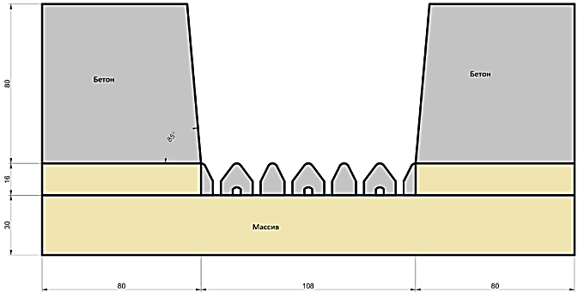
Figure 4.4 Computational scheme at the 65° angle of slope of the block sidewall | Figure 4.5 Computational scheme at the 75° angle of slope of the block sidewall | Figure 4.6 Computational scheme at the 85° angle of slope of the block sidewall
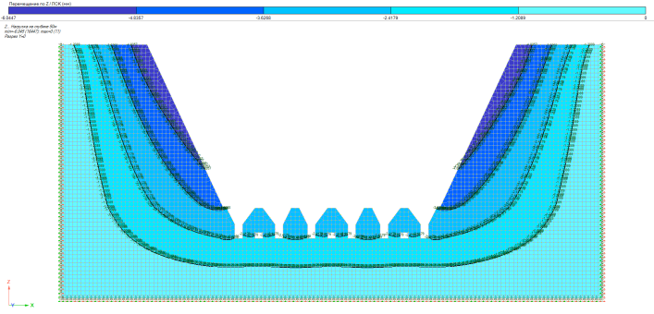 | 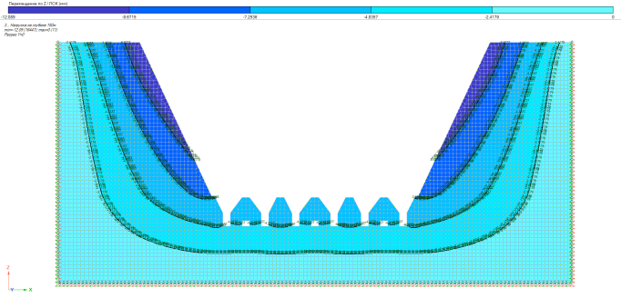 | 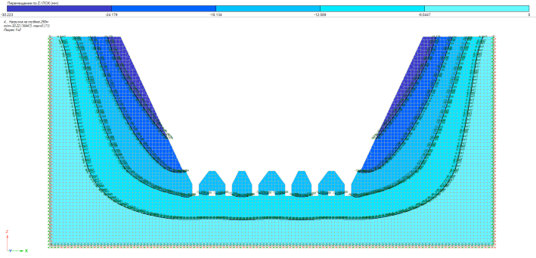
Figure 4.8 B30 concrete. Angle of slope of the block sidewall = 65 degrees. Isofields of elements shift at the load of 50m cave roof | Figure 4.9 B30 concrete. Angle of slope of the block sidewall = 65 degrees. Isofields of elements shift at the load of 150m cave roof | Figure 4.10 B30 concrete. Angle of slope of the block sidewall = 65 degrees. Isofields of elements shift at the load of 250m cave roof
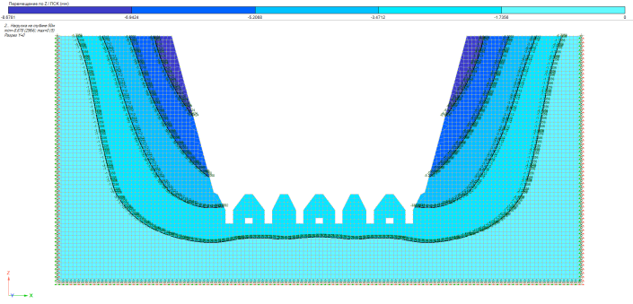 | 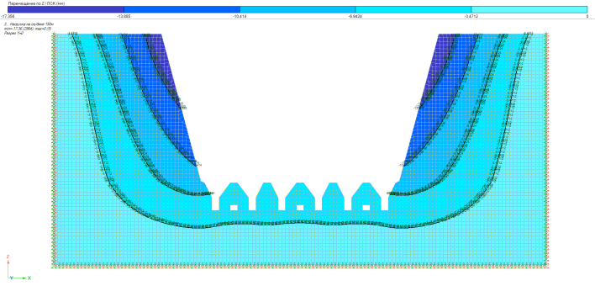 | 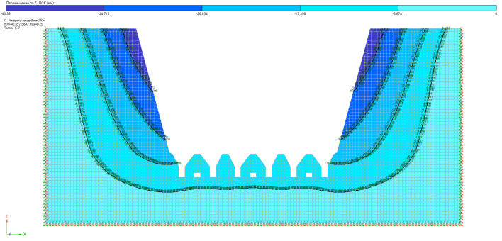
Figure 4.11 B30 concrete. Angle of slope of the block sidewall = 75 degrees. Isofields of elements shift at the load of 50m cave roof | Figure 4.12 B30 concrete. Angle of slope of the block sidewall = 75 degrees. Isofields of elements shift at the load of 150m cave roof | Figure 4.13 B30 concrete. Angle of slope of the block sidewall = 75 degrees. Isofields of elements shift at the load of 250m cave roof

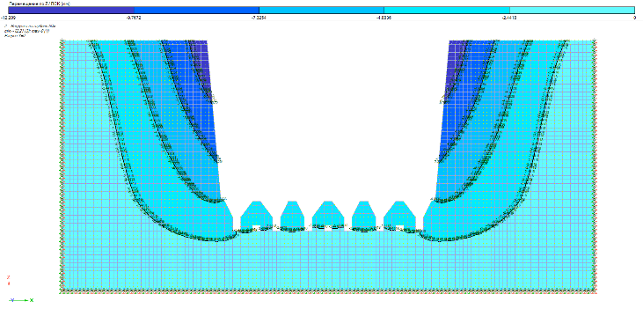 | 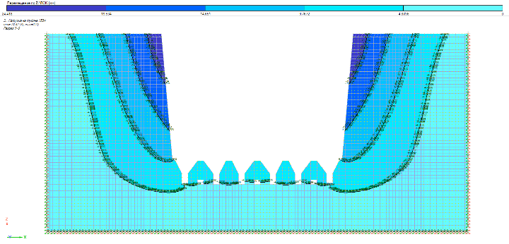 | 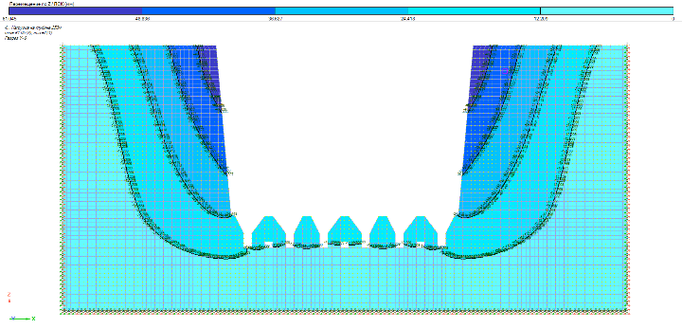
Figure 4.15 B30 concrete. Angle of slope of the block sidewall = 85 degrees. Isofields of elements shift at the load of 50m cave roof | Figure 4.16 B30 concrete. Angle of slope of the block sidewall = 85 degrees. Isofields of elements shift at the load of 150m cave roof | Figure 4. 17 B30 concrete. Angle of slope of the block sidewall = 85 degrees. Isofields of elements shift at the load of 250m cave roof
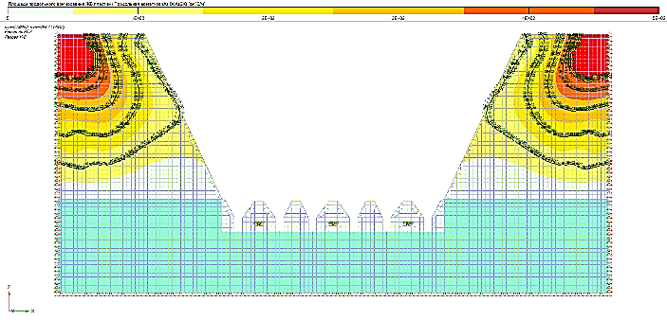 | 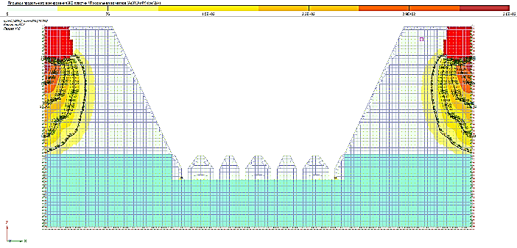 | 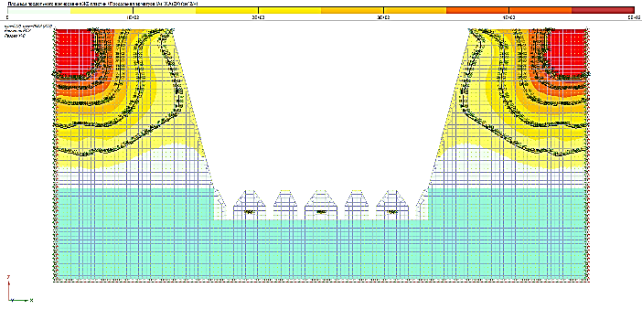
Figure 5.18 B30 concrete. Angle of slope of the block sidewall = 65 degrees. Area of longitudinal reinforcement along Х axis | Figure 4.19 B30 concrete. Angle of slope of the block sidewall = 65 degrees. Area of longitudinal reinforcement along Z axis | Figure 4.20 B30 concrete. Angle of slope of the block sidewall = 75 degrees. Area of longitudinal reinforcement along Х axis
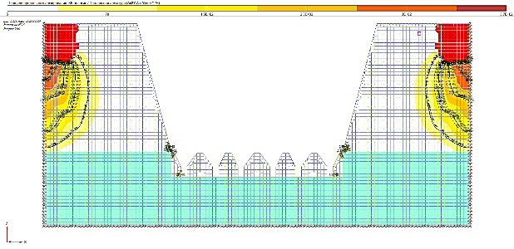  Figure 4.21 B30 concrete. Angle of slope of the block sidewall = 75 degrees. Area of longitudinal reinforcement along Z axis | 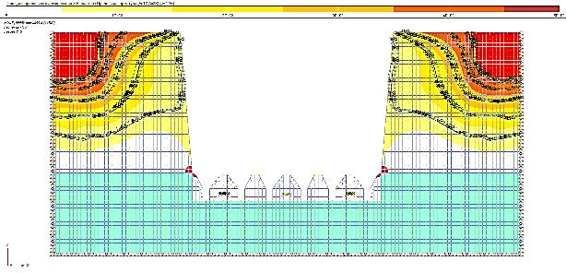  Figure 4.22 B30 concrete. Angle of slope of the block sidewall = 85 degrees. Area of longitudinal reinforcement along Х axis | 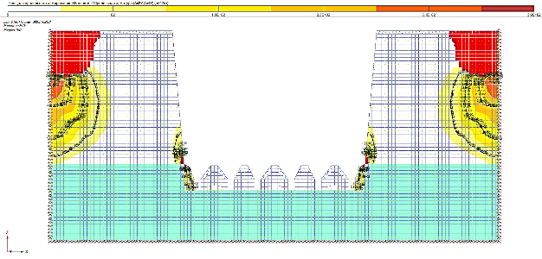  Figure 4.23 B30 concrete. Angle of slope of the block sidewall = 85 degrees. Area of longitudinal reinforcement along Z axis

F – force L – length:
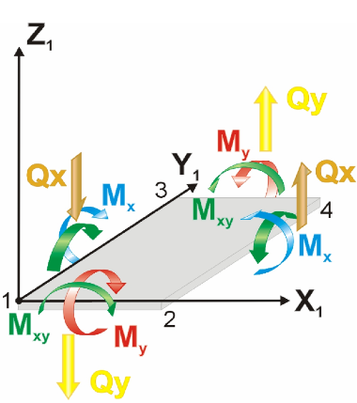
Figure 4.7 Descriptional chart of pressure of FE of slabs

Based on the results of the calculations, it was determined that at an angle of 65 degrees, the scheme is most stable, the forces from the action of loads on the scheme are less than at steeper angles, like 75 and 85 degrees. Accordingly, at an angle of 75 degrees, the scheme is more stable than at 85 degrees.
As the concrete strength increases, the deformation decreases.
The calculation results are presented in Figures 4.8 to 4.17. The results show the absolute displacements (mm) of the structure in the direction of effective loads for the horizons of 560, 720 and 960 meters at the angles of inclination of the block sidewall = 65, 75 and 85 degrees.
According to the results of reinforcement in the computational schemes:
- the fixed extreme lateral zones have the highest percentage of reinforcement and the maximum percentage of reinforcement has been reached;
- the section is small at the longitudinal force; this is due to the peculiarity of the calculation and the choice of the parameters of the boundaries of the calculation model.
In general, the percentage of reinforcement on most part of the monolithic concrete backfilled mass at an angle of slope of the block sidewall = 650 degrees is much lower than at angles of 75⁰ and 85⁰. The results of reinforcement with longitudinal and transverse rods are shown in Figures 4.18 to 4.23. Reinforcement of elements is given in cm²/m. The average geometric dimensions of a square FE are 2x2m. Accordingly, the value of reinforcement 1E + 02 equalling 100 cm²/m will be equal to 20 reinforcing rods with a diameter of 28 at an interval of 200 mm or 0.2 meters if the thickness of FE is one meter.
In fact, according to the calculation, it is possible to use Ø = 10-12 mm reinforcement at an interval of 200 mm along and across the concrete block along Z axis (vertical) with B30 class concrete.
5. Development of Recommendations for the Application of the Combined Geotechnology at Deep Horizons of Mines of the DON Mining and Processing Plant

In accordance with the technological solution of VNIItsvetmet [36] and the practice of industrial development in line with the “Rules of technical operation of mines, placers and pits of non-ferrous, rare and precious metals”, reserves are being developed at the DNK mine of the Almaz-Zhemchuzhina deposit on the horizon -320m/- 640m within the second and third stages of construction where mainly block caving and sublevel caving systems are used, to a lesser extent the system of horizontal descending slicing and backfilling using self-propelled equipment.
According to the proposed combined underground geotechnology in the conditions of deep horizons of the -480m/-640m level of the DON mining and processing plant at the mining of chromite reserves in highly fractured and unstable ore and host rock masses (sometimes in the form of an isolated deposit, up to 80 m thick), the process chart of mining presents the combined application of underground geotechnology within a level by means of horizontal descending slicing and backfilling of the mined space under the artificial roof in the form of a trapezoid block with a 70-80⁰ angle of inclination of the block sidewalls from the upper layer at an angle of repose and uncontrolled caving (Figure 5.1). The proposed combined geotechnology is patented [33,34].
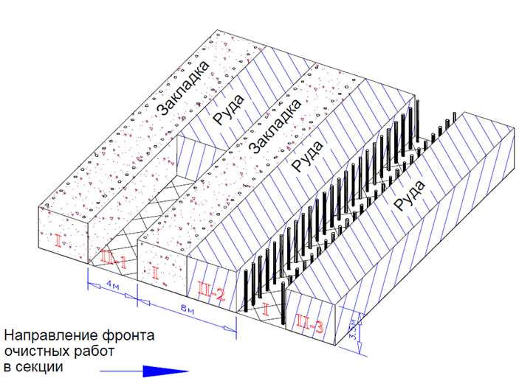
Figure 5.1 The recommended sequence of stoping in the layer. I and II is a mining sequence, 1-3 is stoping sequence of stage II

All operations of the technological process during the preparatory development and stoping for ore mining in the primary block by means of descending horizontal slicing and backfilling of the mined space under the artificial roof in the form of a trapezoid block, including the driving of drifts, an inclined ramp, drives to each layer, ore passes and the ventilation-fill raise as well as stopes are done in accordance with the Industrial Safety Rules and the Operational procedure for mining and concrete stowage works developed by the VNIItsvetmet Institute (Figure 2.10) [36]. At the same time, the block reserves are mined by descending layers, and stoping can be simultaneously done on two or three sublevels. The vertical distance between adjacent sublevels for the simultaneously mined layer must be at least 20 m.
The recommended mining sequence of chromite reserves in blocks is in the direction of the stoping front in sections from the beginning of the blocks flank with stopes and their backfilling with hardening mixtures in a staggered pattern leaving the ore layer, as shown in Figure 5.1.
Technological processes during preparatory development and stoping in the secondary block at the mining system combined with uncontrolled caving, including the driving of haulage drifts and drives for are passes and funnels, an inclined ramp, ore passes and ventilation raises as well as sill cut with subsequent drilling of wells are done in accordance with the Industrial Safety Rules and the Rules for the Technical Operation of Ore Pits and Mines [37,38].
Compliance with a planned sequence for adjacent mining units within one panel allows limiting the development of the uncontrolled caving process vertically, as a result of which it becomes possible to control the vertical rock pressure (the volume of caved rock mass) affecting each individual mining unit by means of a timely release of a dosed volume of the rock mass. Uncontrolled caving process (vertical) can be limited by maintaining the optimal (minimum sufficient) areal dimensions of the stope (no more than 900 m²). Provided the areal dimensions of the stope comply with this value, the estimated vertical size of possible uncontrolled caving does not exceed 50 m from the drawing-off horizon, taking into account that the vertical reserves were previously blasted (undercut). The actual vertical thickness of the ore body is 80 m. When uncontrolled caving vertically reaches to the estimated value of 50 m (minus the volume of the previously released undercut), the volume of the caved rock mass at the haulage drift will be no more than 20 thousand tons, which in terms of the load will be no more than 0.9 - 1 MPa. Consequently, at this stage of production, there is a real possibility of regulating the parameters of vertical pressure - the optimal sequence of mining in production units.
Based on the results of the experimental-industrial research, the following optimal parameters of the necessary and sufficient area for the development of uncontrolled caving process and its subsequent control (the vertical thickness of the ore body in this case is at least 60 m) have been developed and implemented:
- To ensure the development of the uncontrolled caving process, it is necessary to establish and then regularly maintain optimal and sufficient areal dimensions of the stoping (along the strike and across the strike) not exceeding 900 m², while the estimated possible height of uncontrolled caving (formation of the arch of natural equilibrium H) on this area will be no more than 60 m;
Maintaining the established area dimensions of mining units (panel, block) within 600 - 900 m² ensures timely formation and regular development of the uncontrolled caving process and makes it possible to control rock pressure within the panel. At the same time, it is necessary to systematically release the ore from each block.
Based on the foregoing, according to the proposed combined geotechnology for the development of chromite reserves in combination with the above-mentioned development systems, it is recommended to use a general development sequence from the center of the deposit to the flanks and, then, to prepare the primary block (I) on the level and develop reserves using horizontally descending slicing and backfilling, leaving ore reserves for the adjacent block. The next step of the preparation and development of block (II) reserves includes the uncontrolled caving mining system (Figure 5.2).
.
1 – Trapezoid-shaped block; 2 – Angle of slope of the blcok sidewalls; 3 – Adjacent blocks; 4 – Uncontrolled caving technology; 5 – Backfilled layers; 6 – Direction of descending development; 7 – Ore drawing-off level; I and II is a sequence of block mining at the combined geotechnology.
Figure 5.2 The recommended sequence of chromite reserves using the combined geotechnology

- The Method and Calculation of Economic Efficiency of the Combined Geotechnology at Deep -480/-640m Horizons of the “DNK” Mine of the DON Mining and Processing Plant

6.1 The calculation Method of Technical and economic Efficiency of New Options of Underground Development of Highly Fractured and Unstable Ore Deposits at Great Depths of the Mine Using the Combined Geotechnology.
The calculation method for the selection of development systems as optimization criteria, in addition to the reduced costs, should account for the economic damage from losses and dilution and a number of other economic factors.
Analysis of the development of the previous stopes helps to identify several features that affect the choice of the system, the main of which are:
- Insignificant outcropping of rock masses (up to 10-12 m²), which leads to collapse and uncontrolled caving of ore and rock;
- Easy explosiveness of ore and rock masses;
- The presence of many cracks in masses with different thickness from 0.1 mm to 2-3 cm and intensity due to the concentration of rock pressure;
- The process of ore uncontrolled caving intensifying at 400-600 m² outcrops.
A preliminary technical and economic comparison under these conditions was done for three options under identical conditions:
Option 1. Descending horizontal slicing and backfilling of the mined space under the artificial roof, where 100% of the mining operations are performed according to this development system.
Option 2. Technology with uncontrolled caving, where up to 100% of the reserves are mined using this system.
Option 3. Combined underground geotechnology for the development of reserves in deep and multiple isolated ore deposits using a cut-and fill development system which have a standard block shape with 100% hardening backfilling and in an adjacent block on a level with 100% stoping in combination with uncontrolled caving technology.
Option 4. Combined underground geotechnology for the development of reserves in deep ore trapezoid deposits using a cut-and-fill development system with an angle of slope of the block sidewalls = 80-85⁰ from the upper layer of development at an angle of repose with a decrease in the volume of the hardening mixture and mining operations up to 40%, and in the adjacent block on the level in combination with the uncontrolled caving technology using self-propelled equipment in the conditions of ASS (Figure 6.1) with a constant volume of stoping increases the volume of the caved ore mass up to 30%.
To select the most effective underground geotechnology for the extraction of chromite ores, the methodology of competing development systems is substantiated on the basis of which the most effective of them is selected.

Figure 6.1 Process chart of the artificial stope sill for ore drawing with the classical rectangular funnel and delivery of the ore mass by the LHD from the loading drive according to the classical Christmas tree-parallel scheme
According to a comparative technical and economic analysis, the selection method provides for an estimate of the cost of stoping for various options of development systems and the calculation of the costs of preparing and placing a hardening stowing into the stope as well as the costs of uncontrolled caving technology (1).
С _{комб}. = С_{тв.закл.} + С_{сор} → min. (1)

The method must meet the following basic requirements. It must:
- Account for the indicators that affect the result of the performance assessment and reflect all the positive and negative aspects of competing development systems;
- Include indicators of the completed technological cycle;
- Contain indicators that can be easily determined in the conditions of a given enterprise and are not based on assumptions;
- Proceed from the need for the coincidence of the interests of the national economy and mining enterprises;
- Be extremely simple both in form and in content;
- Provide comparable conditions for competing development systems.
For our conditions, the ultimate goal is to maximize the value per 1 ton of recoverable ore from the deposit per unit of time, taking into account production costs in combination with the principle of safe and profitable exploitation of the Almaz-Zhemchuzhina deposit.
Employees of the Mining Institute after D.A. Kunayev propose option 4. The combined underground geotechnology for the development of reserves in deep and multiple isolated ore deposits using trapezoid cut-and fill with an angle of slope of the block sidewalls 80-85⁰ from the upper layer of mining at an angle of repose with a decrease in the hardening stowing up to 40% of the volume of stowing work and on the level, in combination with the uncontrolled caving technology with a constant volume of stoping, increases the volume of caved ore mass up to 30%
Taking into account the mining geological and geomechanical conditions, a system of development with uncontrolled caving and delivery of ore by self-propelled equipment is adopted in the conditions of the artificial stope sill including delivery workings, entryways, ore passes, and funnels are made. Further, the block is undercut by blasthole rings drilled from drilling chambers located above the level of the drawing-off horizon (representing structural elements from artificial drawing-off workings) at the height of 10-20 m.
The economic comparison of development systems revels that there are material and labor costs C (tg/t), ore losses P (%), dilution R (%), specific capital investments k (tenge per 1t/year).
The comparison is done for the minimum amount of comparative losses. The comparison criterion in this case is determined based on the expression (2):
С+У_{пр} →min (2)
where У_{пр}=У^{п}+У_{р} is an economic damage from losses and dilution calculated using the formulas (3 and 4):
(3)

(4)

where С_{пер.п.п} - is costs for the processing of waste rocks, tenge/t;
α_{хв.п.п} - is metal content in tailing pits of waste rocks or in smelter slags.
In view of the insignificant difference in the losses and dilution within the systems under consideration, it is necessary to account for the economic effectiveness of the systems in terms of the volume of preparatory and face heading.
6.2. Calculation of Technical and Economic Efficiency of the Proposed Method of Combined Underground Geotechnology

For specific sections of the mine field, calculations reveal the technical and economic advantages (in the conditions of the designed section of the mine field) of the adopted option of the development system: this is a decrease in the specific volume of preparatory and face heading, an increase in labor productivity, a decrease in labor intensity, and a decrease in consumed materials.
The proposed method of block preparation with the use of self-propelled equipment allows to reduce the specific volume of preparatory development in the production of ore mass using the uncontrolled caving technology and increase in the productivity of ore delivery by over 1.5 times in comparison with the scraper driving.
Considering that the main scope of work within the proposed combined geotechnology at the preparation of the block is different, the coefficient of preparatory and face heading is calculated using the formula (5) and (Table 6.1 and 6.2):

m/1000t, (5 )
where ∑V - is the total lengths and volumes of mining in the block m(m³); Б_{бл} is recoverable ore reserves in the block, t.
Table 6.1 The volume of preparatory development in the block for option 4 proposed by the Mining Institute after D.A. Kunayev:
Workings | Number of workings | The total length of workings, m |  |  | Working’s section, m² | Working’s volume, m³
Workings | Number of workings | Ore | Rock | Total | Working’s section, m² | Ore | Rock | Total
Preparatory development
Load-haul drift | 3 | 50,1 | 0 | 150,4 | 14,8 | 2226,7 | 0 | 2226,7
Drilling and loading drive | 24 | 13,8 | 0 | 331,2 | 14,8 | 4901,7 | 0 | 4901,7
 |  | 63,9 | 0 | 481,6 |  | 7128,4 | 0 | 7128,4
Block parameters: width = 36m, length = 60m and height = 70m.
The conventional block reserves: Б_{бл} = 36 x 60 x 80 = 151,200 m³ x 3.86 = 583,632 tons.
Next, we determine the parameters of the block panel: width = 108m, length = 60m and height = 70 meters. Panel reserves: П_{зп} = 108 x 60 x 70 = 453,600m³ x 3.86 = 1,750,896 tons.
In monetary terms, calculating the difference in ore extraction for the two proposed options 3 and 4 in terms of the cost of ore extraction and technical and economic indicators are presented in Table 7.2:
The calculation of the technical and economic indicators of the compared options with the results of the proposed option revealed the following results: compared with option 3, the cost savings is 1,631,223 tenge.
The technical and economic analysis of the compared options of the proposed underground geotechnology at the development of reserves in deep and multiple isolated ore deposits using a trapezoid cut-and fill system with an angle of slope of the block sidewalls 80-85⁰ from the upper layer of mining under the angle of repose with a decrease in the hardening stowing to 40% of the volume of the backfill and in the adjacent block on the level with the same volume of development and face heading reveals that the volume of caved ore mass increases up to 30% in combination of the uncontrolled caving technology using self-propelled equipment under conditions of artificial stope sill.
Thus, according to the selected option, it is rational to increase the economic efficiency of mining operations at the development of reserves in deep deposits using a trapezoid cut-and-fill system with an angle of slope of the block sidewalls 80-85⁰ from the upper layer of mining at an angle of repose with a decrease in the hardening stowing to 40% of the backfilled volume and in an adjacent block on the level, because the volume of the caved ore mass increases by 30% in combination with the uncontrolled caving technology.
This makes it possible to reduce the cost of mining and development operations without compromising the commercial value of mining in combination with the uncontrolled caving technology. At the same time, the level of economic efficiency of option 4, proposed by the Mining Institute of D.A. Kunaev is 25.4% compared to option 3 which equals 22%, which shows the profitability of the proposed option involving the use of self-propelled equipment by 11.5% which is equal to the sum of 1 million 631 thousand 223 tenge.

Table 6.2 The cost of ore mining and technical and economic indicators of options 3 and 4:
No | Name | Unit | Option 3 | Option 4
No | Name | Unit | Combined underground technology for the development of reserves in deep deposits using descending trapezoid horizontal slicing and backfilling with a block angle of slope 80-85° in combination with the uncontrolled caving and delivery of ore using a scraper | Combined underground technology for the development of reserves in deep deposits using descending trapezoid horizontal slicing and backfilling with a block angle of slope 80-85° in combination with the uncontrolled caving and application of LHD.
1 | Ore mining volume (conventional annual volume) | ton | 10000 | 10000
2 | Losses | % | 15,5 | 13
3 | Dilution | % | 16 | 17
4 | Chrome content | % | 40 | 40
5 | Metal content in chrome ore | ton | 4000 | 4000
6 | Ore mining with due account for losses and dilution | ton | 10100 | 10400
7 | Metal extraction | % | 60 | 60
8 | Metal in the concentrate | ton | 6060 | 6240
9 | Estimated planned price of goods | tenge | 24000 | 24000
10 | Sale price | tenge | 145440000 | 149760000
11 | Preparatory development | m3 | 213,0 | 157,0
12 | Stowing | m3 | 136 | 127
13 | Costs of development heading | tenge/m3 | 25600 | 24300
14 | Costs of stowing | tenge/m3 | 5947 | 5947
15 | Costs of ore mining | tenge/ton | 10600 | 10300
16 | Full production cost | tenge. | 113321592 | 111690369
17 | Saving + excess expenses | tenge. |  | -1631223

CONCLUSION

Within the grant funding for 2018-2020 in line with the schedule of research No. AP05131352 “Development and substantiation of the parameters of combined geotechnology for the safe and sustainable development of chromites at deep horizons” which is urgent for the increase in the underground mining of chromites by means of the combined geotechnology in the conditions of deep horizons of the mine of the DON mining and processing plant, the Mining Institute after D.A. Kunayev has developed the Operating Procedure of Combined Geotechnology at Deep Levels -480/-640 m of the DNK Mine of the DON Mining and Processing Plant”. Below are represented the following main results:
- For the Operating Procedure, a methodical justification was drawn up for the use of the combined geotechnology in the conditions of the DON mining and processing plant with the indication of the urgency of the problem, goal and tasks as well as scientific novelty and practical significance, the expected result of the development of Operating Procedure;
- Based on the mining geological and mining technical conditions, an analytical review of all possible development systems of chromite reserves at the DNK mine of the DON mining and processing plant was done with the presentation of the main technical and economic indicators of the system. The characteristics of domestic mines (Don mining and processing plant, “Voskhod-Oriel”, Zyryanovsk and Leninogorsk plants), CIS (mines: Kryvbas, Gornaya Shoria, Nizhne-Tagil, Tyrnyauz, Slaair plants, Altyn-Topkan mine, Kyrgyzstan) and foreign experience (mines Kiruna Sweden; South Africa Mine: De Bris, Pinch, Premiere and Coffiefontein; Nortsparks Australia, Henderson USA and El Tennente Chile) and characteristics of block caving and uncontrolled caving systems as well as the possibility of using the Block Caving which is applied at the Kiruna mines (Sweden) and at the Palabora mine in South Africa, including an overview on the applicability of block caving with the artificial stope sill descending slicing and backfilling of mined space;
- Based on current activities and mining technical characteristics, which represent the urgent problems of developing a chromite deposit at the DNK mine of the DON mining and processing plant, there are factors showing the feasibility of transiting to the combined geotechnology of uncontrolled caving with the artificial stope sill and delivery of ore in the conditions of rock pressure at the “DNK” mine of the DON mining and processing plant:
- The proposed combined underground geotechnology in the conditions of the -480/-640m; mining the reserves by the trapezoid cut-and-fill system with an angle of slope of the block sidewalls 70-80° from the upper layer of mining at an angle of repose. In this option, the reduction of the hardening stowing is up to 40% of the volume of the backfilling and in the adjacent block on the level allows the increase in the ore production by 30% with the same volume of preparatory and face heading in combination with the uncontrolled caving technology;
- The methodology for the reasonable choice of the development system is proposed and the technical and economic indicators of the compared options is calculated;
- Technical and economic analysis of the compared options according to the proposed combined geotechnology shows the feasibility of transitioning to underground chromite mining in the conditions of the -480/-640m level of the Millionnoye deposit;
- The parameters of the artificial stope sill with uncontrolled caving in the deep horizons of the DNK mine are developed and substantiated;
- The proposed combined geotechnology in combination with the uncontrolled caving system with the artificial stope sill using a scraper are patented:
1) Patent No.34538 registered in the State Register of Inventions of the Republic of Kazakhstan dated 28.08.2020 for the invention “The method for underground mining of highly fractured and unstable ore deposits at great depths using combined geotechnology." Authors: Bekbergenov D.K., Dzhangulova G.K., Nasyrov R.Sh., Aimbetov M.M. and others;
2) Patent No.34565 registered in the State Register of Inventions of the Republic of Kazakhstan dated 29.09.2020 for the invention “The method of creating an artificial stope sill at great depths with a stable reinforced concrete platform at uncontrolled caving.” Authors: Bekbergenov D.K., Dzhangulova G.K., Nasyrov R.Sh., Aimbetov M.M. and others.
4. An explanatory flow chart is presented for the creation of the artificial stope sill at great depths with a stable reinforced concrete platform at uncontrolled caving as load-bearing structural elements that withstand extremely high rock pressure at stoping by means of reinforcing artificial multi-support reinforced concrete platforms for the systematic release of ore from blocks as well as the methodology for justifying the calculation of the strength of the artificial stope sill;
5. To calculate a three-dimensional 3D model, the artificial reinforced concrete stope sill was modelled for uncontrolled caving of ore on the ANSYS PC at values of the total deformation of the ASS at a depth of 560, 720 and 960 m. According to the calculation results, the influence of loads on the nodes of ASS reinforced concrete structures was analyzed. The nodes are most affected at the junctions of the funnels, and the stresses are maximum in the lower parts of the stump pillar located above the scraping drift;
6. According to the method of calculating the strength of the proposed ASS, the bearing capacity was determined, the load on the reinforced concrete pillars, on the horizontal reinforced concrete beam and the horizontal stump pillar was determined, and the safety factor was calculated. According to the performed calculations of the strength of a vertical square reinforced concrete pillar-support with a height of h_{оп}=7÷9 m for the proposed multi-support reinforced concrete stope sill, the safety factor of the element of the vertical square reinforced concrete pillar-support is equal to n = 1.51 and corresponds to their safety factor (for n ≥ 1, 4).
7. The essence of the proposed combined geotechnology using descending slicing and backfilling under the artificial roof in combination with uncontrolled caving and ore delivery using self-propelled equipment in the conditions of the artificial stope sill is in the division of mined deposits within a level and staggered mining using the combined underground geotechnology - descending slicing and backfilling of the mined space under the artificial roof (Figure 2.10) and uncontrolled caving technology and delivery of ore using self-propelled equipment in the conditions of an erected artificial stope sill (Figure 4.1) ensuring high productivity of the combined geotechnology using the process chart of the ASS option using self-propelled equipment in the process of ore delivery to ore passes in the conditions of deep and highly fractured ore deposits with unstable ore masses.
8. Four options of process charts of the artificial stope sill are proposed:
1) process chart for ore production using a classic rectangular funnel and delivery of ore mass by self-propelled equipment (LHD) from the loading drive according to the classic Christmas tree-parallel scheme;
2) process chart for the artificial stope sill using a classic rectangular funnel and delivery of ore mass by LHD from the loading drive according to the classic Christmas tree-step scheme;
3) process chart for the artificial stope sill for ore drawing from the rhomboid funnel and delivery of ore mass by LHD from the loading drive according to the classic Christmas tree-parallel scheme;
4) process chart for the artificial stope sill for ore drawing from the rhomboid funnel and delivery of ore mass by LHD from the loading drive according to the classic Christmas tree-step scheme.
9. The stress-strain states at the application of the combined geotechnology are calculated by means of the computational scheme based on finite elements depending on the angle of slope of the block sidewall. The calculation was done using the software package “Lira soft version 10.6”, the number of elements is 17,012, the number of nodes is 17,711. The calculation was done in a flat computational scheme; FE 24,27 from the program library were used as finite elements (FE). According to the results, the absolute displacements of the structure in mm in the direction of the acting loads are given for the horizons of 560, 720 and 960 meters at the angles of slope of the block sidewall = 65, 75 and 85 degrees.
10. According to the method and the performed calculation of the technical and economic efficiency of the proposed method of the combined underground geotechnology for the extraction of chromites according to the selected option, it is evident that it is necessary to increase the economic efficiency of mining operations at the development of reserves in deep and multiple isolated ore deposits using a trapezoid cut-and-fill system with an angle of slope of the block sidewalls 80-85⁰ from the upper layer of mining at an angle of repose with a decrease in the hardening stowing to 40% of the volume of the backfill and in the adjacent block on the level, because the volume of the caved ore increases by 30% at the use of uncontrolled caving. This makes it possible to reduce the cost of mining and development without compromising the commercial value of mining in combination with the uncontrolled caving technology. At the same time, the level of economic efficiency of option 4 proposed by the Mining Institute after D.A. Kunayev is 25.4% compared to option 3 equalling 22%, which shows that the proposed option with the use of self-propelled equipment is 11.5% more profitable equalling the sum of 1 million 631 thousand 223 tenge.

LIST OF REFERENCES

- Development of ways to increase the stability of preparatory development at great depths in intensely disturbed rock masses at the Don chromite deposit // R&D Report of the MI after D.A. Kunayev. – Almaty, 2002. – 36 p . [in Russian]
- Development and substantiation of the parameters of combined geotechnology for the safe and sustainable development of chromite mining in deep horizons // Progress R&D Report of the MI after D.A. Kunayev. – Almaty, 2018. – 62 p. [in Russian]
3. Reference book on stowing. / Edited by D.M. Bronnikov, M.N. Tsygalov. - M.: Nedra, 1990. – 208 p. [in Russian]
- Skornyakov Yu.G. Underground mining by complexes of self-propelled machines. – M.: Nedra, 1986. – 203 p. [in Russian]
- Operating procedures for the mining and concrete-laying operations during the development of reserves at the Pervomayskoye deposit. "VNIITSVETMET", Ust-Kamenogorsk, 2017. – 51 p. [in Russian]
- Patent No.34538 registered in the State Register of Inventions of the Republic of Kazakhstan dated 08.28.2020 for the invention “Method for underground mining of highly fractured and unstable ore deposits at great depths in mines by means of combined geotechnology." Authors: Bekbergenov D.K., Dzhangulova G.K., Nasyrov R.Sh., Aimbetov M.M. and others. [in Russian]
- Guideline on Geological Maintenance of Mines of JSC “DON mining and processing plant”. Khromtau, 2002. – 34 p. [in Russian]
- Study of engineering and geological features of the development of deep sections of the mine field “Central” of the DON mining and processing plant. R&D report. VIOGEM, Belgorod. 1979. – 67. [in Russian]
- Special measures for the safe mining operations in the conditions of hydrogen extraction at the mines of JSC “DON mining and processing plant”. KazNIIBGP, Karaganda, 1996. – 77 p. [in Russian]
- Investigation of the hydrogeological conditions of watering of the workings of the “Central” mine. R&D report. VIOGEM, Belgorod, 1992.- 123 p. [in Russian]
- Sashurin A.D. Particularities of development of the process of rocks shift at the deposits of the DON mining and processing plant // Materials of the fourth international scientific and practical conference. - Khromtau. - 23-25 May 2007. – P.220-223. [in Russian]
- R&D report “Research of the conditions of formation of water inflows into the stopes and development workings of the Molodezhnaya mine and the development of recommendations for protection against flooding.” Federal State Unitary Enterprise VIOGEM, Belgorod, 2001. – 87p. [in Russian]
- Malakhov G.M. Rock pressure management at the development of ore deposits in the Krivoy Rog basin / Kiev: “Naukova Dumka” - 1990.- 202 p. [in Russian]
- Guidelines on establishing the dimensions of chambers and pillars in room-and-pillar development of non-ferrous metal ores. Leningrad, VNIMI. – 1972. – 81p. [in Russian]
- Balek A.Ye., Panzhin A.A., Konovalova Yu.P., Melnik D.Ye. Particularities of the stress state of the Sokolovskoye iron ore deposit / 7th International Scientific and Technical Conference “Innovative geotechnologies at the development of ore and non-metallic deposits”, Yekaterinburg, April 18-19, 2017: collection of reports / Ural state university Yekaterinburg: Publishing house of UGGU, 2018. - P. 256-265. [in Russian]
- Methods and means of ensuring the stability of mine workings at the development of thick deposits of chromite ores using uncontrolled caving // R&D report of the MI after D.A. Kunayev, –Almaty, 2012. – 80 p. [in Russian]
- Vozhdaev A.V., Aimbetov M.M., Tretyak A.V. Improvement of technological processes of underground mining at mines of the DON mining and processing plant. // Proceedings of the 2nd International Scientific and Practical Conference “Current State and Development Prospects of the Mining Industries”. Rudny, 2004. – P.35-37. [in Russian]
- Proceedings of the 2nd International Scientific and Practical Conference “Current State and Development Prospects of the Mining Industries”. Rudny, 2004. – P.35-37. [in Russian]
- Kazakhstan chrome. Reference book/ Under the general editorship of M.I. Gasik, V.I. Grinenko, V.N. Shashkin // M. - "Metallurgy". - 2001. - 461 p. [in Russian]
- Pre-design studies. Mine “10th Anniversary of Kazakhstan Independence.” Stages I and II of construction. Opening-up and mining of horizons plus 240 - minus 560 m. Kazgiprotsvetmet, 2002. [in Russian]
- Project of development of the mine “10th Anniversary of Kazakhstan Independence” // Kazgiprotsvetmet, technological part, volume 2, book 4, - Ust-Kamenogorsk, 2003. -200 p. [in Russian]
- Patent No. 2014472 Russian Federation. Method of muck pile drawing from ore passes. [Text]/Isayev M.A., Kalekin R.S., Yakovlev Yu.I. and others; applicant and Patent holder: MI after D.A. Kunayeva. published 1994.-3p.: illustrated [in Russian].
- The RK Patent 79933. The method of constructing an artificial stope sill at the development of unstable ore deposits at great depths / Dzhangulova G.K., Zherebko L.N., Pivovarova L.M., 27.01.2012. [in Russian]
- Technological part of the project for the development of the Almaz-Zhemchuzhina deposit at the -400/-560m horizons. Volume 2, book 5. Giprotsvetmet, Ust-Kamenogorsk. 2003. – 235 p. [in Russian]
- Local project, Preparation and development of pilot industrial block No.3 of the "Pervomayskoye" deposit with the analysis and correction of local projects of mining for blocks No.1 and No.2 with due account for the data of operational exploration. Volume 1. Preparation and development of reserves of the “Experimental-industrial block No.1 of the Pervomayskoye deposit at the plus 280 m÷plus 240 m level by descending slicing and backfilling of the mined space.” VNIITSVETMET, Ust-Kamenogorsk. 2017 – 97 p. [in Russian]
- Zenko D.K., Pavlov A.A., Mustafin V.I. Justification of the depth of mine workings at the development of inclined ore bodies using the sublevel caving // Problems of designing of technology for underground and combined development of ore deposits // GIAB. Selected articles (special issue).- 2013.-No.05.-P.117-121.- M.: editorial house “Gornaya kniga.” [in Russian]
- Guideline on geological support and production control of mining enterprises. I44577806.14.135-106-2007. Polar Division of JSC Mining and processing plant “Norilsk Nickel” Mining and Geological Department. – Norilsk, 2007. – 160 p. [in Russian]
- Development of methods for increasing the stability of development workings driven at great depths in intensely disturbed rock masses at the Don chromite deposit // R&D Report of the MI after D.A. Kunayev. –Almaty, 2002-36 p. [in Russian]
- Patent No.34538 registered in the State Register of Inventions of the Republic of Kazakhstan dated 09.29.2020 for the invention “The method of creating an artificial stope sill at great depths with a stable reinforced concrete platform at the uncontrolled caving system.” Authors: Bekbergenov D.K., Dzhangulova G.K., Nasyrov R.Sh., Aimbetov M.M. and others. [in Russian]
30. D. Kaplunov. D. Bekbergenov. G. Dzhangulova. Particularities of solving the problem of sustainable development of chromite underground mining at deep horizons by means of combined geotechnology/ VII International Scientific Conference «Problems of Complex Development of Georesources». E3S Web of Conferences 56. 01015 (2018). - P. 7. [in Russian]
30. R&D report No.АР051313552 “Development and substantiation of parameters of combined geotechnology for the safe and sustainable development of chromite mining at deep horizons” (progress report). The MI after D.A. Kunayev. Almaty, 2018 – 62 p. [in Russian]
31. Bekbergenov D.K., G. Yangulova, Kh.K. Kasymkhanova, B. Bektur. Combined development systems for sustainable development of chromite mining at great depths of mines of the DON mining and processing plant / materials of the Xth International scientific and technical conference: “Combined geotechnology: transition to a new technological paradigm.” Magnitogorsk, 2019. – P. 224-234. [in Russian]
31. Bekbergenov D.K., Dzhangulova G.K., Bektur B.K., Seidakhmetova Zh.I., Duisenbaev D. Development of a combined mining system as a key factor in the sustainable development of chromite mining at great depths of mines of the DON mining and processing plant / Materials of the International scientific-practical conference “Innovation in the field of natural sciences as the basis of export-oriented industrialization of Kazakhstan.” Almaty, 2019. – P. 84-88. [in Russian]
32. Modeling and methodology for calculating the strength of a man-made bottom in a system with self-destruction of ore for ecologically safe mining / VIII International Scientific Conference «Problems of Complex Development of Ceoresources». E3S Web of Conferences 192. 03018 (2020). - P. 7. [in English]
33. Patent No.34565 registered in the State Register of Inventions of the Republic of Kazakhstan dated 09.29.2020 for the invention “The method of creating an artificial stope sill at great depths with a stable reinforced concrete platform at the uncontrolled caving system.” Authors: Bekbergenov D.K., Dzhangulova G.K., Nasyrov R.Sh., Aimbetov M.M. and others. [in Russian]
34. Patent No.34538 registered in the State Register of Inventions of the Republic of Kazakhstan dated 09.29.2020 for the invention “The method of underground mining of highly fractured and unstable ore deposits at great depths using combined geotechnology.” Authors: Bekbergenov D.K., Dzhangulova G.K., Nasyrov R.Sh., Aimbetov M.M. and others. [in Russian]
35. Technological part of the project of development of the -400 / -560m horizons of the “Almaz-Zhemchuzhina” deposit. Volume 2, book 5. Giprotsvetmet, Ust-Kamenogorsk. 2003. – 235 p. [in Russian]
36. Local project, Preparation and development of pilot industrial block No.3 of the “Pervomayskoye” deposit with the analysis and correction of local projects of mining for blocks No.1 and No.2 with due account for the data of operational exploration. Volume 1. Preparation and development of reserves of the “Experimental-industrial block No.1 of the Pervomayskoye deposit at the plus 280 m÷plus 240 m level by descending slicing and backfilling of the mined space.” VNIITSVETMET, Ust-Kamenogorsk. 2017 – 97 p. [in Russian]
37. Industrial safety rules for underground mining. Order of the Minister of Emergency Situations of the Republic of Kazakhstan No.132 dated July 25, 2008. [in Russian]
38. Rules of technical operation of mines, placers and pits of non-ferrous, rare and precious metals. M., Nedra, 1981. – 109 p. [in Russian]

APPENDIX E

Don Mining and Processing Plant, The branch of JSC TNK KAZCHROME
PROTOCOL
of the technical meeting with the Deputy Director of the Don Mining and Processing Plant for technical development, Mr.Nasyrov R.Sh.

Khromtau city 1 October 2020
Chairman: Nasyrov R.Sh.
Secretary: Aymbetov M.M.
Attended by:
NTO Aymbetov M.M., SRC Tretyak A.V., NShDNK Ospanov A.B., GG Mikulov L.N., ITO Karagulov K.A.
Agenda:
The presentation by the Head of the Laboratory “Integrated Development of Mineral Resources” within the grant financing for the years 2018-2020 of the MI after D.A.Kunayev in compliance with the R&D schedule No.AP5131352 on the subject “Development and Substantiation of Parameters of the Combined Geotechnology for Safe and Sustainable Development of Chromite Mining at Deep Horizons”. He presented recommendations on the application of the developed “Operating procedure of the combined geotechnology at deep levels -480/-640 m of the “DNK” mine of the Don mining and processing plant” in the conditions of the “DNK” mine of the Don mining and processing plant which is an essential geotechnology for the increase in underground chromite mining in the conditions of deep horizons of mines of the Don mining and processing plant.
Audience: Bekbergenova D.K., Aymbetova M.M.
After the discussion and exchange of opinions the following was concluded:
- To accept “The Operating procedure of the combined geotechnology at deep levels -480/-640 m of the “DNK” mine of the Don mining and processing plant” presented and developed by the MI after D.A.Kunayev, which is a solution to the urgent technological problem of safe and sustainable development of underground chromite mining by means of the combined geotechnology in the conditions of deep horizons of mines of the Don mining and processing plant.
- To recommend that the Head of the technical department of the Don mining and processing plant Aymbetov M.M. implemented “The Operating procedure of the combined geotechnology at deep levels -480/-640 m of the “DNK” mine of the Don mining and processing plant” presented and developed by the MI after D.A.Kunayev which is a solution to the urgent technological problem of safe and sustainable development of underground chromite mining by means of the combined geotechnology in the conditions of deep horizons of mines of the Don mining and processing plant.

Deputy Director of the Don Mining and Processing Plant
for technical development R.Sh. Nasyrov
stamp, signature

APPENDIX F

