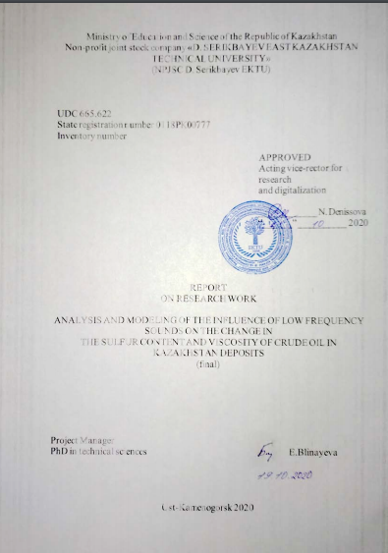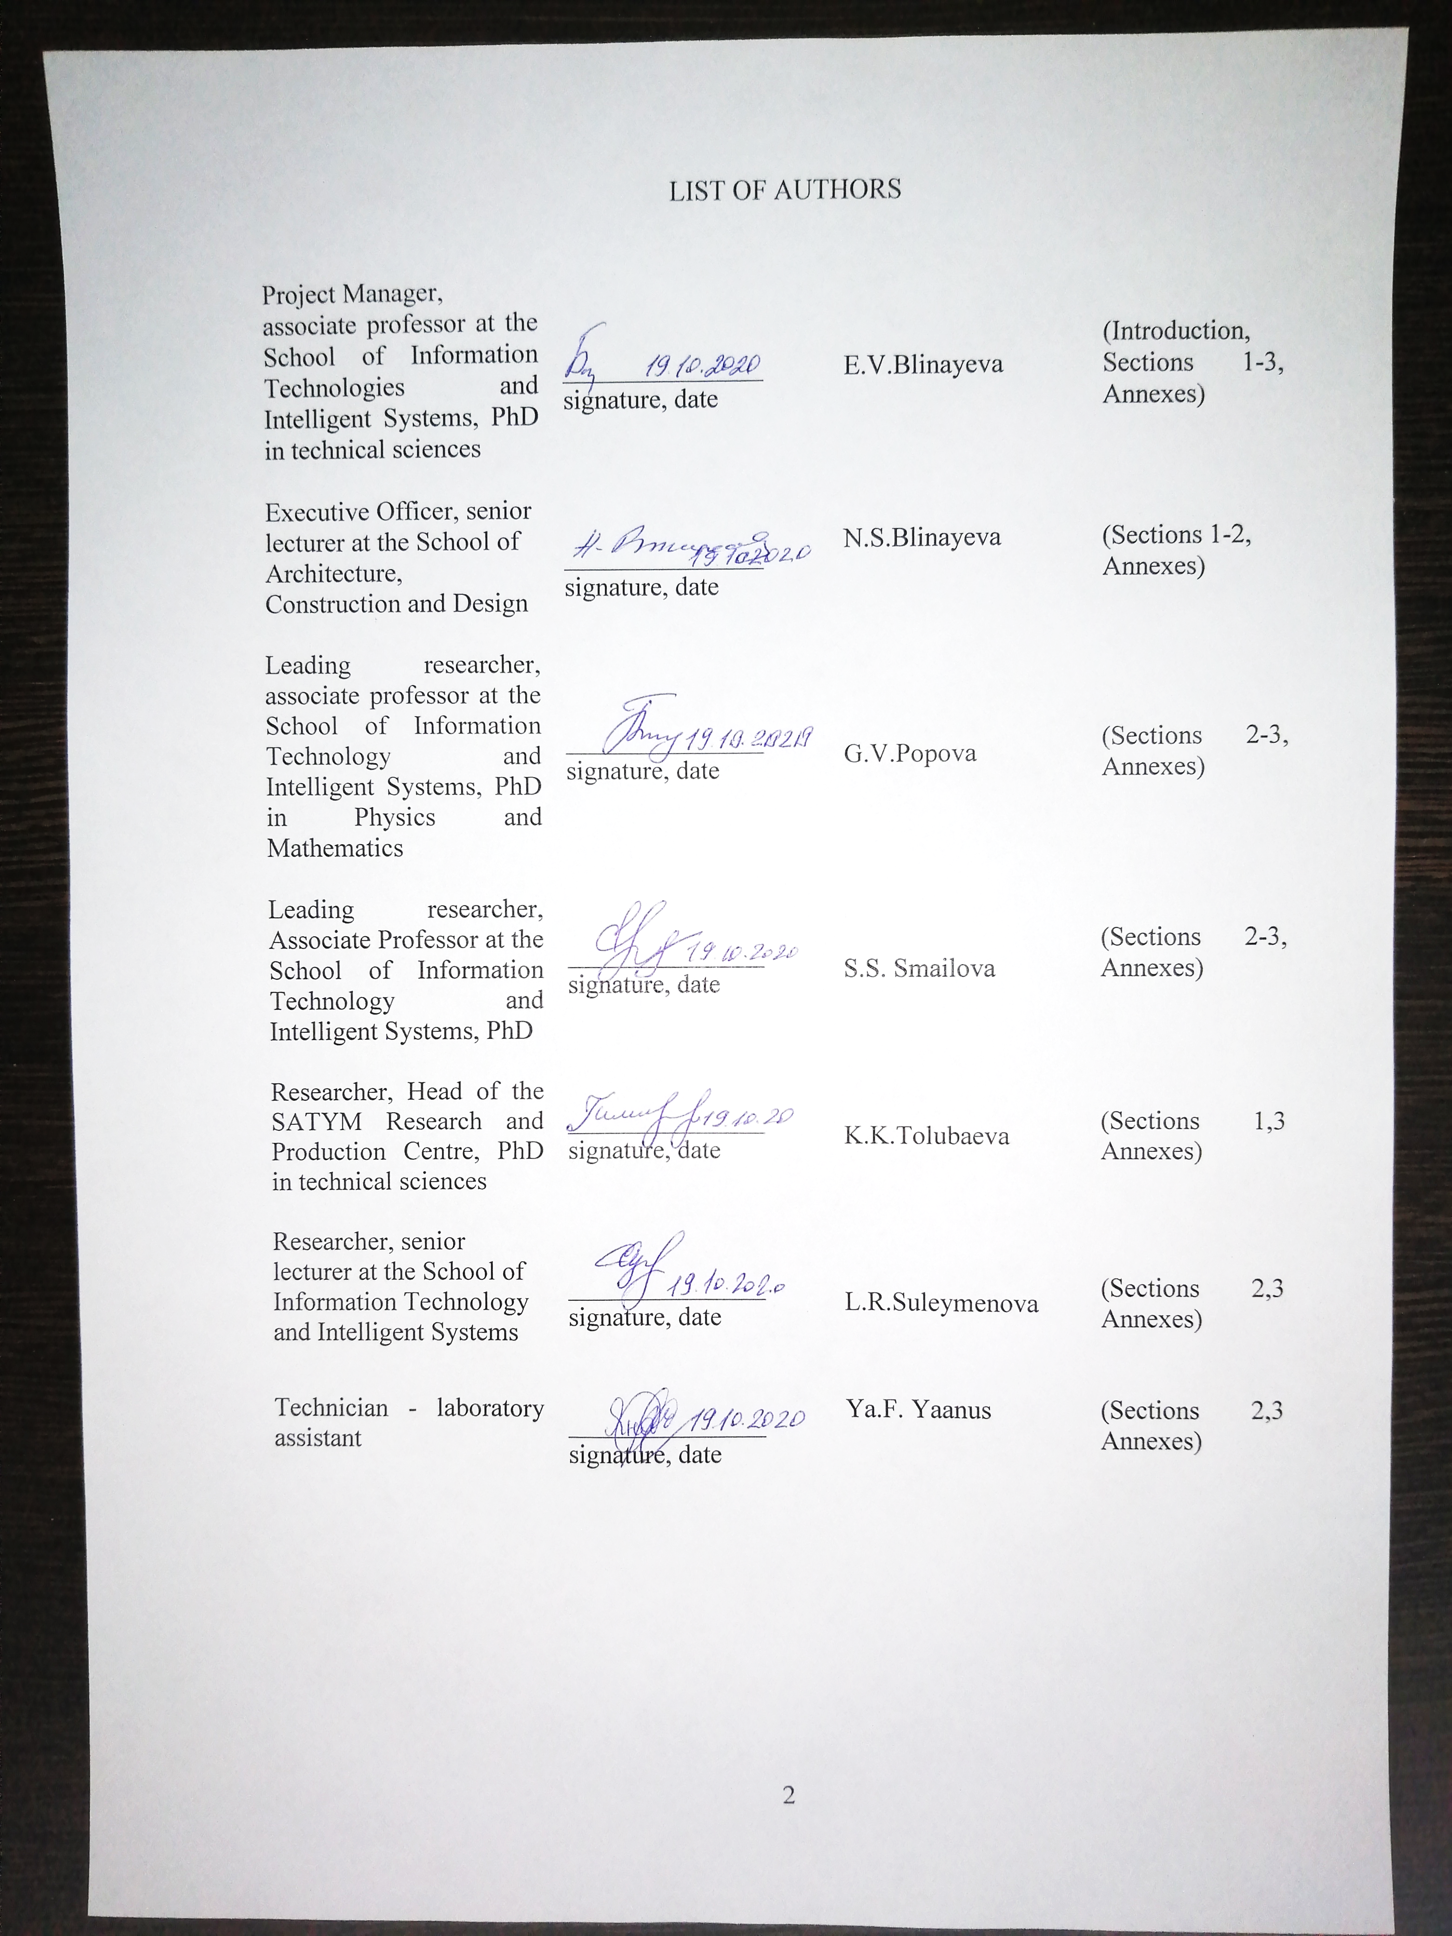
ABSTRACT

Report 25 p., 6 fig., 23 sources, 6 apps.
DEWAXING OF OIL, DESULFURIZATION OF OIL, TREATMENT OF CRUDE OIL BY LOW FREQUENCY SOUNDS.
The object of the study is oil treated with low frequency sounds.
The subject matter of the study is mathematical models describing the processes occurring in oil processed by low frequency sounds.
The aim of the study is to investigate the physical aspects of the processes occurring in low-frequency oil treated with sounds. On the basis of identified regularities, develop a methodology to influence crude oil for desulphurization and dewaxing purposes.
The scientific novelty of the study is the development of a methodology for the exposure of Kazakhstan's crude oil to low frequency sounds in order to extract sulphur and paraffin from processed oil sample volumes.
Based on the results of these studies, technology can be developed for desulphurization and dewaxing of oil produced at Kazakhstan fields.
The research methodology is based on the basic principles and methods of mathematical modelling, applied ecology and experimental theory.
- During the reporting period, work was carried out:
- Pre-project study of existing desulphurisation and dewaxing technologies applied in Kazakhstan.
- Organization of experimental research with samples of crude oil.
- Conducting experimental research with samples of crude oil.
- Analysis of mathematical methods and models describing processes in crude oil under the influence of sound waves.
- Selection of a mathematical model.
- Computer modelling of the process based on experimental data.
- Adapting the selected mathematical model to the conditions resulting from the experiments.
- Development of a system for processing these processes of sulphur and paraffin separation from crude oil samples.
- Development of a methodology for the influence of low frequency sounds on crude oil to reduce the viscosity and sulphur in its composition.
The results of the work in 2020 were as follows: a study of harmonic acoustic waves described by the boundary targets for the Helmholtz equation with a complex non-self-conjugated operator was conducted. Mathematical models in the form of boundary (chief and edge) problems for the elliptical (Schrodinger parabolic type) wave equations were investigated. A comparative analysis was made of software solutions that allow for computer modelling of acoustic processes and the need to develop an in-house software product that allows for the implementation of acoustic modelling tasks in complex environments was justified. Recommendations were made on the methodology of low-frequency exposure to oil samples to change the sulphur and paraffin content of the oil samples under study.
CONTENT

INTRODUCTION…………………………………………………….…….5
MAIN POINT OF THE REPORT ON RESEARCH WORK…………..…..7
1 Adaptation of the mathematical model to experimental conditions….…...7
2 Development of a system for processing these processes of sulphur and paraffin separation from crude oil samples………………………………………..12
2.1 Comparative analysis of specialised acoustic modelling applications…..12
2.2 Description of the concept of a software package for modelling low-frequency acoustic processes in non-Newtonian, viscous fluids………………….17
3 Development of a methodology for the impact of low frequency sounds on crude oil to reduce the viscosity and sulphur in its composition………………….19
CONCLUSION…………………………………………………………….22
LIST OF SOURCES USED………………………………………………..24
ANNEX А Publications based on the results of research work……………30
ANNEX B Extract from the minutes of the Scientific and Technical Council meeting……………………………………………………………………………36
ANNEX C Calendar work plan…………………………………….………37
ANNEX D Print of training manual……………………………….……….47
ANNEX E Accompanying publication documents……………….………..48
ANNEX F Monograph print………………………………………...…….107
INTRODUCTION

A prerequisite for research in this area is the relevance of these studies.
The most important element that determines the quality and cost of oil is the mass fraction of sulphur in the hydrocarbon base. Large amounts of sulphur in crude oil increase transportation costs, complicate processing and degrade the quality of petroleum products, and actively affect metals. The widespread use of various petroleum-based fuels (gasoline, paraffin, fuel oil, etc.) in road, ship and air transport and for electricity generation leads to air pollution with combustion products, primarily sulphur dioxide, which directly threatens human health and causes acid rain, reducing soil fertility.
The cost of oil depends on the degree of its technological preparation. Crude oil produced from different fields has different chemical compositions and varies considerably in quality. Crude oil has the highest cost, which requires minimal processing costs, and from this point of view, reference grades are selected as better quality and therefore more expensive.
Viscosity is another of the most important technical characteristics of crude oil, its refined products, gas condensates and fractions; it determines the nature of the processes of oil production, its lifting to the bottom surface, industrial gathering and preparation, conditions of transportation and pumping of products, hydrodynamic resistance during transportation by pipelines, etc.
With the development of new innovative technologies, it has become possible to study the group composition of crude oil and oil fractions in greater detail and depth, which is of great importance for the petrochemical industry and the development of new oil refining processes.
The use of acoustics in various fields of activity is deeply specific, although in recent years the developments of scientists have become increasingly accessible, allowing the use of sound waves in various areas of human life and practice.
Investigating the impact of different acoustic waves on different environments is a complex process based on the use of specialised software tools. One of the common features of the existing IT solutions on the market is that all of the above programmes are proprietary software products. This means that all the rights to use them, as well as the basic principles for implementing the calculations, can only be obtained after purchasing a licence to use them, or after acquiring absolute ownership rights.
The aim of the work over the entire period of the study was to investigate the physical aspects of the processes occurring in low frequency oil treated with sounds. Based on the results of the experimental experiments, the dependencies between factor parameters (frequency of infrasound, time of exposure to infrasound) and performance parameters (concentrations of sulphur and paraffin) were determined. Computer modelling was carried out on the basis of the dependencies identified to investigate the physical and chemical processes occurring in oil treated with low frequency sounds. A software solution concept has been developed to simulate low-frequency acoustic processes in non-Newtonian, viscous fluids.
A novelty of the study was the development of a methodology for the impact of low frequency sounds on crude oil from Kazakhstan's fields in order to extract sulphur and paraffin from processed oil samples.
Based on the results of this study, a concept was developed to simulate low frequency acoustic processes in non-Newtonian, viscous fluids. The results of the modelling can serve as a basis for developing recommendations on the creation of oil treatment methods to change the sulphur and paraffin content of oil.
The research methods are based on the basic principles and methods of mathematical modelling, applied ecology and experimental theory.
Practical significance. The application of the developed methodology at oil production and refining enterprises of Kazakhstan, taking into account the characteristics of crude oils from different fields, will reduce the cost of processing high wax and high sulphur oils, reduce the environmental "burden" on the environment.
The expected social effect of the project is to improve the quality of life of Kazakh citizens.
During 2018, oil samples from 2 fields were brought to the project: near Zaisan and in Tarbagatai. These samples were exposed to low frequency sounds and tested in the SATYM laboratory of the Serikbayev State Technical University to record changes in wax and sulphur content in the samples after exposure to infrasound (IRN AP05131403-OT-18, inventory number 0218РК01279).
Results for 2019. The second stage of the project included mathematical processing of experimental results and analysis of mathematical methods and models describing chemical processes in crude oil. A suitable mathematical model was selected and computer modelling of the process based on experimental data was carried out (IRN AP05131403-OT-19, inventory number 0219РК01067).
Results of work in 2020. In the third phase of the project, research was carried out on harmonic acoustic waves described as boundary problems for the Helmholtz equation with a complex non-self-conjugated operator and mathematical models in the form of boundary (chief and edge) problems for elliptical (Schrodinger parabolic type) wave equations. A comparative analysis of software solutions allowing for computer modelling of acoustic processes was carried out and the need to develop our own software product allowing for the implementation of acoustic modelling tasks in complex environments was justified. Recommendations were made on the methodology of low-frequency exposure to oil samples to change the sulphur and paraffin content of the oil samples under study.
MAIN POINT OF THE REPORT ON RESEARCH WORK

1 Adaptation of the mathematical model to experimental conditions

Acoustic waves propagating in different environments are subject to the same wave laws. These are the phenomena of wave excitation by specific sources, reflection and refraction of waves at the interface of media, scattering on inhomogeneities, refraction (curvature of the wave propagation path), energy absorption, interference.
The propagation of waves of any nature is easy to understand and explain if we turn to the Huygens principle: every point in the medium involved in a wave motion becomes the source of a new wave, called an elementary wave. The observed wave front is the result of the addition of many elementary waves (Figure 1). The Huygens principle is valid for all wave types, including acoustic and electromagnetic waves.
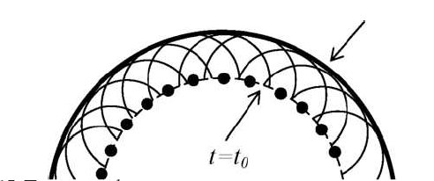
Figure 1 - Wavefront position at different points in time, determined on the basis of the Huygens principle

If there is a boundary with a medium whose properties are different from those of the propagating medium, there is an effect of partial or total reflection as well as partial (and in some cases total) passage into the second medium. However, unlike electromagnetic waves for acoustic waves, in some cases there may be an effect of wave splitting and the appearance of a wave beam reflected at a different angle.
In the paper "Elastic, solid and liquid particle dynamics in a compressible viscous liquid" [1], the authors give an overview of the results obtained as part of a three-dimensional linearized theory in the study of motion and interaction in a liquid of solids and in the study of the propagation of small amplitude waves in elastic bodies interacting with a viscous compressible liquid.
In viscous fluid mechanics, based on the statistical mechanics of irreversible processes, it is believed that the stress tensor can be broken down into two summands: the conservative stress tensor and the viscous (dissipative) stress tensor. Usually this is the sum of the pressure and the viscous stress tensor. When determining the determining ratio for liquids, it is assumed that the viscous stress tensor is a function of the strain rate tensor. In the future, we will assume that viscous stresses and strain rates are related to each other by linear relations (Navier-Stokes law is fair). The constitutive equation for such fluids is as follows [2, 3]:
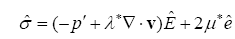 | (1)
where
p’ – fluid pressure; v – liquid particle velocity; Ê – single tensor; and ê – stress and strain rate tensors; λ* and μ* – kinematic and dynamic viscosity coefficients.
In the studies under consideration, the fluid is taken as non-heat-conductive and the processes taking place in the fluid are slow developing, resulting in a volume viscosity factor of zero [2]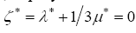. This is equivalent to the fact that pressure p' is defined as the average normal stress in a resting viscous compressible liquid. In solving adiabatic movement problems in a viscous compressible fluid, the equations of motion are used, which, taking into account (1) take the form of [2, 4]:
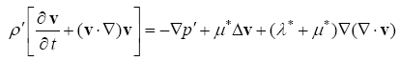 | (2)
continuity equation
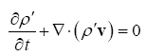 | (3)
and the equation of state for the case of a nonheat-conductive liquid
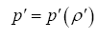 | (4)
where
ρ’ – liquid density. The above equations of hydromechanics are nonlinear.
For the tasks discussed below, it is assumed that the movements and processes under investigation are of a small perturbation nature in certain states of equilibrium or basic movements considered to be known. Accepting the functions sought then as first order values and discarding the second order values and above, relations (2) - (4) can be written down as linear equations [5]:
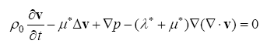 | (5)
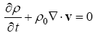 | (6)
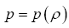 | (7)
Definitive equation (1) after simplifications is as follows:
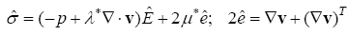 | (8)
In the study of small fluid vibrations near the equilibrium position, the equation can be accepted as a closing equation
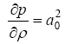 | (9)
Formulas (5) - (9) represent a linearised theory of a viscous compressible non-thermal-conducting fluid. They contain ρ₀ and a₀ – sound density and speed for the liquid in equilibrium; p and ρ – pressure and density disturbances in liquids; 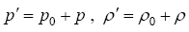.
Presentation of general solutions to the hydrodynamics equations of viscous compressible liquids, first received in [5], is as follows:
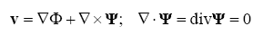 | (10)
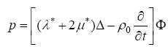 | (11)
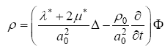 | (12)
where
scalar Ф and vector Ψ potentials satisfy equations:
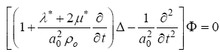 | (13)
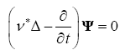 | (14)
In the above percentages 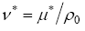 – kinematic viscosity index.
In addition to the linearisation of basic ratios, hydromechanics also carry out linearisation and boundary conditions. In the case of movement of a solid body in fluid, linearisation of boundary conditions is possible with small movements of the body relative to a certain position. In this case, the boundary conditions on the surface of the moving body are drifted normally to the body surface in the specified resting state. For viscous compressible fluid, adhesive conditions must be met on the S surface of the body.
This means that in the case of a fixed body, the speed vector (10) is zero. The free body under the action of hydrodynamic forces will be in a state of motion [6, 7]. For it, the adhesive conditions are as follows:
(15)
where
u and v_{S} – velocity vectors corresponding to the centre of inertia and the arbitrary point of the body surface S; ω – vector of instantaneous angular velocity of body rotation; r – radius-vector of an arbitrary point of body surface S relative to the centre of inertia. Values u and ω are determined from the equations of motion of a solid body under the action of hydrodynamic forces and moments.
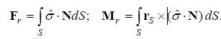 | (16)
A centre of mass movement theorem and a moment theorem are used to equate the movement of a solid body in a liquid:
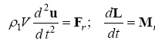 | (17)
where
V and ρ₁ – body volume and density; 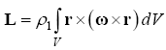– the kinematic moment of a solid body when the body moves relative to a moving coordinate system.
There is a large number of numerical-analytical methods and computational algorithms for solving wave problems [8-16]. The problem of creating computer models aimed at solving certain classes of problems, as well as multifunctional software packages, are described in articles by domestic and foreign researchers [17–19].
From a mathematical point of view, the propagation of harmonic acoustic waves is described as an edge problem for the Helmholtz equation with a complex non-self-conjugated operator. The classes of mathematical models in the form of boundary (chief and edge) problems for the elliptical (parabolic Schrödinger type) wave equations are described in detail in the article by A.V. Gladky and E.S. Podlasov "On Automation of Acoustic Fields Calculations in Homogeneous Wave-Water" [20].
Three classes of mathematical models in the form of edge (chief and edge) problems for elliptical (Schrodinger parabolic type) wave equations are currently used for computer modelling of acoustic fields:
– boundary quests for the Helmholtz elliptical wave equation with a complex non-self-conjugated operator;
– the Cauchy task for the Helmholtz elliptical transformed wave equation;
– chief and edge tasks for Schrodinger-type parabolic wave equations with complex non-self-conjugated operator.
For heterogeneous environments acoustic field of point harmonic source (dependence on time is accepted as e^{-iωt}) in the Cartesian coordinate system (x, y, z) is described by the Helmholtz equation:
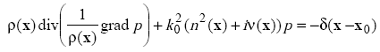 | (18)
where
p(x), x=(x, y, z) – acoustic pressure; k₀= - wave number; n(x)= , x=(x, y, z) – refractive index; с(х) – sound velocity (с₀ – sound velocity at some point); r(x) – medium density; ν(x)≥0 – attenuation coefficient; x₀=(x₀, y₀, z₀) – source coordinates; δ(х-х₀) - Dirac delta - function; i= - imaginary unit.
In a cylindrical coordinate system (r, ϕ, z) equation (1) takes the form:
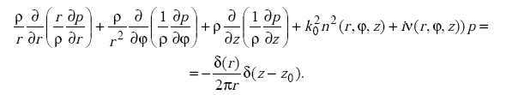 | (19)
When modeling wave problems, mathematical models of soft, rigid and impedance waveguide boundaries are widely used. Impedance conditions contain complex coefficients and describe the acoustic energy loss. In a medium inhomogeneous in density, the conditions of continuity of acoustic pressure and flow are satisfied at the interface.
In addition, for the correct statement of boundary value problems in unbounded domains at infinity, it is necessary to set the appropriate radiation conditions that ensure the uniqueness of the solution.
To simulate acoustic fields in an azimuthally symmetric layered inhomogeneous waveguide with a finite (infinite) depth and acoustic parameters that depend on the vertical coordinate, the method of normal modes is effectively used. In this case, the acoustic pressure satisfies the Helmholtz wave equation:
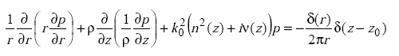 | (20)
Another class of mathematical models is used to calculate the far low-frequency acoustic field in an azimuthally symmetrical environment (at k_{0r} >>1) taking into account forward and backward waves.
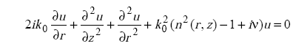 | (21)
One of the most promising methods for mathematical modelling of acoustic fields is the parabolic equation method [2, 3, 7-10], which is based on the solution of chief edge problems for the Schrodinger-type parabolic wave equations that approximate the Helmholtz equation. This approach is used to model mainly unidirectional wave processes.
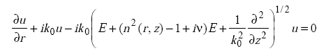 | (22)
Mathematical models in the form of differential equations (1) - (5) allow us to solve the following classes of acoustic wave problems:
- calculation of the acoustic field of point, local, distributed, volume and surface emitters in regular two-dimensional (three-dimensional) layered waveguides,
- cylindrical three-dimensional waveguides with complex normal cross-sections, filled with heterogeneous media;
- reverse wave tasks in regular and irregular waveguides, consisting of determining the properties of the environment, the boundaries and location of different sound sources.
2 Development of a system for processing these processes of sulphur and paraffin separation from crude oil samples

2.1 Comparative analysis of specialised acoustic modelling applications

Various software packages have been developed to perform scientific and technical calculations related to the calculation of the acoustic field in the environment in question, which differ in their characteristics.
Computer-based acoustic modelling, like conventional classical modelling, is based on similar calculation principles. However, its distinguishing feature is the ability to account for real, often changing, acoustic conditions. Thus, a classical calculation based on a physical model with evenly distributed reflecting and absorbing surfaces in the diffusion field is not always correct. This is due to the fact that the real acoustic objects being studied can have different physical and chemical properties. All of this leads to the fact that, using the classical method of acoustic design, the results of calculations may differ significantly from the real state of the object [21].
At present, the most popular of such solutions for acoustic modelling are the following software products:
- COMSOL Multiphysics;
- k-Wave;
- EASE;
- CATT-Acoustic;
- ODEON;
- AIST-3D;
- Actran.
One of the common features of this sector of IT solutions is the fact that all the listed programmes, according to the source code availability classification of the software, are proprietary software products. This means that all the rights to use them, as well as the basic principles for implementing the basic calculations, can only be obtained after the acquisition of a licence to use them or after the acquisition of an absolute ownership right.
However, both basic information and access to the demonstration version can be found on the official websites of developers and dealers.
The Acoustics module extends the capabilities of the COMSOL Multiphysics® package and provides a set of tools for simulating acoustic waves and vibrations in loudspeakers, mobile devices, microphones, sound absorbers, sensors, sonars and flow meters. You can use specialised functions to visualise acoustic fields and build virtual prototypes of devices and components.
For more detailed research, acoustics can be considered together with other physical effects, including structural mechanics, piezoelectric phenomena and hydrodynamics. The COMSOL® software package contains multiphysical links that enable the performance of devices and structures to be calculated as closely as possible to actual conditions.
The Acoustics module also includes many specialized formulations and material models that can be used for highly specialized applications, such as the calculation of thermal and viscous losses (so-called thermal-viscous acoustics) in miniature converters and mobile devices, or the calculation of threshold waves and vibrations based on Bio equations. Multiphysical functionality is further enhanced by the use of several specialized numerical methods, including the Finite Element Method (FEM), Boundary Element Method (BEM), Ray Tracing and Galerkin's Finite Element Breakup Method (dG-FEM).
The main "deterrent" factor in using this software product is the high cost of the license.
k-Wave is a set of MATLAB tools for modelling the time domain of acoustic wave fields.
k-Wave is an open source MATLAB toolkit designed to simulate the time domain of spreading acoustic waves in 1D, 2D or 3D [22]. The toolkit has a wide range of functionality but is based on an advanced numerical model that can take into account both linear and non-linear wave propagation, arbitrary distribution of heterogeneous material parameters and acoustic absorption in the degree law.
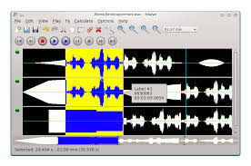
Figure 2 - Interface of the k-Wave programme

The numerical model is based on the solution of three related differential equations in first-order private derivatives, which are equivalent to the generalised form of the Westerwelt equation [23]. The equations are solved using a pseudo-spectral method in k-space, where spatial gradients are calculated using a Fourier coloration scheme and temporal gradients are calculated using a finite difference scheme with correction in k-space. The time scheme is accurate at the limit of linear wave propagation in a homogeneous and lossless environment and significantly reduces numerical dispersion in a more general case.
The degree law of acoustic absorption is taken into account using a linear integra-differential operator based on fractional lamplasian [16]. A fully matched layer with a split field (PML) is used to absorb waves at the edges of the computational domain. The main advantage of the numerical model used in k-Wave over finite difference time domain (FDTD) models is that accurate modelling requires fewer spatial and temporal grid points. This means that models work faster and use less memory.
The k-Wave toolkit is distributed by copyright holders under the GNU Small Public License (LGPL), which is a set of additional permissions added to the GNU General Public License (GPL).
An additional difficulty in using this package is the need to install the MATLAB system on your computer and the client's professional programming skills.
The EASE, CATT-Acoustic, ODEON and AIST-3D software products are based on ray tracing techniques and are oriented towards 3D graphics. However, only CATT-Acoustic and AIST-3D are able to take into account not only the trajectory of sound distribution but also its amplitude. This makes it possible to create a more complete acoustic picture using all re-reflections.
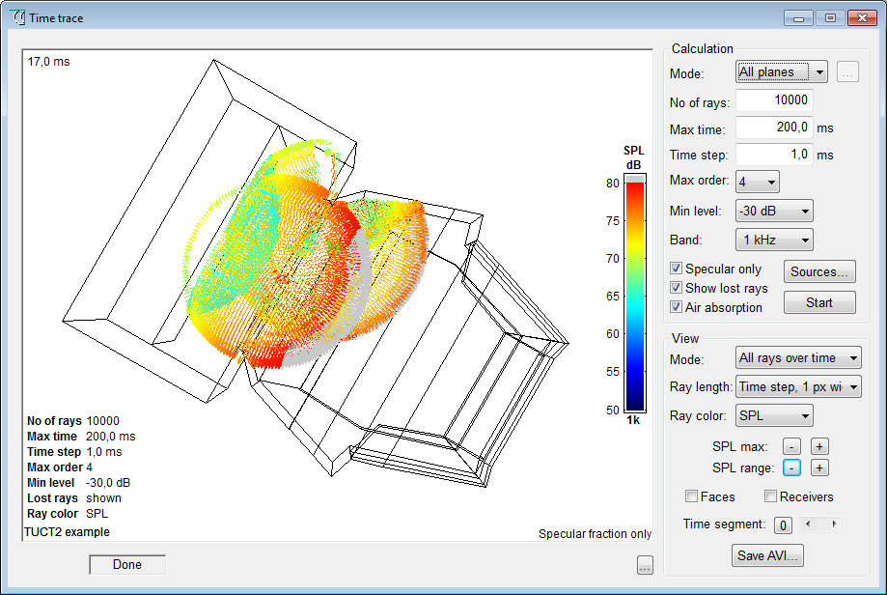
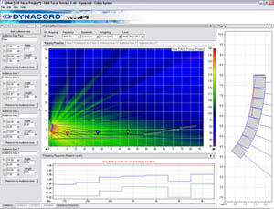

Figure 3 - EASE and CATT-Acoustic programme interfaces
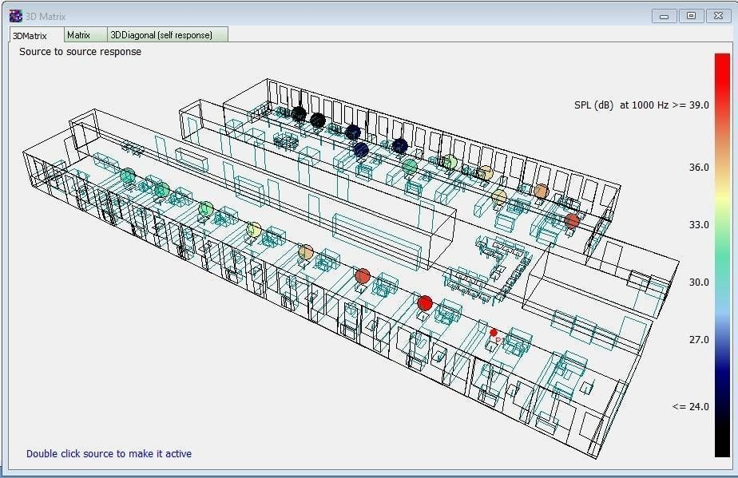
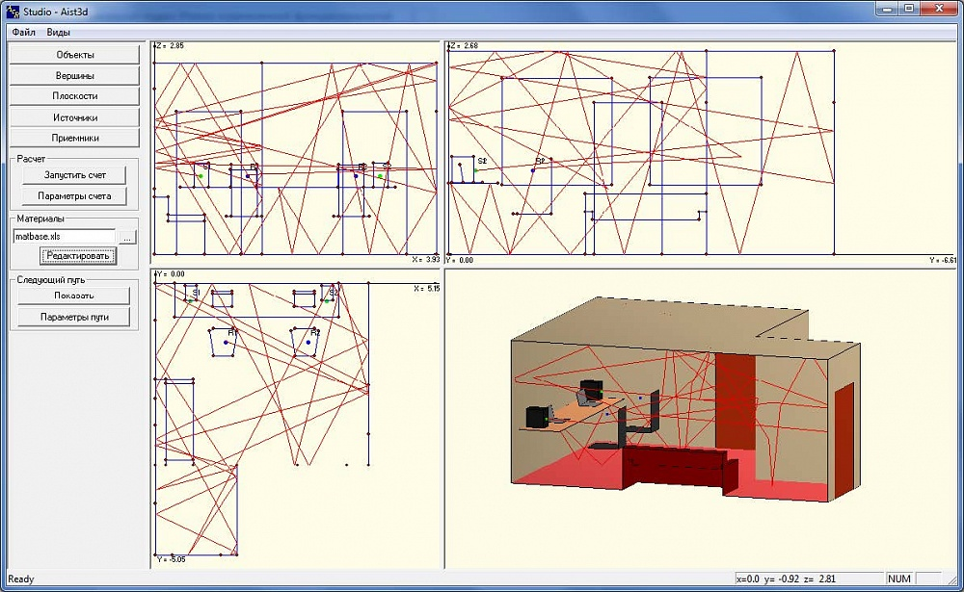

Figure 4 - ODEON and AIST-3D programme interfaces

Of all the above, the EASE programme is considered to be the most thoughtful and user-friendly in terms of data presentation. However, beautiful visualisation is not supported by acoustic calculations, which are simplified, without taking diffusion into account.
The ODEON product provides several ways to work with the 3D model simultaneously. For example, the programme uses a hybrid or combined reflection method, which is a combination of three main acoustic methods: ray tracing, imaginary sources and diffuse reflections. Each of these algorithms is applied consistently to identify both early and subsequent reflections.
Thus, this combination makes it possible to predict which part of the rays will diffuse when tracing and which part will be reflected in a mirror.
Compared to programmes such as EASE and ODEON, the CATT-Acoustic acoustic simulator has a parametric data processing model in which the main geometrical parameters of a room must be manually typed into a geo-file using a special language. This makes it possible, on the one hand, to simplify the process of possible adjustment of parameters in the future but, on the other hand, leads to additional time expenditure at the stage of creating the 3D model.
Actran is a software package for modelling the generation, distribution and absorption of sound in acoustic environments (air, water, etc.). The fully linked vibroacoustic setting allows for the mutual influence of the acoustic environment and structure to be taken into account. In cases where the influence of the environment on the structure can be neglected, one-way coupling can be taken into account; this simplifies modelling and increases the calculation speed.
Actran is based on finite and infinite element methods that allow acoustic effects to be simulated both in enclosed spaces (cavities) and in open space, taking into account the conditions of non-reflection of sound at the boundaries of the calculation area. A rich library of elements and materials provides ample opportunity for modelling. The basis of the element library is formed by one-dimensional, two-dimensional and three-dimensional elements for solving three-dimensional, two-dimensional and axisymmetric problems, multipoint links, infinite elements, etc. The materials presented in Actran allow to simulate acoustic media (gases, liquids), taking into account attenuation and viscosity-thermal losses in thin layers; elastic structural materials taking into account damping; hyperelastic materials in linearized staging; layered composite materials; sound-absorbing materials in staging with absolutely rigid "skeleton", with absolutely supple "skeleton" and in general staging according to Biotech theory.
External load and boundary conditions may include noise sources of various types, modes of oscillation of the acoustic medium in constant cross-section channels, boundary conditions on pressure, speed, acceleration, impedance boundary conditions, force and kinematical effects on the structure of the calculation model, structural boundary conditions, random fluctuations of the acoustic medium pressure, volume and surface sources based on acoustic analogies of Lightheill and Moehring, etc.
Acoustic analysis is performed primarily in the frequency domain by direct integration. At the same time, random impact calculations, calculation of natural frequencies and shapes, calculation of frequency response by modal method or a combination of modal and direct methods for acoustic environment and design are supported. The calculation of transient acoustic processes in the time domain is also supported.
Typical Actran applications include simulating the internal and external acoustic fields of various transport systems, for example, simulating the sound fields in the under-hood of a vehicle and the penetration of noise into the passenger compartment, simulating noise propagation through the exhaust system of an internal combustion engine and further into the surrounding space, analyzing noise in the passenger compartment, researching and selecting the characteristics and design of sound absorbing devices and coatings in the passenger compartments of vehicles, etc. It is also possible to carry out acoustic analysis of the characteristics of consumer goods such as mobile phone speakers, free-standing acoustic systems, musical instruments, other types of sound-producing devices, etc.
In many cases, noise is caused by turbulence in the flow of the medium (air, water, etc.). Well-known examples are the noise of gas turbine and rocket engines, noise from vehicle traffic, noise in ventilation and air conditioning systems, noise from ship propellers, etc.
The analysis of such phenomena implies the availability of information on the speed, density (where applicable), temperature and pressure of the non-stationary flow of the medium. As a rule, this information is obtained by performing hydrogas dynamics calculations in third-party programmes. Based on this information, Actran allows the calculation of noise sources in the flow to be transferred to an acoustic calculation model and the calculation of noise propagation, including, if necessary, taking into account the heterogeneous field of the average speed of the acoustic medium (Actran Aeroacoustics module). The Actran calculation of noise sources in the flow of the medium is based on so-called acoustic similarities. The Lightheill analogy involves noise calculations at Mach speeds of up to approximately 0.2; the Moehring analogy involves noise calculations at Mach speeds of up to approximately 0.8.
The use of a hybrid method (hydrogasdynamics calculation followed by acoustics calculation) makes it possible to eliminate the problems of dissipation of the numerical schemes of hydrogasdynamics calculation, ensure correct acoustic boundary conditions (non-reflection from near-field boundaries, etc.), reduce the need for computing resources in the analysis of hydrogasdynamics and ensure relatively low levels of computing costs for the acoustics analysis itself.
Actran makes it possible to use the results of hydrodynamic calculations obtained in a rotating coordinate system (e.g. connected to a fan or propeller) as well as for the space sector. In this case, Actran automatically interpolates the results to a fixed acoustic grid, copies the sectors and obtains the results in all the required volumes of the medium. The next step is to transfer the results to the frequency domain and then calculate the frequency response.
The high computational efficiency of the Actran calculation is due to the use of modern matrix solvers - MUMPS and PARDISO - as well as a high degree of optimization of the mathematical apparatus, algorithms and program code.
An important feature of Actran is its close integration with MSC Nastran, which allows the "strength" of each product to be leveraged effectively: structural vibration analysis is performed using MSC Nastran (accuracy and speed of this calculation is generally accepted), and simulation of sound distribution in the environment is performed using Actran. Actran also integrates with other common structural and hydrogas dynamics analysis systems. Actran has also been integrated with the Adams system using additional modules.
As a result of the comparative analysis, it becomes clear that it is necessary to develop our own software product capable of computer modelling acoustic processes in environments with various physical and chemical properties. Our own software product will enable us to solve specific tasks and save money required to pay for licenses of software solutions present in the market.

2.2 Description of the concept of a software package for modelling low-frequency acoustic processes in non-Newtonian, viscous fluids

The described concept will make it possible to create a software product for computer simulation of infrasound processes in various environments. C# and the MATLAB R2020a mathematical calculation automation system can be used for development. Principles underlying software development:
- the possibility of automatically selecting the best model based on the available information about the task;
- a modular structure that provides flexibility and the ability to extend and modify the tasks and algorithms implemented;
- support for the possibility of visualisation and interactive dialogue with the user;
- support for automatic generation of reports.
The functional structure of the proposed software solution is shown in Figure 5.
he database stores reference data on the characteristics of the simulated fluid (viscosity, temperature, density, etc.) exposed to low frequency sounds. The input module involves the input of variable input data (manual or selectable from the repository).
Information can be entered either manually or from a file or database.
The processing module allows the rules database to automatically select the most appropriate mathematical model based on the information entered.
Background information on environmental characteristics среды
Input moduleИсходных данных

Data processing module
Mathematical model module
Visualization module
Log of reports
Figure 5 - Functional structure of the programme complex

A mathematical model is selected depending on the type of task to be solved.
For heterogeneous environments, the acoustic field of a point harmonic source in the Cartesian coordinate system (x, y, z) is described by the Helmholtz equation. The method of normal modes is effectively used to simulate acoustic fields in an azimuthally symmetrical layered - heterogeneous waveguide with finite (infinite) depth and acoustic parameters dependent on the vertical co-ordinate. Parabolic Schroedinger-type wave equations, the Helmholtz approximating equation, are used to simulate unidirectional wave processes.
The visualisation module is designed for text and graphical display of calculation results in the form of a table and a colour picture with an adjustable palette and linear (logarithmic) scale. A report can be generated from the results of a computational experiment.
The computing experiment consists of the following stages: input of data on infrasound parameters, selection of characteristics of the fluid under test, selection of a mathematical model, problem definition, solution, visualisation and post-processing. At the data entry stage, the user determines the frequency of infrasound, the time of exposure to infrasound and the volume of the fluid sample. The parameters of the fluid under study, viscosity, density, sulphur content, temperature, etc. are then set.
Depending on the type of calculation to be performed, a mathematical model and calculation parameters are then selected.
The results of the calculation can be displayed in both text and graphical form. The report generation module makes it possible to record the results of a calculation experiment in an RTF or HTML file or print out.

3 Development of a methodology for the impact of low frequency sounds on crude oil to reduce the viscosity and sulphur in its composition

Industrial refining processes can be roughly divided into three main stages:
- crude oil treatment - desalting, degassing and dehydrating;
- primary refining - direct (atmospheric) distillation;
- refining - thermal processes (thermal cracking, coking, pyrolysis) and catalytic processes (catalytic cracking, reforming, including platforming, hydrocracking).
The treatment processes ensure that the crude oil supplied to refineries has the parameters required to obtain better end products, namely low humidity and salt concentrations, and no dissolved gases (methane, hydrogen sulphide, etc.).
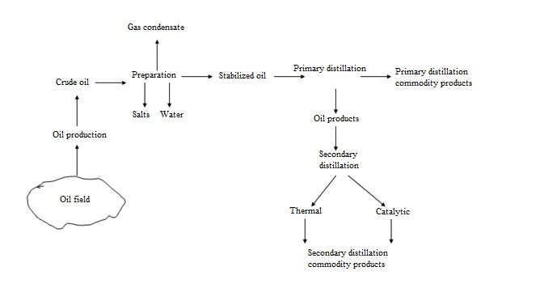
Figure 6 - Comprehensive oil refining scheme

Oil is distilled in rectifying columns, preheating it to 350-400°C.
Since oil contains hundreds of different substances, many of which have similar boiling temperatures, it is virtually impossible to extract individual hydrocarbons. Distillation therefore divides oil into four main fractions that boil over a fairly wide temperature range: gasoline, paraffin, diesel and fuel oil (residual after distillation).
With more thorough distillation, each of these fractions can be divided into even narrower fractions. For example, the petrol fraction (a mixture of hydrocarbons C5 to C12) can be separated into petroleic ether, petrol itself and naphtha.
Thermal and catalytic methods are used at the recycling stage.
Thermal cracking - high-temperature refining of oil and its heavy fractions to produce products with a shorter hydrocarbon chain and lower molecular weight. Coking - a type of deep thermal cracking that involves decomposition at high temperature without the access of air of solid and liquid fossil fuels, with the formation of volatile substances and solid residue - coke. Catalytic cracking - thermochemical processing of oil fractions in the presence of a catalyst to produce a component of high-octane gasoline, light gas oil and unsaturated gases.
Each of the methods mentioned above allows to produce oil products with different characteristics and for different purposes, but all of them have both positive and negative aspects.
It seems to us that it is possible to recommend an infrasound impact on oil at the secondary distillation stage. The organisation of the subsonic impact process has a number of objective limitations.
- The exposure time of a standard device is limited by the requirements of its technical specification. The appliance can operate in a cyclic mode for 45 minutes / 15 minutes to be switched off.
- The interval of the infrasonic waves has minimum and maximum limit values from 1 Hz to 26 Hz.
- The study focused on controlling the sulphur and paraffin content of oil samples. The dynamics of other components present in crude oil were not investigated as part of this work.
The results of these studies lead to the conclusion that sulphur and paraffins present in the oil in a bound state are released under the influence of cavitation processes, which is recorded by laboratory measurements. The sulphur and paraffin released can then be removed from refinery products using existing refinery technologies.
Results have been recorded showing a reduction in the viscosity of crude oil after processing with low frequency sounds. The dynamics of sulphur content was not evident as increases in the percentage of free sulphur in the treated samples were recorded. However, there is an explanation for these results.
During cavitation, there is a periodic local concentration of high density energy, which is associated with cavitation bubble pulsations. Due to the local pressure reduction in the rarefaction phase, cavity bubbles (cavitation bubbles) are formed in the liquid and filled with the saturated steam of the same liquid. Under the influence of the higher pressure in the compression phase as well as the forces of surface tension, the cavity is closed and the steam condenses at the interface between the two phases - liquid and gaseous. The gas dissolved in the liquid diffuses inside the cavern, which is then subjected to strong adiabatic compression. When the cavitation cavity collapses, pressure can reach 100 MPa and temperature can reach 10,000 K, at which point a spherical shock wave begins to spread into the liquid. If pulsed tensile stresses are periodically generated in the liquid, the cavitation «centres» present in the liquid, which are stable small steam and steam-gas bubbles, begin to grow and form what is known as the «cavitation cluster».
The energy released from the cavity collapse is sufficient to excite, ionise and dissociate water molecules, gases and substances with high steam elasticity inside it. In doing so, long molecular chains can be converted into light hydrocarbon radicals of gas and distillate fuel fractions. The binding energy in hydrocarbons varies between 40...400 kJ/mol, with the bond strength in the middle of a normal paraffin molecule being smaller than at the end. In addition, cavitation of high intensity and over a long period of time breaks the carbon bonds in wax molecules. In this case, when the C-H bond is broken, hydrogen is torn from the hydrocarbon molecule, and when the C-C bond is broken, the hydrocarbon molecule is torn into two unequal parts. The result is changes in the physical and chemical composition of the hydrocarbons - a decrease in the molecular weight, crystallisation temperature, etc., which causes changes in the viscosity, density and flash point of an oil product. As a result of microcracking at the molecular level, «activated» particles accumulate in the processed oil products: radicals, ions and ion-radical formations.
The elemental composition of crude oil is very diverse. Secondary distillation products, in particular diesel fuel, contain on average 85.5...86.0% C, 12.5...13% H and 1...2% O. In the production of fuel, it is not possible to be completely free from sulphur.
The average chemical formula for total diesel fuel is C12H24, ranging from approximately C10H20 to C15H28. Diesel fuels contain sulphur compounds - mercaptans (R-SH), sulphides (R-S-R), disulfides (R-S-S-R), thiophenes, thiophanes, etc., rather than elementary sulphur as such.
The S-H bond polarity is much lower than the O-H bond polarity, so the hydrogen bonds between thiol molecules (mercaptans) are much weaker.
As a result of exposure to low frequency sounds in the range of 10 to 30 Hz with varying duration, the covalent bonds in the hydrocarbon are broken and excess hydrogen ions are formed.
As the hydrogen ion is free for a fraction of a second, it is combined with sulphur from the S-H bond. If the presence of sulphur was not detected in the control sample, then after infrasound processing the sample was examined with the «SPECTROSKAN-S» device, which made it possible to detect the presence of sulphur in the samples examined.
Thus, it can be stated that there has been a significant change in the structure of diesel fuel under the influence of infrasonic fluctuations. Despite the seemingly "negative" result - the amount of sulphur in the samples increased after processing, this result is very important. Modern sulphur diagnostic technologies have a number of limitations, which in our case did not allow the presence of sulphur in the original sample to be detected. Exposure to infrasound resulted in the release of sulfur that was originally "hidden" from diagnostic methods and its transition to compounds that are easy to identify.
In our opinion, this is a significant result as it will prevent sulphur compounds from entering the atmosphere which were not diagnosed during the initial inspection.
CONCLUSION

The main results of the project.
Based on the results of the survey, the planned tasks were completed.
The physical aspects of the processes taking place in oil treated with low frequency sounds have been studied. The researchers' hypothesis about the effect of infrasound on paraffin and sulphur content in crude oil was confirmed by the results of laboratory studies of processed oil samples during the laboratory experiment. A computer experiment was conducted confirming the results of laboratory measurements. Mathematical models describing acoustic processes in viscous heterogeneous media were analysed. A comparative analysis was made of existing software developments in the market for computer modelling of acoustic processes. A concept was proposed for a software product that would allow for the simulation of sound effects in different environments using acoustic wave propagation models. Recommendations were developed on the development of an oil infrasound methodology for additional desulphurisation and dewaxing.
Полнота решения поставленных задач. Этапы работы по теме исследования на момент создания отчета выполнены в полном объеме.
Completeness of the tasks set. The stages of work on the research topic were completed in full at the time the report was created.
The results of work on the project have been published in materials of international conferences (8 articles), in journals recommended by the Committee for Control in Education and Science of the Ministry of Education and Science of the Republic of Kazakhstan (7 articles), in publications indexed in Scopus and Thomson Reuters databases (2 articles), in scientific foreign journals (2 articles). Submitted and formally examined 2 applications for a patent of the Republic of Kazakhstan. The list of publications on the subject of the study is presented in Annex A.
Testing of work. The results of the work were presented and discussed at the meeting:
- Scientific seminars of the School of Information Technologies and Intelligent Systems of D. Serikbayev East Kazakhstan technical university;
- Scientific and Technical Council of D. Serikbayev East Kazakhstan technical university (Annex B);
- International Scientific and Practical Conference «Computing and Information Technologies in Science, Technology and Education” (CITech-2018), Ust-Kamenogorsk, Kazakhstan, September 2018;
- III International Scientific and Practical Conference «Membership in the WTO: prospects for scientific research and the international technology market», Amman (Jordan), 17-19 October, 2018;
- IV International Scientific and Practical Conference «Prospects for the Development of Modern Science», 20-22 March, 2019 (Gwangju, Korea);
- International Scientific and Practical Conference «Environmental, Industrial and Energy Security – 2019», Sevastopol, Russia, September 2019;
- V International Scientific and Practical Conference «Quality Management: Search and Solutions», San Francisco (California, USA) 27-29 November 2019;
- V International Scientific and Practical Conference «Europe and the Turkic World: Science, Technology and Technology», Ankara, Turkey, 6-8 May 2020;
- XXXVIII International Scientific and Practical Conference «Fundamental and Applied Scientific Research: Current Issues, Achievements and Innovations», 15 October 2020, Penza, Russia;
- 2nd Online Conference «Environmental Innovations: ADVANCES IN ENGINEERING, TECHNOLOGY AND MANAGEMENT», 19-23 October, 2020 y.;
- an act of introducing the results of research work into the training process of D. Serikbayev East Kazakhstan technical university (System Analysis discipline for undergraduates of the Faculty of Energy) was drawn up and signed in 2019;
- a training manual "Information Technologies for Process Analysis and Modelling" was developed and published for master's students of technical specialities of D. Serikbayev East Kazakhstan technical university (Annex D);
- a monograph "Study of the influence of low frequency sounds on the processes occurring in oil at Kazakh fields" was written and published (Annex F)
The results obtained as a result of work on the project have novelty and practical significance and have prospects for further application in existing oil and petroleum product treatment technologies.
The results of the project may also be considered as a basis for further research to determine the impact of infrasound on other components of oil and petroleum products.
LIST OF SOURCES USED

- A.N.Guz, A.P.Zhuk, A.M.Bagno. Dynamics of Elastic Bodies, Solid and Liquid Particles in Compressible Viscous Fluids. (in Russian) // Applied mechanics. – 2016. – V. 52, №5. (Russian)
- Guz A.N. Dynamics of compressible viscous fluid. - K: A.S.K.., 1998. – 350 p. (Russian)
- Guz A.N. Dynamics of compressible viscous fluid. – Cambridge: Cambridge Scientific Publishers, 2009. – 428 p. (English)
- Landau L.D., Livshits V.M. Theoretical physics, v. 6: Hydrodynamics. – М.: Science, 1986. – 736 p. (Russian)
- Guz A.N. About presentation of the solutions of the linearized equations Stokes-Navier // Doc. of the USSR Academy of Sciences. – 1980. – 253, № 4. – P. 825 – 827. (Russian)
- Guzu A.N. Dynamics of solid bodies in compressible viscous liquid (resting liquid) // Applied mechanics. – 1981. – 17, № 3. – P. 3 – 22. (Russian)
- Guz A.N. About necessary and sufficient conditions to describe the movement of objects in a viscous fluid under acoustic influences // Applied mechanics. – 2000. – 36, № 2. – P. 64 – 71. (Russian)
- Brekhovskikh L.M., Lysanov Y.P. Theoretical bases of ocean acoustics. – L.: Hydrometeo publication, 1982. – 264 p. (Russian)
- Wave propagation and underwater acoustics / Edited by J.B. Keller and J. Papadakis. – М.: World, 1980. – 230 p. (Russian)
- Gladky A.V., Sergienko I.V., Skopetsky V.V. Numerical and analytical methods for investigation of wave processes. – К.: Naukova dumka, 2001. – 452 p. (Russian)
- A.V. Gladkiy, S.I. Lyashko, I.V. Sergienko Optimization tasks of sound wave propagation in heterogeneous media // Reports of the IX Scientific School-Seminar of Academician L.M. Brekhovsky "Ocean Acoustics" combined with the XII session of the Russian Acoustic Society. – М.: GEOS, 2002. – P.108–112. (Russian)
- Alekseev G.V., Komashinskaya T.S. On active minimization of potential sound field energy in a two-dimensional multimode waveguide // Acoustic magazine. – 2003. – V. 49, №2. – P. 149–155. (Russian)
- Bogolyubov A.N., Delitsin A.L., Krasilnikova A.V., Minaev D.V., Sveshnikov A.G. Mathematical modelling of waveguide systems based on finite difference method // Foreign radio electronics. Successes in modern radio electronics. – 1998. – №5. – P.39–54. (Russian)
- V.Yu. Zavadsky Modeling of Wave Processes. – М.: Science, 1991. – 248 p. (Russian)
- Lee D., McDaniel S.T. Ocean acoustic propagation by finite difference method // Comput. Math. Appl. – 1987. – Vol. 4. – P. 305–423. (English)
- Lee D., Pierse A.D., Shang E.C. Parabolic equation development in the twentieth century // J. Comput. Acoust. – 2000. – Vol.1, N 4. – P. 527–637. (English)
- Avilov K.V., Dobryakov N.A., Popov O.E. Software package for calculation of the sound fields in the marine environment, heterogeneous in depth and distribution route // Reports of the X scientific school-seminar of academician Leonid Brekhovsky "Acoustics of the Ocean", combined with the XIV session of the Russian Acoustic Society. – М.: GEOS, 2004. – P. 27–30. (Russian)
- http://oalib.saic.com. (English).
- Gladky A. V., Podlasov E. S. On automation of acoustic field calculations in heterogeneous waveguides // MMS. 2006. №2. – Article reference. (Russian)
- E.E. Istratova, Yu.S. Cherniy, S.I. Biryulya Comparative analysis of software for acoustic room modeling // Creativity and modernity. 2017. №2 (3). Article reference (Russian)
- BE Treeby, J. Jaros, AP Rendell, BT Cox. Simulation of nonlinear ultrasound propagation in heterogeneous, stepwise absorption media using a pseudo-spectral method in k-space // J. Acoust. Soc. Am., Vol. 131. 6, p. 4324-4336, 2012. (English)
- BE Treeby и BT Cox. Simulation of the degree law of absorption and dispersion for sound distribution using fractional lamplasian // J. Acoust. Soc. Am., Vol. 127, нет. 5, p. 2741-2748, 2010. (English)

