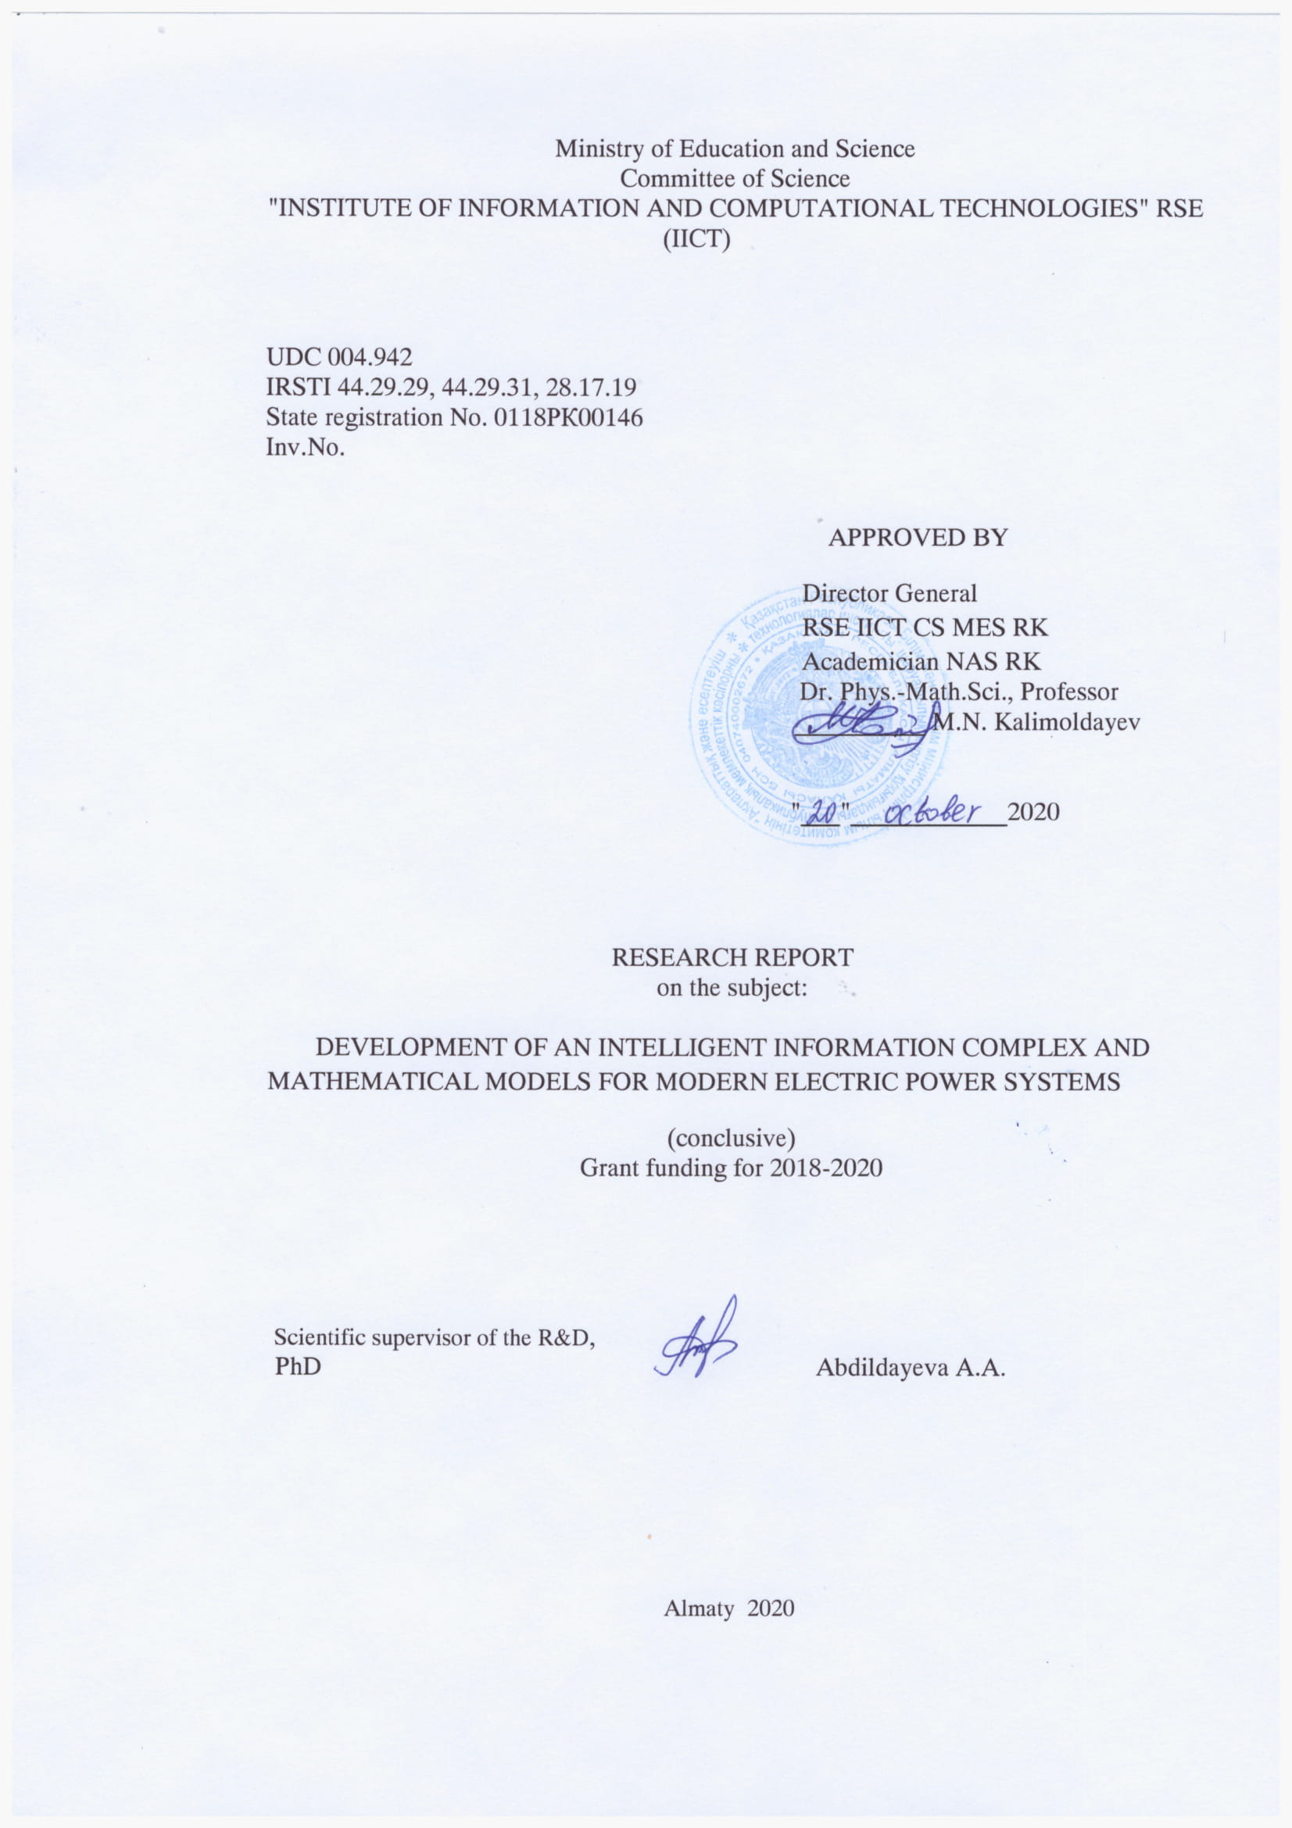

REPORT

Report 184 p., 32 Fig., 41 sources, 5 ADJ.
INTELLIGENT SYSTEMS, MONITORING, ELECTRIC POWER SYSTEMS, MATHEMATICAL MODELS, OPTIMAL CONTROL, DETERMINISTIC AND STOCHASTIC COMPONENTS OF TIME SERIES.
The project is aimed at solving the applied problem of developing an intelligent system with an adaptive energy consumption model and high-quality predictive properties for real-time automation.
The goal of the project is to create a universal mathematical model and develop an intelligent information system for rapid response to emergencies, short-term forecasting and long-term planning of electricity consumption based on retrospective data of the corresponding consumption in the past and taking into account changes in other influential factors in real time.
To obtain the results of research and development of an intelligent information system, the following methods were used: control theory, object-oriented analysis of information systems, object-oriented modeling language UML, algorithms and software packages were developed, methods of the theory of mathematical and computer modeling of EES were studied, and statistical data were collected and prepared.
Main design and technological and technical and operational characteristics: development of a functional diagram, UML diagram and database structure of an intelligent information system.
Level of implementation: for 2020, published only 6 articles and 2 copyright certificates, including 2 article in a peer-reviewed scientific journals indexed in the database Scopus, Web of Science with impact factor, 2 articles in refereed domestic scientific journals with nonzero impact factor, recommended KKSON MES RK; 2 articles in the proceedings of international conferences, as well as the results were introduced into training courses and used in the training of students and undergraduates of the higher school of information technology and engineering of Astana International University in the disciplines "Architecture and organization of computer systems" and "Technologies for developing intelligent systems". Received 2 protection documents for the object of copyright.

CONTAINMENT
INTRODUCTION……………………………………...…………………………………….… 7
1 Methods of forming a mathematical model of the electric power system and developing an intelligent information system …………………………….……….………………….………...11
  - Modeling of power consumption…………………………………………….…. 11
  - Development of an intelligent information system for electric power systems………………………………………………………………………………………..…22
  - Modeling and implementation of multi-agent systems…………………………………………………………………………………………..25
  - Application of IoT technologies in electric power systems based on a mathematical model for an intelligent information system…………………………………………………….30
- Experimental study of the effectiveness of the proposed approach……….………….…34
CONCLUSION……………………………………………………………………..…...….…...42
LIST OF USED SOURCES…………………………………………………….….…………....44
APPENDIX А Calendar plan for 2020…………………………..…………………...……...…..47
APPENDIX B List of publications in 2020………………………………………..…………….56
APPENDIX С 2020 Article Reprints………………………………………………..………......60
APPENDIX D List of used foreign information resources …………………………...……….157
APPENDIX E Automated system of short-term forecasting and monitoring of electricity consumption in educational institutions………………………………………………………..158

TERMS AND DEFINITIONS

Electric power system — the electrical part of the power system and the electric energy receivers fed from it, united by the common process of production, transmission, distribution and consumption of electric energy.
Power System — a technical object as a set of power plants, electric energy receivers and electric networks connected to each other and connected by a common mode.
Information Systems – a system designed for storing, searching and processing information, and the corresponding organizational resources (human, technical, financial, etc.) that provide and distribute information.
Time series analysis is a regression-based method of data analysis that aims to establish causal relationships through data ordering.
Forecasting-determining trends and prospects for the development of certain processes based on the analysis of data on their past and current state.
Time Series Forecasting involves building a model for predicting future events based on known past events, predicting future data before it is measured.
The Processor of a Multi-agent Management system is a server for collecting, processing and storing information, from which a specific agent can get the necessary data in the event of a failure.
A Software Interface is a system of unified communications designed to exchange information between components of a computer system and an operator.

LIST OF ABBREVIATIONS

ARIMA-autoregressive integrated moving average model
SARIMA-seasonal model of autoregressive integrated moving average
RMSE - root mean square error
MAE - average absolute error
MAPE is the average relative error
ARCH-autoregressive models of conditional heteroskedasticity
TBATS-seasonal exponential smoothing model
ANN-artificial neural networks
SVM support vector machines
GDP – Gross domestic product
UML-unified graphical modeling language
ARV-automatic excitation regulator
ARCV – automatic regulator of frequency of rotation
EES – electric power systems Is-information system
AWP — automated working place

INTRODUCTION

The twenty-first century was marked by a firm understanding that the pace of development in society, economy, and technology, which are undergoing drastic changes, is unlikely to slow down, and that the ability to quickly respond to changes in the national and global economy in the external energy market will be a prerequisite for business survival.
Among the most significant changes in the development of the energy sector can be attributed to the following factors:
– growth of consumption of electric energy;
- constantly growing demands on the reliability and quality of power supply from consumers;
- constant increase in the cost of electric energy;
- growing requirements for environmental and industrial safety of energy facilities.
Another important condition that has an increasing impact on the development of all sectors of the economy is globalization – that is, the transformation of the world space into a single zone where information, goods and services, and capital move freely. In the article of the first President of Kazakhstan N. Nazarbayev "Looking to the future: modernization of public consciousness" it is noted that today not only an individual, but also the nation as a whole has a chance of success only by developing its competitiveness. This means, first of all, the ability of a nation to offer something advantageous in price and quality in regional and global markets. And this is not only a material product, but also knowledge, services, intellectual products, and finally, the quality of the labor resource.
The globalization of the electricity market is one aspect of this global trend. Modern technological advances in the electric power industry have already created conditions for creating electric power markets at the international level.
Creating innovative intelligent systems for managing energy consumption processes is an urgent task both for individual facilities(institutions), countries, and for the global economy as a whole. Solving such urgent problems as reducing energy consumption, ensuring energy independence, and reducing greenhouse gas emissions requires determining adequate methods for analyzing, modeling, and predicting time series of consumption and production of various types of energy, and integrating them with existing ones. information systems for making management decisions at the scale of individual enterprises, cities, industries, and States. Insufficient development of theoretical and methodological approaches and practical aspects of the application of systems for forecasting and evaluating the efficiency of electricity use actualizes the need to create integrated automated energy management systems using modern computer-based training methods.
The widespread use of modern technological devices for measuring the amount of energy consumed has contributed to the development of engineering and statistical analysis methods that allow you to effectively plan, predict and control the growth of load in the power system. In the last decade, research has intensified in the field of forecasting electricity consumption by industrial, municipal and energy distribution enterprises, residential complexes, business structures and individual homes [1], [2], [3], [4], [5]. This is due to the need to ensure energy efficiency of buildings, recognized by the International Energy Agency as one of the five conditions for reducing final energy consumption and associated CO2 emissions [6]. Environmental prerequisites and economic feasibility have contributed to the development of national rules for energy-efficient design for various types of buildings, which gave rise to the development of computer software for energy-efficient design of new buildings, such as EnergyPlus, DOE-2, eQUEST, IES., ECOTECT, etc. [7].
Maintaining energy efficiency in buildings requires constant monitoring of energy consumption and identifying factors that affect them in real time. Most researchers define weather conditions as the main factors that determine the dynamics of electricity demand. These include: temperature indicators (air, environment, and room temperature), humidity, pressure, wind speed and direction, cloud cover, and sun brightness; precipitation [8]. Among additional independent factors, the authors use variables in models for electrical load, heat transfer, or heat index; calendar variables; indicators of the size and performance of buildings, urban infrastructure development; indicators of living standards and socio-economic development [8]. For example, the authors [4] use data on average daily energy consumption in kW as a dependent variable for predicting electricity demand in the residential sector. To display calendar effects, researchers include dummy variables, namely a variable for all Saturdays, a variable for all Sundays, and a variable for holidays in the study interval [4]. Note that the frequency of time series used in models is determined by the source and availability of data. For example, [5] shows time series of electricity consumption; in the study [9] - half-hour data with an annual time interval. Accordingly, the forecasts obtained from such a sample may be short-term, for example, for a week. To obtain medium-and long-term forecasts, models are used that are evaluated on data with a higher frequency (for example, monthly data [9]) and with a longer time interval (several decades). Real-time forecasting requires data from measuring instruments every minute or every second.
Analysis of open statistical information on electricity consumption in Ukraine and in Kazakhstan [10], [11] shows that statistics on gross electricity consumption for all sectors of the economy are available only by year; indicators of final consumption including renewable energy sources by households, sectors of industry, transport, services, agriculture, forestry and fisheries, as well as non-energy energy consumption are available only since 2007. At the same time, according to the reports of the relevant ministries [12], it is possible to obtain monthly figures for gross energy consumption in the country and only during the last decade. One way to solve the problem of a small sample of data in order to obtain adequate, statistically significant results and high-quality forecasts can be to use panel models that evaluate similar indicators for a group of objects, for example, simultaneously for all. educational institutions in the region, regions of the country, or countries with similar development parameters. For example, in [13], a panel sample of annual data on electricity consumption by a residential building is presented.
In general, there are problems in the power system of Kazakhstan with the installation of an electricity dispatching system [11], especially the work on the distribution of electricity in some local power networks, and the issues are still very significant. On the one hand, the lack of a perfect system of standards for detecting and testing information technologies, the degree of information exchange in automated and information systems is insufficient, and the corresponding auxiliary tools are not ideal. On the other hand, from the software point of view, many power dispatching systems use distributed software systems, and each software has large differences and does not have a system. The program "Digitalization of Kazakhstan" of the State power grid clearly proposed the construction goals and requirements for the functionalization, automation, dispatching and control of the integrated power grid. In accordance with national requirements for monitoring and management of grid capacity, in accordance with national requirements for monitoring and management of grid capacity, it is necessary to use information digital graphic technology, the SVG graphical model, etc. Improve the security architecture of power dispatching and provide high-quality power supply services to the community.
The novelty of this research is that a prototype of an intelligent information management system has been developed and new state estimation algorithms have been proposed that will be used in conditions of partial and incomplete observability and will provide effective estimates of the system state in real time.
Forecasting the generation, consumption, and balance of fuel and energy resources is an urgent global problem. According to the BP Statistical Review of World Energy [14], the consumption of primary energy sources in the world has increased 1.5 times over the past 20 years: from 9 billion metric tons of oil equivalent in 1998 to 13.5 billion tons in 2017. According to forecasts of the International energy Agency (EIA, 2015) [15] energy consumption will increase by another 40% by 2050, primarily in Asian countries that are not members of the Organization for economic cooperation and development (non-OECD Asia). In terms of energy sources, the largest growth in consumption of natural gas, hydropower and renewable sources is expected [16].
The development of information technology, computer capacity, and data Analytics has contributed to the rapid development of research in the field of forecasting electricity demand at the macro and micro levels. Since the main approaches are based on models that examine historical data on energy consumption, much attention has been paid to the study of factors that explain its dynamics. In particular, the subject of research by many scientists in recent years has been the modeling of cause-and-effect relationships between economic growth factors and energy consumption. The subject of this study is to identify factors that affect final energy consumption and select optimal models for predicting electricity consumption at the level of States and regions. This final report is a continuation of the interim reports - for 2019 inventory № 0219RK00565, for 2018 inventory № 0218RK00175.

1 Methods of forming a mathematical model of the electric power system and developing an intelligent information system

  - Modeling of power consumption

Modern methods of time series forecasting are based mainly on the principle of historical prediction of the future. At the same time, both methods of interpreting information representing past events and ways of extrapolating them for the future are constantly being improved. Parametric modeling is widely used, with regression analysis as a classic example. The most common methods for estimating model parameters are the Gauss least squares method and the maximum likelihood method. Approaches to the specification of parametric models can be divided into structural models based on a system of equations and constraints on parameters, and special "ad hoc" models that do not have a theoretical basis.
Dynamic linear and nonlinear Baess models with the Kalman filter have been successfully used in the framework of the structural approach since the 1980s. The Kalman filter is also used in ARIMA models to eliminate the problem of unreliable parameter estimation by the maximum likelihood method and to determine unobservable components of the series [14]. Justification of the model optimal in terms of statistical characteristics and predictive qualities requires determining the main components of the series, the nature of its stationarity, specification, parameterization, verification and testing of models; testing dummy variables, with the aim of improving their quality.
Also, when studying the autocorrelation of a series, an approach is used to test the hypothesis that there is no autocorrelation before the K lag using the Leung-Box Q-test [14]. To do this, a statistical value is calculated:

where T is the number of observations; ρ² is the j-th order autocorrelation; k is the number of lags. The resulting statistical value is compared with the theoretical value of the distribution 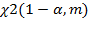
Another widely used method for checking data stationarity is using the criteria proposed in 1979 by W. fuller and D. Dickey and its improved form of the extended Dickey-Fuller test (ADF) [16]. This method consists in testing the statistical hypothesis about the presence of a single root (with an alternative hypothesis about the presence of a root less than one). If the t-statistic is less than the critical values of the ADF statistic, then the null hypothesis is rejected, which indicates that the series is stationary. If there are unit roots, the series is considered to be integrated k-th order I(k) and requires differentiation to lead to stationarity. The condition for applying this test is the homoscedasticity of perturbations, that is, the constant variance of random perturbations ε [17].
If seasonality is detected, it is necessary to eliminate it or include fictitious seasonality variables in order to assess the data stationarity and further build the model correctly. Common smoothing methods: exponential and adaptive smoothing methods, additive and multiplicative Holt-winters models [18].
When using the exponential smoothing method, the new representation of the data series is performed according to the rule:

where S_{t} is the new value of the series level; y_{t} is the original value of the series level; α is the smoothing constant. This method is useful if the data has a slow-growing or horizontal trend.
The adaptive smoothing method allows you to change the smoothing constant during the calculation, which is what the scheme is used for:

Here α changes in time according to the rule:

A more advanced modification of exponential smoothing is the additive Holt-winters model, based on the use of smoothed data, the trend component, and the seasonality index. Smoothing in this case occurs according to the scheme:

where b_{t} is the trend parameter; p = 1, 2 ... is the number of forecast periods, and c_{t} is the seasonality parameter. The components α, b, and c are calculated using the formulas:

Here s is the number of seasonality cycles; α, β, and γ are the smoothing parameters for the series, trend, and seasonality levels, respectively.
If there are two complete seasonality cycles in the observations, smoothing is possible by constructing a Holt-winters multiplicative model. In this case, the following rule is used:

Further modeling based on non-stationary data requires their reduction to a stationary form. If a series belongs to the TS class, it is sufficient to select a trend from the database. If the data verification using the ADF test determined that the series belongs to the DS type, then the problem of non-stationarity can be solved by using i-th order differences instead of the levels of the series. In this case, the autoregressive integrated moving average model ARIMA [19] is used for modeling, which makes a forecast of future values of a time series based on a linear combination of its previous values and perturbations (also known as random shocks or innovations).
The autoregressive process (AR) of order p is described by an equation of the form:

where Y_{t} is the dependent variable at time t; φ, p is the autoregression coefficients; ε_{t} is the error at time t ("white noise") [17].
The moving average (MA) equation of order q has the form:

where ω_{q} are the coefficients MA; μ is the constant mean of the process.
Any stationary model AR(p) can be written as MA (∞). for Example, performing the corresponding operations for AR(1), we get the model MA (∞):

As noted above, a non-stationary process of class DS can be reduced to a stationary one by applying the sequential difference operator -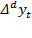. In this case, applies autoregressive integrated moving average model ARIMA (p, d, q), where p is the lag of the model, d is the order of integration and q - order moving average:
The ARIMA model uses known methodology of Box-Jenkins, which assumes that future values of time series are linear function of its previous values and random errors:

where and represent the actual values and random error in time period t – - model parameters, p-model lag, d-integration order (order of series differentiation to bring to stationarity) and q – moving average order.
The SARIMA seasonal model includes, in addition to the parameters (p, d, q), the seasonal parameters (P, D, Q) m, where m is the number of periods in the season.
If there is heteroskedasticity in the data, it becomes appropriate to use autoregressive models of conditional heteroskedasticity ARCH (Autoregressive Conditional Heteroskedasticity) [19]. When constructing such a model for a certain time series, which can be represented as y_{t} = u_{t}, the conditional variance property is used:

where u_{t} is a sequence of independent identically distributed random variables with zero mean; γ, δ satisfy the condition > 0 for all t.
A prerequisite for a reliable forecast is the quality and adequacy of the resulting model. When diagnosing a model, in particular, the model residuals are checked for autocorrelation, normal distribution law, and heteroscedasticity.
One of the methods for testing model residuals for heteroscedasticity is the test proposed in 1980 by G. white [20] to test the statistical hypothesis of the absence of heteroscedasticity using LM statistics:

where n is the number of observations; R² is the coefficient of determination of the auxiliary regression. In the case of homoscedasticity of the model residuals, the LM statistic has an asymptotic distribution χ2(N-1), where N is the number of auxiliary regression parameters.
The calculation of the coefficient of determination R², the standard error of regression, the Akaike and Schwartz information criteria, and the Durbin-Watson statistics are also an integral part of determining the quality of the model.
To select a model among several alternatives, the information criterion introduced in 1971 is used. Akaike [21]:

However, the Akaike criterion is characterized by a choice in favor of a re-parametrized model. This problem is partially eliminated by the Schwartz information criterion [20]:

To test the model residuals for autocorrelation, a correlogram of residuals is constructed, the interpretation of which is similar to the corresponding test for a time series. Another criterion for checking the presence of autocorrelation in the deviations ε of the constructed model is the value of the DW-statistic j. Durbin and John. This value is calculated using the formula (1) and compared with the upper and lower critical values of d1 and d2.

(1)

Analysis of publications in the field of forecasting electricity consumption shows that traditional parametric methods, such as regression models (linear regression and multiple regression) and autoregressive methods (autoregression and moving average models, ARMA, integrated models, ARIMA, vector autoregressions, VAR, and co-integration models, VEC) have been used less frequently recently. However, some authors still note the high efficiency and accuracy of both one-dimensional seasonal integrated autoregression models-moving average, SARIMA [22], and SARIMAX models [22], which include additional exogenous variables in addition to the data on electricity consumption itself.
An analysis of empirical data on hourly electricity consumption in the municipal sector of Estonia [23] shows the seasonal nature of the data and the presence of some anomalous observations in the two-year sample, which includes 17544 data points. The graph of hourly power consumption dynamics is shown in figure 1.
To identify the most significant factors affecting the volume of hourly consumption, we investigated the following exogenous variables:
- average temperature during the observation period in degrees Celsius at an altitude of 2 meters above the earth's surface;
- atmospheric pressure (mm mercury column);
- relative humidity (%) at a height of 2 m above the ground;
- wind direction and speed (angular degrees) at a height of 1-12 m above the ground;
- amount of precipitation (mm) during the period;
-cloudy (Sunny/cloudy);
- night/twilight/day;
- weekends and holidays (separate dummy variables for Saturday (1/0); Sunday (1/0) and holidays (1/0)).
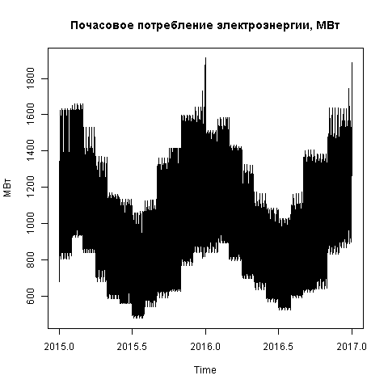
Figure 1-Dynamics of electricity consumption in 2015-2017

Figure 2 and Figure 3 show the results of forecasting electricity consumption based on the seasonal autoregressive moving average model ARIMA and the seasonal exponential smoothing model TBATS.
The parameters of the seasonal SARIMA model include the parameters of the autoregressive order (model lag) p=3, the order of integration (the order of series differentiation to bring to stationarity) d =1, and the order of the moving average q =5. The model also includes seasonal parameters Q_{m}=1.
To justify the choice of the model, we use the lowest values of information criteria and quality indicators of the obtained short-term forecasts – the mean square error (RMSE), the average absolute error (MAE) and the average relative error (MAPE). To improve the quality of models and forecasts, you need to include additional explanatory variables by selecting the most significant indicators and explaining abnormal values by including dummy variables. Further research should be continued in the search for other types of models.
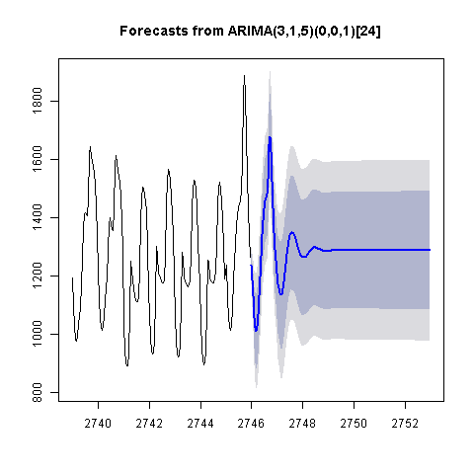
Figure 2 - Forecasting electricity consumption based on the ARIMA model
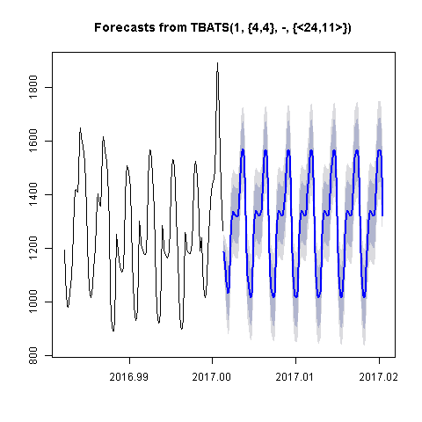
Figure 3 - Forecasting of electricity consumption based on the seasonal exponential smoothing model TBATS

Deep theoretical and practical development, as well as relative ease of use, allows them to remain relevant and in demand. Artificial intelligence methods are becoming increasingly popular in the scientific and business environment [23]. A significant advantage of ANN models is their ability to model nonlinear relationships. The predicted values of the time series in the time period t, obtained using a nonlinear autoregressive model of neural networks, are described by the following equation [24]:

Neural network models often provide an ideal approximation of the actual and model data within the training sample, but if there is not enough data for training, large prediction errors occur. To improve the predictive quality of ANN, a number of methods are used, including: various options for (cross – validation), noise reduction, error regularization, error back propagation method [24], optimized approximation algorithm, and SVM models. The latter are based on minimizing the structural risk of data, while neural networks are based on minimizing the empirical risk [25]. We apply two of the most widely used machine learning approaches to short-term load forecasting, namely artificial neural networks and support vector machines, which will serve as benchmarks for comparison with our proposed PCA regression model. The developed models are compared with these approaches. Other methods include fuzzy systems and knowledge-based expert systems. Such approaches are not recommended for accurate forecasting and are usually based on expert opinion, which may be influenced by various random parameters.
The number of neurons in each layer can vary and is usually selected by an optimization algorithm. Each neuron has one input, and its output is connected to all the neurons of the next layer, creating network connections. Figure 4 shows a neural network model with a 28-day prediction of the smart grid.
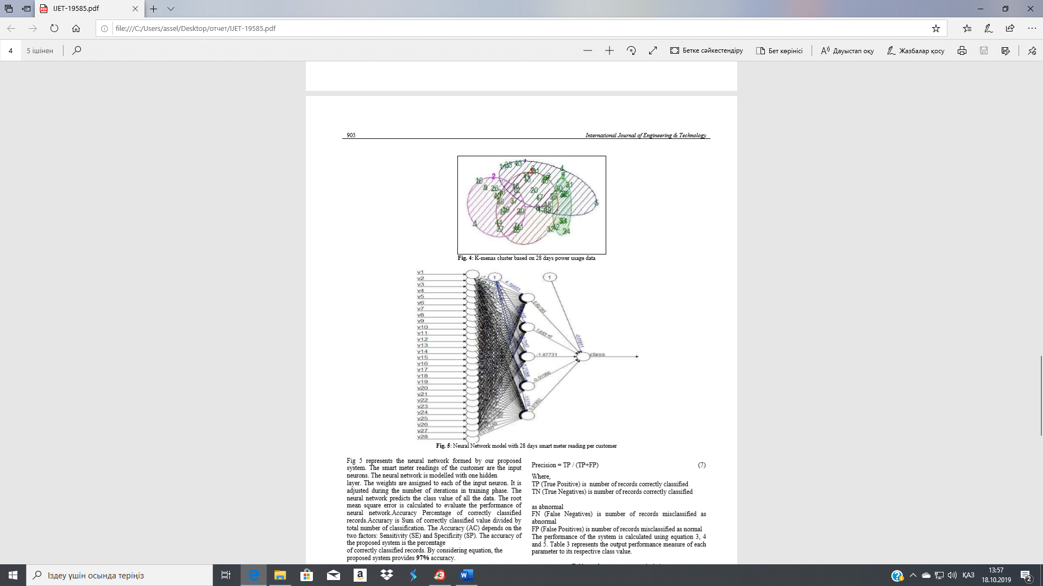
Figure 4-Neural network model with 28-day smart grid prediction

Statistical analysis of data in this work includes the study of the dynamics of time series in the context of countries over time; heterogeneity of panel series in the context of countries and time periods; stationarity and distribution of series; evaluation of possible relationships between series.
Analysis of the dynamics of electricity consumption per capita in the context of individual countries in Europe and Central Asia (figure 5) shows an increase in the indicator for most countries (except Azerbaijan) until 2014. At the same time, the study of GDP per capita statistics in the selected countries (figure 6) indicates a possible relationship between economic growth and energy consumption.
In particular, experts estimate that the country's GDP growth by 1 % provokes an increase in electricity consumption by 0.5% [12]. This is primarily due to the low added value and high electricity consumption of extractive and agricultural industries, which form a large part of the GDP of countries such as Kazakhstan, Ukraine, Russia, and Azerbaijan. In such countries, energy resources form a significant part of consumers ' costs. The gap in energy efficiency indicators, defined in the volume of electricity consumption per unit of output, between the countries of the post-Soviet space and developed countries is on average 200-300% (figure 7) [14].

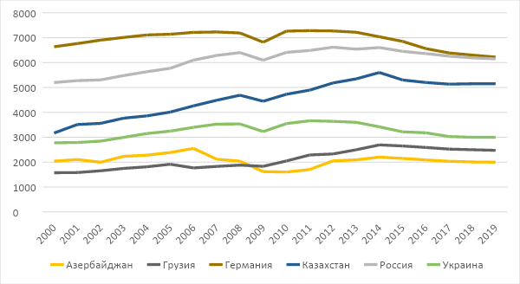
Figure 5-Electricity consumption KW per capital

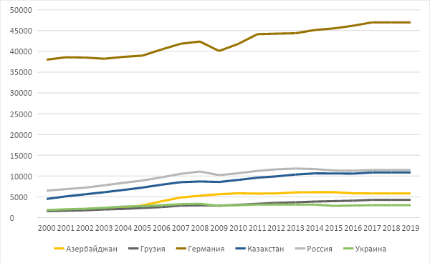
Figure 6-GDP per capita at constant prices in 2010, us dollars
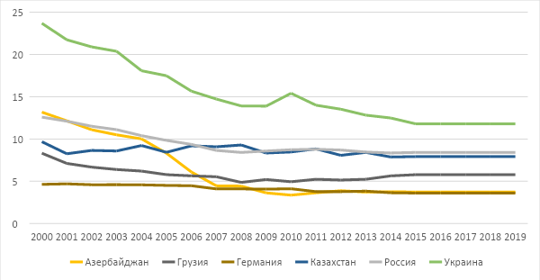
Figure 7-Energy consumption per unit of GDP (MJ / 2011 $ PPP)

The stationarity of the panel series of power consumption was tested on the basis of the extended Dickey-fuller test (Dickey, 1984) [20]. The null hypothesis about the presence of single roots of the H₀ series was rejected based on the statistics t = -6.3028. Here H₀: for an AR (1) process of the form:

$$∆y_{i,t}=μ_{i}+{φρ}_{i}y_{i,t-1}+\sum_{j=1}^{k_{i}}{}φ_{i,j}∆y_{i,t-j}+ε_{i,t}$$

where i = 1, 2..., N objects (countries) and t = 1, 2, ..., T time periods.
Study of the distribution of electricity consumption depending on price parameters and geographical location. Grouping by the above-average price criterion reflects the differences between European countries with competitive market pricing and post-Soviet countries, where, in most cases, there is still a centralized market with state regulation of prices. Abnormally high values of electricity consumption are typical for the Nordic countries with the least number of Sunny days per year and at the same time relatively low price of electricity (Norway, Iceland, partly Finland).

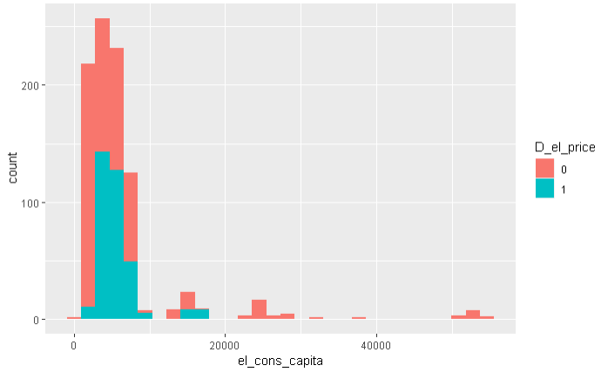
Figure 8-Distribution of electricity consumption depending on the price of electricity
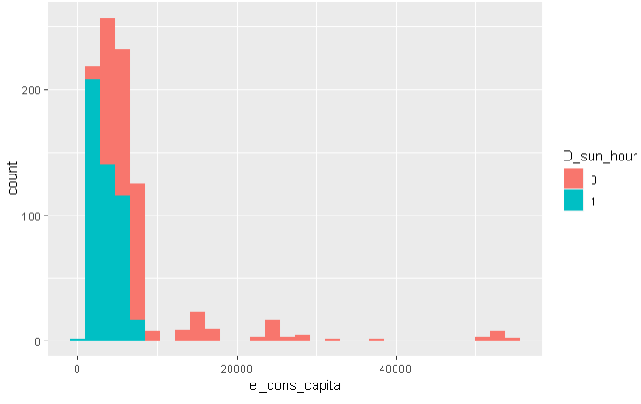
Figure 9-Distribution of electricity consumption depending on the number of Sunny days per year
Comparative analysis of the average values of electricity consumption by country, presented in figure 10, makes it possible to cluster States into groups with consumption above 7000 KW; in the range of 4000 – 7000 KW; less than 4000 KW per capita.

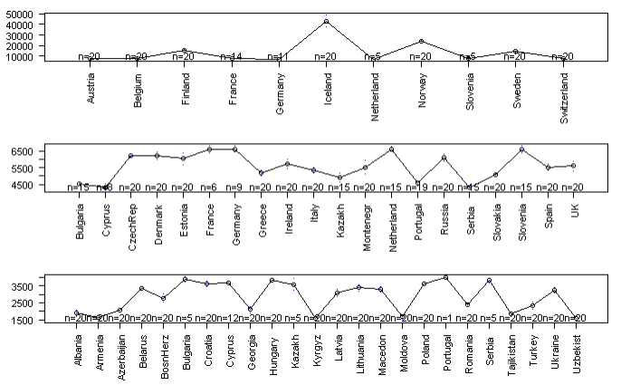
Figure 10-Comparative analysis of average electricity consumption per capita by country

A comparative analysis by year presented in Figure 11 shows a shift in the Central trend of energy consumption in Europe and Central Asia upward with slight decreases in the crisis year 2009 and since 2014, as well as an increase in the confidence intervals of the average values for the study period.

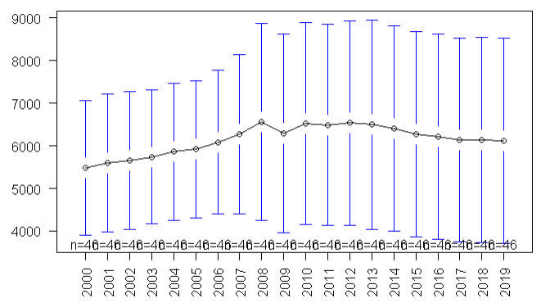
Figure 11-Comparative analysis of average electricity consumption per capital by year

1.2 Development of an intelligent information system for the power industry of systems

The information system is designed to generate automatic control commands and issue them to the remote-control subsystem and other subsystems.
Based on the requirements for an intelligent information system, information models were created using the unified graphical modeling language (UML) for describing, visualizing, designing, and documenting the system.
Figure 12 shows a diagram of the distribution of activity States between roles.

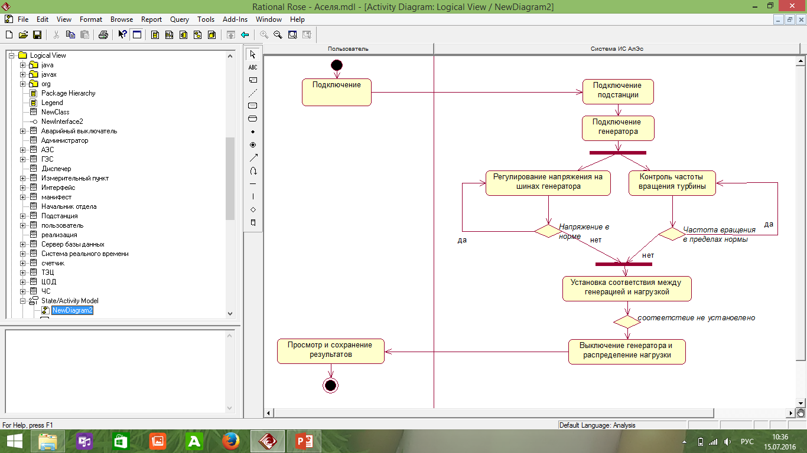
Figure 12-Diagram of activity state distribution between roles

The next step in developing a software product is to build a case diagram. Figures 13-14 show diagrams: sequences of use cases and classes.
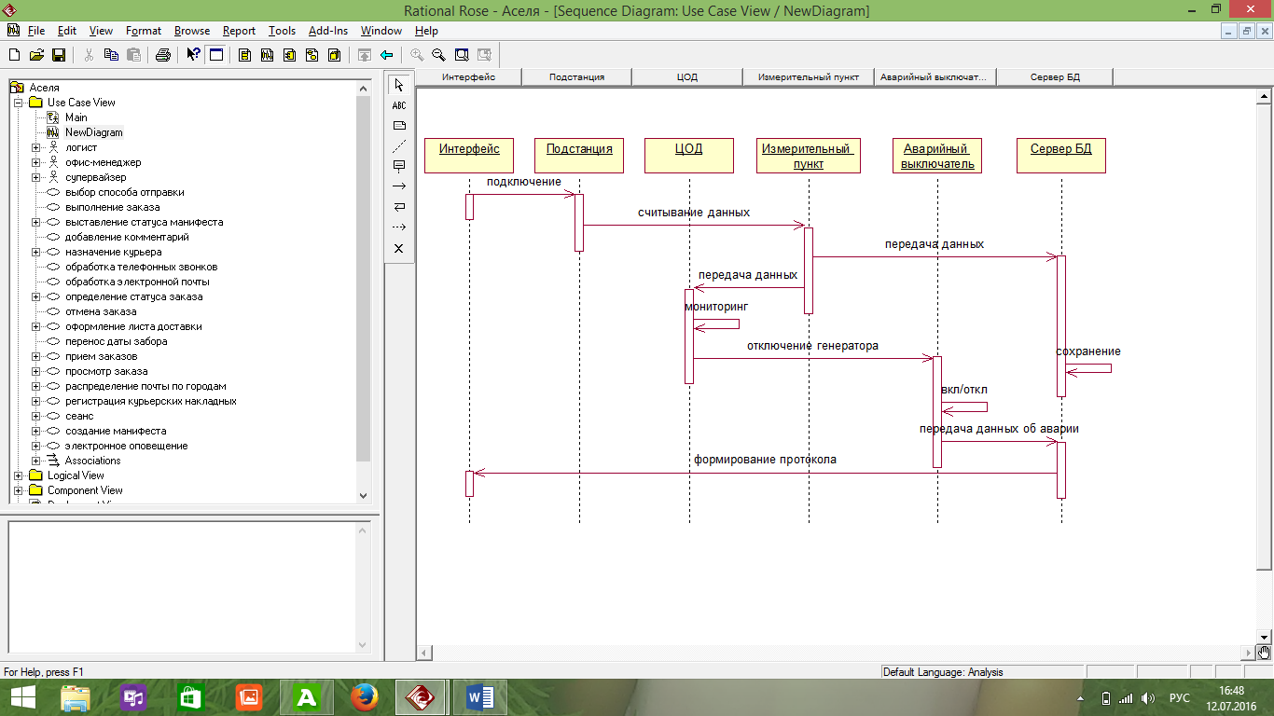
Figure 13- Diagram of case sequence

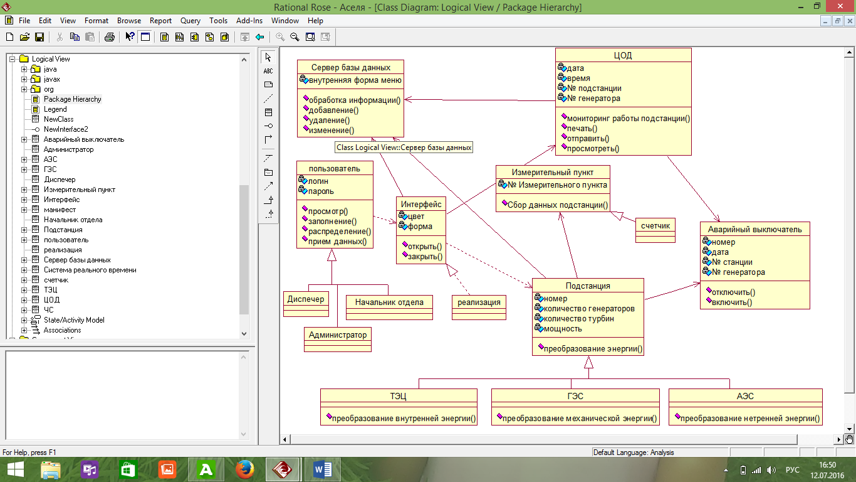
Figure 14- Diagram of classes
The Developed model of the intelligent information system is shown in figure 15.
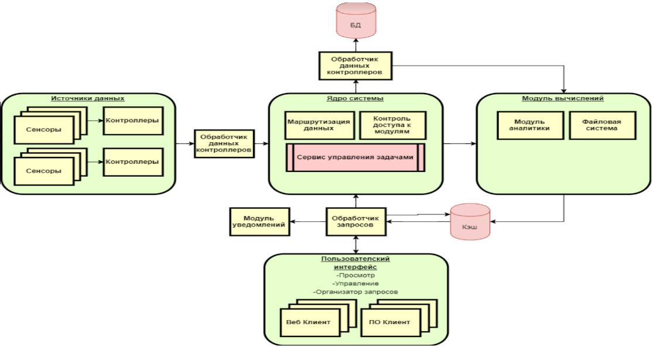
Figure 15 - Model of the system

In figures 16-22 present the interface of the information system
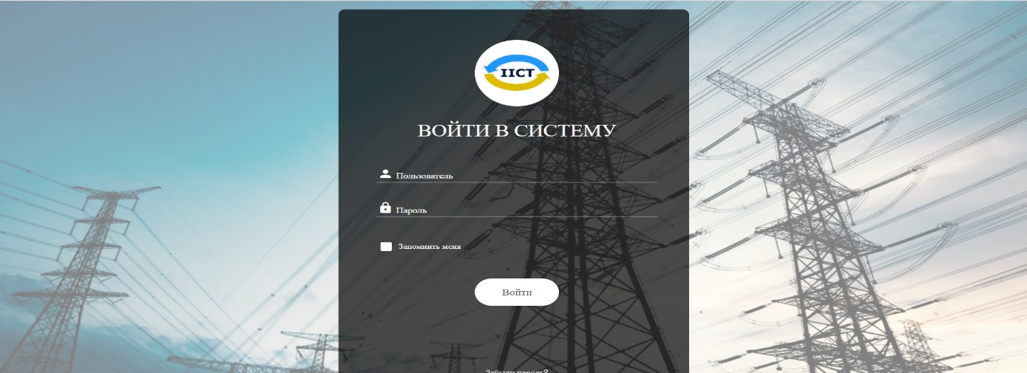
Figure 16-Logging in

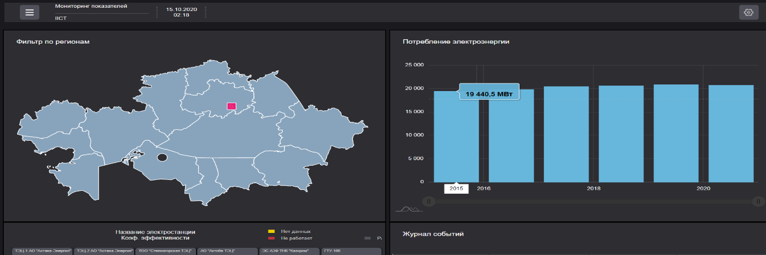
Figure 17-General characteristics of electric power systems in the information system
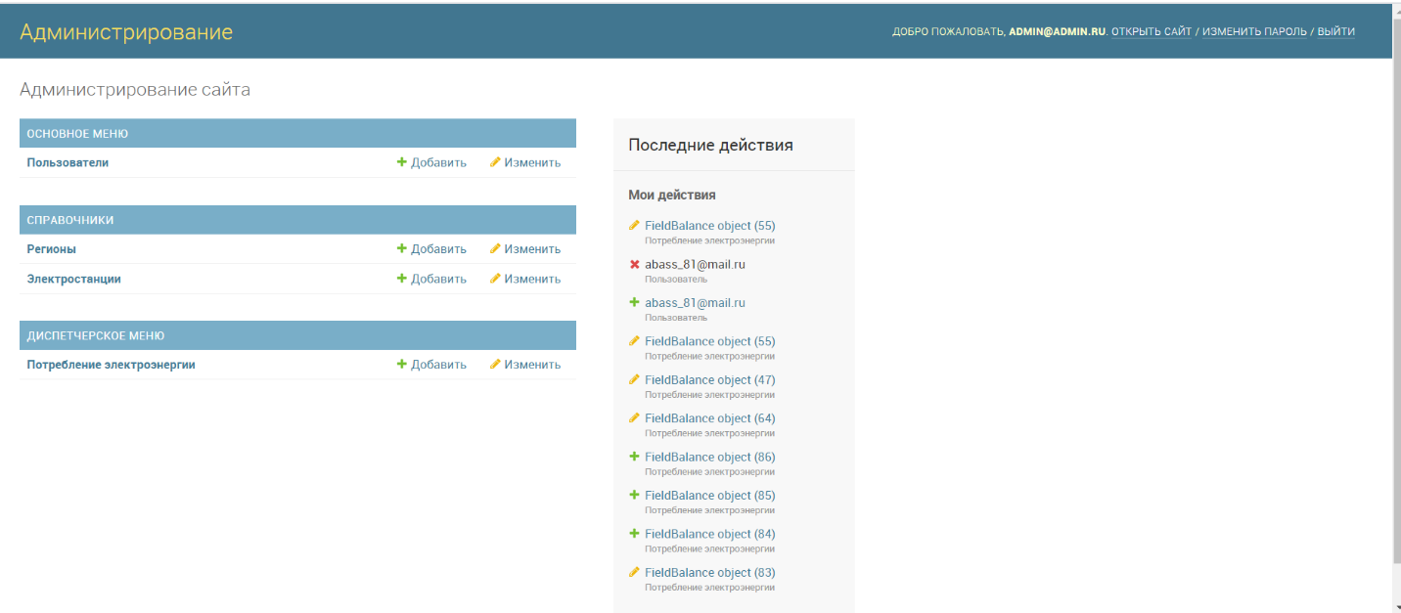
Figure 18 - Administrator interface for the system

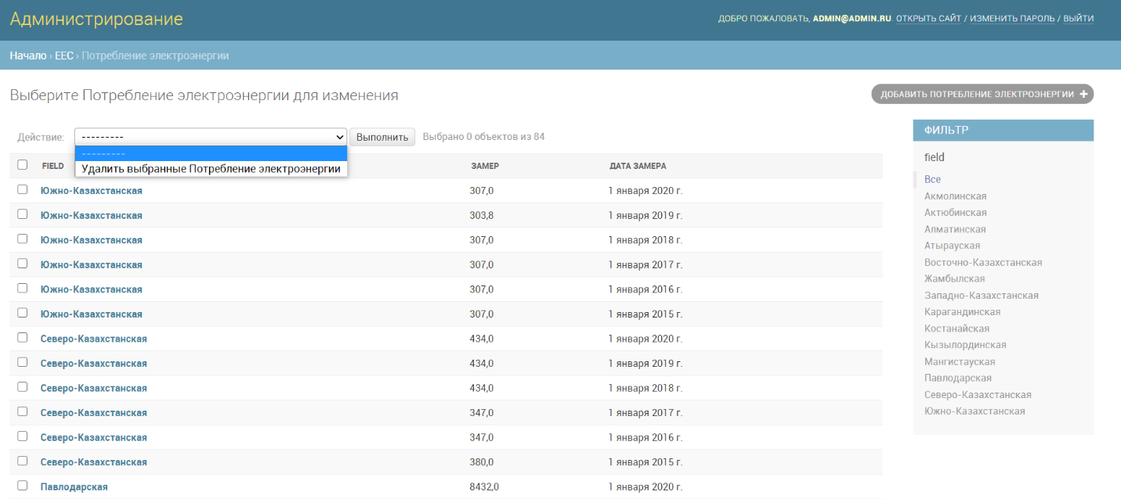
Figure 19-MS SQL DBMS
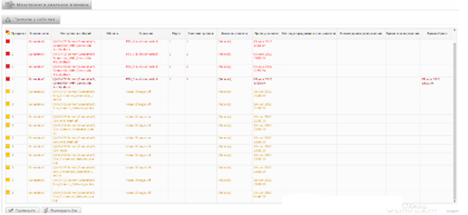
Figure 20-Operator screen. Threats and events

1.3 Modeling and implementation of multi-agent systems

The proposed multi-agent system includes various intelligent agents representing various components. Each agent has a localized knowledge base containing rules and behaviors that governs the decision-making process. The use of a multi-agent control system in the electric power industry will make it possible to form a distributed real-time control system that implements the interaction of the personnel of an intelligent electric power system with automated and automatic complexes based on software and hardware intelligent agents. Figure 23 shows the relationship of agents in electric power systems.
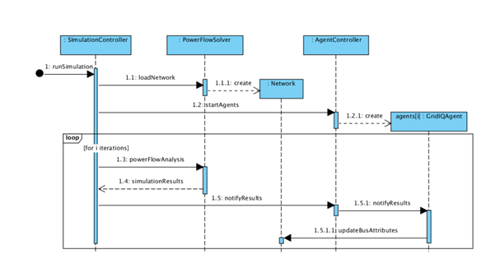
Figure 21-Relationships of agents in electric power systems

When using a multi-agent control system in the electric power industry, it is necessary to take into account the specifics of the operation of electrical equipment and individually approach the development of a multi-agent control system for individual objects.
In the proposed system, as receptors, sensors are used, as well as counters and analyzers of electric power quality indices. Effectors are programmable controllers that implement automatic regulators of excitation (ARV) and rotation frequency (ARV) of generators. The main functions of the agents of the proposed multi-agent control system and their communication (Figure 22) can be shown as follows:
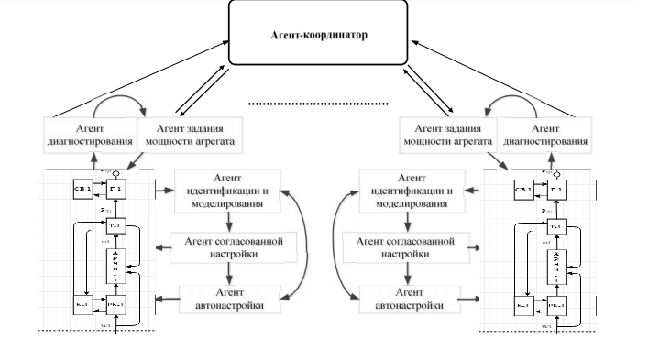

Figure 22-Structure of a multi-agent control system

The proposed multi-agent control system is positioned as a self-organizing system with the ability of agents to initiate a dialogue based on the analysis of a situation that is not prescribed in advance and operates under conditions of uncertainty.
The model structure developed using the AnyLogic platform system dynamics library is shown in figure 23. Circles represent dynamic variables that can change during the simulation. Squares indicate the storage devices that allow the differentiation process to be implemented.
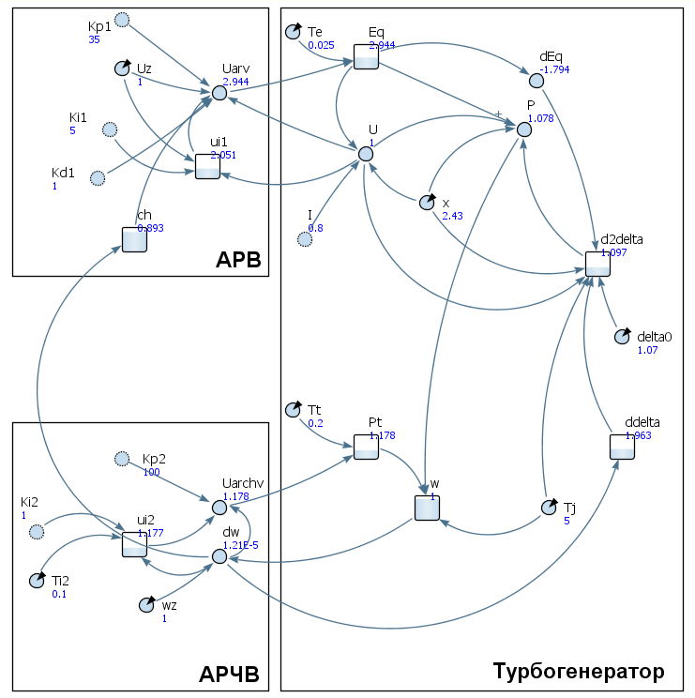

Figure 23-Structure of the distributed generator installation model with ARV and ARV in AnyLogic [24]

The model is based on the following system of equations:

(2)

(3)

where -angular coordinates; - angular velocities; - state vector of the controller; - managing the impact on facilities management; –the damping coefficients of the control object; - constant-dimensional vectors for each; - constant matrix of order ; - the control effect of the regulator , - formed on the principle of feedback; functions

characterize the effects on the subsystem and other subsystems; - continuously differentiable periodic functions satisfying the conditions

For each fixed, second-order differential equations (1) describe the processes in the control object (total control objects ), and the vector differential equation (2) defines the equation of motion of the control object controller.
In particular, for electric power control systems, equations (1) describe the rotational motion of the rotor of synchronous generator, the value is the difference in the rotation angles of the rotor at the nominal frequency and the electromotive force generated by the generator in relative units, the function determines the power of the generator in relative units , and Express the mutual effects of the generators on each other through a common electric line .
Equations (2) describe the dynamics of the steam boiler, the steam turbine automatic speed controller and the excitation system on generator, exposure, develop a controller to stabilize the rotational motion of the rotor - generator, - control generated by the computer to ensure synchronous operation of all generators running the electricity network.
The equations of perturbed motion - generator in the classical model of the power system [25] have the form:

Where - constant,
- constant.
Here is the deviation of the angle between the EMF of the generator and the voltage at the bus -th generator from its value in steady -state disaster mode, a deviation of angular velocity (sliding) -th generator, is the damping factor on the generator, the deviation of the power turbine from their values in steady -state post -fault mode, - moment of inertia of the rotor on the generator , – electrical power of the - th generator and external mutual , power flow between i – th and j –th generator.
The relationship between the control effect and the power deviation of the turbine in the simplest case [26,27] is determined by the differential equation

where the relative movement of the flap closing the access to couple – time constant representing the inertia of the steam in the reheater tubes, the ratio of droop on the speed controller (ARCU), – the gain channel to the central control system, the control action depends on phases the status of all generators.
The structure of relations of agents in the model shown in figure 26. The diagnostic agent has the receptors, allowing to measure parameters of the turbine, and the agent job power osnan an effector which changes the output active power of the turbine.
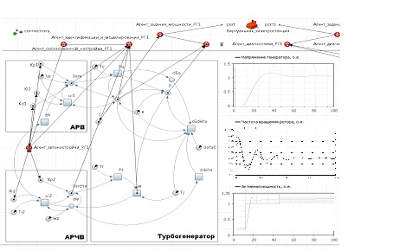
Figure 24-Model of a multi-agent control system with agent connections
shown

1.4 Application of IT technologies in electric power systems based on a mathematical model for an intelligent information system

IT technologies make it possible to build multi-agent control and optimize the shutdown time of generating equipment, as well as minimize the risk of accidents in power systems.
IT technologies consist of intelligent sensor devices, such as smart sensors, intelligent systems, actuators, and an intelligent processor, to create a relationship between each other [28]. To develop an automated information management system, we use the following mathematical model:

$x_{k+1}=A_{d}x_{k}+B_{d}u_{k}+n_{k}$ (4)

where is the system state matrix, x_{k} is the system state at time k , is the input matrix, is the control value, and is the process noise.
To identify and control sensors and actuators, system operators place IoT elements. Basically, the system measurements are obtained using the IOT element, in the form of the following system:

$z_{k}={Cx}_{k}+w_{k}$ (5)

where is the observation information at time k, C is the observation matrix, and a is the measurement noise. Monitoring information is sent to the merge center over the IoT network, which leads to a delay or loss of measurements due to packet drop [28]. Taking into account the loss of observation information, the measurement model (4) can be reformulated as follows:

$y_{k}=a_{k}{Cx}_{k}+a_{k}w_{k}$

where λ_{k} is the obtained measurements under the condition of observation information loss, and is an IoT-based information loss parameter that follows the Bernoulli distribution modeled as follows [28]:

$$a_{k}=\left\{\begin{aligned}1, with probability of λ_{k} \\ 0, with probability of 1- λ_{k}\end{aligned}\right.$$

where λ_{k} is the rate at which information is received from each observation in the merge center. As a rule, the estimation of the dynamic state taking into account information loss in the IoT network is written as follows:

${{\hat{x}}_{k\left|k\right.}={\hat{x}}_{k\left|k-1\right.}+K_{k}(y}_{k}-a_{k}C{\hat{x}}_{k\left|k-1\right.})$

where is the updated state estimate, is the predicted state estimate, and is the gain.
Usually the predicted state and error covariance are calculated as follows:

${\hat{x}}_{k\left|k-1\right.}=A_{d}{\hat{x}}_{k-1\left|k-1\right.}+B_{d}u_{k-1}$
$P_{k\left|k-1\right.}=A_{d}P_{k-1\left|k-1\right.}+{A_{d}^{,}+{+Q}_{k-1}}_{.}$

where is the estimated state of the previous step, and is the covariance matrix of errors of the previous phrase. Based on the above-mentioned filtering process, the optimal gain is designed so that the assumed state converges with the actual state . The IOT communication infrastructure with the evaluator and controller is illustrated in figure 27.
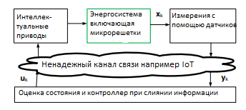
Figure 25-IOT Application for monitoring and stabilizing the microplastics

Life cycle management of power equipment status
Smart enterprises use Internet of things technology through RFID, GPS and other sensors to monitor and collect all aspects of power equipment information (including environment, conditions, accounting, testing, defects, reasonable choice of statistical methods), analyze the current state of equipment, future development law and major influencing factors to form a method of equipment risk assessment based on Internet of things technology, this system can dynamically update added, distributed, maintenance, inactive, unnecessary and other historical data. In this system, equipment status information and asset management information are effectively integrated, and supervision management is unified. The IOT-based power equipment lifecycle management system is shown in figure 28.
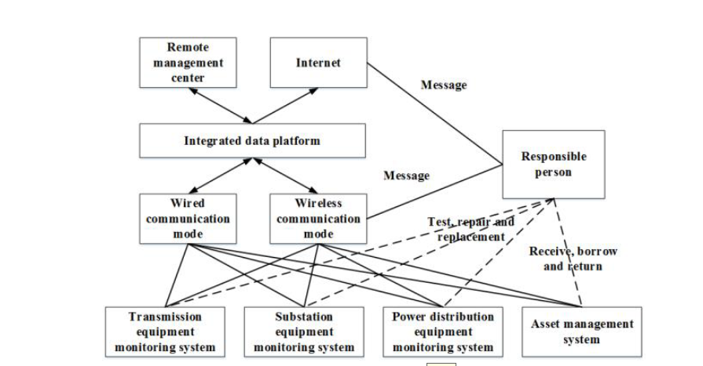
Figure-26 Life cycle management System for power equipment based on the Internet of things

To check the effectiveness of the system, a simulation test will be conducted for the performance of power equipment. The system can detect the operating state of power equipment in real time to improve management efficiency and realize intelligent and digital management of the power industry.
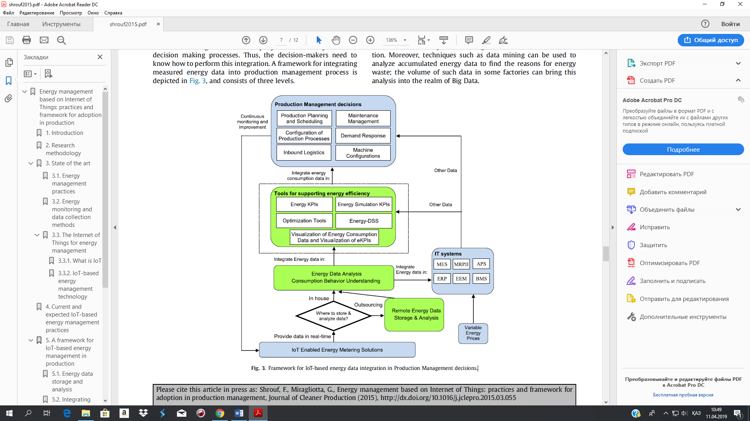
Figure 27-IOT-based energy data integration Framework in production management solutions

Internet of things has been an integral part of the transformation towards smart power grids. Examples of IoT technologies currently used in smart electrical systems include advanced measurement infrastructure (AMI) and dispatch control and data acquisition (SCADA) [12, 13]. There are several advantages to deploying IoT in smart electrical systems:
- Increased reliability, fault tolerance, adaptability, and energy efficiency
- Reduced the number of communication protocols
- Networking and advanced information management features
- Improved control over household appliances
- Enable on-demand and end-to-end access to information provision of services
- Improved touch capabilities
- Improved scalability and compatibility
- Mitigating damage from natural disasters
- Reduced physical attacks (for example, substation break-ins)

Conclusion
In the course of work on the first section was formed mathematical model of the power system, we developed an intelligent information system for the EPS generated requirements to information support of the EES, the information model, the IoT technology is researched on the basis of mathematical models for IMS.
In the first section for 2020 published 1 article in a peer-reviewed scientific publication indexed in the database Web of Science with impact factor; 2 articles in peer-reviewed Russian scientific journal with impact-factor, obtained 2 author's certificates.
- Experimental study of the effectiveness of the proposed approach.

The objectives of the experimental study of the developed software package are:
1) checking the functionality of the software package, no errors during its execution;
2) analysis of the effectiveness of methods for accelerating the method of uneven coatings in the case of one or more criteria.
The experimental method is a system of methods for consistent and most effective implementation of experimental research.
The methodology includes:
1) Defining the purpose and objectives of the experiment.
2) Planning and evaluation, which consists of the following tasks:
- analysis of the usage context, collection of information.
- creating a SOFTWARE development plan based on ISO 9241-210: 2019: Ergonomics of human-system interaction-Part 210: Human-oriented design for interactive systems.
3) Development of SOFTWARE requirements. At this stage, a study of users and usability aspects is carried out, on the basis of which a specification of the requirements of the future system is later compiled. The methods used at this stage are designed to collect information about the user interface, users, their tasks, and the environment in which they are performed.
4) Development of software design and engineering, which includes: design guides, paper prototypes, heuristic and expert evaluation, parallel design, storyboard, prototype evaluation, templates.
5) Implementation and programming. This stage includes choosing a programming language, programming style rules, and developing quick prototypes.
6) Testing and evaluation of the software product
Based on the proposed method, the main and secondary characteristics that affect the process under study were established. Mathematical models and calculation schemes of the process are analyzed. Methods for processing and analyzing experimental data are selected. The results of the experiment are summarized in tables, graphs, and formulas.
The current state of the electric power system of Kazakhstan was tested on the basis of developed mathematical models. The production and consumption of electricity in Kazakhstan are studied, and mathematical models of stabilization, optimal control, and stability of the electric power system are developed. Numerical solutions were obtained using multistep Adamas-Bashford and Adams-Moulton methods and graphical results were shown.
Below are screenshots of the results:

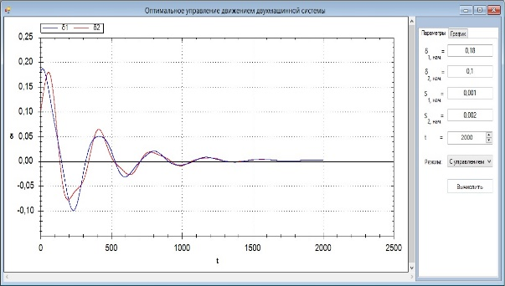

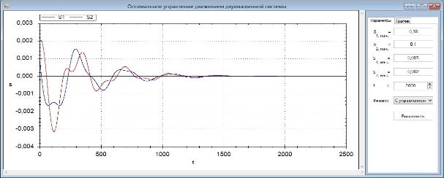

Figure28- Graphs of the function δ₁, δ₂ and S₁, S₂ with control.

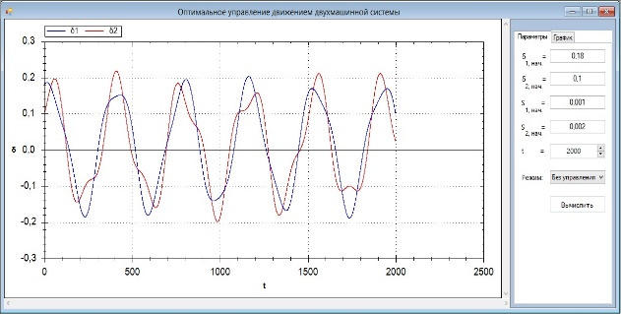
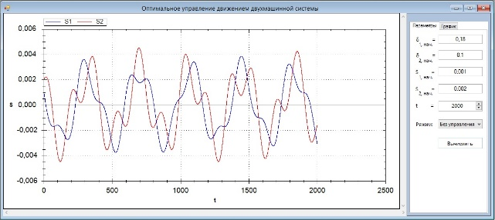

Figure 29 - Graphs of the function δ₁, δ₂ and S₁, S₂ without control.

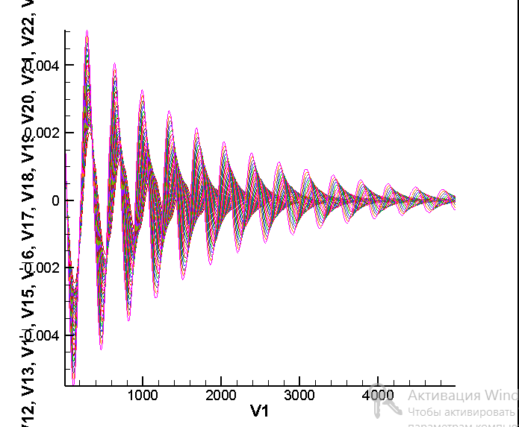
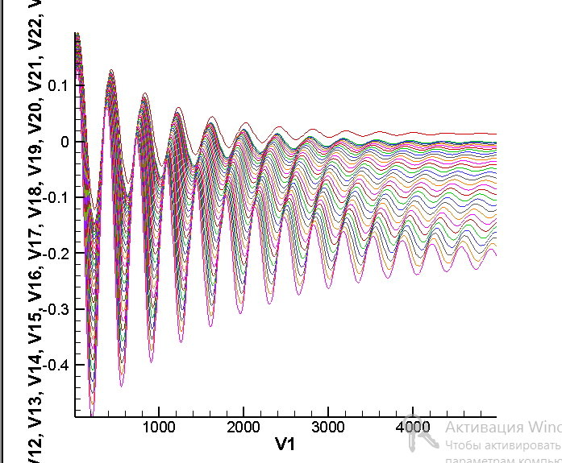
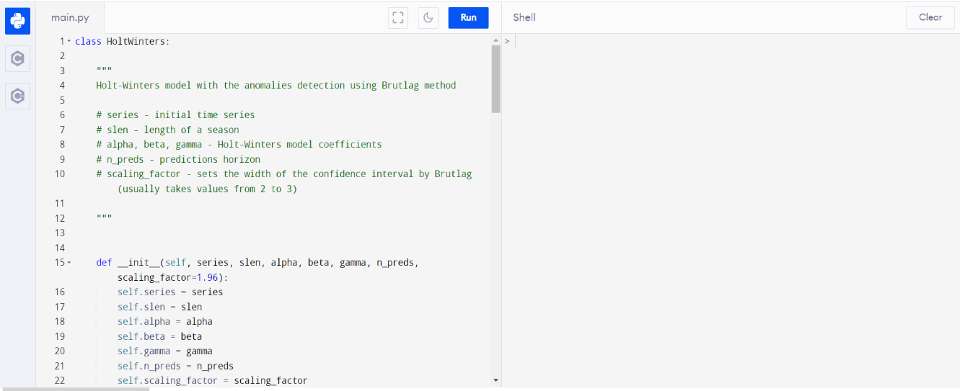
Figure30 - Graphs of the function δ_{i} and S_{i} at 1=30

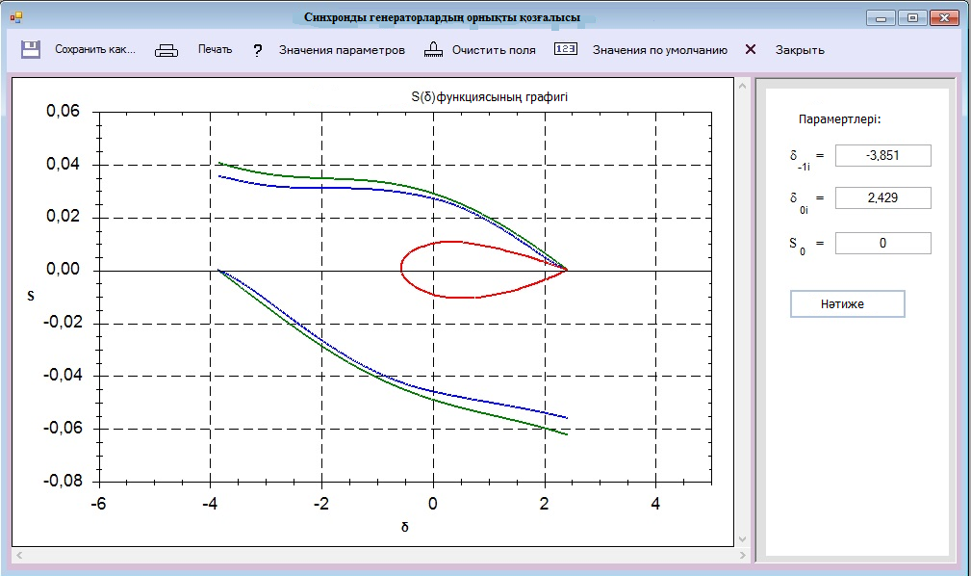
Figure31 - Stability of synchronous generator motion

Analysis of scattering diagrams (figures 32-33) shows the presence of directly proportional linear stochastic relationships between electricity consumption and GDP per capita, population growth and aging. A complete list of significant linear stochastic dependencies is presented in the correlation matrix in figure 39. It is noteworthy that such indicators as the price of electricity, the share of industry in GDP have little impact on electricity consumption.

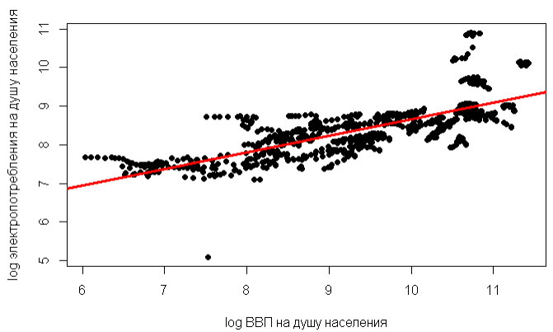
Figure 32-Dependence of electricity consumption on GDP per capital
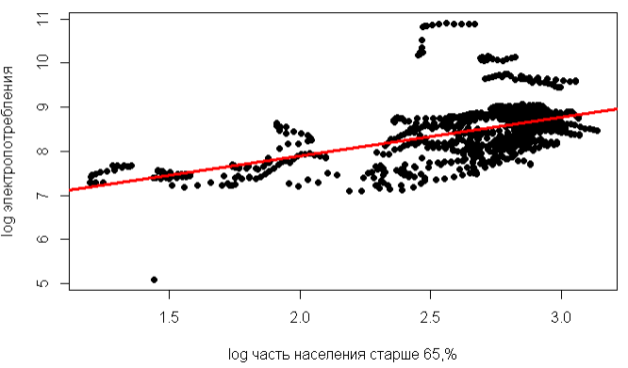
Figure 33-Dependence of electricity consumption on population aging
Source: software implementation in R according to data [5]

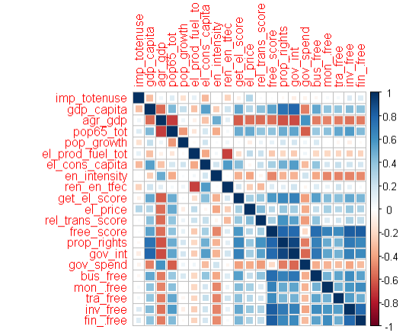
Figure 34-Correlation matrix
Source: software implementation in R based on data [5]

The next step is to study the causal relationships (causality) between variables based on the Granger test [12].
Based on the results of the above tests and statistical analysis, a basic linear regression model was built for pool data on electricity consumption:

All variables are significant for .
Adjusted coefficient of determination
F-statistics = 351.8 for degrees of freedom df = 795, p < 2.2 e-16.
Тo solve the problem, we used a robust covariance matrix to obtain effective estimates of coefficient errors

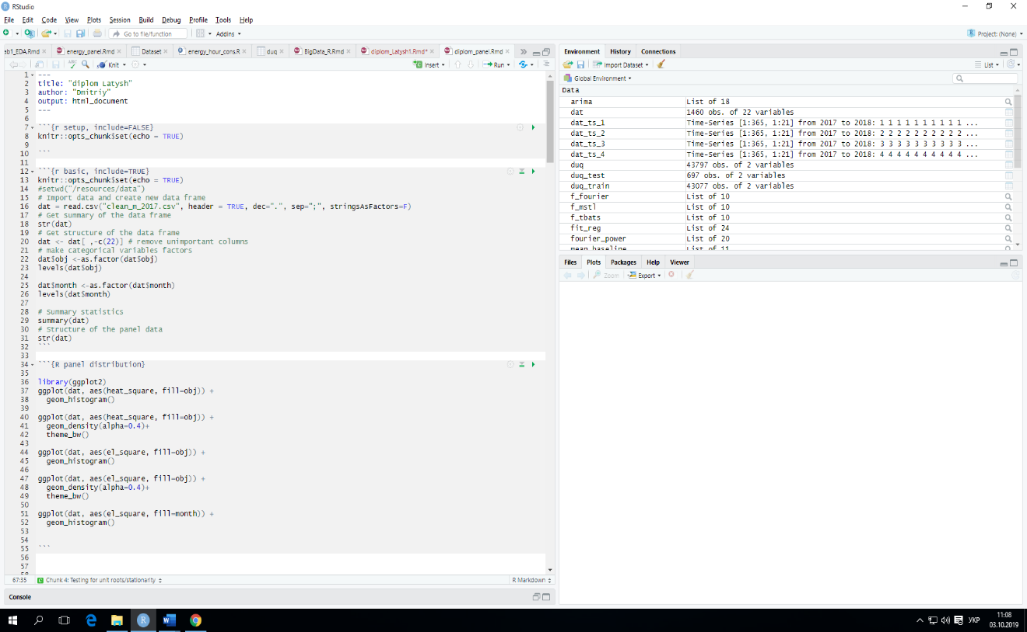
Figure 35-Power system forecast by day

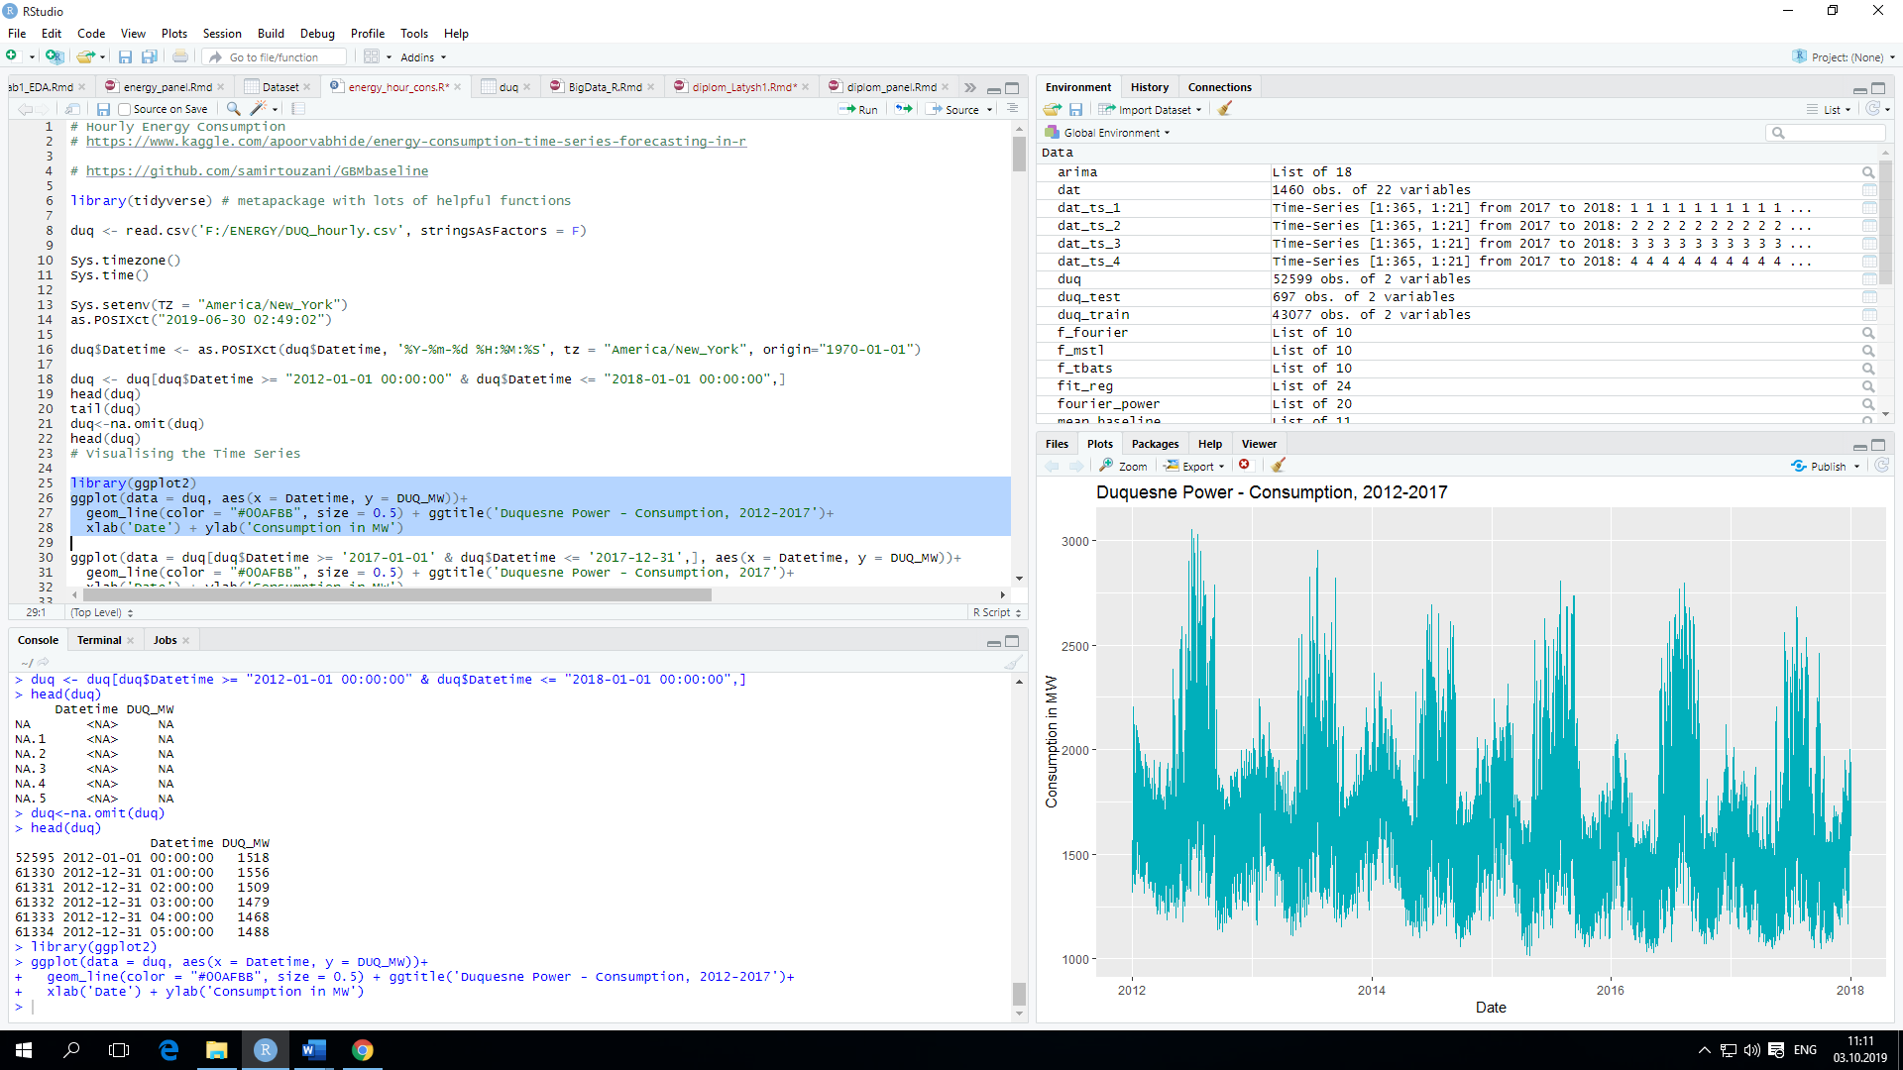
Figure 36-Visual inspection of power consumption time series points, considering possible sources of data changes, including weather, holidays, daily, weekly, and monthly frequency
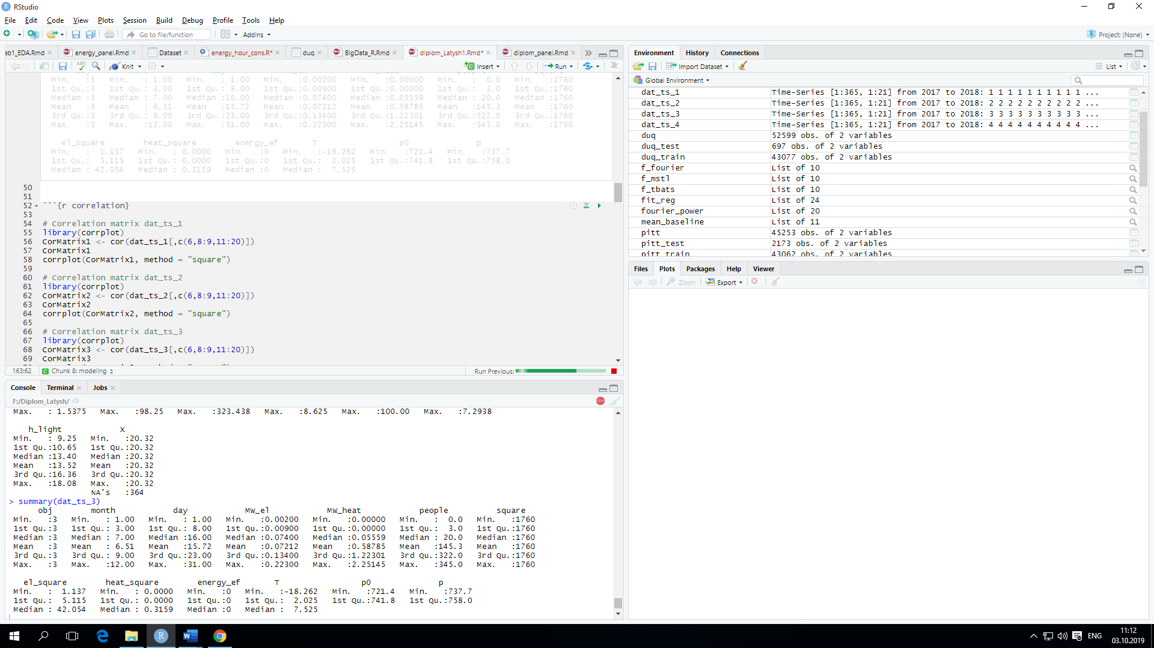
Figure 37-Data by day, week, and month

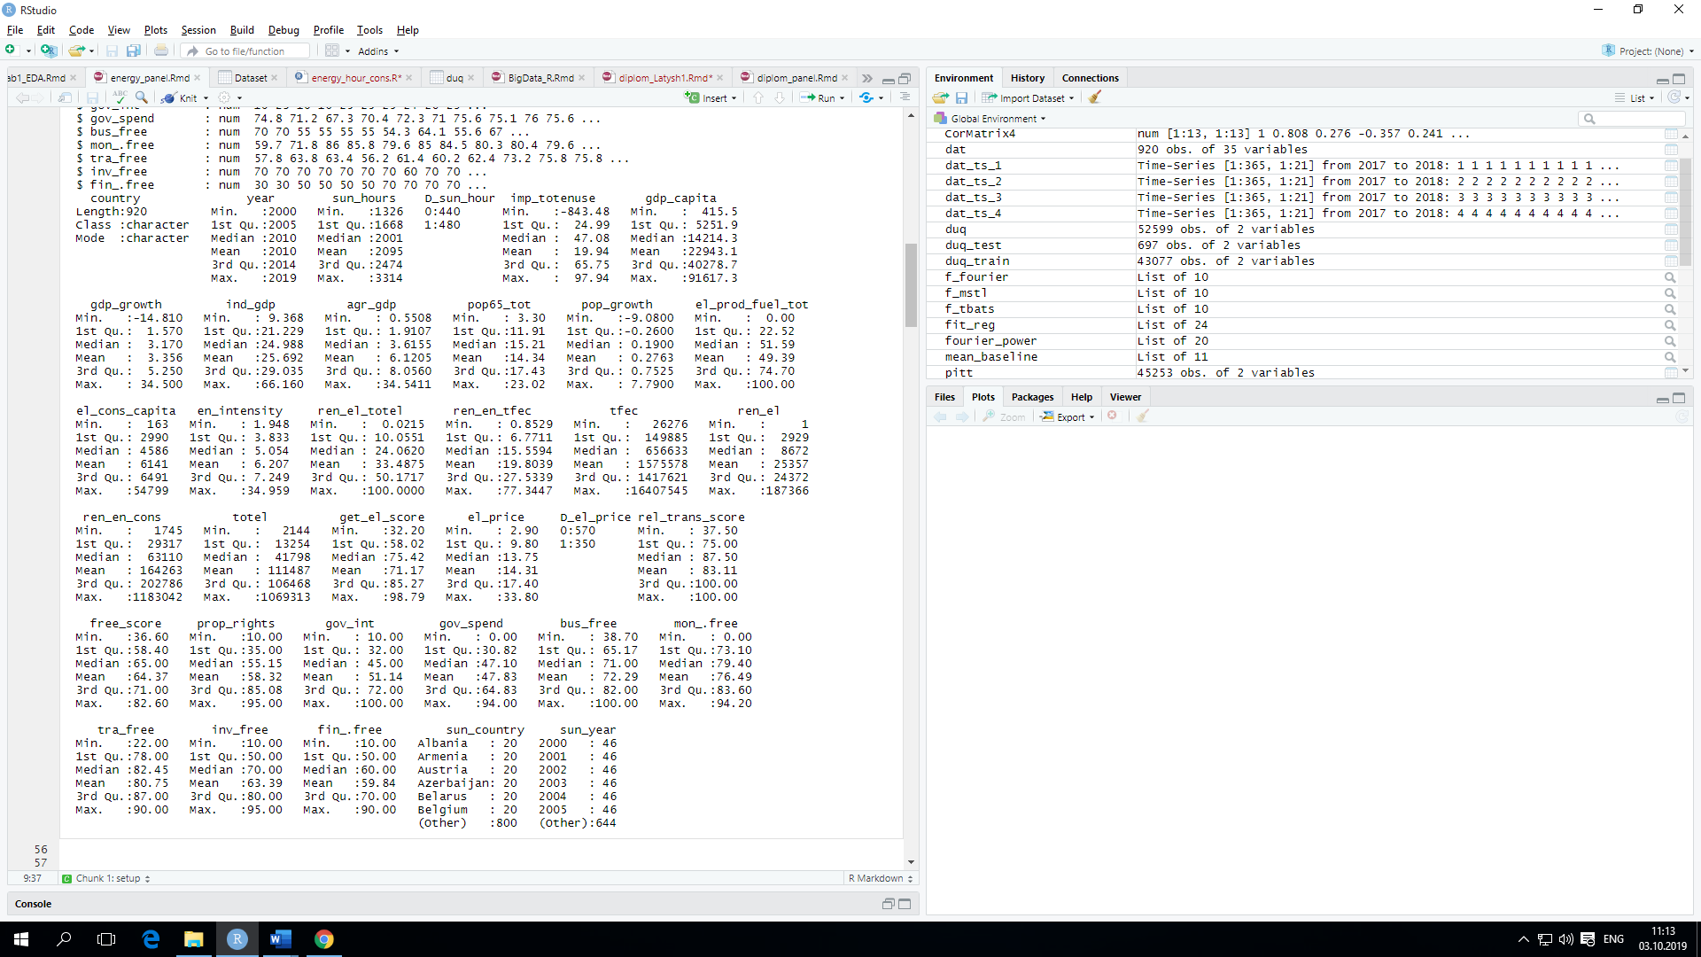
Figure 38- data by age
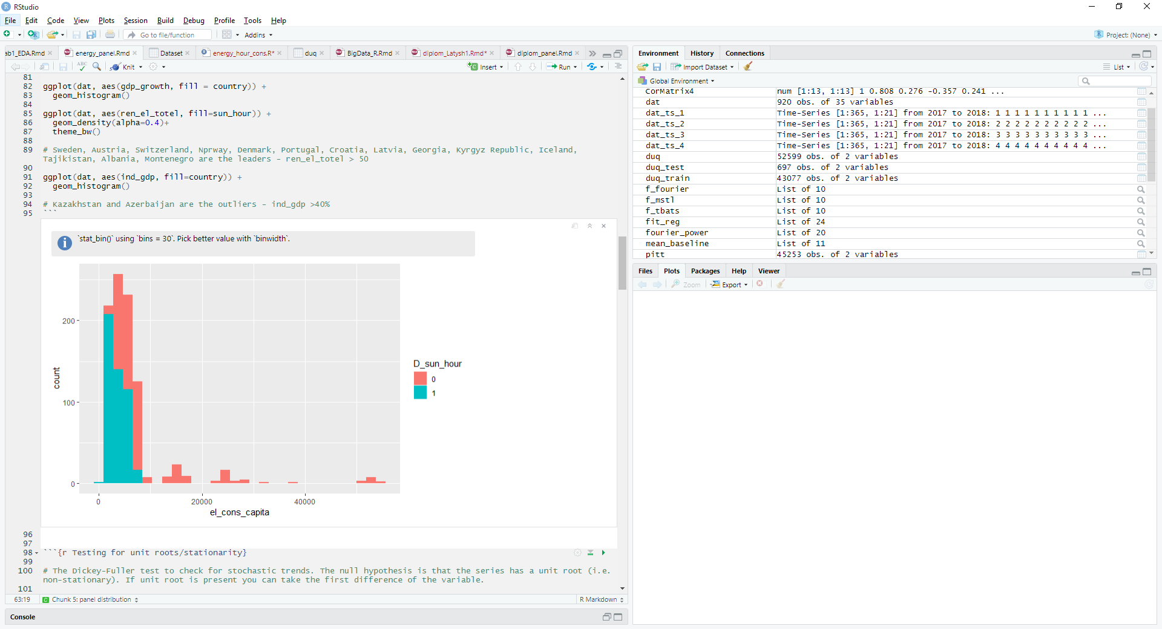
Figure 39-data on sunny days
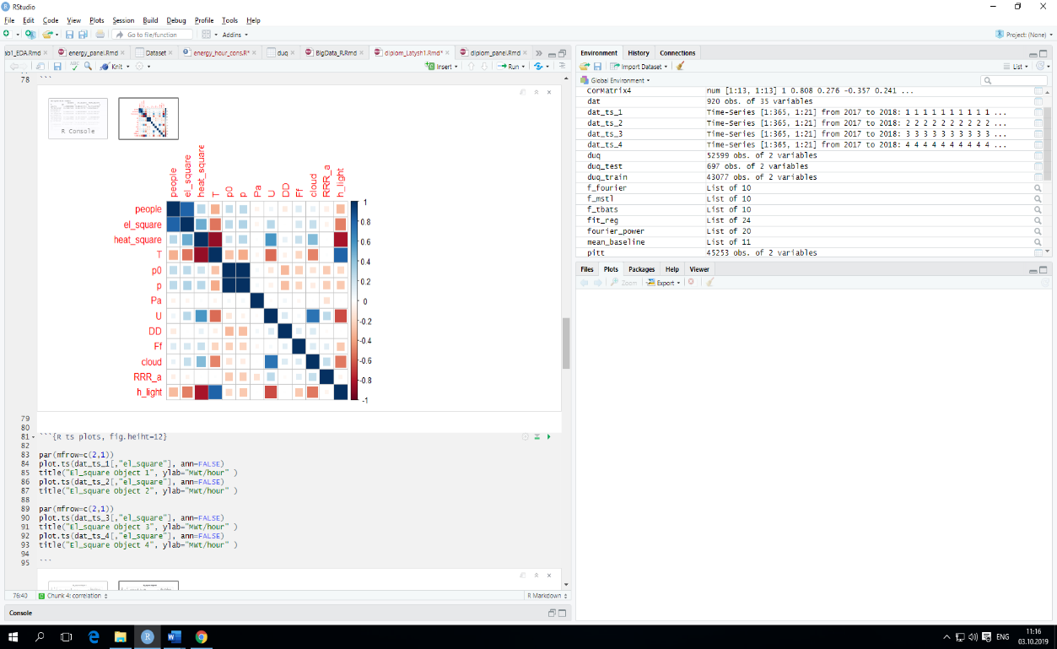
Figure 40-Correlation matrix

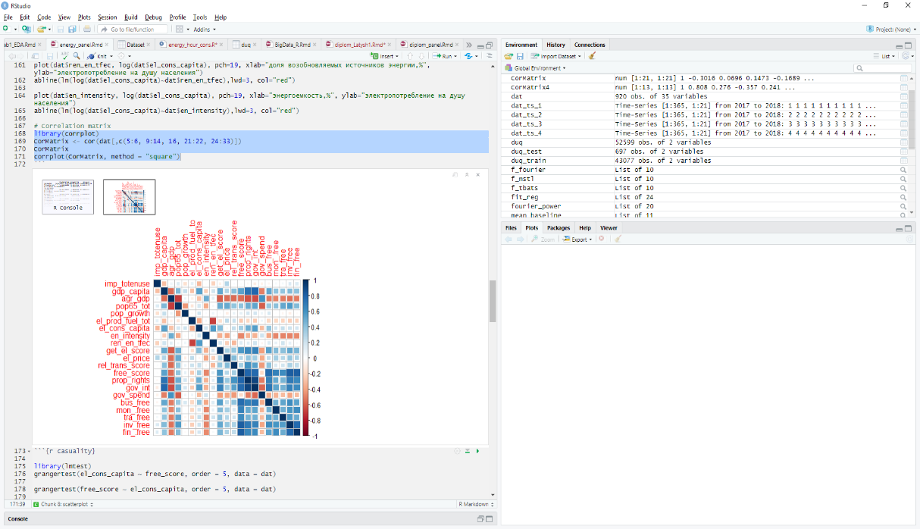
Figure 41-Correlation matrix
Also, the results of the experimental study are described in appendix G.

Conclusion
In the course of the second section, a pilot study was conducted, and the dynamics, distribution, linear stochastic relationships, and cause-and-effect relationships of energy sector indicators in 46 countries in Europe and Central Asia were studied. The dependence of indicators of electricity consumption per capita from such factors as GDP per capita, share of population older than 65 years in the total population, the part of renewable energy sources in gross final energy consumption structure, the proportion of energy imports. Special attention should be paid to the identified relationships between the volume of energy consumption and indicators of economic freedom, in particular, the protection of property rights, ease of doing business and getting access to electricity, and transparent market regulation rules. Methods for processing and analyzing experimental data are selected. The results of the experiment are summarized in tables, graphs, and formulas.
Based on the results of the second section for 2020, 1 article was published in a peer-reviewed scientific journal indexed in the Scopus database with a non-zero impact factor; 2 articles were published in the proceedings of international conferences.

CONCLUSION

The project solved all the main tasks set in the application and reflected in the calendar plan. The paper provides an analytical review of modern scientific and technical, regulatory, and methodological literature. As a result of the analytical review, the theoretical foundations for modeling performance management systems and forecasting the use of electric energy by consumers were selected, based on a combination of elements, generalized autoregressive moving average models (ARIMA), structural and co-integration models, deterministic and stochastic components of time series were studied, mathematical models were developed, deterministic and stochastic components of time series were studied, created UML diagrams and database structure intelligent information systems, requirements are established for information provision of EES created information model and defines the concept of RIS on the basis of mathematical models, designed and developed information system for the EPS studied IoT technologies based on mathematical models for the IMS, the dynamics, the distribution, the linear stochastic dependence and causality indicators of the energy sectors of 46 countries of Europe and Central Asia. The dependence of indicators of electricity consumption per capita from such factors as GDP per capita, share of population older than 65 years in the total population, the part of renewable energy sources in gross final energy consumption structure, the proportion of energy imports. Special attention should be paid to the identified relationships between the volume of energy consumption and indicators of economic freedom, in particular the protection of property rights, ease of doing business and getting access to electricity, and transparent market regulation rules. At the same time, the results obtained indicate that the considered variables are not causal in relation to the energy consumption indicator and its causality in relation to GDP growth and business freedom indicators. Also, the basic tenets of the theory of modeling of systems of performance management and forecasting of electric power consumers, based on the evaluation of the regularities of the dynamics of time series of internal (technical-economic, structural, modal) and external (meteorological, environmental, energy, macroeconomic) factors characterizing the system "generation – climatic conditions – power".
In the course of the work, an experimental study was conducted. Methods for processing and analyzing experimental data are selected. The results of the experiment are summarized in tables, graphs, and formulas.
The results of the implementation of scientific results are publications in peer-reviewed scientific publications indexed in the Science Citation Index Expanded database of Web of Science and having a CiteScore percentile in the Scopus database, in scientific and practical publications, testing of research results at international and national conferences, also, the results of the research were implemented in training courses and are used in the training of students and undergraduates of the higher school of information technology and engineering of Astana International University in the disciplines "Big Data Technologies" and "Applied artificial intelligence". Received 2 protection documents for the object of copyright.
The results of the study for 2020 were published: 2 articles in peer-reviewed scientific publication indexed in the databases Web of Science and Scopus with impact factor; 2 articles in peer-reviewed Russian scientific journal with impact factor, recommended KKSON MES RK received 2 author's certificates, 2 papers in proceedings of international conferences. Also, a monograph was prepared in English: Development of an intelligent information complex and mathematical models for modern electric power systems.
The results of the project can be applied to the design and operation of specific electric power complexes.

LIST OF SOURCES USED
- P. Sen, M. Roy, P. Pal. Application of ARIMA for forecasting energy consumption and GHG emission: A case study of an Indian pig iron manufacturing organization / // Energy. – 2016. - Vol. 116, – P. 1031–1038. //: 25.03.2020.
- Kalnik V. P. Methodology of operational management to spodivannya elektricno ENERG / VP Kalnik // Energetika. - 2013. - no. 1. - P. 49-53. / / http://nbuv.gov.ua/UJRN/eete_2013_1_10. : 11.07.2020.
- F. Zhang, C. Deb, S. Lee and oth. Time series forecasting for building energy consumption using weighted Support Vector Regression with differential evolution optimization technique /] // Energy and Buildings. –2016. - Vol.126. –P.94–103. http://dx.doi.org/10.1016/j.enbuild.2016.05.028 : 14.04.2020.
- H. Verdejo, A. Awerkin, C. Becker, G. Olguin. Statistic linear parametric techniques for residential electric energy demand forecasting. A review and an implementation to Chile / /Renewable and Sustainable Energy Reviews. – 2017. - Vol.74. – P.512–521. // http://dx.doi.org/10.1016/j.rser.2017.01.110. : 10.03.2020.
- Predicting electricity consumption for commercial and residential buildings using deep recurrent neural networks / A. Rahman, V. Srikumar, A. Smith // Applied Energy. – 2018. - Vol. 212. – P. 372–385. // https://doi.org/10.1016/j.apenergy.2017.12.051. : 14.04.2020.
- OECD/IEA 2015 Energy and Climate Change – World Energy Outlook Special Report,IEAPublishing. //https://www.iea.org/publications/freepublications/publication/WEO2015SpecialReportonEnergyandClimateChange.pdf. : 21.07.2020.
- C. Deb, F. Zhang, J. Yang and oth. A review on time series forecasting techniques for building energy consumption. Renewable and Sustainable Energy Reviews. – 2017. - Vol. 74. – P. 902–924. // http://dx.doi.org/10.1016/j.rser.2017.02.085. : 14.04.2020.
- M. Daut, M. Hassan, H. Abdullah and oth. Building electrical energy consumption forecasting analysis using conventional and artificial intelligence methods: Renewable and Sustainable Energy Reviews. – 2016. // http://dx.doi.org/10.1016/j.rser.2016.12.015. 15.08.2018.
- Son H. Short-term forecasting of electricity demand for the residential sector using weather and social variables / H. Son, C. Kim // Resources, Conservation and Recycling. – 2017. - Vol. 123. – P. 200–207. //https://doi.org/10.1016/j.resconrec.2016.01.016. : 21.05.2020.
- Official website of the state statistics service of Ukraine. – //: http://www.ukrstat.gov.ua. : 12.05.2020.
- Official website of the statistics Committee of the Ministry of national economy of the Republic of Kazakhstan. //http://stat.gov.kz. 18.09.2020.
- Official website of the Ministry of energy and coal industry of Ukraine. – //: http://mpe.kmu.gov.ua. 18.09.2020.
- L. Zhang, J. Wu, H. Liu. Policies to enhance the drivers of green housing development in China. Energy Policy. – 2018. -Vol. 121. – P.225–235. //:https://doi.org/10.1016/j.enpol.2018.06.029. : 15.07.2020.
- The World Bank Statistics. URL: https://data.worldbank.org : 25.07.2020.
- The Fraser Institute. Economic Freedom Dataset. URL: https://www.fraserinstitute.org/economic-freedom/dataset : 25.07.2020.
- ATFBank JSC of the Republic of Kazakhstan. Link to: https://www.atfbank.kz/docs/economics/energi_ru.pdf. : 25.07.2020
- Su Y.–W. Electricity demand in industrial and service sectors in Taiwan / Y.–W. Su // Energy Efficiency. – 2018. - Vol. 11, Issue 6. – P. 1541–1557. //:https://doi.org/10.1007/s12053-018-9615-y. : 06.08.2020.
- Carvalho A. Energy efficiency in transition economies: A stochastic frontier approach / A. Carvalho // Economics of Transition. – 2018. - Vol. 26, Issue 3. – P. 553–578. https://doi.org/10.1111/ecot.12152. : 20.05.2020.
- Swan L. Modeling of end-use energy consumption in the residential sector: A review of modeling techniques / L.Swan, V. Ugursal // Renewable and Sustainable Energy Reviews. – 2009. -Vol. 13, Issue 8. – P. 1819–1835. //:https://doi.org/10.1016/j.rser.2008.09.033. : 14.07.2020.
- Hyndman R. J. Forecasting: principles and practice / R. J Hyndman, G. Athanasopoulos. – Otexts, 2013. //:https://www.otexts.org/fpp. 20.01.2020. :
- Fernandez-Villaverde J. The Econometrics of DSGE Models / J. Fernandez-Villaverde // NBER Working Paper. – 2009. – № 14677 //:http://www.nber.org/papers/ w14677.pdf. 25.03.2020.
- Energy Consumption Forecasting Using ARIMA and Neural Network Models / C. Nichiforov, I. Stamatescu, I. Fagarasan, G. Stamatescu // 5th International Symposium on Electrical and Electronics Engineering (ISEEE). – 2017. //:https://doi.org/10.1109/ISEEE.2017.8170657. 15.04.2020
- Johansen S. Modelling of Cointegration in the Vector Autoregressive Model / S. Johansen // Economic Modelling. – 2000. – No. 17. – P. 359–373.
- Abdildayeva A.A., Zhukabayeva T.K., Akhmetzhanov M.A. Electric power engineersқ zhuyelerdi basgaru үshin multiagenttik zhuyeni modeldeu // Bulletin of KazNTU, Technical sciences - 2020. - №3 (139). - S. 667-673.(in Kazakh)
- Maksat N. Kalimoldayev, Assel A. Abdildayeva, Orken Zh. Mamyrbayev, and Maksat Akhmetzhanov Information system based on the mathematical model of the EPS // Open Engineering. - 2016. -Vol. 6, Issue 1, ISSN (Online) 2391-5439, DOI: 10.1515/eng-2016-0053. - P. 464–469
- Aisagaliyev S. A. Analysis and synthesis of Autonomous nonlinear systems of automatic control. - Alma-ATA: Science of the Kazakh SSR, 1980. - 244 p. (in Russian)
- Aisagaliyev S.A. Manageability nonlinear control systems // Izv. Kazakh SSR, Ser. nat. - Mat. -1987. - № 3. - Р. 7-10. (in Russian)
- Kalimoldayev M., Abdildayeva A., Zhukabayeva T., Turaev S. The investigation of the Internet of Things (IoT) in electric power systems // News of the National Academy of Sciences of the Republic of Kazakhstan series of Geology and Technical Sciences. – 2019. - Vol. 5, Nо 437. - Р. 144 – 150. // https://doi.org/10.32014/2019.2518-170X.136: 25.03.2020

APPENDIX A
Calendar plan for 2020

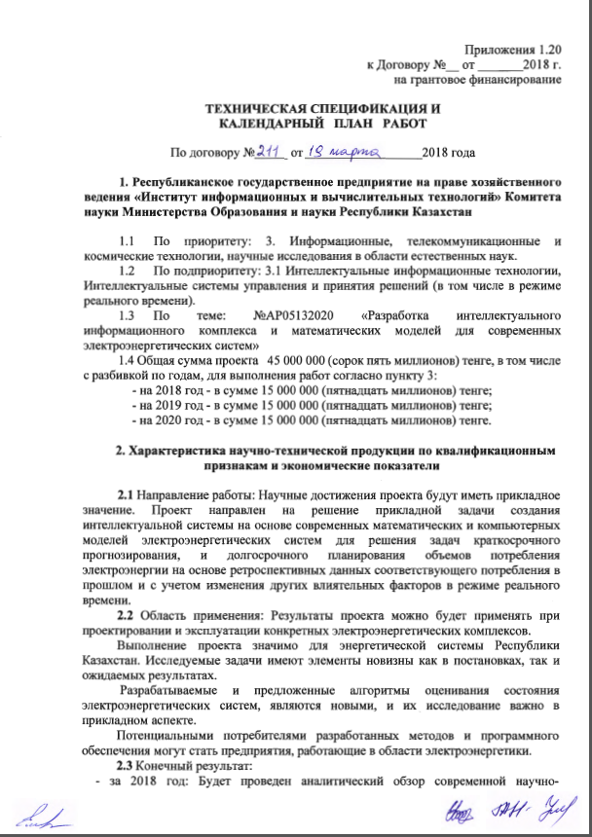

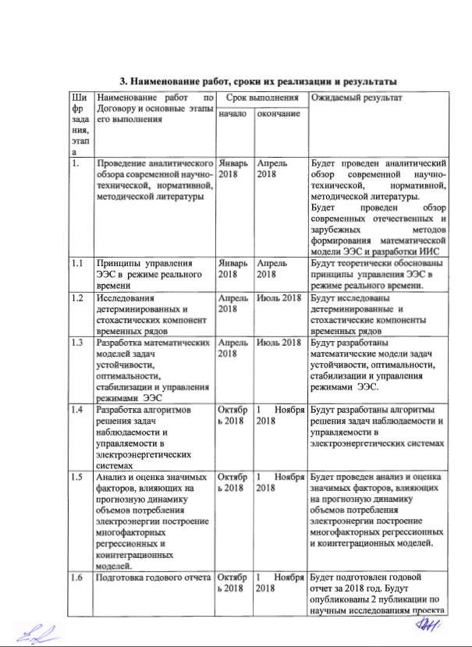
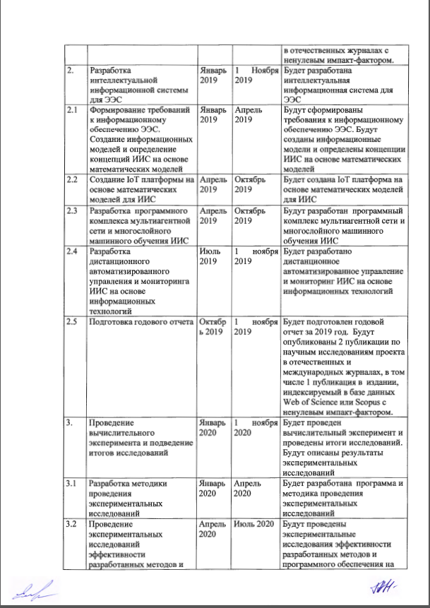

Appendix 1.20
to the contract no. __ from _ _ _ _ _ 2018
on scientific grant funding

TECHNICAL SPECIFICATION AND CALENDAR PLAN
Under the contract no. _ _ _ _ of __________________2018 years

1. RSE on PCBs "Institute information systems and computing services technologies» Science Committee of MES RK
  - Priority area: 3. Informational, telecommunications and space technologies, scientific research in natural sciences.
  - Sub-priority area: 3.1 Intellectual information technologies, Intelligent control and decision-making systems (including the real time mode).
  - Project title: №АР05132020 «Development of intelligent information system and mathematical models for modern electric power systems»
1.4 General Information: project amount 45 000 000 (forty-five million) tenge, broken down by years, to perform activities according to point 3:
- in 2018, in the amount of 15 000 000 (fifteen million) tenge;
- for 2019 in the amount of 15 000 000 (fifteen million) tenge;
- 2020 - in the amount of 15 000 000 (fifteen million) tenge.
2. Description of scientific and technical qualification features and economic indicators
2.1 Area of work: The outcomes of the project will have an application value. The project aims at the solution of the task of creating intellectual system the basis of modern mathematical and computer models of electricity systems for the decision of short-term forecasting and long-term planning the volume of consumption electricity on the basis of retrospective data corresponding consumption in the past, and changes other influential factors in real time.
2.2 Application: Results the project can be will applied when designing and operation of specific electric power complexes.
The implementation of the project is significant for the energy industry systems of the Republic Kazakhstan. The project objectives offer novelty in the statement of the problem and in expected results. The proposed algorithms of evaluation of electric power systems are new and this research is important in the applied aspect.
Potential consumers are business companies and enterprises, working in the region electric power industry.
2.3 Results:
- for 2018: The review of modern technology scientific and technical, regulatory and methodological literature will be conducted; The management principles electric power companies systems (ES) in real time will be researched; the deterministic values and stochastic components of temporary rows will be investigated; the mathematical features issue models sustainability, opticalities, stabilizations and management EES modes will be developed; algorithms of problem solving observability and manageability in electric power plants systems will be developed; the analysis and evaluation of significant factors affecting on the forecast page dynamics of volumes consumption electricity building multivariate regression and cointegration models will be carried out; the annual report for 2018 will be prepared; the papers from scientific research project will be published in domestic and international magazines (1 publication in ranked peer-reviewed journal).
- for 2019: the intelligent information system (AIS) for EES will be developed; the requirements to the information center providing EES will be formulated; the informational resources models and defined AIS concepts based on mathematical models will be created, an IoT platform has been created based on mathematical models for AIS program level complex multi-agent system network and multi-layer <url> IIS training will be developed, the remote control automated management and monitoring IIS based on information systems technologies will be developed, the annual report for 2019 will be prepared. The papers from research project will be published in domestic and international journals, including a publication in ranked journal.
- for 2020: The computing experiment will be conducted and the research results finalized, the method of conducting experimental data research will be developed; the experimental research of the efficiency of developed methods on various platforms of test tasks and various configurations of target platform will be conducted; the comprehensive testing IoT platforms in the in real time mode EES time will be conducted; The results of the project will be summarized; the annual report for 2020 will be written; the papers from research project will be published in domestic and international journals, including 1 publication in ranked journal.
2.4 Patentability: there are no patents planned
2.5 Scientific and technical novelty: Scientific novelty of the work is that intellectual information control system will be developed and new algorithms of evaluation will be suggested, will be used in conditions of partial and incomplete observability and will provide more effective assessments system mode in real time.
2.6 Usage of scientific and technical products performed by: the executor
2.7 Type of application of the results of scientific and (or) scientific and technical activities: theoretical and practical knowledge in the field of artificial intelligence, design of information systems, programming, development of information systems and mathematical modelling of complicated electric power plants systems
3. Name of activity, implementation dates and results
Code number tasks, stages |  | Name of activity on Contract and main stages its execution | Due date |  |  | Expected results
 |  | Name of activity on Contract and main stages its execution | beginning | ending |  | Expected results
1. |  | Conducting review of recent scientific, technical, regulatory and methodological literature | January 2018 | April 2018 |  | The review of recent scientific, technical, regulatory and methodological literature will be conducted.
1.1 |  | The management principles of EES in operation mode in real time | January 2018 | April 2018 |  | The management principles of EES in operation mode in real time will be investigated
1.2 |  | Research of deterministic and stochastic components of temporary rows | April 2018 | July 2018 |  | The deterministic and stochastic components of temporary rows will be investigated
1.3 |  | Development of mathematical models of sustainability, opticalities, stabilizations and management EES modes | April 2018 | July 2018 |  | The mathematical features issue models of sustainability, optimalities, stabilizations and management with EES modes will be developed.
1.4 |  | Development of algorithms of problem-solving observability and manageability in electric power plants systems | October 2018 | November 2018 |  | The algorithms problem solving observability and manageability in electric power plants systems will be developed
1.5 |  | Analysis and evaluation of significant factors, affecting the predictive value volume dynamics consumption electricity generation build multiple factors regression models and co-integration processes models. | October 2018 | November 1 2018 |  | Analysis and evaluation of significant factors, affecting the predictive value volume dynamics consumption electricity generation build multiple factors regression models and co-integration processes models will be carried out
1.6 |  | Preparation of annual report | October 2018 | 1 November 2018 |  | The annual report for 2018 will be prepared. The papers from the research project will be published in domestic and international journals including 1 publication in ranked journal.
2. |  | Development of intellectual property information system systems for EES | January 2019 | November 1 2019 |  | intelligent information system the system for EES will be developed
2.1 |  | Preparation of the requirements to information provision of EES. Creation information systems models and definition concepts of EES based on mathematical models | January 2019 | April 2019 |  | The requirements to information provision of EES will be generated. The information models and concepts of EES based on mathematical models will be developed
2.2 |  | Creation of IoT platforms based on mathematical models for AIS | April 2019 | October 2019 |  | The IoT platform will be created based on mathematical models for AIS
2.3 |  | Development of software of the complex multi-agent system network and multi-layer IIS training | April 2019 | October 2019 |  | Program level complex multi-agent system network and multi-layer IIS training will be developed
2.4 |  | Development of remote control of automated management and monitoring IIS based on information systems technologies | July 2019 | November 1 2019 |  | Remote control of automated management and monitoring IIS based on information systems technologies will be developed
2.5 |  | Preparation of annual report | October 2019 | 1 November 2019 |  | The annual report for 2019 will be prepared. The papers from scientific data of research project will be published in domestic and international journals, including 1 publication in ranked journal.
3. |  | Conducting of computing experiment and summing up the research results | January 2020 | November 1 2020 |  | The computing experiment will be conducted and research results generated
3.1 |  | Development of methods of experimental data research | January 2020 | April 2020 |  | The methodology of experimental data research will be developed
3.2 |  | Conducting experimental data research efficiency developed methods and software security features on various platforms test suites tasks and various configurations target platform | April 2020 | July 2020 |  | The experimental data research efficiency developed methods and software security features on various platforms test suites tasks and various configurations target platform will be developed
3.3 |  | Complex testing of IoT platforms in real time EES | July 2020 | October 2020 |  | It will be conducted comprehensive testing IoT platforms in real time EES
3.4 |  | Summarizing the results of the research project. | October 2020 | November 1 2020 |  | The research results for the project will be summarized. The annual report for 2020 will be prepared. The papers from the research project will be published in domestic and international journals, including 1 publication in ranked journal.
 | from the side of customer:  Chairman of Science Committee of the Ministry of Education and Science of the Republic of Kazakhstan»  _______________ Abdrasilov S.B. |  |  |  | from the side of performer:  Deputy General Director of the "Institute of information and computing services " of the Science Committee of the Ministry of Science of the Republic of Kazakhstan  _________________ Mamyrbayev O. Zh.  Approved:  Chief executor (principal investogator)’s name  ___________________ Abdildayeva A. A.  (signature)

APPLICATION B
List of publications in 2020

1 M. Kalimoldayev, M. Jenaliyev, A. Abdildayeva, T. Zhukabayeva, M. Akhmetzhanov OPTIMAL CONTROL OF POWER SYSTEMS / / News of the National Academy of Sciences of the Republic of Kazakhstan series of Physico-Mathematical Series. - 2020. - Vol. 5, No 333. - P. 86-94. //https://doi.org/10.32014/2020.2518-1726.86
2 Maksat Kalimoldayev, Aleksey Drozdenko, Igor Koplyk, T. Marinich, Assel Abdildayeva and Tamara Zhukabayeva Analysis of modern approaches for the prediction of electric energy consumption// Open Engineering. – 2020. - Vol. 10, No. 1. - P. 350 – 361. https://doi.org/10.1515/eng-2020-0028
3 M. N. Alimandi, A. A. Abdildayeva, M. A. Akhmetzhanov Crdel e-energetically gielerak "lend" ornithine mathematically of Modellbau // Bulletin of Kaznitu, Technical Sciences– 2020. - №3(139). – Pp. 604-611.
4 A. A. Abdildayeva, Jumabaeva T. K., Akhmetzhanov A. M. E energetically Gielen Basara ushin multiagent Jian of Modellbau // Bulletin of Kaznitu, Technical Sciences– 2020. - №3(139). – P. 667-673.
5 Drozdenko A. A., Koplyk I. V., Abdildaeva A. A., Taganova G. Analysis of energy efficiency of functioning of Electromechanical systems // Matera. scientific Conf. Iivt MES RK "Modern problems of Informatics and computing technologies". - Almaty, 2020. - P. 375-400.
6 A. S. 4811. Computer program "electricity demand forecasting Program". Decision on registration of the contract that concerns the author's right to the work Ministry of economic development, trade and agriculture of the state of Ukraine / Koplyk Igor Vladimirovich, Drozdenko Alexey Aleksandrovich, Marinich Tatyana Aleksandrovna, Abdildayeva Asel Asylbekovna, Zhukabayeva Tamara Kokenievna.; publ. 24.01.2020 – - 1 p.
- A. S. 4812. Computer program "program for forecasting hourly electricity consumption". Decision on registration of the contract that concerns the author's right to the work Ministry of economic development, trade and agriculture of the state of Ukraine / Koplyk Igor Vladimirovich, Drozdenko Alexey Aleksandrovich, Marinich Tatyana Aleksandrovna, Abdildayeva Asel Asylbekovna, Zhukabayeva Tamara Kokenievna.; publ. 24.01.2020 – - 1 p.
- Abdildayeva A. A. Development of an intelligent information complex and mathematical models for modern electric power systems. – Nur-Sultan, 2020. – 88 p. ISBN 978-601-7243-10-4

List of publications in 2019

1 Kalimoldayev M., Abdildayeva A., Zhukabayeva T., Turayev S. The investigation of the Internet of Things (IoT) in electric power systems / / News of the National Academy of Sciences of the Republic of Kazakhstan series of Geology and Technical Sciences – - 2019. - Vol. 5, No 437. - P. 144-150. / / https://doi.org/10.32014/2019.2518-170X.136
2. A. A. Abdildayeva, Jumabaeva T. K., T. A. Marinich, Koplyk I. V., Drozdenko A. A. Macrodata poison energiesin ttymode balaudi statistically directer of thalgau // Bulletin of Kaznitu, Technical Sciences-2019. - no. 4. - Pp. 417-422.
3 Kalimoldaev M. N., Drozdenko A. A., Koplyk I. V., Marinich, T. A., A. A. Abdildayeva, Jumabaeva T. K., F. M. Galieva, the Electric energiesin ttymode balaudi modern Zamani tsiders of thalgau // Bulletin KazNTU, engineering science – 2019. - No. 5. – S. 297-306.
4 Kalimoldaev M. N., A. A. abdildayeva, Jumabaeva T. K., F. M. Galieva Kazakhstan electric energetically gies ushin mathematically model ru \\ Mater. scientific Conf. Iivt MES RK "Modern problems of Informatics and computing technologies". - Almaty, 2019. - P. 45-51.
5 Sotnyk M. I., Telizhenko O. M., Drozdenko O. O., Baistriuchenko N. O., Koplyk I. V., Abdildayeva A. A., Zhukabayeva T. K. Simulation of heat electricity consumption by separate entities based on operational monitoring subsystems // Mater. IV international. scientific and practical Conf. "Informatics and applied mathematics", dedicated to the 70th anniversary of Prof. Biyarov T. N., V. Wójcik and the 60th anniversary of Prof. Amirgalieva E. N.-Almaty, 2019. - P. 86-91.
6 Baimanov S. S., A. A. Abdildayeva, Shakirova A. K. Modern optimization techniques in power systems // Matera. IV international. scientific and practical Conf. "Informatics and applied mathematics", dedicated to the 70th anniversary of Prof. Biyarov T. N., V. Wójcik and the 60th anniversary of Prof. Amirgalieva E. N.-Almaty, 2019. - P. 209-219.
7 Kalimoldaev M. N., Abdildayeva A. A., Zhukabayeva T. K. multi-Agent technologies for managing an intelligent electric power system // Matera. IV international. scientific and practical Conf. "Informatics and applied mathematics", dedicated to the 70th anniversary of Prof. Biyarov T. N., V. Wójcik and the 60th anniversary of Prof. Amirgalieva E. N.-Almaty, 2019. - P. 319-333.
8 A. S. 2631. Development of an intelligent information and complex mathematical models for modern electric power systems. Certificate of entering information in the state register of rights to objects protected by copyright of the Republic of Kazakhstan. / Kalimoldaev M. N., Abdildayeva A. A., Zhukabayeva T. K., Galieva F. M.: publ. 04.04.2019. - 1 p.
9 A. S. 5691. Models and methods of a multi-agent decision support system for managing electric power systems. Certificate of entering information into the state register of rights to objects protected by copyright of the Republic of Kazakhstan / Abdildayeva A. A., Zhukabayeva T. K.; publ. 09.10.2019. - 1 p.
10 A. S. 5703. Research of the dispatching system of electric power complexes. Certificate of entering information into the state register of rights to objects protected by copyright of the Republic of Kazakhstan / Abdildayeva A. A., Zhukabayeva T. K.; publ. 10.10.2019 – - 1 p.

List of publications for 2018

1. Kalimoldayev M. N., Abdildayeva A. A., Duzbayev T., Galiyeva F. M. stability of the movement of the electric power system / / Mater. XIV International. Asian school-seminar "problems of optimization of complex systems". – Republic of Kyrgyzstan, 2018. – Ch. 1. - P.52-58.
2. Abdildayeva A. A., Drozdenko A. A., Coplyk I. V., Marinich T. A., Galiyeva F. M. analysis of modern approaches to forecasting the consumption of electric energy // Mater. III International. "no," I said. conf. "Computer science and applied mathematics", post. 80th anniversary of Prof. Biyasheva R. G. and the 70th anniversary of Prof. Aidarkhanova M. B.-Almaty, 2018. - Ch. 2 – P.259-266.
3 Kalimoldayev M. N., Abdildayeva A. A., Akhmetzhanov M.A., Galiyeva F.M. Mathematical modeling of the problem of optimal control of electric power systems // Izvestia NAN RK. Series Fiz."Matt. - 2018. - №5(321). - P.62-67.
4. Abdildayeva A. A., Galiyeva F. M., Bazarbekova M. O., Dauletbek E. T. on the intellectual system and mathematical models of the electric power system / / Nauch. conf. IIVT Mon RK "modern problems of Informatics and research technologies" – Almaty, 2018, pp. 41-46.
5. Abdildayeva A. A., Drozdenko A. A., Coplyk I. V., Marinich T. A. analysis of modern methods of modeling the consumption of electric energy // Nauch. conf. IICT Mon RK "modern problems of Informatics and research technologies" – Almaty, 2018, pp. 46-50.
6. Maksat Kalimoldayev, Assel Abdildayeva, Maksat Akhmetzhanov, Beglan Namazbayev About the Numerical Solution of Optimal Control Problems for Complex Electric Power Systems / / IX International Conference on Optimization Methods and applications Optimization and applications (OPTIMA-2018) - Petrovas, Montenegro, 2018. - P. 89-90
7. Kalimoldayev M. N., Abdildayeva A. A., Akhmetzhanov M. A., Galiyeva F. M. optimization of the system of automatic regulation with the help of a modal control system // Bulletin of KazNPU. Series "physical and Mathematical Sciences" - 2018. - №3(63). - P.67-73.

APPENDIX B
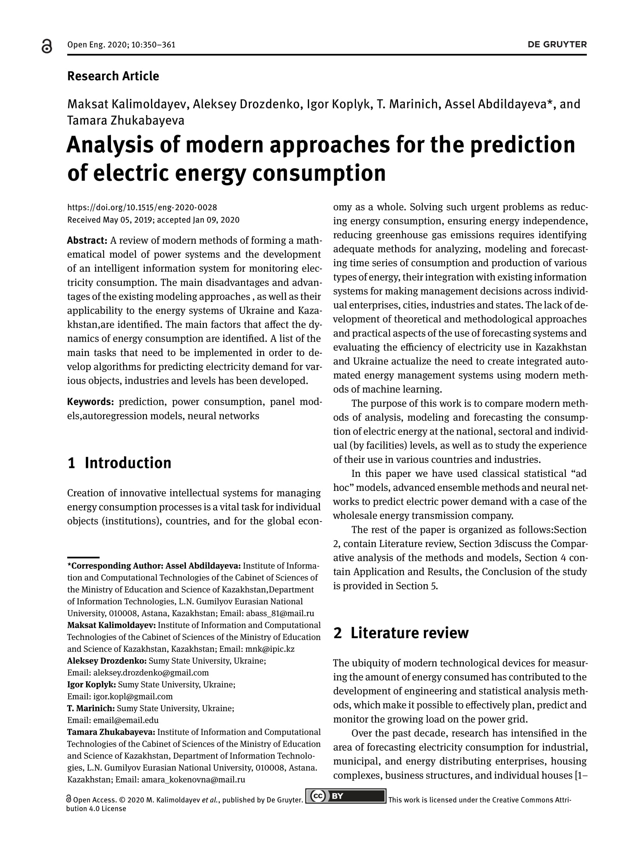
Reprints of articles in 2020

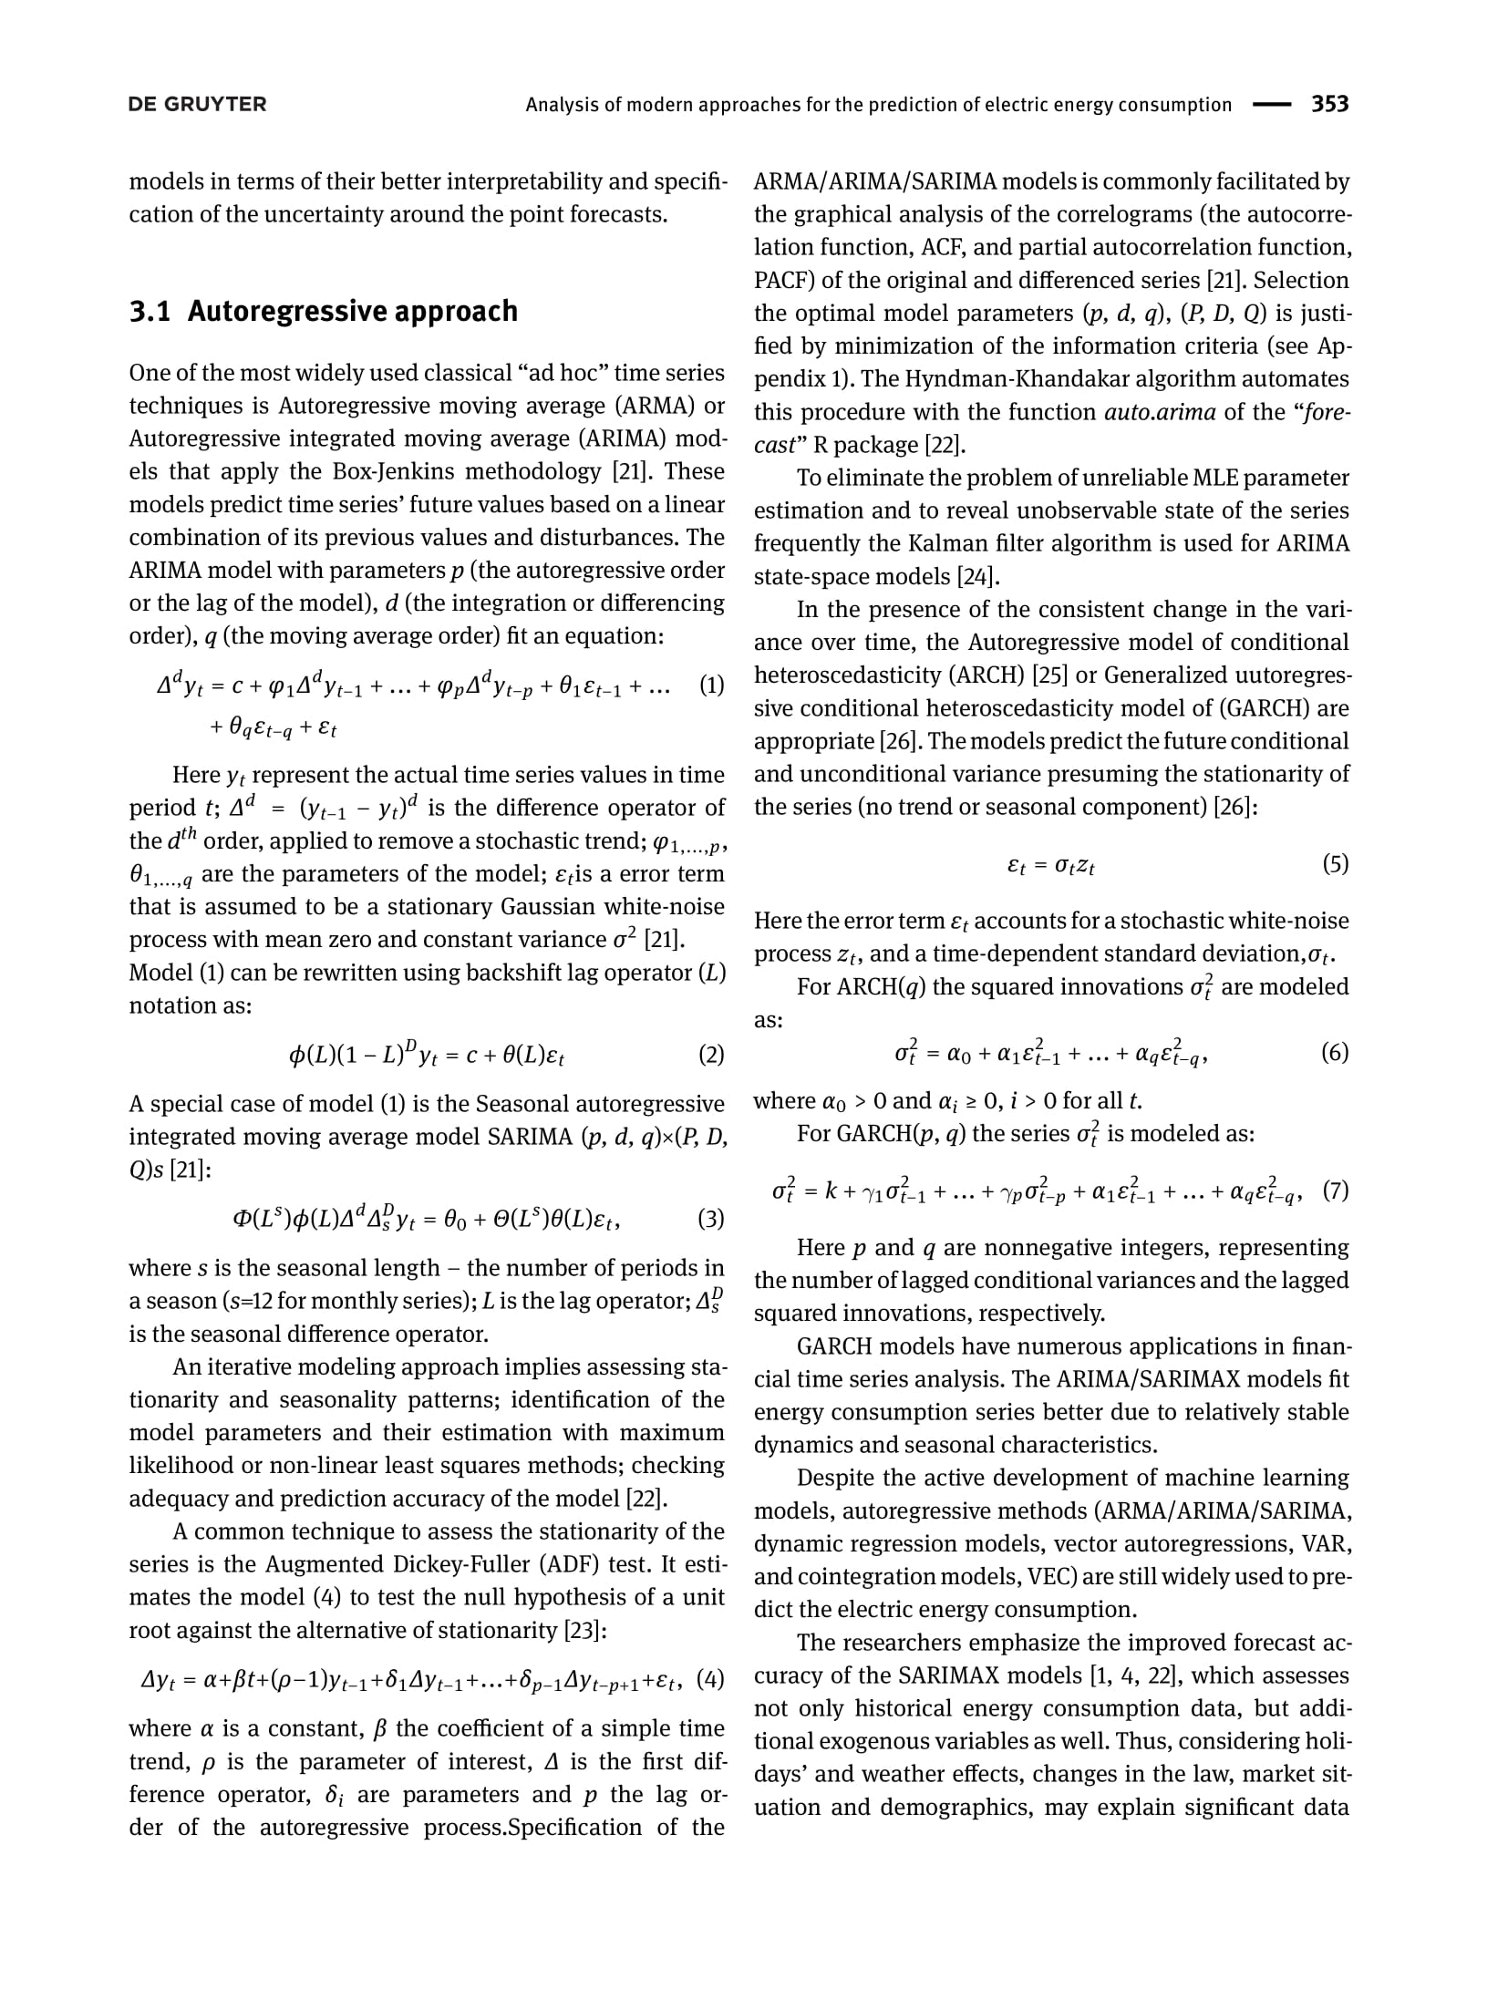

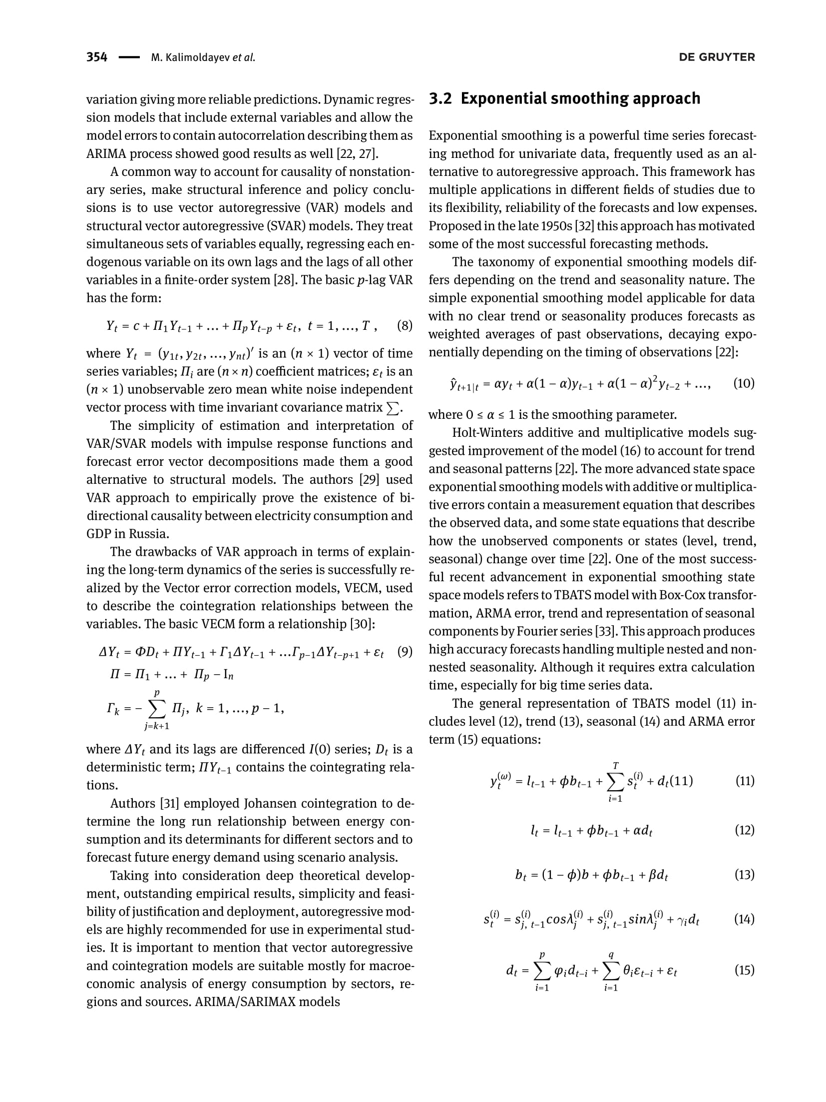

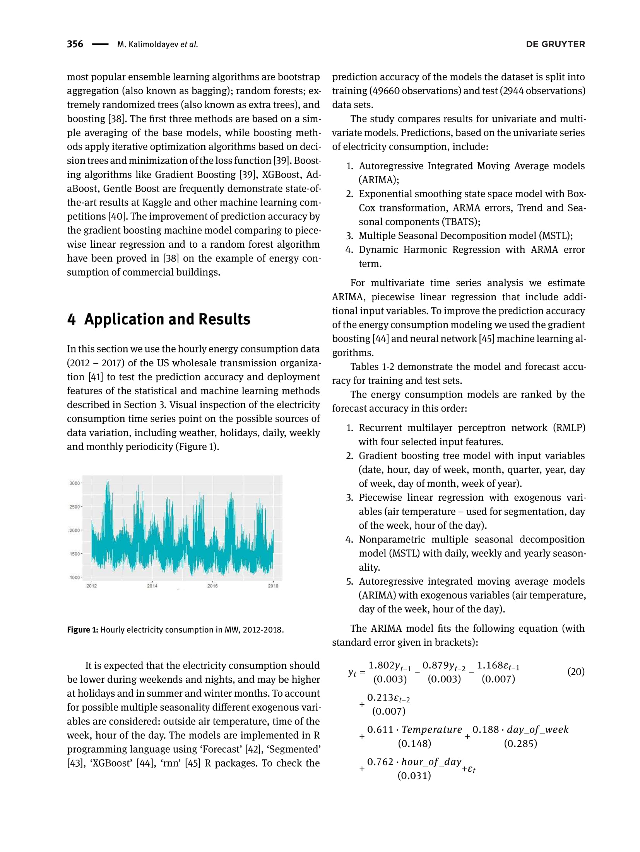

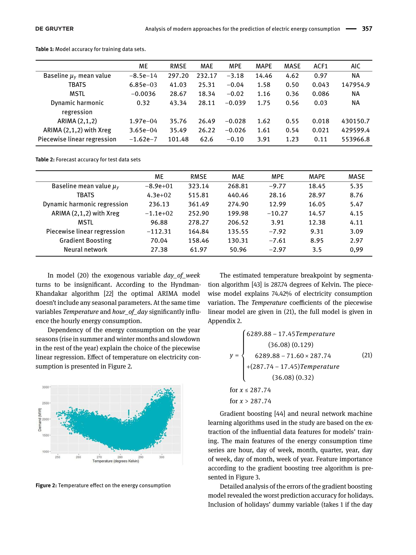

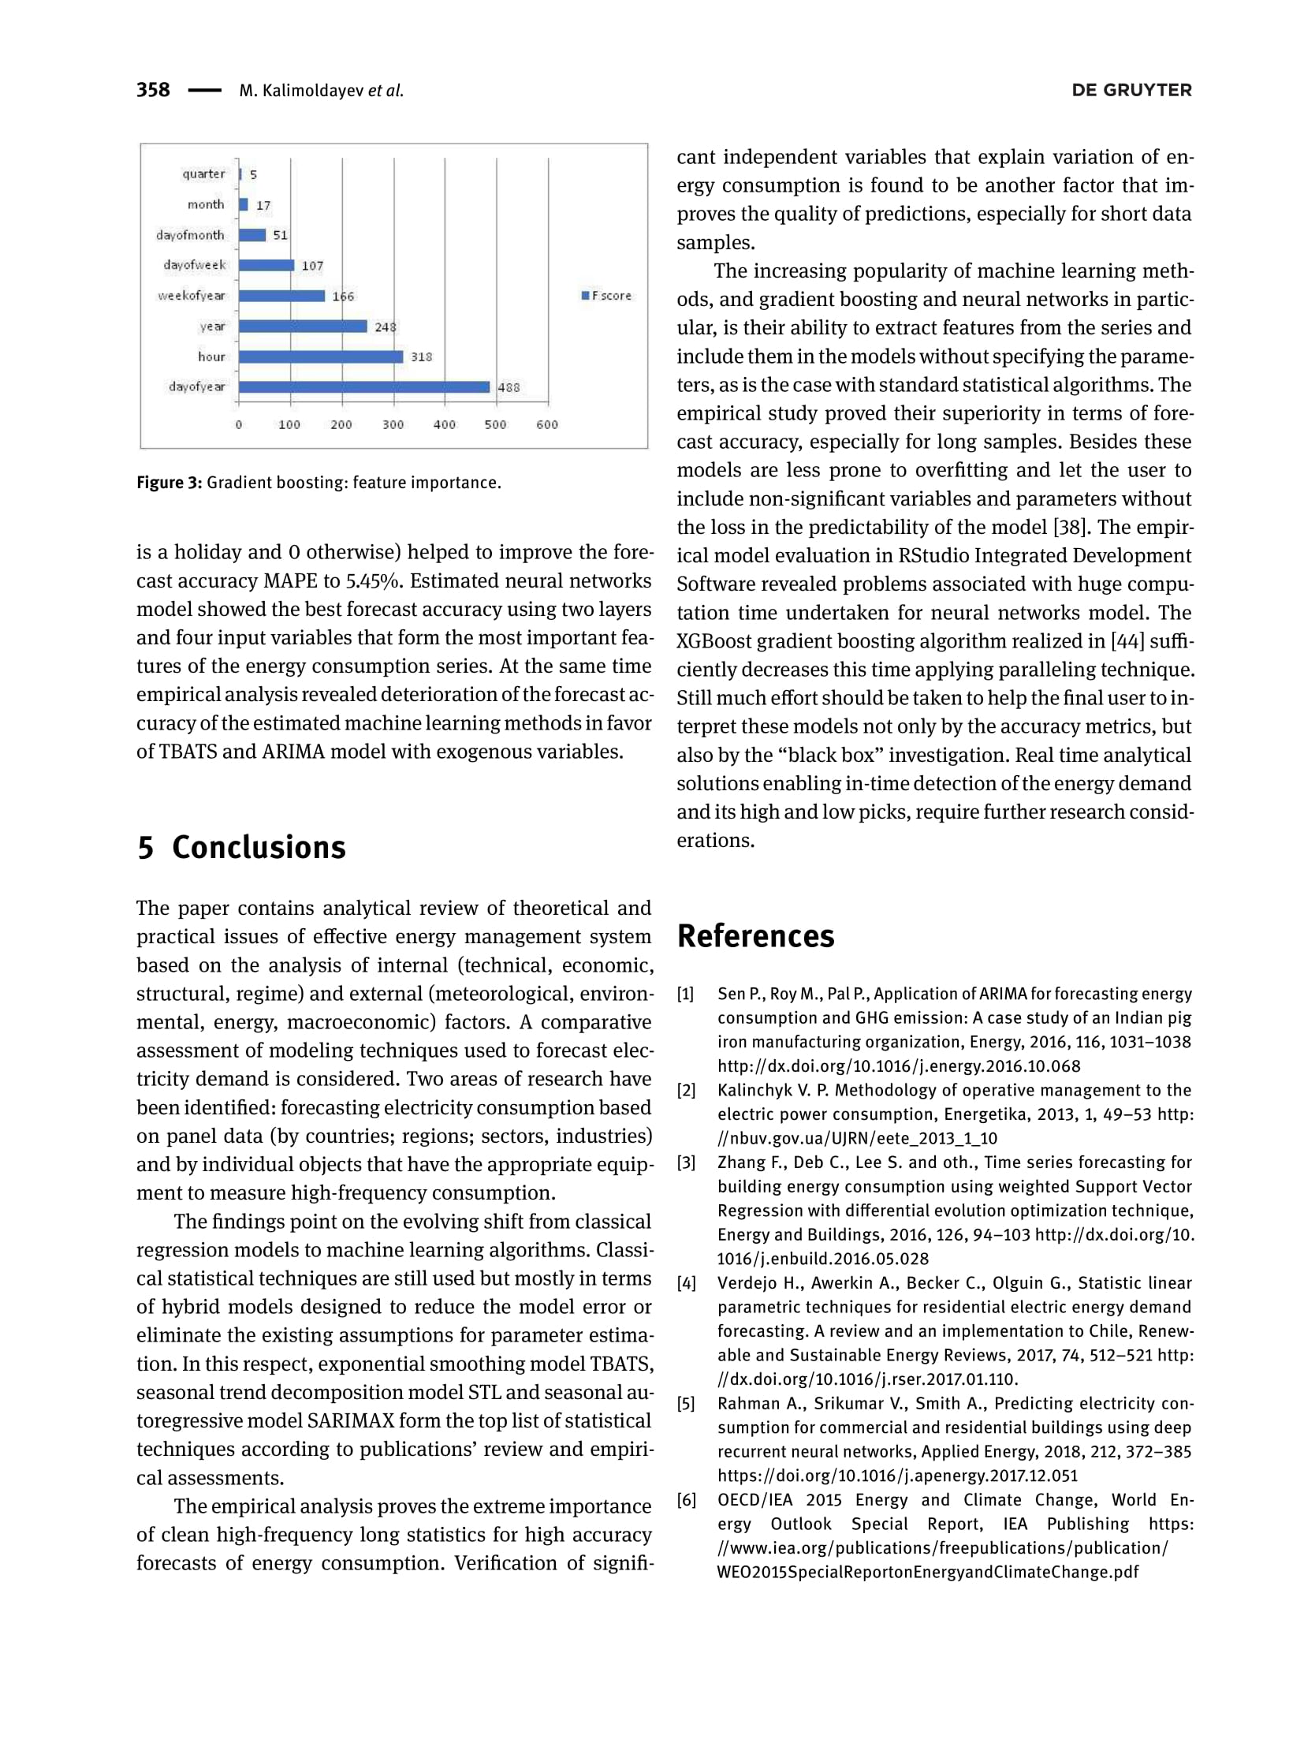

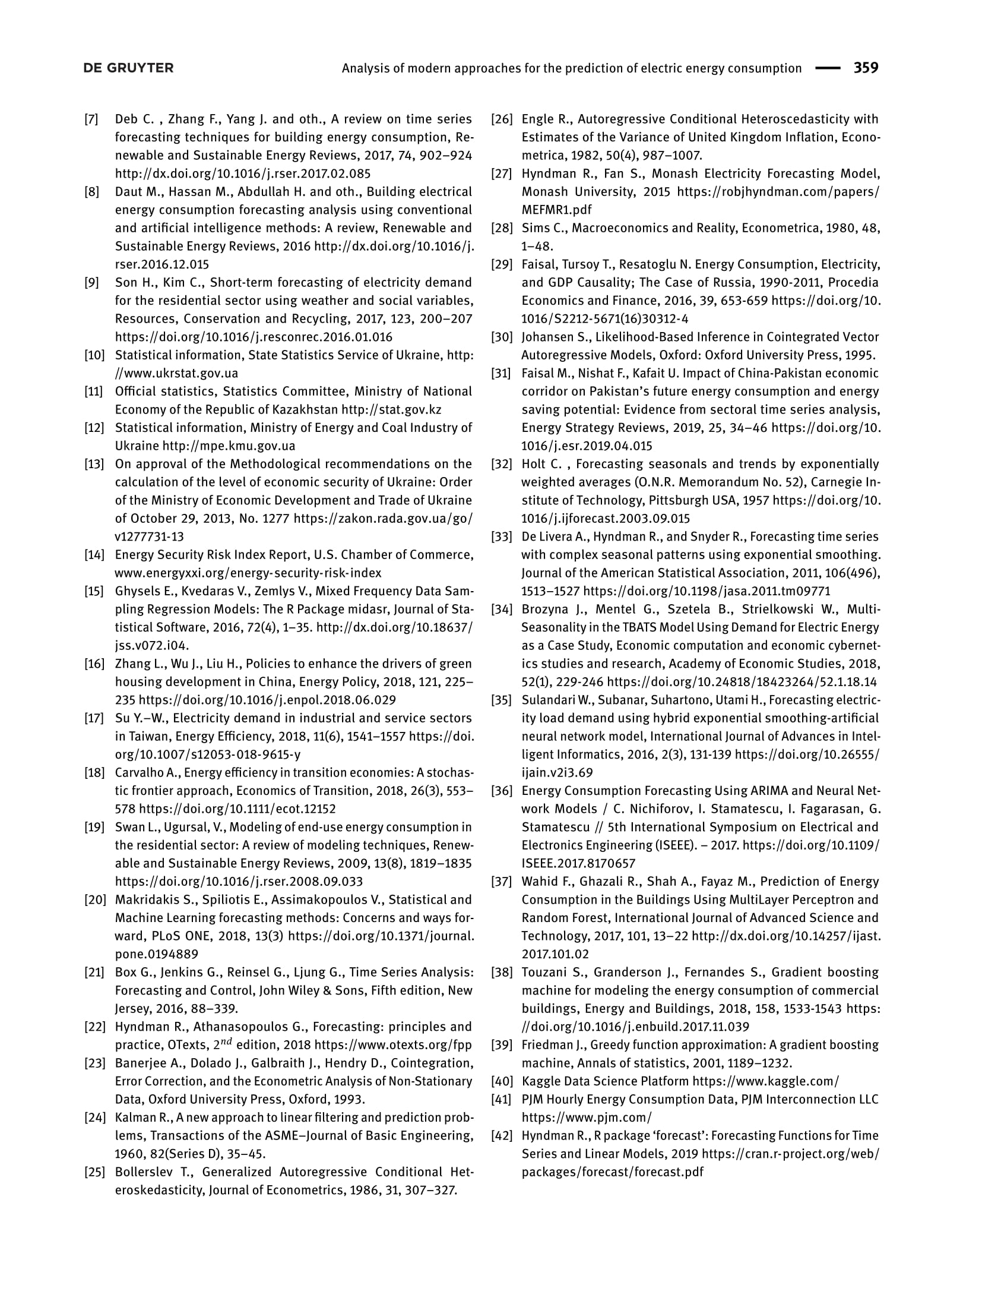

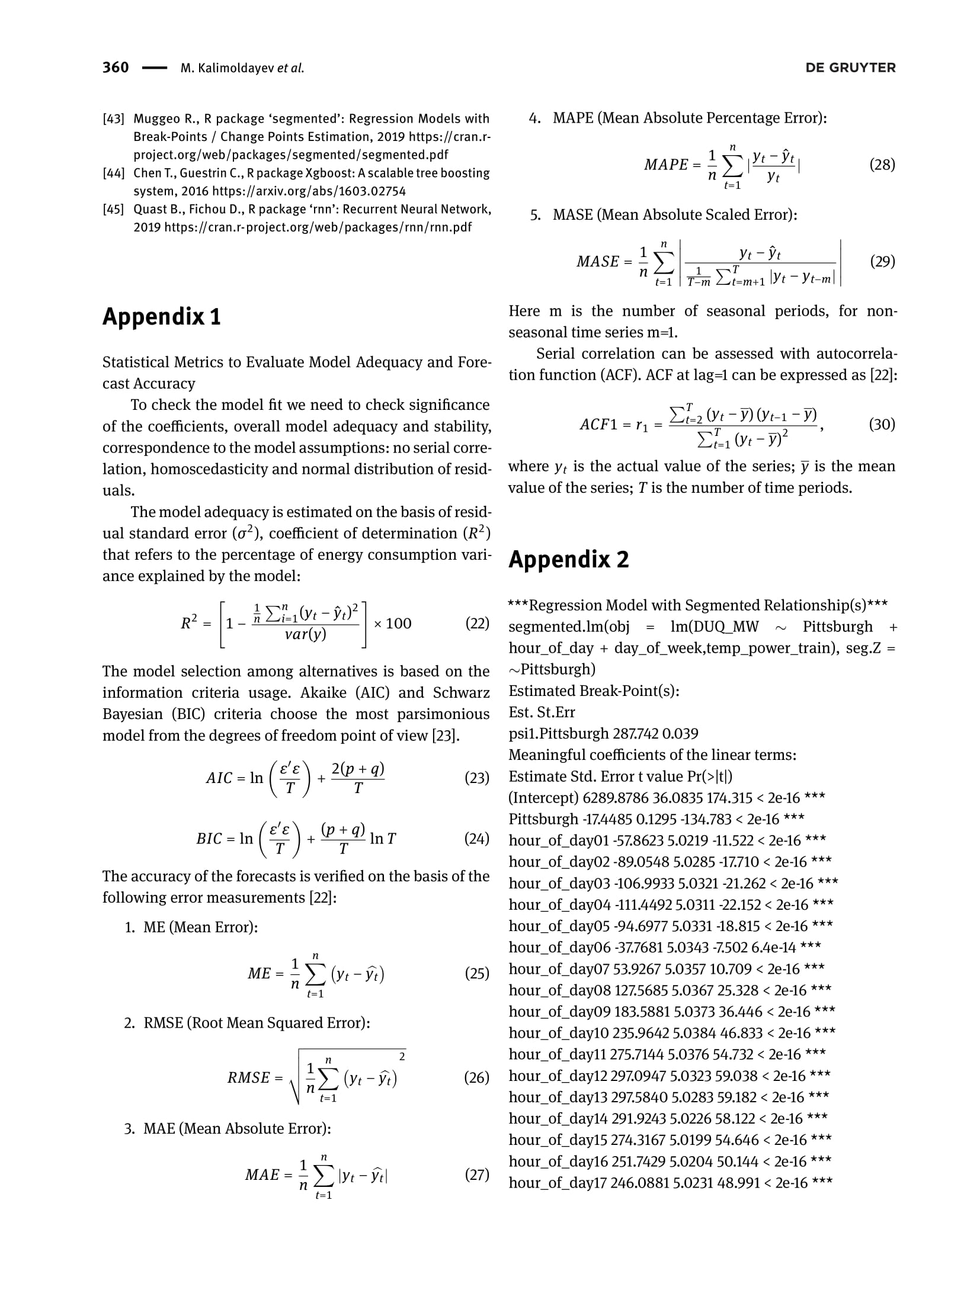

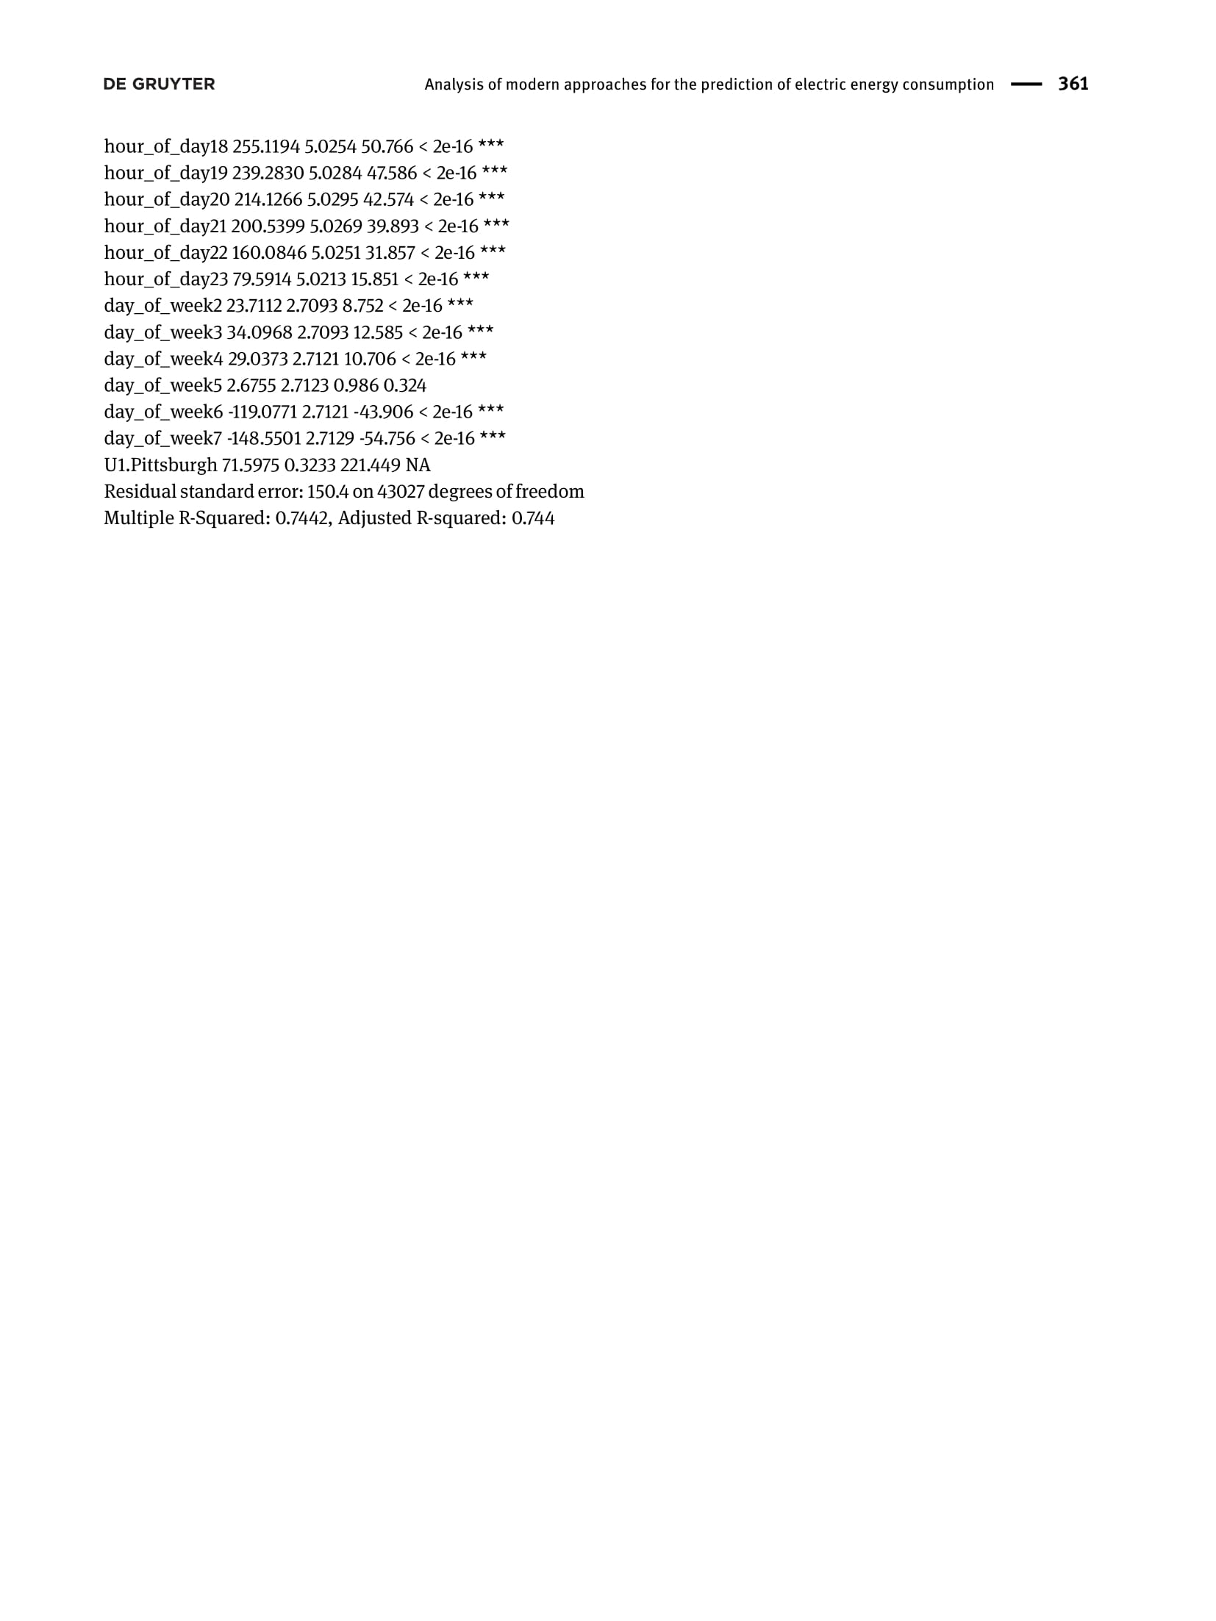

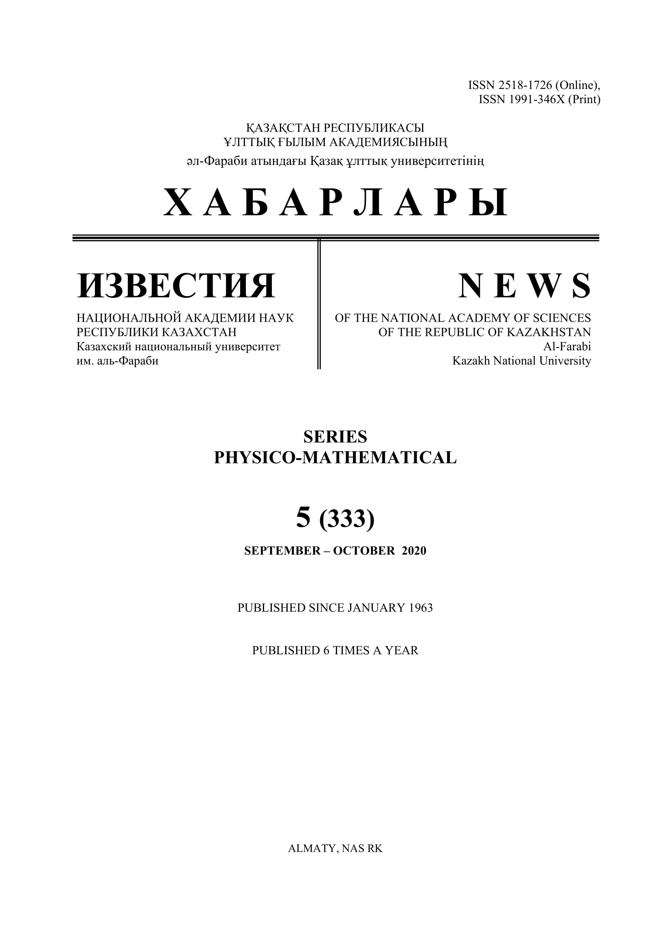







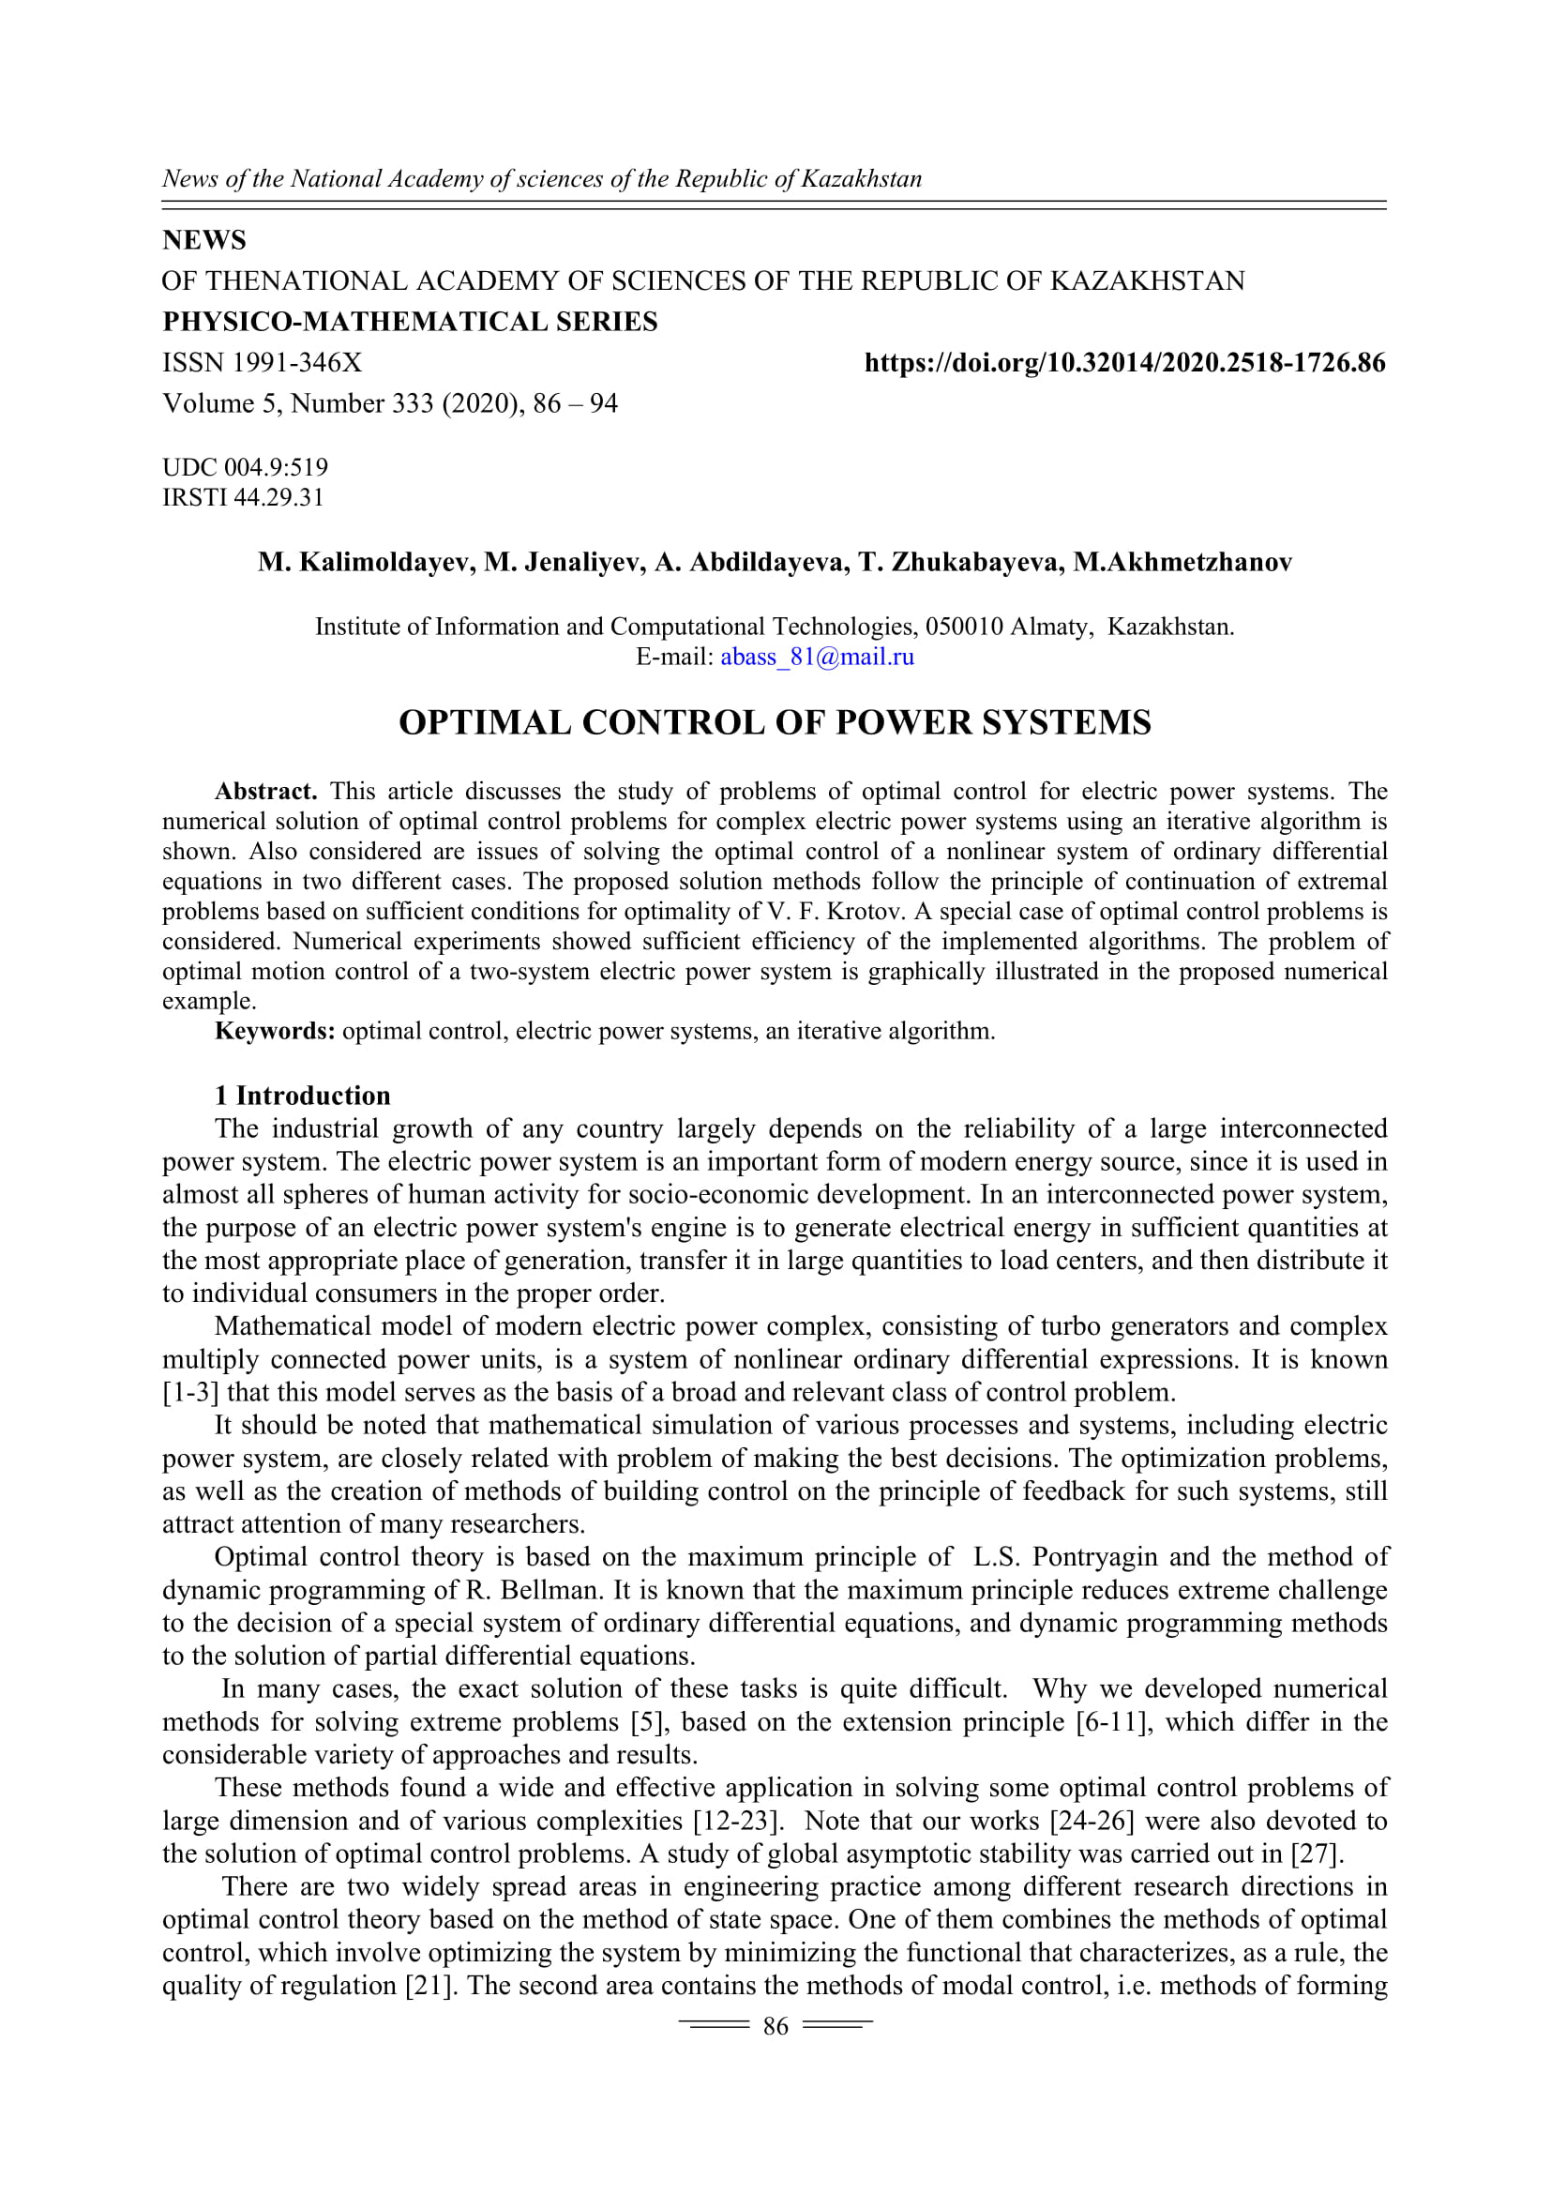

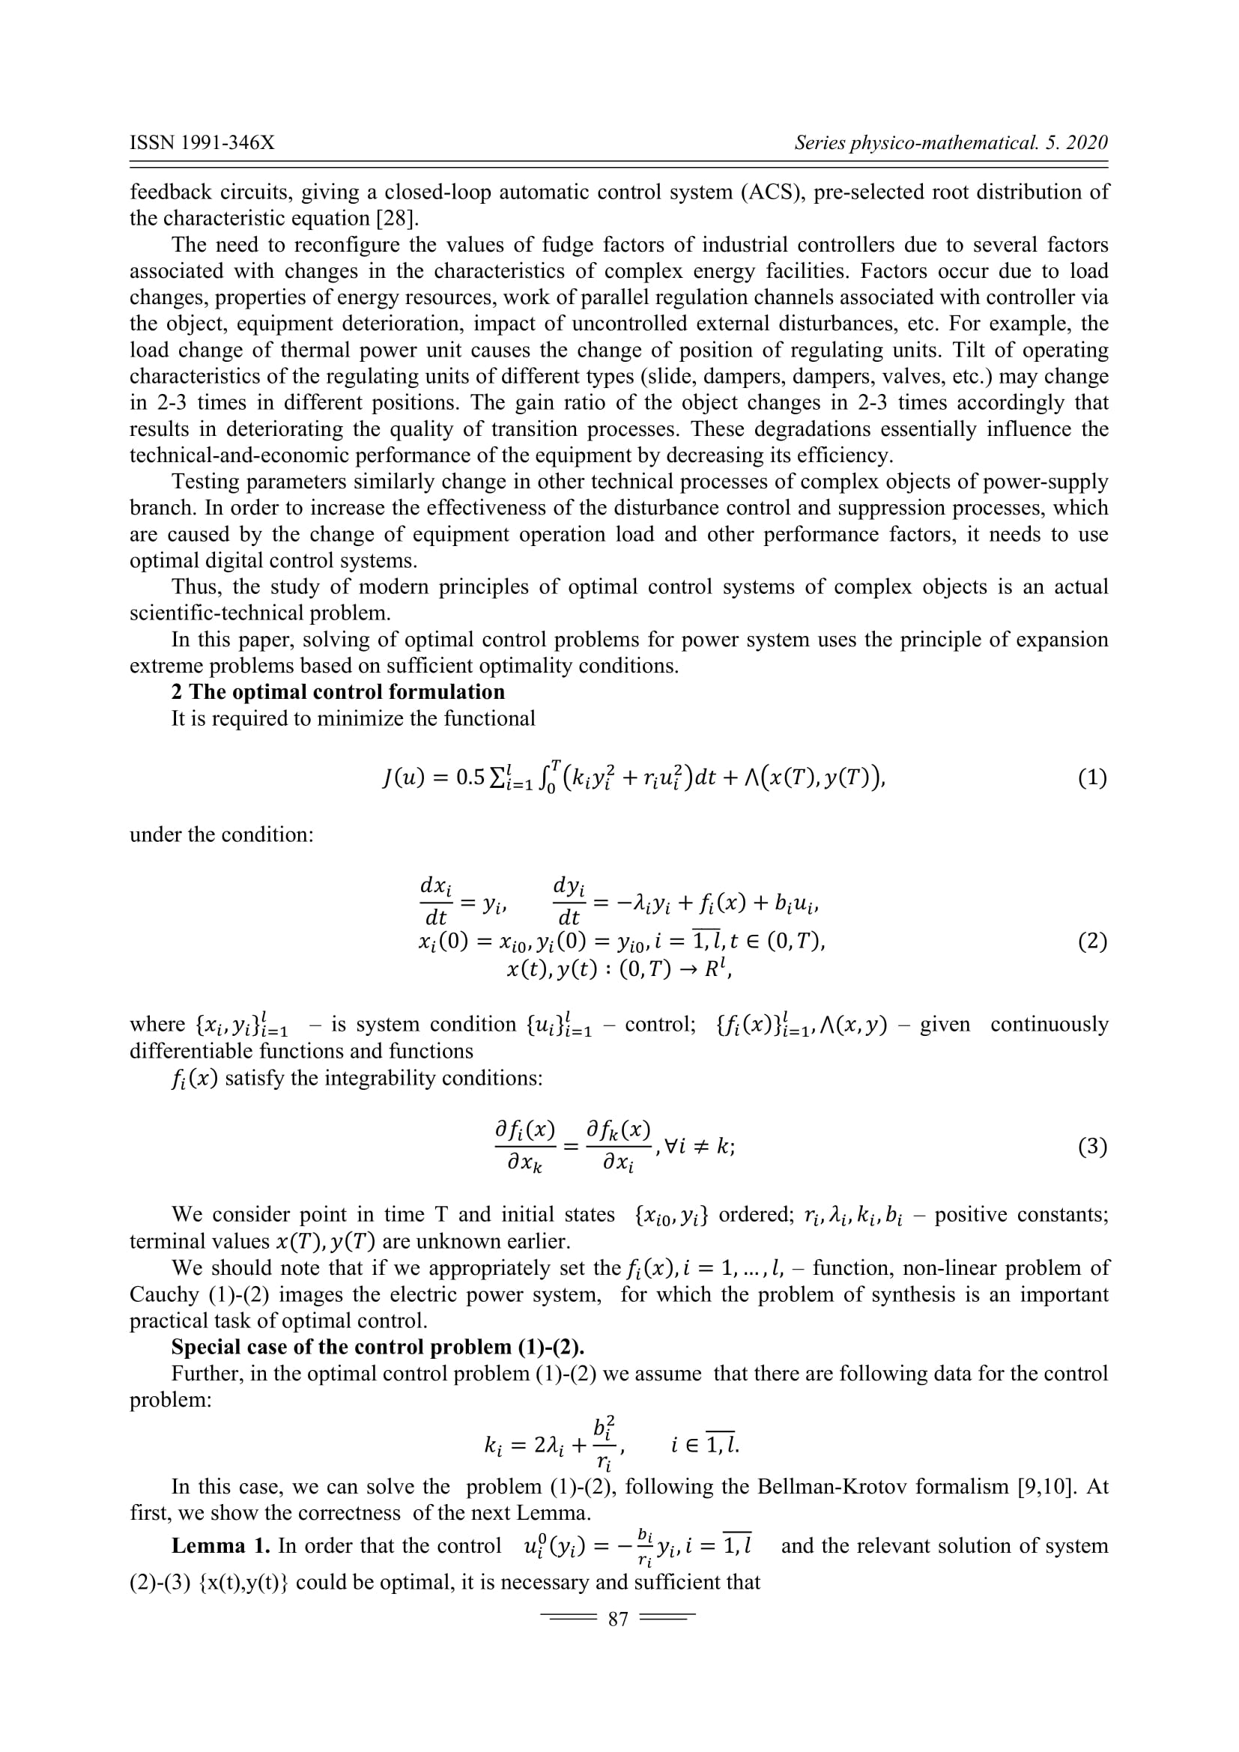

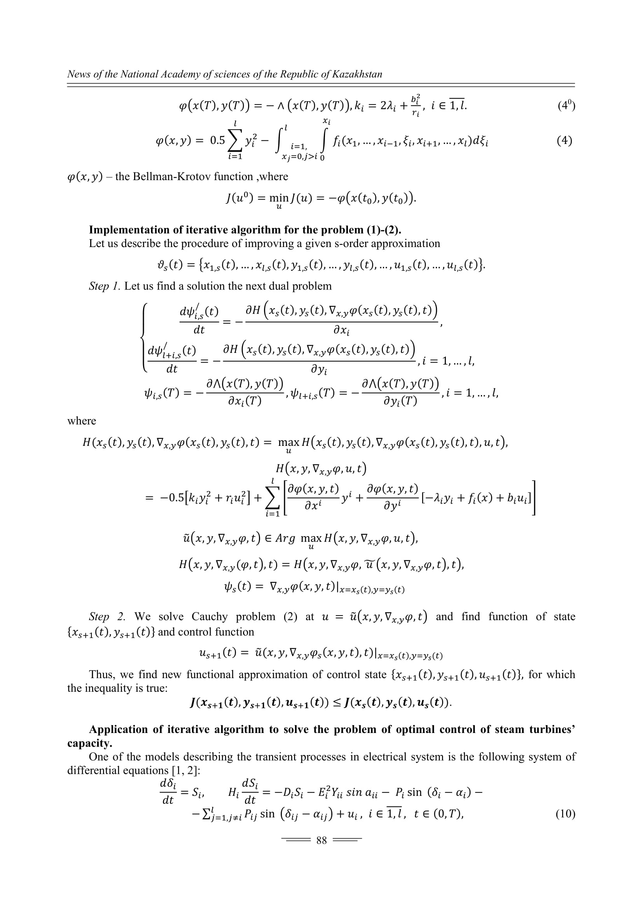

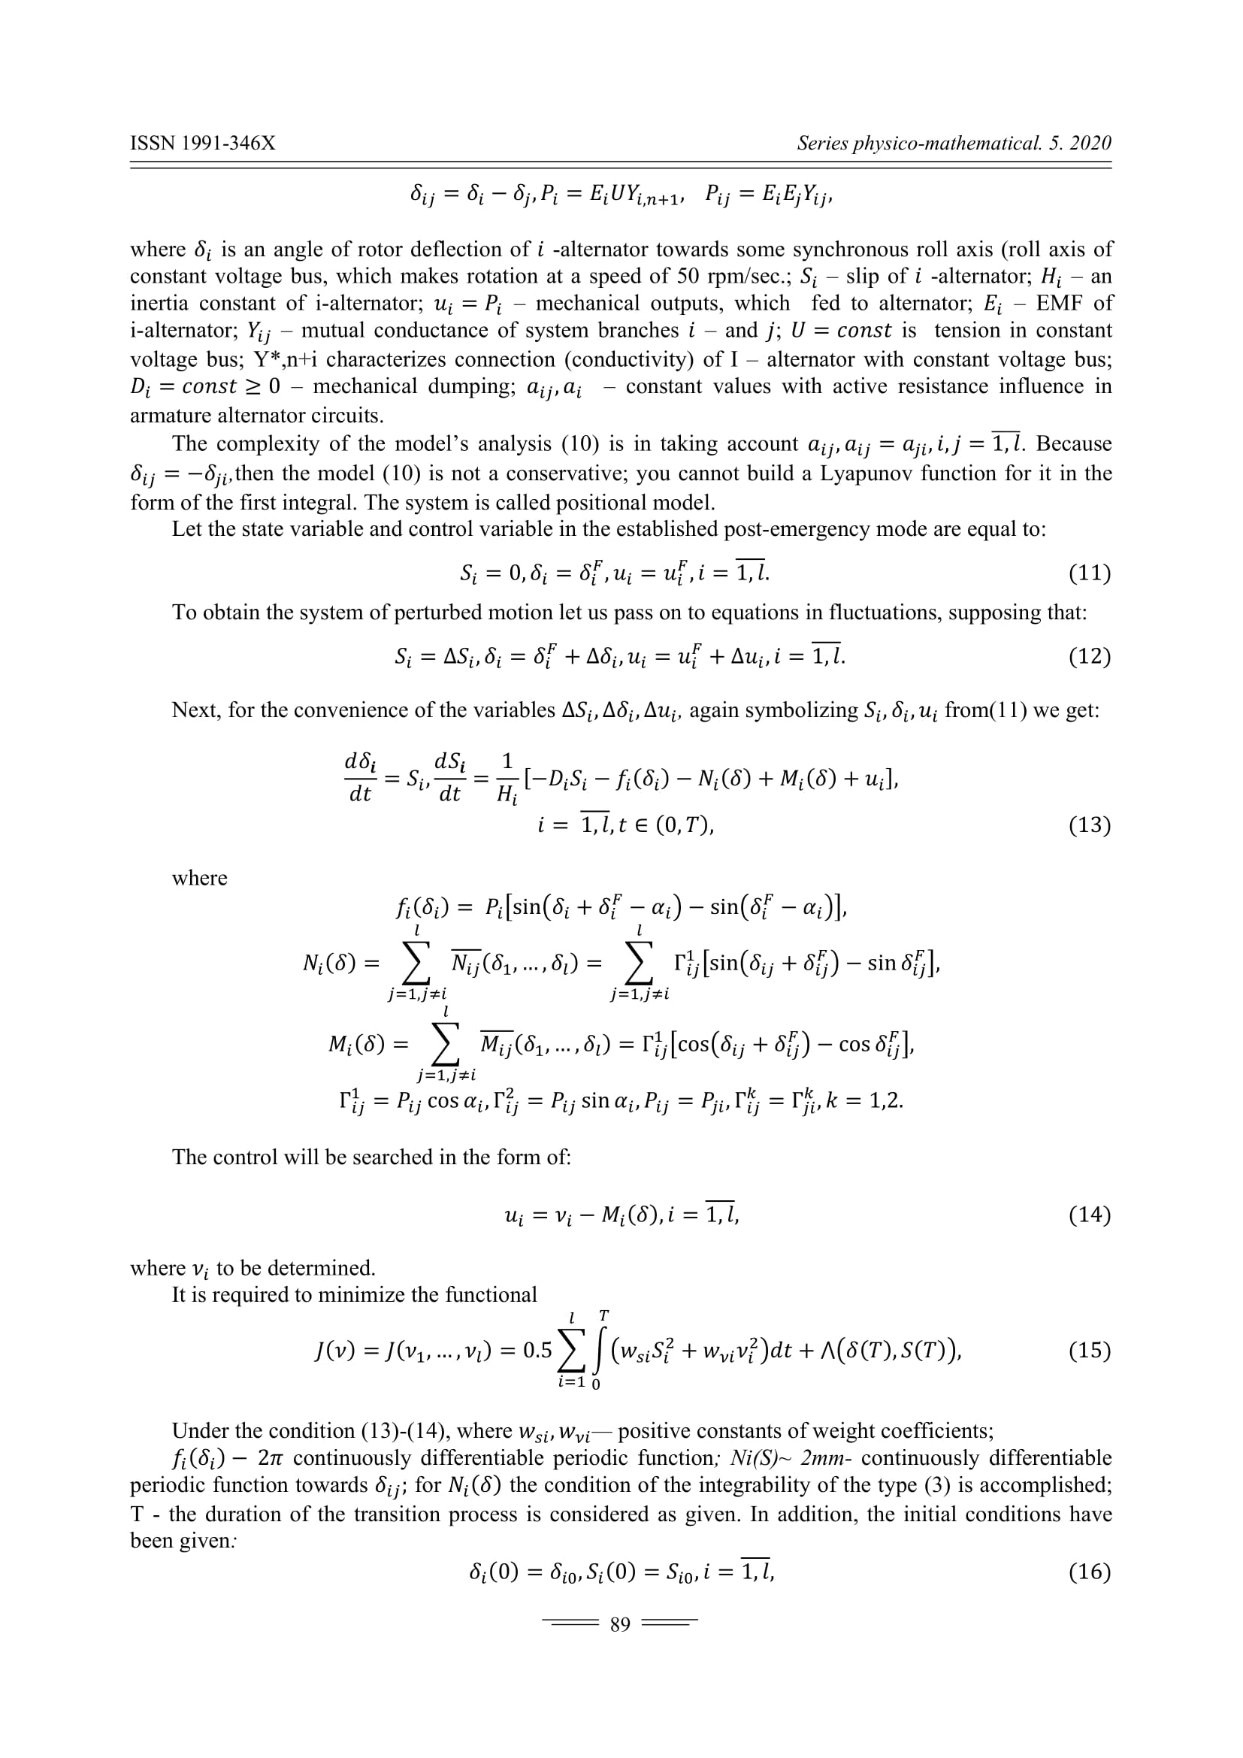

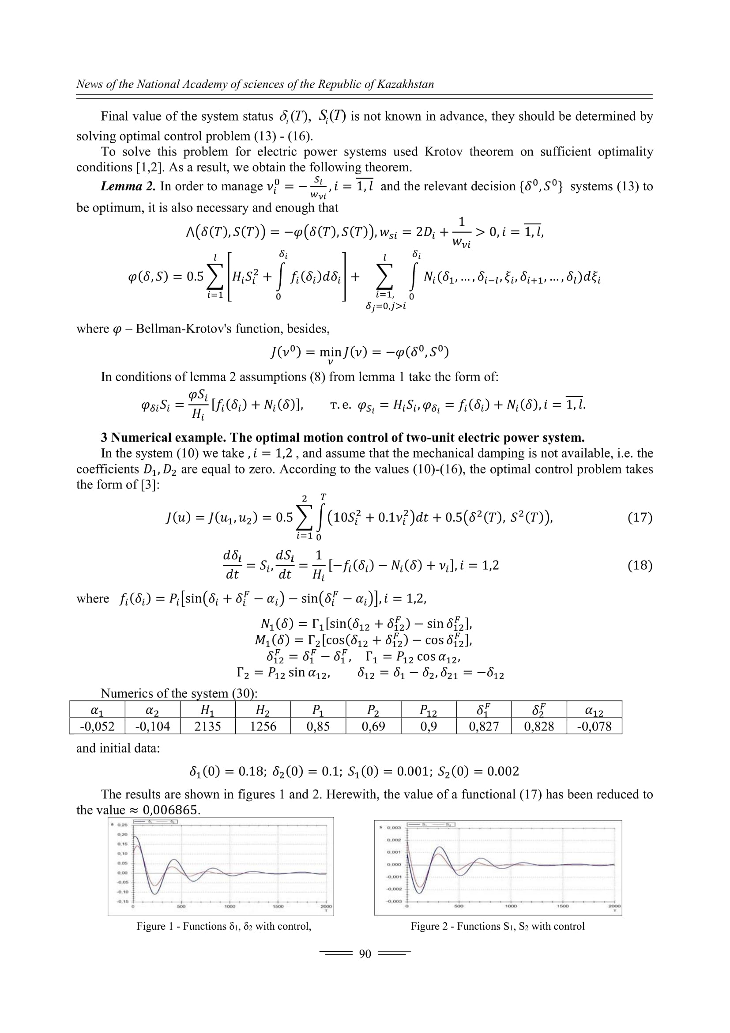

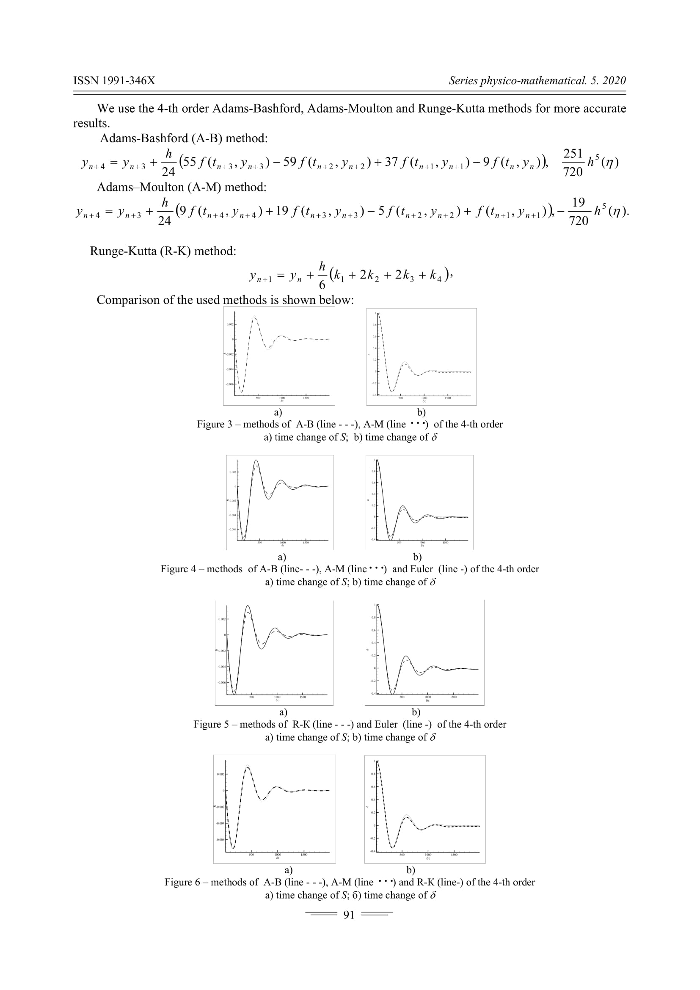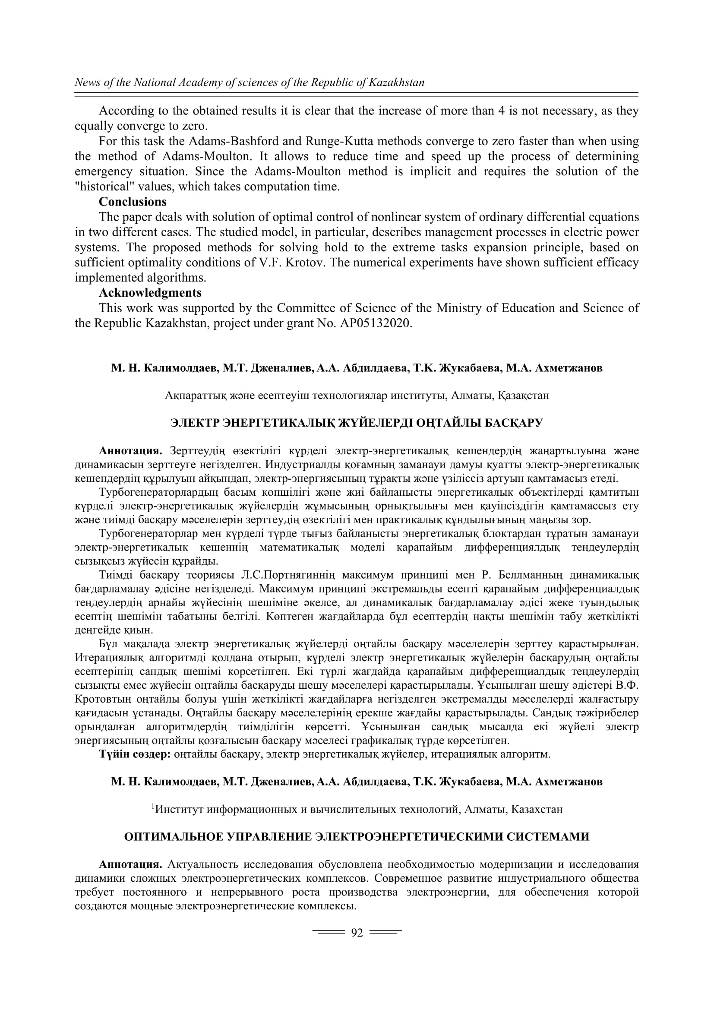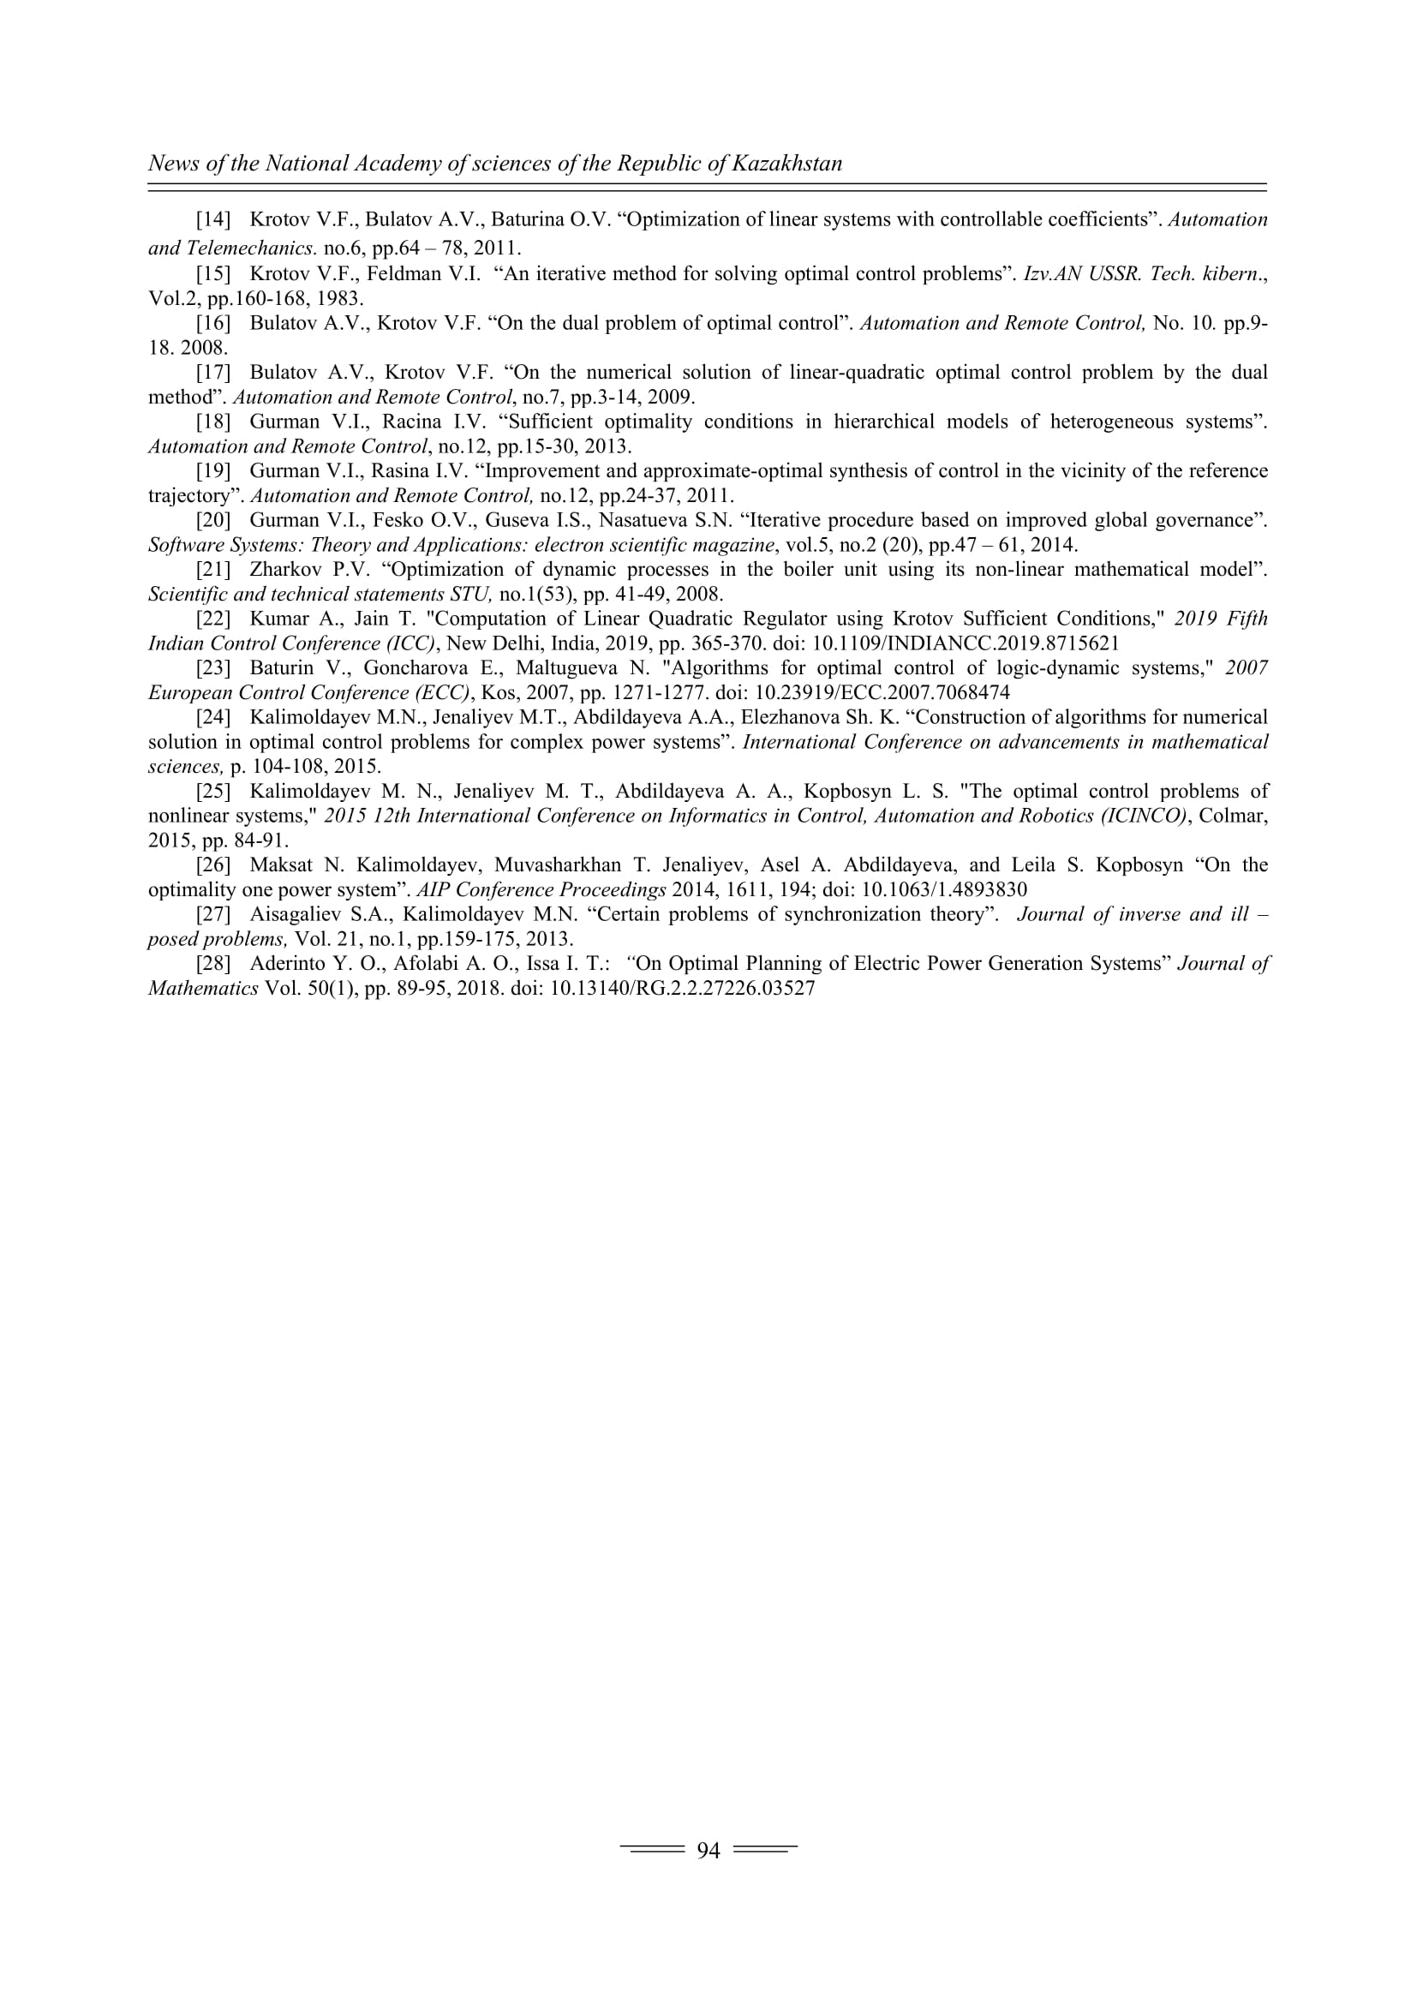

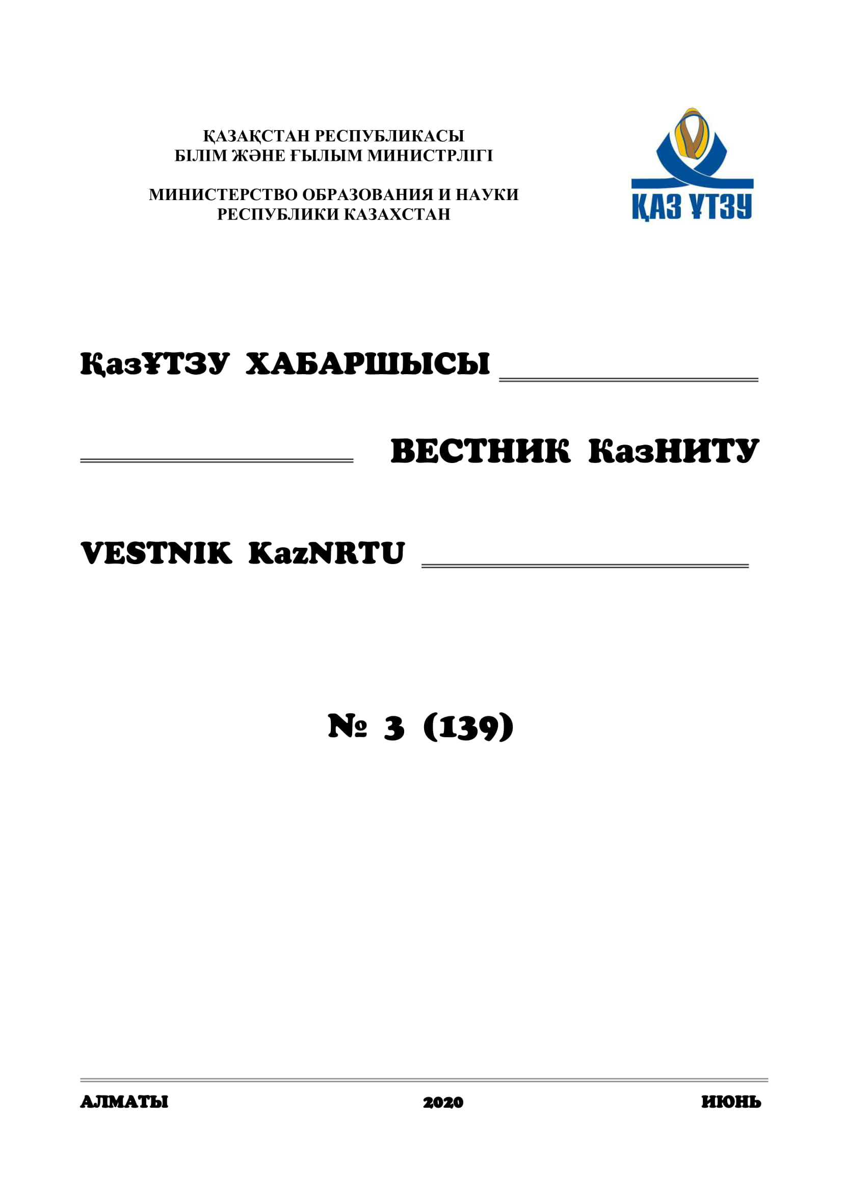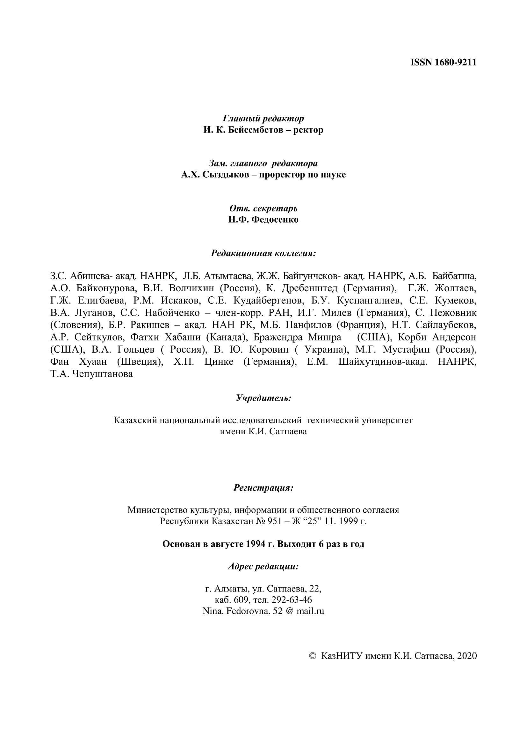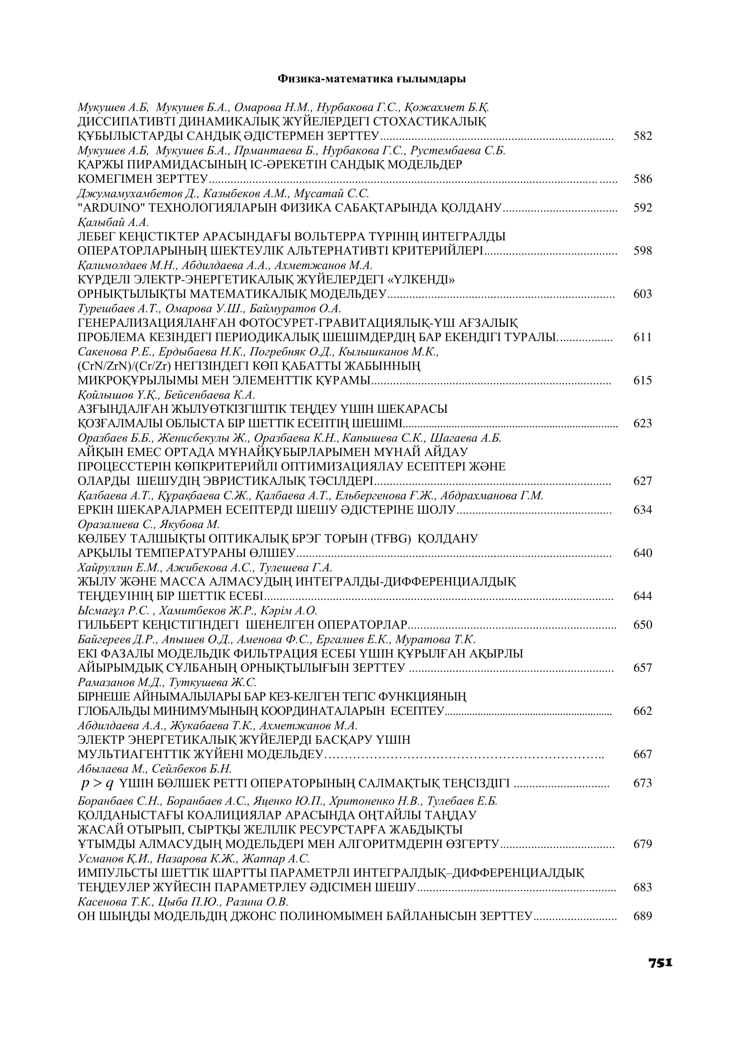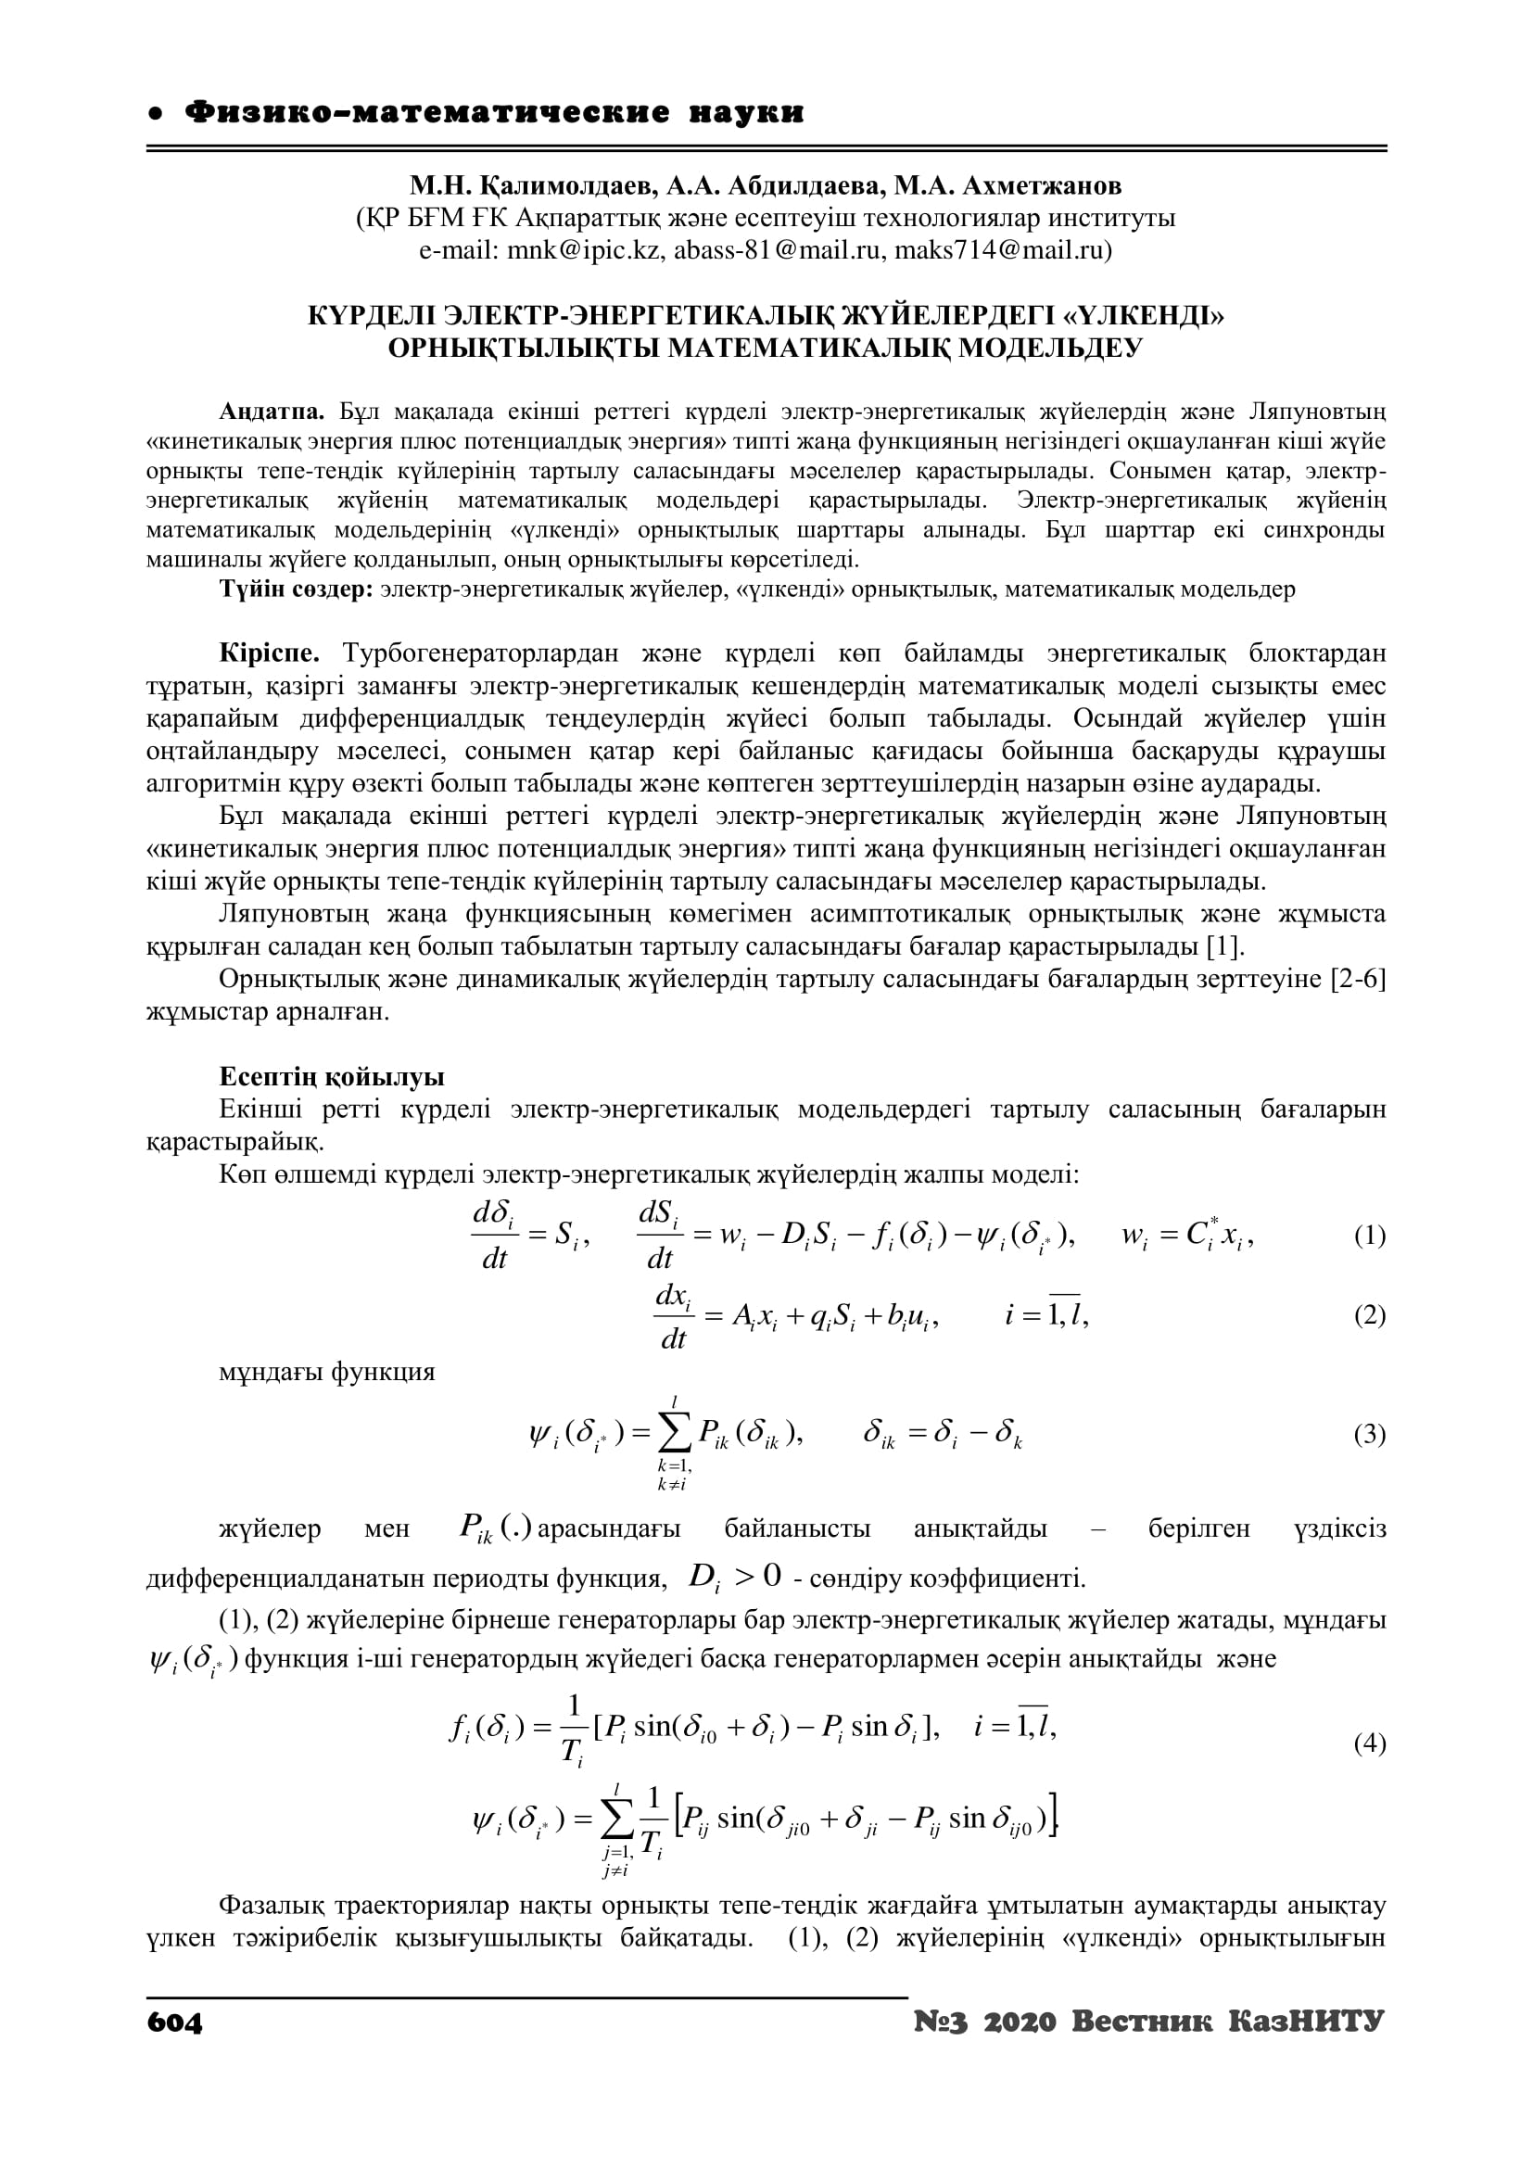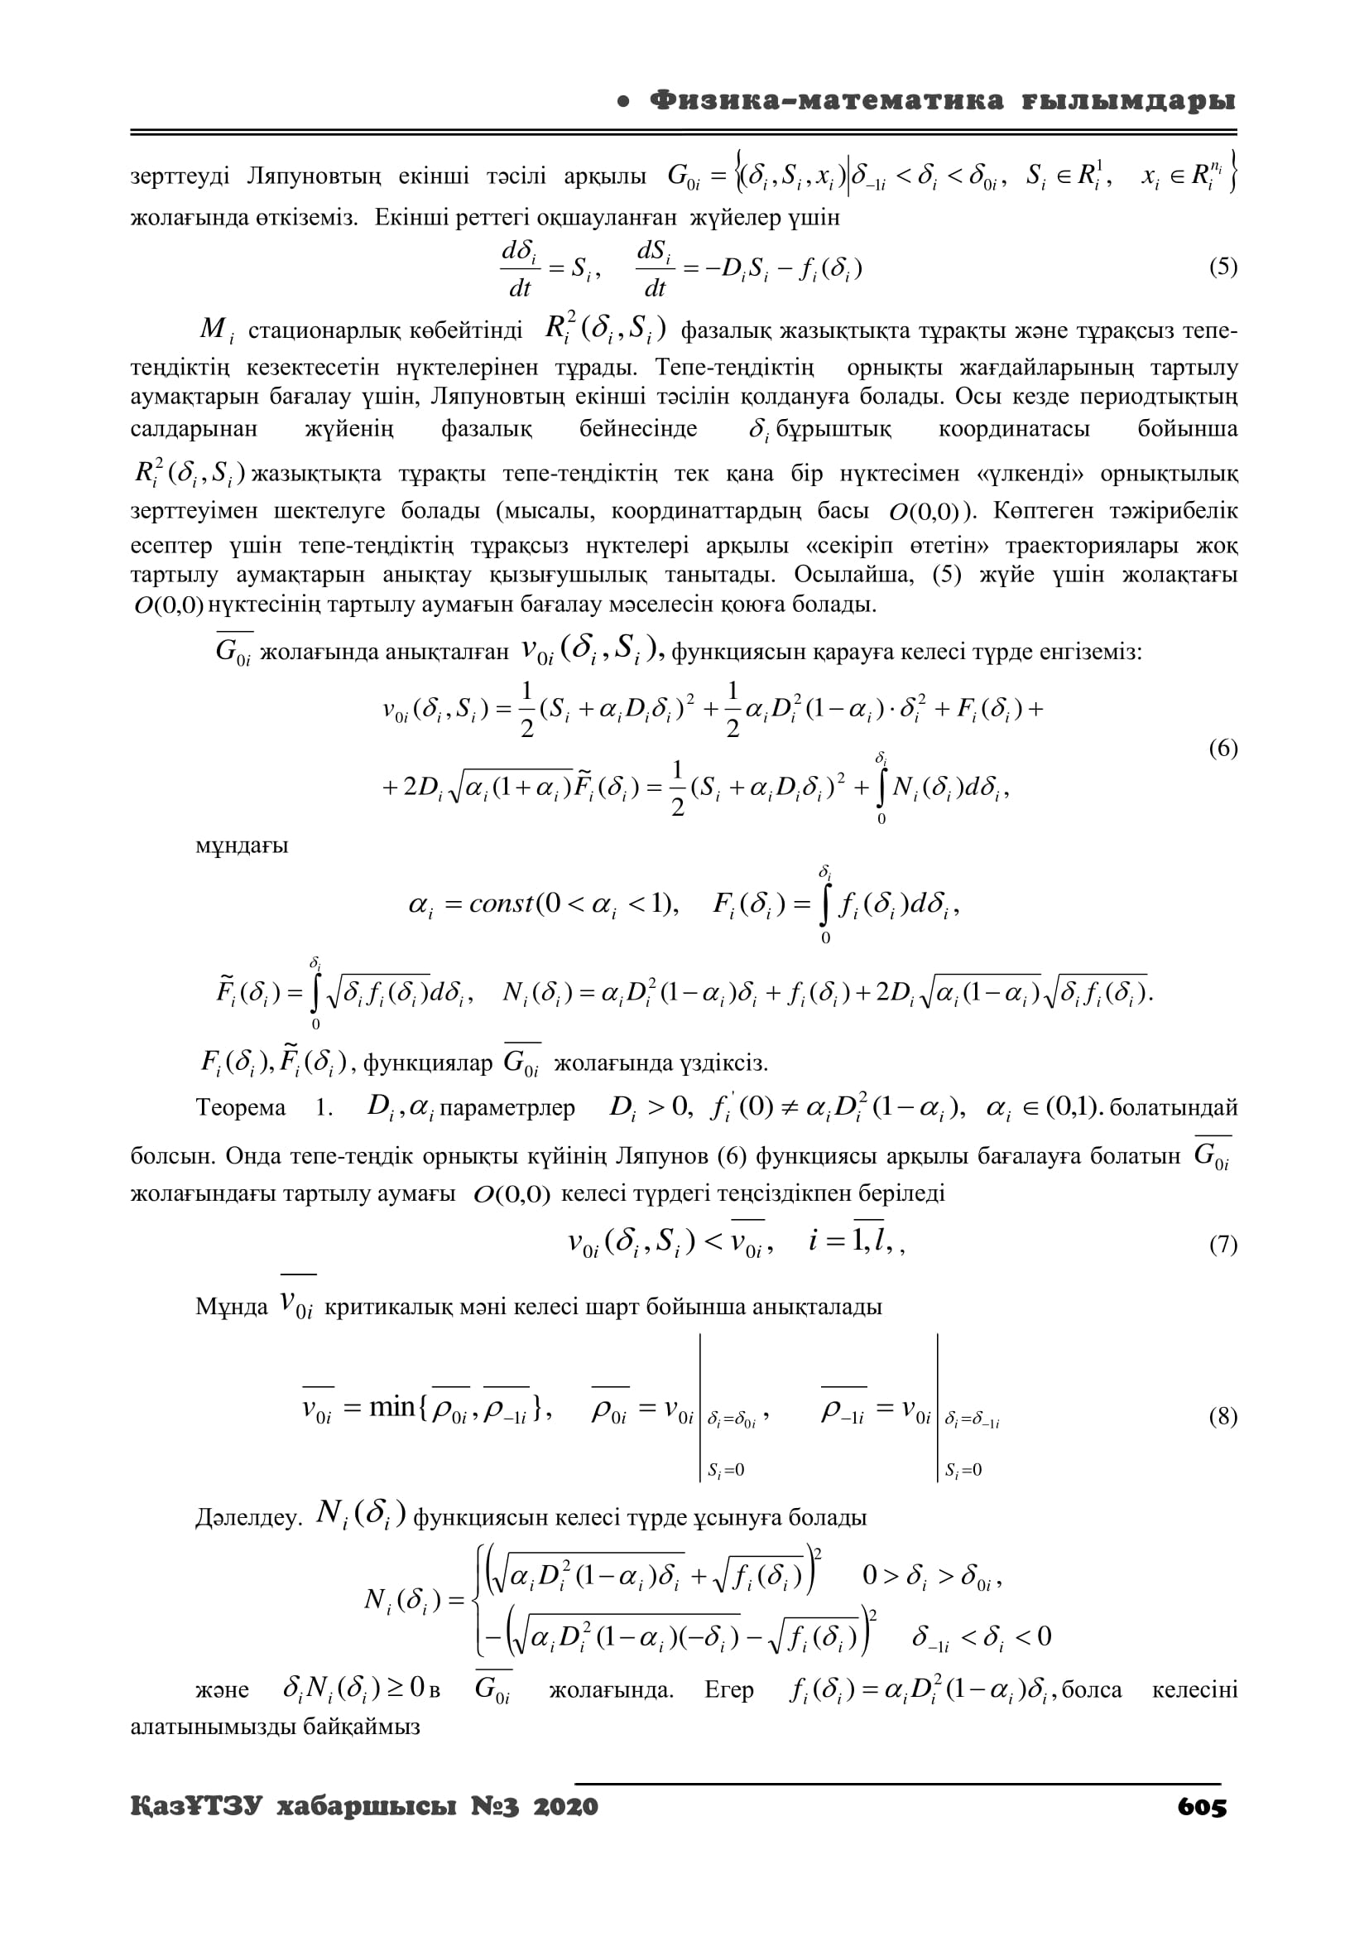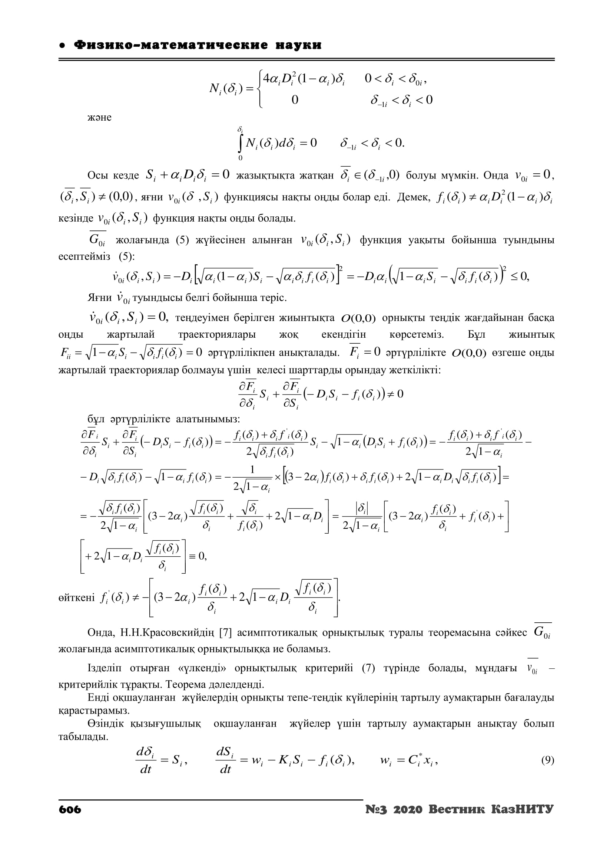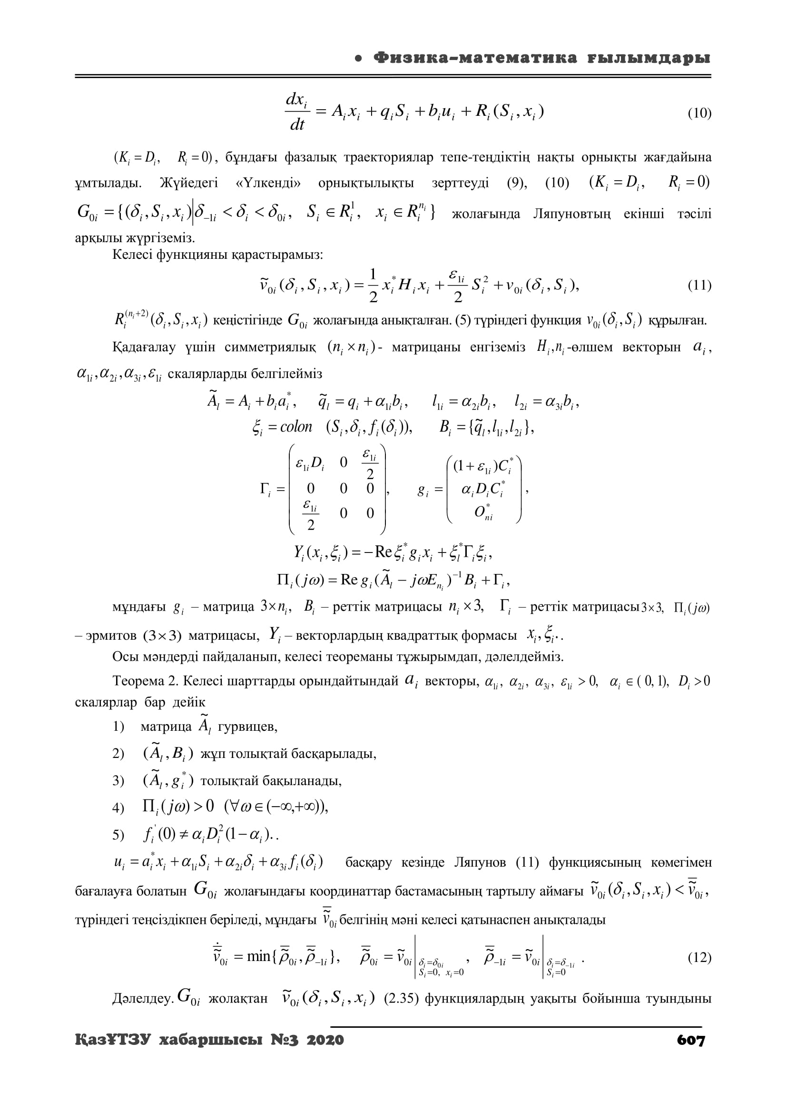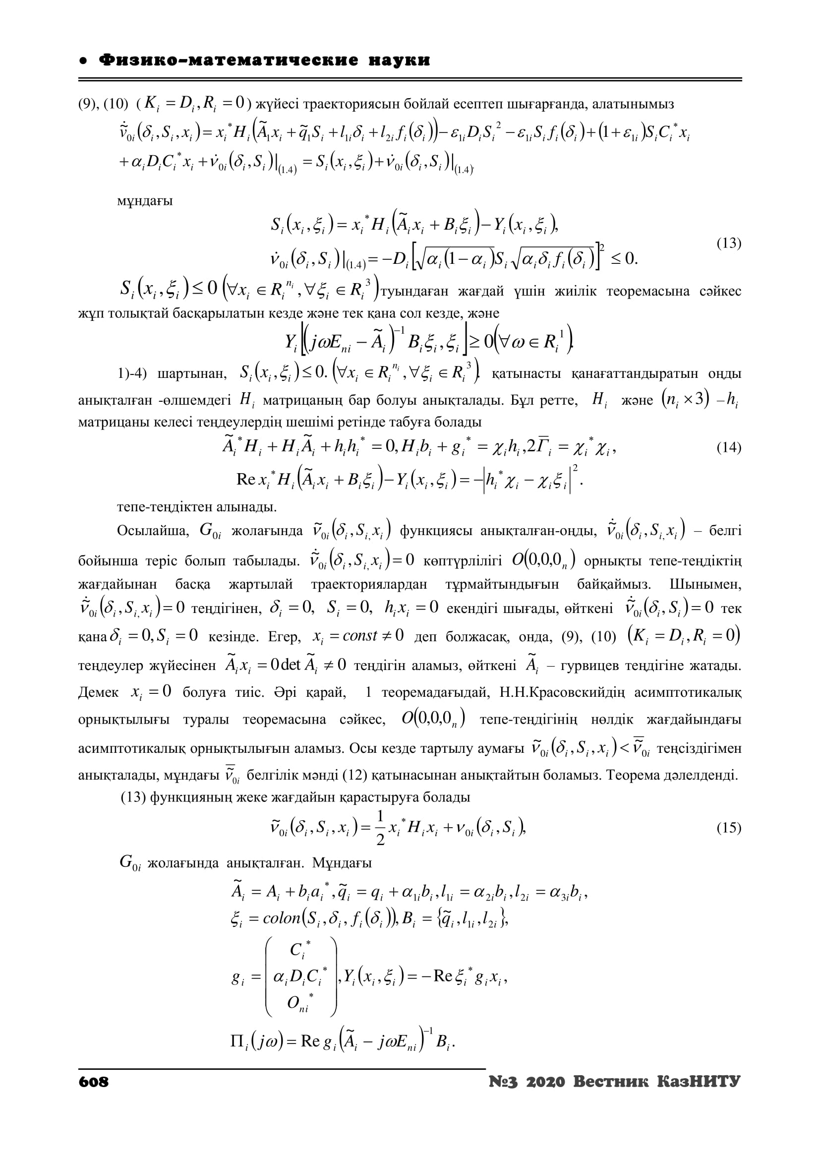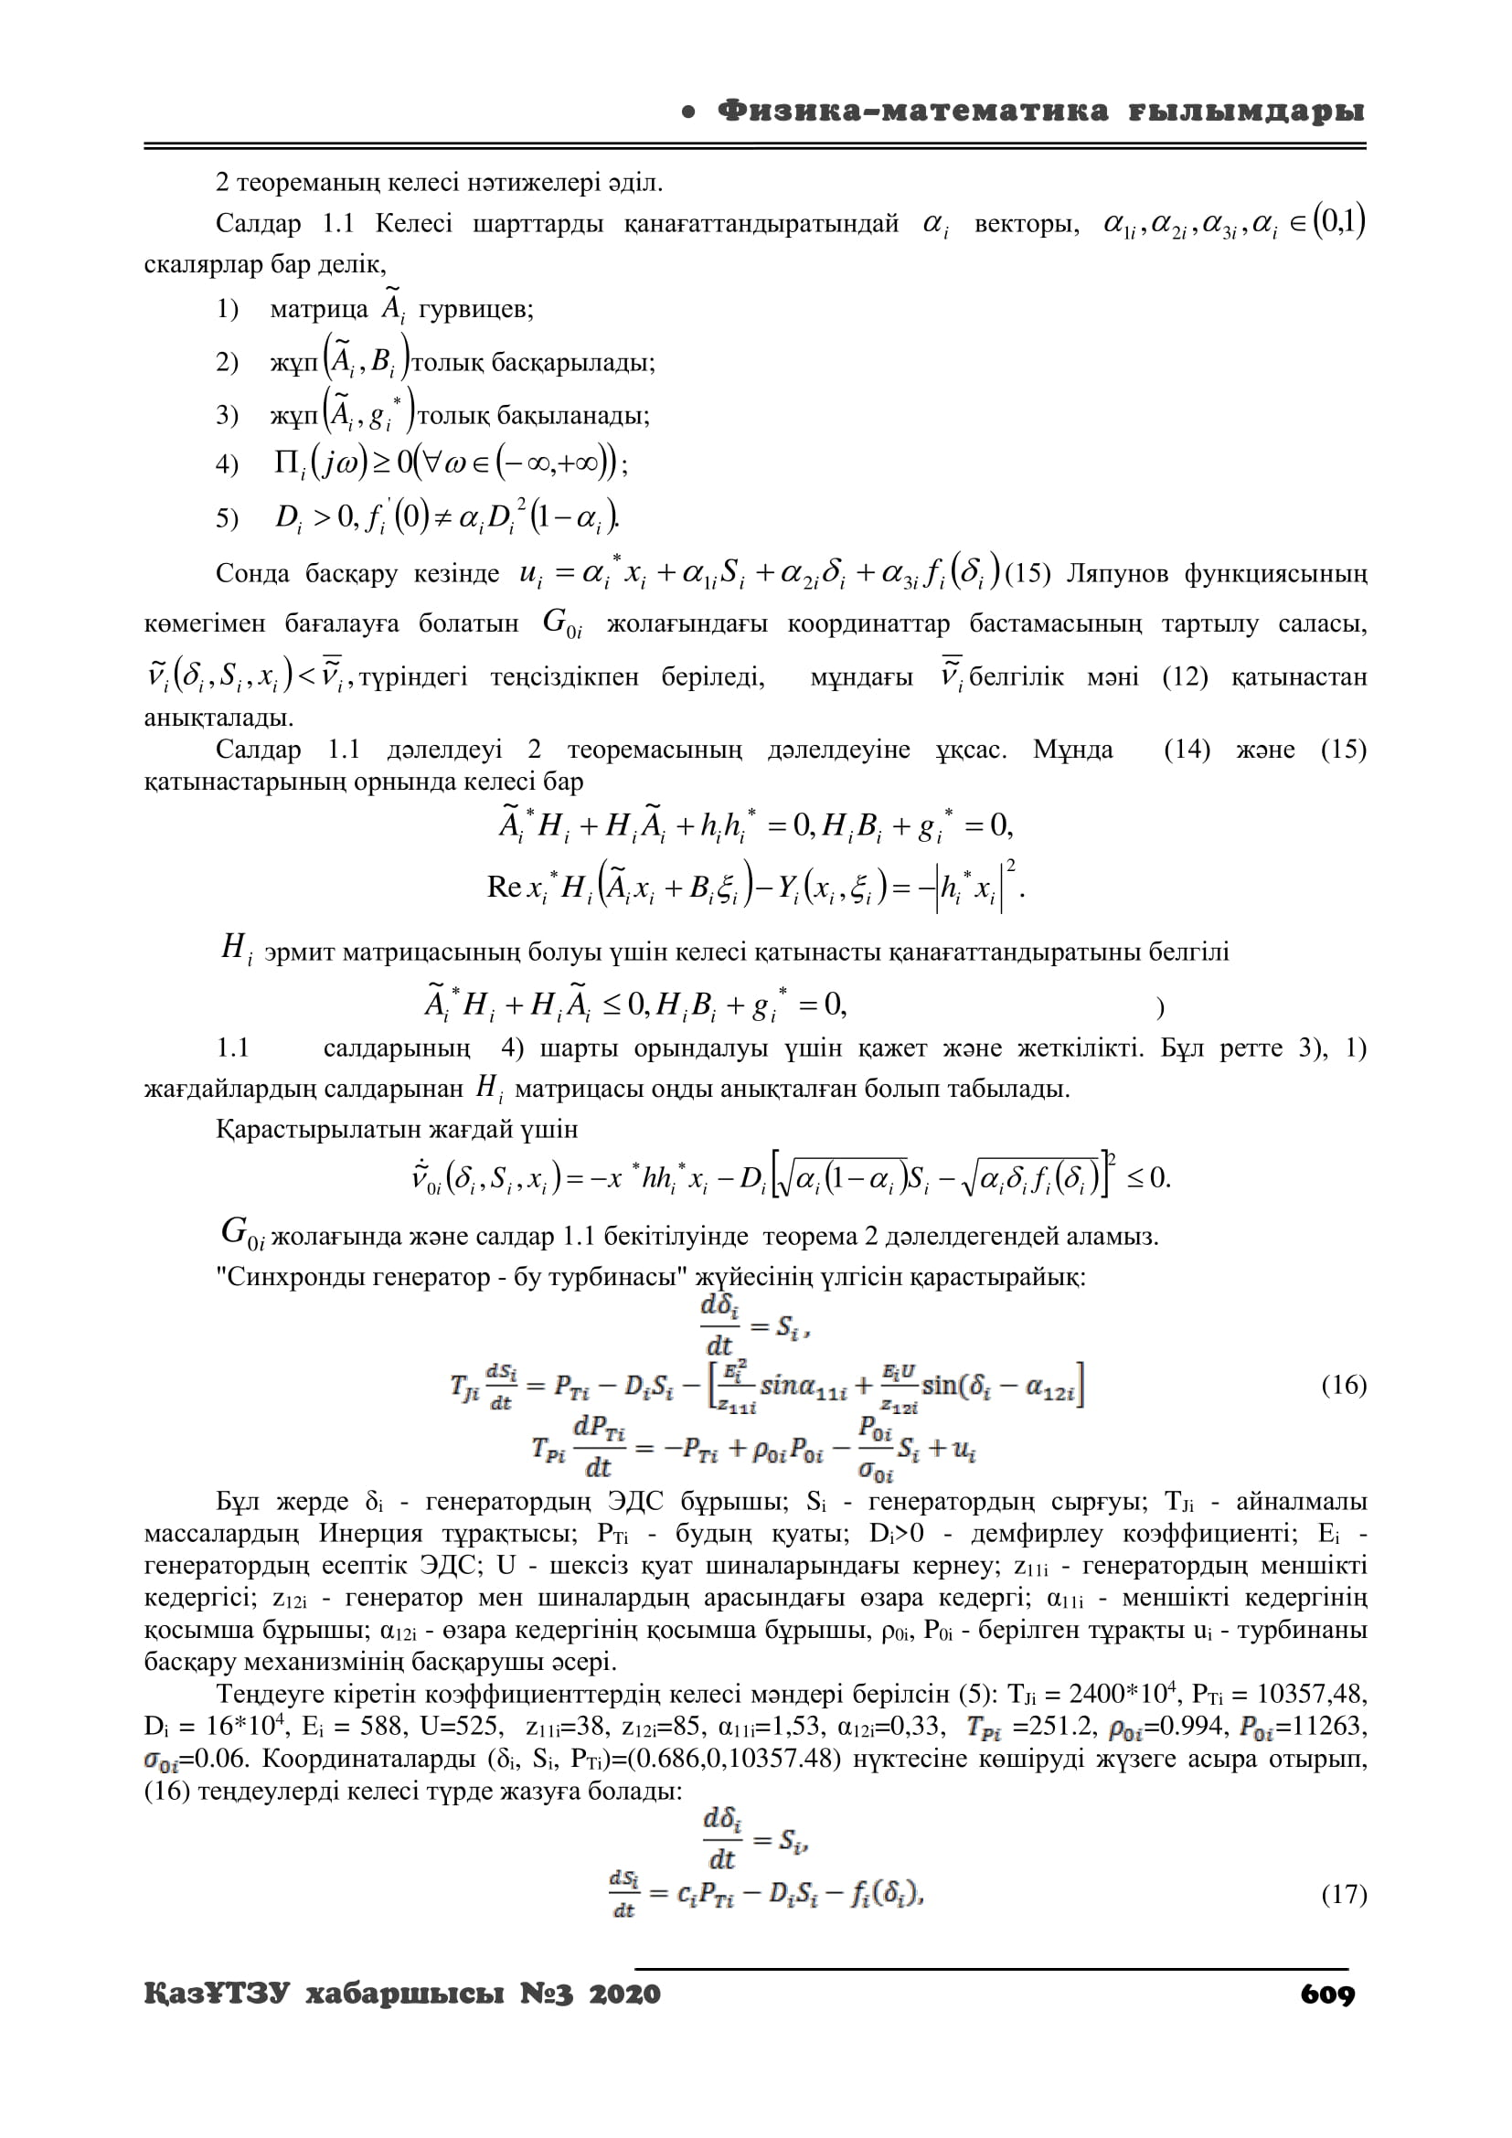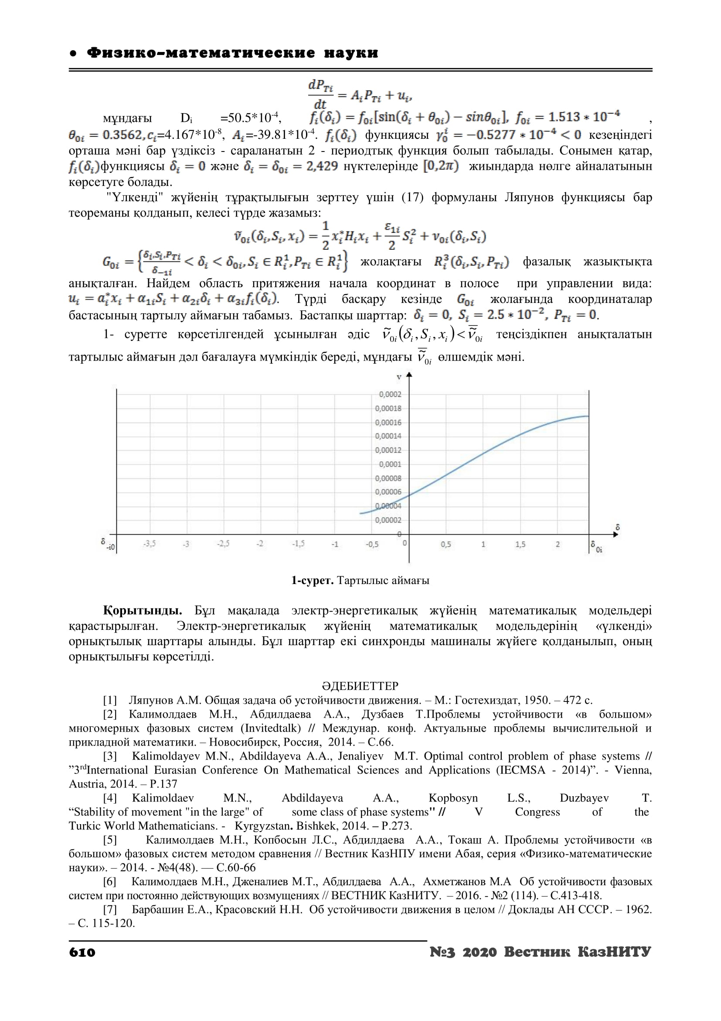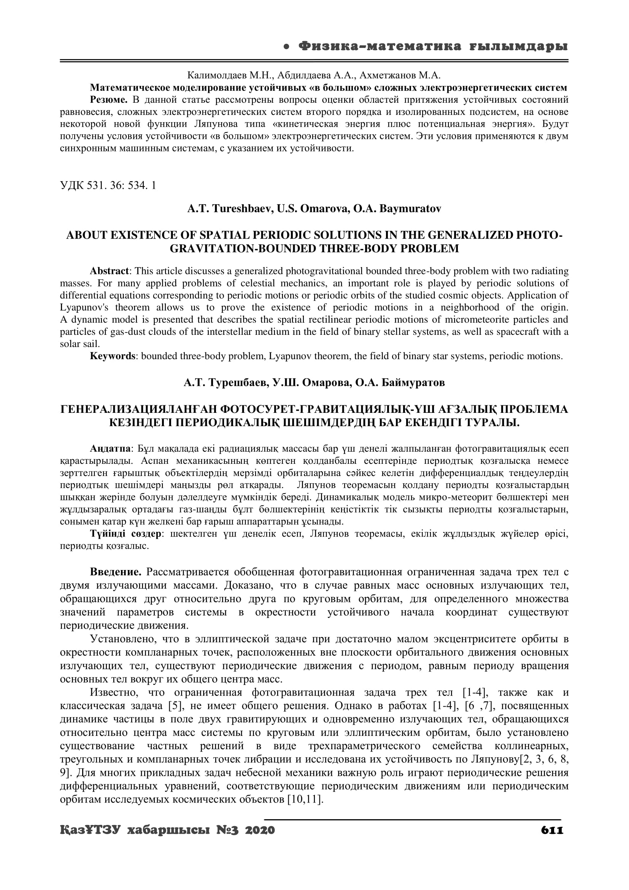

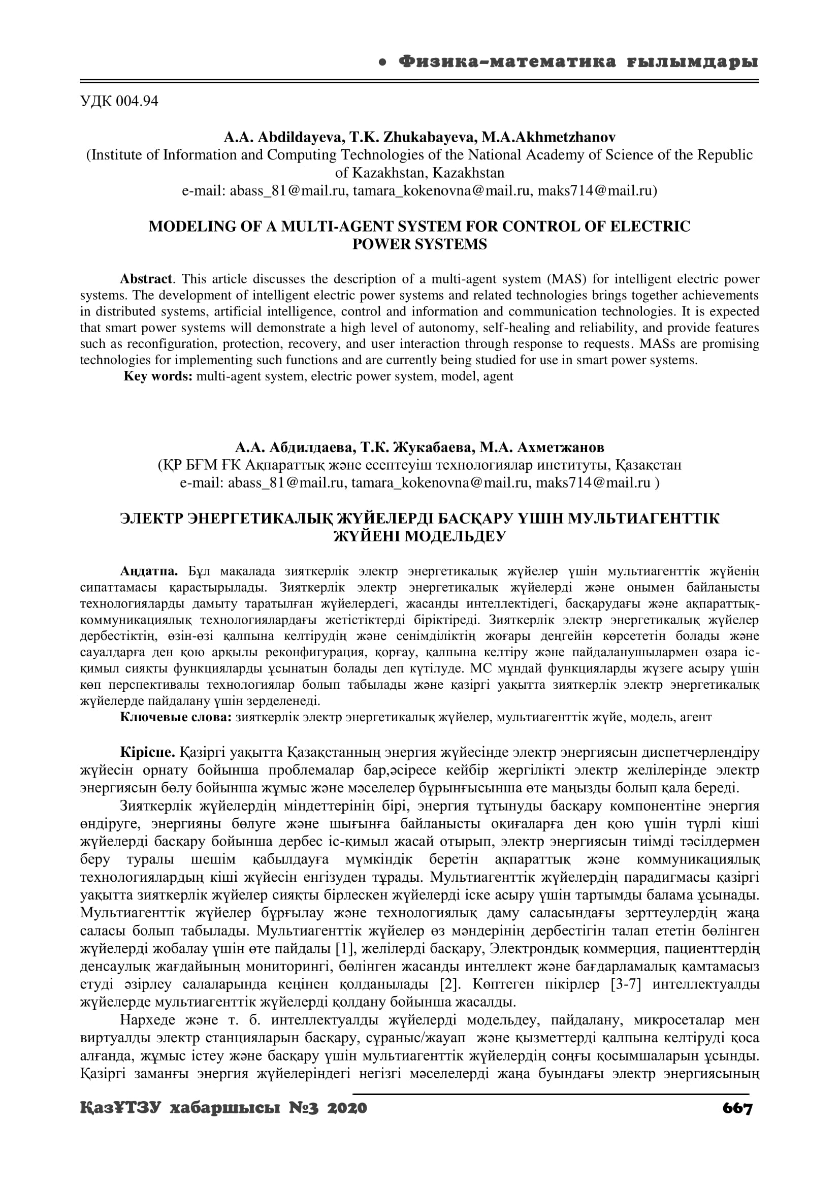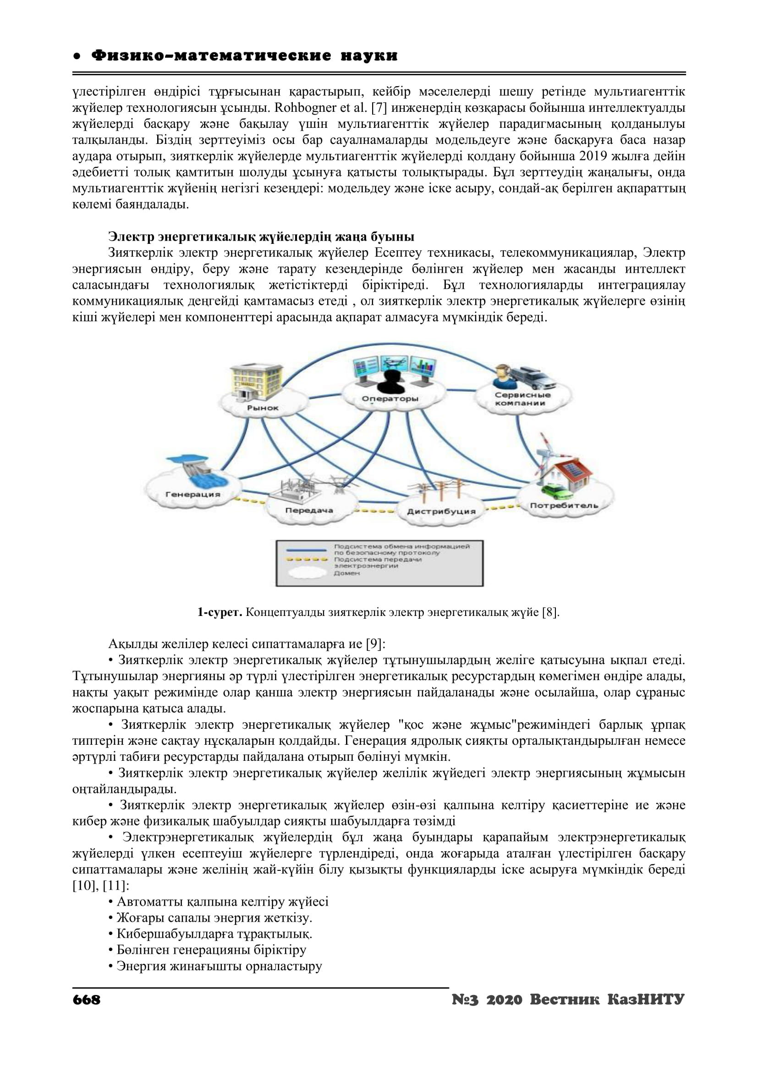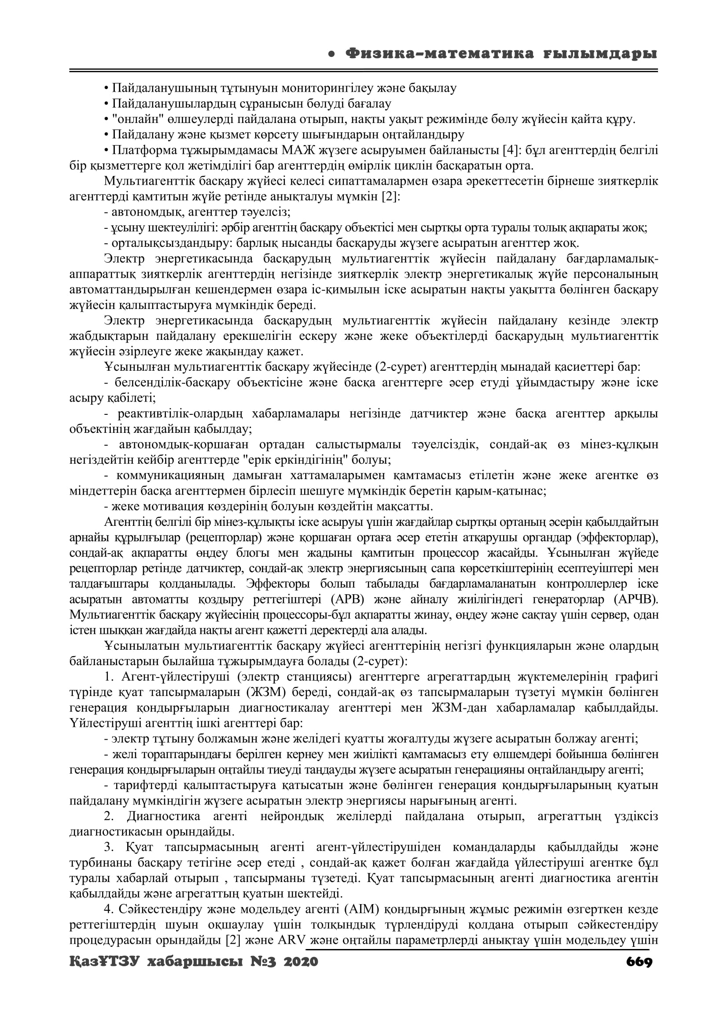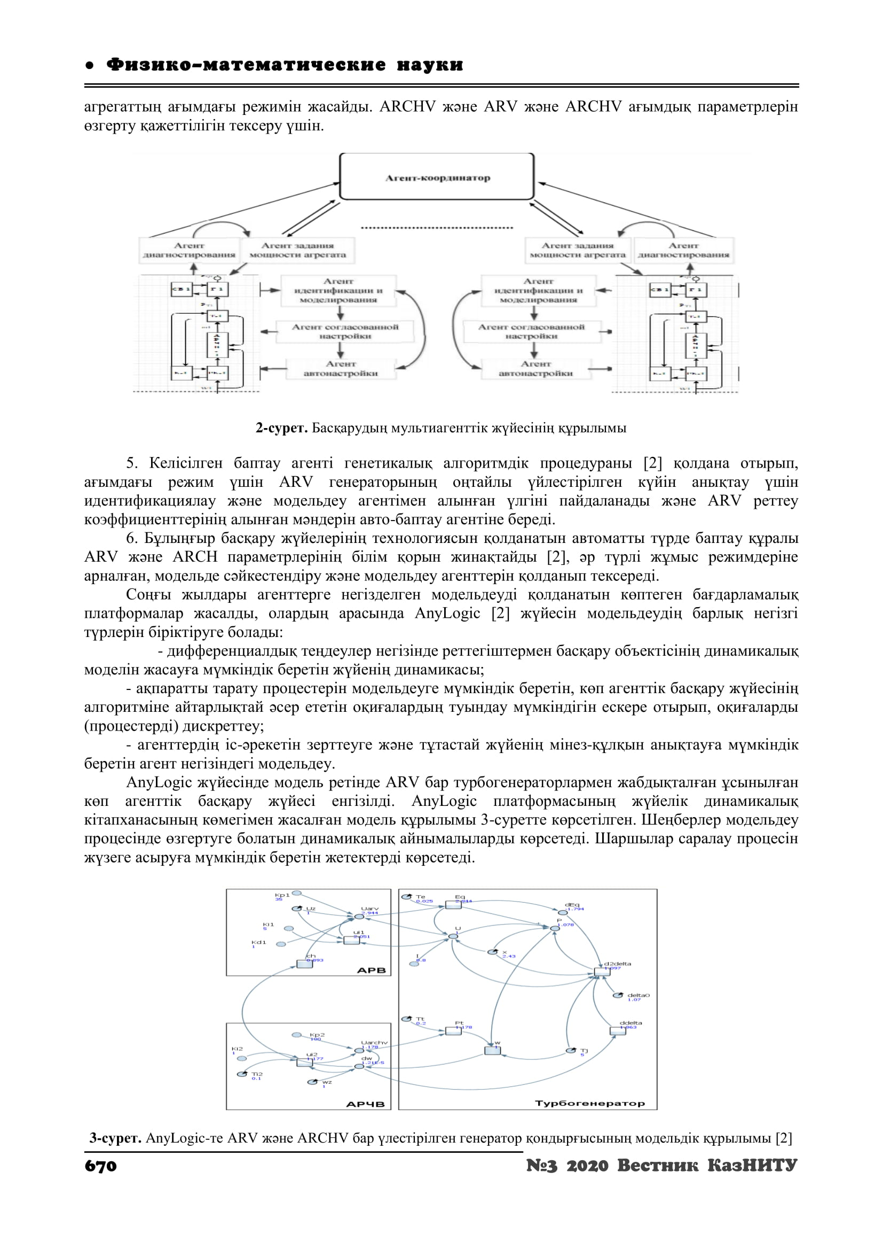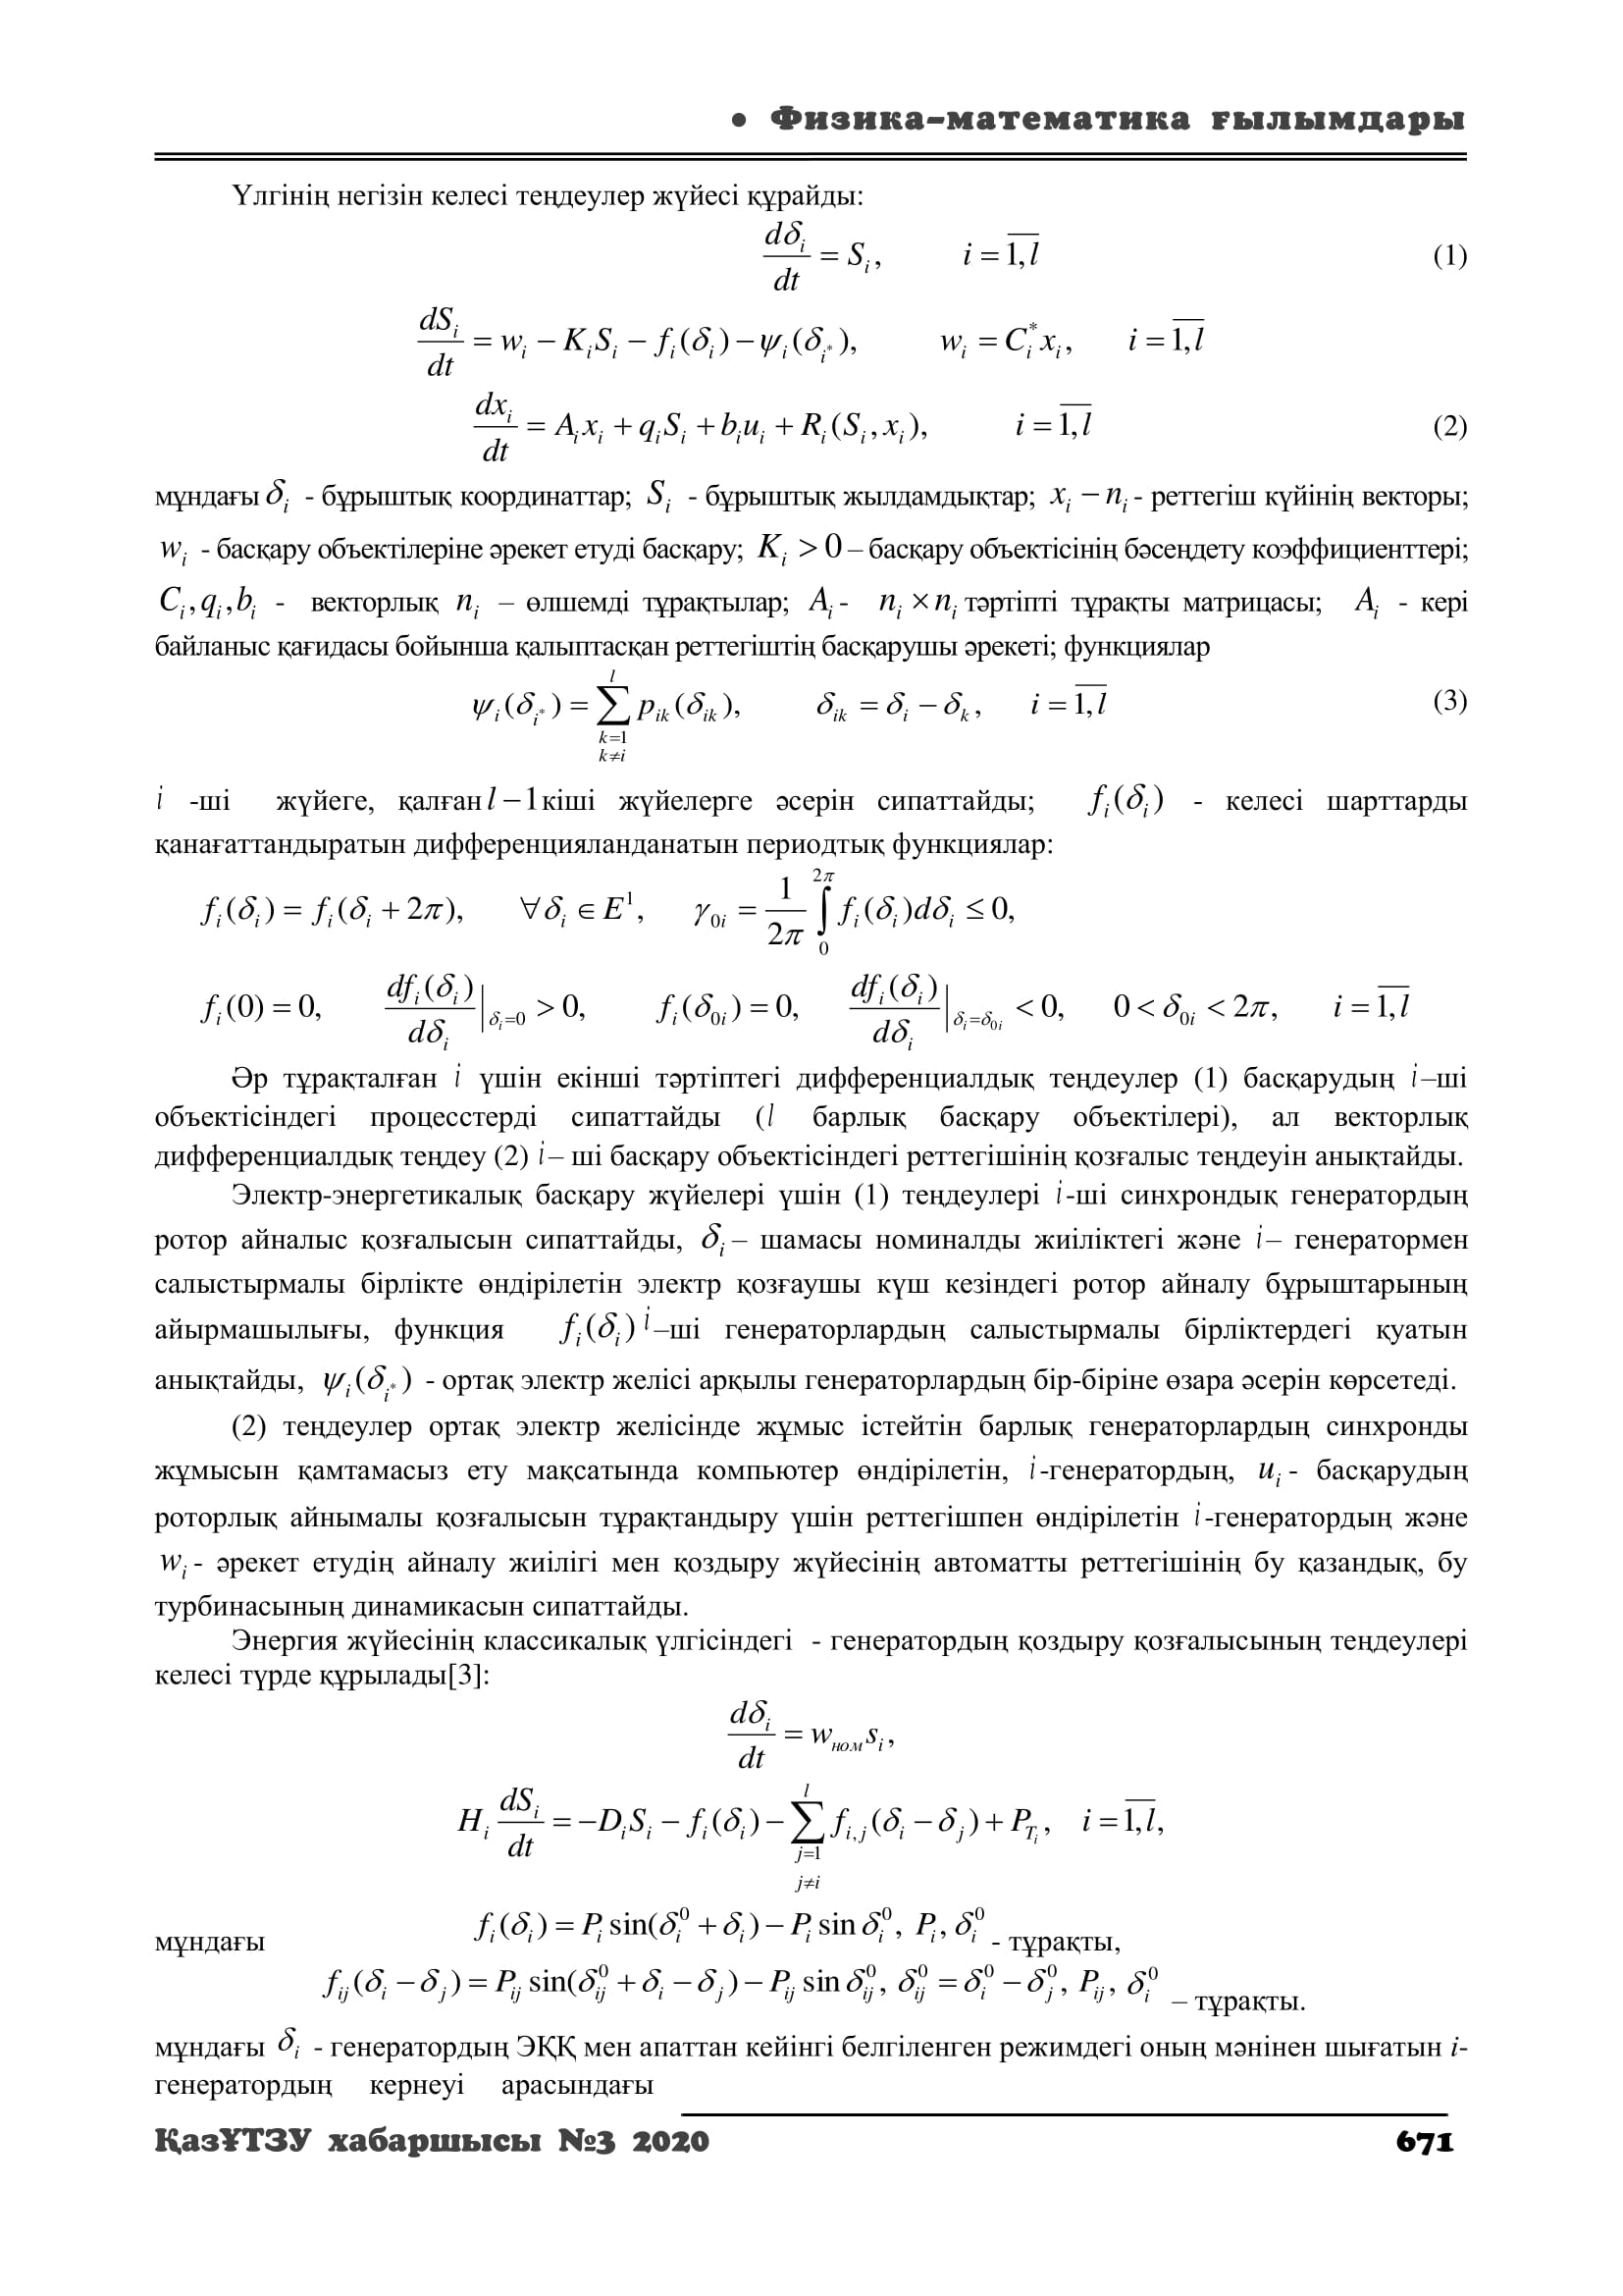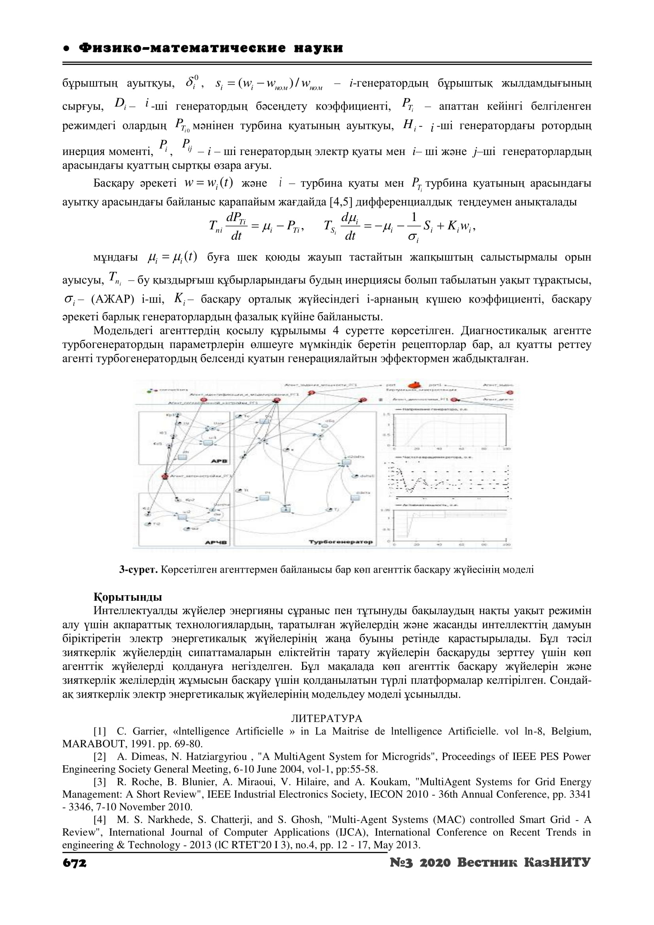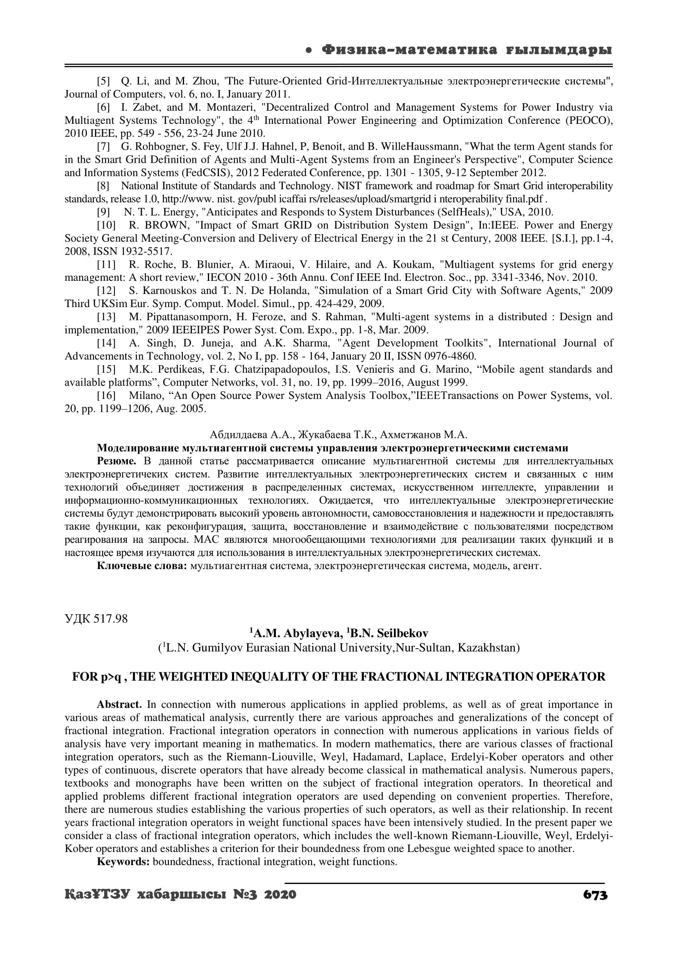

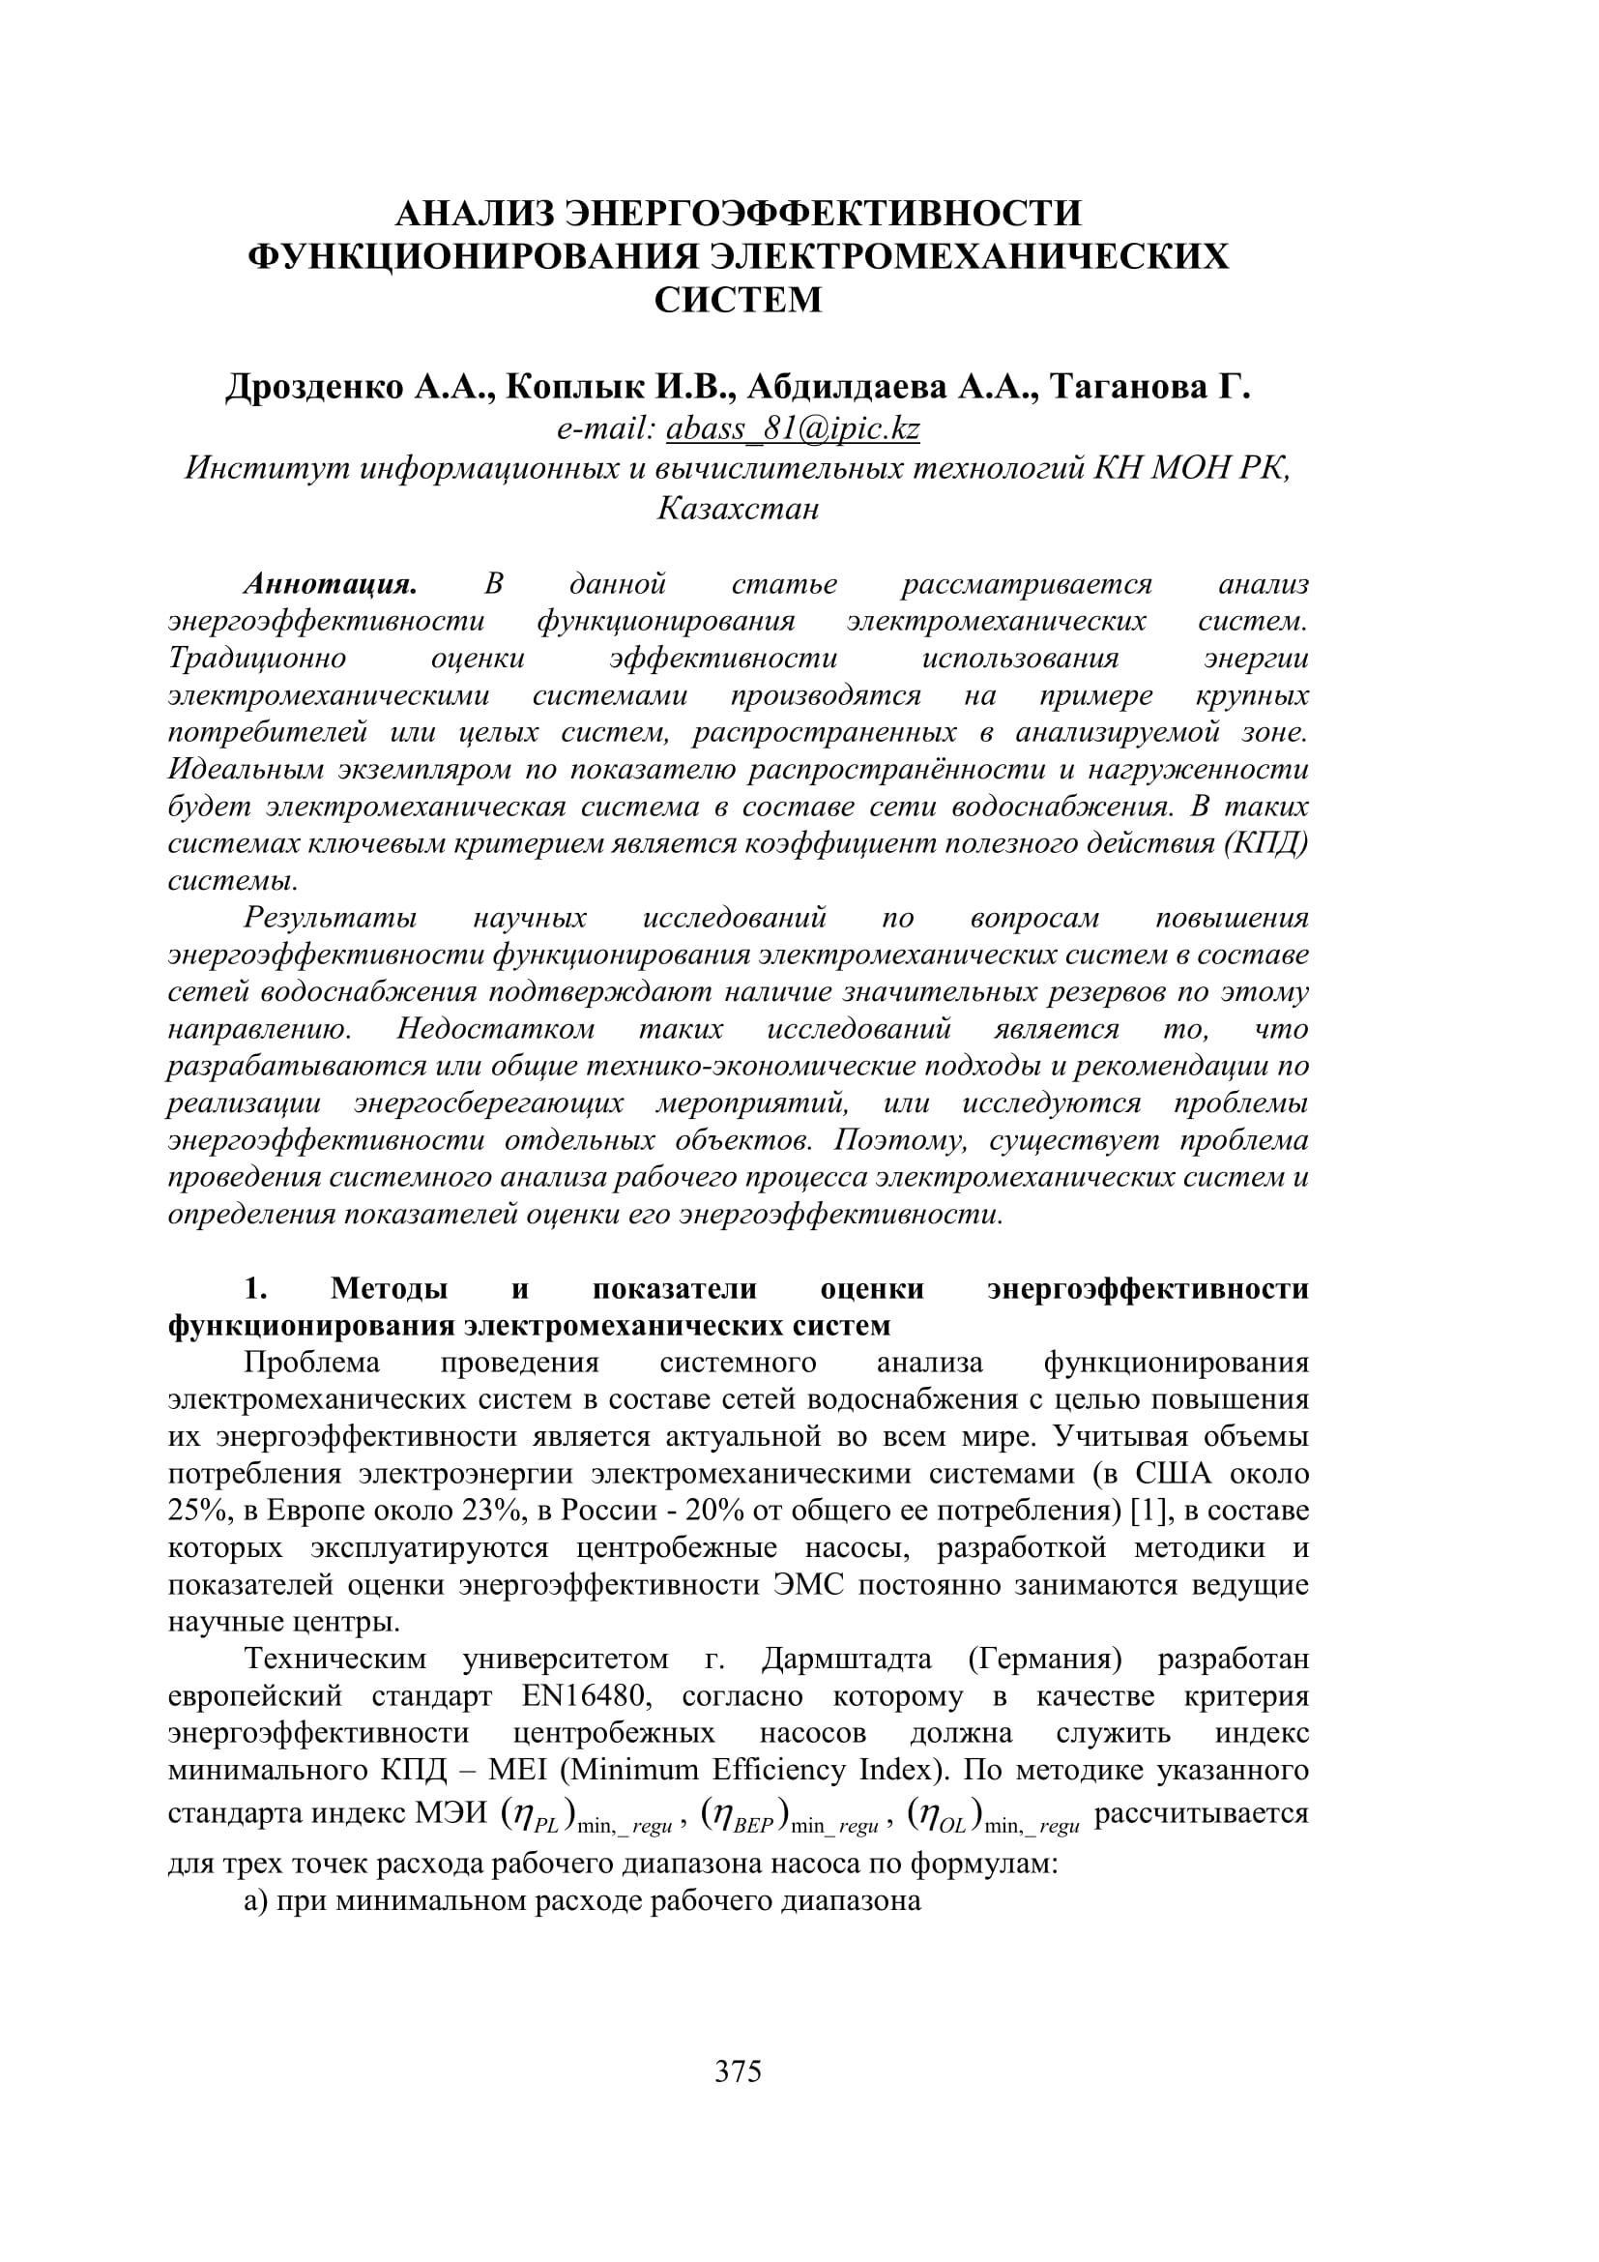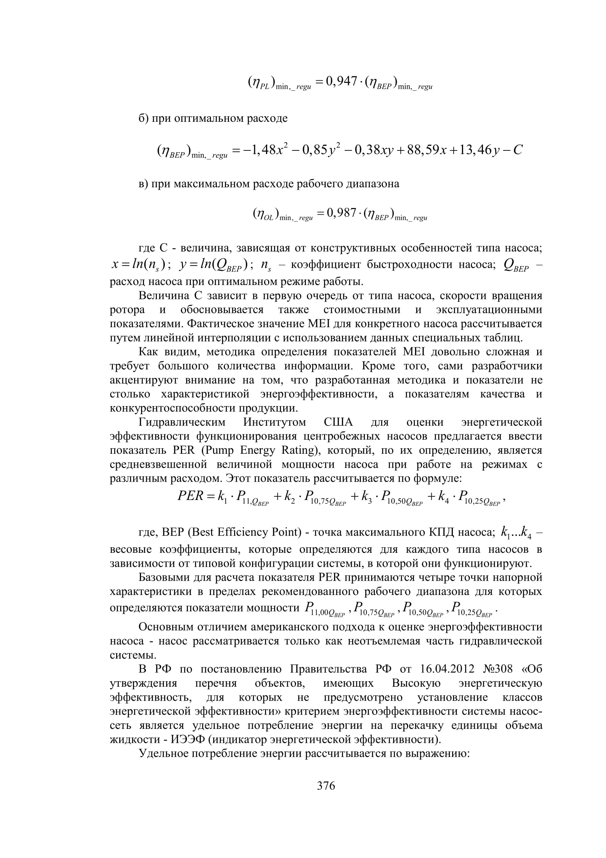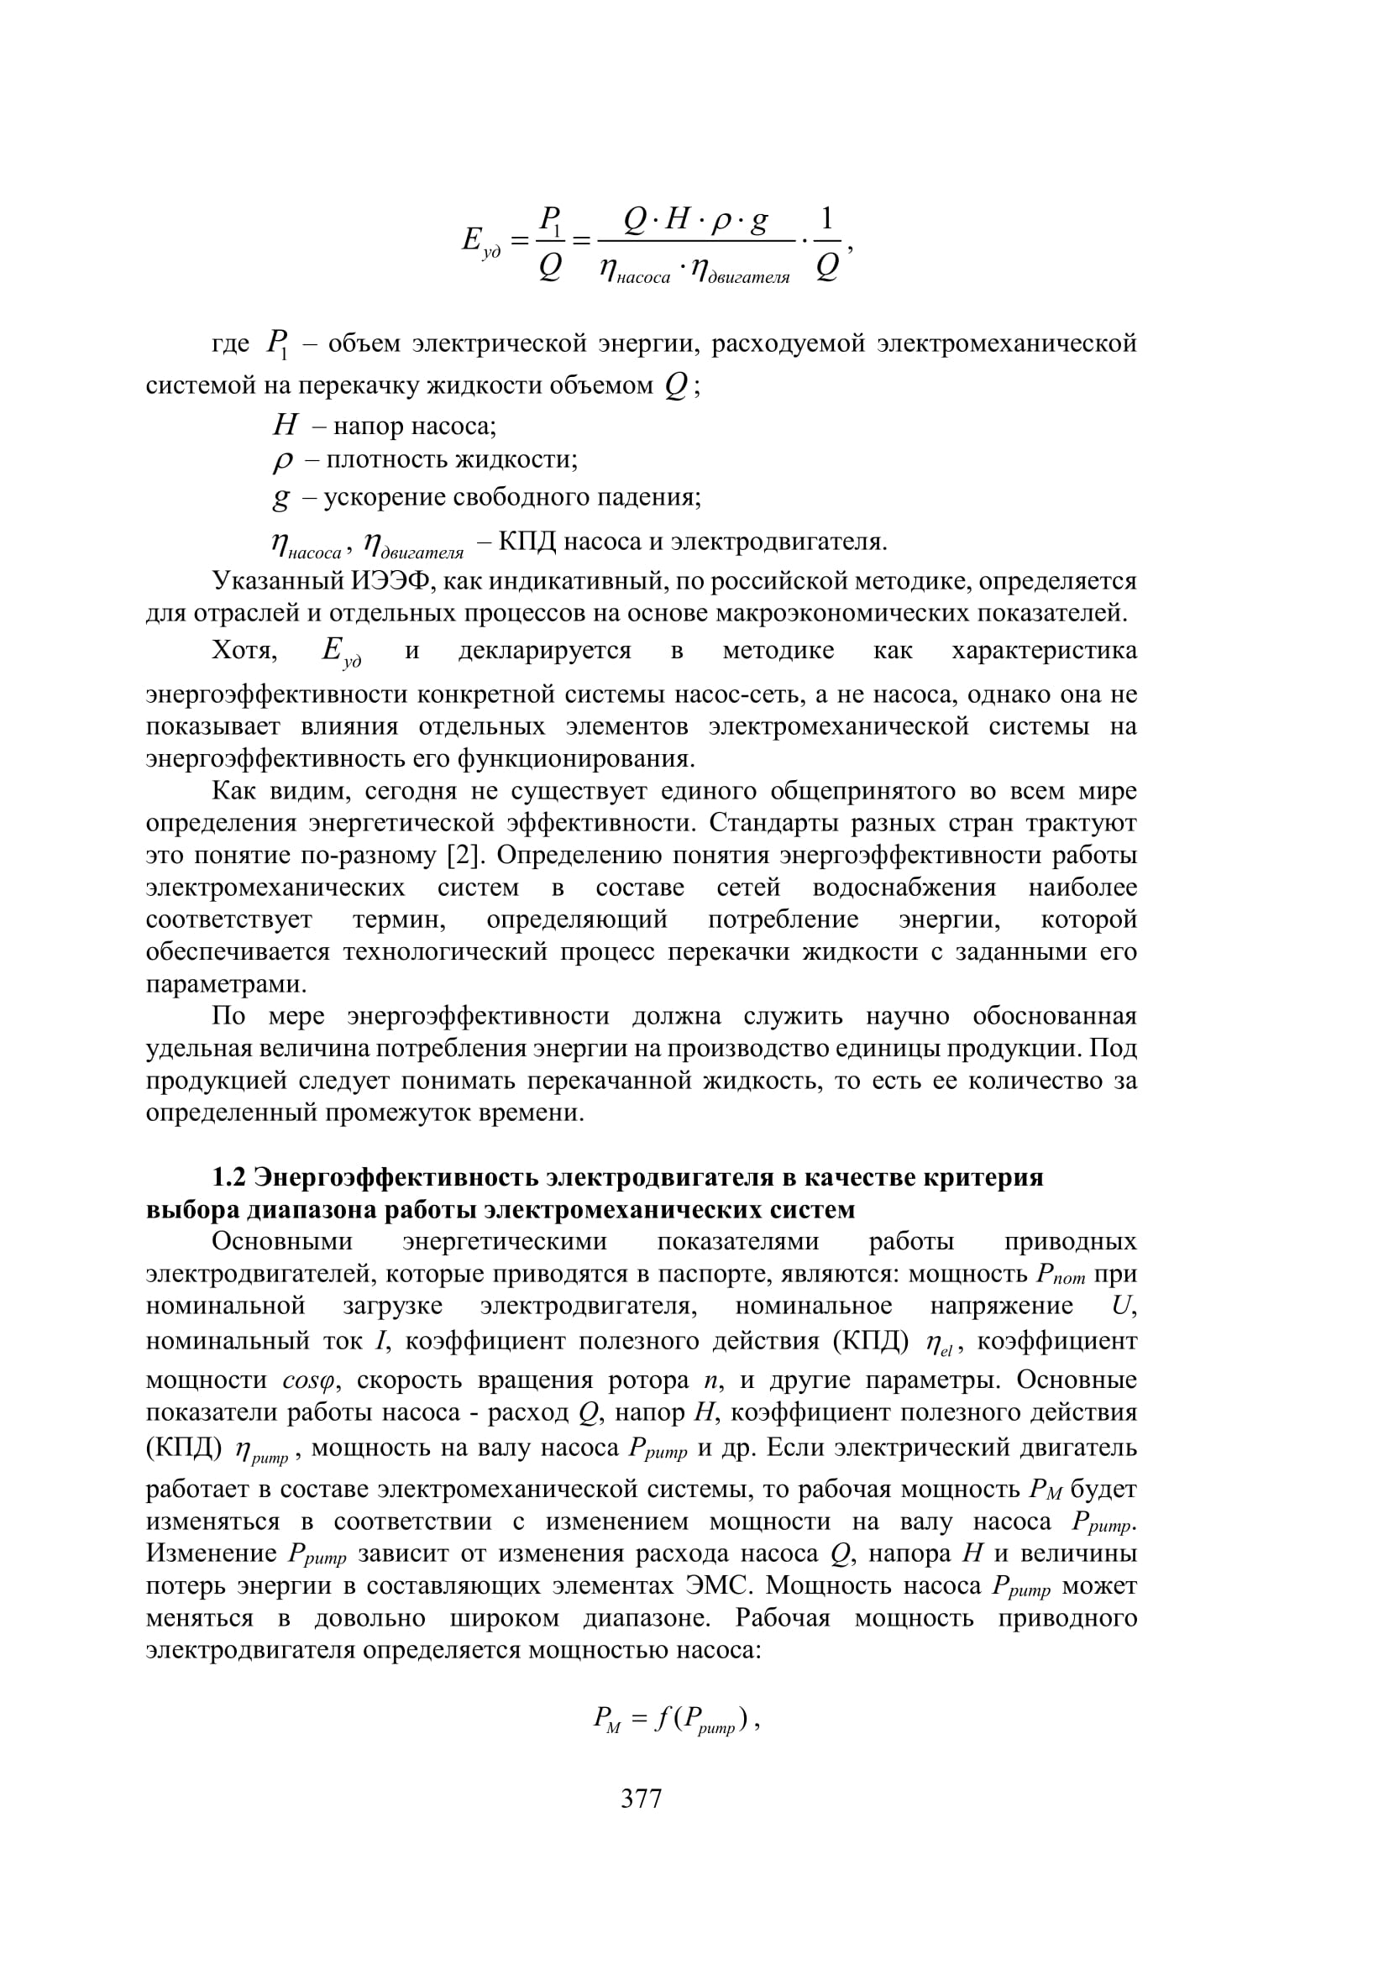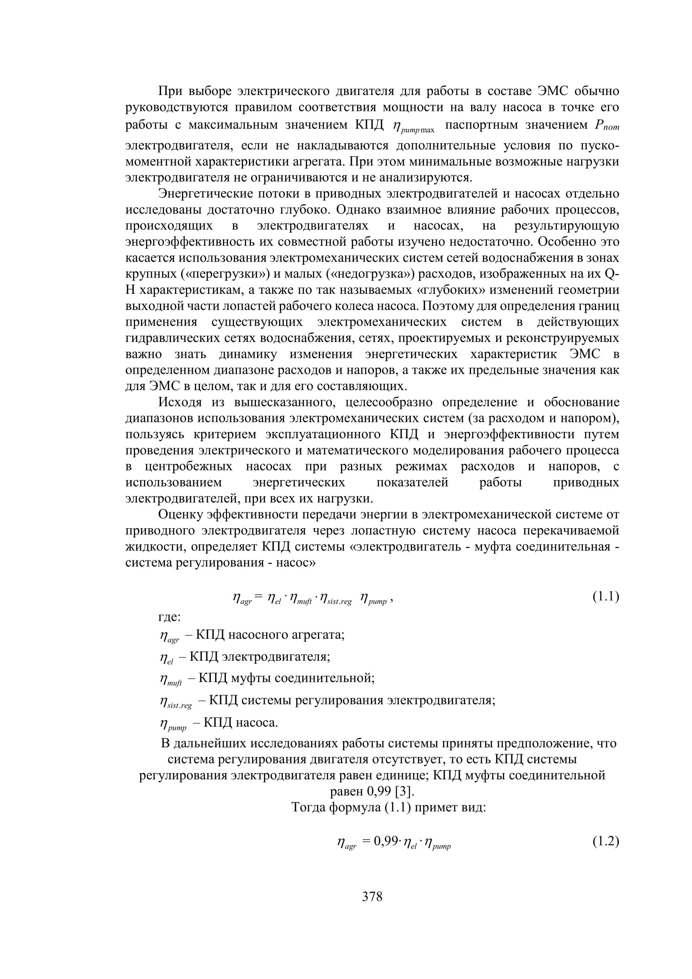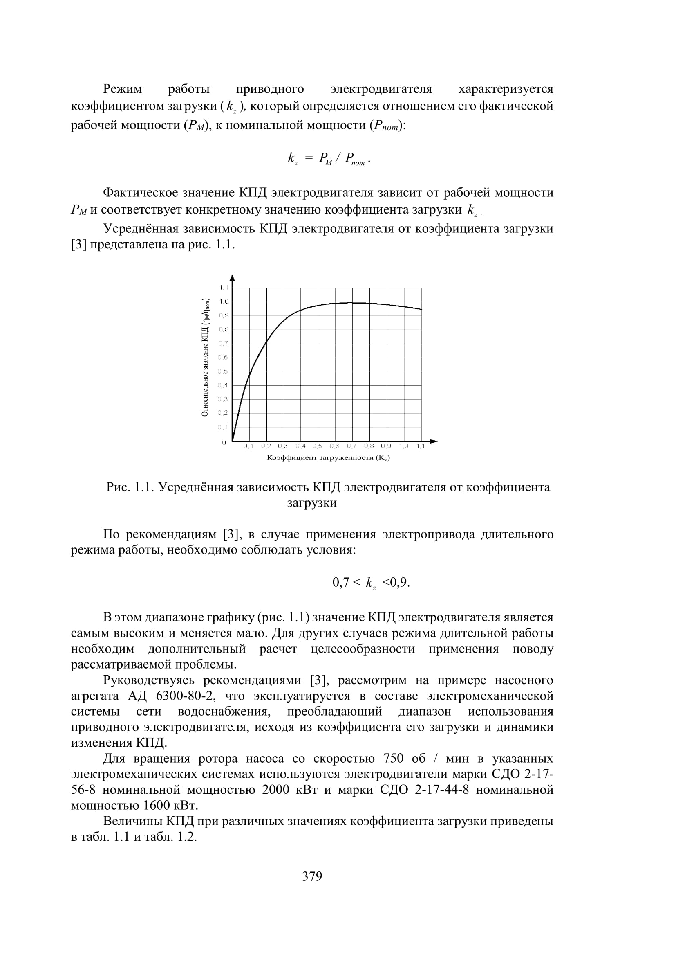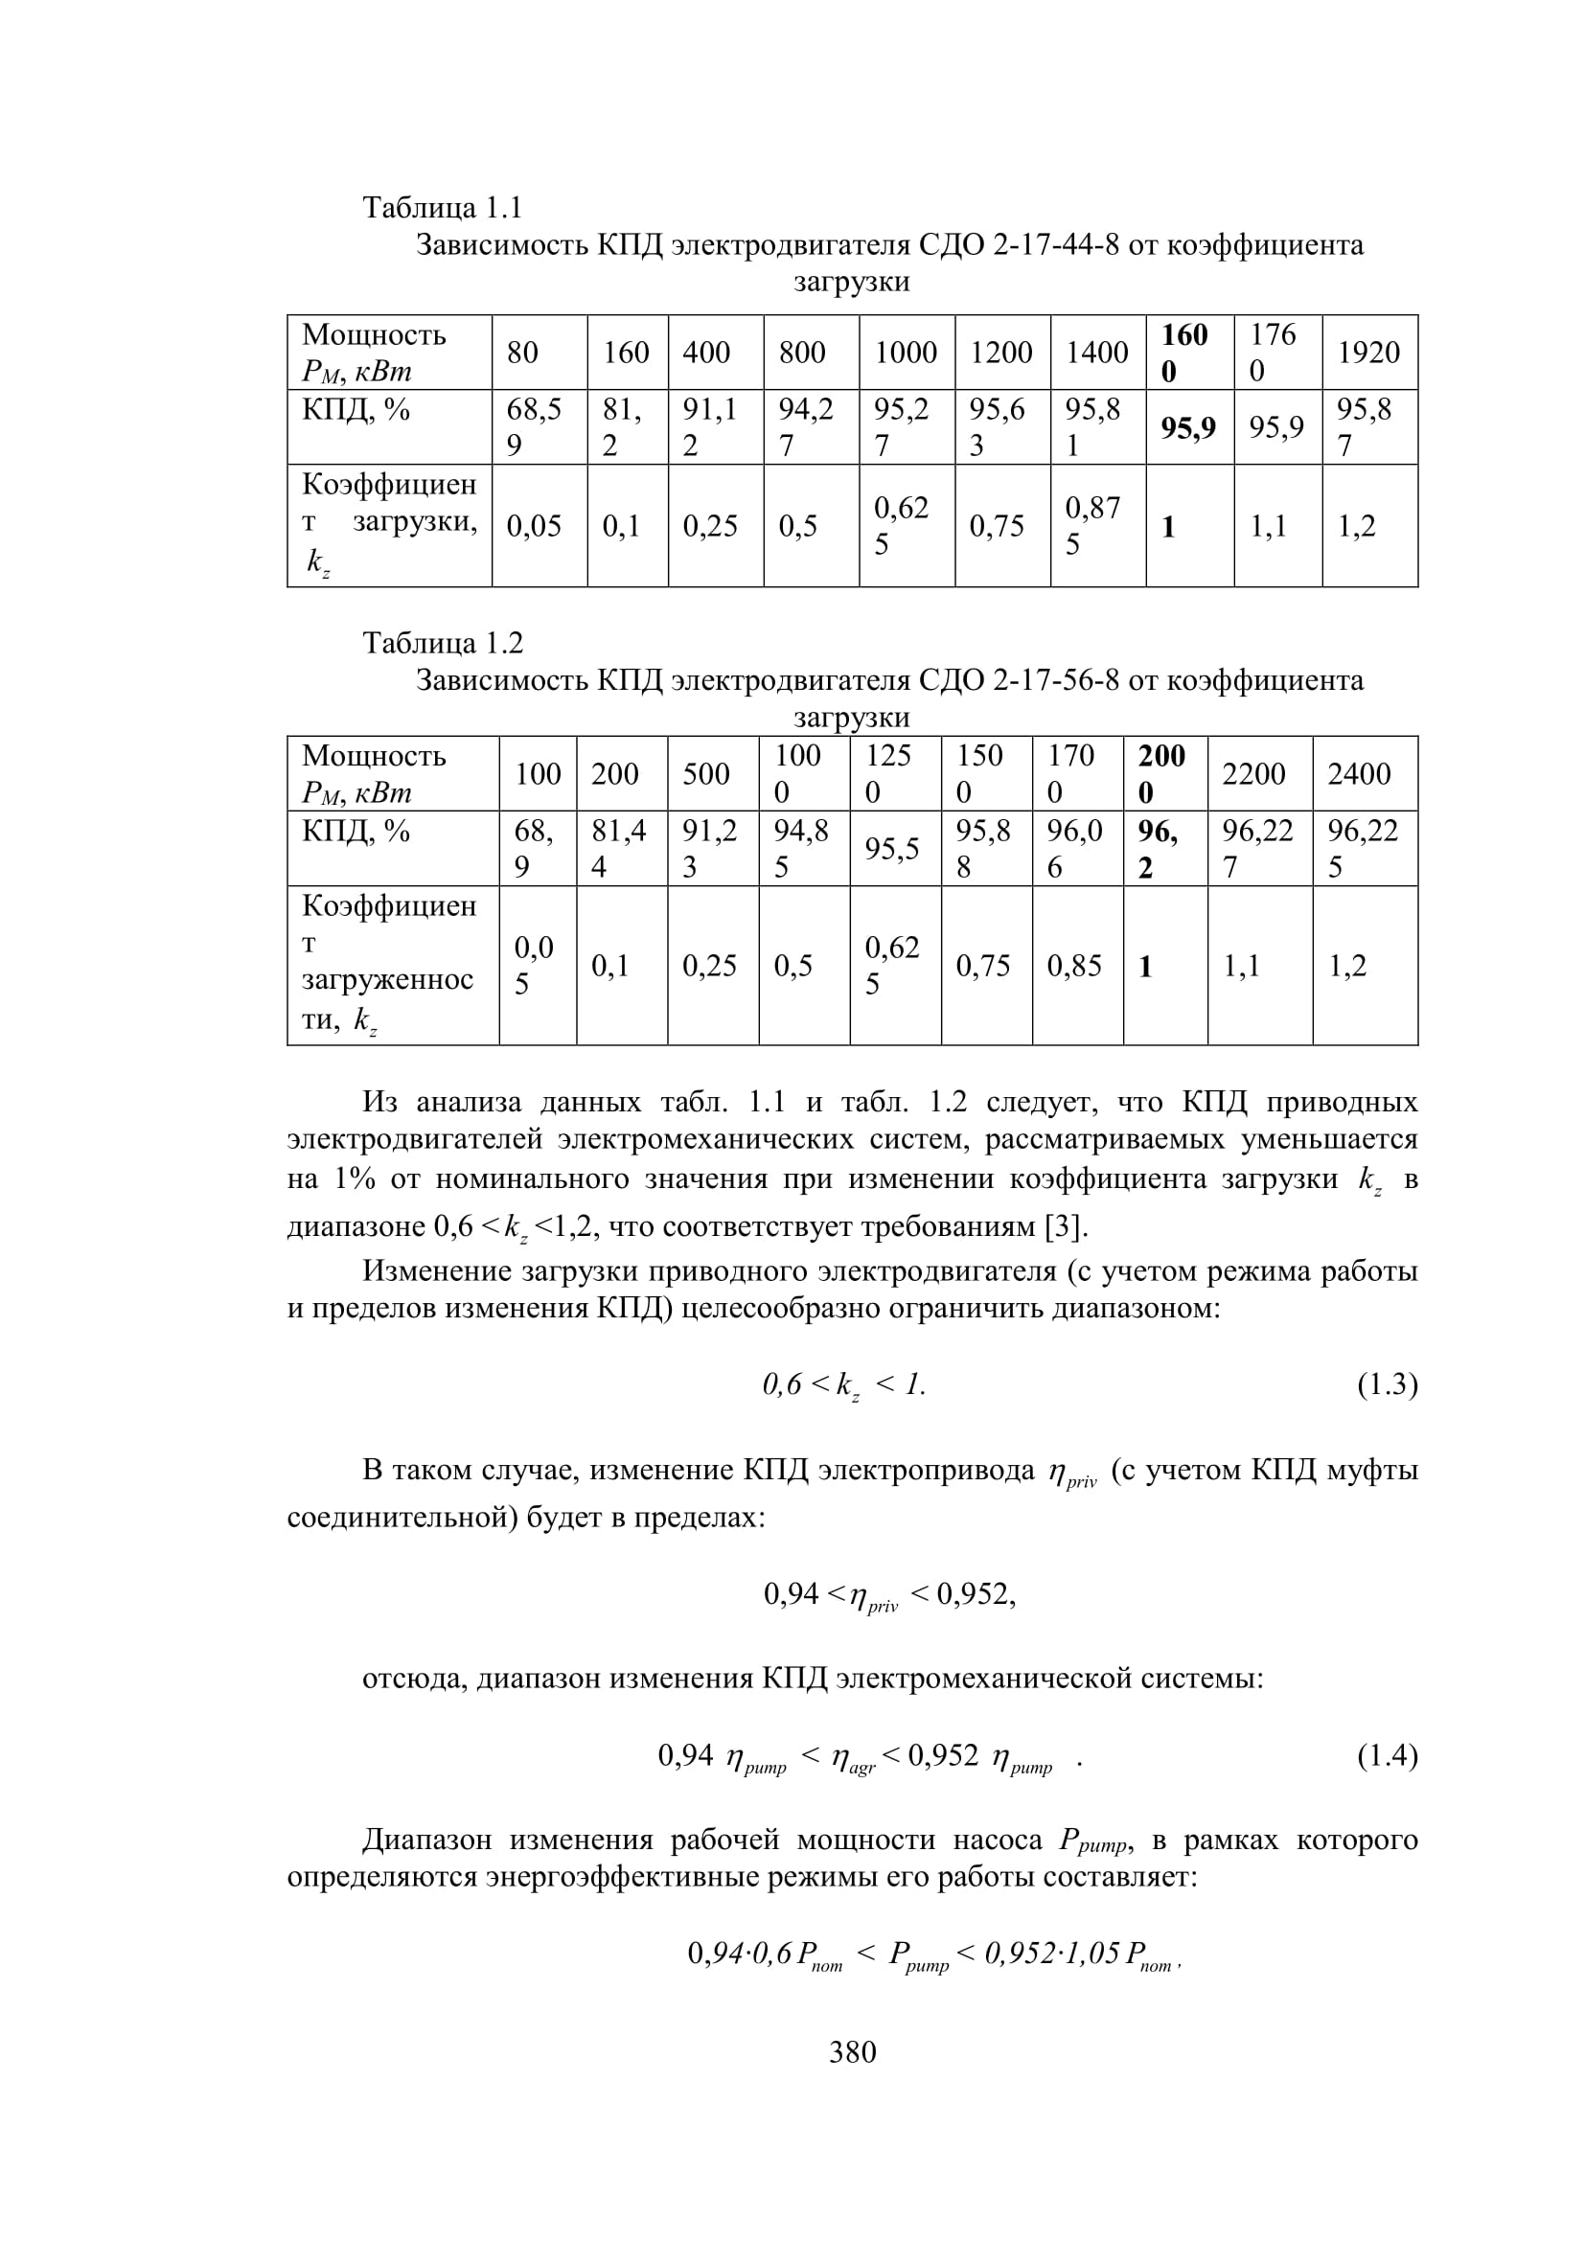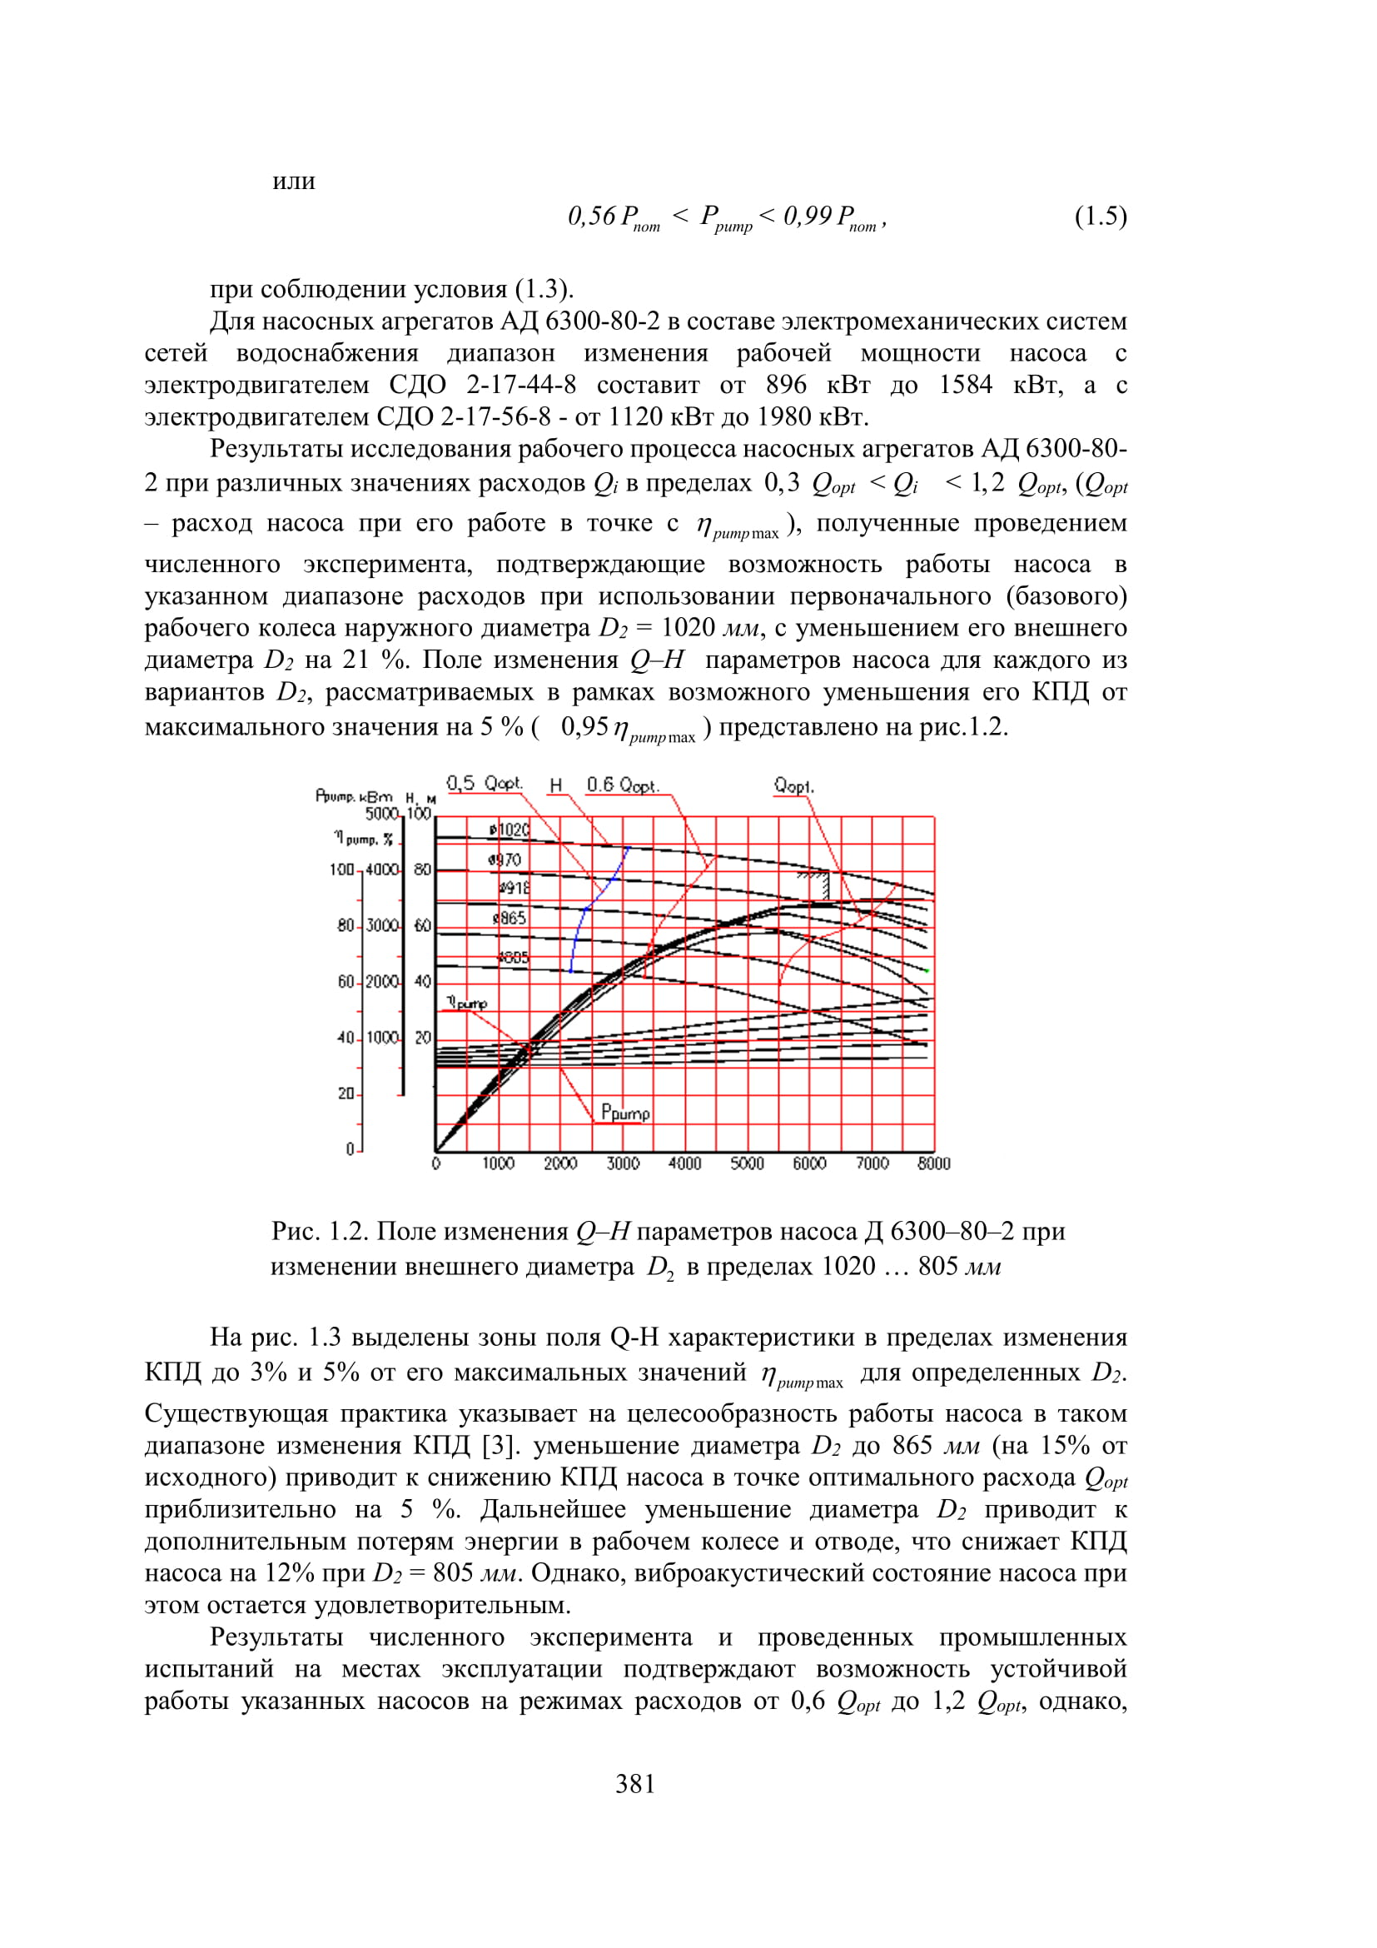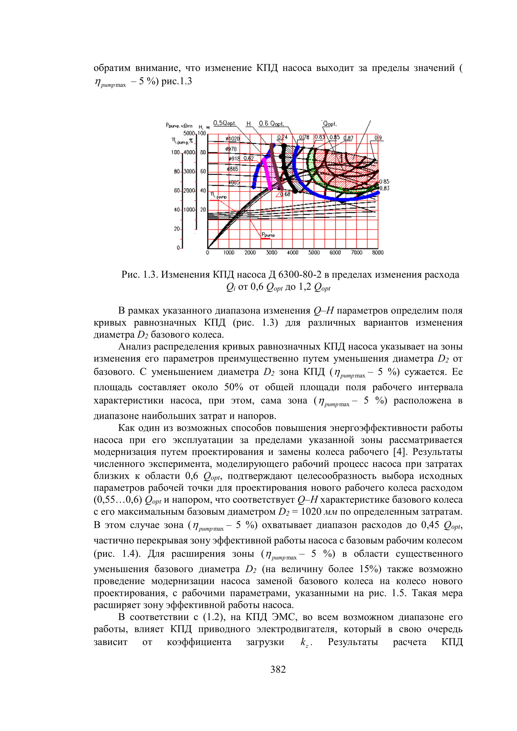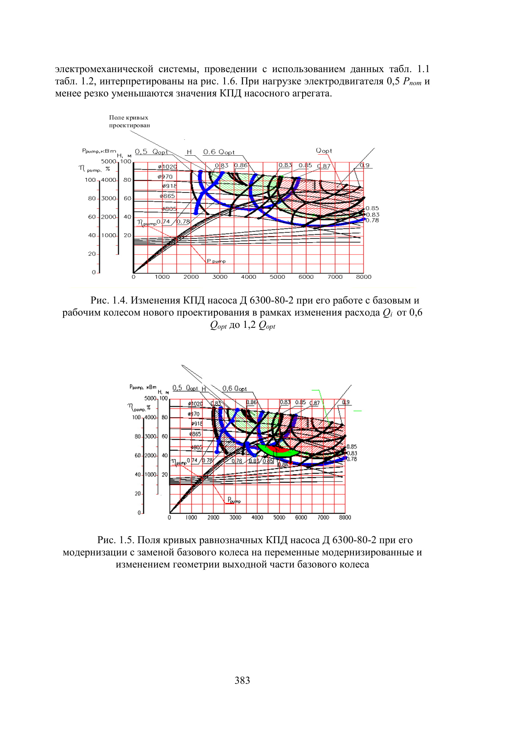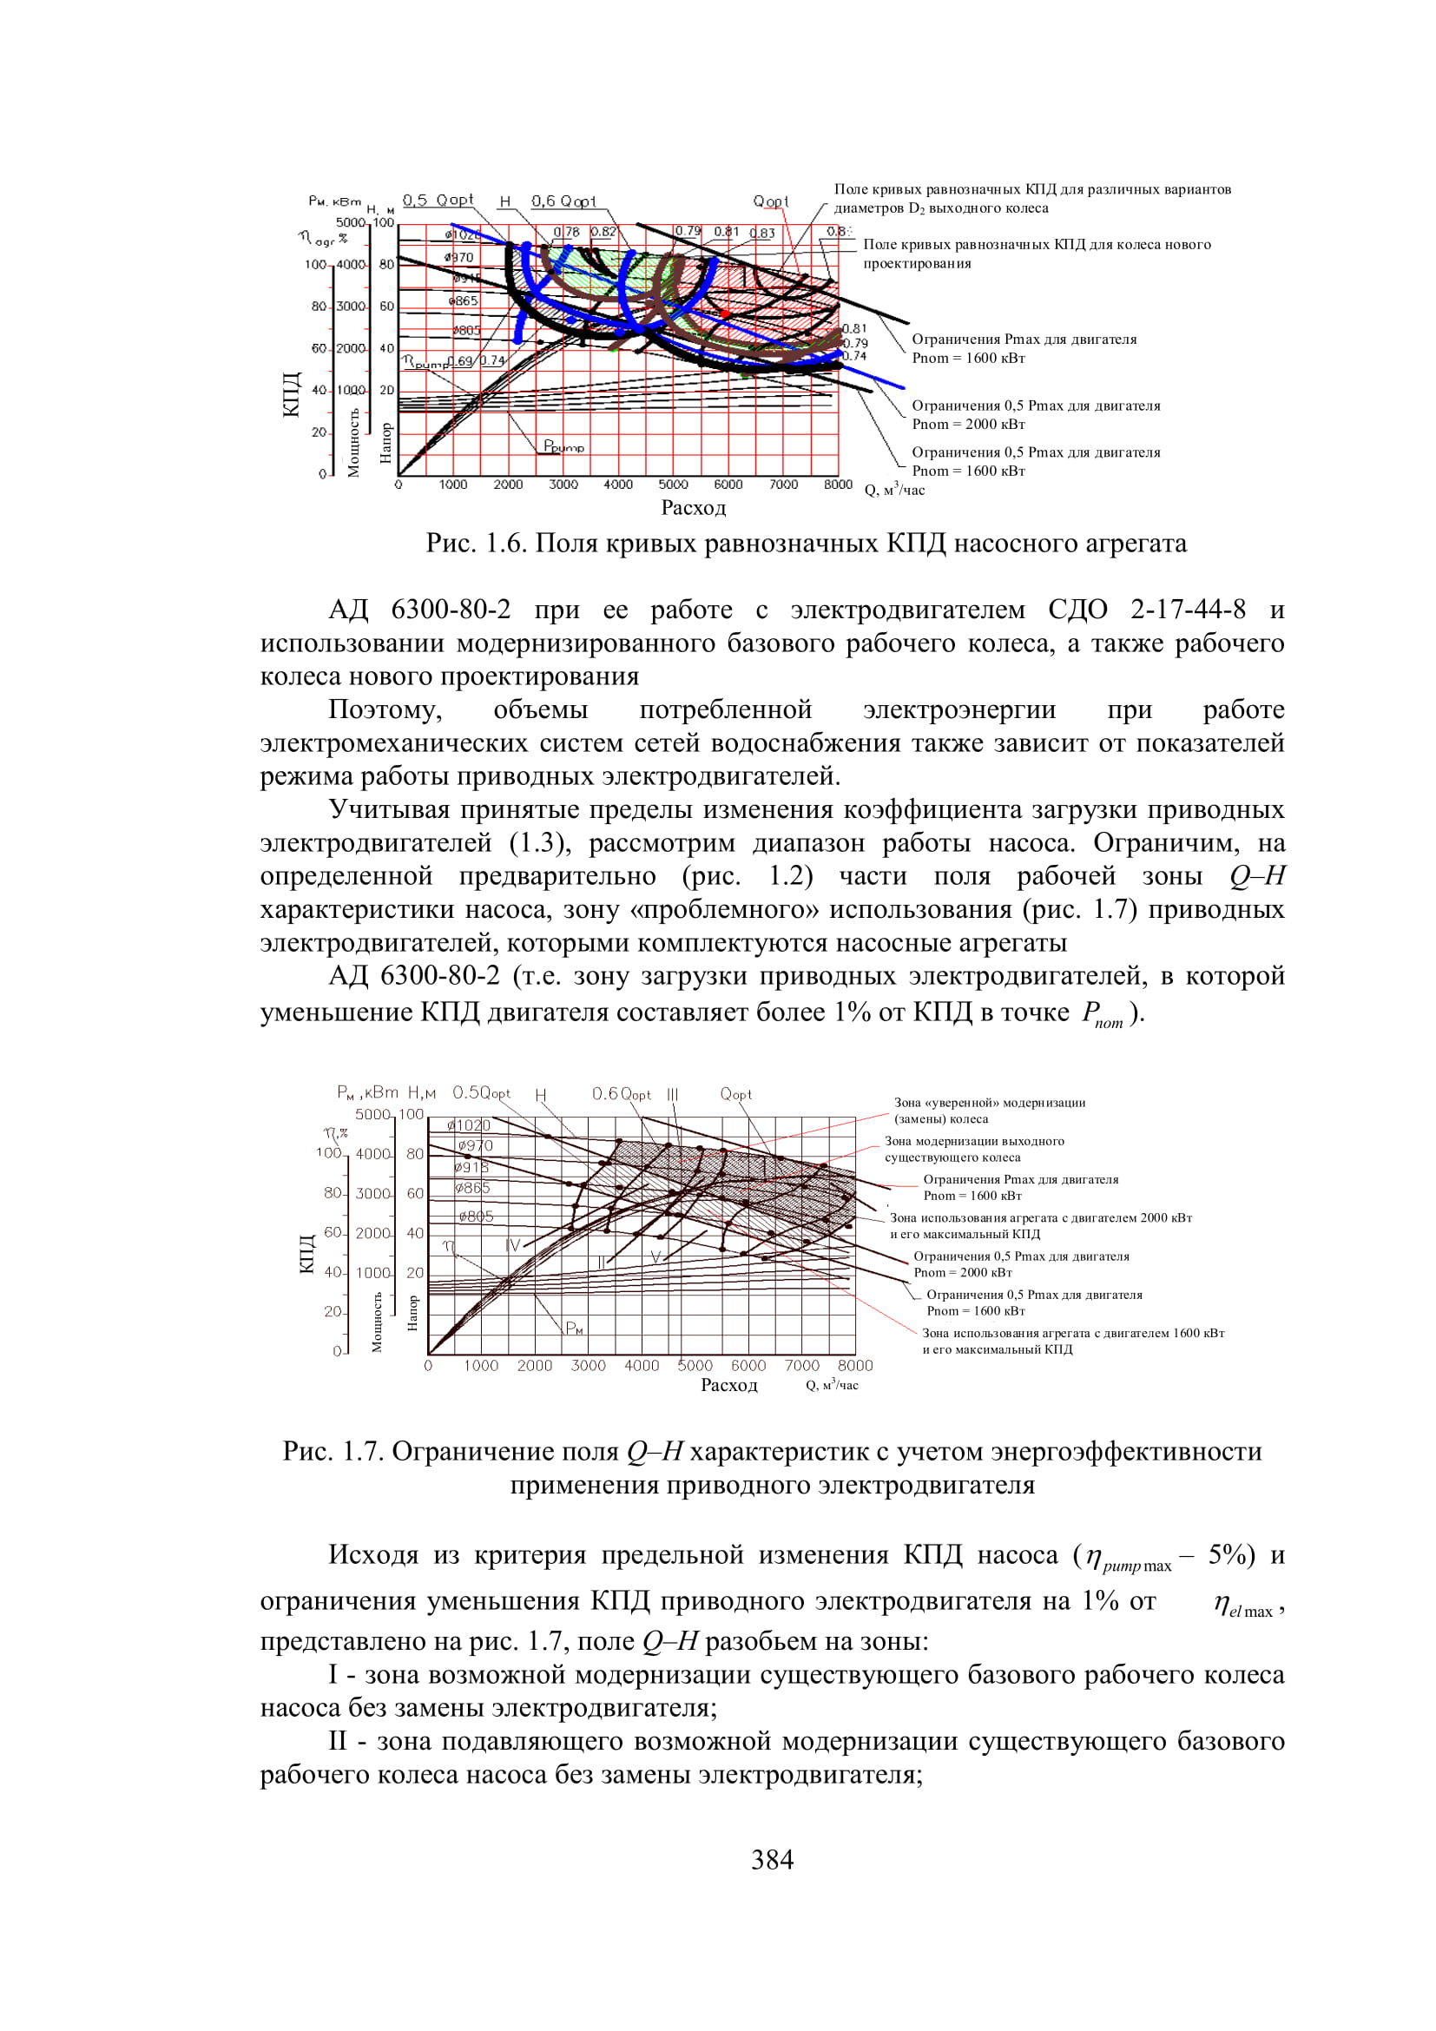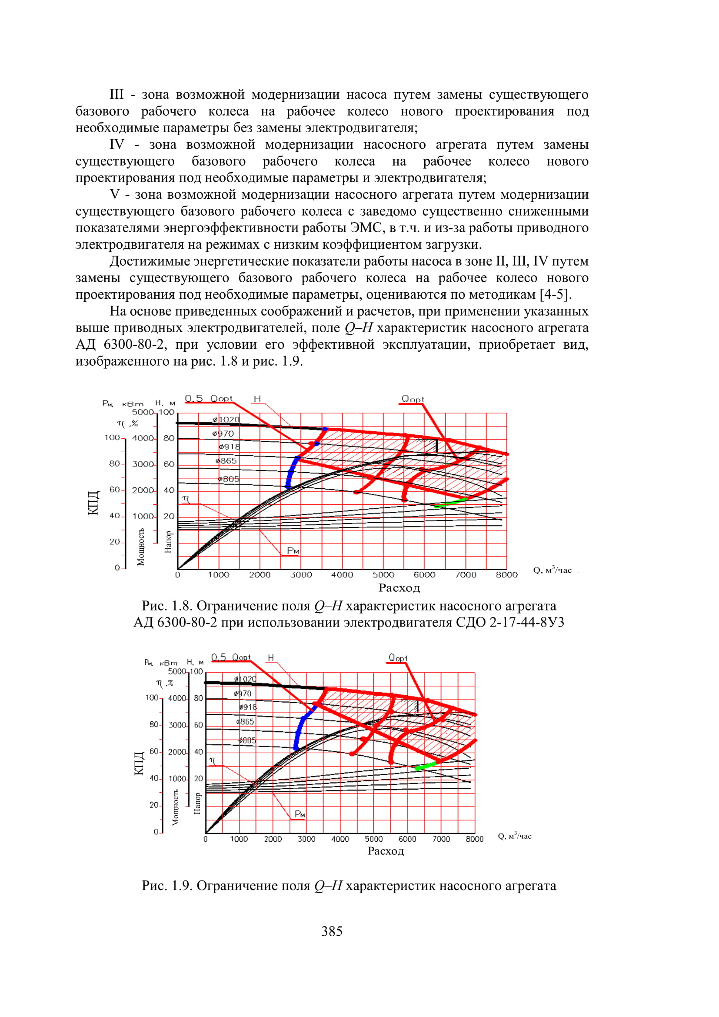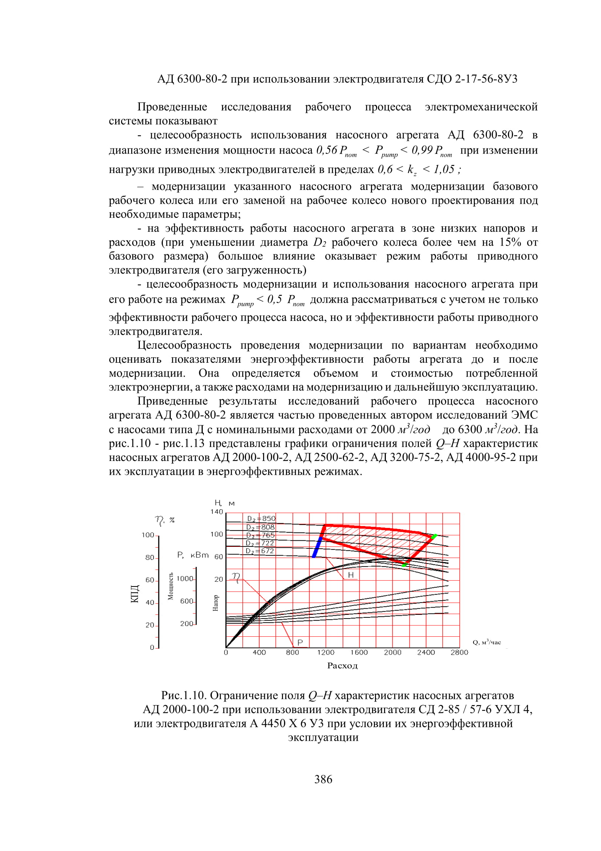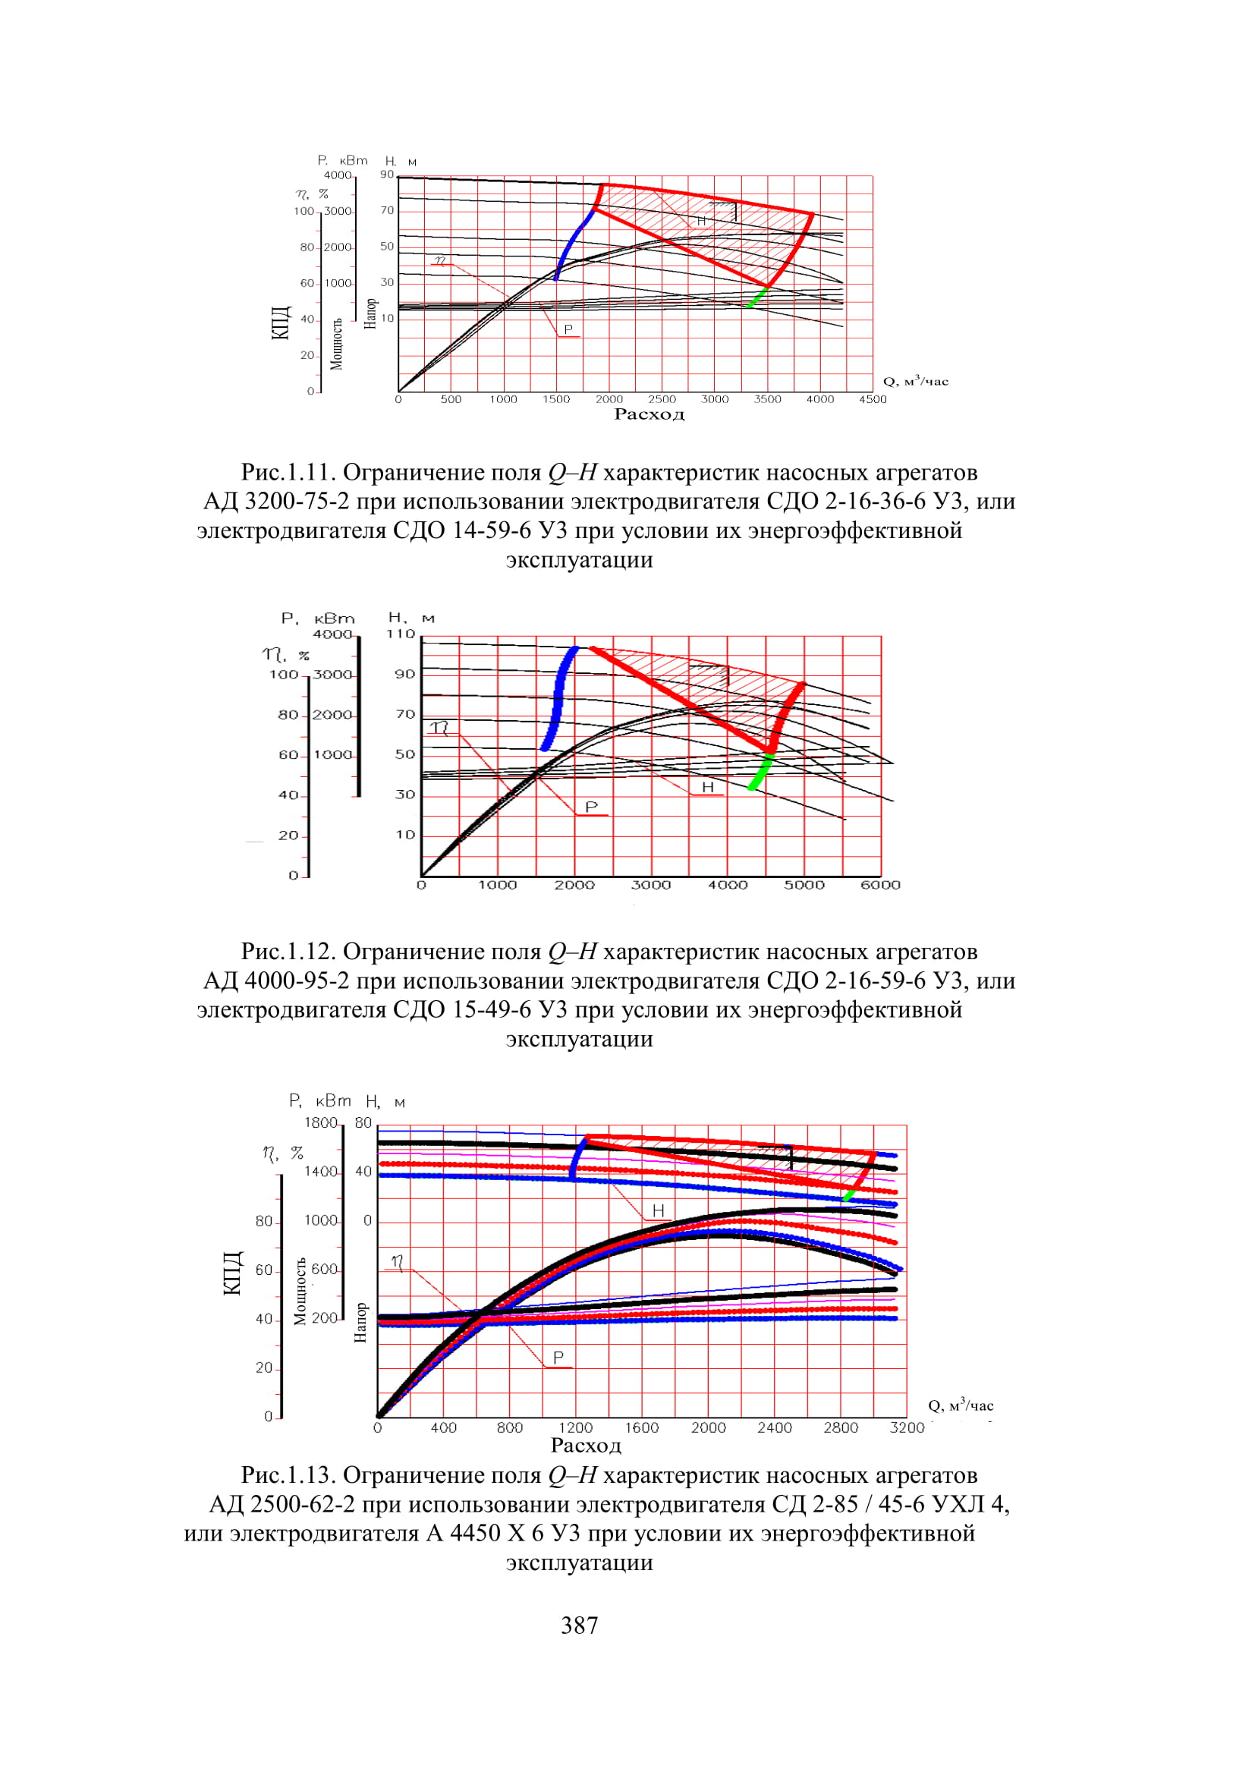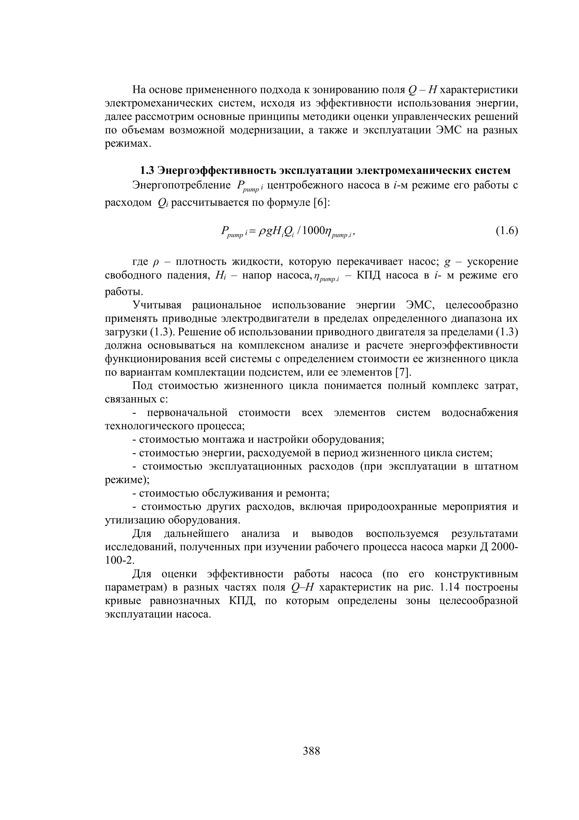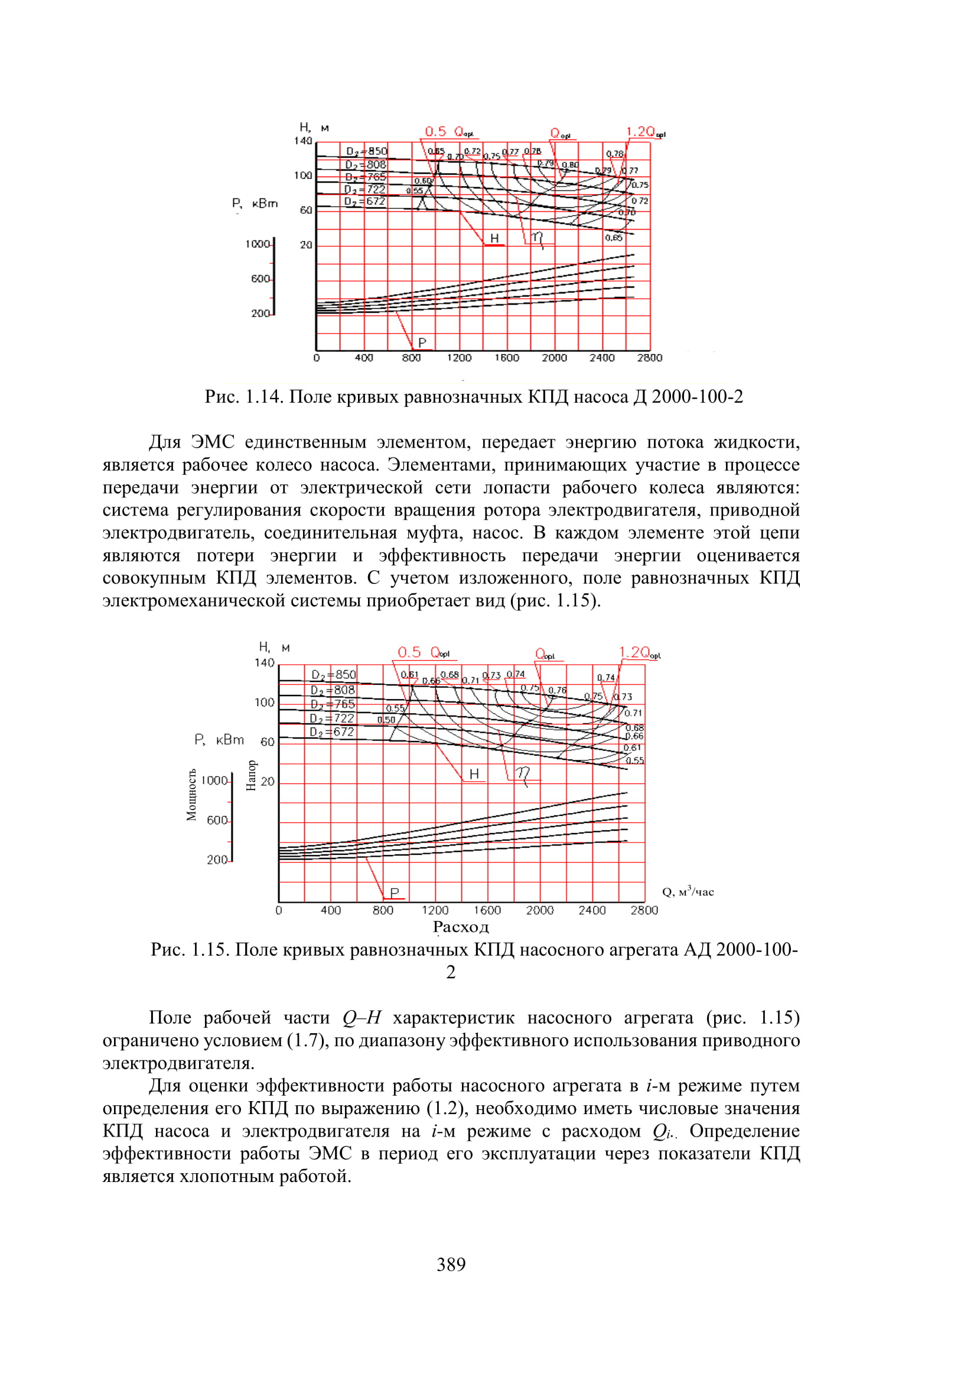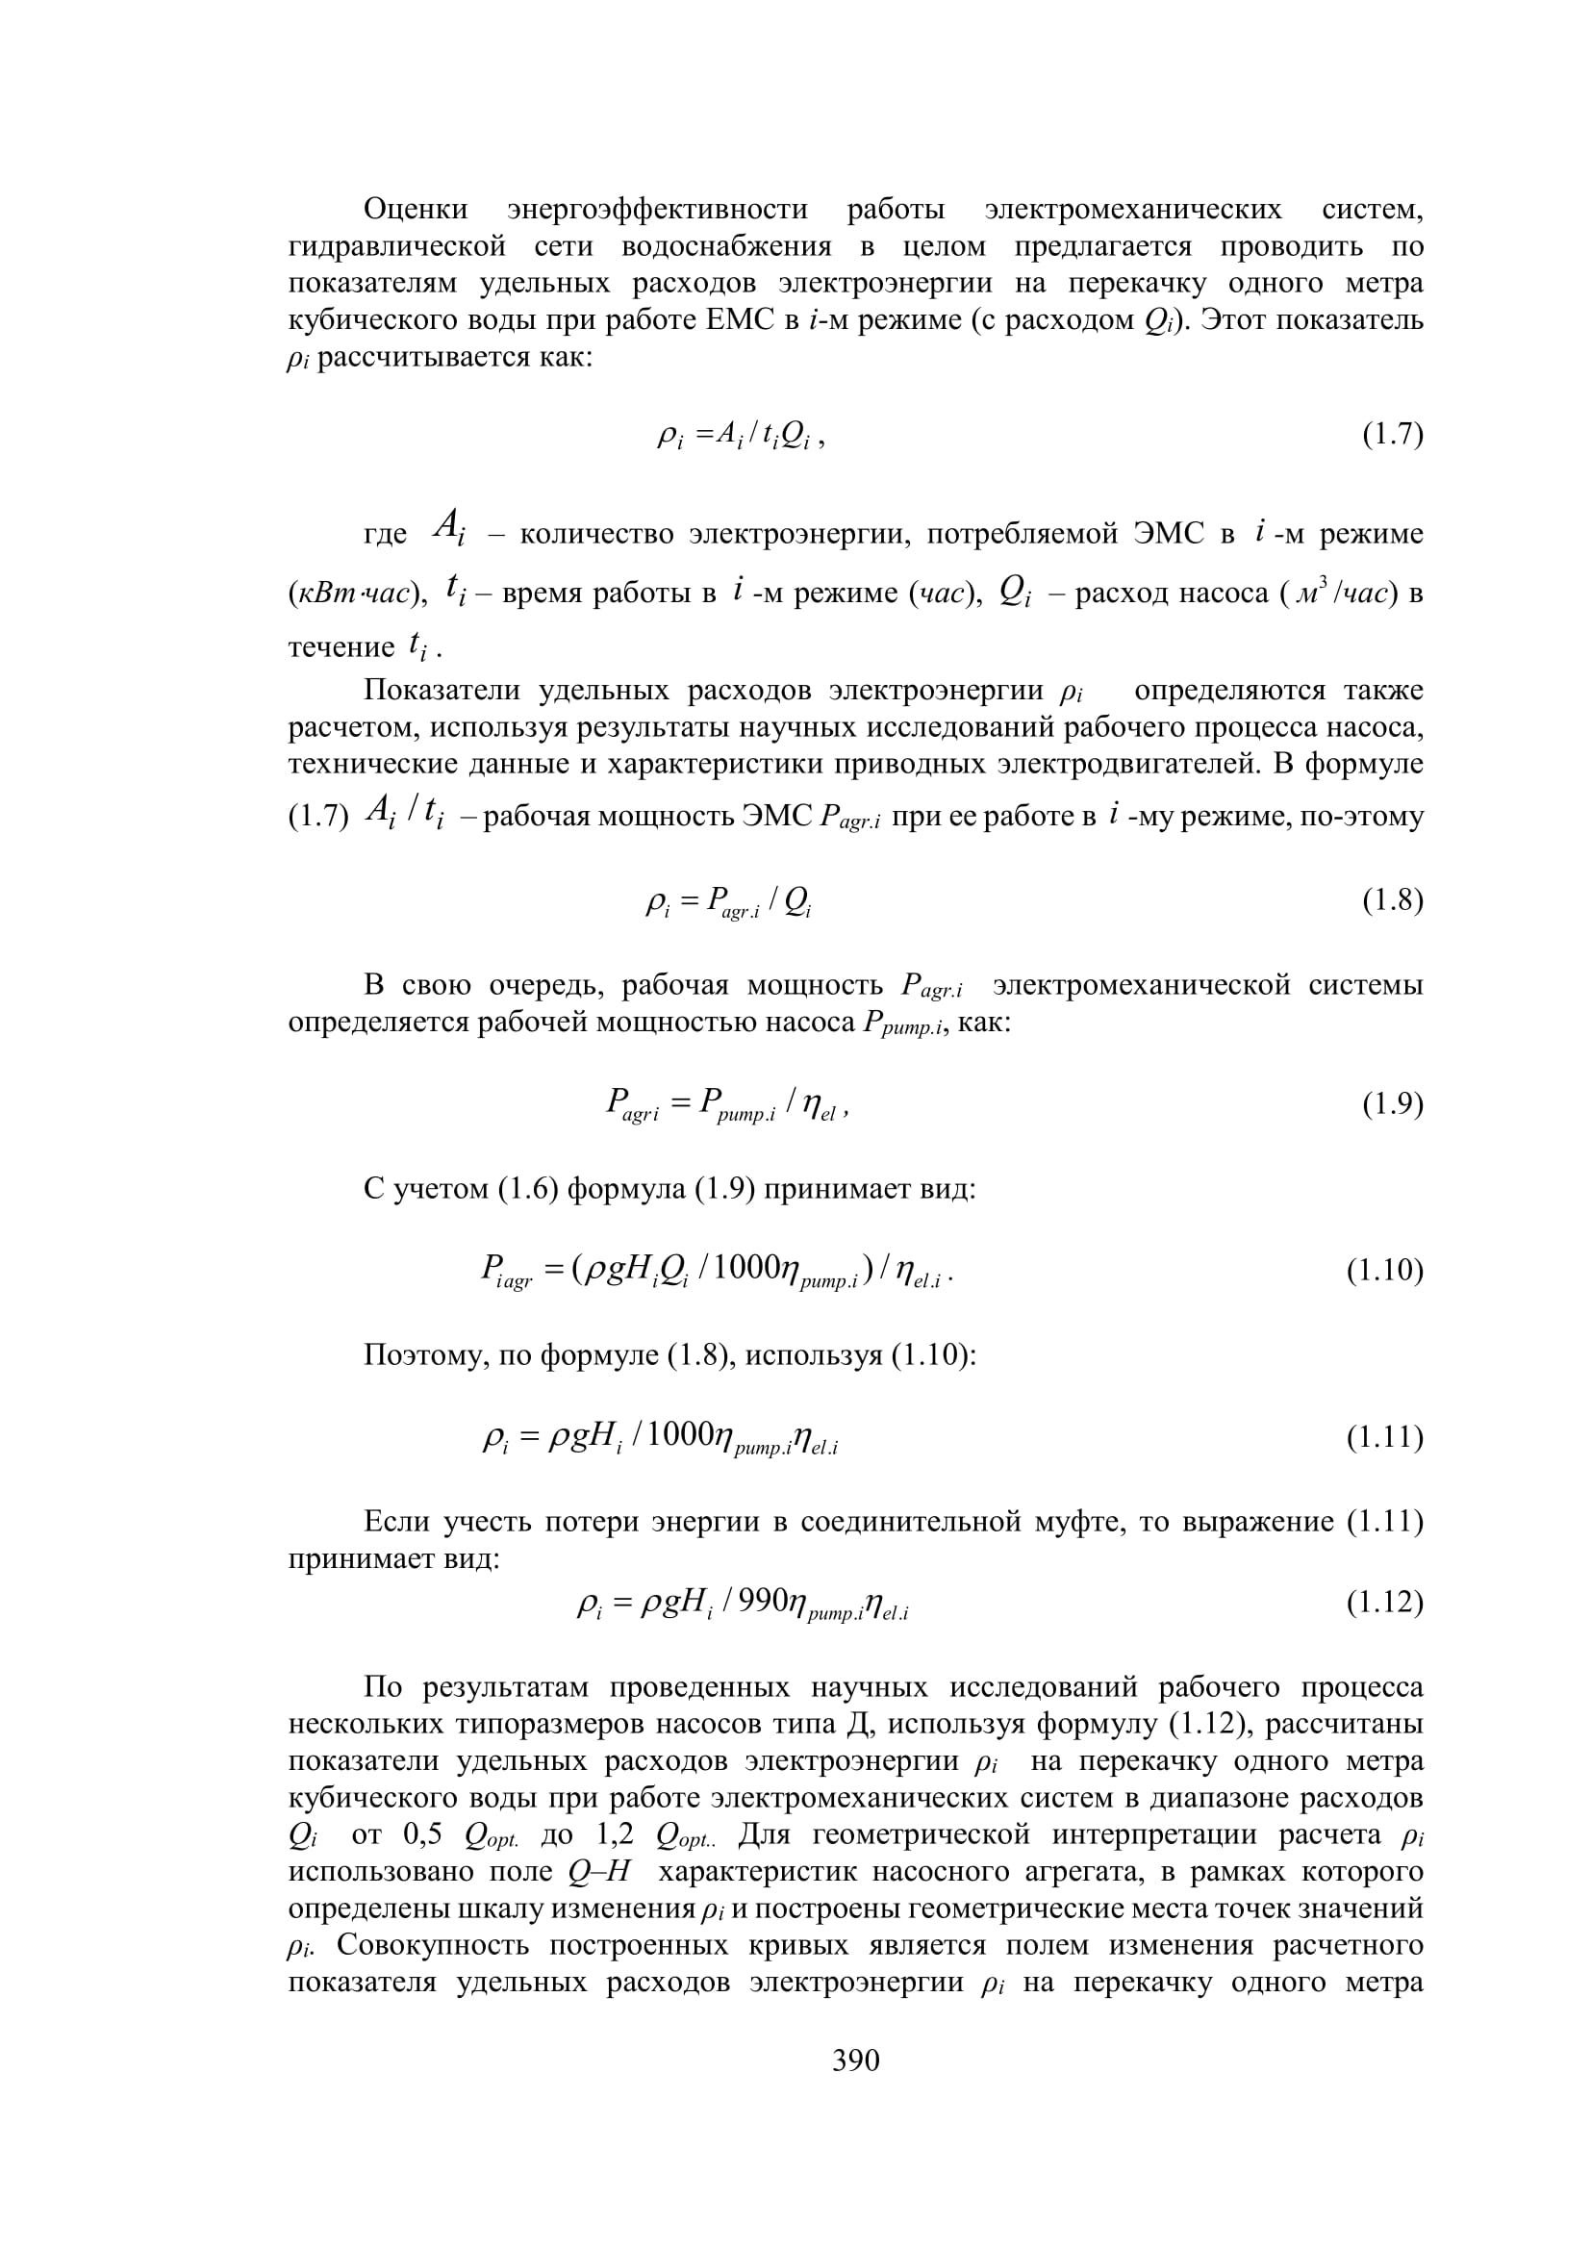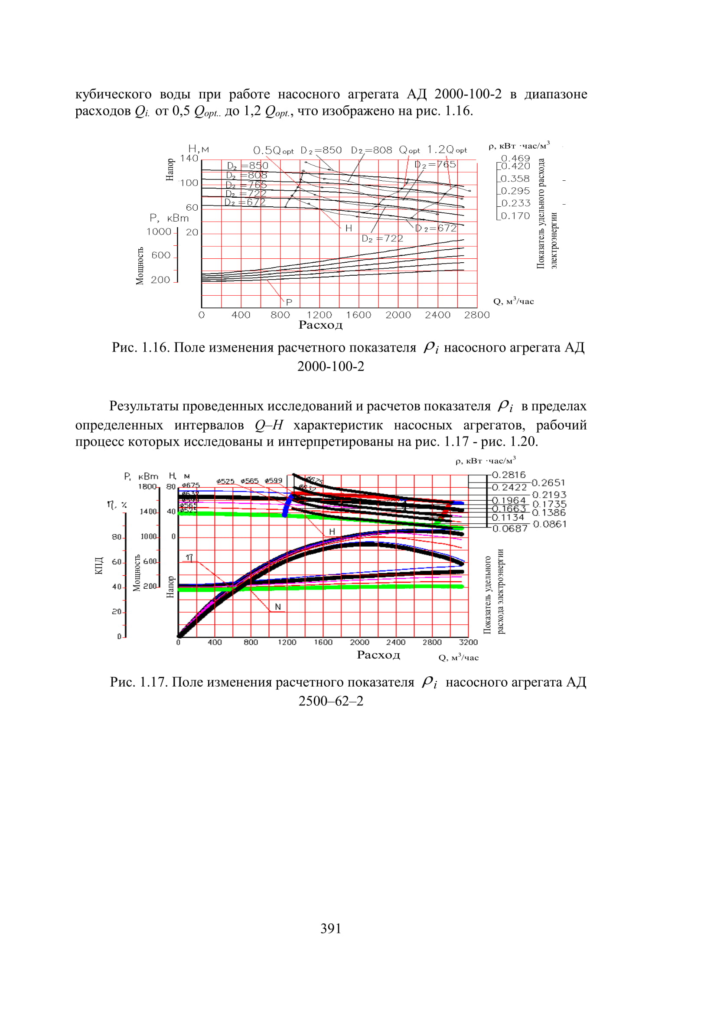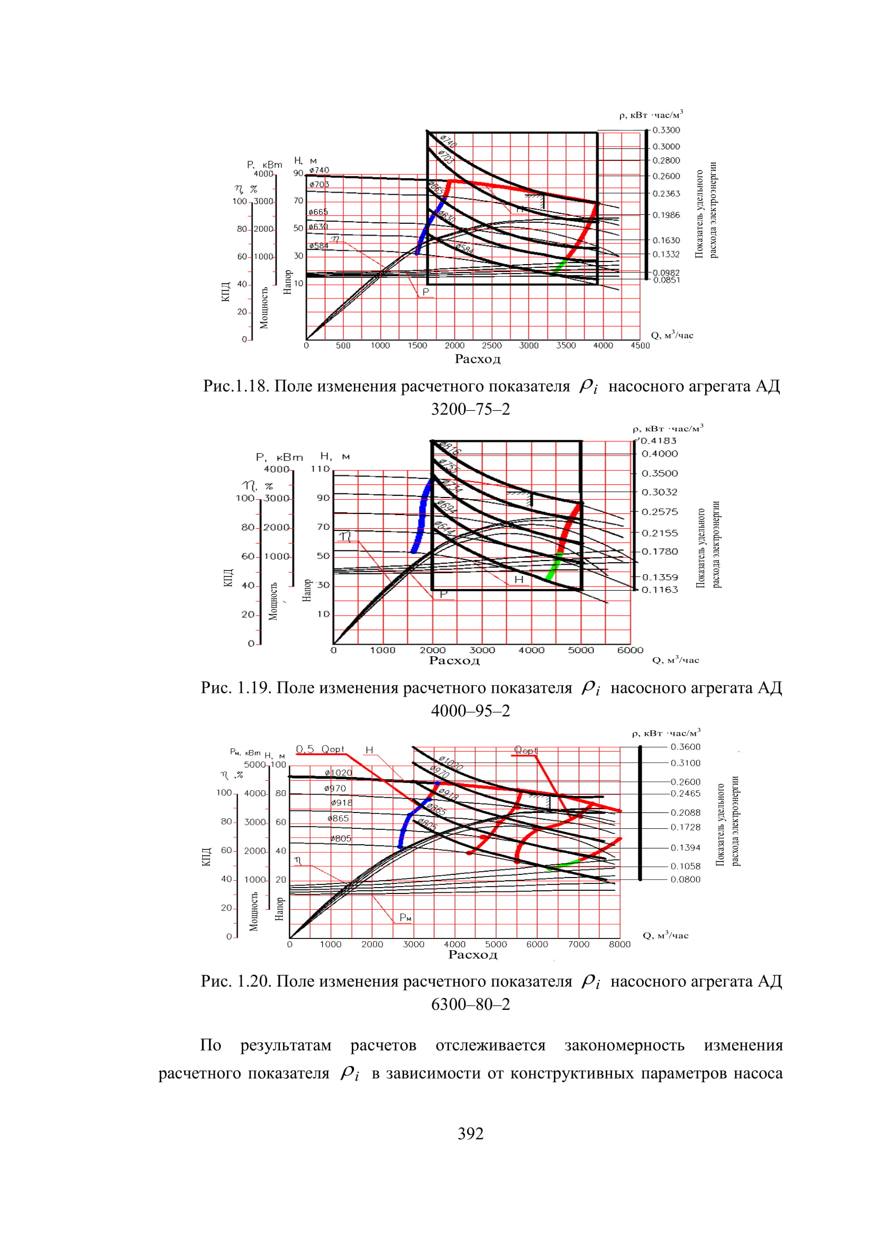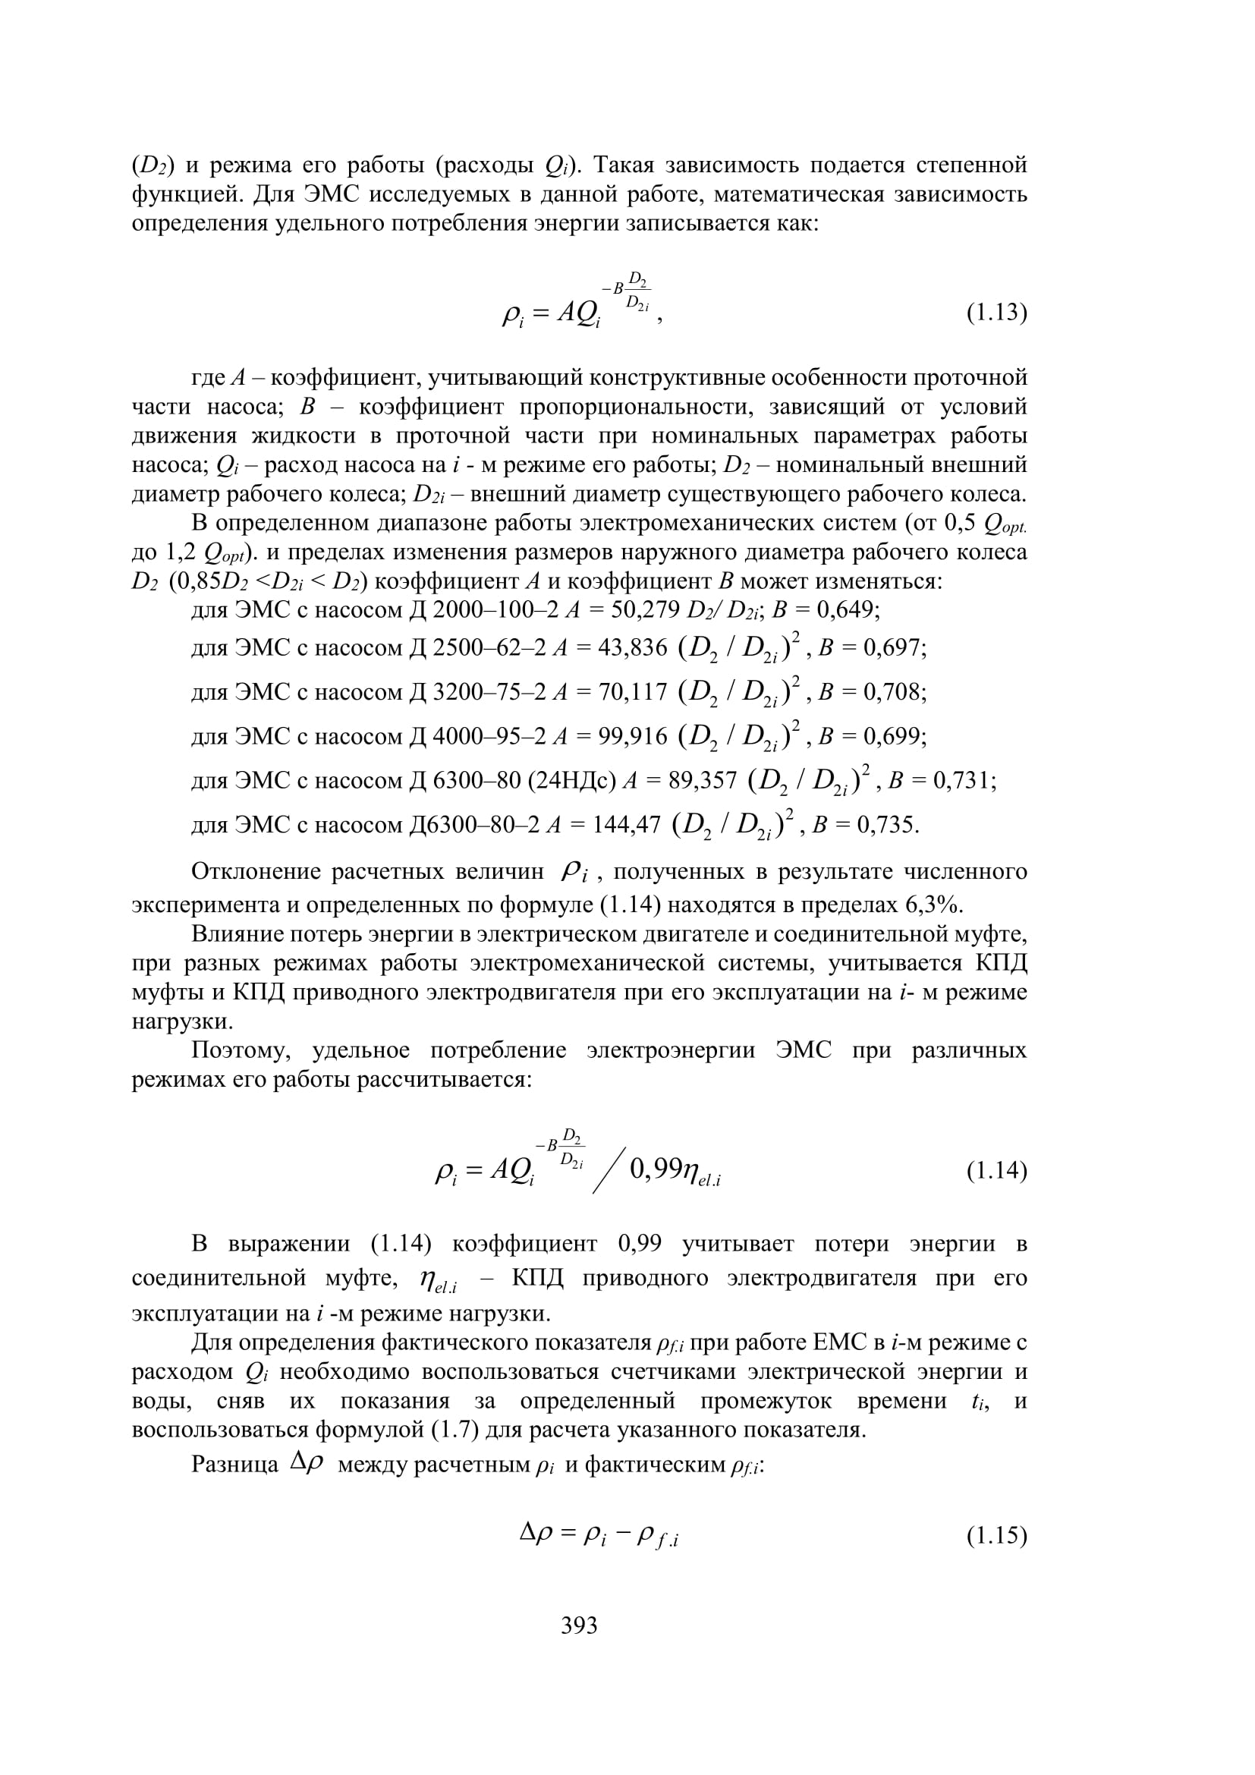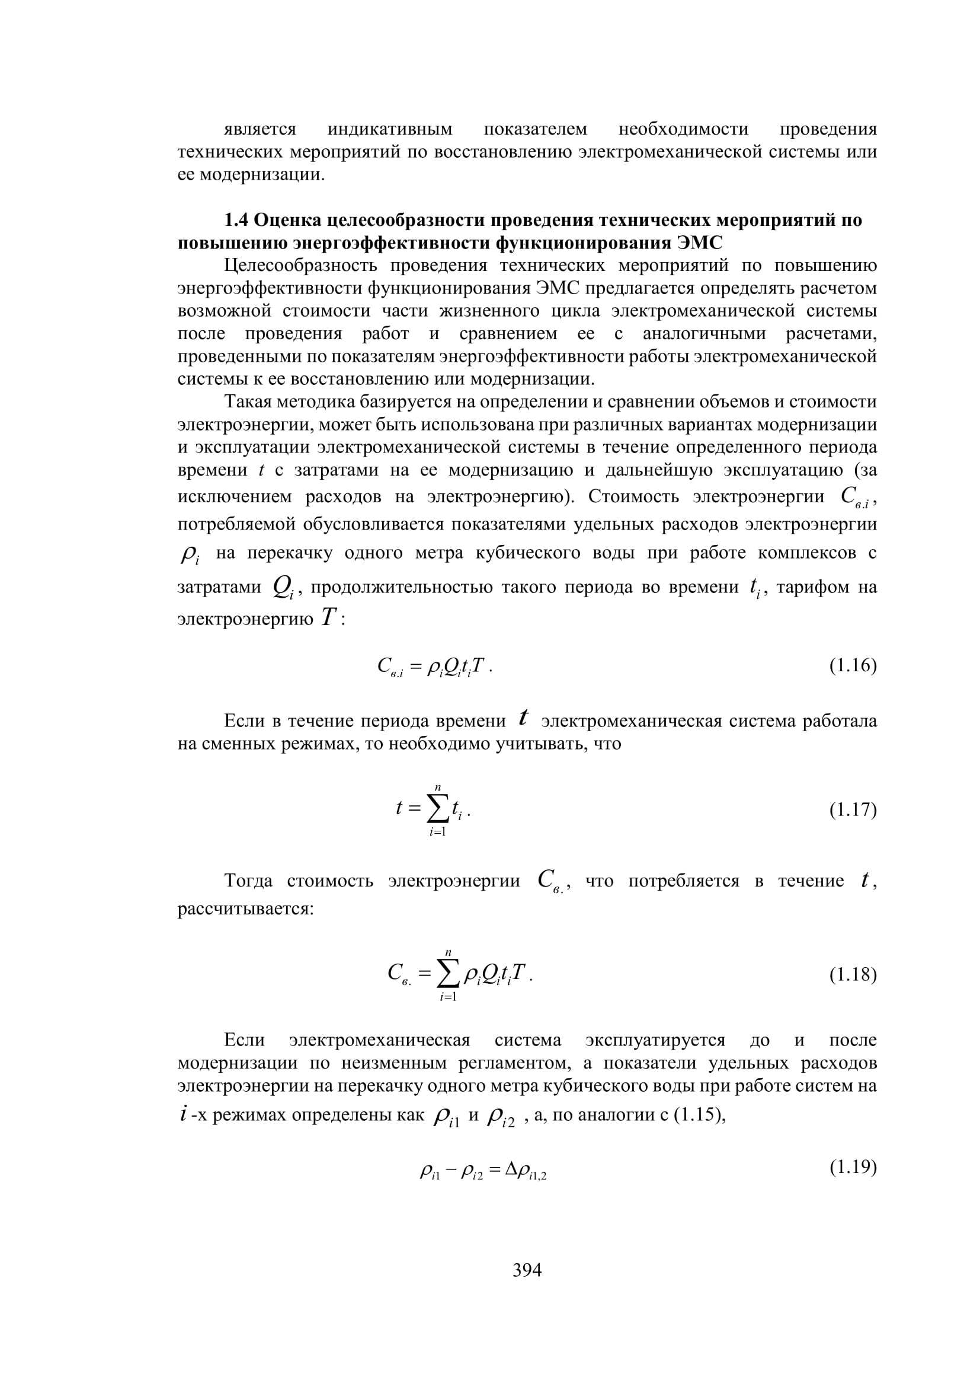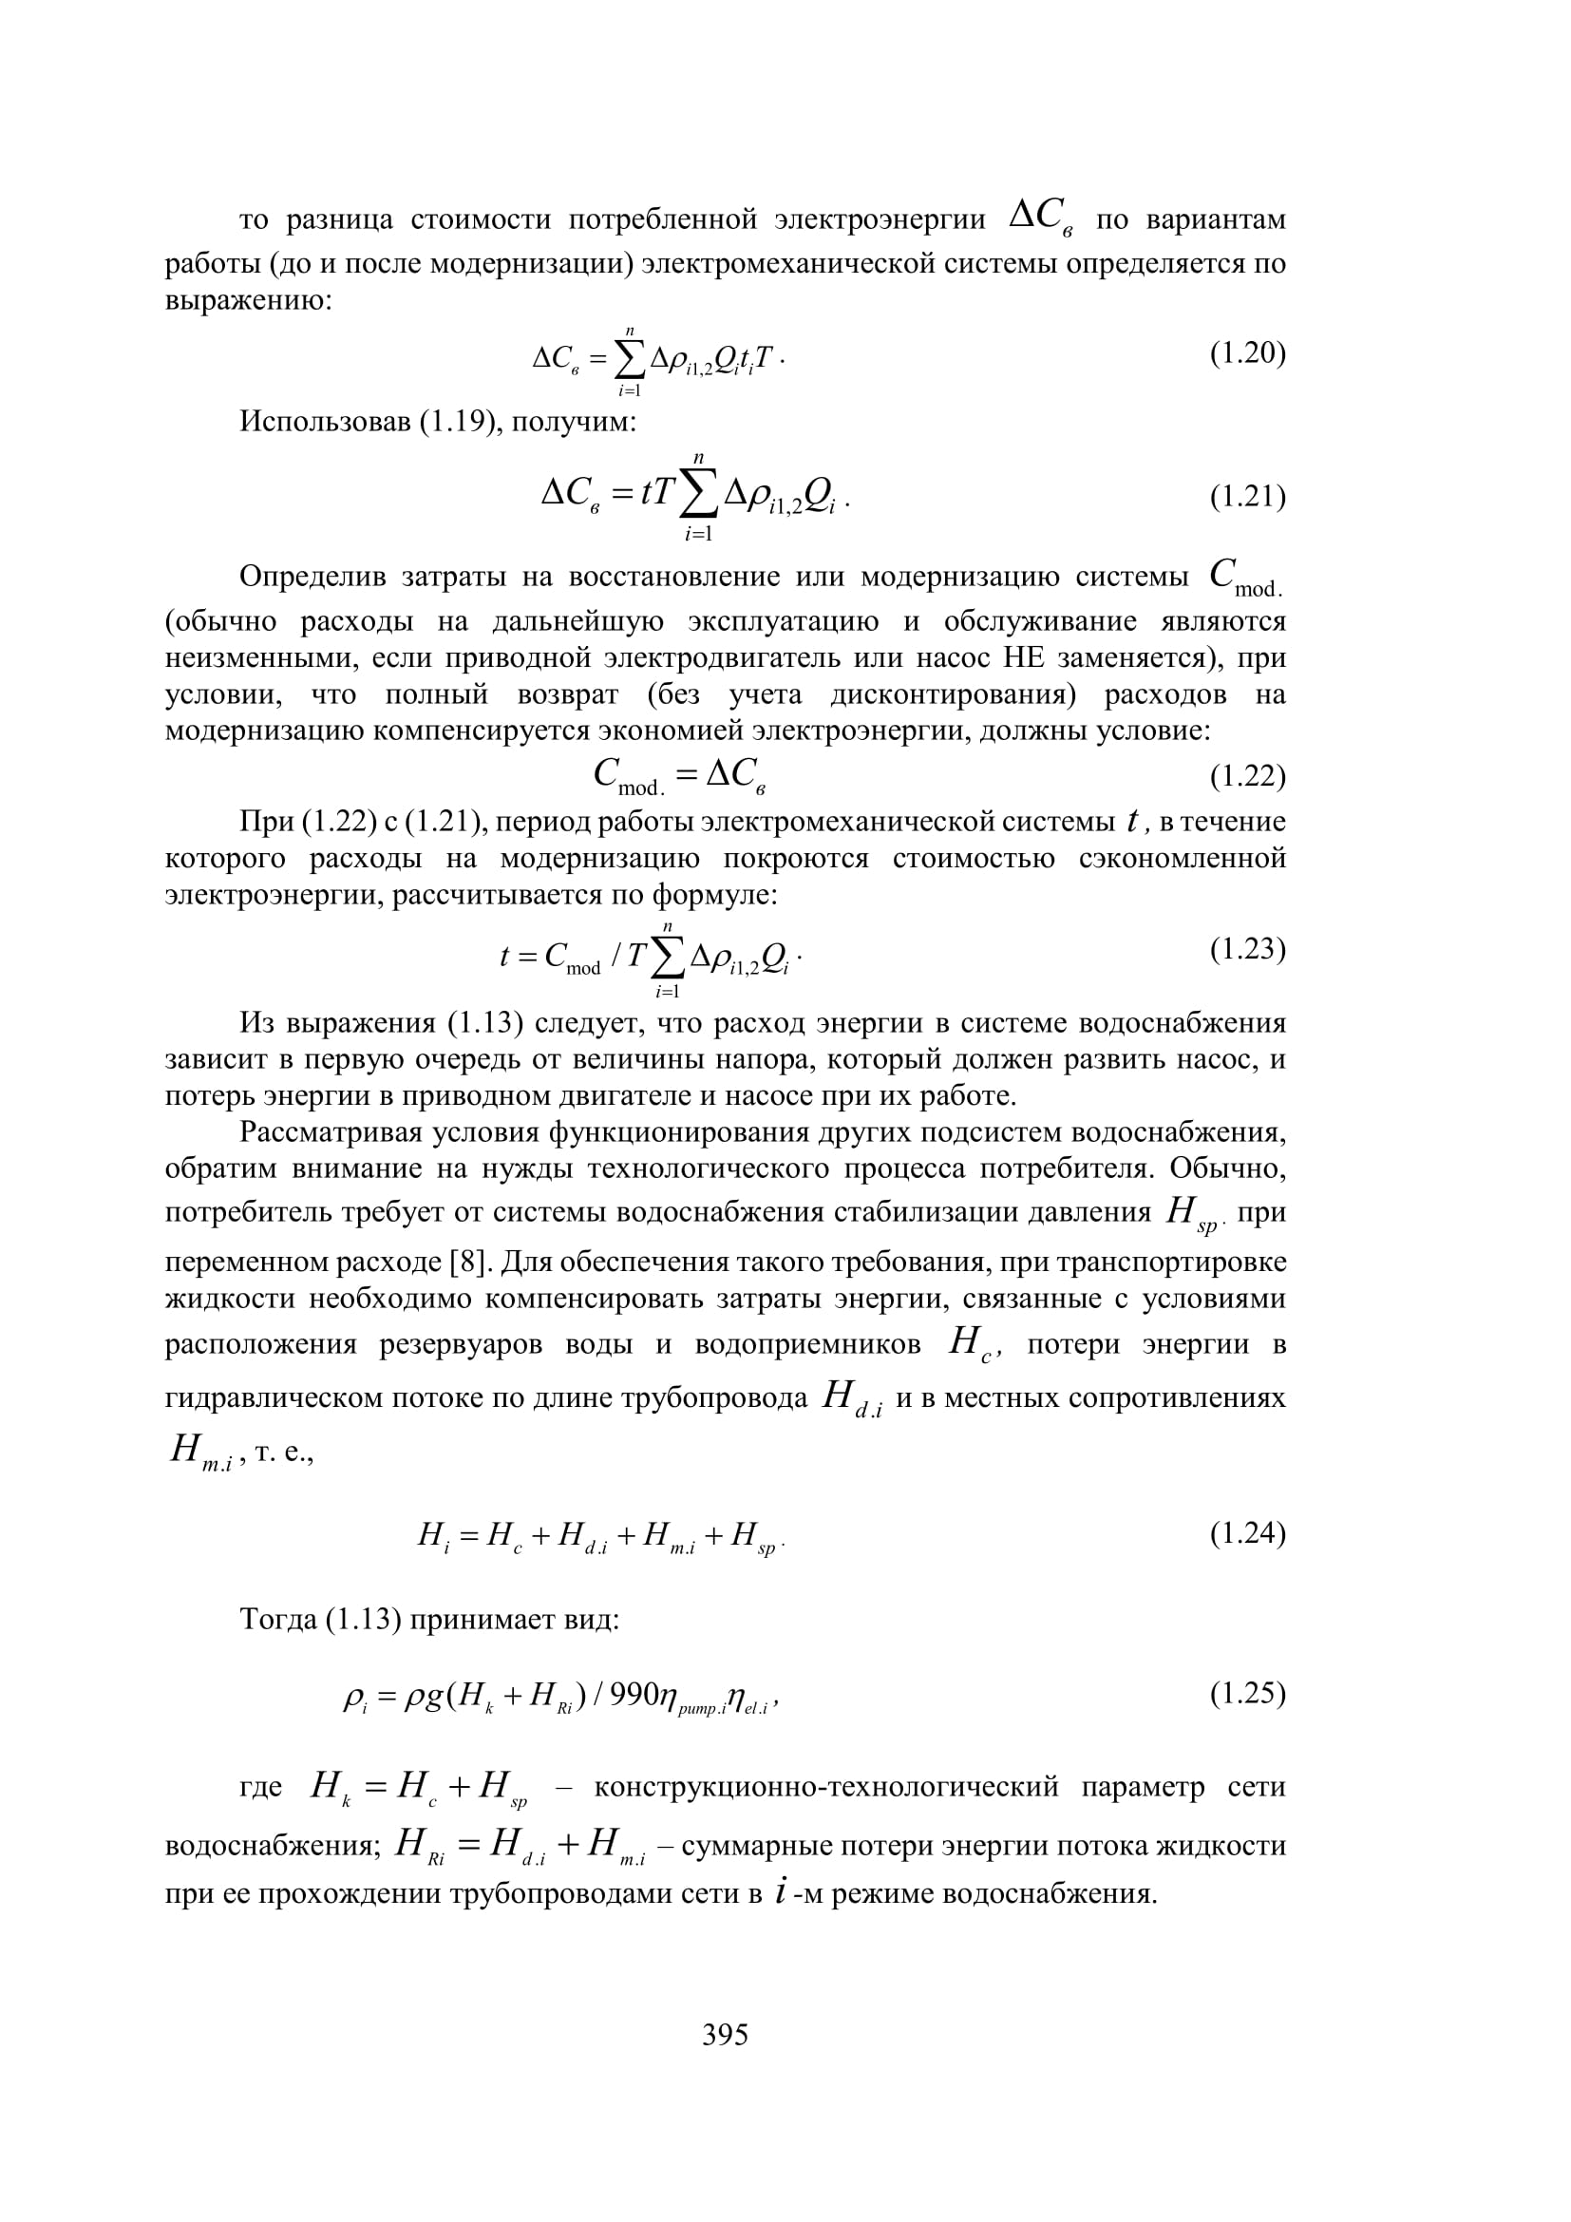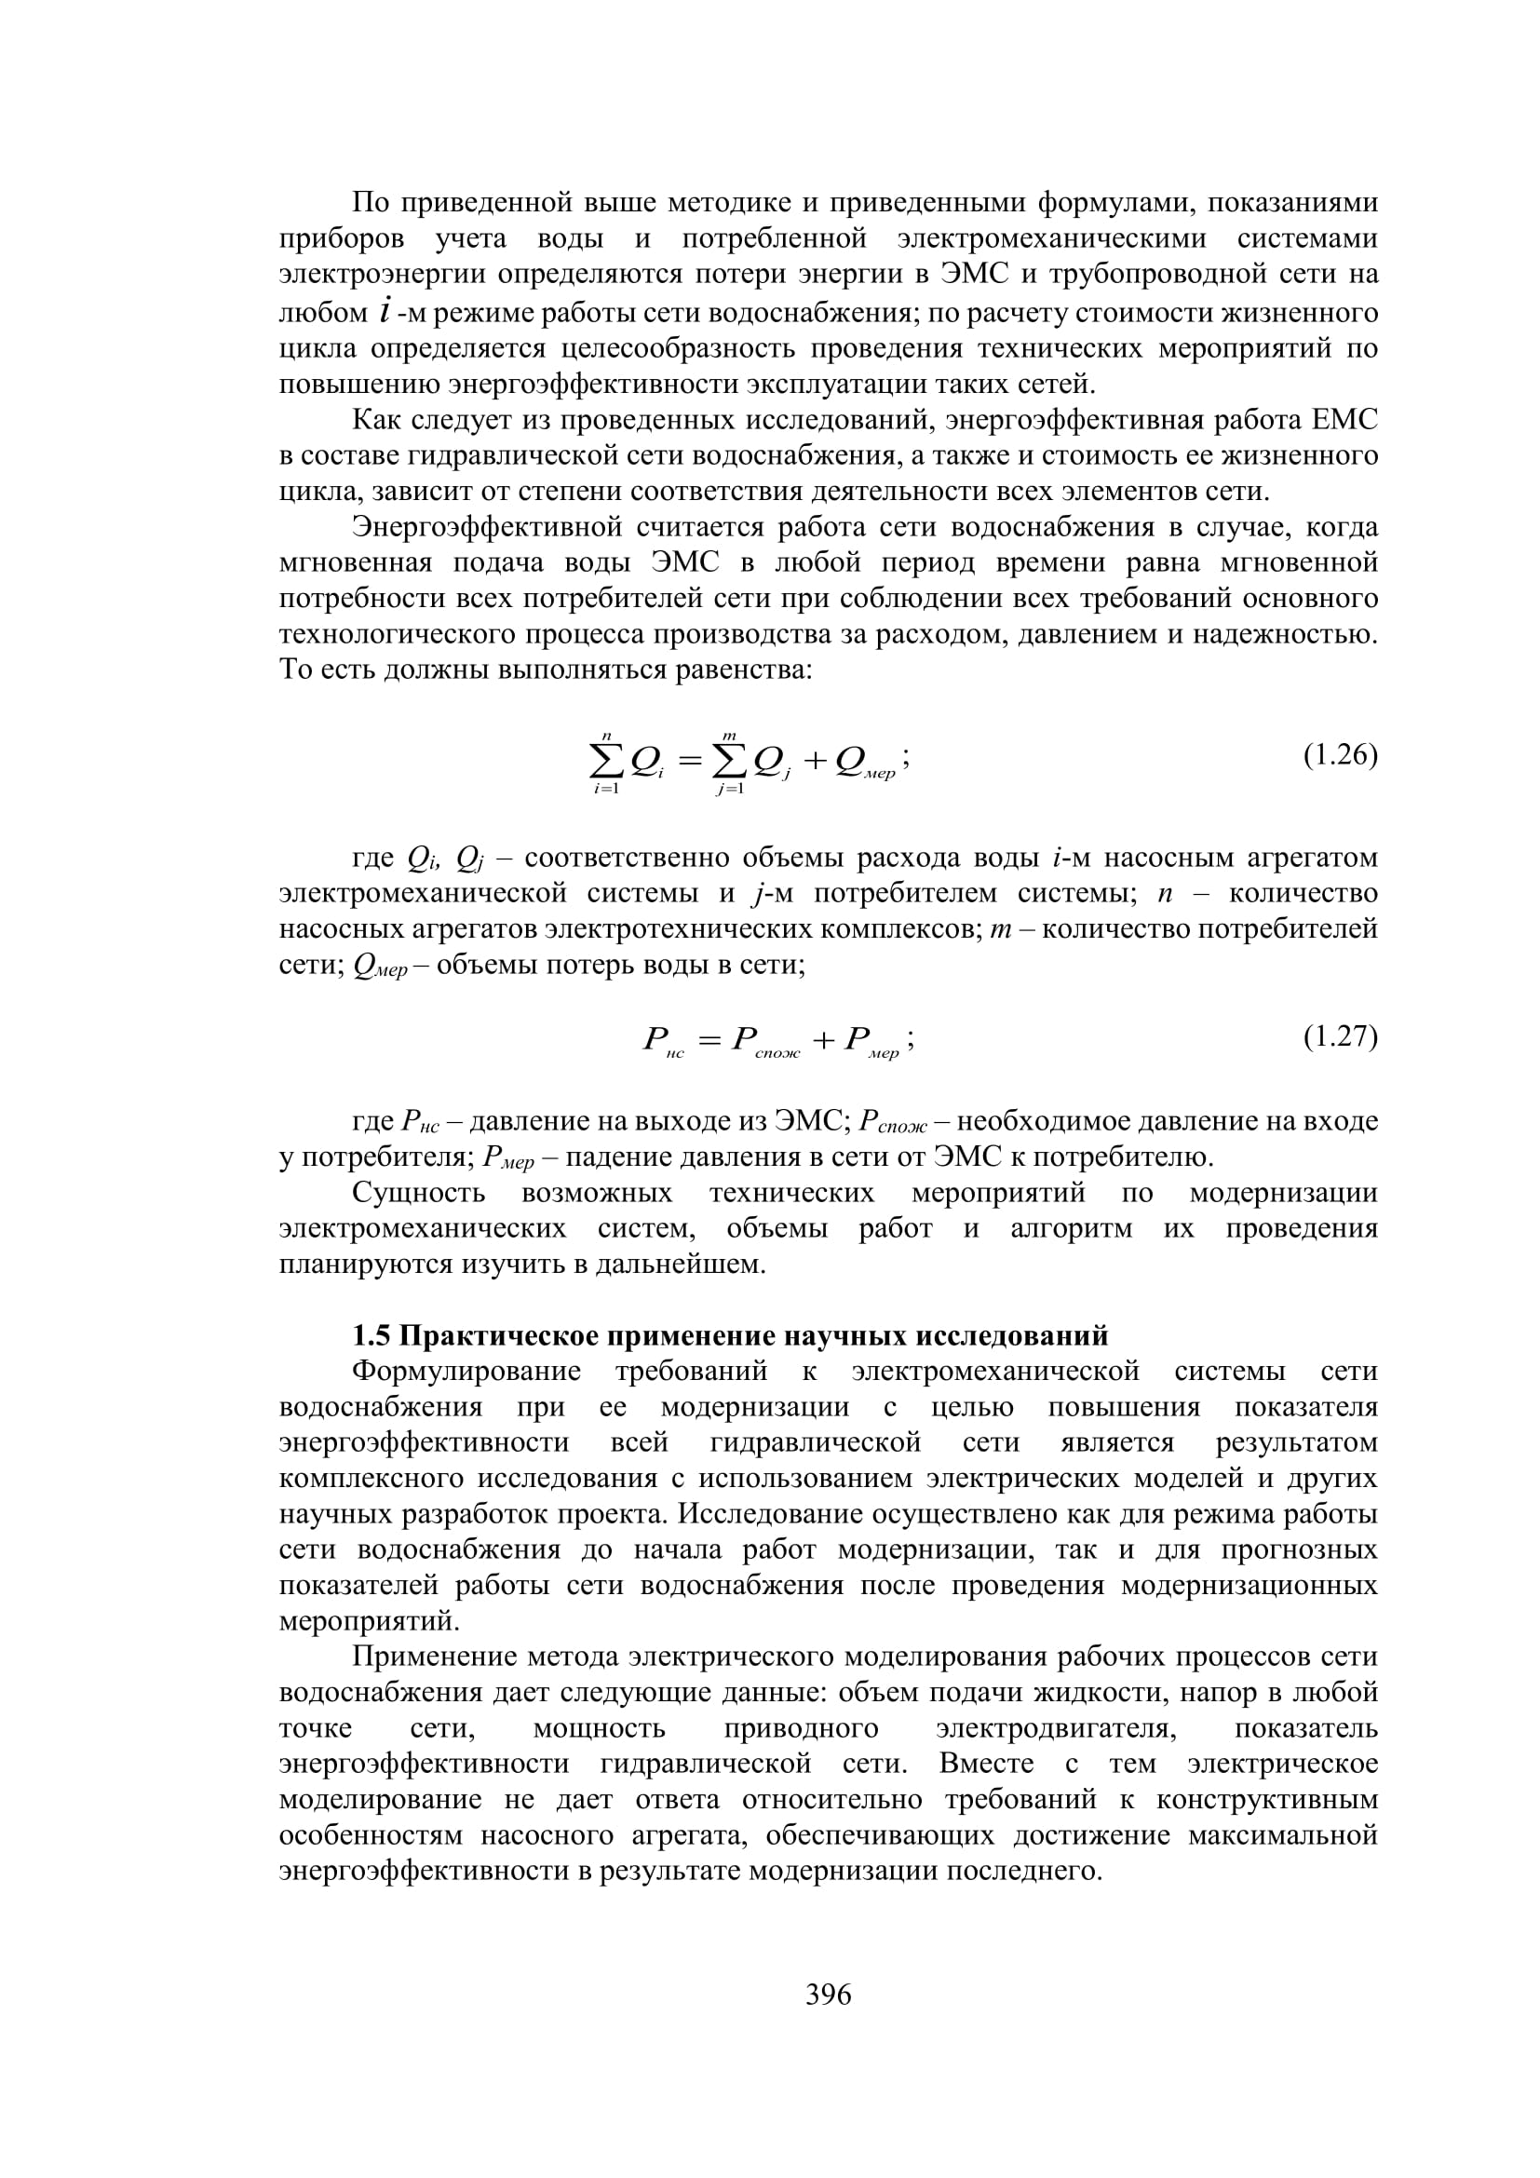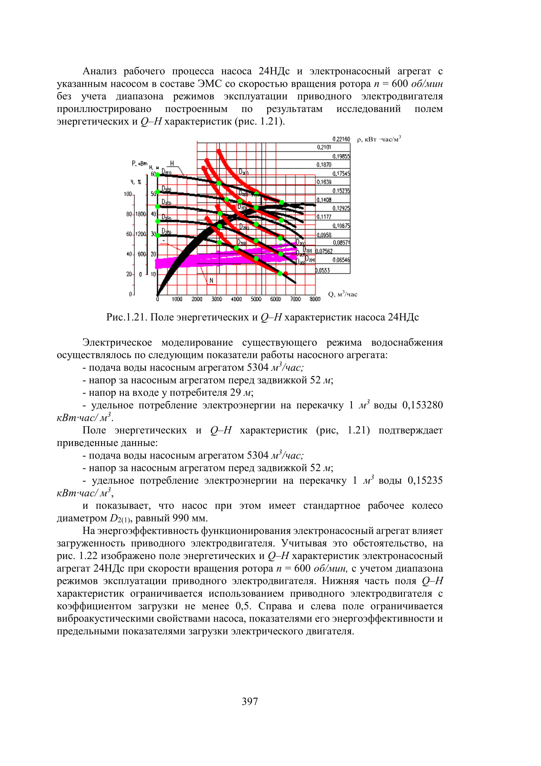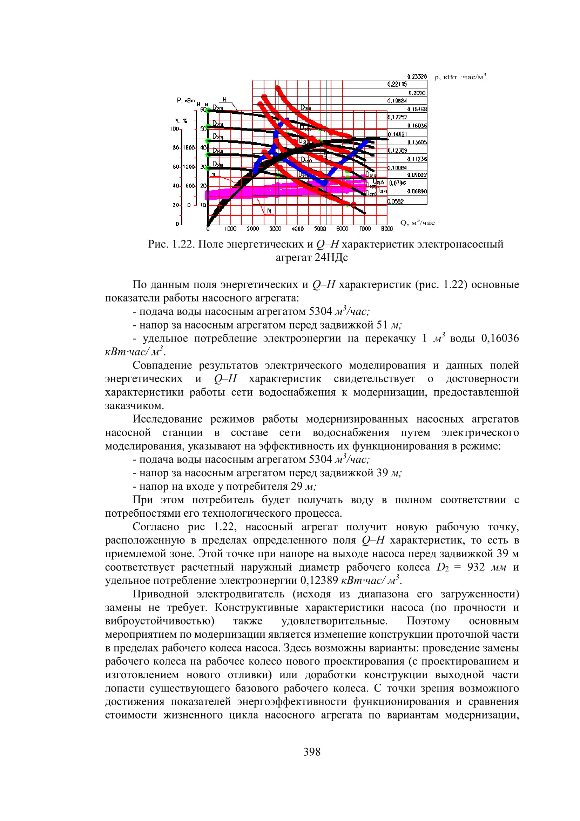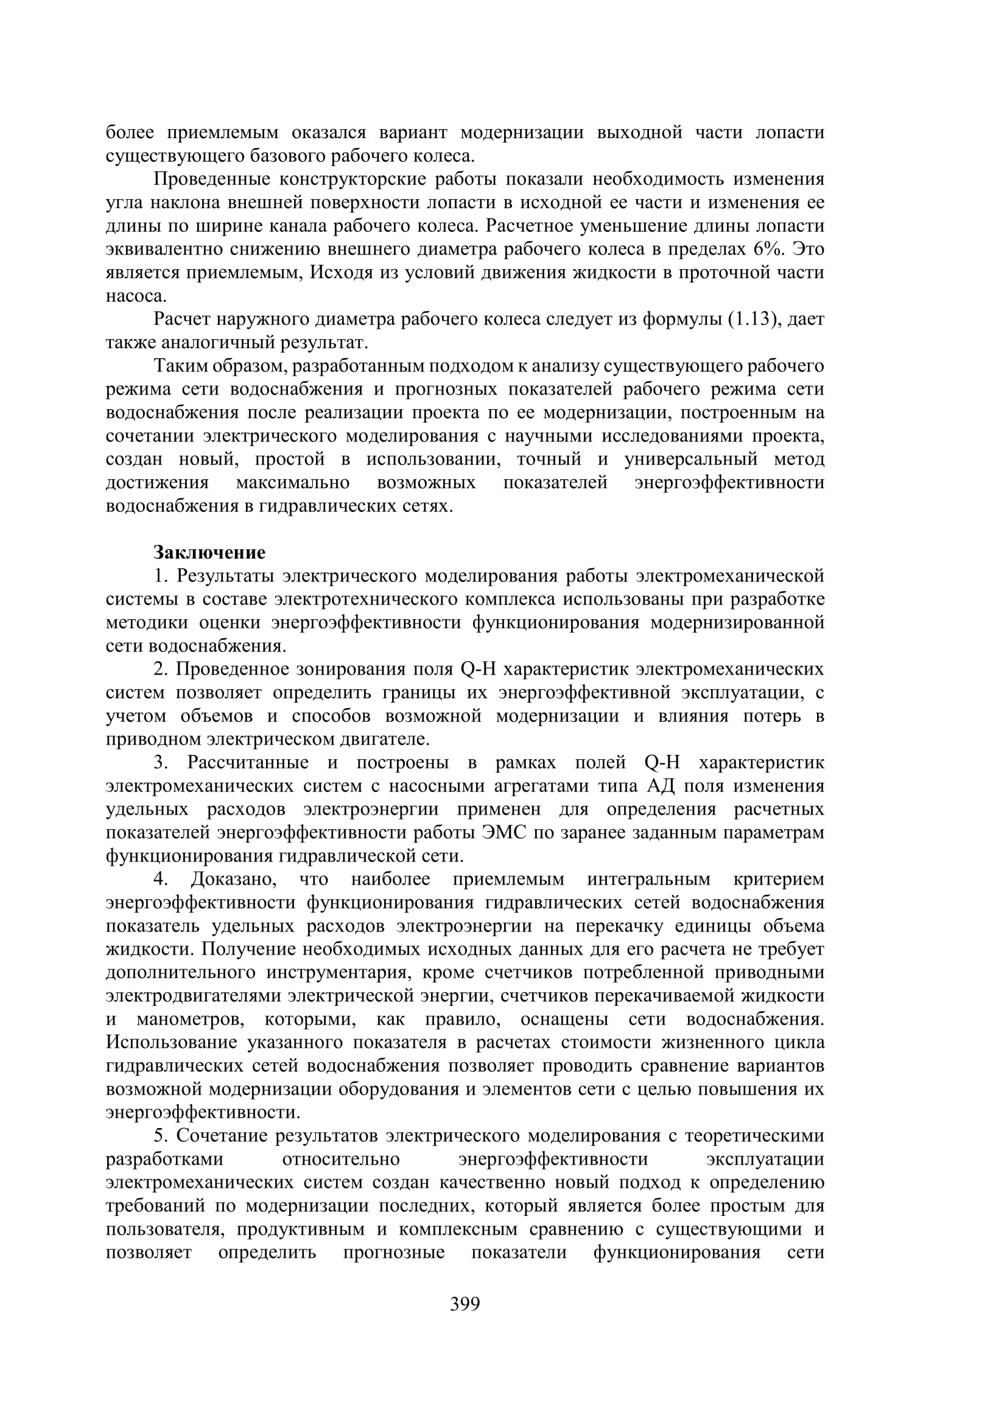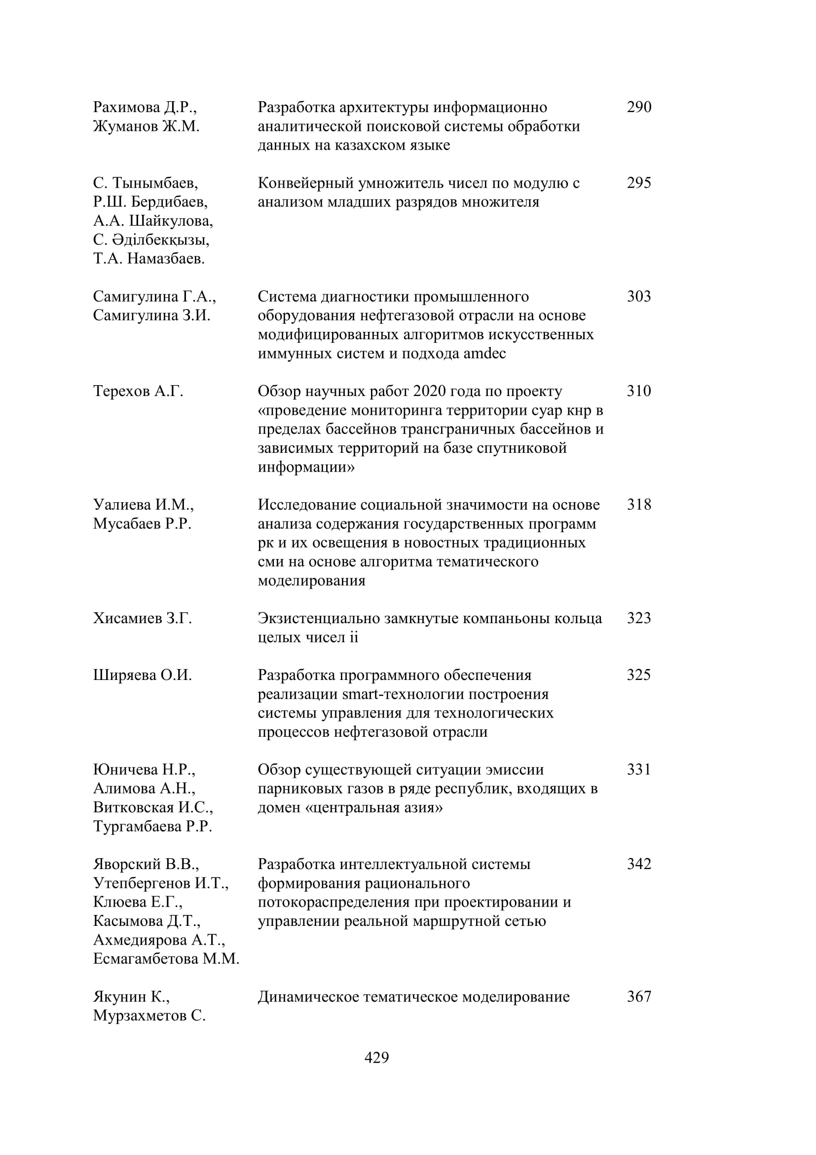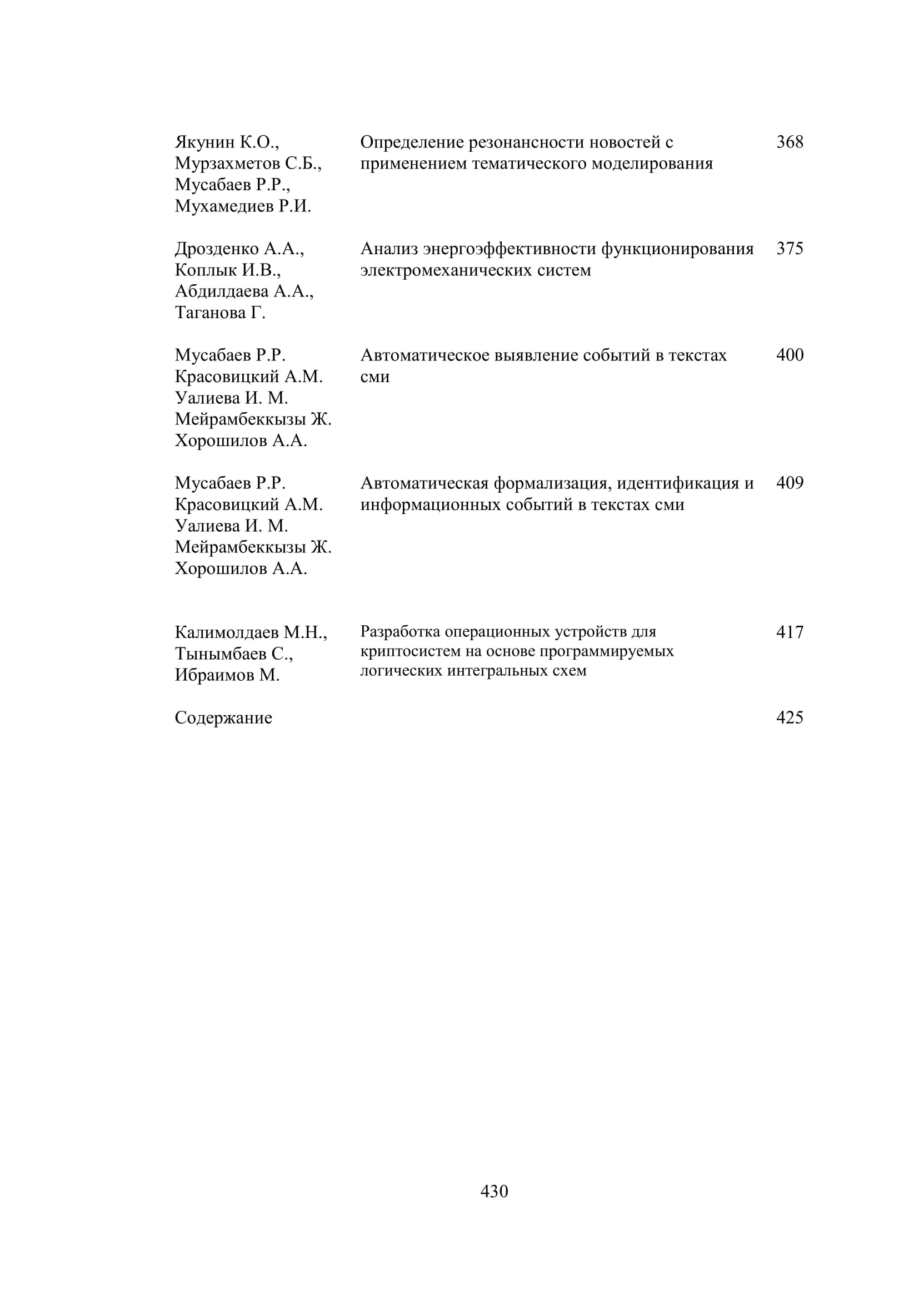







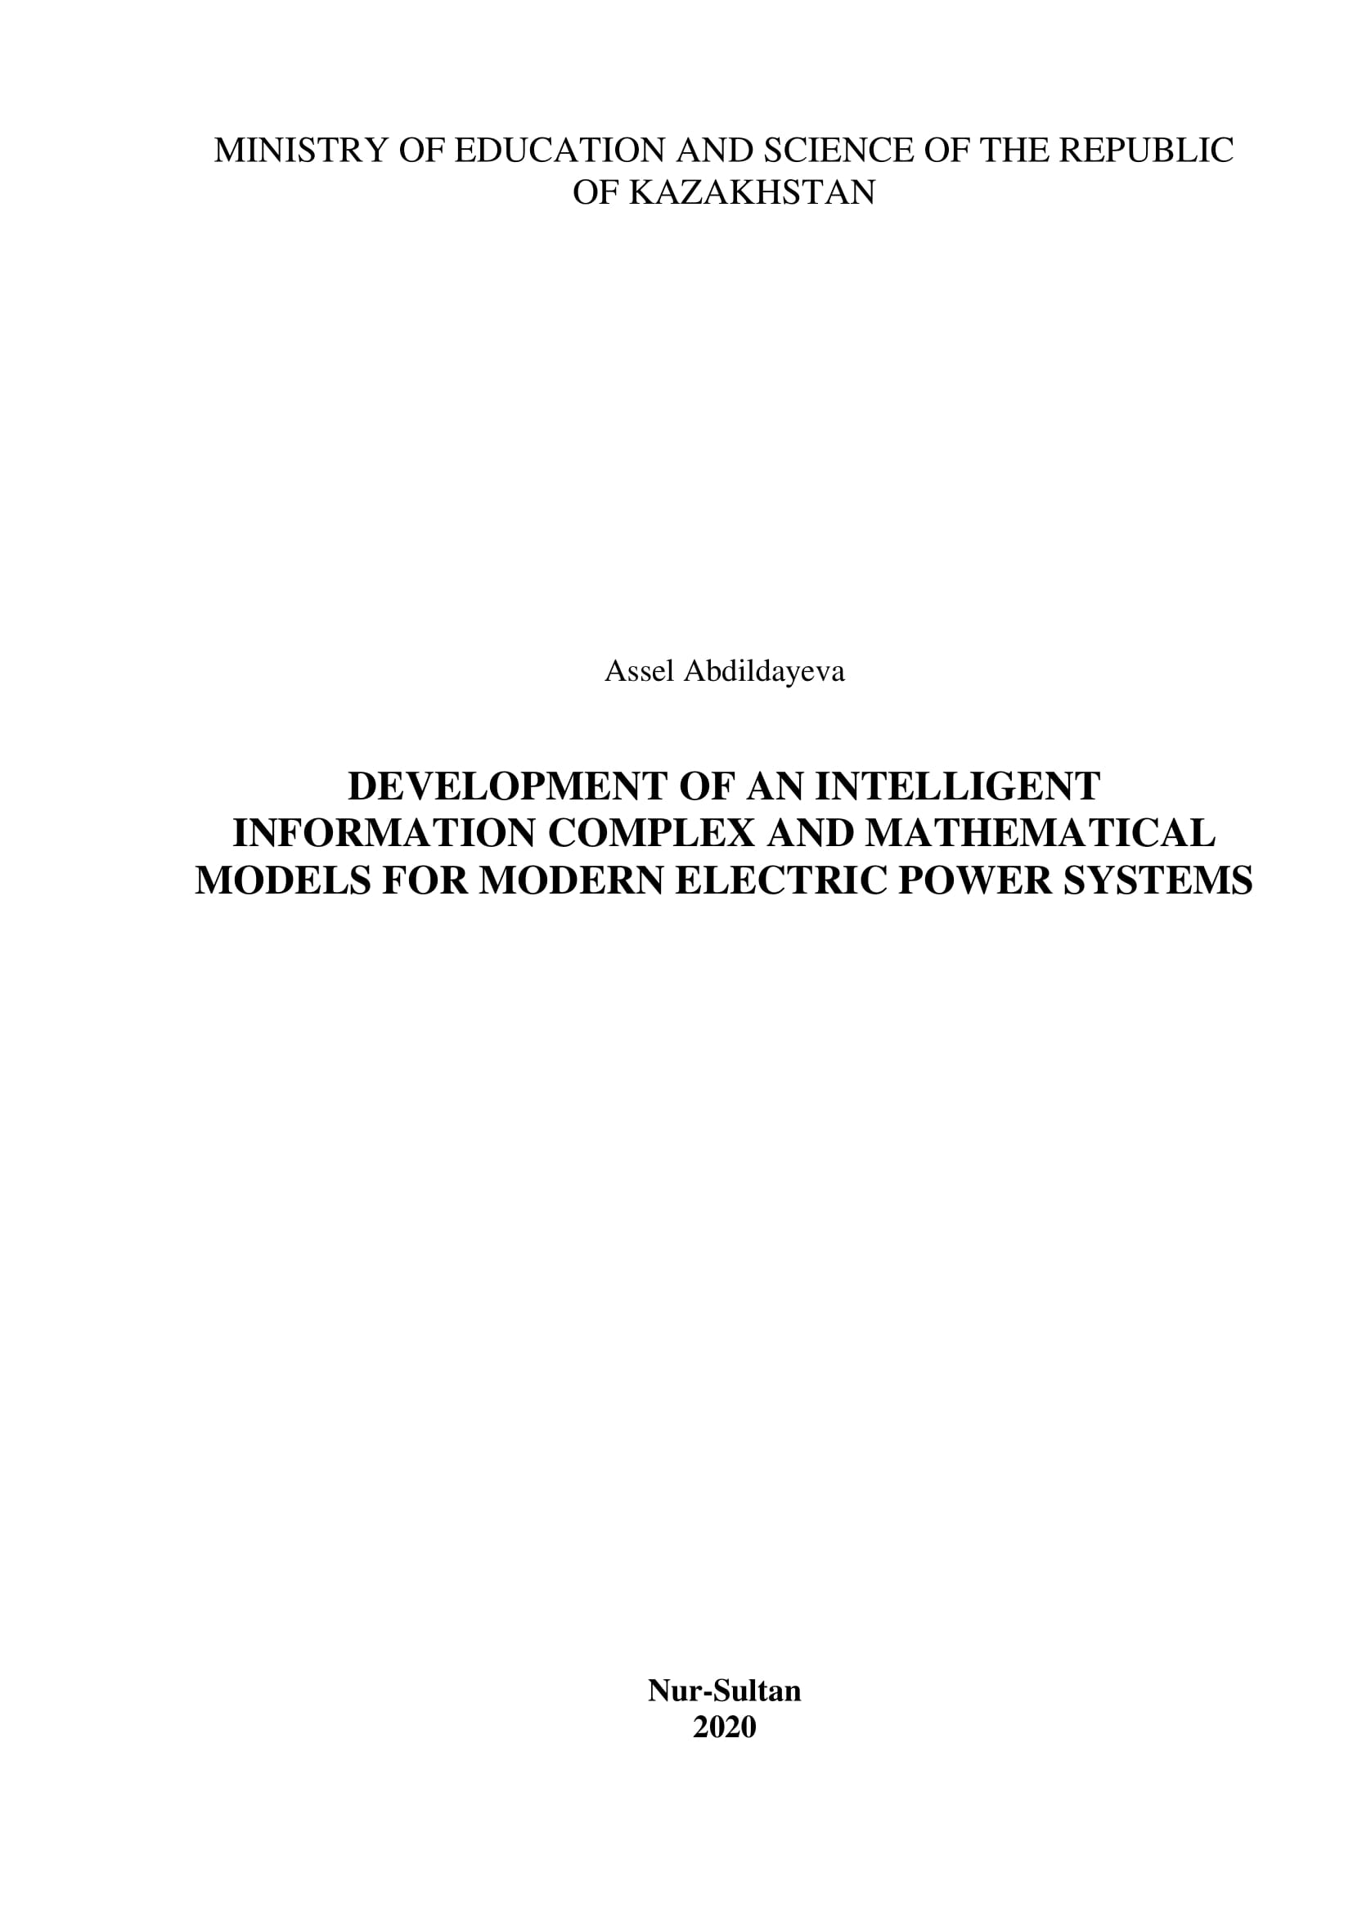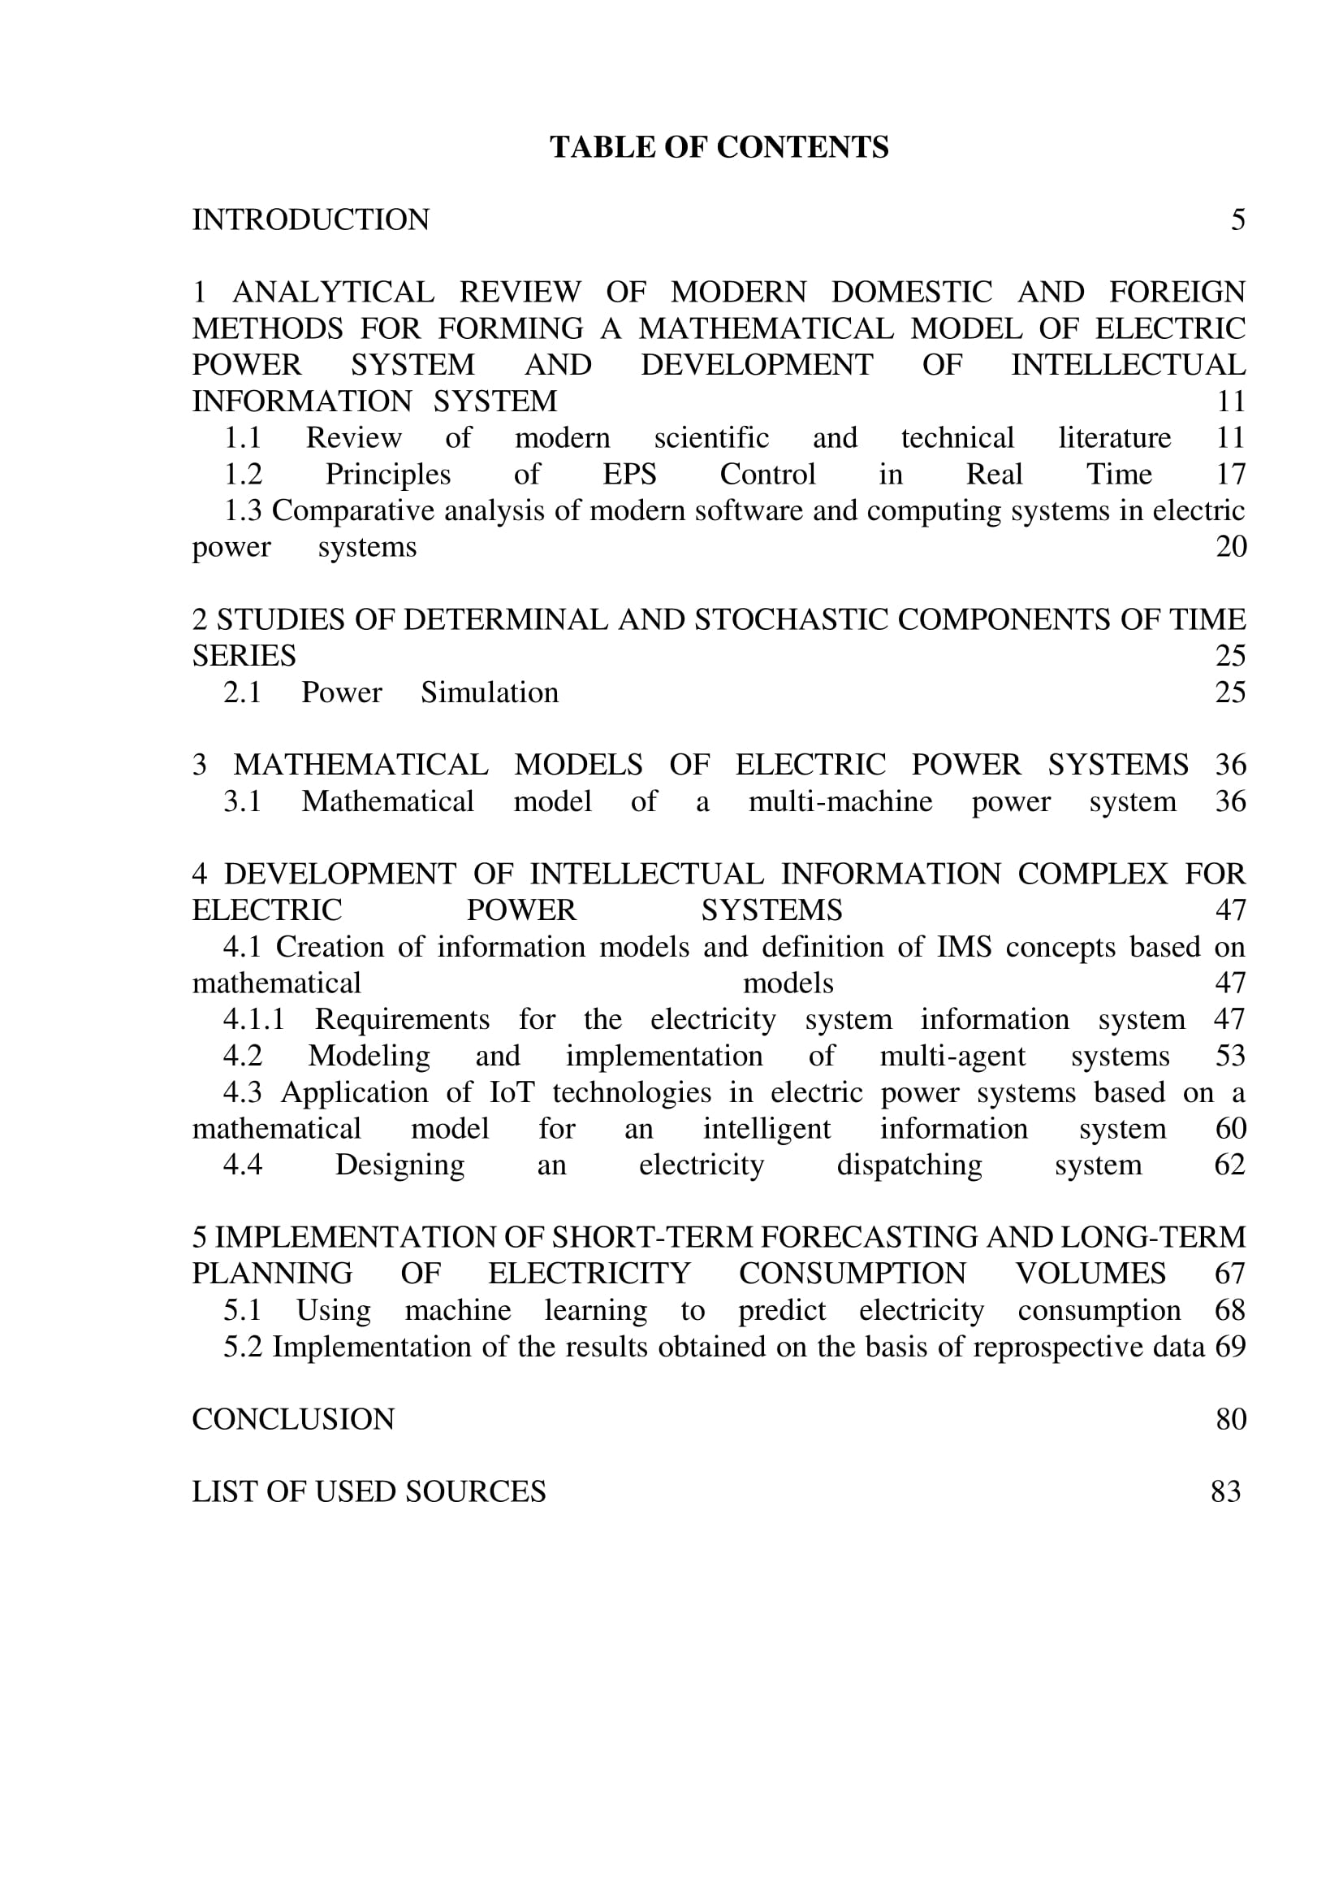

APPENDIX D

1. Elsevier
2. Scopus
3. Springer
4. Clarivate Analytics
5. eLIBRARY

APPENDIX E

Automated system for short-term forecasting and monitoring of electricity consumption in educational institutions
Information systems of electric power systems should include two main functions: monitoring current energy consumption and determining indicators of projected energy consumption for a certain period. The second function is the most problematic from the point of view of correctly determining the limits of energy consumption. Currently, the results (arrays) are used for their calculation) statistical study. Calculation algorithms do not always take into account continuous variable factors that affect electricity consumption. But they can be significant. This situation may affect the interpretation of the results of energy consumption and personnel actions, or the verification of the technical condition of the equipment. As already noted, currently the construction of existing systems for forecasting and monitoring electricity consumption is based mainly on statistical information arrays or standardized indicators and does not take into account a number of current factors affecting energy consumption. The proposed system for automated calculation of projected electricity consumption by current collectors takes into account their installed capacity, operating modes and conditions using mathematical models to determine electricity consumption.
Analysis of the functioning of technological processes of any industrial enterprise, educational institution or other institution indicates the General components of the overall structure of electricity consumption. According to a specific consumption structure, current collectors can be classified according to the systems where they are used. They are:
[1] artificial lighting systems for premises where the main and auxiliary technological processes are carried out;
[2] power supply systems for buildings and processes, as well as their maintenance;
[3] systems for ensuring administrative activities and daily needs;
[4] logistics support systems;
[5] systems for maintaining the basic technological process and support processes.
In the functional area, artificial lighting systems provide General, local and emergency lighting. Their use should provide the necessary sanitary and hygienic level of illumination of workplaces and other premises for performing certain processes. With the necessary level of lighting, the operation of modern collectors of such systems is not impractical. The amount of electric energy consumed by them should be determined by the actual (or established, if their values coincide) electric power and the period of the technological process. . , during which the lighting is below the required level. The duration of the period is affected by the duration of the technological process, its duration, and climatic conditions. The influence of climate conditions can be considered using the climate coefficient Based on these conditions , the amount of electrical energy that should be consumed by current collectors of General and local artificial lighting systems can be calculated using the following formula:

(D1)

The coefficient can take a numerical value of 0 or 1, depending on the lighting level. If the lighting level is sufficient, then if not, then . The current period of operation of the current collectors of lighting systems can be determined and monitored using lighting sensors. The indicative forecast period can be determined considering short-term weather forecasting, and available statistical data on indicators lighting on the meteorological conditions of the environment (cloud cover, day length, season, etc.) in areas where there is a corresponding process. For example, for an educational institution, the algorithm for determining the amount of electricity consumed by the lighting system of classrooms where lectures, practical or other classes of the educational process are held should be based on the formula (D1). That is, according to the results of the energy inspection of the premises, the lighting systems of the premises are certified. The installed power capacity is determined by the level of lighting (natural and artificial). To determine the duration of periods, you must use a class schedule that specifies the type of class, location, time, and duration (in hours). Based on the analysis of statistical data from previous periods and using short-term forecast indicators of future meteorological conditions, it is determined whether artificial lighting systems should be operated during a certain period of the next day for each class (i.e., the value (1 or 0) is determined). The block diagram of this algorithm is shown in figure E1.
Информационная база "Образовательные и вспомогательные помещения"
P_{и educ я}
P_{Илюм в}
(LX)
Постоянного
Базы данных
Расписание уроков. Предметы. Вид занятий. Код тренировочного зала
Переменная база данных

Системный сервер
Системные протоколы
Архив
Информационные материалы (Gismeteo) Погода и климатические показатели для определения
_{Клим}
Иин
Интернет
Иин
Прогноз
_{Иг}
Figure D1 - Diagram of the block of the algorithm for calculating the predicted limit of electricity consumption by lighting systems.

The volume of projected electricity consumption of artificial lighting systems in areas of General vision (corridors, toilets, stairs, etc.) should be determined by a similar algorithm, but some features should be taken into account. The standard lighting level of these rooms is much lower than for classrooms. When calculating, in many cases, you can exclude the influence of clouds during daylight hours, and when determining, you can focus on the minimum values of lighting, the work schedule of the institution (working hours in the daytime) and calendar indicators of daytime. The operating time of the lighting system will consist of two components: from the opening to the standard light values (the first half of the day) , and since the reduction of the standard level until the end of the day and care staff (half day) . Then the calculation of the projected electricity consumption by artificial lighting systems for General vision areas should be determined by the formula:

(D2)

where and - installed or actual electrical power of the current collectors of the artificial lighting system, which operate in the first and second half of the working day of the institution. If and can be represented as , formula (D2) can be represented as:

(D3)
If there is no natural light in the toilets, then based on the analysis of studies conducted on an array of statistical data, it is advisable to take the duration of stay of one visitor there on average 7-10 minutes, i.e. about 0.16 hours. However, for most educational institutions and industrial enterprises, such toilet planning is quite rare and is not considered in our further calculations.
The amount of electricity consumed by the emergency lighting system is proposed to be determined by the traditional calculation, which takes into account the installed capacity of its current controllers and the operating time for 24 hours in accordance with the current rules and regulations:

(D4)

The operation of the General lighting system and local lighting determines the electricity consumption of the lighting system for administrative, residential and auxiliary premises. It is proposed to determine the amount of electricity consumption by analogy with the formula (D3), which takes into account the installed capacity of existing collectors and the schedule of the institution's work for 24 hours. The operating time of the lighting system will consist of two components: since the beginning of the working dreamline agencies or staff presence in the room, to the standard values of lighting (day) and from the time when the illumination level falls below standard level until the end of the working dnai when the staff leaves the premises (the second half of the day)

(D5)

The calculation of electricity consumption during training should take into account the installed capacity of existing collectors involved in the operation of educational technologies (computers, accessories, multimedia projectors, operating models, and other equipment) and the time period during which they are used for a particular class and in a particular class. Based on the results of certification and determination of the list of active collectors, the power-to-weight ratio of the class should be determined, i.e. the established capacity of the current collectors involved in the educational process. The duration of their use depends on the type of classes (lectures, seminars, etc.), as well as on the course and its subject. To simplify the algorithm for automated calculation of the projected volume of electricity consumption, it is recommended to use the relative value, the time of use of current collectors to the total (calendar) time of the class, which is calculated as the load factor (use) according to the formula:

Then the estimated amount of electricity consumed by the current collector during the class is determined by the following formula:

(D6)

To calculate the projected volume of electricity consumption, you must:
Step 1-determine the class code j (j No 1... n);
Step 2-determine the list of current collectors in this class, their installed capacity, where i - is the number of current collectors from the list of class j (i No 1 ... n);
Step 3-determine the codes of academic subjects to be taught in classes j and the types of classes (lectures, seminars, etc.); etc);
Step 4-determine the list of current collectors with capacity that are used in a particular class in a particular academic discipline, determine their load factor, ;
Step 5 - use the formula (D6) to calculate the amount of electricity consumed by the collector and the available list of current collectors for class j to determine the total estimated amount electricity consumed during classes in a particular academic discipline:

(D7)

Based on (D7), the total daily electricity consumption (excluding electricity consumption for lighting) for classes in class j should be determined as the sum of the consumption in each class according to the schedule:
(D8)

As an alternative, in order to unify databases and simplify automated calculation of electricity consumption, it is considered possible, and in some cases appropriate, to add a load factor to the algorithm (D6) for calculating the load factor of the total installed electrical capacity of current collectors on classes. It characterizes the share of the total installed electrical capacity of the current class collectors used in the classroom. Depending on the class type, it is calculated as the ratio of the total installed electrical capacity of the current collectors that are used in this class to the total installed electrical capacity of the current collectors of the class.
To clarify the duration of the current period of work of collectors in the classroom and simplify the calculation (D6) of electricity consumption, the algorithm can be added by the coefficient of use of the total installed electric power of current collectors in the classroom. It characterizes the time of the total installed electric power of current collectors in the classroom in this academic discipline. Depending on the class type, it is calculated as the ratio of the period (in hours) of current collectors operating (their electricity consumption) during this class depending on the duration of the lesson (in hours) according to the schedule. Based on this, the formula (D6) can be represented as follows:

In many cases, the main technological process of learning in the classroom should be preceded by auxiliary preparatory processes that are carried out in separate rooms. When calculating the daily volume of electricity consumption during such processes , the installed electrical capacity of the equipment that is used to perform the support process, its load factor and the duration of the process must be taken into account. Basically, the implementation of support processes coincides in time with the working schedule of the institution, so their duration corresponds to the length of the working day. The daily volume of electricity consumption for auxiliary processes outside the premises should be calculated by analogy with (D6). The total daily electricity consumption in support processes should be calculated by analogy with (D8):
(D9)

The projected electricity consumption of building and process power supply systems, as well as their support (water supply, heat supply, Sewerage, etc.), should be calculated based on the installed electricity capacity of their current collectors and the period of operation. Similar to the previous calculations, we recommend using their load factor in this case . The total estimated daily electricity consumption by building and process power supply systems is calculated by analogy with (D9):

(D10)

The estimated forecast of electricity consumption by the current collectors of units that provide administrative activities, and the internal needs of the institution should be calculated based on the installed electrical capacity of their current collectors and the service life . It is also recommended to use their load factor for the calculations.
It is obvious that the projected estimated volume of electricity consumption should be calculated as the sum of certain components. Given that the current collectors of the lighting system are one of the key consumers in the educational institution, therefore, based on the analysis of the accuracy of the weather forecast, it seems appropriate to define 24 hours as a short-term forecast period. The work schedule of the educational institution is mainly subordinated to the technologies of the educational process, which is regulated by the class schedule. For example, to create profiles of the daily projected volume of electricity consumption, it is proposed to take as a basis the structure of energy consumption by the time of classes. The key information blocks that will form the database for calculating the projected limit of electricity consumption in the future should be the following: information Bulletin of the room indicating its quantity, installed capacity of the current collectors of the lighting system, installed capacity of the current collectors of the educational process; passport academic disciplines, specifying its name, type of class, the installed capacity of current collectors, which are used for this type of activity, load factor of the current collectors during the classes; the schedule, which shall contain information about a calendar date, the periods of classes, the course name, venue, lesson, reference the value of climatic coefficient for each period's lesson depending on the date. The climate coefficient should be updated automatically, taking into account the forecast and the current weather situation, which is estimated using information from the local weather station (available on the Internet). A graphical interpretation of the key information blocks of the algorithm for calculating the predicted amount of electricity consumption during the educational process is given in figure 2.2.
Информационная база Образовательные и вспомогательные помещения"
P_{и educ я,} P_{Илюм в}
Освещение (LX) Нет, нет.
Постоянного
Базы данных
Расписание уроков. Предметы. Вид занятий. Код тренировочного зала
Переменная база данных
Системный сервер
Системные протоколы
Архив
Информационные материалы
(Гисметео) Я не знаю, что сделать.
Погодные и климатические показатели для определения
_{Клим}
Иин
Интернет
Иин
_{Прогноз}
_{Текущий}
_{Скорректированный прогноз}
Информационная база ASCAPC
_{Текущий}
Текущие показатели потребления электроэнергии
Переменной
Базы данных
Архив
Иин
Figure D2 - Block diagram of information blocks of the algorithm for calculating projected electricity consumption during the educational process

To simplify the algorithm for calculating the volume of projected electricity consumption by the lighting system for administrative, residential and auxiliary premises, it seems appropriate to determine the basic duration of the lighting system's operating periods and be a multiple of (or correspond to) the periods of the class schedule.
An integral indicator of the results of calculating the projected volume of electricity consumption for the above components should serve as a reference for the volume of electricity consumption for the next day. This value can be considered as the estimated limit of electricity consumption for the current collectors of a building or institution. The main difference from the existing limits defined by current regulations, which summarize large amounts of General statistical information, is that the results of energy inspection of individual premises can take into account the features of educational and auxiliary processes, climate and weather conditions when determining the adjusted forecast volume of electricity consumption by an educational institution. The proposed algorithm (mathematical model) for determining the volume of electricity consumption is simply integrated into a computer calculation system using modern computer technologies and can be used as a basic platform for forming an automated system for short-term forecasting and monitoring of electricity consumption by operating collectors of electrical complexes and systems of economic entities.
However, the described model should be only (though key) part of an integrated automated system for monitoring current electricity consumption by an individual object, building, or institution. Another component of the system should be an automatic continuous recording of electricity consumption. To do this, you can use the technical and organizational capabilities (basic) of the existing ASCAPC system, elements of which exist and operate in almost every institution. That is, the further algorithm of the system should be based on the current combined data sets of short-term forecasting and real energy consumption with the possibility of analysis and comparison online, eliminating check-in distortion due to the possible influence of the human factor.
The combination of elements of automated forecasting with monitoring of real electricity consumption allows for accurate and detailed planning of schedules and volume of electricity consumption in order to quickly manage the processes of electricity consumption and eliminate inconsistencies in order to improve the energy efficiency of electric power use. As a result, this will reduce the cost of electricity consumed by the building, reducing CO2 emissions to the environment.
A combination of an automated short-term forecasting function for electricity consumption by existing collectors, which is based on forecast indicators of meteorological conditions (determined by information arrays of weather stations or meteorological objects and interfering with the system via the Internet), a variable information array of the institution's class schedule (a key technological process) and a permanent database of the electrical installed capacity of current collectors that are used in a specific room, and the ability to use information arrays of the institution's Automated commercial energy accounting system (ASCAPC), which are combined into an algorithm of the automated information system for determining the amount and schedules of electricity consumption, comparing the profile of real current consumption with them "on-line" provides additional opportunities for timely making effective management decisions in order to effectively use electricity.
The total forecast of electricity consumption should be calculated (in kWh) as the sum of certain components. They should be formed in accordance with the periods of the day, the corresponding schedules of classes and working hours of auxiliary units, forming profiles of electricity consumption in the building. Data can be obtained in the form of tables and graphs of forecast consumption for the next day. The system algorithm allows you to make adjustments to the results of calculating the forecast at the end of the current period, if there are significant changes in the source data variables associated with changes in the schedule of classes or changes in meteorological conditions.
Using current ASCAPC data on electricity consumption, the system algorithm allows you to reproduce the picture of real electricity consumption and its profile in the form of tables and graphs, as well as compare the values of projected electricity consumption with real current online or values of any period.
This method of automated short-term forecasting and monitoring of electricity consumption allows you to determine the current state of electricity consumption in buildings in real time and analyze deviations of actual electricity consumption from the forecast limit using modern information technologies for processing and analyzing monitoring data and, as a result, provides the Manager with operational analytical information for decision-making. The method includes a system for automated short-term forecasting and monitoring of electricity consumption in buildings and powerful analytical tools for processing monitoring results. This contributes to the transition to electronic document management, the formation of current information about electricity consumption on-line for service personnel, as well as to simplify the work of the Manager in terms of making decisions on energy saving measures in the institution.
"Spectrum" of electricity consumption and methods of component analysis
The amount of electricity consumption that is recorded by metering devices usually determines the total consumption of current collectors that are powered by the power grid, at the entrance of which a measuring station is equipped. The key tasks and functions of an automated commercial electricity metering system are to record the amount of electricity that "passed" through the meter during a certain period. A derivative of this function is the calculation of other quantitative indicators of electricity consumption. That is, in any case, these indicators are integrated for all existing collectors of the main ones, if they are not equipped with additional metering devices. In such circumstances, the direct use of system protocols for detailed study and analysis of current collectors, system mechanisms, and technologies is limited. The energy flow must be detailed according to the consumption components in order to conduct a detailed analysis of electricity consumption. In other words, it must be divided into elements to create a "spectrum" of electricity consumption components.
The analysis of the" spectrum " of electricity consumption by buildings of an educational institution is presented in the example of the most typical educational building for a higher educational institution, where educational, laboratory, auxiliary, administrative and residential premises of departments of General technical, electrical, financial and economic spheres are located.
Based on the results of the energy inspection, the nature and profile of energy consumption recorded by ASCAPC measurement systems, it is desirable to divide the day into periods as follows:
1-Night time: from 00.00 to 8: 00 (the beginning of the working day) with a discrete period for determining the amount of electricity consumption in one hour;
2 - day training period: during which key and support processes educational activities are conducted in increments of a period determine the amount of energy that corresponds to the length of one class (from 8:00 to 21.00);
3-Evening period: from 21.00 to 00.00.
Related processes of functioning of the building consumed by electric energy are related to the operation of the Cantina equipment located in the building; round-the-clock operation of the information support system (servers) located in the building, operating collectors of the building's heating network operating during the heating season, periodically operating current collectors of outdoor lighting of the territory near the building, etc.
It is advisable to determine the profile of such an electrical load and the schedule of electricity consumption by analyzing energy consumption on holidays and weekends, when educational and auxiliary processes are not carried out in the building. This element of electricity consumption is called "noise" or "background" electricity consumption. It always accompanies the operation of the building 24 hours a day and its cost are quite constant. As for our case, the selected component of "background" electricity consumption is on average 2 kW in power. It is tracked in each of the three defined daily periods.
Electricity consumption by the current collectors of the outdoor lighting system is observed in the evening hours (period 3). Based on the analysis of power consumption profiles, lighting is switched on according to a schedule that corresponds to climatic conditions and daylight hours. This component is usually about 1 kW in terms of power consumption. The exception is during big holidays, when the territory is decorated with additional lighting.
As already noted, the daytime training period is the time of day during which the key and auxiliary technological processes of educational activities and other processes related to the scientific and economic activities of the institution are carried out. Despite the fact that the main activity during this period is the educational process, which is regulated by the class schedule, for the convenience of analyzing electricity consumption, it is advisable to divide it into time intervals with discreteness, which corresponds to the duration of one class.

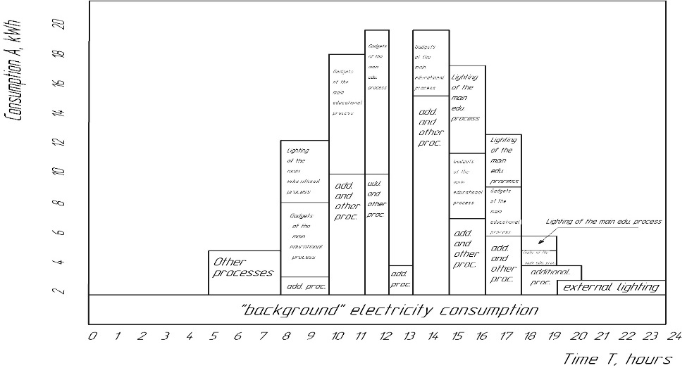
Figure D3 – "spectrum" of electricity consumption by its elements and periods of the day

The results of differentiation of the daily profile of electricity consumption by the specified components allow us to present the "spectrum" of electricity consumption by its elements and periods of the day. A graphical interpretation of the components of daily electricity consumption is given in Fig. D3 and numerical values are given in table D1.
During this period, there is a "background" electricity consumption. That is, the current collectors of an uninterrupted system for supporting the functioning of processes that are carried out in the building, as well as the system of energy and functional support of the building itself. That is, it can be determined among the total electricity consumption as a constant when analyzing electricity consumption during this period. The results of the analysis of electricity consumption on weekends are one of the confirmations of the quantitative assessment of this component of electricity consumption.
If the mentioned components are already separated from the total amount of electricity consumed, the balance should include the amount consumed during educational, auxiliary and other processes. As the results of the analysis show, this component of electricity consumption accounts for about 2/3 of the total electricity consumption in buildings of educational institutions of higher education. Further differentiation of electricity consumption can be based on data from electricity meters, if the building has installed and recorded electricity consumed by construction systems. However, this possibility is rather an exception to the General rule for educational institutions. In this case, it is advisable to continue studying the amount of electricity consumption and their modes using the calculation method. This method uses predefined constants of energy consumption of individual current collectors available in the premises, and an algorithm for their use in the corresponding periods. The most organized and regulated process at the University is the educational one. If you know the current collectors used in a particular class and the schedule of classes, it will not be difficult to make a preliminary calculation of the amount of electricity consumption for any period of the educational process. Given that all other processes, one way or another, are consistent in time with training, it is advisable to consider them with intervals of classes during the working day of the institution.
Тable D1. G1-Components of daily electricity consumption by operating controllers of the educational institution building (based on average data from October to March)
Period  hours, minutes | Actual total consumption, kWh | Const. components of actual consumption "background background, kWh | Consumption under lighting during the educational process (estimate), kWh | Consumption by gadgets during the educational process (estimate), kWh | Consumption of gadgets, lighting and support processes (for example),  KWh | Consumption during training (estimate), kWh | Outdoor lighting, other processes, kWh
0 - 1 | 2,495 | 2,0 | 0 | 0 | 0 | 0 | 0,5
1 - 2 | 2,308 | 2,0 | 0 | 0 | 0 | 0 | 0,3
2 - 3 | 2,038 | 2,0 | 0 | 0 | 0 | 0 | 0,4
3 - 4 | 2,238 | 2,0 | 0 | 0 | 0 | 0 | 0,3
4 - 5 | 2,1 | 2,0 | 0 | 0 | 0 | 0 | 0,1
5 - 6 | 5,026 | 2,0 | 0 | 0 | 0 | 0 | 3,0
6 - 7 | 6,148 | 2,0 | 0 | 0 | 0 | 0 | 4,1
7 -8,15 | 6,264 | 2,0 | 0 | 0 | 0 | 0 | 4,26
8.15 – 9.50 | 12,872 | 2,1 | 4,656 | 5,546 | 0,57 | 10,202 | 0
9.50 – 11.25 | 18,504 | 3,16 | 0 | 7,264 | 8,08 | 7,264 | 0
11.25 – 12.45 | 20,333 | 3,16 | 0 | 7,214 | 9,959 | 7,214 | 0
12.45 – 13.25 | 5,324 | 1,0 | 0 | 0 | 4,324 | 0 | 0
13.25 – 15.00 | 20,032 | 3,16 | 0 | 6,647 | 10,225 | 6,647 | 0
15.00 – 16.35 | 17,807 | 3,16 | 7,84 | 4,742 | 2,065 | 12,582 | 0
16.35 – 18.00 | 13,560 | 3,16 | 2,848 | 4,092 | 3,48 | 6,94 | 0
18.00 – 19.25 | 5,949 | 3,16 | 0,54 | 0,494 | 0 | 1,034 | 1,755
19.25 – 20.45 | 3,727 | 3,16 | 0 | 0 | 0 | 0 | 0,57
20.45 – 22.00 | 2,739 | 2,0 | 0 | 0 | 0 | 0 | 0,74
22.00 – 23.00 | 2,700 | 2,0 | 0 | 0 | 0 | 0 | 0,70
23.00 – 24.00 | 2,99 | 2,0 | 0 | 0 | 0 | 0 | 0,99

This differentiation allows for a more detailed analysis of the volume of electricity consumption within 2 days.
It is advisable to consider the consumption of electric energy by current collectors that are used in the educational process, two components of consumption " spectrum»:
- electricity consumption by external collectors of the lighting system of classrooms where the educational process is carried out (lamps);
- energy consumption by current collectors of devices used in classrooms (multimedia projectors, system units, monitors, laboratory equipment, etc.).
A special feature of the algorithm for such calculations is the need to consider the operating mode of the workplace lighting system in classrooms. This situation is directly related to the level of natural light. This is a variable parameter and depends primarily on the length of the day (climate and geographical parameters), as well as on meteorological factors (cloud cover, etc.). Taking into account changes in the length of the day and indoor lighting at certain hours of the day does not cause any special difficulties. It can be predicted for any period. With regard to variable meteorological factors, this task is more complex and requires a fairly accurate short-term weather forecast. Given that classroom lighting systems can only have two modes of energy consumption – " on "and" off", the algorithm for calculating the amount of energy consumption should be based on these two modes. It is proposed to describe the energy regimes using the weather (climate) coefficient. Depending on these factors, it can take one of two values - "1" or "0". In other words, the projected electricity consumption is calculated taking into account the installed electrical capacity of the current collectors of the lighting system and its energy modes.
The projected volume of electricity consumption by current collectors of devices and gadgets used in the classroom should take into account two features of their use. The number and completion of such devices can vary significantly for each class, so it is advisable to use a constant power capacity (for example, the total installed capacity of current collectors located in the room) of gadgets in the calculation algorithm. It is proposed to take into account the share of their use due to the capacity utilization factor (load) in the class. Determining when to use gadgets during classes remains a problematic task. It is also proposed to determine it by introducing a variable indicator into the algorithm - the time used coefficient (the load factor of gadgets in the class by time). This coefficient should characterize the proportion of the period in the class during which current collectors operate and consume electrical energy.
Having a schedule of classes and using the calculation algorithm, it is not difficult to accurately determine the projected amount of electricity consumption for any period of the working day. For example, table 2.1 shows the results of the calculated differentiation of electricity consumption by class and extracurricular periods.
To determine and evaluate the component of electricity consumption in the "spectrum" in support processes, you can use the calculation method, similar to determining the amount of electricity consumption in the training process. But this is very difficult to do. Despite the fact that the beginning and end of the working day are clearly regulated for staff, it is difficult to determine the daily volume of electricity consumption using a detailed calculation method. The uncertainty of the results is related to the need to take into account the influence of a number of factors. Creating and operating a mathematical model requires a lot of resources and is not always justified. A more acceptable way to determine this component of the "spectrum" is to calculate the remaining part, which is formed after extracting from the full amount of the "spectrum" the values of electricity consumption by current collectors of "background" electricity consumption by outdoor lighting systems, other processes and systems of educational processes together with lighting systems in the educational process. At the same time, the division of electricity consumption into components of lighting systems used in support technologies remains problematic. This problem can be solved by analyzing this component in detail. At the same time, a technique similar to the calculation method can be used in the educational process to calculate the projected consumption of current collectors of lighting systems.
The accumulation of statistical data on the components of the" spectrum " of electricity consumption makes it possible to use other methods of modeling energy consumption processes when predicting the volume of consumption in the future.
Thus, it should be noted that the main stages of the methodology for determining the components of the" spectrum " of electricity consumption in educational institutions should be the following:
- step 1 - using the ASCAPC database, to determine the integrated profiles of daily electricity consumption by current collectors located in the building, to determine the time of the" step " profile (during classes that are held according to the schedule, it should correspond to the duration of classes, in other periods of the day, it is desirable to bring it to one hour);
- step 2-analyze the power consumption profile of the building's current collectors on weekends in order to determine the "background" power consumption of the building's life support systems, outdoor lighting systems of the building and the surrounding area;
- step 3-determining "background" electricity consumption as the remainder of the difference between integral and" background " consumption, determining the profile of total electricity consumption by current collectors during educational and auxiliary processes;
- step 4-use of materials for energy inspections of the premises of the educational building, conducting energy certification of current collectors located in the premises, as well as determining their installed (or actual) electrical power in kW by dividing classrooms into educational and auxiliary; determine the current collectors of the lighting system according to an additional list, calculate their accumulated installed electrical power;
- step 5-according to the list of academic disciplines for which the educational process is conducted according to the class schedule, energy inspection materials to determine the list of current collectors that are used in classes when studying the discipline on a certain type of classes to determine their integral installed (or actual) electrical power;
- step 6-according to the data obtained during steps 4 and 5 for calculating the amount of electricity consumption by current collectors in classrooms in accordance with the class schedule, meteorological and climatic conditions, separately emphasizing the electricity consumption of classroom lighting systems and gadgets used in the educational process;
- step 7-after determining the profile of total electricity consumption by existing collectors in educational and auxiliary processes (step 3), it is proposed to determine (minus) the tariff electricity from existing collectors participating in the educational process (lighting system and gadgets), which allows you to get a profile of current consumption by existing collectors used in support processes;
- step 8 - perform a calculated analysis of current auxiliary process collectors ' electricity consumption, dividing them into lighting systems, etc.
- step 9-create a" profile " of electricity consumption by components in accordance with a certain form and conduct an appropriate energy, financial and economic analysis of electricity consumption.
The calculation of the "spectrum" of the power consumption profile can be simply automated using modern computerization tools with the previous preparatory work listed in the above stages.
Analysis of the components of the" spectrum "of electricity consumption shows that, as a percentage, the average volume of electricity consumption by current collectors in the building of an educational institution is divided according to the following systems:
- "background" consumption is about 36%;
- consumption in the educational process is about 32%,
including: lighting systems is about 39%;
- gadgets is about 61%;
- the consumption of the outdoor lighting system and other processes is about 1%;
- consumption during support processes is about 32%.
As the above data show, electricity consumption in the educational process is about 32% of the total consumption. Other consumption is related to the execution of auxiliary processes. It should also be noted that the amount of electricity consumed differs during different periods of the day. They are the largest during working hours and the maximum consumption occurs during daylight hours, even if the lighting system is not working.
Analysis of the volume of electricity consumption by lighting systems shows a significant share in the total electricity consumption by current collectors of modern technologies of the key educational process. The energy "background" of electricity consumption is also very significant.
The described method of analysis of electricity consumption allows to determine the energy efficiency of processes that take place in the school, comparing the calculated current indicators of specific electricity consumption standard for the institution as a whole and for individual processes. The constructed profiles of actual and projected electricity consumption by current collectors of systems and processes are the basis for making decisions on the further development of measures to improve their energy efficiency, and a real assessment of the feasibility of implementation based on calculated economic indicators.
This methodology allows you to combine elements of calculation algorithms, statistical databases, as well as current and archived data of instrumental measurements (including ASCAPC data) to form a "spectrum" of electricity consumption for further analysis and making appropriate current and future management decisions.
Implementation of solar electric energy generation with the location of solar panels on the enclosing structures of educational buildings
The organization of electric energy generation processes for the needs of educational institutions and the use of enclosing structures on buildings of educational institutions as mounting supports for solar panels is a very forward-looking activity.
The electric energy generation by solar power plants for the needs of technological processes in educational institutions is conditioned and restrained by the schedule peculiarities of the educational process, which is most subject to all other technological processes, as well as conditions and possibilities of solar panels on the territory or facilities. Current legislation regulates the general conditions for the panels location on the external surfaces of buildings.
The attractiveness of the potential application of solar electric energy generation for at least partially satisfying the requirements of an educational institution is also explained by coincidence in time of the generation and consumption schedules of electric energy.
Organizational, technical and climatic aspects of the use of solar electric energy generation installations in educational institutions.
According to the current legislation in Ukraine, the academic year in educational institutions is organized mostly from September 1 to July 1. Due to its climatic and meteorological features in the north and northeast of the country, this period is characterized by high cloud density for almost 4,5 months out of 10 months of the academic year. The results of observations show that the specific generation of electric energy during these 4,5 months is about 780 kWh/10kW of installed capacity of solar panels, i.e. the average daily generation in the «dark» time of year is about 6 kWh/10 kW of installed capacity of solar panels when they are stationary on the roof of the building. However, in the “bright” period of the academic year (September, October, part of March, April, May, June) the total average specific solar generation is about 6310 kWh/10 kW of installed capacity of solar panels, and the average daily generation is about 38 kWh/10 kW of installed capacity of solar panels. The maximum efficiency of solar panels is in July, August (average daily generation – about 48 kWh/10 kW of installed capacity of solar panels), however, during this period, educational institutions stop the educational process and electricity consumption is minimal. The peak of electric energy consumption coincides with the hours of maximum solar electric energy generation, see Fig. D4.

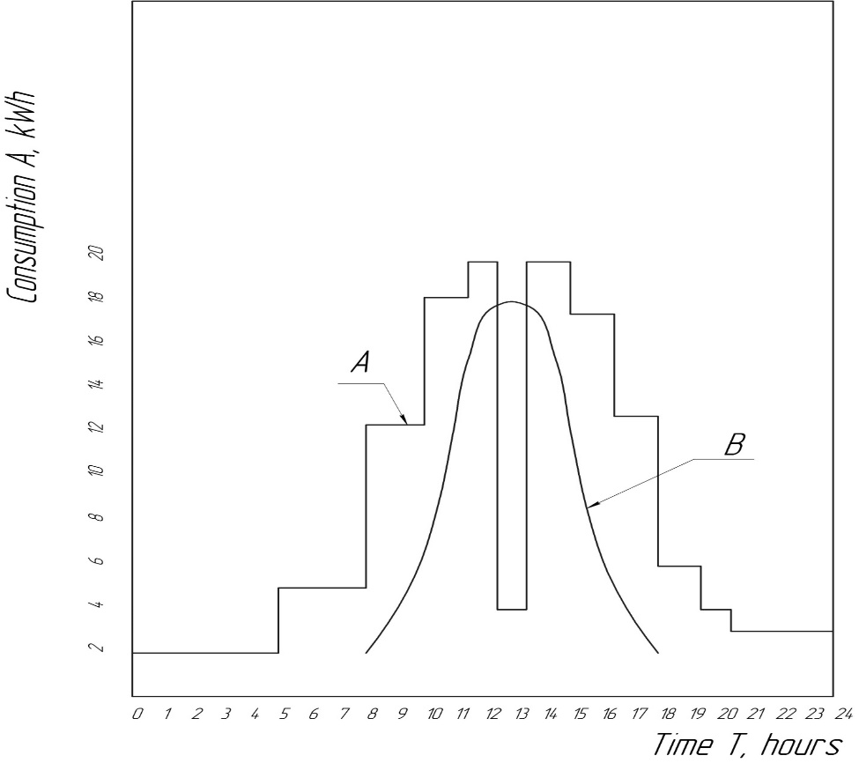

Figure D4 - Profile of electricity consumption by the building of the educational institution and profile of its generation by solar panels by the time of day (A – profile of consumption, B – profile of generation).

If to pay attention to this fact and to plan the most power-consuming classes in hours of the maximum generation during scheduling (in the presence of solar generation), it is possible to «align» schedules (profiles) of power consumption during the educational process. Based on the possibility of placing solar panels on the building and considering the conditions of panels orientation in space for maximum electricity generation, using as much surface area of enclosing structures as possible, it is not difficult to determine the technical capabilities of solar power generation technology in the educational institution. It is also necessary to refer to the economic aspects of the implementation of such a measure, the organizational opportunities for electricity sale to supply companies in the event of a surplus of generated electricity in summer months.
In some cases, it is advisable to use solar panels on vertical surfaces of enclosing structures as a protective and finishing surface of facade insulation systems (on the principle of a ventilated facade). However, when determining the technical and economic rationale for such an action, it is first necessary to pay attention to the efficiency of solar panels, which in such conditions will not be located at the optimal angle to the Sun’s rays.
Research results on the influence of the tilt angle of solar panels on electricity generation.
Solar panels work most efficiently when their surface is perpendicular to the Sun’s rays, so the tilt angle to the horizon is one of the key parameters of the solar power station [12]. Another factor that affects the amount of electricity generation is the azimuth that is the angle between the Sun and the south. Currently tracking these parameters is not a difficult engineering task, but its implementation requires additional equipment and high financial costs, so most solar panels are located on open surfaces at certain angles and with a south orientation. The tilt angle depends on the latitude of the area in which the panels are located. When it is constant during daylight, the efficiency of electric energy generation is variable. To evaluate this effect, the coefficient of electricity generation is used as the ratio of the value of the actual generation power (kW) to the nominal power of the panel (kW):

This coefficient for a constant tilt angle is variable over time and depends on the actual tilt angle of the line connecting the observer and the Sun to the horizon.
The research to determine the dependence of the change in the coefficient in time was conducted on a laboratory installation, which in automatic mode monitors the angle of the panel to the Sun.
To exclude the influence of the azimuth angle during the study, we defined the maximum value of at the i-th period of time and the optimal tilt of the panel, which provides the maximum generation of . The deviation of the tilt angle of the panel was determined from the specified optimal angle. The research results are presented in Table 2.2.

Table D2. – The change in when the tilt angle of the solar panel deviates from the optimal one.

Deviation of the inclination angle | 5⁰ | 10⁰ | 15⁰ | 20⁰ | 25⁰
Calculated coefficient k_{g} | 0,862 | 0,809 | 0,712 | 0,688 | 0,655

If, according to the optimal tilt angle of the panel, we take the coefficient value , then, when changing the tilt angle in the range from 0º to 25º, the coefficient k_{g} changes in the range from 1 to 0,655, which corresponds to the range of decrease in generation from a possible 100 % to 65,5 % in accordance with a change in the tilt angle of the panel from the optimal one at the i-th period of time. Based on the findings and calculations, the calculated coefficient reduces to 0,172. The average value of the decrease in the electric energy generation, when the tilt angle of the solar panel changes from the optimal one in the range from 0º to 25º, is 17,2 %.
The indicated range of variation in the tilt angle of the panel can be considered as moderately acceptable in further calculations and studies, which corresponds to the design capabilities of solar panels placement on the external structures of buildings in the conditions of the northern climatic zone of the country.
The results of the analysis of solar power station operation in the climatic and geographical conditions of the northern region of Ukraine.
Further research on the solar power station operation was carried out using the collected source statistics.
The results of solar power station operation over the past three years with a nominal capacity of 10,2 kW placed on the roof of a building in Sumy (the northeastern region of Ukraine) were accepted for consideration and analysis. The orientation of the plane of the solar panels is south. To consider the architectural features of the building, the panels are placed on the same plane parallel to the roof with the tilt angle of 25º. The fastening of photovoltaic panels is stationary. The volumes of monthly electricity generation are indicated in Table. D3.

Table D3 – The generation of electric energy by a solar power station, kWh.
Months of the year | 2017 | 2018 | 2019 | Average per month
January | 110 | 102 | 114 | 108,6
February | 125 | 132 | 128 | 128,3
March | 273 | 254 | 286 | 271
April | 1398 | 1450 | 1419 | 1422,3
May | 1580 | 1521 | 1590 | 1563,6
June | 1652 | 1618 | 1666 | 1645,3
July | 1393 | 1136 | 1486 | 1338,3
August | 1524 | 1424 | 1707 | 1551,6
September | 1094 | 1127 | 985 | 1068,3
October | 583 | 465 | 781 | 609,6
November | 194 | 132 | 251 | 192,3
December | 73 | 54 | 88 | 71,6

The graphic interpretation of the distribution of average volumes of electricity generation by months of the year is presented in Fig. D5.
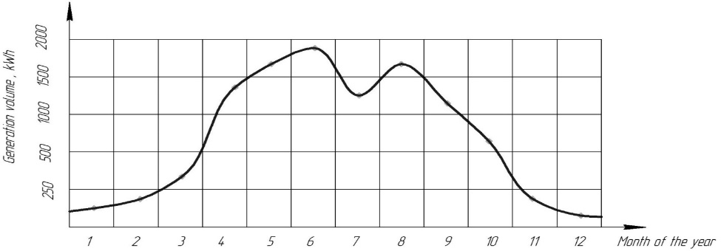
Figure D5- The distribution of average volumes of electricity generation by months of the year.

The analysis of the results of the power station shows that, given the climatic conditions of Sumy, the generation in winter months is 10…15 percent of summer months. This is due to snow cover and cloudy weather during these months. Based on this, organizational and technical settings with a focus on efficient power station operation in winter is inappropriate. It is necessary to focus on the rational use of the solar power station in the period from the last decade of March to the second decade of November, so the main parameters of its adjustment should correspond to the geographical and climatic conditions of this period.
The analysis of statistics on the daily operation of the power station shows that the maximum instantaneous generation power is recorded at about 13 o’clock in the afternoon (in June it averages 9,2 kW in cloudless weather, in November – 6,2 kW under the same conditions). The period of active electricity generation in June is from 7.00 am to 7.00 pm, in November – from 8.30 am to 3.30 pm. Graphic interpretation of the daily change of instantaneous generation power is presented in Fig. D6.

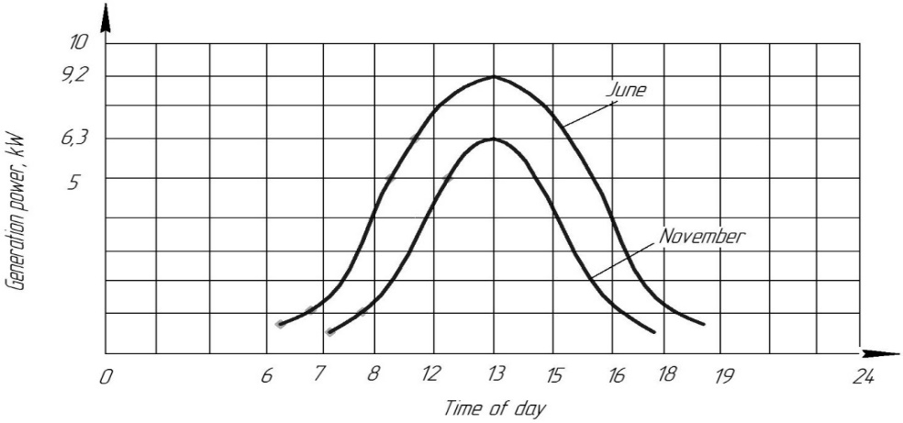
Figure D6. The schedule of daily change in instantaneous power of electricity generation.

Under certain location conditions (based on the calculation algorithm according to the method [1]) the best tilt angle of solar panels in summer will be the numerical value of the latitude of the building, multiplied by 0,93 minus 21 degrees. In our case, it should be about 27º.
The comparison of findings (using a laboratory bench) of the change in solar generation power from the tilt angle of solar panels and the actual statistical data on the solar power station operation indicate the correctness of the algorithm of the method [7] and confirm the decrease in the calculated generation coefficient within 3% with a deviation of the tilt angle of the solar panels from the calculated within 2º. This also corresponds to the trend data in Table D3.

Technical possibilities to increase the electric energy generation by a solar power station.
As already mentioned, these results were obtained under the condition of a stationary location of solar panels on the roof of the building.
However, the amount of solar radiation absorption entering the area of the solar panel (and as a result, the amount of electricity generated by the solar battery) depends on its orientation relative to the cardinal points, the tilt angle of the plane of the solar module relative to the horizon, the length of the daily period of daylight (if electricity generation by the module is possible). That is, the maximum efficiency (excluding the design features of the panel itself) of the solar module, in our case, should be determined by the initial orientation of the panels by geographical indicators, as well as tracking their changes during daylight with the possibility of adjusting the orientation of the panels in space and considering the coordinates of the Sun location in the i-th moment of time. It can be achieved by implementing special technical devices that automatically track the position of the Sun relative to the horizon and the sides of the world and allow you to orient the solar panels at any i-th moment of time.
Architectural and design features of most residential buildings of private construction allow the installation of such rotary devices (trackers) that should orient a separate solar panel in two planes: the azimuth and the angle of the Sun to the horizon.
The results of studies and observations of solar power station operation with an installed capacity of 10,2 kW in climatic and geographical conditions of Sumy city (average annual electricity generation of about 9800 kWh/year) show that equipping it with an automated system for adjusting the tilt angle will additionally generate about 1700 kWh/year. The total average annual electricity generation can reach 11500 kWh/year.
This result can be obtained under the condition of «landscape» arrangement of solar panels, i.e. the longer side of the panel should be located horizontally. This condition should be met to increase the use of the roof area for the position of the panels.
The area use factor is calculated as the ratio of the area of placed solar panels to the total area of the site of their placement on the roof, or the walls of the building:

,

and characterizes the potential value of the power installed on a certain plane of the power station.
Assuming a dense stationary arrangement of the panels on one plane parallel to the roof, the value of will be close to one. That is, the area of the roof will be used as useful as possible.
When the panels are equipped with a track that changes their tilt angle to the horizon and its operation together with the rotation of the panels, shadow zones are created, which significantly reduce the electricity generation in the shaded areas of the panels. To solve the problem, it is necessary to place the solar panels at a distance from each other, which avoids shadow areas. The calculation shows that the position of the panels in compliance with this condition reduces the value of the area use factor by 18 %. This entails a reduction in the number of solar panels and, as a consequence, a reduction in the installed capacity of the solar power station provided that it is located on the same roof area.
Simple calculations show that in this situation the average amount of electricity generated by a solar power station per year should be about 9450 kWh. The comparison of power station operation providing stationary panel mounting on a certain roof area in one plane (subject to the tilt angle of the panels is 25º) and using a tracker installation which monitors the tilt angle of the panels in accordance with the change in the Sun’s angle relative to the horizon, which shows that an increase in electricity generation does not compensate the loss of generation opportunities due to a decrease in the installed capacity of the power station located on the roof of the building.
When designing and carrying out assembly operations on the solar panels installed on the roofs of educational buildings or individual buildings, the main attention should be paid to the plane location of their installation relative to the horizon (mainly to the south) and compliance with the optimal angle of the solar panel relative to the horizon. Under these conditions, the amount of annual electricity generation mainly will depend on the area of solar panels located on the roof. The use of trackers, in this case, is not always justified, even from a technical point of view.
The use of a tracker system that would define the change in azimuth angle provided the position of the solar panels on the building’s roof, is also associated with the problem of rational use of the roof area, and, consequently, with the amount of electricity generated. In addition, the results of research [8] confirm that the deviation of the azimuth angle of primary orientation of the panel plane within 15º to the east or west has almost no effect on the total average annual value of generated electricity.
The studies of literature sources [9] confirm the high efficiency of tracker devices use, provided that the placement of solar panels in one plane in a dense array. In this case, you can avoid shadow areas without reducing the occupancy of the panel area. That is, this scheme of location and orientation of solar panels relative to the Sun position during the daily period of active electricity generation is characterized by the maximum values of area use factors and electricity generation.
The legislative framework in Ukraine for regulating the location and solar power stations operation indicates the position of solar panels on the roofs and walls of buildings, without mentioning the possibility of their separation from the building. Given this fact, the use of tracker devices with the option described above may be questionable.
Increasing the amount of electric energy generated can be achieved by placing additional solar panels on the walls of the building [10]. The effectiveness of such a measure is also associated with determining the tilt angle of solar modules, the area use factors and electricity generation , the calculated numerical values of which can be a criterion for its evaluation.
The placement of panels on the walls of the building is limited by the predominant orientation of the outer surface of the wall to the south and its area, the space of possible installation of the panel, which is limited by the «protective» size of the deviation from the wall surface of the roofline (Fig. D7). This size for most buildings averages no more than 700 mm. It allows you to place the panel in the «magazine» version with an angle of at least 45º.
Based on the optimal value of the tilt angle of solar modules (in our case 27º) in hours of maximum daily activity of the Sun, and, consequently, the maximum electricity generation, the average electric energy generation of the power station with solar panels with an angle of 45º on the wall will be 0,704 of maximum possible.

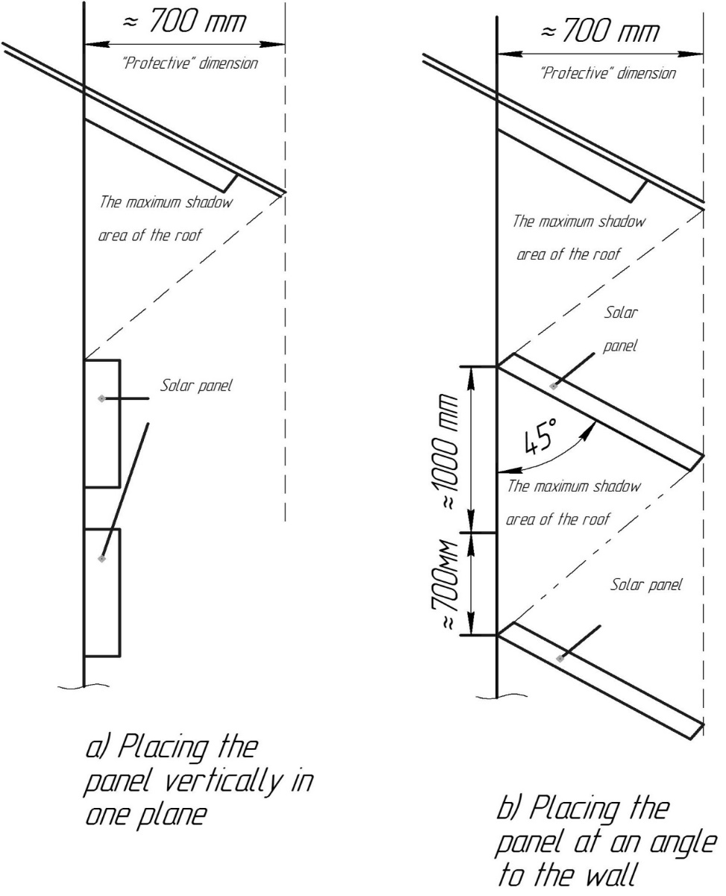
Figure D7 - The layout of solar panels on the walls of the building.

In addition, such a scheme for installing solar panels creates shadow zones on the wall plane, which must be avoided by placing the panels at a distance of about 1700 mm from each other. This feature reduces the area use factor to 0,58. That is, under such conditions, 42 % of the area cannot be used to place solar panels, and the total installed capacity of solar panels located on the wall will be less by almost 42 % compared to the option of placing panels vertically with one plane on the wall.
When placing the panels vertically in one plane, the area use factor of the wall area can be increased almost to one, which corresponds to an additional increase in the area of the location of the solar panels by almost 42 %. However, at the same time, during the hours of maximum daily activity of the Sun, the angle of deviation of the panel plane from the optimum will be about 63º, and, consequently, the average power generation of the power station will be 0,344 from maximum possible. Although in other periods of daylight hours, this angle will approach the optimum, a significant role in changing the generation power will play a change in the azimuth angle.
The total installed capacity can be increased by using the reserve of the area of «shadow zones» for additional panels placement. This measure can raise the total installed capacity by increasing the generation capacity to 0,488 from maximum possible. However, as can be seen from the comparison of calculation data, such a measure does not compensate for the decrease in generation capacity.
Placing solar panels on the wall of the building at an angle of about 45º gives an increase in electricity generation capacity during hours of maximum daily solar activity by almost 30 % compared to the option of placing panels vertically in one plane on the wall even if the wall area use factor increases almost to one.
Technical and economic aspects of implementing measures to regulate the tilt angle of solar panels.
The effectiveness of a solar power station operation when equipping the fastener system of solar panels with a one-turn tracker device (for tracking the optimal tilt angle of the panels) should be considered based on the conditions for a possible simultaneous increase in the average annual generation volumes, as well as its reduction due to a decrease in the number of solar panels placed on the roof.
As calculations show, such a contradiction negatively affects the solar power station efficiency and the efficiency of project innovations. Let’s discuss the use of a solar power station in a separate sphere or economic structure.
If it is possible to organize a solar power station operation in conjunction with the general regional power grid, the excess electricity generated flows and is calculated at a «green» tariff, which is 5,91 UAH/kWh. The average annual electricity consumption by the average economic structure is about 1750 kWh/year. As already mentioned, the average annual electricity generation under the condition of stationary placement of panels is about 9800 kWh/year, the amount of electricity «flowing» into the general network (9800 kWh - 1750 kWh) is 8050 kWh/year. In cash equivalent, it is UAH 47 575. After taxes, the household has a net income of almost UAH 38 300/year. Investments, in this case, amount to about UAH 280 000. Hence, the simple payback period of the project is about 7,3 years, subject to full monetary reimbursement of electricity consumed by this structure and neglect of the gradual in time solar panels efficiency reduction.
In the case of placing solar panels on the roof of the building by means of one-turn trackers to change the tilt angle automatically, the problem of shadow zones arises. According to calculations, its avoidance reduces the active area of electricity generation by 18%, which, under the same conditions of battery location, reduces installed capacity of the power station to 8,36 kW (by 1,83 kW). As already mentioned in the section, despite the increase in the specific generation rate, considering the loss of installed capacity, the average annual generation volume will be about 9450 kWh/year. The amount of electricity «flowing» into the general network (9450 kWh - 1750 kWh) is 7700 kWh/year. In cash equivalent, it is UAH 45,507. Excluding taxes, the structure has a net income of almost UAH 36 633 /year. According to this version of the technical solution, the investment volume will be almost the same UAH 280 000 with the exception of the cost of 7 solar panels (excluding «shadow areas») – UAH 29 400 (the average cost of one panel, considering the installation work, is UAH 4 200), i.e. the added cost of the tracker system is about UAH 140 000. That is, the total investment will be about UAH 390 600.
Hence, the simple payback period of the project is about 10,6 years, subject to a full monetary reimbursement of the consumed electricity and neglecting the gradual decrease in the efficiency of solar panels.
As you can see, under certain climatic conditions, the location of the building, its architectural features, the option of stationary location of solar panels on the roof without trackers is more attractive.
Technical and economic performance of the solar power station is also calculated under the condition of placing solar panels on the wall of the building with their vertical location (Fig. 2.7a) and placing the panel at an angle to the wall (Fig. D7b).
According to the version of Fig. D7, 20 panels with a total installed capacity of 5,2 kW are vertically placed on the wall. During the hours of the peak of solar activity and maximum electricity generation, the average power generation of a power station with such arrangement of solar panels will be 0,344 of the maximum possible, that is, 1,788 kW. Based on the total cost of the panels and possible added costs for their installation (about 20%), amount of required investment will be UAH 100 800.
According to the variant of Fig. D7b, there are 11 panels on the wall (considering the area of «shadow» zones). During the hours of the peak of solar activity, and, consequently, the maximum electricity generation of average power generation of the power station at the solar panels placement with an angle of 45º on the wall of the building will be 0,704 from maximum possible, i.e. 2,86 kW. Based on the total cost of the panels and possible added costs for their installation (about 20% of the cost), the amount of required investment will be UAH 55 400.
A comparison of calculation data shows that under certain climatic conditions, the location of the building, its architectural features, the option of a stationary position of solar panels on the wall at an angle to the wall according to the scheme of Fig. D7b is more attractive.
A comparison of operating results of power station with stationary panel mounting on a certain roof area in one plane (provided the tilt angle of the panels is 25º) and using a tracker installation, which monitors the tilt angle of the panels in accordance with the change in the angle of the Sun relative to the horizon, which shows that an increase in electricity generation does not compensate the loss of generation opportunities due to a reduction in the installed capacity of the power station located on the roof of the building.
When designing and carrying out assembly operations on the solar panels installation on the roofs of buildings, the main attention should be paid to the plane location of their installation relative to the horizon (mainly to the south) and compliance with the optimal angle of the solar panel relative to the horizon. Under these conditions, the amount of annual electricity generation will mainly depend on the area of solar panels located on the roof. The use of trackers, in this case, is not always justified, even from a technical point of view.
Placing solar panels on the wall of the building according to the option of their location at an angle of about 45º gives an increase in electric power generation during the peak of solar activity by almost 30% compared to the option of placing panels vertically in one plane on the wall even if the area use factor is increased almost to one.
Technical and economic calculations show that under certain climatic conditions of the northern part of Ukraine, the location of the building, its architectural features, the option of stationary location of solar panels on the roof without single-turn trackers is more attractive.
The comparison of calculation data shows that under certain climatic conditions, building conditions, its architectural features, the option of stationary location of solar panels on the wall with the tilt angle of the panels to the wall, according to the scheme of Fig. D7b, is more attractive.

