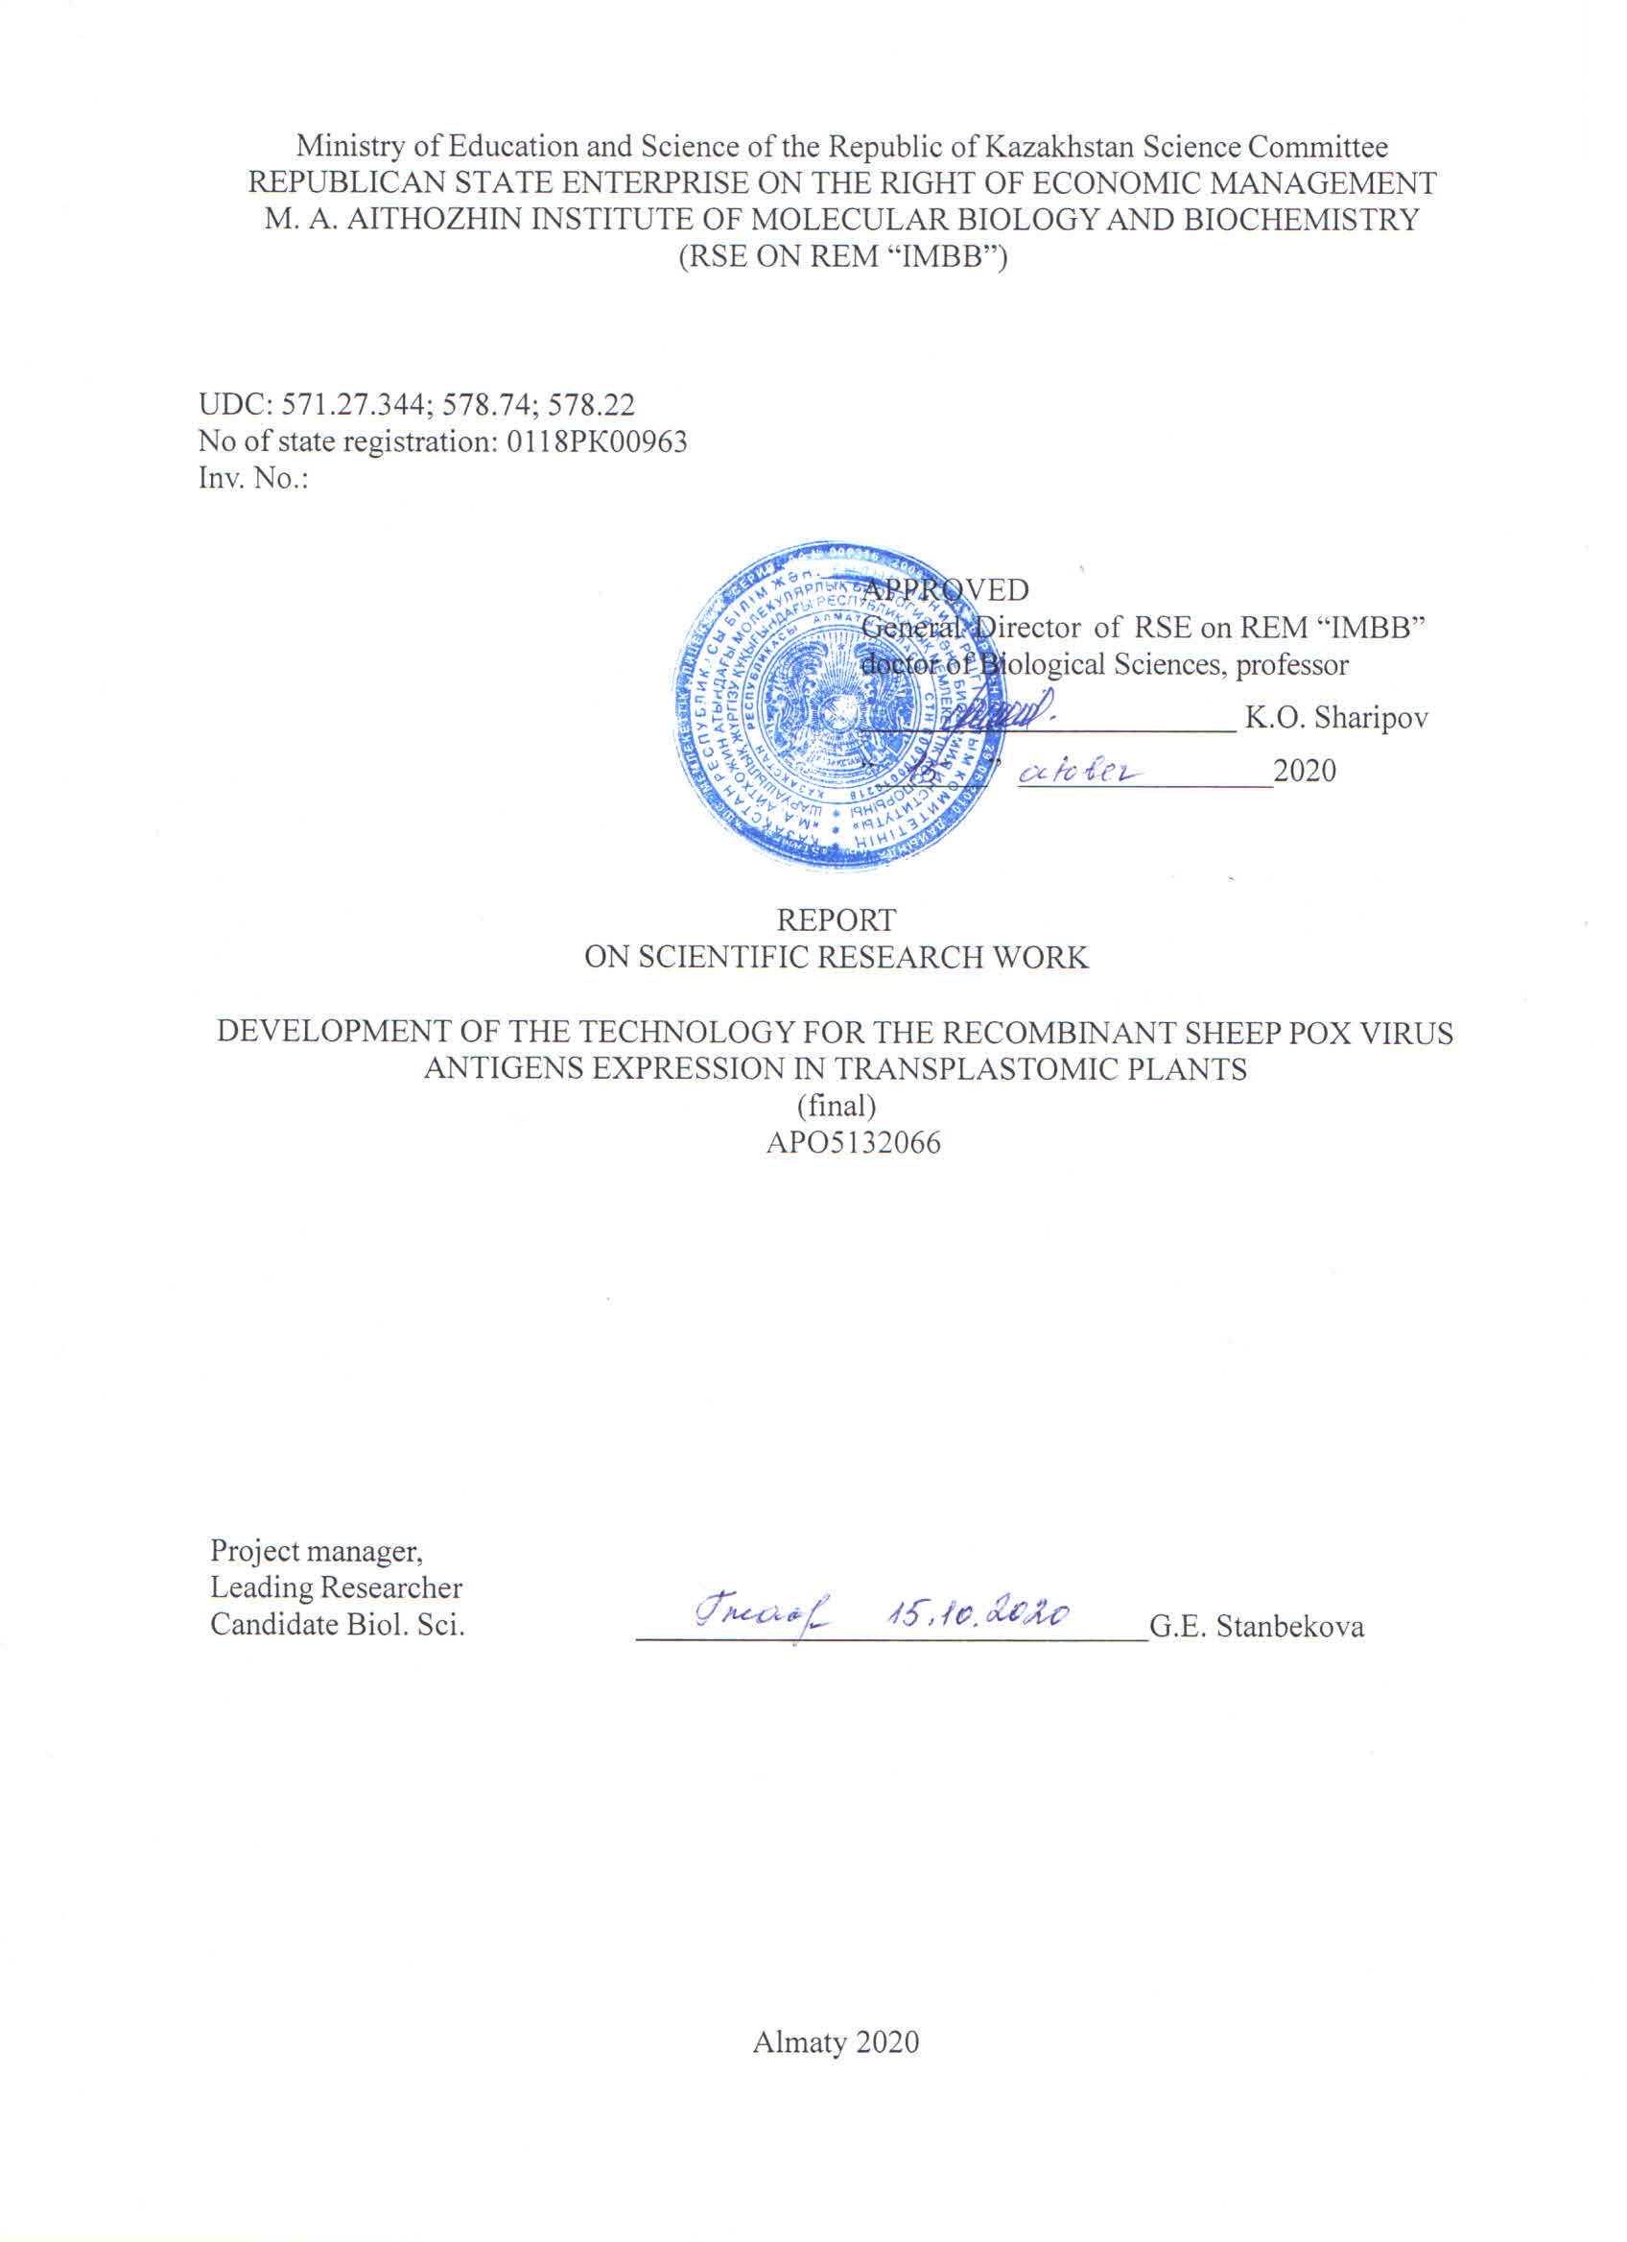

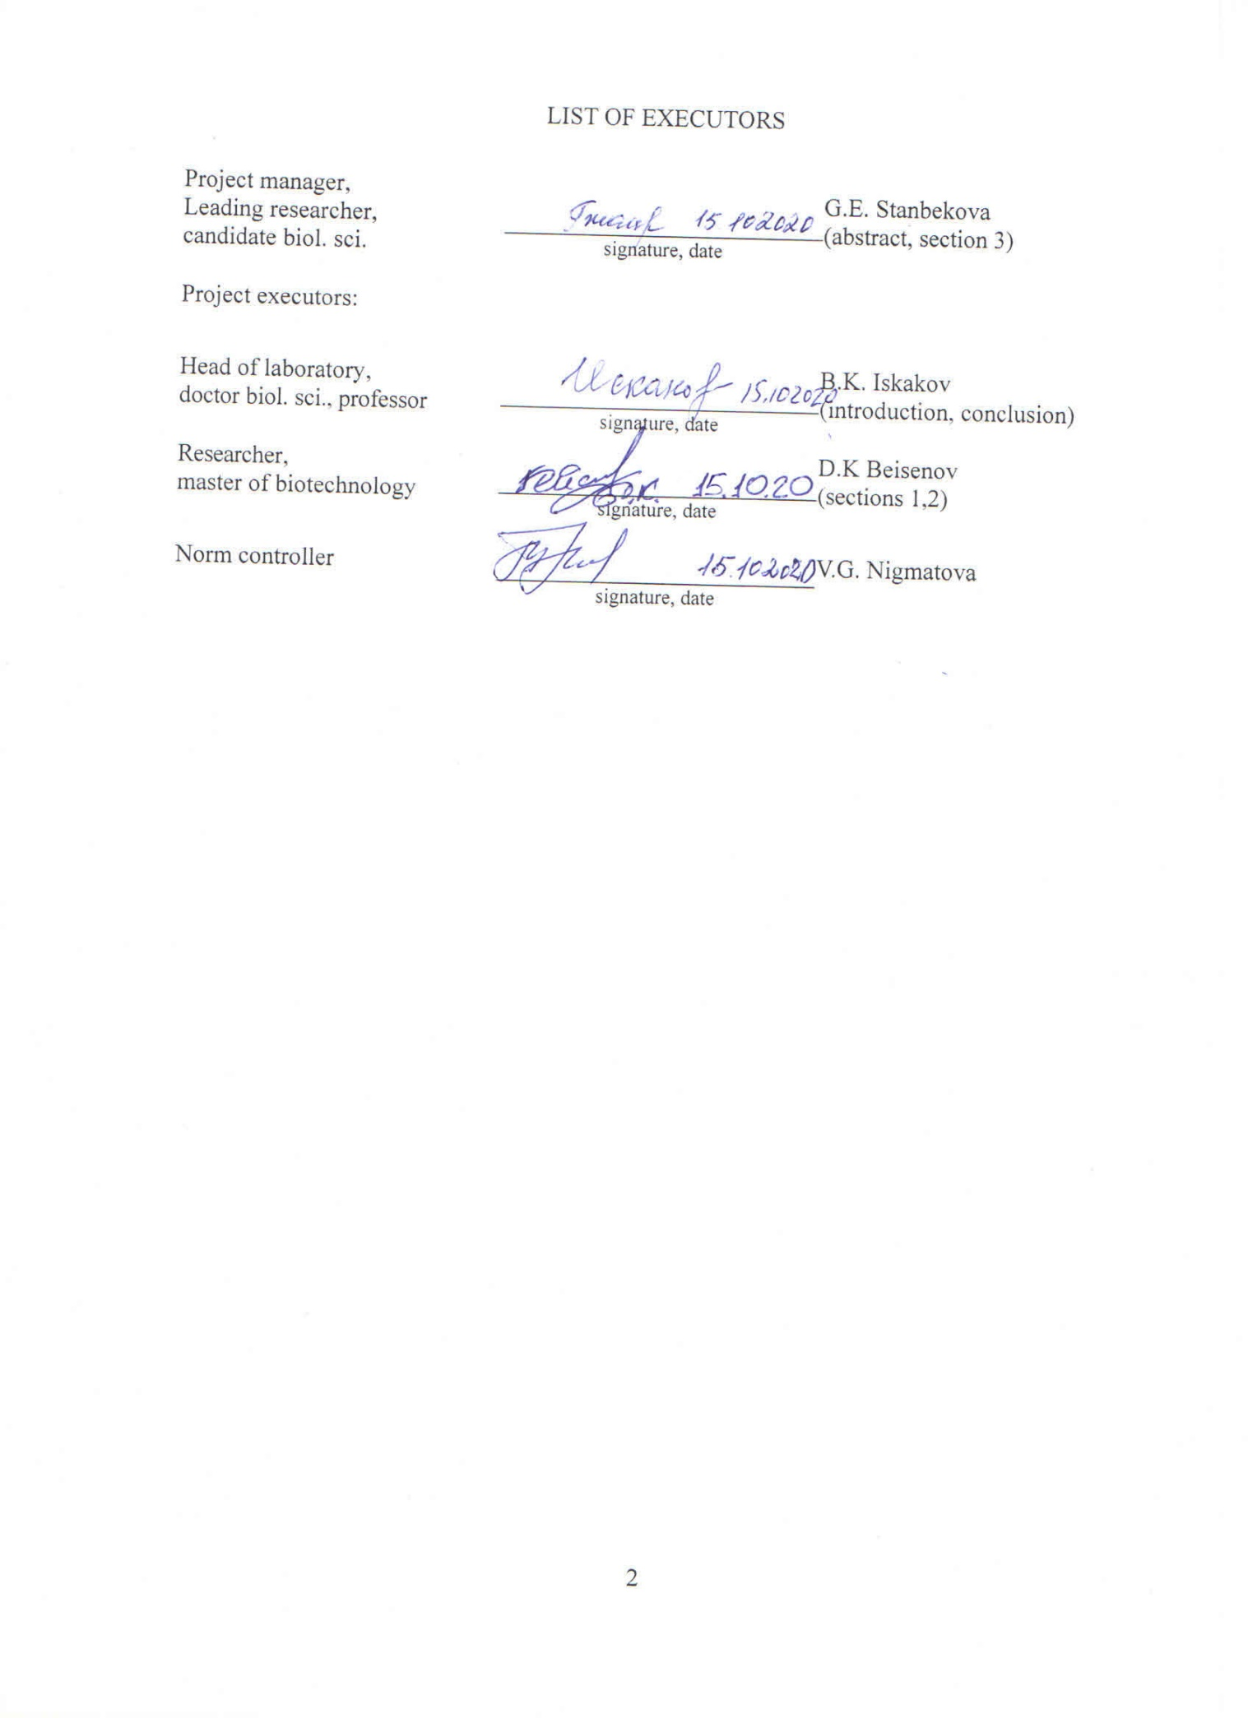

ABSTRACT
Report 56 p., 1 b, 11 fig., 1 table, 30 ref., 5 appendix.
SHEEP POX VIRUS, ANTIGENS, CHLOROPLASTS, TRANSPLASTOMIC PLANTS, EXPRESSION
Object of the study: sheep pox virus sppv-117 and sppv-060 genes, SPPV-A27L and SPPV-L1R antigens and Nicotiana tabacum tobacco plants.
The goal of the project is to develop a technology for producing recombinant sheeppox virus antigens based on N. tabacum tobacco plants with chloroplast expression of the sppv117 gene encoding the antigenic protein SPPV-A27L.
Research methods: computer analysis of nucleotide and amino acid sequences, in vitro plant culture methods, PCR, cloning, restriction analysis, electrophoresis of nucleic acids and proteins, bombardment, spectrophotometry, Western blotting, Southern blotting, Northern blotting.
The results of the work and their novelty: for the genetic transformation of chloroplasts, four constructs were created that ensure the integration of the full-length sppv117 gene and a deletion variant of the sppv060 (sppv060Δ) gene, encoding the SPPV-A27L protein and the ectodomain of the SPPV-L1R protein, respectively, into the chloroplast genome of tobacco into the trnG/trnfM intergenic region. Tobacco lines resistant to the selective spectinomycin antibiotic were obtained by biolistics using a "gene gun". PCR analysis in the presence of gene-specific primers confirmed the integration of the target insert into the plant genome. Subsequent Northern and Western blot analyzes of RNA preparations and protein extracts from the resulting plants showed the expression of the target gene at the transcriptional and translational levels. The content of recombinant proteins ranged from 0.30% to 0.99% of the total soluble protein. The genetic homogeneity of the plastid genomes of nine tobacco lines was verified by Southern blotting, which showed the homoplasticity of three lines and the heteroplasticity of the remaining six. The method of metal affinity chromatography was used to purify recombinant proteins from plant tissue. Seeds of transplastome plants were collected.
Based on the results of this project, 7 works were published (Appendix A). Scans of publications are given in Appendix E.
Applications: plant biotechnology, veterinary medicine.

ҚЫСҚАША АНЫҚТАМА
Есеп 56 б., 1 к., 11 сур., 1 кесте, 30 көз., 5 қос.
ҚОЙДЫҢ ШЕШЕК ВИРУСЫ, АНТИГЕНДЕР, ХЛОРОПЛАСТТАР, ТРАНСПЛАНТОМДЫ ӨСІМДІКТЕР, ЭКСПРЕССИЯ
Зерттеу нысандары: қой шешек вирусының sppv117және sppv060 гендері, олармен кодталатын рекомбинантты ақуыздар, N. tabacum темекі өсімдіктер.
Жобаның мақсаты – SPPV-A27L антигендік протеинін кодтайтын sppv117 генінің хлоропласт экспрессиясымен Nicotiana tabacum темекі өсімдігі негізінде рекомбинантты қой шешек вирусының антигенін алу технологиясын жасау.
Зерттеу әдістері: нуклеотид және аминқышқылы тізбектерінің компьютерлік талдауы, рестрикционды талдау, клондау, нуклеин қышқылдарының мен ақуыздардың электрофорезі, бомбалау, өсімдік дақылдарының in vitro әдістері, ПТР, спектрофотометрия, Вестерн-блоттинг, Саузерн-блоттинг.
Алынған нәтижелер және олардың жаңалығы: хлоропластардың генетикалық трансформациясын жүзеге асыру үшін SPPV-A27L ақуызын және SPPV-L1R ақуызының эктодоменін, сәйкесінше, trnG/trnfM аймағында темекі хлоропласт геномына кодтайтын sppv117 генінің және sppv060 генінің жойылу нұсқасының интеграциялануын қамтамасыз ететін төрт құрылым жасалды. «Гендік мылтықтың» көмегімен биобаллистика әдісі бойынша селективті антибиотик спектиномицинге төзімді темекі линиялары алынды. Мақсатты кірістірудің өсімдік геномына интеграциясы генге тән праймердің қатысуымен ПТР талдауымен расталды. РНҚ препараттарын және алынған өсімдіктерден алынған ақуыз сығындыларын кейінгі Нозерн және Вестерн блот-анализдері мақсатты геннің транскрипциялық және трансляциялық деңгейде экспрессиясын көрсетті. Рекомбинанттың мөлшері жалпы еритін ақуыздың 0,30%-дан 0,99%-ға дейін болды. Тоғыз темекі линияларының сызығының пластидті геномдарының генетикалық біртектілігі Cаузерн әдісiмен сыналды, ол үш линиянын гомопластикасын және қалған алтының гетеропластикасын көрсетті. Өсімдік тінінен рекомбинантты ақуыздарды тазарту үшін метал-аффинді хроматографиясы әдісі қолданылды. Транспластомды өсімдіктердің тұқымдары жиналды.
Осы жобаның нәтижелері бойынша 7 жұмыс жарияланды (А қосымшасы). Мақалалардың сканер нұсқасы Д қосымшасында келтірілген.
Қолдану саласы: өсімдік биотехнологиясы, ветеринария.
CONTENT
P.
ABBREVIATIONS AND SYMBOLS.........................................................................................................6
INTRODUCTION..........................................................................................................................................7
MAIN PART....................................................................................................................................................9
1 Rationale for the choice of studies.........................................................................................................9
2 Objects, materials and research methods................................................................................................11
2.1 Research objects...............................................................................................................................11
2.2 Materials............................................................................................................................................11
2.3 Research methods.............................................................................................................................11
3 Generalization and evaluation of research results..................................................................................15
3.1 Plasmid construction........................................................................................................................15
3.2 Transformation of tobacco chloroplasts..........................................................................................17
3.3 Testing of regenerated plants for the presence of a transgene by PCR……................................17
3.4 Evaluation of the expression of sppv117 and sppv060 genes by Northern blotting....................18
3.5 Evaluation of the content of SPPV-A27L and SPPV-L1RΔ recombinant proteins
in transplastomic plants by immunoblotting...................................................................................18
3.6 Obtaining homoplasmic transplastomic plants synthesizing SPPV-A27L and
SPPV-1RΔ proteins..........................................................................................................................20
3.7 Verification of plant homoplasmy by nucleic acid hybridization……………...….....................21
3.8 Development and optimization of technology for purification of SPPV-A27L and
SPPV-L1RΔ proteins from plant tissue...........................................................................................23
3.9 Obtaining seeds of transplastomic tobacco plants..........................................................................25
CONCLUSION.............................................................................................................................................27
REFERENCES...............................................................................................................................29
APPENDIX A - Publications and organization of scientific activity for 2018-2020........................32
APPENDIX B - Patent Research Report.....................................................................................................34
APPENDIX C - Work schedule for 2018 – 2020...........................................................................39
APPENDIX D - List of foreign information resources................................................................. 44
APPENDIX E - Supporting documents...................................................................................................... 43
ABBREVIATIONS and SYMBOLS
In this research report, the following abbreviations and symbols are used.
BAP | – | 6-benzylaminopurine 6-бензиламинопурин
bp | – | base pairs
BSA | – | bovine serum albumin
DIG | – | digoxeginin
dNTP | – | deoxynucleoside triphosphate
DNA | – | deoxyribonucleic acid
GUS | – | β-glucuronidase
kDa | – | kilodalton
kb | – | thousand base pairs
MS | – | Murashige-Skug
NAA | – | naphthaleneacetic acid
oligoDNA | – | oligodeoxyribonucleotide
PCR | – | polymerase chain reaction
PMSF | – | phenylmethylsulfonyl fluoride
RFLP | – | restriction fragment length polymorphism
RNA | – | ribonucleic acid
SDS-PAGE | – | polyacrylamide gel in the presence of sodium dodecyl sulfate
SPPV | – | sheep pox virus
Sm | – | spectinomycin
trnG | – | encoding glycine tRNA gene
trnfM | – | encoding formyl-methionine tRNA gene килодальтон
TSP | – | total soluble protein
UTR | – | untranslated region
VACV | – | Vaccinia virus
10×His | – | sequence encoding 10 histidine residues

INTRODUCTION
The project was carried out under the budget program: 217 "Development of Science", subprogram 102 "Grant financing of scientific research", by priority: 4 "Life and health sciences", in the specialized direction 4.1. "Basic and applied research in the field of biology."
Sheep pox virus (SPPV) belongs to the Capripoxvirus genus, which is a member of the Poxviridae family [1]. It is a highly contagious disease and due to its rapid spread, affect significant economic damage to sheep-breeding farms, high mortality, especially among young animals; it belongs to especially dangerous diseases [2]. The World Organization for Animal Health classifies it as a notifiable disease [3]. The virus is widespread throughout Central and Central Asia, India, and North Africa. In addition to sheep and goats, some wild animals (saigas, ibex, gazelles) are also susceptible to sheep pox [4]. Reducing the prevalence of this disease among small ruminants will have a fruitful effect on the number of these wild animals.
Vaccination is an effective means of preventing the spread of infectious diseases. At present, for the prevention of this infection in the Republic of Kazakhstan and in neighboring countries, a live vaccine based on an attenuated SPPV strain "NISKhI" is used [5]. Vaccines based on live attenuated virus strains are potentially dangerous and theoretically capable of recombining to form virulent strains. No method of purification of attenuated strains of sheep pox virus can guarantee complete elimination of mycoplasma and prion agents. These disadvantages can be overcome by subunit recombinant vaccines belonging to a new generation of effective immunizing means, an example of this is the first recombinant vaccine against hepatitis B, produced by inserting the surface antigen of the virus into the genome of yeast cells [6].
In this project, for the first time, a technology for the producing of two vaccine candidate SPPV-A27L and SPPV-L1R proteins in tobacco N. tabacum plants, expressing these proteins in chloroplasts, was developed. During the reporting period, 2 articles in scientific journals, 5 abstracts in the collections of proceedings of international conferences were published. Invention patent of the Republic of Kazakhstan was received. A laboratory regulation was developed (Appendix A).
On the topic of the research, a patent information search was carried out for a depth of 5 years in electronic databases, information and reference systems of the United States Patent and Trademark Office (patft.uspto.gov), the Eurasian Patent Organization (www.eapo.org), Rospatent (www. fips.ru), Fresh Patents (www.freshpatents.com); Elsevier (www.elsevier.com), PubMed (www.pubmed.com), Google Patents (https://patents.google.com). The results of the patent information search made it possible to identify the leading scientific organizations in foreign countries working on the problem of obtaining recombinant vaccines for medical and veterinary purposes in plants.
It has been established that the USA and the countries of the European Union occupy the leading position in this area. Based on the results of the patent search conducted over the past 5 years, a number of patents have been identified that have a general focus on the topic (Appendix B). The analysis of scientific literature and Internet data made it possible to identify a number of articles on the study of the transient or stable expression of human and animal pathogen antigens in plant cells. It showed to the prospects of the chosen topic and the relevance of the tasks.
Our data have been performed at high technical level using modern scientific and technical achievements and exclude unnecessary duplication of research.
Appendix C contains the project tasks, work schedules to the Agreement No. 330 dated 04.02.2018 between the Science Committee of the Ministry of Education and Science of the Republic of Kazakhstan and the RSE on REU “Institute of Molecular Biology and Biochemistry named after M.A. Aytkhozhin "SC MES RK. The information resources used in the report are given in Appendix D. Appendix E contains scanned copies of publications.
Interim reports presented research results for 2018 year (inv. No. 0218RK00787) and for 2019 year (inv. No. 0219RK00851).

MAIN PART
1 Rationale for the choice of studies
As the basis for the recombinant vaccine, the immunodominant SPPV coat proteins were chosen. It is known that the structural envelope proteins SPPV60, SPPV095, SPPV117 and SPPV122 are immunodominant [7]. They are orthologues of the L1R, A4L, A27L, and A33R proteins of vaccinia virus (VACV), which was used as a live vaccine in the 20th century. The virus neutralizing activity was shown only for rabbit blood sera to synthesized in bacteria recombinant proteins SPPV60Δ (ectodomain of SPPV60), SPPV117, and SPPV122. We selected SPPV60Δ and SPPV117 for producing in plant chloroplasts, since sera to them showed a high neutralizing activity. Hereinafter, we designated them as SPPV-L1RΔ and SPPV-A27L.
Other investigators showed that immunization of mice with the bacterially synthesized recombinant protein VACVA27L provided complete protection when mice were infected with lethal doses of wild type of VACV [8]. The VACVL1R protein together with VACVA33R and VACVB5R proteins expressed in the baculovirus system protected mice from death during intranasal infection with VACV [9]. Since SPPV and VACV are quite genetically closed, it can be expected that immunization of animals with plant-made SPPV-A27L and SPPV-L1RΔ proteins will also protect animals from viral infection.
Currently for the production of target recombinant proteins bacterial, animal and plant systems are used. The main disadvantage of prokaryotic systems is the absence of post-translational protein modifications. Animal systems are extremely expensive for of recombinant proteins expression and allow obtaining small amounts of a pure product [10].
Plant systems for producing recombinant vaccines are an attractive alternative in comparison with other eukaryotic systems due to their low cost and safety due to the absence of pathogenic human and animal viruses, as well as prions. Numerous works show that transgenic plants with the integration of the target gene into the chromosomes of the cell nucleus usually produce a foreign protein at a low level [11]. An increase in the number of transgene copies in order to increase the level of expression of transgenic mRNAs often leads to their silencing [12].
These difficulties can be overcome by using a transgenic chloroplast system (plastids). Expression of transgenes in plastids has several important advantages over nuclear expression. The amount of recombinant proteins in chloroplasts, as a rule, is several orders of magnitude higher than in nuclear expression and reaches 1–25% of the total soluble protein (TSP) and in exceptional cases reaches more 70% [13, 14].
Other advantages are the absence of the risk of transgene silencing, protection of the target recombinant proteins in plastids from cellular proteases, integration of the transgene into the same intergenic region of plastid DNA, absence of mRNA splicing in plastids. Biosafety through maternal plastid inheritance is another benefit of chloroplast transformation [15]. A number of antigens have been successfully produced in chloroplasts, including antigens of dengue virus, poliovirus, causative agent of cholera, VACV, immunodeficiency virus [16]-[20]. These facts encourages us to choose the chloroplast expression system for the production of the recombinant proteins SPPV-A27L and SPPV-L1R as candidate vaccine proteins against SPPV.
Since most chloroplast vectors are designed specifically for tobacco, we chose tobacco as a plant host for producing recombinant SPPV proteins. Moreover, tobacco has a high growth rate and is an unpretentious crop. The process of purification and concentration of poxviruses from in vitro cultured virus-containing cells for the production of attenuated vaccines is very laborious and costly. The cost of raw materials for the production of recombinant protein from the corresponding tobacco line will be significantly lower.

2 Objects, materials and research methods
2.1 Research objects
The main objects of research: the sppv117gene (GenBank ID: NP_659689), sppv060 gene (GenBank ID: NP_659632) and encoded by them proteins. E. coli DH5α strain, Nicotiana tabacum (cv. Petit Havana) tobacco plants were used. The nucleotide sequences of chloroplast DNA of N. tabacum (GenBank ID: Z00044) was also used.
2.2 Materials
Reagents from “Sigma”, “Bio-Rad”, “Roche”, “Thermo Scienetific”, “Qiagen”, and “5-Prime” were used. Plasmids pICH11599, pKG27, pHK20 and pNT4 were kindly provided by Professor H. Warzecha (Germany). The nucleotide sequences of oligodeoxyribonucleotides (oligoDNA) synthesized by “Eurofins Genomics“ are shown in table 1.
Table 1 - Oligodeoxyribonucleotides used in the work
Gene | Primer | Sequence
sppv117 | 117-for | 5’-gcatcatatggacagagcgttatcaatctttccaggcga
sppv117 | 117-rev | 5’-gcatctcgagtcactttagtgttgtaattcttcctgttt
sppv60 | 060-for | 5’-gcatcatatgggagcagccgctagtat
sppv60 | 060-rev | 5’-gcatgtcgacttatatataaaattgatatatccgtatcccga
flanking region of the tobacco chloroplast genome | сhl-for | 5’-cgacggagagggggtccacc
flanking region of the tobacco chloroplast genome | сhl-rev | 5’-gaagcccctttaccattctgtat
2.3 Research methods
Computer analysis of nucleic acid and protein sequences was performed using “SnapGene 2.8.3” and “DNAMAN 4.03” software; “Image J1.52” was used for densitometry of protein bands.
DNA sequencing was performed using a commercial Big Dye® Terminator v.3.1 kit (“Applied Biosystems”) according to the manufacturer's protocol. Reading was performed in both directions using the gene-specific 117-for and 117-rev, 060-for and 060-rev primers. DNA samples were analyzed on an ABI Prism 310 genetic analyzer (“Applied Biosystems”).
Biolistic plant transformation. For transformation, we used the leaves of N. tabacum (cv. Petit Havana) tobacco plants grown in aseptic conditions in vitro on Murashige-Skoog (MS) medium [21]. The medium contained 3% sucrose, 0.7% agar. Bombardment was carried out using a PDS-1000/He Biolistic Particle Delivery System (“Bio-Rad”) gene gun according to a generally accepted protocol [22]. After bombardment, leaf explants were placed on Petri plates with regeneration medium (MS medium containing 1 μg/ml BAP (6-benzylaminopurine), 0.1 μg/ml NAA (naphthaleneacetic acid) and 500 μg/ml antibiotic spectinomycin (Sm). The plates were incubated at 23°C, with an illumination of 3000 lux and a 16 h/8 h (day/night) regime. Every two weeks, leaf segments were transferred to fresh medium. The regenerated shoots after several months were cut and rooted on hormone-free MS medium supplemented with Sm. At the second stage of selection, leaf explants of the primary shoots were placed on a regeneration medium until secondary shoots appear. In total, 4 repeated regenerations of tobacco transplastomic lines were carried out.
Isolation of DNA. Total DNA samples were isolated from 50 mg of tobacco leaves using the DNeasy Plant Mini Kit (“Qiagen”) according to the manufacturer's procedure.
Polymerase chain reaction (PCR) was carried out using Taq DNA polymerase (“Thermo Scientific”). OligoDNAs indicated in table 1 were used as primers and 100 ng of total plant DNA was used as a template. 20 μl volume of the reaction mixture contained 2 μl of 10 × PCR buffer, 2 μl of 25 mM MgCl₂, 1 μL of 10 mM dNTPs, 0.2 μL of Taq polymerase (1 unit), 1 μl of forward and reverse primers (10 pmol/μL) , 11.8 μl of water and 1 μl of DNA. The reaction was carried out in the following temperature regime: stage 1 - 3 min. at 94ºС - 1 cycle; stage 2 - 30 sec. at 94ºС, 30 sec. at 54ºС, 1 min. at 72ºС - 30 cycles; stage 3 - 5 min. at 72ºС - 1 cycle.
Western blotting. Protein samples from plant leaves were isolated using the Trizol reagent (“Sigma”) according to the manufacturer's recommendations. Protein concentration was measured spectrophotometrically on an Ultrospec 2000 (“Pharmacia Biotech”) relative to known concentrations of bovine serum albumin (BSA) by the Bradford method [23]. The electrophoretic separation of proteins was carried out in a 15% SDS-PAG according to Laemli [24]. After electrophoresis, proteins were transferred onto a PVDF membrane (“Bio-Rad”) by semi-dry electroblotting on a “C.B.S. Scientific”device in transfer buffer (102 mM glycine, 25 mM Tris, 20% (v/v) ethanol) at a current of 0.8 mA/cm² for 1 hour. The membrane was blocked for 1 hour in 3% skim milk prepared in TBS buffer (10 mM Tris-HCl pH 7.5; 150 mM NaCl). Mouse antibodies to pentahistidine (“5-Prime”) diluted in blocking buffer in 1:4000 ratio were used as primary antibodies for protein detection. Secondary anti-mouse IgG antibodies conjugated with horseradish peroxidase (“Santa Crus Biotechnology”) were diluted in blocking buffer at 1:4000 ratio. Incubation with antibodies was carried out for 1 hour at room temperature. Antibodies were washed off four times for 5 min with TBST buffer (TBS containing 0.05% Tween-20). As a substrate Chemiluminescent Peroxidase Substrate 3 (“Sigma”) or Metal Enhanced DAB Substrate (“Thermo Scientific”) were used. To study the antigenicity of plant produced proteins, we used blood serum of a sheep infected with SPPV (“Research Institute of Biological Safety Problems of the Republic of Kazakhstan”), diluted in a blocking buffer at 1: 400 ratio. Anti-sheep IgG conjugated with horseradish peroxidase (“Sigma”) we used as second antibodies diluted at 1: 2000 ratio. Metal Enhanced DAB (“Thermo Scientific”) was used as a substrate.
Southern blotting consisted of the following steps: DNA restriction; electrophoresis of DNA fragments in agarose gel; DNA depurinization and denaturation; DNA transfer to a nylon membrane; fixing DNA to the membrane; preparation of a DIG-labeled probe; hybridization and detection hybrids.
For DNA restriction, a 35 μl mixture was prepared. It contained 3.5 μl of 10× Tango restriction buffer Tango (“Thermo Scientific”), 0.7 μL of EcoO109I restriction enzyme (“Thermo Scientific”), 2 μg of DNA, H₂O. Incubation was carried out overnight at 37°C. The next morning, 0.7 μl of restriction endonuclease was added to the mixture and incubated for an additional 3 hours.
Electrophoresis. 2 μl of 6 × sample loading buffer (0.25% bromophenol blue, 40% sucrose) to a 10 μl aliquot of the restriction mixture was added and loaded into to the wells of 1% agarose gel. Electrophoresis was performed at 5V/cm in TBE buffer (89 mM Tris, 89 mM boric acid, 2 mM EDTA, pH 8.0).
Depurinization was carried out in a 0.25 M HCl solution for 10 min with agitation at room temperature. DNA was denatured in a solution of 0.5 M NaOH, 1.5 M NaCl twice for 15 min. The gel was washed with water and incubated in a neutralizing solution (0.5 M Tris-HCl, 1.5 M NaCl, pH 7.5). The procedure was performed twice for 15 minutes.
Transfer DNA to a Porablot NY plus membrane (“Macherey-Nagel”) was performed overnight by capillary method in 10 × SSC buffer (3 M NaCl, 300 mM sodium citrate) t. To control the completeness of DNA transfer to the membrane, the gel was stained by ethidium bromide solution and assessed visually under UV rays.
DNA fixation on the membrane was performed under 254 nm length UV rays for 3 min.
PCR DIG Probe Synthesis Kit (“Roche”) was used for obtaining a DIG-labeled probe by amplification of DNA from wild-type plants with the participation of a pair of chl-for and chl-rev primers (Table 1).
Hybridization. To prevent nonspecific binding of the probe to the membrane prehybridization was performed for 30 min at 42 ºС in Easy DIG Hyb buffer (“Roche”). Then the solution was decanted and fresh Easy DIG Hyb solution containing the probe was added. The probe solution was preheated at 95 ºС for 10 min and chilled in ice. Hybridization was performed overnight at 42 ° C. The next day, the membrane was washed twice with a solution containing 2× SSC buffer and 0.1% SDS for 15 min with agitating at room temperature. Then the membrane was washed twice for 15 min in 0.2× SSC buffer containing 0.1% SDS at 65°C.
Detection. The membrane was washed in a buffer (0.1 M Maleic acid, 0.15 M NaCl, 0.3% Tween-20, pH 7.5), placed in a blocking buffer (1× DIG Block Reagent, 1 × Maleic acid buffer) for 30 min. Then, Anti-Dioxigenin-AP Fab fragments (Roche) antibodies were added in a 1:5000 ratio and incubated for 1 hour. Then, membrane was washed twice for 15 min in wash buffer and incubated for 5 min in detection buffer (0.1 M Tris-HCl, 0.1 M NaCl, pH 9.5). Detection was performed using alkaline phosphatase CSPD (“Roche”) in detection buffer at a 1:200 ratio. The membranes were exposed on X-ray film (“USA Scientific”).
Northern blotting. RNA samples were isolated using the Trizol reagent (“Sigma”). RNA (5 μg) was separated by electrophoresis in a formaldehyde-containing 1.2% agarose gel and, after transferring to a nylon membrane (“Macherey-Nagel”), was incubated overnight with a probe at 50°C. DIG-labeled PCR products obtained with the participation of plasmids pP117 and pP060 and pairs of primers sppv117-for/sppv117-rev and sppv060-for/sppv060-rev were used as a probe. Probe labeling and detection of hybridization products were performed with the same reagents used in Southern blotting.
Purification of proteins from plant tissue. 1 g of leaves was ground with a pestle in a mortar adding 8 ml of lysis buffer (50 mM NaH₂PO₄, 0.3 M NaCl, 2 mM imidazole, 2% Triton X-100, 15 mM β mercaptoethanol, 2 mM PMSF, pH 8.0). The lysate was centrifuged at 10,000 g for 20 min. 1 ml of a suspension of Ni-NTA agarose (“5-PRIME”) was added to the supernatant. The mixture was then incubated with shaking for 1 hour on ice. After that, the resin was washed twice with 8 ml of wash buffer (50 mM NaH₂PO₄, 0.3 M NaCl, 20 mM imidazole). The proteins was eluted out stepwise using an elution buffer (50 mM NaH₂PO₄, 0.3 M NaCl, 250 mM imidazole, pH 8.0). Protein-containing fractions were combined, dialyzed against potassium phosphate buffer (pH 7.0), and concentrated by ultrafiltration through 3,000 MWCO HY columns (“Amicon”).
General methods. Spectrophotometric measurement of DNA concentration, electrophoresis of nucleic acids and proteins, cloning were performed according to standard methods [25].
Statistical methods. Spectrophotometric measurement of the concentration of DNA, RNA and proteins was carried out in triplicate with the calculation of the mean value (X) and standard deviation (SD) in Microsoft Office Excel 2013.

3 Generalization and evaluation of research results
3.1 Plasmid construction
For expression in chloroplasts, SPPV genes were placed under the control of various chloroplast regulatory elements: the PpsbA or Prrn promoters and the TpsbA or TrbcL transcription terminators. Earlier we obtained vectors containing the sppv117 (450 bp) and sppv060Δ (567 bp) genes as part of the pET19b expression vector [26], [27]. The SPPV genes from the pET19b/sppv117 and pET19b/sppv60Δ plasmids were cloned into the transient vector pICH11599 between the NcoI and BamHI restriction sites generating the pICH11599/sppv117 and pICH11599/sppv60Δ plasmids. The presence of the XbaI site after the BamHI site in the resulting plasmids made it possible to clone the SPPV genes into the pKG27 vector between the NcoI and XbaI sites instead of the uidA gene encoding the β-glucuronidase (GUS) reporter protein, placing them between the promoter and terminator of the plastid psbA gene. The resulting plasmids were designated pKG27/sppv117 and pKG27/sppv060Δ, respectively.
In parallel, both genes were subcloned into the pHK20 vector containing the neo gene encoding neomycin transferase between the chloroplast promoter Prrn and the terminator TrbcL. In order to replace the neo gene with SPPV genes, the vector was sequentially processed with the NdeI restriction enzyme, Klenow fragment in the presence of dNTPs to fill the 5'-protruding "sticky" DNA ends and form blunt ends, then with the XbaI restriction enzyme. Next, the vector was ligated with DNA fragments of the sppv117 and sppv060Δ genes isolated from the plasmids pICH11599/sppv117 and pICH11599/sppv60Δ, prepared in the same way, except that the restriction enzyme NcoI was used instead of NdeI. The resulting plasmids were designated pKHK20/sppv117 and pHK20/sppv060Δ, respectively.
Plasmids pKG27/sppv117, pKG27/sppv60Δ, pHK20/sppv117, pHK20/sppv60Δ were treated with restriction enzymes SacI and HindIII, the corresponding DNA fragments with sizes 992 bp, 1109 bp, 898 bp, 1015 bp were cloned into the pNT4 vector between the indicated sites. As a result, plasmids pP117, pP060Δ (containing the SPPV genes under the control of the PpsbA promoter) and pR117, pR060Δ (containing the SPPV genes under the control of the Prrn promoter) were obtained. Figure 1 shows their maps. The flanking sequences present in the obtained vectors ensure the integration of the transgene into the trnG/trnfM intergenic region of the chloroplast genome by homologous recombination, and the aadA gene, which confers resistance to the Sm antibiotic, allows transformant selection. The sequence of the nucleotide sequences of the sppv117 and sppv060Δ genes in the vectors revealed that these genes do not contain mutations introduced during cloning and the constructs can be used in further work.

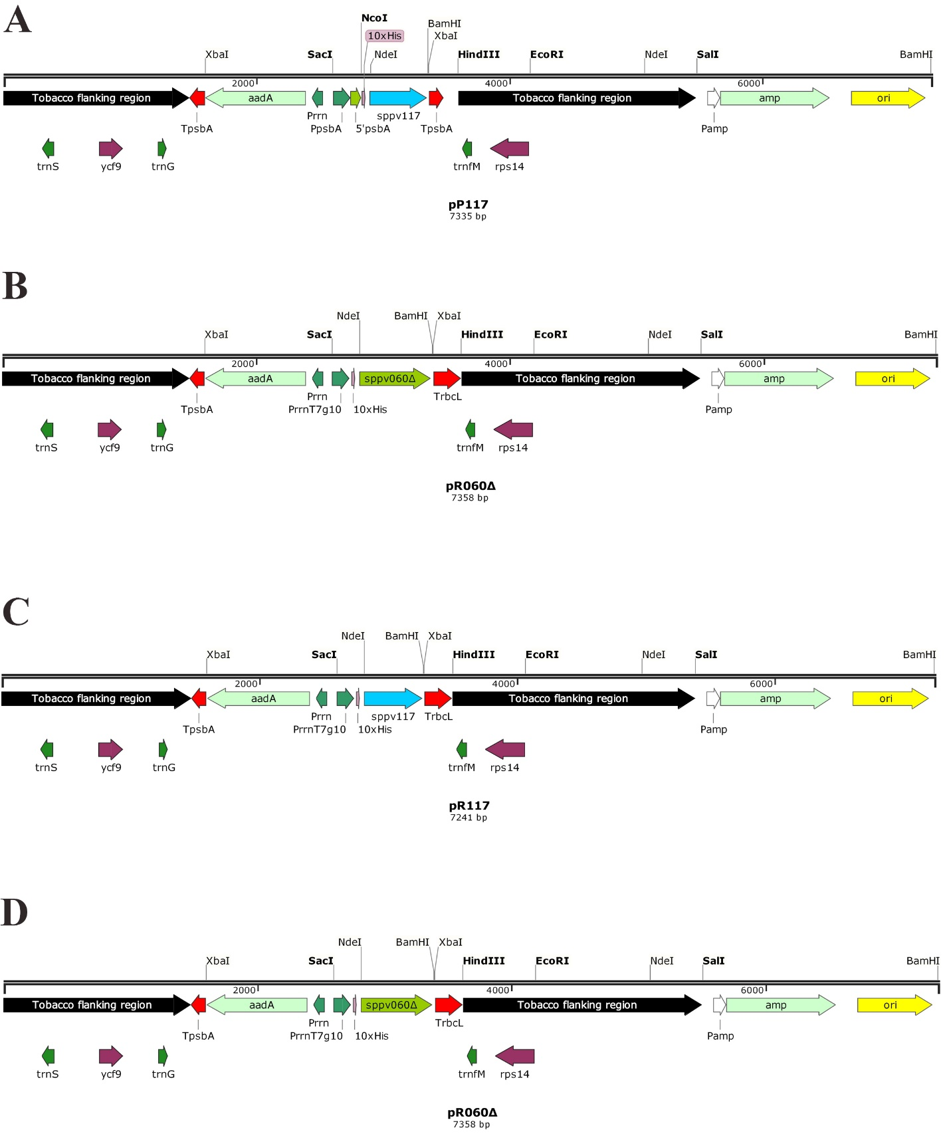
A - pP117, B - pP060Δ, C - pR117, D - pR060Δ. TpsbA - terminator of the plastid gene psbA; aadA - spectinomycin resistance gene; PpsbA - promoter of the plastid psbA gene; trnG - glycine tRNA gene; 5'psbA - 5'UTR of the psbA gene; PrrnT7g10 - plastid ribosomal operon promoter fused with 5'UTR of gene 10 of bacteriophage T7; 10 × His - sequence encoding 10 histidine residues; sppv117 - gene coding SPPV-A27L protein; sppv60Δ - gene coding the truncated form of the SPPV-L1R protein; trnfM - formyl-methionine tRNA gene; amp - ampicillin resistance gene; ori - replication start site.
Figure 1 - Plasmid maps

3.2 Transformation of tobacco chloroplasts
For transformation of tobacco plants N. tabacum (cv. Petit Havana), plasmid DNA of the obtained constructs was isolated from 100 ml of bacterial culture. The final yield of plasmid DNA was 91.25 ± 7.39 μg, which is sufficient to carry out several dozen shots. The obtaining of transplastomic plants by the bombardment consisted of several stages: bombardment whole leaves with gold particles coated with plasmid DNA, cultivating leaf segments on MS medium with hormones and Sm, calli formation, shoot regeneration, rooting of shoots on a hormone-free MS medium containing Sm. Plant regeneration took place two to three months from the start of the experiment. As a result, 10 Sm-resistant regenerated plants were obtained. We failed to select such plants for plasmid pP060Δ. Figure 2 shows the stages of obtaining of transplastomic tobacco plants.
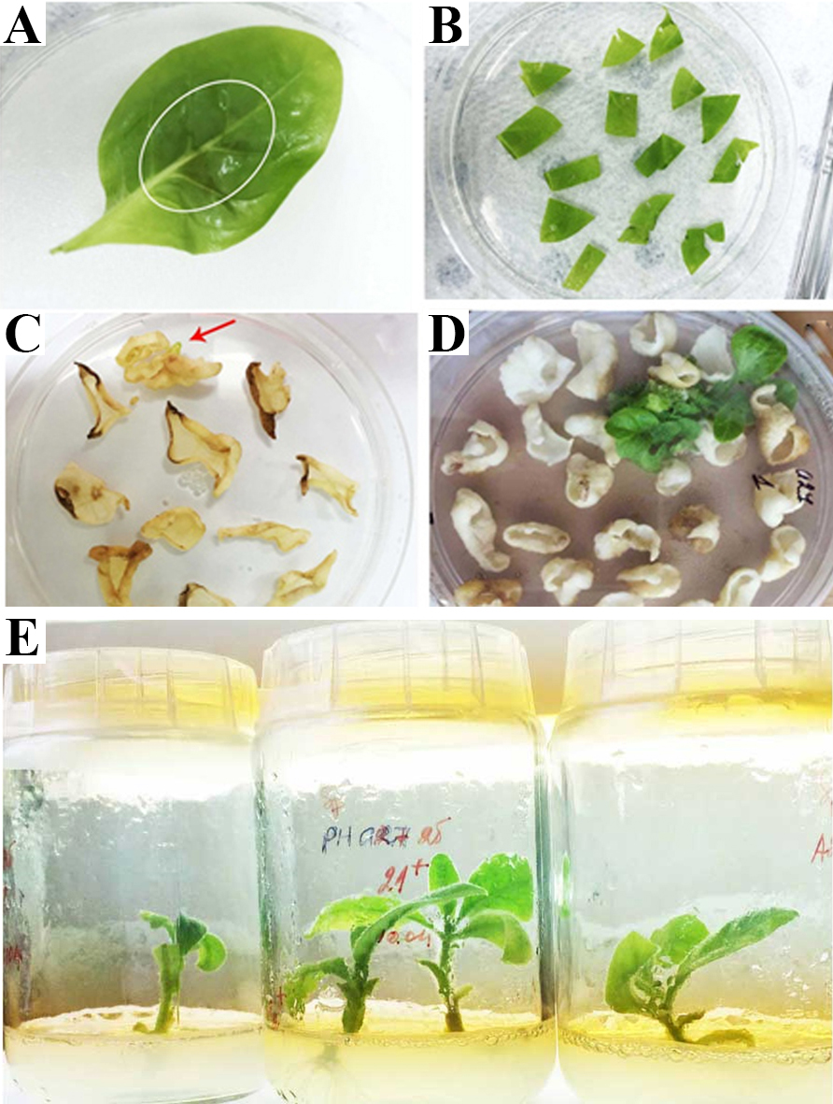
A – a leaf after bombardment with the encircled zone of the penetration of gold particles; B - leaf segments on medium with hormones and Sm; C - formation of Sm-resistant calli; D - regeneration of shoots; E - rooting of plants in a hormone-free medium.
Figure 2 - Stages of biolistic transformation of tobacco

3.3 Testing of regenerated plants for the presence of a transgene by PCR
At the next stage, the presence of transgenes in the regenerated plants was checked by PCR analysis. Total DNA samples were isolated from 10 tested and wild-type plant leaves. The integrity of the obtained samples was evaluated by electrophoresis in agarose gel, the DNA concentration was determined spectrophotometrically at a 260 nm wavelength. 100 ng of DNA from each sample was taken for PCR analysis in the presence of gene-specific primers 117-for/117-rev or 060-for/060-rev. The test showed that seven plants contain the sppv117 gene of 0.45 kb (Figure 3A), three plants - sppv60Δ of 0.57 kb (Figure 3B).

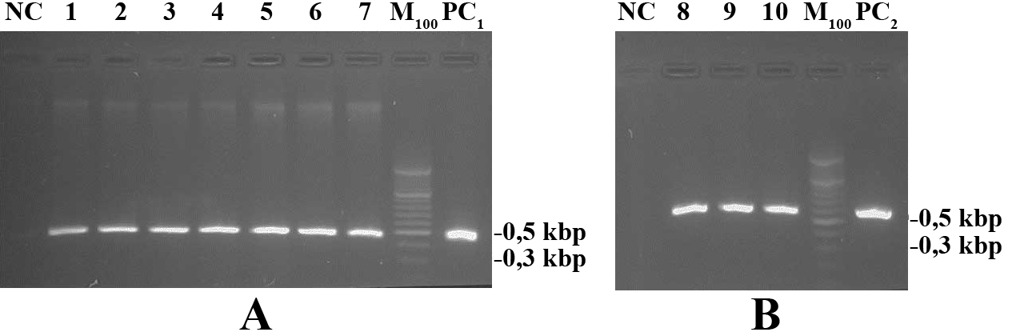
A – PCR with sppv117 gene primers, B – PCR with sppv060 primers. NC - negative control (DNA from wild-type tobacco plant); 1-4 - DNA from regenerated plants obtained with plasmid pP117; 5-7 - with pR117; 8-10 - with pR060Δ; M₁₀₀ - DNA marker O'RangeRuler 500 bp DNA ladder (“Thermo Scientific”); PC₁ and PC₂ - positive control (10 ng of pP117 and pR060Δ plasmids, respectively.
Figure 3 - PCR analysis of total DNA from various lines with sppv117 and sppv060 gene-specific primers

3.4 Evaluation of the expression of sppv117 and sppv060 genes by Northern blotting
The ability of the resulting lines to express the target genes was studied at the transcriptional level. Northern blotting of total cellular RNA samples using DIG-labeled probes for the sppv117 and sppv60Δ genes revealed the presence of two types of specific mRNA in all obtained lines (Figures 4A and 4B). Along with monocistronic transcripts, the presence of longer products was detected, apparently due to ineffective termination of transcription, which is generally characteristic of plastids [28].
3.5 Evaluation of the content of SPPV-A27L and SPPV-L1RΔ recombinant proteins in transplastomic plants by immunoblotting
Since the recombinant proteins SPPV-A27L and SPPV-L1RΔ contain oligohistidine at the N-terminus, the ability of the resulting lines to synthesize these proteins was assessed by immunoblotting using polyclonal antibodies to pentahistidine. Protein samples from the tested tobacco lines were purified using the Trizol reagent. Protein concentration was measured by the Bradford method relative to known BSA concentrations, and 5 μg of each sample was applied to the wells of a 15% SDS-PAAG. After electrophoresis, proteins were transferred to a PVDF membrane and immunoblotted.
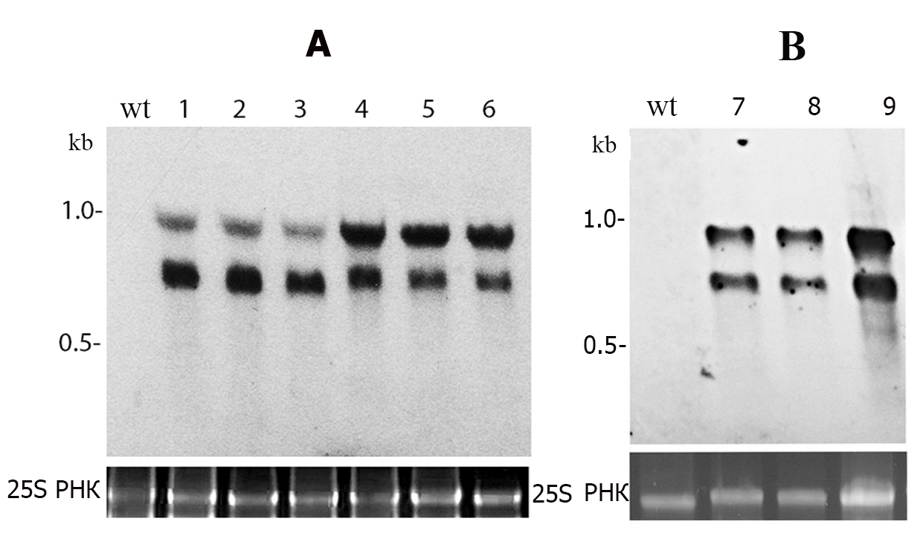
wt - wild type plant; 1-3 - plants transformed with plasmid pP117; 4-6 - plants transformed with plasmid pR117; 7-9 - plants transformed with plasmid pR060Δ. The bottom gels, stained with ethidium bromide, reflect the amount of analyzed RNA.
Figure 4 - Northern blot analysis of total RNA samples from transplastomic plants with probes to sppv117 (A) and sppv060Δ (B) genes

Mouse polyclonal antibodies to pentahistidine were used as the first antibodies, and goat anti-mouse antibodies conjugated with horseradish peroxidase were used as the second. The results of the immunoblot are shown in Figure 5. It demonstrates that all analyzed lines synthesize the virus recombinant proteins. However, the Nt-PpsbA-117 lines containing the sppv117 gene under the control of the PpsbA promoter synthesize the 20.3 kDa SPPV-A27L protein noticeably less than the Nt-Prrn-117 plants containing the sppv117 gene under the control of the Prrn promoter. Nt-Prrn-060Δ plants containing the sppv060Δ gene under the control of the Prrn promoter synthesize 23 kDa SPPV-L1RΔ protein at a level comparable to the level of synthesis of SPPV-A27L.
To measure the content of recombinant proteins, a densitometric analysis of protein bands was carried out using the Image J 1.42q software. Measurements were carried out three times. It was determined that the content of SPPV-A27L protein was 0.29 ± 0.05% in Nt-PpsbA-117 lines and 0.99 ± 0.11% in Nt-Prrn-117 lines of TSP, respectively. The content of the SPPV-L1RΔ protein in Nt-Prrn-060Δ plants was 0.96 ± 0.03% of TSP. These results demonstrate that the expression level of viral proteins under the control of the Prrn promoter is about three times higher than that of the PpsbA promoter.
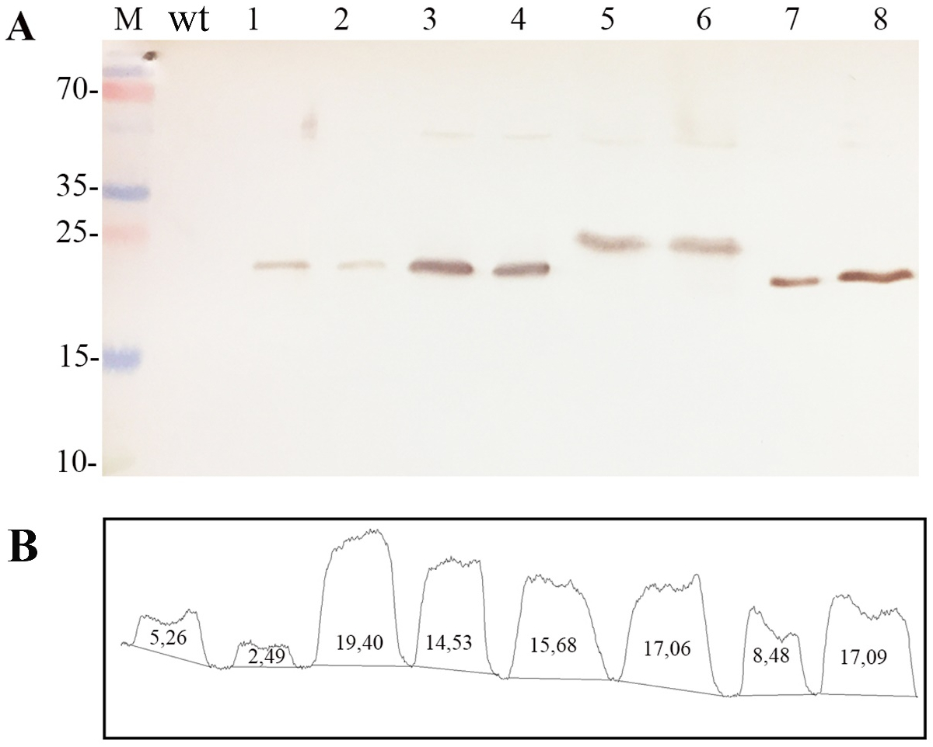
A - Western blot analysis of protein extracts from transplastomic lines with antibodies to pentahistidine. M - marker proteins with sizes in kDa; wt - wild-type plant; 1, 2 - plants containing the sppv117 gene under the control of the PpsbA promoter; 3, 4 - plants containing the sppv117 gene under the control of the Prrn promoter; 5, 6 - plants containing the sppv060Δ gene under the control of the Prrn promoter; 7, 8 - 25 ng and 50 ng of purified bacterially synthesized SPPV-A27L protein. B - Densitometric analysis of the membrane using the Image J 1.42q software.
Figure 5 - Analysis of the synthesis of SPPV-A27L and SPPV-L1RΔ proteins in transplastomic tobacco lines

3.6 Obtaining homoplasmic transplastomic plants synthesizing SPPV-A27L and SPPV-L1RΔ proteins
Primary shoots are genetically heteroplasmic, since their genome consists of transgenic plastids and wild-type plastids. In order to eliminate wild-type plastids and select plastids carrying the aadA gene and the target gene, the second stage of selection of nine lines (three lines of each variant) was carried out. Leaf segments of the selected lines were cultivated on regeneration medium to produce secondary regenerated shoots (Figure 6). This selection was carried out four times. The lines that passed the secondary selection were analyzed by PCR for the presence of transgenes, and then their homoplasmy was studied.
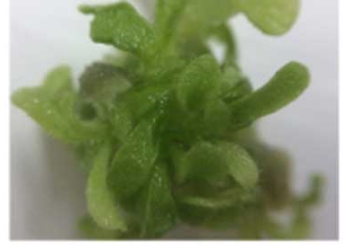
Figure 6 - Re-regeneration of a transplastomic tobacco plant
3.7 Verification of plant homoplasmy by nucleic acid hybridization
The homoplasmy of the obtained lines was assessed by restriction fragment length polymorphism (RFLP) by Southern blotting using a labeled probe. Total DNA samples isolated from transplastomic lines and wild-type plants were treated with EcoO109I restriction enzyme selected by computer analysis of the nucleotide sequence of wild-type tobacco chloroplast DNA using the SnapGene 2.8.3 program. The probe was a 0.71 kb DNA fragment obtained by amplification of wild-type DNA using a pair of chl-for/chl-rev primers. The probe covered the site of transgene insertion into plastid DNA between the trnG (glycine tRNA gene) and trnfM (formyl-methionine tRNA gene) genes, as well as adjacent regions (Figure 7A). The probe hybridized with a 3.2 kb DNA fragment from wild-type plants. The presence of a single DNA fragment with a size of 5.2 kb and the absence of 3.2 kb DNA fragment in Nt-PpsbA-117 transplastomic plants indicates the genetic homogeneity of chloroplast DNA containing the sppv117 gene under the control of the PpsbA promoter (Figures 7B, 7E).
In Nt-Prrn-117 and Nt-Prrn-060Δ lines, in addition to the expected 5.2 kb and 5.3 kb fragments, several fragments were detected that hybridized with the probe and were marked with asterisks in the figure (Figures 7E, 7F). This fact indicates the heterogeneity of plastid genomes, possibly caused by intermolecular post-transformation recombination between endogenous and plastid regulatory elements introduced into the vector (promoters, terminators, 5'-UTR), which can lead to the loss of transgenes and/or heterogeneity of plastids in transplastomic plants. In theory, each element introduced into the vector can cause the formation of at least two types of unintented recombination products. McCabe et al. described a case of recombination between the native and
introduced copies of the TrbcL terminator in a direct orientation [29]. The case of recombination between two copies of the PpsbA promoter has also been described [30].
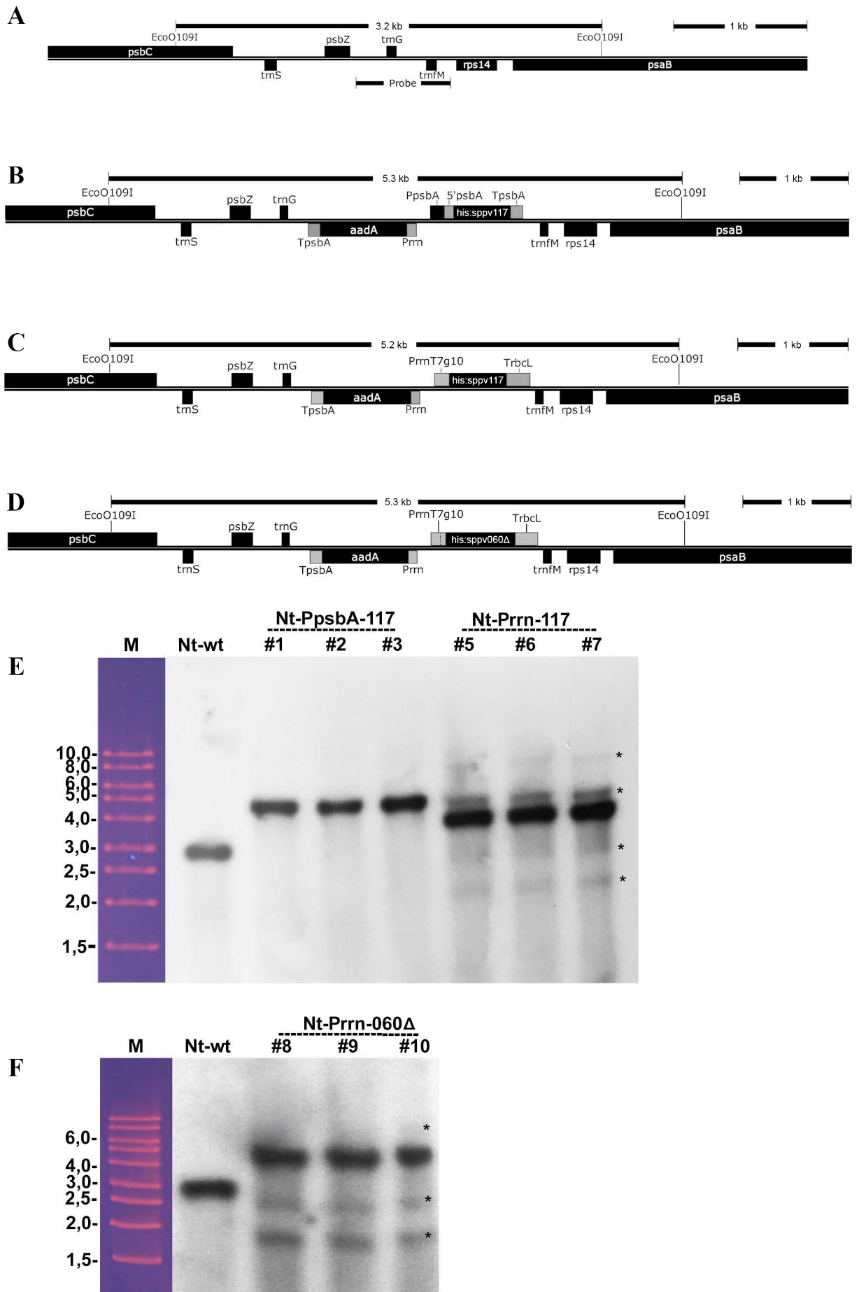
A - the region of integration of transgenes into the plastid of a wild-type plant; B, C - the same region in the genome of plants transformed with the sppv117 gene under the control of the PpsbA and Prrn promoters; D - the same region in the genome of plants transformed with the sppv060Δ gene under the control of Prrn promoter; D, E - blot hybridization of DNA from Nt-PpsbA-117and Nt-Prrn-117 plants; E - blot hybridization of DNA from Nt-Prrn-060Δ plants.
Figure 7 - Southern blot analysis of transplastomic tobacco plants
3.8 Development and optimization of technology for purification of SPPV-A27L and SPPV-L1RΔ proteins from plant tissue
The purification of recombinant proteins by metal affinity chromatography on Ni-NTA agarose was carried out under native conditions. Preliminary experiments showed that the addition of Triton X-100 detergent to the extraction buffer (50 mM NaH₂PO₄, 0.3 M NaCl, 2 mM imidazole, 15 mM β mercaptoethanol, 2 mM PMSF, pH 8.0) or SDS to a final concentration of 2% provided a higher yield of the target proteins compared to Tween-20 (Figure 8).
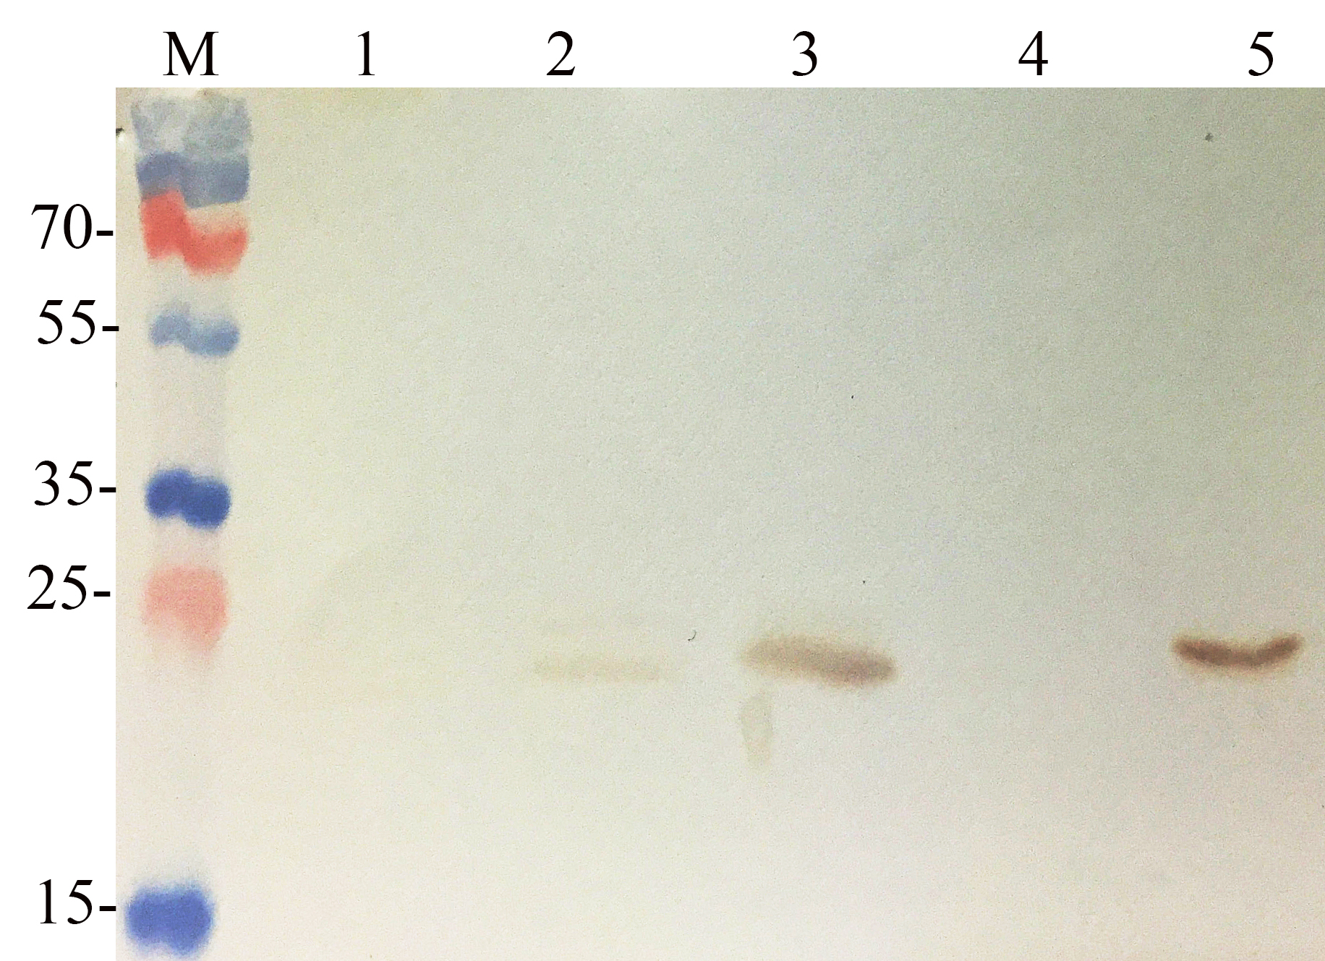
M - protein markers with sizes in kDa; 1 and 2 - wild-type and Nt-Prrn-117#7 plant proteins extracted in buffer containing Tween-20, respectively; 3, 4, 5 –extracted proteins from the Nt-Prrn-117#7plant in a buffer containing SDS, without detergent and in the presence of Triton X-100, respectively.
Figure 8 - Western blot analysis of proteins from leaves of Nt-Prrn-117 # 7 plant in extraction buffers in the presence of detergents

The protein extraction from Nt-Prrn-117 and Nt-Prrn-060Δ plants was performed in an extraction buffer containing 2% Triton X-100. Figures 9 and 10 demonstrate the results of immunoblot detection of the SPPV-A27L and SPPV-L1RΔ proteins in the purified fractions. Protein-containing fractions were pooled, dialyzed against potassium phosphate buffer and concentrated by ultrafiltration. Aliquots of concentrated protein samples were subjected to electrophoresis and then the gels were stained with Coomassie Brilliant Blue G-250 solution. It was revealed that purified samples contain a significant proportion of endogenous plant proteins (lane 1 in Figs. 9B and 10B). Therefore, a second round of purification was carried out on Ni-NTA-agarose, followed by Western blot analysis, dialysis and the concentration of the eluted protein fractions. After the second purification, sufficiently homogeneous samples of recombinant proteins without the presence of nonspecifically bound endogenous proteins were obtained (lane 2 in Fig. 9B and 10B).
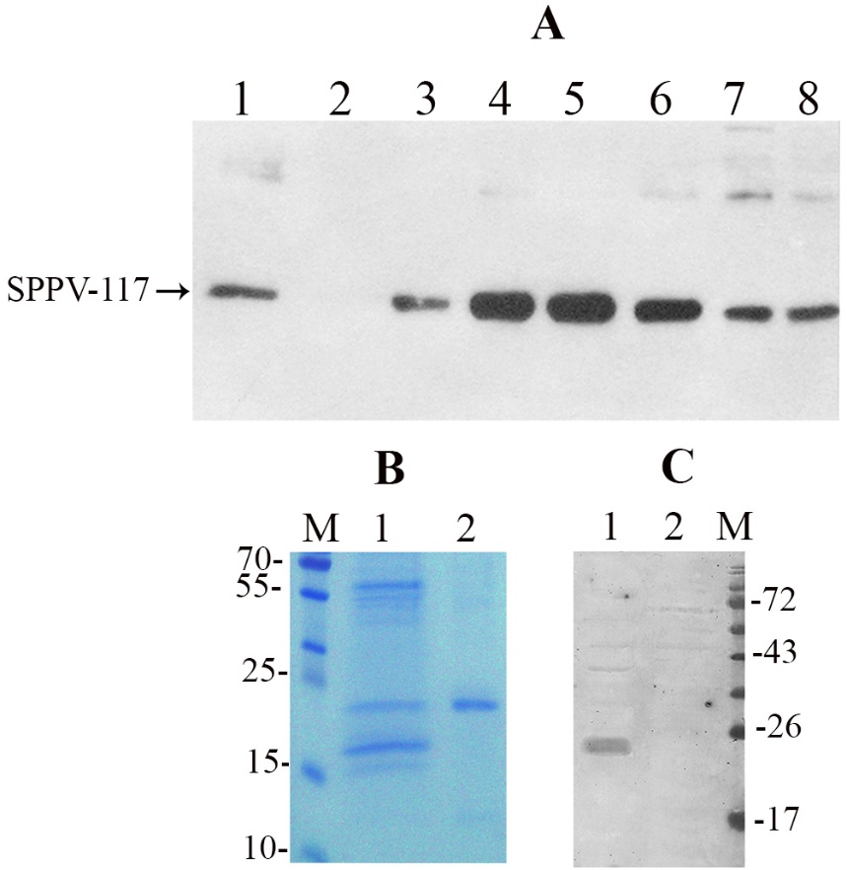
A - Western blot analysis of fractions eluted from Ni-NTA agarose with antibodies to pentahistidine: 1 - extract before binding to Ni-NTA agarose; 2 – a protein fraction not bound with Ni-NTA agarose; 3 – a protein fraction in a washing buffer, 4-8 - eluted protein fractions. B - 15% SDS-PAAG stained with Coomassie G250: M - protein markers with sizes in kDa; 1, 2 - SPPV-A27L after the first and second purification, respectively. B - Western blot analysis of plant-purified SPPV-A27L protein with serum of sheep infected with SPPV: 1 - 0.5 μg of SPPV-A27L protein; 2 - 5 μg protein from wild-type plant.
Figure 9 - Immunoblot analysis and an stained gel of purified SPPV-A27L protein

The yield of purified from leaves proteins was 19.67 ± 1.25 μg/g for SPPV-A27L and 10.3 ± 0.87 μg/g for SPPV-L1RΔ. The purified SPPV proteins were analyzed by Western blot analysis using the blood serum of recovering sheep infected with sheep pox virus. The analysis showed that the serum recognized plant-produced SPPV-A27L and SPPV-L1RΔ proteins (lane 1 in Fig. 9B and 10B). These data indicate that the virus proteins produced by the chloroplast retain their antigenic properties.
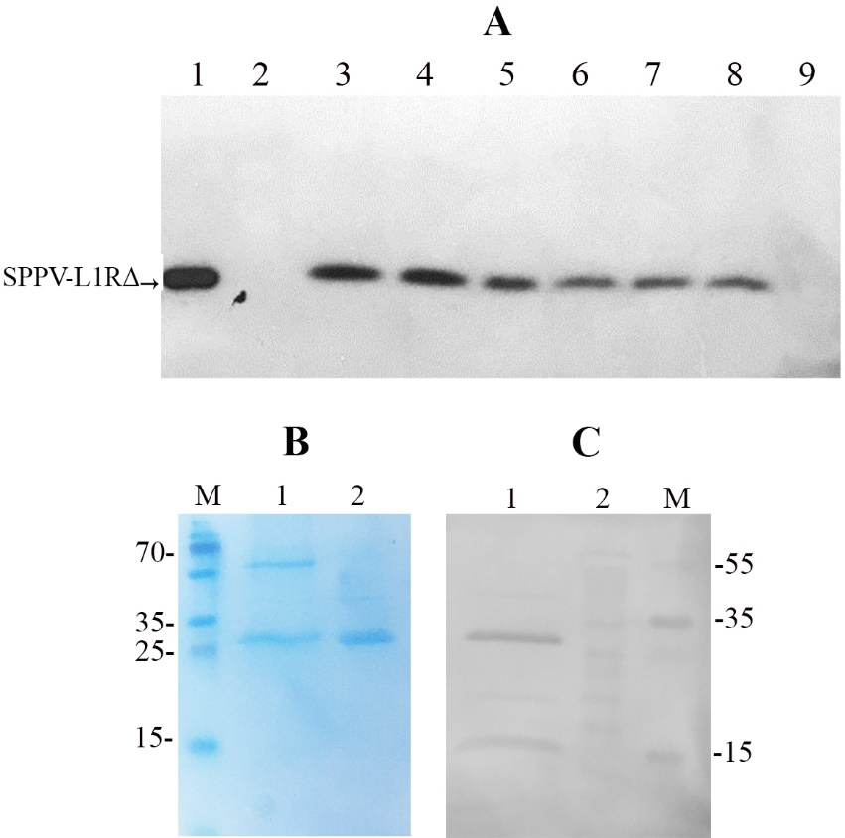
A - Western blot analysis of fractions eluted from Ni-NTA agarose with antibodies to pentahistidine: 1 - extract before binding to Ni-NTA agarose; 2 – a protein fraction not bound with Ni-NTA agarose; 3-9 - eluted protein fractions. B - 15% SDS-PAAG stained with Coomassie G250: M – protein marker with sizes in kDa; 1, 2 - SPPV-L1RΔ after the first and second purification, respectively. B - Western blot analysis of plant-purified SPPV-L1RΔ protein with serum of sheep infected with SPPV: 1 - 0.5 μg of SPPV-A27L protein; 2 - 5 μg protein from wild-type plant.
Figure 10 - Immunoblot analysis and stained gel of purified recombinant protein SPPV-L1RΔ

3.9 Obtaining seeds of transplastomic tobacco plants
Nt-PpsbA-117 transplastomic lines planted into the soil did not differ in appearance from the wild-type plants, while Nt-Prrn-117 and Nt-Prrn-060Δ lines, showed signs of growth retardation and pale leaf color (Fig. 11A). Despite these facts, all transplastomic plants developed normally and set seeds (Figure 11B). The harvested seeds of transplastomic lines and wild-type plants were sterilized and placed on Sm-containing MS medium. As can be seen from Figure 11B, the Nt-PpsbA-117 plants of the T1 generation, in contrast to the wild type, had a bright green color; the Nt-Prrn-117 and Nt-Prrn-060Δ plants of the T₁ generation had a pale green leaf color, but also differed from the bleached wild-type plants. The test for seed germination on a medium with an antibiotic indicates that inserted into the chloroplast genome transgenes are inherited in the T₁ generation.
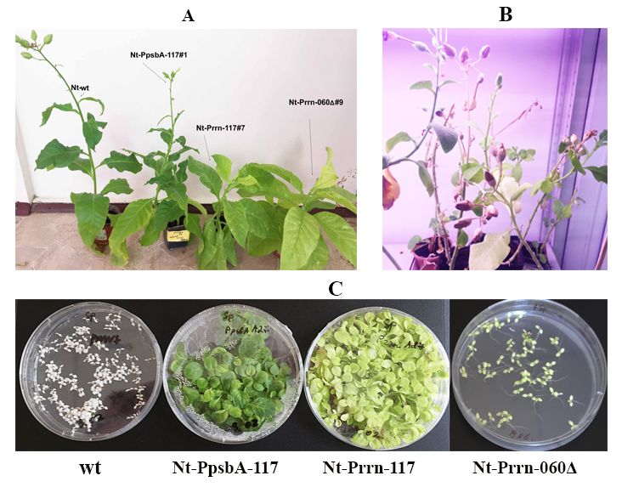
A – transplastomic plants planted into the soil; B - the stage of seed formation; B - test for seed germination on a medium containing Sm. Wild-type plant seeds (wt), Nt-PpsbA-117, Nt-Prrn-117 after 5 weeks and seeds of the Nt-Prrn-060Δ plant 2 weeks after sowing.
Figure 11 - Phenotype of transplastomic plants
CONCLUSION
Sheep pox causes huge damage to livestock in Kazakhstan. The use of cheap, safe and effective next generation vaccines in agriculture will improve food security in the country.
In this work, we have developed a technology for the expression of recombinant sheep pox virus antigens in transplastomic plants. In accordance with the schedule, the following results were obtained:
1) pP117, pR117, pP060Δ, and pR060Δ chloroplast vectors containing SPPV117 and SPPV-L1RΔ structural proteins coding sequence under the control of chloroplast promoter and terminator of psbA gene or rrn promoter and rbcL terminator were designed;
2) insertion transgenes into the chloroplast genome of tobacco N. tabacum leaves was carried out by a biolistic method. Regenerated shoots were obtained using plasmids pP117, pR117 and pR060Δ;
3) PCR test for the presence of transgenes showed that seven selected plant lines contain the sppv117 gene, three plant lines contain the sppv060Δ gene;
4) Northern blotting of total cellular RNA samples using DIG-labeled probes to the sppv117 and sppv60Δ genes detected the presence of specific mRNA in all lines;
5) immunoblot analysis showed that all transplastomic plants accumulated to about 0.3% and 0.9% of total soluble protein in leaves when expressed transgenes from psbA and rrn promoter, respectively;
6) to achieve a homoplasmic state the obtained tobacco lines were subjected to four additional rounds of regeneration on spectinomycin-containing selective medium;
7) Southern blotting showed homoplasmy of three lines and heteroplasmy of six lines;
8) protocol for purification of SPPV-A27L and SPPV-L1RΔ proteins from transplastomic plants was optimized and purification of plant-produced recombinant proteins was carried out;
9) viable seeds of transplastomic tobacco plants were obtained.
Main conclusions:
1) chloroplasts are a suitable expression system for the production of SPPV-A27L and SPPV-L1RΔ antigenic proteins, which were chosen as candidate subunit vaccine against sheep pox;
2) plastid rrn promoter in comparison with psbA promoter provides a higher yield of virus proteins;
3) the vector format of pR117 and pR060Δ leads to reorganization of chloroplast DNA and a change in the color of leaves of transplastomic plants.
Assessment of the completeness of the solution of the tasks. All tasks were completed on time and in full. All studies planned within the framework of the research work have been completed. Invention patent was received. According to the requirements for tender documentation and the schedule, 1 article was published in a domestic journal (Kazakhstan Citation Index - 0.043), 1 article in a Russian journal (Russian Citation Index - 0.220), 1 article was submitted to the journal "Vavilovskii Zhurnal Genetiki i Selektsii" (Scopus percentile - 31%), 1 article was submitted to the journal “Biotechnology Letters” (Scopus percentile - 66%) (see appendix E).
Development of recommendations. As part of the project, laboratory regulations have been drawn up (see Appendix E).
Scientific and technical level of research. The work was carried out at the highest scientific and technical level with the involvement of the most modern methods of molecular biology, biochemistry and plant biotechnology.
Technical and economic efficiency. The use of such biotechnology will raise the scientific and technological level of production in the country; the experience gained will be useful for the production of target proteins in plants, not only for veterinary purposes, but also for medical purposes.
REFERENCES
1 Tulman E.R., Alfonso C.L., Lu Z., Zsak L., Sur J.-H., Sandybaev N.T., Kerembekova U.Z., Zaitsev V.L., Kutish G.F., Rock D.L. The Genomes of Sheeppox and Goatpox Viruses // J. Virol. – 2002. – Vol.76. – P. 6054-6061.
2 Syurin V., Samuilenko A., Soloviev B., Fomina N. Viral diseases of animals. – M: VNITIBP, 1998. – 928 p. (Rus).
3 OIE-Listed diseases 2020. – URL: https://www.oie.int/en/animal-health-in-the-world/oie-listed-diseases-2020/ (date of the application 2020-10-02).
4 Zaitsev V., Sandybaev N., Sultankulova K. et al. Sheeppox virus: Molecular biological properties and genome structure. - Almaty, 2011. – 172 p.
5 Kurchenko F.P., Ivanyushchenkov V.N., Ufimtsev K.P. Efficiency of dry cultural virus vaccine from the NISHI strain against sheep pox // Veterinary Medicine. – 1991. – Vol. 10. – P. 21-24.
6 McAleer W.J., Buynak E.B., Maigetter R.Z., Wampler D.E., Miller W.J., Hilleman M.R. Human hepatitis B vaccine from recombinant yeast // Nature. – 1984. – Vol.307. – P. 178-80.
7 Chervyakova O.V., Zaitsev V.L., Iskakov B.K., Tailakova E.T., Strochkov V.M., Sultankulova K.T., Sandybayev N.T., Stanbekova G.E., Beisenov D.K., Abduraimov Y.O., Mambetaliyev M.А., Sansyzbay A.R., Kovalskaya N.Y., Nemchinov L.G. and Hammond R.W. Recombinant Sheep Pox Virus Proteins Elicit Neutralizing Antibodies // Viruses. – 2016. –Vol.8. – P. 1-13.
8 Vazques M., Esteban M. Identification of functional domains in the 14-Kilodalton envelope protein of vaccinia virus // J. Virol. –1999. – Vol.73. – P. 9098-9109.
9 Fogg C., Lustig S., Whitbeck J.C., Eisenberg R.J., Cohen G.H., Moss B. Protective immunity to vaccinia virus induced by vaccination with multiple recombinant outer membrane proteins of intracellular and extracellular virions // J. Virol. – 2004. – Vol.78. – P. 10230-10237.
10 Demain A.L., Vaishnav P. Production of recombinant proteins by microbes and higher organisms // Biotechnol. Adv. – 2009. – Vol.27. – P. 297-306.
11 Shelkunov S., Shchelkunova G. Plant-based vaccines against human hepatitis B virus // Expert Rev Vaccines. – 2010. – Vol.9. – P. 947-955.
12 Eamens A, Wang M., Smith N., Waterhouse P. RNA silencing in plants: yesterday, today, and tomorrow // Plant Physiol. – 2008. – Vol.147. – P. 456-468.
13 Castiglia D., Sannino L., Marcolongo L., Ionata E., Tamburino R., Stradis A.D., Cobucci-Ponzano B., Moracci M., Cara F.L., Scotti N. High-level expression of thermostable cellulolytic enzymes in tobacco transplastomic plants and their use in hydrolysis of an industrially pretreated Arundo donax L. biomass // Biotechnol. Biofuels. – 2016. – Vol.9. – P. 1-16.
14 Oey M., Lohse M., Kreikemeyer B., Bock R. Exhaustion of the chloroplast protein synthesis capacity by massive expression of a highly stable protein antibiotic // Plant J. – 2009. – Vol.57. – P. 436-445.
15 Clarke J.L., Daniell H. Plastid biotechnology for crop production: present status and future perspectives // Plant Mol. Biol. – 2011. – Vol.76. – P. 211-220.
16 Ruhlman T., Ahangari R., Devine A., Samsam M., Daniell H. Expression of cholera toxin B-proinsulin fusion protein in lettuce and tobacco chloroplasts – oral administration protects against development of insulitis in non-obese diabetic mice // Plant Biotechnol. J. - 2007. – Vol.5. – P. 495-510.
17 Gottschamel J., Lössl A., Ruf S., Wang Y., Skaugen M., Bock R., Clarke J.L. Production of dengue virus envelope protein domain III-based antigens in tobacco chloroplasts using inducible and constitutive expression systems // Plant Mol. Biol. – 2016. – Vol.9. – P. 497-512.
18 Zhou F., Badillo-Corona J., Karcher D., Gonzalez-Rabade N., Piepenburg K., Borchers A.M., Maloney A.P., Kavanagh T.A., Gray J.C., Bock R. High-level expression of human immunodeficiency virus antigens from the tobacco and tomato plastid genomes // Plant Biotechnol. Journal. – 2008. – Vol.6. – P. 897-913.
19 Rigano M.M., Manna C., Giulini A., Pedrazzini E., Capobianchi M., Castilletti C., Di Caro A., Ippolito G., Beggio P., De Giuli Morghen C., Monti L., Vitale A., Cardi T. Transgenic chloroplasts are efficient sites for high-yield production of the vaccinia virus envelope protein A27L in plant cells// Plant Biotechnol. J. – 2009. – Vol.7. – P. 577-591.
20 Chan H., Xiao Y, Weldon W., Oberste S., Chumakov K., Daniell H. Cold chain and virus free chloroplast-made booster vaccine to confer immunity against different polio virus serotypes // Plant Biotechnol. J. – 2016. – Vol.14. – P. 2190-2200.
21 Murashige T., Skoog F. A revised medium for rapid growth and bioassays with tobacco tissue cultures // Physiol Plant. – 1962. – Vol.15. - P. 473–497.
22 Svab Z., Hajdukiewicz P., Maliga P. Stable transformation of plastids in higher plants // Proc. Natl. Acad. Sci. USA. – 1990. – Vol.87. – P. 8526-8530.
23 Bradford M. A Rapid and Sensitive Method for the Quantification of Microgram Quantities of Protein Utilizing the Principle of Protein-Dye Binding // Anal. Biochem. – 1976. –Vol.72. – P. 248-254.
24 Laemmli U.K. Cleavage of structural proteins during the assembly of the head of bacteriophage T4 // Nature. – 1970. – Vol.227. – P. 680-685.
25 Sambrook J., Russel D.W. Molecular cloning: A laboratory manual: 3 volumes. – Third edition. – New-York: Cold Spring Harbor Laboratory Press, 2001.
26 Beisenov D., Stanbekova G., Nadirova L., Zhigailov A., Iskakov B. Expression of a Sheep Pox Virus Gene in Plant Systems under the Control of Plant Viral Regulatory Elements and with Sub-Cellular Targeting // Biosci. Biotechnol. Res. Asia. – 2016. – Vol.13, No.1. – P. 01-08.
27 Бейсенов Д.К., Станбекова Г.Э., Надирова Л.Т., Искаков Б.К. Синтез белка оболочки L1RΔ вируса оспы овец в растениях // Вестник КазНУ. Cерия биологическая. -2014. - Т.60, № 3. – C. 187-190.
28 Stem D.B., Gruissem W. Control of plastid gene expression: 3′ inverted repeats acts as mRNA processing and stabilizing elements, but do not terminate transcription // Cell. – 1987. – Vol.51. – P. 1145-57.
29 McCabe M.S., Klaas M., Gonzalez-Rabade N., Poage M., Badillo-Corona J.A., Zhou F., Karcher D., Bock R., Gray J.C., Dix P.H. Plastid transformation of high-biomass tobacco variety Maryland Mammoth for production of human immunodeficiency virus type 1 (HIV-1) p24 antigen // Plant Biotechnol. J. – 2008. – Vol.6. – P. 914-929.
30 Svab Z., Maliga P. High-frequency plastid transformation in tobacco by selection for a chimeric aadA gene // Proc. Natl. Acad. Sci. USA. – 1993. – Vol. 90. – P.913-917.
APPENDIX A
Publications and organization of scientific activity for 2018-2020
Publications for 2018 year:
1 Stanbekova G., Beisenov D., Nadirova L., Iskakov B., Warzecha H. Recombinant Sheep Pox Virus Antigens Expression In Chloroplasts // Journal of Biotechnology. - 2018. - Vol.282, Suppl. - P. S85. DOI: 10.1016 / j.jbiotec.2018.06.280. (IF 2.533).
2 Stanbekova G.E., Beisenov D.K., Nadirova L.T., Iskakov B.K. Expression of sheeppox virus antigens in plant chloroplasts // Proceedings of the Intern. Symposium "Astana Biotech 2018" / Astana, (June 12-13, 2018) - P. 139 (in Russian).
3 Beisenov D.K., Stanbekova G.E., Karimov N.Zh., Iskakov B.K. Expression of sheep pox viral A27L and L1R proteins in prokaryotic and eukaryotic systems // Proceedings of the 5th intern. scientific conf. "Genetics, genomics, bioinformatics and plant biotechnology" (PlantGen2019) / Novosibirsk, (June 24-29, 2019). - P. 41.
4 Argimbaeva T.U. Obtaining NICOTIANA TABACUM homoplasmic transplastomic plants // Proceedings of the Intern. sci. conf. of students and young scientists "Farabi Alemi" / Almaty, (April 9-10, 2019). - P. 178 (in Russian).
5 Beisenov D.K., Stanbekova G.E., Iskakov B.K. Expression of A27L and L1R proteins of sheeppox virus in prokaryotic and eukaryotic systems // Proceedings of the Intern. sci. conf. of young scientists / Almaty, (November 28-29, 2019) - P.72 (in Russian).
Publications for 2019 year:
1 Stanbekova G.E., Beisenov D.K., Kalieva A.A., Iskakov B.K. Expression of the uidA gene in transplastoma tobacco plants under the control of the 5'-untranslated sequence of the genomic RNA of the Y-potato virus // Bulletin of KazNU, biological series. – 2019, No. 3. - P. 126-135. DOI: 10.26577/eb-2019-3-b12 (in Russian). (Kazakhstan Citation Index - 0.043).
2 Beisenov D.K., Argimbaeva T.U., Stanbekova G.E., Iskakov B.K. Synthesis of the immunogenic domain of the L1R protein of sheeppox virus in rape // Veterinary Medicine, Animal Science and Biotechnology. - 2019, no. 8. - S. 45-54 (in Russian). (Russian Citation Index - 0.220).
Publications for 2020 year:
1 Beisenov D.K., Stanbekova G.E., Iskakov B.K. Transplastomic tobacco plants producing the hydrophilic domain of the L1R coat protein of sheeppox virus. The article is accepted for publication in the journal “Vavilovskii Zhurnal Genetiki i Selektsii” (Scopus percentile - 31%).
2 Production of the sheep pox virus structural protein SPPV117 in tobacco chloroplasts. The manuscript is submitted to the journal “Biotechnology Letters” (Scopus percentile - 66%).

Innovation patent was received:
Stanbekova G.E., Beisenov D.K., Nadirova L.T., Iskakov B.K. Method for producing transplastomic plants synthesizing sheep pox virus antigenic protein SPPV-A27L. KZ patent No. 34156, 05.02.2020.
Laboratory regulations was developed.

Scientific and organizational activities:
1. Staff: 3 in total; including Dr. biol. sciences - 1, candidate of biol. sciences - 1, masters - 1. Young specialists under 35 years old - 1 (33%).
2. International cooperation:
Technical University of Darmstadt (Germany), department of plant biotechnology and metabolic engineering, prof. H. Warzecha.

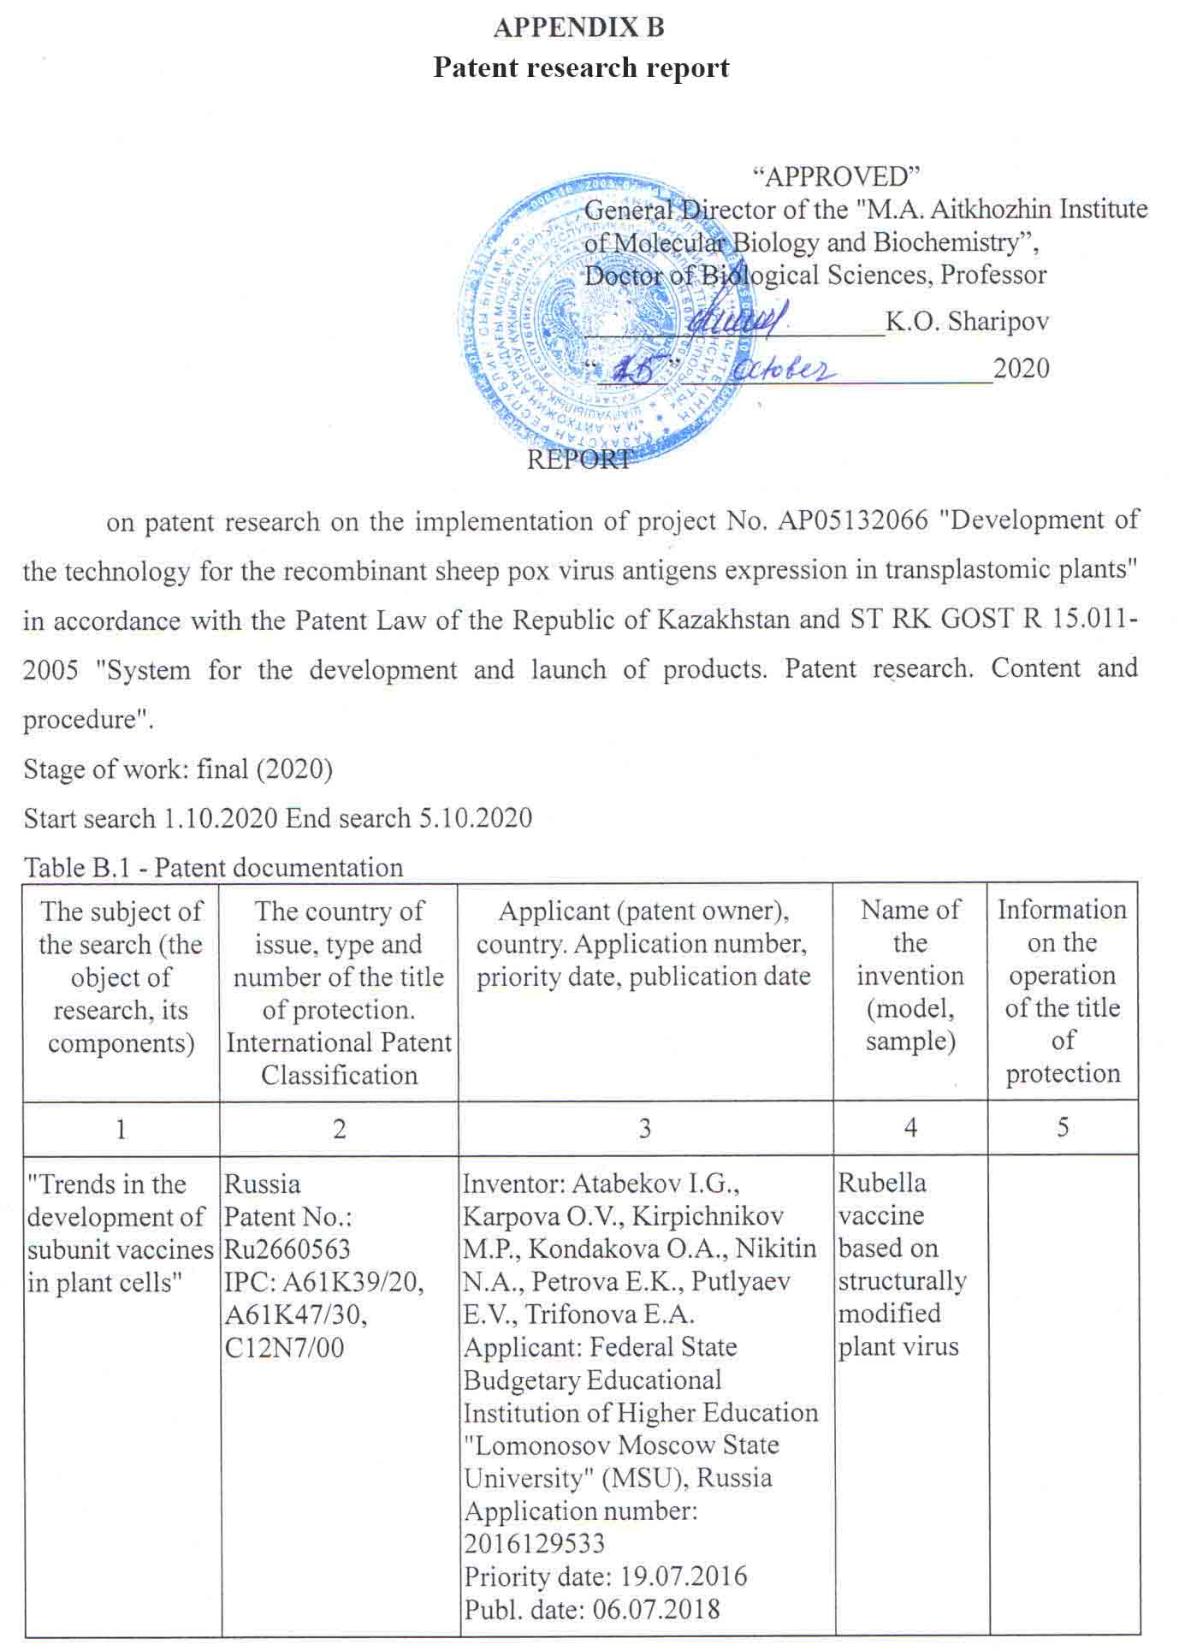

Continuation of the Table B.1
1 | 2 | 3 | 4 | 5
 | The Republic of Korea  Patent No.: KR101783677  IPC: A61K39/12  C12N15/82 | Inventor: Yang M S., Kim T. G., Jang Y. S., Kim D. H.  Applicant: NAT UNIV CHONBUK IND COOP FOUND, Republic of Korea  Application number: KR20150155425 20151106  Priority date: 06.11.2015  Publ. date: 10.10. | Method for mass producing dengue virus vaccine using plant viral expression system
 | USA  Patent No .: US010344293B2  IPC: C12N15/82, A23K20/147 01 | Inventor: An et al.  Applicant: BIOAPPLICATIONS INC., Republic of Korea  Application number: 15 / 315,233  Priority date: 12.05.2016 | Vaccine composition for classical swine fever from plant and manufacturing method thereof
 | European Patent Office  Patent No.: EP2718428B1  IPC: A61K39/00; A61K39/205; A61K39/295; A61P31/16; A61P37/04; C07K14/005; C07K14/11; C12N15/82 | Inventor: D'aoust M-A, Lavoie P-O, Vezina L-P, Couture M.  Applicant: Medicago Inc, Canada  Application number: 12801020.4  Priority date: 13.06.2011  Publ. date: 07.03.2018 | Rabies virus like particle production in plants
 | USA  Patent No.:  US 20190136246A1  IPC:C12N15/82, A61K35/76, A61K39/12, A61P31/14 | Inventor: Van Zyl et al.  Applicant: CSIR, (South Africa); UNIVERSITY OF CAPE TOWN (South Africa); ONDERSTEPOORT BIOLOGICAL PRODUCTS SOC LTD, (South Africa)  Application number: 12801020.4  Priority date: 19.04.2017  Publ. date: 09.05.2019 | Plant - produced chimaeric orbivirus vlps
Continuation of the Table B.2
1 | 2 | 3 | 4 | 5
 | World Intellectual Property Organization  Patent No.: WO2018/115305Al  IPC: C12N15/82,  C07K14/435,  C07K19/00 | Inventor: Phan H. et al.  Applicant: Leibniz-institut fur pflanzen-genetik und kulturpflanzenforschung(ipk), (Germany);  Application number: 12801020.4  Priority date: 21.12.2017  Publ. date: 28.06.2018 | Оligomeric vaccines from plants by s-tag-s-protein fusions
 | США  Patent No.: US10190132B2  IPC: С12N7/00  CI2N15/82  A61K39/145  CO7K14/005 | Inventor: D'aoust M-A. и др. Applicant: Medicago Inc, Canada  Application number: 15/256,119  Priority date: 19.03.2017  Publ. date: 29.01.2019 | Recombinant influenza virus-like particles  (vlps) produced in transgenic plants expressing hemagglu-tinin

Table B.2 - Scientific and technical, market, regulatory documentation and materials of state registration
Search subject | Name of the source of information indicating the source page | Author, company (holder of technical information) | Year, Place and Publishing authority (institution. Deposited source)
1 | 2 | 3 | 4
Expression of pathogen antigens in plants for the development of subunit vaccines | Production of dengue virus envelope protein domain III-based antigens in tobacco chloroplasts using inducible and constitutive expression systems. | Gottschamel J, Lössl A, Ruf S, Wang Y, Skaugen M, Bock R, Clark JL. | 2016, Plant Mol Biol.,  doi: 10.1007/s11103-016-0484-5.
 | Production of Functionally Active and Immunogenic Non-Glycosylated Protective Antigen from Bacillus anthracis in Nicotiana benthamiana by Co-Expression with Peptide-N-Glycosidase F (PNGase F) of Flavobacterium meningosepticum. | Mamedov T, Chichester JA, Jones RM, Ghosh A, Coffin MV, Herschbach K, Prokhnevsky AI, Streatfield SJ, Yusibov V. | 2016, PLoS One, doi: 10.1371/journal.  pone.0153956.

Continuation of the Table B.2
1 | 2 | 3 | 4
 | Plant-based vaccines for oral delivery of type 1 diabetes-related autoantigens: Evaluating oral tolerance mechanisms and disease prevention in NOD mice. | Posgai AL, Wasserfall CH, Kwon KC, Daniell H, Schatz DA, Atkinson MA. | 2017, Sci Rep.,  doi: 10.1038/srep42372.
 | Chloroplast-based inducible expression of ESAT-6 antigen for development of a plant-based vaccine against tuberculosis. | Saba K, Gottschamel J, Younus I, Syed T, Gull K, Lössl AG, Mirza B, Waheed MT. | 2019, J Biotechnol., doi: 10.1016/j.jbiotec.2019.08.016.
 | Cold chain and virus-free oral polio booster vaccine made in lettuce chloroplasts confers protection against all three poliovirus serotypes. | Daniell H, Rai V, Xiao Y. | 2019, Plant Biotechnol J.,  doi:10.1111/pbi.13060.

CONCLUSION
on the performance of patent research
Patent information search was carried out to a depth of 5 years. The patent information search was carried out in electronic databases, information and reference systems United States Patent and Trademark Office (patft.uspto.gov), Eurasian Patent Organization (www.eapo.org), Rospatent (www.fips.ru), Fresh Patents (www.freshpatents.com); Elsevier (www.elsevier.com) and others.
Based on the results of a patent search in the former Soviet Union countries, Europe, the USA, Canada, Korea and others, according to the IPC classes: A61K39, S07K; C12N over the past 5 years, a number of patents have been identified concerning the development of technology for obtaining subunit vaccines in plant cells. It has been established that the USA and the countries of the European Union occupy the leading position in this area.
Review the patent literature on the topic allows us to conclude that the research we are undertaking is relevant and promising. The results of the patent information search made it possible to identify the leading scientific organizations in foreign countries working on the problem of the expression of antigens of human and animal pathogens in plant cells, the development of biotechnology for obtaining recombinant vaccines from genetically modified plants.
An analysis of scientific and technical literature and Internet data made it possible to identify a number of articles on the study of the transient or stable expression of antigens of human and animal pathogens in plant cells and indicates the prospects of the chosen topic and the
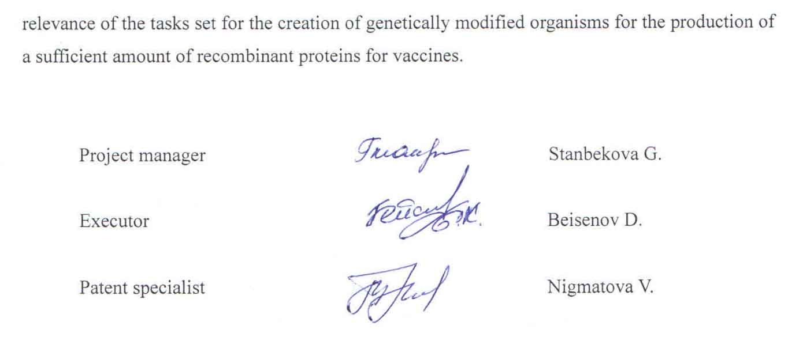

APPENDIX C
Work schedule for the project (2018–2020)
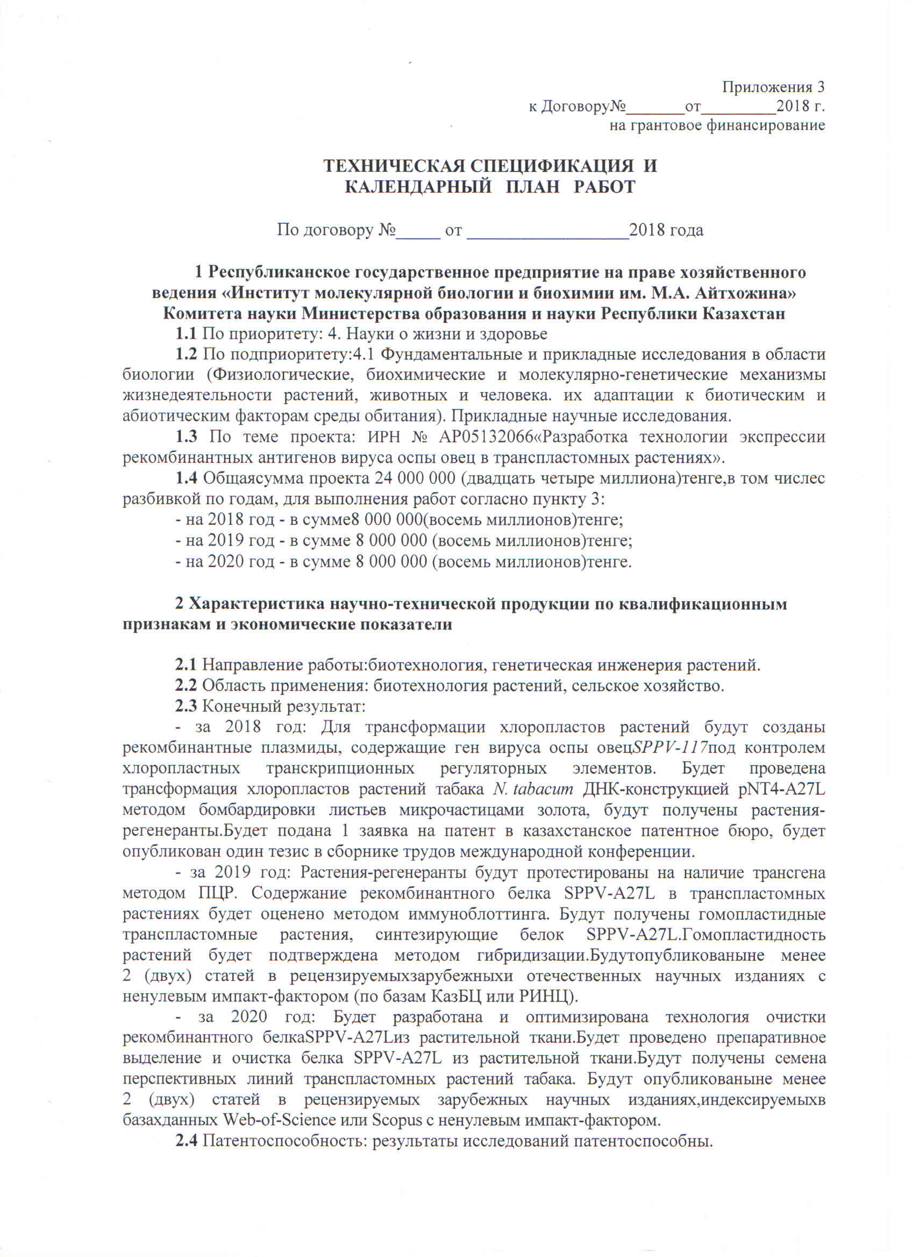

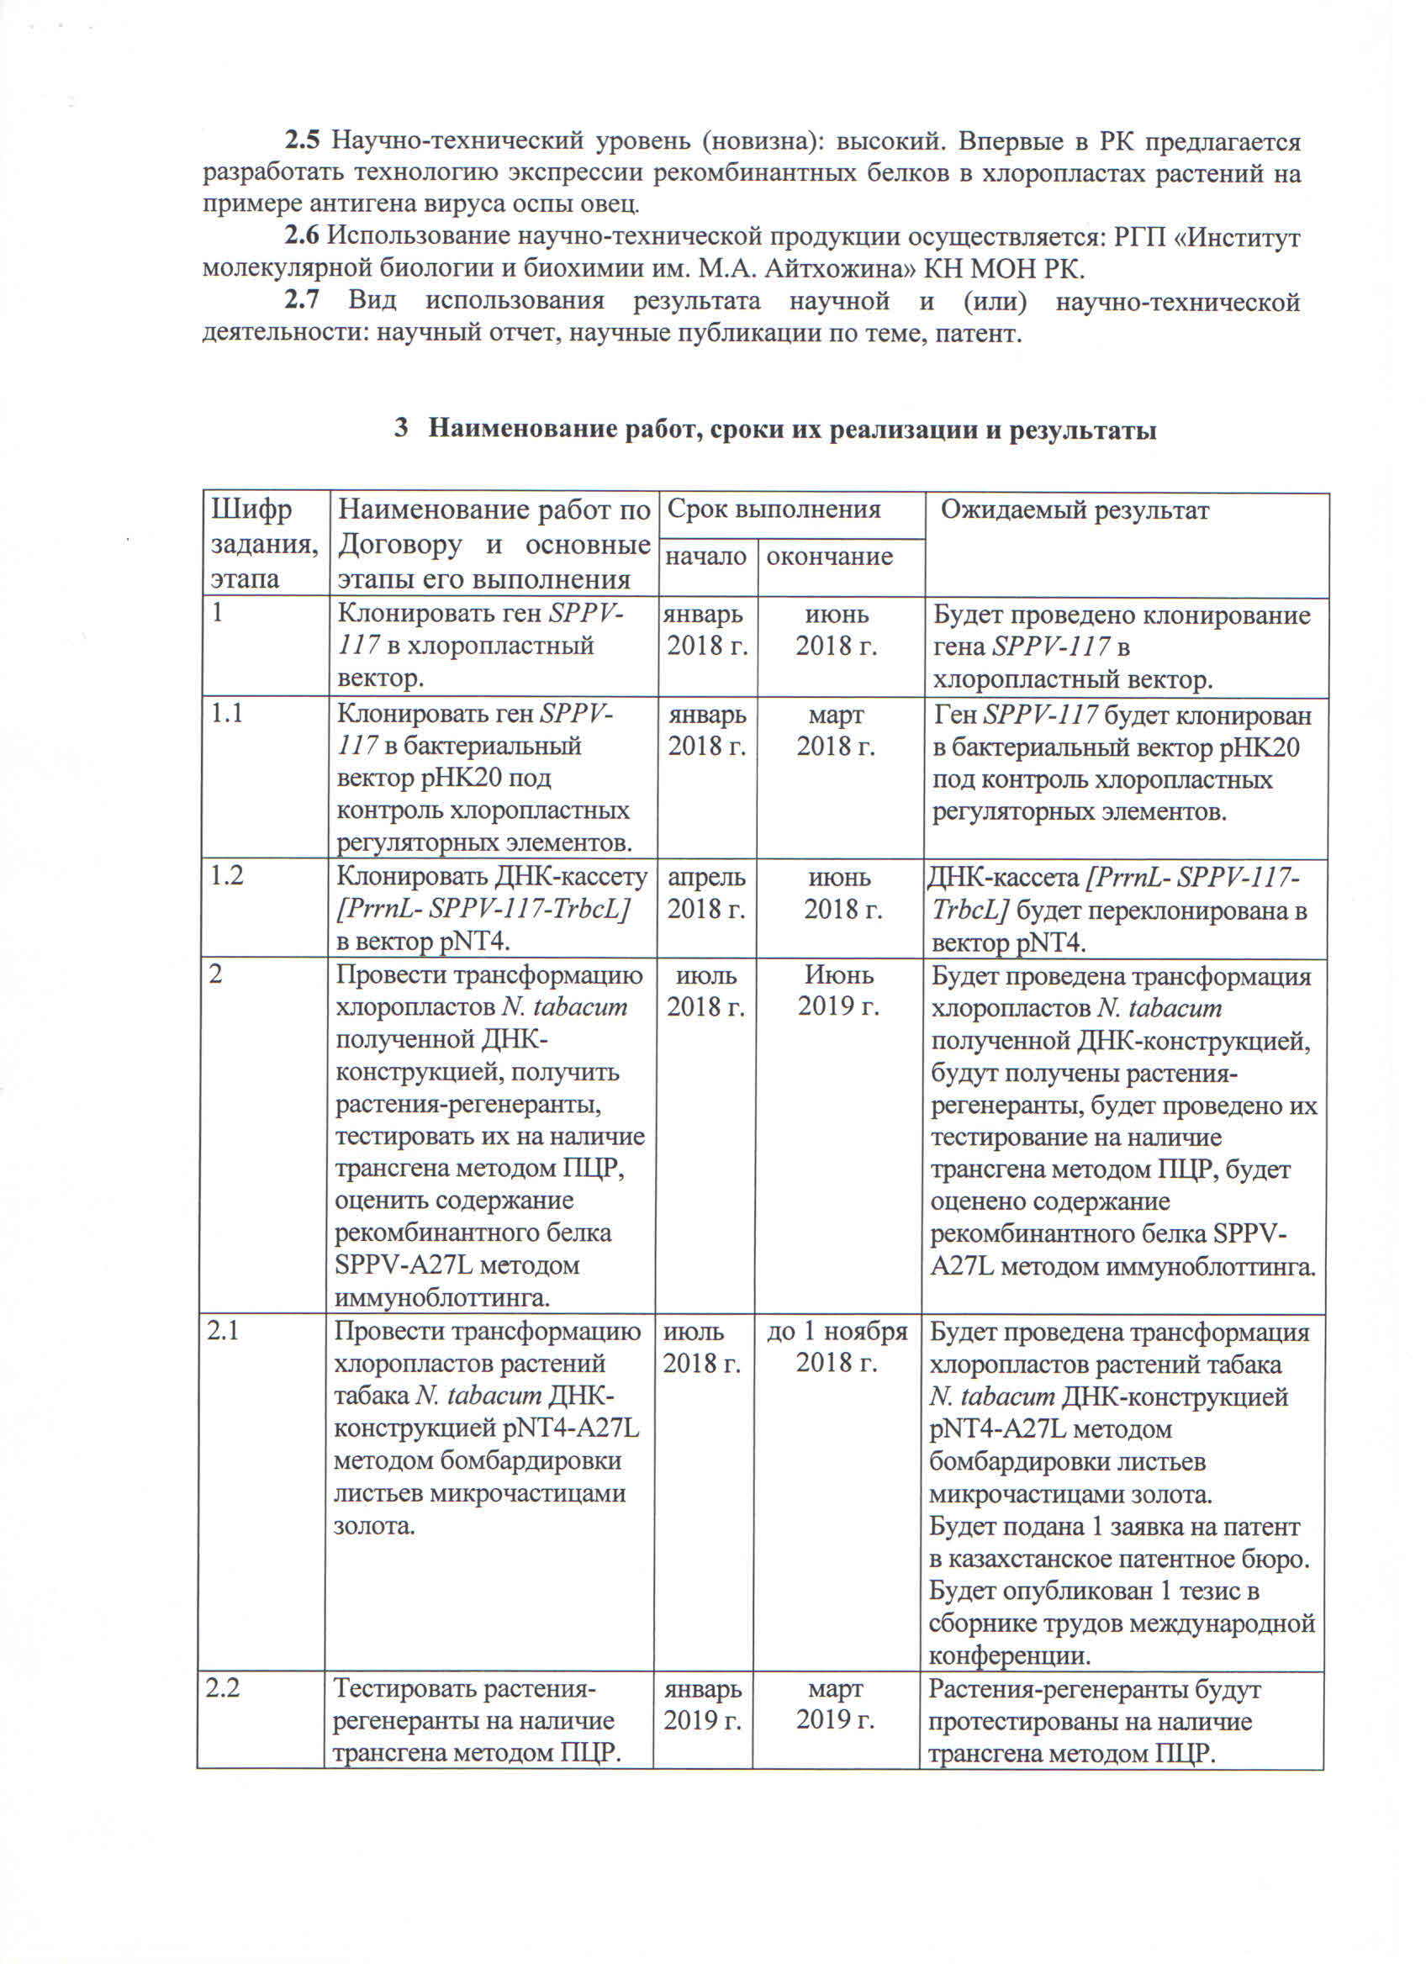

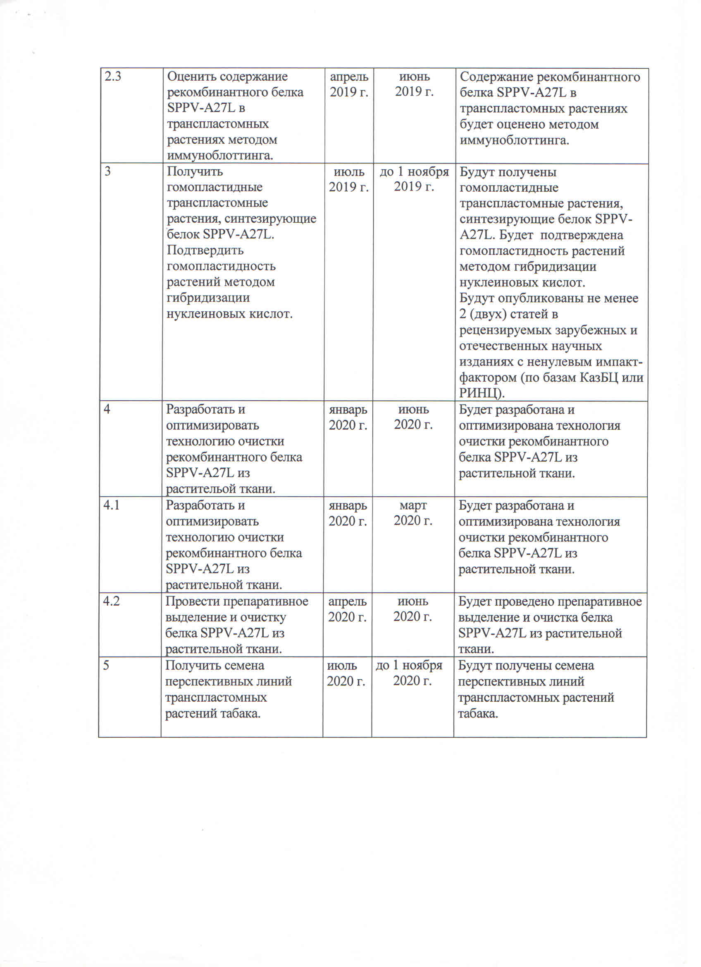

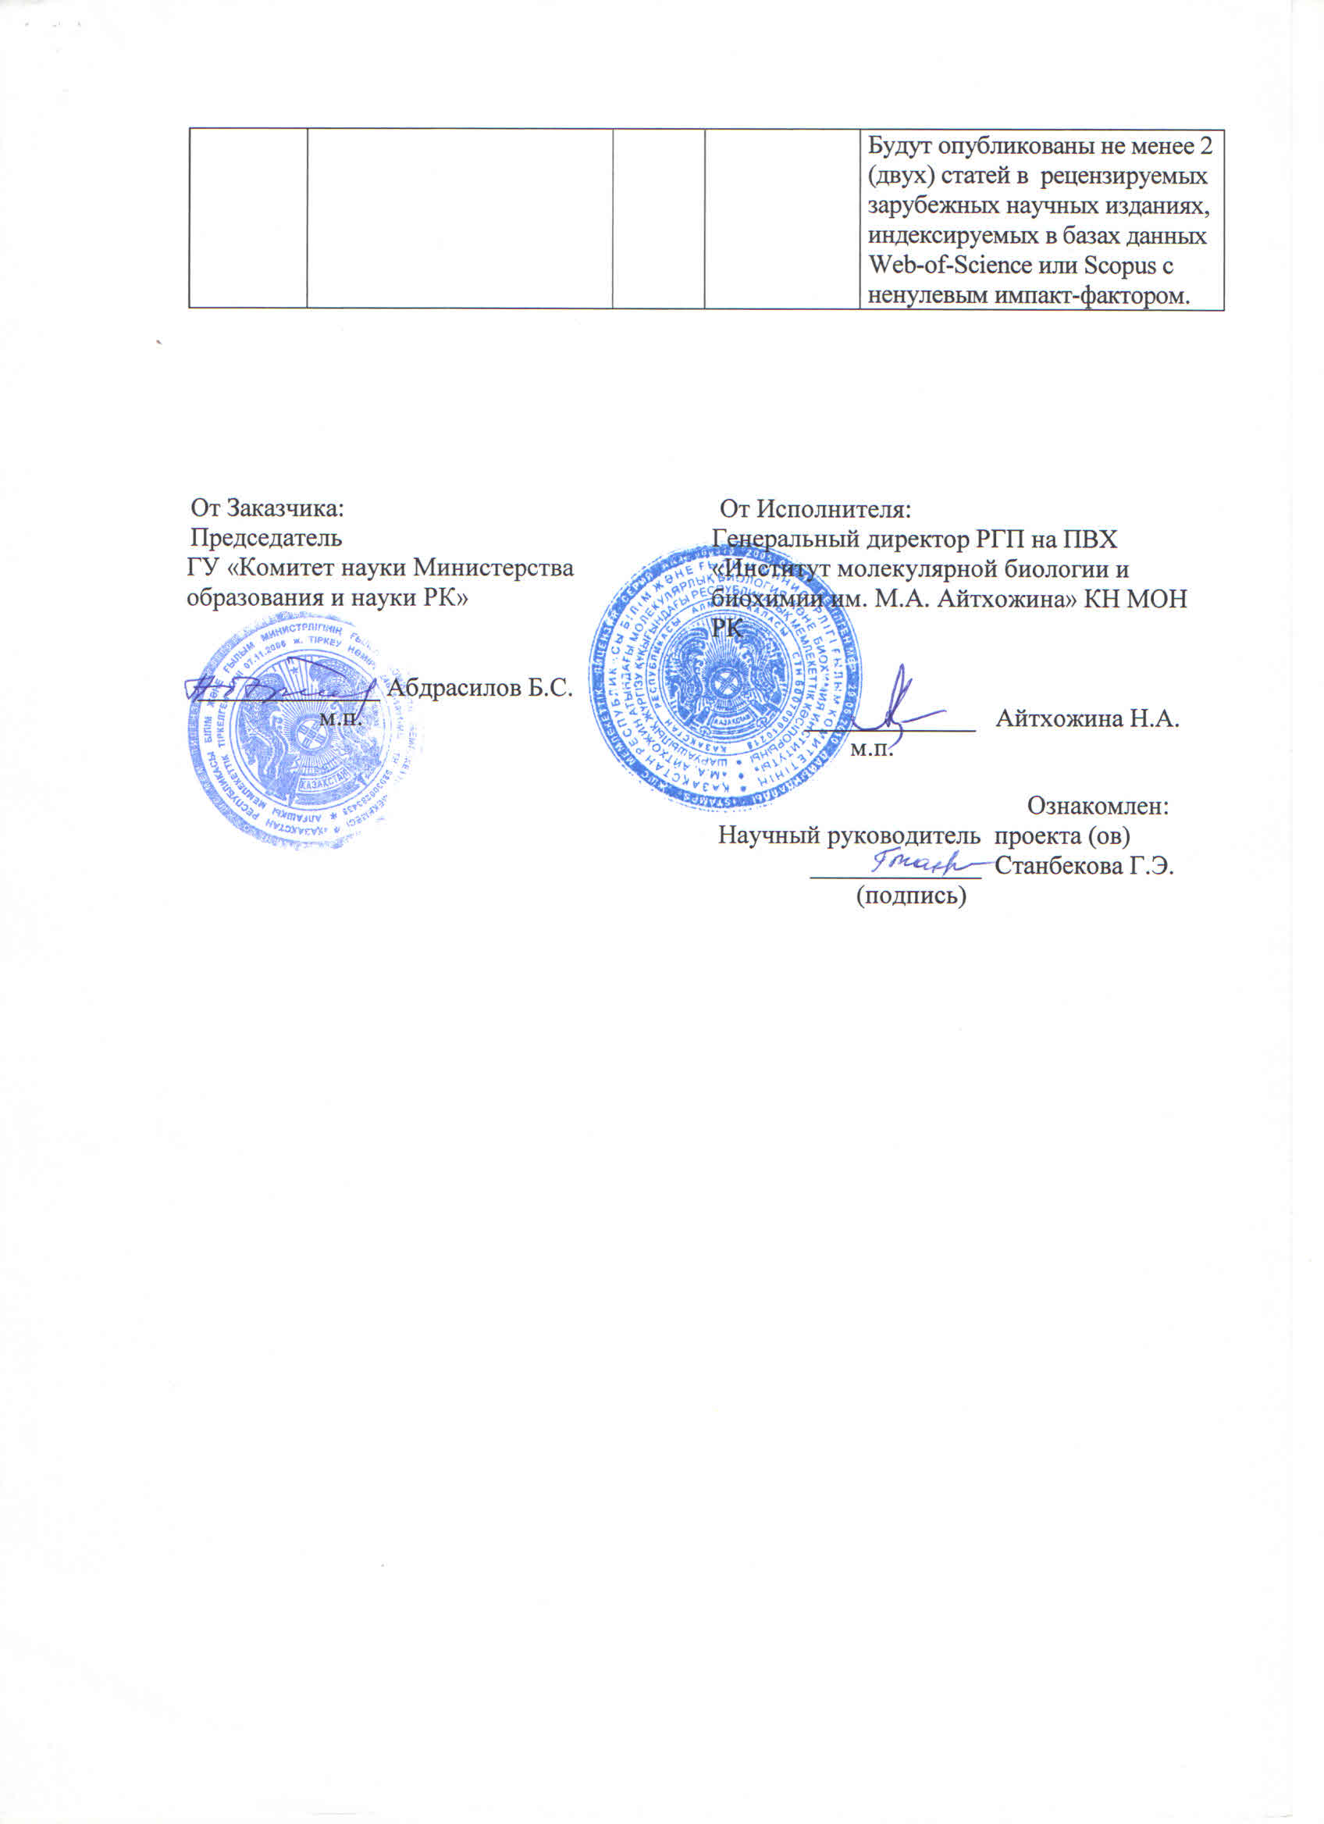

TECHNICAL SPECIFICATIONS AND
WORK SHELDULE
Annex 3
to the Agreement No___
from ____2018 year
Grunt Funding

- Republican state enterprise on the right of economic management " M.A. Aitkhozhin Institute of Molecular Biology and Biochemistry" Science Committee of the Ministry of Education and Science of the Republic of Kazakhstan

1.1 Title of the priority: 4. Life and health sciences.
1.2 Title of the special scientific direction: Fundamental and applied research in biology.
1.3 The name of the project: No. AP05132066 “Development of the technology for the recombinant sheep pox virus antigens expression in transplastomic plants”
"
1.4 The total amount of project financing is 24,000,000.0 (twenty four million) tenge, including with a breakdown by years, for the performance of work in accordance with 3 paragraph:
- For year 2018 - in the amount of 8,000,000.0 (eight million) tenge;
- for year 2019 - in the amount of 8,000,000.0 (eight million) tenge;
- for year 2020 - in the amount of 8,000,000.0 (eigt million) tenge.

- Characteristics of scientific and technical products by qualification characteristics and economic indicators
2.1 Direction of the work: biotechnology, plant genetic engineering.
2.2 Scope: Biotechnology.
2.3 Final result:
- for year 2018: recombinant plasmids containing the sheep pox virus SPPV-117 gene under the control of chloroplast transcriptional regulatory elements will be created. Transformation of chloroplasts of N. tabacum tobacco plants with DNA-construct pNT4-A27L will be carried out by bombardment leaves with gold microparticles. 1 patent application will be submitted to the Kazakhstan patent office, one abstract will be published in the collection of proceedings of the international conference;
- for year 2019: regenerated plants will be tested for the presence of the transgene by PCR. The content of the recombinant protein SPPV-A27L in transplastomic plants will be estimated by immunoblotting. Homoplasmic transplastomic plants producing the SPPV-A27L protein will be obtained. The homoplasmic state of the plants will be confirmed by hybridization. 1 paper will be published in a peer-reviewed foreign scientific publication with a non-zero impact factor; -1 publication in a peer-reviewed domestic scientific journal with a non-zero impact factor (Russian Citation Index or Kazakhstan Citation Index).
- for year 2020: a technology for the purification of the recombinant protein SPPV-A27L from plant tissue will be developed and optimized. Preparative isolation and purification of SPPV-A27L protein from plant tissue will be performed. Seeds of promising lines of transplastomic tobacco plants will be obtained. Two articles will be published in foreign peer-reviewed journals, indexed in the Web-of-Science or Scopus databases with a non-zero impact factor.
2.4 Patentability: Research results are patentable.
2.5 Scientific and technical level (novelty): high. For the first time in the Republic of Kazakhstan, it is proposed to develop a technology for the expression of recombinant proteins in plant chloroplasts using the example of sheep pox virus antigen.

2.6 The use of scientific and technical products is carried out: M.A. Aitkhozhin Institute of Molecular Biology and Biochemistry.
2.7 The type of use of the result of scientific and (or) scientific and technical activity: scientific report, publications in peer-reviewed scientific journals, patent of the Republic of Kazakhstan.

3 The name of tasks and works, the terms of their implementation and results
No. | The name of tasks, activities for the implementation of the project objectives | Period of execution |  | Expected results
No. |  | Start | Finish | Expected results
1 | To clone the sppv117 gene into a chloroplast vector | January 2018 | June  2018 | The sppv117 gene will be cloned into a chloroplast vector.
1.1 | To clone the sppv117 gene into the bacterial vector pHK20 under the control of chloroplast regulatory elements. | January 2018 | March 2018 | the sppv117 gene will be cloned into the bacterial vector pHK20 under the control of chloroplast regulatory elements.
1.2 | To clone the DNA cassette [PrrnL-SPPV-117-TrbcL] into the pNT4 vector. | April 2018 | June  2018 | the DNA cassette [PrrnL-SPPV-117-TrbcL] will be cloned into the pNT4 vector.
2 | To transform N. tabacum chloroplasts with obtained DNA construct, to obtain regenerated plants, to test them for the  presence of the transgene by PCR, and evaluate the content of the recombinant protein SPPV-A27L by  immunoblotting. | July  2018 | June  2019 | N. tabacum chloroplasts will be transformed with obtained DNA construct, regenerated plants will be obtained, they will be tested for the presence of the transgene by PCR, and the content of the recombinant protein SPPV-A27L will be evaluated by immunoblotting.
2.1 | To transform chloroplasts of N. tabacum tobacco plants with the pNT4-A27L construct by bombardment of leaves with gold microparticles. | July 2018 | by Nov 1, 2018 | Chloroplasts of N. tabacum tobacco plants will be transformed with the pNT4-A27L construct by bombarding of leaves with gold microparticles.  1 patent application will be submitted to the Kazakhstan Patent Office.  1 abstract in the collection of proceedings of the international conference will be published.
2.2 | To test regenerated plants for the presence of a transgene by PCR. | January  2019 | March 2019 | Regenerated plants will be tested for the presence of a transgene by PCR.
2.3 | To evaluate the content of the recombinant protein SPPV-A27L by immunoblotting. | April 2019 | June  2019 | The content of the recombinant protein SPPV-A27L will be evaluated by immunoblotting.
3 | To obtain homoplasmic transplastomic plants producing the SPPV-A27L protein. To confirm the homoplasmy of plants by nucleic acid hybridization. | July  2019 | by Nov 1 2019 | Homoplasmic transplastomic plants producing the SPPV-A27L protein will be obtained. The homoplasmy of plants will be confirmed by nucleic acid hybridization.  2 articles will be published  in peer-reviewed foreign and domestic scientific journals with a non-zero impact factor (Russian Citation Index or Kazakhstan Citation Index).
4 | To develop and optimize a technology for the purification of the recombinant protein SPPV-A27L from plant tissue | January 2020 | June  2020 | A technology for the purification of the recombinant protein SPPV-A27L from plant tissue will be developed and optimized.
4.1 | To develop and optimize a technology for the purification of the recombinant protein SPPV-A27L from plant tissue. | January 2020 | March  2020 | A technology for the purification of the recombinant protein SPPV-A27L from plant tissue will be developed and optimized
4.2 | To perform preparative isolation and purification of SPPV-A27L protein from plant tissue. | January 2020 | June  2020 | A preparative isolation and purification of SPPV-A27L protein from plant tissue will be performed.
5 | To obtain seeds of promising lines of transplastomic tobacco plants. | July  2020 | by Nov 1 2020 | Seeds of promising lines of transplastomic tobacco plants will be obtained.  2 articles will be published in foreign peer-reviewed journals, indexed in the Web-of-Science or Scopus databases with a non-zero impact factor.

APPENDIX D
List of foreign information resources
The search was carried out in electronic databases, information and reference systems and resources:
ScienceDirect (www.sciencedirect.com);
Scopus (www.scopus.com);
Web of Knowledge (www.webofknowledge.com);
Web of Science (https://webscience-journal.net/webscience);
Elsevier (www.elsevier.com);
PubMed (www.ncbi.nlm.nih.gov/pubmed);
United States Patent and Trademark Office (patft.uspto.gov),
Fresh Patents (www.freshpatents.com);
Eurasian Patent Organization (www.eapo.org);
Rospatent (www.fips.ru);
Google Academy (https://scholar.google.com);
Google Patents (https://patents.google.com).
APPENDIX E
Supporting documents
Publication for 2018 year:
- Stanbekova G., Beisenov D., Nadirova L., Iskakov B., Warzecha H. Recombinant Sheep Pox Virus Antigens Expression In Chloroplasts // Journal of Biotechnology. - 2018. – Vol.282, Suppl. - P. S85. DOI: 10.1016/j.jbiotec.2018.06.280. (IF 2,533). (in English).


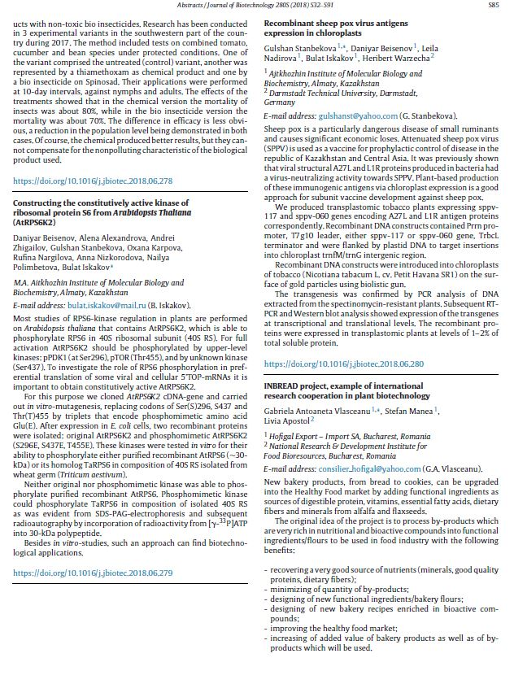

- Stanbekova G.E., Beisenov D.K., Nadirova L.T., Iskakov B.K. Expression of sheeppox virus antigens in plant chloroplasts // Materials of the International symposium "Astana Biotech 2018" / Astana, (June 12-13, 2018) - P. 139. (in Russian)

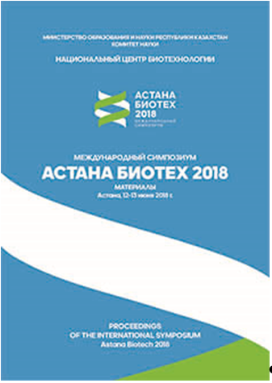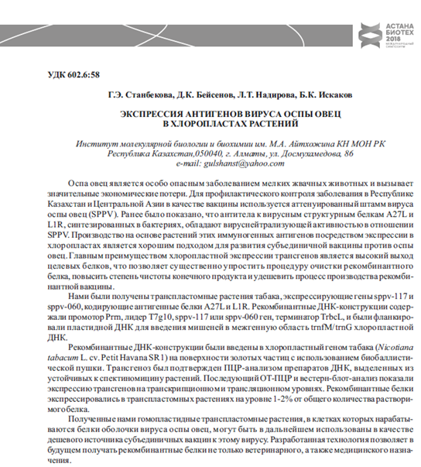

Publications for 2019 year:
1 Beisenov D.K., Stanbekova G.E., Karimov N.Zh., Iskakov B.K. Expression of sheeppox viral A27L and L1R proteins in prokaryotic and eukaryotic systems // Proceedings of the 5th International scientific conference "Genetics, genomics, bioinformatics and plant biotechnology" (PlantGen2019) / Novosibirsk, (June 24-29, 20v19). - P. 41. (in English).

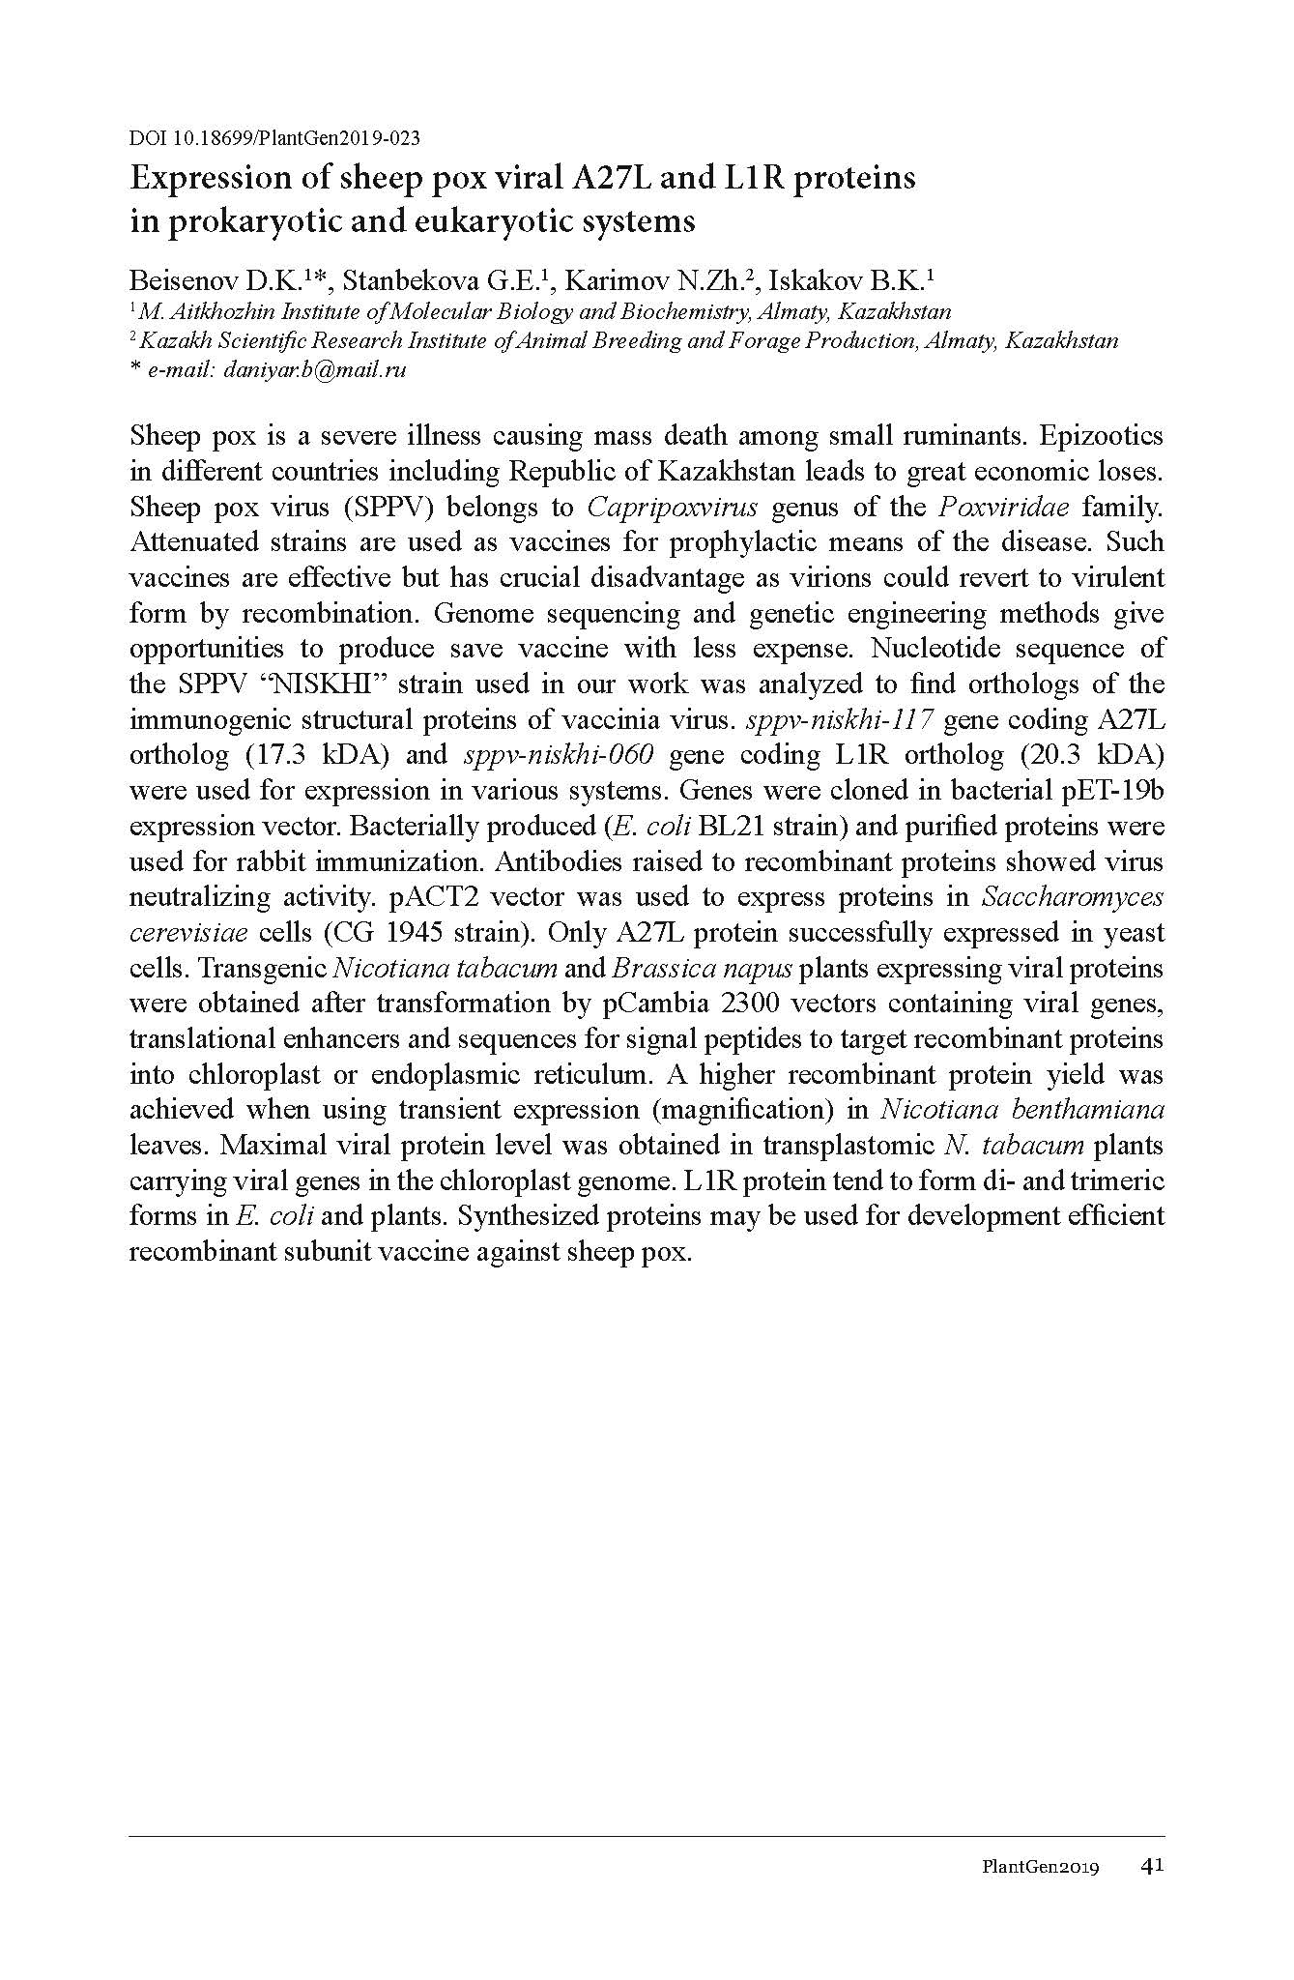

- Argimbaeva T.U. Obtaining homoplasmic transplastomic plants of Nicotiana Tabacum // Proceedings of the International scientific conference for students and young scientists "Farabi Alemi" / Almaty, (April 9-10, 2019). - P. 178. (in Russian)

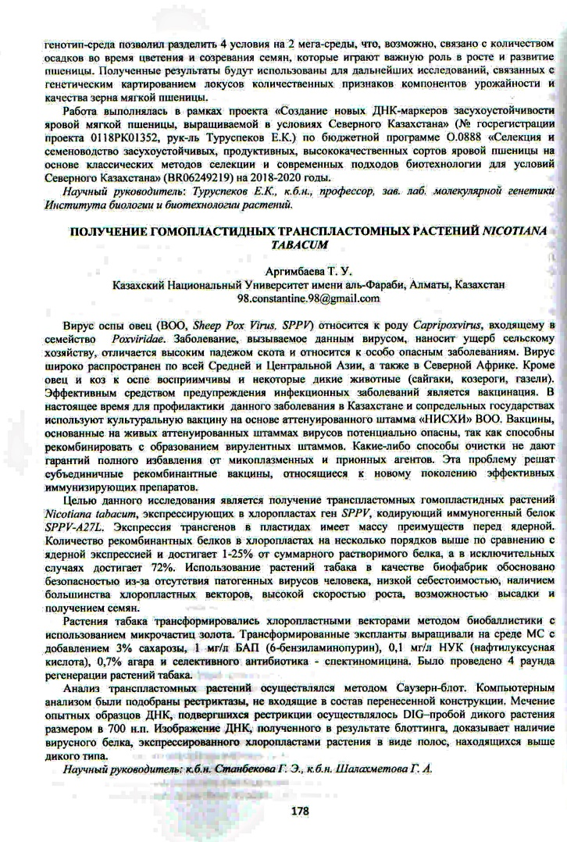

- Beisenov D.K., Stanbekova G.E., Iskakov B.K. Expression of sheeppox virus A27L and L1R proteins in prokaryotic and eukaryotic systems // Proceedings of the International scientific conference for young scientists "Fundamental research and innovations in molecular biology, biotechnology, biochemistry" for the 80th anniversary of academic Murat Abenovich Aitkhozhin / Almaty, (November 28-29, 2019) – P. 72. (in Russian)

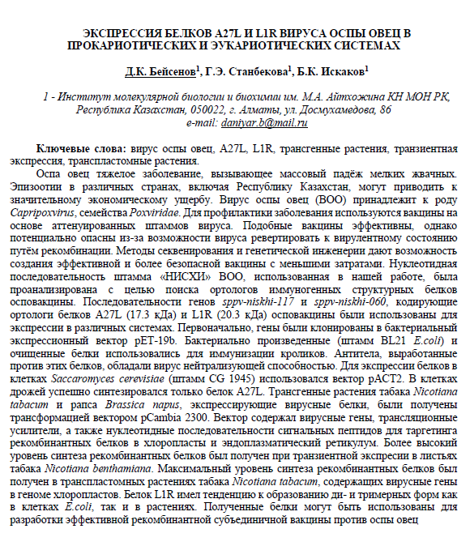

- Stanbekova G.E., Beisenov D.K., Kalieva A.A., Iskakov B.K. Expression of the uidA gene in transplastomic tobacco plants under the control of the 5'-untranslated sequence of the genomic RNA of the Y-potato virus // Bulletin of al-Farabi KazNU, biological series. – 2019, No. 3. - PP. 126-135. DOI: 10.26577/eb-2019-3-b12. (IF KazBC 0.043). (in Russian)


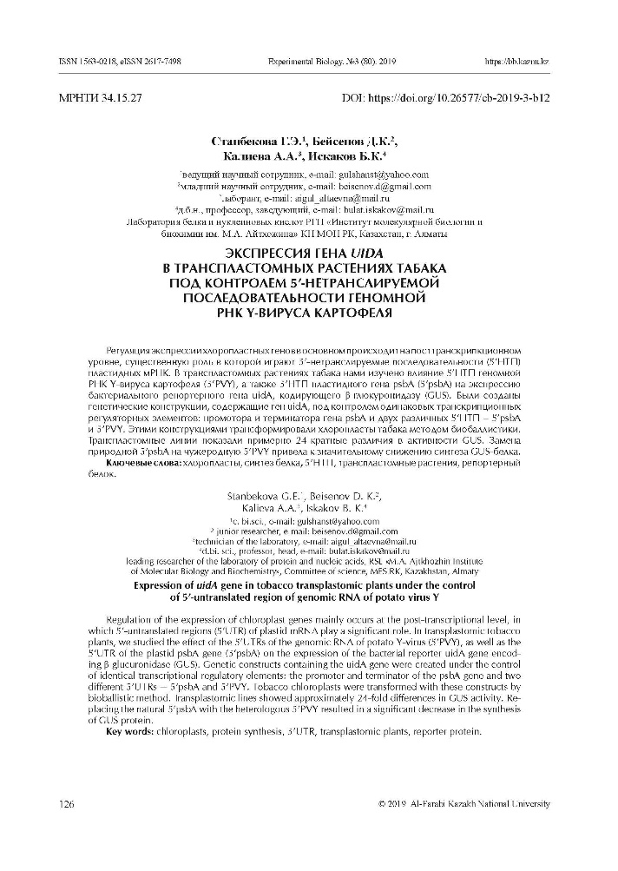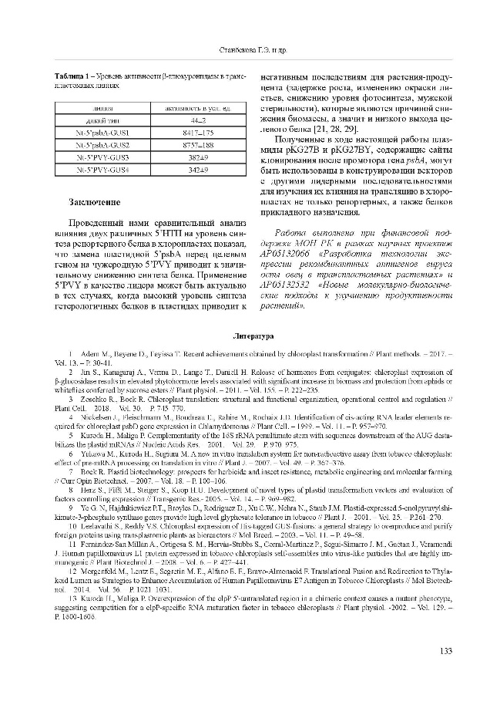

- Beisenov D.K., Argimbaeva T.U., Stanbekova G.E., Iskakov B.K. Synthesis of the sheeppox virus immunogenic L1R protein domain in rape // Veterinary, Animal Science and Biotechnology. - 2019, No. 8. - P. 45-54. (IF RSCI 0.220). (in Russian)
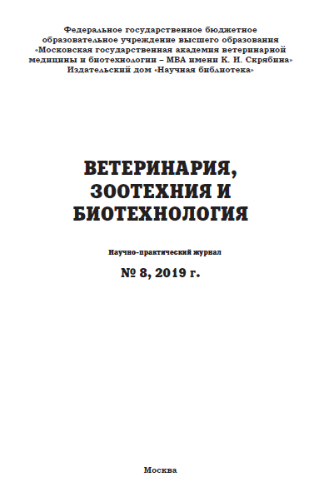
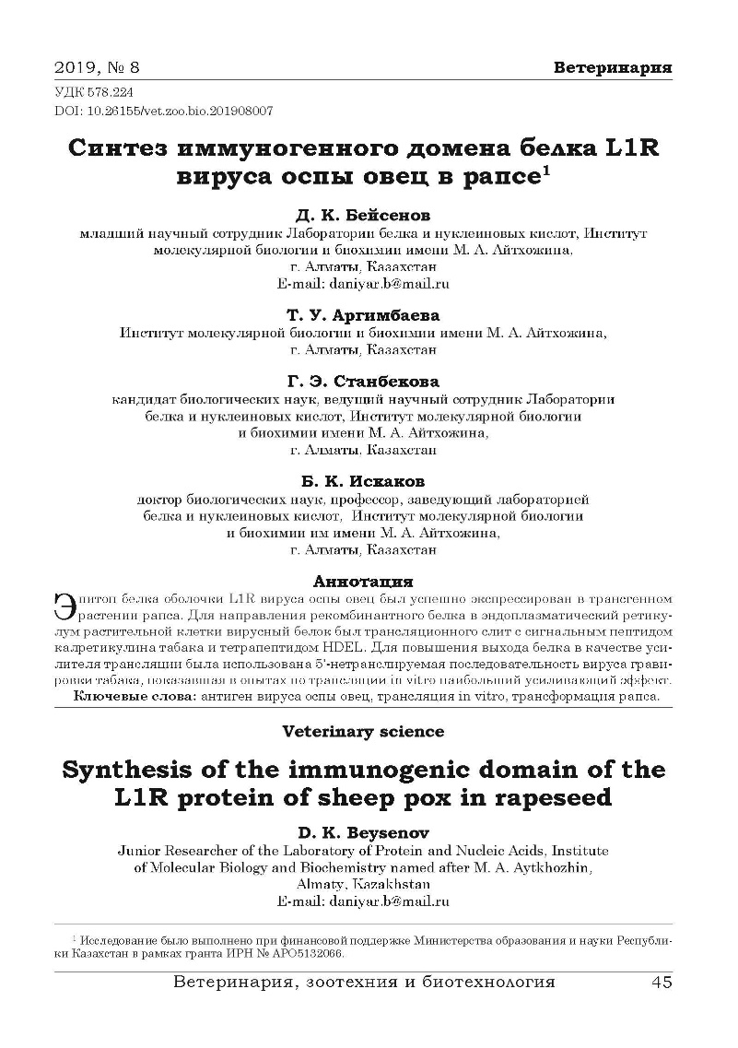
Publications for 2020 year:
1 Beisenov D.K., Stanbekova G.E., Iskakov B.K. Transplastomic tobacco plants producing the hydrophilic domain of the sheeppox virus coat protein L1R. The article is accepted for publication in the journal “Vavilov Journal of Genetics and Selection” (Scopus percentile – 31%). (in Russian).



- Production of the sheep pox virus structural protein SPPV117 in tobacco chloroplasts. Submitted to the jurnal “Biotechnology Letters” (Scopus percentile 66%). (in English).

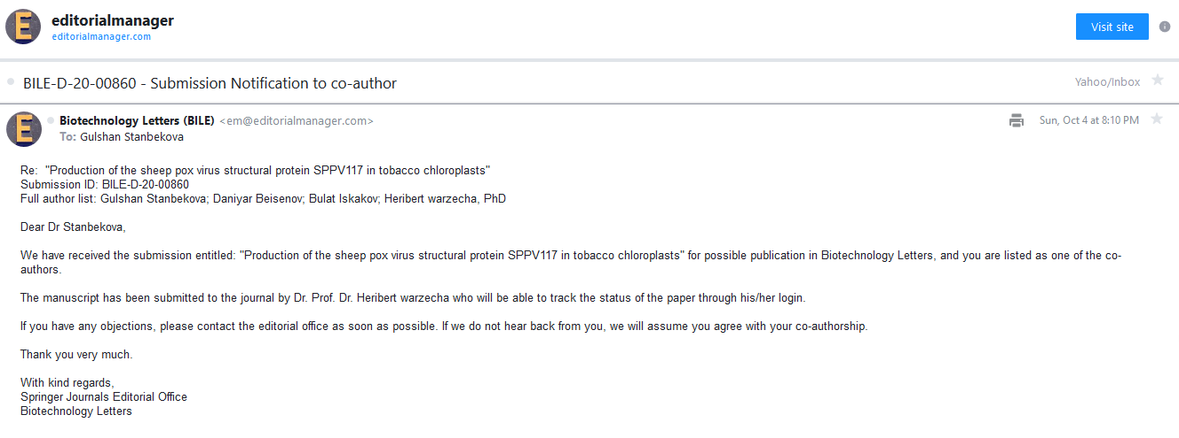

Patent:
Stanbekova G.E., Beisenov D.K., Nadirova L.T., Iskakov B.K. A method of obtaining transplastomic plants synthesizing sheep pox antigenic SPPV-A27L protein. RK patent No. 34156, 05.02.2020. (in Russian).

Laboratory regulations (in Russian).
