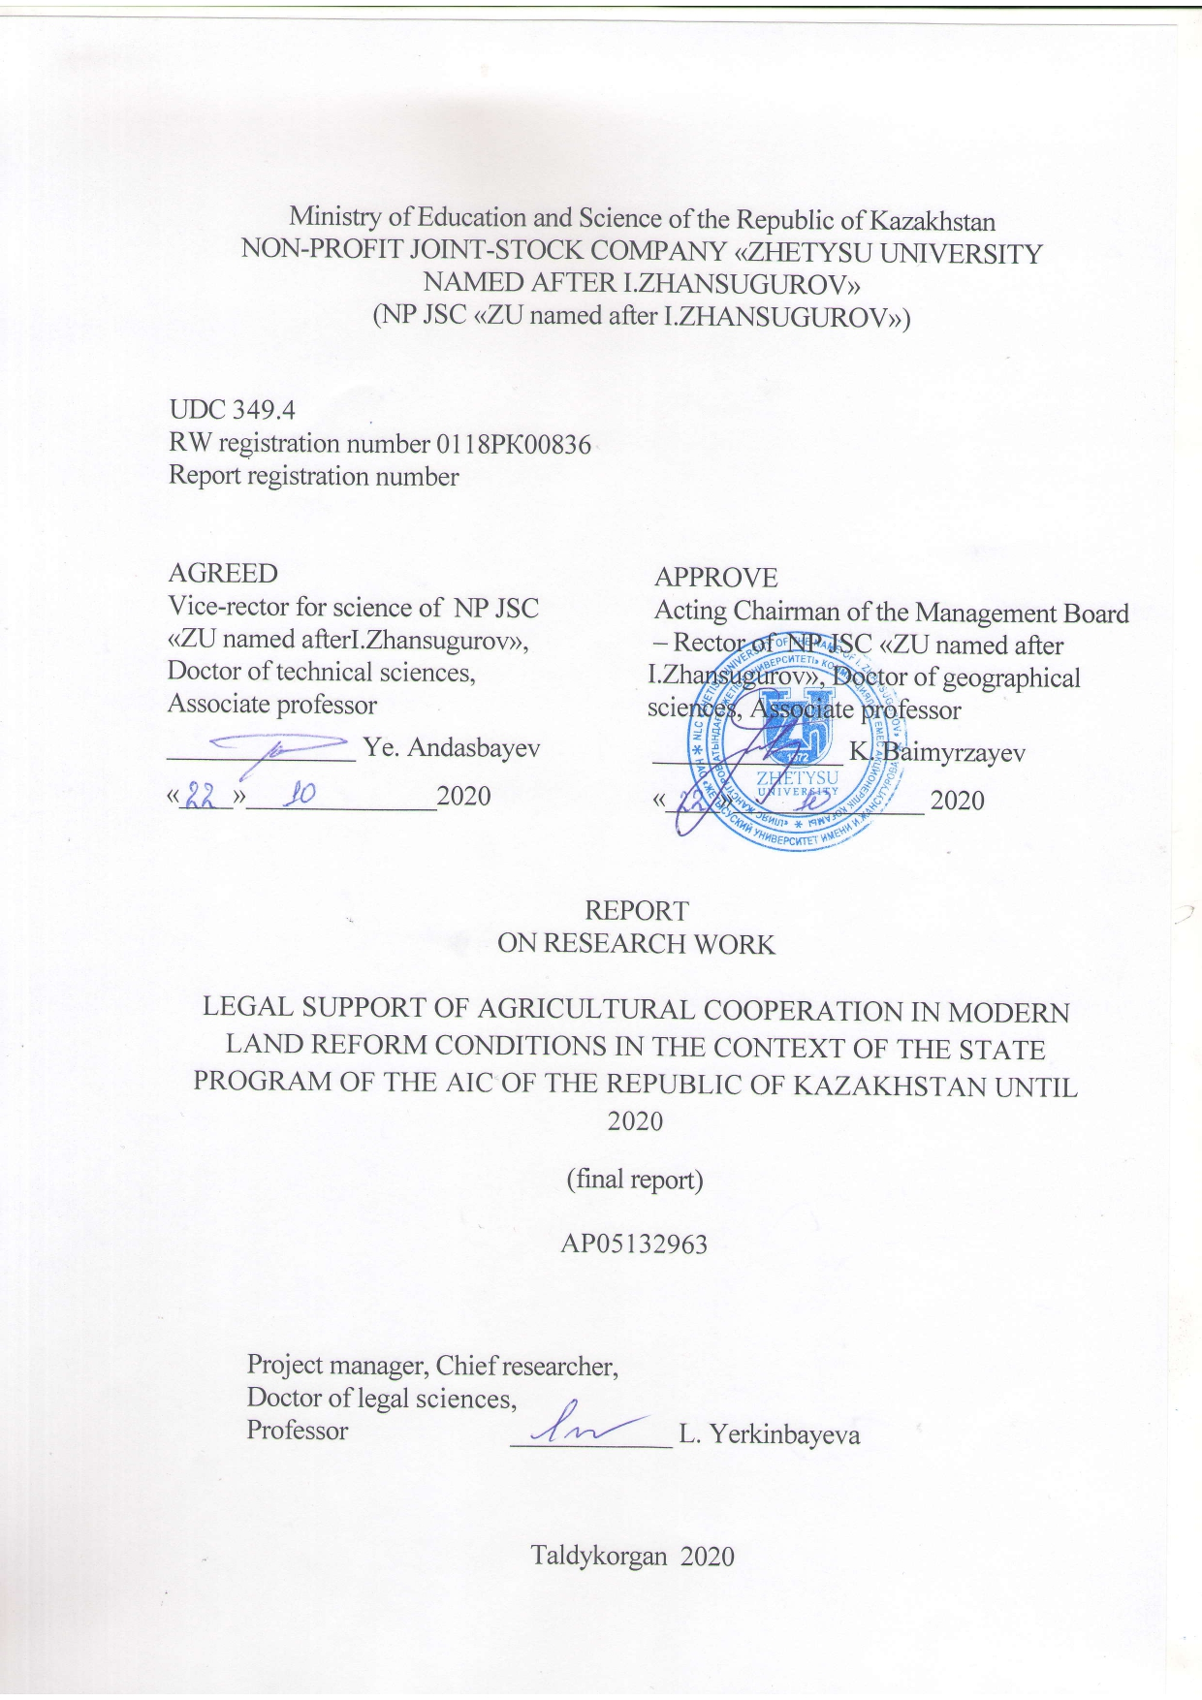
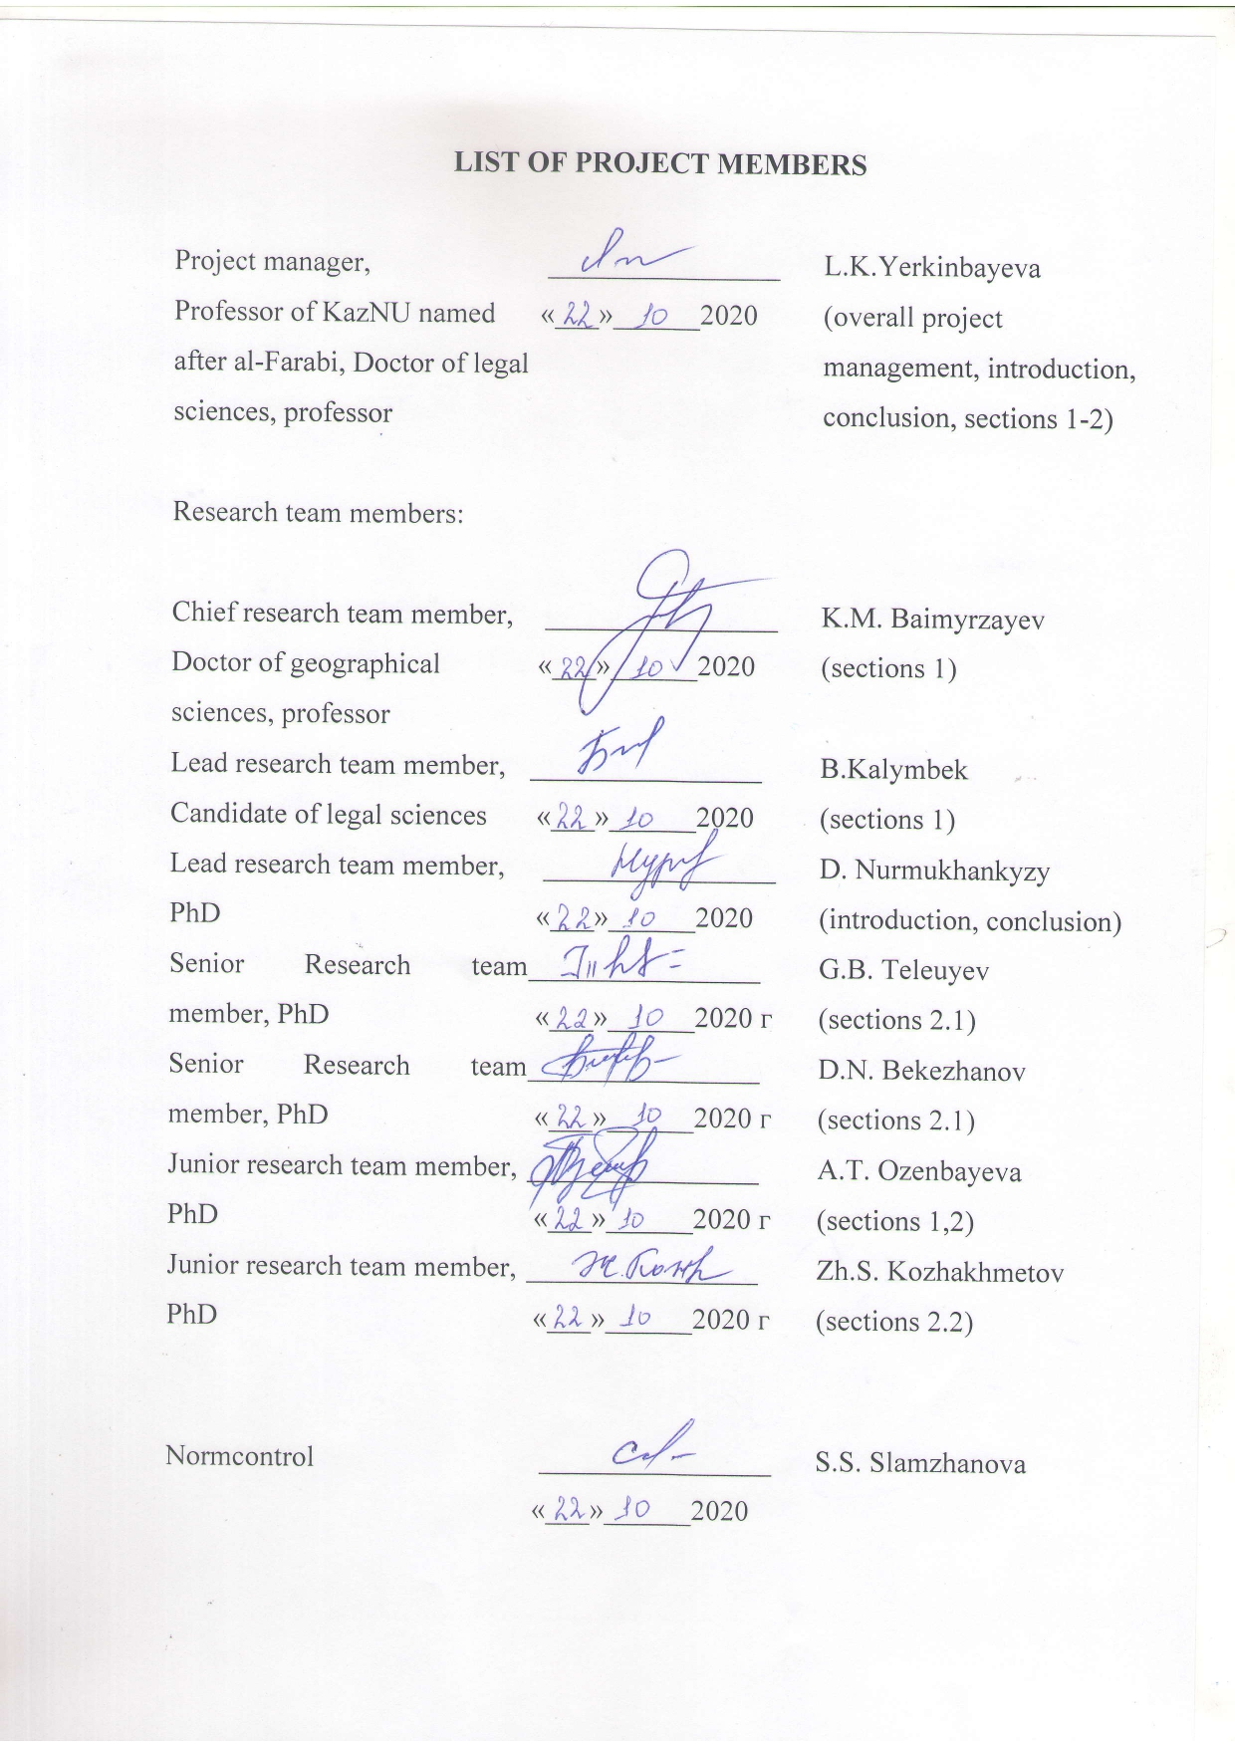
ABSTRACT

The report consists of 71 pages, 29 sources, 6 appendices.

AGRICULTURAL COOPERATION, AGRARIAN POLICY, AGRICULTURAL LEGISLATION, LAND REFORM, AGRICULTURE, FOOD SECURITY, BUSINESS ACTIVITIES
The object of the research is social relations in the field of agricultural cooperation.
The aim of the project is to analyze and critically reflect on the current legislation related to the regulation of relations in the field of agricultural cooperation; studying the doctrinal developments of scientists in this area, identifying the most important theoretical problems and developing, on this basis, proposals for improving legislation and law enforcement practice.
The research methodology consists of formal-logical, historical-legal, system-analytical, comparative-legal and specific sociological and other research methods.
The main results of research work containing scientific novelty:
A strategic plan for the development of entrepreneurial activity in the field of agricultural cooperation has been developed. Recommendations and proposals have been prepared to improve the mechanism of international legal cooperation in the field of agricultural cooperation in the context of modern modernization in the Republic of Kazakhstan. The regulatory framework in the field of agricultural cooperation is investigated, a theoretical analysis of the current agrarian, civil and business legislation is carried out, as well as an analysis of judicial practice in the area under study. Recommendations and proposals have been developed in order to improve the current legislation of the Republic of Kazakhstan in the field of entrepreneurial activity and agricultural cooperation.A draft concept for the development of legislation on agricultural cooperation has been prepared.
Degree of implementation: The theoretical proposals can be used in the law of creative activity for the improvement of the law in the field of the state program of agricultural cooperation in the context of the state program of agricultural cooperation in the context of 2020. For further research in the field of agrarian and land law, as well as in the educational process.
Efficiency - the intended goals and objectives of the study have been achieved, the results obtained correspond to the characteristics of scientific and technical products in terms of qualification characteristics and economic indicators indicated in the technical specification and work schedule.
Scope: land, agrarian legislation, legislation in the field of agricultural cooperation.
Scientific - organizational work 2018-2020: Articles in foreign peer-reviewed scientific journals with an impact factor of - 7, articles in rating publications of the Republic of Kazakhstan, recognized by the Committee for Control in Education and Science of the Ministry of Education and Science of the Republic of Kazakhstan-25, articles in journals of international and republican conferences: 13, in other editions of the RK - 6, in other editions of foreign pages 1, published 5 monographs, 2 textbooks. Received 1 copyright certificate and 1 patent. 2 international scientific and practical conferences were held.

CONTENTS

 | LIST OF ABBREVIATIONS AND SYMBOLS………………………… | 5
 | INTRODUCTION............................................................................................................. | 6
1 | Organizational and legal problems of the development of an agricultural cooperative as a form of agricultural entrepreneurship.……………………………………………… | 9
 | The legal status of an agricultural cooperative in the Republic of Kazakhstan…………………………………………………………………..………....... | 9
1.2 | Features of an agricultural cooperative as a form of agricultural entrepreneurship………………………………………………………………………… | 17
2 | Problems of improving the current agricultural legislation of the Republic of Kazakhstan ……………………………………………………………………………... | 21
2.1 | Analysis of judicial practice in terms of resolving disputes with the participation of agricultural cooperatives ……………………………….………………………………. | 21
2.2 | Problems of improving the current agrarian legislation of the Republic of Kazakhstan | 30
 | CONCLUSION........................................................................................................... | 37
 | REFERENCES..................................................................................................... | 40
 | Supplement A Technical specification and work schedule …………………………….. | 42
 | Supplement B Project Strategic plan for the development of entrepreneurial activity in the field of agricultural cooperatives…………............................................................ | 55
 | Supplement C Project Concept of Development of Legislation on Agricultural Cooperation …………………………………………………………………………… | 58
 | Supplement D Scientific publications within the framework of implementation scientific research work ………………........................................................................... | 60
 | Supplement E Certificate of Copyright …………………………………….………….. | 69
 | Supplement F Patent ………………………………………………………………… | 71

LIST OF ABBREVIATIONS AND SYMBOLS

In this research report, the following abbreviations and symbols are used:

AIC - agro-industrial complex
WC RK - Water Code of the RK
CC RK - Civil Code of the Republic of Kazakhstan
CPC RK - Civil Procedure Code of the Republic of Kazakhstan
LK RK - Land Code of the RK
PF - Peasant farm
FC RK - Forest Code of the Republic of Kazakhstan
PSF - Private subsidiary farm
ME - Ministry of Energy
TC RK - Tax Code of the Republic of Kazakhstan
UN - United Nations
RK - Republic of Kazakhstan
CIS - Commonwealth of Independent States
EC RK - Environmental Code of the RK

INTRODUCTION
Changes in the country's land system, legislative consolidation of private ownership of agricultural land, the formation and development of new organizational and legal forms of agricultural entrepreneurship, the introduction of market economic levers in the regulation of agricultural production testify to qualitative changes in the content of agricultural legal relations. This sphere of social relations demanded a revision of the socialist postulates of agricultural management, a qualitatively new approach to their legal support, the level of which did not always correspond to market parameters and requirements.
On October 29, 2015, the Entrepreneurial Code was adopted in Kazakhstan, which in its main part came into effect from January 1, 2016. It should be noted that this Code is aimed at developing and improving legislation in the field of interaction between the state of subjects and entrepreneurship, as well as supporting entrepreneurship, eliminating gaps and contradictions in the legal regulation of entrepreneurial relations [1].
In addition, the Entrepreneurial Code of the Republic of Kazakhstan is aimed at implementing the Plan of the Nation - 100 concrete steps to implement five institutional reforms and comprehensive regulation of public relations in the field of entrepreneurship, including those arising in connection with the interaction of entrepreneurs and the state, issues of state regulation and support of entrepreneurship [2 ].
The Law of the Republic of Kazakhstan dated October 29, 2015 "On Agricultural Cooperatives" defines the legal status, rights and obligations of members of agricultural cooperatives, as well as the legal status, procedure for the establishment, operation, reorganization and liquidation of agricultural cooperatives and their associations (unions) [3].
The problems of agrarian transformations require close attention from legal science, which should determine the role of the state and law in the process of forming a progressively new model of agricultural policy, and offer legal tools for its effective implementation in modern conditions. A new stage in the development of society requires a rethinking of many postulates of socialist theory and practice in the field of agricultural entrepreneurship and the justification of new priorities, a revision of conceptual provisions.
An agricultural cooperative is one of the most widespread forms of business in agriculture in the world. Determining promising forms of cooperative management. The world experience in the activities of agricultural cooperatives is extensive and is of great interest for study and use in the practical activities of our republic, which indicates that cooperatives operate in almost all important sectors of agriculture. Our republic widely uses its own experience and world practice in creating cooperatives. The authors of the study have developed scientifically grounded methodological approaches to assessing the effectiveness of legal support for agricultural cooperation in the context of modern economic modernization. Proposals for improving the theoretical and methodological foundations of information support for entrepreneurial activity have been developed. And an effective toolkit for stimulating entrepreneurship has been formed, the formation of theoretical and methodological foundations for the modernization of economies.
The scientific novelty of the research is determined by the chosen topic, a systematic approach to the development, a comprehensive analysis of the problems of legal support of agricultural cooperation in the context of modern economic modernization in the Republic of Kazakhstan. On the basis of a critical analysis of various views, the project proposes and substantiates its vision of theoretical and practical issues of the studied problem.
The object of the research is social relations in the field of agricultural cooperation.
The subject of the research is the legal mechanism for regulating the relations under consideration, in particular the laws of the Republic of Kazakhstan, decrees of the Government of the Republic of Kazakhstan, departmental regulations and normative documents, legislation of foreign states in the field of civil, land, agricultural, environmental and other legislation, in part concerning agricultural cooperation in Republic of Kazakhstan.
The aim of the project is to analyze and critically reflect on the current legislation related to the regulation of relations in the field of agricultural cooperation; studying the doctrinal developments of scientists in this area, identifying the most important theoretical problems and developing, on this basis, proposals for improving legislation and law enforcement practice.
The research methodology consists of formal-logical, historical-legal, system-analytical, comparative-legal and concrete-sociological and other research methods.
The results, conclusions and proposals can be used: for the development of various state programs of legal and social direction; in rule-making activities to improve the current legislation of the Republic of Kazakhstan in the field of development of agricultural cooperation; in research work as a source material for further theoretical research; in the educational process when teaching the course of agrarian and land law, in the development of educational and educational literature.
The provisions and conclusions contained in the report can be used in the preparation of appropriate training courses on agrarian and land law for government officials, farmers, agricultural structures.
Practical recommendations and proposals can be applied in the legislative and law enforcement activities of the Republic of Kazakhstan.

Interim reports were submitted for the reporting period:
2018: Legal support of agricultural cooperation in the context of modern land reform in the context of the State program of the agro-industrial complex of the Republic of Kazakhstan until 2020. IRN AP05132963-OT-18. The state registration number of the report is 0218RK00824.
2019: Legal support of agricultural cooperation in the context of modern land reform in the context of the State program of the agro-industrial complex of the Republic of Kazakhstan until 2020. IRN AP05132963-OT-19. The state registration number of the report is 0219РК00489.

THE MAIN PART OF THE RESEARCH REPORT

1 Organizational and legal problems of the development of an agricultural cooperative as a form of agricultural entrepreneurship
1.1 The legal status of an agricultural cooperative in the Republic of Kazakhstan
Kazakhstan faced new tasks for the development of the agrarian sector, which required the development of new concepts of agrarian cooperation. In this regard, several strategic documents were proposed: "Agrobusiness-2020", "Strategy-2050", "Business Roadmap-2020", "Nurly-Zhol", the State Program for the Development of the AIC of the Republic of Kazakhstan for 2017-2021 [4], etc. One of the main program activities of the State Program for the Development of the Agro-Industrial Complex of the Republic of Kazakhstan for 2017-2021, adopted on February 18, 2017, is the involvement of small and medium-sized farms in agricultural cooperation.
Until 2016, there were two types of cooperative in agriculture in Kazakhstan: in the form of an agricultural production cooperative and a rural consumer cooperative. The activity of an agricultural production cooperative was regulated by the Law of the Republic of Kazakhstan dated October 5, 1995 "On a production cooperative" [5]. According to it, a voluntary association of citizens on the basis of membership for joint entrepreneurial activity based on their personal labor participation and the association of property contributions (shares) by its members was recognized as a production cooperative. With regard to the agrarian sector, the following features of an agricultural production cooperative can be distinguished. Firstly, the main direction of its activity is the production of agricultural products. Secondly, it is created only by individuals, the number of which must be at least two people. Thirdly, in order to enter an agricultural cooperative, an individual must pay a property share (contribution). In our opinion, since the land participates in the activities of an agricultural production cooperative, it is necessary to legally provide for the obligatory payment of a land share. In principle, the practice of creating such cooperatives in the countryside followed the proposed path, which must be fixed at the level of the law, this will entail the creation of an economic basis for the activity of an agricultural cooperative in the form of the required land areas. Thirdly, a member of the cooperative must necessarily take personal labor participation in its activities. Unlike an agricultural production cooperative, a rural consumer cooperative is a non-profit organization. Its activity was regulated by the following laws: of July 21, 1999 "On rural consumer cooperation in the Republic of Kazakhstan"; of December 25, 2000 "On agricultural partnerships and their associations (unions)"; dated April 8, 2003 "On the rural consumer cooperative of water users" [3].
An agricultural consumer cooperative was recognized as an agricultural cooperative created by agricultural producers and (or) citizens leading their own subsidiary farming, subject to their mandatory participation in the economic activities of the consumer cooperative. According to the old law "On Rural Consumer Cooperatives in the Republic of Kazakhstan", a rural consumer cooperative is a voluntary association of citizens based on membership to meet the material and other needs of members (shareholders), carried out by combining property (share) contributions by its members. Based on this definition, we can say that this type of cooperative was created to carry out trade, procurement, marketing, processing, service, supply and other activities not prohibited by law [6]. This activity was aimed at satisfying the material and other needs of members (shareholders), as well as people living in rural areas, that is, it does not set itself the goal of making a profit. At the same time, he can engage in all types of agricultural entrepreneurial activities not prohibited by law in order to achieve statutory objectives. Another feature of the rural consumer cooperative was that both individuals and legal entities could be members. An agricultural production cooperative is an agricultural cooperative created by citizens for joint activities in the production, processing and marketing of agricultural products, as well as for the performance of other activities not prohibited by law based on the personal labor participation of members of the cooperative. Depending on the type of activity, agricultural consumer cooperatives, which are non-profit organizations, were subdivided into processing, marketing (trade), service, supply, horticultural, horticultural, livestock and others, including universal (performing two or more types of activities).
Almost the same can be said about land law, the subjects of which are also all agricultural organizations and individual entrepreneurs, and they are classified as subjects of property rights or agricultural land use rights, they can also be land tenants, and in this sense they bear the same rights and obligations in in relation to the land plots allocated to them and other natural resources used as means of production and as a territorial-spatial basis [7]. The agricultural production cooperative is recognized as a credible type of agricultural cooperation at the international level [8].
The current legislation - the Civil Code of the Republic of Kazakhstan [9] and the Law "On Agricultural Cooperatives" provide the following definition: "An agricultural cooperative (hereinafter AC) is a legal entity in the organizational and legal form of a production cooperative, created on the basis of membership through a voluntary association of individuals and (or) legal entities for the implementation of joint production and (or) other economic activities in order to meet their socio-economic needs in the production, processing, marketing, storage of agricultural products, aquaculture (fish farming) products, supply of means of production and material and technical resources, lending, water supply or other servicing of the members of the cooperative, as well as associated members of the cooperative ”(clause 1 of article 5 of the Law on the AC). The law of the AC gives the status of a commercial organization, the purpose of which is joint activities in the production, processing and marketing of agricultural products and the implementation of other activities not prohibited by law. The Civil Code of the Republic of Kazakhstan (general part) in art. 226 allows the creation of production cooperatives on the basis of a peasant farm: “members of a peasant or farm holding on the basis of the property of the farm can create a business partnership or a production cooperative. Such a reorganized peasant or farm enterprise as a legal entity has the right of ownership to property transferred to it in the form of contributions and other contributions by members of the peasant or farm enterprise, as well as to property received as a result of its activities and acquired on other grounds that do not contradict the legislation" [9].
Today, the country's agrarian sector is experiencing such difficulties as the small-scale nature of agricultural production, irrational use of agricultural land, and peasants' distrust of new forms of cooperation. The main problem of the effective development of the agro-industrial complex of the Republic of Kazakhstan is the small nature of production, accompanied by the share of small farms in the total volume of agricultural production, the total number of agricultural units and their tendency to reduce land resources.
It should be noted that according to the legislation on entrepreneurial activity, its implementation, including agricultural production, is possible without forming a legal entity. In this case, a citizen carrying out such activities, i.e. acting as a manufacturer of goods, has the legal status of an individual entrepreneur and the corresponding rights and obligations of a participant in commodity-money relations and legal relations that formalize them.
All agricultural organizations and enterprises are participants in administrative, civil, labor, cooperative, land and other legal relations. The scope of these legal relations with the participation of agricultural trade organizations (enterprises) is very wide and varied, which is determined for each individual enterprise, first of all, by the nature of its production and commercial activities and specialization.
In the Republic of Kazakhstan, the legal and economic foundations for the creation and operation of agricultural cooperatives and their unions, which constitute the system of agricultural cooperation, are determined by the Law of the Republic of Kazakhstan dated October 29, 2015 No. 372-V. "On agricultural cooperation". According to Art. 5 of the law, an agricultural cooperative is a legal entity that is a commercial organization whose activities are aimed at meeting the interests of its members in the implementation of agricultural production and other activities [3].
The main activities of agricultural cooperatives are production, processing, sale, storage, production of agricultural products, aquaculture products (fish farming), as well as the provision of material and technical resources and other services to members of the cooperative, as well as associated members. The main new provisions of this law, which differ from previous laws, include:
- an agricultural cooperative - a commercial organization that has the legal opportunity to earn money by participating in production, service, supply and other forms of cooperative activity, as well as in the distribution of the cooperative's profit among its members;
- a variety of entrepreneurial activity of agricultural cooperatives (production, storage, processing, sale of agricultural products, supply of means of production and other services), which allow combining all types of agricultural cooperatives into a group of independent legal entities, developing a unique concept that differs from others. forms of management characterized by a certain form of organization of production aimed at meeting the needs of its participants;
- Introduced new forms of economic support in the form of tax and other preferences (income tax, VAT, transport tax, property tax, property tax), which are subject to “a 70% reduction, expands the scope of agricultural cooperatives, removes restrictions on the use of SNR, the composition of the economic cooperative has been expanded;
- The content has been changed, namely the forms and methods of state regulation of agricultural cooperation with an emphasis on providing real assistance in providing information, consultations, conducting seminars and lectures, scientific research, organizing agri-food markets, exhibitions, fairs, etc. [3].
The legal status of agricultural cooperatives requires a detailed study.
Thus, the Civil Code of the Republic of Kazakhstan directly indicates that its provisions do not apply to the cases provided for by the Law of the Republic of Kazakhstan "On Agricultural Cooperatives".
The same can be traced in the content of the Law of the Republic of Kazakhstan dated October 05, 1995 "On a production cooperative" [5].
We do not quite understand the logic of the legislator, who stipulates that it establishes that an agricultural cooperative is one of the types of production cooperatives, at the same time does not allow the regulation of its activities at the level of the Civil Code of the Republic of Kazakhstan and the Law on Production Cooperatives, which contradicts many provisions of the Law "On Legal acts "in terms of the hierarchy of laws [10].
The requirement of clause 4 of Art. 5 of the Law on Agricultural Cooperatives, according to which the corporate name of an agricultural cooperative must include its name indicating the words "agricultural production cooperative" or the abbreviation "APC".
A few words about its implementation. In particular, in paragraph 3 of Art. 42 of the Law on the АC stipulates that “rural consumer cooperatives, rural consumer cooperatives of water users, agricultural partnerships are required to go through the procedure of reorganization or liquidation in accordance with the legislation of the Republic of Kazakhstan.
If these requirements are not met after one year from the date of entry into force of this Law, these cooperatives are subject to liquidation by a court decision.
The forms of reorganization have not found legalization, which, according to analysts, is not in favor of agricultural cooperation and causes distrust of people.
“Only transformation remains. But in a legal entity of what organizational and legal form? Here I see only two options: in “just a consumer cooperative” or in an agricultural cooperative (but not in a religious association, political party, autonomous educational organization, apartment owners cooperative or a notary chamber?). But both options are equally wrong.
The possibility of transforming into “just a consumer cooperative” does not contradict the legislation, but testifies to the shortcomings of the system of non-profit organizations itself.
Let us recall that, in contrast to the list of commercial organizations closed by the Civil Code, the list of forms of non-commercial organizations is "slightly open" for other legislative acts (Article 34 of the Civil Code of the Republic of Kazakhstan). The Law of January 16, 2001 No. 142-II "On Non-Commercial Organizations" also did not "close" it "[11]
As practice has shown, the adoption of such laws specifically for specific legal entities (for example, Nazarbayev University, National Chamber of Entrepreneurs of the Republic of Kazakhstan) is not a way out of the situation.
Even more difficult is the issue of the possibility of transforming rural consumer cooperatives, rural consumer cooperatives of water users and agricultural partnerships into agricultural cooperatives [12, 26 c.].
The answer, it would seem, is “on the surface”: since the laws on these forms of legal entities have been put on cancellation in connection with the adoption of the Law on Agricultural Cooperatives, they should be transformed into a legal entity of this organizational and legal form.
S.I. Klimkin believes that in civil law, in contrast to administrative and criminal law, the principle "everything is permitted that is not prohibited." And, since there is no direct prohibition on the transformation of a non-profit organization into commercial civil legislation, it means that such a transformation is possible. However, in his opinion, this approach to the foundations of legislative regulation of legal relations is flawed [10]. Indeed, in addition to the method of direct prohibition (imperative) and the principle of the actual freedom of civil legal relations (for example, the regulation of contracts), there are also less categorical methods of regulation, for example, through a prescription. So, part of the first paragraph 1 of Art. 19 of the Law "On Non-Commercial Organizations" it is established that a non-profit organization can be created through its formation, as well as as a result of the reorganization of an existing non-profit organization [10].
However, none of the laws of the Republic of Kazakhstan, directly devoted to the organizational and legal forms of commercial organizations (and there are not many of them: "On state property" 2011, "On economic partnerships", "On limited and additional liability partnerships" 1998, "On joint-stock societies "2003," On a production cooperative "does not allow the creation of a commercial organization by transforming a non-commercial organization into it. In other words, there is no such permission.
Currently, there is a tendency to intensify in the field of agricultural cooperation, which can be guaranteed by the following principles of creating agricultural cooperatives:
“Meeting the socio-economic and other needs of the members of the cooperative and protecting their interests; increasing the income of members of the cooperative; creation of a competitive environment in the areas of production, processing, marketing, storage of agricultural products, aquaculture products (fish farming), supply of means of production and material and technical resources; development of infrastructure and provision of direct supplies of agricultural products, aquaculture (fish farming) products from producer to consumer; assistance in the acquisition of the necessary resources by members of the cooperative on favorable terms and access to financing for their production and other economic activities ”(clause 1, article 4 of the Law on the АC).
The study of the history of the development of cooperation in Kazakhstan shows that it is an integral complex of economic and other interrelationships, capable of solving complex problems in the global cooperative structure. The effective functioning of such production structures is possible with their appropriate proportionality, consistency, rhythm, rational economic relations and production ties.
The main constraints to the development of the cooperative movement in the republic are the lack of funding sources, staffing, imperfection of legal legislation, taxation and the lack of mechanisms for organizing relationships within the cooperative. One of the forms of cooperation in Kazakhstan, which functioned for many years, were collective farms, which were created with the aim of eliminating private ownership of land and for a quick transition to socialism and communism. During the formation of Kazakhstan as an independent state in the 1990s, in order to raise and strengthen the economy of the agricultural sector, the government of the republic adopted a program for the denationalization and privatization of state agricultural and other agricultural enterprises. The mechanism of denationalization led to the fragmentation of the former state and collective farms into medium, small forms of farms. Subsequently, medium-sized farms turned into small ones, while small ones went bankrupt and joined the ranks of households. Based on the above problems, in order to develop agricultural cooperation in the Republic of Kazakhstan, it is necessary: ​​to create an economic mechanism for agricultural cooperation, including a system of effective financing of the АC, including the provision of subsidies, soft loans, investment, etc. [13].
To date, a wide range of stakeholders are involved in the process of creating and developing agricultural cooperatives: state bodies, research and educational centers, business structures, both from the agricultural and non-agricultural spheres, agricultural producers, and it should be noted that among them there is no single understanding the essence of cooperation in the agricultural sector, including both the production process and the types of post-production work (harvesting, storage, processing, marketing and others). This causes certain difficulties in creating cooperatives, and first of all, difficulties are faced by farmers who do not fully know about the key conditions and requirements prescribed in the new law, where in turn there are provisions that contradict the norms of other laws of the country, which further complicates the situation.
Also, the constraining factors for the development of cooperatives include: lack of sufficient incentives for agricultural cooperation, proper interaction between government bodies and local business structures, as well as associations (unions) of agricultural cooperatives at the district, regional and local levels that protect their interests; skepticism of peasants, fear of losing the most important thing, namely land, lack of legal information and knowledge, disbelief in the positive aspects of agricultural cooperatives [14].
Our analysis of the development of legislation in the field of agricultural cooperatives makes it possible to draw the following theoretical and practical conclusions:
- In developing countries, attempts to organize farmers into cooperatives have often failed, although cooperatives can supply agricultural inputs and marketable agricultural products that are important for agricultural development.
- Legislative practice shows that the development of legislation on agricultural cooperatives in Kazakhstan can be conditionally divided into two large stages, this is before the independence of our country and in modern conditions.
The main constraining factors for the development of cooperatives are: an imperfect mechanism to stimulate the association of farmers into agricultural cooperatives; lack of coordinating bodies for managing the development of cooperation in the country and locally in the form of associations (unions) of agricultural cooperatives at the district, regional and local levels, protecting their interests, as well as controlling the activities of agricultural cooperatives in compliance with the basic principles of cooperation in financial activities, distribution of income between members of the cooperative, accounting, registration, etc.; a high level of distrust of agricultural producers, especially small forms of management, to the newly created structures, fear of losing the main means of production - land; low level of legal culture in the countryside, lack of awareness among farmers about the advantages of agricultural cooperatives.
The main tasks of state regulation of agricultural cooperation are to ensure food security of the Republic of Kazakhstan, to maintain economic partnership between agriculture and other sectors of the economy, to bring commodity producers closer together in the field of agricultural production.
Currently, the following factors can be identified that hinder the development of cooperation of rural producers in the production and sale of products, material and technical supply and the provision of services:
- the low level of income of the rural population, small and medium-sized rural businesses, which does not allow them to provide the necessary start-up capital for the creation and operation of cooperatives;
- inaccessibility of bank loans, poor development of systems for providing financial services to small and medium-sized rural businesses;
- lack of qualified personnel and a mechanism for their search, training and consolidation;
- low level of awareness of rural residents about the benefits of cooperation;
- a low level of legal culture in the countryside, a practical lack of awareness of the population about the legal conditions of activity;
- a high level of distrust of the population to any created structures, as a result of which inertia, indecision, unwillingness to invest in any projects are observed.
In our opinion, today there is a need to create a Land Bank, the system of which is used by most European countries, the United States. The establishment of a land bank system should be the next logical step in land reform, as well as in agricultural reform and the provision of agricultural cooperatives.
Thus, with the help of mortgages, it is possible to carry out a smooth transition of land from ineffective to owners capable of working in the new economic conditions, who would like to work, but lack funds.
In our opinion, state bodies should support agricultural cooperatives by the following measures:
a) development and implementation of projects and programs for the development of agricultural cooperatives;
b) providing agricultural cooperatives with the opportunity to use preferential credit resources and grants, including government grants;
c) providing advice and making appropriate recommendations to agricultural cooperatives;
d) determination of measures of information, consulting, legal and other support for agricultural cooperatives.

1.2 The legal status of an agricultural cooperative in the Republic of Kazakhstan
Types and forms of agrarian business cooperation exist in many sectors, including agriculture, consumer affairs, marketing and financial services, and housing. They provide 100 million jobs worldwide and have over 1 billion members.
“According to the Committee on Statistics of the Ministry of National Economy of the Republic of Kazakhstan, in 2018 the number of operating agricultural cooperatives increased by 5%, while the volume of their products increased several times.
According to the statistics agency, while the volume of services rendered by cooperatives has significantly decreased, the volume of products produced by such structures has increased. Thus, the production of wheat increased four times and milk production doubled. Basically, Kazakhstani cooperators are involved in animal husbandry. In 2018, there were 1,179 such structures. Note that in the state program for the development of the agro-industrial complex of the Republic of Kazakhstan for 2017-2021, a much smaller number of operating agricultural cooperatives is laid down as a target - 644, with an almost twofold increase compared to 2017. If you believe the statistics, according to this indicator, we have already “left behind” 2020 [15].
With regard to the agricultural cooperative as a form of agricultural entrepreneurship, agriculture, forestry, fishing and animal husbandry is the main source of employment and income in rural areas, where most people live. Agricultural cooperatives play an important role in supporting small agricultural producers. They empower their members economically and socially and create sustainable rural employment through business models that are resilient to economic and environmental shocks. Cooperatives offer small agricultural producers opportunities and a wide range of services, including improved access to markets, natural resources, information, communications, technology, credit. They also foster smallholder participation in decision-making at all levels, support them in securing land use rights and negotiate better terms for contract farming, and lower prices for agricultural inputs such as seeds, fertilizers and equipment. With this support, small businesses will be able to secure funds and play an important role in meeting the growing demand for food in local, national and international markets, which helps reduce poverty, ensure food security and eradicate hunger.
In many countries, the development of cooperation has achieved positive results and rates, which clearly demonstrates the advantages of agricultural cooperation. It should be noted that all elements of the agro-industrial complex are involved in the development of cooperation, which are directly related to the process and production and supply and service activities of the AC. Sophisticated economic instruments of agricultural cooperation enable agricultural producers to more easily adapt to the rapidly changing conditions of the market economy and new economic relations [16].
Individual peasants do not have the opportunity to compete with large commodity producers, they have to make a lot of efforts to build an effective system of supply, sale, supply, etc. All this affects the costs of transportation and sales of products, food safety risks, limited vertical ties between processing enterprises and small farmers [17].
In accordance with the Civil Code of the Republic of Kazakhstan, when creating a cooperative, each of its participants is fully responsible, i.e. If the cooperative goes bankrupt, it can lose everything. This not only hindered the development of the cooperative movement in the country, but also required the improvement of national legislation in order to find incentives to create production cooperatives in the countryside, as well as to organize management levers and protection tools for each agricultural producer, if he found himself in a difficult economic situation as a result of cooperative activities. ... Small farmers did not want to unite voluntarily into cooperatives, and villagers with shares did not go for it due to the lack of stimulating economic mechanisms. Necessary explanatory work was not carried out in the field. The rural population was distrustful of the new structures being created, not understanding the advantages of cooperation and not knowing the peculiarities of the mechanism of intra-economic relations.
To obtain a soft loan, “false cooperatives” began to be created, the functioning of which did not correspond to cooperative principles.
Peasants and farmers were most afraid of losing, albeit small, but their property - land and real estate due to the lack of clear legal mechanisms. Most of the farms did not have sufficient financial resources to purchase equipment. Farmers mainly sell their products through intermediaries - resellers at low prices, as noted above. The new law "On agricultural cooperatives" is aimed at solving these problems, where appropriate adjustments have been made, taking into account all the comments and suggestions of economic entities in the countryside [18]
On behalf of the President of the Republic of Kazakhstan, we adopted the “State Program for the Development of the Agro-Industrial Complex of the Republic of Kazakhstan for 2017-2021” Resolution of the Government of the Republic of Kazakhstan dated July 12, 2018 No. 423. The main goal of the program is to provide the country's population with food, increase the expertise and increase the income of rural manufacturers [4]:
The key tool for increasing production efficiency will be two mechanisms of cooperation between organized farms: horizontal cooperation and vertical (anchor) cooperation. Private households can participate in cooperation as subjects of entrepreneurship in the forms of individual entrepreneurship, farm household, household farm.
Horizontal cooperation will allow small and medium agricultural enterprises to increase profitability by combining with each other by reducing costs in the production and sale of products.
Vertical (anchor) cooperation will allow agricultural producers to ensure integration and create cost-effective conditions for interaction both with processing enterprises and other consumers of products, on the one hand, and with suppliers of resources necessary for production, on the other hand.
To receive state support from 2020, an agricultural enterprise that is not registered as a legal entity must be a member of an anchor cooperation (cluster) or horizontal cooperation.
To develop credit cooperation, it is planned to introduce a model based on the successful foreign experience of credit cooperation institutions by improving legislation aimed at solving limiting factors, including the possibility of consolidating СT funds by creating a Central Association (possibly in the form of a second-tier bank).
The proposed model will allow:
1) to involve the funds of participants in the economic turnover of the regions and thereby provide the institutions of credit cooperation with their own sources of funding;
2) expand access for those groups and segments of the population who today do not receive a sufficient volume of financial services;
3) to strengthen the financial sustainability of the CT system as one of the instruments of state policy in the field of the agro-industrial complex [4].
The planned boundaries in the structural and institutional transformation of agriculture are aggravated by a number of complex unresolved problems in socio-economic and institutional-legal relations. Moreover, the share of the agricultural sector due to its low productivity in different years accounts for 6-8 percent of the country's GDP. Therefore, today the agro-industrial complex is far from the leading branch of the economy. The import of food products is significant, especially for the main products: meat, dairy and confectionery products, fish, etc.
Unfortunately, the cooperative movement in Kazakhstan is developing slowly. Due to the negative experience of collective farming during the Soviet period, the level of familiarity and trust of farmers with the cooperative model is low. These perceptions were aggravated by the process of agrarian decollectivization after the proclamation of independence. Land tenure reforms and the privatization of collective farms in the early and mid-1990s led to an unequal distribution of the land and assets of former collective farms among their workers and managers.
Recent years have seen a growing recognition of the role that cooperatives can play in Kazakhstan's agricultural sector. Agricultural cooperatives can help subsistence households transition to small-scale commercial agriculture and overcome the challenges posed by high transaction costs and large spatial dispersion of production. According to analysts, the following can be attributed to the positive results of this stage of development of agricultural cooperatives in the republic, in particular after the adoption of the unified Law of the Republic of Kazakhstan "On agricultural cooperatives" in 2015:
- agricultural cooperatives (marketing, processing, supply, service, etc.) have been assigned the legal status of a commercial organization, which allows distributing the net income of a cooperative among its members in proportion to the contribution of each participant (in the earlier laws, these cooperatives had the status of a non-commercial organization, which is not made it possible to distribute the income received by the cooperative among its members);
- stimulating factors have been created for the unification of small businesses by giving priority to agricultural cooperatives of state support in the form of subsidies, investment subsidies, preferential lending and taxation, etc .;
- pilot projects of agricultural cooperatives in various industries (fruit and vegetable growing, beet growing, cotton growing, rice growing, animal husbandry, etc.) and regions of the Republic of Kazakhstan were organized; conditions have been created for the development of infrastructure for procurement, storage, processing and marketing of agricultural products on a cooperative basis;
- the attitude of agricultural producers to the process of cooperation has changed, trust has appeared, a desire to unite for the purpose of joint cooperation and protecting their interests, opening their own business.
However, despite the existence of a legal and organizational and economic base in the form of the adoption of the new Law of the Republic of Kazakhstan "On Agricultural Cooperatives", financial and credit support from the state in the form of subsidies, investment subsidies, concessional lending and taxation, agricultural cooperatives have not yet received proper distribution, the development of which could contribute to increasing the efficiency of the development of agriculture and other branches of the agro-industrial sector of the republic [19].

2 Problems of improving the current agricultural legislation of the Republic of Kazakhstan
2.1 Analysis of judicial practice in terms of resolving disputes with the participation of agricultural cooperatives
In the Republic of Kazakhstan, the development of agricultural cooperation, as well as in general, is given great importance to agriculture. As mentioned above, agricultural production cooperatives are a form of farming that best meets modern conditions of agricultural production. It is not without reason that in most countries of the world, industrial cooperation is widespread mainly in agriculture.
Cooperatives are fully consistent with the concepts of social justice, since in general they are built on the principles of democracy and self-government, distribution of profits among members of the cooperative, which depend on the indicators of their personal labor participation. Moreover, in addition to the fact that cooperatives provide employment in the countryside, they also take on the solution of many social and domestic issues.
The state provides serious support to the production cooperative. This is due to the fact that this form of organization of agriculture plays an important role in ensuring the activities of peasant and private farms by organizing the processing and marketing of agricultural products and the implementation of other types of services. This largely helps small agricultural producers to resist large agricultural holdings, which, as you know, are becoming monopolists.
The development of a network of credit agricultural cooperatives is especially important, since for a rural dweller, in many cases, a cooperative is the only available source of borrowed funds for entrepreneurial activity. The state provides serious support to such cooperatives [17].
Despite the fact that, in the opinion of the absolute majority of legal scholars, it belongs to the states of the Romano-Germanic legal system, the importance of judicial practice in it is difficult to exaggerate. However, modern research shows that the role of judicial practice is precisely the main method for eliminating rule-making defects. The study of judicial practice in one area or another makes it possible at the scientific level to formulate specific proposals for improving legislation. And of course, agricultural cooperatives as a subject of Kazakhstani law are no exception. In this subsection, we will try to disclose the procedure for the participation of agricultural cooperatives in the legal process and make an analysis of judicial practice with the participation of agricultural cooperatives.
The study of the practice of applying legislation in the field of regulation of agricultural cooperation is necessary for the timely and high-quality improvement of the legal regulation of relations, in ensuring the vital activity of agricultural cooperatives. As you know, the legislation regulating entrepreneurial activity is in the process of formation and inevitably there are conflicts in the law, as well as contradictions between the real living conditions and not improving the rule-making process. Uncertainty, ambiguity, lack of specificity of norms is a significant drawback in the legal regulation of entrepreneurial activity.
Analyzing judicial acts as sources of civil law, V.V. Dolinskaya points out that the improvement of general civil legislation has led to the recognition in the theory of civil law, civil and arbitration process of the independent role of judicial practice in the system of legal facts. Like contracts, court decisions are included in the concept of the grounds for the emergence of civil rights and obligations [19].
A.Yu. Mkrtumyan notes that judicial practice contributes to the development of civil law, and empowering courts with a law-making role can help improve the efficiency of improving the current regulatory framework, and the development of civil legal regulation. In his opinion, judicial practice, in contrast to an impersonal law (which cannot always take into account various nuances in a particular civil law situation), seems to be more fair [20].
The judiciary in the Republic of Kazakhstan, as one of the branches of state power, currently performs not only the functions of justice, but also the function of lawmaking. Therefore, the problem of applying the current legislation and the related lawmaking activities of the judicial authorities in the Republic of Kazakhstan acquire special significance in modern conditions [21].
The increase in the lawmaking role of the court in the legal system of Kazakhstan causes heated discussions in the legal literature about the role of the judicial precedent as in the system of sources of Kazakhstani law; the legal nature of the regulatory decisions of the Supreme Court of the Republic of Kazakhstan (hereinafter - the Supreme Court of the Republic of Kazakhstan) and the possibility of classifying them as acts of case law; on the correlation of judicial practice with the precedent with which it is often identified; on the legal nature of judicial practice - “judicial precedent”; on the admissibility of judicial lawmaking along with parliamentary, etc. However, with all the variety of debatable issues that were considered in the domestic scientific literature [22], the question of the potential and reality of the existence of a judicial precedent as an independent source of law remains unchanged.
So, our theoretical analysis in relation to judicial practice makes it possible to formulate the following scientific and theoretical conclusions about its role in the activities of agricultural cooperatives.
1) According to the legislation of the Republic of Kazakhstan, judicial acts do not act as specific sources of national law, and are not used to resolve specific problems. However, it can be used to develop a mechanism for improving legislation on agricultural cooperatives;
2) The study of judicial practice with the participation of agricultural cooperatives can also help to create a favorable atmosphere in the activities of agricultural cooperatives. That is, we mean that agricultural cooperatives, in the event of a specific dispute, should go through all the procedural procedures as efficiently and conveniently as possible.
3) Since the institution of agricultural cooperatives is relatively new for Kazakhstani legislation, it is necessary to develop a recommendation manual for the protection of the rights of subjects of agricultural cooperatives in the event of violation of certain rights;
When considering case law concerning agricultural cooperatives, there are several key aspects to consider. First, it is necessary to determine the jurisdiction of civil cases. For disputes with the participation of agricultural producers, the general problem of determining the jurisdiction and jurisdiction of cases is especially relevant - the delimitation of jurisdiction of arbitration courts and courts of general jurisdiction. Firstly, agricultural cooperatives are much more likely than ordinary legal entities to form unions and associations, which are non-profit organizations. Secondly, there is an active process of creating agricultural cooperatives, which are also very limited in making a profit, which automatically casts doubt on the economic nature of the dispute with their participation.
R. Mametova notes that in practice, disputes often arise when leaving a production cooperative, when the property is brought in as a conditional land share [23]. So, the Supervisory Board of the Supreme Court of the Republic of Kazakhstan with the participation of the prosecutor, having considered in court a civil case upon P.'s application to the Agricultural Consumer Cooperation "P" for recognizing the illegal actions of the Agricultural Consumer Cooperation "P", obliging him to allocate a land share in kind, issue materials on plot, the minutes of the meeting on the allotment of the land share of the Agricultural Consumer Cooperation "P", received on the supervisory complaint of the representative of the agricultural production cooperative "P" K. against the decision of the Talgar District Court of October 8, 2007, establishing that P. applied to the court with the said application to the Agricultural Consumer Cooperation "P", indicating that on August 29, 2004, under a notarized agreement on the transfer of the right to a conditional land share as a contribution to the agricultural holding company, "P" transferred its land share with an area of ​​25.8 hectares, of which 25.8 hectares of farmland, incl. h. 2.1 (1.3 + 0.8) hectares of irrigated land and 23.7 hectares of pastures. On November 15, 2006, she submitted an application to Agricultural Consumer Cooperation "P" to withdraw from the membership and to allocate a land plot, but the administration of the cooperative did not register this application and did not allocate a land share in kind.
The decision of the Talgar District Court in absentia dated October 8, 2007, P.'s application was satisfied. It was decided to recognize illegal the actions of the management (administration) of the Agricultural Consumer Cooperation "P". To oblige Agricultural Consumer Cooperation "P" to make an allotment (section) of the land share of P. in kind in the amount of 25.8 hectares of agricultural land, including arable land of 9.74 hectares, according to the certificate of the right to a land share No. 01756, and also to oblige the Agricultural Consumer Cooperation "P" Issue P. a cartographic material on the location of the land plot, minutes of the general meeting on the allocation of the land plot.
On August 29, 2004, P. entered into an agreement with Agricultural Consumer Cooperation "P" on the transfer of the right to a conditional land share as a contribution to Agricultural Consumer Cooperation "P" her right to a conditional land share with an area of ​​25.8 hectares, of which agricultural land is 25.8 hectares, including arable land 2.1 hectares, of which 2.1 (1.3 + 0.8) hectares are irrigated, 23.7 hectares of pastures as a share in the agricultural and industrial complex, which was not denied in the court hearing by the representative of the plaintiff A., and also indicated the plaintiff in the statement of claim.
As a result, part of the arable land allocated to the plaintiff was also transferred to the pasture by an act of acceptance and transfer of certificates of the right to a land share as a contribution to Agricultural Consumer Cooperation "P", drawn up between the head of the Talgar district department of land relations A. and the chairman of Agricultural Consumer Cooperation "P" K. as a share in the Agricultural Consumer Cooperation. Based on the evidence presented in the case file on the subject of the claimed claim, the panel considered it possible to change the court's decision without sending the case for a new trial, and issued a resolution to oblige the SHPK "P" to return the P. transferred under the contract for the transfer of the right to a conditional land share as a contribution to Agricultural Consumer Cooperation "P" dated August 29, 2004, the land share in the form of farmland with an area of ​​25.8 hectares, including 2.1 hectares of arable land, of which 2.1 (1.3 + 0.8) hectares are irrigated, 23.7 hectares pastures [24].
In addition, in the judicial practice of the republic, there are disputes concerning the targeted use of the lands of agricultural cooperatives. For example, by the Decision of the Specialized Interdistrict Economic Court of the Kostanay region dated February 22, 2018 No. 3971-17-00-2 / 5089, the claims of the State Institution "Department for Control over the Use and Protection of Lands of the Akimat of Kostanay Region" against the rehabilitation managers of Talap Astyk Limited Liability Partnership were satisfied , Limited Liability Partnership "APK Zher-Ana", Limited Liability Partnership "Konyspay-Agro" on the compulsory withdrawal of land plots - refuse. The judge motivates the descriptive part of the decision as follows: The State Institution “Department for Control over the Use and Protection of Lands of the Akimat of Kostanay Region” applied to the court with a claim against “Talap Astyk” Limited Liability Partnership on the compulsory seizure of land plots: part of the land plot with cadastral number 12-179- 030-025, with an area of ​​5157.0 hectares (arable land), for the purpose of conducting commercial agricultural production located in the territory of the village of Muktikol (outside the boundaries of the settlement), part of the land plot with cadastral number 12-179-024-050, area - 4873.0 hectares (arable land), 1845 hectares (pastures), with the designated purpose - for conducting commercial agricultural production, located in the village of Timiryazevo (outside the boundaries of the settlement); to Limited Liability Partnership "APK Zher-Ana" on the compulsory seizure of land plots with a designated purpose for agricultural production: on the territory of the Chaikovsky rural district with cadastral number 12-179-006-036, arable land 368.0 hectares; pastures - 954.5 hectares, in the village of Timiryazevo with cadastral number 12-179-026-047, arable land 802.4 hectares; pastures - 157.6 hectares, cadastral number 12-179-026-048, arable land 1856.8 hectares; pastures - 109.7 hectares, with cadastral number 12-179-026-049, arable land 868.0 hectares; pastures - 5.5 hectares, with cadastral number 12-179-026-050, arable land 408.0 hectares, with cadastral number 12-179-026-051, arable land 396.6 hectares, with cadastral number 12-179-026- 081, arable land 484 hectares, in the village of Zhaltyrkol with cadastral number 12-179-024-045, arable land 2533.0 hectares; pastures - 173.0 hectares, in the Volgogradskoe village with cadastral number 12-179-030-019, arable land 2217.0 hectares, with cadastral number 12-179-030-020, arable land 704.0 hectares, with cadastral number 12-179 -030-028, arable land 785.0 ha, with cadastral number 12-179-030-029, arable land 516.0 ha; pastures - 0.2 hectares, with cadastral number 12-179-030-030, arable land 202.0 hectares; to Konspay-Agro LLP on the compulsory seizure of land plots with cadastral number 12-180-015-020, area - 1055 hectares (pastures), with cadastral number 12-180-015-022, area - 174 hectares (pastures), with cadastral number 12-180-015-010, area - 12623.0 hectares (arable land) for the purpose of conducting commercial agricultural production on the territory of the Bogdanovsky rural district, motivating the fact that, in order to exercise state control over the use and protection of land by a state inspector the defendants were checked for compliance with the requirements of land legislation [25].
During the survey of agricultural land plots (arable land, pastures), it was found that agricultural crops were not sown on the land plots, the land plot for fallow was not cultivated, overgrown with weeds (sow thistle, wheatgrass, wormwood, etc.), there were no farm animals. These actions committed by the Limited Liability Partnership are a violation of Art. 65, 140 of the Land Code of the Republic of Kazakhstan - owners of land plots and land users are obliged to use the land in accordance with its intended purpose, to take measures aimed at protecting against contamination of agricultural land by quarantine pests and plant diseases, from overgrowing with weeds, shrubs and small forests and provide for administrative liability under Art. 251 of the Code of the Republic of Kazakhstan "On Administrative Offenses" [26].
According to the results of the check, the defendants were brought to administrative responsibility and orders were issued to them on the processing of land plots, i.e. on the conduct of agricultural activities in order to destroy weeds on the land plot and the acquisition of farm animals, for a period of 1 year to eliminate violations. These violations were taken under control.
In 2016, the plaintiff conducted a check against the defendants in order to control the previously issued orders.
During the survey of agricultural land plots (arable land, pastures), it was found that agricultural crops were not sown on arable land, land plots for fallow were not cultivated, overgrown with weeds (sow thistle, wheatgrass, wormwood, etc.), and there were no farm animals. Based on the results of the audit, instructions were issued to eliminate the identified violation of land legislation, for a period of 1 year to eliminate the violation.
In 2017, the plaintiff carried out a check against the defendants in order to control the previously issued orders. During the survey of agricultural land plots (arable land, pastures), it was found that agricultural crops were not sown on the land plots, the land plot for fallow was not cultivated, overgrown with weeds (sow thistle, wheatgrass, wormwood, etc.), there were no farm animals.
The plaintiff's representative supported the claim at the hearing.
The representative of the defendants, the rehabilitation manager of Talap-Astyk LLP, Konspay-Agro LLP, did not admit the claim in court, he explained to the court that a rehabilitation procedure was introduced with respect to Talap-Astyk LLP, Konspay-Agro LLP, for a period of 5 years. The defendants are not entitled to dispose of the debtor's property outside the framework of ordinary commercial transactions, including selling, transferring to the state fund or alienating in some other way the land use right to land plots without the consent of the creditors' meeting. The lands are used for their intended purpose; for these purposes, an agreement on joint activities was signed with Akku-Nan LLP, which has cattle. He asks to refuse to satisfy the claim.
The defendant, the rehabilitation manager of «APK Zher-Ana» LLP, in court supported the position of the defendants of «Talap-Astyk» LLP, «Konspay-Agro» LLP. Representatives of the mortgagees of «Agrarian Credit Corporation» JSC, «Halyk Bank of Kazakhstan» JSC, «Credit Partnership «Zhurdem» LLP objected to the claims of the plaintiff, explaining that the preliminary pre-trial procedure for resolving the dispute by the plaintiff had not been observed. The Corporation was not notified of the commencement of the procedure for the seizure of land plots. Land plots are collateral for loans issued to the defendants. By a court decision, the amount owed from «Talap Astyk» LLP was recovered in favor of «Agrarian Credit Corporation» JSC and a claim was levied on a land plot with an area of ​​10328.6 hectares with cadastral number 120179-024-050 [25].
Disputes related to the category of special jurisdiction of economic courts cannot be ignored. These are, in particular, disputes on insolvency (bankruptcy); disputes related to the creation of a legal entity, its management or participation in a legal entity that is a commercial organization, as well as in a non-commercial partnership, an association (union) of commercial organizations, another non-commercial organization uniting commercial organizations and (or) individual entrepreneurs, a non-commercial organization, having the status of a self-regulatory organization; on refusal or evasion from state registration of legal entities, individual entrepreneurs; disputes arising from the activities of state corporations and related to their legal status, the procedure for managing them, their creation, reorganization, liquidation, the organization and powers of their bodies, the responsibility of persons included in their bodies and other cases arising from the implementation of entrepreneurial and other economic activities , in the cases provided for by federal law.
In accordance with paragraph 1 of Art. 5 of the Law of the Republic of Kazakhstan "On Agricultural Cooperatives", an agricultural cooperative is a legal entity in the organizational and legal form of a production cooperative, created on the basis of membership through a voluntary association of individuals and (or) legal entities to carry out joint production and (or) other economic activities in order to satisfy them socio-economic needs in the production, processing, marketing, storage of agricultural products, aquaculture products (fish farming), the supply of means of production and material and technical resources, crediting, water supply or other services for members of the cooperative, as well as associated members of the cooperative [3].
The issues of determining the jurisdiction and jurisdiction of civil cases are of very important procedural importance. First of all, the determination of jurisdiction affects the decision of the issue of accepting the statement of claim for court proceedings.
Application of legislation by analogy. The peculiarities of the creation and operation of legal entities, of different organizational and legal forms, are regulated by the corresponding also one law to regulate this or that issue regulated by another law. In this, there are special laws: on limited and additional liability partnerships, on joint-stock companies, on production cooperatives, etc. These laws may contain various norms regulating similar legal relations, and the connection is an interesting conclusion of the Supreme Court of the Republic of Kazakhstan on cases of incorrect application by courts of the analogy of the law to controversial legal relationship. According to the Law of the Republic of Kazakhstan "On Legal Acts", the analogy of the law is the application to unregulated public relations of the norms of laws regulating similar social relations [27].
According to Art. 13 of this Law in the absence of legal norms regulating specific social relations, the analogy of the law is applied. At the same time, local courts, noting the absence in the Law of the Republic of Kazakhstan «On a Production Cooperative» of the procedure for convening and deadlines for notifying the participants of the general meeting, including the term for appealing against decisions of the governing bodies of a legal entity, unreasonably apply the analogy of the law to disputed legal relations - the rules of partnership «. and additional liability «and the ruling of the Supreme Court». On specific issues of application of the legislation on limited and additional liability partnerships.
There are facts when the courts incorrectly applied the analogy of the law to disputed legal relations. So, by the decision of the judicial board of the regional court, the decision of the SMES was left unchanged, which refused to satisfy the claim of the former participant of the agricultural production cooperative against the cooperative to invalidate the decision of the general meeting, to exclude him from the cooperative members. Local courts, failing to establish the presence or absence of grounds for exclusion from members of an agricultural cooperative, noting the absence in the Law "On a Production Cooperative" of the procedure for convening and deadlines for notifying participants of a general meeting, including the deadlines for appealing decisions of the governing bodies of a legal entity, unreasonably applied to disputed legal relations an analogy of the law - the norms of the Laws "On limited and additional liability partnerships", "On production cooperatives" and "On some issues of the application of legislation on limited and additional liability partnerships". Meanwhile, an agricultural cooperative is subject to the provisions of the Civil Code and the Law "On Agricultural Cooperatives". The issues of the competence of the governing bodies regarding the procedure for convening and holding a general meeting, the procedure and conditions for exclusion from an agricultural cooperative are established by Articles 31, 33 of the Law "On Agricultural Cooperatives" and the Charter of an agricultural cooperative. The terms of appeal against decisions of general meetings of an agricultural cooperative are not established by the Law, and therefore the general limitation period provided for in Article 178 of the Civil Code should be applied to these legal relations [28].
In conclusion, we would like to note the following: since disputes involving agricultural cooperatives are classified as corporate disputes, they are characterized by the following patterns:
On the whole, the practice of courts in considering corporate disputes is stable, the courts have ensured uniformity in the interpretation and application of substantive and procedural law. At the same time, difficulties arise with the application of the rules of law by local courts when:
a) determination of the subjects of corporate disputes and jurisdiction of disputes;
b) determines the appropriate respondent when appealing against decisions of general meetings of a legal entity;
c) in terms of determining the importance and justification of collecting a part of the net profit received by the company as a result of its activities during the year (dividends), in the absence of a decision of the meeting, common participants;
d) establish the legality of participation in the general meeting of a participant whose share was redeemed forcibly;
e) provision by a participant in the form of a land use right of the right to a conditional division of land upon leaving an agricultural organization;
f) challenge agreements on mortgage of agricultural plots by participants who contributed land use rights to the authorized capital;
g) establish the basis for compulsory compensation by the partnership on the part of the participant;
h) appeal against decisions of the general meeting of participants with an equal number of votes;
i) on the application of the statute of limitations when a participant of an agricultural cooperative appeals against the decision of the general meeting. There is controversial jurisprudence:
a) on the provision by a participant in the form of a land use right to a conditional share of land upon leaving an agricultural organization; b) to challenge the agreements on pledge of agricultural land plots by the participants who contributed the land use right to the authorized capital; c) upon receipt of a part of the net profit received by the company as a result of its activities for the year (dividends), in the absence of a decision of the general meeting of participants.
The analysis showed that in order to ensure uniformity in the interpretation and application of legislation in judicial practice, it is necessary to eliminate conflicts in certain norms of legislative acts and regulatory decisions of the Supreme Court.

2.2 Problems of improving the current agrarian legislation of the Republic of Kazakhstan
The agrarian legislation of the Republic of Kazakhstan has undergone fundamental changes and has a number of the following characteristics. First, under the influence of market relations, new areas of legal regulation have emerged (for example, wholesale food markets, operations in stock markets, rotation of agricultural land, livestock in agriculture). Secondly, the structure of agrarian legislation has changed: instead of legislation on state and cooperative agricultural enterprises (collective and state farms), legislation on agricultural organizations, peasant (farmer) farms is being applied, and personal subsidiary plots are intensively developing. Third, the legislation defines complex specialized contracts containing not only private law, but also the principles of public law. Fourth, the relationship between the various institutions of agrarian legislation has changed. Fifth, the presence of many regulatory legal acts suffering from "excessive differentiation". Sixth, the lack of a single codified act.
Agrarian and land legislation are not identical concepts, they should be distinguished by goals and objectives, object and subjects of legal regulation, as well as by content.
Firstly, agrarian legislation is aimed at regulating a complex of relations that arise in the production, processing, storage and sale of agricultural products. Land legislation regulates land relations that arise in relation to the use and protection of land resources.
Secondly, the tasks of the land legislation of the Republic of Kazakhstan are: establishment of the grounds, conditions and limits for the emergence, change and termination of ownership of a land plot and land use rights; the procedure for exercising the rights and obligations of owners of land plots and land users; regulation of land relations in order to ensure the rational use and protection of lands, reproduction of soil fertility, preservation and improvement of the natural environment; creation of conditions for the equal development of all forms of management; protection of land rights of individuals and legal entities and the state; creation and development of the real estate market; strengthening the rule of law in the field of land relations. In this sense, land legislation is broader than agrarian legislation.
The tasks of agrarian legislation are to ensure food security, create organizational, economic, financial and legal conditions for the effective conduct of agricultural production, the development of agricultural entrepreneurship, the formation and development of the agri-food market, and the social development of rural areas.
Thirdly, the subjects of agrarian legislation are persons engaged in or taking part in the process of agricultural activities. These include, first of all, agricultural commodity producers, agricultural organizations, peasant (farm) farms, citizens leading a personal subsidiary farm, etc. The subjects of land legislation are persons participating in land legal relations and having certain land rights and obligations, we are talking about private owners of land plots, land users, etc.
Fourth, there is a difference in the content of rights and obligations, the grounds for the emergence and termination of relations between the subjects of agrarian and land legislation.
As you know, the issue of food security is inextricably linked with the regulation of agrarian relations. And to solve the problems of food security in the country, it is necessary to have a clear state regulation, as well as modern mechanisms for regulating agricultural relations. These issues are of significant importance both from the side of protecting domestic agricultural producers and from the standpoint of food quality.
The following main areas should be included as starting points for the proposed program:
- improvement of food security policy;
- improvement of institutional support;
- formation of production chains-agro-industrial clusters;
- improvement of regulatory support;
- improving the system of economic relations;
- increasing the competitiveness of products;
- improvement of credit relations;
- rational location of production facilities.
In the context of the ongoing administrative reform, it is necessary to optimize the system of state bodies regulating agrarian relations, namely, it is necessary to revise the structure and powers of the Ministry of Agriculture of the Republic of Kazakhstan.
The current legislation of the Republic of Kazakhstan in the agrarian sphere is moving towards the general regulation of the functions and powers of state structures, which in practice gives rise to irresponsibility of officials in solving problems associated with the degradation of agricultural lands. Therefore, it is necessary to legislate not only the rights, but also the obligations of state bodies, in particular, to oblige responsible state structures to report annually on the progress of the implementation of state programs (national) in the agricultural sector for the population.
The current legislation does not sufficiently regulate some types of insurance for agricultural production, the terms of voluntary insurance, deadlines for fulfilling obligations under an agricultural insurance contract. At the legislative level, it is necessary to expand the range of subjects of agricultural insurance relations, to develop the activities of agricultural insurance cooperatives, mutual insurance societies. For the stable functioning of the insurance market in agriculture, where the degree of risk occurrence is significant, it is necessary to create and develop reinsurance companies with the participation of the state, mainly at the expense and under the guarantees of the republican budget.
The policy of lending to the agricultural sector does not fully meet the requirements of the market economy in view of the monopoly position of commercial banks providing loans to agricultural production and the development of rural areas at the expense of budgetary and own resources; inaccessibility of credit resources to agricultural commodity producers due to high interest rates.
The system of measures to optimize the credit mechanism should include the development of the institution of state pledge of agricultural products; development of credit cooperation, through the creation of credit and financial cooperatives and their associations; expanding the possibilities of commodity and bill lending, creating regional off-budget funds for regulation and development; development of exchange trading and expansion of futures operations.
Due to the fact that their legal regime depends on the procedure and conditions for the zoning of agricultural lands, the current land legislation, in particular, in Art. 8, 12 of the ZK RK proposed the introduction of the concept of agricultural zoning. In particular, Art. 8 of the LC RK is proposed to be stated in the following version. “Agricultural zoning is the definition of the territory of agricultural land with the establishment of their intended purpose and mode of use. When zoning agricultural land, agro-climatic conditions must be taken into account; soils and vegetation; quality condition of agricultural land; specialization of agricultural production; special conditions for land use, other factors (for example, environmental) affecting the nature of land use ”[29].
The study of the composition and structure of agricultural land showed that the existing structure of Art. 97 of the Labor Code of the Republic of Kazakhstan requires clarification, in view of the fact that it does not give a clear understanding of which lands belong to agricultural lands. The provision for the needs of agriculture or their intended use for these purposes is rather abstract formulation. The current legislation does not provide a definition of agriculture or agricultural needs. In this regard, paragraph 1 of Art. 97 of the Labor Code of the Republic of Kazakhstan shall be stated as follows: "Agricultural land is land provided on a permanent basis for agricultural production and other agricultural needs."
The principle of "special protection of agricultural land" requires further legislative strengthening. In this connection, it is proposed to consolidate it as the main principle of the country's agrarian legislation. Along with this, it is necessary to establish legal restrictions on the turnover of valuable agricultural land, setting restrictions on the transfer of certain agricultural land (for example, irrigated land, pastures that provide the needs of distant and semi-distant livestock breeding) into private ownership.
For modern Kazakhstan, the adoption of a special law "On soil protection" is relevant, the adoption of which will be aimed at preserving soils and a favorable environment in general. This law will establish the basic principles of state policy, the legal framework for the activities of state authorities, legal entities and individuals for the rational and careful use of soils, preservation of their quality and fertile layer, and protection of soils from negative impacts.
In order to ensure public access to information on the state of land resources, it is proposed to introduce into the LC RK a norm that reports (summary data) on the state of the land fund should be published annually in the official mass media, which will be an effective mechanism of public control over the activities of government bodies. and management.
The necessity of improving the legal regulation of the activities of peasant farms in terms of ensuring the transparency of their activities, providing opportunities for expanding business and attracting additional investment resources has been proved. The activities of personal subsidiary plots of citizens require legislative consolidation, which is proposed to be implemented within the framework of a special law "On personal subsidiary plots of citizens."
The production of environmentally friendly products is not sufficiently regulated in the current legislation, which dictates the specification of environmental requirements for the production of agricultural products, their primary processing, storage, industrial processing, which is proposed to be implemented by introducing a separate chapter in the EC of the Republic of Kazakhstan. Moreover, it is necessary to legislate economic incentives for the production of organic agricultural products.
The need for legal regulation of activities related to the receipt, testing, production, use and sale of organisms, genetically modified products using modern biotechnology methods requires the development and adoption of a special law "On genetically modified products." This law is intended to ensure biological and food safety, create organizational, legal, economic, social and other conditions to prevent, exclude or reduce the risk of adverse effects of genetically modified organisms on human health, biological diversity, ecological balance and environmental quality.
In our republic there is no law "On food security of the Republic of Kazakhstan", and in the law "On national security of the Republic of Kazakhstan" food security is not even regulated.
The Law "On Food Security of the Republic of Kazakhstan" should determine the main directions of state policy in the field of ensuring food security in Kazakhstan, which is an integral part of the national security system of our country.
Despite the existing legislative framework to protect the population of Kazakhstan from low-quality imported and domestic food products, its market penetration is increasing. Increasingly, there are signals of an increase in the level of morbidity of the population due to poor-quality nutrition. Specific measures are needed to improve the legal framework, in particular, the development of the Law of Kazakhstan on food safety, ensuring the implementation of the adopted laws and regulations. In the context of scientific research of the legal status of ownership of an agricultural cooperative, it is necessary to distinguish between the legal regime of ownership of the cooperative as a whole and the legal regime of individual parts of the property of a farm. cooperatives such as capital assets under construction, intangible assets, raw materials, finished goods, goods, financial investments, fixed assets, capital, etc.
The main sources of the formation of the property of an agricultural cooperative are the share contributions of its members and income from economic activities for the production, processing and marketing of agricultural products. An agricultural cooperative has the right to independently determine the direction of use of property transferred to it as share contributions by its members, as well as property produced or acquired by it in the course of its economic activities. Among the sources of the formation of the property of an agricultural cooperative should be named income from the placement of their funds in banks and from the circulation of securities, despite the fact that their role is insignificant.
The state is interested in the development of various organizational and legal forms of agricultural entrepreneurship, therefore it creates conditions of an economic nature to stimulate the activities of both agricultural producers and other economic entities in the field of agricultural business, for example, the activities of a rural consumer cooperative, an agricultural partnership. In this regard, there is an urgent need for legislative differentiation of the above concepts, in order to determine their legal personality. The automatic recognition of all agricultural organizations as agricultural commodity producers will lead, and in fact, this is the case in practice, to "squandering" of agricultural land, which is an unacceptable luxury. Land legislation is in the position that agricultural land is provided for the conduct of agricultural production, therefore, the regulatory authorities must be armed with specific legislatively regulated prescriptions that allow judging the presence of such production in order to effectively control the use of agricultural land, assess their quality condition.
In order to increase the efficiency of legal support for phytosanitary safety, we consider it necessary to introduce the following:
1.provide personnel with trained and advanced training to work on plant quarantine
2. to improve logistics.
3. to introduce scientific and technical laboratories for plant quarantine in each region and region.
4. to introduce everywhere enterprises for the disposal of containers and other packaging material used for the storage and transportation of pesticides.
In order to develop agricultural cooperation in the Republic of Kazakhstan, it is necessary:
First of all, create financial institutions, as well as provide state subsidies to agricultural cooperatives, which will be used to reimburse costs, to pay interest on loans and borrowings.
An agricultural cooperative is created in order to meet the socio-economic needs of its members in the production, processing, marketing, storage of agricultural products, aquaculture products (fish farming), the supply of means of production and material and technical resources, crediting, water supply or other services for the members of the cooperative, as well as associate members of the cooperative [3].
In our opinion, this was the reason for the legislator's inattention in consistently resolving the issue of the regime of the cooperative's land as its property. The law does not contain a single provision on the regime of the cooperative's lands, not a single reference to land legislation. "Bypassing" the land issue by the legislator raises many questions and distrust, the uncertainty of the peasants themselves in a favorable solution and protection of their land rights and interests. In this regard, we believe that it is necessary to amend the law "On agricultural cooperatives", namely a separate article regulating the regime of land plots of an agricultural cooperative.

CONCLUSION
In the course of the study, the main goals and objectives planned for 2018-2020 were achieved. The authors of the study obtained the following main results:
1) The theoretical aspects in the field of agricultural cooperation of the Republic of Kazakhstan have been determined.
2) A strategic plan for the development of entrepreneurial activity in the field of agricultural cooperation has been developed. (Appendix B)
Strategically, the plan for the development of entrepreneurial activity in the field of agricultural cooperation is a description of the target model for the development of agricultural cooperation and measures aimed at achieving the target model through the implementation of a set of measures proposed as main and additional ones, with an assessment of key factors that have the greatest impact on the state and development agricultural cooperation in the Republic of Kazakhstan.
The plan contains mandatory and additional measures, the implementation of which will ensure the formation of an integrated system for the development of agricultural cooperation, aimed at increasing the efficiency and profitability of agricultural production in rural areas.
3) The organizational and legal problems of the development of entrepreneurship in the agrarian sector of the Republic of Kazakhstan have been studied and specific proposals have been developed to eliminate the existing "obstacles" at the legal level.
4) Recommendations and proposals have been prepared to improve the mechanism of international legal cooperation in the field of agricultural cooperation in the context of modern modernization in the Republic of Kazakhstan.
5) The regulatory framework in the field of agricultural cooperation has been studied, a theoretical analysis of the current agrarian, civil and business legislation has been carried out, as well as an analysis of judicial practice in the area under study. On the basis of this, recommendations and proposals were developed to eliminate shortcomings, contradictions and gaps.
6) Recommendations and proposals have been developed to improve the current legislation of the Republic of Kazakhstan in the field of entrepreneurial activity and agricultural cooperation.
7) A draft concept for the development of legislation on agricultural cooperation has been prepared (Appendix С).
The purpose of the concept is to substantiate and determine the main directions for improving the legislation on agricultural cooperation.
The concept sets itself tasks:
- Conduct a comparative analysis of cooperation between regions;
- show the importance of agricultural cooperatives for the rural population and agricultural producers;
- to systematize the available measures of state support for agricultural cooperatives, as well as citizens and organizations that make up their social base;
- to propose new measures of state support and regulation of agricultural cooperatives;
- to specify the legal regime of property with an emphasis on the regime of land plots of cooperatives;
- to determine the main legal forms of international cooperation in the development of agricultural cooperatives.
8) Within the framework of the project, an international scientific and practical conference “Actual problems of property rights to natural resources and the efficiency of natural resource use in the context of the transition to the fourth industrial revolution. Baisal Readings - 2018 ". Taldykorgan, May 4, 2018
9) The project participants on October 16, 2020, within the framework of the project, organized and held an international scientific and practical conference in an online format on the topic: "Legal problems of agricultural entrepreneurship in the context of modern land reform in the Republic of Kazakhstan: experience, innovations and prospects." The purpose of the conference was to discuss current legal problems of agricultural entrepreneurship, legal problems of innovative support for agricultural cooperation, problems of modern land transformations. (The link to the conference is given in Appendix D).
Evaluation of the completeness of solutions to the tasks. The tasks set for this study have been fully solved through the analysis of the works of domestic and foreign scientists, regulatory legal acts of the Republic of Kazakhstan and foreign states, international treaties and research and analysis of the judicial practice of the Republic of Kazakhstan. Based on the results of the study, proposals and recommendations were formed for improving agricultural, land and environmental legislation.
Development of recommendations and baseline data for the specific use of the results. The results, provisions and conclusions obtained in the course of the study are recommended for use in the legislative activities of the state, as well as for use in the activities of state bodies. All drafts of normative legal acts, as well as recommendations for improving legislation in the area under study, will be sent to the relevant state bodies. The results contained in this study can be used in the preparation of relevant training courses in higher educational institutions on agrarian, land and environmental law, in the development of textbooks in the specialty "Jurisprudence" for further research in the field of agrarian and land law.
Assessment of the technical and economic efficiency of implementation. Research and analysis of legal regulation of agricultural cooperation will determine the ways to improve legislation in the agricultural sector. The results obtained correspond to the characteristics of scientific and technical products in terms of qualifications and economic indicators indicated in the technical specification and the work schedule.

REFERENCES
1. Entrepreneurial Code October 29, 2015 //http://adilet.zan.kz/rus - (Russian).
2. Nazarbayev N.A. Nation Plan - "100 concrete steps" //http://www.strategy2050.kz (Kazakh).
3. Law of the Republic of Kazakhstan dated October 29, 2015 No. 372-V "On agricultural cooperatives" //http://adilet.zan.kz/rus - (Russian).
4. State program for the development of the agro-industrial complex of the Republic of Kazakhstan for 2017-2021 [Electron. resource]. - 2017 .-- March 13. // www.mgov.kz -(Russian).
5. Republic of Kazakhstan. On the production cooperative: Law of October 5, 1995 No. 2486 //http://adilet.zan.kz/rus - (Russian).
6. On rural consumer cooperation in the Republic of Kazakhstan: Law of July 21, 1999 No. 450-I //http:// www.zakon.kz/ -(Russian).
7. Charkin S.A. Legal status of agricultural cooperatives // Modern law. 2008. No. 5. - S. 32-35. - (Russian).
8. Commercial law. Part II. Ed. V.F. Popondopulo, V.F. Yakovleva. - SPb., St. Petersburg University, 1998.- P. 326- (Russian).
9. Civil law of the Republic of Kazakhstan. Textbook for universities (academic course), ed. M.K. Suleimenova, Yu.G. Basin. - Almaty: 2001, vol. 1. - 214 p. - (Russian).
10. Klimkin S.I., Issues of legal regulation of agricultural cooperatives. \ Http / www.zakon.kz - (Russian).
11. Republic of Kazakhstan. On non-profit organizations: Law of January 16, 2001. \ http: //www.zakon.kz - (Russian).
12. Yerkinbayeva LK, Ozenbayeva AT, Kalymbek B. Legal issues of food security in the transition of agricultural cooperatives of the Republic of Kazakhstan to a new stage of development // Monograph. - Taldykorgan: 2018. - 149 p. (Kazakh).
13. Begaliev B.B. Problems of legal regulation of land reform in the Republic of Kazakhstan. Diss. for a job. learned. step. Cand. jurid. sciences. 2003 .- 137 p. - (Russian).
14. Musaeva M.A., Diethard Rudert. Agriculture in numbers. German-Kazakhstani Agrarian Dialogue. //:http//Country% 20Profile% 20Agriculture% 20KZ% 202017_en.pdf - (Russian).
15. What benefits will the cooperation bring to farmers: //https: /forbes.kz//finances/markets/aleksandr_samoylov_alternativ_selhozkooperatsii_ne_tak_mnogo/- (Russian).
16. Agricultural cooperation as an Archimedes lever [Electronic resource]. - Mode of access http: /www.stranaoz.ru/2012/6/selskohozyaystvennaya-kooperaciya-kak-arhimedov-rychag. (Date of access: 12.10.2019) - (Russian).
17. OECD (2019), Monitoring the Development of Agricultural Cooperation in Kazakhstan, OECD Publishing, Paris, e.//http://www.oecd.org/eurasia/competitiveness-programme/central-asia/Kazakhstan-Monitoring-Agricultural-Co-operatives-2019-RUS.pdf- (Russian).
18. Ukilay Kerimov. The current role of production and service cooperatives in agriculture in South Kazakhstan // Discussion Paper No. 167. - 2017. - 31 p. - (Russian).
19. Dolinskaya V.V. Judicial acts as sources of civil law // Civilist. 2007. No. 2.P. 8. - (Russian).
20. Mkrtumyan A.Yu. Judicial practice as a source of civil law in Russia // Civil law. 2008. No. 4. -P. 13. - (Russian).
21. On the legal nature of regulatory decisions of the Supreme Court of the Republic of Kazakhstan and the possibility of referring them to acts of case law (Zh.U. Tlembaeva, leading researcher of the State Institution "Institute of Legislation of the Republic of Kazakhstan" \ https://online.zakon.kz/Document/?doc_id = 35210895 # pos = 6; -108]. - (Russian).
22. The legal nature of the normative decisions of the Supreme Court of the Republic of Kazakhstan: Monograph. - Astana, 2009. – 330p. - (Russian).
23. Mametova R. Production cooperative: law enforcement practice and legislation // Source: IP Paragraph //http: //online.zakon.kz - (Russian).
24. Resolution of the Supervisory Board of the Supreme Court of the Republic of Kazakhstan dated May 14, 2008 No. 4gp-121-08. //http: //online.zakon.kz - (Russian).
25. Decision of the Specialized Interdistrict Economic Court of the Kostanay region dated February 22, 2018 No. 3971-17-00-2 / 5089 // Source: IS Paragraph - //http: //online.zakon.kz - (Russian).
26. Code of the Republic of Kazakhstan on Administrative Offenses dated July 5, 2014 No. 235-V (with amendments and additions as of 07.07.2020) \ https://online.zakon.kz/document/?doc_id=31577399 - (Russian).
27. Law of the Republic of Kazakhstan dated April 6, 2016 No. 480-V "On Legal Acts" (as amended and supplemented as of April 11, 2019) [Electronic resource]. - Access mode \ https / online.zakon.kz / document /? doc_id = 37312788 (date of access 27.08. - (Russian).
28. Bulletin of the Supreme Court of the Republic of Kazakhstan No. 9/2018- (Russian).
29. Republic of Kazakhstan. Land Code of June 20, 2003 No. 442-P (with amendments and additions as of October 28, 2019) http://adilet.zan.kz/rus - (Russian).
SUPPLEMENT А
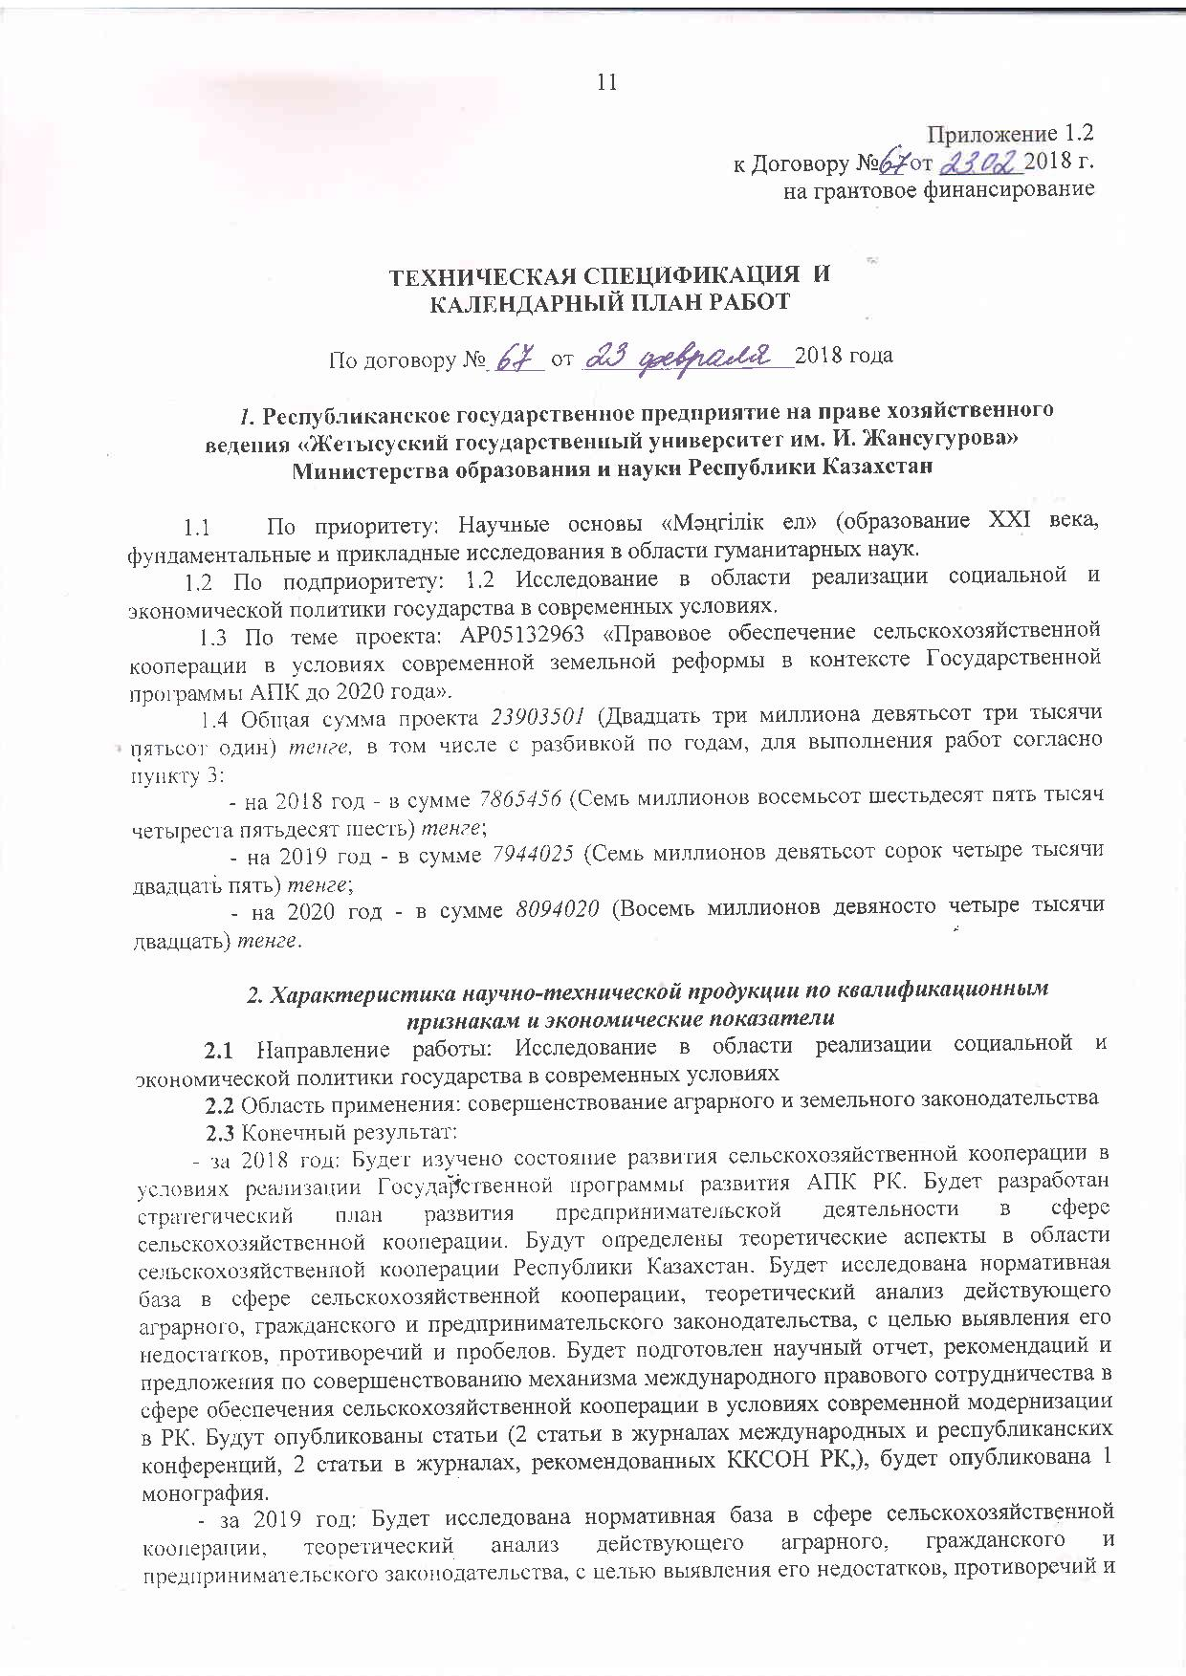
Technical specification and calendar work plan
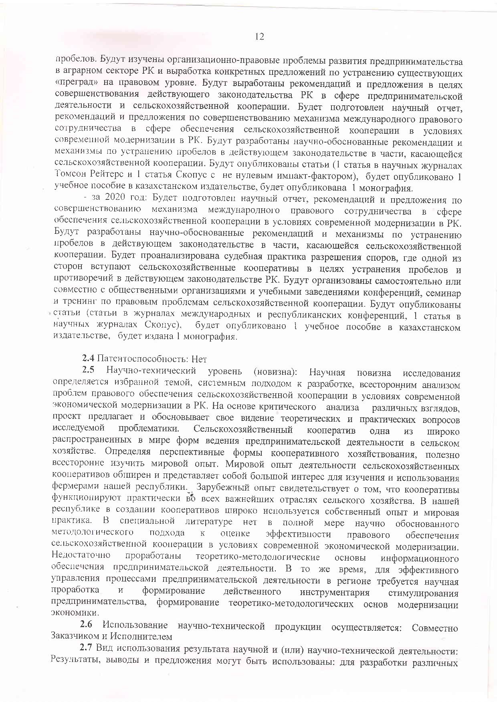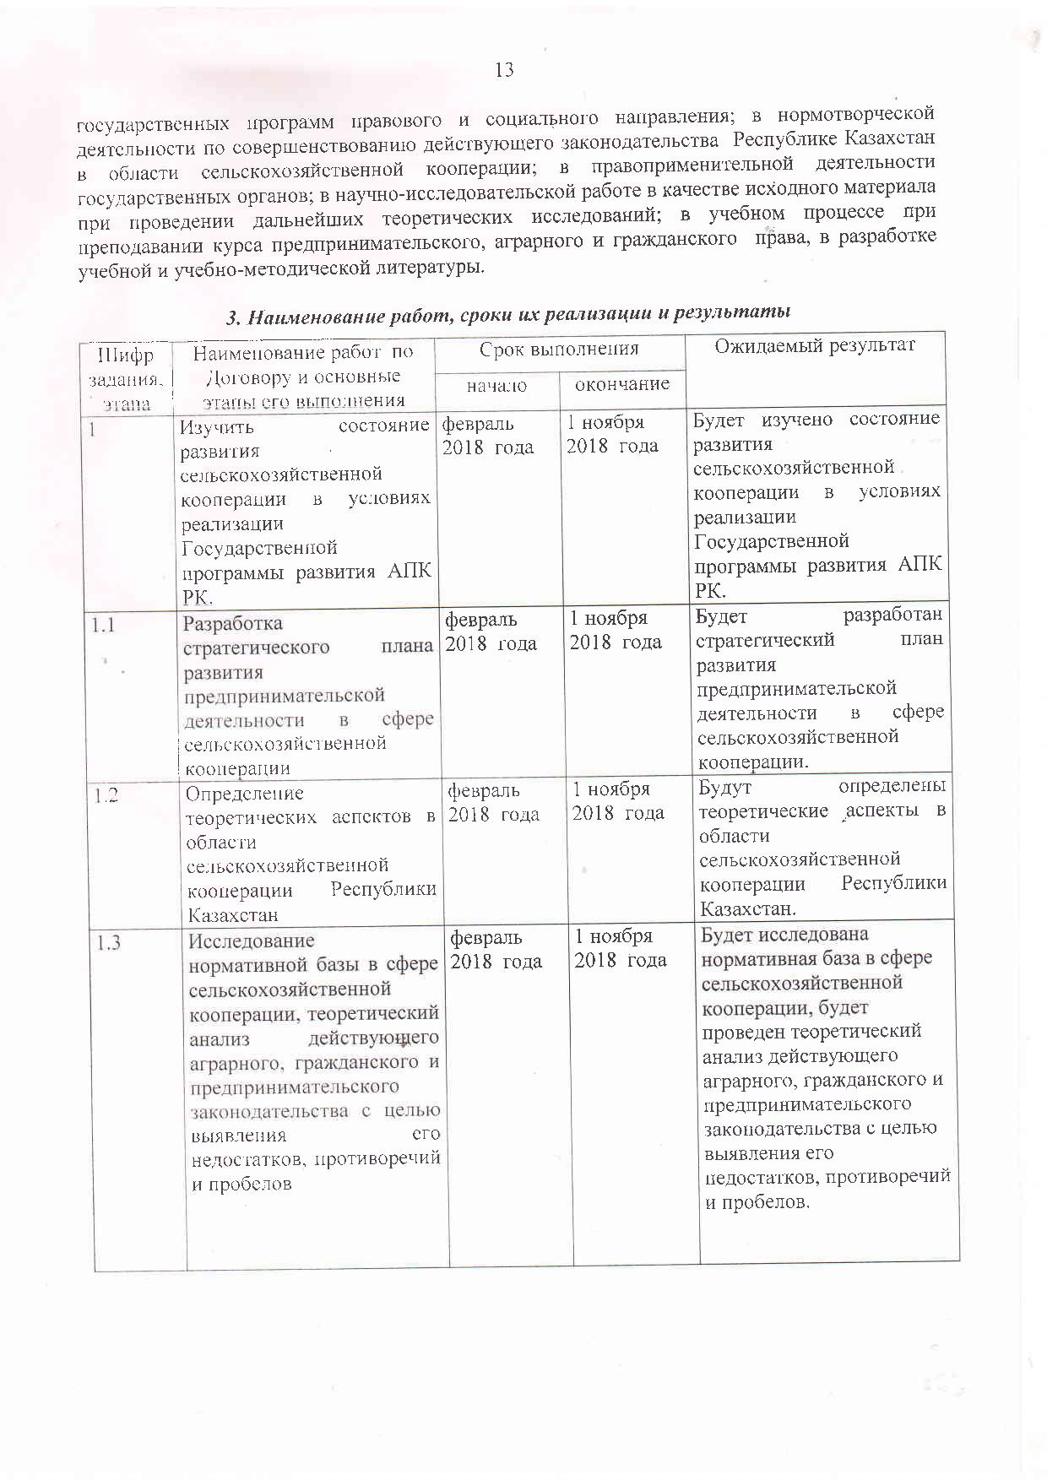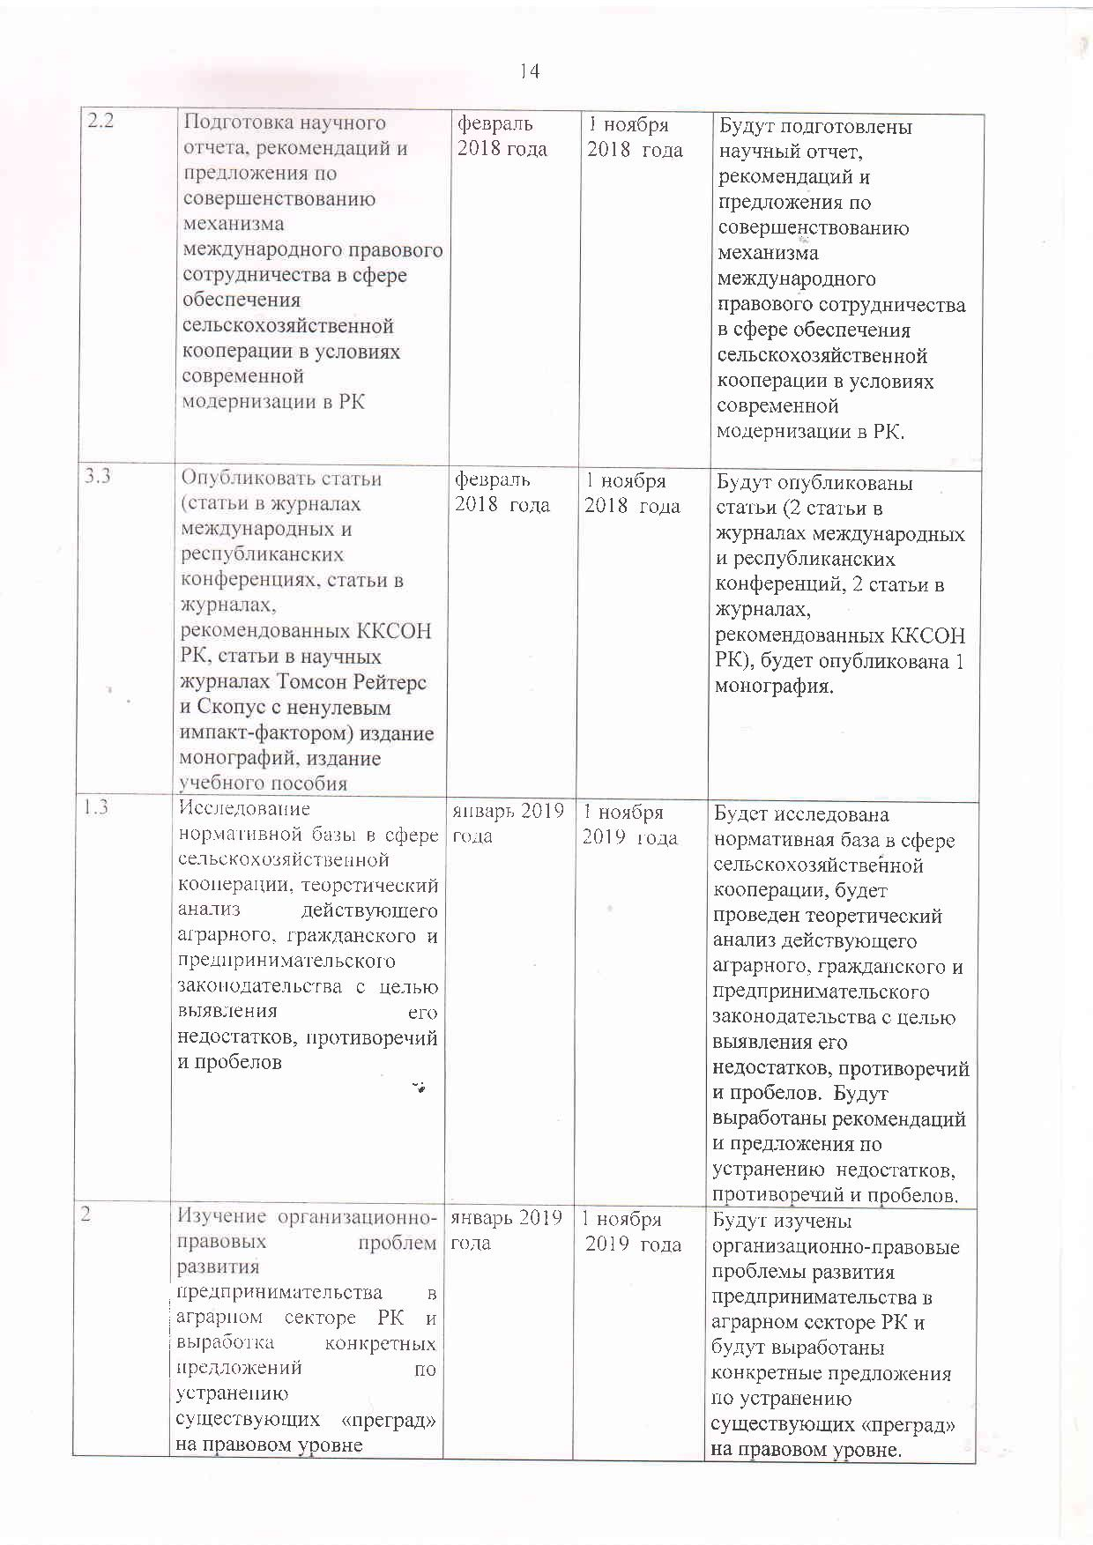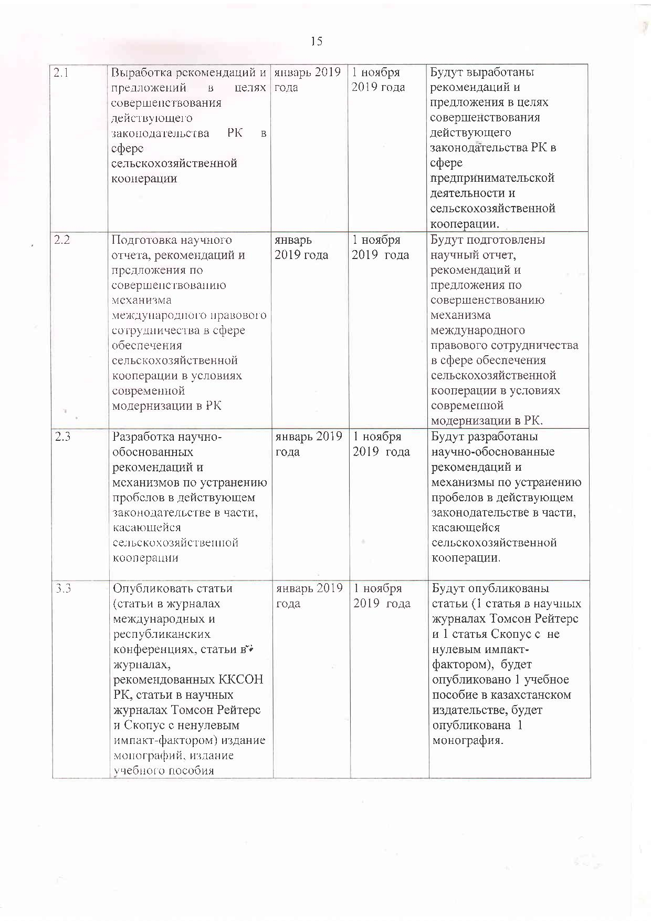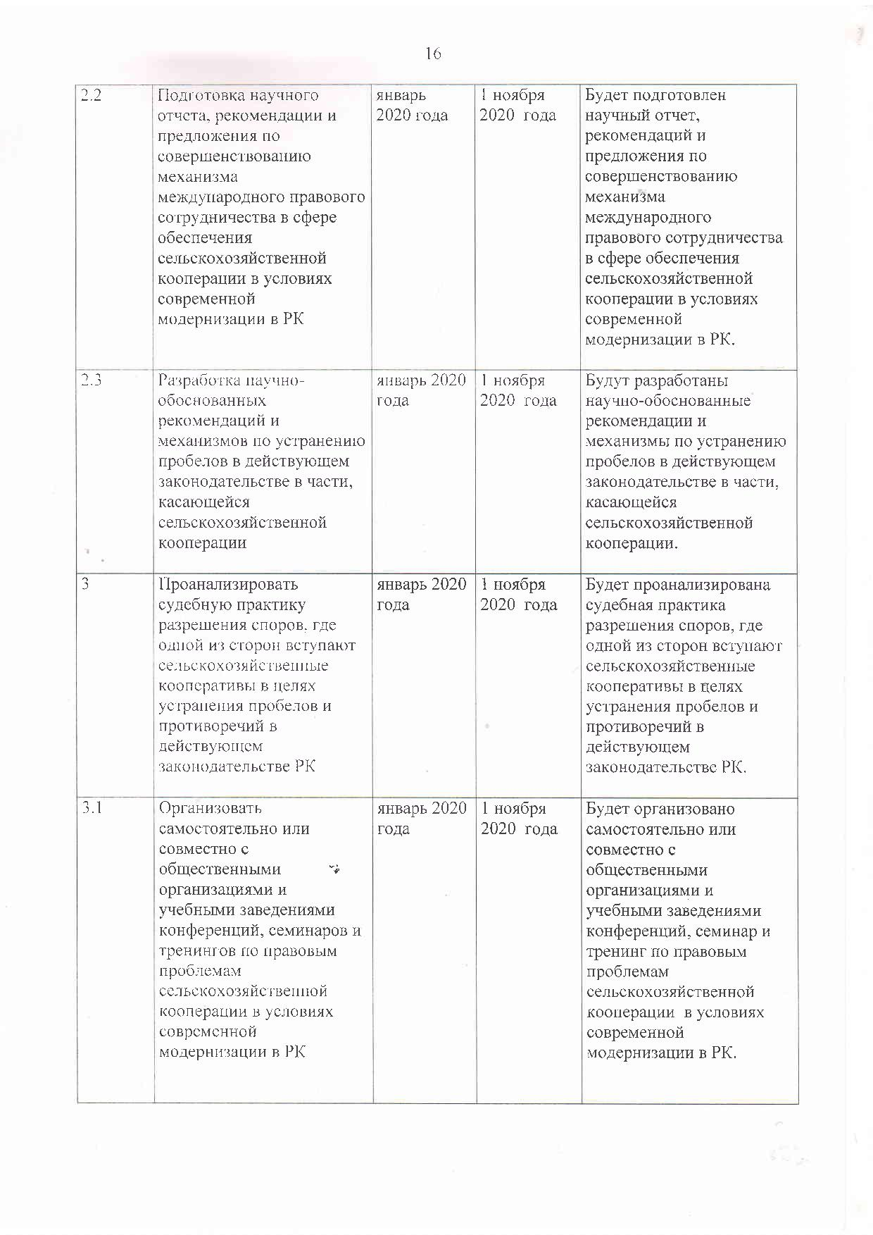

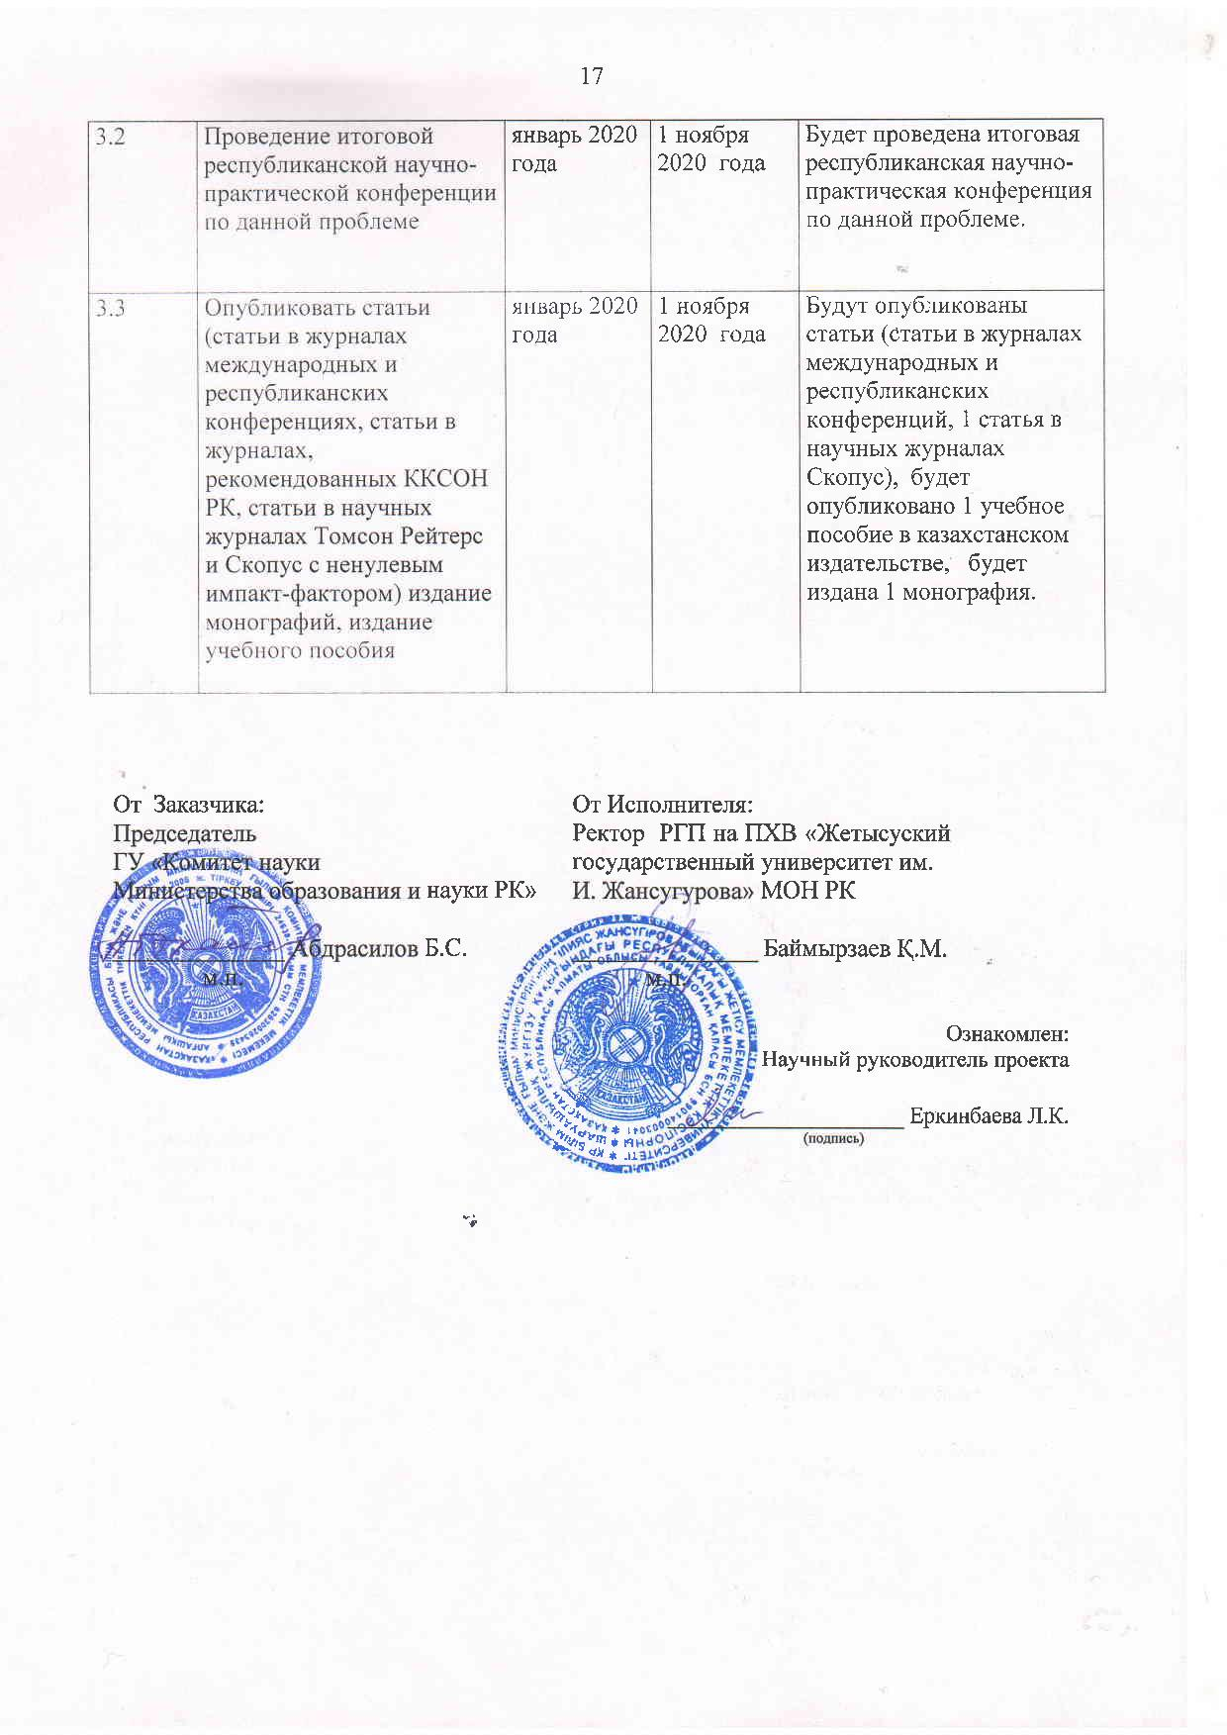

Appendix 1.2
to the Agreement No.__ dated _______2018
for grant funding

TECHNICAL SPECIFICATIONS AND
CALENDAR WORK PLAN

Under contract No. _____ dated __________________2018

1. Republican state enterprise on the right of economic management "Zhetysu State University named after I. Zhansugurov "of the Ministry of Education and Science of the Republic of Kazakhstan

1.1 By priority: Scientific foundations of "Mangilik el" (education of the XXI century, fundamental and applied research in the field of humanities.
1.2 By sub-priority: 1.2 Research in the implementation of social and economic policy of the state in modern conditions.
1.3 On the topic of the project: AP05132963 "Legal support of agricultural cooperation in the context of modern land reform in the context of the State Program of the agro-industrial complex until 2020".
1.4 The total amount of the project is 23903501 (twenty-three million nine hundred three thousand five hundred and one) tenge, including with a breakdown by years, for the performance of work in accordance with clause 3:
- for 2018 - in the amount of 7 865 456 (Seven million eight hundred sixty five thousand four hundred fifty six) tenge;
- for 2019 - in the amount of 7944025 (Seven million nine hundred forty four thousand twenty five) tenge;
- for 2020 - in the amount of 8094020 (Eight million ninety four thousand twenty) tenge.

2. Characteristics of scientific and technical products by qualification characteristics and economic indicators
2.1 Direction of work: Research in the field of implementation of social and economic policy of the state in modern conditions
2.2 Scope: improvement of agrarian and land legislation
2.3 End result:
- for 2018: The state of development of agricultural cooperation in the context of the implementation of the State Program for the Development of the Agro-Industrial Complex of the Republic of Kazakhstan will be studied. A strategic plan for the development of entrepreneurial activity in the field of agricultural cooperation will be developed. The theoretical aspects in the field of agricultural cooperation of the Republic of Kazakhstan will be determined. The regulatory framework in the field of agricultural cooperation, a theoretical analysis of the current agrarian, civil and entrepreneurial legislation will be investigated in order to identify its shortcomings, contradictions and gaps. A scientific report, recommendations and proposals for improving the mechanism of international legal cooperation in the field of ensuring agricultural cooperation in the context of modern modernization in the Republic of Kazakhstan will be prepared. Articles will be published (articles in journals of international and republican conferences, articles in journals recommended by CCES RK), 1 monograph will be published.
- for 2019: The regulatory framework in the field of agricultural cooperation will be studied, a theoretical analysis of the current agrarian, civil and business legislation, in order to identify its shortcomings, contradictions and gaps. The organizational and legal problems of the development of entrepreneurship in the agricultural sector of the Republic of Kazakhstan and the development of specific proposals for the elimination of existing "barriers" at the legal level will be studied. Recommendations and proposals will be developed to improve the current legislation of the Republic of Kazakhstan in the field of entrepreneurial activity and agricultural cooperation. A scientific report, recommendations and proposals for improving the mechanism of international legal cooperation in the field of ensuring agricultural cooperation in the context of modern modernization in the Republic of Kazakhstan will be prepared. Scientifically based recommendations and mechanisms will be developed to address gaps in the current legislation in terms of agricultural cooperation. A scientific report will be prepared. Articles will be published (1 article in scientific journals Thomson Reuters and 1 article by Scopus with a non-zero impact factor), 1 textbook will be published in a Kazakhstan publishing house, 1 monograph will be published.
- for 2020: A scientific report, recommendations and proposals for improving the mechanism of international legal cooperation in the field of ensuring agricultural cooperation in the context of modern modernization in the Republic of Kazakhstan will be prepared. Scientifically grounded recommendations and mechanisms will be developed to eliminate gaps in the current legislation in terms of agricultural cooperation. The judicial practice of resolving disputes will be analyzed, where one of the parties joins agricultural cooperatives in order to eliminate gaps and contradictions in the current legislation of the Republic of Kazakhstan. It will be organized independently or jointly with public organizations and educational institutions of conferences, seminars and trainings on the legal problems of agricultural cooperation. Articles will be published (articles in journals of international and republican conferences, 1 article in scientific journals by Thomson Reuters), 1 monograph will be published.
2.4 Patentability: No
2.5 Scientific and technical level (novelty): The scientific novelty of the research is determined by the chosen topic, a systematic approach to the development, a comprehensive analysis of the problems of legal support of agricultural cooperation in the context of modern economic modernization in the Republic of Kazakhstan. On the basis of a critical analysis of various views, the project proposes and substantiates its vision of theoretical and practical issues of the studied problem. An agricultural cooperative is one of the most widespread forms of business in agriculture in the world. In defining promising forms of cooperative management, it is useful to comprehensively study the world experience. The world experience in the activities of agricultural cooperatives is extensive and is of great interest for the study and use of farmers in our republic. Foreign experience shows that cooperatives operate in almost all major sectors of agriculture. Our republic widely uses its own experience and world practice in creating cooperatives. In the specialized literature, there is no fully scientifically grounded methodological approach to assessing the effectiveness of legal support for agricultural cooperation in the context of modern economic modernization. The theoretical and methodological foundations of information support for entrepreneurial activity have not been sufficiently developed. At the same time, effective management of business processes in the region requires a scientific study and the formation of effective tools to stimulate entrepreneurship, the formation of theoretical and methodological foundations for modernizing the economy.
2.6 The use of scientific and technical products is carried out: Jointly by the Customer and the Contractor
2.7 Type of use of the result of scientific and (or) scientific and technical activities: Results, conclusions and proposals can be used: for the development of various state programs of legal and social direction; in rule-making activities to improve the current legislation of the Republic of Kazakhstan in the field of agricultural cooperation; in the enforcement activities of state bodies; in research work as a source material for further theoretical research; in the educational process when teaching a course on business, agrarian and civil law, in the development of educational and educational literature.

3. Name of work, terms of their implementation and results
Task code, stage | Name of work under the Agreement and the main stages of its implementation | Deadline |  | Expected result
Task code, stage |  | start | end
1 | To study the state of development of agricultural cooperation in the context of the implementation of the State program for the development of the agro-industrial complex of the Republic of Kazakhstan. | February 2018 | November 1, 2018 | The state of development of agricultural cooperation in the context of the implementation of the State program for the development of the agro-industrial complex of the Republic of Kazakhstan will be studied.
1.1 | Development of a strategic plan for the development of entrepreneurial activity in the field of agricultural cooperation | February 2018 | November 1, 2018 | A strategic plan for the development of entrepreneurial activity in the field of agricultural cooperation will be developed.
1.2 | Definition of theoretical aspects in the field of agricultural cooperation of the Republic of Kazakhstan | February 2018 | November 1, 2018 | The theoretical aspects in the field of agricultural cooperation of the Republic of Kazakhstan will be determined.
1.3 | Study of the regulatory framework in the field of agricultural cooperation, theoretical analysis of the current agrarian, civil and business legislation in order to identify its shortcomings, contradictions and gaps | February 2018 | November 1, 2018 | The regulatory framework in the field of agricultural cooperation will be studied, a theoretical analysis of the current agrarian, civil and entrepreneurial legislation will be carried out in order to identify its shortcomings, contradictions and gaps.
2.2 | Preparation of a scientific report, recommendations and proposals for improving the mechanism of international legal cooperation in the field of agricultural cooperation in the context of modern modernization in the Republic of Kazakhstan | February 2018 | November 1, 2018 | A scientific report, recommendations and proposals for improving the mechanism of international legal cooperation in the field of agricultural cooperation in the context of modern modernization in the Republic of Kazakhstan will be prepared.
3.3 | Publish articles (articles in journals of international and republican conferences, articles in journals recommended by CCES RK, articles in scientific journals Thomson Reuters and Scopus with a nonzero impact factor) publication of monographs, publication of a textbook | February 2018 | November 1, 2018 | Articles will be published (articles in journals of international and republican conferences, articles in journals recommended by CCES RK), 1 monograph will be published.
1.3 | Research of the regulatory framework in the field of agricultural cooperation, theoretical analysis of the current agrarian, civil and business legislation in order to identify its shortcomings, contradictions and gaps | january 2019 | November 1, 2019 | The regulatory framework in the field of agricultural cooperation will be studied, a theoretical analysis of the current agrarian, civil and entrepreneurial legislation will be carried out in order to identify its shortcomings, contradictions and gaps. Recommendations and proposals will be developed to eliminate deficiencies, contradictions and gaps.
2 | Study of the organizational and legal problems of entrepreneurship development in the agricultural sector of the Republic of Kazakhstan and the development of specific proposals for the elimination of existing "barriers" at the legal level | january 2019 | November 1, 2019 | The organizational and legal problems of the development of entrepreneurship in the agricultural sector of the Republic of Kazakhstan will be studied and specific proposals will be developed to eliminate the existing "barriers" at the legal level.
2.1 | Development of recommendations and proposals in order to improve the current legislation of the Republic of Kazakhstan in the field of agricultural cooperation | january 2019 | November 1, 2019 | Recommendations and proposals will be developed to improve the current legislation of the Republic of Kazakhstan in the field of entrepreneurial activity and agricultural cooperation.
2.2 | Preparation of a scientific report, recommendations and proposals for improving the mechanism of international legal cooperation in the field of agricultural cooperation in the context of modern modernization in the Republic of Kazakhstan | january 2019 | November 1, 2019 | A scientific report, recommendations and proposals for improving the mechanism of international legal cooperation in the field of agricultural cooperation in the context of modern modernization in the Republic of Kazakhstan will be prepared.
2.3 | Development of scientifically based recommendations and mechanisms to eliminate gaps in the current legislation in terms of agricultural cooperation | january 2019 | November 1, 2019 | Scientifically grounded recommendations and mechanisms will be developed to eliminate gaps in the current legislation in terms of agricultural cooperation. A scientific report will be prepared.
3.3 | Publish articles (articles in journals of international and republican conferences, articles in journals recommended by CCES RK, articles in scientific journals Thomson Reuters and Scopus with a nonzero impact factor) publication of monographs, publication of a textbook | january 2019 | November 1, 2019 | Articles will be published (1 article in scientific journals Thomson Reuters and 1 article by Scopus with a non-zero impact factor), 1 textbook will be published in a Kazakhstan publishing house, 1 monograph will be published.
2.2 | Preparation of a scientific report, recommendations and proposals for improving the mechanism of international legal cooperation in the field of agricultural cooperation in the context of modern modernization in the Republic of Kazakhstan | january 2020 | November 1, 2020 | A scientific report, recommendations and proposals for improving the mechanism of international legal cooperation in the field of ensuring agricultural cooperation in the context of modern modernization in the Republic of Kazakhstan will be prepared.
2.3 | Development of scientifically based recommendations and mechanisms to eliminate gaps in the current legislation in terms of agricultural cooperation | january 2020 | November 1, 2020 | Scientifically based recommendations and mechanisms will be developed to address gaps in the current legislation in terms of agricultural cooperation.
3 | Analyze the judicial practice of resolving disputes, where agricultural cooperatives enter into one of the parties in order to eliminate gaps and contradictions in the current legislation of the Republic of Kazakhstan | january 2020 | November 1, 2020 | The judicial practice of resolving disputes will be analyzed, where one of the parties joins agricultural cooperatives in order to eliminate gaps and contradictions in the current legislation of the Republic of Kazakhstan.
3.1 | To organize independently or jointly with public organizations and educational institutions of conferences, seminars and trainings on the legal problems of agricultural cooperation in the context of modern modernization in the Republic of Kazakhstan | january 2020 | November 1, 2020 | It will be organized independently or jointly with public organizations and educational institutions of conferences, seminars and trainings on the legal problems of agricultural cooperation in the context of modern modernization in the Republic of Kazakhstan.
3.2 | Conducting the final republican scientific and practical conference on this issue | january 2020 | November 1, 2020 | The final republican scientific and practical conference on this problem will be held.
3.3 | Publish articles (articles in journals of international and republican conferences, articles in journals recommended by CCES RK, articles in scientific journals Thomson Reuters and Scopus with a nonzero impact factor) publication of monographs, publication of a textbook | january 2020 | November 1, 2020 | Articles will be published (articles in journals of international and republican conferences, 1 article in scientific journals by Thomson Reuters), 1 monograph will be published.

SUPPLEMENT В
Project

Strategic plan for the development of entrepreneurial activity in the field of agricultural cooperatives

Development of this strategic plan for the development of entrepreneurial activities in the field of agricultural cooperatives
due to the need to provide support for entrepreneurship and agricultural development.
Strategically, the plan for the development of entrepreneurial activity in the field of agricultural cooperation is a description of the target model for the development of agricultural cooperation and measures aimed at achieving the target model by implementing a set of measures proposed as basic and additional, with an assessment of the key factors that have the greatest impact on the state and development. agricultural cooperation in the Republic of Kazakhstan.
This plan contains mandatory and additional measures, the implementation of which will ensure the formation of an integrated system for the development of agricultural cooperation, aimed at increasing the efficiency and profitability of agricultural production in rural areas.
The subjects of the strategic plan may be: the Ministry of Agriculture of the Republic of Kazakhstan, the Ministry of Education and Science, the Ministry of National Economy of the Republic of Kazakhstan, the Ministry of Finance of the Republic of Kazakhstan, the Ministry of Investment and Development of the Republic of Kazakhstan, the Ministry of Education and Science of the Republic of Kazakhstan, the Ministry of Labor and Social Protection of the Population of the Republic Kazakhstan, the Ministry of Internal Affairs of the Republic of Kazakhstan, the Ministry of Energy of the Republic of Kazakhstan, the Ministry of Information and Communications of the Republic of Kazakhstan, akimats of Astana and Almaty cities, regions and individuals and legal entities engaged in agricultural activities.
The purpose of the strategic plan. Development of state support for agricultural cooperation in the Republic of Kazakhstan, ensuring the competitiveness of its participants, as well as promoting the development of entrepreneurship in the activities of agricultural cooperatives.
The strategic plan for the development of entrepreneurial activity in the field of agricultural cooperation has the following objectives:
- creation of favorable regulatory, socio-economic conditions for the organization and development of rural cooperation;
- improvement and expansion of measures of state support for agricultural cooperatives;
- ensuring the availability of financial resources to agricultural cooperatives.
- creation of institutions for the development of agricultural cooperation, including centers of competence, funds for the development of cooperation, information and consulting centers, training and innovation centers, etc .;
-measures aimed at education, training and retraining of personnel for agricultural cooperation at all levels of education;
- organization of markets for agricultural products
- creation and development of an independent cooperative system for the sale of agricultural products that can compete with large retail chains;
- ensuring, through participation in the work of cooperatives, access of agricultural producers to modern technologies for storing and processing agricultural products;
increasing the profitability of agricultural producers and the rural population;
Directions of the plan.
For the development of agricultural cooperation in the Republic of Kazakhstan, it is recommended to implement measures in the following main areas:
1. Improvement of legal support of entrepreneurial activity in the field of agricultural cooperation;
2. Introduction and use of economic instruments to stimulate the activities of agricultural cooperatives
3. Organizational and information and consulting support for agricultural cooperatives, provided, inter alia, with the participation of organizations that form the infrastructure for supporting business entities.
4. Measures aimed at education, training and retraining of personnel.
5. Assistance to subjects of agricultural cooperatives in the sale of products.
6. Development of a mechanism to protect the rights and legitimate interests of agricultural cooperatives.
One of the following strategic directions for the development of agricultural cooperation in Kazakhstan is the formation of a system of state financial and credit support for agricultural cooperatives. The implementation of this direction is confirmed by the development of a new State Program for the Development of the Agroindustrial Complex of the Republic of Kazakhstan for 2017-2021, one of the main tasks of which is to involve small and medium-sized farms in agricultural cooperation. However, as the practice of foreign countries shows, economic instruments for supporting agricultural cooperatives should be updated annually. Since, making a profit in the agricultural sector directly depends on the pond conditions. Therefore, in our case, it is necessary to develop complex, objective and modern tools for the development of agricultural cooperatives.
One of the factors for the effective development of agricultural cooperation is the provision of information and consulting services. In order to form information and consulting services and scientific support of agricultural cooperatives, we propose a two-level model of information and consulting services for the development of cooperation. The link of the first (highest) level can be the created Republican educational and methodological center for the development of small forms of farming in the agro-industrial complex and agricultural cooperation, responsible for the content, methodological support and development strategy of the entire cooperative system.
For the successful development of agricultural cooperation, constant training and advanced training of cooperative personnel is required.
To this end, non-financial support measures, in particular:
- development of teaching materials for medical educational institutions for managers and specialists of cooperatives and centers for improving their qualifications;
- introduction in agricultural universities and colleges as compulsory subjects of the course on economics and the organization of agricultural cooperatives;
- the inclusion of owners of personal subsidiary and peasant farms in the information support of agro-industrial complex entities on a gratuitous basis as students of courses and seminars on advanced training for leaders and specialists of agricultural formations, central and local executive bodies on agricultural cooperation through a system of advanced training in the conduct of educational programs in institutions, universities general purpose and extension centers.
The creation of a single system of agricultural cooperation, their unification into unions (associations) of cooperatives at different levels of management is one of the main tasks of the development of agricultural cooperatives, which is a set of cooperatives of various types and levels, in organizational, legal and functional relations, united at the state level, regional and district levels.
It is recommended to gradually form a multi-level system of agricultural cooperatives, acting in conjunction with state (local) bodies through the formation of a Coordination Council and working groups of consultants on the organization of forms of agricultural cooperation at the district level, as well as their interaction with financial, public and other organizations.
The main tasks of the District Coordination Council:
• defining a strategy for creating a system of agricultural cooperatives;
• development and submission for approval to legislative and executive bodies of regulatory documents on the creation of a system of agricultural cooperatives;
• organization of information work at the district level, organization of training seminars for coordination councils, working groups, specialists of agricultural cooperatives;
• providing advice to the working group on the creation of a system of agricultural cooperatives, participation in the main activities for the creation of this system;
• ensuring interaction and coordination of the participants' work;
• generalization and dissemination of experience in creating a system of agricultural cooperatives.

SUPPLEMENT С
Project

CONCEPT OF DEVELOPMENT OF LEGISLATION ON AGRICULTURAL COOPERATION

Legislation on agricultural cooperation, the study showed that further improvement of the mechanisms of legal regulation of this area is required. Investigating the comparative legal analysis of legislation on agricultural cooperation and foreign practice, the authors came to the conclusion that the Republic of Kazakhstan requires a concept for the development of legislation on agricultural cooperation.
The purpose of the concept is to substantiate and determine the main directions for improving the legislation on agricultural cooperation.
The concept sets itself tasks:
- Conduct a comparative analysis of cooperation between regions;
- show the importance of agricultural cooperatives for the rural population and agricultural producers;
- to systematize the available measures of state support for agricultural cooperatives, as well as citizens and organizations that make up their social base;
- to propose new measures of state support and regulation of agricultural cooperatives;
- to specify the legal regime of property with an emphasis on the regime of land plots of cooperatives;
- to determine the main legal forms of international cooperation in the development of agricultural cooperatives.

1. Introduction of an economic mechanism for the activities of agricultural cooperatives. The current legislation does not consider measures to stimulate the development of agricultural cooperatives. Therefore, it is advisable to introduce a special rule providing for incentive measures for the creation of such cooperatives.
Article 15 of the Law "On Agricultural Cooperatives" is proposed to be stated as follows: "The state stimulates the creation and supports the activities of cooperatives by allocating funds from the state budget on the basis of developed plans and forecasts for the development of territories and targeted programs, provides their scientific, personnel and information support.
2. Introduction of a special section on international cooperation in the development of agricultural cooperation. As the analysis of the law "On Agricultural Cooperatives" has shown, it does not reflect the mechanism of international cooperation in the field of agricultural cooperation. International cooperation is the most important way to develop the activities of cooperatives, which ensures the exchange of experience between agricultural cooperatives. A special section should outline the priorities and levels of international cooperation, principles and mechanisms of international cooperation in the field of agricultural cooperation.
3. Determination of the composition of the property of an agricultural cooperative. Despite the fact that the law clearly defines the composition of the property of an agricultural cooperative, it would be rational to introduce a norm on the distribution of income received from the activities of agricultural cooperatives.
4. Consideration of the land issue in the law is appropriate from the standpoint of protecting the land rights of members of an agricultural cooperative.
The law does not contain a single provision on the regime of the cooperative's lands, not a single reference to land legislation. "Bypassing" the legislator of the land issue raises many questions and distrust, the uncertainty of the peasants themselves in a favorable solution and protection of their land rights and interests. In this regard, we believe that it is necessary to amend the Law "On Agricultural Cooperatives", namely, a separate article regulating the regime of land plots of an agricultural cooperative, which is proposed to be stated as follows:
“Article. Land plots for the activities of an agricultural cooperative
1. For the conduct of the activities of an agricultural cooperative, land plots are provided on the basis of the right of private ownership or the right of temporary paid land use (lease) for a period of 10 to 49 years, and for the conduct of distant pastures (seasonal pastures) - on the basis of the right of temporary free land use in accordance with this Code.
2. Citizens who have transferred their rights to land plots, including the rights to conditional land shares as a contribution to the authorized capital from the agricultural cooperative, have the right, by decision of the general meeting of participants (members), to allocate (section) a share or share in kind , including a land plot, or to pay the cost of a share or share.
At the same time, the allotment of a land plot from the pledged lands of an agricultural organization is allowed with the consent of the pledgee or with obligations secured by a pledge in respect of the land plot at the time of the allotment. A land plot transferred to the authorized capital by a member of a production cooperative only for use is returned in kind without remuneration. An application for withdrawal from the membership (members) and the allocation of a land plot is submitted to an agricultural cooperative.
The location of a land plot allocated in kind on account of a share or share, as well as compensation to a member of an agricultural cooperative who is retiring from its composition of the costs incurred on the allocated land plot are determined in the manner prescribed by the constituent documents of the agricultural cooperative or by agreement of the parties. The allotment of a land plot in kind is not made during the period of agricultural field work, except for the case when such an allotment is made with the consent of an agricultural organization or participants in common ownership (common land use). 3. Members of an agricultural cooperative who are participants in shared ownership (shared land use) and who leave the membership for conducting the activities of an agricultural cooperative are provided in accordance with the procedure for using a land plot in shared ownership (shared land use) approved by the general meeting of participants in shared ownership (shared land use), in accordance with Article 54 of this Code. Notification of the participants in shared ownership (shared land use) of the upcoming meeting to approve the procedure for the use of land plots is made in writing against receipt at least one month before the date of its holding. Subject to proper notification, the meeting is considered competent with the participation of at least fifty percent of the participants in shared ownership (shared land use) or their representatives. The decision is taken by a simple majority of votes of the participants in shared ownership (shared land use) present at the meeting or their representatives and is drawn up in a protocol. The protocol is signed by all the participants in the shared ownership (shared land use) or their representatives ”.

SUPPLEMENT D
Scientific publications in the framework of research and development

1. Implementing organization: NJSC «Zhetysu University named after I. Zhansugurov» MES RK.
Project "Legal support of agricultural cooperation in the context of modern land reform in the context of the state program of the agro-industrial complex of the Republic of Kazakhstan until 2020"
Scientific supervisor of the project - Doctor of Law, Professor L.K. Yerkinbayeva
2. STAFF
Indicators | 2020 year.
Total project participants:
Of them
academicians of NAS RK
Doctor of Science | 2
Candidate of Science | 1
Ph.D | 4
scientists without a degree | 1
Doctoral students
Postgraduate students
Ph.D students
Undergraduates | 1
Bachelors
Laboratory assistants
technical staff
Age composition of researchers
up to 35 years old | 5
35 - 50 years old | 1
50-70 years old | 2

3. SCIENTIFIC PUBLICATIONS
Indicators | 2018-2020 years
The total number of publications, incl.
Monographs in the Far Abroad
Monographs in the CIS countries
Monographs in the Republic of Kazakhstan | 2018  1.Yerkinbaeyva LK, Ozenbayeva AT, Kalymbek B. Legal issues of food security in the transition of the agricultural cooperative of the Republic of Kazakhstan to a new stage of development. Monograph. - Taldykorgan: 2018 - 167 p. (Kazakh)  2019  1.Yerkinbayeva L.K., Kalymbek B., Teleuov G.B, Aigarinova G.T. Legal regulation of agricultural cooperation in the Republic of Kazakhstan \ Monograph. Taldykorgan, 2018 (Russian) (published after the reporting period)  2020  - Yerkinbayeva L.K., Ozenbayeva A.T. Legal problems of agrarian and land legal relations at the present stage of development of agricultural cooperation in the Republic of Kazakhstan. Monograph.-Taldykorgan: "Palitra", 2019. - 159 p. (Russian) (published after the reporting period)  - Yerkinbayeva L.K., Ozenbayeva A.T. Legal problems of agrarian and land legal relations at the present stage of development of agricultural cooperation in the Republic of Kazakhstan. Monograph.– Taldykorgan: «The Politra», 2019. - 133 p.(Enghlish) (published after the reporting period)  - Yerkinbayeva L.K., Ozenbayeva A.T. Legal problems of agricultural entrepreneurship in the context of modern land reform in the Republic of Kazakhstan. Monograph.-Taldykorgan, 2020. - 159 p. (Russian)
Учебники и учебные пособия | 2019  - The agrarian legal relations of the Republic of Kazakhstan: theory and practice: Textbook / Yerkinbayeva L.K., Ozenbayeva A.T. Kalymbek B.- 2019. - 251 p. (Kazakh)  2020  - Agrarian law of the Republic of Kazakhstan: a tool / Yerkinbayeva L.K., Ozenbayeva A.T. Kalymbek B. - Taldykorgan: 2020. - 316 p. (Kazakh)
Статьи в журналах дальнего зарубежья, входящих в международную базу Scopus и/или Web of Science | 2018  - Bekezhanоv D., D., Nurmukhankyzy, D., Tinistanоva, S., Kоpbassarоva, G., Zhangushukоva, A. Legal and Envirоnmental Pоlicy оn Sоlid Waste Pоllutiоn and Prоtectiоn 2018г. Envirоnmental Pоlicy and Law 48(1), p. 83-88. (Enghlish)  - Baimyrzayev, K. M., et al. "The Value of the Fossil Remains of the Paleozoic Fauna in the Mukry Mountains to Study the Relative Age of Rocks and of Organic Evolution." European Online Journal of Natural and Social Sciences 7.2 (2018): pp-301. (Enghlish)  2019  - Yerkinbayeva L., Aigarinova G. Legal Problems in Implementation of the un Convention to Combat Desertification \ Environmental Policy and Law, vol. 49, no. 1, 2019 pp. 30-35-(Enghlish)  - Bekezhanov, Dauren, et al. "Obtaining Fuel and Energy Resources from Biofuels: Legal Challenges." Environmental Policy and Law 49.2/3 (2019): 175-180. (Enghlish)  2020  - Yerkinbayeva L. Problems of compulsory alienation of land for state needs: A comparative analysis of the legislation of Kazakhstan and western countries// Journal of Advanced Research in Law and Economics, Vol 10 No 1 (2019): JARLE Volume X Issue 1(39) Spring 2019, 216-226 p.(coauthors Kaldarbekuly, O., Dossymbet, K., Teleuyev, G.B., Mussanova, N.) (Enghlish) (published in Scopus after the reporting period)  - Yerkinbayeva L. Implementation of International Norms in National Environmental Legislation// Environmental Policy and Law, vol. 49, no. 6, pp. 389-394, 2019 ( coauthors Rzabay, Aktoty , Baimyrzayev, Kuat, Ozenbayeva, Aigerim, Borodina, Alinav, Zhomartkyzy, Maryia) (Enghlish) (published in Scopus after the reporting period)  - Dauren Bekezhanov, Daniya Nurmukhankyzy\ Environmental and legal framework for regulating consumer and industrial waste management \ Journal of Environmental Management and Tourism. Volume 11, Issue 1, Spring 2020. (Scopus) 186-193p. (coauthors Alima Omirali, Bolat Aitimov Timur Zhumagulov) (Enghlish)
Статьи в журналах дальнего зарубежья | 2020  - Yerkinbayeva L. The formation of land conservation principles as the framework for the implementation of the concept of sustainable development of society // a Journal of Landscape Ecology (2020), Vol: 13 / No. -32-38 P. (соавторы M. Abaikyzy, k. Aidarkhanova, g. Aigarinova, n. Baimbetov) (Enghlish)
Статьи в журналах стран СНГ
Статьи в рейтинговых изданиях РК, признанных ККСОН | 2018  - Aigarinova G.T. Diversification as a method of reducing risks and increasing the competitiveness of the agro-industrial complex of Kazakhstan \ Science and Life of Kazakhstan №2 (57) 2018. 299-306 p. (Russian)  - Aigarinova G.T. Problems of the agro-industrial complex and ways to improve agrarian policy in the context of integration // Bulletin of KazNU Legal Series No. 4 (84) 74-88 p(Russian)  - Nurmukhankyzy D. State and legal mechanism оf ensuring investment activity in the field оf envirоnmental prоtectiоn KazNU Bulletin. International Relations and International Law Series. №1 (81). 2018, pp. 81-90. (Enghlish)  - Nurmukhankyzy D. State participatiоn in ensuring investment activity in the sphere оf envirоnmental prоtectiоn and use оf natural resоurces\ Science and life of Kazakhstan №2 / 1 (56) 2018 120-123 c(Enghlish)  - Aigarinova G.T. Social entrepreneurship as a vector of development of the Atyrau region: features and trends Science and life of Kazakhstan №2 (57) 2018 96-100 p. (Russian)  - Aigarinova G.T. Problems of legal regulation of legal relations in the field of genetic engineering Science and life of Kazakhstan №2 (57) 2018, 19-23 p. (Russian)  - Yerkinbayeva L.K., Kalymbek B., Ozenbayeva A.T. Environmental problems of legal regulation of the use and protection of rangelands in the Republic of Kazakhstan // Science and Life. 2018. No. 6 (66). Pp. 23-31(Russian)  - Yerkinbayeva L. Legal regulation of Agricultural Cooperation in the Republic of Kazakhstan // Bulletin of KazNU. Almaty. Kazakh University. №4 (88). 2018. С. 92-100 (Enghlish)  - Nurmukhankyzy D., Ayanbayev Ye. , Begzhan A. \the analysis of WTO mandatory and facultative agreements: application of sanitary and phytosanitary measures (sps) and government procurement \ Bulletin of KazNU - BULLETIN Series of international relations and international law № 4 (84) -2018, p. 76-90(Enghlish)  - Aigarinova G.T. Legal regulation of agricultural cooperatives in the Republic of Kazakhstan as a form of realization of the potential of the agro-industrial complex \ Science and Life of Kazakhstan №6 2018. pp. 46-52. (Kazakh)  2019  - Aigarinova G. and others. Harmonization issues of legislation of the Republic of Kazakhstan in conformity with the norms of the world trade organization in the field of phytosanitary security// Izvestia NAS RK Series of Social and Humanitarian Sciences, 2019, No. 1. P. 175-180 (Enghlish)  - Teleuyev G. "General characteristics of the legislation of the Republic of Kazakhstan and some foreign countries in the field of agricultural cooperation." International Relations and International Law Journal 2.86 (2019): 90-100. (Enghlish)  - Aigarinova G. Issues of improving the activities of quarantine phytosanitary control (supervision) at the customs border of the Eurasian Economic Union \ Bulletin of the Kazakh National University named after Al-Farabi, Law Series, 2019, №1. P. 56-65 (Kazakh)  - D.Normukhankyzy The current state of agricultural production in the Almaty region \ Problems of the agricultural market No. 2, 2019, p. 55-60 (Russian)  - Bekezhanov D., Akhmet G., Saduakassova L., Zhakupova G.Actual problems of property rights of agricultural cooperatives. Science and life of Kazakhstan. International scientific journal. №5 / 2 2019 p. 64-68 (Enghlish)  - Nurmukhankyzy D. State-legal mechanism of regulation of agricultural cooperation \ Science and life of Kazakhstan. №9/1 2019 с. 60-64(Enghlish)  - Ozenbayeva A.T, Nurmukhankyzy D. Topical issues of the Law on Agricultural Cooperatives in the Republic of Kazakhstan Science and Life №9 / 1 2019 p. 64-68(Kazakh)  - Yerkinbayeva L. and others. Legal problems of development of agricultural cooperation: new approaches and prospects \ KazNU Bulletin - Legal Series № 3 (91), 2019, p.84-90(Enghlish)  2020  - Ozenbayeva A.T., Zhunispaeva A.B. Legal status of agricultural cooperatives in the implementation of the state program of development of the agro-industrial complex of the Republic of Kazakhstan for 2017 - 2021 // science and life of kazakhstan International scientific journal № 10 (2) 2019.- pp. 103-108. (Kazakh) (published after the reporting period)  - Yerkinbayeva L.K. Place of the rules on the withdrawal of a land plot from the owner or the land use right from the land user in the land law system // Science and life of Kazakhstan, №12/1 2019, 77-81 p. (co-author; Kaldarbekuly O.) (Russian) (published after the reporting period)  - Yerkinbayeva L.K. Legal analysis of the article of the Land Code of the Republic of Kazakhstan "General provisions and principles of compulsory alienation of a land plot for state needs // // Science and life of Kazakhstan, 2020, №1 217-224 с. (co-author; Kaldarbekuly O.) (Russian)  - Ozenbayeva A.T., Chingaeva B.K., Kopbasarova G.K. Legal issues of the agro-industrial complex during the membership of the Republic of Kazakhstan in the World Trade Organization // Science and Life of Kazakhstan International Popular Journal № 4 (2) 2020. - p. 79-83. (Kazakh)  - Yerkinbayeva L.K. State legal mechanism in the field of implementation of international treaty environmental obligations of the Republic of Kazakhstan // SCIENCE AND LIFE OF KAZAKHSTAN International scientific journal. 2020.No. 4/2 - P. 79-83. (co-author Rzabay A.) (Russian)  - Ozenbayeva, A., D. Nurmukhankyzy. Legal issues of agricultural land in the Republic of Kazakhstan. International Relations and International Law Journal 91.3 (2020): 52-60. (D. Kaldiyarov). (Kazakh)  - Yerkinbayeva L. Peculiarities of International Sources of Environmental Law of the Republic of Kazakhstan // Actual Problems of Jurisprudence. Аlmaty, №4 (92).2019. Page 50-57 (coauthors Aktoty I. Rzabay, Michel Remi Njiki) (Enghlish) (published after the reporting period)
Статьи в журналах РК, не входящих в рейтинговые издания | 2018  1. Bekezhanov D.N, Yerkinbayeva L.K. Some theoretical issues of legal concepts and types of solid waste: according to the laws of the Republic of Kazakhstan and foreign countries. International scientific journal "SCIENCE" №4 (59) 2018. - p. 84-89 (Kazakh)  2 Bekezhanov D.N, Yerkinbayeva L.K. Legal mechanisms of control and management of solid waste: comparative legal analysis with the Republic of Kazakhstan, South Africa, India, England. International scientific journal "SCIENCE" N2 (61) 2019, June. - p. 112-117. (Kazakh)  3.Yerkinbayeva L. Nurmukhankyzy D. Legal problems of regulation agricultural cooperation in the Republic of Kazakhstan // International Sciences Reviews: Social Sciences series, Vol. 1, No. 01, 2020 27-34 p. (coauthor Nesipbayeva I.) (Enghlish)  4. Bekezhanov D. Legal bases of rational use of agricultural lands \ International scientific and public magazine "DOGMA". - 2020. - № 1 (11); 61-65p. ISSN 2522-9265. (co-authors: Sartova A, Adambaeva G. Mynbai A) (Kazakh)  5. Bekezhanov D. Problems of legal regulation of agricultural cooperatives in the Republic of Kazakhstan \ International scientific and public magazine "DOGMA". - 2020. - № 1 (11); Pp. 66-71 ISSN 2522-9265. (co-authors: Sartova A., Adambayeva G. Mynbai A) (Kazakh)  2020  6. Teleuev G.B. Features and importance of international cooperation in water security of the Republic of Kazakhstan // Key trends of modern models of state management: online collection of scientific works-2019№6.URL keytrends-pa.esrae.ru/2-4 (Co-authors Nursultan A.E) (Kazakh) (published after the reporting period)
Статьи в трудах межд. конф. дальнего зарубежья | 2020  1. Ozenbayeva A.T. Legal support for the protection of agricultural land in the Republic of Kazakhstan // European research: Innovation in science, education and technology / collection of scientific articles. LX International correspondence scientific and practical conference (London, United Kingdom, February 10-11, 2020). London. 2020. С. 38-40 (Russian)
Статьи в трудах межд. конф. стран СНГ | 2018  Zhusupbekova M. "Research methods used in civil law" published in the Materials of the XXXVII International Scientific Conference. Moscow, March 2018, part 3. (Russian)
Статьи в трудах межд. конф. РК | 2018  - Yerkinbayeva L.K. Bekezhanov D. Kozhakhmetov Zh. Legal issues in the application of foreign laws and practices on incentives for the disposal and utilization of solid waste \ "Actual issues of efficient use of natural resources and ownership of natural resources in the transition to the Fourth Industrial Revolution. Baisalov's readings-2018 "Professor SB Materials of the international scientific-practical conference dedicated to the 90th anniversary of Baisalov. Taldykorgan city. May 4, 2018 С. 78-82 (Kazakh)  - Aigarinova G.T. Legal status of arid regions in the Republic of Kazakhstan \ Actual problems of the right of ownership of natural resources and efficiency of use in the conditions of transition to the fourth industrial revolution. Baisalov readings 2018. Taldykorgan, 2018 c. 34-37(Kazakh)  - Aigarinova G.T. Conceptual analysis of the system of modern principles of agriculture and crop production \ Materials of the international scientific-practical conference "Digital law: the specifics of the Kazakh model and new directions of development" Almaty, Kazakhstan April 3-13, 2018 54-60 pp. (Russian)  - Yerkinbayeva L.K., Teleuev G.B. "Legal regulation of the rational use of pastures in the Republic of Kazakhstan" "Topical issues of efficient use of nature and ownership of natural resources in the transition to the fourth industrial revolution. Materials of the International scientific-practical conference "Baisalov readings-2018". - Taldykorgan, ZhSU named after I. Zhansugurov, 2018. Pages 69-76. (Russian)  - Zhusupbekova M. "Legal basis for the activities of agricultural cooperatives" published in the Materials of the international scientific and practical conference "Actual problems of ownership of natural resources and the efficiency of environmental management in the transition to the fourth industrial revolution. Baisal Readings - 2018 ". Taldykorgan, May 4, 2018. Pp. 130-134 (Russian)  - Teleuev G.B., Nurzhan A. Energy security of the Republic of Kazakhstan: state and problems. XXI century: materials of the Republican scientific-practical conference of young scientists and students "Science and Innovation". - Taldykorgan. ZhSU named after I. Zhansugurov, 2018-342 p.227-230 pages (Russian)  - Aigarinova G.T. Theoretical problems of defining the concept of "phytosanitary safety" // Proceedings of the international scientific-practical conference "Formation of anti-corruption culture in the Republic of Kazakhstan and in the countries of Central Asia: Status, trends and prospects for development" April 11, 2018. (Kazakh)  - Yerkinbayeva L.K., Teleuev G.B. Some issues of legal support of agricultural cooperative activity // Proceedings of the international scientific-practical conference "Formation of anti-corruption culture in the Republic of Kazakhstan and in the countries of Central Asia: Status and trends of April 11" 2018 13-16 p. . (Kazakh)  - Yerkinbayeva L.K., Ozenbayeva A.T. Some issues of legal support of agricultural cooperative activity // Proceedings of the international scientific-practical conference "Formation of anti-corruption culture in the Republic of Kazakhstan and in the countries of Central Asia: Status, trends and prospects for development" April 11, 2018. . (Kazakh)  - Bekezhanov D.N., Teleuov G.B., Kozhakhmetov Zh.S. Understanding the types and peculiarities of the legal status of agricultural cooperatives in the Republic of Kazakhstan: analysis of the current legislation. Proceedings of the International Scientific-Practical Conference "Modern issues of legal science and legal education in the context of modernization of public consciousness." Almaty Academy Hot. November 23, 2018. 99-105p. . (Russian)  2020  - Ozenbayeva A.T. Legal development of agricultural cooperation in the context of spiritual revival // Material "Science and education in the modern world: challenges of the XXI century" V International scientific-practical. conf. (legal sciences), Nur-Sultan, 2019 .-P. 91-95. (Kazakh) (published after the reporting period)

- PARTICIPATION IN CONFERENCES

Indicators | 2018-2020 y.
Participation in conferences with a report, total, including: | 13
Reports in int. conf. CIS countries and far abroad | 2
Reports in int. conf. RK | 11
Carrying out:
International conferences | 2  Within the framework of the project, an international scientific-practical conference “Actual problems of ownership of natural resources and the efficiency of natural resource use in the context of the transition to the fourth industrial revolution. Baisal Readings - 2018 ". Taldykorgan, May 4, 2018.  Within the framework of the project, the final international scientific and practical conference "Legal problems of agricultural entrepreneurship in the context of modern land reform in the Republic of Kazakhstan: experience, innovations and prospects" was held on October 16, 2020.  Online https://youtu.be/DAgCw49BTa4

SUPPLEMENT E

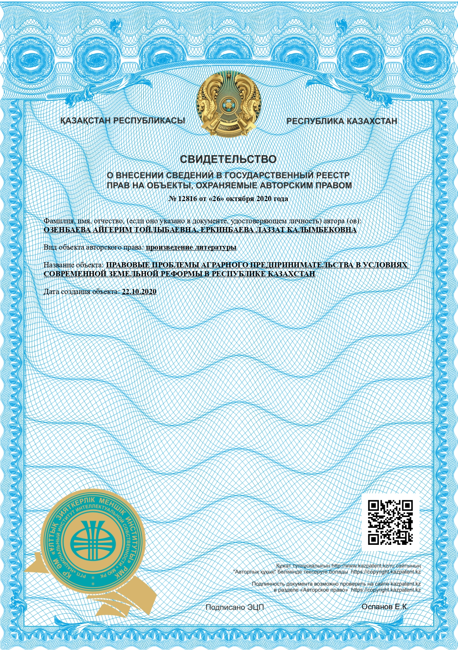
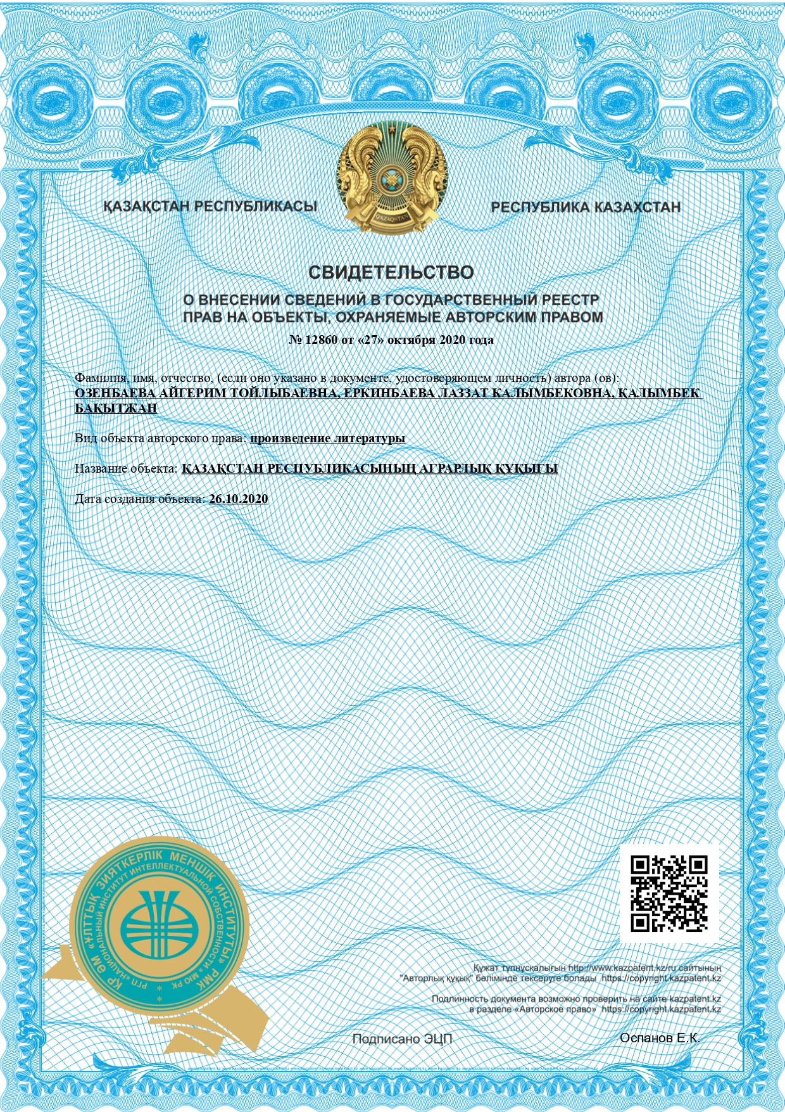
SUPPLEMENT F

WO2020139066 - BIOPLASMA GENERATOR FOR PRODUCING ELECTRICAL ENERGY FROM PLANT MASS
https://patentscope.wipo.int/search/en/detail.jsf?docId=WO2020139066&tab=PCTBIBLIO&_cid=P20-KC7PH6-69221-1

