Ministry of Education and Science of the Republic of Kazakhstan

Committee of Science

RSE «INSTITUTE OF HUMAN AND ANIMAL PHYSIOLOGY»

"

MRNTI 34; 34.39; 34.39.27;

34.39.29; 34.39.39

UDC 612.42:612.44

No. State. Registration 612.42:612.44

Inv No:

«APPROVED»

general director RSE «Institute of Human and Animal Physiology» ____________ Е.K. Makashev

«____» ______________ 2020

REPORT
ABOUT SCIENTIFIC-RESEARCH WORK

on this topic: « ROLE OF THE LYMPHATIC SYSTEM IN THE ADAPTIVE AND COMPENSATORY REACTIONS OF ORGANISM AT AN EXPERIMENTAL HYPOTHYROIDISM AND DEVELOPMENT OF FUNCTIONS OF THYROID DISORDERS' CORRECTION METHODS»

(final)

Project Leader,
PhD, ass. Professor S.N.Abdreshov

Astana, 2020

LIST OF PERFORMERS

Project Leader,  Candidate of Biological Sciences,  ass. Professor | _________________ | S.N.Abdreshov  (introduction, conclusion, conclusions)
Responsible executor,  Head of the laboratory, DMS. | _________________ | G.A.Demchenko  (method, 3.2, 3.3, 3.1.3)
Responsible executor
Senior Researcher,  Candidate of Biological Sciences, | _________________ | N.A.Akhmetbaeva  (Section 3.1, 3.2.3,3.3.2, list of references)
Responsible executor  Junior researcher, | _________________ | B.A.Nurmakhanova.  (application)
Responsible executor  Junior researcher, | _________________ | U.N.Kozhaniyazova  (application)
Responsible executor  senior laboratory assistant | _________________ | U.B.Nauryzbai

Responsible executor  senior laboratory assistant | _________________ | A.M.Kalekeshov

ABSTRACT

Report 137 p., Fig. 48, tables 19, 179 of the source, Appendix 1.
LYMPH, BLOOD, LYMPH VESSELS, LYMPH NODES, CORRECTION, THYROID FAILURE, THYROID GLAND
Theme of the project: «Role of the lymphatic system in the adaptive and compensatory reactions of organism at an experimental hypothyroidism and development of functions of thyroid disorders' correction methods»
Object: laboratory white rats.
Purpose: To study the status, dynamics and features of the thyroid gland, transport, drainage and detoxification and immune function of lymph vessels and nodes in animals with thyroid insufficiency and to develop the ways of correction of the revealed changes.
Methods: Physiological, biochemical, histological.
Results: Experiments were performed on 195 white male laboratory rats weighing 250±3 g. In hypothyroidism, high sensitivity to the monthly effects of mercazolil is shown, which is expressed in synchronous morphological rearrangement of the tissue microdistrict of the thyroid gland and lymph node. Revealed morphological changes of regional lymph node, which are characterized by a change in the ratio of cortex and medulla, in which the fraction of structures in the cortical substance, an increase in the number of macrophages in a lymphoid nodule, brain sinus. Experiments have shown that in rats with hypothyroidism, the content of T3 decreased by 45.7% and T4 by 35.6% in the lymph, and blood T3 by 43.5% and T4 by 41.6% decreased compared to the control group of animals. The data obtained by us shows that hypothyroidism in rats reduces blood supply to the main vessels and the speed of blood flow in the carotid arteries, as well as inhibition of spontaneous and induced contractile activity of the cervical lymph nodes.
After the use of corrective substances, the lymph nodes are more susceptible to reorganization than the thyroid gland. Arterial vessels of the thyroid gland after correction retain a network of adrenergic fibers that have a bright fluorescence close to normal. The use of corrective substances improves the hormonal status in the lymph and blood plasma in rats with experimental hypothyroidism, and reduces the negative effect of mercazolil on the contractile activity of the cervical lymph nodes.
Scientific and organizational work: he has published 3 article RK, 3 article Russia, abstracts of the Russia – 2; RK – 1 thesis; Participation in conferences to the RK: 1 – report, Russia – 2 report.

РЕФЕРАТ
Отчет 137 с., рис.48, таблиц 19, 179 источника, приложенией 1.
ЛИМФА, КРОВЬ, ЛИМФАТИЧЕСКИЕ СОСУДЫ, ЛИМФАТИЧЕСКИЕ УЗЛЫ, КОРРЕКЦИЯ, ТИРЕОИДНАЯ НЕДОСТАТОЧНОСТЬ, ЩИТОВИДНАЯ ЖЕЛЕЗА
Тема: «Роль лимфатической системы в адаптивных и компенсаторных реакциях организма при экспериментальном гипотиреозе и разработка способов коррекции нарушений функций щитовидной железы»
Объект: лабораторные белые крысы.
Цель: Изучить состояние, динамику и особенности щитовидной железы, транспортную, дренажную и детоксикационную и иммунную функции лимфатических сосудов и узлов у животных при тиреоидной недостаточности и разработать способы коррекции выявленных изменений.
Методы: Физиологические, биохимические, гистологические.
Результаты: Эксперименты выполнены на 195 белых лабораторных крысах самцах массой 250±3 г. При гипотиреозе показана высокая чувствительность к месячному воздействию мерказолила, что выражается в синхронной морфологической перестройке тканевого микрорайона щитовидной железы и лимфатического узла. Выявлены морфологические изменения регионарного лимфатического узла, которые характеризуются изменением в соотношения коркового и мозгового вещества, при котором уменьшается доля структур коркового вещества, наблюдалось увеличение число макрофагов в лимфоидном узелке, мозговом синусе. Эксперименты показали, что у крыс с гипотиреозом содержание Т₃ снижалось на 45,7% и Т₄ на 35,6% в лимфе, а крови Т₃ на 43,5% и Т₄ на 41,6% понижалось по сравнению с контрольной группой животных. Полученных нами данные свидетельствует, что при гипотиреозе у крыс снижается кровоснабжение магистральных сосудов и скорость кровотока в сонных артериях, а также угнетение спонтанной и вызванной сократительной активности шейных лимфатических узлов.
После применение корригирующих веществ лимфатические узлы подвержены реорганизации больше, чем щитовидная железа. Артериальные сосуды щитовидной железы после коррекции сохраняют сеть адренергических волокон, имеющих яркую флуоресценцию, близкую к норме. Применение корригирующих веществ улучшает гормональный статус в лимфе и плазме крови у крыс с экспериментальным гипотиреозом, уменьшал негативный эффект мерказолила на сократительную активность шейных лимфатических узлов.
Научно-организационная работа: опубликовано 3 статья РК, 3 статья РФ, Тезисы докладов РФ – 2; РК – 1 тезис; Участие в конференциях РК: 1 – доклада, РФ – 2 доклад.
ТҰЖЫРЫМ
Есеп: 137 бет, 48 сурет, 19 кесте, 179 дерек, 1 қосымша
ЛИМФА, ЛИМФА ТАМЫРЛАРЫ, ЛИМФА ТҮЙІНДЕРІ, ҚАН, ҚАЛҚАНША БЕЗІ, ТИРЕОИДТІ ЖЕТІСПЕУШІЛІК, ТҮЗЕТУ
Тақырып: «Эксперименталды гипотиреоз кезіндегі организмнің бейімделу және компенсаторлық реакциясына лимфа жүйесінің ролі және қалқанша безі қызметінің бұзылуын қалпына келтіру жолдары»
Зерттеу нысанасы: лабораториялық ақ егеуқұйрықтар.
Жобаның мақсаты – Жануарларда тиреиодтық жетіспеушілік кезінде лимфа тамырлары мен түйіндерінің имундық қызметін және транспорттық, дренаждық және детоксикациялық күйін, қалқанша безінің ерекшелігін, динамикасы мен күйін және анықталған өзгерістерді қалпына келтіру әдістерін зерттеу.
Әдістер: Физиологиялық, биохимиялық гистологиялық микроскоптық әдістер.
Нәтижелері: Тәжірибе салмағы 250±3 г болатын 195 лабораториялық еркек егеуқұйрықтарға жасалынды. Эксперименталды гипотиреоз кезінде қалқанша безінің лимфа аймағы мерказолилдің әсерінен жоғары сезімталдығын, қалқанша безі және лимфа түйінінің шағын аймақтарында ұлпаның синхронды морфологиялық қайта құрылуын көрсетеді. Аймақтық лимфа түйінінің морфологиялық өзгерістері анықталды, олар сыртқы және милы затының арақатынасының қалыптасуымен сипатталады, онда сыртқы затының құрылымының үлесі азаяды, ми синусындағы макрофагтар санының артуы, кемелденген плазмоциттер санының азаюы, паракортекс пен жұмсақ тіндердің азаяюы байқалады. Гипотиреоз кезінде лимфада Т₃ мөлшері 45,7% және Т₄ 35,6%-ға төмендегені, ал қанда бақылау тобы жануарларымен салыстырғанда Т₃ 43,5% және Т₄ 41,6%-ға төмендегенін көрсетті. Ееуқұйрықтарда магистралды қан тамырлардың қанмен қамтамасыз етіліуі, ұйқы артериясында қан ағысы жылдамдығы төмендейтіндігін, мойын лимфа түйіндерінің өзіндік және шақырылған жиырылу белсенділігінің баяулайтындығын көрсетті.
Түзеткіш заттарды қолданғаннан кейін лимфа түйіндері қалқанша безге қарағанда қайта құруға бейім екендігі анықталды. Қалқанша безінің артериялық тамырлары нормаға жақын жарқын флуоресценциясы бар адренергиялық талшықтар жүйесін сақтайды. Түзеткіш заттарды қолдану тәжірибелік гипотиреозы бар егеуқұйрықтардағы лимфа мен қан плазмасындағы гормоналды көрсеткіштерді жақсартады, мерказолилдің мойын лимфа түйіндерінің жиырылу белсенділігіне кері әсерін төмендетті.
Ғылыми ұйымдастырушылық жұмыстары: Ағымдағы жылы ҚР 3 мақала, РФ -3, тезис РФ – 2, ҚР – 1 тезис жарық көрді. Конференцияларға қатысу: ҚР – 1 баяндама, Ресейде – 2 баяндама.
СОДЕРЖАНИЕ

INTRODUCTION………………………………..…………………………………… | 8
MAIN PART …………………………………………………………………………… | 12
1 Justification of the direction of research ……………..………....  1.1 Morphofunctional organization of efferent adrenergic and cholinergic innervation of blood and lymphatic vessels and lymph nodes in experimental hypothyroidism and its correction……………………………………………………… | 12  16
2 МАТЕРИАЛЫ И МЕТОДЫ ИССЛЕДОВАНИЯ…………………………........... | 22
3 RESULTS OF THE STUDY AND THEIR DISCUSSION ……………...…………... | 27
3.1 Develop a model of experimental hypothyroidism. to study the physiological, biochemical and hormonal status, structural and functional changes in the thyroid gland in animals with experimental hypothyroidism. to investigate the contractile activity of blood vessels and nodes, lymph flow and biochemical, cellular composition of lymph in experimental hypothyroidism – 2018.. ………………………………… | 27
3.1.1 Morphofunctional state of the thyroid gland and lymph node in normal conditions and in conditions of hypothyroidism ……………………………………… | 27
3.1.2 Lymphodynamics, hormonal and biochemical parameters of lymph and blood in normal rats and in experimental hypothyroidism …………………………………… | 34
3.1.3 The rate of blood flow and blood supply to the thyroid gland and the contractile activity of the lymph nodes in experimental hypothyroidism …………………………… | 42
3.2 To examine the adrenergic innervation of the thyroid gland and lymph vessels and nodes, the ratio of the functional structures of the lymph nodes in different regions of the body, the microstructure of the reticular cells in them with thyroid insufficiency –2019……………………………………………………………………………… | 50
3.2.1 Adrenergic innervation of the thyroid, blood and lymph vessels and lymph nodes under hypothyroidism……………………………………………………… | 50
3.2.2 The ratio of the functional structures of the lymph nodes in thyroid insufficiency (cell body, density, dimensions)… ……………………………………… | 54
3.2.3 Morphofunctional state and microstructure of the tissue microdistrict of the thyroid gland in thyroid insufficiency …………………………….………………………… | 63
3.3 Analyze the obtained material and determine the dynamics of hormonal, structural and functional changes, identify the morphological and functional features of the lymphatic system and the state of the microhemocirculatory bed of the thyroid gland with experimental hypothyroidism against the background of correction with a complex herbal remedy – 2020 ………………………………… | 75
3.3.1 Morphofunctional state and microstructure of the thyroid gland and regional lymph node under conditions of correction ………………………………………… | 75
3.3.2 3.3.2 Condition of adrenergic innervation apparatus of the thyroid, blood and lymph vessels and lymph nodes under experimental hypothyroidism and its correction…………………………………………………………………………… | 92
3.3.3 Influence of corrective substances on lymphodynamics, hormonal and biochemical parameters of lymph and blood against the background of experimental hypothyroidism in rats ……………………………………………………………… | 96
3.4 Discussion of research results …………………………………………………… | 106
CONCLUSION …………………………………………………………………………… | 119
LIST OF SOURCES USED ……………………………………………………………… | 121
APPLICATION А……………………………………………………………………… | 137

INTRODUCTION

Among the modern medical and social problems, one of the most relevant topics is the pathology of the thyroid gland. Thyroid pathology depends on many factors and conditions: geochemical, demographic, socio-ecological, and climatic, etc. [1, 2]. Hypothyroidism is one of the most common pathologies of the endocrine system, due to persistent and long-term deficiency of thyroid hormones in the body or a decrease in their effect on target organs [3, 4, 5].
Hypothyroidism is accompanied by a decrease in basal metabolism, which is why there is a slowdown in the exchange of proteins, fats and carbohydrates, growth, heat production, and differentiation, which leads to rapid fatigue, delayed excitability, reduced lability of the nervous system, and reduced resistance to infections [6, 7, 8].
In terms of prevalence, hypothyroidism is one of the first among all endocrine diseases, and its prevalence increases with age. The variety of clinical symptoms inherent in hypofunction of the thyroid gland is largely due to a violation of metabolic processes associated with a deficiency of thyroid hormones. Thyroid pathology affects the endocrine, immunological, and energy homeostasis of the body [9, 10].
It was found that hypothyroidism develops violations of the mechanisms of oxidative homeostasis, and spontaneous luminosity decreases in the liver. Studies have shown that hypothyroidism reduces the enzymatic activity of malate dehydrogenase, glutamate dehydrogenase, glucose-6-phosphate dehydrogenase, arginase and activation of succinate dehydrogenase [11, 12]. It is believed that the thyroid gland is rich in sympathetic and parasympathetic nerve fibers, but the effect of direct nerve impulses on the activity of the follicles is small and significantly overlaps with the humoral effects of tyrotropin. Nevertheless, irritation of the cervical sympathetic ganglia or exposure to adrenergic substances causes a slight but significant increase in the formation and release of iodized thyroid hormones, despite the fact that in these conditions there is a narrowing of blood vessels and a decrease in blood flow through the thyroid gland [13].
It is considered that the sympathetic nervous system is one of the most important systems of the body that regulates the level of thyroid hormones in the blood serum and the level of their metabolic activity in liver cells. Chemical sympathectomy with 6-hydroxytryptomine and reserpine leads to a decrease in the content of both hormones - thyroxine (T4) and triiodothyronine (T3), but the value of the T3/T4 ratio increases [14, 15]. In the literature, there are only indirect data on adrenergic innervation of the thyroid gland. Studies have compared organ tissue density and iodine uptake in animals subjected to unilateral destruction of preganglionic fibers in the upper cervical ganglion, from which adrenergic innervation of the thyroid gland occurs [16].
It was found that gangliectomy destroys the postganglionic sympathetic innervation; on the contrary, decentralization leaves the postganglionic innervation intact, but cancels the delivery of efferent impulses [17, 18]. One of the main physiological effects of thyroid hormones is the formation of the nervous system and skeleton in the prenatal period, increased sensitivity of receptors to catecholamines, and an increase in the number of catecholamine receptors in the heart muscle and other organs [19].
The method of macropreparation revealed that the rat thyroid gland is fed by two arteries, and in humans, the blood supply to the thyroid gland is carried out by five arteries. According to microtopography, it is known that each thyroid follicle in both rats and humans is entwined with a dense capillary network, and that each follicular thyrocid contacts the hemocapillary wall. Consequently, there is a close direct relationship between the state of the vascular bed and the state of the thyroid parenchyma, which reflects functional adaptation in the vascular-organ system [20, 21].
The lymphatic system is one of the main links in the chain of humoral transport of blood-tissue-lymph-blood, [22-26], and given the important role of the lymphatic system in maintaining homeostasis in the body with thyroid insufficiency, it is of current importance. It is known that lymph nodes play an important role in the formation of humoral and cellular immunity [24, 27]. Among the most important and universal functions of the lymph nodes, regardless of their location and organ affiliation, their hematopoietic and immunopoietic, protective and filtration role in the body is highlighted [28, 29].
The role of the lymphatic system and its lymphoid organs is one of the little-studied problems in biology, in the body's protective reactions when exposed to negative environmental factors on the human body. In the literature available to us, it was not possible to obtain information about the adrenergic innervation of the vascular wall of the artery that provides blood supply to the thyroid gland.
Thus, hypothyroidism is an uninsulated process in one organ of the thyroid gland, with this disease, pathological changes occur throughout the body. In the literature, there are no data on the state of lymph formation processes, the tone of lymphatic vessels, adrenergic innervation of the thyroid gland itself and lymphatic vessels and nodes in hypotriosis. However, the role and functional state of lymphatic vessels and nodes in thyroid insufficiency has not yet been studied.
Over the past decade, the number of people with diseases caused by iodine deficiency has increased dramatically. As a result of the disease, they become younger. There are pathologies of the cardiovascular, nervous and other systems, due to insufficient intake of iodine. In the current conditions, it has become vital for people to consume additional iodine and its compounds as effective means of increasing the body's defenses [30].
Prevention or correction of the thyroid gland in the world requires a change in ideas about methods of preventing diseases. The Arsenal of modern drugs allows only to stop the disease at the height of exacerbation. At this time, all this determines the need for purposeful study of the possibilities of medicinal plants. Use of lymphotropic herbal remedies as an additional source of trace elements, as corrective or preventive measures. Among these products, the use of herbal products is promising, since they have a sufficiently pronounced immunomodulatory and corrective effect, low toxicity, and the presence of a complex of biologically active substances that act on the entire body as a whole [31, 32].
Despite the achievements of biology and medicine, there is still an urgent need for scientific justification and the search for non-medicinal means of prevention and rehabilitation of thyroid disorders. At the present stage, it is necessary to influence the body through the functions of the lymphatic system by expanding the platstarm for new lymphatropic substances to existing ones.
Such studies have not been conducted to date, and the success of prevention or correction is impossible without scientific justification of the means used. The search for alternative methods of prevention or correction of the thyroid gland seems to us relevant and of great practical importance. A more detailed study of the composition of vitamin and mineral complexes used for the prevention of iodine deficiency is relevant, and, of course, the creation of effective medicines to restore the function of the thyroid gland in cases of iodine deficiency disorders.
The purpose of our study was to study the morphofunctional state of the thyroid gland and lymphatic vessels and lymph nodes, the hormonal status and biochemical parameters of lymph and blood in experimental hypothyroidism and the correction of detected disorders with protective substances that restored the structure of the thyroid gland and lymphatic vessels and lymph nodes.
Purpose: To study the status, dynamics and features of the thyroid gland, transport, drainage and detoxification and immune function of lymph vessels and nodes in animals with thyroid insufficiency and to develop the ways of correction of the revealed changes.
Project objective
To develop the experimental model of hypothyroidism. Studies of physiological, immune, biochemical and hormonal status, structural-functional and microhemocirculation changes of the thyroid gland in animals with experimental hypothyroidism. To investigate the contractile activity of blood vessels and nodes the lymphatic system and the biochemical, the
cellular composition of lymph in experimental hypothyroidism.To examine the adrenergic innervation of the thyroid gland and lymph vessels and nodes, the ratio of the functional structures of the lymph nodes in different regions of the body, the microstructure of the reticular cells in them with thyroid insufficiency.
Analyz the resulting material and determine the dynamics of the hormonal, structural and functional changes, identify morphological and functional characteristics of the lymphatic system, and the status microhemocirculation channel of the thyroid gland with experimental hypothyroidism on the background correction is a comprehensive herbal remedy.

MAIN PART

1 Justification of the direction of research

The thyroid gland occupies a special place among the organs of the endocrine apparatus. Diseases of this organ have become a medical and social problem throughout the world. According to the WHO, there are about 300 million people with goiter on Earth [33].
In terms of prevalence, hypothyroidism is one of the first places among all endocrine diseases, and its prevalence increases with age. Hypothyroidism is a condition caused by a prolonged, persistent lack of thyroid hormones, the opposite of thyrotoxicosis. The clinical symptoms of hypothyroidism in adults are myxedema, in children - cretinism. Hypothyroidism can be associated with functional insufficiency of thyroid hormones or with pathological processes that affect hormonal metabolism [34].
The importance of the thyroid gland in the body is very high. This is probably why the body has formed a dual control of the thyroid gland. From the side of the central autonomic system - the hypothalamus. From the side of the peripheral autonomic nervous system - nerve nodes [35, 36]. Thyroid diseases are the most common noncommunicable diseases in the world. In recent years, a steady increase in the incidence of thyroid diseases has attracted attention. Over the past 20 years, there has been a significant change in the structure of thyroid pathology with an increase in the proportion of patients with non-toxic goiter. In Russia and abroad, there is an increase in the number of operations on the thyroid gland, which leads to the development of postoperative hypothyroidism [37]. Thyroid hormones regulate energy metabolism in the body, therefore, with hypothyroidism, all metabolic processes slow down somewhat.
Hypofunction of the thyroid gland is one of the damaging factors of disorders in the feto-placental system. Particular attention should be paid to the course of the gestational process and the perinatal period of newborns in mothers with thyroid diseases in endemic areas (some regions of Kazakhstan) [38, 39, 40]. The health of the mother and child is closely related not only to the state of the mother-placenta-fetus system, but also to the violation of the biocenosis in it. The vulnerable link in the onset of this pathology is the thyroid gland. In patients of reproductive age, the incidence of thyroid pathology is 16-20%. The course of pregnancy and childbirth with hypothyroidism is accompanied by early and late complications. The main causes of hypothyroidism in endemic areas are: insufficient iodine content in food, water, increased radioactive background, genetic causes and pregnancy [41, 42].
In Kazakhstan - Eastern Kazakhstan, the Aral Sea region and the regions of the Dzhungarsky and ZailiyskyAlatau are among the geographic regions with a low iodine content in the biosphere, which is the cause of hypothyroidism. It is known that hypothyroidism decreases energy metabolism, a participant in which is oxygen delivered by erythrocytes [43]. From these positions, disorders in the erythroid link of the blood system can aggravate the clinical manifestations of hypothyroidism. In hypothyroidism, inhibition of erythropoiesis and depletion of the bone marrow depot of mature erythrocytes are observed [44].
In regions of goiter endemic, hypothyroxinemia against the background of goiter may be the reason for a decrease in the intellectual potential of the population of these regions. Hypothyroid encephalopathy is formed as a result of a sharp suppression of anabolic and energy processes in the substance of the brain and manifests itself in a typical symptom complex: memory loss, attention, general lethargy, dizziness, and decreased social adaptation [45, 46]. The torpidity of thought processes, a decrease in the volume of short-term memory are objectively revealed.
In severe, long-term hypothyroidism, significant mental disorders are observed. There can be both exogenously organic psychoses and those approaching endogenous in structure - schizophrenic and manic - depressive [47].
Primary hypothyroidism is associated with thyroid pathology, leading to a decrease in the mass of the glandular tissue of the thyroid gland and inhibition of the synthesis of the hormones thyroxine and triiodothyronine. This may be due to aplasia or agenesis of the thyroid gland, autoimmune processes, iodine deficiency, and selenium deficiency [48].
Secondary hypothyroidism ("central") is associated with the loss of the tropic function of the pituitary gland (decreased thyrotropin production). Insufficient intake of thyroid hormones in the body leads to a violation of protein, carbohydrate metabolism, flattening of the sugar curve after glucose load, to a violation of lipid, water-salt metabolism. Cases of a functional form of primary hypothyroidism due to an overdose of mercazolil and the action of lithium salts have been reported [49].Hypothyroidism occurs at approximately 19 in 1000 in women and 1 in 1000 in men. Despite its prevalence, hypothyroidism is very often diagnosed with delay [50]. This may be due to aplasia or agenesis of the thyroid gland, autoimmune processes, iodine deficiency, and selenium deficiency [51].
It is known that the leading role in maintaining the homeostasis of the body and the formation of long-term adaptation belongs to the endocrine system. Of particular interest in this respect is the study of the morphofunctional features of the thyroid gland, which performs the widest range of functions underlying the body's defense-adaptive reactions and plays a fundamental role in the regulation of metabolism [52]. In the studies, the authors showed the dependence of the structure of the lymph node on the functional state of the thyroid gland.In hypothyroidism, the functional activities of the thyroid gland are disrupted, and the lymph node is compacted with a decrease in the main structural and functional zones against the background of reduced lymphopoietic function [53].
In rats, the thyroid gland is covered with fiber, the sternohyoid and sterno-thyroid muscles, and the visceral leaf of the internal fascia of the neck, which forms an organ capsule fused with the larynx and trachea. The shape of the right and left lobes of the thyroid gland is in the form of an irregular triangle, and the entire organ has the form of a massive bilobate formation with an isthmus [54].According to the literature, three main levels are distinguished in the structural organization of the thyroid gland: thyrocyte, thyroid follicle and thyroid microdistrict; the latter is defined as the minimal area of ​​the thyroid gland containing the main elements of this organ [55]. The hormones thyroxine and triiodothyronine, secreted by the thyroid gland, regulate oxidative processes in the body and affect all types of metabolism.
Despite numerous studies, some aspects of the structural organization of the thyroid gland have not yet been disclosed [56]. These include questions about the transport systems of the thyroid gland, about cellular conglomerates, i.e. interfollicular islets and the role and significance of C-cells for the organ, which are secreted physiologically active substances [57].
It is believed that the thyroid gland is rich in sympathetic and parasympathetic nerve fibers, but the influence of direct nerve impulses on the activity of the follicles is small and is significantly overlapped by the humoral effects of thyrotropin. Nevertheless, irritation of the cervical sympathetic ganglia or exposure to adrenergic substances causes, albeit a weak, but significant increase in the formation and release of iodinated thyroid hormones, despite the fact that under these conditions narrowing of blood vessels and a decrease in blood flow through the thyroid gland occurs [58].
It is generally accepted that the sympathetic nervous system is one of the most important systems of the body that regulates the level of thyroid hormones in the blood serum and the level of their metabolic activity in the liver cells. Chemical sympathectomy with 6-hydroxytryptomine and reserpine leads to a decrease in the content of both hormones, thyroxine (T4) and triiodothyronine (T3), but the value of the T3 / T4 ratio increases [59].In the literature, there are only indirect data on the adrenergic innervation of the thyroid gland. Studies have compared organ tissue density and iodine uptake in animals subjected to unilateral destruction of preganglionic fibers in the superior cervical ganglion, from which adrenergic innervation of the thyroid gland arises [60].
It was found that gangliectomy destroys postganglionic sympathetic innervation, on the contrary, decentralization leaves postganglionic innervation intact, but abolishes the delivery of efferent impulses [61]. One of the main physiological effects of thyroid hormones is the formation of the nervous system and skeleton in the prenatal period, increased sensitivity of receptors to catecholamines, and an increase in the number of catecholamine receptors in the heart muscle and other organs [62, 63].
The method of macro-preparation revealed that the rat's thyroid gland is fed by two arteries, and in humans, the thyroid gland is supplied by five arteries. According to microtopography, it is known that each thyroid follicle in both rats and humans is braided by a dense capillary network, and that each follicular thyrocide contacts the hemocapillary wall. Consequently, there is a close direct relationship between the state of the vascular bed and the state of the thyroid parenchyma, reflecting functional adaptation in the vessel-organ system [64, 65].
It is known that the lymphatic system maintains the constancy of the internal environment of the body, which, along with the interstitial fluid, surrounds tissues and cells. According to the concept of Yu.I. Borodin, the role of the lymphatic system in detoxification and sanitation in a separate lymphatic region is very important, in that liquid medium that surrounds tissues and cells [53], as well as its huge role in maintaining the constants of the internal environment [66-68]. All links of the lymphatic system take part in these processes - capillaries, vessels, lymph nodes. Lymphatic microvessels are the initial link in the lymphocirculatory system and play an important role in maintaining vascular tissue homeostasis [69, 70].
Considering the important role of the lymphatic system in tissue drainage, metabolism and protective-compensatory function, it is of theoretical and practical interest to study the role of the lymphatic system in the development of hypothyroidism. Until now, the functional state of the lymphatic system in hypothyroidism of a clinical or experimental nature has not been studied.

1.1 Morphofunctional organization of efferent adrenergic and cholinergic innervation of blood and lymphatic vessels and lymph nodes in experimental hypothyroidism and its correction

The smooth musculature of the vessels serves as a performer of circulatory reactions associated with a change in the value of hydraulic resistance to blood flow. The mechanism of contraction of smooth muscle cells has been studied in sufficient detail [71]. One of the most characteristic features of smooth muscles is their ability for prolonged (tonic) contraction, i.e. constant contractile activity, not accompanied by signs of its decrease. The vascular tone shows dependence on a complex of influences of non-myogenic origin. The leading role among them is played by neurogenic influences [72].
In the vascular wall, bundles of non-fleshy nerve fibers form a mesh structure, confined mainly to the border area between the connective tissue and smooth muscle membranes. The function of the presynaptic nerve endings is performed by varicose expansion of the fibers, in the varicose expansion synaptic vesicles (vesicles) are revealed, among which there are granular vesicles containing catecholamines and agranular ones containing acetylcholine; they do not occur together in the same nerve endings [73].
The vast majority of efferent nerve conductors in the vascular wall are sympathetic postganglionic fibers, but in a number of vascular regions the participation of additional sources of innervation, local effector neurons, has been described [74].
There are at least three independent mediator systems of vascular innervation: adrenergic, cholinergic and serotonergic. The mediator in the adrenergic nerve fibers of higher vertebrates is norepinephrine, which, when released from varicose endings, as a rule, is to increase the contractile activity of smooth muscle cells with the participation of αl-adrenergic receptors. Exceptions to this rule are dilator effects mediated by the activation of β2-adrenergic receptors. α- and β-adrenergic receptors of blood vessels belong to the category of membrane receptors coupled with GTP-dependent or GTP-binding (G-) proteins [75, 76].
When adrenaline and norepinephrine bind by α-adrenergic receptors, interaction with G-proteins leads to the activation of phospholipase C enzymes, which provides the synthesis of two secondary messengers - inositol-3-phosphate and diacylglycerol. Histochemical methods have shown the presence of dopaminergic fibers in the walls of the arterioles of the renal cortex, and the function of vasodilator structures has been studied very little [77, 78].The action of acetylcholine on the vascular muscles consists of a constrictor myotropic effect mediated by M-cholinergic receptors and a dilatator action, which is realized through stimulation of the secretory activity of vascular endothelial cells, which, with the participation of M-cholinergic receptors, are also capable of releasing a dilator agent, nitric oxide [79].
Perivascular nerve elements themselves are among the structural components of the vascular wall and, along with muscle and endothelial cells, can act as a point of application of neuropharmacological effects. The inhibitory effect of acetylcholine on the release of catecholamines from adrenergic nerve endings allows for the possibility of autoregulation of their functional activity according to the feedback principle [80, 81].
In small vessels, catecholamines from both sources act on the same effector elements: nerve fibers can remove excess catecholamines circulating in the blood from the vascular wall by reuptake through the usual mechanism of mediator inactivation. At the same time, the release of a transmitter from the nerve terminals of the vascular wall is essentially a neurosecretory process [82, 83]. A number of other substances of neurogenic origin and possessing vasomotor action, including vasoactive neuropeptides - vasopressin, angiotensin, neurotensin, etc., are delivered to the smooth muscles of the vessels with the blood flow.Their relationship with reflex influences on smooth muscle tone, realized through changes in the activity of perivascular nerve elements, is rather complicated [84].
Judging by the results of electron microscopic and histochemical studies performed using impregnation methods, penetration of efferent fibers into the depth of the muscular membrane normally occurs mainly along the vasa vasorum [85].The characteristic reticular structure is characterized by the predominance of longitudinally oriented bundles, the thickness of which in the main arteries of a person reaches 150-200 microns, passing into a monoaxonal network with endings. The innervation pattern is complemented by fibers and terminals that form the already mentioned intramural plexuses of the vasa vasorum [86]. The functions of presynaptic structures are performed by varicose veins, in which, when fixed in potassium permanganate under an electron microscope, granular and agranular synaptic vesicles are revealed.When adrenergic fibers are excited, the release of the mediator from varicose dilations increases with its subsequent effector action, in natural conditions it always causes vasoconstriction, and cholinergic fibers - endothelium-dependent dilation [87].
Serotonergic structures form a sparse network on the muscular membrane of all major arteries and provide one of the components of their neurogenic constriction. The constriction of the great arteries can also occur with the participation of dopamine and adrenaline [88, 89].The most pronounced innervation is possessed by large pialarteries, they contain adrenergic and cholinergic trunks up to 25 microns in diameter and individual fibers, the general architectonics of the nerve plexuses. Among the cholinergic nerve fibers extending from the cervical and cervicothoracic paravertebral ganglia, only relatively few are involved in the innervation, mainly of the pial arteries [90, 91].
Mediatory processes in the vascular wall include the effects of hormones circulating in the blood. The catecholamines secreted by the chromaffin cells of the adrenal glands are identical in their action to the catecholamines secreted by the endings of the adrenergic fibers. In large vessels, their action is directed mainly to the cells of the weakly innervated inner layer of the muscular membrane. The sources of cholinergic innervation of the remaining arteries of the thyroid gland remain unclear.
The thyroid gland is provided with a rich vascular and lymphatic network that surrounds the follicles and connects the lymphatic bed of both lobules through the isthmus. In the thyroid glands of humans and laboratory animals, a rich network of intraorgan nerves was found, in which inter- and intralobular nerves are distinguished, located both along the vessels and outside them. Intralobular nerves form a dense network of the finest nerve filaments around follicles [92, 93, 94].
The thyroid gland stands out among the endocrine organs with an abundance of nerve connections. The parenchyma, stroma and its vessels are innervated by sympathetic fibers coming from both upper cervical sympathetic nodes, upper cardiac nerves, occasionally from the middle and lower cervical sympathetic nodes, inter-nodal branches of the border sympathetic trunks, and also from stellate nodes. From both vagus nerves, fibers enter the thyroid gland as part of the superior laryngeal and recurrent laryngeal nerves, the superior cardiac branches, and sometimes from the branches of the inferior vagus ganglion [95, 96].Additional sources of innervation of the gland in humans are the descending branches of the hypoglossal nerves and glossopharyngeal nerves. The listed branches enter the thyroid gland either in the form of independently running nerves, or preliminarily form perivascular nerve plexuses near the common carotid, subclavian and thyroid arteries and already with the latter enter the gland. A branch of a depressor nerve, branches from the middle heart nerves and fibers from the lower cervical somatic nerves enter the gland. The presence of a direct neural connection between the gland and the carotid sinus is assumed [97].
The efferent innervation of the thyroid gland and its vessels is carried out by fibers, the nerve perifollicular apparatus, pulp and non-pulp fibers, bulbous and bulbous endings and other end apparatuses related to follicular cells, vessels, connective tissue and organ capsule. There are receptor (mechano- and chemoreceptors), vasomotor and secretory endings. A great variability of the nervous apparatus of the thyroid gland was noted in the case of general non-endocrine diseases, diseases of the organ itself, and with experimental effects on it ”[98].
The intraglandular lymphatic system of the thyroid gland is the interfollicular capillaries. At the periphery of the lobules, they form a network of collector capillaries, which serve as the beginning of interlobular lymphatic vessels of the first order, which merge from different lobules, form larger collectors of the second order. Approaching the surface of the thyroid gland, they form the parenchymal plexus and the superficial capsular network, which flows into small lymph nodes located under the thyroid capsule [99].
The authors found that the introduction of methylthiouracil, which blocks the synthesis of the thyroid hormone, is accompanied by an increase in the functional activity of the follicular epithelium and corresponding changes in the structure of the organ, its circulatory and lymphatic systems [100, 101]. On the basis of numerous experiments, it leads to the conclusion that thyroid cells are a consequence of disorders in the immune system, although they can secondarily enhance the immune response [102, 103, 104].In experiments, xenotransplantation of thyroid tissue to nude mice from patients with autoimmune diseases showed that the thyroid gland of its immune environment after some time makes this tissue functionally, immunologically and histologically completely normal [105, 106, 107].
According to the authors, the condition of the lymph nodes in the neck is the most important prognostic factor in patients with thyroid cancer [108, 109]. The ultrasound method is of great importance in detecting lesions of regional lymph nodes, especially in paratracheal zones [110].
During the period of recovery and phytorehabilitation, the lymph node is reorganized to a greater extent than the thyroid gland. According to researchers, this indicates an active role of the lymph node in the implementation of the drainage and detoxification function in the lymphatic region of the thyroid gland, which can be enhanced by herbal medicine [111].
Iodine and its compounds play an important role in the regulation of metabolism. With a lack of iodine in the body, the normal course of physiological processes is disrupted, the course of a number of enzymatic reactions is impossible.As a result, the normal functioning of biological systems is disrupted, and iodine is a catalyst for the oxidation reaction in the human body. With a lack of iodine, an undesirable accumulation of under-oxidized fats is observed, which leads to obesity.
It has been established that iodine affects lipid and protein metabolism. When iodine is used in patients with atherosclerosis, there is a tendency to a decrease in the blood cholesterol content and an increase in the lecithin-cholesterol coefficient, as well as a slight decrease in the β-lipoprotein content; under their influence, the lipoproteinase and fibrinolytic activity of the blood increases and its coagulability slightly decreases [112].
For a long time, iodine deficiency was considered practically the only factor provoking the development of endemic and nodular thyroid pathology. The increase in the number of thyroid diseases among people living in ecologically unfavorable areas [113, 114] does not find an unambiguous explanation at present. The problem of correcting the iodine status of the body is complicated by the presence of various factors (established and unidentified) that significantly affect the metabolism of iodine in the thyroid gland and throughout the body.
Administration of iodine in both organic and inorganic forms can lead to adverse reactions from the thyroid gland, which include not only the development of thyrotoxicosis, but also hypothyroidism with or without an increase or without thyroid volume, as well as triggering autoimmune reactions [115, 116].
Some representatives of the Cinquefoil genus have long been used in folk medicine. Currently, the genus Cinquefoil (Potentilla L.) is of great interest for pharmaceutical science and practice due to the content of a wide range of biologically active compounds that determine antibacterial, anti-inflammatory, and anti-thyroid action [117, 118].
Other systems of the body (nervous, neuroendocrine, immune, connective tissue, vascular) are absolutely involved in the functioning of the thyroid gland. At the same time, the activity of the thyroid gland is associated with basic and microelement metabolism. Therefore, when classifying thyroid diseases, it is necessary to take into account not only the specialized tissue (thyroid epithelium), but also the organ-forming role of its other elements.Study of the regulatory role of trace elements in relation to the lymphatic system, mechanisms and rationale for the possibility of correction, on the basis of which it will be possible to create adequate methods of correction. In this regard, it is of interest to study iodine-containing preparations by combining medicinal plants for the lymphatic region and the thyroid gland, which contribute to the stabilization of one or another organ of the body.
Considering the importance of the thyroid gland in the body and the role of the lymphatic system in tissue drainage, metabolism and protective-compensatory function, it is of theoretical and practical interest to study the role of the lymphatic system in the development of hypothyroidism and after their correction. Until now, the functional state of the lymphatic system in hypothyroidism of a clinical or experimental nature has not been studied.

2 MATERIAL AND METHODS OF RESEARCH

Experiments on animals were carried out in accordance with the ethical standards and recommendations for the humane treatment of laboratory animals, reflected in the European Convention for the protection of vertebrates used for experimental and other scientific purposes, set out at the Geneva conference (1971). The maintenance of rats, care, setting up experiments and their withdrawal from the experiment, with subsequent disposal, were carried out in accordance with the principles of bioethics, the rules of laboratory practice. The study was approved by the Local ethics Commission of the Kazakh national medical University (Protocol No. 7 (71) of 11.06.2019).
The experiments were performed on 195 white laboratory rats males weighing 250 ± 3 g. Experimental hypothyroidism in experimental rats was modeled for a month with modeled mercazolilum dissolved in water at a dose of 20 mg per 100 g of animal body weight [110, 119]. Animals were divided into two groups. Rats of the 1st group (control-50 rats) were control, in rats of the 2nd group (70 rats), the 3rd experimental group after correction-75 rats. The duration of the experiment is 31 days. Rats were fed according to the standard vivarium diet. The preparation of the experiment and morphological studies were standardized as much as possible, they were in the same conditions, the diet, the selection of animals, and the collection of material. The animals received a standard diet with free access to water. Rats were fed according to the standard vivarium diet.
The drug with the trade name "mercazolil" (mercazolilum), or the international non-proprietary name "thiamazole" (thiamazole), is an antithyroid agent, one tablet contains 5 mg of the active substance tiamazole. According to its pharmacological properties, mercazolil belongs to a group of drugs that inhibit the formation of thyroid hormones thyroxine (T4) and triiodothyronine (T3), due to the inhibition of the activity of peroxidase, an enzyme involved in the iodization of thyroid hormones, which leads to a violation of their synthesis.
Correction of thyroid disorders, after reproducing the hypothyroidism model, the animals of the third group received an iodine-containing biologically active additive balsam "Vozrozhdenie plus" in powder at the rate of 2 micrograms/100 g of rat body weight and dry extract of white cinquefoil (Potentilla alba L.) at a dose of 50 mg/kg for 30 days [31].
Iodine belongs to the vital trace elements, without which the normal functioning of the human body is impossible. It is a structural component of thyroid hormones (thyroid hormones), which determine the activity of almost all metabolic processes in the body. The body's need for it depends on many factors, namely, on the species and breed affiliation, and the physiological state of the body [11, 32].
In vivo, under ether anesthesia, lymph flow from the thoracic lymphatic duct was recorded, and lymph was collected for research using a graduated micro-cannula. In the caudal part of the abdominal cavity, after collecting lymph, the abdominal aorta was dissected, and a Teflon catheter was inserted into it to collect blood.
The development of hypothyroidism was controlled by the level of TSH, T3 and T4 in the blood and lymph. The concentration of thyroid - stimulating hormone - TSH, triiodothyronine - T3 and thyroxine-T4 in lymph and blood was determined in intact animals and on days 15 and 30 of experimental hypothyroidism by electrochemiluminescence method, using a standard test system in accordance with the attached instructions produced by IMMUNOTECH (Czech Republic), with further processing of the results obtained on the SOVOS INTEGRA 400 analyzer (USA) using diagnostic kits T-4, T-3, TSH (DRG international Inc, Germany).
We studied the rate of lymph flow and its rheological properties in control and experimental groups of animals. In the lymph and blood of all groups of animals, blood clotting time, lymph according to Sukharev, and viscosity were determined using a VK-4 viscometer. In lymph and blood samples, glucose, cholesterol, alanine aminotransferase (Alat) and aspartate aminotransferase (ASAT), total protein, triglycerides, bilirubin, urea, and creatinine were determined using the automatic biochemical analyzer SOVOS INTEGRA 400 (USA) using standard sets for biochemical analysis [120].
The contractile activity of isolated lymph nodes was studied according to the General method. After their surveys and transfer to the installation, the real one consists of a thermostatic chamber, a mechanical one, and a computer registering device. The lymph nodes of the neck were fixed with one end to the camera tape, and the other end to the hand sensor was treated with 6MX1C. As a good food plant for incubation of isolated lymph nodes of rats, the following raster Rebs were used: NaCl-133.0; NaHCO3-16.3; NaH2PO4-1.38; KCl-5; C2-2.5; Mgcl2-0.1; glucose-7.8 mm / liter, pH-7.4 at a temperature of + 37 ° C. The nutrient solution was oxygenated with a gas mixture (95% O2 and 5% CO2). The incubation solution under pressure of 80-90 mm of water slowly passed through the thermostatic chamber [121]. As stimuli to study the induced contractile activity of the lymph nodes, physiologically vasoactive substances were used: epinephrine-hydrochloride, acetylcholine-chloride and histamine-dihydrochloride in concentrations of 1×10-8M-1×10-3M, which were added to the thermostatic chamber where the lymph nodes were located.
To study the blood filling of tissues, we performed impedance measurement using the Mizar-REO rheograph (Russia). A technique was used to study the neck region using tetrapolar lead, which completely eliminates the effect of electrode polarization on the measurement results. Rheograms of different body regions were recorded with ultrasound guidance of electrode localization according to the generally accepted method. Rheography indicators were recorded automatically via a computer on the printer's paper tape. We used data from differential rheograms that characterize the rate of change in blood filling in the study area. The blood flow rate was studied using laser ultrasound dopplerography on a Sanomed-300 device. The study of the main arteries of the extremities was carried out with an ultrasound probe (8 MHz) in a constant wave mode of radiation. The maximum (V max) blood flow velocity was studied, and the pulsation index (HR), resistance index, or Purcelo circulatory resistance (RI) were calculated [122].
At the end of the experiment, the thyroid gland and lymph nodes were taken for morphological examination. A histological method was used. During the study, the thyroid glands were released from fat and weighed. The length, width, and its left and right lobes were measured with a caliper. The total mass of the gland was determined. For light microscopy, the thyroid gland was fixed in 10% neutral formalin. After histological wiring in alcohols of increasing concentration, the materials were clarified in xylene and poured into paraffin. Histological sections of the thyroid gland with a thickness of 4-5 microns were obtained using a ThermoScientificHM 325 microtome. Histological sections of the lymph nodes and thyroid gland were stained with hematoxylin-eosin, Azur, and eosin and enclosed in polystyrene [123]. The preparations were viewed under a Leica 1000 light microscope with a camera.
In blood and lymph samples, the content of total protein, cholesterol, triglyceride, total lipids of urea, creatinine and bilirubin were determined, the level of activity of enzymes: alanine aminotransferase (ALT), aspartate aminotransferase (AST), alkaline phosphatase, amylase in lymph and blood plasma were determined using the standard using the automatic biochemical analyzer COBOS INTEGRA 400. The cellular composition of blood and lymph, urine is determined using the hematological analyzer "SYSMEX KX-219 9". Determination of electrolytes in lymph and blood plasma was studied using the AVL 9180 analyzer (ROCHE DIAGNOSTICS, Austria, 2012). Determination of biochemical parameters of urine was carried out using an analyzer (High Technology, USA, 2013). The morphological composition of lymph was determined in a Goryaev chamber with a Burker grid. Determined the number of leukocytes, leukocyte formula - in dry smears of blood and lymph, stained by the method of S.P. Romanovsky. To study histological preparations and smears of blood and lymph, a light microscope Leica - DM-1000 was used.
To study the structure of the thyroid gland on semi-thin sections, 0.5 mm3 pieces of the organ were fixed in 2.5% glutaraldehyde on 0.1 M phosphate buffer for 3 hours at 4 °C, followed by additional fixation in 1% OsO4 solution on a phosphate buffer for 2 hours and contrasted during dehydration with 1.5% uranyl acetate solution in 70% ethyl alcohol, then poured into synthetic resins. Semi-thin sections were colored toluidine blue. When analyzing semi-thin sections, tissue sections were selected for examination in an electron microscope. Ultra-thin sections with a thickness of 35-45 nm were made on an LKB-8800 ultratome (LKB Produkter AG, Sweden), contrasted with a saturated aqueous solution of uranyl acetate, lead citrate, and studied in an electron microscope "JEM 1010" (JEOL Ltd., Japan).
Morphometric analysis was performed using a morphometric grid [124], which was applied to a section of the lymph node. We counted the intersections of the grid that fall on the entire section of the lymph node, as a whole and separately, for each of its structures-the capsule, cortical plateau, lymphoid nodules, paracortex, pulp strands and sinuses, recalculated as a percentage [124, 125]. During cytoanalysis of the structure of lymph nodes and plaques, the number of cells on a standard area of 1600 mm2 was calculated with their differentiation into blasts, medium and small lymphocytes, plasmocytes, macrophages, and others. Has identified the following structural and functional parameters: bulk density majolicaware space (stroma), including volumetric density of interstitium, blood and lymphatic vessels; volume density of follicular epithelium; bulk density interfollicular epithelium; the volume density of colloid in the follicular cavity [126]. Reference values for cells are used for some structural and functional zones.
Quantification was performed using the program Image Pro Plus 4.1 measurement in the follicle of the thyroid gland the inner and outer diameter (not less than 30 follicles), the height of the cells of the follicular epithelium (wall thickness), followed by follicular calculation of the index space of the follicle, colloid and follicular epithelium; in thyreocyte of the core diameter and then calculate its area or volume (nuclear index) by the known formulas [127, 128].
To study the processes of folliculogenesis, the distribution spectrum of follicles by diameter was analyzed [128, 129]. The heterogeneity of the thyroid gland structure was determined by the number of small (less than 70 microns), medium (70-100 microns) and large (more than 100 microns) follicles, based on their internal diameter, and the heterogeneity index was calculated, which took into account the number of follicles (n) and the degree (k) of follicle enlargement (for small – 0, for medium – 1, for large – 2) using the formula: ∑kn/100.
As integral indicators of the functional activity of the thyroid parenchyma, the thyroid activity index (IA) (or follicular-colloid index (PKI), or "colloid accumulation" index) was calculated from the ratio of relative volumes (areas) of the follicular epithelium and colloid [127, 128, 129]; the function index (if, the ratio of the average follicle diameter and the height of the thyroid epithelium [129]), or lumen-epithelial index (Pei, the ratio of the inner diameter of the follicle to the height of the thyroid epithelium: Pei = d/h, where d is the inner diameter of the follicle; h is the height of the thyroid epithelium); colloid accumulation index(PNA) is the ratio of the inner diameter of the follicle to twice the thickness of its wall: PNA = DF /(2 × h), where DF is the inner diameter of the follicle; h is the height of the thyroid epithelium; sclerosis index (is) is the ratio of the relative volumes of the parenchyma (follicular epithelium) and stroma [130].
To study the adrenergic nervous system of the thyroid gland, blood and lymphatic vessels and nodes, a specific histochemical fluorescence-microscopic method for detecting catecholamines in tissues was used according to the Falk method modified by V. A. Govyrin using glyoxalic acid [131]. Total and cryostatic sections of vessels and lymph nodes 20 microns thick were prepared. The preparations were incubated in a 2% solution of glyoxalic acid prepared on a phosphate buffer with a pH of 7.2. Then the sections were dried under a warm stream of air and thermostated at 100 ° C, followed by clarification and fixation with a 5% solution of polystyrene dissolved in xylene. The preparations were studied using a Vision 300 fluorescence microscope (Australia) with a camera.
The obtained data were statistically processed to determine the arithmetic mean (M), the error of the arithmetic mean (±m), and the significance of differences at P<0.05 using the statistical analysis program StatPlus Pro 2009, AnalystSoft Inc. The arithmetic mean (M) and its standard error (m) were calculated and represented as M±m. Belonging to the normal distribution was determined using the Kolmogorov-Smirnov criterion and related indicators. to assess the level of statistical significance, the student's t-test was used, and the results were considered reliable at p < 0.05.

3 RESULTS OF THE STUDY AND THEIR DISCUSSION

3.1 Develop a model of experimental hypothyroidism. to study the physiological, biochemical and hormonal status, structural and functional changes in the thyroid gland in animals with experimental hypothyroidism. to investigate the contractile activity of blood vessels and nodes, lymph flow and biochemical, cellular composition of lymph in experimental hypothyroidism – 2018.

3.1.1 Morphofunctional state of the thyroid gland and lymph node in normal conditions and in conditions of hypothyroidism

This section provides material on the study of the state of the thyroid gland and lymph nodes in control animals and the group after experimental hypothyroidism. The thyroid gland is the only endocrine organ in which there is a bi-directional movement of products intended for secretion into the blood. The thyroid gland is a tissue microdistrict uniting a group of follicles with an autonomous system of blood and lymph circulation.
When studying the level of functioning of the thyroid gland, it was revealed that in the 2nd experimental group of animals, against the background of the introduction of mercazolil, the beginning of the experiment in rats with a standard diet, an increase in the total average body weight by 13-17% (p <0.05 ). Rats with hypothyroidism were characterized by the presence of characteristic symptoms - low mobility, lack of appetite, drowsiness, hair loss from the lateral surfaces of the body. In rats of the control group, the average mass of the thyroid gland is 0.014 ± 0.001 g. The mass of the left lobe is 0.008 ± 0.002 g, that of the right lobe is 0.006 ± 0.004 g. The length of the left lobe is from 0.5 ± 0.014 to 0.7 ± 0.011 mm, the weight of the right lobe is equal to 0.32 ± 0.007 and 0.34 ± 0.009 mm. The obtained digital data indicate the prevalence of the parameters of the left lobe over the right lobe of the thyroid gland in rats.
For a white laboratory rat, the location of the thyroid gland on the anterior surface of the larynx and the first semi-rings of the trachea is characteristic [132]. In our study, the thyroid gland in rats had a normal anatomical structure and consisted of two lateral lobes of an elongated shape and a connective tissue isthmus connecting them. The thyroid gland was covered with fiber, the sternohyoid and sterno-thyroid muscles, and the visceral layer of the internal fascia of the neck, forming an organ capsule fused with the larynx and trachea (Figure 1).
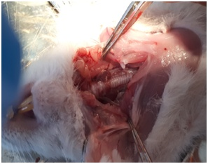
Figure 1 - Anatomical structure of the thyroid glands in rats

The control group of animals has a thyroid gland of elastic consistency, red in color with a reddish-brown and sometimes pink hue. The thyroid gland is of normal structure with the preservation of its basic structural elements. In this group, the thyroid gland contains rounded and oval follicles, in the cavity of which a colloid is located. When stained with hematoxylin-eosin, the thyroid tissue was represented by the same type of follicles, the wall of the follicles was formed by a flattened cubic epithelium located on the basement membrane. The blood supply to the thyroid gland is clearly visible. In the connective tissue between the follicles, blood vessels filled with the formed elements of the blood were determined (Figure 2).

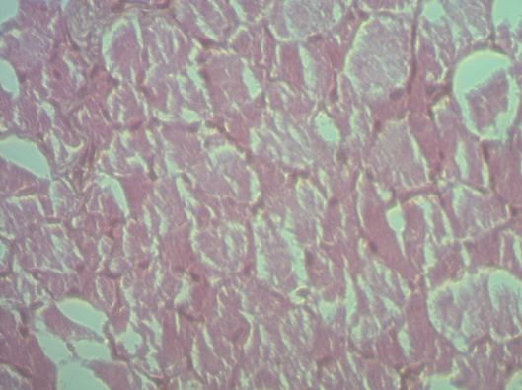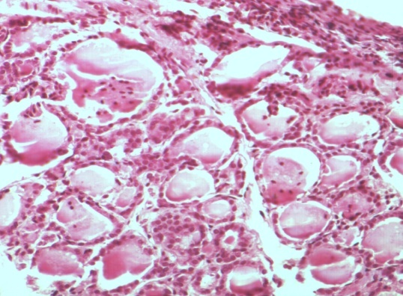
Hemocapillaries, intrafollicular colloid, thyroid structure are clearly seen. Hematoxylin and eosin stain.
Increase approx. 10x0.25; About. 10x20
Figure 2 – The histological structure of the thyroid gland of rats is normal

In the histological structure of the thyroid gland, the control groups are dominated by medium and large follicles, which is characterized by a normoplastic version of the structure with different sizes of follicles, which different sizes of follicles reflect the functional activity of the thyroid gland. The gland parenchyma is represented by rounded, oval or angular follicles. Follicles look like closed vesicles lined with a single-layer epithelium formed by cubic thyrocytes. The nuclei of thyroid cells have a round or oval shape.
It is known that the structure of the thyroid gland and lymph node when taking mercazolil in comparison with the control undergoes some qualitative changes, which is reflected in a decrease in the diameter of the follicles, total volume, volumes of colloid and follicular epithelium [53].
An autopsy in all animals with hypothyroidism showed an increase in the mass of the thyroid glands by 63-34% (p <0.01), i.e. the proportion of the thyroid gland in hypothyroid rats is 1.5-2 times larger than the proportion of glands in rats from the control group. In experimental hypothyroidism, the thyroid follicles were stretched and their sizes were increased, epithelial cells had a flat and elongated shape, the walls of the follicles acquire fuzzy outlines, enlarged, swollen, slightly stained. In lobes of the thyroid gland, single follicles with a small amount of colloid are found. Blood vessels, especially venous ones, are dilated, characterized by plethora and stagnation of blood.Figures 3 show histological preparations of the thyroid gland using mercazolil.

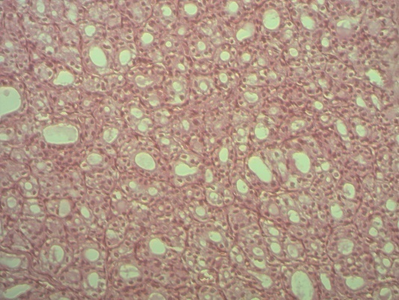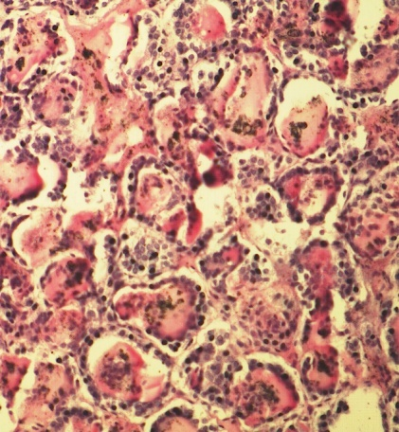

Hyperplasia of the parenchyma, a change in the newly formed and deformed follicles, an increase in the thickness of the follicle wall, partial desquamation of the epithelium, abnormal shape of the nuclei, vacuolization of the cytoplasm, expansion of the interfollicular space. Stained hematoxylin and eosin.
IncreaseApprox. 10х0,25; About. 10х20

Figure 3 – The histological structure of the thyroid gland of rats with experimental hypothyroidism

The results of the study showed that in animals with experimental hypothyroidism, destructive processes are detected. With hypothyroidism in the thyroid gland, there were significant changes in its structure and an increase in wall thickness, violation of the shape of the nuclei, desquamation of epithelial cells, which is reflected in a decrease in the diameter of the follicles, the total volume, volumes of the colloid and follicular epithelium. At the same time, swelling and rounding of the thyroid gland itself were observed. The follicles are small in size, some of them lack colloid and are filled with a clear fluid (Figure 3).
In animals, the cervical lymph nodes are normally covered with a thin, dense capsule. The subcapsular (marginal) sinus is well defined, densely filled with cells. Normally, the structure of the cervical lymph nodes is represented by a uniform development from the main structural and functional zones, there is a clear cortex-brain border in the cervical nodes, an intermediate morphotype of the lymph node is observed, in which there is a slight predominance of cortical substance over the brain substance of the lymph node, and the cortical/medullary ratio of the cervical node is 1.36±0.07 (Figure 4, Table 1).

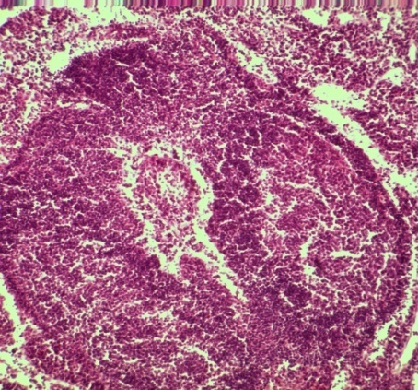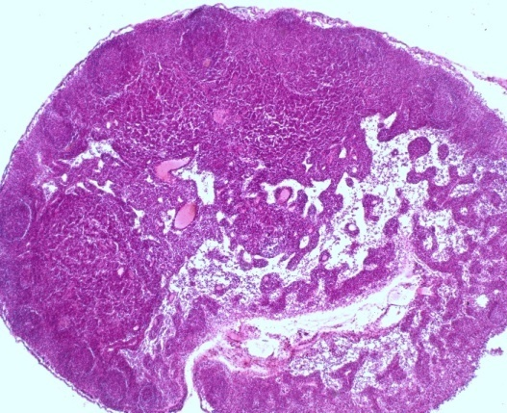
Paracortex is normal. Hematoxylin-eosin stain. Increase approx. 10x0.25; About. 10x20

Figure 4 – Paracortex, located between the cortical and medullary substance of the cervical lymph node in the control group of animals

In the literature, such a morphotype indicates sufficient detoxification-transport and immune function of the lymph node regional for the thyroid gland [133, 134]. Their ratio often changes depending on the state of the internal environment of the body, on the influence of environmental factors, which reflects a change in the functional state of the lymph nodes. The cortical zone contains lymphoid nodules with or without a germinal center, as well as paracortex. The cortical substance contains lymphoid nodules without a germinal center (primary follicles) and lymphoid nodules with a germinal center (secondary follicles). The ratio of lymphoid nodules with a germinative center to lymphoid nodules without a germinative center is on average 1.56±0.06 and indicates the predominance of lymphoid nodules with a germinative center.The deep cortex (paracortex) has an ovoid shape and occupies an area equal to 5.55±0.25%, on the border of the cortical and medullary substance (Figure 4, Table 1).

Table 1 - The structure of the cervical lymph node and indices under normal and with hypothyroidism

Lymph node structures and indices | Control group | Hypothyroidism
Capsule | 1,26±0,05 | 0,96±0,03
subcapsularsinus | 0,71±0,09 | 0,25±0,04*
Corticalplateau | 2,33±0,14 | 1,36±0,12
Lymphoid nodules without a germinal center(F₂) | 1,56±0,06 | 0,96±0,13*
Lymphoid nodules with a germinal center (Ф2) (F₁) | 2,43±0,13 | 1,45±0,39*
paracortex | 5,55±0,25 | 3,74±0,42*^{о}
Billroth'sstrand | 7,19±0,36 | 6,72±0,29
Medullar sinus | 2,01±0,15 | 4,33±0,27**^{о}
The total cross-sectional area of the lymph node | 22,91±1,57 | 19,91±1,26 ^{о}
Index К/М | 1,36±0,07 | 0,72±0,01* ^{о}
IndesF₁/F₂ | 1,54±0,08 | 1,50±0,06 ^{о}
Note: significantly compared with control at P <0.05 *; P <0.01 **

The initial area of the lymph node averages 22.91±1.57%. Initially, intranodular structures are developed and occupy a certain area in the general structure of the lymph node. The subcapsular sinus is quite wide and occupies an area equal to 0.71±0.09%. In the medullar substance, the largest part is occupied by the Billroth's strand 7.19±0.36%; the cerebral sinus accounts for a small part of the area, equal to 2.01±0.15% (table 1). The medullar substance of the node contains Billroth's strandand cerebral sinus, the ratio of the areas of which can also change in an alarming environment or the influence of adverse environmental factors. The indicated functional zones of the cervical lymph node are responsible for the immune and drainage-detoxification function in the body.
After the use of mercazolyl, we observed a decrease in the total area of the lymph node by 13.1% compared with the control group of animals. In experiments, it was shown that at hypothyroidism, the cortical/medullary ratiodecreases to 0.72 ±0.01, which indicates the predominance of the brain substance in the structure of the lymph node(Table 1; Figure 5, 6). In the brain substance of the lymph nodes after the use of mercazolil, there is a statistically significant increase in the area of the cerebral sinus by 2.15 times. An increase in the area of the cerebral sinus is associated with a decrease in the lymphoid parenchyma of the node caused by the intake of mercazolil(Table 1; Figure 5, 6).
Changes in the structure of the lymph node are observed, a shift of the lymphoid nodules inward, with their placement at the border of the superficial and deep cortex, is noted. At the same time, the area of lymphoid nodules with a germinal center and without it when taking mercazolil decreases 1.6-1.67 times. Characteristic intracortical sinuses with a dense arrangement of lymphocytes are found, lymphoid nodules are oriented into the lumen of the sinus. In the cortical substance, the area of the subcapsular sinus, in which lymphoid cells are densely located, is statistically significantly reduced by 2.8 times (Figure 6).

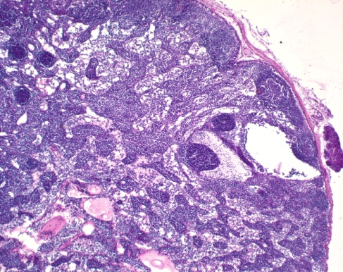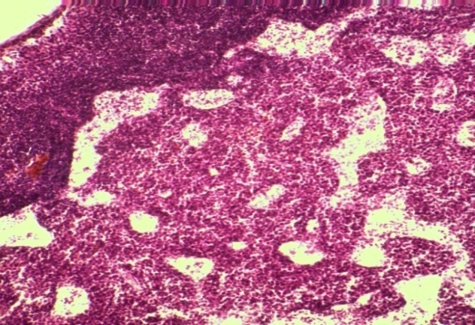

Formed sinuses are cavities. Ectopic lymphoid nodules in the structure of the cervical lymph node. The predominance of the medulla against the background of a decrease in the cortex of the lymph node. Paracortex with intracortical sinuses passing through it. Hypothyroidism Staining with hematoxylin and eosin.
Magnification approx. 10x0.25; About. 10x20

Figure 5 - Histological structures of the cervical lymph node in experimental hypothyroidism

Designations: along the ordinate axis - the area of the main zones of the site in microns. On the abscissa axis of the node: 1 – cortical plateau, 2 – paracortex, 3 – cerebral sinus, 4– K / M index.
Figure 6 – Change in the ratio of the structural and functional zones of the cervical lymph node in rats of the control group and at experimental hypothyroidism

On sections of the lymph node, capsule infiltration with lymphoid elements is often observed. The value of paracortex is statistically significantly reduced by 1.4-1.48 times when taking mercazolil. The decrease in the area of the paracortical zone is relative, since it occurs due to the formation of sinuses(Figure 6). Blood vessels are blood-filled, this indicates an increased vascularization of the lymph node in the presence of mercazolil. Within a month of the use of merkazolil, an increase in the area of the lymph node occurs, which leads to a uniform development of the structures of the cortical and brain substances of the lymph node.
The results obtained are consistent with the results of other authors who studied the structural state of the thyroid gland and indicate a weakening of its functional activity in hypothyroidism [135].
Thus, taking mercazolil leads to disruption of the morphofunctional state of the thyroid gland and cervical lymph node. Changes in the cortical-cerebral ratio with a predominance of the medulla in the lymph node and a decrease in the proportion of the structures of the cortex against the background of ectopia of lymphoid nodules.

3.1.2 Lymphodynamics, hormonal and biochemical parameters of lymph and blood in normal rats and in experimental hypothyroidism

After the introduction of mercazolil, changes in the state of the animals were noted, which gradually progressed: drowsiness, decreased appetite, and dulling of the coat were noted. There was a gradual decrease in thyroid hormone levels and changes in the biochemical parameters of lymph and blood as shown below. After 15 days of research, there was a decrease in the concentration of triiodothyronine (T3) in the lymph by 1.2 times, thyroxine (T4) by 1.14 times, and on the 30th day of the study, the hormones of the studied parameters decreased by 1.8 and 1.7 times, respectively ... A similar picture is shown after 15 days in the blood, the level of triiodothyronine and thyroxine was reduced by 1.12 and 1.14 times, and after 30 days they decreased, respectively, in comparison with the control group by 1.8 and 1.6 times (table 2, figures 7, 8).
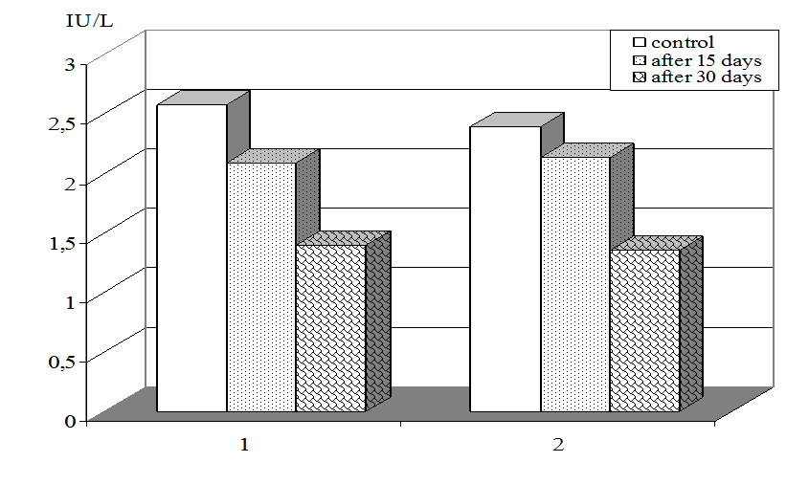

Notations: By Y-axis: triiodothyroninelevel (Т3) in IU/L. By X-axis: 1-lymph, 2 – blood plasma.
Figure 7 – Triiodothyronine content (Т3) in lymph and blood in control and at experimental hypothyroidism

Table 2 – Change of thyroid hormones in lymph and blood of rats of control group and at experimental hypothyroidism

Parameters | Control |  | Experimental
Parameters |  |  | 15 days | 30th day
Lymph
TSH –thyroid-stimulating hormone, IU/L | 0,014±0,0002 | 0,026±0,0001** |  |  | 0,027±0,0003**
Т₃– triiodothyronine, IU/L | 2,58±0,01 | 2,09±0,01* |  |  | 1,40±0,01**
Т₄– thyroxin, IU/L | 65,8±3,3 | 57,8±2,5* |  |  | 42,4±1,7**
Blood
TSH –thyroid-stimulating hormone, IU/L | 0,003±0,0001 | 0,005±0,0001* |  |  | 0,007±0,0002**
Т₃– triiodothyronine, IU/L | 2,39±0,03 | 2,13±0,01* |  |  | 1,35±0,07**
Т₄– thyroxin, IU/L | 52,2±2,4 | 45,8±2,1* |  |  | 32,5±1,3**
Note - * accurate compared to control р<0,05,* -р<0,01**

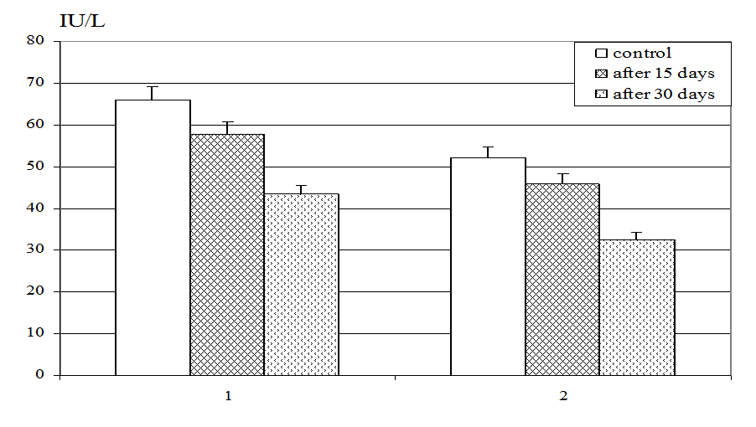
Notations: By Y-axis: thyroxin level (Т₄) in IU/L. By X-axis: 1-lymph, 2 – blood plasma,

Figure 8 – Thyroxin content (Т₄) in lymph and blood in control and at experimental hypothyroidism
The content of thyroid-stimulating hormone (TSH) in the lymph of the control group was 0.014 ± 0.002 μIU / ml. Experimental hypothyroidism was accompanied by the activation of this hormone; in rats under the influence of mercazolil, the TSH value in the lymph of animals of the 2nd and 3rd groups by the 15th and 30th days of the experiment increased by 85% and 92% compared to the control values ( Table 2, Figure 9).
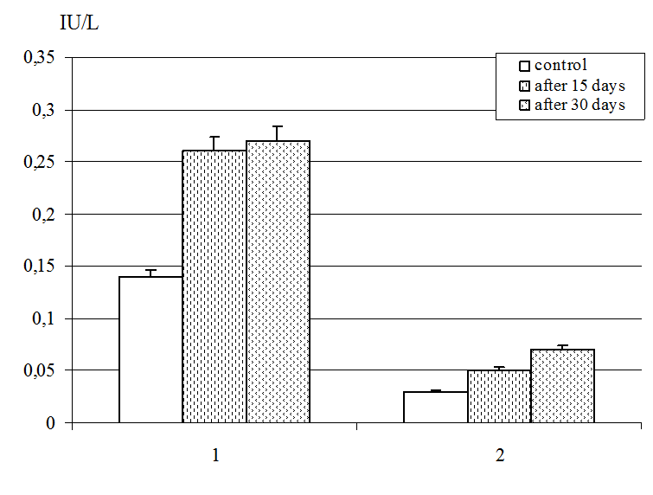

Notations: By Y-axis: Thyroid-stimulating (TSH) level, in IU/L. By X-axis: 1-lymph, 2 – blood plasma.

Figure 9 –– Thyroid-stimulating hormone level (TSH) in lymph and blood in control and at experimental hypothyroidism

In rats of the 2 nd and 3 rd experimental groups in the blood, a decrease in the levels of the hormones triiodothyronine and thyroxine was observed, as well as an increase in the level of thyroid stimulating hormone (TSH). The content of the hormone TSH increased after 15 days by 66% and after 30 days increased by 133.3% compared to the control group of animals, in the control - 0.003 ± 0.001 μIU / L (Table 2, Figure 9).
Thyroid stimulating hormone (TSH) is the most informative indicator of the functioning of the pituitary-thyroid system, in which the level of secretion of the latter increases compensatory during hypofunction of the thyroid gland [136]. An increase in thyroid-stimulating hormones and a decrease in the level of the hormones triiodothyronine and thyroxine in the lymph and blood indicated that we had obtained a model of experimental hypothyroidism and contributed to the continuation of our experiments.
In experimental hypothyroidism in rats, a decrease in lymph flow from the thoracic duct was observed from 0.300.02 (p <0.05) to 0.25 ± 0.02 ml / h (p <0.01), by 12-26% compared with the indicators of the control group (table 3).
In experiments with hypothyroidism, a change in the biochemical parameters of lymph was observed. There was an increase in glucose in hypothyroidism, both in the lymph and in the blood plasma (in the lymph from 5.25 ± 0.9 * to 5.58 ± 0.7 **; in the blood from 5.09 ± 0.3 * up to 5.49 ± 1.2 ** mmol / l) on days 15 and 30 of research, respectively. In experiments, it can be observed that in the 2nd and 3rd groups there was a significant increase in glucose levels by the 15th day of research in lymph and blood by 7% and 24% (p <0.05, p <0.01), and by the 30th day in the lymph and blood of rats of the 3rd group it had a tendency to a further active increase in terms of research time (Figure 10, Table 3).
Daily administration of mercazolil for 15 and 30 days changed the concentration of urea and creatinine in the lymph and blood, in animals of the 2nd group it increased in comparison with intact animals by 14% and 30%, respectively. This process in lymph and blood in rats of the 3rd group progressed in the course of the continuation of the experiments.

Legend: Y-axis: unit of measurement of urea, glucose, cholesterol in mmol / l. Abscissa: lymph, blood.
Figure 10 - The content of urea, glucose and cholesterol in lymph and blood in normal conditions and in experimental hypothyroidism

When studying the lipid profile of lymph and blood in rats with experimental hypothyroidism, the following results were obtained. On the 15th day of experimental hypothyroidism, the level of total cholesterol by 9-18% (p <0.05), and on the 30th day in the lymph and blood exceeded the corresponding indicators of intact animals by 20-39% (Table 3, Figure 10).

Table 3 - Biochemical parameters of lymph and blood in rats of the control and group with experimental hypothyroidism
Indicators | Control  group | Experimental groups
Indicators | Control  group | 15 days | 30 days
Lymphatic flow, ml / min | 0,34±0,02 | 0,30±0,02* | 0,25±0,02**
Lymph
Total protein, g / l | 42,8±1,4 | 45,9±1,9* | 48,3±1,5*
Urea, mol / l | 8,7±0,9 | 10,1±0,12* | 11,3±0,36**
Creatinine, μmol / L | 91,4±2,5 | 102,3±3,3* | 117,2±6,1**
ALAT, mmol / l | 84,4±2,9 | 117,6±12,7** | 148,2±11,1**
AsAT, mmol / l | 159,7±10,8 | 233,1±15,6** | 273,5±10,9**
Alkaline phosphatase, mmol / l | 298,1±10,5 | 357,7±12,1** | 419,9±5,3**
Total bilirubin, μmol / l | 9,6±0,5 | 7,9±0,2* | 6,3±0,4**
Glucose, mmol / l | 4,9±0,2 | 5,25±0,9* | 5,58±0,7*
Cholesterol, mmol / l | 1,3±0,006 | 1,42±0,014* | 1,57±0,014**
Blood
Total protein, g / l | 61,2±2,6 | 65,9±2,6* | 72,3±1,5*
Urea, mol / l | 7,8±0,3 | 8,9±0,19* | 10,1±0,36**
Creatinine, μmol / L | 83,2±1,6 | 92,8±2,7* | 108,6±9,9**
ALAT, mmol / l | 78,4±2,3 | 135,3±11,6** | 207,7±10,6**
AsAT, mmol / l | 139,6±10,1 | 261,9±11,6** | 326,6±10,5**
Alkaline phosphatase, mmol / l | 337,2±10,7 | 448,6±12,3** | 577,5±14,9**
Total bilirubin, μmol / l | 8,3±0,1 | 6,3±0,7* | 5,5±0,8**
Glucose, mmol / l | 4,1±0,3 | 5,09±0,3* | 5,49±1,2**
Cholesterol, mmol / l | 1,48±0,003 | 1,75±0,011* | 20,7±0,016**
Note - * significant compared with control, p <0.05, * -p <0.01 **

In the lymph and blood of rats, the level of bilirubin significantly decreased by 18% (p <0.05) in the second group. In rats in group 3, there was a significant decrease in the level of bilirubin in the lymph and blood by 34% (p <0.01) compared to the levels in the control group. After the introduction of merazolil in rats, the total protein content in the lymph and blood plasma decreased by 7-13% and 8-18%, respectively (normally 42.8 ± 1.4 and 61.2 ± 2.6 g / l). Alkaline phosphatase parameters in groups 2 and 3 increased in lymph by 20-40% (normal 298.1 ± 10.5 mmol / L) and blood plasma by 33-71% (normal 337.2 ± 10 , 7 mmol / L). Above are data on the second and third groups of experimental animals. There was a significant increase in the content of alkaline phosphatase in hypothyroidism.
Determination of the activity of the level of ALT and AST has the greatest clinical significance among transaminases. The study of the content of aminotransferases in the lymph and blood plasma in rats with experimental hypothyroidism showed that the ALT content in the lymph was 117.6 ± 12.7 and 148.2 ± 11.1 mmol / L (p <0.05), plasma 135.3 ± 11.6 and 207.7 ± 10.6 mmol / L (p <0.01 **), respectively. The AST index in the lymph and blood plasma after 15 days was 233.1 ± 15.6 and 261.9 ± 11.6 mmol / L, and after the 30th day, the AsAT content increased by 71% - 133%, respectively (p <0.001 ), compared with the control group (Table 3, Figure 11).

Legend: On the ordinate: the level of ALT, AST, alkaline phosphatase in mmol / L. On the abscissa: 1 - ALT, 2 - ASAT, 3 - alkaline phosphatase.

Figure 11 - The level of aminotransferase and alkaline phosphatase in the lymph in experimental hypothyroidism

In experimental hypothyroidism, a decrease in blood plasma volume (according to the hematocrit data) was observed within 15 and 30 days after the administration of mercazolil. The value of this indicator in the blood of animals of the 2nd group decreased by 6% compared to the control. This process, in the blood of rats of the 2nd group, progressed during the continuation of the experiments. The hematocrit of the blood of rats in this 3rd group decreased on the 30th day of the study by 1.36 times, by 14% compared to the control group of animals.
In our study, with hypothyroidism, a violation of the rheological properties of lymph and blood was observed: the viscosity of the lymph increased from 3.08 ± 0.2 to 4.12 ± 0.3 units. p <0.01, in rats 2 nd and 3 rd increased by 23% compared with intact animals. Both in the lymph and in the blood, an increase in blood viscosity by 25-43%, respectively, was observed in the 2nd and 3rd groups. In experimental hypothyroidism, the viscosity of lymph and blood is 1.34 and 1.43 times higher, respectively, to the initial background (table 4).
The lymph clotting time was reduced by 14-32%, and the blood clotting time by 29-34.5% of the initial values ​​during experimental hypothyroidism. It should be noted that in rats with hypothyroidism, the lymph clotting time was 3.61 ± 0.02 and 2.86 ± 0.01 minutes, while the initial background, i.e. control was 4.2 ± 0.01 min. Blood coagulability at the beginning of the experiment showed 3.68 ± 0.02 minutes, with experimental hypothyroidism it was 2.61 ± 0.01 and 2.41 ± 0.01 minutes. respectively (table 4).
All these facts testify to profound changes in the blood and lymph during hypothyroidism. The data obtained indicate that in hypothyroidism in rats, an increase in viscosity was observed against the background of a decrease in hematocrit and a shortening of the clotting time in lymph and blood and the appearance of erythrocytes in the lymph, which indicates a violation of the rheological properties of lymph and blood.
The results of the study showed that in experimental hypothyroidism, after the introduction of mercazolil in 15 days, the hemoglobin content had significant changes. The hemoglobin content in the blood of rats of the 1st group, it was within 152.7 g / l, with hypothyroidism decreased by 15% compared to the control group. By the 30th day from the beginning of the experiment, its value decreased in comparison with the control group by 30%, by 108.2 g / l (table 4).
From the data in Table 4, it can be seen that after the injection of rat mercazolil in the blood, a decrease in erythrocytes and hemoglobin levels, an increase in the number of leukocytes and platelets were observed. An increase in the number of cellular elements of the blood is associated with a compensatory reaction of the blood system to a change in the concentration of hormones.

Table 4 - Rheological parameters and morphological composition of lymph and blood in the control group and in rats with experimental hypothyroidism

Indicator | Control group | Simulation of hypothyroidism
Indicator | Control group | 2nd group  15 days | 3rd group  30 days
Lymph
Viscosity, units | 3,08±0,2 | 3,79±0,2* | 4,12±0,3**
Coagulability, min | 4,2±0,01 | 3,61±0,02* | 2,86±0,01**
RBC - erythrocytes, x1012 / L | - |  | 0,03±0,001**
WBC - leukocytes, x 109 / L | 5,47±0,4 | 7,8±0,2** | 9,7±0,2**
PLT - platelets, 109 / L | - | - | 3±0,05**
HGB - hemoglobin, g / L | - | - | 0,45±0,001**
LYM - lymphocytes,% | 92,2±2,4 | 120,3±5,3** | 133,1±5,9**
Blood
Hematocrit,% | 48±1,3 | 45,1±1,8 | 41,2±1,8**
Viscosity, | 3,48±0,3 | 4,36±0,9* | 4,98±0,2**
Coagulability, min | 3,68±0,02 | 2,61±0,01** | 2,41±0,01**
RBC - erythrocytes, х103 / μL | 7,53±0,5 | 6,21±0,4* | 5,46±0,6**
WBC - leukocytes, x 109 / μL | 6,8±0,3 | 9,2±0,3** | 10,9±0,8**
PLT - platelets, 109 / μL | 182,1±2,8 | 225,6±3,9** | 265,7±4,5**
HGB - hemoglobin, g / L | 152,7±2,3 | 129,9±1,4* | 108,2±1,6**
LYM - lymphocytes,% | 95,4±2,7 | 127,6±10,9** | 139,4±2,1**
Note - * significant compared with control, p <0.05, * -p <0.01 **

As can be seen from the data obtained, the parameters of erythrocytes in the blood in the control group of animals ranged from 7.59 to 7.84 ± 0.9x1012 / l. Its value in the blood in the experimental groups was reduced by 31%. In the lymph of the 3rd group, a small amount of erythrocytes was found from 0.02 ± 0.001 x1012 / L (table 4).
The platelet count in animals of the 2nd group showed an increase of 35%, and the 3rd group increased by 1.48 times (the 3rd group 265.7 ± 4.5x109 / L) compared with the control group. Normally, there are no platelets in the lymph, only erythrocytes and platelets can appear in the lymph in case of damage to blood vessels and tissue injuries. In the lymph, platelets were found in the 3rd group of animals 3 ± 0.05 x 109 / L (table 4). In experiments, the third group showed a decrease in hematocrit by 14% compared to the control group. The background value of platelets in the blood of rats was detected in the range of 6.8 ± 0.3x109 / L (p <0.05).
It is known that in lymph from the thoracic duct in animals, cells are represented by 98-99% lymphocytes and 1-2% monocytes [137]. In our studies with experimental hypothyroidism, the leukocyte formula of the lymph changed, namely, the number of lymphocytes increased, signaling the activation of the immune system.
With experimental hypothyroidism, the 2nd group of animals, the leukocyte counts increased by 34% compared to the rats with the control group. In intact animals, the level of leukocytes in the blood showed 6.8 ± 0.3x109 / l, in the 3rd group, the platelet count increased to 51% (table 4). Experiments show that with hypothyroidism, leukocytes and lymphocytes increase both in the lymph and in the blood. In the lymph of the 2nd and 3rd groups, leukocytes increase by 43-52%, and in the blood they increase compared to the control indicator, for this period of research by 1.33 and 1.46 times.
From the data obtained, it can be seen that in hypothyroidism, there is a decrease in the concentration of total protein and alkaline phosphatase in the lymph by 26-29 and 50.6%, in blood plasma by 20-25 and 50.2%, respectively. In the blood, leukocytosis and thrombocytosis are observed, a slight decrease in the number of erythrocytes compared to the control. Analysis of the research results showed a decrease in the volumetric rate of lymph flow and changes in the biochemical and rheological properties of lymph. We have found that an increase in lymph viscosity contributed to a decrease in the speed of lymph movement. Changes in physical and chemical parameters and rheological properties of lymph contribute to a change in lymph fluidity.

3.1.3 The rate of blood flow and blood supply to the thyroid gland and the contractile activity of the lymph nodes in experimental hypothyroidism

The blood vessels of the systemic and pulmonary circulation, which together with the heart form a closed circulatory system, include vessels of the elastic (aorta and large arteries) and muscular type (arteries of medium and small caliber), capillaries or exchange microvessels, in which various substances and gases are exchanged between blood and interstitial fluid. The last "capacitive" link of the vascular system is the postcapillary venules, venules, veins and large veins that can contain large amounts of blood.
The main hemodynamic indicators of blood flow through the vessels are the volumetric velocity, the linear velocity and the blood circulation rate, as well as the pressure in various parts of the vascular bed. The main indicators characterizing the cardiovascular system are blood pressure. Systemic arterial pressure in rats was 84-87 mm Hg.
Vascular Doppler ultrasonography has taken an important place in angioneurology over the past two decades. The Dopplegraphic method is based on the application of the Doppler effect - the change in the vibration frequency when reflected from a moving object. Ultrasonic vibrations are generated by sensors with different frequencies, the most widely used are 2, 4, and 8 MHz [138, 139]. Impedance measurements of body organs allow one to monitor the degree of blood circulation in tissues and, as a result, assess the work of the cardiovascular system [140, 141]. Thus, thoracic impedance cardiography (rheocardiography), which monitors the pulse fluctuations of the chest impedance occurring during the cardiac cycle, is a rather promising, technically simple and economically inexpensive method for non-invasive diagnosis of hemodynamic disorders and heart failure [142].
The present study examined the parameters of the carotid artery in rats before and after hypothyroidism. The study of great vessels showed that the most significant changes in blood flow were identified, in particular, by the linear blood flow velocity Vmax and the resistance index Ri.
The results of the studies carried out showed that during the experiments the mean arterial pressure was 90-100 and 85-90 mm. Hg Doppler ultrasound of extracranial vessels and vessels of the upper extremities, carried out according to the standard technique with functional tests, revealed the asymmetry of blood flow in the carotid arteries. The experiments showed that in intact animals, the linear blood flow velocity in rats in the left carotid artery from the initial background increased by 17%, and the right carotid artery showed similar results. A decrease in the linear velocity of blood flow in the carotid arteries was noted in hypothyroid rats. According to the resistance index Ri, the experimental groups showed an increase in the right side by 67% and on the left side by 20% compared to the control group of animals (Table 5).
In the studies, data were obtained on the functional state of blood flow in the norm and in the state of pathology. The average values ​​of the blood flow velocity in the carotid arteries in the control group of animals were: on the right - 16.7 ± 2.5 cm / sec; left 20.8 ± 0.12 cm / sec. The index of resistance or circulatory resistance of Purselo (Ri) on the right - 0.24 ± 0.02; on the left - 0.30 ± 0.15; the index of spectral expansion or spectral expansion (HR) on the right is equal to 146 ± 2.5%; left side - 147 ± 5.3%. In the main carotid artery, the blood flow velocity in hypothyroidism was 18.7 ± 2.2 cm / sec on the right side; pulsation index Ri - 0.40 ± 0.03; HR index - 105.1 ± 0.2%. In experimental hypothyroidism in the carotid artery, the blood flow velocity was on the left 22.45 ± 2.02 cm / sec; resistance index (Ri) - left - 0.36 ± 0.5; the index of spectral expansion or spectral expansion (HR) on the left was - 109.1 ± 5.0% (table 5)
Table 5 - Parameters of local blood flow in the right and left carotid arteries in rats of the control group and the group with experimental hypothyroidism

Indicators |  | Control | Hypothyroidism
Left OCA | V max, cm / sec | 20,8±0,12 | 22,45±2,02*
Left OCA | Ri | 0,30±0,15 | 0,36±0,5*
Left OCA | HR | 147±5,3 | 109,1±5,0**
Right OCA | V max | 16,7±2,5 | 18,7±2,2*
Right OCA | Ri | 0,24±0,02 | 0,40±0,03**
Right OCA | HR | 146±2,5 | 105,1±0,2
V max - maximum blood flow velocity, cm / sec
Ri - index of resistance or circulatory resistance of Purselo
HR - pulsation index or spectral expansion index,%
Note: significant compared to control, * p <0.05, ** p <0.01

According to the rheographic data, it can be seen that in rats with hypothyroidism, there is a decrease in slow and fast blood filling by 35-45% (p <0.01) in the carotid artery compared with the control group of animals. In rheographic studies, it was shown that the basic resistance in the control animals was 170 ± 2.1 Ohm, in the experimental groups it decreased by 12%, and there was also a decrease in the rate of pulse blood filling in the group with hypothyroidism by 45% (p <0.01) by comparison of the control group. The results of the study showed that after the introduction of mercazolil in rats with hypothyroidism, the heart rate decreased by 8% in relation to group 1 (table 6).
As can be seen from table 6, in rats with hypothyroidism, the amplitude of the diastolic wave significantly decreased, in the control group the amplitude of the diastolic wave was 0.023 ± 0.001 Ohm. The diastolic index showed a decrease of 8% and the diastolic arterial index increased by 15% compared to the control.
From the data obtained, it can be seen that the rats of the 2nd group showed an increase in the blood flow velocity and the resistance index, which indicates that vascular disorders occur and a negative effect on this group. Hemodynamic changes were found significantly more often in the vessels of hypothyroid rats than in intact animals. Based on the study, it can be stated that Doppler ultrasonography is an informative method for studying blood flow through the great vessels of the neck region. The data showed a short-term change in local blood flow in the right and left carotid artery. The most pronounced effect was observed in the second group. The revealed hemodynamic disturbances must be taken into account, for a more detailed and in-depth study of the circulatory system, further research is required.

Table 6 - Changes in heart rate and blood flow rates
Indicators | Control | Hypothyroidism
Heart rate. abbr. [bpm] | 167±2,6 | 164±2,9*
Base resistance [Ohm] | 170±2,1 | 149±2,0**
Speed pulse. blood floor. [Ohm / sec] | 0,256±0,01 | 0,139±0.01**
Wed fast blood filling. [Ohm / sec] | 0,48±0,001 | 0,25±0,001**
Speed fast. blood filling. [Ohm / sec] | 2,68±0,001 | 1,70±0,001**
Speed slow blood filling. [Ohm / sec] | 0,17±0,001 | 0,11±0,001
Diastolic amplitude. waves [Ohm] | 0,023±0,001 | 0,015±0,001**
Diastolic index [%] | 75,5±0,003 | 70,6±0,003*
Diastolic arteries. index [%] | 109,0±2,3 | 125,6±1,8**
Note: significant compared to control, * p <0.05, ** p <0.01

The lymph nodes play a key role in the pathogenesis of various diseases [143]. Lymph nodes play an important role in the body's defense against various infections and cellular gene abnormalities. These small but numerous organs are characterized by a variable structure that depends on a combination of external and internal factors [144]. It was of interest to study the effect of hypothyroidism on the functional state of the motor function of the cervical lymph nodes, which are involved in the pathological process.
In rats against the background of experimental hypothyroidism on isolated preparations of cervical lymph nodes, an increase in contractile activity (purity and amplitude) was observed, and tonic contractions were manifested with a frequency of 6.11 ± 0.14 contractions / min and an amplitude of 8.2 ± 0.24 mg (Figures 12, 13). Preparations of lymph nodes in rats in the control group, the response to vasoactive substances, in particular to adrenaline at a dose of 1x10-8 M, was observed an increase in frequency and an increase in the amplitude of contraction by 10% and 17%, respectively. In the control group, the frequency of contraction showed - 9.2 ± 0.2contractions / minute, the amplitude - 17.9 ± 0.2 mg (Figures 12, 13).
Legend: Y-axis: contraction rate in abbreviations / min. On the abscissa axis: 1 - control group, 2 - hypothyroidism.

Figure 12 - Frequency of spontaneous contractions of lymph nodes in normal rats and in experimental hypothyroidism

Legend: Y-axis: amplitude of contraction in mg. On the abscissa axis: 1 - control group, 2 - hypothyroidism.

Figure 13 - Amplitude of spontaneous contractions of lymph nodes in normal rats and after experimental hypothyroidism

In rats of the control group, contractile reactions of the lymph nodes were noted on the action of vasoactive substances. Adrenaline at a dose of 1 × 10-8-1 × 10-3M when applied to lymph nodes caused an increase in their frequency by 5.2 ± 0.2% and an increase in the amplitude of contractions by 16.1 ± 1.2% from the initial background.
Under the action of adrenaline at a concentration of 1 × 10-8-1 × 10-3M on isolated cervical lymph nodes in rats after hypothyroidism, contractile reactions were found in the lymph nodes, the frequency of contractions and the amplitude decreased by 5.1 ± 0.2% and 4, 1 ± 0.3%, respectively, from the initial background. In response to vasoactive substances, in particular to adrenaline at a dose of 1 × 10-8M, there was an increase in the frequency of contractions of the cervical lymph nodes by 13.5% (p <0.05) and, accordingly, the amplitude by 7.7% compared with the control (Fig. 14), but they were higher than in control rats.

Legend: ordinate - shifts in%, 1 - adrenaline (1x10-8-1x10-6 ml). Abscissa: 1 - control group, 2 - groups with hypothyroidism.

Figure 14 - Changes in the frequency of contractions of the cervical lymph nodes in normal rats and in hypothyroidism under the action of vasoactive substances

In this experiment, it was shown that in rats with experimental hypothyroidism there was an increase in the tone of the studied lymph nodes, as evidenced by an increase in vasoconstriction in response to the action of adrenaline at a dose of 1 × 10-8-1 × 10-3M. the concentration of adrenaline in various doses (1 × 10-8-1 × 10-3M) caused a dose-dependent increase in the contractile activity of the lymph nodes of the studied groups.
When analyzing the data obtained, we received a decrease in the contractile activity of isolated lymph nodes, but an increase in responses to vasoactive substances.
In rats against the background of hypothyroidism and on the injection of adrenaline on isolated preparations of cervical lymph nodes, tonic contractions were manifested, the activity of contractions of the cervical lymph nodes showed a frequency of 6.11 ± 0.3 contractions / minute, and an amplitude of 8.2 ± 0.4 mg (Figures 15). In rats with hypothyroidism, acetylcholine at a concentration of 10-7M - 10-6M, when introduced into the incubation solution, caused a weak contractile response due to an increase in the amplitude of contractions, which increased to 8.0 ± 0.5 mg, and the frequency increased to 4.1 ± 0, 3 abbreviations / min. The latency period with the introduction of adrenaline was 11.3 ± 2 sec in control animals, and 16 ± 3 sec in animals with hypothyroidism. Under the action of acetylcholine, the latency period was 12 ± 2 sec in the control group, and 18 ± 3 sec in the hypothyroid group.

Designations: ordinate - shifts in%, 1 - acetylcholine (1x10-7-1x10-6 Ml). Abscissa: 1 - control group, 2 - groups with hypothyroidism.

Figure 15 - Changes in the amplitude of contractions of the cervical lymph nodes in normal rats and in hypothyroidism under the action of vasoactive substances

The spontaneous and evoked contractile activity of the cervical lymph nodes in rats with hypothyroidism decreased compared to the control group. The magnitude of the amplitude and frequency of spontaneous contractions of the nodes decreased. The severity of contractile reactions decreased, and their latent periods increased under the action of vasoactive substances (adrenaline, acetylcholine), which is shown in Figure 16, 17.

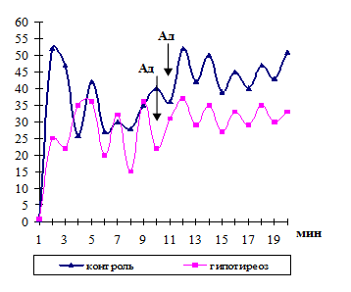

Figure 16 - Contractions of cervical lymph nodes in rats of the control group and in
hypothyroidism when exposed to adrenaline

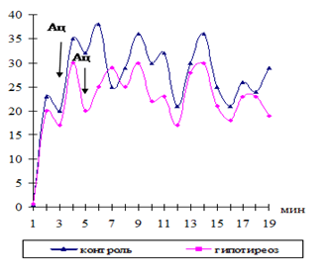

Figure 17 - Contractions of isolated cervical lymph nodes in rats of the control group and in hypothyroidism when exposed to acetylcholine

In these experiments, it was shown that in rats with hypothyroidism, the tone and functional activity of the cervical lymph nodes decreased during the hypothyroid process. An increase in TSH in the blood and lymph and a decrease in T3 and T4 have a depressing effect on the functional state of the regional cervical lymph nodes.

3.2 To examine the adrenergic innervation of the thyroid gland and lymph vessels and nodes, the ratio of the functional structures of the lymph nodes in different regions of the body, the microstructure of the reticular cells in them with thyroid insufficiency –2019

3.2.1 Adrenergic innervation of the thyroid, blood and lymph vessels and lymph nodes under hypothyroidism

This section provides material on the study of adrenergic innervation of the thyroid gland, blood and lymph vessels and lymph nodes in control animals and groups after experimental hypothyroidism. As a result of the study, it was revealed that the rat thyroid gland consists of two separate elongated lobes. The thyroid gland of intact rats at the tissue level is a vascular-functional unit consisting of groups of follicles having an autonomous blood circulation system. As an endocrine gland, the thyroid gland has an abundant blood supply. Despite the fact that the rat's thyroid gland, unlike the human thyroid blood supply, feeds only two arteries, it has a dense capillary network [53, 132].
It is known that the structure of the thyroid gland and lymph node when receiving mercazole in comparison with the control undergoes some qualitative changes, resulting in a decrease in follicle diameter, total volume, volume of colloid and follicular epithelium [53]. In Figures 18a, b, the control histopreparations of the thyroid gland are presented in normal state and under usage of mercazole.

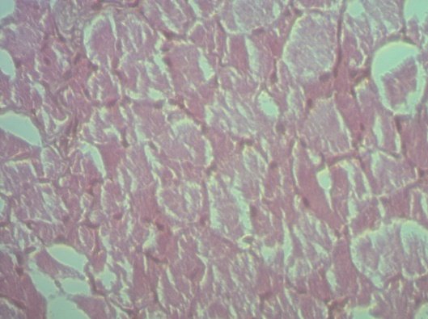
(a) (b)
Legend: (а) normal, (b) - under hypothyroidism.
Lens 10х0,25, Оc. 10х20
Figure 18 – Histostructure of the thyroid gland in normal state and under hypothyroidism
The results of a fluorescent microscopic study showed that adrenergic nerve fibers form plexuses around the blood vessels that approach the gland. Despite the rich innervation of the blood vessels supplying the thyroid gland, we did not detect a network of adrenergic fibers in the thyroid tissue. Only a few adrenergic nerve fibers addressed to the arterial vessels feeding the thyroid tissue can be distributed in the glandular tissue.
Apparently, catecholamines released from nerve endings can affect the function of the thyroid gland, both through the bloodstream and acting directly on thyrocytes. Some researchers, using the method of norepinephrine turnover to assess the sympathetic activity of the thyroid gland in vivo, suggested that the increased activity of adrenergic nerves in the thyroid gland may contribute in some circumstances to an increase in glandularity [145]. Arterial vessels of the thyroid gland belong to the arteries of the muscular type, the middle shell of which is represented by bundles of smooth muscle cells. Mediator of adrenergic nerve fibers is norepinephrine, which, when studied using a fluorescent microscope with histochemical method, produces bright green fluorescence. It is known that norepinephrine affects the effector smooth muscle cell. It is established that the smallest distance between the mediator and the smooth muscle cell is 200 nm, and this indicates the distant effect of catecholamine on the effector cell. As a result of our research, adrenergic nerve fibers in the wall of the superior and inferior thyroid arteries give a bright, specifically green luminescence, which indicates the content of catecholamines within. These nerve fibers form a complex network of adrenergic fibers (figure 19 a, b).

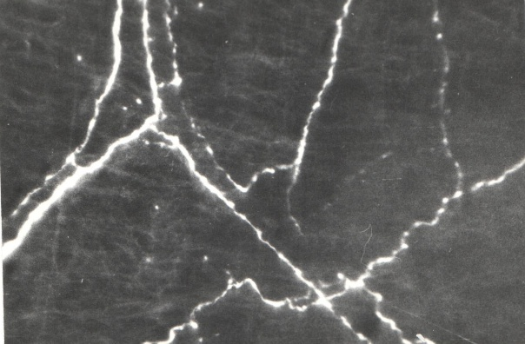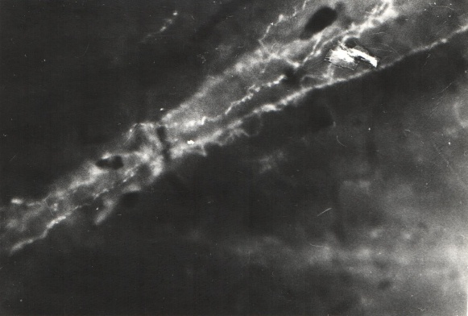
(a) (b)
Legend: (а) - normal, cryostat section, (b) - under hypothyroidism. Total preparations.
Lens 30, Оc. 6,3х
Figure 19– Adrenergic innervation of the wall of the superior thyroid artery

We have found that adrenergic fibers form branchings, and along the nerve fibers varicose extensions are detected which are regularly located and have even more intense fluorescence; the contents of the extensions are known to be norepinephrine [146].
Under hypothyroidism, adrenergic fibers and their varicose extensions are preserved. However, it should be noted that in the wall of the artery of the thyroid gland, large varicose expansions along the nerve fiber under hypothyroidism of rats are in a diffuse state compared to intact animals (figure 20 a, b).
The diffusiveness of the catecholamine depot, that is, varicose thickenings, may indicate that the catecholamines released from the nerve endings of the sympathetic nervous system can apparently affect the function of the thyroid gland both through the bloodstream and through acting on thyrocytes.

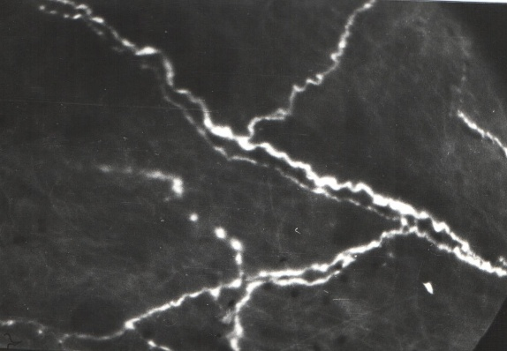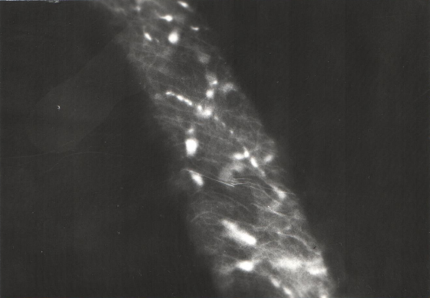
(a) (b)
Legend: (а) - normal, cryostat section, (b) - under hypothyroidism. Total preparations.
Lens 30, Оc. 6,3х
Figure 20– Adrenergic innervation of the wall of the lower thyroid artery in normal state

Lymph nodes and the thyroid gland in the neck are closely interrelated, as they are in close proximity to each other and are very sensitive to the effects of various factors. Using a histochemical fluorescent microscopic method of detecting catecholamines in the wall of the cervical lymphatic vessel and tissue of the cervical lymph node, we found that adrenergic nerve fibers in the wall of the lymphatic vessel in intact animals form rarely looped nerve fibers. Post-terminal thin nerve branchings with small varicose thickenings were found in the valve base of the lymphatic vessels. We have found that smooth muscle cells at the base of the valves of the lymphatic vessel have an oblique longitudinal direction [146].
As we have noticed, on the preparations of the lymph node gates, separate adrenergic nerve fibers were distributed between the trabeculae, leaving the vascular wall. Initially, these nerve fibers serve as the adrenergic innervation apparatus of the wall of blood vessels, and only the individual single thin nerve fibers, separated from the intra-walled vascular nerve plexus, are distributed among the connective tissue of the trabeculae of the lymph node. It is known that in the area of the gates in the capsule of the lymph node there is the greatest number of smooth muscle myocytes. It used to be considered that in the vascular wall the varicose thickenings of the terminal sections of adrenergic axons, in the region of which catecholamines are being released, are at certain definite distances from the smooth muscle cells. The adrenergic nervous apparatus provides motor transmission of signals from the nerve fiber to the smooth muscles, that is, it participates in the realization of vasomotor efferent signaling. Perhaps in this part of the lymphatic vessel, the effect of catecholamines on the effector cell is of particular importance.Under hypothyroidism, adrenergic nerve fibers and varicose thickenings in the wall of the lymphatic vessels remain. Along the adrenergic fibers there are areas with less bright luminescence. Varicose thickenings along the nerve fiber retain their regularity, however, small terminal varicose extensions disappear (figure 2 a, b).

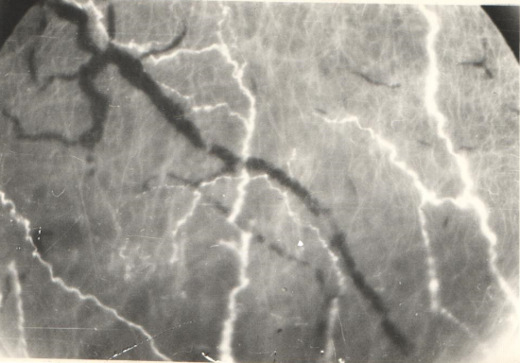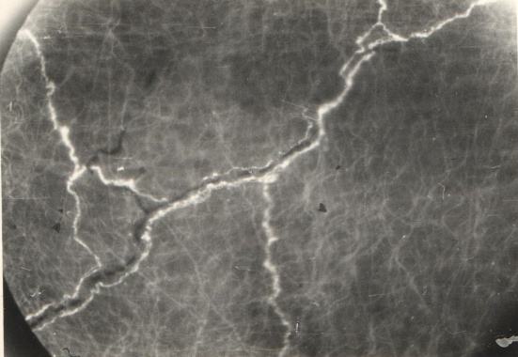
(a) (b)
Legend: (а) - normal, (b) - under hypothyroidism. Total preparations.
Lens 30, Оc. 6,3х
Figure 21–Адренергическая иннервация стенки шейного лимфатического сосуда

In identifying the adrenergic innervation apparatus, our attention was drawn to the site of the gate of the lymph node. Regular varicose thickenings in rats have a brighter fluorescence, which may indicate a high content of catecholamines in them. Such varicose thickenings are considered to be depots of catecholamines. In this area of the lymph node, adrenergic fibers form a plexus in the wall of the blood vessel that feeds the tissue of the lymph node. Separate adrenergic nerve fibers are found in the capsule of the lymph node. Mainly in the tissue of the lymph node adrenergic innervation is addressed to the blood vessels of the lymph node. Under thyroid insufficiency, it was found that the adrenergic nerve plexuses in the gate area of the lymph node remain, however, a low luminescence of the terminal part of the adrenergic nerve fibers with a decrease in the number of varicose thickenings and a decrease in the intensity of their fluorescence was observed (figure 22 a, b).

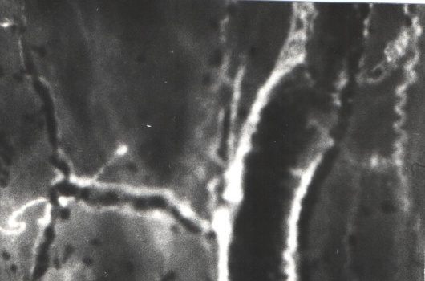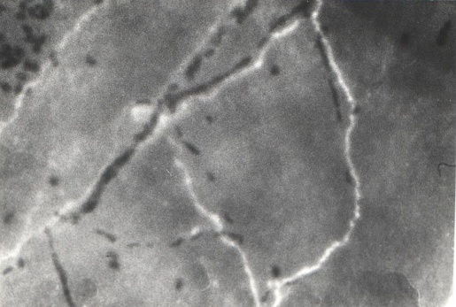
(a) (b)
Legend: (а) - normal, (b) - under hypothyroidism. Total preparations.
Lens 30, Оc. 6,3х
Figure 22– The adrenergic innervation of the capsule of the cervical lymph node is normal state and under hypothyroidism

It is known that arteries and nerves penetrate through the gates of the cervical lymph node. The capsule covering the lymph nodes consists mainly of connective tissue elements, between which there are bundles of smooth muscle cells oriented in different directions. Consequently, the presence of an adrenergic innervation apparatus and smooth muscle cells in the tissue of the lymph nodes affects its contractile function. It has been established that myocytes of the lymph node capsule rhythmically synchronously contract, leading to an increase in intra-nodular pressure and displacement of the lymph from the node to the outgoing lymphatic vessels.
We have considered the qualitative side of adrenergic innervation of the lymph nodes. Аdrenergic innervation is characterized by the presence of multiple nerve fibers that form plexuses with regularly located varicose extensions along the entire length of the nerve fiber. Summing up, the adrenergic innervation apparatus of the blood vessels of the thyroid gland, cervical lymphatic vessels and lymph nodes under hypothyroidism preserve integrity. However, under thyroid insufficiency, the diffusivity of both adrenergic nerve fibers and varicose thickenings, which are depot of catecholamines, has been revealed. Release of catecholamines from varicose thickenings is possible, which may affect the function of the thyroid gland, its blood vessels, as well as the cervical lymph vessels and lymph nodes.

3.2.2 The ratio of the functional structures of the lymph nodes in thyroid insufficiency (cell body, density, dimensions)

The results of the study showed that in animals with experimental hypothyroidism created by us, destructive processes are revealed. In hypothyroidism in the thyroid gland there were significant changes in its structure and an increase in wall thickness, a violation of the shape of the nuclei, desquamation of epithelial cells, which is reflected in a decrease in the diameter of the follicles, the total volume, volumes of the colloid and follicular epithelium. At the same time, swelling and rounding of the thyroid gland itself was observed. The follicles are small in size, some of them are devoid of colloid and filled with transparent liquid. Hyperplasia of the parenchyma, changes in the newly formed and deformed follicles, an increase in the thickness of the follicle wall, partial desquamation of the epithelium, disruption of the shape of the nuclei, vacuolization of the cytoplasm, expansion of the interfolicular space (Figure 23).

Legend: Hematoxylin and eosin stained.Magnification approx. 10x0.25; About. 10x20
Figure 23 - Histological structure of the thyroid gland of rats with experimental hypothyroidism

In animals, the cervical lymph nodes are normally covered with a thin, dense capsule. The subcapsular (marginal) sinus is well expressed, densely filled with cells. Normally, the structure of the cervical lymph nodes is represented by uniform development from the main structural and functional zones, there is a clear cortical-cerebral border in the cervical nodes, an intermediate morphotype of the lymph node is observed, in which there is a slight predominance of the cortical substance over the medulla of the lymph node, the cortical index the cervical node is 1.36 ± 0.07 (Figure 24, Table 7).

The paracortex, located between the cortical and medulla of the lymph node in a normal state. Hematoxylin-eosin staining.
Magnification approx. 10x0.25; About. 10x20
Figure 24 - Paracortex located between the cortex and medulla of the cervical lymph node in the control group of animals

After the introduction of mercazolil, we observed a decrease in the total area of ​​the lymph node by 13.1% compared to the control group of animals. The structure of the lymph node in hypothyroidism causes a decrease in the total area of ​​the lymph node to 19.94 ± 1.23%, which is 13.23% less than the initial indicator and 23.57% less than the control indicator on day 30 of the study. The proportion of areas occupied by different intranodular structures also changes. In the structure of the lymph node, the displacement of the lymphoid nodules inward was noted, with their placement on the border of the superficial and deep cortex. The cortical-cerebral index decreases to 0.79 ± 0.08, which indicates the predominance of the medulla in the structure of the lymph node. In the medulla, a statistically significant increase of 1.5-2.1 times in the area of ​​the cerebral sinus is observed when taking mercazolil. An increase in the area of ​​the cerebral sinus is associated with a decrease in the lymphoid parenchyma of the node, caused by the intake of mercazolil. There are characteristic intracortical sinuses with a dense arrangement of lymphocytes, lymphoid nodules are oriented into the lumen of the sinus (Figure 25, Table 7). The predominance of the medulla against the background of a decrease in the cortex of the lymph node. Formed sinuses-cavities. Ectopic lymphoid nodules in the structure of the lymph node (Figure 26).

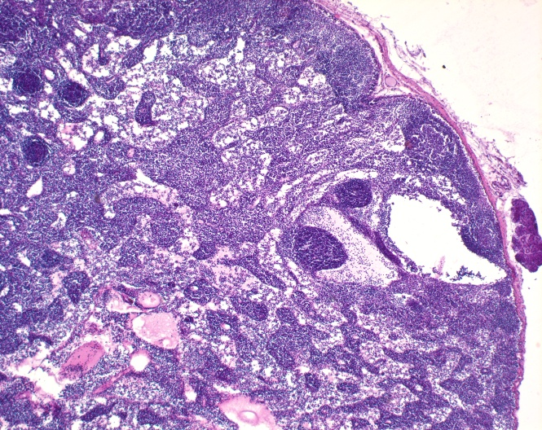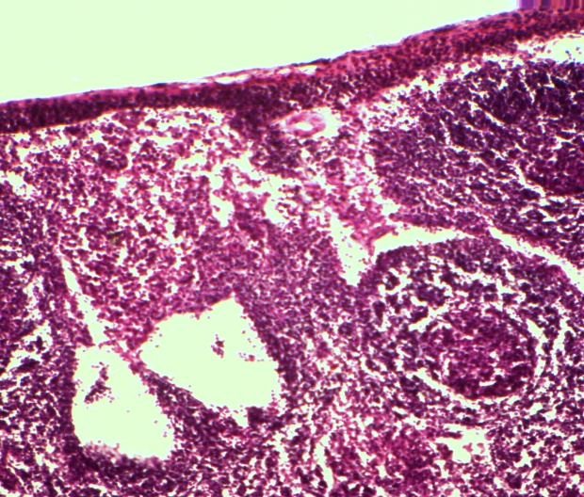

Legend: Hypothyroidism. Staining with hematoxylin and eosin.
Magnification approx. 10x0.25; About. 10x20
Figure 25 - A fragment of the cervical lymph node in experimental hypothyroidism

Table 7 - The structure of the cervical lymph node and indices in norm and hypothyroidism
Lymph node structures and indices | Control group | Hypothyroidism
Capsule | 1,26±0,05 | 0,96±0,03
Subcapsular sinus | 0,71±0,09 | 0,25±0,04*
Crust plateau | 2,33±0,14 | 1,36±0,12
Lymphoid nodules without germinal center (F2) | 1,56±0,06 | 0,96±0,13*
Lymphoid nodules with a germinal center (F1) | 2,43±0,13 | 1,45±0,39*
Paracortex | 5,55±0,25 | 3,74±0,42*^{о}
Pulp strands | 7,19±0,36 | 6,72±0,29
Cerebral sinus | 2,01±0,15 | 4,33±0,27**^{о}
Total sectional area of the lymph node | 22,91±1,57 | 19,91±1,26 ^{о}
Index K / M | 1,36±0,07 | 0,72±0,01* ^{о}
F1 / F2 index | 1,54±0,08 | 1,50±0,06 ^{о}
Note: significant compared to control at P <0.05 *; P <0.01 **

In the cortex, the area of ​​the subcapsular sinus, in which the lymphoid cells are densely located, is statistically significantly reduced by 2.6-2.9 times. Changes in the structure of the cervical lymph node are observed, the lymphoid nodules are displaced in depth, with their placement on the border of the superficial and deep cortex. Infiltration of the capsule with lymphoid elements is often observed. The size of the paracortex is statistically significantly reduced by 1.5-2.2 times when taking mercazolil. At the same time, the area of ​​lymphoid nodules with and without a germinal center decreases 1.6-1.67 times when taking mercazolil. In the cortex, the area of ​​the subcapsular sinus, in which the lymphoid cells are densely located, is statistically significantly reduced by 2.8 times. There are characteristic intracortical sinuses with a dense arrangement of lymphocytes, lymphoid nodules are oriented into the lumen of the sinus. The decrease in the area of ​​the paracortical zone is of a relative nature, since it occurs due to the formation of sinuses. The blood vessels are filled with blood and indicate an increased vascularization of the lymph node under conditions of taking mercazolil (Figure 26).

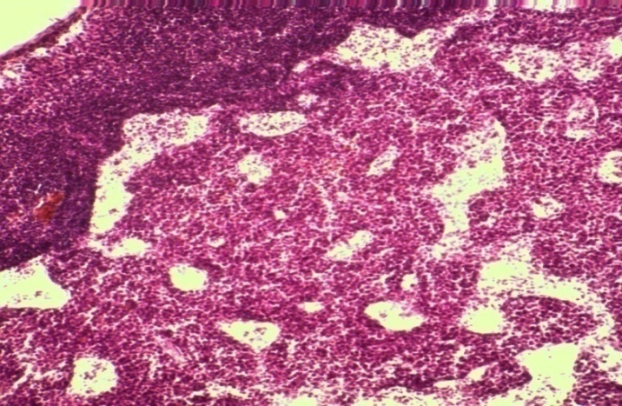

Legend: Formed sinuses are cavities in the structure of the cervical lymph node. Paracortex with intracortical sinuses passing through it. Hypothyroidism Staining with hematoxylin and eosin.
Magnification approx. 10x0.25; About. 10x20
Figure 26 - Histological structures of the cervical lymph node in experimental hypothyroidism

Under conditions of the euthyroid state, i.e. in the control groups, an intermediate morphotype of the lymph node is observed, in which there is a slight predominance of the cortex over the medulla of the lymph node. The cortical-cerebral index is 1.37 ± 0.09. This morphotype indicates sufficient detoxification, transport and immune functions of the lymph node, regional for the thyroid gland. The initial area of ​​the lymph node averages 22.98 ± 1.61%. Initially, the intranodular structures are developed and occupy a certain area in the general structure of the lymph node. The subcapsular sinus is wide enough and occupies an area equal to 0.70 ± 0.08%. In the cortex there are lymphoid nodules without a germinal center (primary follicles) and lymphoid nodules with a germinal center (secondary follicles). The ratio of lymphoid nodules with a germinal center to lymphoid nodules without a germinal center averages 1.55 ± 0.07 and indicates a predominance of lymphoid nodules with a germinal center. The deep cortex (paracortex) has an ovoid shape and occupies an area of ​​5.57 ± 0.26% at the border of the cortex and medulla. In the medulla, the pulp cords occupy most of the 7.11 ± 0.38%, the cerebral sinus accounts for a small part of the area, equal to 2.03 ± 0.17% (table 7).
Within a month, there is an increase in the area of ​​the lymph node, the increase was 12% -14% (table 7). At the same time, the values ​​of the area of ​​the structures of the lymph node change statistically insignificantly with the initial level. The size of the paracortex area tends to increase during all periods of the study, but there is no statistically significant difference with the initial indicator. Perhaps this is due to the accumulation of lymphocytes in the paracortex during their migration through the wall of postcapillary venules into the lymph node. The development of the deep cortex leads to the compaction of the lymph node, which is accompanied by an increase in the cortical-cerebral ratio (C / M index).
Thus, long-term use of mercazolil leads to a change in the cortical-cerebral ratio with a predominance of the medulla in the lymph node and a decrease in the proportion of cortical structures against the background of ectopia of lymphoid nodules.
Under the influence of destabilizing factors, regional lymph nodes are able to present objective information about changes in the structural and functional zones, where immunocompetent cells go through all stages of maturation and differentiation. During the experiment, certain cytological changes were noted in the structural and functional zones of the lymph node in hypothyroidism (table 8).
Lymphoid nodule. The state of hypothyroidism is accompanied by a statistically significant decrease by 1.44 times in the number of lymphoblasts, 1.57 times in the number of medium lymphocytes, 1.51 times in the number of small lymphocytes against the background of an increase in 1.28 times in the number of macrophages per unit area of ​​the lymphoid nodule in the lymph node. A decrease in lymphoid cells in the lymphoid nodule indicates a decrease in proliferative potencies in hypothyroidism (table 8).
Paracortex. In the paracortex, the number of blasts increases statistically significantly by 1.28 times, and the number of medium and small lymphocytes decreases by 1.39 times and 1.20 times, respectively, in the absence of other cells under conditions of the formed hypothyroid state. Changes in the composition of cells in the paracortex are associated with the alignment along the wall and migration of lymphocytes into the lumen of postcapillary venules. This to some extent depletes the cell population in the paracortex under hypothyroidism (Table 8).

Table 8 - structural and functional zones of the lymph node in the control and in experimental hypothyroidism
Cells, number of cells per unit area (1600 μm2) | Control group | Hypothyroidism
Lymphoid nodules
Lymphoblasts | 4,31±0,19 | 3,0±0,17*
Average lymphocytes | 13,33±0,21 | 8,50±0,18*
Small lymphocytes | 9,33±0,29 | 6,17±0,28*
Macrophages | 4,67±0,13 | 6,0±0,17*
Paracortex
Lymphoblasts | 3,0±0,16 | 3,83±0,18
Average lymphocytes | 13,17±0,29 | 9,50±0,29*
Small lymphocytes | 7,83±0,21 | 6,50±0,22*
Reticular cells | 1,01±0,12 | –
Macrophages | 6,33±0,17 | 3,50±0,21*
Plasmacytes | 0,17±0,03 | –
Eosinophilic granulocytes | – | –
Brain cords
Plasmablasts | 2,33±0,19 | 5,50±0,23*
Plasmacytes | 2,67±0,23 | 1,83±0,18*
Small lymphocytes | 5,83±0,21 | 5,17±0,28
Average lymphocytes | 8,67±0,23 | 4,50±0,21*
Macrophages | 4,50±0,12 | 4,51±0,18
Reticular cells | 1,50±0,09 | 0,83±0,10*
Eosinophilic granulocytes | 0,33±0,07 | 0,53±0,09
Cerebral sinus
Small lymphocytes | 8,67±0,26 | 7,0±0,35*
Macrophages | 3,83±0,19 | 6,0±0,27*
Reticular cells | 1,67±0,13 | 1,0±0,14
Plasmacytes | 0,33±0,14 | 0,50±0,19
Eosinophilic granulocytes | 0,33±0,07 | –
Note: significant compared to control at P <0.05 *; P <0.01 **
Pulpy strands. In hypothyroidism, there is a statistically significant 2.36-fold increase in the number of plasmablasts, a 1.46-fold decrease in plasma cells, 1.93 times in the number of medium lymphocytes, and 1.81 times in the number of reticular cells in the pulp cords of the lymph node. The number of small lymphocytes and eosinophilic granulocytes changed statistically insignificantly with the control indicators (table 8).
Cerebral sinus. The cytology of the cerebral sinus in hypothyroidism is characterized by a statistically significant decrease in the number of small lymphocytes by 1.24 times against the background of an increase in the number of macrophages by 1.57 times. The number of reticular cells and plasma cells was within the limits of the control value. In conditions of hypothyroidism, all structural and functional zones of the lymph node are characterized by a reduced number of small lymphocytes; the number of blasts decreases in the lymphoid nodule and increases in the paracortex and pulp cords; the number of macrophages increases in the lymphoid nodule, the cerebral sinus, the number of mature plasma cells decreases in the paracortex and pulp cords. The noted decrease in the content of plasma cells is associated with a decrease in the maturation of these cells from lymphocytes and a delay in their migration into the pulp strands (Table 8).
On sections of the lymph node, infiltration of the capsule with lymphoid elements is often observed. The size of the paracortex is statistically significantly reduced by 1.4-1.48 times when taking mercazolil. The decrease in the area of ​​the paracortical zone is of a relative nature, since it occurs due to the formation of sinuses. The blood vessels are filled with blood, this indicates an increased vascularization of the lymph node in conditions of taking mercazolil. Within a month of the introduction of mercazolil, an increase in the area of ​​the lymph node occurs, which leads to a uniform development of the structures of the cortical and medullary substances of the lymph node.
The results obtained agree with the results of other authors who studied the structural state of the thyroid gland and indicate a weakening of its functional activity in hypothyroidism [147, 148].
Thus, taking mercazolil leads to disruption of the morphofunctional state of the thyroid gland and cervical lymph node. Changes in the cortical-cerebral ratio with a predominance of the medulla in the lymph node and a decrease in the proportion of the structures of the cortex against the background of ectopia of lymphoid nodules.

3.2.3 Morphofunctional state and microstructure of the tissue microdistrict of the thyroid gland in thyroid insufficiency

In this section, material is given on the study of the state of the thyroid gland in control animals and the group after experimental hypothyroidism. The thyroid gland is the only endocrine organ in which there is a bi-directional movement of products intended for secretion into the blood. The morphophysiological structure of the thyroid gland is a tissue microdistrict that unites a group of follicles with an autonomous system of blood and lymph circulation. The thyroid glands of the intact group of animals are characterized by a normoplastic variant of the structure with different sizes of follicles. In rats of the control group, the thyroid gland had a typical structure (Figure 27). In the control groups, medium and large follicles predominate in the structure of the thyroid gland, as indicated by the value of the heterogeneity index, which is 1.19 (Table 9). The ratio between the number of follicles of different sizes reflects the functional activity of the thyroid gland.

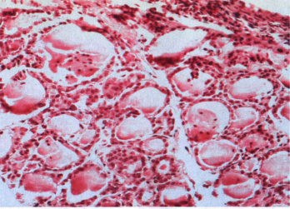

Legend: Mixed normoplastic type (follicular-colloidal type) of the structure of the thyroid gland with follicles of different sizes. Staining with hematosilin and eosin.
Magnification approx. 10x0.25; About. 10x20
Figure 27 - The structure of the thyroid gland in the control groups

In experimental hypothyroidism, the interfollicular space, which have features of a structural response to taking mercazolil. Under the influence of a thyrostatic agent, the follicular organization of the thyroid gland changes with a predominance of small and medium follicles with signs of alteration. The tissue microdistrict is a structural compartment of the thyroid gland and includes follicles, interfollicular space with blood and lymphatic microvessels. It is natural that under the influence of a thyrostatic agent in the thyroid gland, functional depletion eventually occurs, the morphofunctional equivalent of which is the changes occurring in the tissue microdistrict. This is of particular interest for understanding the mechanisms of thyroid dysfunction.

Table 9 - Integral indices of the functional activity of the thyroid gland in rats of the control group and in experimental hypothyroidism

Index | Control | Hypothyroidism
IA (FKI) | 0,18 ± 0,11 | 0,71 ± 0,16*
IF (PEI) | 10,77 ± 0,32 | 3,62 ± 0,41*
PNK | 5,39 ± 0,41 | 1,81 ± 0,22*
IP | 0,56 ± 0,06 | 0,74 ± 0,04*
Vfe / Vife | 6,53 ±0,45 | 5,77 ± 0,40
Vfe / Vk | 0,24 ± 0,04 | 0,67 ±0,08*
Note: IA - thyroid activity index (or PKI - follicular-colloid index); IF - function index (or PEI - lumen-epithelial index), PNA - an indicator of colloid accumulation; IS - index of "sclerosis"; Vfe / Vife - the ratio of the volumetric density of the follicular and interfollicular epithelium; Vfe / Vk - the ratio of the volumetric density of the follicular epithelium and the colloid, the rest of the designations in the text; here * - the difference from the value of the corresponding indicator of the control group (euthyroidism) is statistically significant at p <0.05.

Follicle. After taking mercazolil, a hypothyroid status is formed with a change in the follicular organization of the thyroid gland. The thyroid follicle is traditionally considered a functional unit of the thyroid gland. In its structure, taking into account zoning, small (55.58%) and medium (38.89%) follicles predominate, and a small number of large follicles (5.56%) are recorded, while in conditions of euthyroidism, medium large follicles prevail. The heterogeneity index decreases and reaches a value of 0.5 (in the control - 1.19), reflecting the degree of functional insufficiency of the thyroid gland (Table 9).
The mean follicle diameter was 43.93 ± 2.28 μm, which is 2.5 times less than the control value. The total area of ​​the follicle (by 2.2 times), the area occupied by the colloid in it (by 2.3 times), and the area of ​​follicular epithelium (by 1.7 times) simultaneously decreased. The thickness of the follicular wall, determined by the height of the thyroid epithelium, increased 1.3 times in comparison with the control and amounted to 11.10 ± 0.65 μm.
In rats in control groups (euthyroidism), the height of the epithelium reflects the rate of thyroid secretion without pathological changes. Areas with signs of both increased and decreased functional activity were always observed. Revealed alterative changes in follicles of different sizes, which is associated with desquamation of the epithelium, and in the thyroid epithelium this was expressed in a violation of the shape of the nuclei, vacuolization of the cytoplasm. More often than in controls, an increase in the thickness of the thyroid wall was associated with the formation of an intracellular colloid (Figure 28).

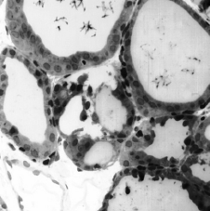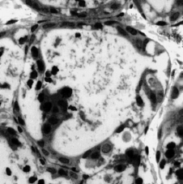

An increase in follicle wall thickness associated with the formation of an intracellular colloid against the background of partial desquamation of the epithelium. Hypothyroidism Staining of semi-thin sections with toluidine blue.
Magnification approx. 7, vol. 20 (40)
Figure 28 - Fragment of the thyroid gland in experimental hypothyroidism

In the lobes of the thyroid gland, during microscopic examination, the central and peripheral zones were distinguished, differing from each other in the size of the follicles. Peripheral zones were represented by relatively large follicles and lined with a single-layer cubic, less often flattened epithelium (Figure 29, A). The follicular cavity was filled with PIC-positive, more fluid, evenly distributed colloid. Resorption vacuoles in the colloid and desquamated cells were less common (Figure 29, A)
The studies showed that the follicular thyrocytes of the peripheral zones were mainly cubic and less often flattened. The apical surfaces of thyrocytes were in contact with the colloid, and the basal surfaces were in contact with the pericapillary space. The content of the follicles was represented by a PIC-positive, dense colloid, along the periphery of which resorption vacuoles were visible. In some follicles, desquamation of single epithelial cells into the follicle cavity was observed. In the central zone of the thyroid lobes, the size of the follicles was one and a half times smaller than in the peripheral zone. The height of thyrocytes and the size of their nuclei were less than in the peripheral zones of the lobes (Figure 29, B).

А Б
Designations: A - peripheral zone, B - central zone. The follicles are oval and round. The colloid is dense, CHIK-positive. ShIK reaction with additional staining with hematoxylin.
Magnification approx. 7, vol. 20 (40)
Figure 29 - Peripheral and central zone of the lobes of the thyroid gland in rats of the control group

In the study of histological preparations of the thyroid gland in rats after taking merazolil after 30 days, small subcapsularly located small areas of epithelial death and destruction of single follicles were revealed. The number of follicles in mm2 of the cut area of ​​the thyroid gland did not differ from the values ​​of the control group (Table 10). The peripheral zones of the lobes of the thyroid gland were represented by oval, round and irregular follicles of smaller size than in rats of the control group, filled with a PIC-positive colloid (Figure 30A).
In rats with experimental hypothyroidism, after receiving mercazolil, the thyroid gland was surrounded by a thin connective tissue capsule, from which thin partitions extended inward, dividing the gland into lobules. The interlobar septa had a reticular structure, there were single areas of septal discomplexation. The parenchyma of the thyroid gland was represented mainly by small follicles. The average number of follicles in mm2 per section did not differ from the values ​​of the control group. In the lobes of the thyroid gland, the central and peripheral zones also differed. The number of follicles in mm2 of the cut area of ​​the thyroid gland did not differ from the values ​​of the control group. In the study of histological preparations of the thyroid gland in rats after taking merazolil after 30 days, small subcapsularly located small areas of epithelial death and destruction of single follicles were revealed. The lumens of the blood vessels were filled with plasma or free. In the central zone of the thyroid gland, follicles of various sizes, from small to large, were encountered, as a result of which their average size exceeded in comparison with the control groups of rats (Figure 30, Table 10).

А Б
Designations: A - peripheral zone, B - central zone. The follicles are lined with cubic epithelium. The colloid is dense, oxyphilic, SHIK-positive. ShIK reaction with additional staining with hematoxylin.
Magnification approx. 7, vol. 20 (40)
Figure 30 - Peripheral and central zone of the thyroid lobes in rats with experimental hypothyroidism

In experiments, an increase in the height of follicular thyrocytes in a number of follicles was noted. The average height of follicular thyrocytes exceeded the corresponding values ​​compared to animals with the control group. The sizes of thyrocyte nuclei did not differ from the values ​​in the peripheral zones, but were statistically significantly smaller than in the central zone of the lobes in the control group rats. The colloid content in the follicles was higher than in the follicles of the peripheral zones of the lobes, and did not differ from the corresponding values ​​of the control group (Table 10). The revealed changes in the morphology and histophysiology of the thyroid gland of the experimental group indicate the heterogeneity of the reaction of the peripheral and central zones. In the peripheral zones of the thyroid gland of the experimental group, an increase in the size of follicles and a decrease in the size of thyrocyte nuclei were noted.
The data obtained show that the thyroid gland of the rats of the control group had a typical structure. Regional differences in the structure of the parenchyma were clearly observed. The parenchyma consisted of lobules separated by connective tissue septa, in which vessels and nerves passed. In the central zone of the thyroid lobes, the size of the follicles, the height of thyrocytes and the size of their nuclei were smaller than in the peripheral zones.
Table 10 - Changes in the morphometric parameters of the thyroid gland of rats in the control group and the group with experimental hypothyroidism

Groups  Parameters | Control group |  | Experimental group
Groups  Parameters | Peripheral zones of the lobes of the thyroid gland | Central zone of the lobes of the thyroid gland | Peripheral zones of the lobes of the thyroid gland | Central zone of the lobes of the thyroid gland
Follicle section area, μm2 | 6691,42±583,3 | 3892,03±202,9 | 6014,71±271,5 | 3452,86±115,7*
Colloid content in the follicle cavity,% | 79,96±1,17 | 73,87±1,39 | 82,91±1,53 | 76,88±1,11
Follicular thyrocyte height, microns | 10,76±0,23 | 10,33±0,14 | 12,95±1,57 | 8,97±0,12*
Nuclei section area, μm2 | 22,01±0,31 | 21,45±0,72 | 25,87±1,13* | 21,11±0,31
Follicle count / mm2 cut | 219,25±3,82 |  | 226,17±4,07
Note: * - statistically significant differences from the values of the control group, * - statistically significant differences between the values of the group of females and the group of males

In the follicles of the peripheral zones, the resorption processes were more pronounced. The colloid in the follicles of the peripheral zones was denser and more compact, but resorption vacuoles were more common than in the central zone of the lobes. Desquamation of the epithelium into the follicle cavity was moderately expressed and occurred mainly in the peripheral zones of the lobes. In the experimental group (group 2), the structure of the lobes of the thyroid gland did not differ fundamentally from the control group. In rats, after taking mercazolil for 30 days, there was a decrease in the size of the follicles in the zones of the lobes of the thyroid gland. There was a large severity of zonal differences in the structure of the parenchyma and a typical lobular structure was observed with the formation of zoning in the lobes. Differences in the structure of the central and peripheral zones of the thyroid lobes were the same as in the thyroid gland of the control rats.
Thyrocyte. In the control groups, thyrocytes were cubic in shape. The mitotic index is very low, there are few myoses. Even at the level of one follicle, the structure of the cytoplasm in triocytes was different. In some thyrocytes, single small granules were visible in the supranuclear zone of the cytoplasm. In other thyrocytes, its nucleus deserves interest (Figure 31). The core of the elliptical species occupies the middle part of the cell. Most often, one small nucleolus was surrounded by clumps of chromatin. The latter were also located near the nuclear membrane.

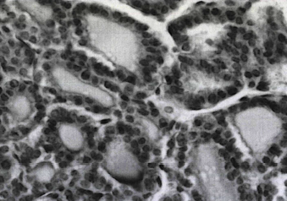
Abbreviations: Cubic thyrocytes with a rather large nucleus located in the basal part. Narrow interfollicular spaces. Staining with hematoxylin and eosin.
Magnification approx. 7, vol. ten
Figure 31 - Thyrocytes of the thyroid gland in rats in the control group

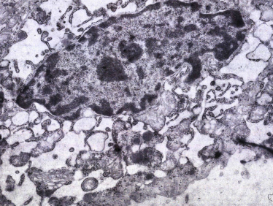
Designation: In the cytoplasm of the thyrocyte there is a small amount of organides, an expanded endoplasmic reticulum, rounded mitochondria, many vacuoles, a minimum number of microvilli on the luminal surface. Electronogram.
Magnification x8000.
Figure 32 - Thyrocytes in experimental hypothyroidism

The thyroid parenchyma itself is formed by a system of thyrocytes, among which there are two main types - follicular and interfollicular cells. The former form follicles with the ability to extracellular accumulation of hormone-active substances. The latter are involved in the proliferation of the thyroid parenchyma, forming interfollicular islets between the follicles. The creation of a hypothyroidism model is associated with a change in the structural organization of the follicular cell itself. Ultrastructural analysis of thyrocytes revealed certain disturbances in the form of a sharp expansion and deformation of the cisternae of the endoplasmic reticulum with a decrease in the electron density of their contents (Figure 32).
In hypothyroidism, the volume density of the granular endoplasmic reticulum decreased by 16.1% in comparison with the indicator of the control group (table 11), while large cavities were formed containing colloid in the cytoplasm of the thyrocyte. In some thyrocytes, desquamation of the epithelium into the lumen of the follicle occurred with exposure of the basement membrane. All of the above are signs of impaired synthesis and / or transport of thyroglobulin into the lumen of the follicle.
After taking mercazolil, he increased the area occupied by the interfollicular epithelium. Analysis of changes in the size of follicles is very informative, since it is associated with organ function and reflects a structural response to taking mercazolil, judging by the integral indicators of the functional activity of the thyroid gland. Activation of proliferation from the interfollicular epithelium was observed. Under the conditions of taking mercazolil, the ratio of follicular and interfollicular epithelia increased, the integral indicator (activity index) increased by 3.9 times, which demonstrates a decrease in thyroid function (Table 11).
In hypothyroidism, thyrocyte indices (mean diameter, nucleus volume) remained within the control values: the mean nucleus diameter was 5.40 ± 0.16 μm (with euthyroidism - 5.29 ± 0.14 μm), the area of the nucleus (nuclear index) was 17.27 ± 1.89 μm2 (with euthyroidism - 16.64 ± 1.60 μm2), which indicates the preservation of cells functionally active. After taking mercazolil, the nuclear cell index decreased by 1.2 times (up to 0.43 ± 0.04, in the control groups it was 0.50 ± 0.03; p <0.05), which indicates the transformation of cubic follicular epithelium into a flattened one. The latter is a sign of a decrease in the function of the thyroid epithelium during light-optical examination.
There was a tendency towards a decrease in the number density of lysosomes with a statistically significant decrease by 41.2% in their volume density in the group with hypothyroidism (p = 0.013). This, apparently, reflects the effect of mercazolil on the resorption activity and the modification of thyroglobulin to thyroid hormones. At the same time, we observed swelling and rounding of mitochondria with disorganization of their cristae and clearing of the matrix. The distribution of mitochondria was uneven; they were often in close contact with the granular endoplasmic reticulum. In hypothyroidism, the volume and number density of mitochondria decreased by 31.8 and 29%, respectively (table 11). In the group of animals with hypothyroidism, a 25.4% decrease in the volumetric density of vacuoles in the cytoplasm of the thyrocyte was found. The bulk of vacuoles is represented by dilated cisterns of the endoplasmic reticulum. The volumetric density of colloid droplets in the cytoplasm of the thyrocyte in hypothyroidism was significantly higher than in the control by 1.9 times. In some thyrocytes, accumulations of lipid droplets were found.

Table 11 – Morphometric parameters of intracellular structures of thyrocytes and interfollicular space of the thyroid gland in control and experimental hypothyroidism

Thyrocyte structure Parameter | Control | Hypothyroidism
Granular endoplasmic reticulum, Vv | 31,58 ± 3,76 | 26,51 ± 2,24
Lysosomes  Vv  Na | 7,30 ± 0,62  23,91 ±1,34 | 4,29 ± 0,75*  26,51 ± 2,24
Mitochondria  Vv  Na | 6,67 ± 0,43  13,82 ±0,62 | 4,51 ± 0,36*  9,83 ± 0,47
Vacuoles, Vv | 18,67 ±1,41 | 13,81 ±1,23
Colloid drops, Vv | 3,04 ±0,35 | 5,86 ±0,61*
Bulk density of interstitium,% | 11,75 ±1,21  (57,40%) | 21,79 ±0,69*  (85,7%)
Volumetric density of the bloodstream,% | 3,71 ±0,19  (18,25%) | 1,38 ±0,05*  (5,43%)
Volumetric density of the lymphatic bed,% | 4,87 ±0,28  (24,31%) | 2,36 ±0,07*  (9,03%)
Bulk density of the stroma,% | 20,46 ±0,57 | 25,47 ±0,32*
Note: Na is the number density of structures in the cut area (the number of structures in the test area), μm0 / μm2; Vv - volumetric density of structures (fraction of ultrastructure as a percentage of the volume of cytoplasm), μm3 / μm3.

The noted violations indicate the damaging effect of mercazolil on the synthetic apparatus of thyrocytes, combined with disorders of the energetic mitochondrial apparatus. In hypothyroidism, metabolic processes and transport processes associated with the synthesis and resorption of the colloid change in thyrocytes.
Interfollicular space. The morphogenetic potentials of stromal-parenchymal relationships are determined by the ratio of follicular epithelial tissue, colloid and interstitium. In hypothyroidism, it was 1: 1.3: 1.2 (in the control 1: 3.5: 1.5), which is associated with a change in the area occupied by these structures. Under the conditions of taking mercazolil, the ratio of the components of the interfollicular space of the thyroid gland changes. The change in the interfollicular space depends on the morphology of the follicular thyrocyte - a flattened cell or not. It is noted that there is a close contact of follicular cell membranes with microvessels. Vesicles are found in the interstitium.
In active prismatic thyrocytes, their basement membrane is in close contact with the blood capillary, which ensures the transport of hormones into the lumen of the blood capillary. The specific proportion of the interstitium increases 1.86 times, the volumetric density of the blood and lymphatic bed decreases 2.7 and 2.2 times, respectively, in the structure of the thyroid gland. In the interstitium, tissue fluid accumulates, the drainage of which is weakened. In this case, the lumen of the lymphatic capillaries is expanded with close contact with the follicle wall. Fragment of the thyroid gland with an expanded interfollicular space (interstitium) filled with tissue fluid, granulation of mast cells (Figures 33, 34).

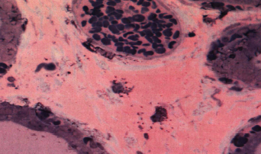

Legend: Full-armored blood vessels. a lymphatic vessel near the follicles. Staining of semi-thin sections with toluidine blue.
Magnification approx. 7, vol. ten
Figure 33 - Blood vessels in the thyroid gland in experimental hypothyroidism

In hypothyroidism, there is a change in the interfollicular space, depending on the morphology of the follicular thyrocyte - flattened cells. There is a close contact of the membranes of the follicular cells of the blood capillary. The lumen of the lymphatic capillary is filled with granular content. Vesicles are found in the interstitium. In active prismatic thyrocytes, their basement membrane is in close contact with the blood capillary, which ensures the transport of hormones into the lumen of the blood capillary. A fragment of the thyroid gland with an enlarged lymphatic vessel near the follicles (Figure 34).
In the interstitium there is an accumulation of tissue fluids, the drainage of which is weakened. The specific proportion of the interstitium increases by 1.85 times, the volumetric density of the blood and lymphatic bed decreases 2.6 times and 2.1 times, respectively, in the structure of the thyroid gland. The results obtained indicate the high sensitivity of not only the bloodstream, but also the lymphatic bed of the thyroid gland to the effect.

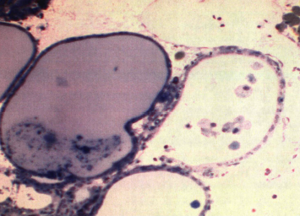

Legend: Dystrophic cells in the lumen of the follicles. Hypothyroidism Staining of semi-thin sections with toluidine blue.
Magnification approx. 7, vol. ten
Figure 34 - Thyroid gland in hypothyroidism with an enlarged lymphatic vessel

The indices assessing the state of the microvasculature changed quite sharply under the studied conditions. This may indicate a decrease in vascularization and lymphatic drainage as a manifestation of the mechanism of action of mercazolil. The results obtained indicate a high sensitivity to thyrotropic effects of not only the bloodstream, but also the lymphatic bed of the thyroid gland.
In studies of the tissue microdistrict of the thyroid gland, pronounced structural changes were noted after taking mercazolil, indicating the formation of a hypothyroid state. Assessment of changes in follicles shows, to varying degrees, a pronounced rearrangement of their architectonics, shape and size against the background of hypertrophy of the thyrocyte, interfollicular proliferation, fragmentation of follicles in combination with desquamation of the epithelium, intracellular accumulation of colloid and ultrastructural changes in the thyrocyte. The interstitium and microvessels are most sensitive to the action of mercazolil. All this creates a general morphological picture of the thyrostatic action of mercazolil, reflecting a decrease in thyroid function and the creation of an adequate model of hypothyroidism.

3.3 Analyze the obtained material and determine the dynamics of hormonal, structural and functional changes, identify the morphological and functional features of the lymphatic system and the state of the microhemocirculatory bed of the thyroid gland with experimental hypothyroidism against the background of correction with a complex herbal remedy – 2020

3.3.1 Morphofunctional state and microstructure of the thyroid gland and regional lymph node under conditions of correction

The most significant morphophysiological structure of the thyroid gland is a tissue microdistrict, which unites a group of follicles and an interfollicular space with an autonomous system of blood and lymph circulation. It is the structures of this tissue microdistrict that suffer the most under the action of pathogenic factors on the thyroid gland, reducing its role in providing morphological and metabolic changes in tissues and organs [149, 150, 151]. This makes the approach promising in assessing the microcirculatory-tissue systems of the thyroid gland in hypothyroidism. In turn, information about changes in the structures of the tissue microdistrict can make a significant contribution to understanding the pathogenesis of hypothyroidism and outline a correction strategy.
This section provides material on the study of the state of the thyroid gland in hypothyroidism in animals after correction. In animals of the 3rd group, which received corrective substances, destructive changes were also revealed in both the central and peripheral parts of the thyroid gland. The majority of follicles contain colloid. In these areas of the thyroid gland, the circulatory network is characterized by plethora, which indicates increased vascularization of the follicles.
When correcting substances are used, clusters (islets) of cells appear in the follicles of the thyroid gland, indicating the regeneration of the thyroid tissue. In the peripheral part of the thyroid gland, follicles with an intrafollicular colloid and capillaries of moderate blood circulation are revealed. However, the interfollicular epithelium was not observed in this zone.
The histostructure of the thyroid gland in rats undergoing correction during the recovery period (group 3) had a positive effect on the restoration of the histostructure of the thyroid gland, but is characterized by the preservation of destructive changes. Individual thyrocytes are torn off from the basement membrane and desquamated cells are located freely in the follicular cavity. In animals, after correction, destructive processes are revealed both in the central and peripheral parts of the thyroid gland, however, follicles containing different amounts of thyroglobulin are revealed, and restoration of the interfollicular structure is observed. The majority of follicles do not contain colloid, and some are filled with different amounts of thyroglobulin. In these areas of the thyroid gland, the circulatory system is characterized by plethora, indicating increased vascularization of the follicles (Figure 35).

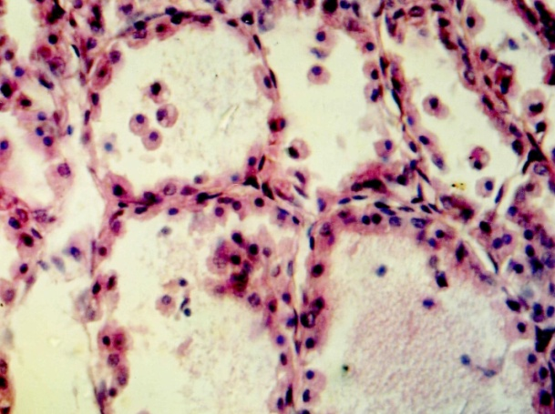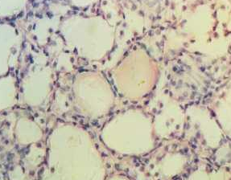
Legend: Mixed follicular-colloid type of the thyroid gland. Staining with hematosilin and eosin.
Magnification approx. 10x0.25; About. 10x20
Figure 35 - Histological structure of the peripheral and central part of the thyroid gland of hypothyroid rats after the use of corrective substances

A study of the thyroid gland showed that during hypothyroidism, various changes occur in it and fluctuations in the number and structure of organelles of follicular cells are observed. After applying our correction, changes occur in the structure of the thyroid gland, the ratio of follicular epithelium, colloid and stroma, and changes in the bulk density of the colloid and interstitium are observed. In the interfollicular space, the interstitial space occupies an intermediate position between the control indicators and in hypothyroidism, making up 65.3-8.1% of the total area during the period of taking corrective substances (Figure 36).

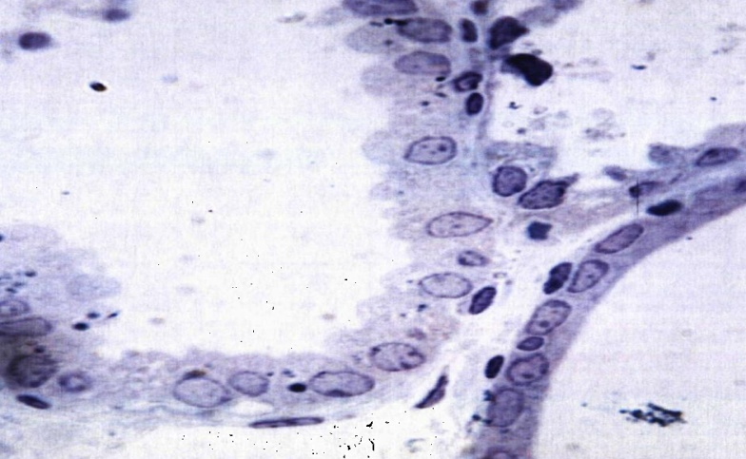

Legend: Follicles with increased and decreased activity. Different follicle wall thicknesses with different shapes and sizes of thyrocyte nuclei. Staining with hematosilin and eosin.
Magnification approx. 10x0.25; About. 10x20
Figure 36 - Follicles after taking corrective substances

The recovery period after taking corrective substances, the thyroid gland has certain properties of inertness in response to the introduction of mercazolil. The volumetric and numerical density of ultrastructural organelles of thyrocytes was observed to reach the control level or exceed it, which indicates an increase in the functional activity of the thyroid gland. The volumetric density of the bloodstream is 1.21-1.73 times less than in the control, and progressively decreases. At the same time, it is 1.1-2.06 times higher than hypothyroidism. The volumetric density of the lymphatic bed remains at the control level during all periods of the study, and it is 1.4-1.5 times higher in terms of its value than the analogous indicator in hypothyroidism (Table 12). Changes in the thyroid gland resulting from the correction determine the dynamics of the integral indices of functional activity.
Thus, the functional and morphological changes in the thyroid gland of animals after the correction of the consequences of hypothyroidism revealed the general direction of their influence on the gland, associated with an increase in its functional activity against the background of restoration of the follicle parameters. Iodine balsam "Revival Plus" in powder enhances proliferative processes in the parenchyma of the thyroid gland and the formation of follicles due to interfolicular epithelium.

Table 12 - Integral indices of the functional activity of the thyroid gland in rats after correction in experimental hypothyroidism

Index | Control | Hypothyroidism | After correction
IA (FKI) | 0,18 ± 0,001 | 0,71 ± 0,006* | 0,33 ± 0,005*
IF (PEI) | 10,77 ± 0,32 | 3,62 ± 0,41* | 12,56 ± 0,36*
PNK | 5,39 ± 0,41 | 1,81 ± 0,02* | 6,59 ± 0,07*
IP | 0,56 ± 0,06 | 0,74 ± 0,04* | 0,62 ± 0,09*
Vfe / Vife | 6,53 ±0,45 | 5,77 ± 0,40 | 5,29 ± 0,61
Vfe / Vk | 0,24 ± 0,04 | 0,67 ±0,08* | 0,33±0,01*
Note: IA - thyroid activity index (or PKI - follicular-colloid index); IF - function index (or PEI - lumen-epithelial index), PNA - an indicator of colloid accumulation; IS - index of "sclerosis"; Vfe / Vife - the ratio of the volumetric density of the follicular and interfollicular epithelium; Vfe / Vk - the ratio of the volumetric density of the follicular epithelium and the colloid, the rest of the designations in the text; here * - the difference from the value of the corresponding indicator of the control group (euthyroidism) is statistically significant at p <0.05.

Follicle: When assessing changes in follicles, a restructuring of their architectonics, shape of size during the period of corrective agents of the consequences of hypothyroidism was noted with varying degrees. Reception of corrective substances, at the stage of rehabilitation, changes the size of the follicles and their distribution in the structure of the thyroid gland (Figure 37). When analyzing the distribution of follicles by size classes, an increase in the proportion of small and large follicles in the structure of the thyroid gland was found. The predominance of small follicles indicates the activation of morphogenetic processes in the thyroid parenchyma against the background of correction. The heterogeneity index increases against the background of the correction and approaches in its value to the control.
In experimental hypothyroidism, the diameter of the "average" follicle decreased to 43.93,92.28 μm, during the period of correction of the "average" follicle it increases on average from 94.91 ± 1.43 μm to 100.89 ± 10.0 μm. After correction in hypothyroidism, a change in the thickness of the follicle wall is observed, in the apical part of many thyrocytes, especially at the end of the experiment, small drops of colloid are clearly visible. Their appearance in combination with an increase in the height of thyrocytes is a sign of an increase in their function. The size of the follicular wall remains at the control level and increases 1.5 times after corrective substances.

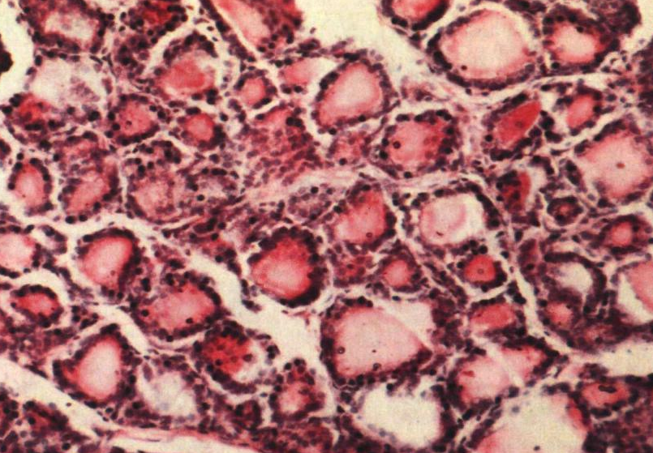

Legend: Representation of follicles of different sizes with a predominance of small ones. Staining with hematosilin and eosin.
Increase approx. 10x0.25; About. 10x20
Figure 37 - The structure of the thyroid gland after correction

In the thyroid gland of rats of the control group, regional differences in the structure of the parenchyma of the lobes were clearly observed. Compared with the control group, there was a tendency to a decrease in the area of follicles, more pronounced in the peripheral zones. In the peripheral zones, an increase in the percentage of colloid and a decrease in the height of the follicular epithelium was noted. Both the central zone and the peripheral zones, an increase in the size of the nuclei of follicular thyrocytes was noted (table 13). The height of the follicular epithelium both in the central and peripheral zones of the thyroid gland was differently directed than in the control peripheral zone by 20.4% higher, and in the central zone by 7.6% lower. After correction, these indicators were noted closer to the original background.
In the central zone of the shares in the follicular thyrocytes of the experimental groups (group 2) there was an increase in comparison with the control group. In the experimental group with hypothyroidism, the structure of the parenchyma of the lobes of the thyroid gland did not fundamentally differ from the control group: a typical lobular structure with the formation of zoning in the lobes was observed. The difference from the control group was the large size of the follicles, as well as the height of the follicular thyrocytes and the size of their nuclei in the peripheral zones of the lobes. Compared to the control group, there was a slight increase in the area of follicles in the peripheral zones and a significant increase in the central zone (Table 13).

Table 13 - Changes in the morphometric parameters of the thyroid gland of rats in the group with experimental hypothyroidism and after the use of corrective substances
Parameters  Groups | Follicle section area, μm² | Colloid content in the follicle cavity,% | Follicular thyrocyte height, microns | Nuclei section area, μm² | Follicle count / mm² cut
Control group
Peripheral zones of the thyroid lobes | 6691,42±583,3 | 79,96±1,17 | 10,76±0,23 | 22,01±0,31 | 219,25±3,82
Central zone of the lobes of the thyroid gland | 3892,03±202,9 | 73,87±1,39 | 10,33±0,14 | 21,45±0,72 | 219,25±3,82
Experienced group
Peripheral zones of the thyroid lobes | 6014,71±271,5 | 82,91±1,53 | 12,95±1,57 | 25,87±1,13* | 226,17±4,07
Central zone of the lobes of the thyroid gland | 3452,86±115,7* | 76,88±1,11 | 8,97±0,12* | 21,11±0,31 | 226,17±4,07
After correction
Peripheral zones of the thyroid lobes | 6237,58±113,4 | 80,23±1,06 | 11,23±0,14 | 23,65±0,12 | 224,34±2,46
Central zone of the lobes of the thyroid gland | 3625,19±195,4 | 75,65±1,27 | 9,65±0,18 | 21,09±0,04 | 224,34±2,46
Note: * - statistically significant differences from the values of the control group

In the peripheral zones of the lobes, signs of increased functional activity of cells were observed in the form of an increase in their height and size of nuclei, leading to their death and destruction of follicles and whole lobules. In the lobules without destruction of follicles in follicular thyrocytes, hypertrophy was revealed. In the central zone of the thyroid gland, an increase in the percentage of colloid, the percentage of follicular epithelium and the size of its nuclei was noted, while in the peripheral zones such changes were not observed.
After the use of corrective agents, the proliferation of the follicular epithelium persists with secretion into the lumen of the follicle or in the form of the appearance of papillary outgrowths in the wall of the follicle. This reflects an increase in the number of actively functioning thyrocytes and is of a compensatory nature. Follicles with varying degrees of functional activity were noted, judging by the morphology of thyrocyte nuclei and the thickness of the wall and follicles. After the application of iodine-containing substances, the parameters of the follicle, namely, the total area, the area of the colloid, the volume of the follicular epithelium, reach the control level (Figure 38).

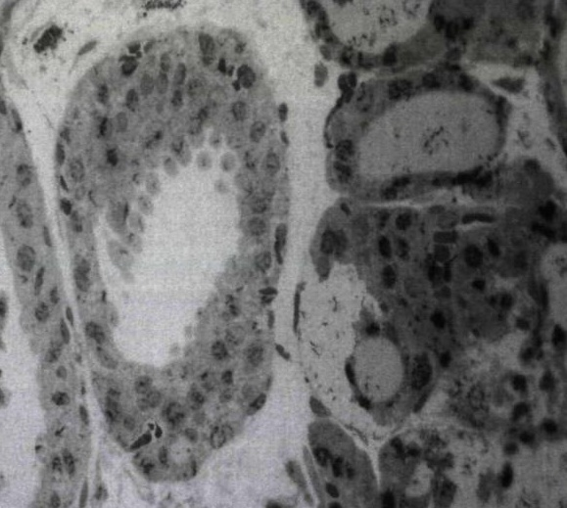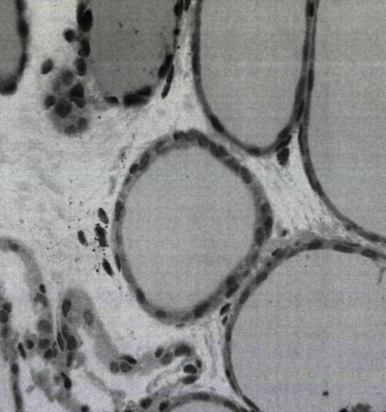
Legend: Proliferation of follicular epithelium with secretion into the lumen of the follicle during correction. Staining of semi-thin sections with toluidine blue.
Magnification approx. 7, vol. 20 (40)
Figure 38 - A fragment of the thyroid gland. Follicles of different sizes and degrees of activity.

Thyrocyte. Under the conditions of the use of corrective substances, the morphometric indicators of the thyrocyte nucleus are stabilized, they do not change (diameter, nuclear index) in comparison with the control and indicators in hypothyroidism. The value of the nuclear cell index was increased by 30 days (by 1.2-1.4 times) and reached the control level against the background of correction.
The use of iodine-containing substances with a combination of cinquefoil is reflected in the dynamics of the restoration of the ultrastructure of thyrocytes. It is noted that after the use of corrective substances, the volumetric density of the granular endoplasmic reticulum is restored to the control values (table 14). The width of the cavities varies, indicating the functional activity of thyrocytes in the formation and transport of thyroglobulin (Figure 39).
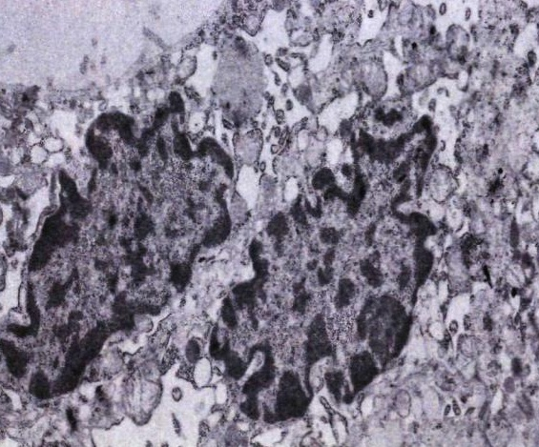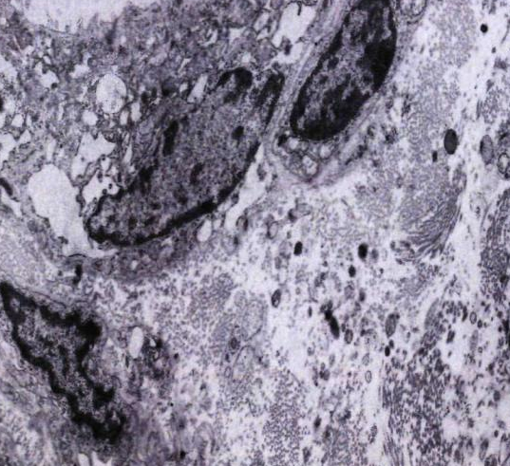
Legend: In the cytoplasm, an expanded granular endoplasmic reticulum. The cores have wavy edges. Abundance of vacuoles and colloid drops. The interfolicular space is filled with fine-grained material.
Electronogram. Magnification x8000.
Figure 39 - Nuclei of thyrocytes after taking corrective substances

After correction in animals on day 30, it increases the volumetric density of lysosomes before the control and keeps them at an increased level, exceeding the control by 1.3 and 1.4 times, respectively (Table 14). At the same time, the numerical density of lysosomes in experimental hypothyroidism increases by 1.4 times, after correction it decreases but above the control level. Has a variety of lysosome morphology (primary and secondary). As a result of the correction, endocytic vesicles and lysosomes become more numerous, indirectly indicating the activity of hydrolytic enzymes in modifying thyroglobulin to thyroid hormones, which are excreted into the bloodstream.
While taking correction, the volumetric density of mitochondria increases 1.6-1.8 times in comparison with hypothyroidism and remains at the level of the upper limit of the control at all times after discontinuation of mercazolil (Table 14). At the same time, the number density of mitochondria exceeds the control value and the indicator in hypothyroidism at all periods of correction. Elongated mitochondria were observed in the cytoplasm of the thyrocyte. Corrective substances increase the energy background of the thyrocyte during the correction period. This is primarily required to ensure the function of the thyroid gland. In hypothyroidism, the volumetric density of vacuoles decreases and corresponds to the indicator, and against the background of correction, the volumetric density of vacuoles is similar in magnitude to the control group.

Table 14 - Morphometric indicators of intracellular structures of thyrocytes and interfollicular space of the thyroid gland in experimental hypothyroidism and after the use of corrective substances
Thyrocyte structure parameter | Control | Hypothyroidism | After correction
Granular endoplasmic reticulum, Vv | 31,58 ± 3,76 | 26,51 ± 2,24 | 30,26 ± 1,16
Lysosomes  Vv  Na | 7,30 ± 0,62  23,91 ±1,34 | 4,29 ± 0,75*  26,51 ± 2,24 | 9,63 ± 0,12*  25,11 ± 1,13
Mitochondria  Vv  Na | 6,67 ± 0,43  13,82 ±0,62 | 4,51 ± 0,36*  9,83 ± 0,47 | 7,96± 0,21*  15,92 ± 0,31
Vacuoles, Vv | 18,67 ±1,41 | 13,81 ±1,23 | 16,29 ±1,05
Colloid drops, Vv | 3,04 ±0,35 | 5,86 ±0,61* | 4,67 ±0,14*
Bulk density of interstitium,% | 11,75 ±1,21  (57,40%) | 21,79 ±0,69*  (85,7%) | 15,23 ±0,18*  (69,4%)
Volumetric density of the bloodstream,% | 3,71 ±0,19  (18,25%) | 1,38 ±0,05*  (5,43%) | 2,11 ±0,03*  (5,7%)
Volumetric density of the lymphatic bed,% | 4,87 ±0,28  (24,31%) | 2,36 ±0,07*  (9,03%) | 3,62 ±0,01*  (16,4%)
Bulk density of the stroma,% | 20,46 ±0,57 | 25,47 ±0,32* | 23,11 ±0,17*
Note: Na is the number density of structures in the cut area (the number of structures in the test area), μm0 / μm2; Vv - volumetric density of structures (fraction of ultrastructure as a percentage of the volume of cytoplasm), μm3 / μm3.

Reception of iodine-containing substances in rats after discontinuation of mercazolil maintains the volumetric density of a drop of colloid at a level that is 1.5 times greater than the control values (in control 3.04 ± 0.35, and after correction 4.67 ± 0.14 *) (table fourteen). The obtained data show that the use of corrective substances in rats with hypothyroidism maintains the synthesis and resorption of the colloid in an equilibrium state.
Interfollicular space. After the abolition of mercazolil in the structure of the thyroid gland, the ratio of follicular epithelium, colloid and stroma was increased compared to the control group.
There is a change in the bulk density of the colloid and interstitium during the correction period. The volumetric density of the interstitium is consistently higher in all periods of correction in comparison with the control and less than in comparison with the experimental group. In the interfollicular space, the interstitium occupies an intermediate position between the control indicators and in hypothyroidism, accounting for 69.4% of the total area after the use of corrective agents (Table 14).
In the experiments of the 3rd group under the conditions of the use of corrective substances, the volumetric density of the bloodstream is lower by 5.7% compared to the control group (in the control, 3.71 ± 0.19; with hypothyroidism, 1.38 ± 0.05 *; after correction 2 , 11 ± 0.03 *), but it progressively increases towards the end of the study while maintaining high vascularization index numbers (Table 14). The volumetric density of the lymphatic bed remains at the control level, and it is 1.5 times higher than in the 2nd group. At the same time, the index of the lymphatic bed indicates a higher level of lymphatic drainage when taking corrective substances (table 14).
Changes in the thyroid gland resulting from the use of corrective substances with iodine-containing substances determine the dynamics of the integral indices of functional activity. They show an increase in the functional activity of the thyroid gland as a result after taking corrective substances.
Lymph node. After the use of corrective substances, the total area of the lymph node changes, and it is 21.8 ± 1.31% (in the control - 33.07 ± 1.92%; the course of mercazolil - 21.6 ± 1.23%). The cortical-cerebral index is 0.82 ± 0.09, as evidence of an increase in the proportion of the medulla in the general structure of the lymph node. The subcapsular sinus remains narrowed with an accumulation of lymphoid cells. After the abolition of mercazolil, there is an increase of 1.76 times the area of the cerebral sinus, 1.44 times of the pulp strands in comparison with the indicator that occurs when taking mercazolil. Fleshy cords of small size are widely represented in the sinus system of the lymph node. The cortical plateau decreases 1.8 times in comparison with the indicator that occurs when taking mercazolil. At the same time, there remain low indicators of the area of the structures of the cortical substance, both in comparison with the control and with the intake of mercazolil (table 15).
The ratio of lymphoid nodules with and without a germinal center is 2.1, which is close to the control value and indicates the predominance of lymphoid nodules with a germinal center.

Table 15 - The structure of the cervical lymph node and indices in normal conditions, with hypothyroidism and during correction

Lymph node structures and indices | Control group | Hypothyroidism | After correction
Capsule | 1,26±0,05 | 0,96±0,03 | 1,11±0,02
Subcapsular sinus | 0,71±0,09 | 0,25±0,04* | 0,62±0,01*
Crust plateau | 2,33±0,14 | 1,36±0,12 | 2,04±0,15
Lymphoid nodules without germinal center (F2) | 1,56±0,06 | 0,96±0,13* | 1,24±0,11*
Lymphoid nodules with a germinal center (F1) | 2,43±0,13 | 1,45±0,39* | 2,19±0,65*
Paracortex | 5,55±0,25 | 3,74±0,42*^{о} | 4,67±0,14*
Pulp strands | 7,19±0,36 | 6,72±0,29 | 6,72±0,29
Cerebral sinus | 2,01±0,15 | 4,33±0,27**^{о} | 4,33±0,27**
Total sectional area of the lymph node | 19,91±1,26 | 24,54±1,16 | 22,91±1,57
Index K / M | 1,36±0,07 | 1,82±0,01* | 0,47±0,04*
F1 / F2 index | 1,54±0,08 | 1,50±0,06 | 1,56±0,02
Note: significant compared to control at P <0.05 *; P <0.01 **

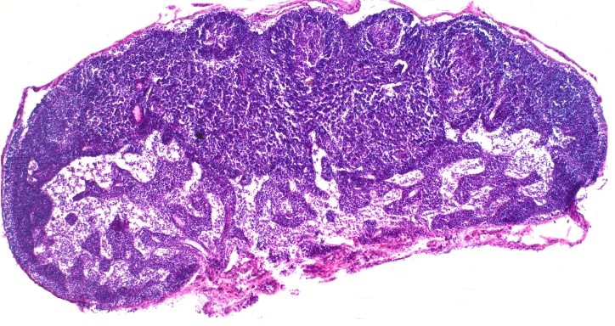А 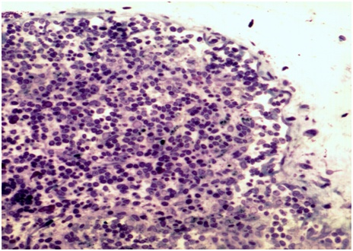Б
Legend: A - Reducing the compaction of the lymph node by increasing the sinus system. Lymphoid nodules with a germinal center predominate. B - Subcapsular sinus with part of the cortical plateau. Recovery stage after correction. Staining with hematoxylin and eosin.
Magnification approx. 10x0.25; About. 10x20
Figure 40 - The structure of the cervical lymph node in conditions of correction
During rehabilitation, among the indicated structural and functional zones, the percentage areas of lymphoid nodules with the germinal center, paracortex (Figure 40) decrease and the area of pulp strands increases in comparison with the control indicators.
During rehabilitation, in comparison with hypothyroidism, the percentage areas of the cortical plateau, lymphoid nodules with the germinal center decrease, and the percentage areas of the brain substance structures increase. In the general structure of the lymph node, the abolition of mercazolil leads to an increase in the proportion of those intranodular zones that had low rates when taking mercazolil, but they do not always reach the control values.
The use of corrective substances during the rehabilitation period increases the immune and drainage-detoxification potential of the lymph node. First of all, this is expressed in an increase in the total area of the lymph node to 27.7 ± 1.59% (the course of mercazolil is 21.6 ± 1.23%). Reception after corrective substances restores the ratio of cortical and medullary substance in the lymph node. The cortical-cerebral index is 1.05 ± 0.13 and indicates the formation of the morphotype of the lymph node, as in the control. The change in the total area under the influence of corrective substances is accompanied by the transformation of the intranodular zones. The size of the subcapsular sinus changes along its length.
At the same time, the area occupied by the medulla increases, mainly due to the pulp strands in comparison with the experimental group. After the use of corrective substances, it was noted that taking the “Revival plus” balm and tincture of white cinquefoil increases the size of the total section of the lymph node, and among the intraranodular structures - the area of the paracortex; other structures did not differ statistically significantly from each other. Nevertheless, upon correction, all indicators of the area of the main intranodular structures are statistically significantly lower than the control indicators, with the exception of the paracortex and pulp strands. The ratio of lymphoid nodules with and without the germinal center is low in size and equal to 1.12, which indicates a decrease in the activity of lymphoid nodules. The results of the studies showed that the correction in comparison with the control decreases the area of lymphoid nodules with the germinal center, cerebral sinus and increases the area of the paracortex and pulp cords; in comparison with the use of corrective substances, there is an increase in the paracortex and a decrease in lymphoid nodules with the germinal center, the cerebral sinus; in comparison with hypothyroidism, a decrease in the capsule, cortical plateau, lymphoid nodules with the germinal center and an increase in the paracortex and pulp strands were noted. The positive effect of “Revival plus” balm and tincture of cinquefoil on the immunoactive zones of the lymph node was noted, which contributes to a more rapid restoration of its immune and drainage-detoxification potential at the stage of hypothyroidism rehabilitation.
The use of corrective substances within a month affects the total area of the lymph node and the size of its structural and functional areas. Within a month, there is an increase in the area of the lymph node, the increase was 12-14% (table 16). At the same time, the values of the area of the structures of the lymph node change statistically insignificantly with the initial level. In comparison with the control parameters, the area of the paracortex decreases by 37.4%, and the area of the cerebral sinus increases by 115.4%, the rest of the structural parameters did not differ significantly. Perhaps this is due to the accumulation of lymphocytes in the parocortex during their migration through the wall of postcapillary venules into the lymph node. The development of the deep cortex leads to the compaction of the lymph node, which is accompanied by an increase in the cortical-cerebral ratio.
Lymphoid nodule. After the use of corrective substances in the lymphoid nodule, the number of blasts increases by 27.6% compared with the indicator for hypothyroidism, while their value remains within the control limits. During the period of correction in the lymphoid nodule, the number of secondary lymphocytes increases by 22.4% in comparison with the hypothyroid status and their number remains 1.3 times lower than in the control group. After the application of corrective substances in the lymphoid nodule, the number of small lymphocytes increases but does not reach the control level (in control 9.330.29, with hypothyroidism 6.17±0.28 *, after correction 7.62±0.11 *), the same time in hypothyroidism is reduced by 1.4 times in comparison with the control (table 16).
With correction in the lymphoid nodule, a 1.2-fold increase in the number of macrophages is observed in comparison with hypothyroidism. At the same time, in comparison with the hypothyroidism group, the number of macrophages after correction is reduced by 8%, but higher than in the control value.
Paracortex. After the use of corrective substances in the paracortex, the number of blasts decreases in comparison with hypothyroidism by 8% (in the control group 3.0±0.16; with hypothyroidism 3.83±0.18; after correction 3.42±0.11). In this case, the number of blasts per unit area of the paracortex is maintained within the limits of control at all times after taking corrective substances.
In comparison with hypothyroidism during the correction period in the paracortex, the number of secondary lymphocytes increases, but below the control value by 14.2%. It can be noted that the number of macrophages in the paracortex after correction increases by 42%, but remains low enough, it is 1.27 times less than the control indicator. During the period of correction in the paracortex, the number of plasma cells per unit area changes little and remains within the limits of the control (Table 16).
Table 16 - Structural and functional zones of the lymph node in experimental hypothyroidism and after correction
Cells, number of cells per unit area (1600 μm²) | Control group |  | Hypothyroidism |  | Hypothyroidism + correction
Lymphoid nodules
Lymphoblasts | 4,31±0,19 | 3,0±0,17* |  | 4,0±0,13
Average lymphocytes | 13,33±0,21 | 8,50±0,18** |  | 10,4±0,12*
Small lymphocytes | 9,33±0,29 | 6,17±0,28* |  | 7,62±0,11*
Macrophages | 4,67±0,13 | 6,0±0,17* |  | 5,51±0,16*
Paracortex
Lymphoblasts | 3,0±0,16 | 3,83±0,18 |  | 3,42±0,11
Average lymphocytes | 13,17±0,29 | 9,50±0,29** |  | 11,3±0,21*
Small lymphocytes | 7,83±0,21 | 6,50±0,22* |  | 8,23±0,11
Reticular cells | 1,01±0,12 | – |  | 0,91±0,06
Macrophages | 6,33±0,17 | 3,50±0,21* |  | 4,98±0,76*
Plasmacytes | 0,17±0,03 | – |  | 0,11±0,01
Eosinophilic granulocytes | – | – |  | 0,15±0,002*
Brain cords
Plasmablasts | 2,33±0,19 | 5,50±0,23* |  | 3,7±0,29
Plasmacytes | 2,67±0,23 | 1,83±0,18* |  | 2,51±0,09
Small lymphocytes | 5,83±0,21 | 5,17±0,28 |  | 5,0±0,01
Average lymphocytes | 8,67±0,23 | 4,50±0,21* |  | 6,8±0,32*
Macrophages | 4,50±0,12 | 4,51±0,18 |  | 3,86±0,19*
Reticular cells | 1,50±0,09 | 0,83±0,10* |  | 1,111±0,54
Eosinophilic granulocytes | 0,33±0,07 | 0,53±0,09 |  | 0,61±0,29*
Cerebral sinus
Small lymphocytes | 8,67±0,26 | 7,0±0,35* |  | 6,25±0,12*
Macrophages | 3,83±0,19 | 6,0±0,27* |  | 4,42±0,19
Reticular cells | 1,67±0,13 | 1,0±0,14 |  | 1,41±0,09
Plasmacytes | 0,33±0,14 | 0,50±0,19 |  | 0,61±0,12
Eosinophilic granulocytes | 0,33±0,07 | – |  | 0,58±0,07
Note: significant compared to control at P <0.05 *; P <0.01 **
Brain cords. With hypothyroidism in the pulp cords, the number of plasmablasts increases by 136%, i.e. 2.36 times, and after the use of corrective substances 1.48 times, respectively, in comparison with hypothyroidism. After the application of “Revival plus” balm and white cinquefoil in the pulp strands, the number of plasmablasts remains within the limits of the control, with a tendency to increase by 30 days of correction.
The number of plasmacytes in the pulp cords in experimental hypothyroidism decreases by 31%, at other times after correction there is no statistically significant difference in comparison with hypothyroidism. In the pulp cords, the number of small lymphocytes in the control and in hypothyroidism is very close in size to each other. During the correction period, it was not revealed without a statistically significant difference. After the use of corrective substances in the pulp strands, the number of average lymphocytes increased by 1.51 times in comparison with hypothyroidism. In comparison with the control, there is a progressive decrease in the number of secondary lymphocytes with recovery after correction. In the experiments, it was shown that after corrective substances in the pulp strands there is a 1.16-fold decrease in the number of macrophages in comparison with the control group and the hypothyroidism group. The number of reticular cells is reduced by 55% in hypothyroidism compared to the control group, and the use of corrective substances increased by 33% (table 2). The number of reticular cells varied within the control, showing no statistically significant difference. During the period of correction in the pulp cords there is a tendency to an increase in the number of eosinophilic granulocytes in comparison with hypothyroidism and their number is stably increased in comparison with the control.
Cerebral sinus. During the correction period in the cerebral sinus, the number of small lymphocytes significantly decreases by 28% and in hypothyroidism by 19.2% compared to the control group. In comparison with the control in hypothyroidism, the number of small lymphocytes in the cerebral sinus remains reduced and ranges from 5.2 ± 0.21 to 7.0 ± 0.35 (Table 16).
During the period of phytorehabilitation in the cerebral sinus, the number of macrophages decreases 1.4-1.7 times in comparison with hypothyroidism. At the same time, the number of macrophages in the cerebral sinus remains within the initial background during the period of application of corrective substances.
After the use of corrective substances in the cerebral sinus, a progressive increase in the number of reticular cells occurs, reaching statistically significant in comparison with hypothyroidism. In comparison with the control, a low content of reticular cells by 60% was noted; in subsequent periods after correction, their number reaches the control value (Table 16).
During the period of application of correction in the cerebral sinus, the number of plasma cells changes little, with a tendency to increase in comparison with hypothyroidism, but the difference becomes statistically significant by the end of the intake of corrective substances in comparison with the control group, it increases by 84% (in the control 0.33±0.14; with hypothyroidism 0.50±0.19; after correction 0.61±0.12). After correction in the cerebral sinus, the number of eosinophilic granulocytes tends to increase in comparison with the control (table 16).
Thus, from the data obtained, it can be seen that the structural and functional zones of the lymph node are characterized by a certain quantitative and qualitative composition of cells, which depends on the thyroid status. Reception of mercazolil and the formation of hypothyroidism is reflected in the cytoarchitectonics of the lymph node. According to the literature, the lymph node is a reflection of those changes that occur in the lymphatic region of the organ under conditions of hypothyroidism and at the stage of correction. It is known that thyroid hormones stimulate the function of lymphoid organs [9], while hypothyroidism inhibits the activity of the immune system [10]. Taking mercazolil blocks the production of thyroid hormones, which is manifested by a change in the morphology of the lymph node.
The data obtained show that hypothyroidism decreases the number of small lymphocytes in all structural and functional zones; the number of blasts decreases in the lymphoid nodule and increases in the paracortex and pulp cords; the number of macrophages increases in the lymphoid nodule, cerebral sinus, the number of mature plasmocytes decreases in the paracortex and pulp cords, which reflects a decrease in immune activity and lymphopoietic function, as well as suppression of cellular reactions in the lymph node, as a result of the immunosuppressive action of mercazolil.
After the use of corrective substances in animals of the consequences of hypothyroidism, the number of blasts is stabilized at the control level, the number of lymphocytes gradually increases to control in the lymphoid nodules, increased in the paracortex and decreased in the cerebral sinus, macrophages at the control level, and by the end of the study they can increase in the lymphoid nodule and decrease. »In the paracortex and pulp cords, the number of plasma cells increases in the pulp cords and the cerebral sinus. There is a rapid restoration of the immune potential of the lymph node. Cytological reactions, along with dynamic stereotypes of changes in the structure of the lymph node, reveal a morphological originality that reflects the functional state of the thyroid gland in hypothyroidism and under conditions of correction. After the application of corrective substances with the help of “Revival Plus” balm and white cinquefoil, a faster recovery of the cellular composition of the structural and functional zones of the lymph node occurs.
The research results showed the dependence of the structure of the lymph node on the functional state of the thyroid gland. In conditions of hypothyroidism, the lymph node becomes compacted with a decrease in the main structural and functional zones against the background of reduced lymphopoietic function. In turn, the use of corrective substances after the cancellation of mercazolil, as a rule, evens out the ratio of cortical and medullary substances in the general structure of the lymph node and leads to the restoration of the area of the medulla and paracortex to the control level. Corrective substances, a combination of “Revival Plus” balm and tincture of cinquefoil are considered as a kind of modifiers of the structure and function of the lymph node during the correction period, which determines the appropriateness of their use in hypothyroidism.

3.3.2 Condition of adrenergic innervation apparatus of the thyroid, blood and lymph vessels and lymph nodes under experimental hypothyroidism and its correction

The sympathetic nervous system is considered to be one of the most important systems of the body that regulates the level of thyroid hormones in the blood serum and the level of their metabolic activity in the liver cells. Chemical sympathectomy with 6-hydroxytrypton and reserpine leads to a decrease in the content of both hormones - thyroxine (T4) and triiodothyronine (T3), but the ratio of T3/T4 still increases [152]. In the literature there are only indirect data on the adrenergic innervation of the thyroid gland. Studies have compared organ tissue density and iodine uptake in animals subjected to unilateral destruction of preganglionic fibers in the superior cervical ganglion, from which adrenergic innervation of the thyroid gland arises [153]. It was found that ganglioectomy destroys postganglionic sympathetic innervation, on the contrary, decentralization leaves postganglionic innervation intact, but cancels the delivery of efferent impulses [154, 155, 156].One of the main physiological effects of thyroid hormones is the formation of the nervous system and skeleton in the prenatal period, an increase in receptor sensitivity to catecholamines, an increase in the number of catecholamine receptors in the heart muscle and other organs [157, 158]. Under hypothyroidism, the thyroid gland and the lymph node are characterized by a unidirectional change in structures towards their reduction [159].
In the available literature, we were unable to obtain information about the adrenergic innervation of the thyroid gland and its blood and lymphatic vessels and lymph nodes under the correction period of the experimentally obtained hypothyroidism. Mostly, the researchers have focused their attention on the morphology of the thyroid gland, lymph vessels and nodes.
Correction of the hypothyroid state of the body is associated mainly with a deficiency of iodine and thyroid hormones. In connection with the steady growth of thyroid disease, the search for new drugs of various origins with thyroid-stimulating action is urgent. In this regard, the use of dietary supplements of plant origin is of interest. The use of a mixture of medicinal herbs does not always give the expected result, since with their prolonged use there may be side effects [160].
During the recovery and phyto-rehabilitation period, reorganization of the lymph node happens in a greater extent than that of the thyroid gland. According to the researchers’ opinions, this indicates the active role of the lymph node in the implementation of the drainage-detoxification function in the lymphatic region of the thyroid gland, which can be enhanced by phytotherapy [111].
The aim of our research was to study the adrenergic innervation of the thyroid gland and the neighboring blood, lymph vessels and nodes under the condition of experimental hypothyroidism and during the correction of the revealed violations with protective substances which restored the structure of the thyroid gland and lymphatic vessels and lymph nodes.
Iodine belongs to the vital microelements, without which the normal functioning of the human body is impossible. It is a structural component of thyroid hormones, which determine the activity of almost all metabolic processes in the body. The need of an organism for it depends on many factors, namely, on the species and breed, the physiological state of the organism [161, 162].The results of a fluorescent microscopic study showed that adrenergic nerve fibers form plexuses around the blood vessels that approach the gland. Despite the rich innervation of the blood vessels supplying the thyroid gland, we did not detect a network of adrenergic fibers in the thyroid tissue. Only a few adrenergic nerve fibers addressed to the arterial vessels feeding the thyroid tissue can be distributed in the glandular tissue.
Under hypothyroidism and after its correction witha combination of iodine and white cinquefoil extract, morphological changes in the thyroid gland are possible. The adrenergic innervation of the thyroid gland seemingly depends on the state of the adrenergic nervous apparatus of the blood and lymphatic vessels in the region of the thyroid gland (figure 41a, b).
Under hypothyroidism, adrenergic fibers and their varicose extensions are preserved. However, it should be noted that in the wall of the artery of the thyroid gland, large varicose expansions along the nerve fiber under hypothyroidism of rats are in a diffuse state compared to intact animals. Diffuseness of varicose veins, which are depots of catecholamines, may indicate that the catecholamines released from the nerve endings of the sympathetic nervous system can apparently affect the function of the thyroid gland both through the bloodstream and through acting on thyrocytes.
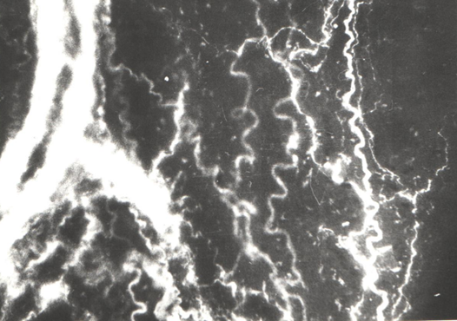
(a) (b)
Figure 41 - Adrenergic innervation of the wall of the superior thyroid artery under
hypothyroidism (a) and under correction (b).
Lens 30, Оc. 6,3х

After correction of hypothyroidism, the structure of the formation of adrenergic nerve plexuses is preserved in the wall of the superior and inferior thyroid arterial vessels (figure 42a, b). However, the adrenergic nerve bundles accompanying the paravasal vessels are in a diffusive state, and there are no varicose thickenings along the length of the nerve fiber.
After correction of hypothyroidism, independent adrenergic nerve fibers in the vessel wall have a bright fluorescence, which serves as an indicator of the content of catecholamines in them (figure 42a, b).

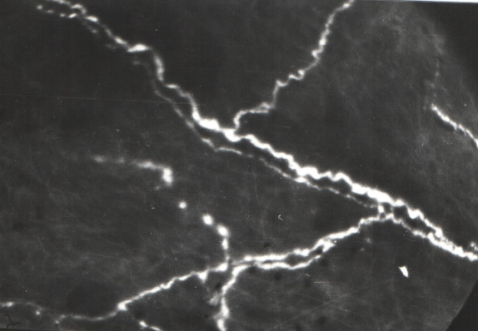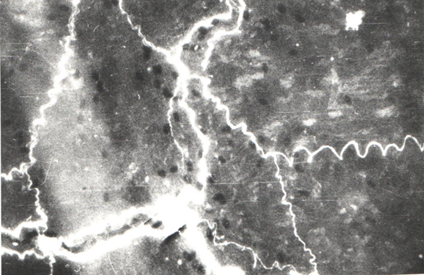
(a) (b)
Figure 42 – Adrenergic innervation of the wall of the lower thyroid artery under hypothyroidism (a) and under correction(b).
Lens 30, Оc. 6,3х

Under hypothyroidism, adrenergic nerve fibers and varicose thickenings in the wall of the lymphatic vessels remain. Along the adrenergic fibers there are areas with less bright luminescence. Varicose thickenings along the nerve fiber retain their regularity, however, small terminal varicose extensions disappear. Under thyroid insufficiency, it was found that the adrenergic nerve plexuses in the gate area of the lymph node remain, however, a low luminescence of the terminal part of the adrenergic nerve fibers with a decrease in the number of varicose thickenings and a decrease in the intensity of their fluorescence was observed.
Under correction, the lymph node and neck lymph vessels are more susceptible to reorganization. Both the terminal part of the adrenergic nerve fiber and the postterminal part remain. However, the terminal part of the adrenergic fibers has a certain degree of diffusion, which was observed under hypothyroidism. Both in the tissue of the cervical lymph node and in the wall of the cervical lymphatic vessel, under the correction adrenergic innervation is maintained mainly along the blood vessels that feed the lymph node and lymphatic vessel (figure 43a, b).
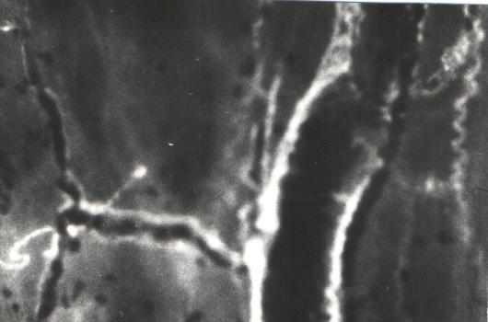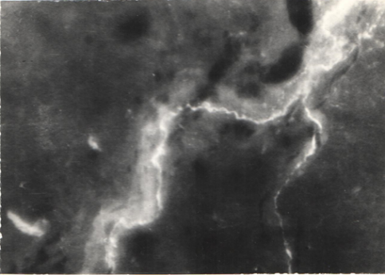
(a) (b)
Figure 43. The adrenergic innervation of the capsule of the cervical lymph node under hypothyroidism (a) and under correction (b).
Lens 30, Ос. 6,3х
Summing up, the adrenergic innervation apparatus of the blood vessels of the thyroid gland, cervical lymphatic vessels and lymph nodes under hypothyroidism preserve integrity. However, under thyroid insufficiency, the diffusivity of both adrenergic nerve fibers and varicose thickenings, which are depot of catecholamines, has been revealed. Release of catecholamines from varicose thickenings is possible, which may affect the function of the thyroid gland, its blood vessels, as well as the cervical lymph vessels and lymph nodes.
Correction of hypothyroidism with a combination of iodine and an aqueous extract of white cinquefoil (Potentilla alba L.) helped restoring the functional activity of the thyroid gland in rats. Lymph nodes are more subject to reorganization than the thyroid gland. Arterial vessels of the thyroid gland retain a network of adrenergic fibers having a bright fluorescence, which is close to normal.

3.3.3 Influence of corrective substances on lymphodynamics, hormonal and biochemical parameters of lymph and blood against the background of experimental hypothyroidism in rats

During a comprehensive endocrine examination, we revealed hypothyroidism in model animals. The TSH level in hypothyroid rats was increased, while the content of the hormones T3 and T4 was decreased. In some rats, changes in coat color (dry, dull and thinning) were observed, as well as sluggishness, rapid fatigue, and excess weight were noted in their coat. In a hormonal study in rats with hypothyroidism after correction, changes in the levels of thyroid hormones and biochemical parameters of lymph and blood were observed as shown below.
After the use of corrective substances, an increase in the concentration of triiodothyronine (T3) in the lymph was observed by 37% (control 2.58 ± 0.01; with hypothyroidism 1.40 ± 0.01 **; after correction 1.92 ± 0.03 *) and thyroxine (T4) by 32% (in control 65.8 ± 3.3; with hypothyroidism 42.4 ± 1.7 **; after correction 56.1 ± 2.9 *). Decrease in the level of thyroid-stimulating hormone (TSH) by 22% compared to the experimental group with hypothyroidism, but these indicators did not reach, respectively, compared to the control group (table 17).

Table 17 - Parameters of thyroid hormones in lymph and blood in rats after correction

Indicators | Control | Hypothyroidism | After correction
Lymph
T3 - triiodothyronine, IU / L | 2,58±0,01 | 1,40±0,01** | 1,92±0,03*
T4 - thyroxine, IU / l | 65,8±3,3 | 42,4±1,7** | 56,1±2,9*
TSH - thyroid stimulating hormone, mlIU / l | 0,014±0,0002 | 0,027±0,0003** | 0,021±0,0001**
Blood
T3 - triiodothyronine, IU / L | 2,39±0,03 | 1,35±0,07** | 1,99±0,02*
T4 - thyroxine, IU / l | 52,2±2,4 | 32,5±1,3** | 43,4±1,9*
TSH - thyroid stimulating hormone, mlIU / l | 0,0003±0,001 | 0,007±0,0002** | 0,005±0,0003*
Note - * significant compared with control, p <0.05, * -p <0.01 **

A similar picture was observed after correction in the blood of rats - the level of triiodothyronine (T3) and thyroxine (T4) was increased by 47% and 34%, respectively, compared with the group with hypothyroidism, but was reduced by 16.7% -16.9%, respectively. compared to the control group (Table 17, Figures 44, 45).
Legend: On the ordinate: the level of triiodothyronine (T3) in IU / L. On the abscissa: 1 - lymph, 2 - blood plasma.
Figure 44 - The content of triiodothyronine (T3) in lymph and blood in experimental hypothyroidism and after the use of corrective substances

Legend: Y-axis: thyroxine level (T4) in IU / L. On the abscissa: 1 - lymph, 2 - blood plasma.
Figure 45 - The content of thyroxine (T4) in the lymph and blood in experimental hypothyroidism and after the use of corrective substances
The content of thyroid-stimulating hormone (TSH) in the lymph of the control group was 0.014 ± 0.002 μIU / ml. Experimental hypothyroidism was accompanied by the activation of this hormone; under the conditions of the use of corrective substances, the TSH value in the lymph of animals of the 3rd group decreased by 22% compared with the hypothyroidism group. In rats of the 3rd experimental group, a decrease in the levels of the hormones triiodothyronine and thyroxine was observed in the blood, and an increase in the level of thyroid-stimulating hormone (TSH) was observed in comparison with the control group of animals. The content of the hormone TSH decreased by 29% compared to the experimental group, in the control - 0.003 ± 0.0001 μIU / L, with hypothyroidism - 0.007 ± 0.0002 μIU / L, after correction - 0.005 ± 0.0003 μIU / L (Table 17 , Figure 46).

Legend: Y-axis: thyroid-stimulating hormone (TSH) level in IU / L. On the abscissa: 1 - lymph, 2 - blood plasma.

Figure 46 - The level of thyroid-stimulating hormone in the lymph and blood in experimental hypothyroidism and after the use of corrective substances

Thus, the correction with the balm "Revival plus" and Potentilla white improves the hormonal status in the lymph and blood plasma in rats with experimental hypothyroidism. A 30-day course of administration of corrective substances significantly reduced the level of thyroid-stimulating hormone (TSH) and led to an increase in the concentrations of triiodothyronine (T3) and thyroxine (T4) in the lymph and blood plasma compared with the parameters of experimental hypothyroidism. At the same time, the parameters of the hormonal status do not reach the level characteristic of intact animals.
In experimental hypothyroidism in rats, a decrease in lymph flow from the thoracic duct was observed from 0.300.02 (p <0.05) to 0.25 ± 0.02 ml / h (p <0.01), by 12-26% compared with the control group. After the use of corrective substances in rats, a change in the rate of lymph flow was observed, but reached the control value (0.29 - 0.02 ** p <0.01) (Table 18).
A biochemical study in the lymph and blood plasma in rats with hypothyroidism showed an increased level of cholesterol (1.57 ± 0.014 and 2.07 ± 0.01 mmol / L), aspartate aminotransferase (273.5 ± 10.9 and 326.6 ± 10 , 5 mmol / L), alanine aminotransferase (148.2 ± 11.1 and 207.7 ± 10.6 mmol / L), creatinine (117.2 ± 6.1 and 108.6 ± 9.9 μmol / L) , urea (11.3 ± 0.36 and 10.1 ± 0.36 mol / l), respectively, compared to the control group.
Changes in the biochemical parameters of lymph and blood in rats of the experimental group with hypothyroidism showed a significant increase in the amount of total protein by 12% and 18%, glucose levels by 13% and 34%, respectively, there was also a significant increase in cholesterol levels by 21% and 40% compared control group. A similar trend was observed with the level of urea and creatinine in the blood, this indicator was 29% and 31% higher in comparison with the data of the control groups.
In rats receiving corrective substances, the cholesterol level decreased by 9-10% compared to the control group. The values ​​of the level of urea and creatine in rats from the second group exceeded by 28-29% in the lymph and 29-31 in the blood, after the use of corrective substances the values ​​of this indicator decreased by 9% and 12-13%, respectively, compared to the group with hypothyroidism. The glucose content in rats from the same group was higher than in rats from the control group. In the lymph and blood of rats in group 3, there was a significant decrease in the level of bilirubin by 25-28% (p <0.05) compared to the second group (table 18).
After the use of corrective substances in rats, the content of total protein in the lymph and blood plasma decreased by 8% and 11%, respectively (normally 42.8 ± 1.4 and 61.2 ± 2.6 g / l; with hypothyroidism 48.3 ± 1.5 and 72.3 ± 1.5 g / l). The indices of alkaline phosphatase in the 3rd group decreased in lymph by 18% (with hypothyroidism 419.9 ± 5.3 mmol / l) and blood plasma by 24% (with hypothyroidism 577.5 ± 14.9 mmol / l). The data for the third group are presented above, a decrease in the content of alkaline phosphatase was noted, but did not reach the control level (table 18).

Table 18 - Lymph flow, biochemical parameters of lymph and blood in rats under the conditions of the use of corrective substances
Indicators | Control | Hypothyroidism | After correction
Lymph
Lymphatic flow, ml / min | 0,34±0,02 | 0,25±0,02** | 0,29±0,02**
Total protein, g / l | 42,8±1,4 | 48,3±1,5* | 44,2±1,9*
Urea, mol / l | 8,7±0,9 | 11,3±0,36** | 10,3±0,11*
Creatinine, μmol / l | 91,4±2,5 | 117,2±6,1** | 106,9±2,4*
ALAT, mmol / l | 84,4±2,9 | 148,2±11,1** | 123,4±5,6**
AsAT, mmol / l | 159,7±10,8 | 273,5±10,9** | 230,1±10,2**
Alkaline phosphatase, mmol / l | 298,1±10,5 | 419,9±5,3** | 344,3±10,6**
Total bilirubin, μmol / l | 9,6±0,5 | 6,3±0,4** | 8,1±0,3*
Glucose, mmol / l | 4,9±0,2 | 5,58±0,7* | 5,26±0,5*
Cholesterol, mmol / l | 1,3±0,006 | 1,57±0,014** | 1,41±0,016*
Blood
Total protein, g / l | 61,2±2,6 | 72,3±1,5* | 64,7±2,4*
Urea, mol / l | 7,8±0,3 | 10,1±0,36** | 8,8±0,17*
Creatinine, μmol / l | 83,2±1,6 | 108,6±9,9** | 95,7±2,4*
ALAT, mmol / l | 78,4±2,3 | 207,7±10,6** | 169,1±12,3**
AsAT, mmol / l | 139,6±10,1 | 326,6±10,5** | 259,3±11,9**
Alkaline phosphatase, mmol / l | 337,2±10,7 | 577,5±14,9** | 439,2±13,1**
Total bilirubin, μmol / l | 8,3±0,1 | 5,5±0,8** | 6,9±0,6*
Glucose, mmol / l | 4,1±0,3 | 5,49±1,2** | 5,02±0,3*
Cholesterol, mmol / l | 1,48±0,003 | 2,07±0,016** | 1,62±0,009*
Note - * significant compared with control, p <0.05, * -p <0.01 **

Determination of the activity of transaminase enzymes in the lymph and blood plasma in rats after the use of corrective substances showed the following pictures, the level of ALT and AST in the lymph decreased by 17-16% compared to the group with hypothyroidism. In rats with correction against the background of hypothyroidism, it showed that the content of ALT and AST in the lymph was 123.4 ± 5.6 and 230.1 ± 10.2 mmol / l (p <0.01), respectively.
The ALT and AST values ​​in blood plasma in the experimental groups with hypothyroidism were 207.7 ± 10.6 and 326.6 ± 10.5 mmol / L, and after correction they decreased by 19% - 21% (p <0.001), respectively, compared with the experimental group 2, but did not reach the control level (table 18, figure 47).
Legend: Y-axis: ALT, ASAT level in mmol / l. On the abscissa axis: 1, 2 - ALT (in the lymph), 3, 4 - AST (in the blood plasma).

Figure 47 - Level of aminotransferase in lymph and blood plasma under correction conditions
In the experiments after the correction, changes in the biochemical parameters of the lymph were observed. There was an increase in glucose in hypothyroidism, both in the lymph and in the blood plasma (in the lymph from 5.25 ± 0.9 * to 5.58 ± 0.7 **; in the blood from 5.09 ± 0.3 * up to 5.45 ± 1.2 * mmol / l) on 30 days of research, respectively. In experiments, it can be observed that in the 2nd group there was a significant increase in the level of glucose in the lymph and blood by 13% and 34% (p <0.05, p <0.001), and after correction of the 3rd group had a tendency to further active decrease in terms of research (table 18, figure 48).
The application of the correction changed the concentration of urea and creatinine in the lymph and blood, in animals of the 3rd group it decreased in comparison with hypothyroid animals by 9% and 12-13%, respectively. In the study of the lipid profile of lymph and blood in rats with experimental hypothyroidism, the following results were obtained. In experimental hypothyroidism, the level of cholesterol in the lymph and blood exceeded the corresponding indicators of intact animals by 21% and 40%. After corrective substances decreased by 10-21%, respectively, but did not reach the initial level (table 18, figure 48).

Legend: Y-axis: unit of glucose, cholesterol measurement in mmol / l. On the abscissa axis: 1 - glucose in the lymph, 2 - cholesterol in the lymph, 3 - glucose in the blood, 4 - cholesterol in the blood.

Figure 48 - The content of glucose and cholesterol in lymph and blood in conditions of correction
In experimental hypothyroidism, a decrease in blood plasma volume (according to hematocrit data) was observed after the administration of mercazolil. The value of this indicator in the blood of animals of the 2nd group decreased by 6% compared to the control. The hematocrit of the blood of rats in this group 3 after the use of corrective substances did not differ in comparison with the experimental group with hypothyroidism.
In our study, with hypothyroidism, a violation of the rheological properties of lymph and blood was observed: the viscosity of the lymph increased from 3.08 ± 0.2 to 4.12 ± 0.3 units. p <0.01, in rats of the 2nd group, both in the lymph and in the blood, an increase of 33% and 43.1%, respectively, was noted as compared with intact animals. After corrective substances, the viscosity of lymph and blood decreased by 13% and 19% (p <0.001), but higher compared to the control values ​​(after correction in the lymph 3.59 ± 0.9 ** and in the blood 4.01 ± 0.2 **) (table 19). The lymph clotting time after correction was reduced by 23%, and the blood clotting time by 23.7% from the initial values ​​during experimental hypothyroidism. The coagulability of lymph and blood at the beginning of the experiment showed 4.2 ± 0.01 and 3.68 ± 0.02 minutes. accordingly, after the application of corrective substances, it was 3.51 ± 0.04 ** (p <0.001) in the lymph and 2.98 ± 0.01 ** min in the blood. (p <0.001). (table 19).
From the above table 19 it can be seen that in the animals of the 3rd experimental group, under the influence of the corrective drugs used, the hemoglobin and erythrocyte indices increased in the blood, as well as the decrease in the leukocyte and platelet content. Thus, in animals of group I, the number of erythrocytes under the influence of mercazolil significantly decreased from 7.53 ± 0.5, х1012 / L to 5.46 ± 0.6x1012 / L (by 72.5%), hemoglobin decreased by 70.9% - from 108.2 ± 1.6 g / L at the beginning of the experiment to 95.4 ± 2.7 g / L at the end of the experiment.

Table 19 - Rheological parameters and morphological composition of lymph and blood in rats with experimental hypothyroidism and after applying correction
Indicator | Control group | Hypothyroidism | Hypothyroidism + correction
Lymph
Viscosity, units | 3,08±0,2 | 4,12±0,3** | 3,59±0,9**
Coagulability, min | 4,2±0,01 | 2,86±0,01** | 3,51±0,04**
RBC - erythrocytes, x1012 / L | - | 0,03±0,001** | 0,01±0,002**
WBC - leukocytes, x 109 / L | 5,47±0,4 | 9,7±0,2** | 7,2±0,6**
PLT - platelets, 109 / L | - | 3±0,05** | 1,39±0,06**
HGB - hemoglobin, g / L | - | 0,02±0,001** | 0,014±0,001**
LYM - lymphocytes,% | 92,2±2,4 | 133,1±5,9** | 119,7±3,2**
Blood
Hematocrit,% | 48±1,3 | 41,2±1,8** | 41,2±1,8**
Viscosity, | 3,48±0,3 | 4,98±0,2** | 4,01±0,2**
Coagulability, min | 3,68±0,02 | 2,41±0,01** | 2,98±0,01**
RBC - erythrocytes, x1012 / L | 7,53±0,5 | 5,46±0,6** | 6,32±0,1**
WBC - leukocytes, x 109 / L | 6,8±0,3 | 10,9±0,8** | 8,1±0,6**
PLT - platelets, 109 / L | 182,1±2,8 | 265,7±4,5** | 214,9±6,7**
HGB - hemoglobin, g / L | 152,7±2,3 | 108,2±1,6** | 129,9±1,5**
LYM - lymphocytes,% | 95,4±2,7 | 139,4±2,1** | 121,3±1,7**
Note - * significant compared with control, p <0.05, * -p <0.01 **

The content of leukocytes in lymph and blood increased from 5.47 ± 0.4x109 / L to 9.7 ± 0.2x 109 / L (by 77.3%) and 6.8 ± 0.3x109 / L to 10.9 ± 0.8x 109 / L (60.32%), respectively. A similar picture was observed after correction in the blood in rats - the number of platelets was increased, respectively, by 41.5%, and was reduced, respectively, by 19.2% compared with the group with hypothyroidism (Table 19).
Thus, morphological studies of lymph and blood, carried out in all studied animals, under the influence of the used corrective drugs, their positive dynamics was established.
We have investigated to reveal changes in the frequency-amplitude characteristics of spontaneous rhythmic contractions of the cervical lymph nodes in experimental hypothyroidism caused by mercazolil and after the use of corrective substances. During the experiment on isolated preparations, we registered a series of spontaneous rhythmic contractions. The frequency of spontaneous rhythmic contractions of the cervical lymph nodes in the control animals was 9.2 ± 0.2 contractions / minute, and the amplitude of spontaneous rhythmic contractions was 17.9 ± 0.2 mg. In experimental hypothyroidism in animals, a decrease in the frequency of spontaneous rhythmic contractions by 66.4% and a decrease in the amplitude of spontaneous rhythmic contractions by 45.9% (p <0.001) are observed. Hypothyroidism led to a decrease in spontaneous contractions and suppression of amplitude, these data indicate that the thoracic lymphatic duct, lymph flow is inhibited. With the introduction of corrective substances, the frequency of contractions was 12.1% (p <0.05) higher, and the amplitude of contractions was lower by 37.2% (p <0.01) compared with the control group. These decreases are insignificant, which gives reason to assume that the effect of corrective substances on the lymphatic vessels and cervical lymph nodes is insignificant.
In the next series of experiments, the responses of isolated cervical lymph nodes to the vasoactive substances adrenaline and acetylcholine were studied in hypothyroidism against the background of correction. Adrenaline in concentrations (1x10-7-1x10-6 M) caused a dose-dependent increase in the frequency of rhythmic contractions, an increase in amplitude by small ones and a decrease by large concentrations of adrenaline in isolated preparations in animals after the use of corrective substances. Adrenaline at a concentration of 1x10-7 M accelerated rhythmic contractions by 8.4% and increased the amplitude by 12.5%, and acetylcholine at a concentration of 1x10-7 M accelerated rhythmic contractions by 23.5% and decreased the amplitude by 17.9% compared to experienced 2nd group. Experiments with a vasoactive substance - adrenaline and acetylcholine showed that in experimental hypothyroidism, suppression of the contractile activity of the cervical lymph node was revealed, and that the suppression of this function of the lymphatic vessel and node is carried out by disrupting the receptor apparatus of the myocyte membranes.
Thus, the results of our studies have shown that the contractile activity of the cervical lymph nodes in animals with hypothyroidism in the experiment is inhibited. According to our data, these changes are associated with disturbances in the receptor link of neurohumoral regulation of this vessel. The use of corrective substances reduced the negative effect of mercazolil on the contractile activity of the cervical lymph nodes, as evidenced by experimental data.

3.4 Discussion of research results

Based on the data obtained, when studying the functions of the thyroid gland in rats, structural transformations of an adaptive nature were revealed, manifested in an increase in the mass of the gland and its linear parameters, and changes in cell follicles.
Analyzing the obtained experimental material, the following picture can be observed - after the introduction of mercazolil, we obtained experimental hypothyroidism with an evidence base and according to biochemical blood data on the relative content of hormones TSH, T3 and T4, and which was more pronounced after 30 days of administration of mercazolil into the body of animals. The functional state of the thyroid gland was suppressed [163], which was reflected in the general state of the animals.
When simulating hypothyroidism in rats, a significant decrease in the content of T3, T4 and an increase in the level of TSH in the lymph and blood were found on the 30th day of the experiment in comparison with the data in intact animals.
The created experimental model of hypothyroidism reveals many target organs in the body, among which the lymphatic system plays an important role. The resulting changes in the lymphoid tissue reflect its participation in the homeostasis of the lymphatic region of the thyroid gland. The interaction of the thyroid gland and the lymph node occurs through the extracellular space (interstitium) with the vascular and non-vascular pathways of microcirculation [164].
In the body with hypothyroidism, there is a decrease in lymph flow, a change in the biochemical and rheological properties of lymph and these data obtained by us indicate the participation of the lymphatic system in the development of experimental hypothyroidism in rats. In hypothyroidism, the data obtained and presented above may have important theoretical significance for understanding the biochemical processes in experimental hypothyroidism.
Disorders of blood flow and lymph flow are an inevitable component of almost every pathological process, since it is at the level of the tissue microdistrict that the key process of the body's vital activity is realized - transcapillary metabolism. It has been shown that dynamic insufficiency of the roots of the lymphatic system plays an important role in the pathogenesis of hypothyroidism [53].
In our study, the concentration of TSH, T3 and T4 in the lymph, which correlated with the concentration of these hormones in the blood. Experiments have shown that in rats with hypothyroidism there is a decrease in the content of T3, T4 and an increase in TSH in the lymph and blood.
In experimental hypothyroidism, we observed changes in the biochemical, rheological and cellular parameters of lymph and blood. The changes we observe reduce the fluidity of both blood and lymph.
It is known that measuring the viscosity of lymph allows you to get an idea of ​​the degree of impaired vascular permeability and the state of the transport function of the lymphatic system in pathological conditions [25, 26]. Thus, the viscosity of lymph depends on the processes of tissue metabolism and is closely related to the violation of vascular permeability. Changes in the rheological parameters of lymph occur simultaneously with a violation of the coagulation system. Clotting accelerated, which worsened the fluidity of both blood and lymph [165, 166]. We have found that an increase in lymph viscosity contributed to a decrease in the speed of lymph movement. As noted in the experiment, the increased viscosity of the lymph in experimental hypothyroidism, the presence of an admixture of erythrocytes in it leads to a tendency to thrombus formation.
In the studies, the authors disclosed that in experimental hypothyroidism caused by the administration of mercazolil to rats for eight weeks, changes in the agranulocytic link of the blood system. Morphological studies have shown that after discontinuation of mercazolil, the phagocytic activity of monocytes / macrophages decreases, lymphocytosis is recorded with subsequent lymphopenia, lymphatisation of the red bone marrow progresses, and central and peripheral lymphopoiesis is activated [165].
In hypothyroidism, the proportion of blood cells increased, and the proportion of the plasma part of the blood decreased. An acceleration of the clotting time of blood and lymph and an increase in their viscosity were found. The number of platelets in the blood increased by 83%, which poses a threat of thrombus formation both in the blood and lymphatic vessels. With the processes of disorders of the body, a change in lymphodynamics and rheological properties of lymph occurs. The data obtained by us indicate the participation of the lymphatic system in the development of experimental hypothyroidism in rats.
The blood system plays a major role in maintaining homeostasis to constantly changing conditions of the internal and external environment. The quantitative and qualitative composition of erythrocyte cells in humans and animals in normal and pathological conditions is characterized by a fairly high stability, which is associated with the constancy of the action of regulatory mechanisms. In recent years, the physiological, morphofunctional, biochemical characteristics of the organism are being actively studied, which are characteristic to one degree or another by a certain feature in the epidemiology of various diseases.
Thus, we can conclude that hypothyroidism develops in rats with the introduction of mercazolil in an average daily dose of 20 mg / 100 g for 30 days with water. It is characterized by the peculiarities of the general condition of rats, in some individuals hair fell out in the tail area, body weight decreased, aggressive behavior was observed in the behavior of rats, as well as in the hormonal, biochemical composition of lymph and blood, changes in the physicochemical and rheological properties of blood and lymph. We have shown a high level of alkaline phosphatase in the lymph and blood, as well as an increased level of the enzymes AsAT and ALAT both in the blood plasma and in the lymph.
Thus, our data confirm the conclusions of other authors that during hypothyroidism functional disorders occur in the thyroid gland [90, 91 92], but along with these disorders we observed changes in lymph flow from the thoracic duct, changes in the content of triotropic hormones in the lymph, an increase in the content of the enzymes AST and ALT in the lymph and blood plasma. These changes in our experiments show that in hypothyroidism destructive processes are observed in the body.
When discussing the results obtained, one cannot but touch upon the issue of changing the area of ​​the thyroid gland. An increase in the area of ​​the thyroid gland in experimental animals is associated with a change in the follicular organization and blood and lymph filling of the organ. This is evidenced by the relative indices of the circulatory and lymphatic channels and the indices of redistribution and excessive accumulation of colloid in follicles. The enlargement of the thyroid gland is often associated with the action of thyrostatic substances. However, an increase in its volume and weight with a short-term effect of thyrostatic agents is caused by hypertrophy of swelling cells of the follicular epithelium and severe hyperemia [167, 168].
As you know, thyroid follicles are the most important structures responsible for the regulation of the hormonal status of the body. Modeling hypothyroidism with the use of mercazolil is widely used in experimental biology and medicine. Mercazollil inhibits the functional activity of the thyroid gland, which blocks the key enzyme in the synthesis of thyroid hormones, thyroid peroxidase [168]. The most important role of the thyroid gland in the life support of the organism is determined by the biological action of its hormones [169].
It is known that follicles differing in size have different metabolic rates, judging by the intensity of histochemical reactions in thyrocytes [142, 143, 144]. The presence of follicles of different caliber in the structure of the thyroid gland does not allow one to uniquely characterize the functional activity of the organ. In our opinion, the functional activity of the thyroid gland depends on the representation of follicles of different sizes. It is their ratio that determines the functional activity of the thyroid gland.
In experimental hypothyroidism, the capsule of the thyroid gland thickens even more, collagen fibers lie even more densely in its outer layer, and loosely in the inner layer. The parenchyma of the gland acquires a characteristic follicular structure: follicles are visible both on the periphery and in the center of the sections, and on the periphery they are larger and elongated in shape.
In our opinion, the functional activity of the thyroid gland depends on the representation of follicles of different sizes. It is their ratio that determines the functional activity of the thyroid gland. So, when taking mercazolil, small follicles prevail, under conditions of rehabilitation, a sufficient number of follicles of different sizes appear. Evidence in this regard is the index of thyroid heterogeneity. Most follicles have narrow, slit-like cavities with slightly oxyphilic contents. However, the lumens of some follicles expand markedly, sometimes a chromophobic colloid can be seen in the center of the follicular cavity, while an oxyphilic colloid is located at the edges.
However, in rats treated with mercazolil, an increase in follicular size was noted both in the peripheral and central zones of the thyroid lobes. In the follicular thyrocytes of the peripheral zones, signs of ineffective resorption and colloid stagnation were revealed. Mercazolil determines the structural response of the thyroid follicle depending on its functional state. The presence of thyroid follicles with different morphology is shown: from minimal changes to destructive damage, which determines the necessary for the functioning of the thyroid gland as a whole.
The authors noted that the proliferation and desquamation of the thyroid epithelium is considered as a manifestation of morphokinetics, reflecting the change in the function of the thyroid gland: hormone poiesis and the release of hormones. In this case, the proliferation of the follicular epithelium is a manifestation of adaptive intraorgan restructuring aimed at maintaining homeostasis [145, 167, 168].
In the thyroid glands in conditions of hypothyroidism, it is characterized by hypertrophy of the thyrocyte, interfollicular proliferation, fragmentation of follicles in combination with desquamation of the epithelium, intracellular accumulation of colloid, ultrastructural changes in the thyrocyte. In hypothyroidism, the synthetic and energetic apparatus of thyrocytes suffers, which alters the metabolic processes and transport processes associated with the synthesis and resorption of the colloid. Most thyrocytes are cylindrical in shape. There are also cubic cells that predominate in the interfollicular islets. In the cytoplasm of follicular thyrocytes, large light vesicles are visible, sometimes adjacent to the nuclear envelope. Such vesicles are also found in the basal part of thyrocytes near the basement membrane. Among thyrocytes, cylindrical cells with oval nuclei displaced to the basal pole and weakly oxyphilic cytoplasm prevail. There are also cubic cells with spherical nuclei and a small amount of cytoplasm.
In hypothyroidism, differences in the central and peripheral zones of the thyroid parenchyma begin to appear more clearly. So, at the periphery, follicular fissures become noticeable, separating the apical surfaces of opposing thyrocytes. Formed follicles are rare; on sections, they consist of 4-6 epithelial cells with large rounded nuclei shifted to the basal pole of the thyrocyte. Follicular cavities are very narrow, tortuous, their contents are weakly oxyphilic. The boundaries of the cells that form the walls of the follicles are clear, straight; however, sometimes mutual invaginations of the membranes of neighboring thyrocytes are noticeable. In the cytoplasm of follicular cells, granules and vesicles of various sizes are found.
The data obtained are in good agreement with the observations available in the literature that, in comparison with other types of glandular epithelium, thyrocytes have increased resistance to the action of stimuli that induce apoptosis [169].
In hypothyroidism, the changes occurring in the structures of the lymphatic region of the thyroid gland, there is a violation of the bloodstream of the lymph node. Morphofunctional studies show destructive changes in the cortex and medulla of the lymph node, especially in the cerebral sinus of the node [170, 171].
According to the literature, the relationship between the volume of the colloid and the lymphatic regions of the thyroid gland and very weak communication between the lymphatic bed and the cerebral sinus of the lymph node are determined [172, 173]. The structural organization of the lymph node in hypothyroidism caused by the intake of mercazolil is characterized by a decrease in its total area due to a decrease in the size of the main structures of the cortex (subcapsular sinus, lymphoid nodules, paracortex) and an increase in the cerebral sinus in the medulla. Mercazolyl hypothyroidism caused impaired peripheral blood circulation, there were well-pronounced destructive changes in the thyroid gland and tissue edema. The initial section of the lymphatic region is the thyroid microdistrict, in which significant changes occur under conditions of thyroid dysfunction. When discussing the results obtained, one cannot but touch upon the issue of changing the area of ​​the thyroid gland. An increase in the area of ​​the thyroid gland in experimental animals is associated with a change in the follicular organization and blood and lymph filling of the organ. This is evidenced by the relative indices of the circulatory and lymphatic channels and the indices of redistribution and excessive accumulation of colloid in follicles.
Each of the structural and functional zones of the lymph node is characterized by a certain quantitative and qualitative composition of cells, which depends on the thyroid status. In hypothyroidism, all structural and functional zones of the lymph node are characterized by a reduced number of small lymphocytes; the number of blasts decreases in the lymphoid nodule and increases in the paracortex and pulp cords; the number of macrophages increases in the lymphoid nodule, the cerebral sinus, the number of mature plasma cells decreases in the paracortex and pulp cords. The noted decrease in the content of plasma cells is associated with a decrease in the maturation of these cells from lymphocytes and a delay in their migration into the pulp cords against the background of a reduced secretion of thyroid hormones. An important reason for the decrease in lymphocytes in lymphoid tissue is their death due to the action of a toxic agent [147].
A direct dependence of morphofunctional changes in lymph nodes on the concentration of toxic metabolites in the afferent lymph has been established [175, 176]. It is known that thyroid hormones stimulate the function of lymphoid organs, while hypothyroidism inhibits the activity of the immune system [177]. Taking mercazolil blocks the production of thyroid hormones, which leads to a change in the morphology of the lymph node. This is reflected, first of all, in the morphometric parameters of the intranodular zones of the lymph node. They mainly decrease in area [173]. The extent of these changes depends on the duration of the mercazolil administration.
Cancellation of mercazolil leads to an increase in the structural and functional zones of the lymph node, with the exception of the total area and the size of the paracortex area, which decreases. A decrease in the paracortex can be considered as its depletion. The mechanism of inhibition of the response of the structural and functional zones after the withdrawal of mercazolil in comparison with the control is probably qualitatively different. A similar change was noted in the works of other authors, leading to a decrease in the functional activity of the lymph node [133]. The most important role of the thyroid gland in the life support of the body, mercazolil inhibits the functional activity of the thyroid gland, which block the key enzyme of thyroid hormone synthesis - thyroid peroxidase [166].
Comparison of indicators of thyroid follicle rearrangement in different periods of the study allows us to conclude that the maximum degree of their changes compared to intact ones is determined in the group with 30-day hypothyroidism, which is characterized by thyrocyte hypertrophy, interfollicular proliferation, fragmentation of follicles in combination with epithelial desquamation, intracellular colloid, ultrastructural changes in the thyrocyte. In hypothyroidism, the synthetic and energetic apparatus of thyrocytes suffers, which alters the metabolic processes and transport processes associated with the synthesis and resorption of the colloid.
In our opinion, the functional activity of the thyroid gland depends on the representation of follicles of different sizes. It is their ratio that determines the functional activity of the thyroid gland. So, when taking mercazolil, small follicles prevail, under conditions of rehabilitation, a sufficient number of follicles of different sizes appear. Evidence in this regard is the index of thyroid heterogeneity.
The data obtained are in good agreement with the observations available in the literature that, in comparison with other types of glandular epithelium, thyrocytes have an increased resistance to the action of stimuli that induce apoptosis [163]. In hypothyroidism, the changes occurring in the structures of the lymphatic region of the thyroid gland, there is a violation of the bloodstream of the lymph node. Morphofunctional studies show destructive changes in the cortex and medulla of the lymph node, especially in the cerebral sinus of the node [164, 165].
According to the literature, the relationship between the volume of the colloid and the lymphatic regions of the thyroid gland and a very weak connection between the lymphatic bed and the cerebral sinus of the lymph node are determined [166]. The structural organization of the lymph node in hypothyroidism caused by the intake of mercazolil is characterized by a decrease in its total area due to a decrease in the size of the main structures of the cortex (subcapsular sinus, lymphoid nodules, paracortex) and an increase in the cerebral sinus in the medulla. Mercazolyl hypothyroidism caused impaired peripheral blood circulation, there were well-pronounced destructive changes in the thyroid gland and tissue edema.
Each of the structural and functional zones of the lymph node is characterized by a certain quantitative and qualitative composition of cells, which depends on the thyroid status. In hypothyroidism, all structural and functional zones of the lymph node are characterized by a reduced number of small lymphocytes; the number of blasts decreases in the lymphoid nodule and increases in the paracortex and pulp cords; the number of macrophages increases in the lymphoid nodule, the cerebral sinus, the number of mature plasma cells decreases in the paracortex and pulp cords. The noted decrease in the content of plasma cells is associated with a decrease in the maturation of these cells from lymphocytes and a delay in their migration into the pulp cords against the background of a reduced secretion of thyroid hormones. An important reason for the decrease in lymphocytes in the lymphoid tissue is their death due to the action of a toxic agent [133].
Thus, on the basis of the data obtained, when studying the function of the thyroid gland in rats, structural transformations of an adaptive nature were revealed, manifested in an increase in the mass of the gland and its linear parameters, changes in the follicles of the gland.
The lymph nodes and the thyroid gland on the neck are closely interconnected, as they are in close proximity to each other and are very sensitive to the effects of various factors, forming tissue microdistricts. We have shown that adrenergic fibers form branches, and along the course of nerve fibers, thickenings of regularly located varicose veins with even more intense fluorescence, as is known, containing catecholamine, have been revealed [53, 166].
Studies have shown that in hypothyroidism, the diffuseness of catecholamines from both adrenergic nerve fibers and from varicose thickenings to the thyroid glands was revealed. This release of catecholamines from varicose veins and changes in the content of these substances in the nerve fiber can affect the function of the thyroid gland, its blood vessels, as well as the cervical lymphatic vessels and lymph nodes.
When discussing the results obtained, one cannot but touch upon the issue of changing the area of ​​the thyroid gland. An increase in the area of ​​the thyroid gland in experimental animals is associated with a change in the follicular organization and blood and lymph filling of the organ. This is evidenced by the relative indices of the circulatory and lymphatic channels and the indices of redistribution and excessive accumulation of colloid in follicles. The enlargement of the thyroid gland is often associated with the action of thyrostatic substances. However, an increase in its volume and weight with a short-term action of thyrostatic agents is caused by hypertrophy of swelling cells of the follicular epithelium and severe hyperemia [165, 166].
In our research, the following substances were used for correction, it included a steam of iodine from the company "Balsam Revival" LLP MTІ Medical and Potentilla alba L. The composition was compiled by us according to the pharmaceutical principle, taking into account the lymphotropic effect of medicinal herbs and was aimed at realizing the effect of lymphatic stimulation, lymphocorrection and lymphoprotection.
In the lymph and blood of animals after correction, the amount of cholesterol in the lymph to blood slightly increased by 21% and 40%, respectively, compared to the control group. in blood plasma coagulability and viscosity of blood and lymph also changed. Coagulability increased in the lymph and in the blood by 23-23.5%. The viscosity in the lymph increased by 13%, as well as in the blood by 19.5% after the application of corrective substances.
In conditions of correction, there are signs of a reactive process from the side of the lymph nodes. This is manifested in an increase in the number density of mature lymphocytes, plasmocytes. The presence of plasma cells is considered as evidence of active immune function of the lymph node. All topographic groups of lymph nodes are characterized by increased lymphoproliferation as a result of correction, which is accompanied by the formation of lymphoid nodules outside and inside the lymph nodes. The results of the study show that ectopia of lymphoid nodules is of a more universal nature and can be observed after the use of corrective substances of the "Renaissance Plus" balm and Potentilla alba L., reduced function of the lymph nodes. An unusual arrangement of lymphoid nodules was noted in the subcapsular zone and medulla of the lymph nodes in animals after correction.
Correction of the lymphoid tissue enhances the processes leading to partial or complete encapsulation of cortical substances, as well as to fragmentation of the lymph node due to the isolation of the protruding parts of the cortex. The previously unknown property of corrective substances to induce the formation of new lymphoid structures (neolymphogenesis) with an increase in immune function has been experimentally shown. This can be considered as a stage of lymph node neoplasm. This is most typical of the cervical lymph nodes, which are initially fragmented.
A direct dependence of morphofunctional changes in lymph nodes on the concentration of toxic metabolites in the afferent lymph has been established [173]. It is known that thyroid hormones stimulate the function of lymphoid organs, and hypothyroidism inhibits the activity of the immune system. Taking mercazolil blocks the production of thyroid hormones, which leads to a change in the morphology of the lymph node. This is reflected, first of all, in the morphometric parameters of the intranodular zones of the lymph node. They mainly decrease in area [174].
In hypothyroidism, the changes occurring in the structures of the lymphatic region of the thyroid gland, there is a violation of the bloodstream of the lymph node. Morphofunctional studies show destructive changes in the cortex and medulla of the lymph node, especially in the cerebral sinus of the node [165, 166].
When studying the lipid profile of lymph and blood in rats with experimental hypothyroidism, the following results were obtained. In rats with experimental hypothyroidism, shifts in lipid metabolism are noted. The levels of holsterin in the lymph and blood significantly increased in comparison with the control group of animals. At the same time, the content of total protein in lymph and blood decreases in relation to that in intact animals. According to the literature, mercazolil is a specific synthetic thyreostatic that inhibits the activity of the thyroid gland involved in the synthesis of hormones, and also inhibits the synthesis of thyroxine, and lowers the synthesis of basic metabolism [175].
The results of the study showed that with the introduction of thyreostatics, i.e. Mercazolil causes a state of experimental hypothyroidism in animals. According to scientific literature data, mercazolil is a specific synthetic thyrostatic agent that inhibits the activity of the thyroid gland involved in the synthesis of hormones, and also inhibits thyroxine synthesis, and lowers the synthesis of basic metabolism [176, 167].
The results of our experiments showed that the rate of lymph flow decreases and the composition of the lymph changes, not only biochemical, but also the rheological properties of the lymph. The changes in viscosity we observe impair the fluidity of both blood and lymph.
Analysis of the results of our research shows that a decrease in the volumetric rate of lymph flow corresponds to changes in the biochemical and rheological properties of lymph. In hypothyroidism, rats showed a shorter clotting time and an increase in the viscosity of blood and lymph. We have shown that a decrease in lymph viscosity promoted a decrease in the speed of lymph movement. As noted in the experiment, the increased viscosity of the lymph in experimental hypothyroidism, the presence of an admixture of erythrocytes in it leads to a tendency to thrombus formation. Other authors have shown that in pathological processes, blood coagulation accelerates and the hypocoagulation phase of thrombohemorrhagic syndrome develops, which is obviously an integral part of pathogenesis, as well as a change in the rheological properties of lymph in pathologies of the body [178].
Clotting accelerated, which worsened the fluidity of both blood and lymph. In the studies, the authors disclosed that in experimental hypothyroidism caused by the administration of mercazolil to rats for eight weeks, changes in the agranulocytic link of the blood system. Morphological studies have shown that after discontinuation of mercazolil, the phagocytic activity of monocytes / macrophages decreases, lymphocytosis is recorded with subsequent lymphopenia, lymphatisation of the red bone marrow progresses, and central and peripheral lymphopoiesis is activated [179].
In the body with hypothyroidism, there is a decrease in lymph flow, a change in the biochemical and rheological properties of lymph and these data obtained by us indicate the participation of the lymphatic system in the development of experimental hypothyroidism in rats.
After the use of corrective substances, the proportion of formed elements in the lymph and blood increases, as a compensatory reaction of the blood system in response to a violation of the body, and this process requires the flow of additional fluid into the blood. Under these conditions, the release of lymphocytes from the lymph nodes into the lymph is associated with a compensatory reaction of the lymph nodes, supplying the bulk of the lymphocytes to the blood. According to researchers, lymphocytes enter the bloodstream mainly from the lymphoid organs. With hypothyroidism of these organs, along with a decrease in lymph flow, the spontaneous and evoked contractile reaction of the organ lymph nodes was inhibited.
The results of our experiments show that a decrease in the rate of lymph flow corresponds to changes in not only biochemical, but also rheological properties of lymph and blood. As can be seen from the data presented, a high level of alkaline phosphatase in the lymph and blood is shown, as well as an increased level of the enzymes AsAT and AlAT both in the blood plasma and in the lymph. Thus, our data confirm the conclusions of other authors that hypothyroidism leads to a functional disturbance in the thyroid gland [169, 170], but along with disturbances, we observed sharp changes in lymph flow from the thoracic duct, a decrease in the drainage and transport function of the vascular lymph, a change in in the content of enzymes in the lymph.
In experimental hypothyroidism, a decrease in the blood supply to the neck area and a decrease in the blood flow velocity in the carotid arteries were observed, which indicates a deterioration in blood circulation in the neck, head and brain. The results of the obtained data showed that after hypothyroidism in rats, heart rate and a slight decrease in the rate of pulse blood filling changed insignificantly and for a short time.
As can be seen from the material obtained, hypothyroidism changes the contractile properties of the smooth muscle lymphogions of the capsule of the cervical nodes, which was reflected in the frequency and amplitude of spontaneous contractions, which decreased. Under the action of the biological active substances adrenaline and acetylcholine on these nodes, an increase in the contractile activity of the lymph nodes was observed, but not with the same activation as with the action of the same biological active substances on the lymph nodes of healthy animals.
In experimental hypothyroidism, in our opinion, pathological processes are observed that lead to edematous phenomena and a decrease in contractile activity is observed in the lymph nodes, but vasoactive substances increased the vasoconstriction of regional lymph nodes.
Lymph nodes, being on the path of the pathological focus into the bloodstream, undergo a number of changes, which can be both protective and adaptive and pathological [65]. In our case, a decrease in the contractile activity of the cervical lymph nodes is associated with their changes in hormonal levels, which depressingly affect the smooth muscle cells of the capsule of the cervical lymph nodes. The revealed changes in the smooth muscle cells of the capsule of the lymph node lead to a decrease in the strength of contractions of the smooth muscles and thereby reduce the lymph flow both along the node itself and further along the lymphatic vessels. Thus, in our study, we noted a decrease in the contractile activity of the lymph nodes, a decrease in the sensitivity of the receptors of the lymph nodes, an increase in the threshold of irritation to vasoactive substances.
Thus, our data indicate that hypothyroidism in rats decreases blood supply in body tissues and blood flow rate in arteries.
As a result of the resulting experimental hypothyroidism and the associated altered hormonal status in the rat organism, the elastic-tonic properties of the arterial vessel walls decrease. The data obtained indicate a decrease in blood supply to the tissues of the rat's body, which are associated with functional hormonal disorders. Effective delivery of oxygen and food products deteriorates, biochemical processes slow down, microcirculation decreases in hypothyroidism. All this leads to a decrease in lymph formation and a decrease in lymph flow in the body.
In rats with hypothyroidism, changes in the hormonal and biochemical composition indicate a significant loss of fluid and electrolytes from the body, and a significant amount of salts, glucose and nitrogen metabolism products accumulate in the lymph. In experimental hypothyroidism, there was a decrease in the blood supply to the neck area and a decrease in the blood flow velocity in the great vessels and carotid arteries. In experimental hypothyroidism, in our opinion, pathological processes are observed that lead to edematous phenomena and a decrease in contractile activity is observed in the lymph nodes, but vasoactive substances increased the vasoconstriction of regional lymph nodes.
Thus, the development of hypothyroidism in experimental modeling in animals has been reliably proved by physiological, biochemical histochemical methods of research. Our data indicate the participation of the lymphatic system in pathological processes in the body of animals during the development of hypothyroidism and in the regulation of homeostasis of the body. The data presented above may be of great theoretical importance for understanding biochemical processes in experimental hypothyroidism.
In hypothyroidism, inhibition of the transport function of the lymph nodes was noted, which means a decrease in the spontaneous and evoked contractile activity of the cervical lymph nodes with a decrease in their sensitivity to the action of vasoactive substances and an increase in the latent period of reactions.
The results obtained in the presented research data, especially in the lymph, may have important theoretical significance for understanding the biochemical mechanisms in experimental hypothyroidism.
Our data indicate that hypothyroidism in rats decreases the blood supply to the great vessels and the blood flow rate in the carotid arteries, as well as suppression of the spontaneous and evoked contractile activity of the cervical lymph nodes. The results of the obtained data showed that after hypothyroidism in rats, heart rate and a slight decrease in the rate of pulse blood filling changed insignificantly and for a short time. Our data indicate that hypothyroidism causes more pronounced changes in the main vessels of the carotid artery compared to the control group. The detection of high indices of blood flow resistance in the carotid arteries during ultrasound examination and a decrease in blood flow velocity require studying the hormonal profile of the thyroid gland to detect hypothyroidism. In hypothyroidism, inhibition of the transport function of the lymph nodes, a decrease in the spontaneous and evoked contractile activity of the cervical lymph nodes with a decrease in their sensitivity to the action of vasoactive substances and an increase in the latent period of reactions were noted. According to pharmacologists, specific drugs and drugs that affect the structure, function and metabolism of the lymphatic system should be classified as lymphotropic substances, and their effect should be understood as the phenomenon of lymphotropy. The fact of pronounced insufficiency of the transport function of lymphatic microvessels in hypothyroidism was pointed out by a number of authors during morphological studies. The positive effect of the use of corrective agents of the Revival Plus balm and Potentilla white, revealed by us, made it possible to conclude both the presence of compensatory, lymphatic stimulating and restorative agents under the influence of hypothyroidism, and the possibility of using these agents to combat the consequences of thyroid disorders. Correction of shifts caused by mercazolil through the use of corrective substances created by Kazakh scientists (Revival Plus balm) had a positive effect on the rheological properties of lymph and blood and contraction of lymph nodes.

CONCLUSION
Based on the data obtained, the following conclusions were drawn:
CONCLUSIONS
1. According to the histological and morphometric analysis of the structure of the lymphatic region of the thyroid gland, they are highly sensitive to the experimental monthly exposure to mercazolil, which is expressed in the synchronous morphological restructuring of the tissues of the thyroid gland and the lymph node. Mercazolil (hypothyroidism) caused a violation of the thyroid follicle, there were well-pronounced destructive changes in the thyroid gland and tissue edema. They acquire fuzzy outlines - enlarged, swollen, blood vessels, especially venous, dilated, characterized by plethora and blood congestion. The changes were revealed especially in the peripheral zones of the thyroid lobes, which led to a decrease in the size of the follicles, and in thyrocytes, the cellular elements changed sharply, which caused a decrease in the production of thyroid hormones and a violation of the development of reactive and compensatory changes in the thyroid gland. In experimental hypothyroidism, morphological changes in the regional lymph node were revealed, which are characterized by the formation of a ratio of cortical and medullary substance, in which the proportion of cortical structures decreases, an increase in the number of macrophages in the lymphoid nodule, cerebral sinus, a decrease in the number of mature plasma cells decreases in the paracortex and pulp cords, as manifestations immunosuppressive action on the lymph node.
2. After the use of corrective agents of the Revival Plus balm and Potentilla White, the proliferation of the follicular epithelium persists with secretion into the follicle lumen or in the form of papillary outgrowths in the follicle wall. This reflects an increase in the number of actively functioning thyrocytes and is of a compensatory nature. Follicles with varying degrees of functional activity were noted, judging by the morphology of thyrocyte nuclei and the thickness of the wall and follicles. It is noted that after the application of corrective substances, the volumetric density of the granular endoplasmic reticulum is restored to control values. The width of the cavities varies, indicating the functional activity of thyrocytes in the formation and transport of thyroglobulin.
3. In experimental hypothyroidism, after the use of corrective substances in animals in the regional lymph node, the number of blasts is stabilized at the control level, the number of lymphocytes gradually increases to control in the lymphoid nodules, increased in the paracortex and decreased in the cerebral sinus, macrophages at the control level, and may by the end of the study increase in the lymphoid nodule and decrease "in the paracortex and pulp strands, the number of plasma cells increases in the pulp strands and the cerebral sinus. There is a rapid restoration of the immune potential of the lymph node and a faster restoration of the cellular composition of the structural and functional zones of the lymph node.
4. Using a specific histochemical fluorescence-microscopic method of visualization of catecholamines, adrenergic innervation was revealed in the tissues of the blood vessels of the thyroid gland, cervical lymphatic vessel and lymph node in hypothyroid rats. The presence of adrenergic innervation in blood and lymph vessels and nodes is shown. In hypothyroidism, diffusion of catecholamine from nerve fibers and varicose veins in the walls of the superior and inferior thyroid arteries and nearby cervical lymphatic vessels and nodes is observed. After the application of corrective substances, the lymph nodes are subject to reorganization more than the thyroid gland. After correction, the arterial vessels of the thyroid gland retain the network of adrenergic fibers with bright fluorescence close to normal.
5. Experimental hypothyroidism is accompanied by regular changes in the indicators of the morphofunctional state of the thyroid gland. A decrease in the lymph and blood T4, T3 and an increase in TSH, which indicates a significant inhibition of its function and a significant change in the macro- and microstructure. With experimental hypothyroidism, we received a decrease in lymph flow, changes in the biochemical, cellular and rheological composition of lymph and blood. The data on these indicators corresponded to a decrease in metabolism in the body. In rats with hypothyroidism, the rheological parameters of lymph and blood were disturbed: the viscosity increased, the coagulation time decreased, and the number of platelets in the blood increased. The use of corrective substances improves the hormonal status in the lymph and blood plasma in rats with experimental hypothyroidism. TSH in the lymph of animals after correction decreased by 22% compared to the group with hypothyroidism. In the lymph, triiodothyronine (T3) increased by 37% and T4) by 32% compared to animals with hypothyroidism. The blood counts of hemoglobin and erythrocytes increased, as well as a decrease in the content of leukocytes and platelets.
6. In experimental hypothyroidism, suppression of the contractile function of the cervical lymph nodes was observed, the elastic-tonic properties of the walls of the arterial vessels decrease, and the blood supply to the tissues of the body decreases. The values ​​of contractile reactions to vasoactive substances decreased. The revealed changes in hypothyroidism lead to a decrease in the strength of contractions of the smooth muscles of the capsule of the node and thereby reduced lymph flow both along the node itself and through the lymphatic vessels. Evaluation of the reactions of the lymph nodes and lymph flow, the composition of the lymph in hypothyroidism allowed us to find the appropriate lymphotronic substances to stimulate the body's defenses. The use of corrective substances reduced the negative effect of mercazolil on the contractile activity of the cervical lymph nodes.
LIST OF USED SOURCES

- Izmozherova N.V., Chumachenko A.N. The frequency of thyroid dysfunction and cardiovascular pathology in women in menopause // Problems of endocrinology, - 2007. –T.53, №1, –S.36-40.
- Comez J.M. et al., Determinants of thyroid volume as measured by ultrasonography in
healthy adults randomly selected // Clin. Endosrinol. -2000. – N5. – P.629-634.
- Antsiferov M.B., Sviridenko N.Yu. Hypothyroidism syndrome: diagnosis and treatment: guidelines. M., -2005, - 28 p.
- Balabolkin M.I., Telnova M.E., Antonova K.V., Diagnosis and treatment ofhypothyroidism in the work of a practitioner // Rus. honey. magazine, - 2008, - Т.16, №15, - С.98-992.
- Kulichenko L.L., Ivakhenko I.V., Krajushkin S.I. Topical issues of diagnosis and treatment of hypothyroidism // Medicinal Bulletin, - 2006, - No. 7, -P.27-33.
- Proschaev K.I. and others. Pain. Molecular neuroimmunoendocronology and clinical pathophysiology, - M .: ed. "GEOTAR-Media", - 2006, - 304 p.
- Kitenko E.M., Khamnueva L.Yu., Andreeva L.S. Thyrotoxicosis syndrome:classification, etiopathogenesis, clinical picture, diagnosis, treatment, medical and social examination: textbook. manuals, GOU VPO Irkutsk State Medical University, - Irkutsk, - 2006, - 35 p.
- Dedov I.I., Troshina E.A., Mazurina N.V., Gerasimov G.A., Yushkov P.V., Shatalova L.D., Alexandrova G.F. Molecular genetic aspects of the newly formed thyroid gland // Problems of endocrinology, - 2000, - No. 2, - P.22-30.
- Troshina E.A., Abulhabirova F.M., Skrynik E.N. Prevention of diseases associated with iodine deficiency in groups at high risk of their development // Consilium Medicum (Women's health), - 2010, - №12 (6). - C.17-20.
- Aukhatova S.N., Mannapova R.T. Immune status with iodine deficiency in piglets and methods for its correction in animal tissues at different levels of iodine and goitrogenic substances in the diet // Monograph, - Ufa, - 2004, - 251 p.
- Kamilov F.Kh., Mamtsev A.N., Kozlov V.N., Abdullina G.M., Lobyreva O.V. The activity of antioxidant enzymes and the processes of free radical oxidation in experimental hypothyroidism and correction of thyroid changes with an iodinated polysaccharide complex // Kazan Medical Journal. - 2012. - T. 93, No. 1. - S. 116-119.
- Mamtsev A.N., Lobyreva O.V., Kasyanov Yu.V., Kamilov F.Kh., Abdullina G.M. Activity of NAD (P) -dependent dehydrogenases in liver tissues in experimental thyroid dysfunction // Naukovi pratsi: Odessa national academy of kharchov technologies. - Odessa, 2012 .-- V. 42, T. 2. - S. 134-136.
- Kruger T. Immunomodulation of peripheral lymphocytes by hormones of the hy-pothalamo-pitutary-thyroid axis // Adv. Neuroimmunol. - 1996; -№6, - Р. 387-395.
- Korchagina I.G., Annikov V.V. Morphological changes in internal organs in hypothyroidism in dogs // Veterinary medicine of domestic animals: Sat. articles. - Kazan, 2011. - Issue 8. - S. 86-88.
- Kashchenko S.A., Goncharova M.V. Ultramicroscopic changes in the rat thyroid gland after immunosuppression // Morphology, T 7, - No. 3, - 2013. - P. 49-53.
- Gershon M.D., Belshaw B.E., Nunez E.A. Biochemical, histochemical and ultrastructural studies of thyroid serotonin, parafollicular and follicular cells during development in the dog // Am. J. Anat. 2005; 132 (1): 5–19.
- Young J.B., Burgi-Saville M.E., Burgi U.,Landsberg L. Sympathetic nervous system activity in rat thyroid: potential role in goitrogenesis // Am J PhysiolEndocrinolMetab. - 2005, -№288, - P. E861–E867.
- Samodelkina E.O., Tsirkin V.I., Prokazova N.V. The effect of lysophosphatidylcholine on α-adrenoreactivity of the smooth muscles of the rat aorta // Bulletin of Experimental Biology and Medicine, - 2011.- T.152, -№ 7. - P. 18-21.
- Arrangoiz R., Cordera F., Caba D., Muñoz M., Moreno E., Luque de León E. Comprehensive review of thyroid embryology, anatomy, histology, and physiology for surgeons // International Journal of Otolaryngology and Head &Neck Surgery. - 2018, - №7, - P. 160-188.
- Kuznetsova N.A. Fundamentals of Clinical Surgery // Practical Guide, 2nd Edition, revised and supplemented, Moscow, Publishing Group "GEOTAR-Media", 2009. -671 p.
- Arrangoiz R., Cordera F., Caba D., Muñoz M., Moreno E., Luque de León E. Comprehensive review of thyroid embryology, anatomy, histology, and physiology for surgeons // International Journal of Otolaryngology and Head &Neck Surgery. - 2018, - №7, - P.160-188.
- Rusnyak I., Feldi M., Sabo D. Physiology and pathology of lymph circulation. - Budapest, - 1957, - 856 p.
- Foldi M., Casley-Smith J.K. Limphangiology. - Stuttgart–New-York, - 1983, - 700 p.
- Borodin Yu.I. The concept of the lymphatic region // Abstracts. II congress of lymphologists of Russia, - St. Petersburg, - 2005. - S. 37-39.
- Bulekbaeva L.E., Demchenko G.A., Balkhybekova A.O., Abdreshov S.N. The contractile activity of lymph nodes in alloxan diabetes and after antioxidant correction // Astanaly med. magazines, -2008. -No. 1 (46), - С.181-183.
- Abdreshov S.N., Bulekbaeva L.E., Demchenko G.A. The contractile activity of the thoracic duct and lymph nodes of rats under antiorthostatic exposure. I.M.Sechenov, - 2011, - T.97, -№5, - С.509-514.
- Bordin Yu.I. Lymphology as integrative medical-biological science // Vestnik limfologii. -2009, - №4. – P. 6-9.
- Galaktionov V.G. Essays on evolutionary immunology.- M.Nauka.-1995.-420 p.
- Borodin Yu.I., Konenkov V.I., Bgatova N.P., Makarova O.P., Rachkovskaya L.N. Influence of nanosized particles of lithium carbonate on the functional activity of macrophages in the development of hepatocarcinoma // Bulletin of Experimental Biology and Medicine, - 2015, Vol. 159. -№4, - С.486-489.
- Borodin Yu.I., Gorchakov V.N., Gaskina T.K. Integrative assessment of the lymphatic region // Morphology, 2006. - T. 129. - No. 4. - P.26.
- 31 Arkhipova E.V., Shantanova L.N., Mondodoeva A.G. Thyroid-stimulating properties of Potentilla Alba L. // Bulletin of the Buryat State University, - 2014, - No. 12, - P.118-122.
- Bolshakova L.S., Litvinova E.V., Zhmurina N.D., Burtseva E.I. Experimental substantiation of the preventive action of iodized food composite // Modern problems of science and education, - 2013, - No. 1, - P.84-89.
- Kuznetsova N.A. Fundamentals of Clinical Surgery // Practical Guide, 2nd Edition, revised and supplemented, Moscow, Publishing Group "GEOTAR-Media", 2009. -671p.
- Valdia E.A. Diseases of the thyroid gland. - SPb .: Peter, - 2001. - 416 p.
- Nilsson O.R., Karlberg B.E. Thyroid hormones and the adrenergic nervous system // Journal of Internal Medicine. 2013, - Vol. 213, №672, - P. 27-32.
- Biondi B., Palmieri E. A., Lombardi G., Fazio S. Effects of subclinical thyroid dysfunction on the heart // Ann. Intern. Med. – 2002. – Vol. 137, № 11. – P. 904–914.
- Sviridenko N.Yu. Functional autonomy of the thyroid gland // Doctor.-2002.-№7.- P.21-23.
- Raisova A.T. Endocrine pathology and pregnancy. - Almaty, - 2008 .-- 140p.
- Beisbekova A.K., Ospanova F.E. Kazakhstan - in a contest with world experience on the way to combat iodine deficiency // Clinical Medicine of Kazakhstan. - 2014, - No. 1 (31), - P.8-12.
- Beisbekova A.K., Kainarbaeva M.S., Bykybaeva S.A., Karagizova A.B., Chuenbekova A.B., Ushanskaya E.Yu., Berdygaliev A.B. Ospanova F.E. Provision of iodine to children of women of reproductive age in Pavlodar, North Kazakhstan and Aktobe regions // Bulletin of KazNMU, -2015, - No. 1, - P.404-407.
- Zeltser M.E., Bazarbekova R.B., Aubakirova Sh.S. Prevention of iodine deficiency diseases / Methodical recommendations. - Almaty, 2005 .-- 23 p.
- Kudabaeva Kh.I., Bazargaliev E.Sh., Koshmagambetova G.K. Analysis of the incidence of thyroid pathology in the Western region of the Republic of Kazakhstan // Astrakhan honey. Journal. - 2013. - T.8. No. 4, -S.103-108.
- Zeltser M.E., Bazarbekova R.B. Problems of chronic iodine deficiency in the Republic of Kazakhstan // Coll. scientific. article "Iodine deficiency diseases", - Almaty, - 2002. - pp. 3-8
- Vasilieva L.S., Makarova O.A. Prevention of stress-induced erythropoiesis disorders and the development of anemia by glycine // Siberian medical journal. -2001. -№5.-С.20-23.
- Agrawal P., Philip R., Saran S., Gutch M., Razi M.S., Agroiya P., Gupta K Congenital hypothyroidism // Indian J Endocrinol Metab. – 2015. – Vol. 19, N2. – P. 221-7. doi: 10.4103/2230-8210.131748
- Albert B.B., Cutﬁeld WS, Webster D, Carll J, Derraik JG, Jefferies C, Gunn AJ, Hoffman PL. Etiology of increasing incidence of congenital hypothyroidism in New Zealand from 1993–2010 // The Journal of Clinical Endocrinology & Metabolism. – 2012. – Vol. 97, N9. – P. 3155-3160.
- Kalinin A.P., Kotov S.V., Karpenko A.A. Neurological masks of hypothyroidism in adults. Pathogenesis, clinical picture, diagnosis // Klin. medicine. -2003.-No.10.-P.58-60.
- Garkunova L.V., Ametov A.S. The state of the cardiovascular system in patients with hypothyroidism in old age // Ter.arch.-2004.-№12.-P.97-99.
- Petunina N. Cardiovascular complications of hypothyroidism // Doctor. -2007, -No.4, -C.2-5.
- Shustval N.F., Eshchenko K.N., Zhadan A.V. Cardiovascular complications of hypothyroidism // Diabetes and heart, 2010, - No. 10 (146), -S.20-27.
- Kas'yanova N.A., Sviridenko N.Yu. Subclinical hypothyroidism // Attending physician.-2006.-No.10.-P.58-61.
- Baltukhaev T.S. Morphometric changes in the thyroid gland of the muskrat during the reproduction period in the Baikal region // Bulletin of the Krasnoyarsk State Agrarian University. 2010. No. 10. P. 137–140.
- Borodin Yu. I., Gorchakova OV, Gorchakov VN Structural reorganization of the lymph node in hypothyroidism and in conditions of early lymphotropic phytorehabilitation // Bulletin of NSMU, 2016. Volume 18. No. 6, - P.158-161.
- Viter V.I., Stepanyan Yu.S. Expert assessment of changes in the thyroid gland in hypothermia // Problems of expertise in medicine, Issue 3, -№ 23, - T.6, -2006, - P.28-29.
- Afonin D.M., Kovushnikov O.V. Experimental and clinical advances in the possibilities and efficiency of autologous tissue transplantation of thyroid tissue and for the prevention of similar diseases using the method of prophylaxis of hormonal disorders // Clinical medical endocrinology journal of surgery -2008. -№4. -S.52-55.
- Melnik O.I. Features of the structural and metabolic changes in the organs of the herbal system in case of common infusion of hypothyroidism and low doses of radioactivity: Author's abstract. diss ... cand. honey. sciences. Lviv. holding honey.un-t im. Danila Galitsky. - Lviv, 2002 .-- 22 p.
- Tovkay O.A. Autotransplantation of thyroid tissue in the early period of operative period in the surgical treatment of double nodular goiter. Author's abstract. diss. ... Cand. honey. sciences. Nat. honey. acad. a diploma. insight into im. P. L. Shupika - K., 2008 .-- 20 p.
- Korchagina I.G. Morphological changes and therapy for hypothyroidism in dogs // Aftoref. dis. Cand. vet. sciences. –Samara, 2013. –21 p.
- Tice L.W.,CrevelingC. R. Electron microscopic identification of adrenergic nerve endings on thyroid epithelial cells // Endocrinology. 2011, Vol. 97, - №5, - P. 1123–1129.
- Sundler F., Grunditz T., Hakanson R.,Uddman R. Innervation of the thyroid. A s tudy of the rat using retrograde tracing and immunocytochemistry //Acta Histochem Suppl. 1989, -№37, - P. 191–198.
- Pisarev M. A, Cardinali D. P, Juvenal G. J, Vacas M. I, Barontini M, Boado R. J. Role of the sympathetic nervous system in the control of the goitrogenic response in the rat // Endocrinology. 2011, - №109, -P. 2202–2207.
- Romeo H.E, Boado R.J, Cardinali D.P. Role of the sympathetic nervous system in the control of thyroid compensatory growth of normal and hypophysectomized rats // Neuroendocrinology. - 2005, -№40, - P.309–315.
- Kuznetsova N.A. Fundamentals of Clinical Surgery // Practical Guide, 2nd Edition, revised and supplemented, Moscow, Publishing Group "GEOTAR-Media", 2009. -671 p.
- Arrangoiz R., Cordera F., Caba D., Muñoz M., Moreno E., Luque de León E. Comprehensive review of thyroid embryology, anatomy, histology, and physiology for surgeons // International Journal of Otolaryngology and Head &Neck Surgery. - 2018, - №7, - P.160-188.
- Borodin Yu.I. Problems of lymphodetoxication and lymphosanation // Proceedings of IK and EL SB RAMS. - Novosibirsk, - 2000. - T.8. - S. 5-9.
- Borodin Yu.I. Theoretical prerequisites for preventive lymphology and human health in Siberia // International conference. "Fundamental problems of lymphology and cell biology", - T.1, - Novosibirsk, - 2008, - P.54-56.
- Demshenko G. A., Abdreshov S.N. Shifts in the Lymph Flow and the Lymph Composition in Toxic Hepatitis and Their Correction by Protective Substances // Bulletin of Experimental Biology and Medicine, -Vol. 148, № 3, -2009, -Р. 403-405.
- Voinarovskaya N.Yu., Pasenyuk A.V. Modern approaches to the use of enteral sorbents // Pharmacological Bulletin. - 1999, - No. 5, - S. 17-18.
- Strelko V.V., Kartal N.T. et al. EPR spectroscopy of blood as a method for assessing the state of the body and the effectiveness of the therapeutic action of enterosorbent // efferent therapy, –2003. T.9. –№3, - С.19-26.
- Borodin Yu.I., Rachkovskaya L.N., Burmistrov V.A. The use of silver-containing compositions // Sorbents as a factor as a quality of life and health: Materials of the All-Russian Scientific Conference. international participation. M .; Belgograd. - 2004 .-- S. 20-23.
- Medvedeva N.A., Gavrilova S.A., Grafov M.A. and others. The secretory function of the endothelium as a factor in the regulation of vascular tone in health and in pathology of the cardiovascular system // Russian Physiological Journal. THEM.Sechenov. - 2001. - T. 87. - No. 11. - S. 1518–1526.
- Akin M.A., Sarici D., Yikilmaz A., Akin L., Gunes T., Ozturk M.A., Kurtoglu S. Aortic Intima-Media Thickness in Newborns with Congenital Hypothyroidism // Hormone Research in Paediatrics. – 2013. – V. 80. – № 4. – Р. 267-72.
- NicolasF. WiernspergerСеротониновыерецепторыподтипа 5-HT2 имозговоекровообращение // JournalofCardiovascularPharmacology. , 2009, 16 (Suppl. 3): S.20­24.
- Fatoyrechi v., Klee G.G., Grebe S.k. et. al. Effects of reducing the upper limit of normal TSN values // JAMA, - 2003, -Vol.290, - P.3195-3196.
- Darinsky Yu. A., Dergacheva EA Morphofunctional changes in the noradrenergic synaptic apparatus of warm-blooded animals upon its activation // Journal of Natural Science, -2015, -№6, -S. 172-183.
- Vrydag W., Alewijnse A.E., Michel M.C. Do gene polymorphisms alone or in combination affect the function of human β3-adrenoceptors? // Br J Pharmacol. 2009. V. 156. P. 127–34.
- De Luis D.A., Aller R., Izaola O., et al. Relation of Trp64Arg polymorphism of β3-adrenergic receptor gene to adipocytokines and fat distribution in obese patients // Ann Nutr Metab. 2008. V. 52. P. 267–71.
- Tarasova O.S., Sofronova S.I., Gainullina D.K., Borzykh A.A., Martyanov A.A. Regulation of nitric oxide production by vascular endothelium during exercise: the role of thyroid hormones // Aviation and Space and Environmental Medicine. - 2015. - T. 49. - No. 2. - S. 55-62.
- Zhu L.Y., Hu L.Y., Li X.L. A prospective study of the relationship between Trp64Arg beta3-adrenergic receptor gene polymorphism and metabolic syndrome // Zhonghua Nei Ke Za Zhi. 2008. V. 47. P. 811–14.
- Collins S., Daniel K.W., Rohlfs E.M. Depressed expression of adipocyte β-adrenergic receptors is a coммon feature of congenital and diet-induced obesity in rodents // Int J Obes Relat Metab Disord. 1999. V. 23. P. 669–77.
- Gjesing A.P., Andersen G., Borch-Johnsen K., et al. Association of the β3-adrenergic receptor Trp64Arg polymorphism with coммon metabolic traits: studies of 7605 middle-aged white people // Mol Genet Metab. 2008. V. 94. P. 90–97.
- Altmann J.B., Yan G., Meeks J.F. et al. G protein-coupled estrogen receptor-mediated effects on cytosolic calcium and nanomechanics in brain microvascular endothelial cells. // Journal of Neurochemistry. – 2015. – V. 133. – № 5. – P. 629–639.
- Medvedeva N.A., Gavrilova S.A., Grafov M.A. and others. The secretory function of the endothelium as a factor in the regulation of vascular tone in health and in pathology of the cardiovascular system // Russian Physiological Journal. THEM. Sechenov. - 2001. - T. 87. - No. 11. - S. 1518–1526.
- Tarasova O.S., Sofronova S.I., Gainullina D.K., Borzykh A.A., Martyanov A.A. Regulation of nitric oxide production by vascular endothelium during exercise: the role of thyroid hormones // Aviation and Space and Environmental Medicine. - 2015.- T. 49. - No. 2. - S. 55-62.
- Shirinsky V.P. Molecular physiology of endothelium and mechanisms of vascular permeability // Advances in physiological sciences. - 2011. - T. 42. - S. 18–32.
- Alphonsus C.S., Rodseth R.N. The endothelial glycocalyx: a review of the vascular barrier // Anaesthesia. – 2014. – V. 69. – № 7. – Р. 777-784.
- Melkumyants A.M. On the role of endothelial glycocalyx in mechanogenic regulation of arterial resistance // Uspekhi fiziologicheskikh nauk. - 2012. - T. 43. - No. 4. - P. 45–58.
- Proenza A.M., Poissonnet C.M., Ozata M. et al. Association of sets of alleles of genes encoding b3-adrenoreceptor, uncoupling protein 1 and lipoprotein lipase with increased risk of metabolic complications in obesity // Int J Obes Relat Metab Disord. 2000. V. 24. P. 93–100.
- Sofronova S.I., Gaynullina D.K., Shvetsova A.A., Borzykh A.A., Selivanova E.K., Kostyunina D.S., Sharova A.P., Martyanov A.A., Tarasova O.S. Antenatal/early postnatal hypothyroidism alters arterial tone regulation in 2-week-old rats // Journal of Endocrinology. – 2017. – V. 235. – № 2. – P. 137-151.
- Borodin Yu.I., Astashov V.V., Gorchakov V.N. and others. Program of health-improving measures for lymphatic sanitation and detoxification of the SB RAMS, - Novosibirsk, -2003, - P.30.
- Smirnov A.N. Elements of endocrine regulation. / ed. V.A. Tkachuk. Moscow: GEOTAR-Media, 2006.352 p.
- Gorchakova O.V., Katkovskaya A.G. Lymphotropic phytorehabilitation at different levels of the organization of the lymphatic region in pathology // Allergology and immunology. - 2007. - T.8, No. 3. - P.319-320.
- de Lloyd A., Bursell J., Gregory J., Rees A., Ludgate M. TSH receptor activation and body composition // Journal of Endocrinology. – 2010. – №204 – P.13–20.
- Physiology of the endocrine system / per. from English. ed. J. Griffin, S. Oheda // M .: Binom. Knowledge laboratory. - 2010.-496 p.
- Khmelnitsky O.K. Cytological and histological diagnosis of thyroid diseases. // Guide. - SPb: SOTIS. - 2002 .-- 288s.
- Boronikhina T.V. Modern concepts of folliculogenesis in the thyroid gland // Clinical and experimental morphology. –2016. –№4. - S. 4-7.
- Borodin Yu.I. Regional lymphatic drainage and lymphodetoxication // Morphology, 2005. - T. 128, No. 4. - P.25-28.
- Shvedavchenko A.I., Sukhoverov A.S. Regularities of anatomy and topography of lymph nodes // Modern Medicine. Theory and practice. -2002, - -No. 1, - P.24-27.
- Shemerling M.D. The lymphatic system of the thyroid gland in conditions of its various functional activity // Proceedings of the scientific conference with international participation dedicated to the 75th anniversary of the birth and 50th anniversary of the scientific and pedagogical activity of Academician of the Russian Academy of Medical Sciences Yu.I. Borodin "Problems of lymphology and interstitial mass transfer" // Proceedings of GU NIIKiEL SO RAMS. - Novosibirsk, - 2004, - T.10, - Part 2, - S.204-205.
- Bryzgalina CM. The role of technogenic factors in the development of thyropathies and reproductive health disorders in women under conditions of natural iodine-selenium deficiency. NGIUV, Novokuznetsk. –2013.- 148p.
- Gerasimova G.A., Fadeev V.V., Sviredenko N.Yu. Melnichenko G.A., Dedov I.I. Iodine deficiency diseases in Russia. The solution to a complex problem is simple, - M .: Adamant, - 2002, - 168 p.
- Troshina E.A., Mazurina N.V., Abdulhabirova F.M. Thyroid gland and nuclear catastrophies. Use of potassium iodide to protect the thyroid gland from radiation-induced damage. –Petrozavodsk: Intel Tek Publishing House, - 2003, - 32 p.
- Trushin S.N., Semenkin R.V. Changes in the parameters of the hormonal thyroid profile and humoral immunity in patients with autoimmune thyroiditis during irradiation of the spleen with low-intensity laser radiation // Russian medical and biological bulletin im. acad. I.P. Pavlova, - 2001, - No. 1-2, - P.45-47.
- Petunina N.A. The use of thyroid hormone preparations in clinical practice // Materials of the satellite symposium of the Berlin-Chemie / Menarini Group "Modern approaches to conservative therapy of thyroid diseases", - M., -2002, - P.6-11.
- Yaglova N.V., Yaglov V.V. Changes in the thyroid status of rats under prolonged exposure to low doses of dichlorodiphenyltrichloroethane // Byull. ex-per. biol. - 2013. - T.156. - No. 12. - S.720-722.
- Bryzgalina S.M. Topical issues of women's health in conditions of iodine deficiency and technogenic pollution of the environment. Novokuznetsk. - 2012 .-- 96 p.
- Mamtsev A.N., Bondareva I.A., Kozlov V.N. Some directions in expanding the range of dietary nutrition in case of endemic thyroid disease // Materials of the VII All-Russian Congress "Health and nutrition of the population of Russia", - M., - 2003, -S.342-343.
- Savchik S.A., Zhukov G.F., Khotimchenko S.A. Iodine deficiency diseases and their prevalence // Microelements in medicine, 2004, - V.5, - №2, -S.1-9.
- Zobolotsaya N.V. Conducting ultrasound examination in cancer patients (clinical observation) // Journal "SonoAce - International", -2001, - №8, - Р.14-17.
- Orlov S.B., Titova M.A., Mukhina I.A. Small intestine resection as an experimental model of hypothyroidism // Morphology. 2002. No. 2. - S. 117-118.
- Gorchakova O.V., Melnikova E.V., Gorchakov V.N. Phyto-optimization of the structure and function of the lymph node in the conditions of rehabilitation of the consequences of hypothyroidism // Practical phytotherapy. - 2009. – № 1.–С.12-17.
- Dedov I.I., Sviridenko I.Yu. Strategy for the elimination of iodine deficiency diseases in the Russian Federation // Probl. endocrinol., 2001. T. 47. No. 6. S. 3–12.
- Jacob P, Bogdanova T.I, Buglova E, Chepurniy M, Demidchik Y, Gavrilin Y, Kenigsberg J, Kruk J, Schotola C, Shinkarev S, Tronko M.D, Vavilov S. Thyroid cancer among Ukrainians and Belarusians who were children or adolescents at the time of the Chernobyl accident // J. Radiol. Prot., 2006. Vol. 26. № 1. P. 51–67.
- Langer R, Burzler C, Bechtner G, Gärtner R. Influence of iodide and iodolactones on thyroid apoptosis. Evidence that apoptosis induced by iodide is mediated by iodolactones in intact porcine thyroid follicles // Exp. Clin. Endocrinol.Diabetes, 2003.Vol. 111.No. 6. P. 325−329.
- Gerasimov G.A., Petunina N.A. Iodine and autoimmune diseases of the thyroid gland // Probl. endocrinol. - 1993.– No. 3 - P.52–54.
- Zimmermann, M.B. Kohrle J. The impact of iron and selenium deficiencies on iodine and thyroid metabolism: biochemistry and relevance to public health // Thyroid., 2002. Vol. 12.No. 10. P. 867–878.
- Melik-Guseinov V.V., Tkhamokova F.K. Identification of phenolic compounds in underground organs of white cinquefoil introduced in the North Caucasus // Vestnik MGOU. Series "Natural Sciences". - 2012. - No. 1. - P. 49–52.
- Kosman V.M., Faustova N.M., Pozharitskaya O.N. and others. Accumulation of biologically active substances in the underground parts of Potentilla alba L. depending on the cultivation period // Chemistry of plant raw materials. - 2013. - No. 2. - P. 139-146.
- Kozlov VN Thyroid transformation in the simulation of the endemic effect in white rats in experiment // Siberian med. Journal. - 2006. - No. 5. - S. 27-30.
- Kamyshnikov V.S., Handbook on clinical and biochemical research and laboratory diagnostics. - M., "Medpress - inform", - 2004, - 920 p.
- Abdreshov S.N., Bulekbayeva L. E., Demchenko G.A.Lymph Flow and Contractile Activity of Mesenteric Lymph nodes in Rats with Toxic Hepatitis Effects of Antioxidants // Bulletin of Experimental Biology and Medicine, 2013, Vol.155, N1, - P. 22–25.
- Kuntsevich G.I., Skuba N.D., Belolapotko E.A. The role of complex ultrasound in the differential diagnosis of focal liver formations. Guidelines.M .: - 1997. - p. 25.
- Merkulov G.A. Course of histopathological technique. –L .: Med., - 1969. - P.79-81.
- Avtandilov G.G. Medical morphometry. M., Medicine, 1990 .-- 384 p.
- Rogers L.F. Magnetic resonance images of reactive lymphadenitis. Lymphology, 2006, Vol.39, - P.53-54.
- Rodzaevskaya E.B., Uvarova I.A. Morphometric study of the thyroid gland in goiter: violation of the normal correlation of tissue components. Basic research in biology and medicine: collection of articles. scientific. Art. Stavropol: SSU Publishing House, 2006. Issue. 2. 78–82.
- Khmelnitsky O.K., Katinas G.S., Bykov V.L. Morphometric study of the thyroid gland // Archives of pathology. 1975; 37 (7): 71–76.
- Khmelnitsky O.K., Tretyakova M.S. The thyroid gland as an object of morphometric research // Archives of pathology. 1998; (4): 47–49.
- Avtandilov G.G. Fundamentals of Quantitative Pathological Anatomy. M .: Medicine, 2002.240 p.
- Bykov V.L. Stereological analysis of the thyroid gland. Arch. anatomy. 1979; LXXVII (7): 98-106.
- Govyrin V.A. Adaptive-trophic function of vascular nerves // Development of the scientific heritage of Acad. L.A. Orbelli. L .: Nauka, 1982.S. 169-181.
- Tolstenkova ES Comparative anatomy of the mammalian thyroid gland // Morphology. - T. 136. - No. 4. - 2009. -S.137.
- Gorchakova O.V. Functional morphology of the thyroid gland and regional lymph node in hypothyroidism during the recovery and phytorehabilitation period // Aftoref. dis. Cand. honey. sciences. - Novosibirsk, 2010. - 22 p.
- Konenkov V.I. Complex analysis of the functions of the lymphatic system // Bulletin of lymphology, "Materials of the III Congress of Russian lymphologists", -2008, -№2, - P.7-8.
- Borodin Yu.I. Lymphology in Siberia. People and problems // Journal Bulletin of the SB RAMS, VOL. 32, No. 1, 2012, - pp. 107-116.
- Glod, D.Yu. Morphological equivalents of the functional state of the thyroid gland in dogs and cats // Veterinary medicine. - 2007. - No. 2-3. –S.14-16.
- Kravchenko V.N., Georgiyants V.A., Vladimirova I.N., Kononenko A.G., Orlova V.A., Shcherbak E.A. The influence of medicinal plants on the level of iodine-containing thyroid hormones in the blood of rats // Biologist. journal of Armenia, -2014, -№4 (66), - p. 17-21.
- KonenokovV.I., BorodinYu.I., LyubarskyM.S. Lymphology. - Novosibirsk, Ed. House "Manuscript", - 2012, -1104 p.
- Rosin Yu.A. Doppler ultrasonography of cerebral vessels in children, -SPb, -2006, - 120 p.
- Gaidar B.V., Parfenov V.E., Svistov D.V. A practical guide to transcranial dopplegrafia, -SPb .: VMA, - 1995, - 100 p.
- Kedrov A.A. About a new method for determining the pulse fluctuations of blood filling of blood vessels in various parts of the human body // Medicine. - 941. -T. 1. —S. 71.
- Zubarev M.A., Mishlanov V.Yu., Dumler A.A., Vladimirsky V.E., Zorina G.A., Kiseleva O.S., Paradey O.R. Rheocardiography: past, present, prospects // Perm Medical Journal. - 2008. - T. 25, No. 1 (Appendix). - S. 7-12.
- Pushkar Yu.T. Investigation of regional blood circulation and central hemodynamics using rheographic methods. - M .: Medicine, 2001 .-- 112 p.
- Fisenko, S.P. Age-related morphological changes in the thyroid gland of black-and-white cattle // Scientific notes of the Kazan State Academy of Veterinary Medicine named after V.I. N.E. Bauman. Kazan, 2010.-T.-201.-С.352-356.
- Borodin Yu. I., Gorchakova OV, Gorchakov VN Structural reorganization of the lymph node in hypothyroidism and in conditions of early lymphotropic phytorehabilitation // Vestnik NSU, ser. Biol., Clinical Medicine, - 2009, - T.7 (2), - P.12-18.
- Broedel O., Eravci M., Fuxius S., Smolarz T., Jeitner A., Grau H., Stoltenburg-Didinger G., Plueckhan H., Meinhold H., Baumgartner A. Effects of hyper- and hypothyroidism on thyroid hormone concentrations in regions of the rat brain. Am. J. Physiol. Endocrinol. Metab. 2003; 285 (3): 470–480.
- Abdreshov S.N., Akhmetbaeva N.A. Protective effect of antioxidants on adrenergic innervation of lymphatic and blood vessels in toxic hepatitis // Bulletin of KazNU im. al-Farabi ser. biological, - 2007, -No.4 (34), -P.14-16.
- Selyatitskaya V.G., Obukhova L.A. Endocrine-lymphoid relations in the dynamics of adaptive processes. - Novosibirsk: SO RAMS, 2001 .-- 168p.
- Yaglova N.V. Cytophysiological features of the thyroid mast cell population under the influence of lipopolysaccharide // Morphology Bulletin. - 2008, - No. (3-4) P. 94–98.
- Verheesen, R.H., Schweitzer, C.M. Iodine deficiency, more than cretinism and goiter // Med.Hypotheses. 2008; 71 (5): 645–648.
- Tice L.W.,CrevelingC. R. Electron microscopic identification of adrenergic nerve endings on thyroid epithelial cells // Endocrinology. 2011, Vol. 97, - №5, - P. 1123–1129.
- Brian Kim Suzy D. Carvalho-Bianco P., Reed LarsenThyroid Hormone and Adrenergic Signaling // Arq Bras Endocrinologia and Metabologia. – 2004, – Vol. 48, – №1, - Р.171-175.
- Sundler F., Grunditz T., HakansonR.,Uddman R. Innervation of the thyroid. A study of the rat using retrograde tracing and immunocytochemistry // ActaHistochem Suppl. – 1989, – №37, – P. 191–198.
- James B. Young, M. Elizabeth Bürgi-Saville, Ulrich Bürgi, Lewis Landsberg Sympathetic nervous system activity in rat thyroid: potential role in goitrogenesis // Am J Physiol Endocrinology and Metabolism. – 2005. – Vol. 288, Issue 5, – E861–E867.
- Enrique Silva J., Suzy D.C. Bianco Thyroid–Adrenergic Interactions: Physiological and Clinical Implications // Journal Thyroid, – 2008, – Vol. 18, –P.157-165.
- Romeo H.E, Boado R.J, Cardinali D.P. Role of the sympathetic nervous system in the control of thyroid compensatory growth of normal and hypophysectomized rats // Neuroendocrinology. – 1985, – №40, –P.309–315.
- Lychkova A.E. Nervous regulation of thyroid function // Bulletin of the Russian Academy of Medical Sciences, - 2013, - No. 6, - P.49-55.
- Arrangoiz R., Cordera F., Caba D., Muñoz M., Moreno E., Luque de León E. Comprehensive review of thyroid embryology, anatomy, histology, and physiology for surgeons // International Journal of Otolaryngology and Head & Neck Surgery. 2018, №7, P. 160-188.
- AbdreshovS.N., Akhmetbaeva, N.A., Atanbaeva, G.K., Mamataeva, A.T., Nauryzbai, U.B. Adrenergic Innervation of the thyroid Gland, Blood and Lymph Vessels, and Lymph Nodes in Hypothyroidism // Bulletin of Experimental Biology and Medicine, – 2019, – Vol.168. – №2, – P.295-299.
- Arkhipova E.V., Damdinova G.Kh. Influence of "Thyroton" on the morphofunctional state of the thyroid gland in experimental hypothyroidism // Bulletin of the All-Russian Scientific Center of the Siberian Branch of the Russian Academy of Medical Sciences, - 2012, - No. 6 (88), - P.55-59.1
- Avtsyn A.P., Zhavoronkov, A.A., Rish. MA et al. Iodine. Human microelementosis: etiology, classification, organopathology. - M .: Medicine, 1991 .-- 496 p.
- Nadolnik L.I. Lupachik S.V., Chumachenko S.S. Influence of short-term daily stress exposure within a month on iodine metabolism in the thyroid gland of rats // Ves. Nat. acad. Navuk Belarusi. Ser. beat. Navuk, 2009.No. 3. P. 77–83.
- Stepanov A.A., Krishtop V.V. Comparative morphological and functional characteristics of the thyroid gland under dynamic and static physical activity // Morphology, - 2007, - T.131, No. 1, -S. 49-53.
- Gorchakova O. V., Gorchakov V. N. Cytoarchitectonics of various zones of the lymph node in phyto-ablation of the consequences of hypothyroidism // Tez. International symposium "Modern problems of lymphology", - Almaty, - 2009, - P.26-27.
- Garmaeva DV, Vasilieva LS Changes in the ratio of peripheral blood agranulocytes and agranulocytopoiesis in animals with experimental hypothyroidism // Almanac of modern science and education, - 2014, No. 4 (83) - P.40-44.
- Demchenko G.A., Abdreshov S.N. Changes in the state of the coagulation system in rats with acute pancreatitis // Mater. international 69th scientific conference dedicated to the 200th anniversary of the birth of N.I. Pirogov, - Tomsk, - 2012, - P.200-202.
- Petrenko V.M. The constitution of the lymphatic system // Bulletin of the SB RAMS. - 2012. - T. 32. - No. 2. - S. 29-35.
- Ermakova O.V. Structural rearrangements of the peripheral endocrine glands of murine rodents under chronic low-dose irradiation. Author's abstract. diss. ... doct.biol. sciences. - M., 2007 .-- 43p.
- S.V. Romashchenko , Shantyz A.Kh. Morphological changes in the organs of rats with experimental hypothyroidism // Mat. interregion. scientific and practical conference. "Topical issues of veterinary pharmacology and pharmacy". - Krasnodar, 2012 .-- S. 84-86.
- Zimina M.S. Pathogenetic priming of antioxidant and metabolic therapy of cardiomyopathy in complex treatment of patients with thyrotoxicosis. Author's abstract. dis. .... cand.honey. sciences. - Kharkov, 2007, - 20 p.
- Zueva O.M., Malakhova Yu.I. To the pathogenesis of immune deficiency in thyroid dysfunction // Omsk Scientific Bulletin, - 2012, -№2, -С.8-12.
- Kavyuk N.S. The structure and regulation of thyroid hormone enzymes // Ukr. Biochem. magazine, -2006, - T.78, No. 1, -S.5-19.
- Demchenko G.A., Bulekbaeva L.E., Abdreshov S.N. Lymphatic flow, biochemical and cellular composition of lymph and blood in experimental peritonitis // International Journal of Experimental Education, - 2016, -№5 (2), - pp. 222-223.
- Kupiryanov V.V., Borodin Yu.I., Karaganov Ya.L. Vyrenkov Yu.E. Microlymphology. - M., - Medicine, - 1983, -288 p.
- Dorzhiev, B.I., Batodorzhieva Ts.B. Clinical manifestations of experimental hyper- and hypothyroidism // Bulletin of BSU. - Ser. biol. - Issue. 8. - Ulan-Ude, 2006. -S. 297-300.
- Demchenko T.G., Burova K.M. Creation of experimental thyrotoxicosis and hypothyroidism by introducing preparations of l-thyroxine and mercazolil into the organism of rats // Successes of modern natural science, -2013, - No. 9, -P.28-29.
- Androsov V.N. "Background" lymphotropic means of resort rehabilitation of patients with hypothyroidism // Bul. SO RAMS, 2005. - No. 1 (115). - S.102-104.
- Pisarev M.A, Cardinali D.P, Juvenal G.J, Boado R.J, Barontini M., Vacas M.I. Ipsilateral thyroid growth and depressed thyroid hormone synthesis and content after unilateral superior cervical ganglionectomy in rats //ActaPhysiolLatinoam. 1983, №33, P. 165–170.
- Shulyarenko E.S., Pankratov A.Yu. Changes in the state of the coagulation system in rats with acute pancreatitis // Mater. international 69th scientific conference dedicated to the 200th anniversary of the birth of N.I. Pirogov, - Tomsk, - 2010, - P.200-202.

APPLICATION А

1 Publications
Articles published in journals of the Republic of Kazakhstan:
2018
1 Abdreshov S.N., Demchenko G.А., Bulekbaeva L.E., Nurmakhanova B.А.,Nauryzbai U.B., Koganezawa U.N. Changes of the thyroid hormones concentration and the biochemical parameters feautures of lymph and blood of rat with hypothyroidism // News of the National Academy of Sciences of the Republic of Kazakhstan, Series of Biological and Medical, - 2018, - №6(330), -Р.30-36.
2019
1 Kozhaniyazova U.N., Shynybekova Sh. S., Abdreshov S.N. Thyroid and hypothyroidism in rats // Bulletin Abai KazNPU, Series of «Natural-geographical sciences», - 2019, - №3(61), - P.11-17.
2020
1 Abdreshov S.N., Kozhaniyazova U.N., Demchenko G.A., Shynybekova Sh.S., Nauryzbay U.B. Features of morphofunctional condition of the thyroid gland and regional lymph node in normal and in hypothyroidism // Reports of the National Academy of Sciences of the Republic of Kazakhstan - 2020, - №4. - Р. 11-19.
Articles published in foreign countries and CIS journals:
2019
1 Abdreshov S. N., Akhmetbaeva N. A., Atanbaeva G. K., Mamataeva A. T., Nauryzbai U. B. Adrenergic Innervation of the thyroid Gland, Blood and Lymph Vessels, and Lymph Nodes in Hypothyroidism // Bulletin of Experimental Biology and Medicine, - №2. Vol. 168, - Р.295-299. (IF – 0.60).
2 Gorchakova O.V., Gorchakov V.N., Demchenko G.A., Abdreshov S.N. Morphological characteristics of tissue microregion of the thyroid gland at experimental hypothyroidism // Siberian scientific medical journal, -2019, - Vol.39, -№4, - С.47-54.
3 Abdreshov S.N., Kozhaniyazova U.N., Shynybekova Sh.S. Morphology of the thyroid gland in experimental hypothyroidism // Current scientific research in modern world. Issue 12 (56), part 2, - 2019, - P. 7-11.
Abstracts in proceedings of international conferences in the CIS:
2018
1 Abdreshov S. N., Demchenko G. A., Akhmetbaeva N. A. State of adrenergic innervation of the thyroid gland and contractility of lymph nodes in hypothyroidism / / XIII international conference "Lymphology: from basic research to medical technologies", Novosibirsk, Russia, - 2018, - P. 3.
2019
1 Abdreshov S. N., Demchenko G. A., Kozhaniyazova U. N., Nauryzbay U. B., Nurmakhanova B. A. Contractile activity of lymph nodes in hypothyroidism / / SB. trudov, VI Congress of physiologists of the CIS. - Vol. 1. (Special Issue Of Acta Natur) - Sochi (Dagomys), Russia, - 2019, - P. 61.
Abstracts in proceedings of international conferences in Kazakhstan:
2018
1 Abdrashov S. N., Demchenko G. A., Nurmahanov B. A., Markov B. W., Koganezawa U. N. Biochemical parameters of lymph and blood in experimental hypothyroidism // Journal of Physiology. Materials of the conference "VIII Congress of the Kazakh physiological society of the Republic of Kazakhstan", - 2018, - №2 (1). – Pp. 30-36.

Submitted for publication:

Monograph in the Republic of Kazakhstan:

1 Abdreshov S. N., Demchenko G. A., Nauryzbay U. B., Kozhaniyazova U. N., Nurmakhanova B. A. Morphofunctional state of the thyroid gland and lymph nodes in experimental hypothyroidism. - 125 p.
Articles published in foreign countries and CIS journals:
1 Abdreshov S.N., Demchenko G.A., Mamataeva A.T., Atanbaeva G.K., Мankibaeva S.A., Akhmetbaeva N.A., Kozhaniyazova U.N., Nauryzbai U.B. Condition of adrenergic innervation apparatus of the thyroid, blood and lymph vessels and lymph nodes under experimental hypothyroidism and its correction // Bulletin of Experimental Biology and Medicine, (ИФ -0,060)
Abstracts in proceedings of international conferences in the CIS:
1 Abdreshov S. N., Kozhaniyazova U. N., Demchenko G. A., Nauryzbay U. B., Nurmakhanova B. A. Lymphodynamics and composition of lymph in experimental hypothyroidism // All-Russian conference with international participation "Integrative physiology", dedicated to the 95th anniversary of the Pavlov Institute of physiology of the Russian Academy of Sciences, Saint Petersburg (Russia), 2020, December, with a report online.
Performances
At conferences in the CIS:
1 Abdreshov S. N. Oral report at the XIII international conference "Lymphology: from basic research to medical technologies", November 20-21, Novosibirsk, Russia.
2 Abdreshov S. N. Oral report to the VI Congress of physiologists of the CIS, October 1-6, Sochi (Dagomys), Russia.
At conferences and seminars in Kazakhstan:
1 Conference at the VIII Congress of the Kazakh physiological society of the Republic of Kazakhstan, September 26-27, 2018, Almaty.

Сalendar plan 2018-2020

n/n | Denomination of the project objectives and realization activities | due date |  | Expected result
 |  | beginning | ending | Expected result
1 | Project Objective in 2018:  To develop the experimental model of hypothyroidism. Studies of physiological, immune, biochemical and hormonal status, structural-functional and microhemocircula-tion changes of the thyroid gland in animals with experimental hypothyroidism. To investigate the contractile activity of blood vessels and nodes the lymphatic system and the biochemical, the cellular composition of lymph in experimental hypothyroidism. | January 2018 | until November 1, 2018 | A model will be developed experimental hypothyroidism. Will be studied physiological, immunna, biohimicheskii and hormonal status, structures, functional and microhemocir-culation-wide changes of the thyroid gland in animals with experimental hypothyroidism. To investigate the contractile tion activity of vessels and nodes, the lymphatic system and the biochemical, the cellular composition of lymph in experimental hypothyroidism.
1.1 | Develop and obtain an experimental model of hypothyroidism in animals. Examine lymph, cellular composition, biochemical and physico-chemical and rheological properties of lymph, blood and urine in thyroid insufficiency. | January 2018 | June 2018 | Will be developed and experimental model of hypothyroidism in animals. Will be studied lymph flow, cellular composition, biochemical, physico-chemical and rheological indicators of lymph, blood and urine at thyroid insufficiency.
1.2 | To study in the control group and animals with hypothyroidism blood flow in the thyroid gland and the main vessels of the body of animals. Explore the contractile activity of lymphatic vessels and nodes in the control group and animals with hypothyroidism. | July 2018 | until November 1, 2018 | Will be studied from control and experimental groups of animals with hypothyroidism the blood flow in the thyroid and great vessels of animal bodies. Will be studied the contractile activity of lymphatic vessels and nodes from the control group and the experimental group of animals with hypothyroidism.
2 | Project Objective in 2019:  To examine the adrenergic innervation of the thyroid gland and lymph vessels and nodes, the ratio of the functional structures of the lymph nodes in different regions of the body, the microstructure of the reticular cells in them with thyroid insufficiency. | January 2019 | until November 1, 2019 | Will be studied the adrenergic innervation of the thyroid gland and the lymphatic vessels and nodes, the ratio of functional structures of the lymph nodes in different regions of the body, the microstructure of reticular cells in them with thyroid insufficiency.
2.1 | Examine the adrenergic innervation of the thyroid gland and lymph vessels and nodes, the ratio of the functional structures of the lymph nodes in different regions of the body, the microstructure of the reticular cells in them with thyroid insufficiency. Examine the adrenergic innervation of the thyroid gland in control animals and animals with thyroid insufficiency. | January 2019 | June 2019 | Will be studied the adrenergic innervation of the thyroid gland in animals of the control group and animals with thyroid insufficiency. Will be studied the adrenergic innervation of the lymphatic vessels and nodes in different regions of the body with thyroid insufficiency.
2.2 | Study the relationship between the functional structures of the lymph nodes with thyroid insufficiency (body cell density measurements). Study the microstructure of the reticular cells in the brain and the cortical layers of the cervical and mesenteric lymph nodes in thyroid insufficiency. | July 2019 | until November 1, 2019 | Will be investigated the ratio of the functional structures of the lymph nodes when the thyroid failure (the cell body, density, dimensions). Will be studied the microstructure of reticular cells in the brain and the cortical layers of the cervical and m-reechnyj lymph nodes in thyroid insufficiency.
3 | Project Objective in 2020:  Analyst the resulting material and determine the dynamics of the hormonal, structural and functional changes, identify morphological and functional characteristics of the lymphatic system, and the status microhemocirculation channel of the thyroid gland with experimental hypothyroidism on the background correction is a comprehensive herbal remedy. | January 2020 | until November 1, 2020 | The analysis of the obtained tion of the material and the dynamics of the hormonal, structural and functional changes identified morphofunctional features of the lymphatic system, and the status microhemocirculation channel of the thyroid gland with experimental hypothyroidism on the background correction is a comprehensive herbal remedy.
3.1 | Conduct an analysis of the resulting material and identify morphological and functional characteristics of the lymphatic system in experimental giperterioza and develop methods for correcting violations. Explore the contractile activity of vessels and nodes, lymph flow, biochemical and cellular composition of lymph and blood in experimental thyroid insufficiency and background correction. | January 2020 | until November 1, 2020 | Will be studied the contractile activity of vessels and nodes, the lymphatic system, the biochemical and cellular composition of lymph and blood in experimental thyroid insufficiency and for the background correction. Will be studied the adrenergic innervation of the thyroid gland and the lymphatic vessels and nodes in different regions of the body and as microhemocirculation channel of the thyroid gland in thyroid insufficiency, and in the background correction.
3.2 | To review and evaluate the data obtained. Statistical processing of materials research, writing the final report, the introduction of writing articles. | July 2020 | until November 1, 2020 | Will examine the ratio of functio-nal structures the lymph-nodes and optical microstructure of the reticular tissue in the brain and the cortical layers of the cervical and mesenteric lymph nodes (cell body density) after correction. The analysis and evaluation of data. Statistical processing of research materials, writing the final report, introduction, writing articles.

