I
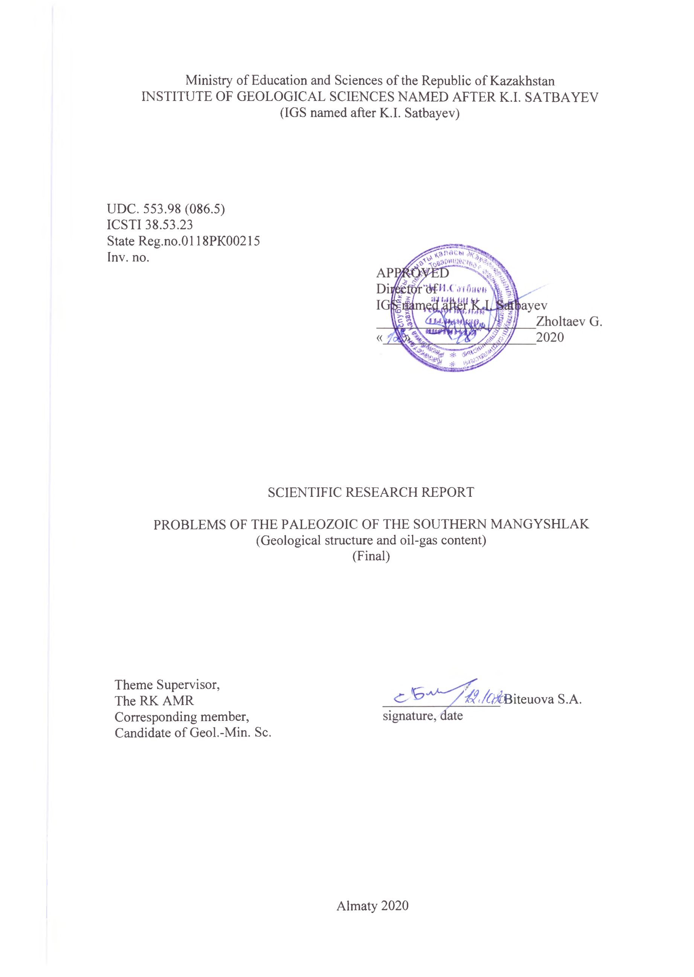
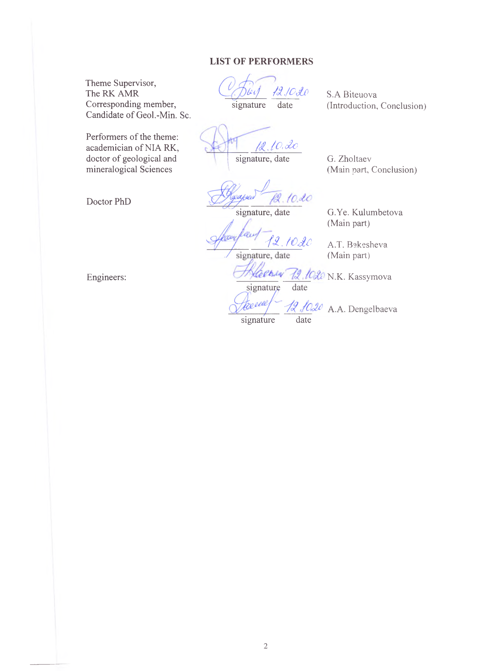
РЕФЕРАТ

Есеп 58 б.,1 кіт., 7 сур., 23 дереккөзд., 2 қосымш.
БАССЕЙН, ТЕРЕҢДІК ЖАРЫЛЫМДАР, МҰНАЙГАЗДЫЛЫҒЫ, ГОРИЗОНТ, ШОҒЫР, РИФ, ӘКТАС, ШАҒЫЛЫСТЫРУШЫ ГОРИЗОНТТАР, ГЕОДИНАМИКАЛЫҚ МОДЕЛЬ, ТАҚТАЛАР ТЕКТОНИКАСЫ
Зерттеу нысаны Маңғышлақтың палеозой шөгінділері болып табылады.
АР05133006 "Оңтүстік Маңғышлақтың палеозой мәселелері (геологиялық құрылысы және мұнай-газдылығы)" гранттық жобасының мақсаты Маңғышлақ бассейнінің палеозой шөгінділері құрылымының геологиялық ерекшеліктерін ескере отырып, көмірсутегі шикізатын және іздеу тиімділігін арттыру болып табылады.
Зерттеу әдістері: геохимиялық деректер мен жаңа сейсмика материалдарының нәтижелері бойынша палеозойда мұнай-газ түзілу мүмкіндіктерін негіздеу, қазіргі координаттарда мұнай-газ түзілу ошақтарының болжамды даму алаңдарын, мұнай-газ жинақталуының ықтимал аймақтарын айқындау.
Алынған нәтижелер және жаңалық: Маңғышлақ бассейнінің геодинамикалық эволюциясын қайта жаңарту жүргізілді, құрылыстың геодинамикалық моделі жасалды және бассейннің палеозой шөгінділерінің мұнай-газдылығы болжамдалды, сондай-ақ палеозой шөгінділерінің литологиялық-стратиграфиялық және геохимиялық сипаттамалары жасалды
Жобаның мақсатына жету үшін Маңғышлақ бассейнінің геодинамикалық эволюциясын қайта жаңарту жүргізілді, оның құрылысының геодинамикалық моделі жасалды және бассейннің палеозой шөгінділерінің мұнай-газдылығы болжамдалды, сондай-ақ палеозой шөгінділерінің литологиялық-стратиграфиялық және геохимиялық сипаттамалары жасалды, Жетібай-Өзен тектоникалық сатысы мен Оңтүстік Маңғышлақ ойысымен Песчаномысско-Ракушечный көтерілімі түйіскен аймақтар құрылысының геодинамикалық модельдері жасалды және палеозой шөгінділерінің мұнай-газдылығы болжамы жүргізілді және оның нәтижелері бойынша Өзенде бірінші кезектегі перспективасы жоғары объектінің паспорты жасалды, онда тереңдігі 6000 м ұңғыманы бұрғылау ұсынылды, оны "Өзенмұнайгаз"АҚ мақұлдады.

SUMMARY

The report 58 p., 1 book, 7 illustrations, 23 sources, 2 annex.
BASIN, DEEP FAULTS, OIL AND GAS CONTENT, HORIZON, DEPOSIT, REEF, LIMESTONE, REFLECTIVE HORIZON, GEODYNAMIC MODEL, PLATE TECTONICS

The object of research is the paleozoic deposits of Mangyshlak.

The purpose of the grant project АР05133006 "Problems of the paleozoic of Southern Mangyshlak (geological structure and oil and gas content)" is to increase the efficiency of prospecting and hydrocarbon raw materials, taking into account the geological features of the structure of the paleozoic deposits of The Mangyshlak basin.
Research methods: the results of geochemical data and new seismic justified by the possibility of oil and gas generation in the Paleozoic, identified in modern coordinates development area alleged hotbeds of oil and gas formation, possible oil and gas accumulation zones.
Results and novelty: the geodynamic evolution of the Mangyshlak basin was reconstructed, a geodynamic model of the structure was compiled and the oil and gas content of the Paleozoic deposits of the basin was predicted, and the lithological-stratigraphic and geochemical characteristics of the Paleozoic deposits were compiled.
To achieve the project goal, the geodynamic evolution of the Mangyshlak basin was reconstructed, a geodynamic model of the structure and oil and gas potential of the Paleozoic deposits of the basin were compiled, and the lithological-stratigraphic and geochemical characteristics of the Paleozoic deposits were compiled, geodynamic models of the structure of the zones of articulation of the jetibay-Uzen tectonic level and Peschanaya and Shell raise with the South Mangyshlak trough and produced a forecast of Paleozoic oil and gas deposits and its results made Passport priority highly promising object on Uzen, where the recommended drilling depth of 6,000 m, which is approved by JSC "Ozenmunaigas".

CONTENT
INTRODUCTION……………………………………………………………………….... | 6
MAIN PART OF THE RESEARCH REPORT…………………………………………... | 7
- The problem of The Mangyshlak paleozoic deposits………..………………………… | 7
- Lithologic-stratigraphic and geochemical features of the paleozoic deposits…………... | 10
3. The Mangyshlak structure geodynamic model................................................................ | 18
3.1 Brief review of the idea on Mangyshlak tectonic nature...………………………….. | 18
3.2 New data on Mangyshlak Paleozoic deposit structure …............................................ | 24
3.3 The Mangyshlak structure geodynamic model ………..…...……………………….. | 25
3.4 Geodynamic evolution of the region………………………..…...…………………... | 30
4. Oil-gas content prospect prediction …………….……………………………………… | 33
4.1 Brief information on oil-gas content of Paleozoic deposits …………………………. | 33
4.2 Prediction of oil-gas content………………………...…………………...................... | 34
4.3 Recommendations for prospecting-exploration works ……….…………….…………. | 35
CONCLUSION………………………………………………………………………..…... | 37
LIST OF REFERENCES………..…...……………………………………………………. | 38
ANNEX А – Passport of the Uzen-Pz structure, prepared by the 3D-MOGT Paleozoic  complex seismic survey for prospecting-exploration drilling in the west part  area adjacent to the Uzen and Karamandybas deposits……………………… | 41
ANNEX B – List of published works during the project period.......................................... | 53

INTRODUCTION
Within the framework of the project no.АР0513306 titled “Problems of the South Mangyshlak Paleozoic structure (geological structure and oil-gas content)" the following have been done: the Mangyshlak geodynamic structure model has been drawn; the Mangyshlak geodynamic evolution since the late Paleozoic has been reconstructed; geodynamic models of the structure of the Zhetybai-Uzen tectonic stage and the Peschanomys-Rakushechny uplift with Zhazgurly trough have been compiled; the forecast of oil and gas bearing capacity of Paleozoic deposits has been made, its results utilized in making the passport of the priority high-prospects object at Uzen; the drilling of a 6,000 m deep well has been recommended and approved by the JSC “UzenMunaiGaz”.
The survey results have been reported in compliance with the Project plan in the following articles:
Zholtaev G.Zh., Iskaziev K.O., Abayildanov B.K. “Paleozoic deposits - potential reserve replenishment and expansion of oil and gas industry raw material base at Mangyshlak”. Izvestia NAS RK. Geology and Technical Sciences Series, No. 5, 2018.
Zholtaev G., Iskaziev K.O., Biteuova S.A. “Regional structure of Mangyshlak Paleozoic deposits”. Geology, geography and global energy, No. 1, Novocherkassk, 2019.
Г. Zholtaev, A.J. Akhmetzhanov, R.B. Abuyev, G.A. Akhmetzhanova, B.B. Oraz. “Terrigenous-Carbonate Reservoirs in the Southeast of the Caspian Depression”. NTZh Oil and Gas Geology No. 4, Moscow 2019.
G. Zholtayev, S. Biteuova, G. Yermekbaeva. “Paleozoic sediments as promising direction for hydrocarbon exploration in the south of the Turanian Platform”. The XX International Multidisciplinary Scientific GeoConference Surveying, Geology and Mining, Ecology and Management – SGEM 2020.
E. Mussina, G.Zh Zholtaev, E. M. Fazylov. “Perspective directions of searching of deposits of hydrocarbon raw materials in the Syrdarya sedimentary basin with the account of the latest data”. The XX International Multidisciplinary Scientific GeoConference Surveying, Geology and Mining, Ecology and Management – SGEM 2020.
G. Ye. Kulumbetova, S. G. Nursultanova and R. M. Mailybayev. Lithological Types and Reservoir Properties of KT-II reservoir on the Eastern edge of Pre-Caspian Basin
// International Journal of Engineering Research and Technology. ISSN 0974-3154, Volume 8, Number 12 (2019pp. 1335-1340, percentile – 13%.
Aigul T. Bakesheva, Vadim G. Fetisov and Vladimir V. Pshenin A Refined Algorithm for Leak Location in Gas Pipelines with Determination of Quantitative Parameters // International Journal of Engineering Research and Technology. ISSN 0974-3154, Volume 12, Number 12 (2019), pp. 2867-2869 © International Research Publication House, http://www.irphouse.com percentile – 13%.
Presentations have been arranged at seminars, international conferences, such as “Geomodel”, “The Bekzhanov Readings” and “P.T.Tazhibayeva and the International Conference of the JSC "IGIIRNIGM" in Tashkent.
As a result of implementation of our recommendations, a new oil and gas bearing Paleozoic floor will be opened at Mangyshlak, which will serve as the start to re-evaluation of for oil and gas content prospects of the Paleozoic deposits throughout the Turan young platform.

MAIN PART OF THE RESEARCH REPORT
- The problem of The Mangyshlak paleozoic deposits

Mangyshlak holds a special position in the formation of Kazakhstan as a world-class oil power, both in terms of hydrocarbon reserves and production volume. In mid-1970s, 15-17 million tonnes of Mangyshlak's annual oil production was followed by the worldwide recognition of Kazakhstan as an oil-producing country.
At present, the relatively stable level of annual production is achieved through the heroic efforts and work of Mangyshlak's oilmen, however an issue auplifts of replenishing reserves in fields under development and discovering new deposits. The potential for new discoveries within the South Mangyshlak oil and gas region may be related to its offshore extension, although there are local structures onshore that have not yet been identified due to poor seismic studies.
A new exploration object is the Upper Paleozoic deposits, the nature of which is described by different views. Some related them to an unpromising foundation, while others see it an intermediate transitional complex from a foundation to a platform cover, admitting their small accumulations of hydrocarbons. Until the early 2000s, the study of Paleozoic deposits lacked attention due to the prevailing geosyncline concept of geological development of the entire region called the Turan Young Platform.
B.A. Titov, A.I. Letavin, D.A. Kukhtinov, E.G. Leonova, M.N. Ivanova, A.G. Schleifer, V.V. Lipatova, B.B. Arbuzov, K.V. Kruchininin, A.A. Rabinovich, and others have made significant contributions to the study of Mangyshlak’s Paleozoic and Triassic deposits.
The majority of researchers were of the opinion that the Paleozoic complex was strongly dislocated in the area of Hercynides, which also included the territory under consideration, according to the concept of fixtures (Tectonic map of Eurasia). In particular, this opinion became practically undisputed because of the view of A.E. Schlesinger, supported by L.A. Yanshin, who referred the pre-Jurassic deposits to a folded foundation. New data on the pre-Jurassic deposits structure obtained by geologists and geophysicists during oil and gas exploration in young platforms of different world regions gave uplift to doubts about the widespread Paleozoic location in areas marked on tectonic maps as young platforms.
First attempts to emphasise the features of the Upper Paleozoic deposits in the region were made by N.A. Krylov, Letavin A.I., who identified an intermediate, or transitional complex, later called quasi-platform or taffrogenic one, i.e. "born by graben", which largely corresponds to structural position of the Paleozoic in the Central Mangyshlak, but does not fully reflect the nature of the same Paleozoic sediments in the area adjacent to the Middle Caspian and Karabogaz anteclises, elevated during the Paleozoic age and which restricted the rifting zone from the south [1], [2].
The given area includes the southeastern part of the Mangistau paleorifte of the Later Paleozoic - Early Triassic age and the northeastern slope of the Middle Caspian and Karabogaz anteclises buried and tectonically processed in great measure (Marabaev, Zholtaev et al., 2005) [3].
Currently, big attention is paid to studies of the Triassic and Upper Paleizoic, i.e. the pre-Jurassic, section part in South Mangyshlak. During years of 2008-2019, fundamentally new information was obtained thanks to 3D MOGT surveys conducted at the Uzen-Karamandybas, Zhetybai, Kurganbai, Alatobe, Aksaz, North Karagiye sites by “Mangyshlakmunaigas”, “Triasmunaigas”, “Emir-Oil”, “PGS” and others.
Early this century, the need to revise existing geophysical and geological materials on the Paleizoic part of the section and assess their possible oil and gas bearing capacity was put forward to “Kazmunaigas” by its then Chief Geologist, Dr. K.O. Iskaziev. For the purpose of complex interpretation of geological and geophysical materials for the Paleizoic part of the Uzen-Karamandybas field section, a consortium of three seismic, gravimetric and aeromagnetic companies was set up under scientific supervision of Prof. G.Zh. Zholtaev. The study proved the mappability of the Paleozoic section by seismic methods. Three thicknesses of weakly dislocated sedimentary deposits were identified, the average of which by the nature of wave field was taken as the analogue to a carbonate-terrigenous grey-colour thickness of the Upper Paleozoic Berkut suite at the Karatau rampart of the Central Mangyshlak dislocation system. A geodynamic structure model of the pre-Jurassic complex was drawn up and a recommendation was issued to drill a 6,000m deep well at Uzen and the need for targeted study of the Paleizoic part of the entire Mangyshlak section was justified. It was proposed to arrange a national programme titled "the Mangyshlak’s Paleozoics".
Our statement was based on the following. Firstly, the existing idea of the foundation’s Hercynian age, when Paleozoic sediments were supposed to be locating everywhere, has not been confirmed by new drilling and seismic data. Secondly, analysing the past and new geological and geophysical data on both Mangyshlak and the south of the Turan platform, we arrived to the conclusion that the region’s crust was formed as a result of the split and subsequent linkage of individual rigid blocks of the ancient continent or its part, not of the geosyncline process. Ancient rigid blocks account for 75% of the Turan platform area. This interpretation allows for existence of undislocated or weakly dislocated Upper Paleozoic deposits within deeply submerged blocks such as the Middle Caspian, in the east of which there is the South-Mangyshlak system of troughs, the Zhetybai-Uzen and Kokumbai tectonic levels. This assumption is supported by the latest seismic information from the Zhazgurly trough, whose Paleizoic part of the section below the V3 reference reflective horizon, timed to the roof of the Indus tier Dolnapa suite, contains clearly visible and traceable three other reflective parallel horizons, indicating the presence of undislocated Upper Paleozoic sediments. Naturally, these 2,500-3,000 m thick Paleozoic sediments represent a new stand-alone prospect for oil and gas exploration at Mangyshlak. We hope this newly discovered structural floor will open up new perspectives for the oil industry at Mangyshlak.
Looking back at the acquisition history of Mangyshlak's oil wealth, in the 1970s, the Triassic deposits were not considered as promising for oil and gas exploration and as such were lacking attention, although individual wells had oil and gas shows. The industrial flow of gas with the Middle Triassic condensate, obtained in 1972 at the South Zhetybai site, from the well 4 at 3,568-3,605 m interval, marked the beginning of systematic and targeted study of Triassic deposits [3]. At present, Triassic deposits are one of the regional oil and gas bearing complexes in South Mangyshlak, with dozens of large and medium sized oil and gas fields discovered there, such as Tenge, Tasbulat, North Rakushechny, Kariman, Dolinny, Akkar, Asar, North Karagiye and others. The targeted prospecting of Triassic sediments is now being carried out by subsoil users [4].
Concerning the Paleozoic deposits, after the Oimasha oil field discovery in the 1980s, wells were drilled on the small amplitude structures of Tashkum, Aschisor, Peschanomys, Zhaga, Zhylandy and North Rakushechny identified by reflecting horizons in the Triassic, with opening of Paleozoic deposits. Most of the wells were aimed at penetrating the weathered cracked granites, similar to that of Oimasha. However, no granite was encountered in none of the areas, although located in the same Oimasha structural zone, on the eastern slope of the Peschanomys-Rakushechny uplift, with numerous developed faults, some of which could channel effusive manifestations in the Triassic. In short, the story of the Triassic oil-gas-bearing complex did not repeat itself, leading to exclusion of Paleozoic deposits from the potentially promising ones and the related Geological Tasks for 2D/3D seismic surveys. Its expected results included compilation of structural maps for the lower reflective horizons V₃ and/or V₂ IV, timed to the Indus tier red-colour roof and the Olenek tier carbonates, respectively. Naturally, with this technical specification, companies processed the obtained seismic material inclusive of these reference target horizons, usually within 2.5-3.0 seconds, while the rest of data within 3.0-6.0 seconds remained unclaimed. The reason was the view that below the V3 horizon there is a foundation consisting of highly dislocated and metamorphosed Paleozoic deposits of no interest to oil and gas exploration. New seismic and deep drilling data on Paleozoic deposits revealed the mistake of the Fixism in relation to the Hercynian age foundation for both South Mangyshlak and the entire Turan platform. New information on the structure of the Paleizoic part of the section at South Mangyshlak indicates that it is weakly dislocated in the Zhetybai-Uzen, Kokumbai and Shakpakty tectonic levels and is not dislocated within the South Mangyshlak and Asseke-audan trough zones, which followed by the need to study Paleozoic deposits as potentially promising complex.

- Lithologic-stratigraphic and geochemical features of the paleozoic deposits

A detailed and most acceptable working stratigraphic diagram of ancient Mangyshlak deposits was proposed by V.V.Mokrinsky (1949), which is still recognized upon some correction. The Mangyshlak’s Karatau complex is dissected from bottom to top by the Berkut (P1), Otpan (P2), Dolnapa (P2) and Tartaly (T1) suites.
The most complete sections of Paleozoic deposits are exposed in the Otpan and Arpaly anticlines of West Karatau. They are mainly marine terrigenous and carbonate-terrigenous sediments with admixture of tuffogenic material.
The Berkut suite was identified in 1937 by V.S. Domarev. It is the lowest part of the exposed Paleozoic stratigraphic section of Mangyshlak formations, well studied in the Bes-schoku mountains of West Karatau. The Berkut suite forms the nuclei of the Otpan and Bes-shoku anticlines and is represented by the interlacing of dense and strong, with cancerous fractures, clay siltstones, argillites, sandy limestone and marl, only rarely changed with interlayers of fine sandstone. The suite has grayish-violet, sometimes bright green colour. They consist mainly of fine-grained carbonate mass. The polymict material does not exceed 5-10% of the rock. Colloidal and sandy-silty limestones have no traces of recrystallisation or metamorphism. Exposed areas of the suite are up to 400 m, further above there is gradual lithological transition to the Otpan suite deposits.
The Otpan suite was first identified in 1927 by M.V. Bayarunas in the area of the Otpan mountain in West Karatau, where these deposits are exposed on archs of the Otpan and Arpaly anticlines. In East Karatau, the Otpan suite forms the arch of the Bes-shoku anticline, and in Karatauchik, the eastern slope of the mount Biliktau and the mount Danyshpan. The suite is represented by dense massive sandstones, often banded, with well sorted grains of various sizes. The rock colour ranges from greenish-grey or brown to purple-red. Layers of siltstones and cross-stratified sandstone with wave-like signs are occasionally observed. In West Karatau, at the suite’s base there are gray and brownish-grey massive sandstones 580m thick, above which observed are layered sandstones of greenish-grey and violet-red colour 160m thick. The section is completed by gray fine and coarse sandstones 520m thick. Rare siltstone interlayers of the Otpan suite in petrographic terms differs from aleurolites of the Berkut suite. There are slightly more grains of quartz and feldspar. Sandstones of the Otpan suite are predominantly fine-grained, polymict, with predominance of grains of quartz, acid plagioclase and potassium feldspar. The fine-grained mass of sandstones is represented by fragments of acidic effusions.
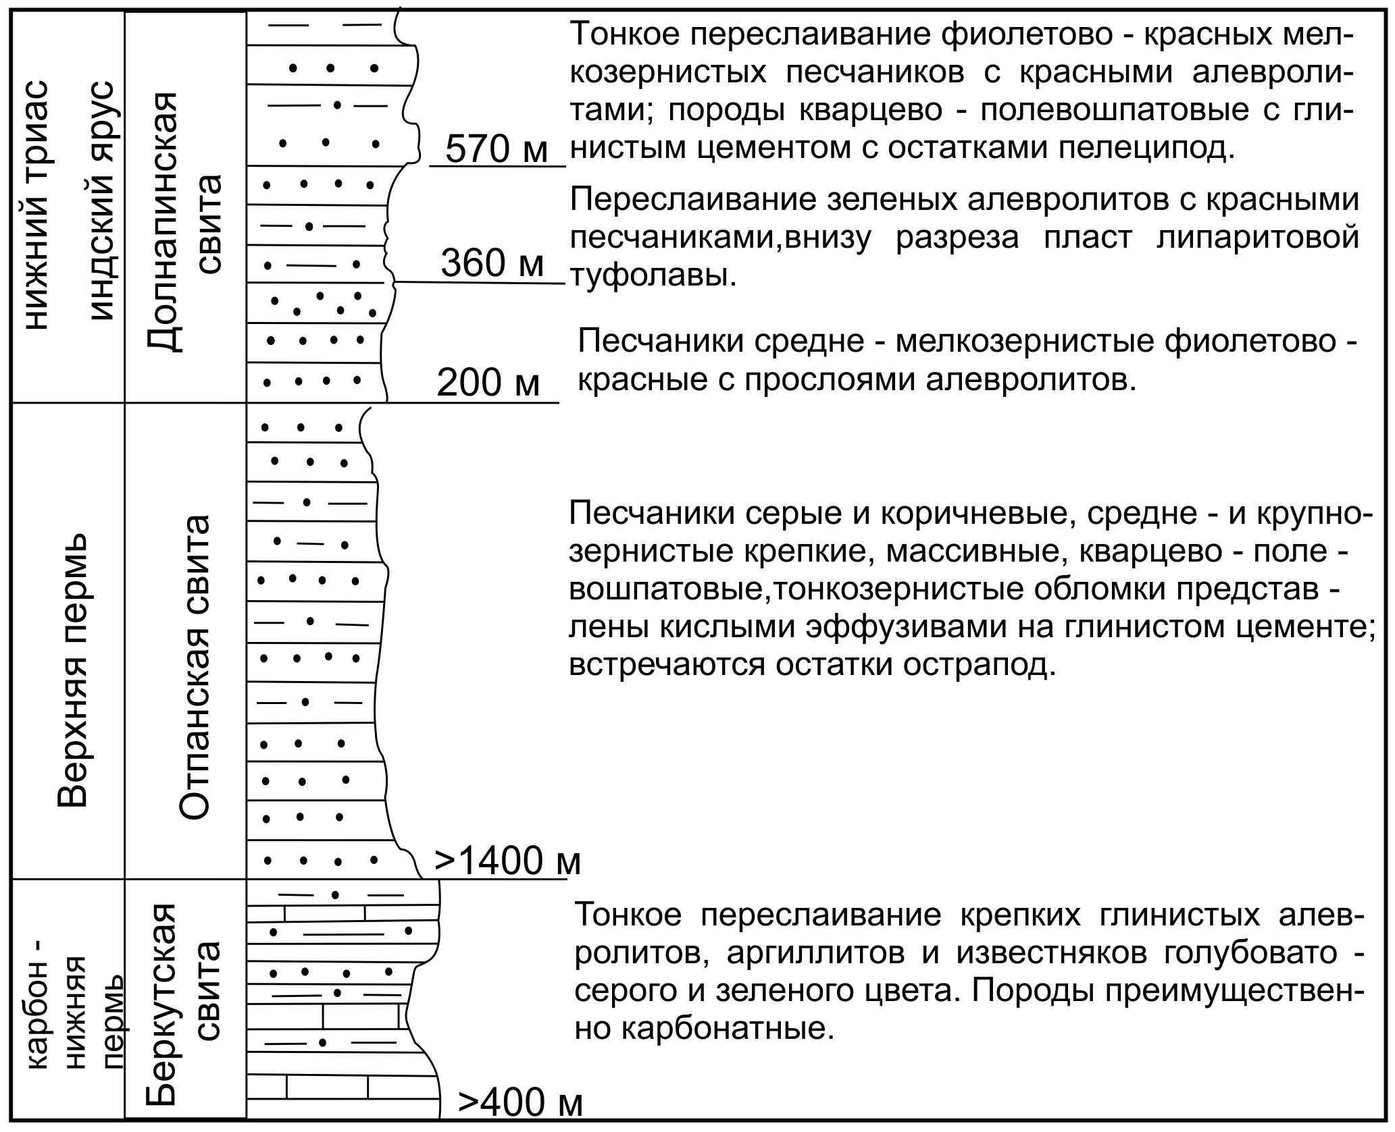
Figure 2.1 – The section of Upper Paleozoic and Triassic deposits in Central Mangyshlak (sources: A.I. Letavin, A.E. Schlesinger, M.M. Mokrinsky, V.S. Domarev, Bayarunas and P.P. Vinyukov)

Clayey cement compuplifts in average 20% of the rock. The Otpan suite of conditionally Late Permian age has been studied in a significant area of West and East Karatau. Its visible thickness reaches 1,400 m; opened (B.I. Titov, 1978) on the South Zhetybai, it is composed of grey sandstones and strong dense siltstones, weakly carbonate, clayey with interlayers of dark-grey argillites and inclusions of charred vegetation remains. Layers of brownish and motley tones are observed on top of the section (figure 2.1) [5], [6].
According to preliminary results of paleontological, palynological and lithological studies, the analogues of the Otpan and Berkut suites were observed in the 392-m thickness, opened on the Aksaz site in South Mangyshlak.
A.P. Pronin and co-authors have studied in sufficient detail the same-aged Medium-Upper Carboniferous and Lower Permian deposits in sections of the parametric wells North Bozashy, North Karazhanbas, East-Karaturun and Arman at Bozashy. They are represented by dark-gray and black argillites, sandstones with charred plant organics and limestones with detritus of foraminifera, brachiopod and fusulinid shells [7].
Paleozoic sediments have been studied within South Mangyshlak by well penetration mainly on the eastern slope of the Peschanomys-Rakushechny uplift and on the northwestern slope of the Karabogaz uplift. Paleozoic rocks were drilled by single wells at the Zhetybai-Uzen levels and the Segindik trough.
To date, the Paleozoic sediments contain the Oimasha oil field, with oil found in cracked granites and primary-terrigenous rocks of Paleozoic age, which undergone intensive transformation through contact metamorphism with intrusion. Moving away from the intrusion, thermal effects weaken, and the rocks acquire their original sedimentary form. This deposit is located in the deep regional fault zone which channeled the granite intrusion 250-340 million years ago. A detailed study of core samples revealed that the granites are leucocratic, dissected by vein bodies, diabase non-metamorphosed porphyryite dykes, as well as reservoir bodies of acidic composition, tearing granites. These observations allow suggesting that faults, which channelled the granite intrusion in the Late Paleozoic, served as feeding channels for effusions in the Triassic period as well, since the Triassic section contains tuffolavae, acidic tuff breccias and pyroclastic rocks.
According to A.A.Rabinovich (2008), the Paleozoic deposits were penetrated in the sites of Aschisor, Tashkum, Peschanomys, Zhaga, Zhantanat, Zhilandy in the 1980s. Though the sections of the wells have not been studied in detail either for rock age nor for their petrographic composition. Their age was assessed by visual inspection of the geologists. All these structures are located on the eastern slope of the Peschanomys-Rakushechny uplift, complicated by numerous (as per seismic survey) tectonic disturbances and their intrusions, i.e. in the same tectonic zone as the Oimasha field. Most of the wells were drilled for the purpose of finding deposits in weathered cracked granites like at Oimasha, but none of the wells encountered granites.
Therefore, in the Oimasha, Zhilandi and other sites located in the fracture zone, it is not correct to consider, basing on the results of a core study from the contact zone, the entire Paleozoic part of the section as metamorphosed and attribute it to the foundation. On the contrary, new seismic data and new rare cores taken from deep wells witness the presence of undislocated or weakly dislocated sedimentary deposits of Upper Paleozoic age.
In wells 25-P Zhetybai and 4-P South Zhetybai, Paleozoic deposits are represented by grey, -rey and black sandstone, siltstones and argillites. The 25-P borehole section was divided in two parts: the lower one, from 3,950 to 4,501 m, is predominantly sandy, and the upper part from 3,720 m to 3,950 m, is silty-argillite with increased content of carbonated detritus. These are normal sedimentary formations which undergone post-sedimentary transformation of the Upper Paleozoic age and there are no signs of metamorphism throughout the section.
They show textures of gravity slippage and underwater turbulence, indicating marine conditions of sedimentation. The total thickness of Paleozoic sediments penetrated by the well is 781m.
Paleozoic dark grey argillites, shales and siltstones have been penetrated in the wells at the Northern Karagiye, Aschisor, Atambai, Alatobe and Aksaz sites to an insignificant thickness within the South-Mangyshlak system of troughs, particularly in the Segyndik trough.
The most clarified by the core was the Paleozoic part at the North Karagiye well 1 of the interval from 3901 to 4450 m, providing 24 samples. They are represented by dark grey, grey and light-grey claystone argillites greasy to touch, siltstones with finely dispersed carbonaceous substance with interlayers of light-grey limestone with organic remains in pelecipod and black siltstonish, sometimes carbonaceous shales with pyrite cracked crystals filled with calcium.
Paleozoic deposits have also been studied on the Zhazgurly trough in North Rakushechny site. The well 12 opened the Paleozoic sediment at 140m. According to seismic data, the Paleozoic thickness in this region is over 500 m. The Paleozoic rocks are represented by gray terrigenous formations - sandstones, gravelites with interlayers of conglomerates and siltstones. The granite pebbles within the conglomerates are 320-340 million years old, i.e. they represent the product of denudation of Lower and Medium Carboniferous intrusions [8].
Available primary materials and published core and mud logging data were revised, based on which the Upper Paleozoic sections were compared for the wells Kumsebshen, Duzier, Alamanel, Sarykamysh, Zhamal, Madar, in the Karabogaz-Karakum district for the Irdaly P-1 and Karshi-1 well (figure 2.2) at the Karabogaz uplift.
On the North-Western slope of the Karabogaz uplift, in the Bukbash and Karshi sites (figure 2.2) terrigenous carbonate grey-coloured rocks were studied by many researchers. Weakly metamorphosed terrigenous rocks - sandstones with interlayers of fine pebble conglomerates and aleuro-siltstones of grey, dark-grey, rarely black and greenish 35-40 m thick - were studied in the wells Bukbash and South Alamuryn. Weathered granites are found in the well Bukbash 2 (2943-2960 m) and South Alamuryn 1 (2866-2869 m) of absolute age of 335-364 million years (D3 - C1) above which there are dark-grey shale of absolute age of 278 million years in the well South Alamuryn 2, which indicates the Early Permian age of dark-gray terrigenous sediments that underwent slight metamorphic changes in the fracture zone, where probably intrusive processes occurred, as in Oimasha.
At the eastern extension of the South-Mangyshlak trough zone, sandstone and grey-coloured argillites were found in the reference wells 2 Kumsebshen and Alamenel (2180-2316 m), which can be compared with weakly metamorphosed terrigenous sediments at the Zhetybai-Uzen level (South Zhetybai site) and Peschanomys uplift (North Rakushechny site). The absolute age of rocks from the Kumsebshen well has been estimate as 262 million years old.
These factual materials demonstrate the regional distribution of grey-coloured terrigenous-carbonate thicknesses over a vast area from Karabogaz to Bozashy and throughout the South, Central and East Mangyshlak.
The Paleozoic structural floor differs significantly from the Mesocaenozoic in that it is deeper and relatively more dislocated in seismic sections.
The wave field in the Mesozoic part of the South Mangyshlak section is relatively better studied and is divided into several large seismic stratigraphic complexes separated by reference reflective horizons VI_{1,} V₃, V₁ and III.
The VI₁ reflecting horizon is confined to the sole of the Triassic sediments, more precisely to the washed surface of the Upper Paleozoic.
The reflective horizon V1 is taken as the lower boundary of Triassic sediments, the main criterion for recognition being the erosive nonconforminty of the horizon with the below-recorded unextended reflections from the Paleozoic part of the section at the Zhetybai-Uzen level and at the Peschanomys-Rakushechny uplift. In the central part of the Zhazgurly deflection, this horizon is traced in parallel with other reflecting horizons dynamically expressed in the Paleozoic part of the section.
Within the limits of South Mangyshlak, the seismic boundary of Tf with the refractive wave velocity Vr=5.8-6.3 km/sec is traced everywhere, and it is also confined to the surface of the Baikal foundation (Kurgan-1 well) (Princes et al. 1972, Bush, Kiryukhin, 1975), the northern tracing boundary of this horizon is the Beke-Bashkuduk fault (Dimakov, Tamarov, 1973) [9], [10], (Figure 2.4) .
Between the North-Mangyshlak and the Beke-Bashkuduk faults, which limit the Baikal age large massifs, there is the Mangyshlak rift zone formed under initial stages of tectonic processes forming the Mesothetis Ocean.
In this narrow zone, geophysicists distinguish the Ts boundaries with low values of different velocities V1=4.0÷5.4 km/sec, which differ significantly from velocities of the Baikal foundation. This means that this narrow slot-shaped rift adjacent to a regional fault (lineament), filled with sedimentary Permian-Triassic (Karatau) complex up to 6-8 km thick (Mstislovsky, 1977) and intensively dislocated should be considered as a structure superimposed on the Baikal foundation along the fault, i.e., it should be considered as a secondary complication in the body of a single Baikal massif uniting the North Ustyurt, Bozashy and Karabogaz uplift until the Late Permian, i.e. the beginning of formation of the Central-Mangyshlak rift zone.
To the south of the Beke-Bashkuduk fault within the Zhetybai-Uzen level, a high-speed Tf horizon of Vr=5.6-5.8 km/sec can be traced, the speeds increasing in the South Mangyshlak trough to 5.9 -6.0 km/sec.
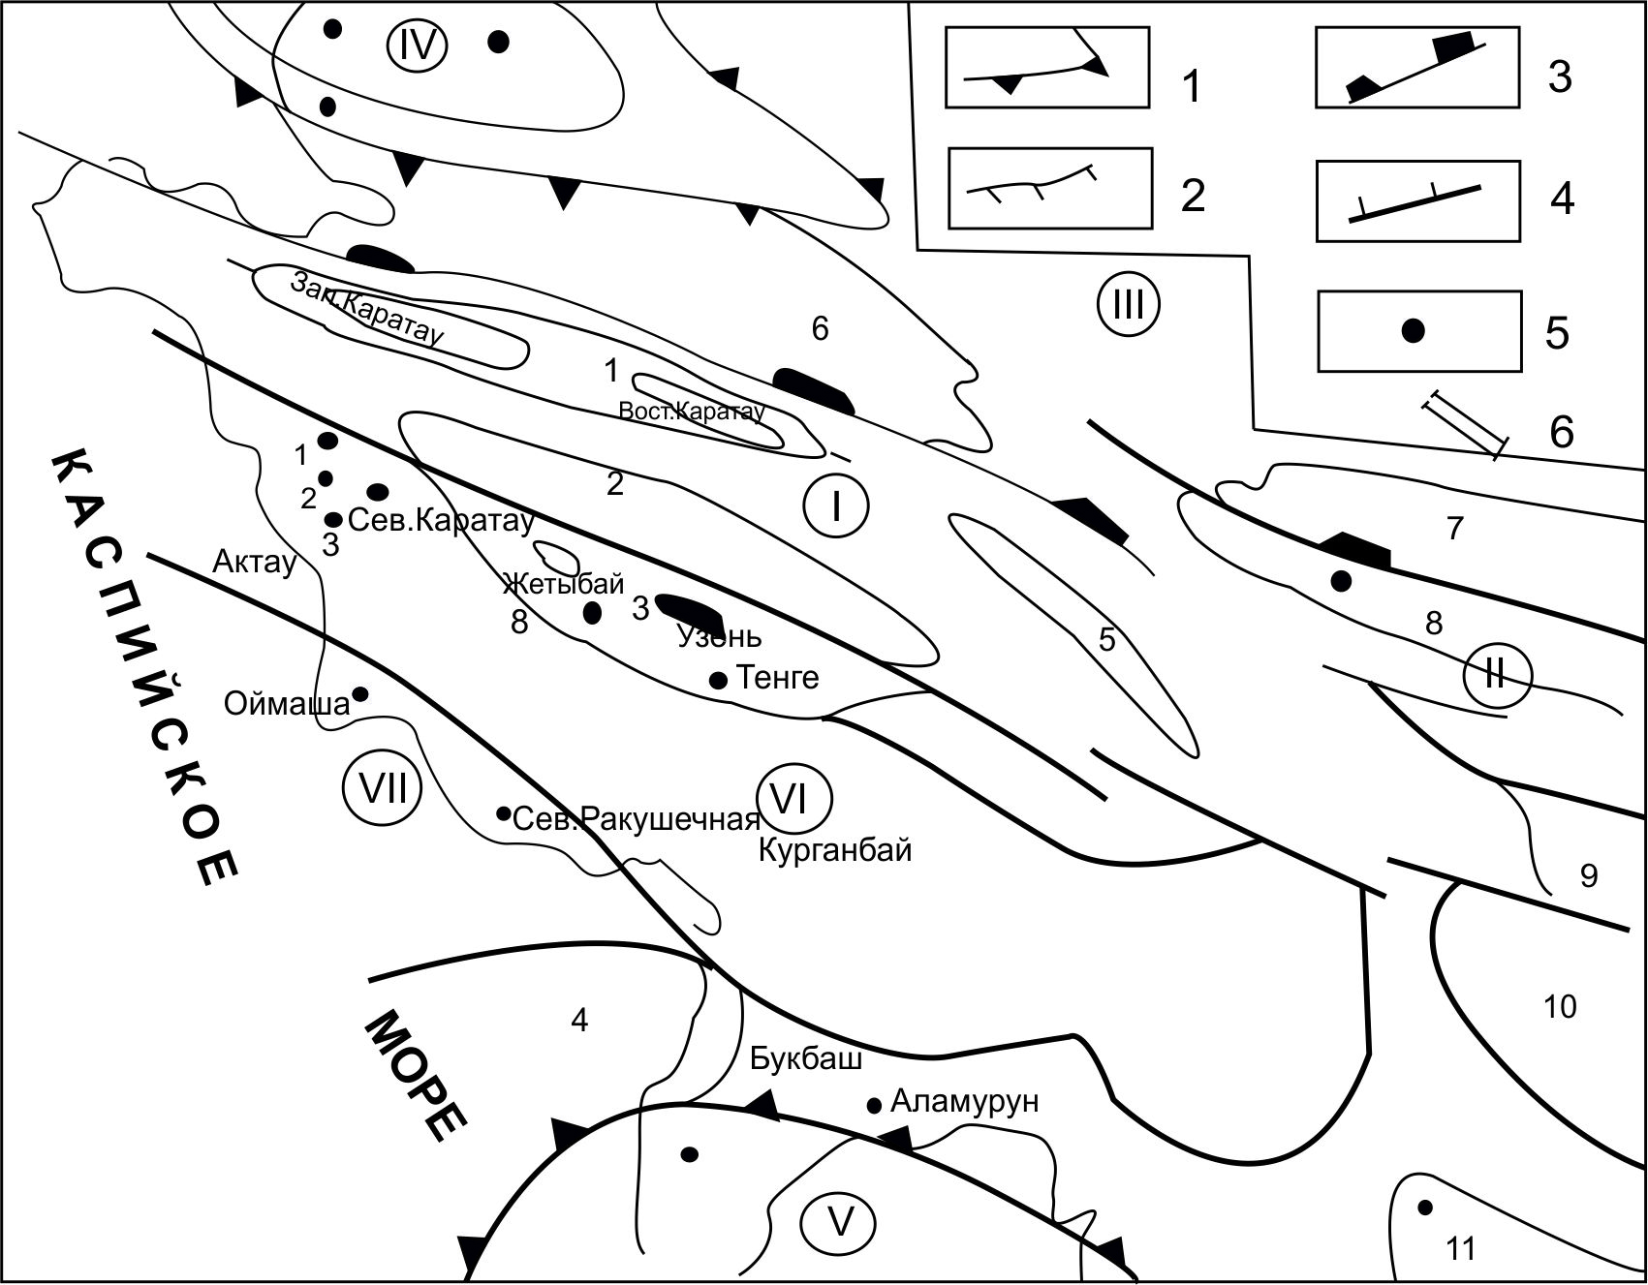
The contours of structures of the first (1) and second (2) order, regional (3) local (4) faults, 5-boreholes where Paleozoic deposits and the time section line have been studied.
Dislocation systems: I - Central-Mangyshlak and II - Central-Ustyurt; troughs: III - North-Ustyurt and IV - Zhazgurly; elevations: V - Karabogaz and VI - North Bozashy and VII - Peschanomys-Rakushechny. 1 - Karatau rampart and 2 - Bekebashkuduk rampart, 3 - Zhetybai-Uzen tectonic level, 4 - bend of the Kazakhstan Gulf, 5 - Tumchagin rampart, 6 - South Bozashy bend, 7 - Baigagyr tectonic level, 8 - Karabakh rampart and 9 - Shakpakty tectonic level and 10 - Assake-audan bend and 11 - Kumsebshi rampart. Small digits are areas where Paleozoic deposits were studied: 1 - Aksaz, 2 - Atambai, 3 - Alatobe, 4 - Zhaga, 5 - Aschisor, 6 - Tashkum, 7 - Zhylandy, and 8 - Pridorozhny
Figure 2.2 – Tectonic chart of Mangyshlak. Location of the examined Paleozoic sections

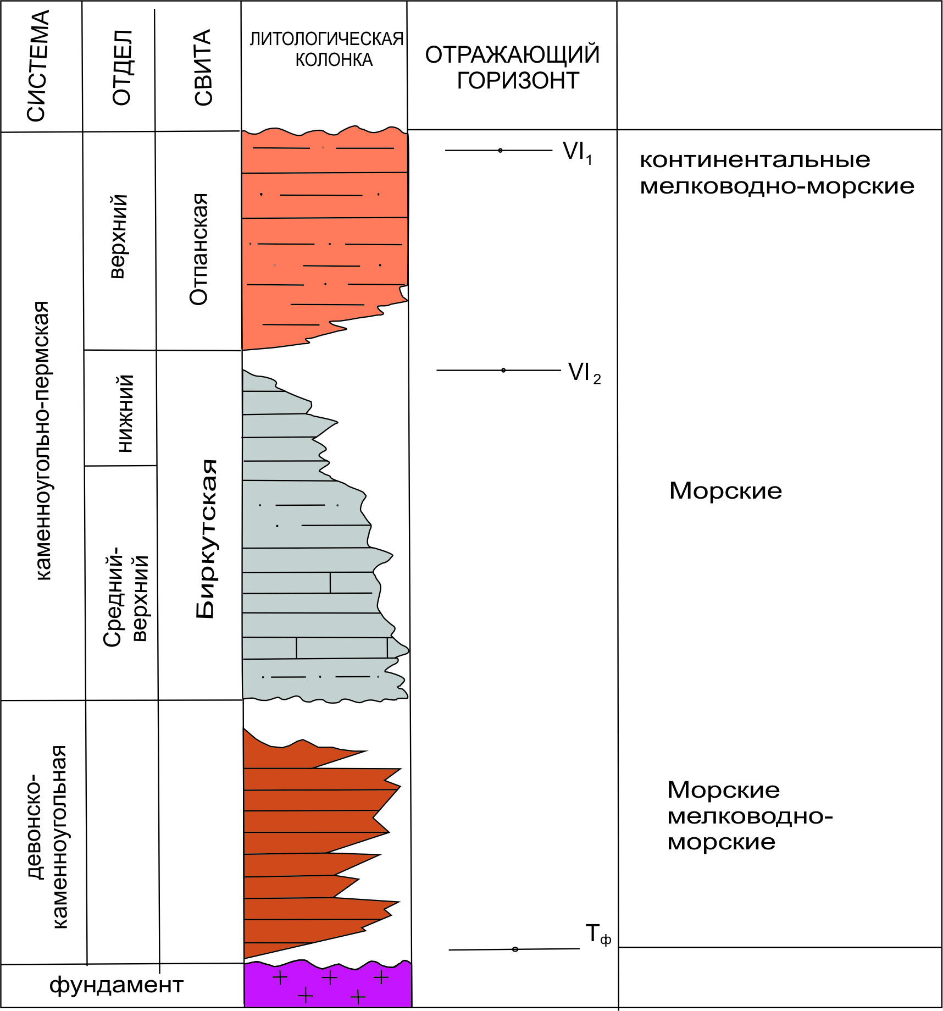
Figure 2.3 – Consolidated seismological section of Mangyshlak’s Paleozoic sediments

Simultaneously with the Tf boundary in the South Mangyshlak Trough, the Ts1 boundary has been registered, conditionally tied to the surface of the Upper Permian sediments. Such a stratigraphic position of this border, as noted by M.M. Mstislovsky and co-authors, has been established in a number of areas of the Turan plate, the Caucasus and in the Karpinsky ridge.
The lower dark-coloured Mangyshlak thickness of the upper Paleozoic is characterized by high organic matter content of 1.3-1.6% with a chloroform bitumen concentration of up to 0.003%. The bulk of bitumen is autochthonous, although the presence of allochthonous bitumen is noticeable.
In terms of geochemical indicators, P.N. Kuprin highly estimates the bituminous-producing properties of the lower dark-coloured thickness of the Upper Paleozoic.
According to the VNIGRI materials, the genetic proximity is recognized of bitumen from pre-Jurassic formations to the Jurassic oils in the fields of Zhetybai, Uzen, Tenge and others. This conclusion is based on the study of the composition of the IR-spectrum, aromatic hydrocarbons, carbonyl paraffins and a number of other features. Data on the content of allochthonic and autochthonic bitumen allow both the possibility of formation of hydrocarbons in the pre-Jurassic sediments themselves and migration along the section. Obviously, traces of vertical migration have been noted, in particular, by V.V. Gribkov and A.V. Lobachev in the Gornyi Mangyshlak Permo-Triassic section.
In 1969, they recorded the presence of significant amounts of oil bitumen in hydrothermal calcite veins permeating the entire Permian and Triassic section of the Belyasen structure. Physical and chemical studies indicate vertical bitumen migration along the Tanashin fault zone and feathering faults. This fact, combined with data on the presence of allochthonic bitumen in the pre-Jurassic sediments, indicates a possible deep vertical migration of hydrocarbons from the Paleozoic sediments to the Triassic and Jurassic rocks.
Of great interest are results of the study of South Mangyshlak oil fields conducted by K.V. Vinogradova, A.M. Medvedeva, L.P. Bagdasaryan, and geological-geochemical studies by a group of scientists from IG and RGI K.R. Chepikov, V.A. Chakhmakhchev and V.I. Kordus.
They found both Jurassic and migratory microfossils from the older Triassic-Paleozoic deposits in oils of the Uzen and Zhetybai Jurassic productive horizons. It has been noted that the content of migratory microfossils grows in the zone of increased fissuring.
A study of microfossils from Triassic oils and reservoirs host rocks in the North Rakushechny and North Karagiye fields showed the presence of both syngenetic Triassic species and migratory Carboniferous forms. The Carboniferous microfossils are present in oils at all stratigraphic Triassic, Jurassic and Cretaceous levels, while only syngenetic microfossil complexes identified are found in reservoir rocks.
To date, little information has been obtained on the geochemical features of Ustyurt's grey-colour Carboniferous deposits. According to V.N. Arnold (1968), the content of organic matter in black argillites of carbon in the adjacent territory of Koikyrlan and Kurganchik varies from 0.41 to 0.66%, reaching 2.93%, with chloroform bitumen concentration up to 0.005%, less often up to 0.01-0.02%.
According to I.N. Shebuyeva, B.P. Borodyaev and others (1972), the average concentration of OM in dark-colour carbonates is 0.63%, the concentration of chloroform bitumen A varies from 0.04 to 0.16%, the most common values being 0.04-0.08%.Three samples of Kurganchik's limestone contain C_{org} of 0.33-0.69%, the A chloroform bitumen of 0.08-0.16%, and five samples of argillites from the wells Shakpakty, Priozerny and Kurganchik showed C_{org} 0.36-1.69%, chloroform bitumen A 0.04-0.08% and alcohol-benzene bitumen 0.5-1.5%.
The analysis of geochemical indicators allows identifying two potentially bituminous thicknesses in the upper Paleozoic and Triassic deposits of Mangyshlak and Ustyurt: grey colours of the Olenek tier of the Lower Triassic and dark colours of the Berkut suite of the Upper Paleozoic (Carboniferous - Lower Permian).

- The Mangyshlak structure geodynamic model

3.1 Brief review of the idea on Mangyshlak tectonic nature
The tectonics of Mangyshlak have been considered to some extent by a large number of researchers. Among the most important works that laid the foundation for modern concepts of Mangyshlak tectonics are the works of A.P. Karpinsky (1887), N.I. Andrusov, M.V. Bayarunas, A.D. Arkhangelsky (1911-1937) and A.L. Yanshin (1945-1951).
A.P.Karpinsky's idea that the Upper Paleozoic mountain structure in Mangyshlak is timed to the folding system stretching from Donbas to TienShan was developed in the works of V.E.Khain (25), A.A.Bakirov and others [11].
The idea of A.L. Yanshin that Mangyshlak represents a Permian-Triassic dislocation system in the body of Hercynian fold area and fades away in western and middle Caspian direction, as well as in the eastern one was reflected in works by М.V.Мuratov, М.F.Мirchink, R.G.Garetsky and oth. [1].
The latter view still has many supporters who consider the Paleozoic deposits to be dislocated because Mangyshlak is located in the Hercynian folding area and recognise the development of the Mesozoic (A.D. Arkhangelsky, 1937) or Cimmerian (A.E. Schlesinger, 1965) folding within the Central Mangyshlak in the body of Hercynides [12].
Observation by one of the connoisseurs of Mangyshlak geology in the region, B.F.Dyakov (1963) [6], "that the folding of Permian-Triassic rocks (Mangyshlak - G.Zh.) is formed under conditions of a narrow rigid sublatitudinal frame under the influence of tangential movements obliquely directed towards the frame [13]. It seems to us that this rigid frame was a ditch-shaped deep sublatitude deflection, laid at the junction of two apparently sharply differing Pre-Permian folding systems extending here from north to south", is the most recognized by geologists and to a greater extent confirmed by new geological and geophysical materials and is close to the position of supporters of the lithospheric plate tectonics theory (V.E. Khain, A.P. Zonenshain, G.Zh. Zholtaev and others) [14].
According to the latter, the Central Mangyshlak mountain system, including the Beke-Bashkuduk rampart, was formed as a result of the inversion of the late Paleozoic - Early Triassic rift, which developed on board the Bozashy Paleorift, which underwent an inversion at the end of the Carboniferous and Early Permian of the Middle Caspian, Peschanomys-Rakushechny and Karabogaz uplifts (Figure 3.1 and 3.2).
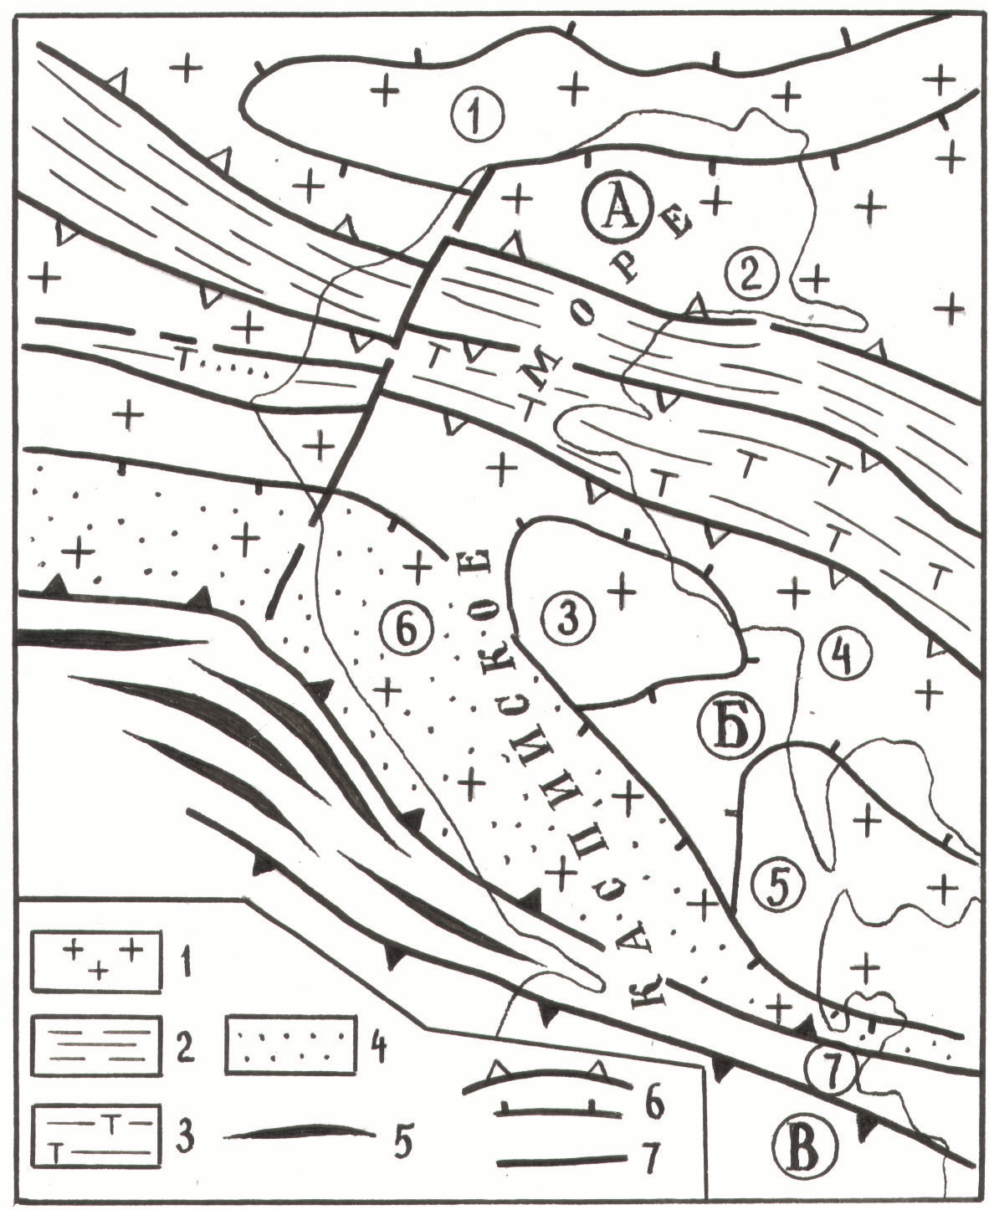
Figure 3.1 – Tectonic position of the Mangyshlak dislocation system (by G.J. Zholtaev 2000)

E.E. Fotiadi (1958), N.A. Kalinin (1963) and earlier A.D. Arkhangelsky considered North Ustyurt as part of the East-European platform with an ancient foundation; later geophysicists observing the Tf border in North Ustyurt with a similar characteristics of the foundation surface in the Caspian syneclise (V1=6.4-6.7 km/sec) confirmed the reality of this idea.
Figure 3.2 – Paleogeodynamic development of the region (as per G.Zh.Zholtaev, 1998)
Now the question is why the Southern Mangyshlak and the Karabogaz massif with similar characteristics and the same Baikal foundation age cannot be attributed to the ancient East European platform. After all, the Central Mangyshlak fold zone, representing a narrow rift zone, which underwent an inversion at the end of the Triassic, cannot be considered as a tectonic element of the same order with the huge massifs of the North Ustyurt and Karabogaz.
In the vast area bounded from the south by the Mesocaenozoic folding system of the Caucasus and Kopetdag, in the northeast by the Ural-Tienshan folding system and in the north-west by the East-European platform (Pre-Caspian syneclise, Voronezh and Ukrainian arches) stand out numerous median massifs of Baikal age: North Ustyurt, Karabogaz, Karakum, Middle Caspian, Kumsebshi and others. In plan, they appear to be wreckage of the southeast end of the ancient Pre-Cambrian East European-Turan continent (10). These fragments, called median massifs, are separated by narrow, divergent zones of different ages, bounded by faults, which H.M. Abdullaev and O.M. Borisov (1963) called narrow zones of plastic deformation, while others called them graben-synclines that underwent inversion; previously these narrow zones of dislocation were called geosynclines. For example, A.E. Schlesinger [22] referred to the Central Mangyshlak dislocation zone as a Cimmeridge age geosyncline.
Due to the fact that the narrow intermassive zones contain dislocated Devonian and Carboniferous rocks in the South Emba zone, the Upper Paleozoic, mainly Carboniferous, and the Lower Permian in Bozashy and the Permian-Lower Permian in the Mangyshlak mountains, many researchers attribute the entire territory to the Hercynian fold zones, i.e. the Ural-Mongolian Hercynian belt. This is not correct, even from a fixation position. What we are observing, taking into account the latest geophysical materials, is the result of the influence of the tectonic processes that took place in the Ural-Tienshan and PaleoTethys Paleoceanic regions on the sharp south-eastern corner of the East European continent. In Devon and Carboniferous, they formed the South-Emba, Dnieper-Donetsk (with an eastern extension on the Donbas and in the Karpinsky embankment) avlacogens. In the Late Paleozoic MesoThetis period, the Scythian-Turan regional lineament zone was formed, which was accompanied by numerous rifts that are now mapped as inverted avlacogens with Permian Triassic rocks as in the Central-Mangyshlak system. Permian-Triassic sediments are intensively dislocated in narrow fault zones. All researchers note the weak dislocation of Permian Triassic rocks on the archs and slopes of the ancient median massifs and in wide areas bent between them. As a result of the effect of stretching, the initial stage of Mesothetis formation resulted in the formation of the Central Rift Zone, which overlapped the upper Paleozoic (upper Carboniferous Lower Perm) sedimentary basin, extending over a vast area from Karabogaz - the Karakum Rise Zone in the south and covering the south of North Ustyurt and the Bozashy Arch. Upper Carboniferous and lower Permian deposits within the rift zone are now represented as the Berkut suite, which has been studied in the Central and Eastern Mangyshlak outcrops (Figure 11). The Otpan and Dolnapa suites probably correspond to the beginning of Mangyshlak rift formation in Late Permian. The most intensive rift formation and its filling with terrigenous red-coloured rocks occurred in the Indus Triassic Age.
With the formation of the Central-Mangyshlak-South Ustyurt rift zone along the section of the Sarmat-Turan Lineament, the once single North Ustyurt Karabogaz block mass split into two: the North Ustyurt and Mangyshlak-Karabogaz.
For the first time, the Karabogazi massif was singled out by Y.N. Godin in terms of the vast maximum in the gravity field. The field of magnetic tension ∆Т_{а} on the array has a mosaic shape and a highly differentiated alternating appearance. According to the nature of the field ∆Т_{а}, the Karabogas massif continues in the Middle Caspian and, in all likelihood, the north-western end of the massif is located within the Eastern Caucasus, at the base of the Tersk-Caspian trough. The northern end of the massif is conditioned by the Mangyshlak system of dislocations. The Karabogaz massif within the boundaries corresponds to the two previously distinguished massifs, the Karabogaz and Central Caspian massifs.
V.S.Knyazev established the pre-Cambrian age of foundation of the Karabogaz massif.
Summing up the results of a brief review of the tectonic position of Mangyshlak, we note that the supporters' view of attributing this territory to Hercynides, as part of the Ural-Mongolian Hercynide belt, from the position of geosyncline concept contradicts new actual geological and geophysical data and it cannot be taken as a theoretical basis for assessing the prospects of oil and gas bearing deposits not only of Mangyshlak, but also of the entire vast territory of the Turan platform.
The main role in the Mangyshlak structural plan, namely, the formation of large structural elements such as the Central Mangyshlak system of dislocation, the South-Mangyshlak system of troughs and the Peschanomys-Rakushechny-Karabogaz uplift zone and their subsequent geodynamic developments, is closely linked to manifestations of geodynamic processes from the plate tectonics position, namely the Paleo and Mesothetis processes.

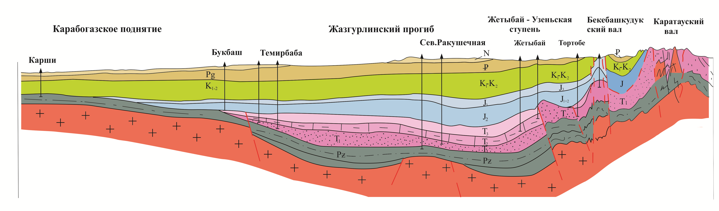
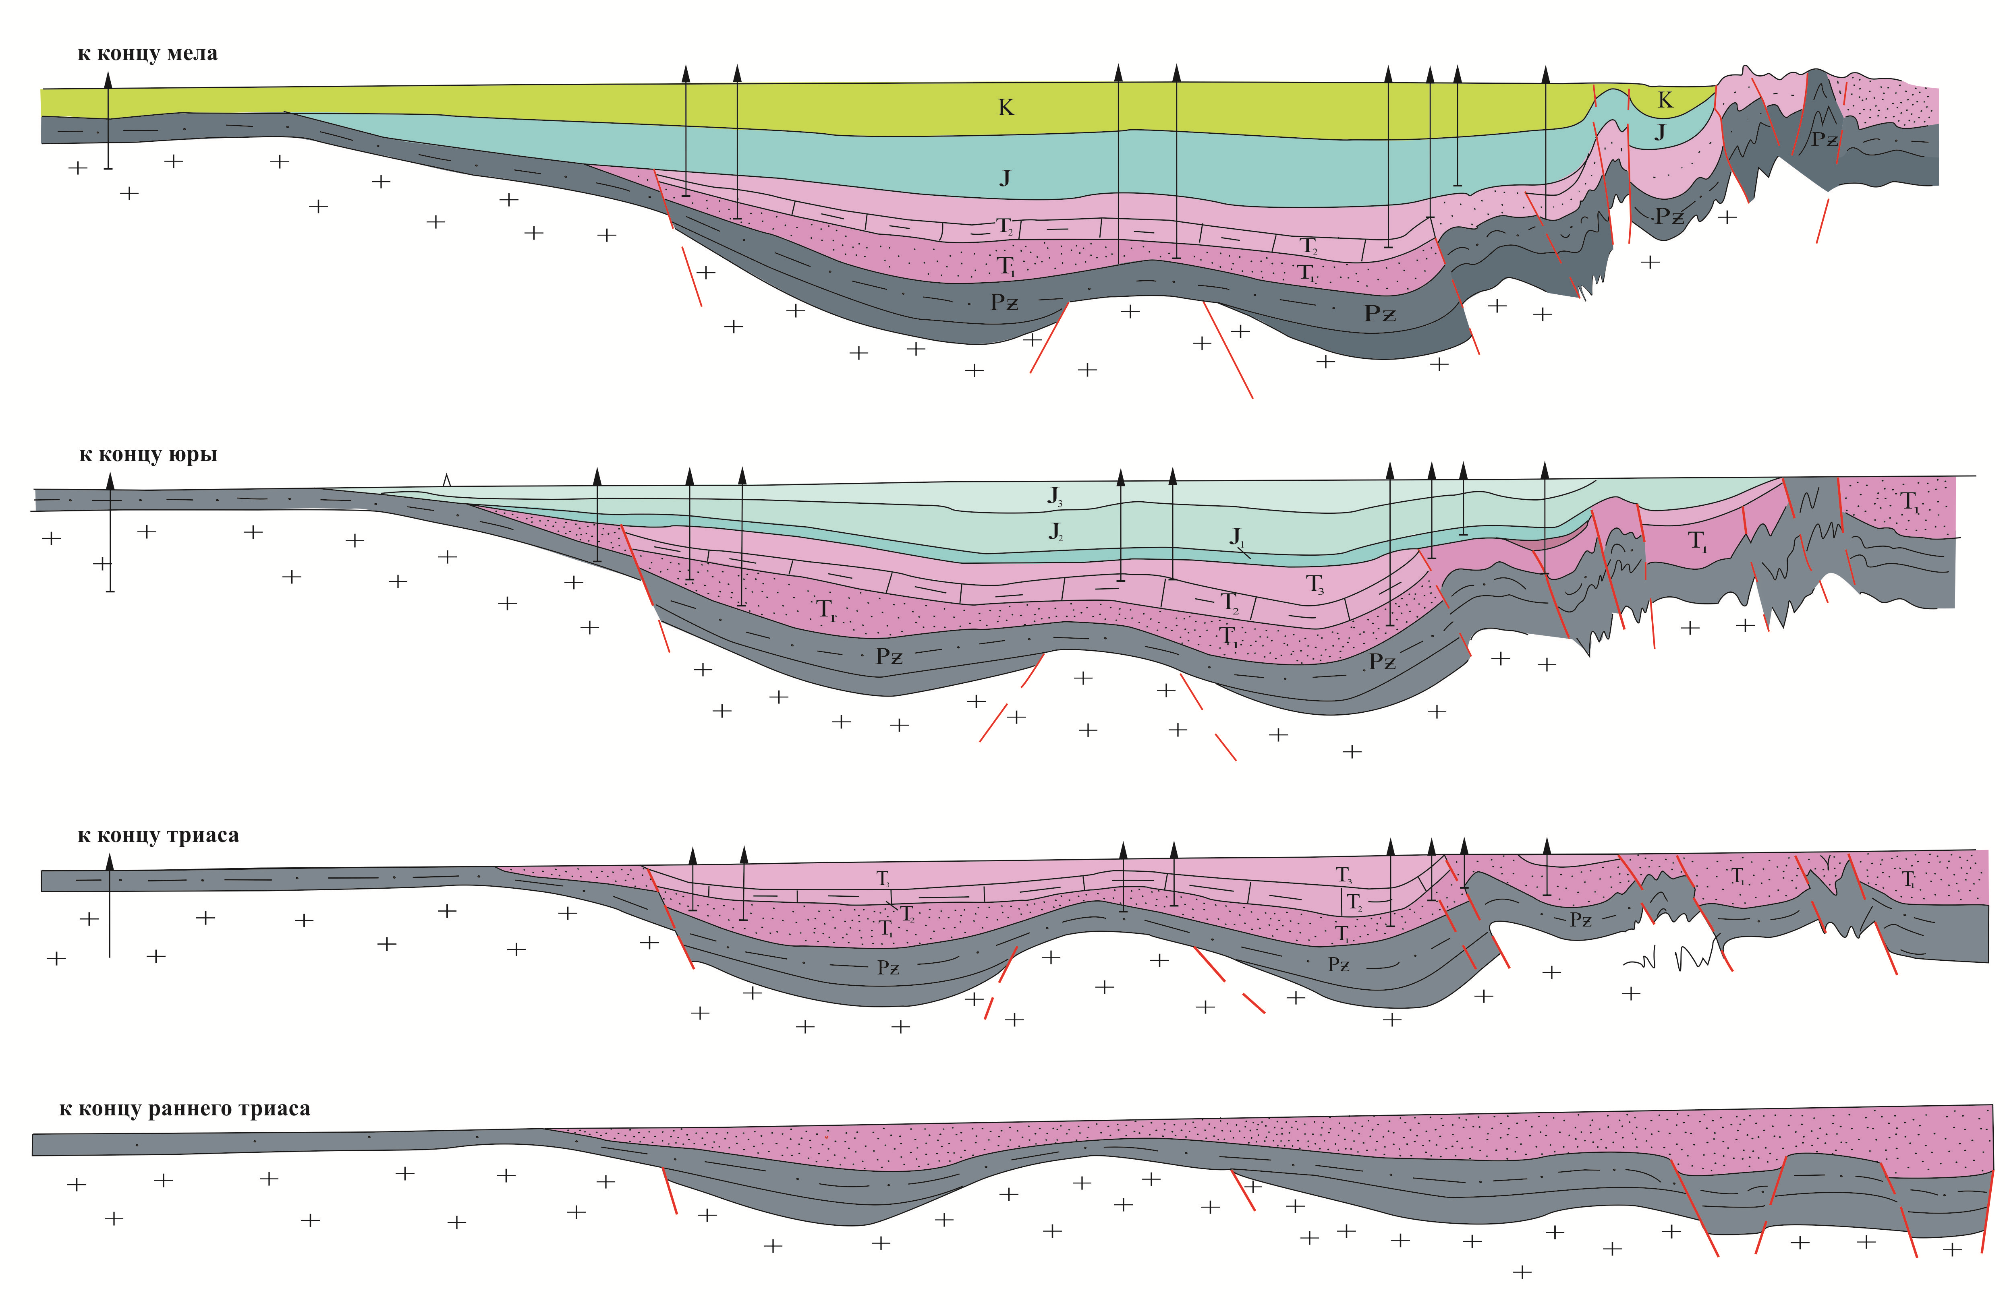
Figure 3.3 – Geodynamic evolution of Mangyshlak (2019)

  - New data on Mangyshlak Paleozoic deposit structure.
Since the discovery of Paleozoic deposits on the archs of the Otpan and Arpaly anticlines at the Karatau embankment in 1911 by M.V. Bayarunas, and subsequently a more detailed description of them by B. Mokrinsky in 1949, who singled out Upper Paleozoic age groups of the Berkut, Otpana and Dolnapa suites, the issues of tectonic structure were considered in numerous publications by B.F.Dyakov (1903), V.A.Lapshov (1903) [12], N.A.Kalinin, A.I.Letavin (1969,1978), R.G.Garetsky, A.E.Schlesinger, A.L.Yanshin (1975), M.Mstislavsky (1976, 1980), A.I. Dimakov, A.I. Tamarova (1973) and others [15].
However, the issue of the tectonic position of the complex in question is still a matter of debate. Some researchers date it to its foundation (Popkov V.I., Yapaskurg O.V., Demidov A.A. (1985), Orudzheva D.S., Rabinovich A.A. (1985) et al.), while others, pointing to its weak dislocation, see it as an "intermediate, or transitional" complex (Letavin A.I., Paragulgov H.H., etc.) [13]. The question of the internal structure of Paleozoic deposits remained unexplored in all regions, due to lack of conditioned geological and geophysical information [16].
Previously, Paleozoic dislocated sediments were found in the areas of Oimash, Zhylandy, Zhaga and other sites, located in the faults development zone separating the Peschannomys-Rakushechny-Karabogaz uplift from the Zhazgurly trough, which probably served as a way of introducing granite intrusions and effusive processes at different times. It is not correct to apply the nature of the Paleozoic sediment dislocation in this narrow area to the entire Mangyshlak territory.
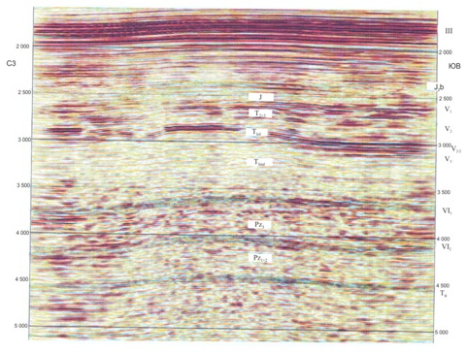
Figure 3.4 – The Zhazgurly trough time domain
The latest borehole drilling data in the Segindyk trough described in the previous chapter and 3D seismic data from Zhazgurly trough demonstrate that the complex in question is dislocated. Samples of compacted dark-gray argillites, siltstones and sandstones with carbonate interlayers without metamorphism were lifted from the boreholes, and parallel clearly visible reflecting horizons are noticed in the seismic sections below the generally accepted reflecting horizons Vз and VI, assumed to be the baseof the carbonate Mid-Triassic complex and the base of the Triassic sediments, i.e. the Paleozoic roof, respectively. In the Paleozoic thickness, three other dynamically distinct reflective horizons characterising the structure of 2-3 km undislocated thicknesses filling the Zhazgurly trough are clearly visible (Figure 3.4).
The processing of core material, their petrographic description, faunistic research, determination of absolute age and analysis of the wave field at seismic transects allowed developing the structure models and reconstruction of the geodynamic evolution of the region.

3.3 The Mangyshlak structure geodynamic model
The tectonics of Mangyshlak (east of the East Karatau Ridge) have been studied from the outcrops and cuts of rare wells that have uncovered Paleozoic deposits and discussed in the works of N.S. Plescheyev, A.I. Sharapov and A.E. Schlesinger and others [17].
M.M. Mstislavsky and his co-authors, analyzing the results of seismic and gravimetric and magnetometric studies conducted in the 1980s, arrived to the following conclusion: "The facts presented in terms of history of development may indicate that the Mangyshlak dislocation zone as an independent structure did not seem to exist for almost the entire Paleozoic (before the Permians), and at that time a quasi-platform Paleozoic cover over the Baikal foundation was formed on its territory, which was composed of a similar foundation of the North Ustyurt and South-Mangyshlak blocks into a single Epibaikal plate" [18].
The more realistic and acceptable regional tectonic position of the Mangyshlak system of uplifts, compared to available geological and geophysical information, is its relation to the planetary structure of the lineament named Sarmat-Turanic by R.G.Garetsky with co-authors and Dnieper-TienShanic by M.M. Mstislavsky.
At first stages of regional studies of the young Turan platform territory prior to 1960, numerous tectonic charts were drawn up, of most of which at present are largely of historical importance, as they are based at best on single and non-condictional geophysical observations and general tectonic considerations based on the outdated geosynclinal concept.
Tectonic models that meet the current level of actual drilling and geophysical materials have appeared in the works of R.G. Garetsky, V.I. Shreibman (1960, 1961), Yu.P. Godin, R.G. Garetsky, A.I. Letavin, M.M. Mstislavsky, A.E. Schlesinger, B.F. Diakov and others.
With the accumulation of actual drilling and seismic information, doubts about the interpretation of the internal structure of Paleozoic sediments, namely the regional location of Paleozoic sediments throughout the entire study area, emerged and became stronger. Middle massifs, intermediate, transitional and taphrogene floors, etc. have begun to be identified.
There are several views on the nature of the region’s foundation. Some consider it to be part of the Hercynids, the Ural-Mongolian belt, and call the young Turan platform formed after the Hercynid cycle, which supposedly soldered the separate median massifs of the ancient Baikal age, i.e. the Paleozoic deposits, in their opinion, are highly dislocated and of no practical interest for oil and gas exploration.
The existence of median massifs separated by geosynclinal zones is questionable to many researchers. Even A.D. Arkhangelsky once separated the Karabogaz and Ustyurt blocks, uniting numerous median massifs.
This idea was based on the results of interpretation of gravimetric and magnetometric materials of that time.
Uzbek geologists, led by A.M. Akramkhodjaev and H.M. Abdullaev, hold a slightly different view. The zones of strong Paleozoic deposits are distinguished as "plastic narrow zones" between ancient median massifs, which do not belong to the zones of geosynclinal development.
Based on our Central Mangyshlak studies, the dislocation system was formed as a result of the inversion of the rift formed by the Sarmat-Turan Lineament in the Late Paleozoic and Early Triassic.
The Central Mangyshlak and Central Ustyurt Uplift Systems, as noted above, are short-lived rift zones that underwent an inversion at the end of the Triassic and could be called avlacogens, but not as geosynclines in the classical sense of fixists. The faults that limit them formed from processes occurring in the asthenosphere did not reach the asthenosphere layer, i.e. the base of the East European-Turanic continent. [16]. Therefore, the entire Central Mangyshlak system, as well as the regional Sarmat-Turanic lineament, should be seen as a crustal fissure in the body of an ancient continent. Cracks such as these are now called in literature the ancient avlacogens and young rifts as the East African Rift System. In the Paleozoic history of the East European-Turanic Continent there were three-four such processes. Probably the earliest in Paleozoic history is the Tuarkyr system of north-western extension, which ran between two blocks, the Karabogaz and Karakum middle massifs.
The second stage of the formation of such zones is in Devon and Early Carboniferous, when the South Emba avlacogen was formed, which is well studied and cut away the sharp south-eastern corner of the ancient continent only at the asthenolayer level, including the North Ustyurt and Karabogaz blocks.
A third relatively weak, narrow and short-lived phase took place across the Bozashy and in the west, through the Mahambet Folding System, continued into the area of the sublatitude late Carboniferous and Early Permian Karpinsky rampart, possibly extending as far as Donbass.
The fourth stage of this process is in the late Permian and early Triassic, when the Sarmat-Turan regional lineament was formed, joined by the Mangyshlak-South Ustyurt graben zone, the rift zone that separated the North Ustyurt and Bozashy regions from the South Mangyshlak-Karabogaz region. This zone, called the Central Mangyshlak avlacogen, is filled with predominantly sedimentary formations strongly dislocated without signs of basic magmatism, as indicated by a magnetic field characterized by zero or negative values everywhere (Kunin, 1971) [19].
In terms of the nature of the section and the structure of the Paleozoic and Mesocaenozoic complexes, the zone of Central Mangyshlak and South Mangyshlak is quite clearly distinguished. In the Central Mangyshlak zone, the Karatau and Beke-Bashkuduk embankments are distinguished, separated by the Shakyrgan trough. The southern boundary of this zone is usually delineated by a large uplift-thrust fault type on the wing of the Beke-Bashkuduk Rampart, which stands out quite confidently on the basis of geological survey materials, seismic data and gravimetric and magnetic fields.
The Beke-Bashkuduk rampart is stretched in a west-north-west direction. Its northern and southern wings are complicated by longitudinal disturbances, and a series of small faults are marked on the arch, forming small blocks in the exposed part of the Jurassic and Cretaceous sediments. On the eastern periclinal of the rampart, local uplifts (Senek, Sokko, Shalabai, etc.) stretch out along its length.
The Zhetybai-Uzen tectonic level, which forms the northern side of the South-Mangyshlak trough, is, in the opinion of most geologists, a terrace-like structural zone of west-northwest extent. In the south it is bounded by the Great Mangyshlak flexure. Within its limits, there are large uplifts of Uzen, Zhetybai, Tenge, Tasbulat and a number of smaller ones.
The largest local structure is the Uzen-Karamandybas anticline, which is comparable in size to the Karasaz-Taspas anticline of the Beke-Bashkuduk rampart. Within the Zhetybai-Uzen tectonic level, three tectonic en echelon lines - Uzen, Zhetybai and Tenge-Tasbulat - are distinguished by their platform cover structures.
Structural maps of the Triassic reflective reference horizons show a staged sinking of the surfaces from the Beke-Bashkuduk rampart towards the South-Mangyshlak sink. The difference in the depth of the Triassic roofing in the arch parts of the Beke-Bashkuduk rampart in relation to the Uzen-Karamandybas line of the anticline is 1,500 m, and the excess of the Uzen-Karamandybas line over the Tenge anticline exceeds 1,100 m. In turn, the Tenge anticline rises 1,000 m or more above the Zhazgurly depression structures.
Judging by the structural structures of reflective horizons V1 and V3, associated with the eroded surface of the Triassic deposits and the lower part of the carbonate-terrigenous formation of the Olenek tier, respectively, the sinking of the Beke-Bashkuduk rampart towards the Zhazgurly bend occurs in stages through flexural systems or narrow zones of tectonic disturbances of various amplitudes.
According to available geophysical materials, the surface of the Mangyshlak foundation is submerged from the south to the north of the Karabogaz arch to the Central Mangyshlak zone. Diving of the foundation occurs in stages along a number of sublatitudinal faults, of which the largest (high-amplitude) are South Mangyshlak and Big Mangyshlak. Available geological and geophysical data clearly indicate that the Mesocoenozoic sediments starting from the Olenek tier are increasing from the Beke-Bashkuduk berm towards the Zhazgurly trough, and the upper Paleozoic-low Earth ( Indus ) sediments are increasing in the north direction. Sharp changes in capacity occur in the zone of regional tectonic disturbances.
An abnormal multiple increase in the capacity of the red-coloured terrigenous formation of the Lower Triassic is observed in the area of the Beke-Bashkuduk rampart. These regional changes in complex capacity are the result of different geodynamic conditions of their formation. The structure of the Upper Meso-Cenozoic complex has been studied much better than that of the Upper Paleozoic-Lower Triassic.
On the main reflective horizon V3, the northern part of the study area, the Beke-Bashkuduk mega rampart is occupying an elevated position at absolute levels of -700-750 m. In the Uzen-Karamandybas section of the anticline, the same horizon is traced at absolute levels - 2500-3000 m, and in the south of the Tengin anticline in the Zhazgurly trough it sits at -5000 m. The V3 surface difference is 4000-4500 m.
The South-Mangyshlak trough zone covers a wide band of relatively submerged foundations, bounded from the north by the Central-Mangyshlak-Ustyurt Uplift Zone and from the south by the Karabogaz-Central-Karakum Uplift Zone. The South-Mangyshlak trough zone in the west extends towards the Caspian Sea. The South-Mangyshlak Trough Zone is distinguished by its relatively simple structure and the predominance of latitudinal elongated structures, which dive stepwise from the south and north to the centre line of the Trough Zone, where the foundation lies at depths of 7.0-9.5 km. Within the South-Mangyshlak trough zone, three groups of structures are clearly visible, differing in structure, Paleozoic and Mesocaenozoic deposits.
The North group of transition structures include the Zhetybai-Uzen, Kokumbai, Koskuduk and Shakpakty levels, which are separated by sublatitudinal faults and flexural fracture zones. Within the levels, the depth of the foundation increases from north to south and there is also a tendency for the surface of the foundation to sink from west to east within the Zhetybai-Uzen and Kokumbai levels and from east to west within the Shahpakhtin and Koskuduk levels. These pairs of levels, adjoining the Central Mangyshlak and Central Ustyurt Uplift from the south respectively, are separated by the Eastern Mangyshlak and Eastern Bozashin Trough periclinal anticlines.
The Central group submerged structures combine the Segendyk Depression, Karagiye Saddle, Zhazgurly Depression and the Kurganbai Uplift, Ushkuduk-Karynzharyk and Assake-audan Depression from west to east. The Segendyk depression within land is a relatively small semi-rampart (50x35 km), slightly elongated in a sublatitudinal direction. The surface depth within the Segendyk Depression varies sharply from 7 km in the central part to 5.8 km on the southeast side.
The Karagiysk saddle looks like a small bridge extending northeast. The south-western border of the saddle is located within the Caspian Sea. The bridge size along the isohypse is 5-30x10 km.
The Zhazgurly depression is a large submerged section of the South-Mangyshlak trough zone. As a result of further more detailed work, the East Karagiye and Moldavian moulds are distinguished here. Both moulds delineate the surface of the Paleozoic isohypse of -6.5 km, and their dimensions in the delineating isohypse are 40x20 km and 45x15 km respectively.
The Kurganbai Uplift is a large asymmetrical projection with dimensions of 45x26 km along the isohypses - 6,000 m. In terms of plan, the Kurganbai Uplift is a triangle. In the arch, the depth of the Paleozoic surface is -5100-5200 m, the amplitude of the uplift reaches 800-900 m along the closed isohypse, and relatively adjacent mulds and depressions over 1,500 m from the adjacent more submerged structural elements, it is separated by extended, amplitude stable flexurals of the foundation surface with angles of incidence reaching 6-7°.
The Ushkuduk-Karynzharyk depression has been studied by a relatively rare network of KMPV profiles. It is the most submerged structural element of all the Mangyshlak profiles. Its northern and southern sides are steep, torn by sublatitudinal regional disturbances, and its north-western side is gentle. The axis of depression is elongated in a latitudinal direction. On the Paleozoic surface the size of the depression is 200x15 km. Depth of foundation in axial areas up to 9,500 m and more.
To the east of the Ushkuduk-Karynzharyk depression, the axial part of which has relatively isometric contours, the Assake-audan depression stretches out. The faults that limit it have an amplitude of 500-700 m on the Paleozoic surface. The grabens extend latitudinally for about 200 km, with a width of 30-50 km. It narrows to the east, and the Paleozoic surface rises to 5-7 km in the same direction. The structural forms of the northern group of transition structures and the central group of submerged structures differ significantly. The northern group of transition structures has a common north-western sublatitude, while the central group of submerged structures has tectonic elements that do not have a common extension, have relatively isometric shapes and are separated from each other by relatively flat flexures and saddles.
The south group of structures structure is the regional rise of the foundation surface from north to south. Peschanomys-Rakushechny Uplift, Kinderli, Birinjik-Tasayuk Levels are the most reliable ones here.
The Peschanomys-Rakushechny Uplift is separated from the South-Mangyshlak Trough Zone, which comprises the regional North-West Fault Zone of northwest stretch. The uplift arch is located in the coastal zone of the Caspian Sea, where the depth of the foundation does not exceed 4 km. Within the limits of the Peschanomys uplift, the depth of the foundation varies from 4 km on the arch to 8 km on the periphery. Previously drilled deep wells to study Paleozoic deposits are located on the northeast side of this uplift in the fracture development zone. These are the structures of Zhilandy, Aschisor, and others.
The Kinderly Level stretches west to northwest and separates the Karabogaz arch from the Ushkuduk-Karynzharyk depression. The Кinderly Level is 30-50 km wide and the length of the studied part is 140 km. From the north and south, the level is limited by faults with amplitude of several hundred metres. A longitudinal fault with amplitude of more than 1 km divides the Kinderly Level into two parts. In the northern part of the level, the depth of the foundation varies from 5.5 to 7.0 km. The southern part of the level, relatively elevated, is separated from the Karabogaz arch by a minor disturbance. The depth of the foundation is invariably reduced to the south to 4.2-2.5 km.

3.4 Geodynamic evolution of the region
As noted in the previous chapter on the tectonic structure of the area, there are two main opinions that come from completely different theoretical concepts.
One relates the entire territory to the area of Hercynides with superimposed Cimmerian myogeosyncline trough of the Central Mangyshlak (A.E. Schlesinger et al.). Others, based on the concept of plate tectonics, believe (L.P. Zonenshayn, G.Zh. Zholtaev and others) that the Mangyshlak tectonic zone includes the Central Mangyshlak dislocation system and the northeast slope of the Middle Caspian Anteclise buried and largely reworked by tectonic processes. The Central Mangyshlak dislocation system was formed as a result of the inversion of the intracontinental rift formed by tectonic processes during the development of the MesoThetis Paleocean in late Permian and early Triassic. Prior to the formation of the Central Mangyshlak Trough (Rift), the territories to the north were considered to be of short duration, but the Bozashi Rift, which underwent an inversion at the end of the Carboniferous period and in the early Permian period, was actively developing, preventing the Kungur saline thickness of the Caspian syneclise from spreading southwards. The inverted and largely denudated marine sediments of Devon, Carboniferous and Asselian-Arthine age have been studied from sections of numerous parametric and deep exploration wells. By comparing the upper Paleozoic marine sediments of the Bozashy zone presumably with the same age sediments of the Berkut Suite at the Beke-Bashkuduk rampart and gray carbonate-terrigenous sediments at the Aksaz area at the Segendyk Trough, it can be assumed that they are fairly widely distributed within the region under consideration. It is likely that sedimentation conditions were also similar in the Bozashy area. Precipitation thicknesses may have been decreasing and marine, coastal and marine terrigenous precipitation may have prevailed in this section on the slope of the Middle Caspian Anticlise [20].
Against the background of the regional monoclinal northward occurrence of upper Paleozoic deposits in late Permian, the Central Mangyshlak trough was formed under the impact of spreading processes in the initial phase of MesoThetis paleocean formation and it is intensively filled with terrigenous continental and coastal sediments of high thickness, which can be conventionally referred to as the Otpan and Dolnapa Suites on the Bek-Bashkuduk, where their thickness exceeds 3000 m.
Paleozoic deposits in the Central Mangyshlak Trough spreading area are likely to have been strongly dislocated and some fragments of them have been exposed on Beke-Bashkuduk and Karatau in the core of the Otpan anticline in the form of the Otpan and Berkut Suites. Paleozoic deposits as a result of tectonic movements were crumpled into linear folds and strongly dislocated in the Central Mangyshlak zone. According to seismic data, they are poorly dislocated and broken by faults (discharges and outbursts) in the Zhetybai-Uzen level and in areas where tectonic disturbances develop on the slopes of regional uplifts such as Peschanomys-Rakushechnyoe and Karabogaz, where intrusions and effusive processes have occurred causing local metamorphic changes in the sedimentary rock. In all other areas of South Mangyshlak, with the exception of narrow areas of contact with deep faults, they are hollow or horizontal, broken in places by low-amplitude faults within tectonic flexures or regional ramparts, forming structural and lithologically shielded traps.
The geodynamic evolution of the area under consideration in the Late Paleozoic rather predetermined a relatively calm marine environment, sometimes alternating with continental palaeogeographical conditions and a relatively weak disposition due to tectonic processes associated with the inversion of the Central Rift. The main inversion process takes place at the end of the Indus age. Then, after a long period of denudation of young mountain systems, peneplain is formed, covered with terrigenous and carbonate-marine deposits in the Olenek Age.
Whereas in the Indus age, the Central Mangyshlak trough was the main arena of sedimentation, since the Olenek age, the trough systems - Zhazgurly and Segendyk - have been the main areas of sedimentation. During the Middle Ages, sedimentation took place under conditions of stable sinking of the basin, which resulted in carbonate and carbonate-terrigenous shallow sea sediments. Short ascending tectonic movements at the end of the Middle Triassic contributed to the activation of denudation processes, especially at Beke-Bashkuduk rampart and to a lesser extent at the northern Zhetybai-Uzen tectonic level, resulting in sedimentation at the beginning of the Late Triassic under continental alluvial-lake plain and subsequently covered by coastal and coastal-marine sediments.
The upward movements and subsequent erosion-denudation processes at the end of the Triassic period created the alluvialised terrain on which alluvial-lake sediments from the Lower Jurassic were accumulated. Beginning with the Jurassic, there was an overall inherited development of the entire area in platform mode. Not only in Mangyshlak, but also in the entire Ustyurt-Mangyshlak region, the presence of grey-coloured carbonate-terrigenic sequences of Carboniferous and Lower Permian in the Paleozoic (in addition to the "usual" red colours of Permian-Triassic) is indisputable. The presence in the Paleozoic section of subaqueous grey-coloured Carboniferous and Lower Permian deposits formed in an anaerobic environment in a single sedimentary basin covering the south of North Ustyurt and Mangyshlak Central and South up to the Karabogaz arch gives reason to assume the presence of weakly dislocated sedimentary strata, possibly oil and gas producing in this region.

4. Prediction of oil-gas content prospects

The problems of oil and gas bearing capacity of the South Mangyshlak section and the spatial location of oil and gas fields have been repeatedly considered and substantiated by various research groups since the mid 50s and 90s. Lithological and structural tectonic control regularities of oil and gas bearing capacity of Jurassic and Cretaceous productive strata have been substantiated and confirmed by the practice of oil and gas field prospecting and development [21].
For a long time, the issues of oil and gas bearing potential and spatial location of fields in the pre-Jurassic complex remained problematic due to poorly studies and complex structure. Thanks to numerous discoveries of oil deposits, Triassic deposits are now considered a promising complex. However, the Paleozoic deposits have different ideas about the potential for their oil and gas bearing capacity.

4.1 Brief information on oil-gas content of Paleozoic deposits
At present, the only rock associated with Paleozoic age is the Oimasha deposit, which is located in the northeastern part of the Peschanomys-Rakushechny arch zone.
Search work in the Oimash area began in 1978 with the drilling of well No 9, laid in the arch of the V₂^{IV} reflecting horizon structure.
According to the results of drilling the first exploration wells, several deposits were identified: well No. 9 - oil in the middle Triassic volcanic carbonate sediments, well No. 10 - oil and gas in the basal layer of the Lower Jurassic (Yu-XIII horizon) and well No. 12 - oil in Paleozoic granites (for the first time in South Mangyshlak).
The results of the drilling and testing of the first wells led to the conclusion about the block structure of pre-Jurassic sediments, as well as the subordinate structural factor for deposits associated with low permeability rocks, primarily Paleozoic granites. For these rocks, the decompaction zones, which are primarily caused by tectonic fracturing, play a decisive role.
In parallel with exploratory and exploratory drilling in the Oimasha area, in 1981-1982 the MOGT seismic work was carried out in detail. The Oimasha uplift is represented on the structural maps for V₂^{IV} reflecting the horizon by a large, complex brachianthycline 11.5*6.5 km, of sublatitudinal stretch. The fold is cut diagonally into two blocks: northwest and south-east, which are shifted relative to each other along the line of disturbance by almost 2 km. . The northwest wing is contoured with a semi-isohypse -3,525 m and via the fault is fully enclosed in independent elevation of 7.0*3.0 km and the amplitude greater than 25 m.
The southeast wing is gypsometrically 50 m above the northwest wing and along isohypse -3,450 m is a semi-anticlinal attached to the fault with two semi-archs. The bottoms of drilled wells range from 3905 m (well #9) to 4450 m (wells #23 and 24), with all wells drilled penetrated Paleozoic formations of sedimentary or intrusive origin. The granite intrusion was opened by 15 wells at depths ranging from 3,565 m (well No. 16) to 4,178 m (well No. 24). Maximum granite thickness of 710 m was drilled in well No. 18.
Ha field has 4 deposits, including 3 oil deposits: in granite intrusion, Paleozoic containing rocks and Middle-Triassic sediments, and one gas-oil deposit in Lower Jurassic sediments. Thirty-four sites have been tested in the granite intrusion. The maximum oil flow rate was 248 m3/day through a 9 mm plug and was obtained in the well 12 while testing the 3720-3773 m interval. The density of Paleozoic oil is 0.835 g/cm3, viscosity under formation conditions is 0.6 s, paraffin content is 11.9% and tar+asphaltenes content is 2.9%. The main reserves of the deposit - 3,587,000 tonnes out of 4,290,000 tonnes of initial recoverable reserves in the Oimasha deposit - are dedicated to granite intrusion. The reservoir, which controls the morphology of an oil deposit in granite in the Oimasha area, combines both formation and core elements. The most favorable reservoir properties of the rocks are found at the intersection sites by fracture disruptions in the formation decompaction zone.
In granite intrusion, the collectors are modified granites, being cracked collectors with open porosity less than 4%, and with porosity more than 4% being pore-cracked. The average value of cracked porosity is 0.24 % and open porosity of pore-cracked collectors is 6 %. The average value of cracked permeability of pore-cracked collectors is equal to 76,3*10⁻³mkm².
The physical and chemical properties of oils were studied under reservoir and surface conditions. The results of oil studies under reservoir conditions show that oil is significantly undersaturated with gas: the excess of reservoir pressure over saturation pressure is significant, 17.6 MPa for Triassic and 28.8 MPa for granite intrusion. The elevated part of the granite massif, to which the modified granites are confined, is unsaturated; the unaltered granites are not collectors. In a granite massif according to the data of testing there are oil deposits dated to the central block and to the southern block. In the central block, the lowest absolute mark of industrial inflow is -3,830 m, which is a conventional VNK, for the South block -3,971 m. The oil deposit in granites is intermittently massive, tectonically shielded.

4.2 Prediction of oil-gas content
The analysis of the distribution of oil and gas deposits in Mangyshlak allows most researchers [1], [10], [24] to draw conclusions about the syngetic oil and gas content of Jurassic and Triassic deposits and the secondary productivity of Cretaceous deposits. It is assumed that oil and gas formation took place at depths of 2.5-3.5 km in the main oil and gas generation zone, located in the most submerged parts of the South-Mangyshlak Trough Zone. The formation of oil and gas deposits took place during the migration of HC from the generation sites to the elevated deflection side. This concept was taken as a theoretical basis for forecasting and determining priority directions and facilities for searching for new oil and gas fields. This concept proved to be highly effective based on the results of the oil and gas field search practice [22].
However, some researchers, noting that there are no deposits and no signs of oil and gas in the axial most submerged deflected parts (Zhazgurly, Segendyk), except for the Kurganbai structure, which is located near the Zhazgurly deflection joint zone with the Zhetybai-Uzen stage, different group composition of oil as the methane HC content at Kurganbai is 47%, while at Zhetybai-Uzen fields 70% and other indicators believe that hydrocarbons from the upper Paleozoic deposits played a significant role in the formation of giant accumulations and in the highly unique degree of oil and gas saturation of the Jurassic section. Geochemical studies were carried out (P.N.Kuprin, B.M.Lepekhin, M.F.Mirchink, etc.) on the carbonate-terrigenous formation of the Dolnapa and Otpane suite. The carbonate-terrigenous formation is characterized by a high organic matter content (0.2-9.8% per rock) [18]. The most enriched bitumen is the lower part of the section. According to their conclusion, this formation is characterized by the presence of autochthonous bitumen.
Noting the coincidence of HC accumulations in Jurassic sediments with zones of hydrodynamic connection between them and underlying formations, the commonality of the chemical composition of Jurassic and Triassic oils, and the connection between the oil and gas bearing capacity of these complexes within the known areas of the fields, a group of scientists (H A.Krylov, A.I.Letavin, D.S.Orudzheva, N.P.Zapivolov, L.M.Savelieva, etc.) write that the pre-Jurassic deposits of Mangyshlak should be considered not only as independent, but also as the main oil and gas-forming complex, which formed the currently known fields of Mangyshlak [23].
The above short excursion on the literature devoted to the problems of oil and gas bearing capacity of pre-Jurassic deposits and the information received about the internal structure of the upper Paleozoic deposits in the studied area shows the relevance of comprehensive study of the Paleozoic of the whole South Mangyshlak in order to reasonably forecast the oil and gas bearing capacity of Paleozoic deposits. The priority oil and gas targets are Uzen-Zhetybay tectonic stage and Peschanomys-Rakushechny and Karabogaz uplift zones with Zhazgurly trough. The second priority is the large tectonic ramparts as the Kurganbai and Segendyk ramparts in the inner part of the South-Mangyshlak Trough.

4.3 Recommendations for prospecting and exploration work
Preliminary results allow us to draw important conclusions about the weak dislocation of Paleozoic deposits of the Zhetybai-Uzen stage and the South-Mangyshlak system of deflections, about the possibility of detailed mapping of their internal structure using more advanced and modern seismic methods, about the possibility of the presence of collector rocks, both porous and cracked at different levels of the Paleozoic, that Paleozoic deposits are of some interest for study in order to find new accumulations of oil and gas.
In order to detect new oil and gas accumulations in the Paleozoic part of the South Mangyshlak section, it is recommended that two exploratory wells be drilled first. One on the Uzen field and the other on the Zhetybai field, where seismic has identified and prepared local structures for prospecting drilling in the Paleozoic part of the South Mangyshlak section with possible future resources of 40-60 million tonnes of the 50th category.
In accordance with the schedule, we have prepared the Passport for Uzen-PZ structure to drill a 6,000 m deep well (Annex A). The JSC “UzenMunaiGaz” and foreign companies from Russia, China and Iran have shown preliminary interest.

CONCLUSION
The fact that the Jurassic and Triassic oils have permanent and significant amounts of microfossils of the same age that contain reservoir rocks testifies to the oil and gas production capacity of these sediments under favourable geodynamic and geochemical conditions. The presence of migratory carbonic forms of microfossils in the oils of the Triassic and Jurassic horizons indicates the need to take into account the importance of vertical oil migration processes and the possible presence of older deposits with significant generation potential, i.e. the possible existence of oil and gas producing strata of the upper Paleozoic age. This suggests that it is possible to form and maintain oil and gas accumulations in the Paleozoic part of the section under favourable conditions, i.e. the presence of pore-cracked reservoirs and zone tyres, and traps of various types, including those shielded by rupture disruptions, such as in the North Caucasus oil fields, where they are confined to folds broken by ruptures. Similar oil deposits can be admitted as existant in the Paleozoic deposits of the Zhetybai-Uzen tectonic stage. One of such structures is the Uzen-PZ. It has been prepared with 2D and 3D seismic surveys from the Paleozoic complex and is proposed for exploratory parametric drilling with a well depth of 6,000 m.
It is expected to find in the Paleozoic complex a deposit similar to that of the CIS-Caucasian deposits in structural tectonically disturbed traps, in pore-cracked reservoirs covered by a local and zonal cap. We hope that the positive results obtained from this well will open up the new Paleozoic stage of the Mangyshlak oil and gas industry.

LIST OF REFERENCES
1 Letavin A.I. Tectonic position of Mangyshlak in the general geo-structure of the Epihercynian platform of the south of the USSR // Geologiya i neftegazonosnost' Yuzhnogo Mangyshlaka. M.: Nauka 1969, P. 10-14. (in Russian)
2 Letavin A.I., Krylov A.I. Main features of tectonics of the platform cover of Mangyshlak Ustyurt and adjacent areas. In Book: Geology and oil and gas bearing capacity of South Mangyshlak // M.: Nedra 1969, P. 15-29. (in Russian)
3 Marabaev Zh.N., Zholtaev G.Zh., Utegaliev S.A. i dr. Geologicheskoe stroenie i perspektivy neftegazonosnosti Severnogo i Srednego Kaspiya [Geological structure and prospects of oil and gas bearing capacity of the Northern and Middle Caspian Sea (in Russian)] // Astana: 2005, - 328 p.
4 Garezkij R.G., Sapozhnikov R.B., Shlezinger A.E. Tectonic nature of the Paleozoic-Lower Mesozoic complex during the period of the Turan and Scythian platforms // M.: Nauka, 1972. – 628 p. (in Russian)
5 Vinyukov V.N. On the tectonics of the Permian and Triassic sediments Mangyshlak // Trudy VNIGRI. M., 1963 - Issue 218., P. 43-52. (in Russian)
6 Vinyukov V.N., Grinberg I.G., Dimakov A.I. Possible oil and gas bearing capacity of Mangyshlaka and Ustyurt permotriassic deposits// Neftegazovaya geologiya i geofizika: 1965, №20, P. 78-85. (in Russian)
7 Pronin A.P., Turkov O.S. Kalmuratova S.A., Mil'kina P.V. New data on Paleozoic deposits of Buzachi peninsula // Geologiya Kazahstana 1997, №4, Р. 43-52. (in Russian)
8 A.I. Levenko. About opening of the Lower Permian flora in Mangyshlak mountains and about age of conglomerates // Report USSR ASc. 1966, vol. 169, №2, Р. 78-84. (in Russian)
9 Dimakov A.I. Tamarov A.I. The Mangyshlak deep structure // L.: Nedra 1973, 380 p. (in Russian)
10 Knyazev V.S., Florenskij P.V. On the cyclical development of Mangyshlaka, Ustyurt and neighbouring areas during the Perm and Triassic periods // Bulletin MONP, Geology dpt., 1968. Vol. XLIII, №3 -P. 16-31. (in Russian)
11 Bakirov A.A., Bykov R.I., Gavrilov V.P., Knyazov V.S. and others. Foundation, major faults of the Turan Plate due to its oil and gas bearing capacity // M.: Nedra, 1970. 437 p. (in Russian)
12 Shlezinger A.E. Schlesinger A.E. Structural position and development of the Mangyshlak dislocation system // Proc. of Intern. GIN USSR ASc. M.: 1965. Issue 132, pp. 48-56. (in Russian)
13 D'yakov B.F. The Mangyshlak’s Geotectonic zoning and forecast of oil and gas bearing capacity. In book: Mangyshlak’s Geological structure and oil and gas bearing capacity // L.: 1965, Р. 89-102. (in Russian)
14 Dergachev A.A., Dmitriev L.P., Zholtaev G.Zh. and others. Structure and prospects of oil and gas content of dairy deposits Peschanomys-Rakushechny area in South Mangyshlak // KazNIITI, series 07. Alma-Ata 1982. Issue 3, Р. 26-35. (in Russian)
15 Lapshov V.A. The deep geological-tectonic structure of Mangyshlak. In book: Geological structure and oil-gas content of Mangyshlak // L.: 1965, Р.103-127. (in Russian)
16 Popkov V.I., O.V. Yapaskurt, Demidov L.A. Base rocks of the south-west Turan plate // Sov.geologia 1985, no. 9, Р. 106-113. (in Russian)
17 Pleshcheev I.S., Sharapov A.I., Shlezinger A.E. Structure of the Eastern Mangyshlak and adjacent areas of the Ustyurt Plateau // Bulletin MONP, Geology dpt., 1961, vol. 36, issue 1, Р. 111-115. (in Russian)
18 Mstislavskij M.M., Mezencev A.M., Olofinskij L.N. Tectonic zoning of the Mangyshlak Rise Zone Pre-Jurasic Base // Geotektonika 1980, №2, P. 63-77. (in Russian)
19 Kunin N.YA. New data on the deep structure of Mangyshlak and Ustyurt from regional geophysical surveys // Ref. sb. VNIIGazprom: 1968, no.5, pp. 53-61. (in Russian)
20 Zholtaev G.Zh. Geodynamic basics of oil and gas regionalization in southern Eurasia // Geologicheskaya nauka i industrial'noe razvitie RK. Almaty: 2010, P. 111-116. (in Russian)
21 Tazhnazarova N.A. Role of migration processes in formation of South-Mangyshlak oil deposits // Geologiya nefti i gaza 2008, no.5. (in Russian)
22 A.M. Akramhodzhaev, Zh.Yu. Yuldashev Geological structure and oil and gas bearing capacity of the Turan plate from the perspective of new global tectonics // Uzbek Geological Journal 1982, №1, P. 11-16. (in Russian)
23 Orudzheva D.S., Popkov V.I., Rabinovich A.A. New data on geological structure and prospects of oil and gas bearing capacity of the South Mangyshlak doyur deposits // Geologiya nefti i gaza, 1985, №7, P. 22-26. (in Russian)

Annex А

Passport
of the Uzen-Pz structure, prepared by the 3D-MOGT Paleozoic complex seismic survey for prospecting-exploration drilling in the west part area adjacent to
the Uzen and Karamandybas deposits

Scientific substantiation of the South Mangyshlak
Paleozoic deposits oil and gas content prospects

By the K.I.Satpaev Institute of Geological Sciences
The 2018-2020 RK MES Grant no.АЗ05133006

Content

 | General information | 3
 | Brief description and oil-gas content prediction estimates | 6
 | Recommendations to prospecting and exploration drilling | 8
 | Conclusion | 8

Tables
No. | Title | pages
1 | Prediction resources | 12
2 | Assessment of geological success | 13

Figures

No. | Title | pages
1 | Calculation planes for the Uzen - Pz Paleozoic object as per VI str horizon | 9
2 | Location of the Pz-la well in the deep seismic section Inline 2950 | 10
3 | The Oimasha deposit, the geological section | 11
 | The boundary and most likely values of the calculation parameters used in the resource assessment | 12

1 General information
  - Location, region, district
The Mangistau Oblast of the Republic of Kazakhstan, the western part of the areas adjacent to the Uzen and Karamandybas fields of the АО «UzenMunaiGaz».

  - Geotectonic region, the nearest deposits
The Zhetybai-Uzen tectonic stage, Karamandybas.

  - Discovery information
Structural maps for Horizon VI and VI_str, based on the results of complex processing and interpretation of 3D-MOGT seismic materials, as well as gravimetric and magnetometric studies of past years (2013).

    - Identification method
For the first time revealed during the 2D-MOGT survey and data gravimetric and magnetometric studies (2013). The structure has been verified by seismic survey ЗD-MOGT (2016-2017).

    - The entity, discoverer of the object
The structure Uzen-Pz was revealed as per the Paleozoic complex on reflecting horizons VI, VI-I for the first time by the Consortium consisting of "SPC Geoken" LLP, "Petroleum Geo Service (Kazakhstan)" LLP, "Largeo Energy" LLP, "GeoMedge KZ" LLP in 2013 under the scientific supervision of Professor G.Zholtaev.

    - The year of inclusion into the revealed resource fund - 2013.

Approved during 2018-2019 in the JSC NK «KazMunaiGas»

  - Preparing the structure
Due to the complex geological structure of the work area, 2D-MOGT seismic data was processed in 2012-2013 using various methods. Thus, one of the stages of the data processing work was to test various processing methods in the time and depth domains. Contractors presented their project concepts, which included processing of seismic data using the following methods, as well as further interpretation and generalisation of geological and geophysical materials (gravitational, magnetic, 2D seismic, lithophacic seismic analysis).
Tests have been implemented according to the following processing methods:
- PSTM - performing test processing in the time domain using PSTM from floating datum
- The methodology of Multifocusing Common Reflection Surface (CRS), where all seismic trails based on the Fresnel Zone 1 generality principle are used in the formation of effective summaries, which significantly increases the statistical effect of the accumulation of signal information. The application of the CRS methodology allows increasing the signal to interference ratio of 2D seismic data and improving the resolution and coherence of target reflective horizons.
- Nuregweam - software tools for building PSDM speed models. The use of this tool for building speed models provided a direct link between the GMDS and the interpretation, with the GMDS-Interpretation cycle being carried out and repeated in order to involve interpreters and geologists of the Customer as much as possible.
RTM - Reverse Time Migration is a solution to the full PSDM wave equation. With RTM, complex wave phenomena, vertical drop images, swivel waves, prism waves (from extreme folding) are solved.
All methods have resulted in the identification of blurred surface structures presumably of Paleozoic age. Based on the results of a comprehensive analysis of geological and geophysical data, the conclusion was made that the Paleozoic complex is more promising in the southern part of the study area and that a 3D seismic survey is required in this part of the site.
The WD seismic survey carried out in 2017 made it possible to solve the tasks of both clarifying the structure of the proposed surface of Paleozoic sediments and additional dismemberment of this complex with the separation of additional surfaces VI_str (surface inside Paleozoic sediments) and VI_1 (roof of "silent" thickness in the proposed Paleozoic complex).

    - The period of preparing – 2013-2019.
    - The entity that prepared the structure (trust, field parties, processing, interpretation, name of report, year of preparation, authors, storage place)
- - GeoEnergy Group LLP conducted 2D-MOGT field seismic surveys.
- - 2D seismic data was processed and reinterpreted by the Consortium of the companies: LLP "SPC "Geoken", LLP "Petroleum Geo Service (Kazakhstan)", LLP "Largeo Energy", LLP "GeoMedge KZ" with preparation of the Report titled "Processing and reinterpretation of 2D seismic data in the western part of the territories adjacent to the Uzen and Karamandybas fields" within the contract territory of JSC "KazMunaiGas Exploration Production" for 2013.
- - In 2016-2017, BGP Geophysical Services LLP (Kazakhstan) conducted field seismic survey works of 3D-MOGT.
- In 2018-2020, with a grant from the Committee of Science of the Ministry of Education and Science of the Republic of Kazakhstan, the K.I. Satpayev Institute of Geological Sciences.
- Processing and interpretation of seismic data 3 D conducted by Professional Geo Solutions Kazakhstan LLP. The report "On the results of processing and interpretation of MOGT 3D seismic data performed within the contract territory of UzenMunaiGaz JSC in the area adjacent to the Uzen-Karamandybas fields in 2017" was prepared.
- Complex analysis of geological and geophysical data and justification of oil and gas prospects of the Paleozoic complex at the Uzen-Karamandybas fields at the Satpaev Institute of Geological Sciences.

1.4.3 Methods of preparation, scope of surveys conducted, profile density, availability of parametric data (VSP, SC, AK, GTK, etc.)
Processing and reinterpretation of 2D-MOGT seismic data for a total of 800 line km.
Processing and reinterpretation of 3D-MOGT seismic data with a total volume of 798 km².
VSP data is represented by 2 wells. The mud logging data for the Mesozoic complex of rocks for the old wells are digitized, while such data for the Paleozoic complex are absent.

  - Costs of exploration and preparation of structure (object), including regional, search and detailed works of all types, KZT2,610.5 million. Grant financing in the amount of KZT18,120,000.00 for complex analysis to substantiate the prospects of Paleozoic deposits.
  - Information on data digital processing (list of the processing complex)

2D-MOGT seismic data was processed at Petroleum Geo Service LLP (Kazakhstan), Largeo Energy LLP and GeoMedge KZ LLP using modern graphs of processing systems in the time and depth areas and obtaining time and depth sections, Almaty and Atyrau respectively.
Processing of seismic data of 3D-MOGT was carried out by Professional Geo Solutions Kazakhstan LLP on modern graphs of processing systems in time and depth areas with obtaining time and depth cubes respectively, Almaty.
- Brief geological characteristics and oil and gas content prediction estimates

  - Features of the structure (object)
The structure was initially identified by reflecting horizons in the Paleozoic complex at the intersection of two 0306001 and 030630 2D seismic profiles. According to the refined structures based on the results of the MOGT-3D seismic survey, the structure is located in the north-western part of the surveyed area.

2.1.1 The trap type and justification of its choice
Traps are expected of both structural and stratigraphically shielded and massive types. The main elevation is highlighted based on ЗD seismic data.

    - Brief description on the trap
The main elevation is a structural type trap in the form of a linear north-west spread anticline. On the roof of a blurred surface (OG VI) the amplitude of the structure reaches 200 metres. On horizon VI_str (horizon inside Paleozoic deposits) the amplitude exceeds 600 m. Along Horizon VI_1 (Paleozoic "silent" roof thickness), the structure is a multi-link isometric anticline with an elevation amplitude of over 800 m.

    - Reflecting horizons, index, age
VI - presumably a blurred surface of Paleozoic sediments;
VI_str - conditional horizon within Paleozoic sediments;
VI I - conditional horizon within Paleozoic complex (roof "silent" thickness).

    - Dimensions, amplitude, area
The size of the trap on reflective horizon VI: on contouring isohypse - 4,470 m is about 15x5.5 km, with a lifting amplitude of about 200 m. The area of the trap is about 50 km².
The size of the trap on reflective horizon VI_str: on contouring isohypse - 4,470 m is about 17x6 km, with an amplitude of about 650 m rising. The area is equal to 75 km².
The size of the trap on reflective horizon VI 1: on the contouring isohypse -5250 m is about 19x8.5 km, with an amplitude of uplift of over 800 m. The area of the trap exceeds 140 km².

    - Lithology
The lithology of the area under study isrepresented by carbonate-terrigenous rocks.

    - Data on disjunctive disturbances
The Paleozoic complex on the square is complicated by tectonic disorders.

    - Relation of structural plans
In general, the structural plans of the facility coincide with horizons VI and VI_str. The closest vault at Horizon VI_1 is dislocated 2.5 km south-south-west.

  - Oil saturation estimates
HC deposits are expected in the Paleozoic complex between horizons VI and VI_1.

2.2.1 Prospective P50 oil and gas resources
Category P50 oil resources have been calculated using the Uzen-Pz bulk method. According to the analysis of seismic attributes, we can assume the presence of a pore-cracked reservoir. There are no direct analogues of this type of reservoir in the Paleozoic complex. The closest analogue in the Paleozoic is the Oimasha deposit with an effective porosity of about 5-6% in the weathering crust of intrusive rocks. However, this work assumes a sedimentary character of the reservoir with higher collector properties (Figure 4). It is expected that hydrocarbon deposits may be contained within the Paleozoic complex between 3,850 and 6,000 m. The total resources of category P50 and calculation parameters are shown in Table 1. Geological P50resources are 167.8 million tonnes of oil and recoverable resources are 41.9 million tonnes.
- Recommendations to prospecting and exploration drilling
1/
1/
V
/
The independent prospecting and exploration well Pz-la is being laid at the intersection of the inline 2950 and crossline 10310 seismic lines with a design depth of 6,000 m for the purpose of penetrating the maximum depth of the assumed carbonate-terrigenous Paleozoic deposits and identifying HC deposits in them.
A dependent project well Pz-1 is being laid at the intersection of the inline 3030 and crossline 10360 seismic lines, its feasibility depends on the results of drilling the Pz-la well. The design depth of the well is 6,000 m.

Conclusion
Further actions:
- Year of introduction into prospecting and exploration drilling: 2021.
- Expected year of field discovery: 2022.
- Productive horizons: the carbonate-terrigenic Paleozoic thickness.
- Industrial oil and gas reserve estimation.

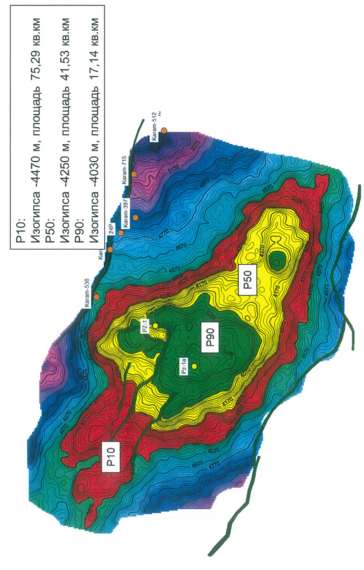 | Figure 1 – Calculation planes for the Uzen-PZ Paleozoic object as per VI_str horizon

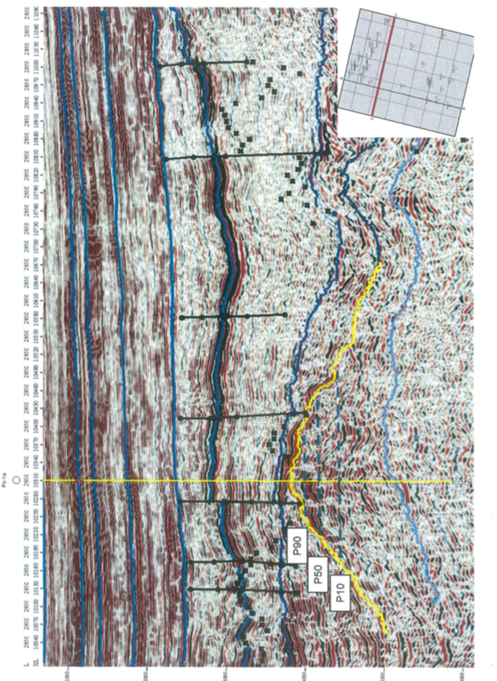 | Figure 2 – Location of the Pz-la well in the deep seismic section Inline 2950.

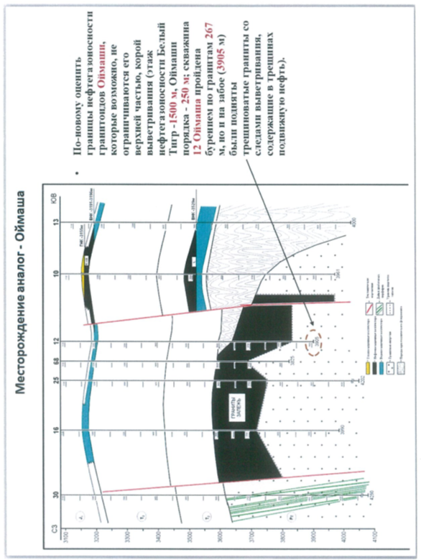 | Figure 3 – The Oimasha deposit, the geological section.

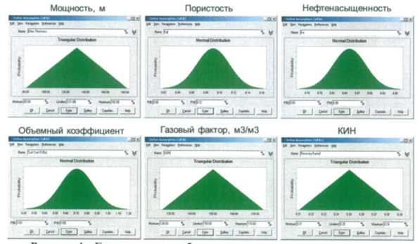
Figure 4 - The boundary and most likely values of the calculation parameters used in the resource assessment
Table 1
Results of resource assessment by probabilistic means (Monte Carlo)
Version | Geological resources of oil, million tonnes | Recoverable oil resources, million tonnes | Geological resources of dissolved gas, bln m³ | Recoverable dissolved gas resources, bln. m³
Р10 | 300,8 | 75,6 | 54,3 | 13,6
Р50 | 167,8 | 41,9 | 30,1 | 7,5
Р90 | 84,7 | 21 | 15,1 | 3,7

Assessment of the geological success of a potential site in Paleozoic sediments adjacent to the Uzen-Karamandybas fields
Factor | Success indicator | Comments
Availability of a trap | 1 | The high-amplitude structure in the Paleozoic was first identified from 2D seismic data and confirmed and refined based on the seismic survey of 3D. The amplitude of the structure exceeds 600 m.
availability and effectiveness of a reservoir | 0,7 | According to the analysis of seismic attributes, we can assume the presence of a porous-cracked collector. There are no direct analogues of such a collector in the Paleozoic complex. The closest analogue in the Paleozoic is the Oimasha deposit with an effective porosity of about 5-6% in the weathering crust of intrusive rocks. This work assumes a sedimentary character of the reservoir with higher collector properties.
availability and effectiveness of a cap | 0,8 | Red-coloured deposits of high-capacity Indian tier (from 600 m and more). Fractures with an offset amplitude smaller than the cap thickness (up to 200 m) suggest a good chance of the cap competency, while maintaining some risk.
availability and maturity of oil-source rocks | 0,7 | The Triassic (lateral migration) and Paleozoic rocks directly might be oil source rocks, with the Berkut suite potentially attributed to oil and gas producing ones (this suite is exposed in the core of the Otpan anticline at the Beke-Bashkuduk rampart). Oil source rocks of the Zhazgurly depression are in the oil window of maturity starting from the Upper Cretaceous, the thermal maturity level of the directly Triassic rocks is currently reaching the late stage values. In this respect, the Berkut suite breeds are poorly studied.
HC migration routes | 0,5 | Possible lateral migration routes: from Zhazgurly depression in the south and directly bordering the structure of the graben in the north. The oil and gas production potential of the Paleozoic rocks themselves is not excluded. On the whole, this factor brings a significant proportion of risk.
Probability of  geological success | 0,3

Annex B
List of published works during the project period
2018 year
G. Zh. Zholtaev, К. O. Iskaziev, В. K. Abayildanov Paleosoic deposits as option for reserves replacement & expansion of raw material base for petroleum industry in Mangyshlak. News of the national academy of sciences of the republic of Kazakhstan, Series of geology and technical sciences, Volume 5, Number 431 (2018), p.p. 163 - 171 Scopus (IF 0, 14), (in English)

2019 year
G. Zh. Zholtaev, К. O. Iskaziev, Biteuova S. A. Regional structure of the Paleozoic sediments of Mangyshlak//Geology, geography and global energy #1, Novocherkassk, 2019, р.р.7-16, (The Russian index of scientific citing (RISC) (IF 0,132)) (in Russian)
G. Zholtaev, A. Zh. Akhmetzhanov, R. B. Abuyev, G. A. Akhmetzhanova, B. B. Oraz. Terrigenous-carbonate reservoirs in the South-East of the Caspian basin// NTJ Geology of oil and gas No. 4, Moscow 2019, р.р.41-49, РИНЦ (The Russian index of scientific citing (RISC) IF 0,647)) (in Russian)

2020 year
G. Ye. Kulumbetova, S. G. Nursultanova and R. M. Mailybayev. Lithological Types and Reservoir Properties of KT-II reservoir on the Eastern edge of Pre-Caspian Basin // International Journal of Engineering Research and Technology. ISSN 0974-3154, Volume 8, №12. 2019, Р. 1335-1340, percentile– 13%, (in English).
Aigul T. Bakesheva, Vadim G. Fetisov and Vladimir V. Pshenin A Refined Algorithm for Leak Location in Gas Pipelines with Determination of Quantitative Parameters // International Journal of Engineering Research and Technology. ISSN 0974-3154, Volume 12, №12 (2019), pp. 2867-2869, International Research Publication House, http://www.irphouse.com percentile– 13%, (in English).

Appendix 1.3
to Agreement no. _ _ of ______2018
for grant funding

TECHNICAL SPECIFICATION AND
JOB SCHEDULE

Under contract no. _ _ _ _ _ from __________________2018 year

1. K. I. SATPAYEV INSTITUTE of GEOLOGICAL SCIENCES LLP

1.1 priority: rational use of natural resources, including water resources, Geology, processing, new materials and technologies, safe products and structures.
1.2 by sub-priority: Geology and exploration of mineral Deposits
1.3 project topic: AR05133006 "problems of the southern Mangyshlak Paleozoic (geological structure and oil and gas potential)".
1.4 the total amount of the project is 18,120,000 (eighteen million one hundred and twenty thousand) tenge, including by year, for the performance of works in accordance with paragraph 3:
- for 2018 - in the amount of 6,000,000 (six million) tenge;
- for 2019 - in the amount of 6,054,000 (six million fifty-four thousand) tenge;
- for 2020 - in the amount of 6,066,000 (six million sixty-six thousand) tenge.

2. Characteristics of scientific and technical products according to the educational characteristics and economic indicators
2.1 field of work: Geology and exploration of mineral Deposits
2.2 scope: Geology.
2.3 final result:
- for 2018: comparative analysis of seismic and drilling materials with the compilation of correlation schemes of sections and geological profiles; published an article in a peer-reviewed domestic journal with a non-zero IF.
- for 2019: geodynamic evolution and model of the modern structure of the Paleozoic deposits of Mangyshlak in the form of technological maps and paleogeodynamic profiles; published articles in peer-reviewed foreign journals with a non-zero impact factor such as geotectonics, etc.
- for 2020: substantiation of the prospects for searching for new oil and gas deposits in the Paleozoic deposits with recommendations for drilling the first search wells and detailed seismic studies. 2 articles have been published in peer-reviewed foreign journals with non-zero IF indexed by Scopus or Web of Sence, in the proceedings of International conferences, and reports will be made at seminars and symposiums at the national level and at universities for doctoral and master's students.
2.4 Patentability: not patentable.
2.5 Scientific and technical level (novelty): according to our constructions from the point of view of plate tectonics, Paleozoic deposits in certain structural zones are of interest for searching for oil and gas deposits.
2.6 Use of scientific and technical products is carried out: Ministry of energy, Ministry of innovation and development of the RK, Committee of Geology and nedropolzovanija, oil companies and private investors.
2.7 type of use of the result of scientific and (or) scientific and technical activities:
the results of our research will assess the oil and gas prospects of large tectonic elements and give recommendations for setting up exploratory (seismic studies of 3D mogt and drilling deep wells) work on specific areas and objects.

3. Work titles, implementation time schedule and results

Task code |  | Contractual work title and work stages* | Implementation date * |  | Expected result*
 |  | Contractual work title and work stages* | Start | End
1. |  | Collection of materials on geological and geophysical knowledge of problems. Work in the Republican geological funds. Study of geological and geophysical materials currently available in the Mangyshlak Basin and adjacent territories.  Business trips to third-party funds and institutions in Russia. The involvement of specialists of industrial enterprises. | January 2018 | June  2018 | Materials on geological and geophysical knowledge of the problems will be collected. Work will be carried out in the Republican geological funds.  Geological and geophysical data currently available in the Mangyshlak basin and adjacent territories will be Studied.  There will be business trips to third-party funds and institutions in Russia. Specialists from industrial enterprises will be involved.  Materials will be collected for analysis.
2. |  | Study of the geological and geodynamic development of the Tethys ocean in the Paleozoic.  Collection of new materials for seismic and field-geophysical research. | July  2018 | 01-11- 2018 | The geological and geodynamic development of the Tethys ocean in the Paleozoic will be studied.  New materials of seismic and field-geophysical research will be collected.  A comparative analysis of seismic and drilling materials will be carried out with the compilation of correlation schemes of sections and geological profiles.  An article will be published in a peer-reviewed Russian journal with a non-zero IF.
3. |  | Comparative analysis of seismic and GIS data. The construction of the correlation diagrams. As a result of the analysis of geological materials, to make a map of lithofacies and facies schemes for the late Paleozoic and mesocainozoic periods.  Generalize existing materials and build maps and geodynamic models. | January 2019 | June  2019 | A comparative analysis of the seismic and GIS data will be performed. Correlation schemes will be created.  As a result of the analysis of geological materials, a map of lithofacies and facies schemes for the late Paleozoic and mesocainozoic periods will be compiled.  Available materials will be summarized and a map and geodynamic models will be constructed.  Geodynamic evolution of the Torgay trough and forecast of oil formation zones will be compiled.
4. |  | Drawing up a geodynamic model of the southern Mangyshlak, and a tectonic-sedimentation, geodynamic model of the basin, based on the analysis of geological and geophysical materials.  Reconstruction of Geodynamic evolution and drawing up a model of the structure of the southern Mangyshlak in the Paleozoic based on its results. | July  2019 | 01-11-2019 | A geodynamic model of the southern Mangyshlak and a tectonic-sedimentation geodynamic model of the basin will be compiled based on the analysis of geological and geophysical materials.  The Geodynamic evolution will be reconstructed and a model of the structure of the southern Mangyshlak in the Paleozoic will be compiled based on its results.  The geodynamic evolution and model of the modern structure of the Paleozoic deposits of Mangyshlak will be compiled in the form of technological maps and paleogeodynamic profiles.  Articles will be published in peer reviewed foreign journals with non zero IF such as geotectonics and others
5. |  | Establishment in modern coordinates of the area of development of oil and gas formation centers, possible zones of oil and gas accumulation.  Development of recommendations for searching for hydrocarbon deposits. Preparation of the final version of the report. To generalize geochemical data and justify the possibility of oil and gas formation in the Paleozoic.  Forecast of oil and gas accumulation prospects and development of recommendations on the direction of exploration. | January 2020 | 01-11- 2020 | The areas of development of oil and gas formation foci and possible zones of oil and gas accumulation will be set in modern coordinates.  Recommendations for searching for hydrocarbon deposits will be developed. The final version of the report will be compiled. Geochemical data will be generalized and the possibilities of oil and gas formation in the Paleozoic will be justified.  A forecast of oil and gas accumulation prospects will be given and recommendations will be made on the direction of exploration.  The prospects of searching for new oil and gas deposits in the Paleozoic sediments will be justified, with recommendations for drilling the first search wells and detailed seismic studies.  2 articles will be published in peer-reviewed foreign journals with non-zero IF, indexed by Scopus or Web of Sence, in proceedings of International conferences, and reports will be made at . seminars and symposiums at the national level and at universities for doctoral and master's students.
  On behalf of the Client:  Chairman of the State Administration  “The Science Committee  at the RK Ministry of Education and Science”  ______________ B.S.Abdrasilov  [Stamp] | On behalf of the Contractor:  Director of “The K.I.Satpaev Institute of Geological Science” LLP  _________________ G. Zholtaev  Familiarised:  Project Researchh Supervisor  _________________ C. A. Biteuova  (signature)

