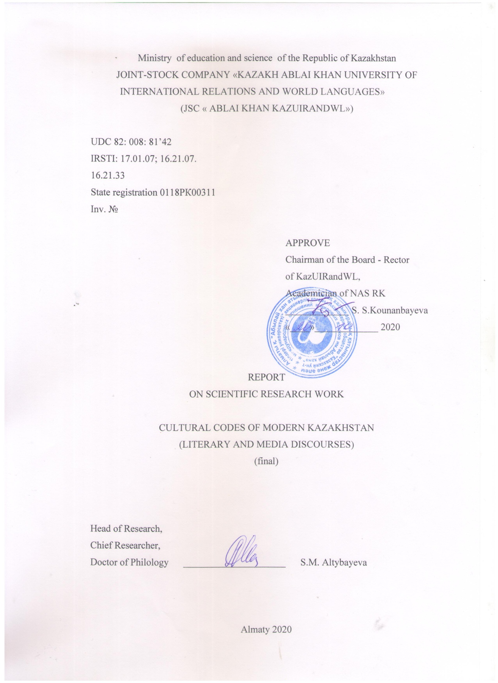

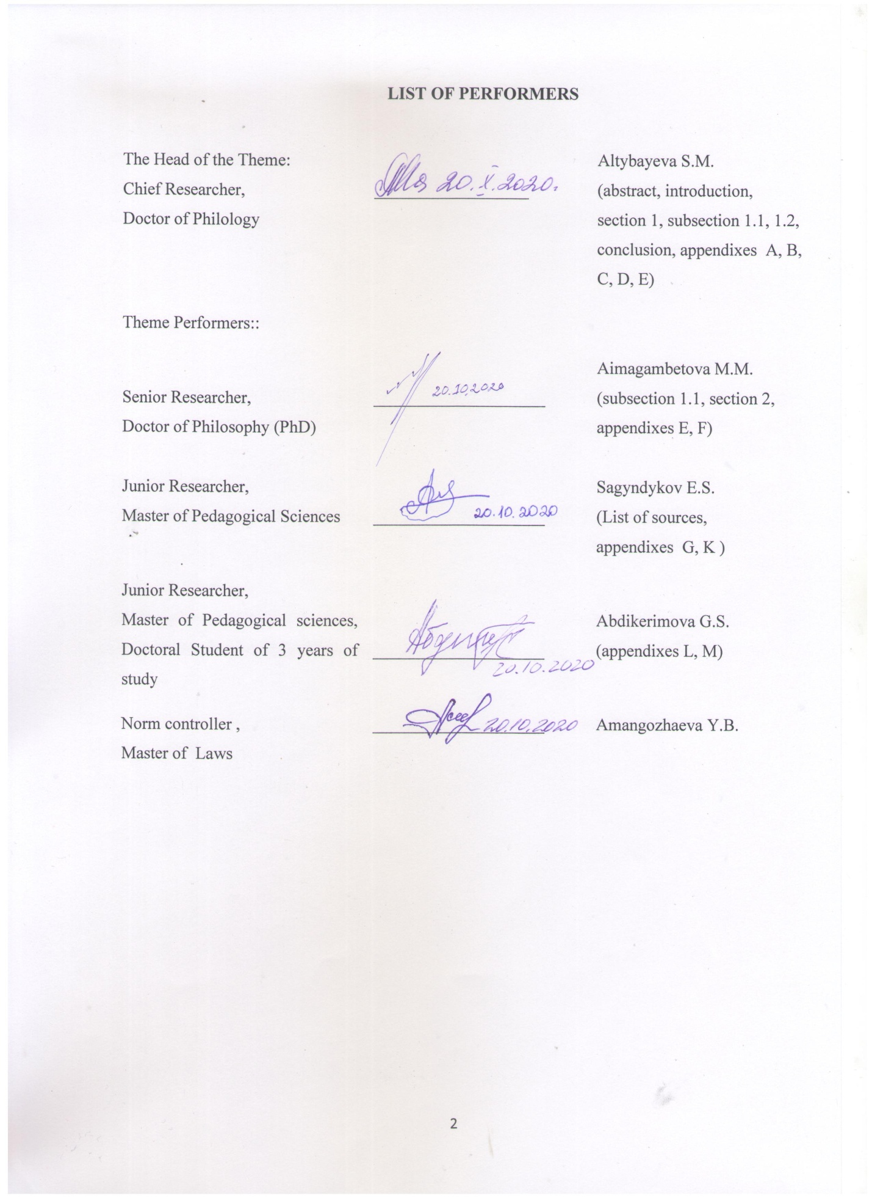

ABSTRACT
Report 112 p., 1 table, 45 sources, 8 appendixes.
CULTURAL CODE, LITERATURE, MEDIA DISCOURSE, CULTURAL CODE’S THEORY, CONCEPT, PHENOMENON, EPISTEM, ETHNOSTERIOTYPE, NARRATIVE, MYTH
Subject of research: literary and media discourses of modern Kazakhstan, in terms of content and functioning of various cultural codes (hereinafter referred to as CС). The aim of the research is a comprehensive interdisciplinary study of the invariant system of CС of the literary and media discourses of modern Kazakhstan.
Research methodology: comparative typological, descriptive, structural and semiotic methods, critical discourse analysis, myth poetic analysis, value analysis, philosophical and narratological analysis, etc. Empirical methods: free association experiment, questionnaire survey, observation, description, content analysis. Dominant scientific approaches: interdisciplinary, hermeneutic.
The following scientific results have been obtained during the research:
It is the first time when the research has defined and scientifically substantiated conceptual and categorical characteristics of CС in the context of literary and media discourses in Kazakhstan; the theory of the cultural code has been updated as the latest interdisciplinary paradigm of modern humanitarian knowledge; more than 30 new terms and concepts of the postulated TCC have been introduced in science; a typology of CC has been developed; the leading cognitive-aesthetic strategies of literature and mass media have been identified and characterized; the CCs that are most frequently used in literature and media discourse have been determined; the main functions of the CC have been defined in the text; the mental coordinates of CC have been identified and described; the informative and communicative nature of CC in media texts has been comprehensively studied. All results differ by exceptional novelty and scientific merit and they conform to the approved time-schedule and technical specifications.
Research results for 2018-2020 have been reflected in 67 works and these results have been used by IPhPR KN MES RK, National TV and Radio Company "Kazakhstan", “Ana tili”, “Jetisy” newspapers, Sevastopol and Pyatigorsk State Universities of the Russian Federation, etc., they have been tested at 17 republican and international conferences, including foreign conferences. Areas of use: the research results can be widely used in research and educational activities; they can be used by various mass media and for implementation of «Rukhani Zhangyru» State Program.

CONTENT
INTRODUCTION………………………………………………………………………………...6
MAIN PART………………………………………………………………………………………9
1 Ideosphere of the cultural code of Kazakhstan: conceptual foundations and modeling
structures…………………………………………………….......................................................9
  - The mental coordinates of the cultural code in the context of the narrative text…………….9
  - Cultural code’s cognitive thesaurus: communicative and epistemological aspects……….23
2 Informative and communicative nature of the cultural code in the media discourse (on
the example of the Kazakhstan press)………………………………………………………….30
CONCLUSION. …………………………………………………………………………………36
LIST OF USED SOURCES…. ………...…………………………………………………….…41
APPENDIX A - List of research object base sources………………...…………………..……...45
APPENDIX B - Graphic research material….…………………………......................................46
APPENDIX C - Concise cognitive thesaurus......………………………......................................52
APPENDIX D - Free associative experiment questionnaire...…………………………….…….58
APPENDIX E - List of published works (2018-2020)….…………….………………………...60
APPENDIX F - Copyright certificates..……….…………………………………………….......74
APPENDIX G - References on the use of scientific results…..…...…………………………….76
APPENDIX K - Calendar plans and technical specifications and for 2018-2020………...……..81

LIST OF ABBREVIATIONS AND SYMBOLS
In the research report, the following abbreviations and symbols are used
MC - | military code / military codes
HCC - | historical and cultural code
CC - | cultural code / cultural codes
CDA - | critical discourse analysis
FAE - | free associative experiment
ТCC - | theory of cultural code

INTRODUCTION
Relevance. One of the concepts mostly used in Kazakhstan’s modern socio-cultural sector and science industry is the concept of a cultural code. It attracts more and more attention of researchers of various specializations for its depth and interpretation variability. The information surplus on the problem of cultural code [1] creates a certain intellectual, reflexive tension in comprehending the essence of the phenomenon itself that lies in its verbal and non-verbal manifestation. In science, this leads to methodological inaccuracy, ambiguity of formulations and intentions. The attempt to clarify the semantics of the term – a cultural code also served as an additional incentive to develop this project and to fill the existing theoretical and terminological gap in the context of the mentioned paradigms of literature and mass media.
The polysemy of the term – a cultural code is evident in a text that has a significant referential and epistemological depth itself. Text as cultural code and a cultural code as text are two-mutually attractive ambivalent substitutions with significant phenomenological potential and research attractiveness. At the same time, comprehension of the modern text and literary text as a unique aesthetic and philosophical precedent became the starting point for a detailed and comprehensive study of the invariant system of cultural codes that underlie the conceptual sphere of a text.
There are numerous arts and crafts coexisting in modern literature, art, mass media of Kazakhstan, most of which are based on the so-called national cultural code and, in a broad sense, are understood as a cultural tradition. The preservation and development of national and cultural identity, rebroadcasting of important cultural artifacts in a text largely occurs due to inclusion and development of various cultural codes. At the same time, there is a kind of "cognitive turn" to the intensive reflection of ideas and concepts from foreign systems and breaking through the ethno-cultural isolation and reaching the deep universal philosophical and historical generalizations. The metamorphosis of the cultural code is deep-set as well as its transition from the status of an instrument for storing and transmitting cultural information to the status of a large-scale episteme, reflecting the polyvalence of the modern world, striving for something new but at the same time "tied up" to tradition.
The processes of aesthetic modeling, adopting qualitatively new aesthetics, are especially obvious in literature, cinema, painting and other types of art. In this sense, the developers sought to read Kazakh literature and media texts through the cultural codes immanently embedded in these texts, using the interdisciplinary mode of interpretation and analysis.
The aim of the research is the comprehensive analysis of the semantics, structure, functioning of the invariant system of cultural codes in the intermedia, namely, literature and mass media. The research base consisted of more than 25 works of fiction, over 20 printed publications and 6 news sites in Kazakhstan. This research covered several aspects: 1) in-depth systematic study of modern literature and mass media in the aspect of reflecting cultural codes; 2) development of semantics, typology, functionality, informative-communicative, phenomenological and referential nature of the cultural code in these discourses; 3) re-actualization of the theory of cultural code as an alternative, sufficiently promising interdisciplinary aspect, determination of its conceptual-categorical and terminological characteristics, methodological approaches, object-subject base, etc.; 4) definition and characterization of models and mechanisms of cultural codes in literature and mass media; 6) the establishment and characteristics of the leading cognitive-aesthetic strategies in these discourses, etc.
Research methodology: comparative typological, descriptive; structural methods, critical discourse analysis, mythopoetic, intertextual, narratological analysis, values analysis, philosophical and interpretation analysis, the method of contextual analysis, contrastive analysis of vocabulary. Empirical methods: quantitative (free association experiment) and qualitative (observation, description, content analysis); methods of sociolinguistics, ethnolinguistics, which also determines the interdisciplinary mode of research. In order to identify general trends and codes of the literary process, the specificity of theoretical and practical aspects of the functioning of media discourse through the prism of cultural codes, there are hermeneutic, phenomenological, epistemological approaches and other scientific approaches applied.
Novelty of results: It is the first time when the national science substantiates correlation between CC and national and foreign traditions in an interdisciplinary aspect, the idea of the theory of cultural code as a special interdisciplinary area of modern interdisciplinary research has been updated. Based on in-depth semiotic, comparative typological, sociolinguistic analysis and other types of analysis of literary and media texts of various genres, the research has revealed the essential conceptual and categorical characteristics of the cultural codes as a holistic aesthetic and informative construct of a significant textual formation. The typology of cultural codes of the mentioned discourses of Kazakhstan is specified and substantiated. The general functional connotations of cultural codes in texts are determined and characterized in terms of intertextual magnetism, sociolinguistics and other sciences as well.
A systematic study of the phenomenon of the cultural code in the literature of Kazakhstan has revealed a number of substantive and poetological features of narrative and mythopoetic modeling. In particular, the coding of significant cultural information through character concepts, world universals, ethno-stereotypes and other elements of poetics makes it possible to build multi-level associative-referential text structures.
Modeling a plot, character, narrative, myth-poetic system, a skillful combination of specific recognizable details (named by Roland Barthes as informants) and fiction, a fictitious scenario in literature generates natural, self-produced numerous intra- and extra-textual correlations of the cultural code as a timeless socio- and ethnical phenomenon.
The project's problematics include the myth poetic and mytho-critical ideospheres, into the orbits of which various complex multidimensional narratives are naturally drawn. The timeless attractiveness of myth, folklore as inexhaustible sources of imagery, cognition of the world and fictions modeling is pretty obvious in Kazakh literature. That entitles us to believe in the constant existential status of its “mythological code” (Yu.M. Lotman).
The study has been performed under Grant Financing Agreement No. 122 dated March 5, 2018 (Research 2018 - items 1-3), Supplementary Agreements No. 2 dated March 7, 2019 and No. 5 of May 4, 2020. In accordance with the Supplementary Agreement No. 2 dated March 7, 2019, changes were made to the Technical specification (results for 2019 - items 2.3 and 2.4) and Calendar work plan (items 4, 5, 6, 8, 9). In accordance with the Supplementary Agreement No. 5 dated May 4, 2020, changes have been made to the Technical specification (results for 2020 - item 2.3) and Calendar work plan (items 7, 8). The Item 9 was carried out in accordance with the Supplementary Agreement No. 2 dated March 7, 2019 (Appendix K).
Calendar plans for 2018 and 2019 years completed in full, interim reports were submitted on time. The list of prepared interim reports on the project topic: 1) interim report for 2018, inventory number 0218RK00920, report volume - 74 pages; 2) interim report for 2019, inventory number 0219RK00620, report volume - 72 pages.

MAIN PART
1 Ideosphere of the cultural code of Kazakhstan: conceptual bases and modeling structures
  - Mental coordinates of the cultural code in the context of the narrative text

The problem of the content and functioning of the CC, not always directly indicated, has become the subject of many philological, semiotic, cultural, philosophical, marketing and other research. These are the works of K.Levy-Strauss, R. Barthes, M.Foucault, C.Todorov, U.Eco, M. Eliade, T.A.van Dyck, A.Biard, S.Chatman, M.Bakhtin, Y.M.Lotman, A.F.Kofman, S.N.Zenkin, V.A.Maslova, N.D.Arutyunova, T.G.Gruschevitskaya, Y.S.Stepanov, E.O.Mendzheritskaya and others. Among the Kazakhstani studies, it is worth mentioning the fundamental works of H. Argynbaev, M.Mukanov, V.Vostrov, K.Baypakov, S.Akatayev, K.Nurlanova, A.Kodar, A. Dosymbaeva, M.Sultanova and others. Certain issues of cultural coding, the specifics of modern Kazakhstani literary and media practice are covered in the works of S.Kaskabasov, O. Suleimenov, B.Azibaeva, S.Kondybai, A.Zhaksylykov, A.Nauryzbaeva, E.Tursynov, B. Abylkassymov, B. Maitanov , U.Abisheva, A.Fazylzhanova, D.Baigozhina, G.Madieva, A. Khamidova, S.Barlybaeva, Zh.Abaeva, B.Raimbekova, A.Abulkasova and others.
In the socio-cultural space of Kazakhstan, there is an exceptional relevance of the study in various projections of the phenomenon of the cultural code. The idea of ​​reviving national culture and spirituality is at the heart of many large-scale projects. These are the so-called Memorable years: 1996 - Year of Patriotic History, 1997 - Year of National Accord and Memory of Victims of Political Repressions, 1998 - Year of Unity and Continuity of Generations, 2000 - Year of Support for Culture, 2004 - "Cultural Heritage" program and others. At present, the nationwide program "Rukhani Zhangyru" - "Spiritual Revival" is being implemented. The search and finding of stable coordinates for the development of sovereign Kazakhstan is unthinkable outside of an interdisciplinary study of the fundamental foundations of national mentality, culture, education, in other words, the cultural code as the leading episteme of the modern world.
Hence the need of defining of the “existential” status and ideosphere of the cultural code at the ontological and poetological levels. The ideosphere is understood as a system of mutually opposed mental constants and cultural artifacts that have unconditional value and are widely implemented by the spatio-temporal range of existence. They get particular meaning in the “secondary modeling” (Y.M.Lotman) structures (literature, cinema, mass media, painting, sculpture, architecture, etc.). The ideosphere of the cultural code includes such categories and concepts as a mental unit, universal, concept, stereotype, construct, episteme, etc. In concrete artistic practice, they are realized through mythologemes, folkloremes, ritualems, realemes, historiosophemes, philosophemes, and others.
Cultural codes are non-autonomous structures. They exist only in relationship with other components of the text, in a certain hierarchy, subordinate to the concept of the work or media messages, the author's attitude. The system of CC, which correspond to each other and transmit important information in the epistemological sense, is the framework of a particular culture. Indeed, the juxtaposition of the hermeneutic and semiotic understandings of “cultural relativity” [2] is the interconnection of all connotations of the cultural code as a volumetric dynamic mental constitution containing specified information about the culture of one or another ethnic group / group of ethnic groups / region. The analysis of the codes functioning in domestic literary and mass media texts shows the implementation of both aspects of "cultural relativism" (negative and positive), which are highlighted by S.N. Zenkin. In the media discourse, especially in the news segment, one can observe a manipulative transformation of the meanings of one or another traditional code, especially precedent names, plots.
It is connected with the general communicative attitude of the media discourse for attracting and retaining the attention of a potential recipient mainly through existing stereotypes, famous cultural precedents, for receiving an instant response to one or another current event, and ultimately forming a certain public opinion. In the media space, codes can acquire initially non-characteristic evaluative connotations (the neutral meaning turns into negative: aul → “escape from the aul”, baiga → “baiga for survival”, salam aleikum → “Salon aleikum, I will shoot”).
In literature, on the contrary, there is a deep immersion in the aesthetics of not only national but also foreign cultural traditions, the transition of codes of material culture into the category of philosophical universals. “From a semiotic-semantic point of view, a cultural code is an artistic reproduction of one or another cultural information about tradition, philosophy, worldview, world order in a specific text space. Like any linguistic sign, the code in the text has two inseparable sides - external and internal, signifier and signified. Hence - the implicit and explicit embeddedness of the cultural code in the story, plot, the manifestation of the reader’s (listener’s, viewer’s) many associative and semantic connections of the cultural code with other concepts, plots, ideas, images, motives” [3, p. 16].
Culture is always invariant, hence the invariance of its codes, directly or indirectly reflected in the text. The cultural code is a capacious mental structure of a wide format, capable of absorbing the signs of a conceptual metaphor [3], an object-material, material world with its inherent specific attributes and metaphysics of the unreal world. Although in a literary text, the code is most often implemented in its symbolic, conventionally metaphorical nature.
Cultural codes in the context of literature are organic, therefore they often perform not only and not so much an informative role as an artistic one, not a secondary one, but a main, dominant one. Revealing and interpreting cultural codes in a specific text means comprehending its aesthetic and philosophical nature.
It is important to keep in mind that culture is a priori a dialogue, the transmission of knowledge. Although there is a danger of “incompatibility of cultural codes. That is why in mass literature only the basic part of the body of precedent texts is often exploited, connected, first of all, with mass culture” [4]. Such provocative rhetoric is used in the media headlines: the precedent text "To be or not to be, that is the question" (W. Shakespeare, Hamlet) → "To be or not to be for sticker “Sh"? (Evening Astana, January 28, 2016), precedent text "For when we were with you, we bequeathed this to you: if anyone does not want to work, he will not eat" (2 Thess. 3:10) → "Who does not work, he eats!" ("Time", September 4, 2014) [5, p.304], the precedent text "Time to throw stones, and time to collect stones; a time to embrace, and a time to avoid embracing” (Eccl. 3: 1-8) → “Time to collect stones, or What has the Development Bank of Kazakhstan developed in Kazakhstan?” (September 15, 2009, Internet newspaper Zona.Kz), etc.
In the literature, precedent texts are presented, as a rule, in quotations (“Constellations of the twins” of Kh.Adibayev), or through a synthesis of both ways of cultural relativism: the transformation of the precedent (Judgment Day (Christ), Kiyamat (The Last Day (Islam) → “The Age of the Last Judgment. Book for those who doubts” by S. Ylubay) and citing the scriptures (ibid.), or through replacing the sacred meaning with the profane (Ragnarok (Old Scand.), Judgment Day (Christ.), Kiyamat (Islam.) → Russian provocation novel “My Ragnarok” by M. Fry). The above facts prove the great "script" and poetological plasticity of the code in the structure of the literary text.
It should also be noted the intertextual attraction of traditional idioms from different cultures (Kazakh, Russian, European) into the space of the media text.Itstructures its special, often overloaded with details, narrative, emotive frame.In literary discourse, precedent texts are implemented through quotation and subsequent author's decoding of the "message". In contrast to the multipolar media discourse with ambiguous communicative-value, blurred ethical attitudes, in which a manipulative and provocative component often prevails, the Kazakhstani literature is a mature aesthetic phenomenon with a strong traditional lyric-epic charge, intertextual conjugation with foreign cultural complexes. This quality is clearly manifested in the book “The Age of the Last Judgment” by S. Elubai, which is replete with references to various sacronims of world religions and demonstrates the way out to broad philosophical generalizations (the author's metaphor of the “Age of the Last Judgment”).
Through cultural codes, it is possible to "count" the civilizational characteristics of a one or another ethnic group, its history, psychometry, economics, traditions, customs, mental attitudes. Similar processes of modeling textual units at the aesthetic-philosophical level, which A.F. Kofman points out The myth poetic paradigm of Kazakhstani literature is distinguished by a combination of stable ethno-labeled conventional-metaphorical units (Turkic mythologemes, especially mythozoonims, folkloremes, ritualems) and world images (centaur, the Tower of Babel, Cyrus, Belshazzar feast, ancient Egyptian gods, ancient Iranian, ancient Indian deities).
Typology of cultural codes of Kazakhstani literature and mass media.
A panoramic study of the modern literary discourse and media discourse of Kazakhstan (the object base consisted of over 25 works; years of publication are 1993-2014; more then 20 media sources) (Appendix A) shows the active functioning of various cultural codes in it. The contextually designated codes acquire special significance when considering the genre-style and narrative specifics of a literary text.
Within the frame work of the project, several variants of the typology of codes were identified and substantiated, depending on the aesthetic and methodological projection of their consideration (Appendix B). Persistent searches for new meaningful forms, the desire to preserve the national code and at the same time over come ethnic isolation lead the authors to create "hybrid" works, metatext structures: novel-myth, novel-tolgau, novel-revelation, novel-ballad, novel of intentions and others.
Figure B.1 - Typology of cultural codes of the literature of Kazakhstan (Appendix B) presents the most frequent codes with marking of the dominant content component (mythologemes, ritualems, folkloremes, historiosophemes and others). For example, folkloremes is folklore units, transformed depending on the main idea of ​​the text, but retaining their original nuclear meaning. Mythologemes are mythological images fixed in the national or world tradition, plots marked with a timeless universal meaning. In modern non-linear novel narration, the rethought of classical myth or folklore image often becomes the conceptual basis of the entire text, the leitmotif of the plot.
Discussing the typology of the CC of modern literature of Kazakhstan in a broader sense, we can group them in a conditionally schematic way (Figure B.2; Appendix B): historical and ethno-cultural codes, religious and cultural, regional, non-national and world CC, etc. Specified code groups interact with each other. The variability of the CC is high, which stems from their very communicative and corresponding nature. Of course, the typology of codes is not limited to these large connections.
An important quality of CC is also its great ability in building the background discourse of the work, its deep associative-mental determinants. The language of traditional and authorial symbols, dating back to national and world archetypal foundations, binary oppositions with a timeless philosophical and aesthetic value, allows writers to expand the conceptual and worldview range of works, enrich their stylistics and imagery. Extraordinary prose of such Kazakh authors as Askar Egeubay, Smagul Elubay, Mukhtar Magauin, Aslan Zhaksylykov, Khasen Adibayev, Askar Altai, Rollan Seisenbayev, Bakhytzhan Kanapyanov, Dyusenbek Nakipov, Didar Amantai, Aigul Kemelbayeva, Abai Tynibekov and others from the multitude of mutually intersecting "chiaroscuro" included in the world and national cultural tradition.

When reconstructing the levels of CC identification in media discourse, the action of the mechanisms of integration and differentiation in Kazakhstani society is taken into account. T.G. Dobrosklonskaya defines "media discourse» as a functionally conditioned type of mass communication, where the media text structures the movement of the media stream" [7]. Consideration of “media discourse” as a complex of speech practices aimed at the recipient of feedback according to culture-based coding methods reflects, to a certain extent, the socio-historical and ideological context in the conditions of the movement of the media flow and the information society (compare: S.I.Bernstein, A.N.Vasilieva, T.G.Dobrosklonskaya, V.G. Kostomarov, B.V. Krivenko, I.P.Lysakova, G.Ya.Solganik, S.I.Treskova and others).
The aggregated features of the CC of the media discourse in Kazakhstan are hierarchy and economy. Hierarchy demonstrates orderliness, determines superiority and subordination, and economy corresponds to the information content, brevity and concentration of the statement. Saving text is dictated by the concise, especially in electronic, media format, focusing on the simultaneous reflection of many "burning" topics in one issue. Hence - the informative and cognitive capacity of the media text.
It should be noted in the media discourse the excessive potential of manipulative influence on the audience to achieve a perlocutionary effect against the background of the open detection of special speech structures. For these purposes, the media discourse of Kazakhstan uses methods of direct and indirect manipulation of information (compare: selection, distortion), rhetorical tools (compare: psychological tricks, figures of speech with cognitive operations, macrostructure) and methods of influencing language means.
Figure B.3 (Appendix B) reflects some of the most frequent codes of media discourse, based on the content analysis of a number of domestic print and electronic media (ideologemes, philosophies, realemes, historiosophemes, color codes, etc.). In the conditional ranking of the CC of this discourse, it is possible to note the relevance of ideologemes, reflecting the general mode of the prevalence of the ideological component in the media, especially reflecting the official point of view.
A comparative typological analysis of a number of ideologemes of literary and media discourses shows a significant semiotic discrepancy between the codes in the designation of one or another concept. The mass media is dominated by contemporary topical ideologemes – responses to one or an other official message. For example, ideologemes as president, power, Ak-Orda, Parliament, Senate, prime minister, Rukhani Zhagyru and others act as multipleinter connected simulacrare flecting a specific political and legal meaning dominating in the mass consciousness. Modern ideologemes in the mass media are connoted by excessive frequency, pronounced positive or negative rhetoric.
While in the literary text the frequency ideologemes as power, khan, khan'shead quarters, council of elders, biys, batyrs and others reflect the historical and ethnocultural component of the original philosophical power as justice, power as law and responsibility. Such a philosophical and ontological understanding of the ideologeme “power” is clearly manifested in the historical novels "Daraboz" by K.Zhumadilov, "Saki" by B.Zhandarbekov, "Death of Otrar" by Kh. Adibayev, "Aқ boz Uy" by S.Elubai, "Zhusip Balasagun" by A.Egeubai , "Caravan" Tynibekovs and others.
Cultural codes of color designations differ from each other in different languages, despite the fact that color is one of the ways of fixing and expressing in the language non-discursive knowledge based on perceptual experience. There are a number of universal features in the color designation system, since they accumulate socio-historical, intellectual, emotional information of a nationally specific nature. For example, color lexeme “white” in modern language retains the traditional symbolic meaning – purity, innocence, honesty. It is used in such new combinations as the white press, white PR, white accounting, white salary, white income: "She emphasized that an important condition for all categories will be the presence of "white" income" (Express K from March 19, 2019), where white income is the official income from wages, which is reflected in taxes and pension contributions of citizens. “In each Address to the people of the country, Elbasy noted the important role of people in white coats, provided doctors with all-round support” (“Caravan” dated March 23, 2019).
On the other hand, “black” is traditionally associated with negative emotions or low moral assessment: a black person, black thoughts, black deeds, black envy. As a rule, the use of the adjective “black” is associated with a negative characterization of something dishonest in modern newspaper texts: “The persons involved in the EU “black list” did not plan to fly to Europe” (Panorama, December 19, 2014). The adjective black is quite popular when characterizing illegal money: black currency, black money: Black cash instead of taxes ("Letter" dated February 27, 2019), i.e. illegal, hidden money. The phraseological unit “black gold” is often found in Kazakhstani media texts, it means oil: “... the company's employees have long known the price of “black gold” and how important it is for our country and people” (“Letter” dated May 5, 2018), which in this case carries a positive connotation.
Color designations reflect cultural and national stereotypes of linguistic communities, are an indicator of changes in the mass consciousness. At the same time, they represent extremely economical, capacious, conveniently arranged methods of storing and transmitting information in the media space. Color symbolism is an important component of the modern polycode media discourse in Kazakhstan. They contain the subtlest axiological, semantic nuances that express the attitude of native speakers to their past and present.
Mythic and folklore modeling and ethnocultural context.
The narrative resources of myth and folklore, possessing the colossal energy of creating timeless universal meanings, become for artistic creativity a source for the formation of complex narrative structures, ambiguous interspecific discourses. Mythopoetic modeling in the aspect of considering the possibilities of myth as a volumetric CC is becoming one of the most productive experimental platforms in the literature of Kazakhstan. The mythopoetic model may include the following components. Myth, folklore, and other conventional metaphorical forms are deeply based on signs; at the structural and compositional level, there are plot configurations, an alinear narrative, a system of historical and ethnocultural codes, including realems, rituals, zoocodes, historiosophems and others.
Mythic and folklore installations often play the role of an extensive compositional device in the creation of a multifaceted ethno-labeled narrative with a simultaneous emergence of universal meanings. At the same time, they are understood as a set of mythologemes, folklore and other conventional metaphor, included in the text space. The designated installations are distinguished by their spatial and temporal capacity, the ability for significant semantic and semiotic transformation.
The polysemantic content of traditional folklore and especially myths objectively re-actualizesthe issues of artistic coding of many objects of the surrounding nature, material and non-material archaic and modern culture, everyday life, and beliefs. The contextual and genre specifications of folklore and mythological sources determine the character and development of the plot, figurative, motive structure, and the narrative model of the work. For example, voluminous Kazakh dastans, epic legends, fairy tales, animal tales about animals are narratively capacious, extended in artistic time and space. The inclusion of explicit references to such specific narratives, hidden allusions, reminiscences to the mythological and folklore resource in the literary text makes it possible to expand the referential, epistemological, axiological status of the narrated events, images, motives. The aesthetics of myth and folklore also combines various examples of the well-known "wandering" plots, which is associated with archaic consciousness, its non-discreteness, volume, and the fundamental absence of logical contradictions.
Because of the comparative typological, contextual, value and content-analysis, the types of some frequent mythonyms of modern literature have been identified and characterized: mythozoonyms, mythoanthroponyms, mythological personal names, mythological names, demononyms, mythofloremes (Figure B.4 - Typology of mythonyms of modern Kazakhstani literature; Appendix B). Mythozoonyms are the most ethnically marked among them, which is explained by the aesthetic and genetic ties of Kazakh literature with the developed mythological and folklore totemic tradition. At the same time, the developers proceeded from the position that it is the precedent names that basically carry a significant informative, communicative, emotive message in revealing the philosophy of the text, its conceptual core. An important result of research work on the problem of semiotic correlation between myth and CC is the developed structural model of mythopoetic analysis of the text (Figure B.5; Appendix B).
The novel-myth “Altai ballads” [8] by A. Altai can be cited as an interesting experience of mythopoetic modeling. The semantic and structural field of the novel-myth is largely built through the system of universal binary oppositions: birth - death, woman - man, love - hate, man - beast, winter - summer, rich - poor and others. All three main characters in this or that situation are simultaneously included in several oppositions, which is determined by the synthesis in this work of several cultural and mythological codes: totemism, Tengrianism, Turkism and Islam.
Historical and cultural codes as a phenomenon of artistic and historical consciousness. The phenomenological nature of the code is manifested in its "natural program" to create allusive, referential, associative and other connections in the consciousness of the perceiving subject. Historical and cultural codes (HCC) in a literary text, in their phenomenological, communicative and dialogical nature, are close to philosophical and literary concepts and universals. The functional purpose and semantics of the HCC are determined by the author's concept of modeling artistic time and space, the system of images, the genre and style specifics of the text, the author's ideological and aesthetic attitudes. The phenomenological aspect of such modeling and the technique of coding significant historical and cultural information is explained by the presence of implicit and explicit informants of the text, which is determined by the certain preoccupation "script" of the narrative.
According to the results of the conducted content analysis, HCCs make up, on average, at least 35% of the total text volume, including descriptive descriptions, reminiscences, allusions, the actual events with which this or that code is directly or indirectly connected. Historical and archaic realities, events, customs, traditions, customs, mythologemes (myths), universals, concepts, stereotypes, legends, parables and other idiomatic polysemantic expressions can act as HCCs in a literary text.
Identified frequency ethnocultural codes of Kazakh literature (Zher-ana, Kok-Tengri, Umai, Samruk, bi, khan, taksyr, batyr, kaharman, batyr, akyn, bird of happiness, azhe, ata-ana, sal-seri, tamga, aul, ulus, horde, zhuz, ru, mushel, taikazan, yurt, astau, beit (grave), etc.), reflecting the traditional way of life and mental representations, build the reader's appropriate associations with other similar narratives. Such connections of personymes are clearly manifested - famous historical personalities (Tomiris, Genghis Khan, Abylai Khan, Abilmambet, Az Tauke Khan, Tole bi, Kazybek bi, Kabanbai batyr, Zhusip bilge, Kenesary khan and others). The transition of the verbal code to the visual one and vice versa is recorded, while the verbal code “provides the solution to the problems of abstract symbolism that unfold in time” (by A. Paivio).
Codes such as personymes, possessing a well-known informative and cognitive capacity, simultaneously activate the reader's historical, logical and imaginative thinking. Personymes, heterotopic details are also text markers. The name of Abylai Khan, who united the scattered Kazakh clans and tribes into a single Kazakh Khanate, is significant for every Kazakh. It is provided a primary description of this image in the novel “Kabanbai Batyr” [9, c. 28-29] by Kabdesh Zhumadilov.
Despite significant differences in style, the choice of the topic itself (various fragments of the ancient, early medieval, recent history of the Steppe) unites Kazakhstani authors by the desire for a philosophical understanding of the thousand-year national history, its landmark events. The history of the people is directly related to the issues of the formation of statehood and ethnic identity. For example, in the novels “Saki’, ‘Kabanbai batyr’, ‘Caravan’ problems of historical continuity are developed, the issues of the formation of Kazakh statehood, the specifics of national mentality, culture and spirituality are also investigated.
All these signs are, of course, present in the books under consideration. Significant personalities who have entered the arsenal of Russian and world historiography, and in literature have acquired the status of a concept as a “semantic structure embodied in stable images” [10, p.19], center the narrative, saturating it with poly semantic allusions, reminiscences and metaphor at the same time. But no less important for the development of the plot, figurative and narrative structure are also those that do not have an emblematic status, special cases of complementary (additional) cultural codes. In Kazakh historical prose, the dominant tendency is to bring famous figures of the past to the narrative center. Based on the analysis of many historical works, it is proposed to classify persons as significant historical and cultural codes in three rows of artistic images (first, second and third rows) (Table B.1; Appendix B).
Personymes (Table B.1 - Typology of personymes in the literary discourse of Kazakhstan; Appendix B). By personims (from the English personal - personal; Greek ὄνυμα - name, title) we mean personalities who perform the functions of CC as a “key” to the concept sphere, the main idea and pathos of the work. They are iconic figures in national and world history; fictional images of the power and military hierarchy (first row), sacred and quasi-sacred images (second row), diplomats, merchants, caravanbashi, guards, spies and other characters whose "presence" in the text is limited to one or two narrative situations (third row). The personalities of the marked three series within art text, performing their functions (basic and optional), remain interconnected with each other not only by direct, linear communication (direct link), but also indirectly (indirect link), through various narrative situations, other characters, time and space.
The formation of such a meta-narrative level of the text through the inclusion of diary and other entries, biographical data, letters, as well as conventional metaphorical means (parables, legends, tales, etc.) is also a distinctive property of coding information at the level of the structure and concept sphere of the work. There is a clear communicative-referential correlation between events "as they are", in a specific place and time, and their possible consequences in the future, the possible causes of their occurrence from the point of view of the narrator / narrators. The emotive, evaluative component with such a narrative strategy is manifested in the appearance in the recipient of many associations that “activate similar traces of memory”.
The encoding of a personality characteristic in a literary text of one or another personyme known in Russian historiography, as a rule, of the first and second rows, takes place in several projections: 1) reproduction of the historical situation, setting, event, specific topos in which the given personyme (or personymes) acts; 2) constancy in text time and space; 3) the primary presentation of the character acting as a cultural code. The last projection carries the functional load of immersing the reader in the atmosphere of the history of the people. Here, every detail of the narrative and description forms a corresponding narrative relief or leads to a complete / partial destruction of the aesthetics of historical reference. In this aspect, personymes can symbolically reflect the dominant archetype of the described ethno culture and era. Analysis of text fragments, which presents the initial descriptions (presentations) of famous historical personalities, reflect not only ethnographic details, but reveal the inner world of one or another iconic image of national history.
The focus of the content analysis of personymes includes such books as "Kabanbai batyr" by K.Zhumadilov, "Ayaz bi" Zh.Shashtay uly, "The Age of the Last Judgment" S.Ylubay, "Saki" by B.Zhandarbekov, "Zhusup Balasagun" A.Egeubay, "The Death of Otrar" by Kh.Adibayev, "Caravan" A., A.Tynibekovs, "Giants" A.Tynibekov and others (Appendix A). It was found that the most common cultural codes in the historical prose of Kazakhstan are personas of national and foreign nationality, a conclusion is made about their approximate ratio of 2:1. In the working list of the catalog of cultural codes, in terms of the use and coverage of the text space, the leading place is occupied by personymes (36% of the entire corpus of the HCC). These are constructs that perform a clearly defined narrative function of creating the main intrigue, plot outline, additional background (associative, synesthetic, cognitive, and other) discourses.
It is important to consider the semiotic nature of the code, as pointed out by Seymour Chatman in Story and Discourse: “The latter (discourse) is clearly the substance of narrative expression, even where the manifestation is independently a semiotic code. But commonly codes serve other codes» [11, p.24]. This thesis can be clearly traced in the analysis of military codes in historical prose, adjacent to a large group of historical and cultural codes.
Military codes in the artistic reception. The military code is a historical and cultural construct that most fully reflects the specifics of the described historical epoch from the point of view of the prevailing military ideology. These are codes of a secondary semiotic nature, their historical and cultural information content is extremely high. The informative and communicative nature of the military code as a phenomenon of artistic and social consciousness presupposes the design of broad associative fields. It is the military, and possibly also religious, code that is currently among the most frequent in the mass media, literature, and art of Kazakhstan.
In the historical and cultural aspect, the military code serves to reveal and comprehend a more significant cultural code that is extended in time, namely, the nomadic cultural code. Based on the idea of ​​S. Chatman, military codes serve to reveal the nomadic code. In other words, built-in and working in the structure of the text, they primarily perform an informative, communicative and axiological function. These codes vividly reflect the hierarchy of meanings inherent in KK, the specifics of the described historical era, the distant time of the creation and development of powerful superpowers, military-nomadic societies. These are large associations of the Saka tribes under the leadership of Queen Tomiris (original Tumar; in “Saki” B. Zhandarbekov), the union of the Huns (“Dassaria” A.Tynibekov), the Mauryan powers, Qin, Xiongnu (“Caravan”), the Mongol Empire (“Death of Otrar. “Last years of Genghis Khan”) and etc.
Military codes are a stable textual construct that contains the most significant concepts that reflect the specifics of military strategy, tactics, psychology, and values. The objects of comparative analysis were historical novels created at different times, which are united by a common theme - a reflection of the ancient (VI century BC) and early medieval (10-13 centuries) proto-Turkic epochal history. This is the dilogy “Saki” (1993) by Bulat Zhandarbekov, the novel “The Death of Otrar. The last years of Genghis Khan” (1997) by Khasen Adibayev, “Zhusip Balasagun” (2005) by Askar Egeubai, the trilogy “Giants” (2008) by Abai Tynibekov, “Caravan” (2014) by Abay and Auez Tynibekov and others.
In the MC system, central and peripheral constructs are differentiated. The central codes include realemes - the names of various types of weapons, military units, the structure of the armed forces, a description of the tactics and strategy of warfare, military command, the hierarchy of the army structure, etc. These codes generally reflect the specifics of the world order of the ancient and early medieval nomadic clan-tribal society. An important place in the worldview and world-building of the nomads was occupied by the preparation and conduct of local battles and major military operations. In these books, the idea of ​​a monolithic people is clearly traced - a warrior who, in the shortest possible time, is able not only to withdraw from the spot, but also to move on to active offensive actions. The synthesis of the concepts of people and warrior reflects archetypal idea about the indiscreteness of the nomadic worldview, where the endless steppe is the mother of a nomad, and the sky (Kok-Tengri) is the dome of his world.
The aggregated military cultural code in these historical works is reflected in the following constructs: philosophemes, historiosophemes, historical ethnonyms and toponyms, realities, mythologemes, ritualems. The conditional differentiation of these and other military codes includes two large subgroups: I. abstract, philosophical semantics, symbolic and metaphorical military codes of an implicit property; II. specific military codes (realemes) reflecting subject-specific connotations of military operations, time, place, many descriptions of weapons, uniforms and others (Table B.2 - Typology of military codes in Kazakh historical novels; Appendix B). In historical works, it is precisely the military codes in all their textual volume that contribute to the creation of documentary and or quasi-documentary, quasi-mythological narratives, mostly all of them in the synthesis of a single artistic text.
One of the important directions of research work was the study of the problem of the deep correlation of mentality as a “historical a priori” (O.V. Kolesova) and the cultural code as a cognitive a priori. The modern global world with its characteristic polarity, drama, instability, often a clash of various ideas and concepts about the present, past and future is objectively reflected in fiction and art. In this connection, the issues of cultural coding / decoding associated with inheritance, tradition, mythopoetic modeling, exclusive philosophical rhetoric (for example, the “Age of the Last Judgment. Book for Doubters” by S.Elubay) are re-actualized. This tendency ultimately leads to the creation of a qualitatively new aesthetic precedent: text-codes in which "philosophy is aestheticized, and literature is saturated with conceptualism" [12, с.31].
The striving for the depth of generalizations, the search for voluminous universal means and techniques in the artistic development of a plot, image, character, motive, time, space, naturally leads artists to the idea of ​​coding, “conceptualizing data”, capable of establishing “a connection between specific fragments of text (units of analysis) and more abstract categories” [13]. Actualization and "conceptualization of data", which is the subject of the general theory of coding [ibid.], for literary and other types of humanitarian discourse becomes a key, supporting mental platform for finding original tools and techniques. This is due to the nature of artistic consciousness as a special form of understanding the surrounding reality, the close relationship between man, society, various transcendental and precedent cases.
A comprehensive study of the phenomenon of the cultural code in modern Kazakhstani literature reveals several levels of its artistic articulation, transmission, perception and reproduction, as well as the corresponding interdisciplinary scientific reflection. They can be conventionally designated as mental, functional, narrative levels. The first level should be called the reflection of a certain mentality, contained in one or another code of material and non-material culture, indirectly reflected in a literary work. This level can be graphically designated the cultural code ↔ “mental constants”, which are understood as literary universals, concepts, stereotypes in meanings given by N.V.Volodina, A.F.Kofman [10; 6]. The mentality is understood as designated by O.V.Kolesova “historical a priori, setting the relationship between the natural and cultural in man” [14, p.25]. Considering the focus of the code on deep knowledge of the world, a person, and their possible correlations, we add that mentality is also a priori cognitive. In artistic practice, mentality is manifested through the inclusion in the text of various conventional-metaphorical means, “literary universals, concepts and stereotypes” [10]. N.V.Volodina notes that “interest in such phenomena“, the search for certain mental constants ”is actualized at the turning points in history” [10, p. 3-4]. This is the period that modern Kazakhstan is going through, and this additionally actualizes the study of the mental coordinates of the СC. The specificity of the perception of the surrounding world, awareness of the non-discrete nature of the micro- and macrocosm underlies such basic codes of literature as mythologemes, folkloremes, rituals, zoomorphic constructs associated with them. For example, In the story “Centaur” [15] by A. Altai, the genre nature of which can be defined as a parabolic story, we see a model for constructing a secondary cultural code through mythological analogy, where «modern heroes and their fates are projected onto mythological prototypes» [16]. The structure of the narrative as a whole reflects the original mythological image and literary archetype (“Centaur” by J. Updike), but at the same time, noticeable and significant details of the extra-textual ethnically, socially and historically marked reality of Kazakhstan at the end of the Soviet period are introduced.
The next level of CC articulation in the text is actually functional. The specificity of the functioning of a particular code is associated with the target setting that it fulfills in the text. CC in a literary text is also considered by us as a holistic aesthetic-informative construct, a textual formation that performs several interconnected, equal functions (in fact, artistic, informative, ontological, hermeneutic, cognitive, cumulative, etc.). This classification includes the general functional connotations of CC in the text (Figure B.6 – СC functions in art text; Appendix B).
Modeling a plot, character, narrative system, a skillful combination of specific recognizable details, which were called by Roland Barthes as “informants” [17], and fiction, a fictitious scenario, generate natural, numerous self-produced intra- and extra-textual correlations. They reflect the specificity of the text as a timeless phenomenon. The third level of code articulation is the modeling principle associated with the previous one. This is the ability of the code to produce and translate the configurations of various discourses (myth poetic, ethno-stereotypic, multicultural and other types of modeling). In the literary text, there is a kind of coding of ethnic, historical, cultural, philosophical, world outlook, economic-legal and other information. In this aspect, mythological constructs are of particular importance. They reveal the deepest archetypes of consciousness, their conjugation with the specific existence of one or another ethnic group(s) in a given time period and space. So, in the novel-dilogy "Saki" [18] by Bulat Zhandarbekov, about 100 characters of different ethno-orientations (Saks, Persians, Babylonians, Egyptians, Greeks, Assyrians, Medes, Jews) are actively involved. Each character is fully outlined, functionally built into the personosphere of the novel, taking a certain place in the development of events. In the background, numerous ancientIranian, Babylonian, Assyrian, ancient Egyptian gods, demons are represented: Ahuramazda, Angra-Manyu, Ahriman, Bel-Marduk (Jupiter), Bahman, Zabab, Ishtar (Venus), Amon-Ra, the Delphic Oracle and others.
They are also adjoined by mythological universals (for example, the transformed archetype of the sun in the novel-essay "Zhusip Balasagun" [19] by A. Yegeubai), "character concept" and literary stereotype. These are significant categories of the poetics of the text. For example, mythical personalities stand apart in the Saki dilogy, having acquired the status of “character concepts” [10, p. 20-21]: proto-Turkic personalities (Ishpakai, Madiy, Partatua, Tomiris, Spargapis, etc.) and personalities of the ancient East (Kir, Nebuchadnezzar, Belshazzar, Homer, Croesus, Pharaoh Psampetychus and many others). These are acting characters, each of which is assigned a certain text space. Each character structures a special “extra-textual realitydirectly or indirectly related to others”, similar in nature to that created by a historian, about which Y.M.Lotman wrote [12]. Each personality produces an associative field reflected in well-known idioms, conceptual metaphors, and comparisons. For example, the novel introduces the plot of the death of Babylon, with a detailed description of the noisy feast of the last king, Belshazzar, on the eve of his death (decoding of the famous idiom “Belshazzar feast”). Such a number of foreign national sacronyms (sacred names) and mythologemes, which carry a significant cultural-informative, epistemological, emotive function in the disclosure of an artistic concept, increase the mythic capacity of the text. The cognitive capacity of a literary text is understood as an aggregated summary characteristic of all functioning mental units: mythologemes, including author’s mythologemes, folkloremes, literary universals, concepts, stereotypes, parables, legends and other conventional metaphors. Literature with the so-called new mythological dominant is characterized by increased myth capacity. This contributes to the creation of a panoramic picture of the ancient world, the impression of the aesthetic and historiographic reliability of the described events.

  - Cultural code’s cognitive thesaurus: communicative and epistemological aspects

The active processes of multilevel modeling, the functioning of CC in the literature and mass media of modern Kazakhstan show the presence and dynamics of a number of certain cognitive-communicative strategies that require a comprehensive study of the very nature of CC as cognitive phenomena. A multifaceted study of the phenomenon of the CC as a priori and a posteriori aesthetic, the accumulation and analysis of significant factual and experimental material logically led us to the idea of ​​postulating some of its theoretical determinants in the predominant contexts of literature and media discourse. With great tension, the knowledge set of methodological, terminological and other systemic features related to the studied episteme will be called the theory of the cultural code (TCС). Such approach actualizes the definition of its object-subject base, methodological basis, problem field, description of the discovered aesthetic and media phenomena, terminological tools and other parameters. The formation of the TCC’s cognitive thesaurus is distinguished by its multipolar semantic and communicative capacity, and a significant heuristic charge. The novelty of this research, among other aspects, is the author's intention of reading and comprehending literary and media texts through the establishment, decoding of CC, description of their semantics and functions, various interspecies linkages. This study focuses on the idea of ​​close interconnection of a number of proposed terms and theoretical positions with philosophy, semiotics, literary theory, narratology, mythpoetics, cultural linguistics, sociolinguistics and other branches of humanitarian knowledge. In a broad sense, the actualization of the problem posed is associated with the knowledge approach, "the mechanism of knowledge production, its distribution and utilization" [20]. Hereinafter the episteme “CC” (in the volumetric understanding of the episteme as a dynamic cognition by M. Foucault [21]) is considered in the typological aspect, on the basis of the identified cognitive-communicative strategies, mainly of the literary discourse of Kazakhstan. The leading cognitive-communicative strategies of Kazakhstani literature. The terminological field of TCC. The CC is characterized by specific conditions for the creation and re-creation, functioning, preservation and transmission of significant information about various aspects of culture, history, the current state of society, state, and civilization. Its specific semantic and stylistic content, referential orientation within the artistic and media texts varies in close connection with its general concept and philosophy, extra text environment. This thesis explains the significant epistemological and phenomenological status inherent in the code, the peculiarities of the formation of its semantics and structure in specific texts. By maximally aggregating the content of the cultural code as a specific semiotic unit of the text, one can speak of its poly semantic and poly stylistic functional orientation. As a result of the research carried out, several variations of the term cultural code were proposed and substantiated (Appendix C). In particular, as a phenomenon of historical, national consciousness, CC in artistic discourse is predominantly of a cognitive-phenomenological and referential nature. This definition emphasizes the cognitive aspect of the term. As the argumentation of the thesis, one can cite an example of personims, mythologemes that accumulate a significant epistemological charge both in semantics and in the structure of an artistic image, plot, and narration. The referential direction of the code varies in close connection with the general concept and philosophy of the work, the extra text environment. Proposed TCC being developed by us objectifies the definition and its specific terminological basis. The presence and active functioning of many cultural codes in literary discourse actualizes the formulation of the problem of the formation of a cognitive thesaurus and the methodology of this theory. Among many (aesthetic, informative, cumulative, axiological, modeling) functions of the code, its communicative function occupies a special place, which is associated with its central goal-setting: cognition of the world through significant artifacts and cognitions embedded in the text, and their subsequent retranslation outside, into the world outside of literature. In other words, the cognitive function of the code is reflected in active cognitive (and discriminatory, decoding) activity, subsequent direct or indirect (allusive, referential, reminiscent) transmission of specific, value-marked information, establishing a timeless dialogical bridge between various aesthetic, worldview, and cultural systems.A significant artifact in the ethnocultural space of the text becomes a cognitive code, a kind of semantic bridge connecting the past, present and future. It is this cognitive capacity of the cultural code that allows artists to build the so-called “texts-codes”, where every significant element of the poetics of the text can always be read as its cognitive code. For example, a lot of mythical-folklore, ethnocultural, universal units included in the text simultaneously constitute its formal texture and “narrative framework” [22]. Under the cognitive-communicative strategy in the context of literature, we mean the most objectified way of artistic knowledge of the world, the creation of a dialogical space between texts, scientific and other discourses, the reader as the final "instance" of the message. To determine a particular strategy, it is necessary to determine its several parameters: content, functional orientation, nature and frequency of iteration of certain modes of cognition (“semantic modes” [23], or epistemes). It is important to investigate their extent in time, aesthetic and referential correlation with the previous tradition. Cognitively voluminous narrative strategies are currently being demonstrated by many Kazakh authors: B.Zhandarbekov (“Saki”), S.Elubay (“Aқ boz ui”), Elubay (“Age of the Last Judgment”), Z.Shashtayuly (“Ayaz bi”), H.Adibayev (“Death of Otrar”), A.Altai (“Altai ballads”; “Centaur”), A.Egeubay (“Zhusip Balasagun”), R.Seisenbayev (“Throne of Satan”), A.Tynibekov (“Giants”), Tynibekovs (“Karavan”), I.Odegov (“Purusha”) and others. Communicative models of the CC. The code has an ambivalent nature in a literary work: semantic and functional content. In the aspect of referentiality and functionality, CC is understood by us as a specific mechanism (tool) for storing and successively transmitting important information about the history, philosophy, spiritual and material culture of a human (individual), ethnos, a group of ethnic groups of a particular region, a particular civilization, all mankind, the Universe (Universum). The relationship between the selected components (informants) can be graphically depicted in two communication models - vertical and cyclical (Figures 6, 7; Appendix B). It is highlighted a specific gradation of informants in the vertical model, and is reflected a clear connection between the components. In this case, the primary informant is a human being and the final component of the presented vertical model is the Universe, which are clearly correlated with each other, projected onto each other. For example, the relationship Universe - Man is the main one in historical works, and contains all informative streams (“Death of Otrar”, “Demb”, “Purusha”, “Ayaz bi”, etc.). It is presented a different quality of informant relationships in the cyclical model. Here the Universe is remarkably “alienated” from other informants, but it acts as an informative and communicative core in the transmission and accumulation of sacred Knowledge. In the aspect of this model, the narrative strategy of the novels “Caravan” of Tynibekovs, “Saki” of B.Zhandarbekov, “Death of Otrar” of H.Adibayev and others can be considered as a consistent detailed presentation and an attempt to comprehend important historical events in Russian and world history. It is structured a special, often overloaded with details, narrative, emotive framework, referential variety of art text. This quality is clearly manifested in the book “The Age of the Last Judgment” by Ylubai, which is replete with references to various sacronyms (names of gods, iconic personalities) of world spiritual traditions, detailed quotations from sacred scriptures (Koran, Bible, Rig Veda, Torah) and author's comments to them. Sacronyms are sacred and quasi-sacred images of mythical, folklore, mystical, fantastic personalities (gods, angels, demons, centaurs, giants, samions, etc.). In other words, an important cognitive-aesthetic strategy of modern literary discourse is the bipolar tendency of ethno-stereotyping of the artistic world and, at the same time, the formation of its multicultural landscape, the end result of which is the multidimensional dialogical space of a particular CC, the expansion of its cognitive, referential and associative connections. Spatial universal codes (mountain, steppe, sky) as sacred substrates of the nomadic world space, marked with the symbols of eternity, transcendence, universality, are the frequency codes of Kazakh culture and literature. Their fictional and functional preoccupation, their great extent in time and space is obvious, but in each specific case the content of these images varies depending on the narrative situation in which they are placed. Such are the Karaspan mountains in the “Death of Otrar” of Adibayev, the Saka steppe in the “Kypshyk aruy” of Magauin, “Saki” of Zhandarbekov, “Karavan” of Tynibekovs, Tengri in “The Cursed Dreams” of A.Zhaksylykov. These images-symbols simultaneously acquire the meaning of heterotopic (qualitatively different, according to M. Foucault [24]) spaces as special sign systems of a specific, namely, syncretic nomadic world order and perception of the world” [25, С.6]. At the same time, as a result of over-ethno-stereotyping of the artistic world, the loss of transcendence as the dominant of the sacronim, mythical image, mythological name and other universal codes is possible. This can lead to the destruction of their semantics, as José Manuel Losada writes about: «Transcendental subversion is also often called mythic subversion or demythologization, insofar as a transcendent and etiological character are elements unique to myth in literature. The loss of one expositive style or another might be innocuous to a mythic narrative, but the loss of its transcendent character would prove lethal» [26, р.7]. We find such a destruction of the sacred semantics of the topos (sacred mountain peak) in the story “Karaly Tobe” by R.Mukanova [27]. The disappearance of transcendence, a turn towards the absolute profanity of artistic space and time (otherwise - internal emptiness, timelessness), the infantilization of images is a necessary device in the story for a contrasting presentation of the crisis state of the modern aul and its inhabitants. Destruction of shrines, first of all, on the mental level, leads to total “profanization and routinization” (M.Z.Musin) [28, С.122]. On the contrary, in “Giants” of A. Tynibekov [29] the foreign CC “pyramid” included in the novel's heterotopic complex, - the abode of mystical blue-bodied creatures - is maximally sacralized, connotated by the mystery of initiation, transcendental connection with other worlds. Here, this sacred topos, in everyday consciousness, due to centuries of “routinization” (M.Z.Musin), associated with crowds of tourists from all over the world, “regains” the semantics of a sacred place, its unprecedented timeless value. The artistic implementation of such cognitive-communicative strategies - maximum sacralization and universalization of the toposes, realities, personimes included in the ethno-stereotypical series of Kazakh (and not only) literature - is, for example, the caravan code. This cognition is deeply connected with a larger philosophical concept path. The latter is clearly correlated in the Kazakh ethnographic picture of the world with historiosophemes as nomads, Sakas, Turks, Polovtsy, Desht-i-Kipchak, cultural unit Dala, folklore units Koblandy, Zhelmaya, Korkyt and others. In the system of CC of Kazakh literature and art, the universal concept “path” acquires the signs of a volumetric philosophical notion connected with another concept “cognition”. In the broad context of nomadic culture, this philosopheme is put into the foundation of ethno-mentality, the national picture of the world.The formation and development of a detailed multicultural landscape in the literary discourse of Kazakhstan is also one of its significant and fairly new cognitive and communicative strategies (texts - “Karavan”, “Giants”, “Saki”, “Death of Otrar”, “Kabanbai batyr”, “Issyk-Kul’s Tamga” and others). A detailed multicultural landscape of literary discourse is understood as the inclusion in literary text of many foreign cultural details - descriptions of culture, history, geography, everyday life, economics, ethno-mentality, significant personalities and narratives. Such a poetic approach is determined by the idea of ​​a wide-format narration of historical (or imaginable) events. The main purpose of a multicultural landscape in a literary text is to perform an additional function of constructing a developed background discourse, determined by the very specifics of the genre of a historical novel. As a result of such a construction of the text, the reader gets the impression of the maximum plausibility of the narrated events. This narrative strategy is successfully implemented in almost all major Kazakh historical works, from the novel “Nomads” by I. Esenberlin to the present, for example, the books “Caravan”, “Giants” by Tynibekovs. In the structure of the poly code space of Kazakhstani literature, philosophies and ideologemes play an important role. A diffusion narrative is developing, in which traditional techniques for creating eventfulness, rhythm, temporality of narration, coexistwith innovative intentions of creating a hyper-quotation, including voluminous allusive, referential multicultural elements, metanarrative, “connecting different languages, as well as cultural and semantic discourses” [30]. In this context, philosophemes as one of the most frequent CC of Kazakhstani literature form the conceptual sphere of the work (“Caravan”, “Age of the Last Judgment”, “Dreams of the Damned”,” Last Duty”, “Ayaz bi”, etc.). According to V. Kartavtsev, “the core of the philosopheme is a certain amount of meaningfully important information, which is a formulated question regarding the essence of the basic constants of natural or human reality. At the same time, with the appearance of attempts to answer this question, the integration of philosopheme into the cultural field takes place” [31]. We propose the following interpretation of this cognition as one of the most frequent codes of Kazakhstani literature: philosopheme is a CC that has a stable semantic-structural and multifunctional content, mainly abstract, extended in artistic time and space. In their dialogical and cognitive-communicative nature, philosophemes, like mythologemes and folkloremes, in a literary text come close to the universals of culture. The core, the substrate of the above definition, is, in our opinion, the comprehension of "referential correlation with one or another abstract entity", for example, the search for the Absolute, Truth in the novels of the “Constellations of Gemini”, “Dance of the Wind” by D.Nakipov, “Dreams of the Cursed” by A.Zhaksylykov, “Caravan” by A.A.Tynibekovs. L.A. Mikeshina refers "universal human representations of cultural experience and activity (happiness, honor, justice, knowledge)" to the "universals of culture" [33, p.23], which are also widely represented in the literary discourse of Kazakhstan. An additional result of such an immanent presence and subsequent development of these philosophemes (universals) in the text is the complication of its genre, stylistic nature. The emergence of hybrid genres - the novel of intentions, the novel-tragedy, the novel-revelation, the novel-myth, the novel-document, the novel-song, the novel-requiem, the transformation of the text into hyper intertext and other qualitative changes in the poetics of the work are associated with the desire of artists to maximize philosophizing and metaphorization the problems raised, their translation from the categories of purely aesthetic into the category mainly ontologically (the novel-requiem “Songy paryz” (Last duty), the novel-revelation “Constellation of the Twins”, the novel-myth “Altai balladasy”, the “Book for the doubters.The Age of the Last Judgment”). In addition, in these and other texts, the philosophical interpretation of universal metaphors acts as a determinant of their poetics. The positioning of the universal in a literary text can be interpreted as a "mediator" [31] between philosophy and literature as a specific form of social consciousness. Less frequent in artistic practice, in comparison with the media, are ideologemes (power, party, people (el), leader (elbasy), politics, senate, parliament), which we understand as concepts placed in a specific ideological and political-legal context. The bipolarity of their interpretation and subsequent translation is noted: on the one hand, the gravitation towards the universalization of the code, access to its critical discourse-analytical comprehension, and on the other hand, an intentional decrease in the meaning of basic constructs, especially ideologemes. An analysis of a number of works of modern literature in Kazakhstan, a predominantly novel genre (“Age of the Last Judgment”, “Caravan”, “Saki”, “Constellations of the Twins”, “The Last Duty”, “Ayaz Bi”, “Giants”, “Circle of Ash”), shows that philosophemes and universals perform in them a number of essential for understanding and disclosing the concept products of functions: in the aspect of expanding the conceptual sphere - ontological, cognitive, axiological. Compositionally, the inclusion of CC of universal semantics (primarily, philosophemes, mythologemes, folkloremes, historiosophemes) contributes to the creation of a multifaceted meta narrative structure. Their genetically peculiar universal meaning makes it possible to classify these concepts as implicit cultural codes.The study of the functioning of the universal codes of culture shows the constancy of their presence in the conceptual core of the text. The latter is characterized as a sub-semiotic unit centering the text space. At the same time, the archiseme of a particular code (philosophemes, mythologemes, folkloremes, historisothemes) can be transformed into an opposite or similar in meaning, but having a significant difference from the original, concept. For example, mythonyms (mythical names), myth personyms (mythical personalities) and especially sacronyms acquire a different ironic content and sound from the traditional one. This is how Croesus, the king of the mighty Lydia, who, due to a strange attachment to mystical and magical rituals, the predictions of the Delphic oracle, lost his kingdom, became a servant of the Persian king Cyrus (“Saki”), appears to be such. Sacronyms and pseudo sacronyms act as heterotopy markers (specific pointers to "other" places) of the mythological-folklore narrative plan. They show sufficient activity in the "generation of meaning" of volumetric spatial codes of modern historical and postmodern Kazakhstani literature. The transformation of the stereotypical approach in the presentation and development of the figurative, motivational system of the text also finds a place in the paradigmatic of both discourses. Some highlighted and analyzed ambivalent cultural codes (path → caravan, knowledge → light, mountain → greatness, river → life, peace → ocean), showing a strong attraction to each other, enhance the emotional charge, the ideological depth of the narrative. A change in the initial semantics, for example, of the subject code towards metaphorization and universalization of meaning (caravan ↔ life) and the reverse process of demetaphorization and sometimes profanation, “routineism” [28] (“Saki” - Croesus and the Delphic oracle) of famous mythologemes, universals of world culture (The Hanging Gardens, the Tower of Babel, the Delphic Oracle – in the novel Saki) are also articulated as productive cognitive and communicative strategies of the Kazakhstani literature. In this way, models of interaction between cultural tradition and artistic practice, building their cognitive and aesthetic relationships are invariant, mobile, reflect the creative individuality of the writer, his concept of the world and man. In the literary process of Kazakhstan, at least two important tendencies interact: the use of traditional folklore, myth poetic complexes that underlie any national literature, and the authors' active search for new opportunities for artistic generalization and expression of an increasingly complex picture of the world. Frequent philosophemes define such universals as freedom, honor, justice, path, knowledge/knowledge, happiness, faith/unbelief, peace, man, time, space, Absolute, truth and others. In some cases, these concepts are revealed in heterotopic dimensions, in others they are deliberately sacralized, passing into the category of mythologemes, sacronyms. In third cases they are profaned, forming additional connotations of reduced meaning in their semantics. The cognitive thesaurus of the TCC is understood as a block of frequency CC, related terms and concepts. The present study includes the most frequent cognitions and epistemes, but, of course, the cognitive thesaurus of the CC is not limited to them.
2 Informative and communicative nature of the cultural code in the media discourse (on the example of the Kazakhstan press)

The interest in mass media discourse is explained not only by its function as an intermediary between information and the audience, a translator and generator of collective values, but also by the specifics of communication processes in post-industrial society. An interesting and promising area of research is the study of the informative and communicative nature of the cultural code in the modern press of Kazakhstan.
Addressing the problem of cultural coding is an important area of linguistic research. Cultural code, or information that characterizes the unique cultural characteristics of a nation, helps understanding people’s psychology and their reactions to current events.
A number of Kazakhstan and foreign researchers hold the opinion that, by independently choosing a particular media channel, a reader, a viewer or a listener participates in the work of the media system, despite the fact that his actions seem passive and the audience is only an object of influence. Digital transformation taking place in modern society in all areas of life contributes to the emergence of an information and communication culture that reshapes people’s way of life and the nature of their communications, affecting their mentality and behavior.
The term «media» («intermediary», Latin) as a concept arose in English language in the XVI century, and in the XVIII century it started to be applied to newspapers, which historically became the first means of mass communication between people and the media. Since the middle of the XIX century, the concept of «media» has been used in the way it is used in modern days - to refer to the dissemination of information through technical means of communication.
In the recent decade, this term has been increasingly used to refer to mass media: print publications, television, radio broadcasting, sources of information on the Internet, as well as sound recordings, video recordings, etc. All these means are combined with such qualities as appeal to a mass audience and accessibility. Their role is so great that modern society is called not only «informational», but also «mediatized», that is, largely dependent on the media [34, p. 102].
Kazakhstan researchers D.O. Baigozhina, N.I. Klushina, S.Sh. Takhan consider «the process of mediatization as a process of qualitative changes in social communications caused by the influence of mass media, which started as the means used to study life and has become a factor determining the most important moments in the life of society and modern personality» [35, p. 785].
Online media is a set of technical means of communication designed to connect a person with an organization, an institution or another individual for the purpose of dissemination and exchange of messages. Online media is an online resource that performs the functions of mass media. For example, many Kazakhstan publications, along with the paper version, have an online website. This trend is inherent in many countries of the world.
The process of combining information from a variety of media platforms is provided by multimedia journalism. «Newspaper readers do not want to be passive subjects of perception of the presented information − they want to gain some control over this process by providing feedback» [36].
In this regard, the importance of the Internet, which has the property of interactivity, as the main channel for delivering various types of visual materials has increased dramatically. Through the Internet, all mass communication media of previous generations have converged, giving them a syncretic form. «One of the important consequences of the development of interactive mass media is the formation of virtual reality as a derivative of technological means of communication, and more broadly, − as a derivative of the total mediatization of communication processes» [37, p.158].
Even today, many Kazakhstan newspapers and magazines have publication formats that seemed fantastic for traditional mass media means: electronic versions of newspapers are equipped with sound, animation, hypertext, extensive electronic archives, and various types of feedback from the audience. As users adopt new forms of communication, they build their own mass communication systems through CMS, blogs, video blogs, podcasts, and likes. «File sharing on the Internet makes it possible to circulate, mix and reformat any digital content» [35, p. 57].
Currently, a new paradigm of society and man is being formed in society, which is based on the awareness of total transformations in the consciousness of man and society, a radical change in social interactions that require new comprehensive approaches to the study of discursive practices, primarily media discourse as defining the specific appearance of the modern world.
«The cultural code of the people is a feature of the mentality, unique cultural features inherited from the ancestors. A typical manifestation of the cultural code is its objectification in oral folk art, in fiction; cultural codes can be fixed in texts in the form of figurative vocabulary and phraseological units. Throughout the history of the development of the ethnic community of Kazakhstan, its specific culture and special worldview have been formed, which is currently reflected in the modern media discourse» [38, p.11].
The cultural code of the people of Kazakhstan is original and peculiar, which is associated with the identity of the cultures and literatures of the peoples inhabiting the Republic. The literary process of Kazakhstan at the present stage undoubtedly has a common unifying principle, often manifested in the artist's futile attempt to penetrate the mystery of today's realities.

N.A. Nazarbayev, in his programmatic article «A Look into the Future − Modernization of Public Consciousness», notes «the emergence in society of the need for a number of changes in the spiritual sphere and the need to preserve the national code» [39].
Multiculturalism implies not only recognition of the equal existence and development of different cultures, but also constant and stable support from the state, both financial, legal and moral. The preservation of the spiritual heritage testifies about the greatness of the people and the formation of its integral picture of the world. Kazakhstan is a multi-ethnic country with a colorful way of life and a multi-faceted mentality. «The modern approach to the rich spiritual heritage involves overcoming the isolation of traditional cultures and their stereotypes, recognizing the pluralism of cultural codes and the multiplicity of their meanings in a new cultural and spatial dimension» [40, p.3].
The main national values of the Kazakh people are unity and assent. In the «Solidarity − the main weapon of society against the pandemic» article of the «Inform Bureau» newspaper, the political scientist E. Yertysbayev writes that “in the conditions of a perfect storm, the Kazakhstan society should act in assent, showing solidarity and unity” [cited on: 41]. For many, it has become obvious that the most powerful antidote to coronavirus is the collective consciousness and continuous cooperation of all. Those who can should do their best to help sick people and those who are at risk, to support doctors and to volunteer and to participate in charity events.
Cultural code of the nation is not a relic of the past, but the quintessence of the best and most viable practices collected by the Kazakh people over the centuries of history. What proved effective then will be «the core of new thinking and cultural strategies» [41]. Particularly important is the analysis of all the elements that make up the cultural code of the nation, their meaning, purpose and constructive possibilities. The implementation of support for traditional values, as well as the formation and development of new value orientations that define national identity, is carried out through the revival of historical values, traditions, national holidays, traditional arts and crafts, the desire of the nation to synthesize traditions and innovations.
The cultural heritage of Kazakhstan is an inexhaustible potential for consolidation and successful development of the Kazakhstan society and state. The state cultural policy strengthens the spiritual, cultural, and national unity of society and contributes to the formation of a moral, independent-minded, creative, responsible, and self-sufficient personality based on the entire array of national culture and history.
An example of drawing readers' attention to the cultural heritage of the Republic is an article in the «Panorama» newspaper, which tells about the opening of the «Petroglyphs of Tamgaly» photo exhibition. Tamgaly is a unique open-air temple, a cultural monument of Kazakhstan. Petroglyphs (rock carvings), which are described in the article, were not only a decoration for the magical ritual and theatrical action in the temple, but also contained the code of the picture of the world of ancient people. Some of the rock carvings refer to ancient myths that have yet to be fully reconstructed by researchers.
Customs express the peculiarities of the way of life and principles of the people and are a mandatory element of the national code. As an integral element of the national genetic code, the continuity of traditions and customs is the most important factor in the implementation of the transfer of worldview values of Kazakhstan, the main condition for the existence of living national traditions. The combination of traditions that pass from generation to generation, contribute to the unity of the nation, increase the uniqueness and spirituality of each family. In accordance with the general traditions, the Kazakh society does not lose its identity precisely because every citizen of the Republic is brought up to understand the existence of certain customs kept in his family. Cultural diversity is the core of tolerance of Kazakhstan people and the key to the prosperity of society.
Meanwhile, a powerful resource for improving the competitiveness of the nation and culture in general is the use of three languages (Kazakh, Russian, English), which must be developed in the context of the globalization of the modern information society. In connection with the use of new interactive technologies, a modern communication space is being formed that goes far beyond the national borders of Kazakhstan. It is necessary to widely use the linguistic capital of Kazakhstan for broadcasting and popularization of national culture at the international level. All Internet resources of printed publications and cultural organizations should be presented in Kazakh, Russian and English to ensure access to them for a wide range of readers, both in the country and abroad.
The «Kazakhstan, a multi-ethnic country» article of the «Aktyubinskiy Vestnik» newspaper is devoted to the development of the Kazakh language. The hero of the article is Marat Ziyadiev, who perfectly knows and teaches the Kazakh language, without being a Kazakh by nationality. That was made possible by being raised in an international family and loving Kazakhstan and the Kazakh language.
In their research, A. Khasbulatov and M. Sultanova note that «the cultural code as a structure that determines the genotype of a nation consists of seven key links, each of which is a generally independent cultural phenomenon: heritage, traditions, customs, language, family, economic systems (lifestyle), holidays» [41].
In table 1, we consider the concepts most frequently used in the press to characterize each of the cultural code phenomena.
Analyzing the content of table 1, we note that the concepts «consent», «tolerance», «hospitality» and «respect» are most often found in the Kazakhstan media space when describing various phenomena of the cultural code. The considered phenomena point to the cultural and philosophical concept of creating a unified picture of the world with the concepts of nature and spiritual life, which is caused by distrust of the cognitive capabilities of the mind and the rationalistic way of thinking [42, p.22]. Thus, we see that the cultural code of the nation is not just the core of the new cultural policy of Kazakhstan, but an important concept of the Eurasian culture, which puts at the forefront of moral values: solidarity, unity and mutual assistance. Tolerance, spirituality, initiative and creativity are historically inherent in the Kazakh people, who continue the cultural tradition and turn it into an element of spiritual existence.

Table 1 - A sample of some of the most frequent basic concepts characterizing the cultural code of the media discourse in Kazakhstan
Name of the concept | Associative-semantic correlations
Heritage | Ethnicity, religion, roots, assent, equality, culture, historical monuments
Traditions | Respect, hospitality, gift, treat, help, tolerance
Customs | Celebration, match making, ceremony, hospitality
Language | Kazakh, Russian, state program
Family | Young people, support, moral maturity, moral standards, love, mutual understanding
Way of life | Good neighborliness, unity, harmony, tolerance
Holidays | Traditions, charity, joy, memory, respect

«The components of the cultural code can be considered as ordered sets of interrelated standards, restrictions and attitudes in relation to different types of activities (for example, communicative, transformative, technological, semantic, axiological, cognitive, aesthetic), the central link of which is a set of signs, meanings and their combinations» [43, p.7].
The nature of cultural codes is that they are formed gradually, over long periods of history and only in the course of the life of the entire people, the population of specific countries.
Speaking about the information and communication nature of the cultural code in the media discourse of the modern press, it should be noted that the information space of Kazakhstan reflects the real speech and social situation of our time. There is a convergence of different styles and worldviews: from Soviet stereotypes to modern postmodernism. However, it is the presence of such diverse forms and content of modern communications that accurately characterize our reality. All these semantic constructions influence the consciousness of modern Kazakhstan society.
Summarizing the research, we note that the cultural code of the nation in the Kazakhstan media discourse reveals the relationship of knowledge with social processes, causing the need to bridge the gap between the two cultures and the formation of a single culture through the humanization of cultural processes.
The method of contextual analysis and the method of interpretative analysis used by us revealed that the words «consent», «tolerance», «hospitality» and «respect» are most often found in the Kazakhstan media space when describing various phenomena of the cultural code.
The informational communicative nature of the cultural code in the media discourse is realized in the presence of a large number of technically available methods and tools that make it possible to present information in a single information space. A variety of options for text content, high-tech graphic technologies, animation, photos, videos, sound, and if necessary, a resource of interactive elements for readers. Studying the phenomena of Kazakhstan's cultural code broadcast through the mass media means, the audience, transforming these phenomena in their own minds, broadcasts them using feedback tools.
The cultural code of the nation is not just the core of the new cultural policy of Kazakhstan, but an important phenomenon of the Eurasian culture that puts unity at the forefront of tolerance, spirituality, initiative and creativity are inherent in the Kazakh people, who continue the cultural tradition and turn it into an element of spiritual existence.

CONCLUSION
Media discourse and literature of modern poly ethnic and poly confessional Kazakhstan are unique dialogue platforms for the existence and functioning of CC of various aesthetic, communicative and cognitive orientations. Its great relief, the coexistence of various aesthetic, worldview and narrative approaches, and significant experimental modus, distinguishes the contextual environment of Russian literature and mass media. In literature, the synthesis of ethnic and international stylistics, plots determines the development of complex hybrid mega- and metanarratives. Actualization of primordial ethno cultural content in the form of recognizable historical images, folklore, sacronyms, a multitude of reminiscences, allusions referring to national symbols and history (Zher-Uiyk, Zher-Ana, Zhelmaya, Samruk, aruak, balbal, Deshti-Kypchak), and motives of other traditions (Russian, Indian, Japanese, Chinese) creates a unique panoramic stereoscopic vision of the developed problems of history and modernity.
The novelty, the theoretical and applied significance of the carried out research lies in the complex interdisciplinary development of a new topical problem field of modern and world science: the cultural code in the discourses of literature and mass media. Because of a comprehensive study of the invariant system of Kazakhstan's spacecraft, the status of these discourses as poly code semiotic dynamic spaces has been determined and substantiated. The close correlations of the world and national traditions and innovative solutions have been proved in the field of poetics and philosophy of the text, especially the literary. Based on a systematic study of CC of different axiological and informative-cognitive nature, the mechanisms of encoding and subsequent decoding of conceptually significant information, leading cognitive-aesthetic, communicative strategies in these discourses are determined. These are, but are not limited to in the literature - the strategies of ethno-stereotyping, universalization of HM, multiculturalism, intertextualization, the creation of diffusion and meta-narratives, in the mass media are the combined synthesis of neorhetoric, intertextualization and text precedence, the transformation of ethnic stereotypes. These strategies are implemented through a system of different cultural codes.
An in-depth consideration of the content and functional field of the cultural code led the developers to the establishment of its significant mental coordinates (universals, concepts, stereotypes), which constitute a kind of semantic support of the text. The named constructs contribute to the creation of a special mental paradigm that produces a polyphonic, multidimensional text space.
Literary universals, concepts, stereotypes, deployed in time and space of a particular art text, reveal, along with other significant poetological characteristics, an extensive cultural section of the described era. The named constructs contribute to the creation of a special mental paradigm that produces a polyphonic, multidimensional text space. The result of the inclusion of the designated mental constants is an increase in the cognitive capacity of the text, maintaining the necessary balance between its descriptive framework and the event basis.
The correlation of literature, media texts with the philosophical, historical, historiographic and other areas has been substantiated. From an interdisciplinary perspective, the aspects of TCC as a special knowledge area have been significantly expanded and re-actualized, and a short cognitive terminological thesaurus has been developed (37 cognitions). The conceptual and categorical meanings of the term "cultural code" and its variants are characterized, substantiated and tested. In particular, CC is viewed as a holistic aesthetic-informative construct, a textual formation that performs several interconnected, equal functions: ontological; communicative, artistic, informative; axiological, etc. Stable value orientations, mechanisms of formation and development of national self-awareness through active inclusion of various cultural codes in literature and mass media have been determined and scientifically substantiated.
The introduction into scientific circulation of a number of cognitive terms of a new problem field, the cultural code confirms its interdisciplinary status. For the first time, the typology and communicative models of CC in several contextual variations (10 structural and typological units; Appendix B), the specificity of the mechanisms of translation and subsequent decoding of codes in the narrative text, including the transition of the verbal code to the associative-visual, according to the theory of A. Paivio. Mythopoetic modeling has been carried out, and a structural model of mythopoetic analysis has been developed. In total, a comprehensive analysis of more than 25 works of fiction in Kazakhstan, 20 print, news sites in Kazakhstan was carried out (Appendix A). An expanded FAE was carried out through a questionnaire survey through Google spreadsheet, direct interviewing of persons of different age and gender orientations to establish, characterize and dynamics of the most frequent cultural codes in the mass consciousness of fellow citizens (Appendix D). FAE is one of the most effective methods of psycholinguistics for the reconstruction of cultural concepts, which often perform the role of CC. As a result of the comparative and CDA of the media text and the data of the FAE, a convergence in the perception and transmission of codes of especially significant ethno-labeled and universal cognitions in both cases was established. At the same time, in the mass media there is a re-semantisation of a number of neutral lexemes and precedent codes, manipulative rhetoric, which is associated with the very nature of this discourse.
Cultural codes, their invariants functioning in literary and media discourses (realemes, folkloremes, mythologemes, ideologemes, conceptual metaphors, literary concepts, universals, stereotypes, including ethno-stereotypes, and other constructs) can have both similar and opposite meaning and purpose. Historical and ethnocultural codes, including MC, personimswere subjected to special scientific reflection. It is proved that the indicated codes in their text volume contribute to the creation and synthesis of documentary and/or quasi-documentary narratives, their specificity is highlighted. For the first time, the typology of military codes, most prominently presented in the modern historical novelism of Kazakhstan, is proposed and substantiated. It reflects history, civilization, revival, spirituality in the general mental-constructive approach of Kazakh literature to the understanding and reflection of the leading episteme. Comprehensive textual analysis aimed at “conceptualizing data” (according to Ticher, [44, p. 333]) shows the dominant of abstract-symbolic connotations of the most frequent CC in Kazakhstan romance (philosopher, ideologeme, folklore, historiosophy, mythologeme, ritual and others). The actual aesthetic potential of this CC in the aspect of narrative, communicative, referential, myth poetic modeling is extensive.
CC can be read as a cognitive phenomenon that synthesizes a “semantic modus” (episteme) and cognition proper in an abstract-symbolic meaning (mythologemes, folkloremes, philosophies, rituals). The code is based on knowledge that has a certain value (depending on the "situation of the statement"), and through the analysis of the code processed in the text, knowledge of the world, history, mental and other coordinates of a particular ethnic group occurs. Understanding the phenomenon of CC as “key characteristics of culture” [45, P.20] becomes a priority in their analysis. The scientific promise of the results obtained is high in the aspect of further interdisciplinary study of CC in various aspects of humanitarian knowledge, including semiotics, literary theory, media linguistics, mythopoetics, philosophy, narratology, etc.
All research results for 2018-2020correspond to the technical specification and schedule of the contract for the GF №122 dated March 5, 2018, additional agreements №2 dated March 7, 2019, №5 dated May 4, 2020(Appendix K).
Approbation of the results. Research results for 2018-2020are reflected in 67 scientific and educational works, including two monographs: "Kazakh prose of the period of independence: tradition, innovation, prospects" (440 p.; 2018) and the collective final monograph "The ideosphere of the cultural code of Kazakhstan: literature and mass media" in Russian and English (224 p.; 2020), the international collection of scientific papers "Cultural code in the intermedial space" (380 p.; 2019), three study manuals, including one in the foreign publishing house LapLambert in English (Latvia), one manual in electronic format (computer program), 15 articles in foreign publications, including 8 articles in publications with a non-zero impact factor, 46 works in Kazakhstan publications, including 21 articles in CCSES of MES of RK journals (Appendix E). The electronic study manual is especially updated in connection with the expansion of the online format in the education and science system. We have obtained copyright certificates for the collective monograph "The ideosphere of the cultural code of Kazakhstan: literature and mass media = Idiosphere of Kazakhstani cultural code: literature and mass media" (authors Altybayeva S.M., Aimagambetova M.M., Abdikerimova G.S., Sagyndykov E.S.) - certificate No. 11588 dated August 11, 2020; study manual "Actual myth poetics" (author Altybayeva S.M.) - certificate №11821 dated September 2, 2020 (Appendix E)
The results for 2020 are reflected in 11 works, including the final collective monograph, the printed study manual "Actual myth poetics" (208 p.), the electronic study manual "Fundamentals of myth poetics" (computer program), 8 scientific articles published in 6 domestic ( including 5 in the journals CCSES) and 2 foreign editions (including 1 in the RSCI journal (IF 0.05), 1 article on the Web of Science database is in print (Appendix E).The plan of research and publications completed in 2020.
Within three years, the results were also tested on 17 national and international, including foreign conferences, a colloquium "Cultural codes of Kazakhstan: updating the terminological thesaurus" was held (January 17, 2019) (file Approbation).
The results obtained are also aimed at the all-round popularization of literature, culture, science of Kazakhstan. The research results have been used into the practical activities of Kazakh and Russian organizations: the Institute of Philosophy, Political Science and Religious Studies of the Committee of Science of MES RK (01-11/146sh of June 17, 2019 y.), the National TV and Radio Company "Kazakhstan", including the newspaper “Ana Tili” (№26 of February 3, 2020), the newspaper “Jetisy” (№01-2/16 of 29.01.2020), Sevastopol and Pyatigorsk State Universities of the Russian Federation (information on implementation (№125 dated June 10, 2020 and №1140 dated June 18, 2020, respectively) (Appendix G).
A lot of work has been done to integrate the project into the international scientific and educational environment: 1)within the framework of the project based on the KazUIR&WL named after Abylai Khan organized and held an international workshop "Cultural codes in the media space" (10-11.09.2018) with the participation of prof. Y. Murashov (Konstanz University, Germany); 2) S.M. Altybayeva became a member of the International Association of Mytho-criticism Asteria (Spain; 2018); in June 2020, she took part online in the annual meeting of members of this authoritative international organization; 3) M.M. Aimagambetova completed a scientific and educational internship through Erasmus + (University of Valladolid, Spain; 2019); 4) S.M. Altybayeva delivered guest lecture on the theme “Cultural code as an art phenomenon” at the University of Bologna, presented the results of the project at the University of Bologna, Sapiens University (Italy; 2019); 5) signed on cooperation in the field of scientific and educational activities - International research project "Myth poetic space of literature in Russia and Kazakhstan: changing aesthetic perspective" with the Institute of World Literature of the Russian Academy of Sciences (June 30, 2020). In addition, fruitful scientific ties with scientists from Sevastopol, Pyatigorsk and Rostov State Universities (Russia), Vilnius University (Lithuania), Kyrgyz-Russian Slavic University (Kyrgyzstan), etc. are actively developing. The active speech activity of the participants in English also contributes to the international scientific approbation of the project: speeches at conferences, guest lectures, publication of 22 works (32% of the total volume); approbation of works in the Research Gate system, RSCI, etc.
Application area: the obtained scientific results can be used in the research activities of scientists of various specializations, teaching staff of universities, undergraduates, doctoral students, in the development of various programs, concepts of spiritual modernization of Kazakhstan society, including in the context of the implementation of the State Program "Rukhani Zhangyru".

LIST OF USED SOURCES
1 Idiosphere of Kazakhstani cultural code: literature and mass media / Collective
monograph. Edited by S.M. Altybayeva. - Almaty, 2020. - 224 p. (Russian=English)
2 Zenkin S.N. French romanticism and the idea of ​​culture // URL: http://www.dissercat. com /content/frantsuzskii-romantizm-i-ideya-kultury#ixzz5d98Tjp9x (date of access 11.07. 2018). (Russian)
3 Altybayeva S.M. Cultural codes of modern literature of Kazakhstan // Collection of scientific works "Cultural code in intermedial space". - Almaty: Gylym, 2019. - P.9-24. (Russian)
4 Chernyak V.D. Linguistic reflection in modern prose // Russian literature in the formation of a modern linguistic personality: Materials of the MAPRYAL Congress 24-27. X.2007 - St. Petersburg, 2007. - p. 82-86. (Russian)
5 Aimagambetova M.M. To the question of the semantic relationship of the transformed phraseological headlines with the text of the article // Collection of scientific works "Cultural code in the intermedial space". Ed. Altybaeva S.M. - Almaty: Gylym, 2019. - P. 282-312. (Russian)
6 Kofman A.F. Latin American artistic image of the world. – M.: Heritage, 1997. - 320 p.(Russian)
7 Dobrosklonskaya T.G. Medialinguistics: a systematic approach to learning the language of the media. - Title from the screen. –URL:http://www.ffl.msu.ru/ research/publications/ dobrosklonskaya/ (date of access 16.07.2019.). (Russian)
- Altai A. Altai ballads //Altai A. Altai short stories: Novel-myth, story-parable, story.
Almaty: Olke Publishing House, 2001. (Kazakh)
- Zhumadilov K. Kabanbaibatyr. - Astana: Audarma, 2004. - 192 p. (Russian)
- Volodina N.V. Concepts, universals, stereotypes in the field of literary criticism.
M.: Flinta, Nauka, 2010. – 256 p. (Russian)
11 Chatman S. Story and Discourse. Narrative Structure in Fiction and Film. - Ithaka
London. 1978. - 277 p. (English)
- Zverev A.M. XX century as a literary era//Artistic guidelinesfor foreign literature
of the XX century. - M.: IMLI RAN, 2002. - P.6-46. (Russian)
- Ticher S., Meyer M., Vodak R., Vetter E. Methods of text and discourse analysis/
Transl. from English. - Kharkov: Humanitarian Center, 2009. - 356 p. (Russian)
- Kolesova O.V. "Mentality" as a philosophical category. Abstract of thesis ...
dissertation on thesis for Doctor of Philosophy. - Nizhny Novgorod, 2017. - 52 p. URL: https://www.dissercat.com/content/mentalnost-kak-filosofskaya-kategoriya (date of access 22.07.2020).(Russian)
15 Altai A. Centaur // Altai A. Novels of the absurd world. - Almaty: Atamura, 2008. – P. 109-124. (Kazakh)
16 PogrebnayaYa. Aspects of modern mythpoetics. URL: http://niv.ru/doc/pogrebnaya-aspekty-mifopoetiki/mifopoetika-i-neomifologizm.htm (date of access 23.07.2020) (Russian)
17 Barthes R. Introduction to the structural analysis of narrative texts // Foreign aesthetics and theory of literature of the XIX-XX centuries. Treatises, articles, essays. –M.: MGU, 1987. -p. 387-422. (Russian)
18 Zhandarbekov B. Saki. Historical novel-dilogy. - Almaty: Zhazushy, -1993. - 624 p.(Russian)
- Egeubay A. ZhusipBalasagun. Novel essay. - Almaty: Arda, 2005. - 312 p. (Kazakh)
20 Halina N.V., Khrebtova T.S. Epistemo-cognitive thesaurus of M.P. Kotyurova //
Philology in the XXI century. URL: https://www.elibrary.ru/ download/elibrary_395 556 55_84772622.pdf (date of access: 04.14.2020) (Russian)
21 Foucault M. Words and things. Archeology of the Humanities. - SPb.: A-cad, 1994. –
408p. (Russian)
22 Stepanov A.G., LebedevV.Yu. Mortality in literature and culture. URL: https://books. google.kz (date of access 21.12.2018.). (Russian)
- Kurlov A.B. Methodology of social cognition. - M.: Prospect, 2015. - 234 p. (Russian)
24 Foucault M. Of Other Spaces: Utopias and Heterotopias // From: Architecture /
Mouvement / Continuité October 1984; (“Des EspaceAutres,” March 1967 Translated from the French by Jay Miskowiec). URL: http://web.mit.edu/allanmc/www/foucault1.pdf(the appeal date 11.02.2020).(English)
25 AyazbekovaS.Sh. World picture of the ethnos: Korkut-ata and the philosophy of
Kazakh music. Ed. 2nd. - Astana, 2011. - 284 p. (Russian)
26 Losada Goya J.M. The Subversive Triad: A Theoretical Approach // Myth and Subversion in the Contemporary Novel. – Cambridge: Cambridge Scholars Publishing, 2012. - P. 3-12. (English)
27 Mukanova R. Black hill // Mukanova R. Muse. Almaty: Zhazushy, 2004. – P. 24-48.
(Kazakh)
28 Musin M.Z. Sacralization and profanization in the development of culture // Bulletin
of socio-political sciences YarGUim. P.G. Demidova. - 2015. - No. 14. - P. 122-127. (Russian)
- Tynibekov A. Giants. Dantalus. East novel. Astana: Foliant, 2008. - 456 p. (Russian)
30 Metanarrative // ​​Encyclopedia of Epistemology and Philosophy of Science. URL:
https://epistemology_of_science.academic.ru/415/metanarrative (date of access 03/26/2020).(Russian)
31 Kartavtsev V.V. The history of the development of ideas about the phenomenon of philosopheme. Electronic journal "Bulletin of the Moscow State Regional University". Philosophy. 2011. No. 4. p. 130-134. URL: https://evestnik-mgou.ru/ru/Articles/Doc/144 (date accessed 09.10.2019). (Russian)
32 Philosophy is the path of knowledge. URL: http://luniverse.org/theosophy_002.html (date accessed 13.10.2017). (Russian)
- Mikeshina L.A. Philosophy of knowledge. - M., 2002. - 506 p. (Russian)
34 Grabelnikov A. A. System of mass media. Bibliographic reference book. − M.: RUDN, 2009. − 708 p. (Russian)
35 Baranova E.A. Convergent Journalism. Theory and practice: textbook. − M.: Yurayt, 2014. −269 p. (Russian)
36 Zasursky I. Convergence as a fusion of space and time in an interactive reality show // Media convergence that changed the world? [Electronic resource]: URL: https://sibirp.ru/attachments/editor/file/random-140424062939-phpapp01.pdf (date of access 15.05.2020). (Russian)
37 VartanovaE.L. Where is media convergence leading? / E.L. Vartanova // Development of the information society in Russia: in 2 volumes − T. 1. Theory and practice. - SPb.: Publishing house of Saint Petersburg. University, 2001. − S. 157-164. (Rusian)
38 Avanesova G.A., Kuptsova I.A. Culture codes: understanding, essence, functional role in cultural practice // In the world of science and art: issues of philology, art history and cultural studies. 2015. − No. 3. − P.10-19. (Russian)
39 Nazarbayev N. Looking into the future − modernization of public consciousness URL: https://www.akorda.kz/ru/events/akorda_news/press_conferences/statya-glavy-gosudarstva-vzglyad-v-budushchee-modernizaciya-obshchestvennogo-soznaniya(date of access: 06.04.2020). (Russian)
40 Gizdatov G.G. Medial discourse of Kazakhstan: social concepts and cognitive strategies // Media education. 2015. − No. 4. − P. 1-9. (Russian)
41 Khasbulatov A., Sultanova M. The cultural code of the nation in the conceptual understanding of the modern cultural policy of Kazakhstan. URL: https://www.academia.edu/ (date of access 16.06.2020). (Russian)
42 Klushina N.I. Culture in the media space: structure and effects // Mass-media and mass communications: the status of scientific and academic disciplines: First Intern. scientific. colloquium. Belgorod, September 26-27, 2013: Sat. scientific. works. - Belgorod, 2013. − S. 37-42. (Russian)
43 Fedotova L. N. Public opinion and journalism. – M.: Moscow State University, 2011. − 189 p. (Russian)
44 Teacher S., Meyer M., Wodak R., Vetter E. Methods of text and discourse analysis. / Transl. from English. - Kharkov: Humanitarian Center, 2009. - 356 p. (Russian)
45 Yakovenko Yu.I., Bagaeva T.L., TashchenkoA.Yu. Basic theoretical approaches to defining cultural codes in sociology // Bulletin of RUDN. Sociology series, - 2015. - Volume 15.- №3. - S.19- 33. (Russian)

APPENDIX A
List of research object base sources
Literary sources:
1 Elubay S. White gray house. Novel-trilogy. - Almaty: Atamura, 2008.- 520 b.
(Kazakh)
2 Elubay S. Age of the Last Judgment. A book for doubters. - Almaty: Mereke,
2012.- 472 p. (Kazakh)
3 Shashtayuly J. Ayaz bi. - Almaty: Zhazushy. - 384 b. (Kazakh)
4 Altai A. Altai ballads. Novel-myth // Altai novels: novel-myth, story-parable, short story. - Almaty: Alke, 2001. - 5 - 214 b. (Kazakh)
- Altai A. Centaur // Altai A. Novels of the absurd world. - Almaty: Atamura, 2008. 109
- 124 b. (Kazakh)
- Zhumadilov K. Kabanbaibatyr. Dilogy. - Astana: Audarma, 2004.- 192 p. (Russian)
7 Zhandarbekov B. Saki. Historical novel-dilogy. - Almaty: Zhazushy,1993.-624 p.(Russian)
8 Tynibekovy A., A. Caravan. Historical novel. -Astana: Foliant, 2014.-464 p. (Russian)
9 Tynibekov A. Giants. Dantalus. Historical novel. -Astana: Foliant, 2008.-456 p.(Russian)
10 Odegov I. Purusha // Any love. Story and stories. -M.: SEIP Fund, 2013.- P.69- 89. (Russian)
- Nakipov D. Circle of ash. A novel of intentions. - Almaty: 2005. - 275 p. (Russian)
12 Nurpeisov A. The last debt. A novel in two books. -M.: PARAD, 2006.- 480 p. (Russian)
- Adibaev H. Death of Otrar. - Almaty: Bilim, 1997.- 352 p. (Russian)
14 Adibaev H. Constellation of twins (Intimate and Mysterious): A Revelation
Novel. - Almaty, 2004.- 182 p. (Russian)
- Seisenbaev R. Throne of Satan. Novel. - Almaty: MKA, 2007. (Russian)
- Seisenbaev R. The dead wander in the sands. Novel. -Almaty: MKA, 2006. (Russian)
- Zhaksylykov A. Dreams of the damned. Trilogy. Almaty, 2005. (Russian)
- Zhaksylykov A. Meerkat House. - Almaty, 2008. (Russian)
- Egeubay A. ZhusipBalasagun. Novel essay. Admata: Arda. - 2005.-312 p. (Kazakh)
- Magauin M. kypchak beauty. The story // Zhuldyz, 2005. - No. 1. (Kazakh)
21 Amantai D. At the beginning of Karkaraly: a novel. - Almaty, 2010.6-123 b. (Kazakh)
- Asemkulov T. It is noon. Almaty, 2003.- 272 b. (Kazakh)
23 Abdikov T. Mind blazing war / Per. from Kazakh language Kim A. // Prostor №2. 2005. - P.7-60. (Russian)
- Mukanova R. Black hill // Mukanova R. Muse. Almaty: Zhazushy, 2004. (Kazakh)
- Omar H. Demb. Stories and essays. -Almaty: Temirkazyk, 2011.-112 p. (Russian)
- Druon M. The Diaries of Zeus. M.: Eksmo; SPb: Domino, 2010.- 448 p. (Russian)
- Fry M. My Ragnarok. SPb.: Amphora, 2013.- 607 p. (Russian)
28 Vasilenko S. Fool. Novel life. Access mode: https://topreading.ru/book-131542-
svetlana-vasilenko-durochka (date of access: 05/10/2020) (Russian), etc.
Mass media sources:
Kazakhstanskaya Pravda, Business Kazakhstan, Vecherny Almaty, Vechernyaya Astana, Akmolinskiye Vedomosti, Vremya, DelovayaNedelya, New Generation, Freedom of Speech, Express K, MoskovskyKomsomolets in Kazakhstan, Komsomolskaya Pravda, Tribuna, Liter , Karavan, Kursiv, Megapolis, Teacher of Kazakhstan, Expert-Kazakhstan, Prosport, as well as news sites: www.vlast.kz, www.zakon.kz, www.tengrinews.kz, www.stan.kz, www.total.kz, www.newtimes.kz, www.nur.kz, etc.
APPENDIX B
Graphic research material

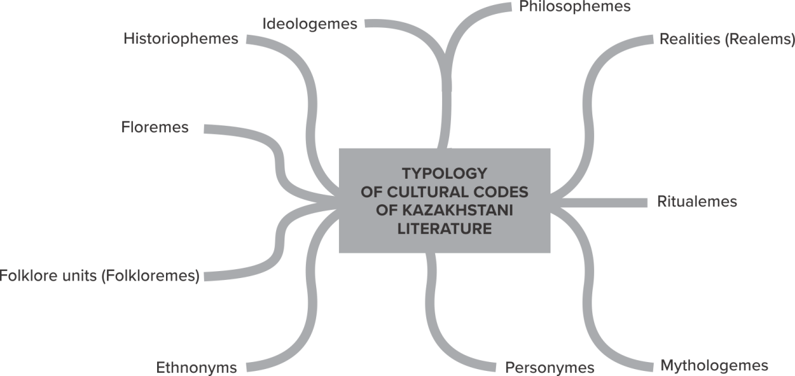

Figure B.1 – Typology of cultural codes of literature in Kazakhstan

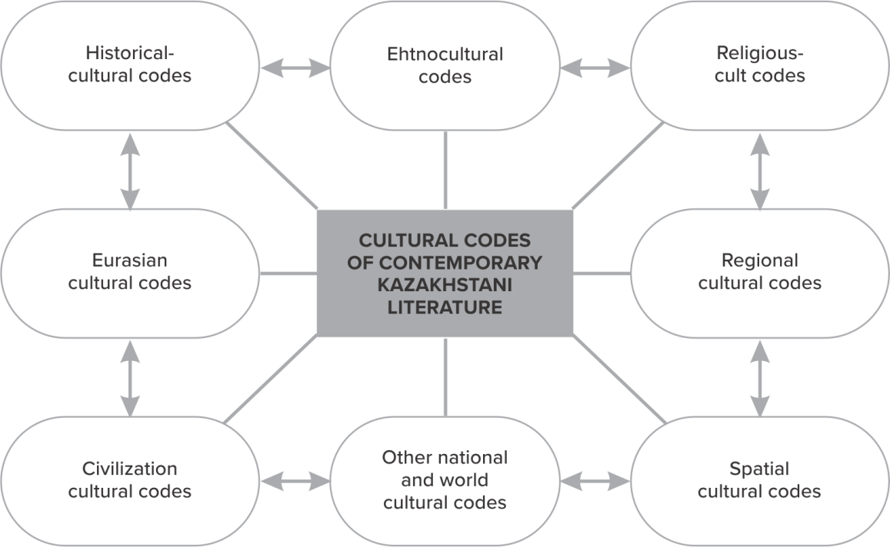

Figure B.2 - Groups of cultural codes of modern literature of Kazakhstan

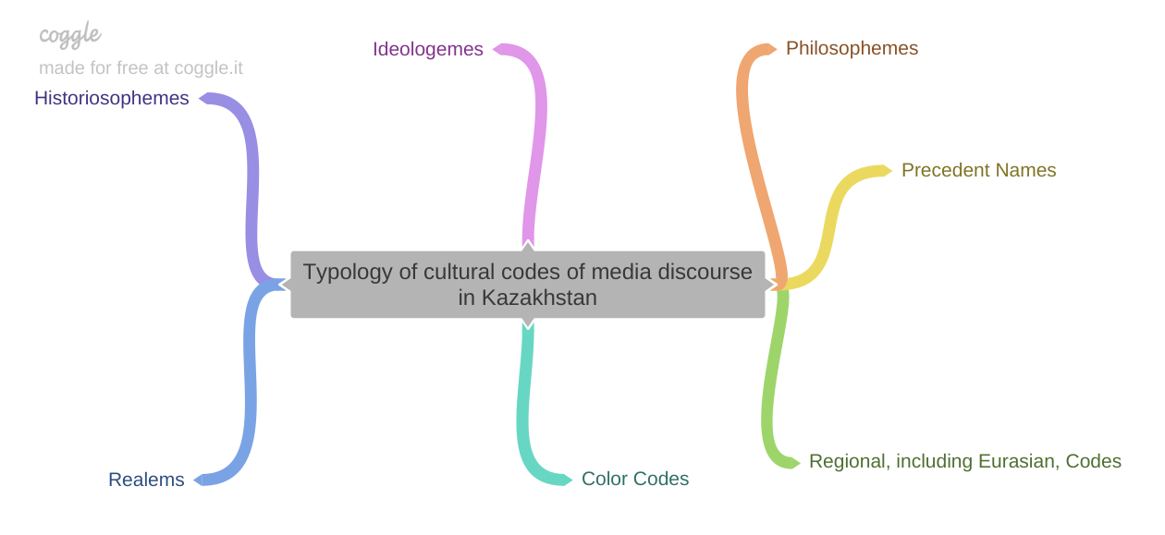

Figure B.3 - Typology of cultural codes of media discourse in Kazakhstan

Figure B.4 - Typology of mythonyms of modern literature in Kazakhstan

Analysis of the narrative function of the myth in the structure of HT
Analysis of the modeling function of the mythologeme as KK

Figure B.5 - Structural model of mythopoetic text analysis

Table B.1 – Personymes in the literary discourse of Kazakhstan
Personymes | Personymes  of the first row | Personymes  of the second row | Personymes  of the third row
Dominant functional assignment | formation of the main plot intrigue, conceptual core, event canvas;  the textual function of the bearer, custodian and protector of traditional values;the narrative function of this personymes is a narrator. | complementary provision of a general narrative strategy; building a background discourse; text function of the companion character. The narrative function is a narrator and narratator. | building a background discourse; communication of additional connotations to the personalities of the first two rows; the narrative function is a narrator.
Status | significant figures of national and world history: rulers, politicians, statesmen, military leaders, judges (biys), as well as famous zhyrau, storytellers, poets, i.e. historical figures known to most readers. Genghis Khan, Abylai Khan, Bukhar Zhyrau, Tole bi, Kazybek bi, Cairo Khan, Makhambet, Khorezmshah Muhammad, Kir, Tomiris and other “character concepts” (N.V. Volodina's term). | sacred and quasi-sacred images of mythical, mystical, fantastic personalities (gods, angels, demons, centaurs, giants, samions, etc.).Themiddle link of the power and military hierarchy, diplomats, merchants, caravanbashi, guards, spies and other characters whose "presence" in the text is limited to one or two narrative situations. Their complementary role is to create the background discourse of a particular plot intrigue. | the middle link of the power and military hierarchy, diplomats, merchants, caravanbashi, guards, spies and other characters whose "presence" in the text is limited to one or two narrative situations. Their complementary role is to create the background discourse of a particular plot intrigue.

Table B.2 - Typology of military codes in Kazakh historical novels

Military Code Type | Cultural Code’s Names | Most Frequency Codes/ Description  (arranged in descending order)
I. Abstract | philosophemes with predominantly binary oppositions in the core of meaning | war - peace, beginning - end, Steppe - East, Steppe - West, Asia - Europe; freedom - slavery, good - evil, justice - injustice, law - lawlessness; the cult of strength.
I. Abstract | ideologemes | national idea, militia, unity, defense of the homeland, historical memory, genetic memory
I. Abstract | mythologems (mostly mythonyms)  They are the most frequent cultural codes. | Tengri, Umai, Ahuramazda, Nergal, Zabab, Venus, Zeus etc.
II.Concrete | historiosophems | historical facts and events, comprehended from the point of view of a particular philosophical doctrine
II.Concrete | ethnonyms, including historical names of tribes, peoples and historical toponyms | Saks, Persians, Huns, Kazakhs, Russians, Mongols, Greeks, Babylonians, Aryans, etc.  Persia, Babylon, Egypt, Media, Lydia, etc.
II.Concrete | realities (realems) | items of weapons - akinak, dwellings - yurt, musical instruments - dombra, kobyz; means of communication - fire telegraph, tamgas, trade caravans, nomad messengers, spies, scouts; descriptions of the economic and legal features of the nomadic military society
II.Concrete | personymes  the frequent cultural codes | specific historical personalities - Tomiris, Genghis Khan, Abylai khan, Abilmambet, Az Tauke khan, Tole bi, Kazybek bi, Kabanabaybatyr, Zhusip bilge, etc.
II.Concrete | ritualems | rituals of the beginning and end of the war - consecration of the sword with fire and milk, the blood of sacrificial animals; war cries - Abylai Khan! Kabanbai! Alash!  funeral rituals; rituals of the beginning of the duel, rituals of fraternization
II.Concrete | spatial cultural codes, including heterotopies | west - east, north - south, steppe, mountains, hills, hills, walls, khan's headquarters, enemy camp, river crossings, lakes, graves, a house of amusements, ships, etc.

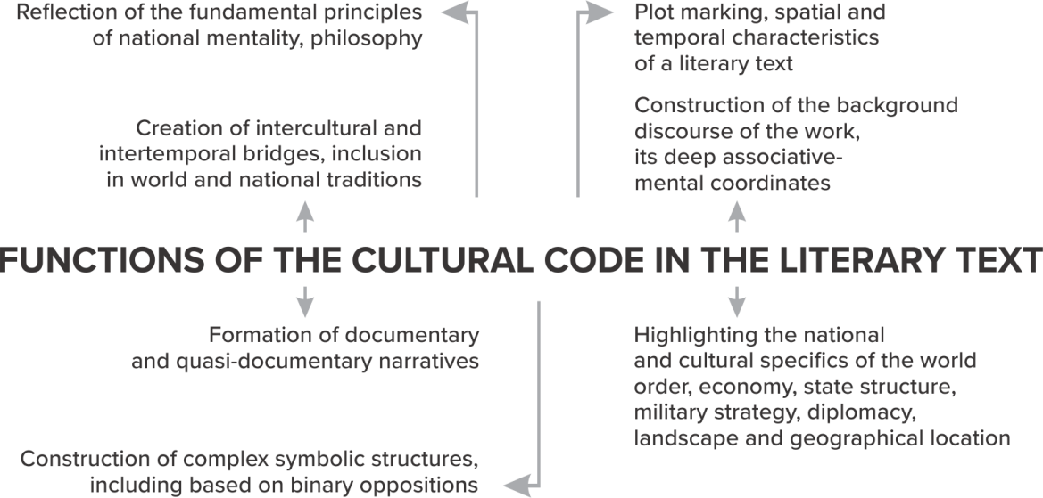

Figure B.6 - Functions of the cultural code in the literary text

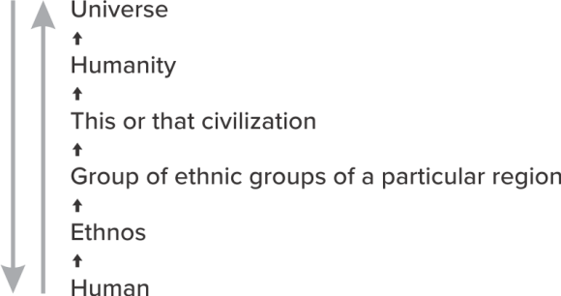

Figure B.7- Vertical communication model of informants

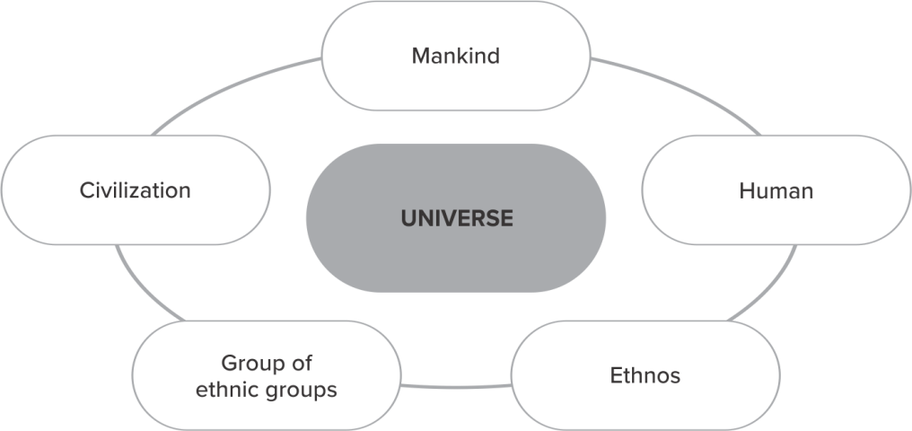

Figure B.8- Cyclic communication model of communication of informants

APPENDIX C
Concise cognitive thesaurus
№ | Term | Conceptual and categorical characteristics
 | Cultural code | has an ambivalent nature in a literary (fiction) work: semantic and functionalcontent.In the aspect of referentiality and functionality, CC is understood by us as a specific mechanism (tool) for storing and successively transmitting important information about the history, philosophy, spiritual and material culture of a person (individual),ethnos, a group of ethnic groups of a particular region, a particular civilization, all mankind, the Universe (Universum).
 | The cultural code is considered by us | as a holistic aesthetic-informative construct, a textual formation that performs several interrelated, equal functions: ontological; communicative; actually artistic; actually informative; axiological, etc.
 | As a phenomenon of historical, national consciousness, the cultural code | in literary discourse has a predominantly cognitive-phenomenological and referential nature.
 | From a semiotic-semantic point of view, a cultural code is | an artistic reproduction of one or another cultural information about tradition, philosophy, worldview, world order in a specific text space. Like any linguistic sign, the code in the text has two inseparable sides - external and internal, signifier and signified. Hence, the implicit and explicit embeddedness of the cultural code in the narrative, plot, the manifestation in the reader (listener, viewer) of many associative and semantic connections of the cultural code with other concepts, plots, ideas, images, motives
 | Cultural code is | a capacious mental structure of a wide format, capable of absorbing the signs of a conceptual metaphor, a material-object, material world with its inherent specific attributes and metaphysics of the unreal world. Although in a literary text, the code is most often implemented in its symbolic, conditionally metaphorical nature. In the media discus, a weighty rhetorical component is added to these characteristics.
 | The phenomenon of the cultural code in the context of literary discourse lies in | its exceptional ability to actualize, conceptualize and transmit information that is significant in the cultural and epistemological terms into the surrounding space, expand and deepen the paradigmatic relationship between the components of the “message” and the emerging associative series and cognitions.
 | The ideosphere of the cultural code is understood as | a system of mutually opposed mental constants and cultural artifacts that have unconditional value and a wide space-time range of existence.
 | The theory of the cultural code | The totality of methodological, terminological and other systemic features related to the episteme of the cultural codewill be called the theory of the cultural code (TCC).
 | An informant is | a carrier and source of cultural information.
 | A historical and cultural code in a literary text is | a specific tool for storing and successively transmitting important information about the history, spiritual and material culture of a particular ethnic group, group of ethnic groups, a particular region, or a particular civilization. In other words, historical and cultural codes are "signs of history and culture", directly or indirectly reflecting the worldview, worldview of a particular ethnic group.
 | The military code is | a historical and cultural construct that most fully reflects the specifics of the described historical era from the point of view of the prevailing military ideology. These are codes of a secondary semioticnature,the historical and cultural information content of these constructs is extremely high. The informative and communicative nature of the military cultural code as a phenomenon of artistic and social consciousness presupposes the design of broad associative fields. It is the military, and possibly also religious, CC at the present time both in the media and in literature and art of Kazakhstan is one of the most frequent. In the aspect of artistic reception, the military code serves to reveal and comprehend the more significant in the historical and cultural aspect, the cultural code extended in time, namely, the nomadic CC.
 | The conceptual core of a cultural code is | an archiseme of a particular concept (construct, mythologeme, name of a literary text, media title, etc.), which can be transformed into an opposite or similar in meaning, but having a significant difference from the original concept.
 | The conceptual core is understood as | a semiotic category that centers the entire text space.
 | A detailed multicultural landscape of literary discourse is understood to | be subordinate to the idea of ​​a wide-format narration of historical (or imaginable) events, the inclusion in a literary text of a multitude of foreign cultural details - descriptions of culture, history, geography, everyday life, economics, ethno-mentality, significant narratives (mythologems, folklore, historiosophems). The main purpose of the multicultural landscape in a literary text is to fulfill the additional function of building a developed background discourse, determined by the very specificity of the novel genre.
 | Mythological universals are | mythologemes, universal in nature, cross-cultural, or supracultural, phenomena reflected in the poetics of the text.
 | Philosopheme is | a cultural code with a stable semantic-structural and multifunctional content, extended in artistic time and space. By their dialogical and cognitive-communicative nature, philosophies, like mythologemes and folkloremes, in a literary text come close to the universals of culture.
 | Ideologemes are understood as | philosophies with reduced initial semantics, placed in a specific ideological and political-legal context.
 | Ethnic stereotypes are | various stable ideas about the mental, emotional-sensual, worldview and other characteristics of a particular ethnic group.
 | Valence of the code is | the ability to create other meanings while preserving the core (cultural code).
 | Personyms are | proper names of personalities performing the functions of a cultural code - a "key" to the concept sphere, the main idea and pathos of the work.
 | Ritualems are | cultural concepts that reflect the ritual component of a particular ritual (initiation, beginning/end of hostilities, fraternization, wedding, matchmaking, funeral, etc.)
 | Sacronyms are | precedent names and place names with sacred semantics.
 | Pseudosacronyms are | mythical (fictitious) names and titles that play the role of the sacred center of the narrative in the text.
 | Sacronyms and pseudosacronyms | show sufficient activity in the "generation of meaning" of volumetric spatial codes of modern historical and postmodern literature of Kazakhstan.
 | Folklorems are | folkloreplots, images and motives.
 | Myth is | the central conditional-metaphorical narrative form of artistic creativity, which, along with the dominant philosophical and aesthetic possibilities, exhibits great intertextual connections and potentials.
 | Mythologeme is | a certain stable mythological image and/or motive that structures the corresponding mythical time and space of a literary text. Mythologeme belong to one of the most frequent cultural codes of literature and mass media
 | Mythological time is | The time of “creation”, hence its sacralization and sanctification. In the mythologies of all peoples, the mythological time of events is marked with a special status of “timelessness”, if we mean ordinary human time.
 | Mythological chronotope is | A myth(ologic)time and space.
 | Mythological space is | a different-sized space of a mythological event, the activities of a mythological hero/heroes, mythological situations, closely related to the corresponding mythological time
 | Mythic-folklore installations are understood as | a set of mythologemes, folklore and other conventional metaphor that are included in the text space. In a literary text, mythic-folklore installations (from the English installation) often play the role of an extensive compositional device in creating a multi-faceted ethnically labeled narrative with a simultaneous emergence of universal meanings.
 | The mythological capacity of a literary text is understood as | an aggregated summary characteristic of all functioning mythoelements (elements of mythopoetics): mythologemes proper, including copyright, literary universals, concepts, stereotypes, parables, legends and other conventionally metaphorical forms and means. Literaturewiththeso-calledneomythologicaldominant.
 | The mythological plot included in the literary text is | a series of interconnected mythological events, characters acting in them, subordinate to the logic and goal-setting of a particular myth.
 | The functional field of mythopoetics is | a set of various interrelated functions of mythopoetic elements. The core of the functional field of mythopoetics, of course, is the mythological image in any of its hypostasis: mythanthroponyms, mythological names, mythozoonyms, neomyphonyms, mythological personal names, demonyms, mythofloremes. The listed types of mythonyms constitute the typology of mythonyms as one of the most frequent groups of mythologemes.
 | Temporal myth markers are | a specific tool that forms the time sequence of mythological and other events. These markers group events in a special way, their consistency or, on the contrary, illogicality of following. In the latter case, we are talking about the desynchronization of mythological time in the event canvas of the work.
 | Heterotopic text markers are | specific pointers (routes, parking lots, maps, etc.) to "other" places.
 | Levels of artistic articulation, transmission, perception, reproduction, interdisciplinary scientific reflection of СС are | mental, functional, narrative levels.

APPENDIX D
Free associative experiment questionnaire

(Regional Cultural Codes)

The experiment in which you are taking part is associative and aimed at researching the concepts of media discourse in Kazakhstan. Please write 1-2 associations that arise when you perceive the data below the words.
Please provide your details:
1. Age:
2. Gender:
3. Occupation:
Please write 1-2 associations that arise when you first read these words:
Rouhani zhagyru
Great steppe
Modernization
Message
Law
Parliament
Power
Rights
National idea
DimashKudaibergen

* The experiment was carried out through the Internet mailing list in the form of a Google spreadsheet. The association experiment involved 100 people aged 18 to 60 years, of which women accounted for about 60%. Occupation of the respondents: education, entrepreneurship, service sector, finance, art.

Author: Aimagambetova M.M.

Free associative experiment questionnaire

(Universals)

The experiment in which you are taking part is associative and aimed at researching the concepts of literary and media discourses in Kazakhstan. Please write 1-2 associations that arise when you perceive the data below the words.
Please provide your details:
- Age:
- Gender:
- Please write down 1-3 associations that arise when you first read these words:
1. Faith
2. Hope
3. Love
4. Happiness
5. Misfortune
6. Peace
7. War
8. Freedom
9. Harmony
10. Chaos

* The experiment was carried out through interviews and direct questionnaires. The association experiment involved 100 people aged 18 to 60 years, of which women accounted for about 60%. Occupation of the respondents: education, entrepreneurship, service sector, finance, art.

Author: Altybayeva S.M

APPENDIX E
List of published works (2018-2020)

№ | Author/ Title of work |  | Printed, hand written, electronic | Place of publication, imprint | Co-authors
2018 год
 |  | Altybayeva S.M. Kazakh prose of the period of independence: tradition, innovation, prospects. Monograph (Russian) | Printed | Almaty: Gylym, 2018. – 440 p.
 |  | Altybayeva S. MythPoetics. Tutorial (English) | Printed | Riga, Latvia, EU: Lap Lambert Academic Publishing. 2018. 225 p. Project – ID 179268. ISBN 978-613-9-88376-9. – 225 p.
 |  | Altybayeva S.M. Myth as a conventionally metaphoric narrative form (English) | Printed | Bulletin of NANRK. - 2018. -5- P.76-84. Emerging Sources Citation Index database, updated version of Web of Science. Clarivate Analytics. CCES | Comutstsi L.V.
 |  | Altybayeva S.М. Сontent and categorical signs of new mythology (English) | Printed | Materials of the International Scientific Conference "Language and Society". Almaty: Polilingv, 2018. - p. 328-333.
 |  | Altybayeva S.M. Cultural code and conceptual metaphor: linking contexts(Russian) | Printed | Almanac “Culture”. - Astana: Institute of Culture, - 2018. - No. 1-2. - C.52-54.
 |  | Altybayeva S.М. Myth and folklore in the structure of contemporary Kazakhstani prose (English) | Printed | Almanac “Culture”. - Astana: Institute of Culture. - 2018. - No. 3. - S. 107-111.
 |  | Altybayeva S.М. Cultural code and myth poetic modeling in the structure of the artistic text ((English) | Printed | Bulletin of NAS RK. – 2018.- No. 5. - S. 5-11. CCES | Sagyndykov Е.S.
 |  | Altybayeva S.M. Actualization of the Myth plot in the literary discourse (English) | Printed | KazNU Bulletin. Ser. Philological sciences. - 2018. - No. 3.- p. 20 - 26. CCES
 |  | Altybayeva S.M. Philosopheme "Way" in the structure of the Kazakh historical novel(Russian) | Printed | Materials of the International Scientific and Practical Conference "Main Directions for the Implementation of the Program of Action for the International Decade for the Rapprochement of Cultures", November 15-16, 2018 - Almaty, 2018. pp. 81-83.
 |  | Altybayeva S.M. Mythological time and space: сategory-based characteristics (English) | Printed | Bulletin of Abay named KazNPU. - 2018. -№3 (65). - p. 72-76 CCES
 |  | Gizdatov G.G. Discourse of cultural identity in the media space of Kazakhstan) (Russian) | Printed | PR and media in Kazakhstan. Collection of scientific works. Issue 15. - 2018. - P.113-120.
 |  | Gizdatov G.G. Contemporary discourse and cultural identity in the Kazakh mediasphere (Russian) | Printed | Almanac. Culture. – 2018. -No. 1-2. - C. 55-57
 |  | Гиздатов Г. Discussion about a philological text (English) | Electronicresource | Slavicum Press Laboratory of Slavic studies. International scientific journal. http://www.phil.uzh.ch/elearning/blog/slavicumpress/2018/03/18/discussion-about-a-philological-text | Pribytko S.
 |  | Gizdatov G.G. Western signs in the linguistic consciousness of Kazakhstanis (Russian) | Printed | Almanac. Culture. - 2018, –№3. –C. 112-116
 |  | Gizdatov G. European book. Review(Russian) | Printed | Expert Kazakhstan. - No. 10. –2018.– P. 44
 |  | Gizdatov G. G. The Book of Cultural Memory. Review(Russian) | Printed | Expert Kazakhstan. - No. 5 2018. P.38
 |  | Gizdatov G. G. Again about identity. Review(Russian) | Printed | Expert Kazakhstan. - No. 9 –2018. –C.35
 |  | Gizdatov G. G. Album of memory. Review(Russian) | Printed | Expert Kazakhstan. - No. 7. - 2018.
 |  | Gizdatov G.G. Culture codes: September work-shop (Russian) | Printed | Til Alemi. –№7 (177) - p. 3.
 |  | Gizdatov G.G. Psycholingustic study of concepts of Kazakhstani discourse (English) | Printed | Bulletin of NAS RK. A series of social sciences and humanities. - 2018 - No. 5. - From. 57 -C. 63. COXON
 |  | Gizdatov G.G. Discourse of a philosopher. Review(Russian) | Printed | Expert Kazakhstan. - 2018.-No. 5. - C.42
 |  | Gizdatov G. Zoocode of the steppe. Review(Russian) | Printed | Expert Kazakhstan. - 2018. - No. 2. - C.35.
 |  | Gizdatov G.G. Cultural codes of media discourse I nKazakhstan (Russian) | Printed | Cognitive language studies. - Moscow: Moscow State University, 2018. -P. 411-414.
 |  | Gizdatov G.G. Metatheoretical aspects of studying the medial space of Kazakhstan (Russian) | Printed | Bulletin of Kokshetau University, philological series. - 2018. - No. 3. - S.30-37. Coxon
 |  | Aimagambetova M.M. Headlineas a component of publicistic text (Russian) | Printed | "Language and Society": Materials of the International Scientific Conference dedicated to the 95th anniversary of Professor A.E. Karlinsky. - Almaty: Polilingv, 2018 .-- S. 316-322
 |  | Aimagambetova M.M. News site’s headline (on the example of the Kazakh and Russian-language press) (Russian) | Printed | Language and speech on the Internet: personality, society, communication, culture collection of articles of the II International Scientific and Practical Conference. - Moscow, RUDN, March 29-30, 2018: in 2 volumes / under general ed. A.V. Dolzhikova, V.V. Barabasha. - M.: RUDN, 2018. - T. 1. - S. 104-111.
 |  | Aimagambetova M.M. Functioning of transformed phraseological units in the headlines of newspapers and news sites (based on the material of the Kazakh media) (Russian) | Printed | The life of phraseology - phraseology in life: a collection of scientific articles for the anniversary of Professor A.M. Melerovich / otv. ed. and comp. I.Yu. Tretyakov; foreword A.E. Yakimov. - Kostroma: Publishing house of Kostroma state. University, 2018. - S. 12-29.
 |  | Aimagambetova M.M. Phraseological units and headline coding problems (English) | Printed | KazNU Bulletin. Ser. Philologist. Sciences. - 2018. - No. 3. –S.11-19. CCES
 |  | Aimagambetova M.A. Zoonims component of natural culture (English) | Printed | Bulletin of KazNPU them. Abay. –2018 - №3. S.69-72. CCES
 |  | Aimagambetova M.M. Signs of culture: understanding the cultural connotation of phraseological units(Russian) | Printed | Scientific journal "Almanac Culture ". - Astana, KazNIIK, 2018. -- S. 92-12.
 |  | Aimagambetova M.M. Transformed proverbs and sayings in the headlines of Kazakhstani newspapers. (Russian) | Printed | Materials of the scientific-practical conference "Science of language and the language of science", dedicated to prof. E. D. Suleimenova. - Almaty: Kazakh University / - 2018. - P. 47 - 51.
 |  | Aimagambetova M.M. Transformed quotes of fiction in the headlines of Kazakhstani newspapers (Russian) | Printed | Problems of poetics and poetry: Mat. VIII International scientific-theoretical. conf., dedicated. 90th anniversary of Abai KazNPU (May 24-26, 2018). - Almaty: "Ulagat", KazNPU named after Abay, 2018. -S. 274-277.
 |  | Aimagambetova M.M. Idioms of literary text as a culture code  (Russian) | Printed | Materials of the International Scientific and Practical Conference "Main Directions for the Implementation of the Program of Action for the International Decade for the Rapprochement of Cultures", November 15-16, 2018 - Almaty, 2018. - pp. 86-89.
 |  | AldabergenovaA.A. Linguacultural aspects of translation of the absurd literature (English) | Printed | Bulletin of NAS RK. Series of Social Sciences and Humanities. – 2018.- No. 5 - p. 113-118. CCES | -
 |  | Aldabergenova A.A. Functional Peculiarities of Translation of American Absurd Literature (English) | Printed | Bulletin of Kokshetau University, philological series, 2018. - No. 3. - P.138-143. CCES | -
 |  | Aldabergenova A.A. Peculiarities of Translation of American Absurd Literature (English) | Electronicedition | Open Access Peer-reviewed Journal Science Review, 2(9), February 2018, Vol.6 Warsaw, Poland, 00-773. Google Scholar
 |  | Aldabergenova A.A. From the history of studying the theory and practice of translating the literature of the absurd (Russian) | Printed | Almanac Culture. - 2018. - No. 1-2. - C. 88-92
 |  | Sopiyeva B.A. The language of politics in the context of media discourse (English) | Printed | PR and media in Kazakhstan. Collection of scientific works. Issue 15. - 2018. - S. 237-243.
 |  | Aldabergenova A.A. Problems of inter cultural equivalence (based on the translation of J. Heller's work (Kazakh) | Printed | PR and media in Kazakhstan. Collection of scientific works. Issue 15. - 2018. - S. 128-133.
 |  | Aldabergenova A.A. Linguocultural aspects of translation literature of the absurd (Russian) | Printed | Cognitive language studies. M.: Moscow State University, 2018. (impact factor RSCI 0.128)
 |  | Sopieva B.A. Cognitive Aspects of research of Media Discourse in Foreign and Kazakhstan’s practice (English) | Electronicedition | Open Access Peer-reviewed Journal Science Review 2(9), February 2018 Vol.6 RS Global Sp. z O.O., Scientific Educational Center (Warsaw, Poland). Google Scholar
 |  | 2019 год
 |  | Collection of scientific works "Cultural code in the intermedial space" // Ed. Altybayeva S.M. (Russian, English)  Authors: Altybayeva S.M., Aimagambetova M.M., Sagyndykov Е.S., Abdikerimova G.S. and others. | Printed | Almaty: Gylym, 2019. - 380 p.
 |  | Altybayeva S.M. Cultural Codes Of Kazakh Literature In The Aspect Of Narratology (English) | Printed | Culture. - Astana: Institute of Culture. - 2019.– No. 1– P. 56-61.
 |  | Altybayeva S.M. Representative models of military codes in the historical romanistics of Kazakhstan (English) | Printed | Bulletin of NAS RK. - 2019.– No. 2. - P.79-87. https://doi.org/10.32014/2019.2518-1467.43. CCES | Comutstsi L.V.
 |  | Altybayeva S.М.Multicultural paradoxes of literature: Kafka, Borges and nouvelle vague of Kazakh prose (English) | Printed | News NAS RK. Series of social and humanitarian sciences. –2019. - No. 2. - S. 153-158. https://doi.org/10.32014/ 2019.2224-5294.61 CCES
 |  | Altybayeva S.M. Mythic-folklore installations in the structure of literary text (Russian) | Printed | Philological aspect: international scientific and practical journal. - 2019. - No. 7. - S.153-164. Access mode: http://scipress.ru/ philology / articles / mifo-folklornye-installyatsii-v-strukture-khudozhestvennogo-teksta.html Impact factor RSCI - 0.05 | Sagyndykov Е.S.
 |  | Altybayeva S.M. Intercultural codes of space and time in th estory "Shining Shambhala" by Nicholas Roerich (Russian) | Printed | Humanistica 21. Том 3. – Przasnysz: WydawnictwoUczelniLingwistyczno-Technicznej w Świeciu. -2019. – C. 335 – 355. CEJSH, CEEOL, CEON, BazHumanitiesand others. | Shevyakova TV
 |  | Altybayeva S.M Specificity of artistic representation of the "caravan" code in the novel of the same name by Abai and Auez Tynibekov (Russian) | Electronicedition | The Russian word in the multilingual world: Materials of the XIV MAPRYAL Congress (Nur-Sultan, Kazakhstan, April 29 - May 3, 2019) [Electronic resource] / Ed. Col .: N. A. Bozhenkova, S. V. Vyatkina, N. I. Klushina and others - SPb: MAPRYAL, 2019 .-- pp. 1742-1746.
 |  | Aimagambetova M.M. Headline as a Component of Publicistic Text (English) | Printed | KazNU Bulletin. Philological series. –2019. –№1. -FROM. 11-18. CCES | Koch K.
 |  | Aimagambetova M.M. Biblicalisms as a feature of the headlines of Russian-language Kazakh newspapers (Russian) | Printed | Materials of the international conference "Actual problems of teaching and studying translation and comparative studies." Almaty. - 2019 - P.26-29.
 |  | Aimagambetova M.M. Cultural codes in the media discourse of Kazakhstan (Russian) | Printed | Philological aspect: international scientific and practical journal. - 2019. No. 7. - S. 209-216. Access mode: http://scipress.ru/ philology / articles / mifo-folklornye-installyatsii-v-strukture-khudozhestvennogo-teksta.html Impact factor RSCI - 0.05
 |  | Aimagambetova M.M. Borrowings in Russian (on the example of Russian-language newspapers in Kazakhstan) (Russian) | Printed | Proceedings and materials of the VI International Congress of Researchers of the Russian Language "The Russian Language: Historical Fates and the Present". Moscow: Moscow State University, 2019. - P. 378
 |  | Sopieva B.A. Theoretical aspects of studying American media discourse (Russian) | Printed | Aglistics of the XXI century: Materials of the IX All-Russian interuniversity scientific and methodological conference. SPb: UniversityEducationalDistricts, 2019. - p. 64-68.
 |  | Sopieva B. A. Political and media discourse in the paradigm of CDA (English) | Printed | Bulletin of NAS RK. A series of social sciences and humanities. - 2019. - No. 1 (322). - S. 73-76. https://doi.org/10.32014/2019.2224-5294.10 CCES
 |  | Abdikerimova G.S. Rational and pragmatic specificity of the argumentatively influencing discourse(Russian) | Printed | Pedagogy and Psychology. - 2019. - No. 2 (39). - P. 163-170. CCES
 |  | Abdikerimova G.S. Intertextuality as the main category in the phenomenon of media precedence(Russian) | Printed | Materials of the III International Scientific and Practical Conference "Science and Education in the Modern World: Challenges of the XXI Century". Nur-Sultan, July 10-12, 2019. - S. 211-215.
2020 год
 | Idiosphere of Kazakhsтani cultural code: literature and mass media =Идеосфера культурного кода Казахстана: литература и масс-медиа/ Edited by S.M. Altybayeva.  Authors: Altybayeva S.M., Aimagambetova M.M., Sagyndykov Е.S., Abdikerimova G.S. (Russian=English) |  | Printed | Almaty, 2020.- 224 p.
 | Altybayeva S.M. Actual mythopoetics. Study manual (Russian) |  | Printed | Almaty, 2020. - 208 p.
 | Altybayeva S.M. Foundations of mythopoetics. Electronic study guide. Computer program (Russian) |  | Electronicedition  603 Мб | Almaty, 2020  Download link:  https://drive.google.com/drive/folders/13c-RaZZC75v8St3nyRb-UYogU_glOpBR?usp=sharing
 | Altybayeva S.M. Cognitive-communicative strategies of Kazakhstani literature: specificity of formation and functioning (English) |  | Printed | The Bulletin of NAN RK Volume 3 (2020). - p. 252-260. https://doi.org/10.32014/2020.2518–1467.92Emerging Sources Citation Index Database, Web of Science, Clarivate Analytics, CCSES | G.E. Imposti
 | Altybayeva S.M. Cultural Code Cognitive Thesaurus:  communicative and epistemological aspects (Russian) |  | Printed | Pedagogy and psychology. 2020. - №2. - pp. 234-243 CCSES
 | Altybayeva S.M. City code in the romance of Kazakhstan (Russian) |  | Printed | Materials of the International Scientific and Practical Conference "Linguistics and Literary Criticism at the Turn of the Millennium", dedicated to the 175th anniversary of the birth of the great son of the Kazakh people Abai Kunanbayev (Atyrau State University named after Kh. Dosmukhamedov, Atyrau, 27.04.2020). Atyrau, 2020. -p. 271-273. | Sagyndykov Е.S.
 | Altybayeva S.M. Narrative strategies of culture, translation and media: stories about Beslan as a situational example (Russian) |  | Inthepress | Collection of materials (online edition of the All-Russian conference "Dictum-Factum: from research to strategic decisions." Novosibirsk: LLC "Siberian Academic Book", 2020. | Comutstsi L.V.
 | Aimagambetova M.M. Language in the light of cultural codes (English) |  | Printed | Bulletin of the Eurasian Humanitarian University. -2020. - №1. - S.247– 251. CCSES
 | Aimagambetova M.M. Cognitive strategies of media discourse in Kazakhstan (Russian) |  | Printed | Philological aspect: international scientific and practical journal. - 2020. –№5. - 214-221. Access mode: https://scipress.ru /philology/articles/kognitivnye-strategii-mediadiskursa-kazakhstana.html RSCI - 0.05
 | АймагамбетоваМ.М. Cultural codes of color terms in the Russian-language media texts of Kazakhstan (Russian) |  | Printed | PSU Bulletin. Philological series. - 2020. - No. 2. - S. 12-21. CCSES
 | Abdikerimova G.S. Approach to the features of mass media discourse from the point of view of linguocultural studies (Kazakh) |  | Printed | Science and life of Kazakhstan. International scientific journal. - 2020. - №2 / 2. - 320-326. CCSES
Total for 2018-2020:
67 titles of printed and electronic scientific and educational works.

In 2020, 11scientific works were published, including collective monograph, two study manuals, 8 articles (1 in peer-reviewed RSCI journal;1 article is in the press on WoS; 5 articles in the CCSES journals).

APPENDIX F
Copyright certificates
- Idiosphere of Kazakhstani cultural code: literature and mass media/ Edited by Saule Altybayeva. Almaty, 2020. Copyright certificate No. 11588 dated August 11, 2020.

- Altybayeva S.M. Actual myth poetics. Study manual. Copyright certificate №11821 dated September 2, 2020.

APPENDIXG
References on the use of scientific results

2019
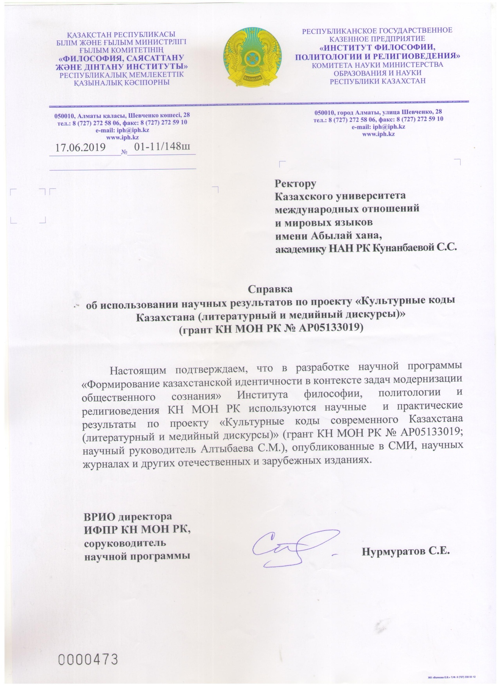
2020
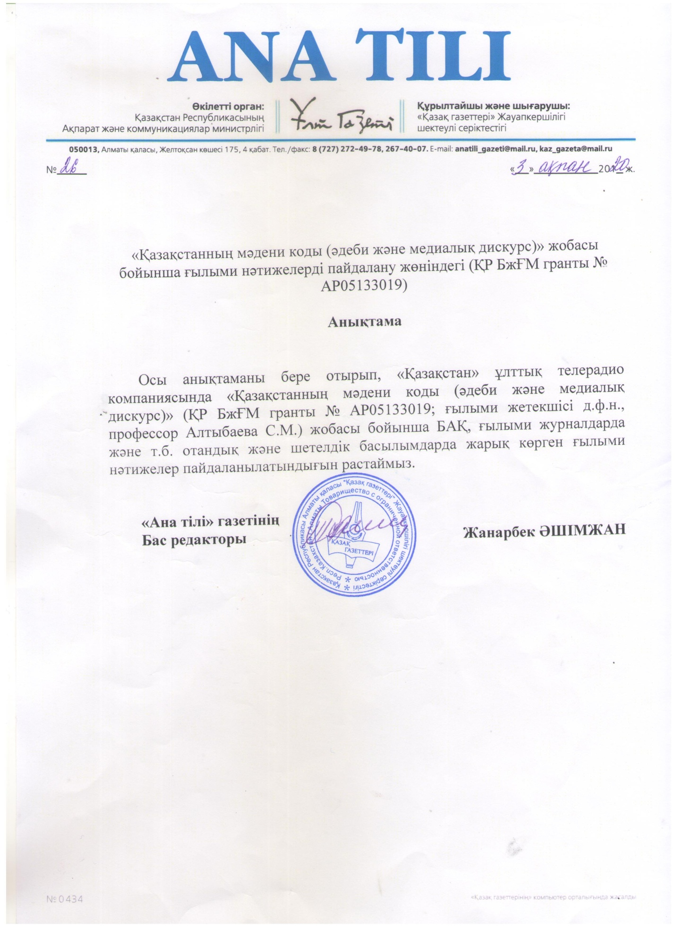

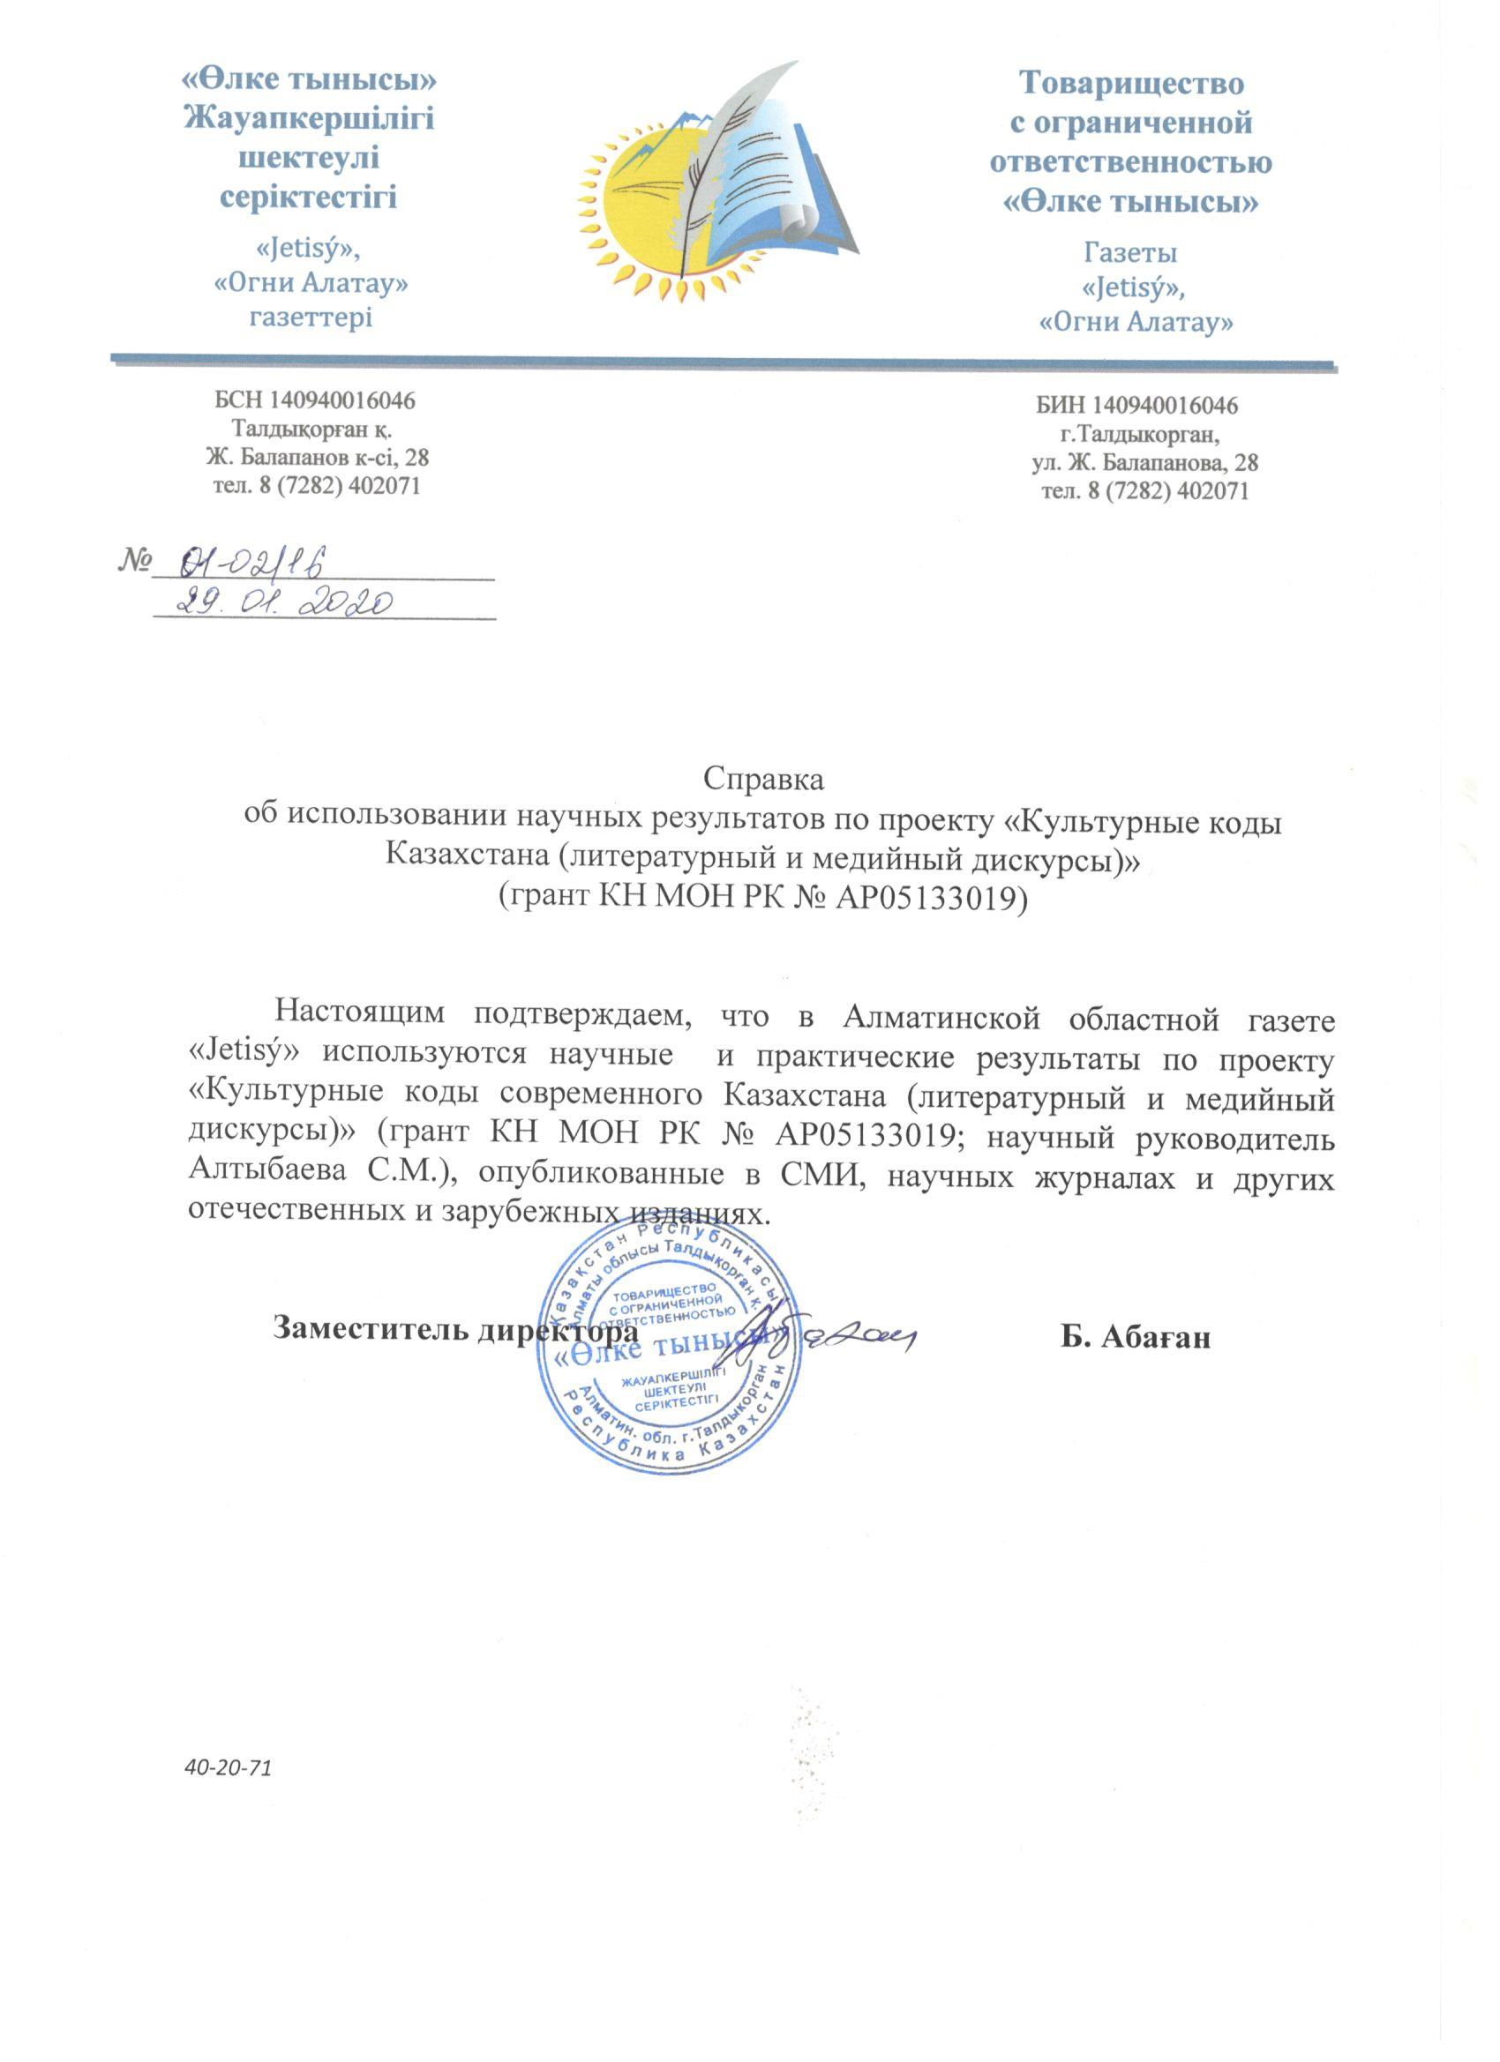

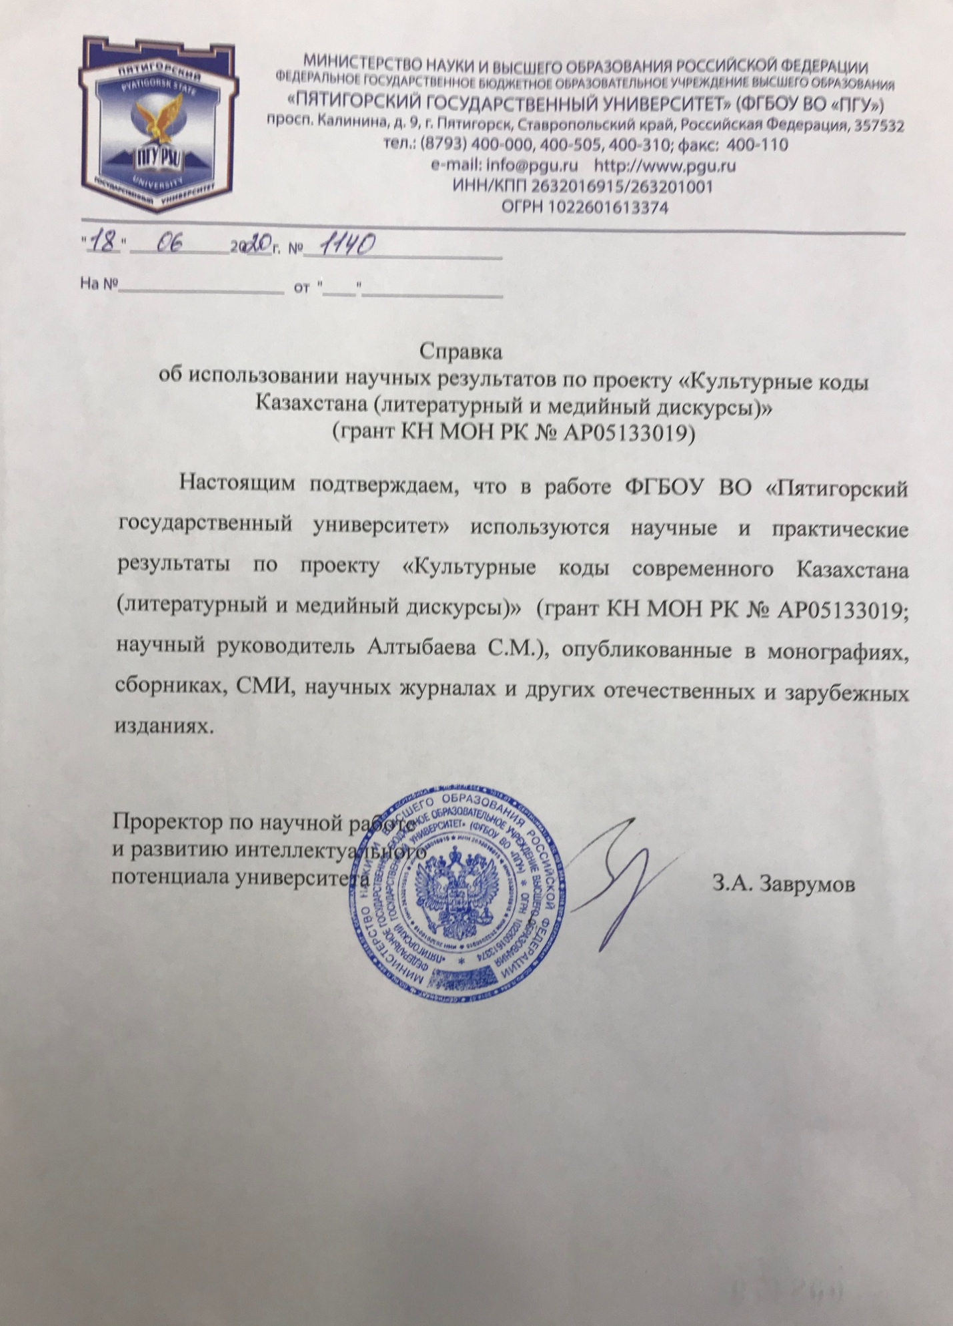

APPENDIX K
Calendar plans and technical specifications for 2018-2020
2018
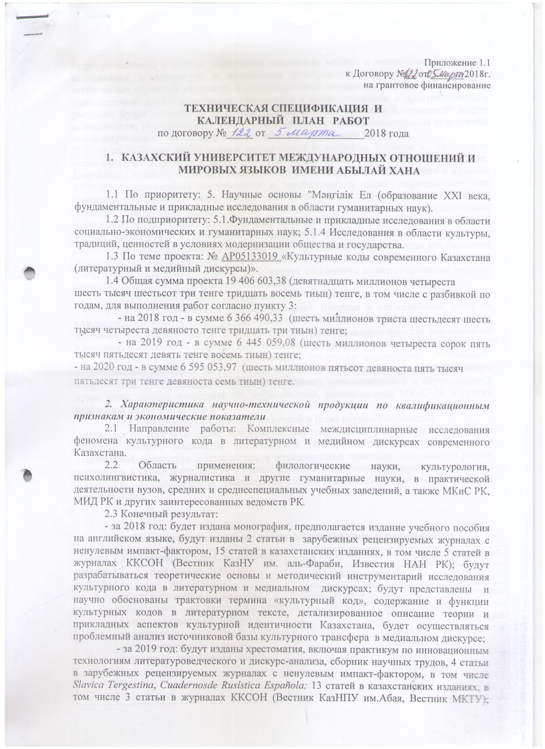

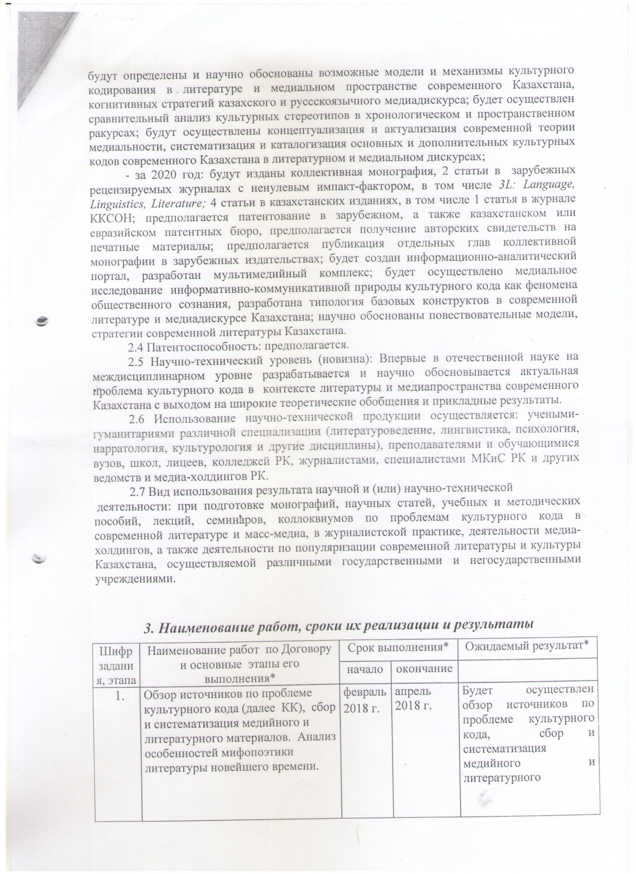

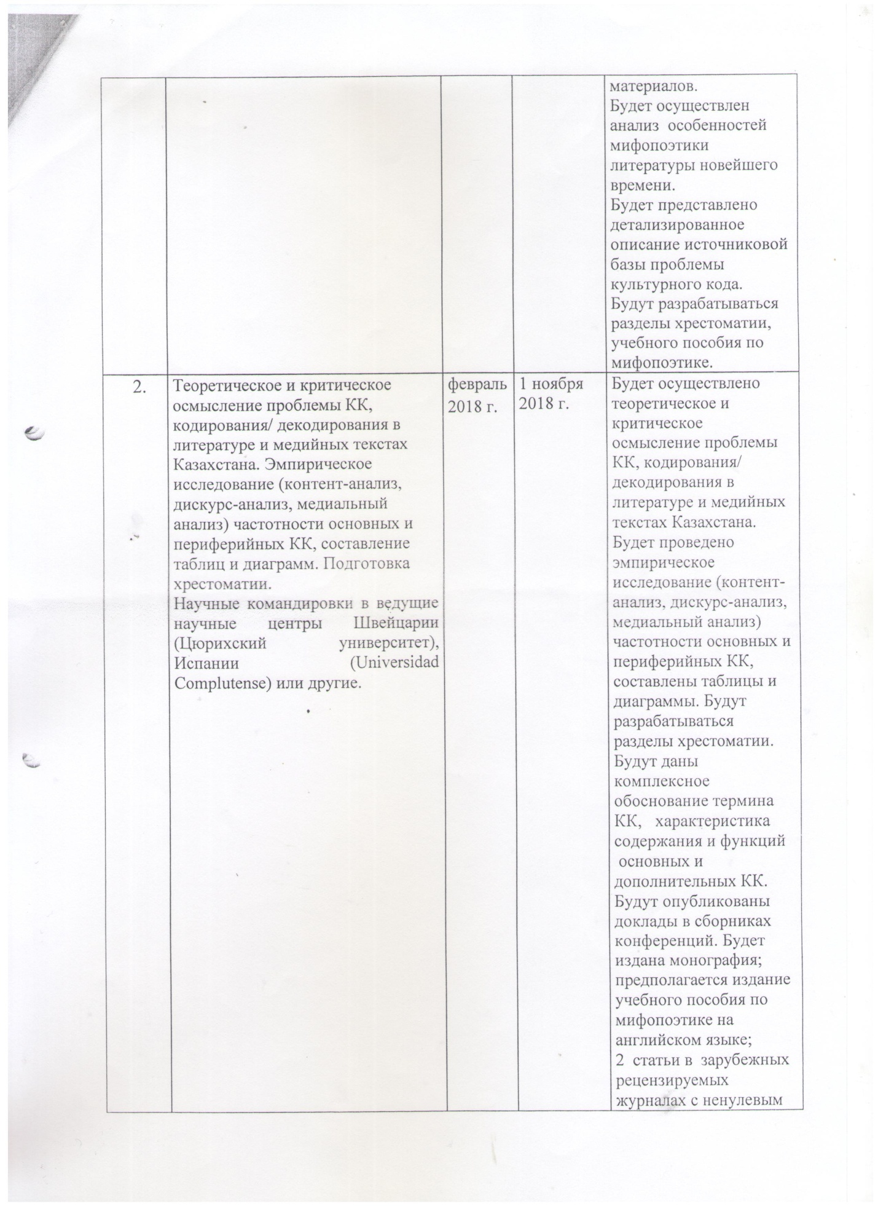

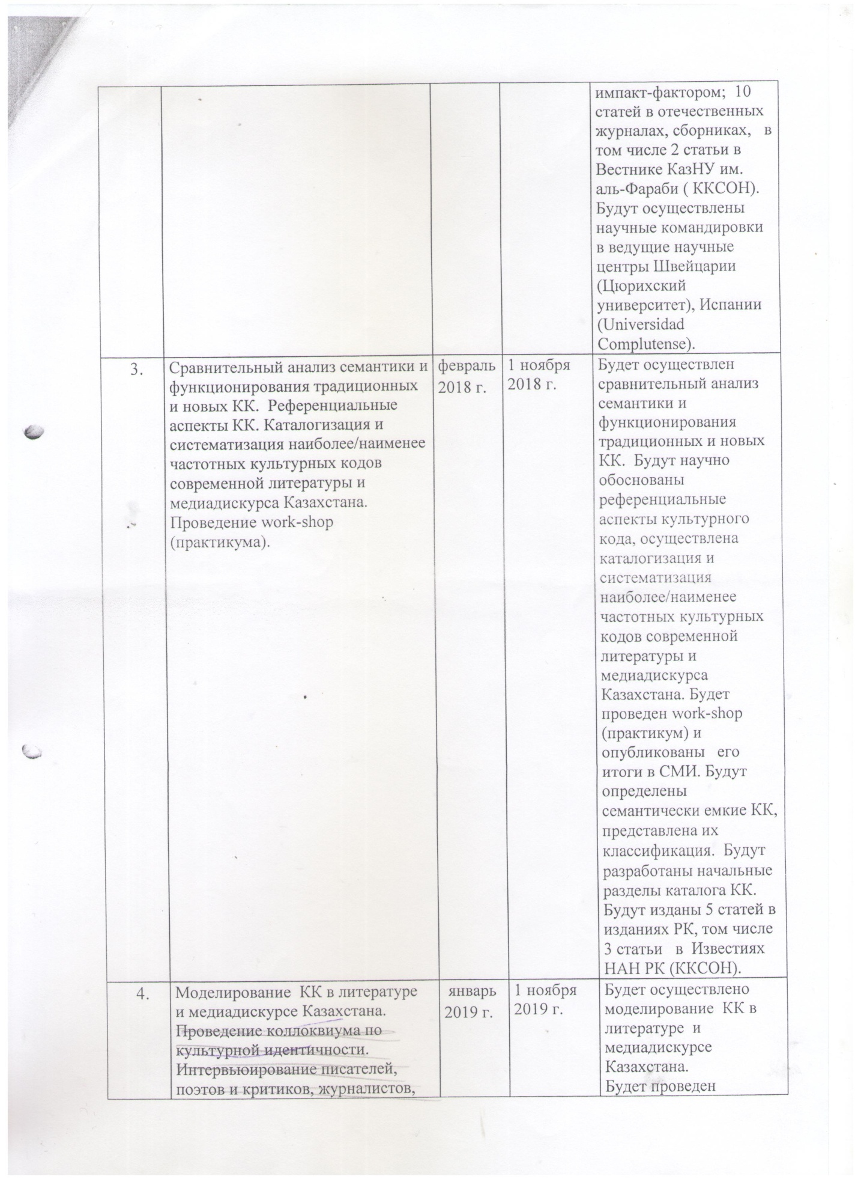

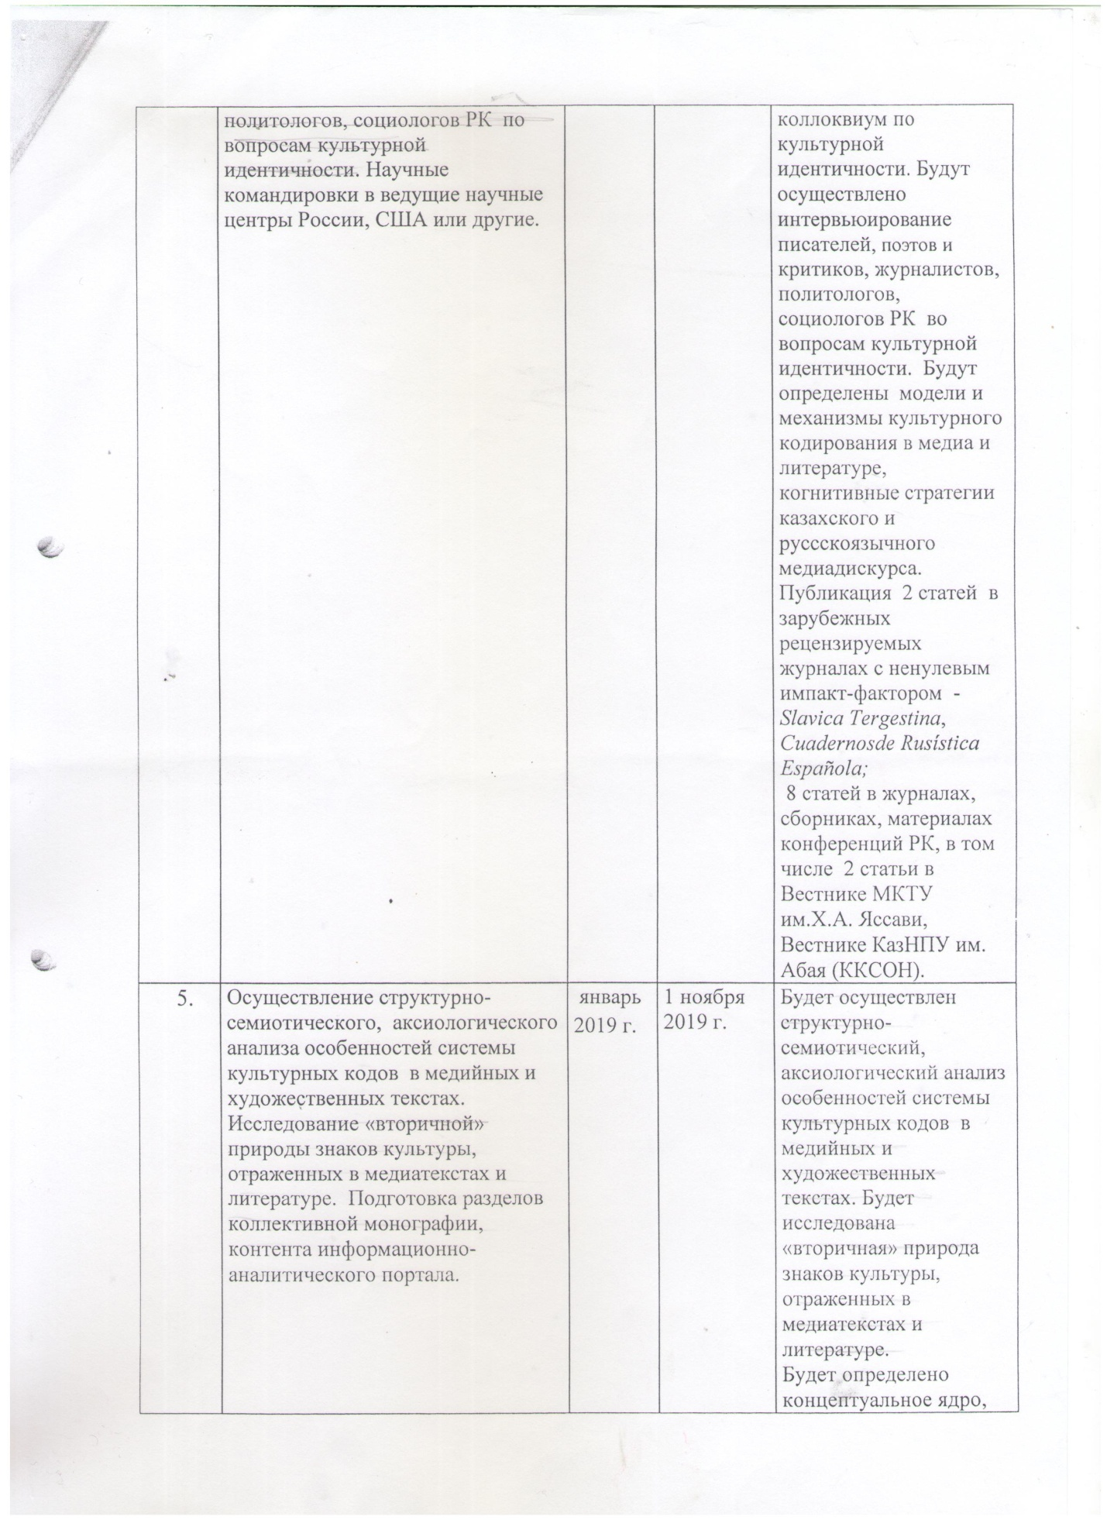

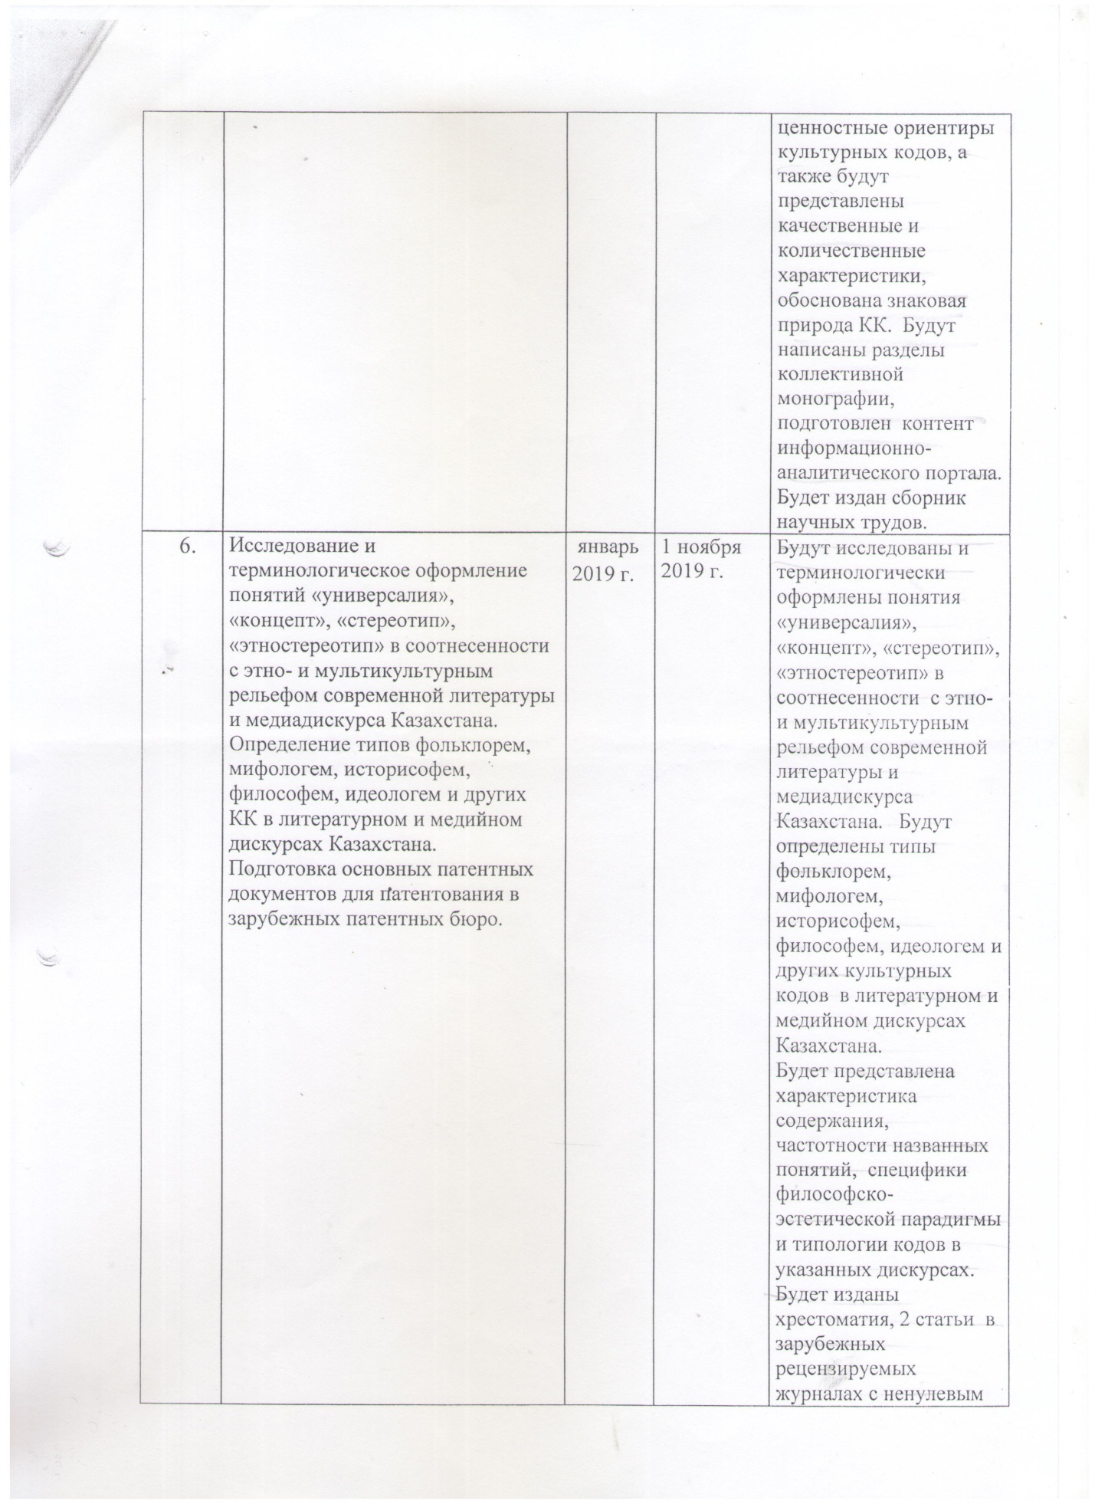

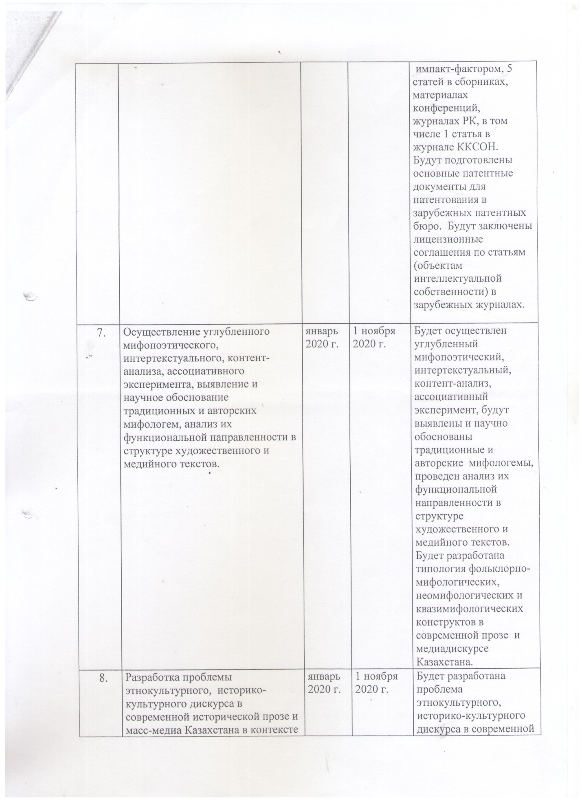

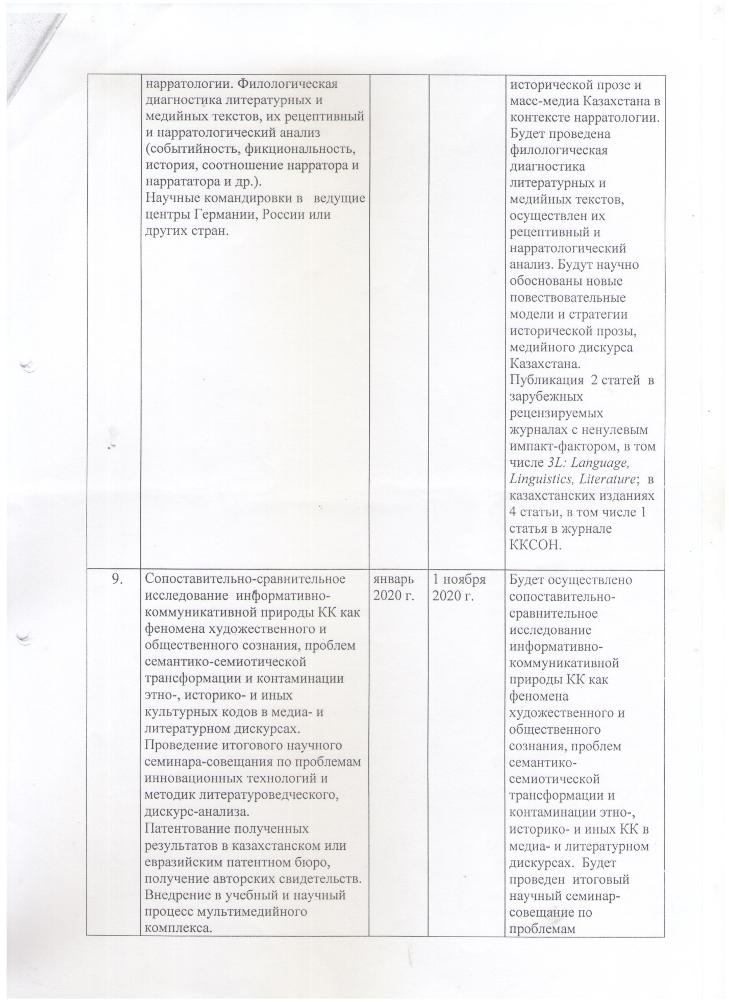

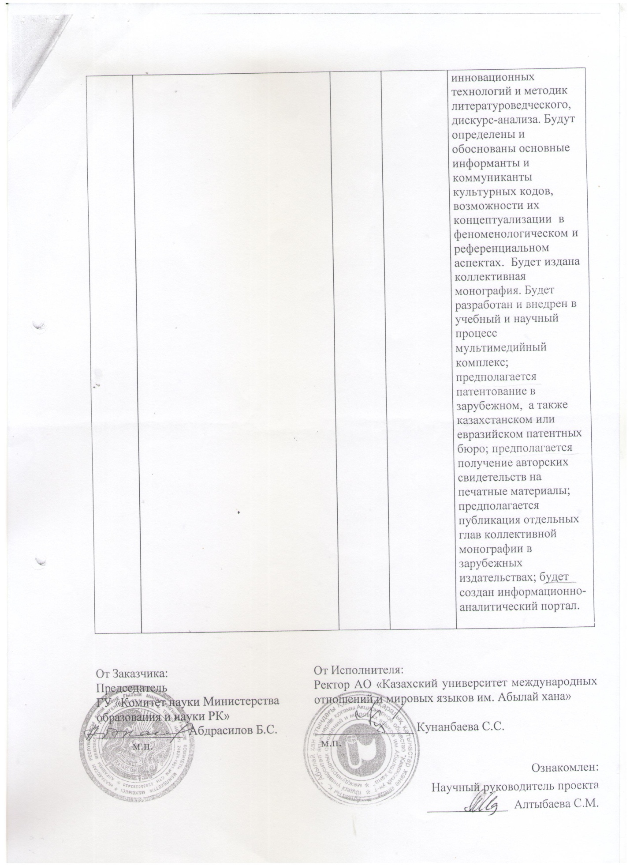

TRANSLATION INTO ENGLISH
Appendix 1.1
to Agreement No. 122 dated March 5, 2018
for grant funding

TECHNICAL SPECIFICATION AND
CALENDAR WORK PLAN
under contract No. 122 dated March 5, 2018

1. KAZAKH UNIVERSITY OF INTERNATIONAL RELATIONS AND WORLD LANGUAGES NAMED AFTER ABYLAY KHAN

1.1 By priority: 5. Scientific basis "Mangilik El (education of the XXI century, fundamental and applied research in the humanities).
1.2 By sub-priority: 5.1. Fundamental and applied research in the field of socio-economic and humanitarian sciences; 5.1.4 Research in the field of culture, traditions, values in the context of modernization of society and the state.
1.3 On the topic of the project: No. AP05133019 "Cultural codes of modern Kazakhstan (literary and media discourses)".
1.4 The total amount of the project 19 406 603.38 (nineteen million four hundred
six thousand six hundred three tengethirty eighttiyn) tenge, including with a breakdown by years, for the performance of work in accordance with clause 3:
- for 2018 - in the amount of 6 366 490.33 (six million three hundred sixty six thousand four hundred ninety tenge thirty three tiyn) tenge;
- for 2019 - in the amount of 6 445 059.08 (six million four hundred forty-five thousand fifty-nine tenge eight tiyn) tenge;
- for 2020 - in the amount of 6 595 053.97 (six million five hundred ninety five thousand fifty three tenge ninety seven tiyn) tenge.
2. Characteristics of scientific and technical products by qualification characteristics and economic indicators
2.1 Direction of work: Comprehensive interdisciplinary research of the phenomenon of the cultural code in the literary and media discourses of modern Kazakhstan.
2.2 Scope: philological sciences, cultural studies, psycholinguistics, journalism and other humanities, in the practical activities of universities, secondary and secondary educational institutions, as well as MC&S RK, MFA RK and other interested departments of the RK.
2.3 End result:
- for 2018: a monograph will be published, a textbook is expected to be published in English, 2 articles will be published in foreign peer-reviewed journals with a non-zero impact factor, 15 articles in Kazakhstani publications, including 5 articles in KKSON journals (Bulletin of KazNU named after I. al-Farabi, Izvestiya NAS RK); theoretical foundations and methodological tools for the study of the cultural code in literary and media discourses will be developed; the interpretation of the term "cultural code", the content and functions of cultural codes in the literary text, a detailed description of the theory and applied aspects of the cultural identity of Kazakhstan will be presented and scientifically substantiated, a problematic analysis of the source base of cultural transfer in the media discourse will be carried out;
- for 2019: a reader will be published, including a workshop on innovative technologies of literary and discourse analysis, a collection of scientific papers, 4 articles in foreign peer-reviewed journals with a non-zero impact factor, including SlavicaTergestina, CuadernosdeRusística Española; 13 articles in Kazakhstani editions, including 3 articles in KKSON journals (Bulletin of KazNPU named after Abai, Bulletin of MKTU); possible models and mechanisms of cultural coding in the literature and media space of modern Kazakhstan, cognitive strategies of the Kazakh and Russian-speaking media discourse will be determined and scientifically substantiated; a comparative analysis of cultural stereotypes in chronological and spatial perspectives will be carried out; conceptualization and actualization of the modern theory of mediality, systematization and cataloging of the main and additional cultural codes of modern Kazakhstan in literary and media discourses will be carried out;
- for 2020: a collective monograph will be published, 2 articles in foreign peer-reviewed journals with a non-zero impact factor, including 3L: Language, Linguistics, Literature; 4 articles in Kazakhstani publications, including 1 article in the KKSON magazine; it is supposed to be patented in a foreign, as well as in Kazakhstani or Eurasian, patent bureaus; it is supposed to obtain copyright certificates for printed materials; it is planned to publish individual chapters of the collective monograph in foreign publishing houses; an information and analytical portal will be created, a multimedia complex will be developed; a media study of the informative and communicative nature of the cultural code as a phenomenon of public consciousness will be carried out, a typology of basic constructs in modern literature and media discourse in Kazakhstan will be developed; the narrative models and strategies of modern literature in Kazakhstan are scientifically substantiated.
2.4 Patentability: assumed.
2.5 Scientific and technical level (novelty): For the first time in domestic science, at an interdisciplinary level, the urgent problem of the cultural code in the context of the literature and media space of modern Kazakhstan is being developed and scientifically substantiated, with access to broad theoretical generalizations and applied results.
2.6 The use of scientific and technical products is carried out by: humanities scientists of various specializations (literary criticism, linguistics, psychology, narratology, cultural studies and other disciplines), teachers and students of universities, schools, lyceums, colleges of the Republic of Kazakhstan, journalists, specialists of MC&S RK and other departments and media -holdings of the Republic of Kazakhstan.
2.7 Type of use of the result of scientific and (or) scientific and technical
activities: in the preparation of monographs, scientific articles, educational and methodological manuals, lectures, seminars, colloquia on the problems of the cultural code in modern literature and mass media, in journalistic practice, the activities of media holdings, as well as activities to popularize modern literature and culture of Kazakhstan carried out by various state and non-state institutions.

3. Name of work, terms of their implementation and results

Jobcode, stage | Name of work under the Agreement and the main stages of its implementation * | Period of execution* |  | Expected Result*
Jobcode, stage |  | Start | ending | Expected Result*
1. | Review of sources on the problem of the cultural code (hereinafter referred to as CC), collection and systematization of media and literary materials. Analysis of the peculiarities of the mythopoetics of modern literature. | February 2018 | April 2018 | A review of sources on the problem of the cultural code will be carried out, collection and systematization of media and literarymaterials.  The analysis of the peculiarities of the mythopoetics of modern literature will be carried out.  A detailed description of the source base of the cultural code problem will be presented. Sections of a reader, a textbook on mythopoetics will be developed.
2 | Theoretical and critical understanding of the problem of СC, encoding / decoding in the literature and media texts of Kazakhstan. Empirical research (content analysis, discourse analysis, medial analysis) of the frequency of the main and peripheral CC, drawing up tables and diagrams. Preparation of a reader.  Scientific trips to leading scientific centers in Switzerland (University of Zurich), Spain (Universidad Complutense) or others. | February 2018 | November 1, 2018 | Theoretical and critical understanding of the problem of СC, encoding / decoding in the literature and media texts of Kazakhstan will be carried out. An empiricalresearch (content analysis, discourse analysis, medial analysis) of the frequency of main and peripheral CC, tables and diagrams were drawn up. Sections of the anthology will be developed.  A comprehensive rationale for the term СC, a description of the content and functions will be given  main and additional СC. Reports will be published in conference proceedings. A monograph will be published; publication of a tutorial on  mythopoetics onEnglish language;  2 articles in foreign  peer-reviewed journals with non-zero impact factor; 10 articles in domestic journals, collections, including 2 articles in the Bulletin of KazNU named after al-Farabi (KKSON).  Scientific trips will be carried out to the leading scientific centers in Switzerland (University of Zurich), Spain (Universidad Complutense).
3 | Comparative analysis of the semantics and functioning of traditional and new CC. Referential aspects of QC. Cataloging and systematizing the most / least frequent cultural codes of modern literature and media discourse in Kazakhstan. Conducting a work-shop (workshop). | February 2018 | November 1, 2018 | A comparative analysis of the semantics and functioning of traditional and new CCs will be carried out. The referential aspects of the cultural code will be scientifically substantiated, cataloging and systematization of the most / least frequent cultural codes of modern literature and media discourse in Kazakhstan will be carried out. A work-shop (workshop) will be held and its results will be published in the media. Semantically capacious CCs will be identified and their classification presented. The initial sections of the CC catalog will be developed. 5 articles will be published in the editions of the RK, including 3 articles in the Izvestiya NAS RK ((KKSON).
4 | CC modeling in literature and media discourse in Kazakhstan. Conducting a colloquium on cultural identity.  Interviewing Writers,  poets and critics, journalists,political scientists, sociologists of the Republic of Kazakhstan on issues of cultural identity. Scientific trips to leading research centers in Russia, the USA or others | January 2019 | November 1, 2019 | CC modeling will be carried out in the literature and media discourse of Kazakhstan.  Colloquium on cultural identity will be held. Interviewing of writers, poets and critics, journalists, political scientists, sociologists of the Republic of Kazakhstan on cultural identity issues will be carried out. Models and mechanisms of cultural coding in media and literature, cognitive strategies of Kazakh and Russian-language media discourse will be determined.  Publication of 2 articles in foreign peer-reviewed journals with a non-zero impact factor - SlavicaTergestina, CuadernosdeRusística Española;  8 articles in journals, collections, materials of conferences of the Republic of Kazakhstan, including 2 articles in the Bulletin of the MKTU named after Kh.A. Yassavi, Bulletin of KazNPU named after Abaya (KKSON).
5 | Implementation of structural-semiotic, axiological analysis of the features of the system of cultural codes in media and literary texts.  Research of the "secondary" nature of the signs of culture, reflected in media texts and literature. Preparation of sections of a collective monograph, content of an information-analytical portal. | January 2019 | November 1, 2019 | A structural-semiotic, axiological analysis of the features of the system of cultural codes in media and literary texts will be carried out. Will be  investigated the "secondary" nature of the signs of culture, reflected in media texts and literature. To be determined  conceptual core, value orientations of cultural codes, and also qualitative and quantitative characteristics will be presented, the sign nature of CC will be substantiated. Sections of the collective monograph will be written, the content of the information-analytical portal will be prepared. A collection of scientific papers will be published.
6 | Research and terminological design of the concepts "universal", "concept", "stereotype", "ethno-stereotype" in relation to the ethno and multicultural relief of modern literature and media discourse in Kazakhstan.  Determination of types by folklore, mythologems, historisothemes, philosophers, ideologemes and other CCs in the literary and media discourses of Kazakhstan.  Preparation of basic patent documents for patenting in foreign patent offices. | January 2019 | November 1, 2019 | The concepts of "universal", "concept", "stereotype", "ethno-stereotype" in relation to the ethno-and multicultural relief of modern literature and media discourse in Kazakhstan will be studied and terminologically formalized.  Types will be defined  folklore, mythologems, historisothems, philosophers, ideologemes and other cultural codes in the literary and media discourses of Kazakhstan. The characteristics of the content, frequency of the named concepts, the specifics of the philosophical and aesthetic paradigm and the typology of codes in these discourses will be presented.A reader will be published, 2 articles in foreign peer-reviewed journals with a non-zero impact factor, 5 articles in collections, conference proceedings, journals of the Republic of Kazakhstan, including 1 article in the KKSON journal.  The main patent documents will be prepared for patenting in foreign patent offices. Licensing agreements will be signed for articles (objects of intellectual property) in foreign journals.
7 | Implementation of in-depth mythopoetic, intertextual, content analysis, associative experiment, identification and scientific substantiation of traditional and author's mythologemes, analysis of their functional orientation in  the structure of artistic and media texts. | January 2020 | November 1, 2020 | An in-depth mythopoetic, intertextual, content analysis, associative experiment will be carried out, traditional and author's mythologemes will be identified and scientifically substantiated, and their functional orientation in the structure of fiction and media texts will be analyzed. A typology of folklore-mythological, neomythological and quasi-mythological constructs in modern prose and media discourse in Kazakhstan will be developed.
8 | Development of the problem of ethnocultural, historical and cultural discourse in modern historical prose and mass media of Kazakhstan in the context of narratology. Philological diagnostics of literary and media texts, their receptive and narratological analysis (eventfulness, fiction, history, the ratio of narrator and narrator, etc.).  Scientific trips to leading centers in Germany, Russia or other countries. | January 2020 | November 1, 2020 | The problem of ethnocultural, historical and cultural discourse in modern historical prose and mass media of Kazakhstan in the context of narratology will be developed. Philological diagnostics of literary and media texts will be carried out, their receptive and narratological analysis will be carried out. New narratives will be scientifically substantiated  models and strategies of historical prose, media discourse in Kazakhstan. Publication of 2 articles in foreign peer-reviewed journals with a non-zero impact factor, including 3L: Language, Linguistics, Literature; in Kazakhstani editions 4 articles, including 1 article in the journal KKSON.
9 | Comparative and comparative study of the informative and communicative nature of CC as a phenomenon of artistic and  public consciousness, problems of semantic and semiotic  transformation and contamination of ethno, historical and other cultural codes in media and literary discourses. Conducting the final scientific  seminar-meeting on the problems of innovative technologies and methods of literary criticism, discourse analysis.  Patenting of the results obtained in the Kazakhstani or Eurasian patent office, obtaining copyright certificates. Introduction of a multimedia complex into the educational and scientific process. | January 2020 | November 1, 2020 | A comparative and comparative study of the informative and communicative nature of CC as a phenomenon of artistic and social consciousness, problems  semantic and semiotic transformation and contamination of ethno, historical and other CCs in media and literary discourses. A final scientific seminar-meeting on the problems  innovative technologies and methods of literary, discourse analysis. Will  identified and substantiated the main informants and communicants of cultural codes, the possibilities of their conceptualization in the phenomenological and referential aspects. Will be published  collective monograph. A multimedia complex will be developed and introduced into the educational and scientific process; patenting is expected in foreign, as well as Kazakhstani or Eurasian patent offices; it is expected to obtain copyright certificates for printed materials; it is planned to publish individual chapters of the collective monograph in foreign publishing houses; an information and analytical portal will be created.

2019
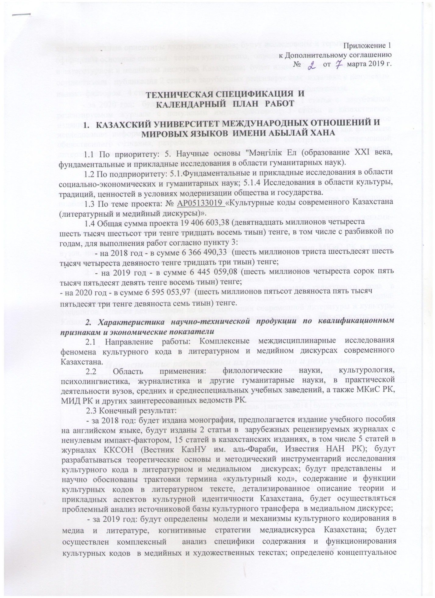

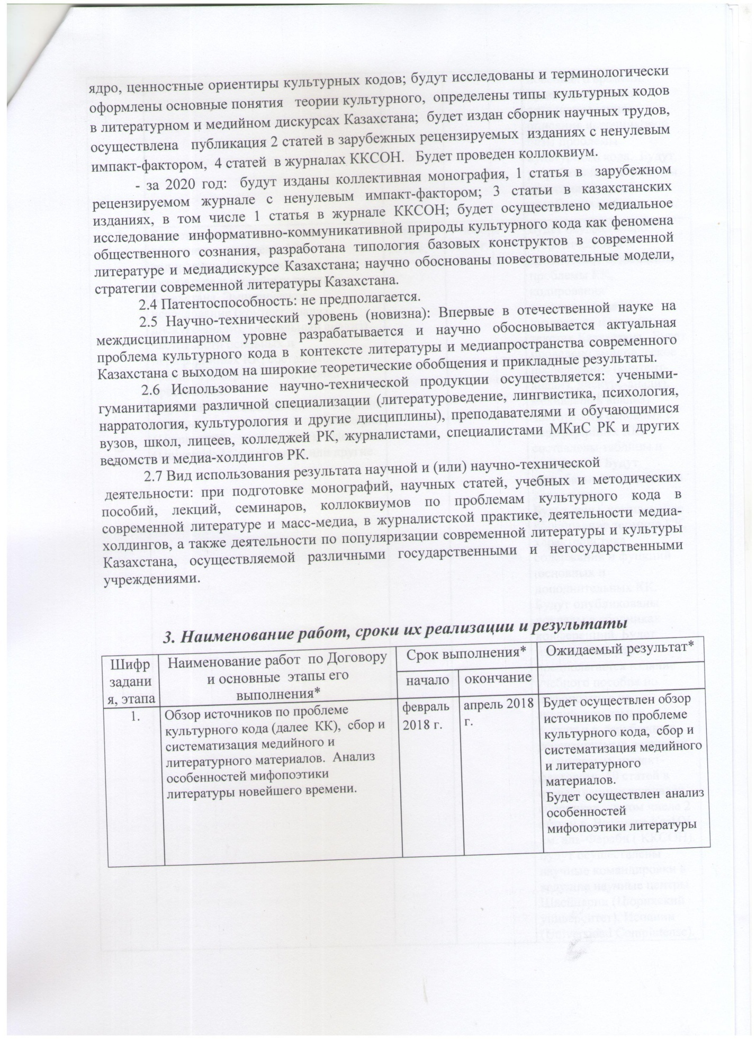

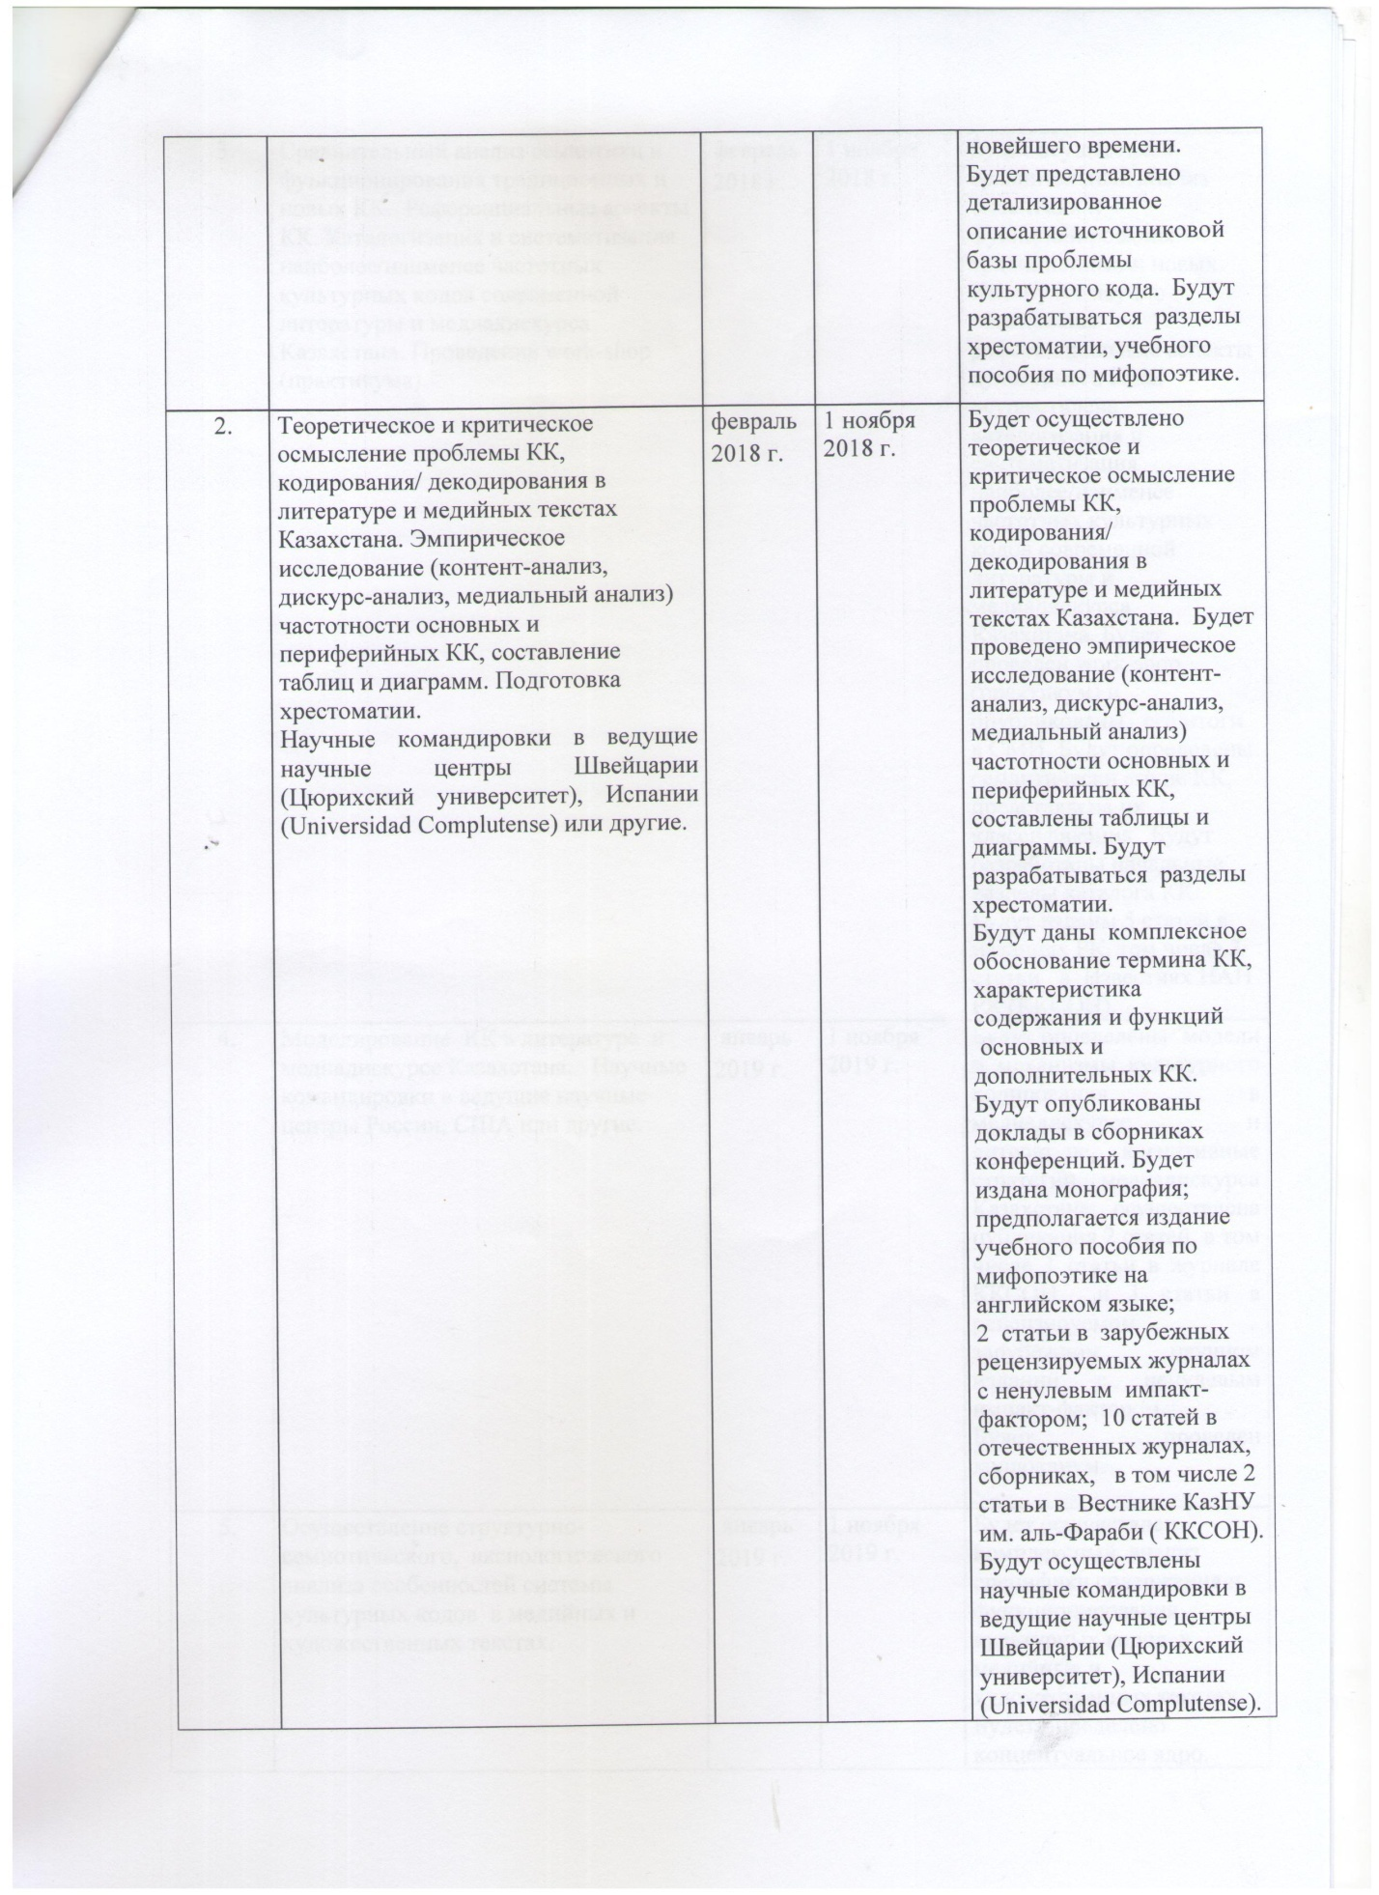

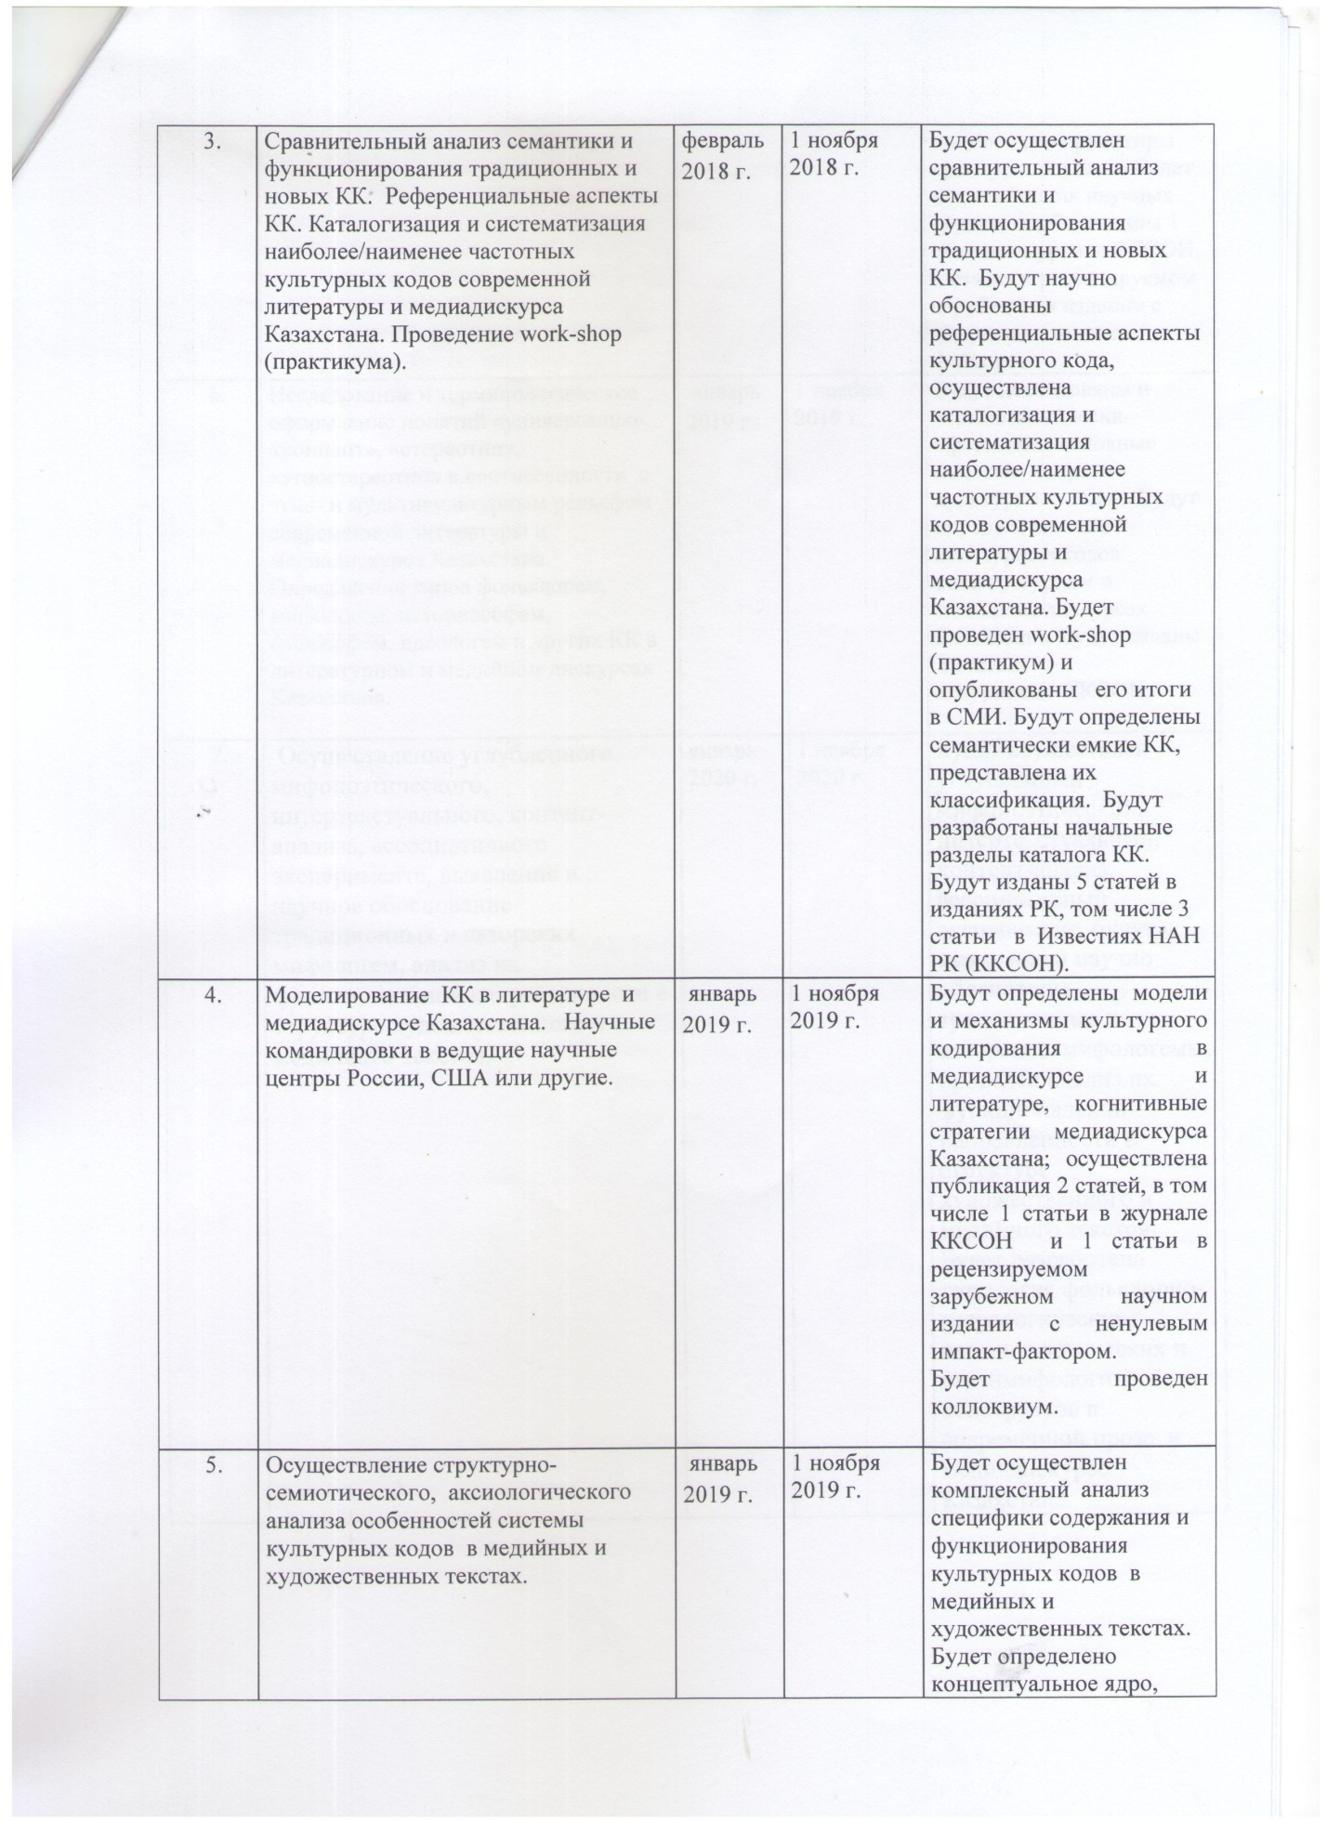

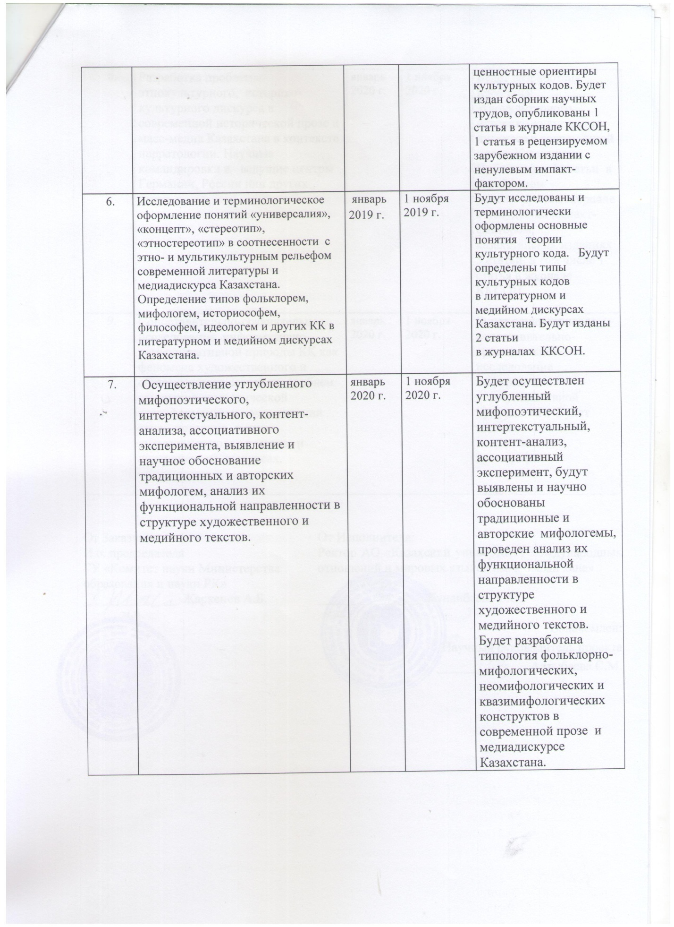

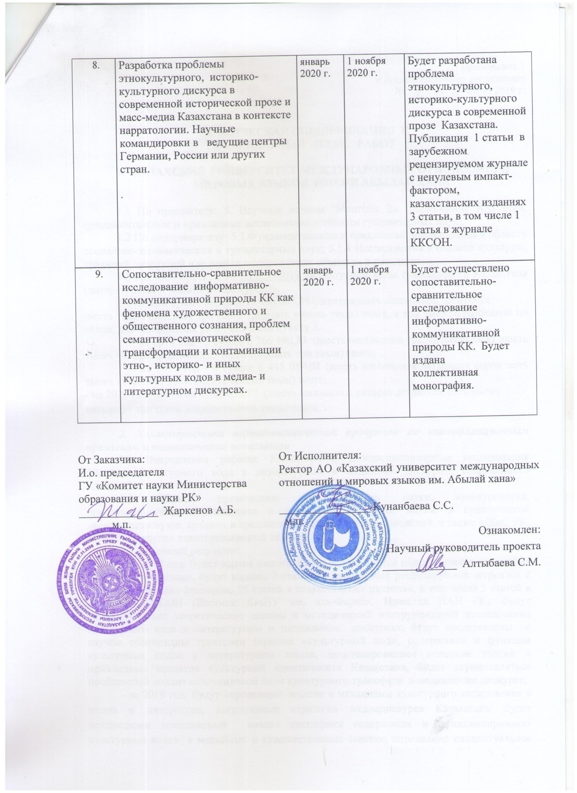

TRANSLATION INTO ENGLISH
2019
Note: In accordance with the decision of the National Scientific Council and Supplementary Agreement No. 2 dated March 7, 2019, changes were made to the Technical specification (results for 2019 - items 2.3 and 2.4) and Calendar work plan (items 4, 5, 6, 8, 9).

Appendix 1.1
to Supplementary Agreement No. 2 dated March 7, 2019

TECHNICAL SPECIFICATION AND
CALENDAR WORK PLAN

1. KAZAKH UNIVERSITY OF INTERNATIONAL RELATIONS AND WORLD LANGUAGES NAMED AFTER ABYLAY KHAN

1.1 By priority: 5. Scientific basis "Mangilik El (education of the XXI century, fundamental and applied research in the humanities).
1.2 By sub-priority: 5.1. Fundamental and applied research in the field of socio-economic and humanitarian sciences; 5.1.4 Research in the field of culture, traditions, values in the context of modernization of society and the state.
1.3 On the topic of the project: No. AP05133019 "Cultural codes of modern Kazakhstan (literary and media discourses)".
1.4 The total amount of the project 19 406 603.38 (nineteen million four hundred
six thousand six hundred three tenge thirtyeighttiyn) tenge, including with a breakdown by years, for the performance of work in accordance with clause 3:
- for 2018 - in the amount of 6 366 490.33 (six million three hundred sixtysixthousand four hundred ninety tenge thirty three tiyn) tenge;
- for 2019 - in the amount of 6 445 059.08 (six million four hundred forty-five thousand fifty-nine tenge eight tiyn) tenge;
- for 2020 - in the amount of 6 595 053.97 (six million five hundred ninetyfivethousand fifty three tenge ninety seven tiyn) tenge.
2. Characteristics of scientific and technical products by qualification characteristics and economic indicators
2.1 Direction of work: Comprehensive interdisciplinary research of the phenomenon of the cultural code in the literary and media discourses of modern Kazakhstan.
2.2 Scope: philological sciences, cultural studies, psycholinguistics, journalism and other humanities, in the practical activities of universities, secondary and secondary educational institutions, as well as MC&S RK, MFA RK and other interested departments of the RK.
2.3 End result:
- for 2018: a monograph will be published, a textbook is expected to be published in English, 2 articles will be published in foreign peer-reviewed journals with a non-zero impact factor, 15 articles in Kazakhstani publications, including 5 articles in KKSON journals (Bulletin of KazNU named after I. al-Farabi, Izvestiya NAS RK); theoretical foundations and methodological tools for the study of the cultural code in literary and media discourses will be developed; the interpretation of the term "cultural code", the content and functions of cultural codes in the literary text, a detailed description of the theory and applied aspects of the cultural identity of Kazakhstan will be presented and scientifically substantiated, a problematic analysis of the source base of cultural transfer in the media discourse will be carried out;
- for 2019: models and mechanisms of cultural coding in media and literature, cognitive strategies of media discourse in Kazakhstan will be determined; a comprehensive analysis of the specifics of the content and functioning of cultural codes in media and literary texts will be carried out; the conceptual core, value reference points of cultural codes have been determined; the basic concepts of the theory of cultural will be investigated and terminologically formalized, the types of cultural codes in the literary and media discourses of Kazakhstan will be determined; a collection of scientific papers will be published, 2 articles will be published in foreign peer-reviewed journals with a non-zero impact factor, 4 articles in KKSON journals. A colloquium will be held.
- for 2020: a collective monograph will be published, 1 article in a foreign peer-reviewed journal with a non-zero impact factor; 3 articles in Kazakhstani publications, including 1 article in the KKSON journal; a medial study of the informative and communicative nature of the cultural code as a phenomenon of public consciousness will be carried out, a typology of basic constructs in modern literature and media discourse in Kazakhstan will be developed; narrative models and strategies of modern literature in Kazakhstan will be scientifically substantiated.
2.4 Patentability: not expected.
2.5 Scientific and technical level (novelty): For the first time in domestic science, at an interdisciplinary level, the urgent problem of the cultural code in the context of the literature and media space of modern Kazakhstan is being developed and scientifically substantiated, with access to broad theoretical generalizations and applied results.
2.6 The use of scientific and technical products is carried out by: humanities scientists of various specializations (literary criticism, linguistics, psychology, narratology, cultural studies and other disciplines), teachers and students of universities, schools, lyceums, colleges of the Republic of Kazakhstan, journalists, specialists of MC&S RK and other departments and media -holdings of the Republic of Kazakhstan.
2.7 Type of use of the result of scientific and (or) scientific and technical
activities: in the preparation of monographs, scientific articles, educational and methodological manuals, lectures, seminars, colloquia on the problems of the cultural code in modern literature and mass media, in journalistic practice, the activities of media holdings, as well as activities to popularize modern literature and culture of Kazakhstan carried out by various state and non-state institutions.

3. Name of work, terms of their implementation and results

Jobcode, Stage | Name of work under the Agreement and the main stages of its implementation * | Period of execution* |  | Expected Result*
Jobcode, Stage |  | Start | ending | Expected Result*
1. | Review of sources on the problem of the cultural code (hereinafter referred to as CC), collection and systematization of media and literary materials. Analysis of the peculiarities of the mythopoetics of modern literature. | February 2018 | April 2018 | A review of sources on the problem of the cultural code will be carried out, collection and systematization of media and literarymaterials.  The analysis of the peculiarities of the mythopoetics of modern literature will be carried out.  A detailed description of the source base of the cultural code problem will be presented. Sections of a reader, a textbook on mythopoetics will be developed.
2 | Theoretical and critical understanding of the problem of СC, encoding / decoding in the literature and media texts of Kazakhstan. Empirical research (content analysis, discourse analysis, medial analysis) of the frequency of the main and peripheral CC, drawing up tables and diagrams. Preparation of a reader.  Scientific trips to leading scientific centers in Switzerland (University of Zurich), Spain (Universidad Complutense) or others. | February 2018 | November 1, 2018 | Theoretical and critical understanding of the problem of СC, encoding / decoding in the literature and media texts of Kazakhstan will be carried out. An empirical  research (content analysis, discourse analysis, medial analysis) of the frequency of main and peripheral CC, tables and diagrams were drawn up. Sections of the anthology will be developed.  A comprehensive rationale for the term СC, a description of the content and functions will be given  main and additional СC. Reports will be published in conference proceedings. A monograph will be published; publication of a tutorial onmythopoetics on  English language;  2 articles in foreign  peer-reviewed journals with non-zeroimpact factor; 10 articles in domestic journals, collections, including 2 articles in the Bulletin of KazNU named after al-Farabi(KKSON).  Scientific trips will be carried out to the leading scientific centers in Switzerland (University of Zurich), Spain (Universidad Complutense).
3 | Comparative analysis of the semantics and functioning of traditional and new CC. Referential aspects of QC. Cataloging and systematizing the most / least frequent cultural codes of modern literature and media discourse in Kazakhstan. Conducting a work-shop (workshop). | February 2018 | November 1, 2018 | A comparative analysis of the semantics and functioning of traditional and new CCs will be carried out. The referential aspects of the cultural code will be scientifically substantiated, cataloging and systematization of the most / least frequent cultural codes of modern literature and media discourse in Kazakhstan will be carried out.A work-shop (workshop) will be held and its results will be published in themedia. Semantically capacious CCs will be identified and their classification presented. The initial sections of the CC catalog will be developed. 5 articles will be published in the editions of the RK, including 3 articles in the Izvestiya NAS RK (KKSON).
4 | CC modeling in literature and media discourse in Kazakhstan.  Scientific trips to leading research centers in Russia, the USA or others | January 2019 | November 1, 2019 | Models and mechanisms of cultural coding in media discourse and literature, cognitive strategies of media discourse in Kazakhstan will be determined; 2 articles were published, including 1 article in the KKSON journal and 1 article in a peer-reviewed foreign scientific journal with a non-zero impact factor.  A colloquium will be held.
5 | Implementation of structural-semiotic, axiological analysis of the features of the system of cultural codes in media and literary texts. | January 2019 | November 1, 2019 | A comprehensive analysis of the specifics of the content and functioning of cultural codes in media and literary texts will be carried out. To be determined  conceptual core,  value orientations of cultural codes. A collection of scientific papers will be published, 1 article will be published in the KKSON journal, 1 article in a peer-reviewed foreign publication with a non-zero impact factor.
6 | Research and terminological design of the concepts "universal", "concept", "stereotype", "ethno-stereotype" in relation to the ethno and multicultural relief of modern literature and media discourse in Kazakhstan.  Determination of types by folklore, mythologeme, historiosopheme, philosopher, ideologeme and other CCs in the literary and media discourses of Kazakhstan. | January 2019 | November 1, 2019 | The main concepts of the theory of cultural code will be investigated and terminologically formalized. Cultural code types will be determined  in the literary and media discourses of Kazakhstan. 2 articles will be published  in the journals KKSON.
7 | Implementation of in-depth mythopoetic, intertextual, content analysis, associative experiment, identification and scientific substantiation of traditional and author's mythologemes, analysis of their functional orientation in  the structure of artistic and media texts. | January 2020 | November 1, 2020 | An in-depth mythopoetic, intertextual, content analysis, associative experiment will be carried out, traditional and author's mythologemes will be identified and scientifically substantiated, and their functional orientation in the structure of fiction and media texts will be analyzed. A typology of folklore-mythological, neomythological and quasi-mythological constructs in modern prose and media discourse in Kazakhstan will be developed.
8 | Development of the problem of ethnocultural, historical and cultural discourse in modern historical prose and mass media of Kazakhstan in the context of narratology. Scientific trips to leading centers in Germany, Russia or other countries. | January 2020 | November 1, 2020 | The problem of ethnocultural, historical and cultural discourse in modern  prose of Kazakhstan.  Publication of 1 article in a foreign peer-reviewed journal with a non-zero impact factor, in Kazakhstani publications 3 articles, including 1 article in the KKSON journal.
9 | Comparative study of the informative and communicative nature of CC as a phenomenon of artistic and  public consciousness, problems of semantic and semiotic  transformation and contamination of ethno, historical and other cultural codes in media and literary discourses. | January 2020 | November 1, 2020 | A comparative and comparative study of the informative and communicative nature of CC will be carried out. Will be published  collective monograph.

2020

2020
Note: In accordance with the decision of the National Scientific Council and Supplementary Agreement No. 5 dated May 4, 2020, changes have been made to the Technical specification (results for 2020 - item 2.3) and Calendar work plan (items 7, 8). The Item9 was carried out in accordance with the Supplementary Agreement No. 2 dated March 7, 2019.

Supplementary Agreement No. 5
to the Аgreement on grant financing
No. 122 dated March 05, 2018

Nur-Sultancity"4" May 2020

State institution "Science Committee of the Ministry of Education and Science of the Republic of Kazakhstan", hereinafter referred to as the Customer, represented by the chairman Zh.D. Kurmangaliyeva, acting on the basis of the Regulation on the Science Committee, approved by order of the Executive Secretary on July 10, 2018 No. 169-K and by order of the Minister of Education and science of the Republic of Kazakhstan dated December 25, 2019. No. 169-ZhK, on ​​the one hand, and the Kazakh University of International Relations and World Languages ​​named after Abylai Khan, hereinafter referred to as the "Executor", represented by the rector S. S. Kunanbaeva, acting on the basis of the Charter, approved of March 23, 2008 No. 12, on the other parties, hereinafter collectively referred to as the "Parties", on the basis of Articles 401, 402 of the Civil Code of the Republic of Kazakhstan, Resolution of the Government of the Republic of Kazakhstan dated May 25, 2011 No. 575 "On Approval of the Rules for Basic, Grant, Program-Targeted Financing of Scientific and (or) Scientific and Technical activities ", Resolution of the Government of the Republic of Kazakhstan" On National Scientific Councils "dated May 16, 2011 No. 519 and decisions of the National Scientific Council on the priority direction" Scientific foundations "Mangilik El (education of the XXI century, fundamental and applied research in the humanities") ( Protocol No. 1 dated July 17, 2020) concluded this Supplementary Agreement to Agreement No. 122 dated March 05, 2018 a (hereinafter referred to as the Agreement) and have come to an agreement as follows:

- The item 2.3 of Appendix 1.1 to the Agreement shall be amended as follows:
The final result for 2020: a collective monograph, a study guide will be published, an electronic study guide will be developed and published, 1 article in a foreign peer-reviewed journal with a non-zero impact factor; 3 articles in Kazakh publications, including 1 article in the KKSON magazine; a media study of the informative and communicative nature of the cultural code as a phenomenon of public consciousness will be carried out, a typology of basic constructs in modern literature and media discourse in Kazakhstan will be developed; the narrative models and strategies of modern literature in Kazakhstan are scientifically substantiated.
- Items 7.8 of Chapter 3. Appendix 1.1 to the Agreement shall be stated as follows:
7 | Implementation of in-depth mythopoetic, intertextual, content analysis, associative experiment, identification and scientific substantiation of traditional and author's mythologemes, analysis of their functional orientation in  the structure of artistic and media texts. | January 2020 | November 1, 2020 | An in-depth mythopoetic, intertextual, content analysis, associative experiment will be carried out, traditional and author's mythologemes will be identified and scientifically substantiated, and their functional orientation in the structure of fiction and media texts will be analyzed. A typology of folklore-mythological, neomythological and quasi-mythological constructs in modern prose and media discourse in Kazakhstan will be developed.  A printed textbook will be published, and an electronic manual will be developed and published.
8 | Development of the problem of ethnocultural, historical and cultural discourse in modern historical prose and mass media of Kazakhstan in the context of narratology. | January 2020 | November 1, 2020 | The problem of ethnocultural, historical and cultural discourse in modern prose of Kazakhstan will be developed.  Publication of 1 article in a foreign peer-reviewed journal with a non-zero impact factor, in Kazakhstani publications 3 articles, including 1 article in the KKSON journal.

- Item 13 of Chapter 3 of Appendix 1.2to the Agreement shall be revised as follows:
13 | Expert assessment of monographs, textbooks and multimedia materials | October 2020 | November 1, 2020 | An expert assessment of the monograph, textbook and multimedia materials and external assessment of specialists will be carried out.  Research results will be published in foreign peer-reviewed scientific journals with a non-zero impact factor.

4. This Supplementary Agreement is an integral part of the Agreement and comes into force from the moment of signing by the Parties and is valid until December 31, 2020.
5. The terms of the Agreement not affected by this Supplementary Agreement remain unchanged.
6. The supplementary agreement is made in two copies, one copy for each of the parties, having the same legal force.
Legal addresses of the parties:
Customer:  State Institution "Science Committee of the Ministry of Education and Science of the Republic of Kazakhstan"  010000, Nur_Sultancity, Mangilik El avenue, 8  BIN 061 140 007 608  BIK KKMFKZ2A  IIC KZ92 0701 01KS N000 0000  KBe 11  RSU "Committee of the Treasury of the Ministry of Finance of the Republic of Kazakhstan"  The chairman  ________________ Zh.D. Kurmangalieva | Executor:  JSC Kazakh University of International Relations and World Languages named after Abylai Khan "  Legal address: 050022 Almaty, Muratbayevst., 200  BIN 011140001654  BIC KCJBKZKX  IIC KZ358560000000010712  KB 16  BANK JSC "BankCenterCredit"  Tel .: 8 702 4999 438  Rector  ______________ Kunanbaeva S.S.

They are arranged according to the principle of gradation of meanings: from general to particular. Introduced into scientific circulation in the relevant publications within the project. In this annex, definitions are presented in the author's edition.

