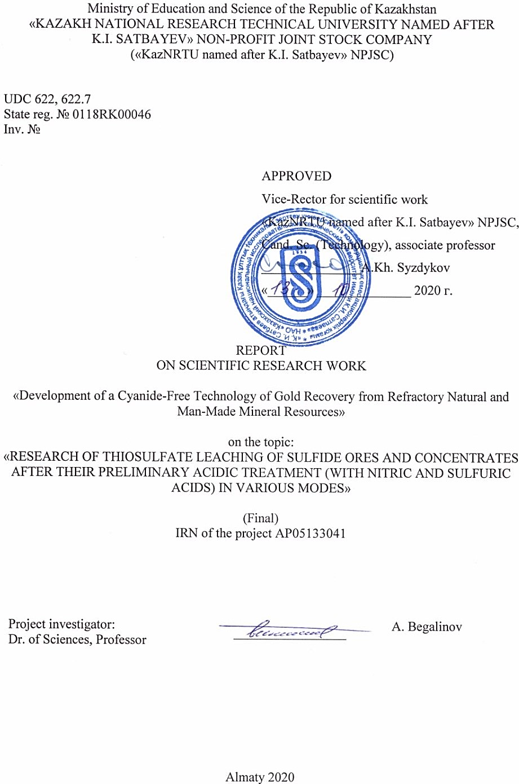

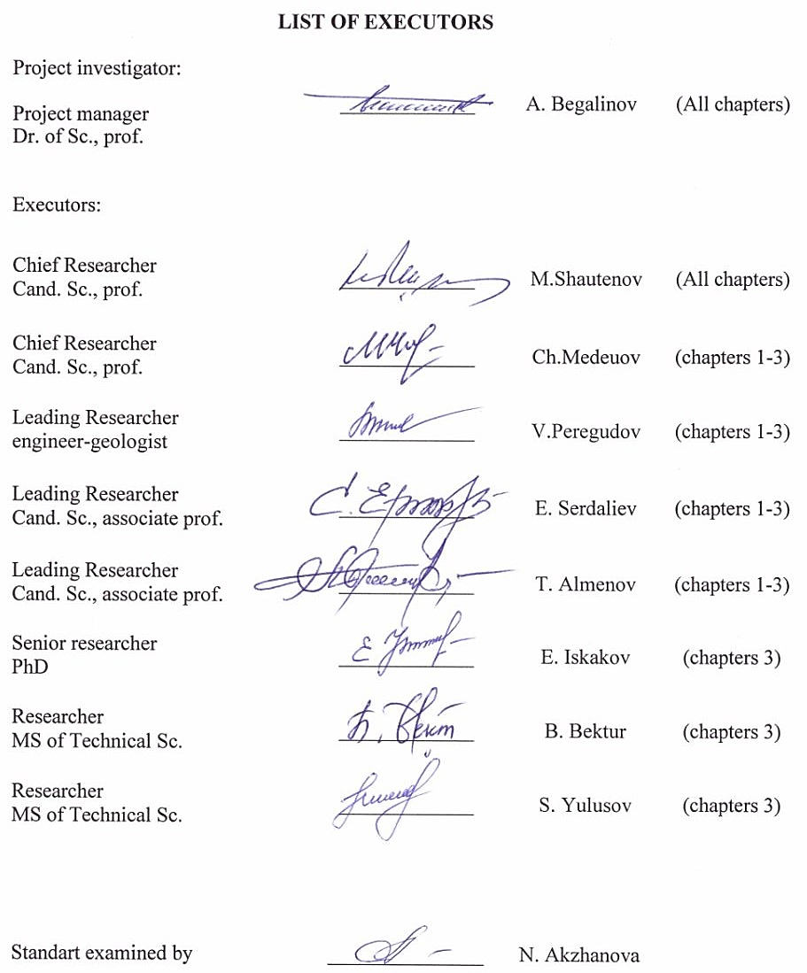

РЕФЕРАТ

Есеп: 40 беттен, 10 суреттен, 16 кесте және 32 дереккөзден, 3 қосымшадан тұрады.

АЛТЫН ҚҰРАМДЫ КЕН, ЕЛЕУІШТІ ТАЛДАУ, ГРАВИТАЦИЯЛЫҚ ЖӘНЕ ФЛОТАЦИЯЛЫҚ БАЙЫТУ, СОРБЦИЯЛЫҚ ЦИАНИДТЕУ, МЕХАНОХИМИЯЛЫҚ БЕЛСЕНДІРУ, РЕАГЕНТ, ТИОСУЛЬФАТТЫ ЖӘНЕ АВТОКЛАВТЫ СІЛТІЛЕУ, ӨТЕ МАЙДА ҰНТАҚТАУ, СУЛЬФИДТІ КҮКІРТ, АЛТЫННЫҢ ХИМИЯЛЫҚ ЖӘНЕ ЭЛЕКТРОХИМИЯЛЫҚ ТҰНБАСЫ, БИПОЛЯРЛЫ ЭЛЕКТРОЛИЗЕР.

Зерттеу нысаны: Пустынное Кварцитовые горки, Бақыршық және Ақбақай кенорындарының кен алаңдарындағы өңделуі «қиын» құрамында алтыны бар кендер және олардың байыту өнімдері.
Жұмыстың мақсаты: тиосульфатты сілтілеу негізінде цианидсіз технология бойынша өңделуі қиын шикізаттардан алтынды алудың тиімді және экологиялық қауіпсіз технологиясын жасау.
Жұмысты жүргізу әдісі немесе әдістемесі: химиялық, физикалық, минералогиялық, фракциялық, елеуішті, седиментациялық, аспапты және тағы да басқа талдау әдістері; гравитациялық және флотациялық байыту әдістері, тиосульфаттық сілтілеу, механикалық белсендіруші ұнтақтау және механикалық-химиялық белсендіру (тотықтыру), химиялық және электрохимиялық тұнбаландыру.
Жұмыстың нәтижесі және оның жаңалығы: кенді ұсақтау мен ұнтақтаудың негізгі оңтайлы параметрлері, өңделуі қиын көмірлі-алтынды-мышьякті кенінен алынған концентраттарды тотықтыру мен сілтілеудің (Бақыршық), сульфидті кендер мен байыту өнімдерінің (Кварцитовые горки) негізгі оңтайлы параметрлері анықталды, сонымен қатар, алтынды кедей тиосульфатты ерітінділерден тікелей электрохимиялық тұндырудың негізгі тиімді параметрлері анықталды.
Жұмыстың жаңалығы: - әзірленген жаңа технология автоклавтағы қысымды 16-20 атмосферадан 5-ке дейін, температураны 290-300°С-дан 60°С-ға дейін төмендетуге мүмкіндік береді, оттегінің орнына тотықтырғыш ретінде - ауаны пайдалануға болады.
- сульфидті материалдардың фазалық түрленуі және алтынның сұйық өнімге ауысу механизмі анықталды.
- тиосульфатты ерітінділерден алтынды тікелей алудың электрохимиялық әдісі жасалды.
- биполярлы электролизердің жаңа конструкциясы әзірленді.
Қолдану саласы: құрамында алтыны бар мору қыртысындағы және түпкі (негізгі) кендердегі, сонымен қатар, техногенді алтын құрамды шикізаттарды өңдеу: Бақыршық, Большевик, Майқайың, Ақбақай және т.б. кенорындары.
Енгізуге ұсыныстар немесе ғылыми зерттеу жұмыстарының мәліметтерін енгізудің нәтижелері: зерттеу нәтижелері байытылуы қиын, құрамында алтын бар кендер мен техногендік шикізатты қайта өңдеудің технологиялық процестерінде пайдаланылуы мүмкін. Зерттеу нәтижелері қамтылған монография мен оқу құралы оқу процесінде қолданылады.
Экономикалық тиімділік немесе жұмыстың маңыздылығы: алтын құрамды шикізаттың өңдеу технологиясын қолдану, әр түрлі мақсаттарға қол жеткізеді: қиын байытылатын алтынқұрамды шикізатты кешенді пайдалануға, табиғи алтынның өте ұнтақ бөлшектерін бөліп алу дәрежесін арттыруға қол жеткізеді және өнеркәсіптік аймақтың экологиялық жағдайын жақсартады.
Зерттеу объектісінің дамуы үшін болашаққа ұсыныстар: алтын құрамды шикізаттарды өндеу әдісі осыған ұқсас технологиялар арасында бәсекелестікке қабілетті деуге болады.

ABSTRACT

The Report 40 pages, 10 figures, 16 tables and 32 references, 3 appendices.

GOLD ORE, SCREEN ASSAY, GRAVITY AND FLOTATION CONCENTRATION, SORPTION CYANIDATION, MECHANOCHEMICAL ACTIVATION, REAGENT, THIOSULFATE AND AUTOCLAVE LEACHING, ALL-SLIMING, SULFIDE SULFUR, CHEMICAL AND ELECTROCHEMICAL DEPOSTION OF GOLD, BIPOLAR ELECTROLYZER.
The object of research or development: refractory gold-bearing ores and products of their concentrates of the Pustynnoye deposit, Quartzite Gorki, Bakyrchik and Akbakay ore field.
The purpose of work: development of an efficient and environmentally friendly technology of gold recovery from refractory raw materials using cyanide-free technology based on thiosulfate leaching.
The method or methodology of work: chemical, physical, mineralogical, sink-and float, screen assay, sedimentation, assay tests and other methods of analysis; gravity, flotation enrichment methods, thiosulfate leaching, mechanical activation grinding and mechanochemical activation, chemical and electrochemical gold deposition.
Results of the work and their novelty: The main optimal parameters of ore breaking and grinding, oxidation and thiosulfate leaching of refractory carbonaceous-gold-arsenic concentrates (Bakyrchik), sulfide ores and beneficiation products (Quartzite Gorki), electrochemical deposition of gold directly from poor thiosulfate solutions were determined.
The novelty of the work: - The developed new technology ensures the reduction of pressure in the autoclave from 16-20 atmospheres to 5, the temperature from 290-300°С to 60°С; air is used as an oxidizing agent instead of oxygen.
- Establishing phase changes of sulfide materials and the transformation mechanism of gold into a liquid product.
- An electrochemical method has been developed to recover gold directly from poor thiosulfate solutions.
- A new design of a bipolar electrolyzer has been developed.
The field of results application: processing of gold ores of the weathering crust and base ores as well as technogenic raw materials from the following deposits: Bakyrchik, Bolshevik, Maykain, Akbakay and many others.
Recommendations on the implementation or results of the R&D implementation: research results can be used in technological processes for processing refractory gold ores and technogenic raw materials. The monograph and study guide can be used in teaching.
Economic efficiency or significance of the work: the use of this technology of processing gold-bearing raw materials will ensure the solution of a number of problems: integrated use of mineral raw materials including the processing of refractory gold-bearing ores, additional recovery of useful components contained in the ore in addition to gold; increased gold recovery due to fine and thin gold and improvement of the environmental situation in the industrial zone.
Predictive proposals for the development of the research object: the developed method of processing gold-containing raw materials can be competitive among similar developments.

TABLE OF CONTENTS
INTRODUCTION 7
1 Research of gold occurrence forms in the studied ore samples and concentration products. determination of gold phase changes at the oxidation of sulfide ores and concentration products under pressure in alkaline and acid media in the presence of oxygen and atmospheric oxygen 13
1.1 Research of Gold Occurrence Forms in the Researched Ore Sample (Mineralogical, Sink-And-Float, Chemical, X-Ray Phase and Other Methods of Analysis). Research of Ore Processing of the Gold Ore Sample (Crushing, Grinding and Classification). Determination of the Particle Size Distribution and Gold Distribution Pattern in Grain Sizes 13
1.1.1 Weathered Gold Ore Sample Preparation for Gravity and Flotation Concentration of the Researched Ores 13
1.2 Research on Gravity and Flotation Concentration of the Gold Ore Sample with the Purpose of Manufacturing Concentration Products for Thiosulfate Leaching 14
1.2.1 Experimental Work on Gravity Concentration of the Researched Ores on Spiral Separators, a Jig, a Concentration Table and a Centrifugal Hydraulic Concentrator 14
1.2.2 Research on Gravity Concentration of Run of Mine Gold Ore (Jigging and Table Concentration) 15
1.2.3 Experimental Work on Flotation Concentration of the Researched Ores 15
1.3 Research on Oxidation of Sulfide Ores and Concentration Products in the Conditions of the Redox Process in Various Milder Temperature and Pressure Modes 16
1.3.1 Characteristics of the Initial Sample 16
1.3.2 Autoclave Oxidation of the Concentrate 16
1.4 Research on Thiosulfate Leaching of Ores and Concentration Products after Preliminary Oxidation of Sulfides in the Conditions of the Redox Process with Various Reagents and Other Process Modes 18
2 Research of phase changes of gold-bearing sulfide ores and concentration products at all-sliming (20, 10 mcm). research on thiosulphate leaching of ores and concentrates after all-sliming in various reagent modes 21
2.1 Selection of Grinding Equipment. Research on All-Sliming of Gold-Bearing Sulfide Ores and Concentration Products and Determining Phase Changes of Minerals and Sulfur Oxidation Degree 21
2.1.1 Mechanical Processing in Mineral Processing Technology 21
2.2 Research on Thiosulfate Leaching of Various Ore Fractions and Concentration Products after All-Sliming. Establishing Optimal Parameters for Grinding and Leaching. 21
2.2.1 Research on All-Sliming of Gold-Bearing Sulfide Ores and Concentration Products 21
2.3 Research on Thiosulfate Leaching of Various Ore Fractions and Concentration Products after All-Sliming. Establishing Optimal Parameters of Grinding and Leaching 24
Conclusions on Section 2 29
3 Research on Thiosulfate Leaching of Sulfide Ores and Concentration Products after Their Preliminary Acid Treatment (with Nitric and Sulfuric Acids) in Various Modes 30
3.1 Research on Leaching of Ores and Concentration Products after Their Preliminary Nitric Acid Treatment (Nitrox Process) in Various Leaching Modes with the Use of Various Solvents – Thiosulfates, Sulfates, Alkalis 30
3.2 Research on Thiosulfate Leaching of Sulfide Ores and Concentration Products after Their Preliminary Sulfuric Acid Treatment in Various Temperature and Chemical Modes. Establishing Optimal Parameters for Acid Treatment and Thiosulfate Leaching 30
3.3 Research on the Chemical and Electrochemical Gold Deposition from Poor Product Solutions Without Sorption and Desorption Operations 30
3.3.1 Electrochemical Method of Gold Recovery from Thiosulfate Solutions 31
CONCLUSION 36
LIST OF REFERENCES 39
APPENDIX A 41
APPENDIX B 49
APPENDIX C 51

INTRODUCTION

Assessment of the current state of the problem and its relevance. In Kazakhstan, as in the world practice, sodium cyanide remains the main chemical tool for gold recovery from ore and concentrates. At the same time, the presence of gold in raw materials in accessible and oxidized forms allows using the cyanide leaching process directly after appropriate crushing or grinding of raw materials. However, at most deposits of Kazakhstan, gold in ore is in fine association with sulfide minerals of iron, arsenic, copper and other non-ferrous metals (pyrite, arsenopyrite, chalcopyrite, etc.). In addition, carbon is present at a number of gold deposits. The fine association of gold in minerals, the presence of carbon and other impurities in the lower forms of valences (Fe++, As+++, S--) create insurmountable difficulties for the gold recovery by means of direct exposure to cyanide solvents. For this reason, these types of ore are usually classified as refractory raw materials. Deposits with such types of ores in Kazakhstan include Bakyrchik, Bolshevik, Maykain, Akbakay and many others, where over a third of the Republic’s explored gold reserves are concentrated [1]. To use the cyanide process for these types of ores requires the use of several additional technological methods, which mainly include preliminary oxidation of raw materials - radically by roasting the ore or concentrate; bacterial oxidation; treatment with nitric acid in the presence of pure oxygen under high pressure in an autoclave (redox process) or under normal conditions in the presence of atmospheric oxygen (nitrox or arseno-processes), etc. Even with the inclusion of the aforementioned, rather complex, additional treatments in the ore processing technology, in some cases (at Bakyrchik, Bolshevik, etc.) it has not yet been possible to achieve acceptable indicators for the gold recovery from raw materials. At the same time, all the mentioned methods do not ultimately exclude the environmental hazard posed by the use of a cyanide reagent at the final stage of the technology.
These problems at the processing of refractory types of gold-bearing raw materials can be solved by using an environmentally friendly reagent based on thiosulfate compounds instead of cyanides.
The analysis of changes in the structure of gold ore over the past two-three decades shows that the relative amount of technologically “simple” gold ores, which can be processed according to standard process charts, is decreasing, and every year their share in the total balance of raw materials is noticeably decreasing. At the same time, the amount of complex ores is increasing, the successful processing of which requires the use of new technological methods, a combination of mechanical concentration, flotation, hydro- and pyrometallurgy, including the use of new reagents for dissolving gold. Such ores are classified as a separate category of refractory gold-bearing raw materials. The processing of this raw material can be ensured only by creating a fundamentally new technology for processing refractory ores based on the use of the simplest environmentally friendly process charts as well as easily and quickly installed technological units. Such technologies include thiosulfate technology for gold recovery from refractory ores. Therefore, the study and development of the innovative, highly efficient and environmentally safe thiosulfate technology for gold recovery from refractory natural and technogenic minerals is an urgent task for the mining and metallurgical sector of the Republic.
Basis and input data for the research development. Gold and silver leaching methods using solutions of ammonium or sodium thiosulfate in the presence of sulfite ion and copper are well known in world practice [2]. The use of the reagent was primarily intended for processing ores unsuitable for leaching using traditional cyanide solutions (cuprous, manganese, carbonaceous, etc.). The experience of Canadian researchers [3] regarding the use of a thiosulfate reagent for leaching rhyolite ore of the following composition: gold - 3 g/t, silver - 113 g/t, and manganese dioxide - 7 kg/t. The process is done at a temperature of 25-60°C, duration up to 3 hours, with the following composition of the solution (%%): 1-42 S₂O₃²⁻; 0.7 NH₃; 0.15-6.0 CuSO₄. As the temperature rises, the degree of gold and silver recovery increases and in 3 hours of leaching at 50°C it reaches 90 and 70%, respectively. In the absence of thiosulfate ion, the gold solubility is very low.
In another work [4], a thiosulfate reagent was used to recover silver from refractory ore containing copper, selenium, tellurium, and manganese. The process was done at a temperature of 40-50°C. The required salt composition of the solution was maintained by adding elemental sulfur and its dioxide. Under these conditions, 90% silver was recovered from the 456 g/t silver ore containing 10.5% manganese. The known method [3] was used for thiosulfate leaching of refractory manganese-containing ore of the following composition: 0.4 g/t of gold, 343 g/t of silver, 2.1% of manganese. Leaching was done using a solution with a concentration of 18% (NН₄)₂S₂О₃ in the presence of 3% ammonium sulfite, 2% ammonium hydroxide, and 4 g/L copper. The silver recovery was 93.2%, gold, 86.7% with the consumption of ammonium thiosulfate equalling 3.6 kg, ammonium sulfite, 1.35 kg, copper, 0.45 kg per ton of ore. The work [5] studies the effect of the concentration of ammonium thiosulfate, ammonia and copper in solution on gold recovery during the leaching of sulfide concentrates. It was found that at 50°C, 1:3 liquid to solid ratio, concentration (mol/L) NН₄ OH 2-4, (NH₄)₂SO₄ 0.5-0.8, (NH₄)₂SO₃, copper 2 g/L, under conditions of pulp aeration with air, gold recovery reaches 95%. There is information about the use of thiosulfate leaching in the processing of complex pyrite with the following composition (g/t): Аu 12.31; Ag 1,390; (%) Cu 5.95; Pb 4.38; S 28.34; Zn 1.33; Fe 26.04; Si 28.34. Under optimal conditions of the leaching process, the gold and silver recovery into solution achieved 93.38 and 85.64%, respectively. In another case [6], the ore with the composition (%): Si 3.97; Аl₂О₃ 3.97; Fe 2.0; Fe₂O₃ 3.3; CaO 2.7; S 0.34; K₂O 2.97; Au 21.8 g/t; Ag 90.2 g/t was leached with a solution of sodium thiosulfate (40-80 g/L) in an ammonia medium (NH₄OH 10-15 g/L) in the presence of copper sulfate (6-8 g/L) at 80°C during 1,5-2.0 hours. The gold recovery into the solution reached 97%. With regard to refractory carbonaceous ores in Nevada [7], raw materials were preliminarily oxidized with oxygen in an autoclave. Ore composition: Au 5-7 g/t, carbon 6-7%, sulfur 1.5-2.5%. The crushed ore was subjected to autoclaving at a temperature of 185-235°C. Next, ammonium thiosulfate (3-11 g/L), ammonium sulfite (0.1 g/L), copper (0.1 g/L) were dosed into the cooled pulp at pH=8.7. Leaching takes about 2 hours at 40-55°C. Gold recovery was up to 80%. The patent [8] contains the results of thiosulfate leaching of a similar type of ore, but with preliminary microbiological oxidation of raw materials and the use of a percolation method for leaching lump ore (-15mm). Ore composition: 1.8 g/t gold, 1.2% carbon, 1.3% sulfide sulfur. Duration of microbiological oxidation is 14 days, percolation leaching is 13 days. The composition of the leaching solution: ammonium thiosulfate 15 g/L, ammonia 1 g/L, copper 60 mg/L. Gold recovery was 68%. To compare, the gold recovery using the cyanide method under similar conditions was only 1% due to the sorption properties of the carbon present in the ore in relation to the cyanide gold complex.
Chinese researchers have studied the effect of thiosulfate, Cu²⁺ and NH₄OH concentrations on gold recovery from sulfide concentrates. It is shown that the recovery reaches 95% at 50⁰C, 1:3 liquid to solid ratio, under conditions of pulp aeration at the following concentrations (mol/L): NH₄OH 2 - 4; (NH₄)₂SO₄ 0.5-0.8; (NH₄) S₂О₃ 0.2-0.3; Cu 3 g/L. In the absence of thiosulfate as well as with its high content, the recovery does not exceed 20% [9].
The pilot testing of the technology based on the thiosulfate gold dissolution was done at a plant in Mexico. Currently, the New-Mont company (USA) uses heap thiosulfate leaching of gold (in conjunction with bio-oxidation) for processing ores containing natural carbonaceous sorbents. Another company (Barrick, USA) tests a technology based on autoclave oxidative stripping of refractory ores at underground mining and subsequent thiosulfate gold dissolution. It was supposed that the full-scale implementation of the process (in conjunction with the autoclave oxidation of double refractory ore and the sorption of gold using a strongly basic ion-exchange resin) will take place at the Goldstrike plant (Nevada, USA) in 2014. A demonstration unit with a capacity of 5 tons of ore (concentrate) per day is in operation.
It is believed that thiosulfate gold leaching can be used in cases where the use of cyanide solutions is impossible or prohibited. Such cases, in particular, are underground leaching and processing of gold-bearing concentrates in the conditions of copper production [10].
It was shown that it is possible in principle to use thiosulfate solutions for anaerobic underground leaching of gold from the sorption-active ore of the Victorian Deep Leeds deposit (Australia), from the double refractory product of autoclave oxidative treatment of the Carlin trend (USA) as well as from the flotation pyrite concentrate in the presence of ion-exchange resin (RIP-process).
With regard to the processing of real objects, it is worth noting the tests on thiosulfate leaching of refractory gold ores with a high content of copper, manganese, lead, zinc and natural carbon.
A large amount of work on thiosulfate leaching of gold and silver has been performed by Russian researchers at the Irgiredmet Institute. The process has been tested in relation to many types of minerals: quartz gold-silver ores, ore flotation tailings from many deposits as well as argillaceous gold ores. Based on the results of these studies, special attention should be paid to the fact that, regardless of the material composition of the source materials, at an initial concentration of sodium thiosulfate of 20-80 g/L during 1.5-2.0 hours, gold recovery is achieved that is not inferior to the level of gold recovery using traditional cyanide process. It is recommended that the leach solution also contain up to 30 g/L of sulfite and sodium sulfate, 5-15 g/L of free alkali and 1-2 g/L of copper sulfate. The process temperature should be maintained at 80°C. As a result, the following indicators of gold and silver recovery from ores were achieved, %:
Quartz ore: | Аu | Ag
Gold ore | 95,0 | 90,0
Silver ore | 95,0 | 98,5
Concentration tailings | 94,0
Argillaceous ore | 97,0 | 94,0
Justification of the need in the research and development. In Kazakhstan, research of thiosulfate technology for gold recovery was first conducted in 1995-1996 in the city of Stepnogorsk: first, on a laboratory scale, and then on an experimental-industrial scale. The object of research was the carbonaceous-arsenic sulfide ore of the Bakyrchik deposit, which, due to the presence of carbon and arsenic as well as the fine germination of gold in sulfide minerals (pyrite and arsenopyrite), from a technological point of view, belongs to the class of very refractory raw materials. While it is still possible to obtain concentrates with acceptable gold recovery rates (95% and higher) from ore using relatively simple gravity-flotation methods, the subsequent hydrometallurgical processing of the concentrate, due to the above-mentioned characteristics of the raw material, is associated with a significant gold under-recovery into the final marketable product. A then operating technical service of the enterprise presented a sample of the concentrate with the following composition: As 7.9%; Fe 15.42%; S 11.8%; C 6.72%; Au 61.1 g/t. The composition of the reagent for leaching, g/L: (NH₄)₂S₂O₃ 10; (NH₄)SO₃ 60; CuSO₄ 1; NH₃ pH = 9.0-9.5. The process was performed at solid to liquid ratio = 1:10, temperature 40-60°C during 3 hours. The degree of gold recovery into solution was 97%.
In the same period, research was done, and the industrial development of thiosulfate technology at some deposits of Kazakhstan - Zherek (in the east) and Kelinshektau (in the south) as well as the processing of gold-bearing weathering crusts of the Symbat site began. To provide these facilities with thiosulfates, reagent plants were built individually for each facility in Semipalatinsk and Taraz. Unfortunately, the work was interrupted due to force majeure, although by the time the plant was shut down for the reconstruction in terms of thiosulfate technology, products in the form of copper-silver-gold bars (about 3 tons) and a chemical silver and gold concentrate (over 100 tons) were produced at Kelinshektau. The authors of this scientific project were directly involved at all stages of the mentioned work and gained invaluable experience and knowledge for its successful continuation. Specific stages and topics of these works will be given below. On this topic, we have issued numerous scientific reports, articles, patents, monographs [11 - 17].
Information about the planned scientific and technical level of development, about patent research and conclusions. At the new stage of development, it is necessary to continue work on improving the thiosulfate technology. Within the framework of the environmentally friendly thiosulfate technology, it is necessary to offer new, more efficient, combined processing methods for each separate type of raw material with due account for the specifics and composition of raw materials. When processing refractory sulfide raw material using cyanide technology, the process of preliminary oxidation of raw materials implies deep hexavalent oxidation of sulfur to the 6-valence, which forces the use of pure oxygen, expensive acids as reagents, and rigid process conditions in terms of pressure and temperature. The proposed technology involves the use of air instead of pure oxygen, cheap sulfuric acid instead of nitric acid, and the process is performed at a lower temperature and pressure. The elemental sulfur formed as a result of the under-oxidation of sulfide sulfur, which is unacceptable in the cyanide technology, is dissolved using a sulfite reagent, thus transforming it into a thiosulfate reagent for leaching gold, i.e. part of the sulfur present in the form of a harmful impurity in the raw material is turned into a reagent for the gold recovery. It is also necessary to significantly change the production technology at the stage of processing productive solutions after gold leaching. The new technology is supposed to effectively precipitate gold directly from poor solutions using chemical or electrochemical methods without resorting to the traditionally used processes of gold sorption and desorption. All these new elements greatly simplify the technology of gold recovery, reduce the operating and capital costs at its implementation [11].
The use of a thiosulfate reagent is based on the property of gold to form a stable water-soluble anionic complex in the form of Au(S₂O₃)₂³⁻- in an alkaline medium with a relatively low ORP. The formation of such complexes is also typical for silver and copper (Cu¹). At gold leaching it is desirable that the solution contain copper ions as a reaction catalyst. Therefore, in the absence of copper in the source material, it is recommended to add it in the form of copper sulfate or other compounds (Cu²). In some cases, the presence of SO₃²⁻ sulfite ions and SO₄²⁻ sulfate ions in the solution is also desirable. Since the latter are products of partial oxidation of the thiosulfate compound, their presence is determined automatically in the process of gold leaching; in other cases, the specified ratio of salts is easily regulated at the stage of their manufacture at a reagent plant. The thiosulfate reagent is made of sulfur and aqueous ammonia. Since these elements are abundant, and sulfur in Kazakhstan is affordable and cheap, with due account for the simple process of making ammonium thiosulfate, the cost of the latter does not exceed $300 per ton. This is considerably lower than the cost of sodium cyanide. Consequently, the use of a thiosulfate reagent pays off even without taking into account the environmental component of projects that is important in modern conditions. Another no less important factor is the fact that a sulfur and ammonia reagent plant can be built near or even at the place of the gold processing complex, which provides the latter with additional conditions for complete autonomy and increasing sustainability of production. This is especially important for enterprises where significant fluctuations in the composition of the processed raw materials are possible. In this case, the reagent plant can promptly respond to the consumer’s demand to adjust the reagent composition.
The thiosulfate reagent can also be manufactured using sulfur dioxide instead of elemental sulfur. In this case, the reagent plant should be placed near a source of sulfur dioxide, which can be sulfuric acid production of non-ferrous metallurgy and chemical enterprises. At the same time, an important environmental problem can be solved to bring sulfur dioxide emissions of these industries to the sanitary standards. In each individual case, the location of the reagent plant is selected with due account for the specific conditions of the main production.
Long-term scientific and industrial experience of the project authors in this area is an evidence of good perspectives of using thiosulfate technology for processing almost all types of gold ores in Kazakhstan. The transition of existing and newly designed enterprises to this technology will ensure the overall enhancement of the gold mining industry of the Republic by increasing its efficiency, reducing environmental hazards and import dependence.
Despite the abundance of information on the thiosulfate technology of gold recovery and the first steps towards its industrial implementation, the development of the technology is still at an early stage. The technology has great potential, the disclosure of which requires the continuation of scientific work in this direction.
Information about the metrological support of R&D. The source technogenic raw materials as well as enrichment products were analyzed in a certified laboratory of the Institute of Geological Sciences named after K.I. Satpayev.
The samples were studied using the method of X-ray spectral microanalysis using a Superpobe 733 electron probe microanalyzer from JEOL (Japan). Analyses of the elemental composition of samples and photographing in various types of radiation was done using an energy dispersive spectrometer INCA ENERGY from OXFORDINSTRUMENTS (England). X-ray diffractometric analysis was performed on an automated DRON-3 diffractometer.
The relevance of the research. Currently, the number of developed refractory natural and technogenic gold minerals is increasing. When they are processed using the cyanide technology, even with the use of complex, additional treatments, it is not possible to achieve acceptable gold recovery indicators. Therefore, research and development of the cyanide-free technology for the effective gold recovery from refractory minerals based on the use of a cheap, easily manufactured and environmentally friendly thiosulfate reagent is a relevant task.
The novelty of the obtained results. The implementation of the results of this research will:
- Allow to use large volumes of refractory natural and technogenic raw materials for the gold production and ensure a significant increase in the production of this metal in the Republic;
- Ensure the gradual transition of the gold mining industry to environmentally safe advanced technology;
- Replace sodium cyanide with a thiosulfate reagent, which will result in the import independence of the Republic in the field of gold production and will increase the share of Kazakhstan participation in the manufacture;
- The developed technology is exclusively innovative and, upon completion, can be used as an independent scientific and technical product in foreign markets.
- Allow creating a scientific and technological foundation for transition of Kazakhstan to “Green Technology” in the field of gold production.
Objectives and tasks of research, their place in the implementation of research in general. The objective of the research is to develop an effective and environmentally friendly technology for gold recovery from refractory raw materials using the cyanide-free technology based on thiosulfate leaching. The production of a new leaching reagent under local conditions from waste sulfur, in addition to environmental safety and a reduction in production costs, will allow avoiding import dependence with regard to the main reagent and raising the share of Kazakhstan participation in the manufacture.
Other objectives include increasing the ability of gold mining enterprises to rationally use resources, and processing of previously unrecoverable minerals. Reducing the environmental load, reducing the cost and simplification of technological processes for gold production.
Promoting the growth of industrial gold reserves suitable for processing, improving the investment climate and increasing the volume of gold production in the country.
The research tasks are:
- Research of the gold occurrence forms in the studied ore samples and concentration products. Establishing phase changes of gold at the oxidation of sulfide ores and concentrates;
- Research of phase changes of gold-bearing sulfide ores and concentrates in the process of all-sliming (40, 20, 10, 5 microns). Research on thiosulfate leaching of ores and concentrates after all-sliming in various reagents;
- Research on the chemical and electro-chemical gold deposition from poor product solutions without gold sorption and desorption from solution;
- Processing of research results, reporting on the work and giving recommendations regarding the industrial development of the technology for processing refractory gold ores of weathering crusts and primary deposits as well as technogenic raw materials of various origins.
- Patenting of developed technologies and publishing articles in domestic and foreign scientific journals.
Within the objective for the years 2018-2020, the tasks have been fully completed and the objectives have been achieved according to the schedule. The obtained results can be implemented at gold mining enterprises processing refractory minerals.
The list of prepared progress reports:
2018 - Registration number 0118RK00046, “Research of gold occurrence forms in the studied ore samples and concentration products. Determination of gold phase changes at the oxidation of sulfide ores and concentration products under the conditions of the redox process followed by thiosulfate leaching”.
2019 - Inventory number 0219RK01174, “Research of phase changes of gold-bearing sulfide ores and concentration products in the process of their all-sliming (20, 10 microns). Research on thiosulfate leaching of ores and concentrates after all-sliming in various reagents”.

1 Research of gold occurrence forms in the studied ore samples and concentration products. determination of gold phase changes at the oxidation of sulfide ores and concentration products under pressure in alkaline and acid media in the presence of oxygen and atmospheric oxygen

1.1 Research of Gold Occurrence Forms in the Researched Ore Sample (Mineralogical, Sink-And-Float, Chemical, X-Ray Phase and Other Methods of Analysis). Research of Ore Processing of the Gold Ore Sample (Crushing, Grinding and Classification). Determination of the Particle Size Distribution and Gold Distribution Pattern in Grain Sizes

1.1.1 Weathered Gold Ore Sample Preparation for Gravity and Flotation Concentration of the Researched Ores

The object of research in this section of the work is weathered refractory argillaceous ore of the Zhartas deposit. Most of the free gold particles in this ore are less than 20 microns in size. Technological ore samples were taken directly in the open pit using the panel sampling method. The weight of the taken samples was 55 kg.
The processing of the source weathered refractory gold raw material has been researched. The process chart of processing the ore samples taken for chemical analysis is shown in Figure 1.1. The chemical composition of the studied samples as well as particle size analysis of the ore are presented in Table 1.1. The content of noble metals was determined using the assay analysis: gold - 3.5 g/t, silver - 16.5 g/t.

Table 1.1 – Results of granulometric analysis of ore with a sequential reduction of the upper limit of size from 40 to 5 mm.

Class size, mm | Ore crushing to size
Class size, mm | 40 |  | 10 |  | 5
Class size, mm | Output, % |  | Output, % |  | Output, %
Class size, mm | Private. | Total | Private. | Total | Private. | Total
more than 40 mm | 1,15 | 1,15 | --- | --- | --- | ---
20-40 | 29,05 | 30,20 | 2,43 | 2,43 | --- | ---
10-20 | 44,26 | 74,46 | 41,14 | 43,57 | 2,28 | 2,28
5-10 | 10,02 | 84,48 | 26,70 | 70,27 | 44,26 | 46,54
2,5-5 | 8,17 | 92,65 | 16,49 | 86,76 | 31,78 | 78,32
0-2,5 | 7,35 | 100 | 13,24 | 100,0 | 21,68 | 100,0
Ore | 100 | --- | 100 | --- | 100,0 | ---

A sieve analysis and distribution of gold by size classes from crushed ore was carried out.

The choice of the upper limit for the size of crushed ore (40 mm) is due to long-term studies of gravitational ore enrichment conducted in the Kaznitu enrichment laboratory. According to these studies, with an average fragmentation of aggregates of mineral grains begin to open. The lower size of crushed ore (2.5 mm) corresponds to the standards for gravity gold-containing concentrate.
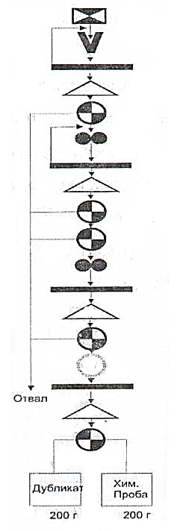 | 1) Sample (6.1 kg, d~73 mm)  Crushed to d-5 mm  Screening. Sieve (d - 5 mm)  Stirring  Reduction (Q₂-3 кг)  2) to be reduced to d₃=2,5 мм  Screening. Sieve (d-2.5 мм)  Stirring  Reduction (Q₃=1.5 кг)  Reduction (Q₄=0.7 кг)  3) is reduced to d=1 мм  Screening. Sieve (d₄-1 мм)  Mixing  The Reduction Of (Q₅-О.3 кг)  Grinding to d₅=0.074 мм  Screening. Sieve (d=0.074 мм)  Stirring  Division
Figure 1.1 – The scheme of sample processing

1.2 Research on Gravity and Flotation Concentration of the Gold Ore Sample with the Purpose of Manufacturing Concentration Products for Thiosulfate Leaching

1.2.1 Experimental Work on Gravity Concentration of the Researched Ores on Spiral Separators, a Jig, a Concentration Table and a Centrifugal Hydraulic Concentrator

Research was carried out on gravity ore dressing using a screw separator, a jigging machine (TsNIGRI) on a concentration table (SKO-05) and a centrifugal hydraulic concentrator (innovation patent No. 30418).
The results of gravity enrichment are presented in table 1.2-1.3.

Table 1.2 – The results of experiments on the enrichment of the screw separator

№ | Products | Output |  | Au Content | Weight of gold | Distribution
№ | Products | g | % | g/t | g | %
1 | I Concentrate | 43,0 | 2,15 | 21,5 | 0,4622 | 13,39
2 | II Concentrate | 65,0 | 3,15 | 7,6 | 0,2470 | 7,15
3 | Tails | 1892,0 | 94,6 | 2,9 | 2,7434 | 79,46
4 | Ore | 2000 | 100 | 3,5 | 3,4526 | 100

Table 1.3 – Results of experiments on jigging and re-cleaning on the concentration table

№  experiences' | Primary concentrate output by jigging, % | Output of refined concentrate, % | Gold content, g/t |  | Extraction  of gold into concentrate, %
№  experiences' | Primary concentrate output by jigging, % | Output of refined concentrate, % | In ore | In concentrate | Extraction  of gold into concentrate, %
1 | 4,17 | 1,5 | 2,3 | 21,4 | 13,95
2 | 5,25 | 1,32 | 3,5 | 26,7 | 10,06

The decrease in technological indicators with increased water consumption is due to the presence of a significant amount of fine gold in the ore sample, which is washed away due to the large flow of water supplied to the separator chute.

1.2.2 Research on Gravity Concentration of Run of Mine Gold Ore (Jigging and Table Concentration)

In ordinary ore, the content of components according to sample analysis is on average: Au-3.5 g / t; Ag-12.0 g / t; Zn – 1.14%; Cu – 0.6%; Pb – 0.5%; Fe – 5.7%.
Experiments on gravitational enrichment of the studied samples were carried out in a jigging machine OP TsNIGRI with their subsequent re-cleaning on the concentration table SKO-0.5 of the Trud plant.
Studies have established the following: the free gold particles isolated from the enrichment products have a size ranging from 10 to 50 microns, and the main part has a size less than 20 microns, which indicates that the bulk of the ore under study is very fine. Such gold when enriched with jigging, concentration on the table is poorly extracted. Extraction by jigging and concentration on the table is in the range of 10-14 %.
To extract fine gold, it is proposed to conduct research on the use of centrifugal devices (for example, Knelson). We have developed domestic centrifugal hydraulic concentrators [1-16], which have shown good results in the extraction of fine gold.
The ore composition-quartz (55.36-60.2%), pyrite (36.3 – 36.9%), mica (3.3 – 4.4%) with an admixture of dolomite, arsenopyrite, Galena – fully corresponds to berezites. Free native gold was not found during fine crushing of ores. Native gold is found as inclusions in pyrite.
I would like to note one feature – during fine crushing (-2+0 mm), cubic pyrite crystals are the first to open, while the bulk of irregular pyrite grains is opened only when ore is crushed to a size class of 0.074 mm.
The results of gravity ore processing at the Quartzite Gorki Deposit are detailed in the 2018 report.
Ores of this geological and technological type are poorly enriched by gravity methods (centrifugal concentration), gold recovery rates are low (5.16 – 10.78%), and concentrates are substandard.

1.2.3 Experimental Work on Flotation Concentration of the Researched Ores

1.2.3.1 Flotation of Gravity Tailings

Experiments on flotation of gravity tails (jigging and re-cleaning on a concentration table) were performed in the laboratory. The study and optimization of flotation of gravity tails was carried out using the method of steep ascent (Box-Wilson method) using full and fractional factor experiments. The reproducibility of experiments was evaluated by the Cochran criterion.
Studies on flotation enrichment of the ore under study were carried out. Optimal flotation conditions were determined based on changes in the size of ore grinding in the class -0.074 mm %, the consumption of reagents (butyl xanthogenate, foaming agent (T-80), medium regulator (soda) and activator (copper sulfate)).
The results of experiments according to the scheme: gravity and flotation of gravity tails are presented in table 1.4.

Table 1.4 – Results of experiments according to the scheme: gravity and flotation of gravity tails

Products | Product yield, % | Gold content, g/t | Weight of  gold, g | Distribution,  %
Graviconcentrate | 0,98 | 15,65 | 0,1534 | 4,22
Flotation concentrate | 4,80 | 42,07 | 2,0194 | 55,58
The flotation tailings | 94,22 | 1,55 | 1,4604 | 40,20
Ore | 100,0 | 3,5 | 3,6332 | 100,0

In the next mode of flotation of gravity tails:
the particle size of ore grinding-70% of class – 0,074 mm;
- consumption of butyl xanthogenate – 150 g / t;
- the consumption of Frother T-80 – 70 g/t;
- consumption of copper sulfate-150 g / t;
- soda consumption-125 g / t;
- duration of the main flotation – 15 minutes;
- duration of control flotation-25min;
- duration of perechistnoy flotation-5 minutes.
The accumulated enrichment products of the initial hard-to-enrich gold-containing ore (concentrates and tailings) will be subjected to thiosulfate leaching in order to open the gold into productive gold-containing solutions.

1.3 Research on Oxidation of Sulfide Ores and Concentration Products in the Conditions of the Redox Process in Various Milder Temperature and Pressure Modes

1.3.1 Characteristics of the Initial Sample

The sample is a collective arsenopyrite concentrate obtained in the mode of maximum gold extraction from the carbonaceous gold-arsenic ore of the Bakyrchik Deposit (Kazakhstan) [17].
The content of the main components, %:
Au – 51.0 g/t, As – 4.82 g/t, Fe – 15.42 g/t, S – 11.8 g/t, C – 11.8 g/t.
The granulometric characteristic is shown in table 1.5.

Table 1.5 – Granulometric characteristics

Class size | Class output | Content
+0,125 | 8,8 | 18,8
+0,125 + 0,074 | 15,8 | 15,6
+0,074 + 0,044 | 10,4 | 18,8
-0,04 | 65,0 | 8,8

1.3.2 Autoclave Oxidation of the Concentrate

Autoclave oxidation was performed: air pressure 14 atmospheres, air flow 2000 m3 / t, temperature 90°C, time 20 hours, H:L=1:5.
Gold was dissolved in the specified mode.

Table 1.6 – Results of leaching of ground concentrate.

№ | Reagent consumption on autoclave oxidation,  kg / t its type | Content in concentrate after autoclave treatment, % |  | Cape after sulfate leaching
№ | Reagent consumption on autoclave oxidation,  kg / t its type | As | S | content  Au, g / t | extraction of Au in solution %
1 | 85 . NaOH | 4,20 | 8,0 | 20,9 | 59,0
2 | 170 . NaOH | 3,80 | 3,3 | 12,1 | 76,3
3 | 260 . NaOH | 1,90 | 1,08 | 4,7 | 90,8
4 | 300 . NaOH | 0,98 | 0,45 | 2,2 | 95,7
5 | 400 . NaOH | 0,13 | 0,40 | 1,1 | 97,8
6 | 600 . Na2CO3 | 5,50 | 1,87 | 3,6 | 92,9
7 | 300 . NaOH+  300 . Na2SO3 | 2,70 | 2,32 | 2,9 | 94,3
8 | 450 . NaOH+  100 . CaO | 4,50 | 2,42 | 4,2 | 91,8
9 | 300 . NaOH+  100 . CaO | 1,80 | 0,63 | 3,0 | 94,1
10 | 360 . KOH | 0,23 | 0,47 | 2,2 | 95,7

From the data shown in table 1.7, it follows that additional refinement of the concentrate to a 100% fineness of class 0.074 mm allows achieving the same level of gold recovery as at the initial fineness with lower alkali consumption - 250 instead of 400 kg/t. An increase in the consumption of alkali during autoclave oxidation to 400 kg / t allows further extraction of 97.8% of gold into the solution. When using soda, the autoclave temperature of 90°C is insufficient (experiment No. 6).
The use of potash alkali requires the same consumption as sodium, but in molar terms, and in weight this figure translates into 560 kg / t.
Further experiments were carried out on the oxidation of the concentrate at a lower pressure – 5 atmospheres. A pre-ground concentrate was used, the air flow rate was maintained at 2000 m3 / t, the oxidation time was 20 hours, the H:L ratio was set to 1: 5. after oxidation, gold was leached from the solid residue with a sulfite solution in the specified mode. The end-to-end output for these operations was 95%. The results are shown in table 1.7.

Table 1.7 – The results of the leaching of the concentrate under low air pressure

№ | The conditions of pressure oxidation |  | Content in concentrate after autoclave treatment, % |  | Content in the cape after sulfate leaching,  г/т. | Extraction into solution, %
№ | reagent consumption, kg / t type | temperature, °С | As | S | Au | Au
1. | 400 . NaOH | 90 | 0,18 | 0,68 | 1,6 | 97,0
2. | 560 . KOH | 90 | 0,14 | 1,40 | 1,4 | 97,4
3. | 400 . NaOH | 120 | 0,12 | 0,33 | 1,3 | 97,5
4. | 400 . NaOH | 140 | 0,64 | 0,88 | 3,0 | 94,1

Autoclave oxidation was performed: air pressure 5 atmospheres, air flow 2000 m3 / t, time 20 hours, H:L=1:5. Gold dissolution is carried out in the specified mode.
From the data shown in table 7, it follows that at a pressure of compressed air of 5 atmospheres for 20 hours, the oxidation of the concentrate proceeds quite satisfactorily within the temperature range from 90 to 120°C, which allows further gold recovery at the level of 97%. At a temperature of 140°C under these conditions, the partial pressure of oxygen becomes insufficient, and the oxidation proceeds less deeply, which leads to a decrease in gold recovery.
The need for fine grinding of the concentrate causes deterioration of the pulp filtrability after autoclave oxidation. Solid filtration capacity at a discharge of 0.7 atmospheres does not exceed 20-30 kg / m2 per hour.
To try to avoid the filtration operation, we checked the possibility of gold dissolving directly in the pulp after autoclave oxidation.
Part of the pulp after autoclave oxidation in experiments 5 and 10 (Table 1.6) was not filtered, but a concentrated solution of ammonium sulfite was added to the pulp to obtain a concentration of ammonium sulfite in the liquid phase of 100 g/l. Solid sodium thiosulfate and copper sulfate were added, based on obtaining concentrations of 10 and 1 g / l, respectively. The pulp was mixed for 4 hours at pH=9.0-9.5 and a temperature of 60°C. At the end of the experiment, the solid was separated, washed and analyzed. In the first case, the cape contained 1 g / t of gold, and in the second 2.1 g / t, i.e. the recovery was 98.0% and 95.9%.
As confirmed by further experiments, when leaching gold directly in autoclave pulps, its recovery into the solution is always higher by 0.2-0.5% than when leaching from filtered capes.
Further work in this direction was not carried out, since no effective method was found for extracting gold from the resulting pulps, in which the liquid phase is characterized by a complex salt composition.
Studies have shown that it is the degree of oxidation of sulfides during autoclave treatment that determines the degree of gold recovery into the solution.

1.4 Research on Thiosulfate Leaching of Ores and Concentration Products after Preliminary Oxidation of Sulfides in the Conditions of the Redox Process with Various Reagents and Other Process Modes

It is known that when implementing the thiosulfate mechanism of gold dissolution, the presence of copper ions in the solution increases the process parameters. Indeed, the addition of copper sulfate to the solution increased the recovery of gold. The optimal ratio of sodium thiosulfate and copper sulfate is defined as 10:1.
In experiments to determine the optimal parameters of the gold dissolution process, a sulfite-bisulfite solution was then used.
The solution had a density of 1.21 g / cm3, pH=6.3, and contained 300 g / l of the и ${SO}_{3}^{2-}$ ion. The working solution was prepared by diluting the initial solution with water, bringing the concentration of the и ${SO}_{3}^{2-}$. ion to 75-80 g/l. PH adjustment during the process was performed with sodium hydroxide.
Bakyrchik concentrate, oxidized to a residual arsenic content of 0.13% and 0.34% sulfur, was leached in a sulfite-bisulfite solution. The process temperature was maintained at 60°C, pH=9.9-9.5, the H:L ratio was set to 1:4, and the time was 4 hours. During the experiments, the amount of sodium thiosulfate and copper sulfate introduced into the working solution was changed. At the end of the experiment, the solid was separated, washed, dried, and the gold content was determined. The results are shown in table 1.8.

Table 1.8 – Dependence of gold extraction on additions to the solution of sodium thiosulfate and copper sulfate

№  п/п | Expenditure  Na₂S₂O₃ – 5H₂O,  г/л | Expenditure  CuSO₄ – 5H₂O,  г/л | Content  Au in a cap,  г/т | Extracting Au, %
1 | 2 | 3 | 4 | 5
1 | 10 | 0 | 4,1 | 92,4
2 | 20 | 0 | 4,1 | 92,4
continuation of table 1.8
1 | 2 | 3 | 4 | 5
3 | 50 | 0 | 3,6 | 93,3
4 | 100 | 0 | 5,9 | 89,0
5 | 5 | 0,5 | 4,6 | 91,4
6 | 10 | 1,0 | 1,0 | 98,1
7 | 20 | 2,0 | 1,4 | 97,4
8 | 40 | 4,0 | 2,6 | 95,2
9 | 50 | 5,0 | 3,5 | 93,5
10 | 80 | 8,0 | 5,4 | 89,9

Gold recovery in all cases was calculated based on its content in the initial concentrate of 51 g/t, the solid yield for autoclave oxidation operations of 95%, and the solid yield for gold leaching operations of 100%.
From the data shown in table 1.8, it follows that the addition of sodium thiosulfate to the sulfite solution in an amount from 10 to 50 g/l allows to stabilize the recovery of gold at the level of 92-93%. An increase in the concentration of thiosulfate to 100 g / l leads to a slight decrease in recovery, probably due to passivation of the gold surface and the effect of salting out with an increase in the concentration of easily soluble salts in the solution.
Simultaneous introduction of sodium thiosulfate and copper sulfate into the solution in a ratio of 10:1 increases the recovery of gold up to 98%. The optimal amount of thiosulfate is 10-20 g / l, copper sulfate 1-2 g/l. Increasing the dosage above the specified limits leads to a decrease in recovery.
Experiments were conducted to determine the optimal leaching time. The oxidized concentrate contained 0.13% arsenic and 0.34% sulfur. Temperature 60°C, pH=9.0-9.5, concentration ${SO}_{3}^{2-}$=75 – 80 g / l, dosage of sodium thiosulfate 10 g/l, copper sulfate 1 g/l, H:L=1:10. The results are shown in table 1.9.

Table 1.9 – Kinetics of gold leaching with a sulfite solution.
№  п/п | Leaching time, hour | Gold content in the cape, g/t | Gold extraction, %
1 | 2 | 3 | 4
2 | 0,25 | 17,9 | 66,7
3 | 0,50 | 11,3 | 79,0
4 | 2,0 | 2,4 | 95,5
5 | 2 | 3 | 4
6 | 4,0 | 1,0 | 98,1
7 | 6,0 | 1,2 | 97,0
8 | 10,0 | 1,8 | 96,7

From the data shown in table 1.9, it follows that under the selected conditions, the optimal time for leaching gold is 4 hours. Over this time, gradually began to develop the process of perioadele gold.
In the next series, the optimal temperature is determined. The oxidized concentrate contained 0.13% arsenic and 0.34% sulfur. The concentration of ${SO}_{3}^{2-}$ in the solution was set at 75-80 g / l, pH was maintained at 9.0-9.5 dosage of sodium thiosulfate 10 g/l, copper sulfate 1 g/l, time 4 hours. H:L=1:4. The results are shown in table 1.10.

Table 1.10 – Influence of the leaching process temperature on the completeness of gold recovery.

№ | Temperature, °С | Gold content in the cape, г/т | Gold extraction, %
1 | 25 | 17,5 | 67,4
2 | 40 | 7,2 | 86,6
3 | 50 | 2,7 | 95,0
4 | 60 | 1,1 | 98,0
5 | 80 | 4,6 | 91,4
6 | 100 | 11,3 | 79,0

From the data shown in table 1.10, it follows that the optimal process temperature is 60°C.
To determine the optimal H:L ratio, a concentrate oxidized to a residual content of 0.18% arsenic and 0.68% sulfur was used. The temperature was maintained at 60°C, pH=9.0-9.5. Time 4 hours, concentration ${SO}_{3}^{2-}$=75 – 80 g / l, dosage of sodium thiosulfate 10 g/l, copper sulfate 1 g/l. The results are shown in table 1.11.

Table 1.11 – The dependence of gold extraction on the ratio of H:L.

№ | H:L | Gold content in the cape, g/t | Gold extraction, %
1 | 1:2 | 2,3 | 95,68
2 | 1:4 | 2,0 | 96,30
3 | 1:6 | 2,4 | 95,53
4 | 1:10 | 2,2 | 95,90

From the data shown in table 1.11, it follows that the H:L ratio does not significantly affect the completeness of gold recovery, but 1:4 should be considered the most favorable.

2 Research of phase changes of gold-bearing sulfide ores and concentration products at all-sliming (20, 10 mcm). research on thiosulphate leaching of ores and concentrates after all-sliming in various reagent modes

2.1 Selection of Grinding Equipment. Research on All-Sliming of Gold-Bearing Sulfide Ores and Concentration Products and Determining Phase Changes of Minerals and Sulfur Oxidation Degree

2.1.1 Mechanical Processing in Mineral Processing Technology

Mechanical processing is one of the most important operations in mineral processing technology. Ore processing must be organized in such a way as to ensure the mineral liberation with optimal grinding of the ore [18]. This process largely determines both the completeness of the extraction of minerals and elements from rocks, and the kinetics of various heterogeneous processes involving solid substances in a finely dispersed state.
Attempts to use the process of mechanical activation to increase the efficiency of mineral raw materials have been made for a long time. Specialized and generalizing works have shown that with an increase in dispersion leading to an increase in the substance activity, it is possible to intensify many technological processes: ore liberation, leaching of individual components from minerals, complete extraction of valuable elements from refractory ores and concentrates [19, 20, 21].
Mechanical activation, to some extent, leads to a change in the structural and physicochemical properties of minerals, especially surface ones. The research has ensured a fairly complete list of physicochemical changes in mineral matter and the transformation of materials during dispersion.
An analysis of works on the mechanochemistry of minerals shows the variety and complexity of the physicochemical processes during mechanical activation, and leads to the conclusion that the reactivity of minerals is determined both by a change in the fine crystal structure and an increase in the surface, and by solid-phase reactions, i.e. the processes accompanying mechanical processing.

2.2 Research on Thiosulfate Leaching of Various Ore Fractions and Concentration Products after All-Sliming. Establishing Optimal Parameters for Grinding and Leaching.

2.2.1 Research on All-Sliming of Gold-Bearing Sulfide Ores and Concentration Products

As a result of comparing the products of existing zifs, flotation concentrates of ores from the Pustynnoye and Quartzite Gorki deposits were purchased for experiments. They are the most typical representatives of persistent gold-containing raw materials, where gold is in a fine Association with sulfide minerals of iron, arsenic, copper and other non-ferrous metals (pyrite, arsenopyrite, chalcopyrite, etc.). based on the analysis of known methods of super-fine grinding of enrichment products, a technological scheme for the production of the experiment was developed. Hardware design of the experiment was made. The scheme of the experiment is developed. Sample preparation was performed.
Studies were conducted on super-fine grinding of enrichment products from the ores of the Pustynnoye and Quartzite Gorki deposits.
Research on super-fine grinding of gold-containing sulfide ores and enrichment products.
Mechanical activation grinding was carried out for the purpose of opening fine gold, the accumulated flotation concentrate with a grinding fineness of 85% of the class -0.074 mm was subjected to super-fine mechanical activation grinding.
Mechanical activation grinding was carried out in a reaction Cup of a vibration grinder. Grinding was carried out by a roller weighing 1100 g and a steel ball mixture – 40% balls with a diameter of 20 mm, 30% with a diameter of 15 mm and 20% with a diameter of 10 mm. The mass of the ball mixture was also 1100 g. The reactor allows to perform mechanical activation of 50-gram attachments of the material by both dry and wet methods. The size of mechanical activation was estimated by the content of -10 microns in the crushed material. The content of this class was determined by sedimentation analysis.
Mechanical activation for both dry and wet opening of resistant gold is aimed at increasing the defect of the crystal lattice of the gold-bearing material without violating its chemical composition as a whole, so the time of mechanical activation can be reduced to the necessary limit determined by the degree of gold recovery. The relationship between the duration of mechanical activation and the output class-10 microns is shown in figure 2.1.
The hardware design of the experiment is defined. To ensure the purity of the study, we also conducted studies of the effect of the fineness of the grinding of enrichment products during processing according to the cyanide scheme.
111456564565411222
211456564565411222
Curve designations: mechanical activation by roller (1); mechanical activation by balls (2).

Figure 2.1 – Dependence of the yield of class-10 microns on the duration and type of grinding agent

Studies have been conducted to increase gold recovery by flotation based on finer ore grinding. Experiments were made on flotation of the initial ore with finer grinding. The results of the experiments are presented in table 2.1.

Table 2.1 – Influence of ore grinding size on gold recovery by flotation

№ experiences' | Products | Output,  % | Gold content, g/t | Distribution, % | Class content less than  0.074 mm, %
1 | Concentrate | 8,15 | 36,5 | 78,24 | 90,15
 | The flotation tailings | 91,85 | 0,9 | 21,76
 | Ore | 100,0 | 3,8 | 100
2 | Concentrate | 9,25 | 32,3 | 79,51 | 93,50
2 | The flotation tailings | 90,75 | 0,9 | 21,49 | 93,50
 | Ore | 100 | 3,8 | 100
3 | Concentrate | 9,56 | 32,2 | 80,97 | 95,75
3 | The flotation tailings | 90,44 | 0,8 | 19,03 | 95,75
3 | Ore | 100,0 | 3,8 | 100 | 95,75
4 | Concentrate | 10,95 | 29,0 | 84,59 | 97,95
4 | The flotation tailings | 89,05 | 0,7 | 26,41 | 97,95
4 | Ore | 100,0 | 3,8 | 100 | 97,95

The results show that the gold content in the flotation tailings decreases to 0.7 g/t with an increase in the ore grinding fineness. The maximum recovery of gold into concentrate was 84.59%.
Studies on sorption cyanidation of a mechanoactivated mixture of flotation concentrates were conducted. The results of the cyanidation experiments are presented in table 2.1.
Studies on the mechanochemical activation (oxidation) of a gold-containing sulfide concentrate under superfine grinding conditions were carried out. The research method included: grinding the concentrate in an alkaline medium using air oxygen as an oxidizer. As a result of the experiment, it was established that the mass fraction of gold in the initial concentrate was 15.5 g / t and decreased in the initial product to 13 g / t and the appearance of gold in the liquid grinding product (0.25 mg / l) with the degree of gold recovery in solution at the level of ≈16% (Table 2.2, Figure 2.2)
The results of sedimentation analysis of the product after superfine grinding are shown in table 2.3 and the results of sedimentation analysis of the initial and crushed product are shown in figure 2.2.

Table 2.2 – Sedimentation analysis

Indicators for the initial product (concentrate)
micrometer | gram | %
+74 | 14,16 | 14,67
74-40 | 18,55 | 19,22
40-20 | 18,48 | 19,14
20-10 | 31,78 | 32,92
10-0 | 13,56 | 14,05
Итого | 96,53 | 100,0
Indicators of sedimentation analysis after grinding
micrometer | gram | %
+74 | 21,58 | 25,63
74-40 | 1,2 | 1,43
40-20 | 14,18 | 16,88
20-10 | 17,95 | 21,37
10-0 | 29,1 | 34,63
Итого | 84,01 | 100,0

Figure 2.2 – Results of sedimentation analysis of the initial and crushed product

Table 2.3 – Results of experiments on sorption cyanidation of a mechanically activated mixture of flotation concentrates

Indicators and results | № experiences'
Indicators and results | 5 | 6 | 7 | 8 | 9
Duration of mechanical activation, min. | 3 | 6 | 9 | 12 | 15
Class content smaller than 10 microns, % | 82 | 88 | 93 | 94 | 94
Duration of cyanidation, hour | 24 | 24 | 24 | 24 | 24
The density of the pulp in cyanidation, % hardness | 29 | 29 | 29 | 29 | 29
Cyanide concentration,%:  initial  added 9 % solution, ml  final | 0,058  5,0  0,12 | 0,058  5,0  0,11 | 0,058  5,0  0,09 | 0,058  5,0  0,06 | 0,058  5,0  0,05
Cyanide consumption, kg / t of product | 20,26 | 20,52 | 21,0 | 21,73 | 21,97
Lime consumption, 94 % kg / t | 1,0 | 1,0 | 1,0 | 1,0 | 1,0
Activated carbon, g | 1,0 | 1,0 | 1,0 | 1,0 | 1,0
Gold content, g / t:  in the initial product  in cyanidation tailings | 13,3  0,63 | 13,3  0,56 | 13,3  0,31 | 13,3  0,31 | 13,3  0,30
Extracting gold from an operation, % | 70,83 | 74,07 | 85,65 | 85,65 | 86,11

As can be seen from the data shown in table 2.3, mechanical activation of a mixture of flotation concentrates leads to a decrease in the gold content in the cyanidation tailings.
So, after three-minute mechanical activation, the gold content in the sorption tailings decreased to 0.63 g / t. gold recovery in the solution from the operation was 70.83 %. The required duration of mechanical activation was 9-12 minutes, after which the content of a class less than 10 microns in the activated material was 93.94 % for a class smaller than 40 microns. Sorption tails were obtained with a gold content of 0.31 g / t, and its recovery in solution from the operation was 85.65 %.
These experiments (Table 2.3) indicate the feasibility of mechanical activation of fine gold associated with sulfides.
The main grinding equipment is a laboratory ball mill with a volume of 2.33 liters. The diameter of the mill drum is 0.19 m, the volume occupied by the balls Vш=0.0010485 m3, which is 45 % of the internal volume of the mill.
The weight of the hitch of the crushed material is 500 grams, the pulp density is 65% solid. The speed of rotation of the mill is 96 rpm.

2.3 Research on Thiosulfate Leaching of Various Ore Fractions and Concentration Products after All-Sliming. Establishing Optimal Parameters of Grinding and Leaching

The technology of hydrometallurgical processing of gold-bearing sulfide raw materials includes two processing stages. At the first stage of the process, the raw material is oxidized and sulfur, iron and arsenic are converted into elements with a higher degree of oxidation. This is associated with the destruction of gold-retaining matrices of minerals (pyrite, arsenopyrite) and ensures more favorable conditions for the access of reagents to the particles of gold leached from the raw material. The success of the second stage of processing of raw materials, directly associated with the conversion of gold into solution, mainly depends on the oxidation rate of the raw material. If a sulfite-thiosulfate composition is used as a reagent for gold dissolving, this condition is slightly specific, different from other reagents. This is related to the fact that in this case sulfur is present as the main element in the rock-forming sulfidic minerals and reagent. Moreover, as was indicated in our previous publications [17-24], sulfur in combination with hydrothermal water are the “culprits” of gold deposits formation. Sulfur and water that in the natural environment form various oxygen-free and, in the presence of air, oxygen chemical compounds (hydrosulfides, sulfides, thiosulfates, etc.), in some cases became gold solvents, in others, in combination with gold, transformed into an insoluble state. Thus, on its way from the subsoil to the earth's surface, gold in compounds with sulfur, depending on the pH and Eh of the medium, was subjected to repeated dissolution and precipitation. These natural processes prove that it is possible to use sulfur, which is present in sulfide raw materials, partially or completely as a reagent in the technology of gold recovery in the processes of its dissolution and precipitation from solutions.
In previous studies, the subject of our research was the autoclave oxidation processes of sulfide raw materials. The so-called redox process takes place at high temperature (250-300ºС) and pressure (16-20 atmg), in a nitric acid medium in the presence of pure oxygen. The process requires high capital and operating costs. Gold is recovered from the solid residue by means of leaching using cyanide solutions. Sulfur in the autoclave is oxidized to a maximum 6-valent state and is completely disposed of in the form of ballast sulfate compounds. The analogous so-called nitrox or arsenic processes differ from the previous process in that they take place without pressure in ordinary conditions and in the atmospheric air. However, in this case, due to the lack of oxidizing potential, sulfide sulfur is oxidized only to an intermediate phase - the elemental state, which is the reason for low gold recovery at the subsequent cyanidation of the solid residue, because elemental sulfur deposited on the surface of gold particles makes it difficult for the solvent to reach them. Within the frameworks of our works on this topic, due to the use of an alkaline medium in the autoclave instead of an acidic one, it was possible to carry out this process in a milder mode (5 atmg instead of 20; 100-120ºС instead of 250-300). The negative influence of the partially elemental sulfur formed in this process was avoided due to the use of sodium sulfite with a small addition of thiosulfate as the reagent for leaching of the solid residue. The interaction of sodium sulfite with elemental sulfur results in the formation of sodium thiosulfate, and thereby in the removal of the sulfur film from solid particles and simultaneous regeneration of the main reagent for gold leaching. Thus, in addition to solving an important technological problem, it was possible to make a part of the sulfur from the source sulfide raw material a useful element instead of the ballast product. In general, with approximately comparable parameters of gold recovery using the cyanide process, in this case, there is an additional effect of reducing the environmental load and economic costs.
We continued working on the topic. The first stage of the autoclave oxidation process of sulfide raw materials was replaced with a simpler version of the mechanochemical processing carried out by means of finer grinding of the source sulfide material. Publications on the mechanochemical conditioning of sulfide raw materials before gold leaching are well systematized in [4]. The initial stage of pyrite oxidation is the formation of ferrous sulfate and elemental sulfur:

${FeS}_{2}+{2O}_{2}={FeSO}_{4}+S$ (1)

At the same time, it is well known from popular manuals on general chemistry [5] that elemental sulfur easily interacts with alkalis and forms the whole range of oxygen and oxygen-free sulfur compounds:

$3S+6NaOH={2Na}_{2}S+{Na}_{2}{SO}_{3}+{3H}_{2}O$ (2)
$S+{Na}_{2}{SO}_{3}={Na}_{2}S_{2}O_{3}$ (3)
${Na}_{2}S+H_{2}O=NaHS+NaOH$ (4)

These reactions prove the possibility of formation of sodium thiosulfate and hydrosulfide compounds during the grinding of raw materials in an alkaline medium and the high probability of formation of water-soluble gold complexes with the mentioned sulfur anions, as evidenced by many publications. It is suffice to cite one of them [3], which seems to be the most interesting in connection with the fact that the mentioned processes are considered more extensively and are used by the authors as the evidence for their theory related to the formation of hydrothermal gold deposits using these processes.
According to this theory, during the formation of hydrothermal solutions at deep horizons in the negligible presence of oxygen and low ORP, gold was most likely present in solutions in the form of a hydrosulfide complex (AuS-). With the rise of solutions to the surface and the ORP increase, this complex was destroyed resulting in the separation of gold, which is commonly called early or high-temperature gold. At the same time, favorable conditions were created for the formation of the thiosulfate sulfur compound and the corresponding water-soluble thiosulfate gold complex. Subsequent more profound changes in the Eh-Ph values of the medium lead to another destruction of this complex resulting in the formation of a gold deposit. The diagrams taken from the cited article and shown in Figures 1, 2, 3 are in good agreement with the author's conclusions and give a complete picture of the zones of stable existence of soluble gold compounds in the Eh-Ph coordinates and the dependence of these compounds’ activity in water on the ORP value. These data provide good guidance for planning and evaluating the results of current and future technological research on this topic.
For technological research, we used a 2.3-liter KazNTU laboratory ball mill. The research method involves grinding the concentrate in an alkaline medium in the presence of atmospheric oxygen as an oxidizer. Due to the absence of continuous air supply in the mill design, the mill must be stopped during the grinding process for periodical supply of fresh air through the loading chute.
The flotation concentrate for the study was obtained from Akbakaysky mining and processing plant. The concentrate has the following parameters: particle size: 0.074 mm, Au content: 15.5 g/t, As: 0.058%, S: 22.6%. Each 300 g of the initial sample of the concentrate loaded into the mill was added with 600 ml of caustic solution with a concentration of 143 g/L. Also, steel balls are loaded at a 1:10 ratio of the concentrate weight. The grinding was performed for 60 minutes. The mill was stopped every 2 minutes for air supply. The measured pH values of the medium equaled 9.0-9.5. At that, the ORP varied within Eh values from -0.176 to -0.186V. Table 1 contains the results of sedimentation analysis of the source and ground products.
These, at first glance, contradicting results have an adequate scientific explanation. According to the existing concepts [27, 28], mechanochemical activation of products is characterized by three stages of the process. While at the first stage there is practically no interaction between the ground particles, at the second stage the interaction begins to increment and is manifested in their aggregation due to Van der Waals forces. At the third stage, this process stops and gives way to the formation of chemical bonds between the particles. Based on these concepts, the +74 μm fraction, obtained as a result of grinding, was classified as the aggregated thinner class. So, it can be assumed that the overall increase in the content of the material with a fineness over 10 μm in the final product amounted to over 60%.
During the grinding in line with the above-mentioned mechanisms, gold was partially leached using reagents formed from its own sulfur. As a result, the mass content of gold in the final ground product significantly decreased from 15.5 g/t to 13 g/t, which corresponds to about 16% gold recovery rate into the solution right at this stage.
It is well known that adding cupric ions to the process of gold dissolution accelerates the process due to gold oxidation. Therefore, an experiment was further conducted with the addition of copper sulfate in the grinding process of sulfide concentrate (at a rate of 1 g/L in terms of copper), while maintaining all the previous parameters of grinding. It resulted in the decrease in the gold content in the ground product to 8.3 g/t, i.e. the gold recovery rate into the solution at the grinding stage increased from 16 to almost 48%. A 100 g sample weight of the obtained ground product after separation of the liquid phase was subjected to sulfite-thiosulfate leaching in a 2-liter magnetic mixer in the following mode:
- Solid to liquid ratio is 1:10;
- Sodium sulfite content in the solution is 100 g/L;
- Sodium thiosulfate content in the solution is 50 g/L;
- Copper content in the solution is 1g/L;
- рН of the medium is 9-9.5, Eh varies from +0.034 to +0.084V;
- Leaching time is 4 hours.
For chemical analysis of the obtained leachate, a 240FS AA Agilent atomic absorption spectrometer was used, a C933 ionomer was used for measuring pH and Eh.

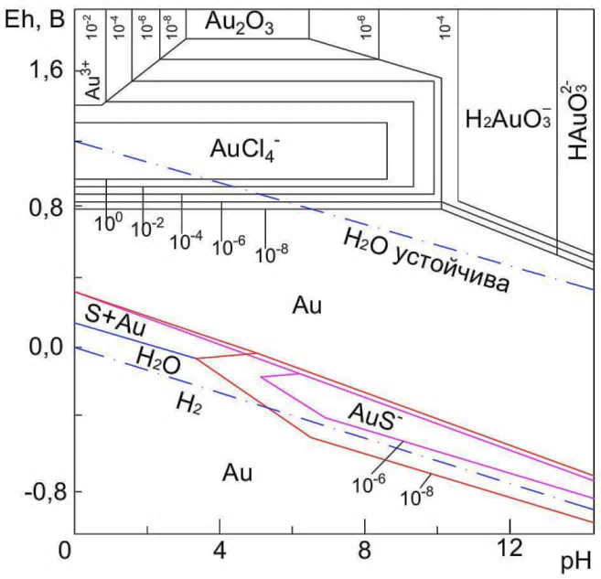
Figure 2.3 – Stability ratios between some gold compounds in water at 25°С and 1 atm.
The amount of dissolved chloride components is 10⁻¹ mol/L, and the amount of dissolved sulfur is 10⁻¹ mol/L (according to Garrels).

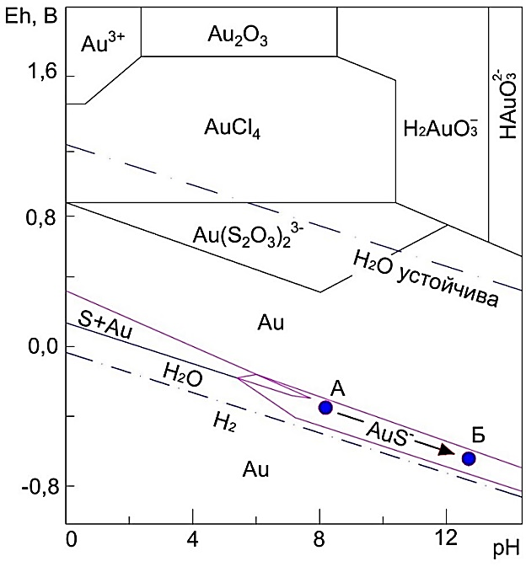
Figure 2.4 – Stability ratios between some gold compounds in water at 25°С and 1 atm with due account for the equilibrium activity of thiosulfate ions.
The amount of dissolved sulfur is 10⁻¹ mol/L and the amount of dissolved chloride components is 10⁻¹ mol/L.
Cape tests after leaching showed that its gold content was 6.1 g/t, i.e. additional gold recovery rate into the solution at this stage was about 27%.
Parameters of gold recovery into the solution with such simple instrumentation could be considered acceptable, however some negative factors associated with this method diminish the advantages of the technology. The pH and Eh measurements during the experiments showed that gold leaching is mainly done in line with the hydrosulfide option, and the zone of stable existence of the soluble hydrosulfide complex of gold in our case is approximately in zone “A” in Figure 2.5.
As Figure 2.5 shows, the range of gold existence in such a compound is characterized by a relatively narrow range of Еh values of the medium. It is difficult to maintain the parameters of real technological processes in this range. And taking into account that these processes take place mainly on the surface of the earth, the situation is complicated by the inevitable contact of productive solutions with atmospheric oxygen, which, in turn, can lead to uncontrolled deposition and loss of gold between the treatment stages. Indeed, the calculations done by the authors of work [3] and presented graphically in Figure 2.5 show that the range of existence of water-soluble hydrosulfide gold complex is limited by narrow Eh values from -0.470 to -0.170V, which especially stand in contrast with the parameters of the thiosulfate compound, where such a zone is much wider and ranges from -0.170 to + 0.760V. Apprehensions regarding the foregoing risks at the implementation of the hydrosulfide method of gold recovery were confirmed as a result of another experiment. With the purpose of increasing the dissolution of sulfide and elemental sulfur according to reactions 1–3, the experiment was performed with a higher dosage of alkali (pH above 11). It was expected that the process of formation of the hydrosulfide gold complex will continue more intensively and proceed in the direction indicated in Figure 2 with the arrow towards point “B”. However, the result turned out to be negative with a significant decrease in the gold dissolution. Most likely, the ORP parameters of the medium went beyond the range of existence of the soluble hydrosulfide gold complex. Another reason for the failure could also be a sharp reduction in the formation of a complexing hydrosulfide anion as a result of the reversal of the sodium sulfide hydrolysis [29] due to the creation of a considerable excess of alkali in the solution.

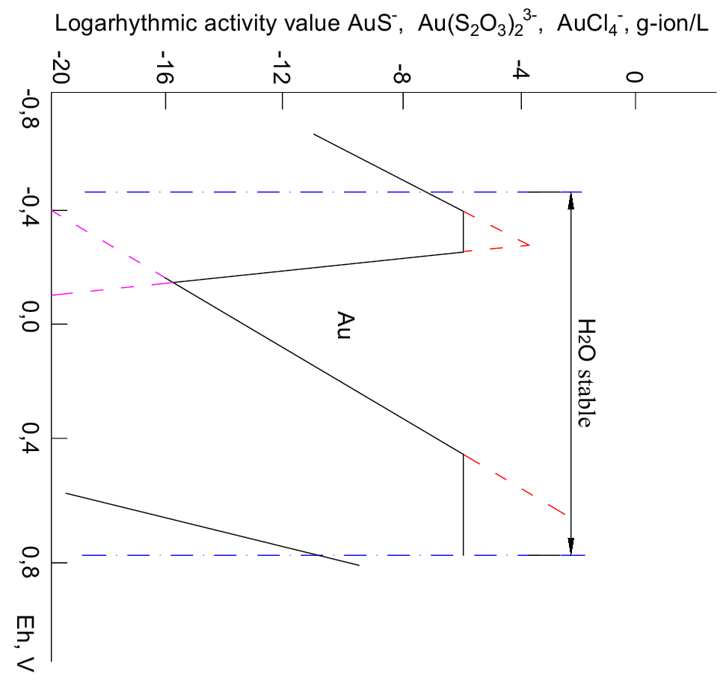
Figure 2.5 – Dependence of the activity (concentration) of some gold compounds in water on the value of the oxidation-reduction potential at 25°С and 1 atm., pH = 8.0.
The amount of dissolved sulfur is 10⁻¹ mol/L.

Obviously, the practical creation of more favorable conditions for technological processes requires a transition to another zone - the zone of stable formation of the thiosulfate gold complex. According to calculations, this area in Figure 2.5 is located at pH = 8, for example, in a wider Eh range from -0.170 to +0.760. True, transiting into this area with the use of atmospheric oxygen as an oxidizer requires pressure, and in normal conditions even stronger oxidizer will be required. For this purpose, for example, chlorine can be used as a reagent, which in its active and ionic forms can act both as an effective oxidizing and complexing agent in a water-soluble gold compound (Figure 1). In addition, the chlorine production in an active sodium chloride water solution using the electrochemical method is a relatively simple task.

Conclusions on Section 2

- The mechanochemical activation by means of grinding a factory sulfide gold-bearing concentrate in the alkaline medium has been studied. The process was done using the 2.3-liter laboratory mill at 1:2 solid to liquid ratio and steel balls at the ratio of 1:10 to the concentrate weight. During 30 minutes of the grinding time, the -10 μm class solid material increased from 14 to 60%. At the measured parameters of the ground medium (pH=8–9 and Eh varies from –0.18 to –0.19V), approximately 16% of gold was recovered into the liquid phase of the mill. With the addition of up to 1 g/L of cupric ions to the grinding process, the recovery into the liquid phase increased up to 48%.
  - It was established that the conversion of gold into solution during the grinding process is explained by the formation of a water-soluble hydrosulfide gold complex (AuS)⁻.
- The remainder of the solid ground product was leached with a sulfite-thiosulfate reagent at 1:10 solid to liquid ratio, the content of sodium sulfite was 100g/L, sodium thiosulfate 50 g/L, copper 1 g/L, at pH = 9-9.5 and process time was 4 hours. A continuous supply of air into the reaction medium ensured maintaining the Eh value of the medium during leaching at a level of +0.030 to + 0.080V. As a result, about 27% of gold was additionally recovered into the solution.
- The results of the performed study were deeply analyzed. It is shown that the practical application of the obtained data in the technology of gold recovery is associated with certain risks due to the relatively narrow range of sustainable existence in the conditions of mechanochemical activation of the raw materials of the hydrosulfide gold complex.
- Further work will be directed at the optimization of processes at both stages of the developed technology. First of all, at the stage of mechanochemical activation of raw materials the work will be aimed at the increase in the oxidizing potential of the medium for converting gold in solution into a more stable compound. To this end, various methods of influencing the reaction medium, including electrochemical ones, will be tested.

3 Research on Thiosulfate Leaching of Sulfide Ores and Concentration Products after Their Preliminary Acid Treatment (with Nitric and Sulfuric Acids) in Various Modes

3.1 Research on Leaching of Ores and Concentration Products after Their Preliminary Nitric Acid Treatment (Nitrox Process) in Various Leaching Modes with the Use of Various Solvents – Thiosulfates, Sulfates, Alkalis

Research has been performed on the selection of various leaching solvents of concentration products after preliminary nitric acid treatment with the purpose of increasing gold recovery.
In the course of experiments using alkali sulfite and thiosulfate reagent as solvents, the highest rates of gold recovery were achieved using a thiosulfate reagent. Moreover, the temperature and pressure required for the process is much lower than in the standard nitrox process, which is a novelty of a new technological application. It is expounded in detail in Section 1.3

3.2 Research on Thiosulfate Leaching of Sulfide Ores and Concentration Products after Their Preliminary Sulfuric Acid Treatment in Various Temperature and Chemical Modes. Establishing Optimal Parameters for Acid Treatment and Thiosulfate Leaching

Laboratory studies have been performed to convert part of sulfur contained in the processed raw material into an additional thiosulfate reagent. To this end, active chlorine (hypochlorite) was added to the grinding and leaching processes as a sulfur oxidizing agent.
Thus, in addition to solving an important technological problem, it was possible to transfer part of the sulfur of the source sulfide raw material from the waste product to the category of a useful element. See more details in Section 2.3.

3.3 Research on the Chemical and Electrochemical Gold Deposition from Poor Product Solutions Without Sorption and Desorption Operations

Possible methods of recovery of noble metals from product solutions after the thiosulfate leaching process include:
- Precipitation in the form of sulfides;
- Cementation precipitation;
- Sorption on activated carbon or ion exchange resins;
- Electrolytic cathode reduction.

Methods of gold precipitation from thiosulfate solutions in the form of sulfides, cementation precipitation, sorption on activated carbon and on ion-exchange resins are described in detail and with examples of practical application [30]. They are beyond the scope of our research. Many research teams did scientific work on direct deposition of noble metals from thiosulfate solutions.
It is possible to recover noble metals from thiosulfate solutions by means of the electrolytic method. However, electrolysis is accompanied by a low current efficiency, since, along with the main process of gold and silver reduction, electric power is used for the decomposition of thiosulfate and the reduction of copper ions to metal. The optimal silver content in the solution, at which electrolysis is expedient, is measured in grams per liter [31]. As determined by the researchers from the Novosibirsk Institute of Solid State Chemistry and Mechanochemistry, the minimum gold content in the solution, at which an effective electrolysis process is possible, is 20 mg/L. The process is done in special design electrolysers (developed by the Institute of Solid State Chemistry and Mechanochemistry), where the cathode is carbon-graphite fiber, and the anode is platinized titanium. The application of the electrolysis process for gold recovery from heap and underground leaching solutions, where its content does not exceed 5 mg/L, is very problematic.

3.3.1 Electrochemical Method of Gold Recovery from Thiosulfate Solutions

At gold leaching from natural or technogenic raw materials, a thiosulfate reagent is used, which, in addition to its own thiosulfate ions (10-100 g/L), is complemented with sulfite ions (5-50 g/L), divalent copper (0.1-0.2 g/L) and excess alkali that ensure pH=9-10.
Leaching the run of mine ore containing 1-5 g/t of gold results in the solutions containing 0.1-1.0 mg/L of gold.
One of the enterprises in the south of Kazakhstan tested a gold recovery method [17] from similar solutions including the gold sorption with highly basic resins from “Purolyte” company, gold desorption from the resin with thiocyanate solutions and electrolytic methods for gold recovery from the eluate.
However, the method has not been developed until the production stage due to the accumulation of polythionates in product solutions, which led to a sharp decrease in the resins to gold activity.
In connection with this, the technology of gold deposition from solutions was changed to chemical deposition using sodium sulfide (hydrosulfide).
Another similar method is the electrochemical silver deposition from fixing (thiosulfate) solutions [31]. Silver is deposited from solutions containing 1,500-2,000 mg/L of silver at a 5.5-6 V in the cell and a cathodic current density not higher than 140 A/m².
Going beyond these parameters is not recommended in the work due to a decrease in the silver recovery into the deposit and a decrease in its content in the deposit due to the formation of slime compounds on the cathode containing, in addition to the metal, its sulfides and elemental sulfur.
The topic under consideration also includes the method of quantitative precipitation of arsenic from solutions using the electrochemical method with the addition of thiosulfate compounds in the form of waste fixing solutions to the purified solutions [32]. In this way, it is possible to perform deep cleaning of solutions from arsenic (0.1 mg/L) bringing them to the appropriate sanitary standards.
The potentiometric studies carried out by the authors of this work showed that when the potential at the cathode varies from - 0.7 to 1.0 V, S₂$O_{3}^{2-}$ions are recovered at the cathode:

$S_{2}O_{3}^{2-}+2e→S^{2-}+SO_{3}^{2-}$ (5)

$S^{2-}$ ions are thus generated for effective precipitation of arsenic.
At that, due to the partial oxidation of the sulfide ion, elemental sulfur is formed at the anode:

$S^{2-}$- 2е $→ S^{0}$ (6)

As in the first example, the possibility of this kind of reaction of silver precipitation from fixing solutions is confirmed by the standard reduction potentials of sulfur compounds:

$S_{2}O_{3}^{2-}/$ $S^{0}-0.29 V ; { S}_{2}O_{3}^{2-}/S2—$0.08 V. (7)

The foregoing examples show that similar methods can be applied to gold electroplating from thiosulfate solutions.
Among the standard potentials of silver, arsenic, gold (+0.300; +0.768; +1.360), the latter has a significantly higher positive potential in comparison with other metals.
Taking into account this fact and the above-mentioned examples, it can be argued that gold from relatively poor thiosulfate solutions can be deeply deposited in the form of a sulfide compound by electrochemical methods without resorting to the sorption-desorption of gold from solutions.
Moreover, it is possible to simultaneously ensure the selectivity of gold recovery by using a low voltage on the cells (2-3 V) and a high intensity of the process by using high current densities (over 140 A/m²) at the cathode.
These parameters constitute the novelty of the proposed method. The high current densities result in significant losses of electrical power in external networks (conductors, contacts).
In order to avoid such losses, it is additionally proposed to carry out the electrolytic process according to the bipolar electrolyzers technology, where the electrolyte in the electrolytic cells, acting as a second-class conductor, excludes the use of many external conductors and contacts.
It is proposed to process the obtained sulphide deposits of gold with admixtures of elemental sulfur according to the standard roast smelting technology to obtain a gold-bearing ingot. The sulfurous gases removed during roasting can be processed according to the well-known technology of sanitary gas treatment [17] to obtain (regenerate) a cycling solution of sodium thiosulfate (ammonium) for leaching the original gold-bearing raw material.
The proposed method was tested on an 11L laboratory electrolyzer, where the part of anodes and cathodes immersed in the electrolyte was 20 cm wide and 14 cm high. The cathode is made of a 4 mm double steel mesh, the anode is made of a stainless steel plate.
Table 3.1 shows the conditions of the experiment at a 2.5V DC voltage in the cell and the results of the electrochemical deposition of gold, silver and copper from solutions obtained in real production conditions. Figure 3.1 shows a characteristic curve of the speed and depth of metal deposition.
From the presented data it is evident that intensive precipitation of gold and silver from solutions occurs during the first 10-20 minutes and during this time slip concentration of gold (0.1-0.2 mg/L) is achieved. At the same time, one more positive fact can be noted: copper is not deposited at a given voltage in the electrochemical cell (2.5 V). Thus, copper does not contaminate the precipitated noble metals and, remaining in the cycling solution, excludes the need to add fresh copper in the process of gold leaching from the source raw material.
The picture practically does not change when the electrolysis is done with an increased 3.0V voltage in the cell (Table 3.2). However, at a voltage of 4V and higher (Table 3.3), coprecipitation is observed on the copper cathode. Therefore, the optimal values of this parameter varies within 2 to 3V.
In general, it should be noted that the rapid deposition of metals in the form of a black precipitate of sulfides can be visually observed from the first minutes of supplying electric current to the electrolyzer, which indicates a high speed of the electrolysis process. One more fact should be noted in the above-mentioned experimental data. The content of thiosulfate ions in solutions after electrochemical treatment remains practically at the same level, despite its partial decomposition, as indicated above, at the cathode with the formation of a sulfide ion consumed for metal precipitation.
This is explained by the fact that the amount of sulfur consumed for the formation of sulfides is a thousandth of the sulfur bound in the thiosulfate ion, and therefore cannot have any noticeable effect on the total sulfur content in this reagent. Secondly, product solutions initially contain sulfide ions, which can reduce thiosulfate ions in the course of the following reaction:

${Na}_{2}{SO}_{3}{+S}^{o}→{Na}_{2}S_{2}O^{3}$ (8)

The experiments were successfully performed in a wide range of current densities at the electrodes:

from $\frac{10А}{0,02×0,014m^{2}}=357 А/m^{2}$ (Table 1)

to $\frac{30А}{0,02×0,014m^{2}}=1071 А/m^{2}$ (Table 3)

The investigated range of current densities significantly exceeds the value of this parameter, which is limited in prototypes.
This indicates that it is possible to significantly intensify the electrolysis process according to the proposed method.

Table 3.1 Electrochemical precipitation of gold, silver and copper from thiosulfate solutions
Time | U, В | I, А | t, °С | Au, mg/L | Ag, mg/L | Cu, mg/L | TCA, g/L
Values of primary solution |  |  | 13 | 0,44 | 14,9 | 278
10 min | 2,5 | 10 | 13 | 0,23 | 10,2 | 267
20 min | 2,5 | 15 | 13,5 | 0,16 | 5,8 | 272
30 min | 2,5 | 10 | 13,5 | 0,16 | 4,9 | 276
40 min | 2,5 | 10 | 13,5 | 0,15 | 4,1 | 275
50 min | 2,5 | 10 | 14 | 0,12 | 3,7 | 270
1 hour | 2,5 | 12,5 | 14 | 0,12 | 3,5 | 264
1 hour  10 min | 2,5 | 12,5 | 14 | 0,14 | 3,9 | 264
1 hour  20 min | 2,5 | 10 | 14 | 0,14 | 3,7 | 260
1 hour  30 min | 2,5 | 10 | 14,5 | 0,15 | 3,5 | 259
2 hours |  |  |  | 0,13 | 2,9 | 252

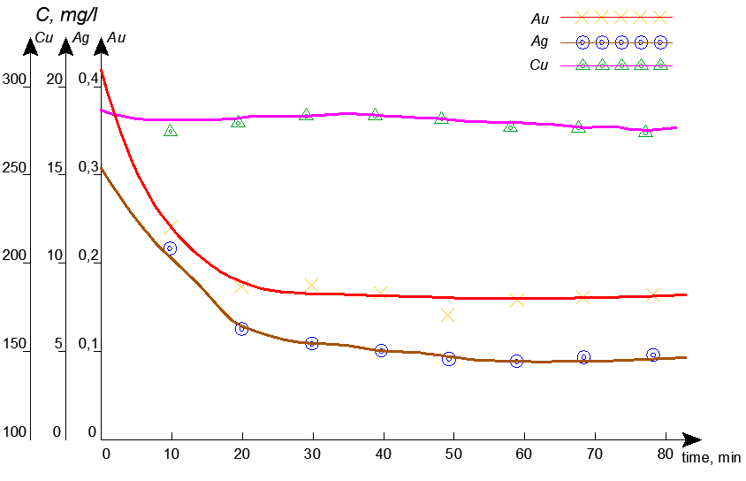
Figure 3.1 Electrochemical precipitation of gold, silver and copper from thiosulfate solutions

Table 3.2 Electrochemical precipitation of gold, silver and copper from thiosulfate solutions
Time | U, В | I, А | t, °С | Au, mg/L | Ag, mg/L | Cu, mg/L | TCA, g/L
Values of primary solution |  |  | 14 | 0,47 | 15,7 | 277 | 41,81
10 min | 3,0 | 75 | 14 | 0,16 | 8,1 | 276
20 min | 3,0 | 40 | 14,5 | 0,2 | 5,0 | 276
30 min | 3,0 | 60 | 15,5 | 0,21 | 3,7 | 273
40 min | 3,0 | 65 | 17,5 | 0,19 | 3,3 | 267 | 40,3
50 min | 3,0 | 67 | 16,5 | 0,21 | 3,0 | 258
1 hour | 3,0 | 67 | 17 | 0,21 | 3,2 | 247
1 hour  10 min | 3,0 | 65 | 17,5 | 0,2 | 2,0 | 224
1 hour  20 min | 3,0 | 67 | 18 | 0,18 | 1,7 | 208
1 hour  30 min | 3,0 | 67 | 18,5 | 0,16 | 1,1 | 180 | 40,3

Table 3.3 Electrochemical precipitation of gold, silver and copper from thiosulfate solutions
Time | U, В | I, А | t, °С | TCA, g/L | Au, mg/L | Ag, mg/L | Cu, mg/L | ORP
Values of primary solution |  |  | 15 |  | 0,45 | 7,5 | 316 | -0,078
10 min | 4,0 | 90 | 16 |  | 0,26 | 3,6 | 242
20 min | 4,0 | 140 | 17,5 |  | 0,245 | 2,8 | 207
30 min | 4,0 | 137,5 | 19,5 | 31,82 | 0,19 | 1,9 | 165
40 min | 4,0 | 140 | 21 |  | 0,13 | 0,8 | 108
50 min | 4,0 | 140 | 23,5 |  | 0,12 | 0,4 | 68
1 hour | 4,0 | 140 | 25 | 30,71 | 0,11 | 0,3 | 43
1 hour  10 min | 4,0 | 145 | 27 |  | 0,074 | 0,2 | 28
1 hour  20 min | 4,0 | 150 | 29 |  | 0,051 | 0,1 | 18
1 hour  30 min | 4,0 | 150 | 30,5 | 32,56 | 0,051 | 0,1 | 15
2 hours | 4,0 |  |  | 33,3 | 0,028 | 0,1 | 1

A new method has been developed for electrochemical deposition of gold directly from poor thiosulfate solutions, which simplifies technological process and reduces its cost by eliminating the cumbersome gold sorption and desorption operations before electrolysis.
A method of electrochemical gold recovery from thiosulfate solutions implies the following:
1. With the purpose selective and intensive gold recovery from poor metal solutions, the process of gold deposition is done in the form of a sulfide compound of gold at the cathode at low voltage in electrochemical cells, for example, 2-3V and high current densities at the cathode, for example, above 140A/m².
2. The method described in point l differs in that to reduce the electric power losses in external networks caused by the use of high current densities in the electrolysis, the process is performed in conditions of bipolar electrolysis, where the electrolyte, acting as a second-class conductor, excludes the use of external networks and contacts.
The method described in points 1, 2 differs in that the resulting cathode precipitates of gold sulfide with elemental sulfur impurities are processed according to known technologies, including roast smelting of the sediment to obtain a gold-bearing ingot from the cinder, and thiosulfate reagent, used for gold leaching from the original raw material, is obtained from roast gases during sanitary cleaning with alkaline reagents.
In order to increase the efficiency of the new method of electrochemical gold deposition directly from thiosulfate solutions, a design of a bipolar electrolyzer has been developed that ensures accelerated evacuation of process products from the interelectrode space: solid ones by gravity downwards, and gaseous ones due to natural forces strictly upward preventing their contact (Figure 3.2, 3.3, 3.4).

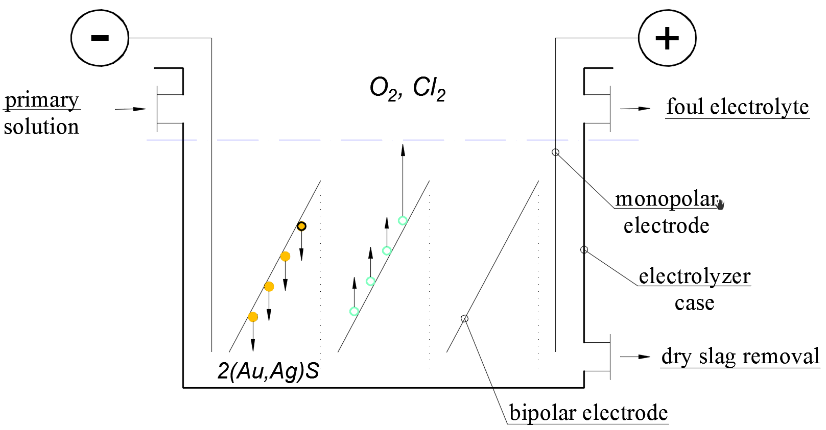
Figure 3.2
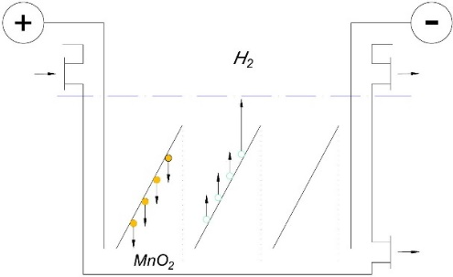 | 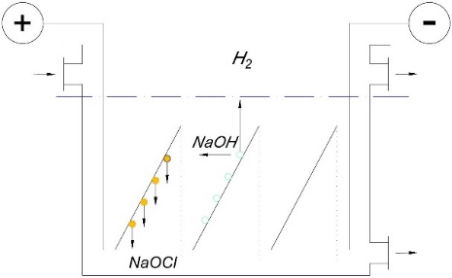
Figure 3.3 | Figure 3.4

The bipolar electrolyzer with plane-parallel bipolar electrodes vertically immersed in the electrolyte is characterized by the following:
1. In order to reduce secondary reactions in the interelectrode spaces and thereby increase the parameters of the electrolysis, the electrodes are installed in the electrolyte in parallel with an inclination to the horizontal surface with the cathode surface facing downwards and the anode surface upwards when forming a solid target product on the cathode. At that, the lower cut line of the previous electrode should not go beyond the projection of the upper cut of each subsequent electrode.
2. The method described in point 1 differs in that in order to minimize the residence and contact time of products of the electrochemical process in the interelectrode space, the width of the electrodes should exceed the height while maintaining the required surface of the electrodes.
3. The method described in points 1, 2 differs in that when the target products are formed in the electrolyzer on the anode surface, for example, at the production of manganese dioxide etc., the electrodes slope changes in the opposite direction or the electric poles change in the other direction.
As a result of the generalization of testing results of a new method of electrochemical gold deposition directly from poor thiosulfate solutions using a new bipolar electrolyzer design, an application for an invention has been submitted.

CONCLUSION

Brief conclusions based on the research results. Based on the performed research according to the 2018-2020 schedule, the following conclusions can be made:
The performed research resulted in establishing upper and lower limits of the fragmentation size ensuring the sequential liberation of mineral grains with the appropriate enrichment methods of this grain size class. Size analysis established the distribution of gold by grain size class and determined the change in the granulometric composition of ore depending on the grinding duration.
- Regression equations were obtained using the Box-Wilson method that describe the interrelation of the main factors affecting the flotation of refractory gold-bearing weathered ores.
- Research of gravity concentration of gold ore of the Quartzite Gorki deposit established that this ore is poorly concentrated using the gravity methods (recovery amounted to 5.16-10.78 %). There is predominant fine fixed ore contained in pyrite, arsenopyrite.
- Ore processing using the gravity concentration (jigging and secondary cleaning of the concentrate on a concentration table), floatation of tailings resulted in the total of 59.8 % of gold recovery into concentrates. Gold content in the concentrates amounted to: gravity concentrate 15.65 g/t, floatation concentrate 42.07 g/t. The gold content in tailings equaled 1.55 g/t.
- Aggregated laboratory research on sulfite-thiosulfate leaching of bulk carbonaceous-gold-arsenic concentrates of the Bakyrchik deposit was performed.
- High values of gold recovery into the solution (96-98%) were obtained at less rigid conditions of concentrate oxidation and leaching compared to the cyanide redox process: the pressure in the autoclave was reduced from 16-20 atmospheres to 5 atmospheres; the temperature was reduced from 290-300°С to 60°С; air was used as an oxidizer instead of oxygen that excludes the need in the oxygen station.
- Mechanochemical analysis of minerals exposed to mechanical activation was done.
- Research on all-sliming of gold-bearing sulfide ores was performed. Mechanical activation grinding was done with the purpose of liberation of fine gold.
- Research on the enhancement of gold recovery by means of floatation based on finer ore grinding revealed that as the fineness increases, gold content in floatation tailings reduced to 0.7 g/t. the maximum gold recovery into the concentrate amounted to 84.59 %.
Sorption cyanidation of mechanical activated mixture of floatation concentrates also results in the reduction of gold content in cyanidation tailings.
The needed duration of mechanical activation is 9-12 minutes, after which the content of particles less than 10 micron in the activated material amounted to 93.94 % within the 40 micron class. Sorption tailings contained 0.31 g/t with gold recovery into the solution equaling 85.65 %.
Research on mechanical activation of sulfide gold-bearing raw material revealed higher efficiency of this method provided, firstly, the operation is conducted in the alkali medium as well as in the presence of the atmospheric air and copper ions, and secondly, sulfite-thiosulfate agent is used in subsequent leaching of the grinded product. Such method of sulfide mineral processing can ensure high values of gold recovery into the solution in both treatments and the transformation of available sulfide sulfur into thiosulfate compound and its use as a reagent.
The work was further aimed at the specification and optimization of parameters at both treatment of the developed technology. Deeper research of gold recovery improvement methods was performed by means of additional increase in the oxidation potential of the medium both due to the use of reagents and electrochemical impact.
- New method of electrochemical gold precipitation directly from poor thiosulfate solutions was developed. The method ensures the simplification and decrease in the cost of the technological process due to the exclusion of cumbersome gold sorption and desorption operations prior to electrolysis.
The electrochemical method of gold recovery from thiosulfate solutions involves the following:
1. With the purpose selective and intensive gold recovery from poor metal solutions, the process of gold deposition is done in the form of a sulfide compound of gold at the cathode at low voltage in electrochemical cells, for example, 2-3V and high current densities at the cathode, for example, above 140A/m².
2. The method described in point l differs in that to reduce the electric power losses in external networks caused by the use of high current densities in the electrolysis, the process is performed in conditions of bipolar electrolysis, where the electrolyte, acting as a second-class conductor, excludes the use of external networks and contacts.
The method described in points 1, 2 differs in that the resulting cathode precipitates of gold sulfide with elemental sulfur impurities are processed according to known technologies, including roast smelting of the sediment to obtain a gold-bearing ingot from the cinder, and thiosulfate reagent, used for gold leaching from the original raw material, is obtained from roast gases during sanitary cleaning with alkaline reagents.
- In order to increase the efficiency of the new method of electrochemical gold deposition directly from thiosulfate solutions, a design of a bipolar electrolyzer has been developed that ensures accelerated evacuation of process products from the interelectrode space: solid ones by gravity downwards, and gaseous ones due to natural forces strictly upward preventing their contact.
The bipolar electrolyzer with plane-parallel bipolar electrodes vertically immersed in the electrolyte is characterized by the following:
1. In order to reduce secondary reactions in the interelectrode spaces and thereby increase the parameters of the electrolysis, the electrodes are installed in the electrolyte in parallel with an inclination to the horizontal surface with the cathode surface facing downwards and the anode surface upwards when forming a solid target product on the cathode. At that, the lower cut line of the previous electrode should not go beyond the projection of the upper cut of each subsequent electrode.
2. The method described in point 1 differs in that in order to minimize the residence and contact time of products of the electrochemical process in the interelectrode space, the width of the electrodes should exceed the height while maintaining the required surface of the electrodes.
3. The method described in points 1 and 2 differs in that when the target products are formed in the electrolyzer on the anode surface, for example, at the production of manganese dioxide etc., the electrodes slope changes in the opposite direction or the electric poles change in the other direction.
As a result of the generalization of testing results of a new method of electrochemical gold deposition directly from poor thiosulfate solutions using a new bipolar electrolyzer design, an application for an invention has been submitted.
Completeness evaluation of the task solution. Compared to the currently used cyanide technology, the proposed processing technology is environmentally safe and cost effective. It ensures considerable simplification of equipment needed for gold recovery treatments, reduces the financial requirements and results in the multiplying effect.
Recommendations and source data on the specific use of research results. Upon completion of the research and obtainment of results, it is expected to be introduced into the production and education.
Assessment of the technical and economic efficiency of implementation. The use of the processing technology of gold-bearing raw materials will allow solving several problems: involving refractory gold-bearing ores in processing and improving the ecological situation of the industrial zone. High rates of gold recovery (96-98%) into solution were obtained under less severe conditions of concentrate oxidation and leaching, in comparison with the cyanide redox process. The technology will ensure complex use of minerals using the mechanochemical activation of the concentrate to transform part of the sulfide sulfur in the mineral into a hydrosulfide and thiosulfate reagent for gold extraction. The developed new method of electrochemical gold deposition using a new design of a bipolar electrolyzer can be successfully applied for the deposition of other metals.
Assessment of the scientific and technical level of the performed research work in comparison with the best achievements in this area. The development was performed at a modern scientific and technical level with the use of modern analytical and research equipment based on the latest achievements in the field of theoretical and practical processing of refractory types of gold-bearing minerals. It is revealed that it is possible to recover a part of gold by means of hydrosulfide and thiosulfate reagents obtained in the conditions of mechanochemical activation from sulfide sulfur contained in the raw material. Higher rates of gold recovery in comparison with other methods were obtained.

LIST OF REFERENCES

1 Peregudov V.V., Shautenov M.R. Gold Mineralization of Kazakhstan // Published by KazSTU after K.I. Satpayev. Volume 1. Almaty, 2017. – P.527. (in Russian).
2 Breuer P.L. and others. Kinetics of Thiosulfate Gold Leaching in the Presence of Copper and Ammonia // Minerals Engineering. V.13.- No.10-11. 2000. - p.1071 – 1081. (in Russian).
3 Zipperian and others. Gold and Silver Recovery from Rhyolite Ores Using Thiosulfate Ammonia // Hydrometallurgy, 1998. – No.3. (in Russian).
4 Marchbank, Dreisinger and others. // USA Patent No.5536297, 1996. (in English)
5 Begalinov A.B., Medeuov Ch.K., Begalinov A.A., Peregudov V.V. Treatment of Weathered Gold Ores at the Symbat Site (Concentration Stage)// Mining Magazine of Kazakhstan.-2007.-No.3. - P.9-15. (in Russian).
6 Begalinov A.B., Akhmetzhanov T.K., Yakovlev A.P., Medeuov Ch.K. and others. Gold Thiosulfate Leaching. Theory and Practice. Research Monograph, Almaty, 2001, 251p.
(in Russian).
7 Langhans J.W. and others. Copper Catalytic Thiosulfate Leaching of Low-Grade Gold Ores // Hydrometallurgy 1992. – No.29. P.192-203. (in Russian). (in Russian).
8 Wan R. and others. // USA Patent No. WO 95/04164, 1995. (in English).
9 Gold Leaching by Low Concentration Thiosulfate Solution / Cao Changlin, Hu Liexue, Gong Qian // Trans. Non-ferrous. Metals Soc. China. 1992. 2, No.4. (in English).
10 Keley B.J. USA Patent No.4369061, 1983. (in English).
11 Yakovlev A.P., Begalinov A., Medeuov Ch.K. and others. Development of Processing Technology of Sulfide Carbonaceous Arsenous Gold-Bearing Concentrates of the Bakyrchik Deposit. Report of JSC “Technopark-Stepnogorsk”, 1996. (in Russian).
12 Begalinov A.B., Yakovlev A.P., Lobko S.V. and others. Method of Gold Recovery from Sulfide Ores and Concentrates. Author’s certificate No.7631 (РК) dated 11.03.1998. (in Russian).
13 Begalinov A.B., Yakovlev A.P., Lobko S.V. Industrial Development of Thiosulfate Technology of Gold Recovery at Kazakhstan Deposits // Mining Magazine (RF). No.11, Moscow, 2001, p.90-93. (in Russian).
14 Begalinov A.B., Yakovlev A.P. and others. Thiosulfate Technology of Gold Recovery from Complex Sulfide Raw Materials. Mining Magazine of Kazakhstan, No.2, Almaty, 2003. – P.34-37. (in Russian).
15 Begalinov A.B., Peregudov V.V., Abdullaev O.T. On the Mineralogical Characteristics of Gold in the Ore of the Kumystinsky Group of Deposits. Mining Geological Magazine, No.1, Almaty, 2007. –P.21-24. (in Russian).
16 Begalinov A.B., Medeuov Ch.K., Begalinov A.A., Peregudov V.V. Processing Technology of Gold-Bearing Weathering Crusts of the “Symbat” Site (Hydrometallurgical Stage) // Mining Magazine of Kazakhstan. 2007. - No.4. -P.2-6. (in Russian).
17 Begalinov A.B., Medeuov Ch.K., Abdullaev O.T. Thiosulfate Gold Leaching (Production Experience) // Mining Magazine of the RF. – 2008. - No.3. - P.50-52. (in Russian).
18 Smolyakov A.R. Liberation of Minerals at Ore Grinding // Mining information and analytical bulletin (scientific and technical journal). 2007. No. 8. P. 224–234. (in Russian).
19 Boldyrev V.V., Avakumov Ye.G. Mechanochemistry of Solid Inorganic Substances // Chemistry success.. – 1971. – V.XL, issue 10. – P. 1835 – 1856. (in Russian).
20 Golosov S.I., Yusupov T.S., Gusev G.M., Molchanov V.I. Possibilities of Improving the Processing Technology of Minerals Based on Fine Dispersion and Mechanical Activation // Physical and Technical Problems of Mineral Development.. – 1972. – No. 4. – P. 104–110.
(in Russian).
21 Lapteva Ye.S., Yusupov T.S., Berger A.S. Physicochemical Changes in Sheet Silicates at Mechanical Activation. - Novosibirsk, 1981. – P. 145-149. (in Russian).
22 Begalinov A.B., Shautenov M.R., Medeuov Ch.K., Almenov T.M. Cyanide-Free Technology of Gold Recovery from Refractory Natural and Technogenic Minerals. // Mining Magazine of Kazakhstan. – Almaty, 2018. – No.1. – P.23 – 27. (in Russian).
23 Begalinov A.B., Medeuov Ch.K., Begalinov A.A., Peregudov V.V. Processing Technology of Gold-Bearing Weathering Crusts of the “Symbat” Site (Concentration Stage). // Mining Magazine of Kazakhstan. – Almaty, 2007. – No.3. – P.9 – 15. (in Russian).
24 Turysbekova G.S., Meretukov M.A., Bektay Ye.K. “Gold: Innovations in Chemistry and Metallurgy”. Almaty: KazSTU, 2015 – 632p. (in Russian).
25 Akhmetov N.S. “General and Inorganic Chemistry” M.: Vysshaya shkola, 1988, 639p.
(in Russian).
26 Tiurin N.G. “The role of Oxidation-Reduction Potential in the Processes of Gold Dissolution and Precipitation.” Research of Natural and Technical Mineral Formation. M.: Nauka. 1966. (in Russian).
27 Balaz P. Mechanochemistry in Nanoscience and Minerals Engineering Springer. Berlin. 2008, 413p. (in English)
28 Opoczky L. Powder Technol. 1977. V.17. P.1-7. (in English)
29 Ostwald W. Lehrbuch der allgemeinen chemie. Bd.2. Engelmann. Leipzig. 1891. 1163p.
(in English)
30 Begalinov A.B., Shautenov M.R., Almenov T.M., Bektur B.K., Iskakov Ye.Ye. Monograph / Cyanide-Free Processing Technology of Gold-Bearing Minerals – Almaty: Editorial house of KazNRTU after K.I. Satpayev, 2020. -332 p. (in Russian).
31 Zhuchkov I.A., Bubeev P.P. Comparative Evaluation of Methods for Silver Recovery from Thiosulfate Solutions. Non-Ferrous Metallurgy. No.3, 1990. P. 62-66. (in Russian).
32 Ye.V. Utkin “Neutralization and Purification of Solutions from Arsenic after Bacterial Leaching of Refractory Gold-Arsenic Concentrates.” Abstract of the PhD thesis. M., 1996. (in Russian).

APPENDIX A

Work schedule for 2018-2020

1. Title of priority direction for which the application is submitted: 1. Rational use of natural resources, including water resources, geology, processing, new materials and technologies, safe products and designs.
2. Title of the specialized scientific direction for which the application is submitted: 1.4 Integrated use of mineral resources; 1.15 Systems of concentration, integrated extraction, processing of natural and man-made crude ore.
3. Proposed date of the project beginning and its duration:
Project beginning: January 2018; project end: December 2020. 36 months.
4. The requested sum of the grant financing for the years 2018-2020 amounts to 27,180 thous.usd, including: for the year 2018: 9,000 thous.usd, for the year 2019: 9,081 thous.usd, for the year 2020: 9,099 thous.usd.

No | Tasks, measures for realization of project tasks | Duration (months) | Beginning of the work realization (dd/mm/yy) | Years of project realization, expected results of the project realization (in terms of tasks and measurements)
 |  |  |  | 2018 | 2019 | 2020
1 | Project task for the year 2018  Research of gold occurrence forms in the investigated ore samples and concentrates. Determination of gold phase change at the oxidation of sulfide ores and concentrates in the conditions of redox-process with subsequent thiosulfate leaching. | 12 months | 03/01/2018-28/12/2018 | At the substitution of cyanide with thiosulfate, it is expected that the leaching temperature and pressure will decrease that will ensure “softer” conditions of the process and simplification of instrumentation of the process chart.
1.1 | I. Research of gold occurrence forms in the investigated ore samples (mineralogical, fraction, chemical, X-ray diffraction analysis and other analysis methods). Research of the ore processing of a gold-containing ore sample (grinding, crushing and classification). Determination of the grain-size classification and pattern of gold distribution in size grades. | 3 months | 03/01/2018-30/06/2018 | Gold occurrence forms in the investigated ore samples and grain-size classification and pattern of gold distribution in size grades will be determined.
1.2 | II. Research of gravity and flotation concentration of gold-containing ore samples with the purpose of obtaining concentrates for thiosulfate leaching. | 3 months | 02/04/2018-29/06/2018 | The optimal process modes of gravity and flotation concentration of investigated roes will be established.
1.3 | III. Research of oxidation of sulfide ores and concentrates in the conditions of redox-process in softer temperature and pressure modes. | 3 months | 02/07/2018-28/09/2018 | Conditions of oxidation and leaching of sulfide ores and concentrates will be studied with the purpose of optimizing the thiosulfate leaching in the conditions of redox-process.
1.4 | IV. Research of thiosulfate leaching of ores and concentrates after preliminary oxidation of sulfides in the conditions of redox-process with the variation of the reagent and other modes of the process. | 3 months | 01/10/2018
2 | Project task for the year 2019 – Research of phase changes of gold-containing sulfide ores and concentrates in the process of their super-fine grinding (20, 10, 5 µm). Research of thiosulfate leaching of ores and concentrates after the super-fine grinding in various reagent modes. | 12 months | 03/01/2019-30/12/2019 |  | The research result will ensure the replacement of pure oxygen with air and the simplification of the oxidation process.
2.1 | V. Selection of grinding equipment. Research of super-fine grinding of gold-containing sulfide ores and concentrates and determination of phase changes of minerals and extent of sulfur oxidation. | 3 months | 03/01/2019-29/03/2019 |  | The optimal parameters of super-fine grinding of gold-containing sulfide ores and concentrates will be determined.
2.2 | VI. Research of thiosulfate leaching of various ore and concentrate fractions after the super-fine grinding. Determining the optimal parameters of the grinding and leaching processes. | 3 months | 01/04/2019-28/06/2019
2.3 | VII. Research of thiosulfate leaching of various ore and concentrate fractions after the super-fine grinding depending on the grinding fineness. Determining the optimal parameters of the grinding and leaching processes. | 3 months | 01/07/2019-30/09/2019 |  | The optimal parameters of grinding and leaching of ore and concentrates will be determined with the purpose of increase in gold recovery from the processed resources.
2.4 | VIII. Research of thiosulfate leaching of various ore and concentrate fractions after the super-fine grinding. Determining the optimal parameters of the grinding and leaching processes. | 3 months | 01/10/2019-30/12/2019
3 | Project task for the year 2020 – Research of thiosulfate leaching of sulfide ores and concentrates after their preliminary acidic treatment (with nitric and sulfuric acids) in various modes. | 12 months | 03/01/2020-30/12/2020 |  |  | New method of chemical and electrochemical sedimentation of gold from lean product solutions will ensure the simplification and reduction of costs of the process due to the exclusion of massive treatments (such as sorption and desorption) of gold prior to electrolysis. A new type of electrolyzer will be developed.
3.1 | IX. Research of ore and concentrate leaching after their preliminary acidic treatment (nitrox-process) in various modes of leaching and with the use of various solvents – thiosulfates, sulfates, alkalis. | 3 months | 03/01/2020-30/03/2020 |  |  | Research will be carried out for the selection of various solvents for concentrate leaching after their preliminary treatment with nitric acid with the purpose of increase in gold recovery.
3.2 | X. Research of thiosulfate leaching of sulfide ores and concentrates after their preliminary treatment with sulfuric acid in various temperature and chemical modes. Determining the optimal parameters of the treatment with sulfuric acid and thiosulfate leaching | 3 months | 01/04/2020-30/06/2020 |  |  | Research will be carried out for the determination of the optimal parameters of leaching depending on the temperature and chemical modes of treatment with sulfuric acid with the purpose of increase in gold recovery.
3.3 | XI. Research of chemical and electrochemical sedimentation of gold from lean product solutions without gold sorption and desorption from solutions. | 3 months | 01/07/2020-30/09/2020 |  |  | The methods for direct chemical and electrochemical sedimentation of gold from lean product solutions will be proposed.
3.4 | XII. Processing of research results during 2018-2020, reporting on the work and submission of data for industrial implementation of the processing technology of refractory ores from deposits like Bakyrchik. Formalization of patents for the developed technologies and writing of articles in domestic and foreign scientific magazines. | 3 months | 01/10/2020-30/12/2020 |  |  | Research results for 2018-2020 will be processed. Reports on work and data for industrial development of technology for processing persistent gold-containing ores will be issued. Patents on the developed technologies and articles in scientific domestic and foreign journals will be issued. A technology for cyanide-free leaching of gold from persistent gold-containing raw materials will be developed. The research results will be presented in the proceedings of international conferences, and 2 articles will be published in foreign peer-reviewed scientific journals with a high impact factor. The textbook "Processing of hard-to-enrich gold-containing natural and man-made raw materials", 1 monograph and 1 patent application of the Republic of Kazakhstan will be published.

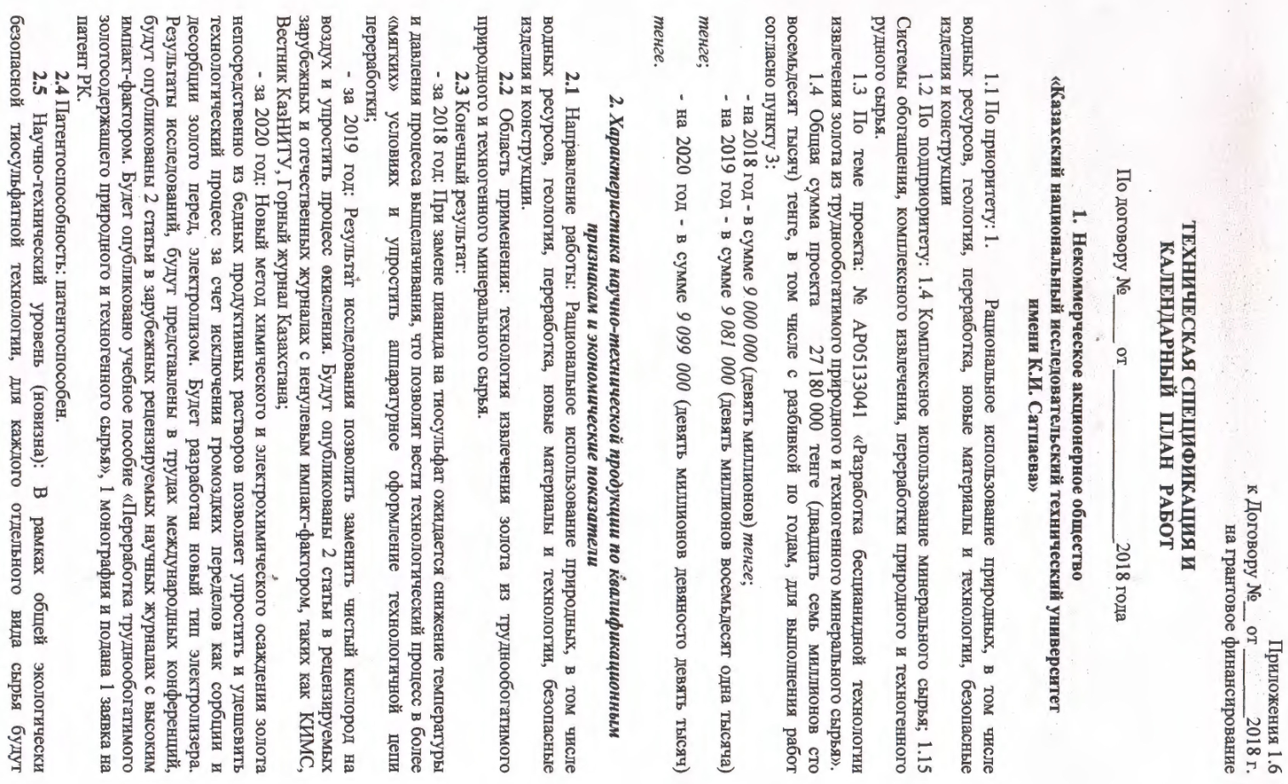
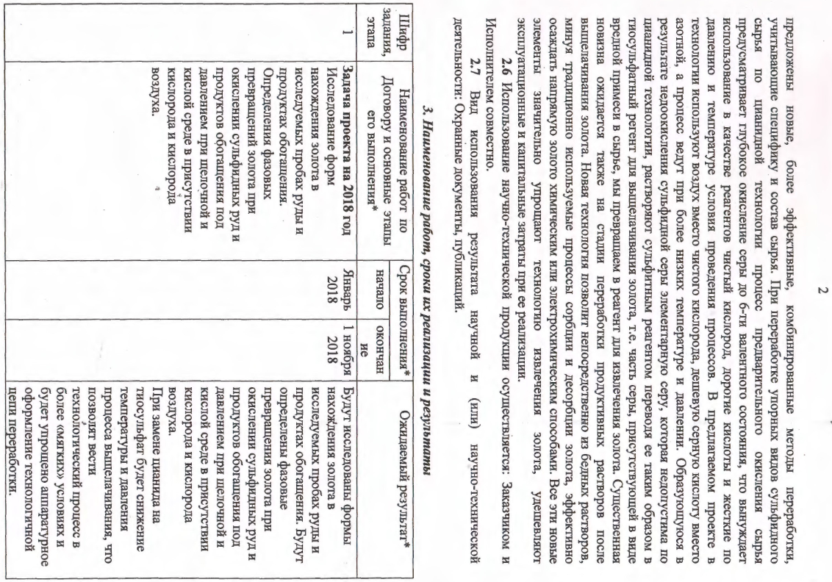

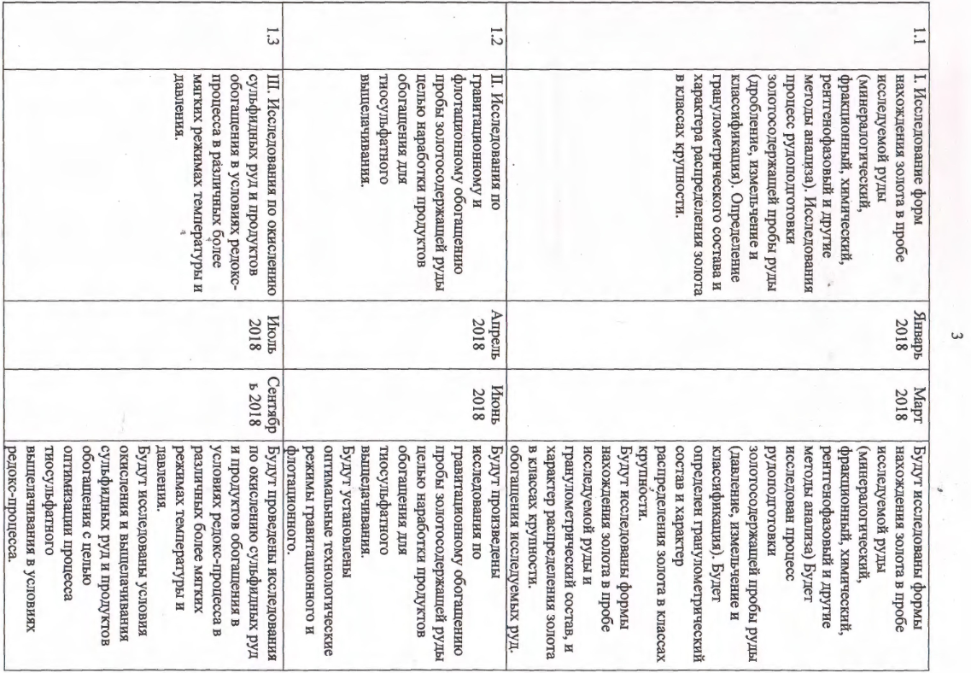

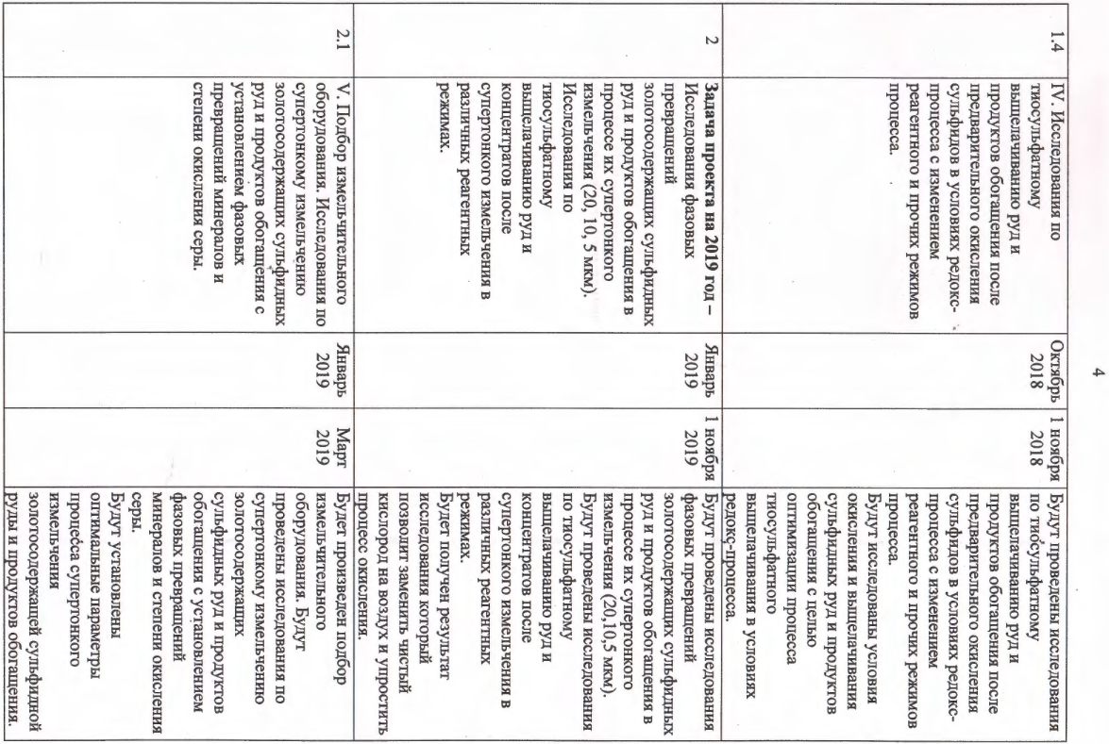

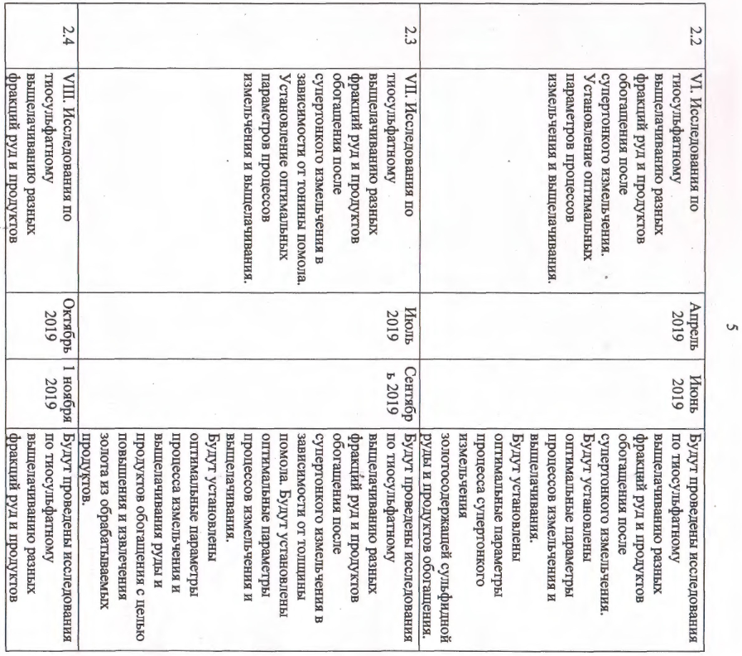

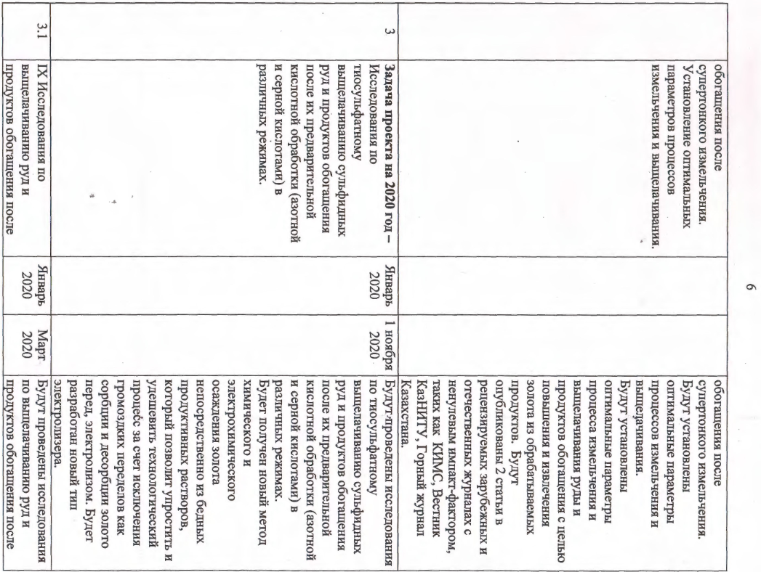

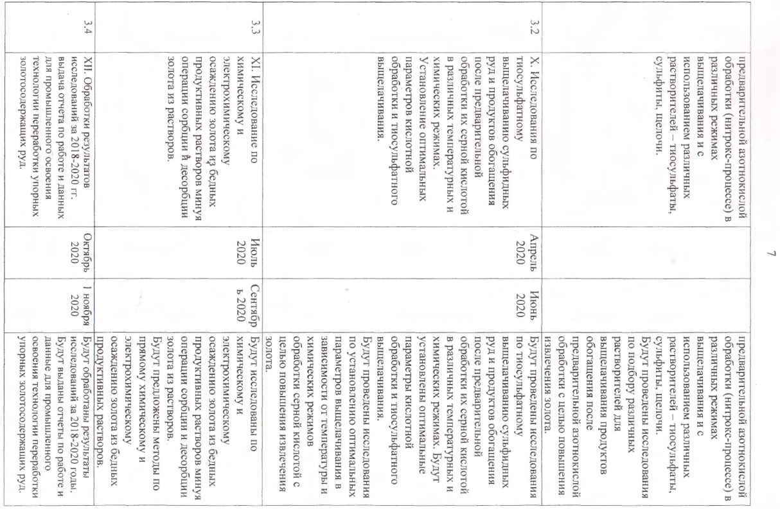

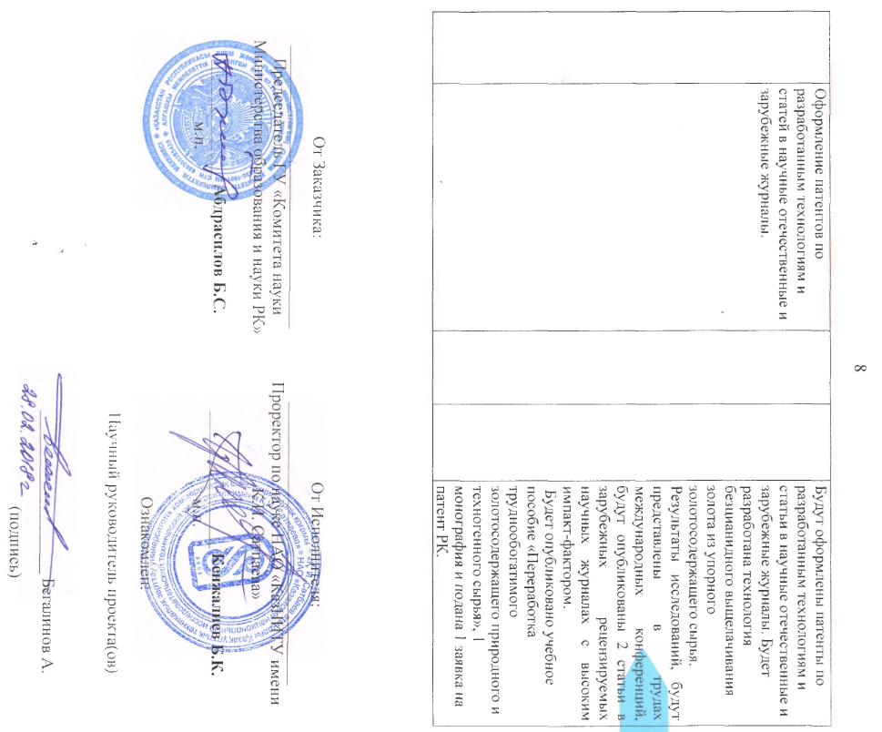

APPENDIX B

List of published works on the topic for 2018-2020

№ | Output data of works | Link
2018 год
1 | Begalinov A., Shautenov M. R., Medeuov CH. K.,  Almenov T. M. "cyanide-Free technology for extracting gold from difficult-to-enrich natural and technogenic mineral raw materials". Scientific, technical and production "Mining journal of Kazakhstan", No. 10 Almaty, 2018, pp. 23-28.  (in Russian). | A copy is attached
2 | Peregudov V. V., Soutenu M.R., A. B. Begalinov  Method of search and evaluation of gold deposits.  Materials of the XVII International scientific and practical conference "resource-Reproducing, low-waste and environmental technologies for subsoil development" within the framework of the program of modernization of public consciousness "Orientation to the future: spiritual revival" Aktau, September 17-20, 2018, pp. 109-111. (in Russian). | A copy is attached
3 | Peregudov V. V., Shautenov M.R., Begalinov A. B., Levin V. L., Zayakina S. B. on the technology of enrichment of ash and slag formations of Ekibastuz coals. Materials of the XVII International scientific and practical conference "resource-Reproducing, low-waste and environmental technologies for subsoil development" within the framework of the program of modernization of public consciousness "Orientation to the future: spiritual revival" Aktau, September 17-20, 2018, pp. 113-114. (in Russian). | A copy is attached
4 | Peregudov V. V., Shautenov M.R., Begalinov A. B., Levin V. L., Zayakina S. B. " on the results of studying gold-sulfide ores (ore body No. 1) of the quartzite Gorki Deposit (Northern Kazakhstan)» Materials of the XVII International scientific and practical conference "resource-Reproducing, low-waste and environmental technologies for subsoil development" within the framework of the program of modernization of public consciousness "Orientation to the future: spiritual revival" Aktau, September 17-20, 2018, pp. 115-116. (in Russian). | A copy is attached
2019 год
1 | Begalinov, A., Shautenov, M., Almenov, T., Bektur, B., Zhanakova, R. Prospects for the effective use of reagents based on sulfur compounds in the technology of extracting gold from resistant types of gold ore (Article). Satbayev University, Kazakhstan. Journal of Advanced Research in Dynamical and Control SystemsVolume 11, Issue 8 Special Issue, 2019, Pages 1791-1796. (in English) | https://www.jardcs.org/abstract.php?id=2521#
2 | Peregudov V. V., Shautenov M.R., Begalinov A. Carla-technology for searching for gold deposits by gold. XII Congress of CIS enrichment companies, nust MISIS, Moscow, February 25-27, 2019. - P. 65-67. (in Russian). | A copy is attached
3 | Peregudov V. V., Shautenov M.R., Begalinov A., Levin V. L. Mineral tracers of gold mineralization in technological products. XII Congress of CIS concentrators, nust MISIS, Moscow, February 25-27, 2019. - Pp. 67-69. (in russian). | A copy is attached
4 | Begalinov A., Medeuov CH. K., Shautenov M.R., Almenov T. M. Prospects for effective use of reagents based on sulfur compounds in the technology of gold extraction from resistant raw materials. XII Congress of CIS concentrators, nust MISIS, Moscow, February 25-27, 2019. - P. 332-334.  (in Russian). | A copy is attached
5 | Shautenov M.R., Zayakina S. B., Peregudov V. V., A. Begalinov Research on the processing of ash and slag waste to obtain useful components. Mining journal of Kazakhstan, No. 10, 2019. (in Russian). | A copy is attached
2020 год
1 | Begalinov, A., Almenov, T., Zhanakova, R., Bektur, B. «Analysis of the stress deformed state of rocks around the haulage roadway of the beskempir field (Kazakhstan)» Satbayev University, Almaty, 50013, Kazakhstan. Mining of Mineral Deposits.Volume 14, Issue 3, 2020, Pages 28-36.  (in English) | http://mining.in.ua/2020vol14_3_4.html
2 | Begalinov, A., Khomiakov, V., Serdaliyev, Y., Iskakov, Y., Zhanbolatov, A. «Formulation of methods reducing landslide phenomena and the collapse of career slopes during open-pit mining» (Conference Paper). Satbayev University, Kazakhstan. Volume 168, 6 May 2020, Номер статьи 000062nd International Conference Essays of Mining Science and Practice, RMGET 2020; Dnipro; Ukraine; 22 April 2020.  (in English) | https://www.e3s-conferences.org/articles/e3sconf/abs/2020/28/e3sconf_rmget2020_00006/e3sconf_rmget2020_00006.html
3 | Zhanakova, R.ª, Pankratenko, А.^{b}, Almenov, Т.ª, Bektur, В.ª «Rational selection of the form of support for the formation of genetic composition of rocks in the conditions of the Beskempir». ªKazakh National Research Technical University named after K. I. Satpayev (Satpayev University), Almaty, Kazakhstan. ^{b}National University of Science and Technology (MISIS), Moscow, Russian Federation. News of the National Academy of Sciences of the Republic of Kazakhstan, Series of Geology and Technical Sciences Volume 1, Issue 439, 2020, Pages 106-113. (in English). | http://nblib.library.kz/elib/library.kz/jurnal/%D0%93%D0%B5%D0%BE%D0%BB%D0%BE%D0%B3%D0%B8%D1%8F_01_2020/Zhanakova.Pankratenko.pdf
4 | Begalinov A. B., Shautenov M. R., Almenov T. M., Bektur B. K., Iskakov E. E. Monograph / cyanide-Free technology for processing gold-containing mineral raw materials-Almaty: kaznitu publishing house named after K. I. Satbayev, 2020. -332 p. (in Russian). | A copy is attached
5 | A. Begalinov, M. R. Sautenov, T. M. Almenov, Janakova R. K., B. K. Bector. Training manual / Processing of hard-to-enrich gold-containing natural and man-made raw materials-Almaty. KazNTU publishing house named after K. I. Satbayev, 2020. -229 p. (in Russian). | A copy is attached
6 | A. Begalinov, M. Shautenov, S. Yusupov, T. M. Almenov, S. B. Yulusov patent Application / Method for extracting gold from thiosulfate solutions. 2020. (in Russian). | Application submitted

APPENDIX C
Extracts from the minutes of meetings

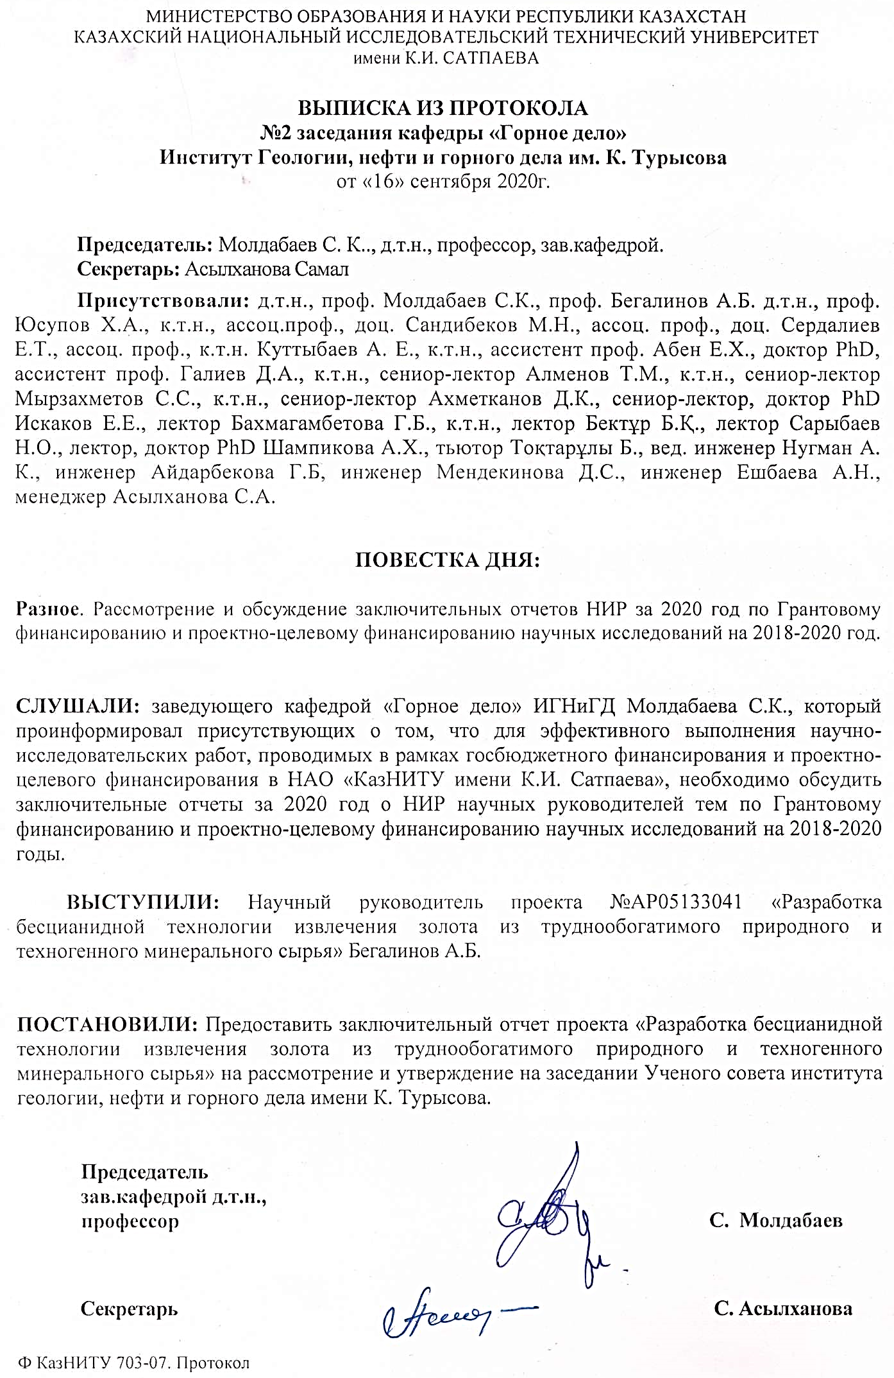

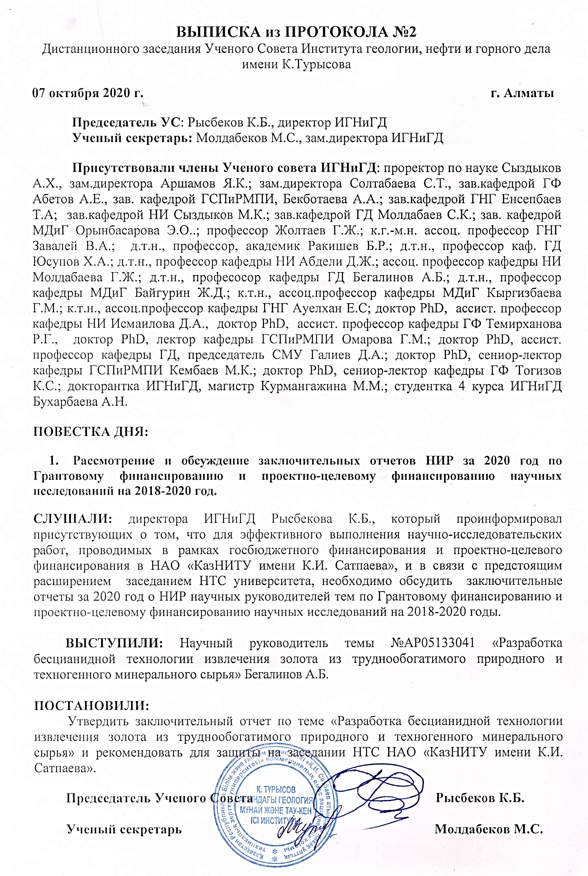

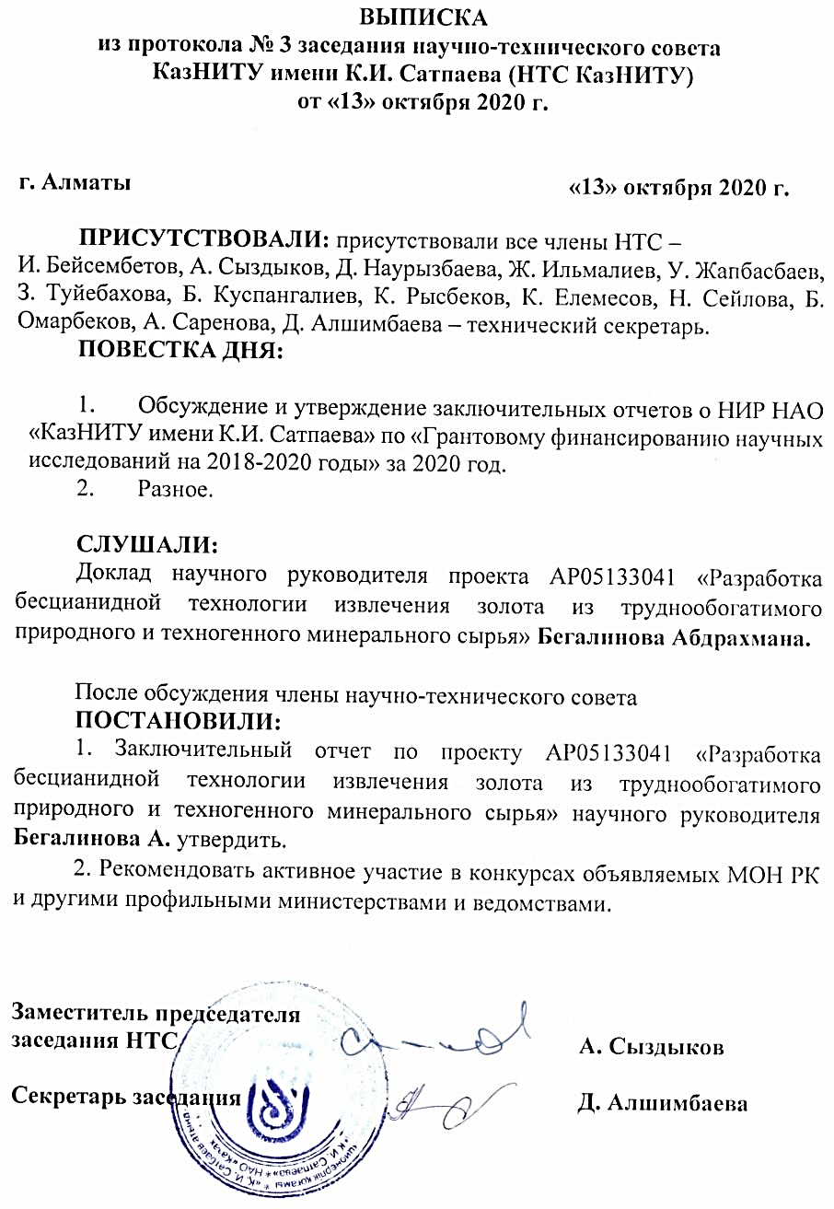

The term was first used by V. Oswald who viewed the mechanochemical activation as an independent science discipline along with thermochemistry and photochemistry [29].

