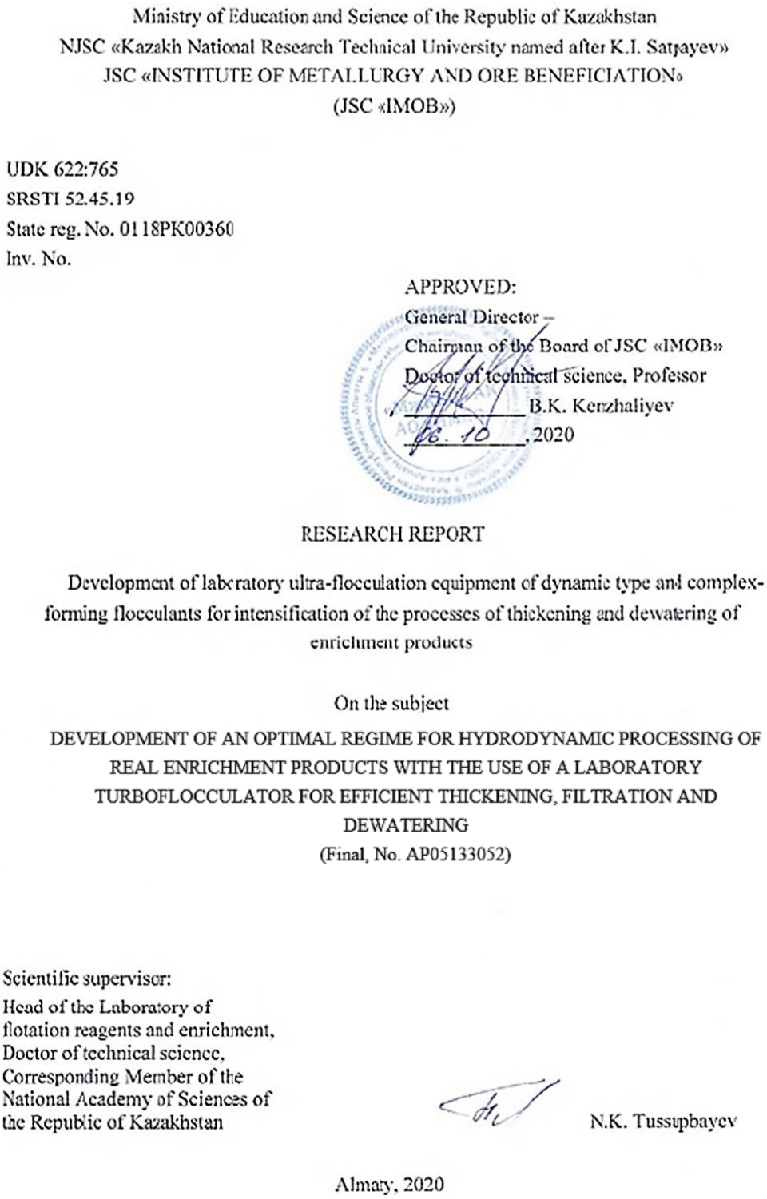
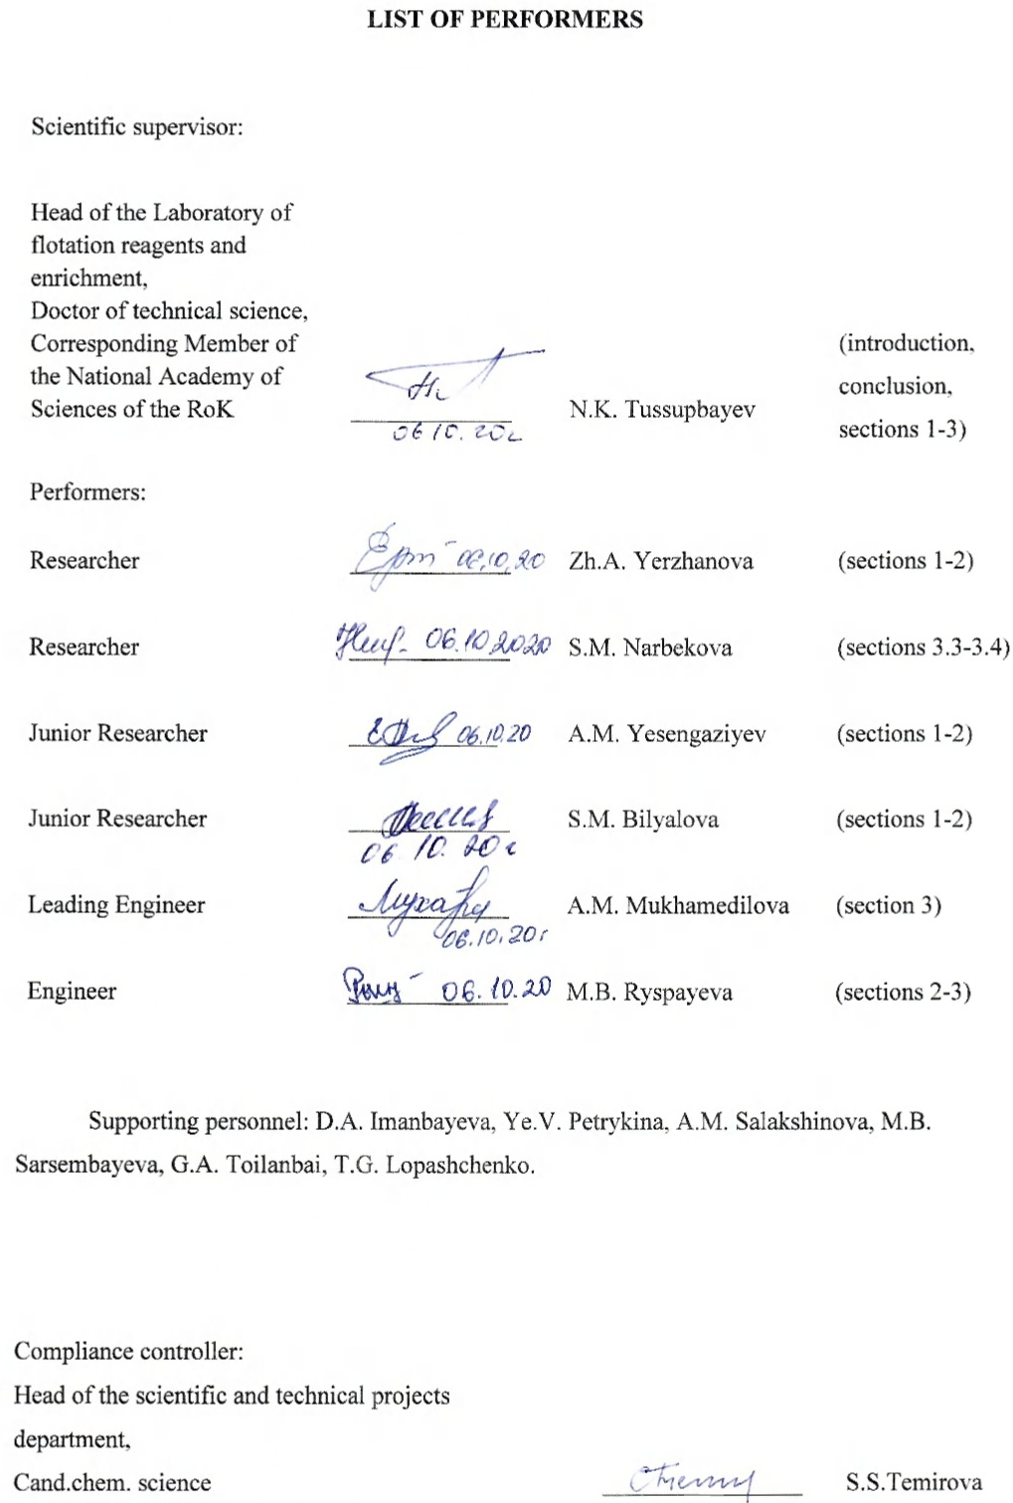АҢДАТПА
Есеп 58 бет., 18 сур., 9 кесте, 17 әдеби деректерден тұрады, 4 қосымша.
МОДЕЛДІК СУСПЕНЗИЯЛАР, БАЙЫТУ ӨНІМДЕРІ, ФЛОКУЛЯЦИЯ, УЛЬТРАФЛОКУЛЯЦИЯ, ҚОЙЫЛДЫРУ, СУСЫЗДАНДЫРУ, ЫЛҒАЛДЫЛЫҚ.
Зерттеу нысандары немесе әзірлеу - моделдік суспензиялар және байыту өнімдері (концентраттар, флотация қалдықтары), "Кemira" фирмасының суперфлокулянттары.
Жұмыстың мақсаты – моделдік суспензиялар мен байыту өнімдерінің гидродинамикалық өңдеудің оңтайлы режимдерін Ультрафлоктестер аппаратын пайдалана отырып, қойылдыру және сусыздандыру үрдістерінің тиімділігін анықтау.
Жұмыс жүргізу әдістері - флокуляция, ультрафлокуляция, сусыздандыру.
Жұмыс нәтижелері және олардың жаңалығы – моделдік және байыту өнімдері суспензиялардың жылдамдық градиенттерінің (G) оңтайлы режимдерін Ультрафлоктестер аппаратын пайдалана отырып, қойылдыру және сусыздандыру үрдістерінің тиімділігі анықталды. Концентрациясы 100 г/л суспензияны G = 500 - 1000 с⁻¹ аралығында 12 сек бойы, ал 50 г/л суспензяны G = 1000 - 1500 с⁻¹ 6 сек бойы өңдеу керек екені көрсетілді. Бұл кезде қойылдырғыштағы ағымды судағы қатты заттың мөлшері 20-30 мг/л дейін азаятыны анықталды.
Жұмыстың жаңалығы – динамикалық типтес зертханалық ультрафлокуляторды қолданғанда флокулалар түзілу кезінде ірі және ұсақ бөлшектердің бірігуі өте аз уақытта жүзеге асуы, соның әсерінен седиментация үрдісі, су фазасының мөлдірлену дәрежесінің жоғары болуы аз уақыт аралығында тезірек жүруі жатады.
Енгізу дәрежесі. Зерттеу ультрафлокуляциялық қондырғылар мен тиімді флокулянттарды жетілдіру шегінде тұр.
Енгізудегі ұсыныстар немесе ҒЗЖ нәтижелерін енгізу. Зерттеу жұмыстарынан алынған нәтижелер, байыту өнімдерін тиімді қойылдыру мен сусыздандыру үрдістерінде қолдануға ұсынылады.
Қолдану аумағы. Пайдалы қазбаларды байыту.
Жұмыстың экономикалық тиімділігі немесе маңыздылығы. Өңделінген технология, қазақстанның тау-кен байыту кәсіпорындарындағы сусыздандыру және қойылдыру үрдісінің байыту өнімдерін қарқындата отырып, үйінді қалдықтардағы пайдалы компоненттердің жоғалымы мен қайтарымды судың тазалануын жақсартады.
Зерттеу нысанның жетілдіру жөніндегі ұсынымды болжау. Кешентүзгіш флокулянттарды және ульрафлокуляция әдісін қолдана отырып, моделдік жүйелер мен байыту өнімдерінен алынған нәтижелерді әрі қарай өндірістіксуспензияларда жүргізуді жалғастыру қажет.
ABSTRACT
The report 58 pp, 18 fig., 9 tabl., 17 ref., 4 app.
MODEL SUSPENSIONS, ENRICHMENT PRODUCTS, FLOCCULATION, ULTRA-FLOCCULATION, THICKENING, DEWATERING, MOISTURE.
Objects of research or development: model suspensions and enrichment products (concentrates, flotation tailings), Kemira superflocculants.
Work purpose: development of an optimal regime for hydrodynamic processing of model suspensions and enrichment products with the use of UltraflocTester for the processes of thickening and dewatering.
Work methods: flocculation, ultra-flocculation, dewatering
Research results and their novelty: development of an optimal regime for a medium velocity gradient (G) of model suspensions and enrichment products with the use of UltraflocTester, a laboratory apparatus, for the processes of thickening and dewatering. It has been found that a suspension with a concentration of 100 g/L should be processed at G = 500 – 1000 s⁻¹ for 12 seconds, while a suspension with a concentration of 50 g/L should be processed at G = 1000-1500 s-1 for 6 seconds. Here, the residual solids content in the thickener overflow is reduced to 20-30 mg/L.
The research novelty is the use of a laboratory ultra-flocculator of a dynamic type, which leads to a rapid combination of large and small particles directly in the process of floccule formation, ensuring their rapid sedimentation and a high degree of clarification of the aqueous phase in a short period.
Implementation degree. Research is at the stage of the development of ultra-flocculation equipment.
Recommendations on implementation or results of implementation. The results are recommended to be used for effective thickening and dewatering of beneficiation products.
Field of use Mineral processing.
Economic efficiency or significance of the work. The developed technology will make it possible to intensify the processes of thickening and dewatering of the enrichment products of mining and processing enterprises in Kazakhstan with the use of ultra-flocculation equipment.
Predictive assumptions about the development of the research object. The obtained results on model systems and enrichment products with the use of an ultra-flocculation method are supposed to be used for industrial suspensions in the future.

TABLE OF ContentS
INTRODUCTION ……………………………………………………………………. | 6
MAIN PART ………………………………………………………………………….. | 10
- Development of an optimal regime for thickening and filtration of model enrichment products with the use of base and complex-forming flocculants ……… | 10
- Development of an optimal regime for hydrodynamic processing of model enrichment products with the use of UltraflocTester for efficient thickening, filtration, and dewatering ………………………………………………………… | 13
- Development of an optimal regime for hydrodynamic processing of real enrichment products with the use of a laboratory turbofloculator for efficient thickening, filtration, and dewatering…………………………………………………………… | 16
3.1 Development of an optimal regime for hydrodynamic processing of tailings with the use of a laboratory turboflocculator for efficient thickening, filtration, and dewatering.……………………………………………………… | 16
3.2 Development of an optimal regime for hydrodynamic processing of lead concentrate with the use of a laboratory turbo-flocculator for efficient thickening, filtration, and dewatering ………………………………………… | 22
3.3 Development of an optimal regime for hydrodynamic processing of zinc concentrate with the use of a laboratory turboflocculator for efficient thickening, filtration, and dewatering ………………………………………… | 29
3.4 Large-scale laboratory tests of copper, lead and zinc concentra- tes for thickening, filtration, and dewatering with the use of a laboratory turboflocculator……………………….……………………………………… | 33
Conclusion ……………………………………………………………………… | 38
References ………………………………..………………………………………. | 42
Appendix A List of published works ………………………………..……………… | 44
Appendix B Schedule ……………………………………………………………… | 45
Appendix C Review ………………………………………………………………… | 53
Appendix D Extract from the Minutes of the Academic Council ………………..…. | 57

Introduction
Assessment of the current state of the scientific and technical problem to be solved.

For thickening processes, the primary role is played by the ability of clay-containing pulps, under certain conditions, to form aggregative and sedimentation-stable systems. Clay minerals, in contact with the liquid phase, actively adsorb polar molecules of the latter on their surface, which leads to the formation of a solvation-hydration layer on the particle surface, which adversely affects the ability of particles to coagulate and precipitate [1-2].

It should be considered that a significant part of hard-to-precipitate solid particles in such systems can be in a colloidal state. The aggregate stability of each of these particles is ensured by electric charges on its surface. They prevent charged particles from sticking together to form larger aggregates and their subsequent precipitation. The magnitude of the charge of the colloidal particle determines the distance for colloidal particles to approach each other. Aggregate and sedimentation stability is determined by a combination of a large number of factors such as physicochemical properties of the solid and liquid phases of the suspension, a degree of dispersion of the material, the specific surface area of the particles, etc. To determine the characteristics of a colloidal system, knowledge of the nature of colloidal particles and the magnitude of their charge is required [3-5].

Recently, Napper et al. have developed new ideas about the so-called displacement flocculation of dispersed systems [6]. Under Napper's concept, the flocculation process occurs under conditions when most of the polymer macromolecules introduced into the dispersion medium are not adsorbed on the surface of the dispersed phase particles but are in a free state in solution. Essentially, this mechanism is that if in a dispersed system, the distance between approaching particles of the dispersed phase is less than the effective diameter of the polymer coil, then macromolecules cannot penetrate the interparticle space and are substantially excluded from it. Thus, there is a microreservoir of an almost pure solvent between the particles, and, in this case, the forces of osmotic pressure from the side of the polymer solution begin to act on the particles and tend to bring these particles closer together. With their further approach, part of the pure solvent is displaced into the bulk phase, which is thermodynamically (more precisely, entropy) favorable and leads to a decrease in the free energy of the system. For this reason, the main distinguishing feature of displacement flocculation is directly related to taking into account the changes in the entropic component of the Gibbs energy that occur in dispersed systems during flocculation.

Flocculation is one of the most effective methods for intensifying the process of separating the tailings of mineral processing by sedimentation and filtration. At the same time, flocculants have one significant drawback – significant molecules, due to a huge molecular weight, have very low mobility, which creates problems when mixing the initial solution of the flocculant with the suspension and the uniform distribution of its molecules in the volume of the process suspension and, consequently, on the surface of the particles. This drawback is especially acute when processing relatively concentrated suspensions (more than 10 g/L of solid). As a result of the uneven distribution of the flocculant in the suspension, areas with too high and too low concentration are formed. Consequently, at the end of the flocculation process, a lot of unbound small particles or aggregates remain in the suspension [3]. These particles not only reduce the quality of the clarified water but significantly complicate sludge dewatering by filtration or centrifugation, which is the most important. This is because unbound fine particles can move in the pores of the filter cake and close them, thereby increasing the hydraulic resistance of the cake and reducing the filtration rate. Moreover, these particles can penetrate and accumulate in the interfiber space of the filter material, reducing its service life several times.

A partial solution to the problem can be achieved by using well-diluted flocculant stock solutions and appropriate dilution of the process suspension. As a result, when processing highly concentrated suspensions (more than 100 g/L of solid), the load on the separation equipment can increase by 50% or more.

In the case of dilute suspensions (<1 g/L solid), the problems of flocculation are complicated by the fact that the frequency of collisions of flocculated particles is significantly reduced, which leads to a significant increase in the time required to complete flocculation.

The above difficulties of using flocculants, as was first shown in [7, 8], can be overcome by using special hydrodynamic processing of the suspension during the introduction of the flocculant and immediately after it. This treatment, called "ultra-flocculation" [7, 9], allows not only to quickly and evenly distribute the flocculant molecules throughout the suspension volume but also to create favorable conditions for the rapid formation of tightly packed and strong floccules. Here, almost all particles are in a bound state, which greatly facilitates further sludge dewatering.
Basis and initial data for the development of the theme. High-molecular substances are widely used to accelerate and increase the degree of aggregation of dispersed particles. For example, they find application in various branches of modern technology for intensifying phase separation processes (e.g. by sedimentation, filtration, flotation, centrifugation), including in water treatment, mineral processing, etc. A large number of works have been devoted to the study of the flocculation of dispersions by polymers. The basis for the development of the theme is the need to create a technology for thickening and dewatering of enrichment products with a modern innovative ultra-flocculation method.
Justification of the need for research. The results of the study can be used to increase the efficiency of the processes of thickening and dewatering of enrichment products with the use of ultra-flocculation equipment.
Information about the planned scientific and technical level of development, patent research, and patent research conclusions. The patents and literature on the problem of thickening, filtration, and dewatering of enrichment products (concentrates, tailings) were analyzed. A review of scientific and technical literature and patent research in this area indicate the novelty of the proposed scientific project for implementation.
Information about the metrological support of the research. In the course of research work, metrological support was determined by the presence of certified Chemical Analytical Laboratory and Laboratory of Physical Methods of Analysis. Metrological measurements were performed on verified control and measuring devices, which ensures the reliability of the results and analyzes. The National Scientific Laboratory in the priority direction "Technologies for the hydrocarbon and mining and metallurgical sectors and related service industries" of Institute of Metallurgy and Ore Beneficiation JSC is accredited for technical competence in the National Accreditation Center of the Committee for Technical Regulation and Metrology and has the Accreditation Certificate No.KZ-I.02.1138 dated 23 February 2016 (valid until 2/23/2021, for compliance with the requirements of GOST ISO/IEC 17025-2009 "General requirements for the competence of testing and calibration laboratories". Institute of Metallurgy and Ore Beneficiation JSC has State License for handling with precursors No. 16011676 dated July 21, 2016, State License for handling with poisons No. 16011643 dated July 20, 2016.
Relevance. In recent years, ultra-flocculation treatment has become more and more widespread in the technology of separating technogenic suspensions. The efficiency of the use of flocculants in the processes of sedimentation and filtration separation of suspension phases largely depends on the regime of hydrodynamic processing of the suspension (medium velocity gradient) after the introduction of a flocculant solution into the suspension. Correct selection of the ultra-flocculation treatment mode allows to increase the sump productivity by several times and significantly reduce the suspended matter content in the overflow. It allows increasing the productivity of vacuum and belt press filters by 1.5-2 times and significantly reducing the consumption of expensive flocculants.
Theme novelty. Development of an optimal regime for hydrodynamic processing of model and real enrichment products with the use of a laboratory turbofloculator for efficient thickening and dewatering.
Relationship of this research with other research. The Republic of Kazakhstan has a large number of mining and processing and coal mining industries which annually generate a huge amount of enrichment products, including concentrates and tailings. Effective processing of these products to thicken and dewater them will significantly increase the productivity of these enterprises and reduce production areas, the consumption of water resources, reagents, and, as a result, the cost of products, which will increase its competitiveness in the international market.
Goals and objectives of the research, their place in the implementation of research work in general. The project aims to improve the processes of thickening and dewatering of model and real enrichment products with the use of superflocculants and by an ultra-flocculation method.
The objectives of the research are as follows: Development of complexing flocculants for effective thickening and filtration of model enrichment products (Report 2018. Inventory No. 0218РК00801); development of laboratory ultra-flocculation equipment and testing it for a significant improvement in the process parameters of thickening and filtration of model enrichment products (Report 2019. Inventory No. 0219РК00782); results of large-scale tests of real enrichment products for thickening, filtration, and dewatering with the use of laboratory ultra-flocculation equipment (2020).
The goal of the research stage in 2020 is to develop an optimal regime for hydrodynamic processing of real enrichment products with the use of a laboratory turbofloculator for efficient thickening, filtration, and dewatering:
- Development of an optimal regime for hydrodynamic processing of tailings with the use of a laboratory turboflocculator for efficient thickening, filtration, and dewatering;
- Development of an optimal regime for hydrodynamic processing of lead concentrate with the use of a laboratory turboflocculator for efficient thickening, filtration, and dewatering;
- Development of an optimal regime for hydrodynamic processing of zinc concentrate with the use of a laboratory turboflocculator for efficient thickening, filtration, and dewatering;
- Large-scale laboratory tests of copper, lead, and zinc concentrate for thickening, filtration, and dewatering with the use of a laboratory turboflocculator.

MAIN PART
1 Development of an optimal regime for thickening and filtration of model enrichment products with the use of base and complex-forming flocculants
At the first stage in 2018, the optimal conditions for the separation of suspended particles from model suspensions of quartz, coal, bentonite, and coal sludge were considered with the use of both individual flocculants and their mixtures, depending on various factors (a charge, order of introduction of components into the system, etc.). In the presence of mixtures of anionic and cationic flocculants, regardless of their composition and the order of introduction of components into the suspension, the particles acquire a negative ζ-potential characteristic of particles that adsorb only the anionic flocculant. For mixtures of charged anionic and cationic flocculants, synergistic flocculating action is observed. This effect took place even for mixtures with multiple excesses of negatively charged segments compared to positively charged ones. The observed patterns are explained by the structural features of the adsorption layers of flocculant mixtures by the coexistence of a thin layer of adsorbed cationic polymer chains with a large number of contacts with the surface and an extended layer of anionic flocculant (long loops and tails of macromolecules), which “hides” the cationic polymer layer. The electrokinetic potential and the ability of particles to aggregate (by the mechanism of formation of polymer bridges) in solutions of mixtures of anionic and cationic polyelectrolytes is determined primarily by the adsorption value of the anionic polymer.
Quartz particles fractionated by sedimentation, that did not precipitate within 24 hours, were the dispersed phase. Measurements of the particle size distribution on a ZetasizerNano ZS device (Great Britain) showed that the fraction used is sufficiently monodisperse and the average particle diameter is 1.8 ± 0.5 μm. Table 1 shows the characteristics of the superflocculants used.
It was shown that a small concentration of cationic flocculant 0.25 mg/g of solid phase does not cause an increase in the degree of aggregation, and a further increase in the concentration of C-494-5 from 0.5 to 2.5 mg/g leads to a significant increase in the degree of aggregation over time. A further increase in the concentration of C-494-5 does not affect the degree of aggregation. Here, the aggregation of particles is caused by the neutralization coagulation of particles as a result of a decrease in their surface charge and potential due to adsorbed macrocations.
Thus, a noticeable synergistic effect is observed: the mutual enhancement of the aggregating ability of cationic flocculants. This behavior can also be associated with the formation of a polyelectrolyte complex due to non-Coulomb forces leading to a more complete opening of positive charges. In mixtures of cationic and anionic polyelectrolytes, the ζ-potential of the particles is determined by the adsorbed anionic polymer, regardless of the charge density of the polyelectrolytes and the sequence of addition of the mixture components to the suspension.
Table 1 – Characteristics of the Kemira superflocculants used

Superflocculants | Type | Molecular weight, M⋅10⁻⁶ | Charge density, mol. %
С-494-5 | Cationic | 11–12 | 5
C-494-25 | Cationic | 11–12 | 25
С-494-35 | Cationic | 11–12 | 35
С-494-80 | Cationic | 11–12 | 80
А-150-5 | Anionic | 14-15 | 5
А-150-30 | Anionic | 14-15 | 30
А-150-60 | Anionic | 14-15 | 60
Improved flocculating activity upon addition of cationic and then anionic flocculants is associated with the formation of a mixed adsorption layer on the surface of quartz particles, leading to rapidly sedimenting aggregates. In the reverse order of the introduction of the components, the formation of a mixed adsorption layer is extended, and, as a result, the aggregation of particles is more slowly.
Some experiments on changing the initial parameters of the coal suspension and polymer flocculants were performed to study the physicochemical properties of the suspension and the flocculant,
Coal suspensions were used as an initial sample. The results of the sieve analysis of the sample are shown in Table 2.
Table 2 – Results of sieve analysis of coal suspension
Size grade | Weight, g | Yield, % | Ash content, %
0.5 | 23.9 | 12.6 | 1.0
-0.5+0.25 | 23.3 | 12.3 | 1.2
-0.25+0.125 | 28.5 | 15.1 | 1.8
-0.125+0.063 | 34.9 | 18.5 | 2.7
-0.063 | 78.3 | 41.4 | 4.3
Total | 188.9 | 100 | 2.9
The dependence of the efficiency polymer flocculants on the temperature of the coal suspension was investigated. Efficiency was evaluated by comparing flocculation activity. In the course of work, we used the following flocculants: flocculant C-494-35, and anionic flocculant A-150-30.
The thickening of a coal suspension with the use of anionic and cationic flocculants produced by Kemira, depending on the temperature and pH of the medium, was investigated. According to the data obtained, there is a deterioration in the flow of the flocculation process at 10-15°C. Heating a suspension of coal to 30°C has a positive effect on the efficiency of the process; however, further heating is ineffective, since it destructs flocculants. It was shown that the process of flocculation does not occur or proceeds less efficiently in an acidic environment. However, at pH8 of the suspension, the flocculating activity increases, and the moisture content of the sediment decreases.
A 1.0% aqueous suspension of bentonite containing negatively charged particles with an average diameter of 18 μm was the next model system.
The stability of dispersed systems was analyzed by the turbidimetric method measuring the attenuation of light intensity when light passes through a dispersed system.
It is shown that polyelectrolyte A-150-30 at an optimum concentration of 2.2 mg/L as the most effective individual flocculant for destabilizing an aqueous suspension of bentonite. The study of polymer complexes revealed that the A-150-30 + C-494-35 complex is the most effective for the deposition of a model bentonite system. It has been suggested that bridging is a key mechanism of flocculation of a model suspension of bentonite with anionic polyelectrolyte A-150.
To select the most effective flocculants for the thickening of a suspension of coal sludge of various concentrations, the laboratory studies were conducted. Chosen flocculants were as follows: anionic A-150-5, A-150-30, and cationic C-494-35 produced by Kemira.
The first sample of coal sludge with a solids content of 25 g/L had an ash content of 75% and a 48 % content of 0-0.044 mm fraction. The research results show that the anionic flocculant A-150-30 acts effectively. Flocculant A-150-5 acts slightly better, and C-494-35− is much worse.
It has been established that with different fluctuations in the concentration and amount of fine particles in coal suspensions, it is necessary to test different flocculants to optimize the technological process. Flocculants act with finely dispersed clay particles with different efficiency.
The choice of model suspensions depends on the fact that, on the one hand, they are part of the enrichment products, and on the other hand, while investigating such objects, we can select effective flocculants or their mixtures for their subsequent use with the UltraflocTester apparatus.

2 Development of an optimal regime for hydrodynamic processing of model enrichment products with the use of UltraflocTester for efficient thickening, filtration, and dewatering
At the second stage in 2019, sedimentation and filtration characteristics of model suspensions (quartz, bentonite clay, coal, and coal sludge) were studied by ultra-flocculation. It is shown that with an increase in the dispersion of the quartz suspension, the processing time in inhomogeneous hydrodynamic fields (medium velocity gradient G> 2000 s⁻¹) significantly decreases, e.g. at t <6 s; with a decrease in the dispersion of the suspension, the optimal hydrodynamic processing mode is determined by the following parameters: 500 <G <1000 s⁻¹; t> 10 s. The quality of clarification of the aqueous phase after sedimentation of the suspension subjected to ultra-flocculation reaches a high value at G> 2000 s⁻¹. If suspension concentration increases, then the uniform distribution of flocculant molecules over its volume becomes difficult, which can be compensated by an increase in G.
The object of the study was quartz suspensions with a concentration of 3 to 50 g/L. Before use, quartz was ground in a ball mill to the required size (d <10 μm or d <5 μm) and then stored as a stock suspension with a concentration of 300 g/L.
Particle size distribution in these fractions was determined using sedimentation analysis; the results are shown in Table 3.
Table 3 – Composition of the quartz fraction by size
Quartz fractions | Quartz fraction content
d <10 μm | 5 – 10 μm  28 % | 1 – 5 μm  59% | <1 μm  13%
d <5 μm | 1 -5 μm  70% | <1 μm  30% | -
The fraction of 5-10 μm particles were separated using a sedimentation classifier and stored in the form of a powder that was subjected to ultrasonic dispersion in a UZDN-2T unit before preparing suspensions. In all experiments, a solution (1 g/L) of a high-molecular cationic flocculant C-494 produced by Kemira was used as a flocculant.
It was found that when flocculating coarsely dispersed suspensions, it is very important to choose the correct ratio between the time of hydrodynamic processing and the medium velocity gradient. Unlike finely dispersed suspensions, coarsely dispersed suspensions should be processed at significantly lower gradients of medium velocity (500-1000s⁻¹), but for a longer time (10-15s) of G. According to the dependences of the flocculation efficiency obtained for quartz suspensions containing both fine and large fractions in their natural ratio, i.e. (0-5 μm): (5-10 μm) = 74:26, it follows that at low concentrations, the unfractionated suspension behaves in about the same way as the suspension containing only a finely dispersed fraction. With an increase in the concentration of solids, the unfractionated suspension turns out to be more resistant to crushing effects at higher values ​​than a finely dispersed suspension. The latter can be explained by the fact that the presence of both small and large particles in the suspension allows the formation of more densely packed and, therefore, more durable floccules. These changes in the average size of floccules, while changing the hydrodynamic regime of ultra-flocculation, reflect that, at insufficiently large gradients of medium velocity (G = 1250 s⁻¹), the floccules have a thread-like nature, and a large number of small unconnected floccules remain in the water. Their size decreases significantly, but they become very dense. Moreover, the number of small fragments is relatively small. This can be explained by the fact that at this value, the flocculant does not have time to evenly distribute in 6 seconds throughout the entire volume of the suspension and on the surface of the particles to ensure flocculation of high quality. As the intensity of hydrodynamic processing at G = 2900 s⁻¹ increases, the floccules become more rounded and compact, and the concentration of small and unbound floccules decreases significantly. A further increase leads to a decrease in the maximum size of floccules and a large number of small fragments forming when the large floccules are repeatedly formed and fragmented.
The use of ultra-flocculation treatment in the recovery of finely dispersed coal by sedimentation in a radial thickener provides the following advantages: decrease in the consumption of flocculants by 2.5-3.5 times; increase in coal concentrate recovery from tailings by 23-26%; reduction of the ash content of the concentrate recovered from tailings from 18 to 12%; reduction of the moisture content of the press filter cake of the concentrate extracted from tailings from 35 to 25%.
It has been found that when using hard hydrodynamic processing characterized by a medium velocity gradient of G = 2000 – 4000 s⁻¹, as well as the subsequent stepwise decrease in intensity (from 1000 to 30 s⁻¹), soft hydrodynamic processing can significantly improve the results of flocculation and subsequent sedimentation separation of diluted (<1 g/L solid) finely dispersed (<1 μm) suspensions of bentonite clay, particularly: acceleration of sedimentation of flocculated suspensions by more than 2 times; decrease in the residual concentration of solid in water by 4-10 times; reduction of flocculant consumption by 2-3 times; compaction of the solid phase sediment by 1.5-2 times.
The research found that in the case of using the anionic flocculant A-150-7 at a flow rate of 20 g/t, the grains of coal sludge precipitate more intensively as compared to A-150-15. When using flocculant A-150-7 with a flow rate of 20 g/t, the height of the clarified layer of the coal sludge suspension is 14 cm in 24 minutes, and the height of the clarified layer when using flocculant A-150-15 is 14 cm in 30 minutes. There is increased adsorption of the cationic flocculant C-496-80 on the surface of the coal sludge, compared to the anionic one, as well as a higher electrical conductivity of aqueous solutions of the flocculant, which is explained by the higher cationic activity of the flocculant C-496-80, which is 80%. On the other hand, an increase in the charge of macromolecules increases the rigidity of the macromolecular chain, which contributes to the deterioration of the flocculation process. Measurement of the ζ-potential of the surface of the coal sludge at various concentrations of the flocculant made it possible to establish a decrease in the charge of the sludge surface from −30 mV to zero when the flow rate of flocculants changed from 10 to 50 mg/L. With a further increase in the consumption of flocculants from 50 to 100 mg/L, the surface of the coal sludge is recharged. At the same time, the use of flocculant A-150-7 leads to a more significant change in the charge of the coal sludge surface, as compared to the cationic flocculant C-496-80. This fact can be explained by the structural characteristics of polyelectrolyte macromolecules and the macromolecular structure of the organic part of coal sludge, which significantly affects the size of floccules and the rate of their deposition.
It has been established that in the case of using the UltraflocTester at an optimal hydrodynamic processing rate of 1500 s⁻¹, the deposition time at a minimum flocculant consumption of 7 g/t is reduced by 100-150 times and is 8 to 30 s. When using flocculant A-150-7 with a flow rate of 7 g/t, the height of the clarified layer of the suspension of coal sludge is 14 cm in 10 seconds; and when using flocculant A-150-15, the height of the clarified layer is 14 cm in 15 seconds.
The performed studies are indicative of the fact that it is necessary to use anionic flocculants of the A-150-7 type at the coal preparation plants of the Karaganda coal basin, which will not only significantly reduce the content of solid particles in the recycled water of the plant but also increase the technical and economic indicators of the process.

3 Development of an optimal regime for hydrodynamic processing of real enrichment products with the use of a laboratory turbofloculator for efficient thickening, filtration, and dewatering
3.1 Development of an optimal regime for hydrodynamic processing of tailings with the use of a laboratory turboflocculator for efficient thickening, filtration, and dewatering
At the third stage in 2020, first, the intensification of processes of thickening and dewatering of slurry tailings of the flotation concentration of the Zhezkazgan Concentrating Plant (ZCP) with the use of ultra-flocculation treatment was studied. The research used Superfloc flocculants manufactured by Kemira (Finland), which are polyacrylamide copolymers with a high molecular weight and varying degrees of ionicity (Table 4). The solutions of Superfloc flocculants were prepared at 60-70°C.
Table 4 – Characteristics of the reagents of Superfloc flocculants

Flocculants | Charge rate, % | Viscosity, mPa/s | Molecular weight
Superfloc С-494 – cationic | 15.2-25.6 | 3.0-3.4 | 5.8·10⁶
Superfloc С-496 – cationic | 27.1-39.3 | 3.7-4.2 | 6.4·10⁶
Superfloc С-498 – cationic | 3.4-4.0 | 4.0-4.6 | 4.1·10⁶
Superfloc А-150 – anionic | 53-63 | 4.5-5.9 | 15.2·10⁶
Superfloc N-100 – non-ionic | 1.8-3.0 | 4-5.2 | 10.1·10⁶

The particle size distribution of the flotation tailings of Zhezkazgan Concentrating Plan was studied using a Photocor-Compact device (Figure 1).
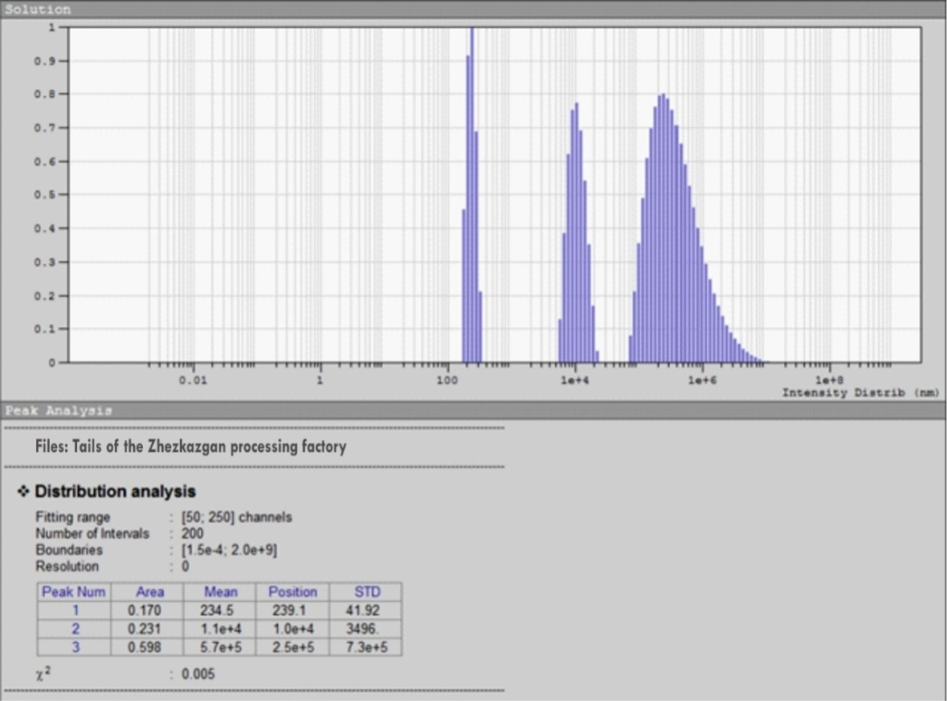

Figure 1 – Particle size distribution of the flotation tailings from the Zhezkazgan Concentrating Plant, determined using the Photocor-Compact device
The study of the efficiency of ultra-flocculation of suspensions used the UltraflocTester-2010 device developed by Turboflotservice (Ukraine), which includes a miniflocculator and an optoelectronic mechanism for fixing the efficiency of flocculation by the average size of floccules and the degree of water clarification (Figure 2). This device is able not only to set the optimal type and dosage of the flocculant but also to fix the optimal mode of hydrodynamic processing of a given suspension.
Using instrumental peristaltic pumps, the test sample of the suspension and the prepared flocculant solution continuously pass through the ultra-flocculator where they are mixed and processed in a hydrodynamic flow for a given time (3 – 12 s). At the exit, the processed sample, passing through the optical sensor, is analyzed, and thus the efficiency of flocculation is determined (Figure 3). The principle of operation of the optical sensor is to recognize fluctuations in the strength of the flow passing through the sample. The data from the optoelectronic mechanism appears on the device display as a numerical value (1 to 99).
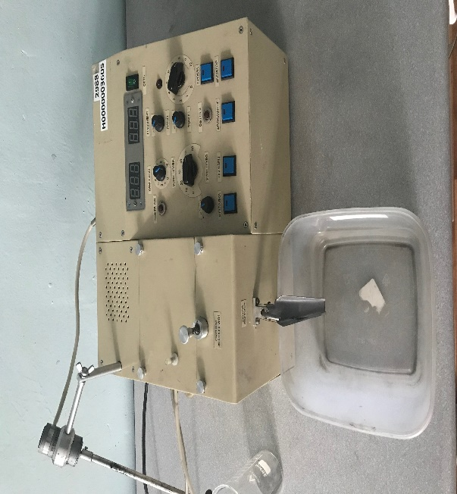

Figure 2 - UltraflocTester-2010
The control panel of the UltraflocTester (at a constant pulp flow rate of 1 cm³/s) provides the possibility to change a flocculant dosage and a rotor rate of the device and regulate the intensity of hydrodynamic processing of the suspension (the average gradient of medium speed is 100 to 10000 s⁻¹).
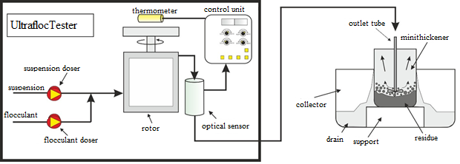
Figure 3 - UltraflocTester-2010
The relative humidity of the materials was studied using a Radwag MAC 210 instrument (Figure 4).
The laboratory testing applied suspension samples prepared from flotation tailings of the Zhezkazgan Concentrating Plant with a specific gravity of particles of 2.7 g/cm³, a dispersed composition of particles (Figure 1) of 59.8% for 570 μm, 23.1% for 11 μm and 17% for << 1 μm, and solid concentration of 50 to 100 g/L.

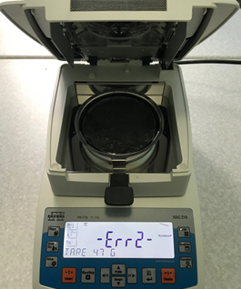
Figure 4 - Radwag MAC 210
According to the laboratory experiment on ultra-floccular processing of the sample, the curves of the dependence of flocculation efficiency (FE) on the flocculant consumption were plotted (Figure 5).
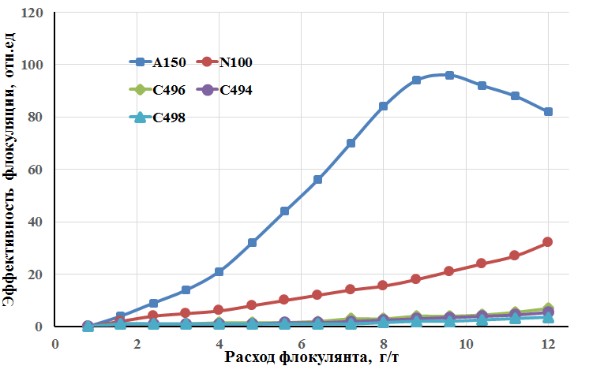
Flocculation efficiency, rel.un,

Flocculant consumption, g/t

Suspension concentration – 100 g/L; gradient of medium speed – 1500 s⁻¹; duration of processing – 6 s
Figure 5 – Dependence of the efficiency of ultra-flocculation treatment on the flow rate of flocculant
Comparative tests of the flocculating effect of non-ionic, cationic, and anionic polyacrylamides on flotation tailings showed that anionic copolymers are the most preferred. The tests found that the anionic flocculant "A – 150" is characterized by the best flocculating action concerning the test sample. If optimal consumption of flocculant A-150 is 9 g/t, then flocculation efficiency (FE) reaches 96-97% (Figure 4). A further increase in the concentration of the flocculant is inexpediently, since it leads to a decrease in the degree of flocculation, probably due to supersaturation and an increase in the viscosity of the reagent, and deterioration in the sedimentation properties of the formed floccules. Cationic flocculants C-494, C-496, C-498 are indifferent to the test sample in the context of flocculation effect. It should be noted that the anionic flocculant A-150, in comparison with other flocculants of the Superfloc series, has the highest chemical affinity concerning the slurry tailings, which consists mainly of mining waste with an insignificant content (basis points) of the metal-ore component.
Figures 6 and 7 show the dependencies of flocculation efficiency of a suspension on a medium velocity gradient at different times of hydrodynamic processing in an ultra-flocculator (3, 6, and 12 seconds). The experiments were performed on a suspension with a solid concentration of 100 g/L and 50 g/L to compare the effect of the hydrodynamic processing time on pulp density. It is noted that if suspension concentration increases, then EF dependence on the duration of hydrodynamic processing increases significantly.
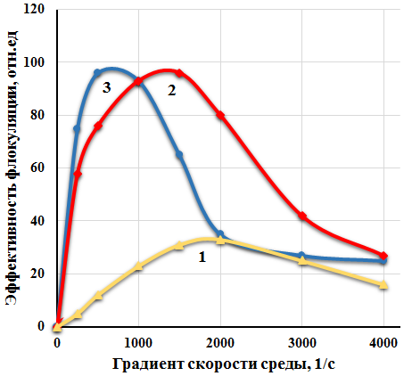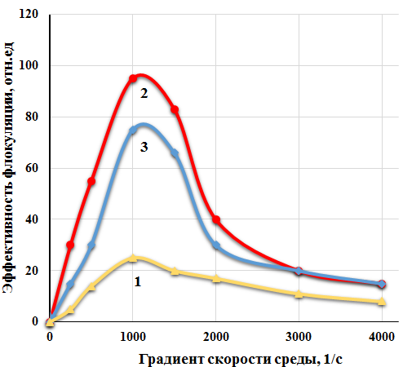
Medium velocity gradient, 1/s
Medium velocity gradient, 1/s
Flocculation efficiency, rel.un,

Flocculation efficiency, rel.un,

1 - Duration of hydrodynamic processing –3 s; 2 – 6 s; 3 – 12 s; suspension concentration – 100 g/L; flocculant A-150; flocculant consumption – 9 g/t  Figure 6 – Dependence of the efficiency of ultra-flocculation treatment on medium velocity gradient | 1 - Duration of hydrodynamic processing -3 s; 2 – 6 s; 3 – 12 s; suspension concentration – 50 g/L; flocculant A-150; flocculant consumption – 9 g/t  Figure 7 – Dependence of the efficiency of ultra-flocculation treatment on medium velocity gradient
The effect of EF dependence on the duration of hydrodynamic processing in combination with an increase in suspension concentration may be associated with the process of distribution of the flocculant throughout the volume of suspension. If suspension concentration increases, then the uniform distribution of the flocculant becomes more difficult and takes longer. If this time is still short, then the graph shows that the process can be accelerated by increasing the gradient of medium velocity (G). Hydrodynamic processing of the samples has shown the importance of the correct selection of the ratio between the hydrodynamic processing time and pulp density. It has been established that samples with a pulp density of 100 g/t should be processed at significantly lower gradients of medium velocity (500-1000 s⁻¹), but for a longer time (12 s). Meanwhile, the suspensions with a relatively average density of 50 g/t have no problems with the uniformity of flocculant distribution, and the optimal speed and time of hydrodynamic processing for a given sample are 1000-1500 s⁻¹ and 6 s, respectively.
One of the advantages of ultra-flocculation treatment is the ability to obtain a cleaner overflow, compared to the conventional flocculation in laminar mode. Hence it follows that the use of ultra-flocculation treatment concerning the concentrated suspensions (100 – 50 g/L) makes it possible to achieve a cleaner overflow of the thickener at lower costs of the flocculant. Figure 8 shows the dependence of the residual concentration of mini-thickener overflow on the intensity of hydrodynamic processing (medium velocity gradient) in the ultra-flocculator. The dependence was obtained in the process of treatment of flotation tailings (100 g/L) with a solution of flocculant A-150 at consumption of 9 g/t. The presented graph shows that the best results (20-30 mg/L) are obtained when the intensity of hydrodynamic processing (averaged medium velocity gradient) is 500-1500 s⁻¹. In the case of conventional processing (velocity gradient is 100-200 s⁻¹), the residual suspension concentration in the overflow is about an order of magnitude higher and amounts to 150-400 mg/L.
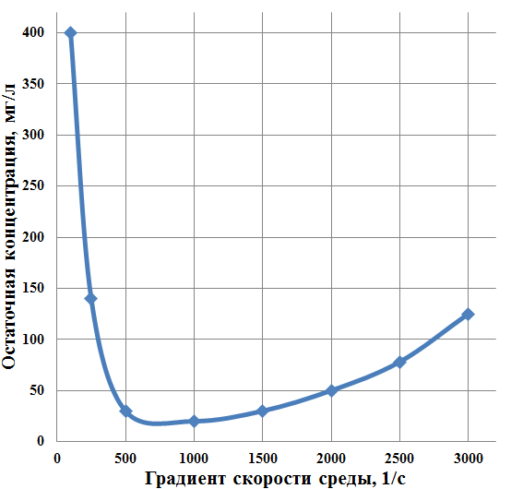
Medium velocity gradient, 1/s
Residual concentration, mg/L

Concentration of flotation tailings suspension of 100 g/L, a flow rate of flocculant A-150 of 9 g/t, a processing time of 12 s
Figure 8 – Dependence of the residual concentration of solid in mini-thickener drainage on the average medium velocity gradient in the ultra-flocculator
To show how the ultra-flocculation treatment beneficially affects the specific volume of the sediment and its fluid loss during filtration, Figure 9 shows the dependences of the moisture content of the sediment of the flocculated suspension after holding it on a grid for 5 minutes and then filtering on a Buchner funnel with the use of a vacuum pump at a pressure of 0.02 MPa for 2 minutes.
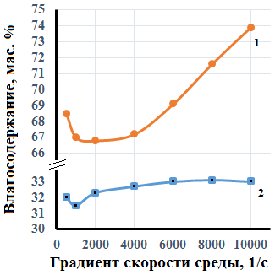
Moisture content, mas.%
Medium velocity gradient, 1/s

Suspension concentration – 100 g/l, flocculant flow rate A-150 – 9 g/t, processing time – 12 s; sludge moisture: 1 - after separation on the grid; 2 - after filtration on the vacuum pump
Figure 9 – Dependence of sludge moisture on the medium velocity gradient
Then, a Radwag MAC 210 moisture analyzer determined the relative moisture content of the samples under consideration.
The graph clearly shows that the minimum value of the moisture content of the sediment before pressing is achieved at a medium velocity gradient G equal to about 2000 s⁻¹, and the minimum moisture content of the filtered cake (about 31.3%) is achieved at G = 1000 s⁻¹.

3.2 Development of an optimal regime for hydrodynamic processing of lead concentrate with the use of a laboratory turbo-flocculator for efficient thickening, filtration, and dewatering
In connection with the need to improve the technical performance of the concentration plants against the background of the complication of the composition of the processed ores, the importance of preparatory operations that accompany the main concentration processes is increasing.
The thickening process usually consists of increasing the concentration of the solid phase in the thickened product in comparison with the feed pulp and obtaining an overflow with a minimum concentration of solid particles, which is achieved by choosing acceptable thickening equipment, as well as the optimal coagulating and flocculating reagents.
Various enrichment products are subjected to thickening: by-products are thickened to remove the water before further processing, concentrates are thickened before filtration, and tailings are thickened to obtain recycled water and reduce the volume of tailings [10].
The article [11] shows the problem of choosing a radial thickener for mining, metallurgical and other industries. The design parameters and the principle of operation of the radial thickener are considered and the features of the thickening process are described, providing the necessary information for the design and selection of the apparatus. The criteria for choosing such type of equipment are analyzed. The difficulties that arise when choosing radial thickeners for a specific process, associated with both the abundance of their names and some uncertainty in terminology and the lack of specific methods for assessing their processability, are described. It is noted that the use of coagulants and flocculants in thickening processes requires appropriate approaches to the selection of equipment and technology management.
The work [12] investigated the effect of several anionic flocculants on the degree of clarification of sludge waters during the thickening of flotation tailings of coal sludge from two coal preparation plants. A polymer flocculant that is effective in settling slurries of both mechanical and column flotation is proposed.
The work [13] presents the results of studies of flocculation and flotation of fine pyrrhotite particles in the presence of a hydrophobic styrene-butadiene copolymer and partially hydrophobic polyoxyethylene with a molecular weight of 4 ppm. It is shown that the use of a hydrophobic polymer in combination with butyl xanthate increases the flocculation and flotability of the mineral. Polyoxyethylene has a weaker effect on flocculation and flotation of pyrrhotite sludge particles.
The process of flocculation of fine slime classes was studied on pulps prepared from lead-zinc ores [14], and it was determined that the rate of flocculation of solid particles with an aluminosilicate flocculant depends on the flow rate of the added flocculant and the amount of slime fraction. It was determined that the optimal amount of flocculant, which provides the highest rate of the thickening process of slime fractions, is a flow rate equal to 1.0 mg SiO²/g.
Work [15] studies the performance of the Raspadskaya Concentrating Plant on coal sludge processing by selective flocculation. A description of the process flow scheme for the processing of coal sludge is presented. The efficiency of the selective flocculation process is shown in comparison with flotation for KZh coal mined at the Raspadskaya mine.
The study [16] considered the flotation of bituminous coal with the addition of polyethylene oxide (PEO). It was found that PEO deteriorates the flotation performance in tap water but significantly improves the flotation in sodium hexametaphosphate solution. In vitro sedimentation experiments, observed flakes and zeta potential analysis shows that sodium hexametaphosphate inhibits the flocculation of kaolinite, thereby allowing selective coal flocculation.
The article [17] presents the data of comparative studies of industrial flocculants, such as polyacrylamide and Besfloc flocculants, for intensifying the processes of thickening of flotation pulps of gold-bearing minerals. The research investigated the possibility of industrial replacement of polyacrylamide (base reagent) with Besfloc flocculants (K-4000, K-4020, K-4032, K-4041, K-4043, and K-4045) manufactured by KOLONLIFESCIENCE, INC (South Korea) since these flocculants are the closest in activity to the base reagent, as well as the choice of the optimal dosage of each of the investigated flocculants at the Gold Recovery Plant of Sovrudnik LLC. The results of the optimization of flocculant consumption are presented. A graphical representation of the dynamics of pulp sedimentation for various flocculants is presented. Besfloc K-4020 with a flow rate of 5 g/t and K-4034 and K-4046 with a flow rate of 3 g/t is recommended for industrial tests.
The experimental results show [17] that a binary flocculant in the form of a composition similar to block copolymers of partially hydrolyzed polyacrylamide (PAA) and an amidoimide polymer (AIP) effectively thickens coal-clay dispersions and can be successfully used to clarify service water.
The work [10] describes the factors influencing the thickening, as well as the effect of clay particles on the sedimentation process. The gravity-driven thickening process is influenced by the mineralogical and granulometric composition of the material, particle shape, pulp pH, thickener design, etc.
Today, there are many studied methods for intensifying the thickening process, such as improvement of the design of thickening equipment; selection of the optimal type and consumption of flocculant; selection of the systems for stabilizing the quality of raw materials described above, etc. Our studies, to intensify the process of thickening of the products of concentration, used the so-called ultra-flocculation treatment of the suspensions under investigation. Ultra-flocculation differs from classical flocculation by using hydrodynamic suspension treatment modes, where the average shear rate (fluid velocity gradient) reaches several thousand rotation seconds. The use of such highly inhomogeneous hydrodynamic fields makes it possible, within a few seconds, not only to achieve a uniform distribution of flocculant macromolecules in the suspension volume and on the surface of flaky particles but also to form larger and more compact flakes. Besides, this approach can significantly reduce the processing time, as well as the consumption of the flocculant [7].
Our research used samples of Kemira acrylamide copolymers such as non-ionic polyacrylamides (N-100, N-300) and ionic anionic (A-150, A-150A) and cationic (C-494, C-498) types.
Anionic flocculants are copolymers of acrylamide with sodium acrylate with a molecular weight of about 14×10⁶ and an anion charge of 53-63%. The molecular weight of the non-ionic polyacrylamide is also approximately 14⋅10⁶. Cationic flocculants (copolymers of acrylamide with methyl chloride dimethyl amino propylacrylamide) have a molecular weight of about 9⋅10⁶ with a cation charge of 27-39%.
To carry out laboratory studies to improve the process of thickening of enrichment products, samples of a suspension were prepared from the lead-zinc bulk concentrate of the Shalkinskoye deposit. The granulometric and elemental composition of the bulk concentrate is shown in Table 5.
The granulometric analysis of the bulk concentrate shows that 79.15% are represented by the 0-44 μm class. The content of the upper size class of +0.1 mm is insignificant and amounts to about 2.24%. It should be noted that due to the significant amount of the fine class in the sample, the processes of flocculation and sedimentation are complicated. In our research, we deliberately chose this type of model suspension intending to test the actual efficacy of ultra-flocculation treatment.

Table 5 – Granulometric and material composition of the bulk concentrate

Size classes, mm | Content, % | Substance composition | Content, %
+0.1 | 2.24 | Zn | 4.83
-0.1+0.074 | 5.15 | Pb | 16.75
-0.074+0.044 | 13.46 | Fe | 6.55
-0.044+0 | 79.15 | SiO₂ | 34.11
 |  | S_{tot.} | 15.95
 |  | Other | 21.81
Total: | 100 | Total: | 100
At the initial stage of the research, suspensions were prepared from the lead-zinc bulk concentrate of the Shalkinskoye deposit at a ratio of 150 g of solids per liter of water. For better wettability of the sample, the prepared suspensions were preliminarily mixed with an overhead stirrer before the ultra-flocculation treatment. Also, solutions were prepared from the investigated flocculants in preselected doses and volumes. The flocculant solution was prepared at a temperature of 60-70°C on a magnetic stirrer for 1 hour.
The original device "UltraflocTester" manufactured by the Ukrainian company "Turboflotservice", was used as an intensifier of dewatering. The device includes a miniflocculator and an optoelectronic recorder of the efficiency of flocculation according to the average size of floccules and the degree of water clarification. This device is able not only to set the optimal type and dosage of the flocculant, but also to fix the optimal mode of hydrodynamic processing of a given suspension.
The test sample of the suspension and the prepared flocculant solution continuously passed through the ultra-flocculator through a pump on the device, were mixed and processed in a hydrodynamic flow for 5 seconds. At the exit, the processed sample, passing through the optical sensor, was analyzed, and thus the efficiency of flocculation was determined. The principle of operation of the optical sensor is to recognize fluctuations in the strength of the flow passing through the sample.
The control panel of the UltraflocTester (at a constant pulp flow rate of 1 cm³/s) provided the possibility to change a flocculant dosage, and by changing a rotor rate of the device, it was possible to regulate the intensity of hydrodynamic processing of the suspension (the average medium velocity gradient is 150 to 4000 s⁻¹).
The results of comparing the efficiency of the flocculating action of non-ionic, cationic, and anionic polyacrylamides concerning the lead-zinc bulk concentrate showed the advantage of the non-ionic copolymer. Non-ionic flocculant "N-100" is the most preferable form among investigated forms. It was noticed that the chosen flocculant allows us to obtain significantly better flocculating action in comparison with other flocculants used. The used flocculant N-300 of non-ionic type and flocculant C-496 of cationic type are equally effective concerning the sample. The cationic flocculant C-498 showed weak activity, while the anionic flocculants A-150 and A-150A did not have a flocculating effect on the sample under study. It should be noted that the object of our laboratory research is presented mainly by lead, zinc, iron sulfides, and rock-forming mineral components. The non-ionic flocculant N-100 has a higher molecular weight and a suitable molecular structure for flocculation of the test pulp.
According to the laboratory experiment on the ultra-floccular processing of the sample, the graphical dependencies of flocculation efficiency on the consumption were plotted (Figure 10).
The optimal consumption of "N100", the most effective flocculant from the list, was 21-24 g/t. Other flocculants at the same dosage showed lower productivity. This flow rate ensures high purity of the overflows and the highest density of the thickened product. An increase in flocculant consumption led to a decrease in density, which is explained by the formation of very large flaky floccules forming very porous and loose sediment. The results of the study showed that the consumption of the reagent equal to 21-24 g/t is optimal and makes it possible to get the highest density of the thickened material.

Suspension concentration – 150g/L; gradient of medium speed – 1500 s⁻¹; processing time – 5s
Figure 10 – Dependence of the efficiency of ultra-flocculation treatment on the flow rate of flocculant
The comparative laboratory tests also assessed sedimentation properties (Figure 11) of samples after ultra-flocculation treatment. The sedimentation rate was tested in a 250 ml cylinder. Samples processed with various flocculants at a flow rate of 24 g/t were taken for experiments in cylinders. Due to the worst efficiency concerning the pulp of the bulk concentrate, anionic flocculants A-150, A-150A were not used in these experiments. During tests in cylinders, flocculant N-100 also showed the best results in terms of sedimentation rate and overflow cleanliness. Based on the measured sedimentation rate of particles, sedimentation curves (Figure 11) allowing to select the preferred type of flocculant were plotted.

Figure 11 – Dependences of the sedimentation time of the pulp after UF treatment
As noted above, the ability to process a sample in a hydrodynamic mode is the main feature of the apparatus we used. Based on the data obtained, a graph of dependence of flocculation efficiency of the suspension on medium velocity gradient is plotted (Figure 12) It was found that for the suspension based on the bulk concentration of the Shalkinskoye deposit, the concentration of which is 24 g/L, the optimal value of medium velocity gradient lies in the range of 1300 to 1500 s⁻¹.
The thickened product was filtered on a Buchner funnel with the use of a vacuum pump at a vacuum of 0.02 MPa, and the duration of the process was recorded.
The filtration rate can be represented as the volume of filtrate passing through a unit of filtering surface per unit of time:
$$W=\frac{dV}{Sdτ}$$ | (1)

where, W is a filtration rate, m/s; V is a filtrate volume, m³; S is a filtration area, m²; τ is a filtration time, s.

Suspension concentration – 150g/L; processing time – 5s; flocculant – N-100; flocculant consumption – 24 g/t
Figure 12 – Dependence of the efficiency of ultra-flocculation treatment on medium velocity gradient
At the end of filtration, the cake was weighed and dried and weighed again; the moisture content of the cake was determined by the difference in weight before and after drying:
$$T=\frac{q_{1}-q_{2}}{q_{1}}100$$ | (2)
where q1 and q2 are the weight of the wet and dry cake, g
The results of the dewatering of pulps of the bulk concentrate of the Shalkinskoye deposit with the use of various flocculants and ultra-flocculation (UF) treatment are shown in Table 6.
Table 6 – Indicators of pulp dewatering after UF treatment and further filtration

Flocculant | Flocculant consumption, g/t | Flocculation efficiency | Filtration rate, m/s | Moisture content of the filtered cake, %
А-150 | 24 | 2 | 0.331741 | 28.14371
А-150А | 24 | 1 | 0.331741 | 27.54491
С-496 | 24 | 50 | 0.398089 | 24.8503
С-498 | 24 | 22 | 0.361899 | 24.73054
N-100 | 24 | 105 | 0.442321 | 23.9521
N-300 | 24 | 51 | 0.408297 | 24.01198

Suspension samples treated with flocculants N-100 and N-300 were examined in transmitted light on an Olympus microscope at 40x magnification and photographed (Figure 13).
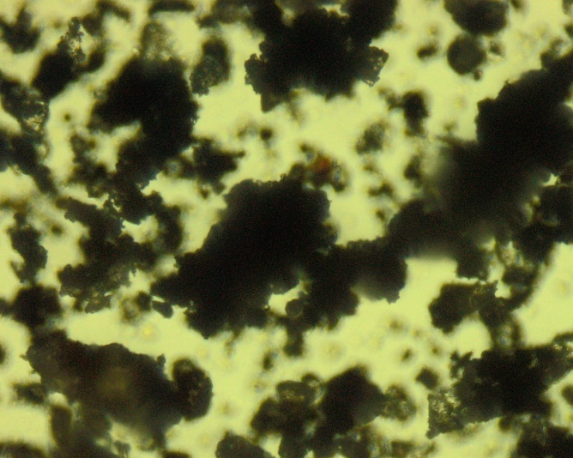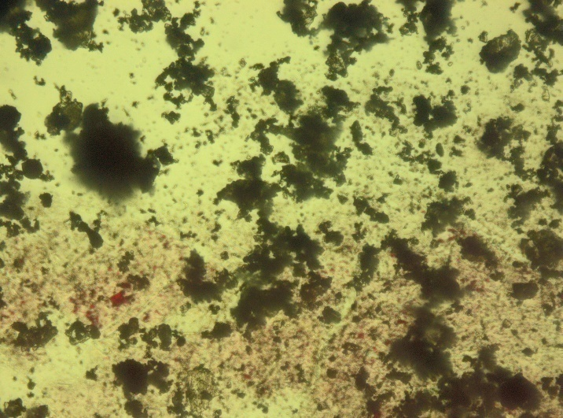
а) b)

a - bulk concentration of the Shalkinskoye deposit after treatment with N-100; b - after treatment with N-300
Figure 13 – Micrographs of the suspension based on the bulk concentration of the Shalkinskoye deposit

A comparison of the photos of the samples shows the enlarged concentrate particles and makes it possible to evaluate the efficiency of the flocculating action of two flocculants.
3.3 Development of an optimal regime for hydrodynamic processing of zinc concentrate with the use of a laboratory turboflocculator for efficient thickening, filtration, and dewatering
The processing of polymetallic ore from one of the deposits in Kazakhstan resulted in the obtained zinc concentrate.
The specified concentrate was dewatered in two stages: thickening (traditionally and by ultra-flocculation) and filtration.
To intensify the sedimentation process and reduce the loss of metals with thickener outflows, flocculants of various grades of anionic A-150, non-ionic N-300, and cationic C-494 types produced by Kemira of approximately the same molecular weight were tested under laboratory conditions.
Based on the results of preliminary tests of various grades of flocculants, flocculant A-150 was selected, and all subsequent studies were performed.
Laboratory experiments were performed on pulps with a base density of zinc concentrate of 46 g/L of solid.
A 0.05% aqueous solution of a flocculant was introduced in 0.5 dm³ glass volumetric cylinders filled with the pulp to 500 mL at various values of its consumption. After thorough mixing of the pulp in the cylinders, a predetermined volume of flocculant was introduced, and after further mixing with a stirrer, a stopwatch was turned on, and the rate of settling of the interfaces between the solid and aqueous phases was monitored.
As a result of the observations, the following indicators were analyzed: Sedimentation rate of products; the volume of thickened material; quality of the clarification of the aqueous phase, and the presence of a foamy product on the upper surface of the cylinder.
The original device "UltraflocTester" manufactured by the Ukrainian company "Turboflotservice", was used as an intensifier of thickening. This device is able not only to set the optimal type and dosage of the flocculant but also to fix the optimal mode of hydrodynamic processing of a suspension under study.
The test sample of the suspension and the prepared flocculant solution continuously passed through the ultra-flocculator through a pump on the device, were mixed and processed in a hydrodynamic flow for several seconds (5 to 15 seconds). At the exit, the processed sample, passing through the optical sensor, was analyzed, and thus the efficiency of flocculation was determined. The principle of operation of the optical sensor is to recognize fluctuations in the strength of the flow passing through the sample. The control panel of the UltraflocTester (at a constant pulp flow rate of 1 cm³/s) provided the possibility to change a flocculant dosage, and by changing a rotor rate of the device, it was possible to regulate the intensity of hydrodynamic processing of the suspension (the average medium velocity gradient is 150 to 4000 s⁻¹).
The results of comparing the efficacy of the flocculating action of non-ionic, cationic, and anionic polyacrylamides concerning zinc concentrate showed the anionic copolymer A-150.
Figure 14 shows the processes of sedimentation of zinc concentrate without a flocculant (curve 1) and with an optimal amount of flocculant A-150 (curve 2) and when using an UltraflocTester device with optimal hydrodynamic processing of 1500 s⁻¹ (curve 3). The figure shows that the zinc concentrate suspension if without a flocculant, settles in 120 seconds, while a layer of foam up to 5 mm thick is observed on the upper surface of the volumetric cylinder, and the aqueous phase is visually turbid. When using the optimal dose of flocculant A-150, the deposition time is 35-40 seconds, the aqueous phase is clean, but a layer of foam up to 2 mm thick remains. In the presence of A-150 at an optimal dose of 25 g/t and a medium speed gradient of 1500 s⁻¹ with treatment time in an ultra-flocculator of 15 seconds, the deposition time of the suspension is significantly reduced to 15-20 seconds. Here, it should be noted that the foam layer disappears and the sediment thickens 2-3 times.

Time. s
Medium velocity gradient of 1500 s⁻¹ (flow rate 25 g/t); processing time in the ultra-flocculator is 15 seconds; concentration of zinc concentrate suspension is 46 g/L: 1 – without flocculant; 2 – A-150 (consumption 30 g/t); 3 – in the presence of A-150
Figure 14 – Dependence of the degree of clarification of the zinc concentrate suspension on the deposition time
Flocculant А-150 is the most preferable form among investigated forms. The chosen flocculant allows us to obtain a significantly better flocculating effect in comparison with other used flocculants, which may be due to the greater flexibility of the polymer chain and the possibility of neutralizing the positive charges of the zinc concentrate suspension particles.
According to the laboratory experiment on the ultra-floccular processing of the sample, the graphical dependencies of flocculation efficiency on the consumption were plotted (Figure 15).
The optimal consumption of the effective flocculant A-150 was 25 g/t. Other flocculants showed less activity at the same dosage. At this flow rate, the purity of overflows and the highest density of the sediment was ensured. An increase in flocculant consumption led to a decrease in density, which is associated with the formation of loose sediment. One of the advantages of ultra-flocculation treatment is the ability to obtain a cleaner overflow, compared to the conventional flocculation in laminar mode. Hence it follows that the use of ultra-flocculation treatment concerning problematic suspensions of non-ferrous metal concentrates makes it possible to achieve a cleaner overflow of the thickener at lower flocculant consumption.
Figure 16 shows the dependence of the residual concentration of the overflow of the mini-thickener on the intensity of hydrodynamic processing (medium velocity gradient) in the ultra-flocculator, obtained in the process of processing of a zinc concentrate suspension (46 g/L) with a solution of flocculant A-150 at a consumption of 25 g/t.

Flocculation efficiency, %

Flocculant consumption, g/t

Flocculants: 1 – N-300; 2 – C-494; 3 – A-150; suspension concentration is 46 g/L; medium speed gradient is 1500 s⁻¹; processing time is 15 s
Figure 15 – Dependence of the efficiency of ultra-flocculation treatment on the flow rate of flocculants
It was shown that the best results (35 mg/L) are obtained when the intensity of hydrodynamic processing is 1500 s⁻¹. In the case of conventional processing (velocity gradient is 100-300 s⁻¹), the residual suspension concentration in the overflow is about an order of magnitude higher and amounts to 250-600 mg/L.

Concentration of flotation tailings suspension of 46 g/L, a flow rate of flocculant A-150 of 25 g/t, and with a processing time of 15 s
Figure 16 – Dependence of the residual concentration of solid in mini-thickener drainage on the average medium velocity gradient in the ultra-flocculator
The ultra-flocculation treatment of a zinc concentrate suspension in the presence of an optimal dose of flocculant A-150 not only increases the rate of sedimentation and compaction of the sediment significantly but changes the moisture content of the sediment after suspension dewatering by filtration. The results are shown in Figure 17. The sediment of the flocculated suspension in the presence of an optimal dose of flocculant A-150 without hydrodynamic processing of the suspension and after treatment with an ultra-flocculator was filtered on a Buchner funnel with the use of a vacuum pump at a pressure of 0.025 MPa for 3 minutes. Radwag MAC 210 moisture analyzer determined the relative moisture content of the samples under consideration.
Moisture, %

A-150 flow rate, g/t
1 – without hydrodynamic processing of the suspension on an ultra-flocculator; 2 – at a medium speed gradient of 1500 s⁻¹

Figure 17 – Dependence of the moisture content of the zinc concentrate suspension after filtration with a vacuum pump on the flow rate of flocculant A-150

It was found that without hydrodynamic processing of the suspension on an ultra-flocculator at a flow rate of flocculant A-150 of 30 g/t, the moisture content of the sediment is 22%, and with the preliminary treatment of the suspension at a medium speed gradient of 1500 s⁻¹, the moisture content of the sediment decreases to 18%.
3.4 Large-scale laboratory tests of copper, lead, and zinc concentrates for thickening, filtration, and dewatering with the use of a laboratory turboflocculator
Thickening is the process of dewatering a pulp by precipitation of the solid particles it contains under the action of gravity. Here, two product yields: the upper product is a pure liquid phase or overflow with some solid content, and the lower product is a thickened product with a solid content of 40-60%.
The larger the particles and the higher their density, the faster they settle. Fine particles with a low sedimentation rate, and clay minerals (kaolin, etc.) swelling in water and enveloping the surface of other minerals form a stable and poorly thickening suspension. Material finer than 0.1 μm practically does not precipitate (colloidal state). When liquid slurries are thickened, the particles precipitate faster. In this case, it is necessary to remove a larger amount of water, which, with the same solid performance of the thickener, increases the rate of ascending liquid flows and thereby increases the removal of fine solid particles into the overflow. Besides, the distances between particles are large in overly diluted pulps. As a result, the particles cannot grow larger. The optimal S:L for thickening is 1:6. If the solid particles of the pulp can stick together with a subsequent formation of aggregates, the thickening is more intense. This phenomenon is used in practice to accelerate the thickening of poorly thickened pulps consisting of fine particles. If hydrophobizing reagents (xanthogenates, soaps, and other collectors) are introduced into the pulp, the intermolecular interaction of water with minerals is weakened and the adhesion of particles (flocculation) is also facilitated. The introduction of high-molecular flocculating reagents into the pulp leads to the fixation of their ends on various minerals with the corresponding formation of solid aggregates.
2000 mL volumetric cylinders and an UltraflocTester device (Figure 2) were used to conduct comparative experiments on the flocculation of copper and lead and zinc concentrates.
If a suspension is placed in a cylinder and observed for some time, the following processes will occur (Figure 18). In the beginning, the solid phase is evenly distributed in the suspension (time point a). After a while, a turbidity boundary appears in the upper part of the cylinder, a boundary between the clarified water and the suspension. At the same time, spontaneous flake formation can be noticed. In this case, the individual movement of particles stops, and the entire suspension begins to settle collectively. At the moment (b), 4 regions (zones) appear in the cylinder: I – area of clarified water, IY – area of collective deposition, IYI – transition area, IV – compression area.
In the area of compression, the particles are in contact with each other. Here, there is a further very slow sedimentation and compaction of the sediment under the pressure of the newly settled particles. The border between IYI and IV areas is visually poorly visible. However, its existence is confirmed by pulp density measurements. As sedimentation proceeds, the turbidity boundary drops, and the compression boundary rises due to an increase in the thickness of the precipitate.
At time point (c): the height of the collective deposition area decreases. At time point (d): the area of collective deposition disappears. The compression area constantly increases, and the transition area decreases and disappears over time.
At time point (e): the turbidity border coincides with the compression border. If the sediment is left to stand for a long time, then it thickens (time point f).

1

2

3

4
Turbidity border
Compression border
τ
а b cde f

Figure 18 – Processes occurring during deposition
The change in the sedimentation rate of suspensions of lead, zinc, and copper concentrates in the absence and presence of flocculant A-150s was evaluated as follows: a suspension of a certain concentration was placed in a 2000 ml graduated volumetric cylinder, a flocculant was added in a required amount, and after stirring, the movement of the suspension (transparent solution interface) was observed at different times. Based on the data obtained, the sedimentation rate of the suspension was calculated and the efficiency of the flocculating action of the studied reagents was determined. In parallel, experiments were performed using an UltraflocTester device. The data obtained are shown in Tables 7-9.
According to Table 7, in the presence of flocculant A-150 with a flow rate of 30 g/t, the highest deposition rate of zinc concentrate was 4.35 cm/s, which is 3 times higher than without a flocculant. In Tables 8 and 9, the highest sedimentation rates of the lead and copper concentrates are 4.66 cm/s and 4.82 cm/s at a flow rate of 45 and 40 g/t, which is 2.7 and 3.7 times higher than the sedimentation rate without flocculant, respectively. When using an ultra-flocculation method with a medium velocity gradient (G) of 500-1500 s⁻¹, it was found that at G = 1500 s⁻¹, the sedimentation rate of the suspension of zinc, lead and copper was 7.14, 8.67, and 7.51 cm/s at A-150 flow rates of 25, 25 and 35 g/t, respectively. At the same time, the sedimentation rate of these suspensions is significantly higher than in the presence of a flocculant, while the consumption of the flocculant decreases from 10 to 30% (see Table 7-9).

Table 7 – Influence of flocculant A-150 on the sedimentation characteristics of a zinc concentrate suspension with a solids content of 46 g/L.
Sr.No | Flocculation methods | Medium velocity gradient (G), s⁻¹ | Flocculant consumption, g/t | Sedimentation rate, cm/s
1 | Without flocculant | - | - | 1.5
2 | With flocculant | - | 15 | 1.85
3 | With flocculant | - | 20 | 2.18
4 | With flocculant | - | 30 | 4.35
5 | With flocculant | - | 45 | 3.5
6 | With flocculant | - | 60 | 2.61
7 | Ultra-flocculation | 500 | 20 | 2.89
8 | Ultra-flocculation | 500 | 25 | 3.41
9 | Ultra-flocculation | 1000 | 20 | 4.44
10 | Ultra-flocculation | 1000 | 25 | 5.97
11 | Ultra-flocculation | 1500 | 20 | 6.58
12 | Ultra-flocculation | 1500 | 25 | 7.14
Table 8 – Influence of flocculant A-150 on the sedimentation characteristics of a lead concentrate suspension with a solids content of 65 g/L.

Sr.No | Flocculation methods | Medium velocity gradient (G), s⁻¹ | Flocculant consumption, g/t | Sedimentation rate, cm/s
1 | Without flocculant | - | - | 1.7
2 | With flocculant | - | 15 | 2.40
3 | With flocculant | - | 20 | 2.84
4 | With flocculant | - | 30 | 3.15
5 | With flocculant | - | 45 | 4.66
6 | With flocculant | - | 60 | 3.82
7 | Ultra-flocculation | 500 | 20 | 3.47
8 | Ultra-flocculation | 500 | 25 | 4.89
9 | Ultra-flocculation | 1000 | 20 | 5.98
10 | Ultra-flocculation | 1000 | 25 | 6.64
11 | Ultra-flocculation | 1500 | 20 | 7.22
12 | Ultra-flocculation | 1500 | 25 | 8.67
Table 9 – Influence of flocculant A-150 on the sedimentation characteristics of a copper concentrate suspension with a solids content of 54 g/L.

Sr.No | Flocculation methods | Medium velocity gradient (G), s⁻¹ | Flocculant consumption, g/t | Sedimentation rate, cm/s
1 | Without flocculant | - | - | 1.3
2 | With flocculant | - | 15 | 1.94
3 | With flocculant | - | 20 | 2.52
4 | With flocculant | - | 30 | 2.95
5 | With flocculant | - | 40 | 4.82
6 | With flocculant | - | 50 | 3.77

7 | Ultra-flocculation | 500 | 25 | 3.67
8 | Ultra-flocculation | 500 | 35 | 4.19
9 | Ultra-flocculation | 1000 | 25 | 4.74
10 | Ultra-flocculation | 1000 | 35 | 6.42
11 | Ultra-flocculation | 1500 | 25 | 6.92
12 | Ultra-flocculation | 1500 | 35 | 7.51
Continuation of Table 9
Thus, the results obtained make it possible to recommend pilot-industrial and industrial testing of the flocculant A-150 with the use of an ultra-flocculation method in those industries of Kazakhstan, that require thickening from finely dispersed and slurry products.
Conclusion
Executive summary
In the presence of mixtures of anionic and cationic flocculants, regardless of their composition and the order of introduction of components into the suspension, the particles acquire a negative ξ-potential characteristic of particles that adsorb only the anionic flocculant. For mixtures of charged anionic and cationic flocculants, synergistic flocculating action is observed. With an increase in the amount of added mixture from 0.3 to 2.5 mg/g, the rate of flocculation and the size of the resulting floccules increase, while a further increase in the concentration of these mixtures to 3.0 and 6.0 mg/g causes a decrease in the size of aggregates.
Studies on the thickening of a coal suspension with the use of base anionic and cationic flocculants produced by Kemira, depending on medium temperature and pH, showed that at a temperature of 10-15°C, the flocculation process worsens. Heating the suspension to 30°C has a positive effect on the efficiency of the process; however, further heating is ineffective, since it destructs flocculants. It has been shown that the flocculation process does not occur in an acidic medium and proceeds less efficiently, while at pH8 of the suspension, the flocculation activity increases, and the moisture content of the sediment decreases.
The sedimentation and filtration characteristics of a model quartz suspension were investigated by the ultra-flocculation method. The quality of clarification of the aqueous phase after sedimentation of the suspension subjected to ultra-flocculation reaches a high value at G> 2000 s⁻¹. If suspension concentration increases, then the uniform distribution of flocculant molecules over its volume becomes difficult, which can be compensated by an increase in G.
The ultra-flocculation treatment for 5 seconds at an intensity of 1000 – 2000 s⁻¹ allows: to reduce the consumption of flocculant by 25-30%; to work with relatively concentrated flocculant master solutions (1-1.5 g/L) and use them without pre-dilution; to reduce the size of the station for the preparation of flocculant solutions by 1.5-2 times; to significantly increase (1.5-2 times) the throughput of thickeners; to reduce the residual solids content in the thickener overflow to a level of less than 30 mg/L.
The use of ultra-flocculation treatment provides the following advantages in the recovery of finely dispersed coal by sedimentation in a radial thickener: decrease in the consumption of flocculants by 2.5-3.5 times; increase in coal concentrate recovery from tailings by 23-26%; reduction of the ash content of the concentrate recovered from tailings from 18 to 12%; reduction of the moisture content of the press filter cake of the concentrate extracted from tailings from 35 to 25%.
Among the considered flocculants of the Superfloc series, the anionic flocculant of grade A–150 is the most effective concerning the investigated samples of suspensions from flotation tailings. The consumption of this flocculant for a suspension with a solid concentration of 100 g/L was 9 g/t.
It has been found that relatively dense suspensions of 100 g/L should be processed at medium velocity gradients of G = 500 – 1000 s⁻¹ for 12 s, and suspensions with a relatively average density of 50 g/L should be processed at G = 1000-1500 s⁻¹ in for 6 s.
The use of ultra-flocculation treatment for a suspension of 100 g/L for 12 s and intensity of G in the range of 500-1500 s⁻¹ reduced the residual solids content in the thickener overflow to 20-30 mg/L.
The dependence of the moisture content in the flocculated sediment after exposure on the grid on the medium velocity gradient has an extreme effect with a minimum in the region of G ≈ 2000 s⁻¹. The dependence of the moisture content in the cake after filtration on a vacuum pump on the medium velocity gradient has an extreme effect with a minimum in the region of G ≈ 1000 s⁻¹.
The pulp from the bulk lead-zinc concentrate studied in the research contains fine and dissimilar fractions that are difficult to precipitate. In turn, these factors complicate the process of dewatering of these pulps. The optimal conditions providing acceptable thickening and filtration performance are as follows: flocculant – N-100; flocculant consumption – 21-24 g/t; medium speed gradient – 1300-1500 s⁻¹; filtration rate – 0.44 m/s; the moisture content of the filtered cake – 24%.
It is shown that in the presence of flocculant A-150 with a flow rate of 30 g/t, the highest deposition rate of zinc concentrate was 4.35 cm/s, which is 3 times higher than without a flocculant. The highest sedimentation rates of the suspension of the lead concentrate are 4.66 cm/s and 4.82 cm/s at a flow rate of 45 and 40 g/t, which is 2.7 and 3.7 times higher than the sedimentation rate without flocculant, respectively. When using an ultra-flocculation method with a medium velocity gradient (G) of 500-1500 s⁻¹, it was found that at G = 1500 s⁻¹, the sedimentation rate of the suspension of zinc, lead and copper was 7.14, 8.67, and 7.51 cm/s at A-150 flow rates of 25, 25 and 35 g/t, respectively. At the same time, the sedimentation rate of these suspensions is significantly higher than in the presence of a flocculant, while the consumption of the flocculant decreases from 10 to 30%.
Thus, the results obtained make it possible to recommend pilot-industrial and industrial testing of the flocculant A-150 with the use of an ultra-flocculation method in those industries of Kazakhstan, that require thickening from finely dispersed and slurry products.
Assessment of the completeness of the solution of objectives. The main difference between ultra-flocculation and conventional flocculation is that during ultra-flocculation treatment, 5-30 times more heterogeneous hydrodynamic fields are used. Such a regime of hydrodynamic processing allows, in a short time (5-7 s), not only to carry out a uniform distribution of the molecules of the high-molecular flocculant over the volume of the suspension and on the surface of the flocculated particles, but also to form large and, which is very important, dense floccules, providing a high sedimentation rate of the solid in thickeners and sediment fluid loss during filtration.
The ultra-flocculation method makes it possible to quickly assess the strength of floccules by measuring the dependence of flocculation efficiency on the medium velocity gradient (G) in a wide range.
Recommendations and initial data on the specific use of research results. Assessment of the technical and economic efficiency of implementation
The results obtained during the implementation of the project will make it possible to develop a technology for the thickening and dewatering of beneficiation products by ultra-flocculation. The results of this project can be used to improve the thickening and dewatering processes at the existing concentrators in Kazakhstan.
Assessment of the scientific and technical level of the completed research work in comparison with the best achievements in this area. This development was performed at a modern scientific and technical level with the use of modern analytical and research equipment, based on the latest achievements in the theory and practice of thickening and dewatering of enrichment products.
Organizational and material and technical conditions for the research. Research work on the project was performed in the Laboratory of Flotation Reagents and Concentration. The team of performers, including 1 D.Sc. in Engineering, 1 Researcher, 1 Junior Researcher, and 1 Leading Engineer, has experience in the development of thickening and dewatering technologies for real flotation products. The project is provided with the necessary research infrastructure, particularly: production facilities, modern research equipment, access to sources of scientific and technical information. Research works were performed under the international standard ISO 10006 "Administrative quality management. – Guidelines for quality assurance in project management".
Institute of Metallurgy and Ore Beneficiation JSC has implemented a certified quality management system concerning research and development activities and personnel training for compliance with the requirements of ST RK ISO9001-2009 "Quality management systems" (Certificate of Conformity No. KZ 7500729.07.03.00578 dated 27.07.2016).
For the successful implementation of the project objectives, there are laboratory premises (520 m²) equipped with the appropriate infrastructure.
Patent and license provision of research provided by the relevant department of the organization at all stages of the project.
The organization has a chemical analytical laboratory and a laboratory for physical methods of analysis, equipped with modern analytical and research equipment.
Economic feasibility of the requested amount of funding for the research. Project costs include the following items: wages, deductions from wages (social tax, social insurance), travel expenses, purchase of materials, other costs (transfers, registration fees), maintenance of equipment and other fixed assets, organizational support.

References
1 Zapolskiy, A.K. Coagulants, and flocculants in water purification processes. Properties. Producing. Application/A.K. Zapolskiy, A.A. Baran. – L.: Chemistry, 1987. – 208 p. (russ).
2 Myagchenkov V.A. Acrylamide copolymers of with flocculant properties: Monograph/V.A. Myagchenkov. – Kazan: KSTU, 2011. – 296 p. (russ).
3 Baran, A.A. Polymer-containing disperse systems/A.A. Baran. – Kyiv: Naukova Dumka, 1986. – 204 p. (russ).
4 Myagchenkov V.A. Acrylamide copolymers of with flocculant properties. Monograph/V.A. Myagchenkov, V.Ye. Proskurina. – Kazan: KSTU, 2011. – 296 p. (russ).
5 Musabekov K.B., Tusupbayev N.K. New composite flocculants // Chemistry and chemical technology. – 2001. – No. 1. – pp. 113-137. (russ).
6 Nepper D. Stabilization of colloidal dispersions with polymers / D. Nepper. – М.: Mir, 1986. – 487 p. (russ).
7 Rulyov N.N., Dontsova T.A., Korolyov V. Ja. ultra-flocculation of Diluted Fine Disperse Suspensions // Mineral Processing and Extractive Metallurgy Review. – 2007. – No.26 (3-4). – pp. 203-217. (eng).
8 Rulev N.N., Nebesnova T.V. Intensification of the process of extraction of finely dispersed coal from flotation concentration tailings by ultra-flocculation // Bulletin of the Odessa State Academy of Education and Architecture. – 2019. – No. 76. – pp. 126 – 135. (russ).
9 Yessengaziyev A., Tussupbayev N. & Bilyalova S. Intensification of dewatering processes of lead-zinc concentrates by ultrafloсculation // Mineralia Slovaca. – 2019. – No. 1. – pp. 102-108. (eng).
10 Friedman S.E. Dehydration of enrichment products / S.E. Friedman, O.K. Shcherbakov, A.M. Komlev. – М: Nedra, – 1988. – 240 p. (russ).
11 Bauman A.V. Criteria for choosing a radial thickener for thickening and water circulation processes // Ore concentration. – 2013. – No.4. – pp. 40-43. (russ).
12 Yeremeyev D.N. Clarification of sludge water and thickening of coal sludge flotation waste with the use of polymer flocculants // Water: chemistry and ecology.. – 2012. – No.2. – pp. 63-66. (russ).
13 Lavrinenko A.A., Glukhova N.I., Lapin Ye.V. The use of flocculants for the intensification of flotation of fine pyrrhotite particles // Mining information and analytical bulletin. – 2012. – No.9. – pp. 167-170. (russ).
14 Kapralov V.I., Telkov Sh.A., Almagambetova S.T. The use of aluminosilicate flocculant in the processes of desliming of finely disseminated lead-zinc ores in Kazakhstan // KazNU Bulletin. – 2011. – No.4. – pp. 133-136 (russ).
15 Baychenko A.A., Ivanov G.V. Floccular flotation of fine coal sludge // Materials of the Scientific and Technical Conference. Kemerovo, 1999. – pp. 9-29 (russ).
16 Berlinteiger Ye.S. The use of flocculants for coal sludge dewatering. Chemical industry. – 2004. – Vol.81. – No.11. – pp. 65-68. (russ).
17 Timoshenko L.I., Antsiferova S.A., Samoilov V.G., Markosyan S.M. Investigation of the thickening process before the hydrometallurgical conversion of gold-bearing ores // Ore concentration. – 2010. – No.1. – pp. 27-29 (russ).

Appendix A
List of published works
2018
Articles in domestic journal:
1 Tusupbayev N.K., Yerzhanova Zh.A., Bilyalova S.M., Toilanbai G.A. Flocculation of a quartz suspension in the presence of superflocculants of various charges // Complex use of mineral raw materials. – 2018. –No. 4. – pp.17-27 (russ).
2 Yessengaziyev A.M., Musina M.M., Yerzhanova Zh.A., Bilyalova S.M., Tussupbayev N.K. Testing of the laboratory apparatus UltraflocTester at thickening of a suspension of tailings // Materials of the International Scientific and Practical Conference "Efficient technologies for the production of non-ferrous, rare and precious metals", Almaty, September 27-29, 2018. – pp. 133-137 (russ).

2019
Articles in a foreign journal:
1 Tusupbayev N.K., Rulev N.N., Yesengaziyev A.M., Bilyalova S.M. Investigation of the process of thickening of model systems by ultra-flocculation // News of the Universities of Kyrgyzstan. – 2019. – No. 7. (RSCI 2017 – 0.024. DOI:10.26104/IVK.2019.45.557) (russ).
2 Yessengaziyev A.M., Tussupbayev N.K., Bilyalova S.M. Intensification of dewatering processes of lead-zine concentrates by ultra-flocculation. // Journal of MineraliaSlovaca. – 2019. – pp. 102-108. (Scopus: SJR 2017 – 0,348; Q2; percentile 17 %) (eng).

2020
Articles in a foreign journal:
1 Tusupbayev N.K., Medyanik N.L., Yesengaziyev A.M., Yertayev M.A. Intensification of the processes of thickening and dewatering of the tail pulp by ultra-flocculation treatment. // Physical and technical problems in minerals development. – 2020. – No. 4. – pp.149-156. (RSCI 2019 – 1,416; DOI: 10.15372/FTPRPI20200414) (russ).
2 Tussupbayev N.K.,Medyanyk N.L., Yessengaziyev A.M., Bilyalova S.M., Yertayev M.A. Intensified thickening and dewatering of sulfury tailings by ultra-flocculation. // Journal of mining science. – 2020. – No. 4. – pp. 137-144. (Scopus: SJR 2017 – 0,41; Q2; DOI: 10.15372/FTPRPI2020040, percentile 38 %) (eng).

Appendix B
Schedule
Appendix 1.2
to the Contract No.__ dated _______2018
for Grant Funding

TECHNICAL SPECIFICATIONS AND WORK SCHEDULE

Under the Contract No. _____ dated ____________, 2017

- CONTRACTOR

Institute of Metallurgy and Ore Beneficiation JSC

1.1 According to the priority: Rational use of natural, as well as water resources; geology, processing; new materials and technologies; safe products and structures.
1.2 According to the sub-priority: Beneficiation systems, complex recovery, processing of natural and technogenic ore raw materials.
1.3 According to the subject of the project:: No. AP05133052 "Development of laboratory ultra-flocculation equipment of dynamic type and complex-forming flocculants for intensification of the processes of thickening and dewatering of enrichment products".
1.4 Total project amount: 30,200,000.0 (thirty million two hundred thousand) tenge, including with a breakdown by years, for work in accordance with Paragraph 3:
– for 2018 – 10,000,000.0 (ten million) tenge;
– for 2019 – 10,090,000.0 (ten million ninety thousand) tenge;
– for 2020 – 10,110,000.0 (ten million one hundred ten thousand) tenge.

- Characteristics of scientific and technical products according to qualification features and economic indicators

2.1 Work direction: Development of applied research and work according to the priorities of forced industrial and innovative development.
2.2 Scope: Mining and processing enterprises.
2.3 Outcome:
– for 2018: Development of complexing flocculants for effective thickening and filtration of model enrichment products. 1 article will be published in a peer-reviewed national scientific publication with a non-zero impact factor (presumably, in the journal "Complex use of mineral raw materials", "KazNRTU Bulletin", "VKazNU Bulletin. chemical series'');
– for 2019: Development of laboratory ultra-flocculation equipment and its approbation for significant improvement of process parameters of thickening and filtration of model enrichment products. 1 article will be published in a peer-reviewed foreign scientific publication with a non-zero impact factor;
– for 2020: results of large-scale tests of real enrichment products for thickening, filtration, and dewatering with the use of laboratory ultra-flocculation equipment. 2 articles will be published in peer-reviewed foreign scientific journals indexed in the Scopus database, with a non-zero impact factor (presumably, in journals "Colloid Journal", "Non-Ferrous Metals", and "Mining Journal").
2.4 Patentability: The results of the research are patentable.
2.5 Scientific and technical level (novelty) The novelty of the topic of this project lies in the development of a laboratory turbo-ultra-flocculator of a dynamic type, which makes it possible to significantly increase the speed and quality of thickening and dewatering of real products of ore and coal concentration.
2.6 The scientific and technical products will be used by the Contractor.
2.7 Type of use of the results of research and (or) scientific and technical activities:
The results obtained will make it possible to develop new technology for the thickening and dewatering of enrichment products with the use of ultra-flocculation equipment.

- Name of work, terms, and results

Task and stage code | Contract work and the main stages of work completion | Work completion time |  | Expected result
Task and stage code | Contract work and the main stages of work completion | Start | End | Expected result
1 | Development of an optimal regime for thickening and filtration of model enrichment products with the use of base and complex-forming flocculants | January 2018 | November 1, 2018 | Optimal modes of thickening and filtration and dewatering of model enrichment products with the use of basic and complex-forming flocculants will be established.
1.1 | Investigation of the processes of thickening and filtration of quartz suspension with the use of base and complex-forming flocculants. | January 2018 | March 2018 | The processes of thickening and filtration of quartz suspension with the use of base and complex-forming flocculants will be investigated.
1.2 | Investigation of the processes of thickening and filtration of coal suspension with the use of base and complex-forming flocculants. | April 2018 | June 2018 | The processes of thickening and filtration of coal suspension with the use of base and complex-forming flocculants will be investigated.
1.3 | Investigation of the processes of thickening and filtration of a suspension of bentonite clay with the use of base and complex-forming flocculants. | July 2018 | September 2018 | The processes of thickening and filtration of a suspension of bentonite clay with the use of base and complexing flocculants will be investigated.
1.4 | Investigation of the processes of thickening and filtration of coal sludge suspension with the use of base and complex-forming flocculants. | October 2018 | November 1, 2018 | The processes of thickening and filtration of coal sludge suspension with the use of base and complex-forming flocculants will be investigated.  1 article will be published in a peer-reviewed national scientific publication with a non-zero impact factor (presumably, in the journal "Complex use of mineral raw materials", "KazNRTU Bulletin", "VKazNU Bulletin. chemical series").
2 | Development of an optimal regime for hydrodynamic processing of model enrichment products with the use of UltraflocTester for efficient thickening, filtration, and dewatering. | January 2019 | November 1, 2019 | An optimal regime for hydrodynamic processing of model enrichment products with the use of UltraflocTester for efficient thickening, filtration, and dewatering will be developed.
2.1 | Investigation of the influence of the hydrodynamic processing of quartz suspension with the use of UltraflocTester on the efficiency of thickening, filtration, and dewatering. | January 2019 | March 2019 | The influence of the hydrodynamic processing of quartz suspension with the use of UltraflocTester on the efficiency of thickening, filtration, and dewatering will be investigated.
2.2 | Investigation of the influence of the hydrodynamic processing of coal suspension with the use of UltraflocTester on the efficiency of thickening, filtration, and dewatering. | April 2019 | June 2019 | The influence of the hydrodynamic processing of coal suspension with the use of UltraflocTester on the efficiency of thickening, filtration, and dewatering will be investigated.
2.3 | Investigation of the influence of the hydrodynamic processing of a suspension of bentonite clay with the use of UltraflocTester on the efficiency of thickening, filtration, and dewatering. | July 2019 | September 2019 | The influence of the hydrodynamic processing of a suspension of bentonite clay with the use of UltraflocTester on the efficiency of thickening, filtration, and dewatering will be investigated.
2.4 | Investigation of the influence of the hydrodynamic processing of a suspension of bentonite clay with the use of UltraflocTester on the efficiency of thickening, filtration, and dewatering. | October 2019 | November 1, 2019 | The influence of the hydrodynamic processing of a suspension of bentonite clay with the use of UltraflocTester on the efficiency of thickening, filtration, and dewatering will be investigated.  1 article will be published in a peer-reviewed foreign scientific publication with a non-zero impact factor.
3 | Development of an optimal regime for hydrodynamic processing of real enrichment products with the use of a laboratory turbofloculator for efficient thickening, filtration, and dewatering. | January 2020 | November 1, 2020 | Optimal regimes for hydrodynamic processing of real enrichment products with the use of a laboratory turbofloculator for efficient thickening, filtration, and dewatering will be developed.
3.1 | Development of an optimal regime for hydrodynamic processing of tailings with the use of a laboratory turboflocculator for efficient thickening, filtration, and dewatering. | January 2020 | March 2020 | An optimal regime for hydrodynamic processing of tailings with the use of a laboratory turboflocculator for efficient thickening, filtration, and dewatering will be developed.
3.2 | Development of an optimal regime for hydrodynamic processing of lead concentrate with the use of a laboratory turboflocculator for efficient thickening, filtration, and dewatering. | April 2020 | June 2020 | An optimal regime for hydrodynamic processing of lead concentrate with the use of a laboratory turboflocculator for efficient thickening, filtration, and dewatering will be developed.
3.3 | Development of an optimal regime for hydrodynamic processing of zinc concentrate with the use of a laboratory turboflocculator for efficient thickening, filtration, and dewatering. | July 2020 | September 2020 | An optimal regime for hydrodynamic processing of zinc concentrate on the use of a laboratory turboflocculator for efficient thickening, filtration, and dewatering will be developed.  2 articles will be published in peer-reviewed foreign scientific journals indexed in the Scopus database, with a non-zero impact factor (presumably, in journals "Colloid Journal", "Non-Ferrous Metals", and "Mining Journal").
3.4 | Large-scale laboratory tests of copper, lead, and zinc concentrates for thickening, filtration, and dewatering with the use of a laboratory turboflocculator. | October 2020 | November 1, 2020 | Large-scale laboratory tests of copper, lead and zinc concentrates for thickening, filtration and dewatering with the use of a laboratory turboflocculator will be performed.

From the Customer's side:  Chairman of the State Department "Science Committee of the Ministry of Education and Science of the Republic of Kazakhstan"  _________________ B.S. Abdrasilov  Place of seal | From the Contractor's side:  General Director – Chairman of the Management Board of the Institute of Metallurgy and Ore Beneficiation JSC  ___________________ Kenzhaliyev B.K.  Place of seal  Read and Understood:  Scientific supervisor of the project  ___________________ Tusupbayev N.K.  (signature)

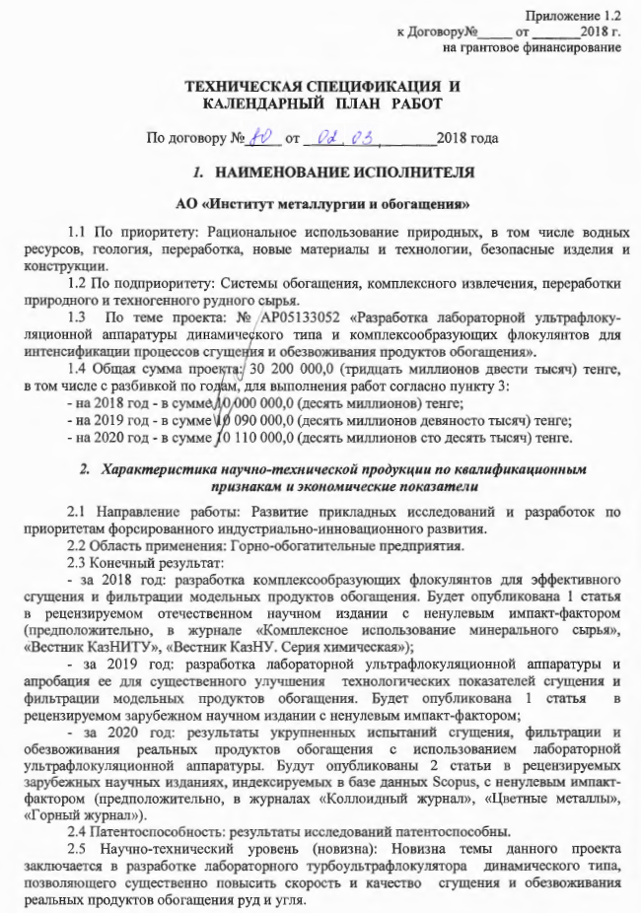

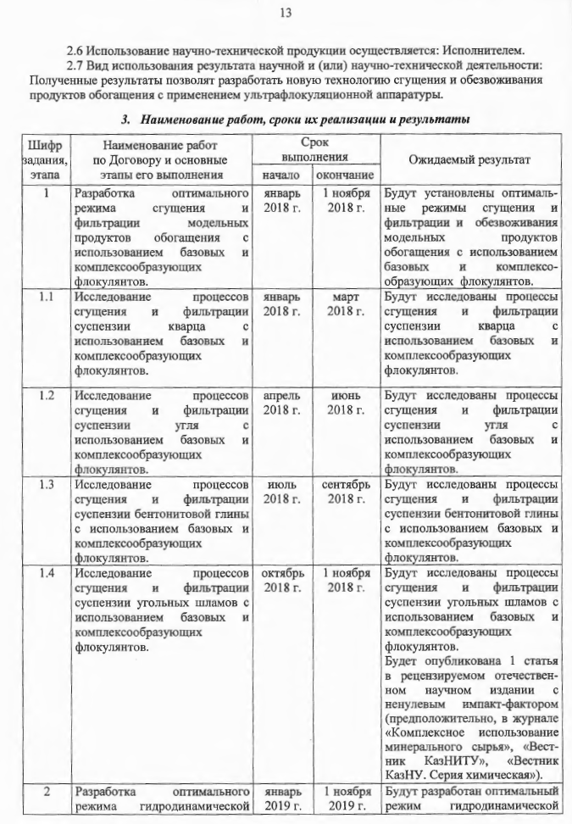

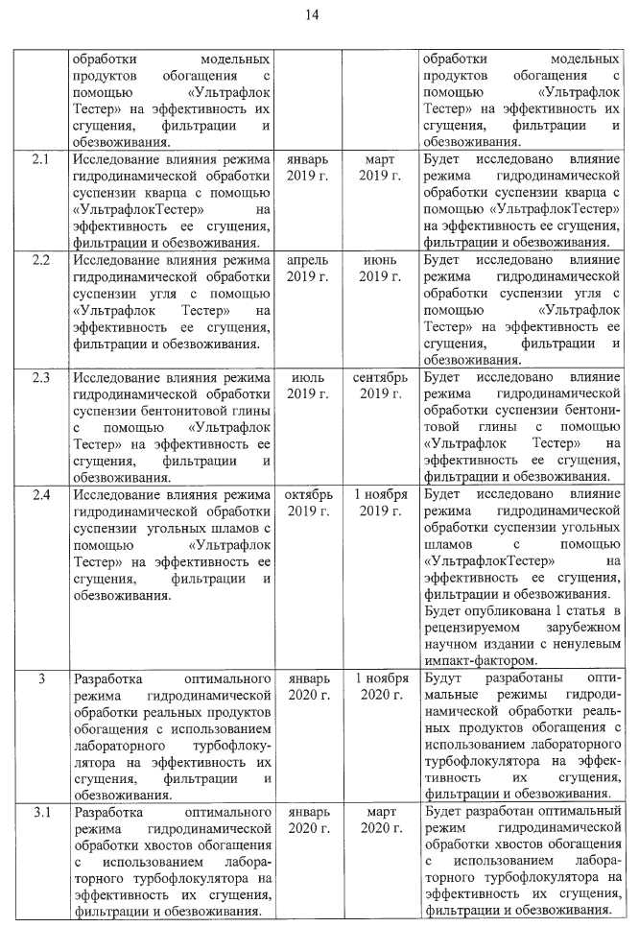
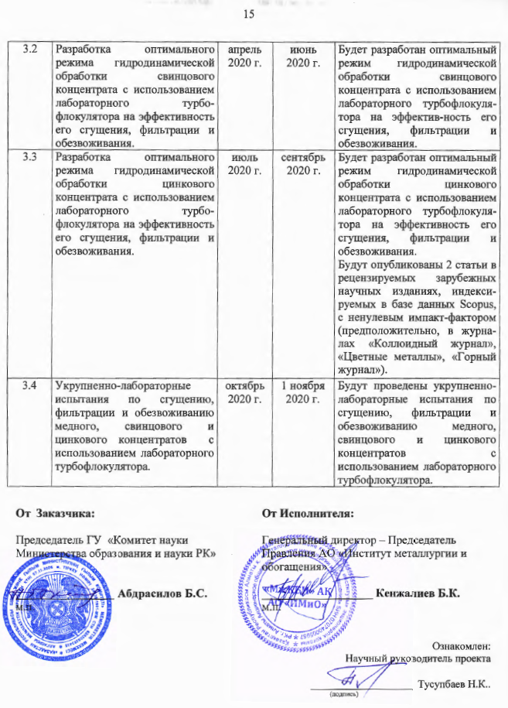

APPENDIX C
Review
on the Final Report for 2020
Institute of Metallurgy and Ore Beneficiation JSC

On the subject: Development of an optimal regime for hydrodynamic processing of model enrichment products with the use of UltraflocTester for efficient thickening, filtration, and dewatering.
According to the project AP05133052: Development of laboratory ultra-flocculation equipment of dynamic type and complex-forming flocculants for intensification of the processes of thickening and dewatering of enrichment products.
Under the program: Grant financing of scientific research for 2018-2020
In the priority direction: Rational use of natural, as well as water resources; geology, processing; new materials and technologies; safe products and structures.
In specialized scientific direction: Beneficiation systems, complex recovery, processing of natural and technogenic ore raw materials.

The report contains 53 pages, 18 figures, 9 tables, 17 references.
In recent years, ultra-flocculation treatment has become more and more widespread in the technology of separating technogenic suspensions. The main difference between ultra-flocculation and conventional flocculation is that during ultra-flocculation treatment, 5-30 times more heterogeneous hydrodynamic fields are used. The efficiency of the use of flocculants in the processes of sedimentation and filtration separation of suspension phases largely depends on the regime of hydrodynamic processing of the suspension (medium velocity gradient) after the introduction of a flocculant solution into the suspension. Correct selection of the ultra-flocculation treatment mode allows to increase the sump productivity by several times and significantly reduce the suspended matter content in the overflow. It allows increasing the productivity of vacuum and belt press filters by 1.5-2 times and significantly reducing the consumption of expensive flocculants.
The ultra-flocculation method makes it possible to quickly assess the strength of floccules by measuring the dependence of flocculation efficiency on the medium velocity gradient (G) in a wide range.
The purpose of the project is to develop an optimal regime for hydrodynamic processing of model suspensions and enrichment products with the use of UltraflocTester for the processes of thickening and dewatering.
The research novelty is the use of a laboratory ultra-flocculator of a dynamic type, which leads to a rapid combination of large and small particles directly in the process of floccule formation, ensuring their rapid sedimentation and a high degree of clarification of the aqueous phase in a short period.
In the course of the project, the intensification of processes of thickening and dewatering of slurry tailings of the flotation concentration of the Zhezkazgan Concentrating Plant with the use of ultra-flocculation treatment was studied. Comparative tests of the flocculating effect of non-ionic, cationic, and anionic polyacrylamides showed that the anionic flocculant A-150 is characterized by the best flocculating effect: If optimal consumption of flocculant A-150 is 9 g/t, then flocculation efficiency reaches 96-97%.
Studies have shown that concerning suspensions of lead-zinc concentrate of the Shalkinskoye deposit, the flocculant "N-100" with an optimal flow rate of 21-24 g/t is the most preferable. It was found that the optimal value of the medium velocity gradient lies in the range of 1300 to 1500 s⁻¹.
The results of a comparison of the flocculating effect of non-ionic, cationic, and anionic polyacrylamides concerning zinc concentrate showed the effectiveness of anionic flocculant A-150 at a flow rate of 25 g/t, which may be associated with greater flexibility of the polymer chain and the possibility of neutralizing the positive charges of the zinc concentrate suspension particles.
The use of ultra-flocculation treatment provides the following advantages in the recovery of finely dispersed coal by sedimentation in a radial thickener: decrease in the consumption of flocculants by 2.5-3.5 times; increase in coal concentrate recovery from tailings by 23-26%; reduction of the ash content of the concentrate recovered from tailings from 18 to 12%; reduction of the moisture content of the press filter cake of the concentrate extracted from tailings from 35 to 25%.
In general, the final report of Institute of Metallurgy and Ore Beneficiation JSC for 2020 under the grant "Development of an optimal regime for hydrodynamic processing of model enrichment products with the use of UltraflocTester for efficient thickening, filtration and dewatering" meets the requirements for reports in terms of the volume and novelty of the results obtained. The scope of work was performed completely under the schedule.

Leading Researcher of the Laboratory
of Synthesis and Physicochemistry of Polymers,
Institute of Chemical Sciences named after A.B. Bekturov JSC
D.Sc. in Engineering, Professor, Corresponding Member of the Russian Academy of Natural Sciences __________ Dzhumadilov T.K.

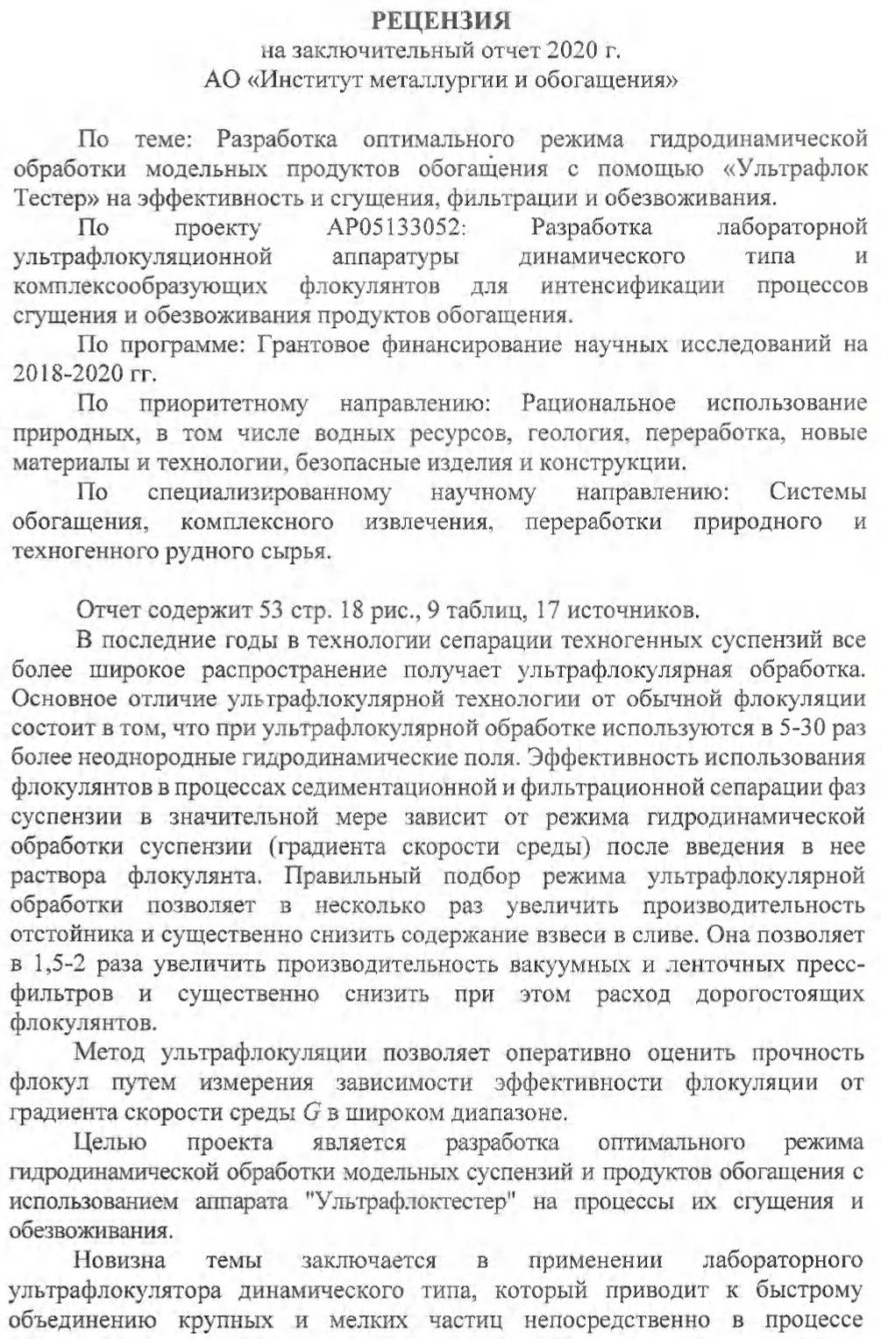
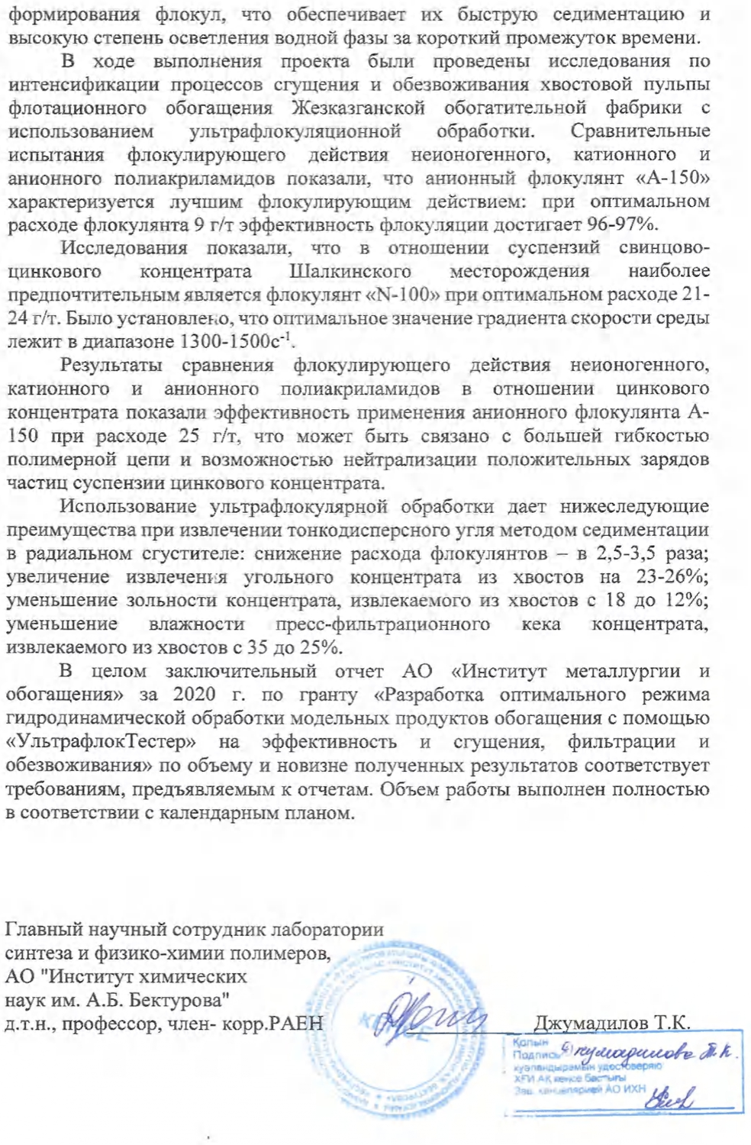
Appendix D

Extract from protocol no. 9
meetings Of the academic Council of JSC "Institute of metallurgy and enrichment"

Almaty city 06.10.2020

Chairman - Kenzhaliev B.K., General Director - Chairman of the Management Board JSC "IMiO", Dr. Tech. sciences, professor
Secretary - S. Temirova, Head of Scientific and Technical Projects Management, Cand. chem. Science
Attended by: 19 members of the Academic Council from 19 payroll.

AGENDA:

Consideration of reports for 2020 on projects carried out within the framework of grant funding for scientific research for 2018-2020.

LISTENED:
On the 12th question
Report of the Head of the laboratory of flotation reagents and enrichment, Doctor of technical science N.K. Tussupbayev «Development of an optimal regime for hydrodynamic processing of tailings with the use of a laboratory turboflocculator for efficient thickening, filtration and dewatering».

QUESTIONS:
Kozhakhmetov S.M.: Are there any interested companies on the topic of your project?
Kvyatkovsky S.A.: Do you have a patent for the ultraflocculator? Do you have the right to use the device?
Agapova L.Ya.: Рow do you imagine using your device in production?

DECISION OF THE SCIENTIFIC COUNCIL

The report on the AR05131425 project «Development of an optimal regime for hydrodynamic processing of tailings with the use of a laboratory turboflocculator for efficient thickening, filtration and dewatering » (Doctor of technical science Tussupbayev N.K.) to approve.

Chairman
General Director –
Chairman of the Management Board
JSC "IMiO",
Dr. Tech. sciences, professor Kenzhaliev B.K.

Secretary
Head of Scientific and Technical
Projects Management,
Cand. chem. Science S. Temirova

