Ministry of Education and Science of the Republic of Kazakhstan
JSC "D. V. Sokolsky INSTITUTE OF FUEL, CATALYSIS AND ELECTROCHEMISTRY"
(JSC «D.V. Sokolsky IFCE»)

UDC 620.197.3; 621.7.029; 621.794.62
MRNTI 81.33.35, 55.22.23;
№ State registration: 0118RK00278
Inventory №

"APPROVED"
General
Director of JSC
«D.V. Sokolsky IFCE»
__________ M. Zhurinov
"__" _________ 2020

REPORT
ABOUT SCIENTIFIC-RESEARCH WORK

«DEVELOPMENT OF ANTICORROSIVE PHOSPHATE MATERIALS FOR OILFIELD EQUIPMENT»
(final)

Theme leader:
candidate of chemical science ____________________________________________ L.A. Fogel

Almaty 2020

LIST OF PERFORMERS
Theme leader:
candidate of chemical science _______________________ Fogel L.A.
signature, date (the abstract, introduction,
main part, conclusion)

Junior researcher ________________________ Sultanbek U.
signature, date (main part)

Junior researcher ________________________ Bold A.
signature, date (main part)

Junior researcher ________________________ Tilepbergen Zh. Zh.
signature, date (main part)

ABSTRACT

Report 60 p., 27 fig., 3 tab., 50 sources, 3 app.
CORROSION, IRON, ADHESIVE PHOSPHATE COATINGS, RUST CONVERTERS, CYCLIC VOLTAGE CURVES
The object of research is adhesive phosphate coatings on the surface of iron samples obtained from phosphating solutions of various natures and rust converters in the presence of accelerators.
The aim of the work is to develop an import-substituting technology for obtaining high-quality adhesive phosphate coatings for effective corrosion protection of iron samples.
Research methods: To control the anticorrosive properties of phosphate coatings on iron samples, independent chemical, physical and electrochemical methods were used.
Solutions for the deposition of phosphate coatings based on rust converters, Phosphomet and Tsinkar with the addition of accelerators of nitrophenol and sodium 3-nitrobenzenesulfonate (m-NBS), hydroxylamine have been developed; the optimal conditions for the formation of phosphate coatings (concentration of the accelerator, temperature, time, stirring speed) have been determined; it was shown that phosphate coatings obtained from a solution containing Phosphomet with additives of nitrophenol and m-NBS have the highest corrosion resistance; new electrochemical methods for determination of corrosion resistance and optimal composition of anticorrosive coatings on steel have been proposed; carried out corrosion tests of phosphate coatings in model and industrial solutions with different mineralization and different pH; the possibility of increasing and stabilizing the corrosion resistance of phosphate coatings in highly saline water of the Pavlodar petrochemical plant is shown.
Basic design, technical and economic indicators: Solutions and conditions for the deposition of phosphate coatings based on rust converters with additives of nitrogen-containing accelerators have been developed. It is shown that the addition of nitrogen-containing accelerators to solutions of rust converters leads to an increase in the corrosion resistance of the deposited phosphate coatings.
Recommendations for implementation and scope: The developed technology for obtaining phosphate coatings on iron samples, as well as chemical and electrochemical methods for controlling the resulting coatings can be recommended for implementation in metal-intensive industries

CONTENT

INTRODUCTION................................................................................................................ | 6
1 Testing of the obtained phosphate coatings in environments with different corrosiveness………………………………………………................................................ | 8
1.1 Research methodology................................................................................................. | 8
1.2 Determination of optimal conditions for the formation of phosphate coatings by the method of cyclic voltammetry.............................................................................................. | 9
1.3 Effect of pH on the corrosion resistance of phosphate coatings deposited from solutions of rust converters …………………………………………………………......... | 17
2 Experiment of the obtained phosphate coatings in environments with different mineralization.…………………………............................................................................... | 19
2.1 Testing the corrosion resistance of phosphate coatings in environments with different mineralization by the Tafel polarization curve method ……………………………………… | 19
2.2 Testing the corrosion resistance of phosphate coatings in environments with different mineralization by the Tafel polarization curve method .......................................................... | 23
3 Testing of the obtained phosphate coatings in corrosive environments with different hydrodynamic conditions ..................................................................................................... | 34
3.1 Determination of the corrosion resistance of phosphate coatings in the waters of the Pavlodar petrochemical plant according to the Tafel curves ............................................... | 34
3.2 Determination of the corrosion resistance of phosphate coatings in the waters of the Pavlodar petrochemical plant with different hydrodynamic conditions ............................. | 39
CONCLUSION .................................................................................................................. | 41
REFERENCES.................................................................................................................... | 44
APPLICATION А – List of published scientific works..................................................... | 49
APPLICATION В – Calendar Plans for 2018-2020……………………………………. | 51
APPLICATION С – Method for determining the optimal composition of anti-corrosion  coatings on steel ................................................................................... | 60

LIST OF ABBREVIATIONS AND SYMBOLS

In this report, the following abbreviations and symbols are used:

С | – the concentration in the volume of the solution (mol.l⁻¹)
M | – molarity (mol.l⁻¹)
t | – temperature (°С)
ω | – disk electrode rotation speed(rpm⁻¹)
Е_{р} | – peak potential (B)
E_{n} | – initial potential for get current-voltage curves
Ek | – finite potential for get current-voltage curves
S | – working surface of the electrode (cm²)
SAS | – surface-active substance
LCP | – paint and varnish coating
GCS | – hot rolled steel
τ, min | – coating formation time
K_{m} | – corrosion rate constant obtained by the gravimetric method (g/m² h)
Q _{mq} | – amount of electricity in microcoulons
ЗСА | – Defensive ability according to Akimov (s)

INTRODUCTION

The processes of deposition of anticorrosive phosphate coatings are widely used in industry for solving various technical problems, due to the unique functional properties of these coatings, such as high adhesion to a metal base, high adsorption capacity, high anti-frictional and extrusive properties and low electrical conductivity [1- 4].
Phosphating is currently the most widely used surface treatment for ferrous and non-ferrous metals. This is due to its economy and speed of the process, its ability to provide excellent corrosion resistance, wear resistance and adhesion [5-13].
The main disadvantages of existing phosphating solutions are the content in their composition of toxic nickel ions, nitrite ion, etc .; high energy consumption due to the high operating temperatures of the process 70-90 ° С; evolution of hydrogen, which prevents the formation of dense sediments, high slag formation. In addition, for the implementation of modern phosphating technologies, rather complicated equipment is required, and the processes themselves require strict control, since the properties of the forming coatings strongly depend on such parameters as free and total acidity, temperature, concentration of accelerators, etc. [13-16]. Consequently, the priority directions in improving the phosphating process are: the development of new phosphating solutions, reducing the concentration of the solution, temperature, surface treatment time, simplifying the adjustment, unifying phosphating solutions, increasing economic and environmental feasibility [17-42].
The leaders of developments in the field of phosphating are the German companies Henkel, Chemetall and the American Parker [10-11]. There are practically no domestic high-level developments in this area. World analogues are the intellectual property of developers who produce ready-made compositions for various stages of the formation of anti-corrosion coatings without disclosing their compositions. Therefore, important sectors of the domestic industry, which produce phosphating of metals, depend on foreign manufacturers, whose prices are unreasonably high. In connection with the above, the development of highly effective domestic technologies of anticorrosive coatings that meet increasing requirements corresponds to the validity of the choice of the research direction.
Constantly increasing requirements for protective coatings with anti-corrosion properties lead to the need to improve the process of their formation. This requires reliable, easily determined criteria for the protective properties and quality of the formed anti-corrosion coatings. To date, a large number of methods have been proposed for assessing the protective properties of anticorrosive coatings on a metal surface [28-41]. Since all corrosion processes are caused by the course of electrochemical reactions, electrochemical methods can be used to assess and control the protective properties of anticorrosive coatings [43-49], which are characterized by high speed and measurement accuracy. Therefore, one of the tasks of this work was the development of an easily determined criterion for the optimal composition of the phosphate coating on an iron electrode in the presence of phosphating accelerators by the electrochemical method.
Along with phosphating solutions, rust converters are widely used to obtain anticorrosive coatings, the use of which does not require preliminary treatment of the metal surface, as is the case with traditional solutions. However, methods of accelerating phosphating in solutions of rust converters have not found proper application and remain poorly studied. Therefore, the purpose of this work was to study accelerated low-temperature phosphating on the surface of iron samples from solutions of rust converters using organic nitro compounds as process accelerators; testing of the obtained phosphate coatings in model solutions with different mineralization and in aggressive environments of an oil refinery.
The main objectives of the project for 2020 are:
- Testing of phosphate coatings deposited from solutions of rust converters under optimal conditions with the addition of various accelerators in model solutions with different mineralization.
- Selection of optimal deposition solutions in order to obtain phosphate coatings with maximum corrosion resistance.
- Development of an electrochemical method for determining the optimal composition of anti-corrosion coatings on steel by taking cyclic volt-ampere curves.
- Testing of the developed phosphate coatings in an aggressive environment with different hydrodynamic conditions.
List of interim reports and their inventory numbers.
1 Interim report for 2018 year on the topic: «Development of anticorrosive phosphate materials for oilfield equipment»" inventory No. 0218РК00208.
2 Interim report for 2019 year on the topic: «Development of anticorrosive phosphate materials for oilfield equipment» inventory No. 0219РК00732.

1 Testing of the obtained phosphate coatings in environments with different corrosiveness
1.1 Research methodology

The formation of protective anticorrosive coatings on steel samples (St. 3) was carried out using phosphating solutions (1-7) with the following compositions:
FR-1 (1): ZnO - 0.145 g/l; MnSO₄ ·H₂O - 0.061 g/l; HNO₃ - 0.083 ml; H₃PO₄ - 0.184 ml; NaOH - 0.0315 g/l;
FR-1 (2): ZnO - 0.58 g/l; NiNO₃·6H₂O - 0.26 g/l; HNO₃⁻0.332 ml; H₃PO₄ - 0.73 ml; NaOH - 0.126 g/l;
FR-1 (3). ZnO - 0.725 g/l; NiNO₃·6H₂O - 0.33 g/l; HNO₃- 0.415 ml; H₃PO₄ - 0.92 ml; NaOH - 0.1575 g/l;
FR-1 (4). ZnO - 1.16 g/l; NiNO₃·6H₂O - 0.5208 g / l; HNO₃-0.614 ml; H₃PO₄ - 1.472 ml; NaOH - 0.252 g/l;
FR-2 (1) - ZnO - 0.0263g/l, Ni(NO₃)₂·6H₂O-0.062g/l; Mn (NO₃)₂.6H₂O - 0.025g/l, HNO₃-0.083ml, H₃PO₄ - 0.23ml, NaOH-0.064 g/l;
FR-2 (2) - ZnO - 0.0263 g/l, Ni (NO₃) ₂ · 6H₂O - 0.062 g/l, Mn (NO₃) ₂ *6H₂O - 0.1312 g/l, HNO₃ - 0.083 ml, H₃PO₄- 0.23 ml, NaOH - 0.064 g/l;
FR-3 - ZnO - 0.0677 g/l, Ni (NO₃)₂ · 6H₂O - 0.0408 g/l, Mn (NO₃)₂ ·6H₂O - 0.127 g/l, H₃PO₄ - 0.226 ml, NaOH - 0, 0376 g/l;
For the deposition of phosphate coatings, the rust preservatives Phosphomet and Tzinkar were also used. Corrosion (rust) converters are specially designed compounds that convert corrosion products (rust) into a strong protective film directly on the treated surface.
Rust converter Tzinkar is used to treat metal (mainly steel) surfaces. The basis of this converter of corrosion products is purified orthophosphoric acid. Manganese and zinc salts are used as active ingredients. It is due to these two components that Tzinkar has a double effect on the surface of the metal. Manganese helps to strengthen the protective layer that forms after the deposition of the converter of corrosion products. The effect of metal alloying is observed. Iron oxide (rust) when exposed to Tzinkar is destroyed and converted into phosphates.
Phosphomet is a phosphating rust modifier for the treatment of steel, cast iron, galvanized and aluminum surfaces prior to painting. It is an aqueous solution of phosphoric acid, corrosion inhibitors and special targeted additives. Phosphomet is designed to protect metal products (mainly carbon and low-carbon steels and cast iron) from corrosion by converting rust into a protective phosphate film (cold phosphating), forming a chemically bonded layer of insoluble phosphoric acid salts of iron, zinc and manganese.
As accelerators of phosphating, we used nitrophenol and sodium m-nitrobenzosuphonate, hydroxylamine.
To prepare the solutions, we used chemical reagents of the “pure” and “pure grade” brands and distilled water.
Pretreatment of metal samples made of steel (St. 3) was carried out by degreasing in an aqueous alkaline detergent composition KM-28 TU 2332-162-00209711-2004 with a concentration of 15-20 g/l at a temperature of 60-65°C for 2-10 minutes and then washed with water. The surface of metal samples was cleaned manually with an abrasive material followed by rinsing with distilled water. To improve the quality of surface treatment, a mechanical rotating installation was also used to process an iron sample using an abrasive material.
The protective and corrosive characteristics of phosphate coatings on steel were studied by the following methods: - drop method (Asimov’s method); by the method of cyclic voltammetry. The drop method is based on the use of a solution of the composition CuSO4 • 5H2O 82 g/l; NaCl 33 g/l; 0.1 N HCl 13 ml /l (so-called Asimov’s reagent) [50]. The protective ability of the coating according to Akimov (ZSA) was determined as the time until the color of the control area under the drop changes from blue to red-brown.
Electrochemical study of corrosion resistance. In order to study the corrosion resistance of the obtained phosphate coatings, the voltammetric method was used [51]. Cyclic current-voltage curves were obtained using a Gamry 3000 potentiostat (USA) in a thermo stated electrochemical cell. The working electrode was an iron (St.3) disk electrode with a visible surface of 0.03 cm². A platinum electrode with a large visible surface exceeding the surface of the brass electrode by more than 100 times was used as a counter electrode. The potentials given in the article were measured relative to a silver chloride electrode manufactured by Metrom (Switzerland) with a potential of 196 mV relative to a hydrogen electrode. A solution of 0.3 M Na₂SO₄ was used as the electrolyte. Cyclic current – voltage curves were recorded in the potential region -0.3 ÷ -1.2 V with a potential sweep rate of 20 mV/s. Before obtaining cyclic current-voltage curves, the surface of the working electrode was updated with abrasive material and washed with distilled water. Cyclic current-voltage curves on a phosphate-coated iron electrode were obtained without updating the electrode surface.

1.2 Determination of optimal conditions for the formation of phosphate coatings by the method of cyclic voltammetry

The approach we propose to determine the corrosion resistance of phosphate coatings is based on a comparison of cyclic volt-ampere curves obtained on the renewed surface of an iron electrode with similar curves obtained on a surface with a phosphate coating. Of particular interest is the use of electrochemical methods for obtaining qualitative and quantitative characteristics, which can be used to establish the electrochemical activity and anticorrosive ability of the obtained coatings in a wide potential range. The use of accelerators of different nature made it possible to obtain phosphate coatings with high anticorrosive properties on iron samples. The protective ability of the formed coatings was assessed by the Akimov drop method in combination with the method of cyclic voltammetry.
Figure 1 shows cyclic current-voltage curves (with a number of cycles of 7) obtained on an iron electrode in the absence of a phosphate coating (Figure 1a) and with a phosphate coating deposited from a phosphating solution FR-2 (Figure 1b) in 0.3 M Na₂SO₄. According to Fig. 1, on the cyclic current-voltage curves of the iron electrode obtained from a solution of 0.3 M Na₂SO₄ in the cathode region, the maximum current (A) is observed in the potential region (E ≈ -0.9 ÷ 0.1 V) due to the electroreduction of iron hydroxide compounds formed on the surface of the electrode during anodic polarization. The maximum current (A) was used to judge the corrosion resistance of the formed phosphate coatings. With an increase in the number of cycles (1–7), a systematic increase in the cathode maximum (A) is observed. The cyclic current–voltage curves obtained on an iron electrode with a phosphate coating (Figure 1b) are in many respects similar to the curves obtained on an iron electrode without a coating (Figure 1a). However, for cycles (1-3), the maximum current (A) (Figure 1 b) is noticeably less than the maximum current (A) in Figure 1a. With an increase in the number of cycles (5–7), the maximum current (A) on cyclic current – voltage curves with a phosphate coating (Figure 1b) is noticeably larger than the corresponding maximum on current – voltage curves of an uncoated iron electrode (Figure 1a).

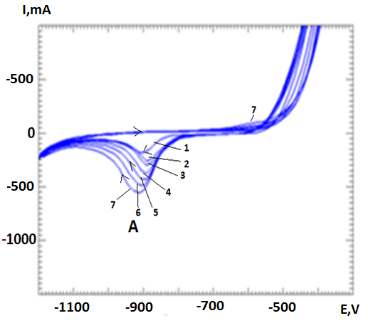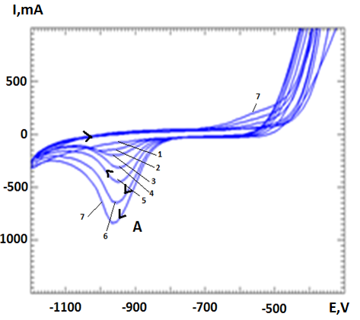
a b
Figure 1 - Cycle current-voltage curves of an iron electrode without a phosphate film (a) and in the presence of a phosphate film (b)

The effect of the number of cycles on the current value of cathode maxima (A) can be more clearly seen in Figure 2, which shows the dependence of the change in the current value of cathode maxima (A) (curves 1.2) for the studied electrodes on the number of cycles.

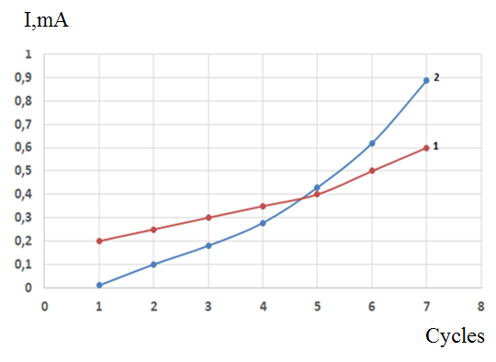
1 - uncoated; 2 - with phosphate coating
Figure 2 - Dependence of the maximum current (A) on an iron electrode in 0.3 M Na2SO4 on the number of cycles of volt-ampere curves

The observed change in the current value of the cathode maxima during cycling allows us to conclude that the presence of a phosphate coating on the iron electrode leads to a noticeable decrease in the maximum current (A) only in the first cycles (1-3). With an increase in the number of cycles, the increase in the current of maximum (A) with a phosphate coating (curve 2) noticeably exceeds the current value of a similar maximum on an uncoated iron electrode (curve 1). It follows that a systematic change in the course of the cathodic and anodic processes when obtaining cyclic current-voltage curves in the studied potential region does not lead to an increase in the corrosion resistance of the phosphate coatings used, but, on the contrary, contributes to the course of corrosion processes.
In connection with the foregoing, it was of interest to evaluate the effect of phosphate accelerators using hydroxylamine and nitrophenol as an example on the change in the corrosion resistance of phosphate coatings on iron electrodes using the cyclic voltammetry method. Figure three shows the dependence of the change in the current value of the cathode maximum (A) on the cyclic current-voltage curves of a phosphate-coated iron electrode on the concentration of hydroxylamine in the FR-2 phosphating solution on the number of cycles (1-7).

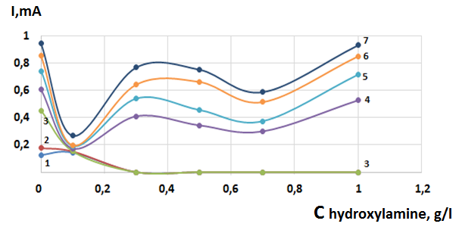
Cycle designations: 1-1; 2-2; 3-3; 4-4; 5 -5; 6-6; 7-7
Figure 3 - The effect of hydroxylamine in a phosphating solution on the cyclic volt-ampere curves of an iron electrode with a phosphate coating during cycling

According to Figure 3, with a small concentration of hydroxylamine in the phosphate solution of the iron electrode on the cyclic current-voltage curves, the cathode current of maximum (A) is practically not observed (Fig. 3, curves 1,2). However, in the case when the concentration of hydroxylamine in the phosphating solution is close to 0.1 g/l, the cathode maximum current (A) within the experimental error becomes unchanged from the number of cycles (1-7). This is most clearly seen in Figure 4, which shows the dependence of the maximum current (A) for different concentrations of hydroxylamine in the phosphate solution on the number of cycles of the current-voltage curves.
According to Figure 4, at a hydroxylamine concentration in the phosphate solution of 0.1 g/l (curve 1), the cathode maximum current (A) remains almost unchanged during the cycling process, while at higher concentrations is observed an increase in the cathode maximum current ( A) (curves 2, 3). Thus, when the concentration of hydroxylamine in the deposition solution FR-2, equal to 01 g/l phosphate coatings are formed having the highest corrosion resistance.

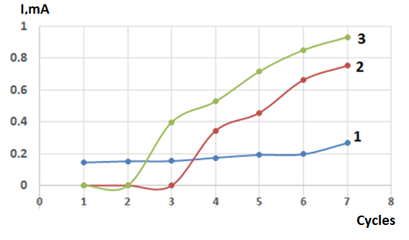
Hydroxylamine concentration (g / l): 1 - 0.1; 2 - 0.5; 3 - 1
Figure 4 - Influence of the number of cycles of volt-ampere curves on the value of the maximum current (A) at different concentrations of hydroxylamine in the precipitation solution

It should be noted that the determination of the optimal concentration of the hydroxylamine phosphate accelerator based on the change in the maximum current (A) on the cyclic current-voltage curves is in agreement with experimental data obtained from the dependence of the protective ability of the phosphate coatings on the concentration of hydroxylamine determined by Asimov’s method on iron samples. In figure Fig. 5 shows the dependence of changes in the protective ability of phosphate coatings according to the Akimov method on the concentration of hydroxylamine in a phosphate solution.

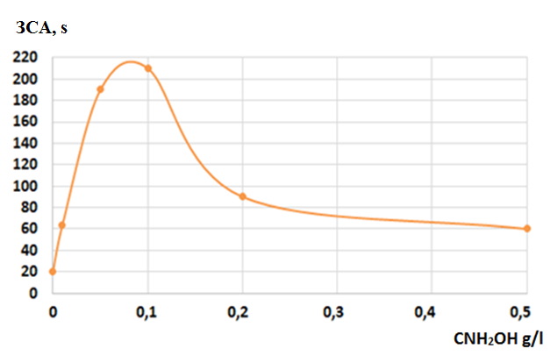
Figure 5 - Dependence of the corrosion resistance of phosphating coatings on the surface of iron samples deposited from a FR-2 solution on the concentration of hydroxylamine
According to Figure 5, phosphate coatings obtained from a phosphating solution of FR-2 in the presence of 0.1 g/l hydroxylamine possess the greatest anticorrosive protective ability. At higher concentrations of hydroxylamine, the protective ability of the phosphate coating decreases. The data obtained are highly correlated with the results of electrochemical studies.
Of particular interest is the study of the effect of the nature of the phosphate accelerator on the corrosion resistance of the formed phosphate coating. The effect of the nitrophenol concentration in the FR-2 phosphating solution on the corrosion resistance of phosphate coatings by cyclic voltammetry was studied. Figure 6 shows the dependence of the maximum current (A) on the concentration of nitrophenol in the FR-2 phosphating solution for an iron electrode with a phosphate coating (Figure 6a) and the dependence of the maximum current (A) on the number of cycles of the voltammetric curves (Figure 6b).
According to Figure 6a, for the first cycle, there is practically no maximum current (A) on the cyclic current – voltage curves in the studied range of nitrophenol concentrations in the phosphating solution. With an increase in the number of cycles, the maximum current (A) is increases noticeably. Moreover, the maximum increase in maximum current (A) is observed when using deposition solutions containing small concentrations of nitrophenol (curves 1-5). This is most clearly shown in Fig. 6b, which shows the dependence of the change in the maximum current (A) on the number of cycles for the different concentrations of nitrophenol in the phosphating solution.

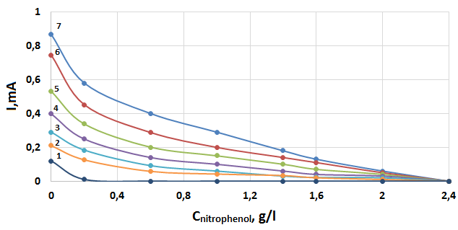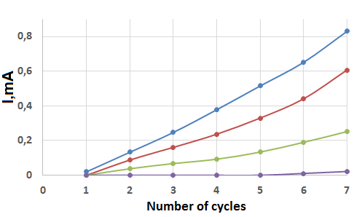
Deposition solution: Phosphomet (a), number of cycles at different concentrations of nitrophenol (b); numbering of cycles: 1 - 1; 2 - 2; 3 - 3; 4 - 4; 5 - 5; 6 -6; 7 - 7 (a); concentration of nitrophenol (g/l): 1-0.078; 2 - 0.25; 3 -1.3; 4- 2.5 (b)
Figure 6 - Dependences of the cathode maximum current (A) on the cyclic volt-ampere curves of the iron electrode on the concentration of nitrophenol

According to Figure 6b, with an increase in the concentration of nitrophenol, a decrease in the maximum current (A) is observed. At a nitrophenol concentration greater than 2 g/l, the maximum current (A) reaches a minimum value for the studied nitrophenol concentrations in the phosphating solution and does not depend on the number of cycles of sequential cycling of current-voltage curves. Therefore, the optimal concentration of nitrophenol, at which the maximum corrosion resistance of the formed phosphate coatings in the FR-2 solution is observed, is a concentration of 2 ÷ 2.5 g/l.
Thus, the use of the electrochemical method of cyclic voltammetry made it possible to establish the optimal concentration of phosphating accelerators of various natures, which provides complete anticorrosive protection of phosphate films on the surface of iron samples and optimal conditions for the deposition of coatings at different concentrations of accelerators. The obtained experimental data are consistent with the independent method for determining the protective capacity by the Akimov method and the electrochemical method based on measuring the polarization resistance from the Tafel curves.
Table 1 shows the corrosion resistance of phosphate coatings, determined by Akimov's drop method sets, formed from phosphating solutions and rust converters under optimal deposition conditions in the presence of various accelerators.

Table 1 - The effect of phosphating accelerators on the corrosion resistance of phosphate coatings on an iron (St. 3) substrate
Phosphating solution | Accelerator | Accelerator concentration, (g / l) | Temperature  deposition,  (t° С) | Deposition time (min.) | Corrosion resistance according to Akimov (s)
1 | 2 | 3 | 4 | 5 | 6
FR-1 (1) | m-nbs | 1 | 40 | 10 | 9
FR-1 (1) | nitrophenol | 2.5 | 40 | 10 | 10
FR-1 (1) | hydroxylamine | 5 | 40 | 10 | 58
FR-1 (2) | m-nbs | 1 | 40 | 10 | 13
FR-1 (2) | nitrophenol | 2,5 | 40 | 10 | 18
FR-1 (2) | hydroxylamine | - | - | - | -
FR-1 (3) | m-nbs | 1 | 40 | 10 | 15
FR-1 (3) | nitrophenol | 2,5 | 40 | 10 | 24
FR-1 (3) | hydroxylamine | - | - | - | -
FR-1 (4) | m-nbs | 1 | 40 | 10 | 25
FR-1 (4) | nitrophenol | 2,5 | 40 | 10 | 34
FR-1 (4) | hydroxylamine | 5 | 40 | 10 | 110
FR-2 (1) | m-nbs | 1 | 40 | 10 | 13
FR-2 (1) | nitrophenol | 0,5 | 40 | 10 | 8
FR-2 (1) | hydroxylamine | 5 | 40 | 10 | 70

Continuation of Table 1
1 | 2 | 3 | 4 | 5 | 6
FR-2 (2) | m-nbs | - | - | - | -
FR-2 (2) | nitrophenol | - | - | - | -
FR-2 (2) | hydroxylamine | 5 | 40 | 10 | 95
FR-3 | m-nbs | - | - | - | -
FR-3 | nitrophenol | - | - | - | -
FR-3 | hydroxylamine | 5 | 40 | 10 | 84
Tzinkar | m-nbs | 5 | 40 | 10 | 180
Tzinkar | nitrophenol | 2,5 | 40 | 10 | 110
Tzinkar | hydroxylamine | 5 | 40 | 10 | 93
Phosphomet | m-nbs | 5 | 40 | 10 | 104
Phosphomet | nitrophenol | 2,5 | 40 | 10 | 330
Phosphomet | hydroxylamine | 5 | 40 | 10 | 27

Based on the studies of the corrosion resistance of the formed phosphate coatings from phosphating solutions and rust converters in the presence of various phosphating accelerators, optimal solutions were selected for the deposition of phosphate coatings on the surface of iron samples with the highest corrosion resistance (Table 1).
According to Table 1, it was found that the most corrosion-resistant coatings are formed from phosphating solutions Phosphomet and Tzikar in the presence of nitrophenol and sodium m-nitrobenzosulfonate (m-MNB). Corrosion resistance of phosphate coatings from a Phosphomet solution in the presence of a nitrophenol phosphating accelerator with a concentration of 2.5 g / l is 330 s (according to Asimov’s method). The corrosion resistance of coatings deposited from a Tzinkar solution in the presence of an m-NBS accelerator with a concentration of 5 g/l is 180 s. Corrosion resistance of phosphate coatings, deposited from solutions of phosphating of FR in the presence of accelerators of nitrophenol, m-NBS, hydroxylamine, is much lower compared to solutions of rust converters. An exception is phosphate coatings deposited from a FR-4 solution in the presence of 5 g /l hydroxylamine. The corrosion resistance of such coatings is 110 s.
Consequently, the determination of the optimal concentration of phosphating accelerators in solutions of the Phosphomet and Tzinkar rust converters by the Akimov drop method to a high degree corresponds to the concentrations of accelerators calculated using the cyclic voltammetry method.

1.3 Effect of pH on the corrosion resistance of phosphate coatings deposited from solutions of rust converters

To test the stability of phosphate coatings in media with different mineralization and different pH values, coatings deposited from solutions of the Phosphomet and Tzsinkar rust converters in the presence of nitrophenol and m-NBS phosphating accelerators were selected. Tests of phosphate coatings, which showed the highest corrosion resistance on the surface of iron samples, were carried out in model solutions (GOST 9.502-82), designed to determine the corrosion resistance of coatings with different pH values ​​close to neutral (pH = 6-9). The corrosion resistance of the coatings was determined by the Akimov drop method and electrochemical methods - by the method of taking cyclic volt-ampere curves and polarization curves according to Tafel.
Figure 7 shows the dependence of the corrosion resistance of phosphate coatings deposited from a Phosphomet solution in the presence of 2.5 g/l of nitrophenol in media with different pH values. Deposition conditions: temperature 40 ° C, depositing time 10 minutes, stirring speed 500 rpm.

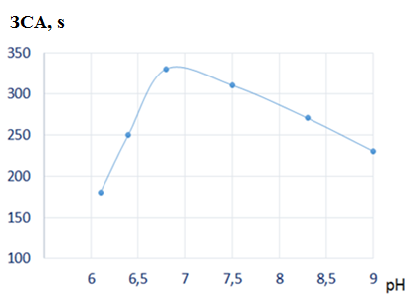
Figure 7 - Dependence of the protective ability of phosphate coatings deposited from the Phosphomet solution in the presence of nitrophenol on the pH of the solution

It was shown that phosphate coatings deposited from the Phosphomet solution in the presence of a nitrophenol phosphating accelerator at pH = 6.7 have the highest corrosion resistance.
Figure 8 shows the dependence of the corrosion resistance of phosphate coatings deposited by their Tzincar solution in the presence of 5 g/l m-NBS.
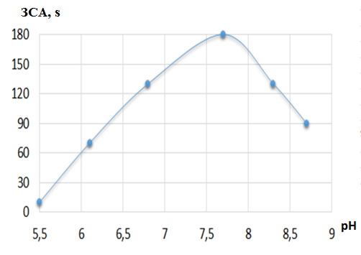
Figure 8 - Dependence of the protective ability of phosphate coatings deposited from a Phosphomet solution in the presence of m-NBS on the pH of the solution

It has been shown that phosphate coatings deposited from Tzinkar solution in the presence of the phosphating accelerator m-NBS at pH = 7.8 have the highest corrosion resistance.

2 Experiment of the obtained phosphate coatings in environments with different mineralization
2.1 Experiment of the corrosion resistance of phosphate coatings in environments with different mineralization by the Akimov drip method

Experiment of iron samples for corrosion resistance by the Akimov method were carried out in model solutions No. 1-4, having different mineralization, i.e. different ratios of the starting salts. The composition of the model solutions is shown in Table 2.

Table 2 - Composition of model solutions
Solution number No. | Mass concentration, mg/l, component
 | NaCI
1 | 243,0 | 25,0 | 192,0 | 8,0 | 5,0 | -
2 | 914,0 | 250,0 | 1924,0 | 361,0 | 237,0 | -
3 | - | - | 213,0 | 138,0 | 333,0 | -
4 | - | - | 319,0 | from 210,0 before 336,0 | 500,0 | -
5 | 82,0 | - | 74,0 | 80,0 | - | 82,0
6 | 410,0 | - | 296,0 | 400,0 | - | 410,0
7 | 30,0 | - | 70,0 | - | - | -

A study of the change in the corrosion resistance of iron samples with a phosphate coating deposited from solutions of rust converters Phosphomet and Tzsinkar in the presence of nitrophenol and m-NBS phosphating accelerators, depending on the exposure time in model solution No.1 at a temperature of 30°C and a stirring rate of 500 vol. / min. (Figure 9). Model solution No. 1 is characterized by a low content of mineral salts. The exposure time in model solution No.1 was changed from 30 to 180 min. The corrosion resistance of the coatings was determined by Asimov’s drop method.
According to Figure 9, with an increase in the exposure time of iron samples with a phosphate coating in model solution № 1, an increase in corrosion resistance is observed for all coatings, with the exception of coatings deposited from the Phosphomet + 5 g/l m-NBS solution.

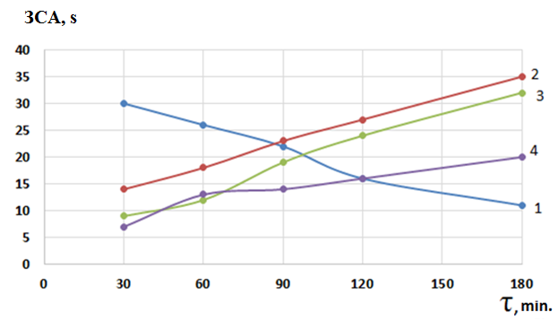
Phosphating solution: 1 - Phosphomet + 5 g/l m-NBS; 2 - Phosphomet + 2.5 g/l of nitrophenol; 3 - Tsinkar + 5 g/l m-NBS; 4 - Tsinkar + 2.5 g/l of nitrophenol
Figure 9 - Influence of the exposure time of phosphate coatings in model solution No.1 on the change in their corrosion resistance

The greatest increase in corrosion resistance was observed on the phosphate coating deposited from the Phosphomet + 2.5 g / L nitrophenol solution. During the exposure time from 30 to 180 min, the corrosion resistance of this coating increased from 7 to 35 s. Phosphate coatings deposited from the Phosphomet + 5 g/l m-NBS solution showed a decrease in corrosion resistance with an increase in the exposure time in model solution No. 1.
The behavior of the obtained phosphate coatings in the model solution No. 2, characterized by a high content of CI⁻ and SO₄²⁻ ions, has been investigated (Figure 10).
In model solution No. 2, characterized by a high concentration of MgSO₄ and CaCl₂ salts, as in model solution № 1, the coatings deposited from the Phosphomet + 2.5 g/l nitrophenol solution showed the highest corrosion resistance -48 s. with exposure time of 120 s. With a further increase in the exposure time, the corrosion resistance of this coating decreased. Corrosion resistance of coatings deposited from Tzinkar solution in the presence of 2.5 g/l of nitrophenol (Figure 4, curve 3) and 5 g/l of m-NBS (Figure 4, curve 4) increases with increasing of exposure time in model solution No. 2.

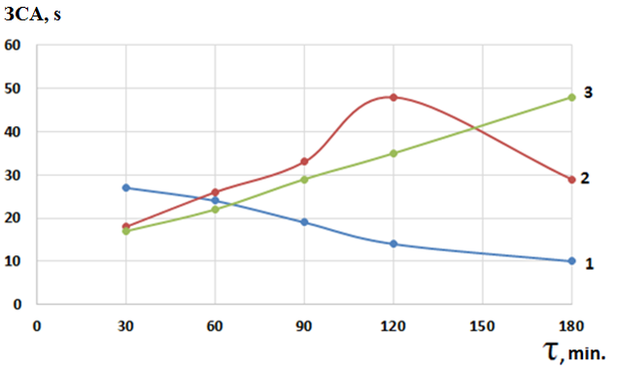
Phosphating solution: 1 - Phosphomet + 5 g / l m-NBS; 2 - Phosphomet + 2.5 g / l of nitrophenol; 3 - Tzinkar + 5 g / l m-NBS; 4 - Tzinkar + 2.5 g / l of nitrophenol
Figure 10 - Influence of the exposure time of phosphate coatings in model solution No. 2 on the change in their corrosion resistance

Thus, an increase in the mineralization of solutions for testing phosphate coatings leads to an increase in the corrosion resistance of phosphate coatings deposited from solutions of Phosphomet + 0.5 g/l of nitrophenol and Tzinkar + 5 g /l of m-NBS, but contributes to a decrease in the corrosion resistance of coatings deposited from a solution of Phosphomet + 5 g / l m-NBS.
The behavior of the obtained phosphate coatings in the model solution No. 3, characterized by a low content of CI- and SO₄²⁻ and HCO₃⁻ ions, has been investigated (Figure 11).

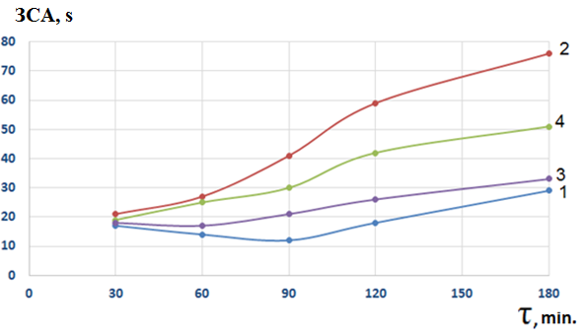
Phosphating solution 3: 1 - Phosphomet + 5 g/l m-NBS; 2 - Phosphomet + 2.5 g/l of nitro-phenol; 3 - Tzinkar + 5g/l m-NBS; 4 - Tzinkar + 0.5 g/l of nitrophenol
Figure 11 - Influence of the exposure time of phosphate coatings in model solution No. 3 on the change in their corrosion resistance
According to Figure 11, a significant increase in the corrosion resistance of the phosphate coating deposited from the Phosphomet + 2.5 g/l nitrophenol solution is observed in the model solution of 3 (curve 2). With a the exposure time of 180 s. the corrosion, resistance of such a coating increases up to 75 s, which is more higher than the corrosion resistance of these coatings in the solutions 1 and 2. Interestingly, when the exposure in model solution 3, there is no decrease in the corrosion resistance of the coatings deposited from the Phosphomet + 5 g/l solution m-NBS (curve 1). The maximum corrosion resistance of phosphate coatings from Tzincar solution observed in the presence of 0.5 g/l of nitrophenol (curve 3) is 50 s. Corrosion resistance of the coating deposited from a solution of Tzinkar + 5 g/l m-NBS is 32 s.
The behavior of the obtained phosphate coatings in the model solution No. 4, characterized by a high content of Na₂HCO₃ and CaCI₂ has been investigated (Figure 12).

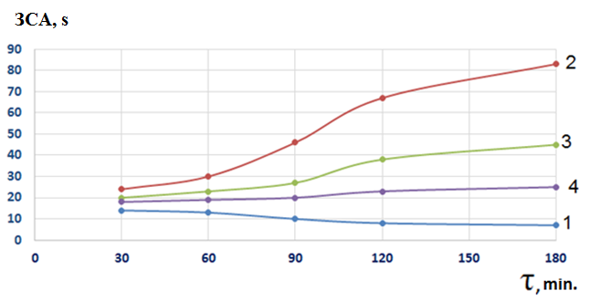
Phosphating solution 4: 1 - Phosphomet + 5 g / l m-NBS; 2 - Phosphomet + 2.5 g / l of nitrophenol; 3 - Tzinkar + 5 g / l m-NBS; 4 - Tzinkar + 2.5 g / l of nitrophenol
Figure 12 - Influence of the exposure time of phosphate coatings in model solution No.4 on the change in their corrosion resistance

According to Figure 12, with an increase in the exposure time of phosphate coatings in model solution No. 4, which is characterized by a high content of Na₂HCO₃ and CaCI₂ salts, a significant increase in the corrosion resistance of the coating deposited from the solution of Phosphomet + 2.5 g/l nitrophenol is observed (curve 2). After 180 minutes of the exposure time of the phosphate coating, its corrosion resistance increases to 82 s. Corrosion resistance of the phosphate coating from the solution of Phosphomet + 5 g/l m-NBS (curve 1) practically does not change when tested in model solution No. 4. The corrosion resistance of coatings deposited from a solution of Tzincar + 2.5 g/l of nitrophenol (curve 4) and from a solution of Tzincar + 5 g/l of m-NBS (curve 3) grows with increasing the exposure time to a lesser extent than the corrosion resistance of coating deposited from the Phosphomet solution + 2.5 g/l of nitrophenol (curve 2).
Thus, when testing phosphate coatings deposited from solutions of rust converters Phosphomet and Tzinkar in the presence of nitrophenol and m-NBS accelerators, an increase in the corrosion resistance of the coatings was observed in model solutions 1-4 with increasing test time. The exception is the coatings deposited from the Phosphomet + 5 g/l m-NBS solution. The corrosion resistance of these coatings decreased with increasing test time or remained unchanged. The highest corrosion resistance of the coatings deposited from the solution of the rust converter Phosphomet + 2.5 g of nitrophenol was observed in the model solution No.4. The corrosion resistance of such coatings was 82 s according to the Akimov method.

2.2 Testing the corrosion resistance of phosphate coatings in environments with different mineralization by the Tafel polarization curve method

In order to obtain independent information on the change in the corrosion resistance of phosphate coatings deposited from solutions of rust converters in environments with different mineralization, along with the Akimov drip method, the Tafel method of polarization curves was used.
Before recording the polarization curves, phosphate coatings were deposited on the surface of the iron electrode from solutions of the Phosphomet and Tzinkar rust converters with additives of nitrophenol and m-NBS accelerators at a temperature of 40°C, a deposition time of 10 min, and a stirring speed of 500 rpm. Then the resulting coatings were annealed in a drying oven at a temperature of 80°C for 15 minutes, after which the Tafel polarization curves were recorded in a 0.3M Na₂SO₄ solution.
A study of the change in the corrosion resistance of iron samples with a phosphate coating deposited from the Phosphomet solution in the presence of 2.5 g/l of nitrophenol, depending on the time of testing in a model solution No.1 at a temperature of 3°C (Figure 13).

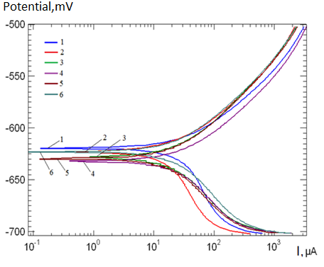
Deposition solution: Phosphomet + 2.5 g/l of nitrophenol, test time: 1 - 0; 2 - 30; 3 - 60; 4- 90; 5 - 120; 6 - 180 minutes
Figure 13 - Tafel dependences of an iron electrode with a phosphate coating on the test time in a model solution No. 1

According to Figure 13, a change in the test time for iron samples with a phosphate coating in a model solution No.1 leads to a shift in the corrosion potential to the region of negative potential values, which indicates a change in the corrosion resistance of the phosphate coating.
The change in the value of the corrosion potential of iron samples with a phosphate coating from the time of testing in a model solution No.1 is shown in Figure 14.

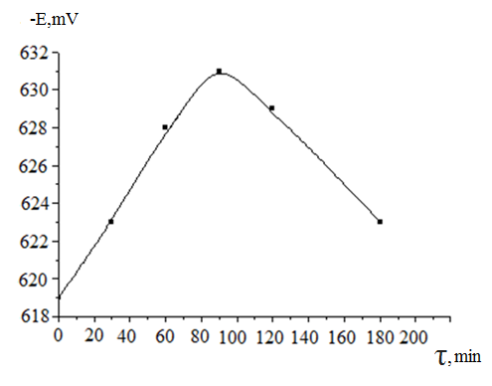
Deposition solution: Phosphomet in the presence of 2.5 g/l of nitrophenol, test time: 1–0; 2 - 30; 3 - 60; 4- 90; 5 - 120; 6 - 180 minutes
Figure 14 - Change in the value of the corrosion potential of an iron electrode with a phosphate coating from the time of testing in a model solution No.1

According to Figure 14, with an increase in the test time of the iron electrode with a phosphate coating in the model solution No. 1 from 30 to 90 minutes the corrosion potential determined on the basis of the Tafel curves is shifted to the region of more negative potentials, which indicates a decrease in the corrosion resistance of the coating. However, it can be observed that with a further increase in the test time of the coating in the model solution No. 1 over 90 minutes, the corrosion potential shifts, on the contrary, to the positive region. The lowest corrosion resistance of the phosphate coating was observed at a test time of 90 minutes. With a further increase in the test time, the corrosion resistance of the phosphate coating increases.
Tafel curves were obtained for an iron electrode with a phosphate coating deposited from a Phosphomet + 5 g/l m-NBS solution at a temperature of 30°C, a stirring speed of 500 rpm. from the time of testing in model solution No. 1 (Figure 15).

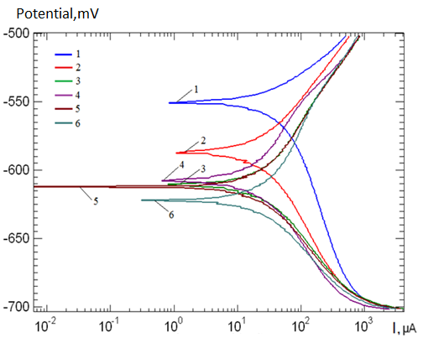
Deposition solution: Phosphomet + 5 g / l m-NBS, test time (min.): 1 - 0; 2 - 30; 3 - 60; 4- 90; 5 - 120; 6-180
Figure 15 - Tafel dependences of an iron electrode with a phosphate coating in a model solution No. 1

According to Figure 15, with an increase in the test time for iron samples with a phosphate coating in the presence of m-NBS in a model solution No. 1, the corrosion potential shifts to the region of more negative values, which indicates a decrease in the corrosion resistance of the phosphate coating.
The dependence of the change in the value of the corrosion potential of iron samples with a phosphate coating deposited from the Phosphomet solution in the presence of m-NBL on the test time in model solution 1 is shown in Figure 16.

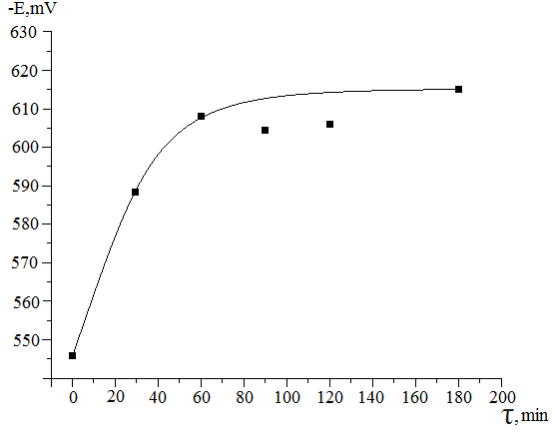
Deposition solution: Phosphomet + 5 g / l m-NBS, test time (min.): 1 - 0; 2 - 30; 3 - 60; 4- 90; 5 - 120; 6-180
Figure 16 - Change in the value of the corrosion potential of an iron electrode with a phosphate coating from the time of testing in a model solution No. 1

According to Figure 16, an increase in the test time for an iron electrode with a phosphate coating deposited from a Phosphomet + 5 g/l m-NBS solution in a model solution No. 1 from 30 to 60 minutes leads to a significant shift of the corrosion potential to the negative region, which indicates decrease in corrosion resistance of the coating. However, with a further increase in the test time of the coating in the model solution No. 1, the corrosion potential practically stabilizes, which is consistent with the determination of the corrosion resistance of similar phosphate coatings by Akimov's drip method (Figure 3).
The influence of the test time of phosphate coatings in the model solution No. 2, which is characterized by a significantly higher concentration of the initial salts in comparison with the model solution No. 1, has been investigated (Table 2). Figure 17 shows the Tafel dependences of an iron electrode with a phosphate coating deposited from a Phosphomet solution in the presence of 2.5 g/l nitrophenol on the test time in a model solution No.2 at 30°C and a stirring speed of 500 rpm.

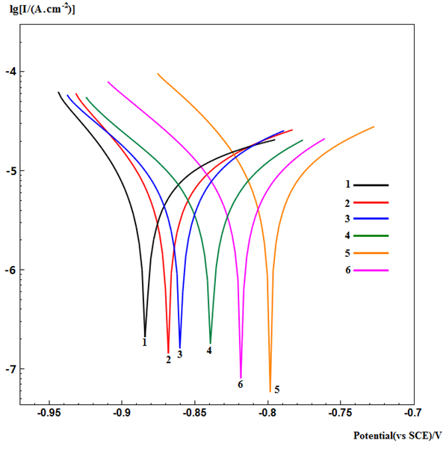
Deposition solution: Phosphomet + 2.5 g/l of nitrophenol, test time (min.): 1 - 0; 2 - 30; 3 - 60; 4- 90; 5 - 120; 6-180
Figure 17 - Tafel dependences of an iron electrode with a phosphate coating in a model solution No. 2

According to Figure 17, increasing the test time for iron samples with a phosphate coating in model solution No. 2 to 120 minutes leads to a shift of the corrosion potential in the area in the positive area. The shift of the corrosion potential to the positive region indicates an increase in the corrosion resistance of the formed coating. The maximum corrosion resistance of the coating is observed when the test time in model solution No. 2 is equal to 120 min. (curve 5). With a further increase in the test time, the corrosion potential shifts to the negative region, which indicates a decrease in the corrosion resistance of the phosphate coating (curve 6).
Figure 18 shows the dependence of the change in the corrosion potential on the test time of phosphate coatings in model solution No. 2, deposited from a solution of Phosphomet + 0.5 g of nitrophenol.

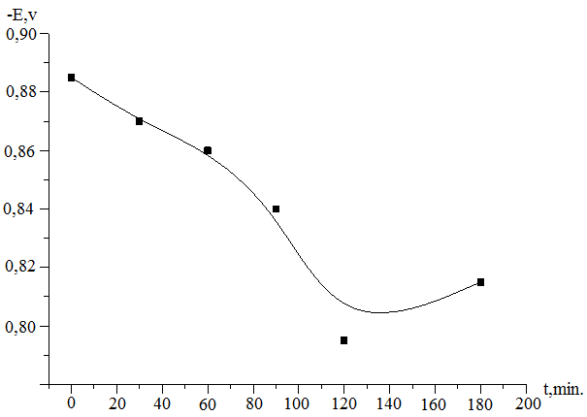
Deposition solution: Phosphomet + 0.5 g of nitrophenol
Figure 18 - Change in the value of the corrosion potential of an iron electrode with a phosphate coating from the time of testing in a model solution No. 2

The results obtained are in high agreement with the results of the drop method for determining the corrosion resistance according to Akimov (Figure 4, curve 2). It is interesting to note that the testing of phosphate coatings in model solution No. 2, which is distinguished by a higher concentration of initial salts as compared with model solution No. 1, leads to a more significant increase in the corrosion resistance of the phosphate coating.
A study of the change in the corrosion resistance of iron samples with a phosphate coating deposited from the Phosphomet solution in the presence of m-NBS at different test times in the model solution No. 2 (Figure 19) was carried out.

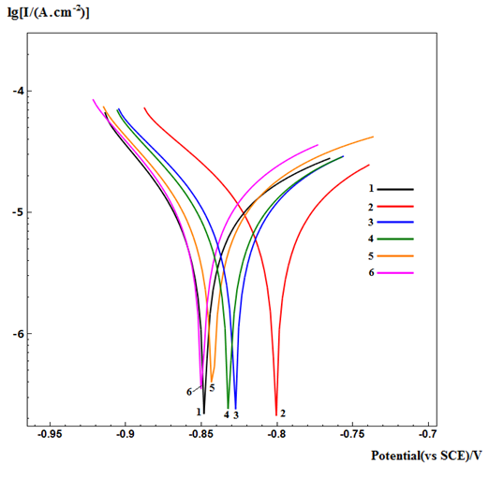
Deposition solution: Phosphomet + 5 g / l m-NBS; Test time: 1 - 0; 2 - 30; 3 - 60; 4- 90; 5 - 120; 6-180
Figure 19 - Tafel dependences of an iron electrode with a phosphate coating at different test times in a model solution No. 2

According to Figure 19, an increase in the test time of the phosphate coating deposited from the Phosphomet + 5 g/l m-NBS solution in the model solution No. 2 leads to a smaller shift in the corrosion potential as compared to the model solution No.1, which indicates a smaller change in the corrosion resistance of the formed phosphate coating.
Figure 20 shows the dependence of the change in the corrosion potential at different test times for phosphate coatings deposited from a solution of Phosphomet + 0.5 g of nitrophenol in a model solution No.2.

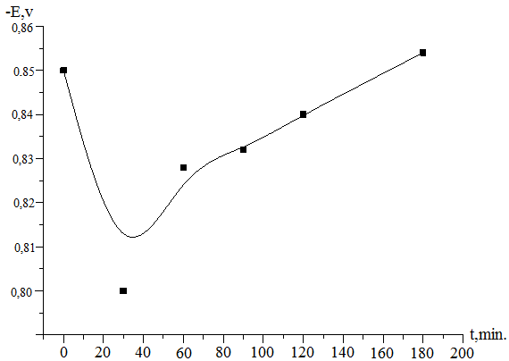
Deposition solution: Phosphomet + 5 g/l m-NBS, test time (min): 1 - 0; 2 - 30; 3 - 60; 4- 90; 5 - 120; 6-180
Figure 20 - Dependence of the change in the value of the corrosion potential of the iron electrode

According to Figure 20, when testing a phosphate coating deposited from a Phosphomet solution + 5 g/l m-NBS in the first 30 minutes there is a shift in the corrosion potential towards less negative values, which indicates an increase in the corrosion resistance of the coating. However, with a further increase in the test time, there is a shift in the corrosion potential towards more values that are negative, i.e. there is a decrease in the corrosion resistance of the phosphate coating. When testing the phosphate coating for 180 min. the value of its corrosion potential becomes equal to the value of the corrosion potential (-0.849V) of the original phosphate coating, not tested in an aggressive environment.
When comparing the behavior of the corrosion potential of iron samples with phosphate coatings deposited from a Phosphomet solution in the presence of m-NBS, from the time of testing in model solutions 1 and 2, it was concluded that phosphate coatings exhibit greater corrosion resistance in model solution No. 1, while their corrosion resistance decreases in model solution No. 2.
Thus, an increase in the concentration of salts in the model solution leads to a decrease in the corrosion resistance of phosphate coatings deposited from the Phosphomet + 5 g /l m-NBS solution.

Investigation of phosphate coatings in model solution No. 3
Model solution No. 3 differs from model solutions No. 1 and No. 2 in the composition of the initial components. Model solution No. 3 is characterized by the absence of NaCI and MgSO₄ salts, as well as by the presence of a high concentration of HCO³⁻, SO₄²⁻ and Ca² ⁺ ions (Table 2).
A study of the change in the corrosion resistance of iron samples with a phosphate coating deposited from the Phosphomet solution in the presence of 2.5 g / L nitrophenol, depending on the test time in the model solution No. 3 at a temperature of 30 °C (Figure 21) was carried out.

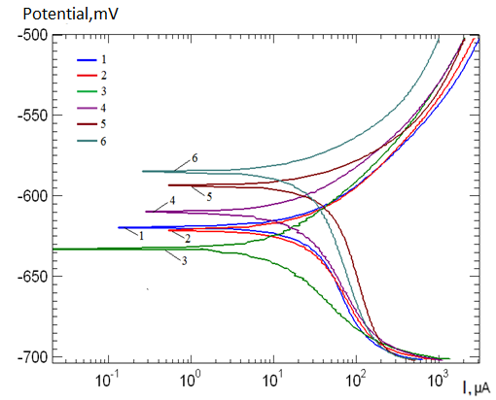
Deposition solution: Phosphomet in + 2.5 g / l of nitrophenol; test time (min.): 1 - 0; 2 - 30; 3 - 60; 4- 90; 5 - 120; 6-180
Figure 21 - Tafel dependences of an iron electrode with a phosphate coating on the test time in a model solution No. 3

With an increase in the test time of phosphate coatings in the model solution No. 3 over 60 min. there is a shift in the corrosion potential to the positive region, i.e. an increase in the corrosion resistance of the phosphate coating.
The dependence of the change in the value of the corrosion potential of iron samples with a phosphate coating deposited from the Phosphomet + 2.5 g/l nitrophenol solution on the time of exposure in the model solution No. 3 is shown in Figure 22.

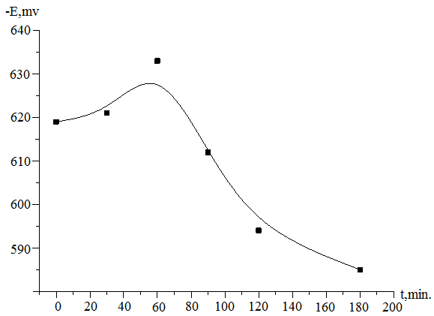
Deposition solution: Phosphomet + 2.5 g nitrophenol, test time (min.): 1 - 0; 2 - 30; 3 - 60; 4- 90; 5 - 120; 6-180
Figure 22 - Change in the value of the corrosion potential of an iron electrode with phosphate coating on the time of testing in a model solution No. 3

According to Figure 22, with an increase in the test time for an iron electrode with a phosphate coating deposited in model solution No. 3 up to 60 min. the corrosion potential, determined from the Tafel curves, shifts towards more negative values ​​by 10 mV, which indicates a slight decrease in corrosion resistance. With a further increase in the test time from 60 to 180 min., there is a sharp shift in the corrosion potential to the positive region by 50 mV, which indicates a significant increase in the corrosion resistance of the phosphate coating. The results obtained correspond to the data on the determination of the corrosion resistance of similar coatings by the Akimov method (Figure 3, curve 2).

3 Testing of the obtained phosphate coatings in corrosive environments with different hydrodynamic conditions
3.1 Determination of the corrosion resistance of phosphate coatings in the waters of the pavlodar petrochemical plant according to the Tafel curves

To assess the corrosion resistance of phosphate coatings in industrial water of the Pavlodar Petrochemical Plant coatings were selected that showed the highest corrosion resistance in model solutions: phosphate coatings deposited by their solution Phosphomet + 2.5 g/l nitrophenol and Phosphomet + 5 g/l m -NBS.
The composition of the Pavlodar Petrochemical Plant water is shown in Table 3.

Table 3 - Process water composition
Chemical name | Unit of measurement | Found | Test method
Hydrogen exponent | PH units | 5,068 | GOST 26449.1-85
General hardness | Mmol/dm³ | 0,20 | GOST 4151-72
Carbonates (CO₃²⁻⁾ | Mg/dm³ | 6,0 | GOST 26449.2-85, p. 5
Calcium (Ca ²⁺) | Mg /dm³ | 2,0 | GOST 26446.1-85, p. 11.1
Magnesium (Mg ²⁺) | Mg /dm³ | 1,2 | GOST 6449.1-85, p. 12
Sulphates (SO₄²⁻⁾ | Mg /dm³ | 6,2 | GOST 4389-72
Chlorides (CI⁻) | Mg /dm³ | 10,6 | GOST 4245-72

The anticorrosive properties of the obtained phosphate coatings were evaluated using polarization curves according to Tafel. In this regard, coatings were obtained on the surface of the iron electrode from a Phosphomet solution containing 2,5 g/l of nitrophenol at a temperature of 30 ° C, a deposition time of 10 min, and a stirring speed of 500 rpm. Then the resulting coatings were annelid in a drying oven at a temperature of 80°C for 15 minutes, after which the Tafel polarization curves were recorded in a 0.3M Na₂SO₄ solution. Figure 23 shows the Tafel curves of a phosphate-coated iron electrode after testing in an aggressive environment (industrial water) for various times.
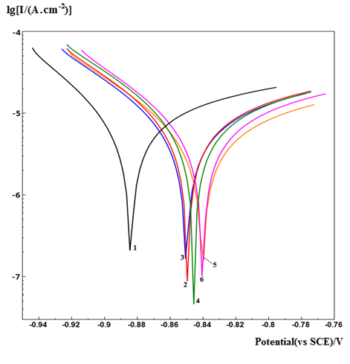
Deposition solution: Phosphomet + 2.5 g / l nitrophenol, test time (min): 1 - 0; 2 - 30; 3 - 60; 4- 90; 5 - 120; 6-180
Figure 23 - Tafel dependences of an iron electrode with a phosphate coating on the test time in industrial water

According to Figure 23, the corrosion potential of the phosphate coating deposited from the Phosphomet + 2.5 g /l nitrophenol solution, with an increase in the test time in plant water, shifts to the region of less negative potential values, i.e. an increase in its corrosion resistance is observed.
The dependence of the change in the value of the corrosion potential of iron samples with phosphate deposited from a solution of Phosphomet + 2.2 g /l of nitrophenol, on the time of testing in industrial water is shown in Figure 24.

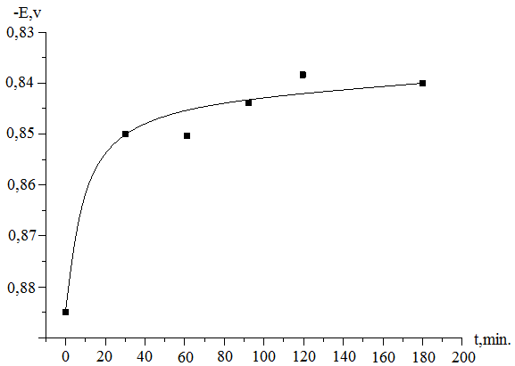
Deposition solution: Phosphomet + 2.5 g/l nitrophenol, test time: 1 - 0; 2 - 30; 3 - 60; 4- 90; 5 - 120; 6-180
Figure 24 - Dependence of the change in the value of the corrosion potential of an iron electrode with a phosphate coating on the test time in factory water

According to Figure 24, the most significant shift in the corrosion potential of an iron electrode with a phosphate coating deposited from a Phosphomet + 2.5 g/l nitrophenol solution to the positive region occurs in the first 30 minutes of testing in factory water. The corrosion potential of the coating not tested in factory water is -0.884 V, and with a test time of 30 minutes its value was -0.850 V. However, it can be observed that with a further increase in the test time of the phosphate coating in the plant water, the corrosion potential changes insignificantly.
Consequently, the test of phosphate coatings deposited from the Phosphomet solution in the presence of 2.5 g /l of nitrophenol leads to a significant increase in its corrosion resistance at the beginning of the test, in the first 30 minutes. Subsequently, an increase in test time helps to stabilize the phosphate coating.
A different picture is observed in the study of the corrosion resistance of phosphate coatings deposited from the Phosphomet solution in the presence of m-NBS after testing them in an aggressive environment (factory water). Figure 25 shows the Tafel dependences obtained on an iron electrode with phosphate coatings deposited from a Phosphomet solution in the presence of m-NBS, after testing in industrial water for various times.
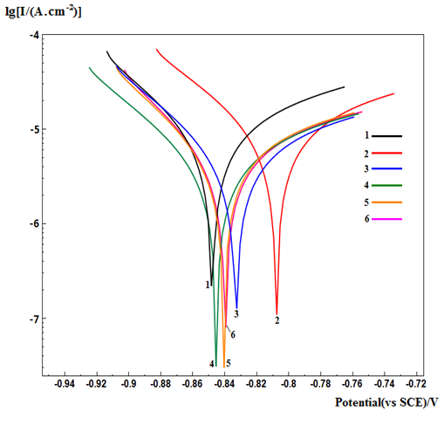
Precipitation solution: Phosphomet + 5 g / l m-NBS, test time (min.): 1 - 0; 2 - 30; 3 - 60; 4- 90; 5 - 120; 6-180
Figure 25 - Tafel dependences of an iron electrode with a phosphate coating at different test times in industrial water

Based on the experimental data obtained, the dependence of the change in the value of the corrosion potential of the iron electrode with a phosphate coating on the test time in industrial water was obtained (Figure 26).
According to Figure 26, an increase in the test time of a phosphate coating deposited from a Phosphomet + 5 g/l m-NBS solution industrial water in the first 30 min leads to a significant shift in the corrosion potential to the positive region (-0.808V), which is due to an increase in corrosion resistance in comparison with the coating not tested in aggressive environment (-0,849V). With a further increase in the test time, a reverse shift of the corrosion potential to more negative values ​​is observed, i.e. there is a decrease in the corrosion resistance of the coating and its further stabilization. When comparing the Tafel dependences shown in Figures 23 and 25, it can be concluded that with a short test time of up to 30 min. in an aggressive environment (plant water), the corrosion resistance of phosphate coatings deposited from the Phosphomet solution in the presence of nitrophenol and m-NBS increases. Further increase in the holding time from 90 to 180 minutes leads to stabilization of the corrosion resistance of phosphate coatings deposited from the Phosphomet + 2.5 g / L nitrophenol solution and to a slight decrease in corrosion resistance with further stabilization of the phosphate coatings deposited from the Phosphomet + 5 g/l m-NBS solution.

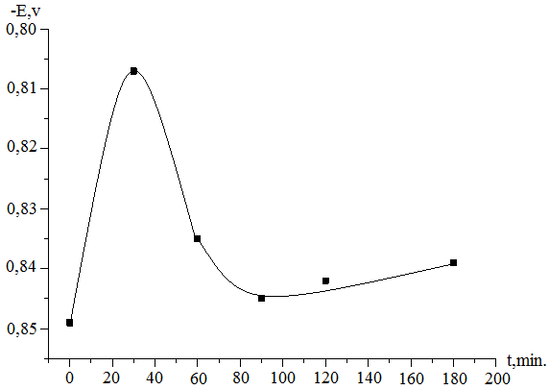
Deposition solution: Phosphomet + 5 g / l m-NBS
Figure 26 - Dependence of the corrosion potential of an iron electrode with a phosphate coating on the test time in industrial water

Thus, on the basis of the carried out studies of the corrosion resistance of phosphate coatings deposited from solutions of rust converters in the presence of accelerators, it was found that phosphate coatings deposited from a solution of the rust converter Phosphomet in the presence of 2,5 g/l nitrophenol have the highest corrosion resistance in aggressive waters of the Pavlodar petrochemical plant.

3.2 Determination of the corrosion resistance of phosphate coatings in the waters of the pavlodar petrochemical plant with different hydrodynamic conditions

The effect of the stirring rate during testing of phosphate coatings deposited from a Phosphomet solution in the presence of 2.5 g/l of nitrophenol and 5 g/l of MNBS was studied.
Figure 27 shows the change in the corrosion resistance of phosphate coatings depending on the test time in the water of the Pavlodar petrochemical plant. Determination of corrosion resistance was carried out by Asimov’s drop method.

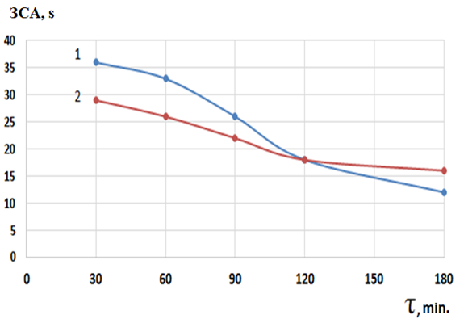
Precipitation solution: 1 - Phosphomet + 5 g/l m-NBS; 2 - Phosphomet + 2.5 g/l nitrophenol
Figure 27 - Effect of stirring speed during the test of the phosphate coating in the industrial water

According to Figure 27, the corrosion resistance of phosphate coatings deposited from the Phosphomet solution decreases with an increase in the mixing rate of the industrial water. The greatest change in resistance is observed in phosphate coatings deposited from a solution of Phosphomet + 5g/l m-NBS. With a change in the stirring speed from 200 to 700 rpm, the corrosion resistance of this phosphate coating decreases from 35 s to 12 s by the Akimov method. Corrosion resistance of the coating deposited by their solution Phosphomet + 2.5 g/l of nitrophenol changes to a lesser extent with increasing stirring speed. With a change in the stirring speed from 200 to 700 rpm, the corrosion resistance of the coating decreases from 29 s to 15 s. With a test time of 120 min. and a mixing rate of the industrial water of 500 rpm, the corrosion resistance of the coatings deposited from both solutions has the same value of 18 s.
Thus, a change in hydrodynamic conditions when testing phosphate coatings deposited from a solution of the Phosphomet rust converter leads to an insignificant change in their corrosion resistance.

CONCLUSION

For the period of work from 2018 to 2020 systematic, complex and applied research was carried out to develop high-tech processes for the formation of anticorrosive phosphate coatings, based on industrial rust converters, taking into account modern requirements and trends
In 2018, according to the schedule and terms of reference, the optimal conditions for the formation of adhesive phosphate coatings on iron samples (time, temperature, stirring rate) were determined by the chemical method and using cyclic volt-ampere curves according to the change in the value of the maximum current (A) from phosphating solutions FR- 1; FR-2; FR-3 and FR-4.The results are compared between the protective properties of the phosphate film by the Akimov drop method and the method of cyclic voltammetry. The effect of the accelerator of the phosphating process, hydroxylamine, on the corrosion resistance of phosphate films on iron samples is considered. The optimal concentration of hydroxylamine for the formation of a phosphate film on an iron electrode was determined. Using scanning electron microscopy, the structure and elemental composition of the coatings being formed have been established. It has been shown that the most dense and fine-grained coating is observed when using FR-1 (4) as a phosphating solution having the following composition: ZnO - 1.16 g/l; NiNO₃.6H₂O - 0.5208 g /l; HNO₃ 0.614 ml; H₃PO₄ - 1.472 ml; NaOH - 0.252 g /l with the addition of 0.5 g |/l of hydroxylamine.
In 2019, according to the schedule and terms of reference, solutions for the deposition of phosphate coatings based on rust converters, Phosphomet and Tzinkar with additives of nitrophenol and sodium 3-nitrobenzenesulfonate accelerators were developed; the optimal conditions for the formation of phosphate coatings (concentration of the accelerator, temperature, time, stirring speed) have been determined; it was shown that phosphate coatings obtained from a solution containing Phosphomet with additives of nitrophenol have the highest corrosion resistance; an electrochemical method is proposed for determining the corrosion resistance of phosphate coatings, based on measuring the ionization current of an iron electrode at a certain potential on cyclic volt-ampere curves; Corrosion tests of phosphate coatings were carried out using the Tafel method of polarization curves and the Akimov method. A study of the effect of accelerators of the phosphating process of nitrophenol and m-NBS on changes in the surface structure of the deposited coatings, roughness, thickness and adhesion was carried out.
Conclusions on the results of the research work done in 2020:
1 A new electrochemical method for determining the optimal composition of anticorrosive coatings on steel has been proposed. The composition of the formed phosphate coating is determined by the value of the concentration of the accelerator, which does not depend on the number of cycles of the cyclic volt-ampere curves of the steel electrode.
2 It has been shown that the developed electrochemical method for determining the optimal composition of phosphate coatings is in high agreement with the determination of the optimal composition by Akimov's drop method.
3 The use of the electrochemical method of cyclic voltammetry made it possible to establish the optimal concentration of phosphating accelerators of various natures, which provides complete anticorrosive protection of phosphate films on the surface of iron samples and optimal conditions for the deposition of coatings at different concentrations of accelerators.
4 It has been shown that phosphate coatings deposited from a solution of the Phosphomet rust converter in the presence of phosphating accelerators nitrophenol and sodium m-nitrobenzenesulfonate (m-NBS) have the highest corrosion resistance
5 It was found that the optimal concentration of nitrophenol, at which the maximum corrosion resistance of the formed phosphate coatings in the Phosphomet solution is observed, is a concentration of 2–2.5 g / l.
6 The effect of pH on the corrosion resistance of the formed phosphate coatings has been studied. It was shown that phosphate coatings deposited from Phosphomet solution in the presence of nitrophenol phosphating accelerator at pH = 6.7, as well as phosphate coatings deposited from Tzincar solution in the presence of m-NBS phosphating accelerator at pH = 7.8 have the highest corrosion resistance.
7 The change in the corrosion resistance of phosphate coatings was investigated when testing them in model solutions differing in composition and different contents of the initial components.
8 It has been shown that an increase in the mineralization of solutions for testing phosphate coatings leads to an increase in the corrosion resistance of phosphate coatings deposited from solutions Phosphomet + 0.5 g /l of nitrophenol and Tzinkar + 5g /l of m-NBS, but contributes to a decrease in the corrosion resistance of coatings from the Phosphomet solution + 5 g /l m-NBS.
9 The highest corrosion resistance of coatings deposited from a solution of a rust converter Phosphomet + 2.5 g/l of nitrophenol was observed in a model solution characterized by a high content of Na₂HCO₃ and CaCI₂. Corrosion resistance of such coatings was 82 s according to Akimov's method.
10 The obtained coatings were tested in environments with high mineralization (industrial water of the Pavlodar petrochemical plant). The highest corrosion resistance was shown by phosphate coatings deposited from the Phosphomet rust converter solution in the presence of 2.5 g /l of nitrobenzene. Moreover, at the beginning of the test, there is an increase in the corrosion resistance of phosphate coatings with their further stabilization.
The use of an integrated approach to the development of adhesive phosphate coatings based on rust converters, as well as the study of the anticorrosive properties of the obtained coatings using independent, modern, high-resolution chemical, physical and electrochemical methods of analysis, complementing each other, allow us to conclude that the solution of the tasks posed is complete.
The developed domestic import-substituting technologies for obtaining adhesive phosphate coatings are distinguished by low energy consumption, since the coating is applied at a temperature of 25-30 ° C; high manufacturability, since it is not required to strictly control the parameters of the solution and the phosphating process itself the absence of hydrogen evolution, which contributes to good adhesion of phosphates to the metal surface; lack of sludge and negative impact on the environment; low cost and time of formation of a phosphate coating and can be recommended for use at industrial facilities (chemical, metallurgical, machine-building and oil-producing industries).
The established patterns in the formation of adhesive low-temperature phosphate coatings based on rust converters are characterized by scientific novelty and relevance. The foregoing allows us to conclude about the high scientific and technical level of the completed report, comparable to the research of leading specialist from foreign countries.
Based on the results of research on the project:
For 2020, 6 articles were published: 1 article in a foreign scientific publication with a nonzero IF; 4 articles in Scopus databases with nonzero IF and 1 article in a domestic scientific publication with nonzero IF and 1 abstracts at an international conference.
For 2018-2020, 8 articles were published: 1 article in a foreign scientific publication with a non-zero IF; 5 articles in Scopus databases with non-zero IF and 1 article in a domestic scientific publication with non-zero IF and 1 abstracts at the International Conference.

REFERENCES

1 Vagramyan T. A., Grigoryan N. S., Mazurova D. V., Abrashov A. A., Akimova E. F. Phosphating. Current state and prospects of development in Russia // Corrosion: materials, protection. – 2011. – No 2. – P. 20–27. (in Russ.)
2 Abrashov A.A., Rozanova D.I., Grigoryan N.S., Vagramyan T.A., Akimova E.F., Kolesnikov V.A., Asnis N.A. On the possibility of replacing chromating processes with phosphating processes of galvanized surface. Corrosion: materials, protection. – 2011. – No 11. – P. 44–48. (in Russ.)
3 Abrashov A.A., Chamashkina N.N., Yurieva G.A., Grigoryan N.S., Vagramyan T.A. Improving the technology of applying phosphate layers // Electroplating and surface treatment. – 2012. – No. 4. – P. 41–46. (in Russ.)
4 Grigoryan N.S., Abrashov A.A., Kulyushina N.V., Vahramyan T.A. Protective metal and conversion coatings. Laboratory practice. –M.: D.I. Mendeleev University of Chemical technology of Russia, 2013. – 150 p. (in Russ.)
5 Banczek E.P., Rodrigues P.R.P., Costa I. Investigation on the effect of benzotriazole on the phosphating of carbon steel // Surface & Coatings Technology. -2006. – №6. – P. 3701–3708.
6 Popic J.P, Jegdic´ B.V., Bajat J.B., Veljovic´ Ð., Stevanovic´ S.I., Miskovi-Stankovi V.B. The effect of deposition temperature on the surface coverage and morphology of iron-phosphate coatings on low carbon steel // Applied Surface Science. – 2011. – № 24. – P. 10855–10862.
7 Yu hui Xie, Ming zhi Chen, De long Xie, Li Zhong, Xin ya Zhang. A fast, low temperature zinc phosphate coating on steel accelerated by graphene oxide // Corrosion Science. – 2017. –V.128, – P. 1–8.
8 De liang He, Fan cai Chen, An hong Zhou, Li hua Nie, Shou zhuo Yao. Real-time monitoring of zinc phosphating process by quartz crystal impedance system // Thin Solid Films. – 2001. –№ 1-2. – P. 263–270.
9 Chao-Min Wang, Han-Chih Liau, Wen-Ta Tsai. Effects of temperature and applied potential on the microstructure and electrochemical behavior of manganese phosphate coating // Surface and Coatings Technology. –2006. – No 6.– P. 2994–3001.
10 Banczek E.P., Rodrigues P.R.P., Costa I. The effects of niobium and nickel on the corrosion resistance of the zinc phosphate layers // Surface & Coatings Technology. – 2008. – № 10. – P. 2008–2014.
11 Sinha P.K, Feser R. Phosphate coating on steel surfaces by an electrochemical method // Surface and Coatings Technology. – 2002. –№ 2-3. – P. 158–168.
12 Feng Fang, Jing-hua Jiang, Shu-Yong Tan, Ai-bin Ma, Jian-qing Jiang. Characteristics of a fast low-temperature zinc phosphating coating accelerated by an ECO-friendly hydroxylamine sulfate // Surface and Coatings Technology. –2010. –№ 15. – P.2381–2385.
13 Peultier J., Rocca E., Steinmetz J. Zinc carboxylating: a new conversion treatment of zinc // Corrosion Science. – 2003. –№ 8. – P. 1703–1716.
14 Mazurova D.V., Grigoryan N.S., Akimova E.F., Abrashov A.A., Vagramyan T.A., Kharlamov V.I. Simultaneous phosphatizing of steel, galvanized steel, and aluminum // Protection of Metals and Physical Chemistry of Surfaces. – 2009. –№3. – P. 68–72.
15 Zimmermann D., Munoz A.G., Schultze J.W. Microscopic local elements in the phosphating process // Electrochimica Acta. – 2003. –№4. – P. 3267–3277.
16 Abrashov A.A., Grigoryan N.S., Vagramyan T.A., Akimova E.F. Improvement of solutions of crystalline phosphating // Electroplating and surface treatment. – 2010. – N.3. – P. 48–52. (in Russ.)
17 Abrashov A.A., Grigoryan N.S., Vagramyan T.A., Papirov R.V. Styazhkina M.I. Low-temperature solutions for crystalline phosphating // Electroplating and surface treatment. – 2013. – № 4. – P. 40–45. (in Russ.)
18 Abrashov A.A., Chamashkina N.N. Yur’eva G.A., Grigoryan N.S., Vagramyan T.A. Improvement in the phosphating process // Electroplating and surface treatment. – 2012. – № 4. – P. 7–12. (in Russ.)
19 Tepe Bulent, Gunay Banihan. Evaluation of pre-treatment processes for HRS (hot rolled steel) in powder coating // Progress in Organic Coatings. – 2008. – V. 62. – P.134-144.
20 T.S.N. Sankara Narayanan. Surface pretreatment by phosphate conversion coatings // Reviews on Advanced Materials Science. – 2005. – № 9. – Р.134-137.
21 Kruglova JI.H., Machevskaya R.A. Study of the steel surface at the initial stage of the formation of zinc phosphate layers by Auger spectroscopy // Paints and varnishes and their application. – 1985. – № 5. – P. 23–26 (in Russ.)
22 Afshar A., Hasannejad H. Effect of current density on DC electrochemical phosphating of stainless steel 316 // Surface and Coatings Technology. – 2010. – № 7. – P. 2302-2306.
23 Banczek E.P., Rodrigues P.R.P., Costa I. Investigation on the effect of benzotriazole on the phosphating of carbon steel // Surface and Coatings Technology. – 2006. –№ 12. – P. 3701–3708.
24 Ptacek B., Dalard F., Rameau J.J. Iron phosphating in a trichloroethylene solution // Surface and Coatings Technology. – 1996. –№ 8. – P. 277–283.
25 Losch A., Schultze J.W. Impedance spectroscopy and other electrochemical in-situ investigations of the phosphating process // Journal of Electroanalytical Chemistry. – 1993. – Vol. 359, – № 11. – P. 39–61.
26 Amadeh A., Sadreddini S. Application of magnesium phosphate coating on low carbon steel via electrochemical cathodic method and investigation of its corrosion resistance // J. of Alloys and Compounds. – 2015. – № 10. – P. 956–958.
27 Sankara Narayanan T.S.N., Jegannathan S., Ravichandran K. Corrosion resistance of phosphate coatings obtained by cathodic electrochemical treatment: Role of anode–graphite versus steel // Progress in Organic Coatings. – 2006. – № 4. – P. 355–362.
28 Grigoryan N.S., Akimova E.F., Vahramyan T.A. Phosphating. M: Globus, 2008. – 144p.
29 Kazarinov I.A., Makhmmod A.A., Trepak N.M., Isaicheva L.A. Cold phosphating of low carbon steel // Eurasian Union of Scientists. – 2016. – №3-4. – P. 101–105.
30 Tamilselvi M., Kamaray P., Arthanareeswari M., Devikala S. Nano zinc phosphate coatings for enhanced corrosion resistance of mild steel // Applied Surface Science. – 2015. – Vol. 327. – P. 218–225.
31 Xie Y., Chen M., Xie D., Zhong L., Zhang X. A fast, low temperature zinc phosphate coating on steel accelerated by graphene oxide // Corrosion Science. – 2017. – Vol.128. – P. 1–8.
32 Zubielewicz M., Kamińska-Tarnawska E., Kozłowska A. Protective properties of organic phosphate-pigmented coatings on phosphated steel substrates // Progress in Organic Coatings. –2005. – Vol.53. – P. 276–285.
33 Verbruggenn H., Baert K., Terryn H., De Graeve I. Molybdate-phosphate conversion coatings to protect steel in a simulated concrete pore solution // Surface and Coatings Technology, – 2019. – №361. – Р. 280–291.
34 Amini R., Vakili H., Ramezanzadeh B. Studying the effects of poly (vinyl) alcohol on the morphology and anti-corrosion performance of phosphate coating applied on steel surface // Journal of the Taiwan Institute of Chemical Engineers. – 2016. – No 58. – Р.542–551.
35. Jegdić B.V, Bajat J.B., Popić J.P., Mišković-Stanković V.B. Corrosion stability of polyester coatings on steel pretreated with different iron–phosphate coatings // Progress in Organic Coatings. – 2011. – No 70. – Р.127–133.
36 Ramanauskas R., Girčienė O., Gudavičiūtė L., Selskis A. The interaction of phosphate coatings on a carbon steel surface with a sodium nitrite and silicate solution // Applied Surface Science. – 2015. – No 327. – Р.131–139.
37 Liascukiene I., Ben Salah M, Sabot R., Refait Ph., Dhouibi L., Méthivier C., Landoulsi J., Jeannin M. Deciphering the role and nature of phosphate species at the surface of stainless steel immersed in phosphoric acid solutions // Applied Surface Science. – 2018. – No 434. –Р.561–572.
38 Sankara Narayanan. Surface Pretreatment by Phosphate Conversion Coatings // Reviews on advanced materials science. – 2005. – No 9. – Р.130–177.
39 Narayan Chandra. Importance of Surface Preparation for Corrosion Protection of Automobiles // Journal of Surface Engineered Materials and Advanced Technology. – 2013. – No 3. – Р. 94–105.
40 Filip Pastorek, Kamil Borko, Stanislava Fintová, Kajánek Daniel and Branislav Hadzima. Effect of surface pretreatment on quality and electrochemical corrosion properties of manganese phosphate on S355J2 HSLA steel // Coatings. – 2016. – No 6. –Р. 46 – 54.
41 Abrashov A.A., Grigoryan N.S., Vahramyan T.A., Akimova E.F. Improvement of crystalline phosphating solutions // Electroplating and surface treatment. – 2010. – No 3. – P. 48–52. (in Russ.)
42 Statsyuk V.N., Sultanbek U., Fogel L.A. The effect of hydroxylamine on the phosphating of iron in sulfate solutions // Bulletin of the NAS of the Republic of Kazakhstan. – 2016. – No 5. –Р. 197-199. (in Russ.)
43 Statsyuk V.N., Fogel L.A., Bold A. Determination of optimal conditions for the formation of phosphate coatings on brass by voltammetric method // Electroplating and surface treatment. – 2016. – No 4. – P. 56–60. (in Russ.)
44 Statsyuk V.N., Fogel L.A., Bold A. Cyclic current-voltage curves of a phosphate-coated brass electrode // Bulletin of the NAS of the Republic of Kazakhstan. – 2016. – No 2. – P.129–135. (in Russ.)
45 Statsyuk V.N., Fogel L.A., Bold A., Sultanbek U. Cyclic volt-ampere curves of an iron electrode with a phosphate coating // Bulletin of the NAS of the Republic of Kazakhstan. – 2017. – No 3. – P. 52–59. (in Russ.)
46 Statsyuk V.N, Fogel L.A, Ait S, Vagramyan T. A, Abrashov A. A. 4th international congress on «Technology engineering and science – 2017: еffect of electrolyte composition on electrode reactions of iron at potentials of its active dissolution» // Abstract Book. – 2017. – No 1. – P. 1–5.
47 Statsyuk V.N., Ait Sauyk, Zhurinov M.Zh., Fogel L.A., Abrashov A.A. Electrode reactions of phosphonic compounds of ATMP and HEDP on a platinum and glass-carbon electrodes // Bulletin of the NAS of the Republic of Kazakhstan. – 2017. – No 5 (425). – P.220–225. (in Russ.)
48 Statsyuk V.N., Ait S., Zhurinov M.Zh., Fogel L.A., Abrashov A.A. The relationship between the adsorption characteristics of amines on mercury and their inhibitory ability on iron // Reports of the National Academy of Sciences of the Republic of Kazakhstan. – 2017. – № 316. – P. 23–29. (in Russ.)
49 Statsyuk V.N., Sauyk A., Fogel L.A., Zhurinov M.Zh., Abrashov A.A. Corrosion processes on iron electrode in presence of heterocyclic amines // Oriental journal of chemistry. – 2017. – No 33. – P. 2868–2874.
50 GOST 9.302-88 Unified system of protection against corrosion and aging. Metallic and non-metallic inorganic coatings. Control methods. – М.: Publishing house of standards. 1990. – 40 p. (in Russ.)

APPLICATION А
List of published scientific works

Foreign publications for 2018:
1 Statsyuk V.N., Fogel L.A., Ait S., Zhurinov M.Zh., Kalinkina A.A., Vagramyan T.A., Abrashov A.A. Kinetics of cathodic reduction of iron ionization products in neutral solutions // Practice of anti-corrosion protection. – 2018. – No. 3 (89). – P. 51 - 56. (IF RSCI -0.2) (in Russ.)

Foreign publications for 2019:
1 Zhurinov M. Zh., Statsyuk V.N., Fogel L.A., Bold A., Abrashov A.A. and Kostiuk A.. Determination of the optimal deposition conditions oxide-zirconium coating on steel base // Rasayan Journal of Chemistry. – 2019. – №12(3). – P.1287–1293. IF –1,8. Percentile – 52 (Scopus)

Foreign publications for 2020:
1 Statsyuk V.N., Bold A., Fogel L.A., Sultanbek U. and Tilepbergen Zh. Determination of the conditions of phosphate coatings formation on iron by voltammetric method // Rasayan Journal of Chemistry – 2020. – №13(1). – P. 339–345. IF –1,8. Percentile – 52 (Scopus).
2 Statsyuk V., Bold A., Zhurinov M., Fogel L., Sassykova L., Vagramyan T., Abrashov А. Using cyclic voltammetry to determine the protective ability of phosphate coatings // Funct. Mater. – 2020. – №27 (3). – P.605–610. IF –0,6. Percentile – 19 (Scopus).
3 Bold A., Fogel L.A., Statsyuk V.N., Sassykova L.R., Sultanbek U., Ait S., Tilepbergen Zh. Zh., Vagramyan T.A., Abrashov A.A. Using of rust converters for deposition of anti-corrosion coatings // Materials today proceedings. – 2020. – №31. – P. 502–504. IF –1,7. Percentile – 39 (Scopus).
4 Statsyuk Vadim, Fogel Lidiya, Bold Amangul, Sultanbek Ularbek, Ait Sauik, Sassykova Larissa. Protective properties of phosphate coatings based on rust converters // Journal of Chemical Technology and Metallurgy. – 2020. – №55(6). – C. 2151–2157. IF –1. Percentile – 39 (Scopus)

National publications for 2020:
1 Statsjuk V.N., Fogel L.A., Zhurinov M.Zh., Bold А., Sultanbek U., Tilepbergen Zh., Ait S., Sassykova L., Vagramyan T.A., Abrashov A.A. Accelerated low-temperature phosphating from solutions of rust converters // News of the National Academy of sciences of the Republic of Kazakhstan, series chemistry and technology. – 2020. – №439(1). – P. 79–86. IF Kaz BC 0,251
2 Bold A., Statsyuk V.N., Fogel L.A., Sasykova L.R. Determination of protective properties of anticorrosive coatings on steel by voltammetric method // Chemical technologies of functional materials: 6th International Russian-Kazakhstani scientific conference, "Almaty -2020". – Almaty, 2020. - Vol. 1. – P.36–39 (in Russ.)
APPLICATION B
Calendar plans for 2018-2020
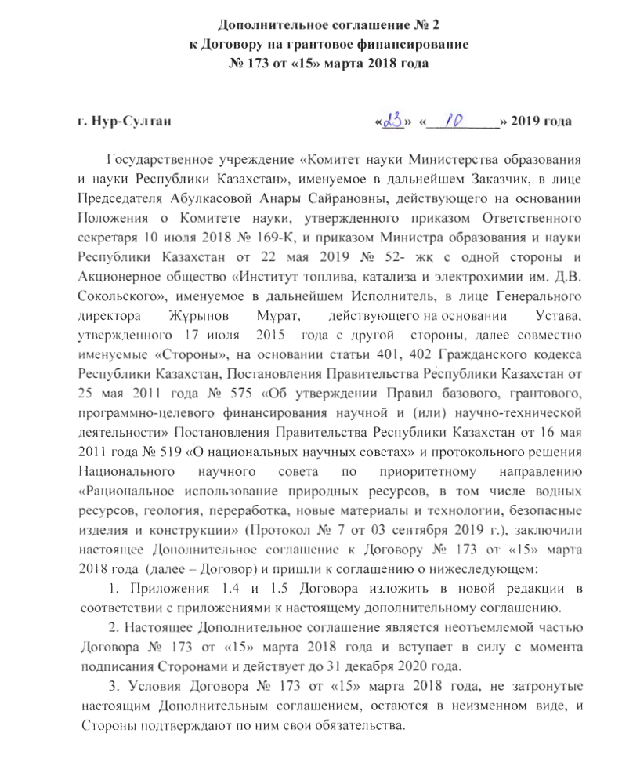

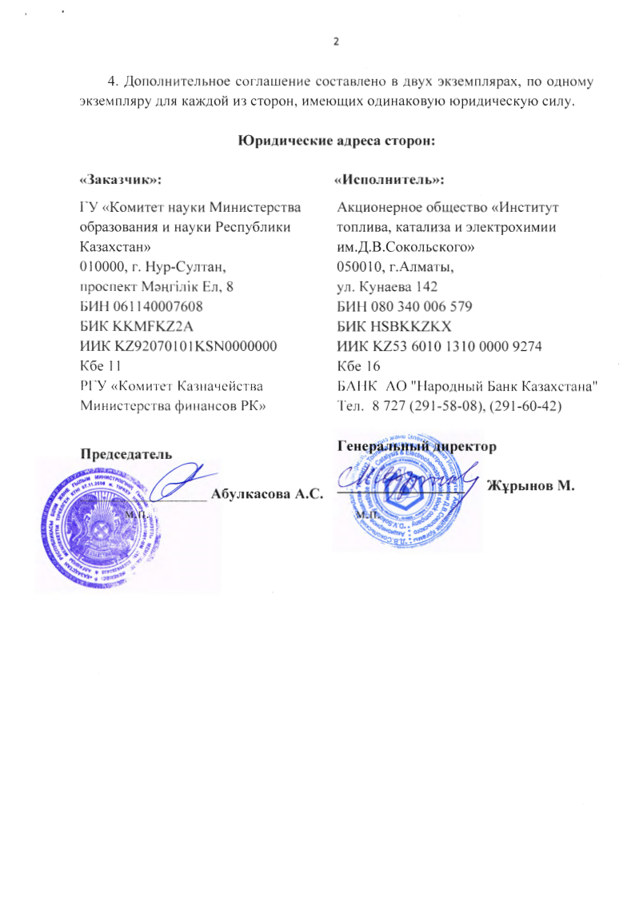

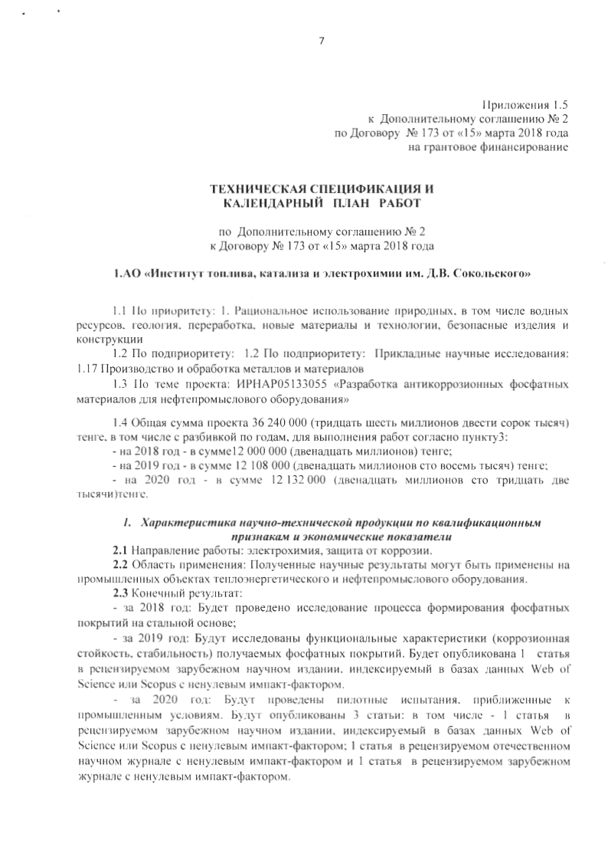

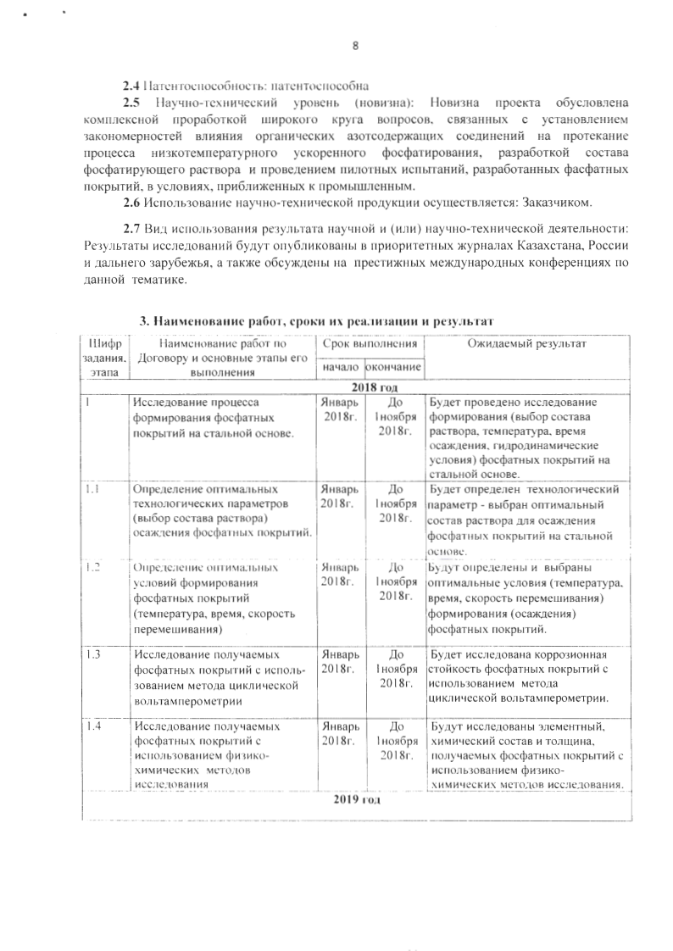

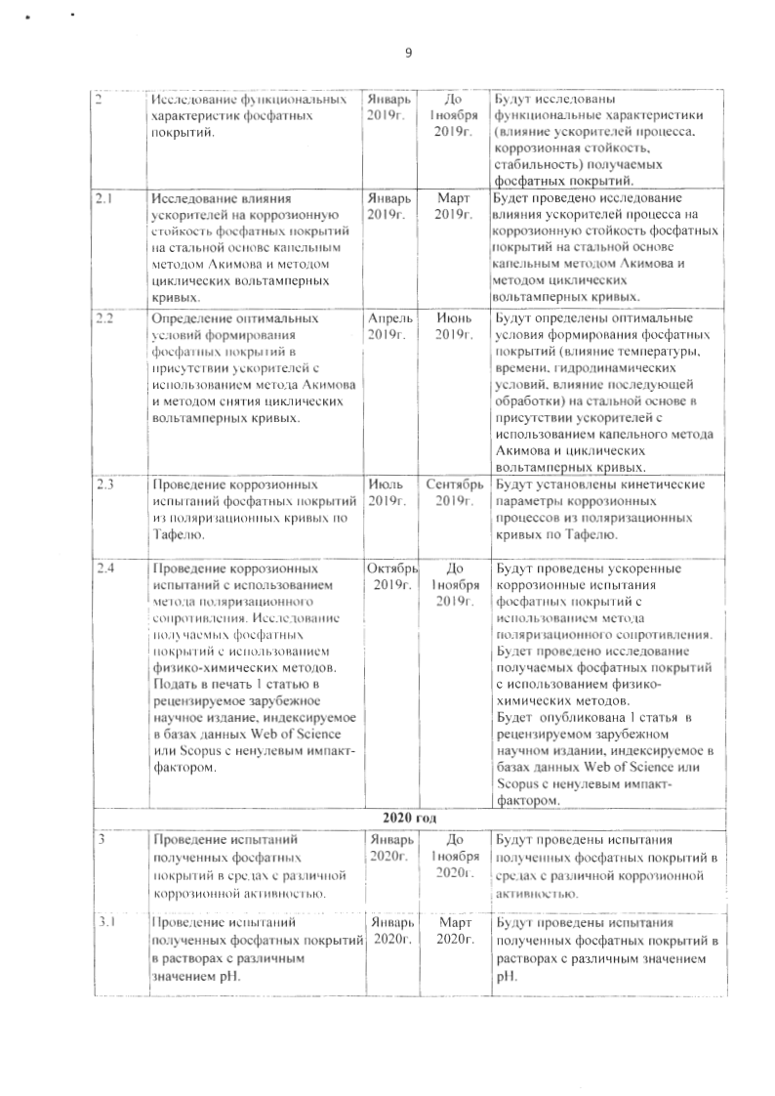

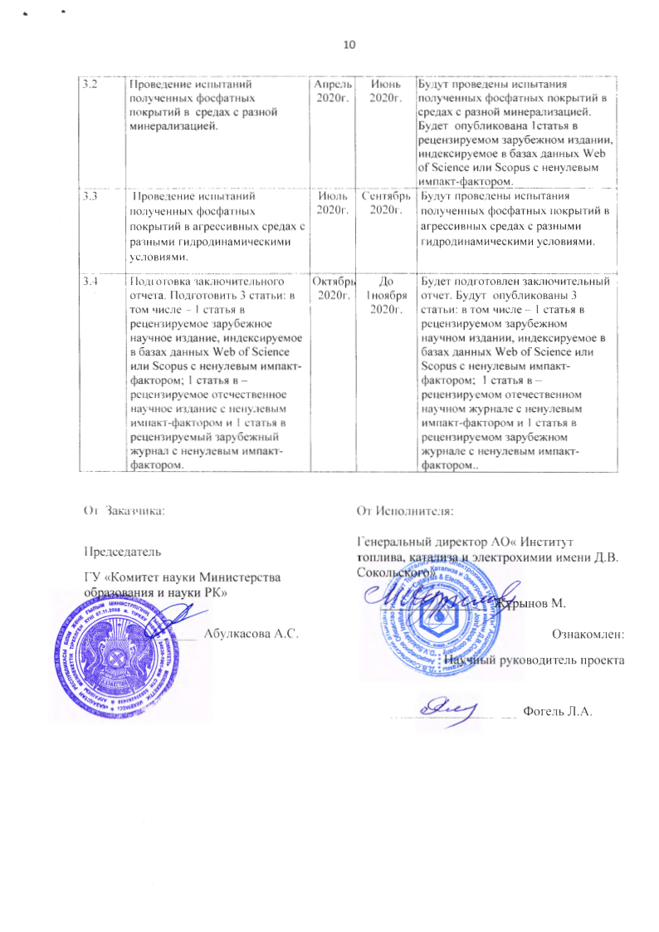

TECHNICAL SPECIFICATIONS AND
CALENDAR WORK PLAN
Under the contract № 173 dated 15.03.2018 of the year
JSC " D.V. Sokolsky Institute of Fuel, Catalysis and
Electrochemistry"

1 By priority: 1. Rational use of natural resources, including water resources, geology, processing, new materials and technologies, safe products and structures
1.2 By sub-priority: 1.2 By sub-priority: Applied research: 1.17 Production and processing of metals and materials
1.3 On the project topic: IRN AR05133055 "Development of anticorrosive phosphate materials for oilfield equipment"
1.4 The total amount of the project is 36,240,000 (thirty six million two hundred forty thousand) tenge, including with a breakdown by years, for the performance of work in accordance with paragraph 3:
- For 2018 - in the amount of 12,000,000 (twelve million) tenge;
- For 2019 - in the amount of 12,108,000 (twelve million one hundred eight thousand) tenge;
- For 2020 - in the amount of 12,132,000 (twelve million one hundred thirty-two thousand) tenge.

- Characteristics of scientific and technical products by qualification characteristics and economic indicators

2.1 Direction of work: electrochemistry, corrosion protection.
2.2 Field of application: The obtained scientific results can be applied at industrial facilities of heat power and oilfield equipment.
2.3 End result:
- For 2018: A study of the formation process of phosphate coatings on a steel base will be carried out;
- For 2019: The functional characteristics (corrosion resistance, stability) of the resulting phosphate coatings will be investigated. 1 article will be submitted to the press in a peer-reviewed foreign scientific publication, indexed in the Web of Science or Scopus databases with a non-zero impact factor.
- For 2020: Pilot tests close to industrial conditions will be carried out. 3 articles will be submitted for publication: including - 1 article for a peer-reviewed foreign scientific publication, indexed in the Web of Science or Scopus databases with a non-zero impact factor; 1 article in a peer-reviewed Russian scientific publication with a non-zero impact factor and 1 article in a peer-reviewed foreign journal with a non-zero impact factor.
2.4 Patentability: patentable
2.5 Scientific and technical level (novelty): The novelty of the project is due to the comprehensive study of a wide range of issues related to the establishment of patterns of the influence of organic nitrogen-containing compounds on the course of the process of low-temperature accelerated phosphating, the development of the composition of the phosphating solution and the conduct of pilot tests, developed phosphate coatings, in conditions approximate to industrial.
2.6 The use of scientific and technical products is carried out by the Customer.
2.7 Type of use of the result of scientific and (or) scientific and technical activities: The research results will be published in priority journals in Kazakhstan, Russia and far abroad, as well as discussed at prestigious international conferences on this topic.

Task number, stage | Name of work under the Agreement and the main implementation stages | Period of execution |  | Expected Result
Task number, stage |  | Starting | ending
2018 year
1 | Investigation of the formation process of phosphate coatings on a steel base. | January 2018 | Until 1st of November  2018  year. | A study of the formation (choice of solution composition, temperature, deposition time, hydrodynamic conditions) of phosphate coatings on a steel base will be carried out.
1.1 | Determination of optimal technological parameters (choice of the solution composition) for the deposition of phosphate coatings. | January 2018 | Until 1st of November  2018  year. | The technological parameter will be determined - the optimal composition of the solution for the deposition of phosphate coatings on a steel base will be selected.
1.2 | Determination of optimal conditions for the formation of phosphate coatings (temperature, time, stirring speed) | January 2018 | Until 1st of November  2018  year. | The optimal conditions (temperature, time, stirring speed) for the formation (deposition) of phosphate coatings will be determined and selected.
1.3 | Study of the resulting phosphate coatings using the method of cyclic voltammetry. | January 2018 | Until 1st of November  2018 | The corrosion resistance of phosphate coatings will be investigated using cyclic voltammetry method.
1.4 | Study of the resulting phosphate coatings using physicochemical research methods. | January | Until 1st of November  2018  year. | The elemental, chemical composition and thickness of the obtained phosphate coatings will be investigated using physicochemical research methods.
2019 year
2 | Study of the functional characteristics of phosphate coatings. | January 2019 year. | Until 1st of November  2019  year.. | The functional characteristics (influence of process accelerators, corrosion resistance, stability) of the resulting phosphate coatings will be investigated.
2.1 | Investigation of the effect of accelerators on the corrosion resistance of phosphate coatings on a steel base by the Akimov drip method and the method of cyclic volt-ampere curves. | January 2019 year. | March 2019 year. | The study of the influence of process accelerators on the corrosion resistance of phosphate coatings on a steel base will be carried out by the Akimov drip method and the method of cyclic volt-ampere curves.
2.2 | Determination of the optimal conditions for the formation of phosphate coatings in presence of accelerators using the Akimov method and the method of taking cyclic volt-ampere curves. | April 2019 year. | June 2019 year. | The optimal conditions for the formation of phosphate coatings (the effect of temperature, time, hydrodynamic conditions, the effect of subsequent processing) on a steel base in the presence of accelerators using the Akimov drop method and cyclic volt-ampere curves will be determined.
2.3 | Corrosion testing of phosphate coatings from polarization curves according to Tafel. | July 2019 year. | September 2019 year. | Kinetic parameters of corrosion processes will be established from polarization curves according to Tafel.
2.4 | Conducting corrosion tests using the polarization resistance method. Study of the resulting phosphate coatings using physicochemical methods.  Submit for publication 1 article to a peer-reviewed foreign scientific publication indexed in the Web of Science or Scopus databases with a non-zero impact factor. | October 2019 year. | Until 1st of November  2019  year. | Accelerated corrosion testing of phosphate coatings using the polarization resistance method will be carried out.  A study of the resulting phosphate coatings will be carried out using physicochemical methods.  1 article will be submitted for publication in a peer-reviewed foreign scientific publication, indexed in the Web of Science or Scopus databases with a non-zero impact factor.
2020 year
3 | Testing of the obtained phosphate coatings in environments with different corrosivity. | January 2020 year. | Until 1st of November  2020 | The obtained phosphate coatings will be tested in environments with different corrosivity.
3.1 | Testing of the obtained phosphate coatings in solutions with different pH values. | January 2020 year. | March 2020 year. | The obtained phosphate coatings will be tested in solutions with different pH values.
3.2 | Testing of the obtained phosphate coatings in environments with different mineralization. | April 2020 year. | June 2020 year. | The obtained phosphate coatings will be tested in environments with different mineralization. 1 article will be submitted for publication to a peer-reviewed foreign scientific publication indexed in the Web of Science or Scopus databases with a non-zero impact factor.
3.3 | Testing of the obtained phosphate coatings in aggressive media with different hydrodynamic conditions. | July 2020 year. | September 2020 year. | The obtained phosphate coatings will be tested in aggressive environments with different hydrodynamic conditions.
3.4 | Preparation of the final report. Prepare 3 articles: including - 1 article for a peer-reviewed foreign scientific publication, indexed in the Web of Science or Scopus databases with a non-zero impact factor; 1 article in a peer-reviewed domestic scientific publication with a non-zero impact factor and 1 article in a peer-reviewed foreign journal with a non-zero impact factor. | October 2020 year. | Until 1st of November  2020  year. | A final report will be prepared. 3 articles will be published: including - 1 article in a peer-reviewed foreign scientific publication, indexed in the Web of Science or Scopus databases with a non-zero impact factor; 1 article in a peer-reviewed domestic scientific publication with a non-zero impact factor and 1 article in a peer-reviewed foreign journal with a non-zero impact factor.
By customer:  Chairman of the State Committee  "Science Committee of the Ministry of  Education and Science of the Republic of  Kazakhstan"  ________________Abulkasova A.S. | From the Contractor:  General Director of JSC " D.V. Sokolsky Institute of Fuel, Catalysis and Electrochemistry "  ________________ Zhurinov M.

APPLICATION С

Methods for determining the optimal composition of anti-corrosive coatings on steel

The developed method for determining the optimal composition of anti-corrosion coatings on steel using the method of cyclic voltammetry was proposed to improve the measurement accuracy, significantly reduce the research time, and create the possibility of a differentiated selection of solutions and conditions for the deposition of an anti-corrosion coating.
The determination of the optimal composition of the anticorrosive coating is carried out in a three-electrode electrochemical cell using a Gamry 3000 potentiostat (USA). The working electrode is a disk electrode made of steel (St. 3) with a visible surface of 0.07 cm2. A silver chloride electrode saturated in a KCl solution with a potential of 196 mV relative to the hydrogen electrode is used as a reference electrode. The auxiliary electrode is a platinum electrode with a visible surface of 2 cm². The surface of the working electrode is preliminarily exposed in a solution for the deposition of an anticorrosive coating with a different composition for 10 minutes at a temperature of 40 °C with stirring, then washed with distilled water and cyclic volt-ampere curves are recorded in an aqueous solution of 0.3 M sodium sulfate in the potential range from -0.3 V to -1.2 V. Then, graphs of the dependence of the maximum current value at E = -0.9 ± 0.1 V on the composition of the precipitation solution for all cycles are plotted and the optimal composition of the solution is determined at which the value maximum current does not depend on the number of cycles.
To confirm the reliability of the results by the proposed method, in parallel, the optimal composition of the anti-corrosion coating was determined by Akimov's drip method. The data obtained by the two methods completely coincide. The time spent on determining the optimal composition of the anticorrosive coating according to the proposed method is ≈ 45 min., which is 20-25 times less than the time spent by the existing methods for determining the protective ability of anticorrosive coatings on steel.

