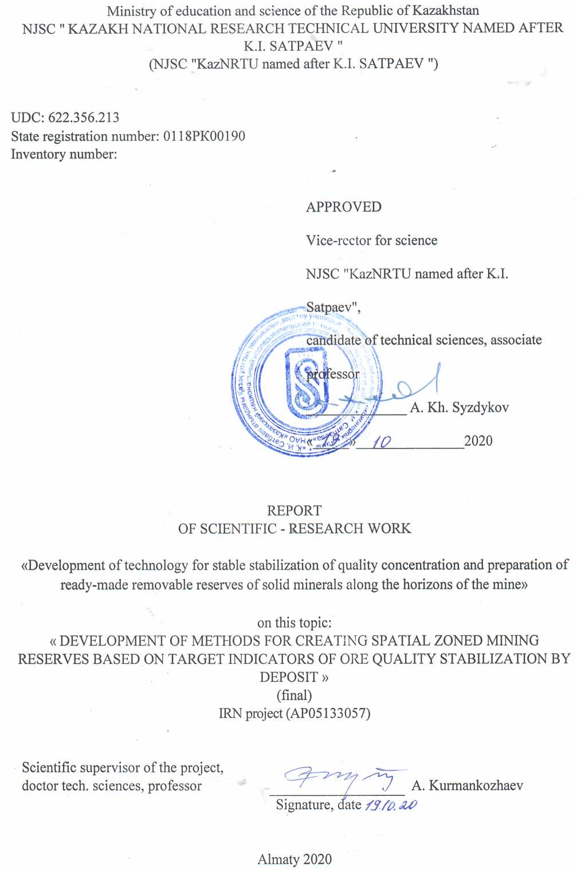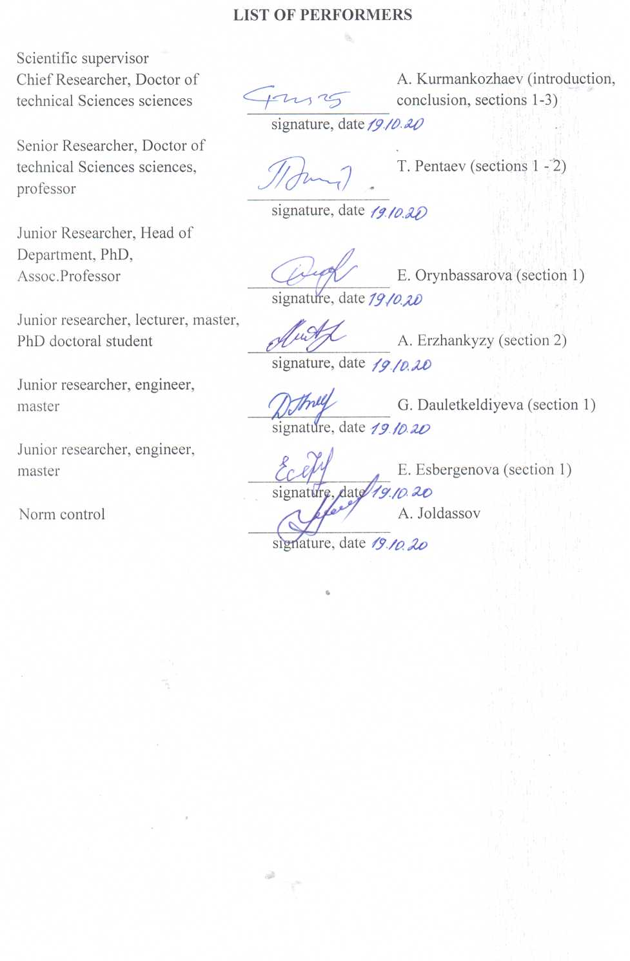
ABSTRACT

The report: 97 pages, 1 book, 18 sources, 3 applications.
RESERVE, STABILIZATION, QUALITY, METHOD, ESTIMATES, CONCENTRATION, CONDITION, GEOINDICATORS, CRITERIA, ALGORITHMS
Object of study: Mining design and production enterprises.
Mining project and mining enterprises.
Purpose of the project: Development of technology for stable stabilization of quality concentration and preparation of ready-made removable reserves of solid minerals along the horizons of the mine.
Method of work: complex, including the method of estimation theory, modeling method, information and geological-geometric analysis, qualimetric estimates.
Results of work and their novelty. A method for determining the geo-indicator properties of the modal characteristic of ore quality is substantiated. Geoindicator geological-geometric and conditioning-technological criteria for assessing mining reserves; a method for assessing the zonal distribution of the useful component; a method for spatial zoning of mining reserves by uniformity of concentrations and a method for the level of conditioning of ore quality. A full - scale experimental analysis of the implementation of the developed methods is performed. Computer computational algorithms for qualimetrization of the geological content of a useful component are justified.
Novelty of the work: for the first time, geo-indicator criteria for typologizing the reserve of different-quality ores were developed (patent No. 233535, 2019 was obtained); a method for determining the genetic zone of influence of the modal value of the useful component (ayavka No. 2019/0637.1, 2020); methods for zoning mining reserves by air conditioning and concentration of ore quality along the mine horizons.
Recommendations for implementing research results. It is required to develop a technological manual on the application of methods for zoning of mining reserves.
Field of application: Mining and geological branch of mineral resources development.
The economic significance of the work is due to the stabilization of fluctuations in the ore content, taking into account the target indicators of consumer quality, the estimated forecast is up to 800 million tenge / mine.
Predictive assumptions about the development of the research object. Development of research on the development of quality stabilization technology for the exploitation of high-value solid minerals is required.

CONTENT

INTRODUCTION
1 Development of qualimetric geo-indicator criteria for mapping the quality of ore minerals………………………………………………………………………………… | 9
2 Analytical description of target indicators of stabilization of quality concentration in the production areas of the reservoir……………………………………………………… | 14
3 Development of methods for creating spatial zoned mining reserves according to target indicators of stabilizing the quality of ores in the deposit ……………………………… | 19
3.1 Substantiation of computer algorithms for qualimetrization of geological content according to geo-indicator criteria ……………………………………………………… | 19
3.1.1 The significance of the impact of the quality and quantity of minerals on the efficiency and manufacturability of mining …………………………………..………… | 19
3.1.2 Computer computational algorithms for qualimetrization of geological content by geo-indicator criteria………………………………………………………………… | 23
3.2 Development of methods for creating spatial zoning of mining reserves according to target indicators of uniformity of concentration and conditionality of ore quality along the horizons of the mine ………………………………………………………………… | 29
3.2.11 Development of a method for creating spatial zoning of mining reserves according to the target indicator of uniformity of concentration of ore quality along the horizons of the mine ……………………………………………………………………… | 30
3.2.21 Development of a method for creating spatial zoning of mining reserves according to the target indicator of uniformity of the ore quality conditionality limits along the horizons of the mine …………………………………………………………… | 33
CONCLUSION | 39
REFERENCES | 44
APPENDIX A – Work schedule for 2018-2020 years | 46
APPENDIX B – List of published works on the topic for 2018-2020 years | 56
APPENDIX B – Extract from the minutes of the Academic Council | 58

INTRODUCTION

Assessment of the current state to solve scientific and technical problems.
Traditional methods of forming the quality of ores consist in drawing up geological high-quality prospective and calendar and current plans for mining horizons, which represent deterministic sets of disparate sets of microblocks with different quality indicators and diverse geometric configuration, from which enlarged production areas are built. The measure of their set is the average content, which is the target quality indicator. However, due to the purely calculated value of its value, and since it is not a natural geological value recorded in the reservoir space, the reliability of average quality is in advance committed to unpredictable accidents, accompanied by systematic and random errors.
The absence of stable proper mechanisms for zoning concentration concentrations, the complexity of the nature of the processes of assessing and using discretely separated geological blocks within a scalar geological exploration massif usually cause a high cost, laboriousness and repeatability of the processes of formation and stabilization of quality, make it impossible to establish real patterns of concentration of ore quality. The well-established practice of a single-shot increase in the volume of exploration wells and sampling of mine workings is often accompanied by the uncertainty of reaching a reasonable concentration limit corresponding to the true average grade for the production area [3,8].
The practice of applying modern foreign directions of geostatistics, traditional methods of isolines, graphic-analytical and computer modeling, methods of structural-mineralogical, geochemical, technological mapping of minerals is reduced to the disclosure of individual parameters and processes that have an indirect effect on the formation of quality, they consider tasks that are not related to these problematic disadvantages [4,9].
Basis and initial data for the development of the theme. The analysis of the acceptability of the known methods for the formation of quality indicators of quality outputs showed that the known methods of geoindicators, which are identical in nature, are reduced to the determination of various properties of rocks and the interrelationships of their features with subsequent identification in relation to the geological mapping of a geological object. They lack analytical assessments describing the dependencies and criteria for identifying target concepts, which affect the effectiveness of their application in various problems of forming and stabilizing the quality of ores during mining.
Justification of the need for research. The need for research is due to the priority and large-scale direction of production for the creation of finished products of minerals in terms of quality and condition, providing the technical conditions of the sales market. The importance of carrying out research and development work on this issue on a national and international scale is due to the fact that solving the problem of creating a consistent process for stabilizing the quality of ores is aimed at a radical modernization of the traditional methods and technologies for forming the standardized quality of ores by averaging with the involvement of technological processes and technical funds. For this, it is envisaged to use the methods and principles of a new direction - qualimetrization of geological and technological processes of exploitation of minerals.
Information about the planned scientific and technical level of development, patent research and conclusions from them. The patent research carried out at the beginning of the work in the field of mapping and the formation of quality at the level of its stability with the involvement of geo-indicator features showed the patentability of the project tasks. The development of new conceptual results obtained under the project, which are associated with the use of geo-indicator signs in the field of georesources, is envisaged.
Information on metrological support of research work. In this project study, the developments being carried out are not associated with negative impacts on the environment, no equipment is required.
Relevance and novelty of the topic. The relevance of the topic is due to the unfavorable economic and technological consequences caused by the growth of competition, the tightening of technical conditions and the market for the quality of mineral raw materials, the dynamics of increasing costs for exploration, numerous testing of wells and various warehouses, additional technical means, averaging technological processes and pre-enrichment. Thus, the solution of the problematic tasks of the formation and stabilization of the ore quality outputs, which make it possible to eliminate the exorbitant cost of frequently repeated ore quality averaging processes by creating progressive approaches and technologies, becomes urgent.
The novelty of the topic. The novelty of the project topic and the impact of the results obtained on the development of science and technology is seen in the use of the first developing direction in the earth sciences - qualimetry of properties and processes of exploitation of minerals, and stable geological-genetic qualimetric geoindicators. For the first time, it was established and experimentally proved that the division of the geological reserve into zonal areas of homogeneous concentration, conditionality and variability of quality can be achieved by the nature of regular changes in the geological contents of ores by using the genetic zone of influence of the modal value of the useful component. A method has been developed to determine the genetic zone of influence of the modal value of the useful component for the first time by using the differences in heterogeneity of the interval values ​​of the contents grouped around it (patent №. 233535, 2019).
The fundamental difference between the new ideas on the topic lies in a fundamental change in traditional approaches and technologies to the processes of formation and stabilization of quality, including spatial qualimetric reproduction of rich and high-quality, typologized according to the target quality indicators, with increased, ordinary and near-contour with a low concentration of ores, zoned according to the degree of quality readiness for specifications and market range. The prospects of ideas on the topic stems from the use of "hidden" natural geoindicator useful properties of the main quality characteristics and the fundamental principle of "feedback" from the target indicators of consumer quality to the parameters of its concentration in the ore massif.
Communication of this work with other research projects. This work is a continuation of the research work "Creation of a qualimetric basis for the theory of regulation of the quality of ore products in difficult mining and geological conditions" and "Development of a method for standardization and technological processes of indicators of mining operations" carried out in the period 2010 - 2014.
Purpose of work. Development of technologies for stabilization of quality concentration and preparation of ready-made removable reserves of solid minerals along the horizons of the mine.
The idea of achieving the goal of the project is based on the use of the concept and methods of qualimetrization of processes in the tasks of stabilizing the concentration of quality and finished stocks with the help of qualimetric geoindicators that ensure a sustainable optimum in terms of their target indicators.
Method of work: complex, including the method of estimation theory, modeling method, informational, geological-geometric and factor analyzes, qualimetric estimates and geo-indicator signs.
Research task:
- Development of qualimetric geo-indicator criteria for mapping the quality of ore minerals;
- An analytical description of the target indicators for stabilizing the quality concentration in the production areas of the reservoir;
- Development of methods for creating spatial zoned mining reserves according to target indicators of uniformity of concentration and conditionality of ore quality along the horizons of the mine.
A full-scale experimental analysis of the acceptability of new methods and analytical assessments of the spatial and statistical distribution of the concentration and conditionality of the quality of ores based on the actual data of the zonal division of the geological reserve of the main deposit of the Lisakovsky iron ore deposit was carried out.
The results of research and development work on problematic problems of parametric stabilization of variation in the consumer quality of ores during their extraction are of great importance in the field of new achievements in domestic and world science.
List of prepared interim reports:
2018 - 0218RK00492 "Development of technology for sustainable stabilization of quality and preparation of ready-made removable reserves of solid minerals along the horizons of the mine"

2019 - 0219RK00387 "Development of technology for stable stabilization of quality concentration and preparation of ready-made removable reserves of solid minerals along the horizons of the mine."

Development of qualimetric geo-indicator criteria for mapping the quality of ore minerals

Based on the results of the analysis of the current state of the practice of assessing quality indicators and the use of geo-indicator signs, their specific features, it has been established that the practice of applying modern foreign methods in statistics, existing isoline methods, graph-analytical and computer models, methods of structural mineralogical, geochemical, technological mapping of minerals is reduced to the disclosure of individual parameters and processes that have an indirect impact on the formation of quality and they consider tasks that are not related to these problem shortcomings [7-9]. Evaluation of the essence and acceptability of the known methods of mapping indicators, quality related to quality in the patent space showed that they are basically identical in the nature of the use of geo-indicators. Their essence boils down to the determination of various properties of rocks and and the relationship of their ghosts with subsequent identification in relation to the geological lodging of a geological object. The lack of analytical assessments describing the dependencies and criteria for identifying target representations affect the effectiveness of their application in various tasks of the mining and geological industry.
The results obtained for 2018 include completed scientific developments according to the schedule:
- An analytical analysis of the current state of the issues of assessing the indicators of geo-resources using geo-indicator features has been carried out, their specific features have been disclosed.
- The method for determining and using the geological - genetic geoindicator properties of the modal quality characteristics of solid fossils, based on the results:
a) The assessment of the geological and genetic properties of the modal value of the useful component in the determined space and the statistical field of contents, obtained in the form of spatial feature properties of the image continuity and the uniqueness of its distribution, as a variable in a deterministic space with absolute coordinates (x, y, z) and statistical feature properties as the number of frequency distribution of grades, as a statistical variable in the well data field with stratigraphic coordinates (j,i,ө);
b) the geo-indicator signs of the geological and genetic properties of the modal value of metal contents were determined, including the highly informative value of the modal value as the main geo-indicator sign; two-dimensional distribution of its values, reflecting the spatial relationship of deterministic geometrical and statistical stratigraphic parameters of well data; its functional connection with the target indicators of the formation of quality.
3) Geoindicator criteria for qualimetrization of ore quality concentration for the production areas of the deposit were developed.
a) substantiated the guiding concept of substantiation of geo-indicator criteria for qualitative typology of a geological reserve of a solid mineral.
b) geo-indicator geological and geometric criteria have been developed that provide typologization of the space of metal contents into the contours of rich, high-quality, ordinary, near-contour poor ores and geo-indicator condition-technological criteria that provide technomorphological parametrization of the rational division of the near-contour areas into mining zones and quality zones.
The target task is the development of geo-indicator digital criteria for qualimetrization of the quality concentration for the production areas of the deposit was carried out for the first time on the basis of the use of natural geological-genetic properties and geo-indicator characteristics inherent in the modal quality characteristic; highly informative and two-dimensionality and its functional determinability in the space of the ore massif are determined and analytically described; for the first time, geometric expressibility was revealed as a spatial variable with absolute coordinates and as a statistical digital variable with stratigraphic coordinates. The suitability of the modal characteristics of the quality of ores as the main qualimetric geo-indicator of the qualitative and technological typology of rich, high-quality, ordinary and near-contour ores for which the limits of concentration, conditionality and variability of the metal content are uniform has been proved.
A method has been developed for determining and using the geological and genetic geoindicator properties of the modal quality characteristics of solid minerals, which is based for the first time on the results of identifying and assessing the natural geological and genetic properties and geoindicator features inherent in the modal quality characteristic. The geological-genetic spatial and statistical characteristic properties inherent in the modal quality characteristic are determined and analytically described, the properties of two-dimensionality of propagation are assessed simultaneously as a spatial parameter, geometrically expressed in the reservoir space and as a statistical measure of the set, estimated by the number of frequencies in the stratigraphic surface, functional relationships by the average value and correlation with the main parameters of quality formation.
The concept of substantiating geoindicator criteria for qualimetrization of ore quality is to create a qualitative and technomorphological structure of an ore massif by substantiating a basic vector geoindicator and its constituent digital criteria that allow parametric structuring of ore quality by production sites within horizons. The basic qualimetric geoindicator as a vector modal-digital criterion is intended for the selection of varieties of raw material quality, geometric display and statistical differentiation of the concentration of metal contents. The substantiation of the basic natural geo-indicator was carried out on the basis of the geological and genetic properties of the modal quality characteristic, according to which spatial and statistical (deterministic) qualimetrization of quality is provided. The basic geo-indicator is a two-criterion, which has a statistical character and has a numerical quantitative value, and as a modal area, which has a spatial character and geometric expression. This property of two-dimensionality of the modal quality characteristics formed the basis for the creation of a two-criterion geo-indicator for a qualitative typology of reservoir reserves.
The main geo-indicator signs of the geological and genetic properties of the modal value of the metal content were determined and evaluated: a) as a quality attribute with the highest information content, exceeding other values by 4-6 times, confirmed by the results of the assessment in the conditions of deposits of chromite, bauxite and iron-bearing ores; b) as a qualimetric modal area as a two-criterion regulatory feature, based on which the geological reserve is divided according to geometric expressions and statistical data of grades into qualitative types of recovered ores and the correlation of spatial and statistical quality parameters along their contours is analytically estimated.
Geoindicator criteria for the qualimetrization of ore quality for the production areas of the deposit, including the components of the criteria: geological-geometric and conditional-technological digital criteria have been developed. Geoindicator geological and genetic criteria provide a qualitative typology of the geological reserve on the basis of which the reproduction of production sites is carried out that are qualitatively homogeneous in terms of target indicators of consumer quality. Geoindicator conditioning-technological criteria provide the parameterization of the technomorphological structure of the areas of near-contour mixed-poor ores, along which rational contours of production itself and waste formation zones are constructed.
A geo-indicator digital model of qualimetrization of the metal content space according to particular digital criteria for the qualitative typology of ores was developed based on the principle of multi-criteria assessment and has the form

F(K₀)=Ф(K_{g}⁰, K_{t}⁰), (1)

where
K_{g}⁰, K_{t}⁰ – geo-indicator criteria of geological (K_{g0}) and technological (K_{t0}) qualification.
The geo-indicator geological criterion (KG0) is a basic component in a multicriteria model and is designed to reproduce and display the limiting contours of metal concentration within the main intra-contour ore massif. In essence, the geo-indicator geological criterion is vector in nature and consists of three particular modal-digital criteria (K_{g.1}, K_{g.2}, K_{g.3}). This criterion serves as a regulatory basis for the reproduction of qualitatively typologized levels of concentration, conditionality and variability of metal contents within the production areas along the horizons.
Private modal-digital criteria allow for a detailed structuring of the geological reserve through its qualitative typology at the level of production areas (blocks). The first particular modal-digital criterion is intended for the typological separation and display of high-grade ore rich with an increased concentration by a combination of positive absolute deviations exceeding the modal value and the aggregate of metal contents common in the contours of these limits К₁= |С_{i}-С_{mо}| ≥0). The second particular modal-digital criterion serves as a critically important regulator of qualimetrization and is intended for typological selection and display of highly informative modotypic quality ores with an increased concentration by a combination of modal values and the aggregate grouped around the zone of influence of their metal contents (K₂= |С_{i}-С_{mо}| →min). The third particular modal-digital criterion is intended for the typological division and display of industrial rank-and-file with a predominant concentration of medium-quality ores by a combination of negative deviations not exceeding the modal value and the aggregate of these metal content limits common in the contours (K₃= |С_{i}-С_{mо}| ≤0).
Thus, the geo-indicator-digital multicriteria model of reproduction of qualitatively typologized zones of concentrations of metal content includes a particular qualimetric criterion:
- Criterion K_{g.1}(C_{i}) =|C_{kaч}-С_{mо}|>0,

distribution limits $C_{mo}{<C}_{qual.i}<C_{qual}^{max}, C_{i }∈C_{qual}$ (2)

- Criterion $K_{r.2}\left(Ci\right)=|C_{mo}-C_{row}|>0$ ,

distribution limits $C_{mo}{>C}_{row.i}>C_{row}^{min}, C_{i }∈C_{row}$ (3)

- Criterion $K_{r.3}\left(C_{i}\right)=|C_{mo}^{max}-C_{mo}^{min}|>0$ ,

distribution limits $C_{mo}^{max}{>C}_{mo.i}>C_{mo}^{min}, C_{i }∈C_{mo}$ (4)

According to the concept of qualimetrization of the geological exploration scalar massif of a deposit during its differentiation, the maximum values ​​of the modal geoindicator and the average value of the content for the base gelogic areas contoured at the initial level of differentiation are subject to a gradual decrease. In the full structure of qualimetrization of a geological reserve of a solid mineral on the basis of geo-indicator digital criteria of qualitative typology, the initial indicators are: maximum values of the geological content for geological areas of quality and ordinary ores; the minimum values of the geological grade for the production areas of run-of-mine and near-contour ores; the values of the amplitude variability of the geological content for geological and operational areas; qualitative limitation (parameter) of the technical conditions for the sale of products; modal values of geological content for geological and operational areas. The qualimetric structure of differentiation of geological reserves provides for spatial zoning of geological reserves using geo-indicator digital criteria through the modal value and the average value of the geological content.

2 Analytical description of target indicators of stabilization of quality concentration in the production areas of the reservoir

A method has been developed for assessing the zonal spatial - statistical distribution of the concentration of a useful component in the contour of an ore deposit, based for the first time on the use of the zone of influence of the modal characteristics of the quality of ores, according to which the zoning and accuracy of mineral reserves are ensured. Analytical estimates of the determination of the dimensional parameters of the zone of influence of the modal value of the contents are substantiated, taking into account their heterogeneity, along which the zonal contours of the reserves of ordinary, high-quality and high-quality ores, homogeneous in concentration and conditionality of the useful component, are established. Potential foundations of operational maintenance and a procedure for qualimetric mapping of zonal ore reserves have been created, aimed at increasing the efficiency of exploration and stabilizing the quality and development of mining operations. Analytical assessments of the formation of uniformity of distribution of concentration and conditionality of ore quality over the production areas of the deposit are recommended. Working formulas for calculating the degree of heterogeneity of ore quality indicators are derived, taking into account their information content and variability of the content of the useful component.
Based on the scientific results obtained, a full-scale experimental analysis of the acceptability of the new method and analytical assessments of the spatial-statistical distribution of the concentration and conditionality of the ore quality was carried out according to the actual data of the zonal division of the geological reserve of the main deposit of the Lisakovsky iron ore deposit. The confirmed conclusions were obtained that: the relative error in determining the zonal reserves is reduced than with the traditional approach due to the stabilization of variability and geometric uncertainty, concentration and conditionality of ore quality, ranges from 25 to 29%. The increase in the level of parametric stability of fluctuations and the uniformity of the quality of zonal reserves of iron ores of the Lisakovsky deposit has been experimentally confirmed. At the same time, the basic natural values of the concentration of iron distribution are differentiated in an ascending order at the level of increase within the zonal reserve from 1.3 to 8.0 times, and also indicators of the variability of the distribution of iron are differentiated in decreasing order at the level of decrease in the range from 1.2 to 3.2 times.
Research work on the project was carried out according to the schedule and includes the results of the study of tasks for the analytical description of the target indicators of stabilization of concentration and quality condition for the production areas of the deposit planned for 2019.
1) The results of the study of the problem of assessing the area of spatial - statistical distribution of concentration, taking into account the zone of influence of the modal value of the useful component, contains developments:
- a method has been developed for assessing the zonal spatial and statistical distribution of the concentration of a useful component in the contour of an ore deposit, based for the first time on the use of the zone of influence of the modal characteristics of the quality of a mineral, which ensures the zoning of division and the accuracy of calculating mineral reserves;
- substantiated analytical assessments of determining the dimensional parameters of the zone, the effect of the modal value of the grades, taking into account their heterogeneity, along which the zonal contours of reserves of ordinary, high-quality and high-quality ores of homogeneous concentration and conditionality of the contents of the useful component are established;
- potential foundations of operational maintenance and a procedure for qualimetric mapping of zonal ore reserves have been created, aimed at increasing the efficiency of exploration and stabilization and development of mining operations.
2) The results of the study of the problem of analytical assessment of the formation of the uniformity of the distribution of concentration and quality of ores in the production areas, provided contains developments:
- substantiated analytical assessments of the formation of uniformity of the degree of distribution of concentration and conditionality of ore quality over the production areas of the deposit;
- developed working formulas for calculating the degree of heterogeneity of ore quality indicators, taking into account their information content and variability of the content of the useful component.
- A full-scale experimental assessment of the acceptability of the developed method for assessing the spatial and statistical distribution of the concentration and quality of ores in the conditions of the main deposit of the Lisakovsky iron ore deposit was carried out.
The assessment of the area of the spatial-statistical distribution of the concentration (zone of influence) of the useful component in the field is based on the developed method, which for the first time considers the zonal differentiation of the geological ore reserve into homogeneous production areas by using the genetic zone of influence of the modal value of the mineral quality.
The essence of the method for assessing the spatial-statistical distribution of the concentration of the useful component over the deposit is to determine the zone of influence of the modal value of the useful component on the content values grouped around it by using the highly informative and minimal level of variability inherent to it at a steady state of the concentration of the useful component, as well as the functionality of the modal value as a natural sign of division in two statistical and geometric measures. Due to the given properties of the modal value, and the direction of the spatial transformations of the reserve indicators within the characteristic contours of zonal changes in concentration concentrations, isomorphic lines drawn according to modal values divide the reserve fields into homogeneous mode-concentrated qualitative, low-grade ordinary and large - high-quality ore reserves of zonal reserves.
The theoretical substantiation of the allocation of zonal parts of the geological reserve was achieved by applying the fundamental geological and genetic modal feature of the dismemberment of the geological reserve by the nature and properties of regular changes in the concentration of useful components in the field of the deposit. The essence of the zonal subdivision of the calculated reservoir reserve is to determine the size of the zone of influence of the modal value of the useful component on the contents values grouped around it by using the degree of differences in the measures of the inhomogeneity of the contents falling on the modal (h_{m0}), small (h_{s.з}) and large (h_{l.з.}) their group values, which determine the boundary values of the contents of the useful component dividing the statistical field of the deposit. Boundary statistical values of the grades and the basic dimensional area of the zone of influence of the modal value geometrized according to them are set differentially through a modular geo-indicator of heterogeneity estimated by the variances of the interval grouped grades.
The modular geo-indicator of heterogeneity is the ratio of the variances of the grades per small $(σ_{s.з}^{2})$ and large ${(σ}_{l.з}^{2})$ their values to the variance over the modal interval$(σ_{m0}^{2})$

$\left\{\begin{aligned}Г_{м.з.}=\frac{σ_{м.з.}^{2}}{σ_{m0}^{2}} \\ Г_{б.з.}=\frac{σ_{б.з.}^{2}}{σ_{m0}^{2}}\end{aligned}\right.$ (5)

Where
$σ_{m0}^{2}$ - dispersion of grades within the modal range;
$σ_{s.з.}^{2}$, $σ_{l.з.}^{2}$ - dispersion values, respectively, within the limits of their small and large interval values.
A model representation of reproducible zonal contours of homogeneous patterns is obtained in the form of dependences of the boundary limits for the separation of the geological reserve on the values of the modular geo-indicator of heterogeneity and the interval of the distribution series, which are expressed in the form of constructive functions by which the boundary values of the statistical separation of the geological reserve are determined:

$$\left\{\begin{aligned}C_{s.3}=-\frac{C_{m0}h}{2}-\frac{σ_{s.3}^{2}}{σ_{m0}^{2}}h, (6) \\ C_{l.3}=C_{m0}+\frac{h}{2}+\frac{σ_{l.3}^{2}}{σ_{m0}^{2}}h (7)\end{aligned}\right.$$

Boundary values of the transition of heterogeneities in the zones of influence of the modal content ($C_{m0}$) for small ($C_{s.3}$) and large ($C_{l.3}$) their values according to formulas (6) and (7) are determined differentially depending on modular geo-indicators of inhomogeneities (5) and the size of the interval (h).
The conceptual order of development of the process of dismemberment of the geological reserve includes the transition from the boundary values of the statistical dimensions of the zone of influence of the modal value ($C_{s.3}$), ($C_{l.3}$) to geometric expressions by displaying them through isomorphic lines traced according to the values of the boundary values in the field of the reservoir reserve. In the complex, the boundary statistical dimensions provide a statistical division of the entire set of grades, and isomorphic lines provide a geometric division of areas of different quality groups of grades.
The theoretical and practical significance of the spatial-statistical regularity of the zonal manifestation of quality uniformity in terms of concentration, conditionality and variability of geological contents in the process of dismembering the reservoir reserve is that the zonal area of ​​influence of the modal value of the useful component divides the geological reserve massif into zonal parts, in which an increase in homogeneity and accuracy, a decrease in fluctuations in the values of variability and uncertainty of geological content at the level of natural minima has a natural genetic character.
An in situ - experimental analysis of the acceptability of the method for assessing and analytical description of the concentration and conditionality of the contents of the useful component is given in the conditions of the Lisakovsky iron ore deposit, which showed that:
1) The uniformity of the degree of fluctuations in the conditionality of the quality of ores increases with an increase in the average value of the grade during the differentiation of the geological prospecting massif into separate ore zones, the variance and range of distribution of grades gradually decrease as the average value of the grade in ore zones;
2) The conditional uniformity of quality and the average value and indicators of content variability are interrelated, with a decrease in the values of the average content of the useful component, the variability indicators - variance and amplitude differences of the contents - are killed with a certain regularity. These patterns have found experimental confirmation in the obtained empirical dependences.
It has been established and experimentally confirmed that the absolute values of the root-mean-square errors in determining the average content and determining the zonal reserves for geological blocks decreases than with the traditional approach due to the decrease in variability and geometric uncertainty in their contours, as well as an increase in the concentration of the useful component, leading to a reduction in random components of the total error.
- A decrease in the geometric error in delineating areas by geological blocks occurs due to the zonal differentiation of the perimeter and dimensional parameters, leading to a reduction in the geometric and interpolation uncertainties of their contours at the level of mining and technical conditions of field development, and on average reach 1.4 times compared to in traditional practice.
- An actual increase in the overall accuracy of calculating zonal reserves occurring due to a decrease in the random component of variability and an increase in the informativeness and geometric certainty of the indicators of zonal reserves in geological blocks, which are more significant in the conditions of large complex - structural deposits and ranges from 25 to 29%.

3 Development of methods for creating spatial zoned mining reserves according to target indicators of stabilizing the quality of ores for a deposit

3.1 Substantiation of computer computational algorithms for qualimetrization of geological content according to geo-indicator criteria

In computer simulations and calculations in the field of task automation, as a rule, problems arise with the reliability and completeness of the initial computational algorithms, the results of which often lead to "hidden" and enormous economic consequences. The impossibility of conducting an operational real check of the reliability, completeness and complexity of the initial computational algorithms due to the advantages of computerization, this problematic task remains outside the attention of research. Due to the multifactorial nature, complexity and diversity of conditions for solving mining and geological problems of the rational development of mining operations and managing the formation of the consumer quality of ores during mining, this problem should be considered a priority for today and in the future.
Substantiation of computer computational algorithms for qualimetrization of geological content according to geo-indicator criteria is aimed at increasing their complexity, completeness and reliability using existing progressive research results. The results of previous work on the project highlighted in the interim reports (2018-2019) and other research data carried out by the performers were used as prerequisites and methodological foundations for the creation of computer computational algorithms. The main ones are:
- Report "Development of technology for sustainable stabilization of quality and preparation of ready-made removable reserves of solid minerals along the horizons of the mine" (intermediate, №. АР05133057, supervisor A. Kurmankozhaev)
- Report "Development of technology for stable stabilization of quality concentration and preparation of ready-made removable reserves of solid minerals along the horizons of the mine" (intermediate, №. АР05133057, supervisor A. Kurmankozhaev)
Report "Creation and implementation of technology for mining in difficult mining and geological conditions" (final, 0109RK01205, supervisor A. Kurmankozhaev)

    - Significance of the impact of the quality and quantity of minerals on the efficiency and manufacturability of mining

The influence of indicators of production and concentrate yields on the completeness and quality of minerals, including quantitative and qualitative losses of ores and metal recovery on the formation of production costs, have been studied from various points of view, which gives them a diverse character.
The assessment of the influence of the completeness and quality of the yield of mining and concentrate of chrome ores on their prime cost was carried out by using the nature of changes in the values of losses and dilution of ores, the dynamics of changes in the yield of concentrate and metal recovery during enrichment, as well as taking into account the formation of the content of the main component in the original mining and tailings, depending on from the level of waste rock clogging. The reporting indicators of mines and the results of studies related to the problem under study were used as statistical initial data for the analysis.
The interconnection between the yield of mined ore and the cost of 1 ton of production for a specific ore body and the dynamics of their change was studied using types of statistical distributions of their values, taking into account the indicators of concentration, conditionality and variability of grades. As the main characteristics of the quality output formation, they are closely related to the type of statistical distribution that describes the mean and modal values of the estimated useful component. By the type of distribution of grades, average and other values are determined, the accuracy and variability of the results of recovering reserves from the subsoil are predetermined.
The assessment of the significance of the influence of the value of the output of mined ore on the economic indicators of mining was carried out using the well-known calculation formulas.
Open pit productivity (A) and overburden repayment cost ($C_{rep}$) vary depending on the values of the extraction yield, losses and dilution of ores and is expressed as [4, 10, 11]

$\left\{\begin{matrix}A=Q_{изв}\left(1-К_{П}+К_{R}\right), \\ C_{пог}=q_{вс}\frac{К_{вс}+К_{П}-К_{R}}{1-К_{П}+К_{R}},\end{matrix}\right.$ (8)

where
$Q_{rec}$- recoverable ore reserve for the reporting period;
$q_{str}$, $К_{str}$ - respectively, the cost and the stripping ratio;
$К_{L}$, $К_{D}$ - loss and dilution coefficients of ores.
Analytical estimates of the relationship between the cost of 1 ton of production, its output ${(γ}_{p})$, overburden indicators $q_{str}$, $К_{str}$, losses $К_{L}$ and dilution $К_{D}$ and the recoverable ore reserve, taking into account the formula for production productivity and the cost of overburden repayment (8), are transformed in the form:

$\left\{\begin{matrix}С_{р}=\frac{1}{γ_{∂}}*\frac{α{\left(q_{\text{вс}}\frac{К_{вс}+К_{П}-К_{R}}{γ_{д}}\right)}^{\text{в}}}{Q_{изв}}, \\ С_{р}=α_{1}-\frac{{\text{в}}_{1}}{q_{\text{вс}}\frac{{(К}_{вс}+К_{П}-К_{R})}{γ_{д}}}+\frac{{\text{с}}_{1}}{Q_{изв}*γ_{д}},\end{matrix}\right.$ (9)

Empirical parameters a, b, c are different for different fields and depend on the actual values of the initial values.
The structure of the relationship between the cost of 1 ton of mining, the cost of repaying the overburden necessary to obtain 1 ton of ore, and the productivity of an excavator for mining was revealed by statistical analysis (N = 654) of their actual indicators for the quarries of the South Kempirsai chromite, Dzhetygarinsky asbestos and Karagailinsky polymetallic deposits. The actual statistical data of the accounting calculation of the cost of production and stripping according to the current technical and economic reports (N = 854) were used.
Formation of the cost of 1 ton of production depending on its output ${(γ}_{p})$ and overburden indicators $q_{str}$, $К_{str } dilution К_{L})$ and dilution$(К_{D})$ taking into account the formulas for determining the cost of overburden repayment and production productivity are analytically expressed in the form [3, 4]

$\left\{\begin{matrix}С_{р}=а_{2}{+q}_{вс}\frac{{(К}_{вс}+К_{П}-К_{R})}{γ_{∂}}-в_{2}, \\ С_{р}=а_{3}+\frac{1}{γ_{д}}*(\frac{{\text{в}}_{3}}{Q_{изв}}),\end{matrix}\right.$ (10)

The structure of the relationship between the prime cost of 1 ton of mined concentrate and their yields and metal recovery rates was studied using statistical analysis based on the actual indicators of these values for the open-pit mines of the Donskoy GOK [3, 4, 11]. As a result of the conducted statistical analysis, the quantitative influence of the quality and quantity of extraction and concentrates on their cost was established, taking into account the losses and dilution of ores in the form of regularities inherent in the processes of the formation of these indicators.
Dependencies of the cost of 1 ton of mined chrome ore $\left(C_{o}\right)$ from its exit $\left(γ_{p}\right)$, cost of chrome concentrate $\left(C_{cn}\right)$ from its exit $\left(c_{cn}\right)$ and the content of the original production $\left(α_{p}\right)$ from the level of metal recovery to concentrate $\left(ε=\frac{β_{cn}}{α_{p}}\right)$

$\left\{\begin{aligned}C_{р}=d_{1}-d_{2} γ_{p}-d_{3}{ α}_{p}, \\ C_{con}=e_{1}-e_{2}∙ γ_{con}-e_{3} α_{p}\end{aligned}\right.$ (11)

Dependence of the cost of 1 ton of mining on the yield of lost ores $\left(К_{L}\right)$ and diluting rocks $\left(К_{R}\right)$

$\left\{\begin{aligned}C_{l}=k_{1}-k_{2} (1-К_{п}+К_{R}), \\ C_{l}=a_{2}∙q_{вс}\left(\frac{К_{вс}+К_{п}-К_{R}}{1-К_{п}+К_{R}}\right)-в_{2}\end{aligned}\right.$ (12)

Analysis of the above correlation equations (11) and (12) shows that the close $\left(R>0,80\right)$ inverse proportional relationships of a linear nature are inherent in the dependencies between: the cost of production and its output, i.e. proportionally to the value of production and inversely proportional to the balance stock, the cost of concentrate and the quality of production, the cost of the concentrate and the extraction of its quality.
The results of the correlation-regression analysis of the formation of the cost prices of varieties of chrome ore products during mining and processing show that certain patterns are inherent:
- the formation of production costs for 1 ton of ore and concentrate is characterized by regularities of proportional decrease (or vice versa) with an increase (or decrease) in the level of yields of quantity and quality and concentration of chrome ores;
- decrease (or increase) in the cost of concentrate occurs in proportion to the increase (or decrease) in the content of the main component in the original ore and the level of metal recovery during the dressing of chrome ores;
- ore losses increase the overburden ratio, reduce the ore yield and thereby increase the level of its prime cost, dilution of ores increases the volumes and costs of mining, transportation, ore mass enrichment and reduces the concentrate yield, and also leads to a decrease in the quality of the ore and concentrate being processed;
- a decrease in the extraction of metal into concentrate and its quality leads to a decrease in the cost of concentrate and the yield of waste (metal in tailings) during enrichment.
A quantitative assessment of the obtained equations of the given dependencies made it possible to establish that each percentage of increase in the production yield causes a decrease in its cost by 9.2%, and an increase in the yield and recovery factor of quality (metal) by one percent causes a decrease in the cost of concentrate by 9.5%.
The studied analytical estimates can be used in the design, optimization of the mode and front of mining operations, substantiation of economic and technical and economic solutions and ore dressing, as well as as a starting point for planning and development of measures to reduce the cost of ore products.
    - Computer computational algorithms for qualimetrization of geological content according to geo-indicator criteria

The substantiation of computer computational algorithms for the qualimetrization of the geological content of the useful component was carried out on the basis of the results of the selection of effective qualimetric estimates before and after production, taking into account the level of their geoindicator significance.
The creation of algorithms for the qualification of the geological content of a useful component is based on two sequential stages of quantitative assessment:
- establishment of basic (reference) qualimetric estimates of the geological content of the useful component before and after mining according to the data of the ore massif;
Assessment of the level of geological content of the useful component based on individual qualimetric indicators and in a comprehensive manner, taking into account the relationship of their formation during production
Algorithms for calculating the qualimetric assessment for determining the average content of a component as the main indicator of the quality of ores are justified in relation to the conditions of the reserve before its extraction and its output during mining.
A. Algorithms for calculating the qualimetric estimate of the ore quality yield through the average value of the grade of the useful component before mining within the ore reserve.
Algorithms for calculating the qualimetric assessment for determining the average content of the useful component in the ore mass before its extraction from the subsoil were created on the basis of geological and geometric data of the ore body and its sections.
The qualimetric assessment of calculating the yield of ore quality before mining is determined as the estimated average content of the useful component in the massif within the contours of the reservoir reserve according to analytical and probabilistic-statistical formulas.
The calculated value of the average content of the useful component$\left({\overline{x}}_{avg}\right)$ according to analytical estimates, they are calculated through the functional dependences of its value on the values of the mode $\left(x_{m_{0}}\right)$, asymmetries (A) and median $\left(x_{m_{b}}\right)$, the spread of the beneficial component, deduced by Professors Pearson and Kelly, [5], with some transformation which have the form

$\left\{\begin{aligned}{\overline{x}}_{avg}=x_{m_{0}}+3 \left(\overline{x}-M_{e}\right) \\ {\overline{x}}_{avg}=x_{m_{0}}+\frac{\overline{x}-M_{e}}{C}, \\ {\overline{x}}_{avg}=x_{m_{0}}+σ∙A\end{aligned}\right.$ С - constant (С=2) (13)
The given dependences are of a complex functional nature and their application requires the availability of statistical data in sufficient volume and appropriate analysis.
The average value of the contents of the useful component determined using the theoretical parameters of the distribution function of the studied variable feature can be converted into qualimetric predictive estimates, taking into account the specific distribution density functions of the feature for the main types of distributions.
The calculated value of the average content of the useful component is determined through correlating quality-determining indicators, including the values of the center of position (modal frequency), measures of location (dispersion) and dispersion (range) of distribution of the contents in the ore massif of the deposit [1,4]. As the initial data for statistical analysis, we used the block results of samples for exploration and drilling and blasting wells in the Lisakovsky iron-ore, Yuzhno-Kempirsai chromite, Karagailinsky polymetallic and Krasnooktyabrsky bauxite deposits [3,4]. Average Correlation $\left(x_{avg}\right)$ с $\left(x_{m_{0}}\right)$, standard deviation$\left(σ\right)$ and amplitude change $\left(d\right)$ contents of the useful component are generalized by equations in the form

$\left\{\begin{aligned}x_{avg}=f\left(x_{0}\right); \\ x_{avg}=ax_{0}^{k}; \\ x_{avg}=f \left(x_{0}, σ, d\right);\end{aligned}\right.$ (14)

The multifactorial dependences of the ore quality yield on the values $x_{0}$, $d$, $σ \left(r=0,90\right)$.
B. Algorithms for calculating the qualimetric assessment for determining the average grade of the useful component based on the data on the quantity and quality of mined ore.
The general expression for the quality outputs during production can be represented as [11]

$T=F\left(T_{3}, T_{gr}, a, b, c\right)$ (15)

where
$T$, $T_{3}, T_{gr}$ – accordingly, the quality of the mined ore mass and ore in the industrial contours of the deposit and mining operations;
a is a generalized indicator characterizing the natural conditions of mining operations, including geomorphological complexity $\left(а_{1}\right)$, heterogeneity $\left(а_{2}\right)$ and variability of the main components $\left(а_{3}\right)$ by deposit $\left(a=f \left(a_{1}, a_{2, } a_{3}\right)\right)$;
b is a generalized indicator reflecting changes in the quality of ores due to transformation during loosening $\left(b_{1}\right)$, averaging$\left(b_{2}\right)$ and dividing $\left(b_{3}\right)$ processes$\left(b=f \left(b_{1}, b_{2, } b_{3}\right)\right)$;
c - a generalized indicator reflecting changes in the qualitative composition of ore due to the degree of readiness of reserves for extraction $\left(с_{1}\right)$, completeness of ore extraction $\left(с_{2}\right)$ when developing a deposit $\left(с=f \left(с_{1}, с_{2, } \right)\right)$.
These indicators include the geological, technical, technological and organizational level of mining operations aimed at creating an effective level of quality education in accordance with the requirements of air conditioning and technical conditions of the market for the sale of products. In general, the general expression of the quality of formation characterizes the aggregate of levels of extraction of minerals from the bowels, its dilution (clogging), taking into account the influence of a large number of factors (natural, economic, technological).
Under the conditions of the formation of the quantity and quality of mined ore in the ore body, the regularities of the quantitative and qualitative mixing of the intra-contour varieties of ores are described by dependencies in the form [4]

$\left\{\begin{aligned}D=Б_{0}e^{±k_{1}qσ_{i}} \\ α_{∂}=C_{0}e^{±k_{2}Cσ_{i}}\end{aligned}\right.$ (16)

where
$Б_{0}, C_{0}$ – maximum possible values of the quantity and quality of redeemable reserves in the massif;
D, $α_{d}$ – values of the quantity and quality of mined ore;
$qσ_{i}$, $Cσ_{i}$ – quantity and quality of ore along the i-th contours of redeemable balance reserves;
$k_{1}, k_{2}$ – empirical parameters of quantitative and qualitative mixing of varieties of mined ore mass. The “plus” and “minus” signs in the model may change depending on the conditions of the mining technology and the volume of intra-ore varieties of ore mass.
Qualimetric evaluation of the calculation of quality output values $\left(γ_{qua}\right)$ and quantity$\left(γ_{quan}\right)$ mined ores depending on the dynamics of volume changes $\left(q_{b}\right)$ and contents $\left(С_{b_{i}}\right)$ extinguished stock, losses $\left(K_{L}\right)$and dilution $\left(K_{D}\right)$ ore during mining is expressed as a system of simplified formulas [3,4]

$\left\{\begin{aligned}γ_{qua}=\frac{1}{γ_{qua}}\left(1-0,01 П+0,01 R\right) \\ γ_{qua}=1-0,01\sum{П_{t}+П_{br}}\end{aligned}\right.$ (17)

Based on the patterns of formation of the quantity and quality of production (16), we obtain:

$\left\{\begin{aligned}γ_{qua}=\exp\left(-k_{2}C_{b}\right), \\ γ_{qua}=\exp\left(-k_{1}q_{b_{i}}\right),\end{aligned}\right.$ (18)

Sufficient convergence of the calculated indicators of the quality and quantity of ore mined, calculated according to empirical and established analytical estimates, as well as by the equations of correlation dependences, show that the recommended qualimetric estimates make it possible to differentiate their values with sufficient reliability.
C. Algorithms for calculating qualimetric estimates of accuracy and fluctuations in the values of the average ore grade during mining.
Factors affecting the accuracy of determining the average content:
- Technical nature: errors in sampling, preparation and chemical analysis of samples (random error).
- Natural character: peculiarities of the location of the indicator in the space of the deposit (random variability), the trend of change in the indicator (linear variability), deviation of the indicator from the linear (natural variability), density of the sampling network;
- Technological nature: the number of simultaneously operating faces (excavators), the productivity and level of organization of the excavators, the displacement of excavators along the length of the entry from a given position due to deviations in productivity from the planned.
It has been theoretically confirmed and experimentally established that the error in determining the average content (quality) occurs mainly (more than 85-90%) due to the natural variability (dispersion) of the distribution of the component contents in the space of the ore body. The best reliable quantitative estimate of the accuracy of the average grade is the basic traditional formulas of probabilistic statistics used to assess the accuracy and fluctuations of the average values of the quality of a mineral.
Accuracy index P as calculated error versus actual error $P_{0}$, which represents the difference between the true value of the content and the mean value calculated for the given series. According to probabilistic statistics, if we express the relationship between $P_{g}$ and P formula:

$P_{g}=∆P$, (19)

then in 68 cases out of a hundred the coefficient ∆ must be less than or equal to 1, in 95.5 cases out of a hundred - less than or equal to 2, etc. When determining the errors in calculating average grades and reserves, it is necessary to comply with the theory of probabilities that the actual relationship between P₀ and P.
The root-mean-square error in determining the average grade of the deposit proceeds from the regular $σ_{rg}^{2}$ and random $σ_{rn}^{2}$ components of the total variability of its value.

$\left\{\begin{aligned}σ^{2}=σ_{зк}^{2}+σ_{сл}^{2} \\ σ_{сл}^{2}=\frac{1}{4}σ^{2} \\ σ_{зк}^{2}=\sqrt{\frac{3}{4}}{ σ}^{2}\end{aligned}\right.$ (20)

Natural component $σ_{rg}^{2}$ за depends on the mathematical expectation of a random function and characterizes the spread of the indicator relative to the mean. Random component $σ_{rn}^{2}$ does not depend on the value of the indicator and is closely related to the genesis of mineralization.
The formula for determining the mean square error in determining the mean content (1) in cases where $σ_{rn}→min$ takes the form

$M^{'}=M\sqrt{\frac{3}{4}}$ (21)

The magnitude of the error (m) means that the average content (M) determined for a given number of observations (n) will not differ from the true value by a value greater than m, i.e. it will be within $M±m.$
Formulas for assessing the accuracy of determining the volume of ore recovered from the subsoil by the arithmetic mean method in working form (в %) [6]

$\left\{\begin{aligned}M_{u}=100\sqrt{\frac{1}{n} \left[V_{m}^{2}+V_{c}^{2}+\frac{2}{\overline{m}\overline{c}} \sum{\left(m_{i}-\overline{m}\right) \left(c_{i}-\overline{c}\right)}\right]+V_{s}^{2}} \\ M_{rn}=\frac{100}{\sqrt{n}} \sqrt{V_{m}^{2}+V_{c}^{2}+V_{s}^{2}∙n} \\ M_{rnсл}=\frac{100}{\sqrt{n}} \sqrt{\frac{2}{\overline{m}\overline{c}} \sum{\left(m_{i}-\overline{m}\right) \left(c_{i}-\overline{c}\right)}} \end{aligned}\right.$ (22)

Here $V_{m}, V_{c}, V_{s}$ – отrelative fluctuations of thickness (m), content (s), area (S) of the ore body, %; $m_{rg}=\frac{2}{\overline{m}\overline{c}} \sum{\left(m_{i}-\overline{m}\right) \left(c_{i}-\overline{c}\right)}$ – reflects the degree of confluence of the regular component of the power and content variability, i.e. if there is covariance between them; $m_{rg}=\left(V_{m}^{2}+V_{c}^{2}+V_{s}^{2}\right)$ – reflects the degree of influence of the random component of the power variability of variables m, c, s; $V_{S}=\frac{σ_{s}}{S^{'}}$ (S – area within the zero contour of the ore body) is a relative measure reflecting the degree of error of the near-contour area, dollar units.
D. Algorithms for calculating the qualimetric assessment of the stability of quality indicators of production.
The essence of the concept of creating parametric standards for managing the quality stabilization process is to highlight the structural characteristics that reflect the "hidden" internal properties and geological and technological features inherent in the dynamics of the empirical distribution of the qualitative indicator as the ore mass transforms.
As structure-forming parameters that differ from traditional ones, as internal “useful” parameters - characteristics of the empirical distribution of features, the following are taken: the mode of features and the amplitude change of the stabilized indicator. Hence these characteristics $(х_{mo}, ∆)$ serve as qualimetric regulators of the ore mass transformation process in the averaging process.
The process of transformation of the modal value towards an increase to the value of the technical parameter of product delivery, and the amplitude variability of the indicator - towards a decrease of at least 80% of its value before averaging and is described by equations [7, 13]

$\left\{\begin{aligned}x_{mo}=x_{т.п}→{\overline{x}}_{ср} \\ ∆_{у}≤0,8∆_{Э}\end{aligned}\right.$ (23)

This nonparametric fact is confirmed by the practical results of work on traditional geometrization and modern qualimetrization of the quality of minerals, as well as from numerous scientific research works on the assessment of statistical distributions of quality indicators in the conditions of a fairly large variety of mineral deposits.
Qualimetric controlled standards for the stabilization processes of different-quality ore reserves are implemented taking into account the planned degree of averaging and technical parameters of product delivery in the form of statistical and spatial assessment. Statistical evaluation ($К_{с}$) reflects the transformation of the distribution of metal contents to its technological limit - the regulated value provided for by the technical condition of the consumer market ($x_{т.п}$). This indicator${(К}_{с})$ expressed as a fashion relationship ${(x}_{mo})$ to the required standardized quality value ${(x}_{т.п})$.

$\left\{\begin{aligned}К_{с}={x_{mo}}/{x_{т.п}}≥1±ε_{0}- stabilization with averaging performed successfully \\ К_{с}={x_{mo}}/{x_{т.п}}<1±ε_{0}- averaging stabilization not completed\end{aligned}\right.$ (24)

Where
$ε_{0}$ - the amount of tolerance for the delivery of products, taking into account the inevitably admitted error in determining the content.
Spatial-amplitude assessment reflects the degree of transformation of the variability of the quality indicator through the magnitude of the amplitude deviation ${(∆}_{d})$ metal content from the planned one and is expressed in fractions of its value after averaging ${(∆}_{avr})$

$К_{n}={∆_{d}}/{∆_{avr}}+ε_{0}$ (25)

The qualimetric standard of a controlled technological process of quality stabilization during ore averaging is obtained in the form

${W_{c.y}=К_{с}∙К}_{n}∙1/{\sqrt{n_{3}}},$ (26)

Where
$n_{3}$- number of faces, over which ore averaging was carried out. The resulting expression of the standard deviation of the quality in the mixed volume of ore is a value that can be reduced by averaging. Fashion values ${(x}_{mo})$ and amplitude variability $(∆)$of the averaged indicator (metal content, grain size, content ratio, etc.) is determined from the sample values with sufficient accuracy using simple statistical formulas.
The results of substantiation of computer computational algorithms for qualimetrization of geological content allows us to conclude that:
- Computer computational algorithms are substantiated on the basis of integrated qualimetric geo-indicator criteria for assessing the main target indicators of ore quality implemented in combination when creating rational mining reserves along the mine horizons;
- target ore quality indicators for which qualimetric geo-indicator criteria for their assessment are justified, selected on the basis of their economic (subsection 3.1.1) and consumer (subsection 3.1.2) significance, and include indicators of the outputs of the main quality indicator of the average ore grade before and after mining, accuracy of the average values and fluctuations of grades, stability of quality indicators of production.

  - Development of methods for creating spatial zoning of mining reserves according to target indicators of uniformity of concentration and conditionality of ore quality along the horizons of the mine
The process of creating spatially zoned mining reserves according to quality targets includes a method based on an assessment of concentration uniformity and a method based on uniformity of the conditionality limits of the useful component.

    - Substantiation of the method for creating spatial zoning of mining reserves according to the target indicator of uniformity of concentration, taking into account the uneven distribution of ore types

The method for creating spatial zoning of mining reserves according to the target indicator of uniformity of concentration concentrations is based on the stage-by-stage formation of the quality and dimensional parameters of the mining stock within the general geological contour of the ore body along the mining horizon of the mine.
With regard to the conditions for the formation of removable reserves along the horizons of the mine, general conceptual requirements have been established, including geological, technological and methodological standardized estimates [1,2].
Geological criteria for the development of ore deposits include:
- mining reserve as a small part of the reserve, ore bodies and deposits;
- must have minimum dimensions according to the corresponding operational and technological parameters of development;
- relatively homogeneous geological conditions: consistent dimensions and elements of occurrence of ore bodies;
- uniform distribution of useful components by area and power;
- constancy of physical and chemical properties of ore and host rocks;
- the reliability of the determination of reserves and the possibility of primary accounting for the extraction of minerals and components.
Technological criteria requirements include:
- criteria for mining them with a unified development system with a unified technological scheme for ore extraction;
- efficiency of technological characteristics and parameters of mining operations;
- rationality of methods for extracting minerals with sufficient completeness and complexity of their extraction from the subsurface;
- by ensuring that there are geological and technological conditions for determining reserves within the dredging reserve;
- primary accounting of extraction of minerals and components is possible;
- clarification of data of operational exploration and ore mining with sufficient reliability;
- as a production geological and technological link in combination with mining equipment, which, as a result of mining operations, produces an ore flow;
- completeness of technology functioning, development and mining operations;
- optimal functioning of design parameters and decision-making processes.
The methodological generalized requirements for the condition for creating the excavated stock include:
- establishment of normative and planned values of losses and dilution of ores in the extracted ore;
- methods for assessing and accounting for ore extraction indicators;
- results of operational exploration of mineral reserves;
- accurate sampling of mined ores;
- the effectiveness of the functioning of economic and organizational management methods.
The main and final stage of the formation of the excavated stock is the results of determining the target indicator of the uniformity of the concentration of grades with subsequent comparison with the planned or specified value.
A. Assessment of concentration uniformity using indicators of their variability.
It is recommended to evaluate the homogeneity of grades in the ore massif using the variability index through the standard deviation $σ$ or variance $σ^{2}$ their values along a given contour of the stock, along which the features of the concentration of the useful component are determined.
As a result of numerous works and many years of practice in assessing regulated quality indicators of minerals, it has been established that:
- the spatial distribution of the useful component in the ore deposit is closely related to the geological and genetic characteristics of the deposit, it has a certain feature in accordance with the established pattern;
- the main characteristic of the distribution of the useful component in the space of the ore deposit, which provides a quantitative assessment of the results, is the natural variability - variance$σ^{2}$.
The uniformity of ores through the amount of dispersion of contents for the i-th section within the reserve field is determined by the formula

$Q_{од}=σ_{i}^{2}=\frac{1}{\sum_{1}^{n_{i}}{S_{ij}}}, \sum_{1}^{n_{i}}{\frac{C_{ij}}{C_{mo.i}}} S_{ij}$ (27)

where
$S_{ij}$ – area of the i-th section on the j-th section in the stock field;
$n_{i}$ – number of the studied population;
$\frac{C_{ij}}{C_{mo.i}}$ – the ratio of the average content for the i-th section to the modal value for the j-th section within the ore reserve.
Indicator $Q_{od}$ numerically reflects the degree of significance or insignificance of the level of uniformity of contents in the contour of the geological reserve and is based on the use of changes in the dispersion of their values within the excavation reserve along the mine horizon.
The regularity of reducing the variance of natural content variability with increasing average concentration and modal value of contents is theoretically confirmed by using the known dependencies common in statistics. Dispersion of contents $σ^{2}$ linked by average (${\overline{x}}_{avg}$), standard deviation $(σ$), number of observations ($N$), in various combinations, which are highlighted in many calculated estimates and formulas of statistics [4,6,7,14,17].
The above analytical relationships between the variance and the mean value and the mode of the abundances prove that they have inversely proportional regularities. As the average content (and mode) increases, the variability of the distribution of the useful component decreases in inverse proportion. A generalized assessment of changes in ore homogeneity was also carried out by using the variance of average grades within the base reserve and along the contours of excavated reserves or sections traversed in the reserve field, taking into account their relationship.
B. Evaluation of the uniformity of concentration of grades by the uniformity of distribution of types of ore products.
The model of the characteristics of the homogeneity (heterogeneity) of the distribution of varieties of types and grades of ore products is presented in the form

$H_{t.g}=1-\sum_{i}^{n}{θ_{i}\left(X\right) lnQ_{i}\left(Z\right)},$ (28)

Qualimetric geometric exponent $θ_{i}\left(X\right),$ designed to assess the uneven distribution of the identified contours of natural and technological types (and varieties) of ore products
$\left\{\begin{aligned}θ_{sp.i}=\frac{\sum_{1}^{μ}{l_{i}}}{L_{3}}; θ_{sp}=\sum_{1}^{n}{θ_{пр.i}}; \\ θ_{st.i}=\frac{d_{i}}{{Mo}_{i}}; θ_{st}=\sum_{1}^{n}{θ_{cm.i}}\end{aligned}\right.$ (29)

where
$θ_{sp}$, $θ_{st}$ – qualimetric estimates of the spatial and statistical unevenness of the location of the i-th natural or technological type of recoverable ore products;
$l_{i}$ – the length of the location of the contour of the i-type or ore grades along the deposit, m;
$L_{c}$ – total length of the reservoir contour, m.
Information parameter $\left(lnQ_{i}(z)\right)$ as an indicator of the totality of the diversity of types and grades of ore products, includes estimates of quantitative $\left(K_{quan.i}\right)$ and quality$\left(K_{qua.i}\right)$ heterogeneity and significance $\left(K_{he.i}\right)$ their exits during mining

$\left\{\begin{aligned}K_{quan.i}=\sum_{1}^{μ}{\left(1-ln\frac{N_{0}}{n_{i}}\right)} \\ K_{qua.i}=\sum_{1}^{μ}{\left(1-ln\frac{C_{i}}{C_{p}}\right)} \\ K_{he.i}=\sum_{1}^{μ}{\left[1-ln\left(\frac{d_{i}-d_{oT}}{C_{p}}\right)\right]}\end{aligned}\right.$ (30)

where
$N_{0}$ – he total amount of all conditionally separated natural types or technological grades of ores during mining;
$n_{i}$ - the number of conditionally contoured contours of a specific i-th natural type or technological grade of ore in the space of the considered area of the mining reserve, fraction of units;
$d_{i}$ – metal content in the mined i - that type (or grade) of ore, %;
$d_{oT}$ – the contents of metals in the mining wastes, %;
$C_{i}$, $C_{с}$ – qualities (content) of the outputs of the i-th natural type or technological grade of ore according to the extraction reserve, %.
Evaluation of formulas (28) - (30) allows us to conclude that the homogeneity of the grades changes in proportion to the values of the geometric and information non-uniformity of the types of ore products.
It follows that the homogeneity of recoverable ore reserves is essentially predetermined depending on the level and nature of the distribution of indicators of homogeneity of ore grades, including the variability of concentration and the degree of heterogeneity of type grades within the extraction reserve, which decrease several times from the initial limits along the general contour of the geological reserve of ores.

    - The method of creating spatial zoning of the extraction reserve according to the target indicator of the uniformity of the ore quality conditionality limits along the mine horizons

The essence of the method for creating spatial zoning of mining reserves according to the target indicator of uniformity of changes in ore quality conditionality along the mine horizons is similar to the previous method. For the initial stage of creating spatial zoning of mining reserves in them, the operational requirements (standards) are similarly used in combination with the allocated contours of reserves in geological areas, reproduced by means of a modal geo-indicator.
The method of zoning of mining reserves according to the target indicator of uniformity of grade conditionality along the mine horizons is to use the developed features, modified in the form of a quantitative scale, including the quantitative ratios of modal and average grade values ​​and parameters of geological and operational conditions, as signs of separation of the ore body reserve. Analytical presentation of qualimetric signs of spatial zoning of mining reserves according to the level of their conditionality was obtained in the form of quantitatively scaled specific ratios of the absolute values of the quality indicators of ores.
The qualimetric scale of mining reserves zoning is constructed using six differentiated criterion assessments.
- Qualimetric assessment of the zoning of the mining stock of commercial high-grade ores, indicating the groups of absolute values of the contents included in the contour of its formation

$K_{qua}\left(C_{i}\right) ≥ \left(\frac{C_{max}}{C_{zo}}\right) ∙ C_{i}$ , (31)

- Qualimetric assessment of zoning of the extraction reserve of high-grade conventional ores

$K_{qua}\left(C_{i}\right) ≥ \left(\frac{{\overline{C}}_{к.b}}{C_{mo}}\right) ∙ C_{i}$ (32)

- Qualimetric assessment of zoning of the excavated stock of high-quality conditioned stable ores

$K_{quan}\left(C_{i}\right)∈\left(Г_{k.k}-Г_{s.o}\right)∙h$ (33)

- Qualimetric assessment of zoning of the extraction stock of ordinary average grade ores

$K_{qual }\left(C_{i}\right) ≥ \left(\frac{{\overline{C}}_{p.c}}{φ_{к.к}}\right) ∙ C_{i}$ (34)

- Qualimetric assessment of zoning of the excavated stock of low grade ore

$K_{s.z }\left(C_{i}\right) ≥ \left(\frac{{\overline{C}}_{m.к}}{φ_{к.к}}\right) ∙ C_{i}$ (35)

- Qualimetric assessment of the zoning of the extraction reserve of the border rejection zones of ores

$K_{b.j }\left(C_{i}\right) ≥ \left(\frac{{\overline{C}}_{p.c}}{φ_{в.п}}\right) ∙ C_{i}$ (36)

where
$C_{vk}$, $C_{к.b}$, $C_{к.к}$ , $C_{p.c}$, $C_{m.н }$, $C_{p.с }$ - the values of the contents of the useful component in the selected sets, according to which the extraction reserves are zoned, respectively, of marketable high-quality, rich conditioned, high-quality conditioned, ordinary medium-standard, low-content conditioned, near-contour mixed ores of rejection zones within the reserve along the mine horizon;
${\overline{C}}_{vk}$, ${\overline{C}}_{к.b}$, ${\overline{C}}_{p.c}$, ${\overline{C}}_{m.к }, {\overline{C}}_{b.p }$- respectively, the values of the average content of the useful component for the excavated reserves;
$C_{max }$- maximum value of the contents of the useful component;
$Г_{m.g}$, $Г_{b.z}$ - modular geo-indicators defining the zones of influence of the modal value;
$φ_{к}$ - the importance of geological condition on ore quality;
$φ_{r.g}$ - rejection grade for ore quality.
In order to increase the reliability and efficiency of the spatial zoning of mining ore reserves in terms of the conditionality of their quality, on the basis of qualimetric scaled estimates, geological and technological analytical indicators are used in parallel:
- determination and assessment of the level of mixing of the mined ore from the formation contour of the i-th extraction ore reserve with host rocks;
- determination and assessment of the level of the pre-dressing separation process of diluted ore mined from the formation contour of the mining stock at crushing and sorting plants;
- determination and assessment of the outcrops of diluting rocks and waste extracted from the formation contour of the i-th extraction ore reserve.
Qualimetric estimated indicators of the conditionality of the extracted ore, recovered during the processing of the i-th extraction reserve, include a complex of opposite coefficients [3,4].
Conditioning and technological parameters of mixing ores and intervening rocks during mining

$\left\{\begin{aligned}α_{rv}=\frac{С_{b}+\text{в}∙A}{1+A}, A=\frac{0,01 \left(R_{0}-R\right)\left(1-0,01П\right)}{0,01П (1-0,01R) }, \\ α_{o.r}=С_{b}{\left(1+{\frac{В_{т}}{П_{0}-П}}_{т}\right)}^{-1}+\text{в} \left(\frac{П_{0}-П_{т}}{В_{т}}\right)\end{aligned}\right.$ (37)

where
$α_{rv}$ – rejection value content of a useful component, %;
$α_{o.r}$ – ore quality by the mined ore reserve, %;
$С_{b}, \text{в}$ – the content of the useful component, respectively, in the recovered ore and host rock, %;
$R_{0}$, $B$ – values, respectively, the limiting sizes of the relative (%) and absolute (t) dilution values, t;
$П$, $R$ – current losses and dilution, %;
$П_{l}$, $В_{d}$ – the amount of lost ores and diluting rocks, t.
The given indicators are intended to improve the optimality of the created contours of excavated stocks due to the complexity and differentiability of the approach to their formation:
- the developed method of spatial zoning of mining reserves by ore quality conditionality allows using quantitative ratios of modal and average grades, parameters of geological and operational conditions, which serve as signs of separation of the ore body reserve, taking into account the geological and technological indicators of ore recovery assessment, which ensures differentiation and reliability of the results of their implementation;
- completeness and comprehensiveness of the results of the implementation of the method of zoning of mining reserves according to the uniformity of the limits of the quality of ore quality are achieved through the use of qualimetric criterion signs of the zoning of the geological reserve into zonal areas of commercial high-quality, rich conditioned, high-quality conditioned, ordinary medium-grade, low-grade conditioned, near-contour mixed ore rejection zones within the reserve along the horizon of the mine.
Technological procedure for the implementation of methods for creating spatial zoning of mining reserves according to target indicators of uniformity of concentration and conditionality of ore quality along the horizons of the mine.
- The choice of suitable for the implementation of methods of zoning mining reserves of computer computational algorithms for qualifying the geological content, formed according to estimates:
- yields of ore quality through the average value of the grade of the useful component within the ore reserve and after mining;
- average grade of the useful component, taking into account the quality and quantity of mined ore;
- the accuracy and variability of the average grade before and after mining;
- stability of quality indicators of production, dependence of the cost of 1 ton of production on its output during production.
2) Preparation of the initial data of the geological reserve of the ore body for zoning of excavated reserves according to the target production indicators in relation to the conditions for the implementation of the methods of their formation.
3) Spatial zoning of rational mining ore reserves according to the target homogeneity of the concentration of the useful component using qualimetric geoindicator criteria for assessing the homogeneity of the grades, the unevenness of types and grades of ores, taking into account the uncertainty of the contours for determining the average values according to the developed method
4) Spatial zoning of rational mining reserves according to the target indicator of uniformity of the limits of conditionality of the useful component based on the analytical basis for its determination and the relationship between the average and modal values of the contents using:
а) Qualimetric geoindicator criteria (assessments) of zoning of mining reserves:
- high quality commercial ores with high quality;
- conditional high-quality rich ores;
- conditioned high-quality highly stable ores;
- average grade ranks by grade of ore;
- ow-grade, low-grade common ores;
- mixed near-contour within the rejection grade of ores.
б) Geological and technological indicators using analytical expressions:
- determination and assessment of the level of mixing of the mined ore from the formation contour of the i-th extraction ore reserve with the host rocks;
- determining and assessing the level of the pre-dressing separation process of diluted ore mined from the formation contour;
- determination and evaluation of the outcrops of diluting rocks and waste extracted from the formation contour of the i-th extraction ore reserve.
5) Evaluation of the results of the implementation of the methods of spatial rationalization of mining reserves by target indicators of stabilization: by uniformity of concentration and conditionality of ore quality by additional involvement of a complex of opposite qualimetric recurrent coefficients (17), (18), (24) - (26), (31) - (36 ).
6) Comparative verification of the results of the implementation of zoning of mining ore reserves according to the developed methods by means of a full-scale experimental analysis of the results of their use using actual data from the exploration and production of ores for specific deposits of solid minerals.

CONCLUSION

The main conclusions based on the results obtained during the reporting period for the project include completed scientific developments carried out according to the schedule.
For the first section:
- An analytical analysis of the current state of the issues of assessing the indicators of geo-resources using geo-indicator signs was carried out, their specific features were disclosed.
- The method for determining and using the geological and genetic geoindicator properties of the modal quality characteristics of solid fossil has been substantiated, based on the results:
- assessment of the geological and genetic properties of the modal value of metal contents in a deterministic space and the statistical field of contents, obtained in the form of spatial feature properties of image continuity and unambiguity of its distribution as a variable in a deterministic space with absolute coordinates (x, y, z) and statistical feature properties in as the number of frequencies associated with the main parameters of the distribution of grades as a statistical variable in the scalar field of well data with stratigraphic coordinates (j, i, ө);
- determination of geological indicators of geological and genetic properties of modal values of metal contents, including highly informative modal values as the main geographic indicator, two-dimensionality of the distribution of its values, reflecting the spatial relationship of deterministic geometric and statistical stratigraphic parameters of well data and the relationship with target indicators of quality formation.
3) Geoindicator criteria for qualimetrization of ore quality concentration for the production areas of the deposit have been developed.
- substantiated the guiding concept for the development of geo-indicator criteria for the qualitative typology of a geological reserve of solid minerals.
- geo-indicator geological and geometric criteria have been developed that provide a typology of the metal content space into the contours of rich, high-quality, ordinary, near-contour poor ores and geo-indicator condition-technological criteria that provide technomorphological parametrization of the rational division of the contour areas into mining zones and zones of rim formation during their development.
For the second section:
1) The results of the study of the problem of assessing the area of spatially - statistical distribution of concentration, taking into account the (zone of influence) of the modal value of the useful component, provided for in the first section of the schedule contains developments:
- a method for assessing the zonal spatial - statistical distribution of the concentration of a useful component in the contour of an ore deposit was developed, based for the first time on the use of the zone of influence of the modal characteristics of the quality of a mineral, according to which the zoning and accuracy of mineral reserves are ensured;
- substantiated analytical assessments of the determination of the dimensional parameters of the zone of influence of the modal value of the grades, taking into account their heterogeneity, along which the zonal contours of the reserves of ordinary, high-quality and high-quality ores, homogeneous in concentration and conditionality of the contents of the useful component, are established;
Potential foundations of operational maintenance and a procedure for qualimetric mapping of zonal ore reserves have been created to improve the efficiency of exploration and stabilize and develop mining operations.
2) The results of the study of the problem of analytical assessment of the formation of uniformity of distribution of concentration and quality of ores in production areas contains the following completed developments:
- substantiated analytical assessments of the formation of the uniformity of the degree of distribution of the concentration and conditionality of ore quality over the production areas of the deposit
- working formulas for calculating the degree of heterogeneity of ore quality indicators are derived, taking into account the information content and variability of the contents of the useful component
3) A natural - experimental assessment of the acceptability of the developed method for assessing the spatial - statistical distribution of the concentration and quality of ores in the conditions of the main deposit of the Lisakovsky iron ore deposit was carried out, which showed that:
- the relative root-mean-square error in determining the zonal reserves decreases than with the traditional approach due to the decrease in variability and geometric uncertainty in their contours, as well as an increase in the information content and indicators of concentration and conditionality of ore quality, leading to a reduction in random components of the total error and ranges from 25 to 29%
The increase in the level of parametric stability of zonal reserves for the iron ore deposits of the Lisakovskoye deposit has been experimentally confirmed: the basic natural values ​​of the concentration of the distribution of iron in the geological reserve are differentiated in an ascending order at the level of increase within the zonal reserve of ordinary - 1.3 times, qualitative - 3.3 times , rich high-quality ores - 8.2 times; indicators of variability of the distribution of iron over the geological reserve are differentiated in descending order at the level of decrease in the range from 1.2 to 3.2 times for these three geological blocks.
For the third section:
- Computer computational algorithms for qualimetrization of the geological content of a useful component have been substantiated, including qualimetric geo-indicator estimates:
- calculation of the average content of the useful component for the block of excavated stock with the involvement of analytical, correlation and probably statistical equations;
- formation of the quality and quantity of the output of mined ore with the involvement of analytical and correlation dependences between the average content of the useful component and the quality-determining indicators of production;
- determination of the accuracy and variability of the initial values of the average content of the useful component.
- the level of stability of quality indicators of production.
- An assessment of the significance of the impact of the quality and quantity of ores and concentrate on the profitability and manufacturability of mining was carried out by using the correlation equations of the dependences of the cost of 1 ton of mined ore on their values during mining;
- the formation of the production costs of 1 ton of ore and concentrate is characterized by regularities of proportional decrease (or vice versa) with an increase (or decrease) in the level of quality yields and ore beneficiation;
- decrease (or increase) in the cost of concentrate occurs proportionally as the content of the main component in the original ore increases (or decreases) and metal is extracted during ore concentration;
each percentage increase in the production yield causes a decrease in its cost by 9.2%, and an increase in the yield and the quality (metal) recovery factor by one percent causes a decrease in the concentrate cost by 9.5%.
3) Spatial zoning of excavated mineral reserves is based on a differentiated approach to taking into account the factors that determine the contours and include a method of zoning according to concentration uniformity and a method according to the uniformity of the conditionality level of the contents of the useful component, which differ in the application of various qualimetric geo-indicator criteria.
4) A method has been developed for spatial zoning of excavated mineral reserves according to the homogeneity of the concentrations of the useful component, which consists in the use of qualimetric geoindicator signs of their zoning according to the degrees of output of the target ore quality indicators, including the dependences and specific ratios of the average, modal and conditional values of the contents of the useful component, according to which the complexity and reliability of the results.
5) A method has been developed for spatial zoning of mining reserves according to the homogeneity of the ore quality conditionality level, which consists in the use of integrated six qualimetric geoindicator criteria (signs) for the formation of ore quality conditionality, due to which the differentiation and optimality of the results of zoning mining mineral reserves.
The novelty of the developments received on the project was confirmed by the received patent №. 233535 and the submitted applications №. 2019/00031-Eurasian 2019 and №. 2019 / 0637.01-kz.
Assessment of the completeness of the tasks. The completeness of the completed scientific developments was assessed based on the complexity, detail and completeness of their contents in accordance with the tasks according to the schedule.
A full-scale experimental assessment of the method for assessing the distribution of the concentration of ore quality in the conditions of the Lisakovsky iron ore deposit was carried out (a patent was obtained based on the results).
Recommendations for the specific use of research results. It is required to develop technological regulations for the application of geo-indicator criteria for typologizing the quality and zoning of mining reserves as the basis for mapping and planning the quality of ores along the horizons of the mine.
Assessment of the technical and economic efficiency of implementation. High technical and economic indicators result from stabilization and reduction of the level of fluctuations in ore grades, increased metal recovery and waste reduction, the estimated forecast is up to 500 million tenge / mine.
Assessment of the scientific and technical level of the completed research work in comparison with the best achievements in this area. The introduction of a method for determining and using the zone of genetic influence of the modal value of the useful component for the qualimetric division of the geological reserve into zonal parts, makes it possible to increase the parametric stability and uniformity of the quality of ores and the accuracy of their parameters, to reduce the cost of labor-intensive averaging processes of stabilization of consumer quality, which have taken root in domestic practice and abroad. countries. Scientific results play a key role in the creation of an advanced technology for stabilizing the quality of ore products.
Publication.
The results of the study were published for the entire period (2018-2020) of the work: 9- articles, one monograph, including those with the impact factor and KKSON 5 articles, 1-based on Scopus, 1 patent received, 2-patent applications were filed ( 1-in the Eurasian and Kazakhstan patent offices).

REFERENCES

- Kurmankojaev A.K. The structural and empyreal to estimate the distribution of quality of minerals. 34-th International Geological Congress (IGC); Australia, Brisbane, 2012, 6 st. (English)
- Kurmankozhaev A. Methods for assessing the loss and quality of ore. Monograph, Science, Almaty. 1996. (Russian)
- Kurmankozhaev A., Kurmankozhaeva A.A. Methodological foundations for ensuring the conditionality of the outputs of ore products during mining. Almaty, KazNTU, 2013. (Russian)
- Kurmankozhaev A., Ospanov S.R. Problems of the system technology of qualimetric regulation of the quality of ore products. Almaty, Monograph Republican Printing House, 2008, 316 p. (Russian)
- Yezhov A.R. Alignment and calculation of distribution, M. Gostatizdat, 1961, 201 p. (Russian)
- Frantsky Yu.G. Geometrization and Mathematical Statistics. Irkutsk, 1979, 147 p. (Russian)
- Methodological recommendations for averaging iron ores in open pit mining. Mining Institute. Ministry of Emergency Situations of the USSR, 1975, 120 p. (Russian)
- Report "Development of technology for sustainable stabilization of quality and preparation of ready-made removable reserves of solid minerals along the horizons of the mine" (interim, No. 2018 / AP05133057, headed by A. Kurmankozhaev.) (Russian).
- Report "Development of technology for stable stabilization of quality concentration and preparation of ready-made removable reserves of solid minerals along the horizons of the mine" (interim, No. 2019 / AP05133057, headed by A. Kurmankozhaev) (Russian) .
- Report "Creation and implementation of mining technology in difficult mining and geological and geoecological conditions" part 3. (final 2011 / 0109РК01205, leader A. Kurmankozhaev) (Russian).
- Kurmankozhaev A. Method of qualimetric preparation of ore deposits for the calculation of their geological reserves. Almaty, Bulletin of KazNRTU, No. 6 2019, pp. 28-35. (Russian).
- Patent of the European Union for the invention "Method of selective mining of near-contour minerals in open pit mining" No. 026718 dated 05/31/2017. (Russian)
- Kurmankozhaev A. Theory of regulation of stabilization of quality of ore products during production./ Asia-Pacific Congress for Computational Mechanics (APCOM 20113). – Singapore. 11-14 December, 2013. (English)
- Zaraisky V.N., Nikolaev K.N., Kazansky K.V. Averaging ores. - M .: Nedra, 1975 .-- 294 p. (Russian)
- Bastan P.P. et al. Methodological recommendations for averaging iron ores in open pit mining. IGD MCHM USSR, 1975. (Russian)
- Design of ore-leveling schemes for open pits. Central Research Institute and TEI of ferrous metallurgy of the MCHM USSR. M., "Express information", issue 111, 1976. (Russian)
- Lomonosov G.G. Formation of ore quality in open pit mining. M .: Nedra, 1975.224s. (Russian)
- GOST 7.32-2017 (Russian)

APPENDIX A
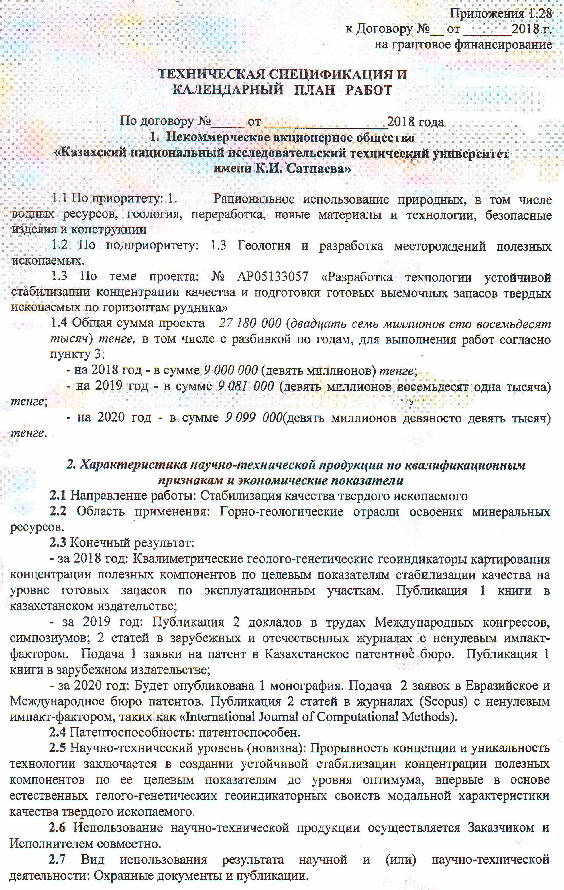
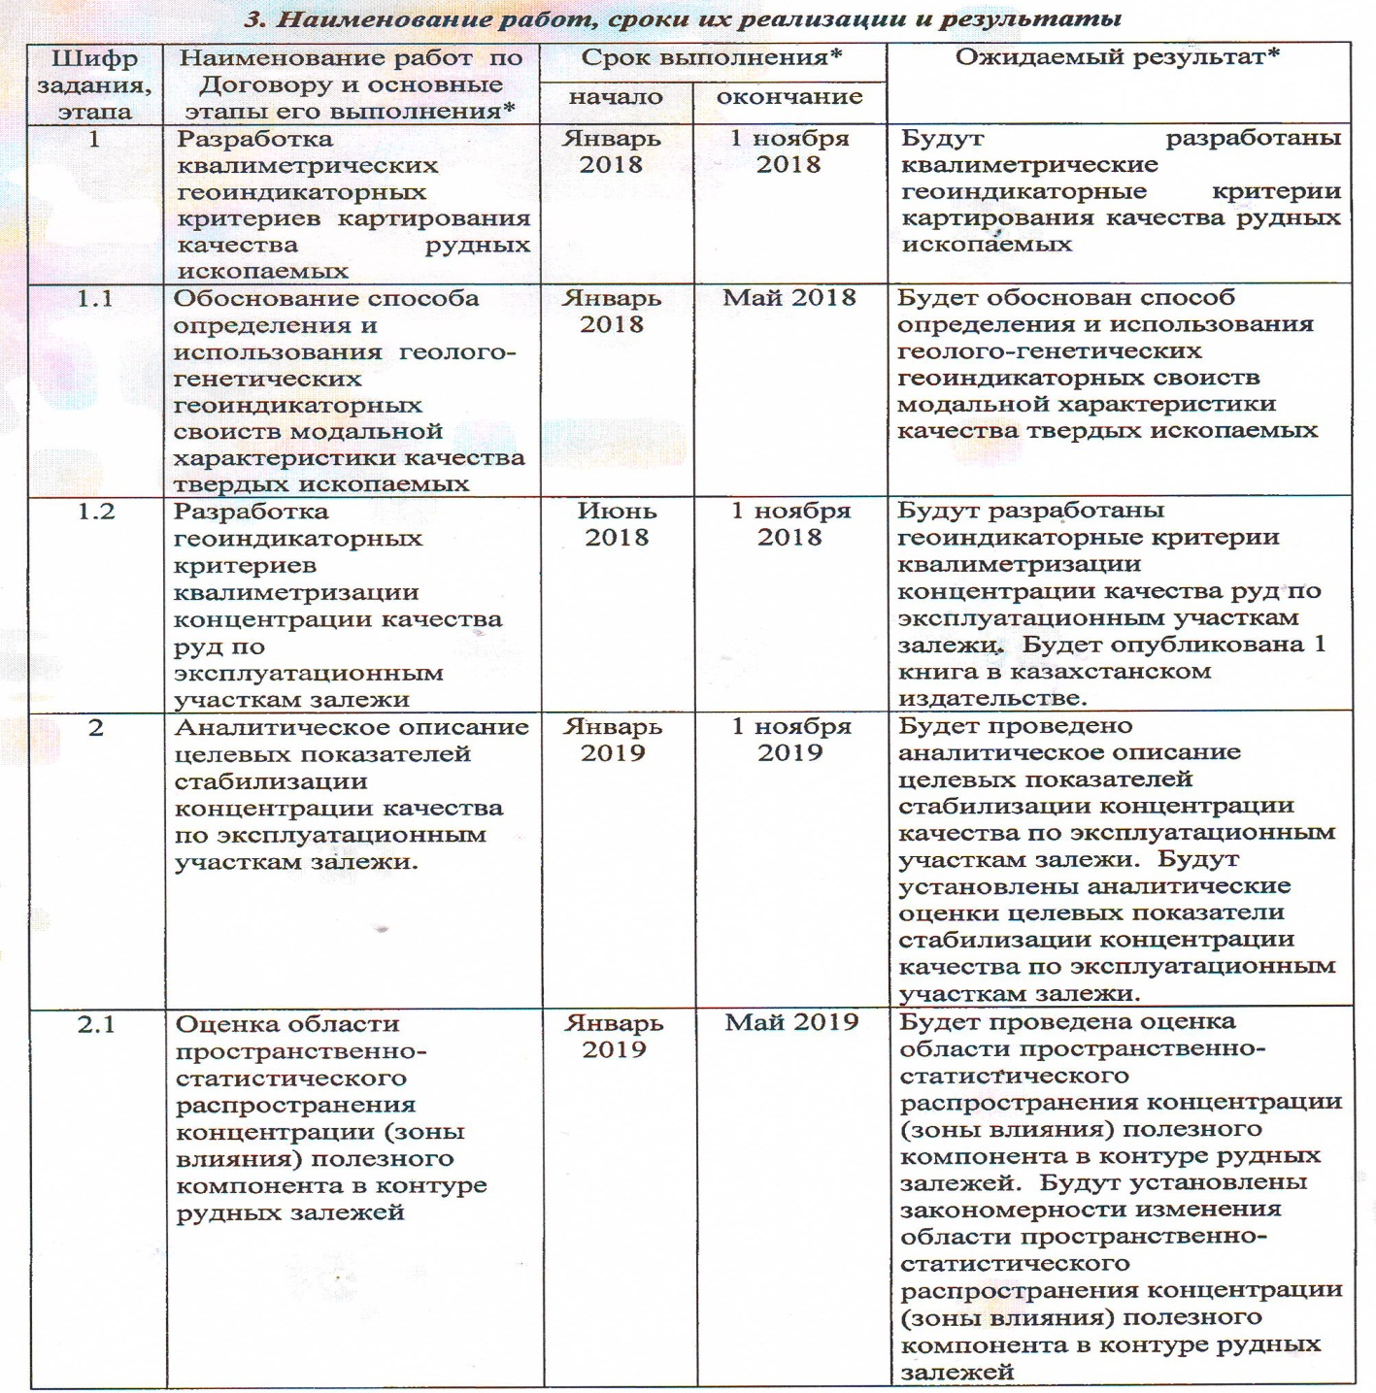


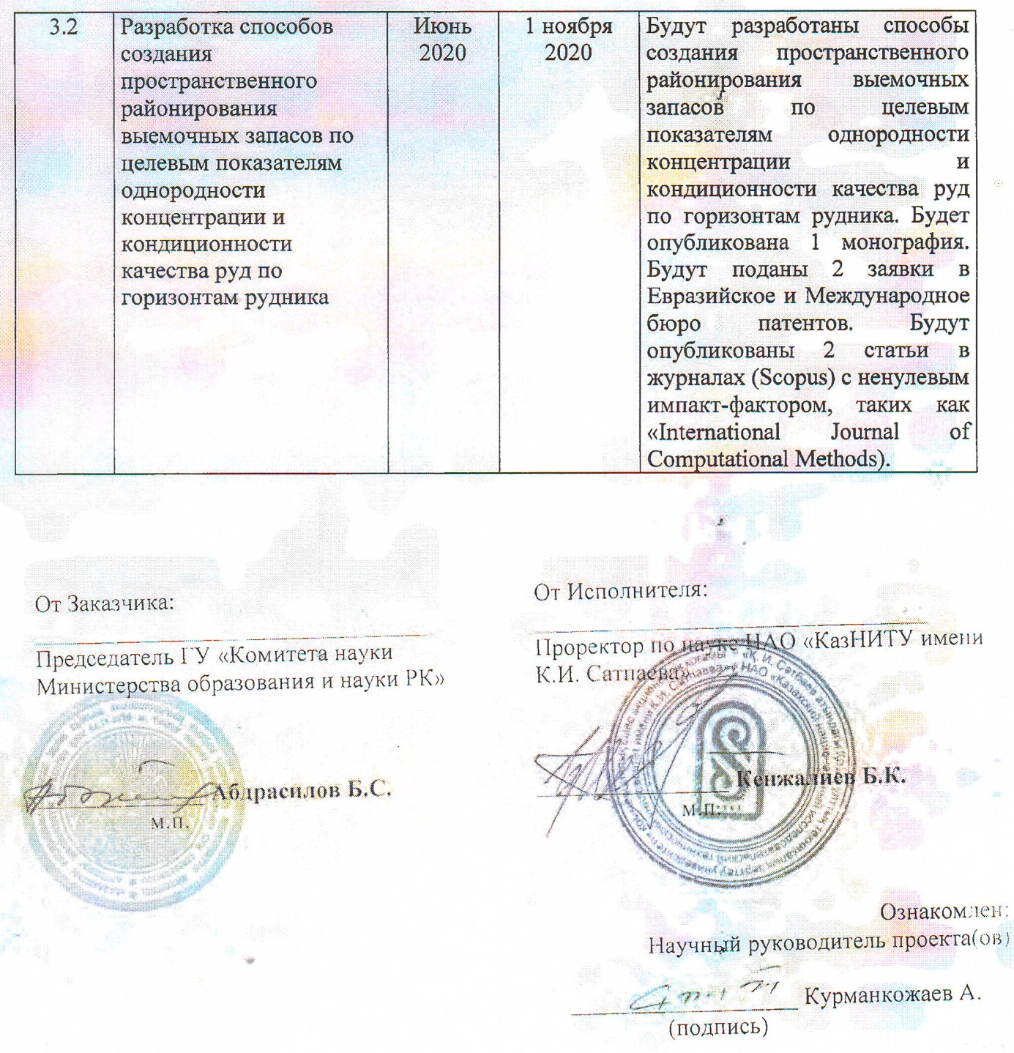

Applications 1.28
to the Agreement No. __o t ________2018
for grant funding

TECHNICAL SPECIFICATIONS AND
CALENDAR WORK PLAN

Under contract №. _____ dated __________________ 2018
1. Non-profit joint-stock company
Kazakh National Research Technical University
named after K.I. Satpayev"

- By priority: 1. Rational use of natural resources, including water resources, geology, processing, new materials and technologies, safe products and structures
- For sub-priority: 1.3 Geology and development of mineral deposits.
- 1.3 On the topic of the project: №. AP05133057 " Development of technology for stable stabilization of quality concentration and preparation of ready-made removable reserves of solid minerals along the horizons of the mine"
1.4 Total amount of the project 27 180 000 (twenty seven million one hundred eighty thousand) tenge, including with a breakdown by years, for the performance of work in accordance with paragraph 3:
- - for 2018 - in the amount of 9,000,000 (nine million) tenge;
- for 2019 - in the amount of 9,081,000 (nine million eighty-one thousand) tenge;
- for 2020 - in the amount of 9,099,000 (nine million ninety nine thousand) tenge.
2. Characteristics of scientific and technical products by qualification characteristics and economic indicators
- irection of work: Stabilization of the quality of solid fossil
- Area of application: Mining and geological industries for the development of mineral resources.
- End result:
- for 2018: Qualimetric geological and genetic geoindicators for mapping the concentration of useful components according to the target indicators of quality stabilization at the level of finished reserves for production sites. Publication of 1 book in a Kazakh publishing house;
- - for 2019: Publication of 2 reports in the proceedings of International congresses, symposia; 2 articles in foreign and domestic journals with a non-zero impact factor. Submission of 1 patent application to the Kazakhstan Patent Office. Publication of 1 book in a foreign publishing house;
- - for 2020: 1 monograph will be published. Submission of 2 applications to the Eurasian and International Patent Offices. Publication of 2 articles in journals (Scopus) with a non-zero impact factor, such as the International Journal of Computational Methods ».
- Patentability: patentable.
- Scientific and technical level (novelty): The breakthrough of the concept and the uniqueness of the technology lies in the creation of a stable stabilization of the concentration of useful components according to its target indicators to the optimum level, for the first time in the basis of natural gel-genetic geo-indicator properties of the modal characteristics of the quality of a solid fossil.
- he use of scientific and technical products is carried out by the Customer and the Contractor jointly.
Type of use of the result of scientific and (or) scientific and technical activities: Security documents and publications

3. Name of work, terms of their implementation and results
The cipher of the task stage | Name of work under the Contract and the main stages of its implementation* | Period of execution* |  | Expected Result*
The cipher of the task stage |  | Start | end | Expected Result*
1 | Development of qualimetric geo-indicator criteria for mapping the quality of ore minerals | January  2018 | 1 november 2018 | Qualimetric geo-indicator criteria for mapping the quality of ore minerals will be developed
1.1 | Substantiation of the method for determining and using the geological and genetic geoindicator properties of the modal quality characteristics of solid minerals | January  2018 | May 2018 | A method for determining and using the geological and genetic geoindicator properties of the modal quality characteristics of solid minerals will be substantiated
1.2 | Development of geo-indicator criteria for qualimetrization of ore quality concentration by production areas of the deposit | June  2018 | 1 november 2018 | Geoindicator criteria for qualimetrization of ore quality concentration by production areas of the deposit will be developed. ”1 book will be published in a Kazakh publishing house.
2 | Analytical description of the target indicators for stabilizing the quality concentration in the production areas of the reservoir. | January  2019 | 1 november 2019 | An analytical description of the target indicators of stabilization of quality concentration in the production areas of the reservoir will be carried out. Analytical assessments of target indicators for stabilization of quality concentration in production areas of the reservoir will be established.
2.1 | Assessment of the area of spatial-statistical distribution of the concentration (zone of influence) of the useful component in the contour of ore deposits | January  2019 | May 2019 | An assessment of the area of spatial and statistical distribution of the concentration (zone of influence) of the useful component in the contour of ore deposits will be carried out. Regularities of changes in the area of spatial and statistical distribution of the concentration (zone of influence) of the useful component in the contour of ore deposits will be established
2.2 | Analytical description of the formation of uniformity of concentration and conditionality of ore quality in production areas | June  2019 | 1 november 2019 | An analytical description of the formation of uniformity of concentration and conditionality of ore quality by production sites will be carried out. Analytical assessments of the formation of the uniformity of concentration and conditionality of ore quality in the production areas will be established. 2 reports will be published in the proceedings of International congresses, symposia; 2 articles will be published in foreign and domestic journals with a non-zero impact factor. 1 patent application will be filed with the Kazakhstan Patent Office. 1 book will be published in a foreign publishing house.
3 | Development of methods for creating spatial zoned mining reserves according to target indicators of stabilizing the quality of ores for a deposit | January  2020 | 1 november 2020 | Methods will be developed for creating spatial zoned mining reserves according to target indicators of stabilizing the quality of ores for the deposit
3.1 | Substantiation of computer algorithms for qualimetrization of geological content according to geo-indicator criteria | January  2020 | May 2020 | Computer algorithms for qualimetrization of geological content according to geo-indicator criteria
3.2 | Development of methods for creating spatial zoning of mining reserves according to target indicators of uniformity of concentration and conditionality of ore quality along the horizons of the mine | June  2020 | 1 november 2020 | Methods will be developed for creating a spatial zoning of mining reserves according to target indicators of uniformity of concentration and conditionality of ore quality along the horizons of the mine. 1 monograph will be published. 2 applications will be filed with the Eurasian and International Patent Offices. 2 articles will be published in journals (Scopus) with non-zero impact factor, such as the International Journal of Computational Methods.

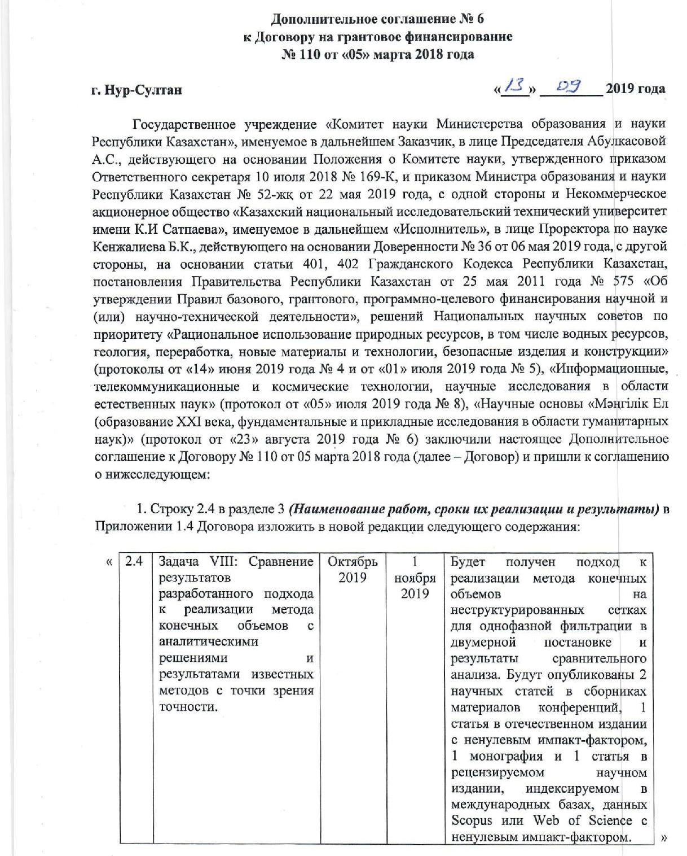
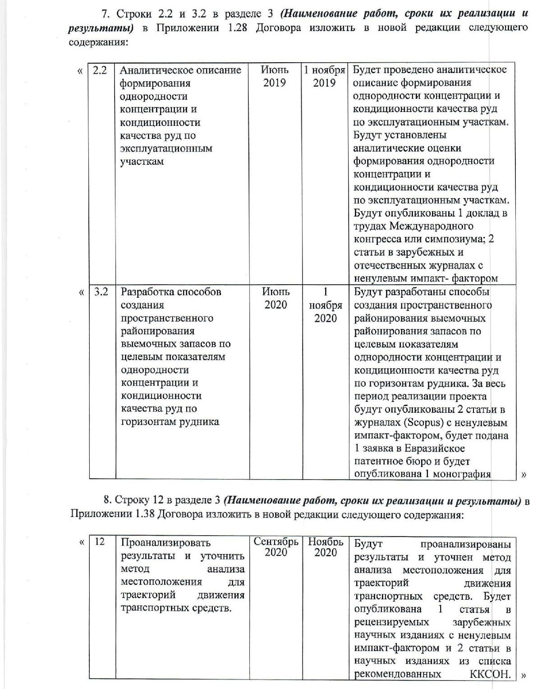



Supplementary Agreement № 6
to the grant financing agreement
№. 110 of" 05 " March 2018

Nur-Sultan «__» __________2019
State institution "Science Committee of the Ministry of education and science of the Republic of Kazakhstan", hereinafter referred to as the Customer, represented by the Chairman A.S. Abulkasova, acting on the basis of the Regulation on the Science Committee, approved by order of the Executive Secretary on July 10, 2018 №. 169-K, and by order of the Minister of Education and Science of the Republic of Kazakhstan №. 52-zhқ dated May 22, 2019, on the one hand and the Non-profit Joint Stock Company Kazakh National Research Technical University named after K.I Satpayev, hereinafter referred to as the "Executor", represented by the Vice-Rector for Science Kenzhaliev B.K., acting based on the Power of Attorney №. 36 dated May 06, 2019, on the other hand, based on Articles 401, 402 of the Civil Code of the Republic of Kazakhstan, Resolutions of the Government of the Republic of Kazakhstan dated May 25, 2011 №. 575 "On Approval of the Rules for Basic, Grant, Program-Targeted Funding of Scientific and (or) Scientific and Technical Activities", decisions of National Scientific Councils on the priority "Rational use of natural resources, including water resources, geology, processing, new materials and technologies, safe products and structures" (minutes of June 14, 2019 №. 4 and of July 01, 2019 №. 5), "Information, telecommunication and space technologies, scientific research in the field of natural sciences" (minutes dated July 05, 2019 №. 8), "Scientific foundations" Mangilik el (education of the XXI century, fundamental and applied research in the humanities) "( Minutes dated August 23, 2019 №. 6) have entered into this Supplementary Agreement to Agreement №. 110 dated March 5, 2018 (hereinafter referred to as the Agreement) and have agreed on the following:
7. Lines 2.2 and 3.2 in section 3 (Name of works, terms of their implementation and results) in Appendix 1.28 of the Agreement, state in a new version as follows:
2.2 | Analytical description of the formation of uniformity of concentration and conditionality of ore quality in production areas | June 2019 | 1 november 2019 | An analytical description of the formation of uniformity of concentration and conditionality of ore quality in production areas will be carried out. Analytical assessments of the formation of the uniformity of concentration and conditionality of ore quality in the production areas will be established 1 report will be published in the proceedings of the International Congress or Symposium; 2 articles in foreign and domestic journals with a non-zero impact factor
3.2 | Development of methods for creating spatial zoning of mining reserves according to target indicators of uniformity of concentration and conditionality of ore quality along the horizons of the mine | June 2020 | November 1, 2020 | Methods will be developed for creating spatial zoning of mining zoning reserves according to target indicators of uniformity of concentration and conditionality of ore quality along the horizons of the mine. Over the entire period of the project implementation, 2 articles will be published in journals (Scopus) with a non-zero impact factor, 1 application will be submitted to the Eurasian Patent Office and 1 monograph will be published

11. The supplementary agreement is an integral part of the Agreement.
12. The terms of the Agreement not affected by this Supplementary Agreement remain unchanged.
13. The supplementary agreement is made in two copies, one copy for each of the parties, having the same legal force.

APPENDIX B

List of published works on the topic for 2018-2020:

- Kurmankozhaev A. Special statistical distribution of indicators of minerals. Astana, Journal of the National Academy of Mining Sciences, No. 2, June 2018, p. 22-28. (Russian) http://www.nagn.kz/images/Magazine/Zhurnal_3_NAGN.pdf
- Kurmankozhaev A. Qualimetric modeling - a new stage of evolution in digital mapping. Astana, Bulletin of KazNAEN, No. 1., 2018, p. 58-66. (Russian) https://kaznaen.kz/wp-content/uploads/2018/10/№-1-2018-почта.pdf
- Kurmankozhaev A., Orinbasarova E., Erzhakyzi A.. Digital model in the problems of Development of modern Cartography. «Scientific discussion» Editorial board address Praga, vol. I, №22, 2018г., st.36-vi. (English) http://scientific-discussion.com/wp-content/uploads/2018/09/VOL-1-No-22-2018.pdf
- Kurmankozhaev A., Orynbasarova E. Information security of the map content in the conditions of complex georesource objects. G. Kharkiv., Proceedings of the XXXVIII International conference "Kazvitok of science in the XXI capital", Science and information center "Knowledge", 2018. p.87-93. (Russian) http://nic-znanie.org.ua/images/docs/August_2018/Kharkiv_august_2018.pdf
- Kurmankozhaev A. Method of qualimetric preparation of ore deposits to the calculation of their geological reserves / A. Kurmankozhaev. - Almaty: Bulletin of KazNRTU im. K.I.Satpaeva, 2019. No. 6. p.17-26. (Russian) https://official.satbayev.university/download/document/12921/ВЕСТНИК-2019%20№6.pdf
- Kurmankozhaev A., Esbergenova E.A. Structural relationships and interchangeability of asymmetric variable types. M .: International Eurasian Scientific Journal, No. 8 (77), Impact factor - 0.82. 2020, p. 13-17. (English) https://euroasia-science.ru/wp-content/uploads/2020/09/Euroasia_877_6_august_2020.pdf
- Kurmankozhaev A. Advantages of degenerated model in the assessment of the distribution of ore reserves variables classified as normally distributed variables. International Turkish scientific journal "Earth Science". Impact factor - 1.362. Percentile - 56%. Publisher - Scientific and Technical Research Council Turkey-Tubitak, 2020, 6 st. (in print) (English) https://journals.tubitak.gov.tr/earth/index.htm
- Курманкожаев А. Advantages of qualimatric modernization of the preparation of a geological reserve, using modal geoindicators. 3 CONFERENCE OF THE ARABIAN JOURNAL OF GEOSCIENCES (CAJG). Springer Pringer nature. Impact factor - 1.12. Percentile - 35%, 2020, 5 st. (in print)
Monographs
- Kurmankozhaev A. Theoretical beginning of probabilistic modeling of distributions of georesource indicators. Monograph, Almaty, publishing house Satbayev University, 2019 .-- 221 p. (Russian)
Patents
- A KZ patent was received for the invention "A method of qualimetric preparation of geological reserves of solid minerals along the horizons of a mine" (No. 233535, 2019, Kurmankozhaev A.).
- An application was filed for obtaining a Eurasian patent for an invention (No. 201800031, 2019, Kurmankozhaev A.).
3 An application was filed for obtaining a Kazakhstan patent for an invention "Method for determining the zone of influence of the modal value of the useful component on the zoning of the dismemberment of the estimated reserves of ore deposits" (No. 2019 /0637.1, 03.09.2019, Kurmankozhaev A.).

APPENDIX B

