Ministry of Education and Science of the Republic of Kazakhstan
Science Committee
REPUBLICAN STATE ENTERPRISE
INSTITUTE OF HUMAN AND ANIMAL PHYSIOLOGY

REPORT
ON SCIENTIFIC RESEARCH WORK
on this topic
The functioning of the lymphatic system from a young organism to an old one and the search for medicinal substances that slow down senile changes

Scientific supervisor of the assignment
Head lab., d.m.s. G.A. Demchenko

Almaty 2020

LIST OF PERFORMERS
Scientific supervisor of the grant
Head lab., d.m.s. __________________________________G.A. Demchenko
(introduction, methodology, section 1а,1в,3,1.3,2.3,3.3,4.3,5.3,6 discussion,
conclusion)
Responsible executor,
senior researcher, Ph.D. _____________________________________S.N. Abdreshov
(methodology, sections 3.3)
Responsible executor,
senior researcher, candidate of biological sciences_____________________ N.A. Akhmetbaeva
(section 3.2)
Responsible executor,
junior researcher ______________ __________________________________S.O. Osikbaeva
(list of references, section1,9. 3.1)
Responsible executor,
junior researcher _____________________________________________ B.Ә. Nurmakhanova
(list of references, section 1в.3.1)
Norm controller, scientific secretary,
Ph.D._________________________________________________________ A.M. Kalekeshov

ESSAY
Report 150 p., Figure 27, Tables 11, 130 of the source, Appendix 3.
LYMPHATIC SYSTEM, LYMPH NODES, LYMPH VESSELS, HERONTOLOGY, AGING.
Topic: "The functioning of the lymphatic system from a young organism to an old one and the search for medicinal substances that slow down senile changes"
Subject: Laboratory white rats, line Wistor-245.
Purpose: To study the morpho - functional state of the lymphatic system during the life cycle of the organism and to develop ways to slow down senile processes using the substances of medicinal plants obtained by scientists of the Republic of Kazakhstan.
Results: There was a decrease in lymph flow, urine output, interstitial fluid in mature animals in comparison with young animals and a further decrease in old animals. An increase in blood and lymph cholesterol, triglycerides, total lipids in old animals and a decrease in glucose were revealed. An increase in leukocytes, neutrophils, CD-20B lymphocytes in the blood and lymph and lymphocytes in the lymph in mature animals, but in old animals, a decrease in the same parameters was revealed. The formation of structural components of adrenergic innervation of lymphatic vessels and nodes in the first 30 days from birth of rats is observed. From the age of one month, adrenergic innervation is a well-formed apparatus. In old animals, the density and number of plexuses are preserved in all parts of the lymph node and lymphatic vessels, but the brightness of the glow decreases; the fibers in the plexuses become intermittent, the number decreases and varicose thickenings disappear. Lymph nodes have common signs of aging: a) an increase in connective tissue with a decrease in the area of ​​lymphoid nodules with germinal centers against the background of the preservation of a compact morphotype; b) unidirectional changes in the cellular composition in a decrease in the number of blasts and medium lymphocytes in lymphoid nodules, paracortical region, plasmocytes in the brain cords against the background of an increase in reticular cells, which indicates a decrease in the immunoreactivity of these structures; The contractile activity of the lymph nodes in old animals was inhibited. During herbal medicine at the stage of late ontogenesis, an increase in the drainage and immune functions of the lymph, activation of contractile activity, an increase in the luminescence of the lymph vessels and nerve plexus nodes, and an increase in the immune function of the structures of the lymph nodes were observed.
Scientific and organizational work under the grant: Articles of Russia - 5; RK-2; Abstracts Russia -2. In the US press -3; Conferences - 3 reports Novosibirsk, Sochi, Prague.

CONTENT

TERMSANDDEFINITIONS  LIST OF ABBREVIATIONS AND DESIGNATIONS  INTRODUCTION………………………………………………………………………….  MAIN PART………………………………………………………………… | 5  6  7  10
1 JUSTIFICATION OF THE DIRECTION OF RESEARCH  А) The importance of the functions of the lymphatic system and in the aging process  Б)Endoecological rehabilitation and medicinal plants…………………………………….. | 10  10  13
2RESEARCH TECHNIQUE……………………………………………… | 20
3 RESULTS OF STUDIES………………………………………………………… | 24
3.1Cellular, biochemical, immunological composition, physicochemical, rheological indicators of lymph and blood, volume and composition of interstitial fluid, diuresis in young and adults | 24
3.2 Adrenergic inversion of lymph nodes from different regions of the body in young, mature and old rats…………………………………………………… | 30
3.3 Contractive activity of lymph nodes from different body regions in young, mature and old rats………………………………………………… | 34
3.4 Contractive activity of lymph nodes from different body regions in young, mature and old rats………………………………………………………………………………… | 47
3.5 Medicinal plants inhibiting aging processes in the body | 46
3.5.1 Cervical knot. Young animals. The morphofunctional state of the cervical lymph nodes is closely related to the drainage of the organs of the head and neck | 46
3.5.2 Mesenteric lymph node. ………………………………………………………… | 48
3.6 Discussion of study results …………………………………………………………… | 66
CONCLUSIONS………………………………………………………………………... | 72
LIST OF USED SOURCES ……………………………………………………………… | 75
ANNEXES А - List of publications……………………………………………………… | 86
ANNEXES В - Agreement with the calendar plan………………………………………… | 99
ANNEXES С - Reprints of articles……………………………………………………… | 100

TERMS AND DEFINITIONS
Adrenergic innervation - sympathetic innervation of blood vessels and nodes
Smooth muscle cells - muscles located in the walls of blood vessels
Medicinal plants - plants used
The lymphatic system is a sub-system of the cardiovascular system
Lymph nodes-immune organs of the lymphatic system
Lymph detoxification-purifying the lymph in the lymph nodes
Microstructure of lymphoid tissue-structures inside the lymph nodes
Late ontogenesis - development after the birth of an organism
Postnatal ontogenesis – functioning of the body in old age
Screening studies-studies that identify certain changes in the body
Senile changes – changes in the body in late pathogenesis
Spontaneous contractions - contractions of blood vessels and nodes without the involvement of the nervous system
Fitokompozitsiya several medicinal plants
Endoecological rehabilitation - restoration of function after the action of medicinal plants and other natural factors

LIST OF ABBREVIATIONS AND DESIGNATIONS
ALAT - Alanine aminotransferase
AsAT - Aspartate Aminotransferase
BA- Alma-Ata hawthorn
BP- Blood pressure
BT - Badan thick-leaved
GLP - Thoracic Lymphatic Duct
HR - Heart rate
EP - Echinacea purpurea
IL - interstitial fluid
K-kopechnik
ZB - Ziziforabunge
ZO-St. John's wort ordinary

INTRODUCTION
The global aging of humankind brings with it many practical problems, including an increase in the burden of disease and the proportion of the population not engaged in productive work. Life expectancy was a concern of people long before the appearance of demographic statistics and bibliometric databases. This is how, for example, Rene Descartes formulated his concern in the 17th century: "Why is my knowledge limited, my growth is small, the lifespan is a hundred years, and not a thousand? - although the numbers are countless, and there is no reason to prefer any of them to the other." There are usually two main questions on this topic: 1) how do we age and 2) why? The first concerns the mechanisms of aging, and the second concerns their / its evolutionary origin. [1].
Aging is a process of reducing the functional reserves of all tissues and systems of the body, associated with the processes of inflammation and thrombus formation, followed by replacement with connective tissue [2,3].
The progress of medicine increases life expectancy, leading to a demographic situation when the number of old people in society increases [2,4]. The problem of aging and the issue of health and quality of life of the elderly remains relevant today because of their characteristic morphological changes on the part of different organs and systems of the body [5]. Age and the associated aging is one of the risk factors for diseases such as cardiovascular and autoimmune diseases, oncological pathologies, infections. Despite active research, the problem of aging is still one of the least understood issues in the biology of the human body.
With aging, changes occur with the manifestation of extinction and violations of regulatory influences, important adaptive shifts are noted - an increase in the sensitivity of the heart and blood vessels to humoral factors and mediators in conditions of destruction of nerve endings, as well as a weakening of the synthesis of mediators [2,5,6].
Age-related changes in the structure of the microvascular network contribute to a decrease in the blood flow velocity in different parts of the brain [7], a deterioration in the diffusion of oxygen from the blood into the tissue [8], and a deterioration in the reactivity of cerebral arterioles to unfavorable exogenous and endogenous factors [9]. Diseases found in many elderly people - angina pectoris, hypertension, diabetes mellitus, atherosclerosis - increase age-related pathologic changes in the circulatory system [10].
Studies of the state of capillaries in skin biopsies by electron microscopy showed that with age, the basement membrane of the capillaries thickens, fibrils collagen, the pore diameter decreases, and activity decreasespinocytosis. These changes lead to a decrease in the intensity of travskapillary exchange [11]. One of the causes of aging is put forward by changes in the microcirculation system. A significant decrease in renal blood circulation with aging has been shown, which is directly related to a decrease in microvascularization. Endoscopic examinations of the gastric mucosa and biopsy specimens revealed a decrease in the number of microvessels [12].
Aging is a complex process caused by many factors and accompanied by a variety of physiological changes, including postnatal development and age-related characteristics of the functioning of the immune system. This actualizes the need to study the functions of the lymphatic system during aging as a life support system associated with endoecological safety and an increase in nonspecific resistance, while searching for new approaches to the prevention and treatment of age-related pathology [13].
The lymphatic system, anatomically and functionally inextricably linked with the circulatory system, takes part in the resorption of water and proteins, in water-salt metabolism and in immune reactions [14]. It has been proven that the development of a number of pathological processes is accompanied by the participation of the lymphatic system, which, due to its protective-compensatory, drainage and transport functions, can change the course of the disease and the state of the body [14,15]. We have studied the state of the lymphatic system in hypertensive conditions [16]. According to the literature, in humans, in the process of aging, the cytoarchitectonics of the lymph nodes changes, their number and size decrease [17].
With age, significant changes, as noted above [10,11,12], occur in the cardiovascular system, which has been studied and continues to be studied, and the lymphatic system, as a part of this system, is scientifically neglected.
At the present stage, it is necessary to influence the aging organism through the functions of the lymphatic system by expanding the platform for new lymphatropic substances to the already existing ones. In gerontology, in our opinion, it will be of great importance to identify violations of the structure and function of the lymphatic system and it is precisely on these changes that corrective actions should be directed.
Despite the advances in biology and medicine, there is still an urgent need for scientific substantiation and search for non-drug means of prevention and therapy of aging [18]. The available morphological and functional features of the organs and systems of the body of an aging person largely determine the adequacy of his responses, which should be taken into account when non-drug methods of correction. Beforein total, this applies to elderly and senile people who suffer from the structure and functions of the lymphatic system, including lymph nodes, due to the accumulation of metabolites and xenobiotics in the body [19]. Consequently, elderly people need to optimize the function of the lymphatic system at all levels of its organization, when an increase in functional reserves and nonspecific resistance is required [20]. This can be achieved using non-drug means of correction, among which herbal medicine is of the greatest interest because of their positive effect on the body.
The main goal of gerontology is to provide a person with the opportunity to live to physiological old age and to provide him with active creative longevity through the use of all means and methods to prevent premature aging. The growing number of older people requires the search and development of acceptable and at the same time modern methods of non-drug and drug correction of growing changes in various body systems.
The purpose of the project: To study the morpho - functional state of the lymphatic system during the life cycle of the body and to develop ways to slow down senile processes using the substances of medicinal plants obtained by scientists of the Republic of Kazakhstan.
Objectives: 1) To study and conduct a comprehensive study of the functioning of the lymphatic system in young rats (3-4 mx) and in mature (10-11 mx). To study the volume and composition of the interstitial fluid, diuresis and the composition of urine in the same animals.
2) To study and conduct a comprehensive study of the functioning of the lymphatic system in old rats (19-20 mx). To study the volume and composition of the interstitial fluid, diuresis and the composition of urine in the same animals
3) To develop methods of slowing down the aging process for this purpose, to carry out screening studies of the substances of medicinal plants isolated by Kazakhstani scientists for the cardiovascular and lymphatic systems on aging animals.
Report for 2018 on the topic: "The functioning of the lymphatic system from a young organism to an old one and the search for medicinal substances that slow down aging changes" State Reg. No. 0118RK00435. Inventory number: 0218RK01307
Report for 2019 on the topic: "The functioning of the lymphatic system from a young organism to an old one and the search for medicinal substances that slow down senile changes" No. gos.reg.0118RK00435. Inv No .: 0219RK01191

MAIN PART

1 Justification of the direction of research
1.1 The importance of the functions of the lymphatic system and in the aging process

The lymphatic system, due to its polyfunctionality, cannot but be considered outside the problem of aging. The lymphatic system is a component of the cardiovascular system, and it is one of the integrating systems involved in all physiological and pathological processes of the body [21]. At the same time, the lymphatic system acts as an intermediary between the closed bloodstream and the cells of the body. It consists of lymphatic gaps, lymphatic capillaries, lymphatic vessels, trunks, ducts, and lymph nodes. The lymphatic system forms an additional bed, which is filled with liquid contents, lymph [20]. The movement of lymph is facilitated by the presence of lymphangion in the lymphatic vessel - an intervalvular segment with smooth myocytes, which has a contractile ability due to which the movement of lymph is carried out [22].
The lymphatic system is subdivided into two sections: 1) Lymph transport routes and 2) lymphoid organs, which belong to the organs of immune defense and hematopoiesis. A lymph node is one of the main structural units of the lymphatic system, which is an example of the combination of two systems, the lymphatic and the immune [23].
Among the organs and systems involved in ensuring homeostasis of the internal environment during aging, an important role belongs to the lymphatic system and its constituent peripheral lymphoid organs - regional lymph nodes, belonging to the body's protective barrier and responsible for the formation of an immune response to the external environment [24]. Lymph nodes occupy a special place among the lymphoid organs, simultaneously carrying out the drainage of the interstitium and immune function [25]. At the same time, the assessment of the state of regional lymph nodes in their relationship with the drained organs remains one of the main directions in morphological studies. The lack of a single point of view regarding the prognostic significance of the immunomorphological restructuring of the lymphatic system during aging determines the need for anatomical and histological assessment of its individual comparatives and cellular composition. At the same time, age-related and pathological changes in the lymphatic system are not differentiated [26].
Water homeostasis is a condition for the vital activity of any organism. Maintaining water homeostasis seems to be the most important function of the lymphatic system [27]. Lymphatic drainage is combined with the neutralization of those harmful substances
which to a greater or lesser extent are present in the interstitium surrounding the cell. The latter is realized by biophysical, biochemical, immune processing of tissue fluid and lymph formed from it [28]. In the process of neutralization of substances harmful to the life of the body, three homeostatic systems are involved: lymphatic, lymphoid (immune) and the system of loose connective tissue, which forms the interstitium - the internal environment of the body. This functional synergism gives grounds to consider these systems as a drainage-detoxification complex, and it should be considered as a kind of functional system that ensures the bio-safety of the body [29].
Most scientists agree that tissue hydration decreases with age [14,15]. In this case, the cells are deprived of their aquatic habitat and at the same time their metabolism in the cell is disrupted, leading to their death [30]. The clinical manifestations of the signs of aging depend on the state of the intercellular substance of the dermis. Collagen and elastic fibers become fragmented and lose their original organization. The composition and molecular weight of dermal proteoglycans also change with age. Proteoglycans lose their original mass, and in this state they cannot associate a sufficient amount of water [31]. It is well known that changes in the extracellular matrix of the dermis are caused by dysfunctions of dermal fibroblasts, since it is these cells that are responsible for the synthesis and decay of all components of the extracellular substance. It has been shown that the number of fibroblasts in the dermis decreases significantly with age [32]. Consequently, the possibilities of regeneration of the dermis decrease with age.
Aging is associated with a lack of interstitial transport and lymph flow, and measures aimed at improving interstitial transport, stimulation of lymph flow, can slow down the effects of different types of aging [33].
All three homeestic systems function together: the lymphatic, lymphoid and loose connective tissue systems, and they must age together [34].
The predisposition to a number of acute and chronic diseases increases as a result of age-related decline in the function of the immune system [35]. It has been established that the rate of decline depends on a number of factors, among which the number and severity of acute and chronic infections, the presence of autoimmune diseases and, possibly, the level of biogenic and technogenic pollution can be distinguished [36]. Consequently, the processes affecting the aging of the immune system should influence the dynamics of mortality in the population. Decreased functions of the thymus and involution of peripheral lymphoid tissue determine the aging of the immune system. Since inSince the set of pathogens was quite stable in archaic communities, the preservation of memory cells was a more profitable strategy than maintaining the ability to respond to new pathogens. Therefore, depletion of naive T-lymphocytes, the thymus began to undergo involution immediately after reaching puberty, which ensures the maintenance of a longer immune memory.
The main directions of the wellness strategy in connection with the changes that the lymphatic, lymphoid (immune) systems and the system of loose connective tissue undergo in old age, which form a drainage and detoxification complex in general. All these anti-sclerotic measures of a general nature slow down the aging process, so the appointment of such is very useful, because all three systems of the drainage-detoxification complex undergo sclerosis. It is also highly advisable to stimulate interstitial transport, lymph formation, lymph flow, as well as lymphatic detoxification processes at all levels of the lymphatic drainage mechanism [37].
In the process of life, the physiological mechanism of the autonomous regulation of ME CVS is restructured, aimed at replacing short-term sympathetic regulation in young people with more efficient and stable regulation of humoral catecholamines in older people [38].
Neurohumoral regulation is not so much due to an increase in the activity of the humoral-metabolic link of regulation, the predominance of which is characteristic of the elderly, but due to an increase in the tone of the autonomic centers, and parasympathetic effects on the myocardium prevailed over sympathetic ones. [39]
One of the key mechanisms of aging is a change in hormonal regulation, for an effective effect on which, in order to prolong life, it is necessary to determine the root cause of these processes [40]. Transposons can serve as molecular drivers controlling the dynamics of hormone levels. This is due to their use as sources of nucleotide sequences that receive specific signals from ribozymes, transcription factors, hormones and their messengers. At that time, in evolution, transposons are sources of ribozymes and proteins with DNA-binding domains. Beginning with zygote division, the species-specific composition and distribution of transposons in the genome can be used as the biological coding required for consistent and cell-specific gene expression. It has been suggested that hormonal regulation is one of the components of a complex system of ontogenesis control under the influence of mobile elements. As evidence, givenworks on the role of transposons in the control of genes of the endocrine system, as well as on the effect of hormones on the activity of transposons. The study of these relationships may have prospects for the development of methods of life extension, since epigenetic changes under the influence of transposons are reversible. [41]
Anemia in elderly patients can be considered a geriatric syndrome that impairs quality of life, functional status, decreases autonomy and affects prognosis. Anemia is associated with other geriatric syndromes such as senile asthenia, sarcopenia, falls and fractures, vitamin D deficiency, dementia, and others. Iron deficiency anemia is the most common. [42]
Accelerated aging, which is formed on the basis of the consequences of severe stressful effects, and this is considered as an independent disease. [43]
In old animals, there is also a low activity of autophagy, which removes damaged organelles and aggregated structures from cells. The age-related shift of the redox balance towards oxidative stress can be the cause of the development of age-associated neurodegenerative, autoimmune, and inflammatory pathologies. [44]
It was revealed that, along with morphological changes, the secretory activity of EC and the release of vF protein into the blood plasma sharply increases. It was found that in the cavity of the podaortic cone of the heart in animals during aging, a mass of products of metabolism of the vW protein, pigmented granularity, Weibel-Palade rod-shaped bodies, and various sizes of thrombi are accumulated [45].
We age because these are the chemical properties of what we are made of, and the way these properties are realized in the conditions of our body. Aging is neither a direct result of evolution by natural selection (a program that sets lifespan), nor is it a side effect (postponed payment for benefits now). Aging is a consequence of the limitations imposed on the possible and results of evolution by the inherent physicochemical properties of the participants in metabolism, and in this it differs from the wear and tear of inanimate technical systems [46].
The global aging of humanity brings with it many practical problems, including an increase in the burden of disease and the proportion of the population not engaged in productive labor. [47]
Age-related changes in the latter in rats (starting from 18 months of age) indicated an increase in infectious intoxication and inflammation, activation of cellular immunity and an effector link, and a predominance of cells.nonspecific protection and their immature forms, on the activation of delayed-type hypersensitivity processes, as well as on a decrease in immunoreactivity and the level of adaptation of the organism [48]
The limitation of the energy value of nutrition is accompanied by an increase in the life expectancy in various experimental objects - mammals [49], invertebrates [50], and microorganisms [51], that is, we can talk about the presence of a common mechanism for regulating the duration of ontogenesis.

1.2 Endoecological rehabilitation and medicinal plants
There are many recipes for stimulating the lymphatic drainage mechanism and the associated lymphatic detoxification. The works of Yu.M. Levin and his colleagues and followers have become the main very effective system of endoecological rehabilitation, providing sanitizing effects on the body of various non-drug means, taking into account the physical condition of the body and its age [30].
Research of Novosibirsk lymphologists within the framework of the concept of Yu.M. Levin and his health-improving system ERL showed the feasibility of using a number of plant polyphenols to improve the health of the population: rosehip roots, cuff, burnet, berries of black currant, blueberries, lingonberries, leaves of badan, red root, Kuril tea, chitosan proved to be an excellent lymphotropic agent [52].
The existing system of prevention and treatment measures prolongs a person's life and makes old age active, but only to a certain limit. Scientific substantiation and active introduction of lymphotropic technologies increases the capital of health and improves the quality of life at any age [53]. Understanding the mechanisms of regulation of life expectancy is the main task of gerontology, since only knowledge of the mechanisms of ontogenesis can provide adequate modeling of the processes of age development and management of life expectancy [54].
Since ancient times, various biologically active natural components of plant, animal and mineral origin have been known, which a person consumes with food and uses it for therapeutic and prophylactic purposes. [55]. In everyday life, health-improving and prophylactic means, called "biologically active food additives", "nutraceuticals", "parapharmaceuticals", have appeared. All of them are associated with the need to improve nutrition and impart health-improving and prophylactic properties to products. Vegetablecomponent - the most common part of dietary supplements and food products. It is plants that contain all the substances necessary for human nutrition. Therefore, the main choice was made on them.
At the same time, special attention is paid to medicinal plants containing essential substances and trace elements, vitamins (vitamin-mineral complexes), minor food components, bioflavonoids, organic acids, glycosides, biogenic amines, regulatory oligopeptides, polysaccharides, oligosaccharides, etc., and they are also sources of polyunsaturated fatty acids (vitamin P) and phospholipids, essential amino acids, antioxidants, dietary fiber, which qualitatively expands their biological activity and increases the therapeutic and prophylactic potential in preserving the capital of health [56].
Numerous results of experimental studies, clinical observations, sanatorium-resort practice have proved the effectiveness of methods of lymphatic sanitation and endoecological rehabilitation using medicinal plants in the form of phyto-assemblies, phytomineral complexes, bioactive additives for the preservation or restoration of structures and drainage-detoxification function of the lymphatic region. At different levels of the anatomical organization of the lymphatic region, it is necessary to consider four possible mechanisms for regulating lymphosanation by means of different means and methods: lymphostimulation, lymphoprotection, lymphocorrection and lymphosuppression.
Stimulation of lymph flow intensifies the intraorganismic circulation of water, contributes to the sanitation of the endoecological space, the return of tissue proteins to the bloodstream, the transport of lipids and microelements necessary for the vital activity of the body, and helps to maintain water and oxidative homeostasis [57].
Plants containing polyphenolic complexes exhibit similar lymphotropy. These include both the medicinal plants themselves and phyto-assemblies or biologically active additives (BAA) created on their basis. Phyto-collection is compiled according to the pharmacotherapeutic principle, taking into account the lymphotropic effect of medicinal plants and is systematized for use in health-improving and therapeutic practice and in anti-aging programs. The composition of the charges is adjusted so that it consists of a phytocomponent containing medicinal plants for the realization of the effect of lymphostimulation, and a compound of substances with a sorption and lymphoprotective effect [58].belongs to the group of aryl-beta-glycosides (hydroquinone derivative). 64-75% of arbutin is excreted in the urine, and arbutin, transformed into hydroquinone, provides antimicrobial action in the urinary tract and has anti-inflammatory and antioxidant effects [60]. Improvement of pericellular humoral transport, the effect of lymph stimulation, and the ability to correct the structure of the lymph node in pathological situations are associated with bioflavonoids [61,62].
After analyzing the literature and the availability of medicinal herbs and their substances, which were offered to us by our scientific partners, the School of Pharmacy of KazNMU and the pharmacological firm "Fitoleum", we settled on the following medicinal herbs: Ziziforabunge, Alma-Ata hawthorn, St. John's wort, Echinacea purpuchnikrnaya Badan thick-leaved
Ziziphorabunge is one of the plants of a family called lily plants, in Latin the name of this plant will sound like this: ZiziphorabungeanaJuz.
Ziziforabunge is a perennial shrub. Under natural conditions, this plant is found in Central Asia and Kazakhstan, as well as in the following regions of Western Siberia: in the Altai and Irtysh regions. Ziziforabunge is endowed with very valuable healing properties, while it is recommended to use the herb and juice of this plant for medicinal purposes. The presence of such valuable healing propertiesdue to the content of essential oils, saponins, organic acids, alkaloids, flavonoids, tannins and vitamin C in the plant.
The aerial part of ziziforabunge also contains essential oil, organic acids, alkaloids, ziforin, tannins and bungeonic acid. Saponins, alkaloids, essential oil, organic acids, vitamin C, flavonoids and tannins are found in stems, flowers and leaves. The buds contain vitamin C.
Ziziforabunge is endowed with very valuable healing properties, while it is recommended to use the herb and juice of this plant for medicinal purposes. Grass includes leaves, flowers, and stems. The presence of such valuable healing properties is explained by the content of essential oils, saponins, organic acids, alkaloids, flavonoids, tannins and vitamin C in the plant.
In the aerial part of ziziforbunge, there is also essential oil, organic acids, alkaloids, ziforin, tannins and bungeonic acid. Saponins, alkaloids, essential oils, organic acids, vitamin C, flavonoids and tannins are found in stems, flowers and leaves. The buds contain vitamin C.
The infusion, decoction and extract of this plant are endowed with hemostatic properties, can increase the activity of respiratory enzymes during hypoxia, and also have a positive effect on collateral coronary blood flow. In addition, such funds have a positive prophylactic and therapeutic effect in myocarditis and myocardial infarction. As for traditional medicine, here the infusion of the herb ziziforabunge is used as a general tonic.
A decoction of the leaves of this plant is used as a diuretic and appetite stimulant, and is also used for stomach cramps, nausea, throat diseases in children and syphilis [63].
Alma-Ata hawthorn (lat.Crataegusalmaatensis) is a shrub or small tree, a species of the genus Hawthorn (Crataegus) of the Pink family (Rosaceae). In nature, the range of the species covers Central Asia and Kazakhstan. For medical purposes, hawthorn fruits (berries) are most often used. Hawthorn fruits contain sugar, organically acids, ascorbic acid, vitamin K, catechins. Hawthorn berries are a real treasure of vitamins C, A, E, K, etc. In addition, they have a high content of essential oils, fructose, pectin and starch. The medicinal properties of the plant include: antitumor and antioxidant effect, wound healing and anti-inflammatory effect, toning of blood circulation, antibacterial effect, vasodilating propertySince the fruits of hawthorn contain a large amount of antioxidants, respectively, it helps to improve blood circulation and cleanse blood vessels. Hawthorn berries are used to treat: angina pectoris, arrhythmia, hypertension, epilepsy and insomnia, stress and chronic fatigue, gynecological diseases. In addition, the hawthorn preparation is prescribed for persons suffering from diabetes mellitus, as well as for persons with liver and kidney diseases. Hawthorn fruits are antispasmodics and can relieve not only headaches, but also help with back and shoulder pain. During the period of exacerbation of seasonal colds and flu, the use of decoctions from hawthorn berries strengthens and enhances the immune system. Hawthorn has the following properties beneficial to human health: vasodilator, cardiac stimulating, anti-inflammatory and antimicrobial, diuretic, antitumor, hepatoprotective, anti-aging, antioxidant, choleretic. Hawthorn berries are unusually rich in ursolic acid, which makes blood vessels dilate, and also fights against tumors, eliminates inflammation.
Many homeopaths advise taking these berries as a medicine for heart problems. This is especially true for people over 50 years old.
Hawthorn is widely used in various herbal preparations that lower blood pressure and cholesterol. Berries contribute to the elimination of toxins and toxins from the body [64].
St. John's wort (Latin Hypéricumperforátum) is a perennial herb; St. John's wort as a medicinal plant has been known for a long time.
The herb St. John's wort (lat. HerbaHyperici) is used as a medicinal raw material - shoots of wild-growing or cultivated St. John's wort collected in the flowering phase. St. John's wort herb contains tannins, essential oil, β-sitosterol, triterpene saponins, vitamins C, E, flavonoids (hyperoside, rutin), anthraquinones, macro- and microelements and other biologically active substances, hypericin dye. St. John's wort contains amentoflavone, a non-selective blocker (antagonist) of opioid kappa receptors, as well as the benzodiazepine segment of the GABAA receptors, which to some extent explains the antidepressant and anti-hangover effect on the psyche. Another component, hyperforin, is an inhibitor of the reuptake of monoamines, including serotonin and dopamine, which also relieves depression. Hypericin selectively inhibits the enzyme dopamine beta-hydroxylase, which increases dopamine levels. In folk medicine, St. John's wort is used in the treatment of gout, articular rheumatism, pulmonary tuberculosis, sciatica. Alcohol tincture is taken orally for rheumaticdiseases, crushed leaves are applied to wounds for early healing. The ground part of the plant is used in the form of a decoction as an anti-inflammatory and astringent agent for diseases of the digestive system, liver, gallbladder, in the treatment of neurasthenia, neuralgia, insomnia, headache, stomach diseases, as a hemostatic and wound-healing agent. St. John's wort oil is used in the treatment of wounds and burns, as a diuretic, and also as a means of stimulating the activity of the heart and tissue renewal [65].
Echinacea purpurea (lat.Echináceapurpúrea) is a perennial plant from the Aster family. Echinacea purpurea herb contains polysaccharides (heteroxylans, arabinoramnogalactans), essential oils (0.15-0.50%), flavonoids, oxycinnamic (chicory, ferulic, coumaric, caffeic) acids, tannins, saponins, polyamines, echinacinated acid (polyinic acid amide ), echinolone (unsaturated ketalcohol), echinacoside (glycoside containing caffeic acid and pyrocatechol), organic acids, resins, phytosterols; rhizomes and roots - inulin (up to 6%), glucose (7%), essential and fatty oils, phenol carboxylic acids, betaine, resins. All parts of the plant contain enzymes, macro- (potassium, calcium) and trace elements (selenium, cobalt, silver, molybdenum, zinc, manganese, etc.). In the medical practice of individual countries, tinctures, decoctions and extracts of echinacea are used as an immunostimulating agent. Its immunomodulatory, antiviral, and anti-inflammatory effects can be of significant benefit to susceptible individuals. The active substances of freshly harvested echinacea juice when administered orally have a nonspecific immunostimulating effect. Due to the high content of essential oils, antioxidants, organic acids, vitamins of groups A, C and E in echinacea, preparations based on echinacea increase immunity, help the body fight against influenza, herpes, SARS viruses. The plant is rich in microelements (iron, calcium, selenium), which have a healing effect on the hematopoietic system, as well as the musculoskeletal system and connective tissue structures. Selenium in combination with vitamins C and E promotes the elimination of free radicals from the body. Antioxidants prevent the process of early aging of body cells and have an antitumor effect [66].
Kopechnik (lat.Hedýsarum) is a genus of plants in the legume family (Fabaceae). recorded on the territory of Russia, Ukraine (Black Sea region), Bulgaria, Romania and Kazakhstan. The complex chemical composition and widespread use in folk medicine, large reserves of raw materials make it possible to recommend kopeckniki as a valuable plant for biomedical research. The bulk of useful componentsconcentrated in the rhizomes of the plant, which explains its multi-speaking name. A set of the following elements necessary for a person forms the composition of the herb of a penny: Flavonoids are natural antioxidants. The estrogens contained in the plant are similar in composition to the female and male sex hormones. Catechins also belong to the flavonoid class. Saponins are organic compounds. Coumarins are considered to be the strongest natural anticoagulants. Xanthones are more likely to act as antioxidants. Tanning elements of the red root normalize the intestinal microflora. Amino acids are involved in protein synthesis. Alkaloids - These complex compounds are considered poisons. Vitamin components are represented in the penny by ascorbic acid and vitamin A. Mineral elements: selenium, nickel, sulfur, aluminum, manganese and a number of other minerals. Also, the red root contains ash, sugar, pectins and other substances that the human body needs. The saturated chemical composition of a medicinal plant can be considered the basic basis for its medicinal and beneficial properties. Stabilizes blood pressure with mild hypertension. Stimulates blood circulation. Prevents blood clots. It has a pronounced expectorant effect. Cleans the blood from toxic products. Reduces body temperature in case of fever. Eases the condition with colds. Due to the presence of antibacterial properties, it helps in the elimination of viruses and other pathogenic pathogens. Regulates the process of hematopoiesis by participating in the formation of erythrocytes. Provides strength to muscle tissue, including the myocardium. It has a positive effect on the state of the nervous system. Increases intestinal peristalsis by strengthening its muscles. Increases the protective functions of the immune system. Helps in the treatment of a variety of sexual and genitourinary disorders in both sexes [67].
Badan thick-leaved, (lat. Bergéniacrassifólia), - perennial herbaceous plants.
The plant is widespread in Kazakhstan. The rhizomes contain 15-27% tannins, mainly belonging to the group of gallotannins, the tannin content of which ranges from 8 to 10%. The tannins of the rhizome contain up to 35% gallic acid. With age, the content of tannins in the rhizomes increases. The rhizomes contain isocoumarinbergenin, 6.52% glucose and up to 2.5% sucrose. The leaves contain from 10 to 23%, in some cases up to 35% tannins (with age, the content of tannins in the leaves decreases). Leaf tannids are a mixture of pyrogall (up to 40%) and pyrocatechol tannins. Arbutin content inleaves reaches 22%, and free hydroquinone - 4%, gallic and ellagic acids are also present. According to the content of arbutin, badan is the richest plant source in the world. Badan preparations have hemostatic, astringent, anti-inflammatory and antimicrobial properties, strengthen the walls of blood vessels, moderately lower blood pressure, and slightly increase the heart rate. For medicinal purposes, rhizomes are used, much less often leaves. The medicinal properties of badan have long been used in Russian folk medicine, as well as in the medicine of Tibet and China. Aqueous extracts of rhizomes and leaves are used internally for colitis and enterocolitis of a non-infectious nature, tuberculosis, acute and chronic pneumonia, pulmonary hemorrhage, acute respiratory, influenza and some other infections, laryngitis, headaches, fevers, articular rheumatism, gastrointestinal diseases. They are used in gynecological practice for heavy menstruation due to inflammatory processes of the appendages, for hemorrhagic metropathies, uterine fibroids, after childbirth, and for bleeding after termination of pregnancy [68].
The main task of our study is to present the most complete picture of the physiological and pathophysiological state of the lymphatic system and the whole organism, during aging. To outline the ways of further development of this direction. To show doctors the inadmissibility of ignoring the lymphological principles, means and methods of treatment, to supplement our medicinal substances (phytocomposition) with the already existing medicinal phytopreparations.

2 Research technique

Experiments on animals were carried out in accordance with the principles of bioethics, the rules of laboratory practice (GLP, European Communities Council Directives of 24 November 1986, 86/609 / EEC) set out at the Geneva Conference (1971). The study was approved by the local ethical commission of the KNMU named after Asfendiyarov (Minutes No. 6 (83) dated May 29, 2019). Removal from experience and painful manipulations on animals were performed under general ether anesthesia.
The study of functional processes and structural - functional organization of the lymphatic system in health and aging can be investigated in a short time period only in experiment. The choice of laboratory animals as model systems for studying aging and developing correction approaches has been justified [69]. In humans, the scheme of age periodization is generally accepted, according to which the following periods are distinguished: children's -1-15 years, adolescence - 16-20 years, mature age: the first period - 21-35 years, the second period - 36-60 years, old age - 61 –74 years old, 75–90 years old, long-livers - over 90 years old. Determining the ratio of the lifespan of rats and humans, a coefficient of 1.7 was used [70], which made it possible to classify animals at the age of 2-4 months as adolescent humans (12-18 years), animals 10-12 months old (35- 45 years old), and animals aged 1.9–2 years old (over 75 years old). The work adhered to conditionally identified age groups - "young" (1-3 months) mature (10-12 months) and "old" (22-24 months). The project planned to study a group of old rats 19–20 m-x, but for a brighter picture of the studied indicators, we took animals of 22-24 m-x for the study.
In accordance with the goal and objectives of the program, experiments were performed on 246 white laboratory rats of different ages, which were kept in the Institute's vivarium on standard food and water regimes. The lifespan of these animals is 36 months. They become sexually mature as early as 2-3 months, and the age of 24 months corresponds to 60-70 years of a person. The animals were divided into 10 groups. The 1st group of animals from 2 days to 2 months are young and the 2nd group of 10-11 months - mature rats were studied for all the parameters listed below in the first year of the grant. According to the program, the 3rd group was in the vivarium for 22-24 months - old rats on a standard diet. The 4th, 5th, 6,7,8,9th groups of animals to the standard water ration of the vivarium will be mixed with one of the medicinal substances or herbal decoctions and they will be examined in 1 month. Medicinal herbs and berries were harvested and medicinal substances were obtained from them and they were used by adding or dissolving in water in the 2019-2020 study.Screening research was conducted with the participation of the following medicinal herbs: Zizifora Bunge, Almaty hawthorn, Hypericum perforatum, Echinocea, penny grass, thick-leaved bergenia. Phytocomposition was tested on the 10th group of old rats.
The phytocomposition used by us consisted of (Zizifora Bunge, Almaty hawthorn, Hypericum perforatum, Echinocea, kopeck, thick-leaved bergenia). We used a carbonic substance obtained from the herb Ziziforabunge [63]. The substance obtained from the fruits of the Almaty hawthorn [64] and decoctions of the herbs Echinocea, St. John's wort, penny, and butt, which were mixed in equal proportions and in this aqueous solution were added substances for one rat per day: Zizifor Bunge 8 mg, Hawthorn 50 mg and 5 mg per day powder of balsam "Revival" containing iodine. The water ration of the animals consisted of a mixture of decoctions and substances dissolved in it - phytocompositions of 80 ml per day per one rat or 350 - 400 g body weight for 3 months and only then the animals were removed from the experiment.
Anesthesia of animals was carried out by inhalation with ether through a mask in which a cotton wool with ether was placed. After anesthesia, an incision was made along the white line of the abdominal muscles, then the thoracic lymphatic duct was dissected at the diaphragm into which a graduated microcannula was inserted and through which the lymphatic tissue was determined and lymph was collected for research. After collecting lymph, the abdominal aorta was dissected in the caudal part of the abdominal cavity, and a Teflon catheter was inserted into it to collect blood.
In blood and lymph samples, the content of total protein, cholesterol, triglyceride, total lipids of urea, creatinine and bilirubin were determined, the level of activity of enzymes: alanine aminotransferase (ALT), aspartate aminotransferase (AST), alkaline phosphatase, amylase in lymph and blood plasma were determined using the standard using the automatic biochemical analyzer COBOS INTEGRA 400. The cellular composition of blood and lymph, urine is determined using the hematological analyzer "SYSMEX KX-219 9". Determination of electrolytes in lymph and blood plasma was studied using the AVL 9180 analyzer (ROCHE DIAGNOSTICS, Austria, 2012). Determination of biochemical parameters of urine was carried out using an analyzer (High Technology, USA, 2013). The morphological composition of lymph was determined in a Goryaev chamber with a Burker grid. Determined the number of leukocytes, leukocyte formula - in dry smears of blood and lymph, stained by the method of S.P. Romanovsky. To study histological preparations and smears of blood and lymph, a light microscope Leica - DM-1000 was used.
The volume of blood plasma was determined by hemotacritis and interstitial fluid. The extracellular fluid volume was determined based on the transmission of low and high frequency currents followed by impedance measurements [71]. Using the Rheo-Mitsarrheograph, the composition of interstitial fluids was studied after it was obtained by the fetilk method according to Aukland [72]. The immunogram of blood plasma and lymph has been studied [73]. A subpopulation of lymphacyte composition was determined by flow cytometry using monoclonal antibodies Cd-3, Cd-4, Cd-8, Cd-16, Cd-19 with the determination of the immunoregulatory index on a FACS CALIBUS flow cytometer. Immunoglobulins by enzyme immunoassay using commercial T-systems manufactured by BECTOR BEST. Blood pressure, heart rate in animals was recorded through the sensor of the surgical monitor "Dreger". Luminescent microscope Vision 300
The contractile activity of isolated lymph nodes was studied according to the generally accepted method [74] using a setup consisting of a thermostatic chamber, a mechanotron, and a recording device. Lymphatic (cervical and mesenteric) nodes were fixed at one end to the bottom of the chamber, and at the other end to the force sensor of the 6MX1C mechanotron. As a nutrient solution for the incubation of isolated lymph nodes in rats, a Krebs solution of the following composition was used: NaCl-133.0; NaHCO3 -16.3; NaH2PO4 -1.38; KCl-5; CaCl2-2.5; MgCl2-0.1; glucose-7.8 mM / liter, pH-7.4 at a temperature of + 37 ° C.
This incubation solution was oxygenated with a gas mixture of 95% O2 and 5% CO2. Incubation solution under a pressure of 80-90 mm water column slowly walked through the thermostatic chamber. Physiologically vasoactive substances were used as stimuli to study the evoked contractile activity of the lymph nodes: adrenaline hydrochloride, acetylcholine chloride and histamine dihydrochloride at concentrations of 1 × 10-8M-1 × 10-4M, which were added to the thermostatic chamber where the lymph nodes were located ...
The adrenergic innervation of the mesenteric, cervical lymph nodes and nodes was studied by histochemical fluorescent microscopic method. To study the adrenergic nervous apparatus of the lymph nodes, a specific histochemical fluorescent-microscopic method for detecting catecholamines in tissues was used according to the Falk method modified by V.A. Govyrin using glyoxalic acid [75]. The mesenteric, cervical, popliteal lymph nodes were taken for the study. Total vascular sections and cryostat sections of lymph nodes 20 μm thick were prepared. The preparations were incubated in a 2% solution of glyoxalic acid prepared in phosphate buffer at pH 7.2. Then the sections were dried under a warm stream of air and thermostated at 100 ° C, followed by clarification and fixation with 5% polystyrene solution dissolved in xylene. The lymph node preparations were studied using a Vision 300 fluorescence microscope (Australia) in conjunction with a computer. A morphometric analysis of the lymph nodes was performed using a morphometric grid [76]. The collected pieces of regional lymph nodes were fixed in 10% neutral formalin or Tellesnitskiy's liquid, followed by the implementation of the classical scheme of conducting and embedding the material in paraffin and preparing histological sections. Some of the lymph nodes were embedded in epoxy resins for the preparation of semi-thin sections. Sections of lymph nodes were stained with hematoxylin and eosin, azure and eosin, toluidine blue, trichromic dye according to C. Masson.
The morphometric analysis of the structural components of the lymph node with the determination of their specific area was carried out using a morphometric grid [77], which was imposed on the section of the lymph node. We counted the number of nodes or intersections of the mesh for the entire slice as a whole and separately for each of the structural components with recalculation in percentages. It was taken into account that the specific cross-sectional area of ​​objects on the cut area corresponds to the specific volume of the object in the sample according to the fundamental principle of Cavalieri – Acker – Glagolev in stereology [77]. In the structural and functional zones of the lymph nodes, the absolute number of cells was counted on a standard area of ​​2025 μm2 with a microscope magnification of 900 times. In the cyto-picture of the lymph node, according to the International Histological Nomenclature, reticular cells, which form the skeleton of the node, were differentiated, lymphopoietic cells - blasts, medium and small lymphocytes, plasmocytes, among which there are free macrophages (histiocytes), as well as few - neutrophils (neutrophilocytes), a ) and others, grouping them into cells of lymphoid tissue, cells performing supporting and phagocytic functions, and cells of peripheral blood [78]. We used Leica DM 750, Mikmed-2 microscopes with a ScanMicro scanning attachment, combined with a computer.
The experimental results were processed by the method of variational statistics on a computer using the Student's t-test. The results were considered reliable at p <0.05.

3 Results of studies

3.1 Cellular, biochemical, immunological composition, physicochemical, rheological indicators of lymph and blood, volume and composition of interstitial fluid, diuresis in young and adults

The lymphatic system in young rats was 2.4 ± 0.3 μl / min. when rats weigh 44 ± 5 ​​g. or 0.05 μl / min. for 1 year. rat tissue, and in mature rats it was 7.9 ± 0.5 μl / min. with an animal weight of 259 ± 18 g. or 0.03 μl / min. for 1 year. tissues, in old animals 6.1 ± 0.6 μl / min with a weight of 384.6 ± 22 or 0.018 μl / min. np 1g. fabrics. The blood clotting capacity in young rats is 3.59 ± 0.4 min, in mature rats it is 3.48 ± 0.4 min, and in old rats it is 2.88 ± 0.5 min. In lymph in young animals, coagulation is 3.90 ± 0.5 min. in mature animals 3.68 ± 0.4 min, in old animals 2.95 ± 0.6 min. Blood viscosity 5.5 ± 0.5 in young animals, in mature animals 5.3 ± 0.4 in old animals 4.5 ± 0.5, in lymph in young animals 4.4 ± 0.5 and mature animals 4.1 ± 0 , 6, and old 3.6 ± 0.5. With increasing age, there was some increase in coagulability and an increase in the viscosity of blood and lymph. The volume of plasma by hematacritis in young people is 48.0 ± 4.2% and in mature people 45.0 ± 3.2%, in old ones 44.3 ± 3.6%. Heart rate in young animals is 496 ± 15, and in mature animals it is 481 ± 11, in old animals 449 ± 14 beats per minute. Blood pressure in old animals is 108 ± 6, 103 ± 7 in mature animals, in young animals 94 ± 11 mm. Diuresis in young animals was 0.000019 ± 0.000001 ml / min 1 g of body weight, and in mature animals 0.000015 ± 0.000001 ml / min. per 1 g of body weight in old animals 0.0000099 ± 0.0000002 ml / min. The decrease was 26% in mature rats and 39% in old ones.
We also noticed an increase in cholesterol and triglycerides and total lipids in the blood and lymph in mature rats and especially in old ones (cholesterol - 15%; 45%; triglycerides - 41%; 16%; total lipids - 18%; 33%, respectively). Glucose decreased slightly in mature rats by 26% in blood and by 7% in lymph, and in old rats by 40% and 16%, respectively (Table 1). The rest of the studied biochemical parameters of blood and lymph in young, mature and old animals: urea, bilirubin, creatinine, total protein, α-amylase, ALT, ASAT, alkaline phosphatase fluctuated at the same values. When analyzing the obtained results of the cellular composition of lymph and blood, we found an increase in leukocytes in blood plasma by 42% and in lymph by 13%, in mature rats, and in old rats there was a decrease in leukocytes in the blood by 35% and in the lymph by 18% compared to mature animals. The rest of the parameters did not reveal any significant changes (table 2).

Table 1 - Biochemical parameters of blood plasma and lymph in young, mature and old animals
Indicators | Bloodplasma |  |  | Lymph
Indicators | younganimals | matureanimals | oldanimals | younganimals | matureanimals | oldanimals
Urea, mmol /l | 4,7 ±0,8 | 4,9± 0,7 | 5,33±0,7 | 6,2 ±2 | 3,9± 0,2 | 5,59±0,7
Bilirubin,kmol | 3,32±0,94 | 3,47 ±0,91 | 1,72±0,75 | 0,7 ±0,02 | 0,5±0,04 | 0,6±0,03
Creatinine, Mcmol / l | 43,82±3,08 | 42,8 ±3,2 | 50,33±4,1 | 39,1±3,6 | 42,4±3,8 | 44,33±2,7
Glucose, mmol | 4,6±0,15 | 3,65 ±0,18* | 2,8±0,21 | 4,62± 0,19 | 4,35 ±0,17* | 3,9±0,19
Totalprotein, g | 68,2±0,43 | 69,5± 0,6 | 67,8±0,7 | 4,4± 2 | 39,3 ±0,4 | 39,6±0,5
α-amylase, U / L | 480±45 | 485 ±52 | 669,4±62 | 550 ±50 | 570±55 | 382,4±49
ALAT, mkkat | 0,13±0,03 | 0,14 ±0,04 | 250,95±22 | 140± 10,23 | 150 ±10,8 | 151,9±9,9
AsAT, mkkat | 0,18±0,5 | 0,20± 0,2 | 167,6±11 | 140±9,0 | 160 ±11,5 | 204,2±13,5
Totalcholesterolmol / l | 1,65± 0,03 | 1,8± 0,04 | 1,9±0,03 | 1,24 ±0,05 | 1,3± 0,04 | 1,8±0,06*
Triglycerides, mol / l | 0,85± 0,04 | 0,95± 0,03 | 1,2±0,1 | 0,68± 0,03 | 0,7 ±0,05 | 0,79±0,07*
Totallipids, g / l | 1,5± 0,04 | 1,65± 0,05 | 1,78±0,04 | 1,2 ±0,04 | 1,3 ±0,05 | 1,8±0,08*
Alkalinephosphatase, U / l | 342 ±14 | 336 ±12 | 387±14 | 410 ±15 | 480 ±17* | 496±18*
Notes: reliable compared to control, -р<0,5*, -р<0,01**

Table 2 - Cellular composition of blood and lymph in young and mature and old animals

Indicators | Bloodplasma |  |  | Lymph
Indicators | younganimals | matureanimals | oldanimals | younganimals | matureanimals | oldanimals
WBC –leukocytes  х10³/ μL | 5,0 ±0,2 | 7,5± 0,1** | 4,9±0,2 | 13,7 ±0,4 | 15,2± 0,3* | 12,8±0,5
RBC – erythrocytes  х 10⁶ / μL | 7,3 ±0,2 | 7,4± 0,2 | 6,9±0,4 | 0,01±0,002 | 0,02±0,003 | 0,03±0,004
HGB – hemoglobin  g/dL | 14,0± 0,3 | 15,0 ±0,3 | 15,6±0,5 | - | - | -
Hcthematocrit  % | 48,0 ±4 | 45,0± 3,2 | 44,3±3,6 | - | - | -
PLT – platelets  х 10³ / μL | 405 ±14 | 425 ±14 | 477,5±18 | - | - | -
LYM % | 52,0 ±2 | 55,5 ±3,4 | 52,5±4 | 87,2± 0,8 | 85,0± 0,8 | 95±1,2
LYM х 10³ / μL | 2,6± 0,2 | 2,7± 0,3 | 2,3±0,4 | 11,9 ±0,3 | 13,0 ±0,4 | 12,2±0,5
Notes: reliable compared to control,-р<0,5*, -р<0,01**

The study of ions in blood plasma, lymph and urine did not reveal significant changes in old, mature and young animals, the only thing in the urine Na ions increased by 11.3% in mature animals (Table 3).

Table 3 - The content of ions in blood plasma, lymph and urine in young, mature and old animals
Indicators | younganimals | matureanimals | oldanimals
in blood
Саin plasma(ммоль/л) | 0,62 ±0,05 | 0,58 ±0,03 | 0,52±0,06
Na⁺in plasma(ммоль/л) | 142 ±6,0 | 140,5 ±5,4 | 139,5±7,5
К⁺ in plasma(ммоль/л) | 3,95± 0,4 | 3,86 ±0,3 | 3,75±0,5
lymph
Саlymph(ммоль/л) | 0,44± 0,04 | 0,4± 0,03 | 0,36±0,04
Na⁺lymph(ммоль/л) | 137,5± 5,4 | 135,1± 4,5 | 134,0±6,2
К ⁺ lymph(ммоль/л) | 3,48± 03 | 3,52± 0,2 | 3,40±0,4
urine
Саurine | - | - | +
Na⁺urine(ммоль/л) | 18,5± 2,0 | 16,41± 1,02 | 15,7±1,01
К ⁺ urine(ммоль/л) | 3,05 ±0,2 | 3,14± 0,1 | 3,09±0,1
Notes: reliable compared to control, -р<0,5*, -р<0,01**

When analyzing the immunological composition of blood and lymph, he also draws attention to an increase in the number of leukocytes by 36% in the blood and by 12% in the lymph in mature animals, but in old rats there was a decrease in their number, an increase in stab and segmented neurophils (Table 4). Received an increase in the number of neutrophils in the blood (stab and segmented), and the lymphocytes decreased in the blood of mature rats, increased in the lymph. In old animals decreased in blood by 52%, and in lymph by 15%. The amount of IgG immunoglobulins in both blood and lymph increased. The number of lymphocyte subpopulations in old animals decreased in blood (especially SD - 16 NK; SD - 20 B-lymph) and some decrease was detected in lymph (Table 4). Interstitial fluid (extracellular) was obtained using the wick method. Its composition in young animals (in mmol / l): Na-135 ± 5; K-4 ± 0.2; Ca-1.1 ± 0.1; Mg-0.6 ± 0.02; Creatine -0.1; Glucose-4.9 ± 0.2; Urea-4 ± 0.1 mmol / l; Protein -0.9 ± 0.1 g / l. In mature animals, Na-139; K-4.3 ± 0.4; Ca-0.9 ± 0.07; Mg-0.5 ± 0.02; Glucose-4.5 ± 0.1; Urea - 4.2 ± 0.3 mmol / l; Protein -1.1 ± 0.2 g / l. in old animals, Na-130 ± 4; K-4.1 ± 0.5; Ca-0.7 ± 0.08; Mg-0.4 ± 0.02; Glucose-4.1 ± 0.2; Urea - 4.4 ± 0.4 mmol / l; Protein -1.1 ± 0.2 g / l. As you can see, the fluctuations were within physiological limits. As you can see, the fluctuations were within physiological limits.

Table 4- Immunological composition of blood and lymph in young, mature and old animals
Indicators | blood |  |  | lymph
Indicators | Young  animals | Mature  animals | Old  animals | Young  animals |  | Mature  animals | Old  animals
Leukocytes :1х10⁹ | 3,97±0,2 | 5,4±0,3* | 3,45±0,4 | 8,5±0,4 |  | 9,5±0,6 | 7,1±0,6
Neutrophils п/я | - | 2,8±0,08** | 2,6±0,09
с/я | 12±1,1 | 39±1,4** | 58,3±2,8 | 2±0,3 |  | 12±1,2 | 9±0,9
Monocytes | 5,5±0,5 | 4,3±0,4 | 11,3±0,5 | 1±0,07 |  | 2±0,05 | 4±0,09
Eosonophiles | - | 1±0,02 | 1,3±0,03
Lymphocytes  % | 82±4 | 54±3** | 42,75±5 | 84,2±2,2 |  | 92,0±1,8* | 73,3±2,8
абс. | 3,45±0,4 | 2,4±0,2* | 1,6±0,4 | 78,4±0,5 |  | 90,5±0,4* | 72,5±0,6
Immunoglobulins
IgM | 0,37±0,04 | 0,45±0,06 | 0,37±0,05 | 0,35±0,03 | 0,4±0,04 |  | 0,31±0,05
IgG | 0,62±0,03 | 1,8±0,07** | 2,47±0,09** | 0,55±0,08 | 0,88±0,06* |  | 0,79±0,06
IgA | 0,29±0,03 | 0,29±0,02 | 0,275±0,02 | 0,31±0,02 | 0,35±0,04 |  | 0,35±0,06
IgE | 21,9±0,04 | 18,7±0,04 | 20,95±0,1 | 19,5±1,1 | 22±0,9 |  | 21±0,8
Lymphocytesubpopulations
Сд – 3 Т-лимф. | 49±2 | 58± 4 | 35±3 | 47± 5 | 49 ±4 |  | 43±4
Сд -4 Т-хелп. | 27±3 | 32 ±2 | 21,7±3 | 28 ±2,2 | 29± 2 |  | 26±3
Сд -8 Т-супр/цит. | 24±1 | 24 ±1,5 | 9±0,7* | 21 ±1,7 | 23± 5 |  | 19±4
Сд – 16 NK | 12±0,5 | 18± 0,8* | 7± 0,9* | 14 ±0,9 | 12± 1,1 |  | 11±1,2
Сд – 20 В-лимф. | 10±0,6 | 14,5± 0,6* | 4,25± 0,8* | 12± 1,1 | 15± 1,2* |  | 12±1,4
Сд-4/ Сд-8(индекс) | 1,1 | 1,3 | 2,41* | 1,34 | 1,26 |  | 1,37
Notes: reliable compared to control, -р<0,5*, -р<0,01**

Highly hydrated and fat-free tissue has less electrical resistance than adipose, bone, and epithelial tissue. High-frequency currents pass through the extracellular and intracellular environment, making it possible to assess the fat-free mass, while lower-frequency currents propagate in the extracellular space. Alternating current with a frequency below 40 kHz spreads mainly through the vessels and interstitial gaps, while bending around the cells, the resistivity of which (due to the high ohmic resistance of membranes) is much higher than the resistivity of the liquid media that make up the intracellular fluid [79].
To determine the volume of interstitial fluid, a rheograph “Reo-Mitsar” with its electrical characteristics was used. The frequency of the probing current of its electrodes is from 30-200 kHz, which allowed us to use its low-frequency currents (30-40 kHz) for research purposes. The amount of interstitial fluid in these groups was determined from the changes in the ohmic resistance curves of a group of young and a group of mature and old animals. (The group of young rats is 33 ± 3%; the group of mature rats is 29.5 ± 3.3% of the body weight, in the group of old rats 26.4 ± 3.4% of the body weight). There was a decrease in IL to mature by 11% and to old by 20%.

3.2 Adrenergic inversion of lymph nodes from different regions of the body in young, mature and old rats

This chapter is devoted to the study of the adrenergic innervation apparatus of the lymph nodes at different stages of postnatal ontogenesis, that is, from the first day of life of rat pups to the period of old age. In the available literature there is no information about the adrenergic innervation apparatus in the structure of the lymph nodes at different age periods of life.
The lymphatic system takes an active part in maintaining homeostasis at the cellular, tissue and organismal levels, carrying out a barrier function in the interaction of the organism with the external and internal environment [14,15]. The most important component of the lymphatic system is the lymph nodes. Lymph nodes have a complex structure, up to 80% of the volume of the node is lymphoid tissue. The subcapsular sinus is located under the capsule, and the lymphoid tissue is penetrated by numerous cerebral sinuses, the width of which is 20-60 microns. The endothelial cells lining the sinuses have many processes and, together with the reticular cells, form a complex three-dimensional network in the lumen of the sinuses through which lymph flows [80].Adrenergic nerve fibers enter the lymph nodes in the region. gates as part of the adventitia membranes of intraorgan vessels, forming terminal plexuses in the parenchyma of the node. A particularly dense plexus is found in the adventitia of the arteries. In the walls of the veins, nerve fibers are less pronounced, extending into the parenchyma of the node form bushy branches in themedulla.
At the border of the medulla and cortical substance, a fine-meshed plexus of adrenergic fibers was revealed, which are rarely detected in the cortex. Revealed adrenergic innervation of the paracortical and interfolicular zones, where the fibers come into contact with macrophage reticular cells [81]. The capsule covering the lymph nodes consists mainly of connective tissue elements, between which there are bundles of smooth muscle cells oriented in different directions[81].It has been established that the myocytes of the lymph node capsule rhythmically synchronously contract, leading to an increase in intra-nodal pressure and the displacement of lymph from the node into the outflowing lymphatic vessels [82]. A number of scientific works are devoted to age-related changes in the morphofunctional state of lymphatic vessels and nodes [83,84]. In adulthood, the lymph nodes, performing immune-drainage-detoxification functions in the body, undergo some structural changes [84]. We have shown the formation of the morphophysiological function of the lymphatic system in postnatal ontogenesis [85]. A sharp decrease in the transport function of lymph nodes in conditions of its denervation has been shown [86]. The purpose of this chapter was to identify the features of adrenergic innervation of the lymph nodes in rats in the process of age-related development from birth to old age.
In both young, mature and old rats, lymph node preparations prepared from the concave side, where the lymph node gates are located, through which incoming arteries and nerves pass, and veins and outflowing lymphatic vessels exit, were examined. As our study showed, in rats for 2-7 days in the arteries of the entering lymph nodes, single nerve fibers with weak fluorescence were observed, which indicates a low content of catecholamines in them.
At the end of such single growing nerve fibers, more brightly fluorescent varicose thickenings are found. In rats for 7-15 days, along with the presence of single nerve fibers, the appearance and formation of nerve plexuses occurs, but already from 12-15 days in the arteries entering the lymph node, further development of the adrenergic apparatus occurs, an increase in the number of nerve fibers, the formation of multiple plexuses between them and the appearance along the entire length of varicose thickenings. The density of adrenergic innervation in the arteries of the lymph nodes, characteristic of adult animals, appears already from the 25-30th day of birth (Fig. 1 a, b).
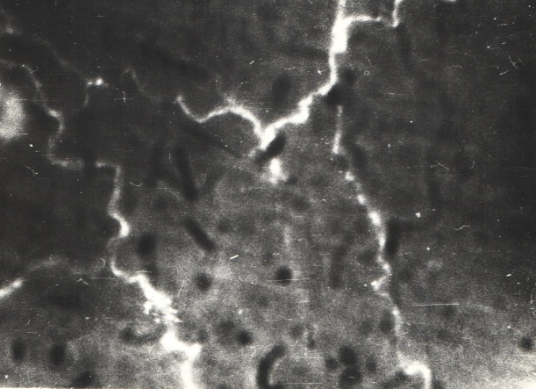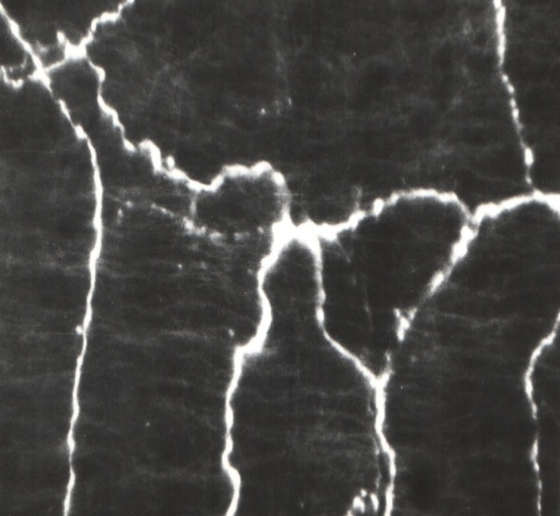
(a) (в)
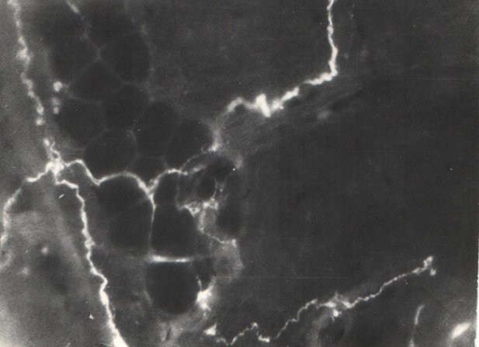
(с)
(a) – Total preparation. Сervical lymph node of a 20-day-old rat, (b) – Total preparation. Сervical lymph node of a 12 month old rat, (с) – Total preparation. Сervical lymph node of a 24-month-old rat.
About. 30, Ok. 6.3x

Figure 1 – Adrenergic nerve fibers in the artery wall in the area of the neck of the cervical lymph node in rats

Adrenergic nerve plexuses are formed in the wall of arterial vessels entering the cervical lymph node (Figure 1 a, b, c). The figures show that in the wall of the blood vessel of the cervical lymph node, large-looped nerve plexuses, consisting of thick nerve bundles, branch into several thin single nerve fibers. Along the length of single nerve fibers, one can observe the distribution of varicose veins, which give a more intense glow, characteristic of catecholamines. The site of the gate of the lymph node has the highest adrenergic innervation.
On a transverse section (Figure 2 a, b) in the area of ​​the hilum of the popliteal lymph node in the wall of blood vessels, individual adrenergic nerve bundles have bright fluorescence. Small and large varicose thickenings regularly located along the nerve fiber produce brighter fluorescence than the nerve fiber itself.
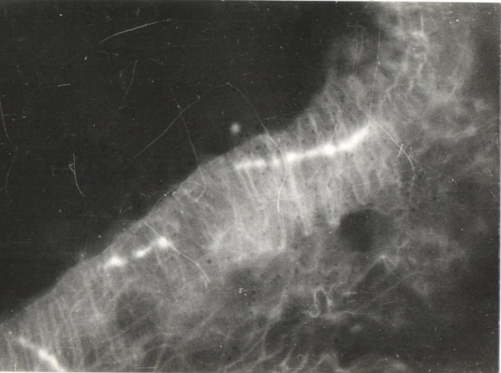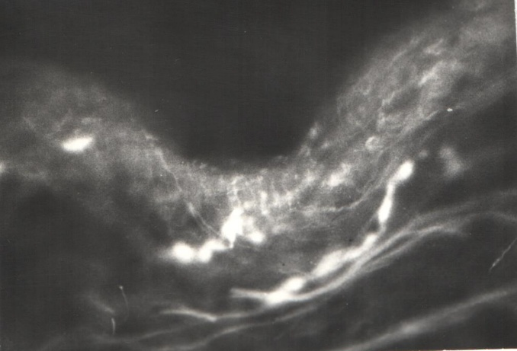
(a) (в)
(a) – Cryostat section, lymph node 3 day old rat, (b) – Cryostat section, lymph of a 10-month-old rat.
About. 30, Ok. 6.3x

Figure 2 – Cryostat section of the artery in the popliteal hilus lymph node in rats

Figures 3 a, b show a cryostat section of a blood vessel feeding the mesenteric lymph node. It was noted that brightly fluorescent catecholamine-containing nerve fibers are distributed in the medioventiceal layer. Such nerve fibers leave the vessel wall and penetrate into the surrounding connective tissue of the lymph node.
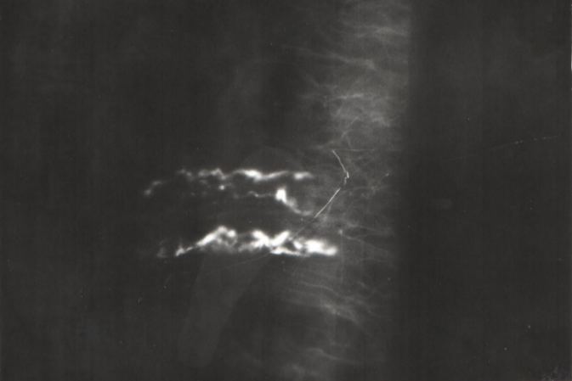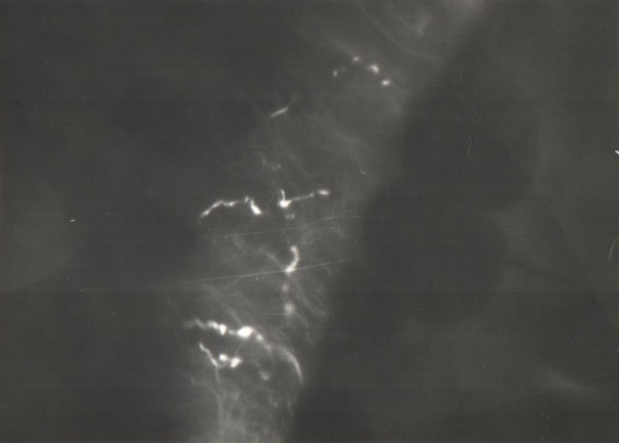
(a) (б)
(a) – Cryostat section, mesenteric lymph node 10.5 month old rats, (b) – Cryostat section, mesenteric lymph node 22 month old rat.
About. 30, Ok. 6.3x
Figure 3 – Cryostat section of the artery in the area of the hilum of the mesenteric lymph node old rats

The reason for our attention to the site of the lymph node hilus was that this site appeared to have a higher adrenergic innervation. As we noticed, on the preparations of the lymph node gates, individual adrenergic nerve fibers were distributed between the trabeculae, leaving the vascular wall. Initially, these nerve fibers are the adrenergic innervation apparatus of the blood vessel wall, and only a few single thin nerve fibers, separating from the intramural vascular plexus, are distributed among the connective tissue of the lymph node trabeculae.
It is known that in the area of ​​the hilum in the lymph node capsule the greatest number of smooth muscle myocytes is noted. It was generally accepted that in the vascular wall the varicose thickenings of the terminal sections of adrenergic axons, in the area of ​​which the release of catecholamines occurs, are located at certain definite distances from smooth muscle cells [87]. The adrenergic nervous apparatus provides motor transmission of signals from the nerve fiber to smooth muscles, that is, it is involved in the implementation of vasomotor efferent signaling [88]. Consequently, the presence of adrenergic innervation apparatus and smooth muscle cells in the tissue of the lymph nodes affect its contractile function.

3.3 Contractive activity of lymph nodes from different body regions in young, mature and old rats

Without active spontaneous contractions of the smooth muscles of the lymph node capsule, the movement of lymph through them is difficult or impossible [15]. The literature describes the parameters of the contractile function of the lymph nodes and the mechanisms of its regulation in healthy young animals without regard to age [63]. It was of interest to analyze the mechanisms of the contractile function of the lymph nodes in young, mature and old animals.
In the first series of experiments, the parameters (amplitude, frequency) of spontaneous phase contractions of smooth muscles of the lymph node capsule of young animals were investigated. Spontaneous contractions of cervical lymph nodes were recorded with a frequency of 4.0 ± 0.4 s / min. and the amplitude of contractions 6.9 ± 0.3 mg, and in the mesenteric nodes - with a frequency of 5.1 ± 0.2 contractions / min. and an amplitude of 7.2 ± 0.7 ml (Figure 4.5).

Designations: on the ordinate - the frequency of contractions per minute on the abscissa: 1 - young, 2 - mature, 3 - old animals.
Figure 4 - Frequency of spontaneous contractions of smooth muscles of the capsule of the mesenteric and cervical lymph nodes in young, mature and old rats

Designations: on the ordinate - the amplitude of contractions in mg, on the abscissa: 1 - young, 2 - mature, 3 - old animals.
Figure 5 - Amplitude of spontaneous contractions of smooth muscles of the capsule of the mesenteric and cervical lymph nodes in young, mature and old rats

When vasoactive substances act on nodes, changes in contractile reactions are noted. A solution of adrenaline in a dose (1x10-8-1x10-3M), when acting on the cervical lymph nodes, in 69% of cases caused contractile reactions with an increase in frequency by 60 ± 1.3% and an increase in the amplitude of contractions by 28 ± 1.4%. The mesenteric lymph nodes of young rats responded with contractile responses in 74% of cases in the form of contractions with increases in frequency by 47 ± 1.4% and in amplitude by 29 ± 1.0%. Acetocholine in a dose (1x10-8-1x10-6M) caused similar reactions. It caused an increase in the frequency of contractions of the cervical lymph nodes in 64% of cases by 45 ± 1.5% and the amplitude by 29 ± 1.1%, and the mesenteric nodes in 71% of cases by 47 ± 1.4% and the amplitude by 29 ± 1. 0% of original values. Under the action of histamine on the cervical lymph nodes in 65% of cases, an increase in the frequency by 40 ± 1.2%, in the amplitude by 30 ± 1.5%, on the mesenteric lymph nodes was noted in 62% of cases, an increase in the frequency of contractions by 32 ± 1.2% , and the amplitudes by 27 ± 0.9% (Figures 6, 7).

Designations: ordinate - frequency of contractions in%, abscissa: 1 - young, 2 - mature, 3 - old animals.
Figure 6 - Changes in the frequency of spontaneous contractions of lymph nodes in rats in% relative to the initial parameters under the action of adrenaline, acetylcholine, histamine
Designations: on the ordinate - the amplitude of contractions in%, on the abscissa: 1 - young, 2 - mature, 3 - old animals.

Figure 7 - Changes in the amplitude of spontaneous contractions of the lymph nodes of rats in% with respect to the initial parameters when exposed to adrenaline, acetylcholine, histamine

In the second series of experiments on mature animals, the following results were recorded: Cervical lymph nodes contracted with a frequency of 3.8 ± 0.5 s / min and an amplitude of 6.8 ± 0.3 mg, and mesenteric nodes with a frequency of 4.7 ± 0.3 / min. and an amplitude of 6.8 ± 0.8 mg(Figures4,5).When vasoactive substances were applied to the nodes of mature rats, we observed the effect of adrenaline in a dose (1x10-8-1x10-3M) on the cervical lymph nodes, an increase in frequency by 54 ± 1.7% of the amplitude by 32 ± 1.5% was observed in 62% of cases. The mesenteric lymph nodes responded in 66% of cases with an increase in frequency by 44 ± 1.5%, and in amplitude by 30 ± 1.2%. Acetylcholine caused an increase in the frequency of contractions of the cervical lymph nodes by 43 ± 1.4% and the amplitude by 27 ± 1.2% in 66% of cases, and the mesenteric nodes increased in 71% of cases by 42 ± 1.7% and the amplitude by 31 ± 1, 3% of the original values.
Under the action of histamine on the cervical lymph nodes, an increase in frequency by 37 ± 1.3% and an amplitude by 24 ± 1.5% was noted in 62% of cases, on the mesenteric lymph nodes in 59% of cases, the frequency of contractions increased by 30 ± 1.1% and an amplitude of 24 ± 1.1% (Figures 6, 7). In the third series of experiments on old rats, we observed a slightly different picture. The frequency of contractions of the smooth muscles of the cervical lymph nodes of old rats was 5.8 ± 0.5 contractions / min, and the amplitude was 3.9 ± 0.4 mg.
In the mesenteric lymph nodes, the frequency is 6.9 ± 0.3 contractions / min, and the amplitude is 3.8 ± 0.8 mg (Figures 4, 5). Vasoactive substances affected isolated lymph nodes as follows. Adrenaline at a dose (1x10-6-1x10-5M) in 57% of cases increased the amplitude of the cervical lymph nodes by 16 ± 1.0% and the frequency by 55 ± 1.6%, and the mesenteric lymph nodes in 52% of cases decreased with an increase in amplitude. by 17 ± 1.6% and frequency by 55 ± 1.6%.Acetylcholine (1x10-6-1x10-4M) in 54% of cases increased the amplitude of contractions of the cervical lymph nodes by 11 ± 1.5%, and the frequency by 32 ± 1.5% and the amplitude of the mesenteric lymph nodes by 15 ± 1.7% and frequencies by 38 ± 1.4%. Histamine (1x10-6-1x10-4M) led in 50% of cases to an increase in the amplitude of the cervical lymph nodes by 8 ± 1.4% and to an increase in the frequency by 18 ± 1.7% and mesenteric nodes which increased in 52% of cases, the amplitude by 11 ± 1.2% and frequency by 16 ± 0.9% (Figure 6.7).
Thus, our study showed that the contractile function of the smooth muscles of the capsule of the lymph nodes of both cervical and mesenteric lymph nodes undergoes changes with age.

3.4 Ratio of functional zones of lymphatic nodes and microstructure of lymphoid tissue in nodes of different localization in young, mature and old rats a) neck node b) meses

А) Cervical knot. Young animals. The morphofunctional state of the cervical lymph nodes is closely related to the drainage of the organs of the head and neck. It is obvious that a change in the function of these organs causes a certain restructuring of the lymph nodes. In young animals, the structural and functional zones in the structure of the lymph node acquire special significance, since the size of the functional compartments serves as the basis for an objective assessment of the state of the lymphoid tissue. In white rats, the cervical lymph nodes have an elongated shape and are located on the right and left in the subcutaneous tissue. In the anatomical structure of the cervical lymph node, a fairly high proportion is noted, occupied by such structures as lymphoid nodules, the internodal part of the cortex, the paracortical region, and the cords of the brain. Developed structural and functional zones in the lymph node indicate a fairly high immune potential in young animals (Table 5).

Table 5 - The area of ​​the structural and functional zones of the cervical lymph node in young, mature and old animals,%
Lymphnodestructure  andindices | young | mature | old | P,
Lymphnodestructure  andindices | 1 | 2 | 3 | P,
Capsule | 1,56±0,15 (4,78%) | 1,75± 0,15  (5,2%) | 4,7±0,26 (17,14%) | P₁₋₃< 0,001
Subcapsularsinus | 1,45±0,17 (4,45%) | 1,46 ±0,2  (4,6%) | 1,44±0,16 (5,25%) | P₁₋₃> 0,05
Internodalpartofthecortex | 4,94±0,62 (15,16%) | 4,85 ±0,5  (15,0%) | 3,98±0,21 (14,52%) | P₁₋₃> 0,05
Lymphoid nodule without germinal center (F1) | 1,97±0,12 (6,04%) | 1,92± 0,15  (5,95%) | 2,07±0,14 (7,55%) | P₁₋₃> 0,05
Lymphoid nodule  with a germinal center (F2) | 3,85±0,20 (11,81%) | 3,7± 0,3  (11,2%) | 1,42±0,14 (5,18%) | P₁₋₃< 0,001
Paracorticalregion | 9,01±0,76 (27,65%) | 8,9± 0,52  (27,1%) | 6,7±0,55 (24,44%) | P₁₋₃< 0,05
Braincords | 8,33±0,29 (25,56%) | 8,25± 0,35  (25,3%) | 6,06±0,33 (22,11%) | P₁₋₃< 0,001
Cerebrallymphaticsinus | 1,47±0,34 (4,38%) | 1,54 ±0,04  (4,49%) | 1,04±0,14 (3,79%) | P₁₋₃> 0,05
totalarea | 32,58±1,57 (100%) | 31,99 ±1,7  (100%) | 27,41±1,23 (100%) | P₁₋₃< 0,05
Cortical-cerebral ratio  (индексК/М) | 2,32±0,08 | 2,3±0,06 | 2,86±0,08 | P₁₋₃< 0,001
F2 / F1 index | 1,95±0,11 | 1,92±0,09 | 0,69±0,12 | P₁₋₃< 0,001
Notes: reliable compared to control, -р<0,5*, -р<0,01**

In the cortex, lymphoid nodules with a germinal center predominate, indicating the activity of lymphaproliferative processes in young animals (Figure 8). In the structure of the lymph node, the sinus system is small in size and is represented mainly by subcapsular and cerebral lymphatic sinuses. The cervical lymph nodes are compact type nodes, and their cortical-cerebral ratio (C / M index) is 2.32 ± 0.08 in young animals. The microanatomical organization of the cervical lymph nodes is characteristic of the immune function, which determines their functional specialization in the lymphatic region
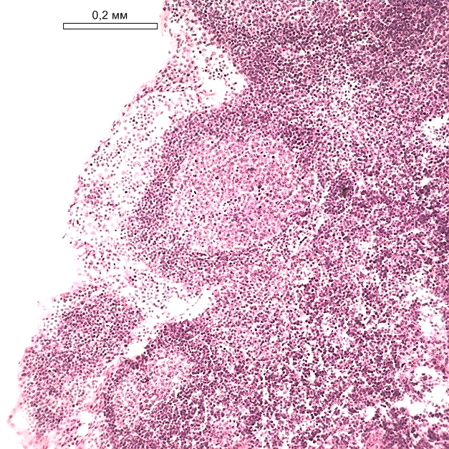
Young animals. Staining with hematoxylin and eosin. Total magnification 120x.

Figure 8 - Dilated germinal centers in the lymphoid nodules of the cortex in front of the dilated part of the subcapsular sinus

Mature animals. The examination of the cervical lymph nodes at the stage of mature ontogenesis did not reveal the morphological equivalent of a decrease in the immune function. In comparison with young animals, there was no change in the lymph node sectional area. Cortical-cerebral index (2.3 ± 0.06). The cortex predominates over the medulla in the same proportion as in young animals (Table 5). The number of lymphoid nodules was identical to the young.
Old animals. Investigation of cervical lymph nodes at a late stage of ontogenesis revealed morphological equivalents of reduced immune function. In comparison with young animals, a decrease in the cross-sectional area of ​​the lymph node was established, which reflects the process of involution of the lymphoid tissue during aging. Compaction of the lymph node with a sufficiently high cortical-cerebral index (2.86 ± 0.08) is increasing. The cortex predominates over the medulla against the background of a decrease in the area occupied by the lymphatic sinuses in the lymph node. With age, there is an increase in connective tissue in the lymph node. First of all, this is expressed in the thickening of the capsule area (3 times) and the development of connective tissue around the blood vessels (Table 5). Part of the lymph node can be replaced by adipose tissue (Figure 9). In such a lymph node it is difficult to differentiate the cortical and medulla. The importance of fibrosis and replacement of lymphoid tissue by adipose tissue for the development of immune deficiency in old age cannot be ruled out. This is facilitated by prolonged contact of the oral cavity with the external environment, which is reflected in the anatomical structure of the regional cervical lymph node.

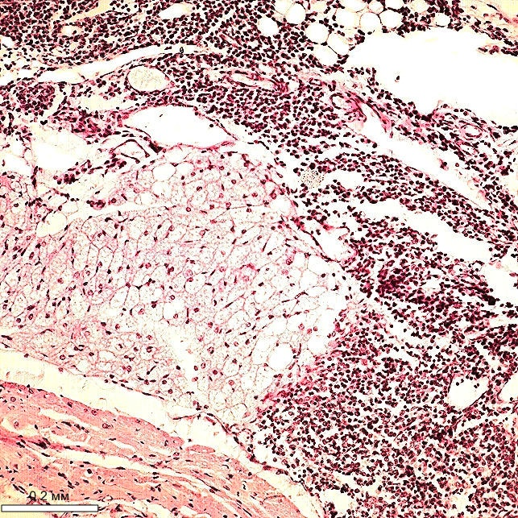
Old animals. Staining with hematoxylin and eosin. Total magnification 120x.

Figure 9 - Fat replacement of lymphoid tissue of a part of the lymph node

In the cortical substance between the lymphoid nodules is the inter-nodular part of the cortex, and on the border with the medulla there is the paracortical region. The inter-nodular part and the paracortical region are referred to as the thymus-dependent zone. The structures of the cortical substance undergo involutive changes, which is expressed in a decrease in the areas of the internodal part of the cortex (by 1.4 times), lymphoid nodules with a germinal center (by 2.7 times), and the paracortical region (by 1.3 times) at the late stage of ontogenesis ( table 5).
In the lymphoid nodules of the preserved lymph nodes, cells with elements of destruction are observed (Figure 10). Simultaneously with age, the structures of the brain matter - brain cords and cerebral lymphatic sinus - decrease in size. The extreme degree of age-related transformation is sufficient lymphoid infiltration at the site of the previously located lymph node (Figure 11).
Analysis of the ordering of structures within the lymph node showed that in old animals the size of most of the structural and functional zones decreases against the background of an increase in the connective tissue component in comparison with young and mature animals. The ongoing decrease in the area of ​​the lymphoid parenchyma of the cervical lymph node is associated with a decrease in its immunoreactivity at the late stage of ontogenesis.
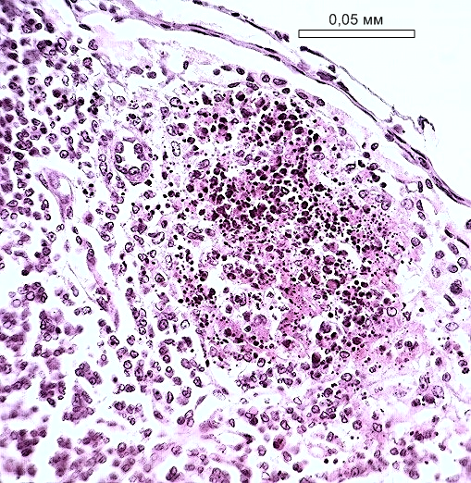
Old animals. Staining with hematoxylin and eosin. Total magnification 480x.
Figure 10 - Lymphoid nodule with destructive cells

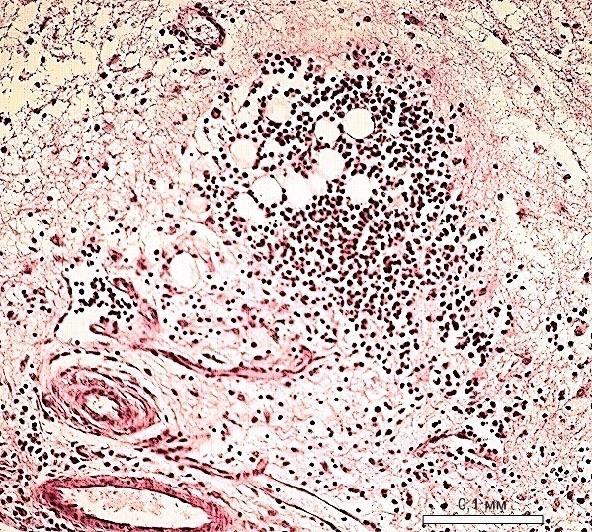

Old animals. Staining with hematoxylin and eosin. Total magnification 240x.
Figure 11 - Lymphoid infiltrate at the site of the lymph node

В) Mesenteric lymph node. Young animals are a peripheral lymphoid organ of high immune activity due to the constant work of the digestive tract. The abdominal location determines the design of the mesenteric lymph nodes, which is characteristic of the compact morphotype according to the classification of Yu. I. Borodin [34, 36]. The mesenteric node has a thin capsule that surrounds it and gives inward weak trabeculae. In the structure of the lymph node of young animals, the cortical substance predominates, judging by the value of the cortical-cerebral ratio, equal to 2.14 ± 0.09 (Table 6). In the cortex, the presence of lymphoid nodules with and without the germinal center was noted (Figure 12).
Their ratio is 1.36 ± 0.11 (Table 6), which indicates an active lymphopoietic function in the lymph node. The medulla is well developed, represented by large cords and wide lymphatic sinuses (Figure 13). Structural and functional zones are developed evenly in the cortex and medulla, which determines a mixed morphological variant of the structure of the lymph node with a sufficiently wide sinus system, indicating the simultaneous performance of the immune and drainage functions.
Mature animals. In the mature state, no changes were revealed in the structural organization of the mesenteric lymph nodes, which is shown by the morphometric data of the dimension of the structural and functional zones. At the stage of mature ontogenesis, the area of ​​the capsule is slightly increased by 2.35 ± 0.1 in comparison with young 2.14 ± 0.09. The elements of the lymph node medulla in young and mature animals were identical.

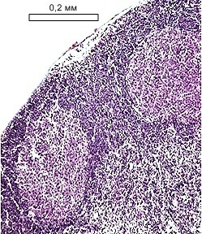
Young animals. Staining with hematoxylin and eosin. Total magnification 120x.
Figure 12 - Dilated germinal centers in lymphoid nodules mesenteric lymph node

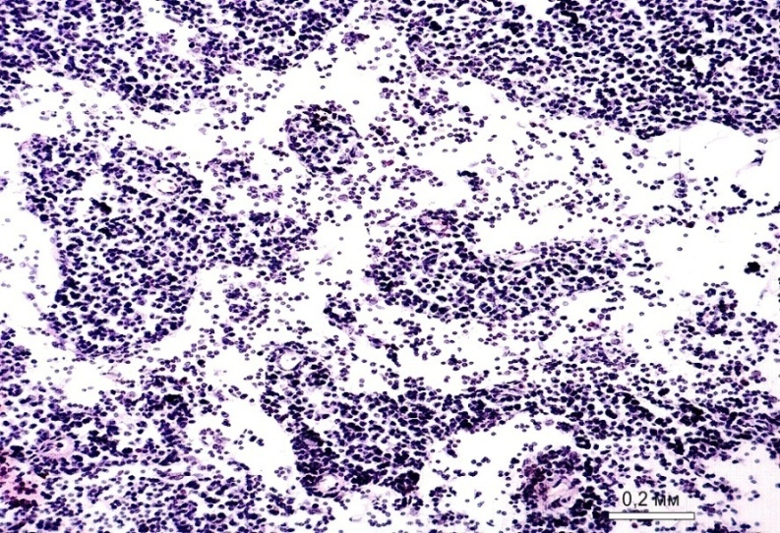

Young animals. Staining with hematoxylin and eosin. Total magnification 120x.
Figure 13 - A fragment of a lymph node with a wide lumen of the cerebral lymphatic sinus and large cerebral cords

Table 6 - The area of ​​structures and indices of the mesenteric lymph node of young, mature and old animals,%
Lymphnodestructure  andindices | young | mature | old | P,
Lymphnodestructure  andindices | 1 | 2 | 3 | P,
Capsule | 5,72±0,19 (9,26%) | 5,95± 0,22  (9,38%) | 9,43±0,45  (14,93%) | P₁₋₃< 0,001
Subcapsularsinus | 4,57±0,17 (7,40%) | 4,55± 0,2  (7,35%) | 3,38±0,27 (5,35%) | P₁₋₃< 0,01
Internodalpartofthecortex | 7,74±0,31 (12,53%) | 7,84± 0,25  (12,7%) | 3,78±0,24 (5,98%) | P₁₋₃< 0,001
Lymphoid nodule  without germinal center (F1) | 4,18±0,17 (6,77%) | 4,12± 0,19  (6,57%) | 3,32±0,22 (5,26%) | P₁₋₃< 0,01
Lymphoid nodule  with a germinal center (F2) | 5,69±0,19 (9,21%) | 5,52± 0,2  (9,05%) | 3,03±0,26 (4,80%) | P₁₋₃< 0,001
Paracorticalregion | 16,02±0,56 (25,93%) | 16,15± 0,43  (27,4%) | 14,29±0,54 (22,63%) | P₁₋₂< 0,05
Braincords | 10,55±0,24 (17,07%) | 11,3 ±0,35  (19,4%) | 22,03±0,72 (34,88%) | P₁₋₃< 0,001
Cerebrallymphaticsinus | 7,31±0,29 (11,83%) | 7,4± 0,25  (12,9%) | 3,89±0,35 (6,16%) | P₁₋₃< 0,001
totalarea | 61,78±1,91 (100%) | 62,83±2,9  (100%) | 63,16±1,59 (100%) | P₁₋₃> 0,05
Cortical-cerebral ratio  (индексК/М) | 2,14±0,09 | 2,35±0,1 | 1,07±0,11 | P₁₋₃< 0,001
F2 / F1 index | 1,36±0,11 | 1,34±1,05 | 0,91±0,08 | P₁₋₃< 0,001
Notes: reliable compared to control, -р<0,5*, -р<0,01**

Old animals. With aging, the structural organization of the mesenteric lymph nodes changes, which is confirmed by the morphometric data on the dimensions of the structural and functional zones. At the late stage of ontogenesis, the areas of the capsule (1.6 times), the brain cords (2.1 times) and the sizes of the subcapsular and cerebral lymphatic sinuses (1.3 and 1.9 times, respectively), the internodal part of the cortex ( 2.1 times), lymphoid nodules with a germinal center (1.9 times), paracortical region by 12%.
The changes relate to the structures of the cortical and medulla of the lymph node, demonstrating age-related involution of the lymphoid tissue, although its degree may be different (Figure 13). The peripheral lymphoid cortex narrows and concentrates closer to the capsule, the deep part of the cortex is divided by the penetrating medulla. Moreover, most of the structure of the lymph node is represented by the reticular stroma. Connective tissue replaces lymphoid tissue, expanding perivascular and in the parenchyma of the lymph node (Figure 13).
Minimization of the main structural and functional areas, especially lymphoid nodules with germinal centers, indicates a decrease in cell proliferation and, as a consequence, the immune potential of the lymph node. The lymphatic sinus system appears narrow on specimens, indicating decreased drainage function of the lymph node (Figure 12, 13). Due to the predominance of the medulla in old animals, an intermediate variant of the morphological structure of the lymph node is formed (the K / M index is 1.07 ± 0.11) with an immune response according to the humoral type. This morphotype is considered optimal for the lymph node, but it cannot be recognized as such completely due to age-induced changes.
It is obvious that senile changes are accompanied by a decrease in the functional activity of the lymph node.When analyzing the mesenteric lymph node of old animals, in 30% of cases, there was an increase in the area of ​​the structures of the cortex due to hyperplasia of the paracortical region. The size of the paracortical region was 28.92 ± 1.27%, and the size of the brain cords - 8.76 ± 0.51% against the background of wide germinal centers of lymphoid nodules in this group of animals. Cerebral lymphatic sinuses remain narrow and constitute 2.52 ± 0.26%.The results of morphometry of the mesenteric lymph node differ from the data in the group of animals, where the predominance of the medulla was revealed (Table 6). The data obtained are typical for a lymph node with a compact morphotype, when the development of a thymus-dependent zone responsible for the cellular link of the immune response takes place.

3.5 Medicinal plants inhibiting aging processes in the body

3.5.1 Screening studies of the substances of medicinal plants isolated by Kazakhstani scientists for the cardiovascular and lymphatic systems
Plants attract the attention of researchers as a source of valuable biologically active substances: terpenoids, flavonoids, coumarins, alkaloids, which are promising for practical use in medicine and pharmacy. Recently, there has been a clear trend towards wider use of herbal preparations in medical practice, the advantages of which are in their harmlessness and effectiveness of therapeutic action [89]. Dietary supplements made from plant materials rich in antioxidants, vitamins, trace elements, etc. have a stimulating effect on the lymph flow, activation of the protein-synthesizing apparatus, cells of the lymphoid organs, thereby increasing their participation in lymphatic stimulation, lymphocorrection and lymphoprotection. [90].
The experiments were carried out on 60 old white laboratory rats of the Wistar line. Medicinal herbs used in our experiments consisted of industrial significant Kazakhstani plants (Zizifora Bunge, Almatinsky hawthorn, St. We also used a carbonic substance obtained from the herbs of Zizifor Bunge and a substance obtained from the fruits of hawthorn. (School of Pharmacy of KazNMU named after Asfendiyarov). From other herbs, we used echinacea, St. John's wort, kopeck, and bergenia to prepare decoctions. The substances were dissolved in drinking water and we gave herbal decoctions to the animals for 1 month. Each group of animals had 10 hours. In total, there are 6 names in the groups of medicinal herbs. The animals were taken for the experiment after 30 days. Lymph flow, urine output, heart rate, blood pressure, coagulability, blood and lymph viscosity, plasma volume by hematocrit, weight of animals were determined

Table 7 - Screening studies of medicinal plant substances and herbal decoctions isolated by Kazakhstani scientists for the cardiovascular and lymphatic systems.
Oldanimals +herbs | LymphaticMl \ min  100г | Diuresis  Ml / min  100г | Bloodclotting  Min. | Lymph  clotting  Min. | Bloodviscosity  Р. | Viscosityoflymph  Р. | Hematocrit % | Theweight
ZiziforaBunge | 2,3±0,18 | 0,0016±  0,00007 | 3,3±0,4 | 3,52±0,6 | 4,9±0,4 | 4,3±0,5 | 45,1±3,9 | 350±20
Hawthorn | 2,4±0,16 | 0,0018±  0,0001 | 2,9±0,5 | 3,1±0,5 | 4,9±0,5 | 3,9±0,4 | 45,4±3,8 | 360±22
St. John'swort | 1,7±0,15 | 0,00011±  0,00002 | 3,2±0,4 | 3,3±0,6 | 4,4±0,6 | 4,2±0,5 | 44,5±4 | 344±20
Echinacea | 1,8±0,16 | 0,0001±  0,00003 | 3,1±0,60 | 3,2±0,5 | 4,5±0,6 | 3,9±0,5 | 44,6±4 | 332±18
Penny | 2,4±0,18 | 0,00015±  0,00004 | 3,4±0,6 | 3,5±0,6 | 4,7±0,7 | 4,2±0,7 | 45,1±4,1 | 362±23
Badan | 2,3±0,2 | 0,00017±  0,00004 | 3,3±0,4 | 3,5±0,7 | 5,1±0,7 | 4,6±0,6 | 44,8±3,8 | 354±21
Oldanimals | 1,6±0,16 | 0,00099±  0,00002 | 2,88±0,5 | 2,95±0,6 | 4,5±0,5 | 3,6±0,5 | 44,3±3,6 | 384±22
The blood pressure of the animals was determined in a group of old rats 108 ± 6 mm / Hg. After medicinal herbs ZB -104 ± 5, BA-109 ± 8, ZO-102 ± 5, EP-104 ± 5, K-102 ± 7, BT-101 ± 4mm / Hg. HR was recorded in old animals 449 ± 14. After the use of medicinal herbs ZB-398 ± 20, BA-404 ± 16, ZO-440 ± 14, EP-435 ± 18, K-429 ± 12, BT-406 ± 15 beats per minute. When analyzing the data after the use of medicinal herbs, it can be noted that they have an effect on the body of animals after a month of their administration and have lymphatic stimulating, corrective, protective effects on the body. All the parameters studied are close to the figures obtained in animals of a younger age.

3.5.2 The effect of the new phytocomposition on the functions of the lymphatic system
The herbal collection was compiled according to the pharmacotherapeutic principle, taking into account the lymphotropic effect of medicinal plants. The composition of the collection has been adjusted so that it consists of phytocomponents containing medicinal plants for the implementation of the effect of lymphostimulation and lymphoprotection, etc. It includes the substances of ZB and BA and herbal decoctions ZO, EP, K, BT and iodine from Balm Revival.
The lymphatic system in old animals was 6.1 ± 0.6 μl / min. with a weight of 384.6 ± 22 g or 1.6 ± 0.16 per 100 g. body weight. After phytotherapy 7.2 ± 0.7 μl / min with a weight of 339.9 ± 19 g. or 2.1 ± 0.17 per 100 g of body weight (p <005).
Blood coagulability in old animals is 2.88 ± 0.5 minutes, and after phytocomposition, 3.44 ± 0.6 minutes. In the lymph 2.95 ± 0.6 min. and 3.62 ± 0.5 min. The blood viscosity in old animals is 4.5 ± 0.5 r, and after phytocomposition is 4.77 ± 0.65 r. In the lymph 3.6 ± 0.5 r. and 3.9 ± 0.7 rubles. respectively. The volume of plasma in terms of geiotocrit in old animals is 44.3 ± 3.6 after phytocomposition is 44.8 ± 2.7. HR in old rats was 449 ± 14, and after phytocomposition 460 ± 19 per min. (BP) in old rats 108 ± 6, after phytocomposition 105 ± 7 mm. Diuresis was 0.99 ± 0.02 after phytocomposition 1.4 ± 0.080 μl / min. per 100 gr. body weight. We also found a decrease in cholesterol and triglycerides and total lipids in blood and lymph after phytocomposition. (cholesterol - 11%; triglycerides - 9%; total lipids - 12%; respectively). Glucose remained within the same range or increased by 6% in the blood and 3% in the lymph (Table 8).

Table 8 - Biochemical parameters of blood plasma and lymph in old animals and after phytocomposition
Parameters | blood plasma |  | lymph
Parameters | old animals | after phytocomposition | old animals | after phytocomposition
Urea, mmol /l | 5,33±0,7 | 5,4±0,8 | 5,59±0,7 | 4,5±0,6*
Bilirubin,kmol | 1,72±0,75 | 3,6±0,8* | 0,6±0,03 | 3,4**
Creatinine, Mcmol / l | 50,33±4,1 | 47,1±3,5 | 44,33±2,7 | 52±3
Glucose, mmol | 2,8±0,21 | 2,1±0,19* | 3,9±0,19 | 1,8±0,2*
Totalprotein, g | 67,8±0,9 | 58,1±2 | 39,6±0,5 | 41,5
α-amylase, U / L | 669,4±62 | 507,2* | 382,4±49 | 334±28*
ALAT, mkkat | 250,95±22 | 236±25 | 151,9±9,9 | 181±12
AsAT, mkkat | 167,6±11 | 144±18 | 204,2±13,5 | 202±14
Totalcholesterolmol /l | 1,9±0,03 | 1,18* | 1,8±0,06* | 1,1±0,08*
Triglycerides, mol / l | 1,2±0,1 | 0,48±0,09** | 0,79±0,07 | 0,64±0,09
Totallipids, g / l | 1,78±0,04 | 1,15±0,08 | 1,8±0,08 | 0,66±0,08*
Alkalinephosphatase, U / l | 387±14 | 339±19 | 496±18 | -
Notes: significant compared to control-р<0,5*, -р<0,01**

Biochemical parameters of blood and lymph in old animals: fluctuated in the same values. When analyzing the results of the cellular composition of lymph and blood, we found in old rats after phytocomposition an increase in leukocytes in the blood by 8% and in the lymph by 3% compared with animals without phytocomposition (Table 9). Erythrocytes slightly increased after phytocomposition by 5.1% in comparison with old animals. Hemoglobin did not change after phytocomposition The platelets in the blood after phytocomposition remained almost unchanged (decreased by 6%)
The study of ions in the blood plasma,lymph and urine did not reveal significant changes in older animals and animals after fitokompozitsiya.

Table 9 - Cellular composition of blood and lymph in old animals and after phytocomposition
Indicators | blood |  | Lymph
Indicators | old animals | after phytocomposition | old animals | after phytocomposition
WBC – leukocytes х10³/ μL | 4,9±0,2 | 5,3±0,3 | 12,8±0,5 | 13,2±0,3*
RBC – erythrocytes х 10⁶ / μL | 6,9±0,4 | 7,2±0,5 | 0,03±0,004 | 0,04±0,006*
HGB – hemoglobin g/dL | 15,6±0,5 | 16,4±0,7 | -
Hct – the hematocrit % | 44,3±3,6 | 4,81±3,9 | -
PLT – thrombocyte х 10³ / μL | 477,5±18 | 449±24 | -
LYM % | 52,5±4 | 50,9±6 | 95±1,2 | 97±1,4
LYM х 10³ / μL | 2,3±0,4 | 2,5±0,4 | 12,2±0,5 | 12,5±0,6
Примечания: достоверно по сравнению с контролем, -р<0,5*, -р<0,01**

Table 10 – Content of ions in blood plasma, lymph and urine in old animals after fitokompozitsiya

Indicators | Old rat |  | old animals after phytocomposition
in the blood
Са in plasma (mmol / l) | 0,52±0,06 | 0,59±0,09
Na⁺ in plasma (mmol / l) | 139,5±7,5 | 144,4±6,9
К ⁺ in plasma (mmol / l) | 3,75±0,5 | 4,45±0,9
in the lymph
Са in lymph (mmol / l) | 0,36±0,04 |  | 0,40±0,06
Na⁺ in lymph (mmol / l) | 134,0±6,2 |  | 140,5±7,2
К ⁺ in lymph (mmol / l) | 3,40±0,4 |  | 3,5±0,5
in urine
Са in urine | + | -
Na⁺ in urine | 15,7±1,01 | 16,5±0,8
К ⁺ in urine | 3,09±0,1 | 3,2±0,1
Notes: reliable compared to the control, -р<0,5*, -р<0,01**
When analyzing the immunological composition of blood and lymph, he also draws attention to an increase in the number of leukocytes by 95% in the blood and by 53% in the lymph in old animals after phytocomposition (Table 11). Got an increase in neutrophils in the blood and lymph (stab and a decrease in segmented) and monocytes. Lymphocytes increased in blood and lymph. After phytocorrection, they decreased in blood by 52%, and in lymph by 15%. The amount of IgM immunoglobulins increased both in the blood and in the lymph. but only lymph IgA, IgE. The number of lymphocyte subpopulations in old animals decreased after phytocomposition in the blood (especially SD - 16 NK; SD - 20 B-lymph) and increased in the lymph (SD-16, SD-20) (Table 11).
Interstitial fluid (IL) was obtained using the wick method. Its composition in old animals: glucose - 4.3 ± 0.3, urea - 4.6 ± 0.3. In old animals after phytocomposition Na-130 ± 4; K-4.1 ± 0.5; Ca-0.7 ± 0.08; Mg-0.4 ± 0.02; Glucose-4.1 ± 0.2; Urea - 4.4 ± 0.4 mmol / l; Protein -1.1 ± 0.2 g / l. As we can see, in old animals after phytocomposition, fluctuations were within physiological limits.

Table 11. Immunological composition of blood and lymph in old animals and animals after phytocomposition
Indicators | blood |  | lymph
Indicators | old animals | animals after phytocomposition | old animals | animals after phytocomposition
Leukocytes  :1х10⁹ | 3,45±0,4 | 6,74±0,6** | 7,1±0,6* | 10,8±0,9**
Neutrophils  п/я | 2,6±0,09 | 3,2±0,1 | - | -
с/я | 58,3±2,8 | 46,5±2,9* | 9±0,9* | 7,1±1
Monocytes | 11,3±0,5 | 3,6±0,8* | 4±0,09* | 2,2±0,07
Eosonophiles | 1,3±0,03 | 1,8
Lymphocytes  % | 42,75±5 | 45,9±7* | 73,3±2,8 | 64,4±3,2
абс. | 1,6±0,4 | 3,1±0,5** | 72,5±0,6

Continued table 11
1 | 2 | 3 | 4 |  | 5
Immunoglobulins
IgM | 0,37±0,05 | 0,40±0,07 | 0,31±0,05 | 0,33±0,06
IgG | 2,47±0,09 | 2,1±0,1* | 0,79±0,06 | 0,69±0,07
IgA | 0,275±0,02 | 0,16±0,03* | 0,35±0,06 | 0,41±0,08
IgE | 20,95±0,1 | 20,3±0,2 | 21±0,8 | 24±1,1
Lymphocytesubpopulations
Сд – 3 Т-лимф. | 58± 4 | 38,2±6* | 43±4 | 49,6±6
Сд -4 Т-хелп. | 21,7±3 | 19±3 | 26±3 | 24,2±2
Сд -8 Т-супр/цит. | 24 ±1,5 | 17,2±1,9* | 19±4 | 23±3
Сд – 16 NK | 7±0,9 | 10,2±0,1* | 11±1,2 | 18±0,9
Сд – 20 В-лимф. | 14,5± 0,6 | 12,4±0,6 | 12±1,4 | 16,5±1,5
Сд-4/ Сд-8 | 0,9* | 1,11 | 1,37 | 1,06
Notes: reliable compared to control, -р<0,5*, -р<0,01**

To determine the volume of IL, a rheograph״Reo-Mizar with its electrical characteristics was used. The frequency of the probing current of its electrodes is from 30-200 kHz, which allowed us to use its low-frequency currents (30-40 kHz) for research purposes. The amount of IL in these groups was determined from the changes in the ohmic resistance curves of a group of old animals and old animals after phytocomposition. (Old rats 26.2 ± 3.4% of body weight, in the group of old rats after phytocomposition 28.9 ± 3.5% of body weight). There was a slight increase in IL in old animals after phytocomposition by 10.3%.
Adrenergic innervation of lymphatic vessels and nodes after phytocomposition
Adrenergic nerve fibers enter the lymph nodes in the region. gates as part of the adventitia membranes of intraorgan vessels, forming terminal plexuses in the parenchyma of the node. A particularly dense plexus is found in the adventitia of the arteries. In the walls of the veins, nerve fibers are less pronounced, extending into the parenchyma of the node form bushy branches in the medulla. On the border of the medulla and cortical substance, a fine-meshed plexus of adrenergic fibers was revealed, which are rarely detected in the cortex.
Revealed adrenergic innervation of the paracortical and interfollicular zones, where fibers come into contact with macrophage reticular cells [85]. The capsule covering the lymph nodes consists mainly of connective tissue elements, between which there are bundles of smooth muscle cells oriented in different directions [80]. It has been established that the myocytes of the lymph node capsule rhythmically synchronously contract, leading to an increase in intra-nodal pressure and the displacement of lymph from the node into the outflowing lymphatic vessels [82].
A number of scientific works are devoted to age-related changes in the morphofunctional state of lymphatic vessels and nodes [58]. Lymph nodes, performing immune-drainage-detoxification functions in the body, undergo some structural changes.
The thoracic lymphatic duct (HLD) is the largest lymphatic vessel in the body of mammals and humans, collecting lymph from 80 - 90% of the body. It distinguishes between the abdominal, thoracic and cervical parts of the thoracic duct.
The microanatomy of the lymphatic vessel wall and the largest of them, the HLP, has common features with the organization of the blood vessel wall. In particular, its general topography is similar to the plan of the structure of the wall of large venous vessels, that is, intima, media and adventitia can be distinguished in it, however, the boundaries between these layers are not sharply expressed [85]. The medial layer of HLP in humans and animals is represented by muscle fibers arranged in three layers (longitudinal, circular and again longitudinal).
The inner surface of the GLP is lined with endothelium, whose cells in animals are mushroom-shaped and protrude into its lumen [85]. Studies of the ultrastructure of the rabbit HLP wall showed that sling filaments are attached at one end to endothelial cells, and at the other to the basement membrane of smooth muscle cells [82]. In addition, sling filaments are involved in regulating the distance between adjacent endothelial cells and prevent collapse of the walls of lymphatic capillaries during tissue edema. Human GLP vascularize from 124 to 160 supplying arteries (esophageal, intercostal, bronchial, lumbar).
Intramural innervation of the GLP, consists of smooth muscle cells of this vessel, equipped with motor nerve endings in the form of "buttons" and "pockets". Such receptor apparatuses are found in all layers of the wall of the GLP. The contractile activity of the lymphatic vessels themselves has long attracted the attention of researchers. The motor activity of the lymphatic vessels is understood to mean both "spontaneous" rhythmic contractions of the vessels, and their ability to respond with changes in their lumen in response to neurogenic and humoral influences.
In old rats and rats after phytocomposition, preparations of lymph nodes and preparations of SOD were studied. As our study showed, the identification of catecholamines in the wall of arterial vessels of the gates of the lymph nodes and in the tissues of the lymph nodes themselves, in old rats, it showed the presence of developed adrenergic innervation, which is represented by shedding from fibers with regularly spaced varicose veins of the same size (Fig. 14,16). The figures show that in the wall of the blood vessel of the cervical lymphatic nerve plexus, consisting of thick nerve bundles, branch into several thin single nerve fibers. Along the length of single nerve fibers, one can observe the distribution of varicose veins, which give a more intense glow, characteristic of catecholamines. The site of the gate of the lymph node has the highest adrenergic innervation. But in old animals, in comparison with mature ones, a decrease in the number and size of varicose enlargements is observed, and in a number of cases we observed an intermittent glow of the nerve fiber - the disappearance of catecholamines in the nerve fiber by sections. The reason for our attention to the site of the lymph node hilus was that this site appeared to have a higher adrenergic innervation. As we noticed, on the preparations of the lymph node gates, individual adrenergic nerve fibers were distributed between the trabeculae, leaving the vascular wall. Initially, these nerve fibers are the adrenergic innervation apparatus of the blood vessel wall, and only a few single thin nerve fibers, separating from the intramural vascular plexus, are distributed among the connective tissue of the lymph node trabeculae. The adrenergic nervous apparatus provides motor transmission of signals from the nerve fiber to smooth muscles, that is, it is involved in the implementation of vasomotor efferent signaling.
In rats, after phytocomposition, an increase in the luminescence along the course of the nerve fibers was observed, as well as an increase in the luminescence of varicose dilations, which in some cases again merge into fibers. On a cross section (Fig. 17) in the area of ​​the hilum of the popliteal lymph node in the wall of blood vessels, individual adrenergic nerve bundles have a brighter fluorescence than in old animals. Small and large varicose thickenings regularly located along the nerve fiber produce brighter fluorescence than the nerve fiber itself. In old animals (22-24 mx) the adrenergic innervation of the HLP is represented by plexuses in the duct wall, there are nerve fibers located in the vasa vusorum and the terminal branches extending from them heading to the duct wall. But this whole picture looks much poorer in fluorescence brightness than a group of younger rats. In these plexuses, only single varicose enlargements are present, and in some fibers they are completely absent, and the terminal branches from the vasa vusorum become much smaller. (Fig 14)
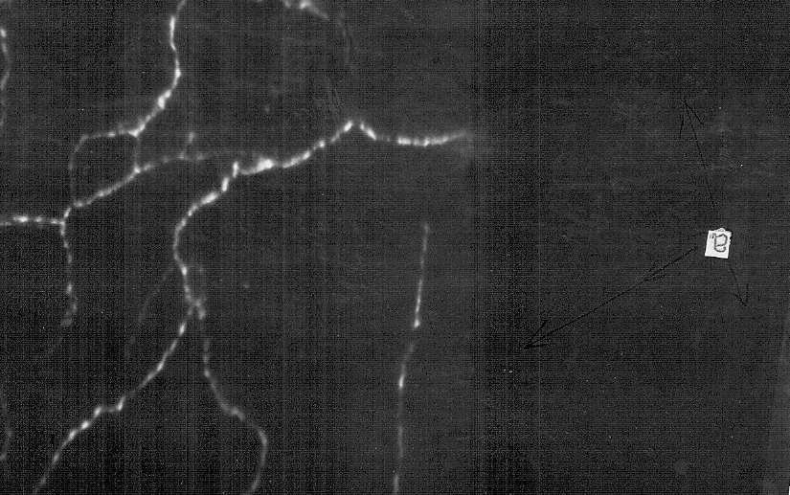
a) – adrenergic nerve fibers. Adrenergic innervation of HLP in old rats after hytocomposition is represented by plexuses of fluorescent fibers with more intense varicose veins with regularly spaced equal size varicose veins, which also fluoresce more brightly than in rats without phytocomposition, and fluorescent compounds appear between them.

Figure 14 - Total preparation of the upper third of the SODI of an old rat (24th)

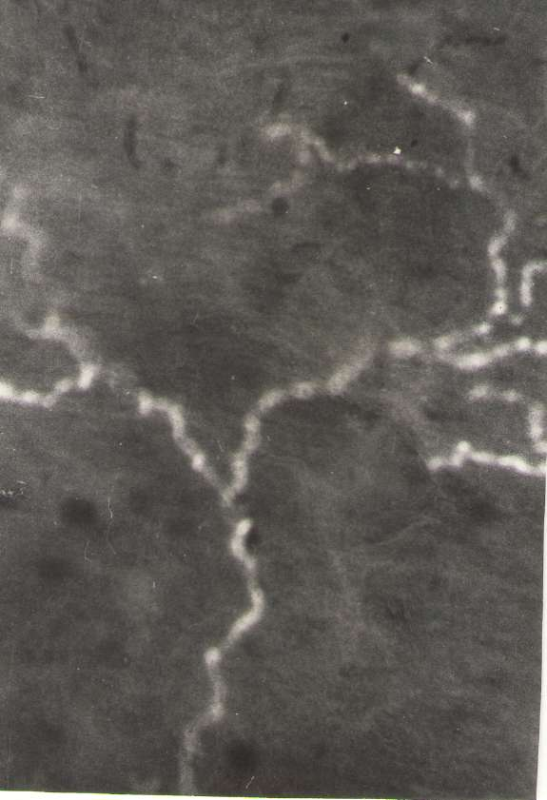
Figure 15 - Total preparation of the upper third of SODI of an old rat after phytocorrection
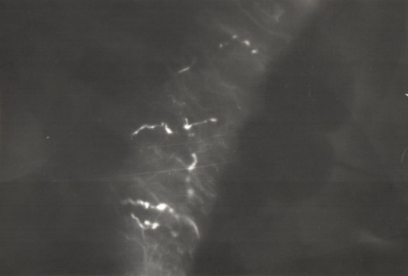
Figure 16 - Cryostat section of the artery in the area of the hilum of the mesenteric lymph node 22 month old rats
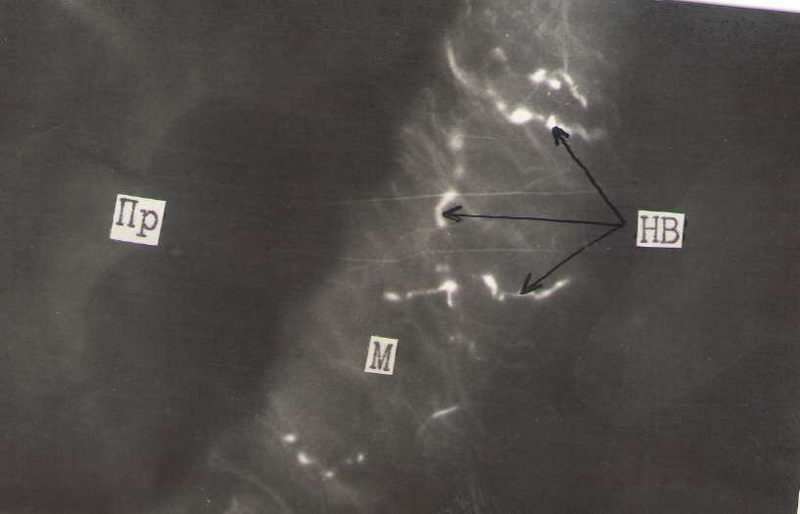
Figure 17 – Cryostat section of the mesenteric lymph node of an old rat after phytocorrection

Contractile activity of lymph nodes after phytocomposition In the first series of experiments on old rats, we observed a slightly different picture. The frequency of contractions of the smooth muscles of the cervical lymph nodes of old rats was 5.8 ± 0.5 contractions / min, and the amplitude was 3.9 ± 0.4 mg. In the mesenteric lymph nodes, the frequency is 6.9 ± 0.3 contractions / min, and the amplitude is 3.8 ± 0.8 mg (Fig. 19.20). Vasoactive substances affected isolated lymph nodes as follows.
Adrenaline at a dose (1x10-6-1x10-5M) in 57% of cases increased the frequency by 55 ± 1.6% and the amplitude of the cervical lymph nodes by 16 ± 1.0%, and the mesenteric lymph nodes in 52% of cases decreased with an increase in frequency by 55 ± 1.6% and amplitude by 17 ± 1.6%. Acetylcholine (1x10-5-1x10-4M) in 54% of cases caused an increase in the frequency by 32 ± 1.5% of the amplitude of contractions of the cervical lymph nodes by 11 ± 1.5%, and in the mesenteric lymph nodes the frequency increased by 38 ± 1.4 %. and an amplitude of 15 ± 1.7%.
Histamine (1x10-5-1x10-4M) led in 50% of cases to an increase in frequency by 18 ± 1.7% and an increase in the amplitude of the cervical lymph nodes by 8 ± 1.4% of mesenteric nodes, which increased in 52% of cases, the frequency by 16 ± 0.9% and an amplitude of 11 ± 1.2% (21.22). In the second series of experiments on old animals and after exposure to phytocomposition, the following results were recorded: Cervical lymph nodes contracted with a frequency of 4.2 ± 4 s / min and an amplitude of 5.3 ± 0.5 mg, and mesenteric nodes with a frequency of 5.6 ± 0, 5 abbreviations / min. and an amplitude of 5.4 ± 0.6 mg (Fig. 1, 2, 3). When acting on the nodes of old rats with vasoactive substances, we observed the effect of adrenaline in a dose (1x10-6-1x10-5M) on the cervical lymph nodes, an increase in frequency by 42 ± 1.8% of the amplitude by 28 ± 1.4% was observed in 67% of cases. The mesenteric lymph nodes responded in 69% of cases with an increase in frequency by 42 ± 1.6%, and in amplitude by 28 ± 1.3%. Acetylcholine caused (1x10-5-1x10-4M) in 66% of cases an increase in the frequency of contractions of the cervical lymph nodes by 40 ± 1.4% and the amplitude by 27 ± 1.2%, and the mesenteric nodes contracted in 71% of cases by 42 ± 1 , 7% and amplitudes by 31 ± 1.3%, from the initial values.
Under the action of histamine on the cervical lymph nodes (1x10-5-1x10-4M), an increase in frequency by 28 ± 1.3% and an amplitude by 37 ± 1.8% was noted in 68% of cases, on the mesenteric lymph nodes in 73% of cases, the frequency of contractions increased by 36 ± 1.3% and the amplitude by 34 ± 1.4% (Fig. 21,22). After three months of exposure to phytocomposition, the group of these rats increased their activity and decreased their weight 325.3 ± 18 g, and the group of old rats 396.7 ± 24 g (P <0.05).

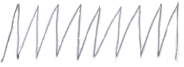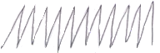
АВС
Designations: A - young B - old C - old animals + phytocomposition

Figure-18 – Spontaneous contractions of isolated mesenteric lymphatic
nodes of young, old rats and old rats after the action of the phytocomposition

Designations: ordinate - frequency of contractions per minute, abscissa: 1 - young, 2 - old, 3 - old animals + phytocomposition.
Figure 19 - Frequency of spontaneous contractions of smooth muscles of the capsule of the mesenteric and cervical lymph nodes in young, old rats and old animals after the action of the phytocomposition

Designations: ordinate - amplitude of contractions in mg, abscissa: 1 - young, 2 - old, 3 - old animals + phytocomposition
Figure 20 - Amplitude of spontaneous contractions of smooth muscles of the capsule of the mesenteric and cervical lymph nodes in young, old rats and old animals after the action of the phytocomposition

Designations: ordinate - frequency of contractions in%, abscissa: 1 - young, 2 - old animals, 3 - old + phytocomposition.
Figure 21 - Changes in the frequency of spontaneous contractions of the lymph nodes of young, old rats and old animals after the action of the phytocomposition in% in relation to the initial parameters under the action of adrenaline, acetylcholine, histamine
Designations: on the ordinate - the amplitude of contractions in%, on the abscissa: 1 - young, 2 - old animals, 3 - old + phytocomposition.
Figure 22 - Changes in the amplitude of spontaneous contractions of the lymph nodes of young, old rats and old animals after the action of the phytocomposition in% in relation to the initial parameters under the action of adrenaline, acetylcholine, histamine
This study showed that the contractile function of the smooth muscle of the lymph node capsule in both the cervical and mesenteric lymph nodes changes with age. Lymph nodes of old animals contracted significantly more often than in young rats, cervical nodes by 45 ± 3.1% (P <0.05), mesenteric nodes by 35 ± 2.4% (P <0.05). In this case, the amplitude of spontaneous contractions of the cervical nodes by 43 ± 2.1% (P <0.05) and mesenteric contractions by 48 ± 2.6% (P <0.05) is less than the corresponding indicators in young animals.
After three months of taking a new bioactive phytocomposition in the third group of old animals, we observed an improvement in the general appearance of these rats, an increase in their activity in cells, and a decrease in body weight by 18% ± 2.1. It was revealed in the cervical lymph nodes a decrease in the rhythm by 9 ± 0.6% and an increase in amplitude by 8% ± 0.5, and the mesenteric nodes also repeated the pattern of contractions - the rhythm decreased by 19 ± 0.8%, and the amplitude increased by 42% ± 1.2, which indicates a different effect on somatic and visceral lymph nodes
The bioactive phytocomposition we used did not change the threshold of action of biologically active substances on the smooth muscles of the lymph nodes, but increased the amount and caused a more pronounced effect on these substances, an activation of the rhythm and an increase in the amplitude of contractions of the lymph nodes were observed.
Phytocorrection of morphofunctional functions of lymph nodes
Old animals. Investigation of cervical lymph nodes at a late stage of ontogenesis revealed morphological equivalents of reduced immune function. With age, there is an increase in connective tissue in the lymph node. First of all, this is expressed in the thickening of the capsule area (3 times) and the development of connective tissue around the blood vessels (Table 8). Part of the lymph node can be replaced by adipose tissue (Figure 2). In such a lymph node, it is difficult to differentiate the cortical and medulla.
The importance of fibrosis and replacement of lymphoid tissue by adipose tissue for the development of immune deficiency in old age cannot be ruled out. This is facilitated by prolonged contact of the oral cavity with the external environment, which affects the anatomical structure of the regional cervical lymph node.
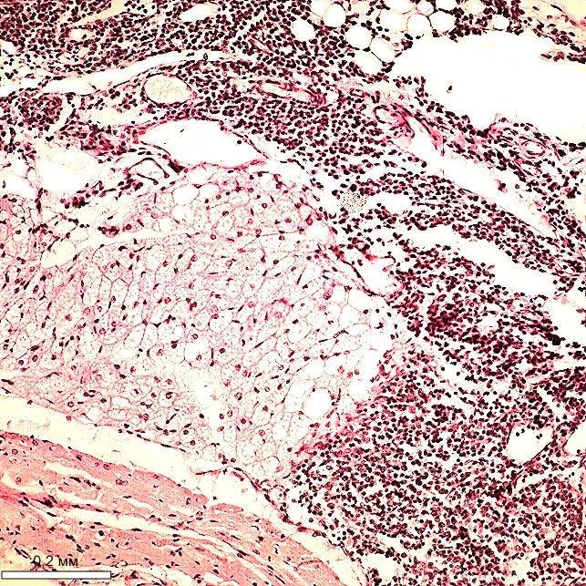

Staining with hematoxylin and eosin. Total magnification 120x.
Figure 23 - Old animals

Fatty replacement of lymphoid tissue of a part of the cervical lymph node In the cortical substance between the lymphoid nodules is the inter-nodular part of the cortex, and on the border with the medulla there is the paracortical region. The inter-nodular part and the paracortical region are referred to as the thymus-dependent zone.
The structures of the cortical substance undergo involutive changes, which is expressed in a decrease in the areas of the internodal part of the cortex (by 1.4 times), lymphoid nodules with a germinal center (by 2.7 times), and the paracortical region (by 1.3 times) at the late stage of ontogenesis ( table 8). In the lymphoid nodules of the preserved lymph nodes, cells with elements of destruction are observed (Figure 3). Simultaneously with age, the structures of the brain matter - brain cords and cerebral lymphatic sinus - decrease in size. The extreme degree of age-related transformation is sufficient lymphoid infiltration at the site of the previously located lymph node (Figure 25).
Analysis of the ordering of structures within the lymph node showed that in old animals the size of most of the structural and functional zones decreases against the background of an increase in the connective tissue component in comparison with young and mature animals. The ongoing decrease in the area of ​​the lymphoid parenchyma of the cervical lymph node is associated with a decrease in its immunoreactivity at the late stage of ontogenesis.
Old animals. Staining with hematoxylin and eosin. Total magnification 480x.
Figure 24 - Lymphoid nodule with destructive cells of the cervical lymph node

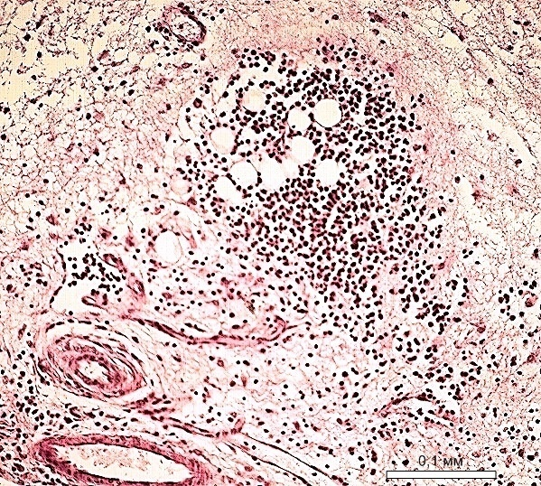

Old animals. Staining with hematoxylin and eosin. Total magnification 240x.
Figure 25 - Lymphoid infiltrate at the site of the cervical lymph node

Old animals. With aging, the structural organization of the mesenteric lymph nodes changes. At the late stage of ontogenesis, the areas of the capsule (1.6 times), the brain cords (2.1 times) and the sizes of the subcapsular and cerebral lymphatic sinuses (1.3 and 1.9 times, respectively), the internodal part of the cortex ( 2.1 times), lymphoid nodules with a germinal center (1.9 times), paracortical region by 12%.
The changes concern the structures of the cortical and medulla of the lymph node, demonstrating age-related involution of the lymphoid tissue, although its degree may be different (Figure 6). The peripheral lymphoid cortex narrows and concentrates closer to the capsule, the deep part of the cortex is divided by the penetrating medulla. Moreover, most of the structure of the lymph node is represented by the reticular stroma. Connective tissue replaces lymphoid tissue, expanding perivascular and in the parenchyma of the lymph node (Figure 7).
Minimization of the main structural and functional areas, especially lymphoid nodules with germinal centers, indicates a decrease in cell proliferation and, as a consequence, the immune potential of the lymph node. The lymphatic sinus system looks narrow on specimens, indicating decreased drainage function of the lymph node. Due to the predominance of the medulla in old animals, an intermediate variant of the morphological structure of the lymph node is formed (the K / M index is 1.07 ± 0.11) with an immune response according to the humoral type. This morphotype is considered optimal for the lymph node, but it cannot be recognized as such completely due to age-induced changes.
It is obvious that senile changes are accompanied by a decrease in the functional activity of the lymph node.
When analyzing the mesenteric lymph node of old animals, in 30% of cases, there was an increase in the area of ​​the structures of the cortex due to hyperplasia of the paracortical region. The size of the paracortical region was 28.92 ± 1.27%, and the size of the brain cords - 8.76 ± 0.51% against the background of wide germinal centers of lymphoid nodules in this group of animals. Cerebral lymphatic sinuses remain narrow and constitute 2.52 ± 0.26%.
The results of the morphometry of the mesenteric lymph node differ from the data in the group of animals, where the predominance of the medulla was revealed (Table 9). The data obtained are typical for a lymph node with a compact morphotype, when the development of a thymus-dependent zone responsible for the cellular link of the immune response takes place. In old animals, two variants of the structure were noted, differing in the degree of development of the thymus-dependent and thymus-independent zones.
In old animals, the effect of phytotherapy can be defined as structurally modifying, expressed in a selective increase or decrease in the size of structural and functional zones, which, before correction in old animals, occupied a smaller or larger area, respectively, in the structure of the lymph node.
After phytotherapy, old animals showed similar values ​​of the area of ​​the internodal part of the cortex in the mesenteric (6.99 ± 0.31%;), and the highest in the cervical (12.3 ± 0.30%; mesenteric <0.001) lymph nodes, which is associated with a decrease in the size of the internodal part in the cervical (1.2 times) lymph nodes and an increase in the mesenteric (1.2 times) lymph node in comparison with animals without correction. After phytotherapy in old animals, the area of ​​the paracortical region in the lymph nodes remained at the level without correction, showing the largest paracortical region in the inguinal lymph node, which is 43.1 ± 2.18% (P <0.001), 2 times exceeding the same indicator in the mesenteric (20.04 + 1.07%) and cervical (21.15 ± 2.17%) lymph nodes
Reception of phyto-collection increases the area of ​​lymphoid nodules with the germinal center (B-zone), mesenteric (1.5 times, P <0.01) and cervical (1.8 times, P <0.001) lymph nodes in comparison with the group of animals without correction. After phytotherapy in old animals in the mesenteric lymph node, the size of the brain cords is 27.1 ± 0.51% (P <0.01), which is 1.3 times less than the indicator without correction and remains the largest in comparison with the cervical (19, 1 + 1.04%) lymph nodes.

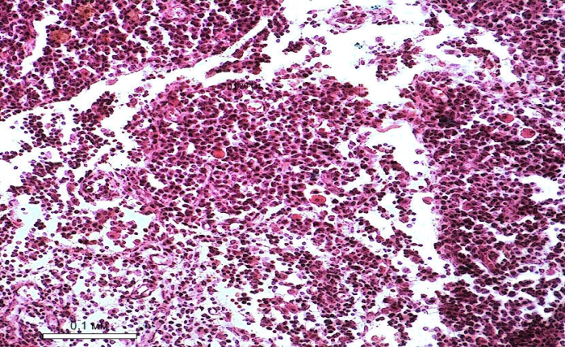
Herbal medicine in old animals. Staining with hematoxylin and eosin. Totalmagnification 240x.
Figure 26 - Formation of a lymphoid nodule at the border of the cortical and medullary substances

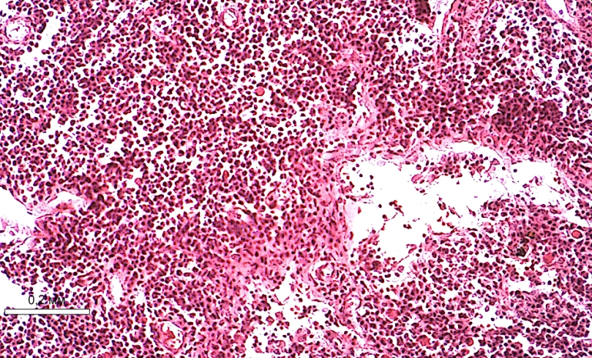
Herbal medicine in old animals. Staining with hematoxylin and eosin. Total magnification 120x.
Figure 27 - Development of connective tissue around the lymphatic sinuses

After phytotherapy in old animals, it was noted that the general sinus system is similar in size in the cervical lymph node, making up 12.59%, which is 1.3-1.5 times less than the area of ​​the sinus system in the mesenteric lymph node (P <0.001). Due to the modulating effect phytotherapy, there is a decrease in wide and an increase in narrow lymphatic sinuses in lymph nodes belonging to different topographic groups.
The size and cellular composition of the structural and functional zones changes after exposure to herbal medicine, determining the different intensity of the immune response in the lymph nodes of different localization. A certain role in this is played by postcapillary venules with high endothelium, through which lymphocytes migrate into the lymph node parenchyma, determining the saturation of cells in structural and functional zones. Common to all lymph nodes is an increase in the number of all cells in the lymphoid nodules, the paracortical region, the number of plasma cells and small lymphocytes in the brain cords after herbal medicine.
In the lymphoid nodules, the number density of lymphoblasts decreases sequentially in the following order: mesenteric (3.01 + 0.22;) - cervical (2.21 + 0.14). Pbryzh-w <0.01) lymph nodes after herbal medicine. The number density of macrophages changes similarly. In old animals, after phytotherapy in the paracortical region, the number density of cells of the lymphoid series is distributed from a large value to a lower value in the row: mesenteric - cervical lymph nodes, as well as the number density of lymphoblasts (plasmablasts) and macrophages in the brain cords.

3.6 Discussion of study results

Analyzing the experimental material obtained, the following picture can be observed - we received a decrease in lymph flow (by 40%), diuresis by 21% and interstitial fluid by 11% in mature animals in comparison with young animals and a more significant decrease in old animals (lymph flow - 64%; diuresis - 42%; IL - 20%). In the blood and lymph of mature animals, the amount of cholesterol and triglycerides slightly increased, but increased more significantly in old animals (cholesterol - 15%, 45%; triglycerides - 41%, 16%, total lipids - 18%, 33%, respectively). The amount of glucose decreased in mature and especially in old animals (blood - 40%; lymph - 16%). Coagulability and viscosity of blood and lymph also changed. Clotting increased by 19% in the blood and 26% in the lymph. Blood viscosity increased by 18% and in lymph by 18% from young to old. Different authors call different values ​​of the optimal water content in the tissues of organisms from age.
In our studies, from a young organism to a mature one, an increase in leukocytes, neutrophils, CD-20V lymphocytes in the blood and lymph and lymphocytes in the lymph has been shown. In old rats, a decrease in leukocytes in the blood by 36%, in the lymph by 25% was observed. Lymphocytes decreased in blood by 21%, and in lymph by 20% compared to mature animals, and a decrease in all populations of lymphocytes in blood and a slight decrease in lymph with old age was observed.
Many authors have shown all the structural components of the lymphatic vessels and nodes are laid in the embryonic period, reach their final development after birth, and are associated with the beginning of active functioning of the nodes. The restructuring of the lymph nodes, according to the functions of the organ, is observed in all age periods of life. In the age groups studied by us (2-45 days, 10-11 and 22-24 months), differences in the ratio of the structural components of the lymph nodes are possible. In the period from 2 to 30 days from birth, the complexity of the nervous structures occurs. We examined the qualitative side of the adrenergic innervation of the lymphatic vessels and lymph nodes.
In both menstrual and mature rats, adrenergic innervation is characterized by the presence of multiple nerve fibers forming plexuses with regularly spaced varicose veins along the entire length of the nerve fiber. The conducted research has shown the presence of a well-formed apparatus in all parts of the node in the capsule and trabeculae, cortical and medulla, as well as in the GLP. The presence of adrenergic nerve fibers in the capsule of the lymph node, where there is an accumulation of smooth muscle cells.
It is known that adrenergic mediators have a distant effect on smooth muscle cells, the distance between them corresponds to 200 nm [93, 94]. Regular varicose veins in adult rats had a brighter fluorescence, which may indicate a high content of catecholamines in them both in the lymph node and in HLP. It is believed that such varicose veins are depots of catecholamines [95,96]. But with age, we have shown that these varicose thickenings begin to decrease and in some plexuses they disappear altogether.
Our study has shown that the contractile function of the smooth muscles of the capsule of the lymph nodes of both the cervical and mesenteric lymph nodes changes with age. The lymph nodes of young and mature rats contracted identically with no visible differences. Perhaps, in order to reveal the differences in the pumping function of the lymph nodes of these groups of animals, it is necessary to take lymph nodes for research in the first days after the birth of the animals, but for this it is necessary to use a more sensitive installation and microtechnology.
It has been shown in the literature that in the process of early postnatal ontogenesis there is a decrease in the role of extra lymphatic factors and an increase in intralimphatic factors in the movement of lymph through the vessels [98]. In newborn animals from 2 weeks of age, spontaneous and evoked contractile activity of the lymphatic vessels is formed. These experiments are obtained on dog puppies in our laboratory.
Probably in the lymph nodes with the development and formation of innervation and other structural elements, the formation of spontaneous contractile activity occurs in the same age period, but by the age of 25-40 days, all morphological structures, as we see, are formed in the rat's node. Lymph nodes of old animals contracted significantly more often than in young and mature rats, cervical nodes by 45 ± 3.1% (P <0.05), mesenteric nodes by 35 ± 2.4% (P <0.05). In this case, the amplitude of spontaneous contractions of the cervical nodes by 43 ± 2.1% (P <0.05) and mesenteric contractions by 48 ± 2.6% (P <0.05) is less than the corresponding indicators in young and mature animals.
A decrease in the amplitude of the lymph nodes characterizes a decrease in the strength of systole, and an increase in the frequency of contractions above the optimal one leads to a decrease in diastole during which the lymphangion of the lymphatic vessel next after the lymph node is filled. All this is the reason for the decrease in the minute volume of the transported lymph through the lymphatic system. Slow filling and emptying of lymph nodes together with a certain pressure in the lymphatic system is significantly reflected when the parameters of the frequency of contractions and amplitude change on the transport function of the lymph nodes
Age-related changes also lead to a 20-40% decrease in the magnitude of contractile reactions of isolated lymph nodes when exposed to vasoactive substances. The vasoactive substances adrenaline, acetylcholine, histamine in old animals caused a pronounced effect only at higher concentrations (1x10-6-1x10-5M), and at concentrations (1x10-8-1x10-7M) their reactions to the activation of the contractile activity of the lymph nodes were weak expressed, only 18.12 and 9% of cases, respectively. In a greater percentage of cases, the effect of these substances was not found. The irritation threshold for vasoactive substances when acting on isolated lymph nodes increased to 1x10-6 M, in old animals, while in young and mature animals it was 1x10-8 M. Changes in the contractile activity of lymph nodes in old animals are based on changes in the morphological structure of the lymph capsule. nodes and, in particular, the replacement of some muscle fibers with connective tissue [99], an increase in the activity of pacemaker cells and a decrease in NO production leading to endothelial dysfunction with age [100], with age, changes occur in the innervation of the lymph node capsule [101], affecting the effector structures of smooth muscle cells. Contractile activity was inhibited with age. The values ​​of contractile responses to vasoactive substances decreased in comparison with young and mature animals. The revealed age-related changes in the smooth muscle cells of the capsule of the lymph nodes lead to a decrease in the force of contractions of the smooth muscles and thereby reduce the lymph flow, both along the node itself and further along the lymphatic vessels.
Thus, in our study, we noted a decrease in the contractile activity of the lymph nodes, a decrease in the sensitivity of the receptors of the lymph nodes, and an increase in the threshold of irritation to vasoactive substances in old animals.
As our studies have shown, the localization of the sclerotic process in the lymphoid parenchyma is very significant. Signs of the development of sclerosis are neoplasms or proliferation of connective tissue at the site of atrophy of parenchymal cells. With regard to the lymph node, there are two options for the predominant localization of sclerosis: 1) in the medulla; 2) in the cortex and paracortical region [102]. According to our observations, sclerotic changes in old animals concern the capsule of the lymph node, and the proliferation of connective tissue occurs more often along the course of the blood vessels. In addition to the existing variants of sclerosis in the lymph node, the localization of subcapsular sclerosis in the peripheral cortex parallel to the marginal sinus and local thickening of the capsule are described for the first time. This localization of sclerosis disrupts the structure of the lymphoid lobule and the passage of lymph through the lymph node, leading to the development of immune and drainage insufficiency.
In the visceral lymph nodes, the lumen of the sinuses is significantly narrowed due to an increase in the volume of stromal elements. The decrease in lymph flow through the visceral nodes is associated with the content of a large volume of toxic substances in the inflowing lymph [103]. In the mesenteric lymph nodes of old animals, the most pronounced changes were observed in the cortical substance of the node, which increased mainly due to the "deep" cortex [104]. The degree of development of connective tissue in the lymph nodes is very important for the prognosis of their function [105].
Numerous studies confirm the important role of lymph nodes in the formation of humoral and cellular immune responses [106]. In old animals, the observed change in the lymph node compartments can be regarded as a reflection of the antagonism of the humoral and cellular links of immunity. Disturbances in the immune system reduce resistance [107], which leads to immune deficiency, judging by the occupied area of ​​the thymus-dependent zone in the lymph nodes of old animals. Reorganization of the lymph nodes with age can occur in different ways: the first option is an increase in the cortex due to hyperplasia of the paracortical region with a decrease in the medulla; second option
This determines the final immune response by humoral or cellular type, respectively. We believe that the variant of morphological changes in the mesenteric lymph node with age largely depends on environmental and nutritional factors. Age-related changes in the immune system include atrophy of lymphoid organs, a decrease in the number of peripheral T-cells, an increase in the number of immature lymphocytes due to a delay in their differentiation, and others [108]. The cyto composition reflects the stages of transformation of the lymphoid parenchyma of the lymph node with age [109,110,111].
For old animals, it is characteristic: in the lymphoid nodules, a decrease in the number of blasts, small lymphocytes, an increase in the number of medium lymphocytes; in the paracortical region, a decrease in the number of small and medium lymphocytes and an increase in the number of macrophages; in the pulp cords, a decrease in plasma cells and an increase in the number of macrophages; in the cerebral lymphatic sinus, an increase in the number of small lymphocytes.
The composition of lymphoid cells is a morphological confirmation of the activation or deceleration of the processes of migration, proliferation and differentiation of immunocompetent cells.
The quantitative predominance of mature and immature plasma cells is evidence of the active immune function of the lymph node [112,113]. A regular decrease with age in the number of prolymphocytes and a corresponding increase in the content of mature lymphoid cells, up to the prevalence of the latter in the cytograms of lymph nodes in old people [114,115] due to a change in the character of Th0 differentiation, a significant part of which become Th1 and / or Th3 lymphocytes [116,117]. Blast transformation is carried out with a delay in the transition of the prolymphocyte (middle lymphocyte) to the lymphoblast. In old age and in children of the first year of life, the percentage of cells subject to transformation decreases by 20–30% [118,119].
It should be noted that there is an inversely proportional relationship between the content of mature lymphoid cells and prolymphocytes [120]. To a greater extent, the delay in the formation of blasts occurs in old animals, primarily in the lymphoid nodules. But such a relationship between the content of mature lymphoid cells and prolymphocytes is not always traced, especially with corrective influences. This can be explained by the different intensity of the process of proliferation and differentiation of lymphoid cells and the direction of the migration flows of cells along the lymphatic bed and from the bloodstream to the lymph node.
It is obvious that the lymph nodes of different topographic and anatomical regions differ in their structural and cellular organization. And this is due to the functional features of the organs located in the area of ​​drainage of regional lymph nodes. An increase in connective tissue elements and reticular cells in the presence of macrophages and lipophages in the presence of macrophages and lipophages is recognized as markers of lymph node aging, which is consistent with the concept of a decrease in the functional activity of the lymphoid parenchyma [121, 122]. The literature contains information on the activation of the functions of the lymphatic system after the use of medicinal plants [89,123]. Medicinal plants enhance the drainage function of the structure of the lymph nodes in pathology [124]. Bioflavonoids affect the smooth muscles of the lymphatic vessels and nodes [125]. Medicinal herbs used in our screening study showed that they affect the animal organism on the lymphatic and cardiovascular systems; increased lymph flow and urine output (ZB, Z, EP, K, BT); improved blood fluidity (ZB, Z, EP, K, BT) , lymph fluidity (ZB, Z, K, BT), increased the volume of plasma (ZB, BA, K,).
Decreased blood pressure (ZB, ZO, K, BT). The heart rate decreased (ZB, BA, BT). The weight of the animals has decreased. The choice of medicinal plants was justified, since the analysis of the figures in the table (). after screening studies showed that the studied parameters approached the figures obtained in animals of younger age. It was decided to use all medicinal herbs involved in our experiments to inhibit aging. Phyto-collection was compiled by us according to the pharmaceutical principle, taking into account the lymphotropic effect of medicinal herbs and was aimed at realizing the effect of lymphostimulation, lymphocorrection and lymphoprotection.
It includes the above listed plants and a steam of iodine from the company "Balsam Revival" LLP MTІ Medical. The phytocomposition used in the study on old animals increased the volume of IL and plasma by 10.3%, respectively. Lymphatic flow increased by 18%, urine output by 41%. An increase in blood flow was observed as the clotting time increased; the viscosity of blood and lymph decreased. Showed a slight decrease in blood pressure and heart rate. The weight of the animals decreased significantly. After the application of phytocomposition, an increase in the luminescence of adrenergic fibers was observed, both in the lymph nodes from different regions of the body (popliteal, mesenteric, cervical, lymph nodes) and in the LHP. It was found that fluorescence is enhanced both in the nerve fiber itself and in varicose veins, in the plexuses in the lymph nodes, and in different parts of the SOD. Bioflavocands stimulate the production (synthesis) of catecholamines and their reserves in nerve fibers increase, which means that the nervous regulation in the lymphatic vessels and nodes improves. After three months of taking a new bioactive phytocomposition in a group of old animals, we observed an improvement in the general appearance of these rats, an increase in their activity in cells, and a decrease in body weight by 18 ± 2.1%. It was revealed in the cervical lymph nodes a decrease in the rhythm by 9 ± 0.6% and an increase in amplitude by 8% ± 0.5, and the mesenteric nodes also repeated the pattern of contractions - the rhythm decreased by 19 ± 0.8%, and the amplitude increased by 42% ± 1.2, which indicates a different effect on somatic and visceral lymph nodes. The bioactive phytocomposition used by us did not change the threshold of action of biologically active substances on the smooth muscles of the lymph nodes, but increased the amount and caused a more pronounced effect on these substances, there was an activation of the rhythm and an increase in the amplitude of contractions of the lymph nodes. Phytotherapy allowed us to correct the transport function of lymph nodes of different localization based on increased lymphoproliferation and lymph stimulation using antioxidant vitamin and microelement balance. Phytocorrection in geronites led to a morphological shift of lymph node structures towards a younger age [127], created adequate conditions for the ordering of interstitial relationships of the fluid balance of the body [128], increased lymph flow. The mechanisms of these processes can be considered as an increase in the resistance of body tissues and cells of lymph node structures to an increase in the resistance of micro and macromolecules to damaging factors, and an increase in antioxidants in the body to an increase in resistance to oxidative stress [129]. In phytotherapy, there are signs of a reactive process from the lymph nodes. This is manifested in an increase in the number density of mature lymphocytes, plasmocytes. The presence of plasmocytes is considered as evidence of active immune function of the lymph node [130]. All topographic groups of lymph nodes are characterized by an increase in lymphoproliferation as a result of herbal medicine, which is accompanied by the formation of lymphoid nodules outside and inside the lymph nodes (Fig. 9, 10).
Such ectopic foci of accumulation of lymphoid cells are called “tertiary lymphoid organs” and their appearance is associated with the development of immunodeficiency in pathology (131). The results of the study show that ectopia of lymphoid nodules is more universal in nature and can be observed after phytostimulation of decreased lymph node function. An unusual arrangement of lymphoid nodules was noted in the subcapsular zone and the medulla of the lymph nodes after phytotherapy in old animals (Fig. 9).
Phytostimulation of lymphoid tissue enhances the processes leading to partial or complete encapsulation of cortical substances, as well as to fragmentation of the lymph node due to the isolation of the protruding parts of the cortex. This can be considered a stage in the formation of a lymph node. This is most characteristic of the cervical lymph nodes, which are initially fragmented. The previously unknown property of phytotherapy to induce the formation of new lymphoid structures (neolymphogenesis) with an increase in immune function has been experimentally shown. Along with the enhancement of the neolymphogenesis process, phytotherapy leads to the optimization of the structure and function of the lymph nodes that have undergone senile changes with an increase in the nonspecific resistance of the organism.

CONCLUSIONS

Based on the data obtained, the following conclusions are made:
1) A decrease in lymph flow, urine output, volume of interstitial fluid in mature animals and a further decrease in old animals compared to young ones was obtained. Data on biochemical, cellular, ionic, immune parameters of blood and lymph, lymph flow, diuresis, composition and volume of interstitial fluid, which corresponded to physiological changes from a young organism to a mature one and then to an old one.
2) Starting from the first days of postnatal ontogenesis, the formation and complication of the adrenergic apparatus in the tissues of the lymphatic vessels and nodes continues, which are fully formed by the 25-30th day after the birth of rats. Starting from one month of age, adrenergic innervation is a well-formed apparatus in all parts of the HLP and the node in the capsule of the trabeculae, cortex and medulla. These are brightly glowing nerve fibers that form plexuses with regularly spaced multiple varicose veins. In old animals, the density and number of plexuses are preserved in all parts of the lymph node and HLP, but the brightness of the glow decreases, the fibers in the plexuses become intermittent, the number of varicose thickenings decreases or disappears.
3) In young and mature animals, no significant changes in the contractile activity of isolated lymph nodes were revealed. The contractile activity of the lymph nodes in old animals was inhibited. A decrease in the contractile activity of lymph nodes of different localization, a decrease in the sensitivity of receptors and an increase in the threshold of irritation to vasoactive substances were noted.
4) Lymph nodes, regardless of localization, have common signs of aging: a) an increase in connective tissue with a decrease in the area of ​​lymphoid nodules with germinal centers against the background of the preservation of a compact morphotype; b) unidirectional changes in the cellular composition in a decrease in the number of blasts and medium lymphocytes in lymphoid nodules, paracortical region, plasmocytes in the brain cords against the background of an increase in reticular cells, which indicates a decrease in the immunoreactivity of these structures;
5) A screening study on old animals of the substance Zizifora Bunge, hawthorn of Almaty and decoctions of herbs St. John's wort, Echinoceapurpurea, penny, and badan thick-leaved showed changes in the studied parameters of the lymphatic and cardiovascular systems, lymphatic flow, urine output, heart rate, blood pressure, blood coagulation and coagulation. plasma volume by hematocrit, weight of animals in the old younger age.
6) The phytocomposition we applied on old animals showed an increase in lymph flow, diuresis, and the volume of interstitial fluid in comparison with old animals without phytocorrection. In the lymph and blood of animals, a decrease in cholesterol, triglycerides and total lipids was observed. In the blood, platelets decreased, and in the blood and lymph, the clotting time and viscosity changed, which improved the fluidity in the vessels.
7) Long-term use of phyto-collection on old animals increased the flow of sympathetic nerve fibers in the lymph nodes and thoracic lymphatic duct. This shows the stimulating effect of bioflovanoids on the production of catecholamines in the nerve fibers of the lymphatic vessels and nodes.
8)Bioactive phytocomposition revealed a statistically significant positive effect in the functioning of the contractile activity of the lymph nodes. A decrease in the rhythm and an increase in amplitude were observed in geronts of both somatic and visceral lymph nodes. Biologically active substances against the background of phytocomposition stimulated the transport component of the lymph nodes.
9) Phytocorrection determined its application to stabilize the structural components of the lymph nodes and water homeostasis in the lymph region and increased the drainage-detoxification functions of the lymph nodes of geronts and, as a result, retained their contractile function. An increase in the area of ​​lymphoid nodules with germ centers, a change in the cellular composition, an increase in the number of blasts and middle lymphocytes in the lymphoid nodules in the paracortical region, plasmacytes in the brain cords and an increase in reticular cells, which increased the immune function of the lymph nodes regardless of their location.
10)Used in studies on old animals under the grant "Functioning of the lymphatic system from a young organism to an old one and the search for medicinal substances that slow down senile changes" phytocomposition revealed a lymphatic stimulating effect (increased IL, increased lymph flow), a stabilizing effect on contractile activity, increased the synthesis of mediators in sympathetic nerve fibers , increased the drainage and detoxification function of the lymph nodes, restored their microstructure.

LIST OF SOURCES USED

- Golubev A. B. Why are we getting old and how?-One answer to two questions // Advances in gerontology. 2018. Vol. 31. - No. 4. - P. 458-472 (In Russian)
- Moskalev A. A. is aging a disease? The point of view of genetics // Advances in gerontology. 2017. Vol. 30. - No. 6. - P. 843-844(In Russian)
- Sorrentino J.A., Sanoff H.K., Sorrentino J.A., Sharpless N.E. Defining the toxicology of aging // Trends in Molecular Medicine, 2014. – July. – Vol. 20. – Issue 7. – P.375–384. doi: 10.1016/j.molmed.201 4.04.004.
- Mayborodin I. V., Agzaev M. K., Ragimova T. M., Mayborodin I. I. Age-related changes in the structure of lymphoid organs: literature review / / Advances in gerontology, 2016-Vol. 29-No. 2. - Pp. 229-238. (In Russian)
- Gomazkov O. A. Cellular and molecular principles of brain aging// Advances in modern biology. - 2012. - No. 2. - P. 141-154. (In Russian)
- Sokolov I. B., Puzanov M. V., Melnikova N. N., Murovets V. O., Sergeev I. V., Dvoretsky D. P. Age-related changes in blood flow rate and blood saturation in the cerebral cortex in rats // Advances in gerontology, 2015-Vol. 28. - No. 3. - P. 466-472(In Russian)
- Chao W., Li C.., Chen L. et al. Stereological investigation of age-related changes of the capillaries in white matter // Anat. Rec. - 2010. - Vol.293. -№ 8. - P.1400-1407 (In English)
- UchidaS. Suzuki A., Kagitani F., Hotta N. Effects of age on cholingic vasodilation of cortical cerebral blood vessels in rats // Neurosci. Lett. 2000. - Vol.294 .-№2 P. 109-112 (In English)
- Najjar S.,Scuteri A.,Lacatta E. Arterial aging is it an immutable cardiovascular risk factor // Hypertension. 2005. - №46. P.454-462. (In English)
- Spitsin A. P., Pershina T. A., Tsarev Yu. K. Features of hemodynamics and heart rate in men with high blood pressure depending on the initial vegetative tone and age ////Advances in gerontology. 2018. Vol. 31. - No. 2. - P. 239-245(In Russian)
- Burger M. Altern und Krankheitalc Problem der Bimorphose.- Leipzig: Thie-me 1980.-783S. (In English)
- Petrenko V. M. the individual Homeostasis: the lymphatic and lymphoid system/ V. M. Petrenko // international journal of applied and fundamental research, 2016. – № 8 (1). – P. 46–51. (In Russian)
- Levin Yu. M. Breakthrough in endoecological medicine. – M., 2006. – P.199. (In Russian)
- Borodin Yu I Lymph as a balancer between blood and tissue fluid // Matera. XI International conference "Fundamental problems of lymphology and cell biology", Novosibirsk, 2013, p. 6-8. (In Russian)
- Demchenko G. A. Functional state of the lymphatic system in circulatory disorders. Autoref. Doc. dis. Almaty. 2007. P. 24. (In Russian)
- Sapin M. R. The age and sex particularities in structure of mans lymphatic nodes. Abst. V.2. VI – Onternat. Cjngress of lymphlogy. Praga.- 1977. P.6.1. (In English)
- Sharmana., Jumadilov. Scientific foundations of quality longevity and aging / / new York, MaryAnnLiebert, Inc., 2011. - 184 p. (In Russian)
- Senenko A. sh. Experimental study of age-related changes in the rate of lymphatic drainage and the possibility of their correction. seminar " Ecology and health. Environmental medicine " - Moscow: MNEPUGU Publishing house, 2002. - P. 135-136. (In Russian)
- Levin Yu. M., Toporova S. T., Sviridkina L. P., barkinhoeva F. A. Discovery of properties to influence the transport of tissue fluid and lymphatic drainage of tissues in some well-known drugs // Materials of the III Intern. Congress "Endoecological medicine". Republic of Cyprus, October 21-28, 2007-Moscow: JSC "Shcherbinskaya tipografiya", 2007. - P. 69. (In Russian)
- Petrenko V. M., Functional morphology of lymphatic vessels / V. M. Petrenko. - SPb., - 2008. - 243s. (In Russian)
- Orlov R. S., Borisov A.V., Borisova R. P. Lymphatic vessels. Structure and mechanisms of contractile activity. - L.: Nauka, 1983. - 254 p. (In Russian)
- Gaivoronsky I. V. human Anatomy and physiology // I. V. Gaivoronsky. 6th ed., reprint. and additional-M.: Medicine, 2011. - 496s. (In Russian)
- Chang J.E., Chang J.E.,Turley S.J. Stromal infrastructure of the lymph node and coordination of immunity // Trends Immunol., 2015. – V.36. – P.30–39. (In Russian)
- Petrenko V. M. Lymphoid or hematopoietic organs? / V. M. Petrenko // Advances in modern natural science. - 2011. - No. 1-P. 142-143(In Russian)
- Toporova S. G. Features of the system of pericellular humoral transport in aging: literature review / / Almanac "Gerontology and geriatrics". - M., 2003. - Issue 2. - P. 90-94. (In Russian)
- Levin Yu. M. Breakthrough in endoecological medicine, Moscow, 2006, P. 199. (In Russian)
- Titova T. Oxidative stress and aging: opportunities for correction.Titova, L. Kudryashova, I. Bolgova, I. Pavlova //Doctor, 2015. - No. 6.. - P. 6-10(In Russian)

- Konenkov V. I. Cell biology-the basis of medical cell technologies // Matera. XI International conference "Fundamental problems of lymphology and cell biology", Novosibirsk, 2013, pp. 4-6. (In Russian)
- Levin Yu. M. Breakthrough in endoecological medicine. New level of medical thinking and effective therapy / Yu. m. Levin. - M.: JSC "Shcherbinskaya tipografiya", 2006. - 200S. (In Russian)
- Oh J.H., Kim Y. K.,. Jung J. Y. et.al. intrinsic aging-and photoaging-dependent level changes of glycosaminoglycans and their correlation with water content in human skin // J.Dermatol. Sci.011. - Vol.62. - P.192-201 (In English)
- Montagna W., Carlisle K., Structural changes in ageing skin // Brit. J. Dermatol. -1990.- Vol.1227. - P.61-70 (In English)
- Levinyu. M., Dzhumabaevas. U., Buyanov. M., Shakhtmeiteri.I. IDR. Endolymphatic and lymphotropic therapy. - Tashkent, -1987. - 234 p. (In Russian)
- Konenkov V. I., Borodin Yu. I., Lyubarsky M. S. Lymphology. – Novosibirsk: Publishing. house "Manuscript", 2012. - 1104 p. (In Russian)
- Klimova E. M., Bozhkov A. I., Kovalenko T. I., Minukhin V. V., Belozerov I. V. Young and old animals use strategies for forming an immune response to infectious agents ////Advances in gerontology. 2018. Vol. 31. - No. 3-P. 330-338(In Russian)
- Selgrade M.K. Air pollution and respiratory disease extrapolating from animal models to human health effects// immunopharmacology.-2000.Vol.48.-P/319-324 (In English)
- Gorchakov V. N., Saranchina E. B., Anokhina E. D. Phytolymphonutritiologiya / // Scientific practice. journal "Practical herbal medicine", 2002. - no. 2. - P. 6-9. (In Russian)
- Chohen H.Y. Miller C. Bitterman K.J. et.al. Colorie restriction promotes mammalian cell survival by inducing the SIRT1 deacetylase // Scince. - 2004. - Vol.305. - P.390-392. (In English)
- Hansen M., Hsu A.-L., Dillin A., Kenyon C. New genes from a Caenorhabditis elegans genomic RNAi screen // PloS Biol. - 2005. -Vol.1. - № 1. -P.119-128. (In English)
- LinSu-Ju, Kaeberlein M., Andalis A.A., et.al. Colorierestrictionextends Saccgaromyces cerevisiae lifespan by increasing respiration // Nature .2002. - Vol.418. - P.344-348. (In English)
- Zykov A. A., Zykov A. A., Golovnev V. A. Pharmacological regulation of the lymphatic system // Novosibirsk: ITC, 2002, -65 p. (In Russian)
- Lutchman V., Medkour E., Samson Y., Arlia-Ciommo A., et.al. Discovery of plant extracts that greatly delay yeast chronological aging and have different effects on longevity-defining cellular processes // Oncotarget, 2016. - Vol.7. -№ 13. -P.16542-16566.DOI 10.18632/ Oncotarget.7665 (In English)
- Bozhkov A. I., Kurguzova N. I., Krivoruchka T. V., Lebed E. N., Mikhailets A. O. Cyclic feeding regime-a new model of experimental gerontology //Advances in gerontology, 2014. - T. 27. No. 2., - P. 25-27. (In Russian)
- Karkishchenko N. N. Laboratory animals (regulations and guidelines) / N. N. Karkishchenko. - M.: Interacademic publishing house "MIC", 2003. - 138 p. (In Russian)
- Gelashvili O. A. Variant of periodization of biologically similar stages of human and rat ontogenesis / / Saratov scientific and medical journal, 2008. – Vol. 4. - No. 22. - Pp. 125-126.
- Famin a.m., Kapitanov E. N., Chemeris A. N. Measurement of electrical conductivity or resistance of a body part. 2006. (In Russian)
- Aukland K., Fadnes H. Wick metod for measuring intestinal fluid protein concentration / / Acta physiol. scand. - 1972. - V. 84. - P. 26-32. (In English)
- Ortolani R., B ellavite P., Caiola F. et al. A comparative method for processing 1. immunological parameters: developing an «Immunogram» // Blood Transfus. 2010 Apr; 8(2):118-25. (In English)
- Blattner R., Klassen H., Denert H. Experiments on isolated smooth muscle preparations – - Moscow. Mir, - 1983, - 206 p. (In Russian)
- Hoverin V. A. the Adaptive-trophic function of vascular nerve // Development of scientific heritage Akad. L. A. Orbelli. L.: Nauka, 1982. Pp. 169-181. (In Russian)
- Avtandilov G. G. Medical morphometry. - M.: Medicine, 1990. - 384 p. (In Russian)
- Gutsol A. A., Kondratev B. Yu. Practical morphometry of organs and tissues / A. A. Gutsol, / ed. By G. G. Avtandilov. - Tomsk: publishing house Vol. UN-TA 1988 – - 133c(In Russian)
- Zykov A. A., Zykov A. A., Golovnev V. A. Pharmacological regulation of the lymphatic system // Novosibirsk: ITC, 2002, -65 p. (In Russian)
- Lutchman V., Medkour E., Samson Y., Arlia-Ciommo A., et.al. Discovery of plant extracts that greatly delay yeast chronological aging and have different effects on longevity-defining cellular processes // Oncotarget, 2016. - Vol.7. -№ 13. -P.16542-16566.DOI 10.18632/ Oncotarget.7665 (In English)
- Bozhkov A. I., Kurguzova N. I., Krivoruchka T. V., Lebed E. N., Mikhailets A. O. Cyclic feeding regime-a new model of experimental gerontology //Advances in gerontology, 2014. - Vol. 27. no. 2., - P. 25-27. (In Russian)
- Gichev Yu. y. Guide to biologically active food additives / Yu. y. Gichev. - M.: Triada-X, - 2001. - 84 p. (In Russian)
- Guidelines. Food products and food additives. Determination of the safety and efficacy of biologically active additives to food. MUK 2.3.2.721-98. Institute of nutrition of the Russian Academy of medical Sciences. Date of introduction-January 1, 1999(In Russian)
- Borodin, Y. I. Effects of lipocorrection and lipoprotein by thermal burn of skin / Y. I. Borodin, N. P. Bgatova // Theses of the IV Congress of lymphologists of Russia. - M.: Prospect, 2011. - P. 12-13. (In Russian)
- Borodin, Yu. I. General principles of sanation of the body by exposure to the lymphatic system, lymphoid organs and intersticin / Yu. I. Borodin / / Guide to clinical lymphology. - M., 2010. P. 13-15. (In Russian)
- Pari,L. Protective effects of hesperidin on oxidative stress, dyslipidaemia and histological changes in iron indused hepatic and renal tozicity in rats/ Pari,L.A.Karthikeyan, P.Karthika// Toxicology Reports, 2015.V.2. P.46-55 (In English)
- Petrenko V. M. Lymph system and the organization of the immune system. Innovac. The science. 2017, No. 9, pp. 68-69. Bibl. 8. (In Russian)
- Gaskina, T. K. Microelement homeostasis of the lymphatic region of the stomach in the dynamics of the ulcerative process and its correction according to the RFA SI / T. K. Gaskina, V. N. Gorchakov, Yu. P. Kolmogorov, E. V. Melnikova // Bulletin of new medical technologies, 2008. - Tom. XV. - No. 2. - P. 94-95. (In Russian)
- Note N. (Heine, X.) of Elgin с1ег Ыо1о§1хсИсп ISSC/PL. Textbook of biological medicine. Basic regulation and extracellular matrix / N. Neshe-M.: Arnebia, 2008. - 244 s (In English)
- Karel Smejkal, Milan Malanik, KarlygashZhaparkulova et. al. Kazakh ZiziphoraSpesies as Sources of Bioactive Substances // Molecules 2016. P. 54 (In English)
- Soares S.S., Bekbolatova E.,Cotrim M.D. et.al. Chemestry and Pharmacology of the Kazakh CrataegusAlmaatensisPojark:An Asian Herbal Medicine. Antioxidants 2019, 8. P.2-14.
- Van Strater A.C., Bogers J.P. Interaction of St John's wort (Hypericum perforatum) with clozapine - Int. Clin. Psychopharmacol. 2012, Mar., 27(2), 121-124. (In English)
- Brykalov A.V., Golovkina E. M., Belik E. V., bostanova F. A. Investigation of physiologically active compounds in a preparation from Echinacea purpurea / / Chemistry of plant raw materials. 2008. No. 3. P. 89-91. (In Russian)
- Pharmacognosy. Atlas. in 3 volumes-samylina I. A., Ermakova V. A., Bobkova I. V., Anosova O. G., - M.: GEOTAR-Media, 2009(In Russian)
- Radilova S. Y. All about medicinal plants on your vegetable patch / Ed. Radelova S. Yu. - SPb: LLC "SZKEO", 2010. - P. 193. - 224 p. (In Russian)
- Karkishchenko N. N. Laboratory animals (regulations and guidelines) / N. N. Karkishchenko. - M.: Interacademic publishing house "MIC", 2003. - 138 p. (In Russian)
- Bozhkov A. I., Kurguzova N. I., Krivoruchka T. V., Lebed E. N., Mikhailets A. O. Cyclic feeding regime-a new model of experimental gerontology //Advances in gerontology, 2014. - T. 27. No. 2., - P. 25-27. (In Russian)
- Karkishchenko N. N. Laboratory animals (regulations and guidelines) / N. N. Karkishchenko. - M.: Interacademic publishing house "MIC", 2003. - 138 p. (In Russian)
- Gelashvili O. A. Variant of periodization of biologically similar stages of human and rat ontogenesis / / Saratov scientific and medical journal, 2008. - Volume 4. - No. 22. - Pp. 125-126. (In English)
- Famin a.m., Kapitanov E. N., Chemeris A. N. Measurement of electrical conductivity or resistance of a body part / / M. D. Vladimirsky research Institute, Moscow. 2006. (In Russian)
- Aukland K., Fadnes H. Wick metod for measuring intestinal fluid protein concentration / / Acta physiol. scand. - 1972. - V. 84. - P. 26-32. (In English)
- Ortolani R., B ellavite P., Caiola F. et al. A comparative method for processing 1. immunological parameters: developing an «Immunogram» // Blood Transfus. 2010 Apr; 8(2):118-25. (In English)
- Blattner R., Klassen H., Denert H. Experiments on isolated smooth muscle preparations – - Moscow. Mir, - 1983, - 206 p. (In Russian)
- Govrin V. A. Adaptive-trophic function of vascular nerves // Development of scientific heritage of the Academy of Sciences L. A. Orbelli. L: Nauka, 1982. Pp. 169-181. (In English)
- Avtandilov G. G. Medical morphometry. - M.: Medicine, 1990. - 384 p. (In Russian)
- Gutsol A. A., Kondratev B. Yu. Practical morphometry of organs and tissues / A. A. Gutsol, / ed. By G. G. Avtandilov. - Tomsk: publishing house Vol. UN-TA 1988 – - 133c(In Russian)
- tanasiychuk, I. S. Cytomorphological characteristics of the cellular composition of lymph nodes in the norm / I. S. tanasiychuk / / Cytology and genetics, 2004. - No. 6. - Pp. 60-66. (In Russian)
- Gorchakov V. N. Tissue microdistrict and its main components. Limfologiya, Novosibirsk, 2012, pp. 86-102. (In Russian)
- Lobov. G. I., Orlov R. S. Cellular mechanisms of regulation of lymph transport / / Russian Physiol. zhurn. 1995. Vol. 81. no. 6. p. 4-7. (In Russian)
- Gorchakova O.V., Gorchakov V. N. Structural organization of lymph nodes of different functional specialization at the stage of late ontogenesis // Biological Sciences, 2015, no. 7 (38), part 2, Pp. 74-76. (In Russian)
- Petrenko V. M., Petrenko E. V. Mechanics of compensatory processes in experimental development of lymph node parenchyma // International journal of applied and fundamental research, 2013, no. 10-2. Pp. 164-166. (In Russian)
- Borodin Yu. I. Theoretical background of preventive lymphology and human health in Siberia / / Byull. SB RAMS, 2008, no. 5 (133). Pp. 14-17. (In Russian)
- Вulekbaeva L. E. Comparative physiology of the lymphatic system. Alma-ATA., - Nauka, -1985. - 164s. (In Russian)
- Chevaline N. N. Morphofunctional changes in the lymph nodes after denervation. Dis. Cand. Novosibirsk, 1971. (In Russian)
- Bülbring E, Tomita T. Catecholamine action on smooth muscle // PharmacolRev. 1987, V. 39 (1), P. 49-96. (In Russian)
- Medić, B. The role of autonomic control in the cardiovascular system: summary of basic principles // Medical Youth, 2016, N67, V. 1. P. 14-18. (In English)
- Lobov G. I., Pan'kova M. N. Transport of lymph by lymph nodes: mechanisms of regulation // ROS. physiology. journal 2012, Vol. 98, No. 11, Pp. 1350-1361. (In Russian)
- Abdreshov S. N., Bulekbayeva L. E., Demchenko G. A. Lymph Flow and Contractile Activity of Mesenteric Lymph Nodes in Rats with Toxic Hepatitis Effects of Antioxidants // Bulletin of Experimental Biology and Medicine, 2013, Vol.155, N 1, - P. 22-25. (In English)
- Karabanov Y. Y. Structural and compositional homeostasis of centenarians," proceedings of the international conference, Kursk, Russia 2014 50 – 53. (In Russian)
- Petrenko V. M. Lymph system and the organization of the immune system. Innovac. The science. 2017, No. 9, pp. 68-69. Bibl. 8. (In English)
- Akhmetbaeva N. A. Morpho-physiological characteristics of the thoracic lymphatic duct of dogs in postnatal ontogenesis. Aftoref. dis. ... Cand. Biol. Sciences. Alma-ATA, 1982. 28C. (In Russian)
- Bülbring E, Tomita T. Catecholamine action on smooth muscle / / PharmacolRev. 1987, N39 (1), P. 49-96. (In English)
- Sidorov A.V. Age-related changes in the electrical activity of identified neurons: maturation or aging, adaptation or diversity? // News of medical and biological Sciences. 2018, Vol. 17, no. 1. (In Russian)
- Emanuylov A. I., Konovalov V. V., Maslyukov P. M., Polyakov E. L., Nozdrachev A.D. Age-related changes in sympathetic innervation in rats // Advances in gerontology. 2018. T. 31. No. 6. –Р.26-32. (In Russian)
- Bulekbayeva L. E., Akmatbaeva N. A. Erlan A. E. the Effect of ischemia of different duration on the adrenergic nervous apparatus of the popliteal lymph node of the rat // Reports of the Academy of Sciences of Kazakhstan, 2010, №5. Pp. 72-75. (In Russian)
- Akmatbaeva N. A. Bulekbayeva L. E., Demchenko A. G. Adrenergic nervous apparatus of the pancreas in acute pancreatitis // Reports of the national Academy of Sciences of Kazakhstan, 2013, no. 6. Pp. 68-72. (In Russian)
- Вulekbaeva L. E., Akhmetbaeva N. A. Development of sympathetic influences on lymph flow in postnatal ontogenesis in dogs / / Journal of evolution. biochem. and Physiol., 1982, Vol. 18, N2. P. 140-143. (In Russian)
- Chevaline N. N. Morphofunctional changes in the lymph nodes after denervation. Dis. Cand. Novosibirsk, 1971. (In Russian)
- Мedich, B. the role of vegetative control in the cardiovascular system: summary of basic principles / / medical youth, - 2016, N67, V. 1. P. 14-18. (In English)
- Akhmetbaeva N. A. Morpho-physiological characteristics of the thoracic lymphatic duct of dogs in postnatal ontogenesis. Aftoref. dis. ... Cand. Biol. Sciences. Alma-ATA, 1982. 28C. (In Russian)
- Gorchakova O. V. Gorchakov V. N. Structural and functional features of inguinal lymph nodes and lymph flow in aging / / Morphology. 2013. Vol. 144. No. 4. P. 25-29. (In Russian)
- Lobov G. I., Pankova M. N., Abdreshov S. N. Transport function of lymph nodes in young and old animals // Advances in gerontology. 2015. Vol. 28. No. 4. Pp. 681-686. (In Russian)
- Thyagarajan S., Madden K. S., Teruya B. et al. Age-related changes in sympathetic noradrenergic innervation of primary and secondary lymphoid organs in female rats Fischer 344 / / J. Neuroimmunol. 2011. Vol. 233 № 1-2. P. 54-64. (In Russian)
- Mayborodin I. V., Shevela A. I., Egorov V. A., Shumkov O. A. Morphological changes in regional lymph nodes in lymph-venous insufficiency / / Problems of lymphology and interstitial mass transfer. Trudy GU Niikiel SO RAMS. - Novosibirsk, 2004. - Vol. 10. - Part 1. - P. 269-270. (In Russian)
- Erofeeva L. M., Mnikhovich M. V. Change in the structure and cellular composition of bifurcation lymph nodes in humans during aging. Byul. Let's try it. Biol. And med. 2018. 165, no. 5, pp. 635-657. (In Russian)
- Krasilnikov S.E. Maiborodin V. I., Strunkin D. N., Zarubenko O. A. Features of age-related changes in the morphology of lymph nodes in oncologic process in the region of imphobia // Morphology, - 2008. – № 3. (109) – p. 58. (In Russian)
- Kharchenko V. G. Mesenteric lymph nodes at pathology in newborns: author. dis. ... candidate of medical Sciences:14.00.02, 14.00.15. - M., -2005. - 17 p. (In English)
- Starkova E. V., Tretyakova Yu. V., Usarec L. M. aleksynska M. A. mesenteric lymph nodes in long-term consumption of water with different mineral composition in ontogeneze // Bulletin SB RAMS, -2005. – № 1 (115). – P. 57–61. (In Russian)
- Konenkov V. I., Borodin, Y. I., Lyubarskii And L. S. Lymphology. - Novosibirsk: Izdat Dom Manuscript, - 2012. -1104 p. (In Russian)
- Fletcher A. L., Fletcher A. L., Acton S. E., Knoblichk.Lymph node of reticular fibroblast cells in normal and pathological conditions. Rev. Immunol., 2015. – V. 15(6). – To be able to. DOI: 10.1038/nri3846. (In English)
- H. Qi., U. Kastenmuller, R.N. Spatiotemporalbasisofinnate Germain and adaptive immunity in secondary lymphoid tissues. Cell. Dev. D. b. n., 2014. - V. 30. - Pp. 141-167.
- HadamitzkyC., SpohrH., Debertin A. S. et al. Age-related histoarchitectural changes in human lymph nodes: an underestimated process with clinical significance? // J. Anat., 2010. – V. 216. – P. 556-562. (In English)
- Betterman K. L., Harvey N. L. lymphatic vascular network: development and role in the formation of immunity // Immunol. Rev., 2016. - V. 271 – - P. 276-292. (In English)
- Pambuccian S.E., Pambuccian S. E., R. H. Bardales Cytopathology lymph nodes. Fundamentals of cytopathology / - new York, Dordrecht, Heidelberg, London: Springer Science + Business Media, LLC 2011. - 287 P. DOI: 10.1007/978-1-4419-6964-4_1. (In English)
- Zakharchenko M. P., Pukhalsky A. L., Aleshin V. A., Shmarin G. V., Aleksanina S. S. Premature aging of the immune system as a result of aggressive environmental factors // Materials Of The Third Intern. scientific Conf. "Donozologiya-2007 ""Problems of diagnostics and correction of endoecological status in modern conditions-St. Petersburg: CJSC" krismas+", 2007. - Pp. 71-72. (In Russian)
- Sokhin A. A. Applied immunology / A. A. Sokhin, E. V. Chernushenko. - Kiev: Zdorovya, 1984. - 320 p. (In Russian)
- Chava S. V. Study of peripheral organs of the immune system when introducing new-generation immune modulators into the body: author's abstract. doctor of medical Sciences:14.00.02. - Moscow, 2007. - 42 p. (In Russian)
- Cremasco V., Woodruff M. C., Onder L. et al. b-cell homeostasis and follicle boundaries are regulated by fibroblastic reticular cells / / Nat. Immunol., 2014. - V. 15. - Pp. 973-981. (In English)
- Trivale C. Les modifications pharmacocinetiques chez la personne gee // Rev. general. et gerontol, 1998. - N.42. - P. 22-27. (In English)
- Toporova, S. G. Features of the system of pericellular humoral transport in aging: literature review / S. G. Toporova / / Almanac "Gerontology and geriatrics". - M., 2003. - Issue 2. - P. 90-94. (In Russian)
- Orlov R. S., Borisov A.V., Borisova R. P. Lymphatic vessels. Structure and mechanisms of contractile activity. - L.: Nauka, 1983. - 254 p. (In Russian)
- Levin, Yu. M. Endolymphatic and lymphotropic therapy / Yu. M. Levin, S. U. dzhumabaev, V. M. Buyanov, I. Ya. Shakhtmeiter [et al.]. - Tashkent, 1987. - 234 p. (In Russian)
- Ghanaians, S. H. Neolentinus and the expression profile of chemokines in breast cancer / S. H. Ghanaians, T. A. Pukhov, E. K. Khusnutdinova, M. G. Galeev [et al.] / / journal of Creative Oncology and surgery, 2012. - No. 1. - P. 4-9. (In Russian)
- Сhesney R. W. the Role of taurine in infant nutrition / advances in experimental biology., 1998. -V. 442.P. 463-476 (In English)
- Gichev Yu. y. Guide to biologically active food additives / Yu. y. Gichev. - M.: Triada-X, 2001. - 84 p. (In Russian)
- Pugach, P. V. Features of the formation of T-and B-zones of mesenteric lymph nodes in rats in the immunohistochemical aspect / P. V. Pugach, N. N. Sysoeva, S. V. Kruglov // Bulletin of the North-Western state. medits. I. I. Mechnikov Univ., 2014. - Vol. 6. - No. 2. - Pp. 23-28. (In Russian)
- Egavag. Ckin as a peripheral lymphoid organ revision of the concept of skin associated lymphoid tissue 2011. - V. 131-P. 2178-2185 (In English)

ANNEXES А
List of publications

List Of publications on the grant topic:
1. Scientific training manual "the concept of the lymphatic region in preventive lymphology" Borodin Yu. I., Gorchakova O. V., Sukhovershin A.V., Gorchakov V. N., Fartukov A.V., Demchenko G. A. LAP Lambert Academic Publishing Ru. 2018 73c.
2. Articles in foreign journals and the CIS
1. Demchenko G. A., Abdreshov S. N., Nurmakhanova B. A. Contractual activity of lymph nodes in young, mature and old rats // Bulletin of Experimental Biology and Medicine, 2019, Vol. 167, No.2, -Pp. 194-197. The impact factor is 0.60, Scopus Q3, P-35%.
2. Gorchakov V. N., Demchenko G. A., Nurmakhanova B. A., Gorchakova O. V. Age features of different lymph nodes from the perspective of the concept of the lymphatic region of academician Yu. I. Borodin / / Siberian medical Bulletin, - 2019, - No. 2, - Pp. 38-44. RSCI-0.755. 3.
3. Demchenko G. A., bulekbaeva L. E., Abdreshov S. N., Nurmakhanova B. A., Osikbaeva S. O. Water homeostasis and composition of biological fluids of young and Mature animals // International journal of applied and fundamental research, - 2019, - №5, -20-25. RSCI - 0.686.
4. Olga V. Gorchakova, Natalya Kolosova. Vladimir N. Gorchakov, Elena Starkova, Georgy A. Demchenko Premature Aging and structural organization of the mesenteric lymph node // Аrchiv Evromedical. -2019, -Vol.9. №3. P.22-24.
5. Olga V. Gorchakova, Yurij P. Kolmogorov, Vladimir N. Gorchakov, Georgy A. Demchenko Interrelation of trace elements and the structural organization of lymph nodes at young and senile age // Аrchiv Evromedical. -2020, -Vol.10. №2. P.22-25.
6. Demchenko G. A., Abdreshov S. N., Akhmetbaeva N. A., Makashev E. K., Nurmakhanova B. A., Balkhybekova A. O., Kalekeshov a.m. features of adrenergic innervation of lymph nodes from different regions of the body in young, Mature and old animals. Bulletin of experimental biology and medicine. 2020, No. 9 P. 268-273, impact factor-0.60, Q-3, percentile-35
Articles published in journals of the Republic of Kazakhstan:
1. Demchenko N. A., Akhmetbaeva N. A. Adrenergic innervation of lymph nodes from different regions of the body in young and Mature animals// Reports of the national Academy of Sciences of the Republic of Kazakhstan 2018, no. 6 P. 40-45.
2. Demchenko G. A., Tuleukhanov S. T., Abdreshov S. N., Osikbaeva S. O., Nurmakhanova B. D., Zhakina K. N. Cellular, biochemical, immunological composition, physico-chemical, rheological parameters of lymph and blood, volume and composition of interstitial fluid, diuresis in young, Mature and old animals // Izvestiya NAS RK, ser. Biol. and med., - 2020, - No. 3-C. 36-42.
Conference proceedings of the CIS:
1. Demchenko G. A., Abdrashov S. N., Nurmahanov B. A., Bulekbayeva L. E. Age peculiarities of contractile activity of lymphatic nodes // XIII international conference "Lymphology: from fundamental research to medical technologies", Novosibirsk (Russia), -2018. S. 15-16.
2. Demchenko G. A., Bulekbayeva L. E., Abdrashov S. N., Nurmahanov B. A., Ashikbaeva S. O. "Age characteristics of the functioning of the lymphatic system" in collection of scientific works of the VI Congress of CIS physiologists, Sochi (Dagomys), - 2019, vol. 1. –P. 83
Presentations at CIS conferences:
1. Demchenko G. A. XIII international conference " Lymphology: from basic research to medical technologies – - Novosibirsk (Russia), -2018.
2. "Water homeostasis and composition of biological fluids of young and Mature animals" in the international scientific conference "Basic research. Modern problems of clinical medicine", Prague, may 10-16, 2019
3. "Age-related features of the functioning of the lymphatic system", VI Congress of physiologists of the CIS, Sochi, October 1-6, 2019

ANNEXES В
Agreement with the calendar plan

Сalendar plan 2018-2020

n/n | Denomination of the project objectives and realization activities | due date |  | Expected result
 |  | beginning | ending | Expected result
1 | Project objective for 2018  To study and conduct a complex study of the functioning of the lymphatic system in young rats (3-4 millimeters) and in mature (10-11 millimeters). To study the volume and composition of the interstitial fluid, diuresis and urine composition in the same animals. | January 2018 | until November 1, 2018 | New data will be obtained on the functioning of the lymphatic system in young (3-4) and mature (10-11m-x) rats and a set of parameters of lymph and blood that we will build on in subsequent years of research in the project.
11.1 | Prepare for experiments and study lymph flow, cellular, biochemical, immunological composition, physico-chemical and rheological parameters of lymph and blood in young rats. Volume and composition of interstitial fluid and diuresis. To study the cholinergic adrenergic innervation of the lymph nodes from different regions of the body in young rats. | January 2018 | June 2018 | A database for research will be prepared. Groups of animals for subsequent research have been formed. New data on the functioning of the lymphatic system and interstitial fluid will be obtained. Adrenergic innervation of lymph nodes in young animals will be studied.
1.2 | To study the contractile activity of lymphatic vessels and nodes from different regions of the body in young rats and mature rats. To study the ratio of the functional zones of the lymph nodes and the microstructure of the lymphoid tissue in the nodes of different locations in young and mature rats. | July 2018 | until November 1, 2018 | New data will be obtained on the contractile activity of blood vessels and nodes from different regions of the body and new data will be obtained on the relationships between the functional zones of lymph nodes and the microstructure of lymphoid tissue in young and mature animals.
2 | Project Objective for 2019  To study and conduct a complex study of the functioning of the lymphatic system in old rats (19-20 moths). To study the volume and composition of the interstitial fluid, diuresis and urine composition in the same animals. | January 2019 | until November 1, 2019 | New data will be obtained on how the lymphatic system functions in old rats (19-20 moths).
2.1 | To study the lymph flow, cellular, biochemical, immunological composition, physico-chemical and rheological parameters of lymph and blood volume and composition of interstitial fluid and diuresis. To study adrenergic innervation of lymph nodes from different regions of the body in mature rats. | January 2019 | June 2019 | New data will be obtained on the functioning of the lymphatic system and interstitial fluid and urinary excretion in mature animals. Adrenergic and cholinergic innervation of lymphatic vessels and nodes in mature animals will be studied.
2.2 | To study the lymph flow, cellular, biochemical, immunological composition, physico-chemical and rheological parameters of lymph and blood. Volume and composition of interstitial fluid and diuresis of old rats. To study the adrenergic and cholinergic innervation of lymphatic vessels and nodes with the contractile activity of lymphatic vessels and nodes from different regions of the body in old rats. To study the ratio of the functional zones of the lymph nodes and the microstructure of the lymphoid tissue in the nodes of different locations in old rats. | July 2019 | until November 1, 2019 | New data on the functioning of the lymphatic system and the interstitial fluid and the urination of old rats will be obtained. New data will be obtained on adrenergic and cholinergic innervation of lymphatic vessels and nodes and on the contractile activity of lymphatic vessels and nodes from different regions of the body in old rats. New data will be obtained on the ratio of the functional zones of the lymph nodes and the microstructure of the lymphoid tissue in the nodes of different locations in old rats.
3 | Project Objective for 2020  To develop ways of slowing the aging process with this purpose to conduct screening studies of medicinal plant substances allocated by Kazakhstan scientists on cardiovascular and lymphatic systems on aging animals. | January 2020 | until November 1, 2020 | New data on the effect of medicinal substances on the cardiovascular and lymphatic systems will be obtained and the mechanism of their influence on the links of the cardiovascular and lymphatic system is revealed.
3.1 | Conduct screening studies of medicinal plant substances on the lymphatic and cardiovascular systems. | January 2020 | until November 1, 2020 | New data on the effect of medicinal substances on the functions of the lymphatic system and the cardiovascular system will be obtained.
3.2 | Analysis of the obtained material in order to identify the age difference and the effectiveness of the administration of medicinal substances on the functions of the lymphatic and cardiovascular systems. Submission of application for a patent, articles for printing and processing of the final report. | July 2020 | until November 1, 2020 | The analysis of the received scientific material on the basis of which will be shown on what functions and links of the lymphatic system the medicinal substances are acting will be analyzed. The final report will be issued and submitted to the press, articles and patents.

ПРИЛОЖЕНИЯ С
Reprints of articles