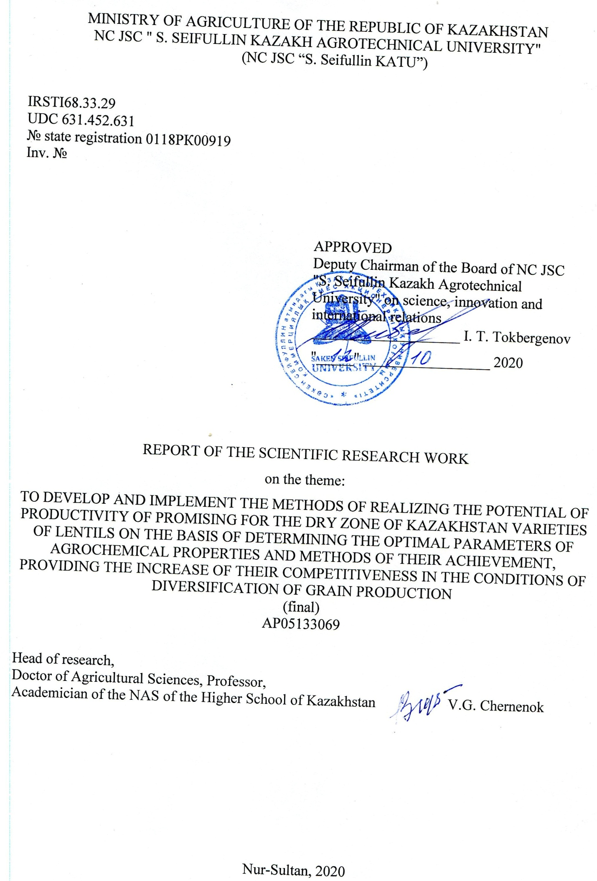
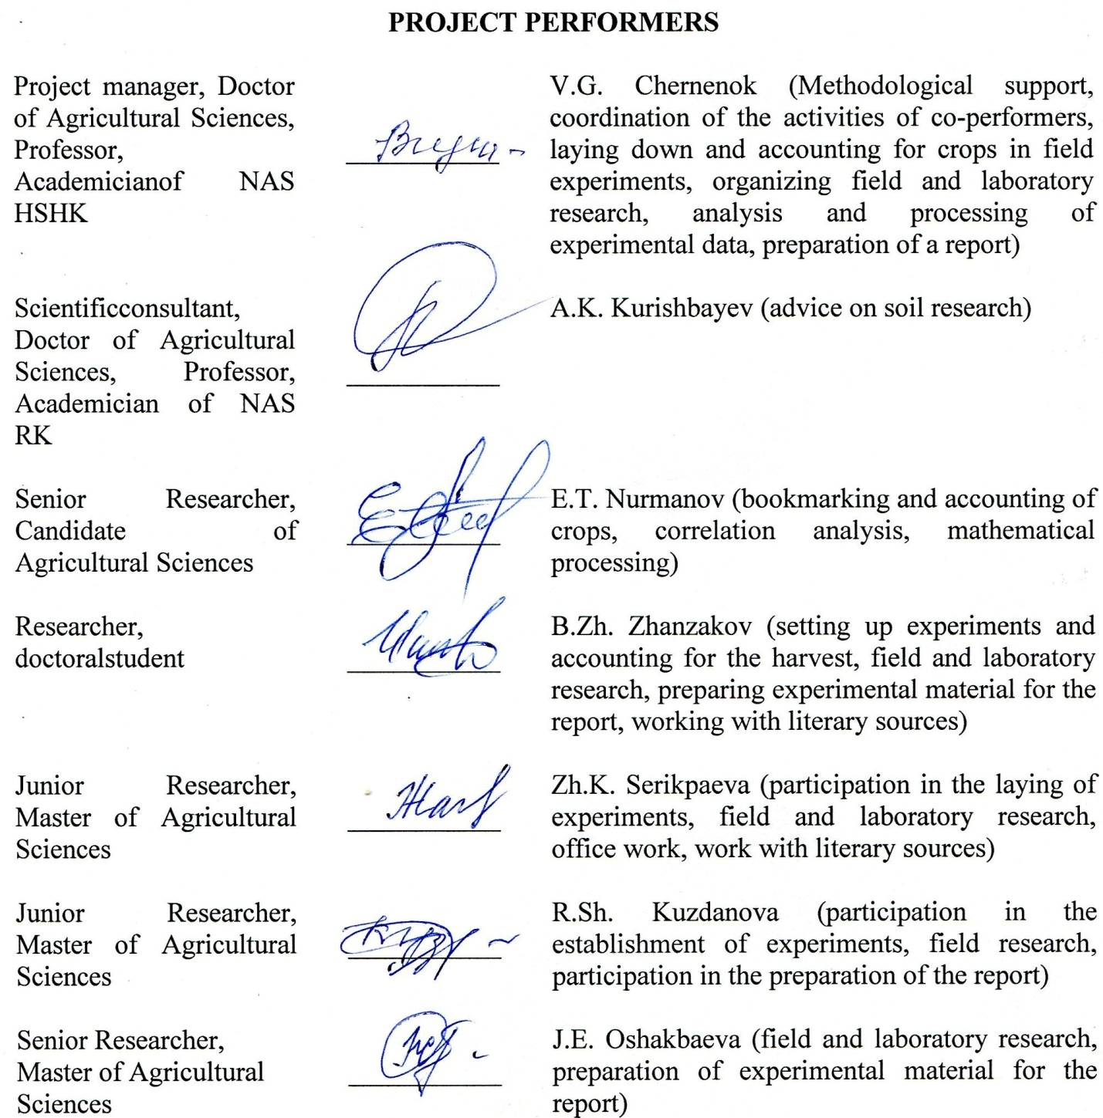
CONTENT
INTRODUCTION | 6
1 BIOLOGICAL CHARACTERISTICS OF LENTILS AND ITS RELATIONSHIP TO THE CONDITIONS OF MINERAL FOOD | 9
1.1 Biological features of lentils | 9
1.2 The relation of lentils to mineral nutrition | 12
2 RESEARCH METHODS | 15
2.1 Research methodology | 15
2.2 Brief characteristics of varieties | 17
3 RESEARCH RESULTS | 18
3.1 Conditions of the Experiment | 18
3.2 Conditions of Mineral Nutrition | 20
3.3 Influence of mineral nutrition conditions on the development of lentil varieties | 25
3.4 Influence of fertilizers on productivity and quality of lentils | 30
3.5 Method of purposeful management of soil fertility and productivity of lentil varieties | 37
3.6 Economic efficiency of using fertilizers for lentils | 41
CONCLUSION | 44
LIST OF SOURCES USED | 46
APPENDIX А | 51
APPENDIX B | 53
APPENDIX C | 54
APPENDIX D | 56
APPENDIX E | 57
APPENDIX F | 79
APPENDIX G | 82
APPENDIX H | 84

ABSTRACT
Report 84 pages, 12 figures, 16 tables, 62 sources, 8 appendices.
SOIL, FERTILIZER, FERTILITY MANAGEMENT, FOOD OPTIMIZATION, PRODUCTIVITY, LENTIL
Object of study:dark-chestnut calcareous light clay soils of the dry steppe zone, varieties of lentils - "Vekhovskaya", "Krapinka", "Viceroy".
Purpose of the work: To develop techniques for optimizing nutrition based on determining the optimal parameters of soil fertility and ways to achieve them, ensuring the realization of the productivity potential while guaranteeing a high return on investment and environmental safety.
Research methods:Field experiments were carried out using 10 variant schemes to create different levels of nutrition with 3 varieties of lentils: Vehovskaya, Krapinka and Viceroy. Field and laboratory studies of soils and plants were carried out in accordance with the technical specification and schedule using methods generally accepted in agrochemistry.
Main results:The biological characteristics of the varieties have been established. The most productive variety "Vekhovskaya" - an average yield of 24.4 c / ha, in second place "Viceroy" - 22.8 c / ha, the last "Krapinka" - 18 c / ha. The most promising varieties for the conditions of Northern Kazakhstan are Vekhovskaya and Viceroy. For the first time, the optimal level of P₂O₅ content was determined: (Рopt mg / kg) for the Vehovskaya and Viceroy varieties - 28 mg / kg of soil, for the Krapinka variety 26 mg. For nitrogen, the optimal level of N-NO₃ content in the 0-40 cm layer (Nopt): for the Vehovskaya variety 15-17 mg / kg soil, for the Viceroy and Krapinka varieties 13-15 mg / kg soil. To determine the dose of fertilizers that must be applied in order to bring their initial content to the optimal level, the Chernenok optimization formulas are proposed: D_{Р} = (Рopt - Рfact) 10, where 10 is the equivalent of P₂O₅ fertilizers 1 mg of phosphorus deficiency in the soil. To determine the nitrogen dose, the following formula has been proposed: D_{N} = (Nopt - Nfact) · 7.5 · PKuvl, where 7.5 is the number of kg a.v. N fertilizers per 1 mg of N-NO3 deficiency in the soil in the 0-40 cm layer. The proposed method for managing soil fertility is the most accurate of all known, it has no analogues, it ensures the realization of the potential of crop productivity and obtaining the maximum yield with a high return on costs. The method is the most perfect and accurate for precision farming and digitalization systems. All tasks of the schedule have been completed.
The methods of purposeful management of soils and productivity of lentil varieties are described. A patent for a useful model No. 5289 "Method for predicting the effectiveness of nitrogen fertilizers" dated 14.08.2020 was received.
DEFINITIONS, DESIGNATIONS AND ABBREVIATIONS

In this RPR, the following terms and definitions are used:
N - NH₄ - ammonium nitrogen
NO₃ - nitrates
N-NO₃ - nitrate nitrogen
P₂O₅ - mobile phosphorus
K₂O - mobile potassium
pH - the reaction of the soil solution
R&D - research work
kg - kilogram
etc. - active substance
kg d.v. - kilogram of active ingredient
Repeat. - repetition
Background-0 - natural background
Naa - ammonium nitrate
ha - hectare
mm - millimeters
agricultural - agricultural
I, III - repetitions of the experiment

INTRODUCTION

Agriculture in Kazakhstan is a vital sector of the national economy. The country's food independence depend on its state.
Extensive farming led to a decrease in the potential and effective soil fertility, which was the reason for persistently low yields (10-12 kg / ha). Studies show that the main reason for low crop productivity is soil depletion, plant starvation. The yield obtained today is 2-3 times lower than possible. The monopoly of spring wheat amid price volatility aggravates the situation.
The strategy "Kazakhstan-2050" sets the task of not only increasing the sown area, but also increasing soil fertility. The problem of increasing soil fertility and productivity was named by the First President of the country as "The basis for the foundations of agricultural well-being." In his message to the people of Kazakhstan "New Kazakhstan in the New World" [1] and a speech at the "Meeting of Agricultural Workers", he called for "ending soil deflation", analyzing the achievements of agricultural science and introducing breakthrough achievements that could dramatically increase the efficiency and competitiveness of agricultural production ... This is intended to ensure the intensification and diversification of grain production, which is laid down in the State Program for the Development of the Agro-Industrial Complex for 2017-2021 [2].
In recent years, in connection with the adoption of the program for the development of the agro-industrial complex in the Republic of Kazakhstan for 2013-2020 "Agribusiness - 2020" aimed at diversifying grain production, the sowing of new promising, competitive crops began to actively expand [3].
Pulses play an important role in diversification, among which lentils occupy a special place. In terms of nutritional value, lentils occupy one of the first places among leguminous crops and are the most valuable source of complete vegetable protein [4, 5]. Lentil seeds contain up to 32% protein, up to 2% fat and up to 62% nitrogen-free compounds. In terms of culinary and consumer merits, lentils belong to those few crops that are highly valued in the world market. Grain waste from lentils has high feed qualities and is a concentrated feed readily eaten by animals. The straw contains 6-10% protein, the chaff - 18%. In terms of fodder qualities, straw and chaff of lentils are superior to many crops, and straw is not inferior in nutritional value to meadow hay and hay of legume-cereal mixtures [6, 7].
Like all legumes, lentils are an active nitrogen fixer and are capable of assimilating in symbiosis with nodule bacteria up to 40-90 kg / ha of ecologically safe nitrogen, which makes it a good precursor in crop rotation. The high purchase price makes lentils more profitable than other crops. However, the yield of lentils remains low, which is evidence of its underestimation and imperfection of agricultural technology [7, 8].
It is also valued as a medicinal plant [9, 10]. In Kazakhstan, the sown area of lentils, according to the Ministry of Agriculture, increased in 2017 to 295 thousand hectares [2]. Unfortunately, in the last 2 years, APK-Inform has noted a decrease in the acreage of lentils.
Studies show that diversification of grain production alone cannot ensure stable development of the country's agro-industrial complex without increasing soil fertility. Only fertilizers can correct soil deficiencies, enrich the soil with nutrients missing for plants, thereby increasing its effective and potential fertility. In solving this problem, there is no alternative to fertilizers. Showing their role in increasing the productivity of lentils is one of the objectives of the project.
Fertilizers, creating the necessary level of mineral nutrition, allow you to realize the potential of the crop. But the increase in soil fertility should be targeted, taking into account the fact that each crop, due to its biological characteristics, makes its own individual requirements for soil properties, conditions and level of fertility, content and ratio of nutrients [11]. Only in the presence of optimal conditions for each crop can it realize its genetic potential and ensure the formation of the maximum possible, in the prevailing conditions of moisture, yield and the most rational use of moisture per unit of production. Fertilizers, when used scientifically, are the most effective and efficient factor in ensuring their rational use. Unfortunately, until now, studies on the use of fertilizers are mostly of a purely empirical nature, when, on the basis of empirical data from field experience, the best ("template") dose or combination of fertilizers is determined based on averaged data, which is recommended for a given crop, without taking into account the entire set of factors that determine the effectiveness of fertilizers and without taking into account the biological characteristics of the culture, variety, their requirements for the conditions of mineral nutrition. This approach cannot guarantee either economic efficiency or environmental safety in a constantly changing environment.
The development of methods for optimizing nutrition not only of a crop, but also of its varieties of different intensity and early maturity will greatly increase the effectiveness of breeding work.
For Kazakhstan, lentils are a new poorly studied culture. But research carried out in Kazakhstan with lentils is mainly devoted to the development of cultivation technology in relation to local conditions [12-16]. The issues of optimization of nutrition and fertilization of crops are not given due attention, without which it is impossible to ensure either high productivity or quality of crops.
In this connection, the goal was set - to study the individual requirements of lentil varieties to soil nutrition conditions and to develop methods for optimizing nutrition based on determining the optimal parameters of soil fertility and ways to achieve them, ensuring the realization of the productivity potential while guaranteeing high payback and environmental safety.
The research task for 2018-2020 included:
- to study the reaction of lentil varieties to different levels of mineral nutrition;
-determine the most important agrochemical indicators of soil fertility, which have the most significant impact on productivity;
- to determine the quantitative indicators of the agrochemical properties of soils, ensuring the realization of the potential of the crop, obtaining the maximum yield in the existing soil and climatic conditions;
- to give an economic assessment of the effectiveness of fertilizers.
For the first time in Kazakhstan, on a fundamentally new basis, methods will be developed for diagnosing the needs of lentil varieties in nutritional elements; the main factors determining the formation of productivity, their optimal parameters, ensuring the realization of the potential of culture, ways of achieving them are determined.
This will make it possible to purposefully manage soil fertility, productivity and quality of lentils with a guaranteed high efficiency of fertilization.
Two interim reports for 2018 and 2019 with registration number 0118RK00919 were prepared for this project «To develop and implement the methods of realizing the potential of productivity of promising for the dry zone of Кazakhstan varieties of lentils on the basis of determining the optimal parameters of agrochemical properties and methods of their achievement, providing the increase of their competitiveness in the conditions of diversification of grain production».

1 BIOLOGICAL CHARACTERISTICS OF LENTILS AND ITS RELATIONSHIP TO THE CONDITIONS OF MINERAL FOOD (Literature review)

1.1 Biological features of lentils

Edible lentils, or Common lentils, or Cultural lentils (lat. Lens culinaris) - a herbaceous plant; family Legumes (Fabaceae).
Lentils are one of the oldest agricultural crops. The homeland of lentils is Southern Europe and Western Asia, where it has been cultivated since the Neolithic era.
This is one of the most important grain legume crops. Its use is very versatile. It is a valuable food product, consumed in the form of grain and in canned form. The ancient Egyptians prepared various dishes from lentils, baked bread from lentil flour. In ancient Greece, there was a proverb: an intelligent person always cooks his lentils well [17].
For many Asian peoples, lentils are one of the most important sources of protein, capable of replacing bread, cereals and even meat in terms of nutritional properties [4].
Since ancient times, lentils have been valued as a medicinal plant.Even ancient Roman doctors used lentils to treat stomach diseases and nervous disorders, believing that constant consumption of it in food makes a person calm and patient.In ancient Russian herbalists were recommended to drink lentil infusion in case of smallpox disease.A broth of lentils is also recommended for kidney stones, liver diseases [9].
Experimental studies have shown that a lentil diet suppresses pathological vascular disease [18].
Lentil seeds contain from 7 to 11 mg / 100 g of iron, which protects the body, especially children from anemia. Tannins contained in lentil seeds bind bacterial toxins and toxic salts of Hg, Pb and others and remove them from the body [19].
Lentils contain the maximum amount of prebiotics, which provide a beneficial effect on the intestinal microflora when eaten regularly [20].
In many countries, lentils have become an important factor in providing a nutritious diet [21].
Among leguminous crops, lentils take one of the first places in terms of nutritional value and are the most valuable source of complete vegetable protein. In terms of the amount of protein, lentils rank second after soybeans and exceed peas, chickpeas, and beans in this indicator. Its seeds contain from 27 to 36% protein [22-25].
Lentils are a unique plant that does not accumulate harmful substances. Neither nitrates nor radionuclides are retained in it. Therefore, lentils are considered completely organic grain. [19, 26, 27].
The leaders in the production of lentils are Canada (harvesting area 1.34 million hectares, gross yield 1.9 million tons), India (1.3 million hectares, 1.1 million tons), Turkey (234 thousand hectares, 345 thousand tons) [28]. According to the Ministry of Agriculture, the sown area of ​​lentils in Kazakhstan increased in 2017 to 295,000 hectares [2].
Biological features.Lentils (esculentaMoench) are an annual herb of the legume family. Cultural lentils have two subspecies: large-seeded (plate) and small-seeded. Large-seeded lentils are distinguished by their higher growth (50-70 cm), large beans and large flat green and spotted seeds with a diameter of 6-9 mm. The growing season is 80-120 days. The mass of 1000 seeds is 55-65 g and more.
Small-seeded lentils are more low-growing (up to 50 cm), with smaller convex seeds with a diameter of 2-5 mm of various colors. The growing season is 65-70 days, it is more drought-resistant. The mass of 1000 seeds is 25-30 g. Large-seeded lentils are used mainly for food purposes, small-seeded lentils are used for livestock feed.
The root system is tap root, the main root is thin, with a large number of lateral roots located in the 0–40 cm soil layer. Nodules are formed on the main and lateral roots [29, 30]. Branched nodules are located within a radius of 10-12 cm. The mass of nodules of one plant reaches 800 mg [31].
The stem is erect or slightly lodging, tetrahedral, strongly branched. Its height is from 25 to 70 cm [32].
Leaves are compound, paripinnate with 2-8 pairs of leaflets, ending in a tendril or tendril rudiment. Leaflets are oval or linear. Stipules are semi-spear-shaped, entire. Seeds are flat, plate or almost spherical, 3-9 mm in diameter. Seed color varies from light green to black. Cotyledons are orange or yellow, rarely green. The mass of 1000 seeds in common varieties ranges from 25 to 65 g [33].
Attitude towards light. Lentils need continuous daylight for normal flowering and fruit formation. Therefore, it is classified as a long day plant. It reacts much more strongly to the shortening of the day than other long-day leguminous crops: peas, chickpeas, china, and beans [34].
Attitude towards warmth. Unlike other legumes, lentils are comparatively not heat demanding. Seeds germinate at +3 - + 4ºC. Fast and friendly shoots appear on the 6-7th day when the soil warms up in a 10 cm layer to +7 - + 10ºC. At lower temperatures, seedlings appear on the 8-12th day. Lentil shoots can withstand frosts down to -3 -5ºC [35-37].

The optimum temperature during the growing season ranges from +12 to + +21ºС. The total heat demand for the growing season is 1450 - 1850ºС. Flowering occurs 40-45 days after germination [38].
Relation to moisture.For seed germination, lentils require 75-93% water from the air-dry mass. The critical period in relation to moisture is the period before flowering of plants [39]. Lentils are easier to tolerate drought than peas, so they can also be cultivated in arid regions [23, 32].
During the period of seed filling, the increased soil moisture causes an increase in the vegetative mass to the detriment of the seed yield. Prolonged dry winds during filling and ripening of seeds dramatically reduce the yield. Lentil plants are responsive to precipitation after drought, they begin to bloom again, form fruits, which sometimes smoothes out the harmful effect of drought. With an excess of moisture, the growing season sharply increases, ripening is delayed.
Attitude to soils. The best soils for lentils are chernozems of light texture. Lentils grow well on loose loamy and sandy loam soils and grows better than peas on light soils. It works poorly on compacted and heavy soils. Very light, poor sandy soils, as well as low places with a close occurrence of groundwater and acidic or saline soils are not suitable for it. It gives high yields on soils with a neutral or slightly acidic reaction (pH 7.0) [40].
Agrotechnical features of lentil cultivation. The best predecessors of lentils include corn, winter cereals. Under the lentils, it is necessary to divert fields clean from weeds, since due to its short stature and slow accumulation of green mass, it weakly fights weeds. You should not sow lentils over lentils, and also return them to their old place earlier than 3-4 years in order to avoid soil fatigue and accumulation of diseases. Soils with a high nitrogen content can cause excessive green mass growth to the detriment of fruiting. It is not recommended to sow lentils after rape, mustard, sunflower, flax, peas, chickpeas more often than once every four years in the same field.
Soil treatment. The system of soil cultivation for lentils does not differ significantly from the cultivation for other early spring crops. Lentils are demanding on the quality of the main and pre-sowing tillage, and reacts positively to early fall plowing.
All methods of soil preparation for this crop should be aimed at maximum moisture accumulation, weed control, as well as good leveling of the field surface.
In winter, for additional accumulation of moisture in the soil, snow retention is carried out. This agricultural practice increases the yield of lentils by 2-3 c / ha.
Presowing treatment consists in early spring harrowing of the plow (as the ridges dry up) in 2 tracks across the main processing, and then cultivation to a depth of 8-10 cm with simultaneous harrowing. To obtain uniform, friendly seedlings in arid regions, it is recommended to roll up the soil before sowing [41].
Sowing. For sowing lentils, it is recommended to use the calibrated seeds of the best zoned varieties. Ripe and harvested in dry weather, under good storage conditions, they retain a high germination capacity (90-96%) for several years [34]. The optimal dates for sowing lentils in the steppe zone of the Middle Volga region is the first decade of May [42], in the conditions of the southern forest-steppe of the Omsk region - the third decade of May [43]. At the same time, there is an increased field germination of seeds (82.4%), good preservation (80.2%) and the highest grain yield.
In Kazakhstan, the technology of cultivation of lentils in rain-fed agriculture in Northern Kazakhstan was studied at the Kostanai Research Institute of Agriculture, the Scientific and Production Center of Grain Economy named after A.I.Baraev, S. Seifullin Kazakh Agro Technical University and others [12-16].
On the dark brown soil of Akmola region Musynov K.M. and others studied the effect of different soil preparation technologies and seeding rates on lentil yield.A regularity was established that in the Vekhovskaya variety, against the background with the minimum tillage technology with an increase in the seeding rate from 2.2 to 2.5 million germinating seeds per hectare, there was a significant increase in grain yield compared to the control (0.4-0.8 c / ha) [15, 16].

1.2 The relation of lentils to mineral nutrition

The formation of 1 ton of grain and the corresponding amount of lentil straw requires 59 kg of nitrogen, 20 kg of phosphorus and 28 kg of potassium. Adding superphosphate can double the lentil yield [44].
Scientists Ali-Khan S.T. and Kiehn F.A. invite for a application nitrogen fertilizers under lentils in doses of 10-20 kg / ha during sowing, and phosphorus from 20 to 100 kg / ha, while the dose of phosphorus fertilizers increases in more arid regions. The application of mineral fertilizers did not affect the weight of 1000 seeds [45].
Studies carried out by E. Bremmer et al. Showed that in the absence of inoculation, the yield of lentils increased with increasing doses of nitrogen fertilizers from 0 to 90 kg / ha [46].
Similar studies with doses of nitrogen fertilizers from 0 to 60 kg of ai / ha in the form of urea were carried out in India, where in two years the yield of lentils increased from the application of nitrogen fertilizers to a dose of N30; higher doses of a further increase in yield did not result [47].
The Czech scientist Harceg I., conducting five years of research on the industrial cultivation of lentils, recommended the optimal dose for this culture N30P42-50K70-80 [48].
Research by Pakistani scientists Imran Mahmood, Abdul Razzaq, S.A.H. Bukhari, M. Naveed Tahir using different doses of NPK on three varieties of lentils are showed that the greatest increase was obtained with a dose of NPK 25:50:50 (45.64%), further increasing the dose had no effect. High doses of phosphate and potash fertilizers increased the protein content of the grain. The yield increased due to the greater number of pods and seeds [49].
Many researchers note the absence of significant differences in yield for lentil varieties [50, 51]. But there was an increase in the protein content from the application of nitrogen fertilizers of 22 kg / ha [52].
In the conditions of the foothill zone of the Kabardino-Balkarian Republic, Kononenko and others concluded that the fullness of seedlings, plant density and overall survival of lentil plants are significantly affected by the meteorological conditions of vegetation and varietal characteristics of the culture, to a lesser extent fertilizers and herbicides [53].
According to the studies carried out in the Stavropol Territory, mineral fertilizers applied directly under the lentils in areas of insufficient moisture were not highly effective. In this case, phosphorus-potassium fertilizers are recommended to be applied under the previous crop. On poor soils and when programming a high yield, it is recommended to apply nitrogen fertilizers at a dose of 30-40 kg / ha. nitrogen in presowing cultivation [54, 55].
On leached chernozems, the calculated dose of mineral fertilizers N25P45K18 provided a significant increase (0.46-0.68 t / ha) in the yield of lentil varieties. The maximum yield of lentils (2.17 t / ha) was provided by the Vekhovskaya variety, which is 0.43 t / ha higher than the Canadian variety. The dependence of the yield of lentils on the layer-by-layer content of nitrate and ammonium nitrogen, mobile phosphorus and exchangeable potassium in the 0-30 cm layer during the growing season of the crop has been established [56].
Research carried out in the forest-steppe Volga region showed that the best background for pre-sowing fertilization for the photosynthetic activity of lentils was phosphorus-potassium with pre-sowing treatment of seeds with rhizotorphin. The increase in dry biomass was 1.18 t / ha or 17% in relation to the control [57].
According to the studies of the biochemical laboratory of the VIPP, the constancy of the chemical composition is noted in the seeds of legumes. Peas, lentils, vetch, and horse beans grown in a wide variety of soil, humidity, and climate conditions (geographical experiments of VIPB) did not change the content of protein substances, ash, fiber, and fat. On lentils, not very sharp differences in chemical composition were observed for individual cultivars [33].
For Kazakhstan, lentils are a relatively new and little-studied culture; the first studies date back to 2001-2007. on the southern chernozems, where the productivity of lentils was studied in comparison with other crops, its role as a predecessor. The results on the yield of lentils for fallow and stubble on average for five years were 15.0 and 13.7 c / ha. Lentils are a good precursor for grain crops as a result of the soil being enriched with nitrogen. When studying the zero and traditional technology of lentil cultivation, the yield did not change, but nitroammophos and ammonium nitrate turned out to be effective, but the latter was inferior in efficiency to nitroammophos [58].
The resource-saving technology of applying fertilizers for leguminous crops was also studied in the desert-steppe foothill zone of the Zailiyskiy Alatau. Studies have shown that it is necessary to apply the most profitable, not high, low-cost fertilizer rates, which provide the greatest payback at sufficiently high levels of yield [59].
In general, the analysis of literary sources showed that in Kazakhstan in general, including the North, the main attention and research is focused on the agrotechnical assessment of lentils and the development of technology for its cultivation.
The issues of mineral nutrition of lentils, its requirements for soil and responsiveness to fertilizers are practically not studied, which served as the basis for their study.
2 RESEARCH METHODS

2.1 Research methodology

The research was carried out in the Agrarian Fund "Aktyk", on dark-chestnut, calcareous, light clay soils with a total humus content of 2.95-2.97%, total nitrogen 0.17%, phosphorus 0.15%, mobile potassium more than 60 mg / 100 g of soil, pH slightly alkaline (8.08-8.1), the amount of absorbed Ca + Mg is 20-22 mg-eq per 100 g of soil.
The experiments were carried out with three varieties of lentils: "Vekhovskaya", "Krapinka" and "Viceroy" on 10 nitrogen-phosphorus nutritional backgrounds (6 phosphorus and 4 nitrogen including control) in 3 replicates according to the scheme below:
1. О - control (without fertilizers)
2. Р60 5. Р150 8. Р90 N60
3. Р90 6. Р 180 9. Р90 N90
4. 120 7. Р90N30 10. N30
A total of 90 experimental plots. Plot size 52.5 m2 (21 × 2.5 m). Nitrogen-phosphorus backgrounds were created by introducing grade A ammophos (10% N, 52% P2O5) and ammonium nitrate (34.6% N) using a SZS-2.1 seeder to a depth of 12-14 cm (Figure 1), followed by rolling.
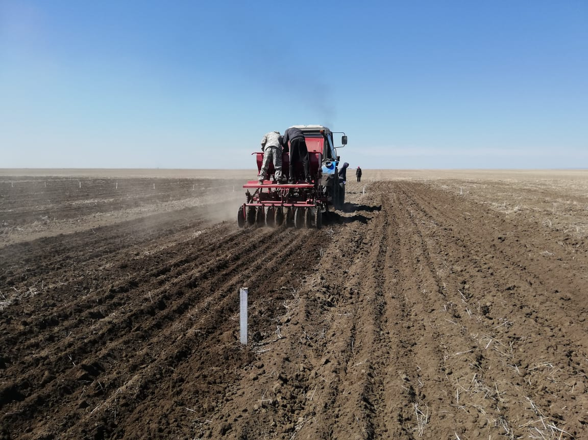
Figure 1 -Plot fertilization
Sowing of crops was carried out at the optimal time for the zone - 15-20 In May.The predecessor is the second crop (wheat) after steam. Lentils were sown at the rate of 2.5 million viable seeds per hectare.
In the experiments, to study the most important agro chemical properties of the soil and the effect of fertilizers on them, soil samples were taken on the control and fertilizer options, Figure 2.
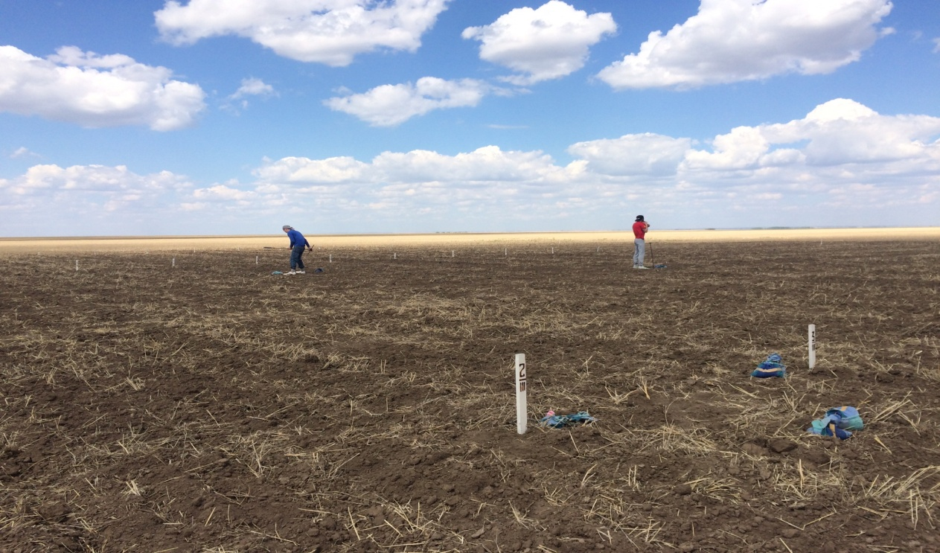
Figure 2 - Plot sampling of soil samples

To study the content and dynamics of soil moisture and nutrients, samples were taken on the control variant to a depth of 0-100 cm every 20 cm of soil. To study the effect of fertilizers on soil fertility, samples were taken for all fertilized options to a depth of 0-20 and 20-40 cm from 5 points on the plot,In the selected samples, soil moisture was determined by the gravimetric method, humus according to Tyurin, the pH of the water extract ionometrically using an ionomer - I 160 MI, nitrate nitrogen using a nitrate analyzer 150.1 MI, ammonium nitrogen - with Nessler's reagent, mobile phosphorus and exchangeable potassium from one extract according to Machigin absorbed by Ca2 +, Mg2 + by the trilonometric method.
During the growing season, plant samples were taken from all variants of all experiments on 50 lentil plants from the plot along the diagonal to determine the accumulation of dry matter and the chemical composition of the plants.
All analyzes were performed in duplicate. More than 1000 analytical soil samples and 360 plant samples were analyzed annually.
Before harvesting, test sheaves were selected for structural analysis of the crop, the chemical composition of the main and by-products, and the removal of nutrients. Counting of the yield was carried out in 6-fold repetition sheaves, followed by threshing in an LD 180 spike thresher.
Mathematical processing was carried out according to Dospekhov [60].
The economic efficiency of the studied techniques was determined by P.F. Menshikov [61].
The results of field and laboratory studies were subjected to mathematical processing and correlation analysis in order to establish a quantitative relationship between crop productivity and agrochemical soil properties.

2.2 Brief characteristics of varieties

Variety "Krapinka" (authors: Suleimenov R.M., KaskarbaevZh.A., Checherina A.N., Chilimova I.V.) food grade, early maturing, small-seeded type.
The protein content is 27.8%, the weight of 1000 seeds sown in the experiments is 37-41 g. Bean cracking resistance is average. Resistant to drought, pests and diseases. The average yield is 13.8 c / ha.
The variety is included in the State Register for the North Kazakhstan region in 2016.
Variety "Vekhovskaya" was created at the Petrovskaya Experimental Breeding Station (Penza Region), classified as a valuable variety, early ripening (ripens in 77-80 days). Protein content - 24-29%, weight of 1000 seeds - 65-82 g. Drought resistance - above average, to beans cracking - average, to damage by pests - high, weakly susceptible to fusarium. The variety is high-yielding, the yield reaches 25 kg / ha.
The variety has been included in the State Register of Breeding Achievements of the Russian Federation since 1992.
Variety "Viceroy" - Canadian origin, mid-season, seeds ripen in 76–80 days. The mass of 1000 seeds is 39 g.
Possesses high commercial and culinary qualities. Plants are resistant to disease, lodging, drought and shedding.

3 RESEARCH RESULTS

3.1 Conditions of the Experiment

The research results were significantly influenced not only by soil, but also by meteorological conditions, on which the development of lentils depended.
The years of research on hydrothermal conditions were different. The most favorable years in terms of precipitation were 2018 and 2020, Table 1.
Table 1 - Amount and nature of precipitation distribution, mm
Months | Middle-long | 2017/18 agricultural years | ± from average long-term. | 2018/19 agricultural years | ± from average long-term | 2019/20 agricultural years. | ± from average long-term
IX-III | 141 | 156 | 15 | 145,3 | 4,3 | 141,6 | 0,6
IV | 20 | 25,7 | 5,7 | 7 | -13 | 32,0 | 12
V | 31 | 24 | -7 | 3,6 | -27,4 | 3,2 | -27,8
VI | 41 | 56,9 | 15,9 | 38,3 | -2,7 | 67,8 | 26,8
VII | 52 | 26,1 | -25,9 | 11,4 | -40,6 | 46,2 | 20,1
VIII | 41 | 41,4 | 0 | 3,6 | -37,4 | 29,2 | -11,8
V-VIII | 165 | 139,6 | -25,4 | 56,9 | -108,1 | 146,4 | -18,6
Agricultural years | 326 | 330,1 | 4,1 | 209,2 | -116,8 | 320 | -6

The table shows that the amount of precipitation for agricultural years 2018 and 2020 were 330 and 320 mm, which is at the level of average long-term, but their distribution during the growing season was different: in 2018, May and especially July were dry. The largest amount of precipitation fell at the end of June and exceeded the average annual by 15.9 mm. May was accompanied by low temperatures, which prolonged the germination period by 10-12 days, table №2. In general, 139.6 mm fell during the growing season, which is 25.4 mm less than the norm.
Table 2 - Average daily air temperature, ⁰С
Months | Middle-long | 2018 year | ± | 2019 year | ± | 2020 year | ±
IV | 1,5 | 5 | 3,5 | 5 | 3,5 | 11 | 9,5
V | 12,5 | 10 | -2,5 | 12,7 | 0,2 | 19 | 6,5
VI | 18,1 | 17,5 | -0,6 | 15,9 | -3,8 | 19 | 0,9
VII | 20,4 | 21,4 | 1 | 22 | 1,6 | 22 | 1,6
VIII | 17,9 | 18,3 | 0,4 | 22,1 | 3,2 | 21 | 3,1

In 2020, the month of May was extremely dry, and August was also dry. The aridity of May was enhanced by high temperatures. The plants survived the May drought in 2020 due to the autumn-winter-spring supply and precipitation in April. In general, the situation with the hydrothermal regime in 2020 was favorable for the formation of the lentil crop.
The 2018/2019 agricultural year was extremely dry, only 209.2 mm of precipitation fell, which is 116.8 mm lower than the long-term average. Most of them fell in the autumn-winter-spring period - 152.3 mm. During the growing season of 2019 - May-August, only 57 mm fell, which is 30% of the norm. But even these precipitations were distributed very unevenly. 67% fell in the month of June (38 mm). During July - August, only 15 mm fell. July and August were extremely dry.
This had an extremely negative effect on the reserves of productive moisture during the growing season, table 3.
Table 3 - Content and dynamics of productive moisture under lentil crops, mm
Soil  layer,  cm | 2018 year |  |  | 2019 year |  |  | 2020 year
Soil  layer,  cm | So-wing | Bran-ching | Bloom | So-wing | Branching | Bloom | So-wing | Bran-ching | Bloom
0-20 | 29,5 | 11,8 | 11,4 | 28,4 | 17,7 | 1,2 | 19,3 | 26,0 | 17,6
20-40 | 35,1 | 19,8 | 19,5 | 34,8 | 24,7 | 3,7 | 19,2 | 27,0 | 21,8
40-60 | 32,7 | 26,6 | 23,9 | 32,4 | 30 | 15,1 | 23,5 | 34,6 | 26,0
60-80 | 31,2 | 36,6 | 35,1 | 27 | 29,7 | 20,3 | 28,8 | 44,6 | 36,7
80-100 | 26,7 | 25,1 | 29,9 | 25,7 | 28,8 | 15,6 | 28,1 | 39,7 | 31,6
0-100 | 155,2 | 109,4 | 115,1 | 148,3 | 130,9 | 55,7 | 118,9 | 171,7 | 133,5

The table shows that in the conditions of 2018, 2019, due to autumn-winter precipitation, a relatively good supply of productive moisture in the meter profile of 155-148 mm, respectively, was provided, which is significantly higher than the moisture supply in 2020.
But in 2020, the situation improved due to the precipitation (114 mm) in June-July, while in 2019, by the flowering phase, the productive moisture in the root layer was practically absent and was 1.2 mm in the 0-20 and 3.7 layers. mm in a layer of 0-40 cm. In these conditions, plants could not develop, which predetermined the fate of the harvest in 2018, 2020 and 2019.
Figure 3 shows a general view of the experiments as of June 24, 2018.
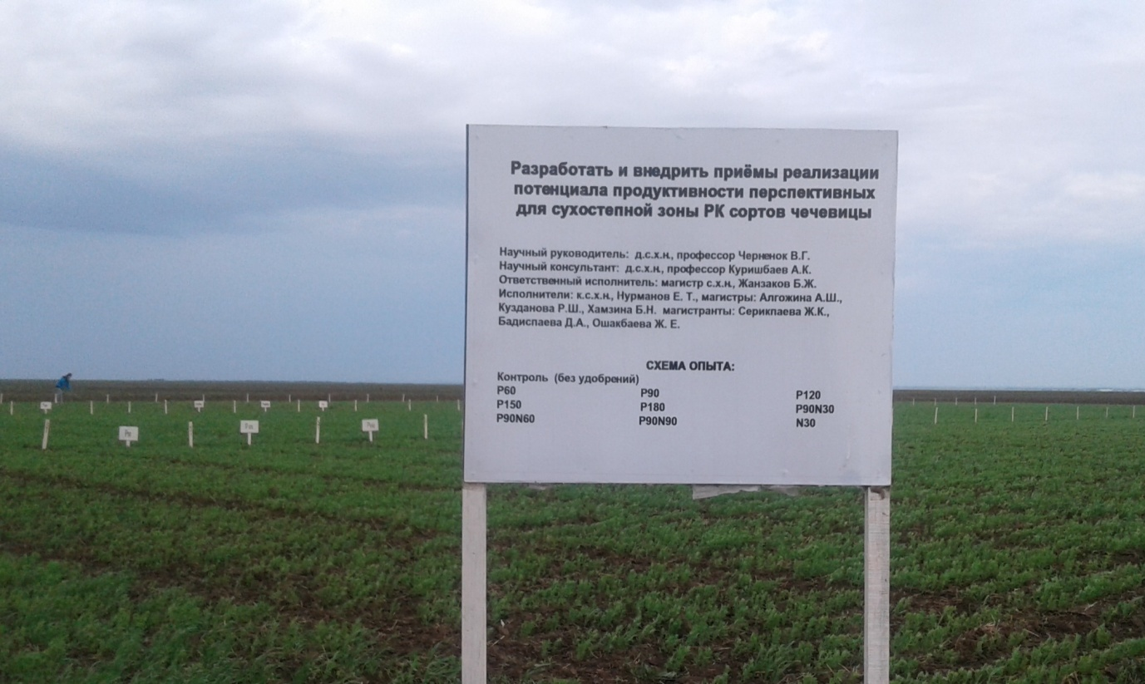
Figure 3 - General view of the experiments

The seedlings were friendly, but the development was slow, on the one hand, these are the biological characteristics of the culture, on the other, the low temperature background held back the development of lentils. In addition to the hydrothermal regime, which developed in different ways during the years of research, the level of mineral nutrition also played an important role.

3.2 Conditions of Mineral Nutrition

Of all the factors studied, humus, the sum of absorbed bases and the pH of the medium were noted to be highly stable. The humus remained invariably at the level of 2.90-3.04% (table 4), which indicates the uniformity of the background.
Table 4 - Humus content under lentil crops,%
Introduced, kg a.i. / ha | 2018 год |  |  | 2019 год |  |  | 2020 год
Introduced, kg a.i. / ha | Krapinka | Vekhovskaya | Vice-roy | Speck | Vekhovskaya | Vice-roy | Speck | Vekhovskaya | Viceroy
0 | 2,96 | 2,97 | 2,97 | 2,93 | 2,94 | 2,95 | 2,95 | 2,96 | 2,96
Р₁₂₀ | 2,99 | 2,97 | 2,94 | 2,9 | 2,92 | 2,95 | 2,95 | 2,95 | 2,95
Р₁₈₀ | 3,00 | 2,97 | 2,91 | 2,92 | 2,92 | 2,93 | 2,96 | 2,94 | 2,93
Р₉₀N₉₀ | 3,04 | 3,03 | 2,99 | 2,9 | 2,9 | 2,9 | 2,97 | 2,96 | 2,95
This is not a high level, but typical for dark chestnut soils. Studies have shown that even with such a humus content in years favorable for moisture, these soils can yield grain crops of up to 30 hkg/ha and more. Fertilizers did not affect the properties of the soil - the sum of absorbed bases, soil pH, table 5.
Table 5 - Content of Ca + Mg in soil and pH of the medium under lentil crops
Introduced  kg a.i. | 2018 |  |  | 2019 |  |  | 2020
Introduced  kg a.i. | Ca + Mg, mg-eq / 100 g of soil | Са²⁺ | рН | Ca + Mg, mg-eq / 100 g of soil | Са²⁺ | рН | Ca + Mg, mg-eq / 100 g of soil | Са²⁺ | рН
«О» | 26,5 | 23,0 | 8,08 | 23,2 | 16,7 | 8,11 | 24,6 | 20,3 | 8,09
Р₆₀ | 26,6 | 23,0 | 8,10 | 24,0 | 16,7 | 8,1 | 25,2 | 20,4 | 8,10
Р₉₀ | 26,4 | 22,6 | 8,07 | 22,5 | 17,0 | 8,12 | 24,6 | 20,3 | 8,09
Р₁₂₀ | 26,1 | 22,7 | 8,12 | 23,2 | 16,7 | 8,11 | 24,3 | 20,1 | 8,12
Р₁₅₀ | 26,4 | 22,8 | 8,10 | 23,7 | 16,7 | 8,11 | 25,0 | 20,3 | 8,10
Р₁₈₀ | 26,5 | 22,7 | 8,11 | 23,5 | 17,0 | 8,12 | 24,9 | 20,1 | 8,11
Р₉₀N₃₀ | 26,4 | 22,8 | 8,11 | 23,5 | 16,5 | 8,08 | 24,5 | 20,2 | 8,09
P₉₀N₆₀ | 26,5 | 23,4 | 8,12 | 22,7 | 17,0 | 8,06 | 24,5 | 20,5 | 8,10
P₉₀N₉₀ | 26,1 | 22,6 | 8,12 | 22,5 | 17,0 | 8,07 | 24,8 | 19,9 | 8,09
N₃₀ | 25,8 | 22,9 | 8,11 | 23,5 | 16,7 | 8,08 | 24,3 | 20,0 | 8,09

The stability of the indicators is explained by the fact that the phosphorus background were created by the introduction of ammophos, in which there is no calcium. The data in the table indicates a high carbonate content and a weak alkalinity of soils. But in general, the soils have good physical and chemical properties.
Hydrothermal conditions during the years of research and fertilization influenced the content and dynamics, first of all, of mineral forms of nitrogen, table 6.
Table 6 - Content and dynamics of mineral nitrogen under lentil crops, mg / kg soil
Soil layer, cm | 2018 |  |  | 2019 |  |  | 2020
Soil layer, cm | Sowing | Branching | Bloom | Sowing | Branching | Bloom | Sowing | Branching | Bloom
0-20 | 5,6 | 11,9 | 9,2 | 11,5 | 15,8 | 6,3 | 6,8 | 10,6 | 6,9
20-40 | 8,8 | 9,6 | 8,9 | 8,3 | 12,6 | 6,9 | 5,4 | 7,7 | 9,4
0-40 | 7,2 | 10,8 | 9 | 9,9 | 14,2 | 6,6 | 6,1 | 9,2 | 8,1
40–60 | 8,1 | 11,9 | 8,8 | 11,2 | 12,5 | 10 | 3,5 | 4,7 | 4,0
60–80 | 10,5 | 14,4 | 14,3 | 8,9 | 9,1 | 7,1 | 2,7 | 3,1 | 4,2
80-100 | 14 | 21,2 | 17,8 | 7,9 | 8,4 | - | 2,6 | 2,4 | 2,6

As can be seen from the table, the initial content of nitrate nitrogen at the time of sowing in the years of research was different: low in 2018, 2020 (6.4-7.2 mg and 5.4-6.1 mg / kg, respectively) in 2019 significantly above - 10 mg / kg of soil in a layer of 0-40 cm.
In 2018 and 2019 nitrogen migration was observed along the soil profile, which is evident from the content of nitrates in layers of 60-100 cm, which was not observed in 2020.An increase in temperatures in late May - early June activated biological processes in the soil, the process of nitrification, which contributed to an increase in the nitrogen content of nitrates in all years for all varieties in the 0-40 cm layer by an average of 3-4 mg compared with the pre-sowing one and amounted to within 10 mg for all varieties in 2018 and 2020.In a very dry year in 2019 with soil moisture and high temperatures from 10 to 13-14 mg / kg of soil. But by the time of flowering, there was a decrease in nitrogen in the soil due to consumption per crop, but remained at the level of 8-9 mg. In 2019, under conditions of the most severe drought, the nitrification process was suppressed, the nitrogen content decreased 2.5-3 times: so for the Krapinka variety from 14.2 to 6.6 mg, for the Vehovskaya variety from 13.5 to 5.7 mg, Viceroy 12.9 mg to 4.9 mg The development of plants also stopped.
A diagnostic indicator of the provision of crops with phosphorus is its content in the 0-20 cm layer. Table 7 shows that the level of phosphorus in the soil before sowing lentils in 2018 and 2020, was within the limits of low, and in 2019 - very low in the Chernenok gradation [11, 62] - 13.3 mg / kg of soil.
Table 7 - Content and dynamics of Р₂О₅ under lentil crops, mg / kg soil
Soil layer, cm | 2018 |  |  | 2019 |  |  | 2020
Soil layer, cm | Sowing | Branching | Bloom | Sowing | Branching | Bloom | Sowing | Branching | Bloom
0-20 | 18,0 | 18,1 | 19,6 | 13,3 | 14,1 | 11,7 | 16,4 | 16,1 | 17,4
20-40 | 8,0 | 6,2 | 7,8 | 5,2 | 5,7 | 4,6 | 5,9 | 6,4 | 7,5
40-60 | 5,0 | 3,7 | 3,9 | 1,45 | 1,2 | 1,5 | 2,1 | 2,3 | 3,6
60-80 | 4,9 | 4,3 | 3,1 | 0,8 | 0,5 | 1,0 | 1,6 | 1,6 | 1,4
80-100 | 5,2 | 3,3 | 2,7 | 0,4 | 0,4 | 1,7 | 0,4 | 0,6 | 0,8

Along the soil profile, the phosphorus content sharply decreases, starting from the subsoil horizon. This is due to the fact that phosphorus salts do not move in the soil (radius 2-2.5 cm). Phosphorus is found in the parent rock, from where it is extracted by the root system of plants and accumulates in the upper layer of the soil, where the main organic mass decomposes, forming inactive salts of calcium, magnesium, aluminum, iron, thereby excluding the possibility of its migration even under conditions of increased moisture.
As can be seen from the data presented, the phosphorus deficiency in the soil was the most important factor limiting the yield.
The content of mobile potassium in the studied soils is very high (731-906 mg / kg of soil in the 0-20 cm layer) and potassium did not limit the yield, Table 8. Along the soil profile, its content significantly decreases, but even in the 80-100 cm layer it remained at the level of the middle class of security - 265-327 mg.
Table 8 - Content and dynamics of K₂O under lentil crops, mg / kg soil
Layer, cm | 2018 |  |  | 2019 |  |  | 2020
Layer, cm | Sowing | Branching | Bloom | Sowing | Branching | Bloom | Sowing | Branching | Bloom
0-20 | 872 | 809 | 829 | 898 | 900 | 734 | 885 | 855 | 782
20-40 | 552 | 482 | 598 | 479 | 567 | 571 | 516 | 525 | 585
40-60 | 374 | 275 | 283 | 330 | 372 | 295 | 352 | 324 | 289
60-80 | 428 | 299 | 307 | 288 | 330 | 232 | 358 | 315 | 270
80-100 | 318 | 272 | 281 | 265 | 290 | 240 | 292 | 281 | 261

The applied fertilizers had a significant effect on the content of nutrients in the soil, Table 9, 10.
Table 9- Influence of fertilizers on the nitrogen content of nitrates in the soil in the 0-40 cm layer before sowing lentils, mg / kg of soil
Introduced,  kg a.i. / ha | Krapinka |  |  | Vekhovskaya |  |  | Viceroy
Introduced,  kg a.i. / ha | 2018 | 2019 | 2020 | 2018 | 2019 | 2020 | 2018 | 2019 | 2020
«О» | 9,3 | 8,5 | 8,0 | 9,0 | 8,8 | 8,3 | 7,6 | 9,2 | 8,6
Р₆₀ | 8,8 | 9,0 | 9,4 | 8,9 | 8,7 | 9,7 | 8,8 | 8,4 | 10,1
Р₉₀ | 9,8 | 9,3 | 10,4 | 9,6 | 10,1 | 10,7 | 9,4 | 10,8 | 11,0
Р₁₂₀ | 12,1 | 10,0 | 10,7 | 10,9 | 11,0 | 11,2 | 9,6 | 11,9 | 11,7
Р₁₅₀ | 12,5 | 10,0 | 11,3 | 9,7 | 11,4 | 11,5 | 8,4 | 12,8 | 12,0
Р₁₈₀ | 13,2 | 12,0 | 11,6 | 11,7 | 12,3 | 12,1 | 10,1 | 12,8 | 12,3
Р₉₀N₃₀ | 14,4 | 13,8 | 12,1 | 13,2 | 12,1 | 13,2 | 12,0 | 10,2 | 14,4
P₉₀N₆₀ | 18,3 | 15,7 | 16,5 | 16,7 | 16,5 | 17,3 | 15,5 | 17,1 | 18,4
P₉₀N₉₀ | 22,6 | 20,3 | 21,0 | 20,5 | 21,2 | 21,4 | 18,4 | 22,2 | 22,3
N₃₀ | 13,8 | 12,7 | 11,8 | 12,5 | 12,0 | 12,9 | 11,3 | 11,3 | 14,0

The determination of nitrates was carried out layer by layer in a layer of 0-20 and 20-40 cm. In expanded form, the results are presented in Appendix A. Table 9 shows the results for a layer of 0-40 cm, which is a diagnostic indicator of the supply of crops with nitrogen. Based on the Chernenok scale developed according to long-term data [62], the content of nitrate nitrogen in the 0-40 cm layer is less than 6 mg / kg of soil indicates that the supply is very low, 6-9 mg - low, 9-12 - average, 12-15 - optimal for many field crops, including legumes such as chickpeas, peas, soybeans. 12 mg / kg soil is the lower optimum limit to which it is advisable to bring the content of nitrogen nitrates in the soil. These indicators are given to assess the results presented in the table.
Table 9 shows that the applied fertilizers increased the nitrogen content of nitrates in the soil, and not only nitrogen, but also phosphorus. This is due to the fact that ammophos, containing 10-11% nitrogen, was introduced as a source of phosphorus. As a result, with increasing doses of phosphorus, the nitrogen content in the soil also gradually increased.
But the most significant effect on the nitrogen content was exerted by nitrogen fertilizers applied both in pure form and against the background of P90. As a result, different backgrounds were created in terms of the content and ratio of elements in the soil, which is very important for determining the optimal level of the content of elements in the soil, ensuring the realization of the potential or maximum possible productivity of varieties under the prevailing hydrothermal conditions.
The phosphorus content increased from 11-15 mg in the 0-20 cm layer to 32-39 mg (Table 10), with increasing doses from 60 to 180 kg. Thus, backgrounds with different levels of nutrition were created, which is necessary for solving the tasks and achieving the goal.
Table 10 - The effect of fertilizers on the content of mobile phosphorus in the soil, mg / kg of soil in a layer of 0-20 cm
Introduced,  kg a.i. / ha | Krapinka |  |  | Vekhovskaya |  |  | Viceroy
Introduced,  kg a.i. / ha | 2018 | 2019 | 2020 | 2018 | 2019 | 2020 | 2018 | 2019 | 2020
«О» | 11,1 | 12,8 | 15,4 | 10,7 | 12,9 | 15,3 | 10,3 | 11,8 | 15,3
Р₆₀ | 16,3 | 16,9 | 21,5 | 16,9 | 17,9 | 21,5 | 17,5 | 16,7 | 21,5
Р₉₀ | 24,9 | 19,8 | 24,5 | 22,7 | 19,5 | 25,2 | 20,5 | 20,7 | 25,9
Р₁₂₀ | 27,4 | 24,8 | 26,7 | 27,5 | 21,7 | 28,1 | 27,6 | 23,0 | 28,6
Р₁₅₀ | 31,3 | 28,1 | 30,8 | 31,4 | 25,4 | 31,1 | 35,4 | 26,8 | 31,5
Р₁₈₀ | 38,7 | 32,6 | 33,0 | 38,4 | 32,0 | 33,5 | 38,2 | 32,0 | 34,0

According to experience, a significant difference is not accepted, which indicates the homogeneity of the experimental plot and allows an objective assessment of the variability of varieties with different levels of phosphorus nutrition.
The effect of nitrogen fertilizers on phosphorus mobility was not revealed. Its content remained at the level of the background version of P90, on the background of which nitrogen fertilizers were applied before taking soil samples.
Nitrogen-phosphorus fertilizers did not affect the potassium content in the soil, table 11.

Table 11 - Influence of fertilizers on the content of K₂O before sowing lentil varieties in a layer of 0-20 cm, mg / kg soil
Introduced,  kg a.i. / ha | Krapinka |  |  | Vekhovskaya |  |  | Viceroy
Introduced,  kg a.i. / ha | 2018 | 2019 | 2020 | 2018 | 2019 | 2020 | 2018 | 2019 | 2020
«О» | 840 | 957 | 822 | 834 | 978 | 824 | 829 | 971 | 824
1 | 2 | 3 | 4 | 5 | 6 | 7 | 8 | 9 | 10
Р₆₀ | 826 | 964 | 820 | 824 | 963 | 824 | 823 | 965 | 820
Р₉₀ | 829 | 969 | 822 | 854 | 986 | 818 | 880 | 990 | 824
Р₁₂₀ | 843 | 930 | 828 | 863 | 945 | 830 | 883 | 963 | 842
Р₁₅₀ | 822 | 919 | 838 | 840 | 939 | 844 | 859 | 960 | 852
Р₁₈₀ | 830 | 946 | 868 | 841 | 931 | 866 | 852 | 916 | 866
Р₉₀N₃₀ | 829 | 908 | 800 | 848 | 917 | 840 | 868 | 927 | 880
P₉₀N₆₀ | 835 | 927 | 824 | 853 | 932 | 846 | 872 | 936 | 870
P₉₀N₉₀ | 838 | 901 | 822 | 856 | 905 | 830 | 875 | 910 | 840
N₃₀ | 855 | 913 | 830 | 843 | 457 | 828 | 831 | 977 | 828

Summing up the soil research, we can conclude that the main factor limiting the realization of the productivity potential of lentils during the years of research was the phosphorus deficiency and moisture supply.

3.3 Influence of mineral nutrition conditions on the development of lentil varieties

The growth and development of plants was determined by a combination of factors - the state and level of soil fertility and hydrothermal conditions, which directly affect the soil, plants and the behavior of fertilizers in the soil, their availability to plants.
The features of the development of different varieties in the initial period of development in the conditions of 2018 are shown in Figures 4,5. The figures show that already in the branching phase, there was a difference between the varieties in terms of the state of plant development.
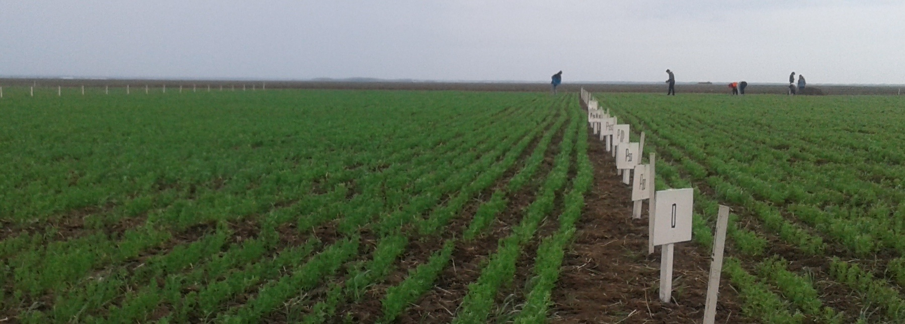
Figure 4 - General view of the "Vehovskaya" variety (left) and the "Krapinka" variety (right)
The figure shows that the Vehovskaya variety is ahead of the Krapinka variety in development.
Figure 5 shows the difference between Viceroy and Vehovskaya.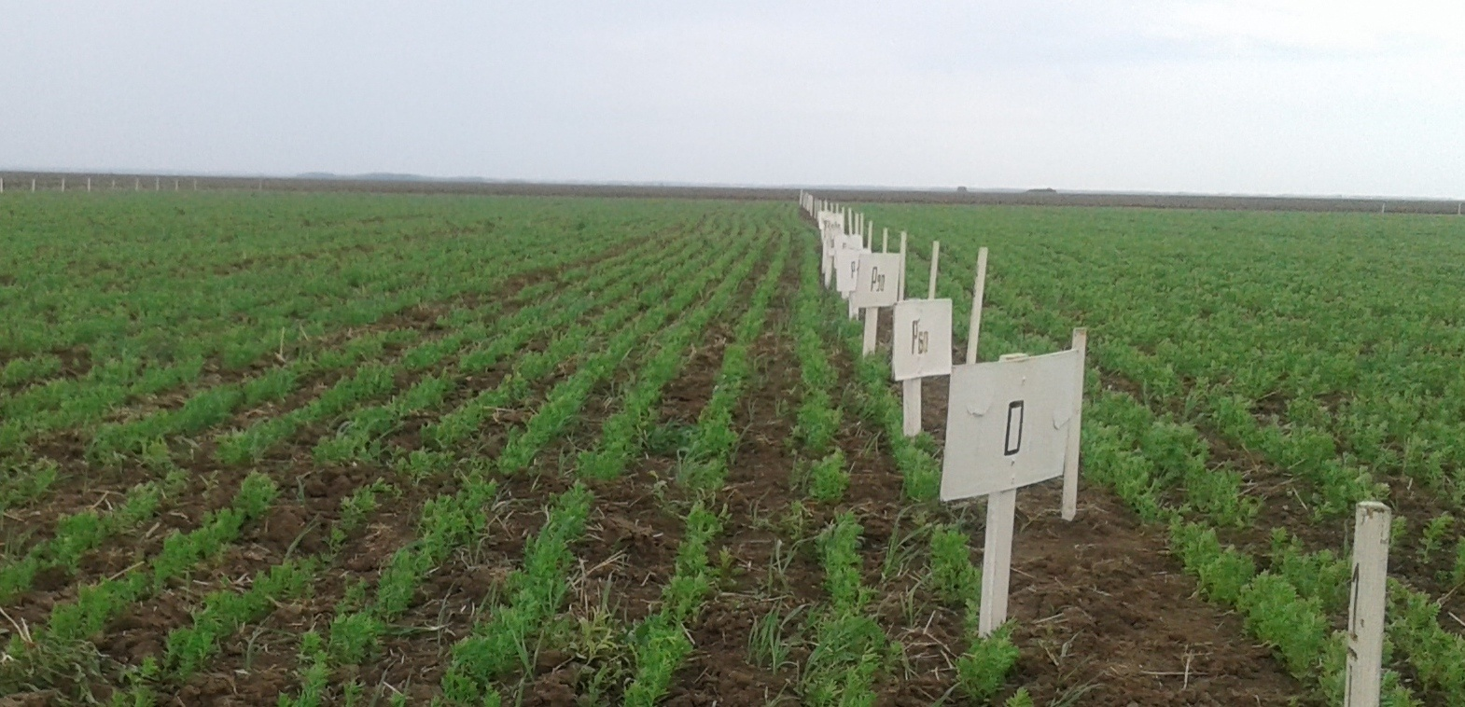
Figure 5 - Variety "Viceroy" (left) and variety "Vehovskaya" (right)
A general view of lentils in the branching phase in 2019 is shown in Figure 6.
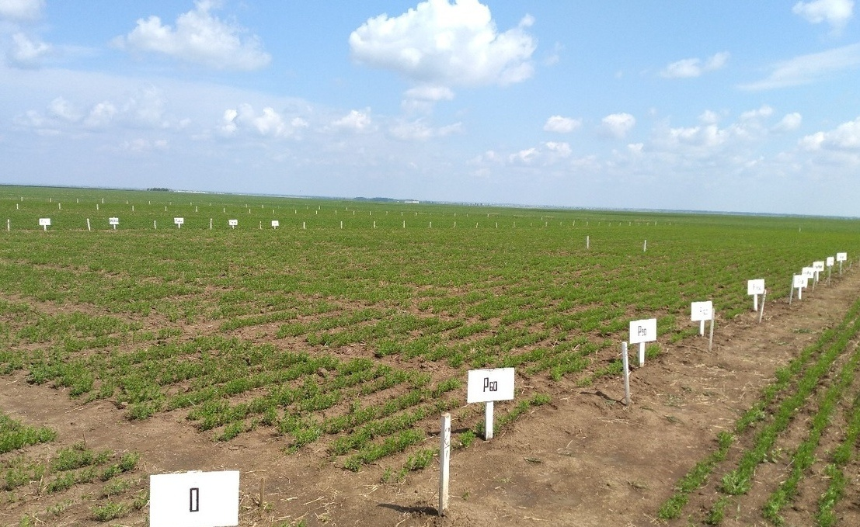
Figure 6 - General view of experiments in the branching phase

In the foreground is the Krapinka variety, the second is the Verkhovskaya variety. Already in the branching phase, a difference in development was observed between varieties.
But this difference is even more visible from a comparison of the state of crops in 2018 (Figure 4, 5) and in 2019 (Figures 6).
Fertilizers, increasing the content of nutrients in the soil, had a great influence on the intensity of development of lentils, Table B.1.
Lentil varieties differed significantly in terms of development rates. In all the years, the Vekhovskaya sort was distinguished by the highest accumulation of dry matter - 75.6-110.8 g / 100 plants in the control during the flowering phase. Sort "Viceroy" and Krapinka were significantly inferior, both against a natural background and fertilized variants. In 2018, fertilizers increased the intensity of varieties development by 2-2.5 times. In the severely arid 2019, the yield increase did not exceed 30-40%, with the smallest increase in the sort Vekhovskaya-25%, which indicates its weak drought tolerance. The sort "Viceroy" showed the greatest resistance to drought.
But on average, over 3 years, the increase in dry matter relative to the control for all sorts was very close at the level of 40-50%.
Phosphorus fertilizers had the greatest influence on the development of sorts. The action of nitrogen was different. Their positive role in the development of lentils was manifested mainly in 2018. In the severely arid 2019, nitrogen fertilizers were not in demand due to an acute moisture deficit. The drought in the spring of 2020 also affected the attitude of lentil sorts to nitrogen fertilizers at the first stage of development.
The conditions of mineral nutrition and hydrothermal regime were reflected in the chemical composition of plants, table 12.
Table 12 - Influence of fertilizers on the chemical composition of lentils in the flowering phase,%
Introduced, kg a.i. / ha | Krapinka |  |  | Vekhovskaya |  |  | Viceroy
Introduced, kg a.i. / ha | N | P₂O₅ | K₂O | N | P₂O₅ | K₂O | N | P₂O₅ | K₂O
2018 год
О | 2,41 | 0,78 | 3,95 | 2,57 | 0,9 | 4,76 | 2,77 | 0,97 | 4,59
Р₆₀ | 2,42 | 0,96 | 3,99 | 2,64 | 0,97 | 5,0 | 3,01 | 1,09 | 4,56
Р₉₀ | 2,49 | 1,02 | 4,04 | 2,87 | 1,07 | 5,26 | 3,08 | 1,11 | 4,58
Р₁₂₀ | 2,72 | 1,05 | 4,09 | 3,06 | 1,07 | 5,22 | 3,23 | 1,18 | 4,54
Р₁₅₀ | 2,78 | 1,21 | 4,16 | 2,94 | 1,14 | 4,72 | 3,27 | 1,25 | 4,84
Р₁₈₀ | 2,73 | 1,34 | 4,14 | 2,72 | 1,21 | 4,91 | 3,34 | 0,96 | 4,68
Р₉₀N₃₀ | 2,84 | 1,16 | 4,38 | 2,73 | 0,89 | 5,10 | 3,13 | 1,13 | 5,02
Р₉₀N₆₀ | 2,89 | 1,28 | 4,35 | 2,95 | 0,98 | 5,30 | 3,25 | 1,23 | 4,89
Р₉₀N₉₀ | 3,07 | 1,33 | 4,29 | 3,04 | 1,18 | 5,10 | 3,35 | 1,25 | 4,82
N₃₀ | 2,53 | 1,13 | 4,24 | 2,73 | 1,07 | 5,05 | 2,87 | 1,05 | 4,70
average | 2,69 | 1,13 | 4,16 | 2,83 | 1,05 | 5,04 | 3,13 | 1,12 | 4,72
2019
О | 2,63 | 1,2 | 5,84 | 2,16 | 0,95 | 5,58 | 2,68 | 1,03 | 5,65
Р₆₀ | 2,74 | 1,25 | 5,57 | 2,24 | 1,01 | 5,91 | 2,77 | 1,08 | 5,48
Р₉₀ | 2,86 | 1,26 | 5,56 | 2,35 | 0,98 | 5,98 | 2,72 | 1,11 | 5,61
Р₁₂₀ | 2,97 | 1,22 | 5,78 | 2,43 | 1,06 | 6,21 | 2,86 | 1,12 | 5,92
Р₁₅₀ | 2,89 | 1,22 | 5,58 | 2,33 | 1,05 | 6,37 | 3,06 | 1,08 | 6,15
Р₁₈₀ | 2,74 | 1,22 | 5,9 | 2,32 | 0,99 | 6,0 | 2,93 | 1,16 | 6,48
Р₉₀N₃₀ | 3,03 | 1,19 | 5,72 | 2,49 | 1,03 | 6,28 | 2,87 | 1,01 | 6,24
Р₉₀N₆₀ | 3,08 | 1,18 | 5,71 | 2,63 | 1,08 | 6,64 | 2,95 | 1,02 | 6,52
Р₉₀N₉₀ | 2,93 | 1,12 | 5,52 | 2,69 | 1,09 | 6,43 | 3,07 | 1,13 | 6,26
N₃₀ | 2,8 | 1,14 | 5,25 | 2,3 | 0,93 | 5,58 | 2,87 | 0,93 | 5,86
average | 2,87 | 1,20 | 5,64 | 2,39 | 1,02 | 6,10 | 2,88 | 1,07 | 6,02
2020
О | 2,04 | 0,74 | 4,15 | 2,61 | 0,78 | 3,55 | 2,72 | 0,71 | 4,21
Р₆₀ | 2,22 | 0,84 | 4,22 | 2,86 | 0,85 | 3,73 | 2,88 | 0,74 | 4,54
Р₉₀ | 2,27 | 0,86 | 4,28 | 2,90 | 0,87 | 4,09 | 2,90 | 0,75 | 4,45
Р₁₂₀ | 2,40 | 0,89 | 4,69 | 3,01 | 0,89 | 4,31 | 2,81 | 0,74 | 4,38
Р₁₅₀ | 2,24 | 0,89 | 4,68 | 3,02 | 0,89 | 4,14 | 2,88 | 0,71 | 4,54
Р₁₈₀ | 2,26 | 0,87 | 4,62 | 3,03 | 0,91 | 3,98 | 2,96 | 0,72 | 4,35
Р₉₀N₃₀ | 2,54 | 0,86 | 4,72 | 3,10 | 0,87 | 4,32 | 3,45 | 0,75 | 4,87
Р₉₀N₆₀ | 2,68 | 0,79 | 4,83 | 3,29 | 0,88 | 4,39 | 3,50 | 0,72 | 4,94
Р₉₀N₉₀ | 2,87 | 0,82 | 4,93 | 3,46 | 0,88 | 4,46 | 3,54 | 0,75 | 4,68
N₃₀ | 2,80 | 0,74 | 4,22 | 3,18 | 0,79 | 3,90 | 3,19 | 0,71 | 4,60
average | 2,43 | 0,83 | 4,53 | 3,05 | 0,86 | 4,09 | 3,08 | 0,73 | 4,54
The table shows that of all the food elements, lentils consume the most potassium. Its content for years and varieties on average for 3 years ranged from 4.16 (grade Krapinka 2018) to 6.02% (grade "Viceroy" 2019). the Highest potassium removal for all varieties was characterized by an acute arid 2019 - from 5.64 to 6.01%. Of the varieties stood out Wehowsky and "Viceroy" 6.1 to 6.0 percent.
The concentration of potassium in plants was also affected by nitrogen-phosphorus fertilizers. With the improvement of phosphorus and nitrogen nutrition, a higher percentage of potassium was also noted. Moreover, the most significant increase in concentration was observed in the acutely arid 2019. The potassium content increased from 5.65% in the control to 6.15% or 0.5% for phosphorous backgrounds and to 6.52% for backgrounds with nitrogen fertilizers. Nitrogen fertilizers increased the potassium content against the background of P90 by almost 1% (from 5.61 to 6.52%).
Nitrogen is in second place in terms of removal. The largest removal was observed in the sort “Viceroy” - more than 3% (3.13-3.08%) in favorable 2018 and 2020. and least of all in severe arid 2019 (2.88% experience average). On the 2nd place is the sort of Vehhovskaya. On average, over 3 years, the nitrogen concentration in plants was 2.76%. The Krapinka sort is 0.1% behind it.
Nitrogen fertilizers had the greatest effect on the nitrogen content in plants. An increase in the nitrogen content in plants was also noted with the introduction of phosphorus. Improvement in the conditions of phosphorus nutrition increased the demand for nitrogen by the culture. The most positive reaction to the improvement of phosphorus nutrition was the “Viceroy” variety, according to which the nitrogen content increased from 2.77 to 3.34%, ie. by 0.67%. While for the sort Vekhovskaya by 0.49%, and for the sort Krapinka by only 0.37%.
The nitrogen content for legumes is a very important quality indicator that directly affects the protein content.
Lentils absorb phosphorus least of all. Its content in plants was 4-5 times less than potassium and 2.5 times less than nitrogen and ranged from 0.8 to 1.2%. The removal of phosphorus by the sort Krapinka was 1.2%. But on average for 3 years for all varieties, the takeout was within 1%.

3.4 Influence of fertilizers on productivity and quality of lentils

Lentil productivity was determined by the biological characteristics of the variety and its requirements for the conditions of mineral nutrition, and hence the different responsiveness to fertilization, Table 13.
The biological characteristics can be judged by the productivity of varieties against a natural background. In 2018, the sort Krapinka with a yield of 11.5 c / ha was inferior to the sort Vehovskaya by 5.7 c / ha and the Viceroy variety by 4.1 c / ha. With the improvement of the conditions of phosphorus nutrition, the productivity of varieties evolved in different ways.
The most responsive was the sort Viceroy, which provided a 71% increase in yield. On the control, the yield was 15.6 centners, according to Р180 - 26.8 centners, an increase of 11.2 centners. The sort “Vekhovskaya” surpassed the sort “Viceroy” only by 1 centner. The yield increase was 66% against the control.
Nitrogen fertilizers in their pure form and against the background of P90 insignificantly, but nevertheless, increased the productivity of sorts by 1.43 centners for sorts "Krapinka" and "Vekhovskaya". The sort "Viceroy" showed the greatest demand for nitrogen. The yield increase was 4.6-5.3 centners.
In the severely arid 2019, the productivity of the variety against the natural background ranged from 1.8 c / ha for the Krapinka variety to 3.8 c / ha for the sort Vehhovskaya. Viceroy had an average position of 2.7 kg / ha.
The varieties reacted differently to the fertilization applied.

Table 13 - Influence of fertilizers on the productivity of lentil varieties, c / ha
Introduced  kg a.i. / ha | Krapinka |  |  | Verkhovskaya |  |  | Viceroy
Introduced  kg a.i. / ha | Productivity, c / ha | increase to "O" |  | Productivity, c/ha | Increase to «О» |  | Productivity, c/ha | Increase to «О»
Introduced  kg a.i. / ha | Productivity, c / ha | c/ha | % | Productivity, c/ha | c/ha | % | Productivity, c/ha | c/ha | %
1 | 2 | 3 | 4 | 5 | 6 | 7 | 8 | 9 | 10
2018 год
«О» | 11,5 | - | 100 | 16,7 | - | 100 | 15,6 | - | 100
Р₆₀ | 15,1 | 3,5 | 131 | 20,0 | 3,3 | 119 | 20,5 | 4,9 | 131
Р₉₀ | 15,2 | 3,6 | 132 | 23,7 | 7,0 | 141 | 22,3 | 6,7 | 142
Р₁₂₀ | 16,0 | 5,6 | 148 | 23,8 | 7,1 | 142 | 25,4 | 9,8 | 162
Р₁₅₀ | 17,1 | 5,5 | 147 | 24,8 | 8,1 | 148 | 25,1 | 9,5 | 160
Р₁₈₀ | 17,0 | 4,5 | 139 | 27,8 | 11,1 | 166 | 26,8 | 11,2 | 171
Р₉₀N₃₀ | 16,6 | 5,1 | 144 | 24,7 | 8,0 | 147 | 26,9 | 11,3 | 108
P₉₀N₆₀ | 16,3 | 4,8 | 141 | 25,0 | 8,3 | 149 | 26,8 | 11,2 | 171
P₉₀N₉₀ | 18,2 | 6,7 | 158 | 26,4 | 9,7 | 158 | 27,6 | 12,0 | 176
Table 13 - Influence of fertilizers on the productivity of lentil varieties, c / ha
1 | 2 | 3 | 4 | 5 | 6 | 7 | 8 | 9 | 10
N₃₀ | 13,3 | 1,8 | 115 | 18,0 | 1,3 | 107 | 17,4 | 1,8 | 111
average | 15,6 | 4,6 |  | 23,1 | 7,1 |  | 21,4 | 8,7
НСР _{0,95} |  | 1,3 |  |  | 1,5 |  |  | 1,6
m, % |  | 3,1 |  |  | 3,4 |  |  | 3,6
2019
О | 1,8 | - | 100 | 3,8 | - | 100 | 2,7 | - | 100
Р₆₀ | 2,1 | 0,3 | 117 | 4,1 | 0,3 | 108 | 2,9 | 0,2 | 107
Р₉₀ | 2,4 | 0,6 | 133 | 4,2 | 0,4 | 111 | 3,4 | 0,7 | 126
Р₁₂₀ | 2,6 | 0,8 | 144 | 4,5 | 0,7 | 118 | 3,7 | 1,0 | 137
Р₁₅₀ | 2,5 | 0,7 | 139 | 4,3 | 0,5 | 113 | 4,1 | 1,4 | 152
Р₁₈₀ | 2,5 | 0,7 | 139 | 4 | 0,2 | 105 | 3,5 | 0,8 | 130
Р₉₀N₃₀ | 2,8 | 1,0 | 156 | 4,2 | 0,4 | 111 | 4,1 | 1,4 | 152
P₉₀N₆₀ | 2,5 | 0,7 | 139 | 3,9 | 0,1 | 103 | 4,2 | 1,5 | 156
P₉₀N₉₀ | 2,9 | 1,1 | 161 | 4 | 0,2 | 105 | 4,2 | 1,5 | 156
N₃₀ | 2,1 | 0,3 | 117 | 4,7 | 0,9 | 124 | 3,5 | 0,8 | 130
average | 2,4 | 0,7 |  | 4,2 | 0,4 |  | 3,6 | 1,0
НСР _{0,95} |  | 0,23 |  |  | 0,31 |  |  | 0,2
m, % |  | 3,32 |  |  | 0,15 |  |  | 0,1
2020
О | 15,0 |  | 100 | 19,9 |  | 100 | 17,2 |  | 100
Р₆₀ | 18,2 | 3,2 | 121 | 23,1 | 3,2 | 116 | 24,3 | 7,1 | 141
Р₉₀ | 21,0 | 6,0 | 140 | 25,3 | 5,4 | 127 | 25,8 | 8,6 | 150
Р₁₂₀ | 23,4 | 8,4 | 156 | 28,4 | 8,5 | 143 | 28,4 | 11,2 | 165
Р₁₅₀ | 21,1 | 6,1 | 141 | 27,5 | 7,6 | 138 | 26,5 | 9,3 | 154
Р₁₈₀ | 18,6 | 3,6 | 124 | 26,6 | 6,7 | 134 | 26,2 | 9,0 | 152
Р₉₀N₃₀ | 23,7 | 8,7 | 158 | 26,6 | 6,7 | 134 | 27,8 | 10,6 | 162
P₉₀N₆₀ | 22,8 | 7,8 | 152 | 29,1 | 9,2 | 146 | 23,8 | 6,6 | 138
P₉₀N₉₀ | 21,5 | 6,2 | 141 | 27,4 | 7,5 | 138 | 22,7 | 5,5 | 132
N₃₀ | 18,5 | 3,5 | 123 | 22,9 | 3,0 | 115 | 19,4 | 2,2 | 113
average | 20,4 | 5,9 | 136 | 25,7 | 6,4 | 133 | 24,2 | 7,8 | 145
НСР _{0,95} |  | 2,22 |  |  | 1,08 |  |  | 1,53
m, % |  | 3,22 |  |  | 1,36 |  |  | 2,13

The maximum yield by varieties from the introduction of phosphorus fertilizers, respectively, was 2.6; 4.5 and 4.1 c / ha, increasing productivity by 44, 18 and 52%. As can be seen from the table, the Viceroy cultivar was the most responsive to the conditions of phosphorus nutrition under the conditions of the most severe drought - 52% to the control on the P150 background, the second place was taken by Krapinka - 44% on the P120 background, which showed the greatest resistance to drought. The most sensitive to drought was the sort Vekhovskaya. The maximum yield increase is 18% against the background of P120.
The varieties also reacted differently to the application of nitrogen fertilizers.
The most responsive variety turned out to be Viceroy, which provided a 56% increase in yield for the P90N30 variant, which is 23% higher than for the background - P90. The sort Vekhovskaya did not respond to the application of nitrogen against the background of phosphorus fertilizers, but with the application of pure nitrogen at a dose of N30, it increased the yield by 24%. The sort Viceroy showed the highest nitrogen demand, providing a 30% increase from pure nitrogen, against the background of P90 - 26%.
But in general, the yield of lentils in the extremely dry 2019 was 4-5 times lower than the harvest in 2018. The results obtained only confirm the tendency of the attitude of soybeans to nutritional conditions and applied fertilizers.
In a relatively favorable 2020, the productivity of varieties against a natural background was similar to 2018: the variety Vekhovskaya (19.9 centners) also had the highest productivity, the variety Viceroy (17.2 centners) was in second place and the lowest productivity of the variety Krapinka (15.0 c / ha).
The introduction of fertilizers, improving the conditions for both nitrogen and phosphorus nutrition, for all varieties and for all variants gave a significant increase in yield. The highest yield increases for all sorts were obtained for the P120 option (from 8.5 centners for the variety Vekhovskaya , 11.2 for the variety Viceroy and up to 8.4 centners / ha for the variety Krapinka). Nitrogen fertilizers, as well as phosphorus fertilizers, gave significant increases in yield, which amounted to 2.2-3.5 c / ha from N30. Against the background of phosphorus, the nitrogen gains were slightly lower.
As a result, the results of three-year studies showed that the studied lentil sorts under the same conditions formed different levels of yield and showed different responsiveness to fertilizers, which indicates the biological characteristics of the sorts. So, the most biologically productive sort is the variety Vekhovskaya, the average yield of which for 2018, 2020. amounted to 24.4 c / ha (2019 is not typical - all sorts, due to the lack of moisture in the soil, stopped growing in July with an average yield of 2.4-4.2 c). On the second place is the variety “Viceroy” with a yield of 22.8 c / ha, the third is Krapinka - 18.0 c / ha.
But it is also obvious that the same variety in different years formed the best harvest against the background of different doses of fertilizers, in particular phosphorus. This was determined by the different deficiency of phosphorus over the years and hence the different need for additional fertilization.
The best result in terms of productivity was formed against the background of that dose of fertilizers, which ensured bringing phosphorus in the soil to the level required for a given variety. And since the experiments were carried out on different sites, with different initial phosphorus content, the phosphorus deficit over the years developed in different ways, this predetermined the different effectiveness of the same dose.
The creation of different levels of phosphorus in the soil due to natural variegation and applied fertilizers is extremely important for answering the main question - what level of phosphorus content in the soil requires this or that sort, in order to subsequently determine what dose of fertilizer should be applied in order to bring the content to the required culture of the optimum.
To evaluate the sorts of lentils as a legume crop, an important indicator, in addition to productivity, is the quality of the grain.
The results of studies on the chemical composition of lentil seed sorts and the effect of fertilizers on quality are shown in Tables 14, 15. Full information is in Table B.1.
Table 14 - The effect of phosphorus fertilizers on the chemical composition and quality of lentil seeds,%
Introduced, kg a.i. / ha | Krapinka |  |  |  | Verknovskaya |  |  |  |  | Viceroy
Introduced, kg a.i. / ha | N | P₂O₅ | K₂O | prote-in | N | P₂O₅ | K₂O |  | protein | N | P₂O₅ | K₂O | prote-in
1 | 2 | 3 | 4 | 5 | 6 | 7 | 8 |  | 9 | 10 | 11 | 12 | 13
2018
О | 3,01 | 1,17 | 2,66 | 16,8 | 3,3 | 1,36 | 2,79 |  | 18,5 | 3,12 | 1,4 | 2,44 | 17,5
Р₆₀ | 3,06 | 1,40 | 2,69 | 17,1 | 3,17 | 1,38 | 2,75 |  | 17,7 | 3,33 | 1,49 | 2,53 | 18,6
Р₉₀ | 3,11 | 1,50 | 2,72 | 17,4 | 3,4 | 1,45 | 2,69 |  | 19,0 | 3,42 | 1,31 | 2,46 | 19,1
Р₁₂₀ | 3,0 | 1,60 | 2,68 | 16,8 | 3,48 | 1,45 | 2,75 |  | 19,5 | 3,42 | 1,43 | 2,60 | 19,1
Р₁₅₀ | 3,14 | 1,53 | 2,72 | 17,6 | 3,32 | 1,44 | 2,70 |  | 18,6 | 3,38 | 1,57 | 2,46 | 18,6
Р₁₈₀ | 3,15 | 1,52 | 2,51 | 17,6 | 3,43 | 1,46 | 2,71 |  | 19,2 | 3,45 | 1,65 | 2,47 | 19,3
average | 3,08 | 1,45 | 2,66 | 17,22 | 3,35 | 1,42 | 2,73 |  | 18,75 | 3,35 | 1,48 | 2,49 | 18,70
2019
О | 3,4 | 1,8 | 2,37 | 19 | 3,31 | 1,79 | 2,74 |  | 18,5 | 3,45 | 1,68 | 2,37 | 19,3
Р₆₀ | 3,75 | 1,82 | 2,36 | 21 | 3,55 | 1,91 | 2,78 |  | 19,9 | 355 | 1,81 | 2,30 | 19,9
Р₉₀ | 3,8 | 1,87 | 2,30 | 21,3 | 3,64 | 1,99 | 2,75 |  | 20,4 | 3,64 | 1,75 | 2,29 | 20,4
Р₁₂₀ | 3,76 | 1,94 | 2,27 | 21,1 | 3,6 | 2,25 | 2,66 |  | 20,2 | 3,68 | 1,68 | 1,98 | 20,6
Р₁₅₀ | 3,53 | 2,01 | 2,24 | 19,8 | 3,45 | 1,98 | 2,59 |  | 19,3 | 3,65 | 1,89 | 2,18 | 20,4
Р₁₈₀ | 3,48 | 2,14 | 2,21 | 19,5 | 3,43 | 1,85 | 2,70 |  | 19,2 | 3,89 | 1,8 | 2,21 | 21,8
average | 3,62 | 1,93 | 2,29 | 20,28 | 3,50 | 1,96 | 2,70 |  | 19,58 | 3,64 | 1,77 | 2,22 | 20,40
2020
О | 2,51 | 1,00 | 2,51 | 14,1 | 3,08 | 0,91 |  | 2,22 | 17,2 | 2,58 | 0,99 | 2,18 | 14,4
Р₆₀ | 2,57 | 1,03 | 2,52 | 14,4 | 3,12 | 0,95 |  | 2,25 | 17,5 | 2,90 | 1,01 | 2,22 | 16,2
Р₉₀ | 2,76 | 1,10 | 2,55 | 15,5 | 3,14 | 0,97 |  | 2,31 | 17,6 | 2,95 | 1,12 | 2,29 | 16,5
Table 14 - The effect of phosphorus fertilizers on the chemical composition and quality of lentil seeds,%
1 | 2 | 3 | 4 | 5 | 6 | 7 | 8 | 9 | 10 | 11 | 12 | 13
Р₁₂₀ | 2,82 | 1,14 | 2,54 | 15,8 | 3,19 | 1,02 | 2,42 | 17,9 | 2,99 | 1,24 | 2,29 | 16,7
Р₁₅₀ | 2,75 | 1,17 | 2,53 | 15,4 | 3,21 | 1,04 | 2,46 | 18,0 | 3,09 | 1,23 | 2,22 | 17,3
Р₁₈₀ | 2,45 | 1,08 | 2,59 | 13,7 | 3,27 | 1,07 | 2,43 | 18,3 | 2,72 | 1,19 | 2,21 | 15,2
averagе | 2,64 | 1,09 | 2,54 | 14,8 | 3,17 | 0,99 | 2,35 | 17,7 | 2,87 | 1,13 | 2,24 | 16,1
Aver.for 3 g | 3,11 | 1,49 | 2,50 | 17,4 | 3,34 | 1,46 | 2,59 | 18,7 | 3,29 | 1,46 | 2,32 | 18,4

As can be seen from the table, the chemical composition of lentil seeds differs significantly from the chemical composition of plants during the growing season. The plants in the flowering phase had the highest percentage of potassium, 2-2.5 times more than nitrogen. In the seeds, on the contrary, the potassium content is much less, phosphorus is more. The first place in terms of concentration is taken by nitrogen, the content of which in all sorts and in all years is more than 3%. The nitrogen content of the variety Krapinka was slightly lower. Thus, the average nitrogen content over three years for all backgrounds in the grain of the variety Krapinka was 3.11%, for the variety Vkehovskaya 3.34% and Viceroy 3.29%. Moreover, even in the non-fertilized control variant, the nitrogen content was within 3%.
The application of phosphorus fertilizers increased the absorption of nitrogen by the sorts of lentils without a significant difference between them, but a higher concentration was noted for the variants with the application of nitrogen fertilizers, Table 15.
So, % of nitrogen against the background of P90 varied by varieties:
Krapinka Vekhovskaya Viceroy
on Р - toNP on Р - toNPon Р - toNP
in 2018.: from 3,11 to 3,44%; 3,4 – 3,74%; 3,42 – 3,59%
in 2019 г.: from 3,8 to 4,04%; 3,64 - 3,76%; 3,64 - 4,46%
in 2020.: from 2,76 to 3,27%; 3,14 - 3,43%; 2,95 - 3,34%
As can be seen, for all varieties of nitrogen-phosphorus variants, a higher concentration of nitrogen was noted. In more favorable 2018 and 2020 in terms of nitrogen content, the variety Vekhovskaya was distinguished, Viceroy was in second place and Krapinka was in third.

Table 15 - Influence of nitrogen fertilizers on the chemical composition and quality of lentil seeds,%
Introduced, kg a.i. / ha | Krapinka |  |  |  | Vekhovskaya |  |  |  | Viceroy
Introduced, kg a.i. / ha | N | P₂O₅ | K₂O | prote-in | N | P₂O₅ | K₂O | protein | N | P₂O₅ | K₂O | prote-in
2018
Р₉₀- background | 3,11 | 1,50 | 2,72 | 17,4 | 3,4 | 1,45 | 2,69 | 19 | 3,42 | 1,31 | 2,46 | 19,1
Р₉₀N₃₀ | 3,23 | - | 2,79 | 18,1 | 3,48 | 1,51 | 2,62 | 19,5 | 3,43 | 1,27 | 2,47 | 19,2
Р₉₀N₆₀ | 3,39 | 1,31 | 2,54 | 19,0 | 3,61 | 1,49 | 2,96 | 20,2 | 3,56 | 1,59 | 2,43 | 19,9
Р₉₀N₉₀ | 3,44 | 1,44 | 2,49 | 19,3 | 3,74 | 1,52 | 2,73 | 20,9 | 3,59 | 1,27 | 2,38 | 20,1
N₃₀ | 3,26 | 1,32 | 2,43 | 18,2 | 3,53 | 1,23 | 2,70 | 19,8 | 3,35 | 1,4 | 2,39 | 18,8
average | 3,29 | 1,39 | 2,59 | 18,40 | 3,55 | 1,44 | 2,74 | 19,88 | 3,47 | 1,37 | 2,43 | 19,42
2019
P90-background | 3,8 | 1,87 | 2,30 | 21,3 | 3,64 | 1,99 | 2,75 | 20,4 | 3,64 | 1,75 | 2,29 | 20,4
Р₉₀N₃₀ | 3,81 | 1,93 | 2,20 | 21,3 | 3,65 | 2,09 | 2,75 | 20,4 | 3,78 | 1,69 | 2,16 | 21,2
Р₉₀N₆₀ | 3,94 | 2,0 | 2,19 | 22,1 | 3,7 | 2,1 | 2,62 | 20,7 | 3,98 | 1,72 | 2,11 | 22,3
Р₉₀N₉₀ | 4,04 | 1,91 | 2,14 | 22,6 | 3,76 | 1,84 | 2,52 | 21,1 | 4,16 | 2,17 | 2,11 | 23,3
N₃₀ | 3,55 | 1,81 | 2,20 | 19,9 | 3,53 | 1,54 | 2,71 | 19,8 | 3,75 | 1,66 | 2,18 | 21
average | 3,83 | 1,90 | 2,21 | 21,44 | 3,66 | 1,91 | 2,67 | 20,48 | 3,86 | 1,80 | 2,17 | 21,64
2020
P90-background | 2,76 | 1,10 | 2,55 | 15,5 | 3,14 | 0,97 | 2,31 | 17,6 | 2,95 | 1,12 | 2,29 | 16,5
Р₉₀N₃₀ | 2,63 | 1,03 | 2,64 | 14,7 | 3,34 | 0,98 | 2,40 | 18,7 | 3,20 | 1,14 | 2,26 | 17,9
Р₉₀N₆₀ | 2,99 | 0,99 | 2,53 | 16,7 | 3,37 | 1,00 | 2,47 | 17,5 | 3,23 | 1,23 | 2,2 | 18,1
Р₉₀N₉₀ | 3,27 | 1,25 | 2,51 | 18,3 | 3,43 | 1,00 | 2,40 | 19,2 | 3,34 | 1,15 | 2,24 | 18,7
N₃₀ | 2,77 | 1,01 | 2,54 | 15,5 | 3,18 | 0,88 | 2,37 | 17,6 | 2,97 | 1,04 | 2,36 | 16,6
average | 2,88 | 1,08 | 2,55 | 16,14 | 3,29 | 0,97 | 2,39 | 18,12 | 3,14 | 1,14 | 2,27 | 17,56
Aver.for 3 y | 3,33 | 1,45 | 2,43 | 18,6 | 3,50 | 1,44 | 2,60 | 19,50 | 3,49 | 1,44 | 2,29 | 19,5

However, the hydrothermal regime of 2019 had the greatest impact on the nitrogen content in grain. Under conditions of the most severe drought, the nitrogen concentration was significantly higher for all sorts, with the advantage of the Krapinka, which once again emphasizes its higher drought tolerance.
The nitrogen content in the grain was directly reflected in the protein content, in the same pattern, tables 14, 15.
In 2018, the highest nitrogen concentration (on average by experience) was obtained for the varieties "Vekhovskaya" and "Viceroy", respectively, and the protein content is 1.5-1.2% higher. The highest protein content for all varieties was noted for nitrogen-phosphorus variants.
In severely arid 2019, the highest nitrogen concentration was obtained for the Krapinka and Viceroy sorts from 3.4 to 3.8-3.9%, and with the introduction of nitrogen fertilizers up to 4.0-4.2%, which determined protein content for these sorts, from 19 to 21% for phosphorus backgrounds, up to 23% for nitrogen-phosphorus variants. Moreover, against the background of P90 due to nitrogen, the protein content in the Krapinka increased by 1.3%, and in the Viceroy by 3%. While, according to Vekhovskaya, the nitrogen content in the grain increased against phosphorus backgrounds from 3.3 to 3.6%, and in combination with nitrogen up to 3.8%. Accordingly, the protein content on an unfermented background, i.e. in the control it was 0.5-0.8% lower and increased due to phosphorus by 1.7%, and with increasing doses up to 90 kg. At higher backgrounds, the protein content decreased from 20.4 to 19.2%. And for the Viceroy cultivar, this indicator was stable and remained at elevated phosphorus levels.
In 2020, the Krapinka reacted better than other varieties to the application of nitrogen fertilizers, increasing the nitrogen content by 0.76% and, accordingly, the protein content increased to 18.3% compared to 14.1% in the control.
As noted above, lentils among legumes are characterized by the highest nutritional and other advantages of not only grain, but also straw, being a high-quality feed.
The effect of fertilizers on the chemical composition of straw during the years of research is shown in Table B.2.
Research results have shown that lentil straw contains a high percentage of nitrogen and reflects the same pattern in varieties as in grain.
It was found that most of all in lentil straw contains potassium - 4.46-5.20%, least of all phosphorus - 0.33-1.18%.
Nitrogen is in second place - 1.3-1.5 in favorable up to 2.43% in an acutely arid year. This ensures high quality lentil straw. The protein content in years favorable for moisture was on average about 8-10% according to experiments, and in acutely arid years up to 12-15% of crude protein, with the highest content according to the variety Krapinka.
Thus, studies have shown that different varieties have different requirements for the conditions of mineral nutrition. They respond relatively well, although in different ways, to fertilization, due to which different levels of the content of elements and, accordingly, nutrition is created in the soil. The biological characteristics of varieties in their resistance to drought were clearly manifested. The variety Vekhovskaya differed from other varieties in higher productivity, it is characterized by the lowest drought resistance, the variety Krapinka has a relatively lower productivity, but higher drought resistance, and in this respect deserves special attention.
But to realize the productivity potential of lentil varieties that are promising for the dry-steppe zone of Kazakhstan, it was necessary to determine the optimal parameters of the main soil properties that ensure its realization.

3.5 Method of purposeful management of soil fertility and productivity of lentil varieties

From the characteristics of main properties of the soil, it was found that the studied soils have sufficiently favorable physical and chemical properties.

But studies have also shown a very high dependence of lentil productivity on the combined effect of soil and climate factors. The years of studies on hydrothermal conditions were very different, which determined the feature of crop development and the effect of fertilizers. But for any combination of factors, the level of mineral nutrition was the determining factor. Each variety, due to its biological characteristics, requires a certain amount and ratio of elements in the soil.

It was established that the determining factors in the formation of crop yields in the rain-fed conditions of Northern Kazakhstan are: the biology of the crop and its individual requirements for growing conditions and soils. Among the factors limiting the formation of the crop are the moisture supply and availability of crops with phosphorus and nitrogen (high potassium content in the soil does not limit the yield.
A high correlation was established between the content of nutrients in the soil and the productivity of the crop for all varieties, which made it possible to determine the optimal levels of the content of nutrients in the soil, which ensured the formation of the maximum possible yield under the prevailing meteorological conditions during the years of studies.
In all the years of studies the most productive variety was a sort of "Vekhovskaya". In 2018, the optimum phosphorus content was not reached.
Hydrothermal conditions in 2019 (severe drought) did not allow to realize the potential of varieties. The yield was for the Vekhovskaya variety from 3.7 to 4.6, Viceroy - 2.7-4.2, Krapinka - 1.8-2.9 c/ha.
In 2020, favorable for moisture, the highest yield and efficiency of fertilizers was obtained. The highest yield was also obtained for the Vekhovskaya variety - 25.7 c/ha on average for the experience, slightly inferior to the Viceroy variety - 24.2 c/ha and in third place Krapinka-20.4 c ha, which is significantly higher than the productivity of the year 2018. This underlines the importance of the results of 2020 for determining the optimal parameters for soil properties, in particular for phosphorus and nitrogen. They made it possible to clearly determine the quantitative relationship between the level of elements in the soil and the productivity of varieties and to determine their optimal levels with a high correlation coefficient, Figures 7-12.

Figure 7 shows the correlation between the productivity of the Vekhovskaya variety and the content of mobile phosphorus in the soil. As seen, the maximum yield at the level of 28.5 centners was formed with a phosphorus content of 28 mg/kg of soil. The same level is optimal for the Viceroy variety, Figure 8.
For the Krapinka variety, which is characterized by lower productivity, the optimal level of phosphorus content is 26 mg/kg of soil, Figure 9.

Figures 10-12 show the results of correlation analysis of the relationship between the productivity of varieties with the nitrogen content of nitrates in the 0-40 cm layer

In a favorable year of 2020, the Krapinka variety produced the maximum yield with a nitrogen nitrate content in the soil at the level of 13-15 mg/kg, Figure 10.
13 mg is the lower limit to which the nitrogen content of nitrates in the soil should be adjusted, ensuring a high return on fertilizer costs. 15 mg is the upper limit which is not advisable to bring the content of N-NO3, as, 0.5 c may not recoup the costs of additional fertilizers, as nitrogen fertilizers is not keptin the soil, not retained, are mobile in the soil solution and can easily move through the soil profile in depth, in contrast to the phosphorus, which does not move in the soil, is kept by chemical absorption and therefore phosphorus of fertilizers remains in the soil. But this process is reversible, due to which phosphorous fertilizers have a long aftereffect [11].
The Vekhovskaya variety produced the highest yield against the background of 15-17 mg N-NO₃ per kg of soil.
For the “Viceroy” variety, in 2020, the effectiveness of nitrogen fertilizers was manifested only in one variant from the introduction of N30 against the background of P90. This is not enough to construct a correlation line. But a high correlation was obtained in 2018, Figure 12. This shows that for Viceroy the optimal level of nitrogen content in the soil is in the range of 13-15 mg/kg of soil, where 13 is the level to which it is advisable to bring the nitrogen content in the soil, preserving the guarantee of their effectiveness.

The optimal ratio of phosphorus to nitrogen for lentils is at the level 2:1.

Thus, the correlation-regression analysis made it possible to determine the optimal levels of phosphorus and nitrogen content in the soil for different varieties of lentils.

It remains to decide the question of how to create these levels, how much fertilizer is needed to bring the content of elements in the soil to the required level, taking into account the initial content of elements in the soil. It should be borne in mind that the effectiveness of nitrogen fertilizers depends not only on the requirements of the crop and the initial content, but also on the moisture supply, as it was established in previous long-term studies.

To solve this problem, it is proposed to use the optimization formulas Chernenok V.G. [62, 11], allowing to purposefully manage soil fertility.

Knowing the optimal levels of phosphorus in the soil for a given crop and the actual phosphorus content in the soil in the pre-sowing period, it is possible to most accurately determine its deficiency in the soil and the dose of fertilizers using the formula (Chernenok):

D_{Р} = (Рopt - Рfact) ∙ 10, (1)

where Рopt- a certain optimal level of phosphorus for the crop;

Рfact - an actual content of phosphorus in the soil;

10 - the equivalent of P₂O₅ fertilizers 1 mg of phosphorus deficiency in the soil.

For varieties Vekhovskaya and Viceroy it will be: Dr = (28 - Рfact) ∙ 10

For the Krapinka variety: D_{Р} = (26 - Рfact) • 10

To determine the nitrogen dose, it is proposed to use the formula:

D_{N}= (Nopt - Nfact) • 7.5 • PKuvl, (2)

Where Nopt- a certain optimal level of nitrogen for the crop;

Nfact– an actual nitrogen content in the soil;

7.5 - the equivalent of fertilizers per 1 mg of N-NO₃ deficiency in the soil in the 0-40 cm layer.

The doses calculated according to the formula shall ensure the bringing of the most important crop-limiting factors in the soil to the optimal level, thereby ensuring the purposeful management of soil fertility.

The proposed method for managing soil fertility and optimizing the nutrition of lentils is the most accurate of all known, ensures the realization of the cropsproductivity potentialand obtaining maximum yield with a high recoupment of costs. The proposed method makes it possible to exclude unproductive waste of fertilizers and to save huge amounts of money on this. It guarantees high efficiency and environmental safety.

3.6 Economic efficiency of using fertilizers for lentils

Introducing new techniques and methods for managing soil fertility and crops productivity, especially if it is associated with certain costs, it is very important to give an economic assessment of the feasibility and effectiveness of these techniques.

The most important indicators of economic efficiency at this stage shall be net income from the applied techniques and cost recoupment. This is especially important when using fertilizers with different periods of their effective action, depending on the amount of fertilizers applied.

The calculation of the economic efficiency of the use of mineral fertilizers was carried out according to the method of Menshikov N.F. [61].

To calculate the efficiency of fertilizers application, the following indicators are taken. The cost of 1 centner of lentil seeds is 10,000 tenge.

The costs item includes the cost of fertilizers applied at the purchase prices of the current year, plus additional costs for storage, transportation, fertilization and additional processing of the additional harvest in the amount of 20% of the cost of fertilizers.

The calculation took into account the duration of the fertilizer aftereffect (P), established in long-term stationary studies (Chernenok, 2009) [11]: for nitrogen - 2 years, for phosphorus: P60 - 4 years, P90 - 5-6 years, P120 - 7-8 years). In this case, for all doses of phosphate fertilizers, a minimum validity period of 4 years is adopted.
Total costs (З) calculated according to the formula:
C = [P x Dtuk + 0.2 x (P x Dtuk)] / D, (3)
where C - total costs, tg;
C - fertilizers price, tg/c;
Dtuk - the dose of fertilizers in c/ ha of physical weight;
0.2–20% of the costs of the cost of fertilizers used for transportation, storage, application and processing of fertilizers;
D-the duration of the fertilizers action.
The calculation of economic efficiency was carried out annually, which was presented in the annual reports. The expanded economic efficiency based on the results of 2020 is presented in Table G.1.
Table 16 presents the results for the main options, showing that the dose of fertilizers that ensured bringing the content of nutrients to the optimal level gave the highest net income, with a high return on costs.
In 2020, a high economic effect was obtained for all varieties and variants. Against the background of a low soil supply with mobile phosphorus and nitrogen of nitrates, all applied fertilizers gave a significant increase in yield, but a different economic effect.
The highest economic effect - net income and recoupment of costs - was obtained for the Р₁₂₀ background, which ensured bringing the phosphorus content in the soil to the optimal level. Net income for the Vekhovskaya variety was 102375 tg/ha, with a recoupment of 13.6 tg, for the Viceroy variety - 137,475 tg, with a recoupment of 17.9 tg, for the Krapinka variety - 101,075 tg and a recoupment of 13.4 tg.
Table 16 - Economic efficiency of fertilizers use in 2020
Applied,  kg d.v. | Produc-tivity,  c/ha | Increase, c/ha | Cost of additional products, tenge | Costs for fertilizerstenge | Net income, tenge | Costrecoup-ment, tg | Profita  bility,%
1 | 2 | 3 | 4 | 5 | 6 | 7 | 8
Vekhovskaya
O | 19,9
Р₉₀ | 25,3 | 5,4 | 70200 | 7313 | 62888 | 9,6 | 860
Р₁₂₀ | 28,4 | 8,5 | 110500 | 8125 | 102375 | 13,6 | 1260
Р₁₅₀ | 27,5 | 7,6 | 98800 | 10188 | 88613 | 9,7 | 870
Р₉₀N₃₀ | 26,6 | 6,7 | 87100 | 14873 | 72227 | 5,9 | 486
P₉₀N₆₀ | 29,1 | 9,2 | 119600 | 22973 | 96627 | 5,2 | 421
N₃₀ | 22,9 | 3,0 | 39000 | 7560 | 31440 | 5,2 | 416
Viceroy
O | 17,2
P₆₀ | 24,3 | 7,1 | 92300 | 4875 | 87425 | 18,9 | 1793
Р₉₀ | 25,8 | 8,6 | 111800 | 7313 | 104488 | 15,3 | 1429
Р₁₂₀ | 28,4 | 11,2 | 145600 | 8125 | 137475 | 17,9 | 1692
Table 16 - Economic efficiency of fertilizers use in 2020
1 | 2 | 3 | 4 | 5 | 6 | 7 | 8
Р₁₅₀ | 26,5 | 9,3 | 120900 | 10188 | 110713 | 11,9 | 1087
Р₉₀N₃₀ | 27,8 | 10,6 | 137800 | 14873 | 122927 | 9,3 | 827
P₉₀N₆₀ | 23,8 | 6,2 | 80600 | 22973 | 57627 | 3,5 | 251
N₃₀ | 19,4 | 1,8 | 23400 | 7560 | 15840 | 3,1 | 210
Krapinka
O | 15,0
Р₉₀ | 21,0 | 6,0 | 78000 | 7313 | 70687 | 10,7 | 967
Р₁₂₀ | 23,4 | 8,4 | 109200 | 8125 | 101075 | 13,4 | 1244
Р₁₅₀ | 21,1 | 6,1 | 79300 | 10188 | 69112 | 7,8 | 678
Р₉₀N₃₀ | 23,7 | 8,7 | 113100 | 14873 | 98277 | 7,6 | 660
P₉₀N₆₀ | 22,8 | 7,8 | 101400 | 22973 | 78427 | 4,4 | 341
N₃₀ | 18,5 | 3,5 | 45500 | 7560 | 37940 | 6,0 | 502

In this case, when calculating the economic efficiency, the minimum duration of aftereffect of phosphorus fertilizers was taken into account.
But even if all the costs were taken for one year, then the net income for the Vehovskaya variety would be 71,350 tg/ha, with a recoupment of 2.82 tg, for the Viceroy variety, respectively 106,450 tg/ha and a recoupment of 3.72 tg, and for the Krapinka variety, 70,050 tg/ ha, with a recoupment of 2.79 tg.
Improving the conditions of nitrogen nutrition for all varieties gave a tangible economic effect both with the introduction of pure nitrogen and against the background of P90. But the demand for fertilizers was much less, due to the better supply of varieties due to nitrogen in the soil.
Thus, the calculation of economic efficiency showed that bringing the content of nutrients to the optimal level and, above all, phosphorus, as the most important factor limiting the yield, ensures the maximum productivity of the variety, realization of its potential possibilities. And determination of doses according to the optimization formulas, ensures high accuracy, which guarantees high economic efficiency, environmental safety and are the most perfect and accurate in demand, especially in the precision farming system.
CONCLUSION
Management of soil fertility and crops productivity is impossible without improving the methods of soil diagnostics, establishing the main agrochemical factors that determine the formation of productivity and determining their optimal parameters. Determination of optimal parameters of basic properties of the soil and development of ways for their achievement shall allow to optimize the conditions of mineral nutrition and ensure the realization of the crops potential productivity and at the same time improvement the quality of products.
Studies conducted on dark chestnut calcareous light clay soils of the dry steppe zone of Kazakhstan on "the development of methods for realizing the productivity potential of lentil varieties promising for the dry steppe zone of Kazakhstan, based on determining the parameters of agrochemical properties of the soil optimal for them and ways for their achievement", took place in difficult climatic conditions.
The years of studies differed, first of all, in the hydrothermal regime, the amount and nature of distribution of rainfalls. 2018 and 2020 years were relatively favorable in terms of a combination of factors. 2019 was characterized by the most severe drought. During the growing season, with an excess of heat and an acute deficit of moisture: during the growing season (May-August), only 56.9 mm fell with an average annual 165 mm. The reserves of productive moisture in the meter profile by the flowering phase decreased from 149 mm to 55-72 mm, and in the 0-20 cm layer they amounted to 1.2 - 3.6 mm. Under these conditions, lentils stopped growing at the end of July. This explains the very low productivity (1.8-3.8 c/ha) and the efficiency of fertilizers (+ 0.4-1 c/ha).
Studies of 2018, 2020 years showed that the productivity of lentil varieties was determined by the hydrothermal regime during the growing season and the initial content of phosphorus and nitrogen in the soil. Different varieties of lentils differed in the intensity of development and formation of productivity. The most productive was the Vekhovskaya variety. Average yield for 2018, 2020 amounted to 24.4 c/ha, in the second place was "Viceroy" 22.8 c / ha and in the last one was "Krapinka" 18 c/ha. The “Viceroy” variety is more responsive to fertilizers, and the Krapinka variety is more responsive to drought resistance.
Fertilizers increased not only productivity, but also the quality of seeds. The most significant effect on the protein content was exerted by nitrogen fertilizers and especially by the hydrothermal regime of the growing season. In hyperarid 2019, the protein content was 2% higher compared to others.
Studies have shown that the most promising varieties for the conditions of North Kazakhstan are Vekhovskaya and Viceroy.
A high relationship has been established between the content of elements in the soil and the productivity of varieties. Using the method of correlation-regression analysis, the optimal levels of Р₂О₅ content were determined, which ensured maximum productivity: for the Vekhovskaya and Viceroy varieties, the optimal level of mobile phosphorus in the soil is 28 mg P2O5 / kg soil, for the Krapinka variety 26 mg/kg soil. In terms of nitrogen, the optimal level of N-NO₃content in the 0-40 cm layer is: for the Vekhovskaya variety within 15-17 mg/kg of soil, for the Viceroy and Krapinka varieties, 13-15 mg/kg of soil.

To solve an equally difficult problem - how to determine the deficiency of an element in the soil and the dose of fertilizers that must be applied in order to bring their initial content to the optimal level, Chernenok optimization formulas are proposed:

D_{Р} = (Рopt - Рfact) • 10,

Where Рopt- a certain optimal level of phosphorus for the crop;

Рfact–an actual content of phosphorus in the soil;

10 - the equivalent of Р₂О₅ fertilizers 1 mg of phosphorus deficiency in the soil.

For the varieties Vekhovskaya and Viceroy it will be: D_{Р} = (28 - Рfact) • 10

For the Krapinka variety: D_{Р} = (26 - Рfact) • 10

To determine the nitrogen dose, it is proposed to use the formula:

D_{N} = (Nopt - Nfact) • 7.5 • PKuvl,

Where Nopt- a certain optimal level of nitrogen for the crop;

Nfact- an actual nitrogen content in the soil;

7.5 - the equivalent of fertilizers per 1 mg of N-NO₃ deficiency in the soil in the 0-40 cm layer.

The doses calculated according to the formula shall ensure the bringing of the most important crop-limiting factors in the soil to the optimal level, thereby ensuring the purposeful management of soil fertility.

The proposed method for managing soil fertility and optimizing the nutrition of lentils is the most accurate of all known, it has no analogues; it ensures the realization of the crops productivity potential and obtaining maximum productivity with a high recoupment of costs. The proposed method makes it possible to exclude unproductive consumption of fertilizers, guarantees their high efficiency and environmental safety.
The method is the most perfect for a precision farming system.
The methods of purposeful management of soils and productivity of lentil varieties are described. All tasks of the schedule have been completed (Appendix E).
A patent for a useful model No. 5289 "Method for predicting the efficiency of nitrogen fertilizers" dated 14.08.2020 was received (Appendix H).
LIST OF SOURCES USED

1 The Message from the President of Republic of Kazakhstan Nazarbayev N.A., dated 28.02.2007. «The new Kazakhstan in the new world» (rus).
2 The State program for the development of the agro-industrial complex of the Republic of Kazakhstan for 2017-2021(rus).
3 The State program of agro-industrial complex development in the Republic of Kazakhstan for 2013-2020 “Agribusiness – 2020” (rus).
4 https://edaplus.info/produce/lentil.html (rus).
5 Varkhalov M.D., Alyev A.I., Kolomeichenko V.V. Features of the cultivation of lentils in the conditions of the Central Russian forest-steppe // Agrarian science.-1998.-No. 5.-19p (rus).
6 Vasyakin N.I. Legumes in Western Siberia. - Novosibirsk. - 2002 .- 182 p (rus).
7 An innovative experience in the production of lentils. - M.: FGBNU "Rosinformagrotech", 2013. - 44 p (rus).
8 Pylov A.P. Cereals and legumes (peas, lentils, beans). - M.: Knowledge, 1975.- 9 p. (rus).
9 All about medicinal plants in your beds / ed. S.Yu. Radelova. - SPBU.: LLCNWBTEA, 2010. - P. 191 (rus).
10 Zhaksymbet O., Umirzakova G.A., Baybatyrov G.A. Production of pasta using finely ground lentil flour // Zhangir Khan West Kazakhstan Agro-Technical University "Science and technology: ten global challenges of the 21st century." - Kostanay. - 2017.- 151 p (rus).
11 Chernenok V.G. Scientific foundations and practical methods of soil fertility and crop productivity management in Northern Kazakhstan. - Astana, 2009..- 66 p (rus).
12 A.I. Grinets Lentils in Northern Kazakhstan // Agrarian sector. - 2017. - No. 2 (32). P. 10-17 (rus).
13 Suleimenov M.K., KaskarbaevZh.A., Shishkov V.P. and other Resource-saving technologies for the cultivation of cereals, legumes, oilseeds and cereals in the north of Kazakhstan: Recommendations. - Shortandy, 2009 (rus).
14 Recommendations for the cultivation of lentils in the conditions of Northern Kazakhstan. - Astana, 2018 .- 47 p (rus).
15 Musynov K.M., Kipshakbaeva A.A., Arinov B.K., Utelbaev E.A., Bazarbaev B.B. Investigation of the influence of agricultural practices on the formation of the yield of leguminous crops in the dry steppe zone of Northern Kazakhstan // Research, results of KazNU. - 2016. - No. 4 (72). – P. 288-294 (rus).
16 Musynov K.M., Kipshakbaeva A.A., Arinov B.K., Utelbaev E.A., Bazarbaev B.B. Features of the technology of cultivation of lentils in the conditions of Northern Kazakhstan // Bulletin of Altai GAU. - 2017. - No. 9 (155). - P. 14-18 (rus).
17 https://edaplus.info/produce/lentil.html (rus).
18 Hanson M.G., Taylor C.G., Wu Y., Anderson H.D., Zahradka P. Lentil consumption reduces resistance artery remodeling and restores arterial compliance in the spontaneously hypertensive rats - J. Nutr. Biochem. – 2016. – №37. – Р.30-38 (rus).
19 Zaprometov M.N. Fundamentals of the biochemistry of phenolic compounds. - M .: Higher school, 1974 .-275 p (rus).
20 I.V. Kondykov Lentil culture in the world and the Russian Federation // "Legumes and cereals". - 2012. - No. 2. - 14 p (rus).
21 Fadeev L.V. Leguminous crops. The demand is growing. Lentils. Part one // Grain products and feed. - 2017. - No. 4. - P. 12-22 (rus).
22 Smirnova - Ikonnikova M.I. Characteristics of plant resources of grain legumes in terms of the quantitative and qualitative composition of protein // "Proteins in industry and agriculture". - Academy of Sciences of the USSR, 1952. - P. 35-39 (rus).
23 Leontiev V.M. Lentils. - L .: Kolos, 1966 - P. 14-16 (rus).
24 Benken I.I., Voluzneva T.A., Mironichenko I.I. Activity of trypsin inhibitors and protein content in seeds of lentils and chin // Bulletin VIR. - 1977. - No. 73. – P. 19 (rus).
25Bakumenko I. Lentils: there is a variety - there is a culture//AgroInfo. - 2015 .- April 6 (rus).
26 G. Obedkov Growing lentils // AgroXXI. - 2016 .- October 28 (rus).
27 Sagan V.V. Lentils: there is a variety - there is a culture // Agroinfo.kz. jn. - 2015 .-September 22 (rus).
28 Prodaction of Lentils by Coutries. UN Food & agriculture Organization, Statistics Division. – 2015. - P. 24 March (eng).
29 Krylov A.V., Lvova P.F., Isaenko K.T. Agricultural technology of legumes. - Voronezh, 1941 .- P. 94 (rus).
30 Tarasenko A.I. Improving the technology of cultivation of lentils in the grain-steppe zone of the Middle Volga region // General agriculture. - 2001 .- P. 65 (rus).
31 Konovalova Yu.B. Private selection of field crops. - M .: Agropromizdat, 1990 .- 543 p (rus).
32 Bodnar G.V., Lavrinenko G.T. Leguminous crops. - M .: Kolos, 1977 .- P. 14-29 (rus).
33 Barulina E.I. Lentils of the USSR and other countries: Botanical and agronomic monograph. - L., 1930 .- 310 p. (rus).
34 Naumkin V.N., Stupin A.S. // Plant growing technology: Textbook. - SPBU: Lan, 2014 .- 592 p. (rus).
35 Bubonov P.S. The ratio of pulses to heat and light. - Gorki, 1952 .- 56 p. (rus).
36 Gnetneva L.N. and others. The results of studying some issues of the fertilizer system for leguminous crops // Nauch. tr. All-Russian Scientific Research Institute of Legumes and Grain Crops. - Saratov, 1976 .- p. 36 (rus).
37 I. S. Kuznetsov Sowing dates of lentils on leached chernozems of the Middle Volga region. - Saratov, 2008 .- P. 23-28 (rus).
38 Grinets A. Lentils - bean queen // AgroInfo. - 2012 .- 24th of December (rus).
39 KormakovaI.Yu. Lentils // Cereals. - 1998. - No. 4. - P. 11-12 (rus).
40 Zotikov V., Sidorenko V. Modern trends in the production of grain legumes and soybeans // Agrarian sector. - 2017. - No. 1 (31) (rus).
41 Glazova Z.I., Golopyatov M.T. Lentil cultivation method. Patent RU 2342823 (rus).
42 Samarov V.M., Tarasenko A.I. Lentil seed yield with different sowing methods in the steppe zone // Materials of the All-Russian conference with elements of a scientific school for youth in the field of rational environmental management "Agroecological problems of a technogenic region". - Kemerovo. - 2009 .- P. 81-82 (rus).
43 Marakaeva T.V., Ridel D.A., Trusov I.D. The influence of sowing dates on the yield of lentils in the southern forest-steppe of the Omsk region. - FSBEI of Higher Professional Education “P.A. Stolypin Omsk State Agrarian University – 2017 (rus).
44 V.N. Vargin Beans and lentils. - Perm: 1st State Printing House, 1922. - P. 17-20 (rus).
45 Ali-Khan, S. T. and Kiehn, F. A. Effect of date and rate of seeding, row spacing and fenilization on lentil // Can. J. Plant Sci. - 1989. – V. 69. - Р. 377-381 (eng).
46 Bremmer E., C. Van Kessel, R. Karamanos. Inoculant, phosphorus and nitrogen responses of lentil // Canadian Journal of Plant Science. – 1989. - V. 69. – Р. 691-701 (eng).
47 Zakeri, H., R. Bueckert, J. Schoenau, A. Vandenberg and G. Lafond. Controlling indeterminancy in short season lentil by cultivar choice and nitrogen management Zakeri, H., G. lafond, J. Schoenau, M.H. Pahlavani, A. Vandenberg. – 2012 (eng).
48 Harceg I. Scusenostisvelkovyrovnumpestovanimsosvicerenanon JRD // Uroda 1978. – Р. 26 (eng).
49 Imran Mahmood, Abdul Razzaq, S.A.H. Bukhari, and M. Naveed Tahir. Optimization of lentil (lens culinaris medic.) cultivars response to NPK under rainfed conditions // J. Agric. Res., 2010, V. 48 (3). - Р. 343-351 (eng).
50 Hussain, M. Effect of Soil Phosphorus and Foliar Application of Calcium-cum-Magnesium on Agro-qualitative Traits of Three Cultivars of Lentil (Lens culinarisMedic). Ph.D. Thesis, Deptt. Agronomy, Univ. Agric., Faisalabad. – 2002 (eng).
51 Hussain, M., S. H. Shah and M. S. Nazir. 2003. Qualitative response of three lentil (Lens culinarisMedic.) cultivars to phosphorus application // Pak. J. Agri. Sci. – 2003. - V. 40 (1-2). - Р. 25-27 (eng).
52 Jinwen Huang1, Reza KeshavarzAfshar, and Chengci Chen. Lentil Response to Nitrogen Application and Rhizobia Inoculation //Communications in Soil Science and Plant Analysis. – 2016. – V. 47 (eng).
53 Kononenko S.I., Khanieva I.M., Chapaeva T.M., Kanukova K.R. Features of the technology of growing lentils in the foothill zone of the KBR // Scientific journal Kuban State Agrarian University, No. 94 (10), 2013 (rus).
54 Galda D.E. The influence of mineral fertilizers on the productivity of plate lentils in the conditions of the Stavropol Territory // Modern resource-saving innovative technologies for the cultivation of agricultural crops in the North Caucasus Federal District: a collection of works based on the material of the 78th scientific-practical. conf. - 2014 .- P. 47-49 (rus).
55 Kononenko S.I. Methods for improving feed conversion // news of the mountain state agrarian university. - 2013. - T. 49, No. 1-2. - P. 210-216 (rus).
56 Esaulko A.N., Galda D.E. Study of the mineral nutrition of lentil varieties in the conditions of the Stavropol Upland // Agrochemical Bulletin. - 2018. - No. 4. - P. 32-36 (rus).
57 Sorokin S.I. Theoretical and practical aspects of improving the technology of growing seed and commercial lentils in the forest-steppe of the Volga region: dis. doct. agricultural sciences. - Barnaul, 2009 (rus).
58 Kaskarbaev Zh.A. Diversification of crop production - the basis of fruit change in the arid steppe of Northern Kazakhstan // Know-till and fruit change - the basis of agricultural policy to support resource-saving agriculture for the intensification of sustainable production: collection of articles. report int. conf. - Shortandy: Publishing house scientific and production center of grain farming named after A.I. Baraeva. 2009 .- P. 68-77 (rus).
59 Eleshev R.E., Umbetov A.K. Resource-saving technology for the use of fertilizers for varieties of grain, leguminous and cereal crops in the conditions of a farm in the desert-steppe foothill zone of the ZailiyskiyAlatau // Modern problems of soil-protective agriculture and ways to increase the stability of grain production in the steppe regions: collection of articles. report int. scientific and practical. Conf., dedicated to the 50th anniversary of the regional state enterprise scientific and production center of grain farming named after A.I. Baraeva, 2006 .- P. 195-199 (rus).
60 Dospekhov B.A. Field experiment technique. - M .: Agropromizdat, 1985 .- P. 223-228 (rus).
61 Menshikov N.F. and others. The effectiveness of the use of mineral fertilizers. - M .: Kolos, 1981 .-128 p (rus).
62 Chernenok V.G. Theoretical foundations of optimization and diagnostics of mineral nutrition of grain crops in the dry steppe zone of Northern Kazakhstan. - Omsk, 1993 .-54 p (rus).

APPENDIX A
The Condition of mineral nutrition

Table A.1 - Influence of fertilizers on the nitrogen content of nitrates in the soil in the 0-40 cm layer before sowing lentils, mg/kg soil
Introduced, kg of active substance / ha | Soillayer, cm | Krapinka |  |  | Vekhovskaya |  |  | Viceroy
Introduced, kg of active substance / ha | Soillayer, cm | 2018 | 2019 | 2020 | 2018 | 2019 | 2020 | 2018 | 2019 | 2020
«О» | 0-20 | 9,0 | 9,2 | 10,0 | 8,0 | 9,5 | 10,8 | 7,6 | 9,9 | 11,6
«О» | 20-40 | 9,5 | 7,7 | 6,1 | 9,0 | 8,2 | 5,8 | 7,4 | 8,6 | 5,6
«О» | 0-40 | 9,3 | 8,5 | 8,0 | 9,0 | 8,8 | 8,3 | 7,6 | 9,2 | 8,6
Р₆₀ | 0-20 | 8,8 | 10,0 | 12,5 | 9,1 | 9,7 | 11,2 | 9,3 | 9,4 | 10,0
Р₆₀ | 20-40 | 8,9 | 8,1 | 6,3 | 8,8 | 7,7 | 8,2 | 8,4 | 7,4 | 10,1
Р₆₀ | 0-40 | 8,8 | 9,0 | 9,4 | 8,9 | 8,7 | 9,7 | 8,8 | 8,4 | 10,1
Р₉₀ | 0-20 | 9,7 | 10,2 | 13,1 | 9,6 | 10,1 | 12,4 | 9,4 | 10,0 | 11,7
Р₉₀ | 20-40 | 10,0 | 8,5 | 7,7 | 9,8 | 10,1 | 9,0 | 9,2 | 11,6 | 10,4
Р₉₀ | 0-40 | 9,8 | 9,3 | 10,4 | 9,6 | 10,1 | 10,7 | 9,4 | 10,8 | 11,0
Р₁₂₀ | 0-20 | 11,6 | 11,3 | 13,9 | 11,1 | 11,2 | 14,1 | 10,4 | 11,1 | 14,2
Р₁₂₀ | 20-40 | 12,6 | 8,7 | 7,6 | 10,8 | 10,7 | 8,4 | 8,9 | 12,8 | 9,2
Р₁₂₀ | 0-40 | 12,1 | 10,0 | 10,7 | 10,9 | 11,0 | 11,2 | 9,6 | 11,9 | 11,7
Р₁₅₀ | 0-20 | 9,9 | 10,3 | 14,6 | 9,7 | 11,7 | 14,0 | 9,5 | 13,1 | 14,3
Р₁₅₀ | 20-40 | 12,0 | 9,8 | 8,0 | 9,7 | 11,2 | 8,9 | 7,4 | 12,6 | 9,7
Р₁₅₀ | 0-40 | 11,0 | 10,0 | 11,3 | 9,7 | 11,4 | 11,5 | 8,4 | 12,8 | 12,0
Р₁₈₀ | 0-20 | 11,6 | 11,5 | 14,5 | 11,2 | 13,7 | 15,1 | 10,8 | 15,9 | 14,7
Р₁₈₀ | 20-40 | 14,9 | 12,5 | 8,6 | 12,2 | 11,0 | 9,1 | 9,4 | 9,6 | 10,0
Р₁₈₀ | 0-40 | 13,2 | 12,0 | 11,6 | 11,7 | 12,3 | 12,1 | 10,1 | 12,8 | 12,3
Р₉₀N₃₀ | 0-20 | 18,5 | 19,0 | 15,9 | 16,0 | 15,1 | 15,6 | 13,4 | 11,2 | 15,3
Р₉₀N₃₀ | 20-40 | 10,2 | 8,7 | 8,2 | 10,4 | 9,0 | 10,9 | 10,6 | 9,2 | 13,6
Р₉₀N₃₀ | 0-40 | 14,4 | 13,8 | 12,1 | 13,2 | 12,1 | 13,2 | 12,0 | 10,2 | 14,4
P₉₀N₆₀ | 0-20 | 27,2 | 18,7 | 22,5 | 22,9 | 20,5 | 21,4 | 18,7 | 12,1 | 21,6
P₉₀N₆₀ | 20-40 | 9,4 | 12,8 | 10,6 | 9,7 | 12,5 | 13,3 | 9,9 | 12,0 | 15,2
P₉₀N₆₀ | 0-40 | 18,3 | 15,7 | 16,5 | 16,7 | 16,5 | 17,3 | 15,5 | 17,1 | 18,4
P₉₀N₉₀ | 0-20 | 35,9 | 20,5 | 29,0 | 29,9 | 22,9 | 27,1 | 23,9 | 25,4 | 27,8
P₉₀N₉₀ | 20-40 | 9,3 | 20,0 | 12,9 | 11,0 | 19,5 | 15,7 | 12,8 | 19,0 | 16,8
P₉₀N₉₀ | 0-40 | 22,6 | 20,3 | 21,0 | 20,5 | 21,2 | 21,4 | 18,4 | 22,2 | 22,3
N₃₀ | 0-20 | 17,3 | 8,9 | 15,8 | 15,2 | 9,0 | 16,2 | 13,0 | 9,1 | 16,7
N₃₀ | 20-40 | 10,4 | 16,5 | 7,9 | 10,0 | 15,0 | 9,6 | 9,6 | 13,5 | 11,3
N₃₀ | 0-40 | 13,8 | 12,7 | 11,8 | 12,5 | 12,0 | 12,9 | 11,3 | 11,3 | 14,0

Table A.2 - Influence of fertilizers on the content of K2O before sowing lentil varieties in a layer of 0-20 cm, mg / kg soil
Introduced, kg of active substance / ha | Krapinka |  |  | Vekhovskaya |  |  | Viceroy
Introduced, kg of active substance / ha | 2018 | 2019 | 2020 | 2018 | 2019 | 2020 | 2018 | 2019 | 2020
«О» | 840 | 957 | 822 | 834 | 978 | 824 | 829 | 971 | 824
Р₆₀ | 826 | 964 | 820 | 824 | 963 | 824 | 823 | 965 | 820
Р₉₀ | 829 | 969 | 822 | 854 | 986 | 818 | 880 | 990 | 824
Р₁₂₀ | 843 | 930 | 828 | 863 | 945 | 830 | 883 | 963 | 842
Р₁₅₀ | 822 | 919 | 838 | 840 | 939 | 844 | 859 | 960 | 852
Р₁₈₀ | 830 | 946 | 868 | 841 | 931 | 866 | 852 | 916 | 866
Р₉₀N₃₀ | 829 | 908 | 800 | 848 | 917 | 840 | 868 | 927 | 880
P₉₀N₆₀ | 835 | 927 | 824 | 853 | 932 | 846 | 872 | 936 | 870
P₉₀N₉₀ | 838 | 901 | 822 | 856 | 905 | 830 | 875 | 910 | 840
N₃₀ | 855 | 913 | 830 | 843 | 457 | 828 | 831 | 977 | 828

APPENDIX B
Influence of mineral nutrition conditions on the development of lentil varieties

Table B.1 - Influence of fertilizers on the accumulation of dry matter by lentils in the flowering phase, g/100 plants
Introduced, kg a.i. / ha | Flowering phase
Introduced, kg a.i. / ha | Sort Krapinka |  | Sort Vekhovskaya |  | Sort Viceroy
Introduced, kg a.i. / ha | г | % c «0» | g | % к «0» | g | % c «0»
2018
О | 54,4 | 100 | 75,6 | 100 | 65,4 | 100
Р₆₀ | 75,8 | 139 | 130,2 | 172 | 120,0 | 183
Р₉₀ | 100,6 | 185 | 149,4 | 198 | 138,4 | 212
Р₁₂₀ | 113,4 | 208 | 165,4 | 219 | 188,2 | 288
Р₁₅₀ | 116,4 | 214 | 166,8 | 221 | 176,4 | 270
Р₁₈₀ | 119,6 | 220 | 200,8 | 266 | 165,6 | 253
Р₉₀ N₃₀ | 97,0 | 178 | 154,8 | 205 | 166,6 | 255
Р₉₀ N₆₀ | 100,4 | 184 | 217,0 | 287 | 155,2 | 237
Р₉₀ N₉₀ | 102,8 | 198 | 193,2 | 256 | 156,0 | 239
N₃₀ | 72,0 | 132 | 115,0 | 152 | 103,4 | 158
average | 93,4 | 180,4 | 156,8 | 207 | 143,6 | 220
2019
О | 73,2 | 100 | 82,5 | 100 | 53,9 | 100
Р₆₀ | 77,3 | 106 | 86,5 | 105 | 60,3 | 112
Р₉₀ | 84,3 | 115 | 89,4 | 108 | 63,8 | 118
Р₁₂₀ | 88,8 | 121 | 97,0 | 118 | 66,5 | 123
Р₁₅₀ | 85,2 | 116 | 97,7 | 119 | 69,4 | 129
Р₁₈₀ | 94,9 | 130 | 102,9 | 125 | 76,9 | 143
Р₉₀ N₃₀ | 99,3 | 136 | 95,6 | 116 | 61,2 | 114
Р₉₀ N₆₀ | 98,4 | 134 | 113,5 | 138 | 74,3 | 138
Р₉₀ N₉₀ | 98,5 | 135 | 100,7 | 122 | 68,3 | 127
N₃₀ | 74,2 | 101 | 88,3 | 107 | 54,9 | 102
average | 87,4 | 119,4 | 95,41 | 115,8 | 64,95 | 120,6
2020
О | 92,8 | 100 | 110,8 | 100 | 78,0 | 100
Р₆₀ | 106,4 | 114,7 | 119,6 | 107,9 | 85,6 | 109,7
Р₉₀ | 121,2 | 130,6 | 120,4 | 108,7 | 87,8 | 112,6
Р₁₂₀ | 134,8 | 145,3 | 142,4 | 128,5 | 99,6 | 127,7
Р₁₅₀ | 118,0 | 127,2 | 141,2 | 127,4 | 98,2 | 125,9
Р₁₈₀ | 119,2 | 128,4 | 139,2 | 125,6 | 92,7 | 118,8
Р₉₀ N₃₀ | 118,5 | 127,7 | 108,8 | 98,2 | 89,6 | 114,9
Р₉₀ N₆₀ | 97,0 | 104,5 | 109,6 | 98,9 | 96,0 | 123,1
Р₉₀ N₉₀ | 102,0 | 109,9 | 93,6 | 84,5 | 95,2 | 122,1
N₃₀ | 86,5 | 93,2 | 92,0 | 83,0 | 67,6 | 86,7
average | 109,6 | 118,1 | 117,8 | 106,3 | 89,0 | 114,1

APPENDIX C
Impact of fertilizers on productivity and quality of lentils

Table B.1 - Influence of fertilizers on the chemical composition of seeds and quality of lentils,%

Introduced, kg a.i. / ha | Krapinka |  |  |  | Vekhovskaya |  |  |  |  | Viceroy
Introduced, kg a.i. / ha | N | P₂O₅ | K₂O | protein | N | P₂O₅ | K₂O |  | protein | N | P₂O₅ | K₂O | protein
2018
О | 3,01 | 1,17 | 2,66 | 16,8 | 3,3 | 1,36 | 2,79 |  | 18,5 | 3,12 | 1,4 | 2,44 | 17,5
Р₆₀ | 3,06 | 1,40 | 2,69 | 17,1 | 3,17 | 1,38 | 2,75 |  | 17,7 | 3,33 | 1,49 | 2,53 | 18,6
Р₉₀ | 3,11 | 1,50 | 2,72 | 17,4 | 3,4 | 1,45 | 2,69 |  | 19,0 | 3,42 | 1,31 | 2,46 | 19,1
Р₁₂₀ | 3,00 | 1,60 | 2,68 | 16,8 | 3,48 | 1,45 | 2,75 |  | 19,5 | 3,42 | 1,43 | 2,60 | 19,1
Р₁₅₀ | 3,14 | 1,53 | 2,72 | 17,6 | 3,32 | 1,44 | 2,70 |  | 18,6 | 3,38 | 1,57 | 2,46 | 18,6
Р₁₈₀ | 3,15 | 1,52 | 2,51 | 17,6 | 3,43 | 1,46 | 2,71 |  | 19,2 | 3,45 | 1,65 | 2,47 | 19,3
Р₉₀N₃₀ | 3,23 | 1,50 | 2,79 | 18,1 | 3,48 | 1,51 | 2,62 |  | 19,5 | 3,43 | 1,27 | 2,47 | 19,2
Р₉₀N₆₀ | 3,39 | 1,31 | 2,54 | 19,0 | 3,61 | 1,49 | 2,96 |  | 20,2 | 3,56 | 1,59 | 2,43 | 19,9
Р₉₀N₉₀ | 3,44 | 1,44 | 2,49 | 19,3 | 3,74 | 1,52 | 2,73 |  | 20,9 | 3,59 | 1,27 | 2,38 | 20,1
N₃₀ | 3,26 | 1,32 | 2,43 | 18,2 | 3,53 | 1,23 | 2,70 |  | 19,8 | 3,35 | 1,4 | 2,39 | 18,8
average | 3,18 | 1,42 | 2,66 | 17,8 | 3,45 | 1,43 | 2,79 |  | 19,3 | 3,4 | 1,44 | 2,46 | 19,0
2019
О | 3,4 | 1,8 | 2,37 | 19,0 | 3,31 | 1,79 | 2,74 |  | 18,5 | 3,45 | 1,68 | 2,37 | 19,3
Р₆₀ | 3,75 | 1,82 | 2,36 | 21,0 | 3,55 | 1,91 | 2,78 |  | 19,9 | 355 | 1,81 | 2,30 | 19,9
Р₉₀ | 3,8 | 1,87 | 2,30 | 21,3 | 3,64 | 1,99 | 2,75 |  | 20,4 | 3,64 | 1,75 | 2,29 | 20,4
Р₁₂₀ | 3,76 | 1,94 | 2,27 | 21,1 | 3,6 | 2,25 | 2,66 |  | 20,2 | 3,68 | 1,68 | 1,98 | 20,6
Р₁₅₀ | 3,53 | 2,01 | 2,24 | 19,8 | 3,45 | 1,98 | 2,59 |  | 19,3 | 3,65 | 1,89 | 2,18 | 20,4
Р₁₈₀ | 3,48 | 2,14 | 2,21 | 19,5 | 3,43 | 1,85 | 2,70 |  | 19,2 | 3,89 | 1,8 | 2,21 | 21,8
Р₉₀N₃₀ | 3,81 | 1,93 | 2,20 | 21,3 | 3,65 | 2,09 | 2,75 |  | 20,4 | 3,78 | 1,69 | 2,16 | 21,2
Р₉₀N₆₀ | 3,94 | 2,00 | 2,19 | 22,1 | 3,7 | 2,10 | 2,62 |  | 20,7 | 3,98 | 1,72 | 2,11 | 22,3
Р₉₀N₉₀ | 4,04 | 1,91 | 2,14 | 22,6 | 3,76 | 1,84 | 2,52 |  | 21,1 | 4,16 | 2,17 | 2,11 | 23,3
N₃₀ | 3,55 | 1,81 | 2,20 | 19,9 | 3,53 | 1,54 | 2,71 |  | 19,8 | 3,75 | 1,66 | 2,18 | 21,0
average | 3,7 | 1,9 | 2,20 | 20,8 | 3,6 | 1,9 | 2,70 |  | 20,0 | 3,9 | 1,8 | 2,20 | 21,0
2020
О | 2,51 | 1,00 | 2,51 | 14,1 | 3,08 | 0,91 |  | 2,22 | 17,2 | 2,58 | 0,99 | 2,18 | 14,4
Р₆₀ | 2,57 | 1,03 | 2,52 | 14,4 | 3,12 | 0,95 |  | 2,25 | 17,5 | 2,90 | 1,01 | 2,22 | 16,2
Р₉₀ | 2,76 | 1,10 | 2,55 | 15,5 | 3,14 | 0,97 |  | 2,31 | 17,6 | 2,95 | 1,12 | 2,29 | 16,5
Р₁₂₀ | 2,82 | 1,14 | 2,54 | 15,8 | 3,19 | 1,02 |  | 2,42 | 17,9 | 2,99 | 1,24 | 2,29 | 16,7
Р₁₅₀ | 2,75 | 1,17 | 2,53 | 15,4 | 3,21 | 1,04 |  | 2,46 | 18,0 | 3,09 | 1,23 | 2,22 | 17,3
Р₁₈₀ | 2,45 | 1,08 | 2,59 | 13,7 | 3,27 | 1,07 |  | 2,43 | 18,3 | 2,72 | 1,19 | 2,21 | 15,2
Р₉₀N₃₀ | 2,63 | 1,03 | 2,64 | 14,7 | 3,34 | 0,98 |  | 2,4 | 18,7 | 3,20 | 1,14 | 2,26 | 17,9
Р₉₀N₆₀ | 2,99 | 0,99 | 2,53 | 16,7 | 3,37 | 1,00 |  | 2,47 | 18,9 | 3,23 | 1,23 | 2,20 | 18,1
Р₉₀N₉₀ | 3,27 | 1,25 | 2,51 | 18,3 | 3,43 | 1,00 |  | 2,40 | 19,2 | 3,34 | 1,15 | 2,24 | 18,7
N₃₀ | 2,77 | 1,01 | 2,54 | 15,5 | 3,18 | 0,88 |  | 2,37 | 17,8 | 2,97 | 1,04 | 2,36 | 16,6
average | 2,75 | 1,08 | 2,54 | 15,4 | 3,23 | 0,98 |  | 2,37 | 18,1 | 3,00 | 1,12 | 2,25 | 16,8
averagefor 3kg. | 3,21 | 1,47 | 2,47 | 18,0 | 3,43 | 1,44 |  | 2,62 | 19,1 | 3,43 | 1,45 | 2,30 | 18,9

Table B.2 - Effect of fertilizers on the chemical composition of lentil straw,%
Introduced, kg a.i. / ha | Krapinka |  |  |  |  | Vekhovskaya |  |  |  |  | Viceroy
Introduced, kg a.i. / ha | N | P₂O₅ | protein | K₂O |  | N | P₂O₅ | protein |  | K₂O | N | P₂O₅ | protein | K₂O
2018
О | 1,28 | 1,10 | 8,0 | 3,78 |  | 1,58 | 1,06 | 9,9 |  | 4,85 | 1,56 | 0,93 | 9,8 | 4,30
Р₆₀ | 1,40 | 1,20 | 8,8 | 4,21 |  | 1,46 | 1,02 | 9,1 |  | 5,36 | 1,60 | 1,02 | 10,0 | 4,57
Р₉₀ | 1,48 | 1,22 | 9,3 | 5,32 |  | 1,62 | 1,02 | 10,1 |  | 5,55 | 1,68 | 1,04 | 10,5 | 4,56
Р₁₂₀ | 1,51 | 1,24 | 9,4 | 5,02 |  | 1,66 | 1,03 | 10,4 |  | 5,32 | 1,72 | 1,09 | 10,8 | 4,29
Р₁₅₀ | 1,55 | 1,11 | 9,7 | 4,51 |  | 1,76 | 1,05 | 11,0 |  | 5,76 | 1,76 | 1,17 | 11,0 | 4,72
Р₁₈₀ | 1,37 | 1,08 | 8,6 | 5,05 |  | 1,87 | 1,13 | 11,7 |  | 5,97 | 1,90 | 1,25 | 11,9 | 4,56
Р₉₀N₃₀ | 1,53 | 1,28 | 9,6 | 4,79 |  | 1,88 | 1,05 | 11,8 |  | 6,03 | 1,73 | 1,02 | 10,8 | 4,54
Р₉₀N₆₀ | 1,67 | 1,10 | 10,4 | 4,50 |  | 1,50 | 1,04 | 9,4 |  | 5,01 | 1,77 | 1,22 | 11,1 | 4,19
Р₉₀N₉₀ | 1,72 | 1,05 | 10,8 | 4,58 |  | 1,83 | 1,04 | 11,4 |  | 5,16 | 1,81 | 1,39 | 11,3 | 4,67
N₃₀ | 1,49 | 1,43 | 9,30 | 4,57 |  | 1,59 | 1,12 | 9,9 |  | 5,99 | 1,82 | 0,97 | 11,4 | 4,17
average | 1,50 | 1,18 | 9,4 | 4,63 |  | 1,68 | 1,06 | 10,5 |  | 5,50 | 1,74 | 1,11 | 10,8 | 4,46
2019
О | 2,14 | 0,69 | 13,4 |  | 4,93 | 1,10 | 0,40 | 6,9 |  | 5,32 | 1,81 | 0,51 | 11,3 | 4,45
Р₆₀ | 2,30 | 0,68 | 14,4 |  | 4,98 | 1,56 | 0,69 | 9,8 |  | 5,40 | 1,88 | 0,52 | 11,8 | 4,69
Р₉₀ | 2,53 | 0,75 | 15,8 |  | 5,04 | 1,73 | 0,86 | 10,8 |  | 5,05 | 1,79 | 0,58 | 11,2 | 4,51
Р₁₂₀ | 2,46 | 0,71 | 15,4 |  | 4,89 | 2,01 | 0,79 | 12,6 |  | 5,26 | 1,99 | 0,60 | 12,4 | 4,74
Р₁₅₀ | 2,34 | 0,72 | 14,6 |  | 5,08 | 2,12 | 0,80 | 13,3 |  | 5,31 | 1,97 | 0,54 | 12,3 | 4,69
Р₁₈₀ | 2,46 | 0,73 | 15,4 |  | 4,87 | 2,00 | 0,70 | 12,5 |  | 5,41 | 1,94 | 0,53 | 12,1 | 4,93
Р₉₀N₃₀ | 2,52 | 0,70 | 15,8 |  | 4,99 | 2,25 | 0,74 | 14,1 |  | 5,24 | 1,97 | 0,62 | 12,3 | 4,55
Р₉₀N₆₀ | 2,57 | 0,64 | 16,1 |  | 5,00 | 2,35 | 0,78 | 14,7 |  | 5,05 | 2,01 | 0,64 | 12,6 | 4,44
Р₉₀N₉₀ | 2,63 | 0,64 | 16,4 |  | 4,87 | 2,62 | 0,70 | 16,4 |  | 5,03 | 2,15 | 0,57 | 13,4 | 4,77
N₃₀ | 2,35 | 0,68 | 14,7 |  | 4,96 | 2,15 | 0,50 | 13,4 |  | 5,10 | 1,80 | 0,55 | 11,3 | 4,63
average | 2,43 | 0,69 | 15,2 |  | 5,00 | 1,99 | 0,70 | 12,4 |  | 5,20 | 1,93 | 0,57 | 12,1 | 4,60
2020
О | 1,01 | 0,51 | 6,31 |  | 4,61 | 0,99 | 0,30 |  | 6,19 | 4,68 | 1,12 | 0,41 | 7,0 | 4,57
Р₆₀ | 1,10 | 0,54 | 6,88 |  | 4,61 | 1,04 | 0,32 |  | 6,50 | 4,75 | 1,23 | 0,43 | 7,69 | 4,61
Р₉₀ | 1,26 | 0,54 | 7,88 |  | 4,64 | 1,13 | 0,35 |  | 7,06 | 4,85 | 1,31 | 0,44 | 8,19 | 4,69
Р₁₂₀ | 1,34 | 0,55 | 8,38 |  | 4,84 | 1,15 | 0,37 |  | 7,19 | 4,68 | 1,43 | 0,47 | 8,94 | 4,62
Р₁₅₀ | 1,34 | 0,51 | 8,38 |  | 4,63 | 1,25 | 0,37 |  | 7,81 | 4,83 | 1,49 | 0,52 | 9,31 | 4,62
Р₁₈₀ | 1,38 | 0,53 | 8,63 |  | 4,69 | 1,03 | 0,30 |  | 6,44 | 4,68 | 1,49 | 0,53 | 9,31 | 4,59
Р₉₀N₃₀ | 1,34 | 0,47 | 8,38 |  | 4,76 | 1,18 | 0,32 |  | 7,38 | 4,63 | 1,27 | 0,46 | 7,94 | 4,61
Р₉₀N₆₀ | 1,39 | 0,50 | 8,69 |  | 4,81 | 1,24 | 0,34 |  | 7,75 | 4,84 | 1,20 | 0,45 | 7,50 | 4,75
Р₉₀N₉₀ | 1,39 | 0,53 | 8,69 |  | 4,97 | 1,30 | 0,33 |  | 8,13 | 4,63 | 1,10 | 0,45 | 6,88 | 4,84
N₃₀ | 1,30 | 0,51 | 8,13 |  | 4,83 | 1,13 | 0,31 |  | 7,06 | 4,84 | 1,27 | 0,43 | 7,94 | 4,76
average | 1,29 | 0,52 | 8,06 |  | 4,74 | 1,14 | 0,33 |  | 7,13 | 4,74 | 1,29 | 0,46 | 8,06 | 4,67

APPENDIX D
The economic efficiency of using fertilizers for lentils

Table D.1 - Economic efficiency of fertilizer use (2020)
Introduced, kg a.i. / ha | Productivity,  c/ha | Increase, c / ha | Additionalcostproducts, tg | Fertilizercosts, tg | Netincome, tenge | Returnoncosts, tg | Profitability,%
Vekhovskaya
O | 19,9
P₆₀ | 23,1 | 3,2 | 41600 | 4875 | 36725 | 8,5 | 753
Р₉₀ | 25,3 | 5,4 | 70200 | 7313 | 62888 | 9,6 | 860
Р₁₂₀ | 28,4 | 8,5 | 110500 | 8125 | 102375 | 13,6 | 1260
Р₁₅₀ | 27,5 | 7,6 | 98800 | 10188 | 88613 | 9,7 | 870
Р₁₈₀ | 26,6 | 6,7 | 87100 | 12188 | 74913 | 7,1 | 615
Р₉₀N₃₀ | 26,6 | 6,7 | 87100 | 14873 | 72227 | 5,9 | 486
P₉₀N₆₀ | 29,1 | 9,2 | 119600 | 22973 | 96627 | 5,2 | 421
P₉₀N₉₀ | 27,4 | 7,5 | 97500 | 30533 | 66967 | 3,2 | 219
N₃₀ | 22,9 | 3,0 | 39000 | 7560 | 31440 | 5,2 | 416
Viceroy
O | 17,2
P₆₀ | 24,3 | 7,1 | 92300 | 4875 | 87425 | 18,9 | 1793
Р₉₀ | 25,8 | 8,6 | 111800 | 7313 | 104488 | 15,3 | 1429
Р₁₂₀ | 28,4 | 11,2 | 145600 | 8125 | 137475 | 17,9 | 1692
Р₁₅₀ | 26,5 | 9,3 | 120900 | 10188 | 110713 | 11,9 | 1087
Р₁₈₀ | 26,2 | 9,0 | 117000 | 12188 | 104813 | 9,6 | 860
Р₉₀N₃₀ | 27,8 | 10,6 | 137800 | 14873 | 122927 | 9,3 | 827
P₉₀N₆₀ | 23,8 | 6,2 | 80600 | 22973 | 57627 | 3,5 | 251
P₉₀N₉₀ | 22,7 | 5,1 | 66300 | 30533 | 35767 | 2,2 | 117
N₃₀ | 19,4 | 1,8 | 23400 | 7560 | 15840 | 3,1 | 210
Krapinka
O | 15,0
P₆₀ | 18,2 | 3,2 | 41600 | 4875 | 36725 | 8,5 | 753
Р₉₀ | 21,0 | 6,0 | 78000 | 7313 | 70687 | 10,7 | 967
Р₁₂₀ | 23,4 | 8,4 | 109200 | 8125 | 101075 | 13,4 | 1244
Р₁₅₀ | 21,1 | 6,1 | 79300 | 10188 | 69112 | 7,8 | 678
Р₁₈₀ | 18,6 | 3,6 | 46800 | 12188 | 34613 | 3,8 | 284
Р₉₀N₃₀ | 23,7 | 8,7 | 113100 | 14873 | 98277 | 7,6 | 660
P₉₀N₆₀ | 22,8 | 7,8 | 101400 | 22973 | 78427 | 4,4 | 341
P₉₀N₉₀ | 21,5 | 6,2 | 80600 | 30533 | 50067 | 2,6 | 164
N₃₀ | 18,5 | 3,5 | 45500 | 7560 | 37940 | 6,0 | 502

APPENDIX E
Work schedule
APPENDIX E
Work schedule

Task code, stage | The name of works, activities for the implementation of project tasks under the Agreement and the main stages of its implementation | Period of execution |  | Expected Result
Task code, stage |  | Beginning | completion of works | Expected Result
2018
1 | To study the biological characteristics of new varieties of lentils, their relation to the conditions of soil nutrition: To implement the project and solve the assigned tasks on the soils of the dry steppe zone of Northern Kazakhstan, field experiments will be laid for three years according to a 10-variant scheme with the introduction of various types of doses and ratios of fertilizers in order various levels of mineral nutrition (6 levels for phosphorus, 4 for nitrogen. A total of 3 experiments will be laid) | Janua-ry 2018 | Septem-ber 2018 | Biological characteristics of new varieties of lentils, their relation to soil nutrition conditions will be studied: To implement the project and solve the assigned tasks on the soils of the dry steppe zone of Northern Kazakhstan, field experiments will be laid for three years according to a 10 variant scheme with the introduction of various types of doses and ratios of fertilizers with the purpose of creating different levels of mineral nutrition (6 levels for phosphorus, 4 for nitrogen. A total of 3 experiments will be laid).
2 | To study the effect of various forms and rates of fertilizers on soil fertility, for which, annually before sowing and during the growing season, soil samples will be taken from 1 and 3 replicates every 20 cm to 1 m for control and all fertilized options up to 40 cm, in which it will be determined humus pH, absorbed bases, mineral forms of nitrogen, phosphorus, potassium. | April 2018 | September 2018 | The effect of various forms and rates of fertilizers on soil fertility will be studied, for which every year before sowing and during the phases of vegetation, soil samples will be taken from 1 and 3 replicates every 20 cm to 1 m for control and all fertilized options up to 40 cm, in which there will be humus pH, absorbed bases, mineral forms of nitrogen, phosphorus, potassium are determined.
3 | To study the influence of soil, climatic conditions and various forms and norms of mineral fertilizers on the growth, development and formation of plant productivity. Every year during the growing season, plant samples will be taken from each option from 10 points on the plot in order to determine the growth rates of various varieties, the accumulation of dry matter. On the basis of this, an assessment of the response of various varieties to the conditions of mineral nutrition will be given. | Май 2018 | October 2018 | The influence of soil, climatic conditions and various forms and norms of mineral fertilizers on the growth, development and formation of plant productivity will be studied. To do this, annually during the growing season, plant samples from 10 points on the plot will be taken from each option in order to determine the growth rates of various varieties, the accumulation of dry matter. Based on the study of the growth and development rates of varieties, an assessment of the response of varieties to the conditions of mineral nutrition will be given, varietal characteristics of lentils and their relation to soil and fertilizers will be revealed.
4 | To reveal the quantitative relationship of soil fertility indicators with the productivity of various varieties. For this reason, 8 most important agrochemical indicators of soil properties will be determined in soil samples selected from all variants to a depth of 40 cm. By the method of correlation analysis of indicators of soil properties and productivity, the closeness of the relationship will be revealed, on the basis of which the most important factors determining the value of the formation of crops in the conditions of 2018 will be identified. | May 2018 | October 2018 | The quantitative relationship of soil fertility indicators with the productivity of various varieties will be revealed. For this reason, 8 most important agrochemical indicators of soil properties will be determined in soil samples selected from all variants to a depth of 40 cm. By the method of correlation analysis of indicators of soil properties and productivity, the closeness of the relationship will be revealed, on the basis of which the most important factors determining the value of the formation of crops in the conditions of 2018 will be identified.
5 | Determine the optimal parameters of the agrochemical properties of soils, ensuring the realization of the potential productivity of the variety. Based on the establishment of a quantitative relationship between fertility factors and productivity, according to the results of the correlation analysis, the optimal parameters of the main soil properties for each variety will be determined, ensuring the realization of the productivity potential of the varieties and the formation of the maximum possible yield under the growing conditions in 2018.. | Sep-tem-ber 2018 | October 2018 | Будут определены оптимальные параметры агрохимических свойств почв, обеспечивающих реализацию потенциальной продуктивности сорта. Ежегодно на основании установленой количественной взаимосвязи факторов плодородия с продуктивностью по результатам корреляционного анализа будут определяться оптимальные параметры основных свойств почв для каждого сорта, обеспечивающие реализацию потенциала их продуктивности и формирование максимально возможной урожайности в складывающихся в 2018 году условиях возделывания.
6 | To develop methods of purposeful management of soil fertility, ensuring the optimization of nutrition and realization of the productivity potential of the studied varieties. Based on the results of the mathematical analysis of the qualitative and quantitative relationship of fertility factors with the productivity of varieties, methods will be developed to achieve optimal parameters and methods of targeted management of soil fertility, which will optimize nutrition and realize the productivity potential of the studied varieties in the soil and climatic conditions of 2018. | Sep-tem-ber 2018 | October 2018 | Methods of targeted management of soil fertility will be developed to ensure nutrition optimization and the realization of the productivity potential of the studied varieties based on the results of 3-year research. Based on the results of the mathematical analysis of the qualitative and quantitative relationship of fertility factors with the productivity of varieties in 2018, methods will be developed to achieve optimal parameters and methods of targeted management of soil fertility, which will optimize nutrition and realize the productivity potential of the studied varieties in soil and climatic conditions in 2018.
7 | To give an economic assessment, the recommended methods for realizing the productivity potential of varieties and identify the most promising and competitive lentil varieties for the dry steppe zone of Northern Kazakhstan. Based on the analysis of the costs associated with the application of fertilizers and the income received, an economic assessment of the effectiveness of the studied methods, methods of managing nutrition and productivity of varieties will be given, and by a combination of quantitative, qualitative and economic indicators, the most promising and competitive for the dry steppe zone of Northern Kazakhstan will be determined in relation to the conditions of 2018 ... | Octo-ber 2018 | 1 Novem-ber 2018 | An economic assessment will be given, the recommended methods for realizing the productivity potential of varieties and identifying the most promising and competitive lentil varieties for the dry steppe zone of Northern Kazakhstan. Based on the analysis of the costs associated with the application of fertilizers and the income received, an economic assessment of the effectiveness of the studied methods, methods of managing nutrition and productivity of varieties will be given, and by a combination of quantitative, qualitative and economic indicators, the most promising and competitive for the dry steppe zone of Northern Kazakhstan will be determined in relation to the conditions of 2018 .
2019
1 | To study the biological characteristics of new varieties of lentils, their relation to the conditions of soil nutrition: in the climatic conditions of 2019. To implement the project and solve the set tasks on the soils of the dry steppe zone of Northern Kazakhstan in the conditions of 2019, field experiments will be carried out according to a 10 variant scheme with the introduction of various types of doses and ratios of fertilizers in order to create different levels of mineral nutrition (6 levels for phosphorus, 4 for nitrogen. There will be 3 experiences in total) | Janua-ry 2019 | Septem-ber 2019 | Biological characteristics of new varieties of lentils, their relation to soil nutrition conditions will be studied: in the climatic conditions of 2019, to implement the project and solve the assigned tasks on the soils of the dry steppe zone of Northern Kazakhstan, in the conditions of 2019, field experiments will be carried out according to 10 variant schemes with the introduction of various types of doses and the ratio of fertilizers in order to create different levels of mineral nutrition (6 levels for phosphorus, 4 for nitrogen. A total of 3 experiments will be laid).
2 | To study the influence of various forms and norms of fertilizers on soil fertility in the climatic conditions of 2019. To do this, before sowing and during the growing season, soil samples will be taken from 1 and 3 replicates every 20 cm to 1 m on control and fertilized options up to 40 cm, in which moisture, humus, pH, absorbed bases, mineral forms of nitrogen will be determined, phosphorus, potassium. | April 2019 | Septem-ber 2019 | The influence of various forms and rates of fertilizers on soil fertility in the climatic conditions of 2019 will be studied. To do this, before sowing and during the growing season, soil samples will be taken from 1 and 3 replicates every 20 cm to 1 m on control and fertilized options up to 40 cm, in which moisture, humus, pH, absorbed bases, mineral forms of nitrogen will be determined, phosphorus, potassium.
3 | To study the influence of soil, climatic conditions in 2019 and various forms and norms of mineral fertilizers on the growth, development and formation of plant productivity. For this, during the growing season, plant samples from 10 points on the plot will be taken from each option in order to determine the growth rates of various varieties, the accumulation of dry matter, and the chemical composition. Based on this, an assessment of the impact of the climatic conditions of 2019 on the reaction of various varieties to the conditions of mineral nutrition will be given. | June 2019 | October 2019 | The influence of soil, climatic conditions of 2019 and various forms and norms of mineral fertilizers on the growth, development and formation of productivity of lentils will be studied.  For this, in various variants of vegetation, plant samples will be taken from 10 points at the growth rate of various varieties, accumulation of dry matter, and chemical composition. On the basis of this, an assessment of the influence of the climatic conditions of 2019 on the reaction of various varieties to the conditions of mineral nutrition will be given.
4 | To reveal the quantitative relationship of soil fertility indicators with the productivity of various varieties in the conditions of 2019. For this reason, 8 most important agrochemical indicators of soil properties will be determined in soil samples selected from all variants to a depth of 40 cm. By the method of correlation analysis of indicators of soil properties and productivity, the closeness of the relationship will be revealed, on the basis of which the most important factors determining the value of the formation of crops in 2019 will be identified. | May 2019 | October 2019 | The quantitative relationship of soil fertility indicators with the productivity of various varieties under the conditions of 2019 will be revealed. For this reason, 8 most important agrochemical indicators of soil properties will be determined in soil samples selected from all variants to a depth of 40 cm. By the method of correlation analysis of indicators of soil properties and productivity, the closeness of the relationship will be revealed, on the basis of which the most important factors determining the value of the formation of crops in 2019 will be identified.
5 | Determine the optimal parameters of the agrochemical properties of soils, ensuring the realization of the potential productivity of varieties in the conditions of 2019.  Based on the establishment of the quantitative relationship of fertility factors with productivity, according to the results of the correlation analysis, the optimal parameters of the basic soil properties for each variety will be determined, ensuring the realization of the productivity potential of the varieties and the formation of the maximum possible yield under the growing conditions in 2019. | Sep-tem-ber 2019 | October 2019 | The optimal parameters of the agrochemical properties of soils will be determined, ensuring the realization of the potential productivity of the variety in the conditions of 2019. Based on the establishment of a quantitative relationship between fertility factors and productivity, according to the results of the correlation analysis, the optimal parameters of the basic properties of soils for each variety will be determined, ensuring the realization of the potential of their productivity of varieties and the formation of the maximum possible yield under the growing conditions in 2019.
6 | To develop methods of purposeful management of soil fertility, ensuring the optimization of nutrition and realization of the productivity potential of the studied varieties. Based on the results of the mathematical analysis of the qualitative and quantitative relationship of fertility factors with the productivity of varieties in 2019, methods will be developed to achieve optimal parameters and methods of targeted management of soil fertility, which will optimize nutrition and realize the productivity potential of the studied varieties. | Sep-tem-ber 2019 | October 2019 | Methods of purposeful management of soil fertility will be developed to optimize nutrition and realize the productivity potential of the studied varieties. Based on the results of the mathematical analysis of the qualitative and quantitative relationship of fertility factors with the productivity of varieties in 2019, methods will be developed to achieve optimal parameters and methods of targeted management of soil fertility, ensuring the optimization of nutrition and the realization of the productivity potential of the studied varieties.
7 | To give an economic assessment, the recommended methods of realizing the productivity potential of varieties and to identify the most promising and competitive lentil varieties for the dry steppe zone of Northern Kazakhstan. Based on the analysis of the costs associated with the application of fertilizers and the income received, an economic assessment of the effectiveness of the studied methods, methods of managing nutrition and productivity of varieties will be given, and by a combination of quantitative, qualitative and economic indicators, the most promising and competitive lentil varieties for the dry steppe zone of Northern Kazakhstan will be determined in the conditions of 2019 | Оcto-ber 2019 | Novem-ber 1, 2019 | An economic assessment will be given, the recommended methods of realizing the productivity potential of varieties and to identify the most promising and competitive lentil varieties for the dry steppe zone of Northern Kazakhstan. Based on the analysis of the costs associated with the application of fertilizers and the income received, an economic assessment of the effectiveness of the studied techniques, methods of managing nutrition and productivity of varieties will be given, and by a combination of quantitative, qualitative and economic indicators, the most promising and competitive lentil varieties for the dry steppe zone of Northern Kazakhstan will be determined in the conditions of 2019.
8 | A patent application will be prepared | Sep-tem-ber 2019 | Novem-ber 1, 2019 | A patent application will be prepared. 2 articles will be published in peer-reviewed foreign scientific journals with a non-zero impact factor and 1 article in journals recommended by the Committee for Control in Education and Science of the MES of the Republic of Kazakhstan.
2020
1 | To study the biological characteristics of new varieties of lentils, their relation to the conditions of soil nutrition: in the climatic conditions of 2020. To implement the project and solve the assigned tasks on the soils of the dry-steppe zone of Northern Kazakhstan in 2020, field experiments will be carried out according to a 10-variant scheme with the introduction of various types of doses and ratios of fertilizers in order to create different levels of mineral nutrition (6 levels for phosphorus, 4 for nitrogen. There will be 3 experiences in total) | Janua-ry 2020 | Septem-ber 2020 | Biological characteristics of new varieties of lentils, their relation to soil nutrition conditions will be studied: in the conditions of 2020, in order to implement the project and solve the assigned tasks on the soils of the dry steppe zone of Northern Kazakhstan, in the conditions of 2020, field experiments will be carried out according to 10 variant schemes with the introduction of various types of doses and fertilizer ratios in order to create different levels of mineral nutrition (6 levels for phosphorus, 4 for nitrogen. A total of 3 experiments will be used).
2 | To study the influence of various forms and rates of fertilizers on soil fertility. For this, under the conditions of 2020, before sowing and during the growing season, soil samples will be taken from 1 and 3 replicates every 20 cm to 1 m on control and fertilized options up to 40 cm, in which moisture, humus, pH, absorbed bases will be determined , mineral forms of nitrogen, phosphorus, potassium. | April 2020 | Septem-ber 2020 | The influence of different forms and rates of fertilizers on soil fertility will be studied.  For this, under the conditions of 2020, before sowing and during the growing season, soil samples will be taken from 1 and 3 replicates every 20 cm to 1 m on control and fertilized options up to 40 cm, in which moisture, humus, pH, absorbed bases will be determined , mineral forms of nitrogen, phosphorus, potassium.
3 | To study the influence of soil, climatic conditions in 2020 and various forms and norms of mineral fertilizers on the growth, development and formation of plant productivity. For this, during the growing season, plant samples from 10 points on the plot will be taken from each option in order to determine the growth rates of various varieties, the accumulation of dry matter, and the chemical composition. On the basis of this, an assessment of the influence of climatic conditions of 2020 on the reaction of various varieties to the conditions of mineral nutrition will be given. | June 2020 | October 2020 | The influence of soil, climatic conditions of 2020 and various forms and norms of mineral fertilizers on the growth, development and formation of plant productivity will be studied.  For this, during the growing season, plant samples from 10 points on the plot will be taken from each option in order to determine the growth rates of various varieties, the accumulation of dry matter, and the chemical composition. On the basis of this, an assessment of the influence of climatic conditions of 2020 on the reaction of various varieties to the conditions of mineral nutrition will be given, and varietal features of lentils in their relation to soil and fertilizers in the conditions of 2020 will be identified. Results for three years are summarized.
4 | To identify the quantitative relationship of soil fertility indicators with the productivity of various varieties in 2020. For this reason, 8 most important agrochemical indicators of soil properties will be determined in soil samples selected from all variants to a depth of 40 cm. By the method of correlation analysis of indicators of soil properties and productivity, the closeness of the connection will be revealed, on the basis of which the most important factors determining the value of the formation of yields in 2020 will be identified. | May 2020 | October 2020 | The quantitative relationship of soil fertility indicators with the productivity of various varieties in 2020 will be revealed. For this reason, 8 most important agrochemical indicators of soil properties will be determined in soil samples selected from all variants to a depth of 40 cm. By the method of correlation analysis of indicators of soil properties and productivity, the closeness of the connection will be revealed, on the basis of which the most important factors determining the value of the formation of yields in 2020 will be identified.  The analysis was carried out for three years.
5 | Determine the optimal parameters of the agrochemical properties of soils, ensuring the realization of the potential productivity of the variety in the conditions of 2020.  Based on the establishment of the quantitative relationship of fertility factors with productivity, according to the results of the correlation analysis, the optimal parameters of the basic soil properties for each variety will be determined, ensuring the realization of the productivity potential of the varieties and the formation of the maximum possible yield in the growing conditions in 2020. | Sep-tem-ber  2020 | October 2020 | The optimal parameters of the agrochemical properties of soils will be determined, ensuring the realization of the potential productivity of the variety in the conditions of 2020. Based on the establishment of the quantitative relationship of fertility factors with productivity, according to the results of the correlation analysis, the optimal parameters of the basic properties of soils for each variety will be determined, ensuring the realization of the potential of their productivity of varieties and the formation of the maximum possible yield under the growing conditions in 2020.
6 | To develop methods of purposeful management of soil fertility, ensuring the optimization of nutrition and realization of the productivity potential of the studied varieties. Based on the generalization of the results of the mathematical analysis of the qualitative and quantitative relationship of fertility factors with the productivity of varieties for three years, methods will be developed to achieve optimal parameters and methods of targeted management of soil fertility, ensuring the optimization of nutrition and the realization of the productivity potential of the studied varieties. | Sep-tem-ber  2020 | October2020 | Methods of purposeful management of soil fertility will be developed to optimize nutrition and realize the productivity potential of the studied varieties. Based on the generalization of the results of the mathematical analysis of the qualitative and quantitative relationship of fertility factors with the productivity of varieties for three years, methods will be developed to achieve optimal parameters and methods of targeted management of soil fertility, ensuring the optimization of nutrition and realization of the productivity potential of the studied varieties.
7 | To give an economic assessment, the recommended methods of realizing the productivity potential of varieties and to identify the most promising and competitive lentil varieties for the dry steppe zone of Northern Kazakhstan. Based on the analysis of the costs associated with the application of fertilizers and the income received, within three years, an economic assessment of the effectiveness of the studied techniques, methods of managing nutrition and productivity of varieties will be given, and the most promising and competitive varieties for the dry steppe zone of Northern Kazakhstan lentils. | Octo-ber  2020 | 1st of Novem-ber  2020 | An economic assessment will be given, the recommended methods for realizing the productivity potential of varieties and the most promising and competitive lentil varieties for the dry steppe zone of Northern Kazakhstan will be identified. Based on the analysis of the costs associated with the application of fertilizers and the income received within three years, an economic assessment of the effectiveness of the studied methods, methods of nutritional management and the productivity of varieties will be given, and the most promising and competitive for the dry steppe zone of Northern Kazakhstan, lentil varieties.
8 | Based on the results of three years, a report has been prepared, at the end of which an assessment of the studied varieties will be given in terms of productivity and prospects for Northern Kazakhstan and methods for purposeful management of soil fertility and productivity of lentil varieties will be outlined. | Sep-tem-ber 2020 | 1st of Novem-ber  2020 | Based on the results of three years, a report will be prepared, at the end of which an assessment of the studied varieties in terms of productivity and prospects for Northern Kazakhstan will be given and methods of purposeful management of soil fertility and productivity of lentil varieties will be outlined.

APPENDIX F
List of publications for 2018-2020 years, the total of 14 publications were published

In rating publications
1 Akhylbek Kurishbayev, Valentina Chernenok and Erbol Nurmanov. Recponse of soybean to nitrogen nutrition conditions and nitrogen fertilizers on soils of dry steppe area of northern Kasakhstan //Research on Crops. –Hisar, India: Agricultural Research Information Centre. -2018. - Volume: 19, No.1. –48-52 (Scopus: CiteScore – 0.6, Percentile – 19) (eng).
2 Saparov A.S., Eleshev R.E., Aitbaev T.E., Chernenok V.G., Filonov V.M., Saparov G.A., Sharypova T.M. The state of soil fertility in Kazakhstan and crop productivity in long-term experiments with fertilizers // Materials ofthe International Scientific Conference "Dynamics of soil fertility indicators and a set of measures for their regulation with long-term use of fertilization systems in various soil and climatic zones." - April 16-17, 2018 - M. –87-96 (rus).
3 Chernenok V.G. Methodological approaches to the development of management techniques and models of soil fertility for different levels of crop yields // Agrochemistry in the XXI century. Materials of the All-Russian Scientific Conference with International Participation, dedicated to the memory of Academician of the Russian Academy of Sciences V.G. Mineeva. - September 27-28, 2018 / Edited by V.A. Romanenkov - M.:, 2018.- 18-22 (rus).
4 Valentina Chernenok. The method of soil fertility management in the rainfed conditions of North Kazakhstan // 10th International Congress on The Soil Resources and Environment Conservation: Abstract book. - 2018. – 17-19 October. – P. 84 (eng).
5 Kurishbaev A.K., Chernenok V.G., Nurmanov E.T., Serikpayeva Zh.K., Zhanzakov B.Zh., Oshakbaeva Zh.E. Prospects for the cultivation of safflower in the dry steppe zone of Northern Kazakhstan // Bulletin of Science of the S.S. Seifullin Kazakh Agrotechnical University (interdisciplinary). -Astana, No. 4 (99). - 2018 - 56-70 (rus).
6 Yerbol T. Nurmanov, Valentina G. Chernenok, Roza S Kuzdanova.Potato in response to nitrogen netrition regime and nitrogen fertilization // Field Grops Research. Volume 231, 1 February 2019, 115-121 (Scopus: CiteScore – 7.4, Percentile – 95; Web of science: Impact Factor – 4.308, Quartile 1) (eng).
7 Nurmanov Ye., Chernenok V., Kuzdanova R. Influence of the conditions of soil nutrition and mineral fertilizers on the productivity and quolity of chickpea beans // AD Alta-Jornal of interdisciplinary Research.-2019,Tom 9/01-V. 118-124. (eng).
8 Akhylbek K. Kurishbayev, Valentina G. Chernenok, Yerbol T. Nurmanov, Tamara F. Persikova, Bakhtiyar Zh. Zhanzakov, Roza Sh. Kuzdanova, Zhanna K. Serikpaeva. Meaningful management of soil fertility and flax productivity. – Arabian Journal of Geosciences volume 13, Article number: 787(2020). doi.org/10.1007/s12517-020-05788-8 (Scopus: CiteScore – 2.0, Percentile – 57; Web of science: Impact Factor – 1.327, Quartile 4) (eng).

Conference Proceedings
1 Chernenok V.G., Oshakbaeva Zh.E., Serikpaeva Zh.K. The reaction of safflower to the conditions of phosphorus nutrition // Materials of the Republican Scientific and Theoretical Conference "Seifullin Readings - 14: Youth, Science, Innovation: Digitalization - a New Stage of Development". - 2018 .-- Vol. I, Part 1. - 45-48 (rus).
2 Chernenok V.G., Badispaeva D.A., Kasymbekova A.E. Influence of conditions of mineral nutrition on the productivity of oil flax // Materials of the Republican Scientific and Theoretical Conference "Seifullin Readings - 14: Youth, Science, Innovation: Digitalization - a New Stage of Development". - 2018 .-- Vol. I, Ch. 1. - 49-52 (rus).
3 Chernenok V.G., Zhanzakov B.Zh., Fomich P.P. Role of RV Mers in the formation of safflower productivity // Materials of the International Scientific and Theoretical Conference Seifullin Readings - 15: Youth, Science, Technologies - New Ideas and Prospects, dedicated to the 125th anniversary of S. Seifullin.- 2019. - T. I, Ch. 1. - 3-7 (rus).
4 Chernenok V.G., Serikpaeva Zh.K., Oshakbaeva Zh.E., Makushchenko A. The relation of safflower to the conditions of nitrogen nutrition // Materials of the International scientific-theoretical conference "Seifullin readings - 15 : Youth, Science, Technologies - New Ideas and Prospects "dedicated to the 125th anniversary of S. Seifullin. - 2019. - T. I, Ch. 1. - 7-11 (rus).
5 Makushchenko A.S. Biological features of lentils // Materials of the international scientific-theoretical conference "Seifullin readings - 16: Youth science of a new formation - the future of Kazakhstan". - T. I, Part 1. - ISBN: 97 8-601-257-209-4. - Nur-Sultan: Saken Seifullin Kazakh Agro-Technical University, 2020. - 150-154 (rus).
6 Makushchenko Р.Р. The attitude of lentils to nitrogen nutrition // Materials of the international scientific and theoretical conference "Seifullin readings - 16: Youth science of a new formation - the future of Kazakhstan". - T. I, Part 1. - ISBN: 97 8-601-257-209-4. - Nur-Sultan: Saken Seifullin Kazakh Agro-Technical University, 2020 - 154-157 (rus).

PATENTS
1 Chernenok V.G., Nurmanov E.T., Serdyukova O.V., Kuzdanova R.Sh., Ermakhanova T.T., Toleuov A.U., Koisheken Arystan. Method of applying biological fertilizers in the cultivation of potato varieties // Patent of the Republic of Kazakhstan, No. 3170. Registration date 24.09.24.2018 (rus).
2 Nukeshev S.O., Chernenok V.G., Eskhozhin D.Z., Romanyuk N.N., Ageichik V.A., Eskhozhin K.D., Kusainov R.K., Akhmetov E.S., Tleumbetov K M., Rustemov A.B. Method of applying mineral fertilizers and a device for its implementation. // Patent of the Republic of Kazakhstan, No. 33602. Registration date 05/03/2019 (rus).
3 Chernenok V.G. Method for predicting the efficiency of nitrogen fertilizers. // Patent of the Republic of Kazakhstan, No. 5289. Registration date 14.08 (rus).

Professor V.G. Chernenok

APPENDIX G
Reprints of articles for 2020
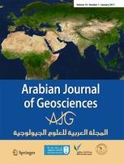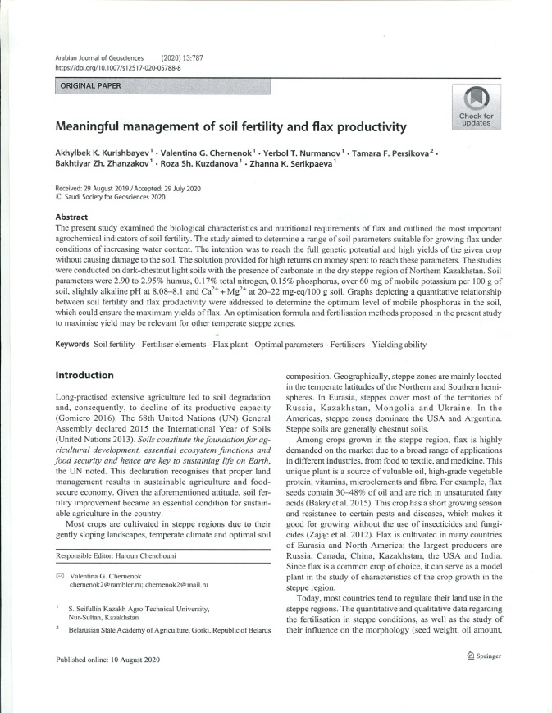

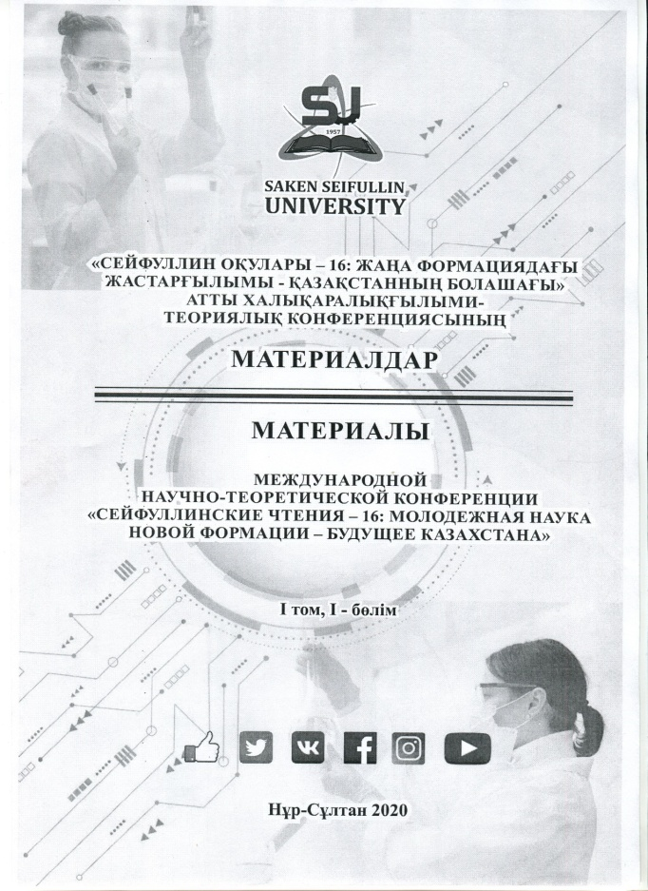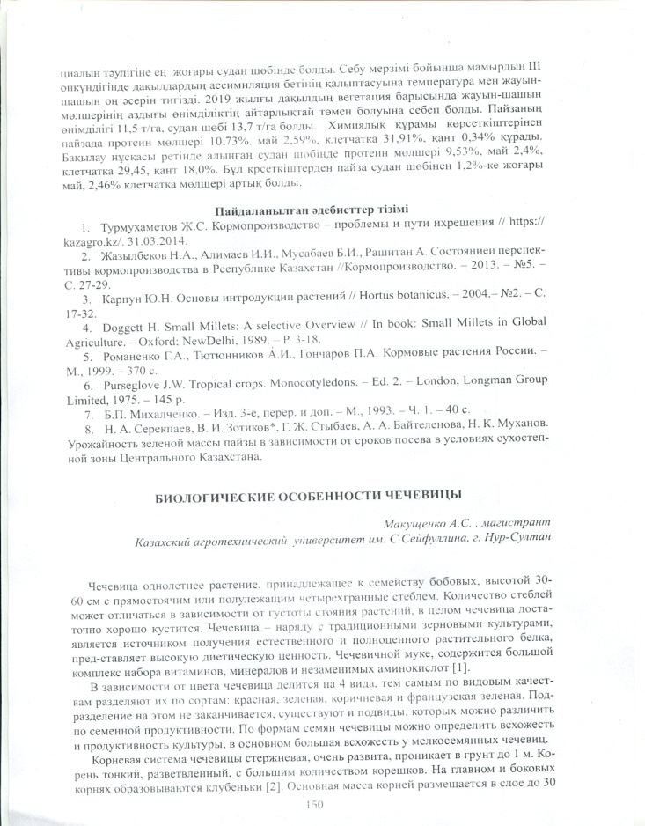

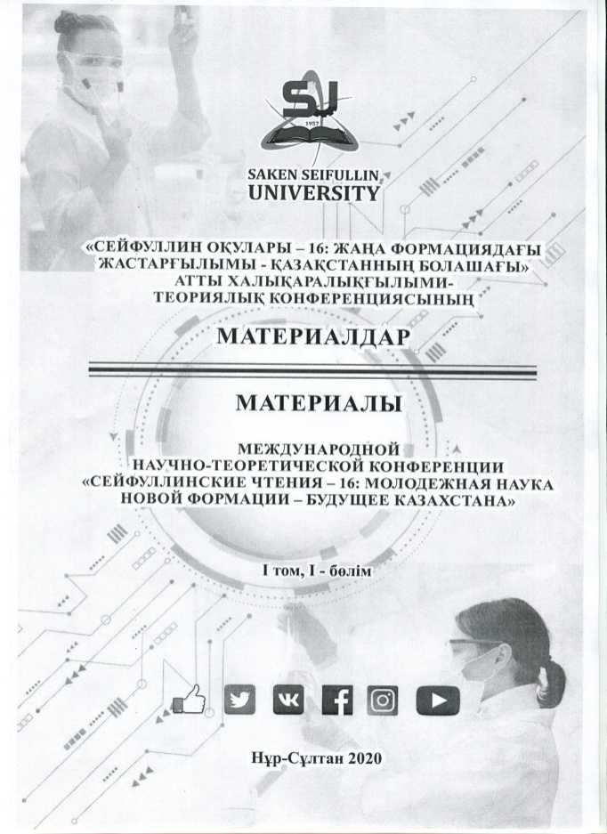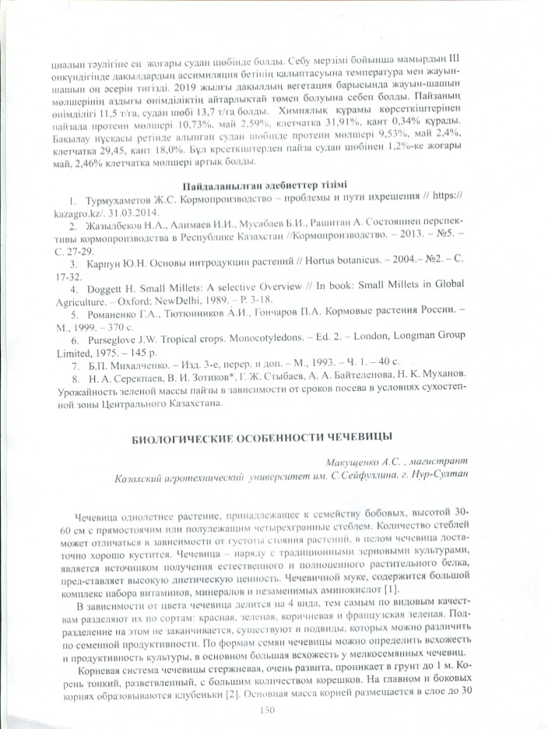

APPENDIX H
Utility model patent
