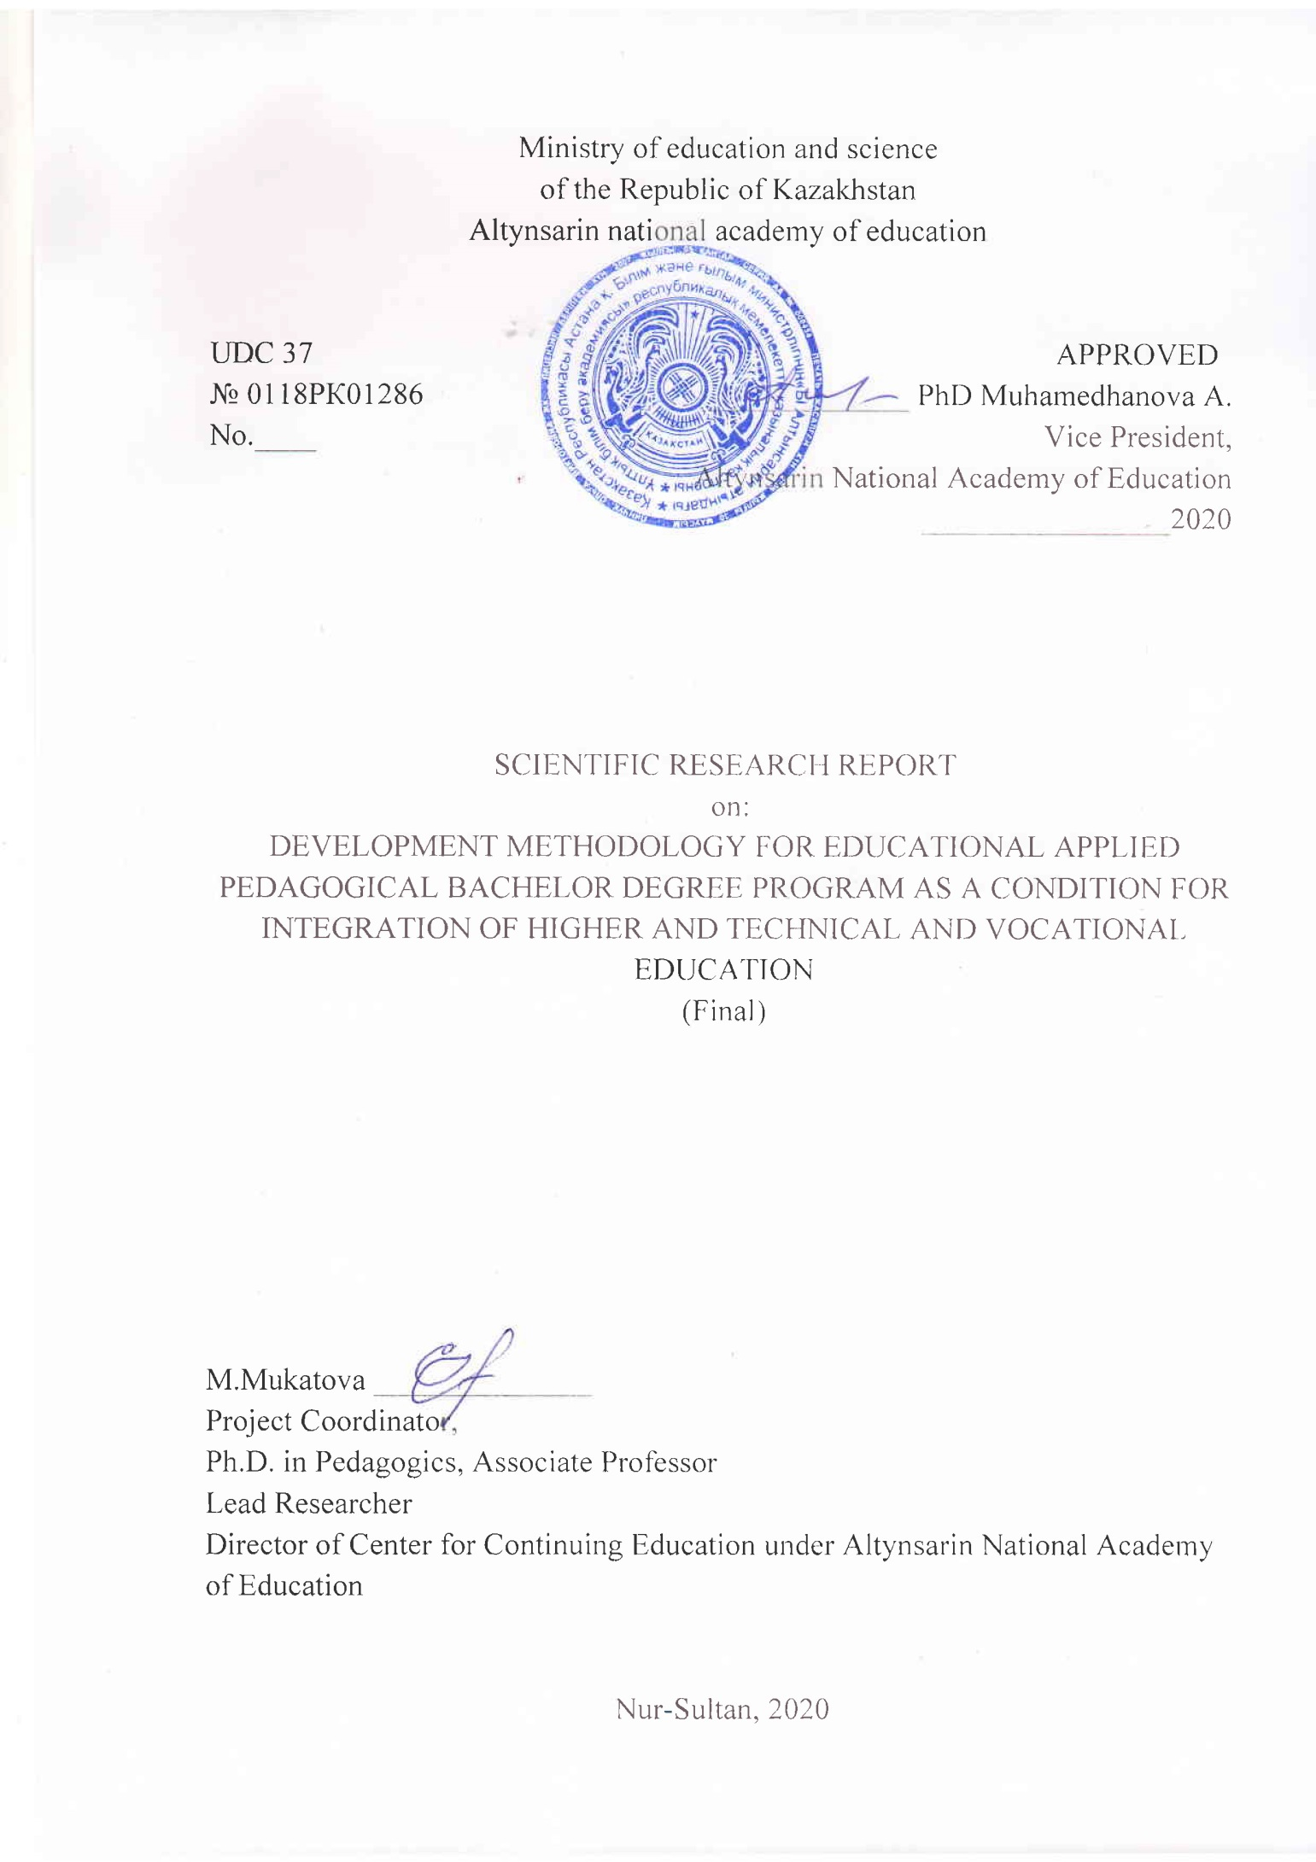

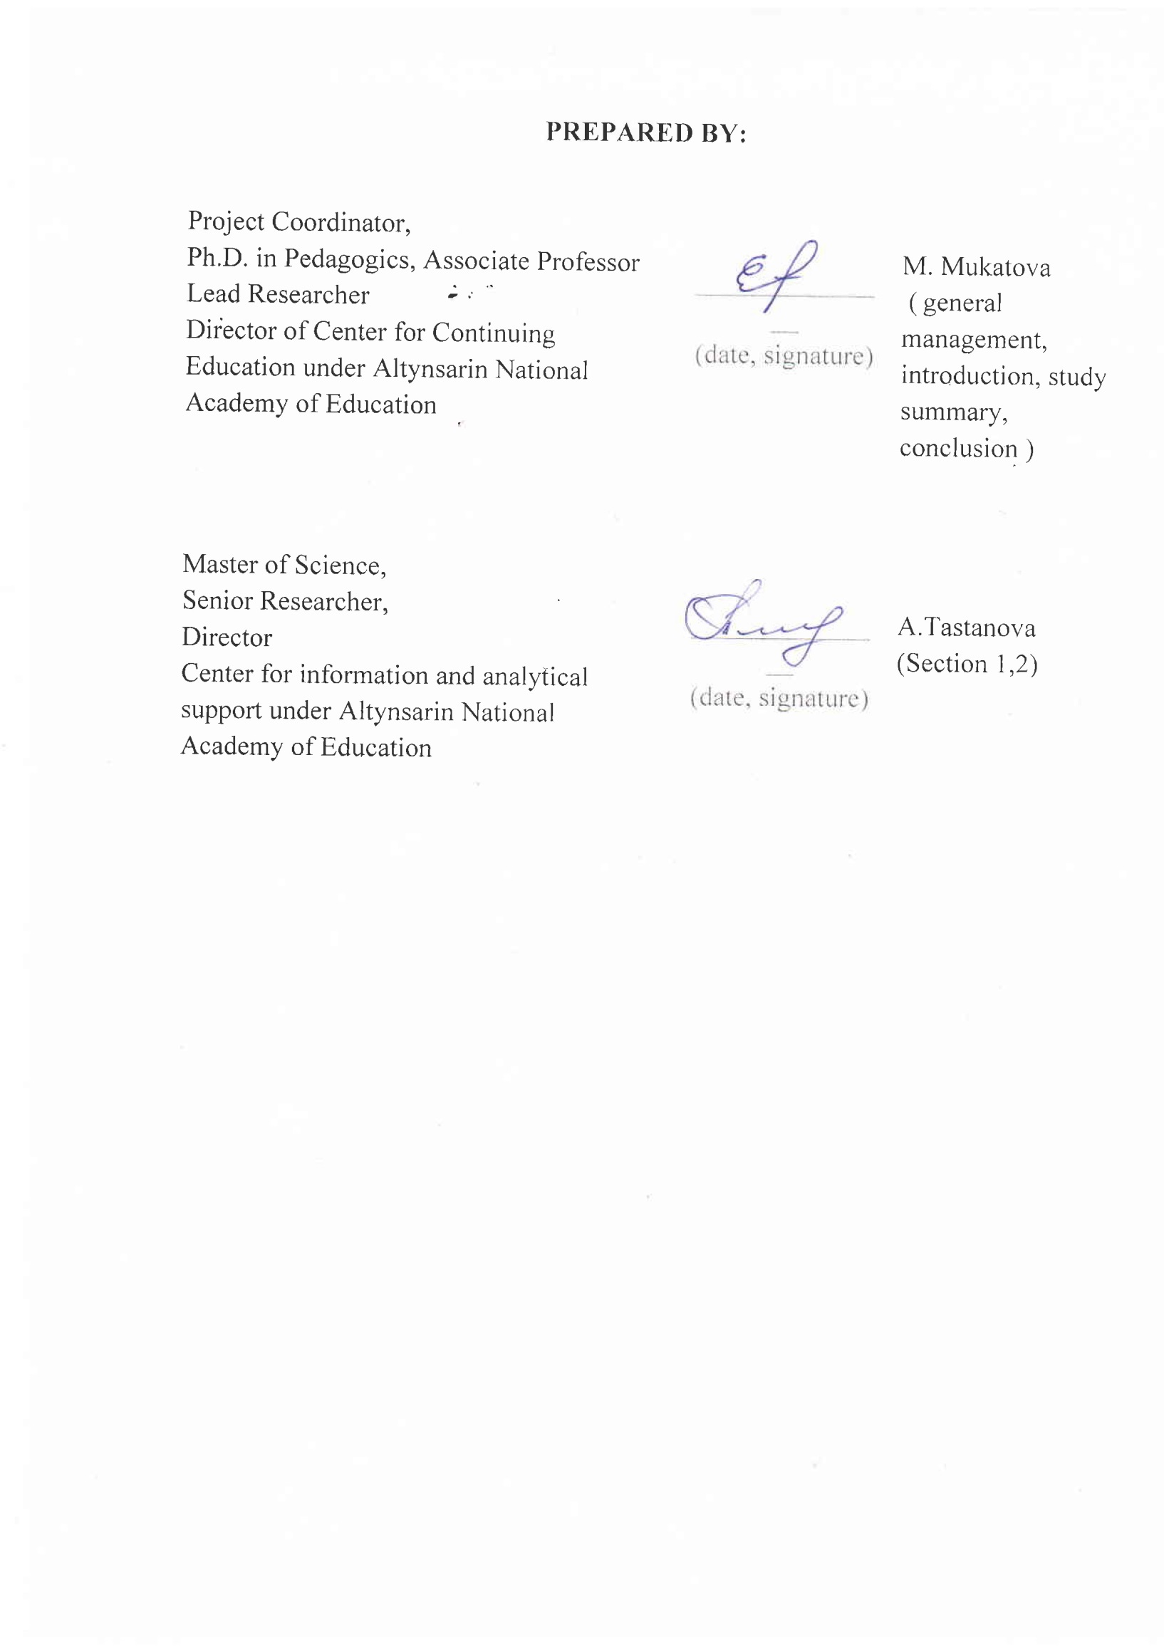 STUDY SUMMARY

Report – 235 pages, 2 tables, 1 figure, 15 resources, 9 annexes.
BACHELOR PROGRAMME, APPLIED BACHELOR PROGRAMME, EDUCATIONAL PROGRAMS, VOCATIONAL EDUCATION
Research object - educational programs of applied pedagogical Bachelor degree program.
Research objective - implementation of the applied pedagogical Bachelor educational program.
The methods and operations of theoretical and practical changes in the teacher education system (teacher training colleges and universities) were the main way to achieve the set objectives.
The research outcomes for the reporting period were published in 3 articles, two of them - in a journal with a non-zero impact factor, 1 - in a journal recommended by the Committee for Education and Science Control under the Ministry of Education and Science of the Republic of Kazakhstan (Annex G); a monograph was developed and published (Annex A); Analytical Report was developed and submitted to the Ministry of Education and Science of the Republic of Kazakhstan; methodological recommendations were developed (Annex C); author's program of advanced training courses was developed (training (basic) course) - Topical issues of training within the updating the content of education (for teachers of technical and vocational education) (Annex B); Certificate of entry into the state register of rights to objects protected by copyright No. 8739 dated March 12, 2020 (Annex H) was received.
Predictive assumptions about the research object development: further fundamental and applied scientific research is required to develop educational programs for applied pedagogical Bachelor degree, professional standards for pedagogical specialties of technical and vocational, higher and postgraduate education.

TABLE OF CONTENT

Introduction..…………………………………………………………………...........……8
1. Development methodology for applied Bachelor educational programs ……………..11
2. Educational programs of applied pedagogical Bachelor degree as one of the ways to integrate the levels of technical and vocational and higher professional education …..…18
Conclusion……….………………………………………………………………………..28
List of References………..……………………………………………………………….31
Annex А. Imprint of the monograph.……………………………………………….....33
Annex B. Authoring program…..……………………………………………………...41
Annex C. Methodological recommendations..…………………………………………74
Annex D. Draft educational program……………………………………………………80
Annex E. List of published articles……………………………………………………102
Annex F. Calendar plan…………………………………………………………………104
Annex G. Prints of published articles…………………………………………………..111
Annex H. Copyright Certificate………………………………………………………..232
Annex I. Order to establish an experimental group.…………………………………234

TERMS AND DEFINITIONS
In this R&D report, the following terms are used with the appropriate definitions
Descriptors - | means description of the level and scope of knowledge, abilities, skills and competencies obtained by students upon completion of the educational program of the corresponding level (stage) of higher and postgraduate education. Descriptors are based on learning outcomes, competencies formed, as well as the total number of credits as per the ECTS
European Qualifications Framework (EQF) - | means a tool to ensure the comparability of academic degrees and qualifications in EU member states which is developed and approved in the European Union
ECTS - | means European Credit Transfer System that indicates complexity of the student's work required to master the module
Expected learning outcomes - | mean a list of competencies (knowledge, abilities, skills) that students must master at the end of the module
Competencies - | mean ability of students to practically apply the obtained knowledge, skills and abilities in professional activities
Modules - | mean stand-alone learning units that are completed in terms of time and content, and defined and systematically organized through ECTS and expected learning outcomes
National Qualifications Framework - | means a structured description of qualification levels recognized in the labor market
Occupational standard - | means a standard that defines requirements to the level of qualifications and competence, content, quality and working conditions in a specific area of professional activity
Industry Qualifications Framework - | means a structured description of the qualifications levels recognized with the industry
Educational Program - | means an approved set of modules or course units required for the award of a specific degree/diploma. The development of educational programs usually takes into account the outcomes to be achieved, as well as a structured set of procedures and learning situations that will lead to the achievement of the specified results

LIST OF ABBREVIATIONS
In this R&D report, the following designations and abbreviations are used
BDP – | Bachelor Degree Program
TA – | Types of Activities
SP ED RK – | 2011-2020 State Program for Education Development in the Republic of Kazakhstan
SP AIID RK – | State Program for Accelerated Industrial and Innovative Development of the Republic of Kazakhstan
SCES RK – | State Compulsory Education Standards of the Republic of Kazakhstan  EQF - European Qualifications Framework
ECTS – | European Credit Transfer System
MDP – | Master Degree Program
MES RK – | Ministry of Education and Science of the Republic of Kazakhstan
MLSCP RK – | Ministry of Labor and Social Protection of the Population of the Republic of Kazakhstan
R&D – | research and development
GED – | general education disciplines
APA – | area of professional activity
SIW – | Students' Individual Work
SIWT – | Students’ Individual Work with Teacher
TUNING – | Tuning of educational structures in Europe

INTRODUCTION
The aim of the Continuing Pedagogical Education System is to create a more flexible, mobile, dynamic and cost-effective mechanism that would make it possible to quickly adapt to changing circumstances, optimally respond to the needs of the market and time [1]. Continuing Pedagogical Education System opens up opportunities for the personal and professional growth of a future specialist. Integration of educational curricula, elimination of duplication at different levels of education makes this system more profitable for the country in terms of material costs, obtaining opportunities for concentrating financial resources.
In the system of Kazakhstani education, the Applied Bachelor Program is becoming a universal form of obtaining professional pedagogical education wherein a significant place is paid to professional self-determination, formation of competencies and personal qualities that make it possible to constantly improve the professional level in accordance with the requirements of the modern labor market.
Analysis of domestic and foreign reference materials indicates that scientists are actively looking for new educational models that allow modernizing the system of pedagogical education in order to meet the social and economic needs of society in the context of innovative development. In the aspect of this study, the works of the following scientists were studied: V. Baydenko, N. Seleznyova, R. Vagenaar, I. Zimnyaya, A. Khutorsky, Y. Kovtun, U. Pak, N. Babenko and others, who reveal the main parameters of the Bologna process in their works [2-9].
Today, the TVE system faces a number of challenges that require immediate action. The entire system of personnel training is being transformed in accordance with the needs of Industry 4.0 and in view of the TVE social orientation.
In this regard, it is necessary to form a fundamentally new model of technical and vocational education. The main tasks for personnel training are determined by the State Program for Education Development until 2025; Program for Productive Employment and Mass Entrepreneurship.
From the point of view of practical orientation, the Applied Bachelor Program, as a type of higher professional education program of the first level, is the most viable for the TVE system at this stage. The main expected outcome of the Applied Pedagogical Bachelor Program implementation is an Applied Bachelor Degree Diploma with the professional qualification indicated, and the gradual refusal to train teachers in the system of technical and vocational education. The basis for this program development is the real market need for qualified teaching staff.
This explains the relevance of this study.
The study is aimed at experimental implementation of the applied Bachelor degree educational programs; monitoring; development of a methodology to form the applied Bachelor degree educational program, and, as a consequence, ensuring the integration of higher and TVE to improve the quality of teachers training; bringing the pedagogical education system in line with professional standards activities of a teacher and state general educational standards of the updated content.
The novelty of the study lies in the fact that in the course of work on the project, a Draft Educational Program for Applied Pedagogical Bachelor Degree was developed in the context of the integration of technical and vocational and higher pedagogical education in view of the provisions of the Bologna Declaration (Annex B).
As part of the Final Report, the following tasks were solved:
1) Development of a methodology for applied pedagogical Bachelor degree educational program;
2) Development of a strategy for the further educational trajectory of the experiment participants;
3) Development of recommendations to work out the applied pedagogical Bachelor degree educational program;
4) Consideration of ways to integrate higher and technical vocational education.
As a result of solving the problems, the methodology for development and implementation of the applied pedagogical Bachelor degree educational program was worked out, and the ways of continuity and integration of the professional education levels were determined.
The expected outcomes in solving these problems are the methodological base for the development of applied pedagogical education in Kazakhstan in the context of structural Bologna reforms that includes a conceptual model of education; practice-oriented model of the educational programs formation; a strategy for planning, achieving and measuring learning outcomes.
As part of a scientific study for 2018-2020, the R&D Interim Reports were submitted:
1) 0118РК01286, ИРН AP05133076-OT-18 dated 27.11.2018 (0118RK01286, IRN AP05133076-OT-18 dated 27.11.2018)
2) 0218РК00605, ИРН AP05133076-OT-19 dated 31.10.2019 (0218RK00605, IRN AP05133076-OT-19 dated 31.10.2019)

1 Development methodology for applied Bachelor educational programs
In 2014-2015, a division of Bachelor's degree into academic and applied was introduced in the Kazakhstani education system, and then amendments and additions were made to the Decree of the Government of the Republic of Kazakhstan dated August 23, 2012 No.1080 State compulsory standard of post-secondary education; Rules for organizing the educational process on credit education system implementing educational programs of technical and vocational education on the basis of which a model of a typical curriculum for training specialists in applied Bachelor's degree was first considered; as well as issues on the implementation of modules of general education and social and humanitarian disciplines.
In order to study the issue on theoretical and methodological basis of the academic and applied Bachelor degree, the current approaches in science to the implementation of practice-oriented pedagogical technologies in the vocational education system have been analyzed.
Some scientists (L. Solyankina, N. Koval and others) consider acmeological, integrative, competence-based, comprehensive and systemic approaches as theoretical and methodological basis of a practice-oriented educational environment that reveal the versatility, multilevel, multi-conditionality of professional competence specialist. Other researchers (A. Verbitsky, O. Larionova, F. Yalalov, etc.) suggest activity-competence, context-competence, personal approaches to practice-oriented learning [10]. Definitely, each of these approaches is aimed at solving the problems that arise in the implementation of a professional applied educational process. However, when determining the methodological foundations for the study of a pedagogical problem, the features of the main educational program in a specific direction of training; objects of professional activity; requirements imposed by society on a graduate in accordance with its profile should be considered as well. In order to determine the methodological requirements to implementation of an applied Bachelor's degree, an analysis of the existing levels of methodology in science was carried out, and the features of their use to resolve the existing problem were revealed.
The general scientific level of the methodology explores general scientific concepts affecting most of the scientific disciplines. In this regard, it made it possible to investigate the problem at an interdisciplinary level in view of the dynamics of essential intrasystem connections. Specifically, the scientific level of methodology made it possible to clarify the goals, content of the applied baccalaureate; describe the principles and procedures typical for a particular direction of training. The methodological and technological level made it possible to focus on the procedure of subjects interaction participating in the educational process; integrate various methods and forms of education within the implementation of the academic and applied Bachelor's degree.
It should be noted that the mentioned methodology levels are characterized by internal unity; they are interconnected and mutually complementary. Understanding of the pedagogical problem at three levels of methodology makes it possible to synthesize together several theoretical and methodological approaches previously known to pedagogical science, thereby creating a new configuration that allows determining the theoretical and methodological foundation for an optimal solution to the problem of introducing applied Bachelor degree in the educational process.
In accordance with SCES RK approved by Decree of the Government of the Republic of Kazakhstan dated August 23, 2012 No. 1080, at least 70% of the total number of classroom lessons should be practical lessons in disciplines of those curricula which provide forming students' professional skills [11].
Within this framework, the implementation of interdisciplinary connections will make it possible to establish what knowledge, abilities and skills are transformed from different academic disciplines; determine the source of interdisciplinary information (one, two or several academic disciplines); ensure the interaction of connecting elements when the obtained knowledge becomes not only a result but a direction of solving new interdisciplinary problems.
When implementing an applied Bachelor programme, it becomes necessary to revise the content of training materials in various disciplines from a highly specialized approach to an interdisciplinary one. This is also due to the fact that in practice, the specialists are faced with problems not of individual disciplines but with a problem of complex application of knowledge in all studied academic disciplines which form the general cultural and professional competencies. An interdisciplinary approach to the practice-oriented learning implementation contributes to development of a dialogue between teachers of various academic disciplines, thereby forming a well-coordinated system of organizing the process of professional training. From this point of view, the interdisciplinary approach is considered as one of the areas of professional development since the work arrangement within the interdisciplinary relationships encourages teachers to self-education and creativity.
The choice of the contextual approach as a specific scientific basis for the implementation of an applied Bachelor program is due to the modern demand of society for practice-oriented outcomes of the TVE educational programs.
The contextual approach is based on the theory of knowledge acquisition and social experience. In accordance with this theory, the acquisition of knowledge and experience is carried out through learning activity of the academic type students passing to quasi-professional activities, and ultimately, to the educational and professional activities. The central semantic category of the contextual approach is the context category. According to A. Verbitsky, the context means a system of internal and external conditions of human life and activity, which affects the perception, understanding and transformation of a particular situation giving meaning and significance to this situation as a whole and its components. The internal context is the individual psychological characteristics, knowledge and experience of a person; external - subject, social and cultural, spatio-temporal and other characteristics of the situation where he/she acts [12].
Following A.Verbitsky and others, when talking about contextual approach to the implementation of an applied (practice-oriented) Bachelor program, we mean the organization of educational process wherein the subject and social content of professional activity is imitated, thereby providing conditions for transforming the student's educational activity into future professional activity.
Thus, it is necessary to distinguish two components in modeling: subject-technological (subject context) and social (social context). At the same time, modeling of professional activity involves real professional situations and fragments from practical activity in all its subject and social ambiguity and contradiction.
The contextual approach implementation within the applied Bachelor program actualizes the problem of social partnership in professional education. Educational institutions that carry out educational activities for undergraduate programs involve employers in the educational process. The transition from quasi-professional activity to educational and professional activity is carried out during the industrial and educational internship.
Thus, within the applied Bachelor program, a close interaction of two interested parties is ensured and aimed at preparing graduates in accordance with the requirements and requests of specific employers. The modular approach acts as a methodological regulation of the applied Bachelor program.
Professional modules are characterized by interdisciplinarity and consist of a set of curriculum disciplines that are similar in logic and goals. The specific features of the module include interdisciplinarity, situationality, independence, integrity and flexibility. Situationality is achieved due to the structural module elements which are situations of professional activity of future Bachelors. The flexibility and dynamism of module shall be understood as the possibility of varying the complexity and volume of the training material, monitoring and evaluation system. The module integrity is represented by the existence of interrelated educational elements (goals, content of educational material, control system). The modular basis of the applied Bachelor program makes it possible to change the content of the educational material in view of the social order, and move away from the continuous teaching method through adapting the educational process to the individual capabilities and needs of students.
Synthesizing together interdisciplinary, contextual and modular approaches to the implementation of the applied Bachelor program, we conclude that the proposed theoretical and methodological basis of the applied Bachelor program makes it possible to implement the professional practice-oriented focus of the TVE educational process in the light of the SCES RK requirements through interdisciplinary connections, a clear sequence of all didactic elements; modeling a set of cultural and professional competencies to be formed and developed in the process of vocational education within the subject and social context; to form mechanisms of interaction between educational institutions and employers.
TVE programs can be modified into applied Bachelor programs by changing their content and format. The main difficulty in modifying TVE programs lies in the need to change the State educational standard for post-secondary education, professional standards (if any), and the recognition of TVE programs as higher education programs (applied Bachelor level). It seems possible to integrate the TVE and HVE programs in colleges which are the subdivisions of the HVE organizations.
Integration of TVE and HVE programs in colleges involves the creation of applied Bachelor program based on the TVE and academic Bachelor programs by adjusting their content. When implementing an applied Bachelor program, in fact, the transfer of TVE programs to the level of higher education takes place. This will increase the prestige of this type of education and attract applicants. Graduates of the new programs (who have completed the full course of study) will receive a diploma of the HVE.
The transfer of TVE to the applied Bachelor program does not imply the creation of fundamentally new programs of education and training, which are fundamentally different from specialists with secondary vocational education, but only provides for the adjustment of the content of the existing TVE programs and their transfer to the institutional level of higher education.
In the course of the research, the general and distinctive competences of students in applied and academic Bachelor programs were identified (Table 1).
Table 1 - General and distinctive competencies of students in applied and academic Bachelor program
Outcomes | Applied Bachelor Program | Academic Bachelor program
Extent of authority (general competence) | Readiness for independent professional activity with responsibility for its result at the level of the unit and (or) organization for activities that require the ability to set goals for their own work and/or subordinates; specify the tasks of activities within the unit; ensure the interaction of the work of the unit with related ones.
Complexity of activity (nature of skills) | Solving practical problems (if necessary, of a technological or methodological nature), involving a choice and variety of solutions. Development, implementation, adaptation, optimization of technologies (including innovative ones) and technological processes. Current and final control, assessment and correction of professional activity components | Solving scientific research problems of a theoretical and methodological nature, involving a choice and variety of solutions. Development, implementation, current and final control, assessment and correction of prof. activities components.
Science intensity of activity (nature of knowledge) | Synthesis of professional knowledge (including innovative) and practical professional experience. Independent search, analysis and evaluation of professional information. | Synthesis of professional knowledge (including innovative ones) and research experience. Independent search, analysis and evaluation of professional information.

Development and implementation of applied Bachelor educational programs are focused on solving the following tasks:
- preservation and development of practice-orientedness in the implementation of the higher education level;
- priority orientation of practice-oriented educational programs implemented by organizations of secondary vocational education (hereinafter - the TVE) on results that meet the requirements of professional standards of higher education; needs of industry labor markets and specific organizations and employers' enterprises that are the customers;
- ensuring the employment of graduates in accordance with the obtained level of qualifications;
- reduction of the adaptation period duration for graduates in the real production process.
When developing and implementing the applied Bachelor educational programs, it is recommended to apply:
- various models of interaction with potential employers (including cluster models);
- modular principle of designing an educational program and building curricula.

2 Educational programs of applied pedagogical Bachelor degree as one of the ways to integrate the levels of technical and vocational and higher professional education
In the process of modernization of pedagogical education in Kazakhstan, the practice-oriented training of students of pedagogical universities is of particular importance. The idea of practice-oriented education i.e. high readiness of a graduate for practical professional activity is not new. All over the world, the transfer of educational emphasis to practice gives good results. Young specialists successfully cope with pedagogical tasks immediately after graduation and starting a job [13]. Among many ways to implement practice-oriented education that meets the requirements of innovative economic development, the modern needs of society and every citizen, the system of applied Bachelor program is of great importance.
The introduction of applied Bachelor programs is aimed at ensuring the integration of professional higher education programs and technical and vocational education. And in this direction, active processes of reform are underway in the education system of Kazakhstan. However, all these processes are mainly aimed at the development of technical specialties. Whereas the future of modern civilization depends not only on the level of technical progress and economic growth [14], it is increasingly determined by the level of education. In this regard, the introduction of an applied pedagogical Bachelor program becomes relevant.
In recent years, the requirements for teaching staff have become much more complicated. If earlier only basic knowledge was required from middle-level specialists, today it is still necessary to have powerful theoretical training. Gradually, the training of specialists in organizations of technical and vocational education is approaching the level of higher education. A kind of hybrid of college and university is being created, where students can become full-fledged specialists. These two circumstances led to the need to create a system of applied pedagogical baccalaureate. Thus, the applied pedagogical Bachelor program is designed to combine the efforts of higher and technical and vocational schools taking the best forms of theoretical training from one and practical from the other.
Considering the international practice, specialists of the Altynsarin National Academy of Education have developed conceptual approaches to the modernization of pedagogical education in the Republic of Kazakhstan (1 Figure).
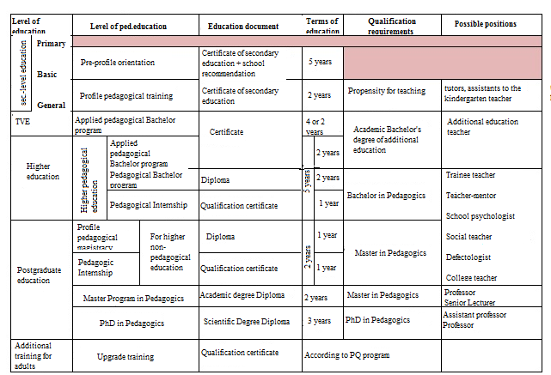
1 Figure - Levels of teacher education
Their distinctive feature is the updated structure and content of teacher education. In the proposed model, one of the levels of pedagogical education is the applied pedagogical Bachelor program both in the TVE system and at the level of higher education. This solution ensures the integration of educational programs at all levels of teaching staff training and allows graduates to find a job after each cycle. Of course, the solution of these problems will require changes not only in the content of teacher education but primarily in the regulatory framework.
In the Republic of Kazakhstan, education is governed by the norms of the Constitution, the Law On Education, as well as certain provisions of legislative acts affecting educational activities. The system of subordinate regulatory legal acts on education includes Decrees of the President of the Republic of Kazakhstan, Decrees of the Government of the Republic of Kazakhstan, Decrees of the Minister of Education and Science of the Republic of Kazakhstan, as well as Decrees of the collegiums of the Ministry of Education and Science of the Republic of Kazakhstan.
Thus, the training of specialists in the applied Bachelor program is provided for in the system of post-secondary education where the legal basis is provided by Article 20 of the Law on Education with the following postulate:
1. Educational programs of post-secondary education are aimed at training qualified staff, middle-level specialists and applied Bachelor from among others with secondary education (general secondary or technical and vocational).
2. The content of educational programs provides for the study of integrated, modular programs of technical and vocational education and individual disciplines of Bachelor program.
Upon completion of training and passing the final certification, students are awarded the qualifications of Mid-Level Specialist, Applied Bachelor.
The educational institution is regulated by Article 33 of the Law on Education, which states that:
1. Educational programs of post-secondary education are implemented in colleges and higher colleges.
2. The training of specialists in educational programs of post-secondary education is carried out in specialties, the list of which is approved by the authorized body in the field of education.
However, in Chapter 2 of the Law on Education, along with the competences of the Government of the Republic of Kazakhstan; the authorized body; local representative and executive bodies in the field of education, the competence of employers is not indicated. This violates the basic principle of the applied Bachelor program i.e. educational programs are developed at the initiative of employers and depend on the conjuncture in the job market.
General requirements for applied Bachelor program are established by the State Compulsory Standard for Post-Secondary Education.
However, in the current SCES RK, the requirements for the level of training, content of education, maximum scope of the study load are not defined for the applied pedagogical Bachelor program. Moreover, there is no mechanism for organizing and planning the educational process according to credit technology, which violates the integration principle of the applied pedagogical Bachelor educational programs and academic pedagogical bachelor degree (Table 2).

Table 2 - Analysis of the State Compulsory Standard for Post-Secondary Education
№ | Content of the State Compulsory Standard for Post-Secondary Education | Need to consider the requirements of the applied pedagogical Bachelor program
1 | 2 | 3
Requirements to the level of training of students
 | Educational programs of post-secondary education should be aimed at training qualified specialists, middle-level specialists and applied Bachelor specialists from among others with secondary education (general secondary or technical and vocational education). The requirements to the level of preparedness of students in post-secondary education organizations provide for the possibility of assigning an applied Bachelor degree (junior engineer) qualification upon completion of training.  Typical curricula should follow the curriculum model and may differ in the case of training:  1) specialists from among persons with special educational needs;  2) specialists in military, medical, culture and art specialties.  Syllabuses and working curriculum of post-secondary education organizations may differ from typical syllabuses and programs in the following cases:  1) work in experimental mode;  2) training of specialists from among persons with special educational needs.  When planning the educational process, post-secondary education developers are guided by a postsecondary syllabus model in accordance with Annex 1 to this standard.  When planning the educational process, the post-secondary education developers are guided by a post-secondary syllabus model with modular and credit training system in accordance with Annex 2 to this standard. | Applied pedagogical Bachelor educational programs should be aimed at training practice-oriented specialists with the award of an Applied Bachelor qualification.  The content of applied pedagogical Bachelor programs should be developed in view of the requirements of employers and based on a modular-competence approach
Requirements to the content of education
 | 10. Content of educational programs of post-secondary education provides:  1) study of integrated courses in general education subjects that are profiling for the development of general professional and special disciplines including those integrated into modules; passing industrial training and professional practice for acquiring professional skills;  2) study of general humanitarian, economic, general professional, special disciplines; undergoing industrial training and professional internship for the acquisition and consolidation of professional skills; | Основные правила организации и планирования учебного процесса по кредитной технологии не отражены в ГОСО
Continuation of Table 2
1 | 2 | 3
3) study of integrated, modular programs of technical and professional, post-secondary education and individual disciplines of Bachelor program;
4) assignment of qualifications (category, class) based on the results of qualifying exams;
5) upon completion of training, assignment of an Applied Bachelor Qualification.
При этом образовательные программы послесреднего образования структурируются по принципу модульно-кредитного обучения.
Requirements to the study load
 | The maximum study load including all types of classroom and extracurricular work should not exceed 54 hours per week.  The scope of classroom studies for those enrolled in the full-time form of education is at least 36 hours per week during the period of theoretical training, excluding optional disciplines and consultations. | Academic load in the applied pedagogical Bachelor program should be planned according to the rules of credit system.

As per the analysis, the State Compulsory Standard for Post-Secondary Education does not provide for the formation of educational programs for applied pedagogical Bachelor degree taking into account the organization of the educational process using credit system.
Moreover, the standard qualification characteristics of the teaching staff positions and persons equated to them, approved by order of the Minister of Education and Science of the Republic of Kazakhstan dated July 13, 2009 No. 338, determine the titles of teaching staff positions [15]. Along with this, there are no positions that suggest the level of professional training of an employee - Applied Pedagogical Bachelor Degree (for example, the position of educator at the preschool education and training organization). Qualification requirements: higher pedagogical or technical and vocational pedagogical education, etc.
The President of the Republic of Kazakhstan recommended that the Government of the country, when preparing proposals for the formation of a technical and vocational education system, provide for the measures of a legislative, economically stimulating and organizational nature. In particular, the Government was recommended to accelerate the adoption of the Law On Professional Qualifications; take measures to update the infrastructure and material and technical base of TVE; create conditions to form the modern engineering and teaching staff.
The National Chamber of Entrepreneurs was advised to legally oblige organizations to carry out professional internships and vocational training at enterprises; provide places for students to practice their skills, as well as additional salaries for mentoring etc. Moreover, Article 140.4 of the Labor Code was amended to the effect that the employer promotes educational institutions that implement educational programs for technical and vocational education; training; retraining and advanced training of personnel. At the same time, the legislator did not specify how the employer is obliged to assist educational institutions, including organizations that implement post-secondary education, to which the applied pedagogical Bachelor program belongs.
Today in Kazakhstan, there are about 20 organizations for certification of specialists. Five of them work in accordance with international requirements. Created Councils for TVE make key decisions on personnel issues throughout the country. At the level of industries and regions, 16 regional councils under Akimats (local administration) and sectoral councils under central government bodies have been created to address personnel training issues. However, their activities mainly affect the field of technical education.
Thus, the analysis of the normative legal acts allows us to conclude that the current legislation does not regulate the activities of the applied pedagogical Bachelor program. There are no by-laws that define the status of applied pedagogical Bachelor program; the rules for organizing and planning the educational process are not defined. In the Classifier of Professions and Specialties, the qualification of an applied Bachelor program is not defined. Mechanisms of interaction with employers are not specified.
In this regard, a necessary condition for the functioning and development of an applied pedagogical Bachelor program is the existing stable legislation that fully ensures its effective legal regulation.
First, it is necessary to amend the Law on Education:
- Introduce the concept of applied pedagogical Bachelor program;
- Introduce an applied pedagogical Bachelor program at the TVE level;
- Determine the terms of training:
- applied pedagogical Bachelor program on the TVE basis - 4 years, on HVE basis - 2 years;
- higher pedagogical education - 5 years;
- postgraduate pedagogical education - 5 years.
4) Introduce a teaching internship.
5) Outline the competencies and powers, functions and responsibilities of employers. For instance:
- participation of representatives of pedagogical associations in the work of national and sectoral councils for the education development;
- participation in the development of the national qualification system:
- participation in the development of the state general educational standard and typical curricula for pedagogical specialties;
- participation in the development of qualification requirements to teaching professions;
- involvement of teaching staff in the examination of the developed programs for the training and retraining.
Second,
- determine the status of the applied Bachelor program;
- introduce the profession of a mentor;
- develop a mentoring system through partnerships with employers in the typical qualification characteristics of teaching staff positions:
Third, develop SCES for post-secondary education in view of the organization and planning of the educational process using credit system.
Thus, it is recommended to amend requirements to qualification level:
- Applied Pedagogical Bachelor program aimed at training practice-oriented specialists with the award of the Bachelor academic degree.
- Level of students provides for the identification of basic and professional competencies.
- Basic competencies are developed in general for the specialty and address issues of social responsibility, work organization, relationships with other people in the workplace, as well as responsibility for the environment.
- Professional competencies are developed for each qualification based on a professional standard in view of the requirements of employers and the social demand of society.
- Cycles of basic and professional modules include modules/disciplines of a mandatory component and an optional component.
- List of modules/disciplines of the compulsory component is determined by the standard curriculum.
- List of modules/disciplines of the optional component is determined by the educational organization independently.
- Scope of the compulsory component of professional modules is at least 70% of the total time allotted for the study.
Scope of optional component of professional modules/disciplines is no more than 30% and makes it possible to:
- expand the main types of activity for which a graduate who has mastered the applied pedagogical Bachelor educational program should be ready;
- ensure training determined by the content of the compulsory component;
- obtain additional competencies required to ensure the competitiveness of a graduate in accordance with the demands of the regional labor market and the possibility of continuing education.
The optional component takes into account the specifics of the social and economic development of a particular region and the needs of the labor market, as well as the individual interests of a student itself.
An optional component is formed according to the proposals of employers and partners of the educational organization, subject and cycle commissions/departments.
The cycle of basic modules includes social and economic, general humanitarian, general professional modules / disciplines.
The educational activities are carried out through the planning of the educational process; content of education; selection of methods for lessons; independent work of students; forms of final control of their educational achievements.
Introduce the following into the requirements to the content of education:
Applied pedagogical Bachelor educational programs are structured on the basis of a competency-based approach using credit technology of education and are focused on the learning outcome.
Introduce the following in the requirements to the study load:
The scope of a student's workload is measured in credits acquired during the academic year for each educational module/discipline or type of academic work.
One academic hour of in-class and out-class work (SRO), all types of internship, intermediate and final certification shall be 45/50 minutes.
Planning of the teaching load of teaching staff and persons equated to them is carried out in credits or academic hours i.e. the time of the teacher's work with the students according to the in-class and out-class works schedule (SROP) or approved schedule for other types of educational work.
When planning the scope of academic work, it is assumed that one credit is equal to 18 academic hours:
1) in-class work of a student throughout the academic period in the form of a semester;
2) work of a student with a teacher during the period of professional internship;
3) student's work on writing and defending the diploma project (work);
4) student's work on the preparation and delivery of intermediate and final certification in the specialty.
The study load of a student is determined by the duration of the academic hour and the volume of hours accompanying the academic hours for different types of academic work.
Independent work of students (SRO) is divided into two parts: independent work to be performed under the guidance of a teacher (SROP), and the part, which is performed completely independently by a student (SROS). The entire scope of the SRO is confirmed with tasks that require the student to work independently on a daily basis.
The academic hours of the student's in-class work shall be supplemented with the corresponding number of SRO hours so that one credit is equal to 3 hours, incl. 2 hours for SRO.
Physical education classes shall not be accompanied by additional SRO hours.
Educational internship, industrial training shall not be accompanied by SRO hours.
Each academic hour of industrial and pre-diploma internship shall be accompanied by 2 hours of SRO.
Each academic hour of interim and final certification shall be accompanied by 5 hours of SRO.
Each academic hour of writing and defending a diploma project (work) shall be accompanied by 11 hours of SRO.
The academic year consists of academic periods; a period of intermediate certification; internship and vacations. Upon completion of the achieved level, the period of final certification is included in the academic year.
Thus, the proposed changes to the content of legislative acts will provide:
- regulatory support for the implementation of the applied pedagogical Bachelor program;
- applied pedagogical Bachelor educational programs will allow to create a unified set of documents uniting programs of technical and professional and higher education;
- equal School-College-University partner system;
- implementation of the credit training system.

CONCLUSION
Within the scientific project in 2019, on the basis of the Akhmetov Pedagogical College (Pavlodar city), an applied pedagogical Bachelor educational program in Primary Education was introduced as an experiment with a training period of 2 years 10 months.
The expediency of the experiment conducting was due to modern trends in the development of the teacher education system and new requirements of the labor market. There is a need to train teachers who can optimally combine basic knowledge and practice-oriented competencies. This form of teacher training is an applied pedagogical Bachelor program that provides a connection between practice-oriented training inherent in the TVE system and the basic fundamental component carried out in universities.
In the course of scientific research:
- the labor market of the region was studied;
- priority areas for training teachers in the region were identified;
- an agreement was signed to conduct an experiment;
- an educational program was developed in Primary education for Applied Bachelor of Primary Education qualification 0105104.
When developing the educational program, the following requirements were considered:
- Professional standard of the Teacher;
- National qualifications framework;
- Classifier of professions of the Republic of Kazakhstan.
The educational program was developed using a modular model using credit training system. This model makes it possible to integrate educational programs of TVE and the university; recognize learning outcomes by levels of education and ensure freedom in the formation of an individual educational trajectory.
The Educational program structure makes it possible to:
1) change up to 50% of the study time allocated for mastering the training material for cycles and modules; up to 50% for each discipline (module) and up to 50% of industrial training and professional internship, while maintaining the total number of hours for training. If necessary, the disciplines of each module and individual disciplines are integrated into other modules;
2) in accordance with the needs of employers, change the content of curricula up to 50% in disciplines integrated into the modules and up to 50% in the vocational module, industrial training and professional internship. Introduce additional professional modules at the request of employers while maintaining the total number of hours for training.
At the second stage of the experiment, the main characteristics and approaches to determining the individual educational trajectory of students were considered.
Analysis of the reference materials showed that individualization of training can be carried out in several directions. First, the individualization of the education content is implemented with the help of individual curricula, and can also be independently supplemented through participation of a student in independent and research work. Secondly, a student has the opportunity to individually select several levels of education. Nevertheless, it is obvious that these technologies cannot be called individual in full measure. Despite the fact that the existing system implies the individualization of learning through the variable part of the curriculum, it is often not fully implemented.
However, the process of forming an individual educational trajectory in the context of an applied pedagogical Bachelor program can be considered from several positions or approaches. Thus, an individual educational trajectory is a purposeful projected differentiated educational program that provides a student with the opportunity to select, form and implement an educational program.
In the context of a modular approach, an individual educational trajectory is a set of modules (basic and variable parts of the curriculum) that allow a student to successfully implement not only its own learning needs but meet the requirements of educational standards.
Thus, an individual educational trajectory is a training plan drawn up together with a teacher-mentor based on an analysis of the student's existing experience and the educational stages previously passed. At the same time, the role of a teacher in this process is emphasized with the tasks including support of the professional self-determination and self-realization of a student.
The analysis made it possible to conclude that the development of an educational program using a modular model of credit system provides students with conditions for individual trajectory as well as an opportunity to choose an individual route in education.
In order to develop a strategy for the further educational trajectory of the experiment participants, it is necessary to consider that the free and independent choice of content and forms of activity requires the following:
- definitions in the educational program of variable sections and the possible amount of hours for studying educational material at the request of students;
- definitions in the educational program of the types and forms of work, as well as variable tasks, providing for the voluntary choice of research and teaching tools by students in view of the specific conditions, capabilities and prospects;
- development of practical tasks and reporting documents in view of the different levels of preparedness, creativity, professional interests and professional prospects of students;
- creating situations of various professional tests in research and teaching activities;
- stimulating creative activity and research activities of students.
However, the successful implementation of the free and independent selection of the content and forms of activity shall be possible, if a student is aware of professional tasks; objectively assesses its abilities; understands the methods of pedagogical process and the reasonable selection of educational means.

LIST OF REFERENCES
- Государственная программа развития образования Республики Казахстан на 2020-2025 годы, утвержденная Правительством Республики Казахстан от 27 декабря 2019 года, № 988. (in Kazakh)
- Болонский процесс: середина пути / Под науч. ред. д-ра пед. наук, профессора В.И. Байденко. - М.: Исследовательский центр проблем качества подготовки специалистов Российский Новый Университет, 2005. - 379 с. ( in Russian)
- Болонский процесс: Результаты обучения и компетентностный подход (книга приложение 1) / Под науч. ред. д-ра пед. наук, профессора В.И. Байденко. – М.: Исследовательский центр проблем качества подготовки специалистов, 2009. – 536 с. (in Russian.)
- Болонский процесс: европейские и национальные структуры квалификаций (Книга приложение 2) / Под науч. ред. д-ра пед. наук, профессора В.И. Байденко. – М.: Исследовательский центр проблем качества подготовки специалистов, 2009. – 220 с. (in Russian)
- Селезнева Н.А. Размышления о качестве образования: международный аспект // Высшее образование сегодня. - 2004. - №4. - С. 35-44. (in in Russian)
- Вагенаар Р. Накопление кредитов, компетенции и определение результатов обучения // Материалы конференции EUA и Швейцарской конфедерации. – Цюрих.- 2002. (in Swedish.)
- Зимняя И.А. Ключевые компетентности как результативно-целевая основа компетентностного подхода в образовании. Авторская версия. - М.: Исследовательский центр проблем качества подготовки специалистов. 2004. – С.40. (in Russian)
- Хуторской А.В. Ключевые компетенции как компонент личностно-ориентированной парадигмы образования // Ученик в обновляющейся школе. Сборник научных трудов // Под ред. Ю.И. Дика, А.В. Хуторского.- М.: ИОСО РАО.- 2002. -С.135-157. (in Russian)
- Ковтун Е. Н. Модель построения основных образовательных программ по гуманитарным направлениям подготовки на основе методологии TUNING-ECTS для реализации принципов Болонского процесса в России. Направления подготовки ВПО «История» и «Культурология». - Челябинск, 2010 (in Russian)
- Матрос Д.Ш. и др. Управление качеством образования на основе новых информационных технологий и образовательного мониторинга. [Текст] - М.: Пед. о-во России, 2009.-96 с (in Russian.)
- Мониторинг региональных образовательных систем: Анализ результатов и рекомендации для органов управления образованием территорий /Под общ. ред. А.Н. Майорова. [Текст] - М.: Полиграф сервис, 1999.-224с. (in Russian.)
- Управление качеством образования: Сб. метод. материалов /Сост. О.Е. Лебедев. [Текст] - М.: Российская политическая энциклопедия (РОССПЭН), 2002. - 128 с. (in Russian)
- Васильев, В.Г. Опыт, высокий профессионализм и качество образования. Этюд об инновационном образовании /В.Г. Васильев//Вопросы образования. – 2009. – № 2 (in Russian)
- Фрумин, И.Д. Введение программ прикладного бакалавриата в российскую систему образования: зачем и как?//Вопросы образования/ И.Д. Фрумин.—2010. – C.247-267 (in Russian)
- Об утверждении Типовых квалификационных характеристик должностей педагогических работников и приравненных к ним лиц. Приказ Министра образования и науки Республики Казахстан от 13 июля 2009 года № 338. Типовые Квалификационные характеристики - в редакции приказа Министра образования и науки РК от 30.04.2020 № 169 (in Kazakh)

ANNEX А

Monograph

MINISTRY OF EDUCATION AND SCIENCE OF THE REPUBLIC OF KAZAKHSTAN
NATIONAL ACADEMY OF EDUCATION. I.ALTYNSARINA

DEVELOPMENT METHODOLOGY FOR EDUCATIONAL APPLIED PEDAGOGICAL BACHELOR DEGREE PROGRAM AS A CONDITION FOR INTEGRATION OF HIGHER AND TECHNICAL AND VOCATIONAL EDUCATION

COLLECTIVE MONOGRAPH

NUR-SULTAN 2020
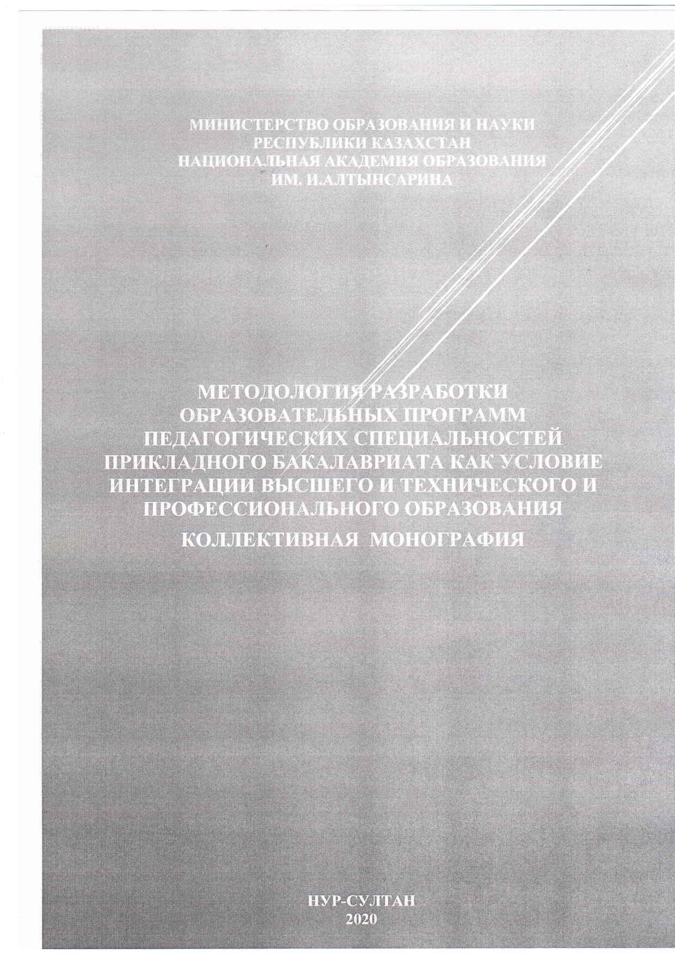
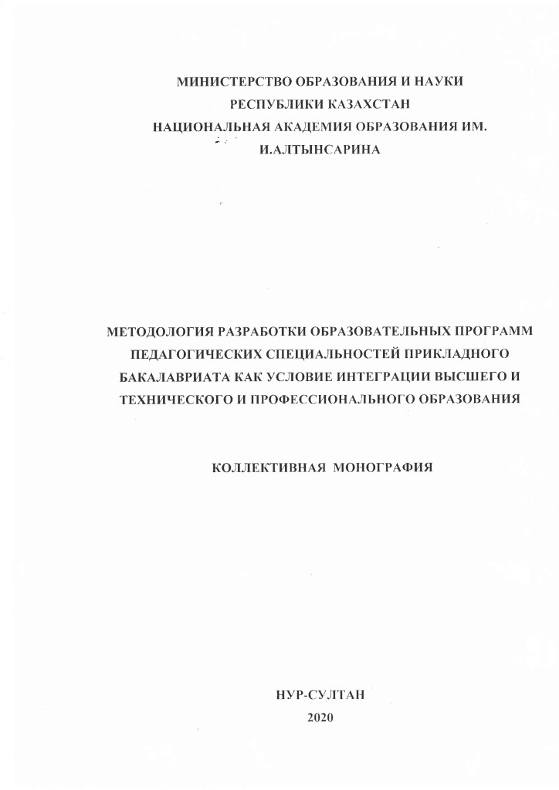

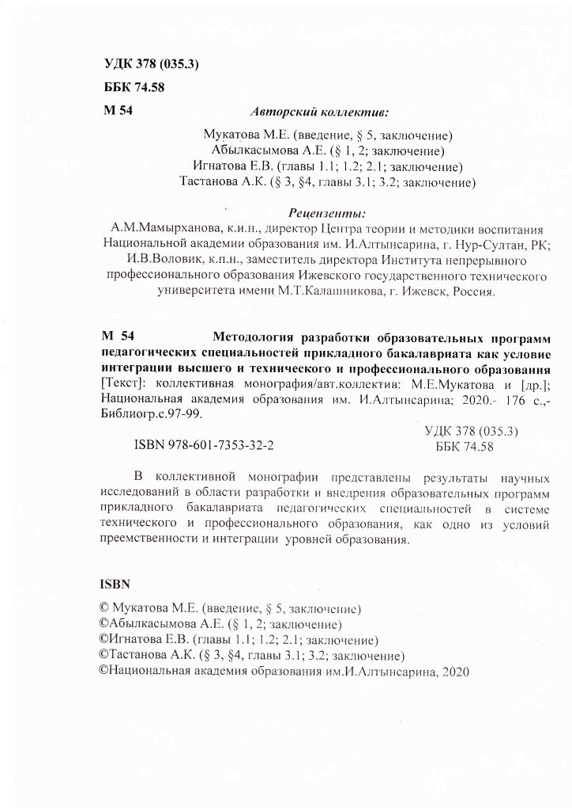

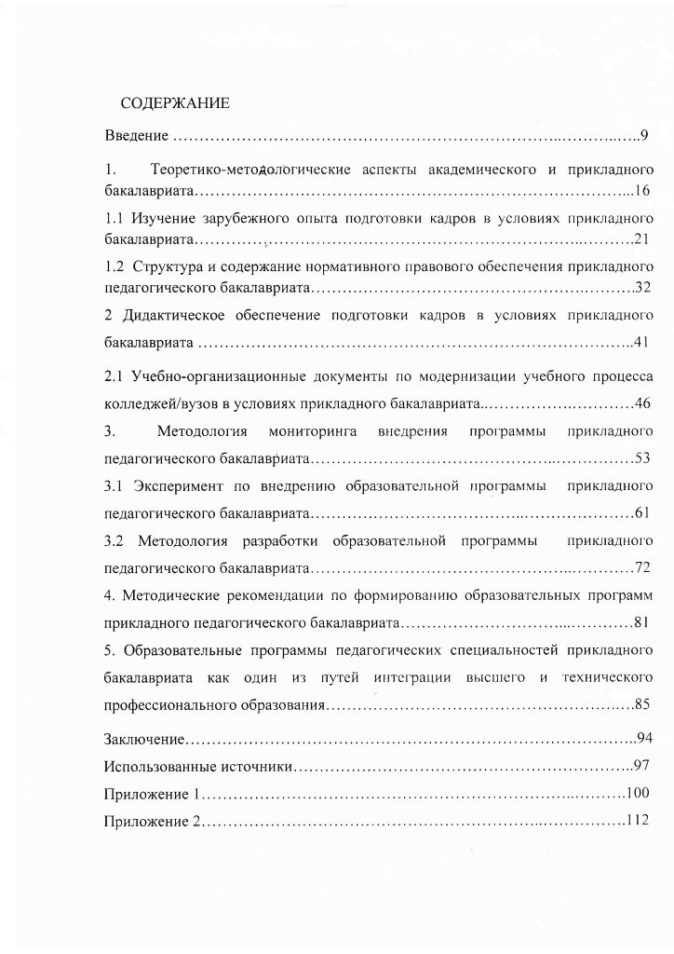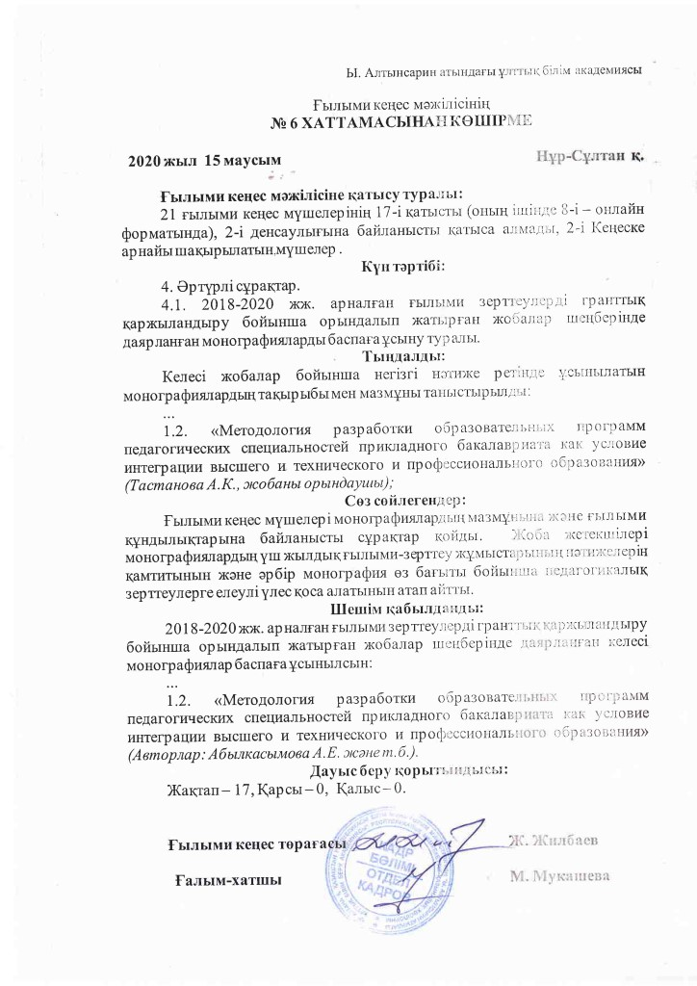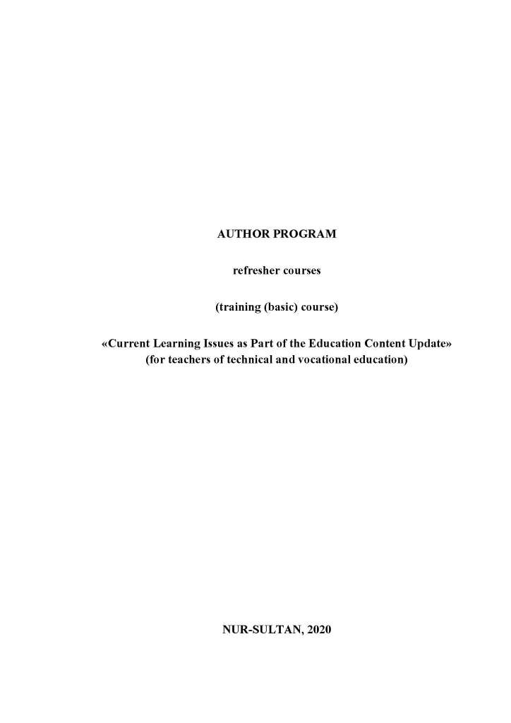

ANNEX B

Author program

Қазақстан Республикасы Білім және ғылым министрлігі Министерство образования и науки Республики Казахстан

Ы. Алтынсарин атындағы Ұлттық білім академиясы Национальная академия образования имени И. Алтынсарина

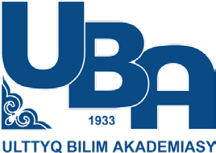

АВТОРСКАЯ ПРОГРАММА
курсов повышения квалификации (тренинговый (базовый) курс)
«Актуальные вопросы обучения в рамках обновления содержания образования»
(для педагогов технического и профессионального образования)

Нур-Султан, 2020

Ы.Алтынсарин атындағы Ұлттық білім академиясының Ғылыми кеңесімен ұсынылды
Қазақстан Республикасында педагог қызметкерлердің біліктілігін арттырудың жаңа моделінің тұжырымдамалық негізі халықаралық білім беру қоғамдастығы қабылдаған білім беру парадигмасы болып табылады, ол педагогтерді өзін-өзі жетілдіруге және өзін-өзі кәсіби жағынан көрсетуге, педагогикалық еңбектің сапасы мен тиімділігін арттыруға бағыттайды.

Авторлық ұжым:

Ы.Алтынсарин атындағы Ұлттық білім академиясының вице- президенті п.ғ.к., доцент А.К. Мухамедханова
Ы.Алтынсарин атындағы Ұлттық білім академиясы Үздіксіз педагогикалық білім беру орталығының директоры, педагогика магистрі, М.К.Аммосов ат. СШФУ аспиранты А.К. Тастанова

© Ы.Алтынсарин атындағы Ұлттық білім академиясы, 2020
Барлық құқықтар қорғалған. Осы басылымды кез келген түрінде және кез келген құралдармен, фотокөшірмені және кез келген электронды нұсқаны қоса алғанда, авторлық құқық иесінің жазбаша рұқсатынсыз толық немесе ішінара басып шығаруға немесе таратуға тыйым салынады.

МАЗМҰНЫ

Кіріспе................................................................................................
Ұйымдастырушылық-педагогикалық талаптар
Бағдарлама паспорты
Оқыту мазмұны
1-бөлім. Білім мазмұнын жаңартудың тұжырымдамасы
2-бөлім. Білім мазмұнын жаңартудың нормативтік құқықтық негіздері
3-бөлім. Оқыту нәтижелерін критериалды бағалау жүйесі
4-бөлім. Жалпыадамзаттық құндылықтар негізіндегі тәрбие жұмысы
5-бөлім. Жаңартылған оқу бағдарламалары бойынша оқыту процесінде құжаттама жүргізу
6-бөлім. Білім мазмұнын жаңартуды ескере отырып КжТБ педагогикалық мамандықтарының білім беру бағдарламаларын әзірлеу
Курстан кейінгі қолдау көрсету жоспары
Ұсынылған әдебиеттер тізімі

КІРІСПЕ

Болашақ педагогтің бәсекеге қабілеттілігін қалыптастыру Қазақстан Республикасында педагогикалық білім берудің басым міндеттерінің бірі болып табылады. Ол бірқатар факторларға негізделген. Олардың ішінде жаһандану, интернационалдандыру, интеграция, әртараптандыру, ізгілендіру, гуманитарландыру, үздіксіздік, практикаға бағытталған оқыту, компьютерлендіру, цифрландыру, смарт және стем-технологиялар бар. Бұлар белсенді, құзыретті, бәсекеге қабілетті және мобилді тұлғаның жаңа мәдени келбетінің қалыптасуы сияқты соңғы нәтижемен контексте барлық ұлттық білім беру жүйесінің бәсекеге қабілеттілігін арттырумен қатар жүреді.
Демек, педагогикалық білім берудің қазіргі заманғы жүйесі үшін болашақ мұғалімдердің еңбек нарығы жағдайында сұранысқа ие және бәсекеге қабілетті болатын құзыреттілік жиынтығын меңгеруіне бағдарланған педагогтерді даярлау тән болуы тиіс.
Педагогтің кәсіби қызметінің табысты болуын айқындайтын бәсекеге қабілетті болашақ құзыреттілігін іріктеу және сипаттау үшін заманауи кәсіби қызметті түсіну, жұмыс берушілердің пікірі, қолда бар нормативтік құжаттарды талдау, сондай-ақ білім беру мекемелерінің қызметкерлері мен түлектерінің құзыреттілігін бағалаудың шетелдік тәжірибесін талдау бағдар болуға тиіс.
Жаңа мемлекеттік білім беру стандарттарында көрсетілген мектептегі білім сапасына қойылатын жаңа талаптар, педагогтің кәсіби стандартын бекіту болашақ педагогтерді даярлауды ұйымдастыруға, мазмұнына, технологияларына және ауқымына өзгерістер енгізу қажеттілігін көрсетеді.
Қазақстан Республикасы Үкіметінің 2019 жылғы 27 желтоқсандағы
№ 988 Қаулысымен бекітілген Қазақстан Республикасының Білім және ғылымын дамытудың 2020-2025 жылдарға арналған мемлекеттік бағдарламасын іске асыру мақсатында жалпы елдің педагогикалық әлеуетін дамыту саласындағы бірқатар проблемаларды және педагогтерді техникалық және кәсіптік білім беру (бұдан әрі - ТжКБ) деңгейінде даярлау мәселелерін шешу қажет.
Қазақстанның педагогикалық білім беруін жаңғырту үдерісінде педагогикалық колледж студенттерінің практикаға бағытталған дайындығы ерекше маңызды. Практикалық-бағдарлы білім беру идеясы – бітірушінің практикалық кәсіби қызметке жоғары дайындығы – жаңалық емес, бүкіл әлемде білім беру акценттерін практикаға көшіру жақсы нәтиже береді, жас мамандар оқуды бітіргеннен кейін жұмысқа шығысымен бірден педагогикалық міндеттерді табысты орындайды. Алайда, бұрын орта буын мамандарынан тек базалық білім талап етілсе, бүгінгі күні мықты теориялық дайындыққа да ие болуы қажет. Техникалық және кәсіптік білім беру ұйымдарында мамандарды даярлау бірте-бірте педагогикалық білім берудің жаңартылған құрылымы мен мазмұны бар жоғары білім деңгейіне жақындап келеді, бұл педагог кадрларды даярлаудың барлық деңгейлерінде білім беру бағдарламаларын интеграциялауды қамтамасыз ету дегенді білдіреді.
Қазіргі уақытта жалпы орта білім беру деңгейінде білім беру мазмұнын жаңартуды енгізу аяқталу сатысында, 2020-2021 оқу жылында жаңартылған білім беру мазмұнының оқу бағдарламаларымен республиканың жалпы білім беретін мектептерінің 11-сыныптары оқытылатын болады. Орта білім берудің жаңартылған мазмұны оның негізгі сипаттамаларын: үш тілді білім беруге көшу, функционалдық сауаттылықты дамыту (математикалық, жаратылыстану-ғылыми, оқу сауаттылығы), оқушылардың оқу жетістіктерін критериалды бағалау, проблемаларды шешуде дербестікті дамыту және т.б. ескере отырып болашақ педагогтердің дайындығын синхрондауды талап етеді.
Аталған біліктілікті арттыру курстарының мақсаты ТжКБ деңгейінде педагог кадрларды даярлау сапасын арттыру, орта білімнен кейінгі педагогикалық білім беру жүйесін педагогтің кәсіби қызметінің стандарттарына және жаңартылған мазмұндағы мемлекеттік жалпыға міндетті білім беру стандарттарына сәйкес келтіру болып табылады.
Ы.Алтынсарин атындағы Ұлттық білім академиясы мақсаты оқытудың және тәрбиелеудің теориясы мен практикасын дамыту, білім берудің барлық деңгейлерінің дамуын ғылыми, әдіснамалық және ғылыми-әдістемелік жағынан қолдау болып табылатын әдістемелік инновациялар орталығы ретінде білім мазмұнын жаңарту аясында оқу- тәрбие процесін ұйымдастырудың өзекті мәселелері бойынша техникалық және кәсіптік білім беру ұйымдарының педагогикалық мамандықтары педагогтерінің біліктілігін арттырудың қысқа мерзімді курстарын өткізуге мүмкіндігі бар.
«Білім мазмұнын жаңарту аясында оқытудың өзекті мәселелері» тақырыбындағы біліктілікті арттыру курстарынан өту (көлемі – 72 сағат) келесі міндеттерді шешуге ықпал етеді:
- педагогтердің ғылыми-әдістемелік және біліктілік деңгейін жетілдіру;
- педагогтердің нормативтік құқықтық сауаттылығын қалыптастыру;
- кәсіби педагогикалық ортадағы өзгерістерге бейімделуді қалыптастыру (мектептегі білім беруде өзгерістердің пайда болуына және білім беру қызметтерінің вариативтілігін кеңейтуге байланысты өз
қызметін қайта құру, білім беру мазмұнын жаңарту аясында мамандық бойынша білім беру бағдарламаларын жобалай білу);
- педагогикалық міндеттерді жоспарлау арқылы кәсіптік- педагогикалық қызметтің вариативті және кешенді мақсаттарын қоя білуді және оларды шешу тәсілдерін іздестіруді оқыту;
- жаңа кәсіби құзыреттілікті игеру, педагогикалық қызметтің түрлері мен әдістерін жаңарту;
- алынған білім мен дағдыларды педагогтің каскадты таратуын қамтамасыз ету.
Техникалық және кәсіптік білім берудің педагогикалық мамандықтары педагогтеріне арналған біліктілікті арттыру курсының әдіснамалық платформасы:
- өзінің тиімділігін дәлелдеген оқыту технологияларын меңгеру негізінде мұғалімнің кәсіби мінез-құлқын өзгертуді көздейтін мінез- құлықтық;
- педагогтің тұлғалық дамуына, оның педагогикалық кәсіптегі жеке даралығын ашуға бағытталған персонологиялық;
- мұғалімнің кәсіби-педагогикалық ой-өрісін дамытуға, пәндік- әдістемелік білім жүйесін тұтас оқу-тәрбие үдерісіне заманауи көзқараспен байытуға бағытталған когнитивті;
- мұғалімнің кәсіби-коммуникативтік мәдениетін жетілдіруге,
«мұғалім-оқушы» жүйесіндегі жеке - іскерлік қарым-қатынастың тиімділігін арттыруға бағытталған әлеуметтік-психологиялық;
- мұғалімдердің біліктілігін арттырудың кәсіптік-білім беру процесін ұйымдастыру кезінде «ересек білім алушылардың» ерекшелігін есепке алуға бағытталған андрагогиялық сияқты теориялық тәсілдер болып табылады.
Біліктілікті арттыру курстары шеңберінде тыңдаушыларға курстан кейін қолдау көрсетіледі, кейін алған білімдерін әрбір педагогтің практикалық қызметінде қолдану дәрежесін анықтайды. Оқыту нәтижесі әдістемелік қызметтің мәнін терең түсіну; педагогтердің инновациялық қызметін жоспарлау, диагностикалау ерекшеліктерін білу; орта білім беру ұйымдарында әдістемелік қызметті тиімді ұйымдастыру болып табылады.

ҰЙЫМДАСТЫРУШЫЛЫҚ-ПЕДАГОГИКАЛЫҚ ТАЛАПТАР

Бағдарлама дәрістерден, тәжірибелік сабақтардан, жобаның тұсаукесерінен тұрады.
Дәріс сабақтарында тыңдаушылар орта білім берудің жаңартылған мазмұнын, жалпыадамзаттық құндылықтар негізінде салынып жатқан оқу-тәрбие аспектілерін енгізуді ескере отырып, білім беру бағдарламаларын әзірлеу кезінде нормативтік-құқықтық негіздер туралы түсініктерді кеңейтеді және тереңдетеді.
Практикалық сабақтар тыңдаушылар іс-әрекетінің нәтижелерін талдау және талқылау арқылы топтық жұмыс түрінде ұйымдастырылады. Олардың мазмұнына: білім алушылардың ББ МБС, білім беру мазмұнын жаңартуды, критериалды бағалау жүйесінің негіздерін анықтайтын барлық нормативтік құқықтық құжаттарды меңгеру нәтижелерін жоспарлау, пәндік, метапәндік және жеке нәтижелерді қалыптастыру бағдарламаларын жобалау кіреді. Бұл меңгерілген дәріс материалын бекітуге, тыңдаушылардың талдау-жобалау іскерліктерін жетілдіруге мүмкіндік береді.
Қайта даярлау бағдарламасының теориялық мазмұнын тиімді меңгеру үшін қажетті көрнекі ақпарат, бейнематериалдар, тарату материалдарын қамтитын компьютерлік презентациялар кеңінен қолданылады.
Бағдарлама оқыту процесінде курс тыңдаушыларына олардың жұмыс тәжірибесін, кәсіби және жеке қасиеттерін ескере отырып сараланған тәсілді қолдануды көздейді.
Бағдарлама зерттеу жобасын қорғау түрінде оны меңгеру нәтижелерін қорытынды бақылауды көздейді (1-қосымша).
Жұмысты меңгеруді және ұйымдастыруды қамтамасыз ететін оқу және оқу-әдістемелік материалдар
Оқу материалдары:
- дәрістің электронды мәтіні;
- мультимедиалық презентациялар.
Оқу-әдістемелік материалдар:
- кәсіби қайта даярлау бағдарламасы;
- қашықтықтан тапсырмалар;
- практикалық сабақтарды әзірлеу.

«Білім мазмұнын жаңарту аясында оқытудың өзекті мәселелері»
ТжКБ педагогтерінің біліктілікті арттыру курсы бағдарламасының паспорты (базалық курс)

Бағдарлама атаулары | «Педагогті әдістемелік қолдау»
Негіздеме | - Қазақстан Республикасының 2007 жылғы 27 шілдедегі  №319-ІІІ «Білім туралы» Заңы (2018 жылғы 4 шілдедегі жағдай бойынша өзгерістермен және толықтырулармен);  - Қазақстан Республикасының «Педагог мәртебесі туралы» 2019 жылғы 27 желтоқсандағы Заңы;  - «Cындарлы қоғамдық диалог – Қазақстанның тұрақтылығы мен өркендеуінің негізі» Қазақстан Республикасының Президенті Қ.Тоқаевтың 2019 жылғы 2 қыркүйектегі Қазақстан халқына Жолдауы;  - ҚР Үкіметінің 2019 жылғы 27 желтоқсандағы № 988 қаулысымен бекітілген Қазақстан Республикасының білім және ғылымын дамытудың 2020-2025 жылдарға арналған мемлекеттік бағдарламасы
Оқыту тілі | Қазақ, орыс
Мақсатты аудитория | Техникалық және кәсіптік білім беру ұйымдарының басшылары, басшыларының орынбасарлары, педагогтер (бағыт - Педагогика).
Курс мақсаты | Педагогтердің кәсіби біліктілігін арттыру
Міндеттері | - педагогтердің ғылыми-әдістемелік және біліктілік деңгейін жетілдіру;  - педагогтердің нормативтік құқықтық сауаттылығын қалыптастыру  - кәсіби педагогикалық ортадағы өзгерістерге бейімделуді қалыптастыру (мектептегі білім беруде өзгерістердің пайда болуына және білім беру қызметтерінің вариативтілігін кеңейтуге байланысты өз қызметін қайта құру, білім беру мазмұнын жаңарту аясында мамандық бойынша білім беру бағдарламаларын жобалай білу);  - педагогикалық міндеттерді жоспарлау арқылы кәсіптік-педагогикалық қызметтің вариативті және кешенді мақсаттарын қою және оларды шешу тәсілдерін іздестіруді оқыту;  - жаңа кәсіби құзыреттілікті меңгеру, педагогикалық қызметтің түрлері мен әдістерін жаңарту;  педагогтің алынған білім мен дағдыларды каскадты таратуын қамтамасыз ету.
Күтілетін нәтиже | Білім беру деңгейлері арасындағы сабақтастықты қамтамасыз етуде педагогикалық шеберлікті жетілдіру
Курстың ұзақтығы | 72 сағат
Курстың нәтижесі | Курс аяқталғаннан кейін қатысушыға Ы. Алтынсарин атындағы Ұлттық білім академиясының біліктілікті арттыру курстарынан өткендігі туралы сертификат беріледі.

ОҚЫТУ МАЗМҰНЫ
1-БӨЛІМ. Білім беру мазмұнын жаңартудың тұжырымдамасы

Білім беру мазмұнын жаңартудың тұжырымдамасы. Білім беру мазмұнын жаңарту жүйелі сипатқа ие және білім берудің барлық деңгейлерін қамтиды.
Мектептің білім беру мазмұнын жаңартудың негізгі принциптері: оқушылардың шығармашылық қабілеттерін дамытуды, қызығушылықтары мен бейімділігін ескере отырып, олардың білім алуын дараландыруды көздейтін білім беру мазмұнының жеке бағдары; ізгілендіру және гуманитарландыру, мәдениеттілік, оқытудың әрбір кезеңінде оқушылардың дене тәрбиесі, зияткерлік, рухани-адамгершілік, эстетикалық, коммуникативтік және технологиялық білім алуын қамтамасыз ететін жалпыадамзаттық құндылықтардың барлық аспектілерін білім беру мазмұнында көрсету; негізгі теорияларды, заңдарды, қағидаларды, ұғымдарды, негізгі проблемаларды және адамзатқа жаппай танымал мәдени-тарихи жетістіктерді зерделеуді қамтамасыз ететін білім мазмұнының әдіснамалық құрамдас бөлігін күшейту, жаңа жағдайларда алған білімдерді қолдану мүмкіндігі; оқушылардың денсаулығын сақтау, оның ішінде оқу материалын азайту есебінен (негізгі мектеп бойынша кемінде 20%-ға), білім беру мазмұнын оқушылардың жас ерекшеліктеріне сәйкестендіру болып табылады.
Тұжырымдама оқу пәндерінің мазмұны мынадай бағыттар бойынша өзгеретінін көздейді: қоршаған әлемдегі өзгерістерге және базалық ғылым жетістіктеріне сәйкес оқу материалын жаңарту; пәндерді интеграциялау, жалпы мәдени маңызы бар қазіргі қоғамда өмір сүруге қажетті жаңа бөлімдер мен тақырыптарды қосу; ескірген бөлімдерді алып тастау; негізгі мектеп оқушыларының оқу жүктемесін азайту мақсатында негізгі және жоғары мектеп арасында оқу материалын қайта бөлу.
Білім мазмұнын жаңарту оқу процесін дәстүрлі ұйымдастырудан біртіндеп кетуді жорамалдайды және күтілетін нәтижелерге негізделеді, олар 6 білім саласы бойынша анықталады және іс-әрекет аспектісін көрсетеді, яғни оқушылар «біледі», «түсінеді», «қолданады», «талдайды», «синтездейді», «бағалайды».
Жүйелік-әдістемелік кешен (ЖӘК) арқылы білім мазмұнын жаңартуды ресурстық қолдау. 2015 жылы мұғалімдерге әдістемелік көмек көрсету және қолдау көрсету үшін жүйелік-әдістемелік кешен әзірленген және іске қосылған болатын. Бұл кешен сабақтарға дайындалу уақытын қысқартады, таңдау материалдары ауқымды: нормативтік құжаттар, оқу бағдарламалары, бағалау бойынша нұсқаулық, сабақтардың дайын әзірлемелері, қосымша теориялық және көрнекі материалдар, аудио - және бейнефайлдар, оқулықтар, цифрлық білім беру ресурстары.

2-БӨЛІМ. Білім беру мазмұнын жаңартудың нормативтік құқықтық негіздері.
Жаңартылған білім беру мазмұнының нормативтік құқықтық актілері. Білім беру деңгейлері бойынша жалпы талаптардың жиынтығын айқындайтын жаңартылған білім беру мазмұнының МЖМБС. Қолданыстағы МЖМБС-мен салыстырғанда жаңартылған мазмұн стандарты нәтижелерге негізделген білім беру моделін құруға бағытталған. Білім берудің жаңа стандартының ерекшелігі оқылатын мазмұнның көлеміне емес, оның тереңдігіне бағдарлану болып табылады.
Күтілетін оқыту нәтижелері түрінде ұсынылған мақсаттар жүйесіне қол жеткізу арқылы оқыту мен тәрбиелеудің сапасын арттыру. Білім алушылардың теориялық білім негіздерін меңгеруін және алынған білімді қолданбалы сипаттағы міндеттерді шешу үшін қолдана білуін дамытуды қарастыратын білімнің академиялық және практикалық бағыттылығын үйлестіру. Оқушылардың жас ерекшеліктерін ескере отырып, пәндік білім мен дағдыларды кезең-кезеңмен тереңдету. Қазақ, орыс және ағылшын тілдерінде білім беру үдерісін ұйымдастыру үшін қажетті жағдай жасау арқылы көптілді білім беру саясатын жүзеге асыру. Балалардың денсаулығын қорғау, сондай-ақ білім алушылардың ерекше білім алуға қажеттіліктерін және қосымша білім беру қызметтерін алу қажеттіліктерін қанағаттандыру үшін қолайлы жағдайлар жасау. Орта білім беру ұйымдарының түрлері мен типтерінің әртүрлілігі жағдайында білім беру деңгейлерінің баламалылығы. Білім беру ұйымдарында инновациялық тәжірибені дамыту. Оқу пәндерінің (пәндердің) тізбесін реттейтін және білім берудің тиісті деңгейінің оқу жүктемесінің инварианттық және вариативтік компоненттерінің көлемін айқындайтын үлгілік оқу жоспары. Спиральді білім беру бағдарламасы негізіндегі оқу бағдарламасы. Оқыту мақсаты мен күтілетін нәтижелер. Қауіпсіз білім беру ортасы. Білім беру мазмұнын жаңартуды ескере отырып инклюзивті білім беру.

Білім беру мазмұнын жаңарту жағдайында білім беру үдерісін ұйымдастырудың ерекшеліктері.
Педагогикалық диагностика. Мониторинг.

3-БӨЛІМ. Оқыту нәтижелерін критериалды бағалау жүйесі.
Бағалау қызметінің пробеламасы – педагогикалық теорияда да, педагогикалық практикада да өзекті мәселелердің бірі. Бүгінгі күнгі бағалау жүйесі білім беру парадигмасының аясында қалыптасты. Сондықтан құзыреттілік тәсілдің қазіргі заманғы талаптарына толық көлемде сәйкес келмейтін білімді меңгеру процесін емес, білімді меңгеру нәтижесін көрсетеді.
Оқушылардың білімін бақылау білім сапасын бағалаудың негізгі элементтерінің бірі болып табылады. Жалпы білім беру нәтижелерін бағалаудың қазіргі заманғы тәсілі осы күні сынға ұшырап отыр. Білім беру алдында тұрған міндеттерді неғұрлым тиімді шешу үшін оқушылардың оқу жетістіктерін бағалаудың жаңа жүйесі енгізілуде, ол бағалау процесін неғұрлым ізгілікті жүргізуге және жеке тұлғаға бағыттауға мүмкіндік береді. Оқу жетістіктерін бағалау түрін өзгерту өте маңызды болып табылады, өйткені бағалау оның алдында болатын оқу процесіне шешуші әсер етеді.
Критериалды бағалау жүйесінің мақсаты жеке оқу курсының мақсатты нұсқамаларымен бағалау жүйесін байланыстыруға мүмкіндік беретін белгілі бір параметрлерді (критерийлерді) пайдалану арқылы оқушылардың оқу іс-әрекетінің табыстылығын анықтау және арттыру, сондай-ақ мектеп білімінің тиісті сатысында оқушылардың құзыреттілігін қалыптастыру болып табылады.
Критериалды бағалау жүйесі элементтерінің негізгі идеялары. Білім алушылардың нақты қол жеткізген нәтижелерінің жоспарланған оқу мақсаттарына сәйкес келу дәрежесін анықтауға бағалаудың бағыттылығын болжайтын құзыреттілік тәсіл. Мақсаттарды және қалаған нәтижелерді анықтау. Жалпы оқу бағдарламасы мен МЖМБС-ты зерделеу қорытындысы бойынша пайда болуы тиіс білім алушының білімінде, іскерлігінде, дағдыларында, қабілеттері мен тәжірибесінде көрінетін күтілетін нәтижелер. Білім беру нәтижелерін ұсыну деңгейінің бірі функционалдық сауаттылық болып табылады.
Формативті бағалау теориясы. Жақын даму аймағы. Оқушының қазіргі даму деңгейі (қандай тапсырманы ол өз бетінше шеше алады) мен педагогтің басшылығымен және құрдастарымен ынтымақтастықта қол жеткізе алатын әлеуетті даму деңгейі арасындағы айырмашылықтың сипаттамасы.
Білім алушылардың жиынтық бағалауы және оқу бағдарламалары мен тоқсанның бөлімдерін/ортақ тақырыптарын және балл мен баға қою арқылы оқу үрдісінің прогресі.
Оқыту мақсаты таксономиясы. Оқыту мақсаты оқушылардың зияткерлік іс-әрекеті санаттарына сәйкес бөлінеді.
Құзыреттілік тәсіл. Оқу бағдарламасын меңгеру білім алушылардың білімдерінде, іскерліктерінде, дағдыларында, қабілеттері мен тәжірибелерінде көрсетілген нақты нәтижелер арқылы бағаланады. Кері байланыс. Кері байланысты ескере отырып, білім беру процесін жобалау.
Критериалды бағалау жүйесін енгізу процесін басқару.

4-БӨЛІМ. Жалпыадамзаттық құндылықтар негізіндегі тәрбие жұмысы.
Бұл бөлім білім беру процесінің мазмұнды негізін айқындайтын білім беру құндылықтарының өзара байланыстылығы мен өзара шарттылығына және күтілетін оқыту нәтижелері жүйесіне негізделген оқыту мен тәрбиелеудің бірлігі қағидатын іске асыруды қамтамасыз етеді.
ТжКБ ұйымдарында тәрбие үрдісін нормативтік-құқықтық қамтамасыз ету. Тәрбие жұмысының негізгі бағыттары.
«Құндылықтарға негізделген білім беру» бағдарламасы: білім беруде құндылыққа бағытталған тәсілді енгізу, ұлттық және отбасылық құндылықтарды дамыту, білім алушыларды тәрбиелеуде отбасының рөлін арттыру, білім беру ұйымдары мен ата-аналардың өзара іс-қимылының жаңа форматын енгізу, өзін-өзі тануды, өзін-өзі дамытуды, білім алушылардың әлеуметтік жауапкершілігі мен әлеуметтенуін қалыптастыру.
Білім алушыларды тәрбиелеудегі халықтық педагогиканың рөлі. Мектеп оқушылары арасында ерте кәсіптік бағдар беру жұмысы, жұмысшы мамандықтарын және орта буындағы білікті мамандарды танымал ету бойынша ауқымды PR-науқан өткізу мәселелері.
ТжКБ ұйымдарында тәрбие жұмысы саласында өзін-өзі басқару жүйесін ұйымдастыру: студенттік парламенттер, клубтар, жастар ісі жөніндегі комитеттер, еріктілер мектептері, спорттық секциялар мен іс- шаралар.

5-БӨЛІМ. Жаңартылған оқу бағдарламалары бойынша оқыту процесінде құжаттама жүргізу
Бөлім білім беру мазмұнын жаңарту аясында білім беру процесін ұйымдастыруда қажетті құжат айналымын зерделеуді қарастырады. Жаңартылған мазмұн бойынша білім беру ұйымдарының басшыларына, мұғалімдерге (біліктілік санаттары бойынша) қажетті нормативтік құжаттардың тізбесі.
Оқу бағдарламасын жүзеге асыруға арналған құжаттар. Оқу бағдарламасы, оқу жоспары, формативті бағалау тапсырмаларының жинақтары, жиынтық бағалау бойынша әдістемелік ұсынымдар. Оқушыларды критериалды бағалау бойынша нұсқаулық.
Пән мұғалімінің құжаттамасы: сабақ конспектісі, күнтізбелік- тақырыптық жоспар, мониторинг картасы, өздігінен білім алу жоспары, өзара сабаққа қатысу материалдары және т.б.
Сынып жетекшісінің құжаттамасы: сыныптағы, сабақтан тыс қызмет, тәрбие жұмысы, еңбекті қорғау бойынша құжаттар, бейіналды және бейінді дайындық бойынша материалдар және т.б.
Құжаттаманы сақтау және жетілдіру бойынша нормативтер.

6-БӨЛІМ. Білім беру мазмұнын жаңартуды ескере отырып, ТжКБ педагогикалық мамандықтарының білім беру бағдарламаларын әзірлеу.
Қазақстан Республикасы Білім және ғылым министрлігі 2015-2016 оқу жылынан бастап «өмір бойы білім беру» концепциясынан «өмір бойы оқу» қажеттілігін түсінуге көшуге бағытталған білім беру жүйесін жаңғыртуды бастады.
Бұл акценттерді мақсатты белгілеуден ақпаратты барынша өздігінен іске асыра білу және қоғам өміріне пайдалы қатысу үшін өз бетінше табу, талдау, құрылымдау және тиімді пайдалана білуін қалыптастыру (құзыреттілік) үшін білім, білік және дағды (білімділік) жиынтығын меңгеруге ауыстыру дегенді білдіреді.
Мектептердің білім берудің жаңартылған мазмұнына көшуі бірте- бірте жүзеге асырылды және 2020-2021 оқу жылында аяқталады.
Бұл жағдайда орта, техникалық және кәсіптік білім берудің оқу бағдарламаларын кіріктіру проблемасы өзекті болып отыр. Бұл, оның ішінде жекелеген пәндер бойынша оқу бағдарламаларының қайталануына байланысты.
Білім беру бағдарламасы әлеуметтік басқару құралы іспетті. Білім беру мазмұнын жаңарту жағдайында ТжКБ ұйымының қызметін оңтайландырудың арнайы ұйымдастырылған тәсілдері мен рәсімдері. Білім беру бағдарламасын процедуралар мен операцияларға ұтымды жіктеу негізінде әзірлеу тәсілі, оларды әрі қарай үйлестіру және оңтайлы құралдарды таңдау мен оларды орындау әдістерін синхрондау.
Білім беру мазмұнын жаңарту аясында және жалпыадамзаттық құндылықтар негізінде білім беру бағдарламасының бағыттылығы.
Білім беру бағдарламасының мақсаттарын қалыптастыру.
Білім беру процесін ұйымдастыру ерекшеліктері, білім беру мазмұны сатыларының немесе деңгейлерінің өзара шарттылығы мен сабақтастығы, іс-әрекетті ұйымдастыру түрлері, педагогикалық технологиялар, оқушыларды аралық және соңғы аттестаттау жүйесі.
Білім беру бағдарламаларын іске асыруды психологиялық- педагогикалық және әдістемелік қамтамасыз ету.
Мониторинг арқылы бағдарламалардың іске асырылуын басқару.

Әдістемелік қызметті ұйымдастыру бойынша презентация дайындау. Бағдарламаның зерттелген бөлімдері бойынша жобаны қорғау. Рефлексивті есеп.
Осы курстардың қорытындысы бойынша тыңдаушылар жобаларды көпшілік алдында қорғауға белсенді қатысатынын атап өту маңызды. Көпшілік алдында қорғауға ең жақсы жобалар шығарылады, олардың тақырыптары әртүрлі мақсатты топтарға бірдей қызықты. Тыңдаушылардың өздерінің жобалық-қолданбалы мүдделері бойынша бір авторлық ұжымға бірігуі, жалпы зерттеушілік ізденісте күш-жігерді біріктіруі және проблемаларды кешенді түрде шешуі тиімді болып табылады. Тәжірибелі тыңдаушылар қатарынан құрылған сараптамалық кеңес өңірлік педагогикалық практикада жобалық қызмет нәтижелерін пайдалану перспективалары туралы қорытынды жасайды.
Жобаларды көпшілік алдында қорғау командамен зерттеу жұмысына ынталандырады, жобалау қызметінің нәтижелеріне сараптама жасайды, тыңдаушылардың инновациялық-зерттеу қызметінің жетістіктерін қорытады, ғылыми-педагогикалық тілді жетілдіреді, курстан кейінгі кәсіби өзін-өзі жетілдіруге жолдама береді.

Курстан кейінгі қолдау көрсету жоспары

№ | Іс-әрекет | Формат | Платформа
1 | Курстан кейінгі қолдау көрсету жоспарын бекіту | күндізгі | Үздіксіз педагогикалық білім беру орталығы
2 | Аналитикалық анықтамалар жасау | Онлайн | ҰБА сайтында
3 | Білім беру бағдарламаларын әзірлеуге, білім беру бағдарламаларына өзгерістер мен толықтырулар енгізуге көмек көрсету | Қашықтан және сапарға шығу | Үздіксіз педагогикалық білім беру орталығы
4 | Республикалық журналдардағы жарияланымдар (әдіскер айдары) | Қашықтан | ҰБА журналдары
5 | ҰБА Халықаралық конференцияларына қатысу | Күндізгі және сырттай | ҰБА жоспарына сәйкес

ҰСЫНЫЛАТЫН ӘДЕБИЕТТЕР ТІЗІМІ

  - Маманға арналған нұсқаулық. - Білім басқармаларының (бөлімдерінің) әдістемелік кабинеттері мамандарының біліктілігін арттыру курстарының білім беру бағдарламасы. - Астана, «Назарбаев Зияткерлік мектептері» ДББҰ, 2018
  - Қазақстан Республикасында білім беруді дамытудың 2020-2025 жылдарға арналған мемлекеттік бағдарламасы (Қазақстан Республикасы Үкіметінің 2020 жылғы 27.12-дегі № 988 Қаулысы)
  - Ахметова Г.М. Через повышение профессионального уровня педагогов - к новому качеству образования // Открытая школа. 2015. № 7. С. 3-6.
  - Хмель, Н.Д. Теоретические основы профессиональной подготовки учителя - Алматы: Гылым, 1998 – 320 с.
  - Горелова Т.Н. От инновационной деятельности в общеобразовательной школе - к совершенствованию профессионального образования: Методическое пособие. В 2 ч. Ч. 1. Опыт инновационной деятельности. Новосибирск: Изд-во НИПКиПРО, 2007. 276 с.
  - Хатюшина А.А. Теория и практика повышения квалификации учителей США: на примере штата Южная Каролина: Автореф. дис.... канд. пед. наук 13.00.08. М., 2009. 171 с.
  - Набатникова Т.И. Педагогические условия организации исследовательской деятельности учителя в системе непрерывного педагогического образования: монография- Костанай, 2014.- 130 с.
  - Хмель Н.Д. Теоретические основы профессиональной подготовки учителя / Н. Д. Хмель. – Алматы: Гылым, 1998. – 320 с.Краевский, В.В. Методология педагогического исследования [Текст]: пособие для педагога – исследователя/ В. В. Краевский. – Самара: Изд-во СамГПИ, 1994. – 165 с.
  - Дауни М. Эффективный коучинг: Уроки коуча коучей/ перевод с англ. – М.: Издательство «Добрая книга», 2008. — 288 с.
  - Ингенкамп К. Педагогическая диагностика. - М.: Педагогика, 1991.
- 240 с.
  - Майоров А.Н. Мониторинг в образовании / А.Н. Майоров. – 3-е изд., испр. и доп. – М.: Интеллект-Центр, 2005. – 424 с.
  - Сластенин В.А., Подымова Л.С. Педагогика: инновационная деятельность. М.: ИЧП "Издательство Магистр", 1997. -224 с.

  - Бабанский Ю.К. Оптимизация процесса обучения: Общедидактический аспект. - М., 1977.
  - Худоминский П.В. Развитие системы повышения квалификации педагогических кадров советской общеобразовательной школы (1917- 1981 гг.). М.: Педагогика, 2006. 184 с.

СОДЕРЖАНИЕ

Введение................................................................................................
Организационно-педагогические условия
Паспорт программы
Содержание обучения
Раздел 1. Концепция обновления содержания образования
Раздел 2. Нормативные правовые основы обновления содержания образования
Раздел 3. Система критериального оценивания результатов обучения
Раздел 4. Воспитательная работа на основе общечеловеческих ценностей
Раздел 5. Ведение документации в процессе обучения по обновленным учебным программам
Раздел 6. Разработка образовательных программ педагогических специальностей ТиПО с учетом обновления содержания образования
План посткурсового сопровождения
Список рекомендуемой литературы

ВВЕДЕНИЕ

Формирование конкурентоспособности будущего педагога становится одной из приоритетных задач педагогического образования PK. Она обусловлена рядом факторов. Среди которых, глобализация, интернационализация, практикоориентированное обучение, компютеризация, цифровизация, смарт- и интеграция, диверсификация, гуманизация, гуманитаризация, непрерывность, стем-технологии, сопровождающиеся жесткой проверкой на конкурентоспособность всех национальных систем образования в контексте конечного их результата: становление нового культурного типа личности активной, компетентной, конкурентоспособной и мобильной.
Cледовательно, для современной системы педагогического образования должна быть характерна подготовка педагогов, их востребованными и конкурентоспособными в условиях рынка труда ориентирующая на овладение будущими учителями совокупностью компетенций.
Ориентирами для отбора и описания компетенций конкурентоспособного будущего педагога, определяющих успешность его профессиональной деятельности, должно стать понимание современной профессиональной деятельности, мнение работодателей, анализ имеющихся нормативных документов, а также анализ зарубежного опыта оценки компетентности работников и выпускников образовательных учреждений.
Новые требования к качеству школьного образования, выраженные в новых государственных образовательных стандартах, утверждение профессионального стандарта педагога предполагают необходимость изменений в организации, содержании, технологиях и масштабе подготовки будущих педагогов.

В целях реализации Государственной программы развития образования и науки Республики Казахстан на 2020-2025 годы, утвержденной постановлением Правительства Республики Казахстан № 988 от 27 декабря 2019 года необходимо решить ряд проблем в сфере развития педагогического потенциала страны в целом, и вопросы подготовки педагогов на уровне технического и профессионального образования (далее - ТиПО) в частности.
В процессе модернизации педагогического образования Казахстана особое значение приобретает практико-ориентированная подготовка

студентов педагогических колледжей. Идея практико-ориентированного образования – высокая готовность выпускника к практической профессиональной деятельности – не нова, во всем мире перенос образовательных акцентов на практику дает хороший результат, молодые специалисты успешно справляются с педагогическими задачами сразу после выпуска и поступления на работу. Однако, если ранее от специалистов среднего звена требовались только базовые знания, то сегодня необходимо еще обладать мощной теоретической подготовкой. Постепенно подготовка специалистов в организациях технического и профессионального образования приближается к уровню высшего образования с обновленной структурой и содержанием педагогического образования, что подразумевает обеспечение интеграции образовательных программ на всех уровнях подготовки педагогических кадров.
В настоящее время на уровне общего среднего образования внедрение обновления содержания образования вошло в заключительную стадию, в 2020-2021 году по учебным программам обновленного содержания образования пройдут обучение 11-е классы общеобразовательных школ республики. Обновленное содержание среднего образования требует синхронизации подготовки будущих педагогов с учетом его основных характеристик: переход на трехъязычное образование, развитие функциональной грамотности (математической, естественно-научной, грамотности чтения), критериальное оценивание учебных достижений учащихся, развитие самостоятельности в решении проблем и т.д.
Целью данных курсов повышения квалификации является повышения качества подготовки педагогических кадров на уровне ТиПО, приведение системы послесреднего педагогического образования в соответствие со стандартами профессиональной деятельности педагога и государственными общеобразовательными стандартами обновленного содержания.
Национальная академия образования им. И.Алтынсарина как центр методических инноваций, целью которого является развитие теории и практики обучения и воспитания, научное, методологическое и научно- методическое сопровождение развития всех уровней образования располагает возможностью проведения краткосрочных курсов повышения квалификации педагогов педагогических специальностей организаций технического и профессионального образования по актуальным вопросам организации учебно-воспитательного процесса в рамках обновления содержания.
Прохождение курсов повышения квалификации на тему
«Актуальные вопросы обучения в рамках обновления содержания образования» (объем – 72 часа) будет способствовать решению следующих задач:
- совершенствование научно-методического и квалификационного уровня педагогов;
- формирование нормативной правовой грамотности педагогов;
- формирование адаптивности к изменениям в профессиональной педагогической среде (перестройка своей деятельности в связи с появлением изменений в школьном образовании и расширением вариативности образовательных услуг, умение проектировать образовательные программы по специальности в рамках обновления содержания образования);
- обучение постановке вариативных и комплексных целей профессионально-педагогической деятельности и поиску способов их решения посредством планирования педагогических задач;
- освоение новых профессиональных компетенций, обновление форм и методов педагогической деятельности;
- обеспечение педагогом каскадного распространения полученных знаний и навыков.
Методологической платформой курса повышения квалификации для педагогов педагогических специальностей технического и профессионального образования являются такие теоретические подходы, как:
- поведенческий, предполагающий изменение профессионального поведения учителя на основе освоения им доказавших свою эффективность обучающих технологий;
- персонологический, ориентирующий учителя на личностное развитие, раскрытие его индивидуальности в педагогической профессии;
- когнитивный, направленный на развитие профессионально- педагогического интеллекта учителя, обогащение системы предметно- методических знаний современными подходами к целостному учебно- воспитательному процессу;
- социально-психологический, ориентированный на совершенствование профессионально-коммуникативной культуры учителя, повышение эффективности личностно-делового взаимодействия в системе «учитель - ученик»;

- андрагогический, направленный на учет специфики «взрослого обучающегося» при организации профессионально-образовательного процесса повышения квалификации учителей.
В рамках курсов повышения квалификации будет проводиться посткурсовое сопровождение слушателей с последующим определением степени применения полученных знаний в практической деятельности каждого педагога. Результатом обучения станет глубокое понимание сущности методической деятельности; знание особенностей планирования, диагностики инновационной деятельности педагогов; эффективная организация методической деятельности в организациях среднего образования.

ОРГАНИЗАЦИОННО-ПЕДАГОГИЧЕСКИЕ УСЛОВИЯ

Программа включает в себя лекционные, практические занятия, презентация проекта.
На лекционных занятиях слушатели расширяют и углубляют представления о нормативно-правовых основах при разработке образовательных программ с учетом внедрения обновленного содержания среднего образования, учебно-воспитательных аспектах, строящихся на основе общечеловеческих ценностей.
Практические занятия организуются в форме групповой работы с анализом и обсуждением результатов деятельности слушателей. В их содержание включены: планирование результатов освоения обучающимися ГОС НО, всей нормативной правовой документации, сопровождающей обновления содержания образования, основ системы критериального оценивания, проектирование программ формирования предметных, метапредметных и личностных результатов, что позволит закрепить освоенный лекционный материал, совершенствовать аналитико-проектировочные умения слушателей.
Для эффективного усвоения теоретического содержания программы переподготовки широко используются компьютерные презентации, содержащие необходимую наглядную информацию, видеоматериалы, раздаточные материалы.
Программа предполагает использование в процессе обучения дифференцированного подхода к слушателям курсов, учитывающего их опыт работы, профессиональные и личностные качества.
Программа предусматривает итоговый контроль результатов ее

усвоения в виде защиты исследовательского проекта (приложение 1).
Учебные и учебно-методические материалы, обеспечивающие усвоение и организацию работы
Учебные материалы:
- электронный текст лекций;
- мультимедийные презентации.
Учебно-методические материалы:
- программа профессиональной переподготовки;
- дистанционные задания;
- разработки практических занятий.

Паспорт программы курса повышения квалификации педагогов ТиПО
«Актуальные вопросы обучения в рамках обновления содержания образования» (базовый курс)

Наименование программы | «Методическая поддержка педагога»
Основание | - Закон Республики Казахстан «Об образовании» от 27 июля 2007 года №319 - ІІІ с изменениями и дополнениями по состоянию на 4 июля 2018 года;  - Закон Республики Казахстан «О статусе педагога» , 27 декабря 2019 года;  - Послание Президента Республики Казахстан К. Токаева народу Казахстана от 2 сентября 2019 г.  «Конструктивный общественный диалог – основа стабильности и процветания Казахстана»;  - Государственная программа развития образования и науки Республики Казахстан на 2020-2025 годы, утвержденная постановлением Правительства РК от 27 декабря 2019 года № 988
Язык обучения | Казахский, русский
Целевая аудитория | Руководители, заместители руководителей, педагоги организаций технического и профессионального образования (направление - Педагогика).
Цель курса | Повышение профессиональной компетентности педагогов
Задачи | - совершенствование научно-методического и квалификационного уровня педагогов;  - формирование нормативной правовой грамотности педагогов;  - формирование адаптивности к изменениям в профессиональной педагогической среде (перестройка своей деятельности в связи с появлением изменений в школьном образовании и расширением вариативности образовательных услуг, умение проектировать образовательные программы по специальности в рамках обновления содержания образования);  - обучение постановке вариативных и комплексных целей профессионально-педагогической деятельности и поиску способов их решения посредством планирования педагогических задач;  - освоение новых профессиональных компетенций, обновление форм и методов педагогической деятельности;  - обеспечение педагогом каскадного распространения полученных знаний и навыков.
Ожидаемый результат | Совершенствование педагогического мастерства по обеспечению преемственности между уровнями образования
Продолжительность курса | 72 часов
Результат курса | По окончании курса участнику вручается сертификат о прохождении курсов повышения квалификации Национальной академии образования им.И. Алтынсарина

СОДЕРЖАНИЕ ОБУЧЕНИЯ
РАЗДЕЛ 1. Концепция обновления содержания образования

Концепция обновления содержания образования. Обновление содержания орбразования имеет системный характер и затрагивает все уровни образования.
Основополагающими принципами обновления содержания образования школы являются: личностная ориентация содержания образования, предполагающая развитие творческих способностей учеников, индивидуализацию их образования с учетом интересов и склонностей; гуманизация и гуманитаризация, культуросообразность, отражение в содержании образования на каждом этапе обучения всех аспектов общечеловеческих ценностей, обеспечивающих физическое, интеллектуальное, духовно-нравственное, эстетическое, коммуникативное и технологическое образование учащихся; фундаментальность, усиление методологической составляющей содержания образования, обеспечивающей универсальность получаемых знаний, изучение основных теорий, законов, принципов, понятий, основополагающих проблем и общепризнанных культурно-исторических достижений человечества, возможность применения полученных знаний в новых ситуациях; приоритет сохранения здоровья учащихся, в том числе за счет разгрузки учебного материала (по основной школе не менее чем на 20%), приведение содержания образования в соответствие с возрастными особенностями школьников.
Концепция предусматривает, что содержание учебных предметов изменяется по следующим направлениям: обновление учебного материала в соответствии с изменениями в окружающем мире и достижениями базовых наук; интеграция предметов, включение новых разделов и тем, необходимых для жизни в современном обществе, имеющих общекультурное значение; исключение устаревших разделов; перераспределение учебного материала между основной и старшей школой с целью уменьшения учебной нагрузки учащихся основной школы.
Обновление содержания предполагает отход от традиционной организации учебного процесса и базируется на ожидаемых результатах, которые определяются по 6 образовательным областям и отражают деятельностный аспект, т.е. учащиеся «знают», «понимают»,
«применяют», «анализируют», «синтезируют», «оценивают».

Ресурсная поддержка обновления содержания через системно- методический комплекс (СМК). В 2015 году разработан и запущен системно-методический комплекс, который призван оказать методическую помощь и поддержку учителям, сокращает время подготовки к урокам, предоставляет широкий выбор материалов: нормативные документы, учебные программы, руководства по оцениванию, готовые разработки уроков, дополнительный теоретический и наглядный материал, аудио- и видеофайлы, учебники, цифровые образовательные ресурсы.

РАЗДЕЛ 2. Нормативные правовые основы обновления содержания образования.
Нормативные правовые акты обновленного содержания образования. ГОСО обновленного содержания образования, определяющий совокупность общих требований по уровням образования. В сравнении с действующим ГОСО стандарт обновленного содержания ориентирован на построение модели образования, основанной на результатах. Особенностью нового стандарта образования является ориентация не на объем изучаемого содержания, а на его глубину.
Повышение качества обучения и воспитания через достижение системы целей, представленной в виде ожидаемых результатов обучения. Сочетание академической и практической направленности образования, предусматривающее усвоение обучающимися основ теоретических знаний и развитие умений применять полученные знания для решения задач прикладного характера. Поэтапное углубление предметных знаний и навыков с учетом возрастных возможностей обучающихся. Реализация политики полиязычного образования посредством создания необходимых условий для организации образовательного процесса на казахском, русском и английском языках. Охрана здоровья детей, а также создание благоприятных условий для удовлетворения особых образовательных потребностей обучающихся и потребностей в получении дополнительных образовательных услуг. Эквивалентность уровней образования в условиях разнообразия типов и видов организаций среднего образования. Развитие инновационной практики в организациях образования. Типовой учебный план, регламентирующий перечень учебных дисциплин (предметов) и определяющий объем инвариантного и вариативного компонентов учебной нагрузки соответствующего уровня образования. Учебная программа на основе спиральной образовательной программы. Цели обучения и ожидаемые результаты. Безопасная образовательная среда.

Инклюзивное образование с учетом обновления содержания образования.
Особенности организации образовательного процесса в условиях обновления содержания образования.
Педагогическая диагностика. Мониторинг.

РАЗДЕЛ 3. Система критериального оценивания результатов обучения.
Проблема оценочной деятельности – одна из актуальнейших проблем как в педагогической теории, так и в педагогической практике. Существующая сегодня система оценивания формировалась в рамках знаниевой парадигмы образования и поэтому отражает результат усвоения знаний, а не процесс их усвоения, что не соответствует в полной мере современным требованиям компетентностного подхода.
Контроль знаний учащихся является одним из основных элементов оценки качества образования. Современный подход к оценке результатов в общем образовании является более критичным. Для более эффективного решения задач, стоящих перед образованием, происходит введение новой системы оценивания учебных достижений школьников, которая позволит сделать процесс оценки более гуманным и личностно- ориентированным. Изменение формы оценивания учебных достижений является очень важным, поскольку оценивание оказывает решающее влияние на процесс обучения, который ему предшествует.
Целью системы критериального оценивания является определение и повышение успешности учебной деятельности учащихся посредством использования определенных параметров (критериев), позволяющих связать систему оценивания с целевыми установками, как отдельного учебного курса, так и формирования компетентностей учащихся на соответствующей ступени школьного образования.
Ключевые идеи элементов системы критериального оценивания. Компетентностный подход, предполагающий ориентированность оценивания на установление степени соответствия реально достигнутых обучающимися результатов планируемым целям обучения. Определение целей и желаемых результатов. Ожидаемые результаты, выраженные в знаниях, умениях, навыках, способностях и опыте обучающегося, которые должны появиться по итогам изучения учебной программы и ГОСО в целом. Одним из уровней представления результатов образования является функциональная грамотность.
Теория формативного оценивания. Зона ближайшего развития. Характеристика расхождения между уровнем существующего развития

учащегося (какую задачу он может решить самостоятельно) и уровнем потенциального развития, которого он способен достигнуть под руководством педагога и в сотрудничестве со сверстниками.
Суммативное оценивание и прогресс обучающихся по изучению разделов/сквозных тем учебных программ и четверти с выставлением баллов и оценок.
Таксономия целей обучения. Цели обучения распределяются согласно категориям интеллектуальной деятельности учащихся.
Компетентностный подход. Освоение учебной программы оценивается через конкретные результаты, выраженные в знаниях, умениях, навыках, способностях и опыте обучающихся. Обратная связь. Проектирование образовательного процесса с учетом обратной связи.
Управление процессами внедрения системы критериального оценивания.

РАЗДЕЛ 4. Воспитательная работа на основе общечеловеческих ценностей.
Данный раздел обеспечит реализацию принципа единства обучения и воспитания, основанного на взаимосвязанности и взаимообусловленности ценностей образования и системы ожидаемых результатов обучения, которые определяют содержательную основу образовательного процесса.
Нормативно-правовое обеспечение воспитательного процесса в организациях ТиПО. Основные направления воспитательной работы.
Программа «Құндылықтарға негізделген білім беру»: внедрение ценностно-ориентированного подхода в обучении, развитие национальных и семейных ценностей, повышение роли семьи в воспитании обучающихся, внедрение нового формата взаимодействия организации образования и родителей, формирование самопознания, саморазвития, социальной ответственности и социализации обучающихся.
Роль народной педагогики в воспитании обучающихся.
Вопросы ранней профориентационной работы среди школьников, проведение масштабной PR-кампании по популяризации рабочих профессий и квалифицированных специалистов среднего звена.
Организация системы самоуправления в области воспитательной работы в организациях ТиПО: студенческие парламенты, клубы, комитеты по делам молодежи, школы волонтеров, спортивные секции и мероприятия

РАЗДЕЛ 5. Ведение документации в процессе обучения по обновленным учебным программам
Раздел предусматривает изучение документооборота необходимого при организации образовательного процесса в рамках обновления содержания образования. Перечень необходимых нормативных документов для руководителей организаций образования, учителей (по квалификационным категориям) по обновленному образованию.
Документы для реализации учебной программы. Учебная программа, учебный план, сборники заданий по формативному оцениванию, методические рекомендации по суммативному оцениванию. Руководство по критериальному оцениванию учащихся.
Документация учителя-предметника: конспект урока, календарно- тематическое планирование, мониторинговая карта, план самообразования, материалы по взаимопосещению и т.д.
Документация классного руководителя: классная, внеурочная деятельность, воспитательная работа, документы по охране труда, материалы по предпрофильной и профильной подготовке и тд.
Нормативы по хранению и активированию документации.

РАЗДЕЛ | 6. Разработка | образовательных | программ
педагогических | специальностей | ТиПО с учетом | обновления

содержания образования.
Министерством образования и науки Республики Казахстан с 2015- 2016 учебного года начата модернизация системы образования, ориентированная на переход от концепции «образование на всю жизнь» к пониманию необходимости «обучения в течение всей жизни».
Это означает смещение акцентов с целевой установки на овладение суммой знаний, умений и навыков (знаниецентризм) на формирование умения самостоятельно добывать, анализировать, структурировать и эффективно использовать информацию для максимальной самореализации и полезного участия в жизни общества (компетентность).
Переход школ на обновленное содержание образования осуществлялось постепенно и завершается в 2020-2021 учебном году.
В этих условиях актуализируется проблема интеграции образовательных программ среднего и технического и профессионального образования. Это связано, в том числе и с дублированием учебных программ по отдельным предметам.
Образовательная программа – как средство социального управления. Специально организованные способы и процедуры

оптимизации деятельности организации ТиПО в условиях обновления содержания образования. Способ разработки образовательной программы на основе ее рационального расчленения на процедуры и операции с их последующей координацией и синхронизацией выбора оптимальных средств и методов их выполнения.
Направленность образовательной программы в рамках обновления содержания образования и на основе общечеловеческих ценностей.
Формирование цели образовательной программы.
Особенности организации образовательного процесса, взаимообусловленности и преемственности ступеней или уровней содержания образования, форм организации деятельности, педагогических технологий, системы промежуточной и конечной аттестации учащихся.
Психолого-педагогическое и методическое обеспечение реализации образовательных программ.
Управление реализацией программ через мониторинг.

Подготовка презентации по организации методической деятельности. Защита проекта по изученным разделам Программы. Рефлексивный отчет.
Важно отметить, что по итогам данных курсов слушатели активно участвуют в публичной защите проектов. На публичную защиту выносятся лучшие проекты, тематика которых одинаково интересна для разных целевых групп. Эффективно то, что слушатели объединяются по своим проектно-прикладным интересам в один авторский коллектив, интегрируют усилия в общем исследовательском поиске и комплексно решают проблемы. Экспертный совет из числа опытных слушателей формулирует заключение о перспективах использования результатов проектной деятельности в региональной педагогической практике.
Публичная защита проектов мотивирует к исследованию в команде, предоставляет экспертизу результатов проектной деятельности, обобщает достижения инновационно-исследовательской деятельности слушателей, оттачивает научно-педагогический язык, дает путевку к посткурсовой профессиональной самореализации.

План посткурсового сопровождения

№ | Действие | Формат | Платформа
1 | Утверждение плана посткурсового сопровождения | очное | Центр непрерывного педагогического образования
2 | Составление аналитической справки | Онлайн | на сайте НАО
3 | Помощь в разработке образовательных программ, внесении изменений и дополнений в образовательные программы | Дистанционный и выездной | Центр непрерывного педагогического образования
4 | Публикации в республиканских журналах (рубрики методиста) | Дистанционный | Журналы НАО
5 | Участие в международных конференциях НАО | Очное и заочное | Согласно плану НАО

СПИСОК РЕКОМЕНДУЕМОЙ ЛИТЕРАТУРЫ

- Руководство для специалиста. – Образовательная программа курсов повышения квалификации специалистов методических кабинетов управлений (отделов) образования. – Астана, АОО «Назарбаев Интеллектуальные школы», 2018
- Государственная Программа развития образования Республики Казахстан на 2020-2025 годы (Постановление правительства от 27.12.2020 года № 988)
- Ахметова Г.М. Через повышение профессионального уровня педагогов - к новому качеству образования // Открытая школа. 2015. № 7. С. 3-6.
- Хмель, Н.Д. Теоретические основы профессиональной подготовки учителя - Алматы: Гылым, 1998 – 320 с.
- Горелова Т.Н. От инновационной деятельности в общеобразовательной школе - к совершенствованию профессионального образования: Методическое пособие. В 2 ч. Ч. 1. Опыт инновационной деятельности. Новосибирск: Изд-во НИПКиПРО, 2007. 276 с.
- Хатюшина А.А. Теория и практика повышения квалификации учителей США: на примере штата Южная Каролина: Автореф. дис.... канд. пед. наук 13.00.08. М., 2009. 171 с.
- Набатникова Т.И. Педагогические условия организации исследовательской деятельности учителя в системе непрерывного педагогического образования: монография- Костанай, 2014.- 130 с.
- Хмель Н.Д. Теоретические основы профессиональной подготовки учителя / Н. Д. Хмель. – Алматы: Гылым, 1998. – 320 с.Краевский, В.В. Методология педагогического исследования [Текст]: пособие для педагога – исследователя/ В. В. Краевский. – Самара: Изд-во СамГПИ, 1994. – 165 с.
- Дауни М. Эффективный коучинг: Уроки коуча коучей/ перевод с англ. – М.: Издательство «Добрая книга», 2008. — 288 с.
- Ингенкамп К. Педагогическая диагностика. - М.: Педагогика, 1991.
- 240 с.
- Майоров А.Н. Мониторинг в образовании / А.Н. Майоров. – 3-е изд., испр. и доп. – М.: Интеллект-Центр, 2005. – 424 с.
- Сластенин В.А., Подымова Л.С. Педагогика: инновационная деятельность. М.: ИЧП "Издательство Магистр", 1997. -224 с.
- Бабанский Ю.К. Оптимизация процесса обучения: Общедидактический аспект. - М., 1977.
- Худоминский П.В. Развитие системы повышения квалификации педагогических кадров советской общеобразовательной школы (1917- 1981 гг.). М.: Педагогика, 2006. 184 с.

ANNEX C
Methodological Recommendations
Методические рекомендации по формированию образовательных программ прикладного педагогического бакалавриата
Реализация Государственной программы образования и науки Республики Казахстан на 2020-2025 гг. актуализировала введение практикоориентированных образовательных программ высшего образования уровня бакалавриата, предусматривающих реализацию образовательной программы «прикладной бакалавр» (далее - программа прикладного бакалавриата). Сущностными характеристиками данных программ является их ориентация на практикоориентированные виды деятельности, отраслевой рынок труда и его массовый сегмент.
- Общие положения
  - Разработка и реализация образовательных программ прикладного бакалавриата ориентированы на решение следующих задач:
- сохранение и развитие практикоориентированности при реализации уровневого высшего образования;
- приоритетная ориентация образовательных программ, реализуемых образовательными организациями высшего образования (далее - образовательные организации), на практикоориентированные результаты, соответствующие требованиям профессиональных стандартов, потребностям отраслевых рынков труда и конкретных организаций и предприятий работодателей, являющихся заказчиками специалистов данного профиля;
- обеспечение трудоустройства выпускников согласно полученному профилю и уровню высшего образования;
- сокращение продолжительности адаптационного периода выпускников в реальном производственном процессе.
  - При разработке и реализации образовательных программ прикладного бакалавриата рекомендуется использовать:
- различные модели взаимодействия с потенциальными работодателями (в том числе кластерные модели);
- модульный принцип проектирования образовательной программы и построения учебных планов;
- сетевую форму реализации образовательных программ
- Рекомендуемый порядок разработки образовательных программ прикладного бакалавриата

  - Формирование коллектива разработчиков программы прикладного бакалавриата по соответствующему направлению подготовки (далее - коллектив разработчиков).
Рекомендуется включать в коллектив разработчиков:
- преподавателей образовательной организации, обеспечивающих освоение входящих в образовательную программу модулей, дисциплин, практик и других форм образовательной деятельности;
- сотрудника учебно-методической службы организации образования;
- представителей предприятий-партнеров и (или) организаций-партнеров (далее совместно - организации-партнеры), на основании заказа которых формируется данная образовательная программа прикладного бакалавриата. В состав коллектива разработчиков могут быть включены представители субъектов сетевого взаимодействия (в случае использования сетевой формы реализации образовательной программы).
Коллектив разработчиков утверждается решением организации образования.
  - Определение вида (видов) и задач профессиональной деятельности, к которым будет осуществляться подготовка выпускника образовательной программы прикладного бакалавриата, профиля данной образовательной программы.
Вид (виды) профессиональной деятельности выбираются на основании государственного образовательного стандарта технического и профессионального образования, профессионального стандарта (при его наличии), существующих и перспективных потребностей отраслевого рынка труда и его региональной составляющей.
Задачи, представленные в стандарте уточняются и дополняются на основе профессиональных стандартов и требований (запросов) организаций- партнеров, являющихся заказчиками данной программы прикладного бакалавриата.
Направленность (профиль) образовательной программы прикладного бакалавриата характеризует ее ориентацию на задачи, выделенные в рамках выбранного вида (выбранных видов) деятельности, к решению которых должен быть подготовлен выпускник.
Направленность (профиль) определяет профессионально-прикладные результаты освоения данной образовательной программы (профессионально- прикладные компетенции), соответствующие им модули, их предметно- тематическое содержание и преобладающие виды практико- ориентированной учебной деятельности.

Организация образования в рамках одного направления подготовки может реализовывать одну или несколько программ прикладного бакалавриата, отличающихся направленностями (профилями).
Направленность (профиль) образовательной программы прикладного бакалавриата может соответствовать направлению подготовки в целом.
  - Уточнение перечня профессиональных компетенций в рамках выбранного вида (видов) профессиональной деятельности.
Профессионально-прикладные компетенции могут уточняться и дополняться в процессе реализации образовательной программы в соответствии с новыми задачами, появившимися в результате проведения анализа профессиональных стандартов (при их принятии), изменяющимися потребностями отраслевого и (или) регионального рынков труда и организаций-партнеров.
  - Проектирование структуры и содержания образовательной программы прикладного бакалавриата.
Образовательная программа прикладного бакалавриата состоит из двух частей: базовой и вариативной. Модули и дисциплины базовой части являются обязательными для освоения обучающимся вне зависимости от направленности (профиля) программы прикладного бакалавриата, которую он осваивает.
Набор модулей и дисциплин, относящихся к базовой части образовательной программы прикладного бакалавриата, организация определяет самостоятельно в объеме, установленном соответствующим стандартом, с учетом соответствующей примерной образовательной программы.
Вариативная часть образовательной программы прикладного бакалавриата направлена на формирование профессионально-прикладных компетенций, в том числе дополнительно сформулированных коллективом разработчиков данной образовательной программы (в случае наличия таких дополнений). Содержание вариативной части разрабатываемой образовательной программы определяется ее направленностью (профилем).
Рекомендуется использовать модульную технологию проектирования программ прикладного бакалавриата и построения соответствующих учебных планов. В этом случае учебный план представляется как совокупность модулей, включающих связанные дисциплины, практики и другие виды образовательной деятельности.
Образовательная организация самостоятельно определяет модульную технологию разработки и реализации образовательных программ прикладного бакалавриата.

Для каждого модуля формулируются результаты обучения, обусловленные результатами освоения образовательной программы в целом. Результаты обучения по модулю должны проверяться при помощи соответствующего оценочного инструментария, который наряду с традиционными формами контроля может включать междисциплинарные образовательные проекты.
  - Разработка возможных траекторий получения обучающимися квалификационных разрядов, классов, категорий по профессии рабочего, должности служащего.
В рамках взаимодействия образовательной организации с организациями- партнерами, по заказу которых формируется данная образовательная программа, рекомендуется коллективу разработчиков подготовить и включить в программу прикладного бакалавриата раздел, содержащий возможные траектории получения квалификационных разрядов, классов, категорий по профессии рабочего, должности служащего.
В ходе учебной практики (практики по получению первичных профессиональных умений и навыков, исполнительской практики, практики по профессии и т.д.) рекомендуется предусмотреть возможность приобретения обучающимся необходимых знаний и умений, требующихся для получения квалификационного разряда, класса, категории по профессии рабочего, должности служащего.
  - Утверждение образовательной программы прикладного бакалавриата. Порядок разработки и утверждения образовательных программ прикладного бакалавриата устанавливается реализующей ее образовательной организацией.
Каждая образовательная программа прикладного бакалавриата в обязательном порядке согласуется с руководителями (или уполномоченными ими лицами) организаций-партнеров, по заказу которых она сформирована.
Информация об утвержденной образовательной программе прикладного бакалавриата размещается на официальном сайте образовательной организации высшего образования в сети Интернет.
- Рекомендации по реализации образовательных программ прикладного бакалавриата
  - Образовательные программы прикладного бакалавриата могут реализовываться образовательной организацией самостоятельно на основе взаимодействия с организациями-партнерами и иными организациями, обладающими как необходимыми ресурсами, так и через сетевую форму ее реализации.
Использование сетевой формы реализации образовательной программы прикладного бакалавриата осуществляется с письменного согласия

обучающегося. В этом случае образовательная организация в установленном ею порядке осуществляет зачет в форме переаттестации или перезачета результатов обучения (полностью или частично) по отдельным модулям, дисциплинам, практикам, освоенным обучающимся в других организациях, которые участвуют в реализации данной программы прикладного бакалавриата.
  - Обучающимся, которые имеют среднее профессиональное образование соответствующей направленности, по решению образовательной организации предоставляется ускоренное обучение по индивидуальному учебному плану в порядке, установленном локальным нормативным актом данной организации.
Сокращение срока получения высшего образования по образовательной программе прикладного бакалавриата в этом случае достигается через зачет в форме переаттестации или перезачетом результатов обучения (полностью или частично) по отдельным модулям, дисциплинам, практикам, освоенным обучающимся при получении среднего профессионального образования.
  - Обучающимся может быть предоставлена возможность одновременного освоения дополнительных профессиональных программ (программ повышения квалификации и программ профессиональной переподготовки), в том числе программ, ориентированных на потребности конкретного работодателя и (или) профессиональные особенности будущих рабочих мест. Содержание данных дополнительных профессиональных программ должно учитывать профессиональные стандарты (при их наличии), квалификационные требования, указанные в квалификационных справочниках по соответствующим должностям, профессиям и специальностям, или квалификационные требования к профессиональным знаниям и навыкам, необходимым для исполнения должностных обязанностей, которые устанавливаются в соответствии с государственными законами и иными нормативными правовыми актами Республики Казахстан о государственной службе.
  - По решению образовательной организации обучающимся может быть предоставлена возможность одновременного освоения образовательной программы среднего профессионального образования и (или) основной программы профессионального обучения соответствующей направленности, в том числе в рамках взаимодействия организации с профессиональными образовательными организациями, организациями-партнерами и иными организациями, обладающими необходимыми ресурсами, а также посредством создания кафедр или иных структурных подразделений

организации, обеспечивающих практическую подготовку обучающихся, на базе иных предприятий.
Организация образования самостоятельно разрабатывает и утверждает порядок одновременного освоения образовательной программы среднего профессионального образования и (или) основной программы профессионального обучения соответствующей направленности.

ANNEX D
Educational program
Project

EDUCATIONAL PROGRAM

by specialty
0111000 - Basic secondary education
Level of professional qualification:
applied bachelor of basic secondary education

Term of study: 2 years 10 months.

Nur-Sultan, 2019

Проект

ОБРАЗОВАТЕЛЬНАЯ ПРОГРАММА
по специальности
0111000 – Основное среднее образование Уровень профессиональной квалификации:
прикладной бакалавр основного среднего образования Срок обучения: 2 года 10 мес.

Нур-Султан, 2019

ВВЕДЕНИЕ

Образовательная программа разработана в соответствии с нормативно- правовыми документами:
- Закон Республики Казахстан «Об образовании» от 27 июля 2007 года
№319-III (с изменениями и дополнениями);
- Государственный общеобязательный стандарт технического и профессионального образования, утвержденный постановлением Правительства Республики Казахстан от 23 августа 2012 года № 1080 (с изменениями по состоянию на 15.08.2017 г.);
– Национальная рамка квалификаций, утвержденная Республиканской трехсторонней комиссией по социальному партнерству и регулированию социальных и трудовых отношений от 16 марта 2016 года;
- профессиональный стандарт «Педагог», утвержденный приказом от 8 июня 2017 года № 133;
- приказ МОН РК «Об утверждении Правил организации учебного процесса по кредитной технологии» от 20 апреля 2012 года №152 (с изменениями и дополнениями от 28.01.17 г. № 90),
  - Классификатор профессий и специальностей технического и профессионального, послесреднего образования;
  - приказ Министра образования и науки Республики Казахстан от 18 марта 2008 года № 125 «Об утверждении Типовых правил проведения текущего контроля успеваемости, промежуточной и итоговой аттестации обучающихся»;
  - приказ Министра образования и науки Республики Казахстан от 31 октября 2017 года № 553 «Об утверждении типовых учебных программ и типовых учебных планов по специальностям технического и профессионального образования».

ПАСПОРТ ОБРАЗОВАТЕЛЬНОЙ ПРОГРАММЫ

    - Область применения

Образовательная программа 0111000 – Основное среднее образование с квалификацией учитель иностранного языка разработана в соответствии с ГОСО РК, Профессиональным стандартом педагога, Национальной рамкой квалификаций и согласована с Дублинскими дескрипторами и Европейской рамкой квалификаций.
Образовательная программа сформирована на основе компетентностного подхода к проектированию и имеет модульный формат.
Требования по приему обучающихся на образовательную программу определены Типовыми правилами приема на обучение в организации образования, реализующие образовательные программы технического и профессионального образования.
Абитуриенты, поступающие на образовательную программу (ОП), сдают вступительные экзамены.
Возможность дальнейшего продолжения обучения – бакалавриат по специальности 6В01730 – «Иностранный язык: два иностранных языка».
Присуждаемый уровень профессионального образования: прикладной бакалавр основного среднего образования, квалификация - учитель иностранного языка.

      - Основные потребители образовательной программы
Основными потребителями образовательной программы являются обучающиеся, их родители, организации образования Республики Казахстан.

      - Цели и задачи образовательной программы
Целью образовательной программы 0111000 – Основное среднее образование с квалификацией учитель иностранного языка является подготовка высококвалифицированного учителя иностранного языка, обладающего высокой социальной и гражданской ответственностью, способного осуществлять профессиональную деятельность на основе обновленного содержания образования в организациях дошкольного и среднего образования в качестве учителя иностранных языков.

Задачи ОП:
- формирование фундаментальных знаний, умений и компетенций, необходимых в профессиональной деятельности;
- языковая подготовка;
- формирование общечеловеческих и социально-личностных ценностей;
- формирование физической и этической, правовой культуры и культуры мышления;
- воспитание в духе патриотизма, дружбы народов Республики Казахстан, толерантности.

    - Квалификационная характеристика выпускника

      - Сфера профессиональной деятельности
Прикладной бакалавр образования по ОП 0111000 – Основное среднее образование с квалификацией учитель иностранного языка осуществляет свою профессиональную деятельность в сфере образования. Квалификационный уровень по НРК – 5.
      - Объекты профессиональной деятельности
Объектами профессиональной деятельности прикладного бакалавра образования по ОП 0111000 – Основное среднее образование с квалификацией учитель иностранного языка являются педагогический процесс в организациях дошкольного и среднего образования всех типов и видов, независимо от форм собственности и ведомственной подчиненности.
      - Предмет профессиональной деятельности
Предметом профессиональной деятельности прикладного бакалавра по ОП 0111000 – Основное среднее образование с квалификацией учитель иностранного языка являются планирование и организация образовательной деятельности обучающихся с использованием инновационных психолого- педагогических методов и средств.
      - Виды профессиональной деятельности
Прикладной бакалавр образования по ОП 0111000 – Основное среднее образование с квалификацией учитель иностранного языка может выполнять следующие виды профессиональной деятельности:
- образовательную (педагогическую);
- учебно-воспитательную;
- учебно-технологическую;
- социально-педагогическую;
- экспериментально-исследовательскую;
- организационно-управленческую;
- информационно-коммуникационную.
      - Функции профессиональной деятельности
Функциями профессиональной деятельности прикладного бакалавра образования по ОП 0111000 – Основное среднее образование с квалификацией учитель иностранного языка являются:
- обучающая;
- воспитывающая;
- исследовательская;
- методическая;
- социально-коммуникативная.
      - Типовые задачи профессиональной деятельности

Прикладного бакалавр образования по ОП 0111000 – Основное среднее образование с квалификацией учитель иностранного языка должен решать в соответствии с видами профессиональной деятельности следующие задачи:
- в области образовательной деятельности:
- обучение и развитие обучающихся, организация процесса обучения и воспитания, проектирование и управление педагогическим процессом, диагностика, коррекция, прогнозирование результатов педагогической деятельности;
- ведение занятий в дошкольных и общеобразовательных организациях образования;
- реализация методических знаний и прикладных умений в конкретной ситуации;
- в области учебно-воспитательной деятельности:
- осуществление учебно-воспитательной работы в соответствии с законами, закономерностями, принципами, воспитательными механизмами педагогического процесса;
- планирование внеклассной воспитательной работы;
- решение конкретных воспитательных задач;
- выбор и использование разнообразных форм и методов воспитания и обучения школьников во внеклассной работе по иностранному языку;
- толерантность в отношениях с обучающимися, коллегами и с родителями;
- в области учебно-технологической деятельности:
- использование в учебном процессе инновационных педагогических технологий;
- использование учебно-технологической среды в организации образовательного и воспитательного процесса;
- в области социально-педагогической деятельности: создание благоприятных условий для воспитания и развития обучающихся и оказание им педагогической поддержки;
- в области экспериментально-исследовательской деятельности:
- изучение современной научно-методической литературы;
- изучение и обобщение передового педагогического опыта в обучении иностранному языку;
- проведение педагогических экспериментов с внедрением их результатов в образовательный процесс;
- в области информационно-коммуникационной деятельности:
- использование в учебно-воспитательном процессе и во внеурочной работе информационно-коммуникационных технологий;
- создание условий для оптимального взаимодействия обучающихся с информационной образовательной средой, электронными образовательными ресурсами;
- организация процесса поиска и обработки естественно-научной информации с использованием информационно-коммуникационных средств и технологий.
- в области организационно-управленческой деятельности:
- планирование содержания курса иностранного языка на разных этапах обучения;
- определение способов организации и проведения учебно- образовательного процесса.
      - Содержание профессиональной деятельности
Содержание профессиональной деятельности прикладного бакалавра образования по ОП 0111000 – Основное среднее образование с квалификацией учитель иностранного языка:
- качественная организация и управление педагогическим процессом;
- ориентация на активное освоение обучающимися способов познавательной деятельности, личностную значимость образования;
- ориентация всего образовательного процесса на личность обучающегося, обеспечение возможности его самораскрытия и самореализации;
- применение различных педагогических технологий, создание благоприятных условий для самообразования и профессиональной ориентации обучающихся.
    - Результаты обучения (общие компетенции)
Результаты обучения прикладного бакалавра образования по ОП 0111000 – Основное среднее образование с квалификацией учитель иностранного языка (5-й квалификационный уровень НРК) соответствуют Дублинским дескрипторам и ориентированы на развитие способностей:
- демонстрировать знания, применять эти знания в профессиональной деятельности;
- формулировать аргументы и решать профессиональные задачи в процессе обучения, включая элементы наиболее передовых знаний в теории методики и преподавания иностранных языков;
- осуществлять сбор и интерпретацию информации для формирования суждений с учетом социальных, этических и научных соображений.

Результаты обучения по образовательной программе:
РО1 – Знает и понимает социально-политическую и экономическую ситуации в стране и мире, систему обновления содержания образования в РК.
РО2 – Знает и понимает сущность основных терминов, структуру и содержание преподавания и обучения иностранных языков;
РО3 – Применяет навыки работы учителя иностранных языков в условиях обновленного содержания среднего образования;
РО4 – Использует профессиональные компетенции в области преподавания и обучения иностранных языков в организациях образования.
РО5 – Развивает функциональную грамотность учащихся в области обучения иностранному языку.
РО6 – Анализирует результаты обучения учащихся и оценивает их учебные достижения по иностранному языку на основе системы критериального оценивания.
РО6 – Использует эффективные коммуникативные способности в социальном взаимодействии в условиях полиэтнического общества (межкультурная толерантность) и трехъязычия (знание казахского, русского и английского языков).
РO7 – Оценивает результаты собственной педагогической деятельности на основе применения рефлексивных навыков.
РО8 – Развивает навыки лидерства и педагогического мастерства через профессиональное самообразование на основе применения инновационных подходов в преподавании и обучении иностранным языкам (в т.ч. ИКТ- технологии).

Общие компетенции прикладного бакалавра образования по ОП 0111000 – Основное среднее образование с квалификацией учитель иностранного языка формируются на основе универсальных и профессиональных компетенций.

      - Универсальные компетенции прикладного бакалавра

Требования к общей образованности:
У1 - оценивать окружающую действительность на основе мировоззренческих позиций, сформированных знанием основ философии, которые обеспечивают научное осмысление и изучение природного и социального мира методами научного и философского познания;
У2 - интерпретировать содержание и специфические особенности мифологического, религиозного и научного мировоззрения;
У3 - аргументировать собственную оценку всему происходящему в социальной и производственной сферах;
У4 - проявлять гражданскую позицию на основе глубокого понимания и научного анализа основных этапов, закономерностей и своеобразия исторического развития Казахстана;
У5 - использовать методы и приемы исторического описания для анализа причин и следствий событий современной истории Казахстана;
У6 - давать оценку ситуациям в различных сферах межличностной, социальной и профессиональной коммуникации с учетом базового знания социологии, политологии, культурологи и психологии;
У7 - синтезировать знания данных наук как современного продукта интегративных процессов;
У8 - использовать научные методы и приемы исследования конкретной науки, а также всего социально-политического кластера;
У9 - вырабатывать собственную нравственную и гражданскую позицию;
У10 - оперировать общественными, деловыми, культурными, правовыми и этическими нормами казахстанского общества;
У11 - демонстрировать личностную и профессиональную конкурентоспособность;
У12 - применять на практике знания в области общественно- гуманитарных наук, имеющего мировое признание;
У13 - осуществлять выбор методологии и анализа; У14 - обобщать результаты исследования;
У15 - синтезировать новое знание и презентовать его в виде гуманитарной общественно значимой продукции;
У16 - вступать в коммуникацию в устной и письменной формах на казахском, русском и иностранном языках для решения задач межличностного, межкультурного и производственного (профессионального) общения;
У17 - осуществлять использование языковых и речевых средств на основе системы грамматического знания; анализировать информацию в соответствии с ситуацией общения;
У18 - оценивать действия и поступки участников коммуникации;
У19 - использовать в личной деятельности различные виды информационно-коммуникационных технологий: Интернет-ресурсы, облачные и мобильные сервисы по поиску, хранению, обработке, защите и распространению информации;
У20 - выстраивать личную образовательную траекторию в течение всей жизни для саморазвития и карьерного роста, ориентироваться на здоровый образ жизни для обеспечения полноценной социальной и профессиональной деятельности посредством методов и средств физической культуры

      - Профессиональные компетенции

A – знание и понимание:
А1 – знание основных понятий и процессов в области преподавания и обучения иностранному языку;
А2 – знание основных разделов фонетики, грамматики, лексикологии и стилистики иностранного языка;
А3 – знание основных этапов планирования урока иностранного языка;
А4 – знание теоретических основ и технологий обучения иностранному языку;
А5 – знание теории обучения, воспитания и развития, а также содержание образовательных программ для разных уровней образования.

В – применение знаний и пониманий:
В1 – владеть системой предметных, психолого-педагогических и методических знаний, умениями и навыками применения теоретических знаний в профессиональной деятельности с учетом конкретных социально- педагогических условий;
В2 – иметь навыки применения, преподавания иностранного языка;
В3 – владение методами и технологиями обучения иностранного языка;
В4 – способность моделировать и реализовывать учебно-воспитательный процесс и различные виды деятельности обучающихся;

В5 – самостоятельное проведение научно-практических исследований, анализ и оценка их результатов с использованием инновационных технологий;
В6 – проведение диагностики развития, общения, деятельности обучающихся разного возраста посредством качественных и количественных методов психолого-педагогических исследований;
В7 – реализация инновационных идей в образовании, способность к принятию нестандартных и альтернативных решений;

С – формирование суждений:
С1 – системное мышление и целостное восприятие педагогической действительности;
С2 – независимость мышления, критические, аналитические, диагностические навыки;
С3 – осознание социальной значимости педагогической профессии, соблюдение принципов профессиональной этики;
С4 – способность к анализу и формированию суждений в предметной области;

D – коммуникативные способности:
D1 – владение технологиями общения, навыками педагогической риторики, стратегиями коммуникаций;
D2 – толерантность и способность к педагогическому сотрудничеству;
D3 – стремление к развитию интеллектуальных, морально-нравственных, культуросообразных, коммуникативных, организационно- управленческих навыков;

E - личностные способности:
E1 – способность к изучению и применению инновационного педагогического опыта, высокая мотивация к педагогической деятельности, стремление к самообразованию и самореализации;
E2 – способность к формированию здорового образа жизни и соблюдение охраны труда.

    - Структура образовательной программы

Образовательная программа 0111000 – Основное среднее образование с квалификацией учитель иностранного языка со сроком обучения 2 года 10 месяцев, предлагает на выбор две образовательные траектории:
- «Профессионально-ориентированное иноязычное образование».
- «Переводоведение и межкультурная коммуникация»

      - Характеристика модулей образовательной программы

Наименование модуля | Компетенции | Наименование дисциплин | Результаты обучения
      - Матрица соотнесения результатов обучения по образовательной программе в целом с формируемыми компетенциями

Компетенции | РО1 | РО2 | РО3 | РО4 | РО5 | РО6 | РО7 | РО8
У1 |  |  |  | + | + | + | + | +
У2
У3
У4
У5
У6
У7
У8
У9
У10
У11
У12
У13
У14
У15
У16
У17
У18
У19
У20
А1
А2
А3
А4
А5
В1
В2
В3
В4
В5
В6
В7
С1
С2
С3
С4
D1
D2
D3
E1
E2

      - Сведения о дисциплинах

№ | Наименование дисциплины | Краткое описание дисциплины (30-50 слов) | Кол-во кредитов | Формируемые компетенции (коды)

      - Сводная таблица, отражающая объем освоенных кредитов в разрезе модулей образовательной программы

Курс обучен ия | Академ ически й период | Количество осваиваемы х модулей | Цикл дисциплин: ООД, ПД, БД (ОК, ВК/КВ) | Количество |  | Количеств о кредитов ECTS | Количество
 |  |  |  | дисцип лин | практик | Количеств о кредитов ECTS | экз. | диф. зачет
1
2
3
Итого:

      - Стратегии и методы обучения
Общие результаты обучения по ОП 5B011900 «Иностранный язык: два иностранных языка» (6-й квалификационный уровень НРК) будут достигнуты посредством следующих учебных мероприятий:
- аудиторные занятия: лекции, семинары, практические занятия – проводятся с учетом инновационных технологий обучения, использованием новейших достижений науки, технологий и информационных систем и в интерактивной форме;
- внеаудиторные занятия: самостоятельная работа обучающегося, в том числе под руководством преподавателя, индивидуальные консультации;
- проведение учебных и профессиональных практик, подготовка дипломной работы.
Содержание ОП позволяет освоить обучающимся систему предметных, межпредметных, психолого-педагогических и методических знаний, демонстрировать знания и понимание в области информационно- коммуникационных технологий, педагогики и психологии, применять эти знания и понимание на профессиональном уровне.

Лекции, семинары, дискуссии, практические занятия, различные виды практик на протяжении всей программы предоставят студентам широкие возможности, чтобы развить ключевые и специальные компетенции по ОП
«0111000 – Основное среднее образование с квалификацией учитель иностранного языка», в частности применение теоретических знаний по методике преподавания иностранного языка с учетом конкретных социально- педагогических условий, рациональное и креативное использование в учебном процессе педагогических технологий и информационных источников (мультимедийные обучающие программы, электронные учебники, ТВ, Интернет и Интернет-технологии).
Руководство профессорско-преподавательского состава самостоятельной работой студентов, индивидуальные консультации позволят развивать студентам учебные и научно-исследовательские навыки. Кроме того, студенты выпускного курса работают над дипломной работой по выбранной ими теме под персональным руководством научного руководителя.

Отслеживание достижений обучающихся и особенности образовательной программы
На протяжении всего периода обучения студенты должны получить и углубить свои знания, совершенствовать умения и навыки по следующим компонентам образовательной программы.
а) Профессиональное обучение. На первом году обучения студенты будут постепенно вовлечены в систему высшего образования посредством участия в формировании учебных навыков наряду с концентрацией целей на получение образования. Это обеспечит развитие способностей студентов в проведении исследования самостоятельно, критически выбирать учебную литературу, а также групповые задания каждую неделю. Все студенты будут изучать одинаковые профессиональные темы, опираясь на теорию и обсуждая свои взгляды на теорию и практику.
На втором году обучения формируется уровень владения иностранными языками, приближающийся к международно-стандартному общеевропейскому В2 уровню. Цель обучения иностранному языку на втором году состоит в формировании коммуникативно-межкультурной компетенции студентов.
На третьем году обучения формируется уровень высокого операционного владения иностранным языком, приближающийся к международно-стандартному общеевропейскому С1 уровню. Цель обучения профессиональному языку состоит в дальнейшем совершенствовании коммуникативно-межкультурной компетенции и формировании профессиональной иноязычной компетенции студентов. Обучение профессионально-ориентированному иностранному языку предполагает учет потребностей обучаемых в изучаемом языке, диктуемых особенностями базового основного иностранного языка.

б) Современные методы обучения языкам. Изменение социального спроса на качество подготовки специалистов, владеющих иностранным языком как средством межкультурного взаимодействия, предопределило необходимость сочетания классического способа обучения и коммуникативного метода обучения иностранным языкам.
Классический способ обучения, основанный на изучении грамматики и переводе текстов клишированными фразами, ориентирован на академическое изучение грамматики языка: он дает углубленное понимание грамматической структуры, устойчивый навык письменной речи, сопровождающийся более высокой грамотностью. Коммуникативный метод является наиболее приближенным к реальной жизни. Он делает упор на активизацию устной речи, вызывая у учащихся дополнительную заинтересованность и мотивацию в изучении иностранного языка.
В начале обучения студенты тестируются для определения их языкового уровня по всем трем языкам: казахскому, русскому и иностранному. Уровень знания по казахскому и русскому языкам разный, в зависимости от региона проживания и школы, где они обучались. Поэтому студенты изучают казахский или русский язык первые два семестра, а также начинают изучать иностранный язык с первого семестра с уровня А2, постепенно, плавно повышая уровень до С1 в пятом семестре. Начиная с базовой лексики и грамматики, студенты будут совершенствовать свое владение иностранными языками до способности применять его на академическом и профессиональном уровнях.
в) Педагогические знания и умения (ПЗУ). Студенты будут знакомиться с основными теориями и моделями, используемыми для их обучения по специальности посредством лекций и семинаров, а также планирования занятий, оценивания и дифференциации. В дополнение к этому, уже с первого курса, студенты начнут посещать школы и будут продолжать этот опыт непрерывно на каждом курсе, так как теория и практика будут неразрывно связаны с помощью следующих работ: применение теоретических знаний, полученных в институте, изучение рекомендуемой литературы, выполнение определенных заданий, касающихся работы в школе, построение наставником модели оптимальной практики, наблюдений в школе, обсуждений и обратной связи. Таким образом, студенты будут проходить все этапы обучения на практике, в соответствии с разработанной преподавателями-наставниками моделью обучения на практике. Эти этапы можно прописать следующим образом:
На первом курсе студенты изучают учебную (ознакомительную) и профессиональную практики путем проведения определенного времени в школах, наблюдая за работой школьных учителей и выполняя данные им задания.
На втором курсе студенты вовлекаются в профессиональные виды практик: учебную (языковую) и психолого-педагогическую, помогая в обучении небольшим группам учеников или отдельным ученикам в качестве помощника учителя, под руководством назначенного для этой цели
наставника-практика.
На третьем курсе, проходя учебно-воспитательную педагогическую практику, студенты постепенно начинают вести классное руководство, подходя к этому творчески, как опытный классный руководитель.
В течение двух лет обучения по программе, для оценивания знаний и умений студента будет использоваться портфолио, содержащее задания и их критический анализ, а также отчеты наставников из школы данные ему о его работе в школе в качестве практиканта.
г) Образовательная технология.
В настоящее время образовательная программа реализуется на основе кредитной технологии обучения, позволяющая выработать индивидуальную траекторию обучения студента, которая может меняться в зависимости от желания студента и возможностей вуза.
Современный студент должен уметь понимать смысл своей работы, грамотно ставить цели, последовательно идти к достижению. И поэтому все вузы Казахстана сотрудничают с разными компаниями, центрами и школами для развития взаимодействия в дальнейшем после окончания университета в качестве преподавателя и устного и письменного переводчика. Поэтому работодатели больше заинтересованы в том, чтобы выпускники педагогического вуза, придя работать в школу, умели формировать у учащихся навыки научно-исследовательской работы, руководить написанием научных проектов и бизнес-стартапов. В результате чего у студентов формируются навыки межкультурной коммуникации, углублённые знания истории и культуры страны изучаемого языка, владения различными методами лингвистического анализа, методологическими основами преподавания иностранных языков и навыками в лингвистических областях, которые направлены на формирование коммуникативной, лингвистической, лингвокультурологической компетентностей. Оценка компетенций студентов является одним из наиболее важных элементов в учебном процессе. Все эти и многие компетентности могут ограничено развиваться при использовании образовательных технологии, которые они смогут применять в своей будущей профессиональной деятельности.

      - Инновации и современность образовательной программы

Основной целью образовательной программы 0111000 – Основное среднее образование с квалификацией учитель иностранного языка является усовершенствование практики подготовки учителей иностранного языка.

Ценностно - ориентированный подход.
Ценностно-ориентированный подход в обучении - это способ организации и выполнения учебной деятельности, получения и использования ее результатов с позиций определенных ценностей. Ценностно-ориентированный учебный процесс целенаправленно формирует систему ценностей личности будущего педагога. Ценностные ориентации – это способность (качество) личности выбрать в качестве ориентира в своей

деятельности определенные ценности (способность ориентироваться в ценностях), а также способность осознать и воспринять их как собственные социально значимые ценности. Реализация ценностей состоит в следовании требованиям, исходящем от ценностей и подчинять этим требованиям повседневную жизнь. Значение ценностей проявляется в сфере формирования норм, привычек, образа жизни, стиля поведения, необходимых для успешного функционирования определенного общества.
Ценности – социально одобряемая и разделяемая большинством людей личностная, социально-культурная значимость определённых объектов и явлений, качеств и способов поведения личности. Ценности стимулируют поведение и поступки, действуя как важный фактор мотивации личности. Идейной основой ценностей высшего образования являются ценности национальной идеи «Мәңгілік ел». Ценностями высшего образования определены: казахстанский патриотизм и гражданская ответственность; уважение; сотрудничество; труд и творчество; открытость; образование в течение всей жизни.

Личностно-ориентированный подход
Целью личностно-ориентированного подхода является индивидуализация учебного процесса, гармоничное формирование и всестороннее развитие личности будущего педагога в учебном процессе, полное раскрытие его творческих способностей с учетом индивидуальных особенностей психического и физического развития студента, потребностей и мотивов поведения на основе потенциальных возможностей.

Деятельностный подход
Деятельностный подход заключается в том, что студент получает знания не в готовом виде, а добывает их сам, осознает содержание и формы своей учебной деятельности, понимает и принимает систему ее норм, активно участвует в их совершенствовании, что способствует активному успешному формированию его знаний, учебных умений и навыков и навыков широкого спектра. Деятельность студентов сгруппирована по таким категориям, как «знать», «понимать», «применять», «анализировать», «синтезировать», «оценивать» .

Дифференцированный подход
Дифференцированный подход подразумевает специализацию учебного процесса для различных групп студентов, создание разнообразных условий обучения для различных групп с целью учета особенностей обучающихся. Дифференцированный подход включает организацию учебной деятельности различных групп обучающихся с помощью специально разработанных средств обучения предмету и приемов дифференциации деятельности. Условием организации дифференцированной работы является применение дифференцированных заданий, которые различаются по сложности, по познавательным интересам, по характеру помощи со стороны преподавателя.

Коммуникативный подход
Коммуникативный подход к обучению – это передача и сообщение информации, обмен знаниями, навыками и умениями в процессе речевого

взаимодействия двух или более людей. Результатом коммуникативного подхода является способность осуществлять общение посредством языка, то есть передавать мысли и обмениваться ими в различных ситуациях в процессе взаимодействия с другими участниками общения, правильно используя систему языковых и речевых норм и выбирая коммуникативное поведение, адекватное ситуации общения. В соответствии с коммуникативным подходом процесс обучения должен включать задания, способствующие формированию умений общения, и режимов работы, адекватных условиям реальной коммуникации (парная и групповая работа).

Игровое обучение
Использование игровых форм в качестве метода обучения способствует активизации познавательных интересов обучающихся. Главные элементы игровой технологии обучения – перед началом игры ставится конкретная цель обучения; через игровую деятельность достигается конкретный педагогический результат; обучающая деятельность подчиняется правилам игры; учебные материалы являются средствами игры. Игровые приемы, направленные на организацию коллективных форм деятельности способствует тому, что студенты учатся уважать мнение других членов малой группы, прогнозировать конечные результаты, самостоятельно планировать деятельность, определять методы достижения целей.

Проектный подход
Учебный проект – учебно-познавательная деятельность, направленная на решение студентами или группой студентов научно-исследовательской, творческой или практической проблемы. Характеризуется общей целью, согласованностью методов и действий, расширенным решением проблемы. Данный подход предполагает, что обучающийся ставит перед собой проблему и самостоятельно находит пути ее решения, при этом алгоритм проектной деятельности (проект - выполняемая при поддержке преподавателя деятельность - самостоятельная деятельность студента по решению значимой проблемы) сохраняется полностью. В рамках знакомства с содержанием раздела рекомендуется организация деятельности будущих педагогов по подготовке совместных/групповых проектов. Проектные работы не ограничиваются только лишь учебными часами, поэтому предусматривается и интеграция с внеурочной деятельностью.

Использование информационно-коммуникационных технологий
Компетентность в использовании информационно-коммуникационных технологий строится на базовых ИКТ-навыках и включает в себя правильное и творческое применение технологий для работы, досуга и коммуникации.
Студенты развивают навыки по ИКТ в процессе обучения по всем учебным дисциплинам, находя, создавая и работая с информацией, сотрудничая и обмениваясь информацией и идеями, оценивая и затем совершенствуя свою работу, используя широкий спектр оборудования и приложений.
В модульной образовательной программе это включает:
- использование мультимедийных ресурсов и СМИ;

- поиск информации в Интернете и базах данных;
- нахождение, выбор и обработка данных с цифровых и Интернет- источников и умение судить об их точности, надежности и важности;
- умение получать, извлекать и систематизировать данные, используя количественную, текстовую, визуальную информацию и базы данных, включая использование гиперссылки, электронных таблиц, а также графических и других приложений;
- использование ИКТ для создания и обработки информации;
- исследование закономерностей и тенденций; изучение возможности использовать модели и моделирование, а также объединение неподвижных и движущихся изображений, звуков и текста для создания мультимедийных презентаций;
- использование в полной мере гибкости цифровой информации для изучения других вариантов, уточнения и улучшения результатов;
- сотрудничество, общение и обмен информацией для работы с другими студентами и преподавателями через использование электронной связи, участие в онлайн форумах, в виртуальной среде обучения;
- использование интерактивных досок для технической поддержки активных видов обучения;
- мультимедийная презентация завершенной работы в рамках ВУЗа или за его пределами.
В соответствии с учебной программой дисциплины кафедры иностранных языков изучаются в течение трех семестров. Каждый семестр разбивается на модули в соответствии с дисциплинами и календарным планом. Каждый модуль содержит лекционные, практические, тестовые задания, перечень самостоятельных работ, учебные аудио и видео материалы.
Разработанный преподавателем виртуальный курс в программе MOODLE расширяет возможности за счет использования интерактивных заданий, компьютерных и мультимедийных технологий. При этом курс разработан таким образом, что его могут использовать студенты разных языковых уровней от А1 до С1. Курс своевременно может быть скорректирован для решения отдельных образовательных задач и реализации разнообразных обучающих стратегий. Также в курсе предусмотрены консультации с преподавателем в режиме реального времени.
В программе особый упор делается на следующие современные инновационные подходы, часто используемые в международной практике, для обеспечения качественного образования по специальности
«Иностранный язык: два иностранных языка».

CLIL - Интегрированное обучение предмету и языку
Основная суть методики интегрированного обучения предмету и языку (CLIL) выражается в так называемом принципе «4C»:
- содержание (Content): главная задача обучения — освоение содержания дисциплины, формирование знаний, умений и навыков, предусмотренных учебной программой;

- общение (Communication): освоение необходимого языкового материала и его использование для обучения через общение на ИЯ, что предполагает активную роль обучающихся в таком учебном процессе, где новые знания не предоставляются в готовом виде, а «конструируются» через совместную деятельность и общение педагога и обучающихся и обучающихся между собой, при этом происходит восприятие и производство иноязычной речи во всех её видах (слушание, чтение, говорение и письмо);
- познание (Cognition): развитие мыслительных навыков высшего порядка и навыков эффективного обучения;
- культура (Culture): формирование межкультурной чувствительности, способности смотреть на людей, вещи и явления сквозь призму другой культуры, что является необходимым для эффективной межкультурной коммуникации.
Кроме того, к основным преимуществам методики CLIL можно отнести более высокий уровень мотивации среди обучающихся (изучение языка становится более целенаправленным, так как язык используется для решения конкретных коммуникативных задач), «инклюзивный» характер данной методики (доступность обучения для лиц с разным начальным уровнем английского, что резко отличает CLIL от так называемой методики «погружения», требующей высокого уровня владения языком уже на старте обучения), а также естественное преодоление так называемых «психологических барьеров», обретение уверенности в использовании ИЯ.
Образовательная технология Case study (кейс-стади) считается одним из лучших методик для развития аналитического и критического мышления, а также креативности. Студентам предлагаются ситуации, нахождение проблемы в ситуации и её решение самостоятельно или в ходе коллективного обсуждения. Case study также доказал свою эффективность в дистанционном обучении. Данный метод составляет основу обучения в онлайн-тренингах. Используются следующие виды Case study:
  - Case-Study-Method (кейс без формулирования проблемы): этот вариант отличается большим объемом материала, так как помимо описания случая предоставляется и весь объем информационного материала, которым могут по льзоваться участники. Основной упор в работе над случаем делается на анализ и синтез проблемы и на принятие решений.
  - Case-based learning. Суть проблемного обучения заключается в таком способе организации образовательного процесса педагогом, в котором ученики самостоятельно работают над решением сложностей, ставя задачи, разбирая противоречия проблемы и приходя к множеству возможных вариантов выходов из ситуации. В CBL учащиеся также сталкиваются с проблемой и вариантами ее решения, но в данной педагогической модели главным является развитие способности самостоятельного обучения и креативного подхода в решении проблем, а не разрешение конкретной проблемы как таковой.
  - Case-Problem-Method (кейс с заданной проблемой): при этом варианте в ходе описания кейса явно формулируются и проблемы. Таким образом, остается больше времени на разработку вариантов решения и подробное обсуждение решений.
  - Case-Incident-Method (прикладные упражнения): в центре внимания находится процесс получения информации. Такая форма работы требует много времени, ее можно рассматривать как особенно приближенную к практике, где получение информации составляет существенную часть всего процесса принятия решения.
  - Stated-Problem-Method (кейс с принятым решением): предоставление готовых решений и их обоснований. Задача студентов заключается в ознакомлении со структурой процесса принятия решений на практике, в критической оценке принятых решений и по возможности в разработке альтернативных решений.
  - Presentation Practice Product (TBL) работает на всех уровнях, со всеми темами, поэтому считается универсальным в преподавании английского языка. Cтруктура PPP (Presentation Practice Product):
Presentation – самая пассивная часть для студентов. Преподаватель представляет информацию в избранной форме (раздаточные материалы, флешкарты, список слов, картинки, презентация на доске, с помощью проектора и т.д.). Тема должна быть раскрыта достаточно детально, чтоб на этапе практики у студентов не возникало дополнительных вопросов.
Practice – также называется дриллингом, часть занятия, в которой весь представленный материал преподавателем механически отрабатывается студентами. Это могут быть письменные упражнения (fill in the gaps, match, transcribe, unscramble, put into the correct order etc.), тестовые задания (multiple choice, correct/incorrect, true/false) всевозможные игры. На данном этапе важно достичь правильности использования и четкого понимания изучаемого слова/ словосочетания/ грамматической структуры в контексте.
Production – последняя, самая длительная, но самая важная часть метода, которая состоит из практических заданий на изучаемую тему. Важно, чтобы задания позволили ученикам выразить свои мысли, используя выученную лексическую или грамматическую структуру.
  - Task-based learning (TBL) - в переводе на русский язык «задания ориентированного обучения и преподавания». В этой технологии язык выступает не как упражнение, а как инструмент выполнения задания, т.е. есть инструмент достижения цели (как и в реальном общении: язык – средство коммуникации). Эта технология отражает естественный процесс усвоения языка: сначала мы испытываем потребность сказать что-то, затем пытаемся это сказать, потом говорим и стараемся сделать свой язык лучше. Любое задание, разработанное по технологии «задания ориентированного обучения и преподавания», основано на наличии «пробела», который необходимо восполнить. Первый вид «пробела» – пропуск информации (передача информации от одного человека к другому), например, групповая работа по восстановлению пропущенной части информации. Второй – пропуск аргумента (использование высказывания посредством обобщения, практическое размышление, понятие взаимоотношений), например, упражнение на выбор лучшего варианта действия посредством диалога, обсуждения. Еще один вид – пробел мнения (поделиться мнением, чувствами, отношением по какой-то значимой теме), например, дискуссия на социальную тему. Результаты выполнения таких заданий не имеют прямого отношения к языковым явлениям. Обучение языку осуществляется в процессе общения и взаимодействия обучающихся
  - Total Physical Response (TPR). Часто этот метод характеризуют как бесстрессовый (stress-free), то есть снимающий у учащихся телесные зажимы, робость и подсознательную боязнь, которые так мешают процессу овладения языком. И дело не только в том, что обучение по этому методу проходит в непринужденной атмосфере и в развлекательной форме. Суть идеи TPR глубже: каждое понятие, каждое слово имеет свой физический облик, его можно выразить тем или иным жестом или движением. И если связать воедино то, как звучит слово, и жест, который его обозначает, то слово запомнится прочно и навсегда.
  - Тest-Teach-Test – это способ подачи нового материала, когда ученикам предлагается вначале выполнить задание, затем дается объяснение, и потом ученики вновь выполняют задание, вооружившись правилом.
  - Guided discovery— индуктивный подход к обучению, в ходе которого преподаватель дает студентам примеры новой структуры, а студенты сами приходят к формулировке правила. Использование данного метода в сфере обучения иностранному языку имеет еще одно неоспоримое преимущество: метод Guided Discovery сходен с изучением родного языка.

      - Контроль и оценка результатов обучения
При подготовке бакалавров (6-й квалификационный уровень НРК) по ОП «6В01730 Иностранный язык: два иностранных языка» предусматривает широкий диапазон различных форм контроля и оценки предполагаемых результатов обучения: текущий и рубежный контроль (опрос на занятиях, тестирование, контрольные работы по темам учебной дисциплины, защита творческих и курсовых работ, дискуссии, тренинги и др.), промежуточная аттестация (тестирование по разделам учебной дисциплины, экзамен, защита отчетов по практикам), итоговая государственная аттестация (защита дипломной работы, государственный экзамен).
Методы оценки имеют целью развитие критического мышления, интеллектуальных, письменных и устных коммуникативных, презентационных навыков.
ОП включает учебную и педагогическую практику в течение всего периода обучения, что позволит студентам освоить практико- ориентированные знания и навыки в предметной области, по планированию и организации учебно-педагогической деятельности, методике преподавания иностранных языков и применения в учебном процессе инновационных технологий обучения, а также педагогическому взаимодействию обучающегося и учителя и др.

Балльно-рейтинговая буквенная система оценки учебных достижений, обучающихся с переводом их в традиционную шкалу оценок и ECTS

Оценка по буквенной системе | Цифровой эквивалент | Баллы (%-ное содержание) | Оценка по традиционной системе
А | 4,0 | 95-100 | Отлично
А- | 3,67 | 90-94 | Отлично
B+ | 3,33 | 85-89 | Хорошо
B | 3,0 | 80-84 | Хорошо
B- | 2,67 | 75-79 | Хорошо
C+ | 2,33 | 70-74 | Хорошо
C | 2,0 | 65-69 | Удовлетворительно
C- | 1,67 | 60-64 | Удовлетворительно
D+ | 1,33 | 55-59 | Удовлетворительно
D- | 1,0 | 50-54 | Удовлетворительно
FX | 0,5 | 25-49 | Неудовлетворительно
F | 0 | 0-24 | Неудовлетворительно

ANNEX E
List of published articles:

- A.E. Abylkassymova,E.A.Tuyakov. On modernization of the system of continuous pedagogical education in the republic of kazakhstan in modern conditions/ J. Ponte - Jan 2018 - Volume 74 - Issue 1/ (А.Е. Абылкасымова, Е.А.Туяков О модернизации системы непрерывного педагогического образования в республике казахстан в современных условиях/ Ж. Понте - январь 2018 г. - Том 74 - Выпуск 1)
- M.E.Mukatova, L.S.Syrymbetova. A single language standard for teaching three languages as a condition for integrating educational programs at all levels of education// Collection of materials of the International Scientific and Practical Conference. National Academy of Education named after I. Altynsarin. - Astana: 2018g.-s.384-388 (М.Е.Мукатова, Л.С.Сырымбетова. Единый языковой стандарт обучения трем языкам как условие интеграции образовательных программ всех уровней образования // Сборник материалов Международной научно-практической конференции. Национальная академия образования им.И.Алтынсарина. – Астана: 2018г.-с.384-388)
- A.K.Tastanova, B.K.EsengalievaThe international experience of training in the conditions of an applied bachelor degree // Collection of materials of the International Scientific and Practical Conference. National Academy of Education named after I. Altynsarin. - Astana: 2018g.-s.216-222. (А.К.Тастанова, Б.К.Есенгалиева. Международный опыт подготовки кадров в условиях прикладного бакалавриата// Сборник материалов Международной научно-практической конференции «непрерывное образование в интересах устойчивого развития: новые вызовы» - Астана, 31мая – 1 июня 2018г., стр. 216-222)
- M.E.Mukatova, A.K.Tastanova, Z.Zhumagulova. Intergation of educational programs of pedagogical specialities within the framework of continuing education. AD ALTA: Journal of interdisciplinary research/2019/volume 9/ ISSUE 1 (М.Е.Мукатова, А.К.Тастанова, З.Жумагулова. Интеграция образовательных программ педагогических специальностей в рамках непрерывного образования// AD ALTA: Joumal of Interdisciplinary Research. -Volume 9, Issue 1, 2019.)
- M.E. Mukatova, A.K.Tastanova. Measuring learning outcomes in the context of curriculum development methodology// Bulletin of PSPU Pedagogical Series. No. 1, 2019 - Pavlodar - S. 208- 219. (Мукатова, М.Е., Тастанова А.К. Измерение результатов обучения в контексте методологии разработки образовательных программ // Вестник ПГПУ Педагогическая серия. № 1 2019г. - Павлодар - С. 208- 219.)
- R.E.Gerasimova, A.A.Nikulina, A.K.Tastanova. Innovative pedagogical experience: experience of international cooperation// Bulletin of the North-Eastern Federal University named after M.K. Ammosov. Series "Pedagogy. Psychology. Philosophy "No. 4 (12) of 2018 -Yakutsk, 2018. -s. 11-16. (Герасимова Р.Е., Никулина А.А., Тастанова А.К. Инновационный
педагогический опыт: опыт международного сотрудничества // Вестник Северо-Восточного Федерального университета им. М.К.Аммосова. Серия
«Педагогика. Психология. Философия» №4 (12) 2018 г. -Якутск, 2018. -с. 11-16.)
- E.V.Ignatova, V.K.Omarova. Sociological analysis of students' satisfaction with the quality of training in conditions of transition to applied baccalaureate// Bulletin of PSPU Pedagogical Series. No. 2, 2019. -Pavlodar -C. 88-99. (Игнатова Е.В., Омарова В.К. Социологический анализ удовлетворенности обучающихся качеством подготовки в условиях перехода на прикладной бакалавриат // Вестник ПГПУ Педагогическая серия. №2 2019г. -Павлодар -С. 88-99. )
- A.K.Tastanova, E.V.Ignatova . On issues of normative support of applied pedagogical baccalaureate in the Republic of Kazakhstan// Scientific and methodological journal "Қазақстан Кәсiпкерi - Professional of Kazakhstan" No. 1
- 2019 - Nur-Sultan - NAO named after I. Altynsarina: -C. 50- 54. (Тастанова А.К., Игнатова Е.В. О вопросах нормативного сопровождения прикладного педагогического бакалавриата в Республике Казахстан// Научно- методический журнал «Қазақстан Кәсiпкерi - Профессионал Казахстана» №1
- 2019 г. - Нур-Султан - НАО им. И.Алтынсарина: -С. 50- 54.)
- Alma E. Abylkassymova , M.R.Kusherbaeva. Training in physics in inter- object relations with mathematics as part of updating the content of education. (Әбілқасымова А.Е., Кушербаева М.Р. Білім беру мазмұнын жаңарту жағдайында физиканы математикамен пәнаралық байланыста оқыту)
//Вестник Казахского национального женского педагогического университета. - №1 (81). – Алматы: «Қыздар университеті» баспасы, 2020. - С.31-37
- Alma E. Abylkassymova , Aspet K. Kagazbayeva , Yessenkeldy A. Tuyakov, Marat S. Dyussov// The Language of Mathematics and Forming the Culture of Mathematical Speech in Students// //Ekoloji. ISSN: 1300-1361 . – Issue:
108. – Pages: 2615-2631. – Turkey, 2019, Q4, Impact Factor – 0,286. (Scopus).
- Zaure Zhumagulova, Anar Tastanova, Lyazzat Kulzhabaeva// On the Regulatory Support of Applied Pedagogical Bachelor Degree in the Republic of Kazakhstan// Talent Development & Excellence Vol.12, No.1, 2020, Q2, Impact Factor 1,5,(Scopus).

ANNEX F
Calendar plan

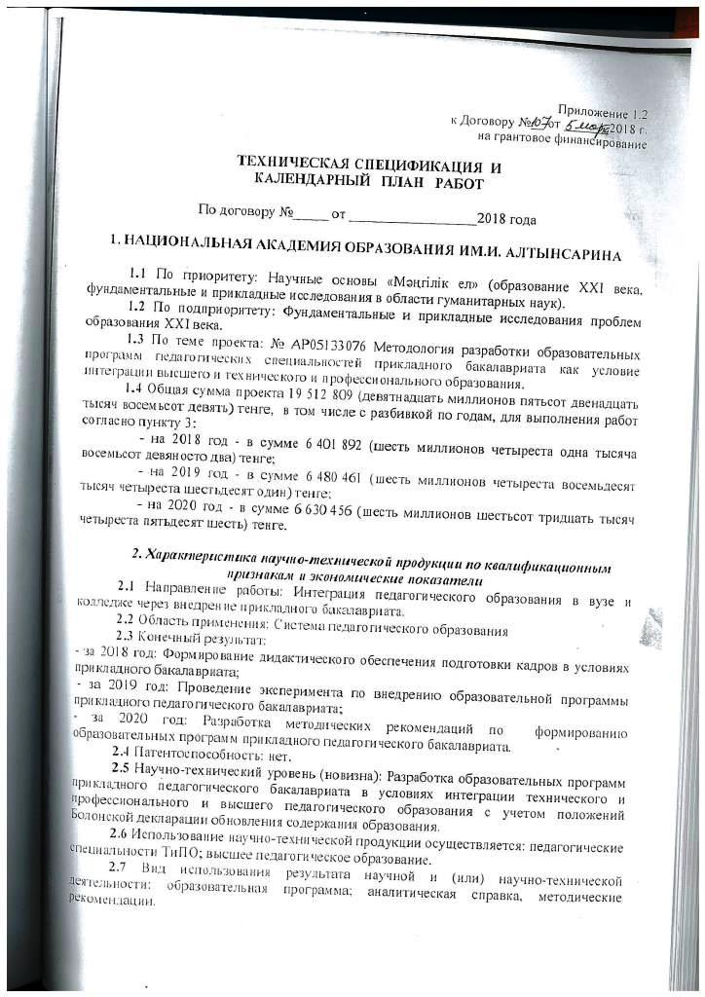
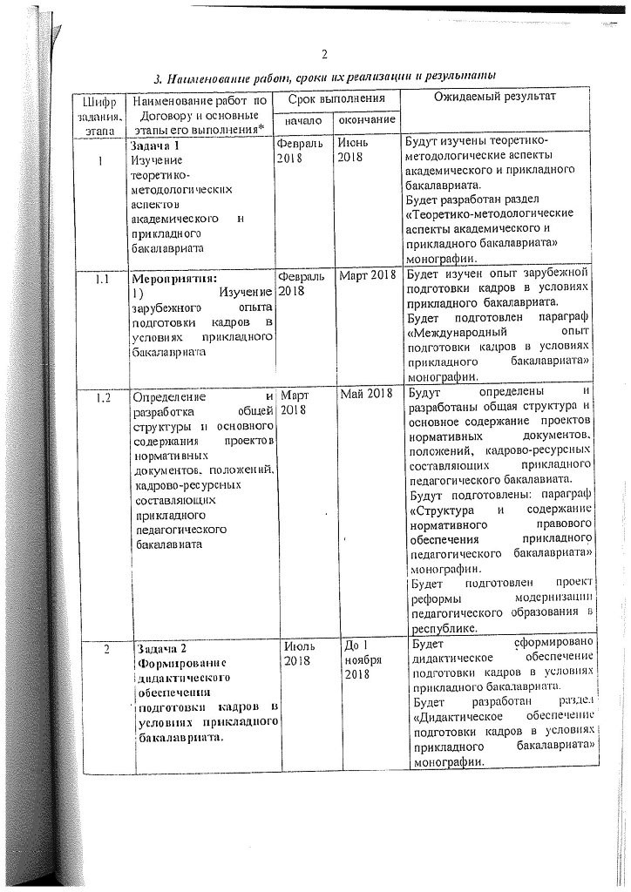
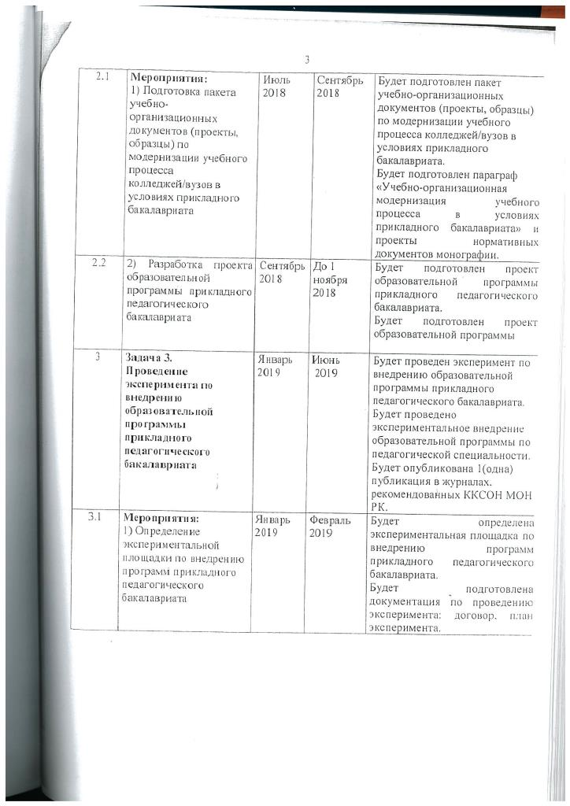
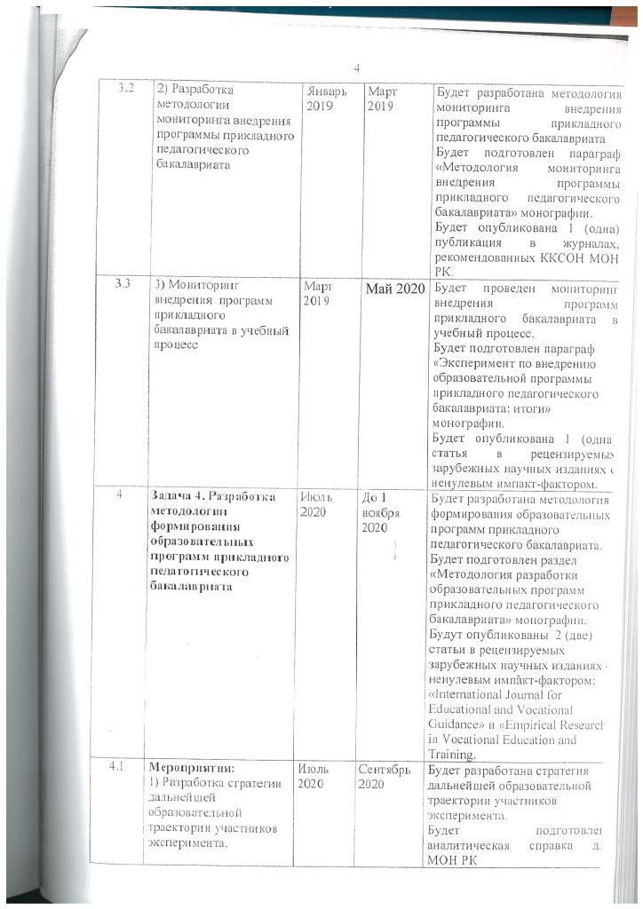
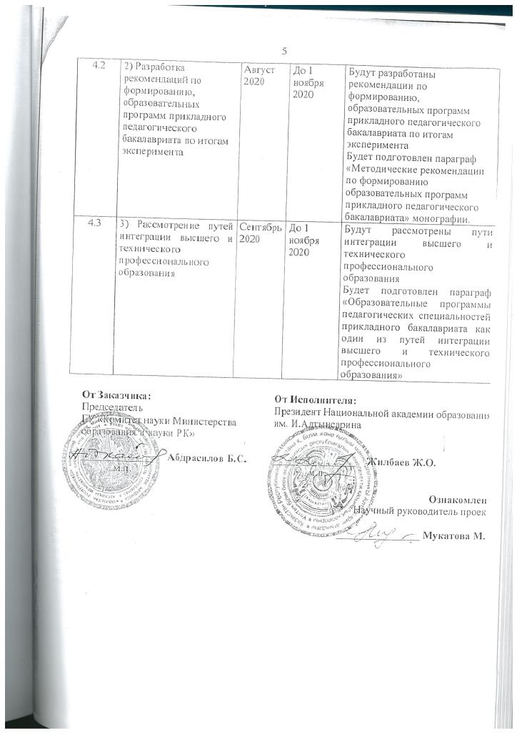
Calendar plan
Code of a task, stage | Title of objectives, activities on implementation of the project objectives | Beginning and end of work execution (day/month/year) |  | Expected Result  (in the context of tasks and activities)
Code of a task, stage |  | beginning | termination | Expected Result  (in the context of tasks and activities)
1 | Task 1  Study of theoretical and methodological aspects of academic and applied baccalaureate | February 2018 – | June 2018 | Section development «Theoretical and methodological aspects of academic and applied baccalaureate»
1.1 | Activity:  Studying of foreign experience of personnel training in the conditions of applied bachelor's degree | February 2018 | March 2018 | Paragraph «International experience of training in the conditions of applied bachelor's degree»
1.2 | Definition and development of the overall structure and drafts’ main content of normative documents, regulations, personnel and resource components of applied pedagogical bachelors | March 2018 | May 2018 | Paragraph «Structure and content of the normative legal support of applied pedagogical baccalaureate»  Project of the modernization reform of pedagogical education in the republic
2 | Task 2  Didactic training provision formation in the conditions of applied bachelor degree. | July 2018 | November 2018 | Section development «Didactic training provision in the conditions of applied bachelor degree»
2.1 | Activity:  Package preparation of educational and organizational documents (projects, samples) on the modernization of the educational process of universities in the conditions of applied bachelor's degree | July 2018 | September 2018 | Paragraph  «Educational and organizational modernization of the educational process in the conditions of applied bachelor's degree» Projects of normative documents
2.2 | Draft curriculum development for the applied pedagogical bachelor's degree | September 2018 | November 2018 | Draft educational program
3 | Task 3.  Conducting an experiment to introduce an educational program for applied pedagogical bachelor's degree | January 2018 | June 2020 | Experimental introduction of the educational program on pedagogical specialty. Scientific article
3.1 | Activity:  Definition of the experimental site for applied pedagogical bachelor programs implementation | January 2019 | February 2019 | Documentation for the experiment: a contract, an experiment plan
3.2 | Methodology development for monitoring the implementation of the applied bachelor program | January 2019 | March 2019 | Paragraph  «Methodology for monitoring the implementation of the applied pedagogical bachelor program». Scientific article
3.3 | Monitoring the implementation of applied bachelor's programs in the educational process | March 2019 | May 2020 | Paragraph «Experiment to introduce the educational program of applied pedagogical bachelor: results». Scientific article
4 | Task 4. Methodology development for the formation of educational programs for applied pedagogical undergraduate | July 2020 | November 2020 | Section «Methodology of educational programs development of applied pedagogical baccalaureate».  Publication in the journal with impact factor
4.1 | Activity:  Strategy development for the further educational trajectory of the participants in the experiment. | July 2020 | September 2020 | Analytical information for MES RK
4.2 | Recommendations development on the formation, educational programs of applied pedagogical baccalaureate based on the results of the experiment | August 2020 | November 2020 | Paragraph «Methodical recommendations on the formation, educational programs of applied pedagogical baccalaureate»
4.3 | Consideration of ways to integrate higher and technical vocational education | September 2020 | November 2020 | Paragraph «Educational programs of pedagogical specialties of applied baccalaureate as one of the ways of integration of higher and technical vocational education»

ANNEX G
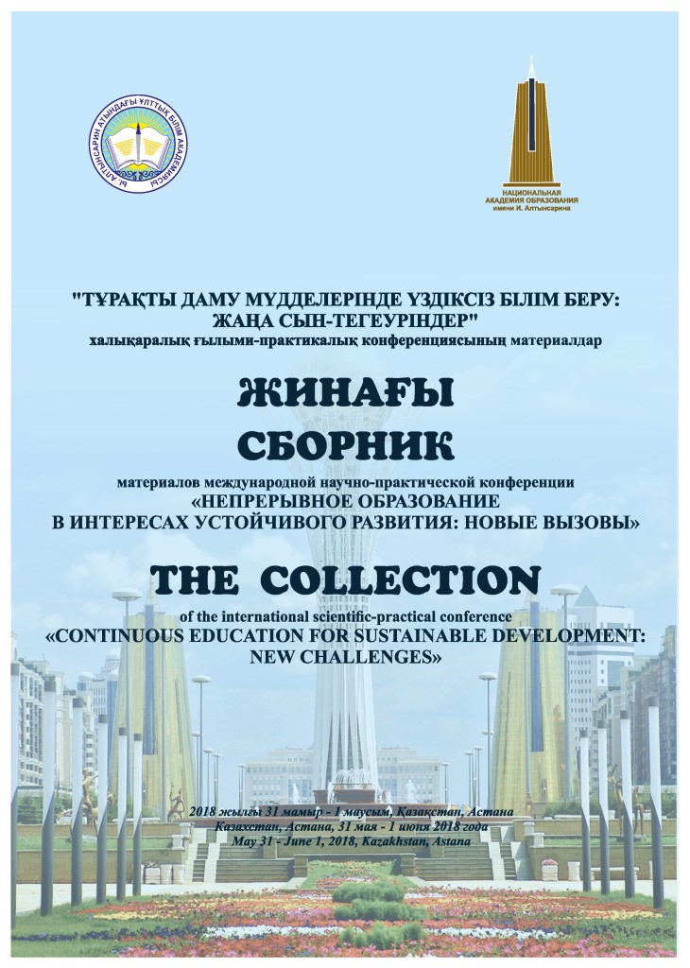
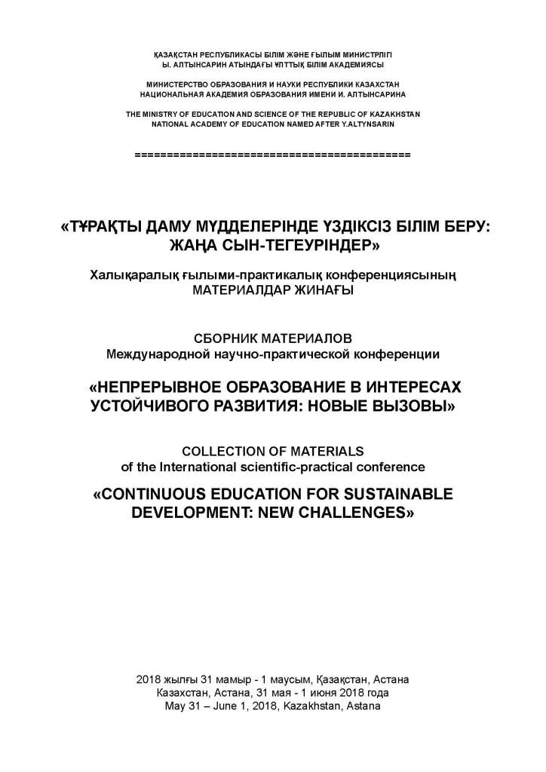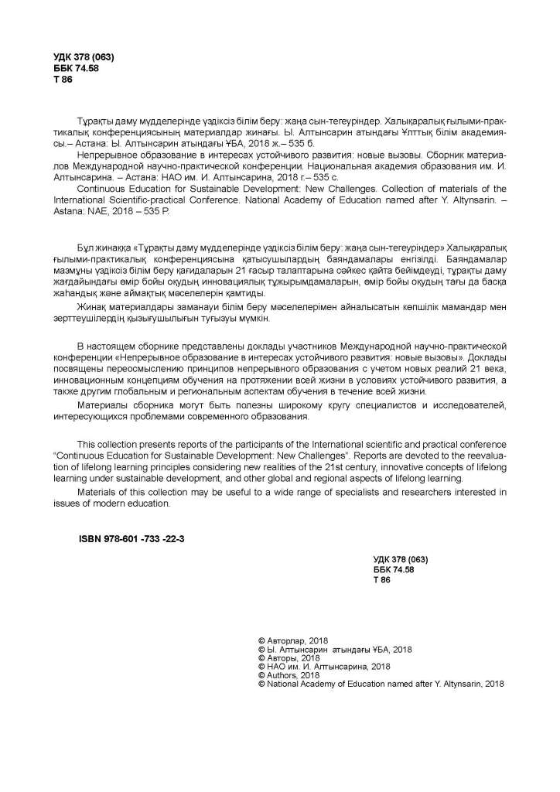

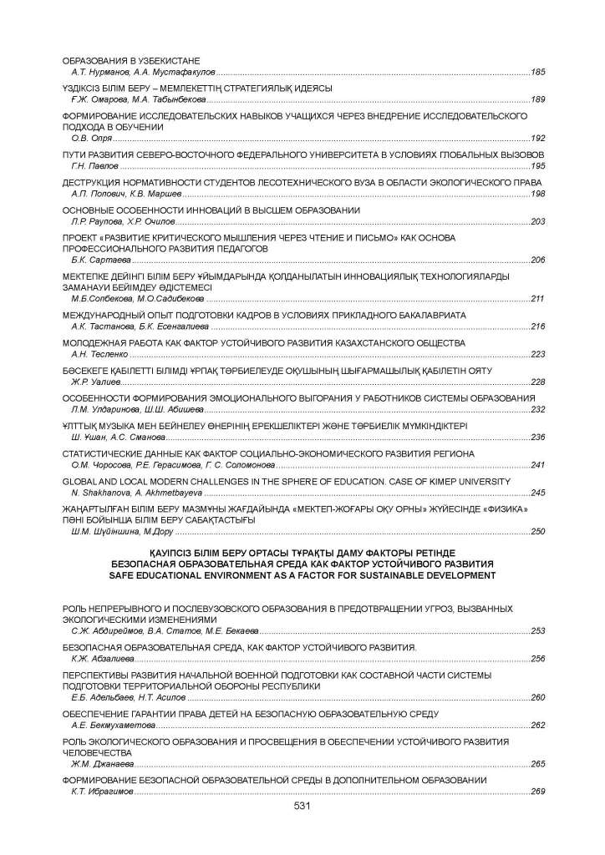
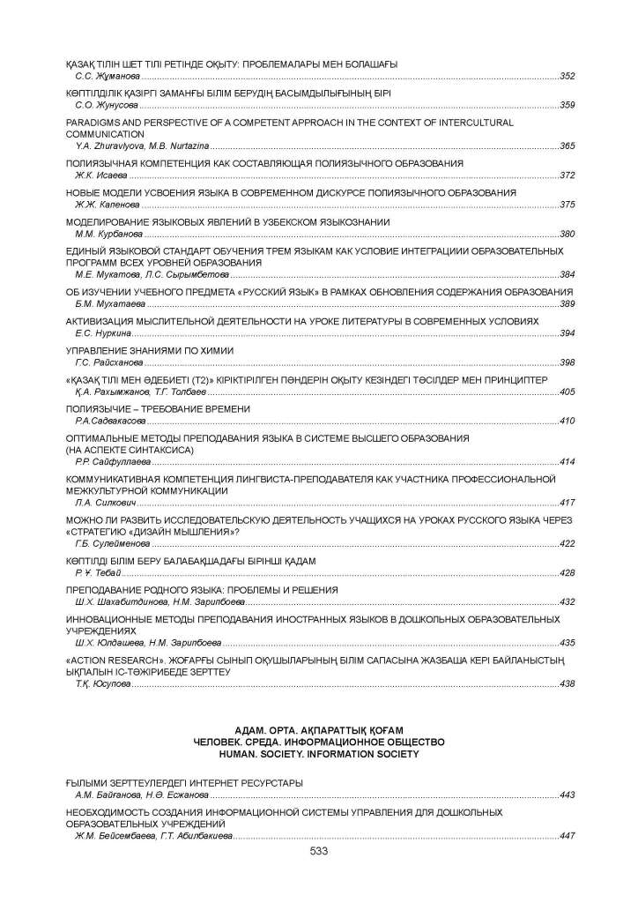
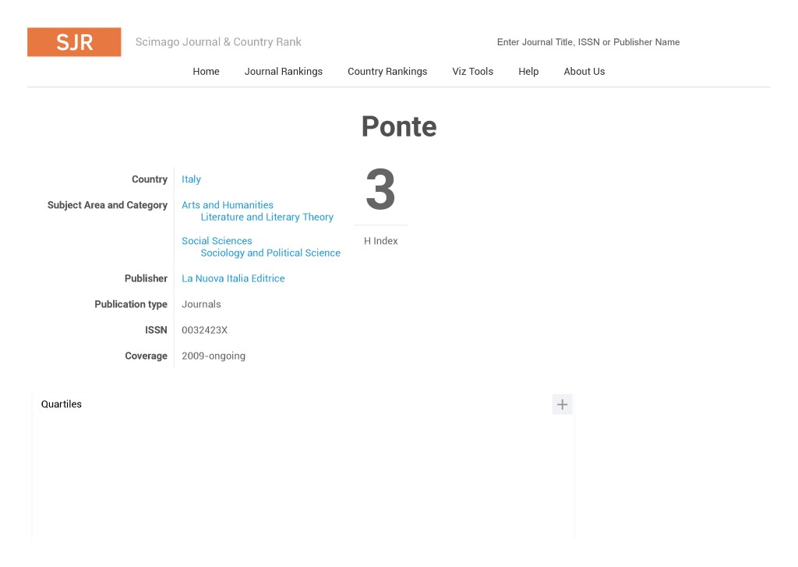

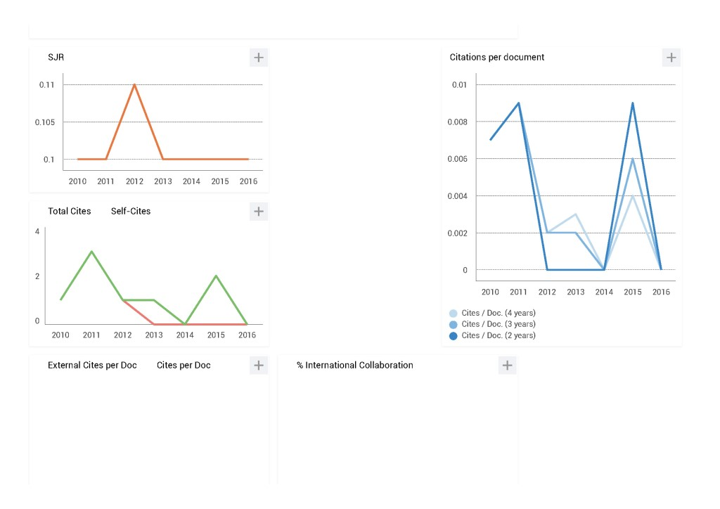

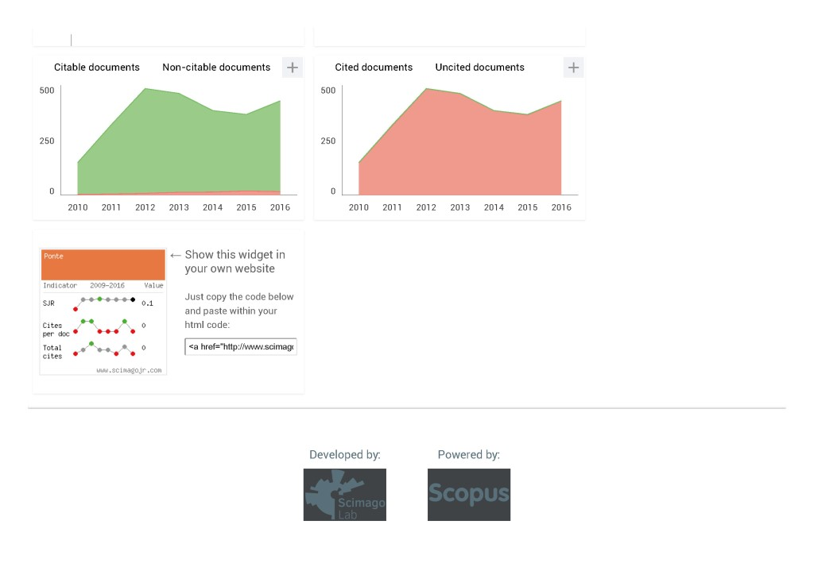



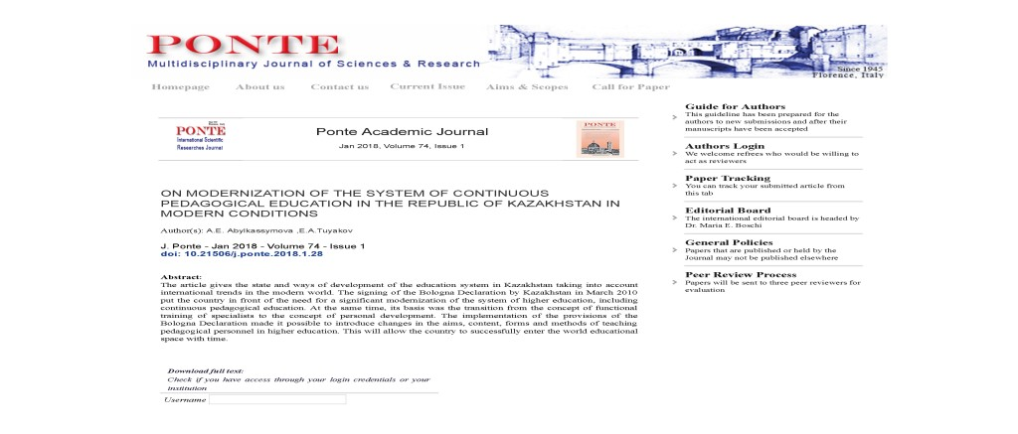



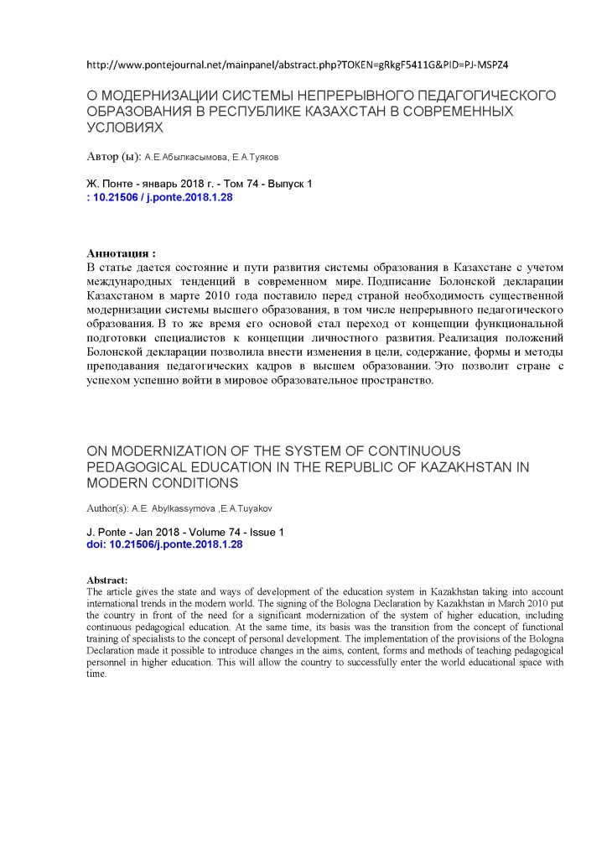
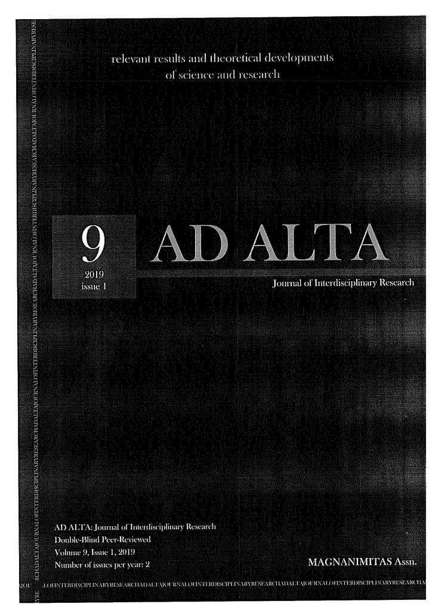
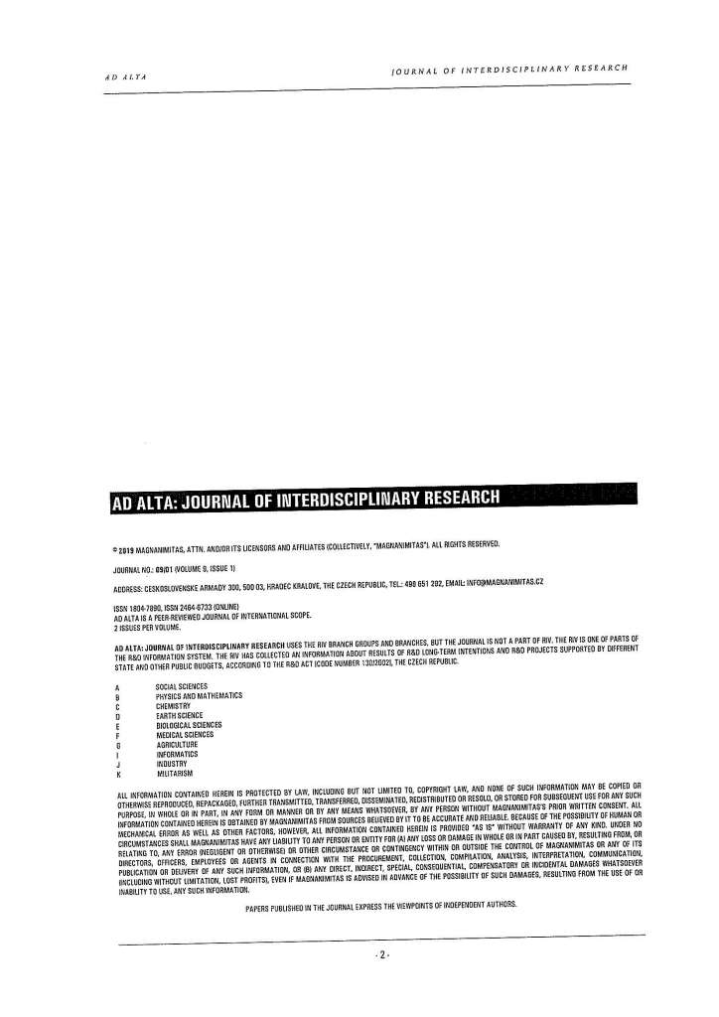
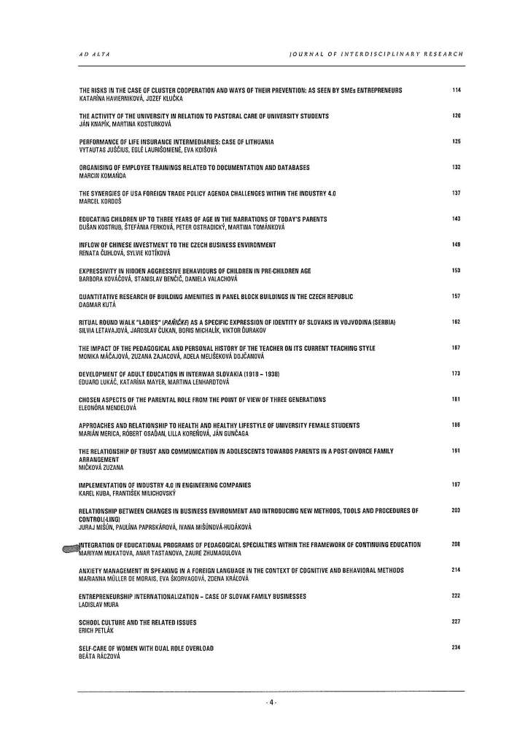
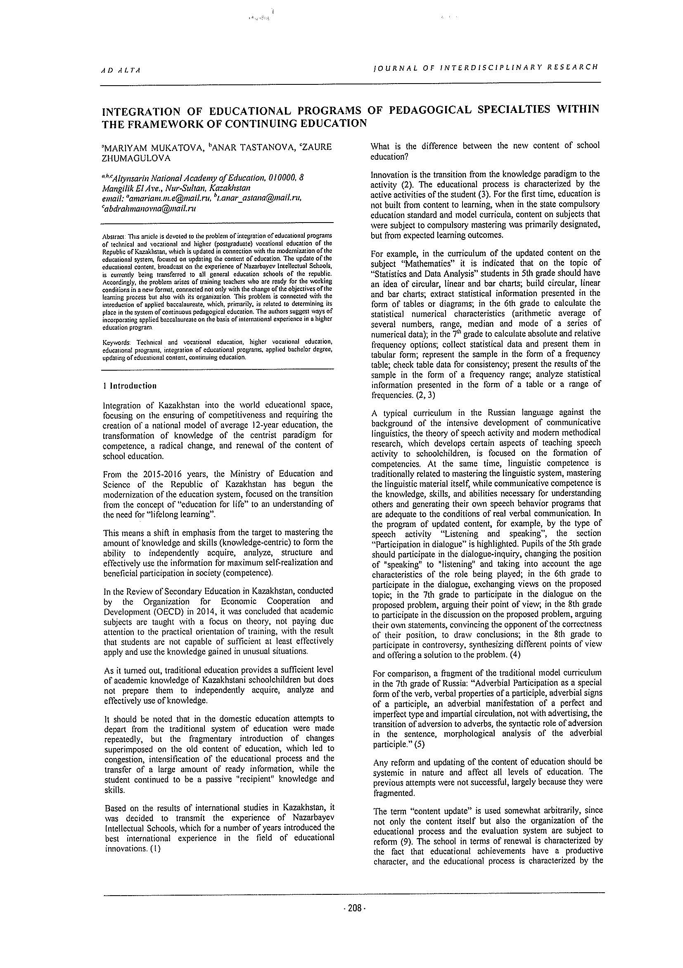
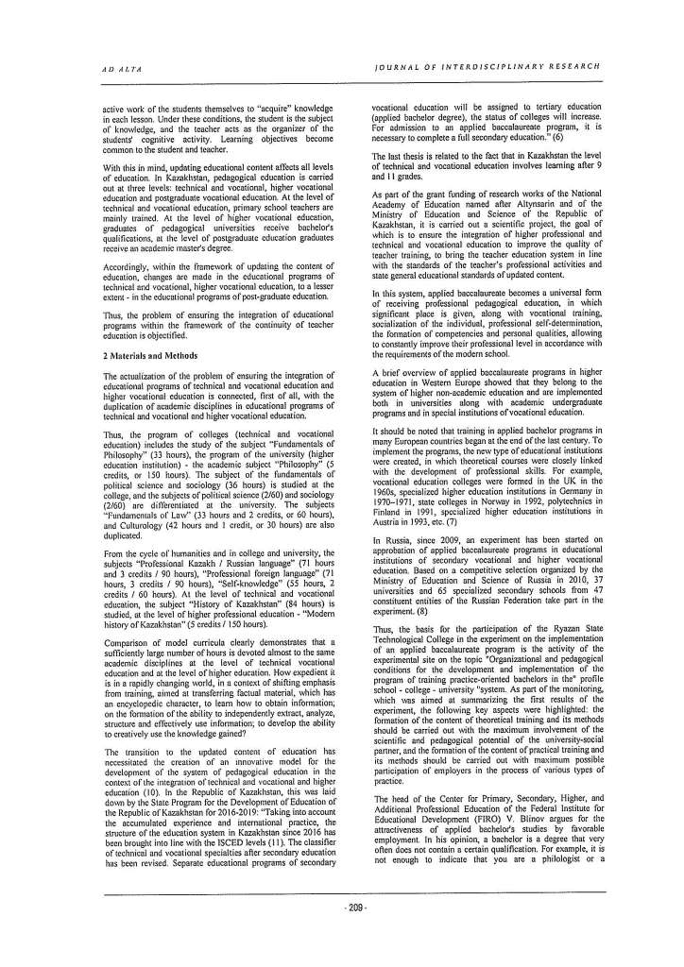
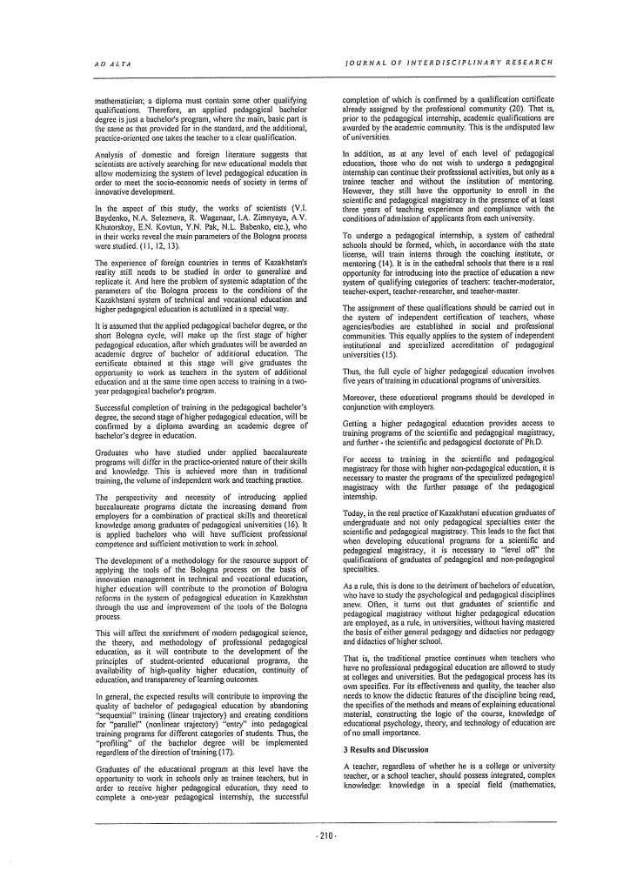
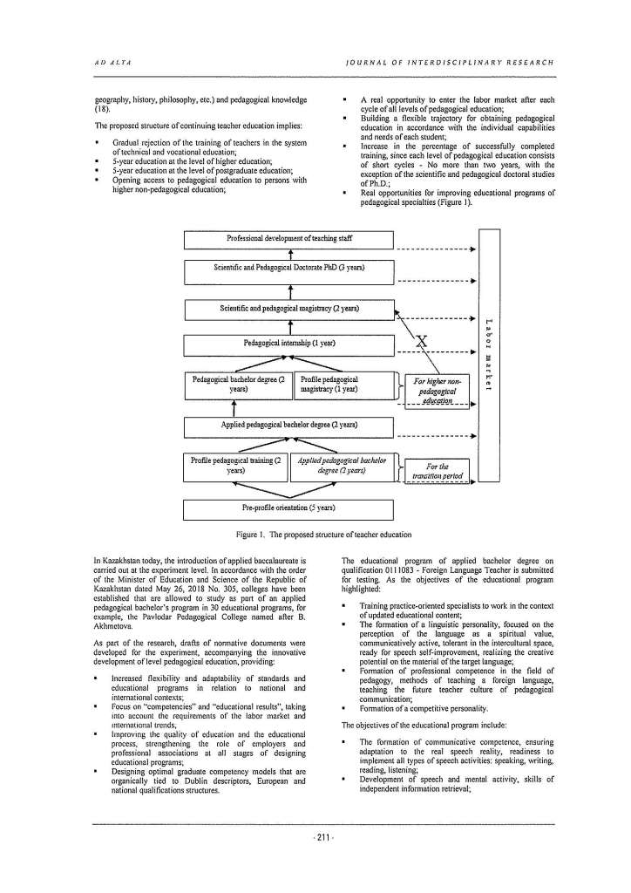
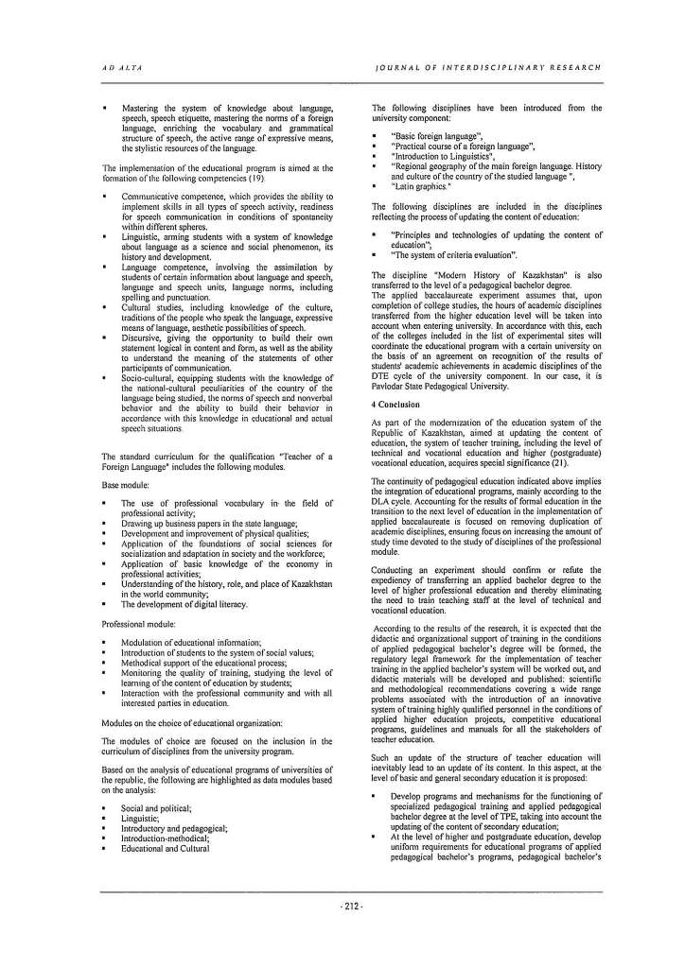
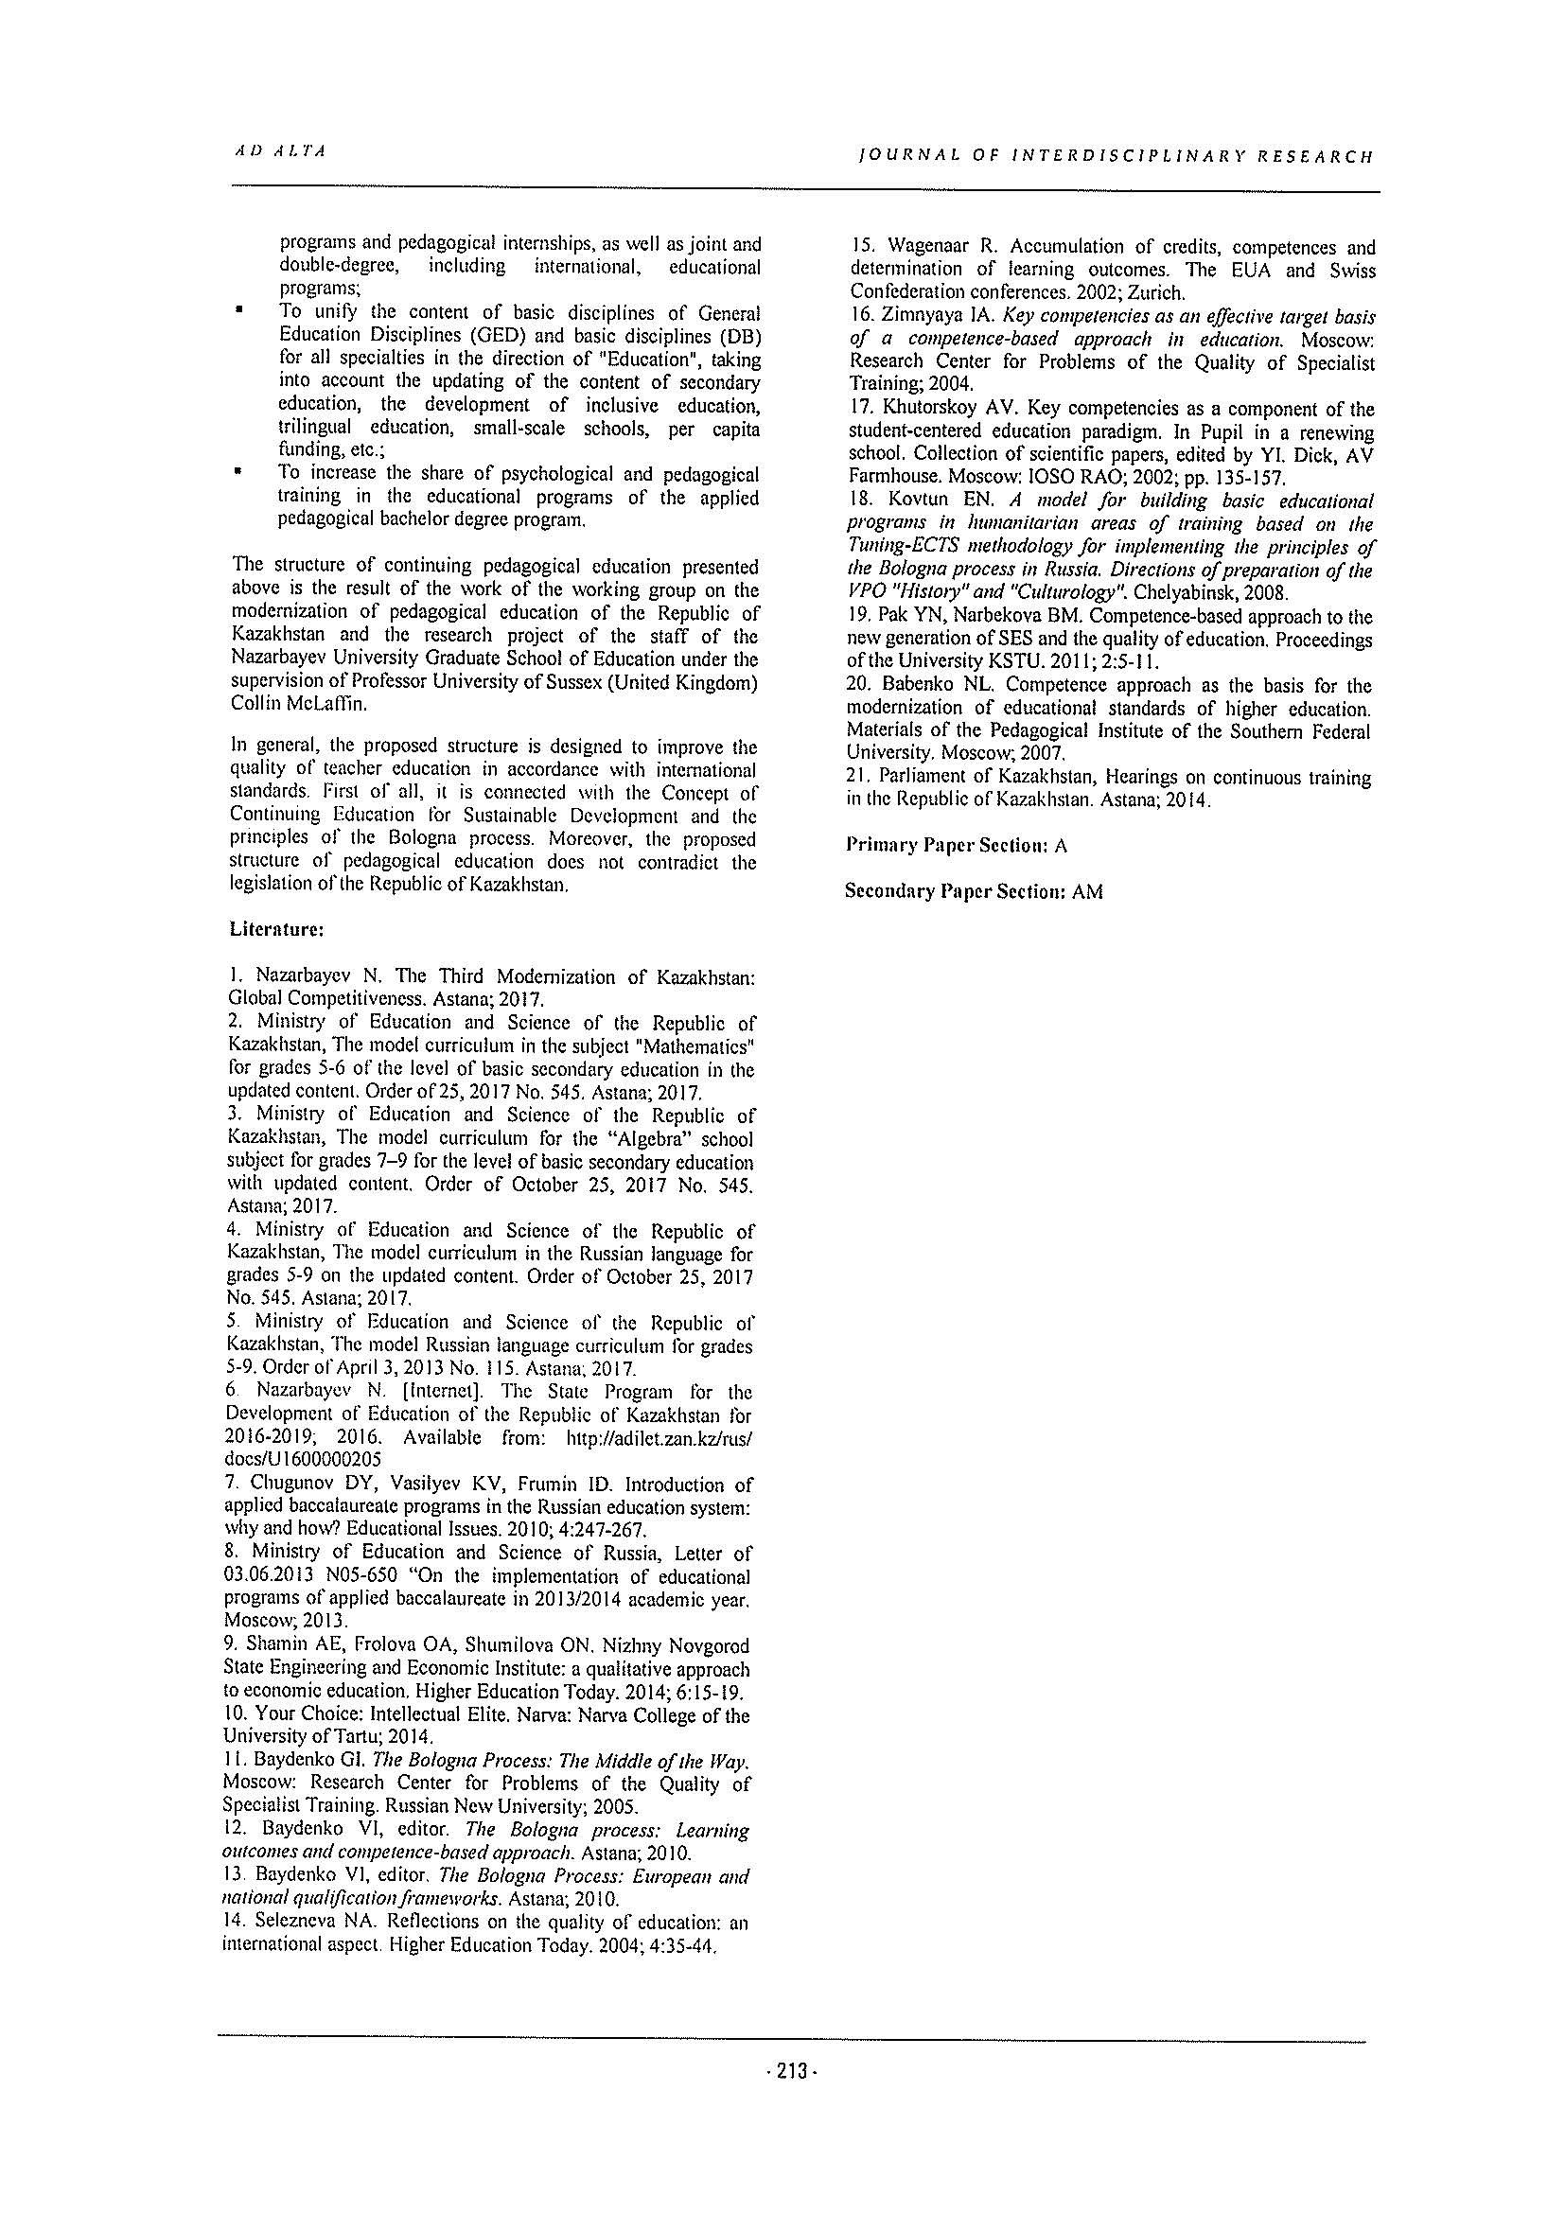

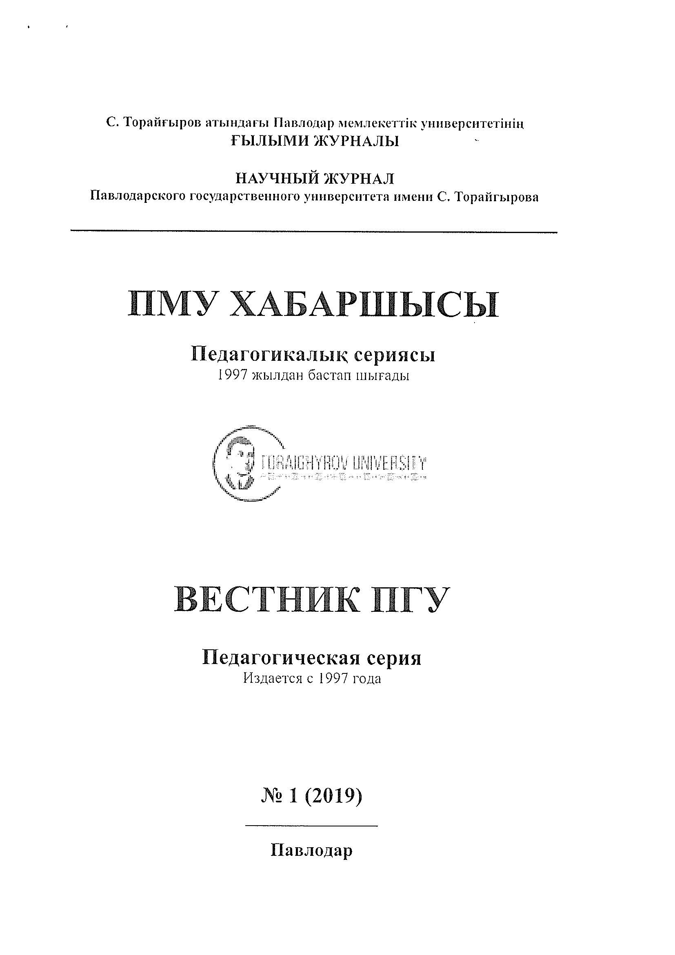
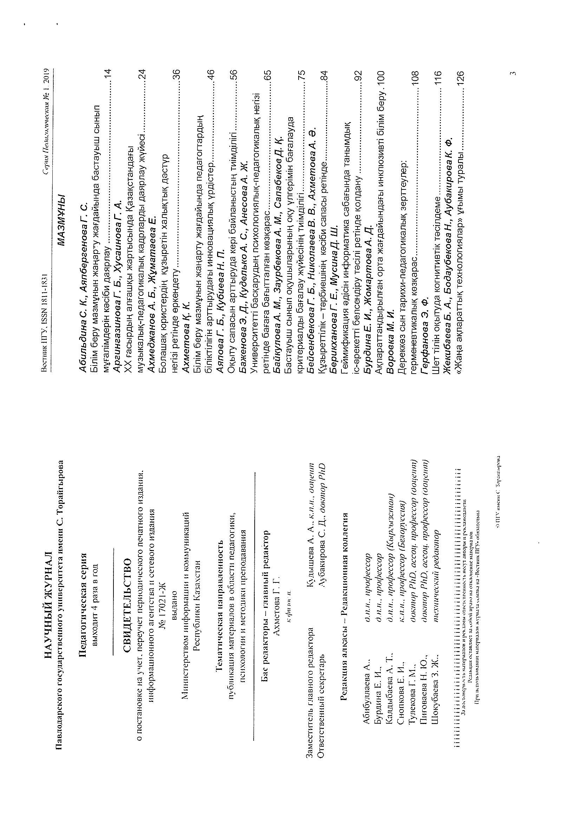
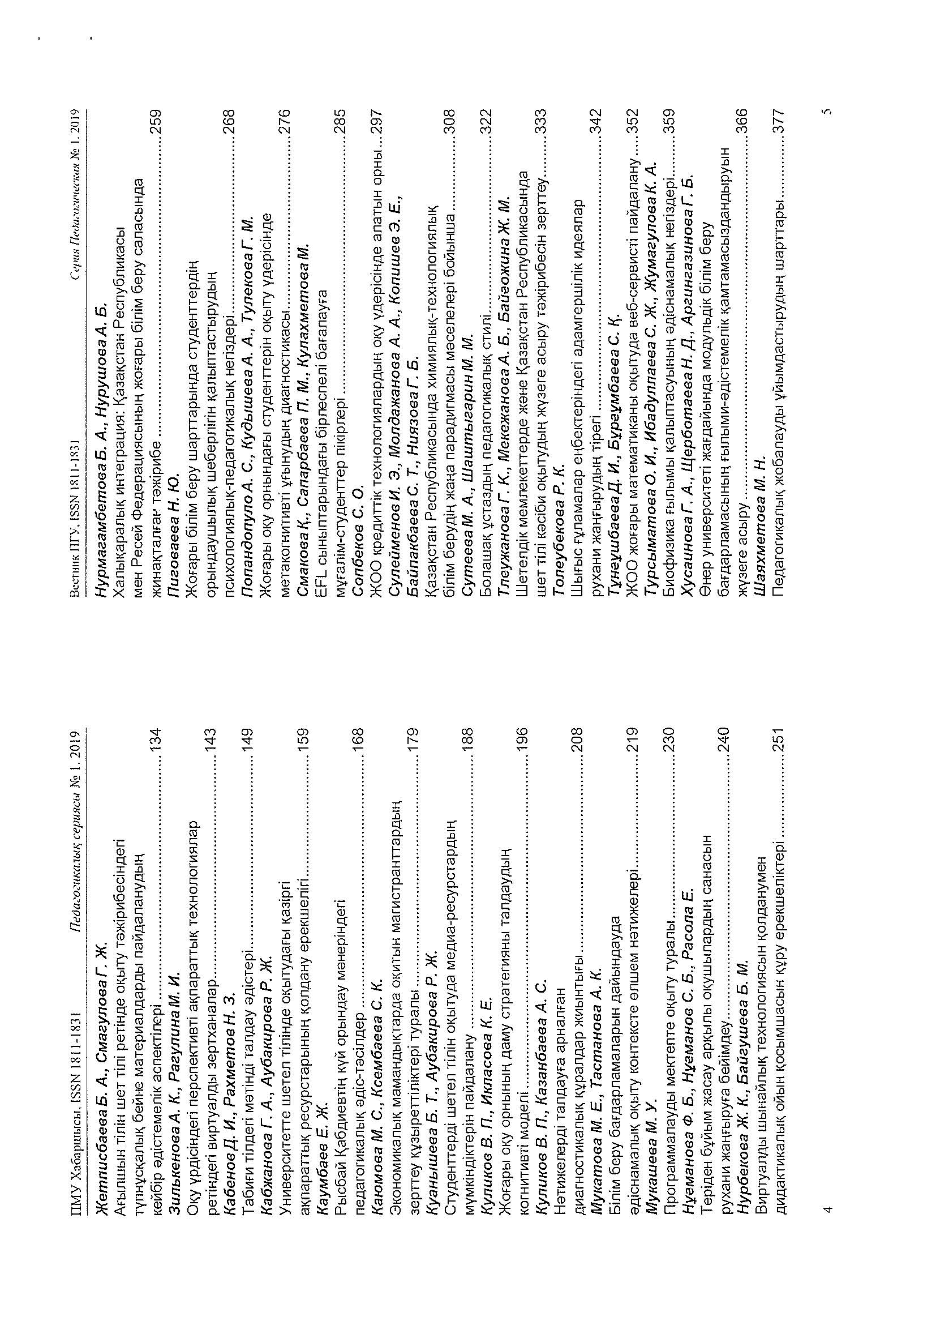
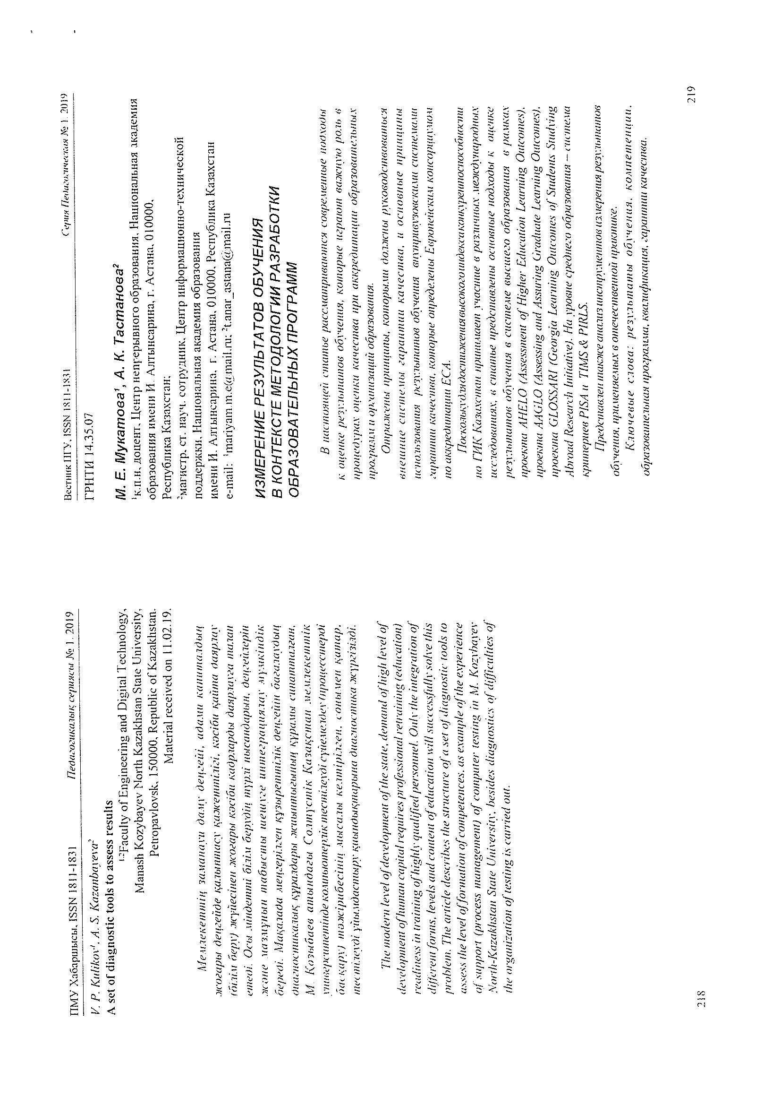
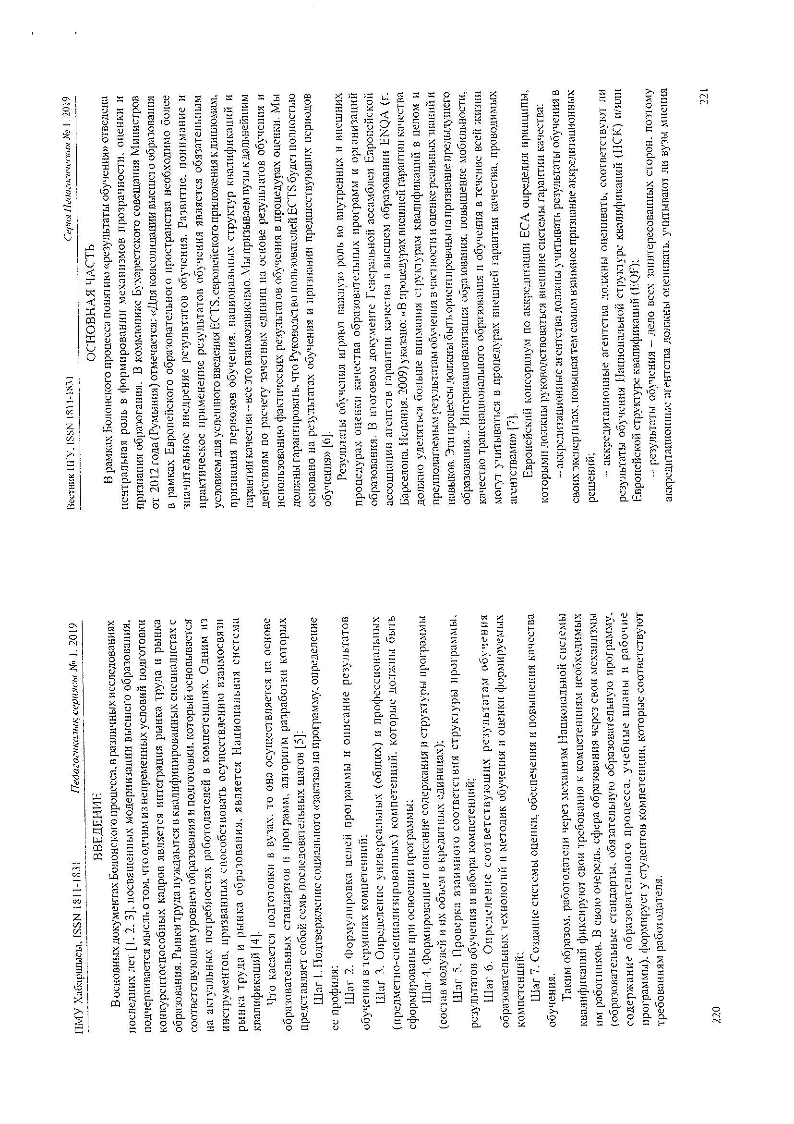
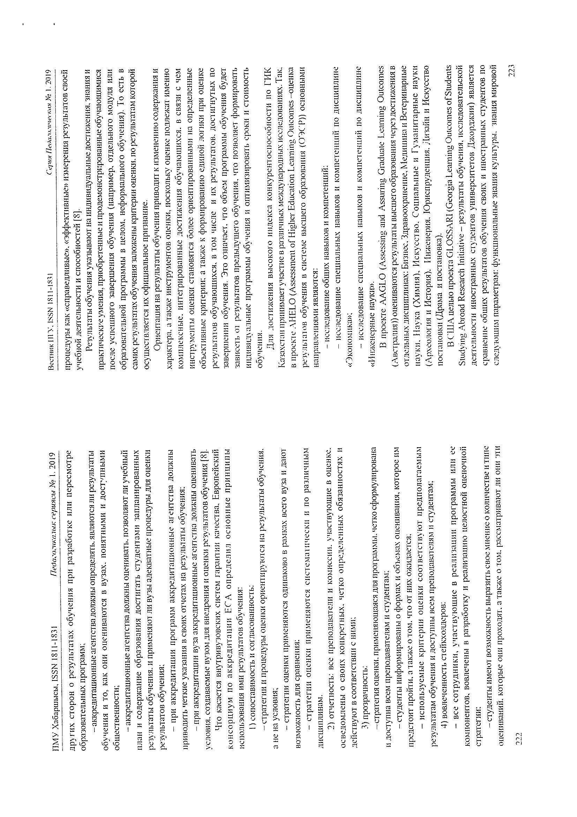
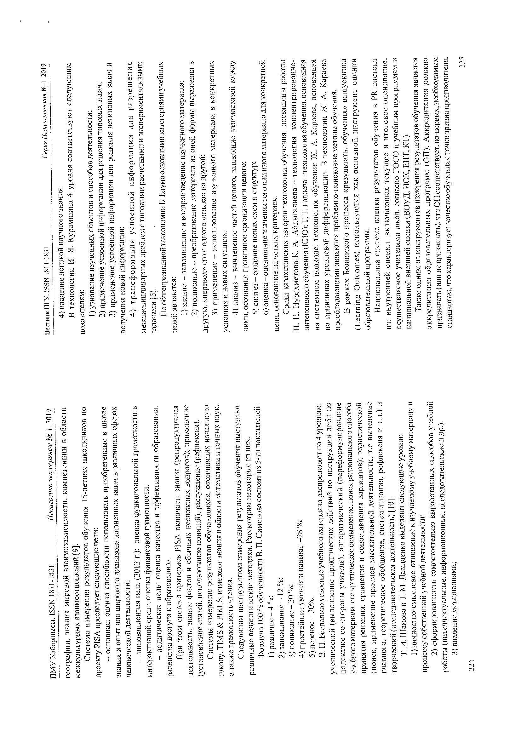
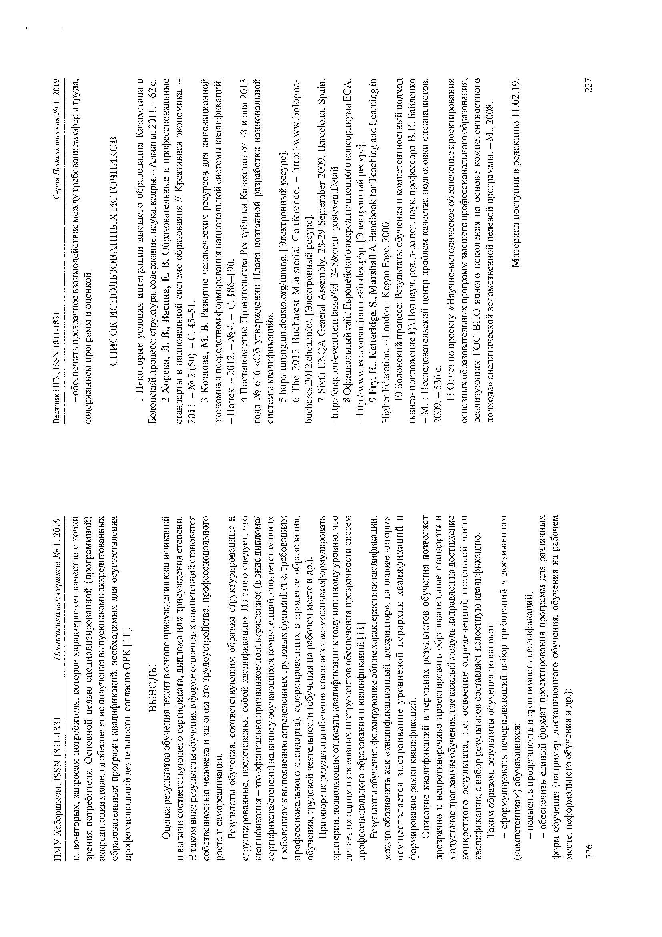
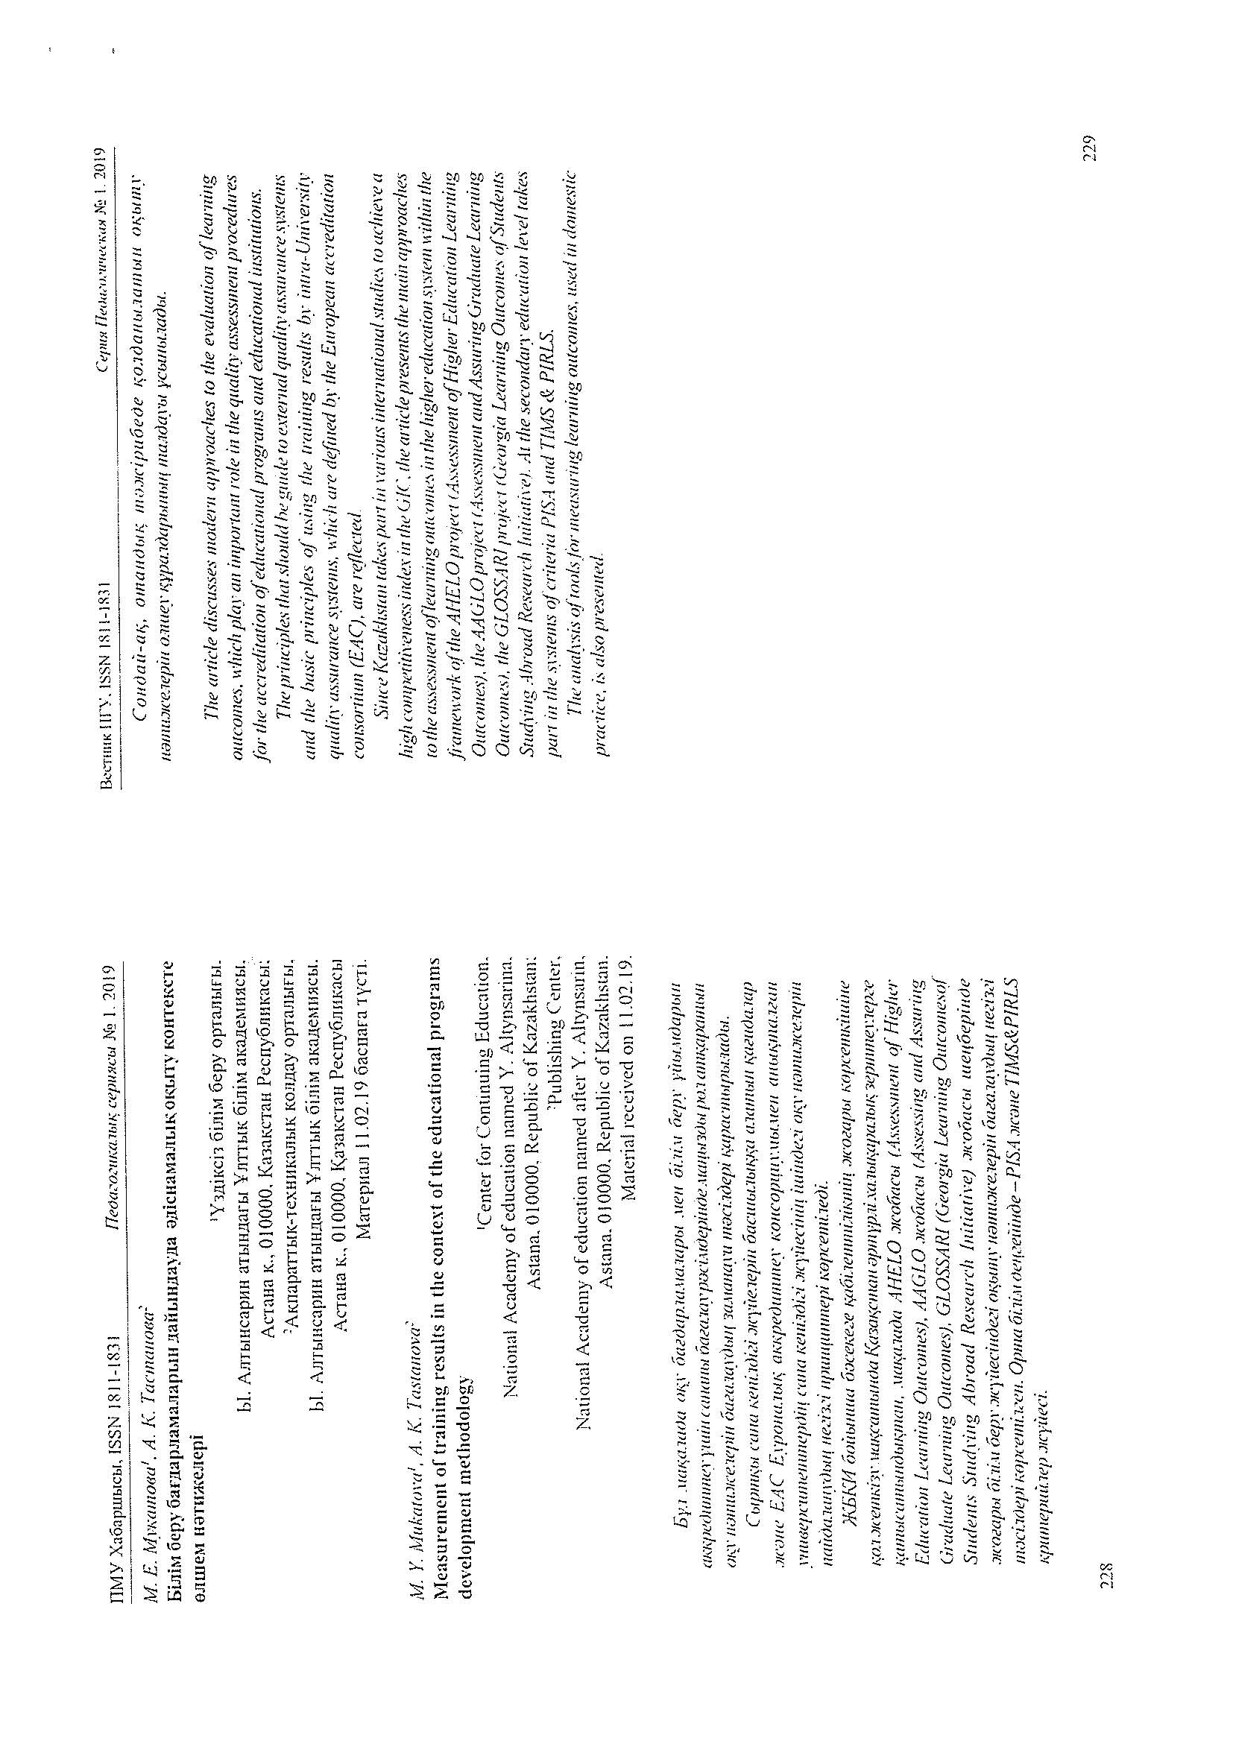
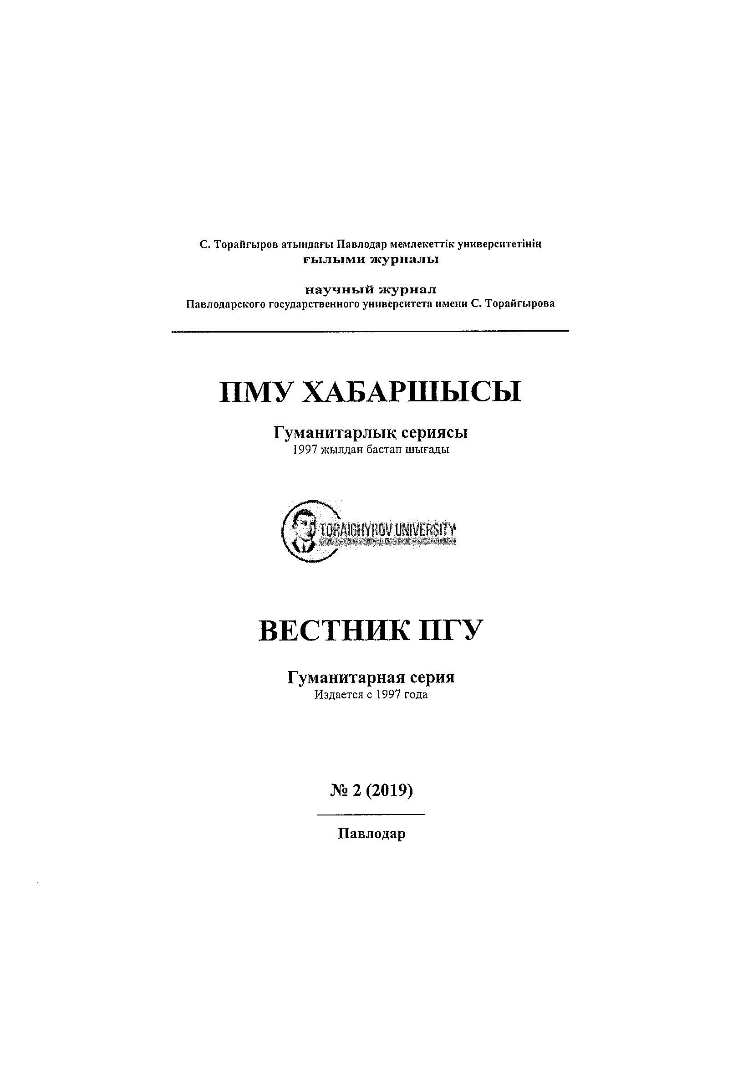
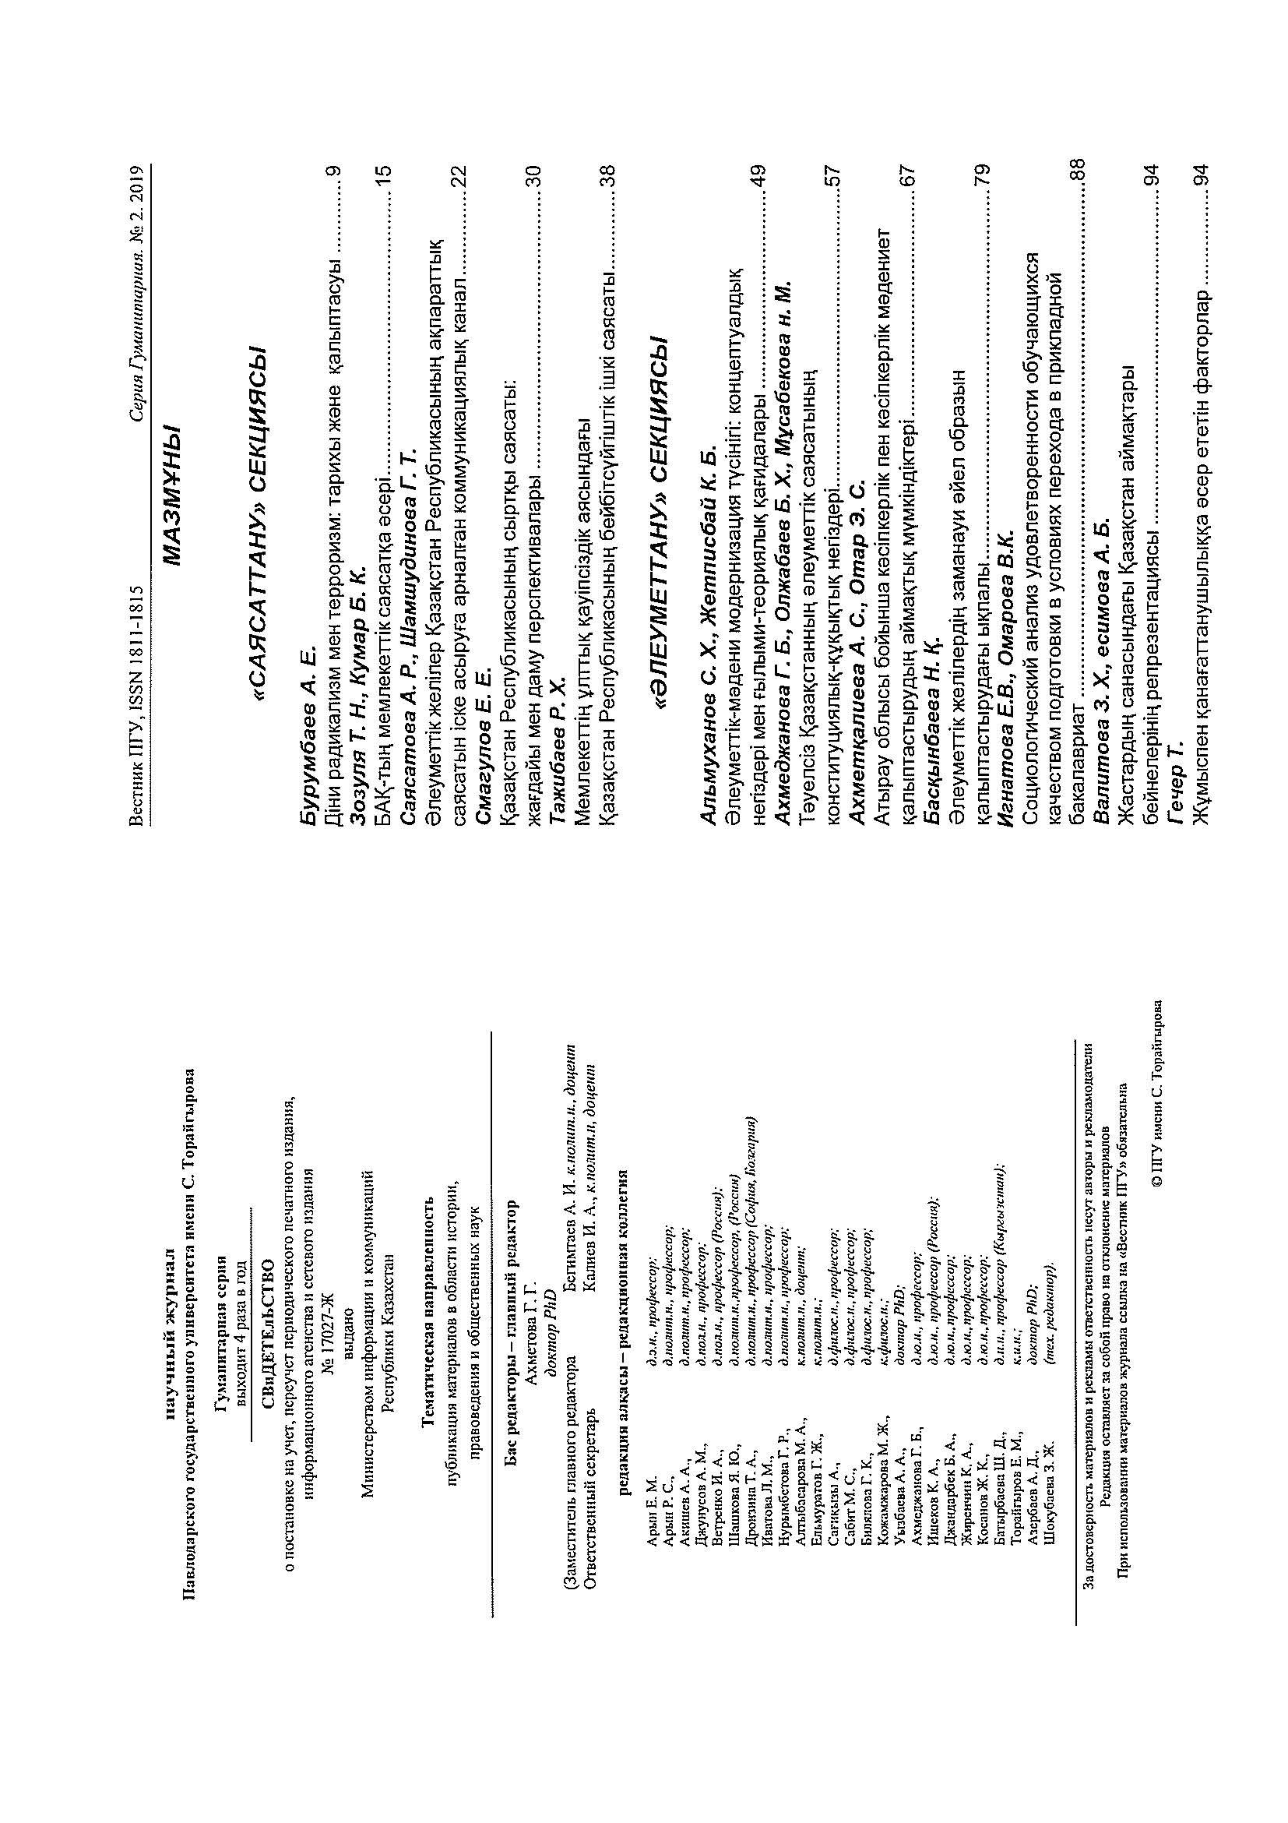
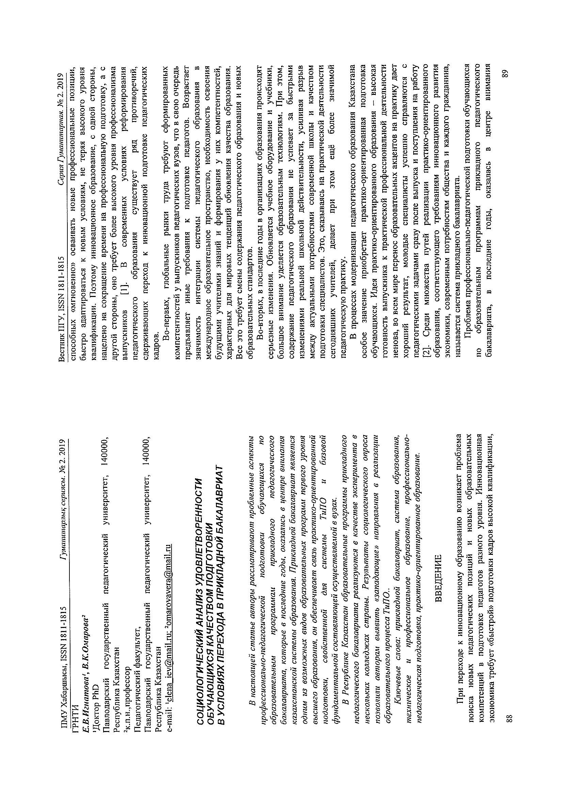
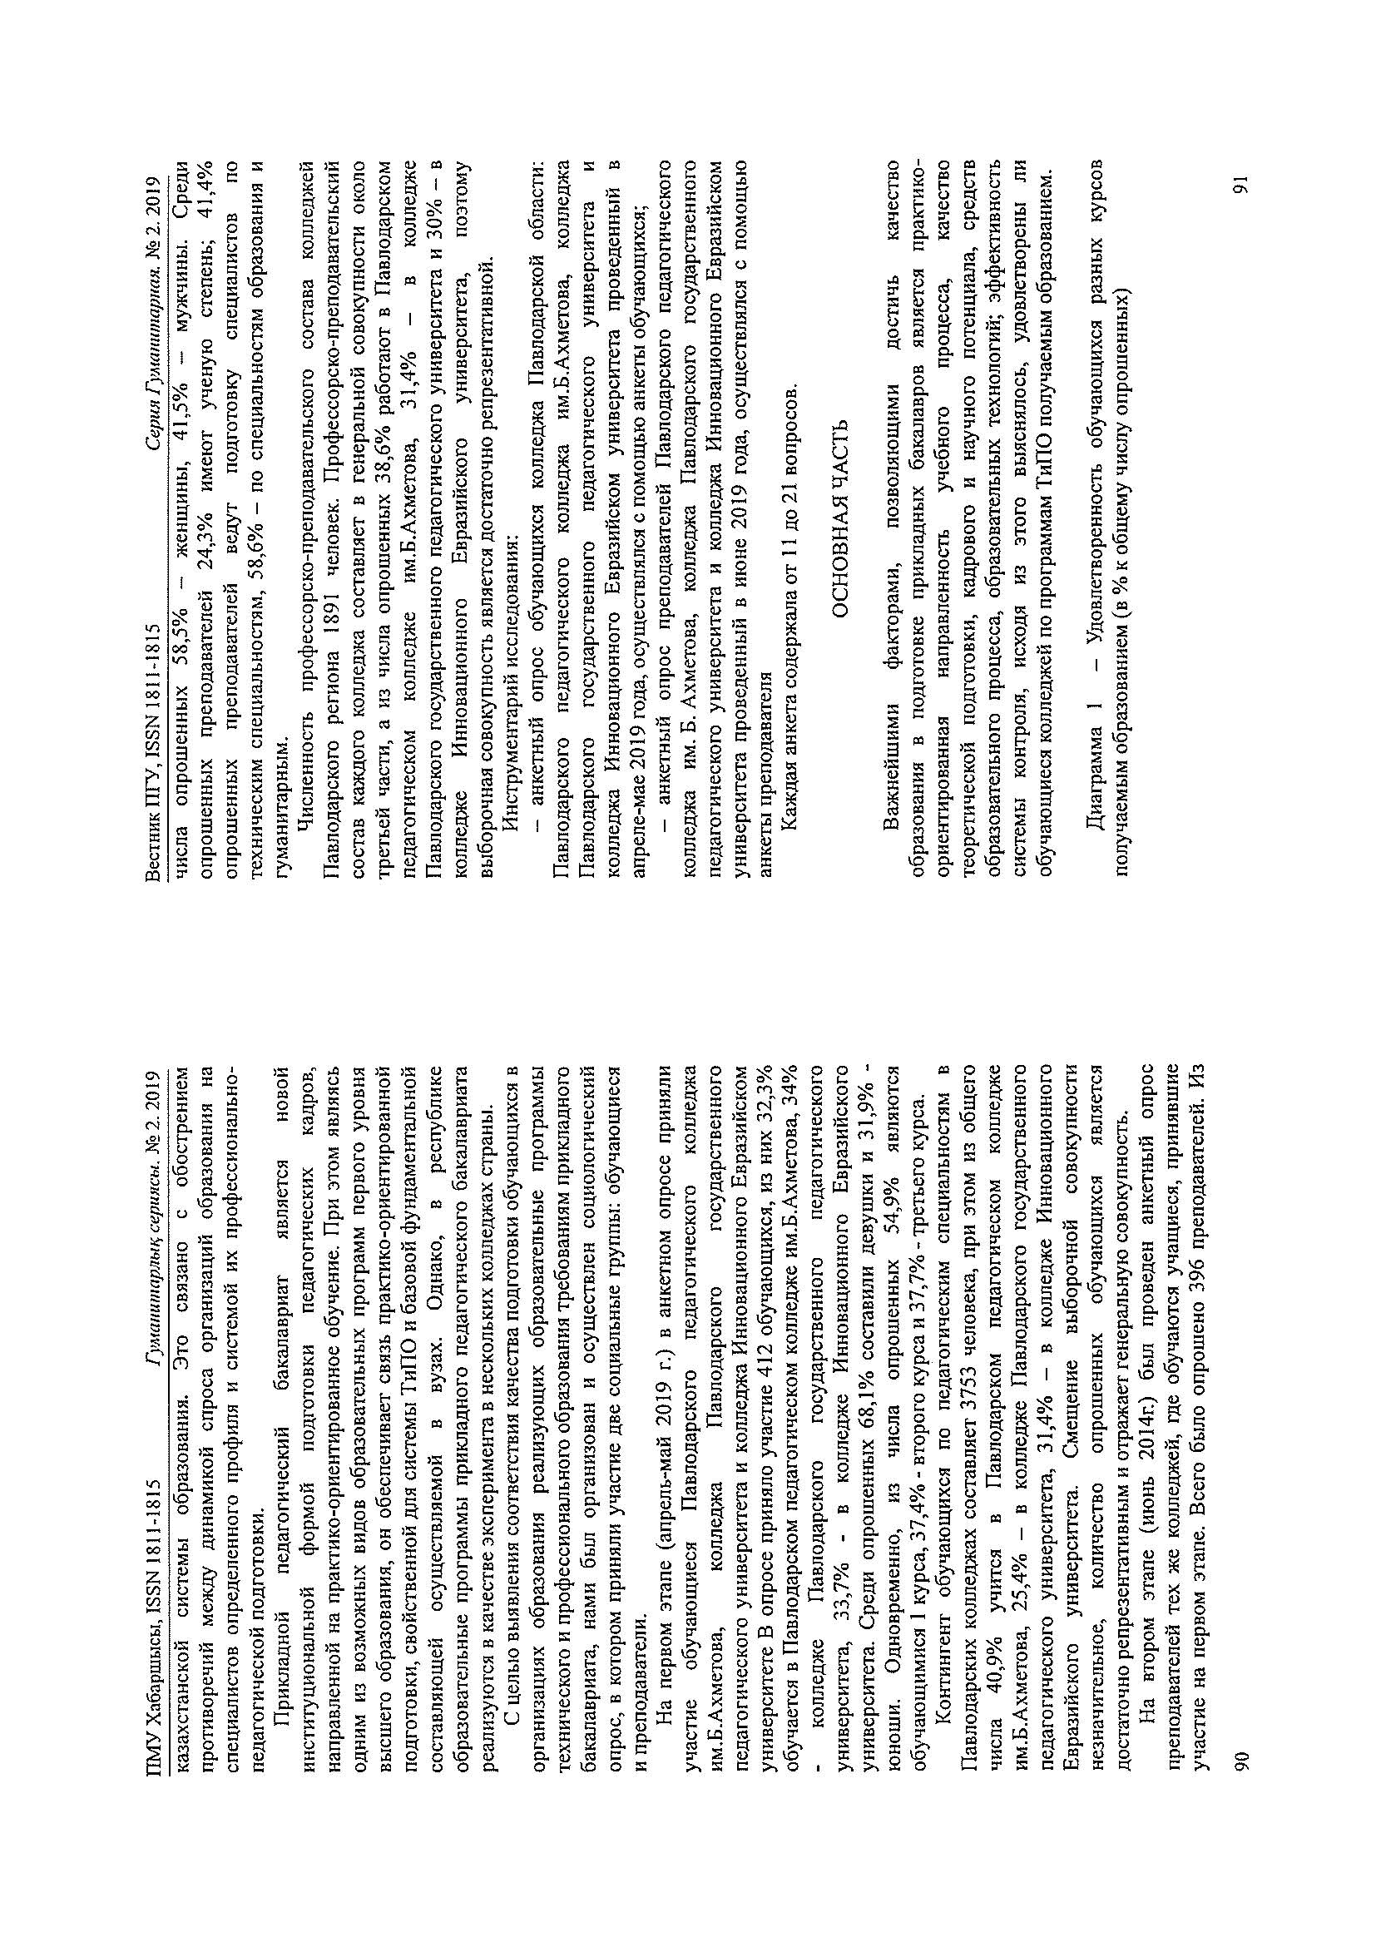
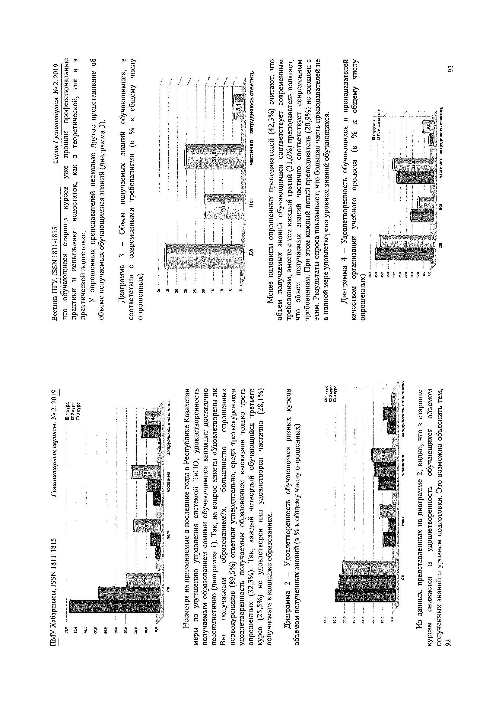
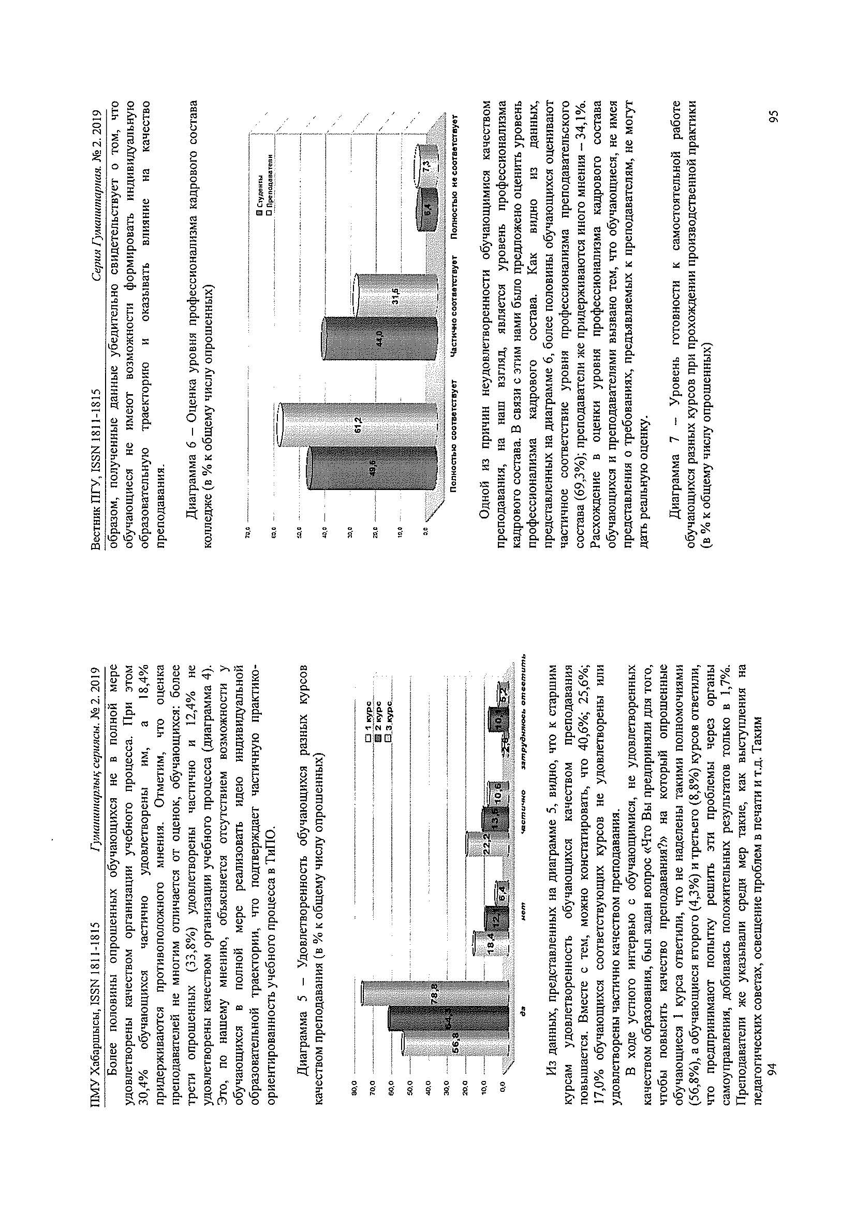
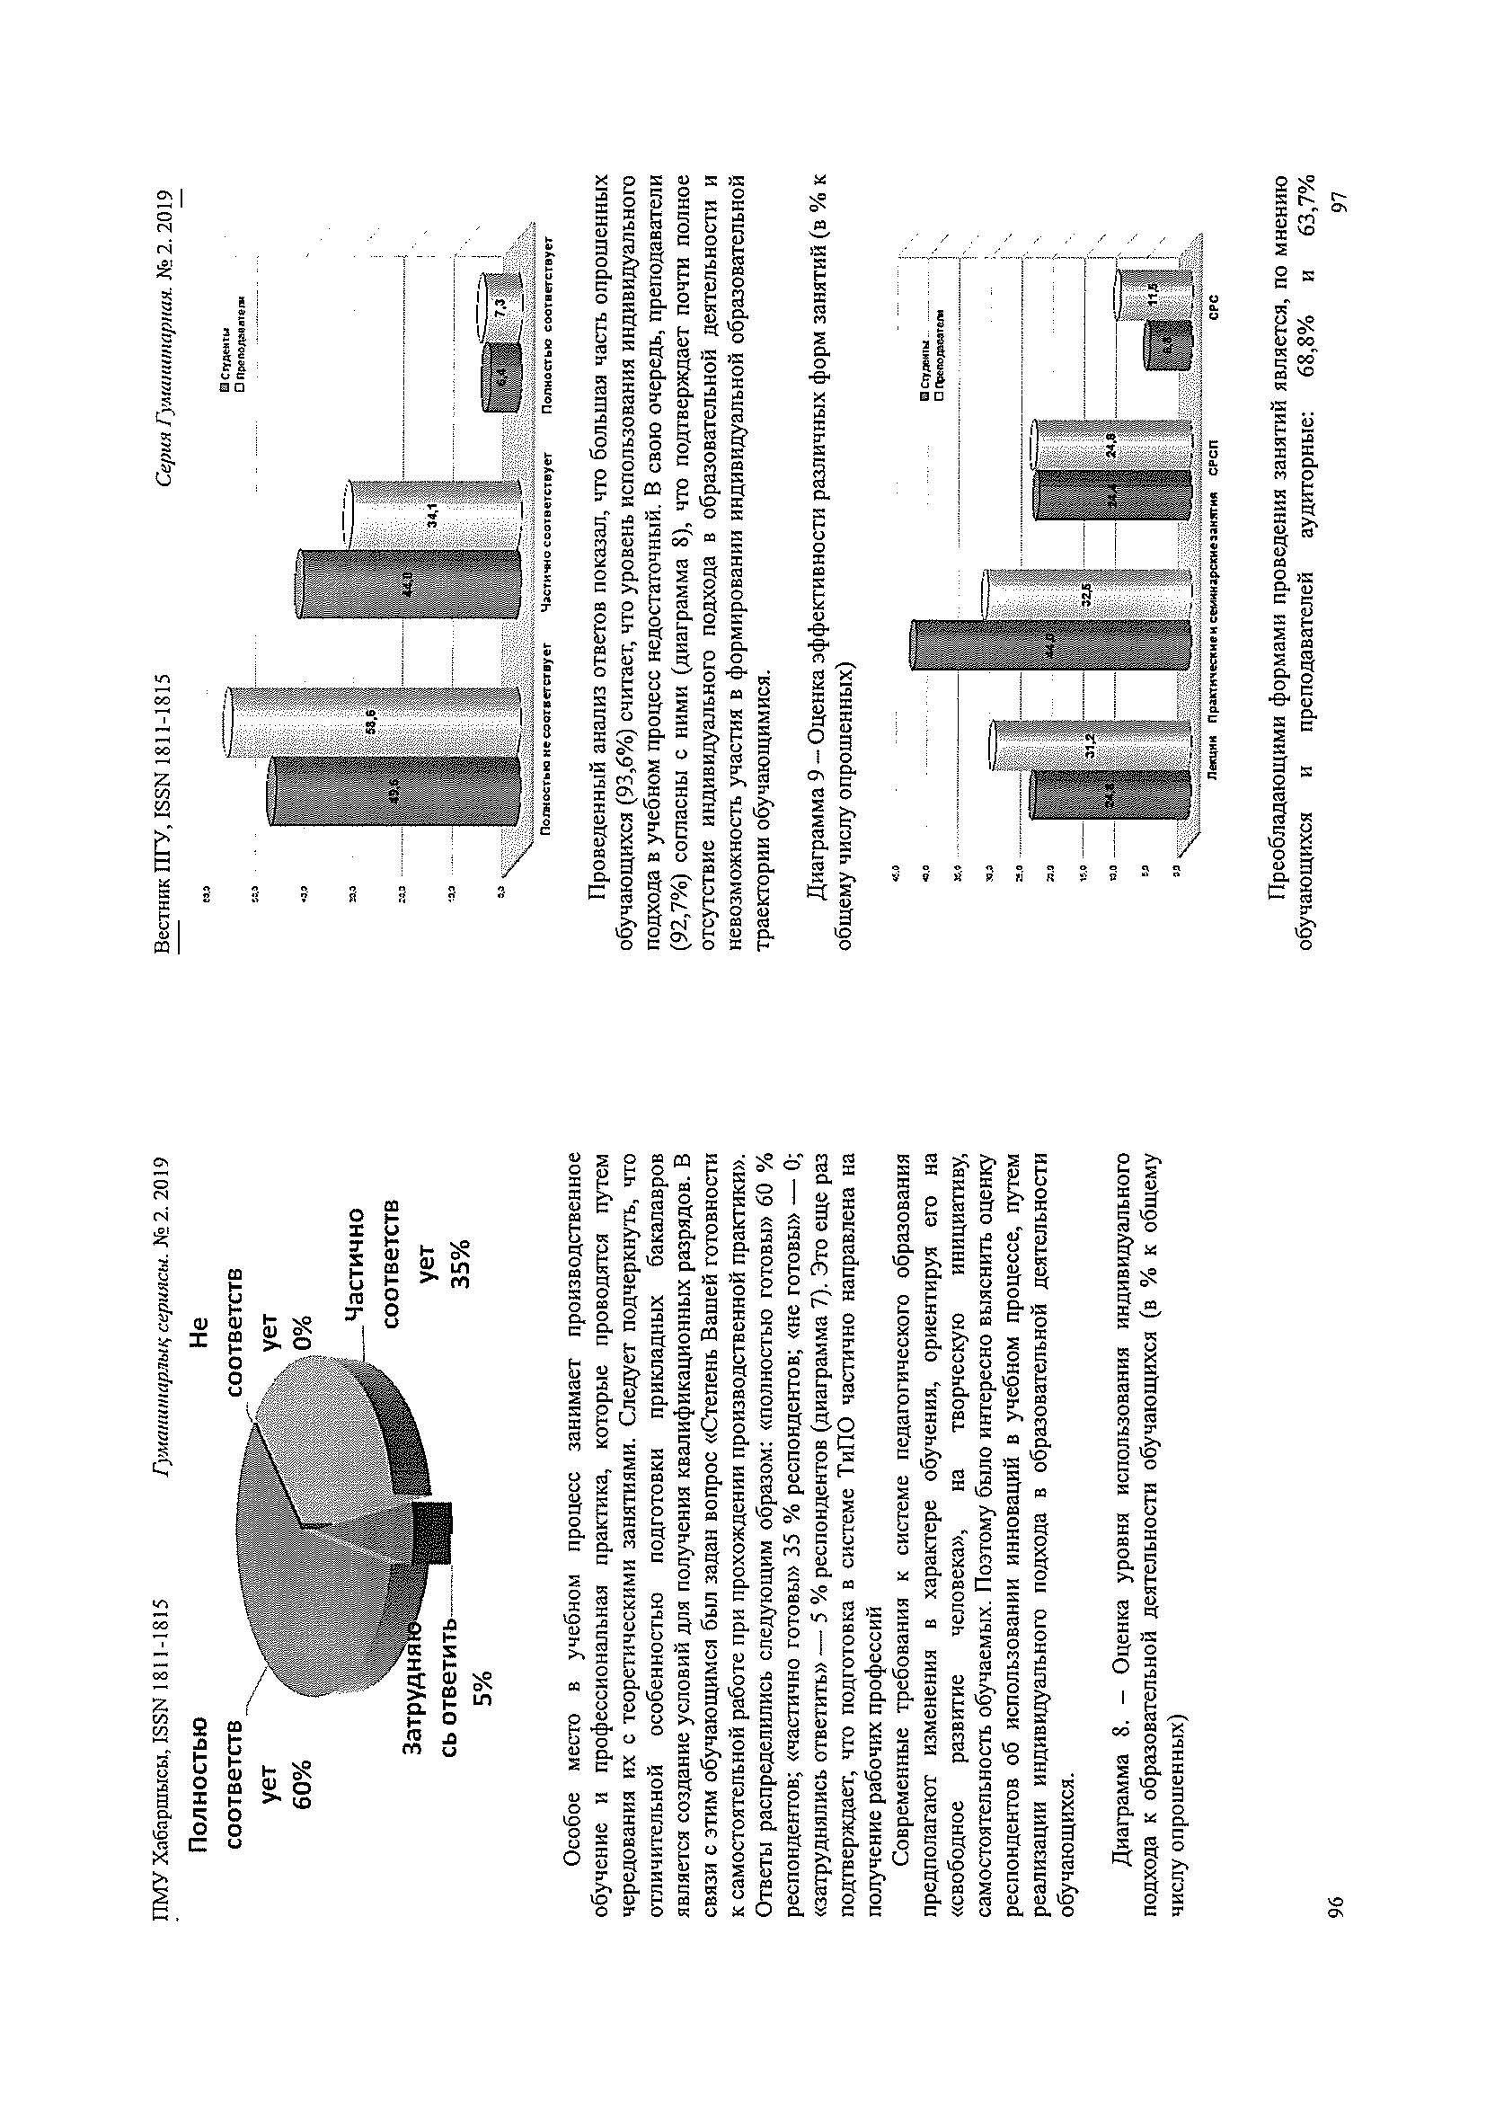
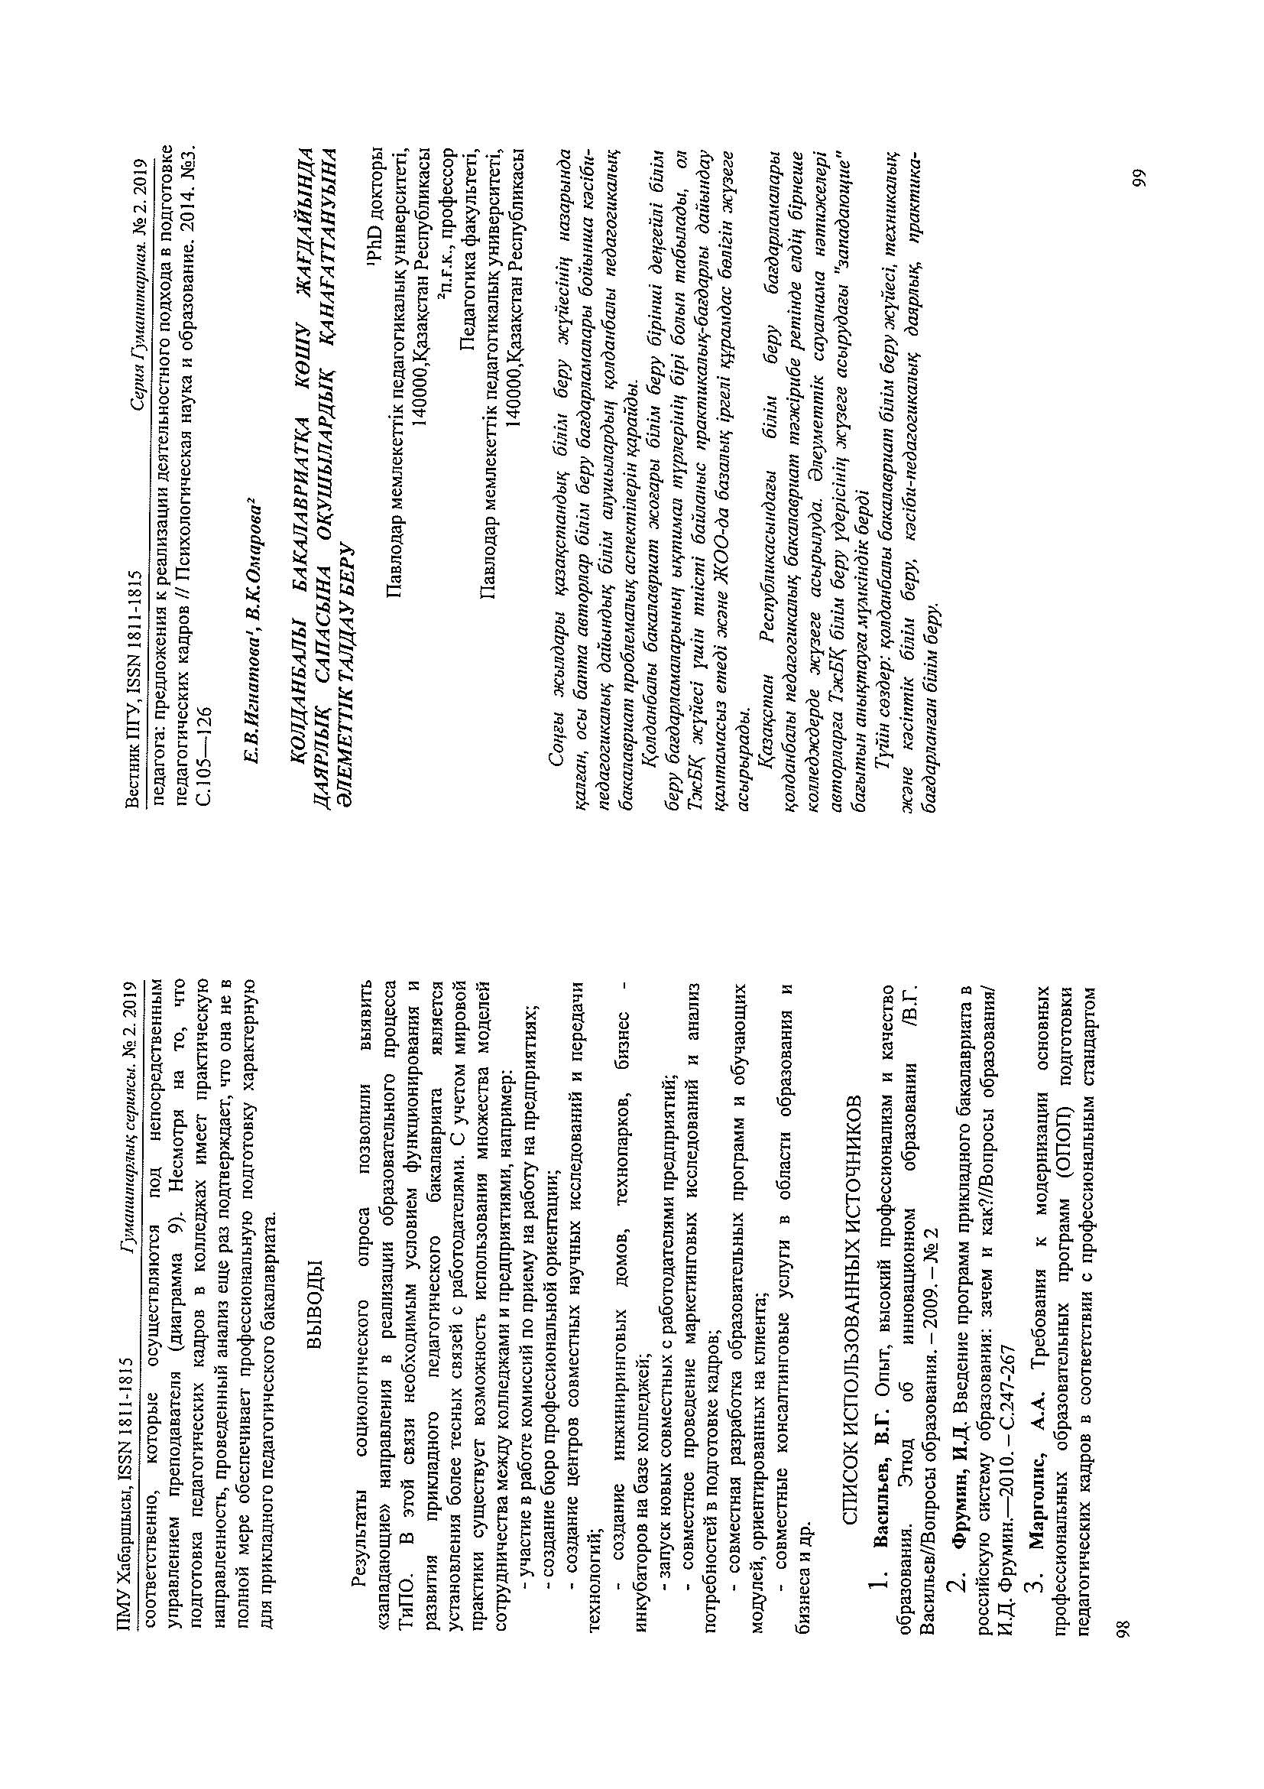
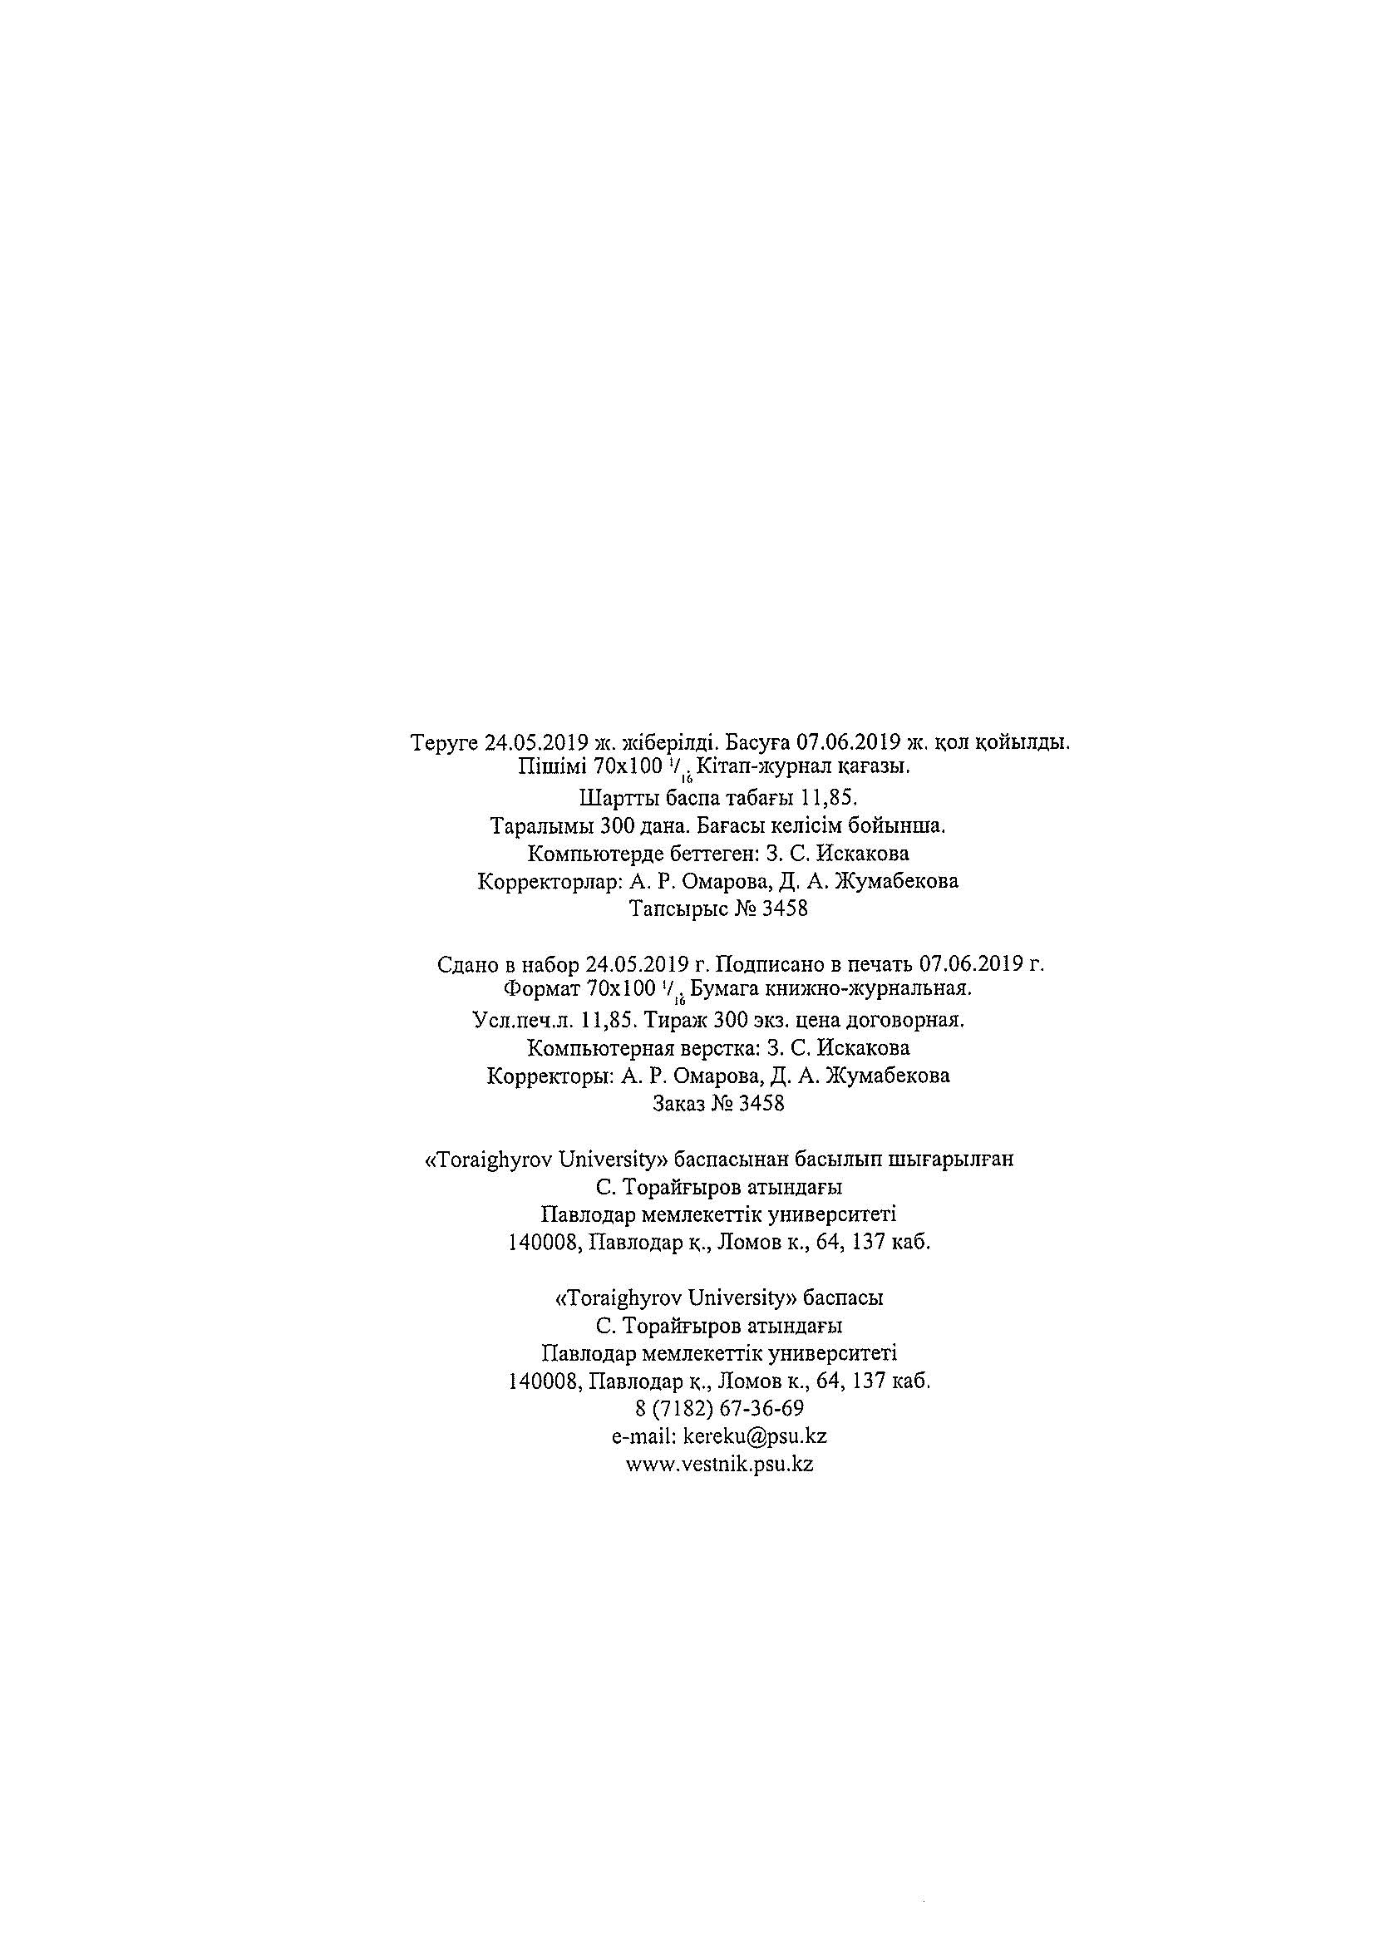
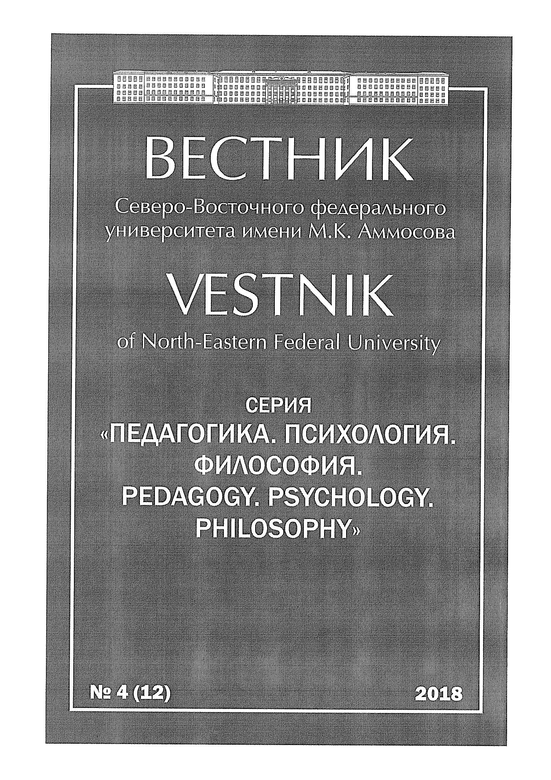
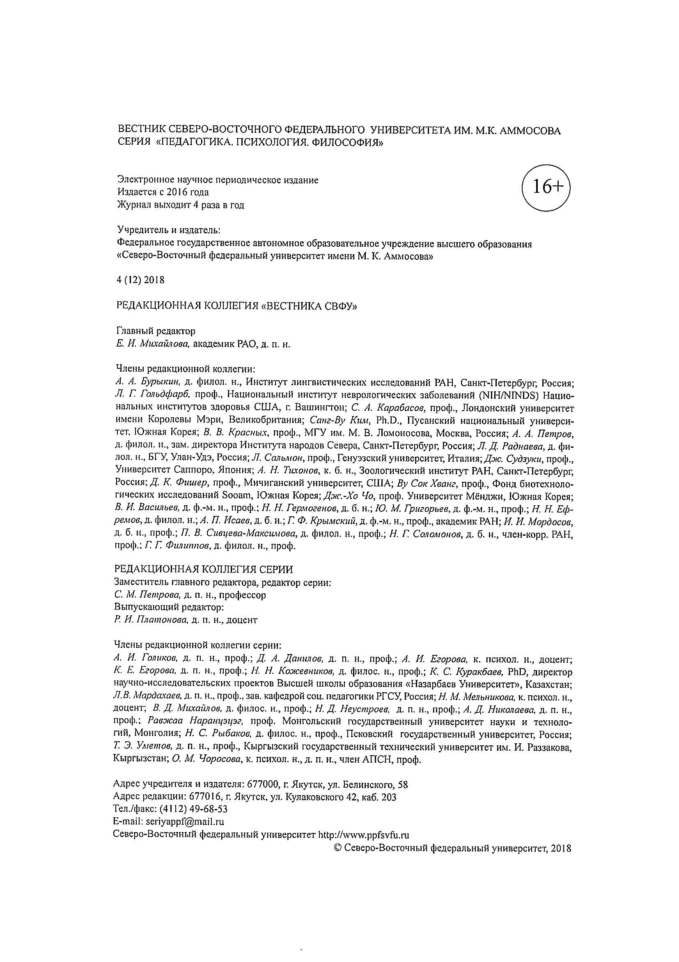
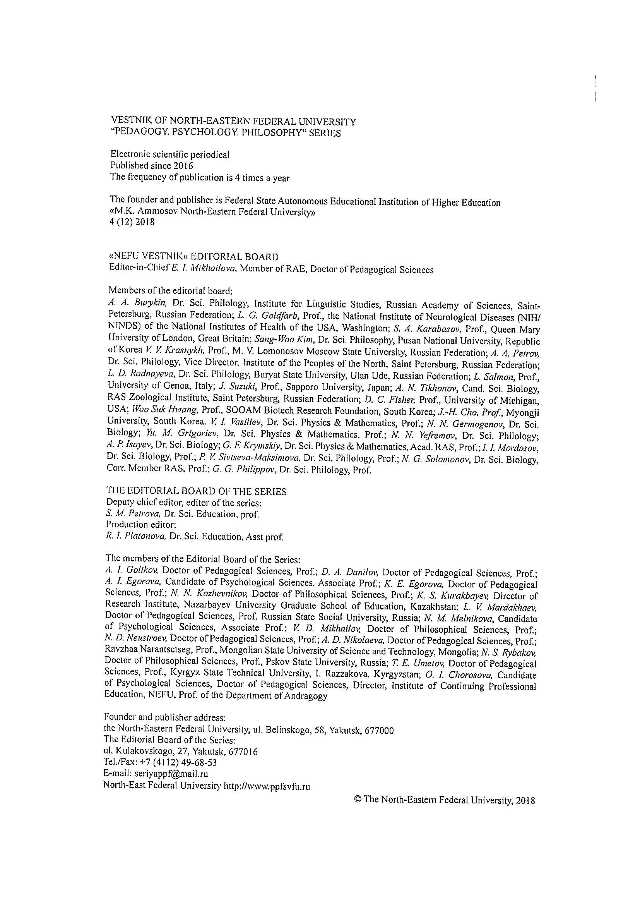
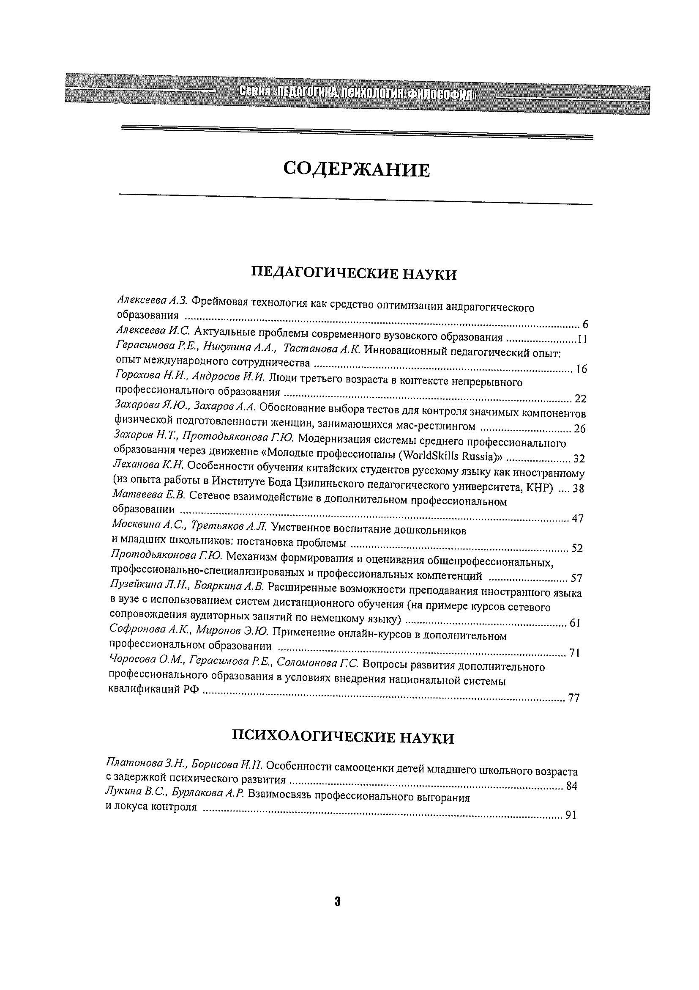
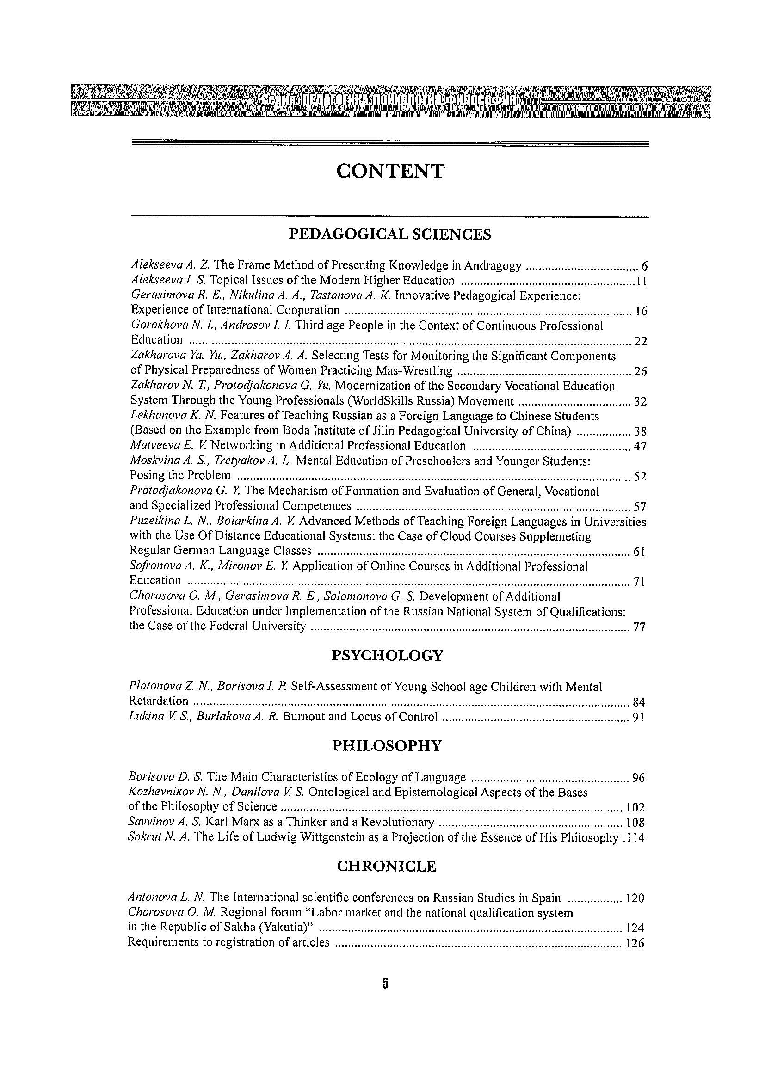
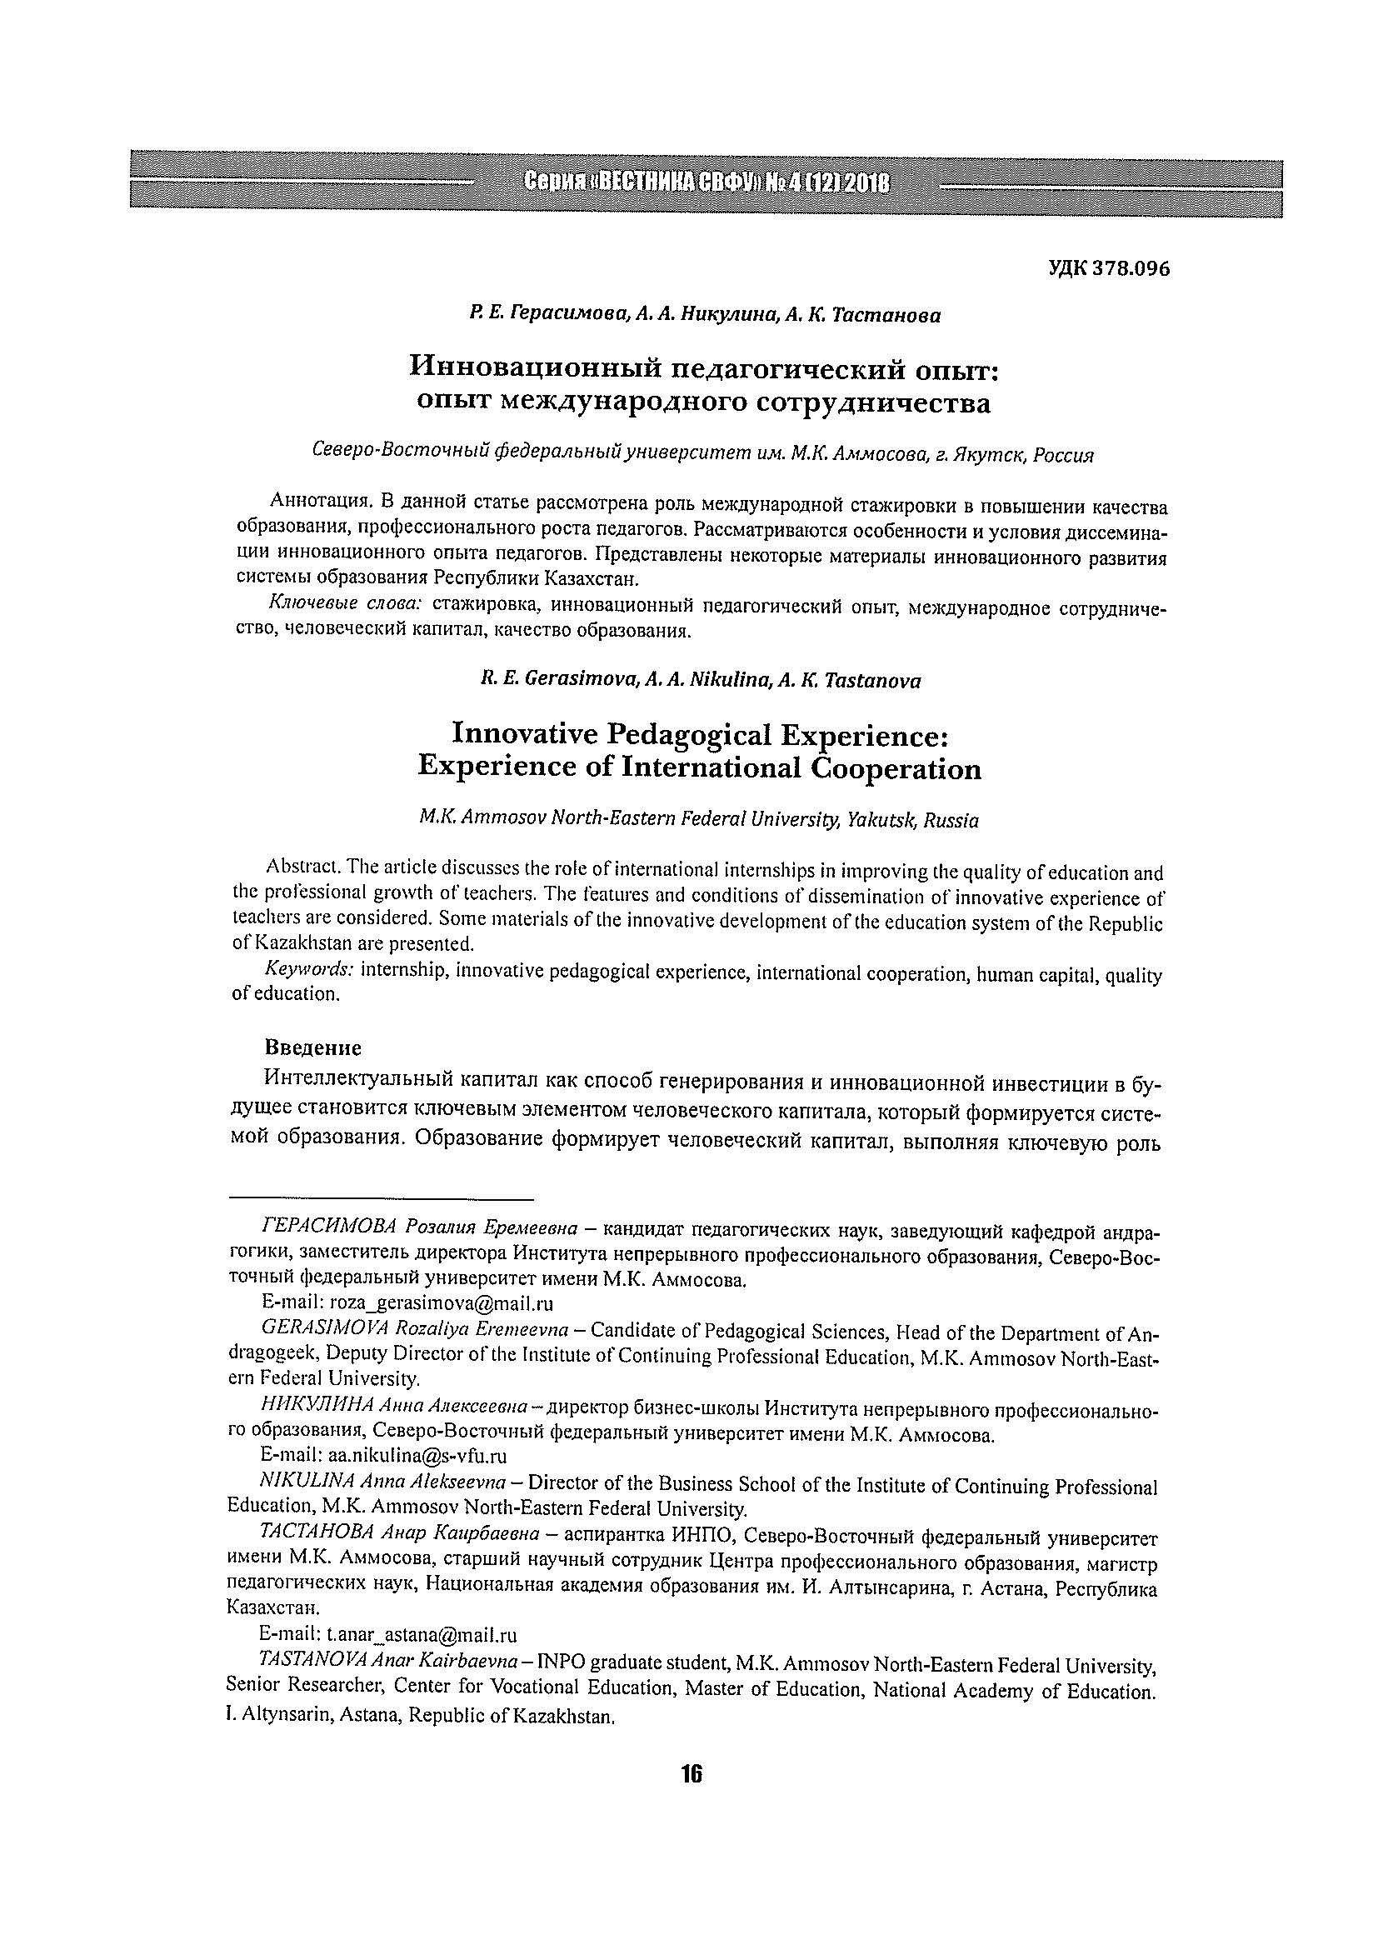
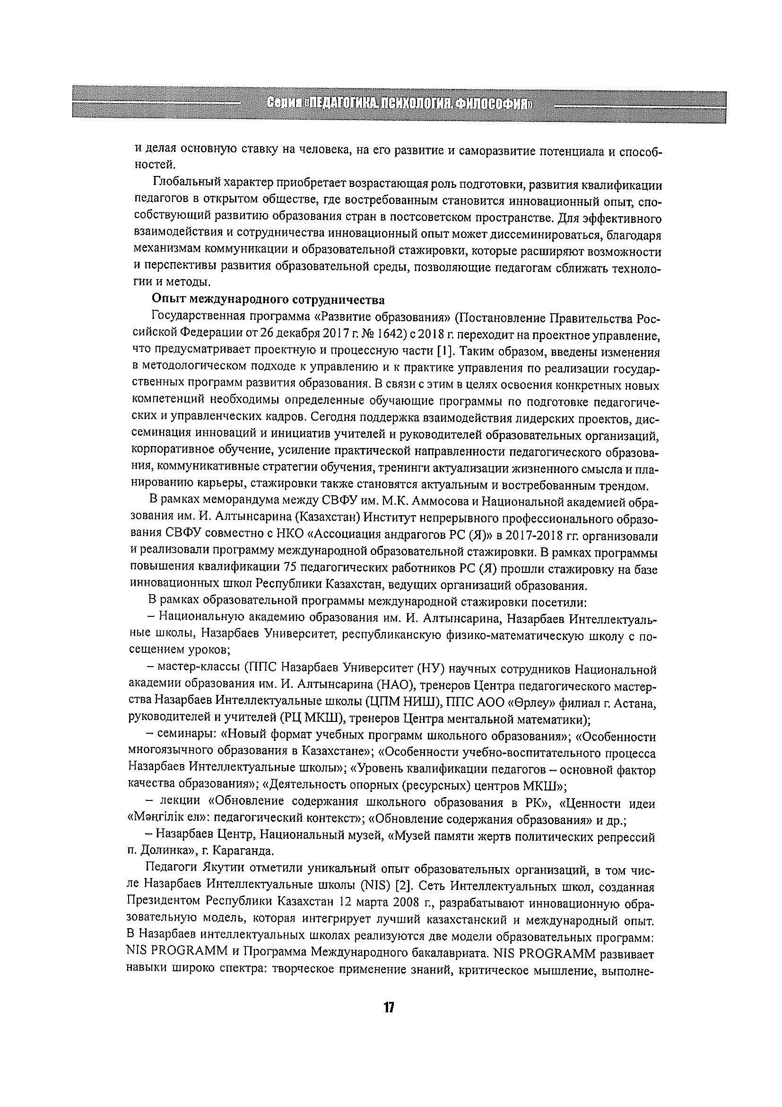
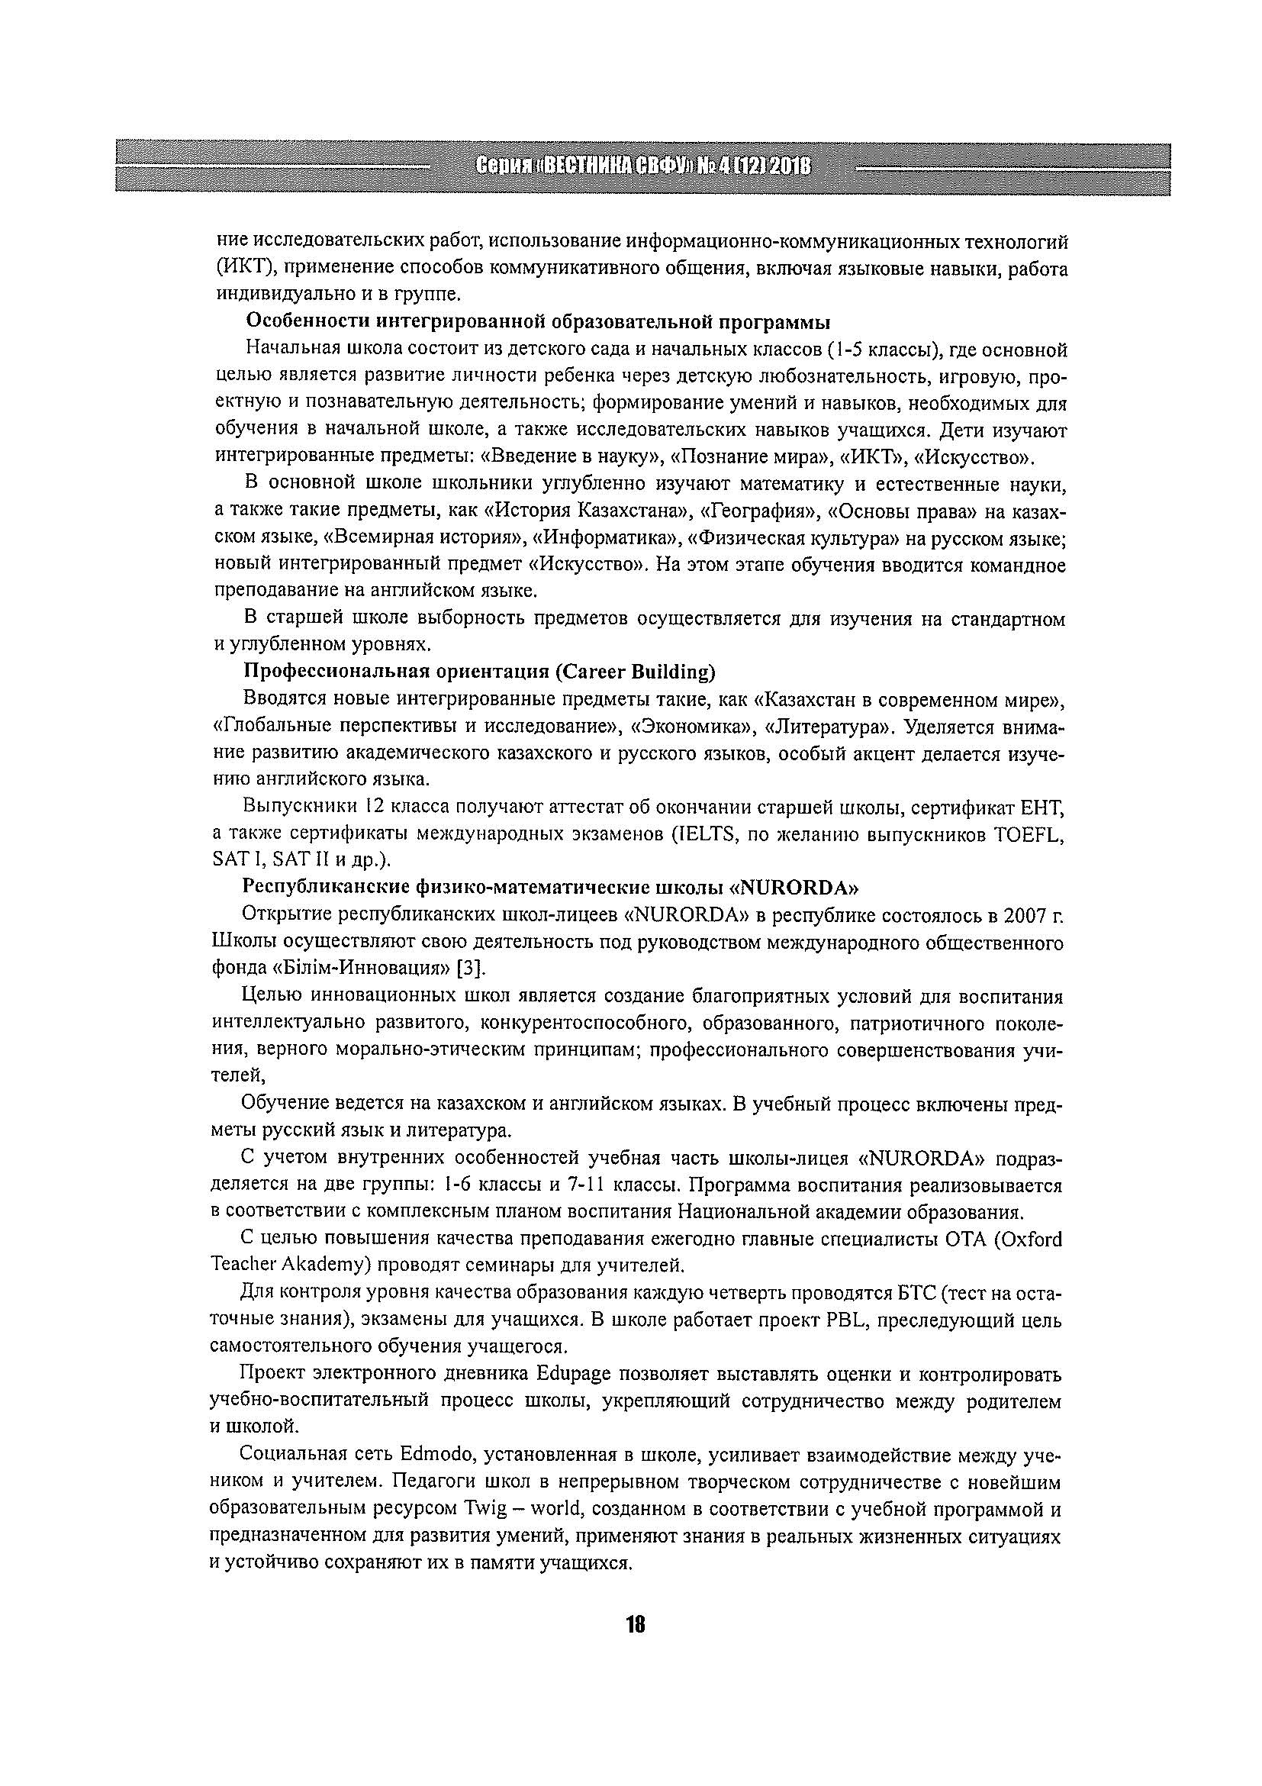
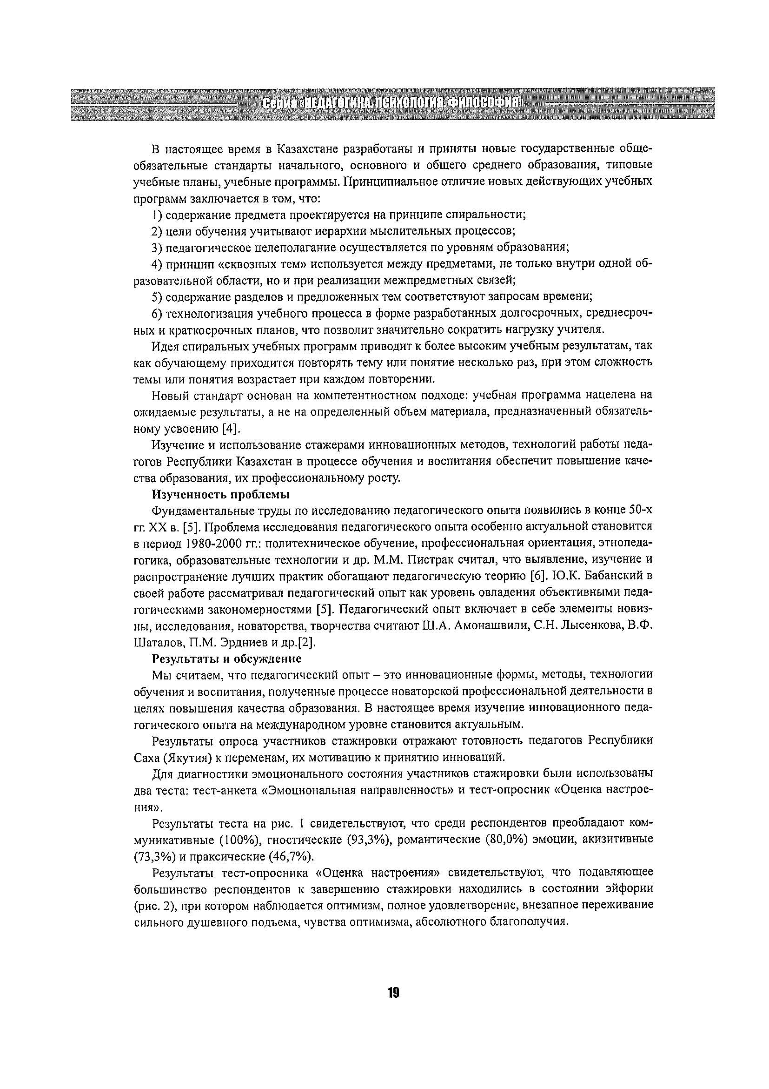
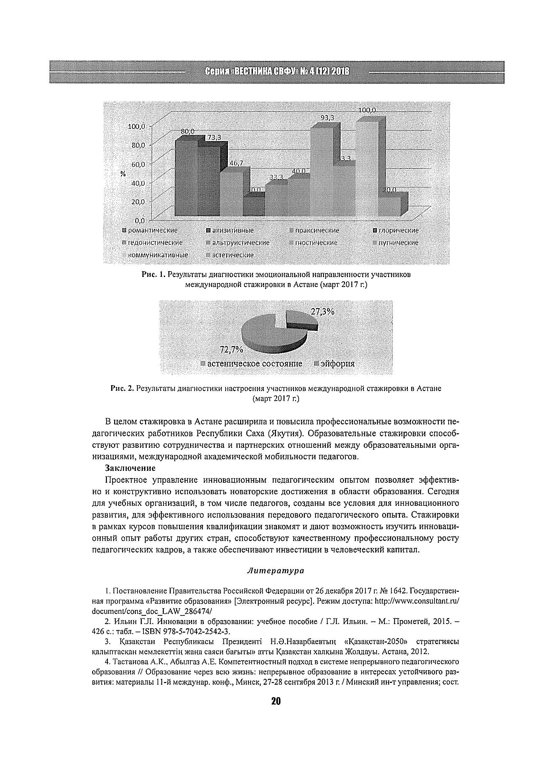
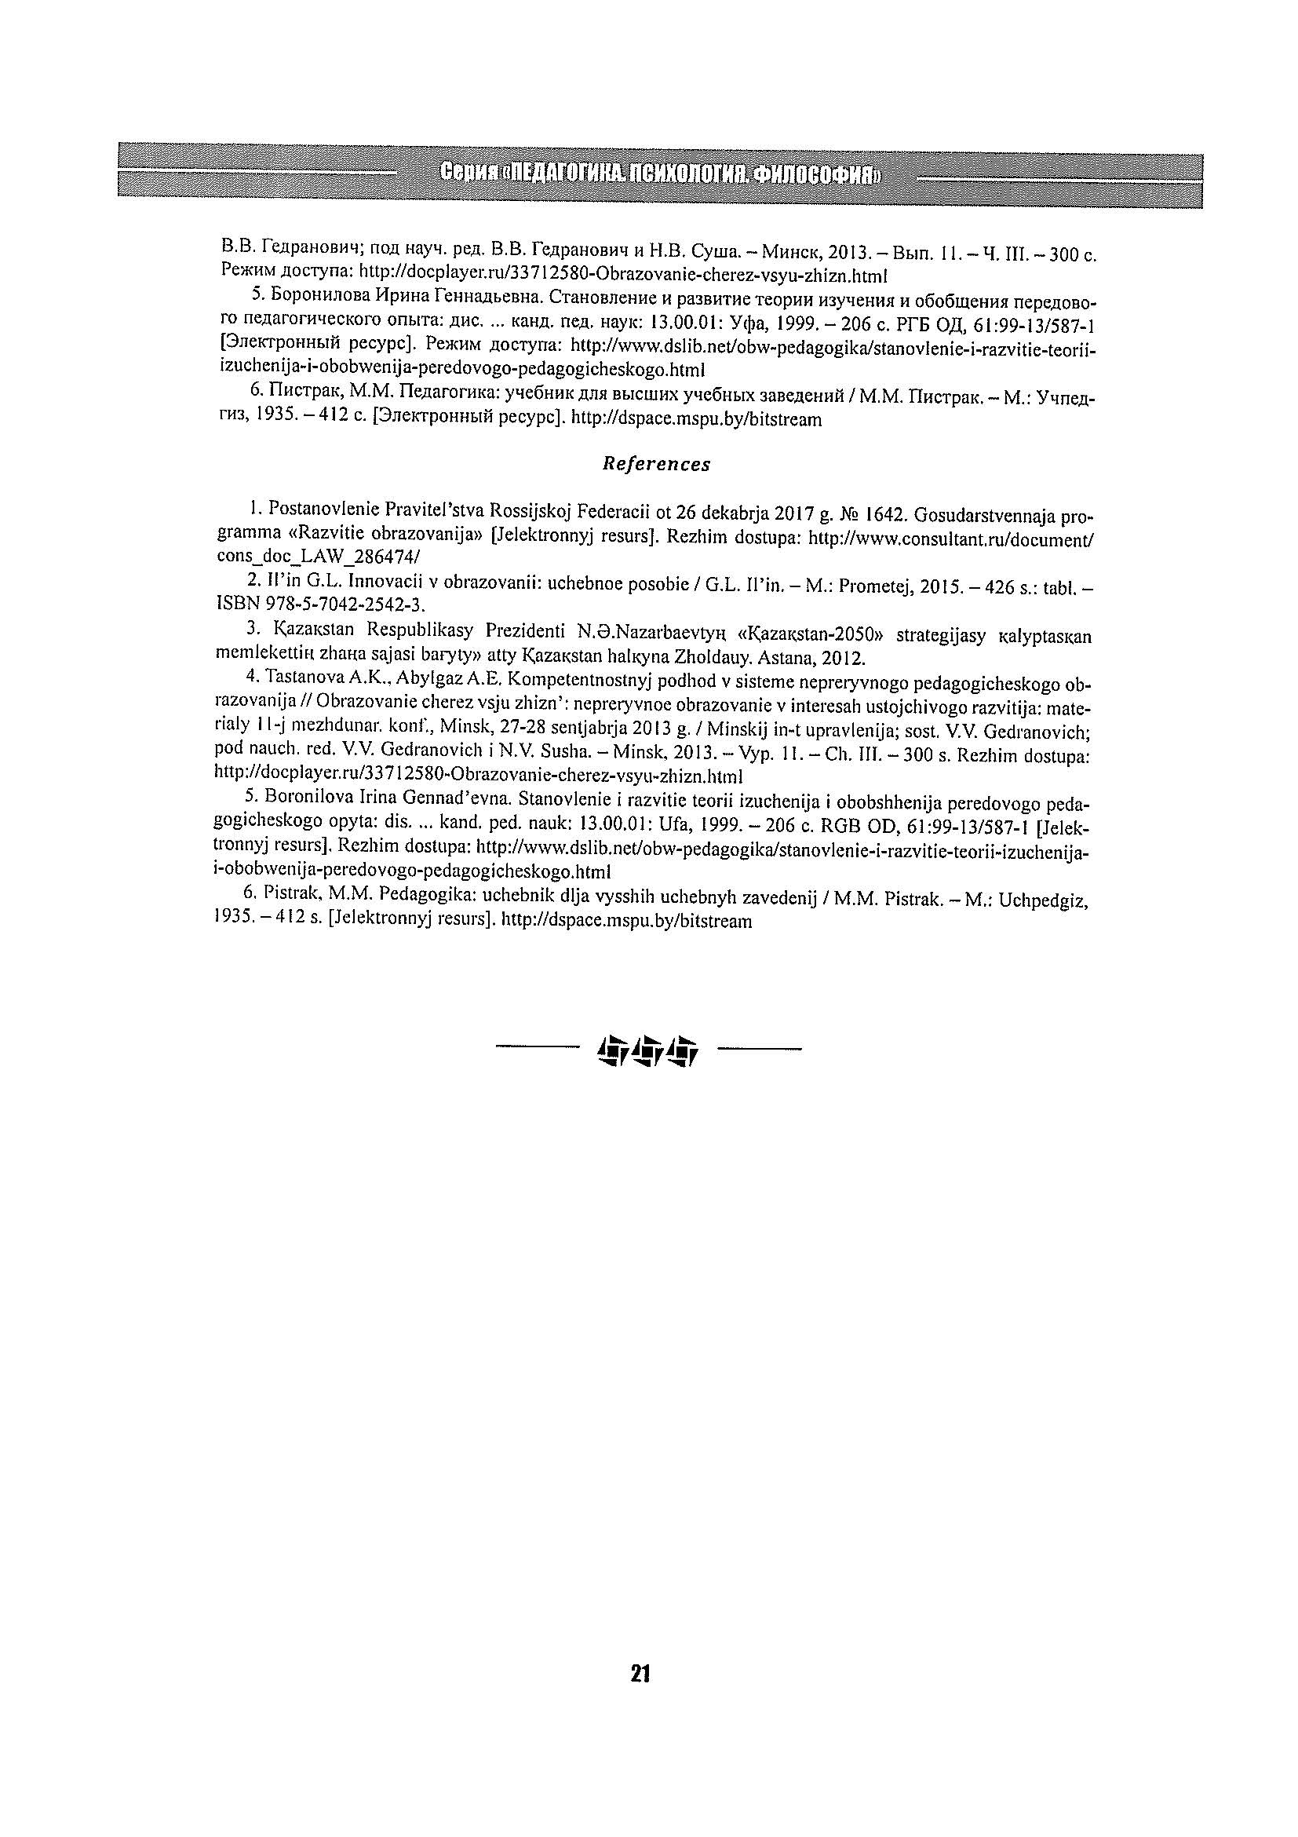
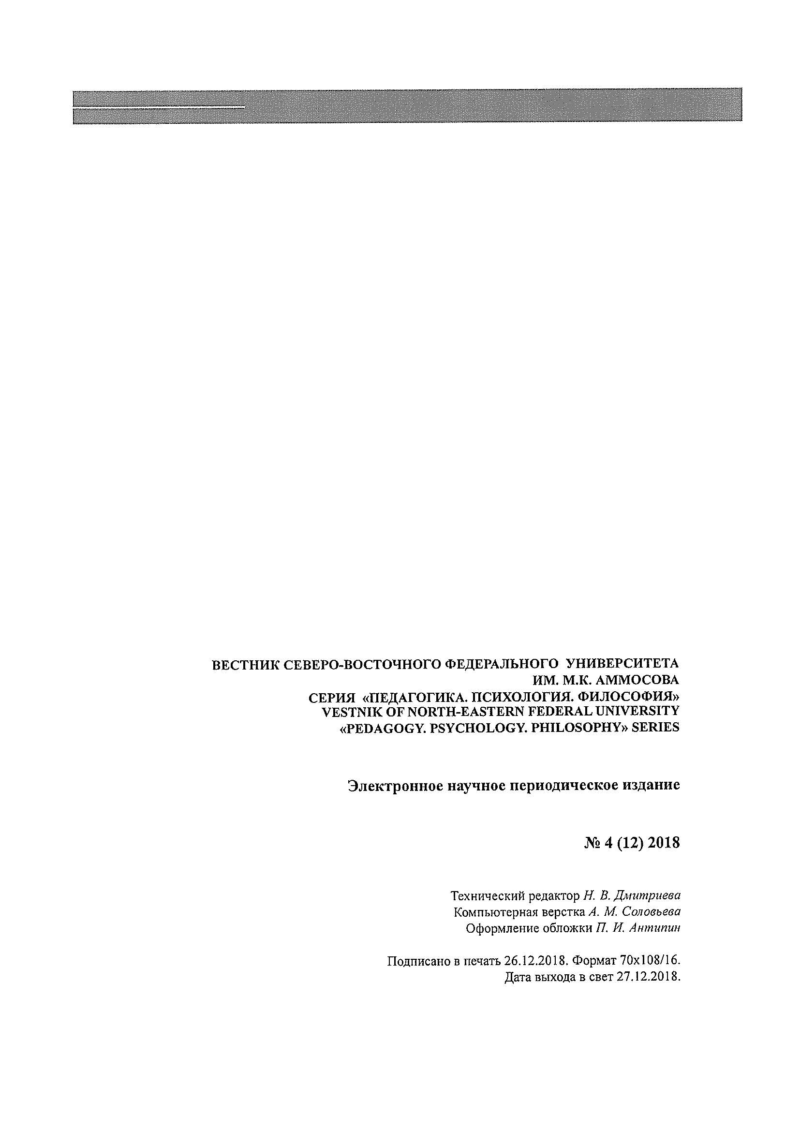
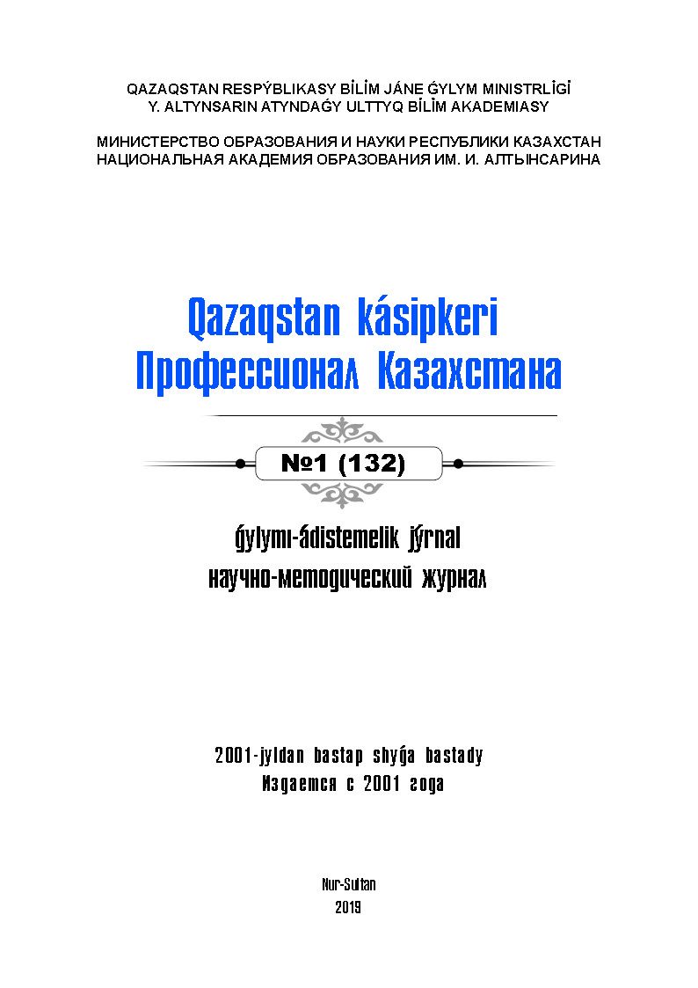
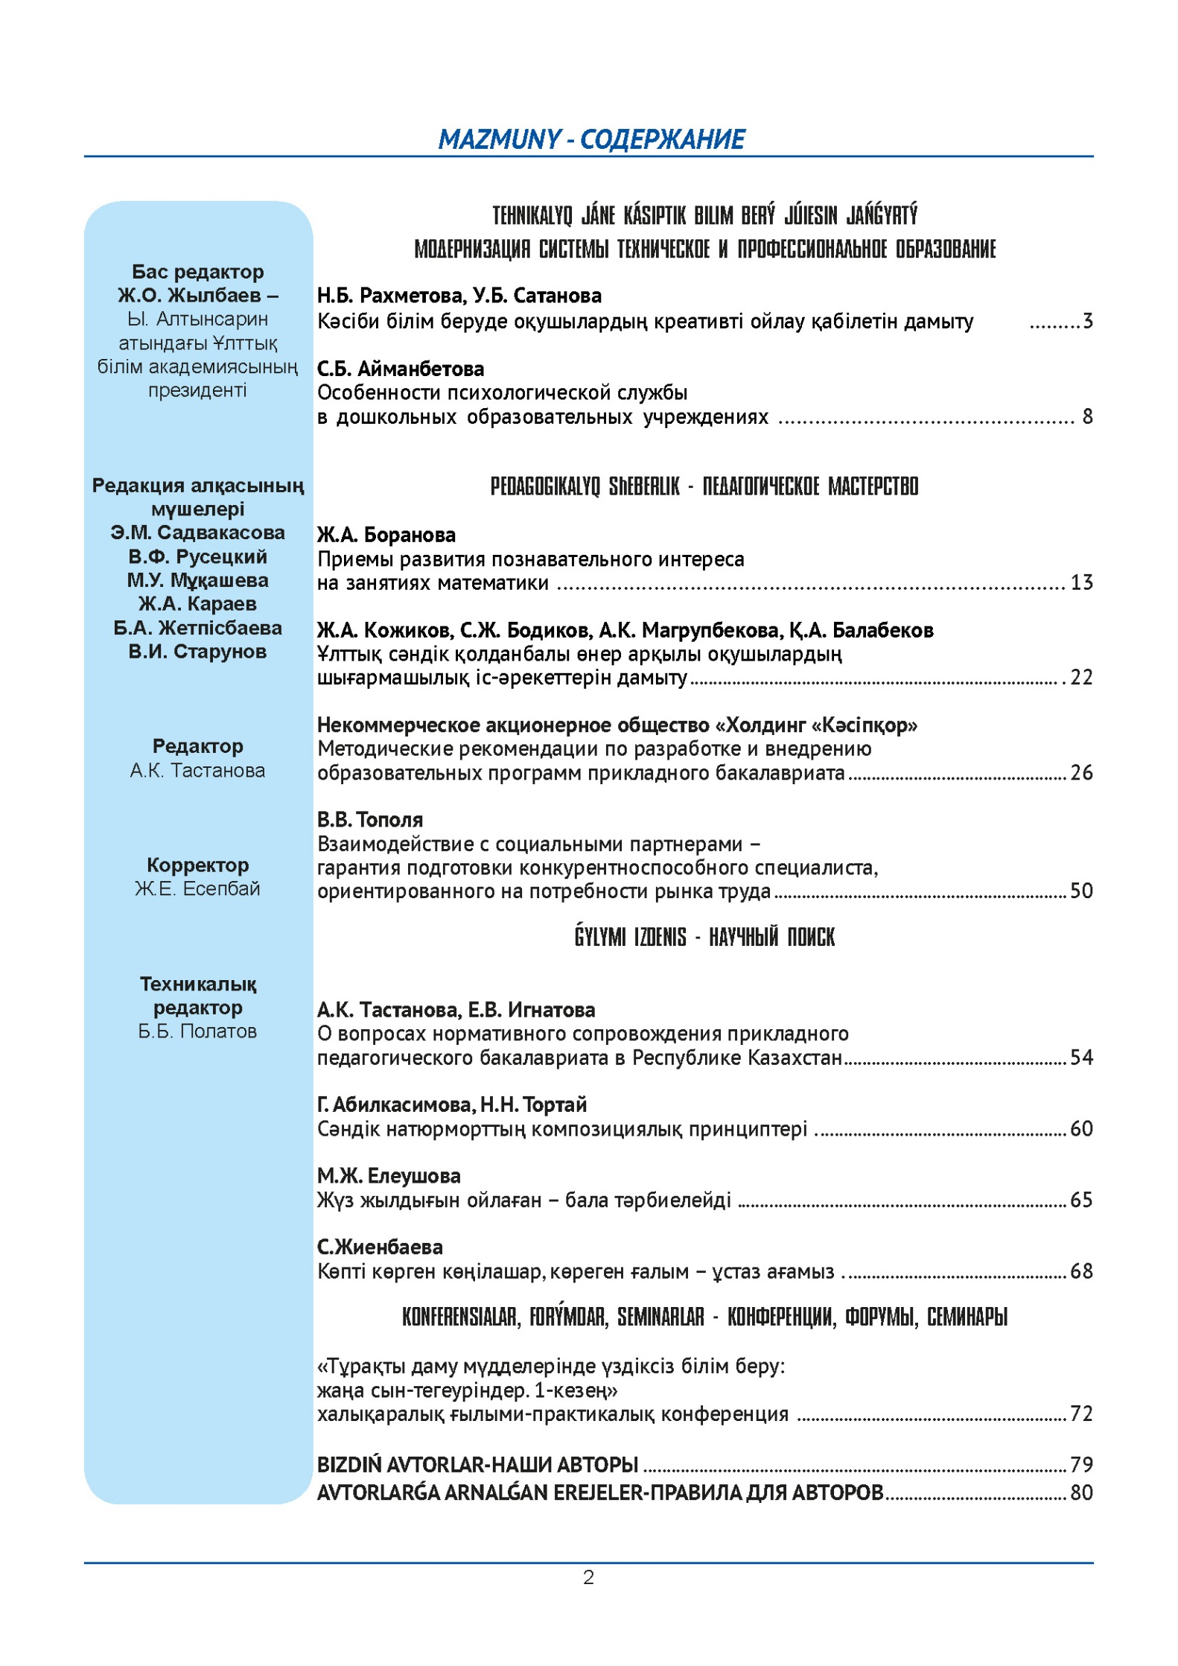
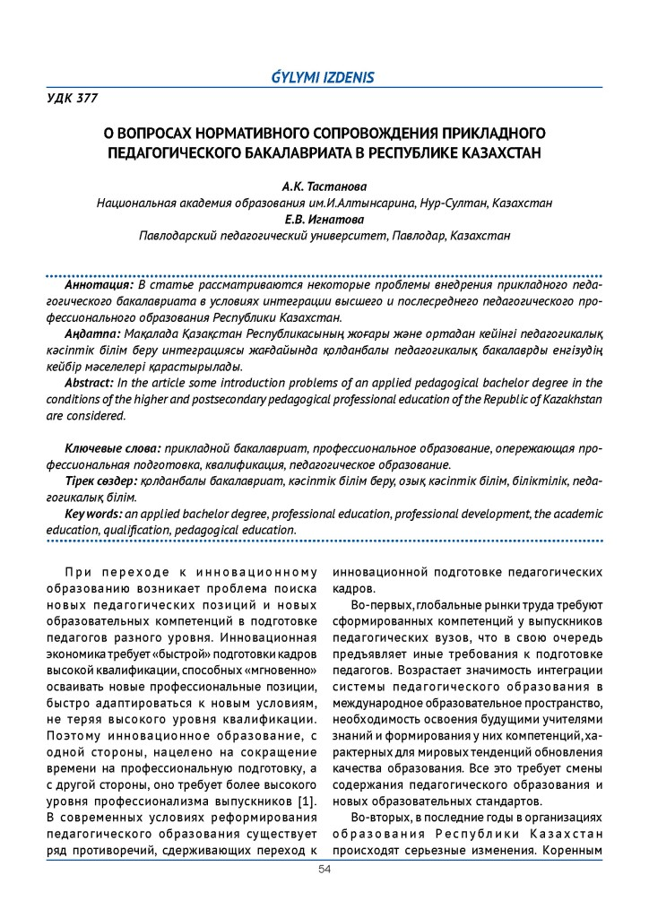
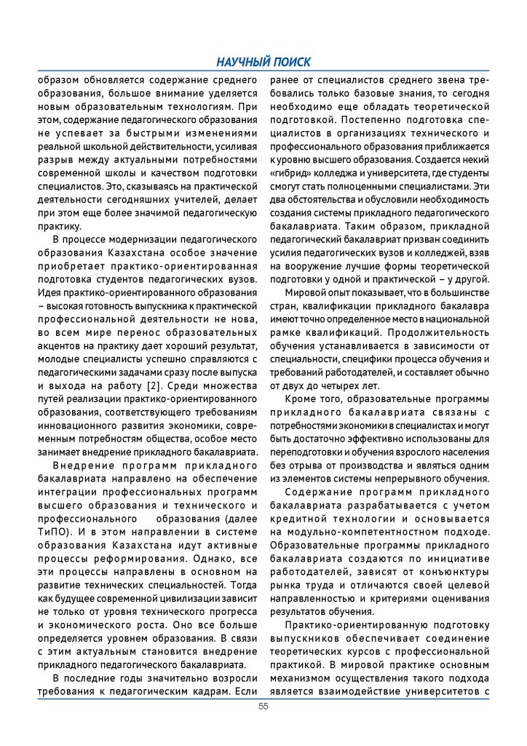
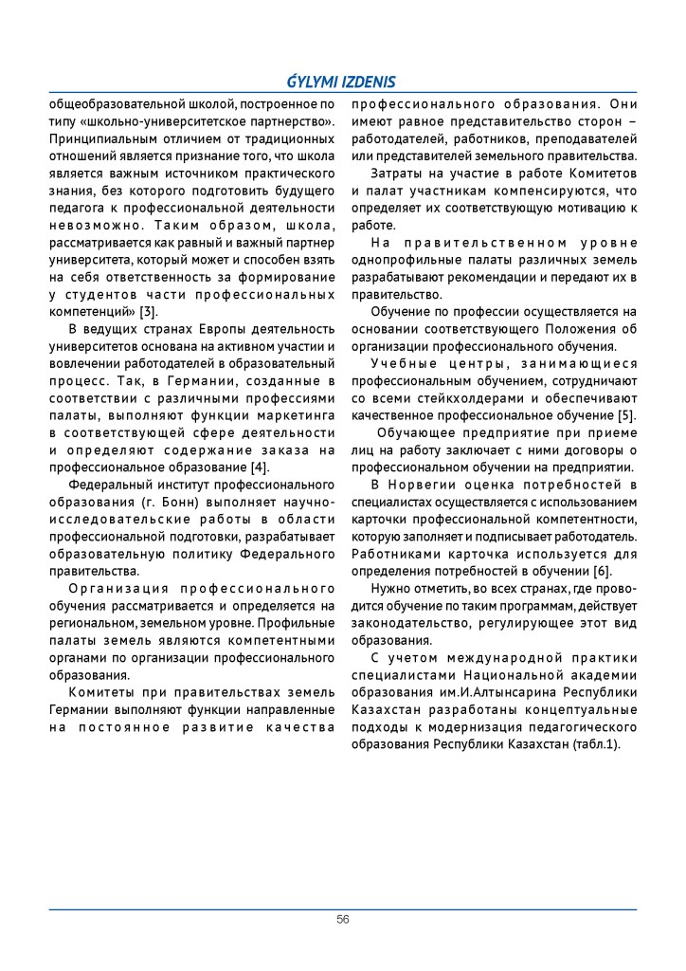
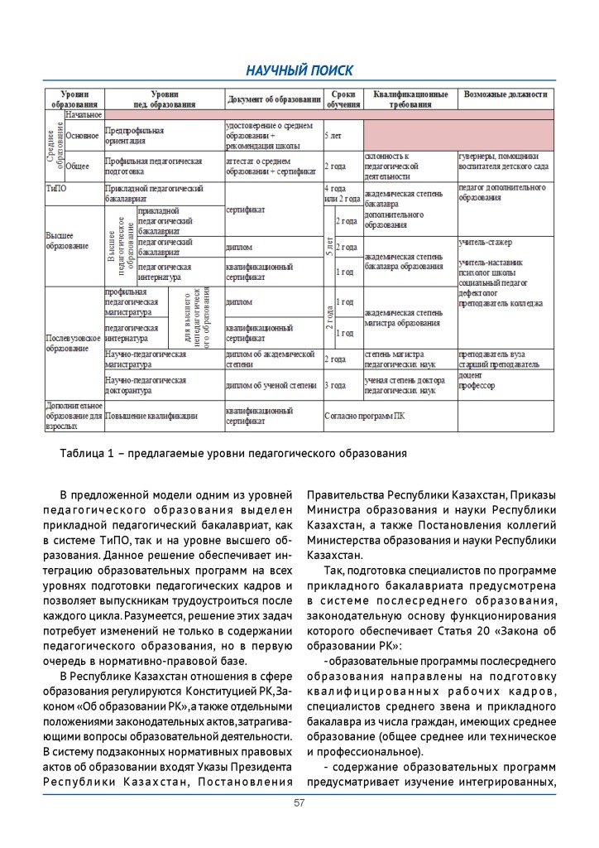
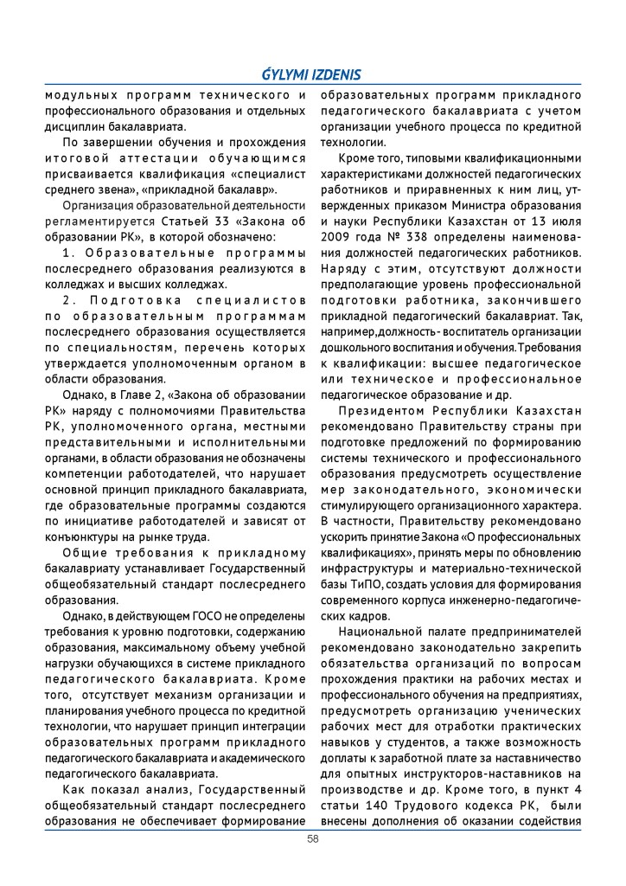
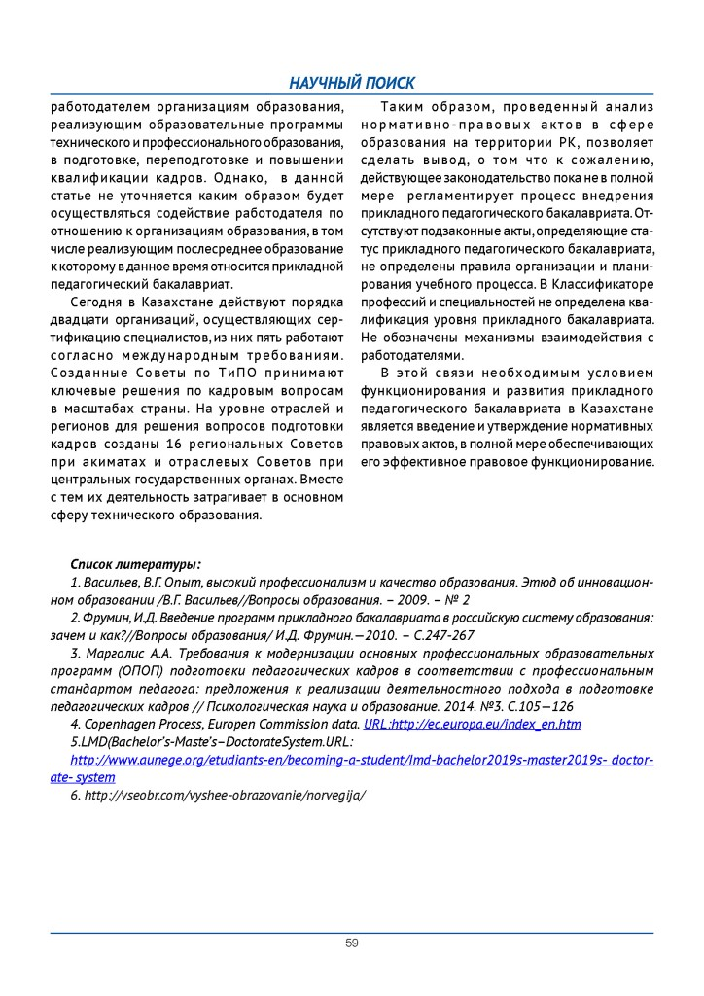
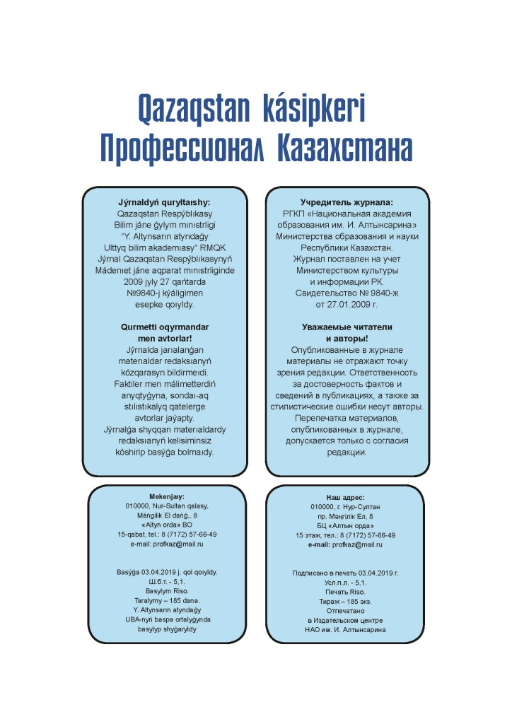
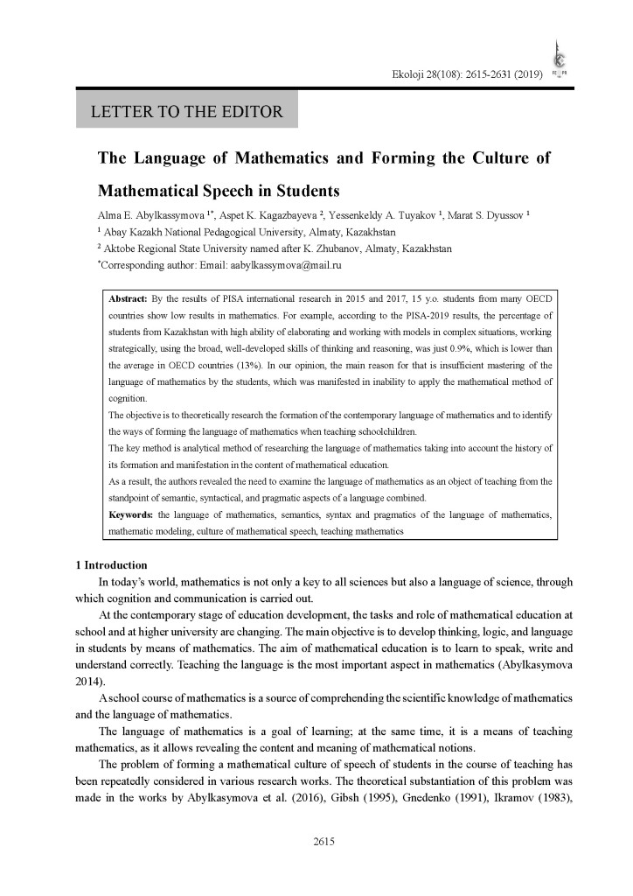
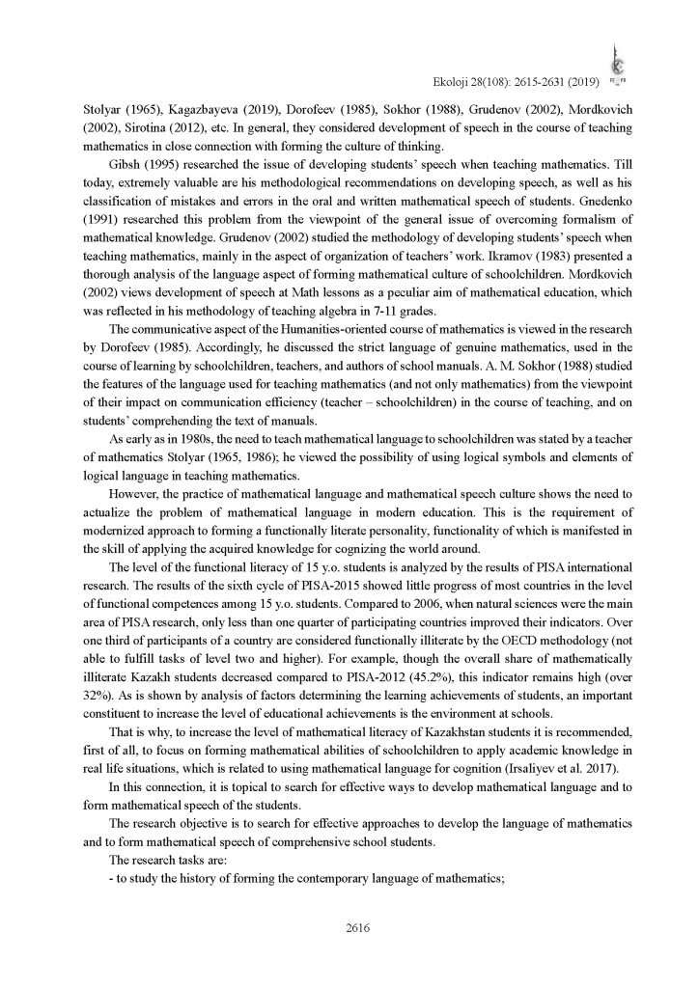
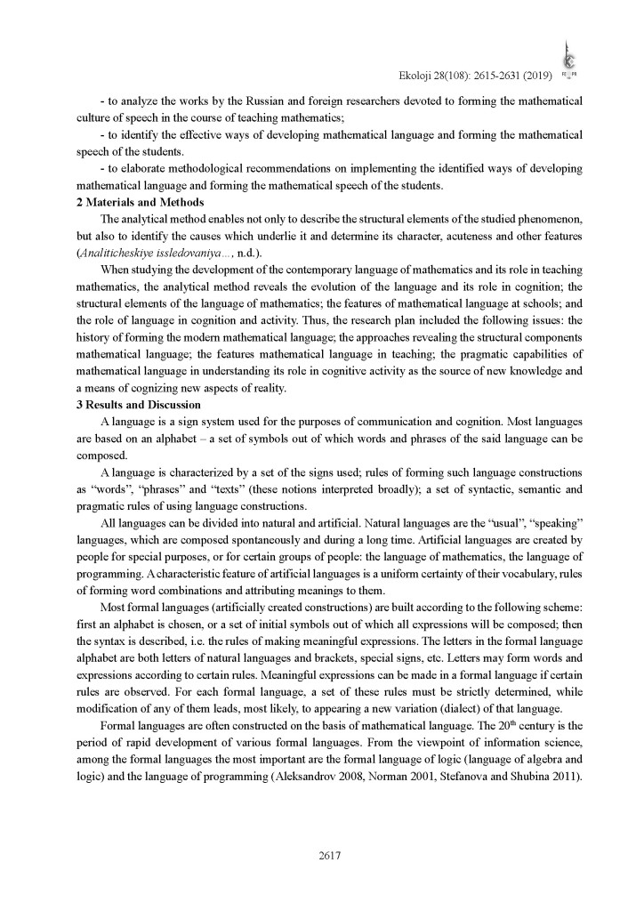
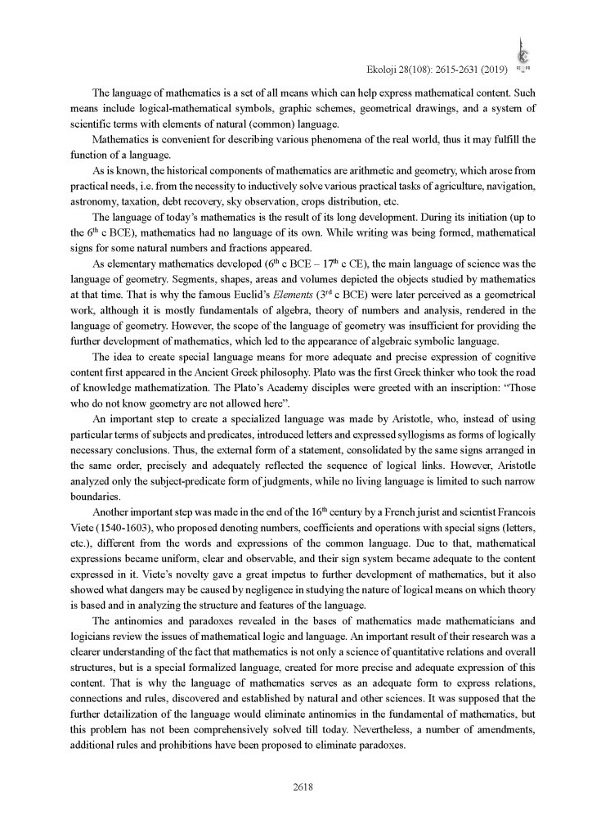
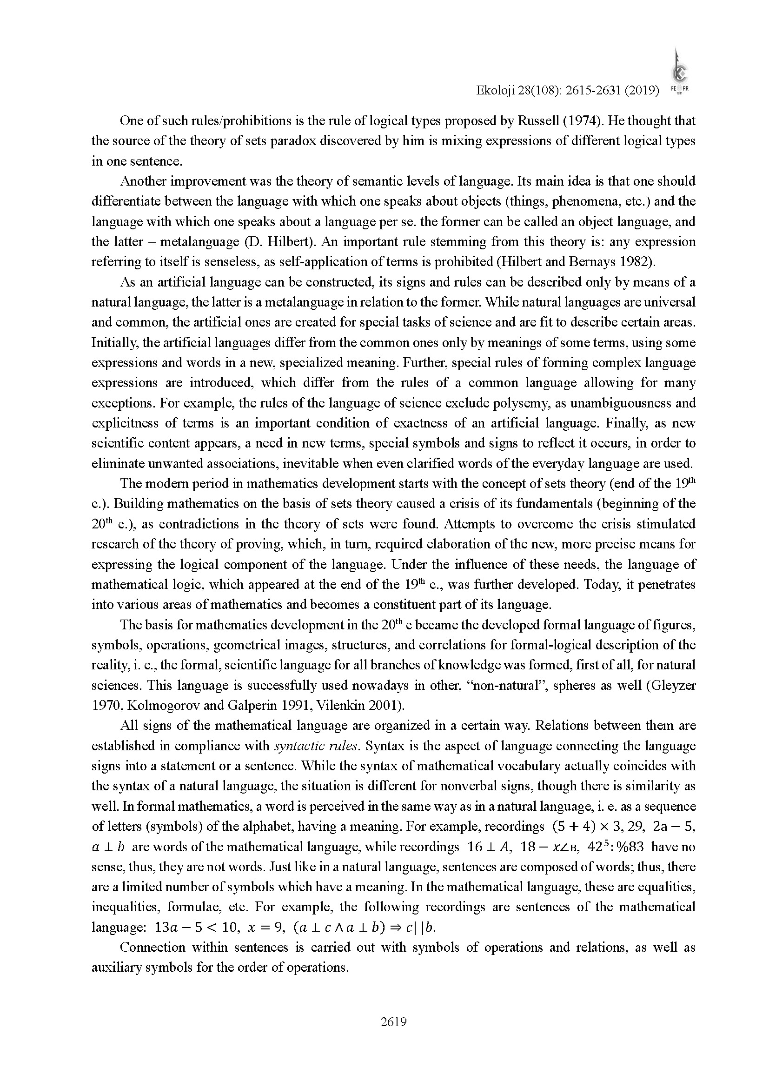
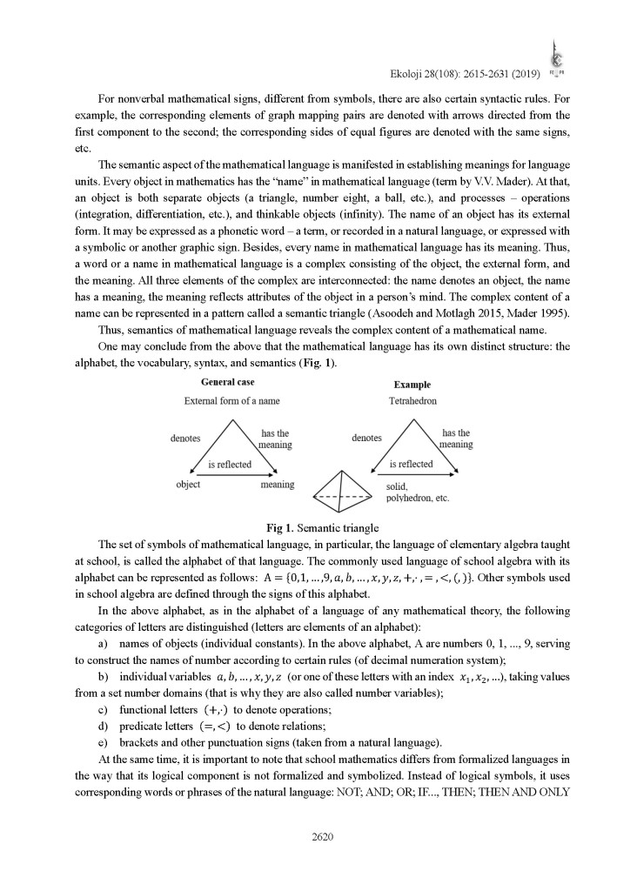
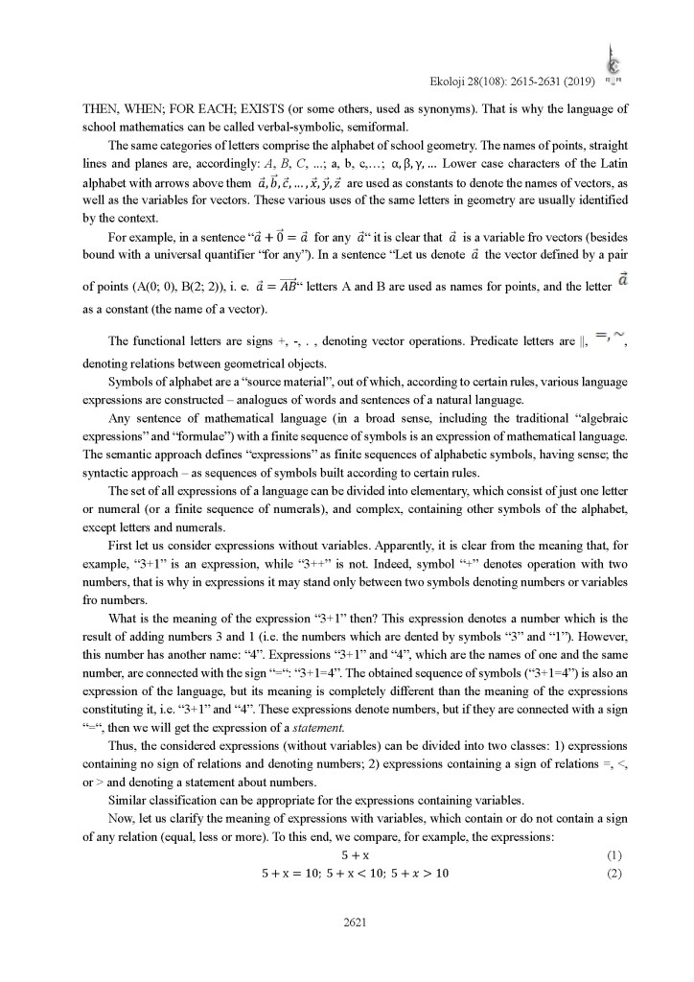
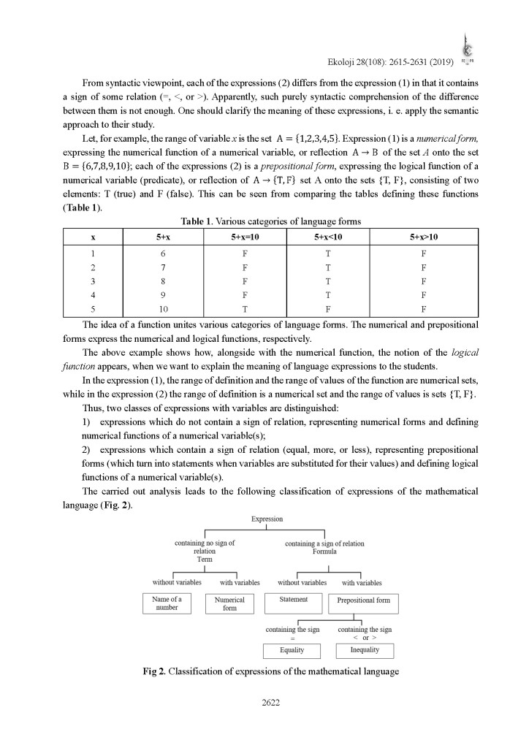
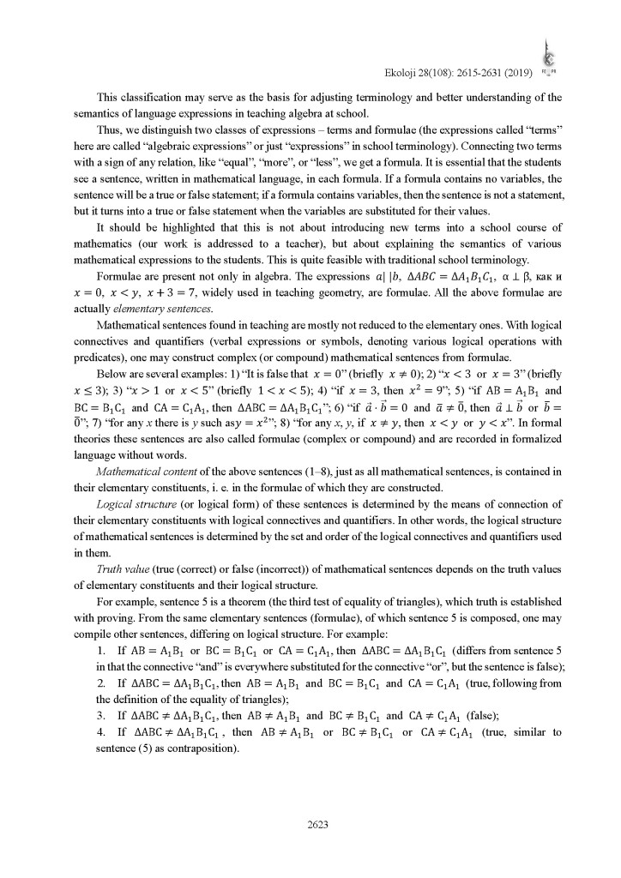
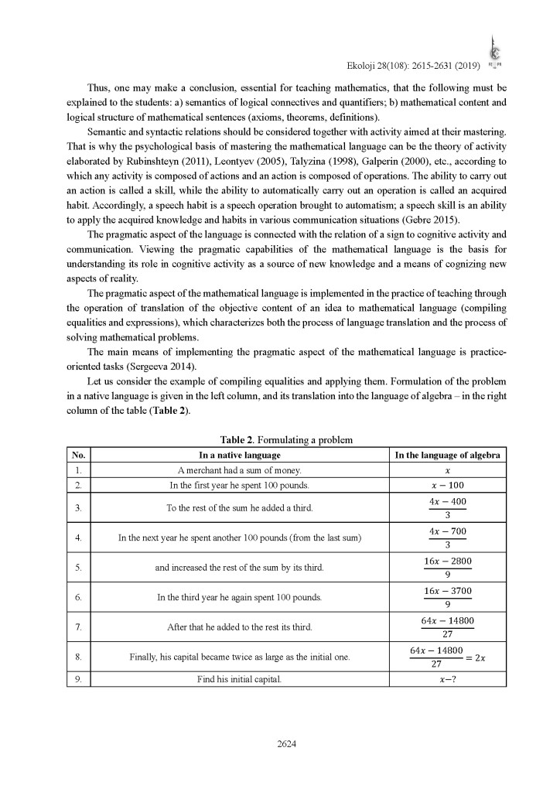
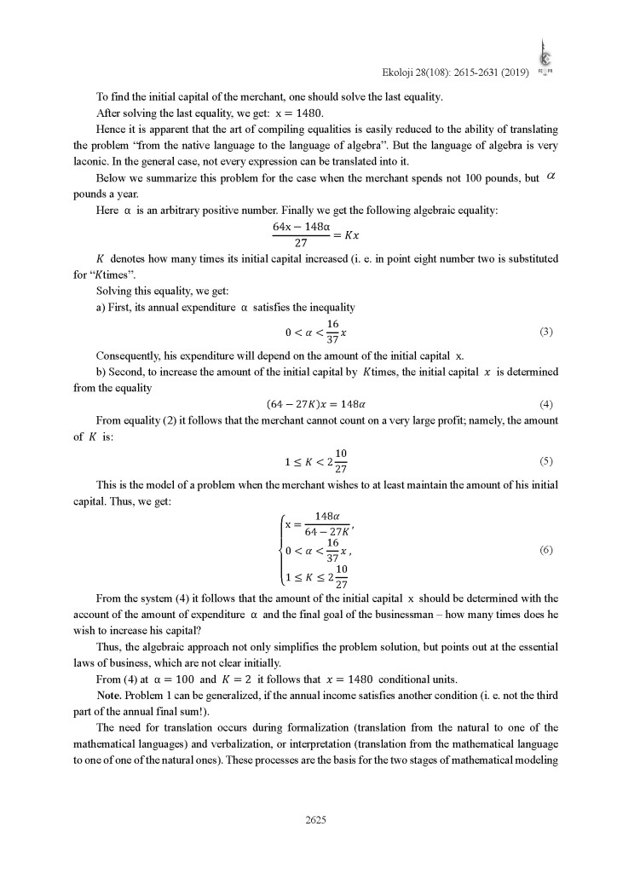
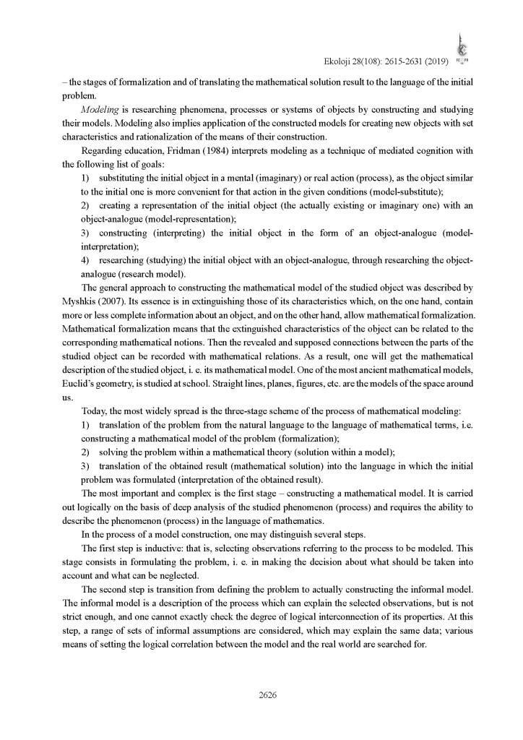
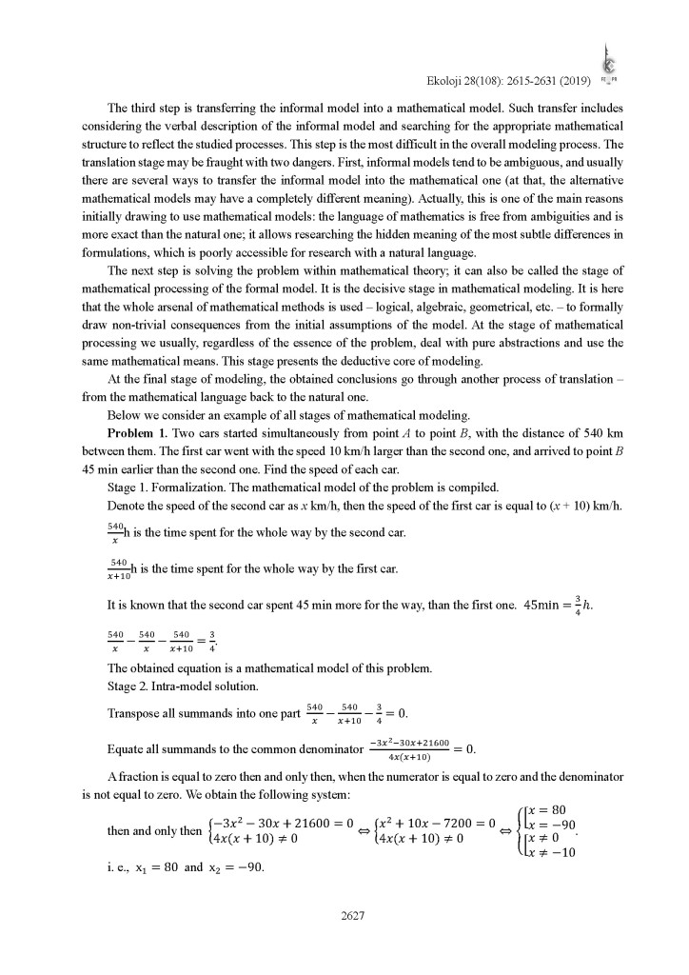
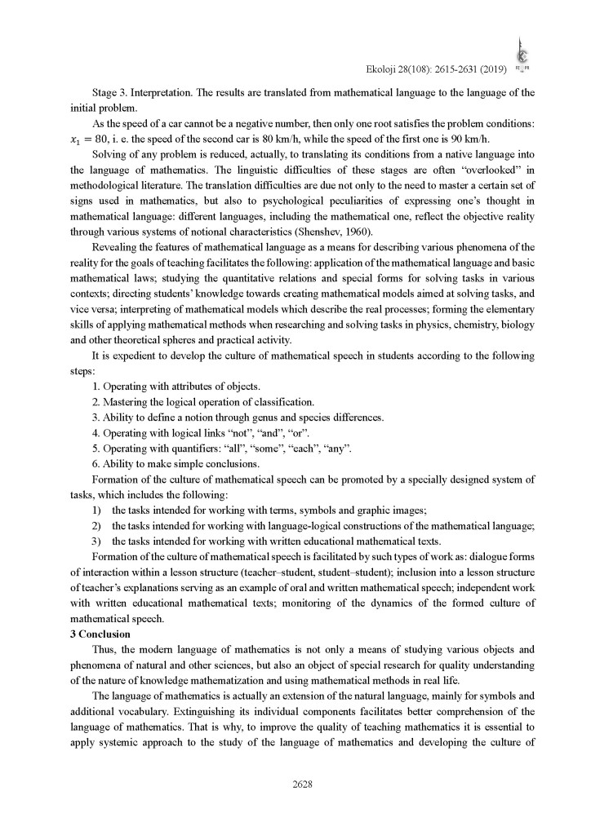

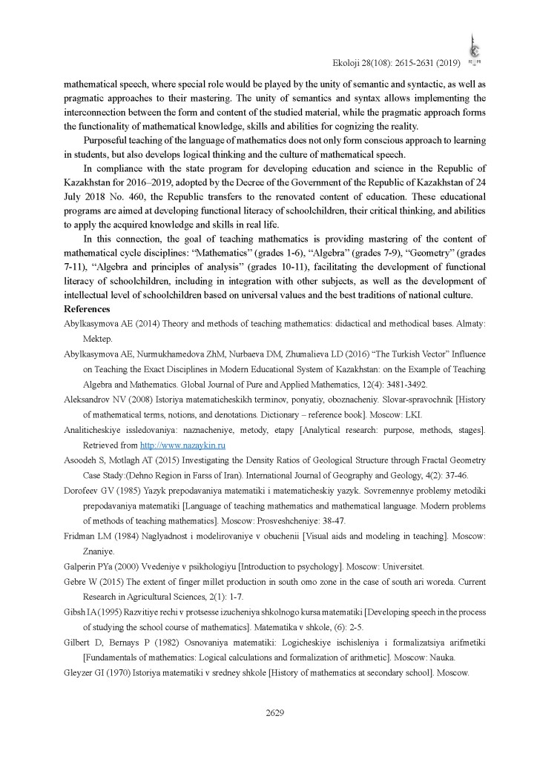
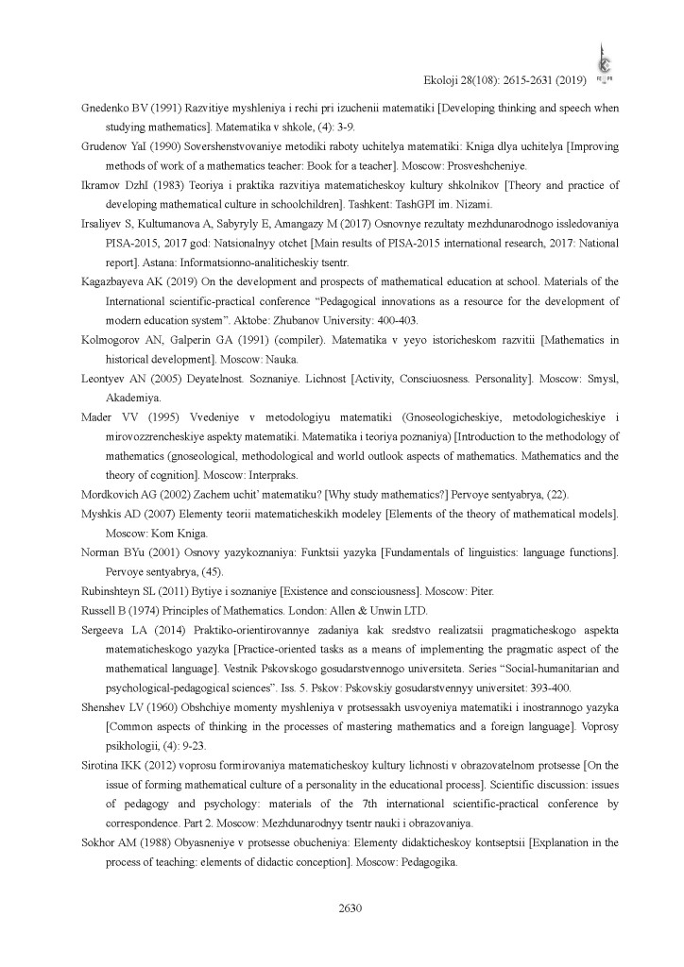
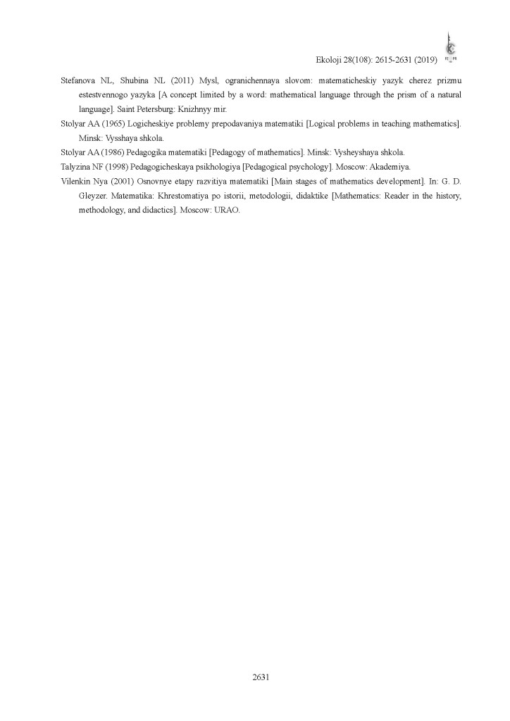
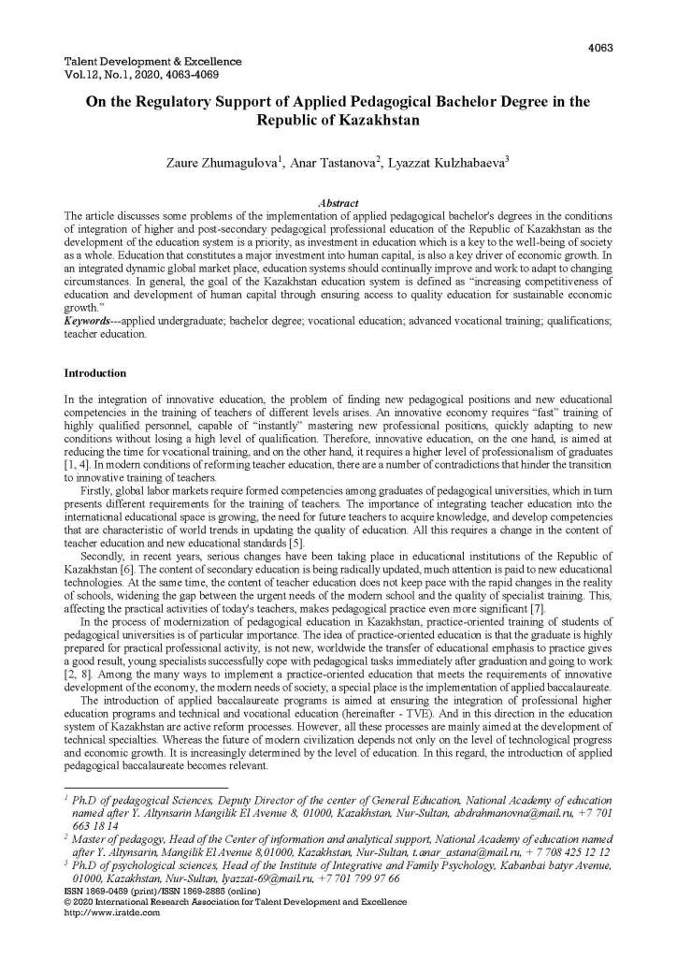
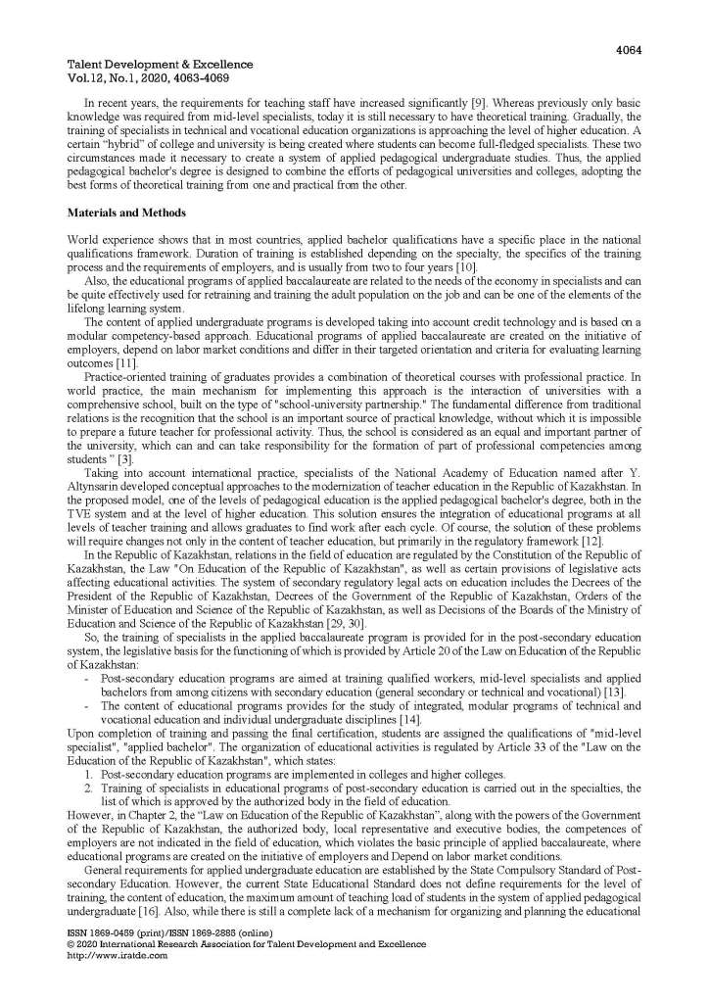
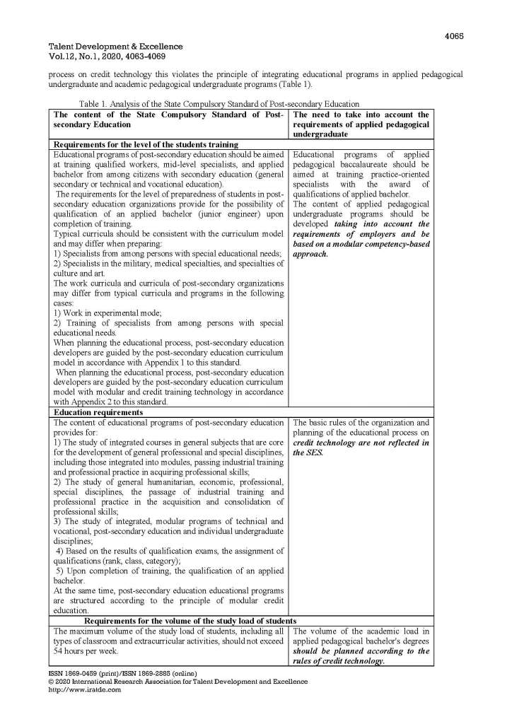
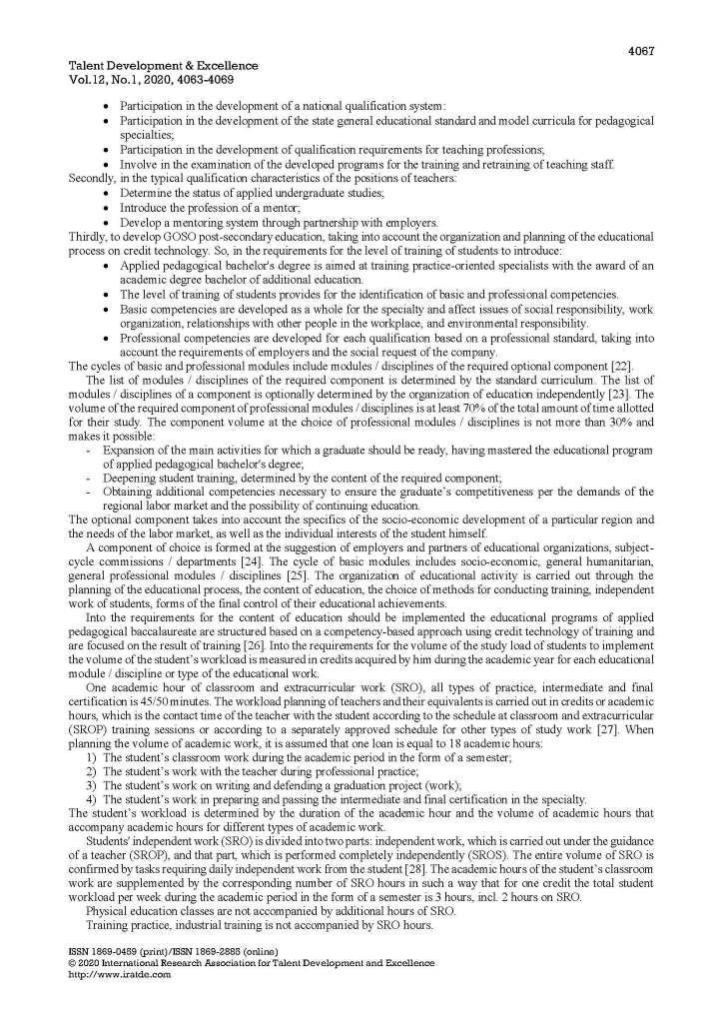
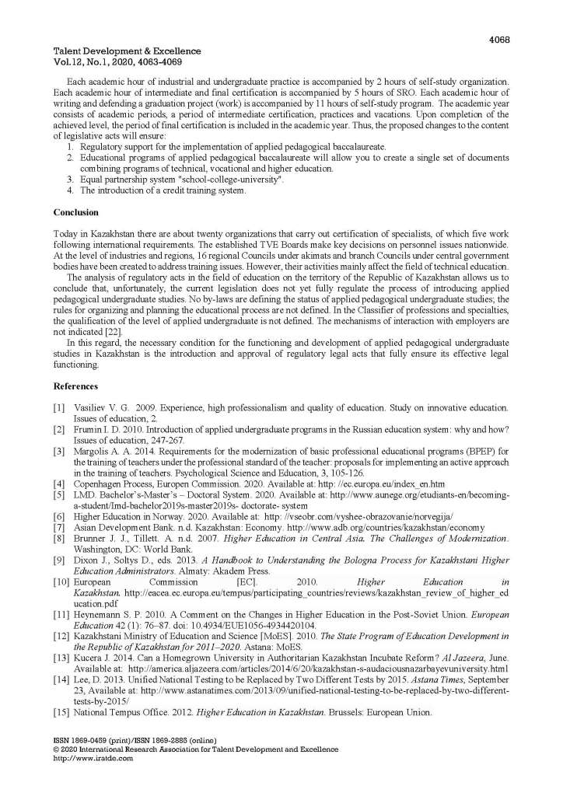
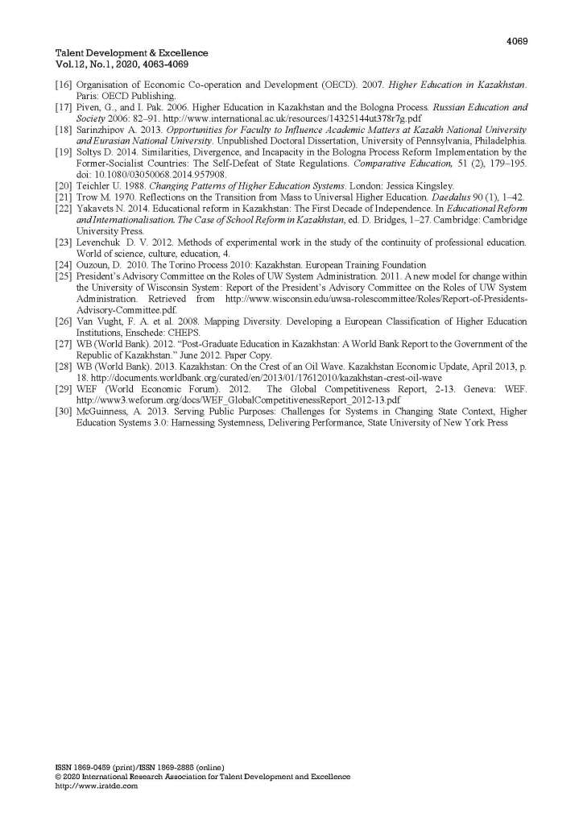
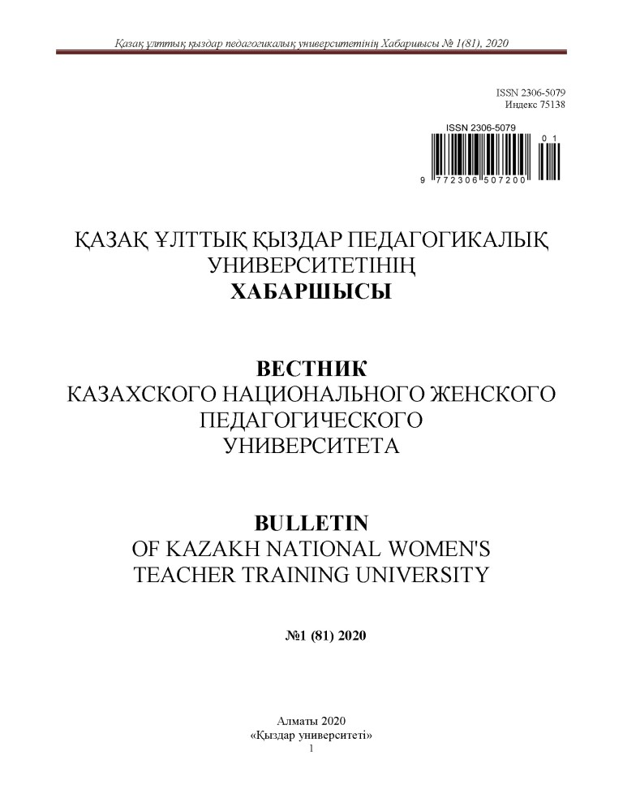

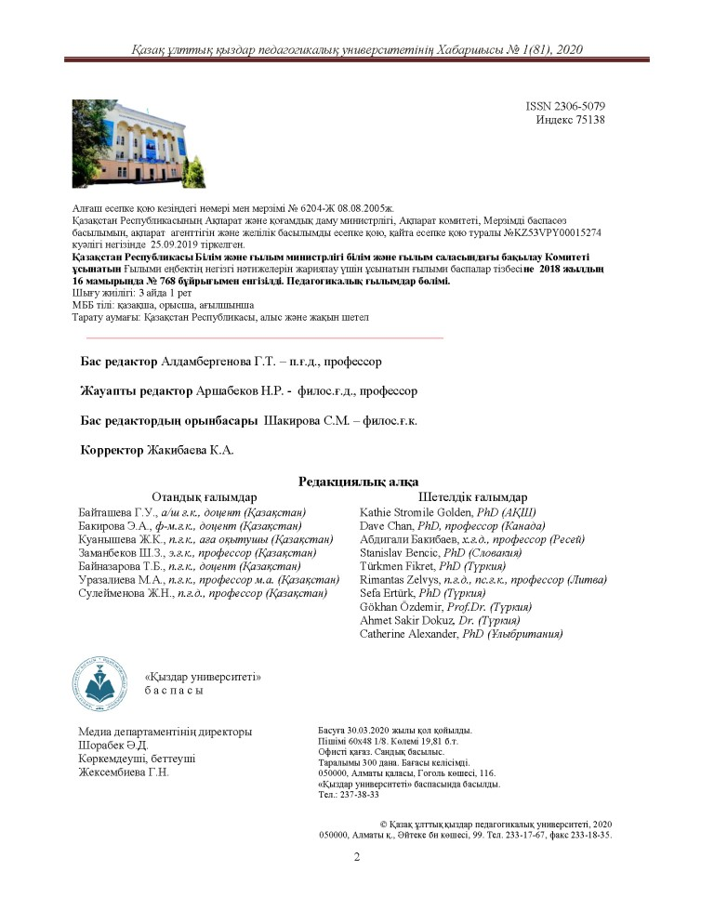
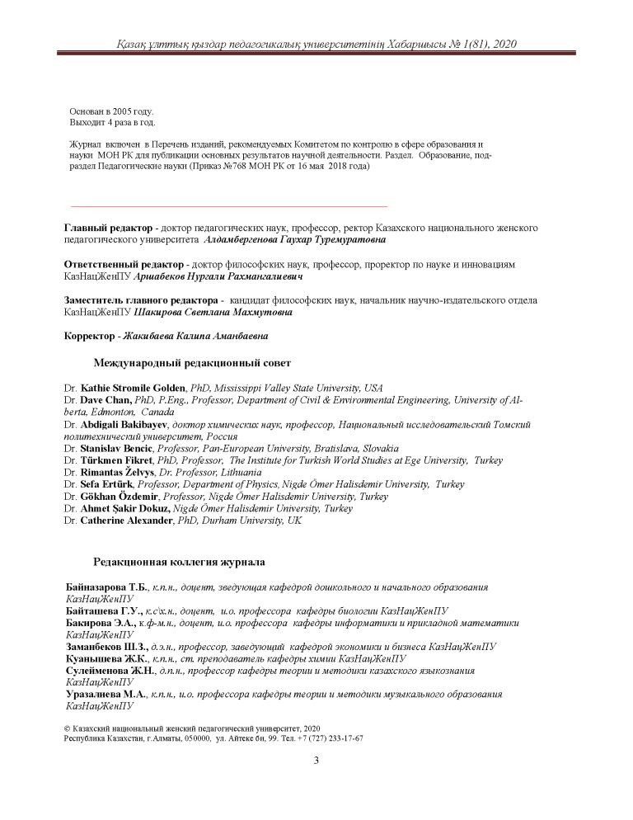
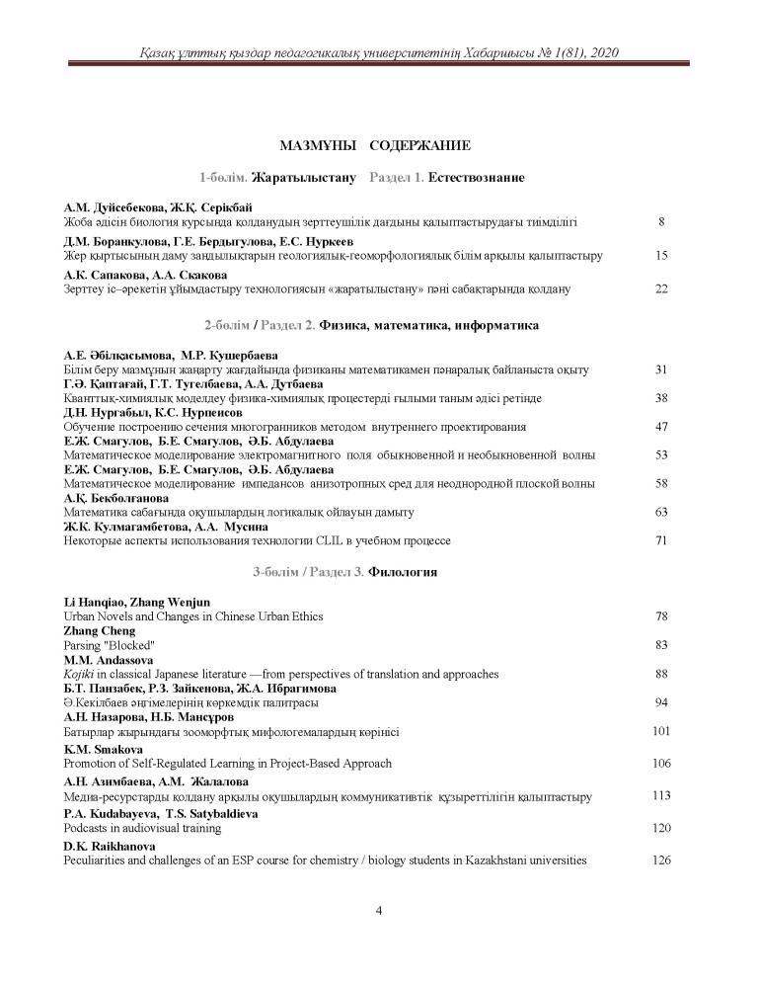
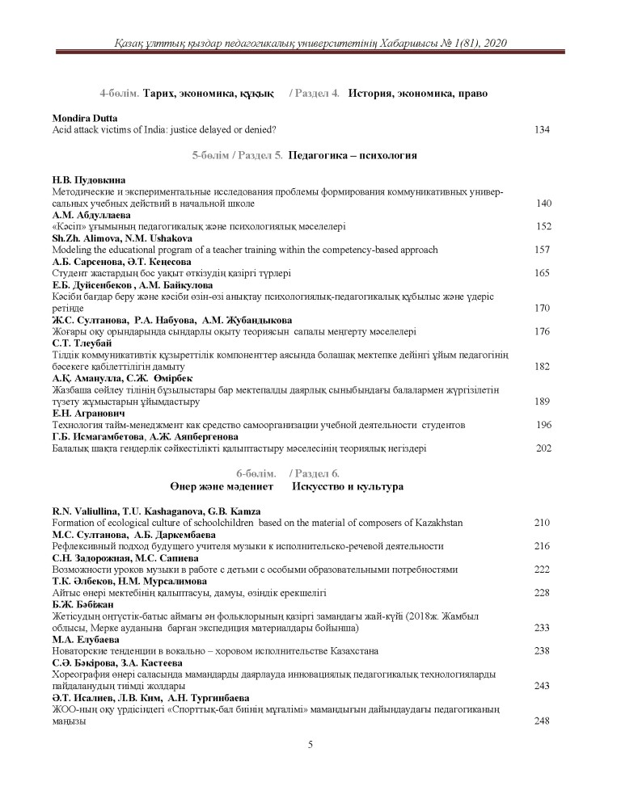
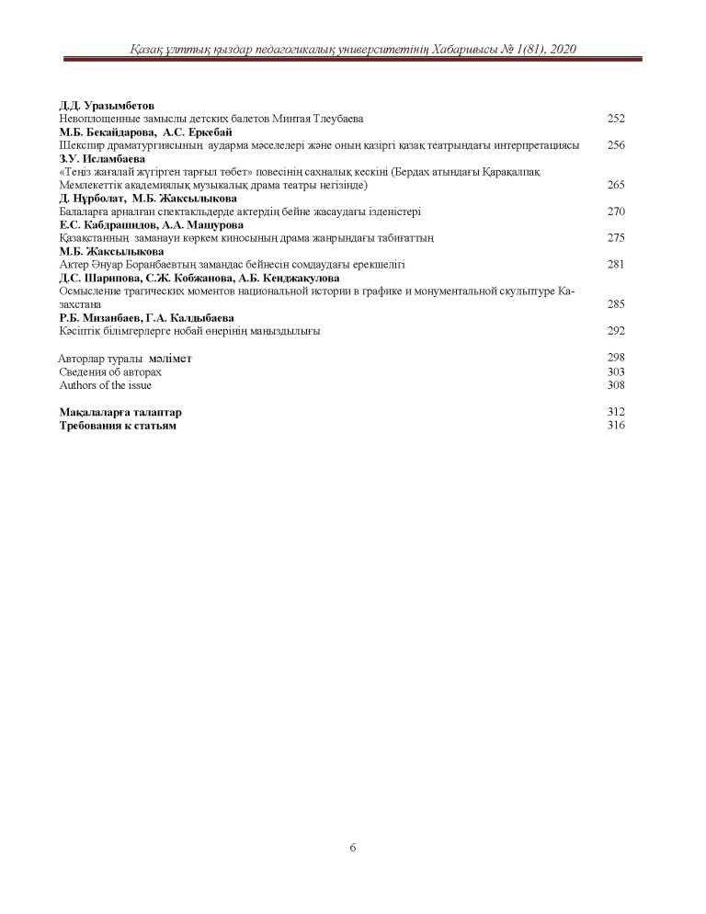
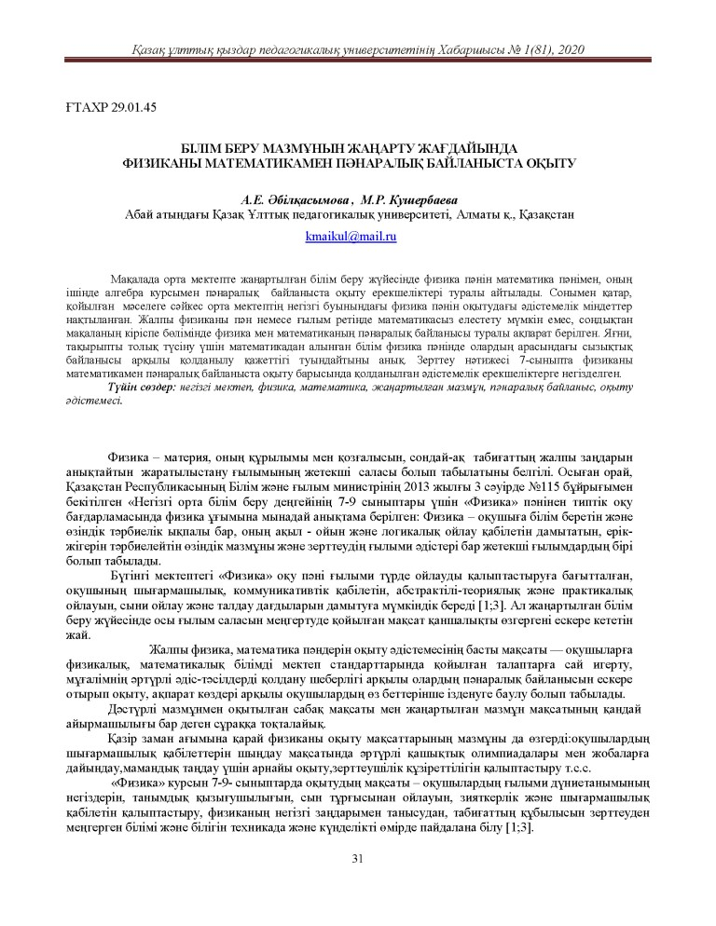
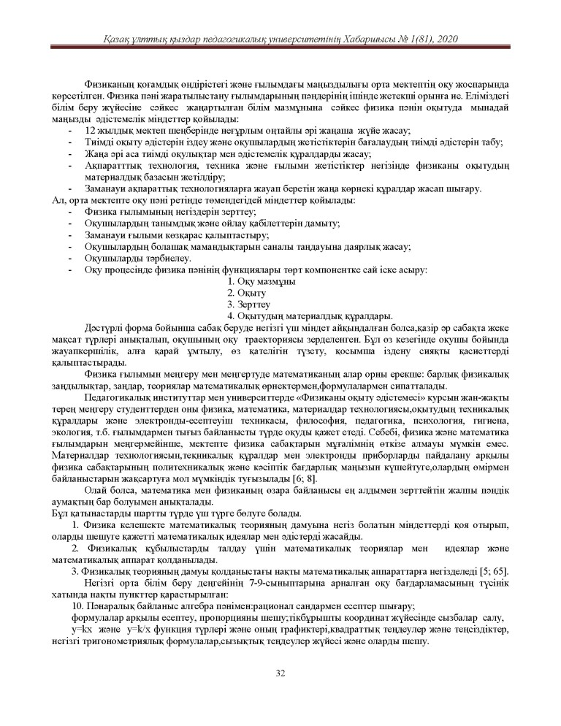
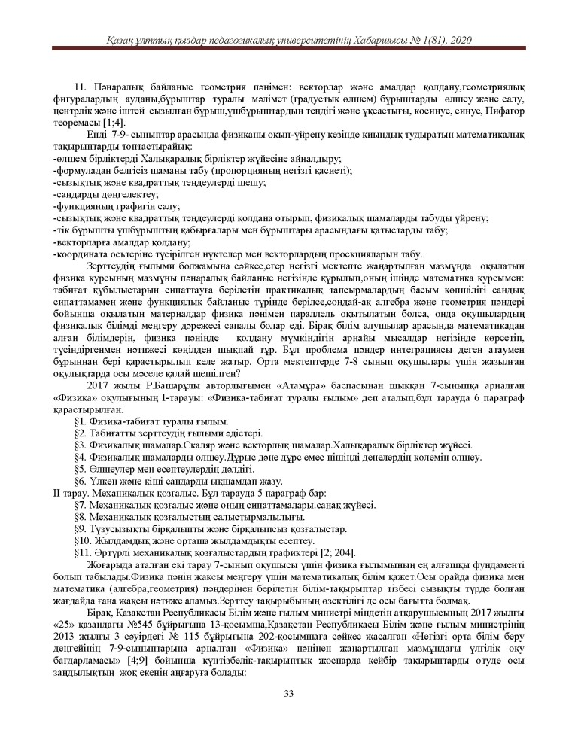

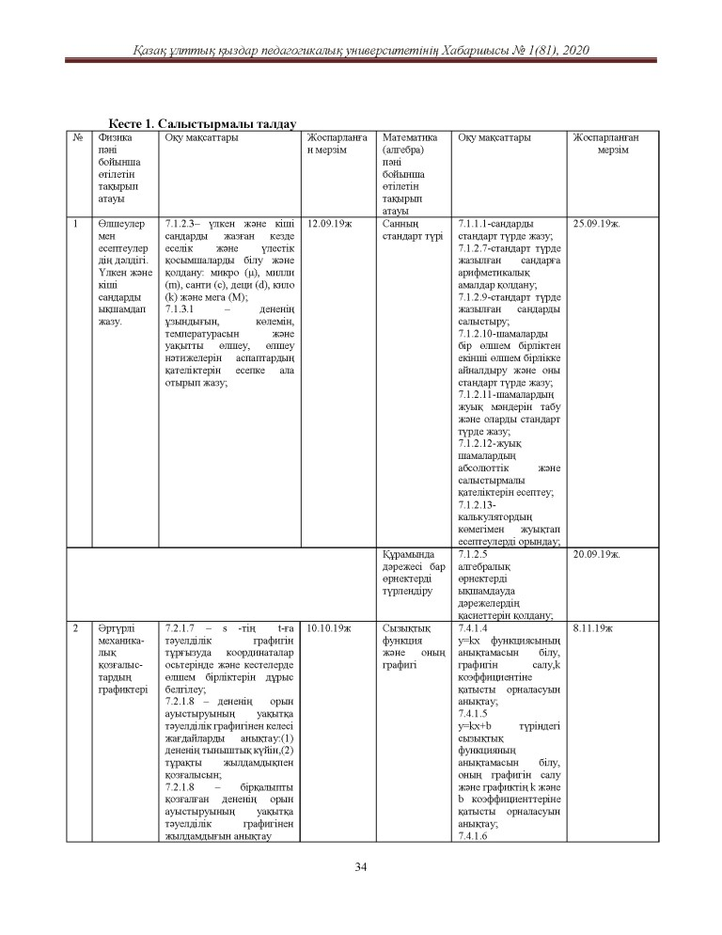
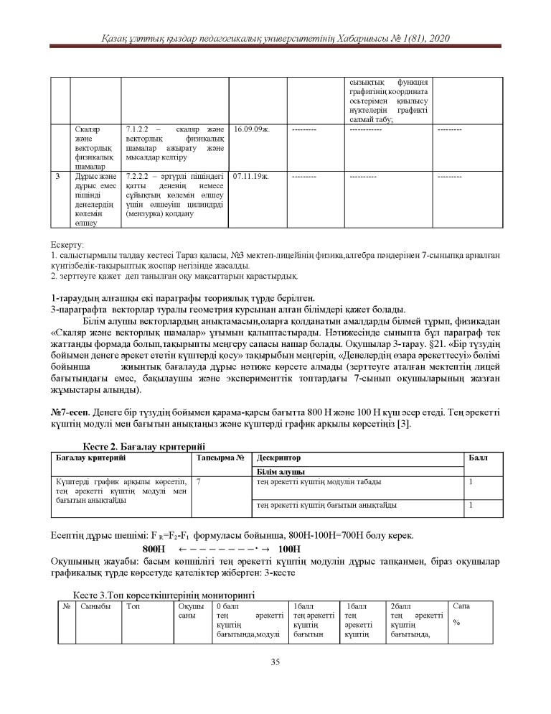

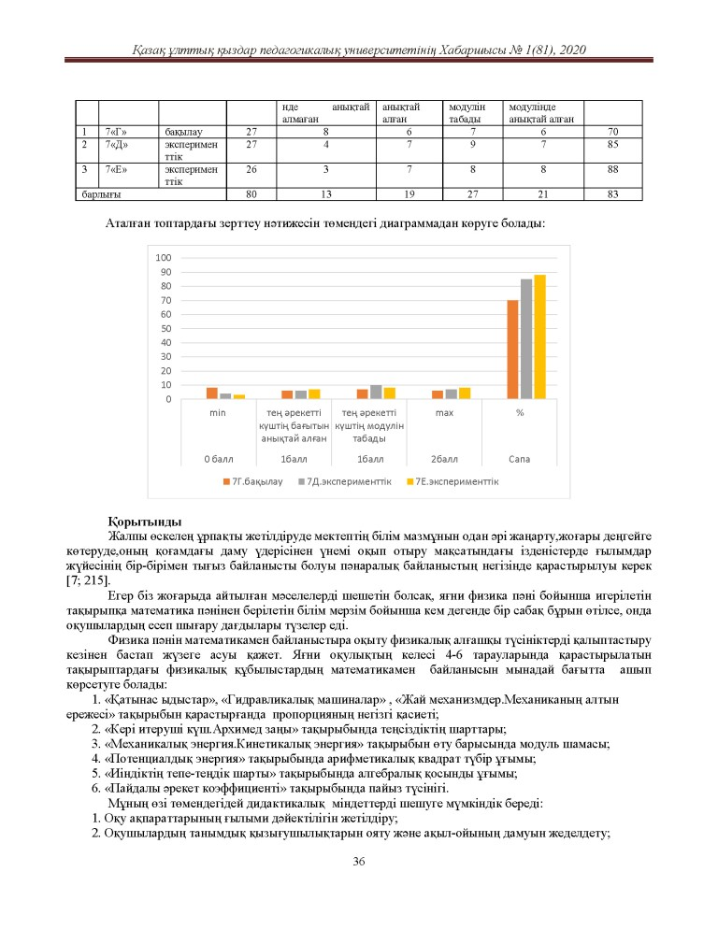
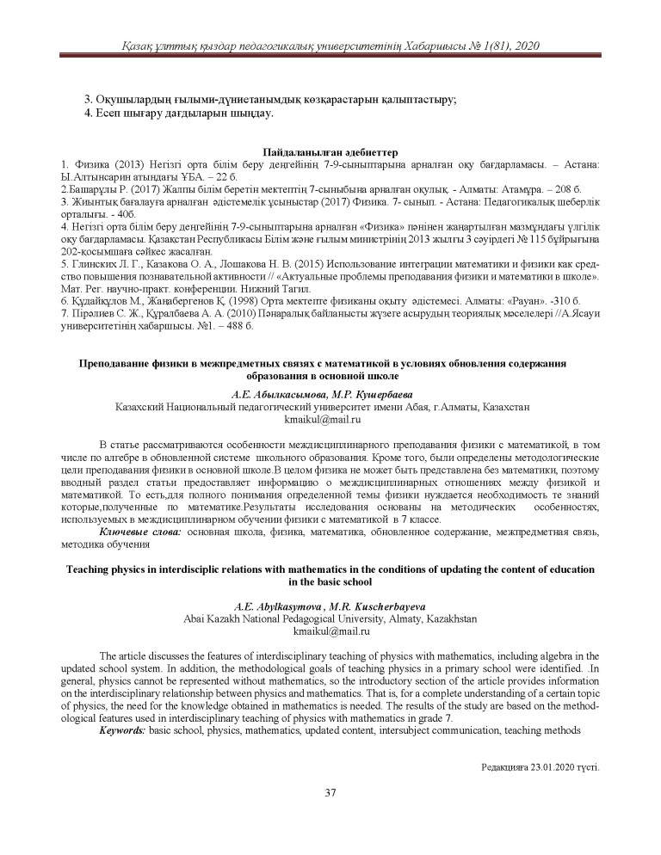
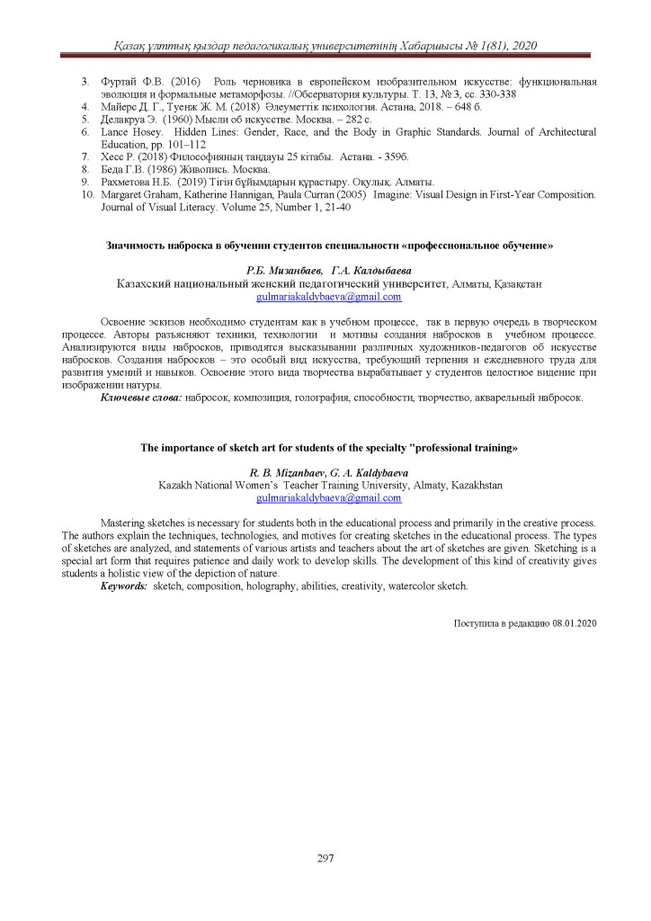
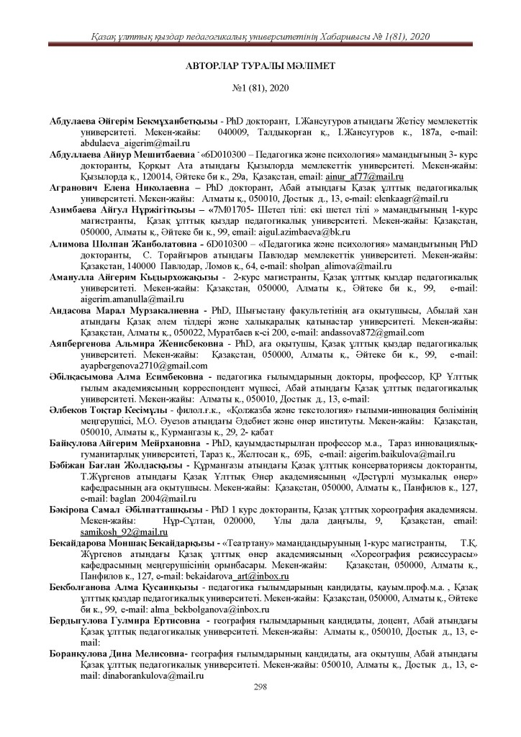
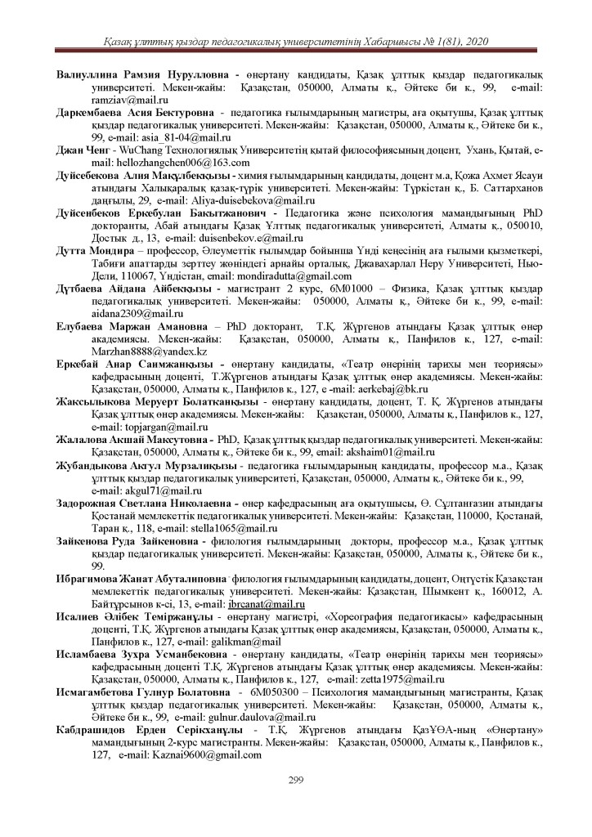
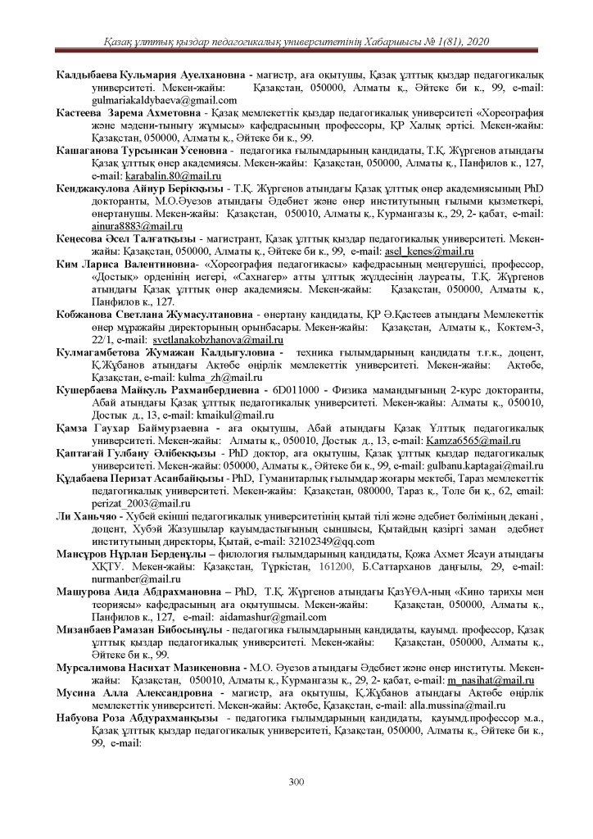
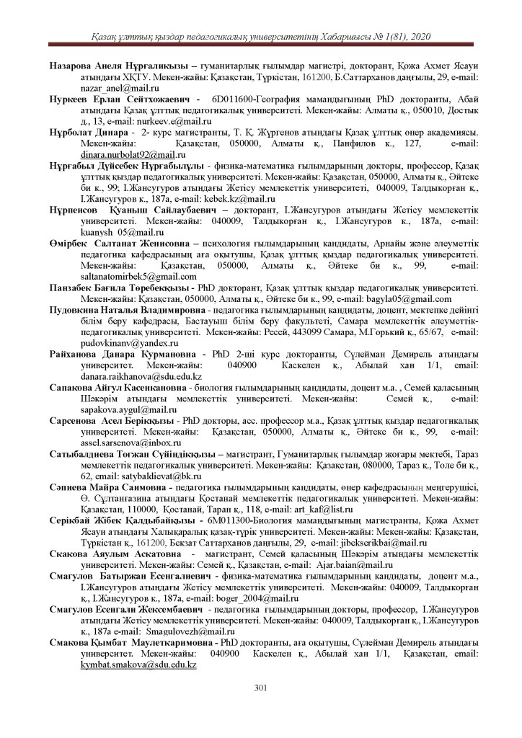
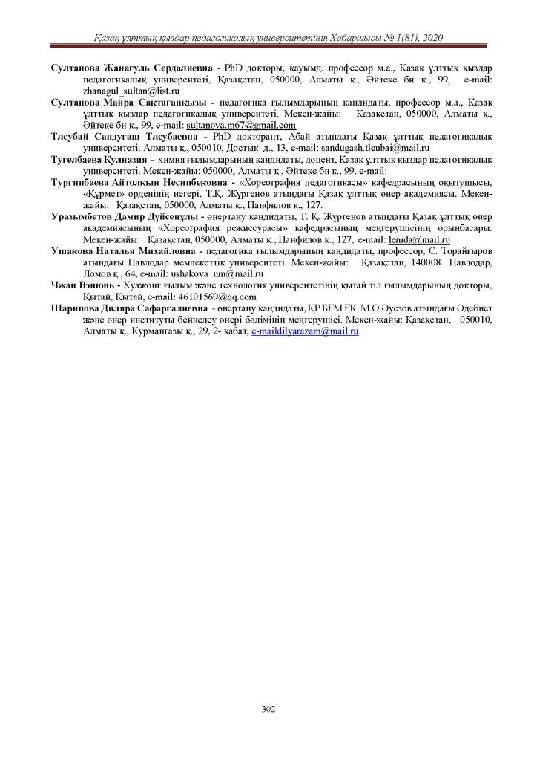
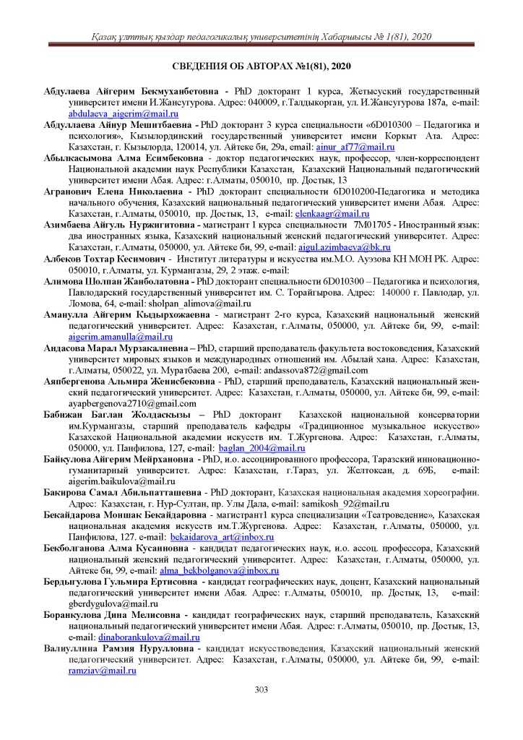
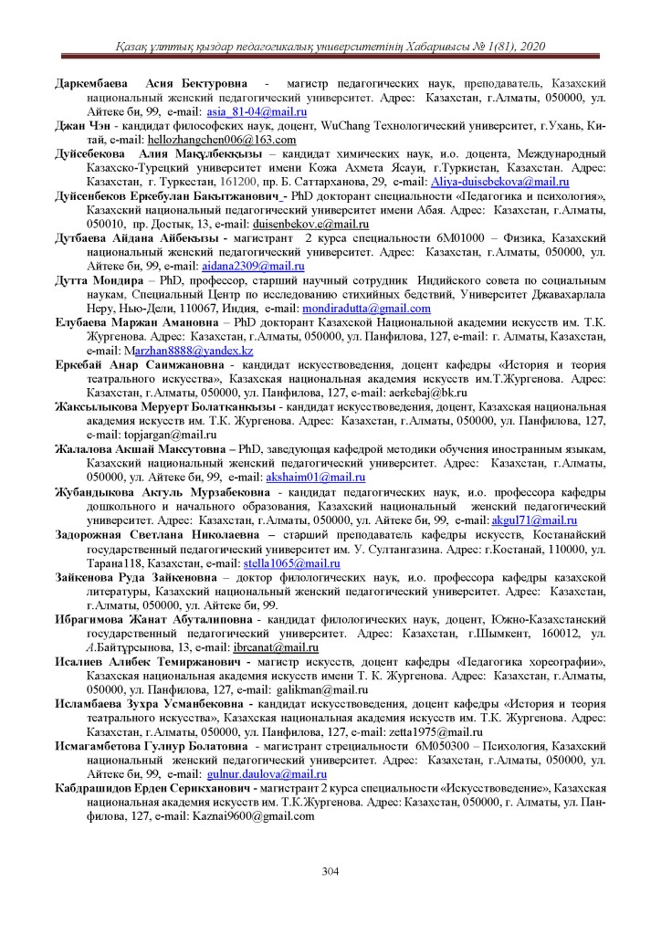
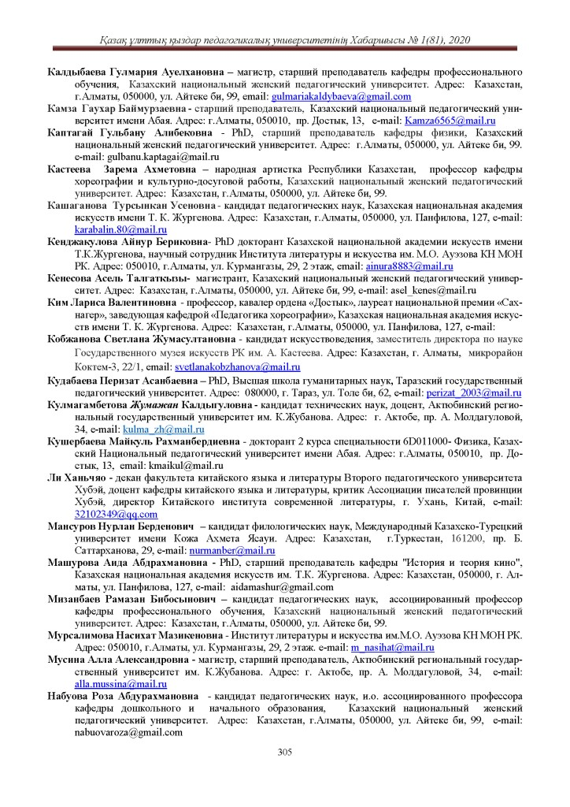
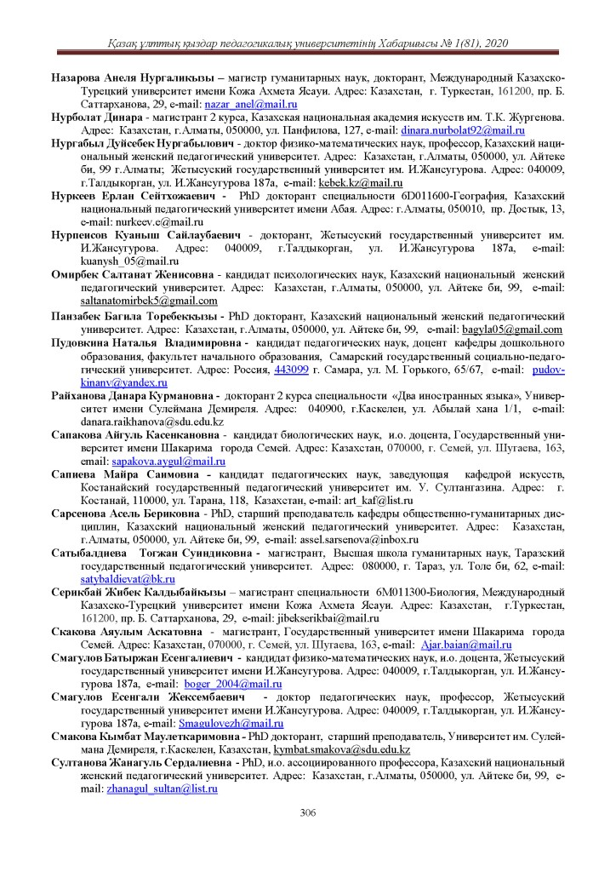
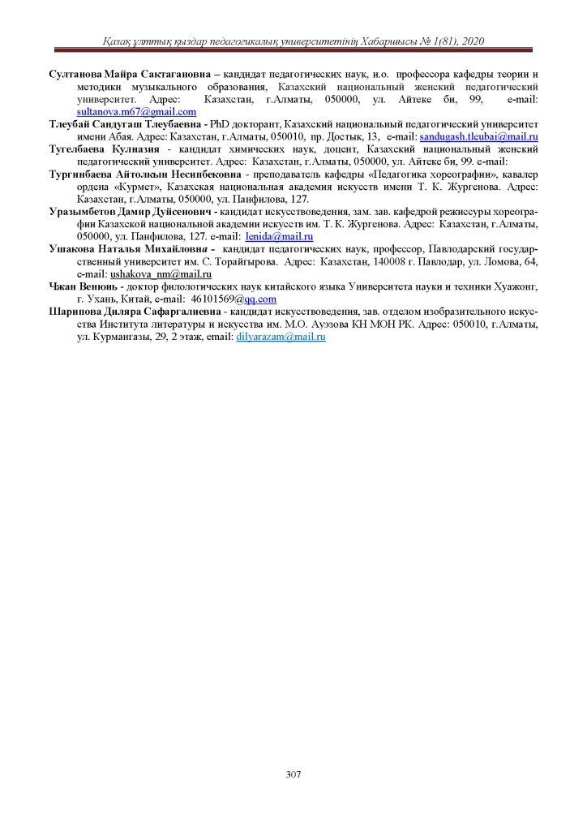
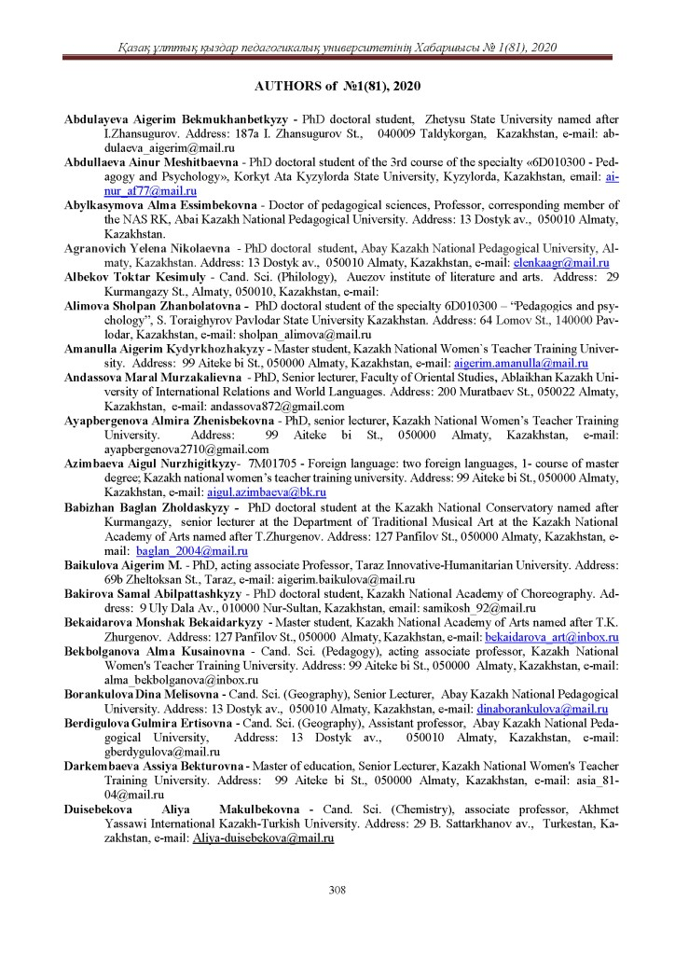
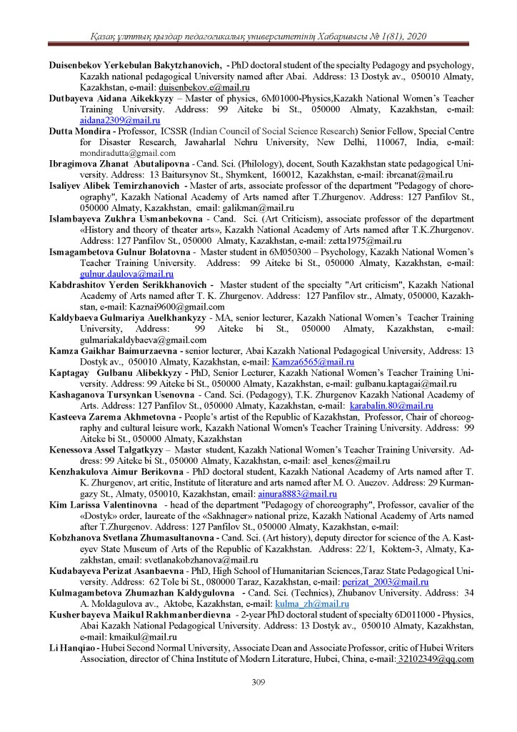
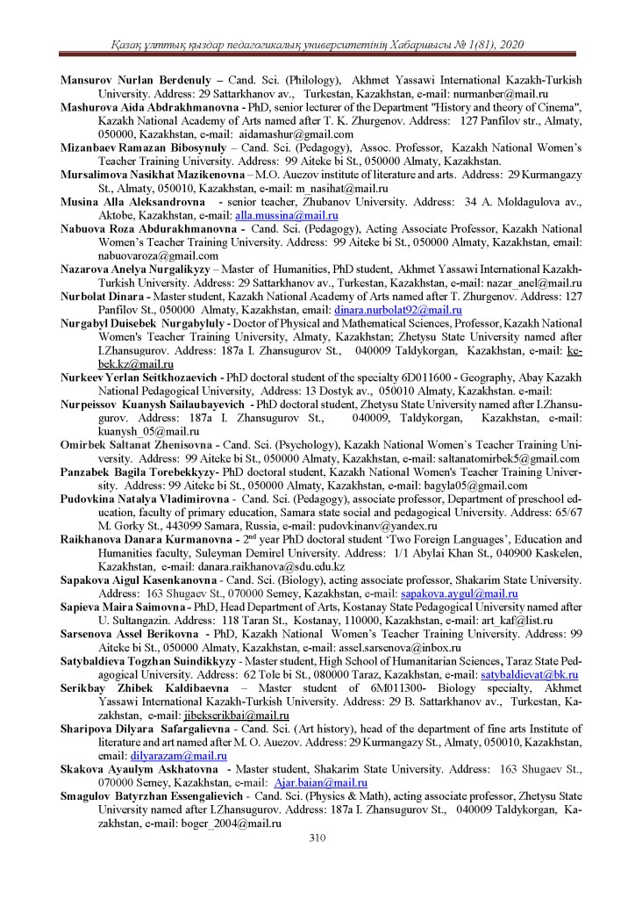
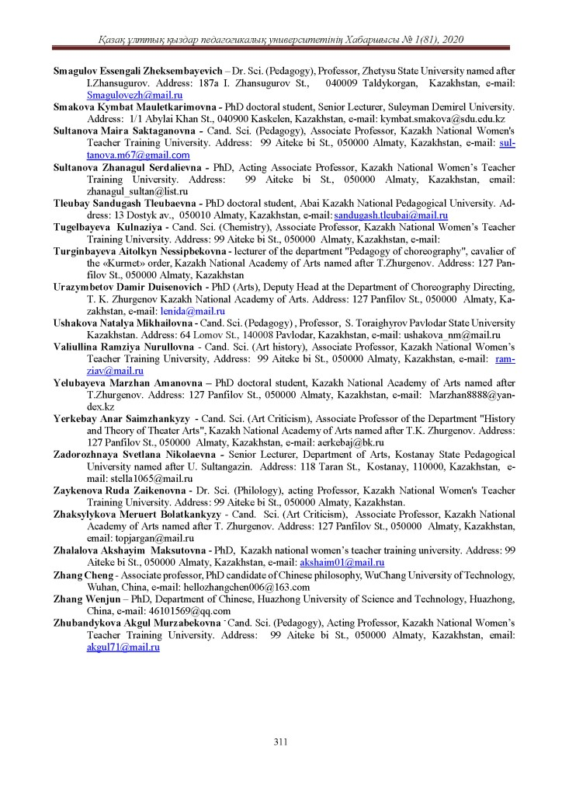
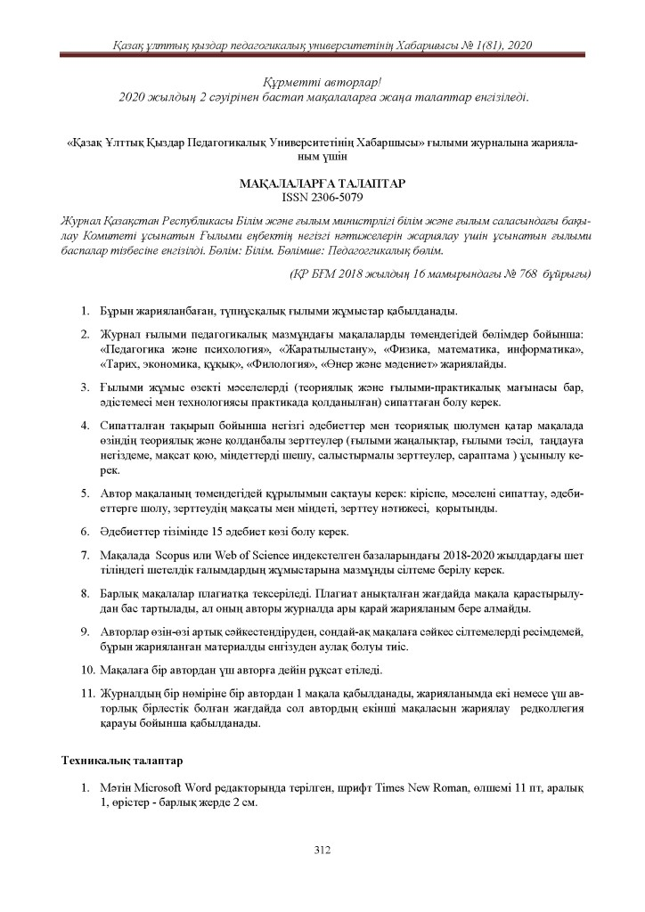
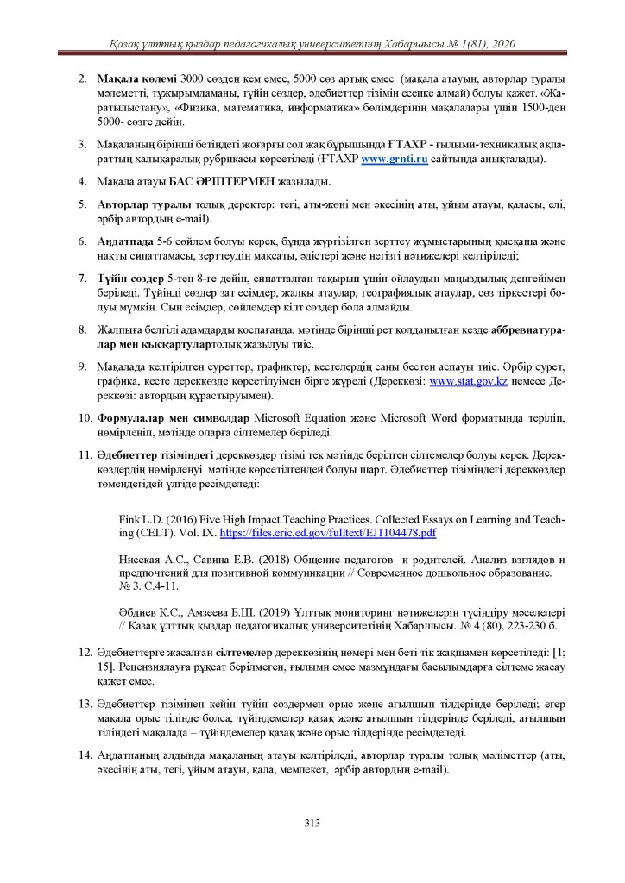
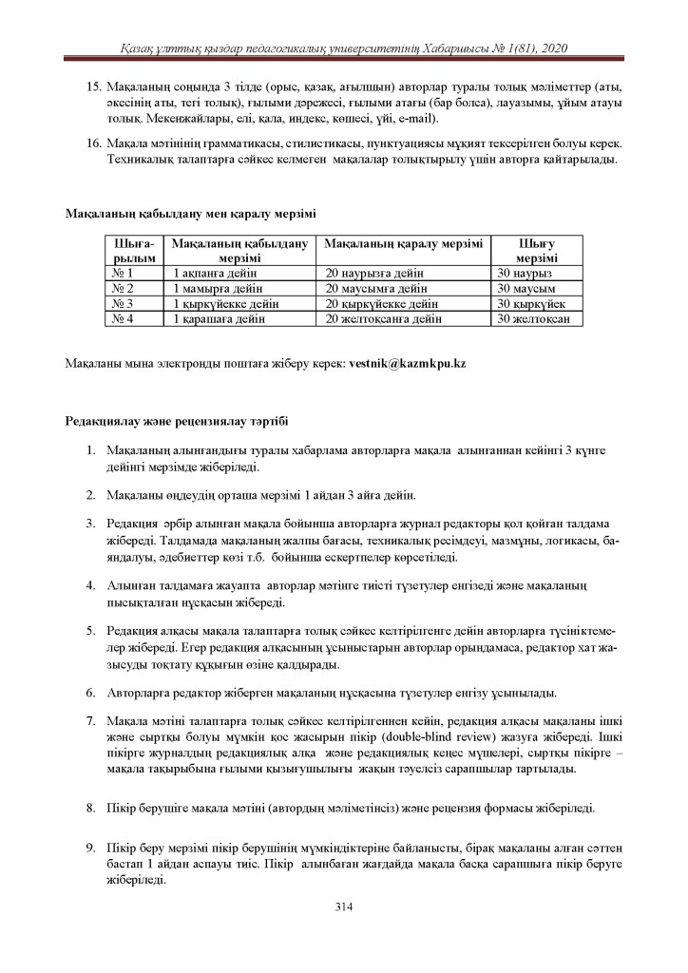
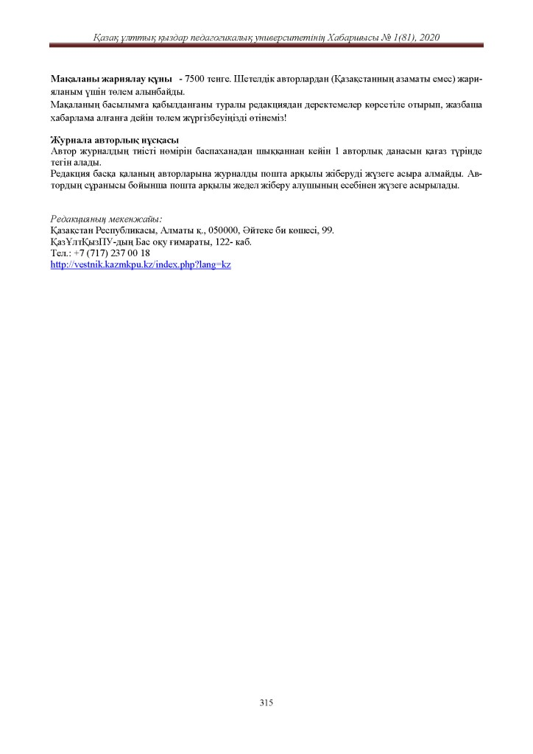
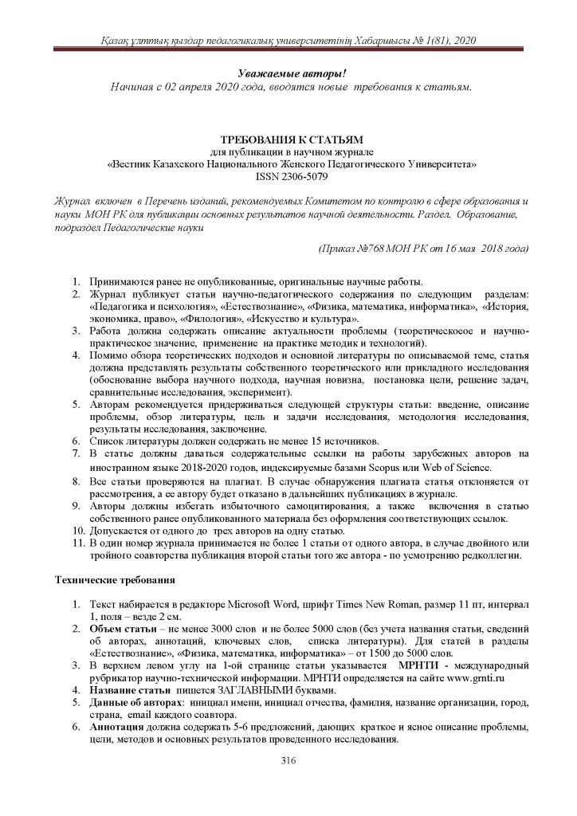
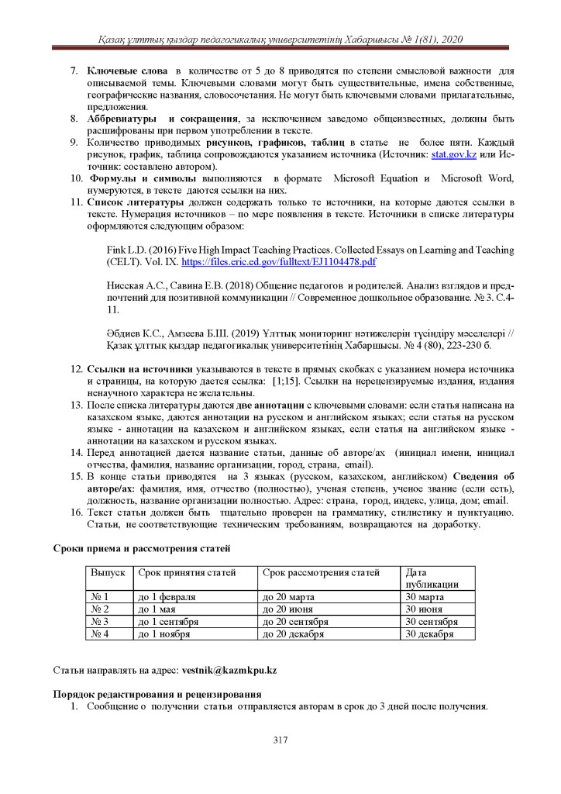
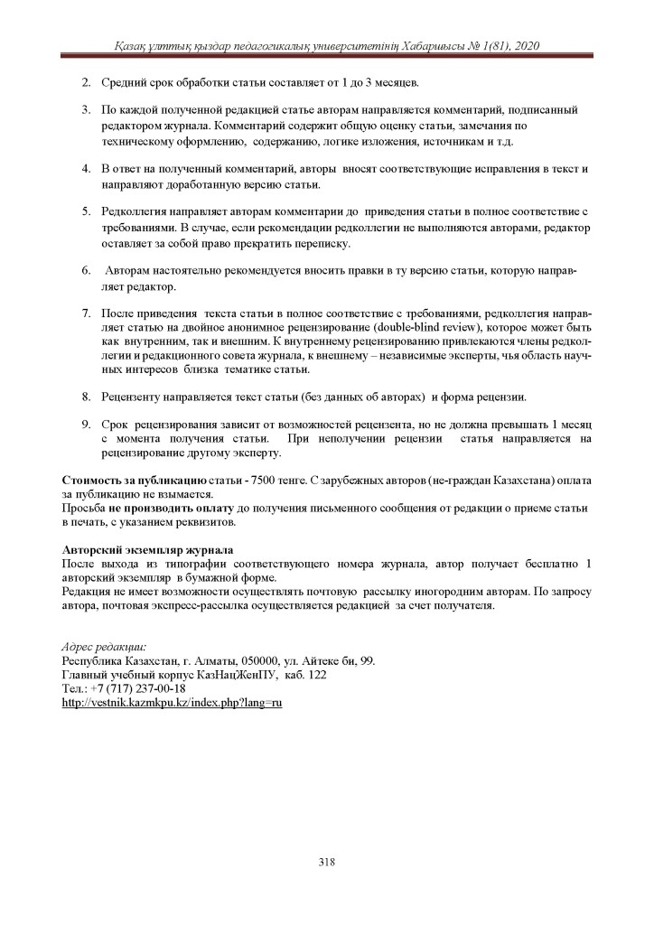
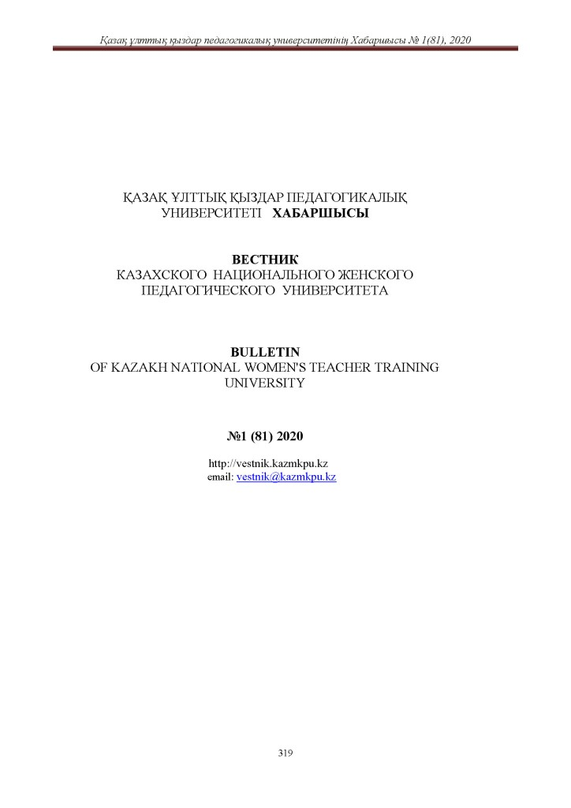
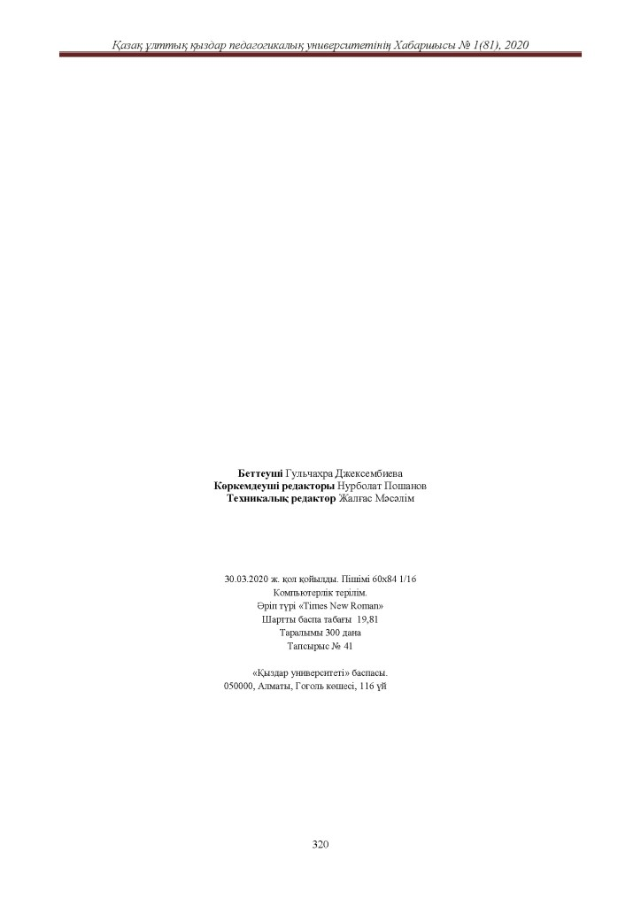
ANNEX H
Copyright Certificate
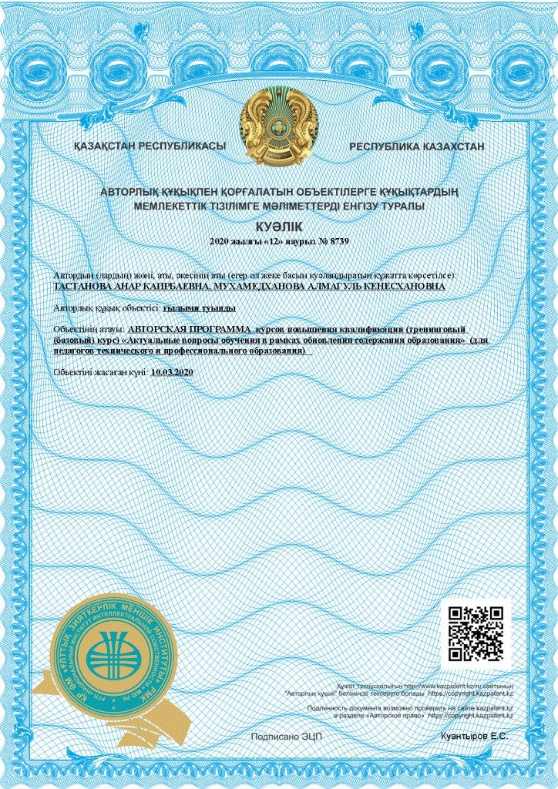
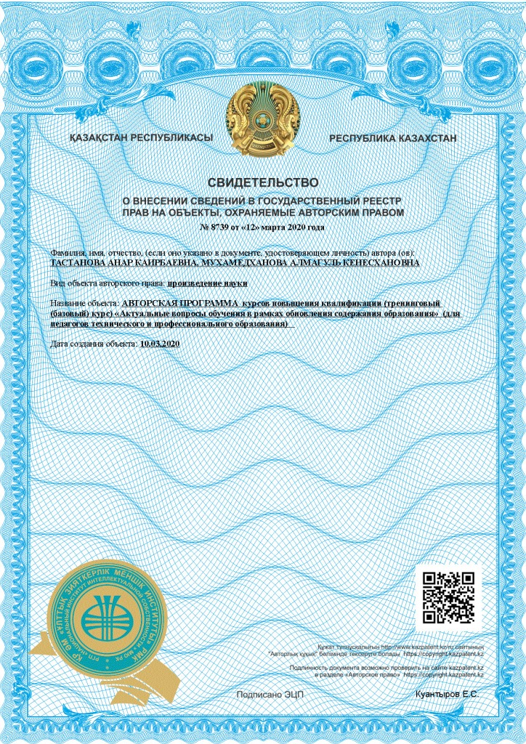
ANNEX I
Order to establish an experimental group
