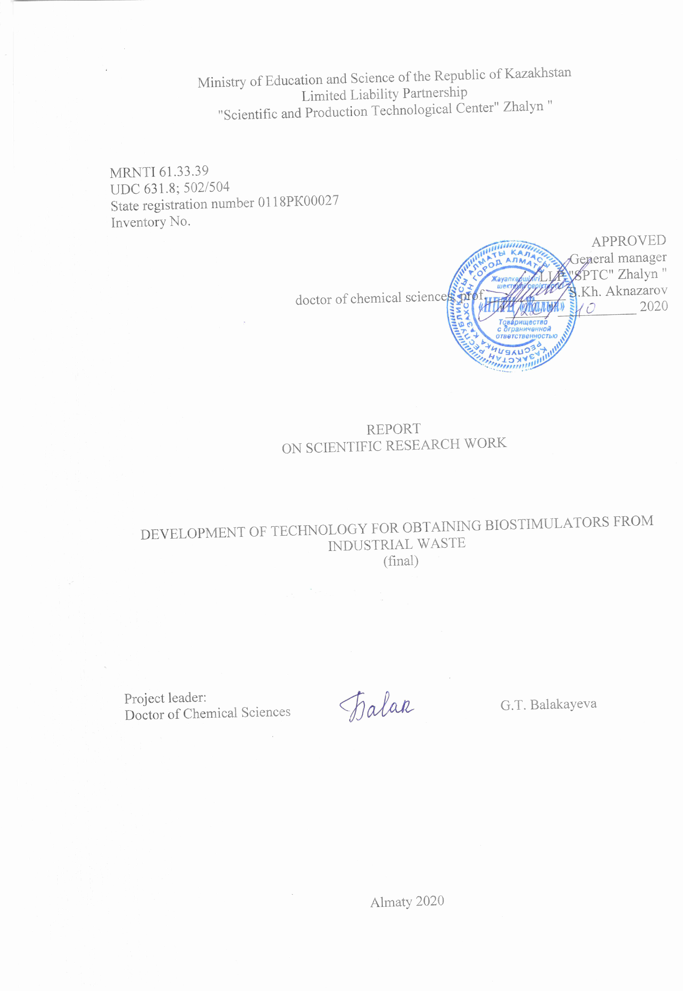

РЕФЕРАТ

Есеп беру: 112 бет, 20 сурет, 16 кесте, 27 библиограф.көздер, 6 қосымшалардан тұрады.
ӨСУ СТИМУЛЯТОРЛАРЫ, НАТРИЙ (КАЛИЙ) ГУМАТЫ, НАТРИЙ (КАЛИЙ) ГУМАТОФОСФАТЫ, АММОФОС, ЖАСЫЛ БАЛДЫРЛАР (Chlorella Vulgarus BIN штамы).
Зерттеу нысанасы: натрий (калий) гуматофосфаты, аммофос, жасыл балдырлар (Chlorella Vulgarus BIN штамы).
Жұмыстың мақсаты: натрий (калий) гуматофосфаты және жасыл балдырлар (Chlorella Vulgarus BIN штамы) негізінде биологиялық өнімдер.
Зерттеудің негізгі нәтижелері:
Натрий (калий) гуматофосфаты мен әр түрлі массалық үлесі қосылған хлорелладан үш жаңа биопрепарат синтезделді: ГУФОС-В_{1,} ГУФОС-В₂, ГУФОС-В₃.
Натрий (калий) гуматофосфат және хлорелла арасындағы өзара әрекеттесу процесі зерттелді. Биоорганикалық хелаттық кешені түзілетін анықталды.
Ж.Жиембаев атындағы Қазақ өсімдік қорғау және карантин ғылыми-зерттеу институтының өсімдіктерді қорғау зертханасында ГУФОС-В_{1,} ГУФОС-В₂ - тың өнгіштігінің энергиясына, көшеттердің өсу қарқынына, зертханалық өнгіштікке әсері лабораториялық зерттеулер арқылы анықталды.
ГУФОС-В_{1,} ГУФОС-В₂, ГУФОС-В₃ (100 кг-нан) іріленген партиялары алынған.
«Фитосанитар» ЖШС-нің 5 гектар аймағында соя дақылында ГУФОС-В₁, ГУФОС-В₂ агрохимиялық сынақтары жүргізілді (Алматы обл., Еңбекшіқазақ ауданы).
ГУФОС-В₁ препаратымен соя өсімдігінің тұқымдарын алдын-ала, тамырлану және жапырақтану мезгілінде шығымдарды 3 рет вегетациялық өңдеудің агрохимиялық сынақтарының нәтижелері: өсімдік сабағының өсуін 7.2%-ға; шоқтағы қабықшалар санының өсуін 38.4 %-ға; бүршіктердің орташа салмағын 80.6 %-ға, өнім шығымын 1.95 т/га (76.2 %-ға) арттырады.
ГУФОС-В₂ препаратымен өңдеу келесі көрсеткіштерге жеткізеді: өсімдік сабағының 19.3%-ға; шоқтағы қабықшалар санын 44.1%-ға; бүршіктердің орташа салмағын 90.9 %-ға, өнім шығымын 2.14 т/га (81.8 %) арттырады.

РЕФЕРАТ

Отчет: 112 стр., 20 рис., 16 табл., 27 библиограф. источника, 6 приложений.
СТИМУЛЯТОРЫ РОСТА, ГУМАТ НАТРИЯ (КАЛИЯ), ГУМАТОФОСФАТ НАТРИЯ (КАЛИЯ), АММОФОС, ЗЕЛЕНЫЕ ВОДОРОСЛИ (штамм Chlorella Vulgarus BIN).
Объект исследования: гуматофосфат натрия (калия), зеленые водоросли (штамм Chlorella Vulgarus BIN).
Цель работы: синтез стимуляторов роста на основе гуматофосфата натрия (калия) и зеленых водорослей (штамм Chlorella Vulgarus BIN).
Основные результаты исследований:
Синтезированы три новых биопрепарата на основе гуматофосфата натрия (калия) с различным массовым содержанием хлореллы: ГУФОС-В_{1,} ГУФОС-В₂, ГУФОС-В₃.
Изучен процесс взаимодействия гуматофосфат натрия (калия) и хлореллы. Установлено образование биоорганического хелатного комплекса.
В Казахском научно-исследовательском институте защиты и карантина растений им. Ж. Жиембаева в лаборатории защиты растений проведены лабораторные испытания по установлению влияния ГУФОС-В_{1,} ГУФОС-В₂, на энергию прорастания, интенсивность роста проростков, лабораторную всхожесть семян культуры соя.
Получены укрупненные партии ГУФОС-В_{1,} ГУФОС-В₂, ГУФОС-В₃ (по 100 кг).
Проведены агрохимические испытания ГУФОС-В₁, ГУФОС-В₂ на культуре соя сорта «нена» на площади 5 га ТОО «Фитосанитар» (Алматинская обл., Енбенкшиказахский район).
Результаты агрохимических испытаний показывали, что предпосевная обработка семян, корневая и внекорневая обработки всходов сои препаратом ГУФОС-В₁ увеличивают: рост стебля растения на 7.2 %, количество стручков в снопе на 38.4 %, среднюю массу стручков – 80.6 %, урожайность - 4.51 т/га (76.2 %).
Предпосевная обработка семян, корневая и внекорневая обработки всходов сои препаратом ГУФОС-В₂ увеличивают: рост стебля растения на 19.3%, количество стручков в снопе - 44.1%, среднюю массу стручков – 90.9%, урожайность – 4.70 т/га (81.8 %).

ABSTRACT

The report contains 112 pages, 20 figures, 16 tables, 27 bibliographers. source, 6 applications.
Keywords: GROWTH STIMULATORS, SODIUM HUMATE (POTASSIUM), SODIUM HUMATOPHOSPHATE (POTASSIUM), AMMOPHOS, GREEN ALGAE (Chlorella Vulgarus BIN strain).
Research object: sodium (potassium) humate phosphate, green algae (Chlorella Vulgarus BIN strain).
Purpose of the work: synthesis of growth stimulants based on sodium (potassium) humate phosphate and green algae (Chlorella Vulgarus BIN strain).
Key research findings:
Three new biological products based on sodium (potassium) humate phosphate with a different mass content of chlorella have been synthesized: GUFOS-B1, GUFOS-B2, GUFOS-B3.
The process of interaction of sodium (potassium) humate phosphate and chlorella were studied. The formation of a bioorganic chelate complex was established.
At the Kazakh Scientific Research Institute of Plant Protection and Quarantine named after S. Zh. Zhiembaeva in the plant protection laboratory conducted laboratory tests to establish the influence of GUFOS-B1, GUFOS-B2, on the germination energy, the intensity of seedling growth, laboratory germination of soybean seeds.
Enlarged batches of GUFOS-B1, GUFOS-B2, GUFOS-B3 (100 kg each) were received.
Agrochemical tests of GUFOS-B1, GUFOS-B2 were carried out on a soybean crop of the "nena" variety on an area of ​​5 hectares of "Fitosanitar" LLP (Almaty region, Enbenkshikazakh district).
The results of agrochemical tests showed that pre-sowing treatment of seeds, root, and foliar treatment of soybean seedlings with the preparation GUFOS-B1 increase: the growth of the plant stem by 7.2%, the number of pods in the sheaf by 38.4%, the average weight of pods - 80.6%, yield - 4.51 t / ha (76.2%).
Presowing seed treatment, root and foliar treatment of soybean seedlings with GUFOS-B2 preparation increase: plant stem growth by 19.3%, the number of pods in the sheaf - 44.1%, the average weight of pods - 90.9%, yield - 4.70 t / ha (81.8%).

CONTENT

DEFINITIONS, DESIGNATIONS AND ABBREVIATIONS ………………………………….7
INTRODUCTION …………………………………………………….……………....................8
1 Literary review ……………...…………………………………………………..……………. 10
2 Development of physicochemical bases of interaction in systems based on sodium humate, ammophos and green algae (V) - (GUFOS-V) ………………………………….…………….13
2.1 Synthesis of a biostimulant composition: sodium humate (GU), ammophos (FOS) and green algae (B) ......................................................................................... .......................................13
2.2 Analysis of the obtained product and establishment of the scheme of interaction of components in the system under study ………………………………………………………….14
3 Development of technology for the production of GUFOS-B1, GUFOS-B2 and GUFOS-B3 ..………………………………………………………………………………………………….21
4 Receipt of enlarged consignments of GUFOS-B1, GUFOS-B2 and GUFOS-B3 ................22
5 Carrying out agrochemical tests GUFOS-B1, GUFOS-B2 ………………………………….24
CONCLUSION ………………………………………………………………...…………….…25
LIST OF USED SOURCES …………………………………………………………... ……….30
APPENDIX A - Work Schedule …………. ……………………………………….………….. 32
APPENDIX B - Supplementary agreement No. 3 to the contract for GF No. 64 dated February 23, 2018 …………………………………………………………………………………………39
APPENDIX С - List of published works on the topic for 2018-2020 ……………….……….43
APPENDIX D - Minutes of discussion of the final report on R&D for 2020 at a meeting of the Scientific and Technical Council of NPTC Zhalyn LLP ……………………………..……….45
APPENDIX E - Supporting document for the item "Training" ……………………………....46
APPENDIX F - Supporting Documents ............................................................................... 47

DEFINITIONS, DESIGNATIONS AND ABBREVIATIONS

The following terms are used in this R&D report with the corresponding definitions, symbols and abbreviations:
1.sodium humate (potassium) - GU;
2. ammophos - FOS;
3. green algae (Chlorella Vulgarus BIN strain) - B;
4. Name of growth stimulants:
sodium humate phosphate (potassium) - algae (GUFOS-B);
GUFOS-B1 - with a volume ratio of 10: 1;
GUFOS-B2 - 10: 2;
GUFOS-B3 - 10: 3.

INTRODUCTION

Assessment of the current state of the problem being solved and its relevance:
To increase the resistance of agricultural crops to the effects of negative environmental factors, increase immunity to diseases and optimize methods for protecting crops from harmful organisms, the following are of decisive importance: pre-sowing seed treatment, foliar and root processing during the growing season and fruiting with biologically active preparations [1-3].
The introduction of a growth stimulator at the initial stage of growth allows you to control the growth of the plant, starting with germination of the seed, laying a strong root system and fast emergence.
Humates stimulate the production of natural growth regulators by the plant itself at the cellular and subcellular levels and activate their functional activity, i.e. the cell begins to reproduce itself and goes into a state of stationary growth [5]. The stimulating and adaptogenic effect of humic substances is explained by the action of quinoid and polyphenol groups that are part of their structure [6].
Sodium humate is necessary for pre-sowing seed treatment, and potassium humate is in demand during the growing season and fruiting of the plant.
Basis and initial data for the development of the theme:
To date, of the proposed plant growth stimulants, biological products based on humic substances are widely used.
We have developed growth stimulants based on sodium (potassium) humatophosphates and a biological component.
Sodium and potassium humatophosphates were synthesized by us and offered as biological products containing the necessary macroelements for plant nutrition. We offer green algae as a biological component, which is a biogenic immunostimulant and a natural antibiotic.
Justification of the need to conduct research on the topic:
Along with the synthesis of new growth stimulants, the project addresses the following problems:
- improvement of soil structure;
- restoration of soil fertility;
- increasing the yield of agricultural crops;
- improving the quality of agricultural products.
The scientific novelty of the results obtained:
Synthesized domestic biological products based on sodium (potassium) GUFOS and green algae: GUFOS-B1, GUFOS-B2, GUFOS-B3, the cost of which is much lower than the cost of expensive foreign drugs.
The physicochemical properties of GUFOS-B1, GUFOS-B2 and GUFOS-B3 were studied by IR spectroscopy, pH-meters, biochemical and chemical analysis of amino acids, vitamins, micro- and macroelements.
Experimental batches of each of the growth stimulants, in the amount of 100 kg, were obtained on an experimental setup.
The synthesized plant growth stimulants have passed laboratory tests at the Kazakh Research Institute of Plant Protection and Quarantine named after S. Zh. Zhiembaeva in the laboratory of plant protection on the culture of soybean variety "Lastochka"
Agrochemical tests were carried out on the experimental field of "Fitosanitar" LLP (Almaty region, Enbekshikazakhsky district, Shelek village).

1 Literary review

Complex humic preparations are a promising new generation of growth stimulants [7-18]. Earlier, we developed organomineral growth stimulants based on sodium (potassium) humates and ammophos (ammonium dihydrogen phosphates) - sodium and potassium humate phosphates (HUFOS). Sodium (potassium) humate with ammophos forms a chelated organomineral complex that contains nutrients in a form assimilable by the plant [19]. Mineral components in combination with plant hormones in the plant support healthy root growth prior to harvest. Plants have 5 main hormones: cytokinin, auxin, gibberellic acid, ethylene, abscisinic acid. Auxin and cytokinin give birth to a new cell, then auxin with the help of nutrients stimulates cell growth. Gibberellic acid, which is produced inside the cell, controls the amount and movement of nutrients in the new cell and its size. Cell division is essential for normal plant development, and cell size is important for root and shoot mass, as well as yield. And the tips of the roots serve as the "brain" center for plant growth control. Renewal of the root system throughout the life cycle of a plant is a guarantee of a high yield and product quality [20,21].
The new growth stimulants we offer contain a biogenic component - green algae (Chlorella Vulgarus BIN strain).
This strain is one of 24 species of chlorella according to taxonomic classification. Chlorella is a single-celled green algae devoid of flagella. The cells have a round or oval shape of microscopic size (2-12 μm) (Fig. 1) [22].

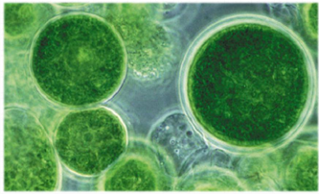
Figure 1 - Chlorella vulgaris

Chlorella is common in fresh and salt water and in soil.
Chlorella is a planktonic organism of surface waters of freshwater bodies. Due to its unpretentiousness and high growth rates, chlorella is widely cultivated on an industrial scale in special installations for obtaining biomass used in plant growing, animal husbandry and the food industry (Fig. 2) [23,24].

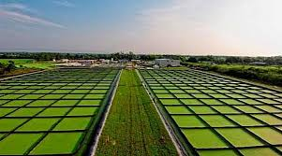
Figure 2 - Cultivation of chlorella on an industrial scale

Chlorella contains more than 650 useful substances: physiologically active components: auxin, cytokinin, phytohormones, proteins, carbohydrates, lipids, minerals, chlorophyll, chlorellin. Protein contains 40 amino acids [25].
The ideal mass ratio of these components ensures the correct and complete course of all life processes in the plant development cycle.
Chlorella, being a living microorganism, interacts with soil structures:
- enriches the soil with organic substances that improve its structure;
- stimulates the growth of soil microorganisms;
- increases own immunity of plants, anti-stress resistance of plants against adverse external influences, including drought, acclimatization, transplantation;
- actively synthesizes the natural antibiotic "chlorellin", which destroys pathogenic microorganisms;
- utilizes oxides of heavy metals, radionuclides, pesticides [25].
It is known that humic metallophosphate complexes increase plant growth, absorption of phosphates and are more effective than phosphorus fertilizers, for example, simple superphosphate. The stimulating effect of such complexes is associated with a direct effect on plant hormones or changes in the hormone auxin [26].
Sodium (potassium) GUFOS is a chelate complex consisting of sodium (potassium) humate macromolecules with a built-in mineral center of hydrophosphate groups of ammophos (Fig. 3) [27].
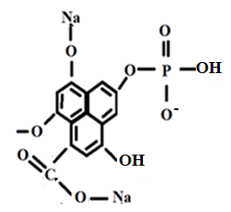
Figure 3 - Fragment of the structure of sodium GUFOS

The technological advantage of production is the process of biostimulant synthesis at room temperature.
The social effect of the introduction of growth stimulants is to improve the structure of the soil and restore its fertility.
The economic effect is an increase in the yield and quality of fruit and berry and agricultural crops.
Biostimulants: GUFOS-B1, GUFOS-B2 and GUFOS-B3 have a prolonged effect, improve the rheological properties of the soil, change the conditions of soil nutrition of plants, causing an active intensification of the processes of mobilization of nutrients in a form assimilable for plants.

2 Development of physical and chemical bases of interaction in systems based on sodium humate, ammophos and green algae - (GUFOS-B)

We have proposed a technology for producing biostimulants based on sodium (potassium) GUFOS and chlorella.

2.1 Synthesis of biostimulants of the composition: sodium humate (GU), ammophos (FOS) and green algae (B).
The synthesis of GUFOS-B was carried out according to the following procedure: a suspension of chlorella (B) is added in small portions to a pre-prepared concentrated solution of sodium (potassium) GUFOS with a ratio of 2: 1. The resulting pulp is stirred at room temperature for 1-2 hours. Volume ratios of GUFOS and chlorella in biological products are 10: 1; 10: 2; 10: 3 respectively. The synthesized growth stimulants are black solutions with pH 6.3-6.6, well stored at a temperature of 10-250C (Fig. 4). Upon prolonged storage, they form a thick suspension.
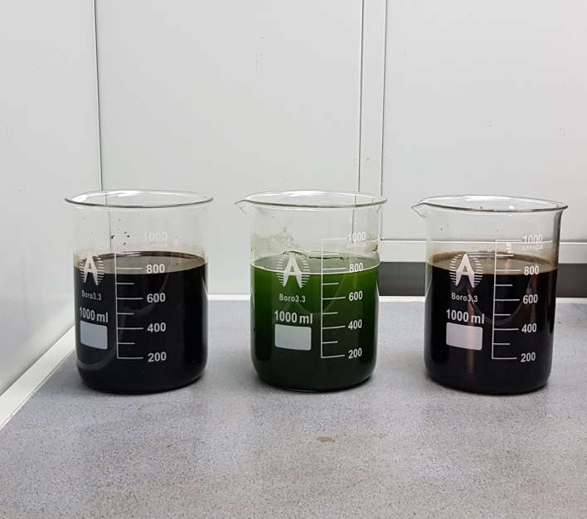
Figure 4 - Solutions of GUFOS sodium, chlorella and GUFOS-B1.

Algae were grown in 10 L containers in the laboratory (Fig. 5) and in the open air (Fig. 6). During cultivation in the laboratory, the container was illuminated with a 40 W incandescent lamp installed above the reactor. To supply carbon dioxide, air was blown through the solution.
As nutrient solutions, Tamiya's medium and a solution of microcomponents were prepared, which were added in the required amounts to the algae solution [23].
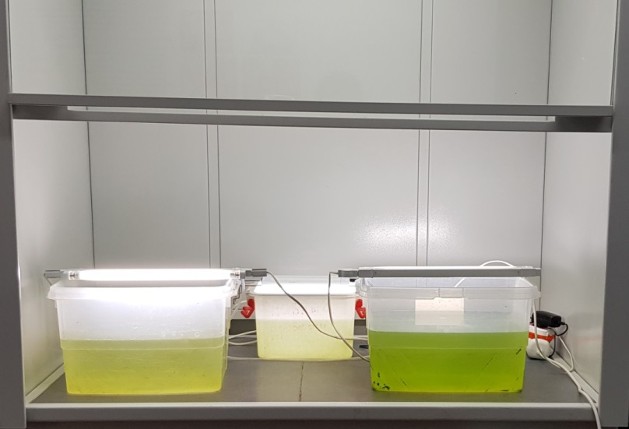

Figure 5 - Cultivation of chlorella in the laboratory

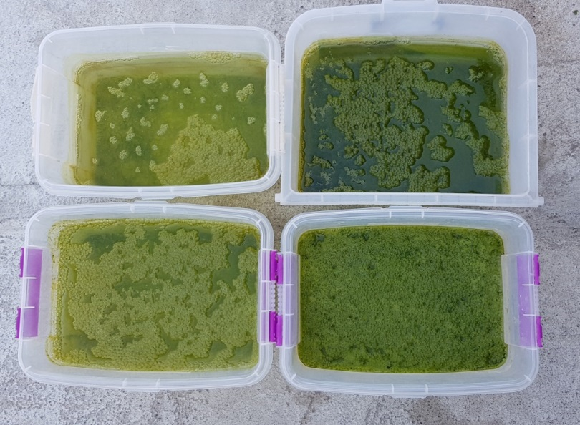

Figure 6 - Cultivation of chlorella outdoors

2.2 Analysis of the obtained products and establishment of the scheme of interaction of components in the system under study
The analysis of the chemical composition of the starting components (Table 1-4) and GUFOS-B1 (Table 5-7), GUFOS-B2 (Table 8-10), GUFOS-B3 (Table 11-13) was carried out on an amino acid analyzer and vitamins AZURA, scanning electron microscope (SEM), on the FT-IR spectrometer "Avatar 370" and on the pH meter pH-150MI.

Table 1 - Chemical composition of sodium humate phosphate,%
P | N | K | C | Na | Ca
12.22 | 4.56 | 1.16 | 30.00 | 1.71 | 6.67

Dried chlorella is a finely dispersed dark green powder with a characteristic odor, with a moisture content of 5.55%.

Table 2 - Composition of amino acids in chlorella

Amino acid name | Mass. % | Amino acid name | Mass. %
Aspartic acid | 4.37 | Cysteine | 0.59
Glutamic acid | 5.82 | Valine | 2.93
Serine | 2.12 | Methionine | 1.13
Histidine | 1.03 | Phenylalanine | 2.50
Glycine | 1.37 | Leucine | 4.25
Threonine | 2.22 | Isoleucine | 1.99
Arginine | 2.95 | Lysine | 3.61
Alanin | 4.42 | Tryptophan | 1.05
Tyrosine | 2.00 | Proline | 2.49
Total: |  |  | 46.83

Table 3 - Composition of vitamins in chlorella

Vitamin name | Mass. % ⋅ 10⁻³ | Vitamin name | Масс. % ⋅ 10⁻³
Vitamin B1 | 3.18 | Vitamin C | 27.38
Vitamin B2 | 3.47 | Vitamin A | 11.11
Vitamin B3 - PP | 34.66 | Vitamin E | 17.02
Vitamin B5 | 5.34 | β-carotene | 31.72
Vitamin B6 | 2.79

Table 4 - Composition of macro- and microelements in chlorella

Element | Mass. % | Element | Mass. %
Calcium | 1.75 | Iodine | 0.004
Magnesium | 0.48 | Iron | 0.09

Table 5 - Composition of amino acids in GUFOS-B1

Amino acid name | Mass. % ⋅ 10⁻³ | Amino acid name | Mass. % ⋅ 10⁻³
Isoleucine | 2.04 | Tryptophan | 1.83
Lysine | 3.93 | Valine | 1.42
Leucine | 4.51 | Histidine | 1.10
Methionine | 1.62 | Arginine | 1.59
Phenylalanine | 2.70 | a-linolenic | 0.46
Threonine | 0.01 | Linoleic acid | 0.36

Table 6 - Composition of vitamins in GUFOS-B1

Vitamin name | Mass. % ⋅ 10⁻³ | Vitamin name | Mass. % ⋅ 10⁻³
Vitamin B3, P, PP | 4.70 | Vitamin B6 | 2.06
Vitamin B5. | 2.01 | Vitamin A | 5.01
Vitamin B2, G | 2.39 | Vitamin C | 21.14
Vitamin B1. | 2.09

Table 7 - Composition of macro- and microelements in GUFOS-B1

Element | Mass. % | Element | Mass. %
N | 4.45 | K | 1.07
P | 11.03 | С | 29.30
Na | 1.55 | Ca | 4.17
Cu | 0.21 | Co | 0.03
 |  | Ni | 0.01

Table 8 - Composition of amino acids in GUFOS-B2

Amino acid name | Mass. % | Amino acid name | Mass. %
Isoleucine | 2.06 | Tryptophan | 2.12
Lysine | 3.95 | Valine | 1.45
Leucine | 4.59 | Histidine | 1.11
Methionine | 1.13 | Arginine | 1.60
Phenylalanine | 2.73 | a-linolenic | 0.50
Threonine | 0,01 | Linoleic acid | 0.36

Table 9 - Composition of vitamins in GUFOS-B2

Vitamin name | Mass. % ⋅ 10⁻³ | Vitamin name | Mass. % ⋅ 10⁻³
Vitamin B4 | 1.24 | Vitamin B6 | 2.09
Vitamin B3, P, PP | 4.75 | Vitamin B12 | 1.07
Vitamin B5. | 2.07 | Vitamin C | 21.97
Vitamin B2, G | 2.43 | Vitamin D | 0.03
Vitamin B1 | 2.12 | Vitamin E | 1.08
Vitamin A | 5.06 | Vitamin K | 0.01

Table 10 - Composition of macro- and microelements in GUFOS-B2

Element | Mass. % | Element | Mass. %
N | 3.80 | K | 0.97
P | 10.18 | С | 25.00
Na | 1.43 | Ca | 3.89
Cu | 0.20 | Co | 0.02
Table 11 - Composition of amino acids in GUFOS-B3

Amino acid name | Mass. % | Amino acid name | Mass. %
Isoleucine | 2.07 | Tryptophan | 2.12
Lysine | 3.98 | Valine | 1.46
Leucine | 4.63 | Histidine | 1.11
Methionine | 1.14 | Arginine | 1.61
Phenylalanine | 2.74 | a - linolenic | 0.51
Threonine | 0.01 | Linoleic acid | 0.36

Table 12 - Composition of vitamins in GUFOS-B3

Vitamin name | Mass. % ⋅ 10⁻³ | Vitamin name | Mass. % ⋅ 10⁻³
Vitamin B3, P, PP | 4.76 | Vitamin B6 | 2.12
Vitamin B5 | 2.08 | Vitamin C | 22.00
Vitamin B2, G | 2.44 | Vitamin A | 5.09
Vitamin B1 | 2.15

Table 13 - Composition of macro- and microelements in GUFOS-B3

Element | Mass. % | Element | Mass %
N | 3.51 | K | 0.89
P | 9.4 | С | 23.10
Na | 1.32 | Ca | 3.59
Cu | 0.18 | Co | 0.02
 |  | Ni | 0.003

Interaction mechanism
The bio-organomineral complex is formed as a result of acid-base interaction between phenolic and alcohol OH - groups of sodium HUFOS and hydrogen ions of carboxyl groups of amino acids (Fig. 7) with the release of water. The formation of donor-acceptor bonds between functional groups of vitamins and hydrogen cations of hydrophosphate groups is also likely. The sodium cations, which are part of the complex, having a large ion size, a single electron charge and a hydration shell, divide large porous particles of the earth into small, less porous ones, which leads to soil compaction.
The formed chelate complex keeps microelements (Mn, Co, Se, Cu, Ni, Zn, Mo, etc.) from binding with negatively charged particles and precipitation in the soil. The presence of chelating agents capable of maintaining the mineral components in plant-assimilable form, as well as soil pH, affect the ability of the roots to absorb nutrients.
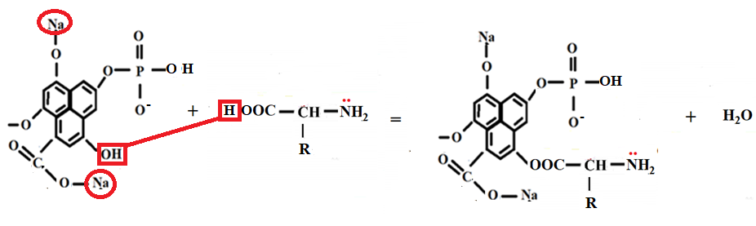

fragment of sodium HUFOS structure fragment of α-amino acid structure bio-organomineral complex

Figure 7 - Scheme of the formation of bio-organomineral
chelate complex
Analysis of the IR spectra of the initial components (Fig. 8-10) indicates changes in the spectrum of GUFOS-B1 (Fig. 10):
- a decrease in the intensity of stretching vibrations of phenolic - OH groups at 1260.05 cm-1;
- shift from 1599.29 to 1595.05 cm-1 and a decrease in the intensity of stretching vibrations of carboxyl groups;
- disappearance of vibrations -C = O bond at 2800-2936 cm-1;
- superposition and displacement of OH-bond vibrations at 3430.91 cm-1.
Changes in the IR spectrum of GUFOS-B1, pH and solution density data (Table 14) confirm the formation of a chelate complex based on the interaction of functional groups of sodium GUFOS and chlorella.
Figure 8 - IR spectrum of sodium GUFOS

Figure 9 - IR spectrum of chlorella

Figure 10 - IR spectrum of GUFOS-B1

Table 14 - The value of pH and specific gravity of the starting components and synthesis products

Name | Green algae | GUFOS Na | GUFOS-B1 | GUFOS-B2 | GUFOS-B3
рН | 7.67 | 6.78 | 6.91 | 7.05 | 7.30
ρ, g/cm³ | 0.995 | 1.032 | 1.035 | 1.018 | 1.014

In the laboratory of the Institute for Plant Protection and Quarantine, laboratory tests were carried out to assess the effectiveness of pre-sowing treatment of soybean seeds of the Lastochka variety with sodium GUFOS, GUFOS-B1. GUFOS-B2. The seeds were moistened in humid chambers with 0.2% solutions (for 10 liters of water - 20 ml of the preparation) of biological products. Water was used as a control solution, and potato-glucose agar was used as a nutrient medium. In each variant, 40 soybean seeds were taken in 3-fold replication.
The influence of biological products on the germination energy, seedling growth intensity, laboratory germination, as well as on the fungal and bacterial microflora of seeds has been experimentally studied. The germination energy was determined on the 3rd day, and the laboratory germination - on the 7th day, according to the number of germinated seeds (Table 15).
To suppress the growth of fungal and bacterial flora, Phytop 8.67.9 dressing agent was added to biological products. As can be seen from the data in Table 15, a decrease in the degree of seed infestation increases the seed germination energy to 23.1%, and the growth rate of soybean seedlings - from weak to intense.

Table 15 - Efficiency of treatment of seeds of soybean variety "Lastochka" with biological products

Options | Germination energy, % | Laboratory germination,% | Seedling growth rate | Growth rate of microorganisms |  | Number of infected seeds, %
 |  |  |  | Fungus | Bacteria | Number of infected seeds, %
Control (water) | 72,5 | 96,6 | + | ++ | +++ | 100
GUFOS B1 + Fitop 8.67.9 | 85.2 | 98.0 | +++ | + | + | 13
GUFOS B2 + Fitop 8.67.9 | 89.2 | 99.2 | +++ | + | + | 9
+ low intensity, ++ medium intensity, +++ intensive development

3 Development of technology for producing GUFOS-B1, GUFOS-B2 and GUFOS-B3

On the basis of the developed procedure for the synthesis of GUFOS-B1, GUFOS-B2 and GUFOS-B3, we propose a technology for their production (Fig. 11).
Technology for obtaining GUFOS-B1, GUFOS-B2 and GUFOS-B3
The technology for producing GUFOS-B1, GUFOS-B2 and GUFOS-B3 includes separate grinding of sodium humate and ammophos in a crusher to 0.1mm and preparation of concentrated solutions of sodium humate (9%) and ammophos (4.5%). The resulting solutions are mixed in a reactor at a temperature of 40-500C for 1-2 hours with the formation of sodium GUFOS. A chlorella suspension is added to the sodium GUFOS solution and the resulting pulp is stirred for 1-2 hours at a temperature of 400C. Synthesized biological products are fed to the receiver.

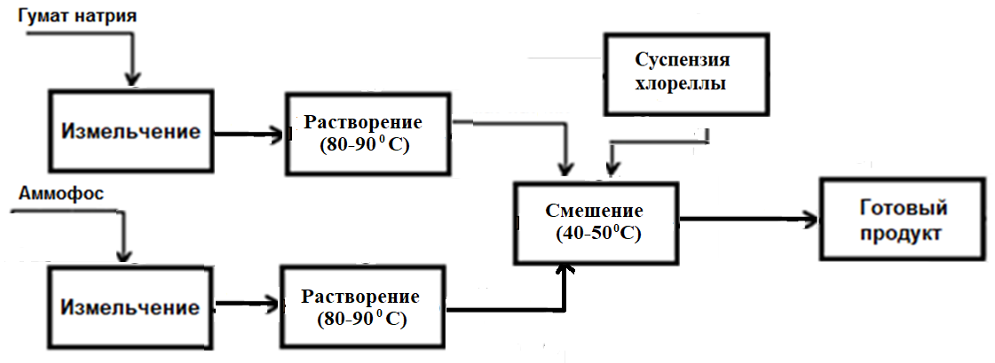
Ammophos
Sodium Humate
Finished product
Chlorella suspension
Dissolution
Grinding
Dissolution
Grinding
Mixing
Figure 11 - Basic technological scheme of synthesis
GUFOS-B1, GUFOS-B2 and GUFOS-B3

4 Receipt of enlarged consignments of GUFOS-B1, GUFOS-B2 and GUFOS-B3

For the synthesis of large batches of GUFOS-B1, GUFOS-B2 and GUFOS-B3, an experimental installation has been developed (Appendix D - the act of large-scale tests). Figure 12 shows the main components of the installation.

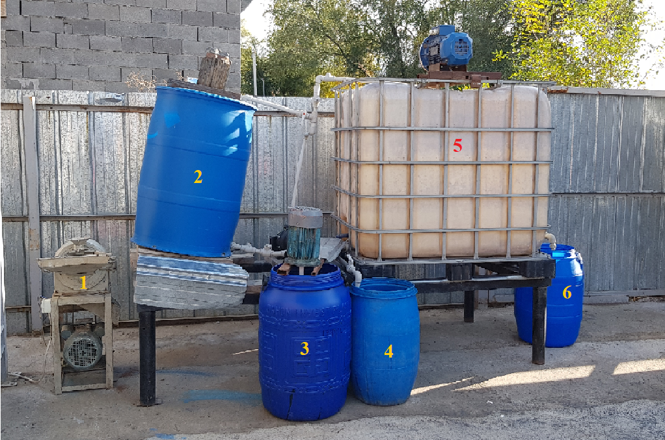
1 - crushing apparatus; 2 - container for sodium humate solution;
3 - container for ammophos solution; 4 - container for chlorella suspension;
5 - reactor; 6 - receiver for GUFOS-V.

Figure 12 - The main units of the experimental setup

Synthesis of an enlarged batch of GUFOS-B1
The calculation of the amount of starting components for the enlarged batch of GUFOS - B was carried out for the ratio of GUFOS sodium and chlorella 10: 1, respectively.
In a crushing apparatus (1), sodium (potassium) humate was crushed, then dissolved in hot water at 80-900C (2). Ammophos was also ground and dissolved in hot water at 80-900C (3). The prepared solutions were mixed in the reactor (4) and stirred at 40-500C until the formation of GUFOS (100 L), then a suspension of green algae (10 L) was added to the reactor in small portions (5). The resulting pulp was stirred for 1-2 hours at a temperature of 400C. The final product was stored in a receiver 6).
Synthesis of an enlarged batch of GUFOS-B2
Calculation of the amount of initial components for a large batch
HUFOS - B2 was carried out for the ratio of HUFOS sodium (potassium) and chlorella 10: 2, respectively.
The sodium (potassium) GUFOS solution prepared as described above was poured (100 L) into the reactor, then a suspension of green algae (20 L) was added in small portions. The reaction slurry was stirred for 1-2 hours at a temperature of 400C. The resulting product was stored in a receiver.
Synthesis of an enlarged batch of GUFOS-B3
Calculation of the amount of initial components for a large batch
GUFOS-B3 was carried out for the ratio of GUFOS and chlorella 10: 3, respectively.
A concentrated solution of sodium GUFOS (100 L) was poured into the reactor, then a suspension of green algae (30 L) was added in small portions. The reaction slurry was stirred for 1-2 hours at a temperature of 400C. The resulting product was stored in a receiver.

5 Conducting agrochemical tests GUFOS-B1, GUFOS-B2

Biopreparations GUFOS-B1, GUFOS-B2 passed agrochemical tests in "Fitosanitar" LLP (Almaty region, Enbenshikazakhsky district) on a soybean crop of the "Nena" variety on an area of 5 hectares (Fig. 13-15).
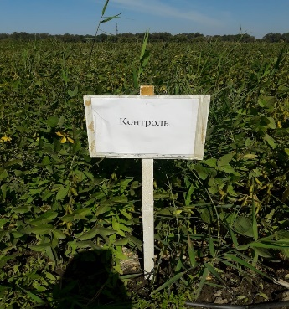
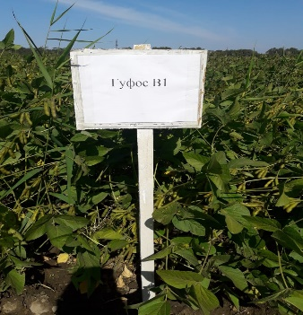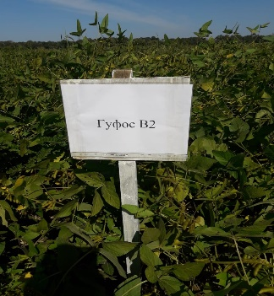
Figure 13 - Markings on the experimental field

The soil is sierozem, according to the mechanical composition of loam, the humus content is 0.2-0.3%, pH = 7.4.
Pre-sowing chemical soil treatment was carried out:
Treater TMTD, consumption 4 l / ha.
Sowing of soybeans was carried out on an area of 5 hectares, the planting scheme is square-nested, two-row, row spacing 50 cm, between plants 10-12 cm, sowing rate 120 kg / ha.
Preparations GUFOS-B1 and GUFOS-B2 carried out: treatment of soybean seeds, root and foliar treatment during the growing season and fruiting. Consumption rate 2l / ha.

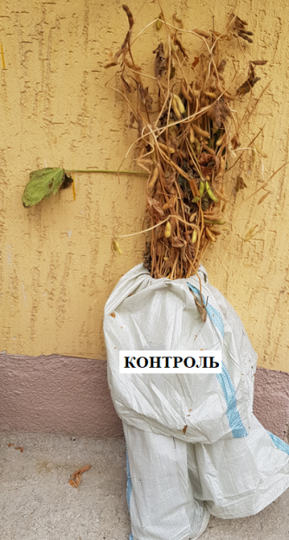 | 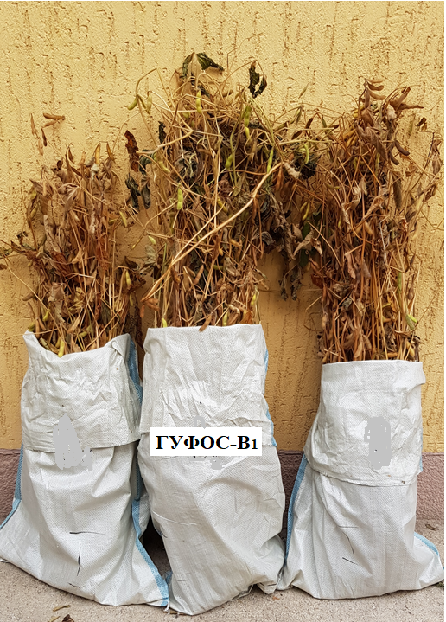 | 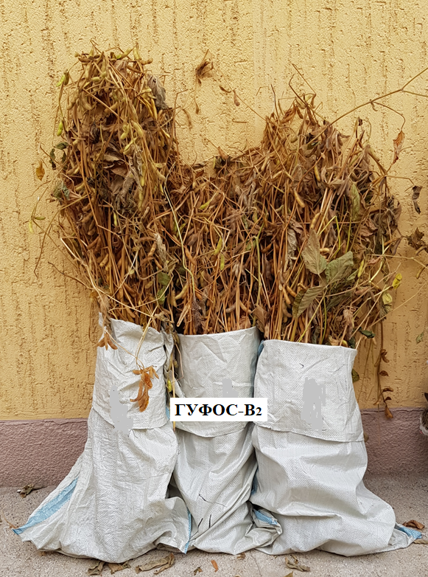
Figure 14 - Control samples of soybeans

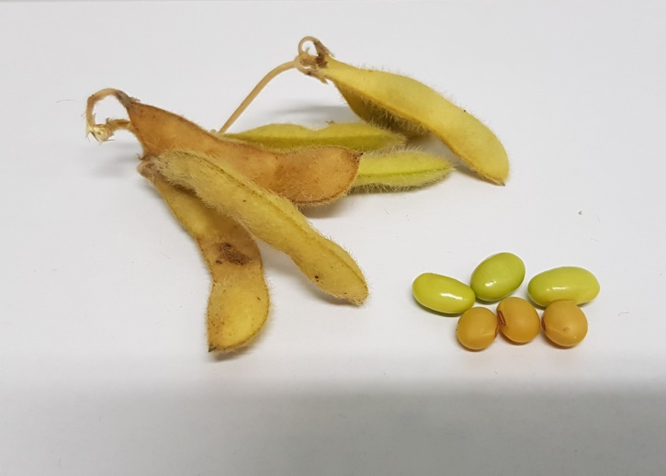

Figure 15 - Pods and grains of soybeans

The results of agrochemical tests are presented in table 16 and in diagrams 16-20.

Table 16 - Results of agrochemical tests
Name | Stem height of 1 plant, cm | Root length, cm | Number of pods in a sheaf, pcs. | Mass of pods in a bunch, g | Yield with  t / ha | Increase in yield in t / ha
control | 115.7 | 20.2 | 320 | 474 | 2,56 | -
GUFOS-B1 | 124 | 23.7 | 578 | 683 | 4,51 | 1.95
GUFOS-B2 | 138 | 25.3 | 611 | 784 | 4,70 | 2.14

An analysis of the results of agrochemical tests shows that the growth stimulators GUFOS-B1 and GUFOS-B2 have an effective effect on the growth, root system, flowering, fruiting and biological yield of soybeans (Fig. 16-20).
Thus, pre-sowing treatment of seeds, root and foliar treatment of soybean seedlings with the preparation GUFOS-B1 increase: the growth of soybeans by 7.2%, the number of pods in the sheaf by 38.4%, the average weight of pods in the sheaf - 80.6%, yield - 4.51 t / ha (76.2%) ...
Presowing seed treatment, root and foliar treatment of soybean seedlings with the preparation GUFOS-B2 increase: the growth of soybeans by 19.3%, the number of pods in the sheaf - 44.1%, the average weight of pods in the sheaf - 90.9%, yield - 4.70 t / ha (81.8%).

Figure 16 - Effect of GUFOS-B1 and GUFOS-B2 on the growth of soybeans
Figure 17 - Effect of GUFOS-B1 and GUFOS-B2 on the root system of soybeans

Figure 18 - The number of soybean pods
Figure 19 - Mass of soybeans

Figure 20 - Soybean yield

The chelate complexes GUFOS-B1 and GUFOS-B2 activate the division of new cells and the movement of nutrients in the plant, as indicated by the data in diagrams 1-3.

CONCLUSION

1. Optimal conditions for the synthesis of 8 new plant growth stimulants based on sodium humate (potassium), ammophos, alcohol stillage, milk whey and green algae have been developed: GUBAR-P (2: 1: 4-6), GUFOS-P (2: 1 : 2-4), GUFOS-PBAR (2: 1: 4: 6), GUMOL (1: 2), GUFOS-BAR (2: 1: 4), GUFOS-B1 (10: 1), GUFOS-B2 ( 10: 2), GUFOS-B3 (10: 3).
2. Possible schemes for the formation of chelate complexes based on the acid-base interaction between the active functional groups of sodium (potassium) humate and ammophos, as well as chemisorption in systems:
a) sodium humate - ammophos - bird droppings;
b) sodium humate - ammophos - alcohol stillage;
c) sodium humate - milk whey;
d) sodium humate - alcohol stillage;
e) sodium humate - ammophos - green algae.
3. Conceptual schemes of synthesis and technologies for obtaining 8 growth stimulants were developed.
4. An experimental setup has been developed for obtaining enlarged batches of stimulants. Enlarged batches of 8 stimulants in the amount of 3, 10 kg, 100 liters of each for agrochemical tests were obtained.
5. Agrochemical tests of stimulants GUBAR-P, GUFOS-P and GUFOS-PBAR were carried out on soft wheat "Lyubava 5" on an area of ​​20 hectares (Kostanay region, K / V "Zhanakhai", LLP "Progress". It is shown that high Agrochemical efficiency is shown by GUBAR-P, wheat yield is 12.55 c / ha, and with the application of GUFOS-P and GUFOS-PBAR - 9.12 c / ha and 8.71 c / ha, respectively.
6. Agrochemical tests of growth stimulants GUFOS-BAR and GUMOL on Manas onions on an area of ​​10 hectares (Almaty region, Dzhambul district, Svetlana LLP) were carried out. Root and foliar treatments of onion seedlings with biological preparations give an increase in the feather (leaf) height of the onion by 12.9-17.4%, leaf mass - by 31.1-52.4%, average bulb mass - by 29.4%. The yield increase is 4t / ha (9.55%) when treated with GUMOL, 3t / ha (7.1%) when treated with GUFOS-BAR.
7. Agrochemical tests of stimulants GUFOS-B1 and GUFOS-B2 were carried out on a soybean crop of the “Nena” variety on an area of ​​5 hectares (Almaty region, Enbekshikazakhsky district, “Fitosanitar” LLP). It has been established that root and foliar treatments with GUFOS-B1 and GUFOS-B2 give an increase in stem growth by 7.2-19.3%, the number of pods - by 38.4 - 44.1% and the mass of pods - by 80.6 - 90.9% of soybeans. The yield increase is 1.95t / ha and 2.14t / ha, respectively.
7. Based on the results of the research, only 10 publications were published, of which 2 are patents.

REFERENCE LIST
1 Markina A.V. Influence of potassium humate on the accumulation of 137Cs and macroelements in barley plants. Abstract dissertation. Candidate of Biological Sciences. Obninsk, 2006. - 03.00.01 Radiobiology, 139 p.
2 Kaishev A.Sh. Study of biologically active substances of alcohol production wastes 04.14.02 - pharmaceutical chemistry, pharmacognosy. Abstract dissertation. Cand. farm. Sciences, 2011.
3 Kuznetsov I.N., Ruchay N.S. Complex microbiological processing of distillery stillage to obtain protein-containing feed product // Modern problems of science and education, 2013, No. 3.
4 Artyukhov D.B. Head of Research Department, FLEXOM Group of Companies Influence of humates and growth stimulants on plant development.
5 Popov A.I. Humic substances, properties, structure, education. - Publishing house: St. Petersburg University, 2004, 248 p.
6 Khristeva, L.A. Physiological function of humic acid in the metabolic processes of higher plants. In the book: Humic fertilizers. Theory and practice of their application. - Publishing house of Kharkov University, 1957, 900 p.
7 Uromova I.P., Sultanova L.R., Dedyura I.S. Biologicals as a factor in increasing the yield and quality of potatoes // Successes of modern natural science. - 2016. - No. 12-1. - S. 117-121.
8 Humic substances as natural detoxicants / I. V. Perminova, D. V. Kovalevsky, N. Y. Yashchenko et al. // Humic substances and organic matter in soil and water environments: characterization, transformations and interactions. Ed.:C.E. Clapp, M.H.B. Hayes, N. Senesi, S. M. Griffith. - Soil Science Society of America Saint Paul <MN, USA, 1996. - P. 399-406.
9 Rauthan, B.S. and Schnitzer, M. (1981) Effects of Soil Fulvic Acid on the Growth and Nutrient Content of Cucumber (Cucumus sativus) Plants. Plant and Soil, 63, 491-495.
10 Sladky, Z. (1959) The Effect of Extracted Humus Substances on Growth of Tomato Plants. Biologia Plantarum, 1, 142-150.
11 Lee, Y.S. and Bartlett, R.J. (1976) Stimulation of Plant Growth by Humic Substances. Soil Science Society of America Journal, 40, 876-879.
12 Šebestová, E. & Machovič, V. & Pavlíková, H. & Lelák, J. & Minarík, L .. (1996). Environmental impact of brown coal mining in Sokolovo basin with especially trace metal mobility. Journal of Environmental Science & Health Part A. A31. 2453-2463. 10.1080 / 10934529609376502.
13 Kobierski, Mirosław & Kondratowicz-Maciejewska, Krystyna & Banach-Szott, Magdalena & Wojewódzki, Piotr & Castejon, Jose. (2018). Humic substances and aggregate stability in rhizospheric and non-rhizospheric soil. Journal of Soils and Sediments. 10.1007 / s11368-018-1935-1.
14 Popov A.I. Humic substances, properties, structure, education. - Publishing house: St. Petersburg University, 2004 .-- 248 p.
15 Khristeva, L.A. Physiological function of humic acid in the metabolic processes of higher plants. In the book: Humic fertilizers. Theory and practice of their application. - Publishing house of Kharkov University, 1957 - P.73-75.
16 Balakaeva G.T., Kalenova A.S., Endibaeva D.A. Obtaining humate phosphate // Abstracts of reports. Repub. scientific and technical conf. "Development and implementation into practice of effective technologies for the production of mineral fertilizers and agrochemicals", 2010. - P.123-124.
17 Balakaeva G.T., Kalenova A.S., Endibaeva D.A. Obtaining organomineral fertilizers based on sodium humate // Materials of the IV International scientific-practical conference "Natural sciences and humanities and their role in the implementation of the program of industrial and innovative development of the Republic of Kazakhstan", 2009. - P. 284-288. - KazNTU, Almaty.
18 Bubish Sholpangul, Kalenova A.S., Endibaeva D.A. The mechanism of formation of sodium humate phosphate // Materials of the International Russian-Kazakhstan School-Conference of Students and Young Scientists "Chemical technologies of functional materials", 2015. - P.54-57 - KazNTU, Almaty.
19 Kaishev A.Sh. Study of biologically active substances of alcohol production waste: author. dis ... cand. farm. Sciences / A.Sh. Kaishev. - Pyatigorsk: GOU VPO "SGMU RZ", 2011. - 24p.
20 Stoller Company USA. J. Stoller Stoller's Book on Plant Physiology: Maximizing Plant Genetics. - 10 p.
21 Kuznetsov I.N., Ruchay N.S. Complex microbiological processing of distillery stillage with obtaining protein-containing feed product // Modern problems of science and education. - 2013. - No. 3.
22 http://beaplanet.ru/vodorosli/zelenye_vodorosli/hlorella.html.
23 Lysak, V.V. Systematics of microorganisms: textbook / V.V. Lysak, O. V. Fomina. - Minsk: BSU, 2014 .-- 304 p.
24 https://www.atomic-energy.ru/news/2014/09/08/51306.
25 Chlorella suspension is a natural biostimulant. NTCV (scientific and technological center of water. - RK, Petropavlovsk, 2015-15s.
26 Physico-chemical characterization of humic-metal-phosphate complexes and their potential application to the manufacture of new types of phosphate-based fertilizers / Journal of Plant Nutrition and Soil Science - 177 (2). 2014. - Р.128–136. https://ezproxy.nu.edu.kz:2364/10.1002/jpln.201200651.
27 Balakaeva G.T., Kalenova A.S., Endibaeva D.A. Getting humatophosphate / Tez. report Rep. scientific and technical conf.

application A
Applications 1.2.
to the Agreement №___ от____2018 г.
for grant funding

TECHNICAL SPECIFICATION AND
WORK SCHEDULE

Under the contract №___ от__________ 2018 года
1.LLP «SPTC «Zhalyn»
1.1 By priority: Rational use of natural resources, including water resources, Geology, processing, new materials and technologies, safe products and structures.
1.2 By sub-priority: New multi-purpose materials based on natural raw materials and man-made waste.
1.3 By project topic: IRN: АР 05133082 «Development of technology for obtaining biostimulants from industrial waste».
1.4 The total amount of the project 21 294680 (Twenty-one million two Hundred and Ninety-four thousand six hundred and eighty) tenge, including by year, for the performance of work according to the item:
- for 2018-in the amount of 7 051219 (seven million fifty-one thousand two Hundred and Nineteen) tenge;
- for 2019-in the amount of 7,114,679 (seven million one hundred and fourteen thousand six hundred and seventy-Nine) tenge;
- for 2020-in the amount of 7,128,782 (seven million one hundred and Twenty-eight thousand seven hundred and eighty-two) tenge.

1. Characteristics of scientific and technical Products by qualification criteria and economic indicators

2.1 Field of work: chemical technology
  - Field of application: production of mineral fertilizers
  - End result:
- - for 2018: Development of technology for obtaining a new biological product of the state enterprise FOS-PBAR.
- - for 2019: the Development of technology for production of biopreparation HOMOL. The results of the study will be issued 1 patent with the use of sodium HUMATE (potassium), monoammonium phosphate, alcohol stillage, whey, poultry manure, etc., and published 2 articles in national, peer-reviewed journals with impact-factor, 1 article in a peer-reviewed scientific publication indexed in the database Scopus with impact factor 2 of the report at international conferences.
for 2020: Development of technology for obtaining the gufos-B biological product. The results of studies will be issued 2 patents of RK, and will be published 3 articles in national journals recommended KKSON, 2 articles in peer-reviewed scientific publication indexed in the database Scopus with impact factor, H of the report at international conferences.
Patentability: Patentable.
  - Scientific and technical level (novelty): New biostimulants for plant growth will be developed based on sodium HUMATE (potassium) and agricultural waste: bird droppings, alcohol bards, whey, and algae.
  - The use of scientific and technical products is carried out by: modern Chemistry LLP.
  - Type of use of the result of scientific and (or) scientific and technical activities: agrochemical tests of preparations in the field will be carried out in Kostanay region for wheat, for tree seedlings in Akmola region, for potatoes in Zhambyl region..
3. Name of works, terms of their implementation and results
Task code I, stage | Name of work under the  Contract and the main stages of its implementation * | Due date * |  | Expected result *
Task code I, stage |  | Beginning | Ending | Expected result *
1 | Development of physical and  chemical bases of interaction in systems based on bird droppings, sodium HUMATE, ammophos, and SPI Tova BA dy. | January 2018 | until November  1, 2018 | Physicochemical bases of interaction in systems based on poultry manure, sodium humate, ammophos and alcohol stillage will be developed.
1.1 | Biochemical and microbiological analysis of the composition of the initial components. Determination of the optimal mass ratio of components in the mixture.  Synthesis of a biological product of the composition: bird droppings (P), sodium HUMATE (GU) and alcohol bard (BAR) GUBAR-P. | January 2018 | March 2018 | The biochemical and microbiological analysis of the composition of the initial components will be investigated, the optimal mass ratio of the components in the mixture will be determined, and a biological product will be synthesized with the composition: bird droppings (P), sodium HUMATE (GU) and alcohol bard (BAR) GUBAR-P. The initial components will be analyzed, mass ratios and conditions for the synthesis of the new  biological product GUPAR-P will be determined.
1,2 | Synthesis biostimulant composition: poultry manure, sodium HUMATE and monoammonium phosphate (FOS) is GUFOS-P.  Establishing the interaction scheme of components in the system. | April 2018 | June 2018 | Will be synthesized biostimulant composition:  bird droppings, sodium HUMATE and monoammonium phosphate (FOS) GUFOS-P,  The interaction schemes  of the components in the system will be set. A new biopreparation's GUFAS-P will be synthesized.

1.3 | Development of technology for production of biological products based on poultry manure, sodium HUMATE, monoammonium phosphate and alcohol bards: GUFOS - PBAR. | July 2018 | September 2018. | Will be developed  the technology of producing biological products based on poultry manure, sodium HUMATE, monoammonium phosphate and alcohol bards: GUFOS-PBAR. Will be developed  the technology of obtaining GUFOS - PBAR.
1.4 | Conduct integrated tests of the process of obtaining GUBAR-P, GUFOS-P,  GUFOS-PBAR Conducting agrochemical tests. | October 2018 | until November  1, 2018 | Will be conducted the integrated testing of the process of obtaining GUBAR-P, GUFOS-P,  GUFOS-PBAR.  Agrochemical tests will be carried out,  Technological and agrochemical tests of production processes will be carried out  GUBAR-P, GUFOS-P,  GUFOS-PBAR.
2 | Establishing the basis of interaction in systems with milk whey( MOL), sodium HUMATE (potassium), alcohol bard and ammophos. | January 2019 | until November  1, 2019 | The basics of interaction in systems with milk whey  (MOL), sodium HUMATE (potassium), alcohol bard and ammophos will be established.  Two new biologics will be synthesized: GUMAL, GUFOS-BAR, Will be held enlarged technological and agrochemical testing. according to the research results, 1 patent of the Republic of Kazakhstan will be issued  using sodium HUMATE (potassium), ammophos, alcohol bard, milk  whey, bird droppings, etc., and will be published 2 articles in national, peer-reviewed journals with a non-zero impact factor, an article in a peer-reviewed foreign scientific publication indexed by a non-zero impact factor, 2 reports at international conferences.

 | 2.1 |  | Determination of the optimal mass ratio of components in the mixture.  Synthesis of a biological product based on sodium HUMATE (GN) and whey (M) HUMOL. |  | January  2019 |  | March  2019 |  | The optimal mass ratio of the components in the mixture will be determined.  A biological product based on sodium HUMATE (GN) and whey (M) GUMOL will be synthesized. It will be synthesized-a biological product:  humol.
 | 2.2 |  | Synthesis of a biological product on the basis of sodium HUMATE (GN), alcohol bards and ammophos – GUFOS-BAR. |  | April 2019 |  | June 2019, |  | Will be synthesized biological product on the basis of sodium HUMATE (GN), alcohol bards and ammophos –GUFOS-BAR. Will be synthesized biopreparation's GUFOS-BAR.
 | 2,3 |  | The development of technology for GUMAL, GUFOS-BAR. |  | July 2019.. |  | September 2019 |  | The technology of obtaining GUMAL, GUFOS-BAR.
 | 2.4 |  | Conduct integrated tests of the receipt of GUMEL, GUFOS BAR. Agrochemical tests of GUMEL, GUFOS-BAR. |  | October 2019 |  | until November  1, 2019 |  | Be conducted larger test getting GUMAL, GUFOS- BAR. Will be held agrochemical testing GUMAL, GUFOS-BAR. Be conducted larger technological and agrochemical test GUMAL, GUFOS-BAR.
 | 3 |  | Development of physicochemical fundamentals of the interaction in the systems on the basis of sodium HUMATE, monoammonium phosphate and green algae (V) - (GUFOS-V). |  | January 2020. |  | until November  1, 2020 |  | Will be developed by physico-chemical basis of interaction in the systems on the basis of sodium HUMATE, monoammonium phosphate and green algae (V) - (GUFOS-V). Will be synthesized a new biological product: GUFOS-V. According to the results of the research, 2 patents of the Republic of Kazakhstan will be issued, and 3 articles will be published in Republican journals,
recommended CCSON, 2
articles in a peer-reviewed foreign scientific
publication indexed in the Scopus database with a non-zero impact factor, 3 reports at
international conferences.
3.1 |  | Synthesis of the biostimulant composition: sodium HUMATE( GU), ammophos (FOS) and green algae (V). |  | January  2020. |  | March  2020 |  | A biostimulator will be synthesized with the composition of sodium HUMATE( GU), ammophos (FOS) and green algae (V).  Will be synthesized a new biological product: GUFOS-V,
3.2 |  | Analysis of the resulting product and establishment of the scheme of interaction of components in the system under study. |  | April 2020 |  | June, 2020 |  | The resulting product will be analyzed and the scheme of interaction of components in the system under study will be established, the scheme of interaction of  components will be established.
3.3 |  | The development of technology for GUFOS-V. |  | July  2020 г. |  | September  2020 г. |  | Will be developed  the technology of obtaining GUFOS-V.
3.4 |  | Conduct integrated tests of the receipt of GUFOS-V. Agrochemical tests of GUFOS-V. |  | октябрь  2020 г |  | until November  1, 2020 |  | Will be held  the integrated test getting GUFOS-V. Will be held  agrochemical tests of GUFOS-V.  Technological and agrochemical tests of GUFOS-V will be carried out.

application B
application C

The list of published works on the topic for 2018-2020
1 Aldabergenov M.K., Balakayeva G.T., Kalenova A.S. New plant growth stimulator - humatphosphate / International scientific conference "Conserving soils and water" - Burgas, Bulgaria. - 2018. - P.165-167.
2 Balakaeva G.T., Kalenova A.S., Sagadatova D. Study of the influence of the growth stimulator GUBAR on wheat yield / V International Russian-Kazakhstan scientific-practical conference "Chemical technologies of functional materials", dedicated to the 85th anniversary of KazNU named after al-Farabi - Russia, Novosibirsk, May 16-18, 2019 / http://chem.conf.nstu.ru/
3 Kalenova A.S., Bubish Sh., Sagadatova D. Synthesis of a growth stimulator based on milk whey / V International Russian-Kazakhstan scientific-practical conference "Chemical technologies of functional materials", dedicated to the 85th anniversary of KazNU named after al-Farabi - Russia, Novosibirsk, May 16-18, 2019 / http://chem.conf.nstu.ru/
4 Kalenova A.S., Bubish Sh., Sagadatova D. Synthesis of green fertilizer based on lactic bacteria / Republican scientific and practical conference "Science and Business" - Almaty, May 22, 2019 / http://zhalynkz.com / post / 10
5 Aldabergenov M.K., Balakaeva G.T., Bubish Sh. Patent of the Republic of Kazakhstan No. 33549 Method of producing organic fertilizer Application dated 18.04.2017.
6 Balakaeva G.T., Kalenova A.S., Brimzhanova K.T., Bubish Sh. Influence of the growth stimulator GUFOS-BAR on wheat yield // Journal of International Agroengineering. - Almaty, 2019. - No. 4 - P. 36-45.
7 Aldabergenov M.K., Balakaeva G.T., Kalenova A.S., Sarsenbaeva G.B., Berganaeva G.E. The effect of potassium humate phosphate on the sowing quality of corn and soybeans // Journal of International Agroengineering. - Almaty, 2019. - No. 4 - P.46-57.
8 Patent of the Republic of Kazakhstan "Method for producing organic fertilizers" dated 20.04.2020, Application 2018 / 09.83.1.
9 Kalenova A., Bubish Sh., Brimzhanova M., Balakaeva G. Synthesis of the bioorganic preparation GUFOS-P // Scientific and technical journal "Science News of Kazakhstan". - Almaty, 2020. - Appendix to No. 3 (146) - P. 9-20.
10 Kalenova A., Bubish Sh., Balakaeva G. Synthesis of a biostimulant based on sodium humate (potassium) and milk whey // Scientific and technical journal "Science News of Kazakhstan". - Almaty, 2020. - Appendix to No. 3 (146) - pp. 21-29.

application D
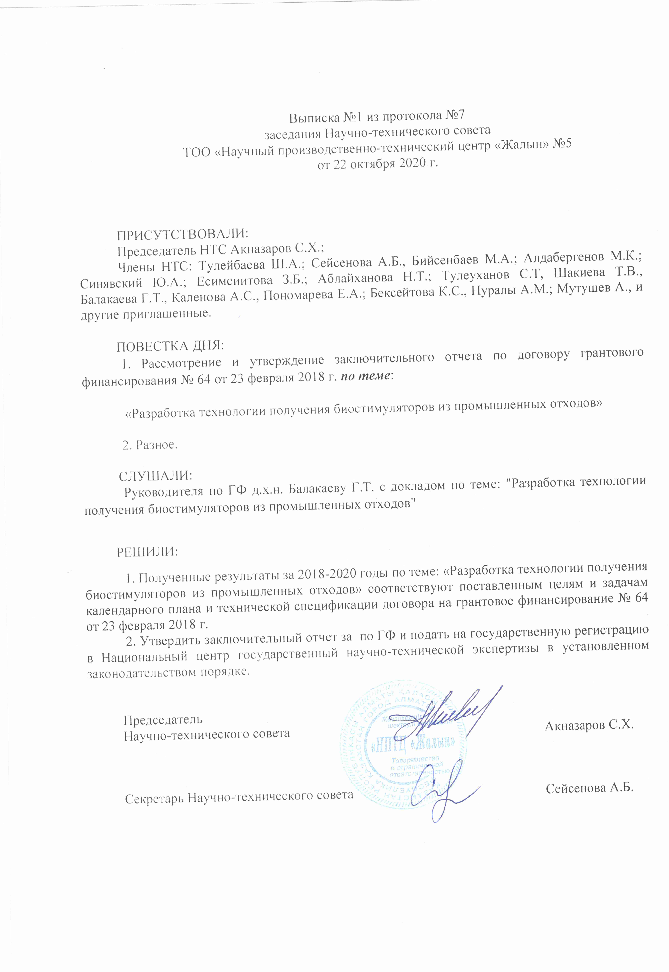
application E

Supporting document for the item "Training"
List of performers with a scientific degree:

1 Balakaeva Gulshat Tultaygyzy, Doctor of Chemistry, Professor, Project Manager, Zhalyn Scientific and Production Technical Center LLP.
2 Aldabergenov Mailibi Kapanuly, Doctor of Chemistry, Professor of Zhalyn Scientific and Production Technical Center LLP.
3 Kalenova Aizhan Sovetovna, Candidate of Chemical Sciences, Assistant Professor of the Department of Chemical Processes and Industrial Ecology, NAO KazNRTU named after K.I. Satpayev ".
List of performers without a degree:
4 Bubish Sholpan, master of technical sciences, engineer of Zhalyn Scientific and Production Technical Center LLP.
5 A. Ernazarova, engineer of Zhalyn Scientific and Production Technical Center LLP.

List of PhD, undergraduate, undergraduate students in research as part of the preparation of their dissertations:

6 Sagadatova Dinara, Master's student of the Department of Chemical Processes and Industrial Ecology, NJSC KazNRTU named after K.I. Satpayev ".

application F

