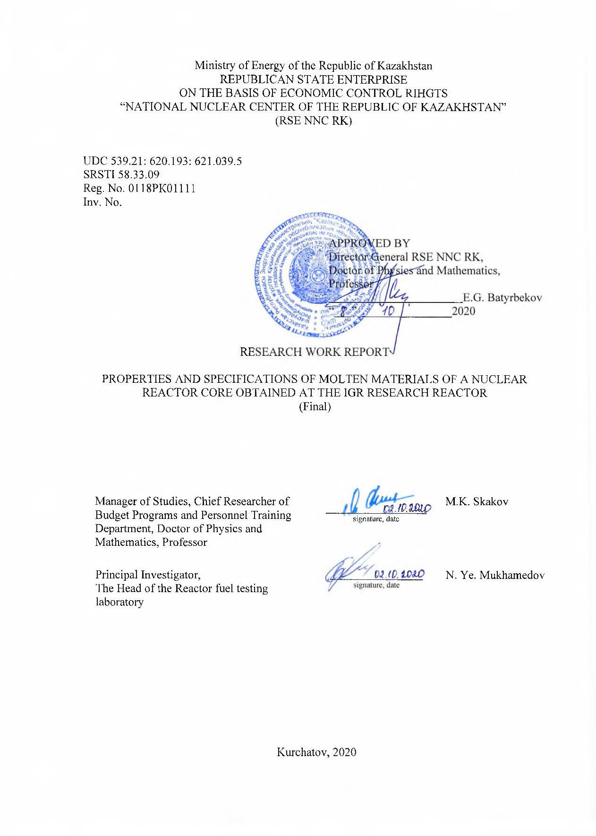
Ministry of Energy of the Republic of Kazakhstan
REPUBLICAN STATE ENTERPRISE
ON THE BASIS OF ECONOMIC CONTROL RIHGTS
“NATIONAL NUCLEAR CENTER OF THE REPUBLIC OF KAZAKHSTAN”
(RSE NNC RK)

UDC 539.21: 620.193: 621.039.5
SRSTI 58.33.09
Reg. No. 0118РК01111
Inv. No.

APPROVED BY
Director General RSE NNC RK,
Doctor of Physics and Mathematics, Professor
E.G. Batyrbekov
“___”________________2020

RESEARCH WORK REPORT

PROPERTIES AND SPECIFICATIONS OF MOLTEN MATERIALS OF A NUCLEAR REACTOR CORE OBTAINED AT THE IGR RESEARCH REACTOR
(Final)

Manager of Studies, Chief Researcher of Budget Programs and Personnel Training Department, Doctor of Physics and Mathematics, Professor | _________________  signature, date | М.K. Skakov
Principal Investigator,  The Head of the Reactor fuel testing laboratory | _________________  signature, date | N. Ye. Mukhamedov

Kurchatov, 2020
LIST OF EXECUTORS

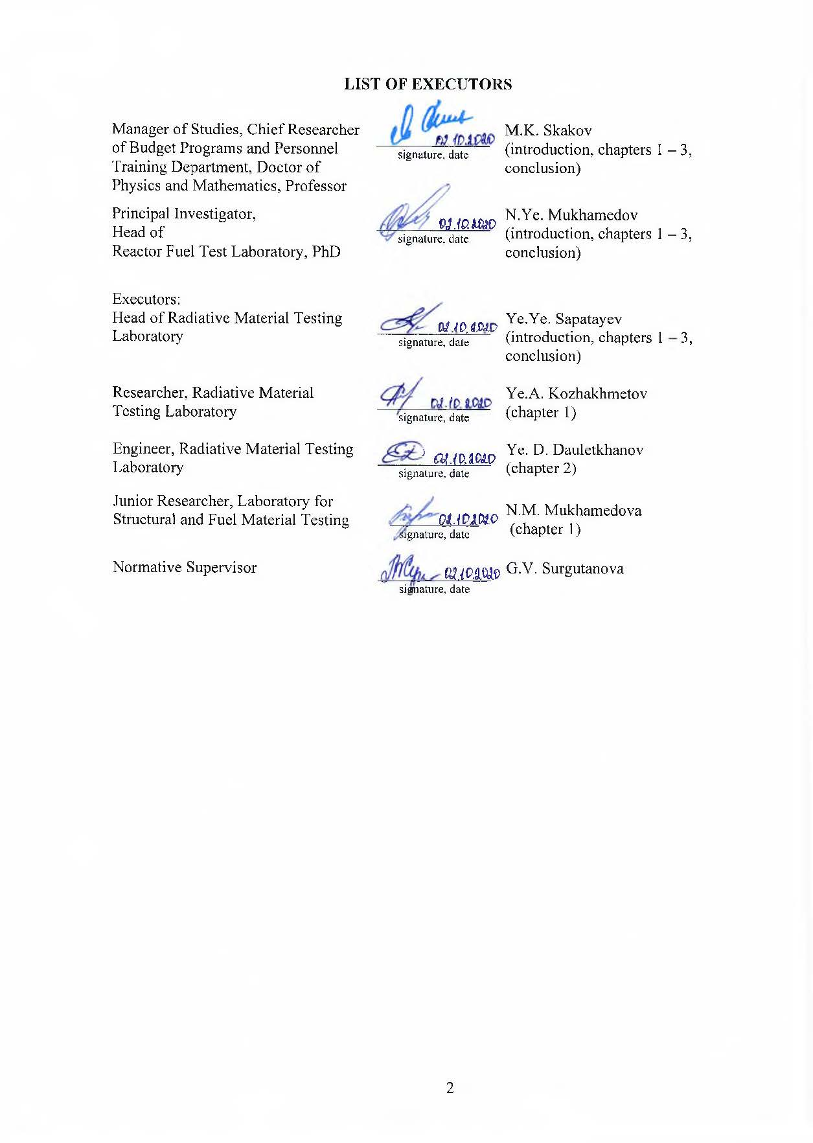  Manager of Studies, Chief Researcher of Budget Programs and Personnel Training Department, Doctor of Physics and Mathematics, Professor | ______________  signature, date | М.K. Skakov  (introduction, chapters 1 – 3, conclusion)
Principal Investigator,  Head of  Reactor Fuel Test Laboratory, PhD | ______________  signature, date | N.Ye. Mukhamedov  (introduction, chapters 1 – 3, conclusion)
Executors:
Head of Radiative Material Testing Laboratory | ______________  signature, date | Ye.Ye. Sapatayev  (introduction, chapters 1 – 3, conclusion)
Researcher, Radiative Material Testing Laboratory | ______________  signature, date | Ye.А. Kozhakhmetov  (сhapter 1)
Engineer, Radiative Material Testing Laboratory | ______________  signature, date | Ye. D. Dauletkhanov  (сhapter 2)
Junior Researcher, Laboratory for Structural and Fuel Material Testing | ___________  signature, date | N.М. Mukhamedova  (сhapter 1)
Normative Supervisor | ______________  signature, date | G.V. Surgutanova

ABSTRACT

Report contains 49 pages, 12 figures, 8 tables, 11 references, 4 appendixes.
REACTOR SAFETY, SEVERE ACCIDENTS, CORIUM, REACTOR
Research object is a solidified melt of structural and fuel materials of a core of nuclear power reactor.
Objective of work is to establish basic structural and phase conditions, physical and mechanical properties, regularity of microstructure structures of melt of structural and fuel materials of a nuclear reactor core.
Research methods: optical metallography, electro microstructure, X-ray phase analysis, element analysis, compression test, processing and analysis of experimental data.
As a result of the research work, structural and phase conditions have been studied, and mechanical tests a melt prototype of structural and fuel materials of nuclear power reactor core have been carried out.
The novelty of the work lies in the fact that for the first time the basic structural-phase states and physical and mechanical properties of the melt of structural and fuel materials of the nuclear reactor core are established.
The scope of the results – the applicability of the research lies in the possibility of using the information obtained in the project for the design, construction and safe operation of power reactors.

CONTENT

INTRODUCTION 5
MAIN PART 8
1 Study of structural and phase conditions of core material melt 8
1.1 Preparation of samples from solidified melt of core material 8
1.2 Structural and phase condition of solidified melt samples of core materials 9
1.3 X-ray structural studies of solidified melt samples of core materials 18
2 Physical and mechanical research of core material melt 23
3 Recommendations on the structure condition, physical and mechanical properties of structural and fuel melt material of nuclear power reactor core 28
CONCLUSION 29
LIST OF REFERENCES 31
APPENDIX А List of publications 32
APPENDIX B Work schedule 35
APPENDIX C RK Patent for Invention No. 33105 42
APPENDIX D RK Patent for Invention No. 34494 48

INTRODUCTION

As it is known, despite a number of NNP’s advantages compared to thermal plants operating on fossil fuel – in economic efficiency, environmental friendliness during normal operation, the volume of fuel reserves and others – atomic energy is potentially the most dangerous of all types of energy known to mankind.
Therefore, ensuring and substantiation of the NNP safety is a priority task in the operation of existing and design of new NNP, which are subject to increased safety requirements. In-depth and versatile studies, as well as the adopted design solutions based on these studies, made it possible to reduce the risk of accidents with the release of radioactive products outside the containment of reactor vessel. A significant increase in safety became possible due to introduction of new organizational, scientific, technical and technological solutions, for example, such as the use of new materials, new circuit solutions, properties of self-regulation and self-protection, equipment of improved quality, passive principles of safety system operation.
Experts consider that modern substantiation of NPP safety, even within the framework of a conservative approach, is difficult for the following reasons:
1) physical and mechanical processes of interaction between corium melt and structural materials of the reactor and materials of underreactor engineering structures were not studied. There is no mathematical model describing similar processes,
2) the high temperature, radioactivity and chemical aggressiveness of the corium melt complicate experimental studies in the physical modeling of probable processes accompanying a severe accident,
3) there is no reliable data on the thermophysical properties of solid and liquid corium, as well as on the properties of structural materials at high temperatures,
4) effect of chemical composition of corium on melt properties and development of severe accident complicates use of the results obtained in experiments that differ in conditions of their setting.
The complexity and lack of study of many physical and chemical processes in severe accidents, as well as a wide variety of scenarios for severe accident development, many of which cannot be formulated in advance, lead to the fact that a conservative approach is often used in their analysis. In accordance with this approach, destruction of the dried core with molten corium flow at the bottom of reactor vessel and subsequent thermal and physicochemical interaction between the melt and the vessel is considered. The influence of a real scenario of core destruction and formation of a molten pool affects the characteristics of the melt, primarily through the time of the pool formation that determines level of residual energy release in the melt, and through the corium composition, which determines its physical and chemical properties. Therefore, in the conservative approach of a severe accident analysis, a parametric problem is considered with varying the energy release and corium melt composition.
As it is known, for several decades, experimental studies have been carried out to demonstrate possibility of controlled removal of molten fuel from reactor core using fast neutrons in order to eliminate the occurrence of repeated criticality, as well as to determine conditions that ensure melt retention inside the reactor vessel without destroying it [1–6]. Such studies, including those carried out at the NNC RK, are designed, on the one hand, to provide direct simulation of some processes occurring during severe accident development accompanied by core material melting, and, on the other hand, to contribute to the formation of a database of experimental data required for the development and verification of calculation codes used for safety analysis of nuclear reactors [7–9].
The current studies are primarily aimed at determining rational ways to mitigate the consequences of severe accidents of nuclear power reactors, at eliminating the possibility of destruction of protective barriers of reactors (power vessel, concrete base of the reactor), preventing the release of melt and fission products into the environment.
Due to the abovementioned, the purpose of the Project for a three-year period, is: to establish basic structural and phase conditions, physical and mechanical properties and regularities in the melt structure of structural and fuel materials of a nuclear reactor core.
The main results obtained during the implementation of the project were published in scientific journals and reported at international scientific conferences (APPENDIX A).
In 2018, within the framework of this project, in accordance with the schedule (APPENDIX B), the following tasks were solved:
- analysis of the results of studies of the properties and specifications of the melt of the materials of the nuclear reactor core obtained un-der out-of-pile conditions,
- theoretical calculation of the feasibility to carry out in-pile experiment on the IGR research reactor for irradiating ampoule experimental device,
- conduct an analysis of the component-element composition of the nuclear power reactor cores,
- development of the design of the experimental ampoule device.
The results of conducted in 2018 works are described in details in intermediate report on R&D: Properties and specifications of molten materials of a nuclear reactor core obtained at the IGR research reactor: report on R&D (intermediate) / branch IAE RSE NNC RK; sup.
M.K. Skakov.– Kurchatov, 2018.– 63 p.− State inv. No. 0218РК00084 [10].
In 2019, within the framework of this project, the following tasks were solved:
- to develop program-methodological documentation of IGR reactor start-up with ampoule experimental device,
- to perform irradiation in-pile start-up with ampoule experimental device at the IGR reactor.
The results of conducted in 2019 works are described in details in intermediate report on R&D: Properties and specifications of molten materials of a nuclear reactor core obtained at the IGR research reactor: report on R&D (intermediate) / branch IAE RSE NNC RK; sup.
M.K. Skakov.– Kurchatov, 2019.– 47 p.− State inv. No. 0219РК00280 [11].
In 2020, within the framework of this project, the following tasks were solved:
– macro- and microstructure studies of core melt materials,
– physical and mechanical studies of core material melt,
– issue scientifically based recommendations on the structure state, physical and mechanical properties of the melt of structural and fuel materials of a nuclear power reactor core.
This annual research report for 2020 on this Project shows the results of fully completed work on the specified tasks. Also, on the topic of the grant, two patents for invention were obtained (APPENDICES C and D). The total number of executors involved in the research work is 15.

MAIN PART

1 Study of structural and phase conditions of core material melt

1.1 Preparation of samples from solidified melt of core material
To study structural and phase state of the core material melt, the following was carried out. From the available ingots of the solidified melt of the core materials obtained based on high-temperature experiments, cube-shaped corium samples with dimensions of 4×4×4 mm were made (Figure 1). The surface the test samples was prepared on a DualPrep-3 grinding and polishing machine using abrasive paper of various grain sizes and polishing cloth (Figure 2). Flowing water was used as a cooling liquid for grinding. During wet grinding, a softer mode of surface treatment of the samples is provided, the results of which are better surface quality, fewer chips, and dust content of pellets is negligible. Information on the materials loaded into the crucible during the experiment and heating temperatures is presented in the Table 1.

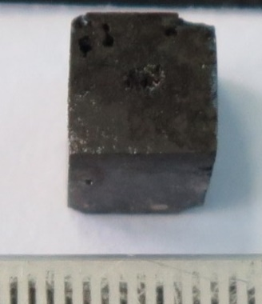 | 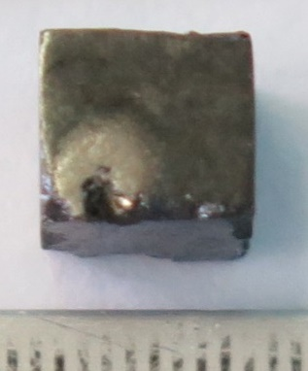 | 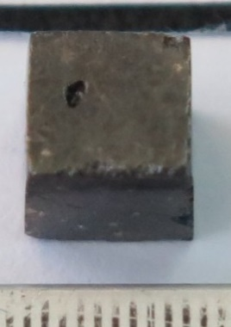 | 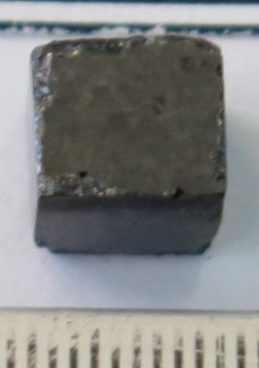
ТаС-5(А) | ТаС-8(В-1) | ТаС-8(В-2) | ТаС-22(Е)
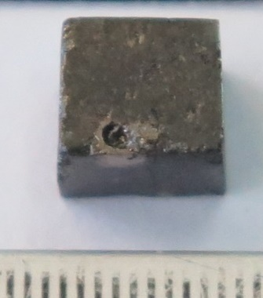 | 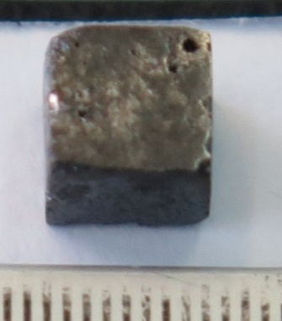 | 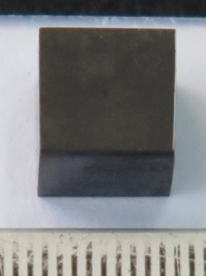
ТаС-8(А-1) | ТаС-12(В) | ТаС-20(А)
Figure 1 – Outer view of samples of corium prototype resulted from the ТаС experiments
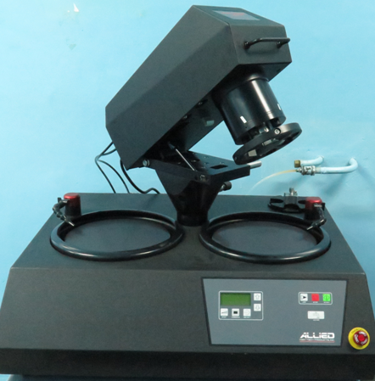
Figure 2 – Automatic Grinding and Polishing Machine DualPrep 3РН

Table 1 – Loading of materials in a crucible for the TC experiments
Experiment # | UO₂ mass, gr. | Mass of steel 12Х18Н10Т, gr. | Mass of steel  Х16Н15М3Б, gr. | t_{Max,} °С
TaC-5 | 135.0 | - | 8.42 | 2500
TaC-8 | 135.0 | 1.51 | 8.51 | 2600
TaC-12 | 135.0 | - | 8.5 | 2600
TaC-20 | 135.0 | - | - | 2850–2950
TaC-22 | 135.0 | - | 1.39 | 2780

1.2 Structural and phase condition of solidified melt samples of core materials
Electron microscopic studies were carried out using a Tescan VEGA3 scanning microscope with an Oxford X-Act energy dispersive microanalysis system (Figure 3).
The images of surface of corium prototype samples were obtained in a backscattered electron mode (BSE) at an accelerating voltage of 20 kV.
The quantitative assessment of the detected pores and inclusions was carried out using a set of images with an area of 1×1 mm in the backscattered electron mode. The distance between regions from which the images were obtained was ~ 500 μm. Image processing was carried out using a special AZtecFeature application and Altami Studio software.

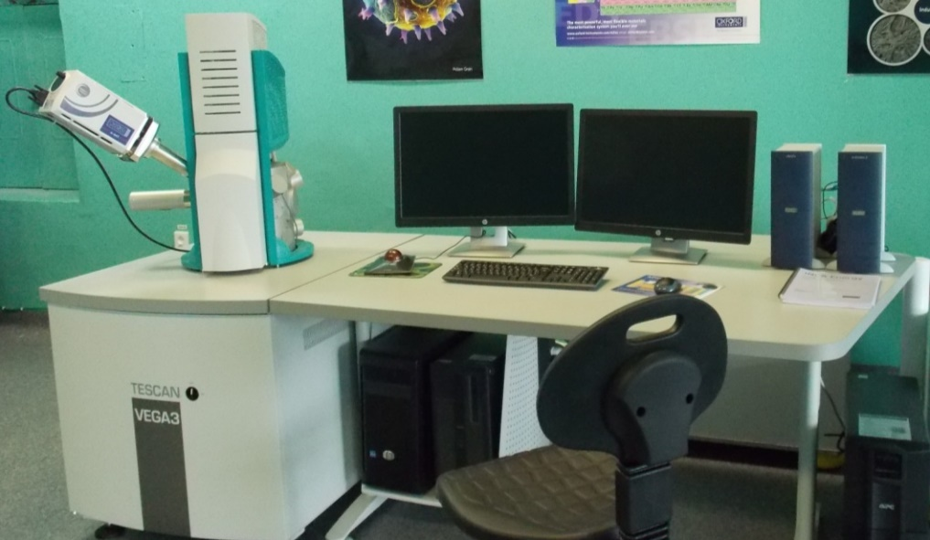
Figure 3 – Scanning Electron Microscope VEGA3

The structure of the sample surface after high-temperature experiments is shown in
Figure 4. The surface of the samples is characterized by presence of a significant number of pores and inclusions of a white tint on the main matrix, while in the samples TaC-5(A) and TaC-8(A) there were a large number of cracks forming between a network of cracks (Figure 4a, b).
A distinctive feature of the TaS-8(A) sample is distribution of cracks along grain boundaries in local areas.
As it is seen in Figure 4, the main concentration of pores and white inclusions are on grain boundaries of uranium dioxide (UO₂). The average size of pores is 9.88 μm. At the same time, at the triple joints of UO₂ grains, there are pores with a size of up to 30 μm. Probably this is due to the merging of adjacent small pores.
The structure of UO₂ is large roundish grains with size of 50-200 μm, surrounded by white inclusions. The cavities on the surface of the samples are remnants of grinding and polishings, and not a microstructural element.

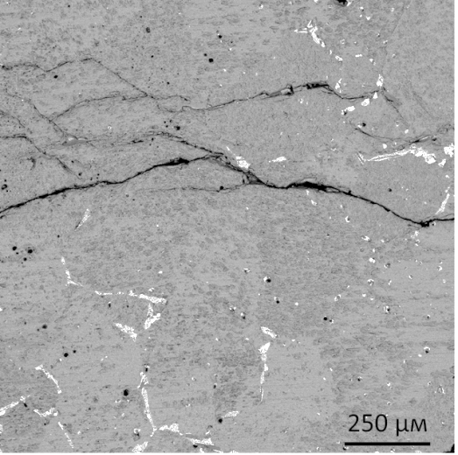 | 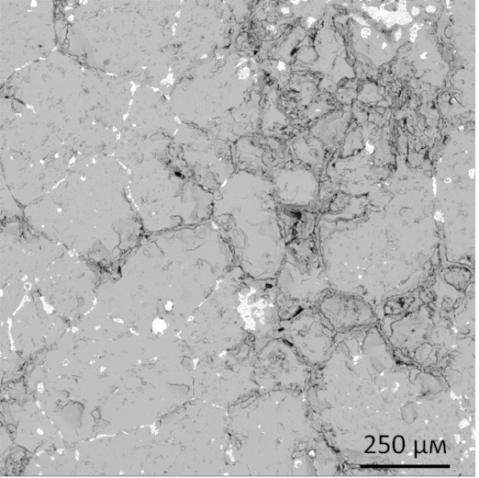
а) TaC-5(А) | b) TaC-8(А)
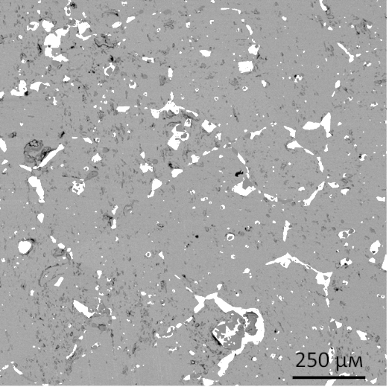 | 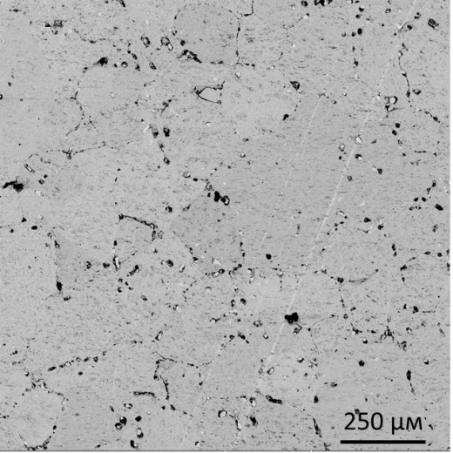
c) TaC-12(В) | d) TaC-22(Е)
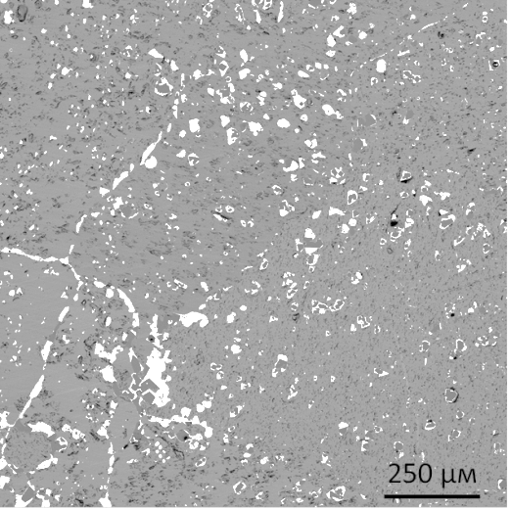 | 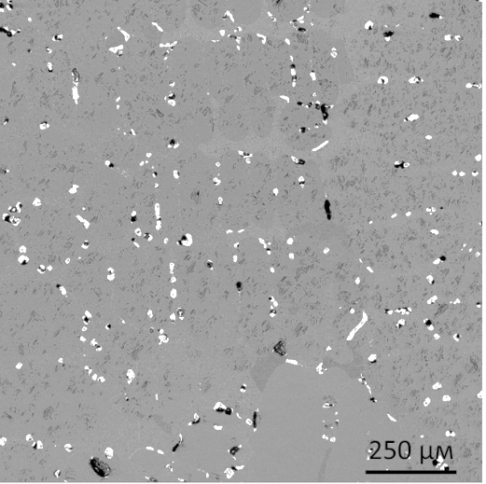
e) TaC-8(В) | f) TaC-20(А)
Figure 4 – Microstructure of corium prototype samples resulted from high temperature experiments

The nature and shape of distribution of white inclusions allows dividing them into 2 types: inclusions of a multifaceted shape with a size of 10-25 µm, distributions of which at different points of solidified melt differ significantly; continuous, line inclusions, which are distributed mainly at the boundaries of UO₂ grains, enveloping them and forming a network structure on the sample surface (Figure 5).
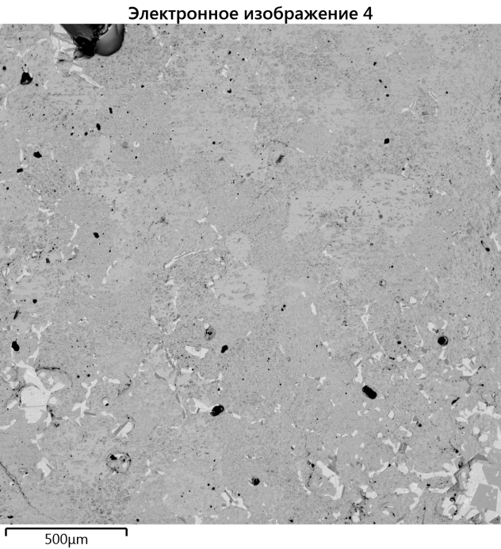 | 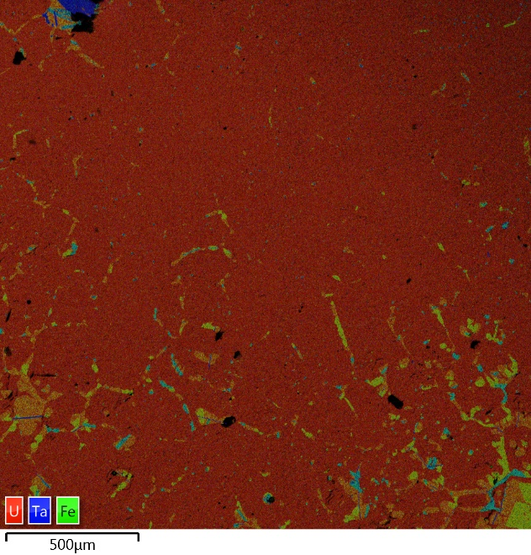
TaC-5(А)
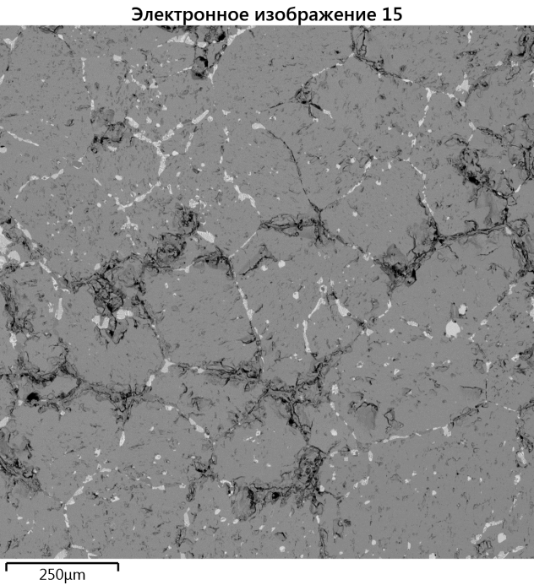 | 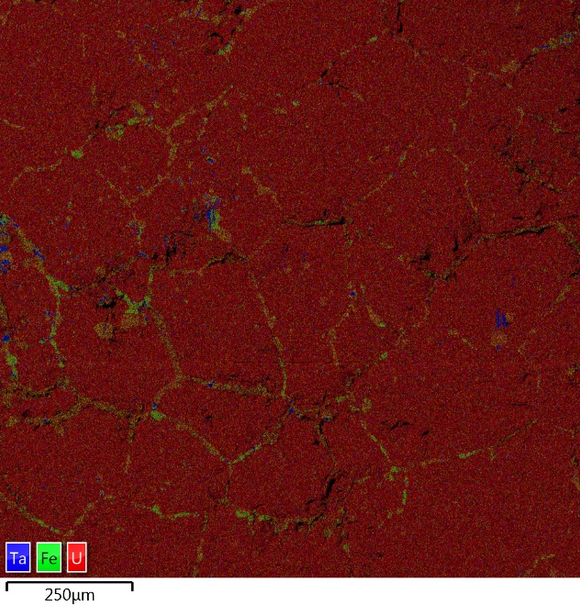
TaC-8(А)
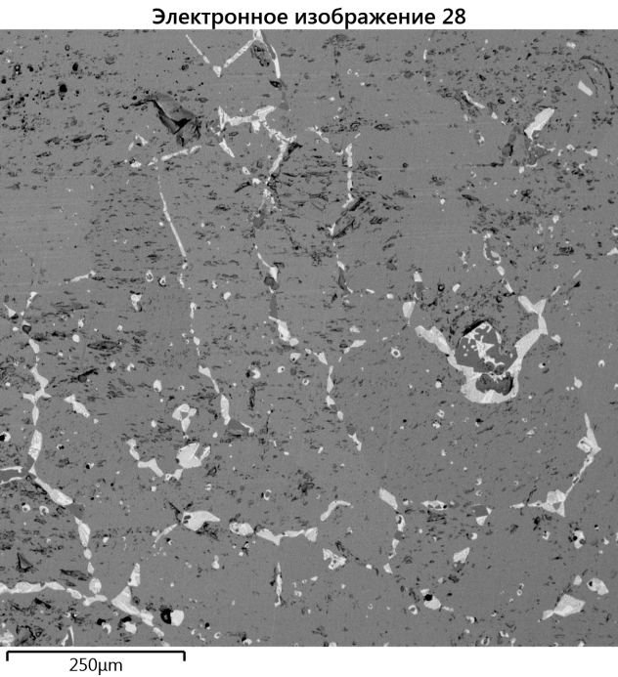 | 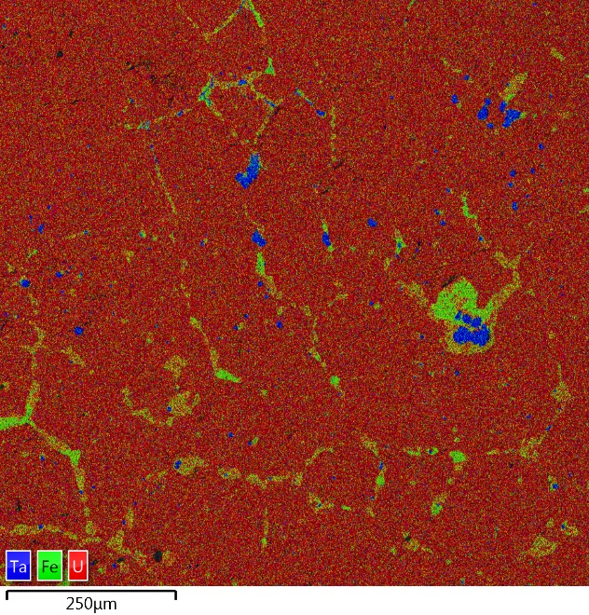
TaC-12(В)
Figure 5 – Corium microstructure, sheet 1

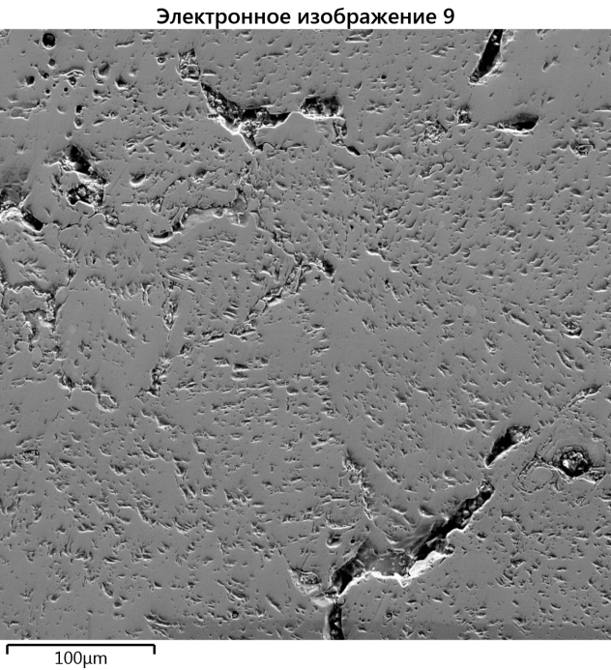 | 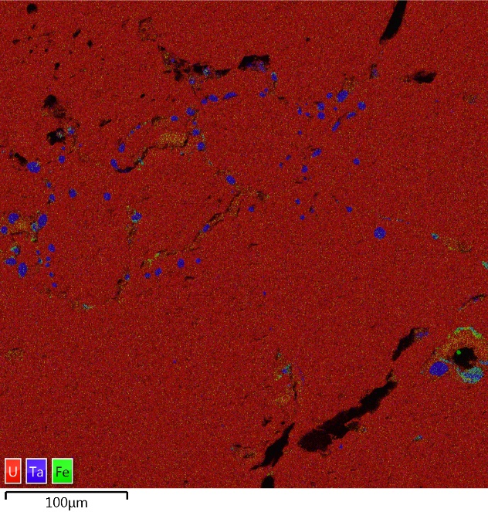
TaC-22(Е)
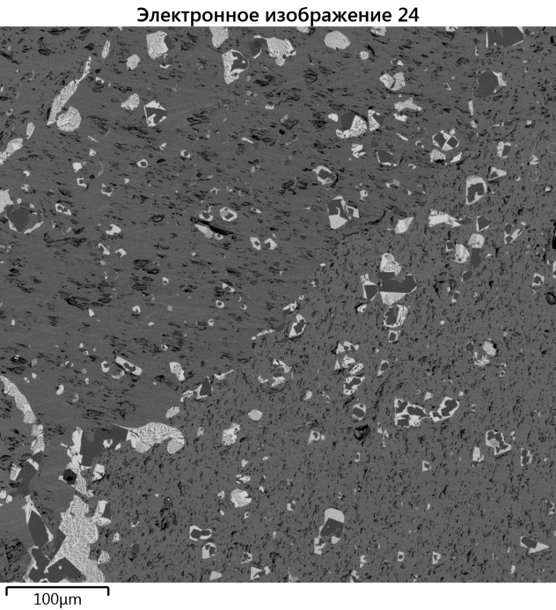 | 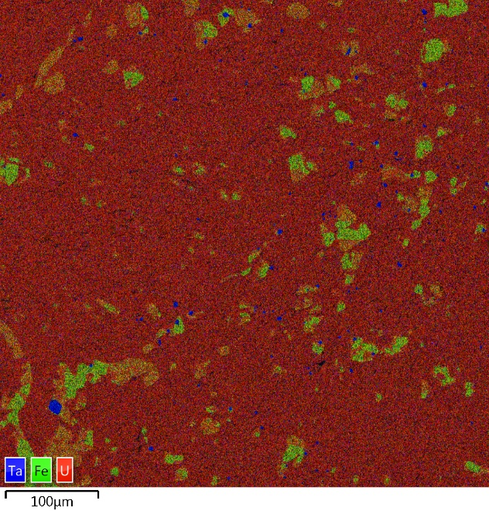
TaC-8(В)
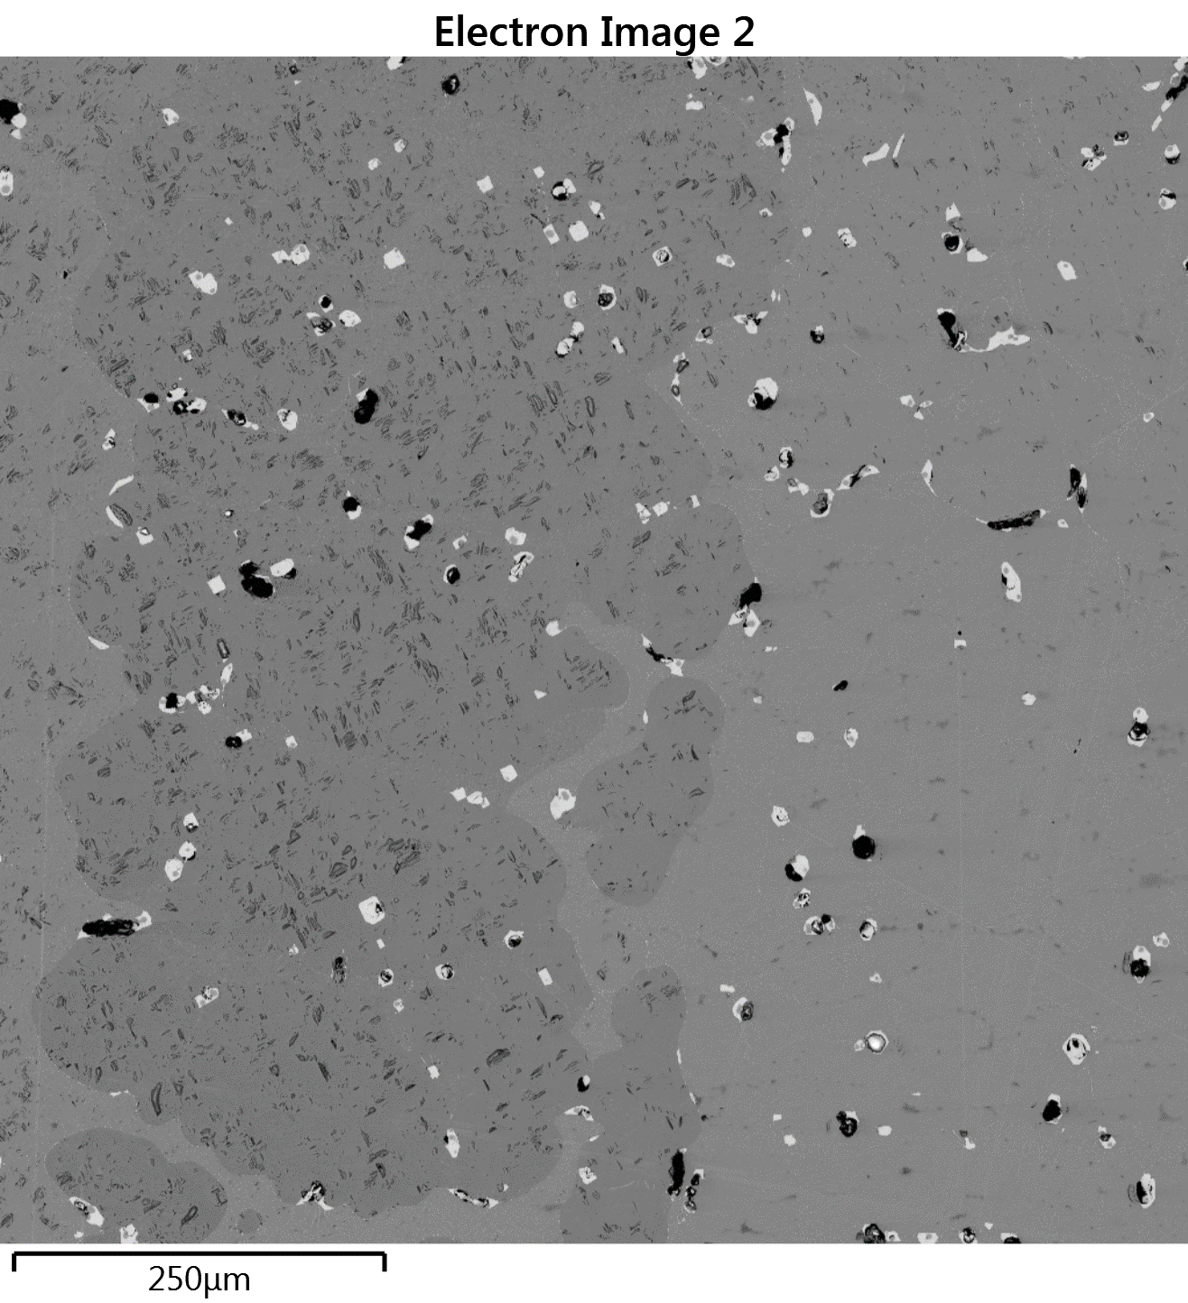 | 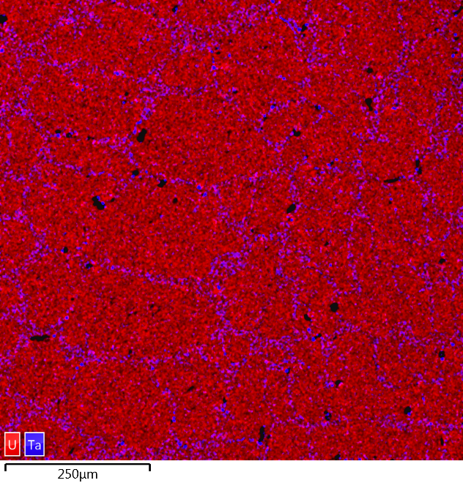
TaC-20(А)
Figure 5, sheet 2
According to the results of SEM/EDS analysis of surface depending on the nature of distribution and phase composition, samples of corium prototype were identified into two groups:
1) group – TaC-20(А), TaC-22(Е),
2) group – TaC-5(А), TaC-8(А), TaC-8(В), TaC-12(В).
The microstructure of the corium from the TaS-20(A) experiment is a heterogeneous system consisting of metallic and non-metallic phases and their mixtures (Figure 6, Table 2). The study of the microstructure allows distinguishing the following components:
- UO₂ grain. Many UO₂ grains form a dendritic structure. The shape of the grains is round and elongated,
- mechanical UO₂ mixture with different sizes of Ta particles (micron and submicron). This mixture forms a network around the UO₂ grains,
- mechanical UO₂ mixture with micron Ta particles,
- metal U,
- metal Ta.

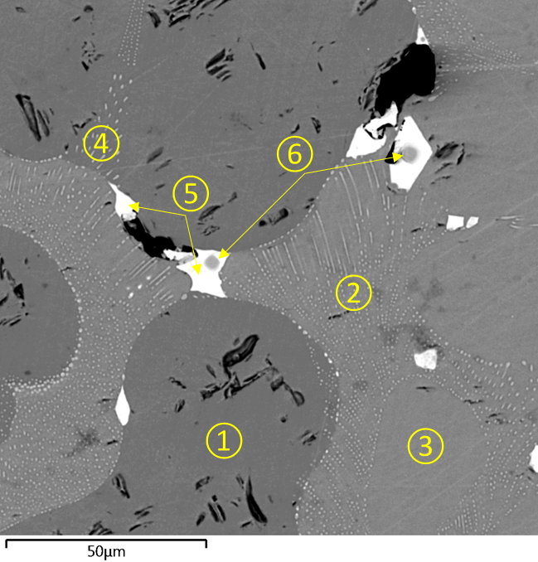
Figure 6 – Microstructure of corium from ТаС-20(А) experiment

Table 2 – Results of a local elemental analysis of the surface of test sample in gauge atmosphere (ga) %
Analysis area | Chemical composition
Analysis area | O | Ta | U
1 | 73.04 | - | 26.96
2 | 70.18 | 2.63 | 27.18
3 | 73.19 | 1.55 | 25.26
4 | 69.56 | 4.06 | 26.38
5 | 15.92 | - | 84.08
6 | 1.68 | 98.32 | -

The main difference in the microstructure of the second group corium prototype samples is presence of phases with a high content of steel components (Figure 7, Table 3). In addition, in these samples, white inclusions observed at low zooming are eutectic of metallic uranium U with micron and submicron particles of the U_{x}Fe_{y}Ni_{z} mixture. By the nature of main phase distribution, the microstructure of the prototype corium samples can be divided into the following components:
- mechanical UO₂ mixture with presence of particles with different sizes (micron and submicron) UС₂ and steel components (Fe, Cr),
- intermetallic compounds U_{x}Fe_{y}Cr_{z},
- intermetallic compounds Ta_{x}Fe_{y}Cr_{z},
- intermetallic compounds U_{x}Fe_{y}Ni_{z},
- metal U, is the main matrix of the mixture,
- micron and submicron particles of U_{x}Fe_{y}Ni_{z} mixture,
- metal Ta.

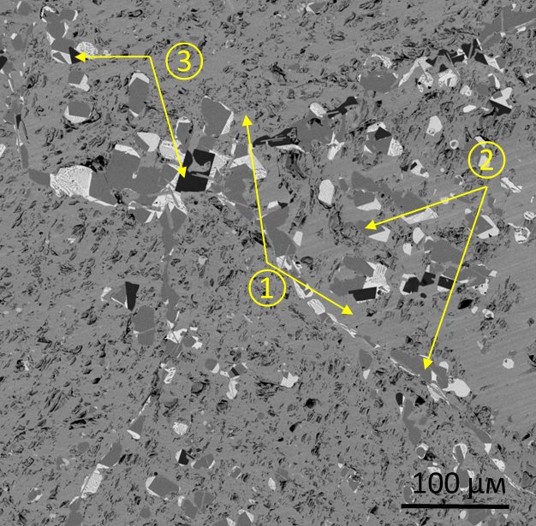 | 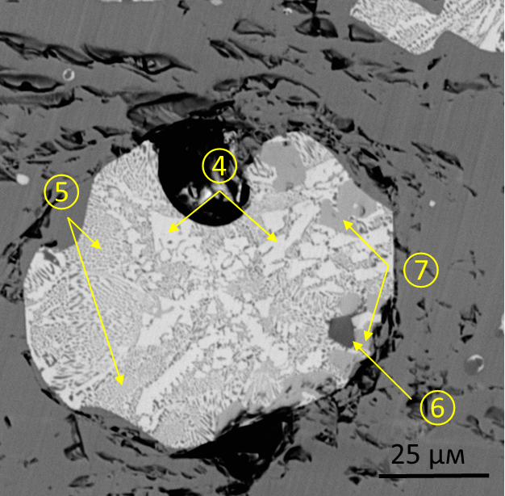
ТаС-8(В) | ТаС-12(В)
Figure 7 – Microstructure of corium prototype samples of the Group 2

Table 3 – Results of a local elemental analysis of the surface of test sample in gauge atmosphere (ga). %
Analysis area | Chemical composition
Analysis area | O | U | Cr | Fe | Ni | Ta
1 | 73.10 | 26.90 | - | - | - | -
2 | - | 38.33 | 12.86 | 48.81 | - | -
3 | - | - | 25.96 | 40.42 | - | 33.62
4 | 5.14 | 85.22 | - | 9.64 | - | -
5 | 6.37 | 73.59 | - | 15.82 | 4.98 | -
6 | 0.89 | - | - | - | - | 99.11
7 | - | 70.01 | - | 20.71 | 9.27 | -

The sample from the TaC-22 (E) experiment should be emphasized separately, where, unlike other TaC experiments, any visual presence of uranium metal was not detected. The microstructure of the corium prototype sample itself is characterized by the presence of three main phases (Figure 8, Table 4):
- round-shaped uranium dioxide is the main matrix of the sample structure, sizes vary in a wide range of values from 20 μm to 200 μm, however, the size of individual large grains reaches 500 μm.
- inclusions of a round-shaped metallic tantalum, located mainly at the UO₂ grain boundaries. Detailed analysis noted a trend towards a bimodal size distribution of metallic tantalum, mainly in two groups from 10 μm to 20 μm and from 2 μm to 10 μm.
- fragmented particles with high content of steel components concentrated mainly around large particles of metal tantalum (10–20 μm).

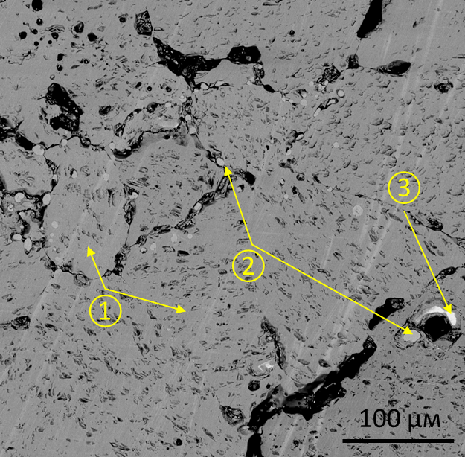 | 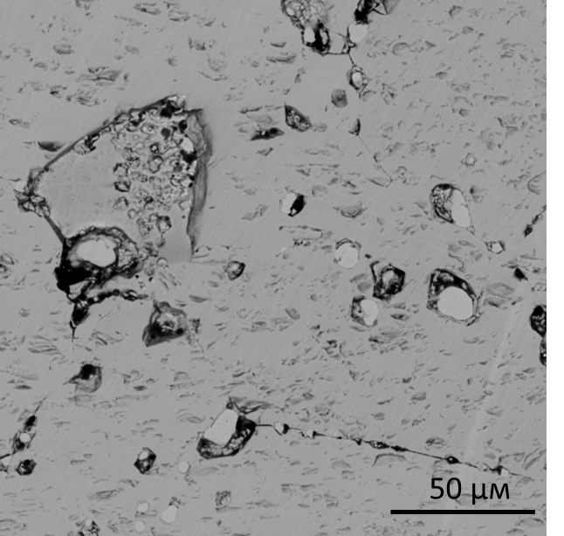
Figure 8 – Corium microstructure from ТаС-22 (E) experiment

Table 4 – Results of local element analysis of the test sample surface in gauge atmosphere (ga) %
Analysis area | Chemical composition
Analysis area | O | Ta | U | Fe
1 | 73.07 | - | 26.93 | -
2 | 1.87 | 98.13 | - | -
3 | - | 62.79 | - | 37.21

The results of a quantitative analysis of the volume fraction and pore sizes and metallic U for all samples after a series of TaC experiments are given in Table 5. However, it should be taken into account that results of quantitative analysis are estimates, since for the samples of Group 2, sizes and fractions of non-metallic U were calculated, but a mechanical mixture – based on
metallic U. A similar assessment was carried out for the TaC-20(A) sample, where metallic Ta formed in the form of islands in the body of a grain of metallic U.

Table 5 – Results of quantitative assessment of pores and metallic U
Name | Pores |  | Metal U
Name | Volume fraction, % | Average size, μm | Volume fraction, % | Average size, μm
TaC-20(A) | 2.7 | 10–20 | 1.9 | 10–15
TaC-22(Е) | 2.79 | 10–20 | - | -
TaC-5(А) | 1.49 | 10–20 | 1.05 | 10–20
TaC-8(А) | 1.73 | 10–20 | 1.21 | 10–20
TaC-8(В) | 1.84 | 10–20 | 1.32 | 10–20
TaC-12(В) | 1.47 | 10–20 | 1.04 | 10–20

1.3 X-ray structural studies of solidified melt samples of core materials
For X-ray diffraction studies, fragments of the prototypes of corium were ground into powder in a corundum mortar until the complete passage of the ground material through a sieve with a mesh size of 50 μm. The resulting powders were pressed into standard cuvettes for powder samples.
The diffraction patterns of the samples were taken using an Empyrean diffractometer manufactured by Panalytical (Figure 9). The PIXcel1D detector mode is a scanning line detector. Radiation: Cu Kα; voltage and current: 45 kV, 40 mA. A fixed divergence slit with an angular divergence of 1°, an anti-scattering slit of 2°, an incident beam mask with marking 20 providing an incident beam width of 19.9 mm was used. Air temperature during shooting is 22 °C. The exposure time (time per pitch) during shooting was 91.8 s, the scanning pitch size for diffractograms was 0.026º2θ, the investigated angular range was 5-153º2θ.
To identify and mitigate the effect of coarse crystallinity, the diffraction patterns of the materials of all samples were recorded three times with repressing of the powder material in the cuvette. The initial data from three diffraction patterns of each sample were averaged in the “HighScore” software, followed by processing and phase analysis of the averaged diffraction patterns.
Diffraction patterns were processed using the “HighScore” processing and search program. The processing procedures for the initial diffraction patterns are as follows:
1) separatopn and remoal of lines corresponding to Кα₂ irradiation,
2) background determination,
3) serach for peaks,
4) itting the calculated profile over the entire range of angles of the diffraction patterns with a pitch of ~ 30°2θ, without limiting the range of intensities (according to the maximum intensity of selected range),
5) analysis and comparison of diffractogram peaks with reference cards of available databases.
Fitting the profile leads to the formation of refined numerical values of the peak parameters necessary for determining the phase composition and analyzing the structural state (so-called calculated parameters). When fitting profiles of the TaC diffraction patterns, an asymmetric function was used (separation of the width and shape of the peak).
To identify phase composition the Crystallography Open Database [10] was used and
PDF-2 [11] database.
At the initial stage of analysis and comparison of the peaks to the reference cards, cards with a limited chemical composition was selected. The limitation of the chemical composition was introduced on the basis of information on charge composition of burden.
Procedures (2–5) are performed using the “IdeAll” automated procedure (“batch operation”) of the “HighScore” software. This ensures the same procedures for seraching for peaks and matching them with reference cards.

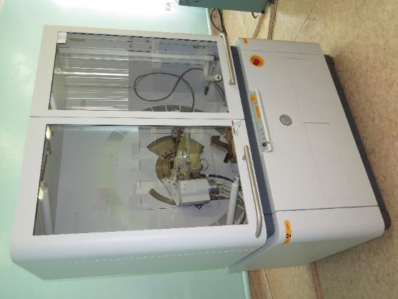
Figure 9 – Empyrean X-ray Diffractometer

Diffraction patterns of TaC samples were considered together. Figure 10 provides overlay of diffraction patterns. The diffraction patterns differ from each other in the intensity levels of diffraction peaks. In the diffractometry of polycrystals, the peak intensities of a certain phase depend on a number of factors, among which the main ones are structure of the crystal lattice and the amount of phase in the sample. The structure of the crystal lattice determines relative intensity ratio of lines of one phase, amount of the phase determines overall intensity level of the phase peaks in diffraction pattern. In general, the higher intensity level of the peaks of a particular phase, the more that phase presents in the sample. However, influence of factors that distort both peak intensity ratio and overall intensity level is possible. These factors include large crystallites in the imaging area and a pronounced texture in their arrangement. Since powder samples with relatively large particles were studied, appearance of texture due to large crystallites cannot be excluded.

Position [°2Theta] (Copper (Cu))
10
20
30
40
50
60
70
80
90
100
110
120
130
140
150
Counts
0
50000
100000
0
50000
100000
0
50000
100000
0
50000
100000
0
50000
100000
0
50000
100000
TaC-5_p
TaC-8
TaC-12
TaC-18
TaC-20
TaC-22
Figure 10 – Overlay of diffraction patterns of TaC samples (Cu, kα₁ radiation)
The main phase in the microstructure of all samples is a phase identified as uranium dioxide with general chemical formula UО with face-centered cubic (FCC) lattice of the Fm-3m space group. The extract from the diffractometric data card that most closely matches the peaks of the diffraction patterns is shown in Table 3. The peaks of this phase differ from the peaks of uranium dioxide of blanket pellets used as loads in the experiments.
Uranium dioxide phase, which is a part of phase composition of samples, differs by a slight shift in the value of the lattice parameter calculated from the positions of gravity centers of peaks, a noticeable (from 20 % to 50 %) increase in integral width of peaks, and presence of general patterns in their changes (in any case, for the first 4–5 peaks) peak profile shapes. Changing profiles is detected when profile is adjusted by functions in the “HighScore” software. They are expressed in deviations of the main peaks, which can be regarded as diffuse low-intensity reflections from certain phases that are homogeneous prototypes of the main phase with modified lattice parameters or having tetragonal or other lattice distortions. For example, such “prototypes” can stand out along the grain boundaries and carry contaminants and other defects in the crystal lattice, and have typical microscopic dimensions. The broadening of the peaks can be explained by vacancies and interstices, for example, oxygen, carbon, or tantalum in the metal sublattice or its interstices. To verify these assumptions, much more extensive studies are required, including those involving other methods, for example, transmission electron microscopy. At the same time, how significantly, these features of the crystal structure influence the main investigated characteristic – strength among other factors was not determined.

Table 6 – Card for description of UО₂ phase
Parameter | Value
Card | 03-065-0285
Empirical formula | О₂U
Data base | NIST
Crystal system, syngony | cubic
Spatial group № | Fm-3m (225)
Unit cell parameters | a = b = с = 5.4710 Å  α = β = γ = 90 °
Calculated dencity, g/cm³ | 10.95
Unit cell volume, 10⁶ pm³ | 163.76
RIR, Corundum number | 23.72
Main reference | Calculated according to NIST using POWD-12 ++,
Structure discription | K.Clausen, W.Hayes, J.E.Macdonald, P.Schnabel, M.T.Hutchings & J.KKjems, High Temp. High Pressures, 15, 383-3, (1983)

Uniquely suitable cards for the identification of peaks of low intensity could not be selected. For the majority of candidate cards having a satisfactory match in the angular positions of the peaks, there was a significant mismatch in their relative intensities. Lines of relative intensity
< 100 % indicated on the diffractometric data cards fit well with the peak intensity ratios of the experimental diffractogram. At the same time, lines with 100 % relative intensity according to the card in diffraction patterns correspond to peaks with a much (2–5 times) higher relative intensity. For the estimated identification of the phase composition of minor phases, cards were selected that are most suitable for describing peaks of low intensity. Crystalline phases α-Fe, Ta, U, FeO_{1±x}, Та₄С₃ were identified as probable phases. Formally, this is far from saying that selected cards characterize the phase composition of samples, but it was not possible to find more successful cards.
These additional phases are inclusions in the grain body, precipitates or groups of precipitates along the grain boundaries of the main phase. Only metallic tantalum is confidently identified in the ТаС-20(А) sample from an ingot of melted uranium dioxide. In the remaining samples, we assume that the best candidates are phases of the wustite type FeO_{1±x}, (spatial group Fd-3m), cubic or orthorhombic α-modification of metallic uranium, metallic solutions with the general formula (Fe, Cr, Ni) based on ferrite. Cards of intermetallic compounds with a general formula (Fe, Ni, Cr)₂U type also have some correspondence with peaks of low intensity in diffraction patterns, however, they were not considered within the framework of this protocol.
Characteristics of available inclusions arising from the crystal structure (density, hardness, metastability, tension, dispersion, unsoundness, preferred orientation and shape of crystallites) only partially determine the effect on the strength of the entire structure. Their location in the structure, connections with other structural components are also important. Such information can be obtained based on electron and optical microscopic studies, which can provide information on size, location, shape, orientation and specific compositions of additional phases as well as fine structure. Without this information, indication of their strengthening or softening, or neutral role in the strength characteristics is impossible.

2 Physical and mechanical research of core material melt
In order to determine strength characteristics we carried out mechanical tests at room temperature in the Universal Testing Machine Tinius Olsen 50ST.
Method for determining the ultimate strength in compression consists in establishing the value ratio of a load preceding the sample failure to the initial area of its cross (nominal) section.
To ensure uniform distribution of the compressive load on the surface of test sample, a set of two plates with a diameter of 50 mm (EG-C-5050 series, manufactured by Inteltest LLC) made of hardened 40X13 chromium steel was used (Figure 11а). The top plate has a spherical support and the bottom plate is rigidly fixed. Between the test sample and the compressing plate were spacer plates 20×20×6 mm in size made of hardened tool steel. To protect an operator from fragments when the sample is destroyed, the test area is equipped with a protective plexiglass screen (Figure 11b).
Tests have been carried out until the destruction of a test sample at a traverse speed of active gripper equal to 1 mm/min.

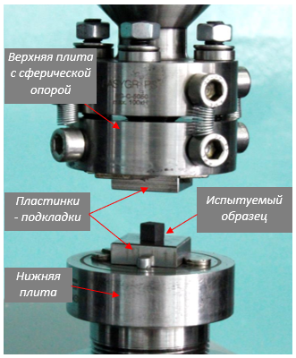 | 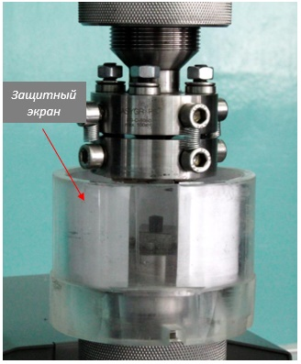
а) | b)
Figure 11 – Outer view of the test plate set

Compressive strength (σ_{сж}) is calculated according to the formula

$σ_{сж}=\frac{P}{S}$, | (1)

where P – fracture load, N;
S – nominal cross-sectional area, mm².
The cross-sectional area (S) in mm² is calculated according to the formula

$S=b·h$, | (2)

where b – sample width, m;
h – sample thickness, m.
Based on the results of a test series, error in the ultimate strength value (confidence interval) is determined according to the following formula

$$∆\overline{σ_{сж}}=t_{αn}∙\sqrt{\frac{\sum_{i=1}^{n}{{\left(\overline{σ_{сж}}-σ_{сжi}\right)}^{2}}}{n\left(n-1\right)},}$$ | (3)

where n – number of measurements;
$t_{αn}$– Student’s coefficient (α=0.95).
Due to the fact that deformation of the test sample was recorded by the relative displacement of active traverse of the testing machine, strain of the strain gauge and other units subjected to loading additionally contributes to the deformation of the sample.
When testing corium samples, the stress-strain compression curves were recorded, which are shown in Figure12.
The values of the ultimate strength in compression and deformation at the maximum load of all tested samples of the TaC series are given in the Table 7.

Table 7 – Results of compression tests of ТаС corium material
Sample | Maximum load, N | Relative deformation at σ_{сж}, % | Strength limit (σ_{сж}), MPa
ТаС-12(А) | 727 | 1.7 | 40
ТаС-12(В) | 2371 | 2.6 | 95
ТаС-22(Е) | 1548 | 3.4 | 62
ТаС-8(А) | 1650 | 4.0 | 99
ТаС-8(В) | 1951 | 3.0 | 91
ТаС-8(В.1) | 2017 | 4.3 | 112
ТаС-5(А) | 1923 | 2.8 | 114
ТаС-20(А) | 2898 | 3.7 | 154
As can be seen from the diagram (Figure 12, Table 8), all TaC samples are destroyed stepwise, this is explained by the fact that the structure of the material is extremely heterogeneous and has large pores and cracks. Basically, the samples at low loads broke off into large fragments and fractured in a stepwise manner, and as a result, have a low ultimate breaking load.

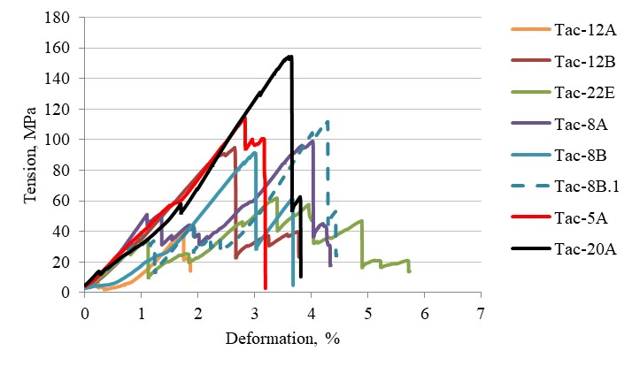
Figure 12 – Diagram of compression tests for ТаС corium samples

Table 8 – Preparation and compression tests of ТаС corium material
Sample # | Before test | After test
Тас-12А | 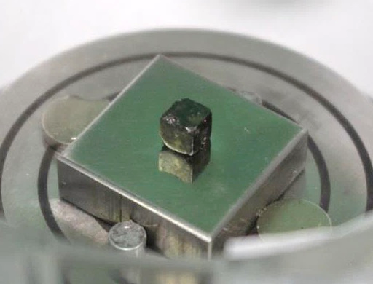 | 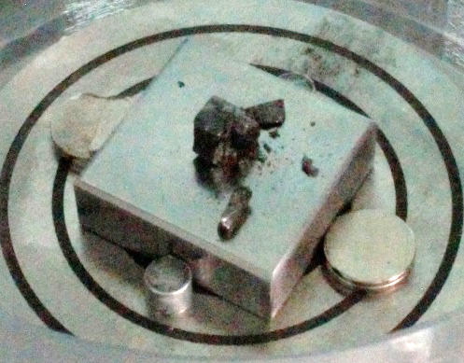
Тас-12В | 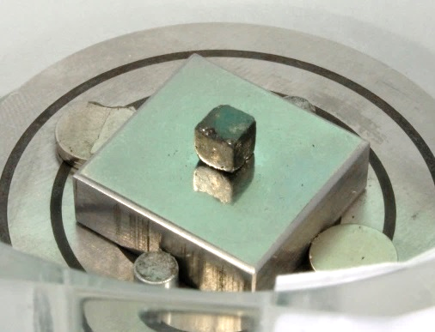 | 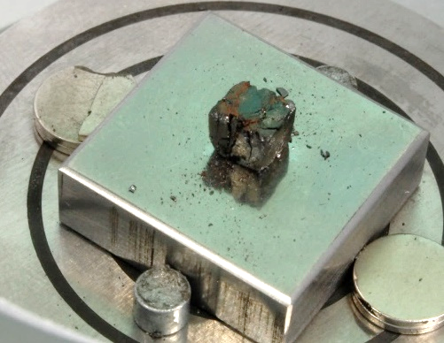
Continuation of Table 8
1 | 2 | 3
Тас-22Е | 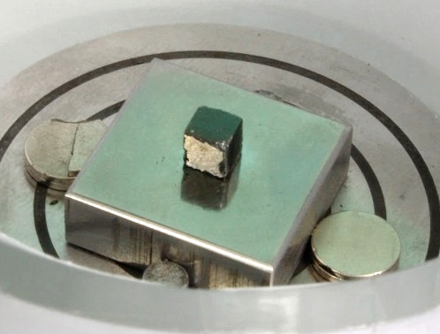 | 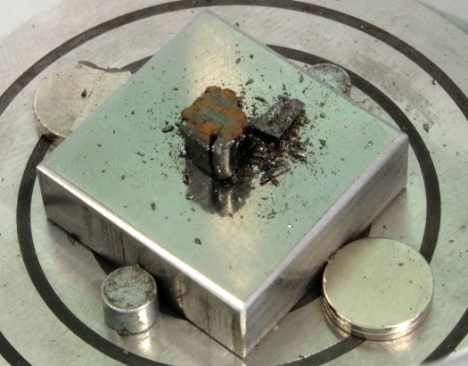
Тас-8А | 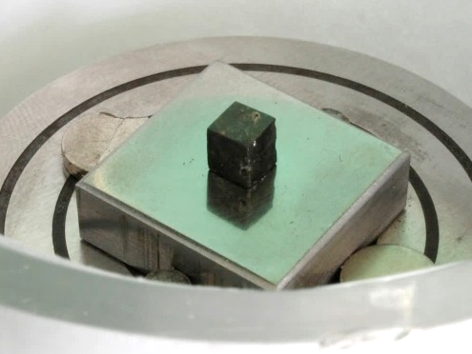 | 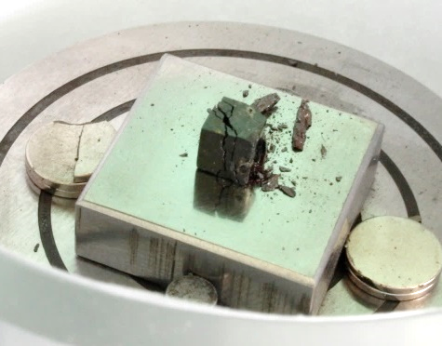
Тас-8В | 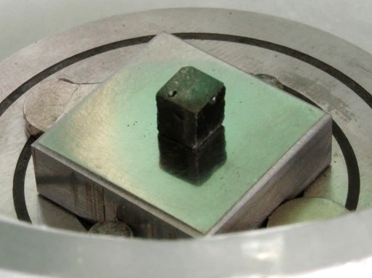 | 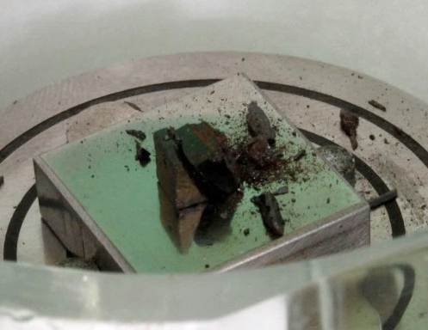
Тас-8В.1 | 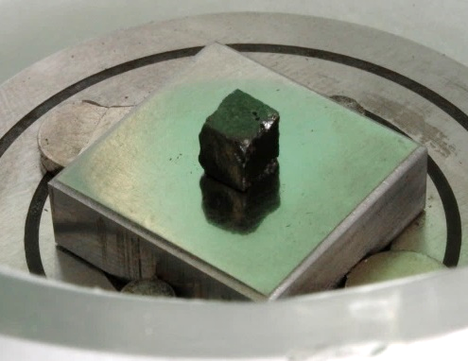 | 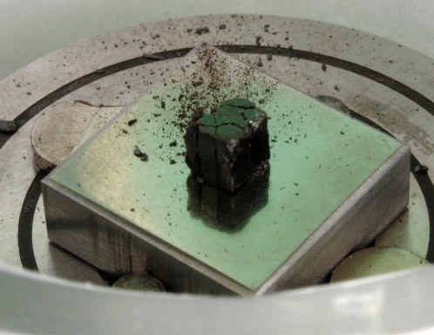
Continuation of Table 8
1 | 2 | 3
Тас-5А | 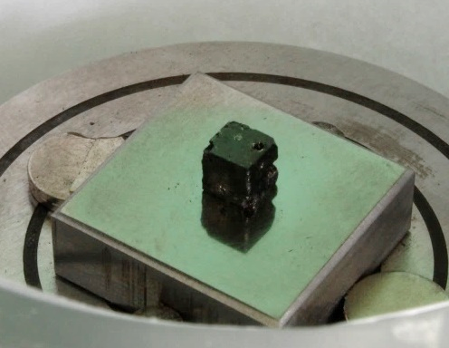 | 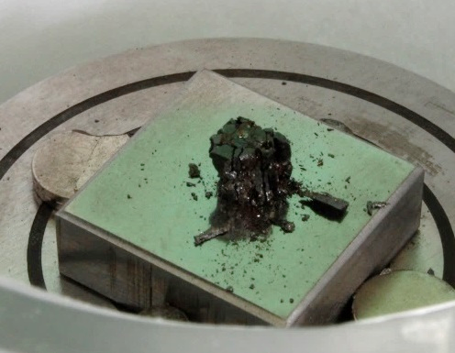
Тас-20А | 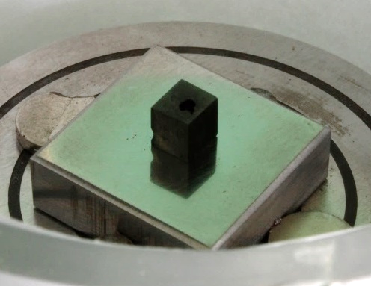 | 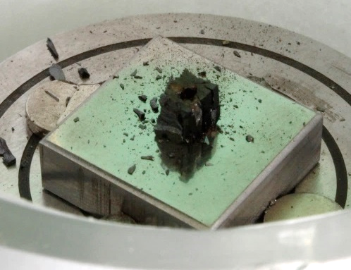

3 Recommendations on the structure condition, physical and mechanical properties of structural and fuel melt material of nuclear power reactor core
According to the results of works the following recommendations can be delivered:
- the main matrix of the microstructure of the solidified melt samples are UО₂ spherical grains,
- pore is formed mainly at boundaries and triple joints of UO₂ grains,
- metallic U is distributed in abundance at the grain boundaries of UO₂, forming a network structure over the entire surface of the samples,
- all samples have a high concentration of micron and submicron Ta inclusions,
- phase composition of the samples is generally similar. The phase composition is based on the cubic modification of uranium dioxide with an FCC lattice of the space group Fm3m. The diffraction peaks of this phase have a slight broadening and distortion of profile at the base, possibly corresponding to variations in the chemical composition of the phase. The lattice parameter of uranium dioxide, determined from the most appropriate database card, is
0.54710 nm. It was not possible to reliably identify phases with a low content corresponding to low-intensity peaks in the diffraction patterns of the samples. Crystalline phases α-Fe, Ta, U, FeO_{1±x}, Та₄С₃ were identified as probable phases with a low content. Only the phase of metallic tantalum in the TaC-20(А) sample of the experiment was satisfactorily identified, the charge of which did not include steel additives. Cards of intermetallic compounds with a general formula of the form (Fe, Ni, Cr)₂U also have some correspondence with peaks of low intensity in diffraction patterns, however, they were not considered within the framework of this protocol,
- the nature of samples destruction of the prototype corium differs from the f TaC experiments. Due to the presence of pores and cracks in the structure, TaC samples fail stepwise and have a low ultimate fracture load.

CONCLUSION

In 2018, under the Grant Project AP05133086 “Properties and characteristics of the melt of materials in a nuclear reactor core obtained at the IGR research reactor”, in accordance with the approved schedule, research works have successfully been carried out and completed, which are preparatory for the forthcoming reactor tests to obtain a melt of the nuclear power reactor core.
Available information on methodological, instrumental and research issues of studying material melts in the cores of power reactors was collected, neutronic calculations were performed to substantiate the possibility of conducting an in-pile experiment at the IGR nuclear reactor to obtain a melt of structural and fuel materials in the nuclear reactor core, the elemental composition of the cores of nuclear power reactors, reactor ampoule experimental device was designed, which provides the possibility of in-pile tests to obtain a melt of the nuclear power reactor.
A literary review with a search depth of up to 30 years has been prepared and completed. The review analyzes the existing data on the structural and morphological state, physical and mechanical properties of melts of structural and fuel materials of the cores of nuclear reactors, obtained in the conditions of simulating severe reactor accidents in out-of-pile conditions.
During the analysis, the main technical specifications of both thermal and fast reactors have been considered. The main advantages and disadvantages of various nuclear power facilities have been considered. The geometrical parameters of the core, type of coolant (water, sodium, lead-bismuth eutectic, and helium), type of moderator (for thermal neutron reactors), uranium fuel enrichment in ²³⁵U have been analyzed.
A computational model of the IGR reactor was created in the MCNP software. The design model of the IGR reactor describes the IGR reactor design as accurately as possible. All dimensions of the elements correspond to the technical documentation for the reactor facility, their material composition corresponds to GOST or the corresponding technical documents.
The computational model has been verified according to the available experimental data on critical state, supercritical state, on the characteristic of the effectiveness of the regulatory element efficiency.
In 2019, a solidified melt of materials of the nuclear power reactor core was experimentally obtained.
In 2020, samples were made of solidified melt of structural and fuel materials of the nuclear power reactor core, and then studies of the structural and phase state and mechanical properties of the samples were started, where main attention was paid to assessing the features of the macro- and microstructure of materials in samples and comparison of the parameters of their fracturing and porosity.
Based on the results, recommendations have been issued on the state of the structure, physical and mechanical properties of the melt of structural and fuel materials of the nuclear power reactor core.
The main results during the Project implementation were reported and discussed at: the VIII International Conference “Semipalatinsk Test Site: Heritage and Prospects for the Development of Scientific and Technical Potential”, RSE NNC RK, Kurchatov, Republic of Kazakhstan, September 11–13, 2018; the 5th International Conference “Fundamental Bases of Mechanical and Chemical Technologies”, Novosibirsk State University, Novosibirsk, Russia, 2018; the XXV International Scientific and Technical Conference of Students and Postgraduates “Radioelectronics, Electronics and Energy”, NRU MEU, Moscow, Russia, March 14–15, 2019; the XIV International Scientific and Practical Conference “The Future of Nuclear Energy – AtomFuture”, IATE NRNU MEPhI, Obninsk, Russia, November 26–30, 2018.
The results of this Project were the background for starting the doctoral thesis entitled “Physical and Mechanical Properties of the fuel and structural material melt of a Nuclear Power Reactor Core” of Tskhe Valentin Konstantinovich, a doctoral student of the D. Serikbayev EKSTU.

LIST OF REFERENCES

1 Suzuki T., Kamiyama K., Kubo S., Tobita Y., Nakai R., Koyama K. A scenario of core disruptive accidnet for Japan Sodium Fast reactor to achieve in-vessel retention // Journal of Nuclear Science and Technology.– 51 (2014).– P.493-513.
2 Jacquemain D. [et al.] Nuclear Power Reactor Core Melt Accidents // IRSN.– 2015.
3 Magallon D., Hohmann H. and Schins H. Pouring of 100-kg-scale molten UO2 into
sodium // Nuclear Technology.–1992.– Vol.98.– P.79-90.
4 Chu T.Y. Fragmentation of molten-core material by sodium // International topical meeting on LMFBR safety, Lyon, France.– 18 Jul 1982.– SAND-82-0300C; CONF-820704-10.
5 Schins H., Gunnerson F.S. Boiling and fragmentation behaviour during fuel-sodium interactions // Nucl. Eng. Des.– 1986.– P.91, 221-235.
6 Berthoud G. Vapor Explosions // Annu. Rev. fluid Mech.–2000.– 32: P.573-611.
7 Skakov М.K., Mukhamedov N.Ye., Vurim A.D., Deryavko I.I. Temperature dependence of thermophysical properties of full-scale corium of fast energy reactor // Science and Technology of Nuclear Installations.– 2017.– Vol. 2017, article 8294653. – 7 p.
8 Skakov М.K., Mukhamedov N.E., Deryavko I.I., Kukushkin I.М. Thermal properties and phase composition of full-scale corium of fast energy reactor // Key Engineering Materials.– 2017.– Vol. 736. – P. 58-62.
9 Skakov M., Mukhamedov N., Deryavko I., Wieleba W., Vurim A. Research of structural-phase state of a natural corium of a fast power reactors // Vacuum.– 2017.– Vol. 141.– Р. 216-221.
10 Gražulis S., Chateigner, D., Downs R. T., Yokochi A. F. Quirós M., Lutterotti L., Manakova E., Butkus J., Moeck P. & Le Bail A. Crystallography Open Database – an open-access collection of crystal structures // J. Appl. Cryst.– 2009.– P.42, 726-729.
11 PDF-2 ICDD Release 2004.

APPENDIX А

List of publications
2020
Articles:
Foreign:
1 Vityuk G., Vurim A., Skakov M., Pakhnits A. Methods and results of determining the impurity gas amount in ceramic fuel // Annals of nuclear energy.– 2021.– Vol. 150 Р. 1-6.
(IF = 1,378, H-59, SJR nuclear energy and engineering Q1, Scopus and WoS, 69 % CiteScore).
2 Mukhamedov N., Sapatayev Ye., Kozhakhmetov Ye., Tskhe V. Research of structural-phase state of corium // Nuclear Engineering and Design.– 2020. (in print).
3 Mukhamedov N., Sapatayev Ye., Kozhakhmetov Ye., Tskhe V. Research of the mechanical properties of corium // Vacuum.– 2020. (in print).
Patents:
1 Skakov M.K., Vurim A.D., Mukhamedov N.Ye., Batyrbekov E.G., Pakhnits A.V.,
Tskhe V.K. Patent of the Republic of Kazakhstan for invention.– No. 34494. Device for studying the process of lower base plate destruction of the control rod guide tube of the CPS under severe accident conditions of a nuclear power reactor. (Russian).
2019
Articles:
Domestic:
1 Skakov М.К., Mukhamedov N.Ye., Pakhnits А.V., Deryavko I.I. Properties of the core melt materials of a nuclear reactor obtained at the IGR research reactor // Bulletin of NNC RK.– Issue 1.– P. 129-132. (Russian). (IF = 0.167, KazBC, 2017).
2 Tskhe V.K., Mukhamedov N.Ye., Skakov M.K., Pakhnits A.V., Murzagaliyeva A.A. Thermal state of ampoule irradiation device during testing of a model fuel system at the IGR research reactor // Bulletin of KazNTU.– 2019 .– Edit.3 (133).– P. 445-451. (Russian). (IF = 0.045, KazBC, 2017).
Foreign:
3 Mukhamedova N.M., Skakov M.K., Wieleba W. Determination of phase composition and mechanical properties of surface of the material obtained on the basis of silicon and carbon by spark-plasma sintering method // AIMS Materials Science.– 2019.– Vol. 6(1) .– P. 1-9. doi: 10.3934/matersci.2019.1.1. (IF = 1,04, H-11, SJR Materials Science Q3, Scopus and WoS, 44 % by CiteScore).

Abstracts:
Foreign:
1 Tskhe V.K., Kozlovsky Ye.V., Mukhamedov N.Ye., Skakov M.K. Computational and experimental determination of the reactivity margin required for start of the IGR reactor // Abstracts of the XXV International Scientific and Technical Conference of Students and Postgraduates “Radio Electronics, Electronics and Power Engineering”.– М.2019.– P. 720. (Russian).
2 Mukhamediv N.Ye., Vurim А.D., Pakhnits A.V., Skakov M.K., Tskhe V.K. Ampoule irradiation device for studying processes with fuel melting // Abstracts of the XIV International Scientific and Practical Conference (Part 1) “The Future of Nuclear Energy – AtomFuture”.– Obninsk: IATE NRNU MEPhI, 2019.– P. 33-34. (Russian).

2018
Articles:
Foreign:
1 Skakov М.К. [et al.] Properties of a prototype corium of nuclear reactor // Science and Technology of Nuclear Installations.– Vol. 2018, Article ID 5208510, 7 pages. (IF = 1.082, H-19, SJR Nuclear energy and engineering Q2, Scopus and WoS, 50 % by CiteScore).
Domestic:
2 Skakov M.K. [et al.] Thermal state of ampoule irradiation device during the experiment at the IGR research reactor // Bulletin of the Semey Shakarim State University.– 2018.– Edit.3.– P. 109-115. (Russian). (IF = 0.02, KazBC, 2017).
Abstracts:
Foreign:
1 Skakov М.К., Mukhamedov N.Ye., Deryavko I.I. Method of manufacturing prototype of a corium by using stand of high-temperature induction heating // Abstracts of 5th International Conference «Fundamental Bases of Mechanochemical Technologies».– Novosibirsk: NSU, 2018.– P. 213.
Domestic:
2 Skakov M.K., Mukhamedov N.Ye., Pakhnits A.V., Deryavko I.I. Properties of the core material melt of a nuclear reactor obtained at the IGR reactor // Materials of the VIII International Conference “Semipalatinsk Test Site: Heritage and Prospects for the Development of Scientific and Technical Potential, Kurchatov, 11–13 September. 2018”.– Kurchatov, RSE NNC RK, 2018.– P. 151.
Patents:
1 Skakov M.K., Mukhamedov N.E., Deryavko I.I. [et al.] RK Patent for Invention.–
No. 33105, Published on 17.09.2018, Bul. No. 35. Method of manufacturing research samples of a prototype corium of a fast power reactor.

APPENDIX B

Work schedule
TECHNICAL SPECIFICATIONS AND WORK SCHEDULE
under contract No. _____ dated __________________2018
1. RSE on the right of economic management "National Nuclear Center of the Republic of Kazakhstan" of the Ministry of Energy of the Republic of Kazakhstan
1.1 Priority: Energy and Mechanical Engineering
1.2 By sub-priority: Alternative energy and technologies: renewable energy sources, nuclear and hydrogen energy, other energy sources
1.3 Project topic: AP05133086 “Properties and specifications of molten materials of a nuclear reactor core obtained at the IGR research reactor”
1.4 The total amount of the project: 23 947 120 (twenty-three million nine hundred forty-seven thousand one hundred twenty) tenge, including with a breakdown by years, for the performance of work in accordance with paragraph 3:
- for 2018 - in the amount of 8,000,000 (eight million) tenge;
- for 2019 - in the amount of 8,109,672 (eight million one hundred nine thousand six hundred seventy two) tenge;
- for 2020 - in the amount of 7 837 448 (seven million eight hundred thirty-seven thousand four hundred forty-eight) tenge.
2. Characteristics of scientific and technical products by qualification characteristics and economic indicators
2.1 Direction of work: Applied research in the field of nuclear energy.
2.2 Field of application: Modeling of severe reactor accidents with melting of materials in its core.
2.3 End result:
- for 2018: the existing data on the structure and properties of melts in out-of-pile conditions will be analyzed; a theoretical and computational substantiation of the possibility of carrying out in-pile experiment on the IGR research reactor for irradiating ampoule experimental device; an analysis of the component-element composition of the cores of nuclear power reactors will be carried out; the design of an ampoule experimental device will be developed. 1 article will be published in a peer-reviewed foreign scientific journal, indexed in the Web of Science or Scopus databases with a non-zero impact factor"
- for 2019: the program-methodological documentation of IGR reactor start-up with ampoule experimental device will be developed; a physical studies program will be developed; a test program will be developed; an irradiation start-up with an ampoule experimental device will be carried out at the IGR reactor; an application for an invention will be filed; 1 article will be published in a peer-reviewed foreign scientific journal with a non-zero impact factor.
- for 2020: macro-, microstructural studies of the melt of the core materials will be carried out; physical and mechanical studies of the melt of the core materials will be carried out; scientifically grounded recommendations will be issued on the state of the structure, physical and mechanical properties of the melt of structural and fuel materials of the nuclear reactor core, obtained in an experiment to simulate a severe reactor accident at the IGR reactor.
2.4 Patentability: An application for an invention will be submitted to the RSE "National Institute of Intellectual Property" of the Ministry of Justice of the Republic of Kazakhstan.
2.5 Scientific and technical level (novelty): The main structural-phase states, physical and mechanical properties, regularities in the fine structure of the melt of structural and fuel materials of a nuclear reactor core obtained at in-pile experiments at the IGR research reactor will be determined for the first time.
2.6 The use of scientific and technical products is carried out: by the Contractor.
2.7 Type of use of the result of scientific and (or) scientific and technical activities: The results will be widely used in a scientific world for modeling of the processes, which are essential part of hypothetical severe accident scenarios on the nuclear reactors, and results of such modeling will be used for creation of more reliable structures in a nuclear power industry.
3. Name of work, terms of their implementation and results
Task, stage number | Contract works and main stages of its completion | Completion period |  | Desired outcomes
Task, stage number | Contract works and main stages of its completion | start | completion | Desired outcomes
1 | Analysis of the results of studies of the properties and specifications of the melt of the materials of the nuclear reactor core obtained un-der out-of-pile conditions | January  2018 | March  2018 | The existing data on the structure and properties of melts in out-of-pile conditions will be analyzed.
2 | Theoretical calculation of the feasibility to carry out in-pile experiment on the IGR research reactor for irradiating ampoule experimental device | April  2018 | May  2018 | A theoretical and computational substantiation of the possibility of carrying out in-pile experiment on the IGR research reactor for irradiating ampoule experimental device
3 | Conduct an analysis of the com-ponent-element composition of the nuclear power reactor cores | May  2018 | June  2018 | An analysis of the component-element composition of the cores of nuclear power reactors will be carried out
4 | Development of the design of the experimental ampoule device | July  2018 | Nov. 1,  2018 | The design of an ampoule experimental device will be developed.  1 article will be published in a peer-reviewed foreign scientific journal, indexed in the Web of Science or Scopus databases with a non-zero impact factor "Science and technology of nuclear installations". 1 article will be published in a peer-reviewed Kazakhstani scientific journal with a non-zero impact factor
5 | To develop program-methodological documentation of IGR reactor start-up with ampoule experimental device | January  2019 | June  2019 | The program-methodological documentation of IGR reactor start-up with ampoule experimental device will be developed.
 | Develop a program of physical studies | January  2019 | April  2019 | A physical studies program will be developed
 | Develop a test program | April  2019 | June  2019 | A test program will be developed
6 | To perform irradiation in-pile start-up with ampoule experimental device at the IGR reactor | July  2019 | Nov. 1,  2019 | An irradiation start-up with an ampoule experimental device will be carried out at the IGR reactor. An application for an invention will be filed. 1 article will be published in a peer-reviewed foreign scientific journal with a non-zero impact factor
7 | Macro and micro-structure analysis of the melt of the core materials | January  2020 | June  2020 | Macro-, microstructural studies of the melt of the core materials will be carried out
8 | Physical and mechanical studies of the core melt materials | July  2020 | October  2020 | Physical and mechanical studies of the melt of the core materials will be carried out. Materials of the article will be submitted to the journal "Nuclear engineering and design" (Web of Science) and "Vacuum" (Web of Science)
9 | Issue scientifically based recommendations concerning the state of the structure, physical and mechanical proper-ties of the melt of the structural and fuel materials of the nuclear reactor core, which were obtained during experiments on modeling of severe accident on the IGR reactor | October  2020 | Nov. 1,  2020 | Scientifically grounded recommendations will be issued on the state of the structure, physical and mechanical properties of the melt of structural and fuel materials of the nuclear reactor core, obtained in an experiment to simulate a severe reactor accident at the IGR reactor. 1 article will be published in a peer-reviewed foreign scientific journal, indexed in the Web of Science or Scopus databases with a non-zero impact factor

From Customer:  Chairman of the State Institution “The Committee of Science of the Ministry of Education and Science of the Republic of Kazakhstan”  __________________ B.S. Abdrasilov  l.s. | From Contractor:  General Director of the RSE on the right of economic management "National Nuclear Center of the Republic of Kazakhstan" of the Ministry of Energy of the Republic of Kazakhstan  ________________ E.G. Batyrbekov  l.s.
Familiarized with:
Scientific supervisor of the project

___________________ Skakov M.K.

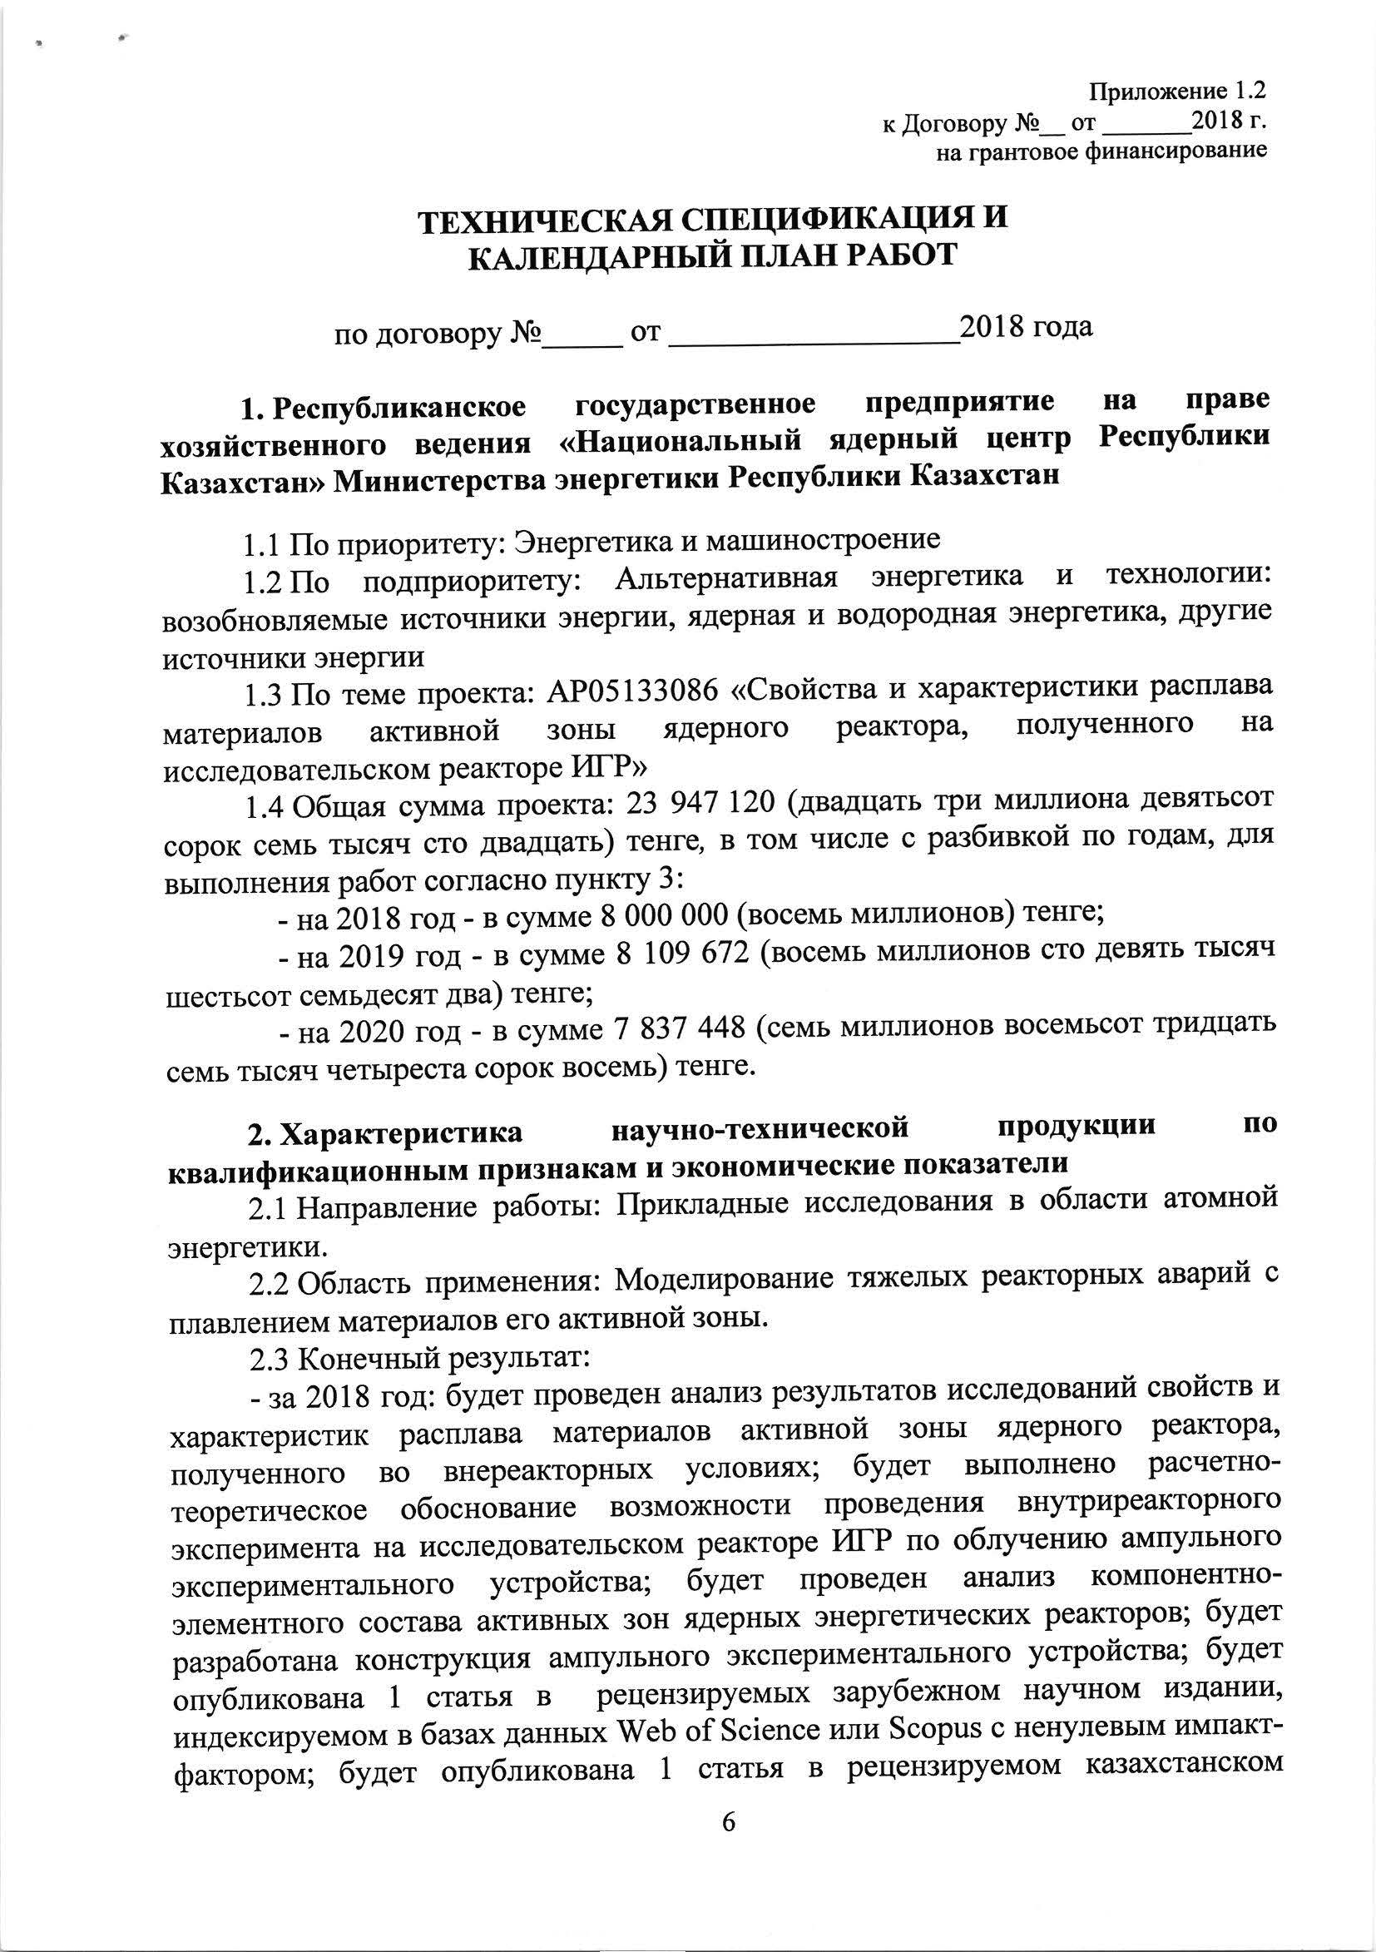
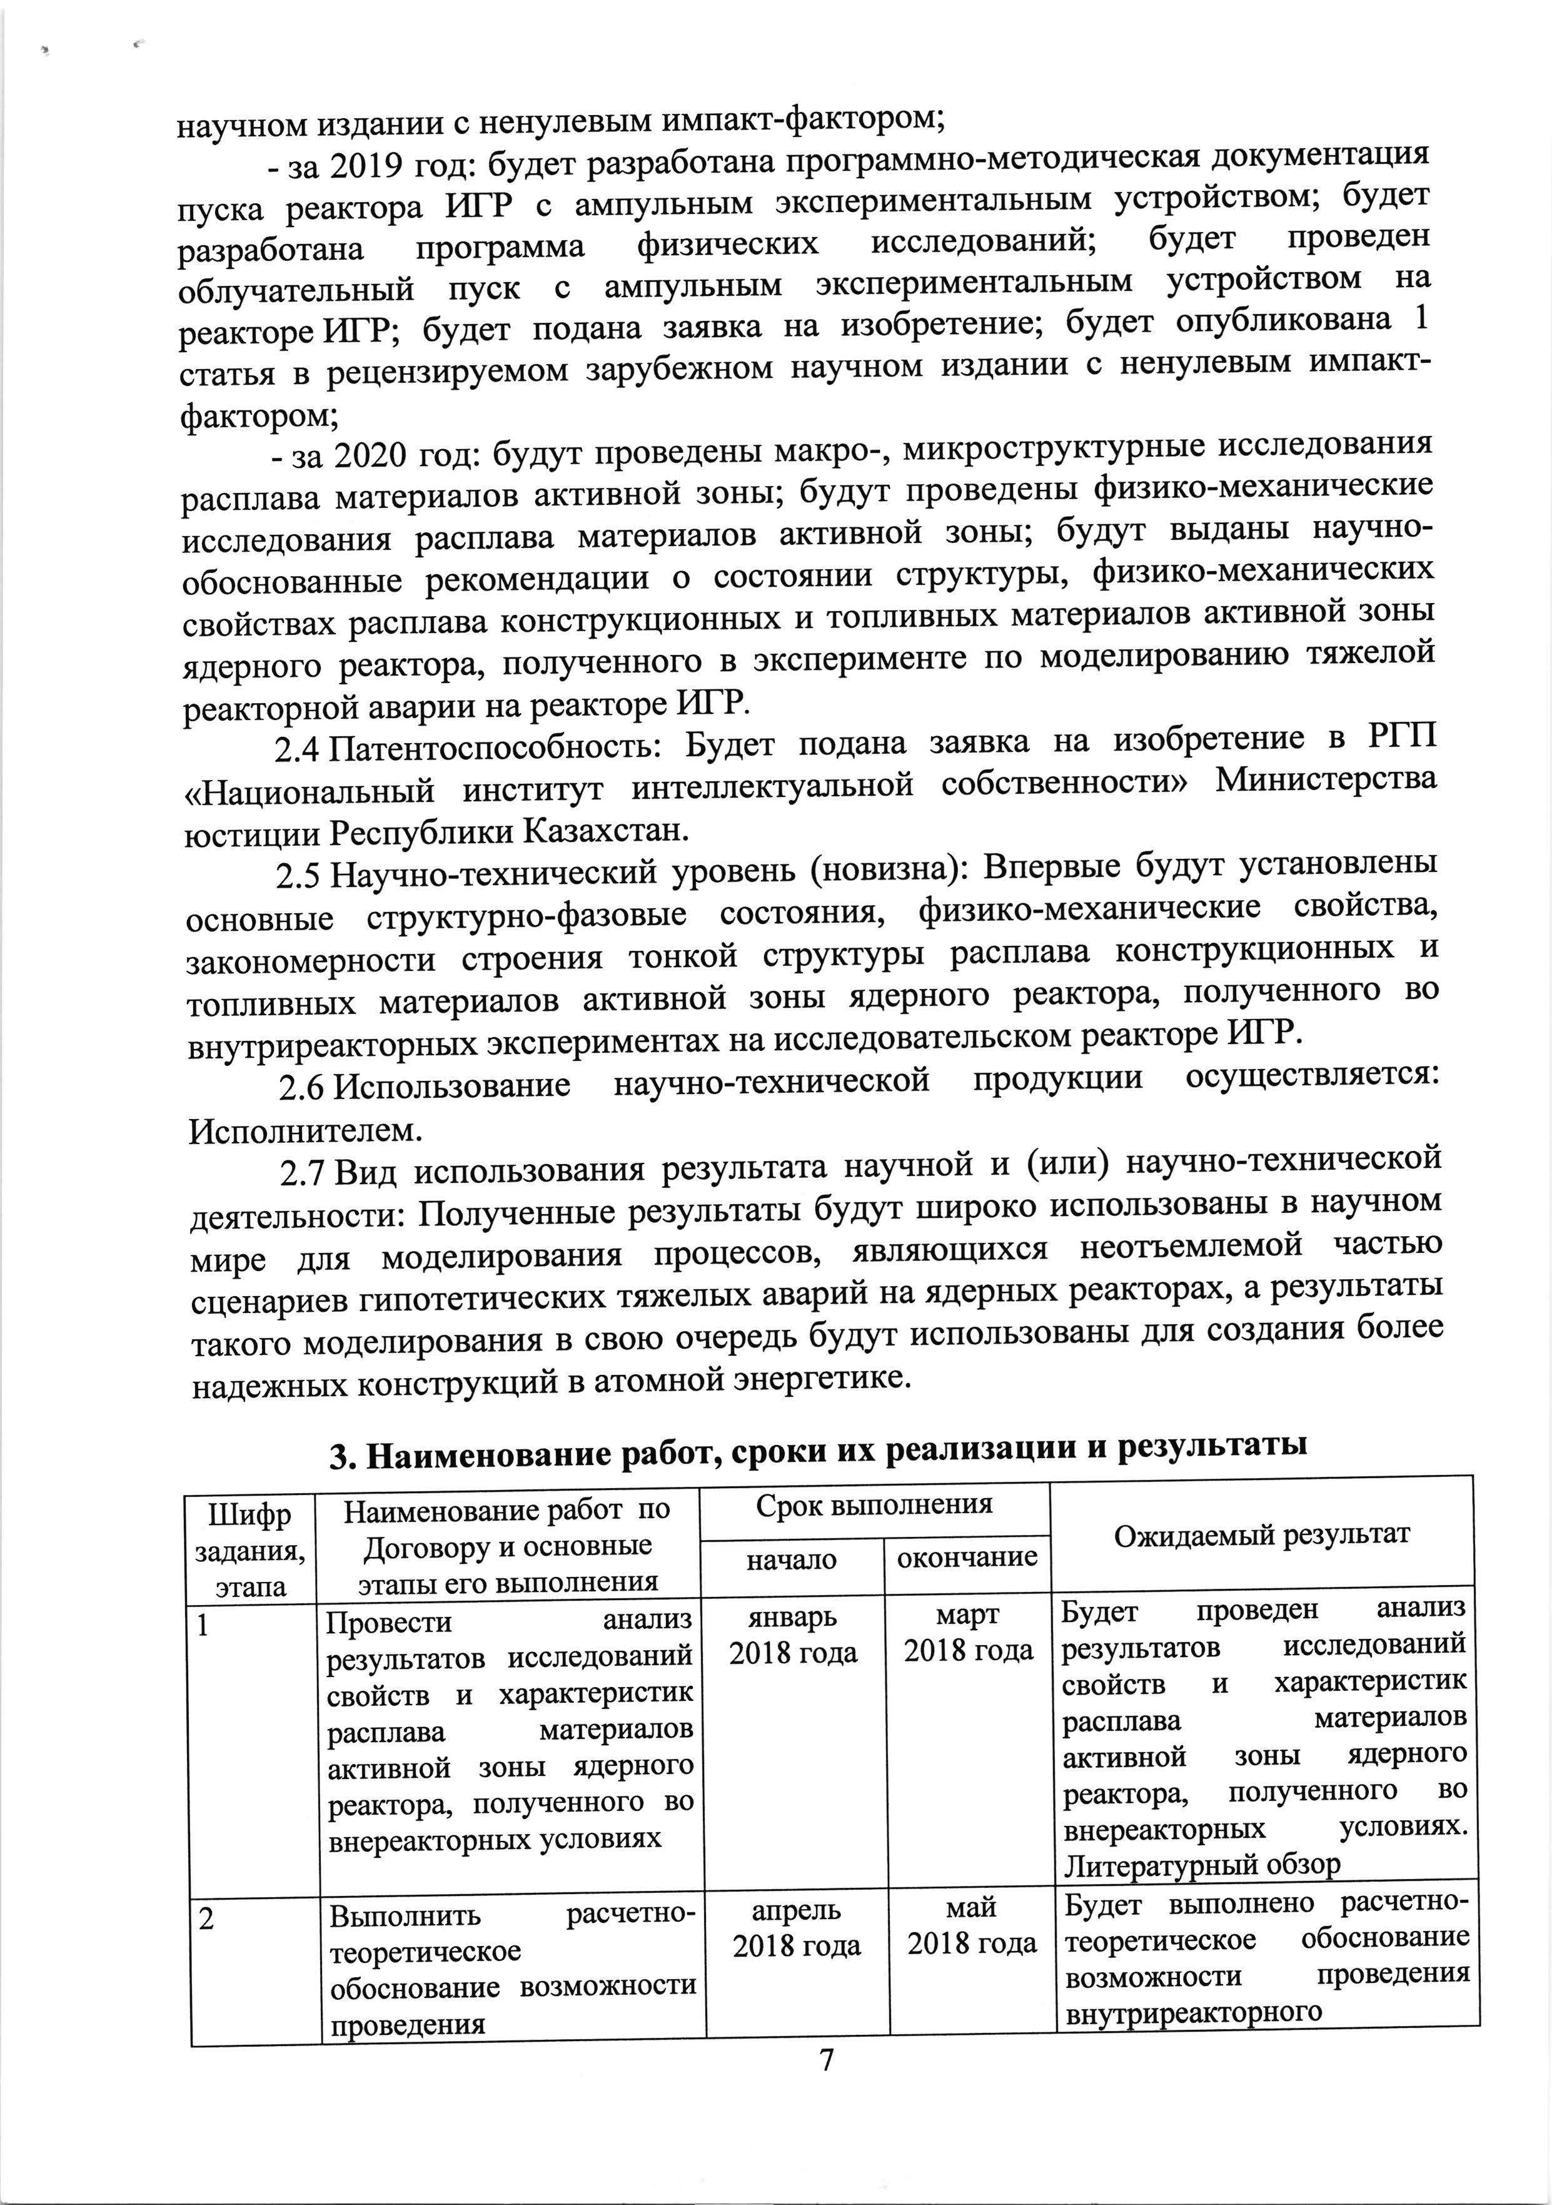
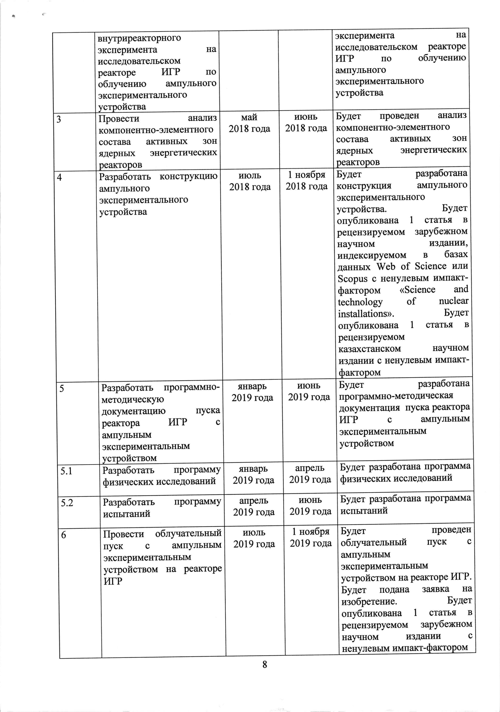
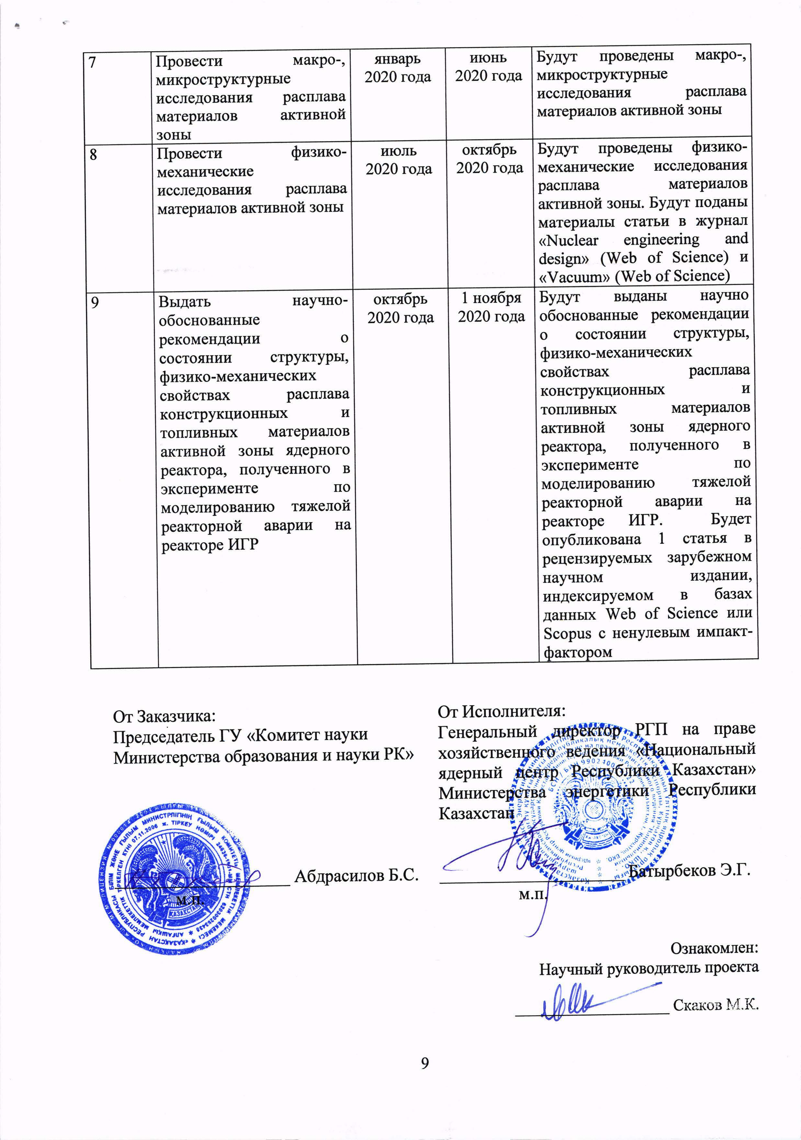

APPENDIX C

RK Patent for Invention No. 33105
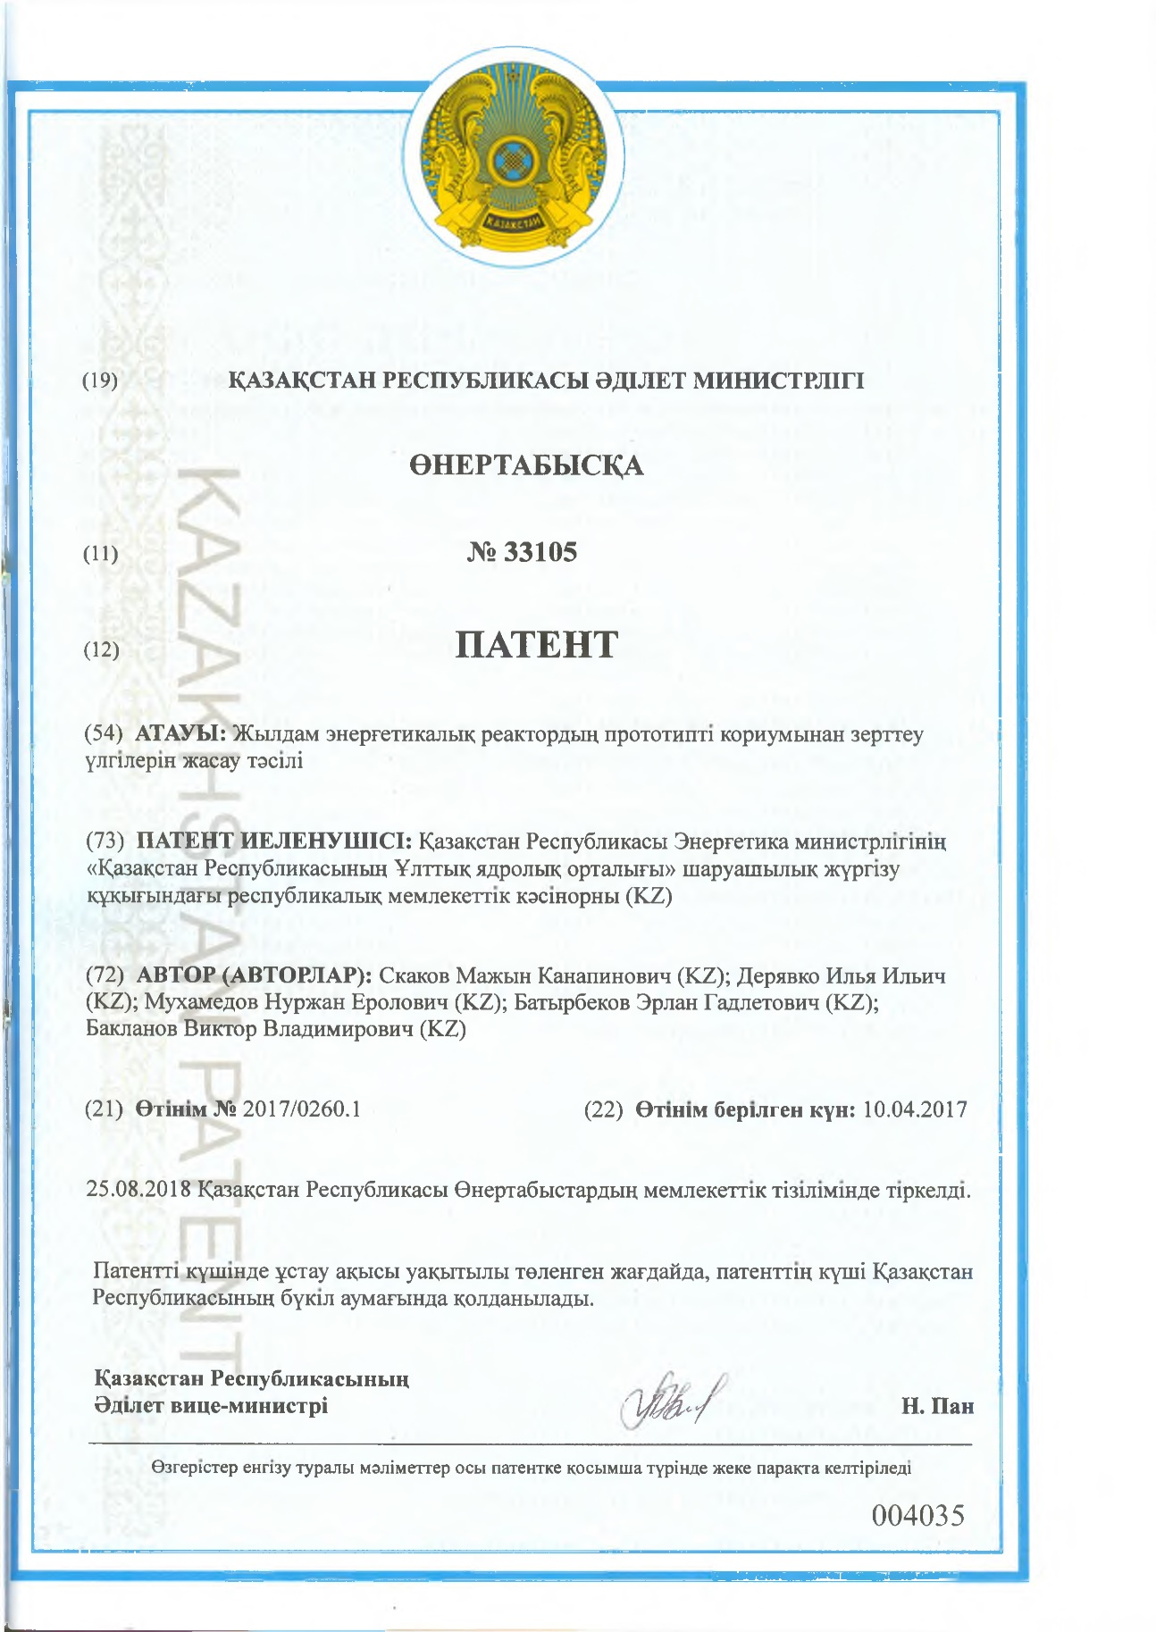
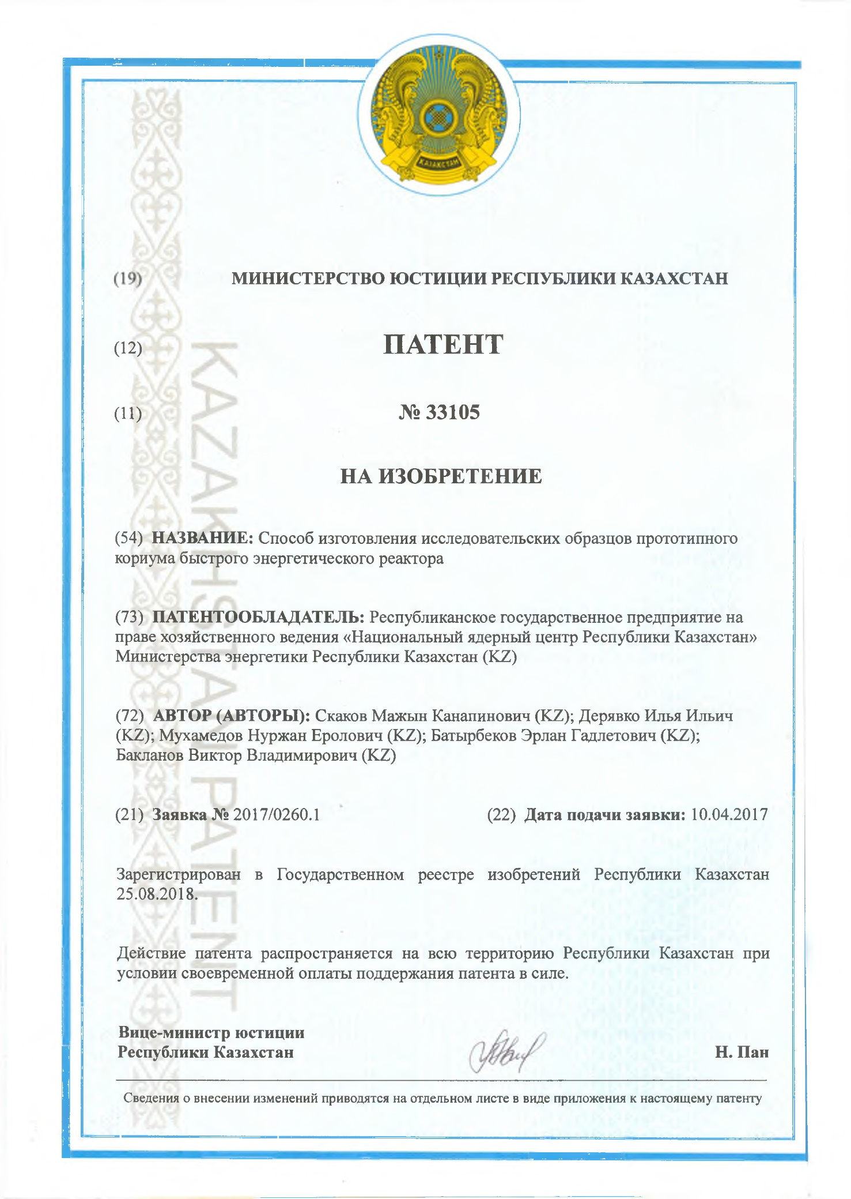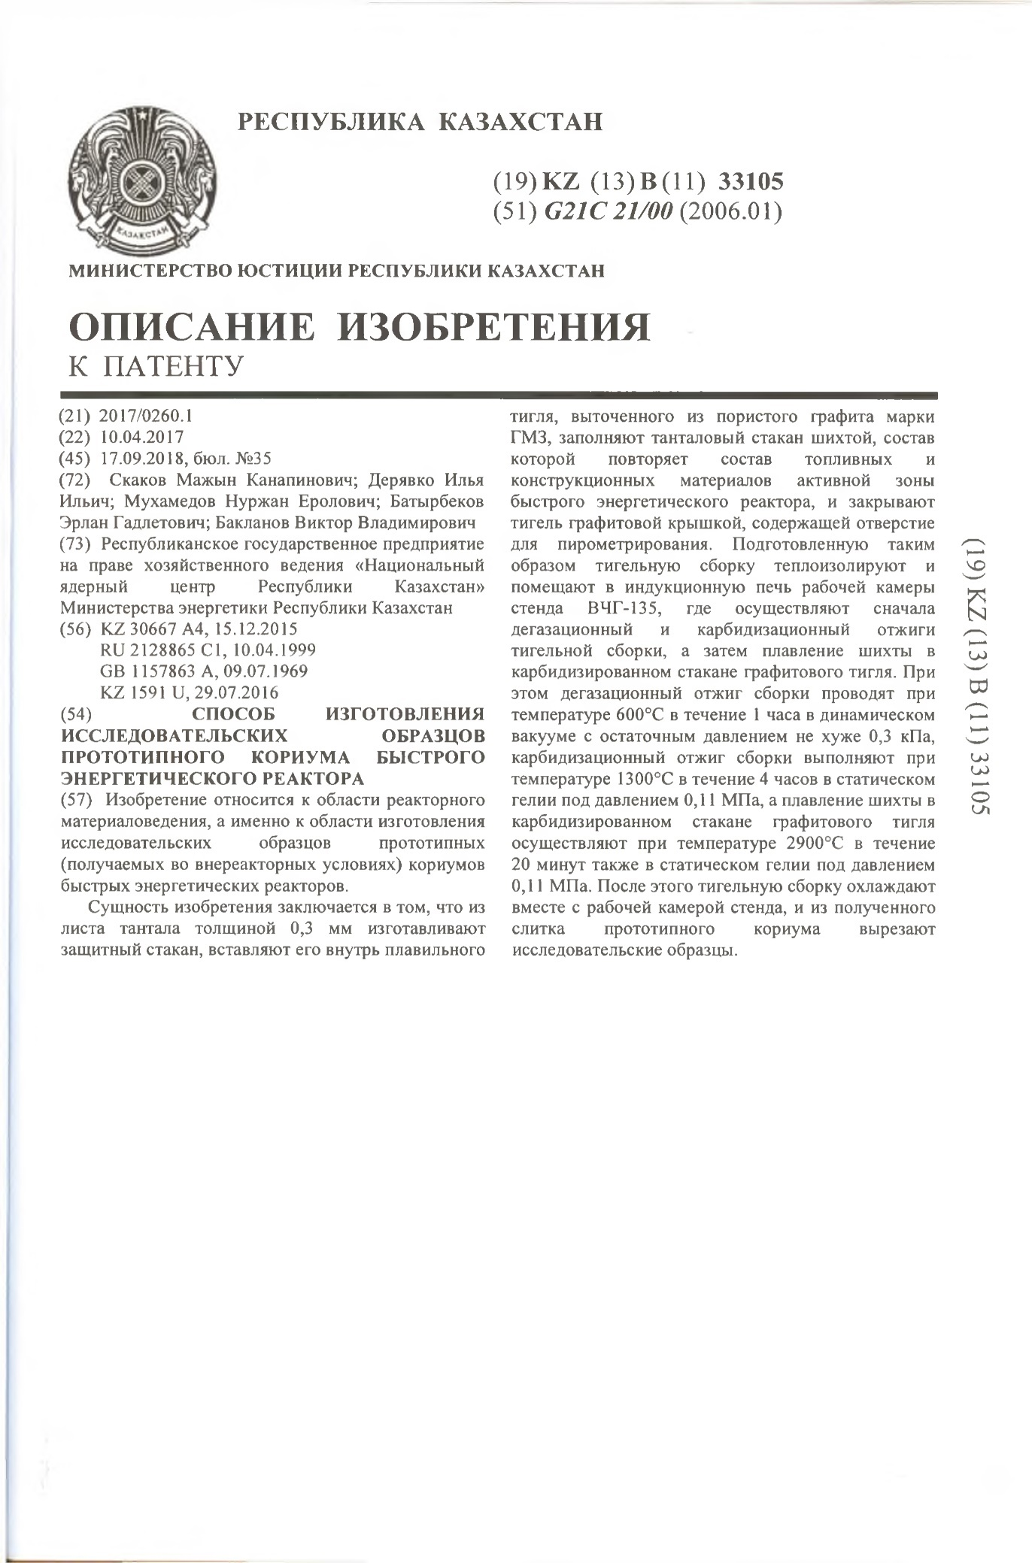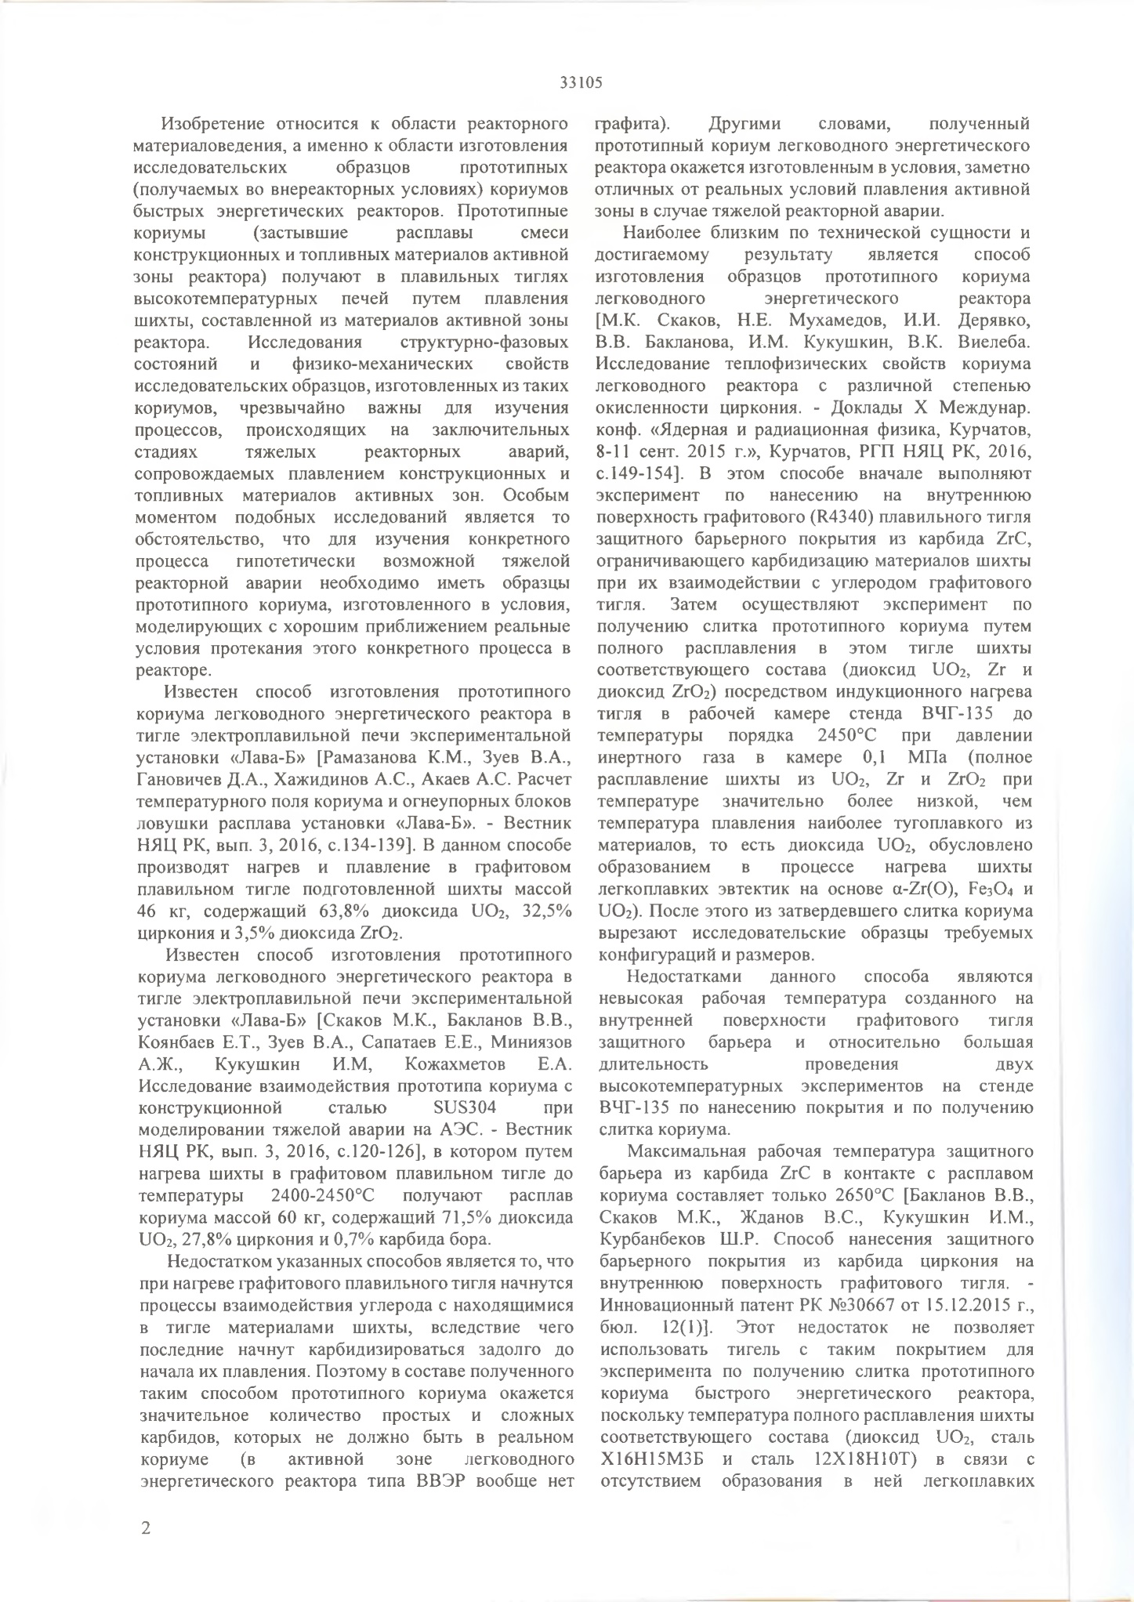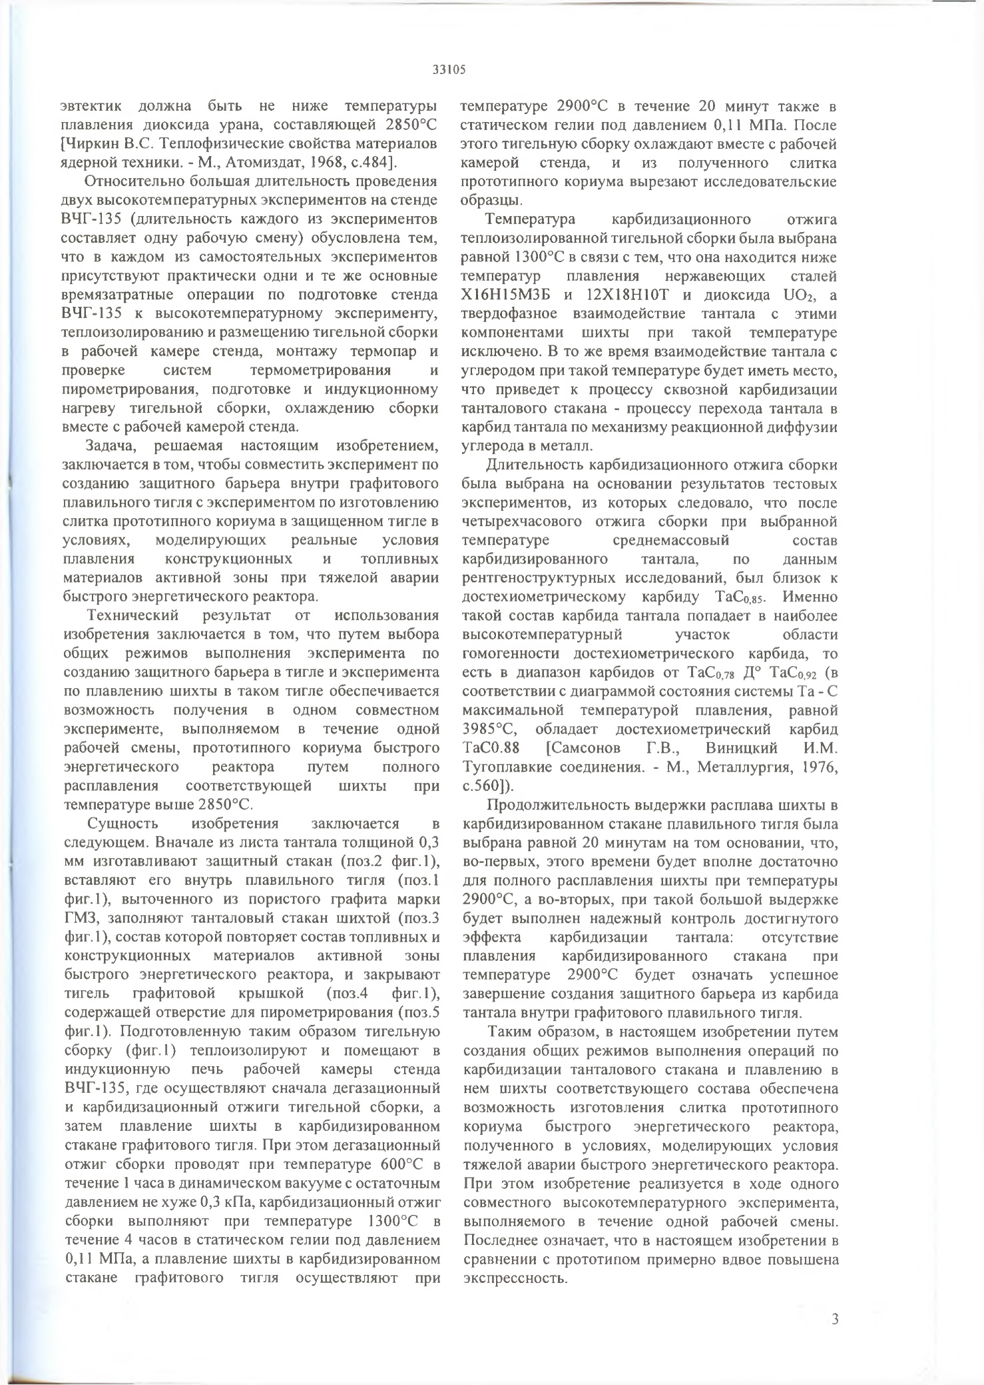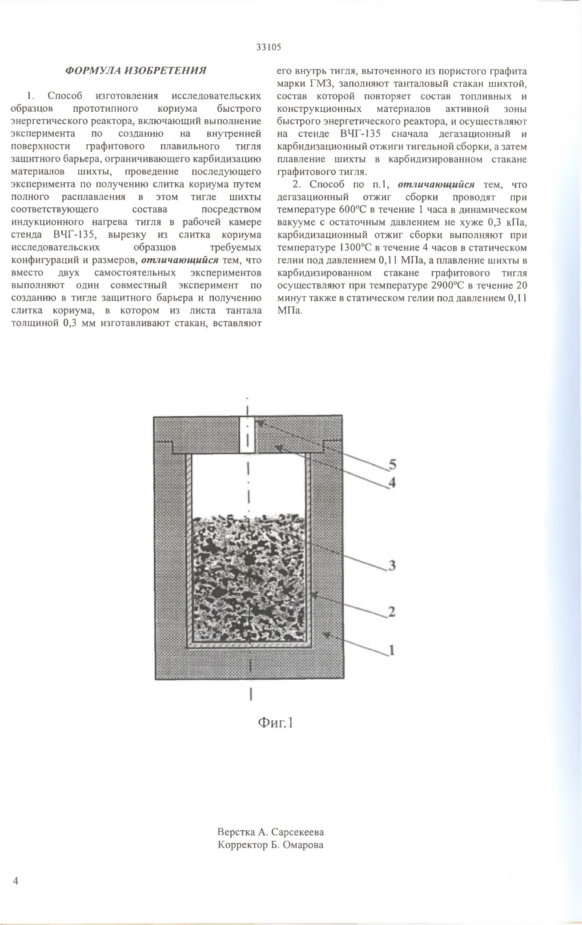

APPENDIX D

RK Patent for Invention No. 34494
