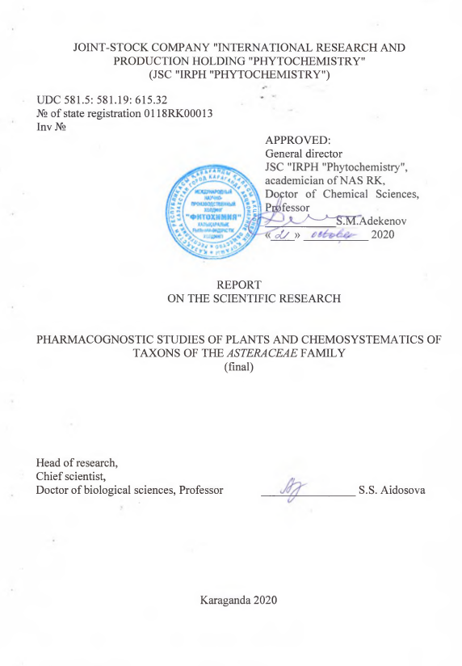
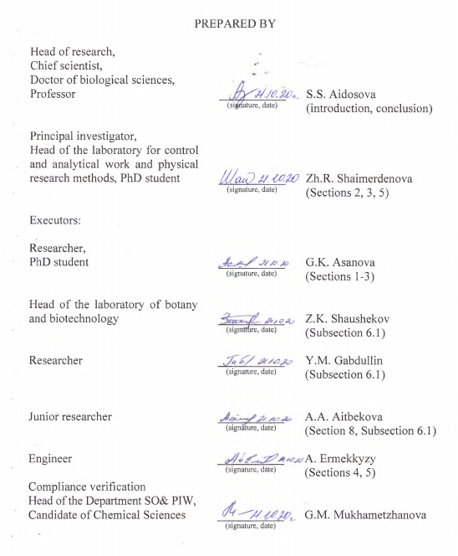

ABSTRACT

Report 142 pages, 27 figures, 7 tables, 42 sources, 7 app.
PLANTS OF ASTERACEAE FAMILY, PHARMACOGNOSIA, MICROPREPARATIONS, ANATOMICAL AND MORPHOLOGICAL CHARACTERS, HISTOCHEMISTRY, CHEMOTAXONOMIC MARKERS.
Research objects: 7 plant species of the genus Saussurea DC., 6 plant species of the subgenus Artemisia Less., 5 plant species of the subgenus Dracunculus (Bess.) Rydb. and 10 plant species of the subgenus Seriphidium (Bess.) Rouy.
The aim of the work is conducting pharmacognostic studies, determination of the species status, determination of the chemotaxonomic characteristics of plants of the Asteraceae family.
Research methods: expeditionary route survey of the area, anatomical and morphological method, histochemical analysis, physicochemical research methods.
The following results were obtained during the implementation of research under the project AP05133096 "Pharmacognostic studies of plants and chemosystematics of taxons of the Asteraceae family":
The anatomical, morphological and diagnostic characters of 7 species of the genus Saussurea DC., 6 species of the subgenus Artemisia Less., 5 species of the subgenus Dracunculus (Bess.) Rydb and 10 plant species of the subgenus Seriphidium (Bess.) Rouy. were determined.
For the first time, histochemical analyzes were carried out to determine the localization of sesquiterpene lactones, flavonoids, coumarins and essential oil in the tissues of organs of the studied plant species.
The areas of growth of the above-mentioned plants were determined, the exploitable reserves were assessed, the quality and trade parameters of plant raw materials were determined, and a summary of 10 species of the subgenus Seriphidium (Bess.) Rouy was compiled.
Areas of growth were identified, the operational reserves of 7 species of plants of the genus Saussurea DC. in Eastern and Central Kazakhstan, Artemisia annua L. in the territory of Almaty region and Artemisia leucodes Schrenk. on the territory of Almaty and Zhambyl regions were estimated, the good quality and merchandising parameters of 7 species of the genus Saussurea DC., 6 species of the subgenus Artemisia Less., 5 species of the subgenus Dracunculus (Bess.) Rydb. and 10 species of the subgenus Seriphidium (Bess.) Rouy were determined.
Analytical normative documents had been developed for the raw materials Peganum harmala L. and Populus balsamifera L.
Application: pharmacognosy, biochemistry, pharmaceutical production.

CONTENT

INTRODUCTION………………………………………...………………….......7
1 Pharmacognostic study of new medicinal plants……………………………….9
2 Determination of anatomical and morphological characters, histochemical and chemical study, exploitable reserves assessment and trade analysis of plants of the genus Saussarea DC. (Results for 2018)…………………………………………………. ….13
3 Anatomical and morphological, histochemical, chemical study, exploitable reserves assessment and quality assessment of plants of the subgenus Artemisia Less. and Dracunculus (Bess.) Rydb. (Results for 2019)…………………………………. ……...14
4 Comparative analysis of anatomical and morphological, diagnostic characters, and the results of histochemical studies of 10 species of the subgenus Seriphidium (Bess.) Rouy……………………………………………………………..…………………….15
4.1 Morphological study of 10 plant species of the subgenus Seriphidium (Bess.) Rouy………………………………………………………………………………..…15
4.2 Anatomical features of 10 plant species of the subgenus Seriphidium (Bess.) Rouy……………………………………………………………….………………….16
4.3 Histochemical analysis of plants of the subgenus Seriphidium (Bess.) Rouy..21
5 Pharmacognostic study and standardization of Populus balsamifera L raw material……….…………………………………………………..…………………....29
6 Identification of habitats, assessment of exploitable reserves and trade analysis of species of the genus Artemisia L. (subgenus Seriphidium (Bess.)..…………………….33
6.1 Identification of place of growth, assessment of exploitable reserves of Artemisia leucodes Schrenk………………………………………………………..…..33
6.2 Trade analysis of species of the genus Artemisia L. (subgenus Seriphidium (Bess.) Rouy.)…………………………………….. …………………….......................34
7 Chemical study of species of the genus Artemisia L. and determination of chemotaxonomic markers. Normative documentation for medicinal raw materials Populus balsamifera L………………………………………………………………………......38
8 Normative documentation for medicinal raw materials Populus balsamifera L.41
CONCLUSION……….……………………………………………...…………42
LIST OF USED SOURCES……………………………………………………..44
Appendix - А Technical specification and work schedule..................................... 48
Appendix - B List of published works..………………….………………………58
Appendix - C Analytical normative document on «Peganum harmala L., roots»..................................................................................................................................118
Appendix - D Analytical normative document on «Populus balsamifera L., buds»…………………………………………………………………………………. 119
Appendix - E Conclusions on the fulfillment of the search regulations.............120
Appendix - F Tables of comparative characteristics of morphological characteristics of 10 plant species of the genus Seriphidium (Bess.) Rouy…………………...………..136
Appendix - G Quality specification on plant raw material «Populus balsamifera L., buds»………………………………………………………………………………….….140
LIST OF ABBREVIATIONS AND SYMBOLS

In this research report, the following abbreviations and symbols are used:
AND - analytical normative documentation
COLOC - two-dimensional spectrum NMR ¹H-¹³C
COZY - Correlation Spectroscopy - two-dimensional spectrum NMR ¹Н-¹Н
CQAES - Committee for Quality Assurance in Education and Science
HPLC - high performance liquid chromatography
IR - infrared spectroscopy
JSC “IRPH “Phytochemisty” – Joint-Stock Company “International Research and Production Holding “Phytochemistry”
MPRM - medicinal plant raw materials
NCSSTE - National Center for State Scientific and Technical Expertise
NCEM MH RK - National Center for Expertise of Medicines of the Ministry of Health of the Republic of Kazakhstan
NMR - nuclear magnetic resonance
NMR ¹³C - carbon magnetic resonance spectroscopy
NMR ¹H - proton magnetic resonance spectroscopy
SP RK - State Pharmacopoeia of the Republic of Kazakhstan
Vol. – volume
UV - ultraviolet spectroscopy
WSS - working standard sample

INTRODUCTION

The prospects for research of medicinal plants of traditional medicine are undeniable for modern domestic pharmacy. The study of poorly studied plants of the domestic flora with the aim of using them as a source of medicinal plant raw materials and creating medicinal preparations on their basis is currently relevant [1]. When such plants are introduced into medical practice, first of all, a whole complex of studies should be carried out to establish their species identity.
Plants of the Compositae or Asteraceae family are widespread in the plant kingdom. Some of them are official species, which are included in the State Pharmacopoeia. Composite plants contain various groups of biologically active compounds, such as tannins, flavonoids, phenolcarboxylic acids, essential oils, vitamins, polysaccharides, alkaloids and others, and are used as effective medicines. At the same time, many composite plants known in traditional medicine are used in combination with official species [2].
The scientific novelty and practical significance of the work is in the use and study of chemotaxonomic markers for the systematization of plants of the genera Saussurea DC., Artemisia L. - the Asteraceae family on the basis of the difference in chemical compositions, both of individual species and closely related sections.
The aim of the project is conducting pharmacognostic studies, determination of the species status, determination of the chemotaxonomic characteristics of plants of the Asteraceae family.
Following tasks were solved according to the calendar plan (Appendix A) in 2018-2020 for the project AP05133096 “Pharmacognostic studies of plants and chemosystematics of taxons of the Asteraceae family”:
- identification of habitats, assessment of exploitable reserves of the genera Saussurea DC., Artemisia L. - of the Asteraceae family;
- determination of biomorphological features and diagnostic characters of the genera Saussurea DC., Artemisia L. - of the Asteraceae family;
- phytochemical study and analysis of the content of secondary metabolites to determine chemical differences, both of individual species and closely related sections, of the genera Saussurea DC. and Artemisia L. - of the Asteraceae family;
- design of chemotaxonomic classifications and determination of the species status of plants of the genera Saussurea DC. and Artemisia L. - of the Asteraceae family.
For the reporting period 2018-2020 during the implementation of the project the following results were obtained:
- a comparative morphological, anatomical, histochemical and chemical analysis of 7 plant species belonging to the genus Saussurea DC. and 21 plant species of the subgenera Artemisia Less., Dracunculus (Bess.) Rydb., Seriphidium (Bess.) Rouy. was carried out.;
- for the first time it was determined using histochemical analysis the localization of sesquiterpene lactones, flavonoids, coumarins and essential oils in the organs of leaf and inflorescence tissues of 28 plant species;
- the areas of growth of seven species of plants of the genus Saussurea DC. were identified, it was found that these species grow in Eastern and Central Kazakhstan;
- areas of distribution of Artemisia annua L. were identified and an assessment of its exploitable reserves in the Almaty region was carried out;
- distribution areas of Artemisia leucodes Schrenk. were identified and the exploitable reserves were assessed in Almaty and Zhambyl regions;
- the quality of plant raw materials was determined, trade parameters were established, and the quantitative content of microelements in plants of the genus Saussurea DC. and the subgenera Artemisia Less., Dracunculus (Bess.) Rydb. and Seriphidium (Bess.) Rouy . was investigated;
- a pharmacognostic study and standardization of raw materials of Peganum harmala L. and Populus balsamifera L., were carried out, an analytical normative documents “Peganum harmala L., roots” and “Populus balsamifera L. buds” were designed;
- the chemical composition of plants of the genus Saussurea DC. and the subgenera Artemisia Less., Dracunculus (Bess.) Rydb. and Seriphidium (Bess.) Rouy. have been studied and chemotaxonomic markers defined (determination of the species belonging of raw materials).
During the reporting period, 7 scientific works were published, of which 3 articles in peer-reviewed foreign editions with an impact factor included in the Scopus database, 2 articles in a peer-reviewed domestic editions recommended by CQAES, abstracts in the materials of an international conference, 2 applications for a title of protection were submitted and 2 analytical normative documents for raw materials were developed (Appendix B, C, D).
The executers include 7 employees, including 1 - Doctor of Biological Sciences, 2 - PhD student, 1 – Master degree holder. All executers of the project have experience in this area.

1 Pharmacognostic study of new medicinal plants

During the implementation of the project AP05133096 "Pharmacognostic studies of plants and chemosystematics of taxons of the Asteraceae family", the available literature data from 2010 to 2020 were analyzed (Appendix E).
The analysis of informational materials indicates that in order to include a new type of medicinal plant raw material in official medicine, firstly, it is necessary, to conduct anatomical, morphological and phytochemical study of plant organs.
Currently, promising objects for pharmacognostic studies are medicinal plants of the Asteraceae family, which are used in both official and traditional medicine. The genus Saussurea DC. and Artemisia L. are of the greatest interest to researchers.
Pharmacopoeial species of the genus Saussurea DC. are Saussurea lappa, C.B. Clarke, roots of Saussurea involucrata Kar. et Kir., Saussurea laniceps Hand.-Mazz., Saussurea medusa Maxim [3-5].
Saussurea lappa, C.B. Clarke is a medicinal plant known in Chinese medicine as "Qust/Kut". The anatomical features of the root Saussurea lappa, C.B. Clarke have been studied. A cross section of the roots showed the presence of a cork of 3-5 layered width, a secondary phloem consisting mainly of parenchyma, multi-series modular bundles, and resin canals along the entire length in the form of cavities, xylem, vessels and groups of xylem parenchyma. In older (perennial) roots of Saussurea lappa, C.B. Clarke the dendritic parenchyma are destroyed and becomes spongy in the center of the root [6-8].
It is known from the literature that Saussurea involucrata Kar. et Kir., Saussurea laniceps Hand.-Mazz., Saussurea medusa Maxim. are part of the collection of medicinal herbs "Snow Lotus". Medicinal plants are used in crushed form, therefore, morphological signs are not enough for their identification, especially for polymorphic species. Microscopic studies using polarized light microscopy and scanning electron microscopy were carried out to distinguish three closely related Saussurea species. Macroscopic identification revealed the positions and locations of the heads, pollen grains, nonglandular hairs, glandular hairs, and cells of the inner surface of the microdanga, which can be used to identify three species of Saussurea snow lotus [9].
The authors of the article [10, 11] carried out a pharmacognostic study of Saussurea involucratа Kar. et Kir., it was determined that the characteristic features are the presence of light cream or greenish membranous bracts, head-like enveloping the scutellum in the budding phase as a result.
Saussurea laniceps Hand.-Mazz. outwardly very similar to Saussurea gossypiphora D. Don, except that the shape of their inflorescences and bracts, as well as the color of their hairs and crests in the flower are slightly different [4].
Another practically valuable Saussurea species is Saussurea salsa Pall. Speng. and Saussurea amara (L.), growing in Kazakhstan. Distinctive features of the anatomical aerial organs for Saussurea amara (L.) are the presence of three conductive bundles in the central vein of the leaf, as well as glandular trichomes of two types. Saussurea salsa Pall. Speng. is characterized by the presence of one conducting bundle in the central vein of the leaf and two parallel to it on both sides outside the central vein, with a small amount of capitate trichomes on the lower epidermis [12]. Data on anatomical and morphological characteristics allow to prepare pharmacopoeial monographs on Saussurea amara (L.) and Saussurea salsa Pall. Speng. for subsequent use in official medicine.
The structural features of the leaf epidermis of two taxonomically difficult to differentiate Far Eastern species Saussurea pulchella (Fisch.) Fisch. and Saussurea neopulchella Lipsch. were determined. The species differ in leaf type, stomatal index, and the size of the main epidermal cells [13].
Thus, the data obtained on the morphological and anatomical features of plant organs in Saussurea species will make it possible to distinguish these species both at the stage of plant collection and in the process of laboratory examination of raw materials.
Among pharmacopoeial species of the genus Artemisia L., Artemisia absinthium L., Artemisia leucodes Shrenk., Artemisia glabella Kar. et Kir., Artemisia scoparia Waldts. et Kit., Artemisia annua L. are known [5,14,15].
One of the promising species of wormwood is Artemisia absinthium L., a rich source of biologically active compounds [16]. A comparative analysis of the morphological, anatomical and histological features of Artemisia absinthium L. and Artemisia austriaca Jacq was carried out. It was determined that Artemisia absinthium L. has stems no more than 25 cm long, slightly ribbed, greenish-gray in color. Leaves are two- or three-part, grayish-green and silvery-gray. Small spherical baskets, 2.5-4 mm in diameter. The flowers are small, yellow. The smell of raw materials is peculiar, strong, and tastes bitter.
When studying the anatomical features of the upper epidermis of the leaves of Artemisia absinthium L., it was determined that the cells are sinuous in shape, the stomata are oval, small in number, and of an anocytic type (surrounded by 3-5 cells). Also, the upper epidermis has T-shaped hairs and large oval essential oil glands with a transverse septum.
On the lower epidermis of Artemisia absinthium L. leaves, the cells are more sinuous. The stomata are represented in large numbers, the anatomical features are the same as on the upper epidermis [17].
In order to study the most important anatomical features and search for new taxonomic characters, the researchers carried out a comparative anatomical analysis of the vegetative organs of Artemisia campestris L., Artemisia absinthium L., Artemisia arborescens L., Artemisia judaica L. and Artemisia herba-alba Asso. The results showed that the anatomical structures of roots, stems and leaves in these species are similar, and that nonglandular and glandular trichomes are common for all species. However, some characters can be considered as species-specific, non-endodermal. Artemisia absinthium L. is distinguished by the presence of secretory canals in the core of the stem, in the leaves the vascular bundle is surrounded by parenchymal cells, there is subepidermal collenchyma, and secretory canals are absent [18].
Artemisia glabella Kar. et Kir. is of particular value - a source of sesquiterpene lactone of the guaian type, which is the active principle of the anticancer drug "Arglabin" [19-21]. Artemisia glabella Kar. et Kir., included in the State Pharmacopoeia of the Republic of Kazakhstan [14].
V.P. Amelchenko has considered in detail the relationship of the most polymorphic taxons of Artemisia commutate Bess., Artemisia laciniata Willd., Artemisia obtusiloba Ledeb., Artemisia vulgaris L., Artemisia Siversiana Willd. [22].
Appendino G. describes the morphological characteristics of pollen for 16 species of wormwood: Artemisia vulgaris L., Artemisia verlotiorum Lamotte, Artemisia atrata Lam., Artemisia chamaemelifolia Vill., Artemisia pontica L., Artemisia annua L., Artemisia eriantha Ten., Artemisia genipi Weber, Artemisia umbelliformis L., Artemisia glacialis L.,, Artemisia absinthium L., Artemisia alba Turra, Artemisia pedemontana Balbis, Artemisia vallesiaca All., Artemisia campestris L., Artemisia campestris ssp. borealis, native to Italy [23].
Another direction in the diagnosis and taxonomy of plants is chemosystematics. Secondary metabolites are used as chemotaxonomic markers. In plants of the genus Saussurea DC. the most widespread are sesquiterpene lactones of the guaian type, among which cinaropicrin is often identified (1), which can be considered as a chemotaxonomic marker of this genus [24,25].
According to the results of a chemical study of more than 260 species of the genus Artemisia L., it was determined that they contain different classes of pharmacologically active secondary metabolites, including sesquiterpene lactones, essential oils, coumarins and other compounds. According to the literature, the main chemotaxonomic markers of plants of the genus Artemisia L. are camphor monoterpenoids (2), 1,8-cineole (3), borneol (4), and linalool (5) contained in essential oils [26].

(1) |  |  | (2) | (3) |  | (4) | (5)
(6) |  | (7) |  |  | (8)
(9) | (10) |  |  |  | (11)

Plants of the subgenus Artemisia L. are characterized by sesquiterpene lactones of the guaian and eudesmanic types isolated from Artemisia vulgaris L., Artemisia argyi H. Lev. & Vaniot [27,28].
Plants of the subgenus Dracunculus (Bess.) Rydb. are included in the group of coumarin-bearing wormwood. From Artemisia campestris L., Artemisia Dracunculus L., Artemisia scoparia Waldst. & Kit. the coumarins herniarin (6), scopoletin (7), artemidin (8) have been isolated, which are hematoxanomic markers of this subgenus [29-31].
According to literature data, plants of the subgenus Seriphidium (Bess.) Rouy. contain sesquiterpene lactones of the eudesmanic type α-santonin (9), tauremizin (10), artemin (11), isolated from more than 20 species of wormwood of this subgenus [31, 32]. The only representatives of this subgenus that produce sesquiterpene lactones of the guaian type are Artemisia leucodes Schrenk., Artemisia juncea Kar. & Kir. and Artemisia lercheana Weber ex Stechm. [33].
Our review makes it possible to analyze and evaluate the level of the current state of pharmacognostic and phytochemical studies of medicinal plants of the family Asteraceae L. Studies of the chemical composition of Kazakhstan’s plant species of the genus Saussurea DC. and Artemisia L. indicate the potential use of these species for the production of biologically active compounds and the development of original medicines based on them.
2 Determination of anatomical and morphological characters, histochemical and chemical study, exploitable reserves assessment and trade analysis of plants of the genus Saussurea DC. (Key results for 2018)

During the implementation of the project AP05133096 "Pharmacognostic studies of plants and chemosystematics of taxons of the Asteraceae family" in 2018, the following results were obtained:
Anatomical, morphological, histochemical analysis and chemical study of 7 plant species of the genus Saussurea DC. were carried out.
For the first time, anatomical and morphological diagnostic features for Saussurea amara (L.) DC., Saussurea salsa (Pall.) Spreng., Saussurea elegans Ledeb., Saussurea elata Ledeb., Saussurea latifolia Ledeb., Saussurea robusta Ledeb., Saussurea turgaiensis. B. Fedtsch. were identified.
For the first time, a histochemical analysis of 7 species of the genus Saussurea DC. was carried out, as a result of which the localization of sesquiterpene lactones in epidermal cells and trichomes, mesophyll parenchymal cells and vascular bundles of leaves was identified. Flavonoids are localized in epidermal cells, mesophyll, vascular bundles of leaves and petals of inflorescences.
For the first time, a comparative study of the qualitative composition of the analysis of 7 plant species of the genus Saussurea DC. Has been conducted. As a result, it was determined that the species of the studied plants contain from 12 to 14 groups of biologically active substances.
To determine the species and chemotaxonomic marker, a chemical study of the aerial parts of 7 plant species of the genus Saussurea DC was carried out. The sesquiterpene lactone cynaropicrin is a chemotaxonomic marker of plants of the genus Saussurea DC.
During the expedition trips to the territories of Central and Eastern Kazakhstan the areas of growth and the assessment of plant reserves of 7 species of plants of the genus Saussurea DC. were determined.
As a result of trade analysis of 7 plant species of the genus Saussurea DC. numerical indicators of quality were established, characterizing the quality of raw materials.
The results of the experiments were published in the form of 1 scientific article included in the Scopus database and 1 article was submitted for publication.
The interim report for 2018 was registered with JSC NCSSTE in accordance with the established procedure (inv. No. 0218RK01118).
3 Anatomical and morphological, histochemical, chemical study, assessment of reserves and quality of plants of the subgenus Artemisia Less. and Dracunculus (Bess.) Rydb. (Key Results 2019)

During the implementation of the project AP05133096 "Pharmacognostic studies of plants and chemosystematics of taxons of the Asteraceae family" in 2019, the following results were obtained:
Anatomical and morphological, histochemical analysis and chemical study of 6 plant species of the subgenus Artemisia Less were carried out. (Artemisia absinthium L., Artemisia annua L., Artemisia frigida Willd., Artemisia rupestris L., Artemisia Sieversiana Ehrh. Ex Willd., Artemisia santolinifolia Turcz.ex Besser.) And 5 plant species of the subgenus Dracunculus (Bess.) Rydb. (Artemisia Dracunculus L., Artemisia quinqueloba Trautv., Artemisia marschalliana Spreng., Artemisia scoparia Waldst. & Kit., Artemisia tomentella Trautv.).
As a result of anatomical and morphological studies in plants of the subgenus Artemisia Less. and the subgenus Dracunculus (Bess.) Rydb. diagnostic characters are established.
As a result of histochemical analysis on cross sections of leaves and surface preparations of flowers of plants of the subgenus Artemisia Less. the localization of terpenoids and phenolic compounds was determined for the first time, and for plants of the subgenus Dracunculus (Bess.) Rydb. the localization of phenolic compounds and coumarins was determined for the first time.
Route expedition trips were carried out on the territory of the Almaty region to identify the place of growth and assess the plant reserves of Artemisia annua L.
When conducting a trade analysis, the norms were determined in the form of numerical indicators that regulate the purity and quality of raw materials of the subgenus Artemisia Less. and Dracunculus (Bess.) Rydb.
As a result of pharmacognostic study and standardization of raw materials Peganum harmala L. an analytical regulatory document " Peganum harmala L., roots" was designed.
Based on the results of a chemical study of sesquiterpene lactones and coumarins, a chemotaxonomic assessment of the subgenera Artemisia Less and Dracunculus (Bess.) Rydb. was carried out.
The obtained experimental results were published in the form of 2 scientific articles and an application for a title of protection was submitted.
The interim report for 2019 was registered with JSC NCSSTE in accordance with the established procedure (inv. No. 0219RK00766).

4 Comparative analysis of anatomical, morphological and diagnostic characters and results of histochemical studies of 10 species of the subgenus Seriphidium (Bess.) Rouy.

4.1 Morphological study of 10 plant species of the subgenus Seriphidium (Bess.) Rouy.

Macroscopic examination of Artemisia schrenkiana Ledeb., Artemisia nitrosa Weber., Artemisia leucodes Schrenk., Artemisia pauciflora Weber., Artemisia terrae-albae Krasch., Artemisia gracilescens Krasch. & Iljin., Artemisia transiliensis Poljakov., Artemisia karatavica Krasch. & Abolin ex Poljakov, Artemisia cina Berg ex Poljakov, Artemisia kasakorum (Krash.) Pavl. the diagnostic elements of plants are established. Using an OGM3-PZ binacular microscope, drawings of leaves and inflorescences of the studied plants were obtained (Figure 1).

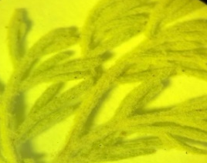  a | 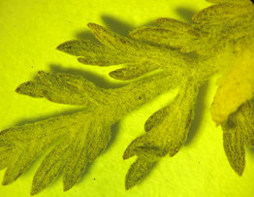  c | 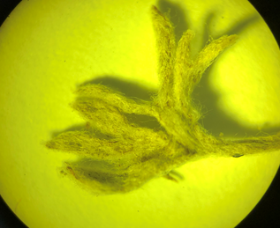  e | 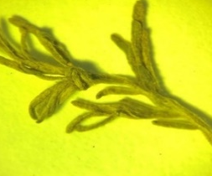  g | 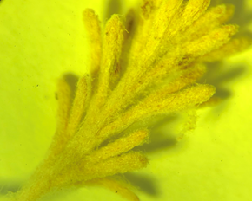  j
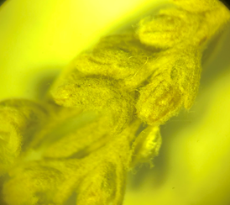  b | 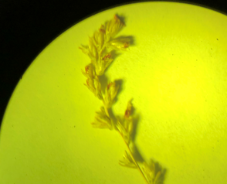  d | 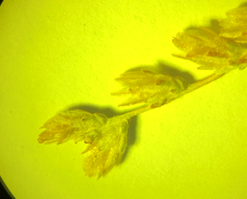  f | 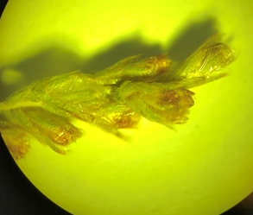  h | 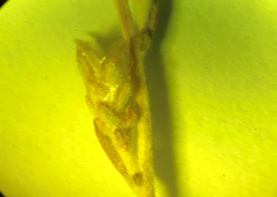  k
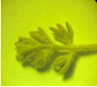  l | 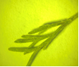  n | 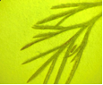  q | 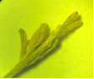  s | 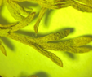  u
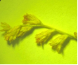  m | 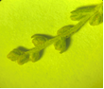  p | 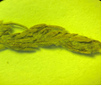  r | 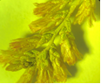  t | 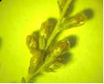  v
Artemisia schrenkiana Ledeb .: a) leaf, b) inflorescence; Artemisia nitrosa Weber .: c) leaf, d) inflorescence; Artemisia leucodes Schrenk .: e) leaf, f) inflorescence; Artemisia pauciflora Weber .: g) leaf, h) inflorescence; Artemisia terrae-albae Krasch .: j) leaf, k) inflorescence of Artemisia gracilescens Krasch. & Iljin .: l) leaf, m) inflorescence; Artemisia transiliensis Poljakov .: n) leaf, p) inflorescence; Artemisia karatavica Krasch. & Abolin ex Poljakov: q) leaf, r) inflorescence; Artemisia cina Berg ex Poljakov: s) leaf, t) inflorescence; Artemisia kasakorum (Krash.) Pavl .: u) leaf, v) inflorescence

Figure 1 - Leaves and inflorescences of 10 species of wormwood of the subgenus Seriphidium (Bess.) Rouy.
By the figures, a description of the morphological characteristics is designed: relief, pubescence, shape, dissection of leaves, structures of inflorescences of 10 species of the subgenus Seriphidium (Bess.) Rouy. (Table 1, 2) (Appendix F).
The studies carried out indicate that the general signs of morphological characteristics in 10 species of wormwood of the subgenus Seriphidium (Bess.) Rouy.: are dissection of leaves, which are double-triple pinnately dissected and heavily pubescent, and the stems are erect, ribbed and covered with hairs. Baskets in most species are oblong-ovate.
As a result of a comparative study of morphological characteristics, a number of distinctive features were revealed: the leaf shape of Artemisia nitrosa Weber. ovate-lanceolate, in Artemisia terrae-albae Krasch., Artemisia karatavica Krasch. & Abolin ex Poljakov., Artemisia cina Berg ex Poljakov. ovoid, in the other 3 species Artemisia leucodes Schrenk., Artemisia pauciflora Weber., Artemisia schrenkiana Ledeb. lanceolate and linear-lanceolate, in Artemisia gracilescens Krasch. & Iljin., Artemisia transiliensis Poljakov., Artemisia kasakorum (Krash.) Pavl. leaves oblong or oblong-ovate in outline. Flowers in all of the above species are yellow with purple appendages, Artemisia leucodes Schrenk. differs in whitish color due to dense pubescence and large inflorescence baskets: 5-7 mm, while in other species it does not exceed 2-3 mm.

4.2 Anatomical features of 10 plant species of the subgenus Seriphidium (Bess.) Rouy.

A comparative study of the anatomical structure of the leaf and stem of Artemisia schrenkiana Ledeb., Artemisia nitrosa Weber., Artemisia leucodes Schrenk., Artemisia pauciflora Weber., Artemisia terrae-albae Krasch., Artemisia gracilescens Krasch. & Iljin., Artemisia transiliensis Poljakov., Artemisia karatavica Krasch. & Abolin ex Poljakov, Artemisia cina Berg ex Poljakov, Artemisia kasakorum (Krash.) Pavl. has been conducted. Transverse sections of plant organs were prepared manually using a microtome on a TOS-2 (INMEDPROM, Russia) freezing device. The thickness of the anatomical sections was 10-15 microns. To view temporary preparations, a micros AUSTRIA microscope with the addition of "microscopy vision" was used.
Analyzing the results of the study of the microscopic structure, we can note the general characters of the anatomical structure of the leaves of Artemisia schrenkiana Ledeb., Artemisia nitrosa Weber., Artemisia leucodes Schrenk., Artemisia pauciflora Weber., Artemisia terrae-albae Krasch. Artemisia gracilescens Krasch. & Iljin., Artemisia transiliensis Poljakov., Artemisia karatavica Krasch. & Abolin ex Poljakov, Artemisia cina Berg ex Poljakov, Artemisia kasakorum (Krash.) Pavl .: on a cross section the epidermis leaves are single-layered, with a layer of cuticle there are essential oil glands and trichomes. General characters of the anatomical structure of the stem: rounded in cross section, multifaceted, with clearly visible 5-7 ribs. In the ribs of the stem, there are sections of collenchyma and sclerenchyma. The core of the stem is represented by large, loosely located cells of the core of the parenchyma (Figure 2-11). Distinctive features of the leaf are presented in Table 3.

Table 3 - Distinctive features of the anatomical structure of the leaf of 5 species of wormwood of the subgenus Seriphidium (Bess.) Rouy.

Species | Trichomes | Mesophyll | Type of conductive bundles
Artemisia schrenkiana Ledeb. | numerous, long, ribbon-like | isolateral-palisade structure | open collateral
Artemisia nitrosa Weber. | not numerous, multicellular | columnar | open collateral
Artemisia leucodes Schrenk. | numerous, medium | isolateral-palisade structure | closed collateral
Artemisia pauciflora Weber. | not numerous, multicellular | palisade | closed collateral
Artemisia terrae-albae Krasch. | numerous, multicellular | palisade | open collateral
Artemisia gracilescens Krasch. & Iljin. | not numerous, multicellular | palisade | closed collateral
Artemisia transiliensis Poljakov. | numerous, medium | isolateral-palisade | closed collateral
Artemisia karatavica Krasch. & Abolin ex Poljakov | not numerous, multicellular | palisade | closed collateral
Artemisia cina Berg ex Poljakov | not numerous, multicellular | dorsoventral type | closed collateral
Artemisia kasakorum (Krash.) Pavl. | not numerous, multicellular | columnar | open collateral

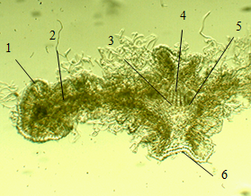 | 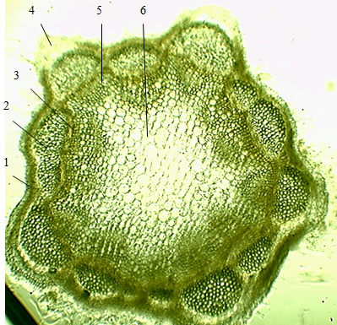
a | b
a) leaf: 1-upper epidermis, 2-mesophyll, 3-phloem, 4-xylem, 5-cambium, 6-lower epidermis; b) stem: 1-epidermis, 2-sclerenchyma, 3-phloem, 4-collenchyma, 5-xylem, 6- parenchyma core

Figure 2 - Cross sections of the leaf and stem of Artemisia Schrenkiana Ldb.

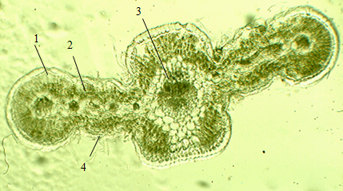 | 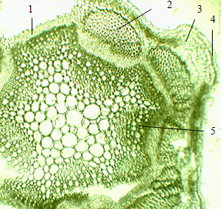
а | b
a) leaf: 1-upper epidermis, 2-columnar mesophyll, 3-conductive bundle, 4-lower epidermis; b) stem: 1-epidermis, 2-sclerenchyma, 3-collenchyma, 4-chlorenchyme, 5-parenchyma core

Figure 3 - Cross sections of a leaf and stem of Artemisia nitrosa Weber.

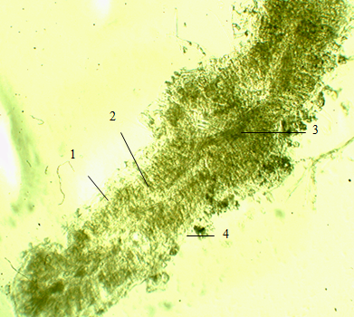 | 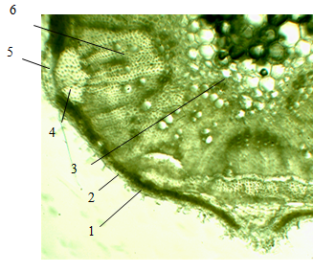
а | b
a) sheet: 1-upper epidermis, 2-columnar mesophyll, 3-conductive bundle, 4-lower epidermis; b) stem: 1-epidermis, 2-chlorenchyma, 3-parenchyma core, 4-sclerenchyma, 5-collenchyma, 6-xylem

Figure 4 - Cross sections of a leaf and stem of Artemisia leucodes Schrenk.

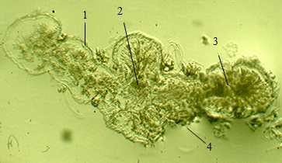 | 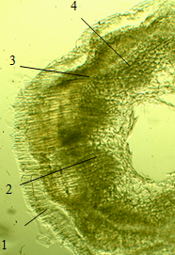
а | b
a) sheet: 1-upper epidermis, 2-conductive bundle, 3-columnar mesophyll, 4-lower epidermis; b) stem: 1-epidermis, 2-phloem, 3-parenchyma, 4-xylem

Figure 5 - Cross sections of a leaf and stem of Artemisia pauciflora Weber.

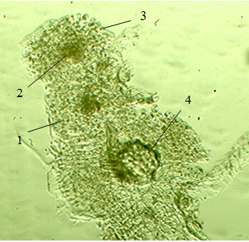 | 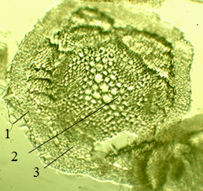
а | b
a) leaf: 1-upper epidermis, 2-palisade mesophyll, 3-lower epidermis, 4-conductive bundle; b) stem: 1-epidermis, 2-parenchyma core, 3-sclerenchyma

Figure 6 - Cross sections of a leaf and stem Artemisia terrae-albae Krasch.

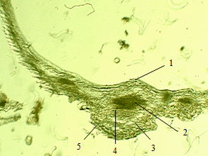 | 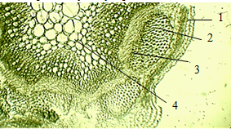
а | b
a) leaf: 1-upper epidermis, 2- phloem, 3-palisade mesophyll, 4-xylem, 5- lower epidermis; b) stem: 1-epidermis, 2-sclerenchyma, 3-phloem, 4-cordate parenchyma

Figure 7 - Cross sections of a leaf and stem of Artemisia gracilescens Krasch. & Iljin

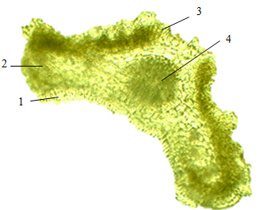 | 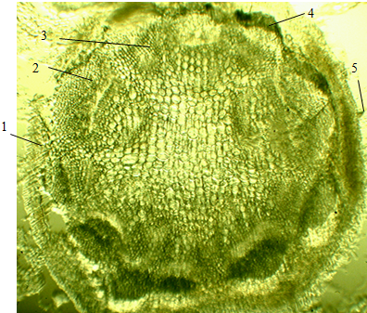
а | b
a) leaf: 1-upper epidermis, 2-mesophyll, 3-lower epidermis, 4-conductive bundle; b) stem: 1-epidermis, 2-phloem, 3-xylem, 4-sclerenchyma, 5-trichomes

Figure 8 - Cross sections of a leaf and stem of Artemisia transiliensis Poljakov

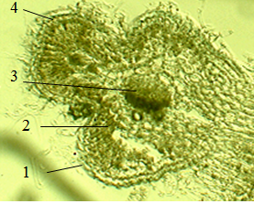 | 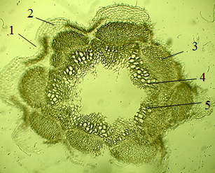
а | b
a) sheet: 1-upper epidermis, 2-mesophyll, 3-conductive bundle, 4-lower epidermis; b) stem: 1-epidermis, 2-collenchyma, 3-sclerenchyma, 4-phloem, 5-xylem

Figure 9 - Cross sections of a leaf and stem of Artemisia karatavica Krasch. & Abolin ex Poljakov
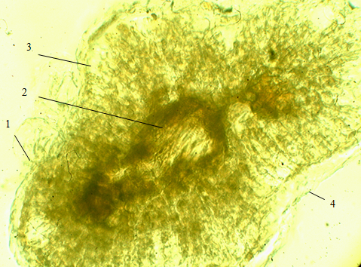 | 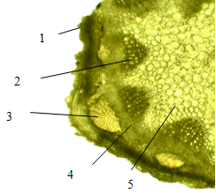
а | b
a) sheet: 1-upper epidermis, 2-conductive bundle, 3-mesophyll, 4-lower epidermis; b) stem: 1-epidermis, 2-xylem, 3-sclerenchyma, 4-phloem, 5- cordate parenchyma

Figure 10 - Cross sections of a leaf and stem of Artemisia cina Berg ex Poljakov

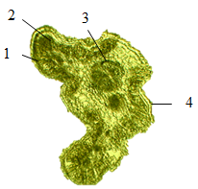 | 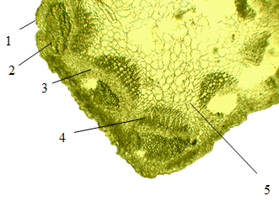
а | b
a) sheet: 1-upper epidermis, 2-mesophyll, 3-conductive bundle, 4-lower epidermis; b) stem: 1-epidermis, 2-sclerenchyma, 3-phloem, 4-xylem, 5- cordate parenchyma

Figure 11 - Cross-sections of a leaf and stem of Artemisia kasakorum (Krash.) Pavl.

Among 10 species of wormwood of the subgenus Seriphidium (Bess.) Rouy. by morphological characters Artemisia leucodes Schrenk. is identical with Artemisia cina Berg. ex Poljak. In order to distinguish Artemisia leucodes Schrenk. from Artemisia cina Berg ex Poljakov the comparison of their anatomical and diagnostic features has been conducted. It was found that in the epidermal cells of Artemisia leucodes Schrenk. there are trichomes, elongated epidermal cells. Similar anatomy of Artemisia leucodes Schrenk. and Artemisia cina Berg ex Poljakov from other species of wormwood, is chlorenchyme, which is located in the stem cells of the epidermis, thereby enhancing the process of photosynthesis, since both species are oligotrophic plants with mineral-poor soils. Identical (similar) anatomy in the cross section of the stem shows the presence of a thick cuticle skin in both species of wormwood, which covers the outer part of the stem. In addition Artemisia leucodes Schrenk. and Artemisia cina Berg ex Poljakov have thickened lignified cell walls, which indicates a large number of mechanical sclerenchymal rings. Distinctive features are as follows: in Artemisia leucodes Schrenk. - vascular bundles of stems, in which the chain xylem is strongly developed, while Artemisia cina Berg ex Poljakov has a weakly expressed phloem and an underdeveloped bundle system.
Based on the results of the anatomical and diagnostic analyzes, general signs of the anatomical structure of the leaf of mesophylls were revealed, which are palisade Artemisia terrae-albae Krasch., Artemisia pauciflora Weber., Artemisia gracilescens Krasch. & Iljin., Artemisia karatavica Krasch. & Abolin ex Poljakov. Artemisia karatavica Krasch & Abolin ex Poljakov. and Artemisia pauciflora Weber. plants have a significant feature like a hollow core on the cross section of the stem, which shows a highly developed mechanical structure. Two plant species Artemisia terrae-albae Krasch and Artemisia kasakorum (Krash.) Pavl are distinguished by an open collateral type of conducting bundle, showing the presence of cambium between the phloem and xylem, which serves as the formation of annual rings or activates the growth of the plant in thickness.
As a result of studying the anatomical structure of 10 species of wormwood of the subgenus Seriphidium (Bess.) Rouy. their common and distinctive features were identified, which can be used to distinguish between species and determine the authenticity.

4.3 Histochemical analysis of plants of the subgenus Seriphidium (Bess.) Rouy.

To determine the authenticity of raw materials, histochemical analysis is of great importance, thanks to which it is possible to determine the composition of secondary metabolites by staining anatomical structures and tissues in sections. Due to the lack of literature data on the histochemical study of the studied 10 species of wormwood, for the first time carried out histochemical reactions on sections of the leaf, stem and inflorescence of 10 plant species of the subgenus Seriphidium (Bess.) Rouy .: Artemisia schrenkiana Ledeb., Artemisia nitrosa Weber., Artemisia leucodes Schrenk. Artemisia pauciflora Weber., Artemisia terrae-albae Krasch., Artemisia gracilescens Krasch. & Iljin., Artemisia transiliensis Poljakov., Artemisia karatavica Krasch. & Abolin ex Poljakov, Artemisia cina Berg ex Poljakov, Artemisia kasakorum (Krash.) Pavl. To identify essential oils, an alcoholic solution of methyl blue was used. Concentrated hydrochloric acid was used to determine the presence of sesquiterpene lactones in the structural parts of plants.
As a result of a histochemical reaction, the stem epidermis of Artemisia schrenkiana Ledeb. is colored blue, which indicates the presence of essential oils. The mesophyll and upper epidermis of the leaf turned yellow, indicating the presence of sesquiterpene lactones (Figure 12).

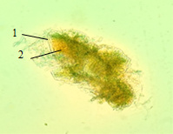 | 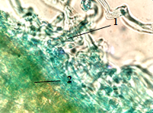
а | b
a) cross section of a leaf in hydrochloric acid: 1- epidermis, 2-mesophyll; b) cross section of the stem in methyl blue: 1-exogenous essential oil glands, 2-sclerenchyme

Figure 12 - Histochemical reactions on sections of a leaf and stem of Artemisia schrenkiana Ledeb.

Under the influence of methyl blue on the cross-section of the stem of Artemisia nitrosa Weber. in phloem parts, in cambia, in mechanical sclerenchyma tissues, in small amounts in trichomes, a blue staining is observed, which indicates the presence of essential oils. Sesquiterpene lactones are localized in the xylem and epidermal cells of the stem (Figure 13).

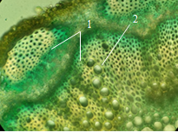
1-endogenous essential oil glands in the phloem, 2-xylem

Figure 13 - Cross section of the stem of Artemisia nitrosa Weber.
in methyl blue

A histochemical analysis was carried out for the content of essential oils and lactones of Artemisia leucodes Schrenk.
By the place of localization in the raw material, the containers are divided into two types: external (exogenous) and internal (endogenous). Result indicates the presence of essential oil in the endogenous essential oil glands, which are well expressed in the phloem parts of the stem (colored blue), which shows the highest localization in these parts of the plant (Figure 14).

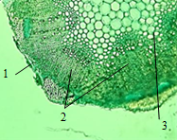 | 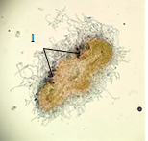 | 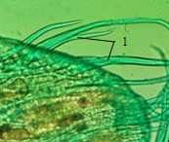
а | b | c
a) cross section of the stem: 1-epidermis, 2-conductive bundles, parenchyma core; b) cross section of the leaf: 1-localization of essential oils in the upper epidermis; c) longitudinal section of a flower bud: 1-trichomes

Figure 14 - Histochemical reaction on sections of aerial organs of Artemisia leucodes Schrenk. in methyl blue solution

Essential oil glands are also found in the sclerenchymal mechanical cells and in the epidermal covering cells of the leaf and stem of Artemisia leucodes Schrenk.
A solution of concentrated hydrochloric acid was used to identify lactones. As a result of the reaction, the epidermis and some parts of the conductive bundles of the stem turned yellow. The transverse section of the leaf revealed the localization of lactones in the lower epidermal mesophylls, and in the vascular bundles (Figure 15).
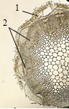 | 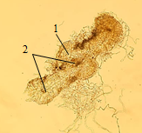
а | b
a) stem: 1-epidermis, 2-conductive bundles; b) sheet: 1-mesophyll, 2-conducting bundles

Figure 15 - Cross sections of stem and a leaf of Artemisia leucodes Schrenk. in concentrated hydrochloric acid

Gained result indicates a small presence of lactones in the stems and leaves of Artemisia leucodes Schrenk.
In inflorescences, lactones are located in the epidermal cells of the flower petals. In the longitudinal section of the bud, stained areas of the epidermis can be seen along the central vein (Figure 16).

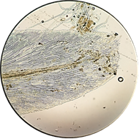

Figure 16 - Longitudinal section of a flower bud of Artemisia leucodes Schrenk. in concentrated hydrochloric acid

Artemisia pauciflora Weber. essential oils are localized in the phloem and xylem parts of the stem, in the lower epidermis of the leaf and in the pistil of the inflorescence. Sesquiterpene lactones are localized in greater quantities in the epidermis of the stem and in trichomes (Figure 17).

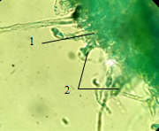 | 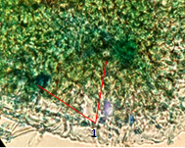
а | b
a) stem: 1-epidermis, 2-trichomes; b) leaf: 1- endogenous essential oil glands

Figure 17 - Histochemical reaction on sections of stem and a leaf
Artemisia pauciflora Weber. with methyl blue

On transverse sections of the stem of Artemisia terrae-albae Krasch. essential oils are localized in epidermal cells and trichomes (Figure 18, a). The presence of sesquiterpene lactones was detected in the trichomes of the stem, in the xylem and in the sclerenchymal tissues of the conducting bundle, in small amounts (Figure 18, b).

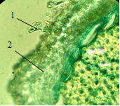 | 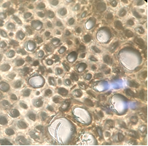
а | b
a) cross section of the stem in methyl blue: 1-trichomes, 2-epidermis; b) cross section of the stem in concentrated hydrochloric acid

Figure 18 - Histochemical reaction on sections of the stem of Artemisia terrae-albae Krasch.

Under the influence of methyl blue on the cross-section of the stem of Artemisia gracilescens Krasch. the epidermis and trichomes of the leaf on the cross section turned blue (Figure 19, a). Judging by the color, we can talk about the presence of essential oils in these areas of plants.
To determine the content of lactones and their localization sites, a solution of concentrated hydrochloric acid was used. Five minutes after immersing the leaf and stem sections of Artemisia gracilescens Krasch. into the solution, the sclerenchymal tissues of the leaf turned yellow (Figure 19 b).

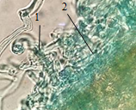 | 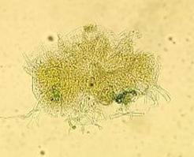
а | b
a) in methyl blue; 1-trichomes, 2-epidermis; b) in concentrated hydrochloric acid

Figure 19 - Cross section of a leaf of Artemisia gracilescens Krasch.

In Artemisia transiliensis Poljakov, after using methyl blue on the cross section of the stem, the epidermal cells turned blue, which indicates the presence of essential oil (Figure 20, a). Under the influence of concentrated hydrochloric acid on the cross section of the leaf, the mesophyll turned yellow, which indicates the presence of sesquiterpene lactones (Figure 20, b).

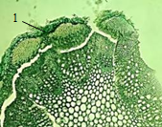 | 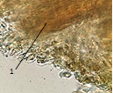
а | b
a) stem in methyl blue: 1-epidermis; b) leaf in concentrated hydrochloric acid: 1-mesophyll

Figure 20 - Cross sections of aerial organs of Artemisia transiliensis Poljakov

As a result of the carried out histochemical reactions in Artemisia kasakorum (Krash.) Pavl. it was found that the localization of essential oils is concentrated in trichomes, in conducting bundles, in mechanical tissues (sclerenchyma and collenchyme) of the stem and leaf (Figure 21, a, b). Sesquiterpene lactones are localized in the epidermal cells of the inflorescence and in the sclerenchymal tissues of the stem (Figure 21, c, d).

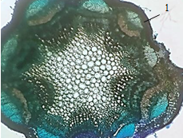  а | 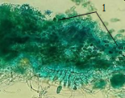  b
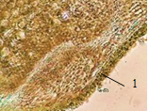  c | 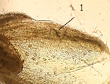  d
a) stem in methyl blue: 1-conducting bundles, 2-sclerenchyma; b) sheet in methyl blue: 1-mechanical fabrics; c) stem: 1-sclerenchyma; d) flower in concentrated hydrochloric acid: 1- epidermis

Figure 21 - Cross sections of aerial organs of Artemisia kasakorum (Krash.) Pavl

Cross sections of Artemisia karatavica Krasch. essential oils are localized in the epidermis, in the trichomes, in the vascular bundles and in the mechanical tissues of the leaf (Figure 22, a). Sesquiterpene lactones are localized in the sclerenchymal tissues of the leaf (Figure 22, b).
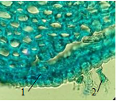 | 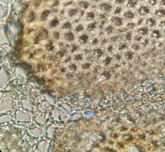
а | б
a) in methyl blue; 1-epidermis, 2-trichomes; b) in concentrated hydrochloric acid

Figure 22 - Cross sections of a leaf of Artemisia karatavica Krasch.

In Artemisia cina Berg ex Poljakov, essential oils are localized in the epidermis and phloem parts of the stem and leaf. A large amount of localization of essential oils is shown in the stem trichomes. On the transverse section of the leaf, essential oils are localized endogenously, in the mesophylls and the vascular bundle. Sesquiterpene lactones are abundant in the epidermis of the stem and in the leaf mesophyll (Figure 23).
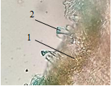 | 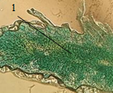
а | b
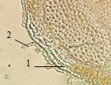 | 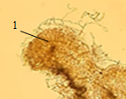
c | d
а) stem in methyl blue: 1-epidermis, 2-trichome; b) leaf in methyl blue: 1-phloem; c) the stem in concentrated hydrochloric acid: 1-mesophyll, 2-trichome; d) leaf in concentrated hydrochloric acid: 1-mesophyll

Figure 23 - Cross sections of aerial organs of Artemisia cina Berg ex Poljakov
As a result of the carried out histochemical reactions on the sections of the leaf, stem and inflorescence, the essential oils, sesquiterpene lactones were determined, and their localization sites were also established:
Artemisia schrenkiana Ledeb .:
- essential oils - in the epidermis of the stem;
- sesquiterpene lactones - in the mesophyll and upper epidermis of the leaf.
Artemisia nitrosa Weber.:
- essential oils - in the phloem, in the cambium, in the mechanical sclerenchymal tissues, in small quantities in the trichomes and mesophyll of the leaf;
- sesquiterpene lactones - in the xylem and epidermal cells of the stem, in the petals of the inflorescence.
Artemisia leucodes Schrenk.:
- essential oils - in the phloem of the stem, in the upper epidermis of the leaf, in the epidermal cells and trichomes of the inflorescence;
- sesquiterpene lactones - in the epidermis of the stem, in parts of the conducting bundle, in the xylem, in the epidermal cells of the inflorescence.
Artemisia pauciflora Weber .:
- essential oils - in the phloem and xylem parts of the stem, in the lower epidermis of the leaf.;
- sesquiterpene lactones - in greater quantities in the epidermis of the stem and in trichomes.
Artemisia terrae-albae Krasch .:
- essential oils - in epidermal cells, in the trichomes of the stem and leaf, in the vascular bundles of the leaf, in the epidermal cells of the inflorescence (in the petals);
- sesquiterpene lactones - in small quantities in the trichomes of the stem, in the xylem and in the sclerenchymal tissues of the conducting bundle.
Artemisia gracilescens Krasch.:
- essential oils - in epidermal cells, in leaf trichomes;
- sesquiterpene lactones - in the sclerenchymal tissues of the leaf.
Artemisia transiliensis Poljakov:
- essential oils - in the epidermis of the stem;
- sesquiterpene lactones - in the leaf mesophyll.
Artemisia kasakorum (Krash.) Pavl .:
- essential oils - in trichomes, in vascular bundles, in mechanical tissues (sclerenchyme and collenchyme) of the stem and leaf;
- sesquiterpene lactones - in the epidermal cells of the inflorescence and in the sclerenchymal tissues of the stem.
Artemisia karatavica Krasch.:
- essential oils - in the epidermis, in trichomes, in vascular bundles and in mechanical tissues of the leaf;
- sesquiterpene lactones - in the sclerenchymal tissues of the leaf.
Artemisia cina Berg ex Poljakov:
- essential oils - in the epidermis and phloem parts of the stem and leaf;
- sesquiterpene lactones - in large quantities in the epidermis of the stem and in the mesophyll of the leaf.
5 Pharmacognostic study and standardization of raw materials Populus balsamifera L.

A pharmacognostic study and standardization of Populus balsamifera L. raw material was carried out, and an analytical normative document " Populus balsamifera L., buds" was developed.
Populus balsamifera L. (balsam poplar) belongs to the willow family (Salicaceae). A plant is native to North America. In culture, it is widely distributed in the European part of Russia, as well as in Western Europe and Asia. In Kazakhstan, it is found in urban plantings of the city of Karaganda and in the East Kazakhstan region.
Based on the sum of extractive substances of the Populus balsamifera L. kidneys, a new antimicrobial, anti-inflammatory, anti-paradontosis agent is being developed at JSC IRPH Phytochemistry.
For the use of drugs in medicine, it is necessary to standardize medicinal plant materials.
Standardization of the buds of Populus balsamifera L. was carried out according to pharmacopoeial methods: determination of morphological groups, impurities, weight loss on drying, total ash, ash insoluble in 10% hydrochloric acid, microbiological purity, quantitative determination: high performance liquid chromatography (SPh RK I, Vol. 1).
To establish diagnostic characters, a macro- and microscopic examination of the buds of balsam poplar was carried out. Buds of Populus balsamifera L. are ovoid or elongated and conical, pointed or dull, sticky. The length of the buds is 1.2-2 cm, in diameter 0.3-0.6 cm. The scales are arranged in tiles, tightly pressed along the edges, sometimes somewhat lagging. The color of the buds is light brown, sometimes greenish. The smell is balsamic, pleasant. The taste is bitter, slightly astringent, resinous (Figure 25).

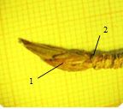 | 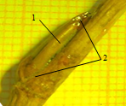
а | b
a) apical kidney; b) axillary bud 1-scale scales, 2-resin

Figure 25 - Appearance of the buds of Populus balsamifera L.

On the cross section of a young bud of Populus balsamifera L., the covering tissue is dense, the parenchyma consists of spongy tissue. Divided cavities can be seen above the phloem (Figure 26). The scales have simple unicellular hairs. The integumentary scales itself consists of cells not of the same shape, with dense walls (Figure 27).
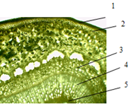
1-plug, 2-parenchyma of the primary cortex, 3-phloem, 4-sclerenchyma, 5-core

Figure 26 - Cross section of the stem of Populus balsamifera L.

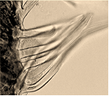 | 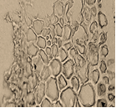
а | b
a) simple unicellular hairs;
b) a fragment of a transverse section of the integumentary scales

Figure 27 - Structural elements of kidney scales
Populus balsamifera L.

To identify flavonoids and tannins in the raw material, a qualitative reaction is carried out with appropriate reagents. 4.0 g of crushed raw material was boiled for 5 minutes with 20 ml of 96% alcohol and filtered. The resulting filtrate was used to identify the active ingredients (test solution).
To establish the presence of flavonoids, a cyanidine test was used, the test solution gradually turns red, and a solution of ammonium iron alum was used to detect tannins, the test solution exhibits a greenish-brown color.
In the trade analysis of the buds of Populus balsamifera L., the main indicators of its quality have been determined: impurities (no more than 2%), moisture content (no more than 10.0%), total ash (no more than 4.0%), ash insoluble in hydrochloric acid (no more 0.5%), microbiological purity (Raw materials must comply with the requirements of SPh RK I, vol. 1, 5.1.4, category 4 B. In 1 g of raw materials, the total number of viable aerobic microorganisms is allowed in quantity no more than 10⁵ bacteria, no more than 10⁴ fungi and no more than 10³ enterobacteriaceae. Escherichia coli and Salmonella are not allowed.). Raw materials must comply with the requirements of SanPiN No. 4.01.071.03: Cs-137 content (not less than 400 Bq/kg), Sr-90 content (not less than 200 Bq/kg).
The main indicator of the quality of medicinal plant materials is the content of the active substance in it. To determine the quantitative content of pinostrobin in the kidneys of Populus balsamifera L., a method of high performance liquid chromatography was proposed. Chromatographic conditions: a mixture of acetonitrile - water - glacial acetic acid (50: 49: 1, v / v) was used as a mobile phase; analysis time approximately 35 min; elution rate 1 ml / min at a wavelength of 289 nm. The content of pinostrobin in dry raw materials must be at least 0.1%.
To confirm the reliability of the method for quantitative determination of pinostrobin in raw materials, validation was performed according to the criteria of linearity, suitability of the chromatographic system, and reproducibility.
The criterion of linearity of the method was determined by analyzing by HPLC using a standard - pinostrobin, by taking individual weighed portions and preparing test solutions.
As a solution to determine the suitability of the chromatographic system, a solution of the MPRM of pinostrobin was used, containing the analyte in the medicinal product and making it possible to assess the suitability of the chromatographic system for carrying out the developed method for the quantitative determination of pinostrobin in the buds of balsam poplar.
The metrological characteristics of the results of the quantitative determination of pinostrobin in the raw material were calculated, which were evaluated according to the results of five repeated measurements, while the content of the active substance pinostrobin in the buds of balsam poplar is 1.92 ± 0.022% with a relative error of the average result of determining pinostrobin of 1.15% (table 4).

Table 4 - Metrological characteristics of the results of the quantitative determination of pinostrobin in the buds of balsam poplar
n | f |  | S² | S | S | P, % | t_{(p,f)} | Δ | ,%
5 | 4 | 1,92 | 0,000082 | 0,029 | 0,013 | 95 | 2,78 | 0,022 | 1,15

According to the validation characteristics, the method is specific for determining the content of pinostrobin in the buds of balsam poplar, which allows it to be used for a reliable assessment of the quantitative content of pinostrobin in raw materials.
The study of the stability of the buds of Populus balsamifera L. was carried out at a storage temperature not exceeding 30°C, relative humidity 25 ± 5%. The main parameters of indicators of quality of Populus balsamifera L. buds during storage were: description; impurities; moisture contents; total ash; ash, insoluble in hydrochloric acid; quantitative content of pinostrobin. Control of the main quality indicators was carried out every 6 months for 3 years.
During storage, the identified deviations in individual indicators do not exceed the permissible limits. Based on the results of the studies, the shelf life of balsam poplar buds was determined for 3 years.
Thus, a quality specification has been developed to standardize the buds of Populus balsamifera L. according to pharmacopoeial indicators, which allow characterizing the quality of raw materials. Anatomical and morphological diagnostic characters were identified, trade indicators were determined. A method has been developed for the quantitative determination of the active substance pinostrobin in the buds of Populus balsamifera L., which makes it possible to carry out quality control, guarantee the quality and constant composition of raw materials.
On the basis of pharmacopoeial indicators, a quality specification and an analytical normative document (AND) “Balsam poplar buds” were developed, which regulates the quality of raw materials (Appendix D, G).
The obtained data on the pharmacognostic study of the raw materials of the buds of Populus balsamifera L. are used for standardization and pharmaceutical development of phytopreparations based on them.

6 Identification of habitats, assessment of exploitable reserves and trade analysis of species of the genus Artemisia L. (subgenus Seriphidium (Bess.) Rouy.).

6.1 Identification of place of growth, assessment of exploitable reserves of Artemisia leucodes Schrenk.

The study of the resources of Artemisia leucodes Schrenk. (whitish wormwood) was carried out in the Moyinkum desert and the Malaysary tract in the Zhambyl region, in sands in the vicinity of the Kapchagai reservoir of the Almaty region. As a result of surveys, 3 massifs of whitish wormwood thickets were revealed: Moyynkum, Kapchagai, Malaysaryn.
In the Moyinkum massif, Artemisia leucodes Schrenk. grows in spots from 50 to 250 m², on the slopes of the northern exposure, on the tops of the dunes. Spots of whitish wormwood are confined to the slopes of dunes of the northern exposure and inter-barnian areas; on the slopes of the southern exposure, only single individuals are found. The species composition of vegetation is represented by 19-25 species. The total area of the massif is more than 600 hectares, of which 175 hectares are occupied by associations with the participation of whitish wormwood. The populations were found 53 km to the west of the Enbek village (Shu-Moyynkum highway), near Lake Beskatyn, Shuy region, and 12 km from the village of Tatty towards Sarykoba, Merken district, Zhambyl region.
The Kapchagai massif is located in the sands near the Kapchagai reservoir of the Ili district of the Almaty region. An area of thickets in this massif grows unevenly in separate spots along the tops, slopes, and less often the bases of the dunes. The thickets begin 2 km from the city of Kapchagai and stretch for 8-10 square meters towards the city of Almaty along the highway, leaving in narrow strips along the ridge-ridged sandy hills. The species composition of the vegetation of the Kapchagai massif is represented by 25-30 species. The total area of the massif was about 600 hectares, of which 150 hectares were occupied by wormwood communities. The density of the stock ranges from 0.9 to 1.1 c/ha. The volume of possible harvests of Artemisia leucodes Schrenk. is 7.1 tons.
The Malaysary massif is located in the northern part of the Kerbulak district of the Almaty region. Artemisia leucodes Schrenk. in this massif is found along the dune sands. The total area of the Malaysary massif is estimated at 120 hectares, of which wormwood associations occupy 62 hectares. The crop productivity ranged from 1.4 to 5.2 c/ha, the stock was 8.1 tons.
In the Moyinkum Desert, under conditions of an acute moisture deficit, there is a dependence of the density of vegetation growth, in general, and whitish wormwood, in particular, on the slope exposure. Whitish wormwood is found only on the eastern and northern slopes, on the southern slopes it is practically not found. In the sands of Kapchagai, Malaysary, in more favorable conditions of moisture, the growth of whitish wormwood is not associated with the exposure of the slope, but depends on the degree of sand fixation and disturbance of the vegetation cover. The area of thickets was 387 hectares, the total stock of raw materials was estimated at 41.7 tons, and the exploitable reserve was 16.6 tons.
The analysis of the quantitative content of leukomizin in Artemisia leucodes Schrenk was carried out depending on the place of growth (Table 5).

Table 5 - The content of leukomizin in Artemisia leucodes Schrenk. depending on the place of growth (for air-dry raw materials).

№ | Growing place | Phase | Leukomizin content, %
1 | Desert Moyynkum, Shuy district of Zhambyl region | Budding | 0,22
2 | Sands of the Kapchagai reservoir, Ili district of Almaty region | Budding | 0,10
3 | Sands of Malaysary, Kerbulak district of Almaty region | Budding | 0,05

The analysis of raw materials showed that in samples collected from different habitats, the quantitative yield of leukomizin differs significantly. Thus, in a sample collected in the vicinity of the Kapchagai reservoir, the content of leukomizin is 0.10%, and from the Moyinkum desert - 0.22%
Thus, the quantitative yield of leukomizin was noted in Artemisia leucodes Schrenk., growing in the Moyinkum desert (Shuisky district, Zhambyl region), and the Kapchagai and Malaysaryn thickets land are the most promising for the preparation of raw materials (Almaty region).

6.2 Trade analysis of species of the genus Artemisia L. (subgenus Seriphidium (Bess.) Rouy.)

Most of the plants of the flora of Kazakhstan are a source of biologically active substances, which can be considered as promising species for use in the production of medicines, while the raw material must meet all quality standards and requirements. One of these requirements is trade analysis, which determines the authenticity and quality of raw materials.
We have carried out a study for the authenticity and quality of the raw materials Artemisia schrenkiana Ledeb., Artemisia nitrosa Weber., Artemisia leucodes Schrenk., Artemisia pauciflora Weber., Artemisia terrae-albae Krasch., Artemisia gracilescens Krasch. & Iljin., Artemisia transiliensis Poljakov., Artemisia karatavica Krasch. & Abolin ex Poljakov, Artemisia cina Berg ex Poljakov, Artemisia kasakorum (Krash.) Pavl. according to the standard methods of the State Pharmacopoeia of the Republic of Kazakhstan: "Rules for the acceptance of medicinal plant materials and sampling methods", consisting of three stages: acceptance of raw materials, sampling, analysis of analytical samples.
Trade analysis was carried out according to the following pharmacopoeial indicators: determination of moisture content; determination of total ash content; determination of the ash content, insoluble in 10% hydrochloric acid; determination of crushing; determination of the degree of infestation of raw materials by barn pests. Results of testing the trade indicators of 10 plant species of the subgenus Seriphidium (Bess.) Rouy. are presented in Table 6.

Table 6 - Metrological characteristics of the results of the trade analysis of plants of 10 plant species of the subgenus Seriphidium (Bess.) Rouy.

Species | Trade analysis of plants
Species | Humidity,  % | Metrological characteristics | Ash,% | Metrological characteristics | Ash, not  soluble in HCl | Metrological characteristics
1 | 2 | 3 | 4 | 5 | 6 | 7
Artemisia schrenkiana Ledeb. | 7,61 | Х_{ср}=7,45  S=0,214  S_{х}=0,096  t(95%, f)=2,78  Δx=0,266 | 3,18 | Х_{ср}=3,352  S=0,168  S_{х}=0,075  t(95%, f)=2,78  Δx=0,209 | 2,08 | Х_{ср}=2,148  S=0,048  S_{х}=0,022  t(95%, f)=2,78  Δx=0,06
Artemisia schrenkiana Ledeb. | 7,12 | Х_{ср}=7,45  S=0,214  S_{х}=0,096  t(95%, f)=2,78  Δx=0,266 | 3,26 | Х_{ср}=3,352  S=0,168  S_{х}=0,075  t(95%, f)=2,78  Δx=0,209 | 2,18 | Х_{ср}=2,148  S=0,048  S_{х}=0,022  t(95%, f)=2,78  Δx=0,06
Artemisia schrenkiana Ledeb. | 7,38 | Х_{ср}=7,45  S=0,214  S_{х}=0,096  t(95%, f)=2,78  Δx=0,266 | 3,44 | Х_{ср}=3,352  S=0,168  S_{х}=0,075  t(95%, f)=2,78  Δx=0,209 | 2,12 | Х_{ср}=2,148  S=0,048  S_{х}=0,022  t(95%, f)=2,78  Δx=0,06
Artemisia schrenkiana Ledeb. | 7,46 | Х_{ср}=7,45  S=0,214  S_{х}=0,096  t(95%, f)=2,78  Δx=0,266 | 3,60 | Х_{ср}=3,352  S=0,168  S_{х}=0,075  t(95%, f)=2,78  Δx=0,209 | 2,20 | Х_{ср}=2,148  S=0,048  S_{х}=0,022  t(95%, f)=2,78  Δx=0,06
Artemisia schrenkiana Ledeb. | 7,66 | Х_{ср}=7,45  S=0,214  S_{х}=0,096  t(95%, f)=2,78  Δx=0,266 | 3,28 | Х_{ср}=3,352  S=0,168  S_{х}=0,075  t(95%, f)=2,78  Δx=0,209 | 2,16 | Х_{ср}=2,148  S=0,048  S_{х}=0,022  t(95%, f)=2,78  Δx=0,06
Artemisia nitrosa Weber. | 8,32 | Х_{ср}=8,516  S=0,200  S_{х}=0,089  t(95%, f)=2,78  Δx=0,248 | 4,92 | Х_{ср}=4,792  S=0,103  S_{х}=0,046  t(95%, f)=2,78  Δx=0,128 | 1,22 | Х_{ср}=1,248  S=0,099  S_{х}=0,045  t(95%, f)=2,78  Δx=0,124
Artemisia nitrosa Weber. | 8,46 | Х_{ср}=8,516  S=0,200  S_{х}=0,089  t(95%, f)=2,78  Δx=0,248 | 4,88 | Х_{ср}=4,792  S=0,103  S_{х}=0,046  t(95%, f)=2,78  Δx=0,128 | 1,18 | Х_{ср}=1,248  S=0,099  S_{х}=0,045  t(95%, f)=2,78  Δx=0,124
Artemisia nitrosa Weber. | 8,82 | Х_{ср}=8,516  S=0,200  S_{х}=0,089  t(95%, f)=2,78  Δx=0,248 | 4,74 | Х_{ср}=4,792  S=0,103  S_{х}=0,046  t(95%, f)=2,78  Δx=0,128 | 1,14 | Х_{ср}=1,248  S=0,099  S_{х}=0,045  t(95%, f)=2,78  Δx=0,124
Artemisia nitrosa Weber. | 8,38 | Х_{ср}=8,516  S=0,200  S_{х}=0,089  t(95%, f)=2,78  Δx=0,248 | 4,68 | Х_{ср}=4,792  S=0,103  S_{х}=0,046  t(95%, f)=2,78  Δx=0,128 | 1,38 | Х_{ср}=1,248  S=0,099  S_{х}=0,045  t(95%, f)=2,78  Δx=0,124
Artemisia nitrosa Weber. | 8,60 | Х_{ср}=8,516  S=0,200  S_{х}=0,089  t(95%, f)=2,78  Δx=0,248 | 4,74 | Х_{ср}=4,792  S=0,103  S_{х}=0,046  t(95%, f)=2,78  Δx=0,128 | 1,32 | Х_{ср}=1,248  S=0,099  S_{х}=0,045  t(95%, f)=2,78  Δx=0,124
Artemisia leucodes Schrenk. | 6,88 | Х_{ср}=6,432  S=0,360  S_{х}=0,161  t(95%, f)=2,78  Δx=0,448 | 5,42 | Х_{ср}=5,52  S=0,189  S_{х}=0,085  t(95%, f)=2,78  Δx=0,235 | 2,10 | Х_{ср}=2,1  S=0,076  S_{х}=0,034  t(95%, f)=2,78  Δx=0,095
Artemisia leucodes Schrenk. | 6,76 | Х_{ср}=6,432  S=0,360  S_{х}=0,161  t(95%, f)=2,78  Δx=0,448 | 5,68 | Х_{ср}=5,52  S=0,189  S_{х}=0,085  t(95%, f)=2,78  Δx=0,235 | 2,14 | Х_{ср}=2,1  S=0,076  S_{х}=0,034  t(95%, f)=2,78  Δx=0,095
Artemisia leucodes Schrenk. | 6,18 | Х_{ср}=6,432  S=0,360  S_{х}=0,161  t(95%, f)=2,78  Δx=0,448 | 5,74 | Х_{ср}=5,52  S=0,189  S_{х}=0,085  t(95%, f)=2,78  Δx=0,235 | 2,06 | Х_{ср}=2,1  S=0,076  S_{х}=0,034  t(95%, f)=2,78  Δx=0,095
Artemisia leucodes Schrenk. | 6,10 | Х_{ср}=6,432  S=0,360  S_{х}=0,161  t(95%, f)=2,78  Δx=0,448 | 5,28 | Х_{ср}=5,52  S=0,189  S_{х}=0,085  t(95%, f)=2,78  Δx=0,235 | 2,00 | Х_{ср}=2,1  S=0,076  S_{х}=0,034  t(95%, f)=2,78  Δx=0,095
Artemisia leucodes Schrenk. | 6,24 | Х_{ср}=6,432  S=0,360  S_{х}=0,161  t(95%, f)=2,78  Δx=0,448 | 5,48 | Х_{ср}=5,52  S=0,189  S_{х}=0,085  t(95%, f)=2,78  Δx=0,235 | 2,20 | Х_{ср}=2,1  S=0,076  S_{х}=0,034  t(95%, f)=2,78  Δx=0,095
Artemisia pauciflora Weber. | 9,12 | Х_{ср}=9,344  S=0,189  S_{х}=0,085  t(95%, f)=2,78  Δx=0,236 | 4,38 | Х_{ср}=4,56  S=0,258  S_{х}=0,115  t(95%, f)=2,78  Δx=0,3204 | 0,96 | Х_{ср}=0,956  S=0,048  S_{х}=0,021  t(95%, f)=2,78  Δx=0,059
Artemisia pauciflora Weber. | 9,20 | Х_{ср}=9,344  S=0,189  S_{х}=0,085  t(95%, f)=2,78  Δx=0,236 | 4,60 | Х_{ср}=4,56  S=0,258  S_{х}=0,115  t(95%, f)=2,78  Δx=0,3204 | 0,90 | Х_{ср}=0,956  S=0,048  S_{х}=0,021  t(95%, f)=2,78  Δx=0,059
Artemisia pauciflora Weber. | 9,42 | Х_{ср}=9,344  S=0,189  S_{х}=0,085  t(95%, f)=2,78  Δx=0,236 | 4,82 | Х_{ср}=4,56  S=0,258  S_{х}=0,115  t(95%, f)=2,78  Δx=0,3204 | 0,92 | Х_{ср}=0,956  S=0,048  S_{х}=0,021  t(95%, f)=2,78  Δx=0,059
Artemisia pauciflora Weber. | 9,38 | Х_{ср}=9,344  S=0,189  S_{х}=0,085  t(95%, f)=2,78  Δx=0,236 | 4,78 | Х_{ср}=4,56  S=0,258  S_{х}=0,115  t(95%, f)=2,78  Δx=0,3204 | 0,98 | Х_{ср}=0,956  S=0,048  S_{х}=0,021  t(95%, f)=2,78  Δx=0,059
Artemisia pauciflora Weber. | 9,60 | Х_{ср}=9,344  S=0,189  S_{х}=0,085  t(95%, f)=2,78  Δx=0,236 | 4,22 | Х_{ср}=4,56  S=0,258  S_{х}=0,115  t(95%, f)=2,78  Δx=0,3204 | 1,02 | Х_{ср}=0,956  S=0,048  S_{х}=0,021  t(95%, f)=2,78  Δx=0,059
Artemisia terrae-albae Krasch. | 8,24 | Х_{ср}=8,40  S=0,177  S_{х}=0,079  t(95%, f)=2,78  Δx=0,220 | 3,80 | Х_{ср}=3,708  S=0,176  S_{х}=0,079  t(95%, f)=2,78  Δx=0,219 | 0,86 | Х_{ср}=0,888  S=0,064  S_{х}=0,029  t(95%, f)=2,78  Δx=0,080
Artemisia terrae-albae Krasch. | 8,20 | Х_{ср}=8,40  S=0,177  S_{х}=0,079  t(95%, f)=2,78  Δx=0,220 | 3,68 | Х_{ср}=3,708  S=0,176  S_{х}=0,079  t(95%, f)=2,78  Δx=0,219 | 0,94 | Х_{ср}=0,888  S=0,064  S_{х}=0,029  t(95%, f)=2,78  Δx=0,080
Artemisia terrae-albae Krasch. | 8,42 | Х_{ср}=8,40  S=0,177  S_{х}=0,079  t(95%, f)=2,78  Δx=0,220 | 3,42 | Х_{ср}=3,708  S=0,176  S_{х}=0,079  t(95%, f)=2,78  Δx=0,219 | 0,88 | Х_{ср}=0,888  S=0,064  S_{х}=0,029  t(95%, f)=2,78  Δx=0,080
Artemisia terrae-albae Krasch. | 8,54 | Х_{ср}=8,40  S=0,177  S_{х}=0,079  t(95%, f)=2,78  Δx=0,220 | 3,76 | Х_{ср}=3,708  S=0,176  S_{х}=0,079  t(95%, f)=2,78  Δx=0,219 | 0,80 | Х_{ср}=0,888  S=0,064  S_{х}=0,029  t(95%, f)=2,78  Δx=0,080
Artemisia terrae-albae Krasch. | 8,60 | Х_{ср}=8,40  S=0,177  S_{х}=0,079  t(95%, f)=2,78  Δx=0,220 | 3,88 | Х_{ср}=3,708  S=0,176  S_{х}=0,079  t(95%, f)=2,78  Δx=0,219 | 0,96 | Х_{ср}=0,888  S=0,064  S_{х}=0,029  t(95%, f)=2,78  Δx=0,080
Artemisia gracilescens Krasch. & Iljin. | 7,40 | Х_{ср}=7,42  S=0,180  S_{х}=0,081  t(95%, f)=2,78  Δx=0,224 | 4,04 | Хср=4,108  S=0,052  Sх=0,023  t(95%, f)=2,78  Δx=0,065 | 1,04 | Х_{ср}=1,108  S=0,048  S_{х}=0,022  t(95%, f)=2,78  Δx=0,060
Artemisia gracilescens Krasch. & Iljin. | 7,18 | Х_{ср}=7,42  S=0,180  S_{х}=0,081  t(95%, f)=2,78  Δx=0,224 | 4,12 | Хср=4,108  S=0,052  Sх=0,023  t(95%, f)=2,78  Δx=0,065 | 1,16 | Х_{ср}=1,108  S=0,048  S_{х}=0,022  t(95%, f)=2,78  Δx=0,060
Artemisia gracilescens Krasch. & Iljin. | 7,62 | Х_{ср}=7,42  S=0,180  S_{х}=0,081  t(95%, f)=2,78  Δx=0,224 | 4,08 | Хср=4,108  S=0,052  Sх=0,023  t(95%, f)=2,78  Δx=0,065 | 1,08 | Х_{ср}=1,108  S=0,048  S_{х}=0,022  t(95%, f)=2,78  Δx=0,060
Artemisia gracilescens Krasch. & Iljin. | 7,34 | Х_{ср}=7,42  S=0,180  S_{х}=0,081  t(95%, f)=2,78  Δx=0,224 | 4,12 | Хср=4,108  S=0,052  Sх=0,023  t(95%, f)=2,78  Δx=0,065 | 1,12 | Х_{ср}=1,108  S=0,048  S_{х}=0,022  t(95%, f)=2,78  Δx=0,060
Artemisia gracilescens Krasch. & Iljin. | 7,58 | Х_{ср}=7,42  S=0,180  S_{х}=0,081  t(95%, f)=2,78  Δx=0,224 | 4,18 | Хср=4,108  S=0,052  Sх=0,023  t(95%, f)=2,78  Δx=0,065 | 1,14 | Х_{ср}=1,108  S=0,048  S_{х}=0,022  t(95%, f)=2,78  Δx=0,060
Artemisia transiliensis Poljakov. | 8,36 | Х_{ср}=8,6  S=0,179  S_{х}=0,08  t(95%, f)=2,78  Δx=0,222 | 5,46 | Х_{ср}=5,396  S=0,192  S_{х}=0,086  t(95%, f)=2,78  Δx=0,238 | 2,28 | Х_{ср}=2,264  S=0,046  S_{х}=0,020  t(95%, )=2,78  Δx=0,057
Artemisia transiliensis Poljakov. | 8,48 | Х_{ср}=8,6  S=0,179  S_{х}=0,08  t(95%, f)=2,78  Δx=0,222 | 5,12 | Х_{ср}=5,396  S=0,192  S_{х}=0,086  t(95%, f)=2,78  Δx=0,238 | 2,20 | Х_{ср}=2,264  S=0,046  S_{х}=0,020  t(95%, )=2,78  Δx=0,057
Artemisia transiliensis Poljakov. | 8,64 | Х_{ср}=8,6  S=0,179  S_{х}=0,08  t(95%, f)=2,78  Δx=0,222 | 5,30 | Х_{ср}=5,396  S=0,192  S_{х}=0,086  t(95%, f)=2,78  Δx=0,238 | 2,32 | Х_{ср}=2,264  S=0,046  S_{х}=0,020  t(95%, )=2,78  Δx=0,057
Artemisia transiliensis Poljakov. | 8,80 | Х_{ср}=8,6  S=0,179  S_{х}=0,08  t(95%, f)=2,78  Δx=0,222 | 5,48 | Х_{ср}=5,396  S=0,192  S_{х}=0,086  t(95%, f)=2,78  Δx=0,238 | 2,28 | Х_{ср}=2,264  S=0,046  S_{х}=0,020  t(95%, )=2,78  Δx=0,057
Artemisia transiliensis Poljakov. | 8,72 | Х_{ср}=8,6  S=0,179  S_{х}=0,08  t(95%, f)=2,78  Δx=0,222 | 5,62 | Х_{ср}=5,396  S=0,192  S_{х}=0,086  t(95%, f)=2,78  Δx=0,238 | 2,24 | Х_{ср}=2,264  S=0,046  S_{х}=0,020  t(95%, )=2,78  Δx=0,057
Artemisia karatavica Krasch. & Abolin ex Poljakov | 7,42 | Х_{ср}=7,548  S=0,200  S_{х}=0,089  t(95%, f)=2,78  Δx=0,249 | 4,60 | Х_{ср}=4,416  S=0,176  S_{х}=0,079  t(95%, f)=2,78  Δx=0,219 | 1,52 | Х_{ср}=1,568  S=0,070  S_{х}=0,031  t(95%, f)=2,78  Δx=0,087
Artemisia karatavica Krasch. & Abolin ex Poljakov | 7,86 | Х_{ср}=7,548  S=0,200  S_{х}=0,089  t(95%, f)=2,78  Δx=0,249 | 4,16 | Х_{ср}=4,416  S=0,176  S_{х}=0,079  t(95%, f)=2,78  Δx=0,219 | 1,60 | Х_{ср}=1,568  S=0,070  S_{х}=0,031  t(95%, f)=2,78  Δx=0,087
Artemisia karatavica Krasch. & Abolin ex Poljakov | 7,34 | Х_{ср}=7,548  S=0,200  S_{х}=0,089  t(95%, f)=2,78  Δx=0,249 | 4,32 | Х_{ср}=4,416  S=0,176  S_{х}=0,079  t(95%, f)=2,78  Δx=0,219 | 1,66 | Х_{ср}=1,568  S=0,070  S_{х}=0,031  t(95%, f)=2,78  Δx=0,087
Artemisia karatavica Krasch. & Abolin ex Poljakov | 7,60 | Х_{ср}=7,548  S=0,200  S_{х}=0,089  t(95%, f)=2,78  Δx=0,249 | 4,48 | Х_{ср}=4,416  S=0,176  S_{х}=0,079  t(95%, f)=2,78  Δx=0,219 | 1,58 | Х_{ср}=1,568  S=0,070  S_{х}=0,031  t(95%, f)=2,78  Δx=0,087
Artemisia karatavica Krasch. & Abolin ex Poljakov | 7,52 | Х_{ср}=7,548  S=0,200  S_{х}=0,089  t(95%, f)=2,78  Δx=0,249 | 4,52 | Х_{ср}=4,416  S=0,176  S_{х}=0,079  t(95%, f)=2,78  Δx=0,219 | 1,48 | Х_{ср}=1,568  S=0,070  S_{х}=0,031  t(95%, f)=2,78  Δx=0,087
Artemisia cina Berg ex Poljakov | 9,10 | Х_{ср}=9,36  S=0,198  S_{х}=0,089  t(95%, f)=2,78  Δx=0,247 | 3,40 | Х_{ср}=3,436  S=0,135  S_{х}=0,060  t(95%, f)=2,78  Δx=0,167 | 1,08 | Х_{ср}=1,252  S=0,109  S_{х}=0,049  t(95%, f)=2,78  Δx=0,136
Artemisia cina Berg ex Poljakov | 9,28 | Х_{ср}=9,36  S=0,198  S_{х}=0,089  t(95%, f)=2,78  Δx=0,247 | 3,36 | Х_{ср}=3,436  S=0,135  S_{х}=0,060  t(95%, f)=2,78  Δx=0,167 | 1,22 | Х_{ср}=1,252  S=0,109  S_{х}=0,049  t(95%, f)=2,78  Δx=0,136
Artemisia cina Berg ex Poljakov | 9,32 | Х_{ср}=9,36  S=0,198  S_{х}=0,089  t(95%, f)=2,78  Δx=0,247 | 3,28 | Х_{ср}=3,436  S=0,135  S_{х}=0,060  t(95%, f)=2,78  Δx=0,167 | 1,32 | Х_{ср}=1,252  S=0,109  S_{х}=0,049  t(95%, f)=2,78  Δx=0,136
Artemisia cina Berg ex Poljakov | 9,62 | Х_{ср}=9,36  S=0,198  S_{х}=0,089  t(95%, f)=2,78  Δx=0,247 | 3,62 | Х_{ср}=3,436  S=0,135  S_{х}=0,060  t(95%, f)=2,78  Δx=0,167 | 1,28 | Х_{ср}=1,252  S=0,109  S_{х}=0,049  t(95%, f)=2,78  Δx=0,136
Artemisia cina Berg ex Poljakov | 9,48 | Х_{ср}=9,36  S=0,198  S_{х}=0,089  t(95%, f)=2,78  Δx=0,247 | 3,52 | Х_{ср}=3,436  S=0,135  S_{х}=0,060  t(95%, f)=2,78  Δx=0,167 | 1,36 | Х_{ср}=1,252  S=0,109  S_{х}=0,049  t(95%, f)=2,78  Δx=0,136
Artemisia kasakorum (Krash.) Pavl. | 9,38 | Х_{ср}=9,492  S=0,183  S_{х}=0,082  t(95%, f)=2,78  Δx=0,228 | 4,02 | Х_{ср}=4,176  S=0,108  S_{х}=0,048  t(95%, f)=2,78  Δx=0,133 | 2,32 | Х_{ср}=2,22  S=0,08  S_{х}=0,036  t(95%, f)=2,78  Δx=0,099
Artemisia kasakorum (Krash.) Pavl. | 9,60 | Х_{ср}=9,492  S=0,183  S_{х}=0,082  t(95%, f)=2,78  Δx=0,228 | 4,16 | Х_{ср}=4,176  S=0,108  S_{х}=0,048  t(95%, f)=2,78  Δx=0,133 | 2,28 | Х_{ср}=2,22  S=0,08  S_{х}=0,036  t(95%, f)=2,78  Δx=0,099
Artemisia kasakorum (Krash.) Pavl. | 9,40 | Х_{ср}=9,492  S=0,183  S_{х}=0,082  t(95%, f)=2,78  Δx=0,228 | 4,20 | Х_{ср}=4,176  S=0,108  S_{х}=0,048  t(95%, f)=2,78  Δx=0,133 | 2,12 | Х_{ср}=2,22  S=0,08  S_{х}=0,036  t(95%, f)=2,78  Δx=0,099
Artemisia kasakorum (Krash.) Pavl. | 9,32 | Х_{ср}=9,492  S=0,183  S_{х}=0,082  t(95%, f)=2,78  Δx=0,228 | 4,18 | Х_{ср}=4,176  S=0,108  S_{х}=0,048  t(95%, f)=2,78  Δx=0,133 | 2,18 | Х_{ср}=2,22  S=0,08  S_{х}=0,036  t(95%, f)=2,78  Δx=0,099
Artemisia kasakorum (Krash.) Pavl. | 9,76 | Х_{ср}=9,492  S=0,183  S_{х}=0,082  t(95%, f)=2,78  Δx=0,228 | 4,32 | Х_{ср}=4,176  S=0,108  S_{х}=0,048  t(95%, f)=2,78  Δx=0,133 | 2,20 | Х_{ср}=2,22  S=0,08  S_{х}=0,036  t(95%, f)=2,78  Δx=0,099

Some trade research indicators of 10 species of plants of the subgenus Seriphidium (Bess.) Rouy have been determined: humidity (6.43-9.36%); total ash (3.35-5.52%); ash, insoluble in 10% hydrochloric acid solution (0.88-2.26%).
The analysis of microelement composition of plants of the subgenus Seriphidium (Bess.) Rouy was carried out (Table 7).
The identified insignificant differences in the content of certain elements can be explained by different conditions of plant growth (mineral composition of soils, the level of technogenic load, etc.). According to the composition of microelements of the investigated objects, it can be determined as a fairly safe and environmentally friendly raw material [34].
Thus, the good quality of plant raw materials was determined, trade research parameters were established and the quantitative content of trace elements in 10 species of plants of the subgenus Seriphidium (Bess.) Rouy. was studied. The obtained numerical indicators of the studied species can be used in the development of quality standards and the preparation of regulatory documents for raw materials.

Table 7 - The quantitative content of microelements in plants of 10 plant species of the subgenus Seriphidium (Bess.) Rouy.
Name of objects | Artemisia schrenkiana Ledeb. | Artemisia nitrosa Weber. | Artemisia leucodes Schrenk. | Artemisia pauciflora Weber. | Artemisia terrae-albae Krasch. | Artemisia gracilescens Krasch. & Iljin. | Artemisia transiliensis Poljakov. | Artemisia karatavica Krasch. & Abolin ex Poljakov | Artemisia cina Berg ex Poljakov | Artemisia kasakorum (Krash.) Pavl.
Micro and macronutrients | mg/kg | mg/kg | mg/kg | mg/kg | mg/kg | mg/kg | mg/kg | mg/kg | mg/kg | mg/kg
Phosphorus (P) | <700 | <1000 | <800 | <1000 | <700 | <900 | <1000 | <800 | <1000 | <700
Barium (VA) | <500 | <400 | 450 | <600 | <400 | <550 | <600 | <700 | <450 | <800
Boron (B) | <600 | <500 | 400 | <400 | <600 | <500 | <400 | <600 | <400 | <500
Beryllium (Be) | 0,6 | <0,7 | 0,4 | <0,5 | <0,7 | 0,4 | 0,5 | 0,6 | 0,4 | 0,6
Tungsten (W) | <7 | <4 | < 6 | < 5 | <5 | < 4 | < 5 | <5 | <8 | < 4
Bismuth (Bi) | <2 | <3 | < 2 | < 2 | <4 | < 2 | < 3 | <3 | <3 | < 2
Vanadium (V) | <4 | <5 | <15 | <10 | <4 | <20 | <5 | <10 | <5 | <15
Cobalt (Co) | <3 | <1 | <2 | <3 | <2 | <2 | <3 | <3 | <2 | <1
Cadmium (Cd) | <4 | <8 | <3 | < 4 | <7 | < 5 | < 4 | <5 | <8 | < 3
Lithium (Li) | <10 | <6 | <5 | <10 | <20 | <8 | <10 | <20 | <6 | <15
Copper (Cu) | <60 | <50 | <50 | <50 | <50 | <70 | <50 | <80 | <70 | <50
Manganese (Mn) | <600 | <500 | <700 | <900 | <500 | <600 | <800 | <700 | <500 | <900
Molybdenum (Mo) | <8 | <3 | <7 | <5 | <5 | <8 | <7 | <6 | <8 | <5
Nickel (Ni) | <6 | <4 | <6 | <8 | <7 | <6 | <8 | <5 | <7 | <7
Scandium (Sc) | <4 | <4 | <4 | <3 | <5 | < 7 | <3 | <6 | <6 | <4
Antimony (Sb) | <20 | <15 | < 25 | < 15 | <15 | < 20 | < 25 | <25 | <20 | < 15
Strontium (Sr) | <500 | <400 | 300 | <600 | <500 | <500 | <400 | <500 | <500 | <600
Silver (Ag) | <0,5 | <0,7 | <0,7 | <0,4 | <0,8 | <0,5 | <0,7 | <0,6 | <0,7 | <0,5
Lead (Pb) | <40 | <15 | 15 | <30 | <20 | <20 | <30 | <30 | <15 | <4
Tin (Sn) | <4 | <3 | <6 | <3 | <5 | <4 | <6 | <3 | <3 | <6
Titanium (Ti | <500 | <300 | <400 | <600 | <400 | <400 | <400 | <500 | <300 | <400
Chromium (Cr) | <30 | <30 | <10 | <20 | <15 | <20 | <20 | <30 | <30 | <20
Zirconium (Zr) | <50 | <30 | <50 | <20 | <20 | <40 | <40 | <30 | <40 | <50
Zinc (Zn) | <150 | <100 | <70 | <60 | <100 | <150 | <200 | <150 | <200 | <100
Germanium (Ge) | <1 | <1 | < 2 | <1 | <1,5 | < 1 | <2 | <2 | <1,5 | < 1

7. Chemical study of species of the genus Artemisia L. and determination of chemotaxonomic markers

Subgenus of Seriphidium (Bess.) Rouy. widespread in the eastern and western hemispheres, out of 41 chemically studied species, 37 have sesquiterpene lactones. Among the studied species of this subgenus, α-santonin is the most common sesquiterpene lactone in Central Asian species. In wormwoods of the subgenus Seriphidium (Bess.) Rouy. mainly contains sesquiterpene lactones of the eudesmanic type, however, in Artemisia porrecta Krasch. ex Poljakov, Artemisia cana Pursh., Artemisia juncea Kar. et Kir., Artemisia lercheana Web., Artemisia tridentate Nutt. sesquiterpene lactones of the germacrane type were found [35].
For determination of chemotaxonomic markers of 10 species of wormwood of the subgenus Seriphidium (Bess.) Rouy. extraction with organic solvents was carried out with heating. The resulting sums of extractives were chromatographed on a silica gel column at an extract - sorbent ratio (1:15). The column was eluted with petroleum ether followed by an increase in its polarity. The structure of the isolated sesquiterpene lactones was established on the basis of literature data and IR-, UV-, NMR ¹H, ¹³C-spectra, two-dimensional NMR ¹H-¹H, ¹³C-¹H spectroscopy (COZY, COLOC).
From Artemisia schrenkiana Ledeb., Artemisia nitrosa Weber., Artemisia pauciflora Weber., Artemisia terrae-albae Krasch., Artemisia gracilescens Krasch. & Iljin., Artemisia transiliensis Poljakov., Artemisia karatavica Krasch. & Abolin ex Poljakov, Artemisia cina Berg ex Poljakov, Artemisia kasakorum (Krash.) Pavl. sesquiterpene lactones α-sanotin (9), β-santonin (10), nitrosine (12), artemin (11), artepaulin (13), artemisin (14), gratsilin (15), argracin (16), tauremizin (10 ) were isolated.
(10) |  | (12) |  | (13)
(14) |  | (15) |  | (16)
Out of the ten studied species of wormwood of the subgenus Seriphidium (Bess.) Rouy. α-santonin was found only in nine species, with the exception of Artemisia leucodes Schrenk. from which sesquiterpene lactones of the guaian type were isolated: leukomizin (17), matricarin (18), 5β (H) -austricin (19), anhydroaustricin (20), grossmizin (21).
38
(17) R=H,  (18) R=OCOCH₃ | (19) | (20) | (21)

In turn, according to the literature data Artemisia leucodes Schrenk. contains sesquiterpene lactones of the guaian type [33]. As it can be seen, Artemisia leucodes Schrenk. differs significantly by the composition of sesquiterpene lactones from other species of wormwood of the subgenus Seriphidium (Bess.) Rouy., which are characterized by the presence of sesquiterpene lactones with an eudesmane carbon backbone.
It is important to note that in the Junceum Poljak. of the subgenus Seriphidium (Bess.) Rouy., in addition to Artemisia leucodes Schrenk., there are Artemisia juncea Kar. et Kir. and Artemisia deserti Krash., in which guaianolides are found. Moreover, the species of the subgenus Seriphidium (Bess.) Rouy. are mainly characterized by eudesmanolides. While sesquiterpene lactones of the guaian type are characteristic of the species of the section Artemisia L. of the subgenus Artemisia L. and therefore the section Junceum Poljak. may be closely related to the subgenus Artemisia L. [36].
According to the results of phylogenetic studies carried out by J. Valles et al. [37], Artemisia leucodes Schrenk. is outside the subgenus Seriphidium (Bess.) Rouy., included in the Junceum Poljakov section. Researchers [38] carried out a phylogenetic reconstruction and determined that Artemisia juncea and Artemisia leucodes Schrenk. are evolutionarily closer to each other, and Artemisia deserti is their related species and suggest that Artemisia leucodes Schrenk., Artemisia juncea and Artemisia deserti should be excluded from Seriphidium (Bess.) Rouy. into a separate subgenus.
Thus, based on the data obtained on the chemical composition of 10 species of wormwood of the subgenus Seriphidium (Bess.) Rouy., It can be concluded that the composition of sesquiterpene lactones in the species of the genus Artemisia L. indicates a close relationship between the subgenus Seriphidium (Bess.) Rouy. and Artemisia L. Their chemotaxonomic relationship is based on the presence in plants of the indicated subgenera of sesquiterpene lactones of three main structural types: germacranolides, eudesmanolides, guaianolides.
Literature data have shown that 1,8-cineole, beta-pinene, thujone, Artemisia ketone, camphor, caryophyllene, camphene, and germacrene D are the main components of most essential oils of the genus Artemisia L. [39].
Earlier, the authors [40-42] carried out a chemical study for the content of essential oils of plants of the subgenus Seriphidium (Bess.) Rouy., Artemisia karatavica Krasch. & Abolin ex Poljakov, Artemisia pauciflora Weber., Artemisia terrae-albae Krasch., Artemisia karatavica Krasch. & Abolin ex Poljakov, Artemisia cina Berg ex Poljakov, Artemisia karatavica Krasch. & Abolin ex Poljakov. The results of the study showed that the studied species are similar in the qualitative composition of the main components of camphor and 1,8-cineole.
To identify the relationship between the component composition of essential oils and the species of wormwood Artemisia schrenkiana Ledeb., Artemisia nitrosa Weber., Artemisia leucodes Schrenk., Artemisia pauciflora Weber., Artemisia terrae-albae Krasch., Artemisia gracilescensch. & Iljin., Artemisia transiliensis Poljakov., Artemisia karatavica Krasch. & Abolin ex Poljakov, Artemisia cina Berg ex Poljakov, Artemisia kasakorum (Krash.) Pavl. the essential oil was extracted by hydrodistillation on a Clevenger apparatus for 2 hours and the composition was analyzed by gas chromatography-mass spectrometry on a gas chromatograph with an Agilent 7890 / 5975C mass-selective detector.
Essential oils are mobile liquids with a specific odor, the yields of which are 0.08-0.51% in terms of air-dry materials. In the isolated essential oils of the studied plants, the following main components (in %) were identified by gas chromatography-mass spectrometry: 1,8-cineole (23.9-70.9), camphor (25.8-66.0), terpinen-4-ol (0.4-5.4), camphene (5.0-9.8), α-thujone (5.3-6.0).
It should be noted that essential oils of 10 types of wormwood are similar in their component composition, however, they differ in the qualitative content of components. Essential oils contain significant amounts of bicyclic monoterpenoids.
The quantitative content of 1,8-cineole and camphor in essential oils is observed in Artemisia schrenkiana Ledeb., Artemisia nitrosa Weber., Artemisia leucodes Schrenk., Artemisia terrae-albae Krasch., Artemisia transiliensis Poljakov., Artemisia pauciflora Artemis. cina Berg ex Poljakov., Artemisia karatavica Krasch. & Abolin ex Poljakov, Artemisia kasakorum (Krash.) Pavl., Artemisia gracilescens Krasch. & Iljin. 1,8-cineole prevails.
Thus, it was found that chemotaxonomic markers of the essential oil components of wormwood of the subgenus Seriphidium (Bess.) Rouy. are 1,8-cineole (3) and camphor (2), the quantitative content of which fluctuates up to 70.9 and 66.0%, respectively.

8 Normative documentation for medicinal raw materials Populus balsamifera L.

The quality of medicinal plant raw materials depends on quality control, the analysis methods used and the requirements set forth in the regulatory documents for medicinal raw materials.
In connection with the development of a new antimicrobial, anti-inflammatory, anti-paradontosis drug based on the sum of extractive substances of the Populus balsamifera L. buds it is necessary to assess the safety and quality of medicinal raw materials.
To submit regulatory documents to the National Center for Expertise of Medicines of the Ministry of Health of the Republic of Kazakhstan, a registration dossier has been developed on the general requirements for medicinal raw materials Populus balsamifera L.
According to the "Instructions for the collection and drying of herbs", harvesting is carried out before budding (March-April) of the buds, since during this period the greatest amount of biologically active substances accumulates.
Based on the pharmacognostic study of the medicinal raw material Populus balsamifera L., a quality specification has been developed based on the results of analyzes of 3 batches of raw materials in accordance with the requirements of the SP RK. The quality specification includes pharmacopoeial indicators: a description of the external signs of raw materials; microscopy to determine the diagnostic signs of balsam poplar buds; a qualitative reaction to the determination of flavonoids in raw materials; microbiological purity; quantitative determination of pinostrobin in the raw material was carried out by HPLC; foreign impurities; total ash; ash, insoluble in 10% hydrochloric acid; loss in mass on drying. These indicators are included in the analytical regulatory document (Appendix D, G).
This review has developed a registration dossier for state registration of balsam poplar buds.
The registration dossier includes: Analytical regulatory document for medicinal raw materials " Populus balsamifera L., buds"; explanatory note to the analytical regulatory document; validation of test methods for medicinal raw materials; stability test results for at least 3 series; labeling text for raw materials packaging.
In accordance with the approved procedure for the examination of medicinal products, acceptance of incoming documents and materials for examination within the framework of state registration, the registration dossier for raw material " Populus balsamifera L., buds" is submitted to the NCEM MH RK (outgoing letter No. 42 dated May 11, 2020, input . No. 14584-OZ dated May 13, 2020, NCEM MH RK).

CONCLUSION

As a result of the analysis of literature data on the project "Pharmacognostic studies of plants and chemosystematics of taxons of the family Asteraceae" (state registration number 0118RK00013), it can be concluded that there is no duplication, it can be confirmed the presence of novelty, in particular, on anatomical and morphological studies, histochemical study of 7 species plants of the genus Saussurea DC. and 21 plant species of the genus Artemisia Less.
When implementing this project in accordance with the action plan for 2018-2020, the following results were obtained:
1) Anatomical, morphological, histochemical and chemical studies of 7 plant species of the genus Saussurea DC were carried out.
Based on anatomical and morphological analysis of 7 plant species of the genus Saussurea DC. distinctive features are defined: stems are straight, ribbed-angular. The leaves are alternate, almost entire, unequally notched-toothed. Baskets are bell-shaped or cylindrical, mostly small, numerous, collected in shields. Anatomy: sclerenchyma is recyclical, located above the vascular bundles, stomata are single, surrounded by 3-7 cells, glandular trichomes are single or multicellular, mainly on the lower side of the leaf.
For the first time, a histochemical analysis was carried out to detect secondary metabolites in leaves and flowers in the studied plant species of the genus Saussurea DC. The localization of sesquiterpene lactones and flavonoids was identified.
2) For the first time, a comparative analysis of anatomical, morphological and diagnostic features, as well as the results of histochemical studies, were carried out for 6 species of the subgenus Artemisia Less., 5 species of the subgenus Dracunculus (Bess.) Rydb. and 10 species of the subgenus Seriphidium (Bess.) Rouy. It was found that the studied species of subgenera differ in the shape of leaves, the number and structure of vascular bundles, pubescence (presence or absence, type of hairs), the type of stomatal apparatus, and the shape of epidermal cells.
As a result of histochemical analysis, the sites of localization of sesquiterpene lactones, flavonoids, coumarins, essential oils in the organs of plants of the subgenera Artemisia Less., Dracunculus (Bess.) Rydb and Seriphidium (Bess.) Rouy. were revealed for the first time. It was found that sesquiterpene lactones, flavonoids are localized in the petals of the inflorescence, essential oils - in the epidermal and parenchymal cells of the leaf mesophyll. In the studied species of the subgenus Dracunculus (Bess.) Rydb. localization of coumarins and flavonoids was found in inflorescence petals, epidermal cells, trichomes, parenchymal cells of the leaf mesophyll. For the studied species of the subgenus Seriphidium (Bess.) Rouy. localization sites of essential oils were found in phloem, cambium, epidermal cells, trichomes, mechanical sclerenchymal tissues of the leaf. Sesquiterpene lactones are localized in the mesophyll, vascular bundles, epidermis, sclerenchymal tissues of the leaf and in the xylem and petals of the inflorescence.
3) For the first time, a comparative qualitative study of the component composition of 7 plant species of the genus Saussurea DC. was carried out. At the same time, it was found that the studied plant species in various quantities contain from 12 to 14 groups of biologically active substances.
4) Based on the results of a chemical study of the aerial parts of 7 plant species of the genus Saussurea DC. the sesquiterpene lactone cynaropicrin was determined to be a chemotaxonomic marker of plants of the genus Saussurea DC. For plants of the subgenus Artemisia Less. and Dracunculus (Bess.) Rydb. sesquiterpene lactones and coumarins were identified as chemotaxonomic markers of the studied taxons. For 10 plant species of the subgenus Seriphidium (Bess.) Rouy. the chemotaxonomic marker is eudesmanic sesquiterpene lactone α-santonin, and in essential oil, the monoterpenoids 1,8-cineole and camphor.
5) The places of growth of 7 species of plants of the genus Saussurea DC. have been identified, it has been established that these species grow in Eastern and Central Kazakhstan. The places of growth were identified and the assessment of the exploitable reserves of Artemisia annua L. in the territory of the Almaty region was carried out. Areas of growth were identified and the exploitable reserves of Artemisia leucodes Schrenk. on the territory of Almaty and Zhambyl regions were estimated.
6) According to the results of the trade analysis and determination of the quantitative content of microelements in plants of the genus Saussurea DC., Subgenera Artemisia Less., Dracunculus (Bess.) Rydb., Seriphidium (Bess.) Rouy. it was determined that the raw materials of the studied plant species are safe and environmentally friendly.
7) A pharmacognostic study and standardization of raw materials Peganum harmala L., Populus balsamifera L. were carried out and analytical normative documents were developed for raw materials " Peganum harmala L., roots" and " Populus balsamifera L., buds".
8) Regulatory documents for the buds of balsam poplar are presented in the NCEM MH RK (outgoing letter No. 42 dated May 11, 2020, input No. 14584-OZ dated May 13, 2020, NCEM MH RK).
During the reporting period, 7 scientific works were published, of which 3 articles in peer-reviewed foreign journals with an impact factor included in the Scopus database, 2 articles in peer-reviewed domestic journals with an impact factor, abstracts in the materials of an international conference, 2 applications were submitted for document and developed 2 analytical regulatory documents for raw materials.
LIST OF USED SOURCES

1 Levchenko V.N,. Zveryachenko A.S., Paskar G.V., Stepnova I.V. Possibilities of the Center for Quality Control of Medicines to Search for Promising Sources of Medicinal Herbal Raw Materials // Military Medical Journal. - 2018.- 339 (7). - P. 53-59 (in Russian).
2 State Pharmacopoeia of the USSR: Issue. 2. General methods of analysis. Medicinal herbal raw materials. - M .: Medicine, 1990.- 400 p (in Russian).
3 Chik W.-I., Zhu L., Fan L.-L., Yi T., Zhu G.-Y., Gou X.-J., Tang Y.-N., Xu J., Yeung W.-P., Zhao Z.-Z., Yu Z.-L., Chen H.-B. Saussurea involucrata: A review of the botany, phytochemistry and ethnopharmacology of a rare traditional herbal medicine // Journal of Ethnopharmacology. -2015. – 172. – P. 44–60 (in Eng.).
4 Chen Q.-L., Chen X.-Y., Zhu L., Chen H.-B., Ho H.-M., Yeung W.-P., Zhao Z.-Z., Yi T. Review on Saussurea laniceps, a potent medicinal plant known as “snow lotus”: botany, phytochemistry and bioactivities // Phytochemistry Reviews. -2016. - 15(4). - Р. 537–565 (in Eng.).
5 Pharmacopoeia of the People's Republic of China, Vol. 1 (English Edition). Beijing, People's Publishing House. - 2005. – Р. 123 (in Eng.).
6 Wei H., Yan L., Feng W., Ma G., Peng Y., Wang Z., Xiao P. Research progress on active ingredients and pharmacologic properties of Saussurea lappа // Curr Opin Complement Alternat Med. - 2014. – 1. - P. 1-7 (in Eng.).
7 Ansari S. Ethnobotany and Pharmacognosy of Qust/Kut (Saussurea lappa, C. B. Clarke) with Special Reference of Unani Medicine // Pharmacogn Rev. – 2019. - 13(26). – P. 71-76 (in Eng.).
8 Mishra A., Mishra A.K., Ghosh A.K., Jha S. Pharmacognostical, Physicochemical and Phytochemical Studies of Some Marketed Samples of Roots used in Ayurvedic Medicines // Pharmacognosy Journal. – 2011. - 3(24). – Р. 55–61 (in Eng.).
9 Chen Q., Yi T., Tang Y., Wong L.L., Huang X., Zhao Z., Chen H. Comparative authentication of three “snow lotus” herbs by macroscopic and microscopic features // Microscopy Research and Technique. – 2014. - 77(8). – Р. 631–641 (in Eng.).
10 Nurbolat Aidarhan uly, Itzhanova Kh.I., Zhabaeva А.N., Gabdullin E.M., Xiao-jin Wang, Haji Akbar Aisa, Adekenov S.M. Pharmacognosy and chemical studying Saussurea involucrata Kar. et. Kir. ex Maxim // Pharmaceutical Bulletin. – 2013. - № 1-3. – P. 41-47 (in Eng.).
11 Zheng Gu, Chao R.G. Saussurea involucratа // 2013. – 8. – 2013 p (in Eng.).
12 Aidosova S.S., Akhtaeva N.Z., Tuleuova G.K.H., Ahmetova A.B., Tazhibay A.M., Shaushekov Z.K., Shurupova M.N., Adekenov S.M.. Comparative morphological and anatomical characteristics of Saussurea amara (L.) DC. and S. salsa Pall. Spreng. Pak. J. Bot. – 2019. - 51(1). – Р. 213-219 (in Eng.).
13 Vorobyova A.N., Basargin D.D. Features of the structure of the leaf epidermis Saussurea pulchella (Fisch.) Fisch. and S. neopulchella Lipsch. // Bulletin of Tomsk State University. Biology. - 2013. - 3 (23). - P. 38–45 (in Russian).
14 State Pharmacopoeia of the Republic of Kazakhstan. - T.2. - Almaty: Zhibek Zholy, 2009 .- P. 719-720 (in Russian).
15 WHO monographs on medicinal plants commonly used in the Newly Independent States (NIS). – 2010. – 450 p (in Eng.).
16 Ahamad J., Mir S.R., Amin S. A pharmacognostic review on Artemisia absinthium // International research journal of pharmacy. – 2019. - 10(1). – P. 25-31 (in Eng.).
17 Shmygareva A.A., Bondarenko A.I., Kurkin V.А., San’kov A.N., Dorohina O.A., Kochukova A.A. Comparative Morphological and Anatomical Studies of Artemisia absinthium and Artemisia austriaca // Der Pharma Chemica. - 2019. - 11(2). - P. 14-19 (in Eng.).
18 Janaćković P., Gavrilović M., Rančić D., Dajić-Stevanović Z., Giweli А.A., Marin P.D. Comparative anatomical investigation of five Artemisia L. (Anthemideae, Asteraceae) species in view of taxonomy // Brazilian Journal of Botany. – 2019. - 42. – P. 135–147 (in Eng.).
19 Adekenov S.M. Natural Sesquiterpene Lactones as Renewable Chemical Materials for New Medicinal Products // Eurasian Chemico-Technological Journal. – 2013. - 15(3). – P. 163-174 (in Eng.).
20 Arglabin - a new anticancer drug (guidelines for use in oncological practice) / Adekenov S.M., Kaidarova D.R., Sirota V.B., Rakhimov K.D. Tkachev S.I., Manzyuk L.V., Ivanov S.M., Zhumakaeva A.M. - Moscow - Almaty - Karaganda. LLP "Glasir", 2019.-29 p (in Russian).
21 Khanina M.A., Serykh E.A., Amelchenko V.P. Atlas of anatomical features of Artemisia species // Tomsk, 1999. - Textbook. –55 p (in Russian).
22 Amelchenko V.P. Biosystematics of Siberian wormwood. Kemerovo: KREOO "Irbis". - 2006. - 238 p (in Russian).
23 Ren G., Yu Z.M., Chen Y.L., Wu S.H., Fu C.X. Sesquiterpene lactones from Saussurea alata // Natural Product Research. - 2007. - 21(3). - P. 221-226 (in Eng.).
24 Wang Y.-F., Ni Z.-Y., Dong M., Cong B., Shi Q.-W., Gu Y.-C., Kiyota H. Secondary Metabolites of Plants from the Genus Saussurea: Chemistry and Biological Activity // Chemistry & Biodiversity. – 2010. - 7(11). – Р. 2623–2659 (in Eng.).
25 Pogodin I.S., Luksha E.A., Predein N.A. The chemical composition of plants of the genus Saussurea DC. Growing in Siberia (review) // Chemistry of vegetable raw materials. - 2014. - No. 3. - P. 43-52 (in Russian).
26 Abad Martínez M.J., Del Olmo L.M.B., Ticona L.A., Benito P.B. The Artemisia L. Genus. Studies in Natural Products Chemistry. - 2012. – Р. 43–65 (in Eng.).
27 Hanh T.T.H., Hang L.T.T., Huong P.T.T., Trung N.Q., Cuong T.V., Thanh N.V., Cuong N.X., Nam N.H., Minh C.V. Two new guaiane sesquiterpene lactones from the aerial parts of Artemisia vulgaris // Journal of Asian Natural Products Research. – 2018. – 20(8). – P. 752-756 (in Eng.).
28 Reinhardt J.K., Klemd A.M., Danton O., Mieri M.De, Smieško M., Huber R., Bürgi T., Gründemann C., Hamburger M. Sesquiterpene lactones from Artemisia argyi: Absolute configuration and immunosuppressant activity // Journal of Natural Products. – 2019. – 82(6). – Р. 1424-1433 (in Eng.).
29 Dib I., Angenot L., Mihamou A., Ziyyat A., Tits M. Artemisia campestris L.: Ethnomedicinal, phytochemical and pharmacological review // Journal of Herbal Medicine – 2017. – 7. – Р. 1–7 (in Eng.).
30 Obolskiy D., Pischel I., Feistel B., Glotov N., Heinrich M. Artemisia Dracunculus L. (Tarragon): A Critical Review of Its Traditional Use, Chemical Composition, Pharmacology, and Safety // Journal of Agricultural and Food Chemistry. – 2011. - 59(21). – Р. 11367–11384 (in Eng.).
31 Ivanescu B., Miron A., Corciova A. Sesquiterpene Lactones from Artemisia Genus: Biological Activities and Methods of Analysis // Journal of Analytical Methods in Chemistry. - 2015. – Р. 1-21 (in Eng.).
32 Du G.-H. Natural Small Molecule Drugs from Plants. - 2018. - P. 619-624 (in Eng.).
33 Islamova J.I. Sesquiterpene lactones as a potential source of new effective antigiardial drugs // European journal of biomedical and life sciences. – 2016. - №2. - Р. 50-52 (in Eng.).
34 SanRaN 4.01.071.03 Hygienic requirements for food safety and nutritional value. – Almaty: 2003. - 152 p (in Eng.).
35 Adekenov S.М., Kiskentayeva А.S., Almurzin N.D., Esenbaeva A.E. Atazhanova G.A. Nymphayol and Gerbolide A from Artemisia porrecta // Chem. Nat. Compd. – 2013. – 49(3). – Р. 532 (in Eng.).
36 Rustaiyan A., Masoudi S. Chemical constituents and biological activities of Iranian Artemisia species// Phytochemistry Letters. - 4(4). – 2011. – Р. 440–447 (in Eng.).
37 Vallès J., Torrell M., Garnatje T., Garcia-Jacas N., Vilatersana R., Susanna A. The genus Artemisia and its allies: Phylogeny of the subtribe Artemisiinae (Asteraceae, Anthemideae) based on nucleotide sequences of nuclear ribosomal DNA internal transcribed spacers (ITS)// Pl. Biol. – 2003. – 5(3). - Р. 274–284 (in Eng.).
38 Malik S., Vitales D., Hayat M.Q., Korobkov A.A., Garnatje T., Vallès J. Phylogeny and biogeography of Artemisia subgenus Seriphidium (Asteraceae: Anthemideae)// Taxon. – 2017. - 66(4). – Р. 934–952 (in Eng.).
39 Pandey A.K., Singh P. The Genus Artemisia: A 2012–2017 literature review on chemical composition, antimicrobial, insecticidal and antioxidant activities of essential oils // Medicines. – 2017. - 4(3). - P. 68 (in Eng.).
40 Sampietro D.A., Gomez A. de los A., Jimenez C.M., Lizarraga E.F., Ibatayev Z.A., Suleimen Y.M., Catalan C.A. Chemical composition and antifungal activity of essential oils from medicinal plants of Kazakhstan // Natural Product Research. – 2016. - 31(12). – Р. 1464–1467 (in Eng.).
41 Suleimenov E.M., Ozek T., Demirci F. Demirci B., Baser K.H.C., Adekenov S.M. Component composition and antimicrobial activity of essential oil from Artemisia kasakorum // Chem Nat Compd. - 2008. – 44(2). – Р. 263–265 (in Eng.).
42 Bogdanov Е.S., Zakhozhiy I.G. The chemical composition of the aerial parts of three representatives of the genus Artemisia of the flora of the Elton region // Materials of reports of the XXIII All-Russian Youth Scientific Conference "Actual problems of biology and ecology".- Syktyvkar, April 04-08 2016. P. 183-185 (in Russian).

APPENDIX А

Technical specification and work schedule

Appendix 1.2
to the Supplementary Agreement
No. 2 dated _______2018
for grant funding

TECHNICAL SPECIFICATIONS AND
CALENDAR WORK PLAN

Under contract No. 79 dated March 02, 2018

1. JSC “International Research and Production Holding “Phytochemistry”

1.1 The priority direction: 4 “Life and Health Sciences”
1.2 The specialized scientific direction: 4.1 “Fundamental and applied research in the field of biology: physiological, biochemical and molecular-genetic mechanisms of the life of plants, animals and humans, their adaptation to biotic and abiotic factors of the habitat”.
1.3 On the topic of the project: №AP05133096 “Pharmacognostic studies of plants and chemosystematics of taxa of the Asteraceae family”.
1.4 Project amount: for 2018 year - 18,547,460 (eighteen million five hundred forty-seven thousand four hundred sixty) tenge; for 2019 year - 13,064,660.74 (thirteen million sixty-four thousand six hundred sixty) tenge 74 tiyn; for 2020 year - 12,688,989.36 (twelve million six hundred eighty-eight thousand nine hundred eighty-nine) tenge 36 tiyn.
2. Characteristics of scientific and technical products by qualification characteristics and economic indicators
2.1 Direction of work: pharmacognosy, chemistry.
2.2 Area of application: biology, pharmacy.
2.3 The final specific result for 2018-2020: Data of anatomical, morphological and diagnostic features, micropreparations of plant organs. Results of chemical and merchandising research of plants to determine a chemotaxonomic marker. Normative document.
2.4 Patentability: Patentable.
2.5 Scientific and technical level (novelty): High.
2.6 The use of scientific and technical products is carried out by: the Contractor.
2.7 Type of use of the result of scientific and (or) scientific and technical activity: scientific publications, reports, regulatory document.

Code of objective, stage | Name of work under the Agreement and the main stages of its implementation | Period of execution |  | Expected result
Code of objective, stage |  | start | end | Expected result
1 | Comparative analysis of structural, morphological and diagnostic characteristics, histochemical studies of 3 species of the genus Saussurea DC. | January  2018 | I quarter  2018 | A comparative analysis of structural, morphological and diagnostic characteristics, histochemical studies of 3 species of the genus Saussurea DC. will be carried out. Data of anatomical, morphological and diagnostic features, micropreparations of plant organs of the genus Saussurea DC.
2 | Comparative analysis of structural, morphological and diagnostic characteristics, histochemical studies of 4 species of the genus Saussurea DC. | II quarter 2018 | II quarter 2018 | Comparative analysis of structural, morphological and diagnostic characteristics, histochemical studies of 4 species of the genus Saussurea DC will be carried out. Data of anatomical, morphological and diagnostic characteristics, micropreparations of plant organs of the genus Saussurea DC.
3 | Identification of habitats, assessment of plant reserves and merchandising analysis of plant species of the genus Saussurea DC. | III quarter 2018 | III quarter  2018 | Locations of growth, assessment of plant reserves and merchandising analysis of plant species of the genus Saussurea DC. will be identified. Data on the identification of ranges, stock assessment and merchandising analysis of plants of the genus Saussurea DC.
4 | Chemical study of plants of the genus Saussurea DC. and determination of chemotaxonomic markers (determination of species identification of raw materials). | IV quarter  2018 | November 1,  2018 | A chemical study of plants of the genus Saussurea DC. will be carried out and chemotaxonomic markers (determination of species identification of raw materials) will be defined.  Results of the chemical composition of plants of the genus Saussurea DC. and data on chemotaxonomic markers.
5 | Comparative analysis of anatomical, morphological and diagnostic features, and histochemical results of the study of 5 species of the subgenus Artemisia Less. | January  2019 | I quarter  2019 | A comparative analysis of the anatomical, morphological and diagnostic features and histochemical results of the study of 5 species of the subgenus Artemisia Less. will be carried out. Data of anatomical, morphological and diagnostic features, and micropreparations of plant organs of the subgenus Artemisia Less.
6 | Comparative analysis of anatomical, morphological and diagnostic features and histochemical results of the study of 5 species of the subgenus Dracunculus (Bess.) Rybd. | II quarter 2019 | II quarter 2019 | A comparative analysis of the anatomical, morphological and diagnostic features and histochemical results of the study of 5 species of the subgenus Dracunculus (Bess.) Rybd. will be carried out. Data of anatomical, morphological and diagnostic features and micropreparations of plant organs of the subgenus Dracunculus (Bess.) Rybd.
7 | Identification of habitats, assessment of plant reserves and merchandising analysis of species of the subgenera Artemisia Less. and Dracunculus (Bess.) Rybd. Preparation of a scientific publication. | III quarter  2019 | III quarter  2019 | Areas of growth, assessment of plant reserves and merchandising analysis of species of the subgenera Artemisia Less and Dracunculus (Bess.) Rybd. will be identified.  Data on the study of ranges, assessment of stocks and merchandising analysis of plants of the subgenera Artemisia Less. and Dracunculus (Bess.) Rybd.  An article will be published in a peer-reviewed domestic scientific journal with a non-zero impact factor.
8 | Pharmacognostic study and standardization of raw materials of Peganum harmala L.  Study of the structural features of sesquiterpene lactones and taxonomy of the subgenera Artemisia Less. and Dracunculus (Bess.) Rybd.  Preparation of a scientific publication and an annual report. | IV  quarter 2019 | November 1,  2019 | Pharmacognostic study and standardization of Peganum harmala L. raw materials will be carried out. Structural features of sesquiterpene lactones and taxonomy of the subgenus Artemisia Less will be studied. and Dracunculus (Bess.) Rybd. Quality specification of raw material.  Analytical Normative Documents (AND) for "Roots of Peganum harmala L.". Results of determining the chemical composition of plant species of the subgenera Artemisia Less. and Dracunculus (Bess.) Rybd.  An article will be published in a peer-reviewed foreign scientific journal, indexed in the Web of Science, Spinger or Scopus databases with a non-zero impact factor. Annual report
9 | Comparative analysis of anatomical, morphological and diagnostic features, and the results of histochemical studies of 5 species of the subgenus Seriphidium (Bess.) Rouy. | January  2020 | I quarter  2020 | A comparative analysis of anatomical, morphological and diagnostic signs and results of histochemical studies of 5 species of the subgenus Seriphidium (Bess.) Rouy. will be carried out. Data of anatomical, morphological and diagnostic signs, and micropreparations of individual organs of plants of the subgenus Seriphidium (Bess.) Rouy.
10 | Comparative analysis of anatomical, morphological and diagnostic features, and the results of histochemical studies of 5 species of the subgenus Seriphidium (Bess.) Rouy. Pharmacognostic study and standardization of raw materials of Populus balsamifera L. | II quarter  2020 | II quarter 2020 | A comparative analysis of anatomical, morphological and diagnostic features, and the results of histochemical studies of 5 species of the subgenus Seriphidium (Bess.) Rouy. will be carried out. Pharmacognostic study and standardization of Populus balsamifera L. raw materials will be carried out. Data of anatomical, morphological and diagnostic features, and micropreparations of individual organs of plants of the subgenus Seriphidium (Bess.) Rouy. Quality specification of raw material. Analytical Normative Document (AND) "Populus balsamifera L. buds".
11 | Identification of habitats, assessment of plant reserves and merchandising analysis of plant species of the genus Artemisia L. (subgenus Seriphidium (Bess.) Rouy.). Preparation of a scientific publication and an application for a title of protection. | III quarter  2020 | III quarter  2020 | Areas of growth, assessment of plant resources and merchandising analysis of plants species of the genus Artemisia L. (subgenus Seriphidium (Bess.) Rouy.) will be identified.  Data on the determination of ranges, assessment of reserves and merchandising analysis of plants of the genus Artemisia L. (subgenus Seriphidium (Bess.) Rouy.).  An article will be published in a peer-reviewed domestic scientific journal with a non-zero impact factor.  Application for a title of protection.
12 | Chemical study of species of the genus Artemisia L. and determination of chemotaxonomic markers (determination of species identification of raw materials). Submission of regulatory documents for medicinal raw materials to the NCEMMD MH RK. Preparation of a scientific publication and a final report. | IV quarter 2020 | November 1,  2020 | A chemical study of the species of the genus Artemisia L. will be carried out and chemotaxonomic markers will be determined (determination of species identification of raw materials). Normative documents for medicinal raw materials will be presented to NCEMMD MH RK. Chemical composition of species of the genus Artemisia L. and data of chemotaxonomic markers. Normative documents. An article will be published in a peer-reviewed foreign scientific journal, indexed in the Web of Science, Spinger or Scopus databases with a non-zero impact factor. Final report.

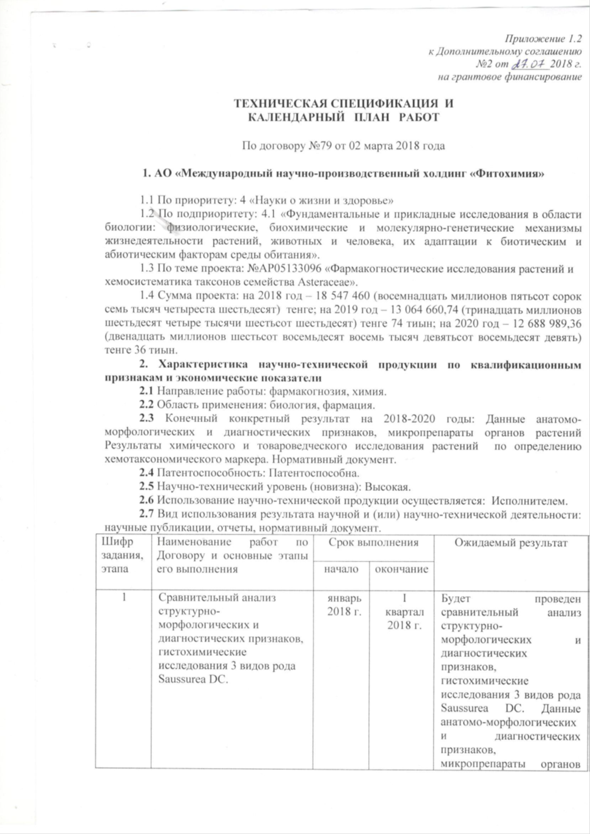

APPENDIX B
List of published works

Patents and applications

- Application for obtaining a patent of the Republic of Kazakhstan No. 2019 / 0484.1 dated 09.07.2019 G. S. Adekenova, G. K. Asanova, S. M. Adekenov. Method for obtaining regenerant plants of bipinnate cornflower (Centaurea bipinnatifida (Trautv.) Tzvel.). Заявка на получение патента РК № 2019/0484.1 от 09.07.2019 г. Адекенова Г.С., Асанова Г.К., Адекенов С.М. Способ получения растений-регенерантов василька двоякоперистого (Centaurea bipinnatifida (Trautv.) Tzvel.).
- Application for a patent of the Republic of Kazakhstan No. 2020 / 0698.1 dated 12.10.2020 Adekenov S.M., Asanova G.K., Shaushekov Z.K. Method of micropropagation of karatu wormwood (Artemisia karatavica Krasch. & Abolin ex Poljakov). Заявка на получение патента РК № 2020/0698.1 от 12.10.2020 г. Адекенов С.М., Асанова Г.К., Шаушеков З.К. Способ микроклонального размножения полыни каратуской (Artemisia karatavica Krasch. & Abolin ex Poljakov)

Scientific articles and abstracts

1. Adekenov S.M., Shaimerdenova Zh.R., Ermekkyzy A. Anatomical study and histochemical analysis of Artemisia leucodes Schrenk. // Fitoterapia. – Vol. 146. – 2020. – Р. 1-6 (impact factor Scopus – 2.527).
2. Adekenov S.M., Asanova G.K., Akhtayeva N.Z., Akhtayeva A.B., Aidosova S.S. Anatomical and morphological characteristics of species of the subgenus Artemisia L. // South African Journal of Botany. – 2020. – 133. – P. 296-300 (impact factor Scopus – 1.792).
3. Aidosova S.S., Akhtaeva N.Z., Tuleuova G.Kh., Ahmetova A.B. Tazhibay А.М., Shaushekov Z.K., Shurupova M.N., Adekenov S.M. Comparative morphological and anatomical characteristics of Saussurea amara (L.) DC. and Saussurea salsa (Pall.) Spreng. // Pakistan Journal of Botany. – Vol. 51 (1). - 2019. - Р.213-219 (impact factor Scopus – 0.73).
4. Shaushekov Z.K., Gabdullin E.M., Alibekov D.T., Adekenov S.M. Resource assessment of Saussurea salsa (Asteraceae) thickets in Central Kazakhstan // Vegetable resources. - 2019. - T. 55, No. 3. - P. 334-342 (RSCI impact factor - 0.331). Шаушеков З.К., Габдуллин Е.М, Алибеков Д.Т., Адекенов С.М. Ресурсная оценка зарослей Saussurea salsa (Asteraceae) в Центральном Казахстане // Растительные ресурсы. – 2019. – Т. 55, №3. – С. 334-342 (импакт фактор РИНЦ – 0,331).
5. Adekenov S.M., Gabdullin E.M., Khabarov I.A., Bekeev B.B., Shaushekov Z.K. Spreading of Artemisia annua L. and its content of artemisinin // News of the National Academy of Sciences of the Republic of Kazakhstan. Series of biology and medicine – 2019. - №2 - Р. 42-48 (impact factor in Kazakhstan citation base 0.036).
6. Gabdullin E.M., Kupriyanov А.N., Adekenov S.M. Artemisia L. (Subgen. Seriphidium (Bess.) peterm. In Kazakh upland // News of the national academy of sciences of the Republic of Kazakhstan, series of biological and medical. – 2020. - 4(340). – С. 46-51 (impact factor in Kazakhstan citation base 0.036).
7. Gabdullin E.M., Ermekkyzy A., Shaimerdenova Zh.R., Adekenov S.M. Promising vicarious species of medicinal plants in the flora of Kazakhstan // International scientific conference "From a plant to a drug" June 4-5, 2020, Moscow. - P. 301-309. Габдуллин Е.М., Ермеккызы А., Шаймерденова Ж.Р., Адекенов С.М. Перспективные викарные виды лекарственных растений флоры Казахстана// Международная научная конференция «От растения до лекарственного препарата» 4-5 июня 2020 г., Москва. – С. 301-309.
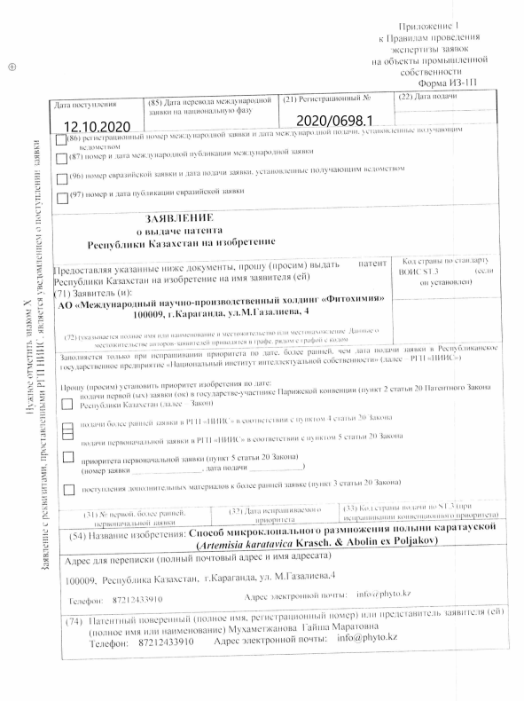

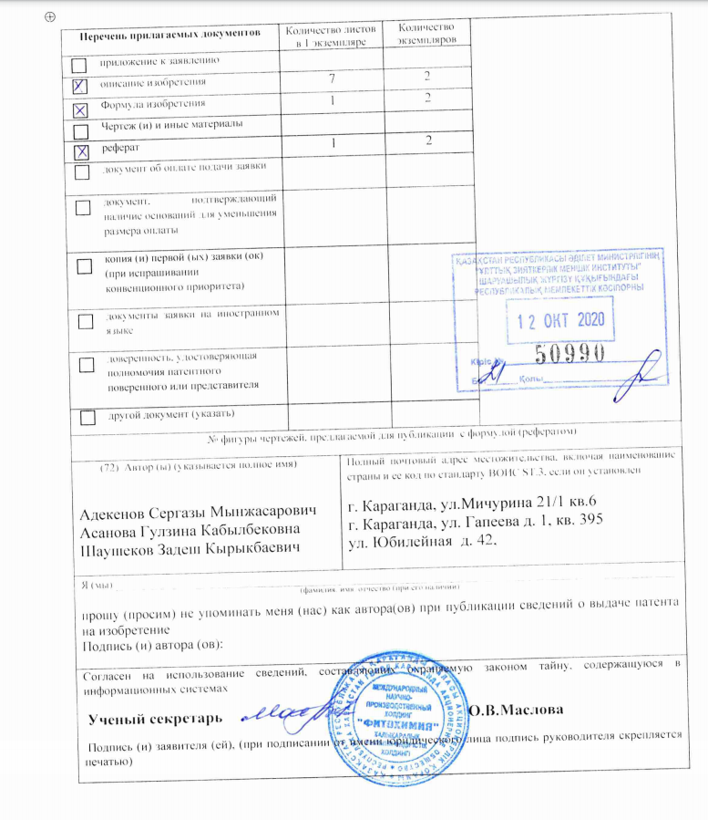

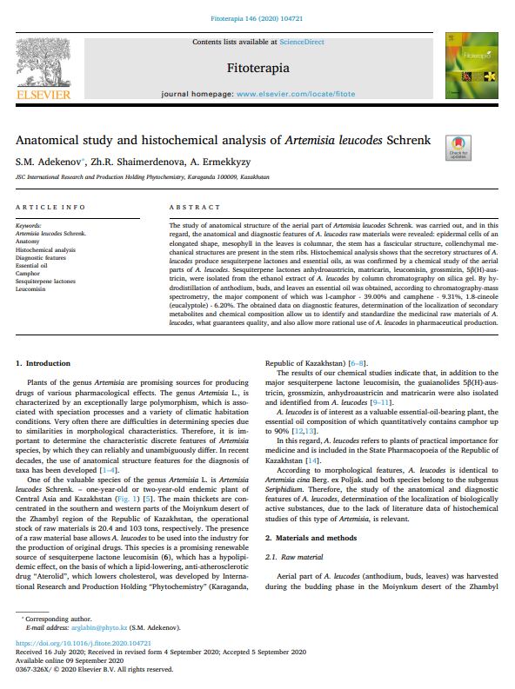

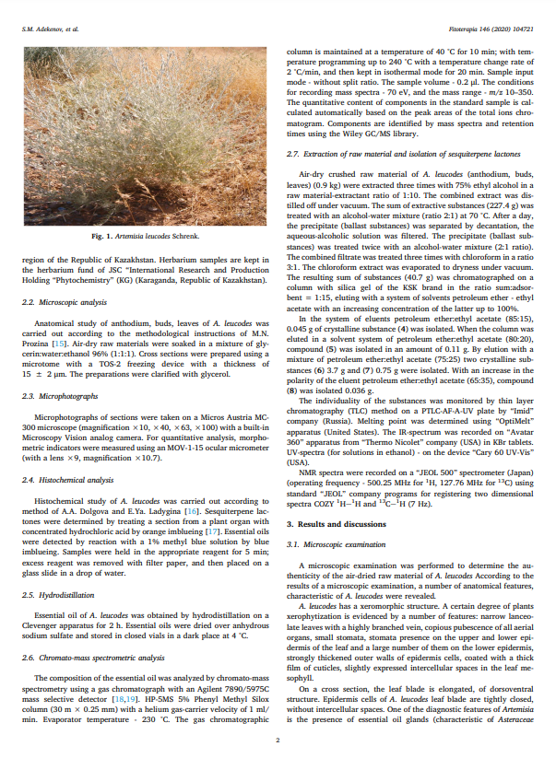
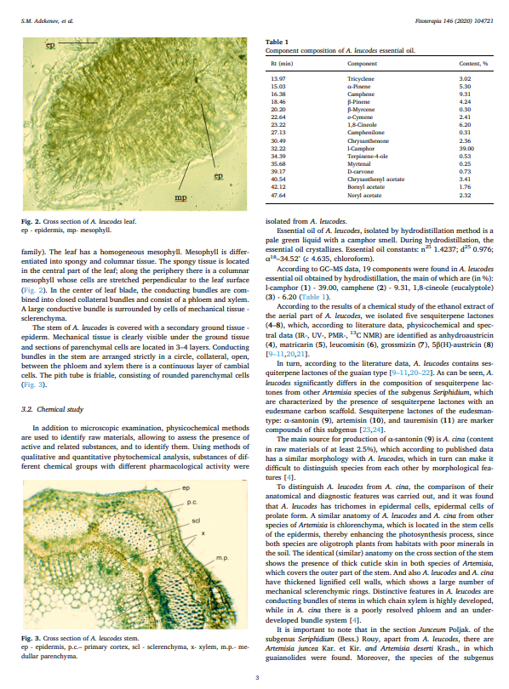

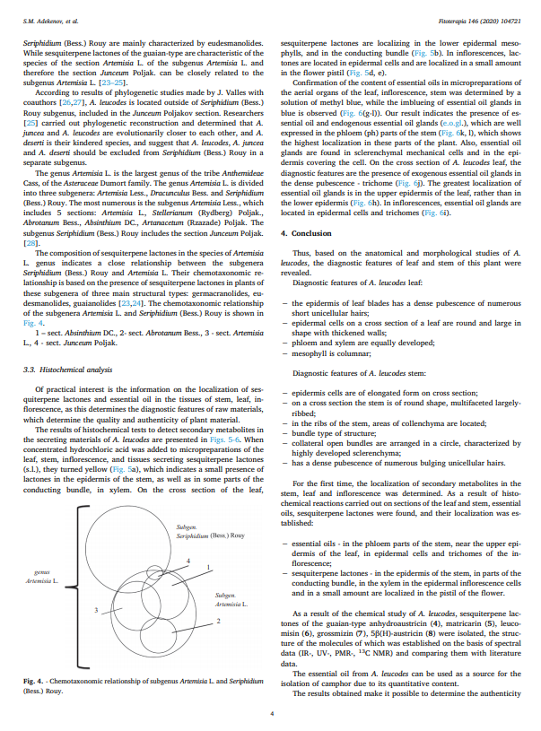

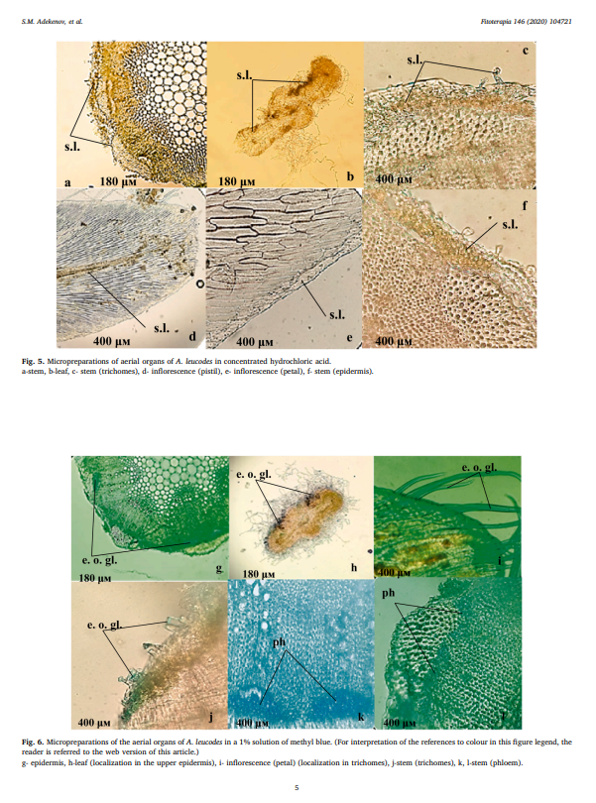

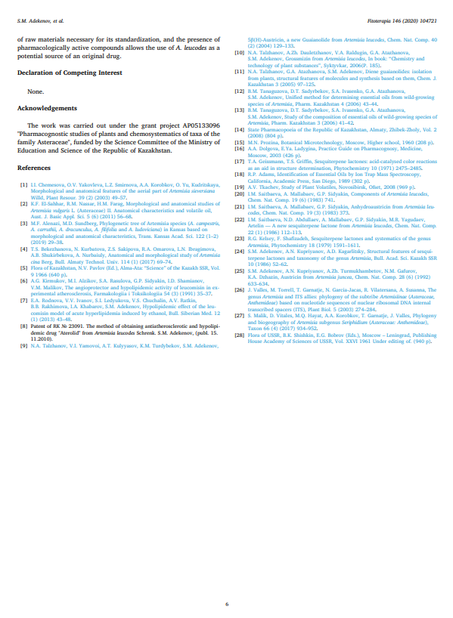
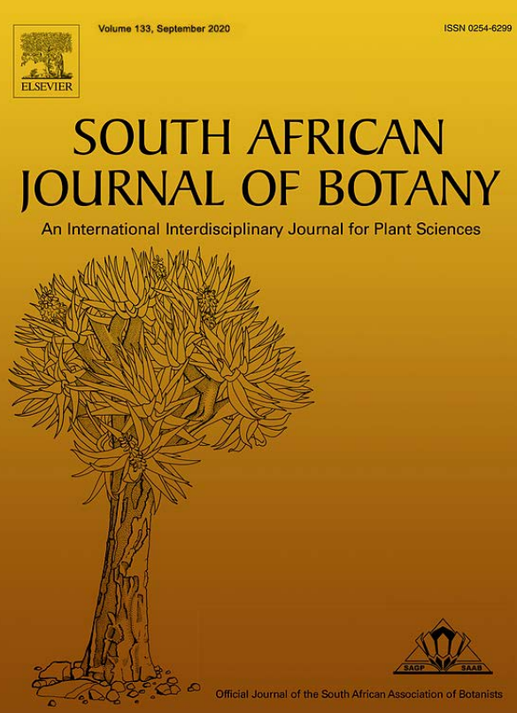

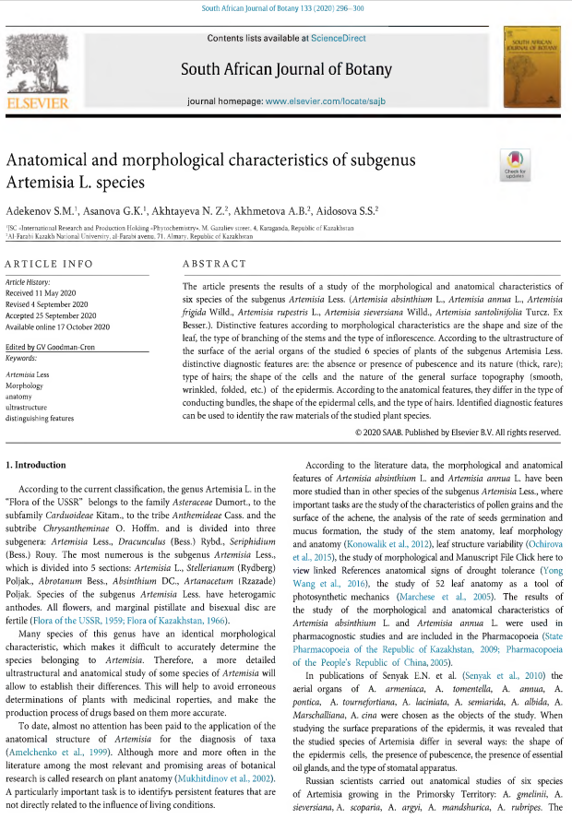
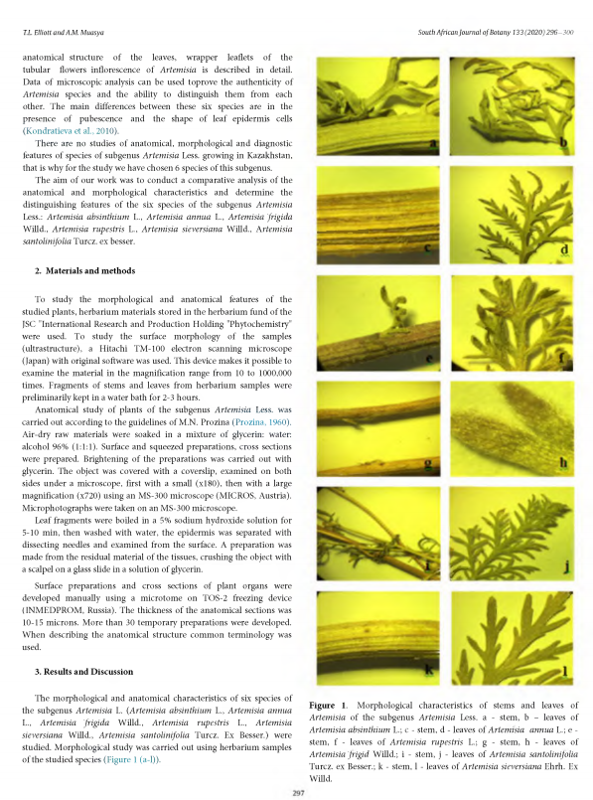

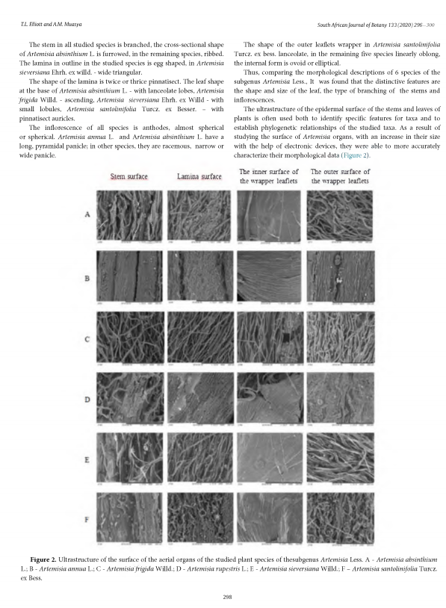

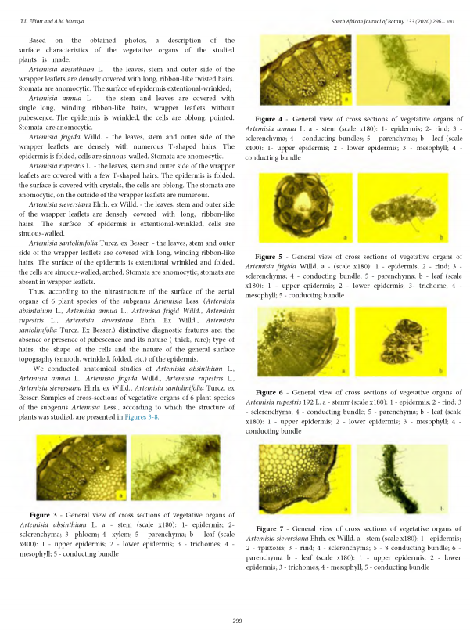

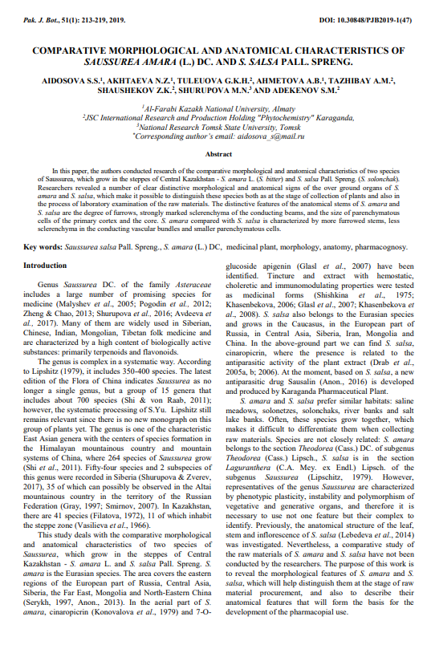

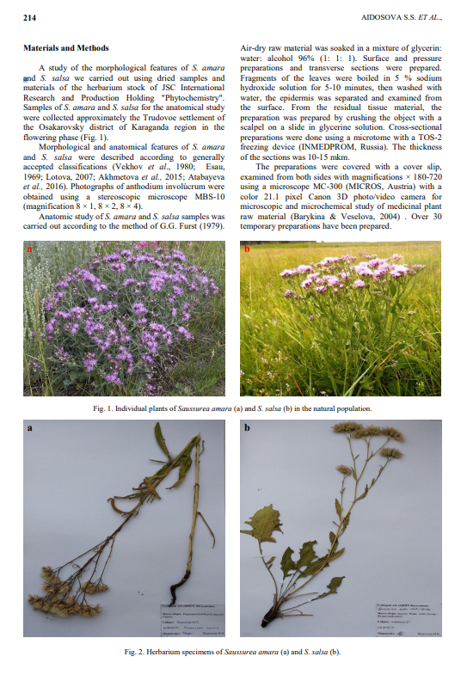

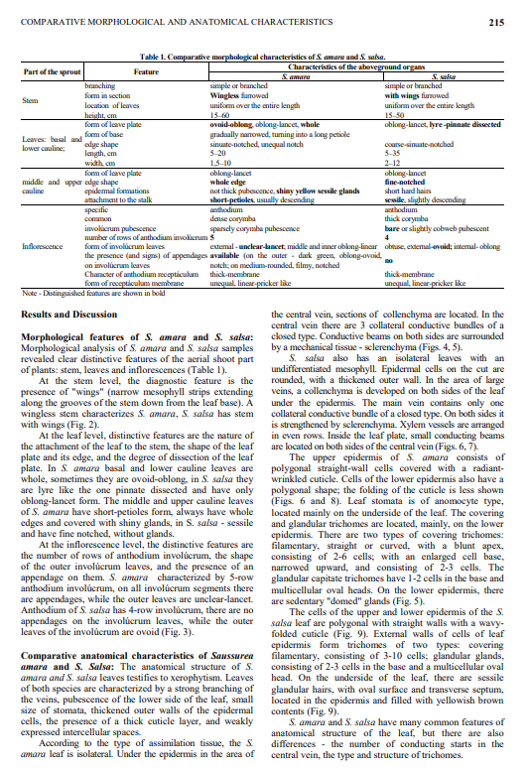

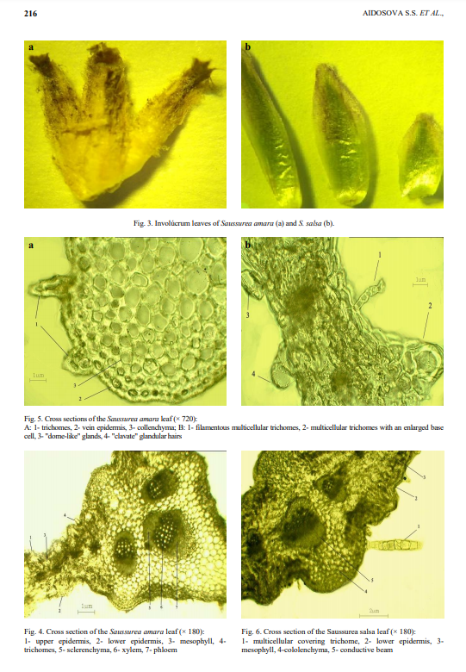
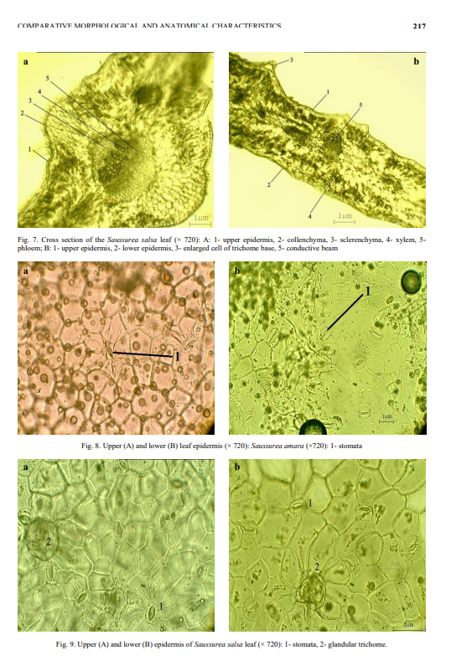

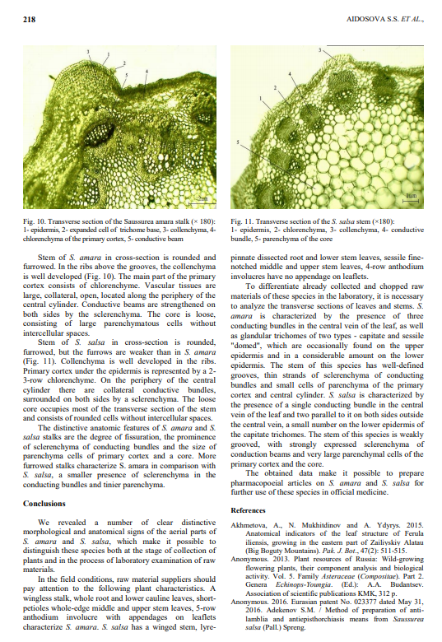

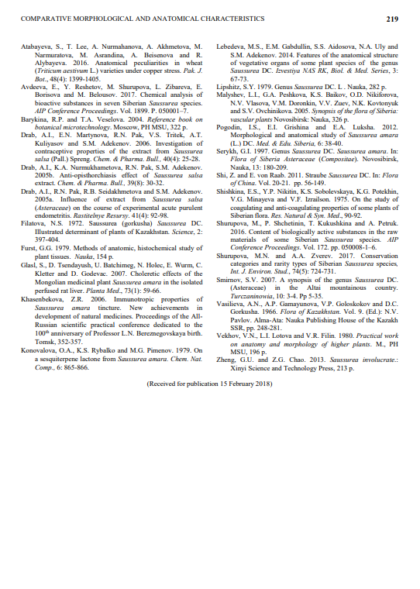
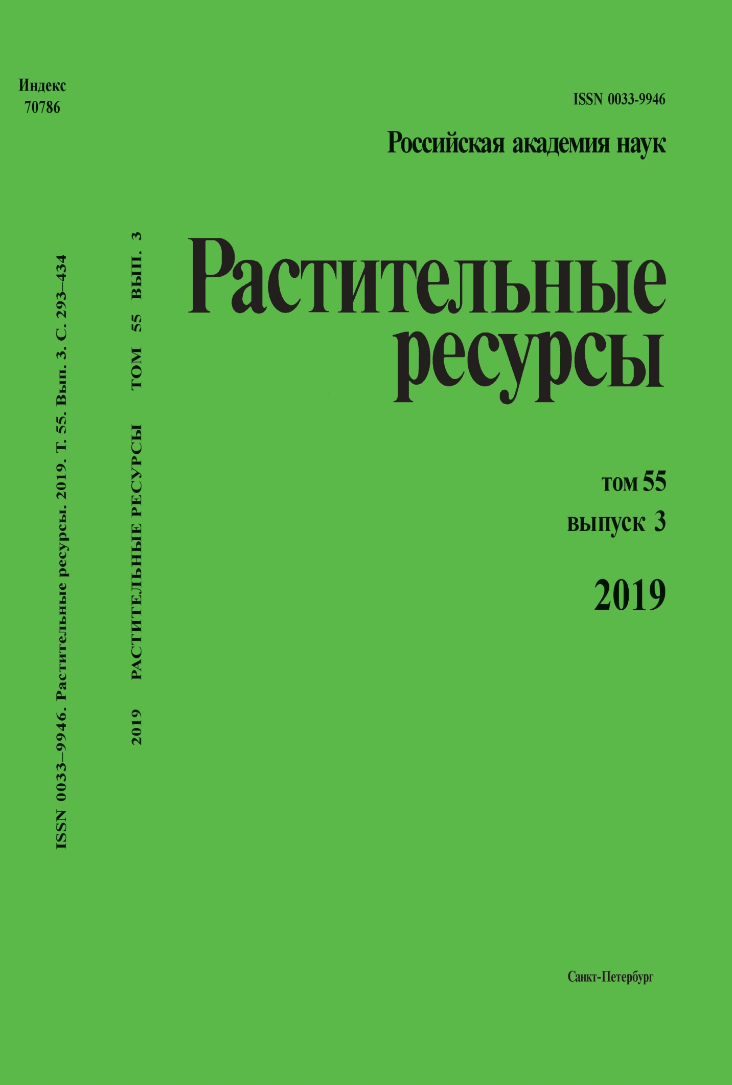
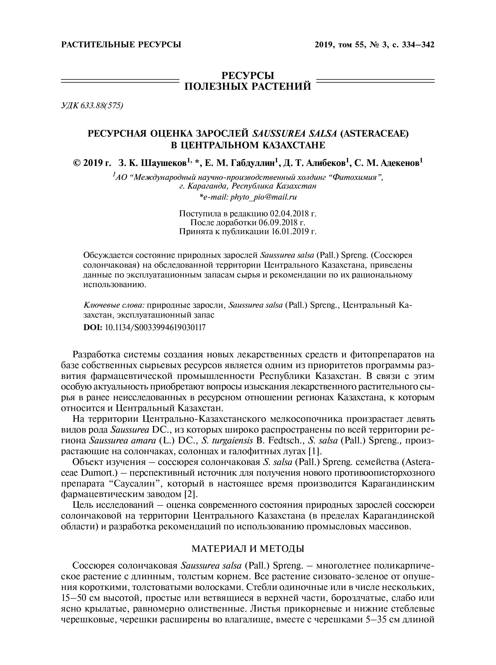
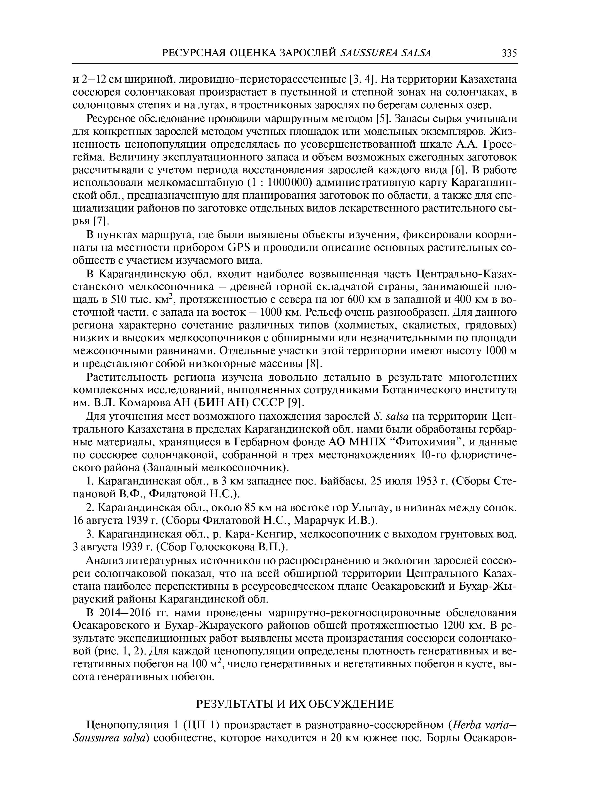
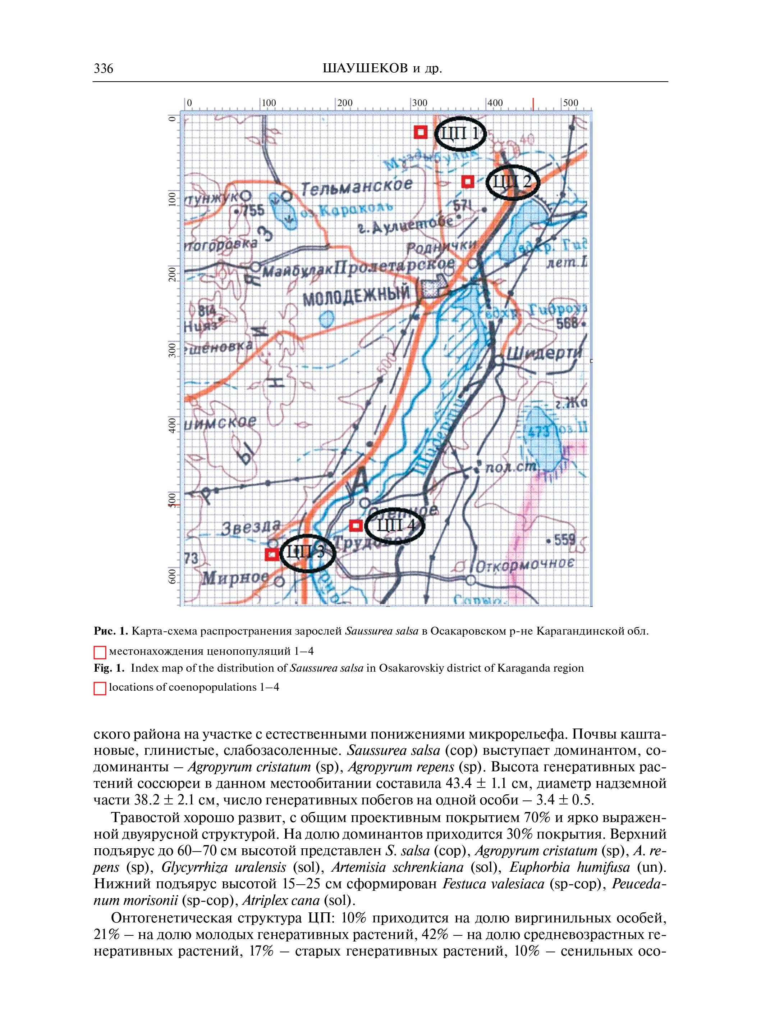
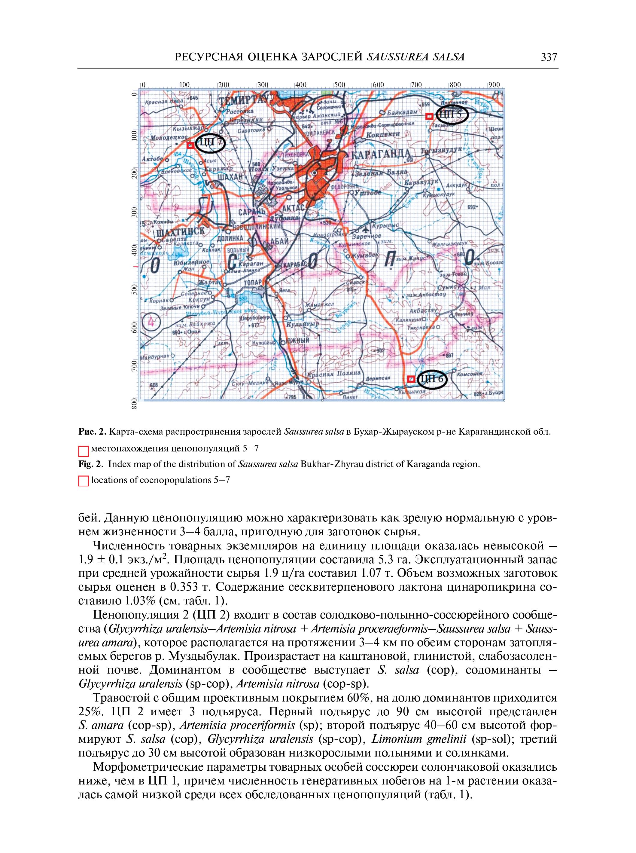
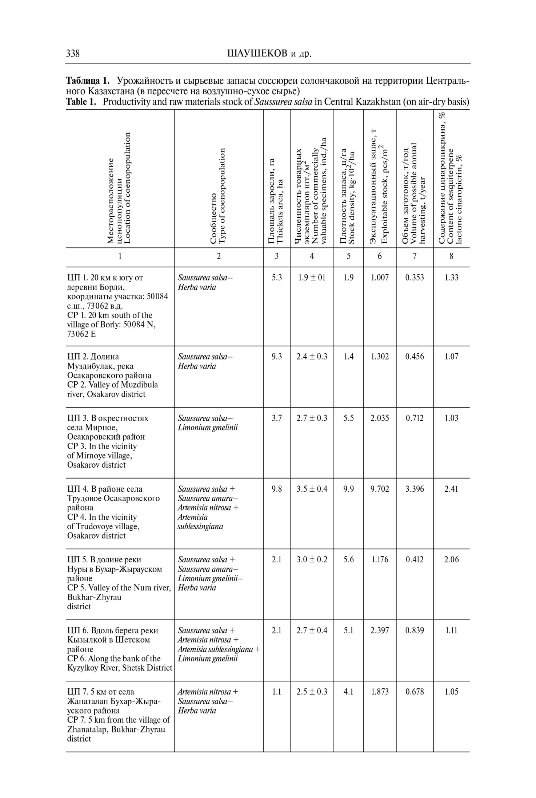
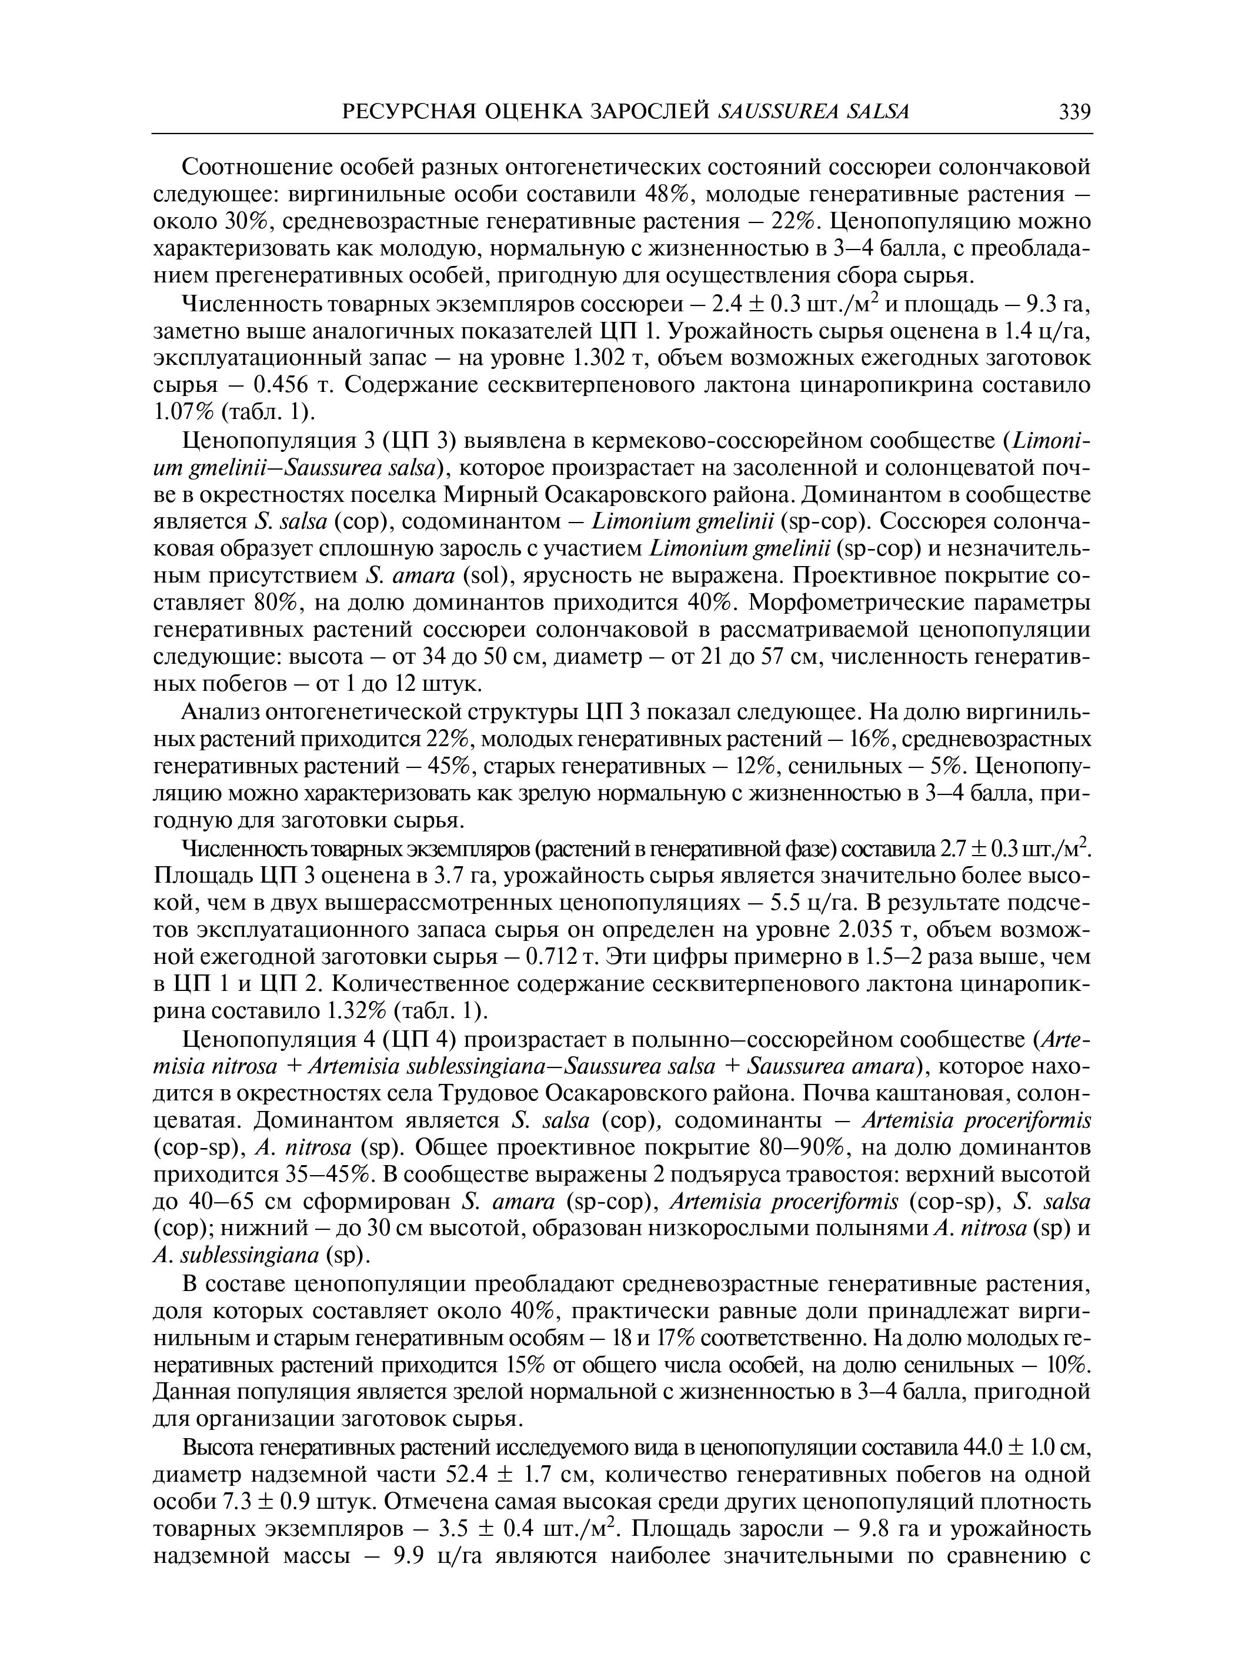
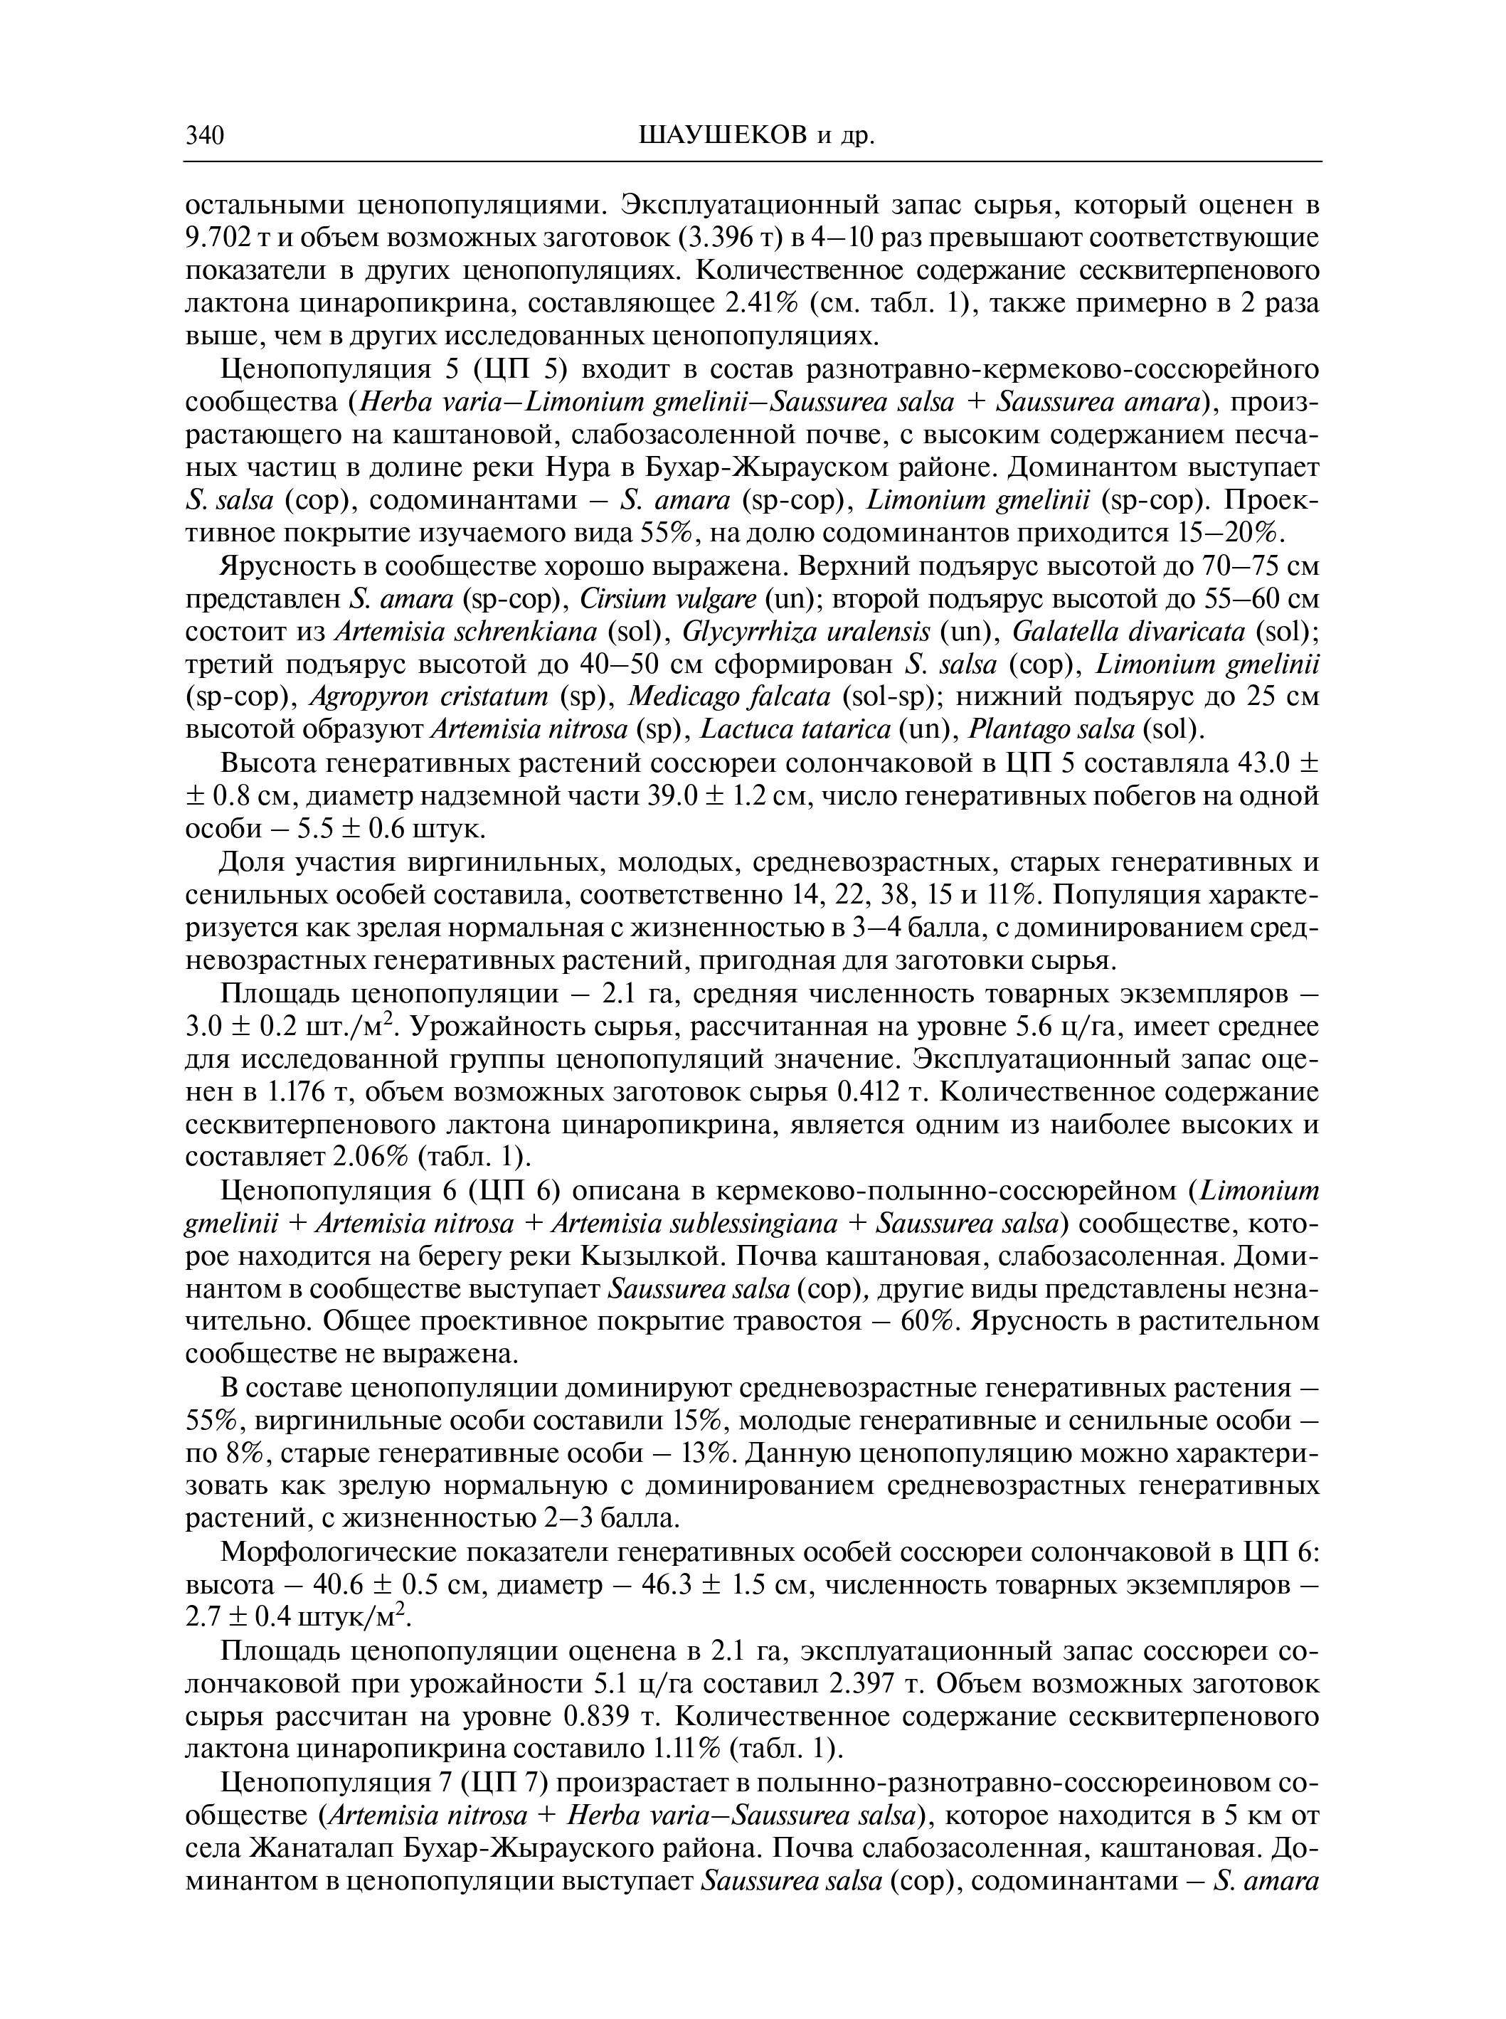
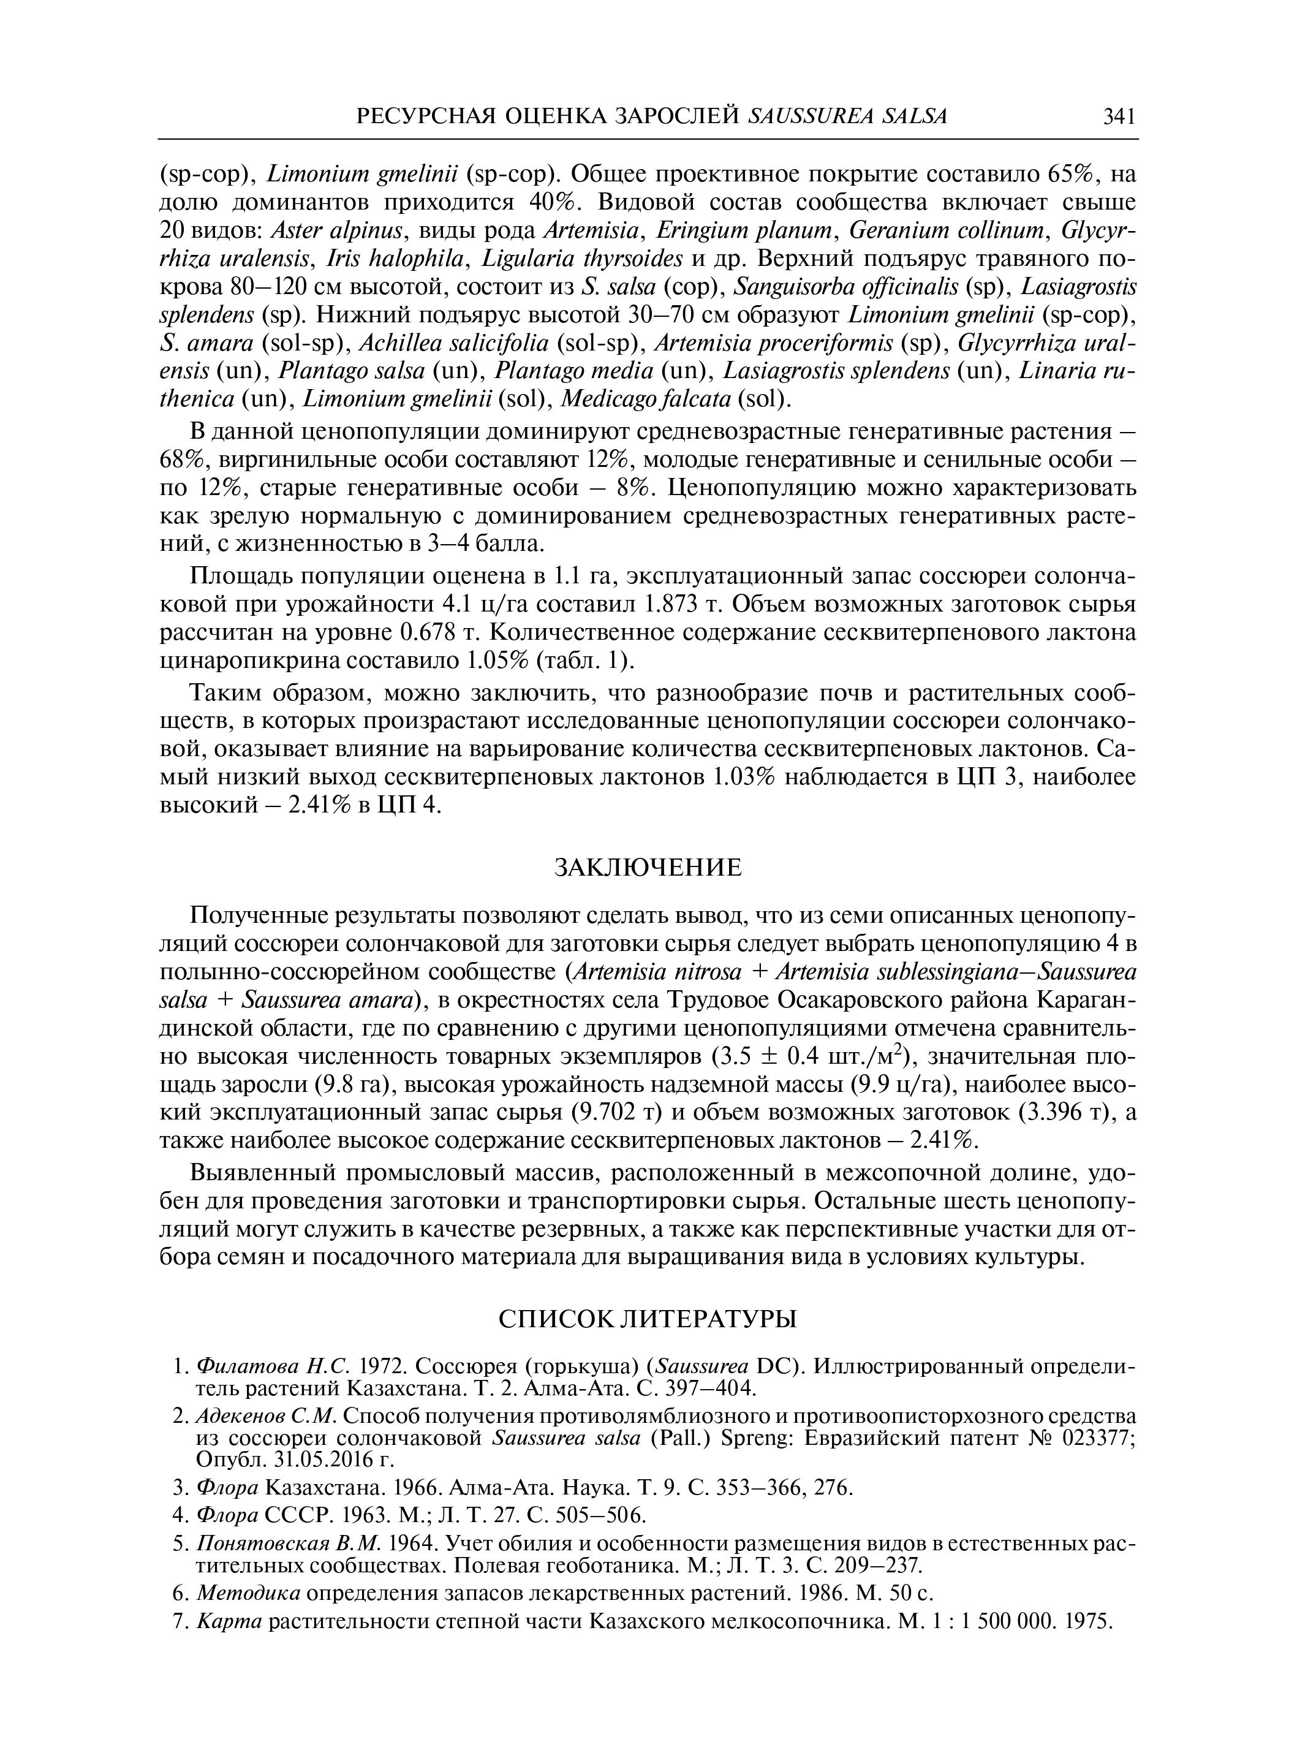
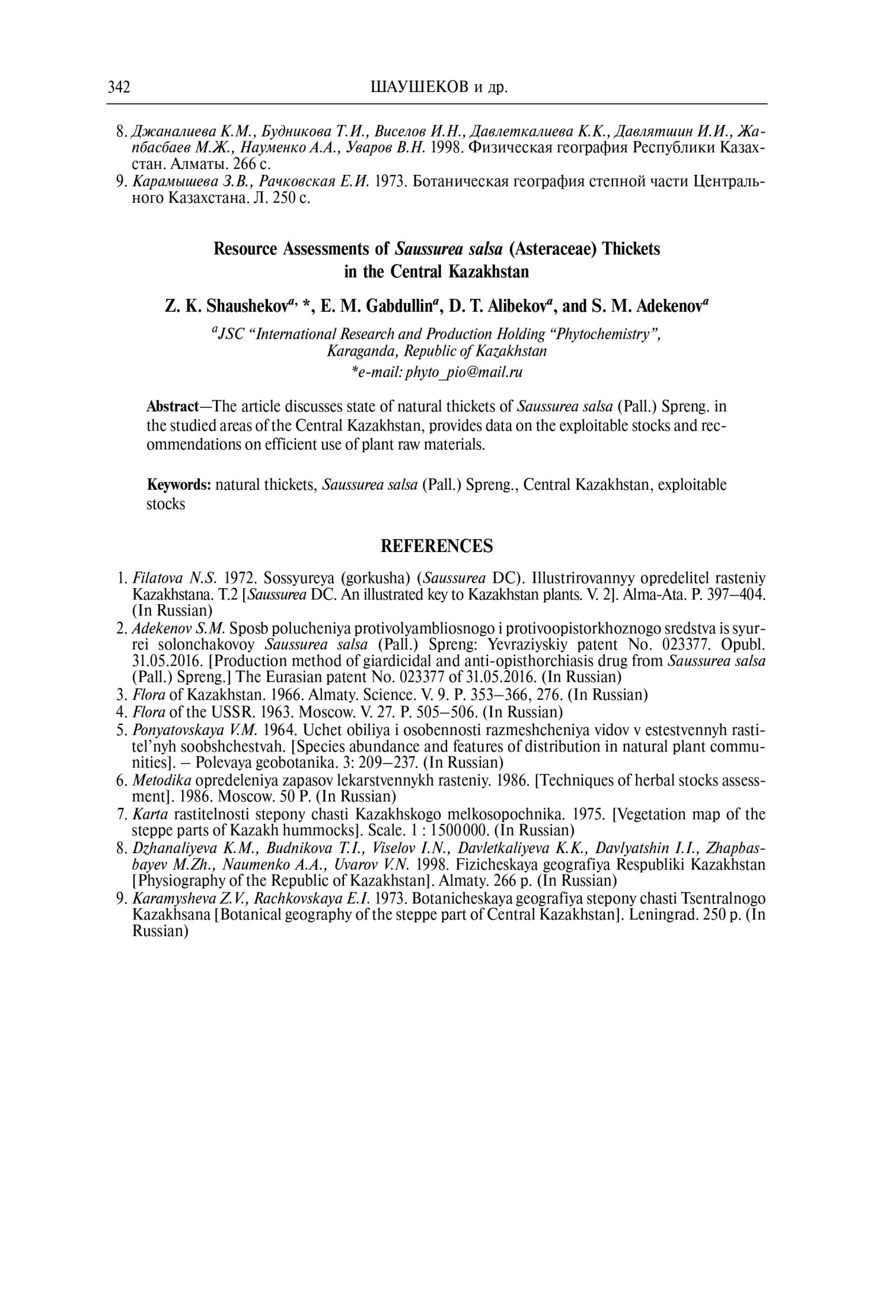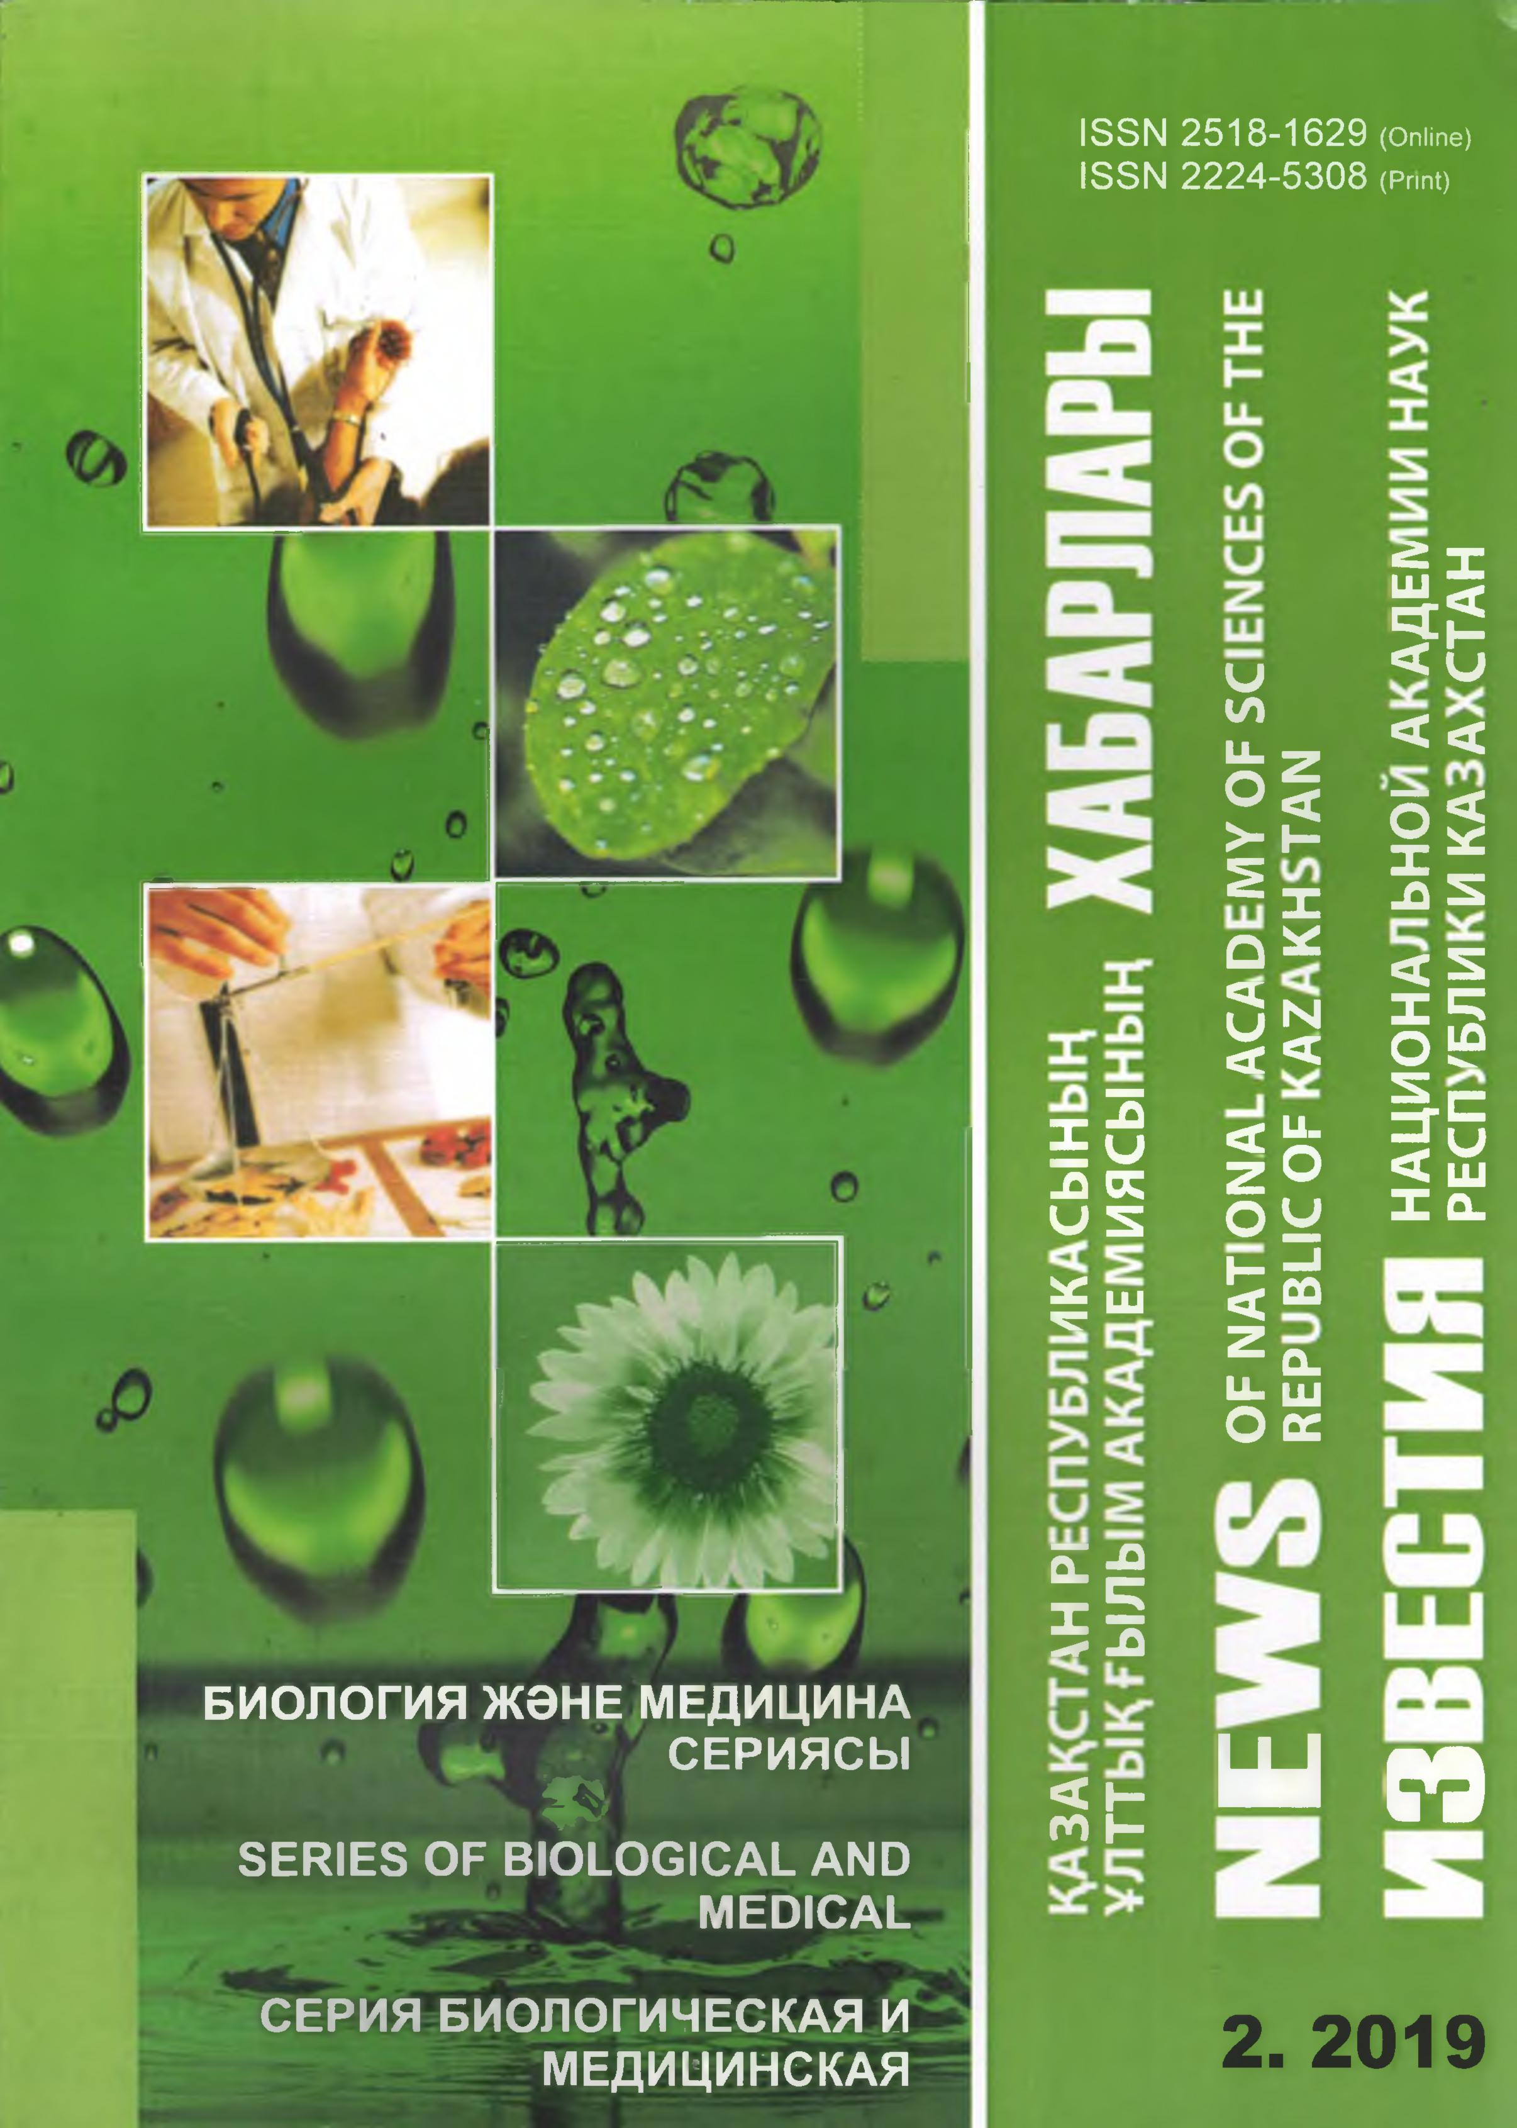
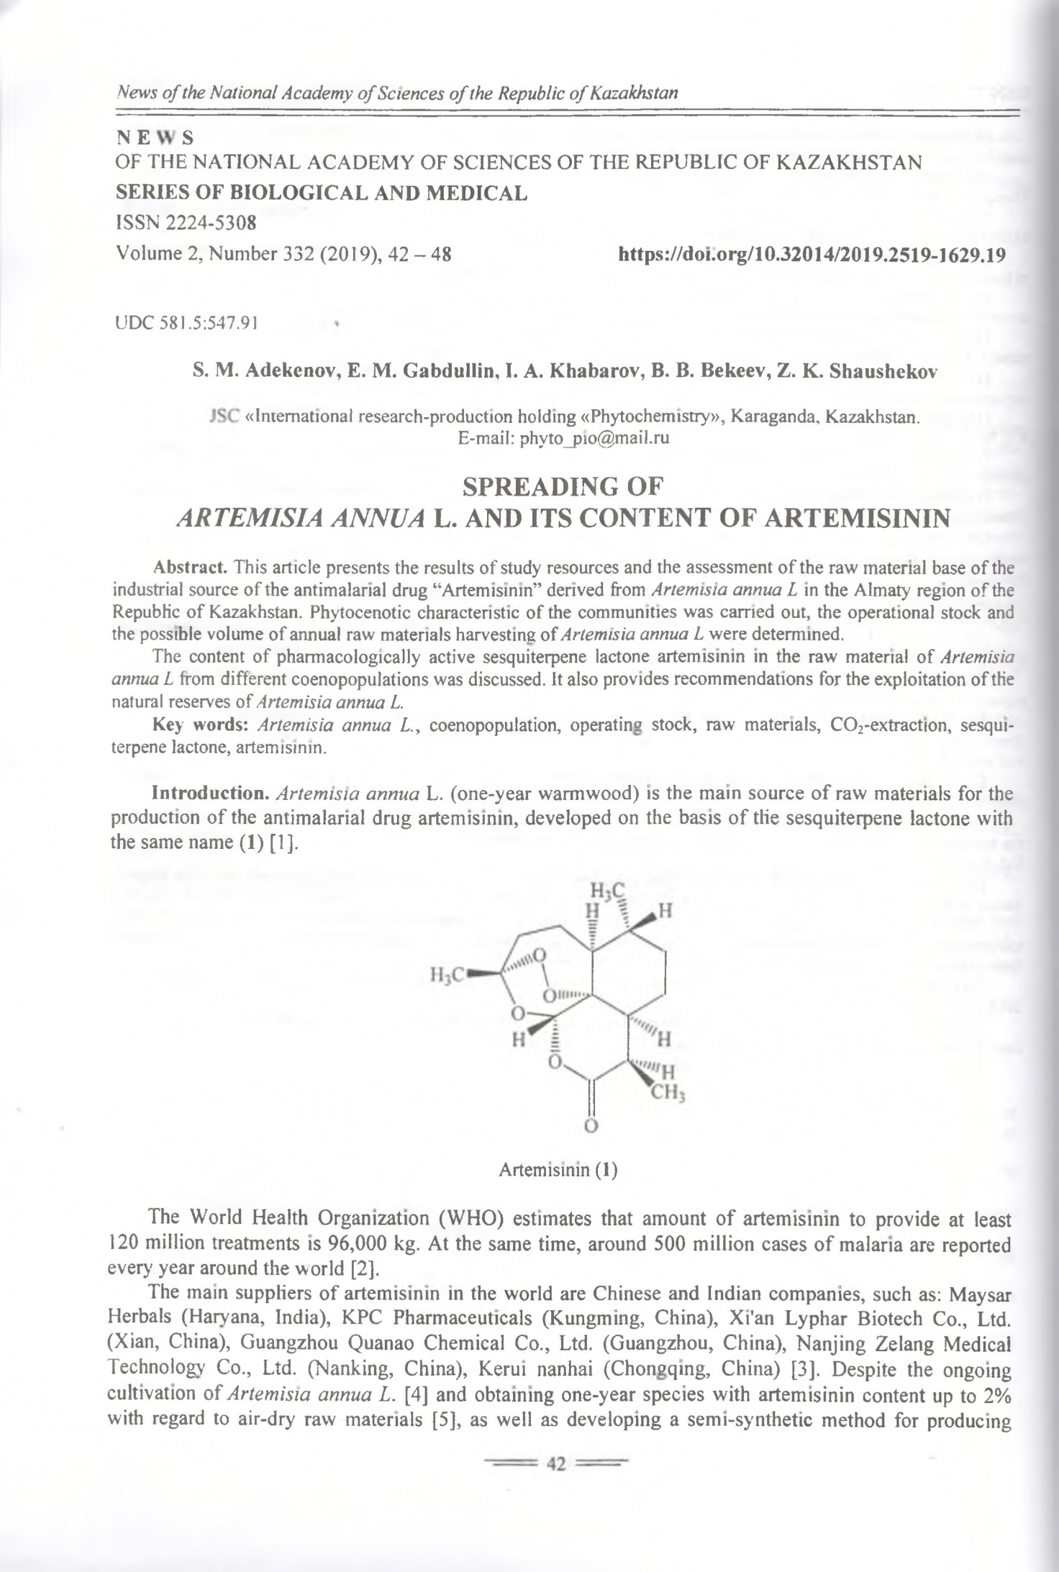
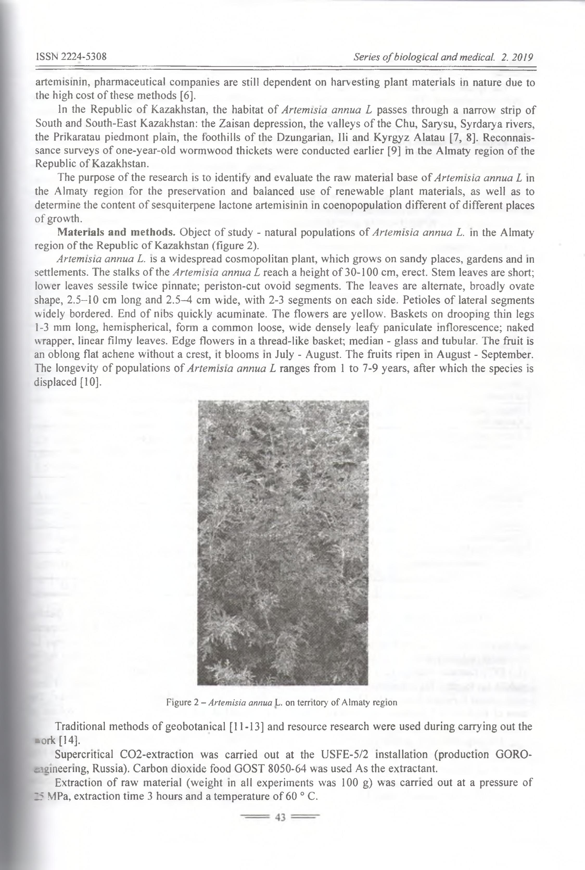
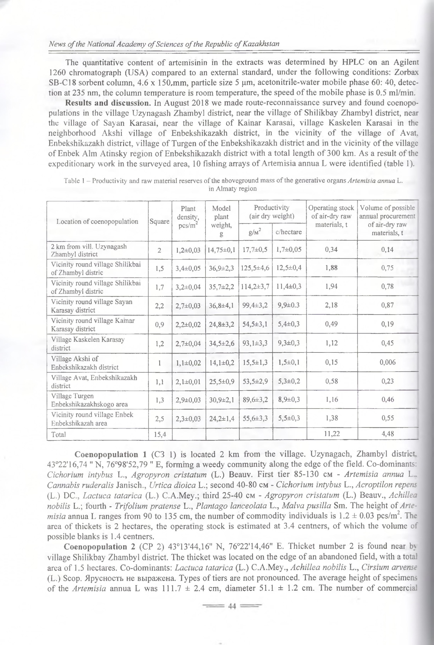
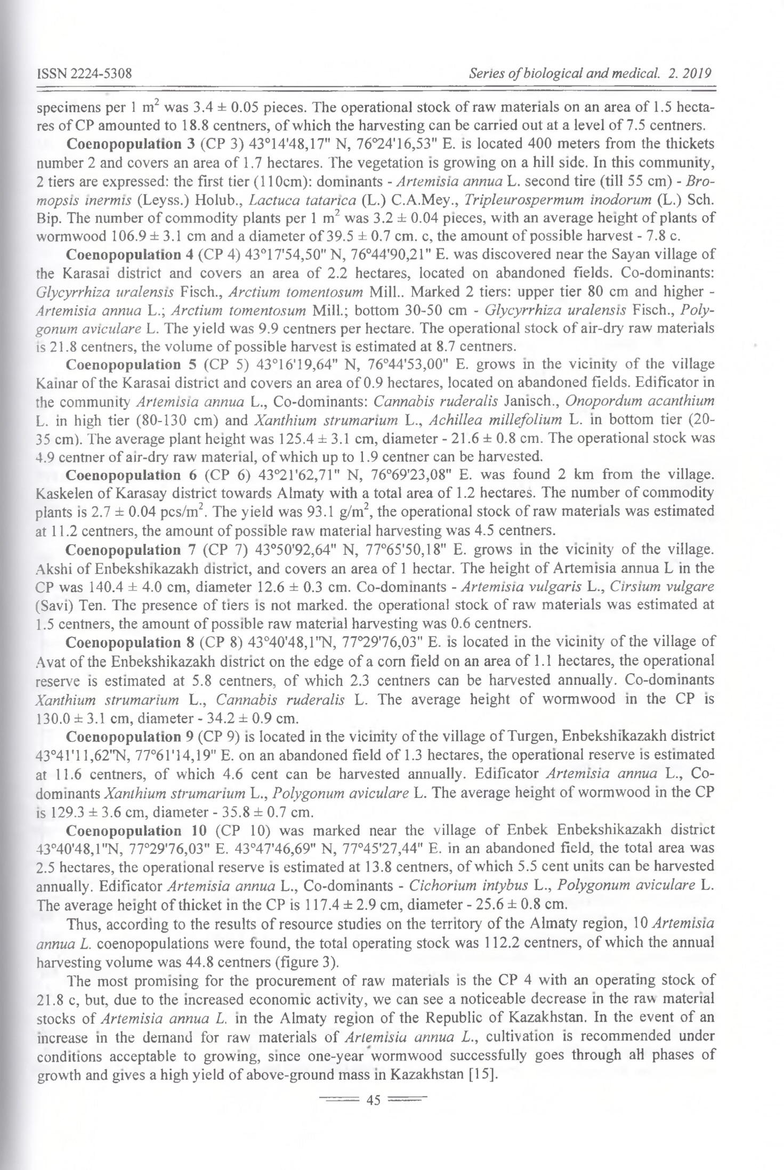
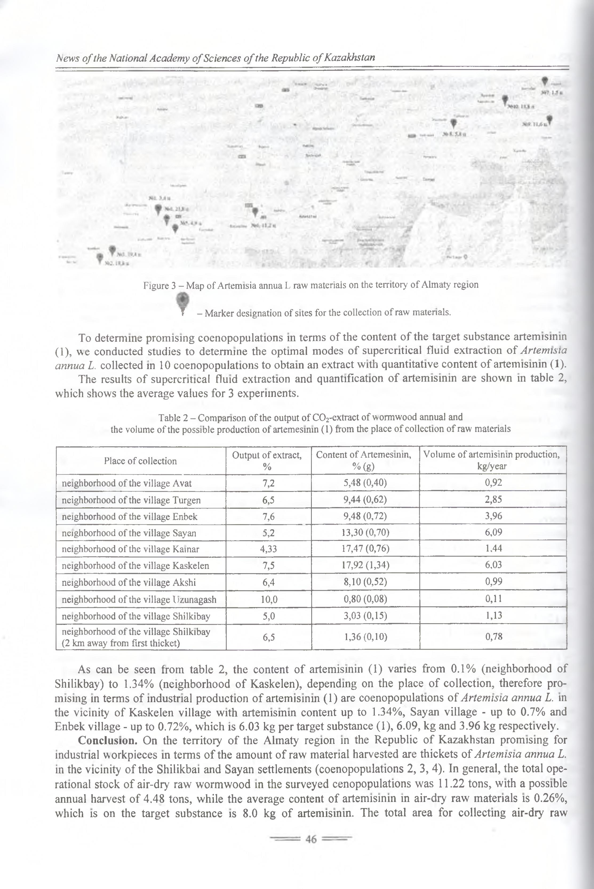
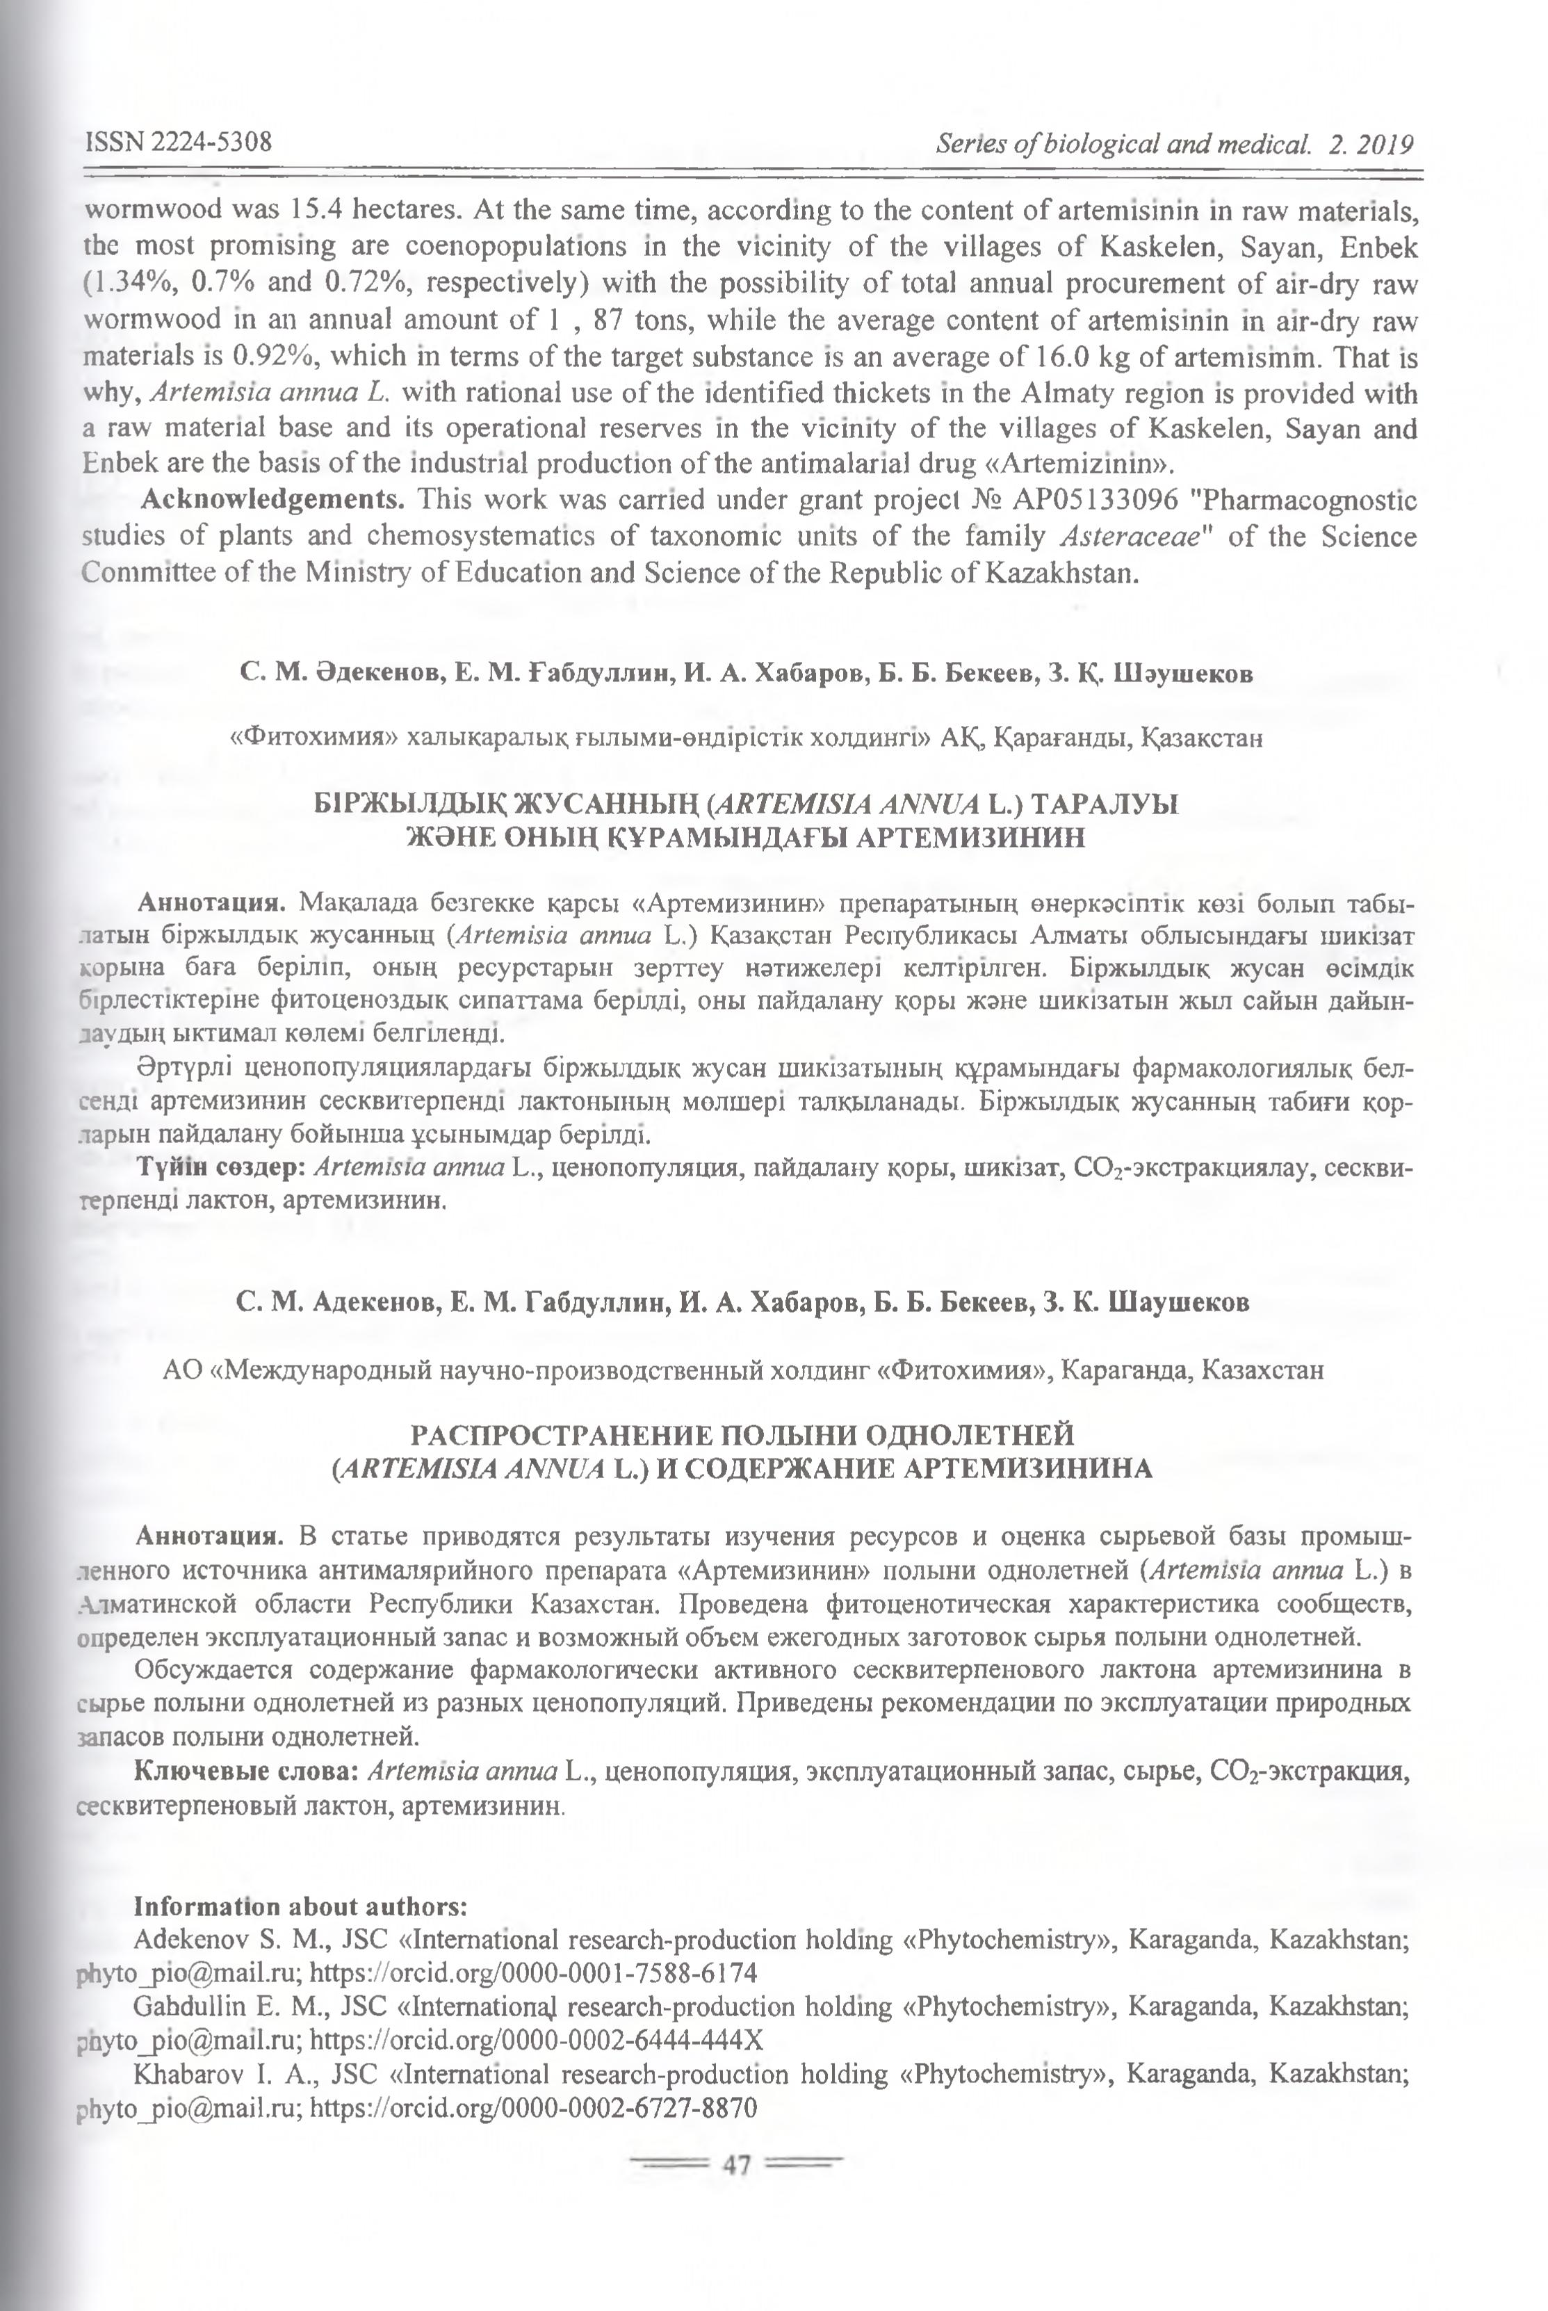
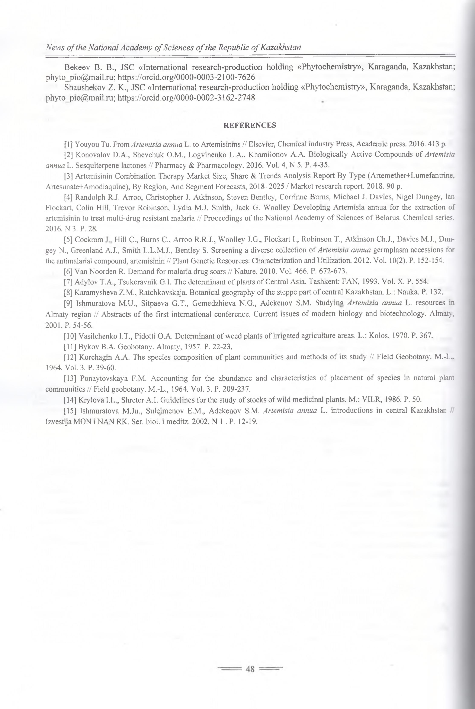

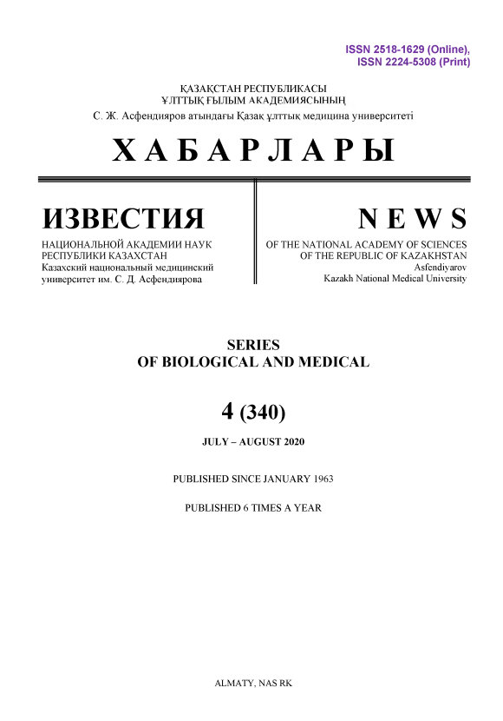

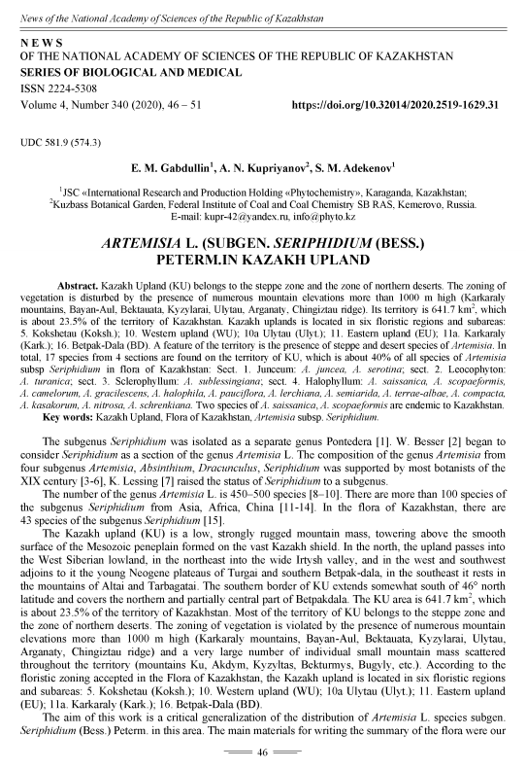
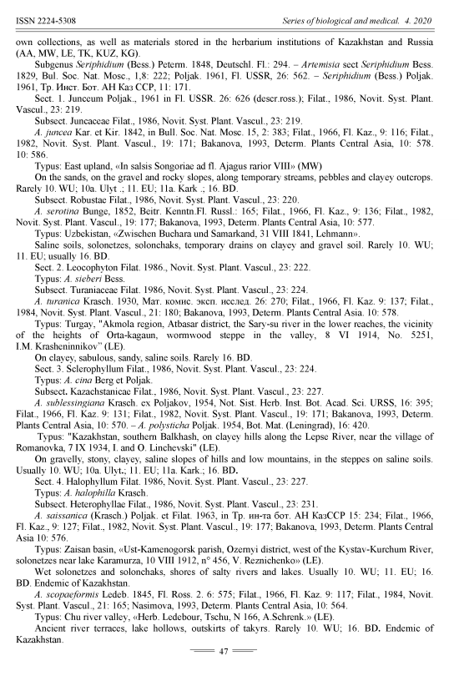

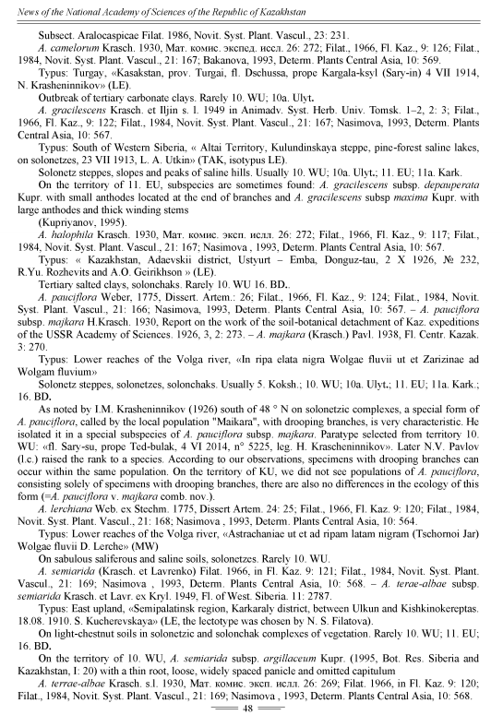
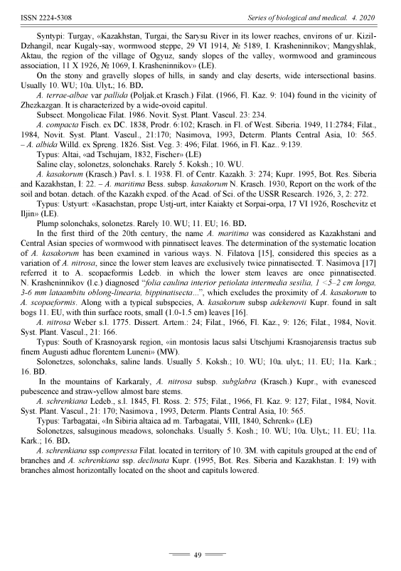
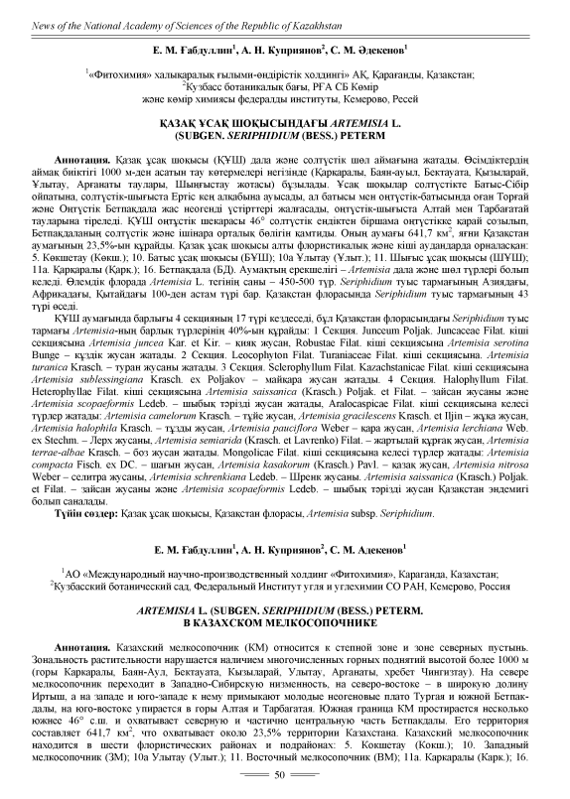
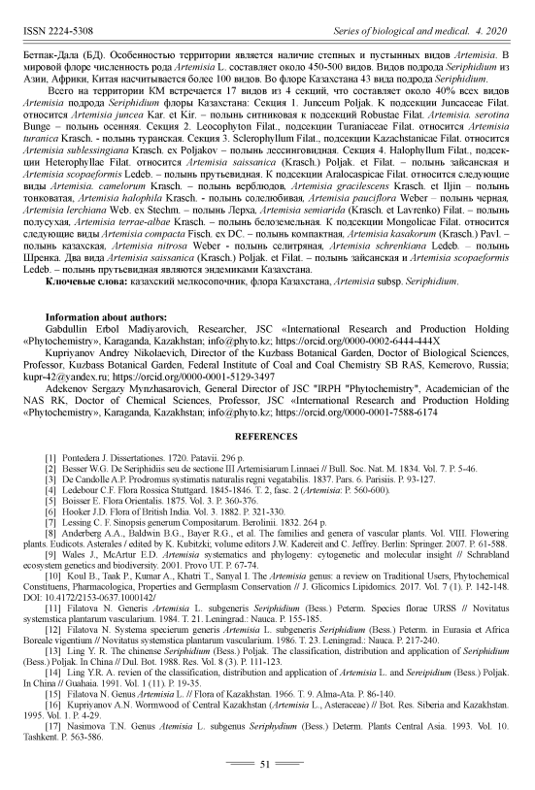

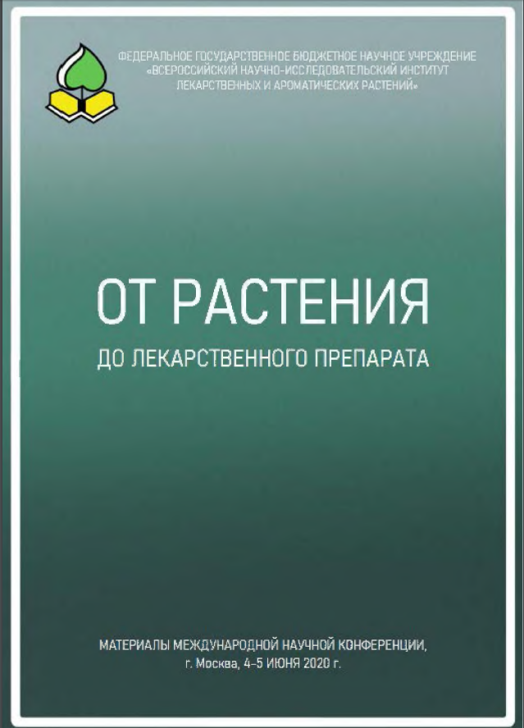

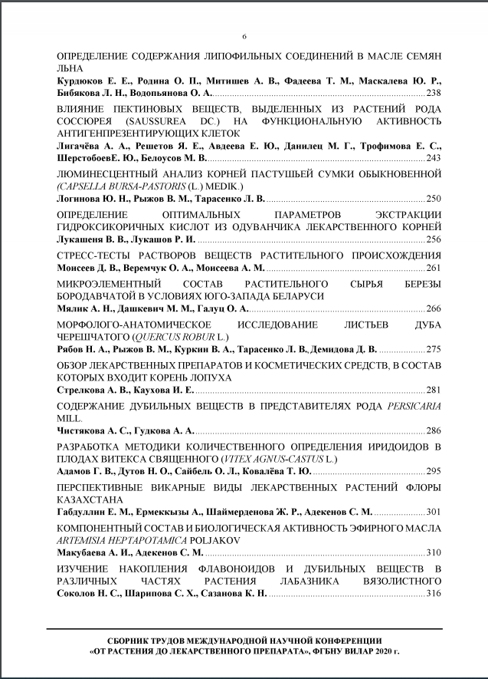

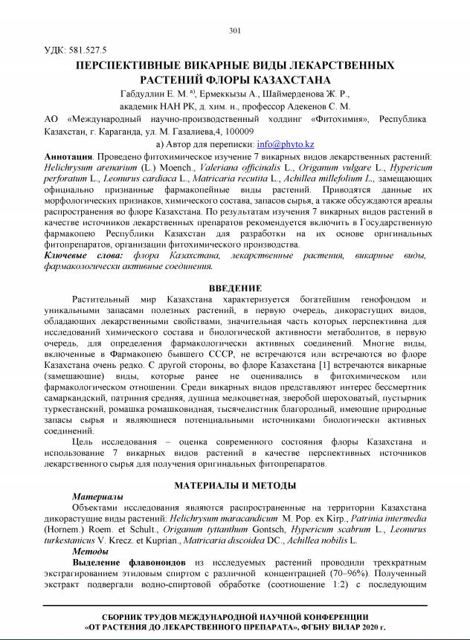

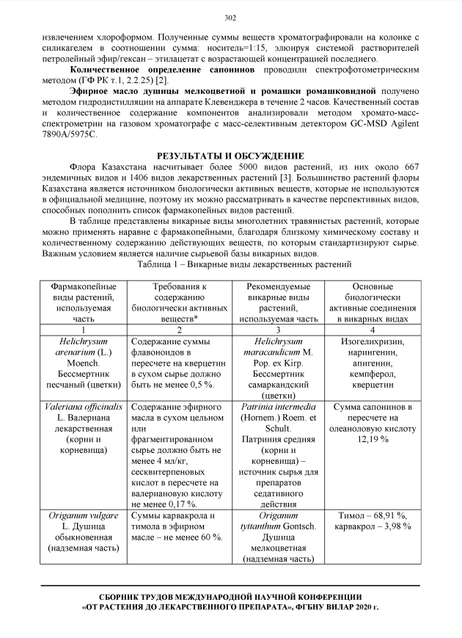
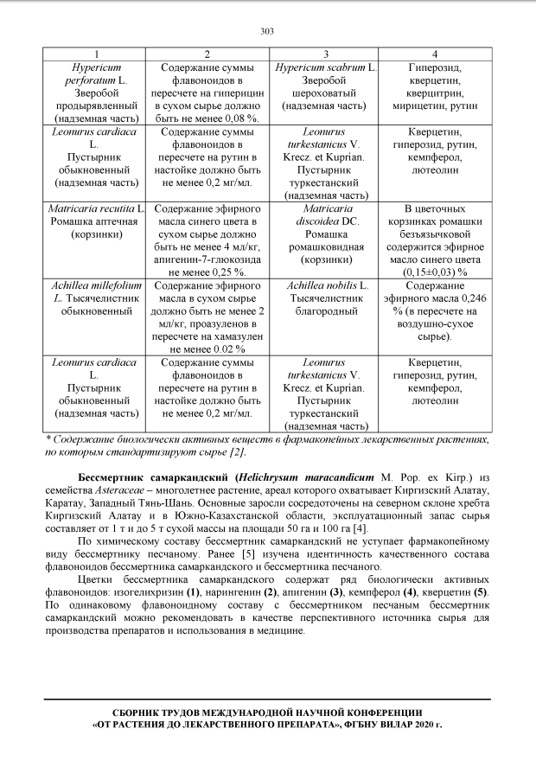
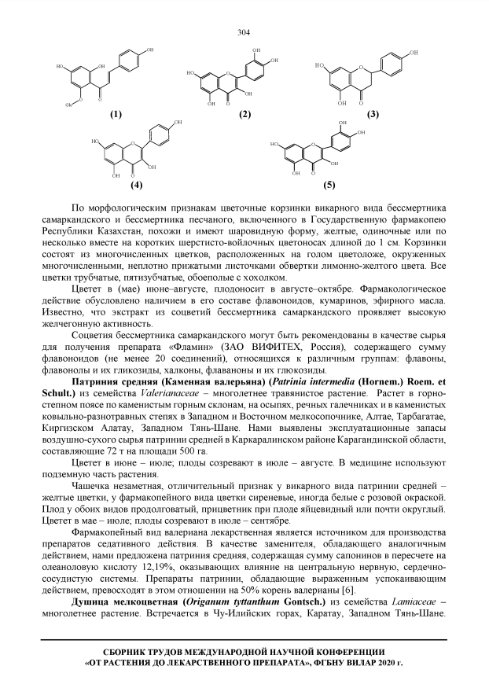

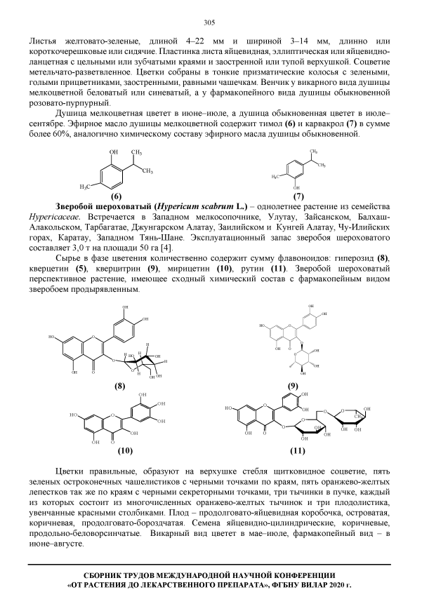

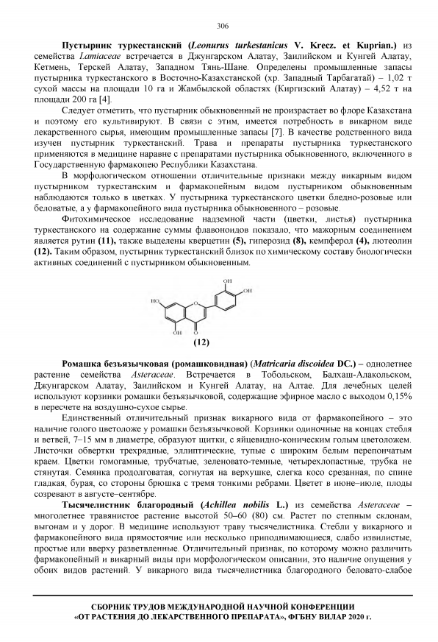

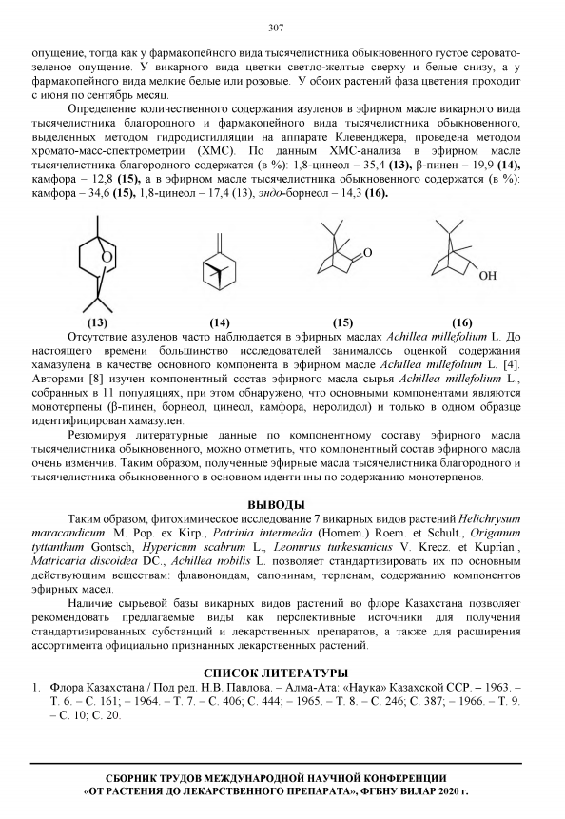

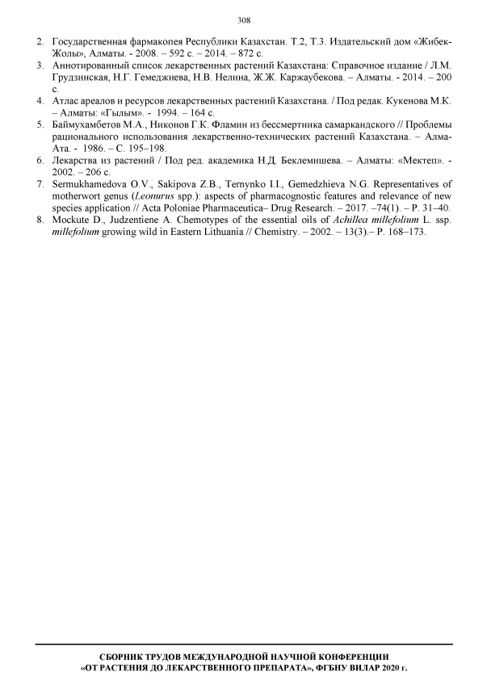

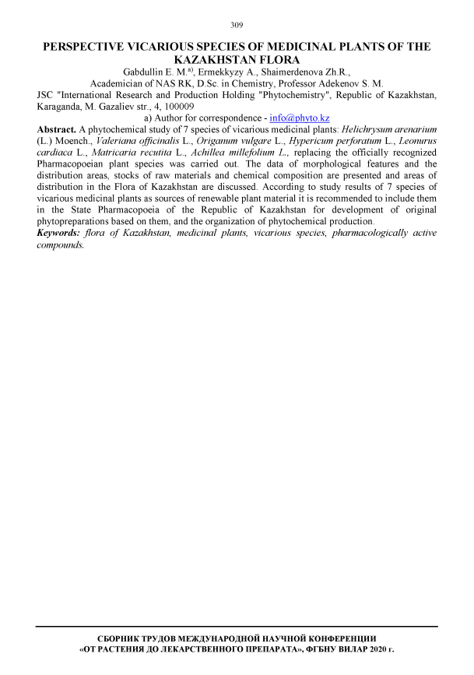

APPENDIX C

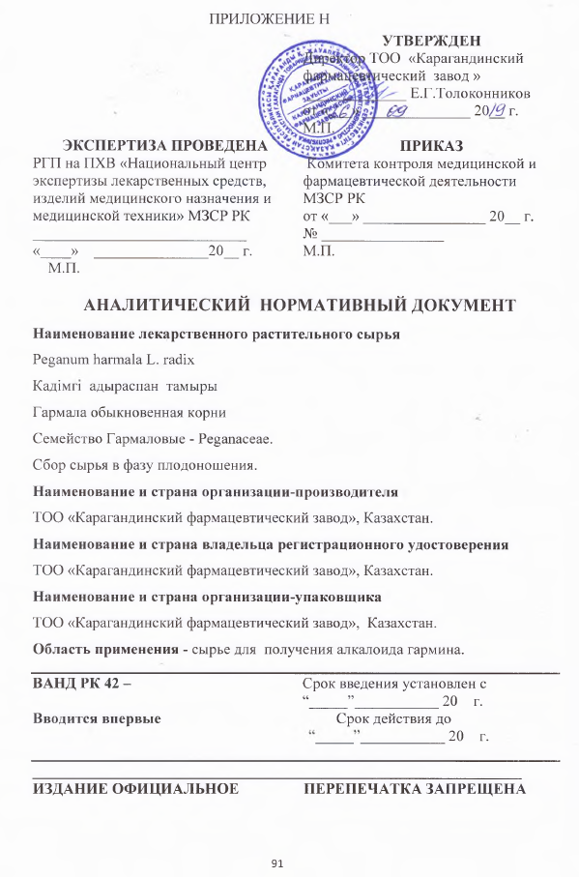

APPENDIX D

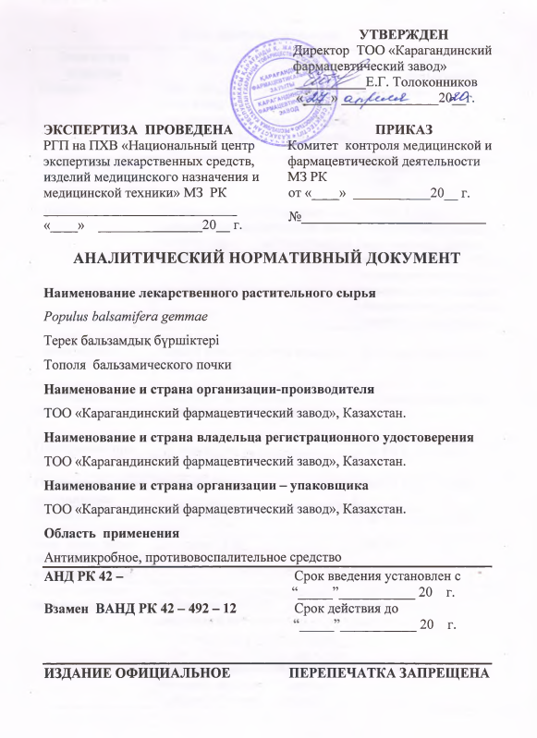

APPENDIX E

CONCLUSIONS ON THE FULFILLMENT OF THE SEARCH REGULATIONS

In the conducted (domestic and foreign) patent search on the Elsevier database, Web of Science, Scopus, Springer, specialized domestic and foreign peer-reviewed journals and specialized scientific literature, the materials of scientific and technical information related to the main areas of plant pharmacognostic research and chemosystematics taxa of the family Asteraceae were found.
As a result of the analysis of materials from the available literature it was determined that pharmacognostic studies and work on the chemotaxonomy of plants of the genus Saussurea DC. and Artemisia L. of the Asteraceae family are held at the Hong Kong Baptist University (Hong Kong), Central Research Institute of Ayurveda (India), Birla Institute of Technology, Mesra, Ranchi (India), Xinjiang Institute of Physics and Chemistry (Urumqi, China), Zhejiang University (China), Ishik University (Iraq), Basel University (Switzerland), Mohammed Premier University (Morocco), Liège University (Belgium), University of London (UK), South Cross University (Australia), Grigore T. Popa University of Medicine and Pharmacy (Romania), University of Regensburg (Germany), I.M.Sechenov Moscow State Medical University (Russia), Orenburg State Medical University (Russia), Lome University (Togo, West Africa), Institute of Marine Biochemistry, Academy of Sciences and Technology (VAST) (Vietnam), Institute of Plant Chemistry, Academy of Sciences of the Republic of Uzbekistan, Omsk State Medical Academy (Russia), Tomsk State University (Russia), Al-Farabi Kazakh National University.
Pharmacopoeial species of the genus Saussurea DC. - Saussurea lappa (Clarke), Saussurea involucrata Kar. et Kir., Saussurea laniceps Hand.-Mazz., Saussurea medusa Maxim. and the practically valuable Saussurea salsa Pall. Speng., Saussurea amara (L.), Saussurea neopulchella Lipsch. are being researched by scientists from scientific institutions of China, Hong Kong, India, Russia, Kazakhstan and other countries. Pharmacognostic studies have been carried out, including the morphological and anatomical features of the root, leaf, stem, inflorescences and pollen grains of these species.
Artemisia absinthium L., Artemisia leucodes Shrenk., Artemisia glabella Kar. et Kir., Artemisia scoparia Waldts. et Kit., Artemisia annua L. are promising species of the genus Artemisia L. introduced into the pharmacopoeia. The available literature contains the results of the study of morphological, anatomical characteristics, chemical analyzes, the effectiveness of the use of the listed species. Also, valuable species such as Artemisia commutate Bess., Artemisia laciniata Willd., Artemisia obtusiloba Ledeb., Artemisia vulgaris L., Artemisia Siversiana Willd. and others. The results of anatomical, morphological and phytochemical studies of organs of promising plants can be used to include them as medicinal plant raw materials in official medicine.
The studies of patent and scientific and technical literature did not reveal information discrediting the novelty of the developments underlying the topic, and indicate the absence of duplication, the presence of scientific novelty and the practical significance of the topic developed.
The regulations have been chosen correctly and are fully implemented. The depth of search for patent information literature for more than 10 years is quite sufficient.
The information revealed during the patent information search confirms the relevance of the developed topic.

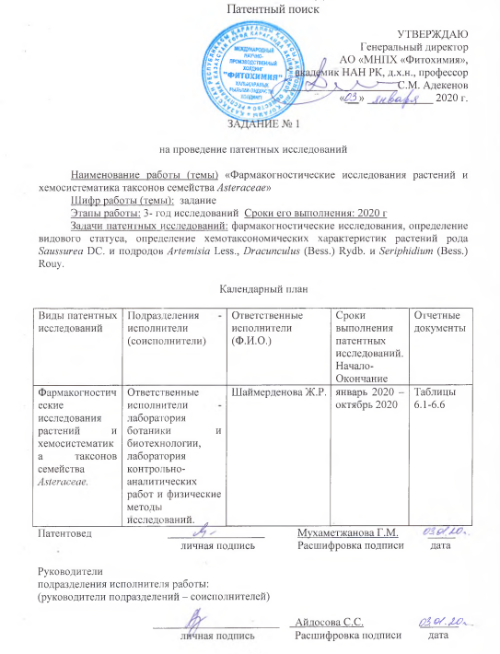

ФОРМА РЕГЛАМЕНТА ПОИСКА

Регнламент поиска № 1

Наименование работы (темы) «Фармакогностические исследования растений и хемосистематика таксонов семейства Asteraceae».
Шифр работы (темы): № АР05133096
Номер и дата утверждения задания
Этапы работы: фармакогностические исследования, определение видового статуса, определение хемотаксономических характеристик растений подродов Artemisia Less. и Dracunculus (Bess.) Rydb., семейства Asteraceae.
Цель поиска информации: оценка патентной чистоты проводимых работ
Обоснование регламента поиска: фармакогностические исследования, определение видового статуса, определение хемотаксономических характеристик растений рода Saussurea DC. и подродов Artemisia Less., Dracunculus (Bess.) Rydb. и Seriphidium (Bess.) Rouy.

Начало поиска январь 2020 г. Окончание поиска октябрь 2020 г.

Таблица Б.1 – Источники информации

Предмет поиска (объект исследования, его составные части, товар) | Страна поиска | Источники информации, по которым будет проводиться поиск |  |  |  |  |  |  |  | Ретро-спек-тивность | Наименование информа-ционной базы (фонда)
 | Страна поиска | Патентные |  | НТИ |  | Конъюктурные |  | Другие |  | Ретро-спек-тивность | Наименование информа-ционной базы (фонда)
 | Страна поиска | наиме-нова-ние | классифика-цион-ные рубрики: мпк (мки), мкпо, нки и другие | наимено-вание | рубрики удк и другие | наимено-вание | код това-ра  гс, смтк, бтн | наимено-вание | клас-сифи-каци-он-ные индексы | Ретро-спек-тивность | Наименование информа-ционной базы (фонда)
1 | 2 | 3 | 4 | 5 | 6 | 7 | 8 | 9 | 10 | 11 | 12
Фармакогностические исследования растений и хемосистематика таксонов семейства Asteraceae. | Казахстан,  Россия,  США,  Китай,  Германия,  Индия,  Британия,  Румыния,  Узбекистан,  Иран,  Испания,  Пакистан |  |  | «Journal of Ethnopharmacology.»,  «Phytochemistry Reviews», «Curr Opin Complement Alternat Med», « Pharmacogn Rev.», « Pharmacognosy Journal», « Microscopy Research and Technique»,  « International research journal of pharmacy», «Der Pharma Chemica», |  |  |  |  |  | 10 лет (2010– 2020 года) | База данных Elsivier, Springer, Web of Science Direct, Scopus Chemweb

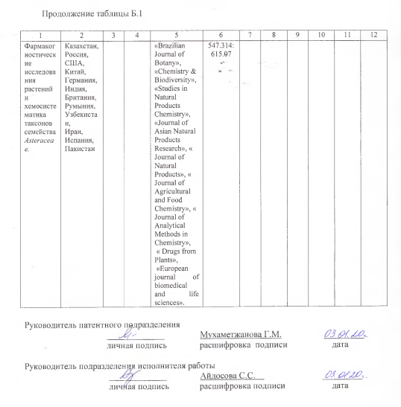

ОТЧЕТ О ПОИСКЕ

В.1 Поиск проведен в соответствии с заданием темы: Фармакогностические исследования растений и хемосистематика таксонов семейства Asteraceae.
Руководитель проекта – доктор биологических наук, профессор С.С. Айдосова
В.2 Этап работы
При необходимости
В.3 Сведения о выполнении регламента поиска (указывают степень выполнения регламента поиска, отступления от требований регламента, причины этих отступлений)
В.5 Предложения по дальнейшему проведению поиска и патентных исследований
В.6 Материалы, отобранные для последующего анализа

Таблица В. 6.1 – Патентная документация

Предмет поиска (объект исследования, его составные части) | Страна выдачи, вид и номер охранного документа. Классификационный индекс | Заявитель (патентообладатель), страна. Номер заявки, дата приоритета, конвенционный приоритет, дата публикации* | Название изобретения (полной модели, образца) | Сведения о действии охранного документа или причина его аннулирования (только для анализа патентной чистоты)
Фармакогностические исследования растений и хемосистематика таксонов семейства Asteraceae. | - | - | - | -

Патентная документация не обнаружена

Таблица В. 6.2 – Научно-техническая, конъюнктурная, нормативная документация и материалы государственной регистрации (отчеты о научно-исследовательских работах)
68
Предмет поиска | Наименование источника информации с указанием страницы источника | Автор, фирма (держатель) технической документации | Год, место и орган издания (утверждения, депонирования источника)
1 | 2 | 3 | 4
Фармакогностические исследования растений и | Молекулярная филогения и хемотаксономия | Володин В.В., Шадрин Д.М., Пылина Я.И., | Вестник биотехнологии. –
Продолжение таблицы В. 6.2
1 | 2 | 3 | 4
хемосистематика таксонов семейства Asteraceae. | экдистероидсодержащих растений семейств Caryophyllaceae Juss. и Asteraceae Dumort. | Друзь Ю.И., Володина С.О., Чадин И.Ф., Дайнан Л. | 2013. – Т. 9. - № 1. – С. 21-27.
-//- | Морфология, анато-  мия и система-  тика растений в фармакогностическом анализе лекарствен-  ного растительного сырья | Галкин М.А., Лукашук С.П. | Уч. пос. – Пятигорск: РИА-КМВ. – 2014. – С. 99.
-//- | Разработка методики количественного определения сесквитерпеновых лактонов в траве соссюреи горькой | Погодин И.С., Лукша Е.А. | Научное обозрение. Фармацевтические науки. – 2014. – № 1. – С. 41-47.
-//- | Saussurea pulchella (Fisch.) Fisch. (Asteraceae): Химический состав, полезные свойства, таксономия | Басаргин Д.Д., Горовой П.Г. | Turczaninowia. – 2012. – №15 (2). – С.102-113.
-//- | Хемосистематика и эволюционная биохимия растений | Семихов В.Ф., Арефьева Л.П., Новожилова О.А., Мишанова Е.В. | История науки и техники. – 2010. – № 5. С. 55-61.
-//- | Биологические особенности Saussurea controversa DC (Asteraceae) при интродукций на юге Томской области. | Свиридова Т.П. | Вестник ТГУ. – 2012. – С. 176 - 178.
-//- | Химические компоненты из Saussurea oligantha. Chemical constituents from Saussurea oligantha. | Li Xue - Hu,  Liang Jian-Ping, Lu Xi-Kong, Tao Lei | Химия природ. соед.: Международный научный журнал. – 2012. – № 2. –  С. 302 - 309.
-//- | Два новых соединения из Saussurea graminea. Two new compounds from Saussurea graminea | Hu Jiang, Shi Xiaodong, Chen Jiagang, Lu Wei Dong, Mao Xia | Химия природ. соед.: Международный научный журнал. – 2013. – № 5. – С. 705 - 707.
Продолжение таблицы В. 6.2
1 | 2 | 3 | 4
-//- | The Composition of biological active substances and pharmacological activity of perspective species flora of Siberia | Krasnov E.A., Avdeeva E.Y., Gorina Y.V., Sherstoboev E.Y. | 4th Annual Russian-Korean Conference “Current Issues of Natural Products Chemistry and Biotechnology”. - Novosibirsk, 2012. – P. 37.
-//- | Сравнительный анализ флавоноидов некоторых видов рода Saussurea DC., произрастающих на территорий Сибири. | Борисова Е.А.,  Зибарева Л.Н.,  Ревушкин А.С. | Мат. IV междунар. научн. конф. «Новейшие исследования в современной науке: опыт, традиции, инновации». – Северный Чарльстон, Южная Каролина, США. – 2017 г. – С. 6.
-//- | Перспективы примене-ние комбинированного метода «Высокоэффек-тивная жидкостная хроматография – метод главных компонентов хемосистематике растений | Гаврилина В.А., Сычев С.Н. | Фундаментальные и прикладные проблемы техники и технологии. 2011. – № 6. –С. 11-15.
-//- | Morphological and anatomical characteristics of Artemisia absinthium var. absinthium and its Polish endemic variety A. absinthium var. Calcigena | Konowalik K., Kreitschitz A. | Plant Syst. Evol. – 2012. - Vol. 298.- № 7.– Р. 1325–1336.
-//- | Изменчивость строения листьев у Artemisia absinthium (Asteraceae) | Очирова К. С., Крылова Е. Г., Паутова И. А. | Вестник Санкт-Петербургского университета. – 2015. - Сер. 3, Вып. 1. –  С. 4-14.
-//- | Artemisia dominant species succession relating to the soil moisture decrease in abandoned land of the Loess Plateau (China):comparative study of drought‑adaptive characteristics | Yong W., Jing Y.,  Pengguo X., Shaoxuan H.,  Ziyun Z,  Ruilian H.,  Zongsuo L. | Springer Plus. – 2016. - № 5. - P. 992.
Продолжение таблицы В. 6.2
1 | 2 | 3 | 4
-//- | Гистохимия трихом официальных представителей семейства Lamiaceae. | Разаренова К.Н., Бабушкина Е.В., Смирнов П.Д., Костина О.В., Муравник Л.Е. | Медицинский альманах. Фармация. – 2017. - №3.(48) – С. 193-198.
-//- | К изучению липидного состава дикорастущих представителей рода Artemisia | Зубова С.Н. | Самарская Лука: проблемы региональной и глобальной экологии. – 2017. – Т. 26, № 2. – С. 145-149.
-//- | From Artemisia annua L. to Artemisinins | Youyou Tu. | Chemical industry Press, Academic press – 2016 – P. 413.
-//- | Biologically Active Compounds of Artemisia annua L. Sesquiterpene lactones | Konovalov D.A., Shevchuk O.M., Logvinenko L.A., Khamilonov A.A. | Pharmacy & Pharmacology. – 2016. – Vol. 4, № 5. – P. 4-35.
-//- | Artemisia annua for the extraction of artemisinin to treat multi-drug resistant malaria | Randolph R. J., Christopher J. A., Steven B., Corrinne B., Michael J. D., Nigel D.,  Ian F.,  Colin H.,  Trevor R.,  Lydia M. J.,  Jack G.,  Woolley D. | Proceedings of the National Academy of Sciences of Belarus. Chemical series. - 2016. - № 3. – P. 28.
-//- | Chemical and biocidal characterization of two cultivated Artemisia absinthium populations with different domestication levels | Luis F. J.,  Jesús B.,  Cristina G., Raimundo C., Carmen E.D.,  Jesús S.,  Azucena G.- C. | Industrial Crops and Products. – 2015. – P. 787-792.
-//- | New terpenoids and thiophene derivatives from the aerial parts of Artemisia sieversiana | Xu-Dong Zh., Chen Zh.,  Shan He,  Bin Zh.,  Ke-Wu Z.,  Ming-Bo Zh., Yong J.,  Peng-Fei T. | Bioorganic & Medicinal Chemistry Letters. – 2017. – P. 5441-5445.
Продолжение таблицы В. 6.2
1 | 2 | 3 | 4
-//- | Micromorphology of achenes of the Artemisia species (Anthemideae – Asteraceae) | Boyko E.V. | Turczaninowia. - 2013, 16 (2) – С. 91–105.
-//- | Содержание флавоноидов в представителях рода Artemisia L. из природных популяций Сибири | Шалдаева Т.М., Высочина Г.И. | Химия растительного сырья. – 2012. - №2. – С.79-84.
-//- | Биологически активные вещества Artemisia annua L. | Жигжитжа-  пова С.В., Рандалова Т.Э., Раднаева Л.Д., Раднаева Л.Д. | Фундаментальные исследования. – 2014. – № 12. – С. 2383-2387.
-//- | К проблеме таксономи-ческого статуса Artemisia santolinifolia Turcz. ex Bess.: хемосистематические аргументы и особен-ности окинской ценопопуляции вида (Восточный Саян) | Намзалов Б. Б., Жигжитжа-  пова С. В., Раднаева Л. Д., Намзалов М. Б., Рандалова Т. Э., Дыленова Е. П., Цыбикова С. З. | Тезисы докл. XVI межд. науч. практ. конф. Проблемы ботаники Южной Сибири и Монголии – Барнаул, 2017. - С. 279-283.
-//- | The Effect of Different Harvest Stages on Chemical Composition and Antioxidant Capacity of Essential Oil from Artemisia annua L. | Belgin C. Ş., Mustafa K.,  Cennet Y. | Tarim Bilimleri Dergisi – Journal of Agricultural Sciences. - 2015. – P. 71-77.
-//- | Биологически активные вещества водно-этанольного экстракта Artemisia absinthium L. | Корнильев Г.В., Палий А.Е., Логвиненко Л.А. | Бюллетень ГНБС. – 2014. – Вып. 110. – С. 59-64.
-//- | Возможности центра контроля качества лекарственных средств по поиску перспективных источников лекарственного растительного сырья | Левченко В.Н.. Зверяченко А.С., Паскарь Г.В., Степнова И.В. | Военно-медицинский журнал. – 2018. – 339(7). – C. 53-59.
-//- | Research progress on active ingredients and pharmacologic properties of Saussurea lappа | Wei H., Yan L.,  Feng W., Ma G.,  Peng Y., Wang Z.,  Xiao P. | Curr Opin Complement Alternat Med. - 2014. – P. 16-22.
Продолжение таблицы В. 6.2
1 | 2 | 3 | 4
-//- | Review on Saussurea laniceps, a potent medicinal plant known as “snow lotus”: botany, phytochemistry and bioactivities | Chen Q.-L.,  Chen X.-Y.,  Zhu L.,  Chen H.-B.,  Ho H.-M.,  Yeung W.-P.,  Zhao Z.-Z., Yi, T. | Phytochemistry Reviews. -2016. - 15(4). - Р. 537–565. doi:10.1007/s11101-015-9452-y
-//- | Ethnobotany and Pharmacognosy of Qust/Kut (Saussurea lappa, C. B. Clarke) with Special Reference of Unani Medicine | Ansari S. | Pharmacogn Rev. – 2019. - 13(26). –P. 71-76.
-//- | Pharmacognostical, Physicochemical and Phytochemical Studies of Some Marketed Samples of Roots used in Ayurvedic Medicines | Mishra A.,  Mishra A.K., Ghosh A.K., Jha S. | Pharmacognosy Journal. – 2011. - 3(24). –  Р. 55–61.
-//- | Comparative authentication of three “snow lotus” herbs by macroscopic and microscopic features | Chen Q., Yi T.,  Tang Y.,  Wong L.L.,  Huang X., Zhao Z., Chen,= H. | Microscopy Research and Technique. – 2014. - 77(8). –Р. 631–641.
-//- | Review on Saussurea laniceps, a potent medicinal plant known as “snow lotus”: botany, phytochemistry and bioactivities | Chen Q., Chen X.,  Zhu L., Chen H.,  Ho H., Yeung W.,  Zhao Z., Yi T. | Phytochem Rev. – 2016. – 15. - Р. 537–565.
-//- | Comparative morphological and anatomical characteristics of Saussurea amara (L.) DC. and S. salsa Pall. Spreng. | Aidosova S.S., Akhtaeva N.Z., Tuleuova G.K.H., Ahmetova A.B., Tazhibay A.M., Shaushekov Z.K., Shurupova M.N., Adekenov S.M. | Pak. J. Bot. – 2019. - 51(1). – Р. 213-219
-//- | Pharmacognosy and chemical studying Saussurea involucrata Kar. et. Kir. ex Maxim | Aidarhan uly N., Itzhanova Kh.I., Zhabaeva А.N., Gabdullin E.M., Wang X.-J.,  Aisa H.A., Adekenov S.M. | Фармацевтический бюллетень. – 2013. - № 1-3. – С. 41-47.
Продолжение таблицы В. 6.2
1 | 2 | 3 | 4
-//- | Особенности строения эпидермы листа Saussurea pulchella (Fisсh.) Fisсh. и S. neopulchella Lipsch. | Воробьёва А.Н., Басаргин Д.Д. | Вестник Томского государственного университета. Биология. -2013. -№ 3 (23). - С. 38–45.
-//- | A pharmacognostic review on Artemisia absinthium | Ahamad J.,  Mir S.R., Amin S. | International research journal of pharmacy. – 2019. - 10(1). – P. 25-31.
-//- | Comparative Morphological and Anatomical Studies of Artemisia absinthium and Artemisia austriaca | Shmygareva A.A., Bondarenko A.I., Kurkin V.А., San’kov A.N., Dorohina O.A., Kochukova A.A. | Der Pharma Chemica. - 2019. - 11(2). - P. 14-19.
-//- | Pharmacognostic Studies and Artemisinin Content of Artemisia Annua L. Grown in Togo | Adjogblé M.K., Bakoma B.,  Metowogo K., Amouzou K.D.,  Potchoo Y.,  Eklu-gadegbeku K.,  Aklikokou K.A., Gbeassor M. | Pharmacogn J. - 2019. - 11(6). – P. 1331-1335.
-//- | Secondary Metabolites of Plants from the Genus Saussurea: Chemistry and Biological Activity | Wang Y.-F.,  Ni Z.-Y., Dong M., Cong B.,  Shi Q.-W.,  Gu Y.-C.,  Kiyota H. | Chemistry & Biodiversity. – 2010. - 7(11). – Р. 2623–2659.
-//- | Химический состав растений рода Saussurea DC., произрастающих на территории Сибири (обзор) | Погодин И.С., Лукша Е.А., Предейн Н.А. | Химия растительного сырья. – 2014. - №3. – С. 43-52
-//- | The Artemisia L. Genus. | Abad Martínez M.J.,  Del Olmo L.M.B., Ticona L.A., Benito P.B. | Studies in Natural Products Chemistry. - 2012. – Р. 43–65.
-//- | Comparative anatomical investigation of five Artemisia L. (Anthemideae, Asteraceae) species in view of taxonomy | Janaćković P., Gavrilović M., Rančić D., Dajić-Stevanović Z.,  Giweli А.A., D. Marin P. | Brazilian Journal of Botany. – 2019. - Vol. 42. – P. 135–147.
Продолжение таблицы В. 6.2
1 | 2 | 3 | 4
-//- | Two new guaiane sesquiterpene lactones from the aerial parts of Artemisia vulgaris | Hong Hanh T.T.,  Thuy Hang L.T.,  Thanh Huong P.T.,  Quang Trung N.,  Van Cuong T.,  Van Thanh N.,  Xuan Cuong N.,  Hoai Nam N.,  Van Minh C. | Journal of Asian Natural Products Research. – 2018. – 20(8). – P. 752-756.
-//- | Sesquiterpene Lactones from Artemisia argyi: Absolute Configuration and Immunosuppressant Activity | Reinhardt J.K., Klemd A.M., Danton O.,  De Mieri M., Smieško M.,  Huber R., Bürgi T.,  Gründemann C.,  Hamburger M. | Journal of Natural Products. – 2019. – 82. – Р. 1424-1433.
-//- | Artemisia campestris L.: Ethnomedicinal, phytochemical and pharmacological review | Dib I., Angenot L., Mihamou A., Ziyyat A.,  Tits M. | J. Herb. Med. – 2017. – 7. – Р. 1–7.
-//- | Artemisia Dracunculus L. (Tarragon): A Critical Review of Its Traditional Use, Chemical Composition, Pharmacology, and Safety. | Obolskiy D., Pischel I.,  Feistel B.,  Glotov N., Heinrich M. | Journal of Agricultural and Food Chemistry. – 2011. - 59(21). – Р.
-//- | Sesquiterpene Lactones from Artemisia Genus: Biological Activities and Methods of Analysis | Ivanescu B.,  Miron A.,  Corciova A. | Journal of Analytical Methods in Chemistry. - 2015. – Р. 1-21.
-//- | Natural Small Molecule | Du G.-H. | Drugs from Plants. - 2018. - P. 619-624.
-//- | Sesquiterpene lactones as a potential source of new effective antigiardial drugs | Islamova J.I. | European journal of biomedical and life sciences. – 2016.- №2. - Р. 50-52.
-//- | The Artemisia genus: a review on Traditional Users, Phytochemical Constituens, Pharmacologica, Properties and Germplasm Conservation | Koul B., Taak P.,  Kumar A.,  Khatri T., Sanyal I. | J. Glicomics Lipidomics. - 2017. - V. 7 (1). - P. 142–148.  Doi: 10.4172/2153-0637.1000142/

Таблица В.6.3 – Перечень покупных комплектующих изделий, по которым запрошена документация

Дата запроса,  реквизиты письма запроса | Наимено-вание и обозна-чение покупных комплектующих изделий | Запрашиваемая документация (ответ о пи, выписка из отчета, ту, пф, выписка из пф)*. цель получения запрашиваемой документации | Вид и номер документа, полученного при запросе или причина отказа, реквизиты письма-ответа. | Наименование запрашиваемой организации или предприятия с указанием местонахождения (адрес)
Комплектующие изделия не имеются, запрашивать сведения о комплектации не требуется.

Таблица В.6.4 — Количество опубликованных охранных документов по годам (изобретательская активность)

Страна подачи заявки | Количество патентов, опубликованных заявок по годам подачи заявки (исключая патенты-аналоги)
1 | 2 | 3 | 4 | 5 | 6 | 7 | 8 | 9 | 10 | 11

Таблица В.6.5 — Взаимное патентование

Национальная при-надлежность заявителя | Страна патентования | Количество патентов |  | Всего
 |  | Националь  ных патентов | Запатентовано в других странах
Не обнаружено

Таблица В.6.6 — География патентования объектов промышленной собственности исследуемыми фирмами (по патентам-аналогам)
Наи-менование  фирмы-патенто вла-дельце | Наи-менова-ние техни-ческого реше-ния (изобре-тения) | Но-мер пер-вич-ной заяв-ки | Дата приори-тета | Дата публи-кации первич-ной заяв  ки | Номера выданных патентов (поданных заявок) по странам выдачи
Патентов-аналогов нет

ВЫВОДЫ О ВЫПОЛНЕНИИ РЕГЛАМЕНТА ПОИСКА

В проведенном (отечественном и зарубежном) патентном поиске по базе данных Elsevier, Web of Science, Scopus, Springer, специализированным отечественным и зарубежным реферируемым журналам и специализированной научной литературе обнаружены материалы научно-технической информации, имеющие отношение к основным направлениям по фармакогностическому исследованию растений и хемосистематике таксонов семейства Asteraceae.
В результате анализа материалов доступной литературы определено, что фармакогностические исследования и работы по хемотаксономии растений рода Saussurea DC. и Artemisia L. семейства Asteraceae проводятся в Гонконгском баптистском университете (Гонконг), Центральном исследовательском институте Аюрведы (Индия), Технологическом институте Бирла, Месра, Ранчи (Индия), Синьцзянском техническом институте физики и химии (Урумчи, Китай), Чжэцзянском университете (Китай), Университете Ишик (Ирак), Базельском университете (Швейцария), Университете Мохаммед Премьер (Марокко), Университете Liège (Бельгия), Лондонском университете (Великобритания), Университете Южного Кросс (Австралия), Медико-фармацевтическом университете “Grigore T. Popa” (Румыния), Университете Регенсбурга (Германия), Московском государственном медицинском университете им. И. М. Сеченова (Россия), Оренбургском государственном медицинском университете (Россия), Университете Ломе (Того, Западная Африка), Институте морской биохимии, Академии наук и технологий (VAST) (Вьетнам), Институте химии растительных веществ. Академии наук Республики Узбекистан, Омской государственной медицинской академии (Россия), Томском государственном университете (Россия), Казахском национальном университете им. Аль-Фараби.
Фармакопейные виды рода Saussurea DC. - Saussurea lappa (Clarke), Saussurea involucrata Kar. еt Kir., Saussurea laniceps Hand.-Mazz., Saussurea medusa Maxim. и практически ценные виды Saussurea salsa Pall. Speng., Saussurea amara (L.), Saussurea neopulchella Lipsch. исследуют ученые научных учреждений Китая, Гонконга, Индий, Россий, Казахстана и других стран. Проведены фармакогностические исследования, в том числе изучены морфологические и анатомические особенности корня, листа, стебля, соцветий и пыльцевых зерен данных видов.
Artemisia absinthium L., Artemisia leucodes Shrenk., Artemisia glabella Kar. et Kir., Artemisia scoparia Waldts. et Kit., Artemisia annua L. являются перспективными видами рода Artemisia L., которые введены в фармакопею. В доступной литературе имеются результаты изучения морфологических, анатомических характеристик, химических анализов, эффективности применения перечисленных видов. Так же, изучаются ценные виды как Artemisia commutate Bess., Artemisia laciniata Willd., Artemisia obtusiloba Ledeb., Artemisia vulgaris L., Artemisia Siversiana Willd. и др. Результаты анатомо-морфологического и фитохимического изучения органов перспективных растений можно использовать для включения их как лекарственное растительное сырье в официальную медицину.
Проведенные исследования патентной и научно-технической литературы не выявили сведений, порочащих новизну разработок, положенных в основу темы, и свидетельствуют об отсутствии дублирования, наличии научной новизны и практической значимости разработанной темы.
Регламент выбран правильно, выполнен полностью. Глубина поиска патентно-информационной литературы более 10 лет вполне достаточна.
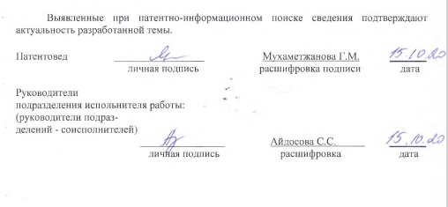

APPENDIX F

Table 1 - Comparative characteristics of morphological characters of 5 plant species of the genus Seriphidium (Bess.) Rouy.

Sprout part | Characters | Characteristics of the aerial organs
Sprout part | Characters | Artemísia leucodes Schrenk. | Artemísia nitrosa Weber. | Artemísia pauciflora Weber. | Artemísia terrae-albae Krasch. | Artemísia Schrenkiana Ldb.
1 | 2 | 3 | 4 | 5 | 6 | 7
Stem | Branching | branching from the base, monodial | from the middle branching, sympodial | at the top branching | at the top branching | at the top branching
Stem | Sectional shape | rounded | rounded | ribbed | ribbed | ribbed
Stem | Leaves arrangement | alternate | alternate | alternate | alternate | alternate
Stem | Height, cm | 30-60 (90) | 40-50 | 10-25 | 35-45 | 30-50 (70)
Leaves | Leaf blade in outline | rounded | ovate-lanceolate | ovoid | ovoid | broadly ovoid or broadly oblong
Leaves | Leaf blade shape | dissected to the base into three palmate-pinnately-divided | double pinnately dissected | twice or three times pinnately dissected | simply or double pinnately dissected | thrice, rarely twice pinnately dissected
Leaves | Base shape | at the base with ears, triply dissected into solid, linear lobules | - | - | at the base with pinnately dissected ears | -

Continuation of table 1
1 | 2 | 3 | 4 | 5 | 6 | 7
1 | Ending leafy lobules | lanceolate | linear and threadlike-linear | linear-lanceolate, short | filiform-linear or linear, short | lower spaced, the rest contiguous, narrowly linear or linear
1 | Length mm | 5-10 | 3-5 | 1.5 | 2 (3) | 2-6
1 | Width, mm | 1-1.5 | 0.5-1 | 0.4-1 | 0.4-1 | 1.5
1 | Stem attachment | medium stem leaves sessile | lower stem long-petiolate, bracts sessile | medium stem leaves sessile | short-petiolate, medium-stemmed leaves sessile | lower stem long-petiolate, others sessile
Inflorescences | Private | basket | basket | basket | basket | basket
Inflorescences | General | panicle long, loose with long branches directed obliquely upwards | collected in a long, narrow, or wide panicle, with short lateral branches | sedentary or on legs, in a typical form, directed upwards or rejected and drooping | collected in a wide, loose panicle with lateral branches, usually almost horizontally deflected, sometimes drooping | numerous, sedentary or short-legged, usually erect
Inflorescences | Peeling wrapper | protruding hairs | pubescence at the beginning of flowering almost glabrous, shiny | punctate glandular, glabrous | 3-4 row, scarlet-convex, whitish with dense, cobweb hairs | whitish, densely pubescent and punctate glandular
Inflorescences | Wrap leaf shape | outer broadly triangular or ovoid, shorter than inner, inner elliptical or oblong | external ovoid, much shorter than internal, internal oblong membranous fringed | external ovoid small, slightly shorter than internal, internal oblong-elliptical | external ovoid, small, much shorter than internal, internal oblong-ovate | outer ovoid-elliptical, much shorter than inner ones, inner oblong-linear
Inflorescences | The nature of the basket receptacle | narrowly filmy edged | from the middle branching, sympodial | filmy bordered | filmy bordered | filmy bordered

Table 2 - Comparative characteristics of morphological characters of 5 plant species of the genus Seriphidium (Bess.) Rouy.

Sprout part | Characters | Characteristics of the aerial organs
Sprout part | Characters | Artemísia gracilescens Krasch. et Iljin. | Artemísia transiliensis Poljakov. | Artemísia karatavica Krasch. et Abol. ex Poljak | Artemísia kasakorum Krash. | Artemísia cina Berg. ex Poljak.
1 | 2 | 3 | 4 | 5 | 6 | 7
Stem | Branching | at the top branching | at the top branching | at the top branching | at the top branching | at the top branching
Stem | Sectional shape | rounded | ribbed | rounded | ribbed | rounded
Stem | Leaves arrangement | alternate | alternate | alternate | alternate | alternate
Stem | Height, cm | 15-30 | 40-65 (80) | 35-60 (70) | 25-45 | 18-30 (45)
Leaves | Leaf blade in outline | oblong | oblong | ovoid | oblong or oblong-ovate | ovoid
Leaves | Leaf blade shape | twice or three times pinnately dissected | double pinnately dissected | twice, three times pinnately dissected | just feathery | double pinnately dissected
Leaves | Base shape | curved or upright at the base | curved or upright at the base | at the base ascending or erect | at the bottom ascending | fertile stems curved or erect at the base
Leaves | Ending leafy lobules | threadlike linear | narrow-linear | narrow lanceolate | whole or deeply cut | narrow-linear
Leaves | Length, mm | 1-2 | 3.5-6 | 2.5-3 (5) | (1) 2-4 | 2.5-4
Leaves | Width, mm | 1 | 1 | 1-2 | 1.5 | 1-2

Continuation of table 2
1 | 2 | 3 | 4 | 5 | 6 | 7
 | Stem attachment | medium stem leaves sessile | bracts simple, linear, sessile | upper bracts simple, sessile linear | seated, upper one-piece, linear | middle stem and lower bracts sessile
Inflorescences | Private | basket | basket | basket | basket | basket
Inflorescences | General | upwardly protruding, sessile, collected in a narrow pyramidal or impoverished spike-shaped panicle | gathered in a narrow panicle | gathered in a narrow panicle | narrow or wide panicle | collected in a narrow, oblong panicle
Inflorescences | Peeling wrapper | grayish pubescent and punctate glandular | grayish, densely cobweb tomentose pubescent | grayish with thick cobweb felt | woolly hairy | green, naked, shiny
Inflorescences | Wrap leaf shape | outer ovoid-elliptical or ovoid | external ovoid | external ovoid | external ovoid | external ovoid
Inflorescences | The nature of the basket receptacle | filmy bordered | filmy bordered | filmy bordered | filmy bordered | filmy bordered

APPENDIX G

