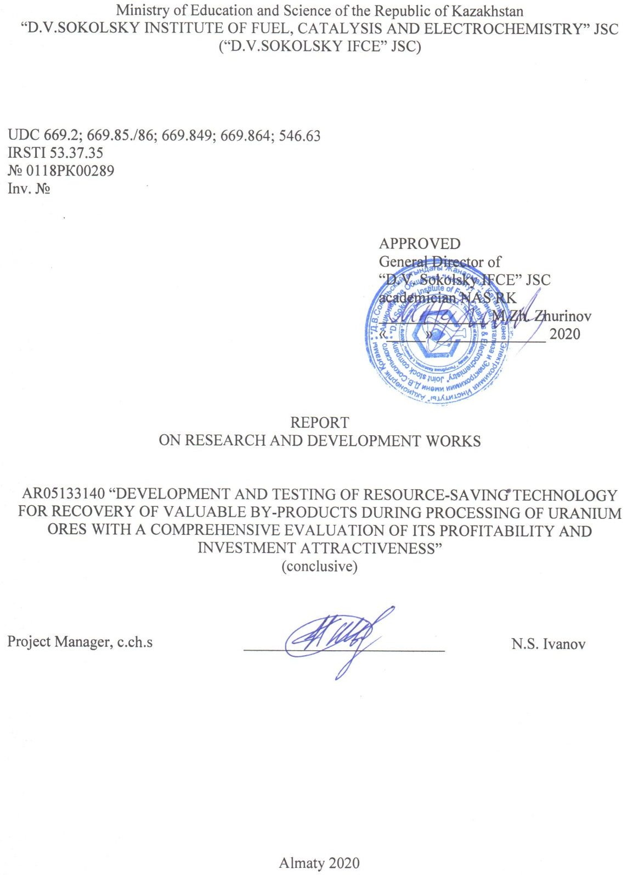
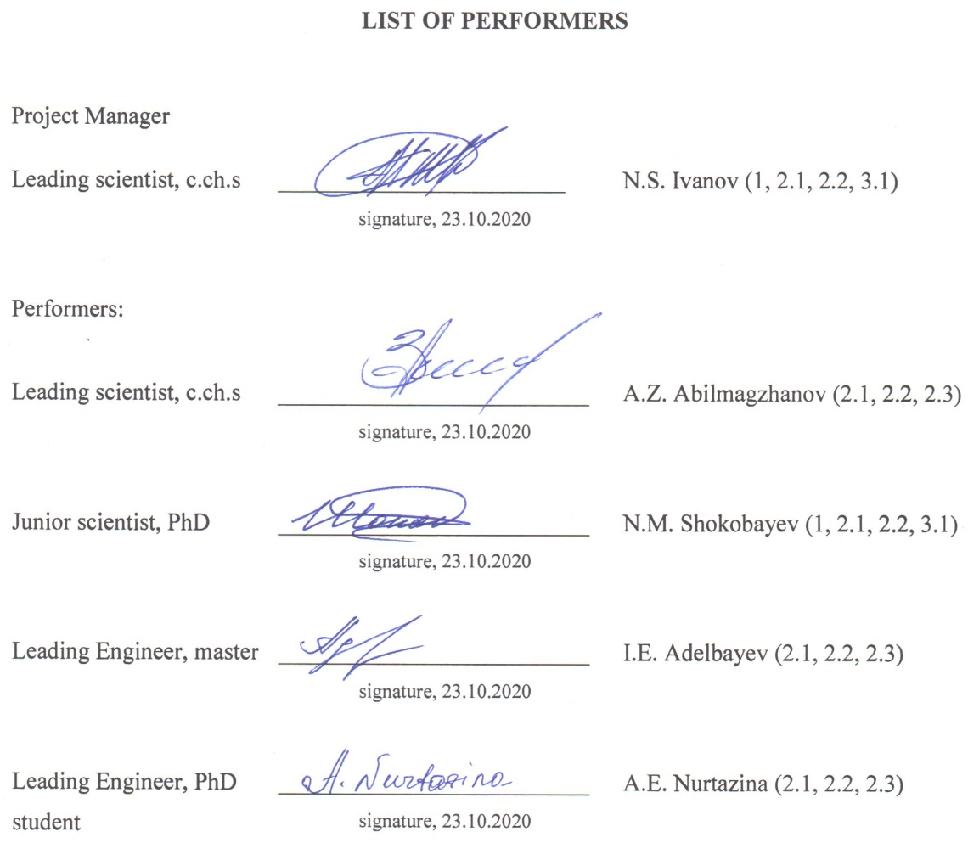

РЕФЕРАТ

Есеп 51 бет, 1 кітап, 7 сурет, 18 кесте, 28 әдебиет тізімі, 5 қосымша.
РЕНИЙ, СКАНДИЙ, ЖЕРАСТЫ ШАЙМАЛАУ, ІЛЕСПЕ БӨЛІП АЛУ, СОРБЦИЯ, УРАН
Зерттеу объектісі: скандий мен ренийді ілеспе өндіру технологиясының өнеркәсіптік өнімдері, сондай-ақ уран өндірісі сорбциясының сүзінділері.
Жұмыстың мақсаты: уран өндірісінің сорбция сүзінділерінен тауар өнімдерін ілеспе өндіру мақсатында құрамында рений мен скандий кездесетін өнеркәсіп өнімдерін шоғырландыру және толық тазалау тәсілі. Техникалық-экономикалық есептеуді орындау.
2018-2019 жылдардағы Жобаның алдыңғы даму сатыларын зерттеу нәтижелеріне қысқаша шолу ұсынылған. Аммоний перренатын толық тазалау бойынша зертханалық зерттеулер жүргізілді. Уран кен орындарын игеру кезінде жерасты шаймалау әдісімен алынатын өнімді ерітінділерден ренийді концентрациялаудың сорбциялық-экстракциялық әдісімен бөлінген тазартылмаған тұздан аммонийдің жоғары сапалы перренатын алу мүмкіндігі анықталды. Аммоний перренаты ерітінділерінен HReO₄ электрдиализдік тазалау және концентрациялаудың оңтайлы шарттары тоқтың тығыздығы 200-250 А/м², электрдиализатор камераларындағы ерітінділердің температурасы 40⁰С, процестің ұзақтығы 2-2,5 сағат, тұзсыздандыру камерасына берілу жылдамдығы минутына 0,75-0,80 көлем болған жағдайда бастапқы ерітіндідегі ренийдің концентрациясы 50-60 г/дм³ болып табылады.
Скандийді ілеспе бөліп алу технологиясының өнеркәсіп өнімдерін шоғырландыру және толық тазалау бойынша сынақтар кешені орындалды. Фосфорорганикалық иониттармен модельдік ерітінділерден скандийдің тепе-теңдік сорбциясының сипаттамалары зерттелді. Статикалық және динамикалық жағдайларда таңдалған иониттермен модельдік ерітіндіден скандий сорбциясы бойынша зерттеулер жүргізілді. Эксперименттер нәтижелері Na₂CO₃ 200 г/дм³ натрий карбонаты ерітіндісін пайдаланған кезде скандиймен қаныққан Lewatit TP260 ионитімен десорбция дәрежесі 87,26% құрағанын көрсетті. NH₄HF₂ 3,5М аммоний фторидінің ерітіндісін пайдаланған кезде ТВЭКС Д2ЭГФК шайырынан скандийді бөліп алу дәрежесі 76% құрады. Уран сорбциясының негізгі ерітінділерінен скандий алу учаскесін құру бойынша техникалық-экономикалық бағалау жүргізілді, ол қабылданған жорамалдар мен орындалған есептеулер шеңберінде 15,58% деңгейінде тиімділікті көрсетті.

ABSTRACT

Report 51 p., 1 b., 7 fig., 18 tabl., 28 ref., 5 appl.
RENIUM, SCANDIUM, UNDERGROUND LEACHING, ASSOCIATED RECOVERY, SORPTION, URANIUM
Subject of research: industrial products of scandium and rhenium by-product mining technology, as well as filtrates of uranium production sorption.
Objective: concentrate and purify rhenium and scandium-containing industrial products for the purpose of by-products production from uranium sorption filtrates. Perform technical and economic calculations.
Brief review of research results of the previous stages of the Project development from 2018 to 2019 is proposed.
Laboratory tests were carried out to further purify the ammonium perrhenate draft. A possibility was established to obtain branded ammonium perrhenate from rough salt separated by sorption-extraction method of concentration of rhenium from productive solutions obtained by underground leaching during uranium deposit development. Optimal conditions for electrodialysis purification and HReO₄ concentration from ammonium perrhenate solutions are current density 200-250 A/m², solution temperature in electrodialysis chambers 40⁰C, process duration 2-2.5 hours, concentration of rhenium in the initial solution 50-60 g/dm³ at the rate of its supply to the desalting chamber 0.75-0.80 volume per minute.
A set of tests on concentration and purification of industrial products of scandium by-product extraction technology was carried out. The characteristics of equilibrium sorption of scandium from model solutions with organophosphorus ionites were studied. The studies of sorption of scandium from the model solution by selected ionites under static and dynamic conditions were carried out. The results of experiments showed that the degree of desorption from scandium-saturated ion Lewatit TP260 was 87.26% when using 200 g/dm³ Na₂CO₃ sodium carbonate solution. Using a solution of ammonium fluoride 3.5M NH₄HF₂ the level of scandium recovery from the resin TVEX (solid extractants) D2EHPA was 76%.
A technical and economic evaluation of the scandium recovery site from master uranium sorption solutions was performed, which demonstrated a 15.58% profitability within the framework of the assumptions made and calculations performed.
CONTENT

DESIGNATIONS AND ABBREVIATIONS 6
INTRODUCTION 7
MAIN PART 8
1. RESEARCH RESULTS FROM PREVIOUS STAGES OF THE PROJECT 8
2. EXPERIMENTAL PART 13
2.1 Source materials and methods of experiments 13
2.2 Investigation of black ammonium perrhenate advanced treatment 16
2.3 Research of scandium solutions concentration processes 21
3. TECHNICAL AND ECONOMIC ASSESSMENT 28
3.1 Associated scandium recovery site evaluation 28
CONCLUSION 35
LIST OF REFERENCES 37
APPENDIX А Technical-economic calculation of Sc associated production at Irkol field. 40
APPENDIX B List of published works 44
APPENDIX C Certificates of acceptance of publications for printing 45
APPENDIX D Calendar work schedule 47
APPENDIX F Protocol abstract 51

DESIGNATIONS AND ABBREVIATIONS

In this research report, the following abbreviations and symbols are used:
LS – leaching solution
L:S – liquid to solid phase ratio
UL – underground leaching
FDEC – full dynamic exchange capacity
AUC – associated useful components
PS – productive solution
UWL – underground well leaching
RM – rare metals
REM – rare earth metals
SEC – static exchange capacity
spec.vol. – specific volume
pH – hydrogen ion exponent, unit

INTRODUCTION

It has been established that in situ leaching method implementation, the accumulation of the following ore elements in the profile of the formation oxidative epigenetic zoning, in addition to uranium, occurs, which can be of practical importance and be developed by the in situ leaching method: selenium, molybdenum, rhenium, vanadium, scandium, yttrium, lanthanides. Compiling in solutions to a possible equilibrium, these components continue to circulate further according to the scheme «pregnant solution → sorption mother liquor → leaching solution → ore → pregnant solution».
The peculiarities of uranium ISL solutions processing include, as a rule, a low content of valuable components and a complex chemical composition. In this regard, many industrial technologies for concentration and extraction, in this case, turn out to be unsuitable and ineffective.
Sorption extraction stands for the most expedient at the stage of primary concentration. Exploring of concentration sorption methods from multicomponent solutions was devoted to many researches carried out more than 40 years ago.
Along with that, the main problems in the implementation of most valuable components associated production are the aspects of putting them on the state balance sheet and the availability of an effective, reliable and flexible technology for their extraction.
Previous experiments have demonstrated the potential to extract rhenium and scandium from uranium sorption filtrates, however, the profitability of production is strongly dependent on the initial contents of these components. In the technological solutions of the uranium mine, taken as the basis of this study, the rhenium content did not exceed 0.02-0.03 g/m3, which generally negatively affects the attractiveness of the project.
In this work an attempt is made to study the possibilities of concentration and purification of rough industrial products of rhenium and scandium and to find a possibility of profitable production by means of development of preliminary TEC (technical-economic calculation).

MAIN PART

1 Research results from previous stages of the project

This chapter summarizes the results and important findings of the Project's research activities in 2018-2019.
The urgency of the problem of complex processing of uranium deposits processed by the PSV method is emphasized by the short remaining period before decommissioning of the existing uranium blocks, which on average varies from 10 to 20 years, as a result of which unrecovered valuable components (rhenium, lanthanides, etc.) will remain in the subsoil, which it will not be expedient to develop in the future directly for their recovery.
Works of 2018. Evaluation of the geological potential for complex processing was carried out on the example of the operating Irkol field. Uranium mineralization is accompanied by increased selenium content, which is the main accompanying component at the Karamurunsky ore district deposits, as well as rhenium, scandium, vanadium and some other elements.
It was found that in the section, the selenium intervals do not bind well into bodies and the latter do not form industrial accumulations, which does not allow estimating selenium as a potential element for additional extraction.
Due to low recovery capacity of rocks, especially gravel differences, there are practically no accumulations of molybdenum, rhenium and vanadium in the uranium ore subzone. Vanadium does not form an independent ore subzone here, but is found in the form of high concentrations of halo (0.01-0.049%), combined with the subzone of uranium and selenium ores. Renium has not been detected in the analytically captured concentrations (over 0.5 g/t). Molybdenum content usually does not exceed 1х10⁻⁴%.
The review of scientific and technical literature and patent information made it possible to establish modern methods of extraction of microcomponents from acid industrial solutions of complex composition.
Despite the low content of potentially attractive elements for extraction, primary laboratory tests were carried out to determine the fundamental sorbability of selected elements on the most preferred resins:
- Ambersep 920U (The Dow Chemical Company), A170 (Purolite), AM-p-2 and AMR (GP “Smoly”) resins were used for rhenium recovery.
- For scandium extraction, the resins of TVEX-D2EHPA (GP “Smoly”), Lewatit TP260 (LANXESS) brands were used.
- Resins of Lewatit 108H (LANXESS), KU-2-8 (LLC “Smoly”) grades were used for REM extraction.
Based on the results of the conducted experiments on rhenium sorption, it was decided to focus further studies on rhenium direction only on resins - A170 and A920 - on which the primary tests on desorption in dynamic mode were performed.
Studies on sorption of scandium allowed to achieve a saturation of 0.024 kg/m³ on the resin TP260 after 700 spec.vol. of uranium sorption mother solutions. D2EHPA resin had a capacity of 0.211 kg/m³ after 2382 spec.vol. Positive primary experiments on desorption in dynamic mode were carried out.
As a result of uranium sorption filtrates pass containing REMs, including dispersions, it was possible to obtain a saturation of 0.03 kg/m3 (495 spec.vol.) and 0.02 kg/m³ on the resin Lewatit 108H (509 spec.vol.).
On the basis of the obtained results in Table 1 there is an initial assessment, which allows to determine the most attractive elements for additional extraction.

Table 1 – Conceptual technical and economic indicators of by-product recovery of rhenium, scandium and REM amounts by four production methods.
Indicator | Method using shop resin  Ambersep 920 | Method using resin Purolite A170 | Method using resin Lewatit TP260 | Method using resin  Lewatit 108H
1 | 2 | 3 | 4 | 5
Concentration of target component in VR/shop resin, mg/dm³ | 0.0055 kg/m³ | 0.018 | 0.209 | 0.673
Annual capacity by marketable product, kg | 40.3  NH₄ReO₄ | 34.4  NH₄ReO₄ | 575.6  Sc₂O₃ | 27 870  Concentrate REE₂O₃
Accepted sale price of the commodity product, $/kg | $1 200 | $1 200 | $2 500 | $25
Annual revenue from sales of marketable products, $ | $48 000 | $41 000 | $1 434 000 | $697 000

Table 1 continue
1 | 2 | 3 | 4 | 5
Capital expenditures:  - technological equipment;  - analytical equipment;  - ion-exchange resin;  - costs of the preparatory period;  - buildings and structures;  - engineering  - working capital (30% of operating expenses) | $962 300  $683 500  $265 000  $400 000  $120 000  $150 000  $30 000  $313 800 | $2 588 300  $650 760  $265 000  $1 114 700  $120 000  $150 000  $30 000  $257 900 | $3 247 100  $742 100  $265 000  $1 485 000  $180 000  $250 000  $40 000  $285 000 | $2 933 400  $1 137 800  $265 000  $150 000  $180 000  $300 000  $40 000  $860 500
Annual operating costs:  - reagents, materials, electric power, FOT, equipment repair;  - AMP costs;  - taxes and payments (incl. severance tax) | $1 050 000  $1 043 000  $3 000  $4 000 | $863 100  $856 500  $3 000  $3 600 | $1 037 900  $900 000  $50 000  $87 900 | $2 912 400  $2 818 400  $50 000  $44 000
Net profit (9 years) | -$1 183 400 | -$1 274 100 | $501 000 | -$2 442 700
NPV (@=10%) (9 years) | -$6 883 400 | -$6 536 900 | -$797 200 | -$13 865 500
Average cost of commercial products (without amortization), $/kg | $26 021,9 | $25 059,4 | $1 808,0 | $104,5

The lower price range is set for profitable extraction of by-products. It should be noted that these calculations were conceptual in nature and reflected the appropriate level of development and accepted assumptions.
Works in 2019. After identification of potential elements for by-product recovery, a set of works on concentration and advanced treatment of rhenium and scandium-containing products and implementation of the basic evaluation of the project for associated recovery of rhenium and scandium in underground well leaching (UWL) of uranium was performed.
Modern foreign scientific and technical information on available approaches to concentration and purification of rhenium and scandium-containing solutions was reviewed.
Ambersep 920U (The Dow Chemical Company) and A170 (Purolite) resins were used for rhenium recovery. For scandium extraction, TVEX- D2EHPA resin (GP “Smoly”) was used.
The kinetics of rhenium sorption-2 from first stage desorbates at different pH solutions was studied. It was found that the capacity and kinetics of A170 resin is slightly higher than that of A920 at pH from 1 to 3. However, already at pH 5 there was a sharp decrease in sorption properties of the resin A170 and complete absence of sorption at pH>10, which is probably due to the type of ion exchange groups.
The resin A920, on the contrary, demonstrated an increase in kinetic and capacitive characteristics with increasing pH. Taking into account that the initial solution (desorbate of the first sorption operation) has an alkaline medium (pH 10-11), the use of direct sorption of rhenium from desorbate on the A920 resin will allow to avoid neutralization of the solution and acidification, which in its turn will positively affect the cost of produced ammonium perrenate.
The possibility of sorption-2 under dynamic conditions from ammonium desorbates from the Purolite A170 resin on a highly basic anionite of Ambersep 920 type has been studied. As a result of the experiment, it was possible to sorp rhenium on the resin under alkaline conditions up to a concentration of 22 kg/m³, which is much higher than expected, because even after passing 800 spec.vol., the filtrate contained only 0.2% of the initial rhenium, without any sign of saturation rate reduction.
Experiments in dynamic conditions confirmed the efficiency of the desorbing solution composition. The average concentration of rhenium in the combined desorbate was 1.5 g/dm³, which allowed to precipitate rhenium at the next stage without further concentration.
The desorbate was processed by liquid extraction and subsequent solid-phase deposition.
Since scandium is also a promising element for extraction, tests on desorption of saturated D2EHPA resin at different concentrations of sodium carbonate were carried out.
The extracted scandium was re-sorbed on D2EHPA resin (sorption-2) at different pH. As a result, the rationality of the first operation of desorption of 100 g/dm³ Na₂CO₃ solutions was established, because in the future a minimum amount of deoxidant is required to bring the pH of the first stage desorbates to the value of 2-3. This solution will allow effective sorption extraction at the second stage with the lowest operating cost.
Based on the results obtained, a clarifying assessment of economic viability of rhenium and scandium extraction was made.
It was established that under the assumptions adopted and the arrangement of the site with a capacity of 29.11 kg of ammonium perrhenate per year, even with a high projected price of $4000/kg and annual revenue of $116,440, this Project will not be profitable and the cost of production (excluding depreciation) is $7312/kg. The main reason for this is the micro content of the valuable component in the initial solution - 0.02 g/m³. The second factor is the high volume of processed solutions - it is obvious that it is desirable to avoid the main sorption process and shift this process and the cost of main uranium processing. The project acquires zero profitability at achievement of initial concentrations of 0.078 g/m³ of rhenium in solution that is 3.9 times more than the current average content.
A preliminary assessment of the organization of the site with a capacity of 109.35 kg of scandium oxide per year showed that the technology has the potential for optimization, and the cost of production (excluding depreciation) is $ 3078/kg. For further development of the area, it is necessary to optimize technical and economic parameters when testing the technology on a larger scale.

2 Experimental part

2.1 Source materials and methods of experiments

In the work we used ionite heterogeneous membranes: cationic membrane of MK-40 brand and anionite membrane of MA-40 brand, their characteristics are given in Table 2.

Table 2 – Characteristics of Heterogeneous Membranes
Index | МК-40 | МА-40
Ionite brand | КU-2 | EDP-10P
Ionite content, % | 65 | 55
Reinforcing tissue | capron | capron
Tear strength in swollen condition, Pa, not less | 1300 | 1200
Exchange capacity, mg-eqv/g | 2.6 | 3.8

Sorption of scandium was studied with the use of sulfuric acid solution simulating solutions of sulfuric acid UWL uranium. The model solution for sorption of 60 dm³ of scandium was prepared by dissolving scandium oxide Sc₂O₃ with 99,9% purity in a hot solution of 60% sulfuric acid (CH 94,6%) at 80⁰C for 0,5 hours.
Solutions used in the experiments were: sodium carbonate Na₂CO₃, ammonium hydrofluoride NH₄HF₂, hydrofluoric acid HF, sodium fluoride NaF, caustic soda NaOH, citric acid C₆H₈O₇.
Preconditioning of these ionites has been carefully performed. The resins were successively treated with 2N hydrochloric acid solution, distilled water and 5% caustic soda solution. Then the resins were transferred to the working form by exposure during the day in the corresponding medium and then washed with distilled water to pH 3.5.
The behavior of metal ions in the process of sorption/desorption was studied under both static and dynamic conditions.
The process of scandium extraction from sulfate solutions was studied using phosphorus-containing ions whose characteristics are presented in Table 3.

Table 3 – Main characteristics of the resins used in the work
Resin | Functional group | Matrix type | Granule size in air-dry condition, mm
Chelate resins
Lewatit TP272 | bis- (2,4,4-trimethylpentyl) phosphinic acid | macroporous, cross-linked polystyrene | 0.30÷1.60
Lewatit TP260 | aminomethylphosphonic acid | macroporous, cross-linked polystyrene | 0.40÷1.25
Solid TVEX extractants
D2EHPA | di-2-ethylhexylphosphoric acid | macroporous, ultra cross-linked polystyrene | 0.65÷2.50
RPO | radical phosphine oxide | macroporous, ultra cross-linked polystyrene | 0.25÷0.80

Sorption under static conditions. Taking into account extremely low concentrations of target components, it is reasonable to apply a large ratio of L:S phases for studies in static conditions. Static sorption was performed in a container of 5 dm³ using a mixing device at L:S ratio of 1000:1 (5 dm³ : 5 g). L:S 120:1 (200 cm³ : 1.7 g) conditions were also applied.
Duration of experiments was from 12 to 24 hours. The stirring speed was adjusted in such a way as to prevent the "embedding" of resin particles at the bottom of the container as a fixed layer. Samples were taken for analysis at certain time intervals without interrupting the experiment. The change in system volume as a result of sampling did not exceed 5%.
The values of static ion exchange capacity were calculated by formula:

$SEC=\frac{С_{0}-С_{р}}{С_{0}}∙\frac{V}{m}$, (1)

where С₀ и С_{р} – initial and equilibrium concentrations of sorbable component, mg/dm³;
V – solution volume, dm³;
m – resin weight, g.
Desorption in static conditions. In the study of desorption, a ratio of L:S 50:1 (250 cm³ : 5 g) with a duration of 12 hours was used. The change in the system volume as a result of sampling also did not exceed 5%.
The content of element in resin was calculated on the basis of material balance taking into account the element concentration in the initial solution.
Sorption under dynamic conditions. To study the processes in dynamics, previously soaked and converted to the required form, the ionite was placed in 30 cm³ plexiglass columns (height to diameter ratio 4,8:1). The solution was passed through the clamped layer from bottom to top with the help of peristaltic pump. The diagram of the installation is shown in Figure 1. At controlled rate of flow, filtrates of sorption were fractionally selected for analysis. The capacity before overshoot (DEC) and the full exchange capacity (FDEC) were determined by integral summation of the area above the sorption output curve in coordinates C/C₀ - t.
The distribution coefficient of sorbed component was calculated by formula:

K_{d} = $\frac{(C_{0}-C)∙V}{C∙m}$ (2)

where K_{d} – sorbable component distribution coefficient, см³/г,
$С_{0}$ –concentration of sorbable component in the initial solution, mg/dm³ or mmole/dm³,
С –concentrations of sorbable component in mother sorption solution, mg/dm³ or mmole/dm³,
$V$ – passed solution volumem – ionite weight mass, g

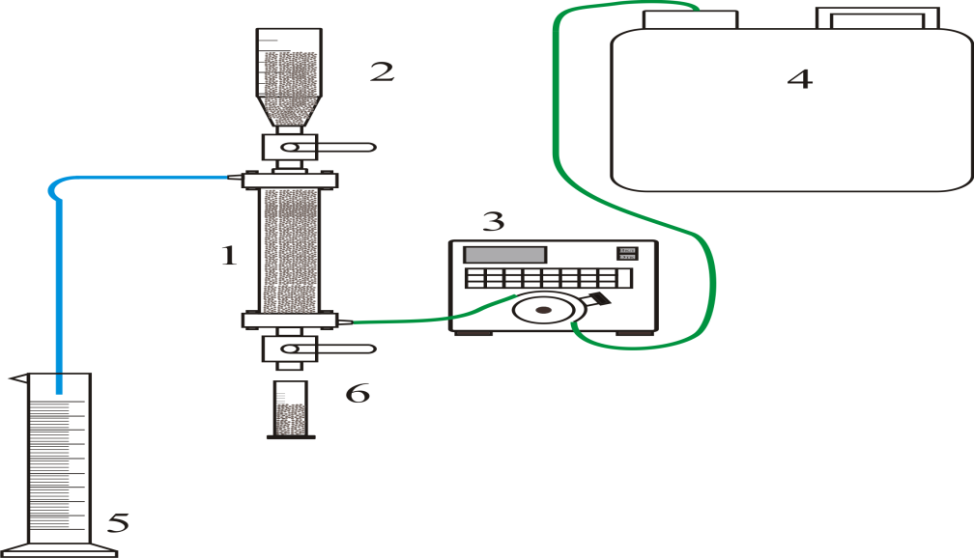
1 - sorption column; 2 - resin hopper; 3 - peristaltic pump; 4 - feed solution tank; 5 - filtrate tank; 6 - resin tank

Figure 1 –Diagram of sorption plant for research in dynamic conditions

Analysis of liquid and solid samples for rhenium and scandium content was carried out in the analytical laboratory “National Scientific Laboratory of Collective Use in the priority direction “Technologies for Hydrocarbon and Mining and Metallurgical Sectors and Related Service Industries” of “Center of Sciences on Earth, Metallurgy and Enrichment” JSC. The atomic emission spectral method of analysis with inductively coupled plasma on Optima 8300 DV spectrometer (PerkinElmer, LLC) Optima 8300 DV (Central Experimental Methodical Expedition) was used for measurements. The quality of HReO₄ rhenium acid obtained was evaluated by deposition of NH₄ReO₄ in accordance with existing specifications.
During the experiments pH solutions were controlled by pH-150MI device.

2.2 Investigation of black ammonium perrhenate advanced treatment

Stable high demand for rhenium in the world market stimulates improvement of methods of its production from ore, technogenic and secondary raw materials. One of the promising sources of by-product extraction of rhenium in Kazakhstan is the productive solutions obtained by underground leaching method during development of uranium deposits [1-5].
Extraction and concentration of rhenium from solutions of different composition in the form of potassium and ammonium perrhenates is most often performed by sorption and extraction methods [6-12]. Pure ammonium perrhenate (NH₄ReO₄) is the main commercial salt used to produce standard powder of pure metal rhenium, the quality of which is strictly regulated. In practice, pure ammonium perrhenate of AR-0 grade is obtained by purification of ammonium perrhenate from impurities by different methods: recrystallization, ion-exchange sorption, liquid extraction, electrodialysis, etc. [13-17].
Recently, the electrodialysis method of processing rough and substandard rhenium salts has been effectively used to produce high-purity concentrated (not less than 20%) rhenium acid with subsequent ammonium perrhenate deposition of АР-0 grade [7,8,18-21]. In comparison with other methods, electrodialysis is characterized by minimal rhenium losses at the processing stage, compactness, small amount of reagents used and high quality of commercial products.
The aim of the work was to investigate electrodialysis process of purification of ammonium draft perrhenate obtained by sorption-extraction method of rhenium concentration and to determine optimal conditions for its implementation.
Source material for electrodialysis purification was rough ammonium perrhenate obtained as a result of research on sorption and extraction processing of rhenium-containing solutions. The technological scheme for extraction of rhenium from uranium sorption filtrates developed by us includes the following sequential operations:
- rhenium sorption from uterine solutions of uranium sorption on weakly basic anionite Purolite A170;
- uranium desorption, washing of anionite;
- rhenium desorption from saturated Purolite A170 ionite with aqueous ammonia solution;
- sorbent conversion;
- sorption of II rhenium from stage I desorbate with a highly basic Ambersep 920U anionite;
- washing of saturated anionite;
- rhenium II desorption from Ambersep 920U resin with a solution of ammonium nitrate and sulfuric acid;
- liquid extraction of rhenium from the organic mixture of desorbate II;
- washing of the saturated extract;
- solid phase re-extraction of rhenium with saturated organic mixture by ammonium sulphate solution;
- filtration, washing of ammonium perrhenate draft sediment.
Model solution for electrodialysis was prepared by dissolving the calculated amount of dry powder, obtained ammonium perrhenate in distilled water at 30-40 ^{о}С.
The process was carried out on the laboratory unit consisting of a three-chamber electrodialysis unit, an intermediate vessel (dividing funnel), a pump and a device for regulating the rate of feed of the initial solution into the demineralization chamber (middle chamber). Anode and cathode chambers were separated from the middle chamber by anionic and cationic membranes respectively. Membrane surface was equal to 0.0142 m². Volume of working solution of ammonium draft perrhenate makes 400 cm³. Before installation into dialyzer the dry membranes were soaked in distilled water for 48 hours. Vacuum rubber gaskets were installed between the membrane frames to create more reliable tightness in the chambers. The cathode is made of stainless steel, the anode material is tantalum-based foil (area 0.006 m²).
Model solution was fed from the intermediate chamber and filled the middle chamber of the electrodialyzer with simultaneous switching on of the pump for circulation of ammonium perrhenate in the middle chamber. Anode chamber was filled with solution, prepared from pure ammonium perrhenate PRA-0, containing 1 g/dm3 of rhenium, cathode chamber was filled with solution, containing 1 g/dm³ of ammonia. Flow rate in the demineralization chamber is 0.8 volume per minute. Rhenium concentration in the initial chamber is 50÷60 g/dm³.
Under the action of electric field NH₄+ and impurity cations, including K⁺ and Na⁺, migrate to the cathode chamber, and ReO⁴⁻ anions migrate through anionic membrane to anode chamber of rhenium acid concentration. Thus, typical metal impurities are concentrated in the cathode and the anolyte is enriched with rhenium. Electrolysis is accompanied by electrolytic release of hydrogen on the cathode and accumulation of hydroxyl ions in the cathode. At the anode, oxygen is released due to the discharge of hydroxyl ions.
The influence of current density and electrodialysis time on the migration rate of rhenium ions and the quality of the obtained ammonium perrhenate was studied.
During the experiments the working current density in the range of 150 - 300 A/m² and the process duration 60-180 minutes were varied. The initial temperature of the process was 30 ^{о}С, with the increase of electrolysis duration over 2 hours and the increase of current density over 200 A/m² the temperature of solutions in electrodialysis chambers increases up to 40 ^{о}С. It is connected with impoverishment of solution on rhenium (concentration of rhenium in demineralization chamber becomes insignificant ~5,5 g/dm³), increase of electrical resistance of solutions and, as a consequence, increase of quantity of heat released.
The results of electrodialysis of model rhenium-containing solutions and dependence of migration of rhenium ions on the duration of the process at different current densities are given in Tables 4-7.

Table 4 – Effect of electrodialysis duration on rhenium migration rate at current density 150 A/m²)
Process duration, min | Content of rhenium in the middle chamber, g/dm³ | Number of rhenium migrating to anode chamber, g | Migration rate of rhenium, g/m²h
60 | 27.66 | 11.36 | 600
90 | 18.14 | 15.14 | 640
120 | 6.12 | 19.80 | 700
150 | 2.86 | 21.24 | 660
180 | 2.22 | 21.68 | 640

Table 5 – Effect of electrodialysis duration on rhenium migration rate at current density 200 A/m²)
Process duration, min | Content of rhenium in the middle chamber, g/dm³ | Number of rhenium migrating to anode chamber, g | Migration rate of rhenium, g/m²h
60 | 27.62 | 11.52 | 640
90 | 17.86 | 15.32 | 660
120 | 5.86 | 20.12 | 870
150 | 1.84 | 21.60 | 700
180 | 1.26 | 22.08 | 640

Table 6 – Effect of electrodialysis duration on rhenium migration rate at current density 250 A/m²)
Process duration, min | Content of rhenium in the middle chamber, g/dm³ | Number of rhenium migrating to anode chamber, g | Migration rate of rhenium, g/m²h
60 | 27.64 | 11.48 | 650
90 | 18.00 | 15.26 | 680
120 | 6.16 | 20.08 | 880
150 | 2.42 | 21.46 | 700
180 | 1.76 | 21.88 | 640

Table 7 – Effect of electrodialysis duration on rhenium migration rate at current density 300 A/m²)
Process duration, min | Content of rhenium in the middle chamber, g/dm³ | Number of rhenium migrating to anode chamber, g | Migration rate of rhenium, g/m²h
60 | 27.64 | 11.48 | 650
90 | 18.14 | 15.20 | 700
120 | 6.44 | 19.86 | 870
150 | 2.54 | 21.32 | 730
180 | 1.84 | 21.82 | 690

As follows from the tables above, the maximum rate of migration of rhenium ions into the anode chamber was observed at the process duration of 2-2.5 hours and was within the limits of 660÷700 g/m²h, 700-870 g/m²h, 700-880 g/m²h, 730-860 g/m²h at operating current densities of 150 A/m², 200 A/m², 250 A/m² and 300 A/m² respectively. Longer conduction of electrodialysis process resulted in reduction of rhenium ions migration rate to 640-690 g/m²h and increase of solution temperature.
Taking into account the results obtained, it is possible to determine optimal conditions of electrodialysis process of rhenium acid concentration from ammonium perrhenate solution: operating current density 200÷250 A/m², process duration 2÷2.5 hours, temperature in the chambers not more than 50 ^{о}С, concentration of rhenium in the initial chamber 50÷60 g/dm³. Under these conditions, concentration of rhenium acid is reached ~300 g/dm³.
Direct output of rhenium in rhenium acid under such conditions of the process was 72%. At concentration of rhenium in anode chamber up to 300÷400 g/dm³ of rhenium acid direct yield was ~90÷94%, total recovery of rhenium at the redistribution was 99,75%.
Then, the solution of rhenium acid, obtained by electrodialysis method, was directed to obtain crystal ammonium perrhenate. Ammonium perrhenate is synthesized when ammonia and rhenium acid interact.
To precipitate ammonium perrhenate, a solution of rhenium acid was neutralized by 8% wt. of ammonia solution. The final pH value was 7.0-7.2. As the solubility of ammonium perrhenate significantly depends on the temperature, to reduce its solubility, the pulp was cooled down to 6-8ºC and filtered. The uterine solution was taken for analysis, and the sludge was dried at 105-110ºС to a constant mass and also analyzed. The obtained ammonium perrhenate was a white crystalline sediment. The quality of ammonium perrhenate obtained from the experiments is given in Table 8.

Table 8 – Content of elements in precipitated ammonium perrhenate salts
Element | Element content, % wt. in ammonium perrhenate salt obtained by electrodialysis at current density
Element | 150 А/m² | 200 А/m² | 250 А/m² | 300 А/m²
Reny | 69.1 | 69.1 | 69.1 | 69.1
Aluminum | 5.8∙10⁻⁵ | 2.2∙10⁻⁵ | 2.0∙10⁻⁵ | 2.5∙10⁻⁵
Iron | 4.6∙10⁻⁴ | 3.8∙10⁻⁴ | 3.8∙10⁻⁵ | 3.9∙10⁻⁴
Potassium | 8.4∙10⁻⁴ | 2.9∙10⁻⁴ | 2.8∙10⁻⁴ | 3.5∙10⁻⁴
Calcium | 9.2∙10⁻⁴ | 4.5∙10⁻⁴ | 4.6∙10⁻⁴ | 4.8∙10⁻⁴
Silicon | 8.2∙10⁻⁴ | 1.0∙10⁻³ | 1.2∙10⁻³ | 3.2∙10⁻³
Magnesium | 1.2∙10⁻⁴ | 6.4∙10⁻⁵ | 6.5∙10⁻⁵ | 9.3∙10⁻⁵
Manganese | 8.2∙10⁻⁶ | 8.2∙10⁻⁶ | 3.5∙10⁻⁵ | 2.8∙10⁻⁵
Copper | 6.5∙10⁻⁵ | 5.2∙10⁻⁵ | 4.8∙10⁻⁵ | 5.3∙10⁻⁵
Molybdenum | 2.0∙10⁻⁴ | 1.2∙10⁻⁴ | 1.0∙10⁻⁴ | 3.1∙10⁻⁴
Sodium | 3.3∙10⁻⁴ | 1.3∙10⁻⁴ | 1.4∙10⁻⁴ | 5.3∙10⁻⁴
Nikel | 4.8∙10⁻⁵ | 4.7∙10⁻⁵ | 4.6∙10⁻⁵ | 4.8∙10⁻⁵
Sulfur | 1.5∙10⁻³ | 1.3∙10⁻³ | 3.4∙10⁻⁴ | 2.6∙10⁻⁴
Phosphorus | 8.8∙10⁻⁵ | 1.8∙10⁻⁵ | 1.6∙10⁻⁵ | 5.6∙10⁻⁵

As can be seen from the data in Table 8, ammonium permeate obtained as a result of electrodialysis, regardless of the operating current density, meets the requirements of technical documentation [22, 23].

2.3 Research of scandium solutions concentration processes

The study of scandium sorption isotherma characterizing the state of ion-exchange equilibrium at constant temperature was carried out at the concentration range maximally close to the technological conditions of uranium leaching. Figure 2 shows sorption isotherms of scandium on ionites obtained by varying the initial concentration in the solution from 0.03 to 0.6 mg/dm³ (0.67∙10-3 ÷ 13.3∙10-3 mmole/dm³). Amount of ionite capacity was calculated by formula (1), distribution coefficient by formula (3). The results of the study of scandium sorption isotherms are given in Table 9.
As can be seen from the given graphs, sorption isotherms of scandium within the studied concentration range are close to the straight-line type. Processing of isotherms was carried out using Langmuir and Henry equations [24]. The results of treatment in coordinates 1/E - 1/C (Langmuir equation) and E - C (Henry equation) are presented in Table 10.
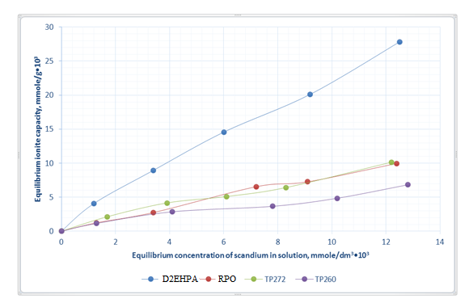
Figure 2 –Scandium sorption isotherms from model solutions of ionites TP272, TP260, D2EHPA, RPO

Table 9 – Results of scandium sorption isotherm research
Ionite | Equilibrium concentration of scandium in solution  mmole/dm³*10³ | Ionite capacity, mmole/g*10³ | Distribution coefficient K_{d}, сm³/g
TP272 | 1.68 | 2.14 | 1756.0
TP272 | 3.95 | 4.16 | 1112.8
TP272 | 6.12 | 5.10 | 914.6
TP272 | 8.28 | 6.42 | 1194.8
TP272 | 12.24 | 10.14 | 862.8
TP260 | 1.28 | 1.15 | 1108.6
TP260 | 4.12 | 2.86 | 689.6
TP260 | 7.76 | 3.66 | 788.0
TP260 | 10.21 | 4.85 | 646.6
TP260 | 12.80 | 6.82 | 658.8
D2EHPA | 1.16 | 4.08 | 3546.2
D2EHPA | 3.42 | 8.95 | 4122.3
D2EHPA | 6.00 | 14.56 | 4852.6
D2EHPA | 9.20 | 20.12 | 3896.2
D2EHPA | 12.48 | 27.82 | 3452.5
RPO | 1.32 | 1.24 | 666.5
RPO | 3.44 | 2.75 | 768.8
RPO | 7.22 | 6.54 | 844.0
RPO | 9.12 | 7.26 | 716.8
RPO | 12.42 | 9.96 | 708.6

Table 10 – Results of scandium sorption isotherm treatment
Ionite Equation | Ionite Equation | Concentration area, mmole/dm³*10³ | Constanta K, dm³/g (Henry) or g/mole (Langmuir) | Correlation coefficient R²
TP272 | Henry | 1.68÷12.24 | 1.12 | 0.8692
TP272 | Langmuir | 1.68÷12.24 | 198.622 | 0.7458
TP260 | Henry | 1.28÷12.80 | 0.72 | 0.9742
TP260 | Langmuir | 1.28÷12.80 | 108.55 | 0.9413
D2EHPA | Henry | 1.16÷12.48 | 3.56 | 0.9826
D2EHPA | Langmuir | 1.16÷12.48 | 16.68 | 0.9748
RPO | Henry | 1.32÷12.42 | 0.82 | 0.9832
RPO | Langmuir | 1.32÷12.42 | 3.10 | 0.9812

From the analysis of the presented results we can conclude that there is no significant difference between correlation coefficients of the two equations for the studied resins in the selected concentration range and conditions.
The study of kinetic characteristics of sorption of scandium was carried out by the method of limited volume [25] on the unit with thermostatable cell at 293 K in such a way that the exchange process took place in a mixing solution of 5000 cm³ with initial composition of 0.22 mg/dm³. In this case, the concentration of sorbed ion in the solution changes in the process of experiment, which affects the speed of the process. The application of rather intensive mixing achieves uniform distribution of ion concentration in the whole solution volume except for the layers directly adjoining the grain (boundary layer). Integral kinetic curves of sorption of scandium investigated at 293 K are shown in Figure 3.
From Figure 3 you can see that the TR260 ionite showed the lowest kinetic and capacitance values, the TR272 and RPO ionites are saturated with scandium in about 6 hours, while the D2EHPA resin shows a lower saturation rate with significantly higher equilibrium capacity. However, the strong affinity of the ion to the extractable element naturally complicates the subsequent extraction of scandium from the resin phase during desorption.
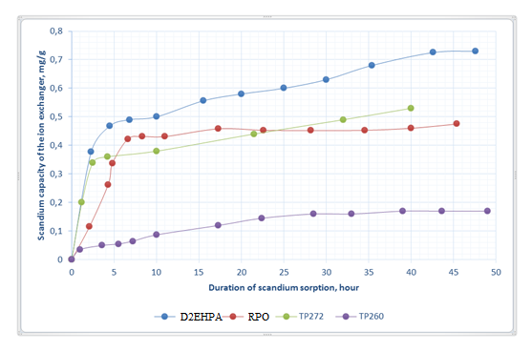
Figure 3 –Integral kinetic curves of scandium sorption from model solutions

The obtained results allowed selecting Lewatit TP260 and D2EHPA ions for further study of sorption extraction of scandium.
Before sorption of scandium on the selected ionites under dynamic conditions, an experiment was conducted in a static mode. The L:S ratio was 1000:1 (5 dm³ scandium-containing solution : 5 g resin). The tank was stirred to prevent tar particles from accumulating for 48 hours, after which a sample of solution was taken and analyzed for scandium. Table 11 shows the results of sorption of scandium in static conditions.

Table 11 – Results of sorption of scandium in static conditions
Resin | Concentration Sc, mg/dm³ |  | Extraction ratio, % | Resin capacity, kg/m³
Resin | Initial | Final | Extraction ratio, % | Resin capacity, kg/m³
ТР260 | 0.186 | 0.155 | 16.72 | 0.031
D2EHPA | 0.186 | 0.139 | 25.27 | 0.047

Sorption extraction of scandium under dynamic conditions was performed according to the method described above from sulfate solution at specific load of 10 spec.vol. / spec.vol./h. Results of sorption of scandium on TR260 and D2EHPA ionites are given in Tables 12 and 13.

Table 12 – Results of sorption of scandium on TR260 ionite
Specific volume, unit | 0 | 100 | 200 | 300 | 400 | 500 | 600 | 700 | α, kg/m³
Concentration Sc, mg/dm³ | 0.186 | 0.081 | 0.157 | 0.161 | 0.180 | 0.184 | 0.183 | 0.176 | 0.027

At the missed volume of solutions the calculated saturation of 0.027 kg/m³ was obtained.

Table 13 – Scandium sorption results on ionite D2EHPA
Specific volume, unit | 0 | 150 | 320 | 486 | 650 | 780 | 942 | 1120 | α, kg/m³
Concentration Sc, mg/dm³ | 0.186 | 0.028 | 0.063 | 0.098 | 0.104 | 0.104 | 0.084 | 0.069 | 0.148
Specific volume, unit | 1190 | 1430 | 1566 | 1678 | 1860 | 2059 | 2218 | 2382 | 0.148
Concentration Sc, mg/dm³ | 0.062 | 0.058 | 0.055 | 0.057 | 0.058 | 0.064 | 0.069 | 0.072 | 0.148

The saturation was 0.148 kg/m³, with the missed volume of solutions it was possible to get the calculated saturation of 0.236 kg/m³.
Thus, at the missed volume of solutions it was possible to obtain saturation on TP260 ionite at 700 units of efficiency equal to 0.027 kg/m³ and on D2EHPA ionite at 2382 units of efficiency equal to 0.236 kg/m³.
Desorption of scandium from saturated ionites was carried out in columns of 30 cm3 (ratio of sorbent layer height to diameter h/d = 4.8:1), filled with saturated resin from previous experience in sorption. The desorbing solution was passed through the clamped layer of ion from bottom to top with the use of peristaltic pump and specific load was 1 spec.vol. / spec.vol./hour At controlled flow rate, sorption filtrates were fractionally selected for analysis.
Desorption of scandium from saturated ion Lewatit TP260 was carried out under dynamic conditions by solution of sodium carbonate with concentration of 200 g/dm³ Na₂CO₃. The results of the experiment on desorption of scandium from the resin TP260 are given in Table 14 and Figure 4.

Table 14 – Results of the experiment on desorption of scandium from Lewatit TR 260 resin under dynamic conditions
Specific volume, unit | 0 | 1 | 2 | 3 | 4 | 5 | 6 | 7 | 8 | 9 | 10
Concentration Sc, mg/dm³ | 0 | 1.98 | 6.25 | 4.56 | 2.40 | 1.22 | 0.84 | 0.62 | 0.45 | 0.23 | 0.23
Extraction Sc, % | 0 | 5.64 | 18.12 | 37.24 | 57.22 | 70.15 | 81.15 | 82.20 | 84.36 | 85.52 | 87.26

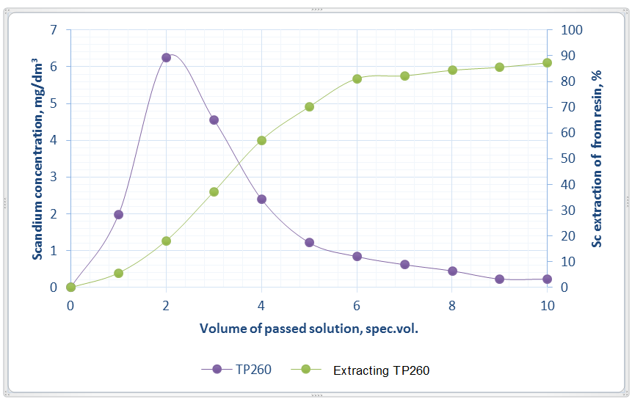
Figure 4 – Scandium desorption curve and scandium recovery ratio from Lewatit TR260 resin

Level of desorption from Lewatit TP260 scandium-saturated ion at 200 g/dm³ Na₂CO₃ and 10 spec.vol. pass at room temperature was 87.26%, which allows to conclude about the effectiveness of the selected scandium desorbent.
Scandium desorption from TVEX D2EHPA saturated ion was carried out under static conditions using various desorbent solutions. The volume of saturated D2EHPA resin for each experiment was 5 cm³. The volume of desorbing solutions was 200 cm³. Desorbing solutions of the following concentration were used:
- 200 g/dm³ Na₂CO₃;
- 3.5М NH₄HF₂;
- 3.5М НF;
- 3.5М NaF;
- 0.5М NaOH + 1M Na₂CO₃;
- 5% - citric acid solution
Results of the experiment on desorption of scandium from resin TVEX D2EHPA are given in Table 15 and Figure 5.

Table 15 – Results of the experiment on desorption of scandium from resin TVEX D2EHPA under static conditions
Desorbing solution | Scandium concentration in desorbate, mg/dm³  during desorption, h |  |  |  |  |  | Extraction ratio, %
Desorbing solution | 1 | 2 | 4 | 6 | 12 | 24 | Extraction ratio, %
Na₂CO₃ | 0.60 | 1.13 | 2.33 | 3.10 | 4.33 | 7.05 | ~100
NH₄HF₂ | 1.8 | 2.62 | 3.35 | 3.65 | 3.75 | 4.32 | 76
HF | 4.74 | 5.53 | 5.86 | 6.27 | 6.56 | 7.22 | ~100
NaF | 0.0025 | 0.068 | 0.068 | 0.065 | 0.070 | 0.096 | 2
NaOH + Na₂CO₃ | 0.48 | 0.85 | 1.15 | 1.20 | 1.15 | 1.09 | 13
Citric acid | 0 | 0 | 0 | 0 | 0 | 0 | 0

It was found in [26-28] that scandium can be extracted from D2EHPA by carbonate alkaline solutions or solutions of hydrofluoric acid or its salts. However, the use of carbonate alkaline solutions for desorption of scandium from TVEX is unacceptable, since D2EHPA will be emulsified and leached from TVEX phase. It is also unacceptable to use some salts of hydrofluoric acid, as this will lead to the formation of complex salts in the phase of TVEX.

Figure 5 – Kinetic desorption curves of scandium from TVEX D2EHPA resin

It can be seen from the data presented in Table 15 and Fig. 5 that when using solutions of sodium carbonate Na₂CO₃ (200 g/dm³) and hydrofluoric acid HF (3.5M) as desorbing solutions, almost complete desorption of scandium from TVEX D2EHPA resin under static conditions was observed.
At the same time, carbonate-alkali solution of 0.5M NaOH + 1M Na₂CO3 and 3.5M solution of sodium salt of hydrofluoric acid NaF showed very low desorption characteristics.
Solution of ammonium fluoride NH₄HF₂, devoid of disadvantages of carbonate-alkaline desorbates, is used for desorption of scandium with phosphorus-containing ionites. In our experiments, the degree of desorption from scandium-saturated ion TVEX D2EHPA with 3.5M solution of NH₄HF₂ at room temperature was 76%.
As can be seen, the obtained results of desorption are in good agreement with the literature data.

3 Technical and economic assessment

The conducted studies and previous basic calculations demonstrated a serious potential for by-product rhenium production. At the same time, it is obvious that microcontent of valuable component in the initial solution (0.02 g/m³) and significant volume of processed solutions do not allow to implement the Project with acceptable economic indicators directly from this raw material.
It should be also taken into account that rhenium is a strategic element and its extraction may make sense even to the detriment of economic feasibility. Marketable product (ammonium perrhenate) accumulated in the warehouse may be potentially sold at a time when metal prices are rising critically and with some benefit.
It should also be noted that there are several uranium facilities in Kazakhstan with solutions containing rhenium up to 0.4 g/m³, which is five times the minimum level for profitable mining (0.078 g/m³).
Thus, the developed technology of rhenium recovery can be estimated for sale directly at the above enterprises with high chances of success.
In the framework of this work, which is based on the solutions of the Irkol deposit, technical and economic calculations will be performed only for the scandium extraction direction.

3.1 Associated scandium recovery site evaluation

As a result of laboratory research, the technological scheme of scandium associated extraction from uranium sorption filtrates was developed. The main technological parameters and modes, which formed the basis of the present technical and economic assessment, were determined.
As the initial and remaining reserves of scandium in contoured uranium ore are unknown, at this stage it is possible to assume that the equilibrium concentration of scandium in solution is 0.22 g/m³. It makes sense to make an assumption about the expediency of processing 250 m³/hour of uranium sorption mother solutions, which is convenient both in terms of hardware design and minimization of financial risks at a potentially acceptable level of profitability.
The technology of scandium extraction is based on sorption I on the impregnated sorbent of TVEX brand, carbonate desorption I, neutralization and subsequent sorption II on TVEX. Desorption II is carried out with sodium carbonate and further scandium oxalate is produced by oxalic oxidation in an acidic medium. Figure 6 shows the hardware design of the proposed technology.
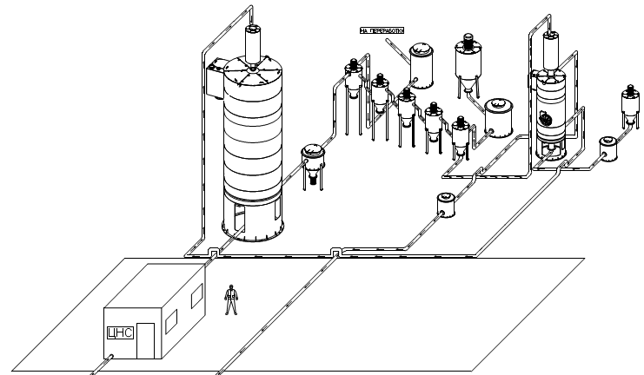

Figure 6 – Basic hardware design of the scandium extraction site

Scandium-containing solution (uranium sorption filtrate) is passed through a pressure sorption column of SNK-3m type filled with TVEX resin until scandium in sorption filtrates with a flow of 250 m³/hour.
Every 24 hours 2 m³ of scandium saturated resin is unloaded from the column. The content of scandium in the resin is 590 g/m³. Desorption is carried out by solution of sodium carbonate with concentration of 100 g/m³ by passing 8 spec.vol. solution through 2 m³ of resin in the corresponding column. Extraction degree of 80% of sorbed scandium with obtaining 16 m³ of desorbate with average content of 59.4 g/m³.
The resin returns to the primary sorption operation. Desorbate is deoxidized with concentrated sulfuric acid solution before further sorption II. Conditioned solution is collected in a collection and further with a flow of 0.25 m³/hour is directed to stage II sorption, which is also carried out on TVEX in a corresponding column. After 0.025 m³ of the processed resin 640 spec.vol. (16 m³) of the stage solution are passed through during 64 hours, after that the content of scandium in the resin will reach 36 kg/m³.
At the end of sorption, desorption is carried out in the same column by passing a desorbing solution of 100 g/dm³ Na₂CO₃ composition. Through 0.025 m³ resin passes 8 spec.vol. solution with extraction of not less than 80% of sorbed scandium. As a result 0,2 m³ of solution with average concentration of 3,6 kg/m³ is formed. Figure 7 shows the principal technological scheme of scandium extraction.
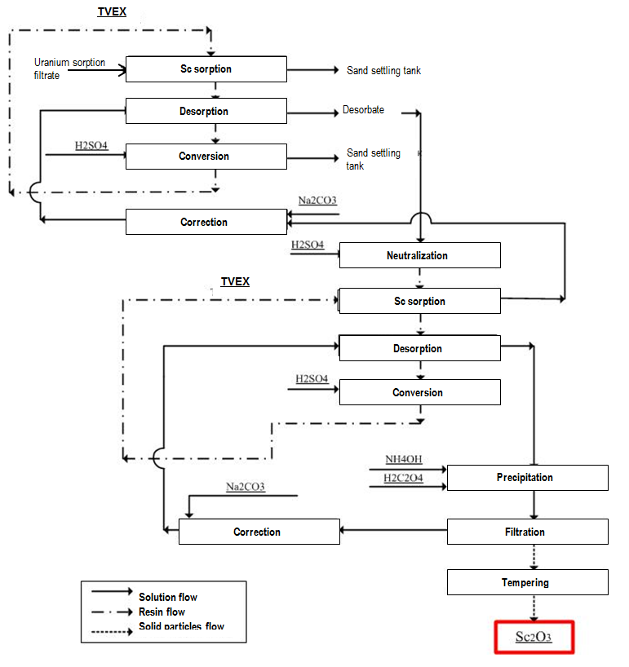
Figure 7 – Process flow diagram for scandium extraction

The resulting desorbate is corrected by pH to 2÷3 by ammonia solution and oxalic acid dehydrate is added. The precipitate is filtered on a nutsch filter and calcined at 900^{о}C to obtain rough scandium oxide.
Thus, the productivity of the site will be about 0.686 kg of scandium for 24 hours or 228.73 kg of scandium per year, which in terms of scandium oxide will be 349.96 kg.
These parameters are indicative and require confirmation when conducting semi-industrial tests on real solutions.
Environmental impact assessment. The scandium by-product recovery site will exist within the framework of uranium production, so all anticipated emissions to the environment should be considered in the context of uranium production. For this reason, the waste from scandium by-product mining will be disposed of together with the waste from uranium production.
The low production volumes of all types of waste allow us to conclude that the additional costs of their disposal will be insignificant.
Project plant establishment. It is assumed that the project will take at least 2 years to develop before commissioning.
Forecast price. In the published sources it is assumed to use as a conservative scenario the price of $2500/kg Sc₂O₃. This price was accepted for financial and economic calculations.
Capital expenditures. Table 16 shows the list and approximate cost of equipment. Modern models, databases and price indices were used for preliminary estimation of the project capital costs. The cost of equipment includes the cost of manufacturing, delivery, installation and strapping by technological pipelines.

Table 16 – Scandium extraction site capital costs
№ | Description | Characteristics | Cost
1 | 2 | 3 | 4
Main process equipment
Sorption Sc I stage
1 | Sorption column with static screen | V = 30 m³  12Х18Н10Т | $146 000
2 | Ionite bunker | V = 2 m³  12Х18Н10Т | $12 600
3 | Uranium sorption filtrate feed pump (no reserve) | Q = 300 m³/hour, delivery head 40 m, acid-resistant | $30 000
Desorption Sc I stage

Table 16 continue
1 | 2 | 3 | 4
4 | Desorption column with static screen | V = 3 m³  12Х18Н10Т | $22 800
5 | Ionite bunker | V = 2 m³  12Х18Н10Т | $12 600
6 | Desorbate tank | V = 16 m³  12Х18Н10Т | $24 500
7 | Circulating desorbate capacity | V = 16 м³  12Х18Н10Т | $24 500
8 | Solution correction reactor | V = 5 m³  12Х18Н10Т | $18 000
Neutralization / Sorption II / Desorption Sc II stage
9 | Sorption/desorption column (2 units) | V = 0.15 m³ | $2 000
10 | Subtotal of site equipment costs |  | $293 000
11 | Intermediate tanks, pumps, instrumentation, technological strapping and shut-off and control valves (+20%) |  | $58 600
12 | Analytical equipment:  - atomic emission spectrometer; |  | $135 000
13 | TVEX ion exchange resins |  | $577 500
14 | Total site equipment costs |  | $1 064 100
Construction and installation works
15 | Costs of the preparatory period (feasibility study, regulations, detailed site design) |  | $100 000
16 | Construction of buildings and structures:  - solution processing area;  - warehouse |  | $250 000  -
17 | Total site equipment costs |  | $350 000
Other expenses
18 | Unforeseen expenses (+15%) |  | $212 120
Total capital expenditures: |  |  | $1 626 220

As can be seen, capital expenditures represent a significant amount, which is more due to the economies of scale, where small scale production is always costlier per unit of output.
In addition, it should be taken into account that the launch will require investments in working capital (100 days x operating costs/day). At the end of the life of the unit, these funds will be returned.
Operating costs. Based on the annual volume of processed solutions, an approximate calculation of raw materials and materials costs was made for the annual operation of the unit. The results of calculations are summarized in Table 17.
The working period is divided into two shifts, each of which has two shifts. The project requires administrative and managerial staff with a working schedule of 8 hours a day and a 5-day working week.

Table 17 – Annual operating costs
№ | Description | Annual consumption | Annual expenses
Reagents and materials
1 | Ion-exchange resin (TVEX) | 1% | $5 780
2 | Sodium carbonate | 323.9 t | $64 780
3 | Sulfuric acid 92.5% | 323.5 t | $48 520
4 | Unaccounted expenses | 5% | $5 940
 | Total reagents and materials |  | $125 020
Electric power
5 | Electric power (pumps, engine, lighting) | 970 | $59 170
Personnel
6 | Chief Technologist | $20 000 х 1 | $20 000
7 | Laboratorian | $11 800 х 2 | $23 600
8 | Operator | $11 800 х 4 | $44 000
 | Total personnel costs |  | $87 600
 | + Social tax (11%) |  | $9 640
 | Total personnel costs including social tax |  | $97 240
Repair and maintenance
9 | Repair of equipment and consumables | 5% of capital equipment costs | $24 300
Administrative and management costs
10 | Administrative and management costs | $10 000 | $10 000
 | Subtotal: |  | $315 730
 | Unaccounted expenses (+10%) |  | $31 570
 | TOTAL: |  | $347,300

Other production costs include equipment repairs and consumables.
The annual operating costs are as follows: $315,730.
Taking into account the preliminary nature of calculations and in order to simplify further calculations, we accept unaccounted operating expenses (secondary taxes: property tax, etc., other expenses) at 10% of the calculated value. Then, the expected amount of operating costs will be $347,300.
Capacity of the site 349.96 kg of scandium oxide per year. At forecast price of $2500/kg and annual revenue of $874,900, this Project is profitable. The cost of production (excluding depreciation) is $1140/kg.
The following assumptions were used to build the financial and economic model:
- Service life of scandium recovery unit - 12 years (till 2033).
- Discounting rate - 10%
- Total depreciation rate of capital expenditures (without dividing assets by categories) - 20%
- Working capital is calculated at 30% of annual operating costs - $347,300
- The mineral extraction tax for Scandinavia is accepted in accordance with the Tax Code of RK at the level of - 6%.
- Calculations are made without inflation
The financial and economic model is given in Appendix A. Calculated economic performance indicators are given in Table 18.

Table 18 – The main indicators of economic efficiency of scandium recovery unit
Index | Value
Net present value (@10%) | $1 034 600
Internal rate of return | 22.71%
Discounted payback period, years | 4.9
Average net profit | $271 300
Profitability | 15.58%

As follows from the calculation results, the project shows acceptable profitability. As for the associated rhenium recovery, the main risks of the project are as follows:
- Reduced installation output;
- Decrease in scandium oxide price. The project remains viable with a price decrease to $1870 per 1 kg of scandium oxide.
- Increase of capital costs for installation.
- Increase in operating costs of the plant
Cumulative effect of the marked risks is also possible if several risks occur simultaneously. As part of this work, no quantitative assessment of risks has been conducted.

CONCLUSION

The researches carried out revealed the possibility of obtaining branded ammonium perrhenate from rough salt separated by sorption-extraction method of concentration of rhenium from productive solutions obtained by underground leaching during uranium deposit development. Optimal conditions for electrodialysis purification and HReO₄ concentration from ammonium perrhenate solutions are current density 200-250 A/m², solution temperature in electrodialysis chambers 40⁰C, process duration 2-2.5 hours, concentration of rhenium in the initial solution 50-60 g/dm³ at the rate of its supply to the desalting chamber 0.75-0.80 volume per minute.
The characteristics of the equilibrium sorption of scandium from the model solutions with organophosphorus ions were studied, on the basis of which Lewatit TP260 and TVEX D2EHPA ionites were selected as sorbents during scandium extraction from uranium sorption filtrates. Studies of sorption of scandium from the model solution by the selected ionites under static and dynamic conditions were carried out. At missed volumes of solutions it was possible to obtain saturation on Lewatit TP260 ionite at 700 spec.vol. equal to 0.027 kg/m³ and on D2EHPA ionite at 2382 spec.vol. equal to 0.236 kg/m³. Studies of subsequent desorption from scandium-saturated ionites using certain desorbing solutions were carried out. The results of the experiments showed that the desorption degree of Lewatit TP260 scandium-saturated ion was 87.26% when using 200 g/dm³ Na₂CO₃ sodium carbonate solution. Desorption of scandium from TVEX D2EHPA saturated ion was carried out under static conditions using various desorbing solutions. When using desorbing solutions of 200 g/dm³ Na₂CO₃ sodium carbonate and 3.5M NF fluorhydric acid, almost complete desorption of scandium from TVEX D2EHPA resin was observed under static conditions. When using a solution of 3.5M NH₄HF₂ ammonium fluoride the degree of scandium recovery was 76%. The carbonate alkaline solution of 0.5M NaOH + 1M Na₂CO₃ and the solution of sodium salt of hydrofluoric acid 3.5M NaF showed very low desorption characteristics. Thus, phosphorus-containing ionites Lewatit TP260 and TVEX D2EHPA can be offered as promising sorbents for extracting scandium from solutions of downhole uranium leaching.
Technical and economic evaluation of the scandium extraction site from mother solutions of uranium sorption was performed, which demonstrated the following results within the framework of the assumptions made and calculations made:
Key economic performance indicators of the scandium associated recovery unit:
- Net present value (@10%) - $1 034 600
- Internal rate of return - 22.71%
- Discounted payback period, years - 4.9
- Average net profit - $271,300
- Profitability - 15.58%
Thus, the developed scandium recovery technology is cost-effective and suitable for pilot testing at the existing production facility.

LIST OF REFERENCES

1 Abisheva Z.S., Zagorodnaya A.N. Contribution of the institute of metallurgy and enrichment to organization of production of compounds of rhenium and osmium isotope -187 in Kazakhstan // Vestnik MITHT. - 2013. – V.8. – №3. – pp. 34-48.
2 Abisheva Z.S., Zagorodnyaya A.N. Bekturganov N.S. Review of technologies for rhenium recovery from mineral raw materials in Kazakhstan // Hydrometallurgy. - 2011. – V109. – №1-2. – pp. 1-8.
3 Sushko S.M.; Berikbolova B.R.; Dolgopolov V.F., Zhelnov V.P. Uranium deposits of Kazakhstan, prospects of their industrial development and prospecting // Actual problems of uranium industry. – Almaty: 2006. – pp. 4-10.
4 Chekmarev A.M., Troshkina I.D., Nesterov Yu.V., Mayboroda A.B., Ushanova O.N., Smirnov N.S. Associated rhenium recovery at complex processing of productive solutions of uranium underground leaching // Chemistry for sustainable development. – 2004. – V.12. - №1. – pp. 115-119.
5 Volkov V.P., Meshcheryakov N.M., Nikitin N.V., Mikhailenko M.A. ndustrial experience of a sorption extraction of rhenium from the recycled solutions of uranium underground leaching // Nonferrous metals. – 2012. – №7. – pp. 64-67.
6 Palant A.A., Troshkina I.D., Chekmarev A.M. Metallurgy of rhenium. – M.: Science, 2007. – 298 p.
7 Palant A.A., Troshkina I.D., Chekmarev A.M., Kostylev A.I. Rhenium technology. – M.: Halley-Print, 2015. – 329 p.
8 Nesterov Y.V. Ionites and ion exchange. Sorption technology in mining uranium and other metals by underground leaching. – M.: Unikorn edition, 2007. – 480 p.
9 Zagorodnaya A.N., Abisheva Z.S., Agapova L.Ya. Technologies for obtaining ammonium perrhenate, rhenium acid and osmium-187 isotope from technogenic formations of non-ferrous metallurgy, uranium industry and secondary raw materials developed at the Institute of metallurgy and enrichment // Effective technologies for production of non-ferrous, rare and noble metals. – Almaty: 2018. – pp. 263-272.
10 Zagorodnaya A.N., Sharipova A.S., Abisheva Z.S., Kopbaeva M.P. Semi-industrial tests of a sorption technology of extraction of rhenium from filtrates of uranium sorption // Nonferrous metals. – 2016. – №4. – pp. 34-40.
11 Volkov V.P., Meshcheryakov N.M., Nikitin N. V., Mikhailenko M.A. Industrial experience of sorption extraction of rhenium from circulating solutions of uranium underground leaching // Nonferrous metals. – 2012. – №7. – pp. 64-67.
12 Anderson C.D., Taylor P.R., Anderson C.G. Extractive metallurgy of rhenium: a review // Minerals and Metallurgical Processing. – 2013. – №30. – pp. 59-73.
13 Leszczyńska-Sejda K., Benke G., Chmielarz F. Synthesis of perrhenic acid using ion exchange method // Hydrometallurgy. – 2007. – №89. – pp. 289-296.
14 Leszczyńska-Sejda K., Benke G., Krompiec S. Synthesis of perrhenic acid using solvent extraction // Hydrometallurgy. – 2009. – №95. – pp. 325-332.
15 Lyapin S.B., Shtyrlov P.U., Heitmitov A.A., Guro V.P., Atakuziev A.A. Ion-exchange method of ammonium perrhenate purification from potassium impurity // Mountain Bulletin of Uzbekistan. – 2004. – №2. – pp. 59-60.
16 Maltseva E.E., Blokhin A.A., Murashkin Y.V., Mikhaylenko M.A. An increase in purity of ammonium perrhenate solutions with respect to molybdenum (IV) with the sorption recovery of rhenium (VII) from Mo-containing solutions // Russ. J. Non-ferrous Metals. – 2017. – №58. – pp. 463-469.
17 Paretsky V.G., Besser A.D., Gedgagov E.I. Ways to increase the production of rhenium from ore and technogenic raw materials // Nonferrous metals. – 2008. – №10. – pp. 17-21.
18 Ponomaryova E.I., Bikinova A.M., Orazbaeva S.N. Development of an electrodialysis method for production of rhenium acid and ammonium perrenate // Chemistry, technology and analytical control of rhenium. – М.: 1990. – pp. 138-141.
19 Palant A.A., Levin A.M., Brukvin V.A., Akhmetov E.F. Obtaining of the concentrated solutions of the rhenium acid by electrodialysis // Nonferrous metals. – 2010. – №11. – pp. 62-64.
20 Palant A.A., Brukvin V.A., Levin A.M., Reshetova O.V. Electrodialysis synthesis of the concentrated solutions of rhenium acid // Metals. – 2011. – №3. – pp. 21-23.
21 Agapova L.Ya., Abisheva Z.S., Kilibaeva S.K., Altenova A.N. Use of electrodialysis to obtain pure ammonium perrhenate of their technical salt // Integrated use of mineral raw materials. – 2014. – №3. – pp. 71.
22 ST RK 3257-2018 Rhenium acid. Specifications. – Introd. 2020-01-01. – Nur-Sultan: Gosstandart, 2020. – 14 p.
23 GOST 31411-2009. Ammonium perrenat. Specifications. – Introd. 2011-01-01. – M.: Standartinform, 2010. – 70 p.
24 Lebedev K.B., Kazantsev E.I., Rozmanov V.M., Pakholkov V.S., Chemezov V.A. Ionites in non-ferrous metallurgy. – M.: Metallurgy, 1975. – 352 p.
25 Znamensky Y.P., Bychkov N.V. Kinetics of ion-exchange processes. Obninsk: Printer, 2000. – 204 p.
26 Semyonov S.A., Reznik A.M., Yurchenko L.D. Scandium extraction during complex processing of various raw materials // Nonferrous metals. – 1983. – №12. – pp. 43-47.
27 Sokolova Y.V., Cherepanin R.N., Makhov S.V., Ter-Akopyan M.N. Extraction concentration of scandium with obtaining of fluoride concentrate at complex processing of ilmenite // New approaches in chemical technology of mineral raw materials. – Spb: 2013. – pp. 501.
28 Wang W., Pranolo Y., Cheng C.Y. Recovery of scandium from synthetic red mud leach solutions by solvent extraction with D2EHPA // Separation and Purification Technology. – 2013. – №108. – pp. 96-102.

APPENDIX А
Technical-economic calculation of Sc associated production at Irkol field

Index | Unit measure | Total for period | Period
Index | Unit measure | Total for period | 0 | 1 | 2 | 3 | 4 | 5 | 6 | 7 | 8 | 9 | 10 | 11 | 12
Sequence years of contract |  |  | 2021 | 2022 | 2023 | 2024 | 2025 | 2026 | 2027 | 2028 | 2029 | 2030 | 2031 | 2032 | 2033
Annual resin processing volume | m³ | 8000.0 |  | 666.67 | 666.67 | 666.67 | 666.67 | 666.67 | 666.67 | 666.67 | 666.67 | 666.67 | 666.67 | 666.67 | 666.67
Average Sc concentration in saturated resin | kg/m3 | 0.59 |  | 0.59 | 0.59 | 0.59 | 0.59 | 0.59 | 0.59 | 0.59 | 0.59 | 0.59 | 0.59 | 0.59 | 0.59
Extraction of Sc (from the productive solution) | kg | 4720.0 |  | 393.3 | 393.3 | 393.3 | 393.3 | 393.3 | 393.3 | 393.3 | 393.3 | 393.3 | 393.3 | 393.3 | 393.3
Through recovery of Sc on resin processing | % | 58.2% |  | 58.2% | 58.2% | 58.2% | 58.2% | 58.2% | 58.2% | 58.2% | 58.2% | 58.2% | 58.2% | 58.2% | 58.2%
Sc production in marketable products | kg | 2745.2 |  | 228.8 | 228.8 | 228.8 | 228.8 | 228.8 | 228.8 | 228.8 | 228.8 | 228.8 | 228.8 | 228.8 | 228.8
Annual production of scandium oxide | kg | 4200.1 |  | 350.0 | 350.0 | 350.0 | 350.0 | 350.0 | 350.0 | 350.0 | 350.0 | 350.0 | 350.0 | 350.0 | 350.0
Accepted selling price of scandium oxide | $/kg | 2 500 |  | 2500 | 2500 | 2500 | 2500 | 2500 | 2500 | 2500 | 2500 | 2500 | 2500 | 2500 | 2500
Annual revenue from sales of marketable products | thous. $ | 10 500 |  | 875.0 | 875.0 | 875.0 | 875.0 | 875.0 | 875.0 | 875.0 | 875.0 | 875.0 | 875.0 | 875.0 | 875.0
Production costs per unit. including: | $
Cost of processing of 1 m3 of resin (direct operating expenses) | $/m³ | 505.95 |  | 505.95 | 505.95 | 505.95 | 505.95 | 505.95 | 505.95 | 505.95 | 505.95 | 505.95 | 505.95 | 505.95 | 505.95
Total annual production costs | thous. $ | 4167.6 |  | 347.3 | 347.3 | 347.3 | 347.3 | 347.3 | 347.3 | 347.3 | 347.3 | 347.3 | 347.3 | 347.3 | 347.3
including:
For resin processing | thous. $ | 4047.6 |  | 337.3 | 337.3 | 337.3 | 337.3 | 337.3 | 337.3 | 337.3 | 337.3 | 337.3 | 337.3 | 337.3 | 337.3
Administrative and management and other expenses. including: | thous. $ | 120.0 |  | 10.0 | 10.0 | 10.0 | 10.0 | 10.0 | 10.0 | 10.0 | 10.0 | 10.0 | 10.0 | 10.0 | 10.0
general administrative and management expenses | thous. $ | 120.0 |  | 10.0 | 10.0 | 10.0 | 10.0 | 10.0 | 10.0 | 10.0 | 10.0 | 10.0 | 10.0 | 10.0 | 10.0
Taxes and deductions from income | thous.$ | 637.5 |  | 55.5 | 54.8 | 54.0 | 53.3 | 52.5 | 52.5 | 52.5 | 52.5 | 52.5 | 52.5 | 52.5 | 52.5
including:
Severance tax rate by Sc | % | 6.0% |  | 6% | 6% | 6% | 6% | 6% | 6% | 6% | 6% | 6% | 6% | 6% | 6%
Severance tax payable | thous. $ | 630.0 |  | 52.5 | 52.5 | 52.5 | 52.5 | 52.5 | 52.5 | 52.5 | 52.5 | 52.5 | 52.5 | 52.5 | 52.5
Property tax | thous. $ | 7.5 |  | 3.0 | 2.3 | 1.5 | 0.8 | - | - | - | - | - | - | - | -
Cost of 1 kg of scandium oxide (without amortization) | $/kg | 1144.1 |  | 1150.8 | 1148.7 | 1146.6 | 1144.4 | 1142.3 | 1142.3 | 1142.3 | 1142.3 | 1142.3 | 1142.3 | 1142.3 | 1142.3
Amortization of capital costs | thous. $ | 1626.2 |  | 325.2 | 325.2 | 325.2 | 325.2 | 325.2 | - | - | - | - | - | - | -
Depreciation of expenses of preparatory period (amortization rate 20%) | thous. $ | 100.0 |  | 20.0 | 20.0 | 20.0 | 20.0 | 20.0
1.1 Development of technological regulation | thous. $ | -
1.2 Installation design | thous. $ | 100.0
2 Amortization of production period costs | thous. $ | 1526.2 |  | 305.2 | 305.2 | 305.2 | 305.2 | 305.2 | - | - | - | - | - | - | -
2.1 Acquisition of machinery. equipment and materials (production amortization method) | thous. $ | 351.6 |  | 70.3 | 70.3 | 70.3 | 70.3 | 70.3
2.2 Buildings and structures (Amortization method) | thous. $ | 250.0 |  | 50.0 | 50.0 | 50.0 | 50.0 | 50.0
2.3 Analytical equipment (production amortization method) | thous. $ | 135.0 |  | 27.0 | 27.0 | 27.0 | 27.0 | 27.0
2.4 Ion exchange resin (production amortization method) | thous. $ | 577.5 |  | 115.5 | 115.5 | 115.5 | 115.5 | 115.5
2.5 Engineering (production amortization method) | thous. $ | 212.1 |  | 42.4 | 42.4 | 42.4 | 42.4 | 42.4
Balance cost of fixed assets |  |  |  | 200.0 | 150.0 | 100.0 | 50.0 | - | - | - | - | - | - | - | -
Buildings and structures | thous. $ | 250.0 |  | 200.0 | 150.0 | 100.0 | 50.0 | - | - | - | - | - | - | - | -
Totol investments | thous. $ | 1740.8 | -1626.2 | -114.6 |  |  |  |  |  |  |  | - | - | - | 114.6
1 Preparatory period | thous. $ | 100.0 | 100.0
1.1 Development of technological regulation | thous. $ |  | -
1.2 Installation design | thous. $ | 100.0 | -100.0
2 Extraction period | thous. $ | 1640.8 | -1526.2 | -114.6 |  |  |  |  |  |  |  | - | - | - | 114.6
2.1 Purchasing machinery. equipment and materials | thous. $ | 351.6 | -351.6
2.2 Buildings and structures | thous. $ | 250.0 | -250.0
2.3 Analytical Instruments | thous. $ | 135.0 | -135.0
2.4 Ion-exchange resin | thous. $ | 577.5 | -577.5
2.5 Other | thous. $ | 212.1 | -212.1
2.6 Working capital (30% of oper. costs) | thous. $ | 114.61 |  | -114.6 |  |  |  |  |  |  |  |  |  |  | 114.61
Total deductions from income (operating expenses + taxes and charges + amortization) | thous. $ | 6431.3 |  | 728.0 | 727.3 | 726.5 | 725.8 | 725.0 | 399.8 | 399.8 | 399.8 | 399.8 | 399.8 | 399.8 | 399.8
Profit before amortization (income from the sale of products and production costs excluding amortization - taxes deductible from income) | thous. $ | 5695.1 |  | 472.2 | 473.0 | 473.7 | 474.5 | 475.2 | 475.2 | 475.2 | 475.2 | 475.2 | 475.2 | 475.2 | 475.2
Production profit (income - all deductions from income) | thous. $ | 4068.9 |  | 147.0 | 147.7 | 148.5 | 149.2 | 150.0 | 475.2 | 475.2 | 475.2 | 475.2 | 475.2 | 475.2 | 475.2
Taxable profit (including transferable loss of previous years) | thous. $ | 4068.9 |  | 147.0 | 147.7 | 148.5 | 149.2 | 150.0 | 475.2 | 475.2 | 475.2 | 475.2 | 475.2 | 475.2 | 475.2
Income tax rate | % | 20.0% |  | 20% | 20% | 20% | 20% | 20% | 20% | 20% | 20% | 20% | 20% | 20% | 20%
Income tax | thous. $ | 813.8 |  | 29.4 | 29.5 | 29.7 | 29.8 | 30.0 | 95.0 | 95.0 | 95.0 | 95.0 | 95.0 | 95.0 | 95.0
Net income (operating income- income tax) | thous. $ | 3255.1 |  | 117.6 | 118.2 | 118.8 | 119.4 | 120.0 | 380.2 | 380.2 | 380.2 | 380.2 | 380.2 | 380.2 | 380.2
Budget efficiency (amount of deductions to the budget) | thous. $ | 1451.3 | 0.0 | 84.9 | 84.3 | 83.7 | 83.1 | 82.5 | 147.5 | 147.5 | 147.5 | 147.5 | 147.5 | 147.5 | 147.5
Cash flow (net profit-investment-reinvestment+amortization) | thous. $ | 3255.1 | -1626.2 | 328.2 | 443.4 | 444.0 | 444.6 | 445.2 | 380.2 | 380.2 | 380.2 | 380.2 | 380.2 | 380.2 | 494.8
Cumulative cash flow | thous. $ | 3255.1 | -1626.2 | -1298.0 | -854.6 | -410.6 | 34.1 | 479.3 | 859.5 | 1239.6 | 1619.8 | 2000.0 | 2380.1 | 2760.3 | 3255.1
Net present value (NPV) of the field |  |  | 0.0 | 0.0 | 0.0 | 0.0 | 3.9 | 0.0 | 0.0 | 0.0 | 0.0 | 0.0 | 0.0 | 0.0 | 0.0
at @=10% | thous. $ | 1034.6
at @=15% | thous. $ | 495.5
Internal rate of return (IRR) | % | 22.71%
Payback period | year | 4.9
NPVstand | - | 0.59
Average net profit | thous. $ | 271.3
Profitability | % | 15.58%
Cash flow to investment ratio | - | 1.87
Profitability index | - | 1.59

APPENDIX B
List of published works

List of scientific works for 2018.
1. N.M. Shokobayev, M.Zh. Zhurinov, D.S. Zhumabayeva, N.S. Ivanov, A.Z. Abilmagzhanov Development of sorption technology of rare-earth metals recovery from uranium in-situ leaching solutions // News of the national academy of sciences of the republic of Kazakhstan series of geology and technical sciences. – 2018. – V.6. – № 432. – pp 77-84. https://doi.org/10.32014/2018.2518-170X.37 (Impact Factor 0.21, Q3, percentile 26%).

List of scientific works for 2019.
1. Ivanov N.S., Shokobayev N.M., Adelbayev I.Y., Abilmagzhanov A.Z., Nurtazina A.E. Investigation of concentration method of scandium-containing solutions // News of the national academy of sciences of the republic of kazakhstan series chemistry and technology. – 2019. – V.6. – № 438. – pp 12-20. https://doi.org/10.32014/2019.2518-1491.68.

List of scientific works for 2020.
1. Application for a patent of the Republic of Kazakhstan for a useful model "Method for scandium desorption from ion-exchange resin". Registration number 2020 / 0898.2.
2. N.S. Ivanov, A.Z. Abilmagzhanov, N.M. Shokobayev, I.Y. Adelbayev, A.E. Nurtazina Scandium extraction by phosphorus-containing sorbents // News of the national academy of sciences of the Republic of Kazakhstan. Series of geology and technical sciences. – 2020. – V.4. – № 442. – pp 156-165. https://doi.org/10.32014/2020.2518-170X.96 (Impact Factor 0.21, Q3, percentile 26%).
3. N.S. Ivanov, N.M. Shokobayev, A.Z. Abilmagzhanov, A.E. Nurtazina, I.Y. Adelbayev Improvement the efficiency of rhenium-containing desorption // Revista de Chimie J. – 2020. – V. 71. – № 12. (Impact Factor 1.755, Q3, percentile 68%).
4. A.Z. Abilagzhanov, N.S. Ivanov, N.M. Shokobayev, A.E. Nurtazina, I.Y. Adelbayev Deep purification of crude ammonium perrhenate by electrodialysis // Revista de Chimie J. – 2020. – V. 71. – № 12. (Impact Factor 1.755, Q3, percentile 68%).

APPENDIX C
Certificates of acceptance of publications for printing
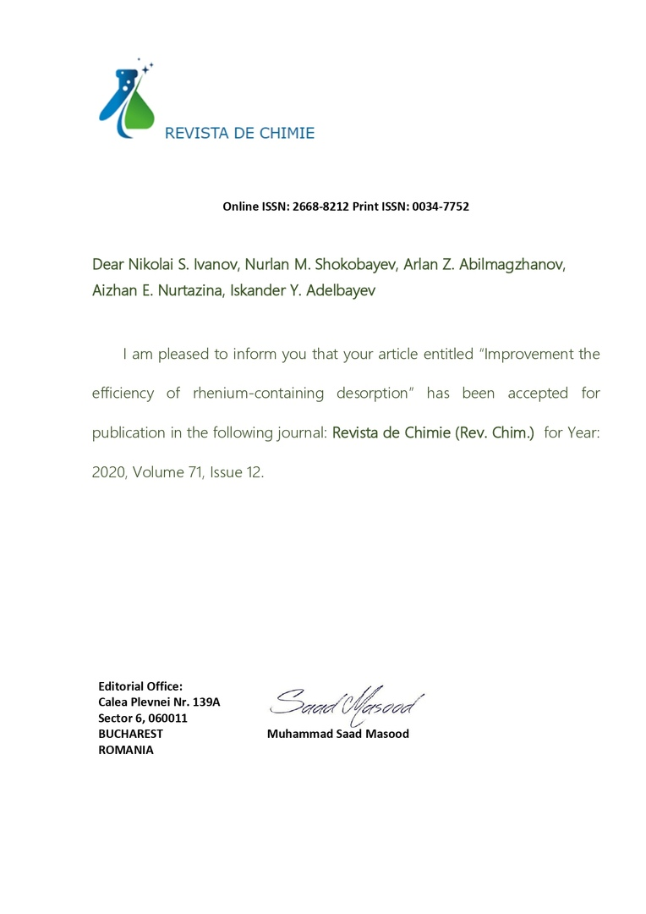

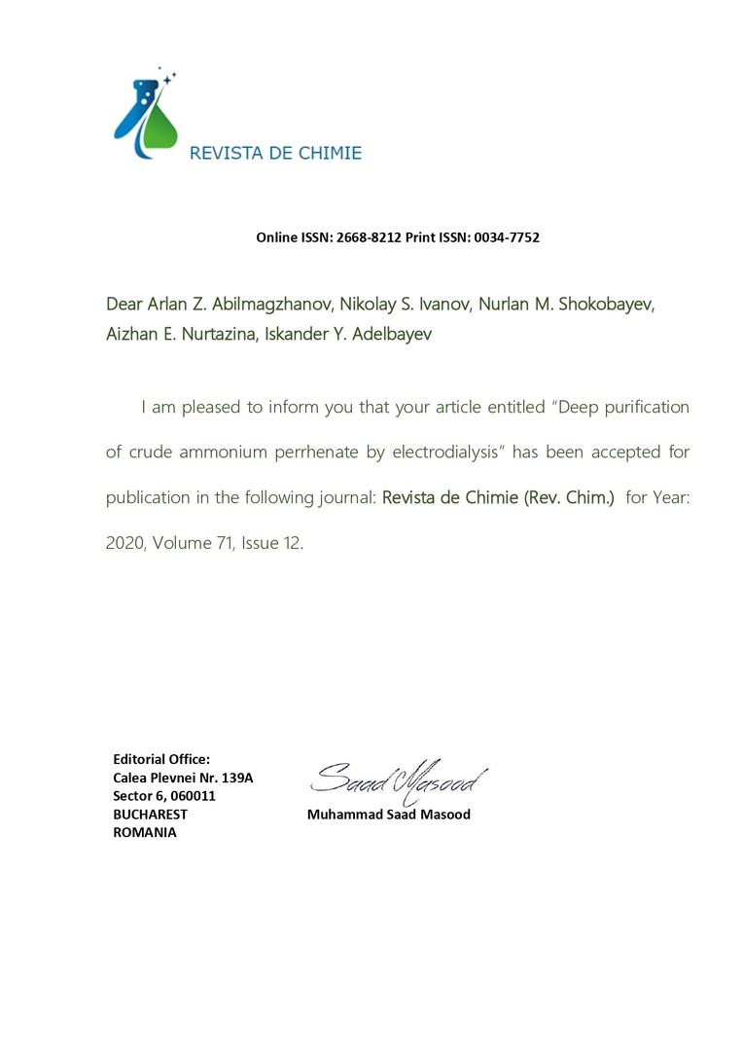

APPENDIX D
Calendar work schedule
Appendix 1.11
To Agreement
№____dated___________ 2018
For grant financing

TECHNICAL SPECIFICATION AND
CALENDAR WORK SCHEDULE

Under Agreement №_____dated__________________ 2018

1. Joint Stock company “D.V. Sokolsky Institute of Fuel, Catalysis and Electrochemistry”

1.1 By priority: Rational use of natural resources, including water resources, geology, recycling, new materials and technologies, safe products and structures.
1.2 By priority: 1.4 Integrated use of mineral resources.
1.3 Project subject: № АР05133140 “Development and testing of resource-saving technology for recovery of valuable associated components during processing of uranium ores with comprehensive assessment of its profitability and investment attractiveness”.
1.4 Total amount of the project is 30,200,000 (Thirty million two hundred thousand) tenge, including annual breakdown, to perform works pursuant to paragraph 3:
- for 2018 - at the amount of 10,000,000 (Ten million) tenge;
- for 2019 - at the amount of 10,090,000 (Ten million ninety thousand) tenge;
- for 2020 - at the amount of 10,110,000 (Ten million one hundred and ten thousand) tenge.

2. Characteristics of scientific and technical products by qualification and economic indicators
2.1 Work area: Metallurgy.
2.2 Scope of application: Uranium mining, metallurgical enterprises.
2.3 Final result:
- For 2018: Effective sorbents for extraction of the most promising elements from model uranium leaching solutions will be identified;
- for 2019: laboratory tests will be carried out to concentrate and purify with commercial products. 2 articles will be printed in peer-reviewed foreign and domestic journals with non-zero impact factor;
- 2020: a preliminary technical and economic calculation of the organization of the by-product useful components recovery site will be carried out. 2 articles will be submitted for printing in a reviewed foreign scientific publication indexed in Web of Science or Scopus databases with a non-zero impact factor. 1 application for a utility model patent will be filed with the Kazakhstan Patent Office.
2.4 Patentability: Patentable.
2.5 Scientific and technical level (novelty): The scientific novelty of the project results lies in the comprehensive approach to conducting research in the chosen field. As a result of the project implementation, geotechnological research on the behavior of associated components in the conditions of uranium UWL will be conducted. Based on geological and geotechnological conditions, the most promising elements for further by-product extraction will be identified. Taking into account the composition of mother solutions, sorption materials corresponding to the maximum extraction of the selected elements will be selected and the extraction kinetics will be calculated. A set of technological tests will be carried out on a laboratory scale and the most optimal processes of solution processing after uranium sorption will be established, which will form the basis of the technology with its subsequent testing on a semi-industrial scale.
2.6 The use of scientific and technical products is carried out: by the Customer.
2.7 Type of use of the result of scientific and (or) scientific and technical activity: Scientific reports, publications, preliminary technical and economic calculation. The results of work will serve the further development of new scientific directions in Kazakhstan, directly related to one of the most significant sectors of the national economy. Results will lay the foundation for new knowledge-intensive industries and become a turning point in the development of mining and processing of rare and rare earth metals.

3. Description of works, terms of implementation and results

Task code, stage | Description of works under Agreement and main stages of its implementation | Implementation period |  |  | Expected result
Task code, stage |  | Beginning |  | End | Expected result
2018
1.1 | Analysis of existing and accumulated geological data from one of the uranium deposits under development in Kazakhstan, identifying the potential for recovery of the presented valuable components | January 2018 | February 2018 |  | Up-to-date geological data and a list of associated components will be collected. The existing and accumulated geological data from one of the uranium deposits under development in Kazakhstan will be analyzed to identify the potential for recovery of the presented valuable components.
1.2 | Carrying out researches and analysis of existing technological methods and techniques of elements extraction with a high level of associated recovery potential.  Carrying out patent search and scientific and literary review | January 2018 | March 2018 |  | The analysis of existing technological methods and techniques of processing of extraction of elements (valuable components) with a high level of associated extraction potential will be performed.  An overview of patent search and scientific and literary review will be prepared.
1.3 | Purchase of necessary laboratory equipment to perform planned test works | January 2018 | May 2018 |  | Required laboratory equipment will be purchased to perform the planned test work.
1.4 | Laboratory research to select effective sorbents to extract the most promising elements from model uranium leaching solutions | April 2018 | Till November 1, 2018 |  | Laboratory research will be conducted to select effective sorbents and effective sorbents will be identified to extract the most promising elements from uranium leaching model solutions.
1.5 | Sampling from operating wells of one of the uranium deposits under development in Kazakhstan.  Determination of the most promising elements to be extracted based on preliminary estimates taking into account market conditions forecast | June 2018 | July 2018 |  | Samples will be taken from operating wells of one of the developed uranium deposits in Kazakhstan. The most promising elements for extraction will be determined on the basis of preliminary estimation taking into account the forecast of market conditions.  The received data will be generalized and directions for further development will be established.
1.6 | Preparation of interim report | October 2018 | Till November 1, 2018 |  | An Interim Report will be submitted.
2019
2.1 | Conducting a set of technological tests for processing solutions from the uranium process cycle to obtain final marketable products in accordance with the established elements | January 2019 | October 2019 |  | Technological tests on processing of solutions from uranium technological cycle with obtaining final marketable products in accordance with established elements. Laboratory tests on concentration and purification will be conducted to obtain marketable products.
2.2 | Generalization of the obtained data, and development of a cost-effective by-product recovery technology. Submission of 2 articles to the press. | September 2019 | Till November 1, 2019 |  | The results of the obtained data will be summed up and a profitable by-product extraction technology will be created.  2 articles will be submitted for printing to reviewed foreign and domestic journals with non-zero impact factors.
2.3 | Preparation of interim report | October 2019 | Till November 1, 2019 |  | An Interim Report will be submitted.
2020
3.1 | Conducting a set of technological tests for post-cleaning and production of conditioning commercial products. | January 2020 | October 2020 |  | A set of technological tests will be carried out for post-cleaning and production of conditioned commercial products.  2 articles will be printed in a reviewed foreign scientific publication indexed in Web of Science or Scopus databases with non-zero impact factor.
3.2 | Development of preliminary TEC for organization of the associated recovery site at one of the uranium enterprises in Kazakhstan. | July 2020 | Till November 1, 2020 |  | A preliminary TEC will be developed to organize a site for associated recovery of useful components at a uranium enterprise in Kazakhstan. 1 application for a utility model patent will be filed with the Kazakhstan Patent Office..
3.3 | Preparation of final report | October 2020 | Till November 1, 2020 |  | Final Report will be submitted.

On behalf of Customer:  Science Committee of the Ministry of Education and Science of RK  _____________ Abdrasilov B.S. | On behalf of Contractor:  General Director of “D.V.Sokolsky Institute of Fuel, Catalysis and Electrochemistry” JSC  _______________ Zhurinov M.

Acknowledged:
Scientific supervisor of the project
_______________ Ivanov N.S.

APPENDIX F
Protocol abstract

PROTOCOL ABSTRACT № 6 dated October 15, 2020
of the enlarged meeting of the Scientific Council of “D.V.Sokolsky IFCE” JSC
ATTENDEES:
Chairman of Scientific Council: Academician of NAS RK M.Zhurinov;
Deputy Chairman of Scientific Council: A.Z. Abilmagzhanov (PhD),
Scientific Secretary: A.S. Zhumakanova (PhD),
Members of Scientific Council: Academician of NAS RK Nadirov N.K, Academician of the NAS RK A.B. Baeshov, Doctors of Sciences, Professors: N.A. Zakarina, A.K. Zharmagambetova, A.T. Masenova, G.K. Bishimbayeva, B. Tuktin, M. B. Dergacheva, S.A. Tungatarova, Candidates of Science: S. Itkulova, B. H. Husain, A.R. Brodsky, A.N. Nefedov, E. Talgatov and other 21 memebers. Total 16 members of the Council out of 17.

AGENDA:
Hearing the reports for 2020 on the research work carried out under the state order for implementation of scientific and (or) scientific and technical projects under the budget program 217 “Development of Science”, sub-program 102 “Grant financing of scientific research”, specifics 156 “Payment for consulting services and research work”".
SUBJECT:
HEARING: Final report of Project Manager, PhD, N.S. Ivanov for 2020 on AR05133140 “Development and Testing of Resource-Saving Technology for Extracting Valuable Associated Components during Processing of Uranium Ores with Comprehensive Evaluation of its Profitability and Investment Attractiveness”.
on priority: “Rational use of natural resources, including water resources, geology, recycling, new materials and technologies, safe products and structures”.
PhD A.Z. Abilmagzhanov, PhD, Academician, Professor M.Z. Zhurinov, PhD, Professor A.T. Masenova took part in the discussion of this report.
DECIDED: Approve the Final report of the project manager, Ph.D. N.S. Ivanov for 2020 on: AR05133140 “Development and Testing of Resource-Saving Technology for Extracting Valuable Associated Components during Processing of Uranium Ores with Comprehensive Evaluation of its Profitability and Investment Attractiveness” according to the priority: “Rational use of natural resources, including water resources, geology, processing, new materials and technologies, safe products and designs”. All tasks of the schedule for 2020 have been completed in full. A set of technological tests for advanced treatment and production of quality commercial products was carried out. A preliminary feasibility study has been developed for organizing section for the extraction of associated useful components at Irkol uranium enterprise in Kazakhstan. Studies of the sorption of scandium on various resins with the construction of sorption isotherms on model solutions have been carried out. A set of technological laboratory tests for desorption of scandium under static conditions using TVEX D2EHPA resin saturated using the model solution was carried out. Various reagents and desorbing solution concentrations were used. Technological laboratory studies on electrodialysis purification of crude ammonium perrhenate were carried out. Tests on scandium precipitation from desorbates were carried out.
As a result of research on the project for 2020, 1 article was published in a domestic scientific journal with a nonzero IF; 2 articles in the Scopus database were accepted for printing (Impact Factor 1.755, Q3, percentile 68%) and the application for a patent of the Republic of Kazakhstan for a utility model was received.

TRUE ABSTRACT

Scientific Secretary: _________________ A.S. Zhumakanova (PhD)

