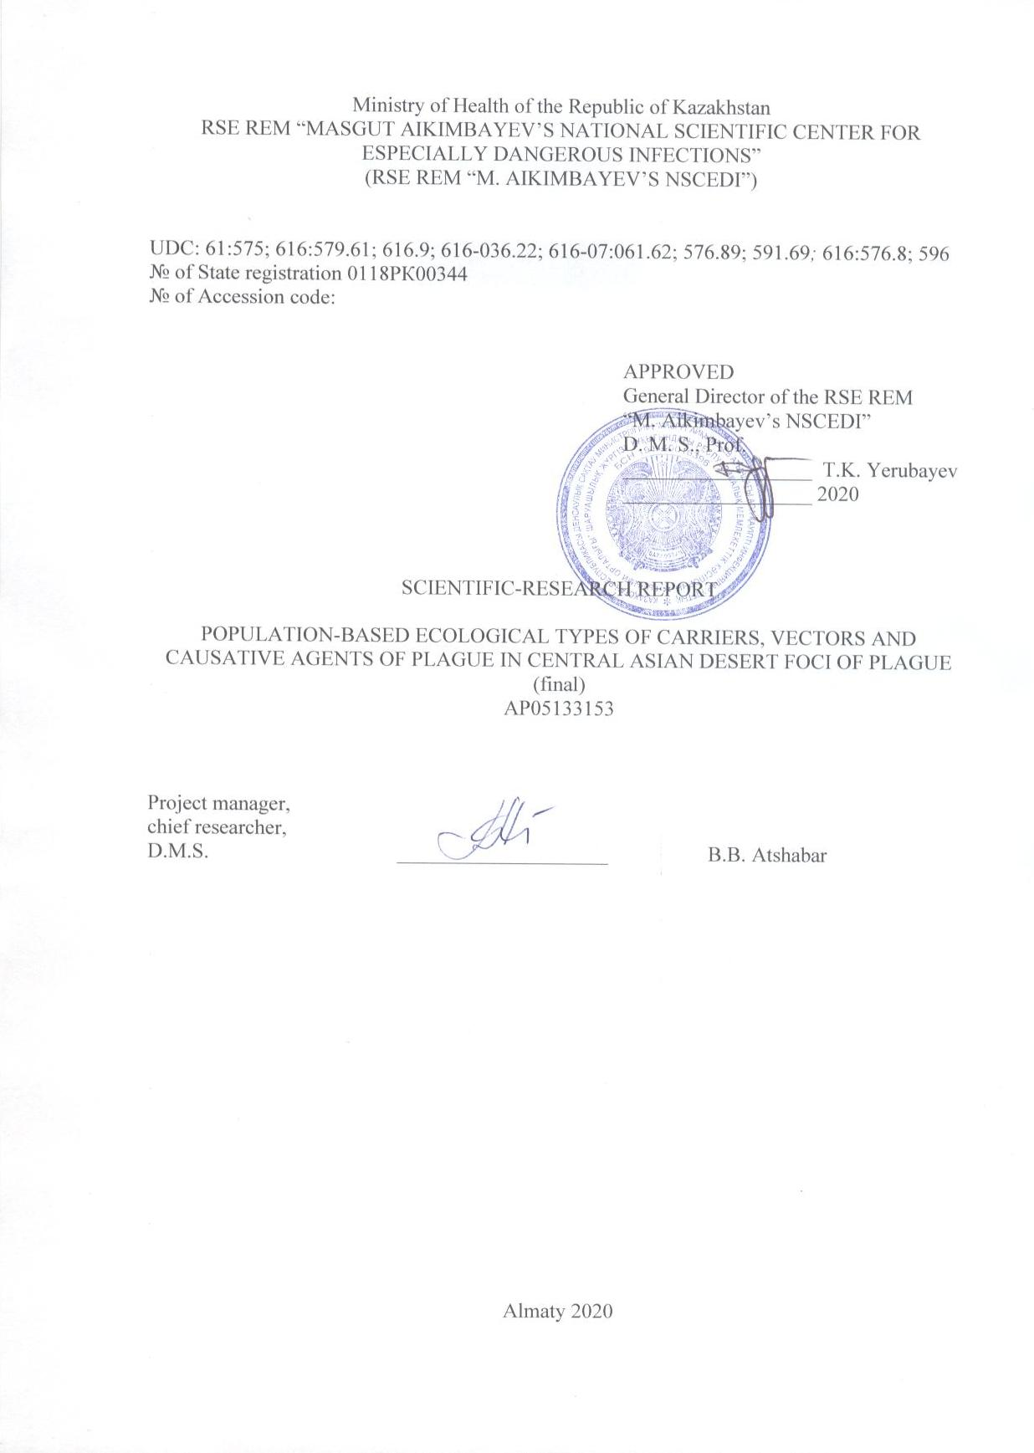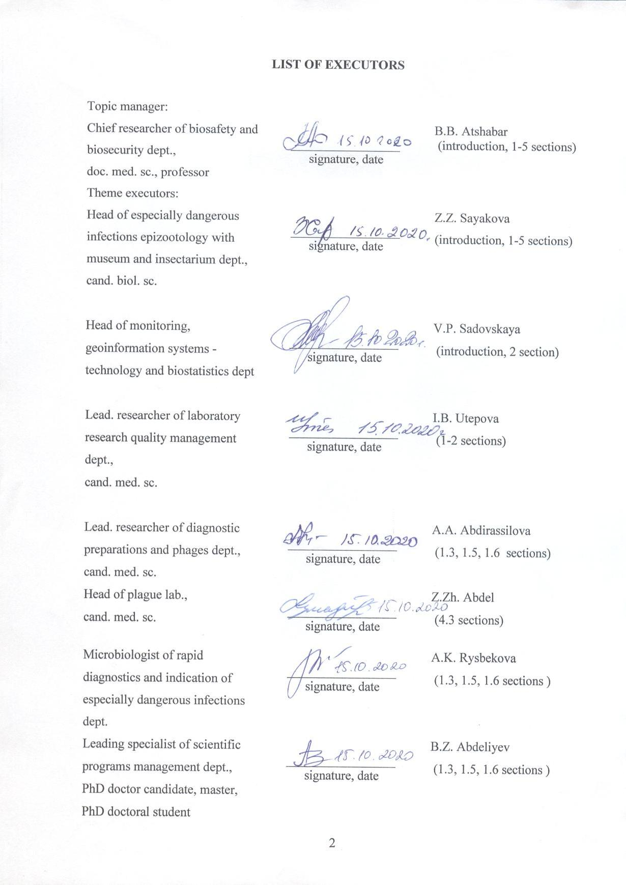
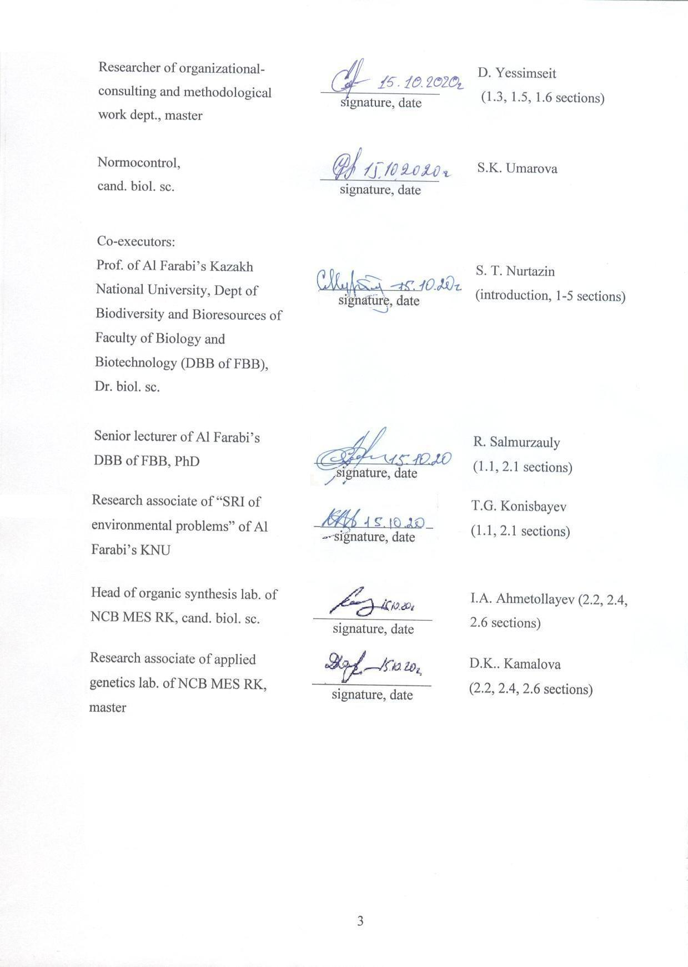

ABSTRACT

Report 86 p., 16 figures, 3 tables, 46 sources, 4 attachm.
NATURAL FOCUS, PLAGUE PATHOGEN, PLAGUE CARRIER, PLAGUE VECTOR, PHENOTYPE, GENOME, DNA, RNA, POPULATION
Objects of study: natural plague source, large gerbil Rhombomys opimus, fleas of genus Xenopsylla, plague pathogen Yersinia pestis.
Purpose of study: to study genetic and phenotypic diversity of ecological populations of host rodent, fleas carriers and plague pathogen from autonomous foci of the Central Asian natural desert plague focus.
Research methods: microbiological, zoological, parasitological, morphometric, molecular-genetic, bioinformational, statistical and geographic information systems.
Results obtained and their novelty: phenotypic properties and differences between populations of R. opimus, the genus Xenopsylla and Y. pestis have been studied from autonomous foci of Central Asian plague focus: Prebalhash, Betpakdala and Pre-Ustyurt. Differences in skull parameters between R. opimus from different populations of the area. Fleas of genus Xenopsylla are differentiated by morphometric parameters. Fleas of X. hirtipes caught in Pribalkhashand Betpakdala foci differ from fleas from other foci by distance between ocular and parietal bristles, between parietal and angular bristles.
Discreteness of R. opimus populations by cytochrome b gene of mitochondrial genome from three autonomous plague foci was revealed. Phylogenetic analysis of R. opimus clustered three large clusters. First cluster – R. opimus sequences trapped in Kazakhstan and China. The second and third – sequences of gerbils caught in Iran.
Fleas of genus Xenopsylla g. minax revealed genetic differences in the nucleotide sequence of Cox2 gene of mitochondrial DNA.
Y. pestis strains belong to three biological variants: Antiqua, Mediaevalis and Orientalis.
Studies indicate that geographical, ecological isolation and natural selection led to heterogeneity of three populations of large gerbils, vector fleas and plague pathogen described.
Implementation degree: 3 articles and 1 monograph have been published.
Application area: health care, education.

CONTENT

INTRODUCTION ……………………..…………………………………………………... | 8
BASIC PART……… …………………………………………………………………….... | 14
1 Materials and methods …………………………………………………………………... | 14
1.1 Analysis of weather conditions in the Central Asian desert natural plague focus area.. | 14
1.2 Sampling of R. opimus and Xenopsylla family fleas …………………………………….. | 15
1.3 Method of extraction of mitochondrial RNA R. opimus …………………………….…... | 17
1.4 Fenetic flea research ……………………………………………………………….…. | 18
1.5 Method of mitochondrial DNA isolation of genus Xenopsylla fleas ………………..… | 19
1.6 Y. pestis DNA genotyping method ……..…………………………………………..……... | 20
2 Biological and ecological-geographical features of habitats of populations of the great  gerbil of the Central Asian natural desert plague focus. ………………………………… | 22
3 Phenotypic differences in populations of R. opimus, the genus Xenopsylla, and Y. pestis  from Autonomous foci of the Central Asian natural desert plague focus…..………….. | 27
4 Genotyping, search for population diversity and genomic features of R. opimus,  Xenopsylla fleas, and Y. pestis strains from the Central Asian natural desert plague focus | 30
4.1 Sequencing mitochondrial RNA of R. opimus …………………………………………… | 30
4.2 Sequencing of mitochondrial DNA in fleas of the genus Xenopsylla………………….. | 31
4.3 Plague epizootic situation in the Central Asian desert plague focus.......................... | 33
4.4 DNA sequencing of Y. pestis strains ………………………………………….…………… | 34
CONCLUSION …………………………………………………………………………… | 37
LIST OF SOURCES USED ………………………….……………………………………. | 39
ATTACHMENT A – Patent search report ……………………………………………..…. | 44
ATTACHMENT B ‒ List of published works on the topic for 2018-2020………………... | 48
ATTACHMENT C ‒Copies of supporting materials for 2018-2020……………………… | 50
ATTACHMENT D – Calendar plan for 2018-2020 and supplementary agreement No. 6  to Contract……………………………………………………… | 68

TERMS AND DEFINITIONS

The following terms with corresponding definitions are used in this SRW report
Auxotrophicity | – inability of microorganisms to synthesize certain organic molecule and thus grow in minimal environment. In this case - dependence on amino acids or nitrogenous bases, inability of microorganism to grow on minimal nutrient media without adding amino acids, nitrogenous bases.
Virulence | – microbial pathogenicity degree
Plague secondary carriers in the natural hearth | – rodents, involved in the epizootic among major carriers and are unable to keep infection in their populations for a long time, although at times they may play a larger epizootic role
Hostality of natural focus | – is determined by the number of carrier species
Natural selection | – the main factor of evolution leading to survival and preferential reproduction of more adapted individuals with useful hereditary traits.
Monohostal plague natural focus | – focus that has one main carrier (host), whose population supports continuous circulation Y. pestis
The main carrier of the plague pathogen in a natural focus | – rodent, whose population supports continuous circulation of Y. pestis in the natural focus
Pathogen vector in a natural plague focus | – an organism capable of transmitting pathogens of infectious diseases
Enzooty | – constant presence of animal diseases with certain infectious disease in given area
Epizootic | – The incidence of infectious disease in animals that is much higher than the usual level in a given area

LIST OF ABBREVIATIONS AND DESIGNATIONS

The following abbreviations and designations are used in this research report

DNA | – deoxyribonucleic acid
D-loop | – displacement loop
mM | – millimoles
ng | – nanogramm
NCBI | – The National Center for Biotechnology Information of the USA
n. p. | – nucleotide pairs
NDVI | – Normalized Difference Vegetation Index
NGS | – nextgeneration sequencing
PCR | – polymerase chain reaction
RK | - Republic of Kazakhstan
RA | – ribonucleic acid
SNPs | – Singlenucleotide polymorphism
COII | – cytochrome oxidase subunit II

ITRODUCTION

Plague – zoonotic natural foci infectious disease. The plague causative agent Yersinia pestis belongs to Enterobacteriaceae family. Y. pestis naturally exists in nature in desert, steppe and mountain landscapes in the carrier-transmitter-excitator system in space and time. Plague foci located in large areas of all continents except Australia and Antarctica are permanent natural reservoir of plague pathogen. In Kazakhstan, natural plague foci occupy more than 39% of the country's territory or about 1.1 million square kilometers (figure 1). Stability and sizes of natural foci, corresponding, as a rule, to the range of this or that rodent species of main carrier, testify to specificity of ecological niche Y. pestis, the level of systemic interaction of pathogen and its natural carriers, the action of selection and selective mechanisms ensuring dynamic equilibrium in the focus between the carrier populations and Y. pestis.
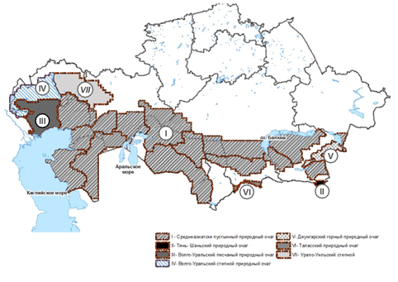

I - Central Asian desert natural focus; II – Tien-Shan natural focus; III - Volga-Urals sandy natural focus; IV - Volga-Urals steppe natural focus; V - Dzhungar mountain natural focus; VI - Talas natural focus; VII - Ural-Urals steppe natural focus

Figure 1 – Natural plague foci in the territoryRepublic of Kazakhstan

A person becomes infected with plague when infected fleas bite, when carcasses are cut or hides of rodents are dressed during hunting and sick farm animals (camels), when epidemic spread by aerogenic or contaminated routes of transmission
Carriers of Y. pestis in natural foci are different types of rodents. The role of carriers is performed by rodent fleas. One of the world's largest Central Asian desert natural plague is monohostal. The main carrier of Y. pestis is a large gerbil Rhombomys opimus Lichtenstein, 1823 (figure 2) [1, 2, 3]. The roles of secondary and random carriers are performed by other types of gerbils and other mammals. The focus extends to the territory of two other Central Asian countries: Uzbekistan and Turkmenistan. There are 14 autonomous foci in the territory of Kazakhstan; they differ from each other by diversity of landscape, spatial and biocoenotic structure, frequency and intensity of e epizooties. [4].
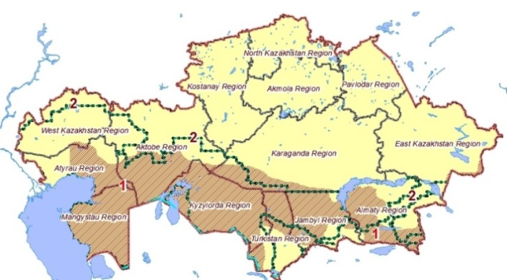

Figure 2 – R. opimus areal in the territoryof Kazakhstan

R. opimus is also widely distributed in desert areas of the northern hemisphere (figure 3), including countries with extensive natural plague foci.

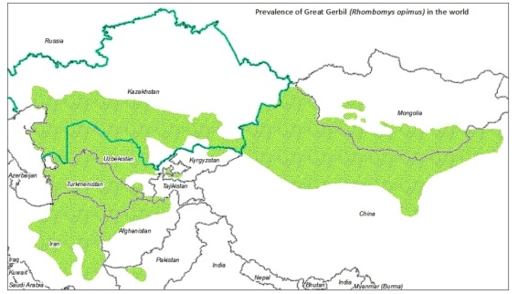

Figure 3 – R. opimus areal in the world

Populations of R. opimus in some parts of the natural habitat differ in phenotypic features, including the structure and size of skull bones, which may indicate that there are differences between representatives of the same species in different parts of range [5]. In total, within the greater gerbil area, up to 16 regional complexes, 13 subspecies and five autonomous population groups are distinguished. Attempts were made to assess the differentiation of the greater gerbils by their morphological features. However, comparison of body size and weight, the size of skull of gerbils from different regional complexes and within the same region caused some difficulties. [6]. To verify the existing schemes, it is necessary to perform DNA-typing of the genome of studied individuals from different population habitats. Geographical isolation and differences in climatic and landscape conditions undoubtedly determined the heterogeneity of the three large gerbil populations described. [7]. As far as we know, the gene of rodents of plague carriers, including R. opimus, has not been studied in Central Asian plague foci. Genomes of R. opimus living on the territory of Iran and northern China are sequenced [8, 9, 10].
The main plague vectors in the desert focus of Central Asia are R. opimus fleas – five species of the genus Xenopsylla: X. skrjabini, X. hirtipes, X. nuttalli, X. gerbilli (X. g. gerbilli, X. g. minax, X. g. caspica) and X. conformis [11, 4, 12, 13]. Several species of fleas of the genus Xenopsylla predominate in the autonomous foci of the Central Asian natural focus: in the Pribalkhash– X. hirtipes; in Betpakdala – X. gerbilli minax and X. skrjabini in Pre-Ustyurt (figure 4). The flea populations of the genus Xenopsylla differ in morphometric parameters. [14].
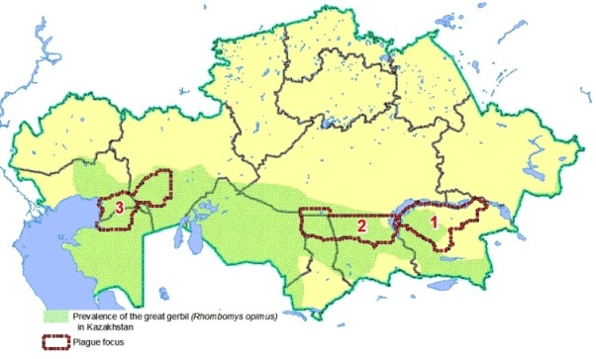

1 - X. hirtipes (Pribalkhashautonomous focus); 2 - X. gerbilli minax (Betpakdala autonomous focus); 3 - X. skrjabini (Pre-Ustyurt autonomous focus)

Figure 4 – Flea areals of the genus Xenopsylla in autonomous foci of the Central Asian natural desert plague focus

At present, we can state the presence of ecological, geographical and temporal isolation of the Y. pestis main carrier and vector populations in the sandy plague focus of Central Asia by phenotypic features. Genomes of some other species of fleas of genus Xenopsylla living in the world are sequenced. [15].
Kazakhstan has established a permanent and active control of plague in natural foci. The roles of different types of rodents carriers and fleas vectors of plague in enzootic and epizootic processes have been detailed and classified (figure 5).
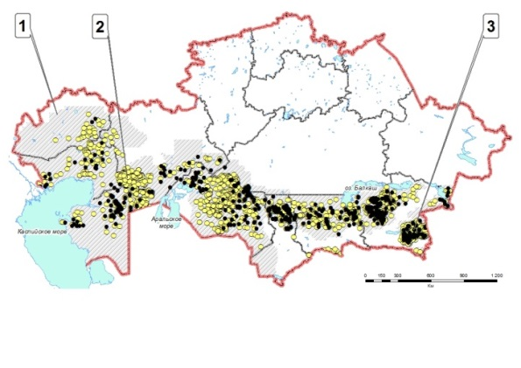

1 - plague enzootic territory; 2 - spots of antibodies detection to Y. pestis fraction I;
3 - spots of Y. pestis extraction

Figure 5 – Epizootic activity of plague foci in Kazakhstan (2000-2017)

Branches of the National scientific center for especially dangerous infections of the MH of RK located in natural plague foci carry out continuous epizootological monitoring of enzootic territories, disinsection and deratization according to indications when active epizootics are detected near settlements [4]. In case of high disease risks, vaccination of the population is carried out. In recent years only sporadic cases have been registered in Kazakhstan, without epidemic spread. The last four plague cases were registered in 2003.
As a rule, in sandy foci during epizootic examination about 90% of strains are isolated from R. opimus [16]. Strains isolated in the Central Asian desert natural foci have cultural and morphological properties typical for the plague pathogen, are sensitive to plague and pseudo tuberculosis phages, ferment glycerin and arabinose, do not ferment framenose, produce pesticin, but are not sensitive to it, are highly virulent for white mice and guinea pigs [4]. At the same time, the study of Y. pestis strains from some other natural foci of Asia and Europe demonstrated phenotypic and genotypic diversity of ecological variants of Y. pestis. Variety of conditions of existence in foci with the participation of different species of main carriers has formed populations of Y. pestis, differing in virulence, needs in growth factors, ability to produce pesticin I and sensitivity to pesticin, fibrinolysin-coagulase and denitrifying activity [17, 18, 19].
In different years, in various restricted areas of the Central Asian natural desert plague center there was a stable long-term circulation of atypical amino acids as growth factors, strains of Y. pestis [20, 21]. In particular, the circulation of leucine dependent strains was recorded in the Pre-Ustyurt autonomous focus, and in the Pribalkhash focus, along with the typical strains of the focus, the arginine dependent strains of Y. pestis were isolated. Analysis of Y. pestis strains from the Central Asian desert and Tien-Shan highland natural plague foci with different ecological conditions showed that the studied strains of Y. pestis belong to three biovars: Antiqua, Mediaevalis and Orientalis. [22, 23]. Y. pestis genome sequenced, strains from many plague foci genotyped [24, 25].
Genome and population genetic diversity of R. opimus are studied for the first time, fleas of genus Xenopsylla, correlation of genotypic variability of properties of geographically and ecologically isolated populations of R. opimus, fleas of genus Xenopsylla and Y. pestis with phenotypic manifestations of properties in areas of natural plague focus.
The breeding effect of genotypic variants of carrier populations on the selection of Y. pestis population properties was analyzed and population features of fleas of the genus Xenopsylla.
The significance of this work is that at present the mechanisms of formation and existence of infectious natural plague foci have not been sufficiently studied, as well as the importance of the rodent of main carrier in the selection and formation of Y. pestis properties, and especially the virulence level. Great scientific and practical interest presents the identification of evolutionary mechanisms of coadaptation of members of the parasitic triad on isolated territories.
Thus, the international genome bank lacks information about rodent populations and their fleas living in Central Asia, in particular plague carriers and vectors: R. opimus, genus Xenopsylla. Preliminary data on genotyping of Y. pestis from plague foci of Kazakhstan and neighboring countries are not complete and do not give a complete picture of genetic diversity.
Understanding the mechanisms of the plague natural foci existence and the influence of large gerbils on the adapted in regions of the Central Asian foci of the Y. pestis population. will make it possible to predict disease risks, develop and change the concept of plague prevention.
Large-scale projects on genotyping of Y. pestis strains have been conducted in recent years jointly by specialists from Europe, China and Mongolia [25, 26]. However, co-adaptation of members of the parasitic plague triad in the natural focus during the evolution at the population level has not been studied before.
By means of field expeditions, study of biological and ecological-geographical, literary and reporting data collected and analyzed material from different sites of R. opimus habitats and fleas of genus Xenopsylla in the Central Asian desert plague focus.
Phenotypic features of R. opimus and fleas of genus Xenopsylla populations were studied during expeditions in the areas of the natural focus, work in the Zoological Museum and with the parasitological collection of NSCEDI, the analysis of literary and reporting data of anti-plague stations of the MH of RK. Properties of Y. pestis properties were studied in the Central Reference Laboratory (CRL) and Reference Laboratory of NSCEDI in collectible and freshly isolated strains.
Genome analysis carried out at the National Center of Biotechnology and the CRL of NSCEDI revealed genotypic variants of ecologically isolated populations of R. opimus, fleas of genus Xenopsylla.
Multifactorial analysis allowed determining the regularities of phenotypic and genotypic differences in populations from autonomous centers of the Central Asian natural desert plague focus.
The results are presented in publications, property maps and distribution of ecological variants of carriers, vectors and Y. pestis populations using geographic information systems.
To determine the variability of their genomes, mitochondrial RNA of R. opimus, mitochondrial DNA of the genus Xenopsylla gerbilli minax and DNA of Y. pestis from the Central Asian natural desert plague focus were genotyped. This plague focus is an optimal opportunity for complex and systematic study of the natural plague focal, its variability, temporal, geographical and ecological isolation of the plague enzootic triad of rodent microbes. Its uniqueness lies in the size, continuity, presence of one dominant rodent species R. opimus, which is the main carrier in the entire area of the focus.
Conducted studies have shown the discreteness of three ecologically isolated populations of R. opimus in the cytochrome b gene of the mitochondrial genome. Genetic differences were found in flea species of the genus Xenopsylla g. minax from autonomous foci of the Central Asian natural focus. Genotyping of strains of Y. pestis populations demonstrated the polymorphism of populations of the plague pathogen from autonomous foci of the Central Asian natural focus.
A patent search was carried out and report on patent research on the implementation of subject was drawn up (attachment A). Attachment B contains a list of published works on the subject for 2018-2020. Attachment C contains the Calendar plan for 2018-2020 and supplementary agreement No. 6 to the contract. Attachment D contains the prints of published works for 2018-2020 and certificates of the publishing house references NAS RK on the acceptance of articles for publication.
The list of titles of interim reports by project stages and their inventory numbers:
Interim Report “Population-based ecological types of carriers, vectors and causative agents of plague in Central Asian desert foci of plague” for 2018. Inv. No. 0218RK00207.
Interim Report “Population-based ecological types of carriers, vectors and causative agents of plague in Central Asian desert foci of plague” for 2019. Inv. No. 0219РК00695.

BASIC PART

1 Materials and methods

The study materials were: 1) Data from weather stations located in the Central Asian desert natural plague focus; 2) Skulls of large gerbils and flea preparations caught in natural plague foci or stored in the zoological and parasitological museum NSCEDI; 3) Mitochondrial RNA samples isolated from the liver of R. opimus; 4) Mitochondrial DNA samples from fleas Xenopsylla g. minax; 5) Y. pestis DNA strains from the collection of the NSCEDI, isolated in three autonomous natural desert foci of the Central Asian plague focus, as well as strains of Y. pestis from other plague foci.

1.1 Analysis of weather conditions in the Central Asian desert natural plague focus area
Changes in the weather conditions in the Pre-Ustyurt focus are described based on the averaged data from three weather stations: Sam, Beineu, Borankol (figure 6). In Betbakdala focus the average data of the weather stations are taken from: Tasty; Ulanbel; Kyzylkum. In the Pribalkhash focus, data from weather stations were processed: Bakanas; Akzhar. In addition, on the territories of gerbils colonies with the portable weather station Kestrel 4500NV measured wind speed, humidity, temperature, air pressure. The coordinates of the surveyed points were recorded with the help of GPS navigator Garmin 62.

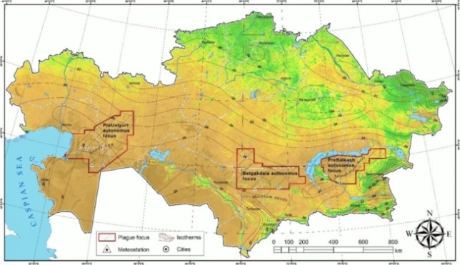

Figure 6 – Map of Kazakhstan with the contours of the Pribalkhash, Betpakdala and Pre-Ustyurt autonomous plague focus, isotherms and location of weather stations in the survey areas

Due to the fact that the number of populations of the plague parasitic triad is directly affected by the amount of precipitation, temperature and abundance of vegetation in the surveyed area was determined by the vegetation index - NDVI. Taking into account the vast territory, 16-day NDVI averages with 500-meter resolution of MODIS-MOD13A1v006 [2634] spacecraft were selected. NDVI data were used. [27].

1.2 Sampling of R. opimus and Xenopsylla family fleas

R. opimus and fleas of genus Xenopsylla were caught by employees of regional branches (anti-plague stations) of NSCEDI in three autonomous foci of Central Asian natural desert plague focus: Pribalkhash, Betpakdala and Pre-Ustyurt (table 1) at annual planned epizootological inspection of natural foci territories of Kazakhstan on plague under the state order in accordance with Sanitary regulations. [28].

Table 1 – R. opimus catching places for collecting samples

Code | Coordinates |  | Catching place
1 | 2 |  | 3
I-B1 | 104-1, ББ-1., Akdala r. N44° 49' 460'' E76°15 558' |  | Southern Pribalkhash
I-B2 | 104-1, ББ-1., Akdala r., N44° 49' 460'' E76°15 558' |  | Southern Pribalkhash
I-B3 | 104-1, ББ-1., Akdala r., N44° 49' 460'' E76°15 558' |  | Southern Pribalkhash
I-B5 | 104-1, ББ-1., Akdala r., N44° 49' 460'' E76°15 558' |  | Southern Pribalkhash
I-B7 | 104-1, ББ-1., Akdala r., N44° 49' 460'' E76°15 558' |  | Southern Pribalkhash
I-B6 | 104-1, ББ-1., Akdala r., N44° 49' 460'' E76°15 558' |  | Southern Pribalkhash
I-B8 | 104-1, ББ-1., Akdala r., N44° 49' 460'' E76°15 558' |  | Southern Pribalkhash
I-B9 | 104-1, ББ-1., Akdala r., N44° 49' 460'' E76°15 558' |  | Southern Pribalkhash
I-B11 | 104-1, ББ-1., Akdala r., N44° 49' 460'' E76°15 558' |  | Southern Pribalkhash
I-B12 | 104-1, ББ-1., Akdala r., N44° 49' 460'' E76°15 558' |  | Southern Pribalkhash
I-B14 | 104-1, ББ-2., Akdala r., N44° 48' 948'' E76°15' 528'' |  | Southern Pribalkhash
I-B15 | 104-1, ББ-2., Akdala r., N44° 48' 948'' E76°15' 528'' |  | Southern Pribalkhash
I-B16 | 104-1, ББ-2., Akdala r., N44° 48' 948'' E76°15' 528'' |  | Southern Pribalkhash
I-B17 | 104-1, ББ-2., Akdala r., N44° 48' 948'' E76°15' 528'' |  | Southern Pribalkhash
I-B19 | 104-1, ББ-2., Akdala r., N44° 48' 948'' E76°15' 528'' |  | Southern Pribalkhash
I-B21 | 104-1, ББ-2., Akdala r., N44° 48' 948'' E76°15' 528'' |  | Southern Pribalkhash
I-B22 | 104-1, ББ-2., Akdala r., N44° 48' 948'' E76°15' 528'' |  | Southern Pribalkhash
I-B23 | 104-1, ББ-3., Akdala r., N44° 48' 827'' E76°15' 802'' |  | Southern Pribalkhash
I-B24 | 104-1, ББ-3., Akdala r., N44° 48' 827'' E76°15' 802'' |  | Southern Pribalkhash
I-B25 | 104-1, ББ-3., Akdala r., N44° 48' 827'' E76°15' 802'' |  | Southern Pribalkhash
I-Sh1 | Sholakespe, N45°10', E68° 00' |  | Western Betpakdala
I-Sh2 | Sholakespe, N45°10', E68° 00' |  | Western Betpakdala
I-Sh3 | Sholakespe, N45°10', E68° 00' |  | Western Betpakdala
I-Sh4 | Sholakespe, N45°10', E68° 00' |  | Western Betpakdala
I-Sh5 | Sholakespe, N45°10', E68° 00' | Western Betpakdala
I-Sh6 | Sholakespe, N45°10', E68° 00' | Western Betpakdala
I-Sh7 | Sholakespe, N45°10', E68° 00' | Western Betpakdala
I-Sh8 | Sholakespe, N45°10', E68° 00' | Western Betpakdala
I-Sh9 | Sholakespe, N45°10', E68° 00' | Western Betpakdala
I-Sh10 | Sholakespe, N45°10', E68° 00' | Western Betpakdala
Continuation of Table 1

1 | 2 | 3
I-Sh11 | Sholakespe, N45°10', E68° 00' | Western Betpakdala
I-Sh12 | Sholakespe, N45°10', E68° 00' | Western Betpakdala
I-Sh13 | Sholakespe, N45°10', E68° 00' | Western Betpakdala
I-Sh14 | Sholakespe, N45°10', E68° 00' | Western Betpakdala
I-Sh15 | Sholakespe, N45°10', E68° 00' | Western Betpakdala
I-Sh16 | Sholakespe, N45°10', E68° 00' | Western Betpakdala
I-Sh17 | Sholakespe, N45°10', E68° 00' | Western Betpakdala
I-Sh18 | Sholakespe, N45°10', E68° 00' | Western Betpakdala
I-Sh19 | Sholakespe, N45°10', E68° 00' | Western Betpakdala
I-Sh20 | Sholakespe, N45°10', E68° 00' | Western Betpakdala
I-Sh21 | Sholakespe, N45°10', E68° 00' | Western Betpakdala
I-Sh22 | Sholakespe, N45°10', E68° 00' | Western Betpakdala
I-Sh23 | Sholakespe, N45°10', E68° 00' | Western Betpakdala
I-Sh24 | Sholakespe, N45°10', E68° 00' | Western Betpakdala
I-Sh25 | Sholakespe, N45°10', E68° 00' | Western Betpakdala
I-Sh26 | Sholakespe, N45°10', E68° 00' | Western Betpakdala
I-Sh27 | Sholakespe, N45°10', E68° 00' | Western Betpakdala
I-Sh28 | Sholakespe, N45°10', E68° 00' | Western Betpakdala
I-Sh29 | Sholakespe, N45°10', E68° 00' | Western Betpakdala
I-Sh30 | Sholakespe, N45°10', E68° 00' | Western Betpakdala
I-A1 | Zhaksy butaly suburbs N46°52'54'', E59°32'43'' | Eastern Pre-Ustyurt
I-A2 | Zhaksy butaly suburbs N46°52'54'', E59°32'43'' | Eastern Pre-Ustyurt
I-A3 | Zhaksy butaly suburbs N46°52'54'', E59°32'43'' | Eastern Pre-Ustyurt
I-A4 | Zhaksy butaly suburbs N46°52'54'', E59°32'43'' | Eastern Pre-Ustyurt
I-A5 | Zhaksy butaly suburbs N46°52'54'', E59°32'43'' | Eastern Pre-Ustyurt
I-A6 | 10 km north of Zhaksy butaly suburbs N46°58'31'', E59°33'24'' | Eastern Pre-Ustyurt
I-A7 | 10 km north of Zhaksy butaly suburbs N46°58'31'', E59°33'24'' | Eastern Pre-Ustyurt
I-A8 | 10 km north of Zhaksy butaly suburbs N46°58'31'', E59°33'24'' | Eastern Pre-Ustyurt
I-A9 | 10 km north of Zhaksy butaly suburbs N46°58'31'', E59°33'24'' | Eastern Pre-Ustyurt
I-A10 | 10 km north of Zhaksy butaly suburbs N46°58'31'', E59°33'24'' | Eastern Pre-Ustyurt
I-A12 | 10 km north of Zhaksy butaly suburbs N46°58'31'', E59°33'24'' | Eastern Pre-Ustyurt
I-A14 | 10 km north of Zhaksy butaly suburbs N46°58'31'', E59°33'24'' | Eastern Pre-Ustyurt
I-A15 | 10 km north of Zhaksy butaly suburbs N46°58'31'', E59°33'24'' | Eastern Pre-Ustyurt
I-A16 | 7 km south of the well Karatay N46°57'57'', E60°16'53'' | Eastern Pre-Ustyurt
I-A18 | 7 km south of the well Karatay N46°57'57'', E60°16'53'' | Eastern Pre-Ustyurt
I-A19 | 7 km south of the well Karatay N46°57'57'', E60°16'53'' | Eastern Pre-Ustyurt
I-A21 | 9 km south of the well Taskudik N46°59'06'', E60° 24'38'' | Eastern Pre-Ustyurt
I-A22 | 9 km south of the well Taskudik N46°59'06'', E60° 24'38'' | Eastern Pre-Ustyurt
I-A23 | 9 km south of the well Taskudik N46°59'06'', E60° 24'38'' | Eastern Pre-Ustyurt
I-A24 | 9 km south of the well Taskudik N46°59'06'', E60° 24'38'' | Eastern Pre-Ustyurt
I-A25 | 9 km south of the well Taskudik N46°59'06'', E60° 24'38'' | Eastern Pre-Ustyurt
I-A26 | Tasbulak suburbs N47°38'19'', E58° 49'43'' | Eastern Pre-Ustyurt
I-A29 | Tasbulak suburbs N47°38'19'', E58° 49'43'' | Eastern Pre-Ustyurt
I-A30 | Tasbulak suburbs N47°38'19'', E58° 49'43'' | Eastern Pre-Ustyurt
I-A31 | Tasbulak suburbs N47°38'19'', E58° 49'43'' | Eastern Pre-Ustyurt
I-A32 | 10 km south of Qosshanirau well N46°48'35'', E59° 17'15'' | Eastern Pre-Ustyurt
I-A34 | 10 km south of Qosshanirau well N46°48'35'', E59° 17'15'' | Eastern Pre-Ustyurt
Continuation of Table 1

1 | 2 | 3
I-A35 | 10 km south of Qosshanirau well N46°48'35'', E59° 17'15'' | Eastern Pre-Ustyurt
I-A36 | 10 km south of Qosshanirau well N46°48'35'', E59° 17'15'' | Eastern Pre-Ustyurt
I-A37 | 10 km south of Qosshanirau well N46°48'35'', E59° 17'15'' | Eastern Pre-Ustyurt
I-A39 | 10 km south of Qosshanirau well N46°48'35'', E59° 17'15'' | Eastern Pre-Ustyurt
I-A40 | 10 km south of Qosshanirau well N46°48'35'', E59° 17'15'' | Eastern Pre-Ustyurt
I-A41 | 10 km south of Qosshanirau well N46°48'35'', E59° 17'15'' | Eastern Pre-Ustyurt
I-A43 | 10 km south of Qosshanirau well N46°48'35'', E59° 17'15'' | Eastern Pre-Ustyurt
I-A44 | 10 km south of Qosshanirau well N46°48'35'', E59° 17'15'' | Eastern Pre-Ustyurt
I-A45 | 10 km south of Qosshanirau well N46°48'35'', E59° 17'15'' | Eastern Pre-Ustyurt
I-A46 | 10 km south of Qosshanirau well N46°48'35'', E59° 17'15'' | Eastern Pre-Ustyurt
I-A47 | 10 km south of Qosshanirau well N46°48'35'', E59° 17'15'' | Eastern Pre-Ustyurt
I-A48 | 10 km south of Qosshanirau well N46°48'35'', E59° 17'15'' | Eastern Pre-Ustyurt
I-A49 | 10 km south of Qosshanirau well N46°48'35'', E59° 17'15'' | Eastern Pre-Ustyurt

In total 88 individuals of great gerbils from three independent population groups were caught: South Balkhash - 20 individuals from 3 points (N44° 49' 460'' E76° 15' 558' - 10 individuals; N44° 48' 948' E76° 15' 528' - 7 individuals; N44° 48' 827' E76° 15' 802' - 3 individuals); Western Betpakdala captured 29 individuals from one geographic area (N45° 10', E68° 00'); 39 individuals from 6 geographical locations (N47° 52' 54'', E56° 32' 43' - 5 individuals; N47° 58' 31', E56° 33' 24' - 8 individuals) were caught in East Pristure; N47° 57" 57", E56° 16" 53" - 3 individuals; N47° 59" 06", E56° 24" 38" - 5 individuals; N47° 38" 19", E58° 49" 43" - individuals; N48° 48" 35", E57° 17" 15" - 14 individuals). The animals were identified as R. opimus by phenotypic traits. All manipulations with R. opimus organs, fleas of the genus Xenopsylla and strains of Y. pestis strains, were carried out in accordance with biosafety standards [29] and techniques for work with pathogens. [30, 31].

1.3 Method of extraction of mitochondrial RNA R. opimus

DNA was extracted from a piece of liver 50 mg. The liver was placed in a 2 ml eppendorf-type tube containing 4 steel balls 4 mm in diameter. The tubes were placed in liquid nitrogen and the contents were broken down into TissueLyser (Qiagen, Germany) for 3 min. The tubes were centrifuged at 10 thousand rot/min for 1 minute, 180 microliter of lysis buffer (ATL buffer, Qiagen) was added. DNA was then extracted using the Qiamp DNA mini kit (Qiagen, Hilden, Germany) according to the manufacturer's instructions, using a protocol to extract DNA from tissues. DNA was eluated at 50 mcl. [32].
A fragment of cytB gene with a length of 578 bp (excluding primers) was amplified using primers UNFOR403 and UNREV1025 [33]. The reaction PCR mixture included: 75 mM Tris-HCl (pH 8.8 at 25° C), 20 mM (NH4) 2SO4, 0.01% (rot/min) Twin 20, 2.5 mM MgCl2, 2 Taq units of DNA polymerase (Thermo Scientific, EP0402), 0.2 mM of each DNTF, 0.5 mcM of each primer and 3 ng. DNA of R. opimus. The PCR amplification program included: prolonged denaturation of 95°С-5 minutes; 35 cycles of 95°С - 20 seconds, 59° -30 seconds, 72°С - 1 minute; final elongation of 7 minutes at 72°С..
The nucleotide sequence of D-loop mitochondrial DNA R. opimus was amplified using Thr-L15926 and DL-H16340 H16340 primers [34]. The reaction mixture included: 0.5 mcM of Thr-L15926 and DL-H16340 primers, 1X buffer for Platinum™ II PCR, 2 mM MgCl2, 0.2 mM of each DNTF, 0.2 mcM of Platinum™ II Taq Hot-Start DNA-polymerase, 3 ng DNA. The PCR amplification program included: prolonged denaturation of 95°C - 5 minutes; 35 cycles of 95°C - 20 seconds, 56°C - 30 seconds, 68°C - 30 seconds; final elongation for 5 minutes at 68°C.
PCR products were cleaned by enzymatic method using Exonuclease I (Fermentas) and alkaline phosphatase (Shrimp Alkaline Phosphatase, Fermentas) [35]. The sequencing reaction was performed using BigDye® Terminator v3.1 Cycle Sequencing Kit (Applide Biosystems) and primers used for PCR amplification according to the manufacturer's instructions. Separation of fragments was performed on the 3730xl DNA Analyzer (Applide Biosystems). The quality assessment and assembly in contiguity was performed using SeqScape 2.6.0 (Applied Biosystems). Phylogenetic analysis was performed using the MEGA 7.0 software, using the highest plausibility method Tamura 3-parameter, discrete Gamma distribution and Boothstrap 1000 [36].

1.4 Fenetic flea research

The material for carrying out phenotypic studies was the fleas of the genus Xenopsylla caught in the course of epizootological studies in the territorially isolated from each other Pribalkhash, Betpakdala and Pre-Ustyurt autonomous foci, as well as from the collection of fleas from the territory of China, stored in the zoological museum of NSCEDI. On the basis of morphometric methods the parameters of head size and hitom were studied. 681 fleas (305 females and 376 males) were selected for morphological studies of chitin exoskeleton with discrete variability representing one of the characteristic features of its appearance. Multiple linear regression was used to evaluate the impact on the listed phenotypic features of the place of catching (focus) and sex of insects. Data processing was performed in a free statistical environment R version 4.0.0 with graphical environment RStudio [37]. To determine species belonging and morphological analysis from fleas, preparations were made using standard methods of [38].
The head and bristles of the head were measured using photos of flea preparations using the ImageJ computer program [39]. For correct interpretation of the analysis results, meristic features were used, the variability of which does not depend on body size [11]. Three meristic features were selected, which have discrete variability, vary within certain limits, represent one of the characteristic features of appearance of insects, allow to analyze the variability, do not undergo changes during the life of an adult: the length of head, the distance between eye and parietal bristles and the distance between parietal and angular bristles. [14].

1.5 Method of mitochondrial DNA isolation of genus Xenopsylla fleas

For genetic analysis, 22 individuals of the genus Xenopsylla fleas were selected from three isolated plague foci: samples B3, B6, B5 and B2 were collected in the Southern Pribalkhash, within a radius of 5 km from the point N44° 49' 460'', E76° 15 558'; samples Sh, Sh1, Sh3, Sh4, Sh5, Sh6, Sh7, Sh10, Sh12, Sh13, Sh14 and Sh15 were collected in Western Betpakdal within a radius of 5 km from the point N45° 10', E68° 00'; samples A2, A3, A4, A5 and A10 were collected in the Eastern Pre-Ustyurt within a radius of 5 km from the point N46°58'31", E59°33'24".
DNA was extracted using a known protocol [40]. A single specimen was intercepted in a 2-ml eppendorf-type tube containing 10 glass beads of 1 mm diameter and 1 steel ball of 4 mm diameter. The tubes were placed in liquid nitrogen and the contents were broken down into TissueLyser (Qiagen, Germany) for 3 min. The tubes were centrifuged at 10 thousand rot/min for 1 minute, 180 microliter of lysis buffer (ATL buffer, Qiagen) was added. DNA was then extracted using the Qiamp DNA mini kit (Qiagen, Hilden, Germany) according to the manufacturer's instructions, using a protocol to extract DNA from tissues. DNA was eluted in 50 mcl.
A fragment of the CoxII nucleotide sequence was amplified using the Insect-A-LEU and Insect-B-T primers [41]. The composition of the reaction mixture included: the Insect-A-tLEU and Insect-B-Tlys primers of 20 pm each; 75 mMTris-HCl (pH 8.8 at 25° C), 20 mM (NH4)2SO4, 0.01% (volume/volume) Twin 20; DNTF at a concentration of 200 nM each; 2 units of Taq DNA polymerase (ThermoScientific); magnesium ions of 2.5 mM; DNA 10 microliters. The total reaction volume is 25 microliters. PCR amplification program: long denaturation of 95º C – 3 minutes; 35 cycles of 95º C – 20 seconds, 59º – 30 seconds, 72º C – 1 minute; final elongation of 7 minutes at 72º C.
PCR products were analyzed by electrophoresis in 1.5% agarose gel with ethidium bromide. 1x TAE-buffer was used as an electrode buffer. The results were documented using the Gel Doc (Bio-Rad) gel documentation system with Quantity One (Bio-Rad) software. The molecular sizes of the analyzed DNA samples were determined by comparing their electrophoretic mobility in the gel with the mobility of markers - a DNA fragment of a known molecular mass. “DNA Ladder 1kb”, (Fermentas) was used as a marker of molecular mass. PCR products were cleaned by enzymatic method using exonuclease I (Thermo Scientific) and alkaline phosphatase (Thermo Scientific) [35]. Sequencing was performed using the BigDye® Terminator v3.1 Cyclic Sequencing Kit (Applide Biosystems) and primers used for PCR amplification according to the manufacturer's instructions. Separation of fragments was performed on the 3730xl DNA Analyzer (Applide Biosystems). Quality assessment and assembly in a continuum were performed using the LaserGene software package (DNAStar).
Phylogenetic analysis was performed using the MEGA 7.0 program, using maximum likelihood method, 3-parameter Tamura model, discrete gamma distribution and Bootstrap 1000 [36]. For phylogenetic analysis 651 n. p. were used due to shorter gene fragments of other types of fleas from NCBI database.

1.6 Y. pestis DNA genotyping method

DNA isolation of Y. pestis strains was performed using QIAamp DNA Mini Kit (Qiagen, USA) [40, 42]. Genotyping of Y. pestis was performed by genome-wide sequencing. DNA sample preparation was performed using Nextera XT DNA Library Preparation Kit (catalog number: FC-131-1024), according to the manufacturer's instructions. Sequencing was performed on a high-performance MiSeq sequencer, Illumina platform, and MiSeq Reagent Kit v3, 600 Cycles (catalog number: MS-102-3003) according to the manufacturer's instructions. As part of the project, 31 strains of Y. pestis were genome-wide sequenced. (table 2).

Table 2 – List of Y. pestis strains for sequencing

Sample cipher | Source of allocation | Autonomous focus
1 | 2 | 3
Chuma-1435 | Rhombomys opimus | Kyzylkum
Chuma-1591 | Rhombomys opimus | Pribalkash
Chuma-161 | C. laeviceps | Ustyurt
Chuma-1629 | Fallen camel | Moyinkum
Chuma-1786 | Marmota caudata | Talass
Chuma-1826 | Ceratophyllus caspius | Talass
Chuma-1919 | Patient | Pre-Ustyurt
Chuma-2033 | Rhombomys opimus | Kyzylkum
Chuma-2094 | Patient | Pre-Ustyurt

Continuation of Table 2

1 | 2 | 3
Chuma-3022 | Rhombomys opimus | Ustyurt
Chuma-3043 | Fallen Rhombomys opimus | Pre-Ustyurt
Chuma-309 | Rhombomys opimus | Pre-Ustyurt
Chuma-3216 | Xenopsylla gerbili | Pribalkash
Chuma-3355 | Patient | North-Priaral
Chuma-3362 | Camel | Mangystau
Chuma-3508 | X. hirtipes | Pribalkash
Chuma-3586 | Rhombomys opimus | Betpakdala
Chuma-4 | Patient | Pribalkash
Chuma-4230 | Rhombomys opimus | Moyinkum
Chuma-4291 | Rhombomys opimus | Moyinkum
Chuma-4490 | Rhombomys opimus | Moyinkum
Chuma-4613 | X. skrjabini | Pre-Ustyurt
Chuma-4658 | Rhombomys opimus | Betpakdala
Chuma-4877 | Xenopsylla gerbili | Moyinkum
Chuma-4878 | Rhombomys opimus | Moyinkum
Chuma-636 | Rhombomys opimus | Ustyurt
Chuma-KA-12 | Fleas without definition | Pribalkash, Lukkumy
Chuma-KA-124 | Rhombomys opimus | Ustyurt
Chuma-KA-41 | Rhombomys opimus | Ustyurt
Chuma-KA-44 | Great gerbil oats | Pribalkash
Chuma-KA-7 | Spermophilus pygmaeus | Pribalkash

Оценку предварительных данных полногеномного секвенирования проводилось с использованием программ FastQC v0.11.7 и Multiqc v1.8. Построение филогенетических деревьев проводили с использованием коммерческого программного обеспечения BioNumerics v8.0 (Applied Maths, Belgium).

2 Biological and ecological-geographical features of habitats of populations of the great gerbil of the Central Asian natural desert plague focus

All three surveyed regions of Kazakhstan are located in the Northern desert zone, where the trends of changes in the amount and mode of precipitation are of particular importance for vegetation. The analysis of climatic and geographical features revealed the degree of synchronization of the trend of changes in air temperature and precipitation for all the territories under consideration.
In Kazakhstan, the average annual temperature increased by + 0.30°C over 10 years for the period 1941-2010 and + 0.39°C over 10 years for the period 1971-2010, while the share of variance explained by the trend is more than 30%. Temperatures also increase in all seasons of the year, with the highest rates in the winter season – by 0.38°C over 10 years (1941-2010) and by 0.51°C over 10 years over the last 40 years (1971-2010). All trends are statistically significant. The frequency of extremely high air temperatures increases. Almost in the entire southern half of Kazakhstan, the number of days with air temperatures above 35°C increases by 1...3 days every 10 years (1941-2010). The total duration of warm periods becomes longer – by 1...4 days in 10 years.
The increase in average annual air temperatures in certain regions of Kazakhstan for the period 1941 ... 2010 ranged from 0.27°C for 10 years (Balkhash-Alakol basin, on the territory of which the Balkhash autonomous focus is located) to 0.33°C for 10 years (Pre-Ustyurt focus). A more significant increase in average annual air temperatures of – 0.44°C over 10 years observed in the Shu-Talas basin, where the Betpakdala autonomous focus is located. Over the period 1971-2010, the temperature increased at the highest rates in winter and spring – by 0.51 and 0.47°C over 10 years, respectively, slightly lower rates of warming in autumn – by 0.40°C over 10 years. In summer, the increase in air temperature was 0.22°C for 10 years.
The territory of Kazakhstan, with the exception of high-altitude areas, characterized by a pronounced aridity: the average annual precipitation over the entire area of the country is about 200 mm. The observed changes in the amount of precipitation on the territory of Kazakhstan in the period 1941-2010 in Kazakhstan as a whole decreased slightly – by 0.4 mm over 10 years. At the same time, more noticeable was the decrease in precipitation in the Zhaik-Caspian basin (Pre-Ustyurt focus): – 0.4 mm for 10 years, in the Shu-Talas basin, where the Betpakdala autonomous focus, the decrease was – 1.7 mm/10 years, and in the Balkhash autonomous focus (Balkhash-Alakol basin) observed a weak trend of increasing annual precipitation by 0.4 mm in 10 years.
The specific climatic conditions of the territory of all three surveyed Autonomous foci consist in a sharp continentality and aridity of the climate. This expressed in significant daily and annual temperature fluctuations and in a small amount of precipitation (100-280 mm) with high evaporation (up to 1000-1200 mm) and significant dryness of the air (figure 7).
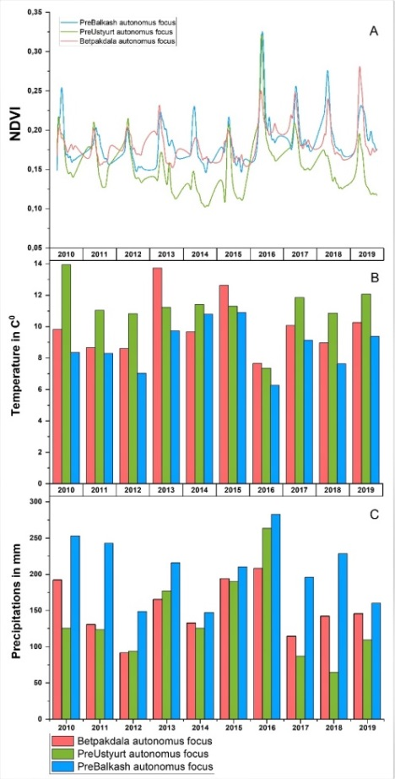

Figure 7 – Average annual precipitation and temperature dynamics and NDVI of the studied autonomous plague foci

The sum of temperatures above 10°C in the described natural foci ranges from 31.00°C to 38.60°C. The result is a weak development of the natural hydrographic network. The level of solar radiation and the nature of atmospheric circulation determined by the geographical location of the territory – a relatively low latitude and distance from water basins (the influence of the Caspian Sea and Lake Balkhash affects only within a narrow coastal strip). Orographic and insolation features of the territory determine the diversity of local atmospheric circulation systems. The average temperature in January in the surveyed territories of autonomous foci is -8.63° C, but on some days, severe frosts are possible, reaching -40-44° C. The winter months characterized by increased wind speeds of 4.5-5 m/s, especially in February and March, which causes the development of snowstorms.
Spring in all natural foci is friendly and short and lasts about a month and a half. Already in March, the surveyed area marked by a sharp rise in average temperature, by 7-8° C compared to February, and intense heating of the soil. In April, the desert zone dominated by frost-free, mostly sunny weather. Daily amplitudes of temperature reaching up to +16-20°C. Weather anomalies are of great importance for arid biocenoses. In the spring, along with an increase in temperature during breaks in the Arctic air masses, cold weather returns and the establishment of temporary snow cover are possible. In summer, most of the country captured by the Northern periphery of the thermal depression, with hot, dry weather and weak winds prevailing. On some days, the temperature exceeds 38-44° C, with high wind speed and relative humidity of 5-15%.
Higher average air temperatures in the warm period of the year are typical for the Pre-Ustyurt and Betpakdala foci compared to the Balkhash one. During the cold period of the year, especially low temperatures are typical for the Betpakdala and Pribalkhash foci (figure 8).
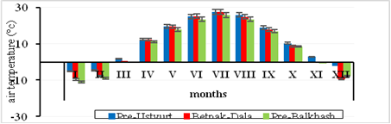
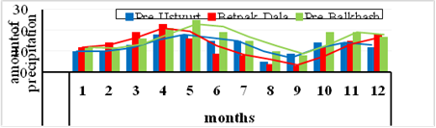

Figure 8 – average monthly precipitation and air temperature for 2010-2017

In all three foci, the frequency of hot and dry weather is – 75-85%. During the invasion of arctic air in anticyclones occurring atmospheric drought with a duration of 10-40 days. Forming a soil drought and in combination with it, atmospheric drought leads to a sharp decrease in the feed capacity of natural phytocenoses, which is one of the factors that depress the population of the great gerbil.
The analysis of average monthly precipitation fluctuations in the territory of the three surveyed foci shows a synchronous mode and close values of air temperature in the warm period of the year (IV-X) and noticeable differences in the cold period (XI-III). At the same time, there are marked differences in the average monthly amount and mode of precipitation. The above causes the difference in the NDVI index.
Summer lasts on average 5 months, from May to September. In the annual course of precipitation, the maximum in the Pre-Ustyurt focus falls in April-July and the second maximum precipitation observed in autumn, in October-November, in Betpakdala falls in March-May and October-December, in Balkhash in March-July and October-December. That is, it coincides with the vegetation maximum of desert vegetation. Minimum precipitation observed in August and September. Relative humidity in the winter months is high and is 65-75%, and in the summer, on the contrary, due to high air temperature and low precipitation, it is very low – 25-30%. Permanent snow cover formed in the first decade of December and disappears by the end of February. The height of the snow cover reaches 10-25 cm. The average duration of winter is 80 days. The depth of soil freezing is 40-45 cm, and in the most severe and low-snow winters it reaches 1 meter or more.
The trend of warming global and especially regional climate in Kazakhstan on the background of some decrease of atmospheric precipitation is an additional factor of aridity of the habitat gerbils, which leads to a reduction of feed resources natural pastures and, consequently, creates conditions for the reduction of the number of gerbils in the examined autonomous natural foci.
The negative effects of excessive grazing pressures on plant communities studied deserts expressed in the form of pasture digression, which accompanied by a decrease in the percent cover of soil with vegetation, reducing the biological and fodder productivity and a loss of biodiversity. According to our assessment, the current economic use of natural pastures characterized as unsystematic. Vegetation characterized by a rather uneven state: from badly knocked down to partially restored.
Due to overgrazing, river flow regulation, laying of linear systems (gas and oil pipelines, roads, and power lines), frequent droughts, and other factors, desertification is rapidly developing in most natural pastures.
The most degraded due to excessive load phytocenoses of natural pastures of the Pre-Balkhash focus, to a lesser extent the Betpakdala autonomous focus. On the natural pastures of the Pre-Ustyurt focus, dimutation processes of partial restoration of downed vegetation are visible, which is a consequence of a sharp decrease in the number of livestock in the region.
Thus, due to the heterogeneity of the environment in the form of climatic, geographical and geobotanical conditions, genetically and morpho-physiologically isolated populations of R. opimus have developed on the territory of the three Autonomous natural foci described. Studies have confirmed the difference between the populations of the great gerbil in morphological (craniometric) characteristics and physiological status [7].

3 Phenotypic differences in populations of R. opimus, the genus Xenopsylla, and Y. pestis from Autonomous foci of the Central Asian natural desert plague focus

X. gerbilli minax in the plague foci of Kazakhstan is distributed from the middle course of the Syr Darya river to the East through the Betpakdala desert, the Kyzylkum and Moyinkum Sands, reaches the Karatal river, then is interrupted and the easternmost part of the range lies between lake Alakol and the Eastern border with China (figure 9).

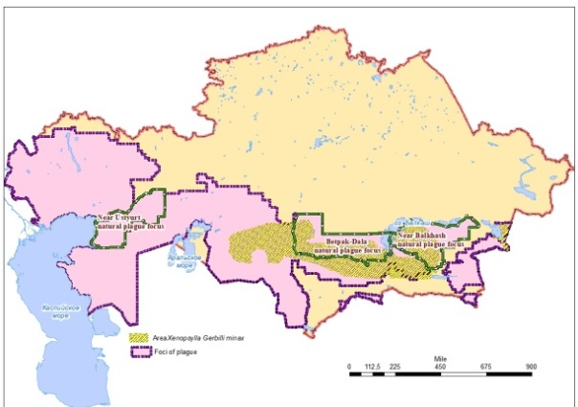

Figure 9 – Area of X. gerbilli minax in Kazakhstan

368 specimens of fleas of this species were divided into 3 groups by habitat – 147 specimens of fleas collected from the Balkhash autonomous plague focus, 71 specimens – from the Betpakdala plague focus. For a comparative assessment, we also studied 5 flea specimens of Tien-Shan plague focus located in the territory of China stored in zooparasitological the museum of NSCEDI.
Fleas of X. gerbilli species caught in Dzungarian autonomous focus statistically significantly differed from the fleas of their species from other foci by the distance between parietal and angular bristles (p = 0.00149), including after stratification by floor (p = 0.00007).
The area of X. hirtipes in plague foci of Kazakhstan occupies much smaller territory in comparison with X. gerbilli minax and is mainly connected with sandy areas (figure 10).
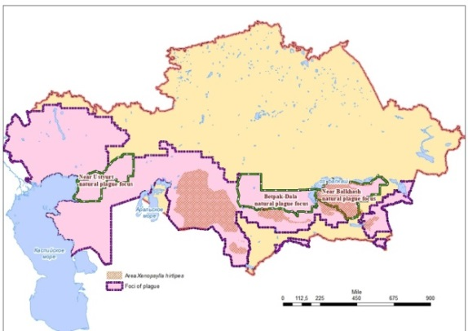

Figure 10 – Area of X. hirtipes in Kazakhstan

137 ex. fleas of this species were divided into 3 groups in their habitat - 105 ex. fleas collected from the Pribalkhash autonomous plague focus, 27 ex. - from the Betpakdala plague focus. For comparative assessment we also studied 5 ex. fleas from the Tien Shan plague focus located on the territory of the RC, which are kept in the zooparasitological museum of NSCEDI.
Fleas of the species X. hirtipes caught in the Pre-Balkhash and Betpakdala foci significantly differed from fleas of their own species from other foci on the basis of the distance between the ocular and parietal bristles (p = 0.00126 and 0.00025, respectively). Also because of the distance between the parietal and angular bristles (p = 0.00138 and 0.00402, respectively), including after sex stratification (p = 0.0525 and p = 0.02127).
The range of X. skrjabini occupies a significant part of the plague foci of Kazakhstan and extends from the Northwestern coast of the Caspian Sea to the East to the Southeastern border with the People’s Republic of China (figure 11).
176 specimens of fleas of this species were divided into 4 groups according to their habitat: 72 specimens of fleas collected from the Balkhash autonomous plague focus, 56 specimens from the Betpakdala focus, and 13 specimens from the Pre-Ustyurt plague focus. For a comparative assessment, we also studied 35 flea specimens from the Tien-Shan plague focus located in the territory of the People’s Republic of China, stored in the zooparasitological museum of NSCEDI.

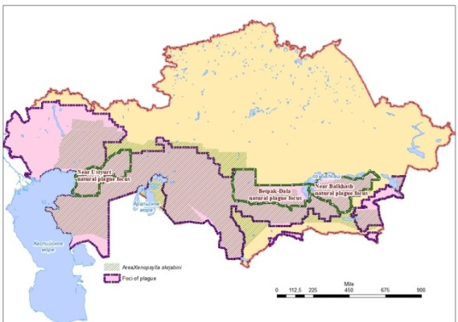

Figure 11 – Area of X. skrjabini in Kazakhstan

X. skrjabini fleas from the Betpakdala, Balkhash and Pre-Ustyurt foci of Kazakhstan do not differ statistically significantly in the distance between the ocular and parietal bristles. Fleas caught in the Betpakdala focus statistically significantly differ from other fleas in terms of head length (p = 0.0355) and the distance between the parietal and angular bristles (p = 0.0181).
Thus, based on the conducted research, we can assume that fleas of the species X. skrjabini caught in various autonomous foci do not differ statistically significantly from each other in phenotypic characteristics and probably belong to the same population group. In addition, fleas of the species X. gerbilli minax caught in the Dzungarian autonomous focus differ statistically significantly from fleas of their own species from other foci based on the distance between the parietal and angular bristles. It may indicate the formation of an independent population of fleas of the species X. gerbilli in the Dzungarian autonomous focus of plague. Flea species X. hirtipes caught in Balkhash and Betpakdala foci, statistically significantly different from the fleas of their own species from other foci based on the distance between the eye and parietal bristles, and based on the distance between parietal and angular bristles. It may indicate the formation of independent populations of flea species X. hirtipes in the Balkhash and Betpakdala plague foci.

4 Genotyping, search for population diversity and genomic features of R. opimus, Xenopsylla fleas, and Y. pestis strains from the Central Asian natural desert plague focus

4.1 Sequencing mitochondrial RNA of R. opimus

To search for possible heterogeneity of R. opimus from geographically and ecologically isolated populations, genotyping of R. opimus performed from the territories of three autonomous foci: Pre-Balkhash, Betpakdala, and Pre-Ustyurt. Based on the analysis of publications [8, 10], it is concluded that to study population differences in great gerbils, it is advisable to carry out genotyping based on the sequence of the CytB gene. In addition, the NCBI international database contains 76 nucleotide sequences of R. opimus, of which more than 35% is the CytB gene sequence.
19 unique haplotypes were identified from a fragment of the CytB gene nucleotide sequence. Of the 578 bases analyzed, 37 transitions accounted for, and four polymorphisms accounted for transversions. Eight of the analyzed polymorphisms lead to amino acid substitution. 88 samples were combined into 7 haplogroups. The first haplogroup included 20 individuals caught in the Southern Pre-Balkhash region. The second haplogroup represented by 15 individuals caught in Western Betpakdala (obviously, letter designations and numbering are needed). The third haplogroup included 5 individuals caught in the territory of Western Betpakdala and 4 individuals from the Eastern Pre-Ustyurt Region. The fourth haplogroup is 4 individuals from Western Betpakdala. The fifth haplogroup represented by 5 individuals from the Western Betpakdala and 18 individuals from the Eastern Pre-Ustyurt Region. The sixth and seventh haplogroups combined individuals exclusively from the Eastern Pre-Ustyurt Region with 6 and 11 individuals, respectively. Reconstruction of the phylogenetic tree by amino acid sequence formed 9 haplotypes.
25 haplotypes were identified based on the D-loop nucleotide sequence. 63 of the 468 bases were variable. Of these, 59 were transits, 3 were transversions, and in three samples from individuals I-B15, I-B16, and I-B17 caught in the Southern Pre-Balkhash Region, adenine insertion was established. Higher genetic variability led to the formation of additional haplotypes in the D-loop analysis in comparison with the CytB gene: haplotype A in the CytB gene formed 5 separate haplotypes; haplotype E – two separate haplotypes; haplotype L was divided into two haplotypes. The composition of the other haplotypes did not differ between the two genes.
Phylogenetic analysis with the nucleotide sequences of 19 haplotypes identified in R. opimus from plague foci in Kazakhstan and the CytB sequences of the R. opimus gene caught in Iran and China [8, 9] formed three large clusters (figure 12).

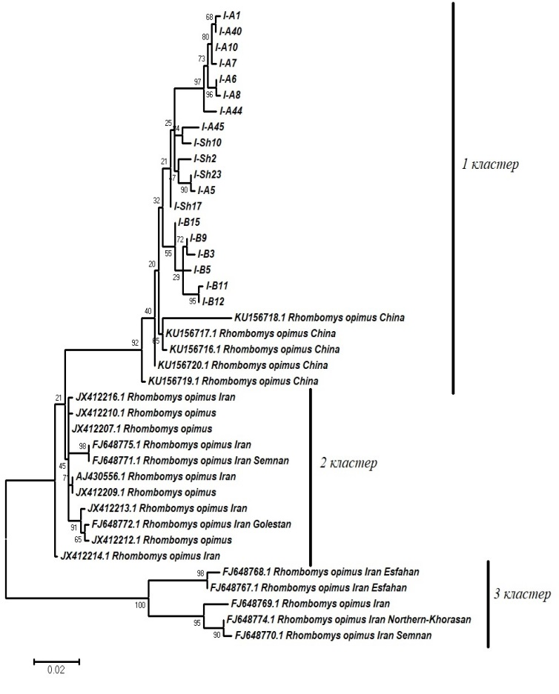

B – Samples collected in the southern Pre-Balkhash Region; Sh – samples collected in the Western Betpakdala; A – samples collected in the Eastern Pre-Ustyurt Region

Figure 12 – Phylogenetic tree based on the analysis of the CytB nucleotide sequence of the R. opimus gene caught in Kazakhstan, Iran, and China

The first cluster – combined sequences of R. opimus caught in Kazakhstan and China, while the great gerbil caught in Kazakhstan is located in a separate clade. The second and third clusters include sequences of great gerbils caught in Iran. Genotyping data of R. opimus populations that circulate in Kazakhstan and are the main hosts in the Central Asian desert plague focus are included in the NCBI international database.

4.2 Sequencing of mitochondrial DNA in fleas of the genus Xenopsylla

Genotyping and search for population diversity and genome features of the genus Xenopsylla performed. 743 bp were sequenced in 22 Xenopsylla samples collected in Kazakhstan. The resulting sequence includes the complete protein-coding sequence cytochrome oxidase subunit II (COII) and a fragment of the tRNA-Lys sequence. 4 haplotypes were found among 22 Xenopsylla individuals caught in Kazakhstan. The largest genotype combined 17 sequences from fleas collected in the Southern Pre-Balkhash Region and Western Betpakdala. Flea samples collected in the Eastern Pre-Ustyurt Region of Kazakhstan are located in a separate clade, are genetically more diverse and are represented by 3 haplotypes (figure 13).

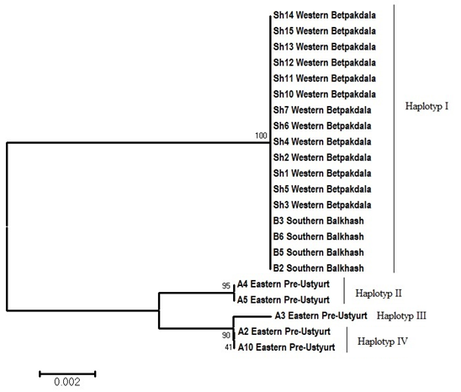

Figure 13 – Phylogenetic tree based on the COII nucleotide sequence and the tRNA-Lys fragment

16 nucleotide polymorphisms were detected in 743 bp, including 4 transversions and 12 transitions (table 3), while these polymorphisms were classified as synonymous by the COII gene sequence.

Table 3 – Nucleotide polymorphisms found among Xenopsylla haplotypes in Kazakhstan

Haplotyops | Nucleotide polymorphisms
Haplotyops | 26 | 104 | 266 | 269 | 278 | 284 | 305 | 341 | 473 | 602 | 608 | 617 | 620 | 638 | 641 | 653
Haplotyp I | A | T | C | C | C | A | T | G | T | C | T | T | C | C | A | G
Haplotyp II | G | C | T | A | A | G | C | G | A | T | T | C | C | T | G | A
Haplotyp III | G | T | T | C | A | G | C | A | A | T | C | C | A | T | G | A
Haplotyp IV | G | T | T | C | A | G | C | A | A | T | C | C | C | T | G | A

Phylogenetic analysis including sequences of the genus Xenopsylla allowed clustering of haplotype I with sequences of X. gerbilli minax collected in the Xinjiang Uygur autonomous region of China (figure 14). Haplotypes II-IV are unique for Kazakhstan and are located in a separate clade.

Figure 14 – Phylogenetic tree based on a fragment of the COII nucleotide sequence of the Xenopsylla flea gene

Phylogenetic clustering of Xenopsylla samples collected from three plague foci shown in figure 14, the absence of amino acid substitutions allows them identified as X. gerbilli minax. However, according to the phenotypic identification and literature sources, Xenopsyla skrjabini predominate in the Eastern Pre-Ustyurt Region of Kazakhstan. The NCBI database contains only one COII sequence of the Xenopsyla skrjabini gene with the inventory number KM890854, which is located as a separate branch in the phylogenetic tree shown in figure 14. It is important to emphasize that fleas caught in the Southern Pre-Balkhash Region and Western Betpakdala are identical to fleas from Chinese populations and do not have genetic variability on the contrary, the population of fleas collected in the Eastern pre-Ustyurt Region is genetically diverse. The results indicate the need for a comprehensive study of fleas in order to change the established canons of circulation on the territory of the Eastern Pre-Ustyurt only fleas of the genus Xenopsyla skrjabini and possible expansion of the distribution area of X. gerbilli minax.

4.3 Plague epizootic situation in the Central Asian desert plague focus

During the last 10 years of monitoring (2010-2019), most of the 14 Autonomous foci of the Central Asian desert focus registered active plague epizootics. Were isolated and studied 1024 strains of Y. pestis. In three autonomous foci of study of populations of R. opimus and fleas of the genus Xenopsylla, 264 strains were isolated: in Pre-Balkhash; in Betpakdals – 60 strains; and in Pre-Ustyurt – 20 strains of Y. pestis.

4.4 DNA sequencing of Y. pestis strains

Genotyping, search for population diversity and genome features of populations of Y. pestis strains from the territory of the natural plague focus of Central Asia was performed.
As part of this task, genome-wide data obtained for 31 Y. pestis strains. The analyzed strains were included in four phylogenetic branches: 0.PE4, 1.ORI3, 2.MED0 and 2.MED1 (figure 15). The phylogenetic branch 0.PE4 includes two strains with the ciphers Chuma-1786 and Chuma-1826, it characteristic that these strains were isolated in the Talas plague focus from the long-tailed marmot or fleas collected from this species of marmot. Strains belonging to the 0.PE4 genetic branch are isolated in Central and Eastern Asia, while virulent and weakly virulent isolates found in this genetic group [25, 43]. Two strains Chuma-1435 and Chuma-4 formed the phylogenetic branch 1.ORI3, the strains were isolated from a great gerbil caught in the Kyzylkum plague focus and a person infected with the plague in the territory of the Pre-Balkhash autonomous plague focus, respectively. Strain Chuma-3362 phylogenetically identified as 2.MED0, this strain was isolated from a sick camel in the Mangystau autonomous plague focus.

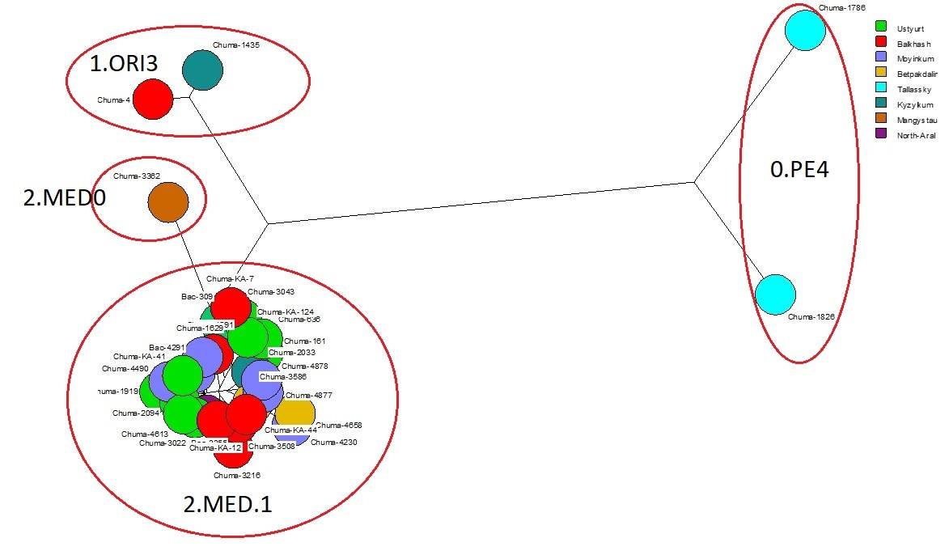

Figure 15 – Clustering of 31 Y. pestis strains
The remaining 26 strains clustered in the medieval biovar of the phylogenetic branch 2. MED1 (figure 16). Strains belonging to the 2.MED1 phylogenetic branch are widely distributed in plague foci in the Caspian Sea, Caucasus, and Central Asia [44]. Strains of the 2.MED1 branch are well adapted to arid landscape and geographical biocenoses, and were isolated in individual cases of plague in the foci of the Pre-Caspian region in the first half of the XX century [45]. Five strains: Chuma-309, Chuma-636, Chuma-161, Chuma-3043, Chuma-KA-7, on the phylogenetic tree were grouped with most strains of the Caucasus-Caspian Region. The remaining 21 strains grouped into a separate branch along with strains from the Central Asian Region, including China and Turkmenistan. At the same time, Kazakhstan strains are located in a separate clade, with the exception of strains Chuma-3508, Chuma-KA-44 and Chuma-KA-12, which separated into a separate clade together with strains isolated in China.

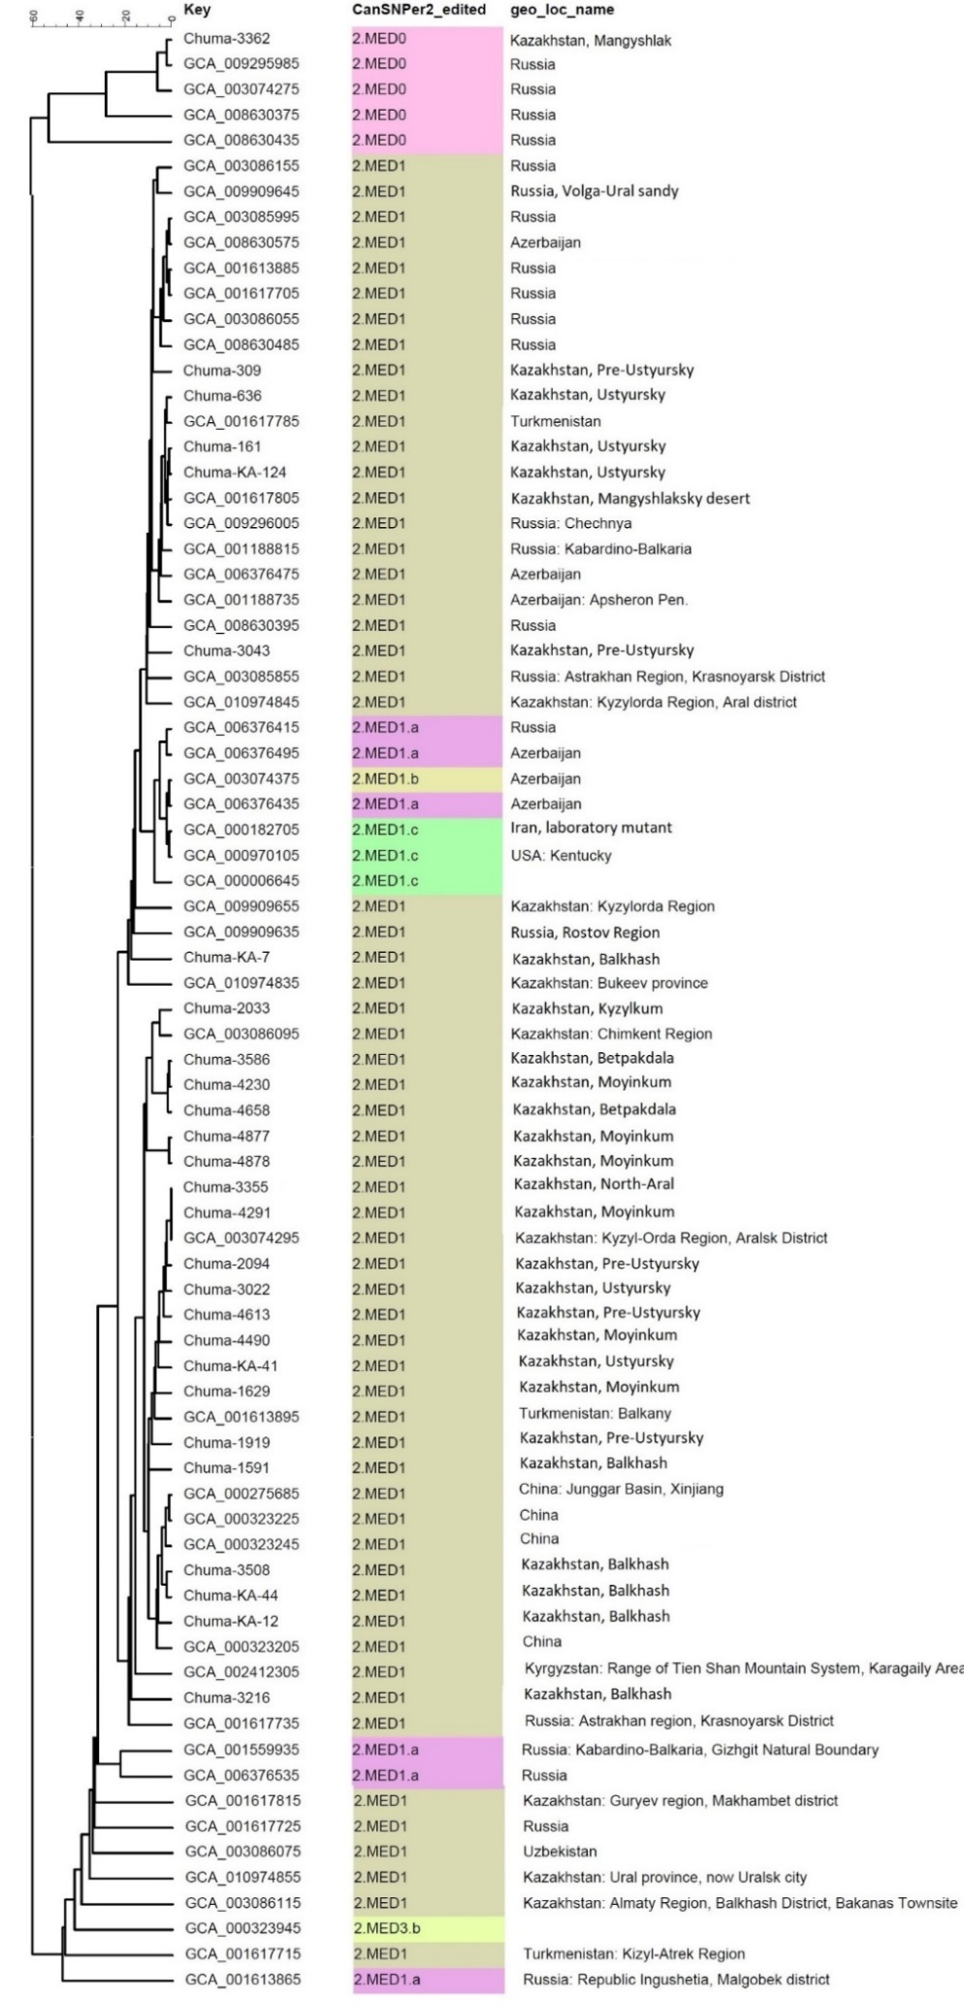
Figure 16 – Clustering of 2.MED phylogenetic branch strains

CONCLUSION

Thus, all the tasks set completed: a) the ecological and geographical features of the meth habitat of plague hosts and vectors in autonomous foci of the natural desert plague focus of Central Asia studied; b) phenotypic and genotypic features of populations of great gerbils R. opimus, fleas of the genus Xenopsylla gerbilli minax caught in three geographically remote regions of the natural desert plague focus of Central Asia and Y. pestis strains circulating in the rodent-flea system from the same habitats of R. opimus were studied; c) comparative genetic analysis of R. opimus populations from the foci of Kazakhstan and from the territory of Iran and China carried out.
When genotyping RNA populations of R. opimus, a correlation of haplotypes with geographical distribution was found, for example, the 1st cluster is formed only by sequences from R. opimus caught in the southern Pre-Balkhash Rregion, the 4th cluster is represented by sequences from individuals caught in the Eastern Pre-Ustyurt Region. Phylogenetic analysis of sequences from R. opimus clustered into three large clusters. The first cluster – combined sequences of R. opimus caught in Kazakhstan and China, while the great gerbil caught in Kazakhstan is located in a separate clade. The second and third clusters include sequences of great gerbils caught in Iran.
Based on the analysis of the nucleotide sequence of the COXII gene, a population of Xenopsylla gerbilli minax was genotyped, which lives in the autonomous foci of the Central Asian desert plague focus.
The conducted research – the first experience of a comprehensive study of the phenotypic and genotypic variability of populations of components of the rodent-flea-Y. pestis plague triad in a natural focus. The historical spread of the plague, the formation of new natural foci in new territories (for example, the US foci) [46] obviously had not only different mechanisms, but also occurred in different ways: a) with the expansion of the main host's range; b) with the relay involvement of new hosts and vectors, and the formation of new plague biocenoses; c) with the transfer of plague-infected rodents, fleas, or the plague pathogen during mass human migrations. The natural migration of rodents and fleas to new territories and the formation of new plague biocenoses led to geographical and ecological isolation, evolution, and the formation of population variability under new conditions.
Future research should directed to the search for facts and factors of co-evolution of the host rodent and the microbe in the plague focus, and the influence of the host rodent on the variability of Y. pestis. To obtain sufficient knowledge about the impact of ecological and geographical isolation on the evolution of participants in the plague biocenosis of the Central Asian desert plague focus, it is necessary to analyze possible genomic features of R. opimus and Y. pestis from all autonomous foci and territories with landscape features.
The revealed statistically significant differences in phenotypic features in the great gerbil and some species of fleas of the genus Xenopsylla indicate the formation of different populations of rodent hosts and flea vectors in natural plague foci. Further research needed to identify the impact of environmental isolation on the phenotypic and genotypic variability of great gerbils and fleas of the genus Xenopsylla.

LIST OF SOURCES USED

1. Begon M., Klassovskiy N., Ageyev V., Suleimenov B., Atshabar B., Bennett M. Epizootiologic parameters for plague in Kazakhstan // Emerging Infectious Diseases. – 2006. – No. 12. – P. 268-273.doi: 10.3201/eid1202.050651. (in English)
2. Wilschut L.I., Addink E.A., Heesterbeek J.A., Dubyanskiy V.M., Davis S.A., Laudisoit A. idr. Mapping the distribution of the main host for plague in a complex landscape in Kazakhstan: An object-based approach using SPOT-5 XS, Landsat 7 ETM+, SRTM and multiple Random Forests // International Journal of Applied Earth Observation and Geoinformation. – 2013. – No. 23. – P. 81-94. doi:10.1016/j.jag.2012.11.007. (in English)
3. Wilschut L.I., Laudisoit A., Hughes N.K., Addink E.A., de Jong S.M., Heesterbeek J.A.P. idr. Spatial distribution patterns of plague hosts: point pattern analysis of the burrows of great gerbils in Kazakhstan // Journal of Biogeography. – 2015. – No. 42 (7). – P. 1281-1292.DOI: 10.1111/jbi.12534. (in English)
4. Atshabar B.B., Burdelov L.A., Sadovskaia V. P. et al. / Atlas of the spread of especially dangerous infections in the Republic of Kazakhstan. – Almaty: Firm “Venus”, 2012. – 232 p. (in Russian)
5. Lapshov V.A. The skull signs of large gerbils as markers of spatial groups of different rank. Ecology and medical significance of gerbils of fauna of the USSR: Abstracts, II All-Union Terriological Society. – Moscow, 1981. – P. 19-25. (in Russian)
6. Panteleyev P.A., Terekina A.N., Varsov A.A. Morphological differences of large gerbils from populations of different rank. Ecology and medical significance of gerbils in the fauna of the USSR. All-Union Terriological Society. – M, 1977. – P. 52-53. (in Russian)
7. Nurtazin S.T., Shevtsov A., Lutsau V., Ramankulov E.M., Sayakova Z.Z., Abdirassilova A.A. et al. Morphological, physiological and genetic features of populations of the main plague carrier Rhombomys opimus Licht., 1823 in the Central Asian desert natural plague focus // Acta Biomedica Scientifica. – 2019. – No. 4 (5). – P. 139-143. doi: 10.29413/ABS.2019-4.5.22. (in Russian)
8. Ito M. , Jiang W., Sato J.J., Zhen Q., Jiao W., Goto K. et al. Molecular phylogeny of the subfamily Gerbillinae (Muridae, Rodentia) with emphasis on species living in the Xinjiang-Uygur Autonomous Region of China and based on the mitochondrial cytochrome b and cytochrome c oxidase subunit II genes // Zoolog Sci. – 2010. – No. 27. – P. 269-78. doi: 10.2108/zsj.27.269. (in English)
9. Oshaghi M.A., Rassi Y., Tajedin L., Abai M.R., Akhavan A.A., Enayati A. et al. Mitochondrial DNA diversity in the populations of great gerbils, Rhombomys opimus, the main reservoir of cutaneous leishmaniasis // Acta Trop. – 2011. – No. 119 (2-3). – P. 165-171. doi: 10.1016/j.actatropica.2011.05.010. Epub 2011 Jun 7. (in English)
10. Bakhshi H., Oshaghi M.A., Abai M.R., Rassi Y., Akhavan A.A., Mohebali M. et al.MtDNA CytB Structure of Rhombomys opimus (Rodentia:Gerbellidae), the Main Reservoir of Cutaneous Leishmaniosis in the Borderline of Iran-Turkmenistan // J. Arthropod Borne Dis. - 2013. – No. 7 (2). – P. 173-184.PMID: 24409443. (in English)
11. Korzun V.M., Tokmakova E.G., Fomina L.A., Sotnikova T.V. Popular organization of settlements of specific types of fleas Mongolian food in the Mountain Altai // Izvestia Irkutsk State University. “Biology, Ecology” series. – 2009. – No. 2 (1). – P. 108-112. – URL: http://isu.ru/izvestia. (in Russian)
12. Reijniers J., Begon M., Ageyev V.S., Leirs H. Plague epizootic cycles in Central Asia // Royal society publishing. – 2014. – No. 10 (6). rsbl.royalsocietypublishing.org Biol. Lett. 10: 20140302. (in English)
13. Y. Zhang, X. Dai, Q. Wang, H. Chen, W. Meng, K. Wu et. al. Transmission efficiency of the plague pathogen (Y. pestis) by the flea, Xenopsylla skrjabini, to mice and great gerbils // Parasit. & Vectors. – 2015. – No. 8. – P. 56. DOI 10.1186/s13071-015-0852-z. (in English)
14. Korzun V.M., Tokmakova E.G. Diskretnaia izmenchivost nekotorykh elementov khitinovogo ekzoskeleta Amphalius runatus (Syphonaptera) // Baikalskii zoologicheskii zhurnal. – 2010. – No. 2 (5). – P. 24-27. (in Russian)
15. Harimalala M., Telfer S., Delatte H., Watts P.C., Miarinjara A., Ramihangihajason T.R. et al. Genetic structure and gene flow of the flea Xenopsylla cheopis in Madagascar and Mayotte // Parasit Vectors. – 2017. – No. 10:347. doi: 10.1186/s13071-017-2290-6. (in English)
16. Asenov G.A., Kenzhebayev A.Ia., Sabilayev A.S., Koptsev L.S., Kudekov M.K., Rudenko R.D. Asenov, G.A.; Kenzhebaev, A.Ya.; Sabilaev, A.S.; Koptsev, L.S.; Kudekov, M.K.; Rudenko, R.D. The place and significance of certain types of carriers in the epizootology of the Kyzylkum and Ustyurt plague centers // Modern aspects of epidemiological surveillance of especially dangerous infections: Theses of the XIII Conference of Anti-Plague Institutions of Wednesday Asia and Kazakhstan. - Alma-Ata, 1990. – P. 12-14.
17. Dyatlov A.I. Evolutionary aspects in the natural foci of the plague. - Stavropol: Stavropol book publishing house, 1989. – 196 p. (in Russian)
18. Atshabar B. Mechanism of formation of population level of virulence of Yersinia pestis // Adv Exp Med Biol. – 2003. – No. 529 – P. 329-332.DOI: 10.1007/0-306-48416-1_63 PMID: 12756781. (in English)
19. Lowell J.L., Zhansarina A., Yockey B., Meka-Mechenko T., Stybayeva G., Atshabar B. et al. Phenotypic and molecular characterizations of Yersinia pestis isolates from Kazakhstan and adjacent regions // Microbiology. – 2007. - No. 153. – P. 169-177. OI 10.1099/mic.0.29059-0. (in English)
20. Martinevskiy I.L., Stepanov V.M., Kenzhebayev A.Ya. Taxonomy, mutation and genetics of pathogenicity of Yersinia pestis and related microbes. - Nukus: “Karakalpakstan”, 1990. – 151 p. (in Russian)
21. Atshabar B.B. Natural variability of Yersinia pestis. - Almaty: “Baspager” LLP, 2000. – 111 p. (in Russian)
22. Lowell J.L., Wagner D.M., Atshabar B., Antolin M.F., Vogle A.J., Keim P. et al. Identifying Sources of Human Exposure to Plague // Journal of Clinical Microbiology. – 2005. – No. 43 (2). – P. 650-56. doi: 10.1128/JCM.43.2.650-656.2005. (in English)
23. Kurmanov B.K., Atshabar B.B., Sariyeva G.E., Abdirassilova A.A., Abdel Z.Zh., Bakhtybekkyzy Sh., Zhunussova A.S., Mukashev N.K., Kabysheva N.P., Kassenova A.K., Nekrassova L.Ye., Begimbayeva E.Zh., Abdikarimov S.T., Zhaparova A.K. Genotyping of Yersinia pestis strains from Central Asian desert and Tien Shan highland plague centers // Medicine. – 2016 – No. 12. – P. 80-87. (in Russian)
24. Achtman M., Morelli G., Zhu P., Wirth T., Diehl I., Kusecek B. et al. Microevolution and history of the plague bacillus, Yersinia pestis // Proc Natl Acad Sci USA. – 2004. – No. 101 (51). – P. 17837-17842. doi: 10.1073/pnas.0408026101. (in English)
25. Cui Y., Yu C., Yan Y., Li D., Li Y., Jombart T. et al. Historical variations in mutation rate in an epidemic pathogen, Yersinia pestis // Proc. Natl. Acad. Sci. USA. – 2013. – No. 110 (2). – P. 577-582. – URL: www.pnas.org/cgi/doi/10.1073/pnas.1205750110. (in English)
26. Riehm J. M., Vergnaud G., Kiefer D., Damdindorj T., Dashdavaa O., Khurelsukh T., Zöller, L., Wölfel R., Le Flèche Ph., Scholz H. C. Yersinia pestis Lineages in Mongolia // PLoS One. – 2012. – No. 7 (2). – P. e 30624.https: // doi.org/10.1371/journal.pone.0030624. (in English)
27. The Application for Extracting and Exploring Analysis Ready Samples. https://earthdata.nasa.gov/?ga=2.223530334.456958950.1602126863-510349700.1602126863. (in English)
28. Sanitary Regulations “Sanitary and epidemiological requirements for the organization and activities to prevent infectious diseases (plague, cholera)” approved by the Order of the Minister of National Economy of the Republic of Kazakhstan dated February 25, 2015 No. 131. – URL: https:zakon.uchet.kz. (in Russian)
29. Nekrassova L.E., Zholshorinov A.Zh., Meka-Mechenko T.V., Turegeldiyeva D.A., Syzdykov M.S., Tugambayev T.I. et al. Implementation of a risk management system for hazardous biological facilities in Kazakhstan (guidelines for practitioners). - Almaty: Printing house GIS-print, 2012. – 230 p. (in Russian)
30. Nekrassova L.E., Temiraliyeva G.A., Meka-Mechenko T.V., Atshabar B.B., Suleimenov B.M., Aimanova O.Ya. et al. A guide to the study of the plague microbe strains. - Almaty: Printing house UPM PSh-5, 2001. – 39 p. (in Russian)
31. Laboratory Biosafety Manual. World Health Organization, 3rd Edition, 2004. – 190 p. (in English)
32. Coyne S.R., Craw P.D., Norwood D.A., Ulrich M.P. Comparative Analysis of the Schleicher and Schuell IsoCode Stix DNA Isolation Device and the Qiagen QIAamp DNAMini Kit // Journal Clinical Microbiology. – 2004. – No. 42 (10). – P. 4859-4862. doi: 10.1128/JCM.42.10.4859-4862.2004. (in English)
33. Kent R.J, Norris D.E. Identification of mammalian blood meals in mosquitoes by a multiplexed polymerase chain reaction targeting cytochrome B // Am J Trop Med Hyg. – 2005. No. 73. – P. 336-342. PMCID: PMC4147110, NIHMSID: NIHMS618466, PMID: 16103600. (in English)
34. Vila C., Amorim I.R., Leonard J.A., Posada D., Castroviejo J., Petrucci-Fonseca F. et al. Mitochondrial DNA phylogeography and population history of the grey wolf Canis lupus // Molecular Ecology. – 1999. – No. 8. – P. 2089–2103. doi:10.1046/j.1365-294x.1999.00825.x. (in English)
35. Werle E., Schneider C., Renner M., Völker M., Fiehn W. Convenient single-step, one tube purification of PCR products for direct sequencing // Nucleic Acids Res. – 1994. – No. 22. – P. 4354-4355. doi:10.1093/nar/22.20.4354. (in English)
36. Tamura K., Stecher G., Peterson D., Filipski A., Kumar S. MEGA6: Molecular Evolutionary Genetics Analysis version 6.0 // Mol Biol Evol. – 2013. – No. 12. – P. 2725-2729. doi: 10.1093/molbev/mst197. Epub 2013 Oct 16. (in English)
37. Mastitskiy S.E., Shitikov V.K. Statistical analysis and visualization of data using R // Heidelberg - London – Tolyatti. – 2014. – 401 p.: – URL: http://r-analytics.blogspot.com (in Russian)
38. Iof I.G., Mikulin M.A., Skalon O.I. Flea detector of Central Asia and Kazakhstan. - Moscow: “Medicine”. – 1965. – 369 p. (in Russian)
39. Mytsik A.V. Using ImageJ for automatic morphometry in histological studies // Omsk Scientific Journal. – 2011. – No. 2 (100). – P. 187-189. (in Russian)
40. Halos L., Jamal T., Vial L., Maillard R., Suau A., Menach A.L. et al. Determination of an Efficient and Reliable Method for DNA Extraction from Ticks // Vet Res. – 2004. – No. 35 (6). – P. 709-713. doi: 10.1051/vetres:2004038. (in English)
41. Wong Miller K.M., Bracewell R.R., Eisen M.B., Bachtrog D. Patterns of Genome-Wide Diversity and Population Structure in the Drosophila athabasca Species Complex // Mol. Biol. Evol. – 2017. – Vol. 34. – P. 1912-1923. doi: 10.1093/molbev/msx134. (in English)
42. Billeter S.A., Gundi V.A., Rood M.P., Kosoy M.Y. Molecular Detection and Identification of Bartonella Species in Xenopsylla cheopis Fleas (Siphonaptera: Pulicidae) Collected from Rattus norvegicus Rats in Los Angeles, California // Applied Environmental Microbiology. – 2011. No. 77 (21). – P. 7850-7052. doi: 10.1128/AEM.06012-11. (in English)
43. Zhou D., Dongsheng Zhou, Tong Z., Song Y., Han Y., Pei D., Pang X., Zhai J., Li M., Cui B., Zhizhen Qi, Jin L., Dai R., Du Z., Wang J., Guo Z., Wang J., Huang P., Yang R. Genetics of metabolic variations between Yersinia pestis biovars and the proposal of a new biovar, microtus // Journal of bacteriology. – 2004. – T. 186. – No.. 15. – P. 5147-5152. DOI:10.1128/JB.186.15.5147-5152.2004. (in English)
44. Kutyrev V.V., Eroshenko G., Motin V., Nosov N., Krasnov J., Kukleva L., Nikiforov K., Al’khova Z., Oglodin E., Guseva N. Phylogeny and classification of Yersinia pestis through the lens of strains from the plague foci of Commonwealth of Independent States //Frontiers in microbiology. – 2018. – V. 9. – P. 1106. – URL: https://doi.org/10.3389/fmicb.2018.01106. (in English)
45. Eroshenko G.A. Popov N.V., Alkhova Zh.V., Kukleva L.M., Balykova A.N., Grazhdanov A.K., Ayazbayev T.Z., Maikanov N.S., Kutiryev V.V. The spread of Yersinia pestis of medieval biovar in the North, North-West Caspian Sea and Transcaucasia in the second half of XX century // Problems of particularly dangerous infections. – 2019. – No.. 4. – P. 48-55. (in Russian)
46. Jones, S.D., Atshabar B., Schmid B.V., Zuk M., Amramina A., Stenseth N.C. Living with Plague: Lessons from the Soviet Union’s Anti-Plague System Proc. Natl. Acad. Sci. USA. // 2019. – No. 116 (19). – P. 9155-9163.doi: 10.1073/pnas.1817339116. (in English)

ATTACHMENT A

Patent search report

REPORT

Report on patent research on the implementation of research work under the budget program: 217 “Development of science”, subprogram 102 “Grant financing of scientific research”, specifics 156 “Payment for consulting services and research”. By priority: “Science of life and health” by sub-priority: “Fundamental and applied research in the field of biology – Physiological, biochemical and molecular-genetic mechanisms of plant, animal and human life, their adaptation to biotic and abiotic factors of the environment”. According to the project AP05133153 “Population ecological variants of the plague host, vector and pathogen in The Central Asian natural desert plague focus”, the Patent Law of the Republic of Kazakhstan and state standard 15.011-2005 “system of product development and production. Patent research. Content and procedure”.

Table A.1 – Number of published protection documents by year (inventive activity)

Equipment object and components | The country of application | The number of patents, published applications by year of filing of the application (excluding the patents-analogues)
Equipment object and components | The country of application | 1999 | 2000 | 2015 | 2018 | 2020
DEVICE FOR ACTIVE, RAPID, SAFE FOR THE OPERATOR CAUGHT OF FLEAS INFECTED WITH PATHOGENS OF DANGEROUS AND ESPECIALLY DANGEROUS INFECTIONS | RF | – | – | 1 | – | –

Table A.2 – Mutual patenting

The nationality of the applicant | Country of patenting |  |  |  |  |  |  |  | Number of patents |  | Total
The nationality of the applicant |  |  |  |  |  |  |  |  | National patents | Patented in other countries
1 | 2.1 | 2.2 | 2.3 | 2.4 | 2.5 | 2.6 | 2.7 | 2.8 | 3 | 4 | 5
Rus | 1 |  |  |  |  |  |  |  | 6 |  | 6

Table A.3 – Geography of patenting of industrial property objects by the studied firms (by analogous patents)

Name of the patent owner's company | Name of the technical solution (invention) | The number of initial applications | Priority date | Date of publication of the initial application | Numbers of issued patents (filed applications) by country of issue
1 | 2 | 3 | 4 | 5 | 6 | 7
Federal state military educational institution of higher professional education “military Academy of radiation, chemical and biological protection named after S.K. Timoshenko" | DEVICE FOR ACTIVE, RAPID, SAFE FOR THE OPERATOR CAUGHT OF FLEAS INFECTED WITH PATHOGENS OF DANGEROUS AND ESPECIALLY DANGEROUS INFECTIONS | 2013152718/13 | 27.11.2013 | 27.12.2011 | 2 567 743 | RU

MAIN PART OF THE PATENT RESEARCH REPORT
A.4 Technical level and development trends of the economic activity object
Form A.4.1 Indicators of the technical level of the equipment object

Name of indicators | Value of indicator
Name of indicators | Development object for 2018 “Method for safe catching of Xenopsilla fleas” | Domestic and foreign objects of similar purpose (including models, companies, countries, and years of fame) |  |  |  |  |  |  |  |  |  | State standard object | International and national standards | Forecast for 2020 “Method for safe catching of Xenopsilla fleas”
Name of indicators |  | DEVICE FOR ACTIVE, RAPID, SAFE FOR THE OPERATOR CAUGHT OF FLEAS INFECTED WITH PATHOGENS OF DANGEROUS AND ESPECIALLY DANGEROUS INFECTIONS |  |  |  |  |  |  |  |  |  | State standard object | International and national standards
Working with land vertebrates | NO | NO |  |  |  |  |  |  |  |  |  |  |  | NO
Working with terrestrial invertebrates | YES | YES |  |  |  |  |  |  |  |  |  |  |  | YES
Practical way out in the study of plague foci | YES | YES |  |  |  |  |  |  |  |  |  |  |  | Implementation in practice

ATTACHMENT B

List of published works on the topic for 2018-2020

- Yeszhanov A.B., Sayakova Z.Z., Sadovskaya V.P., Nurtazin S.T., Kabysheva N.P, Zhunussova A.S., Abdirassilova A.A., Rysbekova A.K., Atshabar B.B. Some morphological peculiarities of a Great Gerbil (Rhombomys opimus Licht 1823) from the Middle Asia desert plague focus // News of the National Academy of Sciences of the Republic of Kazakhstan. – 2019. – No. 3(333). – P. 64-72 (in English).
- Nurtazin S.T., Shevtsov A., Lutsai V., Ramankulov E.M., Sayakova Z.Z., Abdirassilova A.A., Zhunussova A.S., Kabysheva N.P., Rysbekova A.K., Sadovskaya V.P., Yeszhanov A.B., Utepova I.B., Berdibekov A.T., Kulemin M.V., Katuova Zh.U., Atshabar B.B. Morphological, physiological and genetic features of populations of the main plague carrier Rhombomys opimus Licht., 1823 in the Central Asian desert natural plague focus // Acta Biomedica Scientifica. – 2019. – No. 4 (5). – P. 139-143. doi: 10.29413/ABS.2019-4.5.22 (in Russian).
- Jones, S., Atshabar, B., Schmid, B.V., Zuk, M., Amramina, A. and Stenseth, N.C. (2019), Living with Plague: Lessons from the Soviet Union’s Anti-Plague System // Proceedings of the National Academy of Sciences of the United States of America (PNAS). – 2019. – Vol. 116. – N. 19. – R. 9155-9163. – IF 9,661. – Q 1. – 96-i procentil (in English).
- Nurtazin S.T., Atshabar B.B., Sayakova Z.Z., Ramankulov E.M., Shevtsov A.B., “Popular ecological variants of the carrier, vector and plague pathogen in the Central Asian natural desert plague source”. – Almaty, 2020. – 102 p. (in Russian).
- Nurtazin S.T., Atshabar B.B., Shevtsov A., Ramankulov E.M., Lutsai V., Salmurza R., Iklasov M., Kavamoto Y. Ecological, biological and genetic features of some populations of the Great gerbil (Rhombomys opimus Licht.,1823) of Kazakhstan // Bulletin of the National Academy of Sciences of the Republic of Kazakhstan.. – 2020. – No. 6. – Accepted for printing (in English).
- Atshabar B.B., Nurtazin S.T., Shevtsov A., Ramankulov E.M., Saiakova Z.Z., Rysbekova A., Lutsai V., Utepova I B., Sadovskaia V.P., Abdirasilova A. A., Begimbaeva E. Zh., Abdel Z. Zh. Populiatsii osnovnogo nositelia Rhombomys opimus, perenoschikov blokh roda Xenopsylla i vozbuditelia Yersinia pestis v Tsentralno-Aziatskom pustynnom prirodnom ochage chumy // Vestnik Natsionalnoi Akademii Nauk Respubliki Kazakhstan. – 2021. – No. 1. – Accepted for printing (in English).
- Sayakova Z.Z., Shevtsov A., Atshabar B.B., Ryspekova A., Kuznetsov A.N., Sadovskaia V.P., Ramankulov E.M., Nurtazin S.T., Abdirassilova A.A., Yeszhanov A.B. Phenotypic and genetic features of some populations of fleas of plague carriers of genus Xenopsylla in the Central Asian desert natural focus // News of the National Academy of Sciences of the Republic of Kazakhstan. – Accepted for printing (in English).

Participation with a report at conferences

1. Report of B. Atshabar “Living with Plague”. International conference (Nur-Sultan, 25-27): Annual Regional Meeting of Biosurveillance Network of the Silk Road, 25-27 September, Kazakhstan.
2. Report of B. Atshabar “Life with Plague: Lessons from the Anti-Plague System of the Soviet Union”. International scientific conference “Dangerous Infections: New Challenges - A Look into the Future”, Almaty c., “02-03” October 2019.

ATTACHMENT C

Copies of supporting materials for 2018-2020

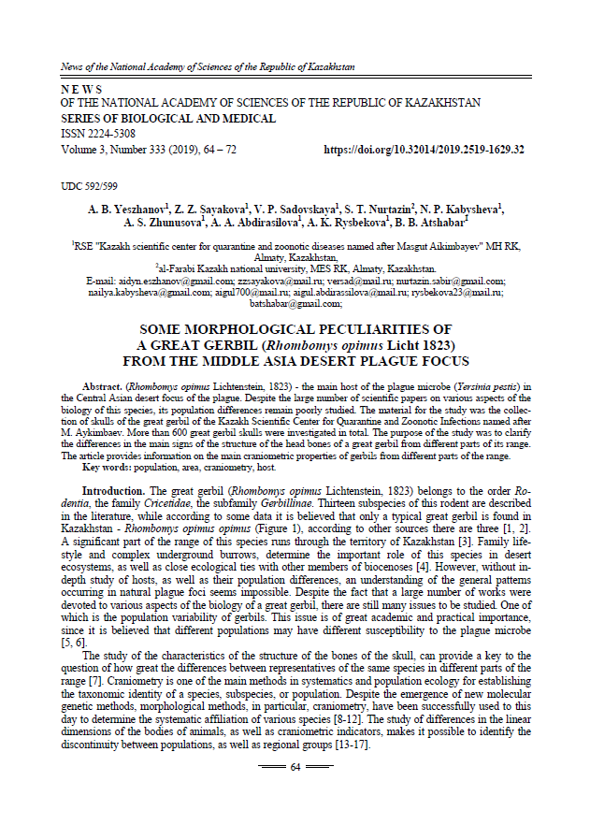

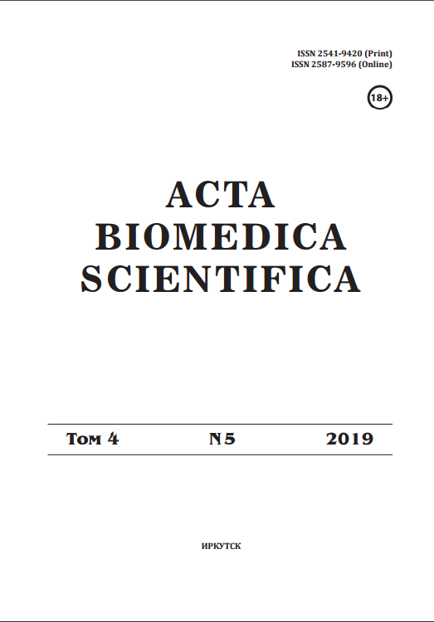

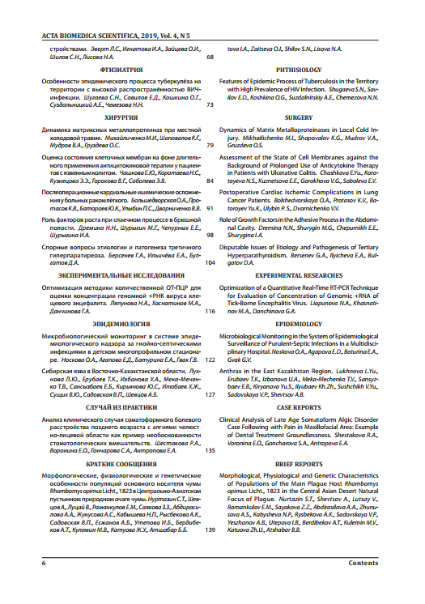
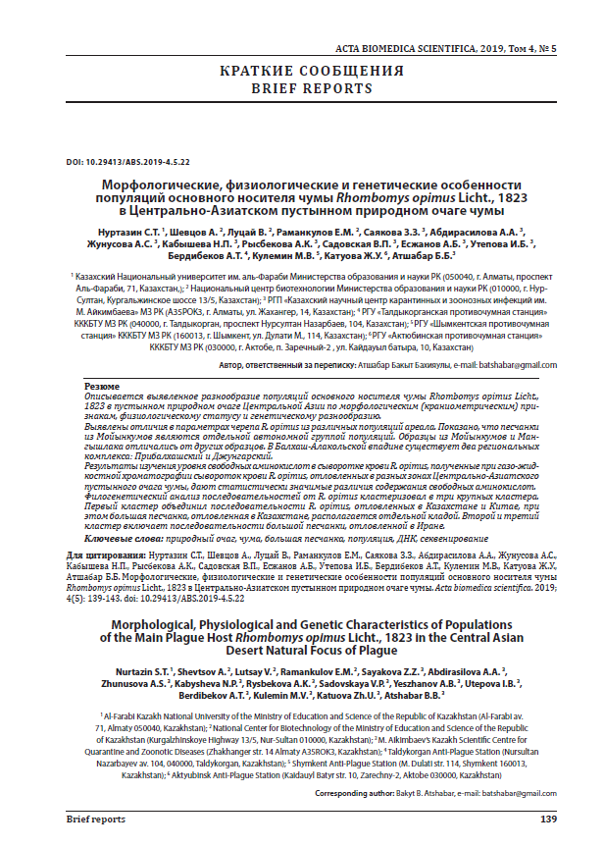

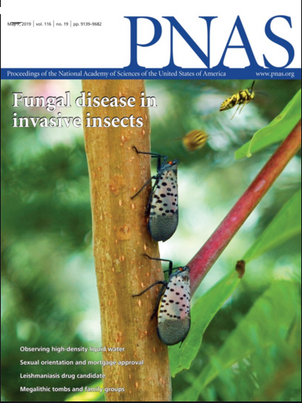
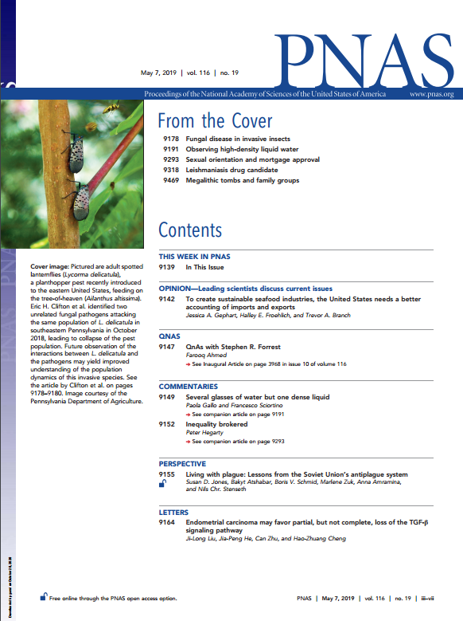
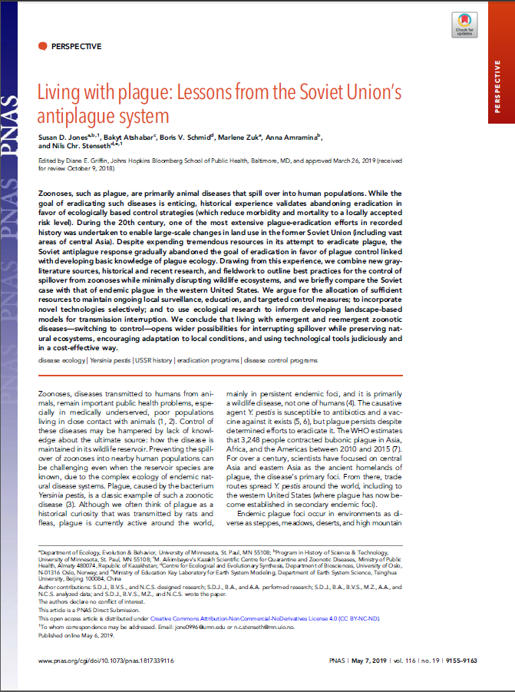

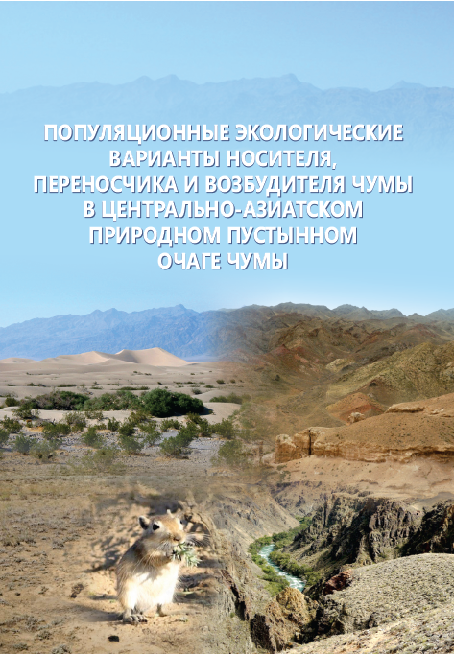

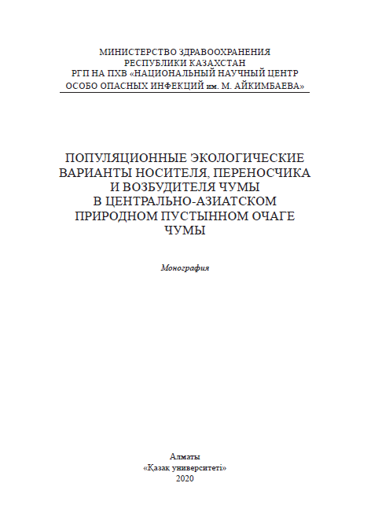

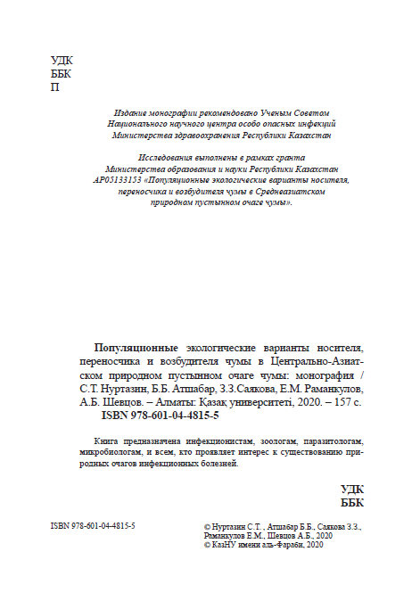

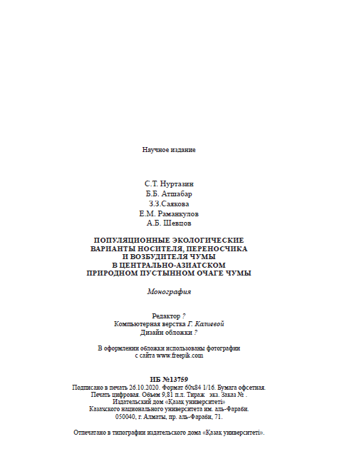
References
of NAS RK Publishing House about acceptance to publication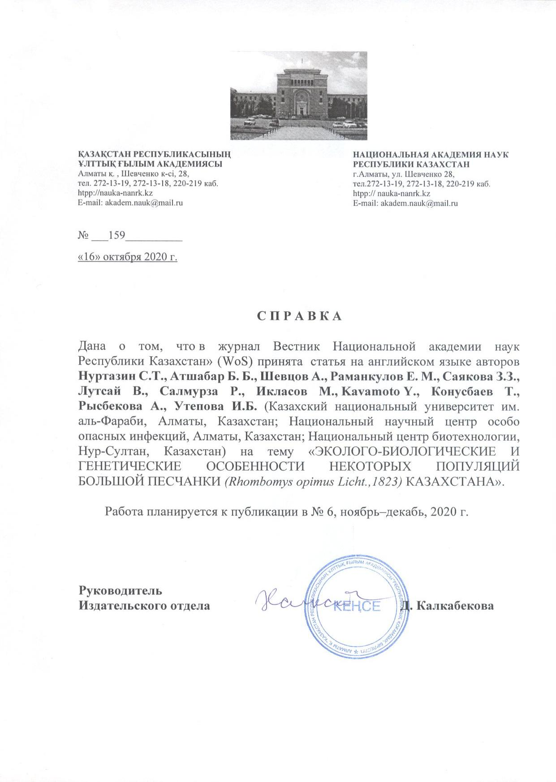

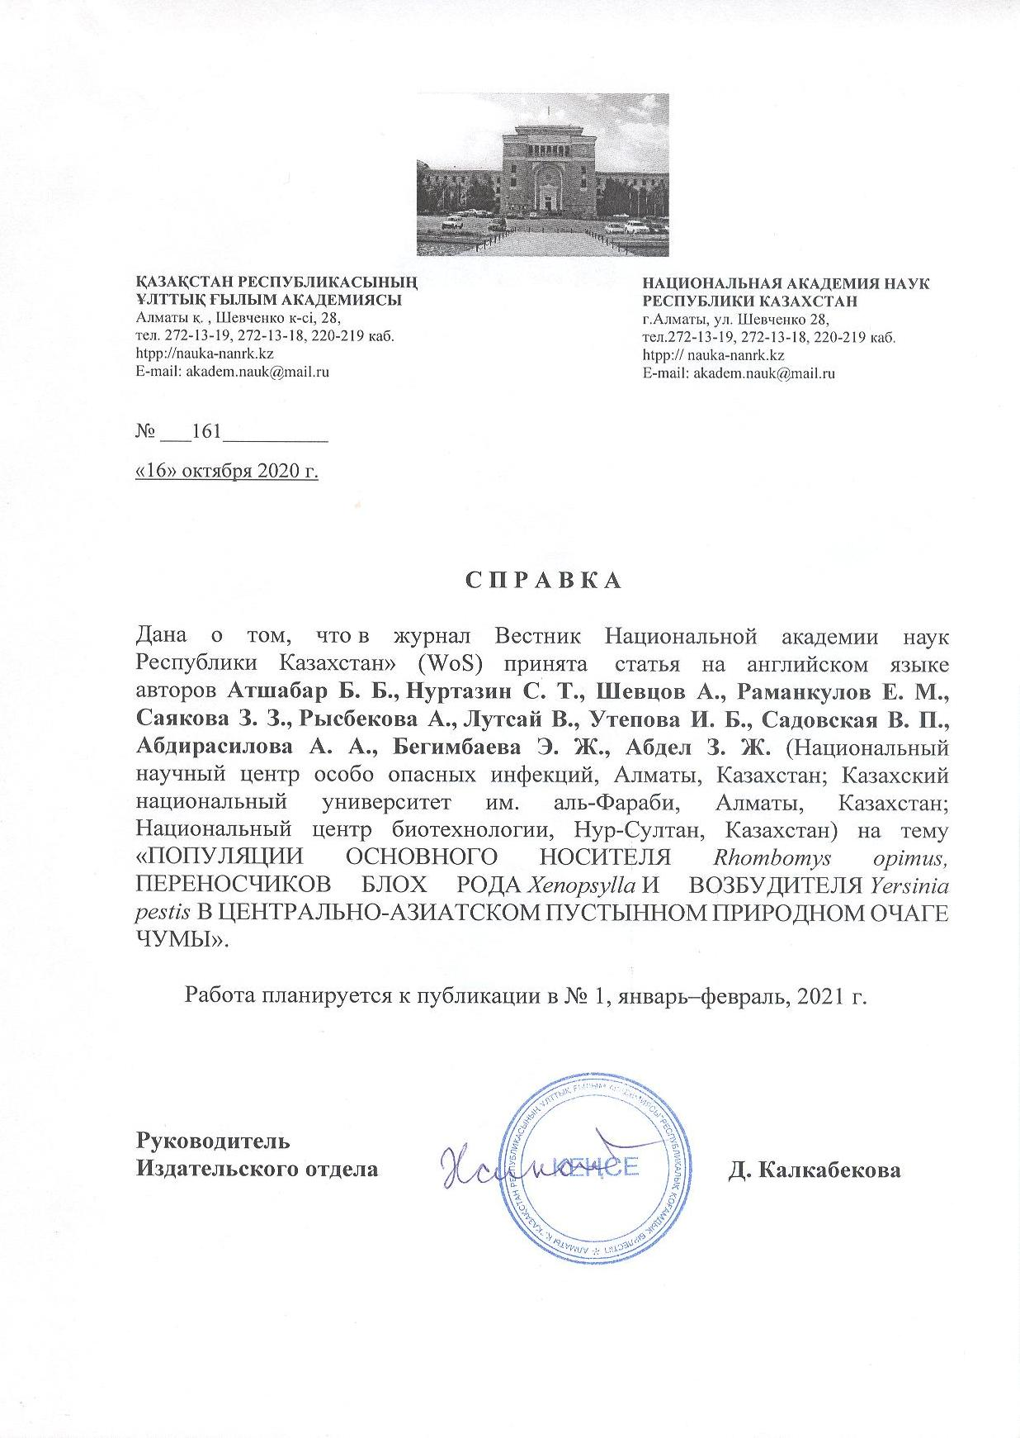

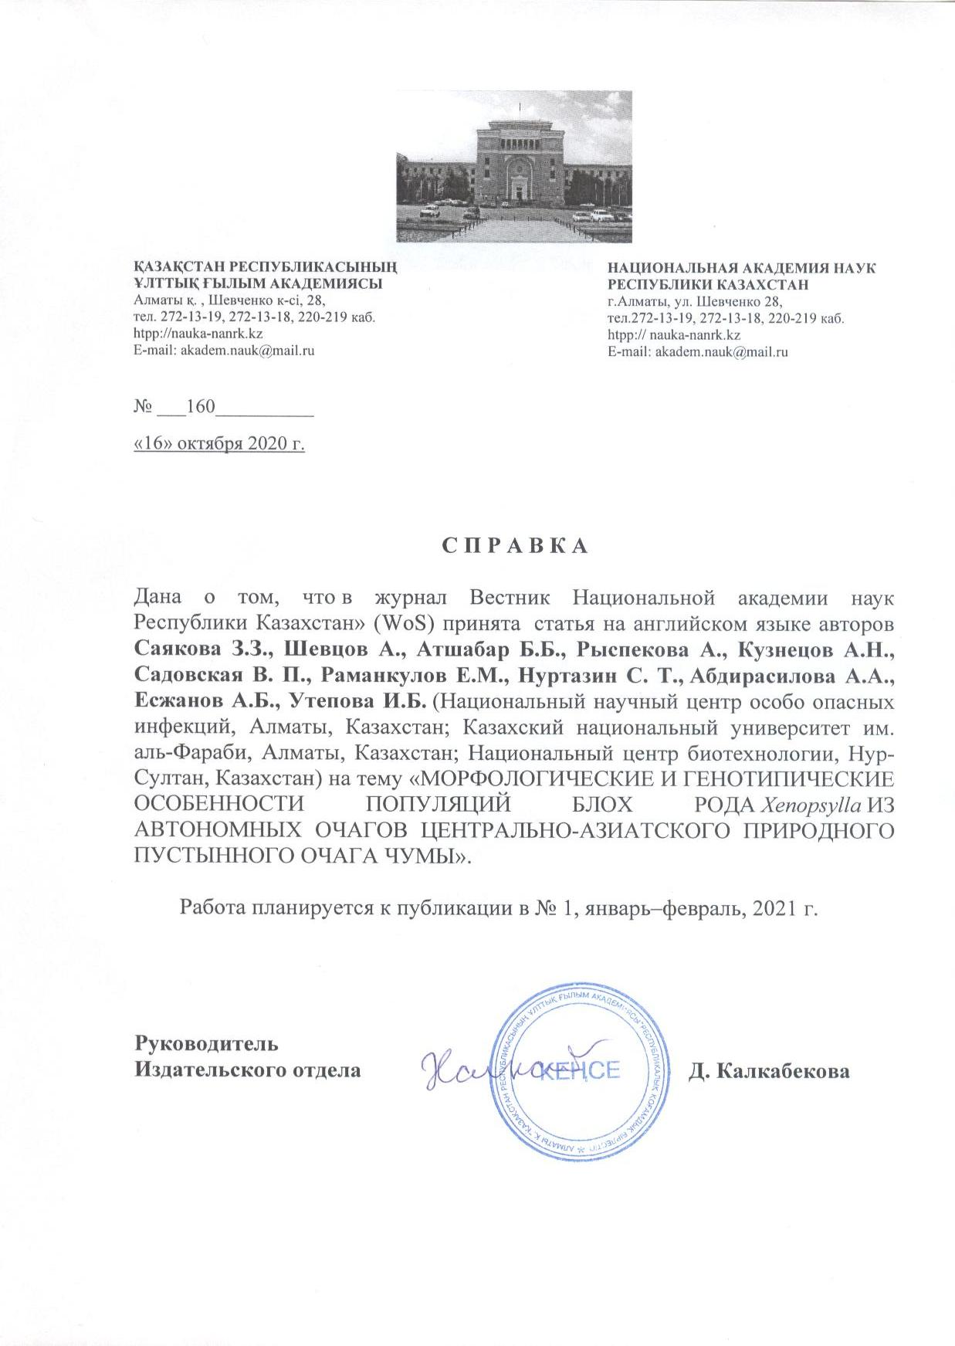

Conferences programs

Annual Regional Meeting of Biosurveillance Network of the Silk Road,
25-27 September, Kazakhstan

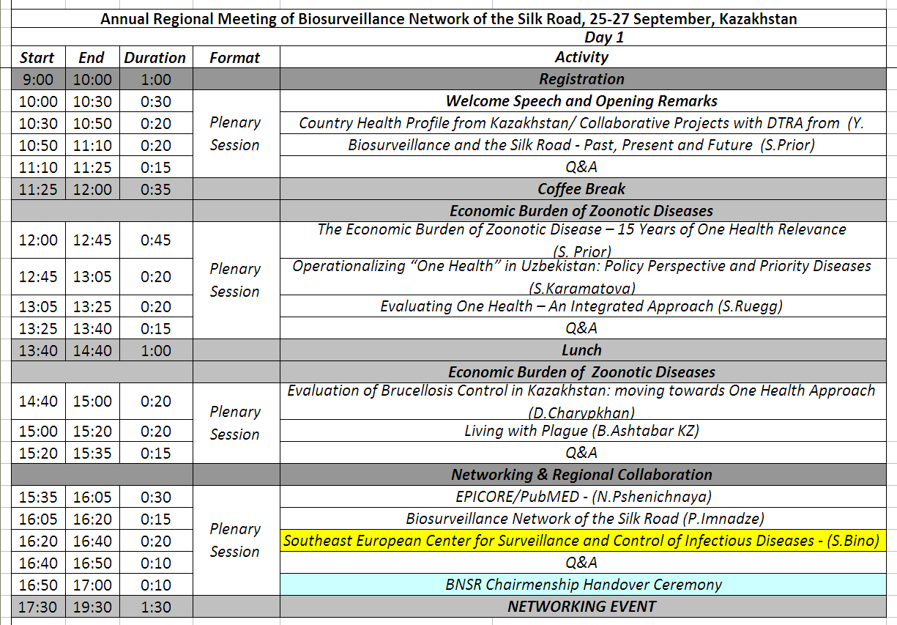

International scientific conference “Dangerous Infections: New Challenges - A Look into the Future”, 02-03 October 2019, Almaty, Kazakhstan
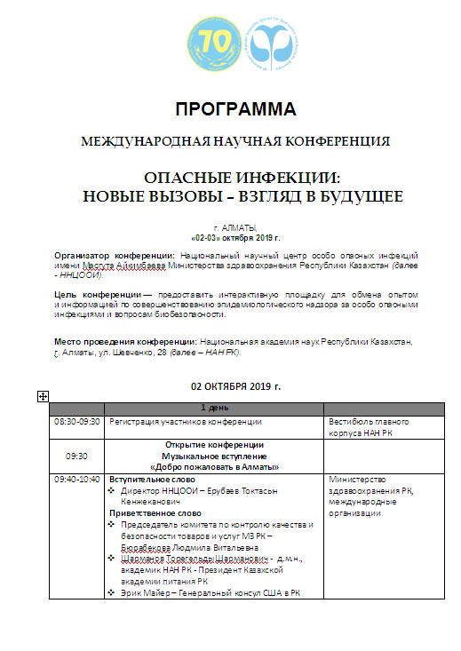
ATTACHMENT D

Calendar plan for 2018-2020 and supplementary agreement No. 6 to contract

Attachment 1.1
to Contract No.____ of _________ 2018
on grant funding

TECHNICAL SPECIFICATION AND
CALENDAR PLAN OF WORKS

Under contract No ______ of ____________.2018

- 1. RSE on REM “Masgut Aikimbayev’s Kazakh Scientific Center for Quarantine and Zoonotic Diseases” of the Ministry of Health of the Republic of Kazakhstan

1.1 By priority: Life and health sciences.
1.2 By Subpriority: Fundamental and Applied Research in Biology
Physiological, biochemical and molecular-genetic mechanisms of life activity of plants, animals and humans, their adaptation to biotic and abiotic factors of the habitat. Fundamental research.
1.3 Project subject: № АРО5133153 "Popular ecological variants of the carrier, vector and plague pathogen in the Central Asian natural desert plague focus".
1.4 The total amount of the project is 30,000,000 (thirty million) KZT, including division by year, to perform the works according to paragraph 3:
- for 2018 – in the amount of 10 000 000 (ten million) KZT;
- for 2019 – in the amount of 10 000 000 (ten million) KZT;
- for 2020 – in the amount of 10 000 000 (ten million) KZT.

2. Characteristics of scientific and technical products by qualification attributes and economic indicators
2.1 Work area: Medicine, biology.
2.2 Application area: Medicine, education.
2.3 Final result
- for 2018:
- The biology, ecology and geography of R. opimus will be studied. in the Central Asian plague focus and the results will be analyzed.
- The phenotypic properties and differences between the populations of R. opimus, genus Xenopsylla and Y. pestis will be studied from autonomous plague foci in the Central Asian plague focus. The results will be analyzed.
- A collection of Y. pestis DNA samples isolated from collector strains will be formed. Primers were selected for PCR amplification of the hypervariable section of R. opimus mitochondrial DNA and genus Xenopsylla.
- Multifactor analysis of regularities and selective mechanisms of formation of ecological populations of R. opimus, genus Xenopsylla and Y. pestis will be carried out.
– for 2019:
- The biology, ecology and geography of R. opimus will be studied in the Central Asian plague foci and the results will be analyzed.
- Phenotypic differences in the populations of R. opimus, genus Xenopsylla and Y. pestis will be studied from autonomous plague foci in the Central Asian plague focus.
- One article will be published in a peer-reviewed national scientific edition with a non-zero impact factor (in the journal CCES “Izvestia NAS RK”).
- A full genome sequencing of Y. pestis collector strains and bioinformatic data analysis will be carried out. PCR amplification conditions of the hypervariable section of R. opimus mitochondrial DNA and Xenopsylla genus will be optimized. A collection of DNA samples extracted from R. opimus and Xenopsylla has been created.and genus Xenopsylla from autonomous foci of the Central Asian plague.
- Multifactor analysis of regularities and selective mechanisms of formation of ecological populations of R. opimus, genus Xenopsylla and Y. pestis will be carried out
– for 2020:
- The phenotypic differences in the populations of R. opimus, the genus Xenopsylla and Y. pestis will be studied from autonomous foci of the Central Asian plague focus.
- Genotyping of R. opimus and the genus Xenopsylla from autonomous foci of the Central Asian plague focus will be performed based on analysis of the nucleotide sequence of the hypervariable section of mitochondrial DNA. Full genome sequencing of newly isolated strains of Y. pestis from autonomous plague foci of the Central Asian plague focus will be performed.
- A multifactorial analysis of regularities and selective mechanisms of formation of ecological populations of R. opimus, genus Xenopsylla and Y. will be carried out. pestis. A final report will be written.
- Strains of the plague microbe will be deposited and the results of genotyping of R. opimus carrier populations and fleas of the genus Xenopsylla and Y. pestis will be introduced in the international genome nomenclature.
2.4 Patent status: Strain deposit of the plague microbe.
2.5 Scientific and technical level (novelty):
For the first time in the project:
- The genome and population diversity of the rodent R. opimus, which dominates the desert landscape of Central Asia, will be investigated.
- The genome and population diversity of the genus Xenopsylla will be studied.
- The correlation between the genotypic variability of properties of geographically and ecologically isolated populations of the rodent R. opimus main carrier, the vector of genus Xenopsylla and the pathogen Y. pestis will be investigated with phenotypic manifestations of properties at sites of natural plague foci.
- The breeding effect of genotypic variants of the main carrier population on the selection of properties of the plague pathogen population and population features of fleas of the genus Xenopsylla during evolution will be studied.
- The influence of geobiocenosis on the selection and evolution of the plague pathogen, carrier and vector and on the selection of ecologically isolated populations of Y. pestis, which differ in virulence, biochemical and antigenic properties, will be studied in order to predict the prospects for the existence of plague foci in space and time and to develop a new vision and recommendations for improving the methodology for monitoring plague foci.
2.6 The use of scientific and technical products is carried out by: Sanitary and epidemiological service, including anti-plague stations, scientists biologists, postgraduate training of specialists in KSCQZD, training of students in KNU named after Al Farabi.
2.7 Type of use of the result of scientific and (or) scientific and technical activities:
The result of the project will be scientific knowledge, publications and developed recommendations on monitoring of natural foci.

3. Наименование работ, сроки их реализации и результаты
Cipher of task and stage | Name of works under the Contract and main stages of its identification | Completion date |  | Expected result
Cipher of task and stage |  | beginning
1 | Study of biological and ecological-geographical peculiarities of the habitats of the great gerbil population of the Central Asian Plague focus. | February 2018 | till November 1, 2018 | Study of biological and ecological-geographical peculiarities of the habitats of the great gerbil population of the Central Asian Plague focus will be carried out
1.1 | Study of biological features of R. opimus populations in the Central Asian plague area | February 2018 | till November 1, 2018 | Study of biological features of R. opimus populations in the Central Asian plague area will be carried out
1.2 | Study of ecological, geographical, literary and reporting data on the habitats of R. opimus populations in the plague area | February 2018 | till November 1, 2018 | Study of ecological, geographical, literary and reporting data on the habitats of R. opimus populations in the plague area will be carried out
2 | Determination of phenotypic differences in the populations of R. opimus, genus Xenopsylla and Y. pestis from autonomous foci of the Central Asian plague focus | February 2018 | till November 1, 2018 | Determination of phenotypic differences in the populations of R. opimus, genus Xenopsylla and Y. pestis from autonomous foci of the Central Asian plague focus will be carried out
2.1 | Determination of phenotypic features of R. opimus populations from autonomous plague foci of the Central Asian plague focus | February 2018 | till November 1, 2018 | Determination of phenotypic features of R. opimus populations from autonomous plague foci of the Central Asian plague focus will be carried out
2.2 | Determination of phenotypic features of genus Xenopsylla populations from autonomous plague foci of the Central Asian plague focus | February 2018 | till November 1, 2018 | Determination of phenotypic features of genus Xenopsylla populations from autonomous plague foci of the Central Asian plague focus will be carried out
2.3 | Determination of phenotypic features of Y. pestis populations from autonomous plague foci of the Central Asian plague focus | February 2018 | till November 1, 2018 | Determination of phenotypic features of Y. pestis populations from autonomous plague foci of the Central Asian plague focus will be carried out
3 | Genotyping, search for population diversity and peculiarities of R. opimus genome, genus Xenopsylla and Y. pestis from autonomous foci of the Central Asian plague focus | July 2018 | till November 1, 2018 | A collection of DNA samples will be formed for genotyping, search for population diversity and peculiarities of R. opimus genome, genus Xenopsylla and Y. pestis from autonomous foci of the Central Asian plague focus
3.1 | Genotyping, search for population diversity and peculiarities of R. opimus genome, | July 2018 | till November 1, 2018 | A collection of DNA samples will be formed for genotyping, search for population diversity and peculiarities of R. opimus genome from autonomous foci of the Central Asian plague focus
4 | Multifactorial analysis of regularities and selective mechanisms of formation of ecological populations of R. opimus, genus Xenopsylla and Y. pestis . | July 2018 | till November 1, 2018 | Multifactorial analysis of regularities and selective mechanisms of formation of ecological populations of R. opimus, genus Xenopsylla and Y. pestis will be carried out
1 | Study of biological and ecological-geographical peculiarities of the habitats of the great gerbil population of the Central Asian Plague focus | January 2019 | June 2019 | Biological and ecological-geographical peculiarities of the habitats of the great gerbil population of the Central Asian Plague focus will be studied.  Publication of 1 article in the journal CCES “Izvestiya NAN RK”
1.1 | Study of biological features of R. opimus populations in the Central Asian plague area | January 2019 | June 2019 | Study of biological features of R. opimus populations in the Central Asian plague focus will be carried out
1.2 | Study of ecological, geographical, literary and reporting data on the habitats of R. opimus populations in the plague focus | January 2019 | June 2019 | Study of ecological, geographical, literary and reporting data on the habitats of R. opimus populations in the plague focus will be carried out. The results will be analyzed
2 | Determination of phenotypic differences in the populations of R. opimus, genus Xenopsylla and Y. pestis from autonomous foci of the Central Asian plague focus | January 2019 | till November 1, 2019 | Determination and analysis of phenotypic differences in the populations of R. opimus, genus Xenopsylla and Y. pestis from autonomous foci of the Central Asian plague focus will be carried out.  Publication of 1 article in the journal RSCI “Acta Biomedica Scientifica”
2.1 | Determination of phenotypic features of R. opimus populations from autonomous plague foci of the Central Asian plague focus | January 2019 | June 2019 | Phenotypic features of R. opimus populations from autonomous plague foci of the Central Asian plague focus will be determined. The results will be analyzed
2.2 | Determination of phenotypic features of genus Xenopsylla populations from autonomous plague foci of the Central Asian plague focus | January 2019 | June 2019 | Phenotypic features of genus Xenopsylla populations from autonomous plague foci of the Central Asian plague focus will be determined. The results will be analyzed
2.3 | Determination of phenotypic features of Y. pestis populations from autonomous plague foci of the Central Asian plague focus | January 2019 | June 2019 | Phenotypic features of Y. pestis populations from autonomous plague foci of the Central Asian plague focus will be determined. . Phenotypic properties of the Y. pestis populations will be studied
3 | Genotyping, search for population diversity and peculiarities of R. opimus genome, genus Xenopsylla and Y. pestis from autonomous foci of the Central Asian plague focus | January 2019 | June 2019 | Genotyping, search for population diversity and peculiarities of R. opimus genome, genus Xenopsylla and Y. pestis and full genome sequencing of Y. pestis collector strains from autonomous foci of the Central Asian plague focus will be carried out
3.1 | Genotyping, search for population diversity and peculiarities of R. opimus genome | January 2019 | June 2019 | Genotyping, search for population diversity and peculiarities of R. opimus genome from autonomous foci of the Central Asian plague focus will be carried out
4 | Multifactorial analysis of regularities and selective mechanisms of formation of ecological populations of R. opimus, genus Xenopsylla and Y. pestis | January 2019 | till November 1, 2019 | Будет проведен многофакторный анализ закономерностей и селективных механизмов формирования экологических популяций Xenopsylla и Y. Pestis
2 | Determination of phenotypic differences in the populations of R. opimus, genus Xenopsylla and Y. pestis from autonomous foci of the Central Asian plague focus | January 2020 | till November 1, 2020 | The phenotypic differences in the populations of R. opimus, the genus Xenopsylla, and Y. pestis from autonomous foci of the Central Asian plague focus will be identified and studied.  Publication of 1 article in a peer-reviewed foreign edition “Vector-borne and zoonotic disease”, indexed in the Web of Science or Scopus database
2.3 | Determination of phenotypic differences in the populations of Y. pestis from autonomous foci of the Central Asian plague focus | January 2020 | till November 1, 2020 | Phenotypic features of Y. pestis populations from autonomous plague foci of the Central Asian plague focus will be determined. . Phenotypic properties of the Y. pestis populations will be studied
3 | Genotyping, search for population diversity and peculiarities of R. opimus genome, genus Xenopsylla and Y. pestis from autonomous foci of the Central Asian plague focus | January 2020 | till November 1, 2020 | Genotyping, search for population diversity and peculiarities of R. opimus genome, genus Xenopsylla and Y. pestis from autonomous foci of the Central Asian plague focus will be carried out. Publication of 1 article in a peer-reviewed foreign edition “Advances in experimental medicine and biology”, indexed in Web of Science or Scopus database.  Strains of the plague microbe will be deposited, and the results of genotyping of R. opimus carrier populations and Xenopsylla and Y. pestis fleas will be introduced. in the international genome nomenclature
3.1 | Genotyping, search for population diversity and peculiarities of R. opimus genome | January 2020 | till November 1, 2020 | Genotyping, search for population diversity and peculiarities of R. opimus genome, genus Xenopsylla from autonomous foci of the Central Asian plague focus will be carried out
4 | Multifactorial analysis of regularities and selective mechanisms of formation of ecological populations of R. opimus, genus Xenopsylla and Y. pestis | January 2020 | till November 1, 2020 | Publication of 1 article in a peer-reviewed foreign edition “Plos biology”, indexed in Web of Science or Scopus database

From Customer:  Chairman | From Performer:  Acting director
of SI “Committee of Science of the Ministry of Education and Science of RK”  _______________ Abdrassilov B.C.  P.A. | RSE on REM “Masgut Aikimbayev’s Kazakh Scientific Center for Quarantine and Zoonotic Diseases” of MH of RK  _________________ Sansyzbayev Ye.B.  P.A.

Acquainted:
Scientific manager of project

_______________ Atshabar B.B.

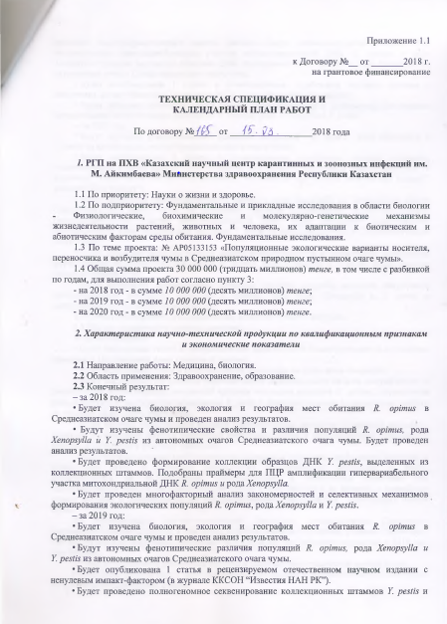

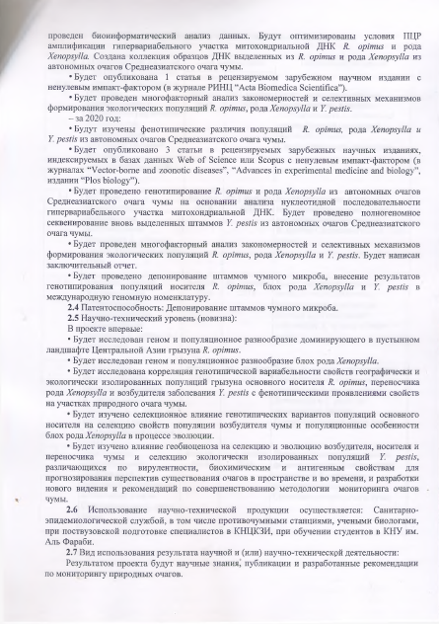

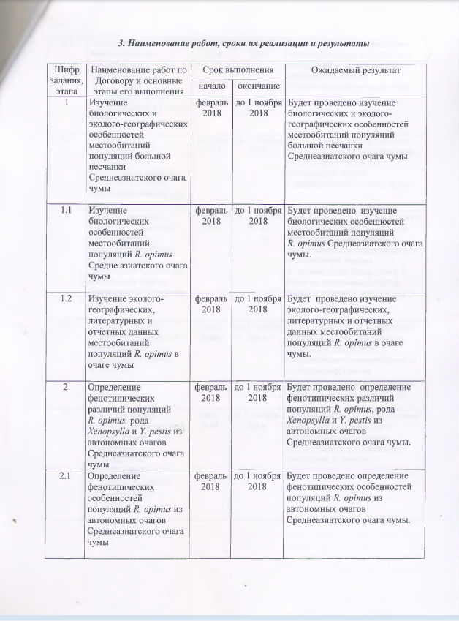

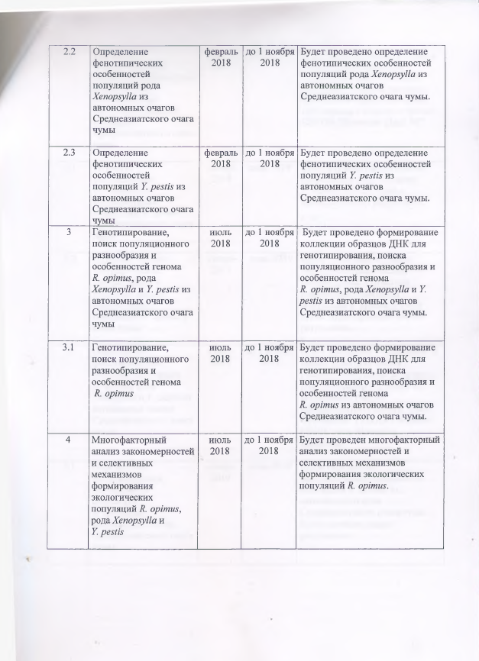

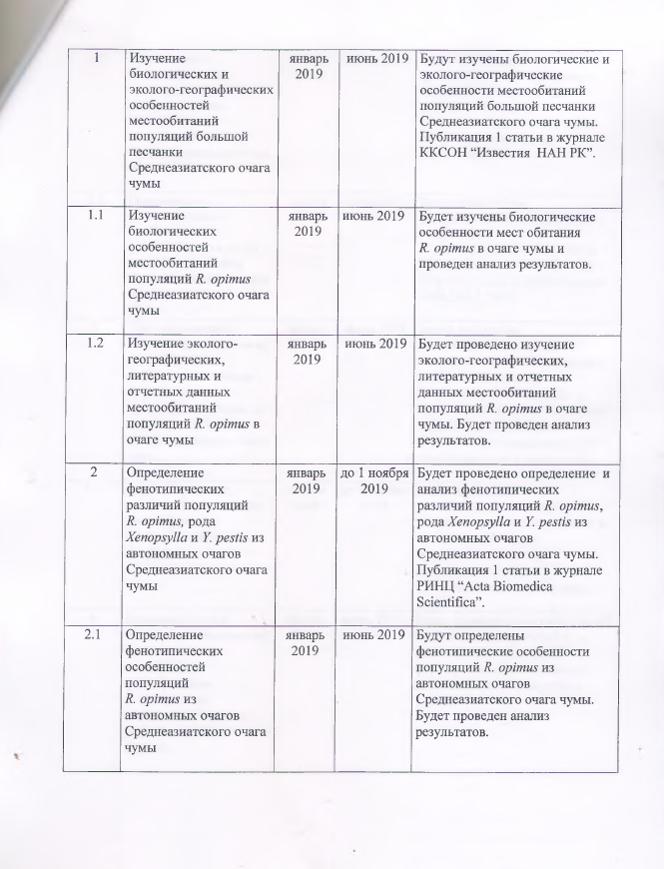

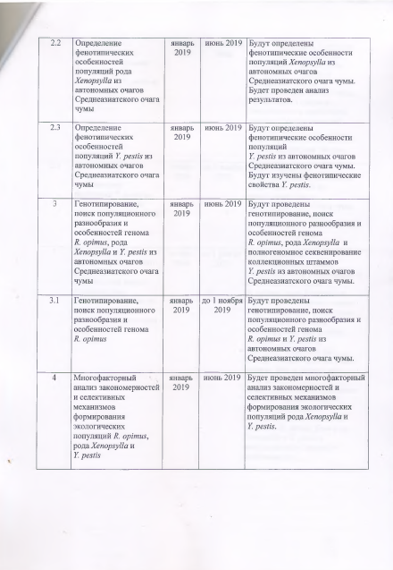

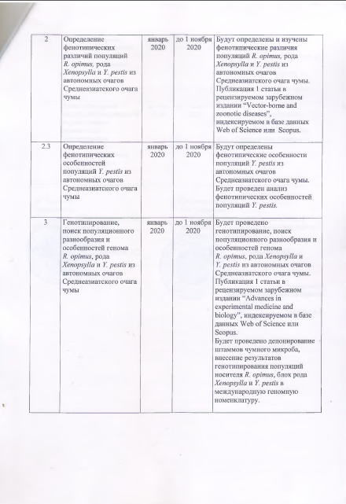

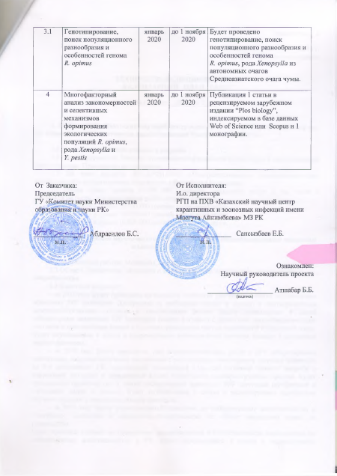

Supplementary agreement No 6
to the contract on grant financing No 165 of March 15, 2018

Nur-Sultan c. «12» August 2020

State Institution “Committee of Science of the Ministry of Education and Science of Republic of Kazakhstan”, hereinafter referred to as the Customer, represented by Chairman Kurmangaliyeva Zh.D., ., acting on the basis of Regulations on Science Committee, approved by the order of Executive Secretary № 169-K of July 10, 2018 and order of the Minister of Education and Science from December 25, 2019 № 169-zhk, on the one hand, and the republican state enterprise on the right of economic management “Masgut Aikimbayev’s National scientific center for especially dangerous infections” of the Ministry of Health of the Republic of Kazakhstan: hereinafter referred to as the Performer, represented by general director Yerubayev Toktassyn Kenzhekanovitch, acting on the basis of the Charter, on the other hand,
hereinafter the Customer and the Performer, jointly referred to as the Parties, on the basis of the Budget Code of the Republic of Kazakhstan dated December 4, 2008, the Law of the Republic of Kazakhstan dated February 18, 2011 “On Science”, the Resolution of the Government of the Republic of Kazakhstan dated May 25, 2011 № 575 “On approval of the Rules of basic, grant, program and target financing of scientific and (or) scientific and technical activities”, the Order of the Minister of Education and Science of the Republic of Kazakhstan dated August 15, 2017 № 410 “On approval of competitive documentation for grant financing of scientific and (or) scientific activities”. Order of the Chairman of the Committee of Science of the Ministry of Education and Science of Republic of Kazakhstan dated January 26, 2018 № 15-ls on the priority “Science for Life and Health” “On approval of the decision of the National Scientific Council on grant funding for research for 2018-2020”, the decisions of the National Scientific Councils on grant funding for the priority "Science for Life and Health" (Protocol № 2 of "19" January 2018), Protocol № 4 of "26" February 2018 and the protocol decision of the National Scientific Council on the priority area “Science of Life and Health” (Protocol № 6 of July 27, 2020), concluded this Supplementary Agreement № 6 to the Agreement № 165 of "15" March 2018 (hereinafter - the Agreement) on the following:
1. In attachment 1.1. to the Grant Financing Agreement № 165 of March 15, 2018 (hereinafter - the Agreement), in paragraph 2, subparagraph 2. 3 “The end result - for 2020”: the words “There will be published 3 articles in peer-reviewed foreign scientific publications indexed in Web of Science or Scopus databases with a non-zero impact factor (in the journals” Vector-borne and zoonotic diseases”, “Advances in experimental medicine and biology”, “Plos biology”) replaced by the words “There will be published 3 articles in peer-reviewed foreign scientific publications indexed in Web of Science or Scopus databases with a non-zero impact factor’.
2. Tasks 2, 3, 4 of the calendar plan 2020 of Attachment 1.1 of the Contract shall be set forth in the following wording:

Cipher of task and stage | Name of works under the Contract and main stages of its identification | Completion date |  | Expected result
Cipher of task and stage |  | beginning | end | Expected result
1 | Determination of phenotypic differences in the populations of R. opimus, genus Xenopsylla and Y. pestis from autonomous centers of the Central Asian plague center | January, 2020 | till November 1, 2020 | The phenotypic differences in the populations of R. opimus, genus Xenopsylla, and Y. pestis from autonomous foci of the Central Asian plague focus will be identified and studied. Publication of 1 article in a peer-reviewed foreign publication indexed in the Web of Science or Scopus database.
2 | Genotyping, population diversity search  and features of R. opimus, genus Xenopsylla and Y. pestis from autonomous foci Central Asian plague focus | January, 2020 | till November 1, 2020 | Genotyping and search for population diversity and features of the R. opimus genome will be carried out, genus Xenopsylla and Y. pestis from autonomous foci of the Central Asian plague focus.  Publication of 1 article in a peer-reviewed foreign publication indexed in the Web of Science or Scopus database.  Strains of the plague microbe will be deposited, and the results of genotyping of R. opimus carrier populations, Xenopsylla and Y. pestis fleas will be introduced in international genomic nomenclature
3 | Multifactorial pattern analysis and selective mechanisms of formation ecological populations of R. opimus, genus Xenopsylla and Y. pestis | January, 2020 | till November 1, 2020 | Publication of 1 article in peer-reviewed foreign edition indexed in Web of Science or Scopus databasesand 1 monograph

- This Agreement is an integral part of the Contract.
- The terms and conditions of the Contract not affected by this additional agreement, remain intact.
- The additional agreement is made in two copies, one for each of the parties having the same legal force.
- The terms and conditions of the Agreement shall enter into force upon signing by the Parties.

Legal addresses and bank details of the Parties

Customer:  State Institution “Committee of Science of the Ministry of Education and Science of Republic of Kazakhstan”  010000, Astana c., Mangilik El, 8 Ave  Тел. 87172 (74-16-53), (74-20-93)  IIC KZ92 0701 01KSN000 0000  RSI “Treasury Committee of the Ministry of Finance of the Republic of Kazakhstan”  BIC KKMFKZ2A  BIN 061 140 007 608  BS 11 |  | Performer:  Republican state enterprise on the right of economic management “Masgut Aikimbayev’s NSCEDI” of MH of RK.  050054, Almaty c., Turksib district, Zhahanger, 14  тел. 8727(223-38-21), (223-39-39)  IIC KZ866018771000556201 KZT  RSI “Treasury Committee of the Ministry of Finance of the Republic of Kazakhstan  BIC KZ10070KK1KS03827004  BIN 191140016396  BS 16
Chairman  ________________Kurmangaliyeva Zh.D.  p.a. |  | General director  _________________ Yerubayev T.K.  p.a.

