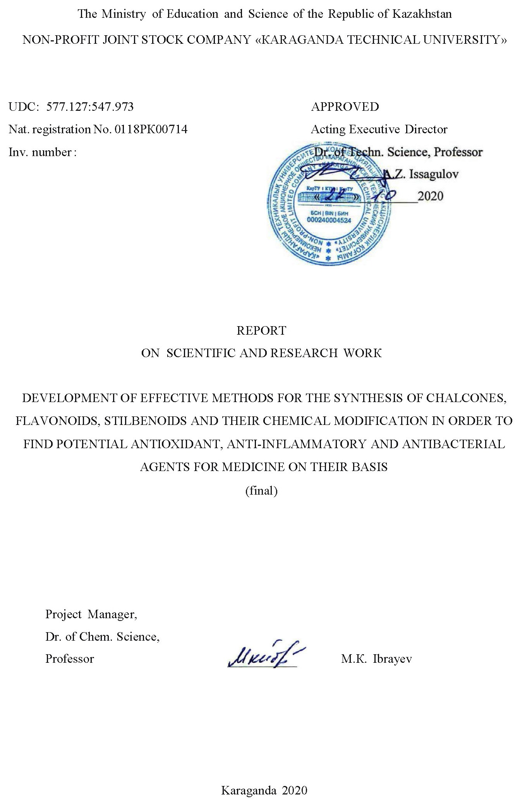
LIST OF EXECUTORS

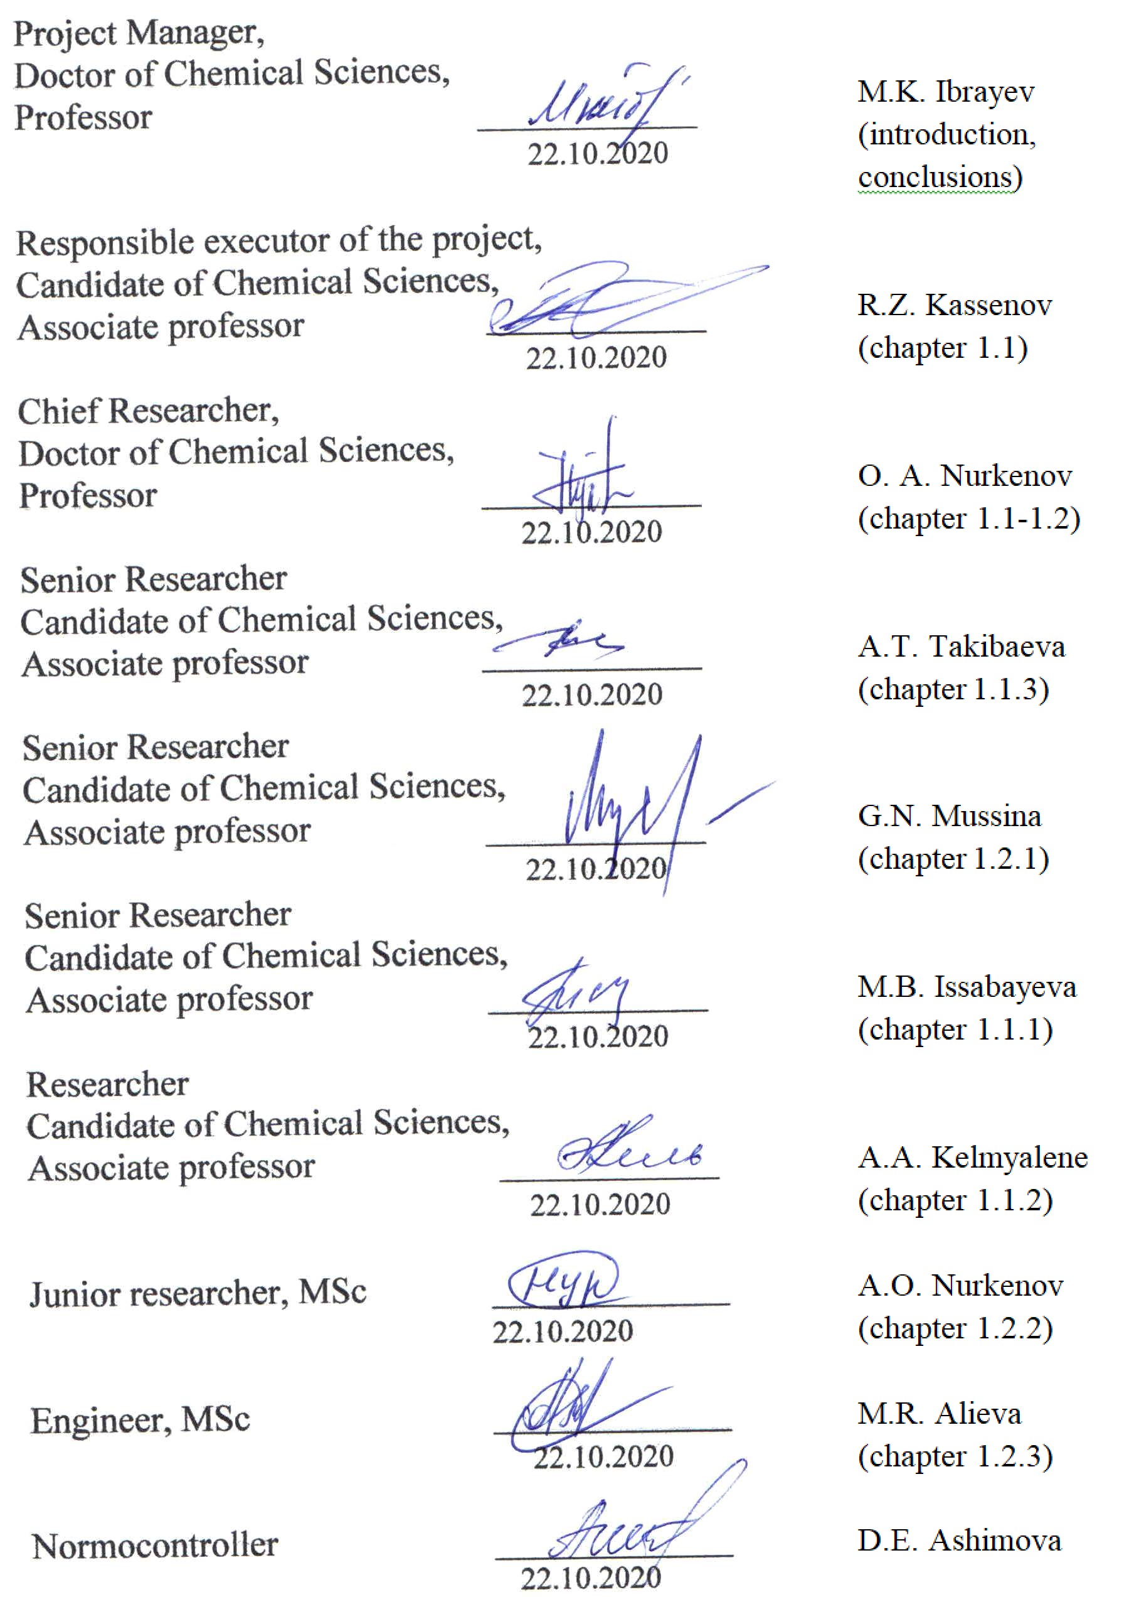
abstract

Report 119 pages, 10 figures, 1 table, 31 sources, 7 app.
trans-4-STYLBENE-CARBOXALDEHYDE, CONDENSATION, ACYLHYDRAZIDES, FUL-LEROPYRROLIDINES, CHALCONES, 4-OXO-4H-CHROMEN-3-CARBOXALDEHYDE, ¹H- and ¹³C-SPECTRA NMR, BIOSCRINING.
The object of the study is trans-4-stilbenecarboxaldehyde, o- and p-hydroxybenzoic acid hydrazides, fullerene C₆₀, chalcones, 6-substituted 4-oxo-4H-chromene-3-carboxaldehydes.
The aim of the scientific project is to develop optimal methods and conditions for the synthesis of new stilbene-containing derivatives, to study possible mechanisms of their formation reactions, as well as to fully establish their structure and conduct bioscreening of synthesized compounds using the PASS program.
The stage of work for 2020 was the directed chemical modification of substituted stilbenoids, the development of previously obtained new compounds for analysis and biotesting. Development of optimal technological parameters for obtaining the most bioactive modified chalcones, pyrazolines, chromones and stilbenoids.
The method or methodology of work to effectively achieve the goal of the project consists in a scientifically grounded choice of potentially available and most promising for modification of trans-4-stilbenecarboxaldehyde; detailed and qualitative study of methods of their directed modification, study of bioscreening of synthesized substances using the PASS computer system.
Results of work and their novelty. In the course of the work, the reaction of condensation of equimolar amounts of o- and p-hydroxybenzoic acid hydrazides with trans-4-stilbenecarboxaldehyde was studied by heating in ethanol for 1-2 hours. It was shown that the reaction proceeds smoothly with the formation of 2-hydroxy- and 4-hydroxy-N- (4 ((E-) styryl) benzylidene) -benzohydrazides in 91% and 80% yields, respectively. The reaction of fullerene C₆₀ with trans-4-stilbenecarboxaldehyde and N-methylglycine under the conditions of the Prato reaction was studied. It was found that fullerene C₆₀ with aldehyde and N-methylglycine forms stilbene-substituted fulleropyrrolidine.
Basic design, technological and technical and operational characteristics. A scheme for the formation of fulleropyrrolidine has been proposed as a 1,3-dipolar addition to the C₆₀ fullerene through the intermediate formation of active azomethine ylides.
A water-soluble fulleropyrrolidine complex was obtained. It was shown that the formation of the complex occurs as a result of the solubilization of fullerenepyrrolidine by PVP chains and the physical interaction of the lactam group with the fullerene sphere. Condensation of the d-pseudoephedrine alkaloid with trans-4-stilbenecarboxaldehyde in a non-polar aprotic solvent has synthesized 2-stilbene-containing 1,3-oxazolidine. It was shown that the reaction of 1,3-oxazolidine formation proceeds stereoselectively with the formation of one stereoisomer with the S-configuration at the C2 atom. The interaction of 2-hydroxyacetophenone with trans-4-stilbenecarboxaldehyde in the presence of an aqueous-alcoholic alkali solution (Claisen-Schmidt condensation) with the formation of a stilbene-holding chalcone was studied. Taking into account the scientific and applied prospects of flavonoid fullerene derivatives, a three-component condensation of fullerene C₆₀, N-methylglycine (sarcosine) and substituted chromone-3-aldehydes was carried out under the Prato reaction conditions. The values ​​of chemical shifts, multiplicity and integral intensity of ¹H and ¹³C signals were determined in one-dimensional NMR spectra. Using the spectra in the formats COZY (¹H-¹H) and HMQC (¹H-¹³C), homo- and heteronuclear interactions were established, confirming the structure of the compounds under study.
The degree of implementation – optimal methods for the preparation of potentially biologically active stilbene-containing hydrazones, oxazodidine, chalcone and pyrazoline have been developed and studied, some aspects and mechanisms of their formation and heterocyclization have been established. Using modern physicochemical methods (IR-, ¹H-, ¹³C and ¹H-¹³C HSCQ spectroscopy), the structures of a number of new chalone derivatives have been established.
Recommendations for the implementation or the results of the implementation of research results. The developed methods for the preparation of potentially biologically active stilbene-containing hydrazones, oxazodidine, chalcone and pyrazoline are recommended for the development of new biologically active substances and practical use in the synthesis of these classes of compounds.
Application area. Pharmacology, medicine.
The significance of the work lies in the development of optimal methods for the synthesis of new substances and testing of their biological activity.
Predictive proposals for the development of the research object: expanding the arsenal of biologically active substances.
CONTENT

 | SYMBOLS AND ABBREVIATIONS …………..………………………………. | 7
 | INTRODUCTION………………………………………………………………… | 8
1 | TARGETED CHEMICAL MODIFICATION OF SUBSTITUTED STYLBENOIDS, DEVELOPMENT FOR ANALYSIS AND BIO TESTS. DEVELOPMENT OF OPTIMAL TECHNOLOGICAL PARAMETERS FOR OBTAINING THE MOST BIOACTIVE MODIFIED CHALCONS, PYRAZOLINES, CHROMONES AND STYLBENOIDS…..........……………… | 13
1.1 | Synthesis, structure and bioactivity of substituted stilbenoids ………………………. | 13
1.1.1 | Condensation of trans-4-stilbenecarboxaldehyde with N-acylhydrazides ………. | 13
1.1.2 | Synthesis and structure of N-methyl-2- (4-styrylphenyl) -3,4-fullero-pyrrolidine .. | 18
1.1.3 | Synthesis and NMR spectroscopic study of the structure of 2- (4 - ((E) -styryl) phenyl) - (4S, 5S) -3,4-dimethyl-5-phenyl-1,3-oxazolidine……………………….. | 23
1.2 | Development of optimal technological parameters for obtaining the most bioactive modified chalcones, pyrazolines, chromones and stilbenoids…………………..…. | 26
1.2.1 | Synthesis and structure of promising new stilbene-containing  chalcone and pyrazoline ……………………………………………..……………. | 27
1.2.2 | Synthesis of promising chromene-containing fullerenes …..……………………… | 29
1.2.3 | Prediction of the biological activity of stilbene-containing hydrazones, oxazodidine, chalcone, and pyrazoline in the PASS system…....…………………. | 32
 | CONCLUSION ……………………………………………………………………. | 38
 | REFERENCES ……………………………………..……………………………... | 43
 | APPENDIX A – Work Schedule for 2018-2020 …………………………… | 46
 | APPENDIX B – List of published works on the topic for 2018-2020…………… | 54
 | APPENDIX C – Computer bioprediction of some new synthesized compounds using the Prediction of Activity Spectra for Substance (PASS) program…………. | 58
 | APPENDIX D – Acts of tests for antiradical activity in the RSE on the RK "National Center for Biotechnology" of the SC MES RK…….…………………… | 76
 | APPENDIX E – Act of testing for antimicrobial activity in the RSE on the REM "National Center for Biotechnology" KN MES RK ……........................................ | 99
 | APPENDIX F – Act of testing for antimicrobial activity at the Karaganda State Medical University ………………………………………………………….……. | 101
 | APPENDIX G – Reprints of scientific publications in the direction of the topic for 2020, without DOI ….…………………………………………………………….. | 103

SYMBOLS AND ABBREVIATIONS

BAC – biologically active compounds
BAS – biological active substances
Hz – hertz
d – doublet
dd – doublet of doublets
DMSO – dimethyl sulfoxide
DMFA – dimethylformamide
IR spectrum – infrared spectrum
SSCC – spin-spin coupling constant
q – quartet
MHz – megahertz
m – multiplet
ppm – parts per million
s – singlet
t – triplet
m.p. – melting point
TLC – thin layer chromatography
NMR – nuclear magnetic resonance
R_{f} – distribution ratio

INTRODUCTION

Relevance.
More than 300 representatives of stilbenoids are known - a group of natural, synthetic and semi-synthetic biologically active substances, chemically related to the group of polyphenolic compounds - phenylpropanoids. The main food sources are grapes, blueberries, blueberries, peanuts, cocoa. The history of their discovery is associated with the discovery of the protective functions of plants in response to external stimuli. Further study revealed pronounced antioxidant properties.
Among the natural biologically active substances of a polyphenolic nature with significant physiological potential, phytostilbenes stand out, and, first of all, resveratrol. Resveratrol (3,5,4'-trihydroxy-trans-stilbene) is a polyphenolic phytoalexin, a stilbene derivative.
resveratrol

Resveratrol is a natural biologically active substance from the group of polyphenols, isolated from dark grapes and grape seeds, which has proven anticarcinogenic, hepatoprotective and anti-inflammatory properties. Resveratrol was first isolated from the roots of hellebore in 1940. Interest in this compound increased significantly after 1992, when its cardioprotective effect was proven. Since then, the number of works devoted to the study and description of the properties of resveratrol has reached several thousand.
Functional derivatives of stilbene (1,2-diphenylethylene) are widespread in the plant kingdom and have long been used in traditional medicine [X-X]. The features of the electronic structure of these compounds, like other representatives of the arylpolyene class, give their molecules not only strong physiological activity, but also valuable physicochemical properties.
The introduction of an aldehyde group into the 4th position of the phenyl ring of the stilbene system increases the reactivity towards nucleophiles and determines the rich synthetic potential of trans-4-stilbenecarboxaldehyde.

trans-4-stilbenecarboxaldehyde

Until now, there is little information on the synthesis and modification of trans-4-stilbenecarboxaldehyde, which determined the relevance and prospects of its study for the search for new bioactive compounds.
The purpose of the scientific project is to develop optimal methods and conditions for the synthesis of new stilbene-containing derivatives, to study possible mechanisms of their formation reactions, as well as to fully establish their structure and conduct biological tests of the synthesized compounds for various types of biological activity.

Abstract of work done in 2018.
The object of the study is chalcones, flavonoids, stilbenoids and their derivatives, which attract the attention of researchers around the world looking for new antioxidant, antiaging agents, due to their widespread use and synthetic potential. In the first year of research, the reactions of obtaining chalcones and their derivatives were studied in detail.
The aim of the scientific project is to develop rational and optimal methods and conditions for the synthesis of new chalcones, flavonoids, stilbenoids and their derivatives, to study the possible mechanisms of their formation reactions, as well as to fully establish their structure and conduct biological tests of the synthesized compounds for various types of biological activity.
The way to effectively achieve the goal of the project lies in the scientifically grounded choice of potentially available and most promising for modification of chalcones, flavonones, stilbenes; detailed and qualitative study of methods of their directed modification, study of bioscreening of synthesized substances in certified laboratories.
Main results. To achieve this goal, the following tasks were completed within the framework of this project:
1. Methods for obtaining and optimal conditions for the synthesis of chalcones under the conditions of classical synthesis, microwave and ultrasonic activation have been developed.
2. Methods for the preparation of pharmacologically active pyrazolines and flavonoids by heterocyclization of hydroxyl-substituted chalcones have been developed.
3. For the first time, a number of new derivatives of chalcones were obtained and their physicochemical and spectral characteristics of the new synthesized substances were studied using modern methods of analysis.
4. Bioscreening of the activity of new functionally substituted chalcones and their derivatives for antimicrobial, antiradical, antibacterial, antifungal types of activity was carried out, as well as anti-inflammatory and cytotoxic effects of chalcones.
5. Based on the results of computer bioprediction and pharmacological screening of the synthesized compounds, the prospects of work in this direction are shown.
6. Based on the results of biological studies, the most promising compounds were selected for a deeper study of their pharmacological activity.
7. Under the conditions of fine organic synthesis, new compounds were developed for their further study.
While fulfilling the project objectives, a large amount of experimental research was carried out on the synthesis and chemical transformation of chalcones and chromones, the establishment of the structure of synthesized biologically active substances using modern physicochemical methods of analysis (IR, NMR spectroscopy, mass spectrometry, etc.). Within the framework of the project, effective technologies for obtaining pharmacological agents based on chalcones and substituted 3-chromones have been developed and proposed. In addition to traditional sources, such activation methods as microwave and ultrasonic were used as innovative laboratory methods. When using these alternative activation methods, the results of most chemical transformations are several times higher than the results obtained using traditional methods. The degree of implementation - the optimal methods for obtaining potentially biologically active polyfunctional derivatives of chalcones have been developed and studied, some aspects and mechanisms of their formation and heterocyclization have been established. Using modern physicochemical methods (IR-, ¹H-, ¹³C and ¹H-¹³C HSCQ spectroscopy), the structures of a number of new chalone derivatives have been established.

Abstract of work done in 2019.
CONDENSATION, ACYLHYDRASIDES, 2-AMINOMETHYLPYRIDINE, 4-OXO-4H-CHROMENE-3-CARBOXALDEHYDE, ¹H- AND ¹³C NMR SPECTRA, ANTIRADICAL ACTIVITY
The object of the study is isonicotinic acid hydrazide, o- and p-hydroxybenzoic acid hydrazides, 2-aminomethylpyridine, 4-oxo-4H-chromene-3-carboxaldehyde, 6-methyl-4-oxo-4H-chromene-3-carboxaldehyde, 6-bromo-4-oxo-4H-chromene-3-carboxaldehyde.
The aim of the scientific project is to develop optimal methods and conditions for the synthesis of new flavonoids and their derivatives, to study the possible mechanisms of their formation reactions, as well as to fully establish their structure and conduct biological tests of the synthesized compounds for various types of biological activity.
The way to effectively achieve the goal of the project consists in a scientifically grounded choice of potentially available and most promising for modification of 3-formylchromone; detailed and qualitative study of methods of their directed modification, study of bioscreening of synthesized substances in certified laboratories.
Main results. To achieve this goal, the following tasks were completed within the framework of this project:
1. A literature review on the chemical transformation of 3-formylchromones has been carried out. It was shown that the introduction of an aldehyde group into the position of the 3-chromone system radically changes the reactivity of the pyrone ring with respect to nucleophiles and determines the rich synthetic potential of 3-formylchromones.
2. The synthesis of 6-methyl-4-oxo-4H-chromene-3-acylhydrazones by condensation of functionally substituted 3-formylchromones and acylhydrazides has been carried out. It was shown that the reactions of 4-oxo-4H-chromene-3-carboxaldehyde with hydrazides of isonicotinic and o- and p-hydroxybenzoic acids in isopropanol by refluxing the reaction mixture for 2 h leads to the formation of the corresponding chromene-containing hydrazones.
3. The synthesis of compounds, combining in one molecule alkaloid and flavonoid fragments, which are of practical interest in terms of studying their mutual influence on biological activity. Thus, the synthesis of 2-substituted 1,3-oxazolidines was carried out by the interaction of the d-pseudoephedrine alkaloid with 4-oxo-4H-chromene-3-carboxaldehyde. It has been found that the condensation process proceeds smoothly with a high formation of target products. It was shown that the reaction of 1,3-oxazolidine formation proceeds stereoselectively with the formation of one stereoisomer with the S-configuration at the C2 atom.
4. Synthesis of Schiff bases by the interaction of 2- (aminomethyl) pyridine with 3-formylchromones (4-oxo-4H-chromene-3-carboxaldehyde, 6-methyl-4-oxo-4H-chromene-3-carboxaldehyde and 6- bromo-4-oxo-4H-chromium-3-carboxaldehyde) in an absolute benzene medium with azeotropic distillation with a Dean-Stark trap. It has been shown that upon refluxing in benzene for 2 h, the reaction proceeds smoothly and leads to the formation of the corresponding chromene-containing azomethines in high yields of 63-98%.
5. Quantum-chemical calculations of the activity of substituted 3-formyl -chromones in the reactions of synthesis of azomethine derivatives have been carried out. Based on the results of the studies carried out, it can be concluded that the ab initio quantum-chemical method 6-31G allows one to see the dependence of the geometric and charge characteristics of substituted 3-formylchromone molecules on the nature of the benzene ring substituents and to take into account the data obtained when carrying out modifications of compounds containing pharmacophore groups in synthesis of new biologically active substances.
6. The structures of the synthesized compounds were studied by ¹H and ¹³C NMR spectroscopy, as well as by the data of two-dimensional spectra COZY (¹H-¹H) and HMQC (¹H-¹³C). The values ​​of chemical shifts, multiplicity and integral intensity of ¹H and ¹³C signals in one-dimensional NMR spectra were determined. Using spectra in the formats COZY (¹H-¹H) and HMQC (¹H-¹³C), homo- and heteronuclear interactions were established, confirming the structure of the compounds under study.
7. Using the PASS program to predict the spectrum of pharmacological activity, the prediction of biological activity by the structure of the synthesized compounds was carried out using logical-combinatorial methods using a databank of drug substances and biologically active compounds. The prospects of work in this direction are shown.
8. Data on the antimicrobial activity of the synthesized chromene-containing 1,3-oxazolidines and azomethine are presented. It was shown that among the synthesized samples 3 - ((4S, 5S) -3,4-dimethyl-5-phenyloxazolidin-2-yl) -4H-chromen-4-one (comp. 21); 6-methyl-3 - ((4S, 5S) -3,4-dimethyl-5-phenyloxazolidin-2-yl) -4H-chromen-4-one (comp. 22) and 3 - (((pyridine 2-ylmethyl) imino) methyl) -4H-chromen-4-one (comp. 24) exhibit moderate antibacterial activity against gram-positive test strains of Staphylococcus aureus, Bacillus subtilis and gram-negative strain of Escherichia coli.
While fulfilling the tasks of the project, a large amount of experimental research was carried out on the chemical transformation of 3-formylchromones, the establishment of the structure of synthesized biologically active substances using modern physicochemical methods of analysis. Within the framework of the project, methods have been developed for obtaining pharmacological agents based on amines, N-acylhydrazides and substituted 3-chromones.
The degree of implementation – optimal methods for obtaining potentially biologically active functional-substituted flavonoids have been developed and studied, some aspects and mechanisms of their formation and heterocyclization have been established. Using modern physicochemical methods (IR, ¹H-, ¹³C and ¹H-¹³C HSCQ spectroscopy), the structures of a number of new derivatives of chalcones have been established.
The Project Calendar Plan (Appendix A) has been fully implemented. As a result of the project 26 publications were issued (Appendix B).
1 TARGETED CHEMICAL MODIFICATION OF SUBSTITUTED STYLBENOIDS, DEVELOPMENT FOR ANALYSIS AND BIO TESTS. DEVELOPMENT OF OPTIMAL TECHNOLOGICAL PARAMETERS FOR OBTAINING THE MOST BIOACTIVE MODIFIED CHALCONS, PYRAZOLINES, CHROMONES AND STYLBENOIDS

1.1 Synthesis, structure and bioactivity of substituted stilbenoids

Stilbene and its derivatives are important for many fields of chemistry, biology and physics. The number of publications available on the Internet devoted to compounds based on stilbene has reached approximately 32,000 [1]. Classical and modern synthetic organic chemistry, (more than 6300 articles) providing a number of stilbene derivatives with various structures, supplies material for the incessant numerous fundamental and practical studies of this class of compounds, motivated by their unique photochemical, photophysical and photochromic properties.
Functional derivatives of stilbene (1,2-diphenylethylene) are widespread in the plant kingdom and have long been used in traditional medicine [2]. The features of the electronic structure of these compounds, like other representatives of the arylpolyene class, give their molecules not only strong physiological activity, but also valuable physicochemical properties. In particular, these compounds can be photochromic, electrically conductive, have nonlinear optical and dielectric properties [3]. Due to the existence of fast and reversible cis-trans transitions induced by photochemistry, stilbenes belong to "intelligent" molecules that can be considered as a two-bit information carrier and used for the production, reception and processing of information [4-6].
The introduction of an aldehyde group into the 4th position of the phenyl ring of the stilbene system increases the reactivity with respect to nucleophiles and determines the rich synthetic potential of trans-4-stilbenecarboxaldehyde.

1.1.1 Condensation of trans-4-stilbenecarboxaldehyde with N-acylhydrazides

In recent years, the interest of chemists in unsaturated aldehydes has been constantly growing. This is due to the fact that, due to their high reactivity and availability, aldehydes are of great scientific and practical importance and are used as synthons in organic synthesis. The chemistry of unsaturated aldehydes is presented in the literature in sufficient detail. However, information on the reactions and use of unsaturated carbonyl compounds containing fragments of o- and p-hydroxybenzoic acid hydrazides is absent in the literature. It should be noted that stilbenes derivatives (triazinestilbenes, diphenylstilbenes, and resveratrol) are used as fluorescent dyes [7, 8]. Their fluorescent properties can be used, for example, to study the penetration through cell membranes and accumulation in tissues of biologically active substances synthesized on the basis of stilbene [9]. It should be noted that the structure of o- and p-hydroxybenzoic acid hydrazides has a high synthetic and biological potential, which makes it possible to develop methods for the synthesis of new biologically active substances [10-12]. Previously, on the basis of o- and p-hydroxybenzoic acid hydrazides, we synthesized a variety of derivatives [13], which showed pronounced antimicrobial activity against gram-positive (Staphylococcos aureus, Bacillus subtilis) strains. Also, hydrazones were used to synthesize inhibitors of such enzymes as monoamine oxidase, epoxide hydrolase, and various cathepsins [14]. The cathepsin family belongs to lysomal proteases that play an important role in the progression of tumors and the pathogenesis of human autoimmune diseases [15]. Therefore, the development of new inhibitors of various cathepsins attracts the attention of researchers.
Therefore, the synthesis of N-arylidenehydrazones containing simultaneously fragments of hydrazides of hydroxybenzoic acids and stilbene in the structure of the molecule is of certain interest associated with the design of both new pharmacologically active substances and the development of tools for visualizing biological processes.
In this regard, we have synthesized new unsaturated N-arylidenehydrazones (3, 4) by condensation of o- and p-hydroxybenzoic acid hydrazides (1, 2) with trans-4-stilbenecarboxaldehyde by heating equimolar amounts of aldehyde and hydrazides in ethanol at 60-70^{о}С and stirring for 1-2 hours.

The structure of compounds (3, 4) was confirmed by ¹H and ¹³C NMR spectroscopy data, as well as by two-dimensional COZY (¹H-¹H) and HMQC (¹H-¹³C) spectra.
The ¹H NMR spectrum of compound 3 has been studied in most detail. Most of the 1H signals of compound 3 under study are observed in the downfield part of the proton spectrum. In the region of 6.94 ppm overlapping of signals of two CH-groups at С-4 and С-20 was noted. In the range from 7.25 to 7.40 ppm the equivalent protons of the benzene nuclei (H-23, 25 and H-15, 17) resonate, as well as the protons of the methine groups at C-6 and C-19. Two-proton doublets with chemical shifts of 7.59 and 7.71 ppm. can be attributed to symmetric protons Н-22, 26 and Н-14,18, respectively. The protons H-5 and H-3 of the phenyl radical give signals at 7.67 and 7.87 ppm. The highest-frequency signal (8.42 ppm) can be attributed to the proton of the amino group.

In the carbon spectrum of compound 3, the most high-intensity signals belong to the equivalent nuclei of aromatic systems: δ (C-15, 17) = 127.19 ppm; δ (C-22.26) = 127.44 ppm; δ (C-14.18) = 128.18 ppm; δ (C-23.25) = 129.28 ppm. Carbon atoms C-19 and C-20 resonate at 128.29 and 130.25 ppm. respectively. Asymmetric atoms of the phenyl radical give signals at 116.48 (C-2), 117.83 (C-6), 119.48 (C-4), 129.09 (C-3), 134.34 (C-5 ) and 159.60 ppm. (C-1). The signal with a chemical shift of 148.87 ppm belongs to the sp²-hybridized C-12 atom at the nitrogen heteroatom. The highest frequency signal (165.28 ppm) belongs to the carbonyl carbon atom.
The structure of compound 3 was also confirmed by the data of COZY and HMQC NMR spectroscopy, which made it possible to establish the spin-spin interactions of homo- and heteronuclear nature. The observed correlations are presented in the diagrams below (Fig. 1).
Figure 1 – Correlation COZY (¹H-¹H) and HMQC (¹H-¹³C) compound 3

In the spectra of ¹H-¹H COZY, spin-spin correlations are observed through three bonds of protons of adjacent methine groups of aromatic rings. Simple interactions of protons with carbon atoms were established using the ¹H-¹³C HMQC spectra.
The spin-spin interactions of compound 4, carried out between the H – H atoms through three bonds, were established using the two-dimensional spectrum COZY (¹H-¹H) (Fig. 2).
Figure 2 – COZY correlations (¹H-¹H) of compound 4

In order to study the spontaneous hydrolysis of new compounds 3, its fluorescence spectrum was studied (Fig. 3). The kinetics of the fluorescence spectrum of compound 3 during its spontaneous hydrolysis was recorded on a Perkin Elmer LS50B instrument at λ_{ex} = 355 nm.

Figure 3 – Kinetics of the fluorescence spectrum of hydrazone 3
at λ_{ex} = 355 nm (slit width 5 nm). Spectra 3 (5 μM solution
in water with 0.5% DMSO) were removed every 2 min.

According to the results of the study, compound 3 has a specific fluorescence peak (λ_{ex} = 355 nm; λ_{em} = 475 nm). In an aqueous medium, this compound is rapidly hydrolyzed with t_{1/2} ̴ 12.5 min, which is accompanied by an increase in fluorescence at λ = 460 nm (λ_{ex} = 355 nm; λ_{em} = 460 nm) (Fig. 3).
Spontaneous hydrolysis. The rate of spontaneous hydrolysis was estimated by measuring the absorption spectra of the studied compound in 0.05 M phosphate buffer (pH 7.0) at 25°C as described previously [4]. Absorption (A_{t}) at a characteristic wavelength of λ = 300 nm for compound 3 was measured at regular intervals until the moment when there was no change in absorption (A∞). The data obtained were used to plot ln (A_{t} - A∞) versus time and the rate constant of the hydrolysis reaction (k ') was found from the slope of the straight line. The half-life (t_{1/2}) was found from the equation: t_{1/2} = 0.693 / k '.
Methods of synthesis of compounds 3 and 4:
2-Hydroxy-N-(4-((E-)styryl)benzylidene)benzohydrazide (3). To 1.04 g (0.005 mol) was dissolved by heating in ethanol, and 0.76 g (0.005 mol) of o-hydroxybenzoic acid hydrazide was added with stirring. The reaction mixture was heated at a temperature of 50-60⁰C for 60 minutes. The solution was cooled, the formed finely crystalline yellow precipitate was filtered off, washed with a small amount of cold ethanol. Yield 1.55 g (91%), mp. 278-279ºС (C₂H₅OH). Spectrum NMR ¹Н (DMSO-d₆), δ, ppm. (J, Hz): 6.94 broad.t. (1Н, СН⁴_{arom}), 6.95 broad. d (1Н, СН=СН-Ph, ²J_{НН} 7.3 Hz), 7.27 d (2Н, СН^{23,25}_{arom}, ²J_{НН} 11.0 Hz), 7.36 d (2Н, СН^{15,17}_{arom}), 7.37 d (1Н, СН⁶_{arom}), 7.40 d (1Н, СН=СН-Ph), 7.58 d (2Н, СН^{22,26}_{arom}, ²J_{НН} 6.9 Hz), 7.67 t (1Н, СН⁵_{arom}), 7.69 d (2Н, СН^{14,18}_{arom}), 7.88 d (1Н, СН³_{arom}, ²J_{НН} 6.4 Hz), 8.42 s (N=CH-Ph), 11,81 s (NH). Spectrum NMR ¹³С (DMSO-d₆), δ, ppm: 116.48 (С²_{arom}), 117.83 (СН⁶_{arom}), 119.48 (СН⁴_{arom}), 127.19 (СН^{15,17}_{arom}), 127.44 (СН^{22,26}_{arom}), 128.18 (СН^{14,18}_{arom}), 128.29 (СН=СН-Ph), 129.09 (СН³_{arom}), 129.28 (СН^{23,25}_{arom}), 130.25 (СН=СН-Ph), 133.81 (С¹³_{arom}), 134.34 (СН⁵_{arom}), 137.39 (С²¹_{arom}), 139.52 (С¹⁶_{arom}), 148.87 (N=CH-Ph), 159.60 (С¹_{arom}), 165.28 (С=О).
4-Hydroxy-N- (4 - ((E-) styryl) benzylidene) benzohydrazide (4). Compound (4) was obtained in a similar manner as described in (3). Yield 1.36 g (80%), m.p.274-275ºС (C₂H₅OH). Spectrum NMR ¹Н (DMSO-d₆), δ, ppm (J, Hz): 6.83 d (2Н, СН^{2,6}_{Ar}, ³J 9.2 Hz), 7.22-7.29 m (4Н, СН¹⁹, СН²⁴_{Ar}, СН^{15,17}_{Ar}), 7.34 t (2Н, СН^{23,25}_{Ar}, ³J 7.6 Hz), 7.58 d (2Н, СН^{22,26}_{Ar}, ³J 7.9 Hz), 7.63-7.68 m (3Н, СН^{14,18}_{Ar}, СН²⁰), 7.78 d (2Н, СН^{3,5}_{Ar}, ³J 8.5 Hz), 8.38 s (1Н, N=СН), 10.11 s (1Н, NH), 11.64 s (1Н, ОН). Spectrum NMR ¹³С (DMSO-d₆), δ, ppm: 115.56 (СН^{2,6}_{Ar}), 124.39 (С⁴ _{Ar}), 127.41 (СН^{15,17}_{Ar}), 127.87 (СН^{22,26}_{Ar}), 128.31 (СН²⁴_{Ar}), 128.42 (СН¹⁹), 129.28 (СН^{14,18}_{Ar}), 129.96 (СН²⁰), 130.22 (СН^{23,25}_{Ar}), 134.22 (СН^{3,5}_{Ar}, С¹³_{Ar}), 137.39 (С²¹_{Ar}), 139.06 (С¹⁶_{Ar}), 146.94 (N=СН), 161.23 (С¹_{Ar}), 163.24 (С=О).
Thus, the reaction of trans-4-stilbenecarboxyaldehyde with hydrazides with o- and p-hydroxybenzoic acids in ethanol by refluxing the reaction mixture leads to the formation of the corresponding stilbene-containing hydrazones. The structures of the synthesized compounds were studied by ¹H and ¹³C NMR spectroscopy, as well as by the data of two-dimensional spectra COSY (¹H-¹H) and HMQC (¹H-¹³C).

1.1.2 Synthesis and structure of N-methyl-2-(4-styrylphenyl)-3,4-fulleropyrrolidine

Currently, the biological properties of fullerenes and their functional derivatives are being actively studied in order to create new drugs and biomaterials on their basis. Compounds with various types of pharmacological activity were found among fullerene derivatives. The development of methods for the synthesis of functionally substituted derivatives of fullerene C₆₀ is of great importance for the creation of new materials and for the production of biologically active substances. Among the large number of derivatives known to date, fulleropyrrolidine derivatives obtained by the Prato reaction are among the most promising for these purposes. Thus, derivatives of fullerene-containing natural amino acids have been synthesized, such as fulleropyrrolidine lutamic acid and fulleroproline. On their basis, a number of biologically active peptides and other derivatives that are promising for use in medicine and technology have been obtained [16, 17].
In fulleropyrrolidine synthesis, studies of the synthesis of a pyrrolidine framework containing new “pharmacophore” groups are of great interest [18]. In this regard, the stilbene fragment is an interesting "pharmacophore" group, since functional derivatives of stilbene (1,2-diphenylethylene) are widespread in the plant kingdom and have long been used in traditional medicine [19]. The features of the electronic structure of these compounds, like other representatives of the arylpolyene class, give their molecules not only strong physiological activity, but also valuable physicochemical properties. Synthetic stilbenoids of various functionality and stilbene-containing polymers are used in the production of laser dyes, sensors, photosensitive markers, and composite materials [4]. Stilbenoids are characterized by antioxidant, anticarcinogenic, bactericidal, antithrombotic and other therapeutic and prophylactic effects. Due to the high pharmacological activity of the derivatives, the stilbene moiety is considered one of the privileged structural blocks in the creation of pharmacologically important substances [20]. However, compounds containing both a stilbene fragment and a fullerene sphere have been little studied so far.
Taking into account the scientific and applied prospects of stilbenoid and fullerene derivatives, we have synthesized and carried out NMR studies of the structural features of new fulleropyrrolidines by three-component condensation of fullerene C₆₀, N-methylglycine (sarcosine) and trans-4-stilbenecarboxaldehyde under Prato reaction conditions.
One of the main factors affecting the yields of the final products in this reaction is the homogeneity of the medium; therefore, the synthesis of stilbene-containing fulleropyrrolidine 5 was carried out in a medium of various solvents - benzene, toluene, chlorobenzene by heating the reaction medium for 4-5 hours. The presence of an amino acid in the reaction medium , which is a zwitterionic compound, possibly negatively affects the reaction rate (heterogeneity factor).

The highest yield of the target fullerenopyrrolidine 5 was obtained in n-xylene medium. The purity and personality of the obtained fulleropyrrolidine 5 were analyzed using HPLC analysis.
The mechanism of formation of N-methyl-2- (4-styrylphenyl) -3,4-fulleropyrrolidine (1), according to the literature [16], proceeds as 1,3-dipolar addition to fullerene C₆₀ through the intermediate formation of active azomethinylides. At the first stage of the reaction, the aromatic aldehyde condenses with sarcosine as a result of nucleophilic addition of the amino group of sarcosine to the carbonyl group of the aldehyde.
Further, in the formed adduct, water is first eliminated, and then decarboxylation with the formation of azoylide (A), which nucleophilically attacks the fullerene core at the bond (6-6). As a result of the addition of azoylide to the bond (6-6) of the fullerene core, a pyrrolidine ring appears:
The structure of the obtained new fulleropyrrolidine 5 was established by IR, ¹H and ¹³C NMR spectroscopy, as well as by the data of the two-dimensional spectra COZY (¹H-¹H) and HMQC (¹H-¹³C).
The IR spectrum of compound 5 contains bands for C – N bonds of the pyridine ring, vibrational frequencies of the fullerene skeleton, C – H and N – H bonds are present (Fig. 4).

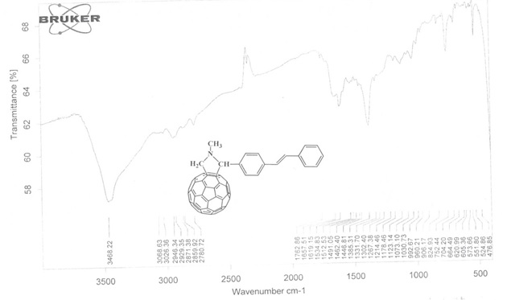
Figure 4 – IR spectrum of compound 5

The UV spectrum of compound 5 has 254, 319, and 431 nm (Fig. 5). The low-intensity peak at 431 nm is characteristic of all [6,6] closed fullerene С₆₀ adducts.
The ¹H NMR spectrum of compound 5 is characterized by the presence of a three-proton singlet signal at 2.87 ppm of the protons of the H-6,6,6 N-methyl fragment in the pyrrolidine ring. The single-proton singlet signal at 4.92 ppm indicates the presence of the H-5 methine proton in the pyrrolidine ring. The appearance of two single-proton doublet signals at 4.31 and 5.02 ppm with the same spin-spin coupling constant 2J 9.2 Hz confirms the presence of two axial and equatorial protons H-2ax and H-2eq of the pyrrolidine ring bound to the fullerene nucleus. The H-14 and H-13 protons of the ethene chain appeared as a single-proton doublet at 7.09 ppm with ³J 3.6 Hz and a broadened single-proton singlet at 7.81 ppm, respectively. The aromatic protons Н-18 and Н-9,11 appeared as one- and two-proton triplets at 7.25 ppm with ³J 7.2 Hz and 7.34 ppm with ³J 7.6 Hz, respectively. Two-proton doublets resonated at 7.27 ppm with ³J 8.4 Hz protons Н-17,19, at 7.47 ppm with ³J 7.6 Hz protons Н-9,11 and at 7.57 ppm with ³J 8.0 Hz protons Н-8,12, respectively.

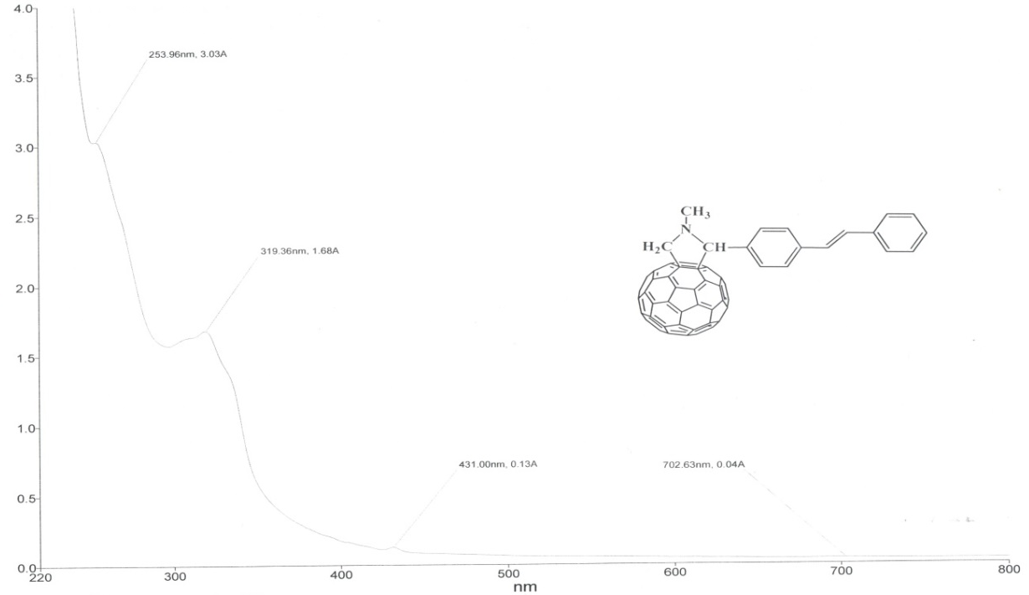
Figure 5 – UV spectrum of compound 5

In the ¹³C NMR spectrum of compound 5, the signals of the pyrrolidine ring with an N-methyl substituent are observed at 40.12 (C-6), 70.12 (C-2), and 83.47 (C-5) ppm The carbon atoms of aromatic and unsaturated fragments resonated at 126.70 (C-9 , 11), 126.99 (C-8.12), 127.85 (C-18), 128.36 (C-14), 128.79 (C-16.20), 129.36 (C-13), 137.73 (C-15), 139.69 (C-10) and 156.22 (C-7) ppm Numerous signals in the range 136-148 ppm belong to sp²-hybridized carbon atoms of the fullerene core.
The structure of compound 5 was also confirmed by the methods of two-dimensional NMR spectroscopy COZY (¹H-¹H) and HSQC (¹H-¹³C), which makes it possible to establish spin-spin interactions of homo- and heteronuclear nature. The observed correlations in the molecule are shown in Figure 6. In the ¹H-¹H COZY spectra of compound 5, spin-spin correlations are observed through two bonds of methylene protons H2ax-H2eq (4.31, 5.02 and 5.02, 4.31) ppm and through three bonds of protons of neighboring methine groups H16, 20-Н18 (7.34, 7.26 and 7.26, 7.34), Н16,20-Н9,11 (7.34, 7.48 and 7.48, 7.34), and Н8,12-Н13 (7.56, 7.81 and 7.81, 7.56) ppm of aromatic rings. Heteronuclear interactions of protons with carbon atoms through one bond were established using ¹H-¹³C HSQC spectroscopy for the following pairs present in the compound: Н⁶-С⁶ (2.87, 40.12), Н^{2ах}-С² (4.31, 70.16), Н^{2eq}-С² (5.02, 70.16), Н⁵-С⁵ (4.98, 83.47), Н¹⁴-С¹⁴ (7.10, 128.36), Н¹⁸-С¹⁸ (7.24, 127.84), Н^{16,20}-С^{16,20} (7.34. 129.11), Н^{9,11}-С^{9,11} (7.48, 126.70), Н^{8,12}-С^{8,12} (7.57, 126.99), Н¹³-С¹³ (7.80, 129.36).
¹H-¹H | ¹H-¹³C
Figure 6 – Correlations in the spectra COZY compounds 5

The main problem that complicates biological studies of fullerene derivatives and the creation of medicinal preparations based on them is the insolubility of fullerenes in water. One of the possible options for overcoming this problem is the preparation of water-soluble complexes of fullerene derivatives with water-soluble polymers approved for use in medicine, for example, with poly-N-vinylpyrrolidone.
In this regard, complex 6 of compound 5 with poly-N-vinylpyrrolidone was obtained in methylene chloride:

The formation of complex 6 occurs as a result of the solubilization of fullerenepyrrolidine by 5 PVP chains and physical interaction of the lactam group with the fullerene sphere. The resulting complex 6 is soluble in water.
Thus, in order to create new structures containing several pharmacologically active functional groups, by the reaction [2 + 3] cycloaddition of trans-4-stilbenecarboxaldehyde to C60-fullerene in the presence of sarcosine under the Prato reaction conditions, we synthesized N-methyl-2-(4-styrylphenyl)-3,4-fulleropyrrolidine, the structure of which was proved by 1H and 13C NMR spectroscopy, as well as by the data of two-dimensional spectra COSY (¹H-¹H) nd HMQC (¹H-¹³C).

1.1.3 Synthesis and NMR spectroscopic study of the structure of 2- (4 - ((E) -styryl) phenyl) - (4S, 5S) -3,4-dimethyl-5-phenyl-1,3-oxazolidine

Biologically active compounds, namely alkaloids and stilbenoids, due to their structural diversity, make it possible to create on their basis a number of new medicinal substances with a wide spectrum of pharmacological action. The synthesis of compounds combining different functional fragments in one molecule is of interest in terms of studying their mutual influence on biological activity and opens up new possibilities for subsequent targeted chemical modification.
Taking into account the scientific and applied perspectives of stilbenes, we have carried out the synthesis of 2-substituted 1,3-oxazolidine based on the d-pseudoephedrine alkaloid and trans-4-stilbenecarboxaldehyde. Interest in 1,3-oxazolidine derivatives of ephedrine alkaloids is due to the fact that these compounds have unique properties that allow them to be used for various practical purposes in medicine and industry, and are also of great scientific interest as products of enantioselective synthesis of planar-chiral compounds [21]. We have previously established the absolute configurations of chiral centers of a number of 1,3-oxazolidine compounds obtained on the basis of ephedrine alkaloids and a number of aromatic aldehydes [22, 23]. The condensation reaction of the d-pseudoephedrine alkaloid with trans-4-stilbenecarboxaldehyde was carried out by boiling in an absolute benzene medium in a Dean-Stark trap until the azeotropic distillation of water ceased.

The reaction proceeds rather quickly and with a high yield (80%) of the formation of oxazolidine 7.
The structure of compound 7 was studied by IR ¹H NMR spectroscopy and X-ray structural analysis, the analysis of the data of which suggests that the reaction product is oxazolidine with the S configuration at the C2 atom of the oxazolidine ring. Apparently, this is the result of thermodynamic control of the cyclization process, i.e. under the conditions studied, the formation of the 2R isomer is sterically less favorable. The IR spectrum of compound 7 lacks absorption bands of the hydroxyl and carbonyl groups of the starting reagents.
In the high-field region of the ¹H NMR spectrum of the compound 7 under investigation, dissolved in acetonitrile (Fig. 7), signals of methyl groups are observed at C-13 (1.15-1.16 ppm) and C-12 (1.91 ppm). Further, there are signals at 2.37-2.52 ppm, 4.69 and 4.93 ppm of CH-groups of a five-membered heterocycle with two heteroatoms O and N. In the low-field part of the spectrum (δ = 7.22-7.59 ppm) resonate protons of aromatic systems.
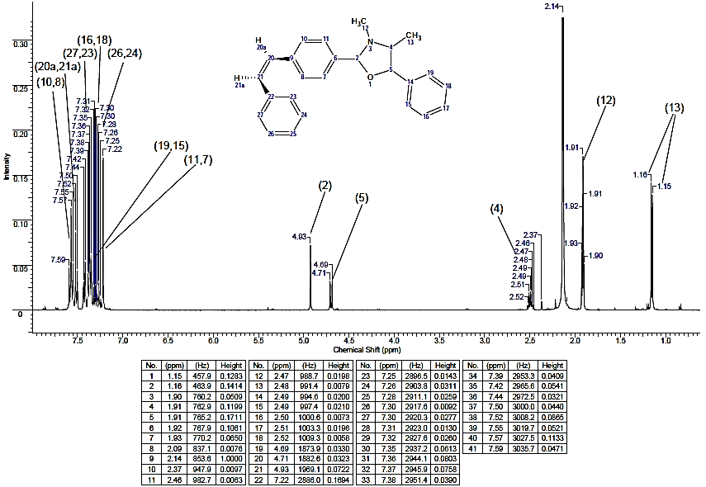

Figure 7 - ¹H NMR spectrum of compound 7

In the ¹³C NMR spectrum of compound 7, the signals of carbon atoms C-2, C-4, and C-5 of the five-membered heterocycle are observed in the region of 99.07, 68.69, and 86.39 ppm, respectively (Fig. 8). Methyl detectors of this system correspond to signals at 13.72 and 34.51 ppm. -9, C-22, C-14 and C-6.

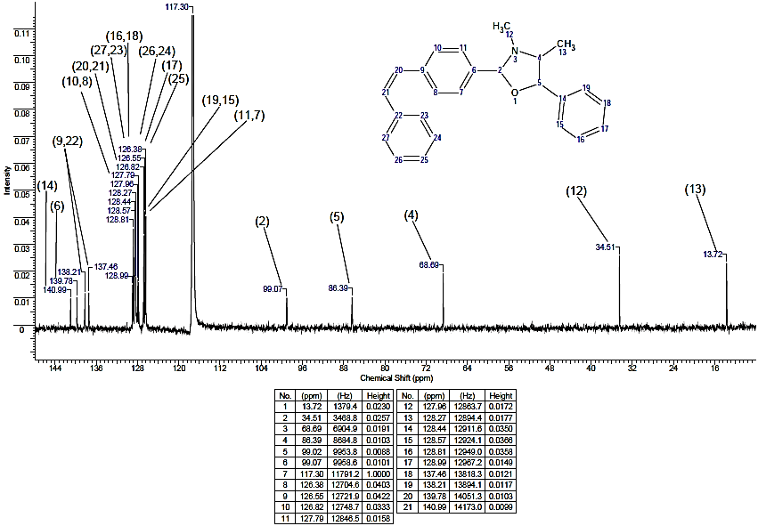

Figure 8 - ¹³С NMR spectrum of compound 7
The results of the interpretation of the two-dimensional spectrum 7 in the HMQC format (¹H ¹³C), with the help of which it is possible to establish spin-spin interactions of a homo- and heteronuclear nature, are presented in Figures 9 and 10.
Figure 9 – Correlations of TOCSY (¹H-¹H) and HMQC (¹H-¹³C) compound 7

Procedure for the synthesis of 2- (4-styrylphenyl) - (4S, 5S) -3,4-dimethyl-5-phenyl-1,3-oxazolidine (7). A mixture of 0.4 g (0.0024 mol) of d-pseudoephedrine and 0.53 g (0.0024 mol) of trans-4-stilbenecarboxaldehyde in 40 ml of absolute benzene was refluxed for 2 h with azeotropic distillation formed during the reaction of water. After the completion of the reaction, the solvent was distilled off, the residue was a light yellow thick oil, and the mixture was chromatographed on a silica gel column (eluent chloroform). After distilling off the solvent, the residue was triturated with petroleum ether. 0.55 g (65%) of product (7) was obtained in the form of a yellow powder with m.p. 137-140 ° C.
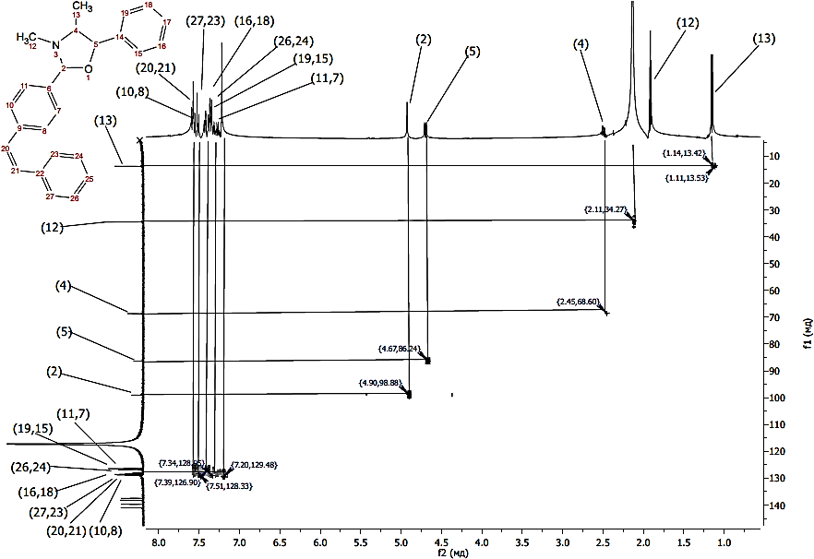

Figure 10 – Capture of the HMQC spectrum of compound 7

Thus, condensation of the d-pseudoephedrine alkaloid with trans-4-stilbenecarboxaldehyde in a non-polar aprotic solvent has synthesized a 2-stilbene-containing 1,3-oxazolidine, the structure of which was proved by ¹H NMR, ¹³C spectroscopy. It was shown that the reaction of 1,3-oxazolidine formation proceeds stereoselectively with the formation of one stereoisomer with the S-configuration at the C2 atom.

1.2 Development of optimal technological parameters for obtaining the most bioactive modified chalcones, pyrazolines, chromones and stilbenoids

As you know, hybrid molecules are systems with two or more pharmacophore fragments (chalcones, pyrazolines, chromones and stilbenoids) with various chemical and biological functions, the pharmacotherapeutic properties of which help to expand the range of their use, reduce side effects and reduce resistance to them. In this case, parts of a hybrid can act both on one biological target and on different ones, which causes interest in the synthesis of hybrid systems. In this regard, the search for ways to combine these pharmacophore fragments is an important task in synthetic organic chemistry and opens up prospects for the construction of new systems with practically significant properties.
1.2.1 Synthesis and structure of promising new stilbene-containing chalcone and pyrazoline

Chalcones are the preferred structures in organic synthesis and are used for the design of various classes of heterocyclic compounds. Significant interest in chalcones is associated with their various pharmacological properties, with their high synthetic potential, which indicates the possibility of using them in the synthesis of many biologically important substances that are promising for use in medicine and agriculture. In turn, chalcones are convenient and affordable intermediates for the construction of various complex poly (hetero) cyclic structures. Therefore, the synthesis of new functionalized chalcones containing, in particular, a stilbenoid group, on the basis of which new biologically active heterocyclic structures can be obtained, is a very important area of ​​research.
Taking into account the scientific and applied prospects of chalcones, in continuation of previously performed works [24, 25], we studied the interaction of 2-hydroxyacetophenone with trans-4-stilbenecarboxaldehyde in the presence of an aqueous alcoholic alkali solution (Claisen-Schmidt condensation). The reaction was carried out at an equimolecular ratio of reagents in the presence of 40% KOH at room temperature for 54 h. The progress of the reaction was monitored using thin layer chromatography. The resulting stilbene-containing chalcone 8 is a powdery yellow substance soluble in benzene, alcohol, and chloroform.

The structure of the obtained chalcone 8 was established by IR, ¹H and ¹³C NMR spectroscopy, as well as by the data of two-dimensional spectra COZY (¹H-¹H) and HMQC (¹H-¹³C).
In the IR spectrum of compounds 8, fairly intense absorption bands are observed in the region of 1592-1580 cm⁻¹, which correspond to the vibrations of the C = C bond conjugated with the carbonyl group.
In the ¹H NMR spectrum of compound 8, the protons H-14 and H-13 of the ethene chain appeared as a one-proton doublet at 7.09 ppm with ³J 3.6 Hz and a broadened single-proton singlet at 7.81 ppm, respectively. Aromatic protons Н-18 and Н-9,11 appeared as one- and two-proton triplets at 7.25 ppm with ³J 7.2 Hz and 7.34 ppm with ³J 7.6 Hz, respectively. Two-proton doublets resonated at 7.27 ppm with ³J 8.4 Hz protons Н-17,19, at 7.47 ppm with ³J 7.6 Hz protons Н-9,11 and at 7.57 ppm with ³J 8.0 Hz protons Н-8,12, respectively.
The structure of compound 8 was confirmed by two-dimensional NMR spectroscopy COZY (¹H-¹H) and HSQC (¹H-¹³C), which makes it possible to establish spin-spin interactions of homo- and heteronuclear nature.
1- (2-Hydroxyphenyl) -3- (4-styrylphenyl) prop-2-en-1-one (8). A solution of 0.19 g (0.0014 mol) of 2-hydroxyacetophenone and 0.3 g (0.0014 mol) of trans-4-stilbenecarboxaldehyde in 20 ml of ethanol was added dropwise to 10 ml of a 40% potassium hydroxide solution with stirring at room temperature. As the addition proceeded, the reaction mixture acquired a yellow color, the solution temperature rose to 32 ° C. The reaction mixture was kept at room temperature for 54 hours. Then the reaction mixture was acidified with dilute hydrochloric acid to neutrality and left overnight in a refrigerator (at -15°C). The precipitated light brown powder was filtered off, dried, and recrystallized from benzene.
The cyclocondensation reaction of hydrazines with α, β-unsaturated ketones is an important synthetic route to 1,2-azoles. Some pyrazole derivatives exhibit the properties of analgesics and platelet aggregation inhibitors, and have strong antibacterial and anesthetic effects [26].
In order to further functionalize the obtained chalcone 8, we studied its interaction with hydrazine hydrate. It was found that, upon boiling chalcone with hydrazine hydrate in ethanol, intramolecular cyclocondensation of the intermediate hydrazone occurs with the formation of the corresponding pyrazole derivative 9.

The structure of compound 9 was confirmed by IR and NMR spectroscopy. Thus, in the IR spectrum of pyrazoline 9, a band of average intensity of the C = N group of the pyrazoline nucleus is clearly manifested in the range 1601–1605 cm ^{– 1}.
In the ¹H NMR spectrum of 2- (5- (4-styrylphenyl) -4,5-dihydro-1H-pyrazol-3-yl) phenol (9), it was found that the group of signals in a low field corresponds to the protons of the 2-hydroxyphenyl and styryl fragments. Two doublets at 7.40 and 7.23 ppm correspond to ortho and meta-protons of the 4-hydroxyphenyl fragment, and two doublets at 6.84 and 6.72 ppm correspond to ortho- and meta-protons of the 4-methoxyphenyl fragment. The protons of the methoxy group correspond to the intense singlet at 3.67 ppm. The next group of signals, which is a triplet in the range of 4.63-4.68 ppm, corresponds to the methine proton (CH_{pyr}) of the pyrazoline fragment. The methylene protons of this fragment resonate in the region of 2.65-2.72 ppm in the form of two doublets. The weak signal at 9.67 ppm refers to the NH-proton of the pyrazoline fragment.
2- (5- (4-Styriphenyl) -4,5-dihydro-1H-pyrazol-3-yl) phenol (9). To 0.002 mol of chalcone 8 in 10 ml of ethanol was added 0.02 mol of hydrazine hydrate. The mixture was heated at 70-80 ° C for 4 hours, then cooled and diluted in 50 ml of water. The precipitate was filtered off, washed with water, and recrystallized from ethanol. Yield 74%, m.p.… ..
Thus, the synthesis of chalcone was carried out and its intramolecular cyclocondensation was carried out with the formation of a promising pyrazoline. Using spectra in the formats COZY (¹H-¹H) and HMQC (¹H-¹³C), homo- and heteronuclear interactions were established, confirming the structure of the compounds under study.

1.2.2 Synthesis of promising chromene-containing fullerenes

In fullerene synthesis, a poorly studied and interesting "pharmacophore" group is the chromene fragment, which belongs to the oxygen-containing heterocyclic system most widespread in the plant world, which is the basis of flavonoids. It should be noted that the chromene system is a part of flavonoids (quercetin, dihydroquercetin, etc.), belonging to a group of substances known for their antioxidant properties [27]. Due to its low toxicity to mammals and significant solubility, the chromone fragment is considered one of the preferred building blocks in the creation of pharmacologically important substances. However, compounds containing both a chromene fragment and a fullerene sphere have been little studied. The only work that describes the synthesis of the fullerene-flavone dyad based on formyl derivatives of natural flavones is described in [16].
Taking into account the scientific and applied perspectives of flavonoid fullerene derivatives, in continuation of previously performed works [28, 29], we carried out a three-component condensation of fullerene C₆₀, N-methylglycine (sarcosine) and substituted chromone-3-aldehydes under the Prato reaction conditions. The synthesis of fullerene pyrrolidines 10-12 was carried out in xylene and toluene media with heating the reaction mixture for 3 hours. The highest yields of the target fullerene pyrrolidines 10-12 were obtained in p-xylene medium (10-12% higher). The purity and individuality of the obtained fulleropyrrolidines 10-12 were analyzed using HPLC analysis.

The mechanism of formation of 3- [1-methyl-fullerene-C60- [1,9c] -pyrrolidin-2-yl] -4H-chromen-4-one (10-12), according to literature data [16], proceeds as 1, 3-dipolar addition to fullerene C₆₀ through the intermediate formation of active azomethine ylides.
The structure of the obtained new fulleropyrrolidines 10-12 was established by IR, ¹H and ¹³C NMR spectroscopy, as well as by the data of two-dimensional spectra COZY (¹H-¹H) and HMQC (¹H-¹³C). In the IR spectra of compounds 10-12, bands for C – N bonds are observed pyridine ring, vibrational frequencies of the fullerene skeleton, C – H and N – H bonds are present.
The ¹H NMR spectrum of compound 10 is characterized by the presence of a three-proton singlet signal at 2.91 ppm of protons of the N-methyl fragment of the attached addend. The appearance of two single-proton doublet signals at 4.37 and 4.98 ppm with the same spin-spin coupling constant ²J 9.6 Hz confirms the presence of two axial and equatorial protons CHax and CHeq of the pyrrolidine ring bound to the fullerene nucleus. The single-proton singlet signal at 5.65 ppm indicates the presence of a methine proton in the pyrrolidine ring. The protons Н-5 and Н-4 of the aromatic ring appeared as one-proton triplets at 7.45 ppm with ³J 7.6 Hz and 7.72 ppm ³J 7.2 Hz, respectively. The expected single-proton doublet was the protons Н-3 at 7.52 ppm with ³J 8.4 Hz. Proton Н-6 resonated with a single-proton multiplet at 8.20-8.23 ppm In the lowest-field part of the spectrum at 8.55 ppm, the proton Н-10 appeared as a single-proton singlet.
In the ¹³C NMR spectrum of compound 10, the signals of the pyrrolidine ring with an N-methyl substituent are observed at 21.74, 30.14, 39.95, 70.03, and 72.29 ppm The carbon atoms of the bicyclic fragment resonated at 118.32 (C-3), 121.02 (C-9), 124.05 (C- 7), 125.47 (С-5), 126.51 (С-6), 133.79 (С-4), 154.22 (С-2), 157.11 (С-10) and 176.29 (С-8) ppm Numerous signals in the region 136 -148 ppm belongs to the sp2-hybridized carbon atoms of the fullerene core.
The structure of compound 10 was also confirmed by the methods of two-dimensional NMR spectroscopy COZY (¹H-¹H) and HSQC (¹H-¹³C), which makes it possible to establish spin-spin interactions of homo- and heteronuclear nature. The observed correlations in the molecule are shown in the diagrams. In the 1H-1HCOSY spectra of compound 1, spin-spin correlations are observed through two bonds of methylene protons Hax-Heq (4.40, 5.01 and 5.01, 4.40) ppm and through three bonds of protons of neighboring methine groups H3-H4 (7.52, 7.73 and 7.73, 7.52) and H5-H6 (7.45, 8.21 and 8.21, 7.45) ppm of the bicyclic ring. Heteronuclear interactions of protons with carbon atoms through one bond were established using 1H-13CHSQC spectroscopy for the following pairs present in the compound: Н-С (СH₃-N)(2.91, 39.95), Н_{ax}-С(СH₂)(4.36, 70.02), Н_{eq}-С(СH₂)(4.98, 70.02), Н-С(СH)(5.64, 74.30), Н³-С³ (7.52, 118.32), Н⁵-С⁵ (7.45, 125.47), Н⁴-С⁴ (7.72, 126.51), Н⁶-С⁶ (8.22, 126.51), Н¹⁰-С¹⁰ (8.55, 156.13).
3- [1-Methyl-fullerene-C60- [1,9c] -pyrrolidin-2-yl] -4H-chromen-4-one (10). To a solution of 100 mg (0.1388 mmol) C₆₀ in 20 ml of xylene were added 48 mg (0.2776 mmol) of 4-oxo-4H-chromene-3-carboxaldehyde and 123.6 mg (1.388 mmol) of N-methylglycine (molar ratio of reagents 1: 2: 5, respectively ). The reactive mixture was boiled for 3 h at 110-120⁰C. After removal of the solvent, the residue was chromatographed on a silica gel column, eluting unreacted C60 and the product with toluene. Yield 28 mg (21%).
6-Bromo-3- [1-methyl-fullerene-C₆₀- [1,9c] -pyrrolidin-2-yl] -4H-chromen-4-one (11). Yield 21 mg (14.7%). ¹H NMR spectrum,δ, ppm (J, Hz): 2.91 s (3Н, Н-18,18,18), 4.37 d (1Н, Н-15ах, ²J 9.6), 4.98 d (1Н, Н-14eq, ²J 9.6), 5.62 s (1Н, Н-13), 7.43 d (1Н, Н-3, ³J 9.2), 7.79 dd (1Н, Н-4, ³J 8.8, ⁴J 2.4), 8.32 d (1Н, Н-6, ⁴J 2.0), 8.54 s (1Н, Н-10). ¹³С NMR spectrum, δ_{С}, ppm: 21.73 (С-17), 30.16 (С-16), 39.96 (С-18), 70.02 (С-15), 72.25 (С-13), 120.15 (С-3), 121.40 (С-7), 125.31 (С-5), 129.19 (С-6), 136.81 (С-4), 156.29 (С-2), 157.14 (С-10), 119.61 (С-9), 174.97 (С-8).
6-Methyl-3- [1-methyl-fullerene-C60- [1,9c] -pyrrolidin-2-yl] -4H-chromen-4-one (12). Yield 17.2 mg (12.8%). NMR spectrum ¹Н, δ, ppm (J, Hz): 2.51 s (3Н, Н-11,11,11), 2.91 s (3Н, Н-18,18,18), 4.35 d (1Н, Н-15ах, ²J 7.6), 4.97 d (1Н, Н-15eq, ²J 7.6), 5.63 s (1Н, Н-13), 7.41 d (1Н, Н-3, ³J 6.8), 7.79 dd (1Н, Н-4, ³J 7.2, ⁴J 1.6), 7.98 s (1Н, Н-6), 8.51 s (1Н, Н-10). ¹³С NMR spectrum, δ_{С}, ppm: 21.54 (С-11), 21.73 (С-17), 30.16 (С-16), 39.97 (С-18), 70.02 (С-15), 72.33 (С-13), 118.14 (С-3), 120.76 (С-5,9), 123.75 (С-7), 125.94 (С-6), 135.01 (С-4), 156.46 (С-2), 156.92 (С-10), 176.31 (С-8).

1.2.3 Prediction of the biological activity of stilbene-containing hydrazones, oxazodidine, chalcone, and pyrazoline in the PASS system

The prediction of the biological activity of stilbene-containing hydrazones, oxazodidine, chalcone and pyrazoline was carried out according to the structural formula of a chemical compound in the Internet version of the PASS computer system (Prediction of Activity Spectra for Substances) [30, 31].
The prediction result is displayed in the form of a list of activity names with calculated values ​​of the probabilities of presence (P_{a}) or absence (P_{i}) of each of the types of activity. If P_{a}> 0.7, then most likely this compound will exhibit this type of biological activity in the experiment, but this substance can be an analogue of a medicinal compound. If 0.5 <P_{a} ≤ 0.7, then there is a high probability that this substance will exhibit this type of biological activity in the experiment, but this substance is less similar to known medicinal compounds. If P_{a} ≤ 0.5, then the probability that a given substance will exhibit this type of activity in the experiment is less, but if its presence is experimentally confirmed, then the substance may turn out to be a new basic structure.
The results of the prediction of the biological activity of the synthesized compounds are presented in table 1. PASS prediction of some previously synthesized compounds is presented in Appendix C.

Table 1 – The results of the prediction of the biological activity of the synthesized compounds in the PASS program
Compound | Pa | Pi | Activity / effect
 | 0,873 | 0,002 | Antituberculosic
 | 0,851 | 0,003 | Antimycobacterial
 | 0,824 | 0,004 | HMGCS2 expression enhancer
 | 0,800 | 0,013 | G-protein-coupled receptor kinase inhibitor
 | 0,800 | 0,013 | Beta-adrenergic receptor kinase inhibitor
 | 0,759 | 0,003 | PfA-M1 aminopeptidase inhibitor
 | 0,750 | 0,004 | Mcl-1 antagonist
 | 0,751 | 0,006 | Threonine aldolase inhibitor
 | 0,716 | 0,004 | Cytoprotectant
 | 0,705 | 0,004 | Catechol oxidase inhibitor
 | 0,703 | 0,031 | Taurine dehydrogenase inhibitor
Continuation of table 1
 | 0,843 | 0,003 | Antituberculosic
 | 0,841 | 0,004 | Threonine aldolase inhibitor
 | 0,826 | 0,003 | Antimycobacterial
 | 0,824 | 0,004 | HMGCS2 expression enhancer
 | 0,812 | 0,012 | G-protein-coupled receptor kinase inhibitor
 | 0,812 | 0,012 | Beta-adrenergic receptor kinase inhibitor
 | 0,810 | 0,034 | Membrane integrity agonist
 | 0,774 | 0,005 | Amine dehydrogenase inhibitor
 | 0,770 | 0,018 | Taurine dehydrogenase inhibitor
 | 0,732 | 0,003 | PfA-M1 aminopeptidase inhibitor
 | 0,732 | 0,008 | Phosphatidylserine decarboxylase inhibitor
 | 0,719 | 0,004 | Mcl-1 antagonist
 | 0,718 | 0,004 | Cytoprotectant
 | 0,712 | 0,009 | Glutamine-phenylpyruvate transaminase inhibitor
 | 0,789 | 0,013 | Nicotinic alpha6beta3beta4alpha5 receptor antagonist
 | 0,750 | 0,017 | Nicotinic alpha2beta2 receptor antagonist
 | 0,706 | 0,009 | CYP2A6 substrate
 | 0,696 | 0,007 | (S)-6-hydroxynicotine oxidase inhibitor
 | 0,673 | 0,011 | (R)-6-hydroxynicotine oxidase inhibitor
 | 0,668 | 0,013 | CYP2A substrate
 | 0,674 | 0,043 | CYP2H substrate
 | 0,641 | 0,010 | CYP2D16 substrate
 | 0,635 | 0,005 | Octopamine antagonist
 | 0,657 | 0,030 | Anaphylatoxin receptor antagonist
 | 0,635 | 0,016 | Oxygen scavenger
Continuation of table 1
 | 0,953 | 0,004 | Antiasthmatic
 | 0,943 | 0,004 | Antiallergic
 | 0,912 | 0,001 | Rhinitis treatment
 | 0,821 | 0,003 | Biliary tract disorders treatment
 | 0,702 | 0,005 | Atherosclerosis treatment
 | 0,622 | 0,009 | Prenyl-diphosphatase inhibitor
 | 0,650 | 0,051 | Nicotinic alpha6beta3beta4alpha5 receptor antagonist
 | 0,611 | 0,064 | CYP2H substrate
 | 0,543 | 0,027 | Beta glucuronidase inhibitor
 | 0,557 | 0,042 | HIF1A expression inhibitor
 | 0,512 | 0,011 | Hepatic disorders treatment
 | 0,510 | 0,025 | APOA1 expression enhancer
 | 0,928 | 0,003 | Feruloyl esterase inhibitor
 | 0,924 | 0,004 | Mucomembranous protector
 | 0,900 | 0,011 | Membrane integrity agonist
 | 0,882 | 0,012 | Aspulvinone dimethylallyltransferase inhibitor
 | 0,869 | 0,003 | Monophenol monooxygenase inhibitor
 | 0,857 | 0,005 | JAK2 expression inhibitor
 | 0,816 | 0,005 | Caspase 3 stimulant
 | 0,814 | 0,008 | Dehydro-L-gulonate decarboxylase inhibitor
 | 0,808 | 0,004 | APOA1 expression enhancer
 | 0,805 | 0,004 | Fatty-acyl-CoA synthase inhibitor
 | 0,803 | 0,004 | Antihypoxic
 | 0,806 | 0,008 | Apoptosis agonist
 | 0,821 | 0,026 | Ubiquinol-cytochrome-c reductase inhibitor
 | 0,813 | 0,018 | CYP2J substrate
Continuation of table 1
 | 0,881 | 0,003 | Antineoplastic (non-small cell lung cancer)
 | 0,789 | 0,038 | Membrane integrity agonist
 | 0,723 | 0,060 | Ubiquinol-cytochrome-c reductase inhibitor
 | 0,676 | 0,030 | Antineoplastic
 | 0,620 | 0,009 | APOA1 expression enhancer
 | 0,643 | 0,045 | Taurine dehydrogenase inhibitor
 | 0,666 | 0,075 | Aspulvinone dimethylallyltransferase inhibitor
 | 0,575 | 0,018 | Histidine kinase inhibitor
 | 0,568 | 0,022 | MAP kinase stimulant
 | 0,553 | 0,024 | Beta glucuronidase inhibitor
 | 0,594 | 0,073 | Nicotinic alpha6beta3beta4alpha5 receptor antagonist
 | 0,521 | 0,018 | UGT2B12 substrate
 | 0,540 | 0,044 | JAK2 expression inhibitor
 | 0,804 | 0,005 | CYP2A6 substrate
 | 0,792 | 0,006 | CYP2A substrate
 | 0,783 | 0,004 | Histidine kinase inhibitor
 | 0,725 | 0,020 | Anaphylatoxin receptor antagonist
 | 0,687 | 0,013 | Kinase inhibitor
 | 0,687 | 0,019 | Aldehyde oxidase inhibitor
 | 0,678 | 0,015 | CYP2B6 substrate
 | 0,670 | 0,011 | 4-Nitrophenol 2-monooxygenase inhibitor
 | 0,665 | 0,054 | Membrane permeability inhibitor
 | 0,598 | 0,004 | CF transmembrane conductance regulator agonist
 | 0,548 | 0,022 | Neurodegenerative diseases treatment
 | 0,553 | 0,043 | HIF1A expression inhibitor
 | 0,568 | 0,060 | TP53 expression enhancer
Continuation of table 1
 | 0,712 | 0,007 | Histidine kinase inhibitor
 | 0,590 | 0,042 | Anaphylatoxin receptor antagonist
 | 0,526 | 0,007 | CF transmembrane conductance regulator agonist
 | 0,523 | 0,030 | Kinase inhibitor
 | 0,505 | 0,032 | CYP2A substrate
 | 0,486 | 0,032 | HMGCS2 expression enhancer
 | 0,485 | 0,035 | CYP2A6 substrate
 | 0,494 | 0,079 | Acetylcholine neuromuscular blocking agent
 | 0,441 | 0,032 | Dementia treatment
 | 0,419 | 0,016 | Antialcoholic
 | 0,415 | 0,025 | Antiparkinsonian
 | 0,399 | 0,010 | Photosensitizer
 | 0,439 | 0,050 | Neurodegenerative diseases treatment
 | 0,744 | 0,006 | Histidine kinase inhibitor
 | 0,743 | 0,008 | CYP2A6 substrate
 | 0,725 | 0,009 | CYP2A substrate
 | 0,660 | 0,018 | CYP2B6 substrate
 | 0,637 | 0,017 | Kinase inhibitor
 | 0,588 | 0,004 | CF transmembrane conductance regulator agonist
 | 0,644 | 0,064 | Membrane permeability inhibitor
 | 0,608 | 0,038 | Anaphylatoxin receptor antagonist
 | 0,575 | 0,017 | CYP1A2 substrate
 | 0,576 | 0,021 | CYP2D substrate
 | 0,571 | 0,021 | CYP2D6 substrate
 | 0,584 | 0,035 | Aldehyde oxidase inhibitor
 | 0,564 | 0,027 | CYP2C9 substrate
 | 0,565 | 0,049 | CYP3A4 substrate
 | 0,567 | 0,083 | CYP2H substrate

As a result of the prediction, it was found that most of the synthesized stilbene-containing derivatives are more likely (Pa> 0.7) to exhibit immunomodulatory, antioxidant activity and be phosphodiesterase inhibitors. For many compounds there is a high probability (P_{a}> 0.7) of antituberculous, antimycobacterial and antioxidant activities.

CONCLUSION

Based on the results of the research work carried out in 2020, the following results were obtained:
1 A condensation reaction of equimolar amounts of hydrazides of o- and p-hydroxybenzoic acids with trans-4-stilbenecarboxaldehyde was carried out by heating in ethanol for 1-2 hours. It was shown that the reaction proceeds smoothly with the formation of 2-hydroxy- and 4-hydroxy-N-(4-((E-)styryl) benzylidene) benzohydrazides in 91% and 80% yields, respectively.
2 The reaction of C₆₀ fullerene with trans-4-stilbenecarboxaldehyde and N-methylglycine under the conditions of the Prato reaction was studied. It was found that C₆₀ fullerene with aldehyde and N-methylglycine forms stilbensubstituted fulleropyrrolidine. A scheme for the formation of fulleropyrrolidine is proposed as a 1,3-dipolar addition to fullerene C₆₀ through the intermediate formation of active azomethine ylides.
3 A synthesis of compounds was carried out, combining in one molecule alkaloid and stilbenoid fragments, which are of practical interest in terms of studying their mutual influence on biological activity. Thus, for the first time, the synthesis of 2-substituted 1,3-oxazolidines was carried out by the interaction of the d-pseudoephedrine alkaloid with trans-4-stilbenecarboxaldehyde. It was found that the condensation process proceeds smoothly with a high formation of target products. It was shown that the reaction of 1,3-oxazolidine formation proceeds stereoselectively with the formation of one stereoisomer with the S-configuration at the C2 atom.
4 The interaction of 2-hydroxyacetophenone with trans-4-stilbenecarboxaldehyde in the presence of an aqueous-alcoholic alkali solution (Claisen-Schmidt condensation) with the formation of a stilbene-containing chalcone was studied. The reaction was carried out at an equimolecular ratio of reagents in the presence of 40% KOH at room temperature for 54 h. In order to further functionalize the obtained chalcone, its interaction with hydrazine hydrate was studied. It was found that when chalcone is boiled with hydrazine hydrate in ethanol, intramolecular cyclocondensation of the intermediate hydrazone occurs to form the corresponding pyrazole derivative.
5 Taking into account the scientific and applied perspectives of flavonoid fullerene derivatives, a three-component condensation of fullerene C₆₀, N-methylglycine (sarcosine) and substituted chromone-3-aldehydes was carried out under the conditions of the Prato reaction. The synthesis of flavonone-containing fulleropyrrolidines was carried out in xylene and toluene media by heating the reaction mixture for 3 h. The highest yields of the target fullerene pyrrolidines were obtained in p-xylene medium.
6 The structures of the synthesized compounds have been investigated by ¹H and ¹³C NMR spectroscopy, as well as by the data of two-dimensional spectra COZY (¹H-¹H) and HMQC (¹H-¹³C). The values ​​of chemical shifts, multiplicity and integral intensity of ¹H and ¹³C signals in one-dimensional NMR spectra were determined. Using spectra in the formats COZY (¹H-¹H) and HMQC (¹H-¹³C), homo- and heteronuclear interactions were established, confirming the structure of the compounds under study.

7 Using the PASS program to predict the spectrum of pharmacological activity, the prediction of biological activity by the structure of the synthesized compounds was carried out using logic-combinatorial methods using a databank on drug substances and biologically active compounds. The prospects of work in this direction are shown.
Based on the research results, 12 new derivatives of stilbene-containing acylhydrazones, fulleropyrrolidine, 1,3-oxazolidines, chalcone and pyrazoline were synthesized. Using modern physicochemical methods (IR-, ¹H-, ¹³C and ¹H-¹³C HSCQ-spectroscopy), their structures have been established. For the reporting year 2020, according to the results of the research performed, 1 monograph (Warsaw, Poland) and 7 scientific papers (5 scientific articles, 2 theses of reports) were published, 1 patent for an invention was received and 1 patent application of the Republic of Kazakhstan was filed.

Based on the results of the research work carried out in 2018, the following results were obtained:
1 Purposeful synthesis of new chalcones was carried out on the basis of functionally substituted acetophenones and substituted benzaldehydes under conditions of convection heating, microwave irradiation and ultrasonic activation. It is shown that the optimal condition for microwave exposure is a radiation power of 150 W with a duration of the product formation time of 30-60 min, and for sonochemical activation the exposure power is 20-35 V (130-227.5 W) with a duration of 20 -30 min at a temperature of 50 ° C. As a result of a comparative analysis of the data obtained, it was determined that the use of microwave irradiation and ultrasonic exposure promotes an increase in the yield of the product and a decrease in the reaction time from 8-9 hours to 20-60 minutes than with traditional technology.
2 For the first time, cyclocondensation and isomerization of 2-hydroxychalcones were obtained and studied the structure of new pyrazolines and flavones. It has been shown that the process of isomerization of chalcones to flavonones in alcohol is catalyzed by water molecules.
3 Using the PASS program to predict the spectrum of pharmacological activity, the biological activity was predicted by the structure of synthesized chalcones, pyrazolines and flavones using logical combinatorial methods using a databank on drug substances and biologically active compounds. The bioprognosis data for chalcones, pyrazolines and flavones indicate that the synthesized compounds may be promising as antibacterial drugs.
4 Data on the anti-inflammatory activity of the synthesized chalcones, pyrazolines and flavonones are presented. It was found that (E) -1- (4-hydroxyphenyl) -3- (4-methoxyphenyl) prop-2-en-1-one, (E) -1- (2,4-dihydroxyphenyl) -3- (4-methoxyphenyl) prop-2-en-1-one, (E) -1- (2-hydroxyphenyl) -3- (4-hydroxyphenyl) prop-2-en-1-one, 2, 2 '- (4,5-dihydro-1H-pyrazole-3,5-diyl) phenol, as well as 2- (2-hydroxyphenyl) flavon-4-one, suppressed the production of anti-inflammatory cytokines, tumor necrosis factor (TNF) and / or interleukin -6 (IL6) by a mechanism independent of the suppression of the transcriptional activity of NF-κB. One of the important physicochemical parameters that determine the biological activity of TNF and IL6 is the lipophilicity of the compounds.
5 Data on the antiradical activity of the synthesized chalcones, pyrazolines and flavonones are presented. It was found that, among a series of new compounds, derivatives of (E) -1- (2-hydroxyphenyl) -3- (3-ethoxy-4-hydroxyphenyl) -prop-2-en-1-one and 4- [5- (4- methoxyphenyl) -4,5-dihydro-1H-pyrazol-3-yl] benz-1,3-diol showed high antiradical activity against the DPPH radical. The results of studying antiradical activity are consistent with the energies of homolytic dissociation of O - H bonds, calculated by the quantum chemical density functional method.
6 Based on the research results, 15 new pyrazole derivatives were synthesized. Using modern physicochemical methods (IR-, ¹H-, ¹³C and ¹H-¹³C HSCQ-spectroscopy), their structures have been established. For the reporting year 2018, based on the results of the research performed, 7 scientific works were published (4 scientific articles and 3 theses of reports).

Based on the results of the research work carried out in 2019, the following results were obtained:
1 A literature review on the chemical transformation of 3-formylchromones was carried out. It was shown that the introduction of an aldehyde group into the position of the 3-chromone system radically changes the reactivity of the pyrone ring with respect to nucleophiles and determines the rich synthetic potential of 3-formylchromones.
2 The synthesis of 6-methyl-4-oxo-4H-chromene-3-acylhydrazones by condensation of functionally substituted 3-formylchromones and acylhydrazides was carried out. It was shown that the reactions of 4-oxo-4H-chromene-3-carboxaldehyde with hydrazides of isonicotinic and o- and p-hydroxybenzoic acids in isopropanol upon refluxing the reaction mixture for 2 h leads to the formation of the corresponding chromene-containing hydrazones.
3 The synthesis of compounds that combine alkaloid and flavonoid fragments in one molecule, which are of practical interest in terms of studying their mutual influence on biological activity, has been carried out. Thus, for the first time, the synthesis of 2-substituted 1,3-oxazolidines was carried out by the interaction of the d-pseudoephedrine alkaloid with 4-oxo-4H-chromene-3-carboxaldehyde. It was found that the condensation process proceeds smoothly with a high formation of target products. It was shown that the reaction of 1,3-oxazolidine formation proceeds stereoselectively with the formation of one stereoisomer with the S-configuration at the C2 atom.
4 The synthesis of Schiff bases by the interaction of 2- (aminomethyl) pyridine with 3-formylchromones (4-oxo-4H-chromene-3-carboxaldehyde, 6-methyl-4-oxo-4H-chromene-3-carboxaldehyde and 6-bromo- 4-oxo-4H-chromium-3-carboxaldehyde) in an absolute benzene medium with azeotropic distillation with a Dean-Stark trap. It has been shown that when boiling in benzene for 2 h, the reaction proceeds smoothly and leads to the formation of the corresponding chromene-containing azomethines in high yields of 63-98%.
5 Quantum-chemical calculations of the activity of substituted 3-formyl-chromones in reactions of synthesis of azomethine derivatives have been carried out. Based on the results of the studies carried out, it can be concluded that the ab initio quantum-chemical method 6-31G allows one to see the dependence of the geometric and charge characteristics of the molecules of substituted 3-formylchromones on the nature of the benzene ring substituents and to take into account the data obtained when carrying out modifications of compounds containing pharmacophore groups in the synthesis biologically active substances.
6 The structures of the synthesized compounds were studied by ¹H and ¹³C NMR spectroscopy, as well as by the data of two-dimensional spectra COZY (¹H-¹H) and HMQC (¹H-¹³C). The values of chemical shifts, multiplicity and integral intensity of ¹H and ¹³C signals in one-dimensional NMR spectra were determined. Using spectra in the formats COZY (¹H-¹H) and HMQC (¹H-¹³C), homo- and heteronuclear interactions were established, confirming the structure of the compounds under study..
7 Using the PASS program to predict the spectrum of pharmacological activity, the biological activity was predicted from the structure of the synthesized compounds using logic-combinatorial methods using a database of drug substances and biologically active compounds. The prospects of work in this direction are shown.
8 Data on the antiradical activity of the synthesized 6-methyl-4-oxo-4H-chromene-3-acylhydrazones, chromene-containing 1,3-oxazolidines and azomethine are presented. It was shown that the above compounds in a final concentration of 50 µM reduce the optical density of the initial solution of DPPH-radical by 27.5%, 25.2% and 8.8%, respectively, therefore, do not exhibit pronounced antiradical activity under the conditions of this test. systems. The results of the study of antimicrobial activity showed that among the presented samples of OZh-1 [3 - ((4S, 5S) -3,4-dimethyl-5-phenyloxazolidin-2-yl) -4H-chromen-4-one, comp. 21]; OZh-2 [6-methyl-3 - ((4S, 5S) -3,4-dimethyl-5-phenyloxazolidin-2-yl) -4H-chromen-4-one, comp. 22] and OZh-4 [3 - (((pyridin-2-ylmethyl) imino) methyl) -4H-chromen-4-one, comp. 24] exhibit moderate antibacterial activity against gram-positive test strains of Staphylococcus aureus, Bacillus subtilis and gram-negative strain of Escheriсhia coli.
Based on the research results, 8 new derivatives of chromene-containing acylhydrazones, 1,3-oxazolidines and azomethines were synthesized. Using modern physicochemical methods (IR-, ¹H-, ¹³C and ¹H-¹³C HSCQ-spectroscopy), their structures have been established. For the reporting year 2019, according to the results of the research performed, 1 monograph, 8 scientific papers were published (4 scientific articles, 2 theses of reports and 2 applications for a patent of the Republic of Kazakhstan were submitted).
The acts of biological activity of the new synthesized compounds are presented in the Appendices D-F. Prints of scientific publications on the topic for 2020 that do not have DOI are presented in Appendix G.

REFERENCES

1 Likhtenshtein G.I., Papper. Photochemical and photophysical characterization of 4,4’-substituted stilbenes: linear free energy // Recent Rescarh Development in Photochemistry and Photobiology. - 1997. – Vol.1. – P. 205–250.
2 Papper V., Likhtenshtein G.I. Substiluted stilbenes: a new view on well-known systems New applications in chemistry and biophysics // Journal of Photochemistry and Photobiology A: Chemistry. – 2001. – Vol. 140. – P. 39-52. DOI: 10.1016/S1010-6030(00)00428-7.
3 Polunin K.E., Sokolova N.P., Gorbunov A.M., Bulgakova R.A., Polunina I.A. Investigation of the interaction of stilbenes with silicon oxide by Fourier-IR spectroscopy // Surface Physics and Materials Protection. - 2008 - T. 44, No. 4. - S. 378-384.
4 Rijkenberg R.A., Bebelaar D., Buma W.J., Hofstraat J.W. Isolated Building Blocks of Photonic Materials: High-Resolution Spectroscopy of Excited States of Jet-Cooled Push-Pull Stilbenes // The Journal of Physical Chemistry A. – 2002. – Vol. 11. – P. 106-110. 2446-2456. https://doi.org/10.1021/jp013422j.
5 He Z., Xue R., Lei Y., Yu L., Zhu Ch. Photorelaxation Pathways of 4-(N,N-Dimethylamino)-4′-nitrostilbene Upon S1 Excitation Revealed by Conical Intersection and Intersystem Crossing Networks // Molecules. – 2020. –Vol. 25 (9). – P. 2230-2235. https://doi.org/10.3390/molecules25092230.
6 Görner H., Kuhn H.J. Cis-Trans Photoisomerization of Stilbenes and Stilbene-Like // Molecules. – 2007. – Vol.1. – P.1-117. https: // doi.org / 10.1002/9780470133507.ch1.
7. Megyesi M., Biczók L., Görner H., Miskolczy Z. Effects of solvent polarity and hydrogen bonding on the fluorescence properties of trans-4-hydroxy-4′-nitrostilbenes // Chemical Physics Letters. – 2010. – Vol. 489 (1-3). – P. 59-63. https://doi.org/10.1016/j.cplett.2010.02.050.
8 Nanjo T. Synthesis of (Z)-Alkenes by Catalytic Photoisomerization // Journal of Synthetic Organic Chemistry. - 2018. – Vol. 76 (12). – P. 1352-1353. https: // doi.org/10.5059/yukigoseikyokaishi.76.1352.
9 Abdel-Halim S.T. Steady-state fluorescence and photo-isomerization study of 1-methyl-4′-(p-N,N dimethyl-aminostyryl) pyridinium iodide // Journal of Luminescence. – 2011. – Vol.131(1). – P. 30-35. https://doi.org/10.1016/j.jlumin.2010.08.022.
10 Lisina S.V., Brel’ A.K., Mazanova L.S., Spasov A.A. Synthesis and antipyretic activity of new salicylic acid derivatives // Pharm. Chem. J. - 2008. - Vol. 42, N 10. - P. 24-26. DOI:10.1007/s11094-009-0184-4.
11 Belikov V.G. Synthetic and natural medicines. M .: Higher school, 1993 .- 85 p.
12 Schepetkin I.A., Khlebnikov A.I., Quinn M.T. N-Benzoylpyrazoles Are Novel Small-Molecule Inhibitors of Human Neutrophil Elastase // J. Med. Chem. - 2007. - Vol. 50. - P. 4928-4932. DOI: 10.1021/jm070600+.
13 Nurkenov O.A., Satpaeva Zh.B., Kulakov I.V., Akhmetova S.B., Zhaugasheva S.K. Synthesis and antimicrobial activity of o- and p-hydroxybenzoic acid thiosemicarbazides // Russ. J. Gen. Chem. - 2012. - Vol. 82, N 4. - P. 668-671. DOI: 10.1134/S107036321204010X.
14 Evranos-Aksöz B., Baysal İ., Yabanoğlu-Çiftçi S., Djikic T., Yelekçi K., Uçar G., Ertan R. Synthesis and Screening of Human Monoamine Oxidase‐A Inhibitor Effect of New 2‐Pyrazoline and Hydrazone Derivatives// Arch Pharm. - 2015. - Vol. 348(10). - P. 743-745. DOI: 10.1002/ardp.201500212.
15 Li Y.Y., Fang J., Ao G.Z. Cathepsin B and L inhibitors: a patent review (2010 - present) // Expert Opin. Ther. Pat. - 2016. - Vol. 1. - P. 14-17. DOI: 10.1080/13543776.2017.1272572.
16 Fullerenes: Textbook / L.N. Sidorov, M.A. Yurovskaya and others - M .: Exam Publishing House, 2005. - 688 p.
17 Khakina E.A., Kraevaya O.A., Popova M.L., Peregudov A.S., Troyanov S. I., Chernyak A.V., Martynenko V.M., Kulikov A.V., Schols D., Troshin P.A. Synthesis of different types of alkoxy fullerene derivatives from chlorofullerene C60Cl6 // Org. Biomol. Chem. – 2017. - Vol.15. - P. 773-777. DOI:10.1039/C6OB02251K.
18 Dumpis M.A. Biological activity of fullerenes – Reality and Prospects / M.A. Dumpis, D.N. Nikolaev, E.V. Litasova, V.V. Iljin, M.A.Brusina , L.B.Piotrovsky // Reviews on Clinical Pharmacology and Drug Therapy. – 2018. - Vol. 16, No. 1. - P. 4-9. doi: 10.17816/RCF1614-20.
19 Da Ros T., Prato M. Medicinal chemistry with fullerenes and fullerene derivatives // Chem. Commun. - 1999. – No. 2. - P. 663. doi: 10.1039/A809495K
20 Zhu Z., Schuster D.I., Tuckerman M.E. Molecular Dynamics Study of the Connection between Flap Closing and Binding of Fullerene – Based Inhibitors of the HIV-1Proteas // Biochemistry. - 2003. - Vol. 42, No. 5. - P. 1326-1329. doi: 10.1021/bi020496s.
21 Neelakantan L. Asimmetric synthesis. I. Synthesis and absolute configura-tion of oxazolidines derived from (-)-ephedrine and aromatic aldehydes // J. Org. Chem.-1971.- Vol. 36.- № 24,- P. 2256-2260. DOI: 10.1021/jo00815a012.
22 Nurkenov O.A., Dzhandygulov A.R., Gazaliev A.M., Turdybekov D., Adekenov S.M. Synthesis and crystal structure of (2S, 4S, 5R) -2- (2-hydroxy-5-bromo-phenyl) -3,4-dimethyl-5-phenyl-1,3-oxazolidine // Zh. total chemistry. - 2007. - T. 77, Issue. 9. - S. 1542-1545.
23 Fazylov S.D., Nurkenov O.A., Arinova A.E., Turdybekov K.M., Turdybekov D.M., Seilkhanov T.M., Sarsenbaev B.Sh., Zhivotova T.S., Isaeva A.Zh., Gazaliev A.M. Synthesis and spatial structure of 2-pyridine-3,4-dimethyl-5-phenyl-1,3-oxazolidine // Chemistry of Nature. conn. - 2016. - T. 52, No. 2. - S. 321-322.
24 Nurkenov O.A., Ibraev M.K., Schepetkin I.A., Khlebnikov A.I., Seilkhanov T.M., Arinova A.E. and Isabaeva M.B. Synthesis, Structure, and Anti-Inflammatory Activity of Functionally Substituted Chalcones and Their Derivatives // Russian Journal of General Chemistry. – 2019. - Vol. 89, No. 7. - Р. 1360–1367.
25 Ibrayev M.K., Akhmetova S.B., Takibayeva A.T., Issabayeva M.B., Nurkenov A.O., Seilkhanov О.T. Synthesis, structure and antimicrobial activity of substituted chalcones and their derivatives // Bulletin of the Karaganda University. Chemistry Series. - 2019. - № 3(95). –P. 28-36.

26 Kaname T., Masaaki T., Hikari M., Kuniyosci O., Katsuyuki I., Naoki N., Masayuki O. Synthesis and analgesic activity of 4-amino-1,2-dihydro-5-(2-hydroxyphenyl)-3H-pyrazol-3-ones and 5-amino-6-(2-hydroxyphenyl)pyrimidin-4(3H)-onesSynthèse et activité analgésique d'amino-4 dihydro-1,2 (hydroxy-2 phényl)-5 pyrazol (3H)-ones-3 et d'amino-5 (hydroxy-2 phényl)-6 pyrimidin (3H)-ones-4 // Eur. J. Med. Chem. - 1987. - Vol. 22, - No 3. - P. 239-242. Doi 10.1016/0223-5234(87)90055-9.
27 De la Torre M.D.L., Marcorin G.L., Pirri G., Tome A.C., Silva A.M.S., Cavaleiro J.A.S. Synthesis of Novel [60]Fullerene — Flavonoid Dyads // Tetrahedron Lett. — 2002. — Vol. 43. — P. 1689. doi: org/10.1002/chin.200221077
28 Fazylov S.D. Nurkenov O.A., Arinova A.E., Seilkhanov T.M., Tuktarov A.R., Khuzin A.A., Bakirova R.E., Muravleva L.E. // Journal. general chemistry. - 2015. - T.85, No. 5. - S. 751-753 (Fazylov SD, Nurkenov OA, Arinova AE, Seilkhanov TM, Tuktarov AR, Khuzin AA, Bakirova RE, Muravleva LA // Russ. J. Gen. Chem. - 2015. - Vol. 85, N 5 - P. 1049.). doi 10.1134 / S1070363215050072.
29 Fazylov S.D., Nurkenov O.A., Arinova A.E., Tuktarov A.R., Khuzin A.A., Turdybekov K.M. // Zh. general chemistry. - 2014. - T. 84, No. 10. - S. 1757-1760. (Fazylov S.D., Nurkenov O.A., Arinova A.E., Tuktarov A.R., Khuzin A.A., Turdybekov K.M. // Russ. J. Gen. Chem. - 2014. - Vol. 84, N 10. - P. 2058.). doi 10.1134 / S1070363214100375.
30 Internet system for predicting the spectrum of biological activity of chemical compounds / A.V. Sadym, A.A. Lagunin, D.A. Filimonov, V.V. Poroikov // Chem.-Pharm. zhurn. - 2002. - T. 36B # 10. - S. 21-26.
31 Poroikov V.V. Forecast of the spectrum of biological activity of organic compounds / V.V. Poroikov, D.A. Filimonov // Zh. Grew up. chem. about-va them. DI. Mendeleev. - 2006. - No. 2. - P. 66-75.

APPENDIX A

Work schedule for 2018-2020
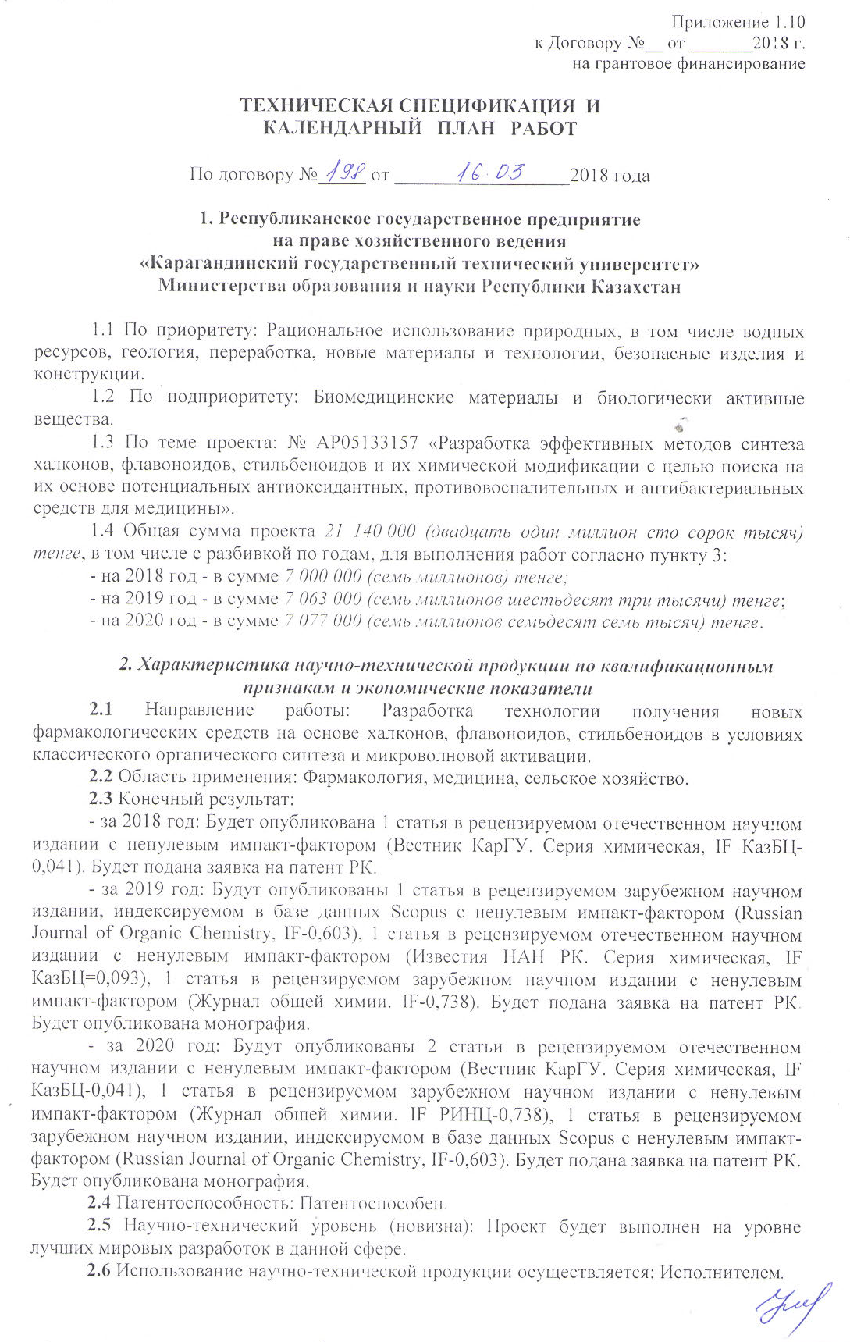

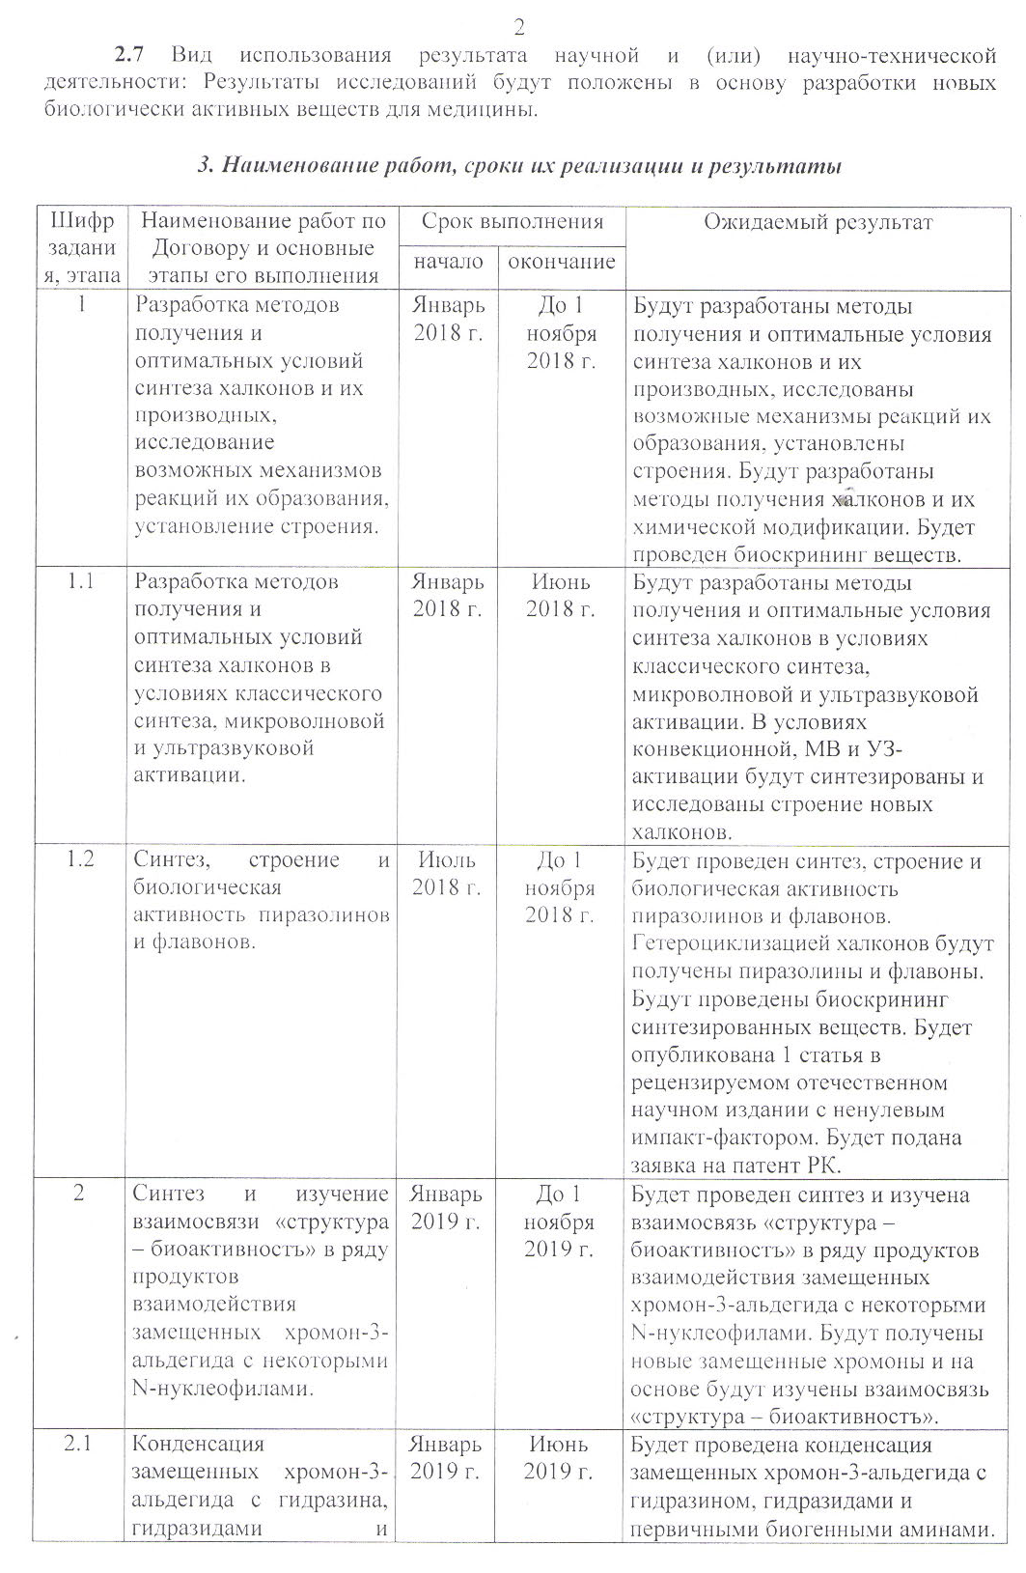

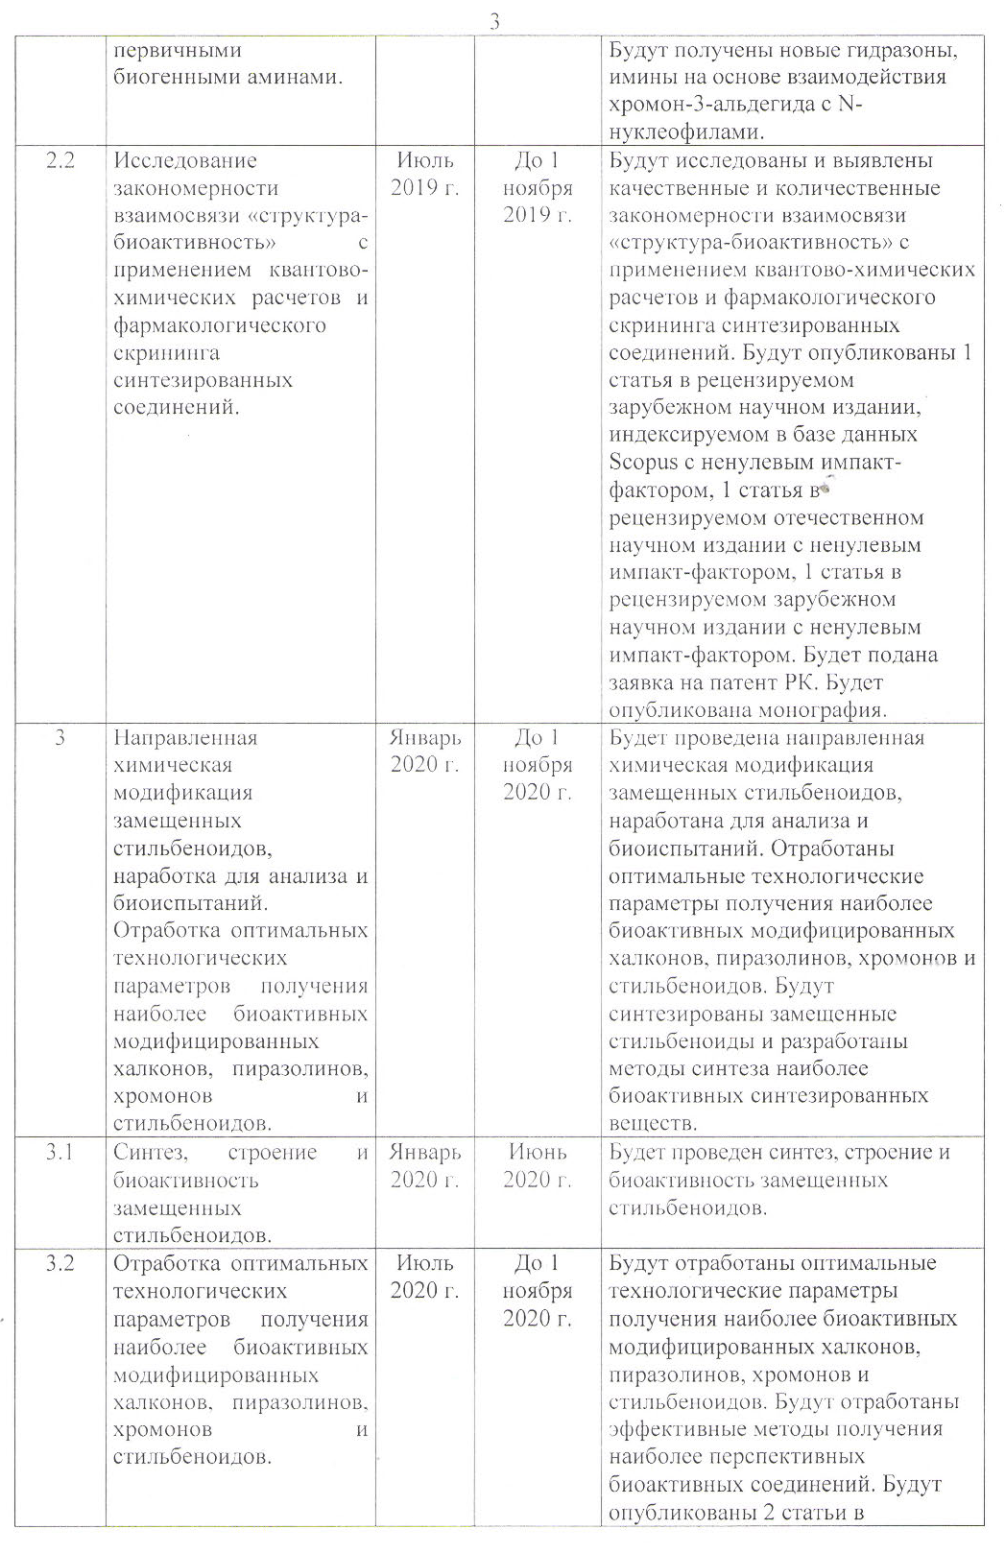

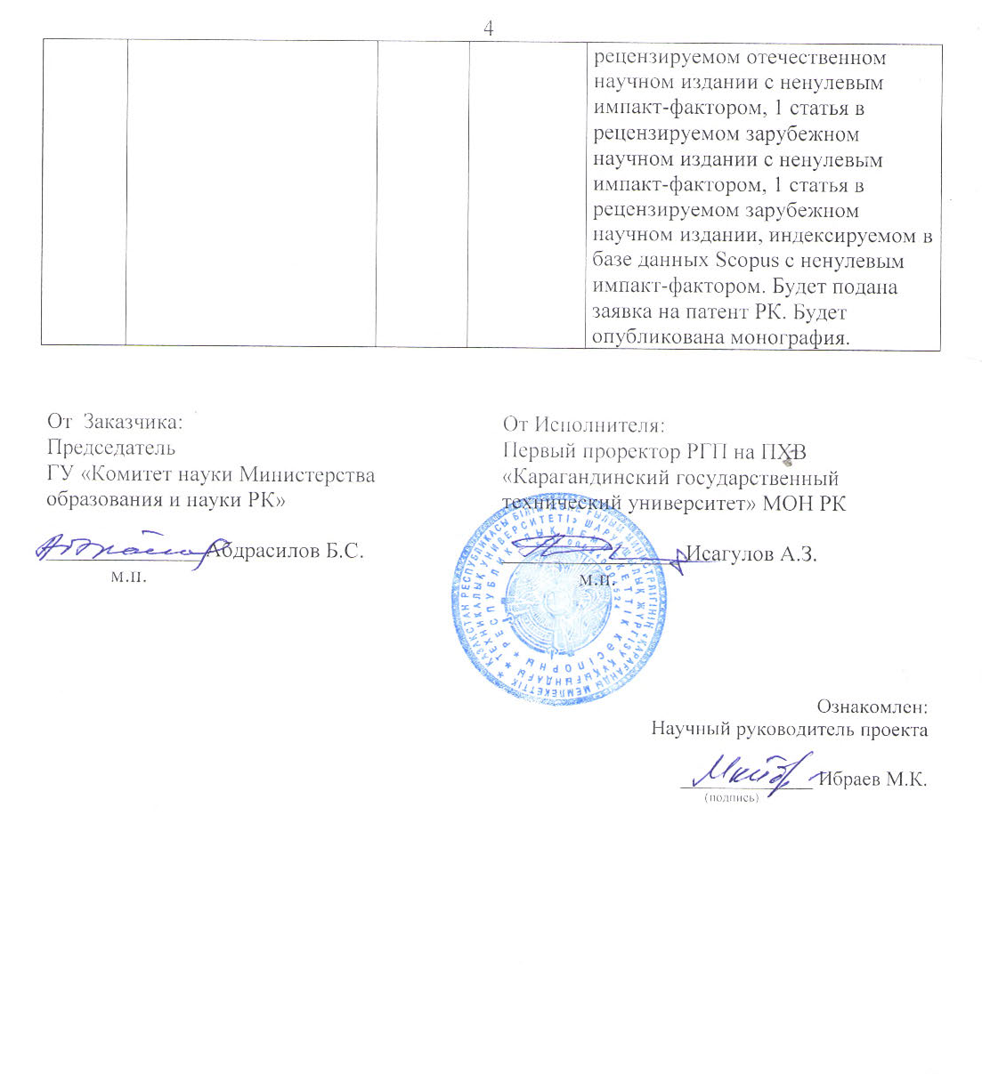
Appendix 1.10
to Agreement No.__ dated _______2018
for grant funding

TECHNICAL SPECIFICATIONS AND
CALENDAR WORK PLAN

under Agreement No. _____ dated __________________2018

1. Republican state enterprise
on the right of economic management
"Karaganda State Technical University"
Ministry of Education and Science of the Republic of Kazakhstan

1.1 By priority: Rational use of natural resources, including water resources, geology, processing, new materials and technologies, safe products and structures.
1.2 By sub-priority: Biomedical materials and biologically active substances.
1.3 On the topic of the project: No. AP05133157 "Development of effective methods for the synthesis of chalcones, flavonoids, stilbenoids and their chemical modification in order to find potential antioxidant, anti-inflammatory and antibacterial agents for medicine on their basis".
1.4 Total project amount 21 140 000 (twenty one million one hundred forty thousand) tenge, including with a breakdown by years, to perform work in accordance with paragraph 3:
- for 2018 - in the amount of 7 000 000 (seven million) tenge;
- for 2019 - in the amount of 7 063 000 (seven million sixty-three thousand) tenge;
- for 2020 - in the amount of 7 077 000 (seven million seventy-seven thousand) tenge.

2. Characteristics of scientific and technical products by qualification characteristics and economic indicators
2.1 Direction of work: Development of technology for obtaining new pharmacological agents based on chalcones, flavonoids, stilbenoids under conditions of classical organic synthesis and microwave activation.
2.2 Applications: Pharmacology, medicine, agriculture.
2.3 Final result:
- for 2018: 1 article will be published in a peer-reviewed Russian scientific journal with a non-zero impact factor. RK patent application will be filed.
- for 2019: 1 article will be published in a peer-reviewed foreign scientific journal indexed in the Scopus database with a non-zero impact factor, 1 article in a peer-reviewed domestic scientific journal with a non-zero impact factor, 1 article in a peer-reviewed foreign scientific journal with a non-zero impact factor. RK patent application will be filed. A monograph will be published.
- for 2020: 2 articles will be published in a peer-reviewed domestic scientific journal with a non-zero impact factor, 1 article in a peer-reviewed foreign scientific journal with a non-zero impact factor, 1 article in a peer-reviewed foreign scientific journal indexed in the Scopus database with a non-zero impact factor. RK patent application will be filed. A monograph will be published.
2.4 Patentability: Patentable.
2.5 Scientific and technical level (novelty): The project will be carried out at the level of the best world developments in this area.
2.6 The use of scientific and technical products is carried out: by the Contractor.
2.7 Type of use of the result of scientific and (or) scientific and technical activities: The results of research will form the basis for the development of new biologically active substances for medicine.

3. Name of work, terms of their implementation and results

Task code, stage | Name of work under the Agreement and the main stages of its implementation | Period of execution |  | Expected Result
Task code, stage |  | Start | ending | Expected Result
1 | Development of methods for obtaining and optimal conditions for the synthesis of chalcones and their derivatives, study of possible reaction mechanisms of their formation, establishment of the structure. | January 2018 | November 1, 2018 | Methods of obtaining and optimal conditions for the synthesis of chalcones and their derivatives will be developed, possible mechanisms of their formation reactions will be investigated, and their structures will be established.  Methods for the preparation of chalcones and their chemical modification will be developed. Bioscreening of substances will be carried out.
1.1 | Development of methods for the preparation and optimal conditions for the synthesis of chalcones under conditions of classical synthesis, microwave and ultrasonic activation. | January 2018 | June 2018 | Methods for obtaining and optimal conditions for the synthesis of chalcones under conditions of convection, MW and ultrasonic activation will be developed, the structure of new chalcones will be synthesized and studied.
1.2 | Synthesis, structure and biological activity of pyrazolines and flavones. | July 2018 | November 1, 2018 | The synthesis will be carried out and the structure and biological activity of pyrazolines and flavones will be studied. By heterocyclization of chalcones, pyrazolines and flavones will be obtained. Bioscreening of the synthesized substances will be carried out. 1 article will be published in a peer-reviewed national scientific journal with a non-zero impact factor. RK patent application will be filed
2 | Synthesis and study of the relationship "structure - bio-activity" in a series of products of the interaction of substituted chromone-3-aldehyde with some N-nucleophiles. | January 2019 | November 1, 2019 | The synthesis will be carried out and the relationship "structure - bioactivity" in a series of products of the interaction of substituted chromone-3-aldehyde with some N-nucleophiles will be studied. New substituted chromones will be obtained and, on the basis, the relationship "structure - bioactivity" will be studied.
2.1 | Condensation of substituted chromone-3-aldehyde with hydrazine, hydrazides and primary biogenic amines. | January 2019 | June 2019 | The condensation of substituted chromone-3-aldehyde with hydrazine, hydrazides and primary biogenic amines will produce new hydrazones, imines based on the interaction of chromone-3-aldehyde with N-nucleophiles.
2.2 | Investigation of the regularity of the relationship "structure-bioactivity" using quantum-chemical calculations and pharmacological screening of synthesized compounds | July 2019 | November 1, 2019 | Qualitative and quantitative patterns of the structure-bioactivity relationship will be identified using quantum chemical calculations and pharmacological screening of the synthesized compounds. There will be published 1 article in a peer-reviewed foreign scientific journal indexed in the Scopus database with a nonzero impact factor, 1 article in a peer-reviewed domestic scientific publication with a nonzero impact factor, 1 article in a peer-reviewed foreign scientific publication with a nonzero impact factor. RK patent application will be filed. A monograph will be published
3 | Directed chemical modification of substituted stilbenoids, development for analysis and biotesting. Development of optimal technological parameters for obtaining the most bioactive modified chalcones, pyrazolines, chromones and stilbenoids. | January 2020 | November 1, 2020 | By targeted chemical modification of substituted stilbenoids, they will be developed for analysis and biotesting. Optimal technological parameters for obtaining the most bioactive modified chalcones, pyrazolines, chromones and stilbenoids have been worked out.  Substituted stilbenoids will be synthesized and methods for the synthesis of the most bioactive synthesized substances will be developed.
3.1 | Synthesis, structure and bio-activity of substituted stilbenoids. | January 2020 | June 2020 | New substituted stilbenoids will be obtained and their structure and bioactivity established.
3.2 | Development of optimal technological parameters for obtaining the most bioactive modified chalcones, pyrazolines, chromones and stilbenoids. | July 2020 | November 1, 2020 | Effective methods for obtaining the most promising bioactive compounds will be developed. 2 articles will be published in a peer-reviewed domestic scientific journal with a non-zero impact factor, 1 article in a peer-reviewed foreign scientific journal with a non-zero impact factor, 1 article in a peer-reviewed foreign scientific journal indexed in the Scopus database with a non-zero impact factor. RK patent application will be filed. A monograph will be published

From Customer:  The chairman  State Institution "Science Committee of the Ministry of Education and Science of the Republic of Kazakhstan"  ______________ B.S. Abdrasilov  м.п. | From the Contractor:  Rector  of the Republican State Enterprise at REM "Karaganda State  Technical University" MES RK  ________________ M.K. Ibatov  м.п.  Acquainted:  Scientific supervisor of the project  _____________ M.K.Ibrayev  (signature)

APPENDIX B

List of published works on the topic for 2018-2020

- Nurkenov О.А., Ibrayev М.К., Fazylov S.D., Таkibayeva А.Т., Kulakov I.V., Tuktybayeva A.E. Chalcones-synthons in synthesizing biologically active matters / News of the NAS RK. Chemistry and Technology Series. 2018 - 4 (430). P. 85-98. (IF = 0.251, KazCB)
- Nurkenov O.A., Ibrayev M.K., Satpaeva Zh.B., Dauletzhanova Zh.T., Seilkhanov T.M. Synthesis and study of antioxidant activity of hydrazone and thiosemicarbazidebased on N-morpholinoacetic acid hydrazide // Bulletin of the Karaganda University. Chemistry Series, 2018, № 1(89). С.22-26. https://chemistry-vestnik.ksu.kz/apart/2018-89-1/3.pdf (IF = 0.083, KazCB).
- Ibrayev M.K., Arinova A.E., Seilkhanov O.T., Shchepetkin I.A., Isabaeva M.B., Nurkenov A.O. Synthesis, structure and intramolecular heterocyclization of 2-hydroxyl-containing chalcones. Bulletin of the Scientific and Technical Society "KAKHAK", 2018, No. 2 (61). S.58-67. (IF = 0.103, KazCB). http://www.ntokaxak.kz/wp-content/uploads/2018/09/Kaxak_2_61_2018.pdf.
- Nurmaganbetov Zh.S., Nurkenov O.A., Fazylov S.D., Seilkhanov O.T., Zholdasbaev M.E., Zhakisheva B.M., Ibrayev M.K. Synthesis and structure of n-acyl derivatives of the alkaloid cytisine. Bulletin of the Scientific and Technical Society "KAKHAK", 2018, No. 3 (62). S. 80-86. (IF = 0.103, KazCB). http://www.ntokaxak.kz/wp-content/uploads/2018/12/1710-Kaxak-362-2018.pdf.
- Aitmagambetova M.S., Ibrayev M.K., Turmukhambetov A.Zh. Chelidonium majus L. - as a promising source of alkaloids / Proceedings of the International Scientific and Practical Conference "Integration of Science, Education and Production - the Basis for the Implementation of the Plan of the Nation" (Saginov Readings No. 10), Part 7. - Karaganda: Publishing House of KSTU, 14-15 June 2018 p.19-20.
- Ibrayev M.K., Takibaeva A.T., Arinova A.E., Seilkhanov T.M., Nurkenov O.A. Synthesis and structure of (E) -1- (4-hydroxyphenyl) -3- (4-methoxyphenyl) prop-2-en-1-she / Proceedings of the International Scientific and Practical Conference “Integration of Science, Education and Production - the Basis for the Implementation of the Nation's Plan "(Saginov's readings No. 10), Part 7. - Karaganda: Publishing house of KSTU, June 14-15, 2018, pp. 88-90.
- Nurkenov O.A., Ibrayev M.K., Takibaeva A.T., Seilkhanov T.M. Synthesis of functionally substituted chalcones and their antiradical activity. / Proceedings of the International Scientific and Practical Conference "Integration of Science, Education and Production - the Basis for the Implementation of the Plan of the Nation" (Saginov Readings No. 10), Part 7. - Karaganda: KSTU Publishing House, June 14-15, 2018 pp. 155-157.
- Nurkenov O.A., Ibraev M.K., Schepetkin I.A., Khlebnikov A.I., Seilkhanov T.M., Arinova A.E. and Isabaeva M.B. Synthesis, Structure, and Anti-Inflammatory Activity of Functionally Sub-
stituted Chalcones and Their Derivatives. // Russian Journal of General Chemistry, 2019, Vol. 89, No. 7, pp. 1360–1367. (IF = 0.716 – WoS, 33 percentile Scopus, Q3 – https://www.scimagojr.com/journalsearch.php?q=21525&tip=sid&clean=0).
- Nurkenov О.A., Ibraev M.K., Seilkhanov T.M., Shulgau Z.T., Fazylov1 S.D., Takibayeva A.T. Synthesis, structure and anti-radical activity of 6-methyl-4-oxo-4н-chromen-3-acylhydrazones // News of the Academy of sciences of the Republic of Kazakhstan. Series chemistry and technology, 2019. - № 436. - P. 25-31. https://doi.org/10.32014/2019.2518-1491.38.
- Ibrayev M.K., Akhmetova S.B., Takibayeva A.T., Issabayeva M.B., Nurkenov A.O., Seilkhanov О.T. Synthesis, structure and antimicrobial activity of substituted chalcones and their derivatives // Bulletin of the Karaganda University. Chemistry Series, 2019. - № 3(95). – P.28-36. DOI: 10.31489/2019Ch3/28-36 (IF = 0.083, КазБЦ).
- Nurkenov O.A., Ibrayev M.K., Shchepetkin I.A., Khlebnikov A.I., Seilkhanov T.M., Arinova A.E., Isabaeva M.B. Synthesis, structure and anti-inflammatory activity of functionally substituted chalcones and their derivatives // Journal of General Chemistry, 2019. - No. 7. - P. 995–1003. (IF = 0.752, RSCI) DOI: 10.1134/S0044460X19070023
- Nurkenov O.A., Ibrayev M.K., Isabaeva M.B. Synthetic transformations of chalcones. // Warsaw: iScience Sp. z o. o., 2019. - 74 pp.
- Ibrayev M.K., Nurkenov O.A., Ibatayev Zh.A. Development of effective methods of chalcony synthesis // ХХI Mendeleev Congress on General and Applied Chemistry. Book 5: Abstracts. – Saint Petersburg, 2019 – p. 352 ISBN - 978-5-6043248-4-4 Book 5. The periodic table and new elements. Medical chemistry: fundamental and applied aspects.
- Ibrayev M.K., Fazyl D.A. Biologicals belsend tabiғi қsilystardy negizinde zhaңa hybrid molecularardyң synthesis zhune yrylymy. // Proceedings of the International Scientific and Practical Conference "Integration of Science, Education and Industry - the Basis for the Implementation of the Plan of the Nation" (Saginov Readings No. 11), June 14-15, 2019 In 5 parts. Part 2 - Karaganda: Publishing house of KSTU, 2019. - P.57-58.
- Patent application No. 2019 / 0773.1 dated October 21, 2019 3 - ((4S, 5S) 3,4-dimethyl-5-phenyloxazolidin-2-yl) -4Н-chromen-4-one, possessing antimicrobial (antibacterial) action.
- Patent application No. 2019 / 0778.1 dated 10.22.2019, 3 - ((pyridin) -2-yl-methyl) imino) methyl) -4H-chromen-4-one, which has antimicrobial (antibacterial) action.
- Nurkenov O. A., Fazylov S. D., Arinova A. E., Seilkhanov T. M., Ibrayev M. K., Tazh-baev E. M. Synthesis of new chromene-containing fulleropyrrolidines // Journal of General Chemistry, 2020, volume 90, no. 7, p. 1143-1145 (IF = 0.752, RSCI) DOI: 10.31857/S0044460X20070203.
- Patent for invention No. 34267 3- (2,4-dihydroxyphenyl) -5- (4-methoxyphenyl) -N-phenyl-4,5-dihydroxy-1H-pyrazole-1carbothioamide, possessing antioxidant (antiradical) action, authors: Nurkenov O A.A., Ibrayev M.K., Takibaeva A.T., Shulgau Z.T., Isabaeva M.B. / Official bulletin № 18 - 06.05.2020. https://gosreestr.kazpatent.kz/Invention/Details?docNumber=302599
- Synthetic transformation of chalcones: Scientific publication/ M.K. Ibrayev, O.A. Nurkenov, T.M. Seilkhanov – Warsaw: iScience Sp. z o. o., – 2020. – 70 p. (Monograph, Warsaw, Poland).
- Nurkenov, O.A., Fazylov, S.D., Arinova, A.E., Seilkhanov T.M., Ibraev M.K., Tazhbaev E.M. Synthesis of New Chromene-Containing Pyrrolofullerenes. // Russ. J. Gen. Chem. 90, 1362–1364 (2020). https://doi.org/10.1134/S1070363220070269 (IF = 0.716 – WoS, 33 percentile Scopus, Q3 – https://www.scimagojr.com/journalsearch.php?q=21525&tip=sid&clean=0).
- Arinova A.E., Nurkenov O.A., Fazylov S.D., Seilkhanov T.M., Ibraev M.K., Kabieva S.K., Omarov T.S. N-methyl-2-(4-styrylphenyl)-3,4-fulleropyrrolidine synthesis and structure. // Bulletin of the Karaganda University. Chemistry series. 2020 № 2(98). С. 15-21. DOI 10.31489/2020Ch2/15-21 (IF = 0.083, KazCB).
- Fazylov S.D., Nurkenov О.А., Muldakhmetov Z.M., Gazaliev A.M., Аrinova А.Е., Ibraev M.K., Vlasova L.M., Fazylov A.S. Biologically active derivatives of fullerene C60. Current state and development prospects // Bulletin of the Karaganda university. Chemistry series. № 3(99)/2020. P. 11-20. DOI 10.31489/2020Ch3/11-20 (IF = 0.083, KazCB).
- Fazylov S.D., Nurkenov O.A., Arinova A.E., Gazaliev A.M., Bakirova R.E., Ibraev M.K., Takibayeva A.Т., Fazylov A.S. Indicators of cell metabolism in vitro in researches of anti-inflammatory and cytotoxic effects of fulleropyrrolidines С60 and their initial substrates // Bulletin of the National Academy of Sciences of the Republic of Kazakhstan, 2020, Volume 5, Number 387, 25-33. https://doi.org/10.32014/2020.2518-1467.139 (IF = 0.264, KazCB).
- Patent application No. 2020/0634.1 dated September 16, 2020 (E)-1-(2,4-dihydroxyphenyl) -3- (4-methoxyphenyl) prop-2-en-1-one, which has an antiradical effect. Authors: Ibrayev M.K., Nurkenov O.A., Takibaeva A.T., Isabaeva M.B., Shulgau Z.T., Rakhimberlinova Zh.B., Alieva M.R.
- Ibrayev M.K., Fazylov A.S., Issabaeva M.B. N-methyl-1-[(4-dimethylamino) phenyl]-fullerene-c60 [1,9] pyrrolidine diiodomethylatine synthesis / Proceedings of the International Scientific and Practical Online Conference "Integration of Science, Education and Production - the Basis for the Implementation of the Nation's Plan" ( Saginovskie Readings No. 12), June 18-19, 2020 In 2 parts. Part 2 / Ministry of Education and Science of the Republic of Kazakhstan, Karaganda State Technical University. - Karaganda: Publishing house of KSTU, 2020.P.753-754.
- Nurkenov O.A., Ibrayev M.K., Takibaeva A.T. Synthesis of n-methyl-2- (4-styrylphenyl) -3,4-fulleropyrrolidine / Proceedings of the International Scientific and Practical Online Conference "Integration of Science, Education and Production - the Basis for the Implementation of the Nation's Plan" (Saginovskiye Readings No. 12), 18- June 19, 2020 in 2 parts. Part 2 / Ministry of Education and Science of the Republic of Kazakhstan, Karaganda State Technical University. - Karaganda: Publishing house of KSTU, 2020.S. 837-838.

APPENDIX C

Computer bioprediction of some new synthesized compounds using

the Prediction of Activity Spectra for Substance (PASS) program

Pa* | Pi* | Calculated activity
0,791 | 0,003 | Thiol protease inhibitor
0,675 | 0,012 | Insulysin inhibitor
0,638 | 0,004 | CYP2A6 inhibitor
0,551 | 0,005 | Amyloid beta precursor protein antagonist
0,576 | 0,050 | Antineoplastic
0,546 | 0,022 | Histidine kinase inhibitor
0,534 | 0,039 | Alkane 1-monooxygenase inhibitor
0,500 | 0,010 | CYP1A2 inhibitor
0,514 | 0,027 | HMGCS2 expression enhancer
0,498 | 0,011 | CYP1A inhibitor
0,485 | 0,007 | NF-E2-related factor 2 stimulant
0,476 | 0,007 | Quercetin 2,3-dioxygenase inhibitor
0,490 | 0,032 | CYP2F1 substrate
0,448 | 0,010 | Mcl-1 antagonist
0,526 | 0,089 | Glycosylphosphatidylinositol phospholipase D inhibitor
0,499 | 0,073 | Phthalate 4,5-dioxygenase inhibitor
0,466 | 0,048 | 4-Nitrophenol 2-monooxygenase inhibitor
0,434 | 0,019 | Focal adhesion kinase 2 inhibitor
0,425 | 0,022 | CF transmembrane conductance regulator agonist
0,437 | 0,035 | Antipsoriatic
0,439 | 0,038 | Heat shock protein 27 antagonist
0,429 | 0,031 | P-benzoquinone reductase (NADPH) inhibitor
0,438 | 0,047 | Malate dehydrogenase (acceptor) inhibitor
0,503 | 0,119 | Nicotinic alpha6beta3beta4alpha5 receptor antagonist
0,454 | 0,074 | HIF1A expression inhibitor
0,404 | 0,033 | RELA expression inhibitor
0,434 | 0,084 | 27-Hydroxycholesterol 7alpha-monooxygenase inhibitor
0,428 | 0,082 | Carboxypeptidase Taq inhibitor
0,410 | 0,070 | Nitrate reductase (cytochrome) inhibitor
0,350 | 0,015 | Anti-Helicobacter pylori
0,361 | 0,032 | CYP2A11 substrate
0,404 | 0,077 | Glutathione thiolesterase inhibitor
* Pa – the likelihood of manifestation of the corresponding type of activity;
Pi – the likelihood of the lack of the corresponding type of activity

0,345 | 0,026 | CYP2A3 substrate
0,371 | 0,053 | Lysostaphin inhibitor
0,408 | 0,091 | Antiinflammatory
0,357 | 0,045 | Monodehydroascorbate reductase (NADH) inhibitor
0,356 | 0,045 | Cardioprotectant
0,378 | 0,080 | Dehydro-L-gulonate decarboxylase inhibitor
0,355 | 0,061 | Leukotriene-B4 20-monooxygenase inhibitor
0,353 | 0,060 | 1-Acylglycerol-3-phosphate O-acyltransferase inhibitor
0,429 | 0,141 | Pseudolysin inhibitor
0,328 | 0,041 | Rheumatoid arthritis treatment
0,456 | 0,174 | Membrane permeability inhibitor
0,379 | 0,099 | (R)-6-hydroxynicotine oxidase inhibitor
0,341 | 0,061 | tRNA-pseudouridine synthase I inhibitor
0,321 | 0,046 | Cholestanetriol 26-monooxygenase inhibitor
0,337 | 0,067 | Ferredoxin-NAD+ reductase inhibitor
0,337 | 0,067 | Naphthalene 1,2-dioxygenase inhibitor
0,316 | 0,051 | Antineoplastic (breast cancer)
0,294 | 0,032 | CYP1A2 inducer
0,480 | 0,218 | Gluconate 2-dehydrogenase (acceptor) inhibitor
0,389 | 0,128 | Electron-transferring-flavoprotein dehydrogenase inhibitor
0,316 | 0,055 | Carbon-monoxide dehydrogenase inhibitor
0,308 | 0,052 | Focal adhesion kinase inhibitor
0,352 | 0,099 | 5 Hydroxytryptamine release inhibitor
0,371 | 0,119 | Fructose 5-dehydrogenase inhibitor
0,314 | 0,067 | Isopenicillin-N epimerase inhibitor
0,348 | 0,104 | Nicotine dehydrogenase inhibitor
0,308 | 0,067 | Cis-1,2-dihydro-1,2-dihydroxynaphthalene dehydrogenase inhibitor
0,318 | 0,078 | Chenodeoxycholoyltaurine hydrolase inhibitor
0,386 | 0,148 | Acetylcholine neuromuscular blocking agent
0,334 | 0,099 | Aspartate-phenylpyruvate transaminase inhibitor
0,339 | 0,104 | Apoptosis agonist
0,289 | 0,057 | Corticosteroid side-chain-isomerase inhibitor
0,266 | 0,037 | Nitrate reductase inhibitor
0,258 | 0,029 | Aryl-alcohol dehydrogenase (NADP+) inhibitor
0,367 | 0,140 | Nicotinic alpha2beta2 receptor antagonist
0,261 | 0,033 | (S)-3-hydroxyacid ester dehydrogenase inhibitor
0,333 | 0,112 | Rubredoxin-NAD+ reductase inhibitor
0,281 | 0,061 | Salicylate 1-monooxygenase inhibitor
0,293 | 0,074 | Antituberculosic

Pa | Pi | Calculated activity
0,768 | 0,004 | Thiol protease inhibitor
0,699 | 0,009 | Insulysin inhibitor
0,690 | 0,003 | CYP2A6 inhibitor
0,513 | 0,005 | Amyloid beta precursor protein antagonist
0,495 | 0,029 | Histidine kinase inhibitor
0,521 | 0,065 | Antineoplastic
0,457 | 0,009 | Quercetin 2,3-dioxygenase inhibitor
0,471 | 0,024 | Heat shock protein 27 antagonist
0,491 | 0,046 | Alkane 1-monooxygenase inhibitor
0,453 | 0,015 | CYP1A2 inhibitor
0,452 | 0,016 | CYP1A inhibitor
0,445 | 0,012 | NF-E2-related factor 2 stimulant
0,456 | 0,038 | HMGCS2 expression enhancer
0,448 | 0,033 | Antipsoriatic
0,434 | 0,020 | CF transmembrane conductance regulator agonist
0,411 | 0,012 | Mcl-1 antagonist
0,404 | 0,026 | Focal adhesion kinase 2 inhibitor
0,414 | 0,051 | CYP2F1 substrate
0,360 | 0,014 | Anti-Helicobacter pylori
0,376 | 0,035 | Cardioprotectant
0,403 | 0,072 | Nitrate reductase (cytochrome) inhibitor
0,414 | 0,088 | Antiinflammatory
0,416 | 0,092 | HIF1A expression inhibitor
0,371 | 0,052 | 1-Acylglycerol-3-phosphate O-acyltransferase inhibitor
0,462 | 0,147 | Mucomembranous protector
0,372 | 0,082 | Kinase inhibitor
0,378 | 0,089 | Vasoprotector
0,302 | 0,014 | Calcium channel N-type blocker
0,326 | 0,042 | Rheumatoid arthritis treatment
0,383 | 0,121 | 27-Hydroxycholesterol 7alpha-monooxygenase inhibitor
0,304 | 0,043 | CYP2A11 substrate
0,397 | 0,140 | Acetylcholine neuromuscular blocking agent
0,354 | 0,098 | 5 Hydroxytryptamine release inhibitor
0,328 | 0,072 | RELA expression inhibitor
0,367 | 0,123 | Oxidoreductase inhibitor
0,383 | 0,140 | Gastrin inhibitor
0,306 | 0,072 | P-benzoquinone reductase (NADPH) inhibitor
0,330 | 0,098 | Malate dehydrogenase (acceptor) inhibitor
0,411 | 0,181 | Phosphatase inhibitor
0,299 | 0,071 | Antituberculosic
0,335 | 0,107 | Apoptosis agonist
0,259 | 0,032 | Antineoplastic (melanoma)
0,275 | 0,062 | Antineoplastic (breast cancer)
0,251 | 0,041 | Nitrate reductase inhibitor
0,277 | 0,067 | Focal adhesion kinase inhibitor
0,331 | 0,123 | 4-Nitrophenol 2-monooxygenase inhibitor
0,407 | 0,200 | Membrane permeability inhibitor
0,301 | 0,100 | Autoimmune disorders treatment
0,283 | 0,097 | Dermatologic
0,203 | 0,020 | MAO inhibitor
0,313 | 0,139 | Chemosensitizer
0,231 | 0,059 | CYP1A2 inducer
0,272 | 0,100 | Antimycobacterial
0,206 | 0,036 | Orexin receptor 1 antagonist
0,233 | 0,064 | CYP2A3 substrate
0,250 | 0,085 | Photosensitizer
0,197 | 0,036 | Catalase stimulant
0,184 | 0,027 | Antihemorrhagic
0,251 | 0,094 | Monodehydroascorbate reductase (NADH) inhibitor
0,248 | 0,093 | HIV attachment inhibitor
0,195 | 0,044 | Antineoplastic (renal cancer)
0,182 | 0,037 | Cysteamine dioxygenase inhibitor
0,279 | 0,134 | CYP19A1 expression inhibitor
0,227 | 0,083 | PfA-M1 aminopeptidase inhibitor
0,283 | 0,141 | Aspartate-phenylpyruvate transaminase inhibitor
0,183 | 0,044 | Alcohol dehydrogenase inhibitor
0,227 | 0,090 | Dihydrodipicolinate reductase inhibitor
0,144 | 0,009 | CYP2A5 inhibitor
0,288 | 0,155 | Insulin promoter
0,186 | 0,053 | CYP2A10 substrate
0,270 | 0,141 | Endopeptidase So inhibitor
0,224 | 0,096 | Cholestanetriol 26-monooxygenase inhibitor
0,252 | 0,124 | CYP2A6 substrate
0,190 | 0,064 | Dual specificity phosphatase 1 inhibitor
0,266 | 0,141 | CYP3A4 inducer

Pa | Pi | Calculated activity
0,789 | 0,003 | Thiol protease inhibitor
0,693 | 0,010 | HMGCS2 expression enhancer
0,559 | 0,034 | Insulysin inhibitor
0,558 | 0,055 | Antineoplastic
0,506 | 0,005 | Amyloid beta precursor protein antagonist
0,427 | 0,011 | Mcl-1 antagonist
0,420 | 0,021 | CYP1A2 inhibitor
0,433 | 0,043 | Histidine kinase inhibitor
0,413 | 0,024 | CYP1A inhibitor
0,388 | 0,035 | Antituberculosic
0,383 | 0,044 | Antimycobacterial
0,384 | 0,048 | Antipsoriatic
0,362 | 0,032 | PfA-M1 aminopeptidase inhibitor
0,432 | 0,118 | Acetylcholine neuromuscular blocking agent
0,353 | 0,041 | Antineoplastic (breast cancer)
0,382 | 0,083 | Heat shock protein 27 antagonist
0,335 | 0,039 | NF-E2-related factor 2 stimulant
0,348 | 0,062 | CF transmembrane conductance regulator agonist
0,300 | 0,024 | CYP2A6 inhibitor
0,311 | 0,039 | HIV attachment inhibitor
0,282 | 0,016 | Calcium channel N-type blocker
0,279 | 0,016 | Alcohol dehydrogenase inhibitor
0,325 | 0,063 | Focal adhesion kinase 2 inhibitor
0,274 | 0,043 | Anti-Helicobacter pylori
0,258 | 0,033 | Antineoplastic (melanoma)
0,276 | 0,052 | CYP2A11 substrate
0,242 | 0,021 | Macular degeneration treatment
0,328 | 0,111 | Apoptosis agonist
0,278 | 0,065 | Photosensitizer
0,226 | 0,014 | Catalase stimulant
0,311 | 0,105 | Feruloyl esterase inhibitor
0,235 | 0,032 | Dual specificity phosphatase inhibitor
0,242 | 0,045 | Nitrate reductase inhibitor
0,296 | 0,104 | Antiprotozoal (Leishmania)
0,264 | 0,075 | Rheumatoid arthritis treatment
0,212 | 0,024 | HCV NS3-helicase inhibitor
0,230 | 0,047 | Uric acid excretion stimulant
0,186 | 0,006 | CYP2A5 inhibitor
0,208 | 0,035 | Antineoplastic (renal cancer)
0,190 | 0,020 | Histone deacetylase class III inhibitor
0,294 | 0,127 | Centromere associated protein inhibitor
0,204 | 0,037 | Orexin receptor 1 antagonist
0,237 | 0,070 | Antineoplastic (brain cancer)
0,204 | 0,040 | Quercetin 2,3-dioxygenase inhibitor
0,279 | 0,115 | RELA expression inhibitor
0,184 | 0,022 | Pim-3 kinase inhibitor
0,259 | 0,105 | P-benzoquinone reductase (NADPH) inhibitor
0,265 | 0,113 | Cardioprotectant
0,169 | 0,018 | Histone deacetylase SIRT2 inhibitor
0,296 | 0,148 | Dementia treatment
0,233 | 0,090 | Angiogenesis stimulant
0,215 | 0,073 | MO15-related protein kinase Pfmrk inhibitor
0,173 | 0,032 | Mannose-6-phosphate isomerase inhibitor
0,162 | 0,025 | Pim kinase inhibitor
0,231 | 0,100 | Focal adhesion kinase inhibitor
0,273 | 0,147 | Muscular dystrophy treatment
0,290 | 0,166 | 4-Nitrophenol 2-monooxygenase inhibitor
0,223 | 0,099 | Antibacterial
0,173 | 0,050 | Pim-1 kinase inhibitor
0,299 | 0,179 | HIF1A expression inhibitor
0,332 | 0,214 | Mucomembranous protector
0,207 | 0,090 | CYP1A1 inhibitor
0,169 | 0,055 | Alcohol dehydrogenase (NADP+) inhibitor
0,158 | 0,045 | Diabetic retinopathy treatment
0,344 | 0,231 | Aspulvinone dimethylallyltransferase inhibitor
0,286 | 0,174 | Chemosensitizer
0,241 | 0,130 | Alkane 1-monooxygenase inhibitor
0,216 | 0,106 | Antidiabetic symptomatic
0,155 | 0,047 | Protein phosphatase inhibitor
0,168 | 0,067 | CYP2A10 substrate
0,140 | 0,042 | MAO inhibitor
0,209 | 0,113 | Dihydrodipicolinate reductase inhibitor
0,144 | 0,048 | Protein kinase (CK2) inhibitor
0,154 | 0,058 | Cysteamine dioxygenase inhibitor
0,133 | 0,038 | JNK mitogen-activated protein kinase inhibitor

Pa | Pi | Calculated activity
0,923 | 0,004 | Antiasthmatic
0,922 | 0,004 | Antiallergic
0,876 | 0,001 | Rhinitis treatment
0,779 | 0,005 | Histidine kinase inhibitor
0,668 | 0,004 | Biliary tract disorders treatment
0,681 | 0,022 | HIF1A expression inhibitor
0,645 | 0,006 | Atherosclerosis treatment
0,576 | 0,023 | 4-Nitrophenol 2-monooxygenase inhibitor
0,601 | 0,049 | TP53 expression enhancer
0,532 | 0,007 | CF transmembrane conductance regulator agonist
0,534 | 0,014 | Prenyl-diphosphatase inhibitor
0,580 | 0,090 | CDP-glycerol glycerophosphotransferase inhibitor
0,496 | 0,029 | MMP9 expression inhibitor
0,512 | 0,048 | Aldehyde oxidase inhibitor
0,477 | 0,014 | RELA expression inhibitor
0,466 | 0,015 | Hepatic disorders treatment
0,534 | 0,085 | Phosphatase inhibitor
0,544 | 0,096 | CYP2H substrate
0,449 | 0,034 | Bilirubin oxidase inhibitor
0,428 | 0,019 | Cardioprotectant
0,419 | 0,018 | Xenobiotic-transporting ATPase inhibitor
0,434 | 0,041 | Vasodilator, coronary
0,388 | 0,006 | MAP kinase kinase 4 inhibitor
0,405 | 0,030 | CYP19A1 expression inhibitor
0,413 | 0,052 | CYP2A6 substrate
0,416 | 0,059 | Kinase inhibitor
0,405 | 0,052 | CYP2A substrate
0,372 | 0,030 | CYP2A11 substrate
0,345 | 0,007 | Allergic rhinitis treatment
0,380 | 0,047 | AR expression inhibitor
0,383 | 0,062 | Cytochrome P450 stimulant
0,378 | 0,057 | Spasmolytic
0,462 | 0,145 | Nicotinic alpha6beta3beta4alpha5 receptor antagonist
0,365 | 0,049 | H+-transporting two-sector ATPase inhibitor
0,379 | 0,066 | CYP2A4 substrate
0,371 | 0,061 | Antiprotozoal (Leishmania)
0,333 | 0,033 | DNA ligase (ATP) inhibitor
0,303 | 0,012 | SULT1E1 substrate
0,372 | 0,093 | Vasoprotector
0,344 | 0,070 | CYP1A substrate
0,341 | 0,074 | CYP1A2 substrate
0,386 | 0,121 | Antineoplastic (non-Hodgkin's lymphoma)
0,354 | 0,092 | Beta glucuronidase inhibitor
0,286 | 0,030 | CYP1A1 inhibitor
0,378 | 0,121 | Anaphylatoxin receptor antagonist
0,279 | 0,023 | CYP1B substrate
0,319 | 0,064 | Isopenicillin-N epimerase inhibitor
0,435 | 0,182 | Ubiquinol-cytochrome-c reductase inhibitor
0,437 | 0,185 | Membrane permeability inhibitor
0,316 | 0,065 | Vasodilator
0,299 | 0,050 | Photosensitizer
0,318 | 0,072 | CYP3A7 substrate
0,340 | 0,097 | Polarisation stimulant
0,345 | 0,105 | Neuropeptide Y4 antagonist
0,325 | 0,089 | NAD(P)+-arginine ADP-ribosyltransferase inhibitor
0,257 | 0,022 | CYP1B1 substrate
0,316 | 0,083 | Antiprotozoal (Trypanosoma)
0,264 | 0,035 | Chronic obstructive pulmonary disease treatment
0,267 | 0,044 | Polyribonucleotide nucleotidyltransferase inhibitor
0,348 | 0,129 | Heat shock protein 27 antagonist
0,288 | 0,071 | Antialcoholic
0,290 | 0,075 | DNA polymerase I inhibitor
0,368 | 0,155 | Membrane integrity agonist
0,258 | 0,047 | Chemoprotective
0,229 | 0,022 | CYP19 inhibitor
0,235 | 0,031 | Aldehyde dehydrogenase inhibitor
0,269 | 0,072 | Anticarcinogenic
0,290 | 0,093 | CYP2B6 substrate
0,349 | 0,154 | 27-Hydroxycholesterol 7alpha-monooxygenase inhibitor
0,321 | 0,128 | CYP3A substrate
0,350 | 0,159 | Antiviral (Picornavirus)
0,223 | 0,035 | CYP2A10 substrate
0,313 | 0,127 | Caspase 8 stimulant
0,252 | 0,067 | Proliferative diseases treatment
0,276 | 0,091 | Antiprotozoal (Amoeba)

Pa | Pi | Calculated activity
0,902 | 0,004 | Antiallergic
0,898 | 0,004 | Antiasthmatic
0,863 | 0,001 | Rhinitis treatment
0,755 | 0,005 | Histidine kinase inhibitor
0,629 | 0,007 | Atherosclerosis treatment
0,632 | 0,028 | HIF1A expression inhibitor
0,602 | 0,005 | Biliary tract disorders treatment
0,535 | 0,006 | CF transmembrane conductance regulator agonist
0,547 | 0,069 | TP53 expression enhancer
0,543 | 0,080 | Phosphatase inhibitor
0,472 | 0,019 | Prenyl-diphosphatase inhibitor
0,550 | 0,102 | CDP-glycerol glycerophosphotransferase inhibitor
0,444 | 0,017 | Cardioprotectant
0,450 | 0,038 | MMP9 expression inhibitor
0,460 | 0,050 | 4-Nitrophenol 2-monooxygenase inhibitor
0,415 | 0,020 | Hepatic disorders treatment
0,507 | 0,118 | CYP2H substrate
0,425 | 0,041 | Bilirubin oxidase inhibitor
0,410 | 0,031 | RELA expression inhibitor
0,418 | 0,069 | Vasoprotector
0,386 | 0,039 | CYP19A1 expression inhibitor
0,369 | 0,025 | Xenobiotic-transporting ATPase inhibitor
0,348 | 0,015 | MAP kinase kinase 4 inhibitor
0,398 | 0,067 | Kinase inhibitor
0,335 | 0,007 | Allergic rhinitis treatment
0,393 | 0,072 | Heat shock protein 27 antagonist
0,378 | 0,067 | Vasodilator, coronary
0,355 | 0,065 | Spasmolytic
0,320 | 0,040 | CYP2A11 substrate
0,335 | 0,061 | H+-transporting two-sector ATPase inhibitor
0,336 | 0,074 | CYP1A substrate
0,341 | 0,080 | Aldehyde oxidase inhibitor
0,276 | 0,016 | SULT1E1 substrate
0,335 | 0,076 | CYP2A6 substrate
0,331 | 0,077 | CYP2A substrate
0,328 | 0,081 | CYP1A2 substrate
0,271 | 0,036 | CYP1A1 inhibitor
0,257 | 0,029 | CYP1B substrate
0,298 | 0,070 | AR expression inhibitor
0,322 | 0,099 | Cytochrome P450 stimulant
0,244 | 0,027 | CYP1B1 substrate
0,241 | 0,029 | Aldehyde dehydrogenase inhibitor
0,270 | 0,059 | DNA ligase (ATP) inhibitor
0,276 | 0,066 | Photosensitizer
0,303 | 0,099 | Antiprotozoal (Leishmania)
0,246 | 0,043 | Chronic obstructive pulmonary disease treatment
0,284 | 0,084 | DNA polymerase I inhibitor
0,251 | 0,053 | Polyribonucleotide nucleotidyltransferase inhibitor
0,351 | 0,158 | Antineoplastic (non-Hodgkin's lymphoma)
0,238 | 0,057 | Chemoprotective
0,228 | 0,049 | Uric acid excretion stimulant
0,200 | 0,021 | Antihemorrhagic
0,298 | 0,120 | Beta glucuronidase inhibitor
0,286 | 0,108 | Antiprotozoal (Trypanosoma)
0,256 | 0,079 | Anticarcinogenic
0,318 | 0,143 | Neuropeptide Y4 antagonist
0,215 | 0,041 | Lipoprotein disorders treatment
0,283 | 0,112 | 1-Acylglycerol-3-phosphate O-acyltransferase inhibitor
0,193 | 0,022 | MAO inhibitor
0,294 | 0,127 | Polarisation stimulant
0,260 | 0,093 | Vasodilator
0,227 | 0,064 | RNA directed DNA polymerase inhibitor
0,283 | 0,124 | CYP2A4 substrate
0,267 | 0,108 | CYP2B6 substrate
0,204 | 0,049 | Dual specificity phosphatase 1 inhibitor
0,255 | 0,104 | Isopenicillin-N epimerase inhibitor
0,240 | 0,090 | Antialcoholic
0,327 | 0,177 | Neurotransmitter uptake inhibitor
0,204 | 0,055 | CYP2A6 inhibitor
0,236 | 0,087 | Cell wall biosynthesis inhibitor
0,205 | 0,056 | UGT1A3 substrate
0,230 | 0,082 | Anti-Helicobacter pylori
0,188 | 0,040 | UGT1A10 substrate
0,195 | 0,048 | CYP2A10 substrate
0,260 | 0,113 | Antiprotozoal (Amoeba)

Pa | Pi | Calculated activity
0,865 | 0,005 | Antiallergic
0,853 | 0,002 | Rhinitis treatment
0,852 | 0,005 | Antiasthmatic
0,710 | 0,008 | Histidine kinase inhibitor
0,592 | 0,005 | Biliary tract disorders treatment
0,571 | 0,011 | Atherosclerosis treatment
0,536 | 0,047 | HIF1A expression inhibitor
0,467 | 0,013 | CF transmembrane conductance regulator agonist
0,443 | 0,021 | Prenyl-diphosphatase inhibitor
0,433 | 0,043 | HMGCS2 expression enhancer
0,389 | 0,053 | Antiprotozoal (Leishmania)
0,361 | 0,030 | Hepatic disorders treatment
0,385 | 0,056 | Bilirubin oxidase inhibitor
0,463 | 0,146 | CDP-glycerol glycerophosphotransferase inhibitor
0,348 | 0,050 | Cardioprotectant
0,331 | 0,034 | Xenobiotic-transporting ATPase inhibitor
0,300 | 0,009 | Allergic rhinitis treatment
0,349 | 0,058 | RELA expression inhibitor
0,372 | 0,093 | 4-Nitrophenol 2-monooxygenase inhibitor
0,359 | 0,080 | Dementia treatment
0,310 | 0,044 | Photosensitizer
0,351 | 0,087 | Caspase 8 stimulant
0,429 | 0,165 | Phosphatase inhibitor
0,312 | 0,053 | Muscle relaxant
0,345 | 0,089 | Feruloyl esterase inhibitor
0,299 | 0,044 | MAP kinase kinase 4 inhibitor
0,433 | 0,179 | CYP2H substrate
0,297 | 0,045 | CYP2A11 substrate
0,270 | 0,024 | Uric acid excretion stimulant
0,304 | 0,062 | Skeletal muscle relaxant
0,330 | 0,096 | Vasodilator, coronary
0,254 | 0,020 | SULT1E1 substrate
0,304 | 0,079 | H+-transporting two-sector ATPase inhibitor
0,263 | 0,040 | CYP1A1 inhibitor
0,248 | 0,035 | Antineoplastic (bone cancer)
0,256 | 0,046 | RNA directed DNA polymerase inhibitor
0,305 | 0,097 | MMP9 expression inhibitor
0,263 | 0,058 | Vascular dementia treatment
0,295 | 0,095 | Antiviral (Herpes)
0,248 | 0,052 | Chemoprotective
0,293 | 0,101 | Antiprotozoal (Trypanosoma)
0,313 | 0,130 | Kinase inhibitor
0,291 | 0,117 | CYP19A1 expression inhibitor
0,270 | 0,099 | Antiprotozoal (Amoeba)
0,200 | 0,032 | Catalase stimulant
0,232 | 0,066 | Polyribonucleotide nucleotidyltransferase inhibitor
0,266 | 0,101 | Spasmolytic
0,268 | 0,109 | DNA polymerase I inhibitor
0,214 | 0,060 | Chronic obstructive pulmonary disease treatment
0,202 | 0,049 | CYP1B1 substrate
0,283 | 0,132 | Muscular dystrophy treatment
0,332 | 0,185 | TP53 expression enhancer
0,331 | 0,187 | Acetylcholine neuromuscular blocking agent
0,297 | 0,160 | Antihypoxic
0,195 | 0,059 | Aldose reductase substrate
0,181 | 0,048 | DNA directed RNA polymerase inhibitor
0,183 | 0,055 | CYP2A10 substrate
0,280 | 0,159 | CYP2A1 substrate
0,219 | 0,103 | Antialcoholic
0,217 | 0,104 | CYP2B substrate
0,129 | 0,019 | NAD(P)H dehydrogenase (quinone) inhibitor
0,208 | 0,098 | DNA ligase (ATP) inhibitor
0,154 | 0,048 | Antihemorrhagic
0,293 | 0,189 | Neuropeptide Y4 antagonist
0,194 | 0,096 | Antihelmintic
0,099 | 0,005 | p53 inhibitor
0,219 | 0,126 | AR expression inhibitor
0,177 | 0,085 | Dual specificity phosphatase 1 inhibitor
0,203 | 0,112 | CYP2B2 substrate
0,135 | 0,045 | MAO inhibitor
0,121 | 0,031 | Cyclin-dependent kinase 6 inhibitor
0,167 | 0,078 | GST M1-1 substrate
0,139 | 0,054 | Protein kinase (CK2) inhibitor
0,121 | 0,037 | CYP1B1 inhibitor
0,169 | 0,086 | CYP1B substrate

Pa | Pi | Calculated activity
0,805 | 0,004 | Antimycobacterial
0,803 | 0,003 | Antituberculosic
0,775 | 0,006 | HMGCS2 expression enhancer
0,773 | 0,004 | Mcl-1 antagonist
0,726 | 0,004 | Thiol protease inhibitor
0,714 | 0,004 | Amyloid beta precursor protein antagonist
0,706 | 0,008 | Insulysin inhibitor
0,654 | 0,007 | Isopenicillin-N epimerase inhibitor
0,640 | 0,003 | MAO inhibitor
0,640 | 0,004 | PfA-M1 aminopeptidase inhibitor
0,610 | 0,027 | Cytoprotectant
0,584 | 0,006 | Neuropeptide Y2 antagonist
0,580 | 0,005 | CYP2A6 inhibitor
0,551 | 0,005 | Focal adhesion kinase 2 inhibitor
0,552 | 0,011 | Transcription factor STAT3 inhibitor
0,521 | 0,012 | Heat shock protein 27 antagonist
0,517 | 0,009 | Cardioprotectant
0,522 | 0,025 | Histidine kinase inhibitor
0,499 | 0,005 | Anti-Helicobacter pylori
0,511 | 0,019 | Transcription factor STAT inhibitor
0,506 | 0,031 | Glutamine-phenylpyruvate transaminase inhibitor
0,518 | 0,043 | Antiviral (Picornavirus)
0,475 | 0,005 | Calcium channel N-type blocker
0,472 | 0,034 | Amine dehydrogenase inhibitor
0,452 | 0,016 | CF transmembrane conductance regulator agonist
0,446 | 0,012 | Focal adhesion kinase inhibitor
0,439 | 0,007 | Ethanolamine oxidase inhibitor
0,425 | 0,011 | Maillard reaction inhibitor
0,457 | 0,054 | Vasoprotector
0,490 | 0,093 | Taurine dehydrogenase inhibitor
0,387 | 0,006 | ATPase stimulant
0,395 | 0,014 | Quercetin 2,3-dioxygenase inhibitor
0,461 | 0,087 | Oxidoreductase inhibitor
0,380 | 0,007 | Alkaline phosphatase inhibitor
0,374 | 0,007 | Orexin receptor 1 antagonist
0,372 | 0,011 | Antineoplastic (brain cancer)
0,385 | 0,027 | Transcription factor inhibitor
0,361 | 0,006 | HCV NS3-helicase inhibitor
0,336 | 0,004 | Catalase stimulant
0,343 | 0,012 | Dual specificity phosphatase inhibitor
0,367 | 0,037 | CYP1A inhibitor
0,364 | 0,037 | CYP1A2 inhibitor
0,364 | 0,039 | Antibacterial
0,357 | 0,037 | Antiviral (Poxvirus)
0,389 | 0,071 | Kinase inhibitor
0,324 | 0,007 | Antileprosy
0,303 | 0,005 | Beta-Lysine 5,6-aminomutase inhibitor
0,374 | 0,085 | Apoptosis agonist
0,349 | 0,061 | Phosphatidylserine decarboxylase inhibitor
0,315 | 0,037 | 5 Hydroxytryptamine 1E antagonist
0,344 | 0,074 | CYP2E1 inducer
0,318 | 0,051 | Antiprotozoal (Coccidial)
0,359 | 0,094 | 5 Hydroxytryptamine release inhibitor
0,305 | 0,041 | Calpain inhibitor
0,331 | 0,068 | Botulin neurotoxin A light chain inhibitor
0,268 | 0,014 | Macular degeneration treatment
0,287 | 0,034 | CYP2E1 inhibitor
0,272 | 0,025 | Falcipain 3 inhibitor
0,325 | 0,084 | Antiinfective
0,322 | 0,084 | CYP1A2 substrate
0,274 | 0,045 | Serine-pyruvate transaminase inhibitor
0,288 | 0,060 | NF-E2-related factor 2 stimulant
0,259 | 0,032 | Antineoplastic (melanoma)
0,276 | 0,050 | Threonine aldolase inhibitor
0,324 | 0,106 | EIF4E expression inhibitor
0,264 | 0,047 | Phenylalanine(histidine) transaminase inhibitor
0,266 | 0,055 | CYP2A11 substrate
0,240 | 0,033 | Monophenol monooxygenase inhibitor
0,211 | 0,006 | MAO B inhibitor
0,313 | 0,112 | Caspase 3 stimulant
0,220 | 0,019 | Cytidine deaminase inhibitor
0,214 | 0,017 | Orexin receptor antagonist
0,293 | 0,100 | RELA expression inhibitor
0,268 | 0,076 | MAP kinase kinase 4 inhibitor
0,209 | 0,018 | Mannose-6-phosphate isomerase inhibitor

Pa | Pi | Calculated activity
0,797 | 0,004 | Mcl-1 antagonist
0,785 | 0,003 | Antituberculosic
0,785 | 0,004 | Antimycobacterial
0,782 | 0,005 | HMGCS2 expression enhancer
0,741 | 0,004 | Thiol protease inhibitor
0,734 | 0,005 | Insulysin inhibitor
0,726 | 0,003 | MAO inhibitor
0,727 | 0,003 | Amyloid beta precursor protein antagonist
0,666 | 0,004 | PfA-M1 aminopeptidase inhibitor
0,649 | 0,005 | Cardioprotectant
0,648 | 0,006 | Antiseptic
0,645 | 0,012 | Histidine kinase inhibitor
0,622 | 0,022 | Cytoprotectant
0,596 | 0,013 | Antiinfective
0,539 | 0,005 | Focal adhesion kinase 2 inhibitor
0,534 | 0,005 | Maillard reaction inhibitor
0,533 | 0,011 | Neuropeptide Y2 antagonist
0,521 | 0,004 | Alkaline phosphatase inhibitor
0,520 | 0,015 | Transcription factor STAT3 inhibitor
0,505 | 0,005 | Anti-Helicobacter pylori
0,549 | 0,056 | Oxidoreductase inhibitor
0,473 | 0,008 | Quercetin 2,3-dioxygenase inhibitor
0,470 | 0,005 | Calcium channel N-type blocker
0,477 | 0,015 | Transcription factor inhibitor
0,470 | 0,013 | CF transmembrane conductance regulator agonist
0,478 | 0,025 | Transcription factor STAT inhibitor
0,460 | 0,022 | Lipid peroxidase inhibitor
0,553 | 0,127 | Ubiquinol-cytochrome-c reductase inhibitor
0,455 | 0,031 | Heat shock protein 27 antagonist
0,540 | 0,123 | Membrane permeability inhibitor
0,526 | 0,112 | CDP-glycerol glycerophosphotransferase inhibitor
0,455 | 0,051 | Apoptosis agonist
0,427 | 0,025 | Antibacterial
0,455 | 0,054 | Vasoprotector
0,405 | 0,005 | HCV NS3-helicase inhibitor
0,405 | 0,020 | Focal adhesion kinase inhibitor
0,385 | 0,006 | ATPase stimulant
0,419 | 0,041 | CYP1A2 substrate
0,389 | 0,011 | Monophenol monooxygenase inhibitor
0,445 | 0,078 | HIF1A expression inhibitor
0,413 | 0,047 | Antifungal
0,407 | 0,047 | CYP1A substrate
0,367 | 0,009 | Dual specificity phosphatase inhibitor
0,478 | 0,125 | Phosphatase inhibitor
0,395 | 0,044 | Antihelmintic (Nematodes)
0,358 | 0,008 | Orexin receptor 1 antagonist
0,361 | 0,013 | Antineoplastic (brain cancer)
0,392 | 0,047 | Radioprotector
0,344 | 0,004 | Catalase stimulant
0,401 | 0,069 | 5 Hydroxytryptamine release inhibitor
0,398 | 0,067 | Aldehyde oxidase inhibitor
0,335 | 0,008 | NADPH oxidase inhibitor
0,340 | 0,028 | 5 Hydroxytryptamine 1E antagonist
0,362 | 0,051 | RELA expression inhibitor
0,410 | 0,102 | Antinociceptive
0,407 | 0,104 | Antiviral (Picornavirus)
0,346 | 0,046 | CYP1A inhibitor
0,313 | 0,013 | Falcipain 3 inhibitor
0,317 | 0,020 | Ethanolamine oxidase inhibitor
0,317 | 0,021 | CYP2A6 inhibitor
0,313 | 0,037 | Calpain inhibitor
0,280 | 0,005 | MAO B inhibitor
0,285 | 0,013 | Antileprosy
0,359 | 0,090 | Kinase inhibitor
0,346 | 0,078 | Caspase 3 stimulant
0,318 | 0,051 | Antiparasitic
0,306 | 0,043 | CYP2A11 substrate
0,336 | 0,079 | HMOX1 expression enhancer
0,317 | 0,062 | CYP1A2 inhibitor
0,318 | 0,065 | Isopenicillin-N epimerase inhibitor
0,392 | 0,144 | Acetylcholine neuromuscular blocking agent
0,259 | 0,015 | Skin whitener
0,277 | 0,046 | Antihelmintic
0,317 | 0,087 | CYP19A1 expression inhibitor
0,256 | 0,028 | ATPase inhibitor

Pa | Pi | Calculated activity
0,793 | 0,004 | Mcl-1 antagonist
0,790 | 0,002 | MAO inhibitor
0,785 | 0,005 | HMGCS2 expression enhancer
0,760 | 0,004 | Antimycobacterial
0,758 | 0,004 | Antituberculosic
0,748 | 0,005 | Insulysin inhibitor
0,736 | 0,004 | Thiol protease inhibitor
0,726 | 0,003 | Amyloid beta precursor protein antagonist
0,692 | 0,009 | Histidine kinase inhibitor
0,662 | 0,004 | Cardioprotectant
0,646 | 0,004 | PfA-M1 aminopeptidase inhibitor
0,629 | 0,020 | Cytoprotectant
0,569 | 0,008 | Neuropeptide Y2 antagonist
0,521 | 0,005 | Quercetin 2,3-dioxygenase inhibitor
0,524 | 0,011 | Antiseptic
0,519 | 0,006 | Focal adhesion kinase 2 inhibitor
0,510 | 0,004 | Alkaline phosphatase inhibitor
0,505 | 0,009 | CF transmembrane conductance regulator agonist
0,537 | 0,044 | Aldehyde oxidase inhibitor
0,507 | 0,022 | Antiinfective
0,485 | 0,006 | Maillard reaction inhibitor
0,490 | 0,019 | Heat shock protein 27 antagonist
0,488 | 0,019 | Transcription factor STAT3 inhibitor
0,469 | 0,005 | Calcium channel N-type blocker
0,546 | 0,089 | Membrane integrity agonist
0,497 | 0,041 | Vasoprotector
0,516 | 0,068 | Oxidoreductase inhibitor
0,464 | 0,021 | Lipid peroxidase inhibitor
0,442 | 0,007 | Anti-Helicobacter pylori
0,460 | 0,030 | Transcription factor STAT inhibitor
0,522 | 0,093 | Phosphatase inhibitor
0,430 | 0,009 | Monophenol monooxygenase inhibitor
0,436 | 0,019 | Transcription factor inhibitor
0,535 | 0,127 | Membrane permeability inhibitor
0,469 | 0,068 | HIF1A expression inhibitor
0,401 | 0,005 | HCV NS3-helicase inhibitor
0,446 | 0,054 | Apoptosis agonist
0,387 | 0,006 | ATPase stimulant
0,401 | 0,021 | Focal adhesion kinase inhibitor
0,422 | 0,043 | CYP1A substrate
0,405 | 0,029 | Antibacterial
0,415 | 0,042 | CYP1A2 substrate
0,405 | 0,033 | RELA expression inhibitor
0,496 | 0,127 | CDP-glycerol glycerophosphotransferase inhibitor
0,439 | 0,082 | Antiviral (Picornavirus)
0,366 | 0,012 | Antineoplastic (brain cancer)
0,397 | 0,045 | Radioprotector
0,413 | 0,062 | 5 Hydroxytryptamine release inhibitor
0,357 | 0,010 | Dual specificity phosphatase inhibitor
0,355 | 0,016 | CYP2A6 inhibitor
0,341 | 0,004 | MAO B inhibitor
0,341 | 0,008 | NADPH oxidase inhibitor
0,375 | 0,045 | Isopenicillin-N epimerase inhibitor
0,344 | 0,015 | Ethanolamine oxidase inhibitor
0,351 | 0,024 | 5 Hydroxytryptamine 1E antagonist
0,372 | 0,046 | CYP19A1 expression inhibitor
0,327 | 0,004 | Catalase stimulant
0,377 | 0,060 | Caspase 3 stimulant
0,386 | 0,073 | Kinase inhibitor
0,469 | 0,165 | Ubiquinol-cytochrome-c reductase inhibitor
0,348 | 0,045 | CYP1A inhibitor
0,403 | 0,107 | Antinociceptive
0,309 | 0,014 | Orexin receptor 1 antagonist
0,307 | 0,015 | Falcipain 3 inhibitor
0,377 | 0,089 | APOA1 expression enhancer
0,335 | 0,052 | CYP1A2 inhibitor
0,381 | 0,098 | Pin1 inhibitor
0,346 | 0,064 | Antifungal
0,327 | 0,047 | Antiviral (Poxvirus)

APPENDIX D
Acts of tests for antiradical activity
in the RSE on the RK "National Center for Biotechnology" of the SC MES RK
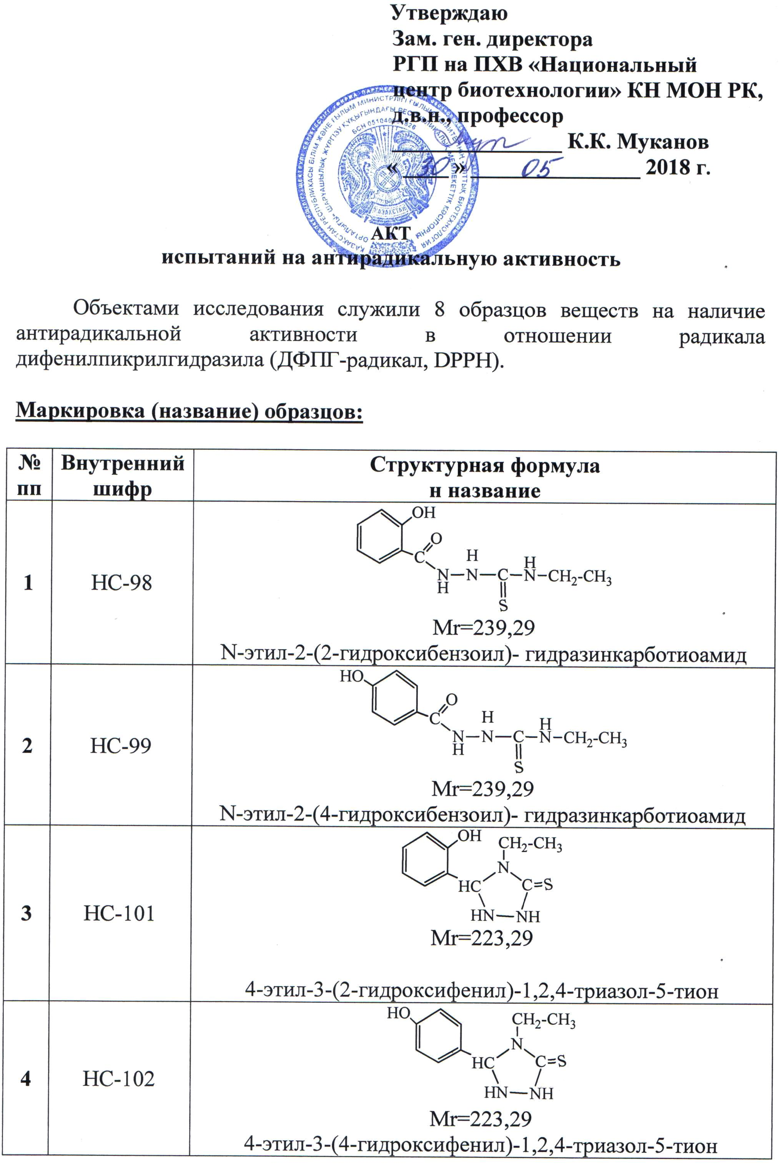
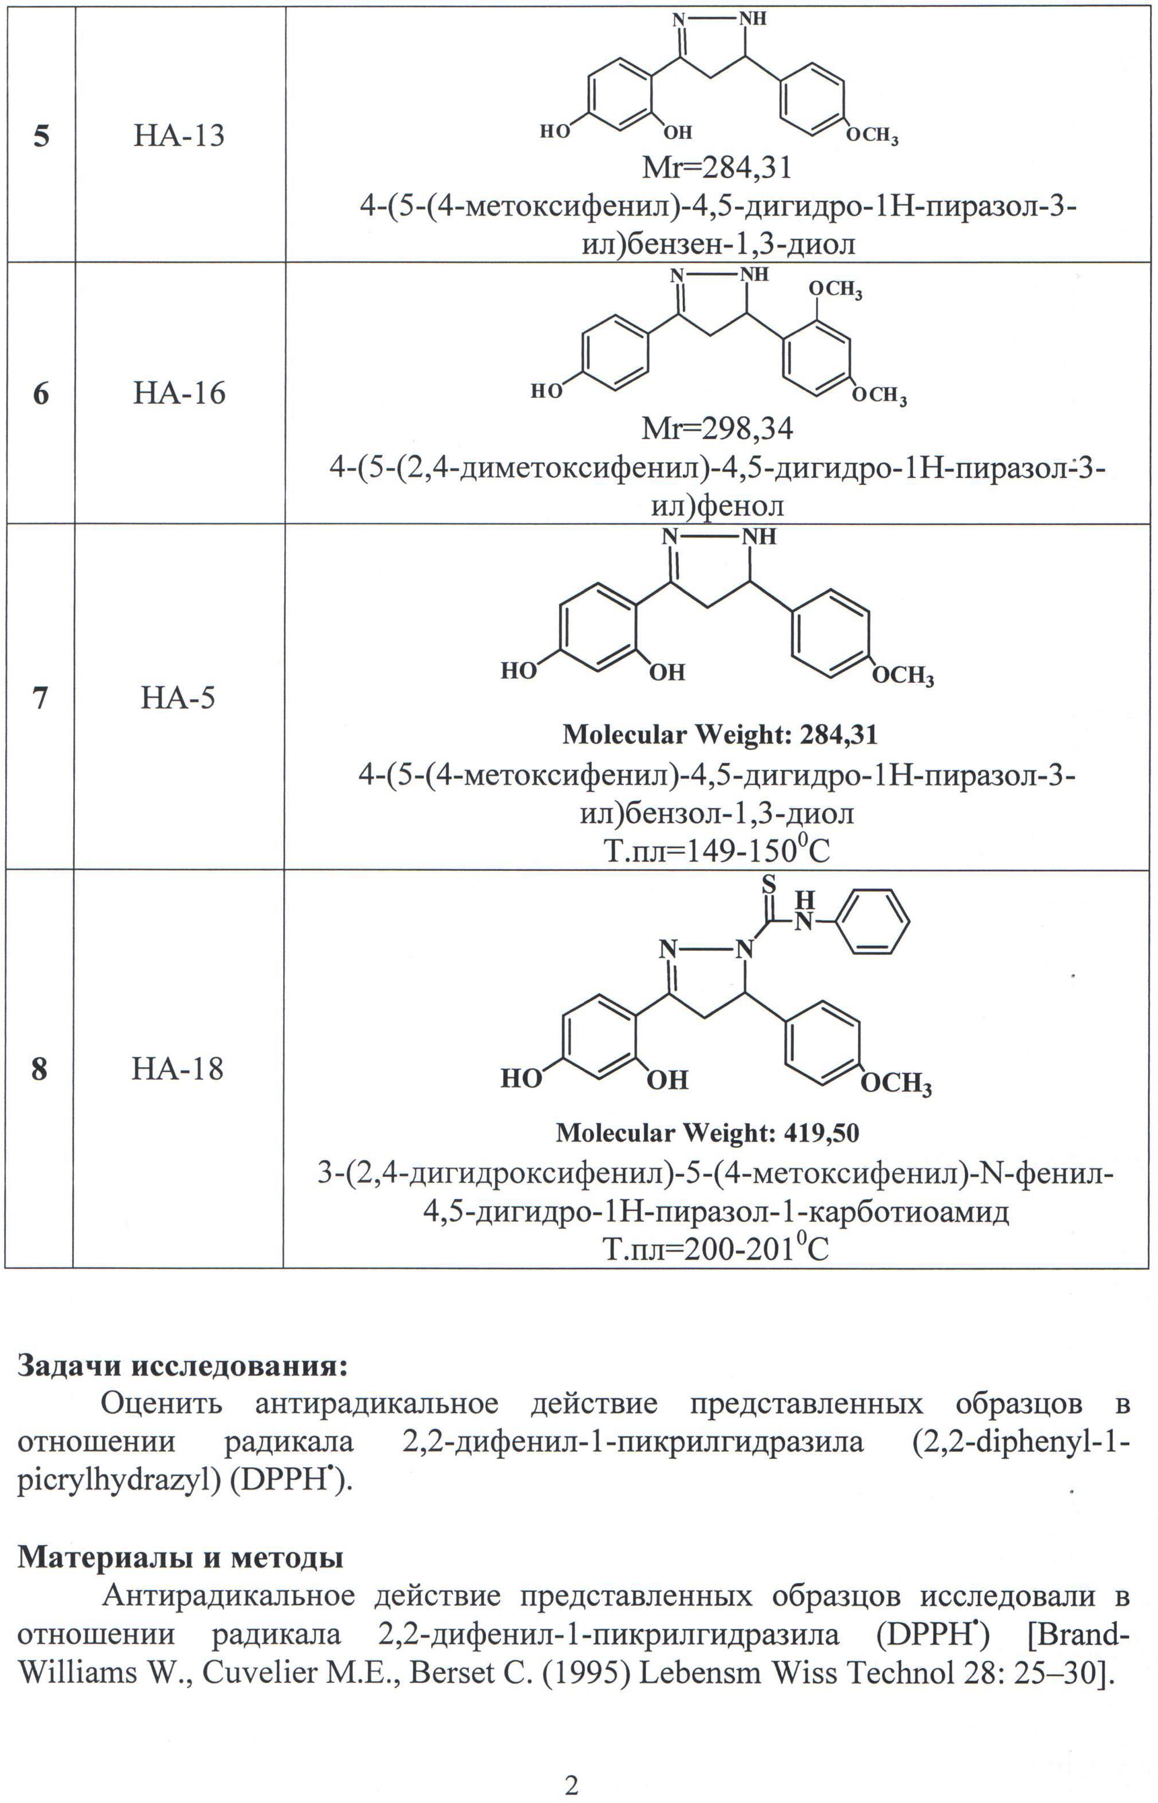
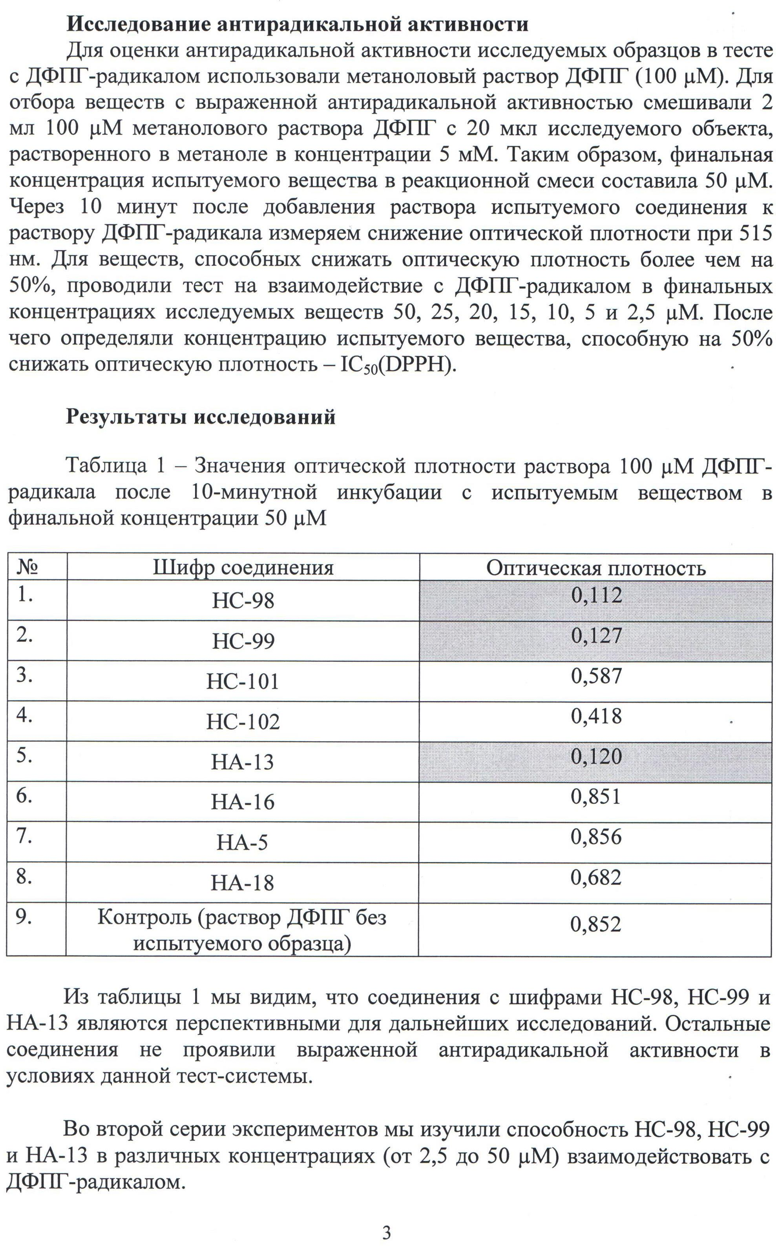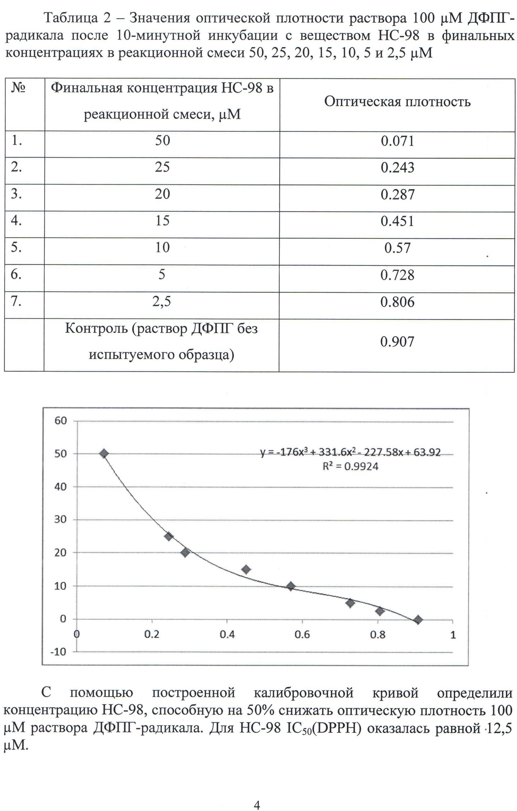
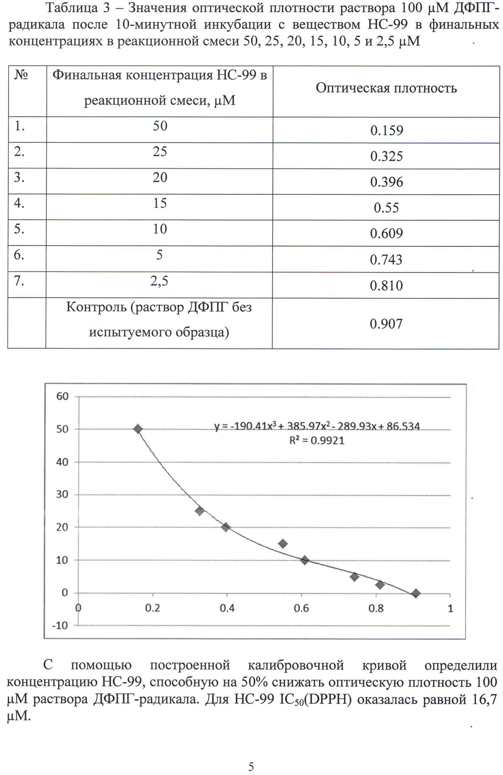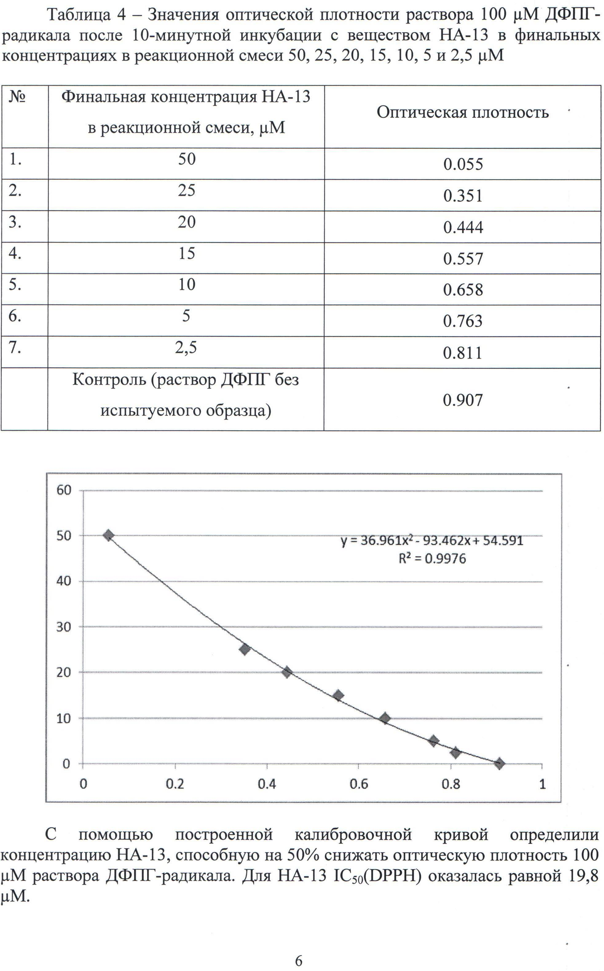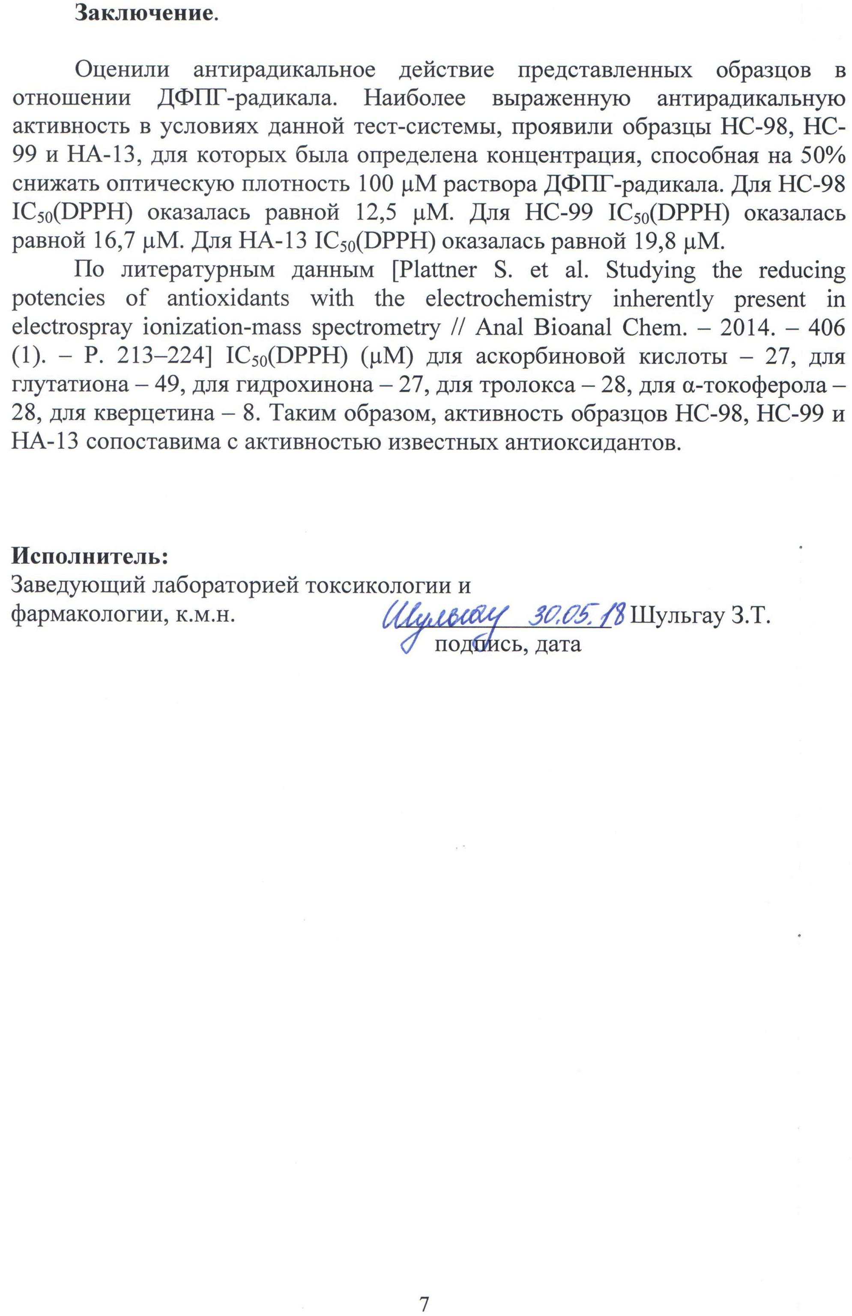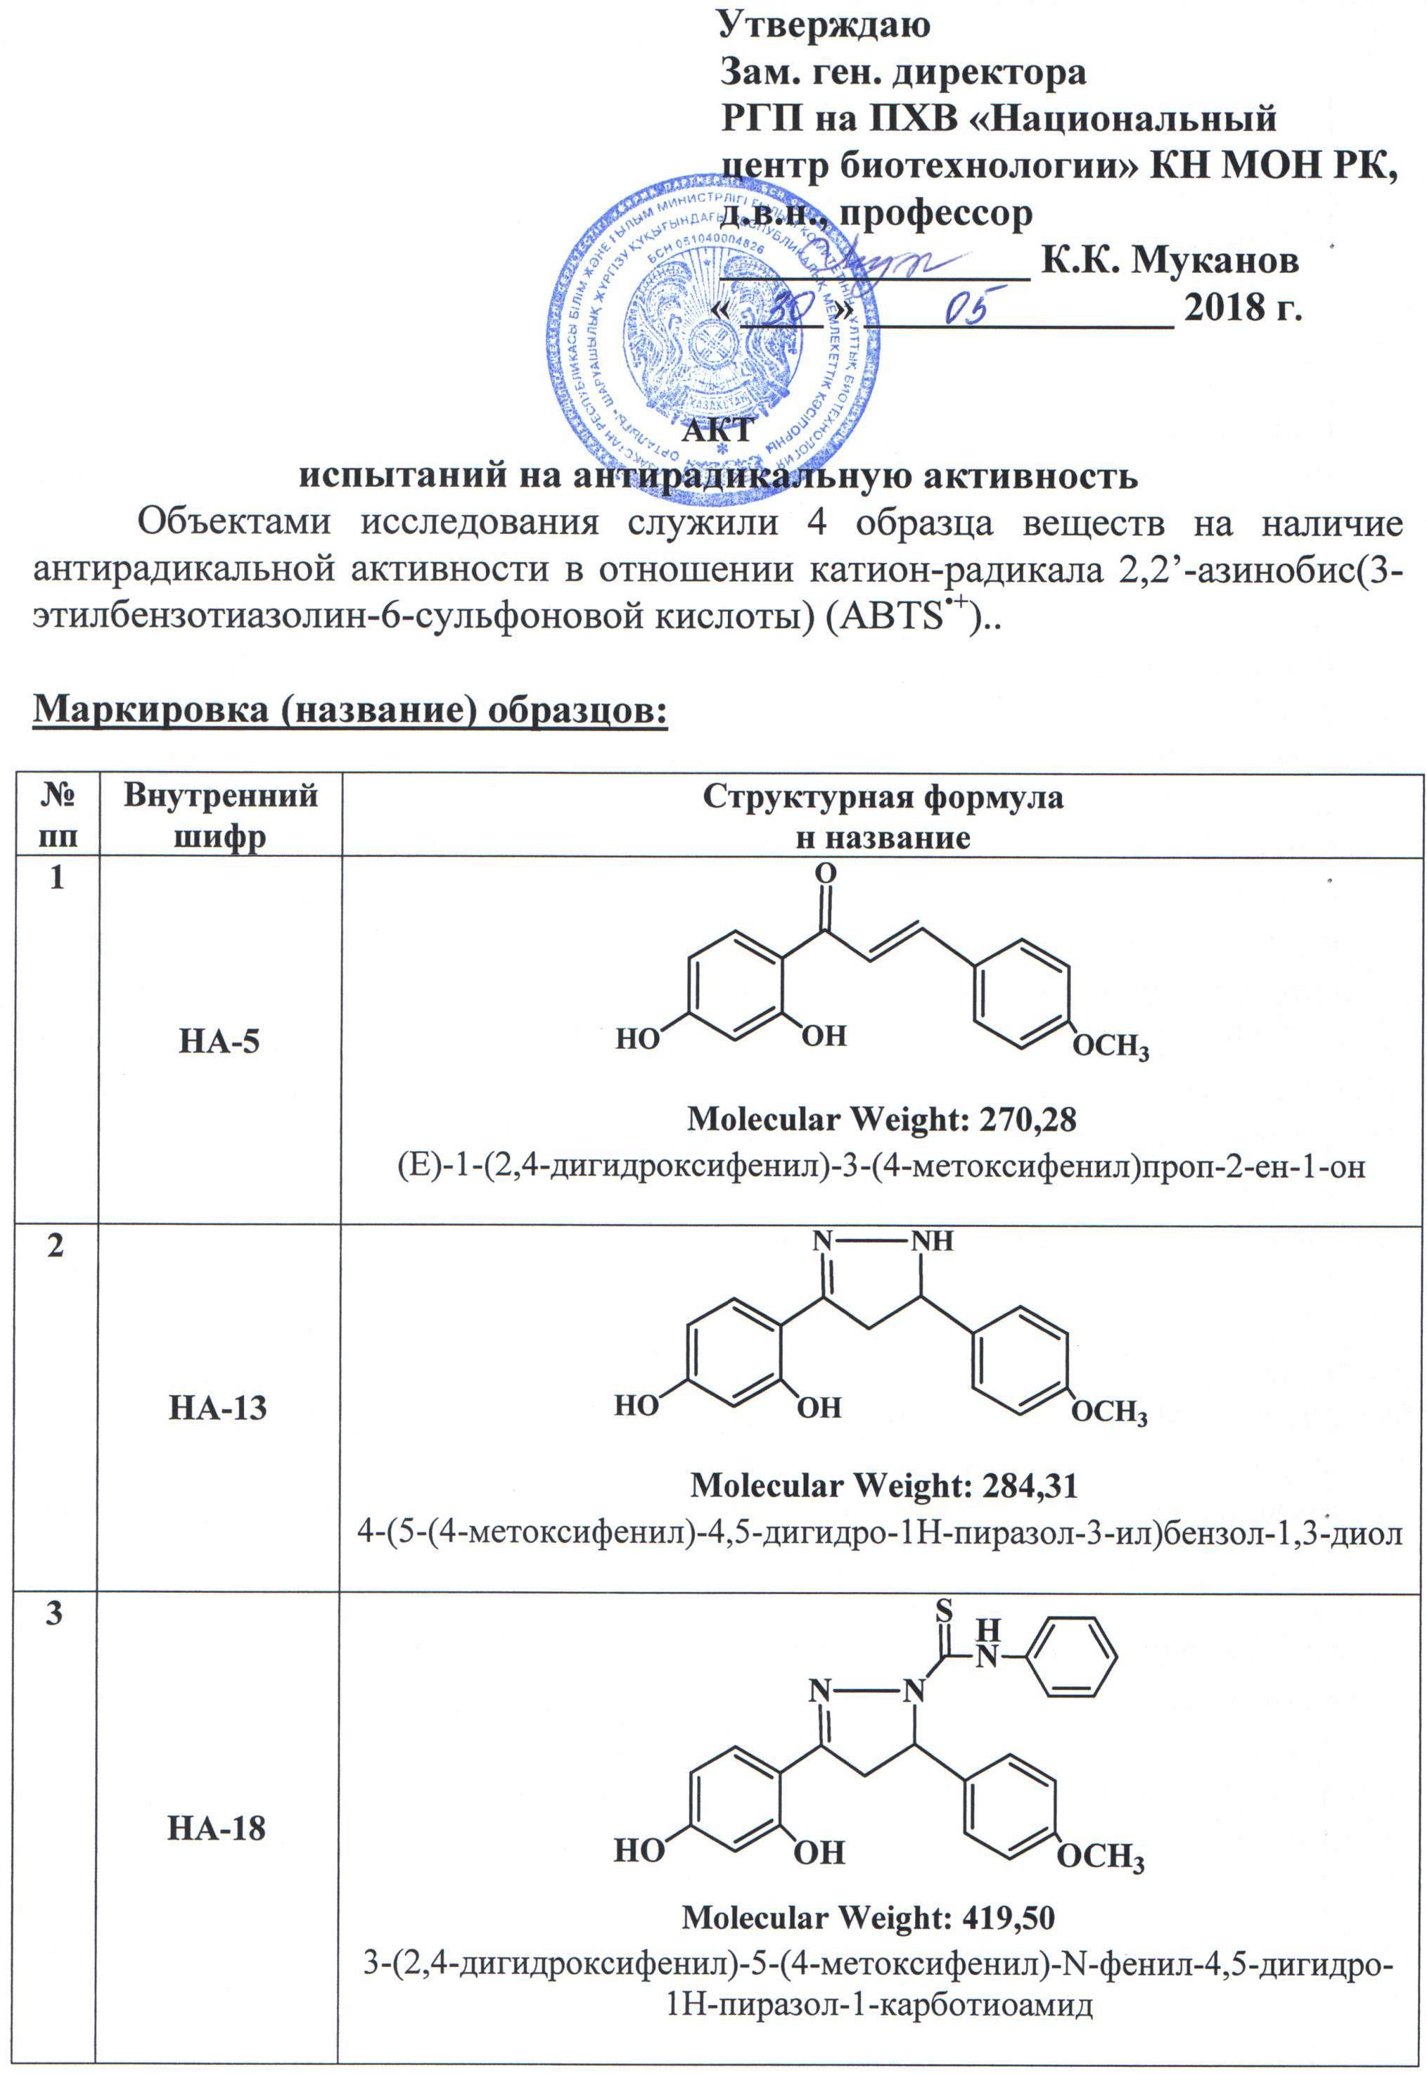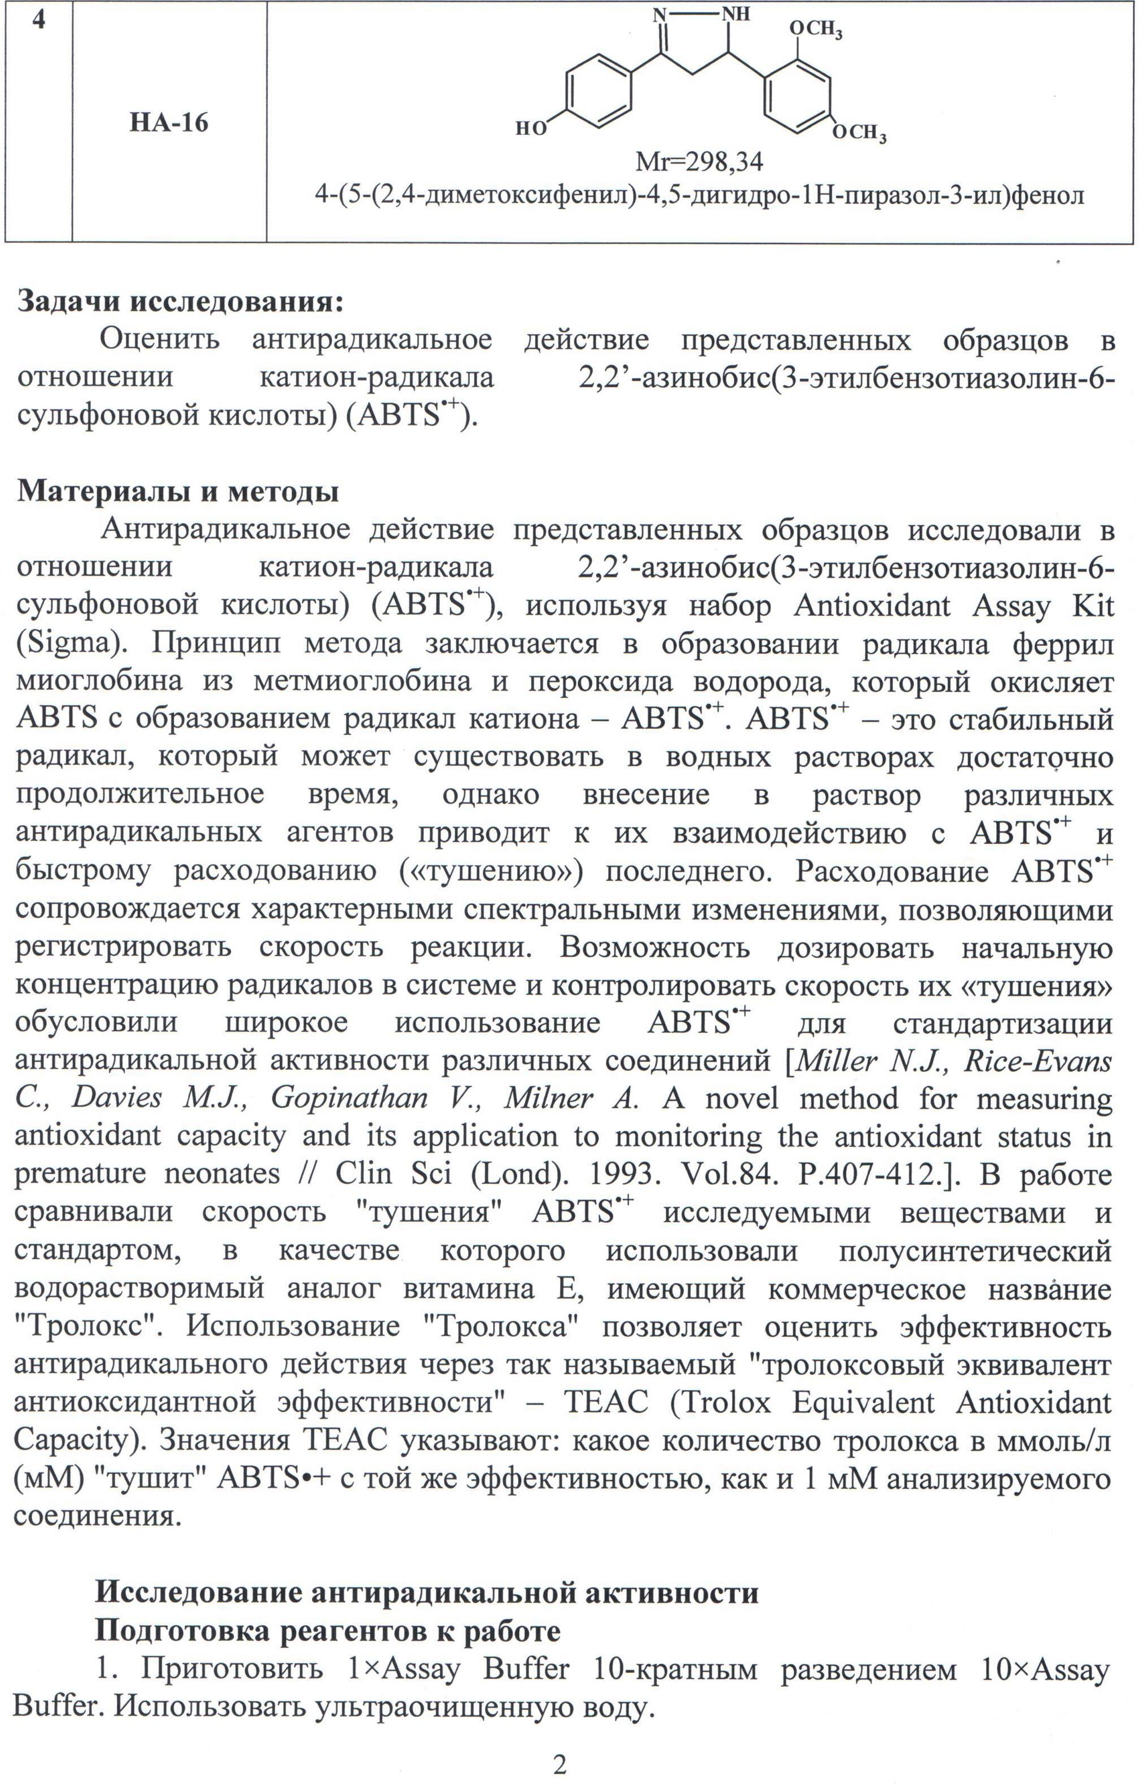
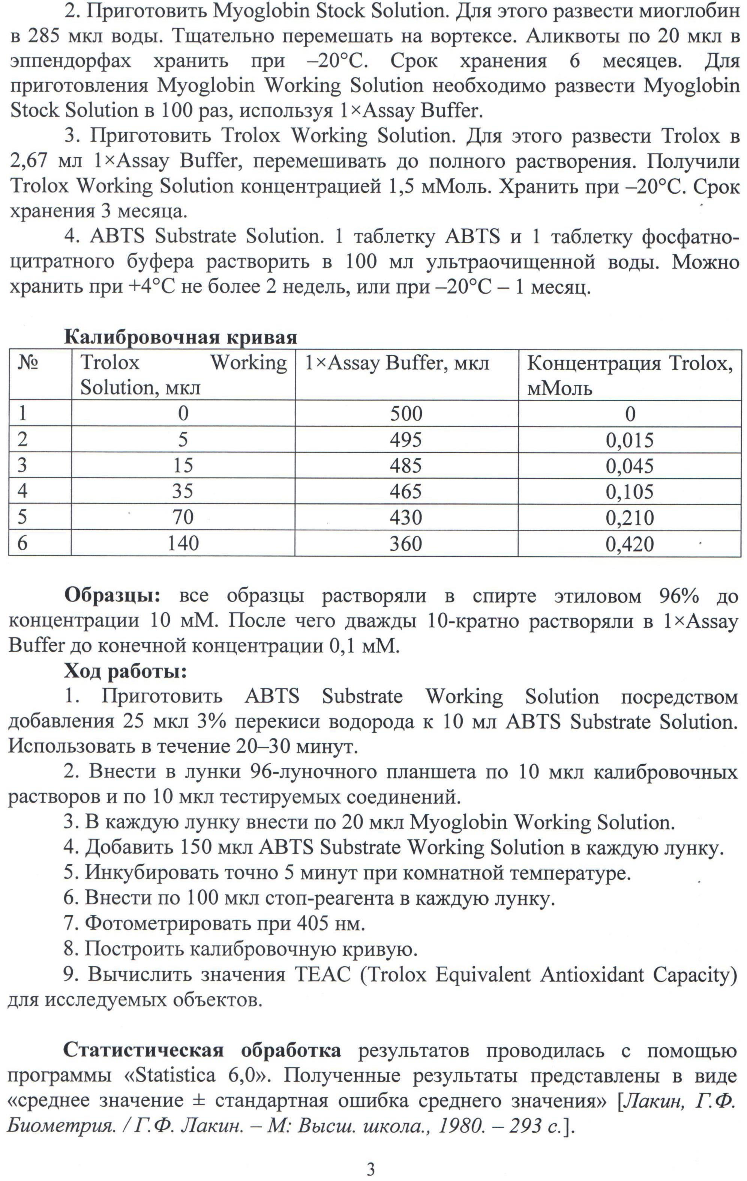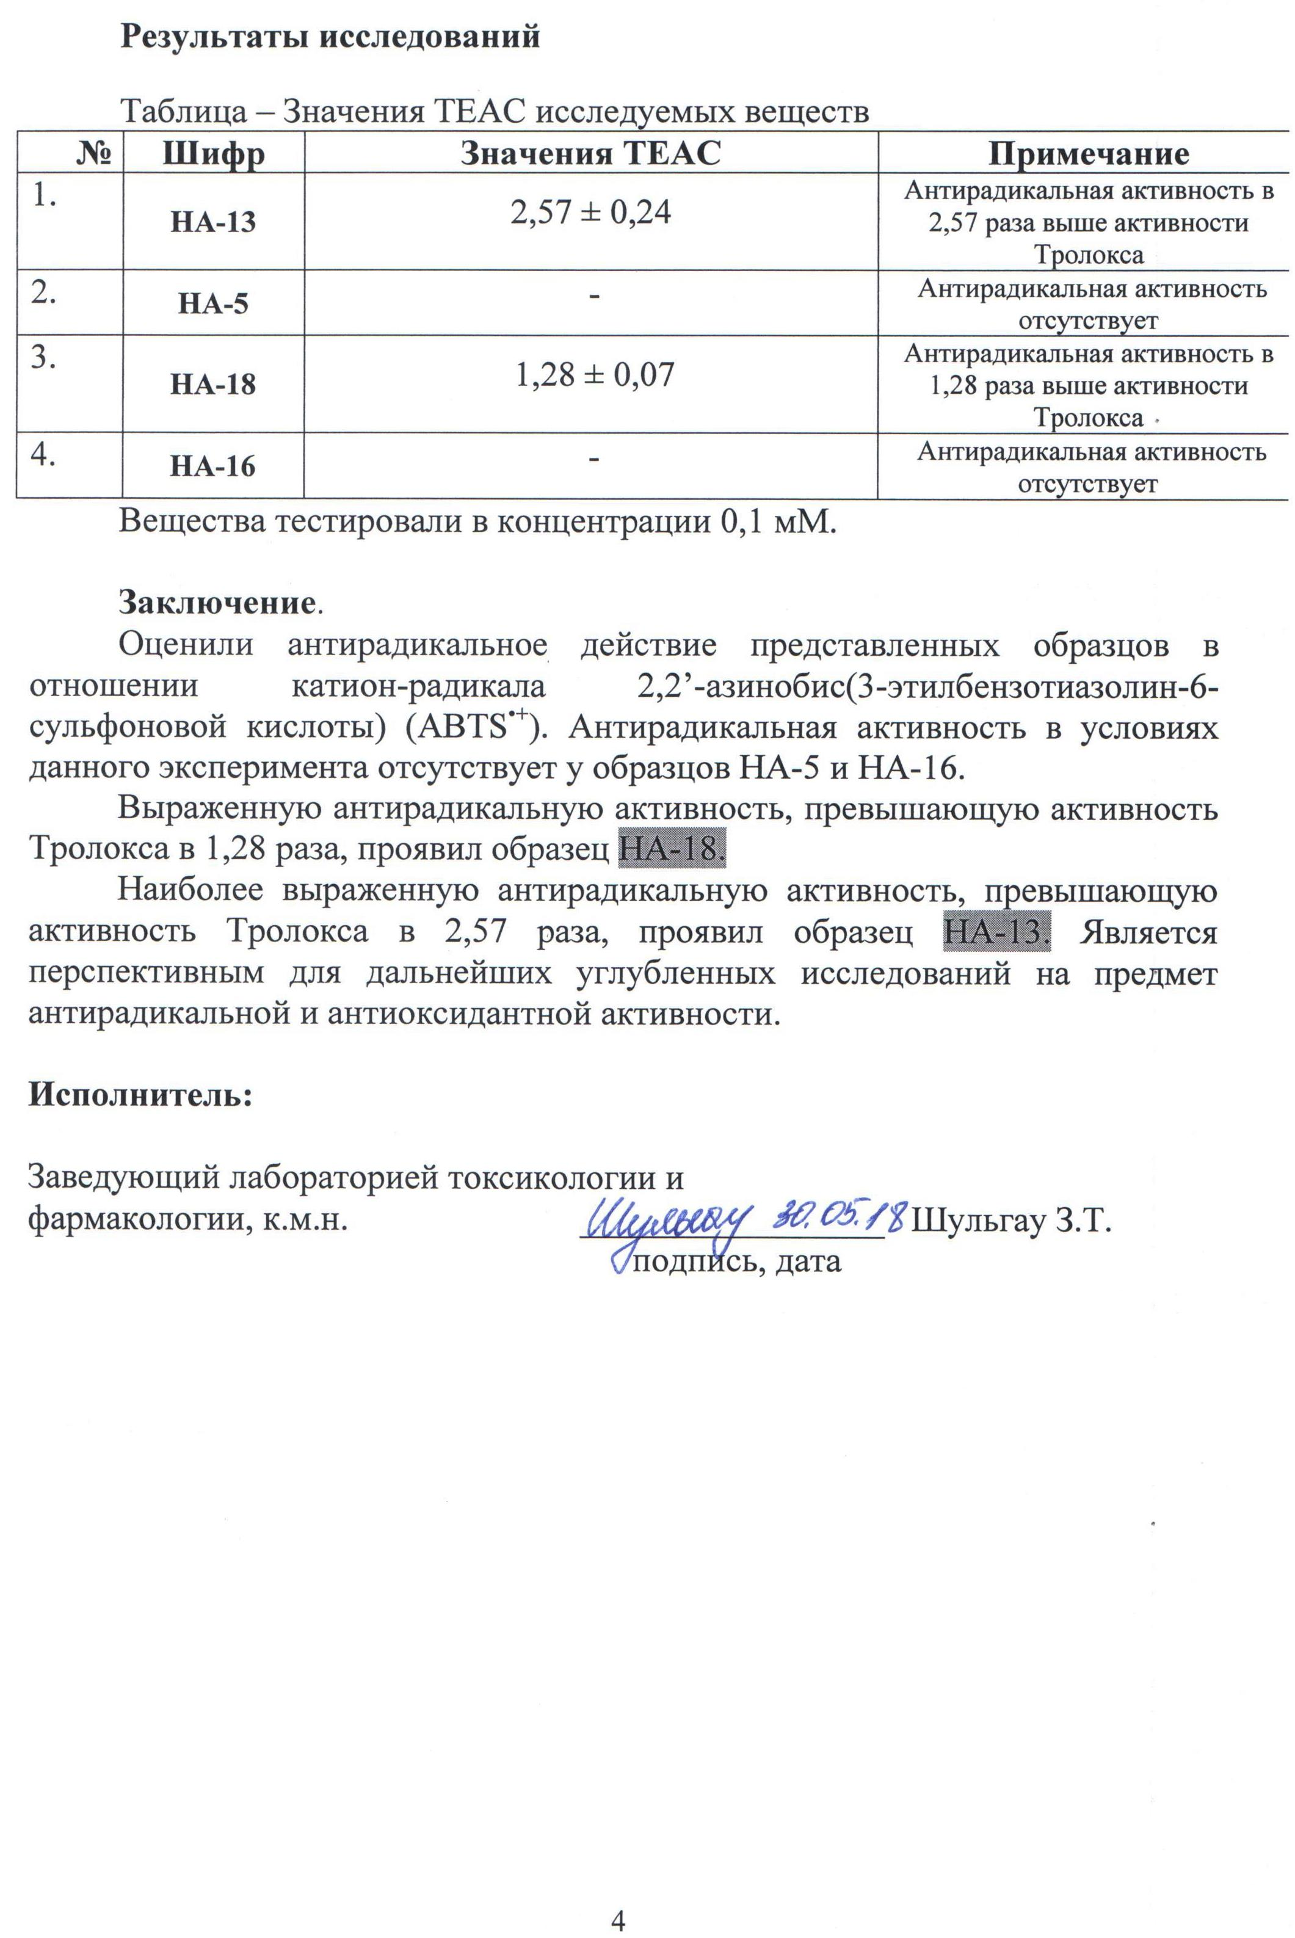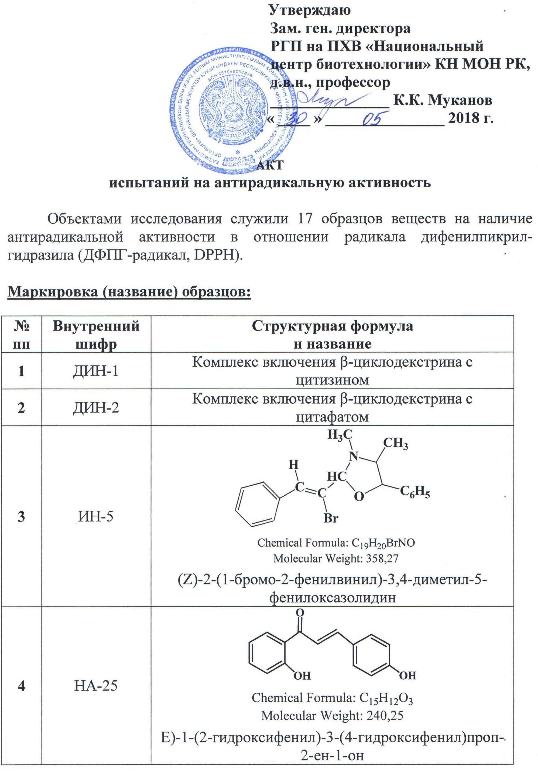

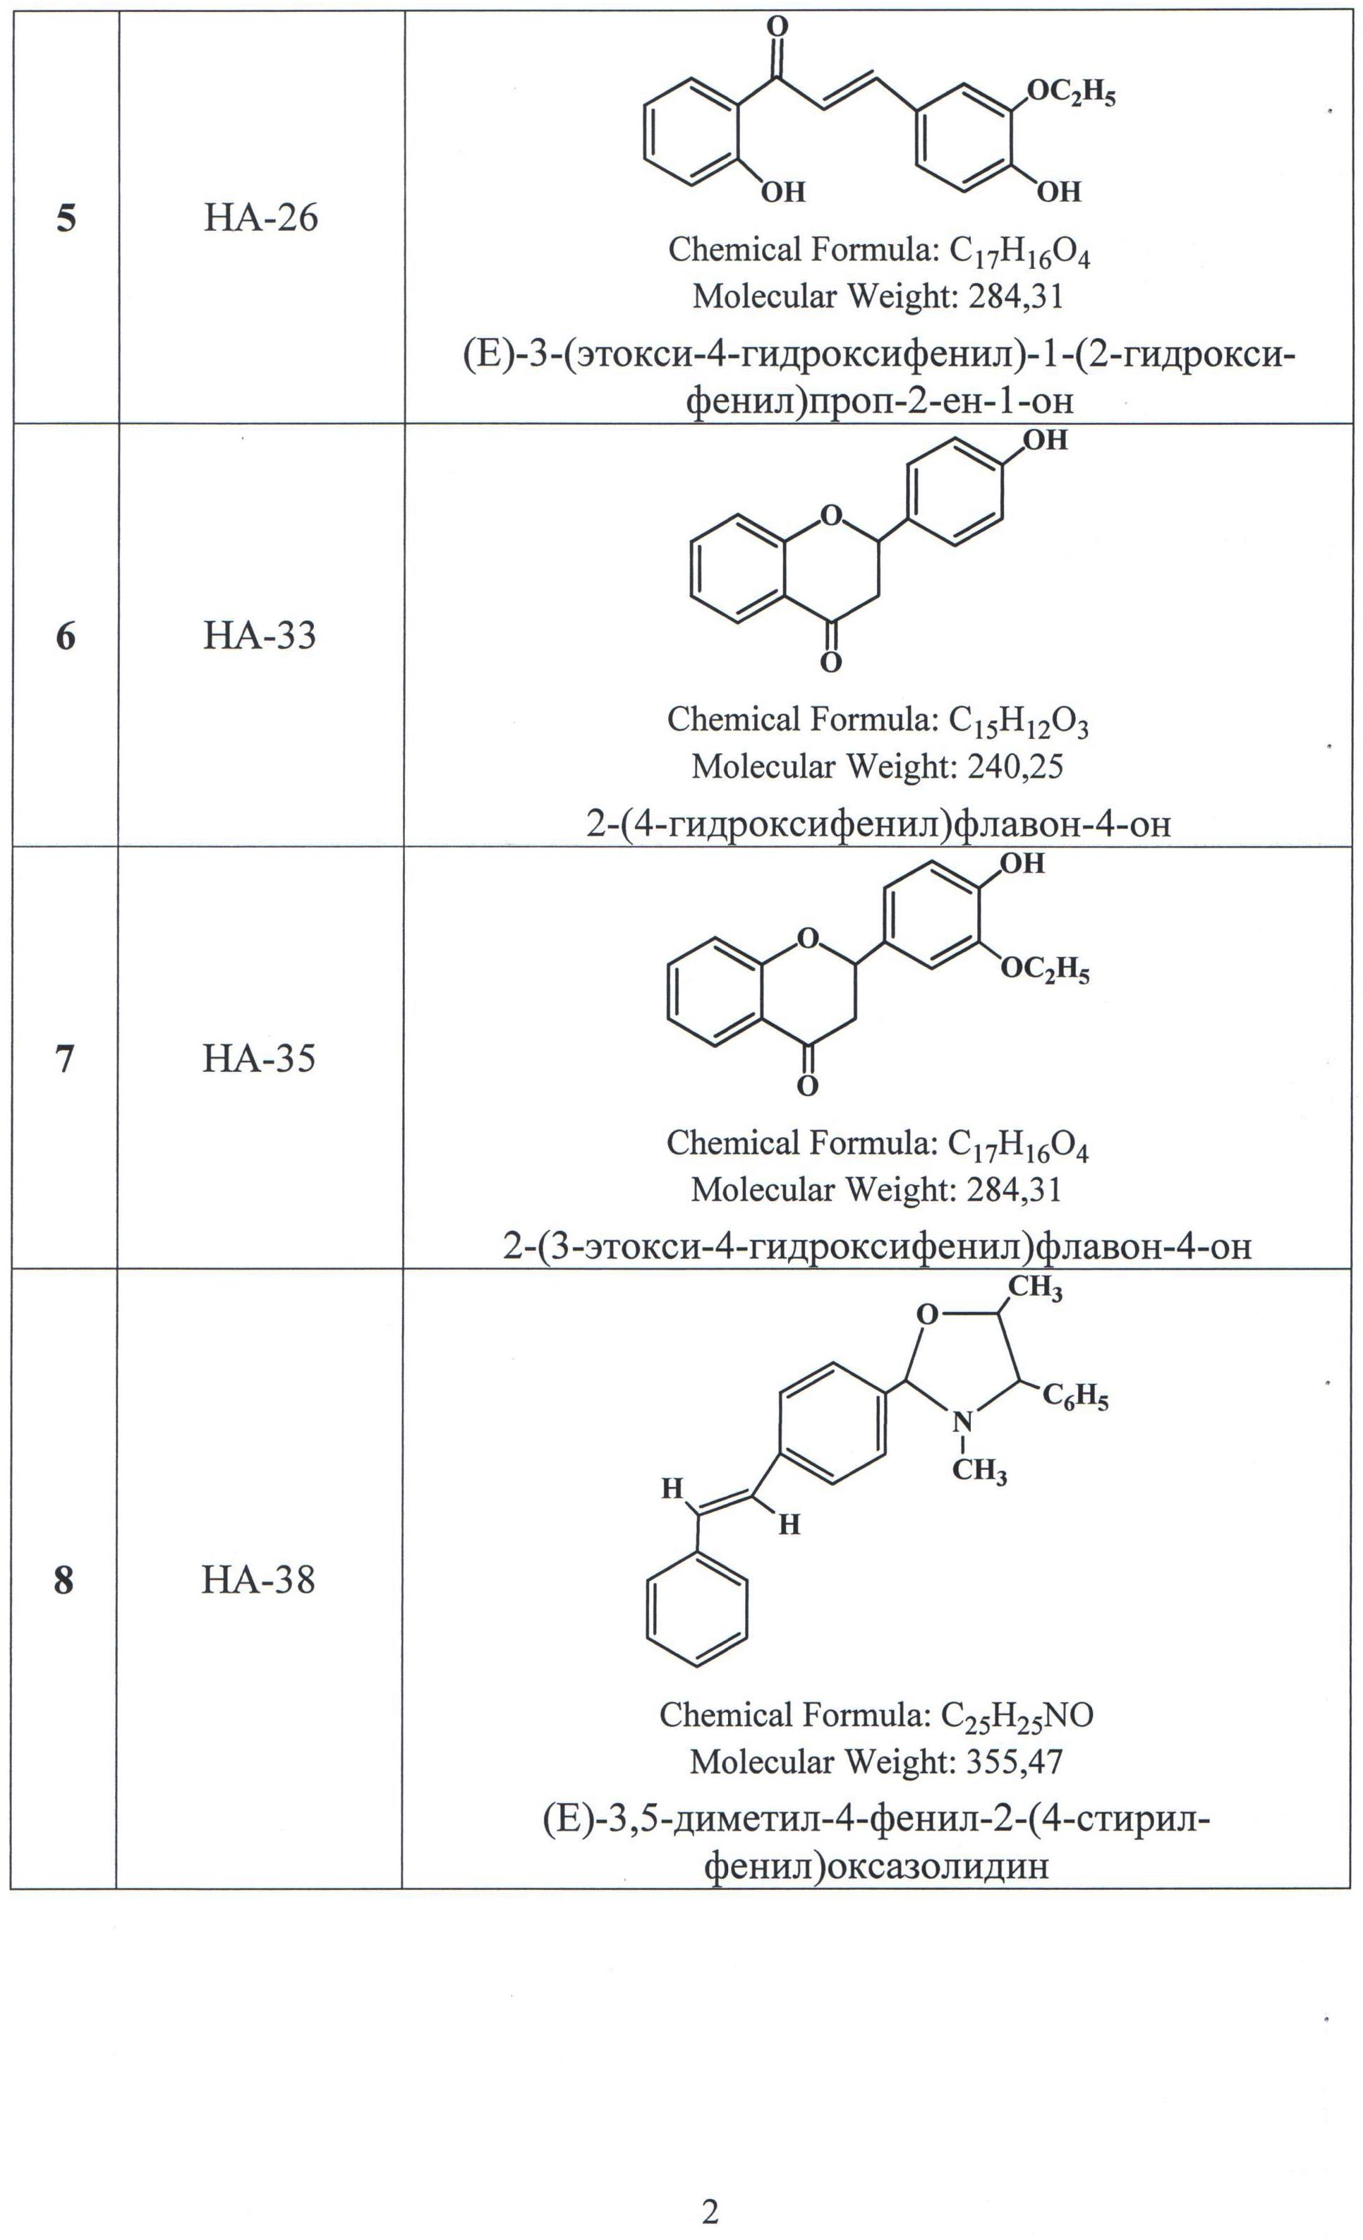
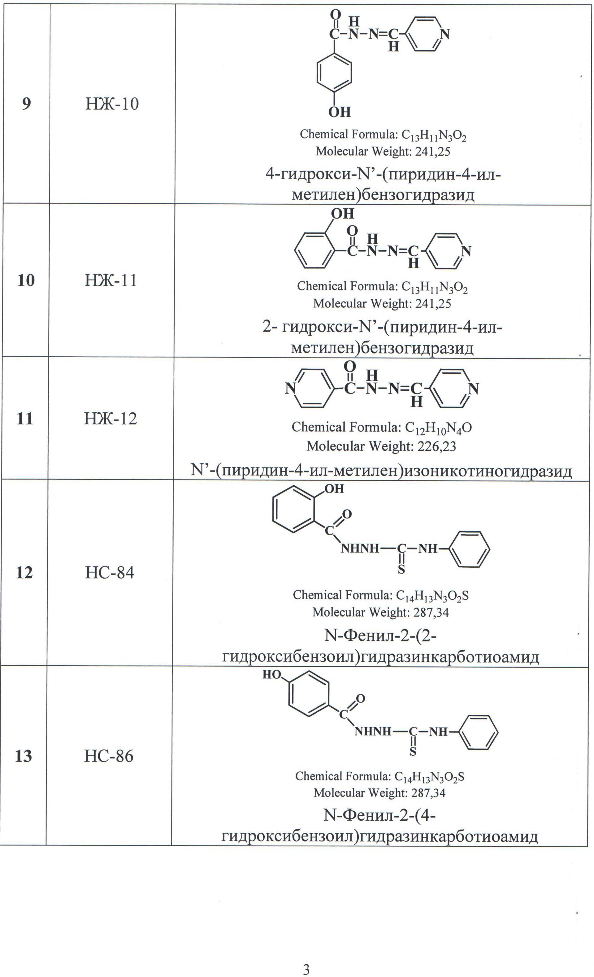
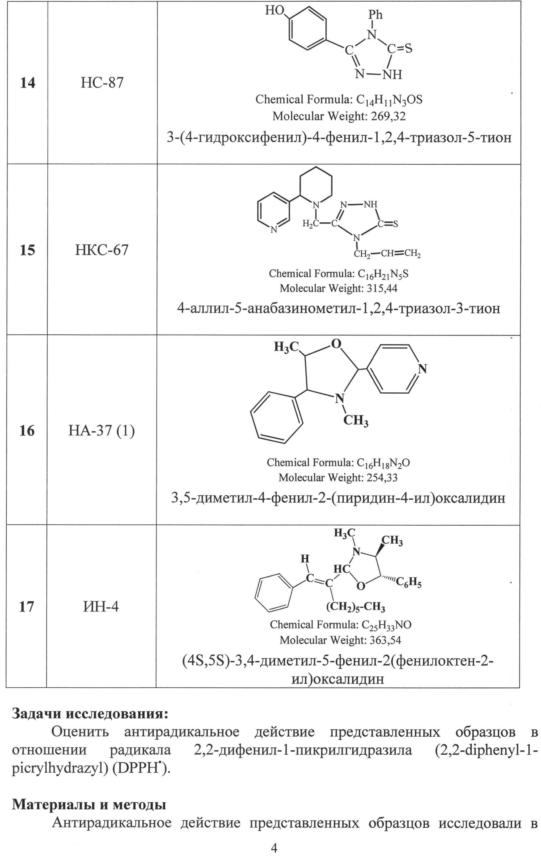
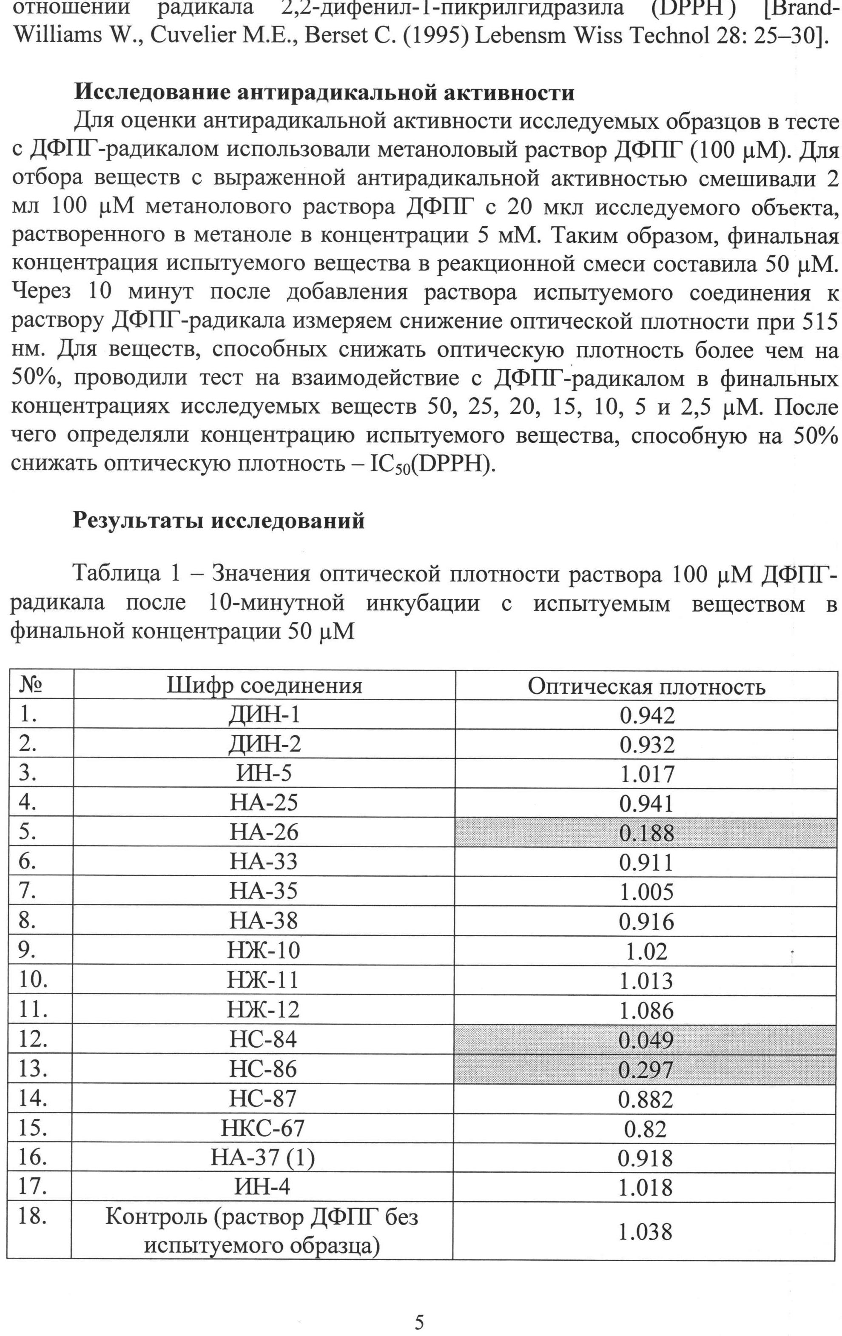
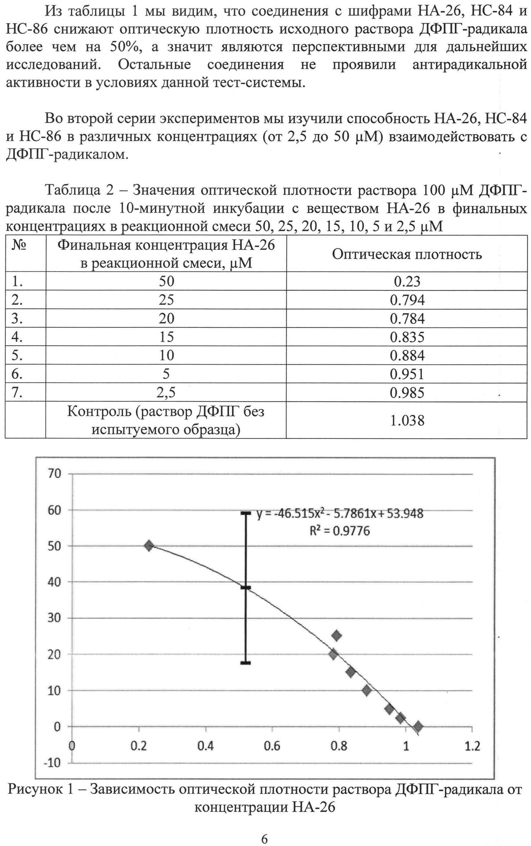
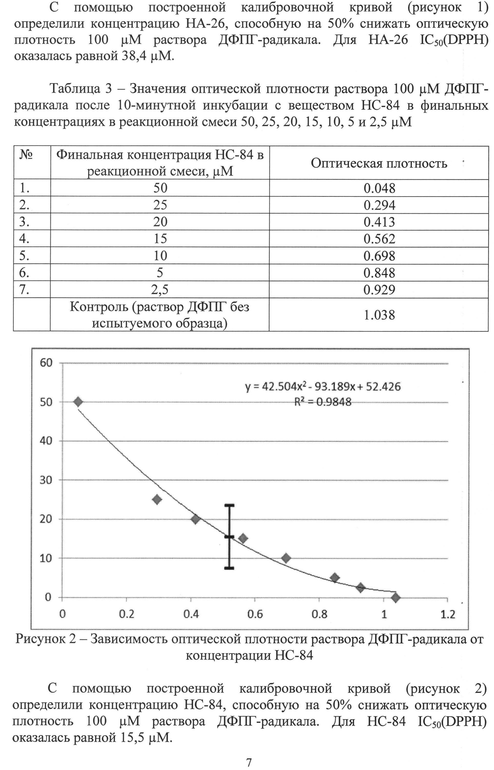
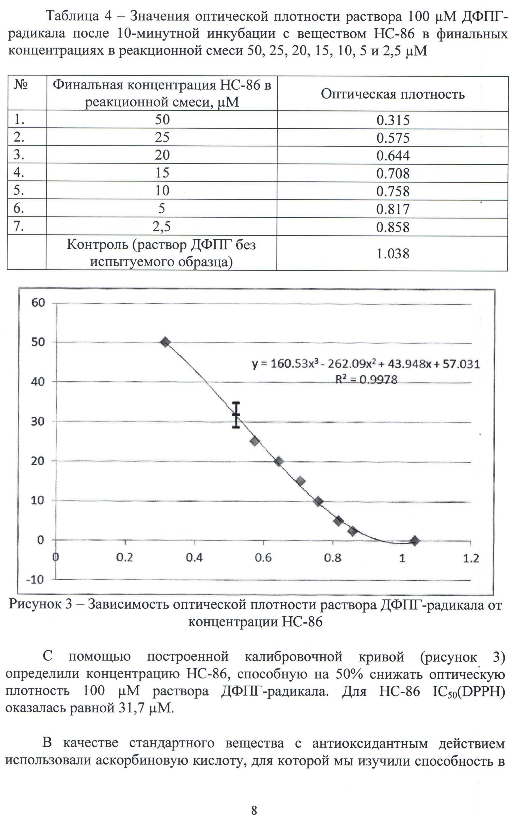
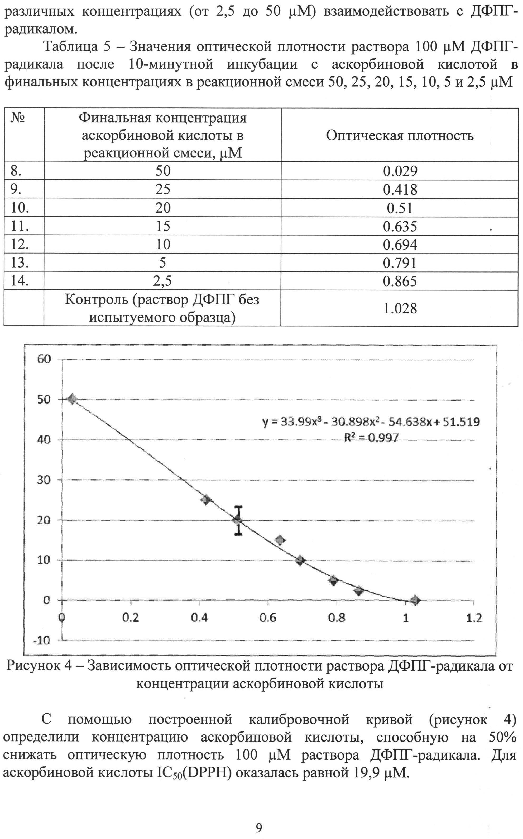
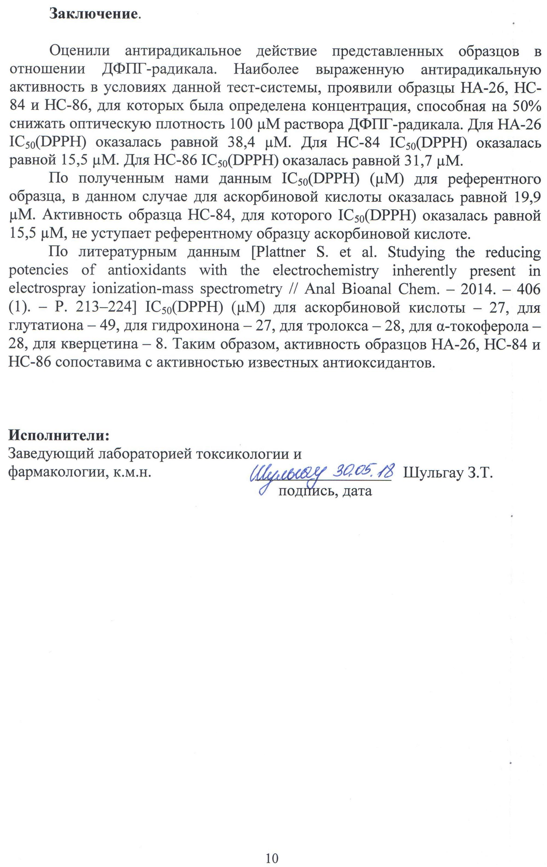

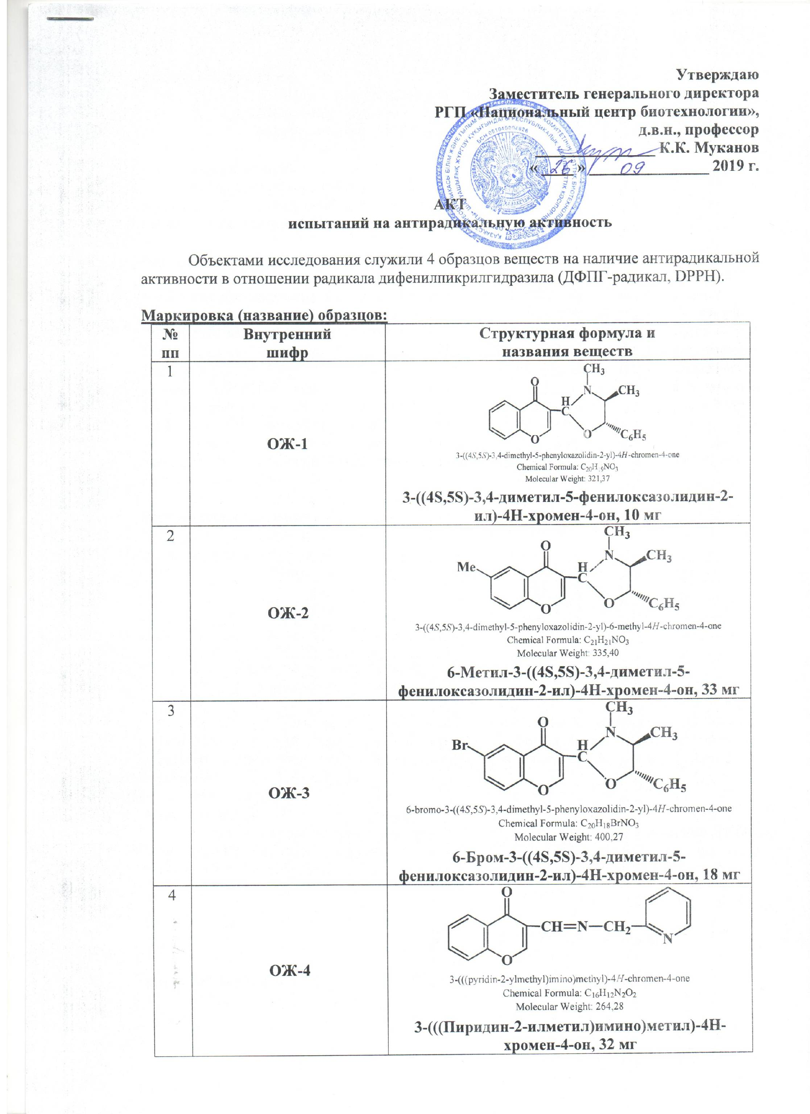
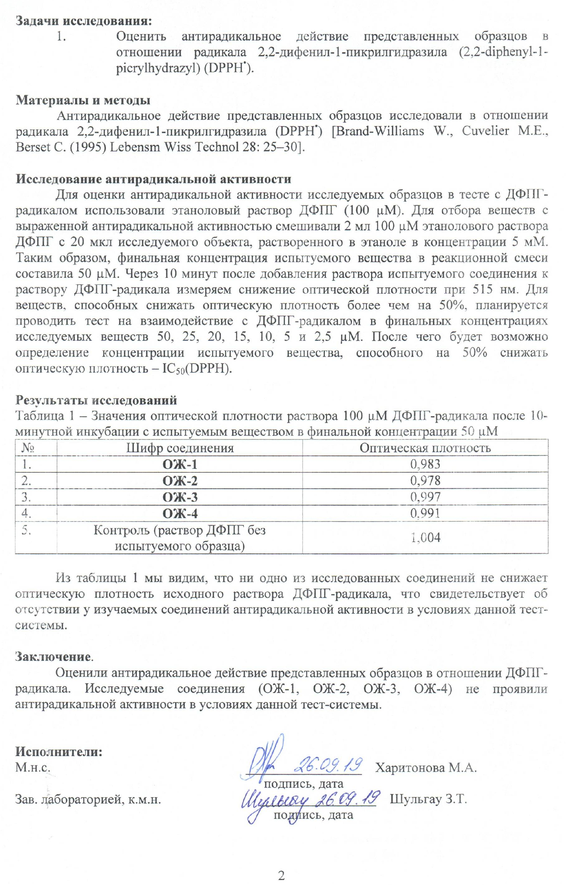

APPENDIX E
Act of testing for antimicrobial activity
in the RSE on the REM "National Center for Biotechnology" KN MES RK

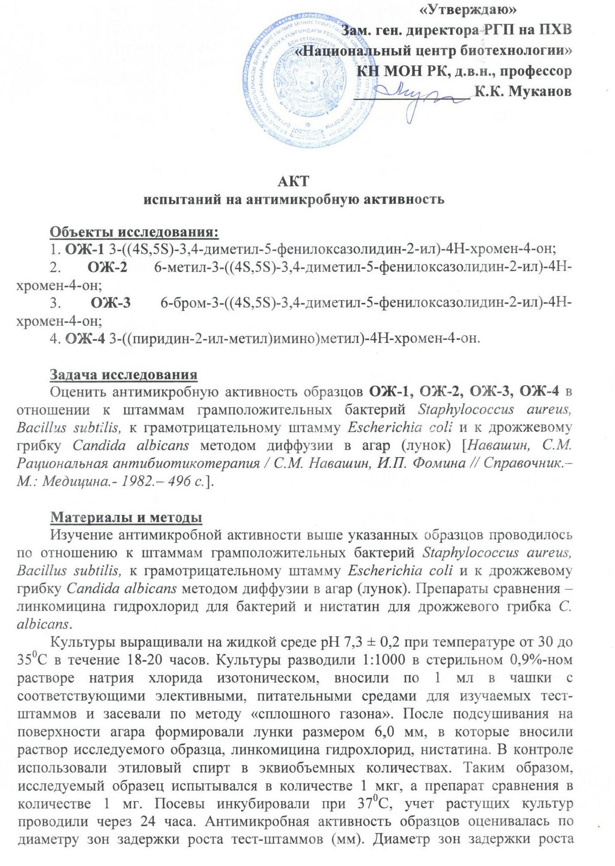

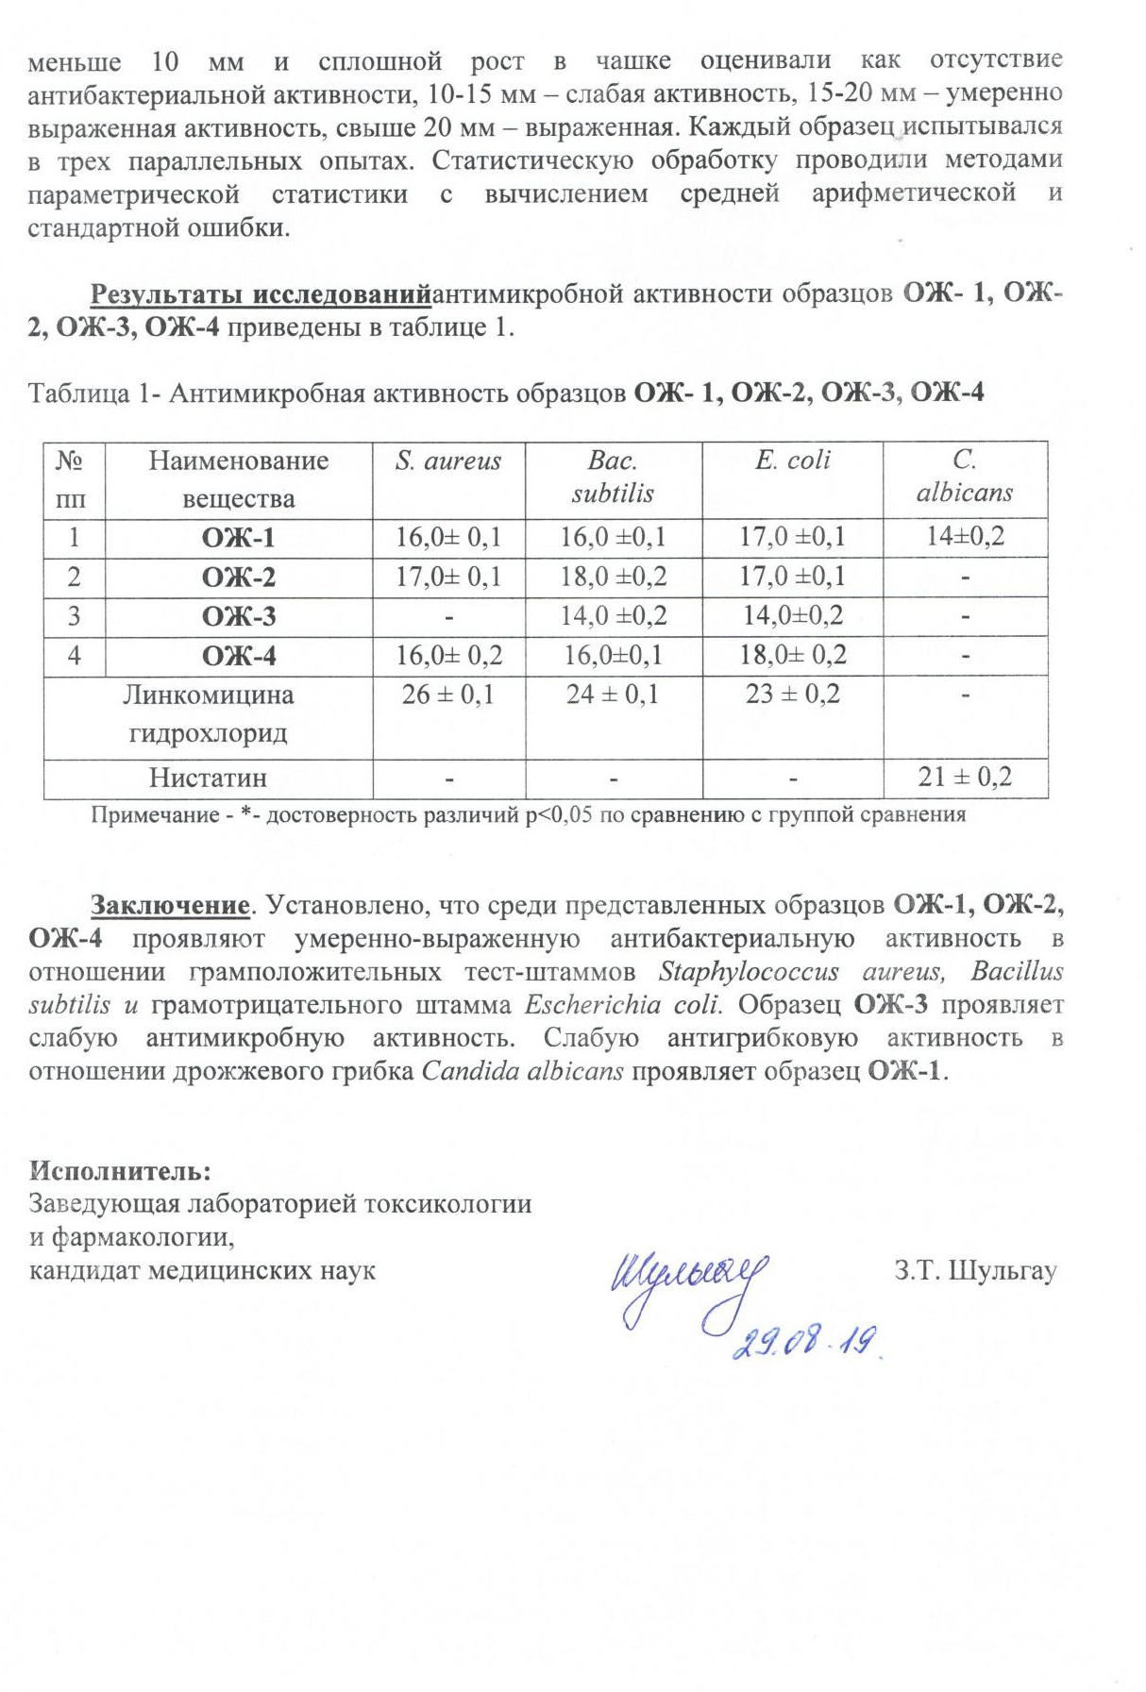

APPENDIX F
Act of testing for antimicrobial activity at the Karaganda State Medical University

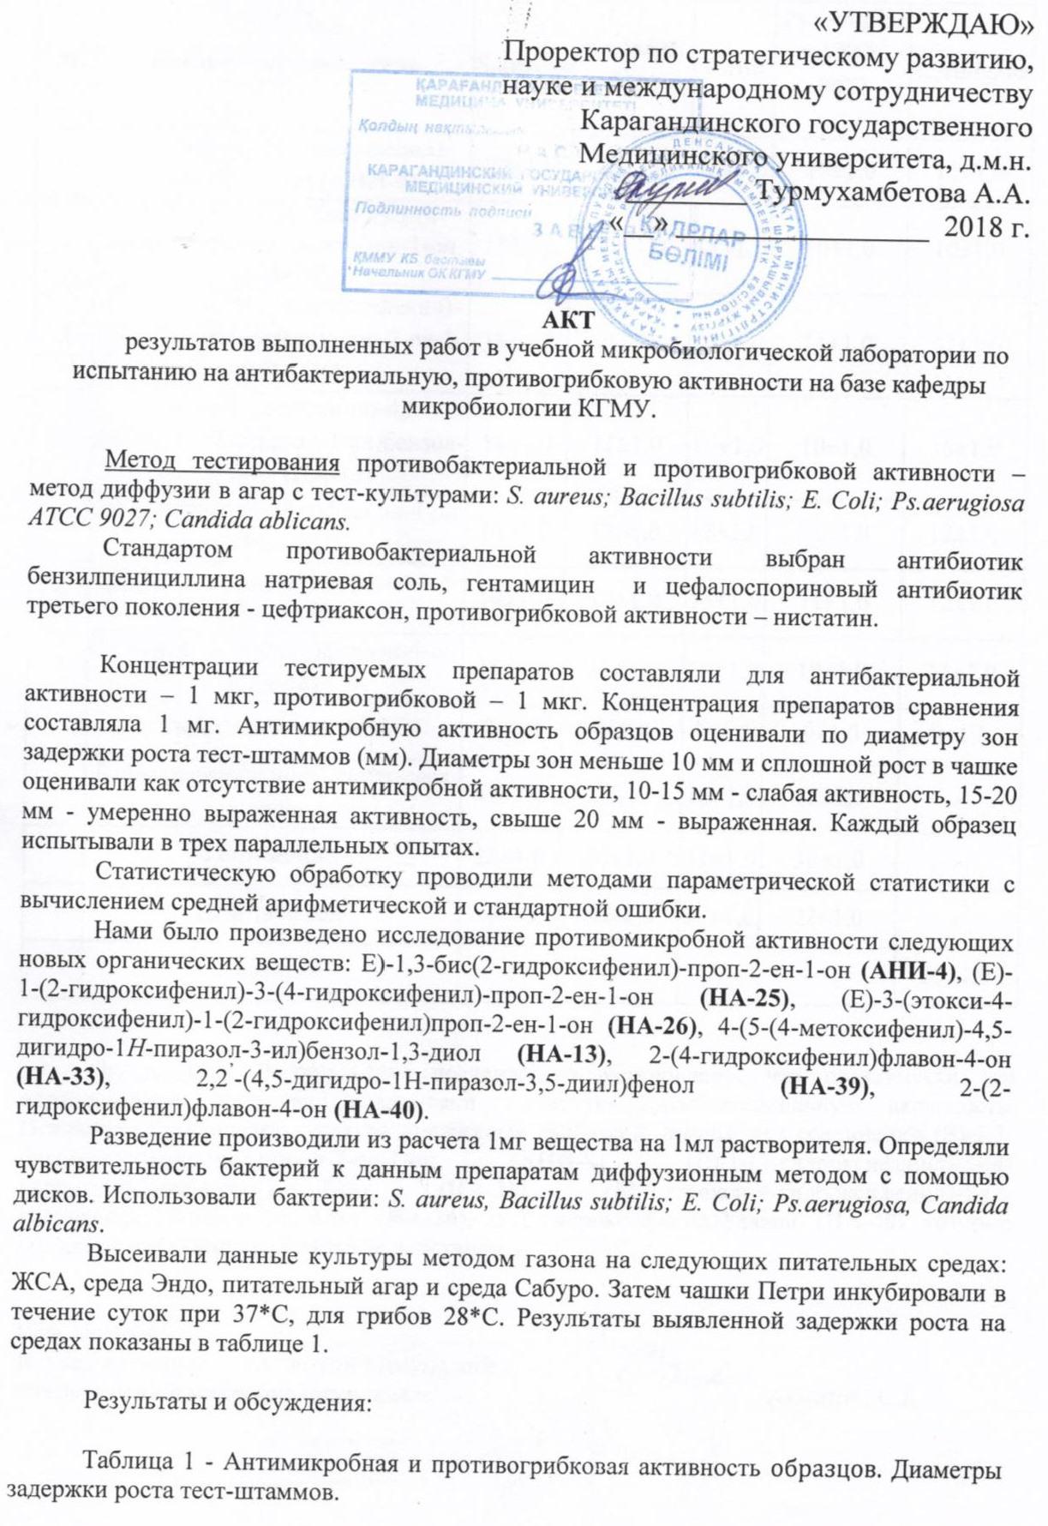

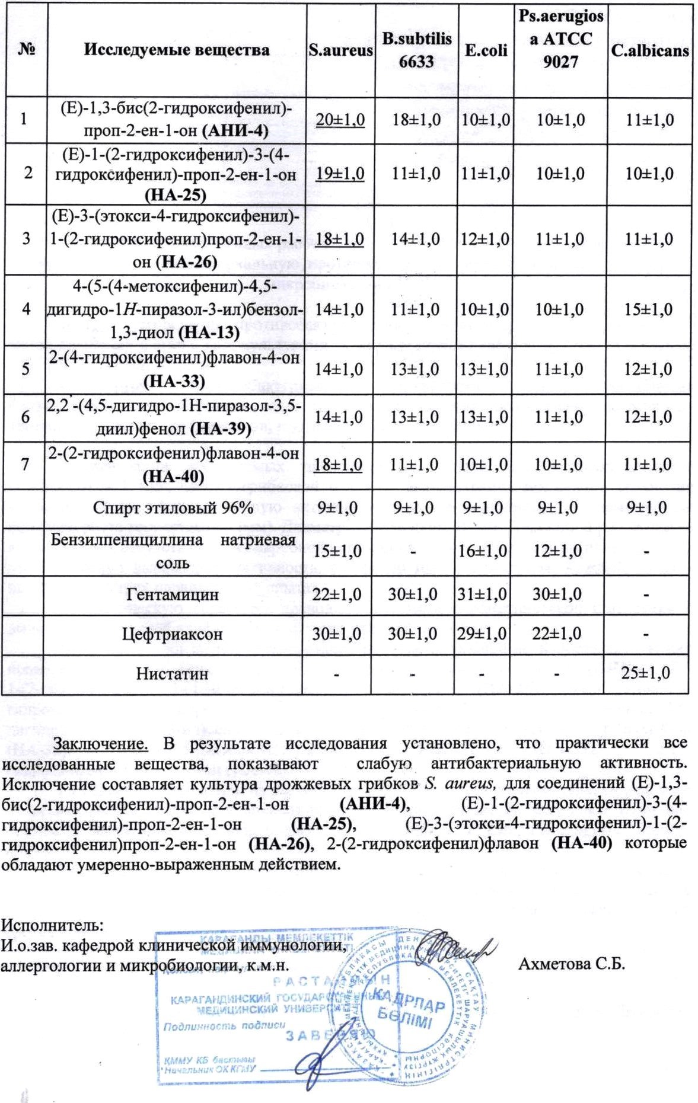

APPENDIX G
Reprints of scientific publications in the direction of the topic for 2020, without DOI
